REFUGEES’ FOOD SECURITY PERCEPTIONS ON REDUCED FOOD RATIONS IN REFUGEES CAMP IN WESTERN TANZANIA

ABDUL ATHUMANI KASUKARI

A DISSERTATION SUBMITTED IN PARTIAL FULFILLFMENT OF THE REQUREMENTS FOR THE DEGREE OF MASTER OF ARTS IN INTERNATIONAL COOPERATION AND DEVELOPMENT (MAICD)
DEPARTMENT OF POLITICAL SCIENCE AND PUBLIC ADMINISTRATION
THE OPEN UNIVERSITY OF TANZANIA
2020

CERTIFICATION

The undersigned certifies that he has read and here by recommends for acceptance by the Open University of Tanzania a dissertation entitled, Refugees’ Food Security Perceptions on Reduced Food Rations in Refugees Camp in Western Tanzania. In partial fulfillment of the requirements for the award of Degree of Masters in International Cooperation and Development (MAICD).

_________________________
Prof. Deus D. Ngaruko
(Supervisor)
____________________________
Date

COPYRIGHT
No part of this Dissertation may be reproduced, stored in any retrieval system, or transmitted in any form by any means, electronic, mechanical, photocopying, recording or otherwise without prior written permission of the author or The Open University of Tanzania in that behalf.

DECLARATION
I, Abdul Athumani Kasukari, declare that, the work presented in this dissertation is original. It has never been presented to any other University or Institution. Where other people’s works have been used, references have been provided. It is in this regard that I declare this work as originally mine. It is hereby presented in partial fulfillment of the requirement for the Degree of Masters in International Cooperation and Development (MAICD).

________________________
Signature

_________________________
Date

DEDICATION
This work is dedicated to a family of Mr. Kasukari, Mr. Babu and majority of all relatives and friends who have been supported me during my study.
.

ACKNOWLEDGEMENT
This work is a product of various contributions from different people. I am very grateful and indebted to them all, however I feel obliged to mention some of them because without their prior guidance, assistance and encouragement I may never have been able to finish this study.

First and foremost, I would like to express my special thanks to the management of Open University of Tanzania for their guidance, intellectual support and material support greatly enabled me to finalize the study. I also thank to my fellow students for their positive support during the whole period of my study.

I thank my supervisor Professor Deus D. Ngaruko who provided me with critical insights, guidance, directives and encouragement. I also wish to express much appreciation to the Director of Refugees Services Tanzania, Kigoma Zone Office of Ministry of Home Affair for Refugees Services and Nyarugusu Camp Office of Ministry of Home Affair Office for Refugees management team for constant motivation, guidance, encouragement and advice during field data collection process.

ABSTRACT
The objective of this study was to assess refugees’ food security perceptions on reduced food rations in Nyarugusu refugee camp Western Tanzania. The study had five research objectives based on food availability, accessibility, utilization, forms of refugees’ food assistance and factors, effects with its coping strategies on refugees’ food ration which were formulated so as to answer the general problem of the research study, which clearly elaborated in the statement of the problem. The population of the study consisted of refugees of Nyarugusu camp in Kasulu-Kigoma Western Tanzania. The researcher used sampling techniques to draw a sample size of 395 households’ who involved as respondents in the study areas. Data were collected from the respondents through structural interview as the methods for data collection through use of questionnaires as tool. The computer program SPSS (Statistical Product and Service Solution) used to analyse collected data by using descriptive statistics analysis which includes frequencies and percentages. Study findings have revealed that in Nyarugusu refugee camp, there are challenges of food availability, accessibility and food utilization for refugees’ food security. The common form of food ration was in-kind food rations while the refugee’s mostly preferred form were cash and in-kind food ration or combination (cash and in-kind food) respectively. The refugees’ perception on factor, effect and coping strategies based on reduced food ration in Nyarugusu Refugee camp western Tanzania mostly were out of their control instead they forced to face them accordingly to environment because to them are not positive but no way out.

Keywords: Refugee, food security, food ration, food assistance, refugee camp.

TABLE OF CONTENTS
CERTIFICATION ii
COPYRIGHT iii
DECLARATION iv
DEDICATION v
ACKNOWLEDGEMENT vi
ABSTRACT vii
LIST OF FIGURES xiv
LIST OF ABBREVIATIONS xv
CHAPTER ONE 1
INTRODUCTION 1
1.1 Background to the Study 1
1.2 Research Problem Statement 5
1.3 Research Objectives 6
1.3.1 General Research Objective 6
1.3.2 Specific Research Objectives 6
1.3.3 Research Questions 7
1.3.3.1 Specific Research Questions 7
1.4 Significance of the study 8
1.5 Limitations of the Study 8
CHAPTER TWO 9
LITERATURE REVIEW 9
2.1 Chapter overview 9
2.1.1 Conceptual Definitions of Key Terms 9
2.1.1.1 Refugee 9
2.1.2 Food Security 11
2.2 Theoretical Literature Review 12
2.2.1 Empowerment Concept 12
2.2.2 Sen’s theory 15
2.3 Empirical Literature Review 17
2.3.1 Food Security Intervention 17
2.3.2. Food security in Refugee Camp Western Tanzania 19
2.3.3 Refugee Food Rationing 20
2.3.3.1 Rationing in Refugee Camp in North of South America 20
2.3.3.2 Rationing in Refugee Camp in Africa 21
2.3.3.3 Rationing in Refugee Camp in Western Tanzania 24
2.4 Information Gap 26
2.5 Conceptual Framework 28
CHAPTER THREE 30
RESEARCH METHODOLOGY 30
3.1 Chapter Overview 30
3.2 Research Approach/ Strategies 30
3.3 Research Paradigm 31
3.8.1 Sampling frame 36
3.8.2 Sampling unit 36
3.8.3 Sample size 37
CHAPTER FOUR 41
DATA ANALYSIS AND DISCUSSION OF FINDINGS 41
Chapter Overview 41
4.1.1 Gender of respondent 42
4.1.2 Respondent’s nationality 43
4.1.3 Respondent’s Age 44
4.1.4 How long have you encamped 45
4.1.5 Respondent’s Level of Education 46
4.1.6 Family size in the camp 47
4.2 Food Availability 48
4.2.1 Present available food aid ration is satisfying the individual or family use. 49
4.2.2 Present available food price affordable for the individual or family food capacity. 50
4.3 Food accessibility 51
4.3.1 Present available food accessible for day to day consumption. 52
4.3.2 Present food access through markets affordable for low-income individual or family of refugees. 53
4.4 Food Utilization 53
4.4.1 The present received foods are used properly as intended for dietary intake. 54
4.4.2 The present received foods are safe to consume for quality of care 55
4.4.3 The part of food are utilize on selling to get money for other needs. 56
4.5 Common forms of food assistance used to accommodate refugees food security ration in Nyarugusu Refugee Camp 57
4.5.1 Refugee’s perception on form of food assistance preferred for Refugees food security in Nyarugusu Refugee Camp Western Tanzania. 59
4.5.1.1 In-kind food 60
4.5.1.2 Cash 61
4.5.1.3 Combination of In-kind food and cash 62
4.6.1 Key factor affecting the implementation of coping strategy on rationing strategy in Nyarugusu refugee camp in Western Tanzania. 64
4.6.1.1 Lack of political good will from the government 65
4.6.1.2 Restrictions of refugee accessing community market 65
4.6.1.3 Denial of permits to work or engage in income generating activities 66
4.6.1.4 Divergent attention and overwhelming demand on UNHCR due to increased cases of conflicts globally 66
4.6.2 The Effect of Reduced Food Ration in Nyarugusu Refugee Camp in Western Tanzania 67
4.6.2.1 Food Insecurity within the camp 68
4.6.2.2 Food is very expensive in the designated market 69
4.6.2.3 There has been increased crime due to rationing 69
4.6.3 The Category of Coping Strategy of Rationing Strategy in Nyarugusu Refugee Camp in Western Tanzania. 70
4.6.3.1 Reduction in the number of meals per day. 71
4.6.3.2 Reduction in size of meals 72
4.6.3.3 Restrict consumption of adults to allow more for children. 73
4.6. 3.4 Skip food consumption for an entire day 73
CHAPTER FIVE 75
CONCLUSION AND RECOMMENDATIONS 75
5.1 Chapter Overview 75
5.2 Summary of Major Findings 75
5.3 Conclusions 77
5.4 Recommendations 80
5.5 Recommendations for Further Research 82
REFERENCES 83
APPENDICES 93

LIST OF TABLES
Table 1: Households per location Nyarugusu Refugee Camp western Tanzania 36
Table 2: Family size in the camp 48
Table 3: The Category of Coping Strategy of Rationing Strategy in Nyarugusu Refugee Camp in Western Tanzania. 71

LIST OF FIGURES
Figure 1: Food Security Conceptual framework 29
Figure 2: Gender of respondent 42
Figure 3: Respondent’s nationality 43
Figure 4: Respondent’s Age 45
Figure 5: How long have you encamped 46
Figure 6: Respondent’s Level of Education 47
Figure 7: Food Availability 49
Figure 8: Food accessibility 51
Figure 9: Food Utilization 54
Figure 10: Common forms of food assistance used to accommodate refugees food security ration in Nyarugusu Refugee Camp. 59
Figure 11: Refugee’s Perception on form of food assistance preferred for Refugees food security in Nyarugusu Refugee Camp Western Tanzania 60
Figure 12: Key factor affecting the implementation of coping strategy on rationing strategy in Nyarugusu refugee camp in Western Tanzania. 64
Figure 13: The Effect of Reduced Food Ration in Nyarugusu Refugee Camp in Western Tanzania. 68

LIST OF ABBREVIATIONS
CSI Coping Strategy Index
CSB Super Cereal with Sugar
DRC Democratic Republic of Congo
FAO Food and Agriculture Organisation
IFAD International Fund for Agriculture Development
MHA Ministry of Home Affairs
NGO’s Non-Governmental Organization
PDM Post Distribution Monitoring
SGBV Sexual and Gender Based Violence
SPSS Statistical Package for Social Sciences
UN United Nations
UNDP United Nations Development Program
UNHCR United Nations High Commissioner for Refugees
URT United Republic of Tanzania
WFP World Food Programme

CHAPTER ONE

INTRODUCTION

Background to the Study
Food Security on Reduced Food Rations in Refugee Camps is one of the most critical challenges at local, national and international level for several years till recently. A study by Whitaker (2008), Refugee Policy in Tanzania as a haven of peace within a troubled region, Tanzania has long hosted refugees from neighbouring countries. Over three decades after independence in 1961, Tanzania received nearly 400,000 refugees from Rwanda, Burundi, Mozambique, South Africa, Somalia, and Kenya. They were housed in twenty rural settlements throughout the country and were encouraged to cultivate food and cash crops. Throughout this period, the government maintained an open-door policy and was internationally recognized for its hospitality toward refugees.

Whitaker (2008) writes that, in the 1990s, the scale of the refugee situation in Tanzania increased dramatically. In total, Tanzania received more than 1.3 million refugees since 1993. UNHCR and a multitude of NGOs flocked to the area to participate in a regional relief operation that at its height cost the international community up to $1 million a day. As refugee flows continued, Tanzanian policy shifted markedly.

Refugees were placed in massive camps near the border and, to make their stay as temporary as possible, were discouraged to farm. The Tanzanian government plans to close camps for Burundian refugees in 2008 and to dismantle decades-old settlements in 2010.

In 2003, Tanzania called for a repeal of the 1951 UN Refugee Convention and the development of an agreement that better reflects today’s realities. The new regime would give more attention to security concerns, burden sharing, and protracted refugee situations.

Whitaker (2008) persists, Tanzania has responded by cracking down on the refugees, restricting their movement, and arresting those suspected of engaging in political activity. While numbers and security considerations certainly influenced Tanzanian policy, international funding levels also have affected protection standards. Since 1996, UNHCR has found it increasingly difficult to raise funds to support refugee operations in central Africa.

At that time, donors were particularly hesitant to pump more money into the Rwandan camps. In recent years, funding for the Burundi operation dropped significantly, forcing cuts in rations and services that led to violent refugee protests.

Tanzania has long made clear its position on the need for international burden sharing. In 2001, Mkapa again called on the international community to fulfil its funding responsibilities. Tanzanian officials subsequently made statements that appeared to threaten a forced repatriation of Burundi refugees. Preliminary evidence thus suggests that funding levels have played a role in recent policy changes in Tanzania.

Western Tanzania is currently hosting refugee in three camps - Nyarugusu Camp (houses 156,464 refugees); Nduta Camp (hosting 115,726 refugees); and Mtendeli Camp (accommodating 44,712 refugees) (UNHCR, 2018). These camps are overcrowded and the services are overstretched (Obodoruku, 2017).

Political instability and violence in neighbouring Burundi and the Democratic Republic of the Congo (DRC) have driven thousands of refugees into Tanzania. The Office of the UN High Commissioner for Refugees (UNHCR) estimates that nearly 243,000 Burundians have become refuge in Tanzania since conflict broke out in the capital of Bujumbura in April 2015. Over 84,000 Congolese have sought shelter, primarily in northwest Tanzania’s Nyarugusu refugee camp.

As of November 2018, more than 56,000 Burundians have voluntarily returned to Burundi, bringing the total number of refugees and asylum-seekers in Tanzania to approximately 328,000, according to the UNHCR (URT, 2019).

According to Obodoruku (2018), the continuous inadequacy of food for refugees has been a pattern, this is evidence from 2010 study conducted by the UNHCR stated that there was lack of sufficient food for refugees.
While conducting interviews with refugees in Nyarugusu camp, they voiced their concerns of the inadequacy of food supply by UNHCR and MHA (Obodoruku, 2017).

While in 2016, the WFP noted that the Super Cereal that was shared by refugees in Nyarugusu camp was temporarily reduced in the months of March, June, July, October, November and December 2015 as a result of the pipeline breaks [deficiency of consistent or adequate distribution of food because of the gap/lack of subsidies (WFP 2016), (Obodoruku 2017).

Refugees in Nyarugusu camp lack sufficient food (UNHCR, 2017); their maize’s rations were reduced 70 percent predominantly in the July 2017 distribution (WFP, 2017). It is fundamental to note that refugees depend on food assistance predominantly from the WFP (Obodoruku, 2017 and 2014) and the international community (UNHCR, 2016). UNHCR (2017) reported that there has been inadequate food for refugees due to the lack of fund. Refugees in Tanzania camps have uncounted constant food reduction constantly for months and years (Obodoruku, 2014). WFP (2017) dispenses food such as pulses, vegetable oil, Super Cereal (SC) and salt in order for refugees to meet a minimum necessary dietary intake of 2,100 calories for a person daily (WFP, 2017).

Nevertheless, UNHCR (2017a) stated that, as of March 31, 2017, the proposed 100 percent once-a-month food aid to refugees in camp was met. On the other hand, in August, the UN News Centre (2017) reported that the funding shortage had resulted in the reduction of food rations for approximately 320,000 refugees in northwest Tanzania. This could lead to longstanding, life-changing effects, such as severe malnutrition or rising susceptibility to disease. UNHCR (2018) noted that the continuous magnitudes of refugees from Burundi to Tanzania had led to food shortages and rations being cut because the Burundian situation is underfunded.
Refugees in Nyarugusu camp unceasingly confront food scarcity. As of January 2018, WFP reduced food rations for refugees in Tanzania. WFP delivered simply 72 percent of the required 2,100 kilocalories (WFP, 2018).

Research Problem Statement
Food Security as a result of Reduced Food Rations in Refugee Camps is still as a contemporary agenda discussed in Tanzania and Globally. According to UNHCR (2016), Reported individual rations, the waiting time at the Food Distribution Point (FDP) has been reduced significantly. WFP has started the planning process to conduct a recognized and credible outcomes and food security monitoring exercise, Community and Household Surveillance (CHS), to determine short to medium term impact of food assistance on targeted households, and to monitor food insecurity and livelihood trends of vulnerable groups over time where the exercise targeted to commence in the first week of July 2016.

Nyarugusu Refugee Camp in Tanzania, where WFP recently ran an extensive Cash Based Transfer (CBT) pilot, distributing cash instead of food to a selected group of refugees as (WFP, 2017). The Tanzanian government terminated CBT program half a year later (Bruin & Becker, 2019). WFP continue to work with UNHCR and partners to establish unified address systems in all camps for surveys and/or Cash Based Intervention (CBI) program to be implemented smoothly. The UN World Food Program (WFP) provides food to refugees hosted in Nyarugusu refugee camps while chronic malnutrition among children in refugee camps remains a concern, as access to nutritious food is limited (URT, 2019).

According to Bruin & Becker (2019), in Nyarugusu refugee camp the refugee situation almost life in the camp termed as difficult with distributed and insufficiently varied food. Based in all villages surrounding Nyarugusu refugee camp local government representatives stated that crime rates have increased in villages where refugees steal, robbers and may take some beans and so on.

It is not known well as to how and to what extent the refugee perceives on rationing practices on food availability, accessibility and utilization with factors affecting, effects and coping strategies on food rationing practices in refugee camp.

Thus the study proposes to assess the refugees’ food security perceptions on reduced food rations in Nyarugusu refugees camp in Western Tanzania.

Research Objectives

General Research Objective
To assess Refugee’s Food Security Perceptions on reduced food rations in Nyarugusu refugee camp Western Tanzania.

Specific Research Objectives
- To determine perception of refugee on food availability in Nyarugusu refugee camp Western Tanzania.
- To identify perception of refugee on food accessibility in Nyarugusu refugee camp Western Tanzania.
- To examine perception of refugee on food utilization in Nyarugusu refugee camp Western Tanzania.
- To assess perception of refugee on form of food assistance in Nyarugusu refugee camp Western Tanzania.
- To identify perceptions on factor, effects of reduced food rations and it’s the coping strategy of Rationing in Nyarugusu refugee camp Western Tanzania.

Research Questions

Specific Research Questions
- What are the refugees’ perceptions on food availability in Nyarugusu refugee camp Western Tanzania?
- What are the refugees’ perceptions on food accessibility in Nyarugusu refugee camp Western Tanzania?
- What are the refugees’ perceptions on food utilization in Nyarugusu refugee camp Western Tanzania?
- What are the refugees’ perceptions on form of food assistance in Nyarugusu refugee camp Western Tanzania?
- What are the refugees’ perceptions on factor, effects of reduced food rations and it’s the coping strategy of Rationing in Nyarugusu refugee camp Western Tanzania.?

Significance of the study
The study will provide knowledge and information to student and Researchers about the refugees’ food security. Hence, they will see the importance of insisting more on refugees’ food security. The study may be beneficial to WFP, UNHCR, MHA and partners to know that refugees’ food security rations recently is very important basic need. To Government side the study will provide awareness in commitment to improve advocacy on refugee’s rationing practices for sustainable development in camp.

1.5 Limitations of the Study
The study was limited to Nyarugusu Refugee Camp Western Tanzania. Therefore, the study findings may not be comprehensive to other areas, however, the underlying theoretical assumptions and methodology of this study should inform similar future studies. Some refugee households were reluctant to participate in the study with argument that are tired from frequent interview with no result of food rations improvement from which makes me to use more time to make them aware on the intention of the study is a platform for the same grievances on food rations as they claiming during this study.

CHAPTER TWO

LITERATURE REVIEW

2.1 Chapter overview
This chapter reviews literature on the Refugees’ Food Security Perceptions on reduced food rations in Nyarugusu Refugees Camp in Western Tanzania. It gives the operational definitions of the concepts, theoretical review and the empirical analyses, which were used in this study, based in some studies related area in globally, studies in Africa and studies in Western Tanzania. The chapter gives also the research gap and the conceptual framework that guided this study.

Conceptual Definitions of Key Terms

2.1.1.1 Refugee
A study by Hunter (2009), define the word ‘refugee’ forms the basis of refugee policy, determining who is eligible for protection and assistance. The recognition of refugee status is a political decision and has a significant impact on refugees’ ability to develop successful livelihoods and meaningful self-reliance. Within refugee law there are several definitions of ‘refugee’.

The most influential and respected definition comes from the United Nations (1951) Convention Relating to the Status of Refugees, where a refugee is defined as a person who, owing to well-founded fear of being persecuted for reasons of race, religion, nationality, membership of a particular social group or political opinion, is outside the country of his nationality and is unable or, owing to such fear, is unwilling to avail himself of the protection of that country (UNHCR 1951, Article 1.a.2).

The concept of a “refugee” still has a temporary connotation (Voutira & Donaa, 2007, p. 167). At the same time that more and more refugees are becoming trapped in refugee situations for a long period of time (Zeus, 2011, p. 257).

Situations of long-term cross border displacement cause many governments to require refugees to live in designated camps and to restrict the refugees’ movements outside these camps (Newman et al 2007, p. 495). Such dynamics characterize long-term displacement in Tanzania, which after an initial open-door policy of the 1960s (Milner, 2009, p. 108; Ongpin, 2008), felt compelled to enforce a strict encampment policy in response to the rapid and massive influx of refugees from the Democratic Republic of the Congo, Burundi, and Rwanda in the 1990s (Dick, 2003; Ongpin, 2008).

Such strict encampment policies are sometimes referred to as “warehousing of refugees” and have implications for the livelihoods and education of refugees (Zeus, 2011) and for aid funding and opportunities for development in host communities (Dick, 2003; Whitaker, 2002).

Nevertheless, the encampment policy is still in place in Tanzania, based on the argument that the government is unable to guarantee the safety of its own citizens and cannot provide enough for the refugees without it (Ongpin, 2008).

2.1.2 Food Security
According to FAO (2002) defined Food security [is] a situation that exists when all people, at all times, have physical, social and economic access to sufficient, safe and nutritious food that meets their dietary needs and food preferences for an active and healthy life.

Food security is a term to designate a condition related to food supply and access, which has been a concern throughout human history. Famine, hunger, food scarcities, and starvation were several common nouns used to describe food problems prior to a formal introduction of the concept of food security (Simon, 2012).

Even as a few studies suggest that the notion of food security did not come into being until the 1970s, Gibson (2012) argued that the concept can be traced well before that time. The notion of food security “borrowed, regurgitated and built on numerous age-old ideological and philosophical foundations” (Gibson, 2012: 511).

Indeed, before World War I, there were already numerous instances concerning food security (Shaw, 2007). However, food security was perceived as a universal issue only after World War I (Shaw, 2007). At the same time, the negative impacts of chronic malnutrition on children and vulnerable people were revealed. Chronic malnutrition, a problem even in high-income countries, drew world attention to issues of food security (Gibson, 2012).

The term “food security” emerged during the global food crisis in the 1970s (Smith, Pointing, and Maxwell 1993) and was put forward to a wider audience at the first World Food Conference in 1974 (WFP et al, 2015). The conference defined food security as “availability at all times of adequate world food supplies of basic foodstuff to sustain a steady expansion of food consumption and to offset fluctuations in production and prices” (Clay, 2002).

The quantity and stability of food supplies lay at the centres of this notion, based on the belief that increasing production and improving consumption distribution could resolve food insecurity (Paulino and Mellor, 1984). In the early 1980s, the concept of food security evolved from the sole focus on self-sufficiency.

In 1983, the FAO expanded the concept to emphasize the importance of the balance between the demand and supply sides of food, and a new definition of food security arose “ensuring that all people at all times have both physical and economic access to the basic food that they need” (FAO, 2003).

2.2 Theoretical Literature Review

2.2.1 Empowerment Concept
According to Rappaport and Seidman (2000), empowerment is both a value orientation for working in the community and a theoretical model for understanding the process and consequences of efforts to exert control and influence over decisions that affect one's life, organizational functioning, and the quality of community life (Perkins & Zimmennan, 1995; Rappaport, 1981; Zimmennan & Warschausky, 1998).
Empowerment may be seen as a process where individuals learn to see a closer correspondence between their goals and a sense of how to achieve them, and a relationship between their efforts and life outcomes (Mechanic, 1991).

Another definition explicitly incorporates person-environment interaction: Empowerment is an intentional, ongoing process centered in the local community, involving mutual respect, critical reflection, caring, and group participation, through which people lacking an equal share of valued resources gain greater access to and control over those resources (Cornell Empowerment Group, 1989).

A definition by Rappaport (1984) accounts for the fact that empowerment may occur at multiple levels of analysis: "Empowerment is viewed as a process: the mechanism by which people, organizations, and communities gain mastery over their lives," but does not provide details about the process across levels of analysis. These definitions suggest that empowerment is a process in which efforts to exert control are central.
These conceptual definitions also suggest that participation with others to achieve goals, efforts to gain access to resources, and some critical understanding of the socio-political environment is basic components of the construct. Applying this general framework to an organizational level of analysis suggests that empowerment may include organizational processes and structures that enhance member participation and improve organizational effectiveness for goal achievement.

At the community level of analysis, empowerment may refer to collective action to improve the quality of life in a community and to the connections among community organizations and agencies. Organizational and community empowerment, however, are not simply the aggregate of many empowered individuals.

As indicated by Hand and Kaiser (2019), Empowerment Theory is used to guide an in-depth exploration of the potential benefits of using community kitchen gardens to increase community food security among Somali Bantu refugees. Empowerment theory has been used to address community food insecurity and limited agency among refugee families through eliciting their perspectives to promote influence over their food environment, which refugees are seldom afforded (Hatfield, 2012).

Empowerment can be described as a community-based process that involves mutual respect, critical thought and group sharing to promote access to and influence over resources that are not equally shared with vulnerable groups (Perkins and Brennan, 1995). This results in more democratic communal participation as well as in an in-depth understanding of the community (Perkins and Brennan, 1995).

The process of community empowerment has been used to inform empowerment theory, which recognizes community members as experts of their environments while exploring key challenges within them in order to uncover solutions to the barriers they identify, underscoring their ability to navigate such identified challenges (Hatfield, 2012).

A study by Hand and Kaiser (2019), showed that it is important to note that when using this framework, the purpose of empowerment is not to teach participants new information, but to support them, which begins by first learning what they already know (Hatfield, 2012).

This involves eliciting their perceptions of barriers to potential solutions to problems identified within their community and working to understand these barriers so awareness can be raised in order to overcome them and ideal solutions can be pursued.

Thus, not only has empowerment theory been used to address limited agency among refugee populations as they are disproportionately vulnerable, particularly to issues of food insecurity (Hatfield, 2012), but it also supports the promotion of greater wellness and social justice by facilitating social change through working to address structural barriers to individual and community agency (Whiteside, 2009).

For these reasons, in accordance with available research recommendations for working with vulnerable non-dominant groups (Hatfield, 2012; Whiteside, 2009) and in consideration of the need to address the problem of community food insecurity among the Somali Bantu, this framework will be used to explore the potential benefits of community kitchen gardens (or community gardens that involve a cooking component) as a means to promote community food security among Bantu refugees.

2.2.2 Sen’s theory
The World Bank report, complemented by Sen’s theory of famine in relation to “rights and entitlement” (Sen, 1981), showed how famines thrive even without food shortages (CISS 2013; Maletta, 2014). The World Bank report and Sen’s theory provided an underlying conceptual approach to a broader food security concept by the end of the 1980s. Both highlighted the need to incorporate the ideas of access to sufficient food and nutritional balance into the food security concept.

The mid-1990s also saw a linking of food security with food safety and preferences (Grover 2010). In 1996, the World Food Summit redefined food security, considering definitions used in official documents by the FAO and the World Bank in 1970–1995 (FAO 2003).

The purpose was to precisely include and reflect on the complexities and diversity of food security problems and changes in official policy thinking of the time (Clay, 2002). The reconstructed definition of food security, agreed upon by leaders of 186 participating countries at the 1996 World Food Summit in Rome reads as follows:

Food security exists when all people, at all times, have physical and economic access to sufficient, safe and nutritious food that meets their dietary needs and food preferences for an active and healthy life (World Food Summit, 1996).

After 1996 World Food Summit, various definitions of food security emerged. World Summit on Food Security (2009), In the 1996 World Food Summit adequately reflects the distinctive features of food as noted earlier (in passing, any definition of food security should reflect the major features of food). It also embraces and highlights several important aspects or dimensions of food security:
Food availability is the most fundamental aspect of food security. Without adequate food availability, there is no need to address other aspects of food security. (“all people … have sufficient … food”).
Supply sustainability is having food to eat at present is important, but having food to eat in the future is equally important. If “food availability” cares more about food supply today, then “supply sustainability” cares more about food availability in the future. (“All people, at all times, have … sufficient … food”).
Food quality and safety, Food should have an acceptable quality with basic required nutrition and should be safe to consume. Otherwise, the functions of food are not fulfilled or they may even cause health problems. (“Safe and nutritious food that meets their dietary needs”).
Cultural acceptability is some food may be not accepted by some groups of people due to different preferences. Apart from availability, food also should be culturally acceptable. (“Food that meets their … food preferences”).
Access to food. Food needs to be available within a reasonable distance. It also needs to be affordable for all people, especially low-income groups. (“All people … have physical and economic access to … food”).

2.3 Empirical Literature Review
This subsection focuses on food security intervention, food security and food rations.

2.3.1 Food Security Intervention
Food security is ensured when all people, at all times, have access economically, socially, and physically to sufficient, safe, and nutritious food that satisfies their nutritional needs and their dietary preferences, allowing them to lead active and healthy lives. Food security of the households corresponds to the application of this concept on the family level, with the centre of attention focusing on the individuals making up the household (FAO, 1996).

Food security and nutrition interventions aim to improve the immediate food security and health and nutritional well-being of refugees, mainly by tackling the immediate and underlying food related causes of malnutrition. A person's nutritional status is highly influenced by his or her environment, WASH and shelter. Where these are inadequate, risk of malnutrition increases (UNHCR, 2018).

Food security interventions in camps aim to prevent malnutrition in the population, especially among women, young children and other vulnerable groups, and to stabilise their food security situation, mainly through food assistance. If markets are well established and accessible, it is particularly important to choose the most appropriate form of food assistance (in-kind food, cash, vouchers, or combination).
Interventions are also organised to assess and monitor the food security and nutrition status of the population. In addition, food security programming promotes food security by means of longer-term interventions that, for example, seek to increase food production. Food security programmes work closely with livelihood programmes to provide longer term solutions and to promote self-reliance (UNHCR, 2018).

It is vital to ensure that food security interventions are strongly coordinated, so that all needs are covered and follow-up assured, and that linkages are made with existing services. Given the fact that UNHCR has the overall accountability for refugee response, a cooperative and transparent relationship with WFP is crucial when working on food security and food assistance, particularly when the refugee population is larger than 5,000. An experienced UNHCR food security expert should be employed in severe food crises or famine. In addition to one-to-one meetings, UNHCR, the government and WFP should establish a food sector coordination meeting, potentially combined with livelihoods, and a joint monitoring mechanism Information about the food pipeline, food availability, and funding should be shared monthly, and information links should be established with other relevant coordination mechanisms that exist in the country. Timely approval of partnership agreements at field level makes it possible to implement agreed interventions rapidly (UNHCR, 2018).

2.3.2. Food security in Refugee Camp Western Tanzania
A case study carried out by UNHCR and MHA (2019), showed that Food Security through Food assistance is provided to all refugees living in Nyarugusu, Nduta and Mtendeli through general food distributions and supplementary feeding programmes. As of October 2018, food rations have risen to 100 per cent of the recommended kcal with 100 per cent of rations maintained for supplementary feeding programme beneficiaries.

Rations for new arrivals, repatriating refugees and hospital inpatients were maintained at 100 per cent of full entitlements. However, a fluctuation in resources resulted in a reduction in the General Food Distribution (GFD) ration ranging from 60% to 88% of the calorie requirement (depending on amount of reduction in different items constituting the food basket) between January and September 2018.
According to UNHCR (2019) reported in a year 2017 community and household surveillance assessment indicated a stable food consumption score but a significant increase in the coping strategy index (CSI), which suggested that households were at risk of further deterioration in food security status unless there were improvements in ration entitlements.

A post-distribution monitoring (PDM) in March 2018 showed deterioration in all key outcome indicators. Dietary diversity, which is low across all camps, dropped below 4.0 for the first time in 2018.

However, due to improvements in food rations and seasonality factors, PDM in May 2018 showed an improvement in a number of food security indicators: CSI decreased from 12.4 to 8.1 and the number of households with acceptable food consumption scores increased from 54.8 per cent to 69.5 per cent. This highlights the importance of maintaining ration entitlements, especially during the lean season (UNHCR, 2019).

2.3.3 Refugee Food Rationing

2.3.3.1 Rationing in Refugee Camp in North of South America
Also, a study by Noboa, et al (2016), in Columbia revealed that rationing was the most common strategy reported for coping with food insecurity. Most often this entailed adults eating less in order to provide sufficient food for their children. Participants largely described this method of rationing as a strategy to ensure sufficient childhood growth and development.

However, many respondents suggested a deeper underlying context for this decision ensuring that children had enough to eat, even if it meant the adults themselves went hungry, was seen as a mechanism by which children were protected from the hardships being faced. Women were seen as more likely to control how food was distributed among household members.

2.3.3.2 Rationing in Refugee Camp in Africa
Tanzania is not the only African country in which refugee operations have been affected by recent funding cuts. In Kenya, budget problems forced 25 percent ration cuts and reductions in health care services for Sudanese refugees. Shortfalls in Guinea led to the dismissal of nearly 400 teachers for children from Liberia and Sierra Leone (Whitaker, 2008).

In Kenya over the years’ livelihood interventions have been implemented in Dadaab refugee camp with an aim of enabling the refugees become self-reliant in the wake of the dwindling humanitarian assistance. This has not been the case as there is still need for the same or more assistance and over dependency on the humanitarian support on the part of the refugees.

A study conducted in 2013 by the implementing agencies in Dadaab refugee camp shows that more than 50% of refugees in the three camps (Dagahaley, Ifo1 and Hagadera) have their current occupation as ‘housework’ with no personal savings and more than 69% of refugees have no income at all.

In addition, the encampment policy renders 85% of the refugee population with no access to market, supplies and limits the potential for self-employment. Overall, the average income for refugee households stands at less than $ 250 per month (Kamau & John, 2013).

The study in Dadaab refugee camp eludes that low financial assistance in the camps have forced the refugees to pursue different ways of survival such as banditry, prostitution and petty theft and slowed down projects. This situation is more delicate with the recent public outcry over increased insecurity in Northern Eastern province of Kenya, aggrieved by Al shabaab attacks.

The fluctuations of the humanitarian funding due to the demand raised by the humanitarian crises all over the world has put pressure on UNHCR and other refugee-supporting agencies to pay much attention to refugees’ economic capacity and to improve their understanding of how refugees construct their livelihoods (Conway, 2004).

According to UNHCR website, the discourse of ‘helping refugees help themselves’ has been employed as a means of enhancing refugee protection and reducing the cost of refugee aid (UNHCR, 2011).

A study by Pottier (1996), the experience of food Aid in Rwandan Refugee Camps; reported the need for better information about life in the camps generally can be argued for on two different levels. The first level is that which deals with the immediate price of ignorance: the prolongation of human suffering. The second level deals with wider implications, in this case the failure of agencies to contribute to the search for long-term political solutions.

In particular, the inappropriateness of yellow maize grain has forced refugees to dispense with this food and convert it into preferred foods; not only staple food (sweet potatoes, matoke) but also foods (vegetables) that could help overcome micro-nutrient deficiencies in the basic ration. As already shown, this conversion has been marked by highly unequal terms of trade.

The inequality will not have disadvantaged powerful refugees dealing in bulk sales, but must have been quite detrimental to the nutritional status of poorer refugees. As recently established in Musuhura Hill, adjacent to Lumasi, the root cause of most adult malnutrition has been essentially social.

A study by Pottier (1996), added that, the most immediate cost related to food aid, however, stemmed from the agencies’ inability to challenge prefecture level distributions. Surveys in Mugunga and Katale, for instance, carried out at two different times (August and October 1994), suggest that these high malnutrition rates were due largely to inequalities in the food distribution systems (for details, see Borton et al., 1996, pp. 96-7, 108).

2.3.3.3 Rationing in Refugee Camp in Western Tanzania
A study by Whitaker (2008), as a haven of peace within a troubled region, Tanzania has long been recognized for its hospitality toward refugees. Since 1993, the country has received approximately 1.3 million refugees from Rwanda, Burundi, and Congo. A secondary issue influencing policymakers, though, was the decline of international funding for the refugee operation. Rations were reduced, programs cancelled, and jobs eliminated.

Whitaker (2008) added that, particularly for regimes that depend heavily on external funding, and on resource transfers within the regime, shortages may reduce the incentives for participating states to cooperate. As funding for the refugee operation in Tanzania declined, the government’s willingness and sense of obligation to live up to its international commitments also waned.

If this pattern of noncompliance extends many participating states, practice within the regime may eventually become inconsistent with its underlying principles. Thus, a lack of funding may reduce compliance and weaken the overall regime. However, as the Tanzanian case makes clear, UNHCR as an organization actually shapes its own funding patterns. It determines regional and program priorities and develops budgets accordingly, presenting them to donors in the form of appeals.

Donors have the option of funding some operations over others or earmarking funds for certain programs, but their decisions are influenced by the information presented to them in the budgets.

A study by Whitaker (2008), if UNHCR does not request sufficient funds for the refugee operation in Tanzania, donors cannot be held responsible. Thus, as constructivists might predict, the agency has an independent impact on state behaviour through its control of information and the budgeting process. Indeed, as other studies have shown, UNHCR has developed a degree of autonomy from state interests.

Finally, the difficulties faced by UNHCR in raising funds for refugee operations, and the resulting impact on protection standards, present serious questions about the funding structure of the international refugee regime. If its underlying principles are to be maintained, the regime may need to be reformed to provide UNHCR with a guaranteed budget for field operations and increased access to non-earmarked funding.

Such changes may reduce the agency’s dependence on key donors and allow it to make more discretionary decisions. Even so, unless UNHCR’s budget is funded in full every year (which seems unlikely), agency staff will continue to face difficult choices about the allocation of scarce resources. Ultimately, both host countries and donor countries must live up to their obligations in order to avoid further weakening of the regime.

The effort to increase overall compliance may require an exchange of ideas and discussion of new proposals to ensure minimal standards of refugee protection around the world.

As indicated by UNHCR (2019), the impact of underfunding is felt acutely in all areas of the Tanzania refugee response. With inadequate funding for the operation, RRP partners have had to divert the already limited resources leading to major gaps in the response. By the end of 2018, funding for the Burundi and DRC inter-agency refugee response in Tanzania stood at, respectively, 36 and 30 per cent.

The lack of consistent and sufficient resources has resulted in food ration cuts for most of 2018, the dilapidation of shelters, overstretched health centres, overcrowded classrooms, and limited services for unaccompanied children and survivors of sexual and gender-based violence (SGBV). This challenge is further compounded by the encampment policy and limited access to livelihood opportunities which undermines the ability of refugees to live in a more dignified manner.

Specific impacts of chronic underfunding include a reduction in food rations below the minimum standard of 2,100 kcal per person per day for most of 2018.

2.4 Information Gap
Base on the concepts of the Refugee’s Food Security literatures reviews little has been written concerning Refugee’s Food Security Perceptions on reduced food rations in refugee camp. Most of literature reviews discussed much on Refugee Food Security and its challenges.

According to United Republic of Tanzania (2019), Refugees and asylum-seekers in Tanzania lack access to livelihood opportunities and remain largely dependent on humanitarian assistance. In particular, refugee camp residents struggle to afford enough nutritious food, which contributes to a high prevalence of malnutrition among young children.

Majority of intellectuals argues on Refugee’s Foods Insecurity but little discussed on the basis for Refugee's Food Security Perceptions on reduced food rations in refugee’s camp. Thus, the study befalls to look at Refugee Food Security Perceptions on reduced rations in refugee camp. This has influenced in the literature reviewed.
Refugee Food Security Perceptions on reduced rations in refugee camp. This identified through indicators on food security like food availability, food accessibility, food utilization and forms of food rations, including the factors, effects and the coping strategies.

This study has revealed the extent to which Refugee Food Security on reduced rations in refugee camp manipulates challenges on food availability, accessibility, utilization. Hence results to the effects like Food Insecurity within the camp, Food is becoming very expensive in the designated market and there has been increased crime due to reduced rationing.

As refugees confirmed In-kind food as existing form of food ration alone is incapable, they suggested cash based intervention or combination of In-kind food and cash as alternatives of forms of food ration.

In other words, the prevalence of the Refugee’s Food Security on reduced food rations have been reflected in the Refugee’s Food Security Perceptions on reduced food rations of the studied in Nyarugusu refugee camp Western Tanzania.

2.5 Conceptual Framework
The conceptual framework is absolutely a lens to guide the questions and analysis through describe the types of variable will be studied that are the relationship between independent, intervening and dependent variables.

The Food Rations in refugee camp depends on the independence variable which influence food security directly and the intervening variables which influence indirectly and the dependent variables are the results of quality and quantity of independent variables and intervening variables which its trickledown effect depend on responsiveness of the development stakeholders and the refugees in camp.

The relationship between independent and intervening variable in this conceptual framework will ensure the sustainable food rations for Refugee’s Food Security in refugee camp for their wellbeing. Therefore, the study of Refugee’s Food Security Perceptions on reduced food rations in refugee camp will bring positive sustainability of Food Rations for Refugee’s Food Security in Refugee camps.

FOOD SECURITY
Food Availability
-Food Price
-Food Aid ration

Food Access
-Food production
-Affordable market
Food Utilization
-Dietary Intake
-Quality of care
-Consumption

Independent Variable

FOOD RATIONS
Dependent Variable

APPROPRIATE FORM OF FOOD ASSISTANCE
-In-kind Food
-Cash Based Intervention
-Vouchers or combination

Intervening variable

Figure 1: Food Security Conceptual framework
Source: adopted used by USAID and food security indicators used by the FAO (Matter, 2017, p. 18; UNHCR, 2018) showing the relationship of variables influencing the Food Security.

CHAPTER THREE

RESEARCH METHODOLOGY

3.1 Chapter Overview
This chapter discusses the research methodology that was adopted by the researcher. It specifically focuses on research paradigm, Research approach, research design, research area, sampling design and sample size, data type and collection methods and data analysis methods, reliability and validity of tools used, scope and limitation of the study were existed.

Research Approach/ Strategies
Research approach refers to whether an inductive, deductive, abdicative or mixed strategy were used by researcher, adopting any mix of paradigmatic position with research approach depended on the research question in hand. Saunders (2012), regards research strategies as a general plan that assists an investigator in responding to research questions systematically.

This study was conducted using a cross-sectional survey design through which data were gathered from a cross section of Refugee at household level and Key informants who are Refugee’s Camp Officers. According to Kothari (2014), a cross-sectional survey design allows data to be collected at a single point in time. A cross-sectional survey design allows for a descriptive analysis, interpretation, as well as for determination of relationship between variables.

According to Bryman & Bell (2013) a cross-sectional survey design allows the researcher to collect data on some different variables to see how differences in the variables may influence the critical variable of interest as per the study objectives. The use of data collection instruments namely questionnaires and interview schedules for extensive and in-depth studies. However, the design is said to consist of some shortcomings, namely failure to analyses behaviour over a period of time.

Research Paradigm
Research paradigm refers to mainly ontological and epistemological assumptions; Paradigm consists of some specific components: Ontology, Epistemology, Methodology and Methods. Holden and Lynch (2004) argue that, the nature of science (objectivism and subjectivism) has been described as a continuum polar contrary through a changing ethical situation associated among them.

Researchers prefer to use Objectivist approach to investigate social science phenomena as the approach is suspected to be realistic. Objectivism uses a positivist approach hence quantitative research paradigm.

According to Bhattacherjee (2012), positivism argument declares that science or knowledge creation is limited to observation and measurement. This is because positivism tends to rely solely on verified theories and castoff the attempt outspread any reason other than observable realities. O’Leary (2004) contends that, the aim of positivists is to test theory and/or articulate knowledge through observation and dimensions so as to foresee and control forces in environment.
Mbwambo (2005) writes that, researchers are generally grouped in positivists and post-positivists leading to quantitative research paradigms, the extreme ends of research methods continuum. He further argues that, a proper research design shows that the researcher not only understands the true problem, but also the right course of action towards a valid solution. Therefore, a research design adopted in any study is a function of the research question and the author’s philosophical inclination.

Thus, the study used a cross sectional survey research design and deductive approach. The design selected because a survey is generally connected with deductive approach and it allows data to be collected at a time across respondents (Saunders, et al. 2009).

This study further used positivism research philosophy. Epistemologically, which is the study of knowledge challenges us to ask ourselves how we know what we know that is objectivity, in other words, sources of knowledge and establishing credibility.

3.4 Survey population
Population refers to a total of an entire people with the features that a researcher desires to learn from within a context of a particular research problem (D’Souza, Singh, Sharma, and Ranjan, 2013). Rwegoshora (2014) defines the target population as the one, which the information is required.

Ross (1978) asserts that defining the target population offers an effective explanation that can be used to guide the creation of a list of population elements, or sampling frame, from which the sample may be drawn. Bryman (2004) asserted that, the survey population is that population which a researcher intends to make generalization.

This study conducted Nyarugusu Refugee Camp at Kigoma in Western Tanzania due to the presences of many refugees with food insufficient claiming. According to the UNICEF report of 2018 has the refugee 156,464. The Refugee Food Security in refugee camp is very important. The surveyed population was 33,884 households’ in Nyarugusu Refugee Camp at Kigoma western Tanzania (URT, 2020).

The sample size of 395 was picked out of 33,889 household’s refugee’s population.

3.5 Research design
This study used a descriptive research design. According to Kothari (2004), the descriptive survey design is appropriate where the overall objective was to establish whether significant relationship among variables exist at some point in time. The descriptive survey design entailed a systematic collection of important information about the population, usually by means of commonly used instruments in the name of interviews or questionnaires administered to a selected sample of the population.

3.6 Data types and source
The study was used both primary and secondary sources of data. Primary data acquired from the refugees through questionnaire while secondary data was collected from authorized and published reports from books, internet sources and journals.

3.7 Data collection methods and tools
Data collection, according to Burns and Grove (2005:733), is a systematic process of gathering information relevant to the study, and should be used to address the research purpose and objectives, and answer the research questions.
Data collected by using the following methods;

3.7.1 Documentary review,
It is significantly quicker and easier to use documentary review than collecting the same data from the scratch because secondary data involves gathering data that has been already collected by someone (Tromp and Kombo, 2006). This study involved the use of already prepared documents from published and unpublished such as books and journals will have consulted to get information related to the study.

3.7.2. Interview method
Williamson et al (1997: 133) ascertain that “interviews attempt to collect information in a systematic manner, which allows for the description and explanation of the beliefs, values, and beliefs of people”.

In addition, the interviewing situation increases the response rate because many people who are unable for example, to fill out a questionnaire by themselves can and will respond to the same questions when the interviewer asks the interviewee. The Refugee Food Security perceptions in refugee camp were interviewed through structured questionnaire.

3.8 Sampling design
Cochran (2003: 67) defines sampling “as the selection of the specific research participants from the entire population and is conducted in different ways according to the type of study”. Time, cost, and inconvenience forbid contacting every individual, thus justifying the gathering of information about only part of the group in order to draw conclusions about the whole.

Sampling decisions are required about not only which people to interview or which events to observe, but also about settings and processes. Babbie (2009: 47) notes, “A representative sample is crucial to quantitative research and must reflect the population accurately so that inferences can be drawn”.

A chosen sample must reflect the attributes and attitudes of the entire population under study when accurate conclusions relating to the whole population are being sought or are wanted. Sampling is the process of selecting individuals from a population who will be studied (Burns & Grove 2005:341).

The study utilizes purposive sampling to refugees of Nyarugusu Camp Western Tanzania because the respondents are more or less directly linked to the area of study and the information, they have on refugee’s food security will be proved to be very essential for the research.

3.8.1 Sampling frame
According to Strauss and Corbin (2007) a sampling frame is a set of information used to identify a sample population for statistical treatment. A sampling frame includes a numerical identifier for each individual, plus other identifying information about characteristics of the individuals, to aid in analysis and allow for division into further frames for more in-depth analysis. The Sampling frame is the full list of members of a population from which the study participants are selected (Strydom, 2005). The entire population from which the sample is to be drawn is household’s refugees in Nyarugusu Refugee Camp at Kigoma in Tanzania.

3.8.2 Sampling unit
Sample unit were household’s refugees in Nyarugusu Refugee Camp at Kigoma western Tanzania.

Households per location | Country of Origin | Pre-Influx Population | Influx Population | Total Household
 | Burundi | 242 | 14,019 | 14,261
 | Congo | 12,360 | 7,206 | 19,566
 | Other | 34 | 23 | 57
Total |  | 12,636 | 21,241 | 33,884
Table 1: Households per location Nyarugusu Refugee Camp western Tanzania
Source: URT, (2020)

3.8.3 Sample size
Total sample size were 395 household’s refugees from Nyarugusu Refugee Camp at Kigoma western Tanzania acquired from the below formula. The sample size calculated by using the following formula;
n= N
1+N (e) ²
Where n= population sample, N=Total population, e= acceptable error, (Yamane, 1967)
So: Confidence Interval (e) ² = (0.05)²
Total of sample population (N) = 33,884
n= 33,884
1+33,884 (0.05) ² Therefore: n=395.3 ≈ 395
The above formula used so as to avoid errors that may occur in calculating the sample size also it is acceptable because it is close to reality.

3.8.4 Sampling procedure
Both probability and non-probability sampling techniques were used to select sample to be used in the study, in probability sampling, simple random sampling technique sampling used to select the sample unit such as refugees in study areas.

On non-probability sampling techniques, purposive-probability technique used so as to select special target group according to position they have in particular area such as Refugees provided information related to the study.

3.9 Detailed Field Work
Primary data collection involved questionnaire design, pre-survey, sampling and administration of the questionnaires to assess the refugees to respondent at locations of study, key informants such as refugees. Questionnaires designed to capture quantitative data for the assessment of Refugees’ Food Security Perceptions on reduced food rations a case of Nyarugusu Refugees Camp at Kigoma in Tanzania respondents.

Secondary data were collected from various sources such as Authorized and published reports from books, internet sources and journals to get information on assessment of Refugees’ Food Security Perceptions on reduced food rations a case of Nyarugusu Refugee Camp at Kigoma in Western Tanzania.

3.10 Data processing, Analysing and Presentation
3.10.1 Data processing
The collected data were processed and verified prior to analysis. Data processing were involved editing, coding, and classification so as to use for analysis then entering into the computer using IBM Statistical product in service solution (SPSS) Statistics for interpretation of data.

3.10.2 Data Analysis
Strydom et al (2007:218) describe data analysis as the process of categorizing, putting into order, manipulating and ultimately summarizing data in order to be able to answer the original research questions. The purpose is to reduce data collected to a format that can give meaning and allow one to draw conclusions (Burns & Grove 2005:754).

Data analysis based on quantitative method depending on the nature of questions. Specifically, answers were obtained through closed-ended questions with multiple choice answer options are analysed using quantitative methods and they involved pie-charts, bar-charts and percentages (Dudovskiy, 2019).

There are following types of questionnaires adopted to support the study which are: In-house (household) surveyed questionnaire. This type of questionnaire involves the researcher visiting respondents in their houses or workplaces. The advantage of in-house survey is that more focus towards the questions can be gained from respondents.

However, in-house surveys also have a range of disadvantages which include being time consuming, more expensive and respondents may not wish to have the researcher in their houses or workplaces for various reasons (Dudovskiy, 2019).

The multiple choice questions will be adopted in this study from which Respondents are offered a set of answers they have to choose from. Scaling Questions, also referred to as ranking questions, they present an option for respondents to rank the available answers to the questions on the scale of given range of values (for example from 1 to 10) (Dudovskiy, 2019).

3.10.3 Data Presentation
Data output presented inform of tables, graphs, charts and word information system so as to show relationship between variables, present overall view of the findings so as to identify trends and display relationship in comparable way between parts of the findings for different studied variable.

CHAPTER FOUR

DATA ANALYSIS AND DISCUSSION OF FINDINGS

Chapter Overview
In this chapter, findings from each specific objective are presented. Data analysis was organized into sections so as to simplify the presentation of the findings. The first section dealt with background information with demographic data from the sampled respondents. The second section focused on the refugee’s perceptions on food availability for refugee’s food security in Nyarugusu refugee camp Western Tanzania was conducted for specific objective one.

The third section presents the refugees’ perceptions on food accessibility for refugee’s food security in Nyarugusu refugee camp Western Tanzania was conducted for specific objective two. The fourth section the refugee’s perceptions on food utilization for refugees’ food security in Nyarugusu refugee camp Western Tanzania was conducted for specific objective three.

The fifth section the Refugees’ perceptions on form of food assistance for refugees’ food security in Nyarugusu refugee camp Western Tanzania was conducted for specific objective four. The sixth section the refugees’ perceptions on factor, effects of reduced food rations and it’s the coping strategy of Rationing for refugees’ food security in Nyarugusu refugee camp Western Tanzania was conducted for specific objective five.

4.1 Sample description

4.1.1 Gender of respondent
From the findings 71.1% percent from respondents 281 were female while 28.9% percent from respondents 114 were male (Figure 2). The discrepancy in gender representative was result of the implication in Nyarugusu refugee camp they consider women as heads of households because the most of ration cards are registered under women’s name. Nyarugusu had more female headed households.

Thus this transmits ability of women to control families in terms of food availability, accessibility and utilization for family consumption.

Figure 2: Gender of respondent
Source: Field Research Data, (2020).

4.1.2 Respondent’s nationality
From the study majority of the interviewed 231 households (58.5%) were refugees from Democratic Republic of Congo while 41.3% were refugees from Burundi 163 households and 0.3 % was 1 household refugee from Rwanda in Nyarugusu Refugee Camp which hosts both Burundians, Congolese and Rwandese refugees (Figure 3). This implies that Nyarugusu Refugee Camp still hosting more than one country like Burundians, Congolese and Rwandese.

Figure 3: Respondent’s nationality
Source: Field Research Data, (2020).

4.1.3 Respondent’s Age
From the findings 3.5% percent from 14 respondents were aged 19 years and below, 23.3% percent from 92 respondents were aged 20-25 years, 17.7% percent from 70 respondents were aged 26-30 years while 55.4% percent from 219 respondents were aged 31 years and above (Figure 4).

The age of respondents in Nyarugusu refugee camp most of respondent were aged 31 years and above as heads of households this implies that majority of youth headed families with their dependents are at a risk of reduced food ration in Nyarugusu refugee camps.

Figure 4: Respondent’s Age
Source: Field Research Data, (2020).

4.1.4 How long have you encamped
From the findings, 6.1% percent of 24 respondents were encamped below 5 years, 57.5% percent of 227 respondents were encamped between 5-10 years, and 7.6% percent of 30 respondents were encamped between 10-20 years while 28.9% percent of 114 respondents were encamped between 21 years and above (Figure 5).

This implies refugees in Nyarugusu camp most are encamped for five years and above years. So, when they claiming on reduced food ration means they experiencing challenges as heads of households because the ration fluctuating as they explained example on July 2020 food ration was reduced from full ration maize meal 380 grams to 334 grams per individual each day for 42 days.

Figure 5: How long have you encamped
Source: Field Research Data, (2020).

4.1.5 Respondent’s Level of Education
From the findings the 33.4% percent from 132 respondents had primary education, 32.4% of 128 respondents were with secondary level of education, 14.2% percent from 56 respondents were with Tertiary education, 4.1% percent from 16 respondents were with University education, 15.9% percent from 63 respondents were none educated (Figure 6). This implies that the study finding was not bias in term of levels of education participation.

Figure 6: Respondent’s Level of Education
Source: Field Research Data, (2020).

4.1.6 Family size in the camp
From the findings of the study on family size in Nyarugusu camp, respondents responded as following: 22% said their family size have less than two children, 78% said their family size have children 2 above, 4.6% said their family size were elder/elders, 37.2% said their family size include two parents, 33.2% said their family size include single parent for the case of Nyarugusu refugee camp (Table 2).
This implies that in Nyarugusu refugee camp majority of families have more than two (2) family members which mean the reduced food ration in the camp affects huge number of the people in the families from which all these groups affected directly when food ration reduced in the camp.

Table 2: Family size in the camp
Family size member’s category Number of response percent of cases (%)
Children 2< 87 22
Children 2> 308 78
Elder/ Elders 18 4.6
Two parents 147 37.2
Single Parent 131 33.2
Source: Field Research Data, (2020).

4.2 Food Availability
Present available food aid ration is satisfying the individual or family use and present available food price affordable for the individual or family food capacity.

Figure 7: Food Availability
Source: Field Research Data, (2020).

4.2.1 Present available food aid ration is satisfying the individual or family use.
Based on the findings of present available food aid ration is satisfying the individual or family use the 2.5% percent of respondents responded highly agree, 15.6% of respondents responded somehow agree, 0% percent of respondents responded don’t know, 74.6% percent of respondents responded disagree, 7% percent of respondents responded highly disagree (Figure 7).

This implies that the present available food aid ration is not satisfying the individual or family use for entire 42 days for one person from received food ration of maize meal- 334grams per day to one person for 42 days, pulses - 94grams per day to one person for 42 days, super cereal with sugar (CSB)- 24grams per day to one person for 42 days, vegetable oil - 18 grams per day to one person for 42 days, salt- 5grams per day to one person for 42 days.

4.2.2 Present available food price affordable for the individual or family food capacity.
Based on the findings of present available food price affordable for the individual or family food capacity the 2.2% were responded highly agree, 10.1% were responded somehow agree, 0% were responded don’t know, 60.6% were responded disagree, 27% were responded highly disagree (Figure 7). This implies that the reflection of majority of respondents with disagree, high disagree and few respondents with high agree and somehow agree respectively this result show present available food price not affordable for the individual or family food capacity.
They added what makes our product to become with high price there is a lot of complication to reach us commodity from the community who bring us most of commodities like fish, small fish and palm oil what makes huge gap compared with prices during community market which operated nearby main entrance gate within camp the commodities prices were very chip and competitive. Therefore, majority of us at least available food price during community market were affordable for the individual or family food capacity.

4.3 Food accessibility
Food accessibility focused on Present available food accessible for day-to-day consumption and Present food access through markets affordable for low-income individual or family of refugees.
Figure 8: Food accessibility
Source: Field Research Data, (2020).

4.3.1 Present available food accessible for day-to-day consumption.
Based on the findings of present available food accessible for day-to-day consumption the 0.7% percent of respondents responded highly agree, 10.1% of respondents responded somehow agree, 0% percent of respondents responded don’t know, 60.7% percent of respondents responded disagree, 28.5% percent of respondents responded highly disagree (Figure 8).

This implies that the study finding from the respondents justified that present available food not accessible for day-to-day consumption as during this study July 2020 the full ration was for 42 days from which those who responded disagree and highly disagree claimed their received food ration for 42 like maize meal consumed for 21 days up to 28 days while the least responded consuming for 14 to 2 days. So, the majority of the households said their food did not reach 42 days because the ration is not enough as intended for dietary intake.

Added and the following days God knows because most of time they borrow foods from neighbours and relatives with excess even claimed borrowing depicted the refugees to persistent food deficit as they must repay what they borrowed after every distribution. But is very seldom happen, so out of that they suffer from improper source of food what make them to skip food consumption for whole day.

At the same time as some households demonstrated that one meal was more likely to be porridge as they did not have sufficient food.

4.3.2 Present food access through markets affordable for low-income individual or family of refugees.
Based on the findings of present food access through markets affordable for low-income individual or family of refugees the 3% percent of respondents responded highly agree, 8% of respondents responded somehow agree, 0% percent of respondents who were responded don’t know, 45.3% percent of respondents responded disagree, 43.7% percent of respondents responded highly disagree (Figure 8).

This implies that the majority of individual or family of refugees with low-income are not affording to access markets.

4.4 Food Utilization
Food utilization focused on the present received foods are used properly as intended for dietary intake, the present received foods are safe to consume for quality of care and the part of food are utilizing on selling to get money for other needs.

Figure 9: Food Utilization
Source: Field Research Data, (2020).

4.4.1 The present received foods are used properly as intended for dietary intake.
Based on the findings of the present received foods are used properly as intended for dietary intake the 2% percent of respondents responded highly agree, 18.9% of respondents responded somehow agree, 0% percent of respondents responded don’t know, 71% percent of respondents responded disagree, 8.1% percent of respondents responded highly disagree (Figure 9).

This implies that the present food rations were not used properly as intended for dietary intake as majority responded disagree, high disagree while very few responded highly agree and somehow agree respectively, since during study dietary intake for enter 42 days for one person were reduced maize meal -334grams out of full ration 380 grams to a person per day, pulses - 94grams out of full ration 120 grams per day to one person, super cereal with sugar (CSB) - 24gm out of full ration 50 grams per day to one person, vegetable oil - 18 grams out of full ration 20 grams per day to one person, salt- 5grams per day to one person for 42 days.

They added the grievances that the present received foods are not much used properly as intended for dietary intake for one person for 42 days as explained just few months ago example the food ration of maize meal was 368gm per day to one person for 28 days while present food ration of maize meal-334gm per day to one person for 42 days so it is difficult to say present received foods are used properly as intended for dietary intake.

Others responded present received foods are not used properly as intended for dietary intake instead they use coping strategy like reduction in the number of meals per day, reduction in size of meals, restrict consumption of adults to allow more for children and very few responded skip food consumptions for an entire day.

4.4.2 The present received foods are safe to consume for quality of care
Based on the findings of the present received foods are safe to consume for quality of care the 0.8% percent of respondents responded highly agree, 99% of respondents responded somehow agree, 0% percent of respondents responded Don’t know, 0% percent of respondents responded Disagree, 0.2% percent of respondents responded Highly disagree (Figure 9).

This implies that present received foods are somehow agreed to be safe to consume for quality of care as reflected from addition response of respondents some of them said the food somehow are safe to consume for quality of care when we take pulses and maize meal with sour or bitter taste, they suffer from stomach ache and diarrhea especially children’s diarrhea from eating pulses.

4.4.3 The part of foods is utilizing on selling to get money for other needs.
Based on the findings of the part of food are utilize on selling to get money for other needs the 0.2% percent of respondent was responded highly agree, 54.7% of respondents responded somehow agree, 0% percent of respondents responded don’t know, 35.3% percent of respondents responded disagree, 9.8% percent of respondents responded highly disagree (Figure 9).

This implies that the part of foods is utilize on selling to get money for other needs as they said they tend to exchange the part of received food through exchange of maize meal, beans or pulses for vegetables such as cassava vegetable (exchange of goods for goods) and sometime exchange of goods such as for money maize meal, beans or pulses.

They reported that their major customer is community surrounding refugee camp commonly they selling to them with low price maize meal with sour taste which to other call it a bitter maize meal or unpleasant/disagreeable which later on the host community mixing with more good maize meal for selling.

The rationing red beans with delaying cooking grievances were selling for small amount of money to host community or their fellow refugees engaged as small venders in the camp which later sold in camp market for Five Hundred Tanzania Shilling for one kilogram of red beans while yellow beans in the same market sold Two Thousand Tanzania Shilling for one kilogram.

Some of them replied that they tend to exchange Pulses for cassava vegetables or selling to get money so as to allow the exchange of food in the family, while others responded have serious stomach problem so when they eat maize meal, pulses or beans they suffer much from stomach ache so they have no means apart from selling or exchange goods by goods such as maize meal, pulses or beans so as to get alternative which are vegetable and cassavas flour.

4.5 Common forms of food assistance used to accommodate refugees’ food security ration in Nyarugusu Refugee Camp
Based on the findings of the Common forms of food assistance used to accommodate refugees’ food security ration in Nyarugusu refugee camp the 94% percent of respondents were responded in-kind food as a common form of food assistance used to accommodate refugees’ food security ration in Nyarugusu refugee camp, 0% of respondents responded Cash as a common form of food assistance used to accommodate refugees’ food security ration in Nyarugusu refugee camp.
While the 6% percent of respondents responded Combination of In-kind food and Cash was a common forms of food assistance used to accommodate refugees’ food security ration in Nyarugusu Refugee Camp (Figure 10). This implies that until the time of this study the common forms of food assistance used to accommodate refugees’ food security ration in Nyarugusu refugee camp was in-kind food assistance this was because 94% of respondents responded In-kind food.

The response of 6% were responded combination of in-kind food and cash-based intervention were common forms of food assistance used to accommodate refugees’ food security ration in Nyarugusu refugee camp these were households which were accommodated through the common forms of food assistance used to accommodate refugees’ food security ration in Nyarugusu refugee camp which recently cash provision stopped and remain in one form of in-kind food assistance.

But they still claiming they don’t know why the cash program removed in that combination form of food assistance in Nyarugusu refugee camp. The least 0% response on cash as a common form of food assistance to them existing encamped refugees it was never cash subsist as exclusively the common form of food assistance used to accommodate refugees’ food security ration in Nyarugusu Refugee Camp.

Figure 10: Common forms of food assistance used to accommodate refugees’ food security ration in Nyarugusu Refugee Camp.
Source: Field Research Data, (2020).

4.5.1 Refugee’s perception on form of food assistance preferred for Refugees’ food security in Nyarugusu Refugee Camp Western Tanzania.
Based on the findings of the refugee’s perception on form of food assistance preferred for refugees’ food security in Nyarugusu refugee camp western Tanzania. The perception relayed on in-kind food, cash, voucher and combination form of food assistance.

Figure 11: Refugee’s Perception on form of food assistance preferred for Refugees’ food security in Nyarugusu Refugee Camp Western Tanzania
Source: Field Research Data, (2020).

4.5.1.1 In-kind food
Based on the findings of the In-kind food as perception on preferred form of food assistance in Nyarugusu refugee camp western Tanzania the 11% percent of respondents responded most appropriate, 2% of respondents responded somehow appropriate, 0% percent of respondents responded don’t know, 5% percent of respondents responded least appropriate, 0% percent of respondents responded not at all appropriate (Figure 11).
This implies that from the several more than one response shows they trust this form of food assistance but the problem is presence of disgusting from in-kind food assistance service offered as they claimed on the quality of care for human being to consume it while major food like maize meal it has sour or bitter taste.

Added sometimes having sand stones to others claimed on stomach ache and red beans take long time to be read cooked with high cost of fire wood five pieces for One Thousand Tanzania Shilling. And Pulses which to them claimed it leads to stomach ache and diarrhea for children when they consume for long period of time.

4.5.1.2 Cash
Based on the findings of Cash as perception on preferred form of food assistance in Nyarugusu refugee camp western Tanzania the 59% percent of respondents responded most appropriate, 0% of respondents responded somehow appropriate, 0% percent of respondents responded don’t know, 0% percent of respondents responded least appropriate, 0% percent of respondents responded Not at all appropriate (Figure 11).

This implies that the majority of refugees’ household were responded for 59% preferred much cash as form of food assistance in Nyarugusu refugee camp western Tanzania.

From the study identified that may be presence of a lot of refugees with disgusts from what they responded were somehow appropriate, least appropriate and few percent responded most appropriate on in-kind food as form of food assistance in Nyarugusu Refugee Camp Western Tanzania it leads them opting Cash the form which to majority of them is unknown form with strangeness, weakness, opportunity and threats.

From the study on the other side the un-responded on this issue of Cash as form of food assistance in Nyarugusu refugee camp western Tanzania they added that they fear to opt unknown cash as form of food assistance because it is possible to handle and respect the package of food not the package of money which can become part of threats for losing it from inside the household and outside the household.

While those opted this form of food assistance said because the in-kind food rations existing for several years with the same kind of food without changing, it is better to get cash so as to enable us changing food type even vegetable.

They added that by claiming on food distribution this they tried including rice ration in our common food rations but bad enough after giving us small part of ration after few times the least part of rice tones was taken out of camp by tracks (big vehicles) as if we are not upright man for consuming rice, go and tell the high rank management we are the human being like them our children preferred and were mostly happy in a shortly time when they eat cooked rice.

4.5.1.3 Combination of In-kind food and cash
Based on the findings of the combination form as perception on preferred form of food assistance in Nyarugusu refugee camp the 23% percent of respondents responded most appropriate, 0% of respondents responded somehow appropriate, 0% percent of respondents responded don’t know, 0% percent of respondents responded least appropriate, 0% percent of respondents responded not at all appropriate (Figure 11).

This implies that those who responded on Combination as most appropriate some of them were those who have been included in combination system by accommodated Cash and In-kind food form of food assistance while some of them haven’t been included in cash or cash and in-kind food form of food assistance.

The unique response of respondents who had been benefited from cash and in-kind food (Combination) as form of food assistance and some of them haven’t been included in cash or cash and in-kind food (Combination) form of food assistance they said that it is important to get assistance of combination of two basic kind form of food assistance cash and in-kind food (Combination).

Refugees suggested food assistance in cash and in-kind food (Combination) both important to fulfill our encamped life, in-kind food assistance is very important while cash form of assistance is mostly necessary for filling gaps and changing gaps of dishes like vegetables and buying substitute of maize meal to get cassava flour for those with problem from Maize Meal adopting themselves to consume cassava flour as alternative food.

4.6.1 Key factor affecting the implementation of coping strategy on rationing strategy in Nyarugusu refugee camp in Western Tanzania.
The key factor affecting the implementation of coping strategy on rationing strategy in Nyarugusu refugee camp in Western Tanzania assessed were lack of political good will from the government, restrictions of refugee accessing community market, restrictions of refugee accessing community market and Divergent attention and overwhelming demand on UNHCR due to increased cases of conflicts globally.

Figure 12: Key factor affecting the implementation of coping strategy on rationing strategy in Nyarugusu refugee camp in Western Tanzania.
Source: Field Research Data, (2020).

4.6.1.1 Lack of political good will from the government
Based on the findings of lack of political good will from the government the 1.8% percent of respondents responded Highly Agree, 98.2% percent of respondents responded don’t know (Figure 12).

This implies that the study from the findings the lack of political good will from the government to majority of respondents they don’t know with small percent of response of highly agree which shows to them not intensive key factor affecting the implementation of coping strategy on rationing strategy in Nyarugusu refugee camp in Western Tanzania.

4.6.1.2 Restrictions of refugee accessing community market
Based on the findings of restrictions of refugee accessing community market the 94.2% percent of respondents responded highly agree, 5.8% of respondents responded agree towards the key factor affecting the implementation of coping strategy on rationing strategy in Nyarugusu refugee camp in Western Tanzania (Figure 12).

This implies that the study finding from the respondents justified one of key factor affecting the implementation of coping strategy on rationing strategy in Nyarugusu refugee camp in Western Tanzania is Restrictions of refugee accessing community market which recently terminated. To them blamed that at least during operating of the community market in the camp the commodity price and accessibility were mostly cheapest compared to moment with no community market.

4.6.1.3 Denial of permits to work or engage in income generating activities
Based on the findings of denial of permits to work or engage in income generating activities the 92.4% percent of respondents responded highly agree, 7.6% of respondents responded agree (Figure 12).

This implies that the study finding from the respondents justified that key factor affecting the implementation of coping strategy on rationing strategy in Nyarugusu refugee camp in western Tanzania is denial of permits to work or engage in income generating activities from which majority of respondents responded highly agree and agree because they said it is legally order in the United Republic of Tanzania to ensure that the refugee are not allowed to work out of the camp for security reasons. But one of respondent added by saying that for decades now we have muscles to work but we are not working we are just free eating with no torture or sweating we wonder much may be what to blame is consuming one types of food for decades now, send great thanks for the government of Tanzania.

4.6.1.4 Divergent attention and overwhelming demand on UNHCR due to increased cases of conflicts globally
Based on the findings of Divergent attention and overwhelming demand on UNHCR due to increased cases of conflicts globally the 1.3% percent of respondents responded highly agree, 83% percent of respondents responded don’t know, 6.7% percent of respondents responded don’t agree, 9% percent of respondents responded don’t at all agree (Figure 12).

This implies that the study finding from the respondents justified that divergent attention and overwhelming demand on UNHCR due to increased cases of conflicts globally to refugees do not observed as one of factors affecting challenge rationing because they don’t inform because they don’t know.

Some of respondents added that we are not informed about the challenges facing our donors, even the reason for food ration reduction we are not informed the reason behind at all instead they just inform us the food ration will be reduced this moment what we see there is no participatory means to us as beneficiaries.

4.6.2 The Effect of Reduced Food Ration in Nyarugusu Refugee Camp in Western Tanzania
The effect of reduced food ration in Nyarugusu refugee camp in western Tanzania assessed food insecurity within the camp, food is very expensive in the designated market and there has been increased crime due to rationing.

Figure 13: The Effect of Reduced Food Ration in Nyarugusu Refugee Camp in Western Tanzania.
Source: Field Research Data, (2020).

4.6.2.1 Food Insecurity within the camp
Based on the findings of food insecurity within the camp the 88.3% percent of respondents responded highly agree, 9.1% of respondents responded agree, 2.6% percent of respondents responded don’t agree (Figure 13).

This implies that the study finding from the majority response on highly agree and agree on food insecurity within the camp as the effect of reduced food ration in Nyarugusu refugee camp in western Tanzania this justified that majority of respondents facing the challenge of food insecurity within the camp.

4.6.2.2 Food is very expensive in the designated market
Based on the findings of food is very expensive in the designated market the 90.2% percent of respondents responded highly agree, 9.8% of respondents responded agree, 0% percent of respondents responded don’t know, 0% percent of respondents responded Don’t Agree, 0% percent of respondents responded Don’t at all agree (Figure 13).

This implies that the study finding from the respondents justified that Food is very expensive in the designated market as majority of response were highly agree and agree shows as the one of effect of reduced food ration in Nyarugusu refugee camp in western Tanzania thrashing their families.

4.6.2.3 There has been increased crime due to rationing
Based on the findings of there has been increased crime due to rationing the 10.8% percent of respondents responded highly agree, 20.7% of respondents responded agree, 68.5% percent of respondents responded don’t know, 0% percent of respondents responded don’t agree, 9% percent of respondents responded don’t at all agree (Figure 13).

This implies that the study finding from the respondents justified that from those who responded highly agree with 10.8% and agree 20.7% for the case of crime issue is very large percent which supposed to be worked on it by controlling crime by improving food rations with enhancement of public awareness in the camp to avoid unnecessary caused crime as most of them claimed their food staff was taken by thieves especially at the end of food rations days for food scarcity.

4.6.3 The Category of Coping Strategy of Rationing Strategy in Nyarugusu Refugee Camp in Western Tanzania.
The category of coping strategy of rationing strategy in Nyarugusu refugee camp in western Tanzania discussed were Reduction in the number of meals per day, Reduction in size of meals, restrict consumption of adults to allow more for children and Skip food consumption for an entire day.

Table 3: The Category of Coping Strategy of Rationing Strategy in Nyarugusu Refugee Camp in Western Tanzania.
 |  | Frequency | Percent
Meals reduction per day. | Highly agree | 363 | 92
 | Agree | 32 | 8
 | Don’t know | 0 | 0
 | Don’t agree | 0 | 0
 | Not at all agree | 0 | 0
 | Total | 395 | 100
Reduced meals size | Highly agree | 352 | 89
 | Agree | 43 | 11
 | Don’t know | 0 | 0
 | Don’t agree | 0 | 0
 | Not at all agree | 0 | 0
 | Total | 395 | 100
Restrict meals in favour of children. | Highly agree | 386 | 97.6
 | Agree | 9 | 2.4
 | Don’t know | 0 | 0
 | Don’t agree | 0 | 0
 | Not at all agree | 0 | 0
 | Total | 395 | 100
Skip food consumption for an entire day. | Highly agree | 5 | 1.3
 | Agree | 30 | 7.6
 | Don’t know | 0 | 0
 | Don’t agree | 0 | 0
 | Not at all agree | 360 | 91.1
 | Total | 395 | 100
Source: Field Research Data, (2020).

4.6.3.1 Reduction in the number of meals per day.
Based on the findings of reduction in the number of meals per day the 92% percent of respondents responded highly agree, 8% of respondents responded agree, 0% percent of respondents responded don’t know, 0% percent of respondents responded don’t agree, 0% percent of respondents responded don’t at all agree (Figure 14).
This implies that the study finding from the majority of respondents on highly agree and agree as their response on reduction in the number of meals per day justified that majority survival on this category of coping strategy of rationing strategy in Nyarugusu refugee camp in western Tanzania as they claimed that just few months ago.

Example received 368grams of maize meals to one person for 28 days but recently on July 2020 received 334grams of maize meals per day to one person for 42 days, so to us Reduction in the number of meals per day is a right choice for coping strategy on reduced food ration.

4.6.3.2 Reduction in size of meals
Based on the findings of reduction in size of meals the 89% percent of respondents responded highly agree, 11% of respondents responded agree, 2% percent of respondents responded don’t know, 0% percent of respondents responded don’t agree, 0% percent of respondents responded don’t at all agree (Figure 14).

This implies that the study finding from the respondents justified that majority of responded highly agree and agree on Reduction in size of meals as response for the category of coping strategy of rationing strategy in Nyarugusu refugee camp in western Tanzania.

As they claimed that just few months ago example received 368 grams of maize meals per day to one person for 28 days but recently on July 2020 received food ration of maize meal- 334grams per day to one person for 42 days, Pulses - 94gm per day to one person for 42 days, Super Cereal with Sugar (CSB)- 24gm per day to one person for 42 days, Vegetable Oil - 18 grams per day to one person for 42 days, Salt- 5grams per day to one person for 42 days.

Hence claimed to them Reduction in the number of meals per day is a right choice for coping strategy on reduced food ration.

4.6.3.3 Restrict consumption of adults to allow more for children.
Based on the findings of restrict consumption of adults to allow more for children the 97.6% percent of respondents responded highly agree, 2.4% of respondents responded agree, 0% percent of respondents responded don’t know, 0% percent of respondents responded don’t agree, 0% percent of respondents responded don’t at all agree (Figure 14).

This implies that the study finding from the respondent’s majority responded highly agree and agree justified that Restrict consumption of adults to allow more for children as one of foremost response for the Category of Coping Strategy of Rationing Strategy in Nyarugusu Refugee Camp in Western Tanzania.

4.6. 3.4 Skip food consumption for an entire day
Based on the findings of skip food consumption for an entire day the 1.3% percent of respondents responded highly agree, 7.6% of respondents responded agree, 0% percent of respondents responded don’t know, 0% percent of respondents responded don’t agree, 91.1% percent of respondents responded don’t at all agree (Figure 14).

This implies that the study finding from the respondents’ majority responded don’t at all agree and few with response of highly agree and agree justified that skip food consumption for an entire day as one of not a foremost for the category of coping strategy of rationing strategy in Nyarugusu refugee camp in western Tanzania.

CHAPTER FIVE

CONCLUSION AND RECOMMENDATIONS

Chapter Overview
This chapter presents the study conclusions based on the study findings, Contribution to the body of knowledge and recommendations for further studies. The chapter starts with a summary of major findings. These are intended to provide in a nutshell what the study brings out from the research conducted. The chapter provides conclusions of the study findings as per the specific objectives and also it provides recommendations of the study.

5.2 Summary of Major Findings
The impact on reduced food ration in Nyarugusu refugees camp western Tanzania persist affect majority of refugees. Specifically, the study intended to firstly assess perception of refugee on food availability for refugee’s food security in Nyarugusu refugee camp Western Tanzania.

Second to assess perception of refugee on food accessibility for refugee’s food security in Nyarugusu refugee camp Western Tanzania. Thirdly, to assess perception of refugee on food utilization for refugee’s food security in Nyarugusu refugee camp Western Tanzania.

Fourthly, to assess perception of refugee on form of food assistance for refugee’s food security in Nyarugusu refugee camp Western Tanzania.
Fifth to assess perceptions on factor, effects of reduced food rations and it’s the coping strategy of Rationing for refugee’s food security in Nyarugusu refugee camp Western Tanzania.

The study revealed that, the Refugee’s Food Security Perceptions on reduced food rations in Nyarugusu refugee camp Western Tanzania still a challenge which need intervention among stakeholders for monitoring and evaluation from which the beneficiaries encamped refugees are complaint silently on available food rations.

The study further approved that under Refugee’s Food Security Perceptions on reduced food rations in Nyarugusu refugee camp western Tanzania the Food Rations still reduced even on July 2020 rationing practice. The refugee claimed on the government of Tanzania because are not well informed with capacity building on repeatedly of Reduced Food Ration for encamped refugees in Nyarugusu refugee camp western Tanzania.

Additional as a result of reduced food rations challenges on perception of refugee were food availability, accessibility and utilization for refugee’s food security in Nyarugusu refugee camp Western Tanzania.

Lack of positive coping strategy of rationing on effects of reduced food rations for refugee’s food security in Nyarugusu refugee camp western Tanzania where the mostly demonstrated coping strategy of rationing on effects of reduced food rations for refugee’s food security were reduction in the number of meals per day, reduction in size of meals, restrict consumption of adults to allow more for children and skip food consumption for an entire day.

Theoretically, the work done by scholars on empowerment theory such as Hand and Kaiser (2019) in consideration of the need to address the problem of community food insecurity among the Somali Bantu, this framework were used to explore the potential benefits of community kitchen gardens for challenge of Refugee’s Food Security on reduced food rations in Nyarugusu refugee camp Western Tanzania (or community gardens that involve a cooking component) as a means to promote community food security among Bantu refugees.

Consequently, intentionally capacities in refugee’s food ration in Nyarugusu refugee camp Western Tanzania need to be built and or strengthened in order to achieve stable and sustainability of refugee’s food security in Nyarugusu refugee camp Western Tanzania.

Conclusions
In general, the study findings confirm that reduced food rations for refugee’s food security in Nyarugusu refugee camp Western Tanzania present available food aid ration is not satisfying the individual or family use even present available food price in the camp market are not affordable for the individual or family food capacity especially for majority with low-income individuals and families.
For Present available food accessible for day-to-day consumption confirmed from respondents is a challenge which needs special intervention as the food ration still reduced even for July 2020 food rations were reduced too.

Food Utilization to be recognize based on the findings of the present received foods are not used properly as intended for dietary intake because the food rations are not fulfil planed 42 days of consumption per individual ration as intended, the findings based on the part of food are utilize on selling to get money for other needs the response confirmed the majority of them are still exchanging received food ration for accommodating other need.

And thereafter some refugees attempting exchanging food for money or foods so as to get alternative food staffs because the received food to them leads to stomach ache and Blood Pressure as explained by some of respondents especially those 0.2% who responded highly disagree on the issue the present received food is safe to consume for quality of care.

Based on the findings of the Common forms of food assistance used to accommodate refugees’ food security ration in Nyarugusu Refugee Camp were majority responded In-kind food as a common form of food assistance used to accommodate refugees’ food security ration and few were responded on Combination of In-kind food and Cash was a common forms of food assistance have been used to accommodate refugees’ food security ration in Nyarugusu Refugee Camp.
Based on the findings of the Refugee’s perception on form of food assistance preferred for Refugees’ food security in Nyarugusu Refugee Camp Western Tanzania the perception relayed on in-kind food, cash, voucher and combination form of food assistance the majority replayed that most appropriate preferred Cash, combination (Cash and In-kind food) and In-kind food respectively.

Based on the key factor affecting the implementation of coping strategy on rationing strategy in Nyarugusu refugee camp in Western Tanzania which highly agree by respondents for huge percent were Restrictions of refugee accessing community market and Restrictions of refugee accessing community market.

Based on the Effect of Reduced Food Ration in Nyarugusu Refugee Camp in Western Tanzania majority of respondents highly agree leads to Food Insecurity within the camp, Food is very expensive in the designated market and few of them responded there has been increased crime due to rationing.

Thus, based on the findings results on category of coping strategy of rationing strategy in Nyarugusu refugee camp the highly agree respondents were relayed on Reduction in the number of meals per day, Reduction in size of meals, restrict consumption of adults to allow more for children and while very few responded Skip food consumptions for an entire day as their category of coping strategy of rationing strategies from which most of them are negative coping strategies.

The author further recommends that; it is important for refugees to have a full awareness on their challenges through participatory approach for coping strategy on reduced food rations. Furthermore, respect for and the use of refugee’s and other development stakeholders’ inherent knowledge and capacities allow the refugees to cultivate innovative approaches to address their own challenges as proposed and discussed in the empowerment theory in this study.

Finally, the process of community empowerment has been used to inform empowerment theory, which recognizes community members as experts of their environments while exploring key challenges within them in order to expose solutions to the barriers they identify, underscoring their ability to navigate such identified challenges from which can be adopted as ideally solution for challenge of Refugee’s Food Security on reduced food rations in Nyarugusu refugee camp Western Tanzania.

Recommendations
Based on the findings of this study, the following key recommendations are presented for deliberately effort to responsible authorities for solution on refugees’ food security due to persisting reduced food ration:

WFP, UNHCR and MHA need to strengthen capacity building approach to create awareness to refugees on rationing complaint and feedback positively in refugee camp.
Refugees’ empowerment on self-reliance for kitchen gardens for micronutrient intake and dietary diversity since reduced rationing affect more women who in other side considered responsible for family and children in refugee camp.

WFP, UNHCR and MHA should keep on robbing and advocacy for fundraising efforts on stable food availability and accessibility for full ration in refugees’ camp.

Grievance on maize meals with sour test and sand particles with delayed cooked beans and pulses WFP should regulate food production for the quality of care for consumption of dietary intake.

WFP, UNHCR and partners shall work on improving stabilizing in-kind and cash-based transfers’ services as refugees’ necessary form of interventions for food ration in camps.

WFP, UNHCR and MHA should support and facilitate those refugees’ positive income generating activities as coping strategies during and after unfavorable rationing situations, if possible, sustainably.

WFP, UNHCR, MHA and other stakeholders shall conduct further repeatedly studies to understand the refugees’ perception on reduced food ration in the camps.
Refugees’ claims on need for diversification of in-kind food such as rice which was rationed and taken back, this study advice the WFP, UNHCR, MHA to consider interventions of the need for diversification of in-kind food like rice in the camps.

MHA shall see the needs for allowing legal markets such as community market under control to enable the refugees more access to food with affordable marketing price through legal business as now most of informal commodities entering the designated market are with high price where small venders claimed because of presence of more illegal charges for legalizing marketing products in the camp.

Recommendations for Further Research
This study based on the refugee’s food security perceptions on reduced food rations in Nyarugusu refugee camp Western Tanzania. There are variables like food availability, food accessibility, food utilization and rationing coping strategies which direct associated with food security advisable to conduct longitudinal studies in order to get more information on refugee food security due to persist reduced food ration in Nyarugusu refugee camp western Tanzania. So as to associate with Sustainable Development Goals number 2 relayed on ending hunger, achieving food security and improving nutrition by 2030 through practicing in the camp.

REFERENCES
Babbie, K. (2009). The Practice of Social Research (6th Ed). Belmont: Wadsworth Publishing Company
Bhattacherjee, A. (2012). Social science research: Principles, methods, and practices. (2nd Ed) Florida: Sage Publications Inc.
Bryman, A. (2004). Qualitative research on leadership: A critical but appreciative review. The Leadership Quarterly, 15, 729-769.
Bryman, A. (2008). Social Research Methods (2nded). Oxford: Oxford University press.
Bryman, A., & Bell, E. (2013). Research Methods (South Asia edition). New Delhi, India: Saurabh Printers, Pvt. Ltd.
Burns, N and Grove, S. (2005). The practice of Nursing Research conduct, critique and utilization 5th ed. Us ed. USA; Else viersaunders.
Center for International Security Studies (CISS). 2013. Food Security in Asia: A Report for Policymakers. Sydney, Australia: CISS.
Clay, E. (2002). Food security: concepts and measurement. Trade reforms and food security: Conceptualising the linkages, 25-34.
Clay, E. (2002). Food Security: Concepts and Measurement. Paper for FAO Expert Consultation on Trade and Food Security: Conceptualising the Linkages. Rome: Food and Agriculture Organization of the United Nations.
Cochran, F. (2003). Walking the tightrope: Ethical Issues for Qualitative Researchers. Toronto: University of Toronto Press
Conway, (2004). Refugee Livelihoods. A case study of the Gambia. UNHCR, EPAU/2004/11, Geneva, 2004.
Corbin, J., & Strauss, A. (2007). Basics of qualitative research: Techniques and procedures for developing grounded theory (3rd ed.). Thousand Oaks, CA: Sage.
Cornell Empowerment Group. (1989). Empowerment and family support. Networking Bulletin, 1,1–23Google Scholar (accessed 12 May 2020).
de Bruin, N., & Becker, P. (2019). Encampment and cash-based transfer: concord and controversy in the World Food Programme’s pilot project in Nyarugusu refugee camp in Tanzania. Journal of Immigrant & Refugee Studies, 17(4), 492-508.
Dick, S. (2003). Changing the equation: Refugees as valuable resources rather than helpless victims. PRAXIS: The Fletcher Journal of International Development, 18, 19–30.
D'Souza, D., Singh, U., Sharma, D., and Ranjan, P. (Eds.) (2013). Educational Technology Training in Teaching and Learning Prospects and Challenges. New Delhi, India: Women’s College Publication. Patna.
Dudovskiy, (2019) Necessary knowledge to conduct a business research; Analysis International Business Leadership Literature Review Management Marketing Personal reflection & development PEST Analyses Politics Porter’s Five Forces Strategy SWOT Analyses Value-Chain Analysis
FAO. (2003). World Food Day: Food security - Ambassador report - Our Actions ...tunza.eco-generation.org › resources View; Chapter 2. Food security: concepts and measurement [21] www.fao.org ›
FAO. 2002. The State of Food Insecurity in the World 2001. Rome.
FAO. 2015. A Short History of FAO. Rome: FAO. http://www.fao.org /about/en/ (accessed 11 April 2020).
Food and Agriculture Organization of the United Nations (FAO). 2003. Trade Reforms and Food Security. Rome: FAO.
Gibson, M. (2012). Food Security—A Commentary: What Is It and Why Is It So Complicated? Foods, 1(1), 18-27.
Grover, V. I. 2010. Food Security. In Green Cities: An A-to-Z Guide, edited by N. Cohen and P. Robbins. Los Angeles: SAGE Publications, pp. 187–192.
Hand, M. D., & Kaiser, M. L. (2018). Promoting Community Food Security and Empowerment among Somali Bantu Refugees: A Case for Community Kitchen Gardens. International Journal of Nutrition and Food Engineering, 12(8), 1073-1078.
Hatfield K. A., (2012) “Mommy and me nutrition: A curriculum for refugee women at the mommy and me family literacy program,” Master’s thesis, pp. 1-28, Mar. 2012.
Holden, M.T. and P. Lynch, (2004). Choosing the appropriate methodology: understanding research philosophy. The marketing review, 2004. 4(4): p. 397-409
Hunter, M. (2009). The failure of self-reliance in refugee settlements. Polis Journal, 2(Winter), 1-46.
Johnstone, K., Perera, N., & Garside, B. Calibrating cooking for refugee camps and surrounding host communities in Kigoma, Tanzania.
Kamau, C., & Fox, J. (2013). The Dadaab Dilemma. A Study on Livelihood Activities and Opportunities for Dadaab Refugees the Dadaab Dilemma: A Study on Livelihood Activities and Opportunities for Dadaab Refugees. (iDC (Intermedia Development Consultants), Ed.). Nairobi, Kenya: DRC, UNHCR.
Kombo, K. D & Tromp, L.A. (2006). Introduction to Proposal and thesis writing. Nairobi: Pauline Publications Africa
Kothari C.R (2004) Research Methodology: Methods and Techniques. New Age International Publishers. New Delhi.2nd Edition
Kothari, C. (2014). Research Methodology: Methods and Techniques. WishwaPrakachan.
Lazzarin, D. (2018). The management of the refugee phenomenon in low and high-income countries: a comparison between Kenya, Tanzania and Italy (Bachelor's thesis, Università Ca'Foscari Venezia).
Loescher, G., & Milner, J. (2009). Understanding the challenge. Forced Migration Review, 9–11. doi:10.1016/B978-0-7020-3008-6.50008-9
Loescher, G., Milner, J., Newman, E., & Troeller, G. (2007). Protracted refugee situations and the regional dynamics of peacebuilding. Conflict, Security & Development, 7, 491–501. doi:10.1080/ 14678800701556602
Maletta, H. 2014. From Hunger to Food Security: A Conceptual History. Lima: Universidad del Pacífico.
Matter, W. I. (2017). Food Insecurity in Asia. Why institution Matter. Accessed May 12, 2020. http://www.adb.org
Maxwell, S., & Frankenberger, T. R. (1992). Household food security: concepts, indicators, measurements: a technical review. pt. 1. Household food security, a conceptual review/Simon Maxwell, Marisol Smith--pt. 2. Indicators and data collection methods for assessing household food security/Timothy R. Frankenberger--pt. 3. Household food security, concepts and definitions--an annotated bibliography/Marisol Smith, Judy Pointing, Simon Maxwell--pt. 4. A selected annotated bibliography on indicators with application to household food security/Barbara ....
Mbwambo, A. H. (2005). Strategies and Firm-Level Institutions in Small-Scale Enterprise Performance in Tanzania. The Case of Small-Scale Garment Manufacturing Firms. Unpublished Thesis (PhD). University of Nairobi, Kenya.
Mechanic, D. (1991, February). Adolescents at risk: New directions Paper presented at the Seventh Annual Conference on Health Policy, Cornell University Medical CollegeGoogle Scholar
Michelle D. Hand, Michelle L. Kaiser (2019). Promoting Community Food Security and Empowerment among Somali Bantu Refugees:A Case for Community Kitchen Gardens. https://www.researchgate.net/publication/331329825
Milner, J. (2009). Refugees, the state and the politics of asylum in Africa. Basingstoke and New York: Palgrave Macmillan
O’Leary, Z. (2004). The Essential Guide to Doing Research. London: Sage Publication Inc.
Obodoruku, B. (2014). Systems Analysis of United Nations High Commissioner for Refugee (UNHCR) Policies Related to Tanzania Including Risk Analysis, and Performance Measures for Monitoring, and Control. Article presented at the BOBCATSSS Barcelona 2014 Conference. Barcelona, Spain, January 29-31, 2014. BOBCATSSS 2014 Proceedings. Accessed April 11, 2020. https://proceedings.bobcatsss2014.hb.se/issue/view/55.
Obodoruku, B. (2014b). “Human Information Behavior Among African Refugees in Tanzania: An Exploratory Study of the Nyarugusu Camp.” (Doctoral Dissertation). Retrieved from ProQuest Dissertations & Theses Global.
Obodoruku, B. (2017). Refugees and United Nations High Commissioner for Refugees (UNHCR): Information Access and Information Services.
Ongpin, P. (2008). Refugees in Tanzania – asset or burden? Journal of Development and Social Transformation, 5, 13–23.
Perkins, D. D., & Zimmerman, M. A. (1995). Empowerment theory, research, and application. An introduction to a special issue. American Journal of Community Psychology,23, 569–579PubMedCrossRefGoogle Scholar
Perkins, D., et al (1995). Behavior setting theory and community psychology: An analysis and critique. Journal of Community Psychology,16, 355–371CrossRefGoogle Scholar
Rappaport, J. (1981) In praise of paradox: A social policy of empowerment over prevention. American Journal of Community Psychology, 9, 1–25PubMedCrossRefGoogle Scholar
Rappaport, J. (1984). Studies in empowerment: Introduction to the issue. Prevention in Human Services, 3, 1–7CrossRefGoogle Scholar
Rappaport, J., & Seidman, E. (Eds.). (2000). Handbook of community psychology. Springer Science & Business Media.
Ross, K. N. (1978). Sample Design for Educational Survey Research. Evaluation in Education. International Progress, 2(2), 105-195.
Rwegoshora, H. (2014). A Guide to Social Sciences Research (2nd Ed.). Dar es Salaam, Tanzania: Mkuki and Nyota Publishers.
Saunders. M, et al (2012). Research Methods for Business Students (6th Ed.).
Sen, A. 1981. Poverty and Famines: An Essay on Entitlement and Deprivation. Oxford, UK: Clarendon Press.
Shaw, J. (2007). The leishmaniases-survival and expansion in a changing world: a mini-review. Memórias do Instituto Oswaldo Cruz, 102, 541-547.
Simon, G. A. (2012). Food security. Rome: University of Roma Tre.
Smith, M., et al (1993), Household Food Security, concepts and Definitions: An annotated Bibliography. Brighton, Institute of Development Studies
Strydom et al, (2007). Research at grass roots. 3rd edition. Pretoria: Van Schaik.
Summit on Food Security. 2009. Declaration of the World Summit on Food Security. Rome. 16–18 November.
UN News Centre (2017). “Urgent funding needed to ensure full food rations for refugees in Tanzania – UN agency.” Accessed April 09, 2020. http://www.un.org/apps/news/story.asp?NewsID=57436#.Wl_awiOZPAQ.
UNHCR (2011). Livelihoods & Self-Reliance, Helping Them Help Themselves, Geneva. Accessed on April 2020 http://www.unhcr.org/pages/4ad2e7d26ht
UNHCR (2017). “Shelter crisis adds to ordeal for refugees in Tanzania’s camps.” Accessed April 08 2020. http://www.unhcr.org/5a1562564.html.
UNHCR and MHA (2019) “The State of Energy &Environment in Refugee Operations in Tanzania”. Presented at Energy and Environment Consultative Workshop, Dar es Salaam.
UNHCR Tanzania. (2016). Burundi Refugee Interagency Operational Update #17. United Nations High Commissioner for Refugees.
UNHCR. (2016b). Fact Sheet. “A cross section of refugees in Nyarugusu camp on the occasion of World Refugee Day 2016.” Accessed April 09, 2020.
UNHCR. (2018). “Tanzania Refugee Situation Statistical Report as of February 2018.” AccessedMay17,2020.https://reliefweb.int/sites/reliefweb.int/files/resources/document%281%29_3.pdf.
UNICEF. 2018. “Tanzania Humanitarian Situation Report (January - February 2018).” Accessed May 09, 2020. https://reliefweb.int/report/united-republic-tanzania/tanzania-humanitarian- situation-report-january-february-2018.
URT, 2019, food assistance fact sheets united Republic of Tanzania. FAO Country Profiles: Tanzania | Food and Agriculture ...www.fao.org › country profiles › index
URT, 2020, Tanzania Refugee Population Update; The boundaries and names shown and the designations used on this map do not imply official endorsement or acceptance by the United Nations. Sources: Boundaries: UNCS; Background: USGS; Data: Government of Tanzania, UNHCR. For more information, please contact: tankbim@unhcr.org or visit:
Voutira, E. and Giorgia,D. (2007). Refugee research methodologies: consolidation and transformation of a field, Journal of Refugee Studies, 20 (2), 163–71.
Webb, P., & Rogers, B. L. (2003). Addressing the in-food insecurity. Food and Nutrition Technical Assistance Project Academy for Educational Development.
Webb, P., & Rogers, B. L. (2003). Addressing the" In" in food insecurity. Food and Nutrition Technical Assistance Project Academy for Educational Development.
WFP (2016). “Cash Based Transfer Response Options Nyarugusu Refugees Camp, United Republic of Tanzania.” Accessed March 25, 20120.
WFP (2017). “Urgent Food Needed to Reverse Food Ration Cut for Refugees in Tanzania.” Accessed March 25, 2020. https://www.wfp.org/news/news-release/urgent-funding-needed-reverse-food-ration-cuts-refugees-tanzania.
WFP, (2015). The State of Food Insecurity in the World 2015: Meeting the 2015 International Hunger Targets: Taking Stock of Uneven Progress. Rome: FAO, 2015, Advances in Nutrition, Volume 6, Issue 5, September 2015, Pages 623–624, https://doi.org/10.3945/an.115.009936
WFP, (2016). Food Assistance to Refugee in North-Western Tanzania Standard Project Report 2016
WFP. (2018). “WFP Tanzania Country Brief.” Accessed May 22, 2020. https://reliefweb.int/sites/reliefweb.int/files/resources/Tanzania%20Country%20Brief %20January%202018.pdf.
Whitaker, B. E. (2002). Refugees in western Tanzania: The distribution of burdens and benefits among local hosts. Journal of Refugee Studies, 15(4), 339–358. doi:10.1093/jrs/15.4.339
Whitaker, B. E. (2008). Funding the international refugee regime: Implications for protection. Global Governance, 241-258.
Whitaker, B. E. (2008). Funding the international refugee regime: Implications for protection. Global Governance, 241-258.
Whiteside, M., et al (2009). Empowerment as a social determinant of Indigenous Australian health: the case of the Family Wellbeing Program. Social work and global health inequalities: practice and policy developments Bristol UK: Policy Press.
Williamson, J. et al, (1997). “A Theory of Quota Surveys.” Oxford: Oxford University Press.
World Food Summit. 1996. Rome Declaration on World Food Security. Rome. 13–17 November. World
Yamane, T. (1967). Statistics: an introductory analysis. New York: Harper and Row.
Zeus, B. (2011). Exploring barriers to higher education in protracted refugee situations: The case of Burmese refugees in Thailand. Journal of Refugee Studies, 24(2), 256–276. doi:10.1093/jrs/ fer011
Zimmerman, M. A. (1995). Psychological empowerment: Issues and illustrations. American Journal of Community Psychology, 23, 581–600PubMedCrossRefGoogle Scholar
Zimmerman, M. A., & Warschausky, S. (1998). Empowerment theory for rehabilitation research: Conceptual and methodological issues. Rehabilitation Psychology, 43(1), 3–16CrossRefGoogle Schola

APPENDICES
Appendix I: Questionnaires for Respondents at Nyarugusu Refugee Camp in Tanzania
Section A: Background information
1. Gender
a) Male
b) Female ( )

2. Age
a) 19 years and below
b) 20-25 years ( )
c) 26-30 years
d) 31 years and above

3. How long have you encamped?
a) Below 5
b) 5-10 years
c) 11-15 years ( )
d) 16-20 years
e) 21 years and above
4. Level of education
a) Primary
b) Secondary ( )
c) Tertiary
d) University
5. Respondent’s Nationality?
a) Congolese
b) Burundian ( )
c) Ugandan
d) Rwandese
6. How many are you in your family in this camp?
Mention them (such two children, two parents and two elders)
Children 2< ( )
Children 2> ( )
Elder/elders ( )
Two parent ( )
Single parent ( )

Section B: The refugee’s perceptions on food availability for refugee’s food security in Nyarugusu refugee camp Western Tanzania.
7. What are the refugee’s perceptions on food availability for refugee’s food security in Nyarugusu refugee camp Western Tanzania?

Food availability | Highly Agree | Somehow Agree | Don’t know | Disagree | Highly disagree
Present available food aid ration is satisfying the individual or family use
Present available food price affordable for the individual or family food capability.

Section C: The refugee’s perceptions on food accessibility for refugee’s food security in Nyarugusu refugee camp Western Tanzania.
8. What are the refugee’s perceptions on food accessibility for refugee’s food security in Nyarugusu refugee camp Western Tanzania?

Food access | Highly Agree | Somehow Agree | Don’t know | Disagree | Highly disagree
Present available food accessible for day to day consumption.

Present food access through markets affordable for low-income individual or family of refugees.

Section D: The refugee’s perceptions on food utilization for refugee’s food security in Nyarugusu refugee camp Western Tanzania.
9. What are the refugee’s perceptions on food utilization for refugee’s food security in Nyarugusu refugee camp Western Tanzania?

Food utilization | Highly Agree | Somehow Agree | Don’t know | Disagree | Highly disagree
The present received food are used properly as intended for dietary intake
The present received food is safe to consume for Quality of care
The part of food are utilize on selling to get money for other needs

Section E: The Refugee’s perceptions on form of food assistance for refugee’s food security in Nyarugusu refugee camp Western Tanzania.
10. What are the common forms of food assistance used to accommodate refuges’ food security rations in refugee camp?
In-kind food ( )
Cash
Voucher or combination

11. In your perception what do you think is the best form of food assistance to accommodate refugee’s food security provisions in refugee camp?
Modality | Most appropriate | Somehow appropriate | Don’t know | Least appropriate | Not at all appropriate
In – kind food
Cash
Voucher
Combination

Section F: The refugee’s perceptions on factor, effects of reduced food rations and it’s the coping strategy of Rationing for refugee’s food security in Nyarugusu refugee camp Western Tanzania.
12. What are the key factors affecting the implementation of coping strategy on Rationing strategies in your refugee camp?
No. |  | Highly agree | Agree | Don’t know | Don’t agree | Not at all agree
 | Lack of political good will from the government
 | Restrictions of refugee accessing community market
 | Denial of permits to work or engage in income generating activities
 | Divergent attention and overwhelming demand on UNHCR due to increased cases of conflicts globally

13. What are the effects of reduced food rations in refugee camp?
No | Effect | Highly  agree | Agree | Don’t know | Don’t agree | Not at all agree
1. | Food Insecurity within the camp
2. | Food is very expensive in the designated market
3. | There has been increased crime due to rationing

14. What is the Category of coping strategy of Rationing strategies in your refugee camp?
No. | Rationing strategies | Highly agree | Agree | Don’t know | Don’t agree | Not at all agree
1 | Reduction in the number of meals per day.
2 | Reduction in size of meals
3 | Restrict consumption of adults to allow more for children.
4 | Skip food consumption for an entire day.

Appendix II: Open University Form Appendix 11.16
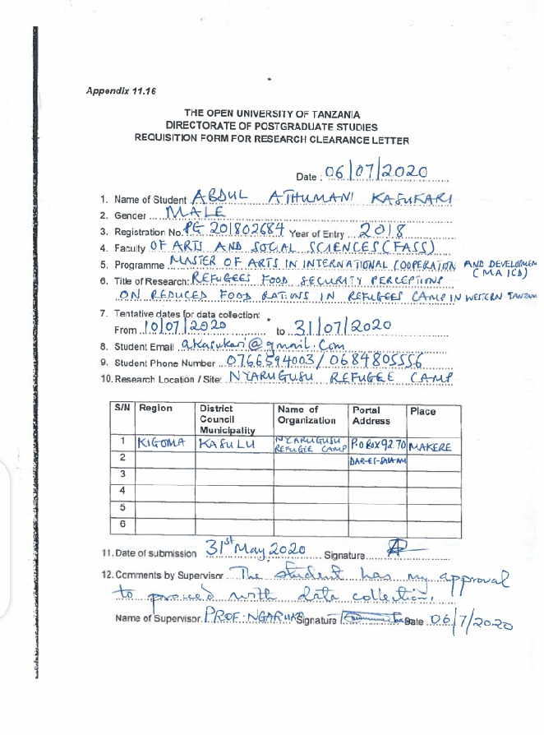

Appendix III: Research Proposal Cover Page
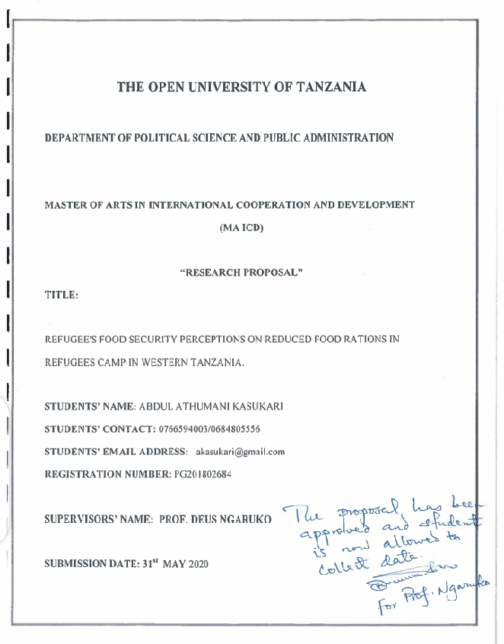

Appendix IV: Research Permit Letter from Ministry of Home Affairs for Refugees Services.
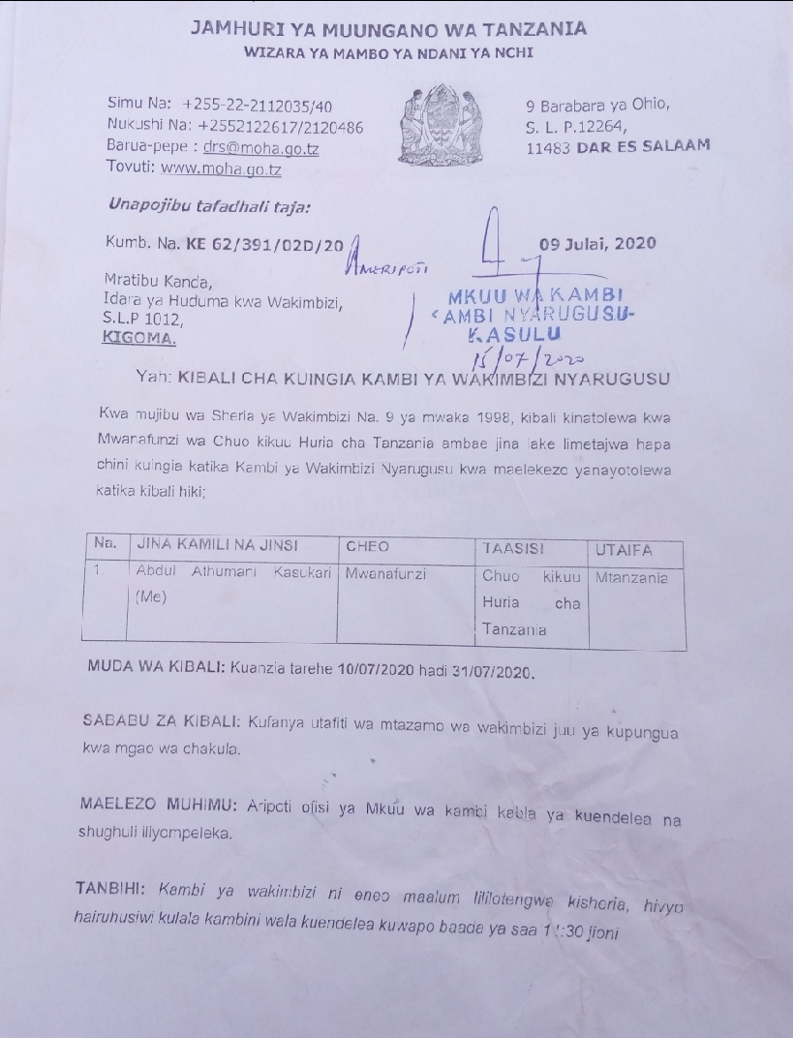

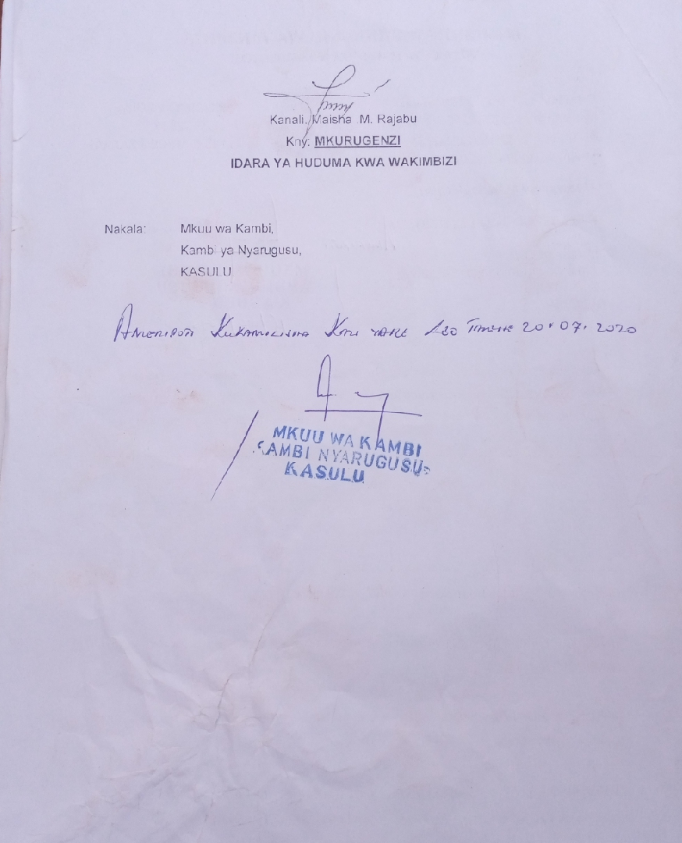

Appendix IV: Nyarugusu Refugee’s Food Ration Time Table of 13/07/2020 to 24/07/2020 as was noticed on the wall of Zone 1 Office Nyarugusu Refugee Camp.
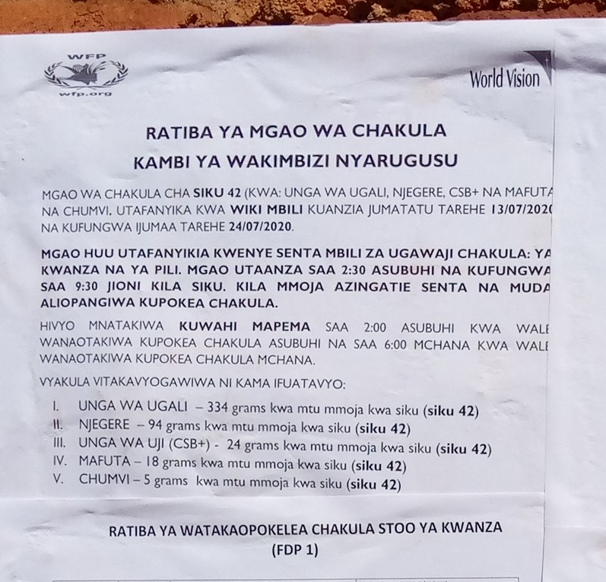

Appendix V: The goods at small market in Nyarugusu Refugee Camp located at Zone 1
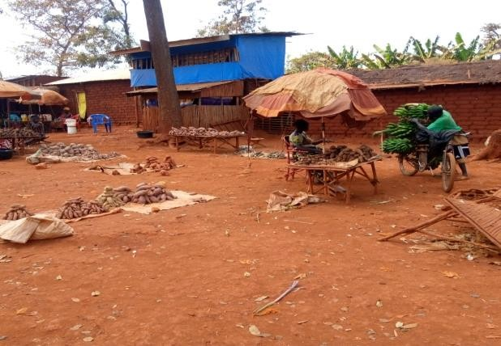
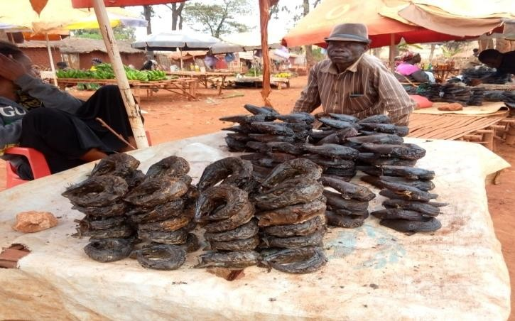
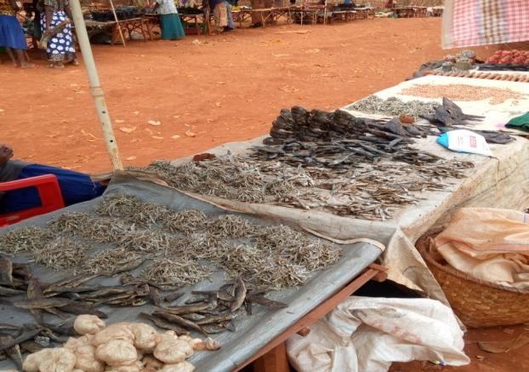
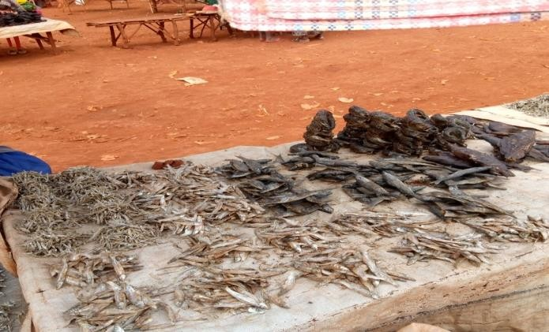
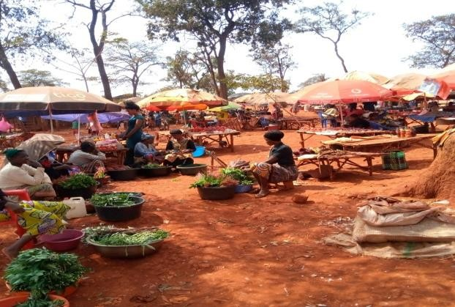
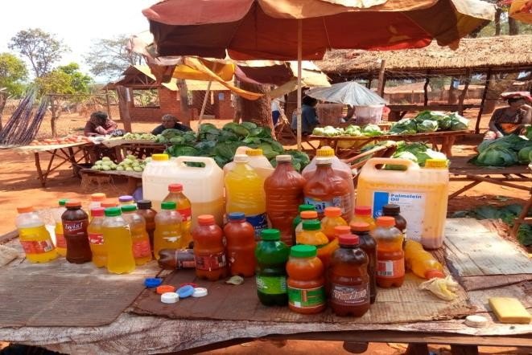
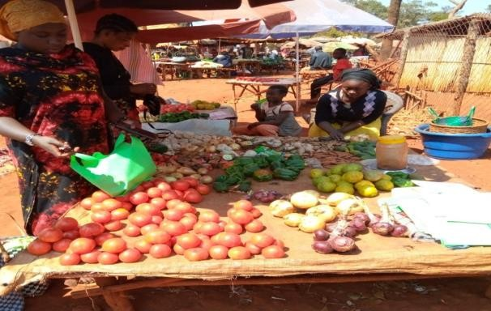
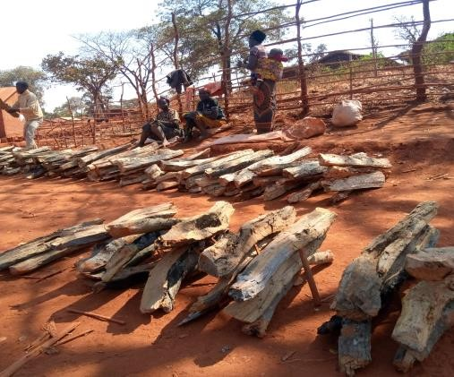

Appendix VI: Cases of home-based Vegetable Garden status in Nyarugusu
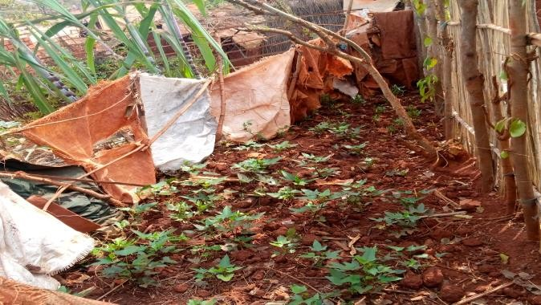
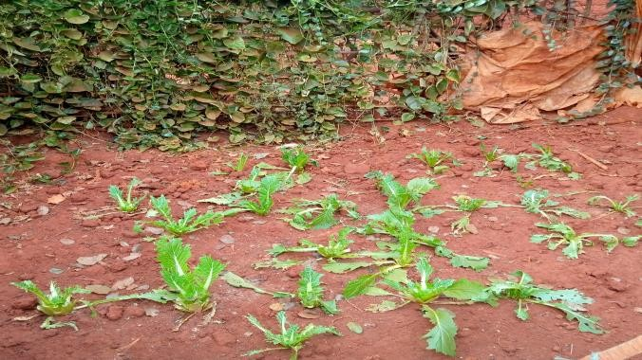
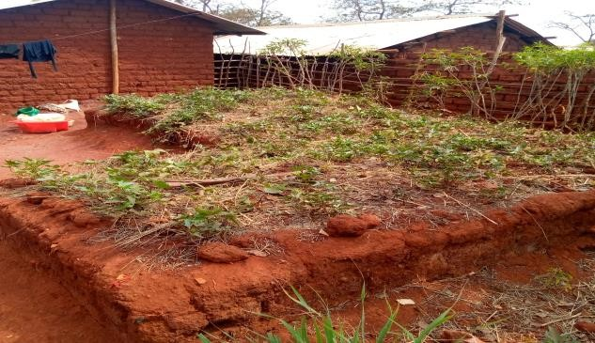
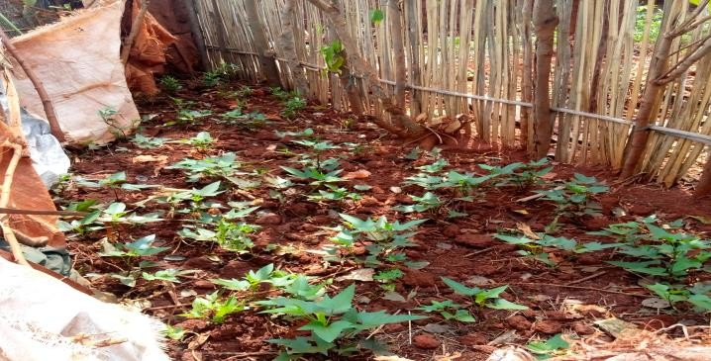
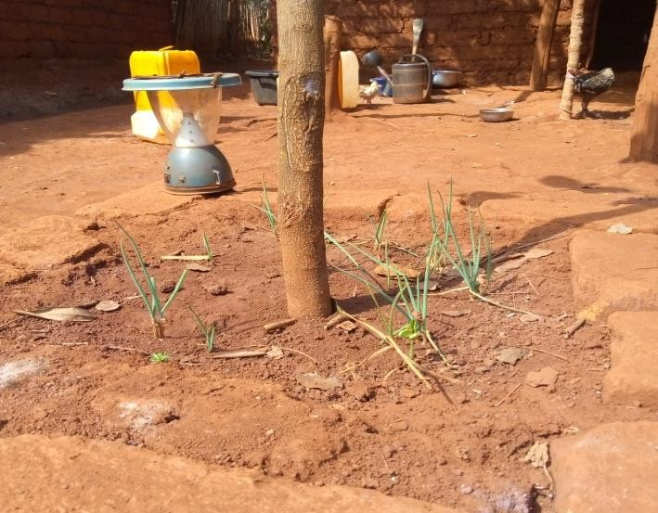
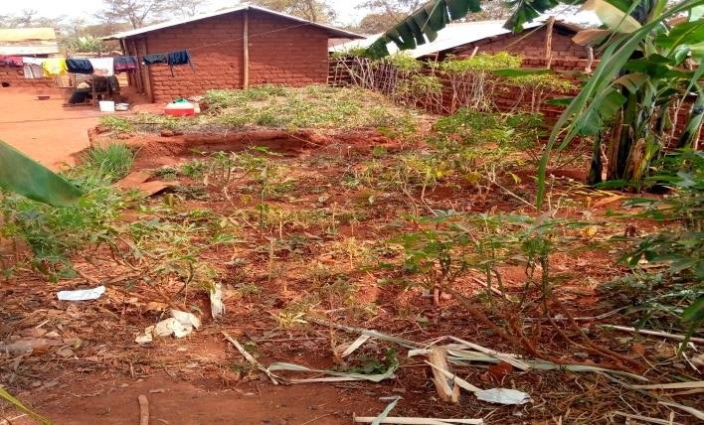
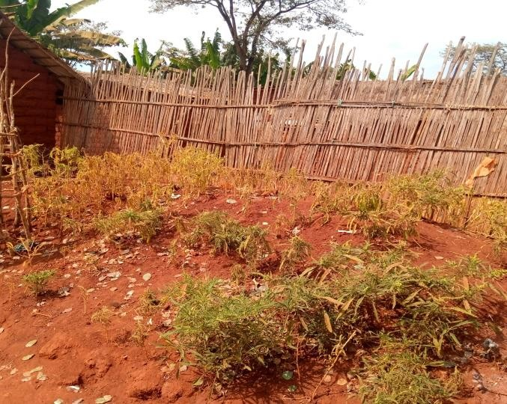
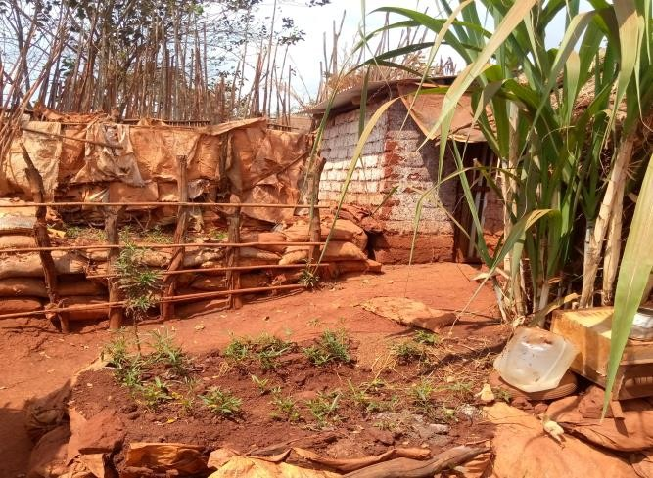
Refugee Camp

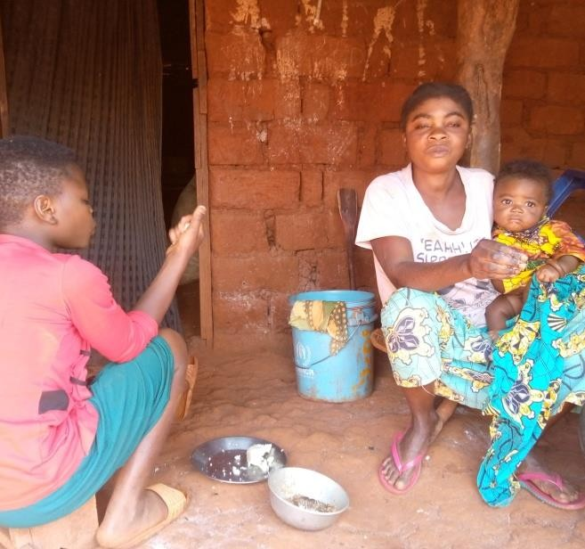
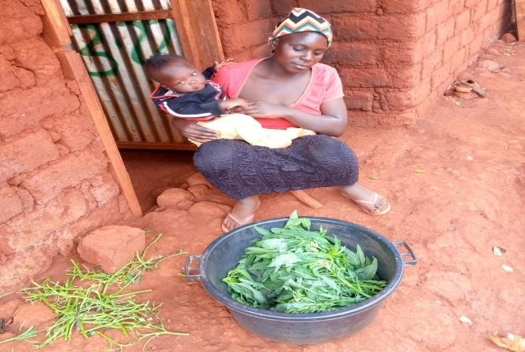
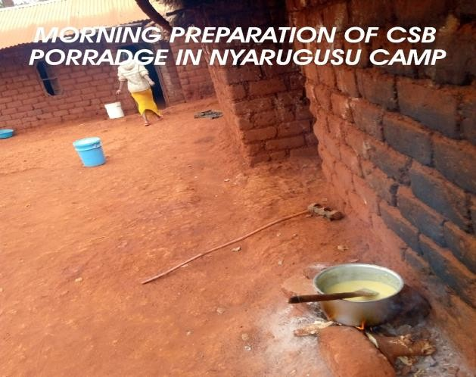
Appendix VII: Cases of women in Nyarugusu Refugee camp as responsible head of family for food searching and preparation for family members including children.

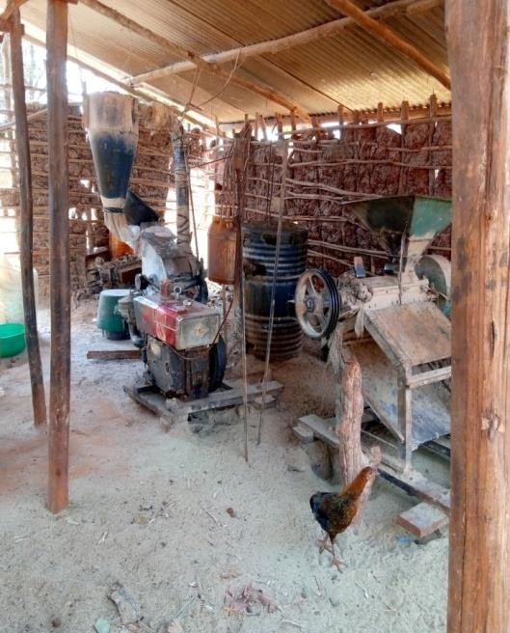
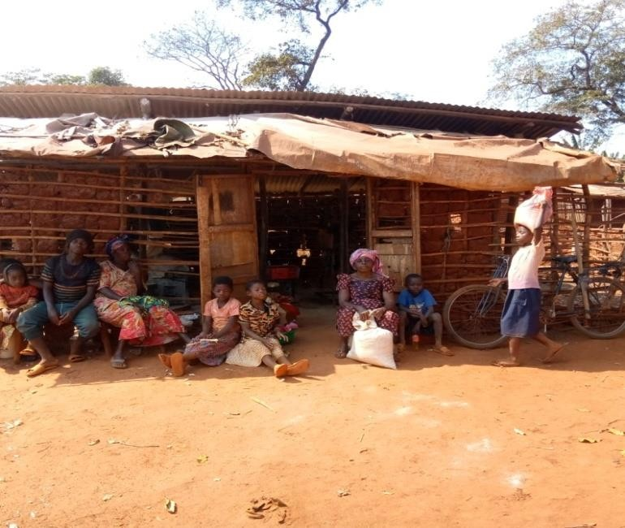
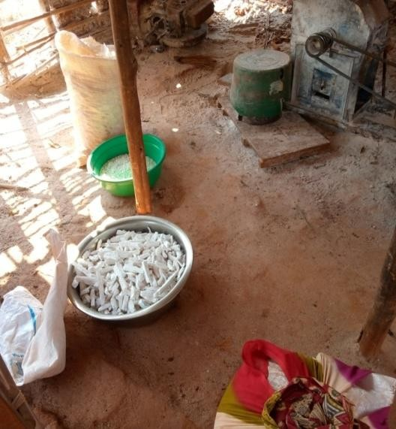
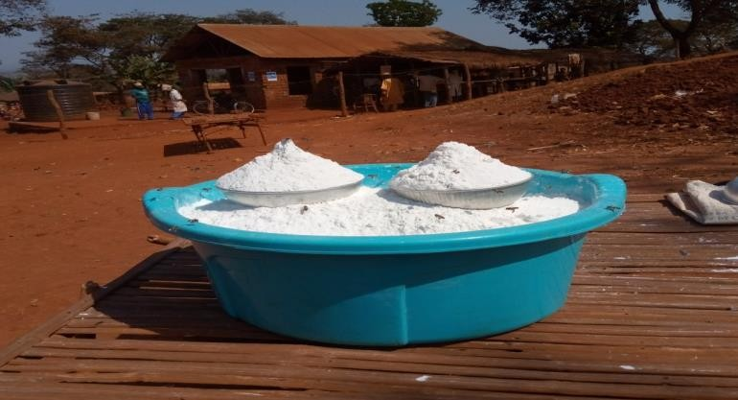
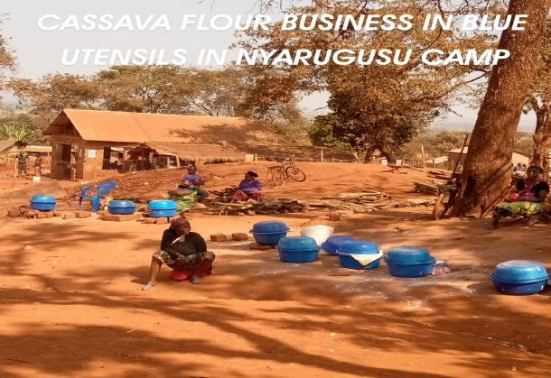
Appendix VIII: Cassava flour as substitute of maize meal in Nyarugusu Camp

Above images of Refugee at milling machine looking for cassava flour service as substitute food product from rationing maize flour.

Cassava flour sold at a destine market in Nyarugusu Camp Zone 1 for Five Hundred Tanzania per bowl.
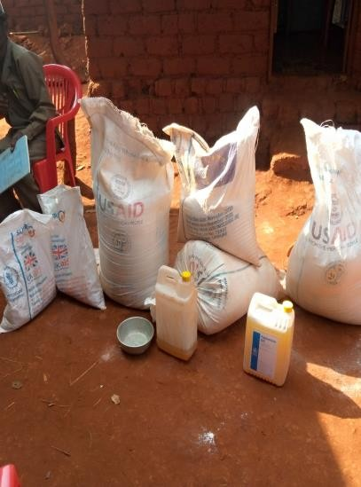
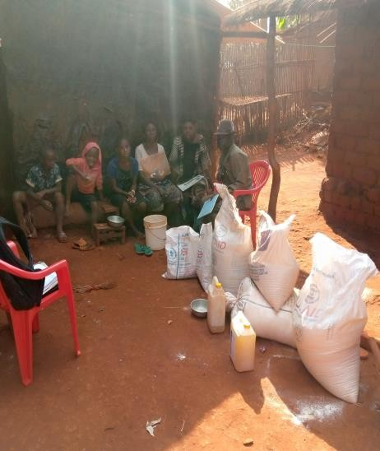
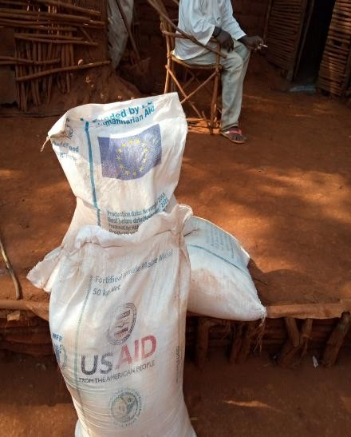
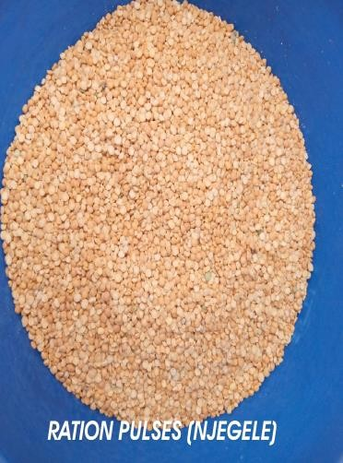
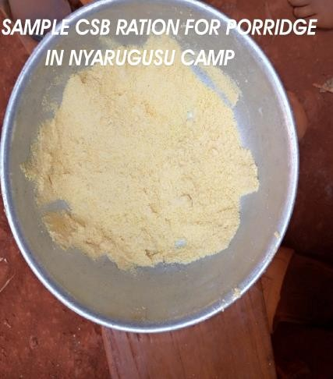
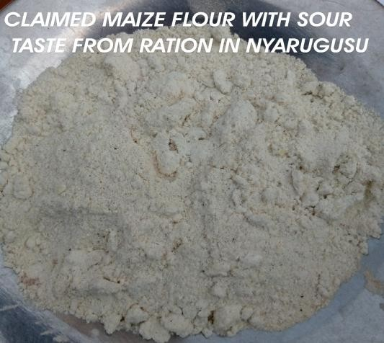
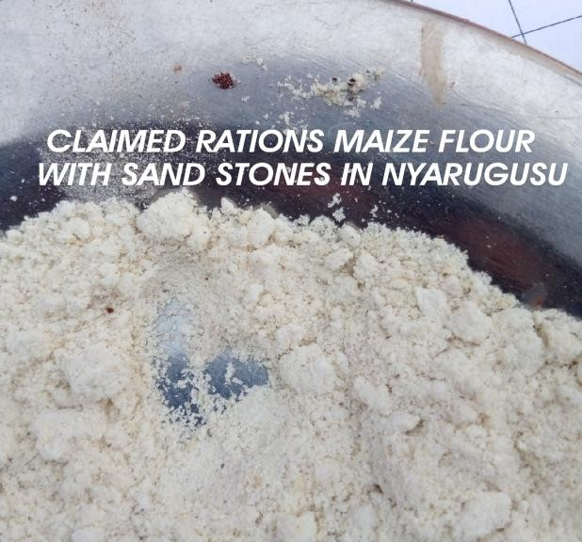
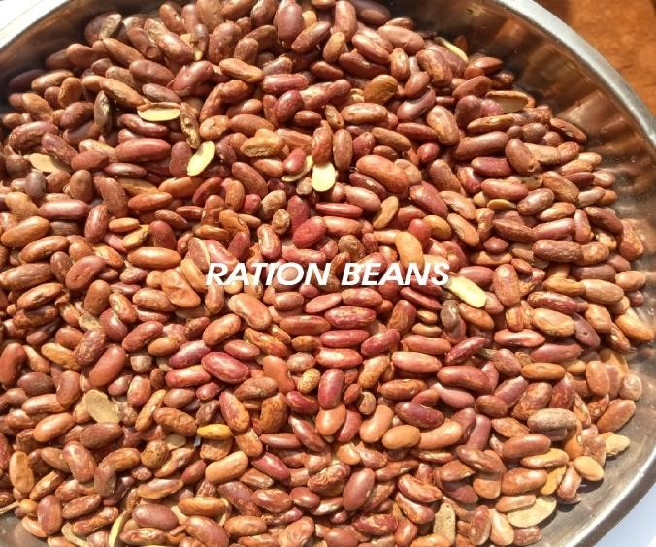
Appendix IX: Samples of package of Food Rations in Nyarugusu Refugees Camp.

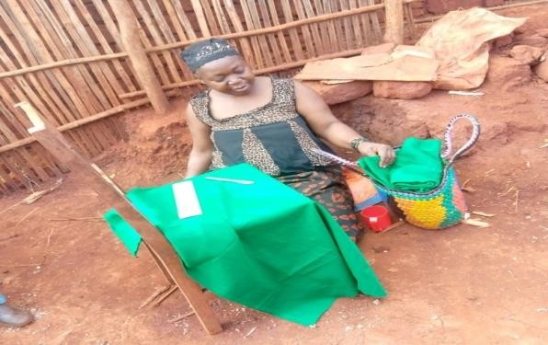
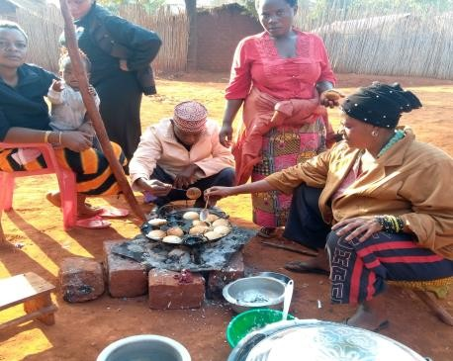
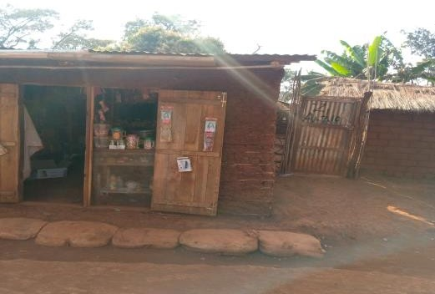
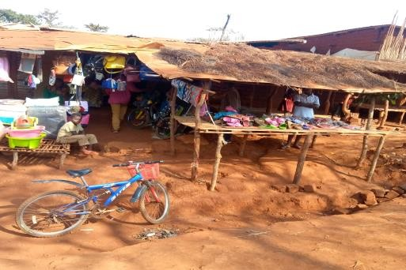
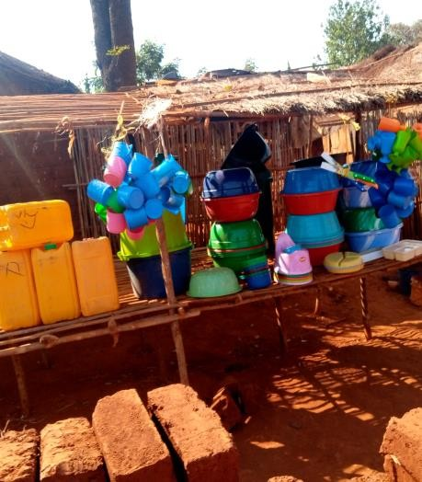
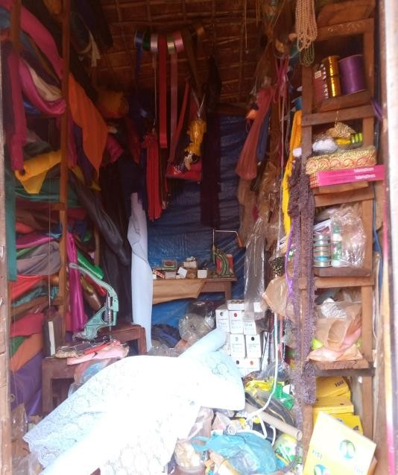
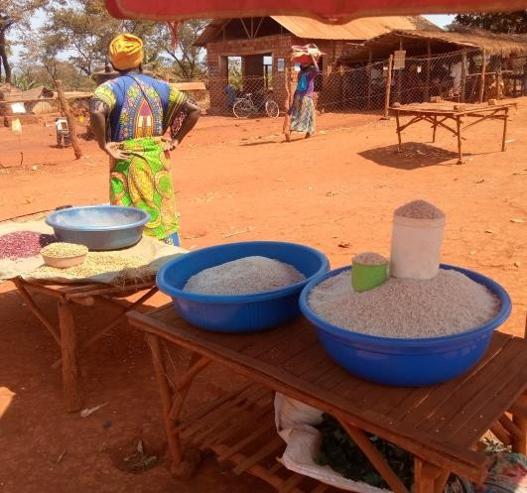
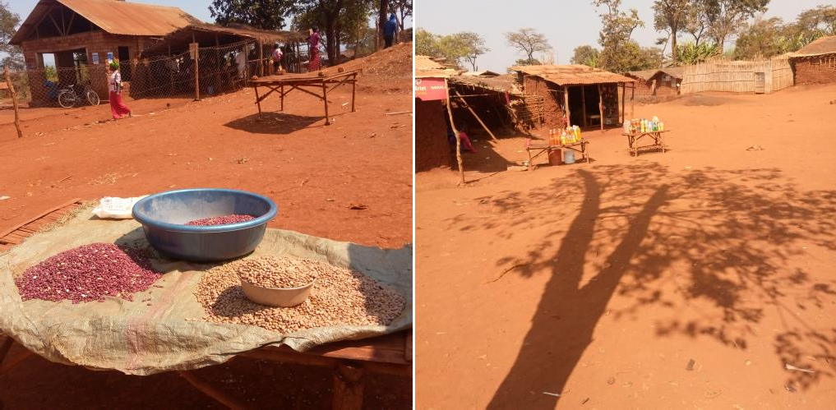
Appendix X: Samples of economic activities conducted by some of Nyarugusu Refugee camp to support their food security as located at zone 1.

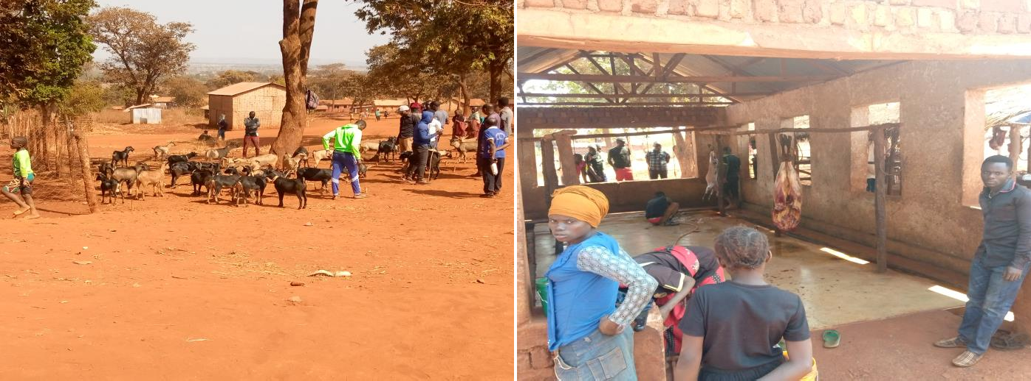
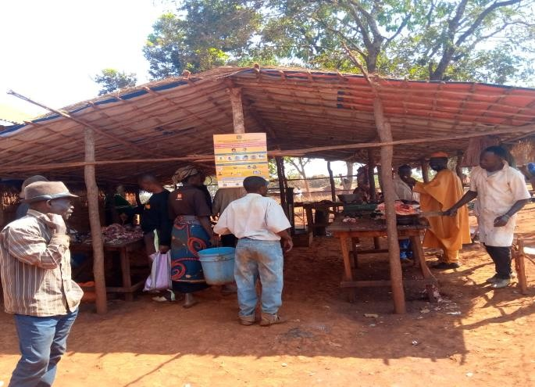
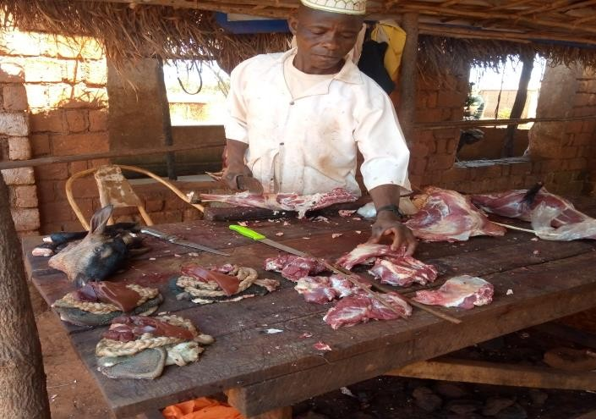
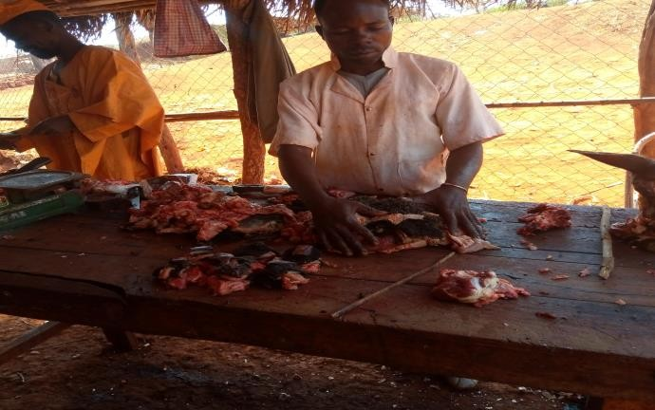
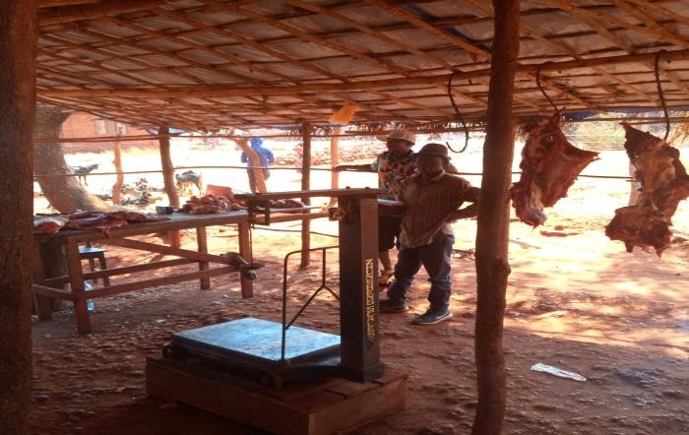
Appendix XI: Butcher of goats and cows meets as one of economic activities conducted by some of Nyarugusu Refugee camp to support their food security as located at Zone 1 Nyarugusu

Appendix XII: Selling Ration Beans business at a market located Zone 1 area in
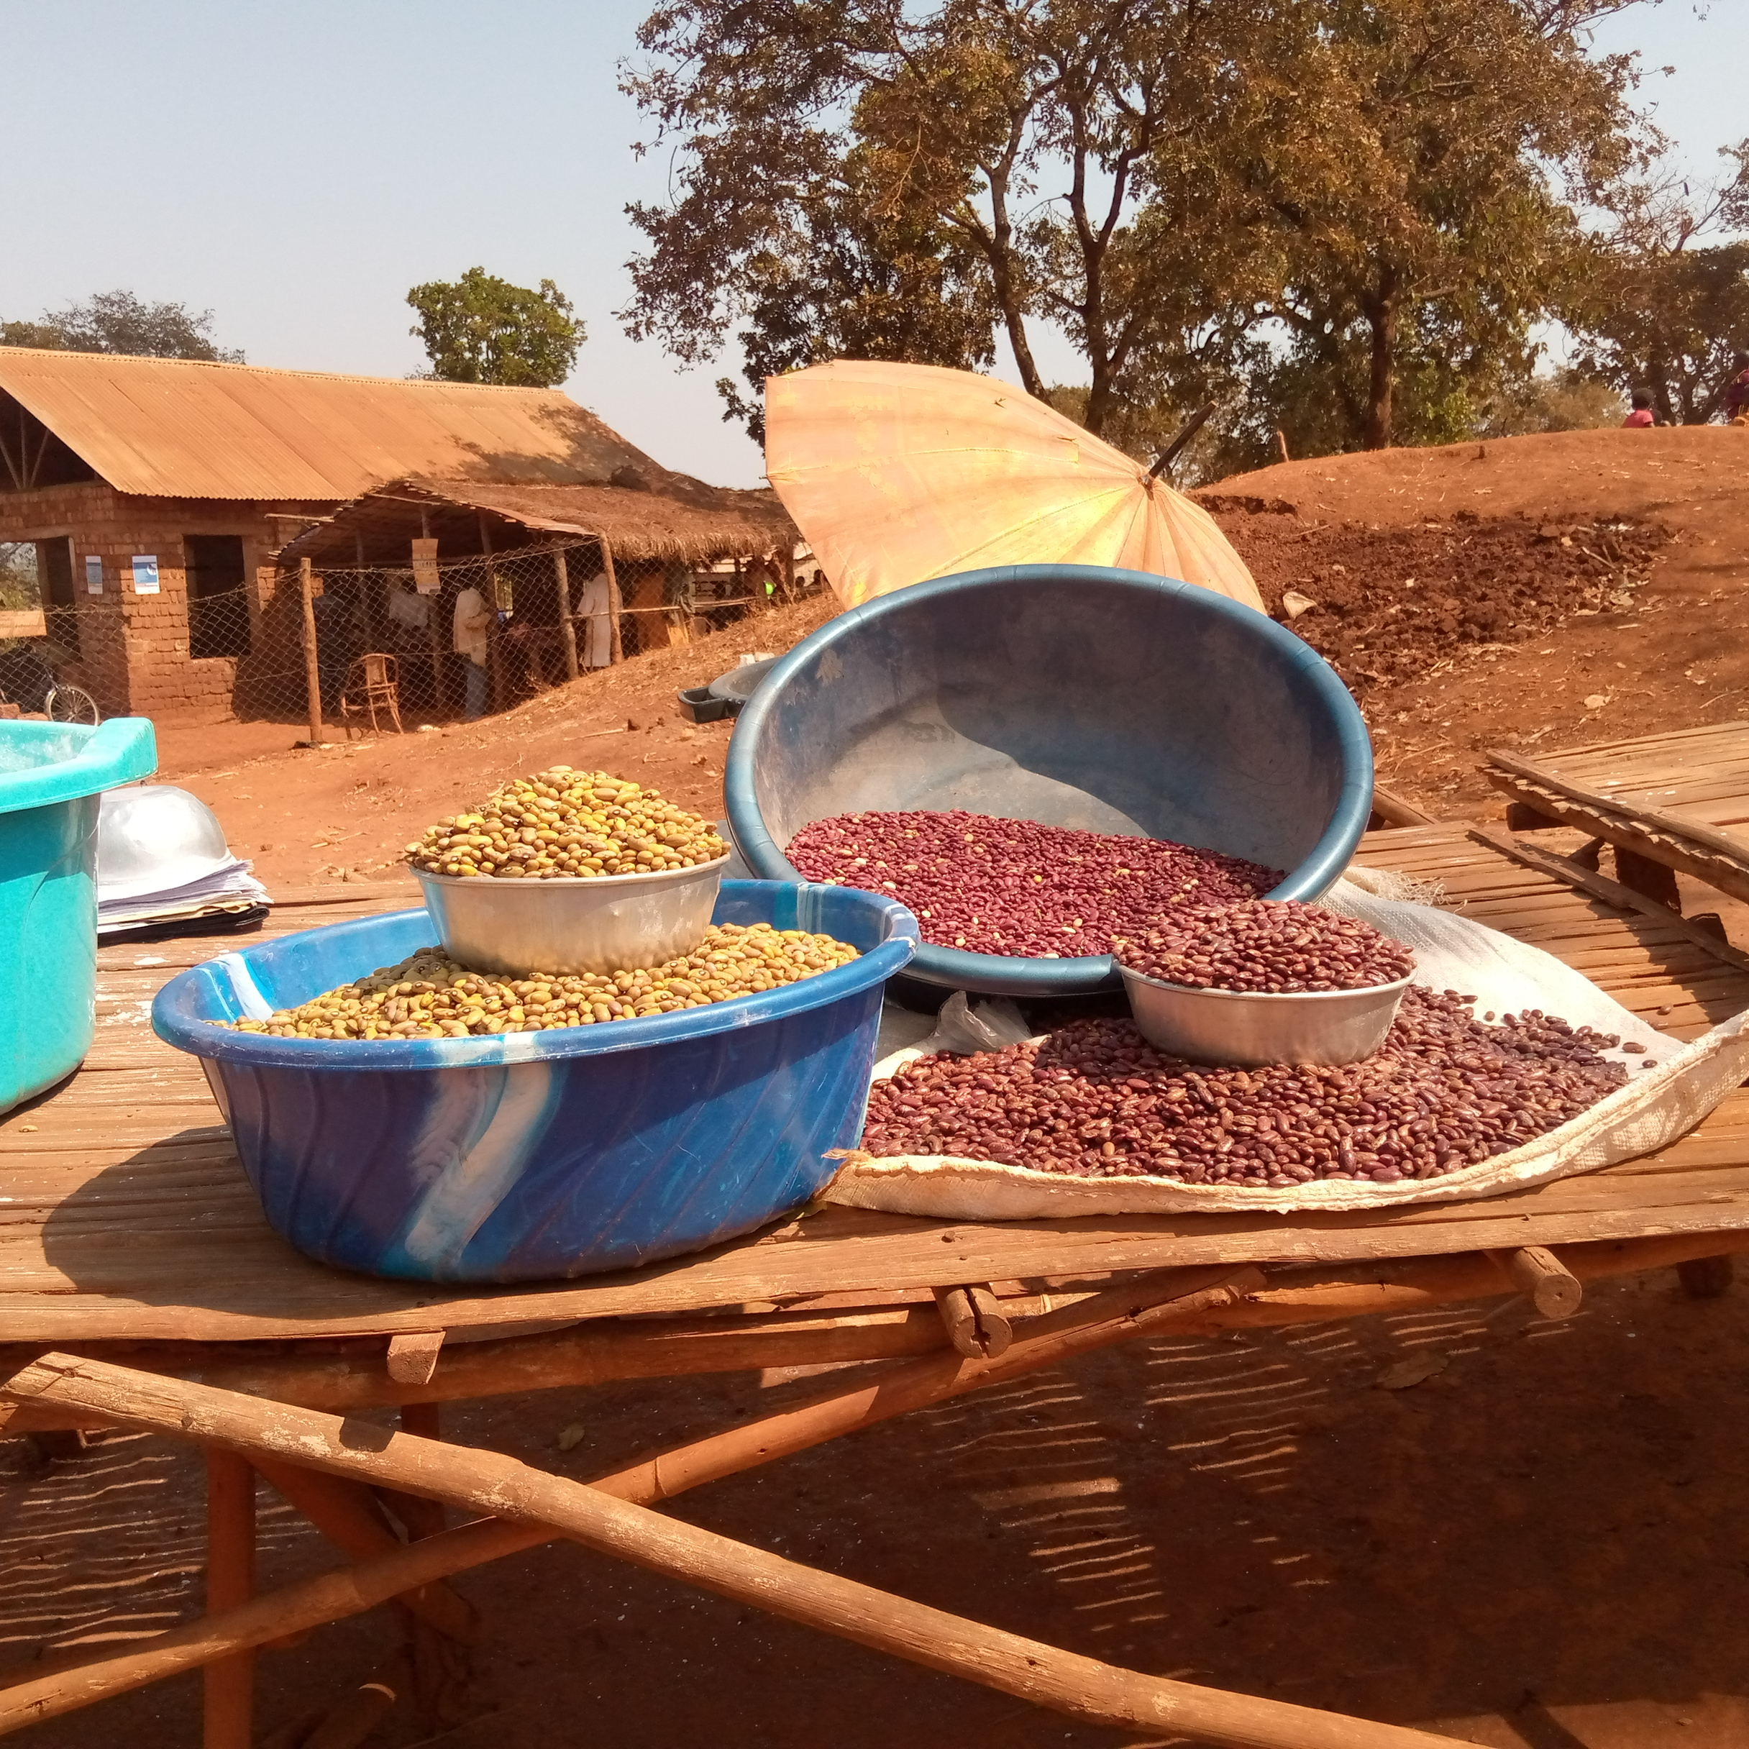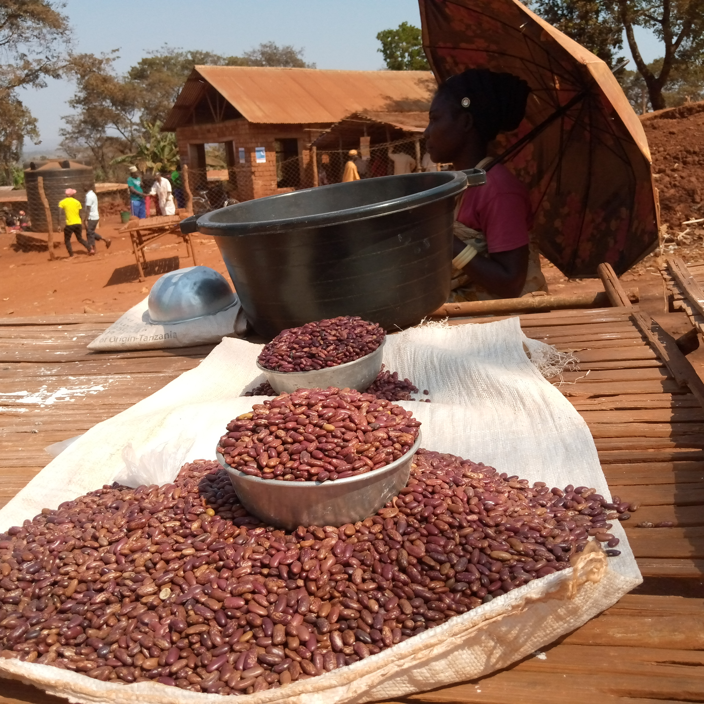
Beans at a market in Nyarugusu Refugee Camp the yellow beans sold TSH2,000/= while Rationing read beans claimed delaying cooking sold from household ration to small vendors at a market sold TSH500/= per Bowl as observed.

