TRAINING ON MODERN BATIK DECORATION TECHNIQUES: A CASE STUDY OF JEMA WOMEN GROUP- SANDALI WARD TEMEKE DAR ES SALAAM, TANZANIA

EVELYNE GEORGE MWAIMU

A DISSERTATION SUBMITTED IN PARTIAL FULFILMENT OF THE REQUIREMENTS FOR THE DEGREE OF MASTER OF COMMUNITY ECONOMIC DEVELOPMENT OF THE OPEN UNIVERSITY OF TANZANIA

2014

CERTIFICATION
The undersigned certifies that I have read and here by recommend for the acceptance by the Open University of Tanzania (OUT) A project entitles Training on Modern Batik Decoration Techniques a case study of Jema Women Group –Sandali Ward Temeke Dar es salaam in partial fulfillment of the requirements for the degree of Masters of Community Economic Development of the Open University of Tanzania.
Signature …………………………………….

Name: Dr. Leonard William Fweja

Supervisors

Date ………………………………

COPYRIGHT
This dissertation is a copyright material which is protected under the Berne Convection, the copyright Act 1999 and other International and National enactments in the behalf of intellectual property.
It should not be produced by any means in full or in part, except for short discourse with an acknowledgement, written permission of the Directorate of Post Graduate studies on behalf of both the author and the Open University of Tanzania.

DECLARATION
I Evelyne George Mwaimu, declare that this CED project report is my own original work and that it has not been presented and will not be presented to any other university for similar or any other degree award.

Signature………………………………………………………………………………

Date…………………………………………………………………………………….

DEDICATION
This study is affirmatively dedicate to my beloved husband, THOMAS JAMES SALALA and a close best friend who had toiled day and nights in rendering comfort, support advice and courage towards the completion of this work and I
pray to God to reward him best in his entire life.

AKNOWLEDGEMENT
Conducting a research or a study like this one is not a simple task. Indeed it requires social and academic assistance and or advice, hard work, determination, being objective and above all determination and absolute trust in God. Further, I understand that many people in their respective capacities have contributed a lot in helping me complete this work, however due to circumstances beyond my anticipation and control, I decline to mention them all, but, I am thankful for all their efforts and endeavours. Further, I am very obliged to mention and acknowledge the contribution of the following people.

At foremost, I greatly thank God for his immeasurable guidance he has bestowed upon me throughout the process of this study and for granting me wisdom, strength and health and indeed to him everything is possible.

Secondly and with special recognition, I ultimately thank and acknowledge the professional and broad guidance received from my Supervisor Mr. Fweja Leonard for his objective endeavours towards shaping my mind for a clear research study and for giving me the best research skills towards the writing and completion of this study.

Further, I find it prudent to acknowledge the assistance and advice received from my academic friends Mrs. Rose Kibaja, Samson Muganyizi and Ms. Florence Masamba for their endless, immeasurable but visible efforts through which I have been able to compile this work. Further, I also thank my fellow employees and especially Mr. Emmanuel Sango for spending much of his time discharging my office duties and assignments especially during the process of data collection and all his efforts stand as immeasurable inputs in this study. Lastly, I extend thanks to all those who have assisted me in one or the other and I affirmatively pray to the God reward them abundantly and create simplicity in all their social and academic problems and endeavours.

LIST OF ABBREVIATION
AIDS Acquired Immune Deficiency Syndrome
CBOs Community Based Organization
CED Community Economic Development
CAN Community Needs Assessment
DAWASCO Dar-es-Salaam Water and Sewerage Company
FGD Focus Group Discussion
GDP Gross Domestic Product
HBS Household and Budget Survey
HIV Human Immune Virus
ILO International Labour Organization
JWG Jema Women Group
LFM Logical Framework Matrix
MIS Monitoring Information System
MKUKUTA Mpango wa Kukuza Uchumi na Kupunguza Umasikini Tanzania
MOV Means of Verification
NGO Non Government Organization
NSGRP National Strategy on Growth and Reduction of Poverty
MOV Means of Verification
OVI Objectively Verifiable Indicator
PEDP Primary Education Development Plan
SACCOS Saving & Credit Cooperative Society
SIDO Small Industries Development Organization
SME Small and Medium Enterprises
SPSS Statistical Package for Social Science
SWOC Strength Weakness Opportunities and Challenges
TAG Tanzania Assemblies of God
TANESCO Tanzania Electric Supply Company
URT United Republic of Tanzania
VICOBA Village Community Bank

ABSTRACT
The CNA was conducted with the overall objective of gathering facts from Sandali ward community on the existing livelihood enhancement opportunity’s needs as reflected by the problems in the community it also aimed at analysing causes and identify community assets which will enable identify a specific project that will effectively address the problems of limited livelihoods improvement. Based on the participatory findings of the CAN it was established that production of batik clothes of low quality which is associated with low income earnings due to inadequate of knowledge and skills on batik production was the most pressing need for the CBO. To address this problem the project titled “Training on modern batik decoration techniques” Sandali Ward, Temeke district was set with the main goal of improving livelihood of Sandali ward community.
Strategies used to implement this project include financial resources mobilization, preparation of training manual according to the needs of the target group and undertaking training for the target community. Participants of the training were stakeholders of batik production project in Sandali ward, Temeke district. The main outputs of the project were production of quality batik products(clothes), quantitative supply of batik clothes, improving social livelihood of group members, improving production capacity through innovation and training, acquisition of advanced batik production techniques.

TABLE OF CONTENTS
Supervisors Certification i
Statement of Copyright ii
Declaration iii
Dedication. iv
Aknowledgement v
List of Abbreviation vii
Abstract…. ix
Table of contents x
List of Tables xvi
List of Figures xvii
CHAPTER ONE : PARTICIPATORY NEED ASSESSMENT 1
1.1 Introduction 1
1.2 Community Profile of Sandali Ward 2
1.2.1 Location 2
1.2.2 Climate and Precipitation 2
1.2.3 Topography and Vegetation 3
1.2.4 Population in the Ward 3
1.2.5 Administrative set-up of Local Government 3
1.2.6 Social Services Available in Sandali Ward 4
1.2.7 Other Institutions 5
1.2.8 Water Supply 5
1.2.9 Power Supply 6
1.2.10 Economic activities 6
1.2.11 Livestock keeping 6
1.2.12 Agriculture 7
1.2.13 Ethnicity and Religion 8
1.2.14 Security Status 8
1.2.15 Markets 8
1.2.16 Financial Services 9
1.3 Community Needs Assessment 9
1.3.1 Overall CNA Objective 9
1.3.1.1 Specific objectives 9
1.3.2 Research questions 10
1.3.3 Research Methodology 10
1.3.3.1 Research Design 10
1.3.3.2 Sampling Techniques and Sampling Size 11
1.3.3.3 Data Collection Methods 11
1.3.3.4 Data Analysis Methods and Presentation 13
1.4 Community Needs Assessment Findings 13
1.4.1 Respondents education 13
1.4.2 Age of Respondents 14
1.4.3 Respondent Marital Status 15
1.4.4 Size of Households 15
1.5 Identified Problems 16
1.5.1.1 Lack of Security 17
1.5.1.2 Poor availability & accessibility of clean and safe water in the commun 18
1.5.2 Respondents engagement in economic activities 18
1.5.3 Income poverty 19
1.5.3.1 Respondents’ views on their income level 19
1.5.3.2 Poor availability and Accessibility of Financial Services 19
1.6.1 Summary 21
CHAPTER TWO : PROBLEM IDENTIFICATION 22
2.1 Background to Research Problem 22
2.2 Problem Statement 22
2.3 Project Description 23
2.3.1 Stakeholders analysis 23
2.3.2 The Target Community 23
2.3.3 Project Goal 25
2.3.4 Project Objectives 25
2.3.4.1 Specific objectives 25
2.4 Host Organization 25
2.4.1 The name of the Group 25
2.4.2 Location 26
2.4.3 Membership 26
2.4.4 The Group Vision 26
2.4.5 The Group Mission 26
2.4.6 Group Activities 27
2.4.7 Group Annual Income 27
2.4.8 The Group Values Statement 27
2.4.9 Membership 27
2.4.10 Group Challenges 29

CHAPTER THREE : LITERATURE REVIEW 31
3.1 Introduction 31
3.2 Theoretical review 31
3.2.1 The Livelihoods System Framework 31
3.2.2 The Sustainable Livelihoods Systems Framework 32
3.3 Empirical Literature 32
3.3.1 Batik Influences 33
3.3.2 Small -Scale Batik Clothes in Developing Economies 33
(i) The importa nce of Batik Clothes Production 33
3.4 Policy Review; 37
3.4.1 The Tanzania 2003 SME Development Policy: 37
3.4.2 Community Development Policy 37
3.4.3 National Strategy for Growth and Reduction of Poverty 38
3.5 Literature Review Summary 39
CHAPTER FOUR : PROJECT IMPLEMENTATION 41
4.1 Introduction 41
4.2 Products and Output 42
4.2.1 Products: 42
4.2.2 Outputs: 42
4.3 Project Planning 43
4.3.1 Project Implementation Plan 43
4.3.2 Implementation Plan – Logical Framework Matrix (LFM) 44
4.4 Inputs Requirements for Project Implementation 47
4.5 Staffing Pattern 47
4.6 Project Budget 48
4.7 Project Implementation Report 49
(i) Drying Procedures 58
4.8 Project Implementation Ghantt Chart 59
4.9 Summary 61
CHAPTER FIVE : PROJECT PARTICIPATORY MONITORING, EVALUATION AND SUSTAINABILITY 63
5.1 Introduction 63
5.2 Participatory Monitoring 63
5.2.1 Monitoring Information System 65
5.2.2 Participatory Monitoring Methods Used 65
5.2.3 Participatory Monitoring Plan 66
5.3 Monitoring results 68
5.4 Participatory Evaluation 69
5.4.1 Performance Indicators 70
5.4.2 Participatory Evaluation Methods 70
5.4.2.2 Field visit 71
5.5 Project evaluation Summary 72
5.5.1 Evaluation results 74
5.3 Project Sustainability 74
5.3.1 Economic Sustainability 74
5.3.2 Social Sustainability 75
5.3.3 Environmental Sustainability 75
5.3.4 Sustainable Development 75
5.3.5 Strategic Planning and Management 76
5.4 Sustainability Indicators 76
5.4.1 Project Achievement: Percentage of Batik clothes Producers Enhanced Knowledge on Batik Clothes Decorations Techniques 76
5.4.2 The link with Municipal council Technical Officials 77
CHAPTER SIX : CONCLUSION AND RECOMMENDATIONS 78
6.1 Introduction 78
6.2 Conclusion 78
6.3 Recommendations 79
REFERENCES 85
APPENDICES 84

LIST OF TABLES
Table 1. 1 Population in Temeke District 3
Table 1. 2 Number of Pupils by Primary Schools 2013 4
Table 1. 3 Number of Pupils by Secondary Schools 2013 5
Table 1. 4 Respondents education 13
Table 1. 5 Age of Respondent 14
Table 1. 6 Respondent Marital Status 15
Table 1. 7 Size of Households 16
Table 1. 8 Identified problems Ranking 16
Table 1. 9 Respondents’ opinions on the status of security in the Community 17
Table 1. 10 Respondents’ opinion on the Status of Accessibility and availability of clean and safe water in Sandali Ward 18
Table 1. 11 Rating of income levels Vs. Basic needs 19
Table 1. 12 availability and accessibility to financial services in the community 20
Table 1. 13 Community Needs Ranking 21
Table 2. 1 Stakeholders of Jema women Group 23
Table 2. 2 Demographic Characteristics of Jema Women Group 26
Table 2. 3 Assessment of Jema Women Group using the (SWOC) Analysis 28
Table 5. 1 Participatory Monitoring Plan 67
Table 5. 2 Performance Indicators 70

LIST OF FIGURES

Figure 2. 1 Organization Structure of Jema Women Group..................................28
Figure 4. 1 An expert of batik clothes lecturing to JWG members during class session training;........... 51
Figure 4. 2 JWG members observing clothing materials and taking notes during class training............ 52
Figure 4. 3 An instructor demonstrates to trainees by removing decorated batik clothes from aluminum pot with mixture of hot water. In right photo a trainer rinse cloth in cold water................ 53
Figure 4. 4 JWG members and CED student practicing in pinching activity during practical training Source: Study findings, 2014 54
Figure 4. 5 An instructor demonstrates to trainees on how to put colours in batik clothes. In right photo a trainer practiced the taught procedure by using tea spoon during practical training. Source: Study findings, 2014 54
Figure 4. 6 A trainer demonstrates tie and dye method by placing tied batik cloth into containers with solution of colours during practical training. 55
Figure 4. 7 A trainer stamped cloth by using candle method. 56
Figure 4. 8 JWG members participate in stamping activity. 57
Figure 4. 9 Trainer demonstrates the washing and rinses procedures after taught on clothes decoration techniques. 57
Figure 4. 10 Trainees o f JWG members placing Batik clothes on the ground for drying under close supervision of trainer. 58
Figure 4. 11 CED researcher Ms. Evelyn Mwaimu inspects batik clothes and enjoying outputs of JWG after implementation of the project. 59

CHAPTER ONE

PARTICIPATORY NEED ASSESSMENT

1.1 Introduction
According to carter, (1992), the participatory needs assessment is a process of an assessment of the current situation which involves the task of asking the community members about their daily life and is aimed at discovering important issues/challenges and needs of a certain community so that the results of assessment would guide future action planning. The participatory needs assessment is a participatory approach by which the members of the community are fully engaged in identifying their problems along with the most pressing needs and collectively devise means of addressing their problems and attaining the identified pressing need.

The underlying importance of the participatory or the community needs assessment or is aimed at engaging the community members in identifying their problems along with the most pressing needs. The participatory approach also helps the community members in gathering information on the existing needs in society and devising means of attaining them. Further, the participatory approach helps the community members in designing deliberate action plan on how to attaining the identified community needs ad this involves giving priority to the selected activities in the intended action plan.

The participatory needs assessment which was conducted in this study aimed at identifying the problems and needs of community members in Sandali ward and set up a project to address the most pressing need identified by the community members in Sandali Ward.

1.2 Community Profile of Sandali Ward

1.2.1 Location
Sandali Ward is one of the eight (8) wards of Chang’ombe Division, Temeke Municipality, which is one of the three Municipalities of Dar es Salaam City including Ilala and Kinondoni. Sandali Ward constitutes twelve Sub-wards called ‘Mitaa’ namely: Sandali, Veterinary, Mkwinda, Mamboleo A, Usalama, Tindwa, Mwembeladu, Mwembemnofu, Mpogo, Kimbung, Mamboleo B and Kisiwani. Sandali ward is has land area of 6.4Km². In respect to ecological zones the ward is located in northern part of Temeke Municipality and the ward shares borders with Tandika and Temeke wards in the East, Kiwalani and Yombo Vituka wards in the West, Nyerere Road in the North and in the South is bordered with Tandika ward. Its geographical location lies between 39º12' - 39º33' east and 6º48' -7º33' south. The area is characterised by sandy soil, low water holding capacity, high water table and poor soil fertility. (Source: Temeke Municipality Profile, 2012).

1.2.2 Climate and Precipitation
The ward experiences a Tropical coastal belt of Tanzania, with dual and erratic conventional rains, short rains start from October to December while long rain season is between March and May. The average rainfall is 1000 mm the lowest being 930 mm and highest 1200mm. Humidity is around 96% in the mornings and 67% in the afternoons. Temperature just like rainfall is also influenced by ocean. High temperature prevails throughout the year ranging from 25⁰C during the period of June to August up to 35⁰C in the period of October to March. The climate is also influenced by two monsoon winds; the South-Westerly Monsoon winds from April to October and North-Westerly Monsoon winds from November to March. (Source: Temeke Municipality, Profile 2013)

1.2.3 Topography and Vegetation
The main natural vegetation of Sandali ward includes coastal shrubs, swamps, Miombo woodland and mangrove trees. (Source: Temeke Municipality, Profile 2013)

1.2.4 Population in the Ward
According to the 2012 Population Census, Temeke Municipality had a population of 1,368,881 people where by 669,056 are male and 699,825 were female. The population growth rate for Temeke Municipality was 3.9% base year 2012. Based in this population growth rate, the total population for Sandali ward in 2012 was 52,600 people whereby 26,000 were males and 26,600 were females. The effect of higher population densities continually is allied with extensive poverty and other serious social problems such as crimes, leading to unsustainable development the situation we are facing in Sandali currently. The rapid population increase is influenced by both natural causes and migration (birth and migration rates). Based on Population Census for Temeke District as at the 2012, Sandali ward population data is shown in

Table 2. (Source: National Population Census, 2012)
Table 1. 1 Population in Temeke District
 | Males | Females | Total
Temeke Municipal | 669,056 | 699,825 | 1,368,881
Sandali Ward | 26,000 | 26,600 | 52,600
(Source: National Population Census, 2012)

1.2.5 Administrative set-up of Local Government
In urban areas the lowest unit of Local Government is the ‘Mtaa’ or neighbourhood. Section 14 (3) of the Local Government (Urban Authorities) Act No. 8 of 1982 stipulates that, ‘the area of an urban ward shall be divided into ‘Mtaa’ consisting of a number of households, which the urban authority may determine. The administrative structure of the Local Government in Temeke Municipality at division and ward level sees.

1.2.6 Social Services Available in Sandali Ward
The basic services which available in the ward are; education facilities, health, infrastructures, safe water, communication network, trade, security informal sectors development, waste management, source of energy, financial services, cooperates and civil organizations ,recreation places and productive sectors such agriculture and market, just to mention few.
(i) Education
The ward has two primary schools and one secondary school which are government owned. There are 4,768 pupils of which 2,439 (48.8%) are girls and 2,209 (51.1%) are boys in primary schools as shown in Table 1.2 below. While in Temeke secondary there 2,646 pupils of which 1,334 (50.4%) are boys’ and 1,305 (49.6%) are girls. The statistics show that the number of enrolment of primary school pupils has been increasing from year to year since the inception of Primary Education Development Plan (PEDP) though also the number of girls being enrolled is higher compared to boys.

Table 1. 2 Number of Pupils by Primary Schools 2013
Primary school name | Number of pupils |  | Total
Primary school name | Boys | Girls | Total
Sandali | 1,337 | 1,368 | 2,705
Veterinary | 992 | 1,071 | 2,063
Total | 2,209 | 2,439 | 4,768

Source: Sandali Ward Profile, 2013

Table 1. 3 Number of Pupils by Secondary Schools 2013
Secondary school name | Number of pupils |  | Total
Secondary school name | Boys | Girls | Total
Temeke | 1,334 | 1,305 | 2,646
Source: Sandali Ward Profile, 2013
(ii) Health Services
Sandali ward has a total of five health facilities which are public and private. There four private dispensaries in the Sandali ward and one nearby public health centre which provides health services to the community. Whereas referral cases from dispensaries are forwarded to Temeke Municipal Hospital whereas other complicated cases are directly forwarded to Muhimbili National Hospital. (Source: Personal Interview with Ward Health Officer – February 2013)

1.2.7 Other Institutions
There are eleven churches including Catholic mission and TAG, ten mosques which are used by community for worships, three NGOs and two CBOs which provide services to community in different aspects to improve livelihood such as serve orphans and homeless/street children, they also serve widows, and HIV patients, create awareness in HIV/AIDS in the community and provide training to community in business management and education in artists copyright protection and hunting activates in Selous game reserve.
(Source: Observation and personal interview with ward Development Officer and Ward Executive Officer– February 2013).

1.2.8 Water Supply
The ward is experiencing reliable clean and safe water supplied from Dar es Salaam water and Sewerage Company (DAWASCO). Sandali sub-wards (Mitaa) are getting some of its water from the pipe system offered by different NGOs and private water suppliers who provide services to the community. Other sources of water are from three bore holes which are located in Veterinary, Mbunga and Mbembeladu sub-wards, but their water are of low to high salinity. (Sources: Ward Health Officer – February 2013).

1.2.9 Power Supply
The main source of power for lightening is electricity which is generated, transmitted and supplied by Tanzania Electric Supply Company (TANESCO). Community members commonly use charcoal, kerosene, gas and firewood for cooking and as a source of energy. (Source: Personal Interview with Officer, February 2013 and Ward Development Reports 2013)

1.2.10 Economic activities
Various economic activities are conducted in Sandali ward including fishing, petty businesses example Shops with various commodities, food sellers, ‘Mama Lishe, foods, fruits and batik, livestock keeping such as cattle, chicken and ducks. Also crop production such as cultivation of batik like Amaranths Potato leaves, Chinese and pumpkins leaves through irrigation (Source: Ward Development Reports, 2013).

1.2.11 Livestock keeping
Various livestock are kept to both commercial and domestic use purposes. Livestock kept include: Dairy Cattle, Goats, Pigs and Poultry such as chickens both indigenous and improved ducks. Livestock as an important component of agriculture contributes about 20 - 30 per cent of milk supply in the Municipality.

1.2.12 Agriculture
Agriculture is still an important economic activity especially in the peri-urban area of the municipality. According to Temeke Municipal Profile of 2012, out of the municipals’ 656,000 hectares of land, 40,000 ha are potential arable land for agriculture. However, only 28,000 ha (70%) are used for crop production due to rapid expansion of urban related activities.

Agricultural provides the municipal with employment of about 14.5% of the population who are engaged in agricultural activities. Also agricultural contributes 28% of the total food requirements to municipal, while the remaining portion is obtained from outside the municipal. Temeke municipality is engaged more in batik production such as Amaranths, Potatoes leaves, Chinese cabbage, Pumpkins and egg plants. However, the municipal agricultural productivity faces some major challenges which among them being: high rates of urban expansion resulting to decline in land for agricultural production, land degradation due to high population density and human activities, inadequate knowledge on improved farming technologies among farmers and progressive increasing urban related activities which lead to encroachment of areas potential for agricultural practices. Thus, majority were producing the batik in area around which planned for settlements (Source: Interview with ward Agricultural Officer, February 2013).

Based on the 2002 statistics from, Bureau of Statistics, the total GDP of Dar es Salaam was Tshs. 1,459,013 million which represent 16% of the National GDP. The survey indicated GDP per capital for the Dar es Salaam to be Tshs.584.086 with 35% of the population earning an average income of 387.319 per annum (about 20,000 per month). (Source: Dar es Salaam City Profile 2004).The Household and Budget Survey (HBS) 2007 showed a limited decline in income poverty in all areas between 2010/01 and 2007/08. The proportion of the population below the basic needs poverty line in Dar es Salaam city declined from 17.6 per cent to 16.4 per cent. Income poverty declined marginally due to low growth of agricultural sector which employs the majority of the poor. (Source: Poverty and Human Development Report – 2009).

1.2.13 Ethnicity and Religion
Sandali ward residents are of different ethnic groups and religions including Moslems and Christians (Source: Ward Development Report, 2013).

1.2.14 Security Status
The ward has three police posts which are located in Sandali, Mamboleo A and Mamboleo B sub wards, although the community security groups were supervised by sub ward leaders in their respective areas. However, there is a ward security committee to which a police auxiliary is a member (Ward Development Report 2013). Each sub-ward (Mtaa), has established a participatory community security to assist in securing people and their properties. Right now there are 12 participatory community security groups in Sandali ward which work in collaboration with other security forces. (Source: Personal Interview with Ward Executive Officer, February, 2013).

1.2.15 Markets
There is one market place within the Sandali ward which is found in Magenge Mapya area where people get their daily needs. Farm goods and other products are sold in the local market and residential areas near residents’ houses. (Source: Ward Development Reports and Personal interview with Ward Executive Officer, February 2013).

1.2.16 Financial Services
There is banking service in Sandali ward which are provided by Village Community Banks (VICOBA) with four groups, also there one Saving and Credit Cooperative Societies (SACCOS) and some NGOs. (Source: Personal interview with Ward Community Development Officer, February 2013 and Ward Development Report 2013).

1.3 Community Needs Assessment
CNA is a method of determining from insider’s point of view, what activities are needed and can be supported. It is a process of building partnership with communities of all gender, ages and backgrounds by promoting meaningful participation through structured dialogue guided by interview in order to gather accurate information on problems existing, underlying causes, to understand the community capacities and to hear their proposed resolutions. The identified needs were prioritised in order to identifying the most pressing need. Also CNA helps in mobilizing communities to take collective actions in solving their own problems.

1.3.1 Overall CNA Objective
The overall needs assessment objective was to gather facts from Sandali ward community on the existing livelihoods enhancement opportunity’s needs due to problems in the community, analyze causes and identify community assets which will enable identify a specific project that will effectively address the problems of limited livelihoods improvement.

1.3.1.1 Specific objectives
- To identify the problems and needs of community members in Sandali ward
- To prioritise the identified problems and needs
- To set up a project to address the most pressing need

1.3.2 Research questions
Research questions are issues that are related to research objectives. They guide the research process by addressing the variable of the study. The Researcher used the following questions
- What are the problems and needs of Community Members in Sandali Ward?
- How are the identified problems and needs prioritized by the Community Members in Sandali Ward?
- What is the pressing need that can form a base for setting up a project?

1.3.3 Research Methodology
Research methodology is a science of studying how research is done scientifically. In it, various steps are generally adopted by a researcher in studying his research problem along with the logic behind them. It clarifies the methods applied and the logic behind using a particular methods or techniques so that research results are capable of being appraised by the researcher (Kothari, 2004).

1.3.3.1 Research Design
A research design shows the way for the research work. It is the ‘glue’ that holds all the elements in a research project together. Orodho (2003) defines it, as the scheme framework or plan that is used to make answers to research problems. It involves asset of decisions regarding what topic is to be studied among what population, with what research methods, and for what purpose. Also, it provides the sampling frame and unit. Description of data collection methods and tools used, also elucidate how the data will be processed, analysed and presented. Furthermore, reliability and validity of the study are described. The research design was descriptive and cross- sectional where observation strategy and focus group discussions were used together with questionnaires, to the selected sample of the people and the secondary information from different sources at district, ward, CBO and literature review from documentary. The descriptive and cross – sectional research design was applied in the current CNA in order to obtain realistic information of real standard living of community members, their problems, priorities and suggestions for improvement. The design provided the researcher with an opportunity to collect data on wide range of behaviours, to capture a great variety of interactions and openly to explore the survey topic.

1.3.3.2 Sampling Techniques and Sampling Size
In the study both random and purposive sampling techniques were used in selecting the respondents. Random sampling method was used to get a simple random representative sample of Sandali Ward population for survey questionnaires so as to get a wider view of the information regarding their community problems and needs.

1.3.3.3 Data Collection Methods/Tools
Data collection is essential in research as it gathers specific information aimed at proving or refuting some facts.
The study used the following data collection methods:
- Questionnaires
The Researcher administered 68 Questionnaires, (see Appendix2) with a mix of open and closed-ended questions to household heads that were required to answer questions posed. Questionnaires are written in Swahili language to allow easy readable and administration to the target community.

- Interviews
The Researcher identified key informants who are knowledgeable, experienced and understanding in specific issues for interviewing, aimed at obtaining responses from direct encounter e.g. face to face question and answer sessions. In interviews, researcher asked questions orally and recorded the respondent’s answers. During interviewing, scholar extracted information, opinion, or beliefs from the respondents orally or verbally on the spot. Key informative interviews were also conducted to key informant leaders to get clarification of the issues. Key informant leaders involved ten ward government leaders, three key influential people in the ward, and 15 CBOs members. The reason for selecting these groups was because of their ability on explanation of community issues. A semi-structured interview was done using a checklist to ensure coverage of areas and missing information. All interviews were conducted in Kiswahili for the benefit of the community members.
- Focused Group Discussion
Focus Group Discussions (FGD) involved 20 people guided by the researcher. During discussions group members talked freely and spontaneously about a certain topic/issue or question. The objective of conducting FGD was to obtain in depth information on perceptions and ideas of the group. The aim of discussion also was to facilitate active sharing and promote a two way communications and transparency as key element in identifying what is working, what is not working well and areas that need to be focused on for the period of study.

A check list was developed for conducting FGDs. With community members engaged in batik production in order to gets full information on the existing needs in decoration of clothes, marketing to assess needs and develop intervention. Government leaders in the ward and technical officials such as Community Development Officer, Education Officer, Health officials, Agricultural Extension Officer and other professionals in the areas assisted in interpreting the information.

- Observation
The Researcher observed and recorded directly the various activities of the community members. Participatory mapping and transect walk combined with observation were used in order acquire background information of the area of study and have overall picture of the community. Various key features were observed for example natural resources, water sources, settlement, and different places of economic activities, CBOs location and social services like schools, churches, mosques, recreation halls and infrastructures just to mention few.

1.3.3.4 Data Analysis Methods and Presentation

1.4 Community Needs Assessment Findings

1.4.1 Respondents education
Table 1. 4 Respondents education
Respondent's Education status |  | Respondent Sex |  | Total
 |  | Male | Female | Total
 | Primary school education | 10 | 29 | 39
 | Secondary school education | 7 | 11 | 18
 | vocational Training | 1 | 1 | 2
 | University graduate | 2 | 1 | 3
 | Not attended classes | 0 | 6 | 6
Total |  | 20 | 48 | 68
Source: Study Findings, 2014
A total of 68 household heads were interviewed through questionnaires, 15 (22.1%) from Sandali, 20 (29.4%) from Mwembeladu, ‘Mtaa, from Veterinary, 20 (29.4%)’ and 13 (19.1%) from Mamboleo A. ‘Mtaa. In terms of gender distribution, 48 (70.6%) were females and 20 (29.4%) were males. With regard to education status, 39 (57.4%) pursued primary school education, 18 (26.5%) attained secondary school education, 2 (2.9%) received vocational training college education, 3(4.4%) are University graduates while 6 (8.8%) were not attended classes.

1.4.2 Age of Respondents
The age of respondents is presented in Table 1.6 Respondent’s ages ranged between 18 and 75 years. The respondents are categorized into five groups. The first group is for members with age between of 18 -25 years who comprise 19.1% of the respondents, the second and third groups is contain majority ones of respondents with age ranges of 26-35 years and 36-45 years with close percentage of 26.5 and 25 while the forth group with age of 23.5 % their age ranges between 46-59 years and the last group of respondents have 5.9% with age of above 60 + years. As shown in the Table 1.6. The age distribution generally show that the community is dominated by the active age population.

Table 1. 5 Age of Respondent
Age |  | Frequency | Percent | Valid Percent | Cumulative Percent
 | 18 -25 years | 13 | 19.1 | 19.1 | 19.1
 | 26-35 year | 18 | 26.5 | 26.5 | 45.6
 | 36-45 years | 17 | 25.0 | 25.0 | 70.6
 | 46-59 years | 16 | 23.5 | 23.5 | 94.1
 | Others ( 60 + )years | 4 | 5.9 | 5.9 | 100.0
 | Total | 68 | 100 | 100.0
Source: Study Findings, 2014

1.4.3 Respondent Marital Status
The results on marital status were summarized in the Table 1.7 below as follow: among interviewed respondents 27.9% were single, majority of respondents indicated that were married and comprise 33.8%, 2.9% were divorced while 35.3% of respondents were widow. The marital status implies that the community has a substantial number of single parent families.

Table 1. 6 Respondent Marital Status
 |  | Frequency | Percent | Valid Percent | Cumulative Percent
 | Single | 19 | 27.9 | 27.9 | 27.9
 | Married | 23 | 33.8 | 33.8 | 61.8
 | Widow | 24 | 35.3 | 35.3 | 97.1
 | Divorced | 2 | 2.9 | 2.9 | 100.0
 | Total | 68 | 100 | 100.0
Source: Study Findings, 2014

1.4.4 Size of Households
Respondent’s house hold size ranges between 1 – 6 + members. The respondents are categorized into three groups. The first group have households with 1-3 family members and comprised 19.1% of respondents, the second is the predominant group with family members between 4-5 44.1% while the third group have family member between 6 and above and comprise 36.8% of respondents see (Table 1.8). The findings show that the birth rate is so high and family planning is rarely practiced.

Table 1. 7 Size of Households
 |  | Frequency | Percent | Valid Percent | Cumulative Percent
 | 1 to 3 Members | 13 | 19.1 | 19.1 | 19.1
 | 4 to 5 Members | 30 | 44.1 | 44.1 | 63.2
 | 6 + Members | 25 | 36.8 | 36.8 | 100.0
 | Total | 68 | 100 | 100.0
Source: Study Findings, 2014

1.5 Identified Problems
Findings from CNA with a particular focus on problem identification led to six problems being identified, namely, Lack of adequate skills and knowledge on batik making, lack of security, poor availability and access to safe water, Lack of adequate capital, Inadequate entrepreneurship skills and knowledge, Lack of adequate and reliable security, Lack sustainable income generating activity.
Table 1. 8 Identified problems ranking
S/No | Type of problem | S.cores | Ranking of Needs by Numbering
1 | Lack of adequate knowledge and skills on batik making. | 21 | 1
2 | Lack of security | 14 | 2
3 | Poor availability and access of clean and safe water | 11 | 3
4 | Lack of adequate capital | 10 | 4
5 | Inadequate entrepreneurship skills and knowledge | 7 | 5
6 | Lack of sustainable income generating activity | 5 | 6
Source: Study Findings, 2014
From the identified problems above, lack of adequate skills and knowledge on batik making and decorations appeared to be the most pressing problem and the remaining five problems were not seen by community members as major problems in their community.

1.5.1.1 Lack of Security
Table 1. 9 Respondents’ opinions on the status of security in the Community
 |  | Frequency | Percent | Valid Percent | Cumulative Percent
Valid | Good | 1 | 1.5 | 1.5 | 1.5
Valid | Average | 41 | 60.3 | 60.3 | 61.8
Valid | Not good | 26 | 38.2 | 38.2 | 100.0
Valid | Total | 68 | 100 | 100.0
Source: Study Findings, 2014

For development to be attained it requires the community being secured in terms of people and their properties. Documentary review at ward level indicated that there are two police posts which serve to keep peace in wards and an auxiliary police who is a member of ward Security Committee (Ward Development Report, 2013).
Response in a semi-structured interview with Ward Executive Officer on the status of security in the community was “Security in the ward is a big challenge especially in Sandali, Mamboleo A and Mamboleo B sub wards due to high population while only two police posts was located in these three sub-wards. He also explained that we initiated Participatory Community Security in each sub-ward (Mtaa) to ensure effective security all the time though few residents use private security. The results from household interview indicated that security in Sandali ward generally is fair/not bad as; 1(1.5%) reported that is satisfactory, 41 (60.3%) indicated average while 26 (38.2%) of respondents opinions indicated security to be unsatisfactory (Table 1.10 above).

1.5.1.2 Poor availability &accessibility of clean and safe water in the community
According to Poverty and Human Development Report (2009), in urban areas there was a decline in piped water supply which reflected the failure of network expansion and services delivery to keep pace with urban population growth. The MKUKUTA target was to meet 90 per cent of households in urban community by 2015 using improved sources as main sources of drinking water. Coverage estimate in Dar es Salaam urban is about 68 per cent. Sandali ward is also affected by unreliable clean and safe water. The household survey on accessibility and availability of clean and safe water indicated the following:

Table 1. 10 Respondents’ opinion on the Status of Accessibility and availability of clean and safe water in Sandali Ward
 |  | Frequency | Percent | Valid Percent | Cumulative Percent
 | Good | 3 | 4.4 | 4.4 | 4.4
 | Average | 42 | 61.8 | 61.8 | 66.2
 | Not good | 23 | 33.8 | 33.8 | 100
 | Total | 68 | 100.0 | 100.0
Source: Study Findings, 2014

The results indicated generally clean and safe water to be not available as 42 (61.8%) of respondents opinions was average, Not good comprises 23 (33.8%) while 3 (4.4%) indicated good status.

1.5.2 Respondents engagement in economic activities
Productive employment is the principle route out of poverty. It is estimated that about 95 percent of Dar es Salaam City residence are employed in the informal sector while 5 per cent are in formal sector. Based on statistic of 2002; employment in Dar es Salaam City was 46.5 per cent (Poverty and Human Development Report 2009). However, employment creation has been in small businesses which typically have low earnings and productivity.

1.5.3 Income poverty

1.5.3.1 Respondents’ views on their income level
Table 1. 11 Rating of income levels Vs. Basic needs
 |  | Frequency | Percent | Valid Percent | Cumulative Percent
 | Average | 38 | 55.9 | 55.9 | 55.9
 | Not satisfy | 30 | 44.1 | 44.1 | 100.0
 | Total | 68 | 100.0 | 100.0
Source: Study Findings, 2014

Household heads interview results about satisfaction of income in relation to meet their basic needs indicated that 38 (55.9%) of respondents were averaged satisfied while 30 (44.1%) indicated to be not satisfactory (Table 1.12).

1.5.3.2 Poor availability and Accessibility of Financial Services
Documentary review at ward level indicated that there three Savings and Credits Cooperative Societies (SACCOS) in all seven ‘Mitaa’ and ten Village Community Banks (VICOBA) which were established to provide financial services to the community (Source: Personal interview with Ward Community development Officer, February 2013). Household heads interview results indicated that generally there was a problem of availability and accessibility of financial services where 27 (39.7%) of respondents’ opinions on the availability and accessibility of financial services was not good, 4 (5.9%), of respondents was good while 37 (54.4%) of respondents opinions was average (Table 1.13).

Table 1. 12 availability and accessibility to financial services in the community
 |  | Frequency | Percent | Valid Percent | Cumulative Percent
 | Good | 4 | 5.9 | 5.9 | 8.9
 | Average | 37 | 54.4 | 54.4 | 63.3
 | Not good | 27 | 39.7 | 39.7 | 100.0
 | Total | 68 | 100 | 100.0
Source: Study Findings, 2014
Community Needs Prioritization
CNA was done in Sandali ward office and Mwembeladu sub-ward area where community member’s needs were identified. A need can be defined as a necessity or requirement to address or alleviate or solve a problem or constraint. Therefore in addressing community, group or household needs the process must begin with clearly identifying the problem or constraint. Target group needs are many and do not carry equal importance or priority and as such they cannot all be addressed at the same time. Therefore, different needs are compared and scrutinized their preferences between them. Thus, prioritising needs is an important element of a Needs Assessment exercise.
Identified Community Needs were ranked by numbering using organization development tool depending on priorities. Seven needs were identified and prioritised as presented in Table 1.14 of those improvement of batik quality was ranked highest as the most pressing need and improved security was the least ranked need. Other needs in their order of priority are sustainable income generating activity, increased availability and accessibility of domestic water, accessibility of capital for business investment, improved entrepreneur skills and knowledge, inadequate security and collection and disposal of solid waste to check for environmental diseases
Table 1. 13 Community Needs Ranking
S/No | Type of needs | Scores | Ranking of Needs by Numbering
1 | Improvement of Batik Quality | 17 | 1
2 | Sustainable income generating activity | 13 | 2
3 | Access to water for domestic use | 10 | 3
4 | Collection and disposal of solid waste to check of environmental diseases | 9 | 4
5 | Access to capital for business investment | 8 | 5
6 | Improved entrepreneurship skills and knowledge | 6 | 6
7 | Improved security | 5 | 8
 | TOTAL | 68
Source: Study Findings, 2014

1.6.1 Summary
The Participatory Needs Assessment was done to identify the problems and major needs of Sandali ward community. The assessment resulted into identification of various problems affecting development of Sandali community such as inadequate security, unreliable clean and safe water, and inadequate income to satisfy basic needs, others were; inadequate capital for business investment and lack of knowledge in entrepreneurship management skills. In view of the problems they are facing community members also identified the needs which they need to be addressed of improvement of batik quality was ranked first and improved security was ranked last. Other needs were livelihood improvement opportunities, access to clean and safe water for domestic use, collection and disposal of solid waste, access to capital for business investment, improved entrepreneurship skills and knowledge. From this list of needs, the most pressing need which was about improvement of batik formed the base for setting up a project.

CHAPTER TWO

PROBLEM IDENTIFICATION

2.1 Background to Research Problem
From the results of the CNA several problems and needs were identified. The identified problems were lack of clean and safe water, lack of capital, inadequate entrepreneurship skills and knowledge, lack of security, lack of adequate skills on batik making and decoration and lack of livelihood improvement opportunities. As for the needs, seven needs were identified by the community members at Sandali. Of the identified needs, improvement of batik quality so as to increase the sales for more income earning was ranked as the most pressing need and improved security as the least pressing need. Thus improvement of batik quality which is the most pressing need formed the basis for the set up of the current project.

2.2 Problem Statement
Despite batik clothes production activities low quality has been an area of concern to compete with same products from other competitors. This situation has resulted into poor sells and poor earnings to the extent that producers cannot afford to upscale the production. Due to this impediment the business has stagnated for years without growing and no an intervention has been done to address the problem. Training in batik production will enhance the skills batik makers, improve the product quality and thus equip them with a competitive advantage in the batik market. Thus the focus of this project was to address this knowledge by improving their technical skills and hence quality of batik and thus improve their earning and quality of life.

2.3 Project Description
The project Title was: “Training on modern Batik clothes Decoration Techniques”: A Case study of Jema women batik clothes entrepreneurs of Sandali ward, Temeke Municipality, Dar es Salaam Region.

2.3.1 Stakeholders analysis

The main stakeholders of the project includes JWG whose role is to unity women involved in the business of batik production, NGOs, Temeke Municipal Council officers and leaders who are responsible for the general administrative issues.

Table 2. 1 Stakeholders of Jema women Group
Stakeholders | Roles
Local Government (Temeke Municipal Council) | -Provide consultation and technical support.These includes ward Community Development Officer, WEO.
Group leaders | -To manage business activities of the the group  -Supervising operation activities of CBO
CBO members | -They are owners of the business  -They are the ones producing batik
Customers (community) | -Buying batik products
KULEA Organization | -Provides grants to JWG
Source: Survey, 2014

2.3.2 The Target Community
The target community is the Sandali ward batik clothes entrepreneurs including members and non-members of Jema Woman Group (JWG). The group was introduced to researcher during personal interview with Ward Community Development Officer. Currently, Jema Woman Group is not registered and will be registered as CBO under business registration ordinance (Cap.213) with total of 20 members and it will be recognized as one of the groups dealing with batik clothes designing, decorations and production. The group was initially established on 10Th September 2011 with 12 founder members. In 2012, five other members joined the group; also another three members joined the Jema Women Group later in 2013. After community was motivated by batik clothes production activities more people were interested and joined the group. Currently Jema Women Group has 20 members who were engaged in batik clothes designing, decorations and production activities as main source of income and job opportunity. JWG members are involved in designing of different garments such gowns, vikoi and t-shirts just to mention few.

Majority of the Jema Women Group members who were engaged in batik clothes entrepreneurship activities have not yet attended training on modern batik clothes techniques as majority are widows and due to high costs incurred. For example, five participants attended tailor-made training course on batik clothes decoration conducted by SIDO it costs 200,000/= thus, group members are unable to pay training fees. From the result of need ranking in first chapter, an intervention needed to came up with solution, training was planned and conducted to 20 group members of JWG on modern batik clothes decoration techniques as means of community empowering. High quality batik clothes production requires modern clothes decoration technical skills and knowledge in batik clothing production procedures to deliver high marketable products to clients. Involvement of community members to safe guard their interest of batik clothes processing was realized. The project was meant to serve and improve the livelihoods of the community members of Sandali ward in Temeke Municipality – Dar es Salaam region. The first target group was twenty members of Jema Women Group which was host organization implemented the project. Thereafter, the project will be scaled out to other people who reside in the ward and even outside the ward. During training, group members utilized local resources to achieve their objectives. The direct beneficiaries are benefited from better living standard and health through the income received from batik clothes sales.

2.3.3 Project Goal (Overall Objective)
The project goal is improved livelihoods to Sandali ward Community

2.3.4 Project Objectives
The project objective is to increase income generating opportunities of the Jema Women Group by imparting with knowledge and skills on modern batik clothes decoration techniques/ methods.

2.3.4.1 Specific objectives
- Training of 20 members on the selection materials suitable for batik by mid August 2014
- Training of 20 members on selection of dyes suitable for batik making by mid August 2014
- Training of 20 members on the dying process of batik by August 2014
- To identify the marketing sites for selling batik by late August 2014

2.4 Host Organization
Host organization is the organization to which the project will be implemented

2.4.1 The name of the Group
The organization which hosted the project is Jema Women Group,

2.4.2 Location
Jema Women Group has small office but their meeting place is in Mwembeladu ‘Mtaa’ at the Sandali ward executive office.

2.4.3 Membership
Members should reside within Sandali ward and should not be below 18 years. Be willing to participate actively in group activities as planned and agreed by group members in order to achieve the goal of improving the livelihoods of the community.
Table 2. 2 Demographic Characteristics of Jema Women Group
Sex | Females
Sex | 20
Age by group (years) | 18-35 | 36-45 | 46-59 | 60 +
Age by group (years) | 5 | 7 | 6 | 2
Marital status | Married | Single | Divorced | Widowed
Marital status | 3 | 1 | 2 | 14
Education Status | Primary Education | Secondary Education | University Education | Not attended school
Education Status | 16 | 4 | 0 | 0
Family size | 1-3 Members | 4-5 Members | 6 + members
Family size | 10 | 6 | 4
Source: Study findings, 2014

2.4.4 The Group Vision
The vision statement of the group is to improve community’s livelihood situations through income generating activities by 2015.

2.4.5 The Group Mission
The mission of the group is to produce high quality and marketable batik clothes for sales within and outside the country at reasonable price in order to realize reasonable profit, overcome poverty through self help approach and conserve environment.

2.4.6 Group Activities
The group members perform various activities such as petty business and batik clothes making. When interview was conducted among group members the results was as follows: Produced gowns items include 16 (80%) of group members indicated to process gowns, 4 (20 %) processes vikoi. Also members search markets and distribute processed products to customers.

2.4.7 Group Annual Income
The total annual income earned for the period of 2013 is 2,970,000/=.The income from sales of processed batik clothes products is 2,250,000/= and 720,000/= from members monthly contributions, being the yearly total.

Up to September 2014, 8,000,000 the total income is 8,720, 000/=, whereby the sum of 8,000,000 was earned from sales of batik clothes like gowns, vitenge, vikoi and shirt and 720,000/= as group members monthly contributions (the total of the year) (Source: Jema Women Group Annual Report 2013and 2014).
Annual Report 2013and 2014).

2.4.8 The Group Values Statement
The recognition of the philosophy that 100% customer satisfaction is required to ensure a profitable business “profits are by-products of satisfying customers, not the other way around”. Strive for Excellence and work as a team.

2.4.9 Membership
Membership was open to any Sandali ward resident of the age not below 18 years who was able to work especially disadvantageous group like widows as a team upon agreed targets.
The organization structure of the host group is presented in Figure 2.1 below.

GROUP CHAIRPERSON

TREASURER
SECRETARY

GROUP MEMBERS

Figure 2. 1 Organization Structure of Jema Women Group.
Source: Research Findings, 2014

Table 2. 3 Assessment of Jema Women Group using the (SWOC) Analysis
STRENGTHS | WEAKNESSES
Group members have primary and secondary school education, no university graduates this decreasing understanding capacity. | Lack of adequate modern batik processing facilities
The group has strong and capable leadership | Lack of adequate capital and skills for business expansion
Group members are linked to ward Community Development Officer | The group has weak linkage with other organization
The garments and other materials used for batik production are easily and locally available | The produced batik clothes are not certified by accredited textile quality and standards institutions .i.e TBS
The group is the processes of registration | Group has no market place to sale their products
OPPORTUNITIES | CHALLENGES
Government intervention in promoting value addition in textile sector through processing and quality control | Failure to control property right of owners brand
Availability of human resource for transferring knowledge on modern batik clothes decoration technology | Failure to control quality and safety of batik clothes produced
Availability of batik markets
Financial support from the government, and other donors | Insufficient skills in modern batik clothes processing techniques
Social and cultural acceptance of batik fashions
Source: Study findings, 2014

2.4.10 Group Challenges
The group faced many challenges, when a researcher visited host project area he discovered that among challenges the group has a small office building at that moment as it was addressed by group Chairperson. Thus, meetings are conducted in sandali ward office premises. During discussion the group secretary narrated that the group has no adequate capital for business expansion although it has started long time. Hence, initiatives through group members’ contributions were done to ensure sustainability. Other challenges expressed by group members include little knowledge and skill in modern batik clothes decoration techniques.

According to group leaders, the majority of individuals in the group are widows with low income; also there was inadequate space for batik clothes production. These challenges lead to produced batik clothes by Jema Women Group not meet high quality and fetch low price in the market. The group members also expressed that they contributed in kind and in cash to project activities as one of their roles. Each member in the group was responsible to pay Shs 3,000 /=, as monthly contributions to boost business capital. Some of the project costs were incurred by CBO and individual partners. The Researcher had a role of facilitated by coordinating all project activities to ensure that they are accomplished the objectives as planned and supported in purchase of garment materials for batik clothes practical training. The Jema Women Group participated in all activities during practical training, provided site and materials/facilities.

Different measures of solving problems were discussed by group members which include: Fundraising through raising group member’s contributions from 3,000/= to 5,000/=, capacity building through training in modern batik clothes decoration techniques and business management skills, subject matter specialist from private company from Tabata in Ilala district facilitates to impart knowledge. Furthermore to group members adopted and expanded their project themselves after training.

CHAPTER THREE

LITERATURE REVIEW

3.1 Introduction
This chapter contains findings from Theoretical, Empirical and policy literature. The literature reviewed is a research hack-up to the problem. It links community needs assessment with literature review to account for what has been published on a topic by accredited scholars and researchers. The main purpose is to convey to readers knowledge and ideas that have been established on batik processing as a livelihood opportunity especially to urban people with limited land for textile manufacturing and as an additional enterprise for income generations

3.2 Theoretical review
The Theoretical review captures theoretical thinking of different scholars and it provides various definitions of terms and concepts on livelihoods opportunity, batik clothes production and its contribution to poverty alleviation and community development.

3.2.1 The Livelihoods System Framework
Chambers and Conway (1992) state that; “A livelihood comprises the capabilities, assets (including both material and social resources) and activities required for a means of living”. A livelihood is sustainable when it can cope with and recover from stresses and shocks maintain or enhance its capabilities and assets, while not underling the natural resource baseB.
The livelihoods framework was initially designed to improve the understanding of rural households, but it is now seen as a generic framework for use in urban as well as rural areas (Singh and Gilman, 1999, Martin et al, 2000; Sanderson, 2000) The livelihoods framework views poor households as being dependent upon a diversity of strategies in order to address poverty. These strategies are based on a set of household ‘assets’ natural capital (land and water); financial capital; physical capital (houses, equipment, animals, seeds); human capital (in terms of both labour force and capacity, or skills); and social capital (networks of trust between different social groups). The deployment of assets also depends on external influences such as dealing with regulations, policies, urban authorities and local marketing practices. The inability to adequately use and employ the various assets at their disposal can leave households vulnerable to economic, environmental, health and political stresses and shocks.

3.2.2 The Sustainable Livelihoods Systems Framework
Various studies illustrate how a batik clothes in urban areas is used as a strategic by the urban poor to generate income and provide employment to urban people. This practice is considered an important tool of the urban poor in order to contend with poverty, generate income. (Rakodi 1991, Maxwell 1994).
Md Noor, N,L and Nordin,A(Requirements Elicitation for the technology conception of a Community Information System for the Indigenous Microenterprises) Batik making has evolved into a social-economic uplift within indigenous and has long existed as a cottage industry. In Malaysia the batik industry has been revived by the government intervention in support of the industry industry. Besides emphasizing batik as cultural identity, the Malaysian government is also interested in improving the livelihood of batik producers where the majority operates their trade as microenterprises. A case of the Malaysian Microenterprises.

3.3 Empirical Literature
Opportunities for live hoods project through batik cloth decoration training to Jema Women group was coughed in CED practice, tradition and informed with similar work successfully carried out by others elsewhere. The researcher reviewed very similar projects conducted as follows:

3.3.1 Batik Influences
Nobody knows exactly when or where batik originated, some claim it to be thousands of years old. Many believe the island of Java Indonesia to be the cradle of batik. Java is well known around the world for its batik artistry. It's believed that as in many cultures, religion and royalty played a big part in influencing the designs of batik. Through the centuries there has been an intermingling of cultures that have influenced batik.

Indonesia is a land of many cultures and religions. With over 17,000 islands, 300 plus nlanguages and roughly 240 million people, it's a wonder how that they keep it all together, but that's another story. Hindu, Islam and other religions, influenced traditional batik art. For instance in our "Java Classics" collection you'll see the repetitive patterns of Islamic influence. You'll also find sarongs with "Ganesha" and "Shiva" which are Hindu deities. Other influences include the Dutch who arrived in the 17th century bringing more colors. The Chinese brought more symbols like dragons, lions and the Phoenix. As a result of the cultural influences many styles have developed and now there is a wide array of batik designs. Batik is known and used all over the world. It is a beautiful and exotic art form with infinite possibilities.

3.3.2 Small -Scale Batik Clothes in Developing Economies

The importance of Batik Clothes Production
The word batik is said to have been derived from the Malay word which means “to drip” a “drop” that is "to write" or "to dot" Dunsmore (1996) but exactly where and when the technique was first practiced is uncertain.

Batik is an art medium and methodology for creating design, usually on cloth, by applying wax to portions of the material and then dyeing it, then removing the wax. This can be done to make vibrant colors and incredible designs.
Batik is said to be an ancient art that has been handed down for thousands of years. However, it is likely that the principle was discovered independently in several different areas. It is said to be wide spread as the Middle East, Africa, Indonesia, Malaysia, China, Thailand, Philippines, India and more!

Moreover (Dunsmore, 1996), further expatiated that the earliest known batiks dated to the 5th-6th Century AD, were evacuated in Egypt and include a linen cloth with white patterns showing litelical scenes blue background. It was first practiced by the ancient Egyptians but it reached its highest development in Java, where it has been since the 7th Century AD. In addition, the technique is claimed to have been more than a millennium old, that historically evidence indicated that the cloth decorated through some form of resist technique was in use in the early Centuries AD in several, West African, Middle-eastern and Asian communities (The Encyclopedia American International, 1993 ). Boeheke (2005), he supported the claim that resist dyeing has a good geographical distribution, historically found in all continents except the Pacific Island and Australia.

Roojen (1993) also revealed that a generally accepted theory is that it was introduced by people from the Indian Sub-continents, which are known to have travelled to Southeast Asia as early as 1000 AD. Indian trade textiles exported during the second millennium were very popular in Southeast Asia, and some of these were decorated using a wax resist technique. Moreover Roojen (1993), he further declared that it was in java that resist dye methods of decorating fabric was developed to unprecedented heights and into unique art for. However, Dunsmore (1996) substantiated the claims that in West Africa resist is an ancient tradition that it is practiced with the main centers of production in West Africa, in Nigeria, Senegal, Sierra-leone and the Gambia.

Kerlogue (2007) also came into conclusion that the earliest known written reference to “batik” is almost certainly in the Dutch bill of landing of 1641 connected with a shipmecel of cargo from Bataria in Java to Bengkuluos the West coast of Samatra. However it is the researcher’s opinion that whether the word was used to refer to precisely we call “batik” today is uncertain. Due to many years of practical experience Quick (1977) came to the conclusion that batik is a resist technique for applying colour and design to fabric and that each colour dye protected by wax coating before the next colour is applied.

Furthermore, Dunsmore (1996) attested to this evidence that resist dyeing technique patterns are created on cloth ( usually on dyed cotton or silk) by painting or stenciling design in wax, rice or cassava paste, mud or some other dye assistance substance on the area intended to retain their original colour after dyeing. Patterns are applied in hot wax into a piece of un-dyed cloth, usually cotton.

Colour plays an important role in batik making and a result informed (Bochlke, (2005) to come up with the claims that on achromatic patters, white (cloth colour) and dark brown such as the Bogolan mud cloth of Mali, or white and Indigo as in batik of the blue are more common.

However, indigo blue was the commonest early dyes it is especially suitable for batik as indigo dyes process does not involve heat, which might destroy the resist Dunsmore (1996) noted.
Ibid (1996) further discussed that natural dyes include all shades of indigo blue, yellow (rare) red and brown. Moreover Bochlke (2005), attested to the fact that batik clothes produced in Java are also more colourful. And those traditional batiks for central Java tend to have muted indigo motifs, brown, cream and white in geometric motifs, a few such as Parang rusak, were restricted for use only in the royal palaces of Yogyakarta, Surakarta and other central Javanese royal courts, but overtime those sumptuary laws have fallen by the wayside.

Batik designs from central Java can be grouped into four categories, there are strong geometrics and the fourth is more organic Bochlke ( 2005) claimed However, the first is the “gans” miring of diagonally running designs such as “parang” rust “broken knife”, the second is “mitik” consisting of small dots or scallops as filler in large designs, this patterns imitates the visual effect of woven cloth, and the third is “ceplok” which has grid formed designs inspired by rosettes and cross-sections of fruits while the fourth is the “ semen” category of styled flora and fauna motifs.
Block printing is among the earliest forms of textile printing. Among the oldest existing examples is a child’s tunic of the fourth antory.

Today it is believed that certain patterns have special meanings and are thought to bring the wearer good luck, wealth, prosperity, health, etc. We hope it brings you good luck and prosperity when you wear your sarong from 1 World Sarongs.
Currently, batik art has spread to India, China, Malaysia, Europe and Africa. It has become a skill and art of many great cultures. Today it is worn worldwide by men and women, and can be seen almost anywhere. Artists typically decorate their batik fabrics in any way they are inspired. Because the art is becoming more and more popular there are lots more resources for the artists. This is yielding many types of designs, colors, and patterns. Batik is being used to make many different items some of which you'll find on 1 World Sarongs. Mainly clothing and sarongs, but if you go to our Indonesian Art page and look under Masks you'll find batik is being used as well.

3.4 Policy Review;

3.4.1 The Tanzania 2003 SME Development Policy:
The Tanzania 2003 SME Development Policy overall objective is “to promote the creation of new and improve performance and competitiveness of existing enterprises with a view to ensure faster job creation and income generation. The policy intends to serve as a guide or framework for co-ordinated interventions. It provides the role of implementing agencies and tools for implementation programmes”. The priority areas of the policy include among other things: “address the legal and regulatory environment on SMEs, physical infrastructure, entrepreneurship and business skills, access to information, access to markets, institution framework and co-ordination for SMEs development and industrialization.”

Apart that, the policy addresses all importants areas for SMEs growth but it remains silent for informal small enterprises which covers 50% of all Small Enterprises in Tanzania Jema women group inclusive.

3.4.2 Community Development Policy
The First President of the United Republic of Tanzania, Mwalimu Julius K. Nyerere emphasizes that “True development is development of people not things”. People are the basic resources in bringing about development. On the basis of the above a clear concept emerges that ‘true development is the development of people and is brought by people themselves’. Community Development Policy emphasizes on eradication of poverty through involving those responsible in bringing about community development by advising and training individual families and households encourage group or cooperative activities, consolidating the informal sector by encouraging economic activities, industries, small businesses and production in groups both in urban and rural areas. This is the only way poverty can be eradicated in the country (URT: 1996).

The Community Development Policy aim at enabling Tanzanians to bring about their own development by working to improve production so that they may have increased income which will enable community to build a better life through self reliance and the use locally available resources. This was one of the objectives under review.

3.4.3 National Strategy for Growth and Reduction of Poverty
National Strategy for Economic Growth and Reduction of Poverty (NSGRP II, 2009), in Kiswahili, MKUKUTA, is informed by Vision 2025 and committed to the achievement of the Millennium development Goals (NDGs). It has an increased focus on growth and governance and is an instrument for mobilizing efforts and resources towards its outcomes. Based on MKUKUTA, Growth and Reduction of Poverty is guided by the broad outcome of achieving and sustaining broad-based and equitable growth. The reduction of income poverty requires sustained GDP growth which is sustainable, equitable and broad-based. To achieve this strategy, MKUKUTA strategy focus on scaling up investments towards modernizing small, medium and large scale agricultural enterprises with emphasis on agro-processing and promoting more sustainable use of natural resources for the benefit of the communities. Some of the objectives of growth and reduction of poverty are; to reduce unemployment, scaling up participation of informal sector and SMEs, reduced negative impacts on environment and peoples’ livelihoods, and reduced urban population below the basic poverty line (URT:2005).

URT strategy much that it also focus to informal sector but it lack practical mechanism to reach and help small informal groups such as Jema Women group; no structure and system down to grassroots level to meet, educate and support small non- formal groups which are struggling to alleviate there living through economic development endeavors.

In summary, apart that these three policies and strategies namely, 2003 SME Policy, Community Development Policy and MKUKUTA Policy they are aiming at helping small informal Enterprises among others, they lack a clear practical mechanism to reach this group. The government have to streamline these policies and strategies to make them more accessible and practical to informal sectors Jema women group inclusive.

3.5 Literature Review Summary
This section presents literature which was reviewed including theoretical, empirical and policy literatures. Theoretical thinking of scholars viewed livelihood as comprising of assets, and capabilities and activities required for means of living. In order to face poverty, poor household have to depend upon a diversity of strategies based on asset of assets including physical capital, natural capital, financial capital and human capital. Empirical literature reviewed focused on what other researchers did in relation to batik processing as means of reduced of post harvest losses in batik, value addition and as an opportunity to livelihood improvement to various communities outside and within Tanzania. Batik clothes were seen to serve as agent for promoting equitable economic growth in various societies. It demonstrated great potential for generating income and a great socio-economic impact in human welfare people who were trained on batik processing techniques improved their living standard and even received health benefits from its consumption. Different Policies were reviewed such as Community Development Policy and National Strategy for Growth and Reduction of Poverty (NSGRP). Community Development Policy described its directions towards poverty reduction with emphasis on various areas which included formation of self help groups and cooperative, encouraging economic activities and production groups so that they may increase their commitment to self development and finally overcome poverty

CHAPTER FOUR

PROJECT IMPLEMENTATION

4.1 Introduction
This section puts into action the recommendations from CNA, literature review and scientific research portrayed in chapter one. It provides what was planned originally and describes the actual implementation of Jema Women Group batik (cloths) decorations initiative. The project was implemented from July, 2013 to September 2014, based on the prioritized needs as resulted from needs ranking in chapter one. The group members chose to start with an improvement of batik sales for more income earning as critical need to solve problem of low income. Thus, an intervention was to conduct training in modern batik decoration techniques to improve the quality and value addition in decorated clothes. In implementing training program the researcher started with conducting training needs analysis to Jema Women Group members and the outcome was preparation of training. It focused on: modern batik decorations techniques/methods and procedures, selecting good quality clothes materials for batik making, how to design different clothes decorations and practical training on decoration different batik clothes, drying and packing practices.

Thereafter, preparation of training schedules, training materials and instruction manual was done (Appendix 3) and mobilization of resources for facilitation of training objective. Training was planned to be done in the morning hours to allow clothes drying and methods used in training were lecturing, demonstration and group discussion. After training, Jema Women Group members were capable to continue with making different batik clothes in the absence of trainer, but CED student was visited and monitored the project regularly during implementation phase. This section listed all activities which were implemented in order to realize project objectives. They included: Project planning, Logical Framework Matrix (LFM), Project inputs, staffing, project budget and implementation report, implementation Ghantt chart and summary.

4.2 Products and Output
The implementation of this project aimed at increasing income generating opportunities through training on modern batik decoration techniques. By the end of the project the following products and outputs were realized.

4.2.1 Products:
- Improved competitive advantage
- Improved batik product Fetching high price in the markets.
- Increased income as result of selling more quality batik clothes products.
- Community members have better living life standard.
- Improved participation of Jema group members in meeting and Trade fairs show
- Increased confidence, ownerships and project sustainability.
- Enhanced record keeping improved to meet standard requirements and for other purposes.

4.2.2 Outputs:
- Production of quality Batik products(Clothes)
- Quantitative Supply of Batik Clothes
- Improving social Livelihoods of group members
- Improving Production capacity through innovation and training
- Acquisition of advanced Batik production Techniques
- Improved income of the people

4.3 Project Planning

4.3.1 Project Implementation Plan
The chart below summarizes the implementation plan of the project activities. The chart results show the time frame, resources needed and the persons who are responsible for assigned tasks.
Table 4. 1 Project Implementation Plan
Objective | Activities | Resource/  Input | Time frame | Responsible persons
Training of 20 members on the selection materials suitable for batik by August 2014 | To conduct training on:  - Types of batik  -Texture differences  - Dyeing ability of each material. | -Transport  -Funds  -Stationeries  -Training materials | Mid-August 2014 | CED Student, Trainers.
Training of 20 members on selection of dyes suitable for batik making by August 2014 | To conduct training on;  - chemicals and supplies needed for dyeing  -Types of dyes  -Dye mixing techniques  -Dyeing conditions (e.g optimum dyeing temperature)  -Actual dyeing  -Pre washing to remove invisible finishes, drying | -Transport  -Funds  -Stationeries  -Training materials | Mid August 2014 | CED Student, Trainer.
Training of 20 members on the dying process of batik | To conduct training on;  - Identifying various tools for making patterns  -Actual process of making patterns | Transport  -Funds  -Stationeries  -Training materials | Mid August 2014 | CED Student, Trainer.
To identify the marketing sites for selling batik by late August 2014 | To conduct training on;  -Identifying marketing areas  -Identifying potential customers  -Signing business contracts. | Transport  -Funds  -Stationeries  -Training materials | Late August 2014 | CED student, trainer

4.3.2 Implementation Plan – Logical Framework Matrix (LFM)
Logical Frame Work involves an analysis and documentation of objectives and output/results, what shall be done to achieve the objectives (activities), how (the means), and the potential assumptions.

Table 4. 2 Implementation Plan – Logical Framework Matrix (LFM)
Summary of Objectives and Activities | Objectively Verifiable Indicators | Means/Source of Verification(MOV) | Assumptions
Goal: Improving the Livelihoods of Sandali Ward Community(Temeke) | Improved Livelihood through quality Batik cloth Production | - Observations  - Interview  - Transact Walk  - Training and field Visits | - Availability of experienced trainers  - Availability of Production material  - Batik Production sites in place  - Active participation of target groups
Specific Objectives  Training of 20 members on the selection material for Batik by Mid August 2014 | a)20 Members trained  b)Identification of needed batik  c) identifying textual differences in Batik material  d) Provision of Batik material to each member | - Training  - Participatory Observation  - Interview  - Consultation of Experienced producers of Batik | - Availability of selection material  - Active participation of Trainers  - Commitment of target group to participate  - Finance for purchasing selected material  - Attainable training goals
Training of 20 members on selection of dyes suitable for Batik Making by Mid August 2014 | a)Obtaining chemicals needed for dying  b)Selection of dying types required  c) Use of appropriate dying techniques  d) compliance to dying conditions  e)Prewashing for removal of invisible finishes  f)Drying of dyed Batik clothes | - Training of targeted group Members  - Participatory observations  - Interview  - Focused group discussions  - Transact Walk | - Availability of consultants on Batik production  - Assurance on funds availability  - Adequate supply of dying material  - Affordable prices for dying material  - Training targets to be achieved
Training of 20 members on the dying Process of Batik by August 2014 | a)20 targeted members trained  b) | - Consultation with trainers  - Participatory observations  - Effective training  - Interview with targeted group Members | - Production of quality Batik Products  - Participation of all targeted group members
To identify four marketing cites for selling Batik by Mid August 2014 | a)Selection of Batik Marketers  b) identifying potential customers  c) Outsourcing business partners  d) Establishment of selling patterns | - Consultation of Experienced Batik Sellers  - Focused group discussion  - Participatory observation and interviews  - Interview with prospective customers | - Existence of competitive market  - Possibility of Higher volume of sales  - Expectation of stable market prices  - Retention of many Batik Customers
Expected Outputs  - Production of quality Batik products(Clothes)  - Quantitative Supply of Batik Clothes  - Improving social Livelihoods of group members  - Improving Production capacity through innovation and training  - Acquisition of advanced Batik production Techniques | a)Competitive quality  b)Attaining of stable income levels by trained group  c) higher customer retention  d) High Sales Volume | - Observations  - Interview  - Consultation with Trainers, Customers and Targeted group Members | - Training targets attained  - Quality production targets attained  - Competitive Market share attained  - Intended volume of sales achieved  - Targeted % of income levels improved
Activities  - To train 20 members on Batik Production  - Training target Members advanced Methods of quality Batik Production  - To equip targeted Members on strategic Market techniques  - To train target members on basic ways of expanding Batik entrepreneurship ways  e) Training targeted members on business management techniques | a)Inputs  Material for Batik dying and production  b)Experienced Trainers  c) Batik Production Training Manual  d) Transport  e) Food and refreshments  f)Funds  g) Power supply | - gnnPurchase and sale c  - Number of customers served weekly  - No of Batik Weekly Produced  - % of profits attained  - Amount of cost incurred for Batik Production | - Existence of lstable Financial support  - Availability of Adequate resources  - Availability of active Batik production Members  - Availability of stable markets  - High Demand for Batik Products/Clothes

4.4 Inputs Requirements for Project Implementation
The inputs required for accomplishing project objectives and activities are shown table 4.3...below
Table 4. 3 Project Inputs
Inputs | Costs(Tsh)
Consultancy costs  Training cost  Training venue  Training materials/manual  Transport | 200,000  500,000  100,000  200,000  50,000
TOTAL | 1,050,000
Source: Survey 2014

4.5 Staffing Pattern
The following table shows staffing plan and training needs of the project staff and their roles.

Table 4. 4 Project Staffing
S/N | Position | Supervisory role | Training needs
 | Supervisor(Manager) | -overall supervisor of the project activities  -Top execute officer of the project | -Management skills  -Project planning and management
 | Accountant | --Prepares and present financial report of the project  -keep the books of accounts of CBO | -Bussiness Management  -Book keeping knowledge  -Financial management
 | Sales Manager | -Looks for the market of batik  -Receives tender of making batik | -Sales skills
 | Quality controller | -Ensures the quality of batik products | -Quality control and assurance skills
Source: Study findings, 2014

4.6 Project Budget
The budget found for project implementation was realised from different sources. The internal source contributed 20% of the total project budget, 10% came from the researcher and KULEA Organization contributed 70% of the raised fund.
Table 4. 5 Project Budget
Activity | Budget( Tsh)
-Identification of training needs  -Preparation of training materials/manual  -Identification of training needs(financial and human resources)  -Identification of training venue  -Meeting with target group leaders to compromise and confirm training schedule  -Consultancy costs  -Conducting training on selection of materials suitable for batik making  -Conducting training on selection of dyes suitable for batik making  -Conducting training on dyeing process  -Conducting training on identifying market sites for batik products  -Conducting training on simple book keeping  -Conducting training on marketing skills  TOTAL | 20,000  200,000  20,000  100,000  20,000  200,000  100,000  100,000  100,000  100,000  100,000  100,000  1,160,000

4.7 Project Implementation Report
The project implementation was done for the purpose of realizing improved livelihoods of Sandali ward community through training on modern batik clothes decorations techniques/ method. The project implementation started in August, 2014 and various activities were implemented as narrated in figures below.
The aim of conducting training on selection of good materials for batik clothing was enhanced, skills on what kind of batik is required with regards to quality requirements for modern batik clothes designs. The training involved both classes and practical sessions. Trainees were grouped into five and each group was started with the preparation and processing procedures after attended theory session. All activities done by group members were supervised by facilitator and CED student. Jema Women Group members were photographed in different processing stages during practical session; see Photographs below. Materials used are garments materials of different colours suitable for batik making, flip chart, marker pen, handouts, books and resources.

(i) Enhance Knowledge and Skills on Modern Batik decoration
There was a need to attain the knowledge of modern batik decoration procedures, safety and quality assurance of the products before starting batik production. In the classroom session JWG was trained on: Importance of batik clothes decoration; Definitions of key terms; batik processing methods, colours mixing ratios, different batik designs techniques in particular; Preparation of garments materials for batik clothes making prior to processing activities and its importance i.e selection of good materials for batik, colours sorting, washing and proper rinsing processed clothes, drying and packing practices. It also covers different methods used in decoration of clothes such Tie and Dye and Candles method. Furthermore, training covers preparation of material inputs such as firewood bundles and other processing equipment and tools including cloth materials, wooden spoon, aluminium pots, Sodium hydroxide, water and protective gears (apron and gloves) used during decorations practices.
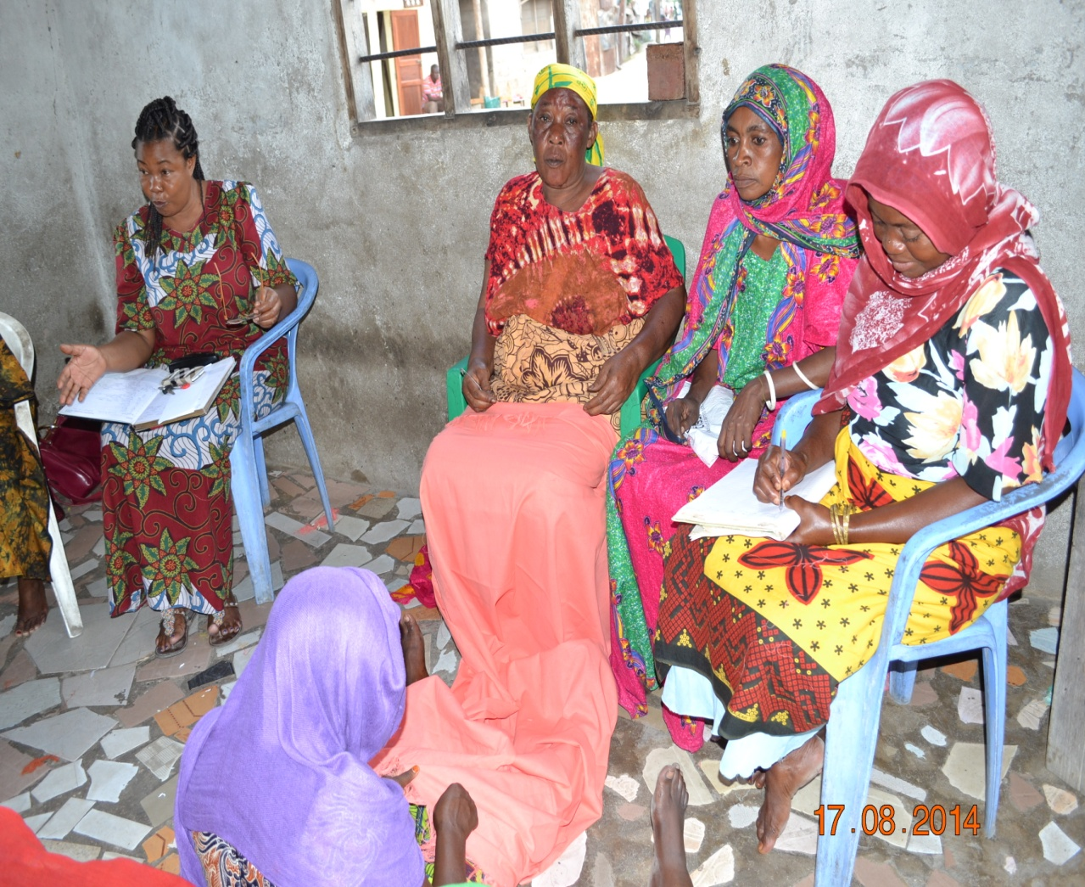
Figure 4. 1 An expert of batik clothes lecturing to JWG members during class session training;
Source: Study findings, 2014

(ii)Selection of good garments material for Batik clothes production
The selection high clothing materials of batik clothes processing involved carefully selection of high quality clothing materials for batik production. Trainees were practiced on collection good cotton garments for high quality batik clothes before starting decorations practices. This will ensure good and high produced products which will fetch higher prices in the markets. In figure 4.1 above, JWG members attending lecture from an expert, taking notes and observing good garment for batik production.

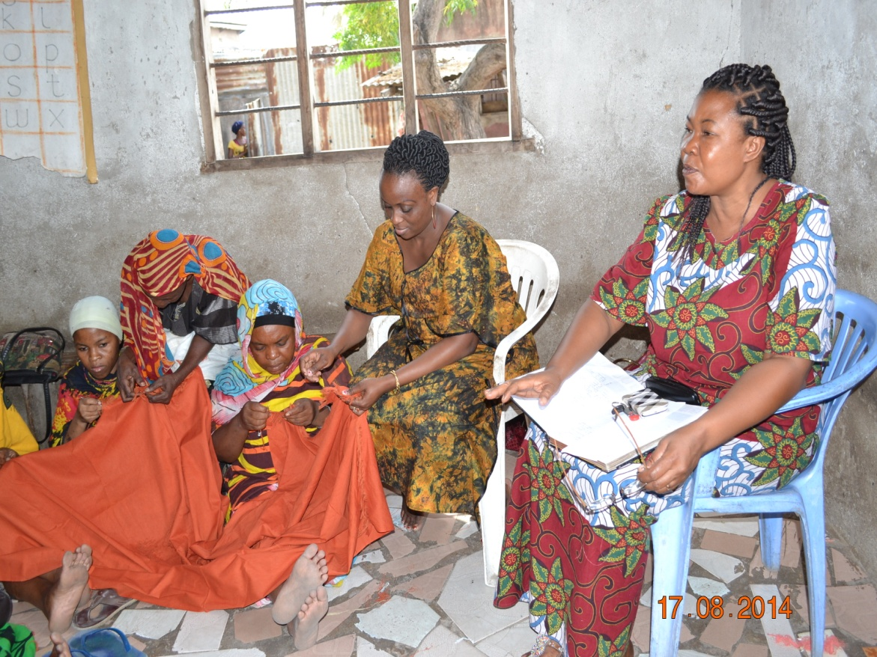
Figure 4. 2 JWG members observing clothing materials and taking notes during class training.

(iii) Practical Training on modern Batik clothes Processing Techniques.
Practical session involved the application of what was taught in the classroom session. Garments materials used were: Three pairs of cloth materials for making batik Vitenge, six pieces cloths material with 1.5 m length for making vikoi, different colours 5 boxes, Candles 4 bundles, oven, four aluminum pots, charcoal and water. Trainees were divided into five sub-groups for learning purpose and each group was given one type of batik cloth for decoration processing. Each sub-group was closely supervised by trainer to ensure that all taught processing procedures are adhered.

.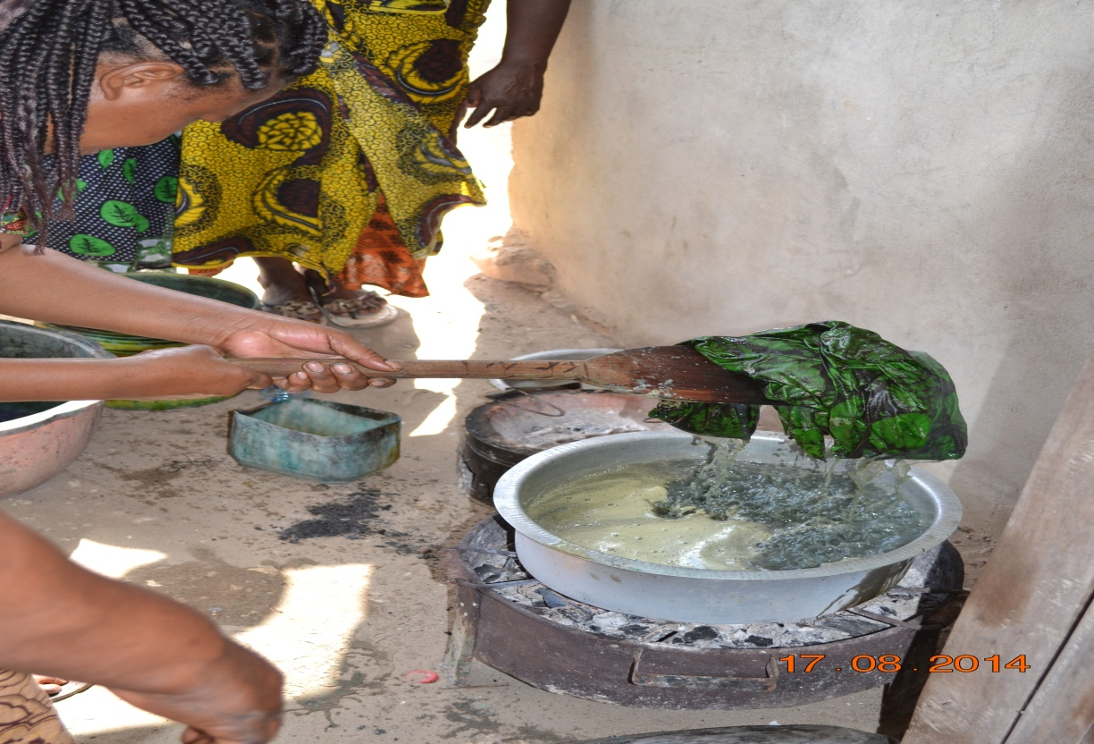
Figure 4. 3 An instructor demonstrates to trainees by removing decorated batik clothes from aluminum pot with mixture of hot water. In right photo a trainer rinse cloth in cold water.

(iv)Tie, Dying, Washing and Drying
Trainees were participated in tying activity. In this practice a piece of clothing material were squeezed and tied systematically by use of threads in the processes. The procedures involve soaking garment materials in solution/mixture one liter of cold water. The solution/mixture was prepared by addition of 4 tea spoon of caustic soda, 3tea spoons Sodium and one and half teaspoon (1.5) of any chosen colour into one liter of cold water. This is mixture is enough for decoration of 4 pieces of batik clothes. The clothes materials were soaked into cold water and then place into ground ready for pinching process. After pinching activity, addition of colours process done by using tea spoon to make your drawings, i.e the maximum of three types of different colours can be used in a piece of batik clothing.

In the photographs Figure 4.4, Jema Women Group members and CED student were participated and practiced pinching of garment for batik clothes production under close supervision of trainer during practical session.
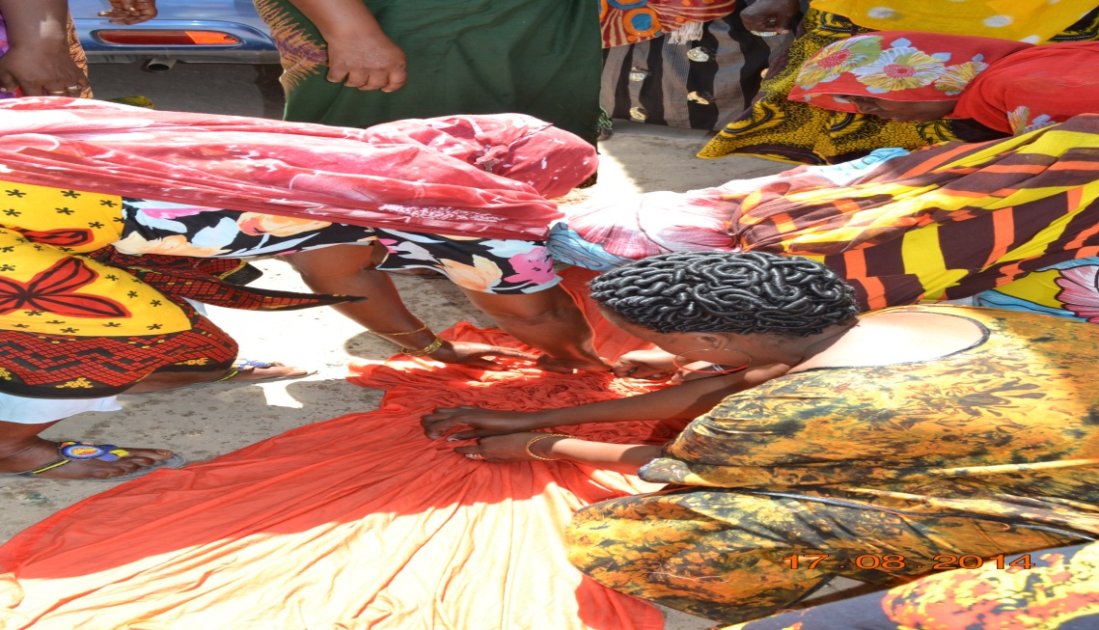
Figure 4. 4 JWG members and CED student practicing in pinching activity during practical training Source: Study findings, 2014
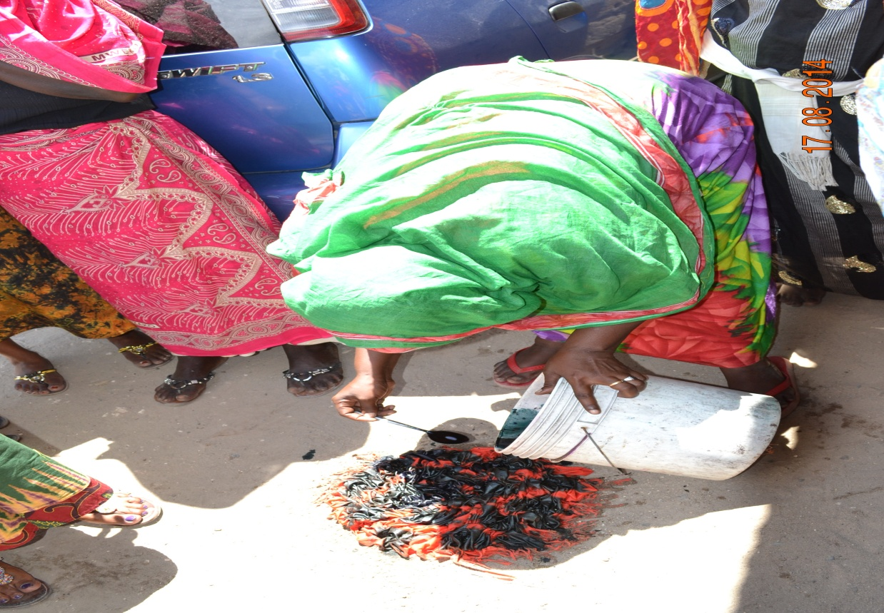
Figure 4. 5 An instructor demonstrates to trainees on how to put colours in batik clothes. In right photo a trainer practiced the taught procedure by using tea spoon during practical training. Source: Study findings, 2014
In ties and dying techniques, it needs to start with 5 pieces of clothing materials. The procedure involved preparation of mixed solution. The mixture was prepared by addition of 7 tea spoon of caustic soda, 6 tea spoons Sodium and three and half teaspoon (3.5) of any chosen colour into one liter of cold water. After folding and tie the batik clothes then soak in water to ease the next process of placing that garment in dying colors solution. Finally place the batik clothes in ground to dry ready for sales.
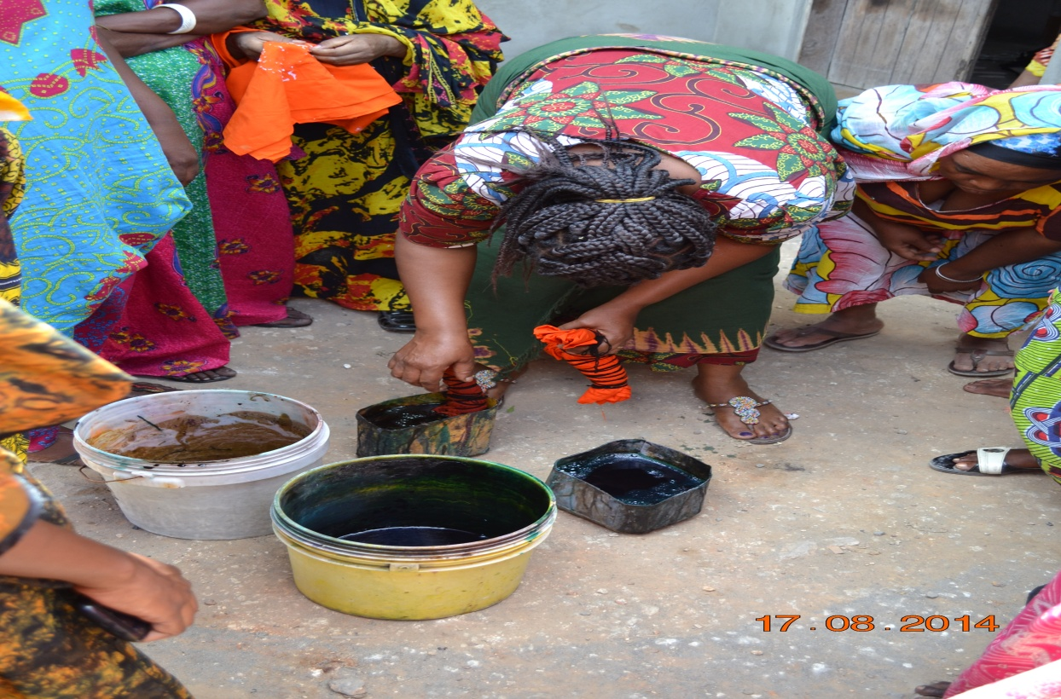
Figure 4. 6 A trainer demonstrates tie and dye method by placing tied batik cloth into containers with solution of colours during practical training.

(1)Preparation of Batik Clothes by using Candles techniques
The first step in preparation of modern batik clothes by using candles method was to prepare/cut a garment of three metres and let the candles to melts, and then trainees took selected drawings and started drawing /stamping. Second step was preparation of solution by putting 5 tea spoon of caustic soda, 4 tea spoons Sodium and two and half teaspoon of any chosen colour into three litres of boiling water. But, if you opt to use two different colours for example green and yellow colours, you take 1.5 teaspoon full from each colours. They allowed a mixture to cool and they added some water and they were continued to stir the solution in order to simplify the process of soaking of garment during batik clothes production. Then they dipped a piece of batik clothes into the cold water with colours for ten to fifteen minutes during this stage. After the elapse batik clothes were removed from the solution of cold water and placed into ground ready for drying. Finally decorated batik clothes were dipped in hot water in order to ensure that all remain part of candles are removed. Moreover batik clothes were rinsed in clean water and place in sun for final drying.

In the photographs, batik clothes decoration procedures in different stages are shown from Figures 12-18 . In Figure 18, trainer demonstrating to JWG members on how to use candles (wax) method by placing a piece of cloth on table ready for decoration activity. Below photographs trainees practiced stamping activity under supervision of trainer during practical training as shown in above figures.

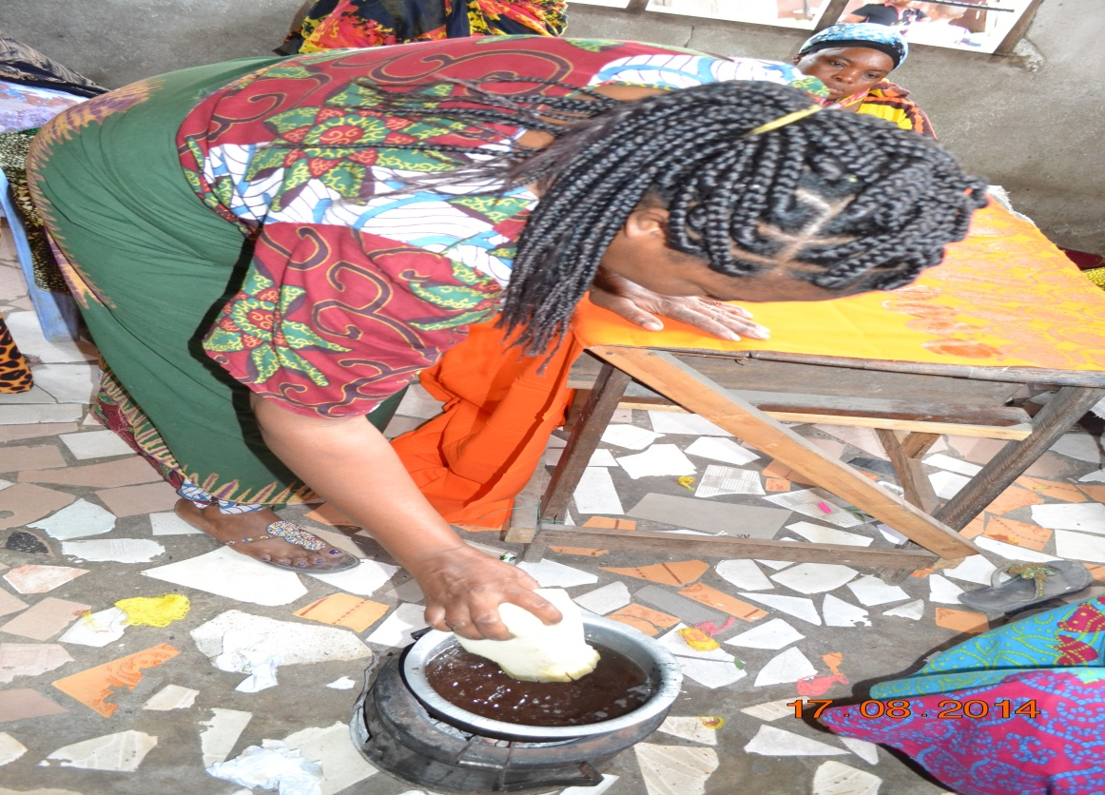
Figure 4. 7 A trainer stamped cloth by using candle method.
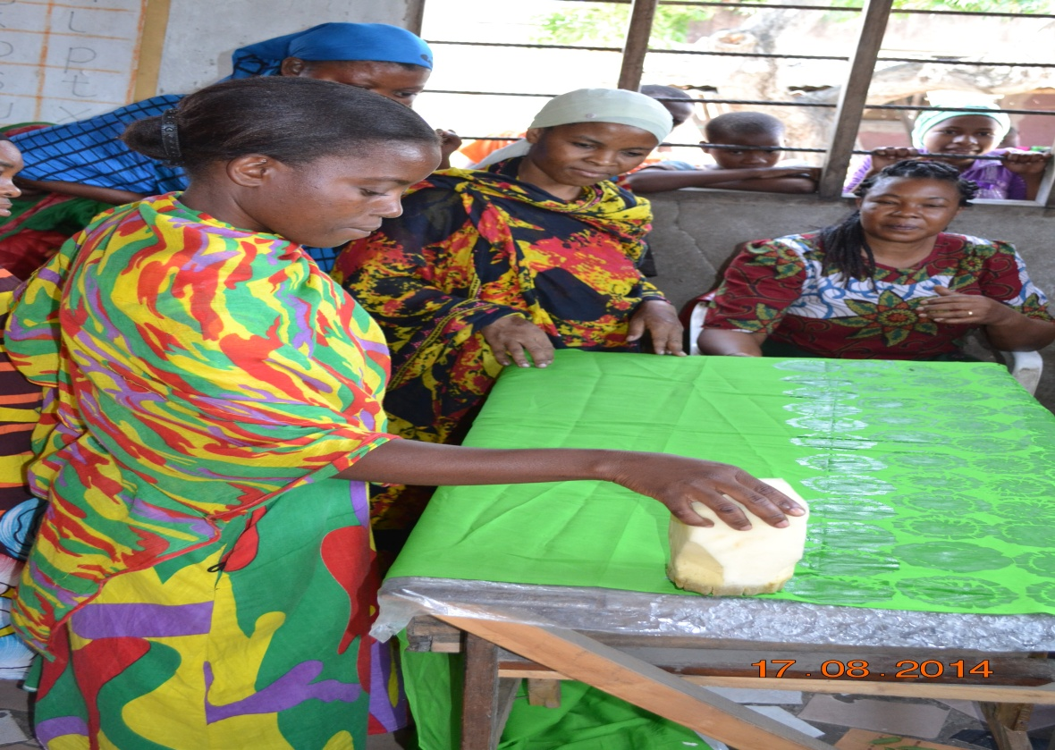
Figure 4. 8 JWG members participate in stamping activity.
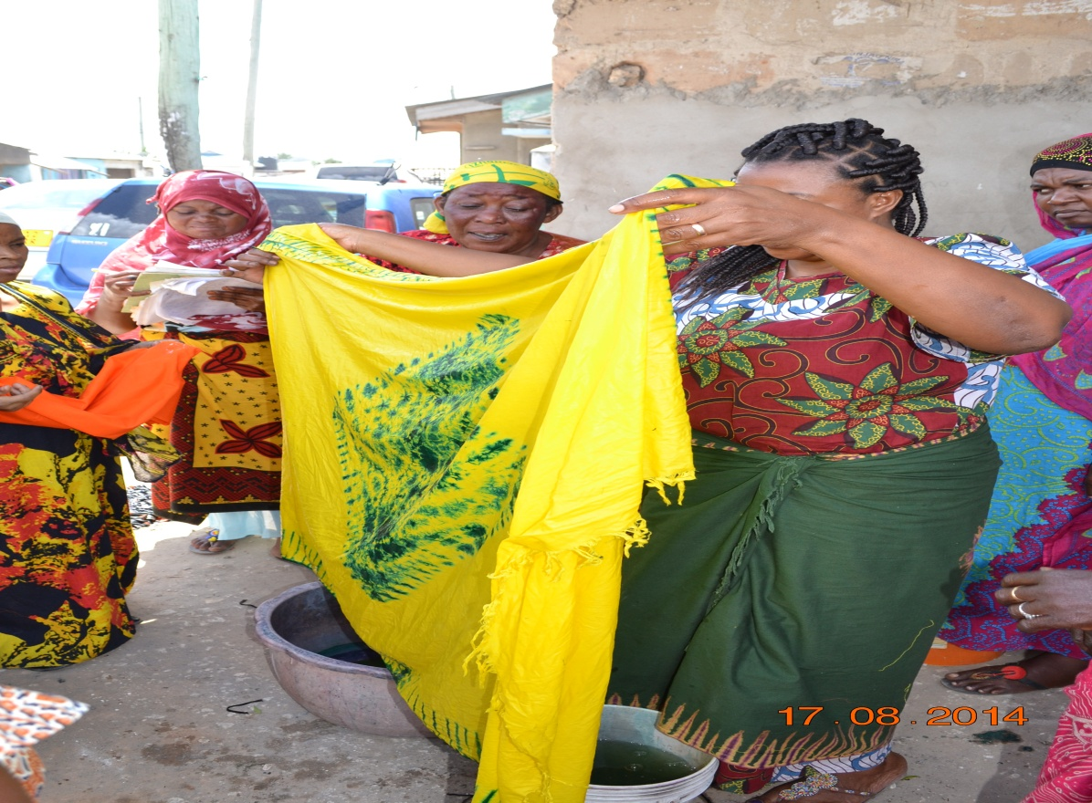
Figure 4. 9 Trainer demonstrates the washing and rinses procedures after taught on clothes decoration techniques.

Drying Procedures
The Batik clothes were placed on the ground for sun drying. In below photographs an expert demonstrates drying activity to trainees. Also JWG members were doing drying Batik clothes during practical training. Figure 4.10

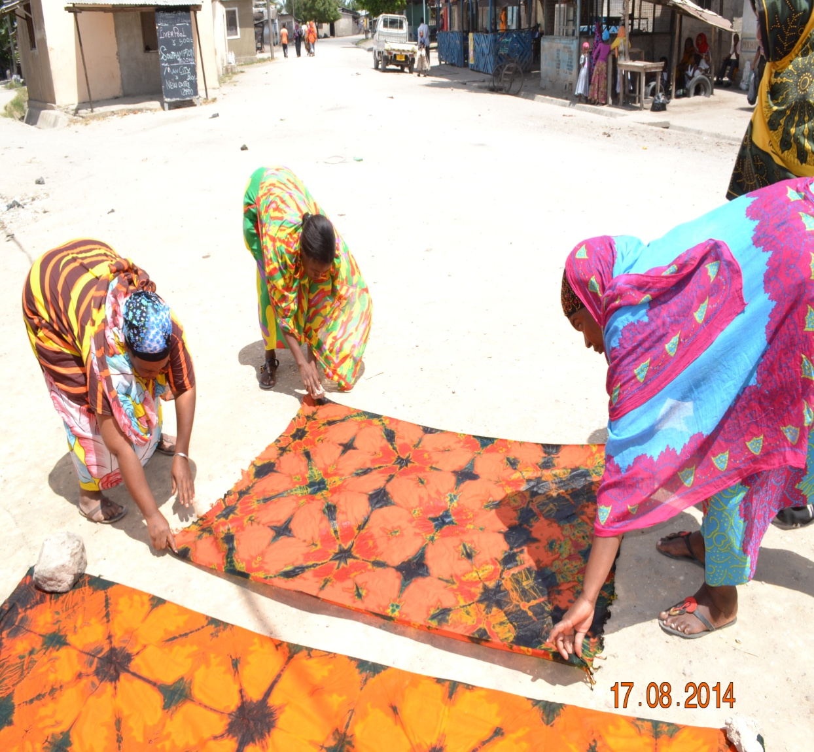
Figure 4. 10 Trainees o f JWG members placing Batik clothes on the ground for drying under close supervision of trainer.
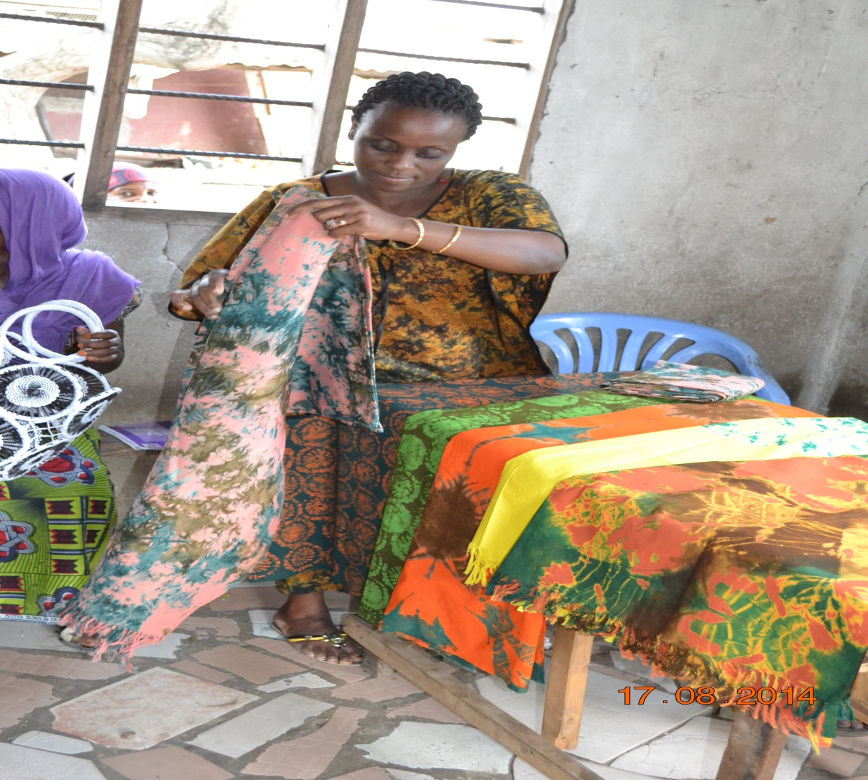
Figure 4. 11 CED researcher Ms. Evelyn Mwaimu inspects batik clothes and enjoying outputs of JWG after implementation of the project.

4.8 Project Implementation Ghantt Chart
A Gantt chart is a graphical representation of the duration of task against the progression of time. It is a useful tool for planning and scheduling projects. Gantt chart is helpful when monitoring the progress of the project.
Table 4. 6 Project Implementation Gantt chart
Activities | Implementation period |  |  |  |  |  |  |  |  |  |  |  |  |  | Resources  needed | Responsible  Person
Activities | Year 2013 |  |  |  |  |  | Year 2014 |  |  |  |  |  |  |  | Resources  needed | Responsible  Person
Activities | J | A | S | O | N | D | J | F | M | A | M | J | J | A
Identification of the Community |  |  |  |  |  |  |  |  |  |  |  |  |  |  | Stationery | CED student
Writing a letter requesting to conduct CAN |  |  |  |  |  |  |  |  |  |  |  |  |  |  | Stationery | CED student
Conducting CAN |  |  |  |  |  |  |  |  |  |  |  |  |  |  | Funds  Stationery  Fuel | CED student Community Members
Identification of problem |  |  |  |  |  |  |  |  |  |  |  |  |  |  | Funds  Stationery | CED student  Community Members
Project formulation |  |  |  |  |  |  |  |  |  |  |  |  |  |  | Stationery | CED student Community Members
Writing CNA report |  |  |  |  |  |  |  |  |  |  |  |  |  |  | Stationery, Funds | CED student
Identification of training needs |  |  |  |  |  |  |  |  |  |  |  |  |  |  | Funds  Stationery | CED student and Target group
Identification of training resources |  |  |  |  |  |  |  |  |  |  |  |  |  |  | Funds,  Stationery | Facilitator  CBO leaders
Mobilization of financial resource |  |  |  |  |  |  |  |  |  |  |  |  |  |  | Funds  Stationery | CED student,  CBO leaders
Preparation of training materials/ manual |  |  |  |  |  |  |  |  |  |  |  |  |  |  | Funds, Stationery | CED student Trainers
Identification of training venue |  |  |  |  |  |  |  |  |  |  |  |  |  |  | Stationery, Funds | CED student
Acquiring required training resources |  |  |  |  |  |  |  |  |  |  |  |  |  |  | Funds | CED student
Meeting with CBO leaders to compromise and confirm training schedule |  |  |  |  |  |  |  |  |  |  |  |  |  |  | Funds,  Stationery | CED student Trainers  CBO leaders
Conducting training on selection of materials suitable for batik making |  |  |  |  |  |  |  |  |  |  |  |  |  |  | Funds,  Training materials | CED student Trainers
Conducting training on selection of dyes suitable for batik making. |  |  |  |  |  |  |  |  |  |  |  |  |  |  | Funds,  Training materials | CED student Trainers
Conducting training on dyeing process |  |  |  |  |  |  |  |  |  |  |  |  |  |  | Funds,  Training materials | CED student Trainers
Identifying marketing sites for selling of batik clothes |  |  |  |  |  |  |  |  |  |  |  |  |  |  | Funds,  Training materials | CED student Trainers
Conducting training on simple Book keeping |  |  |  |  |  |  |  |  |  |  |  |  |  |  | Funds,  Training materials | CED student Trainers
Conducting Monitoring and Evaluation |  |  |  |  |  |  |  |  |  |  |  |  |  |  | Funds,  Training materials | CED student  CBO leaders
Writing project report |  |  |  |  |  |  |  |  |  |  |  |  |  |  | Funds,  Training materials | CED student
Survey:2014

4.9 Summary
This chapter described various planned interventions and reports the implementation status. Most activities were implemented as planned. Different planned trainings were conducted to impart the knowledge on modern batik clothing techniques, which included also the Practical Training on batik Processing, drying and packing practices. Group members were started with selecting high quality materials for batik clothes production and different batik designs and decorations methods, they were taught on selection of dyes, training on dyeing process as well as learning about market sites of the batik products where by they tried to think of their potential customers. However, according to the trainer, the batik processing skills are enhanced effectively through close supervision of the trainer on the whole procedures at least two consecutive production cycles.

CHAPTER FIVE

PROJECT PARTICIPATORY MONITORING, EVALUATION AND SUSTAINABILITY

5.1 Introduction
This chapter portrays monitoring, evaluation and sustainability of the Jema women group (batik makers) for batik clothes production project as planned routinely gathering information needed to keep to project in track. It aimed at designing indicators to anticipated problems which could occur so that solution could be formulated before it happens. Indicators were also used to measure project progress and evaluate its. Monitoring and evaluation was a useful tool in reviewing the project progress with an eye to ensure that its capacity to function regardless of charges in external funding sources and staffing (sustainability). Monitoring and evaluation was part and parcel of the project as it was done from the first stage of CAN to summative evaluation, September 2014.

5.2 Participatory Monitoring
Participatory monitoring is a process through which stakeholders at various levels engage in monitoring a particular project, share control over the content, the process and the results of the monitoring activity and engage in taking corrective actions. According to the World Bank, 2010, participatory monitoring focuses on active engagement of primary stakeholders. It is a continuous process of collecting information to compare how well the project is being executed against expected results. It also aims at providing managers and key stakeholders with regular feedback and early indications of progress or lack thereof in the achievement of intended results. Generally, it involves gathering and analyzing data on implementation process, strategies and results and recommending corrective measures. Monitoring results provide information on whether implementation proceeds as planned and as according to the budget. It also provides facts on the significance of effectiveness of an existing strategy. In areas where it does not produce the planned outcomes it gives chances to project managers to formulate or revise implementation strategies and approaches. Monitoring results also can provide important indicators about the efficiency with which resources are used to implement activities and achieve the outcomes.

In order to conduct monitoring performance indicators are developed. These are signals that reveal progress (or lack thereof) towards objectives. Both qualitative and quantitative variable that provides a simple and reliable basis for assessing achievements, changes in performance may be used. Indicators should be quantifiable and easy to monitor. They are five types of indicators: Impact indicators, outcome indicators, output indicators, activities (Process) indicators and input indicators. Impact indicators showed the broad changes such as that of economic and social terms brought about by the project. It shows the long-term effect of the intervention, for example increased batik cloches sales. Outcome or effect indicators reflect more in immediate or intermediate results from interventions. They describe the change in development between the comparison of outputs and the achievement of impact for example increased batik production or increased income for batik clothes makers. Output indicators show specific tangible products that emerge from processing inputs thought project activities as they are necessary to achieve the objectives of the projects. It is the measurable results of activities for example: batik clothes production services/skills provided to batik clothes producers or total pairs of batik attires products produced. Activities indicators show action in context of programming which is necessary and sufficient and though which inputs are mobilized to produce specific outputs or contribute to the outcome. Inputs indicators are the resources such as time funds, labour and materials that are necessary to carry out project activities.

5.2.1 Monitoring Information System
Monitoring information system (MIS) is a system designed to collect and report information on a project and project activities to enable a manager to plan, monitor and evaluate the operations and performance of the project. Information collected was that could show the project performance as planned. Each evaluator used a form in which the expected objective, activity, needed resources and achievement indicators were shown. The evaluator monitored whether what was shown on the paper was what was being performed on the ground. Any deviations to the planned activities or expected outputs were immediately reported to the project supervisor and the CED student.

5.2.2 Participatory Monitoring Methods Used
Various methods were used in data collection methods were interview, direct observation and documentation.

- Interviews
The researcher gather information through key informants who were Jema Women group and ward officials and agreed to measure to what extent the project is going to operate.
- Observation
The researcher in collaboration with Jema Women group community officer observed if all activities are implemented as planned. The researcher was engaged in the physically observation of what was going on without direct participation in the business. This method helped performance.

- Review of documents (Secondary data)
Documentation involves minutes of monthly meetings where by CBC members will get feedback on project progress. Also reviewing the books of accounts of the project. To check records of sales on the process of batik produced the amount sold and the amount of batik pieces damaged if any.

5.2.3 Participatory Monitoring Plan
Actual monitoring was done to measure achievements that were aligned to planned objectives, strategies and activities to ensure that they were on track. The following were closely monitored: Inputs (Human, finance, materials, time resources). Process activities were monitored to ensure that they were carried out as planned and completed and outputs were monitored to ensure that they met the standards according to the plan: Input indicators constituting the following: The amount of funds available according to the budget, number of trainees’ handouts produced and other training materials and equipments prepared number of participants and availability of trainer. Output indicators comprised the following: Number of members trained, turn up of trainer and number of sessions proceedings.
Table 5. 1 Participatory Monitoring Plan
Work plan activities | Monitoring objective | Objective verifiable indicators | Importance of monitoring | Responsible person | How gathering monitoring information | planned delivery time
Identification of training needs | - To know training needs of the target group | -Conducted trainings  -Target groups attended trainings | -Know the gap and train what is real needed by the target group | - CED student  - CBO members | -Training needs assessment report | January,  2014
Identification of resources ( Human and financial resources) | - To know and get right trainers and funds for training. | - Acquired resources. | - To have valuable resources for implementation of the project. | - CED student,  - CBO members - CBO leaders. | -Human and finance resource report | January, 2014
Preparation of training materials/ Training Manual. | - To get training manual for guide training. | - Developed training manual | - Having a tool of training | - CED student | -Training report and  Manual | January – February, 2014
Identification of training venue | - To have venue for training | - Acquire venue for training | - To avoid inconveniences | - CED student  - CBO members  - Leaders | -Visiting training venue | March – April, 2014
Acquiring required training resources | - To acquire training materials | - Acquired training materials | To be well organized before starting trainings | - CED student | -Training resources report | April, 2014
Meeting with target group leaders to compromise and confirm training schedule | - Acquitting group leaders and members the intention of trainings | - Conducting group leaders meeting. | To make training move smoothly and as planned. | - CED student  -Trainers | -Visiting the CBO leaders  -CBO leaders meeting minutes | April, 2014
Conducting training on selection of materials for batik making. | - To provide knowledge and skills to the target group | - Number of participants attended trainings | Target group acquire knowledge and skills | - CED student  - Trainers | -Training report  -Relevance of training materials | Mid-August 2014
Conducting training on selection of dyes suitable for batik making. | - To provide knowledge and skills to the target group | - Number of participants attended trainings | Target group acquire knowledge and skills | -CED student  -Trainers | -Training report  -Relevance of training materials | Mid-August 2014
Conducting training on dyeing processes. | - To provide knowledge and skills to the target group | - Number of participants attended trainings | Target group acquire knowledge and skills | -CED student  -Trainers | -Training report  - Relevance of training materials | Mid-August 2014
To identify marketing sites for selling of batik products. | - To provide guidance to the target group on marketing sites. | - Number of participants attended trainings | Target group acquire knowledge and skills | -CED student  -Trainers | -Training report  - Relevance of training materials | Late August 2014

Source: Survey, 2014

5.3 Monitoring results
According to the collected data by interview CBO members were aware of suitable materials for batik production, hence high quality of batik products.
Since project implementation was still going on, the CBO members were very good in identification of chemicals, mixing dyes for batik production.
Moreover, through observation as one of the method of monitoring , researcher observed that JWG were capable of identifying different techniques of dyeing process eg. When dealing with pinching type of batik the material should be deepen in the dye for not more than 20 minutes, the water for mixing up with dye, should be very hot so as to avoid running of colours from batik clothes.

5.4 Participatory Evaluation
Evaluation is a systematic investigative collection of information that can help to determine whether a project is proceeding as planned and whether it is meeting its stated project goals and objective according to proposed timeline. It measures progress of project implementation against planned objectives. Data are examined to determine if current operations are satisfactory or if some modification are needed. The identified outputs, outcomes and impact that were identified during planning stage that the project was expected to achieve or contribute form basis for evaluation process.

It is comparative in nature as it compares the situation at the start of the project and after the project completion and thus, generally evaluation begins at the start of the project. The aim of conducting participatory evaluation is to determine the relevancy, efficiency, effectiveness, impact, sustainability and fulfillment of objectives. It has advantages that it examines relevant issues by involving key players in evaluation design, it promotes participants’ learning about the project and its performance and enhances their understanding of other stakeholders’ points of views, it improves participants’ evaluation skills and mobilizes stakeholders, enhance team work spirit and build shared commitment to act on evaluation recommendations.
Evaluation can address outcomes and other development issues as it is undertaken selectively to answer specific questions to guide decision makers and or program managers and to provide information to underlying theories and assumptions used in program development if were valid, what worked and what did not work properly and reason why.

5.4.1 Performance Indicators
The following are the summary of performance indicators against objectives as shown in table 5.2 below:
Table 5. 2 Performance Indicators
S/NO | OBJECTIVE | PERFORMANCE INDICATOR
1. | to train 20 member selection of materials | - Number of Jema women group trained  - Identification of needed batik  - Identification of texture differences of Batik materials.
2. | training 20 member on selection of dyes suitable for batik making | - Number of target group trained  - Identification of chemicals needed for batik production.  - Knowledge on dye mixing techniques.  - Techniques of colour combinatinations e.g. Yellow + Orange + Purple = Brown
3. | training of 20 members on dyeing process | - Number of target group trained  - Techniques of dyeing requirements e.g. The use of hot water, number of minutes required when dyeing different types of batik.  - Knowledge of dye mixing techniques
4. | Identifying marketing sites for selling batik | - Number of targed group trained  - Signing business contracts  - Receiving tenders of making batik  - Identifying potential customers.
Source: Survey 2014

5.4.2 Participatory Evaluation Methods
Participatory evaluation was done in two stages formative evaluation which was conducted while activities were in progress to see the extent to which the project was achieving its objectives. At the end, summative evaluation was done, information gathered during needs assessment comparing with actual outputs and outcomes and determined whether the project was successful or not. The following were methods used in participatory evaluation.

Semi-structured Interview
A semi structured interview was important to assess if batik clothes producers understood the whole practices of batik clothes decorations techniques in order to see the impact of training as an evaluation procedure.

5.4.2.2 Field visit
As training conducted was practical, the evaluation method used included also field visit. Follow up during active batik processing activities and management procedures were done in area where it was planned.

5.5 Project evaluation Summary

Table 5.3 Project Evaluation Summary
S/N | Project Objectives | Performance Indicators | Expected Outcomes | Actual Outcomes
1 | Training of 20 members on selection of materials suitable for batik making | -Number of CBO members trained  -Identification of needed batik  -Identification of texture differences of batik materials | -Increase sales turn over  -Production of quality batik products  -Quantitative supply of batik products  -Improving social livelihood of group members  -Improving production capacity through innovation and training  -Acquisition of advanced batik production techniques. | -Sales turn over increased  -Increased production of quality batik products  -Increased quantitative supply of batik products  -Improving social livelihood of group members  -Improving production capacity through innovation and training  -Acquisition of advanced batik production techniques.
2 | Training of 20 members on selection of dyes suitable for batik making | -Number of targeted group trained  -Identification of chemicals needed for batik making  -Knowledge on dye mixing techniques | -Increase sales turn over  -Production of quality batik products  -Quantitative supply of batik products  -Improving social livelihood of group members  -Improving production capacity through innovation and training  -Acquisition of advanced batik production techniques. | -Sales turn over increased  -Increased production of quality batik products  -Increased quantitative supply of batik products  -Improving social livelihood of group members  -Improving production capacity through innovation and training  -Acquisition of advanced batik production techniques.
3 | Training of 20 members on dyeing process | -Number of target group trained  -Techniques of dyeing conditions eg, the use of hot water , number of minutes required when dyeing different types of batik. | -Increase sales turn over  -Production of quality batik products  -Quantitative supply of batik products  -Improving social livelihood of group members  -Improving production capacity through innovation and training  -Acquisition of advanced batik production techniques. | -Sales turn over increased  -Increased production of quality batik products  -Increased quantitative supply of batik products  -Improving social livelihood of group members  -Improving production capacity through innovation and training  -Acquisition of advanced batik production techniques.
4 | Identifying marketing sites for selling batik products | - Number of target group trained  -Signing business contract  -Receiving tenders of batik products  -Identifying potential customers | -Increase sales turn over  -Production of quality batik products  -Quantitative supply of batik products  -Improving social livelihood of group members  -Improving production capacity through innovation and training  -Acquisition of advanced batik production techniques. | -Sales turn over increased  -Increased production of quality batik products  -Increased quantitative supply of batik products  -Improving social livelihood of group members  -Improving production capacity through innovation and training  -Acquisition of advanced batik production techniques.
Soucre: Survey, 2014

5.5.1 Evaluation results
The results shows that after project implementation CBO members got more money on selling of batik clothes which are of high quality compared to the ones produced before project implementation. They were selling a pair of batik cloth for 15,000/= while after project implementation they were selling batik for about 20,000/= due to their quality being improved.

Moreover, project members seems to be satisfied with the training. They suggested that as the project goes on they need to be registered with SIDO so that they can access the market of their products easier internationally, since the registration fees is about 200,000/= and this amount is within their capacity.

5.3 Project Sustainability

5.3.1 Economic Sustainability
Batik clothes producers are using locally available materials from neighboring local market sources to produce processed batik clothes. Batik clothes are available at enormous amount as they are usually produced in Dar es Salaam, up country and others batik clothes are brought from regions of the world. The acquisition of other equipments and the use of more advanced technologies will be adopted using the income from sales of produced batik clothes. Also with the expected financial support from Local Government Authority/SIDO, there is high chance of sustaining the project due to use of economics of scale which reduces the production costs. This will result into production of more decorated batik clothes which will in turn increase producers’ income and thus improve community livelihoods. The economic sustainability also will be contributed by low production costs, such as that of garments, candles, colours and other materials which are obtained locally and at cheaper price with higher rate of returns resulting from higher valued batik clothes. Monthly contribution of group members will raise the business capital investment. Also the increasing demand for sales of batik clothes due to benefits it has to human choices will also sustain the production as market will be available the only strategy needed is communication between the producers and the consumers.

5.3.2 Social Sustainability
The use of batik attire is not a new incident as it was started a long time ago. The wear of these clothes was based on various reasons including: Traditional wear and national costume. This led to various ethnic groups to value batik dress which lead it to be socially acceptable. Therefore, dress in batik attire is socially acceptable, and the demand of these batik clothes is increasing day by day mainly in urban areas.

5.3.3 Environmental Sustainability
Environmentally, the project will be sustainable because it does not destroy environment of the area as it uses locally available batik materials which can be lost and cause environmental pollution and contamination. The use of these materials conserves the environment; however there is a need for seeking other alternative way of energy source during boiling process instead of using firewood.

5.3.4 Sustainable Development
Batik clothes production will contribute to increased batik clothes entrepreneurs income. A pair of batik cloth (Kitenge) currently fetches a price of 18,000 to 20,000 Tanzania shillings in (Dar es Salaam price). Batik clothes entrepreneurs earning at least 160 -200 pairs per week will obtain 2,880,000 to 3,600,000 shillings. This income is reasonable and higher than the income of low earner of government employee. This describes how batik clothes production can improve livelihoods of the majority and reduce poverty.

5.3.5 Strategic Planning and Management
The government through Small Industries Development Organization (SIDO) is financing Local Authorities to finance small scale profitable investments like that of batik clothes textiles with the purpose of enhancing quality, productivity and profitability of these projects. The focus is to enable them to graduate from small scale production to medium or large scale production. This shows how the government is highly committed in supporting such initiatives financially.

5.4 Sustainability Indicators

5.4.1 Project Achievement: Percentage of Batik clothes Producers Enhanced Knowledge on Batik Clothes Decorations Techniques
The project resulted into training of 20 (100%) group members as the expected numbers on thus; Jema Women Group was enhanced with knowledge in modern batik clothes production techniques. This knowledge also included the practical training on modern batik clothes decoration by use of candles and ties and dyes methods. The quantity of batik clothes produced increased as results sales raised and income earning. After project was fully implemented, the group production was raised from 150 to 400 pairs of batik clothes per month, each pair was sold with an average price of 15,000/= After getting training, they were able to produce 400 pairs of batik with the price of 20,000/= per piece because of their good quality.

5.4.2 The link with Municipal council Technical Officials
The researcher facilitated the link with municipal technical officials and therefore the group will continue to be supported technically and financially, this is another chance of project sustainability.

CHAPTER SIX

CONCLUSION AND RECOMMENDATIONS

6.1 Introduction
This chapter describes the results of the entire work of the project and through the Researchers’ experiences the Researcher tries to recommend to others who will attempt doing the same projects. The concluding part summarizes the,; summarize the reason which guided the project choice, reports on implementation of the monitoring and evaluation and sustainability plan. It also summarizes the findings of participatory monitoring, evaluation and sustainability plan. The recommendation part describes the recommendations to others likely to attempt the similar project on all parts including through researcher’s experiences participatory assessment, project design and implementation, literature review, monitoring evaluation and sustainability.

6.2 Conclusion
CNA was conducted and main findings showed that inadequate knowledge and skills of batik making was the most critical problem which led to the set up of this project.
Since JWG were producing batik clothes , but they were of very low quality because they did not have the knowledge and skills of making batik which made them to be sold cheap, hence the CBO earned less.

There were some specific objectives set for this project, includes training of 20 members on selection of materials suitable for batik making, where buy under this objective JWG were able to identify texture differences, dyeing ability of each material.
Moreover there was training of 20 members on selection of dyes suitable for batik making , that is, the group members were able to know different types of dyes, techniques of mixing dyes, dyeing conditions.
Also there was training on dyeing process of batik, here the group members were able to identify various tools for making patterns eg. the use of candles(wax)
Moreover JWG were taught on identifying marketing sites for selling batik products, whereby they were capable on identifying potential customers, signing business contracts.

6.3 Recommendations
The researcher recommended the following
The community Needs Assessment is a good exercise for coming out with the real needs of the community concerned.
- Research methods and tools used in CNA are highly recommended as they enhance the researcher’s knowledge towards various issue which could not be explained by other methods
- The Logical Framework Approach is a very good project design as it guides the whole research process and supports participatory monitoring and evaluation plan.
- Categorization of literature review into theoretical, empirical and policy sections are highly recommended because they are systematic in nature
- Participatory Monitoring and Evaluation approach is a very useful approach for sustainability of the project as it induces a sense of ownership and transparency which is a basis for sustainability of projects.
- The identified problems from Community Needs Assessment were not all addressed by the project due to limited resources and time. Problems of inadequate capital for business investment and lack of entrepreneurship skills and management and persistent environmental degradation were among the identified problems which were not addressed.
- The researcher took a small sample population for survey due to limited time and resource. Statistically, results were not significance to generalize for the whole population of Sandali ward.
- The Researcher also recommended a need to find out other alternative source of energy for boiling process because use of firewood also contributes to environmental degradation.

REFERENCES
Adam,1998.Application of a guideline for curricular work and the development of a curriculum concept for food processing in the informal sector in Tanzania. Dar es Salaam, Tanzania: VETA, GTZ Office (unpublished report).

Baud, I.S.A. and De Bruijne,G.A. (eds) 1992. Gender, small-scale industry and development policy. London, UK: IT Publications

Bell, A., Mazaud, F. and Mück, O. 1999. Guidelines for the analysis of postproduction systems. FAO, Rome, Italy. 102p. www.fao.org/inpho (24 June 2014).

Calcopietro, C.M. 1999. Towards a policy for small and medium enterprises in Tanzania.Vienna, Austria: UNIDO.

CEDPA, (1994). Project Design for Project Managers. Training Mannual series Volume II: Washington D. C. U. S. A.

Chambers, R., Conway, R. (1992). Sustainable rural livelihoods: Practical concepts For the 21st century. Institute of Development Studies (IDS): Brighton, UK, Discussion Paper No 296

Classens, 1993.Women’s economic groups and co-operatives in Dodoma, Tanzania.thesis, Wageningen, The Netherlands division. United Nations Rome: Elaine, M. Nair (Tan), N.G.

Hannan-Andersson, C. 1996. Swedish International Development Authority’s support to women’s small-scale enterprises in Tanzania. In: Dignard, L. and J.(eds).Women in micro- and small-scale enterprise development. London, UK: IT Publications. Small-scale Food Processing in Eastern and Southern Africa

Kothari C.R. (2004). Research methodology: Methods & Techniques. New Age International (P) Ltd, Publishers. New Delhi India.
Kombo D.K. and Tromp D.L. (2006), proposal writing and thesis proposal: An Introduction. Pauline’s Publications, Africa: Nairobi.

O’Reilly, C., Gordon, A. (1995). Survival strategies of poor women in urban Africa.The case of Zambia. NRI Socio-economic Series 10: Natural Resources Institute, Chatham, UK

Orodho, A.J. (2003). Essentials of Educational and Social Sciences Research Methods. Nairobi: Kenya

Orodho, A.J. and Kombo, D.K. (2002). Research Methods, Nairobi: Kenyatta University, Institute of Open Learning.

Parker, R.L., Riopelle, R. and Stell,W.F. 1995. Small enterprises adjusting to liberalization in fine countries. World Bank Discussion Paper No. 271.Washington, DC, USA: World Bank.

PWDS. 1998. Workshop on community-based enterprise promotion for sustainable livelihood of the poor. Trivandrum, Germany: Fordergesellschaft fur Techniken in der Dritten Welt.

Rakodi, C. (1991). Women’s work or household strategies? Environment and Development, vol 3, no 2, pp39-45 RUAF Foundation. Resource Center on Urban Agriculture and Food Security. Retrieved on 22nd April 2011 from World Wide Web: http//www.ruaf.org/node/512sanderson, D. (2000). Cities, Disasters and Livelihoods: CARE, United Kingdom.

Sandali Ward Development Reports: 2013 and 2014

Singh, N., Gilman, J. (1999). Making livelihoods more sustainable, International Social Science Journal, vol. 51, no. 4 pp 539-545.

Teszler, R. 1992. Small-scale industry’s contribution to economic development. In:

The World Bank. (2010). Participatory Monitoring and Evaluation in Topics. Participation and Civic Engagement. Washington D.C: The World Bank.
URT: Community Development Policy: Ministry of Community Development Women affairs and children (1996)

URT: Tanzania Poverty and Human Development Report (2009). Mkukuta Monitoring system. Research and Poverty Alleviation: Dar-Es-Salaam –Tanzania.

Webster, S. (1985). Education Research: Competence for Analysis and Applications 6th Edition. New Jersey: Macmillan.

APPENDICES

Appendix 1: QUESTIONNAIRE

DODOSO LA UTAFITI WA JAMII KATIKA KATA YA SANDALI- TEMAKE- 2014
Community Needs Assessment Survey questionnaire for Sandali Ward in Temeke Municipality

SEHEMU A: TAARIFA YA UTAMBUZI WA ENEO
- Mkoa....................................... 1.2. Wilaya...............................................
1.3. Kata........................................... 1.4. Mtaa..................................................

1.5 Sehemu/Jina la eneo...............................
1.6 Jina la Mwenyekujibu/ Mwanakikundi.................
2.0 TAARIFA MUHIMU ZA KAYA
2.1. Jinsia
1. Mume 2. Mke
2. 2. Umri wa Mwenyekujibu
1. Miaka18-25 2. Miaka 26-35 3. Miaka 36-45
4. Miaka 46-59 5. Wengine (Zaidi ya Miaka 60)
2.3 Idadi ya watu katika Kaya (Weka tiki)
1. Watu 2 hadi 3 2. Watu 4 hadi 5 3. Watu 6 + na zaidi
2.4. Hali ya Ndoa
1. Sijaoa/sijaolewa 2. Nimeoa/Nimeolewa 3. Mjane 4. Ninatalaka
2.5. Kiwango cha Elimu
1. Ninaelimu ya Darasa la Saba 2. Elimu ya Sekondari
3. Nimehitimu elimu ya Ufundi 4. Nimehitimu Chuo Kikuu

3.0. Hali ya Ulinzi na Usalama katika Jamii

1. Nzuri 2. Nzuri Kiasi 3. Siyo nzuri

3.1 Hali ya upatikanaji wa Maji safi na Salama

1. Nzuri 2. Nzuri Kiasi 3. Siyo nzuri

3.2 Kwa mtazamo wako ni shughuli zipi jamii inazifanya ili kupambana na umasikini?
- Biashara ndogo ndogo taja……………... 2. Nimeajiriwa 3. Kazi nyingine taja……………….
3.3. Kwa kiasi gani kipato unachopata kinatoshereza mahitaji yako ya lazima?
1. Kipato kinaridhisha 2. Wastani 3. Hakitoshelezi mahitaji
3.4 Ni changamoto zipi unafikiri zinakwamisha maendeleo katika jamii? (Taja)
- --------------------------------------------------------------------------
- --------------------------------------------------------------------------
- --------------------------------------------------------------------------

3.5. Ni nini chanzo cha changamoto hizo? (Taja)
- -------------------------------------------------------
- ------------------------------------------------------
- ------------------------------------------------------

3.6 Hali ya upatikanaji wa huduma za Kifedha katika jamii ikoje?

- Nzuri 2. Wastani 3. Siyo nzuri

3.7 Kwa maoni yako, nini mahitaji yako ili kuboresha biashara yako?(Taja)

- ------------------------------------------------------------------------------
- -------------------------------------------------------------------------------
- ------------------------------------------------------------------------------

3.8. Ni Shughuli zipi za uvunaji wa maliasili zinazosababisha uharibifu wa mazingira? Mfano kukata miti, kuchoma mkaa,kuchimba mchanga na uvuvi haramu( Taja)

- ----------------------------------------------------------------------------
- ----------------------------------------------------------------------------
- ----------------------------------------------------------------------------

4. Kwa maoni yako, jinsi gani jamii inashiriki katika kuhifadhi mazingira?(Taja)

SEHEMU B: TAARIFA MUHIMU ZA KIKUNDI

4.1. Ni kipi Chanzo kikuu cha mapato yako?
1. Biashara 2. Utengenezaji wa Batiki. 3. Nimeajiriwa
4. Kazi nyingine (Taja)………
4.2 Je, una ujuzi wa kutengeneza Batiki?
- Ndiyo 2. Hapana

4.3. Je, utengenezaji wa Batiki unaweza kuwa chanzo cha shughuli za kuingiza kipato kama mafunzo yatatolewa?
- Ndiyo 2. Hapana

  - Je, vifaa kwa ajili ya utengenezaji wa batiki vinapatikana kiurahsi?
1. Ndiyo 2. Hapana

5.0. Aina gani ya nguo zinazotengenezwa na kikundi? (Taja)
- -----------------------------------------------------------------
- -----------------------------------------------------------------
5.1. Ni njia zipi zinatumika kutengeneza Batiki (Taja)
- --------------------------------------------------------
- --------------------------------------------------------
5.2 Aina gani ya vifaa vinavyotumika katika utengenezaji wa Batiki? (Taja)
- ------------------------------------------------------------------------------
- ------------------------------------------------------------------------------
5.3 Ni vifaa gani vya kujikinga mnnavivaa wakati wa utengenezaji wa Batiki?
1. Kuvaa gloves mikononi 2.Kuvaa unifomu maalum 3. Vifaa vingine taja……
5.4. Ni changamoto zipi unafikiri zinakwamisha uzalishaji wa Nguo (batiki) katika jamii yenu?
i. ---------------------------------------------------------------------------------------------
ii. ---------------------------------------------------------------------------------------------
iii. ---------------------------------------------------------------------------------------------
5.4 Nini hasa Kiini cha changamoto hizo?
i. ---------------------------------------------------------------------------------------------
ii. ---------------------------------------------------------------------------------------------
iii. ---------------------------------------------------------------------------------------------
5.5 Kwa mawazo yenu, unahitaji nini ili kuboresha biashara yenu?
i. ---------------------------------------------------------------------------------------------
ii. ---------------------------------------------------------------------------------------------
iii. ---------------------------------------------------------------------------------------------
SEHEMU C: TAARIFA ZA ZIADA
1. Ni vifaa vya aina gani vinavyomilikiwa na kilundi? .........................................................................................................................
2. Ni aina gani za Batiki zinazalishwa na wanakikundi:
i)………………… 2…………………. 3………………… 4…………………
3. Ni watu wangapi wameajiajiri katika shughuli ya kutengeneza Batiki?
4. Je, unauza wapi bidhaa zenu?
- ------------------------
- ------------------------
5. Jumla ya mapato yako kwa mwaka kutokana na uuzaji wa batiki
.............................................................
6. Je, wateja wanaridhika naubora wa bidhaa zenu mnazozitengeneza?.......
1. Ndiyo 2.Hapana
7. Ni kiasi gani cha fedha mwanachama anachangia kila mwezi kwa ajili ya maendeleo ya kikundi chenu……

Appendix 3: TRAINING MANUAL

Small Scale Batik clothes Manufacturing: Processing Methods, Equipment and Decoration Practices Training Manual.

- Training methodology:
  - Methods of training used: Lecture and practical sessions (Participatory)
  - Number of trainees participated 20
- Theory on: Importance of Batik clothes production. Characteristics of good garments for batik clothes production and Importance of clothes decorations.
- Classification of Batik Attires
Batik clothes are groups on the basis of methods and procedures of production techniques i.e Candles, ties and dyes methods
Principles of batik clothes production, Different batik clothes decorations Techniques i.e
How to Tie Dye, How to Batik and More ways to Dye Instructions
Materials Needed: Appropriate cloth or clothing; water; fiber reactive dyes; Sodium carbonate, Rubber bands, synthetic sinew, Plastic bottles with which to hold the dye [125 to 250 ml] is a good size).

Instructions:
- Choose the right fabric, first. Fabrics that are at least 80% cellulose fiber--cotton, rayon, linen, tencel, or hemp-- are best for dyeing. 100% is better. 50% cotton/50% polyester makes nice pastels. Cotton clothing is often sewn with non-cotton thread, which stays white, but this is not usually a problem. Avoid 100% polyester or nylon. Silk is the only protein (animal) fiber that can be dyed with this recipe.
- Next, wash your fabric. This can be done days in advance. Unwashed fabric may not dye well.
- Then, if you're planning to tie-dye, tie the dry garments in advance. It's easiest that way. (Tying wet garments that contain soda ash is a total pain, because you should always wear gloves when handling soda ash, but gloves get caught in the string or rubber bands; it's okay to moisten the fabric with plain water to tie, and then soak in soda ash.)
- Mixing the dyes may be done up to one week in advance. (Longer storage requires refrigeration.)
Put the dye solutions into squirt or spray bottles for applying the dye - buy plastic bottles specifically for this purpose.
Be careful when you measure out the dye the jars open as short a time as possible, and use a face mask. Don't breathe dye! The stuff isn't very toxic, but you can become sensitized to it, which would put an end forever to your dyeing.
- Pre-soaking the fabric. Just before dyeing, pre-soak the fabric for fifteen minutes to one hour in a solution of sodium carbonate, mixed one cup per gallon of water. This stuff is also known as soda ash, and is similar to, but three times as strong as, washing soda.
- Applying the dye. Lay the fabric nearly flat, or pleated loosely, and drip with squeeze bottles directly onto the fabric, or spray it on with a spray bottle. This part is easy and fun, but always more tiring.
Be sure to wear gloves! The sodium carbonate is slightly caustic and must be washed or at least wiped off of your skin immediately after contact. (Not to mention that the dyes themselves look very odd on your hands for a couple of days afterwards--while a special hand cleaner is sold for cleaning up after dyes. Also, no fabric dye has been fully tested for safety when spilled on the skin.)
- Reaction time. Make sure that the fabric stays wet, for the reaction to take place, no less than two hours, but preferably eight to twenty-four hours. The amount of time required depends on the temperature, which should be at least 70°F (21°C). In our humid climate here, we just leave the clothing outside, but in drier climates you may need to use plastic wrap or plastic bags.
- Wash the clothing. Many dyers prefer to use Synthrapol detergent in the wash water, to help prevent dyes from mixing in undesired ways. You still need to isolate very light colours (especially yellow/orange); the problem with transfer of unreacted dye from dark to light regions is reduced by waiting a full day or more before washing out, as dye which has not reacted with the fabric will tend to react with the water, if given enough time. Then dump the dyed items directly into the washer without rinsing first, but many prefer to rinse by hand than machine-washing. Wash your cloth first in cold, once, then twice in the hottest water available and end by double-rinsing. You may need to wash the clothes separately the first few wearings, but pretty soon they are 100% colourfast and safe to wash with anything, in my experience.
- Heat setting is necessary. The only reason to use a hot water wash is to rid the cloth of the last bits of unreacted dye. It is important to use cold water before using hot water, as hot water may, in the presence of the sodium carbonate, encourage some excess dye to become a little too closely associated with the fabric, resulting in dye that gradually rinses out over the course of many types of washing.

How to Tie Dye - Complete Instructions
How to Dye basic recipe first: Make sure you have all the chemicals and supplies you need: Sodium carbonate, thin rubber or plastic gloves, measuring cups and spoons, squirt bottles to put the dye solution into, rubber bands, a dusk mask for measuring out dyes, and a bucket for pre-soaking the fabric in sodium carbonate solution. If you don't have everything you need, you can still tie today, and be ready to dye when you get the rest of your equipment.

Note: Be sure to pre-wash all clothing to remove invisible finishes that can prevent the dye from getting to the fabric.
Why Tie
The whole point of tie dyeing is to prevent the dye from reaching the fabric evenly. Any place that the dye can't reach will stay white, or a lighter colour, of course. The gradations of colour from intense to light can be beautiful. You can accomplish this by folding the fabric, tieing it with string, using rubber bands, etc.
Another reason to tie is that it makes each garment of piece of cloth a small, neat bundle--much easier to handle if you have a lot to do. If you don't tie, but just apply the dye directly, you need more space and can do fewer garments or pieces of fabric at a time.

Ways to Tie
Fold a piece of clothing in vertical pleats, and you'll end up with horizontal stripes. Horizontal pleats result in vertical stripes. Diagonal pleats make a nice effect. Stitch a loose basting stitch in any shape you like, and then pull the threads tight for another form of tie-dyeing that can have really cool results. For concentric circles, grab the cloth where you want the center to be, and pull, until you've more or less made a long tube of the garment, then apply rubber bands at intervals along the fabric. The "scrunch" pattern, made by crumpling the fabric very evenly, so that ultimately it makes a nice flat disk when held with rubber bands.

For the now-traditional spiral,: you lay the garment on a flat smooth surface, smooth out all the wrinkles, then make a small pleat right across where you want the center to be. Grab the very center of that pleat with a clothes pin, and begin to twist. As you twist, pleats appear farther and farther away from the center; as these pleats get too large, split the pleats with your hands, keeping each fold the same height above the table, no more than one to two inches in height.
Colour Mixing
You can make all the colours you need by mixing lemon yellow, rose-pink, and turquoise.
Simple rules:
- a lot of fuchsia and a little yellow make red
- red and yellow make orange
- yellow and turquoise* make green
- a lot of turquoise* plus a little fuchsia makes blue
- turquoise* plus fuchsia makes purple
*(remember to double the amounts of turquoise as compared to other colours)
Colour Choice
The two most obvious differences between a wonderful tie-dye and a so-so one are colour choice and colour saturation. You'll find that you really have to work to squirt enough dye into the folds to avoid a large amount of white on the finished garment. In choosing colours to place adjacent to each other, remember the colour wheel. Do not place "opposite" colours next to each other, such as red near green, or blue near orange, or yellow near purple: the results would be a muddy mess. If you really like bright colours, avoid placing a colour with red mixed *in* it, such as purple, near green.
A good basic rule is to apply two colours next to each other only if they appear next to each other in the following short list:
Fuchsia...yellow...turquoise...purple...fuschia
...or, for a more detailed colour scheme, choose adjacent colours from the following expanded list:
Fuchsia... red... orange... yellow... green... turquoise... blue... purple...fuschia
It really does help to place fuchsia between red and purple.
For eye-popping colour contrasts, you can avoid muddy mixtures of colours by adding a thickener such as sodium alginate to your dye mixtures; applying contrasting colours to the two sides of your bundled folded fabric will then result in alternating stripes.

How do you tie-dye a spiral pattern?
Everyone who tie-dyes has to do a spiral, sooner or later. It's the modern formula of tie-dyeing. You can make it your own by applying the spiral to a garment you've already folded in two, varying just where you place the center of the spiral, pleating the center of the spiral horizontally or vertically a few times before you begin the twist, or just by making a very careful choice of colours.

How to Tie It
You just pinch the cloth where you want the center of your spiral to be (try a spring-type clothes pin), then twist, then continue to twist; when the cloth 'mountains' get more than an inch or two taller than the 'valleys', use your other (third?) hand to split each tall pleat into two. Once you have the entire garment compacted into a flat disk, no more than two inches thick, you put rubber bands or ties around the disk, in several directions, to maintain its shape.

Applying the Dye
With the fabric twisted into a spiral, you make nice, even quadrants of each colour, like cutting a pie into six or eight pieces and colouring each piece a different colour. These turn into the twisted spiral when the fabric is untwisted! The prettiest results come when adjacent colours are in rainbow order. The most eye-popping results are obtained by using thickener in your dye, so that you don't get muddy mixtures, and applying opposite colours (on two sides of the tied fabric disk, in the same section of the cloth. A stained-glass effect is obtained by applying black dye to one side and brightly coloured dye to the other.

How to Tie Dye on Dark Fabric
If you are attempting to tie-dye a garment that is already dark in colour, first check the fiber content label! You must not use chlorine bleach on anything made of synthetic fibers, such as polyester, nylon, or spandex, nor on any animal fiber such as wool or silk.

Since dye is transparent, it won't work to try to dye on top of a dark background. The dye will not show up. You can still get the same effect, however. There are three different materials that are used to 'dye' onto a dark background:
1. Chlorine bleach (hypochlorite)
2. Colour remover (sodium hydrosulfite)

How to Do Low Water Immersion Dyeing
Low Water Immersion dyeing is also known as "scrunch" dyeing, "crumple" dyeing, or "crackle" dyeing. In traditional immersion dyeing, one uses a large volume of water, frequent stirring, and the use of leveling agents such as salt and, optionally, Calsolene oil, in order to make the colour as smooth and featureless as possible. Low water immersion dyeing is the opposite of this approach. In low water immersion dyeing, one uses as little water as possible, crunching the fabric together for a sort of resist effect, with as little stirring as possible.

Wonderful colour gradations are the hallmark of the low water technique. Where mixing opposite colours, such as red and green, result in ugly muddy effects in tie-dye, they result in gorgeous subtle shadings in low water immersion dyeing. The reason for this is that, in tie dyeing, one normally pre-soaks the fabric in the soda ash fixer, or else adds it to the dye solutions themselves, so that the dye immediately reacts with the first fiber it touches. There is no chance for the dye colours to blend before the reaction takes place. In contrast, the low water technique involves adding the fixer *last*, after allowing the colours to slowly blend and creep along the fabric, resulting in truly infinite gradations of colour.

Instructions
My technique is involve mix new colours as you need them, and choose not to add any fixer until after all of the dye has been added.

Applying dye. First, crumple the garment or cloth and stuff it tightly into a container. Then mix up one colour of fiber reactive dye, anywhere from 1/16 to 4 teaspoons of dye per cup, total volume one to two cups (where a teaspoon is about 5 ml, and a cup is about 250 ml). Do not add urea - you want nothing but pure dye in water. It may take five or ten minutes of constant stirring to dissolve some dyess. Pour this over the garment.

Next, mix another colour, in much the same manner. Try wild colour combinations – such as purple plus orange, or black plus emerald green. Then be careful to wet the entire top layer of the garment, in case air bubbles within the garment cause it to float, leaving the top regions sticking out of the dye bath. (Better, perhaps, to avoid air bubbles altogether.)

You may choose to pour a cup or two of plain water over in between adding different colours, or you may choose to put one colour in the bottom of the container (having first checked the fit with the dry garment in the clean container) before adding the clothing, and pour another colour over the top.
You can also use only a single colour, especially if it is a mixture of dry dye colours so that the colours will tend to separate out as they creep along the fabric. Keep track of how much water you add, total, for the next step. Do not stir or mush the fabric at all in this step, unless you wish to mute the variations in the final piece.

Allowing the colours to blend and spread. After you have added enough dye and water to almost cover the garment (try weighting it down with a glass measuring cup, if it floats too much - beware of rust spots from metal objects used as weights), leave it alone for anywhere from a few minutes to an hour. This time allows the colours to creep along the fabric, creating beautiful mixtures. Pre-mixed colours will tend to separate as the constituent dyes creep along the fabric at their own individual rates. Too little time will not allow this diffusion separation to occur; too much time can actually reduce the amount of variation in the piece, however, by allowing the dyes to diffuse too thoroughly, and blend together.

Fixing the dye. When you have left the dye to rest long enough, you can now add the fixer. This is the same sodium carbonate, or soda ash, used in the other recipes in this site. A good concentration to use is one teaspoon (5 ml) for each cup (250 ml), total volume, in the dye bath - including whatever amount of water you will be using to dissolve the soda ash in for adding it. Soda ash dissolves best in warm water, about 95°F (35°C). If you have used a total of 8 cups of water in your dye bath, then, use 9 teaspoons, or 3 tablespoons, of soda ash, dissolved in an additional cup of water. Gently pour this soda ash solution over the top of the dye bath. I add more water if the topmost bits of fabric are still sticking out of the liquid, at that point. I do not stir or agitate the mixture in any way.

Reaction Time. You must then leave the soda ash to react with the fabric and dye for a minimum of one hour. Some prefer to "batch" the reaction for 24 to 48 hours, but this added time not to be necessary, however you can leave the reaction overnight when that is more convenient. Thus "batching" is an attempt to make up for low temperatures in the reaction, caused by low room temperature. If your room is cold, it may be more useful to warm the reaction (*after* adding the soda ash, not before, as dye will quickly react directly with hot water, leaving none to react with the fabric) than to leave it for long periods of time.

Alternatively, you may cover your container tightly (such as with plastic warp) and heat for a couple of minutes in a oven, watching closely to stop the heating if enough steam accumulates to risk pushing the covering off. The amount of time required depends on your oven and your total volume, so it's better to just watch closely and stop the heating when the liquid is obviously hot. Salt. Some dyers prefer to add salt to their low water immersion dyeing, to increase depth of shade and/or patterning. Only trial and error can tell you which you prefer. You can use one teaspoon (5 ml) per cup (250 ml) of total water volume.

Dip or Fold Dyeing

What is dip dyeing?
Dip dyeing is a way to get the lovely continuous colour gradations seen in low water immersion dyeing, while gaining more control over the end result.
You can dip whole garments, one edge at a time, but tend to fold the garments first, so as to get a much easier package to work with, and to produce specific repeating patterns.

Instructions
Fold the fabric. For precision folding, it helps to use an iron, making crisp sharp folds at regular intervals. You can fold in many different ways, just as in tie dyeing. I prefer to avoid the use of any ties, except perhaps a very loose rubber band to help hold the packet together. Any ties represent not only white resist regions, but also a path along which colour can creep on the outside of the packet, sometimes resulting in very dramatic lines on just two of the many fold faces.
The "flower' pattern is produced by first accordian-folding your garment or yardage to make a long narrow rectangle, then folding the fabric back and forth in the shape of a triangle. Any fold pattern you choose should be folded back and forth, accordian style, rather than over and over as you might fold a sheet to put it away, so that no edge is enclosed within another edge, but instead every edge is available for exposure to the dye.

Dip the fabric. Here's the fun part, watching one colour creep up along the fabric, then watching the next colour 'chase' the first colour along up. The subsequent colour mixes only at the edges, as the preceding colour wicks further up the fabric.
You can dip corners of whole edges in the dye, or use a 5 ml eyedropper (sold in pharmacies for dispensing medication to young children) to add dye to a small region of one side. Repeat with multiple colours on various parts of your fabric until little or no white remains. Do not immerse one face of the folded fabric - just edges - so that you can be sure that what you see creeping up the side of the packet is identical to what is happening inside.

In the 'flower fold' example, the corner of the fabric bundle is the center of the flower; the flower is often circular when unfolded. Dip once for the flower petal colour, then again for the colour that marks the center of the flower. Dip only for a very short time if you want a small flower center.

Fixing the dye. Follow the method described in "Fixing the dye" on the low water immersion page. Calculate how much dye liquid your fabric has absorbed, adding it all up together (and subtracting the amount left in the containers after dipping), then use a total of 1 teaspoon (5 ml) soda ash per cup (250 ml) of water - including the cup or so that you dissolve the soda ash in for this final step.
Some of the dye will float off of the fabric and mix into the soda ash solution. Some may get on other parts of the dyed fabric, disturbing the perfection of your design.
Alternatively, you can add the soda ash with the dye. This may result in less subtle gradations, but you might find it a little easier.

Reaction Time. You must then leave the soda ash to react with the fabric and dye for a minimum of one hour, up to 24 or 48 hours under some conditions. See 'Reaction Time' on the lower water immersion page for more details.)

Washing out. Wash out as usual - first with cold water, then (if the fabric can handle it) hot water, preferably using detergent specially formulated for dyers. Except for the first rinsing, use the hottest water that the garment can handle, for most efficient removal of excess unattached dye

How to Batik
You can batik silk, cotton, and rayon with the same easy fiber reactive dye and soda ash recipe that is so popular in other forms of hand dyeing. The advantage of this type of dye is that you can use cool water (that won't melt wax!), fiber reactive dye is reasonably non-toxic, and the method is very simple and easy.

How to Dye basic recipe first.
Make sure you have all the chemicals and supplies you need for dyeing as mentioned above.

Additional Supplies for Batik
You'll need to buy both beeswax and paraffin to mix together; some cheap paintbrushes for covering large sections; or several, with which to apply the wax; and some way to keep the wax at a constant temperature.
It is best to use a mixture of beeswax (or its substitutes) and paraffin, because paraffin alone crackles too much, while beeswax alone doesn't crackle at all. (If you don't like the crackle effect, use pure beeswax, or its substitutes, without paraffin.)
Each of your tools needs a ridge on it to prevent it from sliding down into the scalding hot melted wax.

Instructions
Draw with melted wax wherever you want the fabric to remain a lighter color. If the wax does not seem to penetrate the fabric, it is probably not hot enough; check the temperature. (Beware of dangerous overheating; wax can burn, causing a dangerous house fire, or just smoke that can cause lung damage.) It's best if your design can tolerate a few random light spots from accidental drips of wax.

Usually stretch the garment over a cookie sheet or other baking implement, depending on the size of the garment; this prevents the wax from getting through to the other side of the garment, and makes it easier to control the fabric, as well.

Apply dye when the wax is cool.
You can wait for days or even weeks after waxing to proceed to dyeing, if you prefer. Crumple the fabric if you want a lot of veining, then pre-soak in sodium carbonate and apply dye as described in How to Dye. Use only cool water dye such as recommend, not any sort of hot water dye, and be sure that your soda ash and your dye mixtures are at room temperature, not hot, since even a little melting may ruin your design. Wash the excess dye out, after the full "batching" time of 2 to 24 hours has passed, using cold water only. You don't need melted wax in your washer. Obviously, you must not let anything waxy get into your hot air dryer.

Repeat? For traditonal, multiple-step batik, air-dry, and repeat the waxing and dyeing steps as desired, starting with the lightest colors and progressing toward the darker ones, first spending some time to plot the appropriate order for the colors and how each color will mix with the previous ones. For modern "faux" batik, a single round, involving direct application of different fiber reactive dye colors where they are wanted, is sufficient.

Removing the wax can be the hardest part.
Simmering in hot water, with soap, is the best method used. This requires a large (preferably several gallon) cook pot. Add liquid soap, rather than detergent, to the water. Using this soap, you did not have to get the water anywhere near a boil before all of the wax had floated to the top of the pot. The procedure is much more difficult without soap, though you can re-use the wax if you don't use soap or detergent to aid in its removal.

If you allow the pot to cool afterwards, with the fabric safely below the surface, the wax will harden so that you can lift it off, instead of leaving a residue in the fabric. Don't worry about toxicity from the wax in your food pots, as both beeswax and paraffin are considered safe for consumption, though indigestible in quantity; there is the practical matter of removing any wax that gets on the sides of the pot, after scraping as much as is easy to get out, but heating the pot and wiping with paper towels works.

Batiking without wax
You may occasionally read of batiking with alternative resists. Beware of water-soluble resists; I found the hard way that Deka's Silk Resist, for example, washes right out during the sodium carbonate pre-soak step of dyeing. If you use a washable resist, not only will you lack the interesting cracks and veins, but you will also need to find an alternative to the use of the washing soda pre-soak, such as applying sodium carbonate solution. After-Fix afterwards, or drying the fabric after pre-soaking in soda ash, before applying the resist. This also requires a much more frugal hand with the dye solutions. Large excesses of dye solution will also wash away any water-soluble resist. Alternative resists can be extremely valuable, resulting in wonderful results - but these results will never be very close approximations of true wax batik.

Annex 4: Checklist of Tools for Participatory Community Assessment
Types of Assessment | Key cited Areas | Tools used
Community Assessment | - Active/passive participation  - Safety, poverty,  - housing| shelter  - Community assets  - Number of people per household  - Households characteristics  - Education | - Observation combined with transect walk  - Interviews - semi structured interviews and key informative interviews  - Questionnaires  - Focus group discussions  - Documentary sources
Economic Assessment | - Economic activities: business, what types and size of business, percentage of population engaged in business, formal and informal employment  - Key employment opportunities.  - Agriculture and livestock, production  - Income per person  - Income generating groups | - Observation  - Questionnaires  - Focus group discussions
Environmental Assessment | - Natural resources: source of water,  - Climate-rainfall,  - Land and shelter | - Observation  - Focus Group Discussion  - Transect walk

Health Assessment | - Kind and types of health facilities  - Whom is a major health provider-Government or private | - Interviews (Key informative interview and semi- structured interview)  - Observation combined with transect walk  - Documentary sources
Community organizations/ institutions | - List types or kind of organization  - Activities and their roles  - Their impact on community /society | - Focus group discussions

