ASSESMENT OF MARKETING STRATEGIES TOUR OPERATORS USE FOR MARKETING AND PROMOTION OF TANZANIA TOURISM PRODUCTS: A CASE OF ARUSHA CITY

ERICK ABDIEL KAAYA

A DISSERTATION SUBMITTED IN PARTIAL FULFILLMENT FOR THE REQUIREMENTS FOR THE DEGREE OF MASTER OF ARTS IN TOURISM STUDIES OF THE OPEN UNIVERSITY OF TANZANIA

2014

CERTIFICATION
This is to certify that, the study titled Assessment of Marketing Strategies Tour Operators use for Marketing and Promotion of Tanzania Tourism Products by Kaaya Erick Abdiel (a researcher), meets the regulations and rules governing the award of the Master of Arts in tourism studies of the Open University of Tanzania and it is approved for its great role towards knowledge and presentation.

………………………………………..
Dr. Kiula D.M.
(Supervisor)

……………………………..
Date

COPYRIGHT
This dissertation is a copyright of Mr. Kaaya Erick Abdiel and The Open University of Tanzania. No part of this research work may be reproduced, stored in any retrieval system or transmitted, in any form or by any means, mechanical, photocopying, recording or otherwise without prior written permission of the author or the Open University of Tanzania in that behalf.

DECLARATION
I, Erick Abdiel Kaaya, do hereby declare that this dissertation is my own original work done within the period of registration and has neither been submitted nor being concurrently submitted for any degree award in other Institution.

............................................
Signature

............................................
Date

DEDICATION
I am dedicating this work to my parents Mrs Elly Mungure, Dr A.P.A Kaaya, my brother Frank Peter and Arthur Abdiel.

ABSTRACT
This study research focused on assessment of marketing strategies tour operators use for marketing and promotion of Tanzania tourism products. The importance of Tourism cannot be underscored. Its success to achieve customer satisfaction among tour operators determines higher profit and success tourism development. This study therefore was guided by three objectives. These were; to evaluate marketing strategies tour operators use, to determine effectiveness of marketing strategies tour operators use and to examine achievement of marketing strategies tour operators use in marketing and promotion of Tanzania tourism products. This research is quantitative by nature. The collection of data was facilitated through the employment of questionnaires and documentary review and analyzed using SPSS before converted to Microsoft excel. The study findings include Marketing strategies, efficient marketing strategies, Effectiveness of marketing strategies, Achievement of marketing strategies. From the study findings and conclusions, recommendations were drawn. These were that each tour operator should implement efficient marketing strategies, product development (innovation) should be considered, service improvement, marketing course programs should be conducted, improvements of websites contents, government should support public private partnership to improve tourism marketing. For further research, this study suggests that there is need to conduct a research on improvement of Tanzania tourism marketing.

ACKNOWLEDGEMENTS
I would like to thank all those who helped me through the research project of MA Tourism program. I would like to express sincere appreciation to my supervisor Dr Kiula of Mount Meru University for his great support and advice throughout the process of research project completion.

Also, I would like to thank my parents, brothers and all my other close friends for their supports and valuable ideas. Lastly, I would like to thank all tour operators. Their contributions were of great help toward the completion of this research project by giving their valuable information, time and thoughts.

TABLE OF CONTENTS
CERTIFICATION ii
COPYRIGHT iii
DECLARATION iv
DEDICATION v
ABSTRACT vi
ACKNOWLEDGEMENTS vii
LIST OF TABLES xi
LIST OF FIGURES xii
LIST OF ABBREVIATIONS xiii
CHAPTER ONE 1
1.0 INTRODUCTION 1
1.1 Background Information 1
1.2 Problem Statement 3
1.3 Objectives of the Study 4
1.3.1 General Objective 4
1.3.2 Specific Objectives 4
1.3.3 Research Questions 4
1.4 Conceptual framework 5
1.5 Justification of the Study 6
CHAPTER TWO 7
2.0 LITERATURE REVIEW 7
2.1 Introduction 7
2.2 Theoretical Literature Review 7
2.2.1 Theoretical Literature Review on Tour Operation and Tourism Marketing 7
2.2.2 Theoretical Literature on Tourism Product As A Service 8
2.2.3 Theoretical Literature on Market Channels for Marketing and Promotion 10
2.4 Public Private Partnership 18
CHAPTER THREE 21
3.0 METHODOLOGY 21
3.1 Introduction 21
3.2 Research Design 21
3.3 Study Area 21
3.4 Study Population 22
3.5 Population Sample 23
3.6 Sampling Procedure 23
3.7 Data Collection 23
3.7.1 Primary Data Collection 23
3.7.2 Secondary Data Collection 23
3.8 Data Analysis 24
3.9 Ethical Consideration 24
CHAPTER FOUR 25
4.0 DATA PRESENTATION ANALYSIS AND DISCUSSION 25
4.1 Introduction 25
4.2 Evaluation of Marketing Strategies 26
4.3 Efficient Marketing Strategies 27
4.4: Effectiveness of Marketing Strategies 28
4.5 Achievement of Marketing Strategies 30
4.6.3 Tourism Products Tourists Prefer 32
4.6.1 Tourists’ Satisfaction. 33
4.7.3 Tour Operator’s Participation In Marketing 34
4.7.1 Marketing Experts among Tour Operators 35
4.7.2 Reviews and Analysis of Marketing Strategies 36
4.7.4 Tour operator’s Opinion on Government 36
4.7.7: Marketing Combination Factors 38
4.8 Conclusion 40
CHAPTER FIVE 41
5.0 CONCLUSIONS AND RECOMMENDATIONS 41
5.1 Introduction 41
5.2 Conclusions 41
5.3 Recommendations 43
5.3.1 Recommendations to Tour Operators 43
5.3.2 Recommendations to the Government and Tourism Organizations 44
5.3.3 Areas for Further Research 44
5.4 Chapter Conclusion 44
REFERENCES 46
APPENDICES 51

LIST OF TABLES
Table 4.1: Evaluation of Marketing Strategies. 26
Table 4.2: Efficient Marketing Strategies 27
Table 4.3: Effectiveness of Marketing Strategies 29
Table 4.4: Achievement of Marketing Strategies 31

LIST OF FIGURES
Figure 1.1: Conceptual Framework 5
Figure 3.1: Arusha City Map 22
Figure 4.1: Efficient Marketing Strategies 27
Figure 4.2: Effectiveness of Marketing Strategies 29
Figure 4.3: Achievement of Marketing Strategies 30
Figure 4.4: Tourism Products and Services 31
Figure 4.5: Tourism Products Tourists Prefer 32
Figure 4.6: Market Sources 33
Figure 4.7: Tourists Satisfaction 34
Figure 4.8: Tour Operator’s Participation in Marketing 34
Figure 4.9: Marketing Experts 35
Figure 4.10: Reviews and Analysis of Marketing Strategies 36
Figure 4.11: Tour operator’s Opinions on Government 37
Figure 4.12: Lack of Marketing Professionals 38
Figure 4.13: Marketing Combination Factors 39

LIST OF ABBREVIATIONS
MA – Master of Arts
MNRT – Ministry of Natural Resource and Tourism.
NBS – National Bureau of Statistics.
SPSS – Statistical Package for Social Sciences.
TANAPA – Tanzania National Parks.
TATO – Tanzania Association of Tour Operators.
TTB – Tanzania Tourist Board.
UNCTAD – United Nations Conference on Trade and Development.
WTO – World Tourism Organization
PPP – Public Private Partnership

CHAPTER ONE

1.0 INTRODUCTION

1.1 Background Information
Kazda and Caves (2000) state that tourism have been a means of obtaining income for ages, but it was developed to accommodate the needs of all travellers when deregulation of airlines began in United States of America in 1978 (Van Der Merwe, 2003). Tourism with number of characteristics make significant contribution to the economy (Tourism Master Plan, 2002) doubles its economic contribution every 10 to 15 years (Golub, 2000).

The money spent by vacationers is the main source of income for almost 40% of the world’s countries (WTO, 2002). The practical advantages of tourism is the world’s single biggest generator of foreign exchange and rapid job generator, since most of the jobs are accessible to anybody and not only for highly qualified job seekers.

Many less developed countries now regard tourism as an important and integral part of their economic development strategies (Dieke, 2003). Tourism in East Africa is one of the largest and fastest growing sectors (WTO, 2012) and has become the largest foreign exchange earner exceeding even gold exports, which is the top merchandise export item (UNCTAD, 2008).

As stated by Dieke (2003) that, as the demand for tourism increases, so it brings an opportunity for linkages with other economic sectors. However, despite much success to date, this industry’s potential is yet to be fully exploited and the benefits associated with high linkages of this sector to other sectors of the economy are low (UNCTAD, 2008).

There is need, therefore, to create international link between the tourist and the destinations and thereby represent a leverage point for leading the move towards sustainability. The steps taken should be coherent and comprehensive with benefits equally distributed between tour operators, tourists, destination communities and the environment. The link between sustainability and tour operators’ competitiveness makes good business sense (World Economic Forum, 2008).

Tanzania Tourist Board has launched an international tourism marketing strategy that can place African nation on top among the world’s leading tourist destinations. The milestone strategy took 18 months of public and private partnership to compile, involving joint discussions and consultations between both sectors (public and private) in which key stakeholders were involved, indeed it is a milestone in the history of the tourism promotion partnership in Tanzania, since the establishment of Tanzania Tourist. This strategy with among other things, develop a distinctive and competitive positioning of Tanzania and make use of more focused and cutting edge techniques with approaches to international tourism marketing (TTB, 2013).

The study, therefore, given the above background intended to assess the marketing strategies tour operator use for marketing and promotion of Tanzania tourism products.

1.2 Problem Statement
The worldwide recession and decline in tourism has led many African nations to develop new and more aggressive marketing strategies. Traditionally marketing concentrates on increasing visitation and treats tourism like any other commodity (Burns, 1999).

Ryan (1991) explains that companies and governments in tourism have applied only part of the marketing mix to tourism that is promotion with little attention being paid to the other components of the marketing mix. Sufficient information on strategies applicable in marketing and promotion of tourism products is therefore crucial. However, in contrary the available Tanzania’s budget to market the country is limited; therefore Strong Tourism Partnership between public organizations involved in the marketing and promotion of Tanzania and private sector is crucial (TTB, 2013).

Most of available literature concentrates more on the impacts of tourism and on limiting tourism development, for example, the study conducted by Luvanga and Shitundu (2000) assessed the role of tourism on poverty reduction while Nkonoki ‎(2012) assessed challenges of tour operators in Tanzania. Given the ongoing observation it can conclusively be deduced that market dynamics information and requirements of entrepreneurs at the destination and the place of origin have not fully been considered.

The study, for that matter, was undertaken to fill the gap of knowledge by assessing
the marketing strategies tour operators use for marketing and promotion of Tanzania tourism products offered by tour operators in study area under consideration.

1.3 Objectives of the Study

1.3.1 General Objective
The overall objective of this study was to assess marketing strategies tour operators use for marketing and promotion of Tanzania tourism products.

1.3.2 Specific Objectives
The specific objectives of the study included the following:-
- To evaluate marketing strategies tour operators use for marketing and promotion of Tanzania tourism products.
- To determine effectiveness of marketing strategies tour operators use for marketing and promotion of Tanzania tourism products.
- To examine achievement of marketing strategies tour operators use for marketing and promotion of Tanzania tourism products.

1.3.3 Research Questions
- What are the marketing strategies tour operators use for marketing and promotion of Tanzania tourism products?
- What are the tourism products are marketed and promoted by tour operators?
- What are the achievements and effectiveness of the marketing strategies tour operators use for marketing and promotion of Tanzania tourism product?

1.4 Conceptual Framework
Conceptual framework refers to the schematic diagram which shows the variables included in the study. It is a diagrammatical relationship between variables (independent and dependent) to be studied. In this study the dependent variable is Tourism products and services which influenced by the independent variable, the Marketing strategies includes Online marketing, Social media, International trade fairs and exhibitions, Relationship marketing, Local tourism fairs, Product innovation and development, Travel trade, E-tourism and E-marketing, Outdoor billboards and posters, Catalogue, magazines and newspapers, Brochure, flyers, leaflets, business cards, Television and Radio network.

Independent Variable
MARKETING STRATEGIES
- International trade fairs and Exhibitions
- Online Marketing, Websites, Emails
- Social Media, Facebook, You tube, Twitter, Blogs
- Outdoor billboards and posters
- E-tourism and E-marketing
- International road shows
- Product innovation and development
- Relationship Marketing
- Local tourism fairs
- Travel trade
- Search Engine optimization
- Catalogue, Magazine and Newspapers
- Television and Radio network
- Brochure, Flyers, Leaflets, Business Cards
- Price determination and Product identification

MARKETING SUPPORTIVE VARIABLES
- Marketing Personnel
- Customer Care
- Internet
- Media
- Government and private organizations
- Direct Selling
- Policy

Tour Operators

Dependent variable
Tourism developmen, economic growth and employment
Tourism products and services

Figure 1.1 Conceptual Frameworks
Source: Field research, 2014
Furthermore the conceptual framework assumes that in order for independent variables to perform requires additional support (Marketing supportive variables) such as Government and private organizations, Media, Marketing Personal, Customer care and Internet for marketing and promotion of tourism products in order to reach the targeted goals of tourism development, economic growth and employment opportunities.

It was due to the above explained facts that the researcher employed the conceptual framework as illustrated in figure 1.1 which was used as a guideline in the facilitation of the process in which the study objectives were achieved.

1.5 Justification of the Study
Understanding marketing strategies the tour operators use in marketing and promotion of Tanzania tourism products is of paramount importance. The study in question established the findings useful for tour operators. The findings, if employed, may enable the optimization of benefits and it can enable them to use the marketing mix elements to their target markets. The study is in line with tourism master plan (2002) which supports the promotional activities of tour operators, identification of target markets and also the national tourism policy (1999) which emphases the understanding of customer needs, developing and delivering the products customer desires, having skilled staffs and utilization of information technology as a marketing tool.

CHAPTER TWO

2.0 LITERATURE REVIEW

2.1 Introduction
Literature review chapter covers the related literature which appears relevant to a particular topic or field undertaken.

2.2 Theoretical Literature Review
This is the type of research related to some abstract idea or theory that used to develop new concepts or to reinterpret an existing one (Kothari, 2004).

2.2.1 Theoretical Literature Review on Tour Operation and Tourism Marketing
Makens et al (2002) defined marketing as a process used to design a product or service combination that provides a real value to the targeted customers, motivates purchase, and fulfils genuine customer needs. In briefly marketing includes all activities resorted in getting goods and services from producer or supplier to the user.
Tourism marketing performed at two distinct levels the micro and macro level (Krippendorf, 1971; Freyer, 1999; Koutoulas, 2001). At micro level the individual enterprises engage themselves in marketing their own products or offers while the macro level involves non profit organizations in marketing the entire destinations business. The micro marketing is performed among others by providers of individual tourism products such as hotels, transport companies, visitor attractions, as well as by the travel trade such as travel agencies while Macro marketing include government agencies and co-operative organizations of varying forms.
Marketing concept holds that the key to achieve organizational goal is being more effective than competitors in creating, delivering and communicating superior customer value to your chosen target markets (Kotler and Keller, 2009). The marketing task is not to find the right customers for the product but to find the right product to suite the customers.

Duncan (2002) Marketing focuses on meeting customer wants and needs. To be able to satisfy customer wants and needs, it is necessary to consider the marketing mix of the product or service the company provided. The marketing mix involves four marketing elements namely product, price, promotion and place. These “four Ps” determined how a product is made or a service provided, its cost, where it distributed and how promoted (Van Der Merwe, 2003).

2.2.2 Theoretical Literature on Tourism Product As A Service
The four basic characteristics that make the marketing of tourism different from the marketing of manufacturing products includes intangibility, inseparability, variability with perish ability (George, 2001).

2.2.2.1 Intangibility
Services such as tourism described as intangible (Pender, 1999). This implies that they cannot be seen, felt, heard, tasted or smelt prior to purchase. Service offered cannot be inspected or tested in advance and cannot be brought to consumer (George 2001). This increases the complexity for potential tourists of acquiring product knowledge in advance of purchase as it is possible with tangible products. Thus the tourism marketer has an important task to promote the intangible benefits of tourism, such as relaxation, entertainment and education as well as aiming to make the intangible aspects seem more tangible.

2.2.2.2 Inseparability
In the case of manufacturing industry, the products are manufactured, sold and then consumed over a number of years unlike tourism offerings which are sold first and then produced and consumed simultaneously (George, 2001). Thus in the tourism industry, customers often involved in the creation of the service (Pender, 1999) for example, asking the tourist guide questions about the museum being visited. This has implications in that the way the offering is delivered is crucial because staff and consumers have to be present when the service is being consumed.

2.2.2.3 Variability
Tourism products differ each time they are consumed because humans produce them (George, 2001). Service providers are part of the offering and cannot provide the exact levels of service each time or the same levels of service as their colleagues. Also, no two consumers are precisely the same. They may have different needs, demands, expectations, moods, perceptions and emotions, causing the tourism offering to vary according to each situation. Tourism companies can only strive towards offering a standardized and consistent service, but because people are involved, an exact standard can never truly be realized.

2.2.2.4 Perishability
Producers cannot “hold stock” of a service or product to consumed later. There is a finite period during which the sale and consumption of a service can occur (Pender, 1999). If that period has passed the revenue that could have been earned by providing the service is also lost. Thus providers of services try to sell their service even by lowering the price rather than losing the full amount. By reducing prices shortly before a service is due to be delivered is one way to stimulate demand before the service is considered (Van Der Merwe, 2003).

2.2.3 Theoretical Literature on Market Channels for Marketing and Promotion
To facilitate promotion of tourism products and services different market channels are applied which involves the following:

2.2.3.1 Media
Media are channels through which organizations advertise their products (Youell 1998). Popular media channels include newspapers and magazines, television, radio, cinema, transport, outdoor advertising and electronic advertising. The channel is the method which communication travels from the source (sender) to the receiver (Belch & Belch 2001).

Two types of channels of communication exist, namely personal and non personal channels of communication. Advertising, sales promotion and publicity and public relations can be regarded as nonperson communication channels, direct marketing, interactive marketing and personal selling can be viewed as personal means of communication.

Information received from personal influence channels is generally more persuasive than information received via the mass media (Belch & Belch 2001), since the sales message is far more flexible, personal and powerful than an advertisement. The message can be adapted to the prospective customer at the time of sale and immediate feedback is possible.

2.2.3.2 Personal Communication
Personal channels of communication are direct interpersonal contact with individuals or groups (Belch & Belch 2001). Media that carry messages to identifiable customers or prospects are referred to as addressable media; because all these types of media can be used to send brand messages to specific geographic and electronic addresses (Duncan 2002). Addressable media include postal mail, fax, telephone and the Internet. Addressable media are used primarily to communicate with current customers or with carefully selected prospects.

2.2.3.3 Direct Marketing
Direct marketing, if planned and executed effectively, has the potential to be more cost-effective than any other promotional tool because of the precise targeting that the technique allows. Existing customers can be contacted to introduce them to new products and special offers, while new customers can be identified and encouraged to purchase products and services through direct channels. Types of direct marketing include direct mail, telemarketing, direct response advertising and door to door pamphlet distribution (Youell 1998). More recently, the Internet has been introduced as a form of marketing communication.

Considering that the Internet only became accessible to public users in 1994 (Hanson
2000), and has grown rapidly since it has potential as an excellent marketing tool. The tourism industry is ideal for the Internet because of its intangible nature.

When a consumer makes the decision to purchase, the product does not exist and is only consumed at a later date (World Tourism Organization Business Council, 1999). The fact that travel and tourism can be considered an intangible, electronic product before it can be consumed makes it suitable for marketing and selling online. On the Internet, potential tourists can see what a destination looks like and experience a virtual tour of their hotel room.

2.2.3.4 Interactive Marketing
The two way media which allow both companies and customers to send and receive messages, are called interactive media. The benefit of interactive media (telephone, e-mail, and personal sales people) is that they allow an instant exchange of information to take place, making it possible for a customer to contact the company and receive feedback.

The fastest interactive medium is E-mail (Duncan, 2002). Messages can flow between individual members directly, or to any number of members worldwide allowing organizations to communicate directly with their customers and ensuring a personalized touch. E-mail has proven to be a popular and effective way to reach customers because it is simple and inexpensive to use. However, unsolicited e-mail has become a source of customer irritation. Customer permission is an important consideration in the proper use of emails Campaigns.

2.2.3.5 Personal Selling
Personal selling is a form of person to person communication, in which a seller attempts to assist or persuade prospective buyers to purchase the company’s product or service (Belch & Belch 2001). Personal selling involves direct contact between buyer and seller, which gives the marketer communication flexibility. This means that the seller can see or hear the potential buyer’s reactions and modify the message accordingly. Personal selling can be targeted to specific markets and customer types that are the best prospects for the company’s products or service (Van Der Merwe, 2003).

2.2.3.6 Nonperson Communication
Nonperson channels of communication carry a message without interpersonal contact between sender and receiver. Nonperson channels are generally referred to as mass media, because they are communication channels through which messages may be sent to the “masses”, that is, large diverse audiences (Duncan, 2002).

2.2.3.7 Advertising
Advertising is the use of paid media by an organization to inform existing and potential customers and persuade them to buy its products (Youell, 1998). Being a nonperson form of communication, advertising implies the use of mass media that can transmit a message to large groups of individuals often at the same time (Belch & Belch, 2001). There is no opportunity for immediate feedback from the message recipient so before message is sent, advertiser must consider how the audience can interpret and respond.

2.2.3.8 Sales Promotion
The marketing activities that provide extra value or incentives to the sales force, distributors or the ultimate consumer can be regarded as sales promotion (Belch & Belch, 2001). The two categories of sales promotion are consumer oriented sales promotion and trade oriented sales promotion. Consumer-oriented sales promotion stimulates short-term sales by means of coupons, sampling, premiums, rebates or contests, whereas trade-oriented sales promotion, for example, trade shows or price deals, encourage the trade to promote and make use of a company’s products.

2.2.3.9 Public Relations
Publicity is probably the most credible form of marketing communication (Belch & Belch, 2001) since it is not the company itself but rather an outsider who compliments or criticizes the company. Publicity is not directly paid for, since the company attempts to encourage the media to say something positive about it in their newspapers or magazines by performing well, providing unique services or sponsoring an event. Public relations involve creating a positive image of the business to its publics which include customers, shareholders, employees and suppliers (Cronje et al, 2000).

It is the management function whereby public attitudes are evaluated, and a programme of action to earn public understanding and acceptance is executed (Belch and Belch 2001). Public relations and publicity are considered to be supportive, rather than primary factors in the marketing and promotional process (Van Der Merwe, 2003).
However, tour operators function as intermediaries in the tourism distribution system linking producers and consumers to each other (Moutinho, 2000). Tour operators are organizations that offer package vacation than can include everything from transportation, accommodation, activities, entertainment, meals and drinks (Hudson, 2008).

2.2.3.10 Internet Marketing
Nothnagel (2006) cited by (Matikiti,2011) described internet marketing as an umbrella term which encompass the common used internet marketing methods which are e-mail marketing, web advertising, on line branding, use of search engines and newsletters for marketing hospitality services.

Internet represents a tremendous opportunity. It gives customers much wider choice of products, services and prices from different suppliers with means to select and purchase items more easily. For the organisations it gives the opportunity to marketing their products and services in order to expand into new markets, offer new services and compete on a more equal footing with larger businesses (Dave Chaffey et al, 2006).

Madu et al, (2002) cited by Mwarania (2012) state that the potential of using the Internet for marketing activities is derived from its general use as an information exchange system in the digital age. The information can be stored, indexed, retrieved, restructured and redistributed automatically by software and without human intervention. The Internet connects companies and companies with customers and people with people without regarding time, space and hardware/ software platforms.

2.3 Empirical Literature Review
The empirical research it relies on experience or the observation, often without due regard for theory. It is data based research coming up with conclusions which are capable of being verified by observation or experiment (Kothari, 2004).

In the journal written by Palatkova (2012) pointed out that evolution of tourism marketing started in (marketing) focused on production and sales towards marketing based on consumer-orientation and later on the societal or sustainability orientation. One of the core issues of tourism marketing is the consumer behaviour. The growing share of tourists from the former developing countries especially from the emerging economies as China, India and Brazil (lower and upper-middle income countries) forced the traditional and new tourists’ destinations and private companies to rethink their traditional marketing procedures and tools.

The significant phenomena of last two decades which has affected tourist behaviour is the development and application of the information and communication technologies in tourism marketing. While all other demographic trend (population ageing in developed countries), ecological trends and consumption trends represent the challenges for tourism worldwide.

The pull motivation factors work as the specific attributes of a destination and/ or company which determine the destination, hotel or travel agent choice. After the destination choice completing, push and pull motives are interconnected with particular destination. The tourism motivations can sometimes be an impediment for the loyalty to destination or company choice, since some consumers prefer novelty, change and new experience influenced by personal characteristics.

The research study of internet marketing adoption and performance of tour operators in Nairobi Kenya by (Mwarania, 2012) which resorted on descriptive survey research design, using stratified random sampling procedure and application of semi structured questionnaire for data collection, then analyzed using descriptive statistics and presented through use of means, percentages concluded that:

The initial cost of developing a website and maintenance is too high for tour companies; that employees in the organisations were all computer literate; that using internet to market fits well with the way respondents liked to work; that the organization has supported adoption of internet marketing and this will provide access to global consumer markets as well as growing the market share. The study recommends that Financial institutions should make credit facilities available to tour firms as the initial cost of developing website is too high for them; employees in the organisations should be trained on the use of computers to avoid computer illiteracy; Senior management of the firm should be helpful in the use of internet marketing, this could be through allocation of funds during budgeting.

The strength of the appeal of Tanzania to tourist product is dominated by natural assets of the country. The assessment is that by any standards, Tanzania is an exceptionally beautiful and interesting country. With famous national parks, 32 Game reserves, 38 Game controlled areas, a unique Conservation area and Marine park. Generally the strength of Tanzania tourist product lies on: Abundance, diversity, reliability and visibility of wildlife, unspoiled environment with spectacular scenery, Low tourist density, Safe destination, Authenticity and Friendly people (Tourism Master Plan, 2002).

Tanzania is the land of contrast endowed with friendly people, abundant wildlife, spectacular landscapes, sandy beaches, culture mosaic and archaeological sites. Among attractions of Tanzania include Serengeti National Park, Mountain Kilimanjaro, Selous Game Reserve and Ngorongoro Crater. Additional attractions include the pristine white sandy beaches along the coastal Indian Ocean and the romantic islands of Zanzibar and Mafia with excellent deep sea fishing in Mafia Island (Tanzania Tourism Policy, 1999)

Tanzania has a rich heritage of archaeological, historical and rock painting sites which have been designated to World Heritage Sites. The Olduvai Gorge is the site of discoveries of the earliest man in the world, the white sandy beaches. Tanzania offers interesting culture and crafts for example Maasai culture, Art Makonde sculptures and carvings.

2.4 Public Private Partnership
Wikipedia (2014, accessed on internet), state that, public private partnership (PPP) is a government service or private business venture which is funded and operated through a partnership of government and one or more private sector companies. The public private partnership involves a contract between a public sector authority and a private party, in which the private party provides a public service or project and assumes substantial financial, technical and operational risk in the project.

Tourism is important economic development sector for most countries and a gate which integrates countries to international markets. Tourism projects generally require a high amount of initial investment for which the private financing may become impossible for most companies. Public Private Partnership (PPP) could suggested as a viable model to finance tourism projects where tourism projects are financed and operated through a partnership of government and one or more private sector companies. Such partnerships are characterized by sharing investment amount, risk, responsibility and revenues between the partners Business (Teker, 2012).

2.5 Policy Framework
National tourism policy (1999) of Tanzania puts emphasis on obtaining a precise understanding of customer needs, developing and delivering the products customer’s desire, having adequately skilled staff in place and the utilization of information technology as the marketing tool.

Tourism master plan (2002) promote the image of Tanzania quality resorts and diverse tourist attractions includes natural and cultural, it supports the promotional activities of tour operators in the tourism industry such as hoteliers, tour operator and travel agents while provides the pre and post vacation services needed to ensure customer satisfaction (National Tourism Policy,1999).
In reviewing the future development of tourism sector, Tanzania is faced with the inevitability of having to select between the alternative courses of action that involves the future character of Tanzanian tourism, potential for product expansion and product formulation through determining the type of tourism products to be developed, scale and design of development, rate of growth to be pursued and the extent to which tourism development is dispersed throughout the country (Tourism Master Plan, 2002).

2.6 Research Gap
In reviewing the literature, the study in question made observations as indicators of how rich Tanzania is in tourism on the one hand. However, on the other hand, tourism in Tanzania, in whose products are inclusive still lags behind. Therefore, the study, employed the review to determine how the strategies, though not directly originated from tourism business in Tanzania are articulated.

CHAPTER THREE

3.0 METHODOLOGY

3.1 Introduction
Research methodology is a systematic way to solve research problem. It defined as a science of studying how research is done scientifically (Kothari, 2004). The methodology chapter for this research study covers research design, study area, study population, population sample, sampling procedure, data collection, data analysis and ethical consideration.

3.2 Research Design
This study resorted to a descriptive survey research design using quantitative method. The researcher selected quantitative method in order to explain the phenomena by collecting numerical data that analyzed mathematically (Aliaga and Gunderson, 2000). Questionnaires were prepared and dispensed to 100 tour operators. This study centred on assessing the marketing strategies tour operators’ use for marketing and promotion of Tanzania tourism products.

3.3 Study Area
The study was conducted in Arusha city involved tour operators based within Arusha City. The city is located in the northern Tanzania within Arusha region. Arusha city covers 208 square km with a total population of 416,442 according to census of 2012 (National Bureau of Standards, 2013). The choice for the study area was considered due to the fact that, Arusha city is a global tourist destination and is the centre of the famous northern Tanzania safari circuit. The city endowed with high concentration of tour operators that arrange safaris for tourists and visitors to the famous natural and cultural attractions of Tanzania.

According to Tanzania Association of Tour Operators (TATO) there are 230 active tour operator members with over 193 based in Arusha especially within Arusha city which arrange different tourism activities to national parks, cultural sites and ngorongoro crater (Tanzania Association of Tour Operators, 2013).
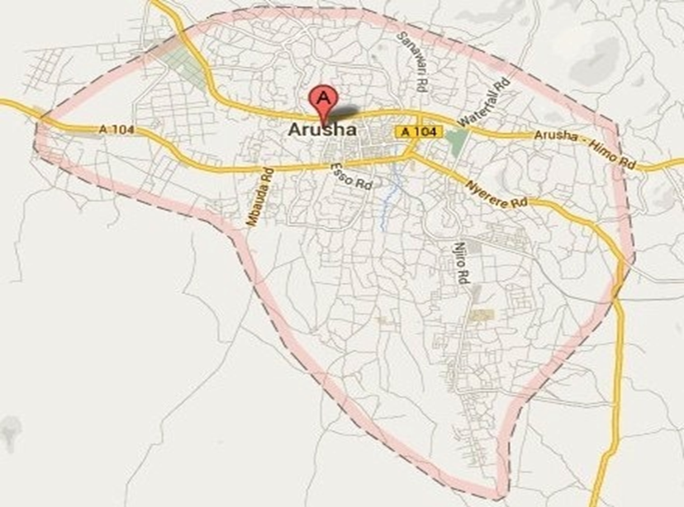
Figure 3.1 Arusha City Map
Source: Eco Planet Africa, 2014

3.4 Study Population
Goddard and Melville (2001) refer population as any group that is the subject of the research interest. Study population involves a set of people, items or objects under consideration in the specific study. The study population for this research study involves the entire tour operators within Arusha city.

3.5 Population Sample
The population sample for this research study involved 100 tour operators located within Arusha city. The sample makes 50% of the entire population and believed to have a better representation of the rest.

3.6 Sampling Procedure
Simple random sampling procedure was employed to select tour operators in Arusha city. Simple random sampling is the basic sampling method assumed in the statistical computation. The selection of tour operators based on the fact that tour operators work closely with tourists and visitors in arranging and marketing natural and cultural tourism products of Tanzania.

3.7 Data Collection
Both primary and secondary data was collected in order to address objectives of the study.

3.7.1 Primary Data Collection
Primary data was collected through questionnaires because it was the practical possible means to gather the required information for the study from the large number of participants in a short time.

3.7.2 Secondary Data Collection
Both published and unpublished documents were reviewed. The documents were obtained from TTB, TATO and other tourism stakeholders. The documents, thereafter, were reviewed so as to get practical insights in relation to the problem in question.

3.8 Data Analysis
The statistical Package for Social Sciences (SPSS) was used for statistical analysis. The data set was screened and examined for incorrect data entry and missing values. The program enables the researcher to conduct statistical analysis of the findings which presented in conjunction with the available literature.

3.9 Ethical Consideration
During research study the researcher ensured participants confidentiality about the information they provided by establishing a good relationship, being sensitive to culture bounds and involved directors, managers and marketing officers. The researcher discussed with participants’ about the intention of the study before the research study conducted. The researcher secured an introduction letter (Appendix 3) to introduce himself and request support from the participants’ when conducted the research study.

CHAPTER FOUR

4.0 DATA PRESENTATION ANALYSIS AND DISCUSSION

4.1 Introduction
This chapter presents data collected, analysis of the study focused on assessment of marketing strategies tour operators use for marketing and promotion of Tanzania tourism products. The first section based on evaluation of marketing strategies tour operators use for marketing and promotion of Tanzania tourism products. Further determined the efficient marketing strategies tour operators concentrate for marketing and promotion of Tanzania tourism products.

The second section determined effectiveness of marketing strategies tour operators use for success tourism business in marketing and promotion of Tanzania tourism products.

Third section examined the achievements of marketing strategies tour operator’s use for marketing and promotion of Tanzania tourism products. Also presented other related factors include Tourism products, level of satisfaction, market sources, marketing experts and government role in effective marketing. Figures are presented with conjunction with tables for clarifications on presented findings.

The data analyzed using Statistical Package for Social Sciences (SPSS) based on the specific objectives of study focused on assessment of marketing strategies tour operators use for marketing and promotion of Tanzania tourism products.

4.2 Evaluation of Marketing Strategies
Relating to research specific objective to evaluate marketing strategies tour operators use for marketing and promotion of Tanzania tourism products. During the process of analysis the given findings gathered and presented in table 4.1.

Table 4.1 Evaluation of Marketing Strategies
Marketing Strategies | Yes | Percent | No | Percent | Total
International trade fairs and exhibition | 54 | 54% | 46 | 46% | 100%
Online marketing, website, emails | 100 | 100% | 0 | 0% | 100%
Social Media | 76 | 76% | 24 | 24% | 100%
Outdoor billboards and posters | 11 | 11% | 89 | 89% | 100%
Catalogue, magazines, newspapers | 23 | 23% | 77 | 77% | 100%
E-tourism and E-marketing | 38 | 38% | 62 | 62% | 100%
Television and Radio network | 5 | 5% | 95 | 95% | 100%
International road shows | 7 | 7% | 93 | 93% | 100%
Brochures, flyers, leaflets, business cards | 79 | 79% | 21 | 21% | 100%
Travel trade | 26 | 26% | 74 | 74% | 100%
Product innovation and development | 32 | 32% | 68 | 68% | 100%
Search engine optimization | 53 | 53% | 47 | 47% | 100%
Relationship marketing | 65 | 65% | 35 | 35% | 100%
Local tourism fairs | 55 | 55% | 45 | 45% | 100%

Source: Field Research, 2014

The evaluation of marketing strategies tour operators use for marketing Tanzania tourism products, the findings reviled that: 100% online marketing, websites and emails, 79% brochures, flyers, leaflets and business cards, 76% social media, 65% relationship marketing, 55% local tourism fairs, 54% international trade fairs and exhibition, 53% search engine optimization, 38% e-tourism and e- marketing, 32% product innovation and development, 26% travel trade, 23% catalogue, magazines and news papers, 11% outdoor billboards and posters, 7% international road shows and 5% television and radio networks.

4.3 Efficient Marketing Strategies
The findings of efficient marketing strategies the tour operators concentrate in marketing and promotion of Tanzania tourism products presented in table 4.2 and figure 4.1.

Table 4.2 Efficient Marketing Strategies
Efficient Marketing Strategies | Frequency | Percent | Valid Percent
International trade fairs and exhibitions | 27 | 27.0 | 27%
Online marketing, websites, pages, emails | 57 | 57.0 | 57%
Social media, blogs, facebook, you tube, twitter | 4 | 4.0 | 4%
E-tourism and E-marketing | 2 | 2.0 | 2%
Local tourism fairs | 2 | 2.0 | 2%
Relationship marketing | 8 | 8.0 | 8%
Total | 100 | 100 | 100%

Source: Field Research, 2014

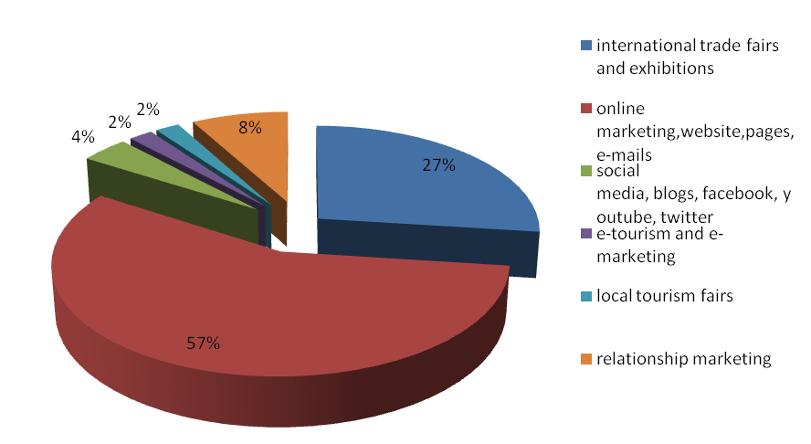
Figure 4.1 Efficient Marketing Strategies
Source: Field Research, 2014
Related to marketing strategies the tour operators concentrate, table 4.2 and figure 4.1 both reveal the findings concerned the efficient marketing strategies the tour operators concentrate in marketing and promotion of Tanzania tourism products as: 57% online marketing, websites and emails, 27% international trade fairs and exhibition, 8% relationship marketing, 4% social media, 2% E-tourism and E-marketing and 2% local tourism fairs.

Based on the given percentages of the marketing strategies tour operators concentrate shows that online marketing, website pages and email score 57% indicating that is the marketing strategies large number of tour operators concentrate. This can be concluded that the potential of using Internet for marketing activities is derived from its general use as an information exchange system in the digital age that organization has supported the use of internet marketing to access to global consumer markets as well as growing the market share (Madu et al, 2002).

Internet enable tour operators to acquire more customers to purchase since internet enable quick access of information to reach more people and less expensive means of communication. Due to technological revolution and competition among tour operators companies in marketing their products each of them strive to lead the market through wide interactions of simple marketing techniques with less cost in mind with the intention to increase sales.

4.4: Effectiveness of Marketing Strategies
Second specific objective of this study was to determine effectiveness of marketing
strategies tour operators use for marketing and promotion of Tanzania tourism products.

Table 4.3 Effectiveness of Marketing Strategies
 | Frequency | Percent | Valid Percent
Yes | 56 | 56.0 | 56%
No | 44 | 44.0 | 44%
Total | 100 | 100 | 100%
Source: Field Research, 2014

Figure 4.2: Effectiveness of Marketing Strategies
Source: Field Research, 2014

The interpretation of figure 4.2 and table 4.3 shows the findings on effectiveness of marketing strategies the tour operators use for marketing and promotion of Tanzania tourism products indicated that 56% agree the effectiveness of marketing strategies tour operator’s use for marketing and promotion of Tanzania tourism for success of tourism business and 44% disagree about the effectiveness of marketing strategies tour operators use for the success of tourism business. According to the findings this can imply that among 56% of tour operators marketing strategies they use are effectiveness to the success of tourism business and 44% among tour operators marketing strategies they use are not effective to the success of tourism business.

4.5 Achievement of Marketing Strategies
Another specific objective of the study was to examine the achievements of marketing strategies tour operators use for marketing and promotion of Tanzania tourism products.
Figure 4.3: Achievements of Marketing Strategies
Source: Field Research, 2014

Table 4.4 Achievement of Marketing Strategies
 | Frequency | Percent | Valid Percent
Good | 37 | 37.0 | 37%
Better | 40 | 40.0 | 40%
Excellent | 13 | 13.0 | 13%
Fair | 9 | 9.0 | 9%
Poor | 1 | 1.0 | 1%
Total | 100 | 100.0 | 100%

Source: Field Research, 2014
The presentation of the findings from respondents concerned the achievement of marketing strategies tour operators use for marketing and promotion of Tanzania tourism products in table 4.4 indicate that: 40% better, 37% good, 13% excellent, 9% fair and 1% poor. These findings show the different level of achievement among tour operators which obtained through the implementation of marketing strategies for marketing and promotion of Tanzania tourism products. Further the illustration presented above also presented in figure 4.3 originated from Microsoft window excel.

4.6 Tourism Products and Services
The findings also disclosed the tourism products and services tour operators of Arusha city offered presented in figure 4.4.
Figure 4.4 Tourism Products and Services
Source: Field Research, 2014
The results as can be observed on figure 4.4 indicate the tourism products and services tour operators offered in percentage as follows; 96% wildlife safaris, 86% mountain climbing, 79% cultural tourism, 77% beach holiday 62% transfer service, 61% hiking and trekking, 47% walking and biking, 42% accommodation, 42% historical tour, 39% canoe and boat safari, 21% scenic tour, 15% air ticketing, 11% horse ride, 6% shuttle service and 6% hunting safaris. The above results can imply that tour operators offered most wildlife safaris, mountain climbing, cultural and beach holiday while the least products are shuttle service, hunting safari, horse ride and air ticketing service.

4.6.3 Tourism Products Tourists Prefer
With an intention of finding tourism products tourists prefer, the findings in figure 4.5 revealed that 2% of tourists prefer combination of wildlife and beach, 6% mountain climbing, 9% wildlife safaris, 16% wildlife safaris and mountain climbing combination, 21% wildlife safaris, mountain and beach combination while 46% prefer all which includes wildlife, mountain and beach.
Figure 4.5 Tourism Products Tourists Prefer
Source: Field Research, 2014
4.6.2 Market Sources
The study was also conducted focusing its direction on major source of market for tour operators. The researcher thus managed to disclose the findings through asking related questions to the selected respondents.

As can be observed in figure 4.6, the researcher discovered tour operators markets for Tanzania tourism products. 93% of correspondents depend on foreign market, 5% of correspondents depend both local and international market while 2% of correspondents depend on local market. The result implies that foreign market is the most efficient market for large number of tour operators than local market.
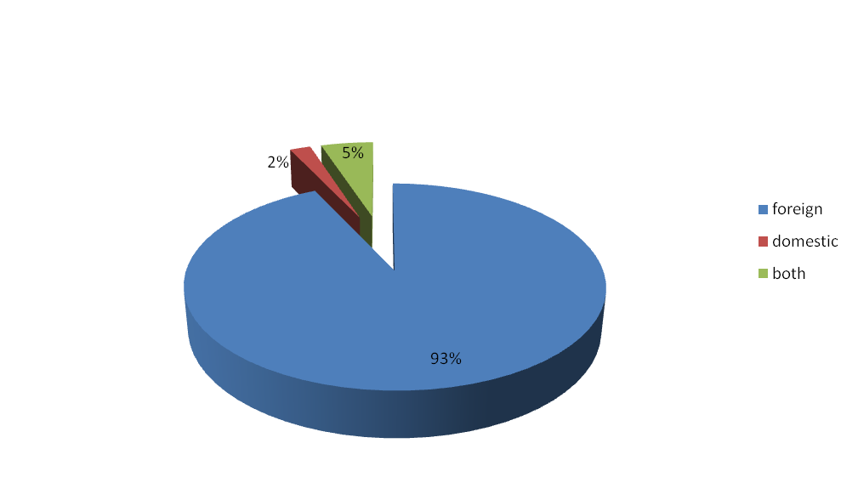
Figure 4.6 Market Sources
Source: Field Research, 2014

4.6.1 Tourists’ Satisfaction.
Tourist’s satisfaction is among the important aspect for tourism business development. The study therefore disclosed the findings showing the level of satisfaction of tourists concern the tourism products and services offered by tour operators of Arusha city.
As indicated in figure 4.7, satisfaction for tourists varies among tour operators as indicated. Findings show that 50% satisfied while 46% are well satisfied and 4% are slightly satisfied. The result can implies that tour operators strive to satisfy tourists at high level while others remain at a lower level of satisfaction.
Figure 4.7: Tourists Satisfaction
Source: Field Research, 2014

4.7.3 Tour Operator’s Participation In Marketing
In addition to the ongoing findings, the researcher sort to find whether tour operators participate in marketing and promotion of Tanzania tourism products locally and internationally. The findings presented in figure 4.8.
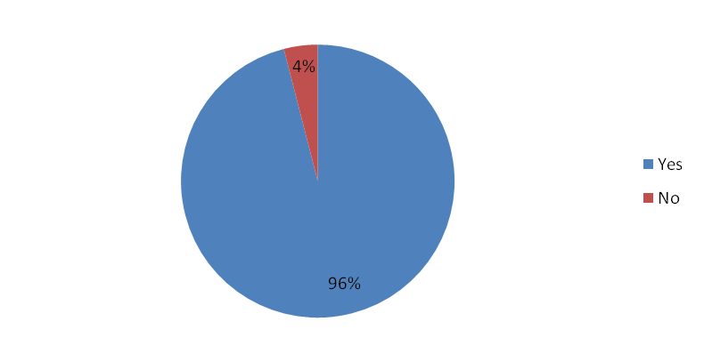
Figure 4.8: Tour Operator’s Participation in Marketing
Source: Field Research, 2014
Figure 4.8 shows that 96% of (respondents) the tour operators participate in marketing of Tanzania tourism products locally and internationally while 4% do not. According to the Implications of the disclosed findings conclusively imply that 96% of tour operators participate in marketing Tanzania tourism products at both local and international level while 4% of tour operators do not according to the findings.

4.7.1 Marketing Experts among Tour Operators
With the intention to identify whether the tour operators have marketing experts to handle all marketing activities, the findings presented in figure 4.9.
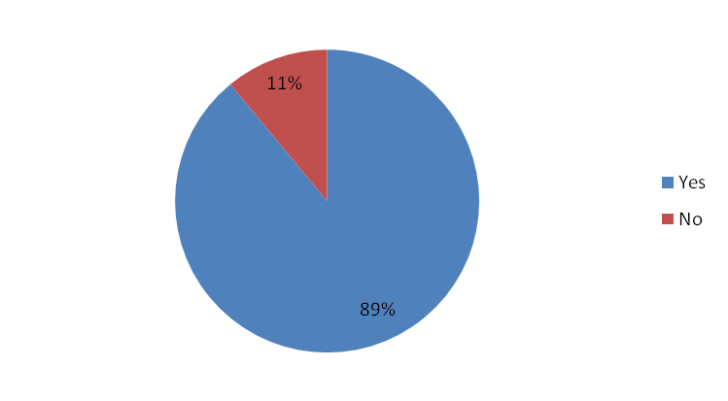
Figure 4.9 Marketing Experts
Source: Field research, 2014.

Findings presented in figure 4.9 reveal that 89% of tour operators have marketing experts while 11% of tour operators lack marketing experts to handle all marketing activities. According to the findings above it implies that 89% of tour operators in Arusha city have marketing expert to handle marketing activities.

4.7.2 Reviews and Analysis of Marketing Strategies
During the process of data analysis the findings gathered which concerned with the reviews and analysis of marketing strategies implemented among tour operators, the result presented in figure 4.10.
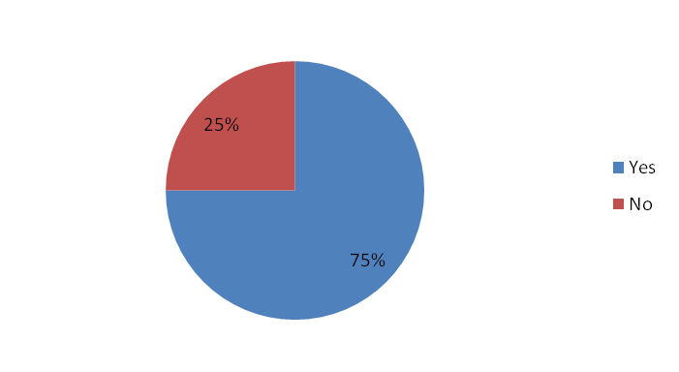
Figure 4.10 Reviews and Analysis of Marketing Strategies
Source: Field research, 2014.

The findings from respondents concerned the reviews and analysis of marketing strategies implemented among tour operators show that 75% of tour operators in Arusha city reviews and analyzes the marketing strategies while 25% do not review and analyze marketing strategies. This implies that as per result shows in percentage the 75% of tour operators do reviews and analyze to determine the effective marketing strategies for marketing.

4.7.4 Tour operator’s Opinion on Government
In order to find out about tour operators opinions concerning the role of government in effective marketing and promotion of Tanzania tourism products inside and outside the country the findings presented in figure 4.11.

Figure 4.11: Tour operator’s Opinions on Government
Source: Field Research, 2014

Results from figure 4.11 show that, 72% of tour operators disagreed while 28% agreed on government role to effective marketing of Tanzania tourism products inside and outside the country. Findings above shows 72% disagreed concerning the government role to effectively marketing and promotion of Tanzania tourism products inside and outside the country.

4.7.6 Lack of Marketing Professionals
Further the study find out whether tour operators lack marketing professionals the findings presented in figure 4.12.

Figure 4.12: Lack of Marketing Professionals
Source: Field research, 2014.
The findings disclosed that 77% of tour operators employ marketing professionals while 23% of respondents lack marketing professionals. According to the findings it can be conclude that 77% of tour operators within Arusha city have marketing professionals while 23% of tour operators lack marketing professionals.

4.7.7: Marketing Combination Factors
This section involves the marketing related factors being associated with the contribution organization in marketing and promotion of Tanzania tourism products. The findings from respondents concerned the statements A to O (Appendix2) disclosed that;

94% of correspondents agreed that some of tour operators lack marketing skills and techniques. 94% of correspondents agree that marketing is a critical problem affecting tour operators. 92% of respondents agree that tourism marketing is an expensive factor for tour operators demanding large amount of fund. 90% of correspondents agree that Tanzania tourism products and services are highly expensive. 85% of respondents agree that each tour operator focuses on satisfying needs and wants of customers.

84% of respondents agree that social media are not yet fully utilized by tour operators in marketing and promotion of tourism products. 75% of respondents agree that e-marketing and e-commerce are not yet applied effectively by tour operators. 73% of respondents agree that tourists are well satisfied with products and services offered by the tour operators. 55% of respondents agree that most of tour operator’s websites are disorganized with poor contents about tourism products and services offered. 53% of respondents agree that language barrier contribute to poor marketing and promotion of Tanzania tourism products. 46% of respondents agree that Tanzania Tourist Board (TTB) marketing strategies are helpful for tour operators.

42% of respondents agree that local tourism fairs contribute on the expansion of tourism market and increase numbers of customers to purchase tourism products and services. 39% of respondents agree that Tanzania Association of Tour Operators (TATO) supports tour operators companies in marketing and promotion of Tanzania tourism products. 38% of respondents agree that marketing strategies applied by TTB are most useful strategies for development of tourism industry of Tanzania. 36% of respondents agree that TTB works effectively in marketing and promotion of tourism products and services of Tanzania. Further illustration has been presented in figure 4.13.
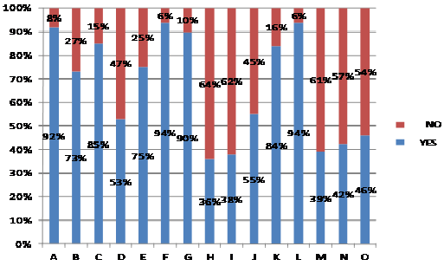
Figure 4.13: Marketing Combination Factors
Source: Field research, 2014.

4.8 Conclusion
This chapter centred on data presentation, analysis and discussion about assessment of marketing strategies tour operators use for marketing and promotion of Tanzania tourism products. The study focused on evaluation of marketing strategies, efficient marketing strategies, the effectiveness of marketing strategies tour operators use, achievement of marketing strategies, tourist’s satisfaction, tourism products and the tour operator’s market sources. The data analyzed through Statistical Packages for Social Science (SPSS) then findings were imported to Microsoft window excel for clear presentation of the figures and tables.

CHAPTER FIVE

5.0 CONCLUSIONS AND RECOMMENDATIONS

5.1 Introduction
This chapter presents conclusion and recommendations concerning the assessment of marketing strategies tour operators use for marketing and promotion of Tanzania tourism products. During research study the researcher evaluate marketing strategies, determine effectiveness of marketing strategies and examine achievement of marketing strategies tour operator’s use for marketing and promotion of Tanzania tourism product, also focus to determine tourist satisfaction, the tourism products, government and private sector contribution and concerning marketing experts. Further researcher suggested things to be followed for the development of tourism sector.

5.2 Conclusions
Through the study of assessment of marketing strategies tour operators use for marketing and promotion of Tanzania tourism products, the researcher has disclosed the following indicated as follow:

Tour operators use various marketing strategies to market and promote Tanzania tourism products. Tour operator’s offers tourism products and services to tourists with focus to deliver satisfaction to their customers. Since satisfaction is an important aspect which every customer expect when purchase the tourism product and service.
While ongoing is true, however, on the other hand poor satisfaction to customers, lack of product development and innovation, poor marketing strategies implementation among tour operators can affect the tourism business. Despite the availability of marketing professionals the findings has disclosed that some of tour operator lack marketing experts to handle all marketing activities.

The implementation of marketing strategies without evaluating the effectiveness can contribute to unfulfilled achievement of marketing and promotion of tourism business.The innovation and development of tourism products can add value and desire for customer to taste and experience. The development of products and services intended to deliver value to customer is the major task that each tour operator should focus in order to satisfy customers and generate sales.

Any marketing and promotion of tourism products and services requires sufficient information about the products marketed since tourism products are not physically seen, measured or touchable but can only experienced. Hence sufficient information about tourism products and services offered by tour operators can motivate customers to engage and purchase. This includes good arrangement of product with sufficient information, constructs organized websites and well optimized as a source of information that reach majority of people worldwide.

Successful marketing and promotion of Tanzania tourism products requires both efforts of tour operators (private sector) and government tourism organizations to work closely to ensure optimal marketing of tourism products and services at national level and international level. Hence the establishment of public private partnership (PPP) between government and private sector in marketing and promotion of Tanzania tourism products can improve tourism marketing leads to tourism development, employment opportunities and economic growth.

5.3 Recommendations
Tourism is an important sector that contributes the economic growth and employment opportunities for communities within the country. Relating to research study on assessment of marketing strategies tour operator use for marketing and promotion of Tanzania tourism products, the researcher has drawn the following recommendations to be considered in order to enhance marketing and promotion of Tanzania tourism products for development and success of tourism sector.

5.3.1 Recommendations to Tour Operators
Each of tour operators should implement the efficient marketing strategies for marketing and promotion of Tanzania tourism products. Also should review and analyze the marketing strategies frequently to locate effective marketing strategies according to their target markets. The product development and service improvement is crucial to deliver value to customers.

Marketing course programs should be conducted to facilitate better performance of tour operators and staffs through hiring marketing professionals. This can be achieved through different seminars and conferences that tour operators may sponsor themselves or the government.
Improvement of website contents including valuable information details to capture customers and visitor’s mind. This may also mean the optimization of websites content keywords, improvement of web speed, acceptance of electronic payment system and language selection services to expand market through internet system.

5.3.2 Recommendations to the Government and Tourism Organizations
The government should corporate on public private partnership organization (PPP) as the factor to reinforce marketing and promotion of Tanzania tourism products in order to improve tourism marketing leads to tourism development, employment opportunities and economic growth.

Tanzania tourists board (TTB) should identify the efficient marketing strategies to implement in marketing and promotion of Tanzania tourism products.
The government should recognize the marketing professional’s contributions on how to achieve effective marketing of Tanzania destination locally and internationally.

5.3.3 Areas for Further Research
Tourism sector is among key economic sources of Tanzania in general and Arusha city in specific. Based on the findings of this study, it has been revealed that there is need for a research study to be conducted in Arusha city focused specifically on how to improve tourism marketing of Tanzania.

5.4 Chapter Conclusion
This chapter has covered conclusions and recommendations based on the research study of assessment of marketing strategies tour operators use for marketing and promotion of Tanzania tourism products. Further, the researcher has presented recommendations in order to achieve tourism marketing of Tanzania tourism products for development of tourism sector, economic growth and employment opportunities.

REFERENCES
Aliaga, M. and Gunderson, B. (2002). Interactive Statistics. Second Edition, Prentice-Hall.
Belch GE and Belch MA (2001). Advertising and Promotion. An Integrated Marketing and Communications Perspective. 5th Edition. Boston: McGraw-Hill.
Burns, P. (1999). Paradoxes in Planning Tourism elitism or brutalism? Annals of Tourism Research, Vol. 26 (2).
Cronje GJ, Du Toit GS, Motlatla MDC (2000). Introduction to Business Management. Cape Town: Oxford University Press.
Dave, Chaffey. Fiona, Ellis Chadwick. Richard, Mayer. Kevin Johnston, (2006). "Internet Marketing: Strategy, Implementation and Practice", Third-Edition. Harlow, England. Pearson Education Limited.
Dieke, Peter. U.C, (2003). "Tourism in Africa’s Economic Development: Policy Implications", Management Decision, Vol. 4, No. 3.
Duncan, T. (2002). IMC: Using Advertising and Promotion to Build Brands. New York: McGraw-Hill/Irwin.
Eco Planet Africa, (2014). Arusha City Tour. Available: [http://ecoplanetafrica.com/arusha-city-tour/] site visited on 2/3/2014.
Freyer, W. (1999).Tourismus - Marketing: Marktorientiertes Management imMikro - und Makrobereich der Tourismuswirtschaft, 2. Auflage, München & Wien: R. OldenbourgVerlag.
George, R. (2001). Marketing South African Tourism and Hospitality. Cape Town: Oxford University Press.
Goddard W and Melville S 2001. Research methodology: An introduction. Second Edition. Lansdowne: Juta and Co.
Golub.H. (2000). “Foreword” in World Travel and Tourism Council centenary booklet, “Linking Hanson, W. 2000.Principles of Internet Marketing. Cincinnati, Ohio: South-Western College.
Hanson, Ward. (2000). Principals of Internet Marketing. Cincinnati, Ohio: South - Western College publishing.
Hudson, Simon. (2008) Tourism and Hospitality Marketing: A Global Perspective. London, SAGE Publications Ltd.
Kazda, A & Caves, RE. (2000). Airport design and operation. Amsterdam, New York: Pergamon.
Kothari, C. R, (2004). Research Methodology-Methods & Techniques, Second Edition. New Delhi, India: New Age International Publisher.
Kotler, P. & Keller, K. (2009). Marketing Management, 13th-Edition. New Jersey. Pearson Prentice Hall.
Kotler, P. Bowen, J & Makens, J (2002). Marketing for Hospitality and Tourism – Third Edition. Pearson Education: Upper Saddle River, New Jersey.
Koutoulas, D. (2001). The Theoretical Determination of the Tourist Product as a Presupposition for Tourism Marketing [in Greek].Doctoral Dissertation. Chios: University of the Aegean.
Krippendorf, J. (1971). Marketing imFremdenverkehr. Bern &Frankfurt:Herbert Lang & Cie.
Luvanga, N and Shitundu, J. (2003).The Role of Tourism in Poverty Alleviation in Tanzania, Research Report No. 03.4 on Poverty Alleviation (REPOA). Dar es Salaam Tanzania, Mkuki na Nyota Publishers Limited.
Madu, C.N. and Madu, A.A. (2002), “Dimensions of e-quality”, International Journal of Quality & Reliability Management, Vol. 19 No. 3, pp. 246-58.
Matikiti, Rosemary. (2011). The impacts of internet marketing on the profitability of the hospitality Sector in the eastern cape province, South Africa. Eastern Cape Province, South Africa.
Moutinho, L. (2000). Strategic Management in Tourism. London: CABI Publishing.
Mwarania, Ninette. Kaari. (2012). Internet Marketing Adoption and Performance of Tour Operators in Nairobi Kenya. Nairobi, Kenya.
National Bureau of Statistics (2013). Tanzania Ministry of Finance.
Nkonoki, S. (2012). Challenges of Tour Operators. Case study: Dar-es-Salaam, Tanzania.
Nothnagel, B.L. (2006). Internet Marketing Communications: A content analysis of websites of graded lodges in South Africa. Ms Thesis (Unpublished). Pretoria University, South Africa.
Palatkova, Monika. (2012) Travel and Tourism Marketing - Review. Czech Journal of Tourism 01/2012 (30-52).
Pender, L. (1999). Marketing Management for Travel and Tourism. Cheltenham, UK: Stanley Thornes.
Ryan, C. (1991). Tourism and Marketing - A Symbiotic Relationship, Tourism Management.Vol.12 (2), pp.101-111.
Tanzania Association of Tour Operators (2013). Mainland Tour Operators List. Available: http://www.tatotz.org/.
Tanzania Tourist Board, (2013). Tourism expected to blossom next year-tourism annual report. Available: http://www.tanzaniatouristboard.com/.
Teker, S., D. Teker, (2012), Tourism projects financing: a public-private-partnership model, Business Management Dynamics, (EBSCO), 2(5), 5-11.
UNCTAD (2008). FDI and Tourism: The development dimension. East and Southern Africa UNITED NATIONS, New York and Geneva 2008. University Press.
United Republic of Tanzania (2002).Ministry of Natural Resources and Tourism, Tourism Master plan strategy and action. Final summary update.
United Republic of Tanzania (2005). Tanzania Tourism sector survey. The International Visitors Exist survey report; Pp 17.
United Republic of Tanzania (Sept. 1999). National Tourism Policy: Dar es Salaam: Government Printers. Pp 4.
United Republic of Tanzania, (2002). Report.[http://www.tanzania.go.tz] site visited on 2/8/2013.
United Republic Tanzania (2002). Integrated Tourism Master Plan for Tanzania Summary and Action Plan.
UNWTO (2002). Report of World Tourism Organization to United Nations Secretary. General in preparation for High Level Meeting on the Mid-Term Comprehensive Global Review of the Programme of Action for the Least Developed Countries for the Decade 2001-2010.
Van Der Merwe, Michelle. Caroline (2003). Marketing communication methods used by tour operators in Guateng. Research Dissertation: University of South Africa, South Africa.
World Economic Forum (2008). Highlights of the travel & tourism competitiveness report. Available: http://www.weforum.org/en/media/publications/ Competitivenes reports/index.htm.(25-08-2014).
World Tourism Organization (1999). Compendium of Tourism Statistics 1993-1997.Nineteenth.
World Tourism Organization (2001). Tourism Satellite Account: Recommended Methodologies Framework. New York.

APPENDICES

APPENDIX 1: Questionnaire for Respondents
Questionnaire number………………………………………………………...............
Date………………………………………………………………………….................
This questionnaire requests you to fill solely for academic purpose. I kindly, therefore request you to respond to the following questions.

- Please indicate below the marketing strategies the company use for marketing and promotion of Tanzania tourism products, (Please tick the applicable).
Marketing strategies | Strategy used
 | Yes | No
International trade fairs and exhibitions
Online marketing, Website pages, emails
Social media, Blogs, Face book, YouTube, Twitter
Outdoor billboards and posters
Catalogue, Magazine and Newspapers
E-tourism and E-marketing
Television and Radio network
International road shows
Brochures, flyers, leaflets, business cards
Travel trade
Product innovation and development
Search Engine Optimization (SEO)
Relationship Marketing
Local Tourism Fairs

- With reference to the marketing strategies the company use above please indicate the efficient marketing strategy the company has concentrated more in marketing and promotion of Tanzania tourism products?…………………………………...
..............................................................................................................................................................................................................................................................
- Did the marketing strategies the company use for marketing and promotion of Tanzania tourism products are effectiveness for the success of tourism business? (Please tick one only).
(a) Yes ( )
(b) No ( )
- To what extent the marketing strategies the company use have achieved in marketing and promotion of Tanzania tourism products? Please tick appropriate one only.
(a) Good ( )
(b) Better ( )
(c) Excellent ( )
(d) Fair ( )
(e) Poor ( )
- Please indicate the tourism products or service the company offers in general (tick the applicable, if it is more than one, please rank them starting from 1 as the major).
(a) Cultural tour ( )
(b) Wildlife photographic safaris ( )
(c) Hunting Safaris ( )
(d) Beach holidays ( )
(e) Mountain Climbing ( )
(f) Scenic Tour ( )
(g) Historical Tour ( )
(h) Walking & Biking tour ( )
(i) Hiking and Trekking ( )
(j) Canoe & Boat Safari ( )
(k) Horse ride Safaris ( )
(l) Accommodation ( )
(m) Air ticketing ( )
(n) Transfer services ( )
(o) Shuttle services ( )
- Kindly indicate below the tourism products tourists prefer. Tick the applicable below.
(a) Wildlife Safaris ( )
(b) Cultural Safaris ( )
(c) Mountains Climbing ( )
(d) Beach Holidays ( )
(e) Wildlife and Mountains ( )
(f) Wildlife, Mountains and Beach ( )
(g) Wildlife and Beach ( )
(h) All of them ( )
- Please indicate below the company sources of market (Tick the applicable one).
(a) Foreign ( )
(b) Domestic ( )
(c) Both of them ( )
- How can categorize the tourist’s satisfaction level for Tanzania tourism products and services the company offered? (Tick the applicable one below).
(a) Satisfied ( )
(b) Slightly satisfied ( )
(c) Well satisfied ( )
- Does the company involve in marketing and promotion of Tanzania tourism products locally and internationally? (Tick the applicable one only).
(a) Yes ( )
(b) No ( )
- Please indicate whether the company has the marketing experts to handle all marketing activities. Tick the applicable one.
(a) Yes ( )
(b) No ( )
- Does the company review and analyze the marketing strategies implemented for marketing and promotion of Tanzania tourism products? (Tick applicable one only).
(a) Yes ( )
(b) No ( )
- Did the government effectively market and promote Tanzania tourism products inside and outside the country? (Tick applicable one only).
(a) Yes ( )
(b) No ( )
- Do you agree that there is availability of tourism marketing professional in Tanzania? (Please tick applicable one only).
(a) Yes ( )
(b) No ( )

- Do you agreement that the company lack marketing professionals? (Tick only one applicable).
(a) Yes ( )
(b) No ( )
- Please state whether you agree or disagree with the statements below, (Please tick the applicable).
 | Agree | Disagree
Tourism marketing is expensive factor for tour operators demanding large amount of fund.
Tourists are well satisfied with products and services offered by tour operators.
Each tour operator focuses on satisfying needs and wants of customers
Language barrier contributes to poor marketing and promotion of Tanzania tourism products.
E-marketing and E- commerce are not applied effectively by tour operators.
Some of tour operators lack marketing skills and techniques
Tanzania tourism products and services are highly expensive
TTB works effective in marketing and promotion of Tanzania tourism products and services
Marketing strategies the TTB use are most useful for development of tourism industry of Tanzania
Most of tour operator’s websites are disorganized with poor contents about tourism products and services offered.
Social media are not yet fully utilized by tour operators in marketing and promotion of Tanzania tourism products
Marketing is the critical problem affecting tour operators
Tanzania Association of Tour Operators (TATO) supports tour operators in marketing and promotion of Tanzania tourism products.
Local Tourism Fairs contributes to expansion of tourism market and increases number of customers to purchase tourism products and services.
Tanzania Tourist Board (TTB) marketing strategies are helpful for tour operators.

Thank you for Your Cooperation!
APPENDIX 2: Responses from the Respondents
- Tourism marketing is expensive factor for tour operators demanding large amount of fund.
- Tourists are well satisfied with products and services offered by tour operators.
- Each tour operator focuses on satisfying needs and wants of customers.
- Language barrier contribute to poor marketing and promotion of Tanzania tourism products.
- E-marketing and E-commerce are not yet applied effectively by tour operators.
- Some of tour operators lack marketing skills and techniques.
- Tanzania tourism products and services are highly expensive.
- TTB works effectively in marketing and promotion of tourism products and services of Tanzania.
- Marketing strategies the TTB use are useful for development of tourism industry of Tanzania.
- Most of tour operator’s websites are disorganized with poor contents about tourism products and services offered.
- Social media are not yet fully utilized by tour operators in marketing and promotion of tourism products.
- Marketing is critical problem affecting tour operators.
- Tanzania association of tour operators (TATO) supports tour operators in marketing and promotion of Tanzania tourism products.
- Local tourism fairs contribute expansion of tourism market and increase numbers of customers to purchase tourism products and services.
- Tanzania tourist board (TTB) marketing strategies are helpful for tour operators.

APPENDIX 3: An Introduction Letter to Participants

The Open University
of Tanzania
Po Box 23409
Dar Es Salaam, Tanzania
_______________________________________________________________________
17Th August, 2013
Dear Sir / Madam,
I am Kaaya Erick Abdiel, Spanish and Italian Tour Guide pursuing Master of Arts in Tourism Studies of The Open University of Tanzania at Arusha regional centre. I am requesting your support in my master’s research project titled “Assessment of Marketing Strategies Adopted by Tour Operators in Marketing and Promotion of Tanzania Tourism Products’’. The intention of this research project is only for academic purpose.

I hope you will accept my request for the success of my research project.
Yours Sincerely,
______________
Kaaya Erick Abdiel
M.A Tourism Studies Candidate
Open University of Tanzania.

