IMPACT OF FOREIGN EXCHANGE INTERVENTION ON SHILLING FLUCTUATION IN TANZANIA

ABDUEL ELINAZA

A DISSERTATION SUBMITTED IN PARTIAL FULFILMENT OF THE REQUIREMENTS FOR THE DEGREE OF MASTER OF SCIENCE ECONOMICS OF THE OPEN UNIVERSITY OF TANZANIA
2013

CERTIFICATION
The undersigned certify that he has read and hereby recommends for acceptance by the Open University of Tanzania a dissertation entitled: Impact of Foreign Exchange Intervention on Shilling fluctuation in Tanzania in partial fulfilment of the requirements for the degree of Master in Science (Economics) of the Open University of Tanzania.

....................................................................................
Dr Jehovaness Aikaeli
(Supervisor)

.....................................................................
Date

COPYRIGHT
No part of this dissertation may be reproduced, stored in any retrieval or transmitted in any form by any means, electronic, mechanical, photocopying, recording or otherwise without prior written permission of the author or the Open University of Tanzania in that behalf.

DECLARATION
I, Abduel Elinaza, declared that this dissertation is my own original work and that it has not been presented and will not be presented to any other university for a similar or any other degree award.

………………..............................................................
Signature

..........................................................................
Date

DEDICATION
I dedicate this work in the loving memory of my father Joseph ‘Joe’ Mwanga Elinaza and my uncle Godfrey ‘Shimbo’ Msuya whom left me with the spirit of endurance, hardworking and strong will and lust for reading more. Father/Uncle you will always remain so special to me.

ABSTRACT
This study investigates the impact of foreign exchange market intervention and shilling in Tanzania. The study aspires to develop a deeper understanding of foreign exchange intervention in the country. Literatures suggest that central banks intervene in the foreign exchange market for several reasons, including calming disorderly markets, correct misalignments, and accumulating reserves. But literatures a one thing and market disorder another thing all together. The recently Bank of Tanzania intervention and shilling fluctuations has led to renewed interest in how central banks should intervene to maximize it efficacy. This paper sheds light on a number of operational aspects of intervention. For this purpose, economic technique OLS, cointegration test, and Error Correction Mechanism was applied to time series. To gauge impact of intervention, Error Correction Term was applied. The study selected weekly Interbank Foreign Exchange Market and foreign exchange inflows data from 2006q1 to 2012q1. It also presents evidence on intervention practices based on the outcome of the results. The results shows that BoT intervention play little role to correct exchange rates levels and at short term are increasing fluctuation while no proof was registered that commercial banks sales have either positive nor negative impact on the market. The empirical results of this study raise a number of policy issues, because Tanzania is a net import-economy, therefore, the central bank has to strike a balance between the exchange rates that will not discouraging exports but at the same time controlling prices up spiral, which are the results of imports because of shilling depreciations. Since, higher inflation has spiral effects, be it economically or politically.

ACKNOWLEDGMENTS
Though only my name appears on the cover of this dissertation, a great many people have contributed to its production. I owe my thankfulness to all those people who have made this dissertation possible and because of them my graduate experience has been one that I will cherish forever.

My deepest gratitude is to my Lord Jesus for His abundantly grace, bless and love, without Whom - through his humble servant, Man of God Bishop Zachary Kakobe of Full Gospel Bible Fellowship Church - I could not have the wisdom, strength, good health nor breath of life to conduct this dissertation. May His Name be praised forever, Hallelujah! Amen.

I would like to express heartfelt thanks to my supervisor, Dr Jehovaness Aikaeli, who in spite of his tight schedules, dedicate a lot of his time and effort to guide me to this level. I have been amazingly fortunate to have a supervisor who gave me the freedom to explore on my own ideas and at the same time the guidance to recover when my steps faltered. His patience and support helped me overcome many crisis situations, during lecturing classes up to the finishing of this dissertation.

I would like to convey my special thanks to Dr Felician Mutasa, the programme coordinator for encouraging me to pursue this programme immediately after seeing my undergraduate results. He has been always there to listen and give advice. I am deeply grateful to him for the discussions that helped me sort out the technical details of my work. Dr Razack Lokina and [Dr] Nicas Nyabu for their insightful comments and constructive criticisms at different stages of my research which were thought-provoking-especially on research modal and estimations. I am also thankful for their practical advice after going through my proposal. I also express my utmost gratitude to Dr Deus Ngaruko for holding me to a high research standard and enforcing strict validations for each research result, and thus teaching me how to do research. Dr Khatibu Kazungu, I am indebted to him for his continuous encouragement and guidance, in an outside lecture rooms. He helped me understand my research area better.

I am also thankful to the Daily News staff, whom, without their cooperation and understating I could not make this study come-true. Kudos to Business Desk guys and the rest of the editorial team! I will always remember the support I received from Bank of Tanzania staff, led by Dr Joe Masawe, and International Monetary Fund—Dar es Salaam Office.

Many friends and family members have helped me stay sane through these difficult years. Their support and care helped me overcome setbacks and stay focused on my graduate study. I greatly value their friendship and I deeply appreciate their confidence on me.

Most importantly, and not least, as none of this would have been possible without the love and patience of my family. My Mother Emma, and my late father, Joseph Elinaza, to whom this dissertation is dedicated to, has been a constant source of love, concern, support and strength all these years. I would like to express my love and heart-felt gratitude to my wife Saumu Zidadu and my son Joe. My extended family has aided and encouraged me throughout this endeavour. Space limited me from mentioning many other friends, but I say thank you a million-time.

TABLE OF CONTENTS
Page
CERTIFICATION ii
COPYRIGHT iii
DECLARATION iv
DEDICATION v
ABSTRACT vi
ACKNOWLEDGMENTS vii
TABLE OF CONTENTS ix
LIST OF FIGURES xiii
LIST OF TABLES xiv
LIST OF APPENDICES xv
ACRONYMS xvii

CHAPTER ONE 1
1.0 INTRODUCTION 1
1.1 Introduction 1
1.2 Research Problem 3
1.3 Research Rationale 4
1.4 Research Objective 5
1.5 Hypothesis Question 5

CHAPTER TWO 7
2.0 BACKGROUND OF THE ECONOMY, FOREIGN EXCHANGE MARKET AND EXCHANGE RATE MOVEMENTS 7
2.1 Introduction 7
2.2 Tanzania Economy Overview 7
2.3 Historic Background of Foreign Exchange Market in Tanzania 11
2.3.1 Money Markets 12
2.3.2 Interbank Foreign Exchange Market 13
2.3.3 Capital Market 14
2.3.4 Treasury Bonds 15
2.3.5 Equity Market 15
2.3.6 Collective Investment Schemes 15
2.4 Foreign Exchange Operations 16
2.4.1 Trends in Interest Rates 17
2.4.2 Discount Rate 18
2.4.3 Deposit Rate 19
2.4.4 Treasury Bills and Bonds Interest Rates 20
2.4.5 Overnight Rate 21
2.5 Inflation 23
2.6 Exchange Rate Performance at Interbank Foreign Exchange Market 23
2.7 Liquidity Management and Interest Rate Developments 24
2.8 Financial Sector Stability 25
2.9 Conclusion 26

CHAPTER THREE 28
3.0 LITERATURE REVIEW 28
3.1 Introduction 28
3.1.1 Theoretical Review 28
3.1.2 The Economics of Exchange Rates 30
3.1.3 Foreign Exchange Market Efficiency 31
3.1.4 Channels of Influence 32
3.1.5 Market Microstructure Intervention 35
3.2 Empirical Literature 37
3.3 Literature Review Summary 39

CHAPTER FOUR 40
4.0 RESEARCH METHODOLOGY 40
4.1 Introduction 40
4.2 Research Design 40
4.3 Hypothesis 41
4.4 Measurement of the Impact of Intervention 42
4.5 Determinants of the Impact of Intervention 43
4.5.1 BoT Net Sales 43
4.5.2 Commercial Banks Net Sales 44
4.5.3 BoT Net Purchases 44
4.5.4 Vector 44
4.6 Data Analysis Methods 44
4.7 Data Analysis Technique 46
4.8 Test for Unit Root using Augmented Dickey-Fuller Test 47
4.9 Spurious Regression 47
4.10 Error Correction Mechanism/Model-ECM 48
4.11 Cointegration 49
4.12 Granger Causality Test 50
4.13 Data Sources 51
4.13.1 Data Limitation 51
4.14 The Research Anticipation 52

CHAPTER FIVE 53
5.0 EMPRICAL RESULTS AND INTERPRETATION 53
5.1 Introduction 53
5.2 Descriptive Statistics 53
5.3 Diagnostic Tests 55
5.3.1 Normality of Residual Test 55
5.3.2 Model Specification Test 57
5.3.3 Unit Roots Test 57
5.4 Testing of Cointegration 63
5.5 The F-test 64
5.6 Interpretation of the Results 65
5.7 Error Correction Model 68
5.7.1 Short and Long Term Impact 68
5.8 Granger Causality Test 71
5.9 Conclusion 73

CHAPTER SIX 75
6.0 CONCLUSION POLICY IMPLICATION AND RECOMMENDATIONS 75
6.1 Introduction 75
6.2 Summary of the Study and Empirical Findings 75
6.3 Policy Implications 76
6.4 Limitation of the Study and Recommendations for Further Study 77
REFERENCES 79
APPENDICIES 85

LIST OF FIGURES

Figure 2.1: Exports January 2005 – January 2012 8
Figure 2.2: Inflows and outflows of Foreign Exchange 9
Figure 2.3: Total Imports versus Oil Imports 10
Figure 2.4: GDP Growth by Quarterly 11
Figure 2.5: Government Securities 14
Figure 2.6: Lending/Deposits Rates 18
Figure 2.7: Discount Rate 19
Figure 2.8: Deposit Rates 20
Figure 2.9: Bill/Bond Rates 21
Figure 2.10: Other Interest Rates 22
Figure 2.11: Inflation 23
Figure 2.12: Exchange Rates 24
Figure 5.1: Kernel Density Estimate 56

LIST OF TABLES

Table 5.1: Summary of Descriptive Statistics 54
Table 5.2: Skewness/Kurtosis Tests for Normality 57
Table 5.3: Model Specification Test 57
Table 5.4A: Model Unit Roots 58
Table 5.4B: Model Unit Roots 59
Table 5.5: Dickey-Fuller Test for Unit Root at Levels 59
Table 5.6: Dickey-Fuller Test for Unit Root at Levels 60
Table 5.7: Shilling Variable Residual Prediction 60
Table 5.8: Dickey-Fuller Test for Unit Root 63
Table 5.9 : OLS Log 68
Table 5.10: ECM Estimation 69
Table 5.11: ECM-Estimation without Source 70
Table 5.12: Granger Causality Test Results between Shilling and BoT 71
Table 5.13: Granger Causality Test Results between Shilling and Bank 71
Table 5.14: Granger Causality Test Results between Shilling and BoT 72
Table 5.15: Granger Causality Test Results between Shilling and Source 72

LIST OF APPENDICES

Appendix 1 : Analytical Methodologies of Empirical Studies on Intervention Effects on the Exchange Rate using OLS 85
Appendix 2: Summary of Descriptive Statistics 86
Appendix 3: Skewness/Kurtosis Tests for Normality 86
Appendix 4: Regression Result OLS Model before Partial Logarithm 87
Appendix 5: Regression Results OLS after Partial Logarithm 87
Appendix 6: Testing Stationarity for the Entire Model 87
Appendix 7: Residual Test 88
Appendix 8: ADF for Shilling Log 88
Appendix 9: Testing for Variable Shilling First Deference 88
Appendix 10: Testing Results for Unit Root for Variable BoT 88
Appendix 11: Testing Results for Unit Root for Variable Bank 89
Appendix 12: Testing results for Unit Root for Variable BoT 90
Appendix 13: Testing Results for Unit Root for Variable Source 90
Appendix 14: IFEM Sales trend 91
Appendix 15: In and Outflows of Forex 91
Appendix 16: Exchange Rate (shilling) 92
Appendix 17: Inflation 92
Appendix 18: Error Correction Model computed with Source variable 93
Appendix 19A: Shilling/Bank Granger Causality 93
Appendix 19B: Bank /Shilling Granger Causality 93
Appendix 20A: Shilling/BoT Granger Causlity 93
Appendix 20B: BoT /Shilling Granger Causlity 94
Appendix 21A: Shilling/BoT Granger Causlity 94
Appendix 21B: BoT/Shilling Granger Causlity 95

Appendix 22A: Shilling/Source Granger Causlity 95
Appendix 22B: Source/Shilling Granger Causlity 95
Appendix 23: Working Data 96

ACRONYMS
ADF Augmented Dickey-Fuller
BoT Bank of Tanzania
CBT Central Bank of Turkey
CF Capital and Financial flow,
CPI Consumer Price Index
ECM Error Correction Mechanism/Model
ECT Error Correction Term
IBCM Interbank Cash Market
IFEM Interbank Foreign Exchange Market
IMF International Monetary Fund
NICOL National Investment Company
NMB National Microfinance Bank
NPLs Non Performing Loans
OLS Ordinary Least Square
Repo Repurchasing Agreement
SSA Sub-Saharan Africa
TCCIA Tanzania Chamber of Commerce Industry and Agriculture

CHAPTER ONE

1.0 INTRODUCTION

1.1 Introduction
The Bank of Tanzania (BoT) intervenes in the foreign exchange market frequently and in most cases with a relative large amount. These interventions, an independent policy tool, aim to correct foreign exchange mismatch, sensible exchange rate volatility, accumulate reserves and supply foreign exchange to the market and obtaining shilling for the government. BoT receives on behalf of the government budget support funds from donors in foreign currencies therefore have to sell them in the IFEM to convert the international currencies into local currency. In most cases the central banks interventions are directed into exchange rate whether to fix it, realign it, or reduce its volatility.
Under flexible exchange rate regimes, the timing and amount of intervention to determine whether or not to intervene at all become critical policy decisions. Theories suggest that under a fixed exchange rate regime, foreign currency supply and demand conditions dictate the timing and amounts of official intervention. In many countries, however, intervention remains important even after moving to managed and floating exchanges rates from various forms of pegs, literatures show.
Therefore this paper analyses this contention issue and determine its effectiveness in Tanzania without destabilizing the shilling. The understanding is that intervention is not bad if it sterilise the market meaning it would not affect the money supply unlike non-sterilise, which does.
There are disagreements among economists that the non-sterilisation move affect the exchange rate, just like conversional changes in monetary policy, typically for central banks purchasing or selling government securities—particularly bonds—could affect exchange rates.
On other hand, despite practising exchange flexibility regime BoT continues intervention at the foreign exchange market, in recently months pumping an average of 100 million US dollar a month The Daily News (October 2011). The almost always daily intervention on the IFEM could not help much to stabilise the shilling, especially between 2010 and 2011; instead the shilling continue its freefall against a US dollar (Tanzania’s main trading currency). For instance, at the end of the September 2011, Tanzania foreign reserve was equivalent to four months of exports unlike the same period previous year which was enough to covers six months (BoT: October 2011 Monthly Economic Review).
Foreign exchange interventions can be risky and might link to undermine a central bank’s credibility if it fails to maintain currency stability. This was seen in 1994 in Mexico following currency crisis that was driven by speculation, and was a leading factor in the Asian financial crisis of 1997. Though this has yet to happen in Tanzania, but in recently days, the shilling freefall in three East African Community (EAC) member states compelled governors of Kenya, Uganda and Tanzania to meet in the fourth quarter of 2011, in Nairobi, to try to find the common stance on how to quell the depreciations, BoT Monetary Policy Statement (June 2012).
Therefore the research analyses the effects of the intervention on the level and impact of the exchange rate. The essence is to establish the amount of foreign exchange sales or purchases and its impact on the shilling movement and cast doubt on claims that intervention is a useful tool to smoothing volatility. The period used to analyse the pattern is between first quarter of 2006, which is seen as the most fluctuated period, and first quarter of 2012. During that period the shilling wobbled more than other epoch since independence. At one time, in October 2011, the local currency hit the lowest level ever of 1,820/- against a US dollar.
The research outcome sheds lights on the effect of shilling depreciation, whether positive or negative on inflation—using the same span period. The shilling depreciation has positive relation with high inflation from the fact that Tanzania is a net-import economy.

1.2 Research Problem
Exchange rate fluctuations have as far-reach impact on a net-import economy—like Tanzania. Therefore, balancing the exchange rate is crucial. Because, the appreciation of the shilling to a certain level makes its exports relatively expensive compared to its neighbour countries in EAC, which produces almost the same agricultural goods (traditional exports) hence lowering the country competitive edge abroad; and on other hand, depreciation of shilling, despite reducing prices for exports goods and services, has little value addition as the economy does not have enough goods and services to sell abroad. Depreciation also makes imports expensive thus fuel inflation which in turn disturbs macroeconomic fundamentals and distorts economic growth pattern. High inflation can also lead to political and civil unrest.
In that context, (where foreign exchange fuel inflation)intervention in foreign market has to be done precisely if not timely, though in many cases it may be done in good intention but produces negative out comes, because it was not done at a correct or appropriate time. If it is done to early might send wrong signals and fuel speculations thus instability of either currency. Also intervention might be insufficient to cause further currency disturbance and left the market or the economy with more volatility exchange market. Another contentious issue is that intervention can be done all the way but, still, the currency continue to be unstable. And, is it necessary to intervene or should the market left to determine its exchange rate equilibrium as the law of demand and supply states?
Therefore, the study explores the timely intervention period and a sufficient amount for the intervention and whether it is important to intervene at all. All these are crucial deterministic for market stability. And prove the sentiment of impact of intervention on shilling by identifies elements of best practice in official foreign exchange intervention, assesses it effectiveness and what is its root cause. IMF had almost studied similar case in Mexico and Turkey (2004)….however, in Tanzania most study centred on foreign exchange volatility and exports or international trade, Paul (2007), and Igogo (2010).

1.3 Research Rationale
The rationale of this study is not only limited to fulfil my Master of Science Degree in Economics as per requirement of the Open University of Tanzania, but also will contribute to provide empirical evidence toward acceleration of the economic growth after embarking from fixed exchange regime to free-floating exchange regime two decades ago. The research will add value to the existing knowledge of economic theories on IFEMs, especially on developing countries which most have turned from fixed to flexible exchange regime. On top of that it will be used as an area of reference for similar research by researchers quoting this study in their works. It will be also be a useful document for further studies that will be conducted later.

1.4 Research Objective
The objective is to examine the causality between foreign market intervention and its impact on shilling in Tanzania. The study explores the plausible long-run linkage between foreign exchange intervention and shilling movements — whether going north or south.
- To investigate impact of foreign exchange intervention on shilling
- To identify characteristic pattern of the shilling following intervention
- To determine the causality of the market intervention and shilling fluctuation

1.5 Hypothesis Question
This study examines the degree of exchange rate change (S_{h}) following IFEM interference on whether through BoT net sales of foreign currency (BOT_{t}), BoT net purchases (BOT*_{t}) net sales of commercial banks (BANK_{t}) and vector (X) which stands for interest differential that comprises seasonality effects, for instance during traditional export seasons. The significant of dependent variables will be confirmed by the test-statistics on each variable (dependant) through the following hypothesis.
- IFEM intervention has no significant impact on shilling directions—either south or north
- BoT net sales of foreign currency at IFEM does not cause significantly impact on shilling exchange rate
- Net sales trading of the commercial banks at IFEM does not cause significant impact on shilling exchange rate
- The fluctuations of shilling exchange rate are not a significant result of neither BoT net sales nor commercial banks at the IFEM

CHAPTER TWO

2.0 BACKGROUND OF THE ECONOMY, FOREIGN EXCHANGE MARKET AND EXCHANGE RATE MOVEMENTS

2.1 Introduction
This chapter describes the Tanzania economy and how it has been affected by exchange rate fluctuations from 2006q1 and 2012q1. Since Tanzania is a net-import economy, shilling appreciation or depreciation has a direct impact on the level of inflation, which in return impacts either negatively or positively on the country macroeconomic fundamentals. It shows, how, foreign exchange movements have a direct link with structure and behaviour of various sectors of the economy. Also the chapter explores on the historical background of foreign exchange market in the country and the role of the BoT on IFME intervention.

2.2 Tanzania Economy Overview
In the global picture, up to the end of 2011, the recovery from financial meltdown remained weak (BoT Monetary Policy Statement midterm review June 2012). The weak recovery was mainly due to the crisis in the Euro Zone associated with sovereign debts, which coupled with weak consumer and business confidence in the rest of the world. In emerging and developing economies, real growth slowed down, mainly due to policy tightening and decline in investments and external demand. Though, according to BoT, Sub-Saharan Africa (SSA) continued to record strong economic performance notwithstanding adverse supply shocks from drought, especially in Eastern and Western Africa, the Euro Zone crisis have direct impact on foreign exchange movements to impact negatively on exports revenues.
Tanzania has three main revenue sources of foreign currencies, through export of traditional and non-traditional goods, remittance from Diaspora and donor aids—for supporting budget plus NGOs and other development activities. All these three sources were affected by Euro Crisis, with exceptional from gold (prices increases at the world market climbed during the recession) and manufacturing (most of the commodities are sold in East and Central Africa) region.

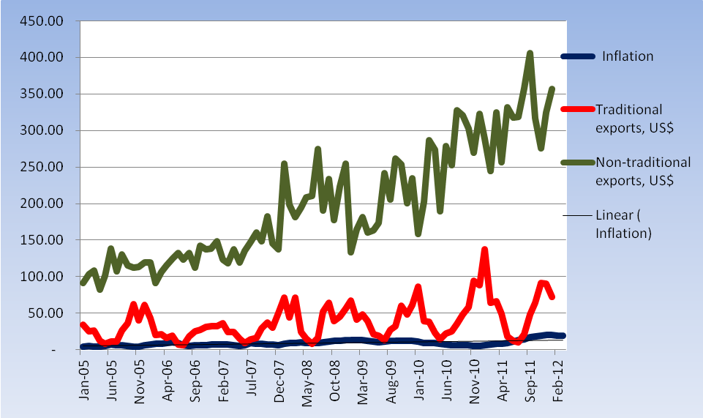
Source: BoT IFEM data

Figure 2.1: Exports January 2005 – January 2012

In Tanzania revenues from traditional crops declined due to low prices offered at the world markets. Figure 2.1shows that non-traditional exports become the leading forex revenue sector over time. The sector exports trend shows that it on the increasing path starting 2000, while exports of traditional exports fluctuating below the 100 marks. However, exports figures have been on the increase since 2008 and increased further between 2010 and 2011, which is a period when the shilling heavily depreciated. This demonstrates that there is a relationship between raise of revenues from exports when the shilling depreciates, this also was observed by Paul (2007).
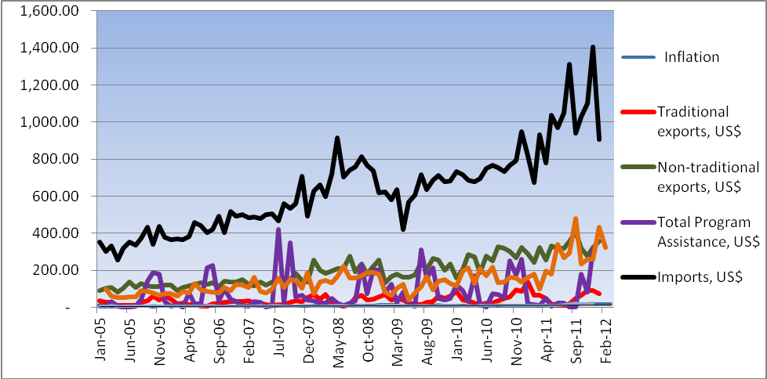

Source: BoT IFEM data

Figure 2.2: Inflows and outflows of Foreign Exchange

But when the shilling slides down the prices of commodities or exports becomes relatively cheaper, it’s like selling on discount, though on other hand importation prices of goods and services increase. Also oil prices increase considerably to over 125 US dollars a barrel in return to balloon Tanzania oil bill. Figure 2.3 below shows that the country oil bill is consuming about one third of the total import volumes.
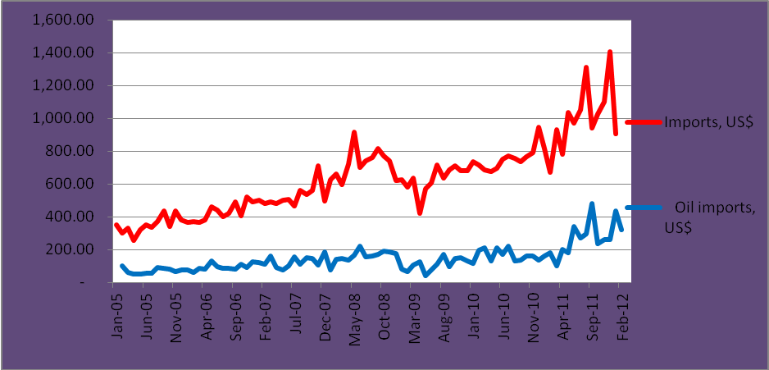
Source: BoT IFEM data

Figure 2.3: Total Imports versus Oil Imports

Between 2005 and 2011, the Tanzania economy grew between 6.0 per cent and 7.4 per cent. During those years the growth was limited due to global financial crisis and high oil prices in world market and poor harvest following drought weather since 2008. Figure 2.4 below demonstrates clearly by-quarterly GDP growth business cycles that were either experienced due to drought or world financial crisis of 2008.

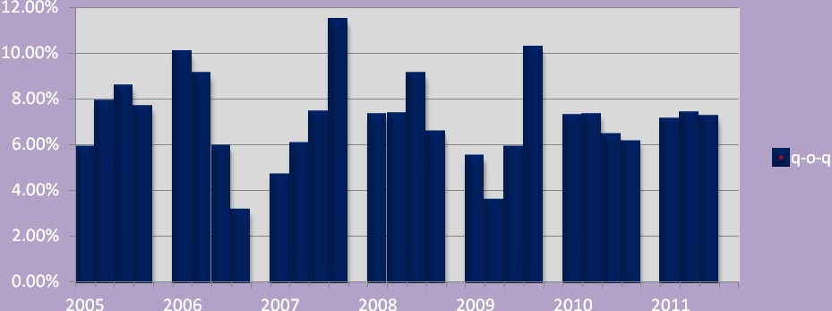
Source: BoT IFEM data

Figure 2.4: GDP Growth by Quarterly

2.3 Historic Background of Foreign Exchange Market in Tanzania
The Foreign Exchange Act was enacted in March 1992. The Act liberalised the external trade and created enabling environment for market determined exchange rates. Before the Act, Tanzania practised fixed exchange rate regime. However, in 1993, BoT began auctioning foreign exchange as a tool for liquidity management with the central idea of making the auctioning results as determinant of market-based exchange rate. In the following two years, the bank introduced Treasury Bills Auctions, as a tool for financing short term government deficit, an instrument for liquidity management, and as a reference point for the determination of market interest rates. The Auctions began with the 91–day Treasury bill, others bills were introduced later.
It was in June 1994 when the Interbank Foreign Exchange Market (IFEM) was introduced to replace the weekly foreign exchange auction system. The IFEM, which is a wholesale market, facilitated determination of the exchange rate. In the same year a fully-fledged Directorate of Financial Markets was established at BoT to develop and supervise the functioning of the markets.
The efforts bore fruits substantially but there were a dialogue gap. Then in March 2004 the central bank established Financial Markets Leaders Forum in order to promote dialogue and networking among stakeholders in the financial markets. Structured and informal knowledge sharing facilitated by the Forum, according to BoT, has enhanced comprehension of the market minutiae among market participants.

2.3.1 Money Markets
The money market, in the country, comprises of dealing in the Treasury bills, Repurchase Agreements (REPOS), Interbank Cash Market (IBCM) and Interbank Foreign Exchange Market (IFEM).
The Treasury bills market is dominated by commercial banks and participation is limited to residents. The tenure of the bills are 35, 91, 182, and 364 days, which are issued in the primary market once fortnightly and settlement is done on the next day, and secondary market trading is done over the counter—BoT Monthly Economic Review (May 2012).
REPOS involve the sale of securities with an agreement to repurchase the securities at a future date, and at an agreed price. They were introduced to manage intra-auction liquidity variations. At the moment repo transactions are conducted between the BoT and commercial banks. Tenure for Repos ranges between 2 days maturity to 14 days maturity.
While interbank cash market provides opportunity for lending and borrowing amongst commercial banks. It is a key segment in the money market where banks trade their positions to manage their liquidity imbalances.

2.3.2 Interbank Foreign Exchange Market
Foreign exchange transactions in Tanzania are done between the BoT and commercial banks, and amongst commercial banks and their customers—including bureaus de change. However, large volumes of foreign exchange transactions take place in the IFEM. The exchange rate used is market determined and the mean official exchange rate serves as a reference rate.
The IFEM plays an important role in the determination of the official exchange rate and monetary policy implementation. The number of participating commercial banks in this market currently stands at 45 out of which, about half of the banks, transact through Reuters Dealing System. The price mechanism is a two way-quote system, where each bank posts it’s tender/ask prices, for a bundle of 100,000 US dollar (Tanzania’s leading trading currency).
The main objectives of the IFEM, according to BoT, are to allow banks and other authorised dealers to play an active role in developing markets and instruments to serve their customers; to increase the efficiency in the allocation of foreign exchange reserves, thereby facilitating market-determined exchange rates; to create a favourable environment for foreign investment, which would, ultimately, pave the way to full liberalisation of the capital account; and to improve the conduct of monetary policy.

2.3.3 Capital Market
Capital market is where financial instruments for raising capital are traded. Instruments like stocks and bonds are traded. This market is one of the key in analysing the foreign exchange pattern because if returns in exchange rate are high, due to the short period of realising one’s return to investment, investors will swift their attention from government paper to IFEM. In return it affects the interest rate patterns to slope downward.
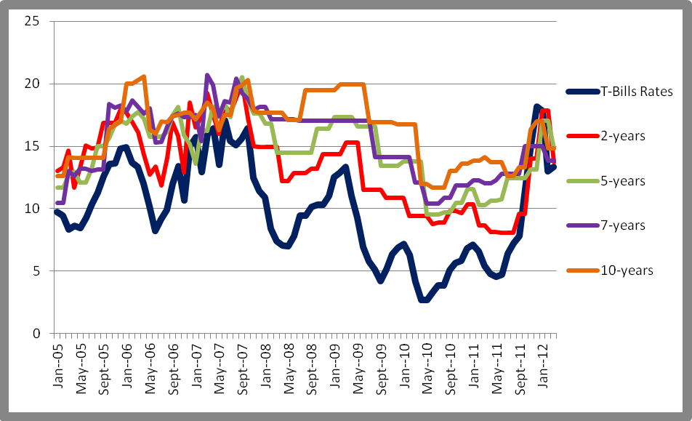
Source: BoT IFEM data

Figure 2.5: Government Securities

For instance between the period of January and June 2012, as Figure 2.5 thick-blue line represent T-bills, a short term security, fetched high returns compared to the long term papers, The Daily News (May 2012). A trend normally experienced during economic recession because the future remains uncertainty. But in Tanzania was caused by the liquidity scarcity because BoT where out to curb shilling freefall and galloping inflation.

2.3.4 Treasury Bonds
The Treasury bonds market has four maturities of 2, 5, 7 and 10 years that are issued in the primary market by the BoT on behalf of the government and are dominated by pension funds. The auction is held once every month. The bonds are listed at the Dar es Salaam Stock Exchange (DSE), for secondary trading, though their trading has not been vibrant. Also there are about 10 corporate bonds issued and listed at DSE of various amounts and tenures.

2.3.5 Equity Market
The equity market is currently consisting of fifteen companies listed at DSE. Participation of non-residents in IPO is limited to 60 per cent of the shares. The listed companies are TOL Gases Ltd, Tanzania Breweries Ltd, Tanzania Tea Packers Ltd, Tanzania Cigarette Company, Tanga Cement Company Ltd, Swissport Tanzania Ltd, Tanzania Portland Cement Ltd, Kenya Airways Ltd (cross-listed), East Africa Breweries Ltd (cross-listed), Jubilee Holdings Ltd (cross-listed), Africa Barrick Gold (cross-listed) DCB Commercial Bank, NICOL (delisted in 2011), CRDB Bank, Precision Air and National Microfinance Bank (NMB) which is the first bank to be registered on the DSE. In total there are 17 listed companies at DSE where six cross listed while 11 are domestic firms.

2.3.6 Collective Investment Schemes
These schemes gives an opportunity for the majority of Tanzanian citizens to invest, take a stake in privatization, further participate in the capital markets and obtain a return on their investments. Moreover, they are structured to provide opportunities to both low and high income Tanzanian individuals as well as registered based organisations whose beneficiaries are Tanzanians to participate in them—namely Umoja Fund, TCCIA Investment Company, and National Investment Company (NICOL).

2.4 Foreign Exchange Operations
BoT gradually eased foreign exchange controls after the enactment of the Foreign Exchange Act of 1992, by allowing the establishment of foreign exchange bureaux in April 1992, introducing foreign exchange auctions in July 1993, and creating the Interbank Foreign Exchange Market (IFEM) in June 1994.
The foreign exchange market in Tanzania is composed of the wholesale and retail markets. The IFEM is the wholesale market, which plays an important role in the determination of the country's official exchange rate and the provision of funds for the accumulation of international reserves. Tanzania's trade and exchange system is completely free of restrictions on making payments and transfers for current account transactions, BoT (2003).
In 2005 Foreign exchange operations were guided by the need to achieve a stable market determined exchange rate, according to BoT’s Monetary Policy (June 2012). In this respect and consistent with the price stability objective, BoT continued to exercise interventions aimed at quelling transitory fluctuations in the exchange rate so that market forces persist to play a greater role in determining the exchange rate. In addition, two-way quote mechanism was introduced at the IFEM. Under this arrangement IFEM participants are required to quote two exchange rates: one at which they are willing to buy, and another at which they are willing to sell, with a minimum trading lot of 100,000 US dollars. The system assisted to increase transparency in trading and reduce speculation in the exchange rate movements.
At the end of December 2004, official international reserves stood at 2.3billion US dollars, equivalent to 8.8 months of imports of goods and services. But over time, the amount swell to 2.7 billion US dollars in February 2008, before raised slightly to 3.6 billion US dollars in January 2012, which is approximately equivalent of four months of imports , BoT Monthly Economic Review (May 2012).
Nevertheless, the BoT data shows that gross foreign reserves of commercial banks have increased from only 780.1 million US dollars in February 2008 to 1.02 billion US dollars in January 2012, implying that gross foreign reserves of the banking system in Tanzania have grown from 3.5 billion US dollars in February 2008 to about 4.6 billion US dollars in January 2012.

2.4.1 Trends in Interest Rates
The overall lending rate was last reported at 12.00 per cent, according to BoT data. Historically, between 2005q1and 2012q1, the interest rates fluctuated between 14 per cent and slightly over 17 per cent. In most cases the overall rates remains at 15per cent. The black line, on Figure2.6 below, depicts the liner range, which shows that the rates stayed closer to the line in the last five years.
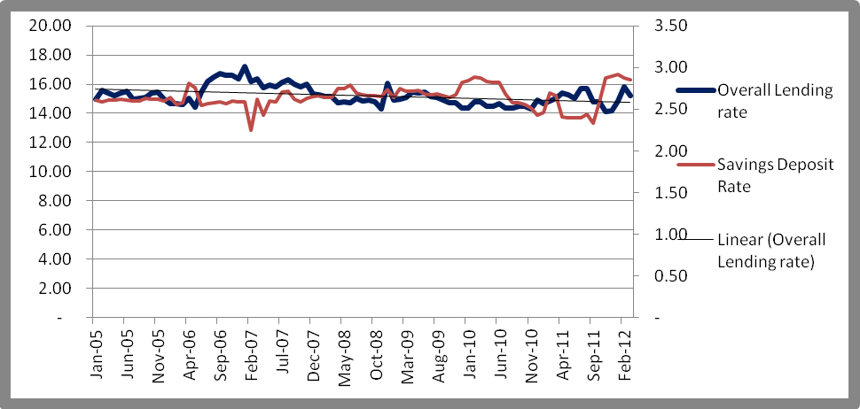
Source: BoT IFEM data

Figure 2.6: Lending/Deposits Rates

2.4.2 Discount Rate
Discount rate is the interest rate charged to commercial banks and other depository institutions on loans they receive from BoT’s lending facility--the discount window. The rates overtime since 2005 went down from almost 15 per cent to the lowest during the period of 3.70 per cent before climbing up again to settle at 12 per cent since November 2011 up to March 2012. This shows that shilling depreciation has a little effect on discount window, (see Figure 2.7 below).
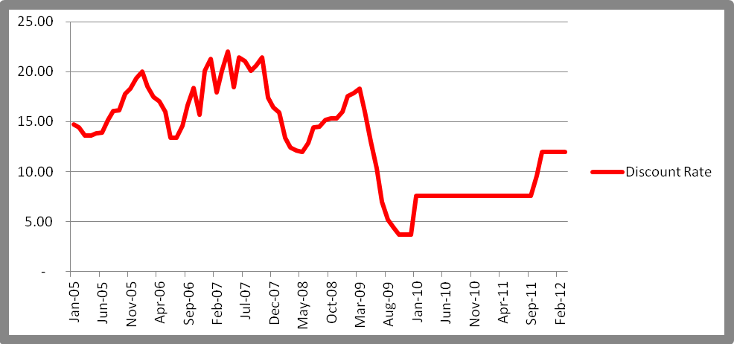
Source: BoT IFEM data

Figure 2.7 Discount Rate

2.4.3 Deposit Rate
In deposit terminology, a term deposit rate refers to the amount of money paid out in interest by a bank or financial institution on cash deposits. Banks pay deposit rates on savings and other investment accounts.

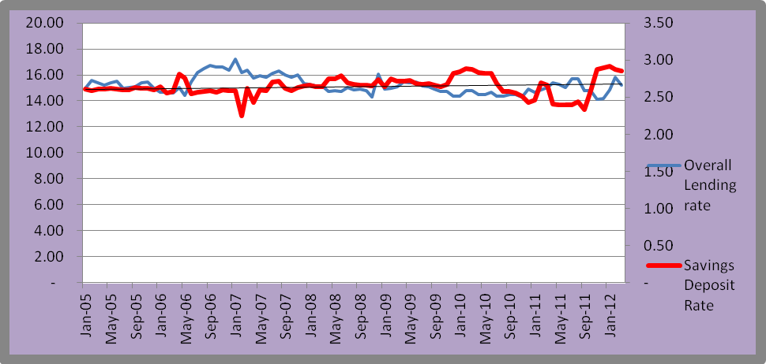
Source: BoT IFEM data

Figure 2.8: Deposit Rates

Deposits are the bank’s main source of fund for lending. Savings accounts earn a rather low rate of interest, but cash deposited in certain other account types are also paid a deposit rate by banks and financial institutions. In essence, the deposit rate is the price that a bank pays a depositor for the use of their money for the time period that the money is on deposit. Deposit interest rates can be either fixed for a certain period of time with a minimum amount of money on deposit, or it can be variable, which fluctuates. Since 2005 Figure 2.8 shows that deposits rates fluctuated between 2.30 per cent and 2.90per cent, but shows a huge gap between deposits and overall lending rates.

2.4.4 Treasury Bills and Bonds Interest Rates
The local currency, shilling, fluctuation also has a relative impact on Treasury Bills and Bonds’ yield rates, as portfolio investors almost always tend to scout around for quickly and highly return of their investments. If there is a good return on foreign exchange market, money mongers tend to swift attention to the market and abandon the debt market, which takes time to mature. Figure 2.9 below shows the trend.
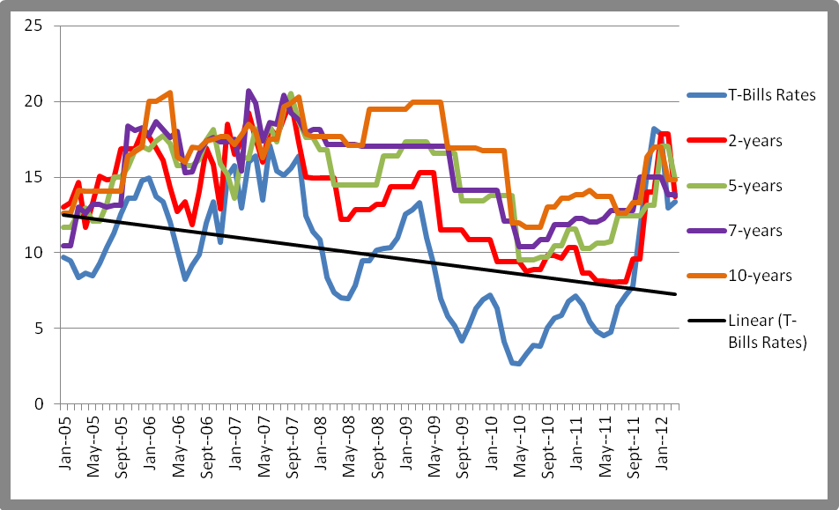 Source: BoT IFEM data

Figure 2.9: Bill/Bond Rates

2.4.5 Overnight Rate
The overnight rate is generally the rate that large banks use to borrow and lend from each other on the overnight market. In some countries (United States of America), for example, the overnight rate may be the rate targeted by the central bank to influence monetary policy. In most countries, the central bank is also a participant on the overnight lending market, and will lend or borrow money to some group of banks. BoT’s Monthly Economic Review (April 2012) shows that all money market rates increased substantially in March 2012. The increase is a reflection of tight liquidity following tight monetary policy stance adopted by the BoT to avert shilling from further sliding and reverse galloping inflation rate. The overnight IBCM increased to 25.79 per cent from 16.27 per cent recorded in March 2012, and 1.80 per cent recorded in the corresponding period of 2011. A number of banks accessed the Lombard window, pushing the Lombard rate to 30.94 per cent in April 2012, from 19.53 per cent in March 2012 and 2.17 per cent in April 2011.
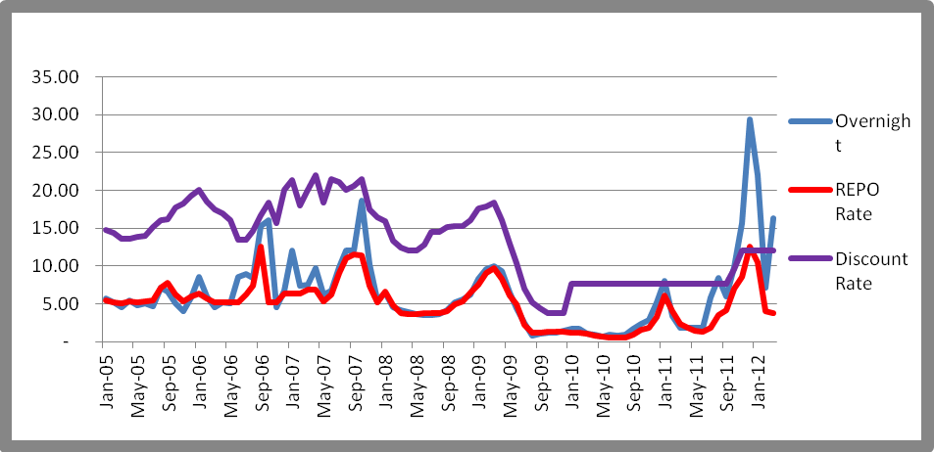
Source: BoT IFEM data

Figure 2.10: Other Interest Rates

Figure 2.10 shows that since the central bank imposes tight liquidity control in October 2001, overnight, Repo and discount rates take a quick up swing as the market was experienced low level of money in circulation. The squeeze saw some commercial banks, among them the leading ones - NMB and National Bank of Commerce -embarked on promotions to woo deposits in the first half of 2012. The trend helped to boost deposits rates from below 5 per cent to between 8 and 10 per cents.

2.5 Inflation
Tanzania is a net-import economy. Therefore when the shilling depreciates makes imports expensive hence fuelling inflation. Figure 2.11 depicted the trend that inflation in the past five years while Figure 2.12 shows the shilling depreciations tendency over the same period. The two figures indicate there are positive correlations between shilling depreciation and inflation rate. Though between September 2009 and September 2011 when CPI fall the exchange rate continue to remain on the high side.
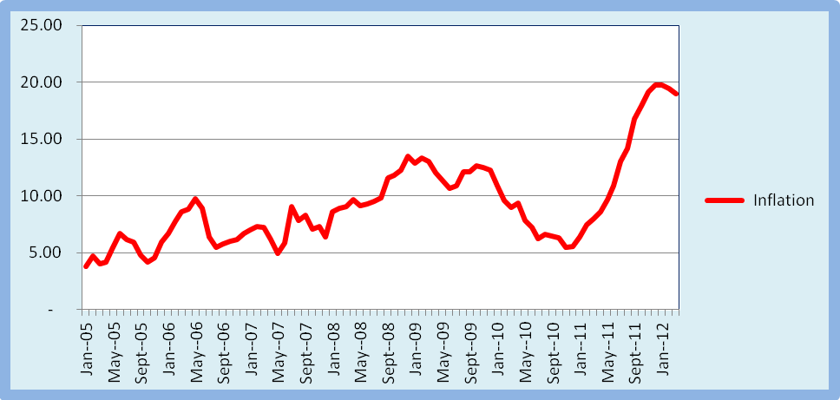
Source: BoT IFEM data

Figure 2.11: Inflation

2.6 Exchange Rate Performance at Interbank Foreign Exchange Market
Since the introduction of Tanzania shilling in June 1966, after the collapsing of East African Currency Board, the domestic currency keeping on sliding—though the biggest swing was in 2011. Figure 1.12, though shows the depreciating trend since 2005, the slope clearly show the upward swing trend. Tanzania is a net-import economy, where exports are not supporting imports to create imbalances on favour of exports. In this case depreciation of a shilling raises the costs of imported goods and services. This could have an adequately meaning if the economy takes the advantages to exports more goods and services, but unfortunately the country has less goods and services to export and in most cases sell overseas commodities in raw forms.
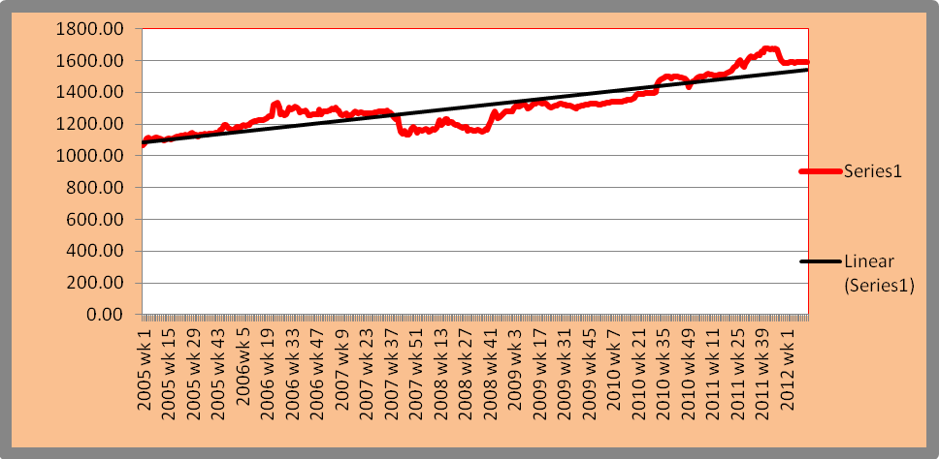
Source: BoT IFEM data

Figure 2.12: Exchange Rates

2.7 Liquidity Management and Interest Rate Developments
In the first ten months of 2011/12, the BoT pursued relatively cautious monetary policy in an effort to dampen inflationary pressures in the economy, which were also manifested in other East Africa Community (EAC) countries. Governors of the EAC Central Banks agreed to take coordinated actions towards the end of 2011 specifically to address these pressures, The Daily News (Oct 2011), BoT (June 2012). As part of East Africa Community coordinated monetary policy actions during the second quarter of 2011/12, the Bank raised the minimum reserve requirement on government deposits held by commercial banks from 20 per cent to 30 per cent, and increased the Bank rate by 442 basis points to 12 per cent in two stages. The monetary policy measures taken by the BoT, coupled with developments in commercial banks’ investment preference in foreign assets, strict government expenditure and good revenue performance led to shilling liquidity squeeze among banks.
These developments were mirrored in money market interest rates, which rose sharply in the second quarter of 2011/12, trending downward in January and February 2012 before turning around to an upward trend again in March and April 2012. The overnight interbank rate increased from an average of 5.9 per cent in September 2011 to 29.3 per cent in December 2011, but declined to 7.2 per cent in February 2012 before rising again to 16.3 per cent in March 2012 and 25.8 per cent in April 2012. Similarly, Treasury bills weighted average yield rose from 7.8 per cent in September 2011 to 18.2 per cent in December 2011, and fell to 12.9 per cent in February 2012 before rising to 13.4 per cent in March 2012 and 14.4 per cent in April 2012. As liquidity conditions among banks remained tight, banks used the intraday loan facility, the Lombard window, reverse repo and rediscount windows at the BoT to square their positions. It is noteworthy that developments in the money market interest rates were not fully reflected in banks’ deposits and lending rates Figure 2.6 and Figure 2.8.

2.8 Financial Sector Stability
The stability on financial sector plays an importance role in stability the money markets, because commercial banks are the key players in the IFEM. According to BoT, banks participation at IFEM is about 60 per cent. Between 2005 and 2008, the financial sector remained strong—measured by the banks’ capital and liquidity levels in regard to regulatory requirements Martin (2011). However, between 2008 and 2010, the stability was slightly shaky after the global financial crisis.
Nevertheless, during the year ending April 2012, the banking sector remained strong with capital and liquidity levels being above regulatory requirements BoT (June 2012). The ratio of core capital to total risk weighted assets and off-balance sheet exposures was at 18.2 per cent compared with a minimum regulatory requirement of 10.0 per cent. This represented slight decrease from 18.6 per cent recorded at the end of April 2011.
BoT (June 2012) indicates that the ratio of total loans to customers’ deposits stood at 65.7 per cent, which was within the threshold of 80 per cent. In the same period, the ratio of (NPLs) to total loans decreased to 7.6 per cent from 8.3 per cent recorded in April 2011, mainly due to improved credit administration by the banking institutions. However, NPLs net of provisions to core capital increased to 18.1 per cent from 17.4 per cent recorded in April 2011. Despite the increase, the banking sector capital was still resilient to credit risk, implying that in the unlikely event that the NPLs deteriorate to loss, the sector’s core capital will be eroded to the maximum of 18.1 per cent. Martin (2011) shows that since half of the commercial banks assets are compose of loans, advances and overdrafts and over 70 per cent of revenue comes from interest, this may portrayal banks to significant shocks and risks.

2.9 Conclusion
The chapter presented the history of money markets in Tanzania and effect of exchange rate in various interest rates regime and inflation trend. The exchange rate, according to Ishii el at (2006 p32), has remained an important determinant of inflationary outcomes and expectations even after the float, and the authorities (across the world) have been vigilant against volatility. Though, overall lending rates and deposits rates were not affected by the shilling depreciation other interest rate - Repo, Overnight, government securities yield rates were somehow affected by shilling volatility. On other hand, money markets—equities at Dar es Salaam Stock Exchange—where not affected by the shilling depreciation during that period under the study (Mr Moremi Marwa, Chief Executive Officer of Tanzania Securities Limited, a stock brokerage firm, told the researcher during an oral interview for The Daily News in 2012). Also data show that exchange rate drive inflation high as well.

CHAPTER THREE

3.0 LITERATURE REVIEW

3.1 Introduction
This chapter briefly looks at the theory fundamental on the subject under the study. It is divided into two main parts, theoretical and empirical literatures. In theoretical it looks at the concepts on channels which influence the shilling volatility under exchange regime. While in empirical, the chapter reveals experience of other markets in regards of IFEM interventions. It briefly looks at other studies and experience including far-reaching impact of other IFEMs encountered, especially in developing countries. The study provides a selective coverage of the literature on exchange rates, focusing on developments within the last fifteen years.

3.1.1 Theoretical Review
The developments in econometrics have shed important light on the understanding of exchange rates amid availability of high-quality data, which are responsible for stimulating the large amount of theoretical and empirical work on exchange rates in recently past, Sarno and Taylor(2002).Though economists and econometricians have enriched their understanding in regards of exchange rates, a number of challenges and open questions remain in the exchange rate debate, enhanced by events including the launch of the Euro and the large number of recently currency crises from developed to developing countries.

In observing this, in simplest let the rest of the world be a single country. Let Ω denote the nominal exchange rate - specifically, the price of a unit of foreign currency in terms of domestic unit. Basically the rise in exchange rate means the foreign currency becomes more expensive and therefore weakening, or depreciating of, the domestic currency. Equally, a fall in Ω corresponds to an appreciation of the domestic currency. Let P* denote the price of imported goods and services in unit of foreign currency Romer (2006 p231). This means the price of imported goods in units of domestic goods (Ф) is
Ф = P*/P.........................................................................(1)
This tells us that the higher the real exchange rate implies that foreign goods have become more expensive relative to domestic goods. In the economy which function at near or full potential residents of that particular import-country would likely turn to purchase domestic goods as they have become relative cheap compared to imported ones. But is not the case for net-import economy as it produce less than it consume. The gap in that case is filled by imports.
At this particular point one can make different assumptions about exchange regime—floating or fixing—capital mobility (perfect or imperfect), and exchange rate expectations (static or rational) Romer (2006) because the planned expenditure has gone up. This can be presented mathematically:
Y= E(Y, r, G, T, Ф) ................................................................(2)
where Y =real output, r the real interest rate, G real government purchase, T real tax and Ф price of foreign goods in unit of domestic goods. Under normal circumstances equilibrium in the foreign exchange markets requires that the capital and financial flow, CF, (foreigners’ purchases of domestic assets minus domestic residents’ purchases of foreign assets), and net exports NX, sum to zero.
CF = CF(r-r*), CF’(.)>0 ...............................................................(3)
For instance, if their sum is positive, this means that foreign demand for domestic goods and assets exceeds domestic demand for foreign goods and assets. In other words it means that foreigners want to trade for more of domestic currency than domestic resident want to trade for foreign currency, hence the foreign-exchange market is not in equilibrium. The equilibrium requires
CF = CF(r-r*) + NX(Y, r, G, T, Ф) = 0 .....................................................(4)
According to the literatures, this assists us to determine what happens if BoT stay out of the market and what are the consequences of the shilling, will the curve heads north or south. Ishii et al. (2006) has identified circumstances that surround the intervention as (a) to correct misalignments or to stabilize the exchange rate at a predetermined level—in other words, to try to set the exchange rate at a desired level, for example, one that will encourage exports, the Daily News May (2012); (b) to calm disorderly markets; (c) to accumulate reserves; and (d) to supply foreign exchange to the market—this occurs when the government is a major recipient of foreign exchange (for example, in Tanzania through royalty payments from extraction industry and funds received from multilateral development partners).

3.1.2 The Economics of Exchange Rates
According to Taylor (1995) exchange rate economics has been one of the most active and challenging areas of economic research between 1970s and 1990s. Academic interest in foreign exchange market efficiency can be traced to arguments concerning the information content of financial market prices and the implications for social efficiency. In its simplest form, Taylor’s (1995) efficient markets hypothesis can be reduced to a joint hypothesis that foreign exchange market participants are (in an aggregate sense) (i) endowed with rational expectation and (ii) risk-neutral. If the risk-neutral efficient markets hypothesis holds, then the expected foreign exchange gain from holding one currency rather than another (the expected exchange rate change) must be just offset by the opportunity cost of holding funds in this currency rather than the other (the interest rate differential). But also in an efficient speculative market, prices are expected to fully reflect information available to money and it should not be possible for a trader to earn excess returns to speculation.

3.1.3 Foreign Exchange Market Efficiency
Early efficiency studies tested for the randomness of exchange rate changes for example Poole (1967). However, only if the nominal interest rate differential is identically equal to a constant, and expectations are rational, then (1) implies that a random walk in the exchange rate (with drift if the constant is non-zero). Generally, the random walk model is inconsistent with the uncovered interest rate parity condition.

Taylor (1995) quoting (Dooley and Jeffrey Shafer 1983; Levich and Lee Thomas 1993) shows that another method of testing market efficiency is to test for the profitability of filter rules. A simple j-per cent filter rule involves buying a currency whenever it rises j per cent above its most recent channel and selling the currency whenever it falls j per cent below its most recent peak. If the market is efficient and uncovered interest rate parity holds, the interest rate costs of such a strategy should on average eliminate any profit. A number of studies do indicate the profitability of simple filter rules, although it is usually not clear that the optimal filter rule size could have been chosen ex ante, and there are often also important elements of riskiness in that substantial sub-period losses are often. Hence, early tests of efficient that involve simple test for random walk in the spot rate were supplanted by basic linear regression analyses of uncovered interest parity. The tests were in turn replaced by application of the use of sophisticated rational expectations estimators which allows the use of sample more finely than the term of the contract involved Taylor (1995).

3.1.4 Channels of Influence
The enormous literatures on foreign exchange intervention focus on three main channels of influence: signalling, portfolio balancing, and market microstructure. Intervention can be effective through the signalling channel if it is perceived as a credible signal on the future stance of monetary policy (Guimarãeset al. 2004 p6).

(i) The Monetary Channel
Economists have recognized a relationship between changes in countries' monetary-growth rates and changes in their exchange rates (or balance of payments under foreign exchange rates) at least since Hume's price-specie-flow doctrine (The price–specie flow mechanism is a logical argument by David Hume against the Mercantilist (1700–1776) idea that a nation should strive for a positive balance of trade, or net exports. The argument considers the effects of international transactions in a gold standard. He argued that when a country with a gold standard had a positive balance of trade, gold would flow into the country in the amount that the value of exports exceeds the value of imports. Conversely, when such a country had a negative balance of trade, gold would flow out of the country in the amount that the value of imports exceeds the value of exports). Although international economists might disagree about the relevant time frame and relative importance of money in exchange-rate models, few would object on theoretical grounds to the inclusion of money among the determinants of exchange rates, Taylor (1995).

(ii) The Exchange Rate Channel
This is another channel of monetary under transmission, which can affect GDP, and one that is sometimes modelled in the IS-LM model, is through the impact on exchange rates, The Channels of Monetary Transmission, AkilaWeerapana (fall semester 2005). The basic idea is that when central bank increases the money supply, it lowers short-term nominal interest rates and thus lowers short-term real interest rates as well. Lower short-term real interests rates imply that local currency denominated assets are less attractive than foreign assets leading to a decrease in demand for the said currency. The subsequent depreciation of the dollar makes domestic goods cheaper than foreign goods and leads to an increase in net exports, and therefore in GDP as well Romer (2006). For small open economies with flexible exchange rates, this can be a particularly important channel of transmission. The reason why some small open economies choose to adopt fixed exchange rates can also be understood from this equation: when the exchange rate is not allowed to change then domestic interest rates must be equal to world interest rates, thus the monetary policymaker is rendered toothless, according to Weerapana (2005) Department of Economics at Wellesley College—US.

(iii) The Portfolio-Adjustment Channel
Economists have extended the closed-economy, portfolio-balance models of asset demand, initially developed by Tobin (1969), to the open-economy case. In a portfolio model of asset demand, risk-averse wealth holders, facing uncertain rates of return on an array of assets, diversify their portfolios across assets instead of holding only the single asset currently yielding the highest rate of return. When exchange risk and political risk are introduced into the model, a strong incentive exists for wealth holders to diversify their portfolios across currencies, Taylor (1995). The assets relevant to the portfolio balance model are government bonds. Individuals generally do not hold large balances of foreign.

(iv) Signalling Channel
Under signalling or expectations channel, market participants may adjust their exchange rate expectation when they perceive intervention as signalling a change in the future monetary policy Taylor (1995), Guimarães et al. (2004) and Ishii et al (2006). Thus it can influence the exchange rate in either direction. The influence comes, for example, the sales of foreign currency by a central bank normally leads to a local currency appreciation, not because the intervention changes the fundamental of supply and demand conditions in the market but it signals a contradiction monetary policy (for instance higher exchange rates) in the future if downward exchange rate pressure perseveres. Because intervention is a policy instrument, a central bank can follow through policy actions that justify intervention to safe guard its credibility and avoid financial losses. The best example is for the central bank to tight monetary policies if its domestic currency remains under down-spiral pressure. BoT responded by halved the amount of foreign currency that commercial banks can hold (net open position) to 10 per cent. This was October 2011 when the shilling hit historical lowest lifetime level exchanging at 1,820/- a US dollar the Daily News (2011). Signalling partly depends on the institution and policy credibility of the central bank Ishii et al (2006).

(v) Portfolio Balance Channel
The portfolio balance channel, domestic and foreign currency denominated bonds assets are imperfect substitutes (and therefore, the “riskier” bond pays a risk premium) and intervention can be effective by modifying the currency composition of agents’ asset portfolios. The microstructure approach emphasizes the effects of order flow, market participants, information asymmetries, and price discovery in the foreign exchange market. Central bank trades are assumed to emit information to the market, which modifies exchange rate expectations and ignites a tide of foreign exchange orders, magnified in part by trend-chasing traders Lyons, (2001).

3.1.5 Market Microstructure Intervention
This branch of intervention examines the question of what happens when orders to buy or sell are not always balanced in the selected time period. It centres on influence of price change to the order flow. In the context of this intervention model, a central bank’s intervention or order can have both temporary and persistent effects. The microstructure literature focuses on the question of the how prices may be affected due to asymmetric information, in this case traders in the market might have different inflation. This, urges Dominguez’s (2003), may occur during heavy volume trading informed traders can easily hide their trades. Nevertheless Dominguez (2003) shows that currency prices and returns are also likely to change in reaction to intervention news, depending on how the news influences traders’ forecasts of future currency movements. Once intervention news is fully revealed to the market (and all uncertainty is resolved), theory suggests that volatility (and volume) should revert back to initial levels.
On other hands, economic theory suggests the three possible above channels through which exchange market intervention could alter exchange rates fluctuations. The monetary channel allows intervention to influence exchange rates by altering the relative growth rates of nations' money stocks. Hurnpage (1986) urges that there is little disagreement about the potency of such intervention; in fact, central banks can maintain fixed exchange rates through relative changes in their money stock. However, the extent to which these channels operates in practice remains an open question in the literatures, as the empirical evidence on the effectiveness of intervention, let alone its channels, remains inconclusive.

(i) Official Intervention
Official intervention in foreign exchange markets occurs when the authorities buy or sell foreign exchange, normally against their own currency and in order to affect the exchange rate. Sterilized intervention occurs when the authorities—simultaneously or with a very short lag—take action to offset or “sterilize” the effects of the resulting change in official foreign asset holdings on the domestic monetary base. The exchange rate effects of intervention—in particular sterilized intervention—have been an issue of some debate in the literature.

3.2 Empirical Literature
Most studies show that empirical studies on the effectiveness of central bank intervention focused exclusively on advanced economies. The quickly non-scientific conclusion on the research bias towards advanced economies primarily reflects the non-availability of data, but also the depth and sophistication of their foreign exchange markets assumed in many models of the intervention. For example, Dominguez et al (1993) estimate the effect of intervention on contemporaneous exchange rate movements and on forecast of future exchange rate and have found out mixed evidence in favour of the signalling and portfolio balance channels. Using survey data to measure exchange rate expectations, they find a significant effect on intervention on market expectations, especially if intervention are announced or coordinated. They also show that secret interventions are largely ineffective.
The consent in the literature until recent, according to Guimarães et al (2004), was that the portfolio effect gives a limited role for intervention to influence the exchange rate. One exception, a Dominguez et al (1993) study found out a significant and potentially large portfolio effect during the 1984–88 period, using survey data to measure exchange rate expectations and risk premium.
Nevertheless, recent research using data on order flow identifies permanent price effects through the portfolio balance channel. Evans et al (2001, 2002) found that intervention has a significant price impact in the most liquid currency pair market (before the introduction of the euro). Evans and Lyons’ (2001, 2002) urge that (the U.S. dollar-deutsche mark) that foreign exchange transactions have the largest impact on the exchange rate when the flow of macroeconomic announcements is high. More generally, in a series of papers using an event study approach, Fatum (2000) and Fatum et al (2003) find strong evidence in favour of interventions. In analyses of both the US dollar-deutsche mark and U.S. dollar-Japanese Yen bilateral exchange rates, they find that sterilized intervention systematically affects the exchange rate level, regardless of whether it is secret or announced. The probability of success is much higher, however, when interventions are coordinated among central banks and when they are conducted on a large scale (i.e., greater than 1.0 billion US dollars). Also using an event study approach, Edison et al (2003) find that the Reserve Bank of Australia’s interventions had some success - albeit a modest one - in moderating the depreciating tendency of the Australian but also increase exchange rate volatility trend.
Studies have shown that intervention appears to be ineffective in reducing volatility, and oftentimes, increases it. Both Dominguez (1998) and Hung (1997) provide evidence that following the Plaza Accord (September 1985) intervention tended to reduce exchange rate volatility among the G-3 currencies, but when the post-Louvre (1987–1989) period is examined, intervention increased volatility.
In contrast with most findings for advanced economies, empirical evidence on the effects of intervention in emerging market economies has been scant. In their empirical analysis of intervention in Mexico and Turkey, Domac et al (2002) conclude that central bank foreign exchange sales (but not purchases) were highly effective in influencing the exchange rate movements and in reducing volatility in both countries. In particular, they find that a net sale of 100 million US dollars appreciates the exchange rate by 0.08 per cent in Mexico and 0.2 per cent in Turkey. A more recent study on Chile by Tapia et al (2004) found that intervention had a small and generally insignificant effect on contemporaneous exchange rate movements, but in contrast, public announcements on potential intervention had a statistically significant impact on foreign markets. Saatcioglu (2006) when analysing the Central Bank Republic of Turkey (CBT) and its foreign exchange market intervention policies for post-crisis period of February 2001 – March 2005 using GARCH and methodology and unrestricted vector autoregression techniques (VARs) were employed to reveal the dynamic relationships between the CBT interventions and their ex-post consequences, showed that rather than decreasing the volatility of the exchange market, interventions are shown to be ineffective and inefficient. Also, Saatcioglu (2006) noted that a detailed investigation of central bank interventions indicates that purchase interventions are more effective in controlling the volatility of exchange rates than sale interventions.

3.3 Literature Review Summary
The importance of this study is to determine the impact of IFEM intervention on local currencies, especially in most developing which is net importers while some targeting exchange rates, and play a crucial role on CPI to affect economic growth over time. The interventions in most cases were meant to stabilise disorderly markets. But if, the more frequently and easily it intervenes, the more it will impede the development of a deep and robust market; then appropriate intervention strategies have to be put in place. Gosh el et (1996) finds that exchange rate regime can influence economic growth through investment or increased productivity. The study analyses two exchange regime namely pegged and floating, where pegged regimes indicates to have higher investment while floating regimes had faster productivity growth. On net, per capita GDP growth was slightly faster under floating regimes.
The study therefore stands to offer analysis to assists planners to arrive at the right decision. Unfortunately many such studies have been centred to developed world than developing countries (see empirical review subtitle 3.2).

CHAPTER FOUR

4.0 RESEARCH METHODOLOGY

4.1 Introduction
This chapter presents methodology used to achieve the desired goal of the study by measuring the impact of foreign market intervention on the shilling volatility. The chapter touches the research design which constitutes the blueprint of data collection, measurement and analysis of data hence arriving at a precise conclusion. Actual is in this chapter that enables the study to provide the glue that holds together the researcher hypothesis that BoT intervention at IFME by ways of selling US dollars increases the shilling volatility in the economy.

4.2 Research Design
The study analyses the causality relation between exchange market intervention and its impact on shilling in the Tanzania’s economy. The research uses secondary data mainly from the BoT. The data collected are daily figure on shilling exchange rate against the US dollar (the main trading currency of Tanzania), which have been compounded in weekly manner. In the recently years, which covers the study period BoT no longer purchases forex at IFME only sales. This has forced the researcher to measure the impact of shilling volatility by using weekly amount of money the BoT spent on intervention - net sales - and net sales of commercial banks. Also inflows of forex at the economy are taken into consideration as well. The sources of inflows are monthly export figures, Diaspora, and bilateral and multilateral grants for donors’ countries. The total amount of trading volume on the foreign exchange market, and monthly inflation data from NBS (the idea here is to examine the correlation between shilling depreciation and inflation).
Data span from first quarter of January 2006 to similar quarter in 2012. This is seen as the most fluctuated period when the shilling wobbles more than other period since independence in December 1961, to hit the lowest level of 1,860/- against US dollar quoted by commercial banks. In total this is almost six years period and to have the required sample size, the study will take weekly exchange rates - from the first week of January 2006 to the last week of March 2012. This will gives us 314 weekly samples of exchange rates and amount the BoT used to intervene into the market.

4.3 Hypothesis
Based on theoretical and empirical literature and the view of the objective and questions the research raised the following hypothesis, which are tested to determine the effectiveness of the intervention on the IFME. The questions are:-
- IFEM intervention has no significant impact on shilling directions - to either direction
- BoT net sales of foreign currency at IFEM does not cause significantly fluctuation on shilling exchange rate
- Net sales trading of the commercial banks at IFEM does not cause significant impact on shilling exchange rate
- The fluctuations of shilling exchange rate are not a significant result of neither BoT net sales nor commercial banks at the IFEM

4.4 Measurement of the Impact of Intervention
Dominguez (1998) indicated that various volatility equations show that intervention and exchange rate volatility are often correlated: “but it may be that volatility causes intervention, rather than the other way around”. This, according to Dominguez (1998), raises the issue of whether intervention is truly an exogenous signal, or whether past exchange rate changes influence the decision to intervene. On other hand Saatcioglu (2006) finds that the CBT interventions are under the control of uncertainties and exogenous variables in the Turkish economic environment. Rather than decreasing the volatility of the exchange market, interventions are shown to be ineffective and inefficient. Analyzing the direction of CBT interventions, sale auctions rather than the buy auctions are found effective in conduct of the CBT’s monetary policy. When analysing the results Dominguez (1998) indicates that that changes in monetary policy and intervention policy often influence exchange rate volatility while reverse causality tests, moreover, suggest that it is not volatility that causes intervention. Ishii el at (2006) shows that intervention may have nontrivial effects on exchange rate volatility, for instance Mexico, sales of foreign exchange are usually associated with increases in exchange rate volatility, in contrast to the often-stated objective of intervention to smooth volatility. But the evidence is more mixed in Turkey, with foreign exchange sales (but not purchases) reducing volatility in the short term, but increasing it in the long term.

4.5 Determinants of the Impact of Intervention
The review of the theoretical and empirical literature on the determinants of the impact of intervention prior to the choice of the indigenous and exogenous variables depict that purchasing and selling are the main variables that drives instability. This researcher, for simplicity uses OLS and to measure the impact of intervention Error Correction Mechanism (ECM) or Error Correction Model (ECM) is employed because is a means of reconciling the short-run behaviour of an economic variable with its long-run behaviour Gujarat and Porter (2009 p769). And the study uses weekly sample—from 2006q1 to 2012q1 to give a total of 323 weeks in six years. Under normal circumstances OLS gives biased and inconsistent estimates when applied to non-stationary relationships between regress and in left hand side with current endogenous variables on the right hand side (Johnston, 1960: p275), therefore ECM correct the inconsistent. The researcher took into account the Tanzania economy sources of the foreign currencies inflows, comprises of total export, Diaspora remittance and foreign aid, which play relative big role in determining the impact of intervention on exchange rates or IFEM.

4.5.1 BoT Net Sales (BOT_{t})
BoT net sales were measured using the weekly amount of sales at the IFEM in the span period of six years from 2006q1 to 2012q1. Saatcioglu (2006) and Ishii el at (2006) indicated that net sales, are the driver of volatility, though Ishii el at (2006) proved not in short term but on the long run.

4.5.2 Commercial Banks Net Sales (BANK_{t})
The net sales of commercial banks were measured using the same time span as of BoT net sales, but these sales are considering that the market is function at equilibrium where demand matches supply.

4.5.3 BoT Net Purchases (BOT_{t}*)
BoT net Purchases were measured using the weekly amount of sales at the IFME in the span period of six years from 2006q1 to 2012q1. Though, BoT’s rarely purchases forex at the market.

4.5.4 Vector
Vector contained other inflow sources of foreign currencies in the economy, which include total exports revenues, aid funds from the donors to Tanzania and Diaspora remittance. This, other source of income is considered to hold the IFEM at equilibrium if their inflow matches the demand at the forex market. Short of enough forex, for instance traditional exports have seasonality effects, at the market, the BoT compelled to intervene. The interventions in most case push the market out of equilibrium. Therefore, Vector, is uses as a proxy in the study.

4.6 Data Analysis Methods
To reach to the research objective, a wide array of analytical techniques will be used to evaluate the effectiveness of intervention. To examine the intervention impact on exchange rate level OLS regressions of the mean and through event studies of the intervention episodes are applied, due to its capability and simplicity. However, since the researcher is dealt with time series data, which is a sequence of data points, measured typically at successive points in time spaced at uniform time intervals, it’s better to examine its positive and negative challenges. Time series analysis encompasses methods for analyzing time series data in order to extract meaningful statistics and other characteristics of the data. Time series forecasting is the use of a model to predict future values based on previously observed values. While regression analysis is often employed in such a way as to test theories that the current values of one or more independent time series affect the current value of another time series. Also time series are analysed in order to understand the underlying structure and function that produce the observations. Understanding the mechanisms of a time series allows a mathematical model to be developed that explains the data in such a way that prediction, monitoring, or control can occur, for instance prediction or forecasting, which is widely used in economics and business.
It is assumed that a time series data set has at least one systematic pattern. The most common patterns are trends and seasonality. Trends are generally linear or quadratic. To find trends, moving averages or regression analysis is often used. Seasonality is a trend that repeats itself systematically over time. A second assumption is that the data exhibits enough of a random process so that it is hard to identify the systematic patterns within the data. Time series analysis techniques often employ some type of filter to the data in order to dampen the error. Other potential patterns have to do with lasting effects of earlier observations or earlier random errors. Time series reflect the stochastic nature of most measurements over time. Thus, data may be skewed, with mean and variation not constant, non-normally distributed, and not randomly sampled or independent.
Therefore, since the research objective is to measure the impact of BoT intervention at foreign exchange market, OLS model is employed owing to its simplicity. OLS was also used by Guimarães and Karacadag(2004), Evans and Lyons (2002), Edison (1993), Dominguez and Frankel (1993a, 1993b) and Sarno and Taylor (2001) to determine the impact of exchange in different economise. Appendix 1.
The model is:-
∆Sh = βo + β1BOT_{t} + β2BANK_{t} + β3BOT*_{t} + β4X_{t} + ε_{t}....................................(5)
where Sh is the exchange rate change, BOT_{t} and β2BOT*_{t} donated net sales and purchases of foreign currency for intervention purpose respectively and BANK_{t}, is the amount of banks trade at IFEM and the X vector includes the interest differential (including on seasonality effects e.g. traditional export seasons), the equation is in log. The error term is the unexpected return which is used to model the conditional volatility of the exchange rate in the volatility equation. The equation (5) of the empirical model (the mean equation) analyses changes in the exchange rate return - depreciation or appreciation - against the US dollar as a function of intervention.

4.7 Data Analysis Technique
To achieve the research goal based on the time series data, the first step is to make sure that the lagged phenomenal are not distorting the model. To gauge the intervention’s impact clustering, that is, the periods in which they exhibit wide swings for an extended time period followed by a period of comparative tranquillity a specified by Gujarati and Porter’s (2009, p773). Therefore, this study employs ECM estimation technique and Engle Granger cointegration to explain short run and long run dynamic impressions of exchange rate on economic growth. Also, the model will be tested for stationarity using the Augmented-Dickey Fuller Unit root test to be sure and detect that inconsistent analysis and spurious relationship.

4.8 Test for Unit Root using Augmented Dickey-Fuller Test
This test, Gujarati and Porter’s (2009, p757), is conducted by augmented by adding the lagged the value of the dependant variable ∆Yt.
∆Yt = β1 + β2t +λYt-1 +∑_(i=1)^mαi ∆Yt-i +εt...........................................(6)
Were εt is pure white noise error term and were ∆Yt-1 = (Yt-1 - Yt-2), ∆Yt-2 = (Yt-2 - Yt-3), and so forth. The numbers of lagged differences are 314 samples which are enough to avoid serially uncorrelated, so that to get unbiased estimated of λ, the coefficient of lagged Yt-1. Remember still the H_{o} that λ=0 will be tested as well. The DF test assumes that the error terms ε_{t}are uncorrelated, thus the use of the standard DF test critical values would be invalidated if the error terms in the test is correlated over time, violating the white noise assumption of the DF test.
DF also assists on identifies cointegrating for testing for unit roots in the residuals under Engle-Granger test. Technically speaking Engle-Granger is based on the Dickey–Fuller (or the augmented) test for unit roots.

4.9 Spurious Regression
A spurious regression occurs when pair of independent series, but with strong temporal properties, are found apparently to be related according to standard inference in an OLS regression. Therefore, given that economic time-series are typically described as non-stationary processes, the estimates of such variables will lead to spurious regression and their economic interpretation will not be meaningful. If the unit root tests find that a series contain one unit root, the appropriate route in this case is to transform the data by differencing the variables prior to their inclusion in the regression model, but this incurs a loss of important long-run information. Alternatively, if the variables are cointegrated, that is, if a long-run relationship exists among the set of variables that share similar non-stationarity properties, regression involving the levels of the variables can proceed without generating spurious results. In this case, a “balanced” regression leads to meaningful interpretations and evades the spurious regression problem.

4.10 Error Correction Mechanism/Model—ECM
An Error Correction Model is a dynamical system with the characteristics that the deviation of the current state from its long-run relationship will be fed into its short-run dynamics. ECMs are category of multiple time series models that directly estimate the speed at which a dependent variable ‘Y’ returns to equilibrium after a change in an independent variable ‘X’. ECMs are a theoretically-driven approach useful for estimating both short-term and long-term effects of one time series on another. Thus, it meshes well with the research objectives. ECMs are useful models when dealing with integrated data for estimating both short-term and long-term effects of one time series on another.
ECM was first used in 1984 by J.D Sargan and later popularised by Engle and Granger, Gujarat and Porter (p 764, 2009). The ECM was used to correct disequilibrium following an important theorem, known as Granger Representation Theorem that states that if two variables Y and X are cointergrated, the relationship between the two can be expressed as ECM. Let’s consider the following model:-

Ut = SHILLING – β1 – β2BOT – β3.................................................(7)
∆SHILLING_{t} = λ₀ + λ₁∆BOT_{t} + λ₂u_{t-1} + ε_{t}..................................(8)

where εt is a white noise error term and ut-1 is the lagged value of the error term in equation (8). ECM on equation (7) states that ∆SHILLING depends on ∆BOT and also on the equilibrium error term. If the latter is nonzero, then the model is out of equilibrium. Supposed ∆BOT is zero and ut-1 is positive. This means SHILLING-1 is too high to be equilibrium, that is BOT_{t-1} is above equilibrium value of (λ₀ + λ₁BOT_{t}). Since λ₂ is expected to be negative, he term λ₂u_{t-1} is negative and therefore, ∆SHILLINGt will be negative to restore the equilibrium. That is, if ∆SHILLINGt, is above its equilibrium value, it will start falling in the next period to correct the equilibrium error; hence the name ECM Gujarat and Porter (2009 p764).

4.11 Cointegration
Cointegration is defined as a long run relation of variables that are linked to form an equilibrium relationship when the individual series themselves are non-stationary in their levels, but become stationary when differenced. Consequently, it can be stated that cointegration highlights the existence of a long run equilibrium to which the system converges overtime.
Two of the widely used tests in modern research for cointegration are the Engle-Granger and the Johansen procedures. The study uses Engle-Granger. The Engle-Granger procedures investigate the possibility of cointegration in bi-variate models. To test for cointegration regress one I(1) variable on another using least squares. Then test the residuals for non-stationarity using the (Augmented) Dickey-Fuller test. If the series are cointegrated, the Dickey-Fuller test statistic will be statistically significant. The null hypothesis is that the residuals are non-stationary. Rejection of this leads to the conclusion that the residuals are stationary and the series are cointegrated.
Before, conducting estimation is important to make sure that a time series data remain stationary. A time series data is said to be stationary if the mean and variance are constant through time and the value of the covariance between the two time periods depends only on the distance or lag between the two time periods and not the actual time at which the covariance is computed (Gujarati, 2009). However, if the mean and variance change in samples for different time spans then, this type of variable is known as non-stationary variable. Regression equations with non-stationary variables have serious limitations. Among other problems, their t-ratios and the adjusted R-square will be overestimated by a large magnitude. Therefore, all tests become invalid. This is known as the spurious regression problem. In order to avoid the problem of spurious regression, trended data is differenced a minimum of time to generate a stationary series. Although there are several tests of stationarity, such as the graphical analysis, the correlogram test and the unit root test, in this study deals with the unit root test. The most popular test of stationarity over the past several years is the unit root test.

4.12 Granger Causality Test
Estimation of the vector error correction using Granger causality test will be useful also in tracing the two way causality between the variables. Also normal T-test and F-statistics will be applied. The Granger causality test is a statistical hypothesis test for determining whether one time series is useful in forecasting another. Ordinarily, regressions reflect "mere" correlations, but Clive Granger, who won a Nobel Prize in Economics, argued that certain set of tests reveal something about causality. If a time series ‘X’ is said to Granger-cause ‘Y’ if it can be shown, usually through a series of t-tests and F-tests on lagged values of ‘X’ (and with lagged values of ‘Y’ also included), that those ‘X’ values provide statistically significant information about future values of ‘Y’. Let’s assume that every time the BoT intervenes the market spikes shilling depreciation than to when these spikes didn't happen, interventions "Granger causes" depreciation. There are limitations, however. As its name entails, Granger causality is not necessarily true causality. If both ‘X’ and ‘Y’ are driven by a common third process with different lags, one might still accept the alternative hypothesis of Granger causality.

4.13 Data Sources
The data are sourced from the BoT ranging from 2006q1 to similar quarter in 2012. In total this is almost six years period and to have the required sample size, the study will take weekly exchange rates. This will gives us 323 weekly samples of exchange rates and amount the BoT used to intervene into the market.

4.13.1 Data Limitation
In the recently years, especially from 2008 BoT seldom purchases US dollars at IFEM. It is mainly sales dollars. This has forced the researcher to measure the impact of intervention on shilling by using weekly amount of money the BoT spent on intervention—net sales—and net sales of commercial banks. Also BOT capture monthly inflows of forex to the economy this create a limitation to clearly examine relation and correlation of shilling unsteadiness at IFEM. On other hand due to limitation of weekly GDP growth data it’s relatively difficulty to analyse the impact of exchange rate volatility on the macroeconomic fundamentals.

4.14 The Research Anticipation
The research anticipates establishing impact of foreign exchange intervention on shilling in Tanzania. Also determine whether one per cent increase of IFEM intervention affect the shilling value by the same percentage in either directions. This will assists to verify the effectiveness of intervention. Guimarãesand Karacadag’s, (2004) urge that Mexico’s foreign exchange sales shown small impact on the exchange rate level although raised short-term volatility, while in Turkey, intervention does not appear to affect the exchange rate level though reduces its short-term volatility. That in mind, the researcher wants to establish if the policy objectives, which most aims to minimise the effect of intervention on the exchange rate, cast no doubt on the claims that intervention is a useful tool for smoothing fluctuations.

The doubt is casted from the fact that despite BoT continual intervening the IFEM by pumping an average of 100 million US dollars per month, The Daily News (October 2011), the shilling continues to fall unabated reaching the lowest level of over 1,860/- a US dollar as quoted by bureau de charges in October 2011. According the reports from various media, the shilling was rescue from the free-fall by other measures when the central bank introduced other tight monetary measures.

At the end of the day the researcher wants to show whether foreign exchange intervention may be effective or ineffective tool to smoothen shilling volatility in Tanzania.

CHAPTER FIVE

5.0 EMPRICAL RESULTS AND INTERPRETATION

5.1 Introduction
This chapter presents empirical results and their interpretations. The study starts by looking at the exchange trend and its impact on their sector of the economy, the like of inflation, the cost of borrowing interest rates, imports and exports. Then it proceeds, at this chapter, on diagnostic tests, estimations and their post-estimation tests and later interpretation of the results before summarising the chapter.

5.2 Descriptive Statistics
Descriptive statistics are presented in Table 01, where time representing number of observation in weeks from 2006q1 to 2012q1 giving 323 weeks or observations. BoT net sales (BOT), commercial net sales represented by (BANK), while shilling exchange rates, the dependent variable is SHILLING, and BoT net purchases seen as BOT* and summation of inflows of foreign exchange in dollar wise presented as SOURCE. The Table 01 shows that BOT, BANK, SHILLING and SOURCE their means were 16.53, 11.34, 1342.16 and 79.07 per cent respectively in the last six years. Since if the value of the mean lays between minimum and maximum shows the strongest influence the dependable variable, in our case the SHILING. From Table 5.1 all independent variables means are between min and max depict how well they explained dependable variable. BOT mean is 16.53 which is well between min of 0 and max of 49.25; BANK mean 11.34 is also between min of -5.84 and max of 173.1; and BOT* mean of 1.16 lays between its min of 0 and max 62.5 while SOURCE mean of 79.07 is between min of 0 and 171.08. The dependable variable SHILLING mean of also 7.19 is between 7.03 and max of 7.42. shows that how well this variable is explained by exogenous variables.

Table 5.1 Summary of Descriptive Statistics
Variable | Mean | Min | Max
BOT | 16.53347 | 0 | 49.25
BANK | 11.34341 | -5.84 | 73.1
BOT* | 1.169814 | 0 | 62.5
SOURCE1 | 79.07721 | 0 | 171.08
SHILLING | 1342.161 | 1133.83 | 1678.43
SHILLING LOG | 7.196699 | 7.033357 | 7.425614

While, appendix 14 shows exchange rate remain in the higher side, heading north, despite BoT market intervention by pumping more US dollars, especially in second half of 2011 and in the first half of 2012. This is a period that the Tanzania’s shilling plummeted to the lowest level ever since the introduction of the currency in June 1966 after the collapse of East African Currency Board. The collapsing of the Board saw the establishment of Bank of Tanzania (BoT) in 1966. The appendix 14 shows, the shilling keep climbing when BoT increase sales at the IFEM and climbed down when the central bank eases sales at IFEM. It seems that commercial banks sales of forex have little impact on the movement of the shilling compared to when central bank sales do. Forex inflows, on other hand, assist on keeping the exchange rate at equilibrium because increases traders confidence that the market has sufficient supplies in return it lowers the demand and speculation at IFEM. Nevertheless, revenues from exports proceedings are not adequate to support imports receipt. Appendix (15) shows the imbalance. In monetary term, according to BoT monthly Economic Review(August 2012), at the end of July 2012 total exports reached 8,083.5 million US dollars compared to total imports of 12,965.6 million US dollars. The import increase was largely driven by oil imports following a rise in oil prices in the world market coupled with an increase in domestic demand for oil for thermal power generation.
The imbalance increases demand for US dollars at the IFEM to push further shilling depreciations which in turn fuel inflation in the economy. Late 2011 and early 2012 exchange rate was quoted by commercial banks at between 1,600/- and 1,820/- a dollar. This was the same period when inflation also hit the highest level of almost 20 per cent in over a decade. Therefore statistics are illustrating a relationship between exchange rate depreciation and high inflation rate in Tanzania, appendix 16 while Appendix 15 shows shilling depreciating trend. Not only that, the two Appendices15 and 16 show a positive relationship between exchange rate and inflation detonating that the high the inflation the higher the interest rates.

5.3 Diagnostic Tests

5.3.1 Normality of Residual Test
The results of Kernel density plot Figure 5.1 shows that the residual is long-tailed and right skewed. The value of the Probability Density Function (PDF) has values which are greater than three (3) known as mesokurtic—which are normal distribution. The plot has Kernel’s bandwidth of 0.0290. Literature suggests to accept a positive value which indicates the possibility of a positively skewed distribution (that is, with scores bunched up on the low end of the score scale)Brown (1997).

Figure 5.1: Kernel Density Estimate

Normal distributions produce a kurtosis statistic of about zero (about zero because small variations can occur by chance alone). So, in appendix 3 a kurtosis statistic of SOURCE and BOT variables are acceptable kurtosis value for a mesokurtic (that is, normally high) distribution because it is close to zero at 0.8465 and 0.7265 respectively. But since the remaining variable SHILLING, BANK and BOT*, which are 0.0000 the study failed to accept as their kurtosis statistic departs further from zero, a positive value indicates the possibility of a leptokurtic distribution (that is, too tall) or a negative value indicates the possibility of a platykurtic distribution (that is, too flat, or even concave if the value is large enough). Table 5.2 below shows that variable SHILLING, BOT, BANK, BOT*, are statistical significant as their p-value are 0.0 except variable SOURCE which is insignificant at 0.3. The SOURCE variable was only used as a proxy that balances the model to equilibrium. Therefore its insignificant poses no threat the model results.

Table 5.2 Skewness/Kurtosis Tests for Normality
Variable | Prob>chi2
SHILLNG LOG | 0.0000
BOT | 0.0923
BANK | 0.0000
BOT* | 0.0000
SOURCE | 0.3938

5.3.2 Model Specification Test
The model was checked using Ramsey RESET test. The power of the fitted values of regrassand ∆SHILLING or SHILLING LOG shows that the model has omitted variables problem (Table 5.3).Ramsey RESET test using powers of the fitted values of SHILLING. Ho: model has no omitted variables

Table 5.3 Model Specification Test
SHILLNG LOG | Coefficients | Std. Err | t | P>|t|
BOT | .0032964 | .0004831 | 6.82 | 0.000
BANK | .0019483 | .0004992 | 3.90 | 0.000
BOT* | .0003279 | .0009003 | 0.36 | 0.716
SOURCE | .0003279 | 0112265 | 4.73 | 0.000
F(3, 301) = 9.82 Prob> F = 0.0000

5.3.3 Unit Roots Test
Often, OLS is used to estimate the slope coefficients of the autoregressive model. Use of the OLS relies on the stochastic process being stationary. A test of stationarity (or non-stationarity) over the past several years is the Unit root test. Furthermore, the assumptions of the Classic Linear Regression Model (CLRM) requires that both variables under examination (regressand and regressors) being stationary and zero mean and constant variance of the errors. However, most of time series variables are characterized by no-stationary behaviour triggered by existence of a pattern that perhaps suggesting that the mean of the time series under study is changing over time. Granger and Newbold (1974) termed such estimates when the stochastic process is non-stationary as Spurious regression results; implying high R² values and t-ratios yielding results with no economic sense. Therefore, with the important explained, the augmented Dickey-Fuller test (ADF) was used to detect the presence or absence of a unit root for each variable under the study. Augmented Dickey-Fuller in Table 5.4B shows that the model in partial logarithm was stationary, because t-statistic in critical value is greater than 1, 5, and 10 per cent respectively of Interpolated Dickey-Fuller while p-value for Z(t) equals 0.0000.

Table 5.4A Model Unit Roots
SHILLING LOG | CONSTANT | BOT | BOT* | BANK | SOURCE
 | 7.0996 | 0.004034 | 0.00045 | 0.001924 | 0.0001

Table 5.4B Model Unit Roots
Dickey-Fuller Test for Unit Root Number of obs = 322
Variable | Test statistic | 1% Critical Value | 5% Critical value | 10% Critical Value | Order of Integration | Stationarity
Residual | -5.038 | -3.454 | -2.877 | -2.570 | I(0) | Stationary
p-value for Z(t) = 0.0000

However, since the researcher used 323 variables, the obtained unit roots result for the model is not sufficient to conclude that variables are stationary thus the model is not spurious at individual levels especially when dealing with time series data. Therefore a further individualistic test for each variable was deployed to check for stationarity while at the same time avoid running a meaningless regression—spurious; if unit results shows that the variable are stationary then the estimation continues as the model would not be meaningless.

Table 5.5: Dickey-Fuller Test for Unit Root at Levels
Number of obs = 322
Variable | Test statistic | 1% Critical Value | 5% Critical value | 10% Critical Value | Order of Integration | Stationarity  Status
SHILLING LOG | -0.583 | -3.454 | -2.877 | -2.570 | I(1) | Non-stationary
BOT | -5.971 | -3.454 | -2.877 | -2.570 | I(0) | Stationary
BANK | -5.373 | -3.454 | -2.877 | -2.570 | I(0) | Stationary
BOT* | -8.623 | -3.454 | -2.877 | -2.570 | I(0) | Stationary
SOURCE | -5.166 | -3.454 | -2.877 | -2.570 | I(0) | Stationary
p-value for Z(t) = 0.0000 for BOT, BANK, BOT*and SOURCE, while for SHILLING LOG is 0.8747
Table 5.5 presents the results of the unit root test. When the ADF or t-statistic is smaller than the critical value, it stated to be stationary at respected level of significance or if the absolute value of ADF statistic is greater than the absolute critical value then it is stationary at the respective level of significance. In that case, the results show that SHILLING LOG, is non-stationary while BOT, BANK, BOT* and SOURCE are stationary at all levels of critical values. But continuing with variable SHILLING LOG at non-stationary will produce invalid estimates—as Granger &Newbold termed as spurious regression results. In this regard, the first difference of the non-stationary variable was undertaken and the results of the first order integration are portrayed in Table 5.6.

Table 5.6: Dickey-Fuller Test for Unit Root at Levels Number of obs = 322
Variable | Test statistic | 1% Critical Value | 5% Critical value | 10% Critical Value | Order of Integration | Stationarity status
SHILLING LOG | -10.247 | -3.454 | -2.877 | -2.570 | I(0) | Stationary
BOT | -5.971 | -3.454 | -2.877 | -2.570 | I(0) | Stationary
BANK | -5.373 | -3.454 | -2.877 | -2.570 | I(0) | Stationary
BOT* | -8.623 | -3.454 | -2.877 | -2.570 | I(0) | Stationary
SOURCE | -5.166 | -3.454 | -2.877 | -2.570 | I(0) | Stationary
All variable p-value for Z(t) = 0.0000

The variable shilling is not stationary. The procedure or determine which lag is to be used in testing the stationary of the rest of the variable, the residual prediction of the model was implemented, with the help of STATA software. From the below Table 5.7 the problem lays at lag (2), which is the one with four starts.

Table 5.7: Shilling Variable Residual Prediction
Sample: 2006q1 – 2012q1 Number of obs= 319
lag | LL | LR | df | p | FPE | AIC | HQIC | SBIC
O | 275.646 |  |  |  | .010464 | -1.72192 | -1.7172 | -1.71011
1 | 1020.08 | 1488.9 | 1 | 0.000 | .000099 | -6.38294 | -6.37351 | -6.35933*
2 | 1022.09 | 4.0297* | 1 | 0.045 | .000098* | -6.3893* | -6.37516* | -6.35389
3 | 1022.09 | 1.2e-05 | 1 | 0.997 | .000099 | -6.38303 | -6.36418 | -6.33582
4 | 1022.28 | .36626 | 1 | 0.545 | .000099 | -6.37791 | -6.35434 | -6.31889

Key: AIC stands for Akaike Information Criterion, SBIC the Schwarz' Bayesian Information Criterion, FPE is Final Prediction Error, HQIC is Hannan and Quinn Information Criterion, LL log likelihoods, LR Likelihood Ratio.

After identifying the problem, using ADF unit root test, lag 2 was regressed on SHILLING LOG as Table 5.7 shows to obtain the following results, where at critical value produced a t-statistic of 0.583, which is lower at 1, 5,and 10 per cent of interpolated Dickey-Fuller at 3.454, 2.887, and 2.570 respectively while p-value for Z(t) stands at 0.8747 suggesting that variable SHILLING LOG is non-stationary.
To make endogenous variable SHILLING LOG stationary Difference-Stationary Process of transforming it follows in a bid to avoid running into spurious regression problem, which may arise from regressing a non-stationary time series on one or more non-stationary time series Gujarati and Porter (2009 p760). According to Maddala et al, if time series has a unit root, the first differences of such time series are stationary. Therefore the solution here is to take the first difference of SHILLING LOG.
Let LogSHILLING_{t} be ∆SHG_{t}. Therefore ∆SHG_{t}=(LogSHG_{t}-LogSHG_{t-1})………..( 9)

The above Table 07 results depict that since the dependent variable critical values at 1, 5 and 10 per cent are 3.454, 2.877 and 2.57 respectively are less that t-statistic value which is 10.247, then the first difference of SHILLING LOG is stationary.

Testing Stationarity of Variable BOT. ADF is also used here to test the stationarity of variable BOT. The same lag (2) is used again and regressed on variable BOT to obtained Table 5.6 results which the unit roots test shows the variable is stationary since in absolute value t-statistic at 5.971 which is a great value compared to interpolated Dickey-Fuller at 1, 5 and 10 per cent values of 3.454, 2.877 and 2.57 respectively while p-value Z(t) equals 0.0000.

The same procedure was used to test stationarity of variable BANK residual, ADF unit roots is employed. The same lag (2) is used, since is the lag picked after running the very first test. The variable was regressed on lag (2) to obtained Table5.6 results which the unit roots test shows the BANK at 1, 5 and 10 per cent interpolated Dickey-Fuller has critical values of 3.454, 2.877 and 2.57 respectively while p-value Z(t) equals 0.0000, while t-statistic absolute value is 5.373. The t-statistic value is greater than interpolated value a trend that means the BANK series is stationary.
Variable BOT* was tested. Augmented DF is also used here to test the stationarity of variable BOT*, lag 2 is used also. The variable was regressed on lag (2) to obtained Table 5.6 results which the unit roots test shows the BOT* is stationary since in absolute value t-statistic at 8.623 is a great value compared to interpolated Dickey-Fuller at 1, 5 and 10 per cent values of 3.454, 2.877 and 2.57 respectively while p-value Z(t) equals 0.0000.

Lastly variable SOURCE was tested. ADF unit roots is engaged, using the same lag(2). The variable was regressed on lag (2) to obtained Table 5.6 results which the unit roots test shows the SOURCE at 1, 5 and 10 per cent interpolated Dickey-Fuller has critical values of 3.454, 2.877 and 2.57 respectively while p-value Z(t) equals 0.0000, while t-statistic absolute value is 5.373. The t-statistic value is greater than interpolated values confirming that the SOURCE series are stationary.

5.4 Testing of Cointegration
To test for cointegration between two or more non-stationary time series, it simply requires running an OLS regression, saving the residuals and then running the ADF test on the residual to determine if it is stationary. Therefore, Cointegration was carried out using Engle Ganger cointegration test based on unit root tests of regression residuals.

Table 5.8: Dickey-Fuller Test for Unit Root Number of obs = 322
Variable | Test statistic | 1% Critical Value | 5% Critical value | 10% Critical Value | Order of Integration | Stationarity
Residual | -5.038 | -3.454 | -2.877 | -2.570 | I(0) | Stationary
p-value for Z(t) = 0.0000
Results for co-integration analysis (unit root test for the residuals-the error-correction term) are summarized in Table 5.8. An examination of unit root tests for the residuals -5.038 rejecting the null hypothesis of non-stationary series which implying that the residuals are stationary, suggesting that the variables in the co-integration regression equation are cointegrated or they have the long-run relationship.
According to Engle and Granger (1987), cointegrated variables must have an ECM representation. Thus, an error correction term should be incorporated into the equation in determining regressors short-run adjustments in attaining the long run equilibrium.
The results of the cointegration equation in Table 5.8 are in accordance with the Interpolated Dickey-Fuller at 1%, 5% and 10%, the critical values are -3.454, -2.877 and -2.50 respectively. Therefore, from Table 08 above, having 322 observations and the T-statistic value of -5.038 in absolute value the study rejects the null hypothesis of non-stationary and provides stationary conclusion at order zero I(0).
This cointegration test is important to determine whether the non-stationary explanatory variables drive each other as well as if they influence the dependent variable. Second, is testing whether the dependent variable has a long run relationship with its determinants Gujarat et al (2009). As Granger notes “a test for cointegration can be thought of as a pre-test to avoid ‘spurious regression’ situation.” Then the researcher’s spurious regression doubt was cleared as the equation is stationary and at individual levels the variables are also stationary (see Table 5.6).

5.5 The F-test
The F-test was used to goodness of fit since the R² calculated is 0.22 to indicate that the model variance verification of shilling fluctuation is merely 22 per cent. Since t-statistic (see article 5.3.3) in critical value is greater than 1, 5, and 10 per cent respectively while p-value for Z(t) equals 0.0000, then the model is stationary. The causes of low R² may be caused by omitted variable which was experienced when testing the model specification using Ramsey Test. However, using the relationship between F and R² still is possible to evaluate the null hypothesis that all regression coefficients are equal to zero versus the alternative that at least one does not. An equivalent null hypothesis is that R-squared equals zero.
Since F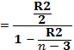R² is 0.22 and n=323…………………(10)
Therefore 0.0484/2 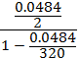 = 8.29……………………….(11)

Under the null H_{o} that R² = 0, the preceding F value follows the F distribution with 4 and 320df in the numerators respectively, from F table value is significant at about 5 per cent levels; the p value is actually 0.0000 Table 5.9. Therefore the study rejected the hypothesis that the four regressors have no impact on the regress and, notwithstanding the fact that R² is only 0.22. A significant F-test indicates that the observed R-squared is reliable, and is not a spurious result of oddities in the data set, Gujarat and Porter (2009) p 243. Moreover, literatures suggest that R² does not indicate whether the independent variables are a true cause of the changes in the dependent variable; omitted-variable bias exists; the correct regression was used; and the most appropriate set of independent variables has been chosen.

5.6 Interpretation of the Results
The results of Table 5.9 of OLS regression on semi logarithm mode show that coefficients BOT and BANK are contributes positively or have positive relationship with dependable variable SHILLING on the Interbank Foreign Exchange Market (IFEM). On the other hand, though results of coefficients BOT* and SOURCE are not significant, are positive related to indigenous variable SHILLING. The coefficient of BOT is 0.004 and it is statistically significant (with p-values of 0.0000). The findings indicate if BoT net sales increase by 1 per cent at the market it explains the market variation of about 0.04 per cent. The amount of central bank sales is insignificant to cool the market as it pumping a large sum of forex while the exchange rate volatility is cooled down by 0.04 per cent. It is insignificant percentage change to bring back the market at equilibrium in short-term. This suggesting that cooling volatility at IFEM may be explained by variables which are outside the market—like regulation, policy, speculation, politics, inflation and exports/imports ratio. At the pick of all time shilling free-fall (between April and October 2011) BoT’s Governor Prof Benno Ndulu said the bank was selling on average of 100 million US dollars a month but the shilling kept on depreciating, Daily News (October 2011). Guimarães and Karacadag (2004) findings on Bank of Mexico sales at the market shows that , intervention seems to have a non-negligible effect on exchange rate changes, with a 100 million US dollars sale of foreign exchange by the central bank estimated to appreciate the peso (against the U.S. dollar) by 0.4 percent.
In Turkey, Guimarães and Karacadag (2004), reveals that official intervention does not influence exchange rate levels while coefficient on the sale of foreign exchange carry the wrong sign (consistent with a “leaning against the wind” policy), but they are statistically insignificant. According to Saatcioglu (2006), findings on Central Bank of Turkey (CBT), differs with others. They reveal that selling auctions have a significant and positive impact on the level of exchange rate return.

Coefficient of BANK, Table 5.9, was positive at 0.0019 and significant at 1 per cent level, which indicates one per cent increase of commercial banks sales at IFEM is explained by 0.19 per cent variation of shilling movements, an amount that is not significant to have a far-reached impact to determine the shilling movement. Appendix 14 shows that commercial banks sales have relative little impact on influencing the market trend rather keep the market at the equilibrium.

Coefficient BOT* positive at 0.0004 and significant at 10 per cent level, which indicates that 1 per cent change in exchange rate is explained by 0.04 per cent of central bank purchases, meaning its impact is trivially. According to Saatcioglu (2006), findings on CBT, buying interventions (and interest rate cuts) did not have a statistically significant impact on the change in exchange rate levels. He, also, reveals that buying interventions and interest rate cuts did not have a statistically significant impact on the change in exchange rate levels: “Finally, the impact of the conditional variance on the exchange rate returns is not significant. In Mexico, Guimarães and Karacadag(2004),finds that foreign exchange purchases, which constitute the bulk of interventions, do not appear to have had a statistically significant impact on the value of the peso. In Turkey Guimarães and Karacadag (2004), apart from coefficient to have a wrong sign, it was statistically insignificant.

The coefficient SOURCE (forex inflows) was used as a proxy to study its relationship with exchange rates and volatility and whether the inflows help in one way or another to cool the market fluctuation tempo. The coefficient was positive at 0.0001 and statistically significant at 10 per cent level. Its positive impact level is insignificantly as it explains a variation of 0.01 in the market.

Table 5.9 : OLS Log
Number of obs = 323
SHILLING LOG | Coefficient | Std. Err. | T | P>|t| | [95% Conf. | interval]
BOT | .0040338 | .0005001 | 8.07 | 0.000* | .0030498 | .0050178
BANK | .0019247 | .000539 | 3.57 | 0.000* | .0008643 | .0029851
BOT* | .0004515 | .0009927 | 0.45 | 0.650** | -.0015017 | .0024046
SOURCE | .0001007 | .0001398 | 0.72 | 0.472** | -.0001744 | .0003758
CONSTANT | 7.099681 | .0158929 | 446.72 | 0.000 | 7.068413 | 7.13095
F-Statistic 23.23: Prob (F-Statistic) 0.0000 *significant: ** not significant
R-squared 0.2261: Adj R-squared 0.2164

5.7 Error Correction Model
An Error Correction Model is a dynamical system with the characteristics that the deviation of the current state from its long-run relationship will be fed into its short-run dynamics. Thus, in the short run, the variables which explain economic growth are in disequilibrium. In order for these variables to attain into equilibrium, cointegration of the variables in long run is needed. This adjustment of disequilibrium is obtained from error term which is treated as equilibrium error term (Sargan and Bhargava, 1983). The analysis of the results in the table below symbolize error correction term by error term

5.7.1 Short and Long Term Impact
Table 5.10, depicts the ECM, but since the adjustment coefficient-error-correction term (ECT) (ERROR) is positive (error correct coefficient ERROR is expected to be negative—Gujarati (2009)) and statistically significant. Therefore, estimating the results at this level gives meaningless analysis. This is, however, despite having significant p-values results of error variable (see the star at Table 5.10), the coefficient results’ value is explosive and not reasonable because there results have to be in negative between 0 and 1 to measure the existence of dynamic stability and not positive sign. Then the variable SOURCE, which is a model proxy, was dropped from the equation.

Table 5.10: ECM Estimation
VARIBLE | Coefficients | Std. Error | P-values
BOT | .0009786 | .0001375 | 0.000
BANK | 2.30e-07 | .0000552 | 0.997
BOT* | .0007684 | .000584 | 0.190
SOURCE | .0002343 | .0000421 | 0.000
ERROR | .2918276 | .0277629 | 0.000*
Constant | .000738 | .000551 | 0.182

When the proxy SOURCE was dropped from the model, Table 5.11, the adjustment coefficient ECT (ERROR), as expected, isnegative (-0.0022) but statistically not significant. The coefficient negative is indicating the existence of dynamic stability. That is, any divergences that influence exchange rates are adjusted by the availability of forex at IFEM in the short run and are determine by central bank net sales and purchases, commercial banks net sales and not by foreign currency inflows toward the equilibrium. This is a signal of the existence of a short-run relationship between IFEM intervention and shilling volatility. Note the sign of the error correction term is -0.0022; this value implies that the adjustment mechanism of the long run equilibrium deviation of the model is 0.0022 units, in absolute term, suggesting that 0.22 per cent of the disequilibrium is corrected in week time (because data used to calculate ECT were in weekly series). This indicating that the IFEM to return to equilibrium, given the percentage of correcting the disequilibrium shown, it will take longer time if intervention method is deployed (Appendix 14).

Table 5.11: ECM—Estimation without Source
VARIBLE | Coefficients | Std. Error | P-values
BOT | -.0000654 | .0000709 | 0.357
BANK | -.0000329 | .0000648 | 0.612
BOT* | -.0000976 | .0003148 | 0.757
ERROR | -.0022179* | .0072379 | 0.760*
Constant | .0006669 | .0006466 | 0.303

In particular it means the BoT foreign exchange sales has no impact on short term instead might increase volatility, since only 0.22 per cent of the discrepancy between long-term and shot-term is corrected within a week. The findings is consistent with the findings of Domaç and Mendoza (2002), while Guimarães and Karacadag (2004) find out that it raises short-term exchange rate volatility in Mexico but reduces it in Turkey.

Saatcioglu (2006) investigating CBT finds out that in the case of selling auctions, a positive shock to the exchange rate return has a positive and significant effect on exchange rate volatility. And on other hand, a one standard deviation positive shock to selling auctions increases the volatility rather than decreasing it. This is similar case to Tanzania (Appendix 14) and Daily News (Oct 2011), where despite BoT intervening the market selling on average 100 million US dollar a month the shilling continue to depreciate further to reach historical level of 1,820/- a US dollar, until other monetary measures were deployed. Saatcioglu (2006) says “...the CBT’s interventions are perceived by market participants as a sign of increasing uncertainty in the Forex markets, leading them to require a higher price for the exchange rates.”

5.8 Granger Causality Test
Correlation test does not tell anything about the causal relationship between endogenous and exogenous variables. Thus the Granger causality test is used to examine the direction of the relationship that exists between the variables.

The relationship between SHILLING variable and BOT variable are tested to see whether causality runs either side or one way.

Table 5.12: Granger Causality Test Results between Shilling and BoT
Null hypothesis | Std Error | Probability
SHILING does not Granger cause BOT | .6659725 | 0.000
BOT does not Granger cause SHILLING | .0037632 | 0.000

From Table 5.12, the study rejects the null hypothesis SHILLING does not Granger cause BOT, because it has the lowest p- value, and also rejects the null hypothesis BOT does not Granger cause SHILLING, due to the fact that p-value is 0.000. Therefore, it appears that Granger causality runs either way from SHILLING to BOT and BOT to SHILLING.

Table 5.13: Granger Causality Test Results between Shilling and Bank
Null hypothesis | Std Error | Probability
SHILING does not Granger cause BANK | .8001126 | 0.000
BANK does not Granger cause SHILLING | .0036436 | 0.000

Table 5.13, depicts that the null hypothesis SHILLING does not Granger cause
BANK does not hold—thus the study rejected it, because it p- value equals to 0.000 and the vice versa is similar to also rejects the null hypothesis that BANK does not Granger cause SHILLING, due to the fact that p-value is 0.000. Therefore, it appears that Granger causality runs either way from SHILLING to BANK and BANK to SHILLING.

Table 5.14: Granger Causality Test Results between Shilling and BoT*
Null hypothesis | Std Error | Probability
SHILING does not Granger cause BOT* | 1.481841 | 0.056
BOT* does not Granger cause SHILLING | 0020849 | 0.056

From Table 5.14, the study rejects the null hypothesis SHILLING does not Granger cause BOT*, because it has the lowest p- value, and also rejects the null hypothesis BOT* does not Granger cause SHILLING, due to the fact that p-value is 0.056. Therefore, it appears that Granger causality runs either way from SHILLING to BOT* and BOT* to SHILLING. The study did not anticipated the BOT* variable that represented Bank of Tanzania Purchasing to have heavy interconnection with SHILLING variable movement. As it shows its p-value is not that exactly at 0.056.

Table 5.15: Granger Causality Test Results between Shilling and Source
Null hypothesis | Std Error | Probability
SHILING does not Granger cause SOURCE | 2194744 | 0.688
SOURCE does not Granger cause SHILLING | .0142314 | 0.688

From Table 5.15, the study accept the null hypothesis SHILLING does not Granger cause SOURCE, because it has the higher p- value of 0.688, and also accepts the null hypothesis SOURE does not Granger causes SHILLING, due to the fact that p-value is 0.688. Therefore, it appears that Granger causality does not runs from neither SHILLING to SOURCE or from SOURCE to SHILLING. The variable SOURCE was used as proxy to balance the equation and was not expected to Granger cause shilling. As the foreign exchange inflows availability reduces market speculation to calm the market in a long-run.

5.9 Conclusion
This chapter presented the diagnostic, estimations and post estimation test results of study on the determinants of impact of foreign exchange intervention on shilling in Tanzania. It showed the strengths and weaknesses of different estimation techniques and how they attempted to take in hand the strictness of endogeneity. Also it shows that ECM was used for estimation purposes and the relationship between F and R² which states when the latter is equal to zero the former is zero ipso facto. This was deployed because R squared was only 0.22. In summary stationarity test on all variables in levels shows the time series is non-stationary, that is, it contains unit roots. While the test of stationarity in first difference shows that the time series is stationary.

Cointegration test shows that the variables are cointegrated or they have the long-run relationship. The Granger causality test reveals that the causality runs from the shilling fluctuations to central bank interventions at the IFEM in Tanzania.

Finally, the result of the study indicates that BoT interventions are insignificant to tackle exchange rate and fluctuation rather fuel it because forex inflows in the long-run help to keep the market at equilibrium but not interventions. This was evident as the variable SOURCE, which used as proxy to balance the equation, did neither Granger causes SHILLING nor SHILLING Granger cause SOURCE. As the foreign exchange inflows availability reduces market speculation to calm the market in a long-run. And in the absence of forex inflows in shot-run pushes fluctuations further up, which means the central bank intervention spear speculations because players might perceive it as a sign of increasing uncertainty in the market leading them to require higher prices for exchange rates—as stated in the law of demand and supply.

Therefore availability of inflows to the market has crucial role in stabilizing the market in a short-run and long-run. On other hand, no support was found that commercial banks sale at IFEM do(es) not cause significant fluctuation on shilling exchange rate, despite to have statistically significant p –values that had a low value.

CHAPTER SIX

6.0 CONCLUSION POLICY IMPLICATION AND RECOMMENDATIONS

6.1 Introduction
This chapter concludes the study by providing a summary of how the study was approached, its empirical findings and their policy implications. It also point out limitations faced by the researcher and recommendation for the future study.

6.2 Summary of the Study and Empirical Findings
The study aimed at investigating Bank of Tanzania IFEM intervention on shilling in the economy by looking at determinants of shilling’s fluctuations in Tanzania. The study used weekly time series data covering the period between 2006q1 and 2012q1 with a total of 323 observations. The OLS model proposed by Dominguez and Frankel(1993a) was used but modified to take on account the availability of data (appendix 1). The model was picked as its core data is interventions and exchange rates. The compilation of news items, reports of central bank intervention, and other relevant information for dummy variables were dropped and instead forex inflow was used as a proxy. Error Correction Model (ECM) was deployed for estimation of the severity of endogenous variable.

The ECM results suggest that lagged variables BOT, BANK were statically significant while BOT* and SOURCE were insignificant. On other hand, coefficient (ERROR) error-correction term (ECT) indicates the existence of dynamic stability in the short term, without the proxy - SOURCE. But when the model was calculated with SOURCE, the results did not make sense because ERROR was positive, which means the analysis is not reasonable.

6.3 Policy Implications
The empirical results of this study raise a number of policy issues regarding foreign exchange market intervention. The market exchange prices supposed to be decided by the market forces. But given the fact that Tanzania is a net importer economy, the market often times receives a relative low supply of foreign currency to compel BoT intervention. Also BoT has to intervene to correct the exchange rate as depreciation makes imports expensive to spur inflation. The Central Bank says it has to strike a balance between the exchange rates that will not discouraging exports because the nation still needs forex to furnish its imports. In the last nine months, since January 2012, the exchange rate runs in a range of between 1,560/- and 1,590/- a US dollar, suggesting that Band Exchange Rate Regime might be suitable for the country to cool volatility. In essence, the BoT should have a clear policy which will help in reducing speculations thus strengthening the local currency. Empirical evidence also suggest that signalling (expectation) channel also help to ease speculation and easing volatility, because the market will know in advance the amount of forex that will be sold in the next auction unlike secretive interventions.
Tanzania is heading toward opening its capital account. It will start by partially opening the account for EAC member states, allowing portfolio investments to flow either direction of the border posts without restrictions and follows a full opening to the rest of the world in 2015. Therefore when the country is heading toward that direction, BoT should come up with proper and clear policies that will safeguard exchange rate fluctuations. Because, exchange rate plays a crucial role into the economy, especially the one like Tanzania, which is imports based. The higher the shilling depreciate the likely higher the inflation.

Higher inflation has spiral effects, be it economically or politically. Economically, inflation pushes up interest rates for lending; increase the maturity return yield rates for government securities to balloon total national debt stock, reducing individual disposal incomes to cut-down expenditure thus reducing aggregate demand and in return supplies. Cutting supplies will force manufacturers to lower output to affect employment and denying government the much needed revenue. Job cuts leads to political unrest, which is bad for the economy and wellbeing of a nation, particularly in this era of wooing Foreign Direct and Portfolio Investments which are needed for technological and capital transfer to job creation and government revenues.

6.4 Limitation of the Study and Recommendations for Further Study
This study determines the extent of intervention on shilling using only BoT sales and purchase and commercial banks sales while forex inflows was used as a proxy. Therefore, studies exposing compilation of news items, channels of influences and other relevant information for dummy variables are highly recommendation to gauge effectiveness of the intervention in moving exchange rates.

The researcher, only look the impact of IFEM intervention on shilling but studies on the impact of shilling fluctuation to other macroeconomics fundamental like inflation, other interest rates, foreign currency reserve are recommended to help the authorities to come up with a good policy that would keep the economy at equilibrium. The global trades as a village in contemporary times thus financial crisis in one part of the world affect the entire system—the similar of 2008 financial meltdown in Europe.

REFERENCES
Adler, G. and Tovar, C.E. (2011). Foreign Exchange Intervention: A Shield against Appreciation Winds? IMF working paper [Online] 11 (16) p.1-6, 12. Available from: http://wwwimf.org [Accessed 19/03/2012]

Ahuja, H.L. (ed) (2011). Modern Economics: New Delhi: S. Chand

Bollerslve,T. (1986). Generalised Autoregressive Conditional Heteroskedasticity. Journal of Econometrics.[Online] 31 p.307–327. Available from: http://en.wikipedia.org [Accessed 15/03/2012]

Bank of Tanzania.(2003). Payment Systems in the Southern African Development Community—Tanzania chapter 2003.Dar es Salaam. (p.12)

Canales-Kriljenko, J.I. (2003). Foreign Exchange Intervention in Developing and Transition Economies Result of a Survey. IMF working paper. [Online] 03/95 p.5-8. Available from: www.imf.org [Accessed 20/03/2012].

Davidson, R. and Mackinnon, J.G (eds) (2004). Econometrics Theory and Methods. Oxford: Oxford University.

Domac, I. and Mendoza, A. (2002). Is there Room for Forex Interventions under Inflation Targeting Framework? Evidence from Mexico and Turkey. The World Bank, Policy Research Working Paper Series. [Online] 3288p. 6,10 and 26-28. Available from: elibrary.worldbank.org [Accessed 19/03/2012]

Dominguez, K.M. (1998). Central Bank Intervention and Exchange Rate Volatility., Journal of International Money and Finance School of Public Policy, University of Michigan[Online] 17 (1998). Available from: http://www-personal.umich.edu [Accessed 1/03/2012]

Dominguez, K.M.E. (2003). The Market Microstructure of Central Bank Intervention Journal of International Economics[Online]59 p.25–45, p.31-32, p.187-188. Available from:http://faculty.haas.berkeley.edu [Accessed 27/02/2012]

Dominguez, K.M.E. and Frankel, J.A. (1993). Does Foreign-Exchange Intervention Matter? The Portfolio Effect American Economic Review[Online] 83 (5) p.1361-1365. Available from: http://www.hks.harvard.edu [Accessed 2/02/2012]

Edison, H.J., Cashin, P. and Liang, H. (2003). Foreign Exchange Intervention and the Australian Dollar. IMF Asia and Pacific Dept working paper [Online] 3 (99). Available from: http://wwwimf.org [Accessed 15/03/2012]
Elinaza, A. (2011). Shilling’s free-fall traced to illegal forex trading. The Daily News 29th October.

Elinaza, A. (2012). Short Term Bonds Make High Yield. The Daily News 24thMay.

Fatum, R and Hutchison, M.M. (2005). Foreign Exchange Intervention and Monetary Policy in Japan 2003-04.International Economics and Economic Policy [Online] 2 (2005) p.249-250. Available from: http://people.ucsc.edu [Accessed 2/04/2012]

Fatum, R. (2000). On the Effectiveness of Sterilized Foreign Exchange Intervention. ECB Working Paper [Online] 10 p.5-6, 18. Available from: www.tcmb.gov.tr [Accessible 31/03/2012]

Fisher,S. (2001). Exchange Rate Regime: Is the Bipolar View Correct? IMF Distinguished Lecture on Economics in Government 2001: The American Economic Association and the Society of Government Economists—New Orleans. Available from: www.imf.org

Ghosh, A.R, Gulde, A., Ostry,J.D. and Wolf,H. (1997). Does the Exchange Rate Regime Matter for Inflation and Growth? IMF Economic Issue.[Online] 2p.10. Available from:www.worldbank.org [Accessed 23/03/2012]

Greene, W.H.(ed.) (2008). Econometric Analysis: London: Pearson Education

Guimarães, R.F. and Karacadag, C. (2004). The Empirics of Foreign Exchange Intervention in Emerging Markets Countries: the Case of Mexico and Turkey IMF working paper. [Online]04 (123) p.4-6, 40. Available from: www.imf.org [Accessed 2/2/2012]

Gujarati, D.N. and Porter, D.C. (eds) (2009). Basic Econometric. Boston: McGraw-Hill

Harvey,A. (ed) (1990). The Econometric Analysis of Time Series. Cambridge: MIT Press
Hurnpage, O.F. (1986). Exchange-Market Intervention: The Channels of Influence, Economic Review [Online] p.8-10. Available from: http://clevelandfed.org. [Accessed 19/03/2012].

Hutchison, M.M. (2002). The Role of Sterilized Intervention in Exchange Rate Stabilization Policy. Department of Economics University of California, USA [Online]. Available from: http://www.blackwellpublishing.com [Accessed 20/03/2012]

Igogo, T. (2010). Real Exchange Volatility and International Trade Fluctuation in Tanzania. A Dissertation Submitted in partial fulfilment of the Requirement of University of Dar es Salaam for the Mater of Arts. Economics: University of Dar es Salaam.

Ishii, S., Jorge Iván Canales-Kriljenko,J.I., Guimarães, R. and Karacadag, C. (2006). Official Foreign Exchange Intervention, IMF Occasional Paper [Online] 249 p.1, 32. Available from: www.imf.org [Accessed 19/03/2012]

James Dean Brown (1997). Shiken: JALT Testing & Evaluation: University of Hawai'i SIG Newsletter. [Online] 1 (2)p. 18-21. Available from: www.jalt.org [Accessed 30/09/2012]

Martin, G. (2011). Determinants of Commercial Banks’ Profitability in Tanzania. A Dissertation Submitted in partial fulfilment of the Requirement of University of Dar es Salaam for the Master of Arts. Economics: University of Dar es Salaam

Paul, C. (2007). Exchange Rate Volatility and Tradition Exports in Tanzania. A Dissertation Submitted in partial fulfilment of the Requirement of University of Dar es Salaam for the Mater of Arts. Economics: University of Dar es Salaam

Poole, William (1967). Speculative Prices as Random Walks: An Analysis of Ten Time Series of Flexible Exchange Rates, Southern Econ. J. Apr. 1967, 33(2), p468–478.http://connection.ebscohost.com

Richard,L. (2001). The Microstructure Approach to Exchange Rates Cambridge MIT Press, Chapter 5 Empirical Frameworks and Chapter 6 Exchange Rate Models: Macro to Micro foundations

Romer, D. (ed) (2006). Advanced Macroeconomics: Boston: McGraw-Hill
Saatcioglu, C. (2006). An Analysis Of Central Bank Interventions: Evidence From Turkey. University of Istanbul, International Business & Economics Research Journal [Online] 6 (4) p.83. Available from: journals.cluteonline.com [Accessed 19/03/2012]

Sarno, L and Taylor, M.P (2002). The Economics of Exchange Rates Cambridge University Press Statistics Corner Questions and answers about language testing statistics: Reliability off surveys.

Tapia, M. and Tokman, A. (2004). Effects of Foreign Exchange Intervention Under Public Information: the Chilean Case. Working Papers Central Bank of Chile [Online] 255 p.25,26. Available from: connection.ebscohost.com [Accessed 19/03/2012].

Tobin, J. A. (1969). General Equilibrium Approach To Monetary Theory. Journal of Money, Credit and Banking [Online] 1 (1), p.15-29. Available from: http://www.deu.edu.tr [Accessible 19/03/2012].

APPENDICIES

Appendix 1 : Analytical Methodologies of Empirical Studies on Intervention Effects on the Exchange Rate using OLS
Sources | Economic Specification | Data Requirements | Advantages and Disadvantages
Dominguez and Frankel  (1993a) | OLS Regression of Mean Equation  Δst = α + βIt + γ′Xt + εt,  where Δs is the exchange rate change, I is  intervention, and the X vector includes the  interest differential, the country risk premium,  and possible dummies, including on seasonality  effects (e.g., Monday effect), news items, and  reports of central bank presence in the market | • Intervention, exchange rate,  interest rate, country risk premium (e.g., spreads on sovereign bond) on a daily basis  • Compilation of news items, reports of central bank intervention, and other relevant information for dummy variables | • Simple technique  • Simultaneity between exchange rate changes and intervention  • Analyzes only contemporaneous  effects with no insight on long-term effects  • Provides no insight on the channel of transmission
Edison (1993)  Dominguez and Frankel  (1993a, 1993b)  Sarno and Taylor (2001) | OLS Regression of Risk Premium Equation  ρt= θ1Bt + θ2B*t,  where ρt= r – r* + E(st+1) – st,  where ρtis the risk premium, r is domestic  interest rates, r* is foreign interest rates, B is local currency– denominated bonds, and B* is foreign currency–denominated bonds.  The risk premium, ρt, is measured by deviations  from uncovered interest parity, either assuming  rational expectations or using survey data.  If ρtis nonzero (in violation of interest rate parity) and systemically responds to the relative supplies of B and B* (i.e., imperfect substitutability),  then the exchange rate necessarily changes  in response to intervention and a change in the  relative supplies of B and B* | • Local and foreign currency bond  supplies, exchange rate, interest rate on a daily basis.  • Daily survey data on exchange rate expectations (if rational expectations are not assumed)  • In the absence of data on bond supplies, intervention may be used as a proxy for the change in relative bond supplies | Assuming rational expectations or the use of survey data has a number of problems.  • Simultaneity between exchange rate changes and relative bond supplies (or intervention)

Sources | Economic Specification | Data Requirements | Advantages and Disadvantages
Evans and Lyons  (2002) | OLS Regression of Order Flow Equation  Δst= α + βΔrt+ γxt+ εt,  where Δrtis the change in the interest differential, and xtis interdealer order flow,  which is defined as the net of buyer-initiated and seller-initiated foreign exchange orders that  are consummated. | • Daily data on interest rates,  exchange rates, and interdealer  order flow | • Order flow data are not always available  • Effectiveness of order flow in affecting exchange rates is an indirect measure of the effectiveness of central bank–initiated order flow  (intervention)  • Simultaneity between exchange rate  changes and order flow  • Measures the impact of private sector–generated order flow, which is equivalent to a sterilized secret intervention
Source: Ishii (2006)

Appendix 2: Summary of Descriptive Statistics

Variable | Obs Mean Std. Dev. Min Max
-------------+--------------------------------------------------------
TIME| 323 162 93.38629 1 323
BOT | 323 16.53347 10.61062 0 49.25
BANK | 323 11.34341 9.520848 -5.84 73.1
SHILLING| 323 1342.161 141.7444 1133.83 1678.43
BOT* | 323 1.169814 5.291861 0 62.5
-------------+--------------------------------------------------------
SOURCE| 323 79.07721 36.1923 0 171.08
SHILLING LOG | 323 7.196699 .1024746 7.033357 7.425614
----------------------------------------------------------------------

Appendix 3: Skewness/Kurtosis Tests for Normality
------- joint ------
Variable | ObsPr(Skewness) Pr(Kurtosis) adj chi2(2) Prob>chi2
-------------+-----------------------------------------------------------
SHILLINGLOG1 | 322 0.6927 0.0000 33.64 0.0000
BOT | 323 0.0315 0.7265 4.76 0.0923
BANK | 323 0.0000 0.0000 . 0.0000
BOT* | 323 0.0000 0.0000 . 0.0000
SOURCE | 323 0.1778 0.8465 1.86 0.3938
----------------------------------------------------------------------------------------------------

Appendix 4: Regression Result OLS Model before Partial Logarithm

Source | SS df MS Number of obs = 323
-------------+------------------------------ F( 4, 318) = 23.70
Model | 1485568.5 4 371392.126Prob> F = 0.0000
Residual | 4983883.98 318 15672.5911 R-squared = 0.2296
-------------+------------------------------ Adj R-squared = 0.2199
Total | 6469452.48 322 20091.4673 Root MSE = 125.19

--------------------------------------------------------------------------
SHILING | Coef. Std. Err. t P>|t| [95% Conf. Interval]
-------------+------------------------------------------------------------
BOT | 5.524032 .6902376 8.00 0.000 4.166023 6.882041
BANK | 2.867913 .7438186 3.86 0.000 1.404486 4.331341
BOT* | .5477612 1.370045 0.40 0.690 -2.147736 3.243258
SOURCE | .0889568 .1929694 0.46 0.645 -.2907013 .4686149 cons | 1210.622 21.93351 55.20 0.000 1167.469 1253.776
--------------------------------------------------------------------------

Appendix 5: Regression Results OLS after Partial Logarithm

Source | SS df MS Number of obs = 323
-------------+------------------------------ F( 4, 318) = 23.23
Model | .764599186 4 .191149797 Prob> F = 0.0000
Residual | 2.61673618 318 .00822873 R-squared = 0.2261
-------------+------------------------------ Adj R-squared = 0.2164
Total | 3.38133537 322 .010501042 Root MSE = .09071

--------------------------------------------------------------------------
SHILLING LOG | Coef. Std. Err. t P>|t| [95% Conf. Interval]
-----------+--------------------------------------------------------------
BOT | .0040338 .0005001 8.07 0.000 .0030498 .0050178
BANK | .0019247 .000539 3.57 0.000 .0008643 .0029851
BOT* | .0004515 .0009927 0.45 0.650 -.0015017 .0024046
SOURCE | .0001007 .0001398 0.72 0.472 -.0001744 .0003758
_cons | 7.099681 .0158929 446.72 0.000 7.068413 7.13095
--------------------------------------------------------------------------

Appendix 6: Testing Stationarity for the Entire Model
Dickey-Fuller test for unit root Number of obs = 322

---------- Interpolated Dickey-Fuller ---------
Test 1% Critical 5% Critical 10% Critical
Statistic Value Value Value
--------------------------------------------------------------------------
Z(t) -5.052 -3.454 -2.877 -2.570
--------------------------------------------------------------------------
MacKinnon approximate p-value for Z(t) = 0.0000

Appendix 7: Residual Test

Selection-order criteria
Sample: 2006w6 - 2012w12 Number of obs = 319
+----------------------------------------------------------------------+
|lag | LL LR df p FPE AIC HQIC SBIC |
|----+-------------------------------------------------------------------|
| 0 |275.646 .010464 -1.72192 -1.7172 -1.71011 |
| 1 |1020.08 1488.9 1 0.000 .000099 -6.38294 -6.37351 -6.35933* |
| 2 |1022.09 4.0297* 1 0.045 .000098* -6.3893* -6.37516* -6.35389 |
| 3 |1022.09 1.2e-05 1 0.997 .000099 -6.38303 -6.36418 -6.33582 |
| 4 |1022.28 .36626 1 0.545 .000099 -6.37791 -6.35434 -6.31889 |
+------------------------------------------------------------------------+

Appendix 8: ADF for Shilling Log
Augmented Dickey-Fuller test for unit root Number of obs = 320 ------ Interpolated Dickey-Fuller ---------
Test 1% Critical 5% Critical 10% Critical
Statistic Value Value Value
--------------------------------------------------------------------------
Z(t) -0.583 -3.454 -2.877 -2.570
--------------------------------------------------------------------------
MacKinnon approximate p-value for Z(t) = 0.8747

--------------------------------------------------------------------------
SHILING LOG | Coef. Std. Err. t P>|t| [95% Conf.Interval]
-----------+--------------------------------------------------------------
SHILLING LOG |
L1. | -.0031803 .0054538 -0.58 0.560 -.0139106 .00755
LD. | .1124161 .0563386 2.00 0.047 .0015698 .2232623
L2D. | -.002693 .056321 -0.05 0.962 -.1135046 .1081186
|
_cons | .0237131 .0392472 0.60 0.546 -.0535057 .1009319
--------------------------------------------------------------------------

Appendix 9: Testing for Variable Shilling First Deference

Augmented Dickey-Fuller test for unit root

Number of obs = 319 -------- Interpolated Dickey-Fuller ---------
Test 1% Critical 5% Critical 10% Critical
Statistic Value Value Value
--------------------------------------------------------------------------
Z(t) -10.247 -3.454 -2.877 -2.570
-------------------------------------------------------------------------
MacKinnon approximate p-value for Z(t) = 0.0000
-------------------------------------------------------------------------
SHILLING LOG1| Coef. Std. Err. t P>|t| [95% Conf. Interval]
--------------------------------------------------------------------------
SHILLING LOG|
L1. |-.9257218 .0903411 -10.25 0.000 -1.10347 -.7479737
LD. | .0353843 .0752577 0.47 0.639 -.1126869 .1834555
L2D.| .0364118 .0561921 0.65 0.517 -.0741476 .1469711
cons | .000885 .0005599 1.58 0.115 -.0002166 .0019867
--------------------------------------------------------------------------

Appendix 10: Testing Results for Unit Root for Variable BoT
Augmented Dickey-Fuller test for unit root

Number of obs = 320 ----- Interpolated Dickey-Fuller ---------
Test 1% Critical 5% Critical 10% Critical
Statistic Value Value Value
--------------------------------------------------------------------------
Z(t) -5.971 -3.454 -2.877 -2.570
--------------------------------------------------------------------------
MacKinnon approximate p-value for Z(t) = 0.0000

--------------------------------------------------------------------------
D. |
BOT | Coef. Std. Err. t P>|t| [95% Conf. Interval]
-----------+--------------------------------------------------------------
BOT |
L1. | -.3486714 .0583901 -5.97 0.000 -.4635539 -.2337889
LD. | -.2520156 .0630706 -4.00 0.000 -.376107 -.1279243
L2D. | -.1496453 .0551759 -2.71 0.007 -.258204 -.0410867
|
_cons | 5.825844 1.088147 5.35 0.000 3.684915 7.966773
--------------------------------------------------------------------------

Appendix 11: Testing Results for Unit Root for Variable Bank
Augmented Dickey-Fuller test for unit root Number of obs = 320

---------- Interpolated Dickey-Fuller ---------
Test 1% Critical 5% Critical 10% Critical
Statistic Value Value Value
--------------------------------------------------------------------------
Z(t) -5.373 -3.454 -2.877 -2.570
--------------------------------------------------------------------------
MacKinnon approximate p-value for Z(t) = 0.0000
--------------------------------------------------------------------------
BANK | Coef. Std. Err. t P>|t| [95% Conf.Interval]
-----------+--------------------------------------------------------------
BANK |
L1. |-.3030951 .0564123 -5.37 0.000 -.4140862 -.192104
LD. |-.3947797 .0644076 -6.13 0.000 -.5215016 -.2680577
L2D. |-.1269316 .0558119 -2.27 0.024 -.2367415 -.0171217
|
cons | 3.484125 .7767476 4.49 0.000 1.955874 5.012375
-------------------------------------------------------------------------

Appendix 12: Testing results for Unit Root for Variable BoT*
Augmented Dickey-Fuller test for unit root umber of obs = 320

-------- Interpolated Dickey-Fuller ---------
Test 1% Critical 5% Critical 10% Critical
Statistic Value Value Value
--------------------------------------------------------------------------
Z(t) -8.623 -3.454 -2.877 -2.570
--------------------------------------------------------------------------
MacKinnon approximate p-value for Z(t) = 0.0000
-------------------------------------------------------------------------
BOT* | Coef. Std. Err. t P>|t| [95% Conf. Interval]
-----------+--------------------------------------------------------------
BOT* |
L1. |-.612353 .0710156 -8.62 0.000 -.7520762 -.4726299
LD. |-.1678546 .0642085 -2.61 0.009 -.2941848 -.0415244
L2D. |-.0850086 .0509089 -1.67 0.096 -.1851719 .0151547
_cons | .6022426 .2733899 2.20 0.028 .0643482 1.140137
--------------------------------------------------------------------------

Appendix 13: Testing Results for Unit Root for Variable Source
Augmented Dickey-Fuller test for unit root Number of obs = 320

---------- Interpolated Dickey-Fuller ---------
Test 1% Critical 5% Critical 10% Critical
Statistic Value Value Value
--------------------------------------------------------------------------
Z(t) -5.166 -3.454 -2.877 -2.570
--------------------------------------------------------------------------
MacKinnon approximate p-value for Z(t) = 0.0000
--------------------------------------------------------------------------
SOURCE | Coef. Std. Err. t P>|t| [95% Conf. Interval]
---------+---------------------------------------------------------------
SOURCE |
L1. | -.1627235 .0314977 -5.17 0.000 -.2246953 -.1007517
LD. | .0847938 .0564607 1.50 0.134 -.0262925 .1958802
L2D. | .0847938 .0564607 1.50 0.134 -.0262925 .1958802
|
_cons | 12.82958 2.716741 4.72 0.000 7.484391 18.17476
--------------------------------------------------------------------------

Appendix 14: IFEM Sales trend
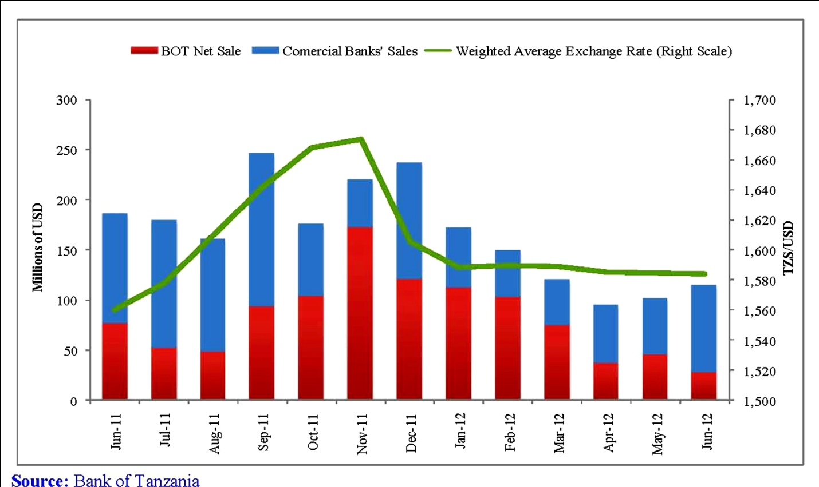

Appendix 15: In and Outflows of Forex

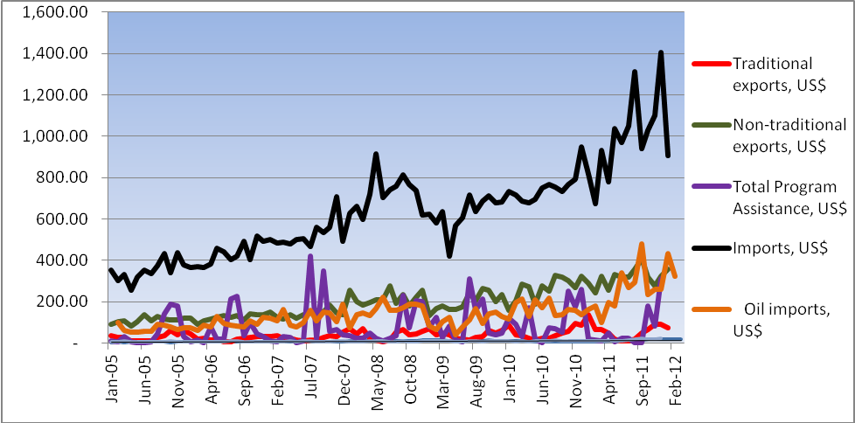

Appendix 16: Exchange Rate (shilling)

Appendix 17: Inflation
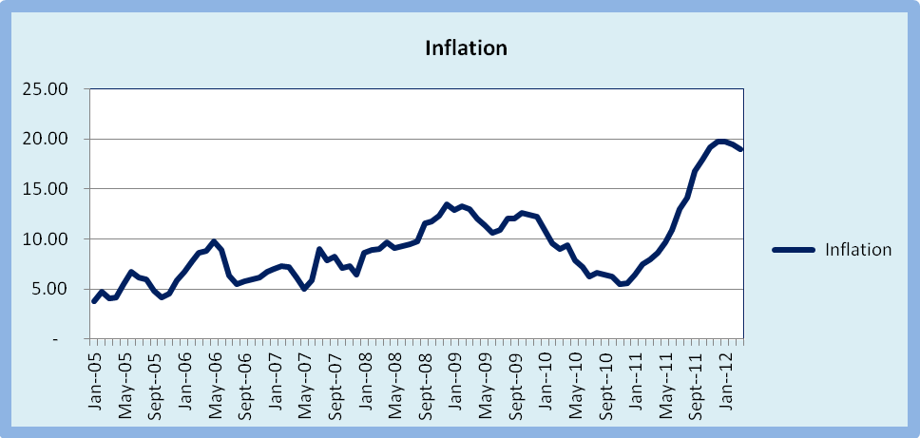

Appendix 18: Error Correction Model computed with Source variable

Source | SS df MS Number of obs = 322
-------------+------------------------------ F( 5, 316) = .
Model | .031332431 5 .006266486 Prob> F = 0.0000
Residual | 2.4967e-15 316 7.9010e-18 R-squared = 1.0000
-------------+------------------------------ Adj R-squared = 1.0000
Total | .031332431 321 .000097609 Root MSE = 2.8e-09

------------------------------------------------------------------------------
SHILLING| Coef. Std. Err. t P>|t| [95% Conf. Interval]
-------------+----------------------------------------------------------------
BOT | .0039648 6.53e-11 6.1e+07 0.000 .0039648 .0039648
|
BANK | .0019162 3.55e-11 5.4e+07 0.000 .0019162 .0019162
|
BOT* | -4.91e-13 2.45e-11 -0.02 0.984 -4.86e-11 4.76e-11
|
SOURCE 4.83e-12 8.25e-12 0.59 0.559 -1.14e-11 2.11e-11
|
ERROR | 1 1.59e-08 6.3e+07 0.000 1 1
|
_cons | -6.39e-11 1.57e-10 -0.41 0.685 -3.74e-10 2.46e-10
------------------------------------------------------------------------------

Appendix 19A: Shilling/Bank Granger Causality
Source | SS df MS Number of obs = 322
-------------+------------------------------ F( 1, 320) = 23.02
Model | 429978.626 1 429978.626 Prob> F = 0.0000
Residual | 5977973.23 320 18681.1663 R-squared = 0.0671
-------------+------------------------------ Adj R-squared = 0.0642
Total | 6407951.86 321 19962.4668 Root MSE = 136.68
------------------------------------------------------------------------------
L.shiling | Coef. Std. Err. t P>|t| [95% Conf. Interval]
-------------+----------------------------------------------------------------
bank |
L1. | 3.838597 .8001126 4.80 0.000 2.264452 5.412743
|
_cons | 1297.881 11.84357 109.59 0.000 1274.58 1321.182
------------------------------------------------------------------------------

Appendix 19B: Bank /Shilling Granger Causality

Source | SS df MS Number of obs = 322
-------------+------------------------------ F( 1, 320) = 23.02
Model | 1958.07551 1 1958.07551 Prob> F = 0.0000
Residual | 27223.0346 320 85.071983 R-squared = 0.0671
-------------+------------------------------ Adj R-squared = 0.0642
Total | 29181.1101 321 90.906885 Root MSE = 9.2234
------------------------------------------------------------------------------
L.bank | Coef. Std. Err. t P>|t| [95% Conf. Interval]
-------------+----------------------------------------------------------------
shiling |
L1. | .0174806 .0036436 4.80 0.000 .0103121 .024649
|
_cons | -12.11312 4.914483 -2.46 0.014 -21.78189 -2.444338
------------------------------------------------------------------------------

Appendix 20A: Shilling/BoT Granger Causlity

Source | SS df MS Number of obs = 322
-------------+------------------------------ F( 1, 320) = 79.01
Model | 1268859.48 1 1268859.48 Prob> F = 0.0000
Residual | 5139092.38 320 16059.6637 R-squared = 0.1980
-------------+------------------------------ Adj R-squared = 0.1955
Total | 6407951.86 321 19962.4668 Root MSE = 126.73
------------------------------------------------------------------------------
L.shiling | Coef. Std. Err. t P>|t| [95% Conf. Interval]
-------------+----------------------------------------------------------------
bot |
L1. | 5.919634 .6659725 8.89 0.000 4.609396 7.229871
|
_cons | 1243.4 13.0924 94.97 0.000 1217.642 1269.158
------------------------------------------------------------------------------

Appendix 20B: BoT /Shilling Granger Causlity

Source | SS df MS Number of obs = 322
-------------+------------------------------ F( 1, 320) = 79.01
Model | 7169.98366 1 7169.98366 Prob> F = 0.0000
Residual | 29039.629 320 90.7488405 R-squared = 0.1980
-------------+------------------------------ Adj R-squared = 0.1955
Total | 36209.6126 321 112.802532 Root MSE = 9.5262
------------------------------------------------------------------------------
L.bot | Coef. Std. Err. t P>|t| [95% Conf. Interval]
-------------+---------------------------------------------------------------
shiling | L1. | .0334503 .0037632 8.89 0.000 .0260465 .0408541
_cons | -28.31615 5.075807 -5.58 0.000 -38.30232 -18.32998
------------------------------------------------------------------------------

Appendix 21A: Shilling/BoT* Granger Causlity

Source | SS df MS Number of obs = 322
-------------+------------------------------ F( 1, 320) = 3.68
Model | 72758.6597 1 72758.6597 Prob> F = 0.0561
Residual | 6335193.2 320 19797.4787 R-squared = 0.0114
-------------+------------------------------ Adj R-squared = 0.0083
Total | 6407951.86 321 19962.4668 Root MSE = 140.7
------------------------------------------------------------------------------
L.shiling | Coef. Std. Err. t P>|t| [95% Conf. Interval]
-------------+----------------------------------------------------------------
var5 |
L1. | -2.840789 1.481841 -1.92 0.056 -5.756171 .0745922
|
_cons | 1344.726 8.031594 167.43 0.000 1328.924 1360.527
------------------------------------------------------------------------------

Appendix 21B: BoT/Shilling * Granger Causlity

Source | SS df MS Number of obs = 322
-------------+------------------------------ F( 1, 320) = 3.68
Model | 102.369849 1 102.369849 Prob> F = 0.0561
Residual | 8913.47877 320 27.8546212 R-squared = 0.0114
-------------+------------------------------ Adj R-squared = 0.0083
Total | 9015.84862 321 28.0867558 Root MSE = 5.2777
------------------------------------------------------------------------------
L.var5 | Coef. Std. Err. t P>|t| [95% Conf. Interval]
-------------+----------------------------------------------------------------
shiling |
L1. | -.0039969 .0020849 -1.92 0.056 -.0080988 .0001049
|
_cons | 6.534896 2.812116 2.32 0.021 1.002325 12.06747
------------------------------------------------------------------------------

Appendix 22A: Shilling/Source* Granger Causlity
Source | SS df MS Number of obs = 322
-------------+------------------------------ F( 1, 320) = 0.16
Model | 3241.73688 1 3241.73688 Prob> F = 0.6876
Residual | 6404710.12 320 20014.7191 R-squared = 0.0005
-------------+------------------------------ Adj R-squared = -0.0026
Total | 6407951.86 321 19962.4668 Root MSE = 141.47
------------------------------------------------------------------------------
L.shiling | Coef. Std. Err. t P>|t| [95% Conf. Interval]
-------------+----------------------------------------------------------------
source |
L1. | .0883279 .2194744 0.40 0.688 -.3434671 .5201229
|
_cons | 1334.386 19.11131 69.82 0.000 1296.786 1371.985
------------------------------------------------------------------------------

Appendix 22B: /Source/Shilling Granger Causlity

Source | SS df MS Number of obs = 322
-------------+------------------------------ F( 1, 320) = 0.16
Model | 210.203718 1 210.203718 Prob> F = 0.6876
Residual | 415300.171 320 1297.81304 R-squared = 0.0005
-------------+------------------------------ Adj R-squared = -0.0026
Total | 415510.375 321 1294.42484 Root MSE = 36.025
------------------------------------------------------------------------------
L.source | Coef. Std. Err. t P>|t| [95% Conf. Interval]
-------------+----------------------------------------------------------------
shiling |
L1. | .0057274 .0142314 0.40 0.688 -.0222714 .0337263
|
_cons | 71.64008 19.19511 3.73 0.000 33.87552 109.4046
------------------------------------------------------------------------------

Appendix 23: Working Data
time | BOT | BANK | SHILING | BOT* | source
1960m2 | 20 | 4.7 | 1171.86 | 0 | 43.9575
1960m3 | 0 | 2.45 | 1181.98 | 0 | 43.9575
1960m4 | 0 | 5.6 | 1182.15 | 39 | 43.9575
1960m5 | 0 | 10.3 | 1173.12 | 0 | 43.9575
1960m6 | 3 | 5.97 | 1186.01 | 0 | 33.3375
1960m7 | 0 | 5.86 | 1192.16 | 0 | 33.3375
1960m8 | 0 | 7 | 1186.5 | 0 | 33.3375
1960m9 | 0 | 4.81 | 1192.16 | 0 | 33.3375
1960m10 | 0 | 8.85 | 1191.81 | 0 | 34.3125
1960m11 | 32.9 | 5.53 | 1209.52 | 0 | 34.3125
1960m12 | 0 | 6.6 | 1213.59 | 0 | 34.3125
1961m1 | 7.5 | 4.38 | 1216.58 | 0 | 34.3125
1961m2 | 23.9 | 4.01 | 1220.6 | 0 | 53.5025
1961m3 | 28.1 | 2.95 | 1224.63 | 0 | 53.5025
1961m4 | 0 | 7.98 | 1222.99 | 0 | 53.5025
1961m5 | 4.9 | 8.55 | 1227.02 | 0 | 53.5025
1961m6 | 0 | 9.95 | 1225.9 | 0 | 53.5025
1961m7 | 24.25 | 5.5 | 1232.86 | 0 | 41.7125
1961m8 | 17 | 5 | 1237.62 | 0 | 41.7125
1961m9 | 28.3 | 6.16 | 1247.58 | 0 | 41.7125
1961m10 | 26.2 | 9.44 | 1251.4 | 0 | 41.7125
1961m11 | 26.95 | 3.98 | 1251.4 | 0 | 41.4225
1961m12 | 10 | 5.63 | 1321.15 | 1.2 | 41.4225
1962m1 | 24.9 | 10.49 | 1331 | 0 | 41.4225
1962m2 | 0 | 12 | 1335.97 | 0 | 41.4225
1962m3 | 20 | 13.73 | 1302.48 | 0 | 87.42
1962m4 | 0 | 7 | 1263.97 | 0 | 87.42
1962m5 | 0 | 6.08 | 1274.08 | 0 | 87.42
1962m6 | 0 | 7.06 | 1254.48 | 0 | 87.42
1962m7 | 26.35 | 4.79 | 1264.4 | 0 | 45.4475
1962m8 | 7.2 | 4.38 | 1284.89 | 5 | 45.4475
1962m9 | 0 | 9.04 | 1303.2 | 0 | 45.4475
1962m10 | 24.9 | 10.36 | 1294.57 | 0 | 45.4475
1962m11 | 29.5 | 10.38 | 1297.47 | 0 | 54.885
1962m12 | 29.5 | 11.58 | 1311.63 | 0 | 54.885
1963m1 | 24.8 | 11.64 | 1305.8 | 0 | 54.885
1963m2 | 42.79 | 8.26 | 1294.49 | 5 | 54.885
1963m3 | 0 | 13.35 | 1273.95 | 1.41 | 53.0125
1963m4 | 31.7 | 14.18 | 1281.73 | 0 | 53.0125
1963m5 | 25.75 | 11.82 | 1279.53 | 0 | 53.0125
1963m6 | 15 | 13.3 | 1284.05 | 0 | 53.0125
1963m7 | 24.11 | 11.52 | 1266.44 | 0 | 49.08
1963m8 | 0 | 6.57 | 1258.32 | 0 | 49.08
1963m9 | 0 | 6.39 | 1258.32 | 0 | 49.08
1963m10 | 10 | 15.15 | 1261.21 | 0 | 49.08
1963m11 | 19.4 | 10.19 | 1261.64 | 0 | 43.6125
1963m12 | 0 | 8.25 | 1261.73 | 4 | 43.6125
1964m1 | 0 | 5.9 | 1261.62 | 6.2 | 43.6125
1964m2 | 0 | 7.47 | 1292.44 | 8.5 | 43.6125
1964m3 | 10.8 | 8.96 | 1261.73 | 0 | 44.665
1964m4 | 0 | 14.79 | 1282.76 | 0 | 44.665
1964m5 | 16.55 | 3.26 | 1283.02 | 0 | 44.665
1964m6 | 9.6 | 5.2 | 1281.36 | 0 | 44.665
1964m7 | 0 | 2.08 | 1284.75 | 5.5 | 49.7325
1964m8 | 0 | 8.49 | 1285.89 | 8 | 49.7325
1964m9 | 29.1 | 0.51 | 1301.27 | 5.5 | 49.7325
1964m10 | 32.35 | 30.35 | 1291.3 | 10 | 49.7325
1964m11 | 3.55 | 4.83 | 1303.3 | 0 | 35.5225
1964m12 | 0 | 8 | 1287.38 | 0 | 35.5225
1965m1 | 12.3 | 6.64 | 1288.13 | 0 | 35.5225
1965m2 | 49.25 | 73.1 | 1260.34 | 0 | 35.5225
1965m3 | 10 | 7.54 | 1258.37 | 2.25 | 41.7875
1965m4 | 12.6 | 9.3 | 1264.16 | 5 | 41.7875
1965m5 | 16.05 | 13.77 | 1268.22 | 1.05 | 41.7875
1965m6 | 0 | 15.35 | 1244.7 | 3.15 | 41.7875
1965m7 | 0 | 4.37 | 1254.16 | 62.5 | 148.188
1965m8 | 0 | 12.87 | 1258.45 | 2.5 | 148.188
1965m9 | 14.75 | 10.6 | 1269.45 | 0 | 148.188
1965m10 | 0 | 5.05 | 1277.4 | 0 | 148.188
1965m11 | 0 | 9.65 | 1275.12 | 27.32 | 51.4975
1965m12 | 6 | 8.83 | 1269.92 | 28.3 | 51.4975
1966m1 | 0 | 3.9 | 1272.03 | 5.1 | 51.4975
1966m2 | 10.2 | 7.1 | 1274.43 | 0 | 51.4975
1966m3 | 0 | 4.95 | 1270.47 | 11.31 | 133.44
1966m4 | 0 | 9.45 | 1268.86 | 4.47 | 133.44
1966m5 | 0 | 4 | 1268.71 | 4.065 | 133.44
1966m6 | 0 | 11.25 | 1269.71 | 3.385 | 133.44
1966m7 | 0 | 5 | 1264.87 | 9.3 | 70.98
1966m8 | 0 | 3.3 | 1266.97 | 17.7 | 70.98
1966m9 | 0 | 9.5 | 1272.96 | 23.72 | 70.98
1966m10 | 0 | 10.52 | 1272.46 | 8.07 | 70.98
1966m11 | 0 | 2.05 | 1281.82 | 24.8 | 62.8425
1966m12 | 48.7 | 30.2 | 1281.98 | 1.5 | 62.8425
1967m1 | 0 | 26.88 | 1280.44 | 10.15 | 62.8425
1967m2 | 1 | 6.1 | 1281.69 | 0 | 62.8425
1967m3 | 13 | 7.35 | 1280.9 | 0 | 62.8425
1967m4 | 15.2 | 3.63 | 1283.34 | 0 | 59.47
1967m5 | 3 | 10.42 | 1276.61 | 0 | 59.47
1967m6 | 2.2 | 7.65 | 1275.74 | 0 | 59.47
1967m7 | 0 | 12.75 | 1260.09 | 1 | 59.47
1967m8 | 5 | 14.45 | 1246.5 | 0 | 92.0675
1967m9 | 14.7 | 7.75 | 1232 | 0 | 92.0675
1967m10 | 1.9 | 16.9 | 1246.42 | 0 | 92.0675
1967m11 | 22.6 | 18.05 | 1200.75 | 0 | 92.0675
1967m12 | 4.8 | 12.2 | 1154.87 | 0 | 68.18
1968m1 | 14.71 | 10.22 | 1137.9 | 0 | 68.18
1968m2 | 14.7 | 10.22 | 1158.84 | 0 | 68.18
1968m3 | 14.71 | 10.2 | 1133.83 | 0 | 68.18
1968m4 | 14.71 | 10.22 | 1136.47 | 0 | 71.285
1968m5 | 11.93 | 11.68 | 1139.5 | 0 | 71.285
1968m6 | 10.93 | 12.67 | 1169.86 | 0 | 71.285
1968m7 | 12.93 | 10.68 | 1179.71 | 0 | 71.285
1968m8 | 11.93 | 11.68 | 1170.4 | 0 | 69.06
1968m9 | 11.93 | 11.68 | 1147.71 | 0 | 69.06
1968m10 | 3.8 | 10.86 | 1163.43 | 0 | 69.06
1968m11 | 3 | 11.66 | 1163.43 | 0 | 69.06
1968m12 | 4.6 | 10.06 | 1155.77 | 0 | 64.765
1969m1 | 3.8 | 10.87 | 1165.75 | 0 | 64.765
1969m2 | 8.73 | 8.05 | 1170.6 | 0 | 64.765
1969m3 | 8.73 | 8.05 | 1163.48 | 0 | 64.765
1969m4 | 8.73 | 8.05 | 1153.41 | 0 | 60.705
1969m5 | 8.73 | 8.05 | 1159.81 | 0 | 60.705
1969m6 | 8.4 | 9.99 | 1171.78 | 0 | 60.705
1969m7 | 8 | 10.4 | 1166.32 | 0 | 60.705
1969m8 | 8.8 | 9.58 | 1174.86 | 0 | 80.1275
1969m9 | 8.4 | 9.99 | 1188.4 | 0 | 80.1275
1969m10 | 8.75 | 16.8 | 1224.07 | 0 | 80.1275
1969m11 | 8.75 | 16.8 | 1195.01 | 0 | 80.1275
1969m12 | 8.75 | 16.8 | 1206.3 | 0 | 71.625
1970m1 | 8.75 | 16.8 | 1229.69 | 0 | 71.625
1970m2 | 13.38 | 17.47 | 1232.61 | 0 | 71.625
1970m3 | 13.38 | 17.46 | 1209.2 | 0 | 71.625
1970m4 | 13.38 | 17.46 | 1215.24 | 0 | 134.99
1970m5 | 13.38 | 17.46 | 1210.6 | 0 | 134.99
1970m6 | 18.68 | 13.9 | 1199.88 | 0 | 134.99
1970m7 | 18.68 | 13.89 | 1192.81 | 0 | 134.99
1970m8 | 18.68 | 13.9 | 1197.53 | 0 | 74.71
1970m9 | 18.68 | 13.89 | 1190.19 | 0 | 74.71
1970m10 | 12.5 | 18.29 | 1179.71 | 0 | 74.71
1970m11 | 13 | 18.29 | 1174.98 | 0 | 74.71
1970m12 | 12 | 19.29 | 1179.61 | 0 | 119.868
1971m1 | 12.5 | 18.79 | 1179.61 | 0 | 119.868
1971m2 | 10 | 15.06 | 1159.96 | 0 | 119.868
1971m3 | 5 | 20.06 | 1165.65 | 0 | 119.868
1971m4 | 15 | 10.06 | 1163.82 | 0 | 119.868
1971m5 | 10 | 15.07 | 1157.11 | 0 | 130.063
1971m6 | 12.5 | 24.49 | 1159.82 | 0 | 130.063
1971m7 | 12.5 | 24.49 | 1162.18 | 0 | 130.063
1971m8 | 13 | 23.99 | 1166.27 | 0 | 130.063
1971m9 | 12 | 24.99 | 1156.41 | 0 | 72.0225
1971m10 | 20.5 | 13.13 | 1153.37 | 0 | 72.0225
1971m11 | 20.5 | 13.13 | 1157.29 | 0 | 72.0225
1971m12 | 20 | 13.63 | 1171.18 | 0 | 72.0225
1972m1 | 21 | 12.63 | 1165.06 | 0 | 84.6125
1972m2 | 17.4 | 2.64 | 1192.21 | 0 | 84.6125
1972m3 | 17.4 | 2.6 | 1218.74 | 0 | 84.6125
1972m4 | 17 | 3.08 | 1258.59 | 0 | 84.6125
1972m5 | 17.8 | 2.24 | 1282.14 | 0 | 66.865
1972m6 | 22.5 | 0.33 | 1256.73 | 0.025 | 66.865
1972m7 | 22.5 | 0.33 | 1238.2 | 0.025 | 66.865
1972m8 | 22.5 | 0.33 | 1243.53 | 0.025 | 66.865
1972m9 | 22.5 | 0.33 | 1258.71 | 0.025 | 66.865
1972m10 | 18.68 | 13.9 | 1266.63 | 0 | 73.5575
1972m11 | 0 | 3.9 | 1277.68 | 5.1 | 73.5575
1972m12 | 0 | 6.39 | 1279.85 | 0 | 73.5575
1973m1 | 10 | 15.15 | 1280.3 | 0 | 73.5575
1973m2 | 24.5 | 0.6 | 1280.3 | 0 | 51.8625
1973m3 | 24.5 | 0.6 | 1282.68 | 0 | 51.8625
1973m4 | 24.5 | 0.6 | 1304.69 | 0 | 51.8625
1973m5 | 24.5 | 0.6 | 1311.76 | 0 | 51.8625
1973m6 | 24.5 | 1.8 | 1336.97 | 0.8 | 51.6075
1973m7 | 34.52 | 9.12 | 1311 | 0 | 51.6075
1973m8 | 34.52 | 9.12 | 1318 | 0 | 51.6075
1973m9 | 34.53 | 9.08 | 1326.02 | 0.3 | 51.6075
1973m10 | 34.52 | 9.12 | 1320.01 | 0 | 144.42
1973m11 | 15 | 12.43 | 1312.5 | 0 | 144.42
1973m12 | 10 | 17.43 | 1298.18 | 0 | 144.42
1974m1 | 15 | 12.43 | 1304.92 | 0 | 144.42
1974m2 | 20 | 6.03 | 1318.02 | 1.4 | 99.39
1974m3 | 16.03 | 10.71 | 1328.77 | 0 | 99.39
1974m4 | 16.03 | 10.71 | 1328.14 | 0 | 99.39
1974m5 | 16.03 | 10.71 | 1332.1 | 0 | 99.39
1974m6 | 16.03 | 10.51 | 1340.18 | 0.2 | 128.625
1974m7 | 21.48 | 15.23 | 1336.49 | 0 | 128.625
1974m8 | 21.48 | 15.23 | 1329.48 | 0 | 128.625
1974m9 | 21.48 | 14.53 | 1334.83 | 0 | 128.625
1974m10 | 21.48 | 15.93 | 1329.82 | 0 | 92.7675
1974m11 | 16.95 | 16.73 | 1322.37 | 0 | 92.7675
1974m12 | 16.95 | 16.73 | 1311.13 | 0 | 92.7675
1975m1 | 16.95 | 16.73 | 1306.53 | 0 | 92.7675
1975m2 | 16.95 | 16.73 | 1311.09 | 0 | 74.2775
1975m3 | 9.99 | 12.95 | 1316.35 | 0 | 74.2775
1975m4 | 10 | 12.94 | 1315.73 | 0 | 74.2775
1975m5 | 9.99 | 12.95 | 1324.64 | 0 | 74.2775
1975m6 | 9.99 | 12.95 | 1330.71 | 0 | 89.1075
1975m7 | 9.99 | 12.95 | 1327.84 | 0 | 89.1075
1975m8 | 27.5 | 14.25 | 1321.52 | 0 | 89.1075
1975m9 | 27.5 | 13.5 | 1322.84 | 0 | 89.1075
1975m10 | 27.5 | 15 | 1318.3 | 0 | 89.1075
1975m11 | 27 | 14.25 | 1315.22 | 0 | 93.255
1975m12 | 25 | 14.41 | 1316.16 | 0 | 93.255
1976m1 | 20 | 19.41 | 1310.08 | 0 | 93.255
1976m2 | 30 | 9.41 | 1306.86 | 0 | 93.255
1976m3 | 25 | 6.4 | 1301.31 | 0 | 85.2975
1976m4 | 25 | 10.74 | 1311.21 | 0 | 85.2975
1976m5 | 25 | 10.74 | 1310.84 | 0 | 85.2975
1976m6 | 25 | 10.74 | 1316.92 | 0 | 85.2975
1976m7 | 25 | 10.74 | 1318.77 | 0 | 91.6075
1976m8 | 26 | 2.06 | 1320.4 | 0 | 91.6075
1976m9 | 24 | 4.06 | 1321.93 | 0 | 91.6075
1976m10 | 25 | 3.06 | 1324.3 | 0 | 91.6075
1976m11 | 25 | 3.06 | 1327.67 | 0 | 118.48
1976m12 | 25 | -0.84 | 1328.03 | 0 | 118.48
1977m1 | 20 | 4.16 | 1328.23 | 0 | 118.48
1977m2 | 30 | -5.84 | 1328.61 | 0 | 118.48
1977m3 | 25 | -0.84 | 1328.98 | 0 | 58.11
1977m4 | 27.5 | 13.5 | 1325.65 | 0 | 58.11
1977m5 | 20 | 19.41 | 1322.4 | 0 | 58.11
1977m6 | 16.2 | 1.61 | 1328.32 | 0 | 58.11
1977m7 | 16 | 1.8 | 1329.26 | 0 | 78.5825
1977m8 | 16.4 | 1.42 | 1334.62 | 0 | 78.5825
1977m9 | 16.2 | 1.61 | 1336.92 | 0 | 78.5825
1977m10 | 16.2 | 1.61 | 1337.7 | 0 | 78.5825
1977m11 | 20 | 0.44 | 1338.44 | 0 | 90.265
1977m12 | 20 | 0.44 | 1338.66 | 0 | 90.265
1978m1 | 20 | 0.44 | 1339.25 | 0 | 90.265
1978m2 | 20 | 0.44 | 1339.89 | 0 | 90.265
1978m3 | 20 | 0.6 | 1340.46 | 0 | 110.887
1978m4 | 20 | 0.9 | 1341.04 | 0 | 110.887
1978m5 | 20 | 0.3 | 1342.6 | 0 | 110.887
1978m6 | 20 | 0.6 | 1345.97 | 0 | 110.887
1978m7 | 15 | 1.73 | 1348.46 | 0 | 107.618
1978m8 | 15 | 1.73 | 1350.31 | 0 | 107.618
1978m9 | 15 | 1.73 | 1352.5 | 0 | 107.618
1978m10 | 15 | 1.73 | 1356.03 | 0 | 107.618
1978m11 | 21.25 | 0.03 | 1360.81 | 0.25 | 156.447
1978m12 | 21.25 | 0.03 | 1364.69 | 0.25 | 156.447
1979m1 | 21 | 0.28 | 1377.22 | 0.25 | 156.447
1979m2 | 21.5 | 0.03 | 1389.01 | 0.25 | 156.447
1979m3 | 15 | 0.2 | 1390.21 | 0 | 136.768
1979m4 | 15 | 0.2 | 1391.29 | 0 | 136.768
1979m5 | 15 | 0 | 1391.91 | 0 | 136.768
1979m6 | 15 | 0.4 | 1392.92 | 0 | 136.768
1979m7 | 15 | 0.03 | 1393.53 | 0 | 171.08
1979m8 | 15 | 0.03 | 1394.17 | 0 | 171.08
1979m9 | 15 | 0.03 | 1394.87 | 0 | 171.08
1979m10 | 15 | 0.03 | 1395.38 | 0 | 171.08
1979m11 | 19 | 0 | 1396.08 | 0 | 114.118
1979m12 | 19 | 0 | 1400.07 | 0 | 114.118
1980m1 | 19 | 0 | 1447.08 | 0 | 114.118
1980m2 | 19 | 0 | 1469.22 | 0 | 114.118
1980m3 | 19 | 0 | 1479.28 | 0 | 83.7075
1980m4 | 25 | 0.06 | 1488.45 | 0 | 83.7075
1980m5 | 25 | 0.06 | 1492.26 | 0 | 83.7075
1980m6 | 25 | 0.06 | 1496.71 | 0 | 83.7075
1980m7 | 25 | 0.06 | 1498.84 | 0 | 102.965
1980m8 | 27 | 26.07 | 1496.96 | 0 | 102.965
1980m9 | 23 | 30.07 | 1488.42 | 0 | 102.965
1980m10 | 25 | 28.07 | 1499.31 | 0 | 102.965
1980m11 | 25 | 28.07 | 1497.29 | 0 | 90.3375
1980m12 | 25 | 25.66 | 1497.77 | 0 | 90.3375
1981m1 | 25 | 25.66 | 1497.06 | 0 | 90.3375
1981m2 | 25 | 25.66 | 1491.98 | 0 | 90.3375
1981m3 | 25 | 25.66 | 1495.4 | 0 | 90.3375
1981m4 | 19.22 | 23.04 | 1486.31 | 0 | 91.485
1981m5 | 19.22 | 23.04 | 1486.27 | 0 | 91.485
1981m6 | 19.22 | 23.04 | 1477.91 | 0 | 91.485
1981m7 | 19.22 | 23.04 | 1430.23 | 0 | 91.485
1981m8 | 19.22 | 23.04 | 1459.63 | 0 | 91.485
1981m9 | 16.2 | 1.61 | 1469.85 | 0 | 22.8725
1981m10 | 24.6 | 44.15 | 1470.67 | 0 | 22.8725
1981m11 | 17 | 20 | 1479.07 | 0 | 22.8725
1981m12 | 26 | 26.5 | 1490.65 | 0 | 22.8725
1982m1 | 22 | 26.9 | 1499.39 | 0 | 22.8725
1982m2 | 25 | 14.45 | 1500.3 | 0 | 73.256
1982m3 | 29.5 | 21.4 | 1502.24 | 0 | 73.256
1982m4 | 16 | 11.8 | 1502.71 | 0 | 73.256
1982m5 | 10 | 34.85 | 1512.77 | 0 | 73.256
1982m6 | 22.6 | 15.34 | 1515.1 | 0 | 73.256
1982m7 | 21.6 | 20.9 | 1511.79 | 0 | 80.04
1982m8 | 17.6 | 16.6 | 1510.74 | 0 | 80.04
1982m9 | 9 | 22.53 | 1502.71 | 0 | 80.04
1982m10 | 16 | 15.8 | 1504.39 | 0 | 80.04
1982m11 | 19 | 14.35 | 1507.18 | 0 | 80.04
1982m12 | 9 | 3 | 1511.25 | 0 | 95.726
1983m1 | 20 | 9.24 | 1511.96 | 0 | 95.726
1983m2 | 11 | 10.8 | 1512.09 | 0 | 95.726
1983m3 | 5 | 19.55 | 1513.22 | 0 | 95.726
1983m4 | 14 | 22.12 | 1515.36 | 0 | 95.726
1983m5 | 17 | 29.95 | 1521.18 | 0 | 116.088
1983m6 | 19.7 | 30.46 | 1530.02 | 0 | 116.088
1983m7 | 20 | 22.4 | 1537.17 | 0 | 116.088
1983m8 | 8 | 12.61 | 1552.61 | 0 | 116.088
1983m9 | 16.4 | 27.65 | 1559.82 | 0 | 116.088
1983m10 | 34.91 | 3.84 | 1567.69 | 0 | 93.894
1983m11 | 42.82 | 11.36 | 1589 | 0 | 93.894
1983m12 | 22.17 | 19.68 | 1605.42 | 0.6 | 93.894
1984m1 | 17.35 | 47.91 | 1570.89 | 0.4 | 93.894
1984m2 | 32.55 | 8.4 | 1560 | 0 | 93.894
1984m3 | 10.1 | 17.95 | 1579.13 | 0 | 149.978
1984m4 | 7 | 9 | 1594.99 | 0 | 149.978
1984m5 | 6.8 | 10.6 | 1614.16 | 0 | 149.978
1984m6 | 19.45 | 29.35 | 1625.52 | 0 | 149.978
1984m7 | 23.1 | 49.22 | 1623.39 | 0 | 149.978
1984m8 | 19.75 | 15.88 | 1621.36 | 0 | 85.88
1984m9 | 26.45 | 51.28 | 1626.61 | 0 | 85.88
1984m10 | 29 | 29.57 | 1637.02 | 0 | 85.88
1984m11 | 20 | 14.4 | 1636.1 | 0 | 85.88
1984m12 | 20 | 19.17 | 1660.14 | 0 | 85.88
1985m1 | 24.5 | 6.55 | 1654.45 | 0 | 0
1985m2 | 38 | 11.82 | 1677.7 | 0 | 0
1985m3 | 44.5 | 9.15 | 1678.43 | 0 | 0
1985m4 | 40.8 | 6.25 | 1673.95 | 0 | 0
1985m5 | 38.5 | 15.04 | 1667.87 | 0 | 0
1985m6 | 35 | 17.04 | 1675.78 | 0 | 0
1985m7 | 10.4 | 20.85 | 1668.11 | 0 | 0
1985m8 | 4.9 | 35.72 | 1678.01 | 0 | 0
1985m9 | 48.1 | 27.63 | 1671.2 | 0 | 80.04
1985m10 | 43.7 | 24.4 | 1633.28 | 0 | 80.04
1985m11 | 35.8 | 14.89 | 1603.42 | 0 | 80.04
1985m12 | 35.8 | 14.89 | 1592.76 | 0 | 80.04
1986m1 | 35.8 | 14.89 | 1587.96 | 0 | 80.04
1986m2 | 30.4 | 18.16 | 1586.75 | 0 | 93.894
1986m3 | 21.75 | 11.93 | 1585.28 | 0 | 93.894
1986m4 | 20.9 | 12.35 | 1589.22 | 0 | 93.894
1986m5 | 25.5 | 9.55 | 1590.78 | 0 | 93.894
1986m6 | 23.4 | 10.55 | 1590.09 | 0 | 93.894
1986m7 | 42.35 | 0 | 1587.87 | 0 | 0
1986m8 | 20.8 | 1.45 | 1588.96 | 5.5 | 0
1986m9 | 24.7 | 9.85 | 1591.28 | 2.5 | 0
1986m10 | 15 | 4.28 | 1588.48 | 4 | 0
1986m11 | 13.75 | 8.7 | 1588.97 | 0 | 0
1986m12 | 10 | 14 | 1589.77 | 0 | 0

