IMPACT OF OCTOPUS REEFS CONSERVATION PRACTICES ON LIVELIHOOD IMPROVEMENT: A CASE OF SONGOSONGO ISLAND

ZEPHANIA ARLNOD

A DISSERTATION SUBMITTED IN PARTIAL FULFILMENT OF THE REQUIREMENTS FOR THE DEGREE OF MASTER OF PROJECT MANAGEMENT
DEPARTMENT OF MARKETING, ENTREPRENEURSHIP AND MANAGEMENT
OF THE OPEN UNIVERSITY OF TANZANIA
2025

CERTIFICATION
The undersigned certifies that he has read and hereby recommends for acceptance by the Open University of Tanzania a dissertation entitled: “Impact of Locally Managed Octopus Reefs Conservation Practices on Livelihood Improvement: A Case of Songosongo Island”, in partial fulfilment of the requirements for the Degree of Master of Project Management.

……………………………………….
Prof. Joseph Magali
(Supervisor)

………………………………...
Date

COPYRIGHT
No portion of this Dissertation may be repeated, kept in any retrieval system, or conveyed in any form by any means, electronic, mechanical, photocopying, recording or otherwise, without prior written permission of the author or The Open University of Tanzania in that behalf.

DECLARATION
I, Zephania Arnold, declare that the work presented in this dissertation is original. It has never been presented to any other University or Institution. Where other people’s works have been used, references have been provided. It is in this regard that I declare this work as originally mine. It is hereby presented in partial fulfilment of the requirements for the Degree of Master of Project Management of the Open University of Tanzania.


.................................................
Signature

……28/10/2025…………
Date

DEDICATION
I dedicate this work to my beloved son Zion Zephania Dagaa. My wish is to see him pursue a path in scientific marine and fisheries research in his future academic endeavors. Finally, my lovely spouse, Domitila Magaka, has provided her precious time, endless support, inspiration, and financial resources in support of this great accomplishment.

ACKNOWLEDGMENT
First, I would like to extend my gratitude to the Almighty Lord God for His blessings, which have enabled me to be where I am, and for the path He has directed me to take throughout my career. I am a good witness to the life of a scholar, who has a lot of dynamics and triangulation of knowledge, thoughts, and ideas. I can testify that I would not have made it this far without the incredible guidance from the most talented, wise, good listener, adviser, and academic guide, Professor Joseph Magali. His timeless support and guidance on shaping the proposal and dissertation in accordance with the Open University of Tanzania (OUT) guidelines and international standards have been invaluable.

I would also like to thank OUT management for the opportunity to study this programme. I extend my sincere gratitude to my family, particularly my wife, Domitila, and my children, for their support and encouragement, which have enabled me to complete this study. Lastly, I would like to thank all research participants who agreed to participate in this study. I appreciate your efforts and support. Thank you all.

Special thanks go to Kilwa District Authority, especially the fisheries division on Songosongo Island, for their ongoing support during data collection. I also appreciate the community of Songosongo for being welcoming and willing to participate in this study freely, without charging me anything, which might cover the time they lost during the interviews.

ABSTRACT
This study assessed the impact of locally managed octopus reef conservation practices on livelihood improvements in Songosongo Island, Tanzania, from 2017 to 2024. The specific objectives evaluated the indicators of community income, business capital, physical assets, housing conditions, and food intake. The study adopted the positivist philosophy. The 83 respondents were selected proportionally via stratified and simple random sampling. Statistical tools, including paired t-tests, chi-square tests, and descriptive analyses, were used to evaluate changes before and after reef conservation practices. Findings showed a statistically significant improvement in business capital (p = 0.016), household physical assets (p = 0.0023), housing conditions (p < 0.001), and food security (p = 0.004). While average income increased by 22.5%, this change was not statistically significant (p = 0.2048), suggesting economic outcomes vary. More than 80% of respondents reported building new homes and increasing their daily meals from 2 to 3. The study concludes that community-led reef conservation practices are a practical strategy for enhancing coastal livelihoods. The study recommends integrating financial support, infrastructure investment, and food security programming into marine conservation efforts.
Keywords: Impact, Octopus Reefs conservation practices, livelihood improvement, Songosongo Island
TABLE OF CONTENTS
CERTIFICATION ii
COPYRIGHT iii
DECLARATION iv
DEDICATION v
ACKNOWLEDGMENT vi
ABSTRACT vii
LIST OF TABLES xiii
LIST OF FIGURES xiv
LIST OF ABBREVIATIONS AND ACRONYMS xv
CHAPTER ONE 1
INTRODUCTION 1
1.1 Chapter Overview 1
1.2 Background of Study 1
1.3 Statement of the Research Problem 2
1.4 Research Objectives 3
1.4.1 General Objective 3
1.4.2 Specific Objectives 3
1.5 Significance of Study 4
1.6 Scope of the Study 5
1.7 Organization of the Study 5
CHAPTER TWO 7
LITERATURE REVIEW 7
2.1 Overview 7
2.2 Conceptual Definitions 7
2.2.1 Temporary Octopus Reef Conservation Practices
(Community-led reef conservation/management) 7
2.2.2 Livelihood 8
2.2.3 Livelihood Improvement 8
2.2.4 Working Definitions 9
2.3 Theoretical frameworks: Sustainable Livelihood Approach (SLA) 9
2.4 Empirical Literature Review Globally 12
2.4.1 Empirical Literature Review in Asia 14
2.4.2 Empirical Literature Review in Africa 15
2.4.3 Empirical Literature Review in East Africa 17
2.4.4 Empirical Literature Review Tanzania 18
2.5 Research Gap Identified 21
2.6 Conceptual Framework 22
2.7 Research Hypotheses Development 23
CHAPTER THREE 24
RESEARCH METHODOLOGY 24
3.1 Introduction 24
3.2 Research Philosophy 24
3.3 Research Design 24
3.4 Research Approach 25
3.5 Area of Study 25
3.6 Study Population, Sample Size, and Sampling Procedure 26
3.6.1 Study Population 26
3.6.2 Sample Size 26
3.6.3 Sampling Procedures 27
3.6.4 Variables and Measurement Procedures 28
3.7 Data Collection 29
3.7.1 Questionnaire (primary data) 29
3.7.2 Secondary Data 30
3.8 Validity and Reliability 30
3.8.1 Validity 30
3.8.2 Reliability 31
3.9 Data Processing and Analysis 31
3.10 Ethical Considerations 32
CHAPTER FOUR 34
RESULTS AND DISCUSSIONS 34
4.1 Introduction 34
4.2 Demographic Characteristics of the Study Sample 34
4.3 Trend for Octopus Reef Closure catches in Songosongo over
the Years 36
4.4 Assessing the Effectiveness of locally managed Octopus
Reef Conservation Practices in improving the Community Income 38
4.5 Impact of Reef Conservation Practices on Business Capital 40
4.6 Impact of Octopus Reef Conservation Practices in enhancing
Physical Assets 42
4.7 Impact of the Octopus Reef Closure on improving Housing
Conditions 44
4.7.1 House Improvement Status 45
4.7.2 Construction of New Houses 46
4.7.3 House Wall Materials 47
4.7.4 Household Roofing Materials before and after Reef
Conservation Practices 48
4.8 Analyzing the Impact of Reef Conservation Practices on the
Number of Meals 51
4.9 Discussion of the Result 53
4.9.1 Impact on Community Income 53
4.9.2 Impact on Business Capital 54
4.9.3 Impact on Physical Assets 55
4.9.4 Impact on Housing Conditions 55
4.9.5 Impact on Food Security 56
CHAPTER FIVE 57
SUMMARY, CONCLUSION, RECOMMENDATION 57
5.1 Introduction 57
5.2 Summary of the Major Findings 57
5.3 Effectiveness of locally managed Octopus Reef Conservation
Practices on Community Income 57
5.4 Effectiveness of Octopus Reef Conservation Practices in
improving Business Capital 58
5.5 Role of Octopus Reef Conservation Practices on Physical Assets 58
5.6 Impact of Octopus Conservation Practices on Housing Conditions 58
5.7 Impact of locally managed Octopus Reef Conservation Practices
on Meal intake Frequencies 59
5.8 Impact of locally managed Octopus Reef Conservation
Practices on improving Business Capital 59
5.9 Implication of the Findings 59
5.10 Conclusion 61
5.11 Study Limitations 62
5.12 Recommendations for Future Research 63
REFERENCES 66
APPENDICES 76

LIST OF TABLES
Table 3.1: Summary of Variables and Measurement Procedures 29
Table 4.1: Socio-demographic Characteristics of the Study Sample 36
Table 4.2: Paired t-test Analysis for Income before and after Octopus
Reef Conservation Practices 40
Table 4.3: Paired t-test Analysis for Business Capital before and after
Octopus Reef Conservation Practices 41
Table 4.4: Ownership of Business or Livelihood-Related Tools and
Equipment by Household 43
Table 4.5: Paired t-test Analysis for physical assets before and after
Octopus Reef Conservation Practices 43
Table 4.6: Distribution of Roofing Materials among Households 50
Table 4.7: Statistical Summary for Housing conditions 50
Table 4.8: Number of Daily Household Meals since the Establishment
of Octopus Reef Conservation Practices 52
Table 4.9: Change in Daily Household Meal Frequency since the
Establishment of Octopus Reef Conservation Practices 52
Table 4.10: Results of the Paired t-test on Daily Meals before and
after Reef Conservation 52

LIST OF FIGURES
Figure 2.1: The Conceptual Framework 23
Figure 4.1: Octopus Reef Conservation Practices and Opening Catch
Trend for Songosongo between 2017-2024 37
Figure 4.2: Octopus sales during the 3 days of fishing during the Reef
Opening in Songosongo 38
Figure 4.3: Household Income before vs after Reef Closure 40
Figure 4.4: Illustrates the Business Capital vs after Reef Closure 42
Figure 4.5: Household Assets before vs After Reef Closure 44
Figure 4.6: Boxplot showing the Proportion of Households that improved
or rehabilitated their Homes 46
Figure 4.7: A boxplot showing the Proportion of Households that built
a new House 47
Figure 4.8: A bar Plot of Wall Materials with Percentage Labels 48
Figure 4.9: Proportion of Roofing Materials Used by Households 50
Figure 4.10: Change in Daily Household Meal Frequency since the
Establishment of Octopus 53

LIST OF ABBREVIATIONS AND ACRONYMS
BMU | Beach Management Unit
CBO | Community-Based Organization
FAO | Food and Agriculture Organization
MAB | Man and Biosphere reserve
MLF | Ministry of Livestock and Fisheries
MPA | Marine Protected Area
NBS | National Bureau of Statistics
NGO | Non-Governmental Organization
PO RALG | President‘s Office, Regional Administration and Local Government
RUMAKI | Rufiji, Mafia, and Kilwa Districts
SLA | Sustainable Livelihood Approach
TAFIRI | Tanzania Fisheries Research Institute
WWF | World Wide Fund for Nature

CHAPTER ONE

INTRODUCTION
  - Chapter Overview
This chapter presents the Background of the study, states the problem, and explains the specific objectives. Furthermore, this chapter covers research questions, study significance, and study Dissertation organization.

  - Background of Study
Coastal communities and artisanal fishers face critical challenges. These include poverty, insufficient income, food insecurity, and inadequate housing infrastructure (FAO, 2022). These challenges are exacerbated by pressure on marine resources from population growth and increased food demand, as well as the adverse effects of climate change, such as ocean acidification and rising sea levels (Russell, 2011). Small-scale fishers are vital globally, accounting for half of global fishing effort and over one-quarter of the catch by volume (Bhandari, 2020). Over 3 billion people, mostly in developing countries, rely on coastal and marine ecosystems for their livelihoods, with small-scale fishers making up 90% of global fishing jobs (Bhandari, 2020).

However, coastal livelihoods are strained by environmental and economic pressures, as seen in Tanzania, where octopus catches dropped from 573 tons in 2003 to 340 tons in 2017, coinciding with a surge in new fishers and illegal fishing practices (Sauer et al., 2020; Silas et al., 2021). Between 2003 and 2017, an influx of new entrants in fisheries activities rose from 13,783 to over 54,511 people in the seaside regions (MLF, 2018), whereby most of the fishers operate illegally with the absence of licenses, as well as applying prohibited gear such as iron rods that increase pressure and threaten the octopus fishery sustainability in Tanzania. On the other hand, Tanzania's coastal population has increased from around 10 to 15 million (NBS, 2022).

Despite research showing some positive economic impacts of conservation measures, such as seasonal conservation practices (Oliver et al., 2015; Ainsworth et al., 2023; Wicaksono et al., 2023), there is a lack of focus on housing and food security. This study assesses the effects of octopus reef conservation practices on Songosongo Island, specifically examining multidimensional livelihood improvements by considering income, business capital, physical assets, housing, and food security.

  - Statement of the Research Problem
Despite the increasing adoption of community-led marine conservation measures in Tanzania, understanding of their socio-economic impacts remains weak (Salunke, 2024). While octopus reef closures are widely acknowledged for improving fish stocks and short-term fisher income (Silas et al., 2022; Mtonga et al., 2022), evidence on their broader livelihood outcomes, such as food security, physical asset accumulation, and housing improvement, is scarce. Moreover, many prior studies have focused narrowly on ecological or income dimensions, neglecting the integrated livelihood perspective emphasized by the Sustainable Livelihood Approach (SLA) (Chambers & Conway, 1992; Scoones, 1998). Empirical literature (Oliver et al., 2015; Wicaksono et al., 2023; Sack, 2024) highlights these gaps. For instance, studies have shown that octopus conservation practices can improve catch yields and incomes, but often do not address broader livelihood dimensions such as food security and housing.

Limited research exists on the role of community perceptions and engagement in conservation practices (Drury, O'Neill et al., 2023). These gaps highlight the need for comprehensive studies integrating livelihood outcomes with conservation efforts. This study addresses these gaps by assessing how locally managed octopus reef conservation practices influence five livelihood dimensions: community income, business capital, physical assets, housing conditions, and food security within the SLA framework.

  - Research Objectives
    - General Objective
The general objective of the study is to assess the impact of locally managed octopus reef conservation practices on livelihood improvement in Songosongo Island.

    - Specific Objectives
- To assess the effectiveness of locally managed octopus reef conservation practices in improving community income
- To examine the effectiveness of locally managed octopus reef conservation practices in improving business capital
- To evaluate the contribution of octopus reef conservation practices in enhancing physical assets
- To evaluate the role of octopus reef conservation practices in improving housing conditions
- To analyze the impact of reef conservation practices on the number of meals

  - Significance of Study
This study contributes to both the theoretical and practical dimensions of fisheries management. Theoretically, the study contributes to the Sustainable Livelihoods Approach (SLA) by integrating conservation-specific variables such as reef conservation practices into livelihood outcomes. Methodologically, the research applies a mixed-methods approach that integrates quantitative livelihood data and qualitative community narratives, supported by longitudinal secondary data (2017–2024). This combination enhances validity and captures both measurable impacts and local perceptions, an approach rarely applied in Tanzanian marine livelihood studies.

Empirically, the study generates new evidence on underexplored livelihood indicators, such as housing improvements, business reinvestment, and meal frequency, providing a more holistic view of well-being. The findings can guide policy design for sustainable fisheries management and coastal development planning. Practically, the findings inform government agencies, NGOs and local institutions such as Beach Management Units (BMUs) on how to strengthen community participation in marine conservation. The results also support the implementation of Tanzania’s Blue Economy strategy and the National Fisheries Policy (2020) by aligning biodiversity protection with poverty reduction.

Scope of the Study
This study was conducted on Songosongo Island, located in the Kilwa district of the Lindi region. This study intended to provide a thoughtful examination of the contribution of the community-led octopus reef conservation practice in protecting marine ecosystems and improving the local community’s livelihoods. The study specifically assessed the local community's perceptions of octopus reef conservation practices, identified the methods used by local resource managers (BMU) to conserve marine ecosystems, and determined the benefits these practices deliver to the ecosystem and dependent livelihoods. Data was collected from both primary and secondary sources. The study involved 83 participants from the island, including government representatives, fishers, BMU leaders, intermediaries, and local community members.

  - Organization of the Study
This part demonstrates how the dissertation for this study has been organized and structured. The study is organized into three chapters, each comprising the following sections. Chapter one presents the background of the research problem, statements of the research problem, objectives of the study, research questions, significance of the study, scope of the study and limitations of the study. Chapter two presents the definitions of key terms, the theoretical framework, the empirical literature review, the research gap, and the conceptual framework. Chapter three presents the research approach, research design, population, sample size and sampling procedure, sources, data collection methods, validity and reliability of data collection instruments, data analysis procedures, and ethical considerations. Chapter four highlights the study's results, interpretations, and discussions. Finally, chapter five presents the study's conclusion, recommendations, and limitations.

CHAPTER TWO

LITERATURE REVIEW
  - Overview
This chapter aimed to provide a review of concepts and ideas related to the study's objectives. It also included conceptual arguments from several writers to provide a thorough grasp of the research. This chapter discusses theoretical analysis, empirical analysis, research gaps, and the conceptual framework in detail.

  - Conceptual Definitions
This subtopic of the study highlighted major concepts by defining key terms that frequently appeared throughout the study.

    - Temporary Octopus Reef Conservation Practices (Community-led reef conservation/management)
Octopus reef conservation practices refer to temporary, community-managed closures of reef areas that allow octopus populations to regenerate before reopening for controlled harvesting (Slade et al., 2022; Mwambao Coastal Community Network, 2023). These practices are part of the Nature-based Solutions (NbS) that aim to balance biodiversity restoration and livelihood security (Misra et al., 2022). For this study, the indicators used under this definition included: community compliance with conservation rules, Beach Management Unit participation and governance units, and enforcement of reef closures. The indicators used to measure the strength of local management structures and their influence on sustainable marine resource use.
    - Livelihood
Livelihood refers to the means of earning money to live. Communities in the islands depend on whaling for food and income, while communities in rural areas depend on agriculture for food and income (Niehof, 2001). Also, Livelihood refers to the ability of people to earn a living through a combination of capabilities, assets, and activities that support their daily needs, often relying on local resources or economic opportunities (Reina, 2022). Other scholars defined Livelihood as the process of earning money or resources to support oneself or a family, encompassing both formal and informal sectors, such as agriculture, fishing, and trade (Islam & Ryan, 2015). Livelihoods are sustainable when they can cope with and recover from shocks while maintaining or enhancing their capabilities without degrading natural resources (Carney, 1999). Under this study, the livelihood indicators that were adopted were income, asset ownership, food security and housing conditions (Solesbury, 2003).

Livelihood Improvement
Livelihood improvement refers to positive and sustainable improvements in household and individual means of securing basic needs, achieved through increased income, enhanced capital, improved access to food, better housing, and the accumulation of tools or equipment (Scoones, 1998; Islam & Ryan, 2015). The indicators applied under the livelihood improvement in this study were: community income, which was measured by the mean household income from fisheries, business capital measured through the investment value in fishing-related activities, physical assets, housing conditions, measured through house rehabilitation or newly built and food security, which was measured by daily meal frequency.
    - Working Definitions
Based on the literature, the study adopts the following working definitions throughout, which helped structure the data collection tools and analysis. Locally managed octopus reef conservation practices are defined as short-term, community-enforced closures of reef ecosystems designed to restore octopus stocks and improve household livelihood. Livelihood improvement is defined as measurable progress in income, asset ownership, housing and food security attributable to conservation interventions. Therefore, these definitions were constructed from multiple sources and justified by their direct relevance to the Sustainable Livelihood Approach and Study’s objectives.

  - Theoretical frameworks: Sustainable Livelihood Approach (SLA)
This section presents the theory reviewed for this study. The theory discussed in this section is the Sustainable Livelihood Approach (SLA), which shows how livelihoods can be sustainable through coping with and recovering from stresses and shocks, while maintaining or enhancing their capabilities and assets, both currently and in the future, without undermining the natural resource base.

The study used the Sustainable Livelihood Approach (SLA) to assess the socio-economic impacts of octopus reef conservation practices on the livelihoods of the Songosongo Island community. SLA, introduced by Chambers and Conway (1992) and further developed by Scoones (1998), identifies five capital assets: human, natural, financial, social, and physical, that interact within a context shaped by external factors like environmental changes, policies, and institutional processes. Under this approach, livelihoods are influenced by the interplay between assets, vulnerability, and institutional process (Carney, 1999). The theory emphasizes that sustainable livelihood outcomes, such as income growth, food security, and asset accumulation, depend on access to these capitals and the ability to manage environmental resources effectively.

The Sustainable Livelihood Approach (SLA) emerged in response to the growing recognition of the need for holistic, multidimensional frameworks to address poverty, resource management, and resilience (Tambe, 2022). It was built on earlier work in rural development, particularly recognizing the interplay between socio-economic and environmental factors in shaping human livelihoods (Su et al., 2021). Scoones (1998) further developed and popularized SLA, emphasizing the five capital assets framework: Natural capital, which corresponds to reef and fishery resources restored through conservation, financial capital corresponds to household income and business capital, physical capital relates to improved assets and housing conditions, and human and social capitals relate to BMU participation, community organization and knowledge sharing.

The theory states that livelihoods are composed of five capital assets, namely: Human, Natural, Financial, Social, and Physical. These assets interact within a vulnerable context shaped by external factors such as environmental changes, policies, and institutional processes (Chambers & Conway, 1992). The goal is to achieve sustainable livelihood outcomes, including improved income, food security, and resilience to shocks.
Diverse scholars such as Kogachi et al. (2023), Shah et al. (2022), Santiago de la Puente et al. (2022), Ismail (2023), Owusu (2020), Oliver (2018), Cakacaka (2018), Salema (2020), Divakarannair (2017) and Jacob (2017) have applied SLA in different contexts. These applications include analyzing livelihood capitals, assessing the socio-economic performance of fishing communities, and evaluating the vulnerabilities of coastal communities. These variables include financial capital (income, business capital), physical capital (housing, infrastructure), food security, governance, and social equity.

Chambers and Conway (1992) and Scoones (1998) argued that the Sustainable Livelihoods Approach (SLA) offers a comprehensive framework for understanding multidimensional poverty and resilience strategies by integrating environmental, social, and economic factors. According to Salema (2020), the approach offers flexibility, enabling adaptation across diverse socio-economic and environmental contexts. Similarly, Kyalo (2024) highlighted that SLA enhances the sustainability of mariculture practices by linking diverse livelihood strategies to improved mariculture productivity, food security, and resilience against climatic shocks, particularly for smallholders.

De Haan and Zoomers (2005) argued that the Sustainable Livelihoods Approach (SLA) overemphasizes asset classification while often neglecting the role of systemic power dynamics in resource distribution. Moreover, Ashley and Carney (1999) noted that the approach lacks a robust mechanism to address rapid socio-economic or ecological changes. Sunny et al. (2020) critiqued the SLA for its inadequate consideration of the dynamic and often cyclical vulnerabilities faced by marginalized communities, particularly in the context of climate change, where the interplay of environmental, economic, and social factors exacerbates systemic inequalities and limits adaptive capacities.

The Sustainable Livelihoods Approach (SLA) was crucial to this study, as it provides a structured framework for examining the complex interactions between livelihoods and external factors. It is handy for analysing how conservation measures, such as octopus reef conservation practices, affect community livelihoods. Despite being criticized for its limited focus on power dynamics and rapid change, this study adapted the framework by incorporating a broader analysis of governance, equity, and community participation (De Haan & Zoomers, 2005; Ashley & Carney, 1999). Previous studies in Tanzania that applied the SLA to fisheries (Katikiro, 2014; Yanda et al., 2023) often failed to incorporate environmental management practices as determinants of livelihood outcomes. This study fills that gap by positioning octopus reef conservation practices as a key variable affecting multiple livelihood capitals.

  - Empirical Literature Review Globally
A study by Lau et al. (2021) examined gender equality in coral reef socio-ecological systems across multiple countries using a literature review. The study revealed a reduced community income due to limited evidence on how livelihood diversification increases community income while addressing gender inequality. However, this study did not address housing conditions and lacked a clear link to sustainable livelihood frameworks. The study recommended further research on gender-transformative approaches to sustainable food systems in coral reef communities.

A study by Andrachuk et al. (2022) assessed the global impact of coral reef governance on strengthening community and collaborative approaches using a literature review and the Complex Adaptive Systems theory. The study revealed that locally managed marine areas (LMMAs) positively influenced income and food security by fostering community participation in conservation through sustainable fishing practices, enhancing biodiversity, and improving resilience. However, it highlighted a lack of quantitative evidence on the impacts of governance on community assets. The study also lacked a gender-inclusive governance approach.

Another study done by Ainsworth et al. (2023) investigated sustainability priorities among artisanal octopus fisheries in western Asturias and Galicia using a literature review and generalized depletion models. The study found that octopus reef closure increased community income. However, it did not assess food security or housing conditions, focusing instead on octopus certification for export markets.

Also, in the global context, a study by Sack (2024) examined community-led bioeconomy development and nature-based solutions (NBS) in the Global South using a literature review method without applying a specific theory. The study found positive effects on income and food security from reef conservation initiatives. However, it focused mainly on climate trends and did not directly address livelihood indicators.
Another study by Salunke (2024) analyzed a locally managed marine protected area in Fiji using a descriptive analysis method without a theoretical framework. The study showed that nature-based solutions (NbS) positively influenced income and food security. However, it highlighted a gap between scientific and Indigenous knowledge in marine resource sustainability, and allowing local Indigenous knowledge spheres to take the lead, with support from Western knowledge spheres, is key to ensuring the health and sustainability of our marine resources.

    - Empirical Literature Review in Asia
A study by Islam et al. (2021) assessed the impacts of seasonal fishery conservation practices in the Northern Bay of Bengal using descriptive analysis and linear regression with a sample of 50 participants. The study revealed negative impacts on income and food security during conservation practices, prompting fishers to resort to asset liquidation. It did not directly evaluate housing conditions.

Also, Kushardanto (2022) explored the determinants of Household finances for co-management in small-scale fisheries in Indonesia using a literature review. The study showed positive effects on income and food security through fisheries co-management, thereby increasing the effectiveness of reef conservation. However, it emphasized the need for financing and gender policies to ensure sustainable fisheries management.

Wicaksono et al. (2023) studied small-scale octopus fisheries in North Minahasa, Indonesia, using a descriptive analysis method. The study found positive impacts on income from the octopus reef closure, but mainly focused on fisheries certification for export markets, neglecting local livelihood outcomes such as food security and housing.

    - Empirical Literature Review in Africa
Oliver et al. (2015) assessed the economic benefits of periodic conservation practices in the octopus fishery in Southwest Madagascar using descriptive and inferential statistics across 36 closure sites. The study revealed increased income, with 27 of 36 sites generating more revenue than in open-access fishing scenarios. However, the study did not assess how the conservation practices influenced housing conditions or food security.

A study by Bhandari (2020) investigated the effects of fishing pressure on octopus distribution in Mauritius using descriptive analysis with a sample of 503 interviews. The study found that reef conservation, which imposes temporal restrictions or limits resource access, negatively impacts income due to high fishing pressure on adjacent reefs and reduced octopus abundance. However, it lacked sufficient temporal data on octopus reef closures and did not assess housing conditions.

Russell (2022) analyzed fisheries management plans in the EA (East Africa), SA (South Africa), and IO regions using a literature review and co-management model. The study revealed that improved fisheries management has positive impacts on the community's income and food security. However, it did not assess housing conditions and recommended a regional surveillance plan for better fisheries inspection.
Nyiawung et al. (2022) examined ocean conservation and marine resource management in Africa using a literature review and the Theory of Planned Behaviour. The study found income improvements due to migrant fishers' contributions, as they introduced new fishing techniques and increased currency circulation in areas of residence. However, it did not assess physical assets or housing conditions. Additionally, it highlighted challenges in policy coherence in fisheries management.

Yeboah (2022) investigated the socio-economic implications of closed fishing seasons in Ghana using descriptive analysis with a sample of 268 fishers, processors, and traders. The study revealed a negative impact on income, with an average loss of $199, and reduced food security during conservation practices. However, it lacked a detailed analysis of housing improvements and long-term food security resilience.

A study conducted by Golden et al. (2024) analyzed the impact of artificial coral reefs on Fisheries, Human Livelihoods, and health in Madagascar using regression analysis with a sample of 450 households. The study revealed positive effects on food security due to reef conservation. The reef conservation seemed to support healthy biodiversity, hosting thousands of species that later spread to other areas through the spiral-over effect. However, the study addresses a lack of data on how fisheries' economic benefits contribute to household income and capital.

McCabe et al. (2024) evaluated the impacts of locally managed periodic octopus fishery conservation practices in Comoros and Madagascar using descriptive analysis, regression analysis, generalized additive models (GAMs), and a mixed-model statistical approach, with a sample size of 449 closure events. The study revealed that income increased due to comprehensive ecosystem-based management, ensuring long-term fishery sustainability. However, the study focused on scientific data and research rather than socioeconomic or social science aspects, thereby excluding the analysis.

    - Empirical Literature Review in East Africa
A study by Lokina (2011) conducted a cost-benefit assessment of marine and coastal resources in Tanzania and Kenya using thematic analysis and the Ecosystem Valuation theory. The study revealed positive impacts on community income, food security, and physical assets from coral reefs, mangrove forests, and Seagrass coastal conservation. However, it found a lack of periodic surveys to capture income and poverty levels accurately.

Also, Drury O'Neill et al. (2023) assessed participatory marine conservation in Zanzibar using grounded theory and without specifying a sample size. The study revealed positive impacts on income and food security due to octopus reef conservation practices. However, it did not examine housing conditions for resource beneficiaries.

A study by Otieno (2024) evaluated artisanal fishers' perspectives on Balancing Conservation and Livelihood in the Kisite-Mpunguti Marine Protected Area (KMMPA) in Kenya using thematic analysis and the Political Ecology theory. The study conducted 46 interviews with key respondents and undertook 297 household surveys. The study found negative impacts on income due to restricted fishing grounds and limited livelihoods. It did not comprehensively assess housing conditions or highlight the food security implications.

    - Empirical Literature Review Tanzania
Kuboja (2013) analyzed policies and legal frameworks for marine protected areas governance and their patentability for achieving conservation and livelihood goals in Tanzania using a literature review. The study found potential and limitations in policies for integrating conservation and livelihood goals. However, it did not evaluate the socio-economic impacts of reef conservation.

Katikiro (2014) examined reef fisheries and livelihoods in southern Tanzania using a mixed-methods approach, the Sustainable Livelihoods Approach (SLA), and a sample of 297 households. The study found income improvement linked to reef health. However, it lacked an exploration of long-term livelihood trajectories and their link to sustainable development. The study also did not assess financial and material capacity or detailed nutritional outcomes.

Moshy et al. (2015) examined social-ecological changes and livelihood resilience among fishing communities in Mafia Island Marine Park, Tanzania, using descriptive analysis without a specific sample size. The study found negative impacts on food security (reduced meals), income, and housing conditions due to restrictions in park areas. It primarily focused on community resilience against climate change.
Wema (2019) analyzed the resilience of ecosystem services and local livelihoods on Songosongo Island, Tanzania, using thematic analysis and the Resource Curse Theory and Sustainable Livelihood Approach (SLA) with 79 informants. The study found increased income from job opportunities associated with natural gas projects, but negative impacts on physical assets. However, it did not assess food security and highlighted limited access to credit systems like VICOBA.

Mtonga et al. (2022) investigated the rise in exploitation of Tanzanian octopuses and its impact on livelihood using a systematic literature review and national fishery data from 1980 to 2020. The study revealed improvements in individual income from short-term octopus reef conservation practices but noted governance challenges arising from data discrepancies. However, it did not assess food security or physical assets and lacked social-ecological studies linking conservation practices to long-term livelihood improvements.

Silas et al. (2022) evaluated the impact of octopus-fishing conservation practices on well-being and management success in Tanzania using descriptive analysis and the Direct Use Value (DUV) framework. The study deployed 61 fishers as key respondents. The study showed economic improvements in livelihoods due to octopus conservation practices. However, it called for further exploration of community awareness and support for sustainable fishing practices, particularly on submerged and remote reefs.

Berrío-Martínez (2022) investigated the complexities of fishery conservation practices through a literature review and Complex Adaptive Systems (CAS) theory, involving 200 fishers, to examine octopus movements in Tanzania. The study showed income improvement from increased octopus yields. However, it did not link fisheries to local food security or housing conditions, focusing instead on export-driven outcomes and limited improvements in women fishers' assets.

Baker (2022) assessed the relationship between human well-being and Marine Protected Areas (MPAs) in Tanzania, using content analysis. The study deployed 140 respondents. The study revealed improvements in income from MPAs, associated restrictions, and reef conservation measures. However, it did not integrate community perspectives in MPA management to align with local values and well-being. Moreover, the study lacked an exploration of the long-term well-being impacts on migratory fishers and of the socio-political dimensions of MPAs.

Yanda et al. (2023) assessed coastal community livelihoods in Lindi Region, Tanzania, using thematic analysis, the SLA, and Social-Ecological System (SES) theories, based on 140 semi-structured interviews. The study revealed improvements in livelihoods due to resource dynamics, but did not assess the impacts of reef conservation on food security.

Silas et al. (2023) explored the influence of seascape configuration on octopus catches in Tanzania using correlation and regression methods across eight landing sites. The study highlighted sustainable income generation for communities, focusing on far and submerged reefs. However, it focused on export markets and did not assess local communities' food security or housing improvements.
Katikiro et al. (2024) explored the impact of established, persistent, and scaled-up marine community-based natural resource management in Tanzania using descriptive analysis and co-management theory, based on 12 focus group discussions. The study revealed positive impacts on income for community groups like BMUs and VICOBAs, as well as improved food security from better-managed fisheries reefs. However, it did not assess housing conditions for the communities.

  - Research Gap Identified
Many studies have documented temporary income losses and food security challenges during reef closure periods (Yeboah, 2022; Moshy et al., 2015), yet there is little evidence on how communities navigate these trade-offs and build long-term resilience. Despite the growing body of literature on octopus reef conservation practices, studies specific to Tanzania often lack comprehensive analyses of community perceptions, governance dynamics, and the socio-economic impacts (such as housing quality, food security, and physical assets) of conservation practices (Mtonga et al., 2022; Silas et al., 2022).

This study aimed to address these gaps by incorporating a multidimensional analysis of how locally managed octopus reef conservation practices impacted livelihoods on Songosongo Island, focusing on individual livelihood (income, housing structure, capital assets, physical assets, and number of meals) during and after conservation practices, community perceptions and the role of co-management in stimulating Beach Management Units’ sense of resource ownership and their role in sustainable fisheries management.
  - Conceptual Framework
The conceptual framework explores how controlled human-biodiversity interactions can address human needs while promoting biodiversity conservation. It conceptualizes locally managed reef conservation practices as a set of community-driven marine resource management activities, including the enforcement of temporary closed or conserved reefs, coordination and arrangements by Beach Management Units (BMUs), and fisher compliance with restrictions and structured post-conservation harvesting strategies.

The practices represent the functionality of community-based conservation. They are central to influencing the availability of natural assets, such as octopus stocks, and to conditioning financial, physical, and food security, as well as the frequency of meals, in relation to livelihood improvement. The figure (2.1) summarizes the relationship between the independent variable (octopus reef conservation practices), the mediating factors (institutional arrangements and community participation), and the dependent variables (specific livelihood outcomes), aligned with the Sustainable Livelihood Approach (SLA).

INDEPENDENT VARIABLES DEPENDENT VARIABLE
Livelihood sustainability
- Improved Income
- Improved Business Capital
- Enhanced Physical Assets
- Enhanced Housing conditions
- Improved Number of meals
Octopus reef Conservation practices
- Monitoring, Control, and Surveillance (MCS), considering the Enforcements
- BMU participation and governance
- Community compliance

Figure 2.1: The Conceptual Framework
Source: From Empirical Literature

  - Research Hypotheses Development
The following Hypotheses have been formulated based on the empirical literature review.
H1: Locally managed octopus reef conservation practices positively improve community income.
H2: Locally managed octopus reef positively increases business capital among fishers.
H3: Locally managed octopus reef conservation practices positively enhance the physical assets owned by households.
H4: Locally managed octopus reef conservation practices positively improve housing conditions.
H5: Locally managed octopus reef conservation practices positively increase the number of meals consumed daily.

CHAPTER THREE

RESEARCH METHODOLOGY

Introduction
This chapter discussed the research design and study area, the study population, the sampling design and sample size, the methods of data collection, the data collection tools, the reliability and validity of the data, the data analysis, and the expected research findings.

Research Philosophy
This study adopted a positivist research philosophy. The philosophy acknowledges making conclusions based on realities (Munang, 2013). Positivists emphasize the use of scientific methods to conclude phenomena (Saunders et al., 2018). Positivists align with the SLA theory, which recognizes that livelihoods are influenced by both observable (quantifiable) and subjective (perceptual) factors. Therefore, this philosophy enables statistical evidence on local narratives, ensuring a comprehensive understanding of the conservation-livelihood nexus.

Research Design
The study employed an explanatory design, which allows for the analysis of the cause-and-effect relationship between variables (Saunders et al., 2019). Quantitative data were used to measure changes in livelihood indicators (income, business capital, assets, housing, and food intake). The numerical data enabled testing hypotheses to explain how conservation practices affected the livelihood variables.

  - Research Approach
This study adopted a deductive approach, which involves applying the theory to test the hypotheses (Denscombe, 2010). The study, therefore, used SLA to examine how conservation practices influenced the livelihood improvement of conservation members. The data were analyzed using the R-Studio statistical package, employing descriptive statistics and paired-samples t-tests to identify patterns and statistically significant changes.

  - Area of Study
The study was conducted at Songosongo Island in Tanzania's Kilwa District due to its rich marine ecosystems and the heavy reliance of its population on fisheries, particularly the octopus fishery (Silas et al., 2022; MLF, 2018). The island’s 5.709 km² area, with its fringing, atoll, and barrier reefs, supports biodiversity essential for local livelihoods. However, fishing pressure and environmental degradation posed challenges, necessitating conservation efforts such as temporary reef conservation practices (Russell, 2022).

The island plays a significant role in Tanzania’s artisanal fisheries, with octopus being a crucial catch (Sauer et al., 2020). The research aimed to explore how community-led initiatives, backed by Beach Management Units (BMUs) and organizations such as WWF, contribute to sustainable fisheries management, focusing on governance, community perceptions, and socio-economic impacts to inform broader conservation strategies (Silas et al., 2023).
  - Study Population, Sample Size, and Sampling Procedure
    - Study Population
The population of Songosongo Island is approximately 5,600 individuals, including 2,427 women (NBS,2022). Among them, there are 862 registered fishers and Beach Management Unit (BMU) members who benefit from octopus reef closure initiatives. Within this group, 22 individuals serve as BMU leaders, playing a vital role in governing marine resources. Under this study, data were collected from primary beneficiaries and stakeholders in octopus fisheries. These included fishers, intermediaries, and processors, as they are directly affected by any decline in stock. The researcher focused on sampled households of fishers and other stakeholders involved in fisheries activities on the island.

    - Sample Size
The study defined a sample as a smaller group standing for a larger population, with sampling as the process of selecting individuals to ensure representation (Ary et al., 2010). The sample size was determined using Yamane’s (1967) formula with a 95% confidence level and a 10% margin of error, yielding a sample of 83 participants from a population of 862 engaged in fisheries activities. The sample included eight (8) Ward and executive committee leaders, three (3) Kilwa government representative leaders, five (5) village committee members, fifteen (15) BMU representatives, five (5) fish traders, five (5) value chain stakeholders, twenty (20) fishers, and twenty-two (22) local community members. This selection ensured the representation of those directly engaged in or affected by fisheries resources and governance, aligned with the study's goals (Appendix I).
$n=\frac{N}{1+Ne^{2}}= \frac{862}{1+862 x {0.105}^{2}}= 83$
Where n = sample size from the population
N = target population size
e = level of precision
1 + N$e^{2}$ = adjustment factor to account for sampling error

Using N as 862, which is the population involved in fisheries activities in Songosongo, e = 0.105 (10.5% level of precision). Hence, a total sample size of 83 respondents was selected, proportionally allocated to key stakeholder categories (fishers, BMU leaders, traders, village leaders, and community members) to ensure representativeness and minimize sampling bias.

    - Sampling Procedures
This study employed stratified and simple random sampling to ensure that all key groups involved in octopus fisheries were represented. A proportionate sampling approach was used, with the targeted population of 862 individuals divided into distinct strata based on roles in the fisheries sector, including fishers, BMU members, fish traders, value chain stakeholders, village leaders, and community members indirectly involved. A sample size of 83 respondents was determined using Yamane’s (1967) formula with a 95% confidence level and a 10% margin of error. The sample was proportionally allocated across the strata based on each group’s population. Within each stratum, simple random sampling was conducted using a random number generator or lottery method from available BMU records, registration lists, or community rosters. When selected individuals were unavailable or declined to participate, replacements were randomly selected from the same group. This approach helped to minimize sampling bias, ensure representation, and alignment with the study’s objective of comprehensively assessing the socio-economic impacts of octopus reef conservation practices (Onyango, 2015; Gorstein, 2019).

Variables and Measurement Procedures
The study focused on two components: livelihood sustainability for coastal communities and the bulk of items (Community income, Business Capital, Physical assets, Housing conditions, and food security) as dependent variables. The data were collected at Songosongo, and questionnaires and surveys were used because they enabled the researcher to gather more information on the community's perceptions. Moreover, data on octopus production or catches were obtained secondarily through eCAS by consulting the MLF, District authorities, and NGOs that have been supporting the octopus closure initiatives from the beginning.

Table 3.1: Summary of Variables and Measurement Procedures
Sn | Variable | Code | Measurement Indicators | Source | Type of scale
1 | Community Income | CI | CI1: Monthly earnings | Silas et al. (2022); Mtonga et al. (2022) | Ratio
2 | Business Capital | BC | BC1: Start-up funds | Katikiro et al. (2014); Wema (2019) | Ratio
3 | Physical Assets | PA | PA1: number of tools and equipment | Silas et al. (2023); Moshy et al. (2015) | Count (Ratio)
4 | Housing improvement | HC | HC1: House construction/rehabilitation  HC2: type of wall  HC3: Type of roof | Silas et al. (2022); Moshy et al. (2015) | Ordinal
5 | Food Security | FS | FS 1: Number of meals per day | Silas et al. (2022); Mtonga et al. (2022) | Ratio
6 | Octopus Reef Conservation Practices:  Enforcement of the conserved reefs,  BMU governance and coordination,  Community Compliance | ECR  BGC  COC | Number of enforcements, Monitoring, Control, and surveillance (MCS)  Frequency of BMU meetings and member participation  Number of incidents in restricted fishing areas, illegal gear use, and fishing during closing periods | Gurney et al. (2014)  Lau et al. (2021)  Benbow et al (2014) | Ordinal  Nominal  Ordinal
Source: Field Data (2025)

  - Data Collection
    - Questionnaire (primary data)
A questionnaire containing closed-ended questions was administered to the local community using the Kobo tool installed on the tablet. The researcher employed this method due to its effectiveness and efficiency in data collection (Karunarathna et al., 2024). The questionnaire was administered to village representatives to assess their perceptions of the octopus reef closure and its impact on their livelihoods, including income, capital assets, housing conditions, the number of meals, and physical assets (Zhao Xu, 2023).

Secondary Data
Secondary data were collected from NGOs, namely WWF and the District Fisheries Office, showing octopus production data for the 3 days of harvest following the reef openings. The data ranged from 2017 to 2024. Also, the total catch data for octopus specific to Songosongo was validated in the eCAS dashboard under the Ministry of Livestock and Fisheries and Tanzania Fisheries Research Institute (TAFIRI). These data were intended to reflect on the impact of octopus reef conservation practices on total productivity and on the value of the money earned from selling the catch. Moreover, the data used to address objective one compares pre- and post-closure catch and income records to quantify livelihood change.

Validity and Reliability
In this study, the researcher ensured the validity and reliability of the instruments and data.

Validity
Validity is defined as “the extent to which a measure adequately represents the underlying construct that it is supposed to measure” (Bhattacharjee, 2012). It is the correctness or 'precision of research findings' (Drost, 2011). To ensure validity, the researcher submitted the instruments to the supervisor for review and refinement, and for corrections or comments, if any. On the other hand, the researcher was incredibly careful when transcribing survey data to reflect what was reported during the interview accurately. Finally, the researcher ensured that the data were presented professionally and avoided any biases.

Reliability
Reliability is “the degree to which the measure of a construct is consistent or dependable” (Bhattacherjee, 2012), or it is an indicator that measures the internal consistency of the data (Zikmund et al, 2013). In other words, reliability means the “replicability” of research findings. It measures whether results obtained in one study would be replicated if another study using the same methodology were conducted (Drost, 2011). To ensure reliability, the researcher asked participants for a convenient time to participate in this study, to reduce participants’ errors, since they had already decided to participate. In addition, the researcher ensured that all participants were aware of the study's aim, that it was for academic purposes only, and that no participant's name would appear in the study report. This helped to reduce participants’ bias. It is, therefore, the researcher’s belief that the data collected would yield the same or comparable results if the same or similar methods were used.

  - Data Processing and Analysis
Data analysis is a process through which data is reduced to produce a coherent interpretation (Skovdal & Cornish, 2015). In this study, the data analysis included both qualitative and quantitative methods. These techniques were used to analyze questionnaire survey data (Skovdal & Cornish, 2015). On the other hand, quantitative data were coded, manipulated, and uploaded to RStudio for analysis. To measure impact and test hypotheses, the following inferential techniques were used: a paired t-test to compare livelihood indicators before and after conservation interventions, and a chi-square test to examine associations between conservation participation and livelihood outcomes.

The qualitative data, such as respondents' profiles and perceptions of the community regarding octopus reef conservation practices as a benefit arising from biodiversity conservation, were analyzed descriptively using frequencies and percentages. Moreover, catch data from eCAS and landing sites were entered into Excel and analyzed using histograms. The trends were interpreted for years during the Octopus Reef Conservation Practices initiatives.

Ethical Considerations
Ethics means “conformance to the standards of conduct of a given profession or group” (Chan, 2020). The study was conducted in accordance with the university's ethics and protocols, and ethical approval was obtained. Participants in the survey had the option of accepting (or declining) to participate at their discretion. The participants were informed that participation in the study was voluntary. Participants were also informed of their rights; for example, they could withdraw from or stop taking the survey at any time if they were uncomfortable, with no repercussions. During and after the survey, the researcher maintained the anonymity and confidentiality of interviewees. During reporting, all responses were considered and given equal weight (Belcher et al., 2022).

The researcher also discussed the benefits and importance of answering questions honestly throughout the distribution of the questionnaire. Negative and unexpected findings were disclosed, even if they cast doubt on the research design and findings. This survey was conducted purely to gather data, and all information gathered was kept private and not shared with any third parties. Concretely, the researcher maintained academic professionalism by avoiding plagiarism, fabrication, and data falsification, and by using published data without acknowledging the source (Bhattacherjee, 2012).

CHAPTER FOUR
RESULTS AND DISCUSSIONS

Introduction
This chapter presents the findings on the impact of locally managed octopus reef conservation practices on livelihood improvement. The following five specific objectives were pursued: (i) assess the effectiveness of locally managed octopus reef conservation practices in improving community income, (ii) to assess the effectiveness of locally managed octopus reef conservation practices in improving business capital, (iii) to evaluate the role of octopus reef conservation practices in enhancing physical assets, (iv) to evaluate the role of octopus reef conservation practices in improving housing conditions, and (v) to analyze the impact of reef conservation practices on the number of meals. The sample demographic characteristics are described in Section 4.2, and the trend for octopus reef conservation practices is described in Section 4.3. The indicators for the study are analyzed in Sections 4.4 and 4.8, where the T-test and chi-square tests were used to test the results for some indicators. Moreover, the results are discussed in section 4.9.

Demographic Characteristics of the Study Sample
The study involved a total of 83 respondents whose age ranged from 18 to 60 years, with three-quarters (79.5%) between 35 and 59 years. About (66%) of respondents were men and (34%) were females, and this was a good indication considering the coastal culture where women are normally difficult to get their representation during the meetings, dialogues, and research, as the majority are normally speechless, shy, and require permission from their spouse. This is similar to Otieno (2024), who noted that most respondents were male, reflecting the gender patterns in the coastal community. Many (72%) have completed primary school level, and 11 % managed to reach a higher learning level, which is a university degree reflecting generally low education attainment levels among small-scale fishers as reported by Katikiro (2014) and Drury et al. (2023), who also found primary education to be the most common among coastal fishing communities in Tanzania and Zanzibar, respectively.

Almost three-quarters (71%) were married or cohabiting, a figure comparable to that of Yanda et al. (2023), suggesting that family units typically manage household-level fishing livelihoods. Table 4.1 summarizes the sociodemographic characteristics of the study participants. Moreover, the total targeted sample size for this study was 83 respondents, and all 83 participants responded to the questionnaires, resulting in a response rate of 100%. According to Fincham (2008), response rates above 80% are considered excellent for survey-based research, suggesting that the data obtained in this study are reliable and representative of the intended population. This high response rate also reduces concerns related to non-response bias, thereby enhancing the credibility of the study’s findings.

Table 4.1: Socio-demographic Characteristics of the Study Sample
S/N | Variable | Percentage (%)
1 | Sex
 | Female | 34
 | Male | 66
2 | Education level
 | Primary | 72
 | O-Level | 11
 | Certificate | 5
 | Advanced Diploma | 1
 | University degree | 11
3 | Marital status
 | Single | 14
 | Married | 71
 | Separated | 5
 | Divorced | 6
 | Widow/er | 4
4 | Age
 | 18 – 34 | 15.7
 | 35 – 59 | 79.5
 | 60+  N=83 | 4.8
Source: Field Data 2025

Trend for Octopus Reef Closure catches in Songosongo over the Years
The Songosongo community has been practicing reef closure since 2017 as part of Nature-based Solutions (NbS) to ensure sustainable resource management and enhance community resilience to climate change. The data considered by this researcher are from 2017 to 2024, as seen in (Figure 4.1). The trend of octopus catches resulting from reef closures has been fruitful. The highest catch recorded was 54 tons, which generated TZS 272,258,705 in three fishing days. In contrast, the lowest being 9.2 tons generated TZS 18,412,000 to fishers and this was mainly during the COVID-19 pandemic, whereby the gatherings were restricted, hence the community delayed opening the reefs exceeding 90 days as recommended by scientists, due to a change in temperature, octopus migrate to deeper water to find a suitable and optimum living temperature (figure 4.2).

The community has managed to master the best closing seasons, which are during the southeast monsoon winds (April to July), whereby biologically the octopus mate and produce a lot during this season due to the availability of heavy rains, which carry nutrients through the river streams towards the ocean (Silas et al.; al, 2022). The best reef-opening seasons have been observed to be September and October; in other months, when the community tried to open, the catch was low, as seen in the graph below.

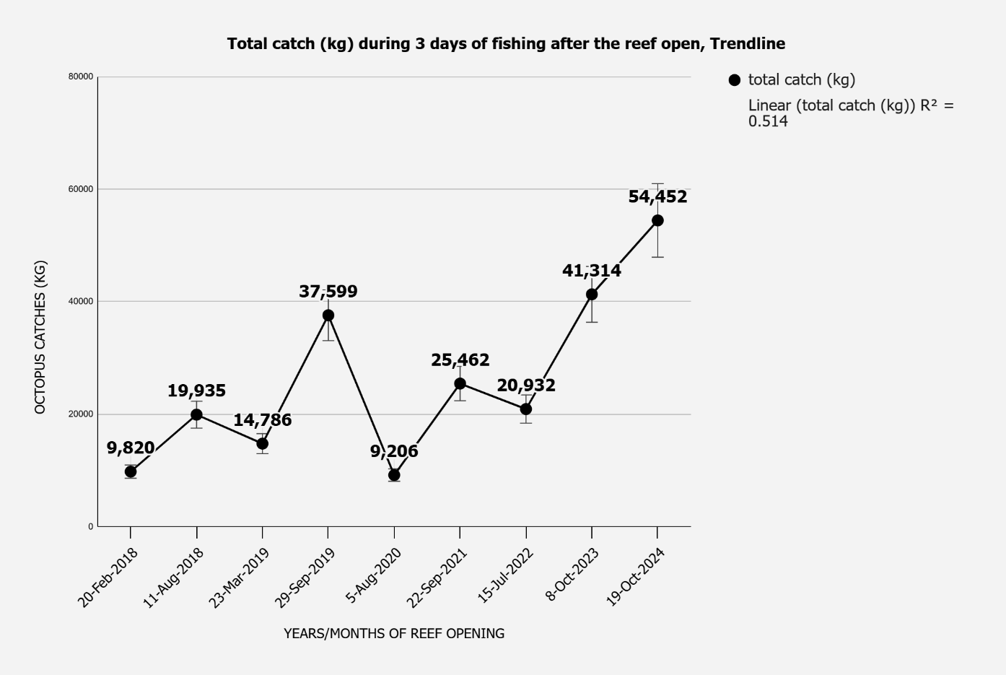
Figure 4.1: Octopus Reef Conservation Practices and Opening Catch Trend for Songosongo between 2017-2024
Source: WWF, BMU, and the District Fisheries Office
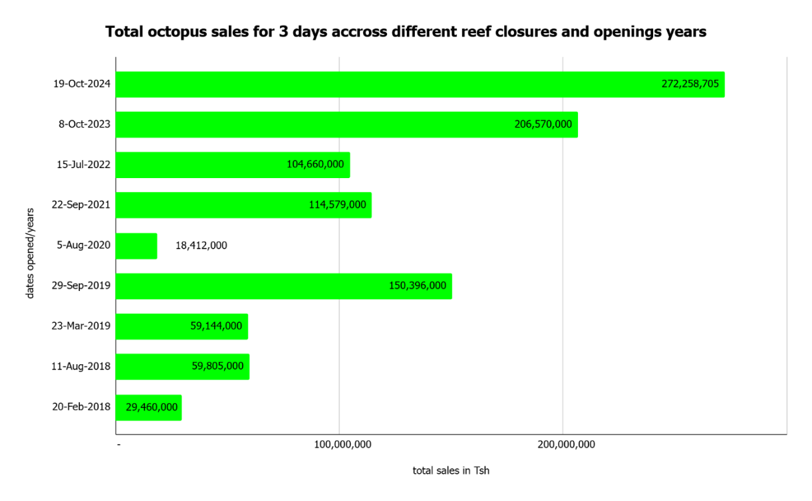
Figure 4.2: Octopus sales during the 3 days of fishing during the Reef Opening in Songosongo
Source: WWF, BMU, and the District Fisheries Office (2025)

Assessing the Effectiveness of locally managed Octopus Reef Conservation Practices in improving the Community Income
This section presents an analysis of changes in household income from octopus fishing before and after the implementation of reef-closure initiatives on Songosongo Island. The aim was to assess whether locally managed octopus reef conservation practices had a positive impact on community income, a key indicator of livelihood improvement. 82 Respondents reported their average monthly income from octopus fishing before and after the reef conservation practices. Using the R statistical package, a boxplot (Figure 4.1) was used to compare the distribution of income across the two periods visually. The boxplot showed that median income increased slightly after reef conservation practices.
However, income variability was high in both periods, with a wide interquartile range and outliers. Some respondents reported extremely high incomes after closure, suggesting heterogeneous benefits across the community. To quantify the change, the average household income was computed. The mean monthly income before closure was Tsh 231,000, and after closure, Tsh 261,000. Therefore, on average, household income from octopus fishing increased by 22.5% following reef conservation practices, indicating a positive trend in economic outcomes attributable to the intervention.

However, a paired samples t-test showed no significant difference at the 5% level (t= -1.2781, df = 83, p = 0.2048) and 95% confidence interval [–193,583; 42,137 ] between the two periods, which are income before and income after closure as seen in (table 4.2); This implies that the change in income could be due to chance rather than the reef closure intervention alone. While the reef closure initiative shows positive trends in income improvement, the statistical test indicates that the change is not yet strong enough to confirm significance, as the probability of observing this change by chance exceeds 20%. This may be due to High variability in income as seen in (figure 4.3), Other influencing factors such as market access, fishing gear, or individual capacity, and Fishers' behaviours or uneven implementation of conservation practices.

Table 4.2: Paired t-test Analysis for Income before and after Octopus Reef Conservation Practices
S/N | Statistic | Value
1 | t-value | -1.2781
2 | degrees of freedom (Df) | 83
3 | P-value | 0.2048
4 | 95% confidence interval | [–193,583; 42,137]
Source: Data analysis (2025)

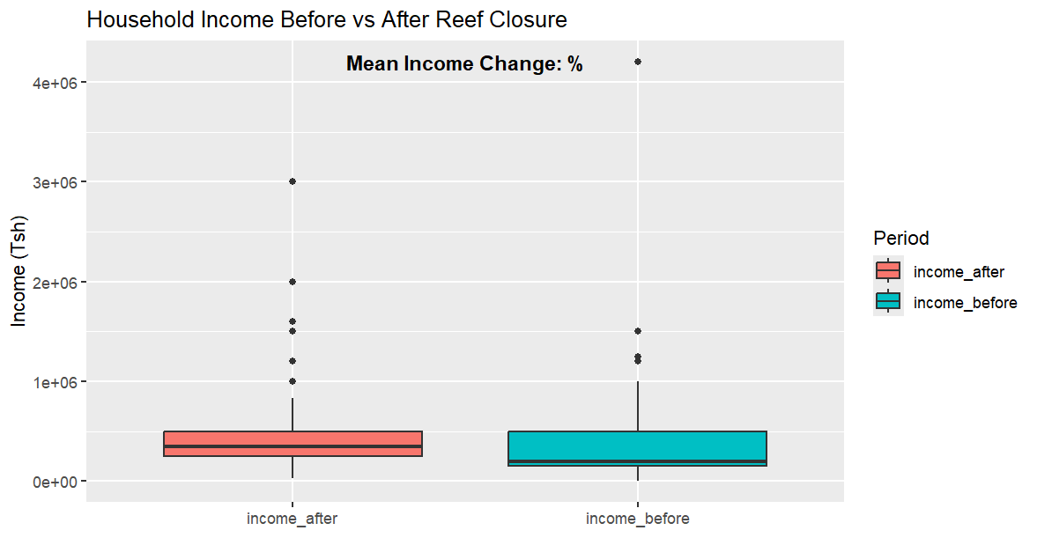
Figure 4.3: Household Income before vs after Reef Closure
Source: Data analysis (2025)

Impact of Reef Conservation Practices on Business Capital
83 Respondents were asked to estimate the amount of capital they invested in their fishing-related businesses both before and after the implementation of octopus reef conservation practices. The analysis showed a clear upward shift in average business capital post-closure. Specifically, the mean business capital increased from TZS 2,581,928 before the conservation practices to TZS 3,226,506 after. This represents an absolute increase of TZS 644,578, which corresponds to a 25% improvement (Figure 4.4). To determine whether the increase in business capital is statistically significant, a paired samples t-test was performed.

The test results showed a significant difference at the 5% level (t = 2.457, df = 82, p = 0.016) and a 95% confidence interval of [123,457 to 1,167,890] (Table 4.3). This implied that reef conservation practices had a positive, meaningful economic effect on fishers’ reinvestment capacity. The increase in average business capital suggests that locally managed reef conservation practices may contribute to greater reinvestment into fishing enterprises and related activities. Improved octopus stock availability, coupled with better pricing post-closure periods, empowered fishers to expand or upgrade their business operations. Despite this encouraging trend, variability in responses suggests that not all community members were equally able to benefit from reef conservation practices. Further policy support, including access to microfinance and cooperative marketing, is recommended to ensure equitable reinvestment in fishing profits.

Table 4.3: Paired t-test Analysis for Business Capital before and after Octopus Reef Conservation Practices
S/N | Statistic | Value
1 | t-value | 2.457
2 | degrees of freedom (Df) | 83
3 | P-value | 0.016
4 | 95% confidence interval | [123,457; 1,167,890]
Source: Data analysis (2025)
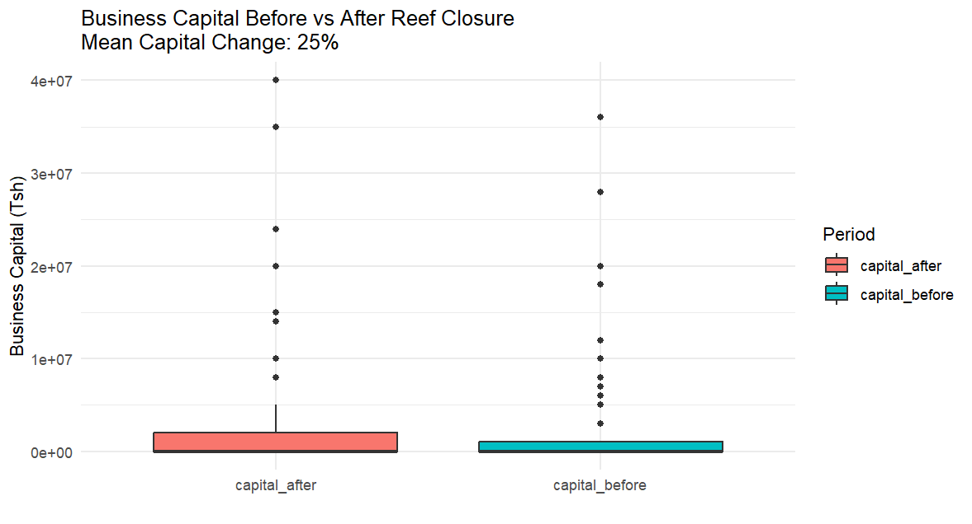
Figure 4.4: Illustrates the Business Capital vs after Reef Closure
Source: Data analysis (2025)

Impact of Octopus Reef Conservation Practices in enhancing Physical Assets
Asset ownership is a core indicator of long-term livelihood stability and economic resilience. The Respondents were asked to report on the number of household assets they owned before and after the implementation of reef conservation practices on Songosongo Island. On average, the number of household assets (table 4.4) increased following the reef closure intervention. 21 households (25.3%) reported owning an average of 3 different assets, and 8 households (8.4%) reported having zero assets. Comparing the two periods (Figure 4.5), the rise of asset ownership suggests that improved octopus catches and associated income gains may have enabled community members to acquire or upgrade household assets (e.g., radios, bicycles, boats, or nets).
The paired sample t-test showed a significant difference at the 5% level (t= 3.142, df = 83, p-value = 0.0023) and 95% Confidence Interval: [0.37, 1.60]
With a Mean Difference: +0.98 assets (table 4.5). Generously, results showed a statistically significant increase in household asset ownership following reef conservation practices (p < 0.01). This supports the hypothesis that reef conservation practices positively contributed to household asset accumulation, via improved income and reinvestment capacity.

Table 4.4: Ownership of Business or Livelihood-Related Tools and Equipment by Household
Responses | Freq. | Percent
0 | 7 | 8.43
1 | 13 | 15.66
2 | 16 | 19.28
3 | 21 | 25.30
4 | 15 | 18.07
5 | 6 | 7.23
6 | 1 | 1.20
7 | 2 | 2.41
8 | 2 | 2.41
Total | 83 | 100.00
Source: Data analysis (2025)

Table 4.5: Paired t-test Analysis for Physical Assets before and after Octopus Reef Conservation Practices
S/N | Statistic | Value
1 | t-value | 3.142
2 | degrees of freedom (Df) | 83
3 | P-value | 0.0023
4 | 95% confidence interval | [123,457; 1,167,890]
 | Mean difference | +0.98
Source: Data analysis (2025)
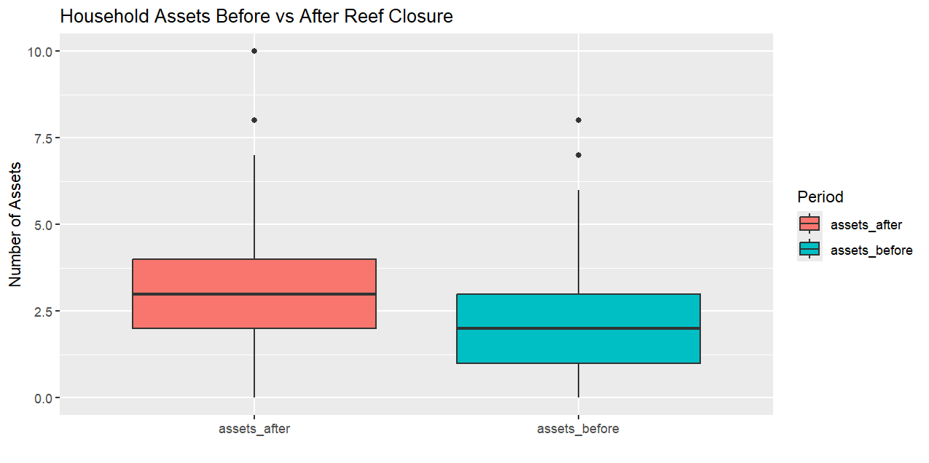
Figure 4.5: Household Assets before vs After Reef Closure
Source: Data analysis (2025)

Impact of the Octopus Reef Closure on Improving Housing Conditions
This section presents an analysis of the changes in household housing conditions on Songosongo Island following the establishment of reef conservation practices between 2017 and 2023. Housing conditions were assessed in terms of house improvement or rehabilitation, the construction of new houses, and the types of materials used to construct house walls.

These indicators collectively provide an overview of how community members’ living standards changed in response to improved livelihoods resulting from reef closure management. The results are presented using descriptive statistics, graphical summaries, and statistical tests to decide whether the observed differences are statistically significant.

House Improvement Status
Analysis of house improvement revealed that 77 households (92.8%) reported having improved or rehabilitated their existing houses since the implementation of reef conservation practices. Only a small proportion, 6 (7.2%), reported not having undertaken such improvements (figure 4.6). A binomial test was performed to determine whether this high improvement rate deviated significantly from a hypothetical 50% benchmark.

The results were highly significant (p < 0.001), suggesting that the proportion of households undertaking home improvements was not due to random variation but instead reflects a systematic change in living conditions. The significant improvement rate among households is likely linked to positive livelihood outcomes from reef conservation practices, such as increased fisheries productivity, higher income, or more stable resource availability. Enhanced income flows may have enabled residents to invest in home repairs or upgrades, thereby improving their overall living environment.
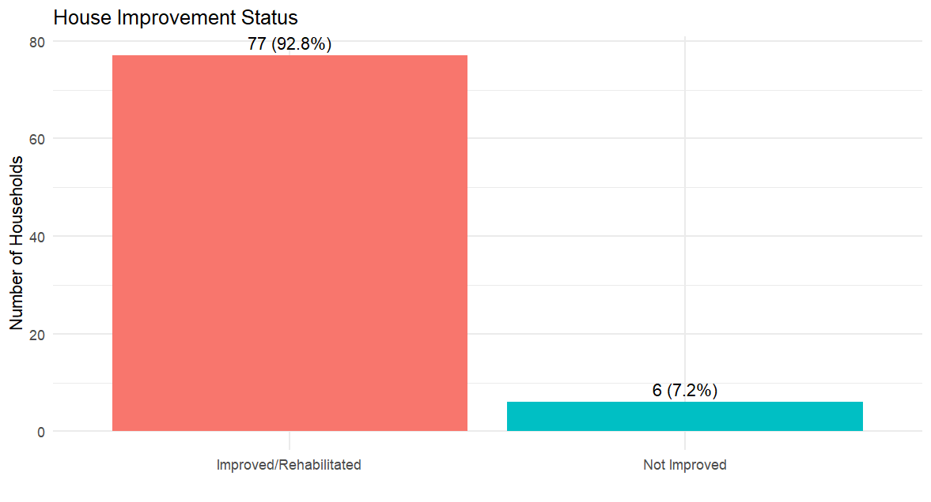
Figure 4.6: Boxplot showing the Proportion of Households that improved or rehabilitated their Homes
Source: Data analysis (2025)

Construction of New Houses
About the construction of new houses, 80.7% of respondents showed that they had built a new house since reef conservation practices were introduced, while 19.3% had not (Figure 4.7). A binomial test comparing this rate to a 50% baseline also yielded a highly significant result (p < 0.001), reinforcing the finding of a substantial pattern of new house construction beyond what would be expected by chance. A two-proportion test comparing the rate of house improvement with the rate of new house construction showed no statistically significant difference (p > 0.05). This suggests that both pathways, rehabilitating existing homes and building new houses, were important in improving household housing conditions in the community. The construction of new houses provides further evidence of enhanced household capital accumulation. Many households appear to have taken advantage of increased incomes or more predictable fishing returns to invest in larger, more permanent residential structures. These plots visually emphasize the shift toward improved housing conditions following the implementation of reef closure.

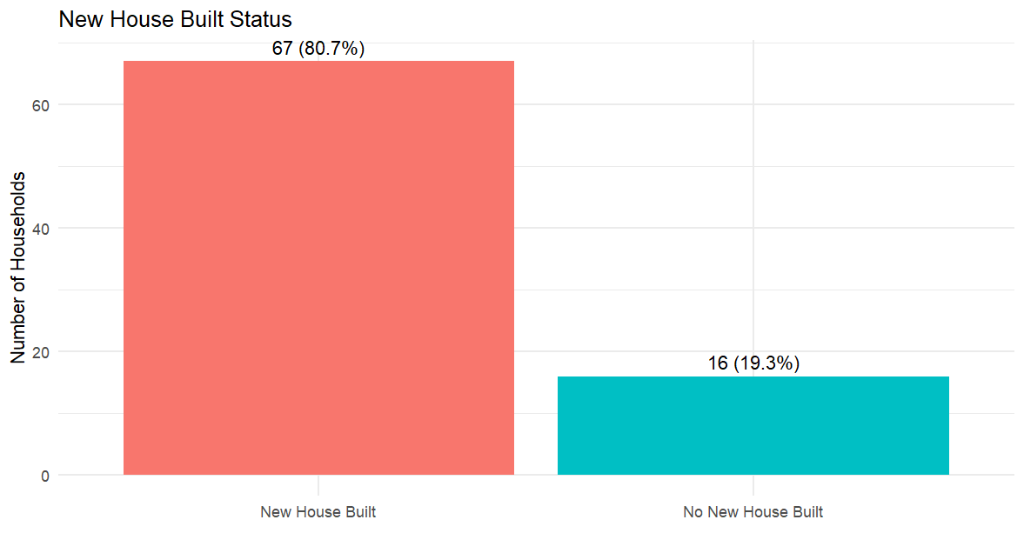
Figure 4.7: A boxplot showing the Proportion of Households that built a new House
Source: Data analysis (2025)

House Wall Materials
Analysis of the materials used for house walls revealed a diverse range of choices among respondents, including mud, bricks, cement blocks, and coral. Of the 83 households surveyed, 58 (62.4%) reported using cement blocks as their roofing material, while only 13 (14%) reported still using mud despite the introduction of the octopus reef closure (Figure 4.8). A descriptive summary showed that more permanent materials, such as cement blocks and bricks, were increasingly used, while traditional materials, such as mud, were relatively less common. A chi-squared goodness-of-fit test showed a highly significant difference from a uniform distribution (p < 0.001), indicating that households had a clear preference for more durable wall materials. This transition toward robust materials may show a long-term investment in housing stability, with residents feeling sufficiently secure in their improved incomes and in the sustainability of the reef conservation practices to commit to higher-quality building materials.

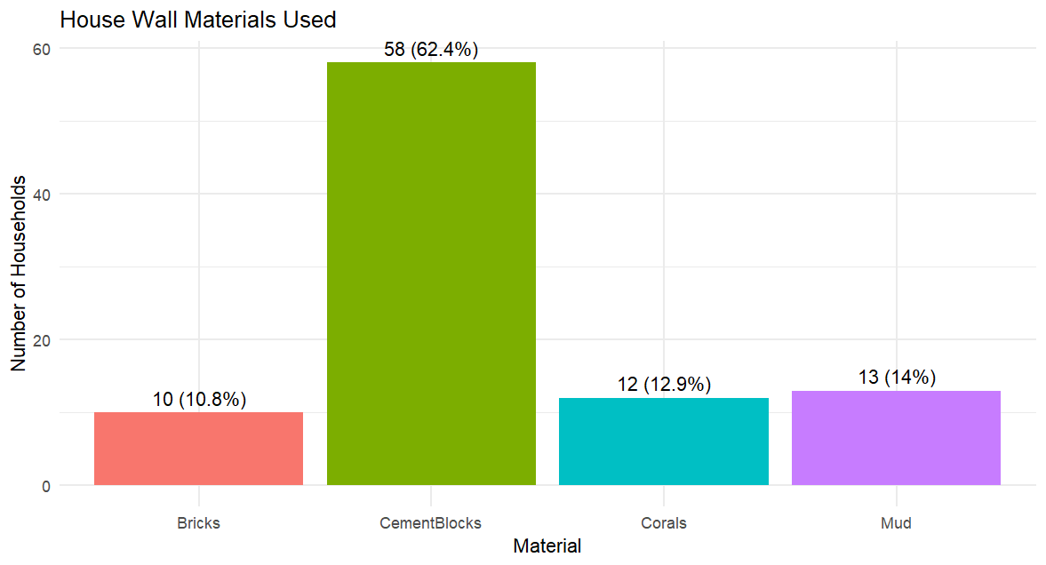
Figure 4.8: A bar Plot of Wall Materials with Percentage Labels
Source: Data analysis (2025)

Household Roofing Materials before and after Reef Conservation Practices
An analysis was conducted to examine the types of roofing materials households used after the establishment of Octopus Reef conservation practices. The findings showed a marked shift in roofing preferences among respondents. Out of 83 households surveyed, 85.5% (n = 71) reported using iron or aluminium sheets for roofing, while only 14.5% (n = 12) continued to use traditional grass or thatch roofing (Table 4.6).

This distribution is illustrated in Figure 4.9, which highlights the dominance of iron/aluminium sheets as the preferred roofing material following reef closure interventions. The boxplot shows a significant shift from traditional to more durable, modern roofing structures, likely reflecting improvements in household income and structural investment capacity during the studied period.

A binomial test was performed to assess whether the proportion of households using iron/aluminium roofing differed positively from a hypothetical equal distribution (50%). The results showed a statistically significant preference for iron/aluminium roofs (p < 0.001, 95% CI: 76.1%–92.3%), suggesting a strong departure from chance.

Furthermore, a chi-squared goodness-of-fit test confirmed this finding, showing a highly significant difference between the observed and expected distribution (χ² = 41.94, df = 1, p < 0.001). These results provide robust evidence that the adoption of iron and aluminium roofing materials has become the norm among most households, proving substantial improvements in housing quality and household resilience associated with the reef closure management measures.
Table 4.6: Distribution of Roofing Materials among Households
Material | Frequency | Percentage
Grass/Thatch | 12 | 14.5%
Iron/Aluminium | 71 | 85.5%
Source: Data analysis (2025)

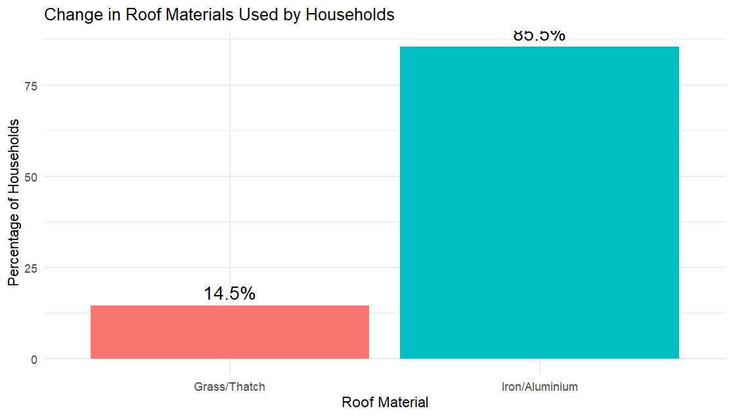
Figure 4.9: Proportion of Roofing Materials Used by Households
Source: Data analysis (2025)

Table 4.7 Statistical Summary for Housing Conditions
Indicator | Statistical Test | p-value | Interpretation
House improvement | Binomial test vs 50% | <0.001 | Significant improvement beyond chance expectation
New house construction | Binomial test vs 50% | <0.001 | Significant new construction beyond chance expectation
Wall materials distribution | Chi-squared goodness-of-fit | <0.001 | Unequal distribution favouring permanent materials
Improvement vs new house | Two-proportion (prop. Test) | >0.05 | No significant difference between rates
Source: Data analysis (2025)
These findings strongly suggest that reef conservation practices contributed positively to household well-being in Songosongo. Most households invested in either improving or building new houses, accompanied by a marked shift toward permanent building materials. Together, these trends reflect enhanced household confidence in their livelihood stability and their ability to make long-term housing investments.

Analyzing the Impact of Reef Conservation Practices on the Number of Meals
Food security is a critical dimension of livelihood wellbeing. This study assessed household food access by comparing the average number of meals consumed per day before and after the implementation of octopus reef conservation practices. A comparison of reported meals per day shows a clear upward trend. On average, households consumed 2 meals per day before the reef conservation practices and 3 meals per day afterward. Since the establishment of the octopus’ closure, the sample of 68 households (81.9%) reported an increased number of meals from 2 to 3, and 15 households (18.07 %) reported remaining with 2 meals per day (Table 4.8). Specifically, in Songosongo, 45 respondents (54.2%) reported increasing from 2 to 3 meals per day (Table 4.9).

To determine whether the increase was statistically significant, a paired samples t-test was conducted (t = 2.983, df = 82, p-value = 0.004) and a 95% Confidence Interval [0.21, 0.92] Mean Difference of 0.56 meals/day (Table 4.10). The result is statistically significant at the 1% level (p < 0.01), confirming a meaningful improvement in food access among participating households after the reef conservation practices. The increase in daily meal frequency and quality, as shown in the community view (Figure 4.10), reflects improved household food security, driven by income gains and better catch availability post-closure. This suggests that octopus reef conservation practices contributed not only to economic benefits but also to essential social outcomes such as nutrition and health.
Table 2.8: Number of Daily Household Meals since the Establishment of Octopus Reef Conservation Practices
Responses | Freq. | Percent
Two Meals per Day | 15 | 18.07
Three Meals per Day | 68 | 81.93
Total | 83 | 100.00
Source: Data analysis (2025)

Table 4.9: Change in Daily Household Meal Frequency since the Establishment of Octopus Reef Conservation Practices
Variables | Freq. | Percent
No | 38 | 45.78
Yes | 45 | 54.22
Total | 83 | 100.00
Source: Data analysis (2025)

Table 4.10: Results of the Paired t-test on Daily Meals before and after Reef Conservation
S/N | Statistic | Value
1 | t-value | 2.983
2 | degrees of freedom (Df) | 83
3 | P-value | 0.004
4 | 95% confidence interval | [0.21; 0.92]
5 | Mean Difference | +0.56 meals/day
Source: Data analysis (2025)

Figure 4.10: Change in Daily Household Meal Frequency since the Establishment of Octopus
Source: Data analysis (2025)

Discussion of the Result
The discussion examines how locally managed octopus reef conservation practices have influenced livelihood indicators in the Songosongo Island community and explores their implications for sustainable conservation strategies.

Impact on Community Income
The findings showed that the mean household income from octopus fishing increased modestly from TZS 231,000 to TZS 261,000 per month following reef conservation practices (a 22.5% rise); this change was not statistically significant (p = 0.2048). The significant increase in income aligns with findings by Oliver et al. (2015), Silas et al. (2022), and Wicaksono eta al. (2023), who observed similar post-closure income rises in Madagascar, Tanzania, and Indonesia, respectively. This suggests that while reef conservation practices may contribute to stabilizing or modestly increasing income, the effects were uneven and influenced by other factors, such as market conditions, access to fishing equipment, and broader economic shocks, including the COVID-19 pandemic. This aligns with studies such as Yeboah (2022) and MacCabe et al. (2024), which reported that seasonal conservation practices can yield only temporary or marginal income gains unless coupled with financial literacy programs. In Songosongo, sustained increases indicate effective BMU governance and reinvestment strategies, demonstrating the value of institutional support consistent with the SLA’s “financial capital” pathway (Scoones, 1998).

Impact on Business Capital
The results revealed a positive, statistically significant increase in business capital among households following reef conservation practices, with mean capital rising by 25% (p = 0.016). This supports the findings of Andrachuk et al. (2022) and Otieno (2024), who documented reinvestment behaviour among fishers following successful marine closures. Higher catches following reef reopening periods likely increased revenues and improved reinvestment opportunities (Ainsworth et al., 2023), which highlights that effective reef conservation practices can create opportunities for reinvestment and upgrading of small-scale fishing businesses. Nevertheless, the variability across households underscores the importance of ensuring fair reinvestment opportunities, perhaps through community-led savings groups or microfinance initiatives. In the SLA context, these results show conversion of natural capital (restored fish stocks) into financial capital (business investment). The same was noted by Mwambao Coastal Community Network (2023) in Zanzibar.

Impact on Physical Assets
Analysis of physical asset ownership produced mixed results. The descriptive summaries suggested an increase in household assets, showing a significant positive change with a mean of 0.98 in the number of assets owned after the reef conservation practices by individual households (p = 0.0023). This reflects the accumulation of livelihood tools and equipment, such as fishing gear and transport means, supporting household resilience. This is consistent with Island and Ryan (2015) and Golden et al. (2024). In Songosongo, asset accumulation represents improved livelihood resilience, a core component of SLA’s physical capital dimension. These results contrast with Katikiro (2014), who found limited asset growth in unregulated fishing communities, highlighting the advantage of structured conservation management. However, some households reported no change or even selling off assets during closure periods to cope with temporary income gaps, reflecting a negative coping strategy observed in similar studies (e.g., Pomeroy et al., 2007).

Impact on Housing Conditions
The study showed a strong positive effect of reef conservation practices on housing conditions. Over 92% of households reported significant improvements, and over 81% constructed new houses and upgraded to more durable building materials. These changes were highly significant (p < 0.001) and indicate that many households invested in durable structures, such as houses with cement walls and iron/aluminium roofing. This supports the findings of Gurney et al. (2014) and Wema (2019) in Lindi, who observed that community-based conservation can improve housing and broader well-being. No negative housing trends were observed in this study. Globally, similar patterns were reported in Fiji and Vanuatu by Ainsworth et al. (2023). These outcomes emphasize that well-enforced reef closures can yield long-term welfare effects beyond income, a dimension often missing in earlier studies. This strengthens the link between the SLA and financial and physical capital.

Impact on Food Security
Food security, measured by the number of daily meals, showed a significant improvement after reef conservation practices consistent with FAO (2022) and McCabe et al. (2024), who found that marine resource recovery directly supports local food systems. Most households (81.9%) increased their meal frequency from 2 to 3 meals per day compared with two meals before conservation practices (P=0.004), suggesting improved access to food and nutrition. This outcome is likely linked to higher catches, more stable fishing incomes, and greater market availability of octopus.

Studies by Benbow et al. (2014) and Sack (2024) in coastal Mozambique support this result, showing that periodic conservation practices can enhance catch recovery, thereby improving household nutrition and diversifying diets. This emphasizes the value of reef conservation practices not only for economic gains but also for critical social outcomes such as food security and health. Moreover, no households reported a reduction in meal frequency, and no negative outcomes related to food security were seen.

CHAPTER FIVE

SUMMARY, CONCLUSION, RECOMMENDATION

Introduction
This chapter presents a summary, implications, conclusions, and recommendations. Further limitations and suggestions for further studies are provided.

Summary of the Major Findings
A total of 83 respondents participated in this study, which assessed the impact of locally managed octopus reef conservation practices on livelihood outcomes in Songosongo Island between 2017 and 2024. The study examined how octopus reef closures affect livelihood indicators, including community income, business capital, physical assets, housing conditions, and food security. The study employed a descriptive and inferential research design, using both primary and secondary data sources. Data were analyzed using descriptive statistics, paired t-test, and chi-square tests.

Effectiveness of locally managed Octopus Reef Conservation Practices on Community Income
Analysis of income revealed an average increase from TZS 231,000 to TZS 261,000 per month post-closure. However, the change was not statistically significant, suggesting that while reef conservation practices may have helped stabilize incomes, other factors, such as market access or broader economic conditions, may have influenced the results. Therefore, the reef conservation practices showed a positive but inconclusive impact on community income.

Effectiveness of Octopus Reef Conservation Practices in improving Business Capital
Findings showed that average business capital invested in fishing-related activities increased from TZS 2,581,928 to TZS 3,226,506 following the implementation of reef conservation practices. The change was statistically significant, suggesting that improved stock availability and better post-closure prices enabled fishers to reinvest in their enterprises. This demonstrates the positive role of reef conservation practices in strengthening local business capital and promoting reinvestment among small-scale fishers.

Role of Octopus Reef Conservation Practices on Physical Assets
Ownership of physical assets (fishing vessels, engines, advanced gears, terrestrial transport such as motorbikes) also improved significantly, indicating the accumulation of tools and equipment relevant to livelihoods post-reef closure. These improvements highlight reef conservation practices to household economic resilience through asset accumulation.

Impact of Octopus Conservation Practices on Housing Conditions
Significant changes were seen in housing conditions. A binomial test confirmed that 92.8% of respondents had improved or rehabilitated their homes, while over 80% constructed new houses. Analysis of construction materials revealed that 85.5% of households used iron/aluminium sheets for roofing, and 62.4% used cement blocks for walls, showing a preference for durable materials post-closure. These changes were statistically significant using binomial and chi-squared goodness-of-fit tests.

Impact of locally managed Octopus Reef Conservation Practices on Meal Intake Frequencies
Regarding food security, a significant increase in daily meal frequency was observed, with the average rising from 2 to 3 meals per day. Over 80% of respondents reported currently eating three meals daily, and showed an increase since the introduction of reef conservation practices, suggesting better food access and enhanced nutritional security. This confirms that reef conservation practices improved food security among fishing-dependent households on Songosongo Island. This enabled the fish population to remain stable and replace the harvested population in most ocean areas.

Impact of locally managed Octopus Reef Conservation Practices on improving Business Capital
The overall findings show that while reef conservation practices had modest effects on income, they positively enhanced business reinvestment, asset accumulation, housing quality, and food security. All statistical tests were computed at a significance level of α = 0.05. These results demonstrate that when well-managed and supported, community-led reef conservation practices can be effective nature-based solutions to improve coastal livelihoods in marine-dependent communities.

Implication of the Findings
Practically, the study shows the values to community members, Fishers, and the BMU of Songosongo Island. The supporting evidence from this study and earlier studies shows that properly managed octopus reef conservation practices can improve housing conditions, business capital, food access, and even income for resource beneficiaries along the value chains. As of this relevance, therefore, the community groups should be encouraged to continue coordinating seasonal and spatial reef conservation practices as the most appropriate local form of Nature-based solution. The financial companion groups, such as Community Microfinance Groups (CMGs), joint fish marketing cooperatives, and fishers' associations, should be strengthened to maximize the reinvestment of benefits from the initiative. Moreover, fishers should be provided with training in best-practice resource management, financial literacy, and alternative livelihoods, such as eco-tourism and advanced, large-scale seaweed farming, to increase community resilience during reef closure periods.

The study's findings also have policy implications for policymakers, including the Ministry of Livestock and Fisheries, local government authorities, and supporting NGOs. The locally managed octopus reef conservation practices should be broadly integrated into the Blue Economy Frameworks, Marine Spatial Planning, and Integrated Coastal Zone Management guidelines. Also, Financial incentives or revolving loan schemes could be developed to help fishers purchase modern fishing gear to improve the quality of octopus catches and meet international market demands.

This finalizes the process of Octopus Fishery Certification in Tanzania, which is 89% as of the status, as per the Ministry of Livestock Fisheries reports (2022), with the gear used being the major drawback. Moreover, the government should invest in infrastructure, such as improved cold storage facilities and transport systems, to enhance the value chain for octopus products, ensuring higher, more stable incomes post-closure. Finally, policy frameworks should support capacity-building initiatives for BMUs to enhance their enforcement capabilities and encourage co-management practices.

Last but not least, the study has implications on the Sustainable livelihood Approach (SLA) whereby, the research has advances the SLA by empirically demonstrating how periodic marine reef conservation practices conservation measures contributes to improve multiple livelihood assets including the physical, financial, and food assurance, the research also reinforces the SLA’s principle that sustainable livelihoods require the interplay of natural resource stewardship and socio-economic support systems.

Furthermore, the study expands SLA thinking by showing how participatory governance, through BMUs, can empower communities to jointly manage resources and achieve resilience even in the face of ecological and market shocks. This evidence helps bridge the gap in SLA literature by linking marine conservation outcomes to livelihood trajectories in the Tanzanian coastal context, adding practical evidence to an area where power dynamics, equity, and local institutions had previously been under-researched.

Conclusion
In conclusion, this study affirms that locally managed octopus reef conservation practices have meaningfully improved livelihoods on Songosongo Island. The most notable impacts were seen in business capital growth, improvements in housing conditions, and food security, where community members experienced statistically significant gains. Although income improvements were modest and statistically insignificant, the general trend suggests that reef conservation practices stabilize household economies. Importantly, these conservation practices provided communities with the opportunity to reinvest in assets, housing, and nutrition, which are critical dimensions of long-term resilience and wellbeing.

The research underscores the role of community-led marine conservation in delivering tangible socio-economic benefits when combined with effective governance and institutional support. However, the success of such interventions depends on holistic strategies that address not only ecological restoration but also economic equity, market access, and local capacity building. As such, octopus reef conservation practices can be a vital tool in coastal development planning, particularly when implemented through inclusive, adaptive, and community-driven frameworks.

Study Limitations
This study was geographically limited to Songosongo Island in Kilwa District, which constrains the generalizability of the findings to other marine-dependent communities in Tanzania or the broader Western Indian Ocean region. The socio-cultural practices, governance arrangements, and ecological conditions on Songosongo may differ from those in other coastal areas, meaning that the results should be interpreted with caution when considering broader policy applications. Future research should consider replicating the study across multiple coastal sites to build comparative evidence and strengthen external validity.

Methodologically, the study relied on self-reported data, which may be subject to recall bias. The baseline (before) information was retrospective rather than based on real-time measurements. Furthermore, external confounding factors (e.g., price inflation, climate events, and external aid) were not fully controlled for. These limitations suggest caution when generalizing the findings. Future research using longitudinal data and larger samples could better isolate the effects of reef conservation practices from other influences.

Finally, the study was limited by the choice of livelihood indicators, particularly the use of the number of daily meals as a proxy for food security, which does not capture the full nutritional quality or food diversity of household diets. Likewise, other relevant livelihood capitals, such as social or political capital, were not fully assessed, even though they may strongly influence livelihood resilience. Future studies should expand the range of indicators to include multidimensional measures of well-being and food security for a more holistic evaluation.

Recommendations for Future Research
Based on the findings, the study recommends that although income levels have improved slightly after reef conservation practices, the change was not statistically significant. This suggests a need for more interventions to enhance economic gains. It is recommended that stakeholders, particularly local government and NGOs, facilitate access to better markets and value-added opportunities for octopus products. Training in sustainable fishing techniques, fish processing, and marketing can also help maximize profits. Additionally, integrating octopus harvesting into broader community development strategies (e.g., cooperative models or ecotourism) can create diversified income sources.

Secondly, given the statistically significant increase in business capital post-closure, future conservation initiatives should be coupled with financial support mechanisms. Enhancing and developing microfinance schemes, savings groups (e.g., VICOBAs), or grant programs for fishers can further empower reinvestment in livelihoods. These financial instruments should be designed to be inclusive, with special attention to women and youth, who often face higher barriers to capital access.

Additionally, to build on the increase in household physical assets, community-level interventions should promote asset security and diversification. Programs that offer subsidized fishing gear, or co-owned communal assets such as cold storage or transport facilities, can reduce individual risk while boosting productivity. Asset management and maintenance training should also be provided to ensure long-term value and reduce losses from misuse or environmental damage.

With over 90% of households reporting improvements or new housing, this shows a readiness to invest when income is available. Policymakers should support this momentum by improving access to affordable construction materials and services, possibly through public-private partnerships. Furthermore, integrating housing improvements with disaster resilience measures (e.g., cyclone-proof roofing, elevated structures) would align household investments with climate adaptation strategies.

About food security, the significant improvement seen calls for reinforcement through nutrition-sensitive policies. Community education on dietary diversity and balanced meals should go with reef closure initiatives. Additionally, promoting home gardening or integrated aquaculture could provide supplementary food sources during off-seasons, enhancing resilience to potential fluctuations in reef harvest yields.

REFERENCES
Aberdeen, T. (2013). Case study research: Design and methods. Thousand Oaks, CA: Sage. The Canadian Journal of Action Research, 14(1), 69-71.
Ainsworth, G. B., Pita, P., Pita, C., Roumbedakis, K., Pierce, G. J., Longo, C., & Villasante, S. (2023). Identifying sustainability priorities among value chain actors in artisanal common octopus fisheries. Reviews in fish biology and fisheries, 33(3), 669-698.
Alamer, A. (2022). Exploratory structural equation modeling (ESEM) and bifactor ESEM for construct validation purposes: Guidelines and applied example. Research Methods in Applied Linguistics, 1(1), 100005.
Andrachuk, M., Epstein, G., Andriamalala, G., Bambridge, T., Ban, N., Cheok, J., & Young, J. (2022). Reports - Wildlife Conservation Society, Coral reef governance: Strengthening community and collaborative approaches-A Vibrant Oceans Initiative Whitepaper.
Ashley, C., & Carney, D. (1999). Sustainable livelihoods: Lessons from early experience (Vol. 7, No. 1). London: Department for International Development.
Baker, D. M. (2022). Relational Seascapes: Human Wellbeing and Marine Protected Areas in Tanzania (Doctoral dissertation, Duke University).
Barendse, J., Failler, P., Okafor-Yarwood, I., & Mann-Lang, J. (2023). African ocean stewardship: navigating ocean conservation and sustainable marine and coastal resource management in Africa. Frontiers in Marine Science, 10, 1244652.
Beach Management Unit (2009). Beach Management Unit national guideline.
Belcher, B. M., Claus, R., Davel, R., & Jones, S. M. (2022). Evaluating and improving the contributions of university research to social innovation. Social Enterprise Journal, 18(1), 51-120.
Berrío-Martínez, J. (2022). Exploring complexities of fishery conservation practices using octopus movements: an individual-based modelling approach.
Bhandari, K. (2020). "The den ecology and the effects of fishing pressure on the distribution of Octopus cyanea (Octopodidae: Mollusca) in Rodrigues lagoon. Journal of Natural History, 54(45-46), 2961-2977.
Creswell, J. W. (2012). Educational research: Planning, conducting, and evaluating quantitative and qualitative research (4th Ed.). Boston, MA: Pearson Education, Inc.
De Haan, L., & Zoomers, A. (2005). Exploring the frontier of livelihoods research. Development and change, 36(1), 27-47.
De la Puente, S., de la Lama, R. L., Llerena-Cayo, C., Martínez, B. R., Rey-Cama, G., Christensen, V., & Valdés-Velasquez, A. (2022). Adoption of sustainable low-impact fishing practices is not enough to secure sustainable livelihoods and social wellbeing in small-scale fishing communities. Marine Policy, 146, 105321.
Denscombe, M. (2010). The effect heuristic and perceptions of ‘the young smoker’as a risk object. Health, risk & society, 12(5), 425-440.
Drost, E. A. (2011). Validity and reliability in social science research. Education Research and perspectives, 38(1), 105-123.
Fincham, J. E. (2008). Response rates and responsiveness for surveys, standards, and the Journal. American Journal of Pharmaceutical Education, 72(2), 43.
Golden, C. D., Hartmann, A. C., Gibbons, E., Todinanahary, G., Troell, M. F., Ampalaza, G., & Zamborain-Mason, J. (2024). HIARA study protocol: impacts of artificial coral reef development on fisheries, human livelihoods, and health in southwestern Madagascar. Frontiers in Public Health, 12, 1366110.
Gorstein, M., Loerzel, J., Edwards, P. E. T., & Levine, A. S. (2019). National Coral Reef Monitoring Program Socioeconomic Monitoring Component
Hollweck, T. (2015). Case Study Research Design and Methods. Canadian Journal of Program Evaluation, 30(1), 108–110.
Islam, T and Ryan, J (2015) Hazard Mitigation in Emergency Management. Butterworth-Heinemannt, New York
Islam, M. M., Begum, A., Rahman, S. M. A., & Ullah, H. (2021). Seasonal fishery closure in the northern Bay of Bengal causes immediate but contrasting ecological and socioeconomic impacts. Frontiers in Marine Science, 8, 704056.
Ismail, K., Vitasari, H., & Habibah, S. N. (2023). The Low level of Sustainability of Fishing Households Livelihood Assets Around Marine Conservation Areas. In BIO Web of Conferences (Vol. 70, p. 06003). EDP Sciences
Jacob, K. (2017). Implication of fishers ‘livelihoods on poverty reduction along lake victoria basin: a case of mbita sub-county, kenya (Doctoral dissertation, kisii university).
Kam, J. K., Chan, E., Lee, A., Wei, V. W., Kwok, K. O., Lui, D., & Yuen, R. K. (2020). Student nurses’ ethical views on responses to the severe acute respiratory syndrome outbreak. Nursing ethics, 27(4), 924-934.
Karunarathna, I., Gunasena, P., Hapuarachchi, T., & Gunathilake, S. (2024). The crucial role of data collection in research: Techniques, challenges, and best practices. Uva Clinical Research, 1-24.
Katikiro, R. E. (2014). Reef fisheries and livelihoods in coastal villages of southern Tanzania: lessons for adaptation to environmental change. Staats-und Universitatsbibliothek Bremen. Retrieved April, 7(2017), 00104183-1.
Katikiro, R., Mahajan, S. L., & Medard, M. (2024). The establishment, persistence, and scaling of marine community-based natural resource management in four coastal districts in Tanzania. Marine Policy, 169, 106341.
Kennedy, I. (2022). Sample size determination in test-retest and Cronbach alpha reliability estimates. British Journal of Contemporary Education, 2(1), 17-29.
Kogachi, A., & Shaw, R. (2023). Application of Sustainable Livelihood Approach (SLA) to address climate-induced risks through the lens of Africa borderland. Climate, 11(3), 65.
Klassen, A. C., Creswell, J., Plano Clark, V. L., Smith, K. C., & Meissner, H. I. (2012). Best practices in mixed methods for quality-of-life research. Quality of life Research, 21, 377-380.
Kuboja, B. N. (2013). Policies and legal frameworks for Marine Protected Areas governance in Tanzania mainland: their potential and limitations for achieving conservation and livelihood goals. United Nations-Nippon Foundation of Japan Fellowship Programme.
Kumar, A., Upadhyay, R., Samanta, B., & Bhattacherjee, A. (2024). Improving safety in complex systems: A review of integration of functional resonance analysis method with semi‐quantitative and quantitative approaches. Human Factors and Ergonomics in Manufacturing & Service Industries, 34(6), 572-588.
Kushardanto, H., Jakub, R., Suherfian, W., Subarno, T., Ansyori, A. I., Sara, L., & Campbell, S. J. (2022). Household finances and trust are key determinants of benefits from small-scale fisheries co-management. Marine Policy, 145, 105284.
Lau, J., & Ruano-Chamorro, C. (2021). Gender equality in coral reef socio-ecological systems.
Lamola, A. A., & Yamane, T. (1967). Sensitized photodimerization of thymine in DNA. Proceedings of the National Academy of Sciences, 58(2), 443-446.
Lefthand-Begay, C., Redmore, L., Armatas, C., Brisbois, J., Choden, K., Craig, D., & Mills, M. (2025). From paternalism to self-determination: examining evolving tribal-federal relationships and co-management arrangements through three case studies. Humanities and Social Sciences Communications, 12(1), 1-14.
Lokina, R., Nerman, M., Sandefur, J., & Leone, S. (2011). Poverty and Productivity: Small-Scale Farming in Tanzania, 1991-2007. Preliminary results for International Growth Centre commissioned study.
McCabe, M. K., Mudge, L., Randrianjafimanana, T., Rasolofoarivony, N., Vessaz, F., Rakotonirainy, R., & Cox, C. (2024). Impacts of locally managed periodic octopus fishery conservation practices in Comoros and Madagascar: short-term benefits amidst long-term decline. Frontiers in Marine Science, 11, 1358111.
Moshy, V. H., Bryceson, I., & Mwaipopo, R. (2015, September). Social-ecological changes, livelihoods, and resilience among fishing communities in Mafia Island Marine Park, Tanzania. In Forum for Development Studies (Vol. 42, No. 3, pp. 529-553). Routledge
MLF, 2018. Annual Fisheries Statistics Report. Ministry of Livestock and Fisheries, Dodoma
Mtonga, C., Jiddawi, N., & Benjamen, D. (2022). Recent rise in exploitation of Tanzanian octopuses: a policy and management challenge. Western Indian Ocean Journal of Marine Science, (1/2022), 107-118.
Munang, R., Thiaw, I., Alverson, K., Mumba, M., Liu, J., & Rivington, M. (2013). Climate change and Ecosystem-based Adaptation: a new pragmatic approach to buffering climate change impacts. Current Opinion in Environmental Sustainability, 5(1), 67-71.
Niehof, A. (2001). Rural livelihood systems: Conceptual framework (No. 5). International Potato Center.
Oliver, T. A., Oleson, K. L., Ratsimbazafy, H., Raberinary, D., Benbow, S., & Harris, A. (2015). Positive catch & economic benefits of periodic octopus fishery conservation practices: do effective, narrowly targeted actions ‘catalyze ’broader management? PLoS One, 10(6), e0129075.
O'Neill, E. D., Daw, T. M., Lindkvist, E., & Mwaipopo, R. (2023). Compliance, Complexity and Cephalopods-Disaggregated Responses to Participatory Marine Conservation & Management.
Onyango, L. J. (2015). Fishers’ attitude towards performance of Beach Management Units (BMUs) in regulating fishery and reducing poverty: case study of two BMUs Lake Victoria, Tanzania. International Journal of Marine Science, 5.
Otieno, J. (2024). Balancing conservation and livelihoods: artisanal fishers'perspectives on the kisite-mpunguti marine protected area, kwale county, kenya (master's thesis, university of agder)
Reina, M. A. (2022). The Applicability of International Disaster Relief.
Root, J. R., & Lindstrӧm, E. (2024). Embracing Mixed Methods Research in Special Education. Research and Practice for Persons with Severe Disabilities, 49(4), 231-241.
Russell, D. (2022). Assessment of regional/national fisheries management plans and related activities the coastal marine fisheries of cluster 1 of the ea, sa, and io region 2022.
Sack, H., Gajjar, S. P., Reid, H., & Pandey, A. (2024). Community-led bioeconomy development and nature-based solutions (NbS) in the Global South: recommendations to the G20.
Salunkhe, G. (2024). A multidisciplinary approach inimplementing nature-based solutionsfor marine and coastal ecosystems: Case study of a locally managed Marine Protected Area initiated bylocal Indigenous knowledge and methods in Fiji.
Saunders, M.N.K, Lewis, P., & Thornhill, A. (2019). Research Methods for Business Students. (8th Edition) Pearson Education Limited, England
Sauer W, Potts W, Raberinary D, Anderson J, Sylvio Perrine M (2011) Assessment of current data for the octopus resource in Rodrigues, western Indian Ocean. African Journal of Marine Science 33 (1): 181-187catches: Implications for a sustainable fishery. Fisheries Research, 264, 106716.
Shah, J. M., Uddin, M. S., Hussin, R., Hamdan, D. D. B. M., Ibrahim, D., & Ijuwan, N. N. B. A. (2022). Sustainable Livelihood Strategies of Fishing Communities in Marine Protected Area (MPA), Sabah, Malaysia. International Journal of Human Resource Studies, 12(2), 44.
Sianipar, I. M. J., Lee, C. H., Wang, H. J., Kim, D. C., & Suryawan, I. W. K. (2024). Determinant of importance-performance and willingness to participate in Komodo adaptive conservation programs. Journal for Nature Conservation, 81, 126697.
Silas, M.O., Kishe, M.A., Mgeleka, S.S., Kuboja, B.N., Ngatunga, B.P., Matiku, P (2022). The octopus fishing conservation practicespositively impact human well-being and management success, in the case of Tanzania.
Silas, M. O., Kishe, M. A., Semba, M. R., Kuboja, B. N., Ngatunga, B., Mgeleka, S. S., & Gullström, M. (2023). Seascape configuration influences big blue octopus (Octopus cyanea)
Solesbury, W. (2003). Sustainable livelihoods: A case study of the evolution of DFID policy (Vol. 217). London: Overseas Development Institute.
Sureshchandar, G. S. (2023). Quality 4.0–a measurement model using the confirmatory factor analysis (CFA) approach. International Journal of Quality & Reliability Management, 40(1), 280-303.
Tambe, S. (2022). Sustainable Livelihoods approach. In Teaching and learning rural livelihoods: A guide for educators, students, and practitioners (p.45-56). Cham: Springer International Publishing
Tiku, S., & Pecht, M. (2010). Validation of reliability capability evaluation model using a quantitative assessment process. International Journal of Quality & Reliability Management, 27(8), 938-952.
Wema, E. F. (2024). The role of Tanzania library services board in enhancing information literacy skills among the public in Tanzania. Information Development, 40(3), 398-413.
Wicaksono, V. A., Nasution, A. M., Putriraya, A. R., & Digdo, A. (2023, July). Understanding the socio-ecological system of small-scale octopus fisheries in North Minahasa to achieve sustainable certification. In IOP Conference Series: Earth and Environmental Science (Vol. 1220, No. 1, p. 012033). IOP Publishing.
Willer, D.F., Aldridge, D.C., Gough, C. et al. Small-scale octopus fishery operations enable environmentally and socioeconomically sustainable sourcing of nutrients under climate change. Nat Food 4, 179–189 (2023). https://doi.org/10.1038/s43016-022-00687-5
Wulfing, S., Kadba, Baker-Medard, M., & White, E.R. (2024). Assessing the need for temporary fishing closures to support sustainability for a small-scale octopus fishery. Fisheries Research, 276, 107045.
Yanda, P. Z., Mwajombe, A. R., & Gwambene, B. (2023). Coastal communities’ livelihoods conditioned by resource use dynamics and changing environments in Lindi Region, South-Eastern Tanzania. Marine Policy, 150, 105532.
Yeboah, E. N. (2022). Socioeconomic Implications of Closed Fishing Season in the Marine Artisanal Sector: A Case Study of Elmina and Apam in the Central Region of Ghana (Doctoral dissertation, University of Cape Coast).
Xu, Z., Qayum, M., Afzal, J., & Aslam, M. (2023). Availability and access to Livelihood capital assets for development of sustainable Livelihood strategies of fishers: A case study of Manchar Lake Pakistan. Heliyon, 9(12).

APPENDICES

Appendix 1: Sample Size Table for Big Population (Yamane, 1967)
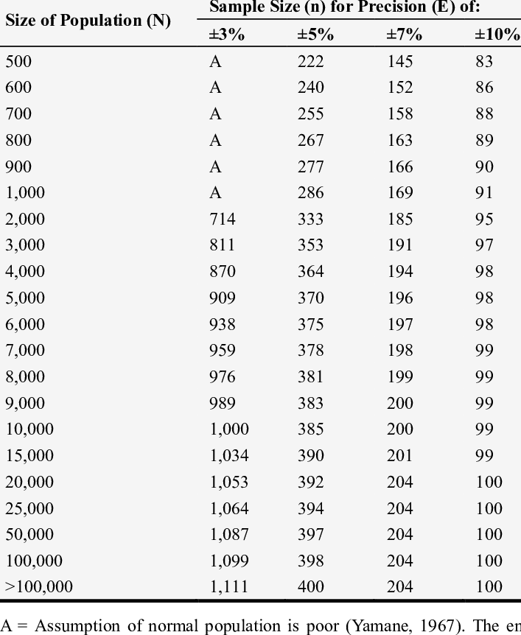

Appendix 2: Clearence Letter from OUT DPGS
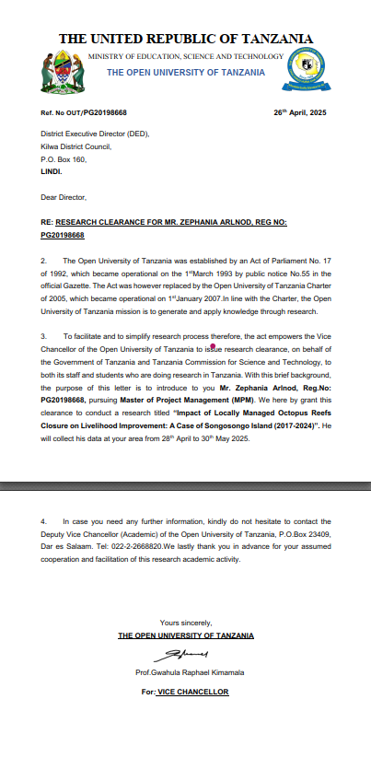

Appendix 3: Acceptance letter in Kilwa District – Songosongo Fisheries Office
