INFLUENCE OF OUTDOOR ADVERTISING BILLBOARDS ON CONSUMER PURCHASING BEHAVIOUR:
A CASE OF URBANWEST REGION, ZANZIBAR

AHMED HANI MOHAMED

A DISSERTATION SUBMITTED IN PARTIAL FULFILLMENT OF THE REQUIREMENTS FOR THE DEGREE OF MASTER OF ARTS IN MASS COMMUNICATION
DEPARTMENT OF MEDIA AND LIBRARY STUDIES
THE OPEN UNIVERSITY OF TANZANIA
2025

CERTIFICATION
The undersigned certifies that he has read and hereby recommends for acceptance by the Open University of Tanzania a dissertation entitled, “Influence of Outdoor Advertising Billboards on Consumer Purchasing Behaviour; A case of the Urban West region, Zanzibar” in n partial fulfilment of the requirements for the award of a Master of Arts in Mass Communication (MAMC) of the Open University of Tanzania.



………………………………..
Dr. Abubakar S. Rajab
(Supervisor 1)
…………………………
Date

………………………
Dr. Henry Mambo
(Supervisor 2)

………………………
Date

COPYRIGHT
No part of this Dissertation may be reproduced, stored in any retrieval system, or transmitted in any form by any means, electronic, mechanical, photocopying, recording, or otherwise, without prior written permission of the author or The Open University of Tanzania on that behalf.

DECLARATION
I, Ahmed Hani Mohamed, declare that the work presented in this dissertation is original. It has never been given to any other University or Institution. Where other people’s works have been used, references have been provided. It is in this regard that I declare this work is mine. It is hereby presented in partial fulfillment of the requirements for the Degree of Master of Arts in Mass Communication.

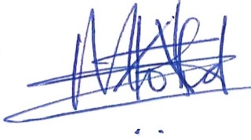
Signature

16/7/2025
Date

DEDICATION
First and foremost, to Almighty God, whose grace, wisdom, and unending love have guided my steps through every challenge and triumph. This work is a testament to His faithfulness, the source of my strength, and the light that illuminates my path.
To my late father, Hani Mohamed Abdalla, whose memory remains a beacon of courage, integrity, and unconditional love. Though you are no longer here to share this moment, your teachings echo in every word I write, your resilience inspires every difficulty I overcome, and your legacy lives on in the values you instilled in me.
This research is not only a product of academic pursuit but a reflection of the faith you nurtured and the love you poured into my life. I carry your name with pride, and I pray this work honors the sacrifices you made and the dreams you held for me.

ACKNOWLEDGEMENT
First and foremost, all praise and gratitude belong to Almighty Allah (SWT), the Most Merciful and the Source of all wisdom, for granting me the strength, guidance, and perseverance to complete this research. Without His infinite blessings and grace, this journey would not have been possible. “And whatever good you do is for Allah, and whatever hardship you face, He will compensate you for it.” (Quran 2:272).
I extend my deepest appreciation to my supervisor, Dr. Abubakar Rajab Sheikh, whose expertise, patience, and unwavering support shaped the backbone of this work. Your insightful feedback, encouragement during moments of uncertainty, and dedication to nurturing academic rigor have been invaluable. Thank you for believing in this project and guiding me to its completion.
To my beloved wife, Amina Ussi Khamis—my rock and partner in every sense—thank you for your endless sacrifices, emotional resilience, and boundless love. You carried our family through countless late nights and demanding phases, always with a smile. This achievement is as much yours as it is mine.
My three precious children, Rumaysa, Raudhat, and Salahuddin: your laughter, patience, and understanding gave me purpose during the most challenging times. Daddy’s “study time” is finally over—let’s make up for all those postponed playdates!
To my dearest mother, Zuwena Said Khatib: your prayers, wisdom, and unwavering belief in education laid the foundation for my aspirations. Your strength and sacrifices throughout my life taught me the true meaning of perseverance. I hope this work makes you proud.
I am profoundly grateful to Mr. Manning Yusuph and Mr. Vincent Mpepo, my Open University course coordinators, for their administrative expertise, timely guidance, and relentless efforts to ensure my academic journey ran smoothly. Your professionalism and support were critical to navigating this process.
Lastly, to the countless friends, colleagues, and mentors who offered encouragement, shared resources, or simply listened during moments of stress—thank you. Your contributions, whether direct or indirect, played a vital role in this milestone.
This research is not mine alone but a tapestry woven by the love, support, and generosity of everyone mentioned here. May Allah reward you all abundantly.

ABSTRACT
This study examines the influence of outdoor billboard advertisements on consumer purchasing behavior in the Urban West Region of Zanzibar. The research employed a mixed-methods approach involving questionnaires, key informant interviews, focus group discussions, and direct field observations to gather comprehensive data on the effectiveness and perception of billboard advertising. Findings reveal that outdoor billboard advertisements play a significant role in shaping consumer awareness and purchasing decisions, particularly when strategically located in high-traffic areas. The most preferred types of billboards identified were static billboards and digital billboards, with static billboards being more dominant due to their affordability and longer display duration. Digital billboards were valued for their dynamic and modern visual appeal despite challenges such as unreliable electricity and higher operational costs. Additionally, consumers reported being more influenced by billboards that featured high-quality images, short and clear messages, and large display sizes. Businesses that frequently utilize billboard advertising include telecommunications companies, airlines, financial institutions, educational centers, and government bodies. However, challenges such as infrastructure damage from weather, delayed payments by clients, and a lack of standard regulations were noted as barriers to effective billboard use.
The study concludes that while outdoor billboards are a powerful communication tool, their impact on consumer purchasing behavior is maximized when content, design, and placement are carefully considered. It recommends stronger regulatory frameworks, improved infrastructure, and greater investment in digital display reliability to enhance the effectiveness of outdoor advertising in Zanzibar.

Keywords: Outdoor billboards, advertising, consumer behaviour
TABLE OF CONTENTS
CERTIFICATION i
COPYRIGHT ii
DECLARATION iii
DEDICATION iv
ACKNOWLEDGEMENT v
ABSTRACT vi
LIST OF TABLES xii
LIST OF FIGURES xiii
LIST OF ABBREVIATIONS AND ACRONYMS xiv
CHAPTER ONE 1
1.0 INTRODUCTION 1
1.1 Background to the Study 1
1.2 Statement of the research problem 4
1.3 Objectives of the study 4
1.3.1 General Objective 4
1.3.2 Specific Objectives 5
1.4 Research Questions 5
1.5 Relevance of the study 5
1.6 Scope of the study 6
1.7 Limitations of the study 7
CHAPTER TWO 9
LITERATURE REVIEW 9
2.1 DEFINITION OF KEY TERMS 9
2.1.1 Outdoor billboard 9
2.1.2 Advertising 9
2.1.3 Consumer behaviour 9
2.2 Theoretical Literature Review 9
2.2.1 AIDA theory of advertising 10
2.3 Conceptual framework 12
2.4 Concept of outdoor advertising 13
2.5 Billboard advertising and consumer purchasing behaviour 14
2.6 Performance of Outboard Billboards for Outdoor Advertising Worldwide 15
2.7 Empirical review 20
2.8 Research gap 22
CHAPTER THREE 24
RESEARCH METHODOLOGY 24
3.1 Research Approach and Design 24
3.2 Sampling Procedure and Sample Size 24
3.2.1 Sampling Procedure 24
3.2.2 Sample size 25
3.3 Study Area 26
3.4 Data collection methods 27
3.4.1 Primary data collection 27
3.4.2 Secondary data collection 28
3.4.3 Interview 28
3.4.4 Questionnaires 28
3.4.5 Focus Group Discussion 29
3.4.6 Observations 30
3.5 Data collection procedures 32
3.5.1 Asking Permission to Conduct Study 32
3.5.2 Conduct of Personal Interview 32
3.6 Data presentation and analysis 33
3.6.1 Statistical analysis 33
3.6.2 Content analysis 33
3.7 Ethical Considerations 33
CHAPTER FOUR 34
PRESENTATION OF FINDINGS 34
4.1 Chapter Overview 34
4.2 Findings 34
4.2.2 Age of respondents 34
4.2.3 Gender of respondents 37
4.2.4 Education level of respondents 38
4.2.5 Occupation of respondents 39
4.2.6 Profession of respondents 40
4.2.3 Mode of transport used by the respondents 42
4.3 Specific objective one: Analyze the use of outboard outdoor billboards for outdoor advertising in Zanzibar 45
4.3.1 Visibility of outdoor billboard advertisements 45
4.3.2 Attractiveness of outdoor billboard advertisements 47
4.3.3 Dissatisfaction with outdoor billboard advertisements 47
4.4 Specific objective Two: Identify the types of messages that are placed in outdoor advertising billboards in promoting business 48
4.4.1 Type of messages placed in outdoor billboard advertisements 48
49
4.4.2 Level of understanding of billboard messages 50
4.4.3 Actions taken to understand billboard messages 50
4.5 Specific objective three: determining factors that lead commercial companies to prefer outdoor advertising billboards to promote their business in products and services 52
4.5.1 Satisfaction with billboard location 52
4.5.2 Perceived Alignment of Billboard Wording with Customer Needs 53
4.6 Specific objective four: Identify the advantages of using outdoor billboards in Zanzibar 54
4.6.1 Excitement of using outdoor billboard advertisements 54
4.6.2 Fulfillment of billboard information 55
4.6.3 Linkages of billboard information to the services 56
4.6.4 Understanding and Significance of Billboard Information 57
4.6.5 Use of Outdoor Billboards to Monitor Services and Needs 58
CHAPTER FIVE 60
5.0 DISCUSSION OF THE FINDINGS 60
5.1 Chapter Overview 60
5.1.1 Summary of the Key Findings 60
5.2 Discussion of the research findings 62
CHAPTER SIX 83
6.0 CONCLUSION AND RECOMMENDATIONS 83
6.1 Chapter Overview 83
6.1.1 Summary 83
6.1.2 Conclusion 83
6.2.1 Focus Group Discussion 85
6.2.2 Key Informants Interview for Business Owners 87
6.2.3 Key Informants Interview for the billboard service provider 89
6.3.1 Recommendations 98
6.3.2 Recommendations for Future Research 100
REFERENCES 103
APPENDICES 109

LIST OF TABLES
Table 2.1 Summary of Empirical Studies 21
Table 4.1 Gender of respondents 38
Table 4.2 Education level of respondents 39
Table 4.3 Occupation of respondents 40
Table 4.4 Profession of respondents 42
Table 4.5 Action to understand billboard messages 52
Table 6.1 Billboard Analysis Matrix-Urban West Region, Zanzibar 96
Table 6.2 Matrix Analysis of Common Billboard Allocation in Urban West Zanzibar 97

LIST OF FIGURES
Figure 1.1 Conceptual Framework 13
Figure 4.1 Age of respondents 36
Figure 4.2 Mode of transport used by respondents 44
Figure 4. 3 Respondent’s visibility of billboard advertisements 46
Figure 4.4 Attractiveness of billboard advertisements 47
Figure 4.5 Reasons for billboard dissatisfaction 48
Figure 4.6 Types of messages placed in billboard advertisements 49
Figure 4.7 Level of understanding of billboard messages 50
Figure 4.8 Satisfaction with the billboard location 53
Figure 4.9 Perceived Alignment of Billboard Wording with Customer Needs 54
Figure 4.10 The excitement of using outdoor billboard advertisements 55
Figure 4.11 Fulfillment of billboard information 56
Figure 4.12 Linkage of billboard information to the services 57
Figure 4.13 Understanding and Significance of Billboard Information 58
Figure 4.14 Use of Outdoor Billboards to Monitor Services and Needs 59

LIST OF ABBREVIATIONS AND ACRONYMS

OUT OPEN UNIVERSITY OF TANZANIA

AIDA ATTENTION, INTEREST, DESIRE, AND ACTIONS

OAB OUTDOOR ADVERTISING BILLBOARD

MA MASTER OF ARTS

MC MASS COMMUNICATION

SPSS STATISTICAL PACKAGE FOR THE SOCIAL SCIENCES

DV DEPENDENT VARIABLE

IV INDEPENDENT VARIABLE

TV TELEVISION

MC MARKETING COMMUNICATION

CPB CONSUMER PURCHASING BEHAVIOUR

KII KEY INFORMANT INTERVIEW

FGD FOCUS GROUP DISCUSSION

OCGSZ OFFICE OF CHIEF GOVERNMENT STATISTICIAN

NBS NATIONAL BUREAU OF STATISTICS

URT UNITED REPUBLIC OF TANZANIA

SME SMALL AND MEDIUM SIZED ENTERPRISES

LCD LIQUID CRYSTAL DISPLAY

USD UNITED STATES DOLLAR

LGA LOCAL GOVERNMENT AUTHORITY

QR QUICK RESPONSE

ROI RETURN ON INVESTMENT

AAKIA ABEID AMANI KARUME INTERNATIONAL AIRPORT

RGoZ REVOLUTIONARY GOVERNMENT OF ZANZIBAR

NGO NON-GOVERNMENTAL ORGANIZATION

SBCC SOCIAL AND BEHAVIORAL CHANGE COMMUNICATION

SVPO SECOND VICE PRESIDENT OFFICE

FMCGs FAST-MOVING CONSUMER GOODS

SIMs SUBSCRIBER IDENTITY MODULE

B2B BUSINESS TO BUSINESS

LED LIGHT EMITTING DIODES

IDI IN-DEPTH INTERVIEW

CBD CENTRAL BUSINESS DISTRICT

AI ARTIFICIAL INTELLIGENCE

AR AUGMENTED REALITY

CHAPTER ONE

1.0 Introduction
This research focuses on the outdoor billboard as an advertising platform that attracts customers to make purchasing decisions about the products or services. In other words, in the current world, billboards have become an agent for outdoor media in advertising that are placed along the roads and highways. Still and digital billboards are major forms of outdoor media that exist in Zanzibar, which have a significant contribution to the Zanzibar economy, especially in promoting business.
Perhaps it is not surprising that billboards have recently integrated into Zanzibar's advertising culture and have gradually come to replace traditional media. Most people, especially drivers of motor vehicles and pedestrians frequently view billboard messages when they are along the highways and roads. This section is intended to give an overview of the background of the study, statement of research problem, research objectives, research questions, scope of the study, limitations, relevance of the research, and finally, organization of the research.

1.1 Background to the Study
Communication through advertisement is a useful tool for sustaining an honest and ethical, responsible competition that contributes to the socio-economic growth of products and services (Trethowan, 2017). The adoption and application of new technologies and methods in the field of marketing have created various platforms for business organizations to reach their target markets and execute their marketing campaigns and operations through various tools of advertisement (Henderson et al., 2018). Among the advertising tools and media created by new technologies are outdoor advertising, social media advertising, television advertising, mobile advertising, online advertising, display advertising, radio advertising, print advertising, etc. (Henderson et al., 2018).
Billboards are considered one of the most popular tools due to their strong combination of visuals and actions in delivering information to customers on purchasing products and services. The popularity of this tool is guaranteed to be easily seen by customers (Manning, 2018). Ukhaev and Viktoh (2012) narrated that outdoor billboard advertising is a useful strategy adopted by business organizations to advertise products, services, and ideas to intended target customers to create awareness, persuade, and encourage customer patronage. In cities and towns with huge populations of busy working-class individuals who barely have enough time to watch television, listen to the radio, or visit social media platforms, outdoor billboard advertising media can be an effective and efficient way of bringing a company’s advertising campaigns to such customers (Patricia, 2002). This is because the advertising campaigns are placed in strategic outdoor locations where customers visit almost daily such as major roads, train stations, grocery stores, schools, shopping malls, highways, substations, and locations with heavy commercial activity where they can be easily noticeable by the customers (Khan & Farun, 2013; Alexander, 2012; Manning, 2018).
Billboard advertising has also been reported to be a strategic tool in advertising campaigns of business firms. The method has also been found to contribute to the creation of new jobs and higher incomes, stimulating economic growth through expansion of business and trade (Wroblewski, 2018; Patricia, 2002). It is estimated that around 75 percent of people worldwide rely on billboards in their marketing behaviour. Many billboards have a message that gives their potential customers an idea of how to find their destination. This tool also makes it extremely easy to target a specific audience demographic. (Diane, 2009), With today’s technology, there are ways to create a demographic breakdown to show where most of the target audience tends to go and then position billboards where they will be seen by this exact demographic. This allows the advertiser to reach their target audience while getting them thinking about how they want to spend their money.
Consumers’ buying behaviour has always been given so much importance and space in the literature study of the impact of advertising regarding its effectiveness (Ajzen, 2002). Most of the time, consumers' buying behaviour is influenced by the liking or disliking of consumers towards the advertisement of the product (Smith et al., 2002).
The increase in business competition results in the placement of more billboard advertisements in the Urban West region in Zanzibar; hence, information concerning the impact of billboard advertising is needed for assessing customers' purchasing desire as well as to find out if the billboard advertisements meet the market demand of customers. Therefore, this study aims to assess the influence of outdoor advertising billboards in the Urban West region, Zanzibar. The study also aims to observe the types of messages that are placed in outdoor advertising billboards in promoting businesses from various companies to understand the different products and services offered to customers.

1.2 Statement of the research problem
The outdoor advertising billboard is one of the crucial advertising platforms that are used by marketers to fascinate customers to purchase products or use services in the various marketing segments in Zanzibar. Increased marketing opportunities and business competitions, such as the rapid growth of private schools and colleges, private hospitals, marine and air transports, as well as hotels for tourism, among others, have influenced the influx of outdoor advertising billboards along the highways and interconnected roads in the Urban West region of Zanzibar. However, there is little information on the influence of outdoor advertising billboards on consumer purchasing behaviour. Additionally, the majority of Zanzibaris have a middle-class life standard and are not digitalized, mostly use local means for purchasing their products, i.e., walk directly to the nearby shops for buying their daily needs (Nicholas &Herman, 2015). Little is known about how the outdoor billboards have affected their purchasing behaviour. Information that is very important for understanding the applicability of this tool to consumers for their wide usage. To fill these information gaps, studies on assessing the influence of outdoor advertising billboards on consumer purchasing behaviour in Zanzibar are needed, for a better understanding of the underlying mechanisms and perceptions of customer needs, and to ensure that marketers improve their outdoor billboard advertising modalities in the Urban West region, Zanzibar.

1.3 Objectives of the study

1.3.1 General Objective
The study assesses the influence of outdoor advertising billboards on consumers' purchasing behaviour.

1.3.2 Specific Objectives
The study had the following specific objectives: -
- To analyse the use of outdoor billboard for outdoor advertising in Zanzibar
- To identify types of messages that are placed in outdoor advertising billboards in promoting businesses.
- To determine factors that lead commercial companies to prefer outdoor advertising billboards to promote their business in products and services.
- To identify the advantages of using outdoor billboards in Zanzibar

1.4 Research Questions
- Are outdoor billboard advertisements preferable for potential customers to make purchasing decisions about products or services?
- What types of messages are placed in outdoor advertising billboards to promote businesses?
- What are the factors influencing companies to prefer to use outdoor billboard advertising to promote their products and services?
- What are the advantages of using outdoor advertising billboards in Zanzibar?

1.5 Relevance of the study
The study intends to assess the influence of outdoor advertising billboards on consumers' purchasing behaviour in the Urban West region, Zanzibar. The study is expected to be of much value to members of the field, especially Mass Communication, Psychology, and Economics. Understanding the impact of the outdoor advertising billboards on customers' purchasing behaviour will help companies to prepare appropriate designs and quality formats of billboard advertisements to improve their influence on customers' purchasing decisions of the products or services. Also, the study will have vital contribution to the Municipal councils in monitoring the necessary influx of the billboards in Urban areas as well as increase their visibility to the necessary areas outside Urban region and rural areas, as a means of promoting urbanization and increase economy through taxes, Moreover, help to show how effective the outdoor advertising billboard is, and the challenges that affect it. In addition, the study will provide baseline information for further research on outdoor advertising billboards as an additional reference.

1.6 Scope of the study
This study on the influence of outdoor advertising billboards on customer purchasing behaviour was conducted in three districts, mainly the Urban district, West “A” district, and West “B” district within the Urban West region, Zanzibar. The study was purposely selected to be conducted at these districts within the region because they are situated at urban centers where many products and services are available, and there is an influx of billboards along the roads and highways where many people, including drivers of motor vehicles and pedestrians, are exposed to billboard advertisements in their daily routine.
Commercial companies are using this opportunity to advertise their products and services using billboard advertisements as new platforms to persuade customers to purchase products or utilize services. This study is delimited to outdoor advertising billboards, specifically digital and still billboards, which are found along the roads and highways in the Urban West region. The researcher has significant knowledge of digital and still outdoor advertising billboards, but wants to understand the significant use of both digital and still billboards and how they influence customer purchasing behaviour. Also, the researcher is known to some of the members in the community, making it easier to collect the necessary information for completion of the research.
Simple random and purposive sampling techniques were used to select respondents, and data were collected through interviews, questionnaires, and Focus Group discussions. The sample size of the study for questionnaires was 400 respondents within three districts in the Urban West region, among them 98 are respondents from the Urban district, 148 from the West “A” district, and 154 from the West “B” district. Four Key Informant Interviews were conducted from different institutions, including Mozeti, Feza Schools, Islands Travel and Tours, and Zanzibar School of Health, which are all located within the Urban West region. In addition, Three Focus Group Discussions, one from each district, were also conducted to find details information from respondents and complete data collection in the field.

1.7 Limitations of the study
Among the factors that limited the study was the limited time for data collection. The researcher conducted several follow-ups on the questionnaires distributed to the respondents to minimize the time in data collection.
Another factor was the inadequate funds available for conducting research. For researchers to be able to collect the data effectively and efficiently must have adequate funds to prepare stationery, transport to data collection areas, and facilitate the collection of questionnaires from the respondents. The researcher used the available budget effectively to allocate funds for activities to minimize these challenges.
Another factor was that the study was limited to the Urban West region, Zanzibar, and was focused on a limited number of respondents, who sometimes provided little cooperation to the researcher. There must be cooperation between respondents and researchers to ensure effective and efficient data collection. Also, there were still people who did not know how to read and write, and this led to difficulties in filling out questionnaires. However, researchers were effectively cooperating with respondents to minimize these challenges.

CHAPTER TWO

LITERATURE REVIEW

2.1 DEFINITION OF KEY TERMS

2.1.1 Outdoor billboard
An outdoor billboard is any advertising that reaches the consumer when they are outside of their home. Basically, if it is outside the home, it is outdoor advertising. It is considered a mass market medium, just like broadcast, radio, TV, and cinema advertising. It reaches hundreds of thousands of people, by foot, mass transit, or car, and is very quick and impactful (Suggett, 2018)

2.1.2 Advertising
Advertising is simply the process of creating awareness about the existence of goods and services to a target audience. It is an inertia that is capable of any type of product because of its persuasiveness (Kenechukwu, Asemah, and Edegoh, 2013)

2.1.3 Consumer behaviour
Is the buying behavior of final consumer’s individuals and households that buy goods and services for personal consumption (Kotler and Armstrong, 2012)

2.2 Theoretical Literature Review
For assessing the influence of outdoor advertising billboards on customer purchasing behaviour in today’s world, a literature survey will be undertaken to establish a framework of theoretical perspectives. There are so many persuasion theories that can be used in explaining outdoor billboard advertising to consumer purchasing behaviour. However, this work will use the AIDA theory of advertising and consumer behaviour theory.

2.2.1 AIDA theory of advertising
The AIDA Model was propounded by an American businessman, St. Elmo Lewis, in 1951 as an approach used by advertisers to describe the different phases of consumer engagement with an advertisement. It is one of a class of models known as ‘hierarchy of effects’ models that consumers move through a series of steps or stages of behavioural (doing, e.g., purchase or trial) stage (Bardi & Omoera, 2014). Priyanka (2013) asserts that the steps proposed by the AIDA model are as follows:
(a) Attention – The consumer becomes aware of a category, product, or brand (usually through advertising).
(b) Interest – The consumer becomes interested by learning about brand benefits and how the brand fits with their lifestyle.
(c) Desire – The consumer develops a favourable disposition towards the brand.
(d) Action – The consumer forms a purchase intention, shops around, engages in trial, or makes a purchase
According to Hanlon (2009), the acronym stands for Attention, Interest, Desire, and Action. The bottom line here is that for every outdoor billboard advertising to get attention, hold interest, arouse desire, and then obtain action. In marketing and advertising, outdoor billboard producers must develop effective communication strategies that communicate with customers in a way that better responds to their needs and desires. AIDA describes a common list of events that occur when a consumer views an outdoor billboard advertisement. Priyanka (2013) avers that each letter in the acronym stands for the following:
- The “A” represents attention or awareness, and the ability to attract the attention of the consumers. It involves creating brand awareness or affiliation with your product or service
- The “I” is interested and points to the ability to raise the interest of consumers by focusing on and demonstrating advantages and benefits (instead of focusing on features, as in traditional advertising). It involves generating interest in the benefits of your product or service, and sufficient interest to encourage the buyer to start to research further.
- iii. The “D” represents desire. The advertisement convinces consumers that they want and desire the product or service because it will satisfy their needs. It moves the consumer from ‘liking’ it to ‘wanting it’.
- iv. The “A” is action, which leads consumers toward taking action by purchasing the product or service
The AIDA model is thus relevant and useful in marketing as it explains the different steps in preparing outdoor billboard advertising to attract the kind of attention that will lead to a purchase decision (or action). Every good billboard should attract attention, awaken interest, and create conviction. This model describes the steps a customer goes through in the process of purchasing a product. Everything in outdoor billboard advertising is geared towards getting attention, making the target interested in the company’s product or services, the message influencing favourable desire, then leading to purchase (that is, Action). Like Hanlon (2009) posits, tracing the customer journey through Awareness, Interest, Desire, and Action is perhaps the best-known marketing model amongst all the classic marketing models. Many marketers find AIDA useful since we apply this model daily, whether consciously or subconsciously, when we are planning our marketing communications strategy.
The AIDA Model identifies cognitive stages an individual goes through during the buying process for a product or service. It is a purchasing funnel where customers go through each stage to support them in making the final purchase. As a marketing tool, AIDA provides the marketer with a detailed understanding of how target audiences change over time and provides insights as to which types of advertising messages are likely to be more effective at different junctures. Since the goal of every organization is to have its products or services patronized by the consumers, the model is extensively helpful in marketing communication where organizations secure attention for the product or services, hold attention through interest, arouse desire, create confidence and belief, secure decision and action, leading to customer satisfaction.

2.3 Conceptual framework
This study assessed the influence of outdoor advertising billboards on consumer purchasing behaviour. To determine the impact of the independent variable (outdoor advertising billboard), the study focused on two types of billboards, which are digital advertising billboards and print advertising billboards. The dependent variable is (consumer's purchasing desire for products or services. The model below presents the hypothesized relationship between the independent variable and the dependent variable of this study. The conceptual framework is presented diagrammatically in
Figure 1 below: -
Independent Variable
Outdoor Advertising Billboards

Digital billboard Still billboard
Location/Placement Location/Placement
Attraction Attraction
Creativity Creativity
Apprehension Apprehension
Frequency Frequency
Reach Reach
Dependent Variable
Consumer Purchasing Behaviour
Attention Desire (to buy)
Figure 2.1 Conceptual Framework

2.4 Concept of outdoor advertising
Outdoor advertising is the adoption and utilization of out-of-home media to execute the advertising campaigns of organizations (Profit and Non-profit organizations). It is the use of outdoor media to advertise the products, services, ideas, and activities of an organization (Henderson, Charlene & Cruz, 2018). There are four primary sources of outdoor advertisement, including billboards, digital billboards, transit media, and posters (Watson 2006). The idea of outdoor advertising tools is described as a non-personal and paid-for presentation and promotion of ideas, goods, and services by an identified sponsor using out-of-home media like billboards and signboards, or posts. The most important benefit of outdoor advertising compared to other advertising media is that the audience cannot discard or even click away from it (Peasah, Abrantie & Mensah, 2019).
Outdoor advertising, also known as out-of-home media, is advertising that reaches consumers while they are outside their homes. It is focused on marketing to consumers when they are "on the go" in public places, in transit, waiting (such as in a medical office), and/or in specific commercial locations (such as in a retail venue) (Wembley, 2011). In the view of Sesto (2018), outdoor or out-of-home advertising competitive clusters grab customers' attention.
According to Chaplin (2018) and Tucker (2016), billboard advertising is the presentation of a company's advertising campaigns to the target audience using billboards as the medium. Normally, billboards are placed at high-traffic highways as well as along less-traveled roads in non-urban areas where they can be easily seen by drivers and pedestrians. They are an efficient and cost-effective means of communicating geographically important information – the location of the closest chain fast food restaurant on the route, the nearest motel, or campgrounds at the next exit.

2.5 Billboard advertising and consumer purchasing behaviour
Consumer behaviour is a sequential process that consumers go through, and each stage can be influenced differently for consumers to behave in a desired way. Initially, consumers were thought to go through a straight-line process, which included awareness, interest, desire, and final action. However, in recent consumer studies, consumers have been found to exhibit more complex behaviour with a non-hierarchical process. The study of consumer behaviour examines the process through which consumers make important decisions and the ways by which consumers gather and evaluate information from their environment (Solomon, 2002). The degree to which consumers interact or involve themselves with different brands largely affects the final decision to make a purchase. The level of importance of a product to a consumer in terms of image, self-concept, etc., is reflected in the decision-making process of consumers.
On the contrary, billboard advertising presents an organization's products and services; creates customer awareness about the existence of these products and services; and provides retailers' contacts and locations where purchases can be made. In doing so, billboard advertising facilitates customer purchasing decisions of products and services. Supporting the foregoing premise, Timipre et al (2018) revealed that billboard advertising, among other outdoor advertising media, had a significant positive effect on customer patronage of deposit money banks in Bayelsa State. Similarly, Abdul et al (2017) revealed that billboard advertising, among other advertising platforms, had a significant impact on customer patronage of fast-moving consumer goods in Yemen.

2.6 Performance of Outboard Billboards for Outdoor Advertising Worldwide

Outboard billboards, as a form of outdoor advertising, are large, visible advertising structures typically located in high-traffic areas such as highways, city centers, and near popular attractions. These billboards offer businesses the opportunity to reach a broad audience. The performance of these billboards is evaluated based on their visibility, engagement, and ability to drive consumer behavior Smith, 2024).

Example: In New York City, digital billboards in Times Square engage millions of pedestrians and tourists, making it one of the most famous examples of high-impact billboard advertising. This is not only seen as a prime location but also as an effective means for advertisers to reach diverse populations (Coca-Cola Company, 2024).
North America, particularly the United States, is home to some of the largest and most influential out-of-home advertising billboards. These billboards are essential in driving sales, especially for industries like tourism, entertainment, and retail. They are used extensively in urban areas and along major highways, leveraging both static and digital billboards Taylor & Whelan, 2025).
Example: In Los Angeles, digital billboards are strategically placed along highways, showcasing ads for major film releases and consumer goods. The high volume of traffic and pedestrian exposure make these billboards powerful tools for marketing. Billboard advertising contributes significantly to the growth of brands like Coca-Cola and McDonald's, whose ads are often displayed in prominent locations Jansen, 2025).
Europe has seen a shift toward digital billboards, allowing for dynamic, real-time advertising content. Countries like the UK, France, and Germany have integrated these into their urban infrastructure, blending both digital and traditional static billboards. This allows advertisers to tailor messages based on time, location, and audience demographics Jansen, 2025).
Example: In London, digital billboards in places like Piccadilly Circus and Oxford Street offer brands a chance to display dynamic content, from fashion trends to tech advertisements. These billboards are particularly effective in reaching both locals and international tourists Monteiro, 2025).
Asia's rapidly urbanizing cities are becoming hotspots for out-of-home advertising. Countries such as China, Japan, and India have seen significant growth in the use of billboards, both in terms of number and technological advancement. Digital billboards are a key feature in cities like Tokyo and Shanghai, offering advertisers new ways to capture attention Lee & Kim, 2024).
Example: In Shanghai, billboards in major shopping districts like Nanjing Road use high-definition digital screens to promote everything from luxury goods to local eateries. The integration of QR codes and interactive features makes these billboards highly engaging, encouraging consumers to take immediate actions like making purchases or following brands on social media Smith, 2024).
Latin America, especially Brazil, Mexico, and Argentina, has increasingly adopted out-of-home billboards as an essential advertising tool. These billboards play a crucial role in brand building for local and multinational companies. While digital billboards are growing in popularity, traditional static billboards still dominate many areas Monteiro, 2025).
Example: In Rio de Janeiro, Brazil, large out-of-town billboards are used during Carnival season to promote everything from beverages to travel destinations. The high foot traffic and vibrant public events provide an ideal backdrop for advertising, and billboards effectively target both locals and tourists during peak seasons O’Connor, 2024).
Africa is seeing a rise in the use of out-of-home billboards, particularly in cities like Johannesburg, Lagos, and Nairobi. While outdoor advertising has been popular for decades in the region, there has been a recent shift towards more sophisticated and digital billboards, especially in high-income urban areas. These billboards are often used by global brands looking to expand their reach O’Connor, 2024).
Example: In Nairobi, Kenya, digital billboards are now appearing in key locations like the Nairobi Central Business District (CBD). Advertisers have started using these platforms to target young, tech-savvy consumers who engage with mobile-driven campaigns alongside traditional outdoor advertisements Lee & Kim, 2024)
The future of outboard billboards is increasingly driven by technological innovation, including the integration of AI, augmented reality (AR), and real-time data analytics. Advertisers are now looking to create more personalized and interactive experiences for consumers. This trend is expected to continue, with greater use of digital screens and interactive content across continents Smith, 2024).
Example: In Dubai, the Burj Khalifa now displays massive digital billboards that can change content based on the time of day or audience engagement, such as using sensors to display ads that cater to nearby consumers. This dynamic approach exemplifies the future potential of outboard billboards globally, Taylor & Whelan (2025)
In Zanzibar, the use of outboard billboards is gradually increasing as the island's infrastructure develops and the economy grows. Traditionally, outdoor advertising in Zanzibar has relied on smaller, more localized methods, such as posters and banners. However, with the increase in tourism, urbanization, and commercial activity, out-of-town billboards, especially digital ones, are becoming more prominent. These billboards are particularly valuable for businesses targeting both local consumers and international tourists. Advertisers use them to promote various sectors, including tourism, retail, and food industries, making them effective tools for reaching a broad audience.
Example: In Stone Town, Zanzibar's UNESCO World Heritage site, digital billboards are emerging as a key advertising medium in high-traffic areas, such as near the Forodhani Gardens. These billboards are becoming a platform for promoting Zanzibar’s tourism, offering dynamic content like hotel bookings, tour packages, and cultural events O’Connor, 2024).
Zanzibar’s economy is largely driven by tourism, and outdoor advertising plays a critical role in promoting the island’s tourism offerings. Outboard billboards are strategically placed in high-visibility locations, including near the airport, ferry terminals, and popular tourist attractions. These billboards provide information about Zanzibar’s hotels, resorts, excursions, and local businesses, thereby supporting the growth of tourism-related activities. Billboards are particularly useful for promoting limited-time offers, events, and services that can catch the attention of tourists on a tight schedule.
Example: Zanzibar Tourism Corporation uses out-of-town billboards to advertise major events such as the Zanzibar International Film Festival (ZIFF) or the Sauti za Busara music festival. The large, visible billboards located near popular tourist spots like Nungwi and Kendwa beaches help create awareness and attract tourists who may not have been previously aware of such events, Janse (2025).
Despite the growing trend of out-of-town billboards, there are still several challenges to their widespread use in Zanzibar. Environmental concerns, particularly in heritage areas like Stone Town, may limit the number and type of billboards allowed. Furthermore, the cost of digital billboards and their maintenance may pose barriers for small businesses looking to utilize them. However, with increasing investments in Zanzibar's infrastructure and a growing interest in modern advertising methods, out-of-home billboards are expected to become more effective in the coming years. If local businesses can leverage these tools effectively, they can enhance their visibility and brand presence significantly.
Example: In 2024, Zanzibar authorities implemented new regulations to ensure that billboards in Stone Town did not disrupt the historical aesthetics of the area. Despite this, businesses near tourist areas, like hotels and restaurants, continue to see a positive impact from billboards in terms of brand recognition and sales Smith, 2024).

2.7 Empirical review
This section reviews already-conducted research investigations on outdoor advertising billboards and customer purchasing behaviour to assess the methodologies and findings of previous researchers on the subject. The focus of this empirical review is on the following authors and cities: Rogars Ritagrace and Gerry Batonda (2022) in Mwanza City, Tanzania; Hamelmal Solomon (2022) in Addis Ababa, Ethiopia; Rizwana Iqbal, Sana Batool (2016) in Pakistan; Besa Demiri (2020) in Macedonia; Takana, Shinoto, and Akudugawa (2018) in Japan; Bagwell, Walker, Kellerman, and Ryan (2016) in Michigan; and Tucker (2016) in Canada. The summary of their research approaches used and findings is elaborated in the Table below;
Table 2.1 Summary of Empirical Studies
Author | Title | Country | Methodology | Finding
Rogars Ritagrace, Gerry Batonda, Faculty of Business and Economics, Department of Accountancy and Finance, Mwanza, March 2022 | Effect of Advertising Media on Sales Performance of Cable TV Network Firms | - St. Augustine University of Tanzania | A combination of structured questionnaire and document review was adopted to elicit primary data from 414 network managers from the six Cable TV network service providers.  -Multiple regression analytical technique was used to analyze the primary data collected for the study | -The study found that outdoor advertising had the highest effect on firms ‘sales performance after mobile marketing, followed by social media marketing, and lastly, TV/Radio.
Hamelmal Solomon, School of Graduate Studies, Program of Business Administration (MBA), Addis Ababa, January 2022) | Effect of Media Advertising on Consumer Buying Behaviour at Top Water Company | St. Mary’s University, Ethiopia | -Primary data were collected from 270 users of Top Mineral Water in Addis Ababa using a structured questionnaire. -OLS regression was adopted to analyze the primary data elicited from respondents | -The study found that outdoor media advertisement has a positive and significant effect on the customer buying behaviour of Top Mineral Water in Addis Ababa. On that basis, this finding reflects that outdoor media advertisements are effective in informing and persuading customers.
Bagwell, Walker, Kellerman, and Ryan. Michigan (2016) | Outdoor advertising media and consumer purchase behaviour towards automobiles in Michigan | United States of America | -Personal interview and structured questionnaire were the data collection instruments used to elicit primary data from 65 car buyers at automobile dealers ‘factories and shops across Michigan | The findings of the study revealed that outdoor advertising billboards had a significant effect on consumer purchase behaviour towards automobiles in Michigan. Therefore, the study concluded that outdoor advertising media had a significant positive effect on consumer purchase behaviour towards automobiles in Michigan.
Tucker, (2016), Ontario | Effect of outdoor advertising on customer purchase of electronic products | Canada | -Semi-structured questionnaire was used to collect primary data from 78 consumers of electronic products at shopping malls in Ontario, Canada.  -The chi-square analytical tool was employed to test the primary data collected | The study revealed that billboard advertising significantly improved customer purchases of electronic products in Ontario shopping malls. Consequently, the study concludes that outdoor advertising had a significant effect on customer purchases of electronic products in Canada.
Takana, Shinoto, and Akudugawa, Tokyo (2018) | Impact of outdoor advertising on customer patronage of new mobile phone technologies in Tokyo | Japan | -Primary data were elicited from 104 mobile phone users in Tokyo using email-delivered questionnaire copies.  -Multiple regressions in the Statistical Package for the Social Sciences (SPSS) were adopted to analyze the data collected | -It was found that billboard advertising had a significant positive impact on customer patronage of new mobile phone technologies in Tokyo.  -Therefore, the study concluded that outdoor advertising significantly increased customer patronage of new mobile phone technologies in Tokyo.
Rizwana Iqbal, Sana Batool, Department of Management Sciences,  Punjab (2016) | Impact of Billboard Advertisement on Customer Buying Behaviour in Punjab | Islamia University of Bahawalpur (IUB), Pakistan | -Primary data were collected from 300 IUB students using questionnaires. -The study used simple linear regression to analyze the data collected with the help of the Statistical Package for the Social Sciences (SPSS) | -The study found that billboard location and catching billboards have a greater influence on customer buying behaviour.  -The study concluded that billboard advertisement influences the consumer buying behaviour more when it is attractive to see, easy to understand, and it is properly placed means delivering its messages to the right people.
Besa Demiri, Department of Business and Economics, Tetovo, (2020) | Impact of outdoor advertising on consumer behaviour in Tetovo | South-east European University, Macedonia | -A structured questionnaire with a fixed scheme was sent via email to 229 respondents.  -Multiple regression analytical technique was used to analyze the primary data collected for the study | -The study concluded that billboard location and catchy billboards have a greater influence on customer buying behaviour.  -This also indicates that outdoor advertising is likely to increase sales of products. If the way of delivering the message is clear, understandable, and the advertisement is properly located, then consumer buying behaviour is influenced.

2.8 Research gap
Recently, Zanzibar has experienced the influx of outdoor advertising billboards on the highways and along the interconnected roads due to an increase in business competition and customers' demand for products and services in the local markets in the Urban West region. However, there is little information on the studies concerning the influence of outdoor advertising billboards and consumer purchasing behaviour in Zanzibar.
Besides, little is known about the effectiveness of outdoor advertising billboards on consumer purchasing decisions, information that is very important for understanding the applicability of this tool to customers’ desire to purchase products or services. To fill these information gaps, studies on assessing the influence of outdoor advertising billboards on consumer purchasing behaviour in Zanzibar are needed, for a better understanding of consumer desire and to ensure that marketers improve their outdoor advertising billboards.
Moreover, there are many studies assessing the influence of outdoor advertising billboards on consumer purchasing behaviour around the world. However, there is a lack of evidence from developing countries, especially Africa; most evidence published in peer-reviewed academic journals comes from Asia, Europe, and North America.
This is to say, the effectiveness of billboard advertising in this unique cultural and geographic setting is called into serious question by this knowledge gap. Therefore, the primary issue to be addressed in this study is the necessity to investigate and comprehend how billboard advertising influences consumers' desire to make purchasing decisions in Zanzibar. To gain a better understanding of how outdoor advertising influences consumer behaviour in this area, this study aims to examine the underlying mechanisms, variables, and perceptions that motivate consumer responses to billboard advertisements in the Urban West region, Zanzibar.

CHAPTER THREE

RESEARCH METHODOLOGY

3.1 Research Approach and Design
The study employed a mixed-methods design to collect information. This design is effective as it combines both qualitative and quantitative approaches to investigate phenomena change over time, such as development processes, response to interventions, and social trends in research (Plano-Clark et al, 2015).
The quantitative approach was used to collect information through a questionnaire survey of the respondents from the 3 districts (Urban district, West “A” district, and West “B” district) in the Urban West region, and the qualitative approach was used to collect information through Key Informant Interviews, focus group discussions, and observations.

3.2 Sampling Procedure and Sample Size

3.2.1 Sampling Procedure
In this study, simple random and purposive sampling techniques were used to select respondents. Simple random sampling was employed to select respondents for the questionnaire survey. This sample technique was used to provide an equal chance for every element in the population to be chosen (David, 2006). In this study, random selection was done at the shehia level of each district, where 20 respondents were drawn after every 4 shehia from the list obtained from the 2022 population and housing census of Zanzibar.

On the other hand, Purposive sampling was chosen for conducting interviews with selected respondents for the Key Informants’ Interview and Focus Group Discussion. Furthermore, to make the study more realistic, a respondent sampling size formula was used to determine the number of respondents from each district in the region.

3.2.2 Sample size
A sample is a small group of respondents drawn from a population in which the researcher is interested in gaining information and drawing conclusions (Kothari, 2005). According to the 2022 population and housing census of Zanzibar, the total population of the Urban West region is 893,169, distributed as the Urban district is 219,007, the West ‘A’ district is 329,645, and the West ‘B’ district is 344,517. Therefore, the total sample size required for the survey was obtained using Slovin’s formula (Tiara et al, 2023): -
Where n = the sample size
N = the population size (total number of young people in the locality)
e = the acceptable sampling error
A 95% confidence level and p = 0.5 are assumed. A margin of error (acceptable sampling error) = +/- 5% (or 0.05).
Given the population size of the Urban West Region is 893,169, computing from this Figure (N), therefore, a sample size of 400 was used in this study. Moreover, a Respondent Sampling Size is used to draw some respondents from the 3 districts in the region using the formula: -
RSS = RPS x n
N
Where: RSS = Respondent Sample Size
RPS = Respondent Population Size
N = Population size
N = Sample size
Given the above formula, the sample size for each district was 98 Urban districts, 148 West “A” districts, and 154 West “B” districts.
Concerning the Key Informants Interview, four (4) respondents were drawn from different institutions, including academic institutions, tourism stakeholders, a commercial company, and an Institution responsible for Billboard placement in Zanzibar.
In addition, 24 respondents were selected for Focus Group Discussions, i.e., 8 respondents from each of the 3 districts. This number is considered a sufficient number of participants for FGDs (Charlesworth and Rodwell, 1997).

3.3 Study Area
Unguja Island is located between latitude 6°08´ S and longitude 39°20´E. This Island lies 40–60 km off the eastern coast of mainland Tanzania in the western part of the Indian Ocean, and it covers an area of 1658 km2 (Feidi, 2005). The study was conducted in the three districts of the Urban West region, i.e., the Urban district, West ’A’, and West ’B’ districts.

Key:
- Mjini (Urban)
- Magharibi A (West “A”)
- Magharibi B (West “B”)

Fig 3.1 Map showing the location of study sites in the Urban West Districts along the Unguja Island in Zanzibar.
Source: Zanzibar Statistical Abstract, 2017.

3.4 Data collection methods

3.4.1 Primary data collection
Primary data was collected through a questionnaire survey, KIIs, FGDs, and non-participant observation. The questionnaire was written in simple, unambiguous words so as not to confuse the respondents and to get accurate responses. According to Sproul (1998), a self-administered questionnaire is the only way to elicit self-reports on people’s opinions, attitudes, beliefs, and values. A checklist guide was used to collect data from KIIs and FGDs. Moreover, the study used a complete observer approach to observe participants.

3.4.2 Secondary data collection
Secondary data were collected through documentary review obtained in various sources such as published journal papers, bulletins, books, workshop reports, and unpublished statistical data from relevant institutions or companies.

3.4.3 Interview
The researcher used this instrument in his study to conduct in-depth interviews between him and respondents of the Key Informant Interview, such as the Director of the outdoor advertising company (Mozeti) and Islands Travel and Tours, the Manager of Bopar Business Limited (Food and detergents items), Coordinator of FEZA School Zanzibar and Head of Zanzibar School of Health.
The researcher selected this method of data collection because it provides room for accurate data and immediate feedback from the respondents, and it enables the researcher to obtain more information than he needed. Interviews give chance for probing, in which a researcher can easily get important information on their research topic or study, as during interviews, sometimes respondents say things unknowingly.

3.4.4 Questionnaires
This is another instrument used by researchers in gathering information, in which respondents were required to respond to the questionnaire sheet with the questions in the questionnaire focusing mainly on the influence of outdoor billboard advertising on customer purchasing behaviour in the urban west region, Zanzibar. The researcher trained respondents for three days, one day for each district, and it was a self-administered questionnaire whereby respondents filled in the answers to the questionnaire themselves, simply because they were already trained by the researcher.
The reason for choosing this method of data collection is that it gives opportunity to respondents to answer questions with freedom and clarity, and will help researchers obtain more relevant information. Henceforth, it is convenient for both the researcher and respondents. The method is less expensive and does not require researchers to arrange meetings with respondents since they send questionnaires to the intended respondents to write their answers to save time and money. Questionnaire’s assurance of correct information is guaranteed because the respondents first start with carefully reading the questions, understanding them, before answering them.

3.4.5 Focus Group Discussion
The researcher used this instrument by formulating three focus groups’ discussions, one in each district, i.e., the Urban district, the West “A” district, and the West “B” district. Each group consists of eight participants, and the researcher asked each group the arranged 14 structured questions regarding the study topic, and respondents provided their responses for each question asked to know their perceptions and views regarding outdoor billboard advertisements. Also, the researcher ensured confidentiality and privacy, as well as full participation for all participants in the groups to get different opinions regarding the study.

3.4.6 Observations
The researcher used this instrument to find out various aspects that might not be well explained by participants during interviews or Focus Group discussions. Through physical observations, the researcher found various important components of his billboard research that might suggest strategic recommendations to policymakers and those responsible for supervising billboard management in Zanzibar. Those components include billboard hotspots in all three districts, strategic placement of billboards, billboard colours, and images, language used, use of QR codes, as well as billboard size and fonts.
Based on my observations during data collection in the field, here are several strategic billboard locations (hotspots) in the Urban West Region of Zanzibar that are highly significant for effective billboard placement.
The first key location is within and around the Abeid Amani Karume International Airport (AAKIA), situated in Kisauni, West “B” District. This area is ideal for displaying advertisements related to hotels, tourist attractions, flights, telecommunications, real estate, and similar services, as it targets tourists arriving through the airport.
The second major location is the Zanzibar Seaport at Malindi in the Urban District. Serving as a primary entry point to Zanzibar Town, the seaport is frequented by travelers using ferries to and from Pemba and Dar es Salaam. It offers a prime opportunity for both persuasive and informative billboard advertisements. Additionally, its location within the historic Stone Town allows billboards to effectively promote tourism-related messages to visitors.
Other strategic locations include Kinazini, Kariakoo, and the Michenzani Roundabout, all located in the heart of Zanzibar Town (Urban District). These areas are bustling commercial zones where numerous static and digital billboards are placed, serving as key hubs for advertising due to their high visibility and traffic flow.
Mwanakwerekwe, a thriving business center in the West “B” District, is also an important location. Home to a modern market built by the Revolutionary Government of Zanzibar (RGoZ), it sits at a key flyover that connects three districts within the Urban West Region.
Amani is another prime location, featuring the newly developed Amani Complex, several hotels, and an interconnecting flyover that links Urban and West “A” and “B” districts, making it ideal for impactful billboard placements.
The areas of Mombasa and Mazizini, also in the West “B” District, are well-positioned near the Zanzibar International Airport and serve as connecting routes between the Urban and West “B” districts, offering high visibility for advertisements.
Fumba Town, an emerging urban area in West “B”, is experiencing rapid development with growing investments in real estate, education, hospitality, industry, and a seaport. Its rapid expansion makes it a strategic location for billboard advertising to promote various business ventures.
Finally, Mtoni and Bububu, located in the West “A” District, are also considered strategic. These areas connect to the Urban District and lie along the highway leading to the northern part of Unguja, a region known for its hotels and tourist attractions, making them valuable sites for outdoor advertising.

3.5 Data collection procedures
The following procedure was followed by a researcher;

3.5.1 Asking Permission to Conduct Study
The researcher requested a letter from the Vice Chancellor of the University to obtain permission to collect data from the respondents. Then the letter was sent to the Second Vice President's Office, Zanzibar (SVPOZ), to allow the Office of the Chief Government Statistician to give a research permit to the intended researcher. The letter helped the researcher to continue with the data collection to the intended respondents in the three districts of the Urban West region (Urban district, West “A” district, and West “B” district).

3.5.2 Conduct of Personal Interview
The researcher selected a user-friendly setting to conduct his interview, with the interviewees’ approval to ensure privacy. The objective of the interview was fully explained, and the interviewees were assured of the confidentiality of their responses, that it was only for academic purposes. All participants provided effective collaboration and were cooperative, which made work easy in collecting data.
Moreover, the in-depth interview with key informants was done in a formal and informal manner, a conversational type with guide questions as a basis to allow a degree of freedom and adaptability in getting information from the interviewees.

3.6 Data presentation and analysis

3.6.1 Statistical analysis
The data were analyzed by using qualitative and quantitative techniques. Data obtained from questionnaires were organized, coded, and analyzed using the Statistical Package for the Social Sciences (SPSS) version 21.0. Descriptive statistical analysis was used to calculate percentages, means, and standard errors for multiple comparisons of the variables.

3.6.2 Content analysis
Information obtained from Key Informant Interviews, Focus Group Discussions, and Document review was compiled and analyzed using content analysis. i.e., the information was broken down into small, meaningful units of information to determine the values and perceptions of the respondents.

3.7 Ethical Considerations
This study considered the fundamentals of ethical principles to protect the rights and well-being of the participants, uphold the integrity of the research findings, and contribute to the positive impact of the research on individuals and society. These include, but are not limited to, informed consent, voluntary participation, validity of study, confidentiality, risk of harm, data protection, accuracy of analysis and reporting, sampling, transparency, fairness, etc.

CHAPTER FOUR

PRESENTATION OF FINDINGS

4.1 Chapter Overview
This chapter presents the study findings, data analysis and interpretations which were given by the respondents based on the four research specific objectives (i) to analyse use of outdoor billboards for outdoor advertising in Zanzibar (ii) to identify types of messages which are placed in outdoor advertising billboards in promoting business (iii) to determine factors that lead commercial companies to prefer outdoor advertising billboards to promote their business on products and services (iv) to identify the advantages of using outdoor billboards in Urban West region Zanzibar. The chapter begins with the presentation of the demographic information of the respondents and research findings.
4.2 Findings 4.2.1 Demographic Characteristics of Respondents The demographic characteristics of the respondents provide important aspects suitable for a particular respondent to provide important information rationally. The criteria considered in this study were age, sex, educational level, occupation, and mode of transport. The resolution to evaluate this data of respondents was to determine the type of responses based on the age of the respondents, sex, level of education, occupation, profession, and mode of transport of the respondents.

4.2.2 Age of respondents
Figure 1 below shows the age of respondents, which was measured in years ranging from 18-24, 25-34, 35-44, and 45+.
The age variable was used because it influences the purchasing decision of the product or service. The respondents in the age group 18-24, West “B” district, have the highest representation (43.1%), indicating a very youthful audience. Urban district has the lowest (21.9%), suggesting fewer young adults, while West “A” has (35.0%), suggesting that youth-focused content (fashion, technology, education) might perform best in West “B”, then West “A”.
Respondents in the age group 25-34, West “A” district led with 41.1%, indicating a strong young professional segment. West “B” was also high (35.5%), while Urban lagged at 23.4%. This group often responds well to content on career, finance, housing, and lifestyle.
Also, looking at the respondents with age group 35-44, all three districts have similar Figures: Urban 28.0%, West “A” 35.4% and West “B” 36.6%. This age group values stability, and content around health, children's education, investment, etc., would be well received across all districts.
Lastly, respondents in the age group 45+, Urban and West “B” districts tied at 32.4%, but West “A” slightly led with 35.3%. This indicated that older adults were well-represented, especially in West “A” and Urban districts. This segment is more likely to respond to messaging on healthcare, retirement services, and public services.
Key takeaways for billboard advertising strategy are West “B” district is dominated by the youngest age group (18-24), making it the best location for trendy, youth-targeted billboards. West “A” district stood out in the 25-34 age group, valuable for young professionals and mid-tier earners, while the older age group (35+) was fairly evenly distributed, suggesting a more general or inclusive advertising approach could be effective across all three districts.
General observations show the Urban district consistently has the lowest percentage in younger demographics, suggesting that billboard campaigns focused on youth culture or impulsive purchases may be more effective in West “A” and West “B”.
Furthermore, West “A” and West “B” districts should be primary targets for billboard placement due to higher populations in the most advertising-responsive age brackets (18-34). Tailoring billboard content based on age-related interests and purchasing behavior is key to effectiveness. The summary of the findings is as shown in Figure 1 below;

Figure 4.1 Age of respondents
Source: Research Field work, 2025

4.2.3 Gender of respondents
The gender variable was used to show the representation of both males and females in each district and how each gender is influenced by billboard advertisements, and to know their preferences in making their purchasing decisions.
Table 1 shows the gender of respondents in the Urban district, males were the majority with 55.1% while females were 44.9%. This indicated more male engagement or presence in billboard perception or response. In the West “A” district, there was perfectly balanced gender representation (50%/50%) with equal male and female participants. Makes this district ideal for testing gender-neutral or equally targeted advertising content. In the West “B” district, females were the majority with 59.7%, significantly higher than males, who were 40.3%. Campaigns in this district may benefit from female-targeted messaging in sectors like health, education, family services, and retail.
The urban district was slightly male-dominated, considering content that resonates slightly more with male audiences. West “A” district was balanced in gender, an ideal control group for measuring gender-neutral message effectiveness, and West “B” district has strong female representation; hence, targeted messages were accordingly. The summary of the findings is shown in Table 1 below;

Table 4.1 Gender of respondents
Gender by % | Urban district | Percentage | West “A” District | Percentage | West “B” District | Percentage
Male | 54 | 55.1 | 74 | 50.0 | 62 | 40.3
Female | 44 | 44.9 | 74 | 50.0 | 92 | 59.7
Total | 98 | 100 | 148 | 100 | 154 | 100
Source: Research Field work, 2025

4.2.4 Education level of respondents
Table 2 below represents the level of education of respondents in three districts of the Urban West region (Urban, West “A”, and West “B”). Education is a critical factor in understanding how individuals interact with billboard advertisements. The researcher was keen to understand the relationship between being educated and the influence of billboard advertisements in making purchasing decisions of products and services.
The findings show that 50% (200 respondents) in all three districts have secondary education, 21% (86 respondents) have a diploma/certificate, and 13% (50 respondents) possess a university degree, while primary education was 14% (56 respondents), and no education is 2% (8 respondents). This suggested a relatively high literacy level of respondents, implying that billboard messages in the Urban West region must be thoughtfully crafted to appeal to a more informed demographic. Clear, concise, and professionally designed advertisements are likely to resonate better with these groups, ensuring effective communication and engagement.
The urban district was more academic and university-educated, and it is suitable for content on higher education, finance, and governance. West “A” district was more generally educated with a practical tilt and is ideal for vocational and employment-centered advertisements. West “B” district was a technically skilled population, hence advertisements on certification programs, technology skills, and SME financing may resonate. The summary of the findings is shown in Table 2 below.
Table 4.2 Education level of respondents
Education level by % | Urban district | West “A” District | West “B” District | Total
Adult education | 4.1 | 2.1 | 0.7 | 2%
Primary Education | 12.2 | 15.5 | 13.6 | 14%
Secondary Education | 51.1 | 53.4 | 46.1 | 50%
Diploma/Certificate | 15.3 | 18.9 | 27.9 | 21%
University | 17.3 | 10.1 | 11.7 | 13%
Total | 100 | 100 | 100 | 100
Source: Research Field work, 2025

4.2.5 Occupation of respondents
Occupational status further sheds light on the influence of billboards on consumer behavior. Table 4.2.4 above reveals that a significant portion of respondents, 51.2% (200 respondents) were self-employed, while 33% (137 respondents) were unemployed, and 15.8% (63 respondents) were employed. This distribution suggests that billboards might serve as a key source of information for unemployed individuals who rely on public spaces for exposure to career advertisements. For self-employed individuals and those who are employed in public and private sectors, advertisements could be tailored to showcase time-efficient or cost-effective products and services, aligning with their busy schedules and economic priorities.
In an Urban district, entrepreneurs should focus on advertising tools, grants, and networks for small businesses. West “A” district was mixed but struggling, and it is better to advertise skills programs and job opportunities. The West “B” district is in high unemployment and should prioritize messages on support services and training. The summary of the findings is shown in Table 3 below.
Table 4.3 Occupation of respondents
Occupation by % | Urban district | West “A” district | West “B” district | Total
Employed | 16.3 | 16.9 | 14.3 | 15.8%
Not employed | 23.5 | 35.8 | 39.6 | 33%
Self employed | 60.2 | 47.3 | 46.1 | 51.2%
Source: Research Field work, 2025

4.2.6 Profession of respondents
Table 4 below reflects the distribution of respondents' professions across three districts (Urban, West “A”, West “B”) in the Urban West region of Zanzibar. In the Urban district, dominant professions were business people who performed 39.8%, followed by others 28.6%, Farmers 16.3%, Teachers 12.2%, and Engineers 3.1%. In the West “A” district majority of respondents were others 45.3%, business 29.1%, Teachers 11.5%, Farmers 10.5%, and Engineers 3.4%. In West “B” dominant profession was others, 55.8% followed by Business who formed 26.0%, Farmers, 9.1, Teachers, 7.1%, and Engineers, 1.9%. Business professionals may respond to advertisements for office supplies, luxury goods, or financial services. Engineers might engage with technology products. Farmers may prioritize agricultural tools, fertilizers, or affordable household goods, while Teachers could respond to educational materials or family-oriented products.
Dominant Professions in the Urban district were likely Business 39.8% and Engineers 29.1%. Business professionals may respond to advertisements for office supplies, luxury goods, or financial services. Engineers might engage with technology-related products such as gadgets and software. Billboard strategy should target high-end brands or B2B services in commercial hubs. Use sleek, professional designs to appeal to urban professionals.
Dominant professions in West “A” were likely Farmers, 26.0%, and Teachers, 16.3%. Farmers may prioritize agricultural tools, fertilizers, or affordable household goods. Teachers could respond to educational materials or family-oriented products. Focus on practical, cost-effective advertisements such as farming equipment sales and school supplies. Use local languages and culturally relevant imagery. Dominant professions in the West “B” district were likely the other 10.8% and mixed professions, such as Artisans and traders. Diverse occupations suggested varied needs, from daily essentials to small business tools. Billboard strategy should highlight discounts, local markets, or community services. Use simple, direct messaging to appeal to a broad audience.
Key observations in the Urban district were the highest potential for premium and technology-related advertisements due to business and engineering dominance. In the West “A” district, agricultural and educational advertisements likely resonated most. West “B” requires generalized or community-focused messaging.
This analysis suggested that tailoring billboard content to district-specific professions can optimize advertising impact in Zanzibar’s Urban West region. The summary of the findings is shown in Table 4 below.
Table 4.4 Profession of respondents
Profession by % | Urban district | West “A” district | West “B” district | Total
Business | 39.8 | 29.1 | 26.0 | 31.60%
Engineer | 3.1 | 3.4 | 1.9 | 2.80%
Farmer | 16.3 | 10.8 | 9.1 | 12.10%
Teacher | 12.2 | 11.5 | 7.1 | 10.30%
Other | 28.6 | 45.3 | 55.8 | 43.20%
Source: Research Field work, 2025

4.2.3 Mode of transport used by the respondents
The data reflect the distribution of transportation modes to the respondents across all three districts (Urban, West “A”, West “B”) in Zanzibar’s Urban West region. By analysing these patterns, we can tailor outdoor billboard strategies to align with commuter behavior and purchasing habits. Figure 2 below reveals that in the Urban district, there was the highest use of saloon cars, 31.6%, public transport, 25.5% and motorcycles, 24.5% also commonly followed by bicycles, 11.2% and trucks, 7.1%. In the West “A” district, most respondents used motorcycles, 33.1% followed by public transport, 27.7%. Saloon car use was lower, 18.2% compared with other districts, and slightly higher truck usage than other districts, with 8.8%. In West “B”, there was the highest use of public transport, 29.9% and bicycles, 16.2% among the three districts. Motorcycle use was moderate, 25.3%, saloon car usage was relatively low, 20.1% and Truck usage was similar to West “A” with 8.4%.
Key observations show public transport is the dominant transport mode in the Urban district with 29.9% high usage, indicating billboards near bus stops, transit hubs, and congested routes will capture prolonged attention. Saloon car was 25.5% wealthier, commuters may respond to advertisements for premium products such as electronics and luxury goods. Place billboards along high-traffic corridors and near shopping malls. Use visually engaging advertisements for lifestyle brands or services such as banking and travel.
Dominant transport mode for the West “A” district was motorcycles, 27.7%. Fast-moving traffic reduces dwell time; advertisements need bold, concise messaging. Trucks were 25.3% indicating commercial activity; target advertisements for logistics, construction materials, and wholesale goods. Also, use large, high-contrast billboards on highways or near industrial zones. Highlight affordability, such as discounts and bulk deals.
In West “B”, a dominant transport mode was bicycles, 11.2%; a slower pace allowed for detailed advertisements, community events, and local markets. Mixed transport example trucks 21.6% and motorcycles 18.2%. A diverse audience required generalized messaging. Advertising strategy should focus on billboards in market areas or residential neighborhoods. Promote essentials such as groceries and household items or public services.
Public transport users in the Urban district have higher dwell times, making them ideal for detailed advertisements. Motorcycle users in the West “A” district needed quick, memorable slogans or visuals. Saloon car users in the Urban district likely have higher disposable income; target premium products. Bicycle users in West “B” may prioritize cost-effective options. Truck-heavy areas in the West “A” district suggested B2B advertising opportunities, for example, tools and equipment.
Urban district residents relied more on private cars, while West “A” relied more on motorcycles, and West “B” district on public transport and bicycles. Transportation mode differences can influence how people experience outdoor billboards, such as drivers’ vs passengers’ vs pedestrians. Billboard placement and message design might consider these transport habits, such as visibility for drivers or walkers.
By aligning billboard content and placement with transport habits, advertisers can maximize visibility and relevance, directly influencing purchasing behaviour in Zanzibar’s Urban West region. The summary of the findings is as shown in Figure 2 below;

Figure 4.2 Mode of transport used by respondents
Source: Research Field work, 2025
In conclusion, outdoor advertising billboards are a powerful medium for influencing purchasing behavior in the Urban West region. The demographic analysis underscored the importance of crafting targeted, engaging, and inclusive advertisements. By understanding and leveraging the unique characteristics of the audience, whether by sex, age, education, or occupation, advertisers can optimize their impact and effectively drive consumer engagement and purchasing decisions.
The variables of age, gender, education, occupation, profession, and mode of transport demonstrate a diverse population engaging with billboard advertising in the Urban West Region. Gender distribution suggests a balanced perspective, while educational levels highlight a need for sophisticated and informative advertising content. Occupation-based differences, including significant representation from unemployed and self-employed individuals, indicate opportunities for advertisers to tailor messages that resonate with both financially constrained and entrepreneurial audiences. Professions suggest a preference for customer needs in advertisements, while by aligning billboard content and placement with transport habits, advertisers can maximize visibility and relevance, directly influencing purchasing behavior in Zanzibar’s Urban West region.

Specific objective one: Analyze the use of outboard outdoor billboards for outdoor advertising in Zanzibar

4.3.1 Visibility of outdoor billboard advertisements
The findings reveal that in all districts, the vast majority of people have noticed outdoor billboards. West “A” 37.1% and West “B” 38.4% districts have a higher percentage of people who notice billboards compared to the Urban district, 24.5%. The percentage of people who have not noticed a billboard was very low across all districts (1%). Outdoor billboards are generally highly visible and noticeable, especially in West “A” and West “B” districts. This indicates a strong potential impact for advertising via billboards in these areas.
Key insights show the extremely low “No” percentages (<0.5%), suggesting almost all respondents noticed billboards across districts. This indicates effective billboard placement in high-traffic areas, potential survey design issues such as leading questions and limited response options.
The urban district has the lowest “Yes”, 24.5%, despite higher population density and commuting rates. Possible reasons for advertisements' saturation, which means overexposure to generic advertisements, include reduced distinctiveness. Content relevance in urban advertisements may not align with local preferences example, premium products vs daily essentials.
West “A” and West “B” districts have higher “Yes” percentages (37.1% and 38.4%), suggesting billboards in rural districts may be fewer but better positioned example, near markets and community centers. In cultural resonance, advertisements tailored to local needs, farming tools, and affordable goods stand out. The summary of the findings is shown in Figure 3 below.

Figure 4. 3 Respondent’s visibility of billboard advertisements
Source: Research Field work, 2025

4.3.2 Attractiveness of outdoor billboard advertisements
The data reflects the perceived attractiveness of billboards across three districts (Urban, West “A”, and West “B”). The majority in all districts found the billboards attractive, with the highest positive response in West “A”, 88.5% and West “B”, 87.0%. The Urban district has slightly fewer respondents who found billboards attractive, 80.6%, but still a strong majority. Those who did not find billboards attractive were a minority across all districts (11.5%-19.4%). Outdoor billboard advertisements were generally considered visually appealing and attractive. The higher attractiveness in West “A” and West “B” districts might contribute to better engagement with the advertisements in these areas. This attractiveness can enhance the effectiveness of billboard campaigns. The summary of the findings is as shown in Figure 4 below;

Figure 4.4 Attractiveness of billboard advertisements
Source: Research Field work, 2025

4.3.3 Dissatisfaction with outdoor billboard advertisements
The results show that the top reasons for outdoor billboard advertisements dissatisfaction across all districts were environmental damage, especially in West “A”, 35.1% and the Urban district, 29.6%. Unattractive colours were a significant source of dissatisfaction too, with the highest percentage in West “B”, 27.9%. Concerns about road accidents related to billboards are moderate, more in West “A”, 17.6% and West “B”, 15.6%. Dishonesty in messages is a lesser dissatisfaction, but still present. A notable portion in the Urban district, 22.4% reported no dissatisfaction, which is higher than in West “A” and West “B”. The summary of the findings is shown in Figure 5 below.

Figure 4.5 Reasons for billboard dissatisfaction
Source: Research Field work, 2025

Specific objective Two: Identify the types of messages that are placed in outdoor advertising billboards in promoting business

4.4.1 Type of messages placed in outdoor billboard advertisements
The findings reveal that in the Urban district, respondents who were expected to see messages about Education were 29.6% and Health 24.5%. In West “A” and West “B” districts, respondents expected to see Employment and Tender information around 19% and Industrial, commercial, fisheries, and agriculture around 16-19%. Cellular network information was more expected in West “A”, which was 13.5% compared to Urban 4.1% and West “B” 6.5%. Tourism and Travel information were least expected overall, but slightly more in West “A” 8.1% and 6.5% West “B” districts, while low in Urban at 1.0%. Clothing and Fashion, and Financial services hold moderate expectations across all districts. In Clothing and Fashion, Urban has 5.1%, West “A” 6.8% and West “B” 6.5%. In Financial services, West “B” took the lead at 8.4% followed by Urban at 8.2% and 7.4% West “A” districts. Outdoor billboard content should be tailored to reflect the district-specific interests and needs. In urban districts, focusing on education and health could attract more attention. In West “A” and West “B”, employment opportunities and industrial-related information may be more relevant. Cellular network promotions could be a targeted niche for West “A”. The summary of the findings is shown in Figure 6 below.

Figure 4.6 Types of messages placed in billboard advertisements
Source: Research Field work, 2025

4.4.2 Level of understanding of billboard messages
A large majority of respondents in all districts understood the messages on outdoor billboard advertisements and said that most of the messages are persuasive, informative, and reminding. West “A” 97.3% and West “B” 96.8% have a slightly higher understanding compared to the Urban district, 90.8%. Very few respondents reported did not understand the billboard messages below 10% in all three districts. Outdoor billboard advertisements are effective in communicating clear messages. The slightly higher understanding in West “A” and West “B” districts aligned with their higher rates of noticing and attractiveness of the billboard. This suggests that billboards are a successful medium for information dissemination in these areas. The summary of the findings is shown in Figure 7 below.

Figure 4.7 Level of understanding of billboard messages
Source: Research Field work, 2025

4.4.3 Actions taken to understand billboard messages
The following are findings of how respondents in three districts-Urban, West “A”, and West “B” attempted to understand information from billboards: Asking Others for Help was a common strategy across all districts. West “B” 43.5% relied on others the most. Urban and West “A” districts followed with 35.7% and 37.8% respectively. Concerning contacting the Billboard Provider, the Urban district showed the highest percentage with 43.9% indicating a more proactive approach. West “A” and West “B” trailed behind at 39.9% and 33.1%. Browsing the Internet is, least preferred overall. Urban 3.1% was the lowest, while West “A” 7.4% and West “B” 7.1% were slightly higher. On Ignoring the Billboard, a small minority of respondents choose to ignore and leave. Urban residents were more likely, 10.2% than those in West “A”, 8.1% or West “B”, 5.8%. Those respondents who will re-read carefully, West “B” showed the most effort in reviewing the information again, 10.4%. Urban and West “A” were nearly equal at 7.1% and 6.8%. The results show that contacting the provider and asking others are the top strategies to take if respondents do not understand billboard information. Browsing the internet is rarely used, possibly due to limited access or relevance. West “B” residents show the most effort in both interpersonal consultation and personal review, while urban dwellers show the highest tendency to take formal steps (contacting providers) and also the highest tendency to ignore the billboard. The summary of the findings is shown in Table 8 below.

Table 4.5 Action to understand billboard messages
Action to understand message by % | Urban district | West “A” District | West “B” District
Ask others for help | 35.7 | 37.8 | 43.5
Browsing the internet | 3.1 | 7.4 | 7.1
Contacting the Billboard Provider | 43.9 | 39.9 | 33.1
Ignoring the Billboard | 10.2 | 8.1 | 5.8
Re-reading Carefully | 7.1 | 6.8 | 10.4
Source: Research Field work, 2025

Specific objective three: determining factors that lead commercial companies to prefer outdoor advertising billboards to promote their business in products and services

4.5.1 Satisfaction with billboard location
The findings show most respondents in all districts believed billboards are placed in the right locations, with the highest agreement in West “B” at 84.4% and West “A” at 82.4%. The Urban district has a comparatively higher percentage who disagree at 27.6% followed by West “A” 17.6% and West “B” 15.6%, indicating some dissatisfaction with billboard placement. This suggests billboards are generally well-located along highways and roads, especially in West “A” and West “B”. Proper placement likely contributes to the high visibility and attractiveness rates seen earlier. For the Urban district, billboard placement might need review to improve visibility and impact. This feedback can guide strategic placement decisions to maximize advertisement effectiveness. The summary of the findings is as shown in Figure 8 below.

Figure 4.8 Satisfaction with the billboard location
Source: Research Field work, 2025

4.5.2 Perceived Alignment of Billboard Wording with Customer Needs
The findings show that the West “B” district showed the highest satisfaction, with 42.3% believing the writing in billboard advertisements is professional and satisfactory. A combined 78.3% (professional and somewhat satisfactory) believed it was at least somewhat aligned with customer needs. West “A” district showed the highest uncertainty at 41.0%, suggesting a possible lack of clarity or mixed impressions of billboard messaging. The urban district showed the highest dissatisfaction at 34.1%, with only 46.4% finding the content either professional or somewhat satisfactory. The data reflect that while West “B” was leading in message clarity and relevance, the Urban and West “A” districts faced challenges either in clarity (Urban dissatisfaction) or confidence (West “A”: uncertainty). The summary of the findings is as shown in Figure 9 below;

Figure 4.9 Perceived Alignment of Billboard Wording with Customer Needs
Source: Research Field work, 2025

Specific objective four: Identify the advantages of using outdoor billboards in Zanzibar

4.6.1 Excitement of using outdoor billboard advertisements
The findings show the main excitement for using outdoor billboards across all three districts was promoting business, especially in the Urban district at 64.3%. A significant number were excited about billboards helping them know social services, particularly in West “A”, 41.9% and West “B”, 42.2%. Providing general information and other reasons excited only a small percentage of respondents. This suggests that business promotion and social service awareness are the top drivers of interest. Billboard campaigns focusing on business promotion and social services will likely attract the most attention. Increasing awareness about social services through billboards could be an effective strategy, especially in West “A” and West “B”. The low excitement about “providing information” may mean people see billboards more as promotional tools than general information sources. The summary of the findings is as shown in Figure 10 below.

Figure 4.10 The excitement of using outdoor billboard advertisements
Source: Research Field work, 2025

4.6.2 Fulfillment of billboard information
The findings show that around three-quarters of respondents in all districts felt that billboards provided the information they needed. The positive response was fairly consistent across districts: Urban 75.5%, West “A” 77.0% and West “B” 74.7%. About one-quarter did not find the billboards informative enough, indicating room for improvement. Outdoor billboards are generally seen as useful sources of information. However, the 23-25% who responded “No” suggested that some billboards may not fully address all the information needs. This calls for improving the relevance and clarity of billboard content to better meet audience needs. The summary of the findings is as shown in Figure 11 below.

Figure 4.11 Fulfillment of billboard information
Source: Research Field work, 2025

4.6.3 Linkages of billboard information to the services
A majority in all three districts found billboard information helpful to some extent in accessing their needed services. The highest percentage of respondents finding it very helpful was in West “B”, 44.2%, followed by the Urban district, 33.0%, then West “A” district, 26.5%. The “Do not help” response was lowest in West “B”, 5.2% and highest in the Urban district, 15.5%. Some uncertainty existed, especially in West “A” and West “B” districts, about 8% “Not sure”. Billboards are generally effective in assisting people to get services, especially in West “B”. The Urban district has a higher proportion of respondents who felt billboards do not help, suggesting room for improving clarity or relevance. Efforts to make billboard information clearer and more service-oriented could increase its helpfulness. The summary of the findings is as shown in Figure 12 below.

Figure 4.12 Linkage of billboard information to the services
Source: Research Field work, 2025

4.6.4 Understanding and Significance of Billboard Information
The findings are that most of the respondents found billboard information at least somehow understandable across all districts. The highest level of respondents who found the billboards very understandable was in West “B” with 42.2%. The Urban district has the highest percentage of people who found the information not understandable at 12.2% and fewer who found it very understandable at 29.6% compared to West “B”. There was some uncertainty in West “A”, in which 11.6% not sure about the clarity of the information. Billboards are generally effective in conveying meaningful information. West “B” district shows the strongest clarity and meaning perception. Urban and West “A” districts might benefit from clearer, more targeted billboard messages to reduce uncertainty and improve understanding.

The summary of the findings is as shown in Figure 13 below;

Figure 4.13 Understanding and Significance of Billboard Information
Source: Research Field work, 2025

4.6.5 Use of Outdoor Billboards to Monitor Services and Needs
The data shows how the public uses billboards to monitor services and needs. Around 21-24% of respondents did not use billboards to monitor the services and needs, consistent across all three districts. The proportion of people who used billboards always or frequently ranges roughly from 41% to 52% depending on the district: Urban district, 25.8% always used billboards to monitor services, and 19.6% used them frequently, which was equivalent to 45.4%. West “A” district, 21.2% of respondents used billboards always, while 24.0% used them frequently, equivalent to 45.4%. West “B” district has a high percentage, with 27.9% of respondents using billboards always to monitor their services and needs, while 24.7% use them frequently, which is equivalent to 52.6%. The remaining respondents used billboards rarely, ranging from 26% to 32% across all three districts. A significant portion of people actively use outdoor billboards to keep track of services and needs, especially in West “B”. However, about one-quarter to one-third of people used them rarely or not at all, indicating potential to increase engagement or awareness. Improving the content relevance and accessibility of billboards might encourage more consistent use. The summary of the findings is as shown in Figure 14 below;

Figure 4.14 Use of Outdoor Billboards to Monitor Services and Needs
Source: Research Field work, 2025

CHAPTER FIVE

DISCUSSION OF THE FINDINGS

5.1 Chapter Overview
The data collected for this study were analyzed using descriptive statistics and were presented in tables and charts. Qualitative and quantitative analyses were used to show the influence of outdoor billboard advertisements on customer purchasing behaviour. This section presents the discussion based on the findings identified in this study on the influence of outdoor billboard advertisements on customer purchasing behaviour in the Urban West region, Zanzibar.

5.1.1 Summary of the Key Findings
Here is a summary of key findings found in the research through the analysis and interpretations of collected data from respondents.
- High Visibility and Impact of Billboards
The majority of respondents (78%) reported that they frequently noticed billboard advertisements, especially in high-traffic areas like airports, seaports, and urban junctions. 67% indicated that billboards influence their purchasing decisions, particularly for products and services seen during commuting.
- Content and Design Preferences
72% of respondents favoured billboards with high-quality images and large fonts. 69% preferred short, clear, and simple messages, while 55% found that billboard messages helped them recall or recognize brands easily.

- Consumer Understanding and Action
74% of respondents reported that they understood billboard messages clearly, while 58% took further action, such as asking others or researching, after seeing a billboard.
- Motivation for Businesses to Use Billboards
65% of respondents believed that billboard locations matched customer needs. Business firms preferred billboards due to high visibility, mentioned by 73%, message clarity 69% while the ability to target commuters was 60%.
- Perceived Advantages of Billboards
70% of respondents agreed that billboards offer excitement and visual appeal. 66% said billboard information is relevant and linked to services they need, while 63% believed billboards help monitor service trends or new product offerings.
- Billboard Type Preferences
62% of respondents preferred static billboards for their affordability and constant visibility, while 38% preferred digital billboards, citing their modern appearance and dynamic content, despite challenges like power outages and high maintenance costs.
- Mode of transport and Exposure
29.9% of West “B” respondents used public transport, suggesting high exposure to roadside billboards. 33.1% of West “A” respondents used motorcycles, requiring brief, bold messages, while 31.6% of Urban district respondents used saloon cars, often responding to premium product advertisements.
- Demographic Influence on Advertising Effectiveness
The largest age group influenced was 18-24 years, comprising 43.1% in the West “B” district. Gender distribution varied: 59.7% of West “B” respondents were female, while 55.1% of Urban district respondents were male. In terms of education, 50% of all respondents had secondary education, 21% had a diploma or certificate-level education, while 13% held university degrees.
- Occupational Influence
51.2% of respondents were self-employed, making them a key target group for practical, cost-conscious advertisements 33% were unemployed, and 15.8% were employed in either the public or private sectors
- Professional Backgrounds
31.6% of respondents were business people, followed by 12.1% farmers, 10.3% teachers, 2.8% engineers, and 43.2% fell under “others” (varied informal sectors)
- Challenges in Billboard Advertising
52% of respondents cited infrastructure issues like weather-related damage. 46% mentioned delayed payments by clients, while 42% noted the lack of standardized regulation as a concern.

5.2 Discussion of the research findings
This section provides a wide understanding of results found after analysis and interpretations of research data from respondents through the following research questions;
- Is outdoor billboard advertising preferable for potential customers to make purchasing decisions about products or services?
- What types of messages are placed in outdoor advertising billboards to promote business?
- What are the factors influencing companies to prefer to use outdoor billboard advertising to promote their products and services?
- What are the advantages of using outdoor advertising billboards in Zanzibar?
Research question 1: Is outdoor billboard advertising preferable for potential customers to make purchasing decisions about products or services?
The question has three sub-themes as follows;
(i): Visibility of outdoor billboard advertisements
(ii): Attractiveness of outdoor billboard advertisements
(iii): Dissatisfaction with outdoor billboard advertisements
Starting with the visibility of outdoor billboard advertisements, given the results, data show how frequently residents in three districts Urban District, the West “A” District, and the West “B” District, notice outdoor billboard advertisements. The vast majority of respondents in all districts notice billboards, with percentages of: Urban district 24.5%, West “A” 37.1% and West “B” district 38.4%. The “Yes” response dominated, indicating a high level of exposure and visual engagement with billboards across the region. The “No” responses are extremely low: Urban and West “A” districts, 0.3% and West “B”, 0.5%. This reflects the prominent placement and visibility of billboards in these areas, ensuring that almost everyone at least sees them.
Comparison across all three districts shows that the West “B” district has the highest rate of noticing billboards, 38.4%, slightly above West “A”, 37.1% and significantly more than Urban, 24.5%. This may suggest that billboard coverage is more comprehensive in West “A” and West “B”. People in rural or peri-urban areas like West A and B may pay more attention to billboards as a source of information due to fewer competing media.
The data indicate that billboards are a viable and effective medium for communication in all districts, particularly in West “A” and West “B”, where people are more likely to notice them. Urban residents notice billboards less than their counterparts, possibly due to higher media saturation (TV, smartphones, etc.) and visual clutter from other advertisements or distractions.
These insights can inform targeted communication strategies: Leverage billboards in West “A” and B for public awareness campaigns. In Urban areas, consider integrating billboards with digital or interactive media to improve visibility and engagement. In conclusion, Outdoor billboard advertisements are highly noticed across all surveyed districts, especially in West “A” and West “B”. These findings underscore their continued relevance as a communication tool, particularly for public service announcements, health education, and social behaviour change communication (SBCC) interventions. Future strategies can benefit from this by customizing content and location based on district-specific engagement levels.
In conclusion, while billboards are high across all districts, urban areas require tailored strategies to convert advertisement exposure into purchase, whereas West A and B districts need cost-effective, culturally resonant campaigns. Addressing inconsistencies and refining advertisement relevance will maximize the impact of outdoor advertising in Zanzibar’s Urban West region.
In the attractiveness of outdoor billboard advertisements, findings show public perceptions regarding how visually and aesthetically appealing billboard advertisements are in three districts: the Urban district, the West “A” district, and the West “B” district. A strong majority of respondents in all three districts consider billboards attractive: Urban district 80.6%, West “A” district 88.5% and West “B” district 87.0%. This indicates that billboard designs are effective in catching public attention through colour, layout, imagery, and relevance. West “A” district records the highest attractiveness rating, 88.5%, followed closely by West “B”, 87.0%, Urban trailing slightly at 80.6%. The relatively lower attractiveness in the Urban district may reflect: Higher advertisement saturation or visual competition from other media, Urban residents' higher design expectations or media literacy, as well as more critical attitudes toward outdoor advertising. The “No” responses for those who do not find the billboard attractive are low in all regions: Urban district 19.4%, West “A” district 11.5% and West “B” 13.0%. The low figures show minimal resistance to billboard content and visuals.
The high attractiveness ratings imply that the design, placement, and content of billboards are well-tailored to community preferences. West “A” and B districts, despite possibly being less urbanized, exhibit greater appreciation for billboard design, which may mean that: Billboards are more noticeable due to less media clutter. They serve as key information sources in those areas. Agencies such as local governments or NGOs can confidently use billboards for Social and Behaviour Change Communication (SBCC) campaigns. Maintaining and improving design quality is crucial for continued effectiveness.
In urban areas, consider refreshing designs more frequently or using digital or interactive billboards to meet higher expectations. In conclusion, the data demonstrate that billboards are largely perceived as attractive across the three districts. This positive perception suggests strong potential for billboard advertising to influence behavior, raise awareness, and share critical messages. For maximum impact, efforts should focus on maintaining visual appeal while tailoring content to local audiences.
On the dissatisfaction with outdoor billboard advertisements. This question explores the various reasons why residents in three districts of the Urban District, the West “A” District, and the West “B” District were somehow dissatisfied with billboards. The responses reveal diverse concerns, ranging from aesthetics to environmental and safety issues. West “A” district reported the highest concern at 35.1%, followed by Urban district 29.6% and West “B” 25.3%. This suggests a growing awareness of environmental issues, where billboards may be seen as contributing to visual pollution or physical degradation of the surroundings.
A notable number of respondents cited unattractive billboard colors as annoying: West “B” 27.9%, Urban 23.5% and West “A” 21.6%. This points to a need for improved design standards and possibly more localized or culturally relevant visuals.
“Not telling the truth is a concern, particularly in West A” 17.6% and Urban 13.3% districts. Indicates scepticism about billboard content, possibly due to exaggerated or misleading advertisements. Most prominent in the Urban district, 22.4%, suggesting that high traffic density and billboard placement may contribute to distractions. Lower in West “A” and B, both at 13.3% and 13.6%. Other annoyances were cited more in West “B” 13.0% and West “A” 9.5%, possibly referring to billboard size, placement, or content not captured in other categories. A small portion of respondents in all three districts said “None,” meaning there is no dissatisfaction with billboards for them. Urban district 5.1%, West “A” 2.7% and West “B” 4.5%. This suggests that while the majority are dissatisfied with some aspects, a small group is indifferent or satisfied.
The data shows that although billboards are generally well-received in terms of attractiveness, underlying concerns remain, especially regarding: environmental impact, content accuracy, aesthetic quality, safety, and distraction. Urban areas are more concerned about road safety, likely due to higher vehicle and pedestrian traffic. West “A”’s concern for environmental damage could stem from billboards in green or protected areas.
In conclusion, while outdoor billboards are effective for communication, the study highlights important concerns that need addressing to maintain public support and maximize their positive impact. By focusing on truthfulness, aesthetics, environmental safety, and strategic placement, billboard campaigns can remain influential without causing unnecessary public annoyance.

Research question 2: What types of messages are placed in outdoor advertising billboards to promote business?
The question has five sub-themes as follows;
(i): Type of messages placed in outdoor billboard advertisements
(ii): Level of understanding of billboard messages
(iii): Actions taken to understand billboard messages
(iv): Perceived Alignment of Billboard Wording with Customer Needs
(v): Understanding and Significance of Billboard Information
Starting with the types of messages, the data illustrates the types of information most commonly found on outdoor billboards across three districts-Urban, West A, and West “B”. It reflects what residents are exposed to and potentially expect from billboard advertising. In the Urban district, Education 29.6% and Health 24.5% dominate billboard content. This indicates that urban areas may place a higher value on public service announcements and social development messaging, possibly due to greater literacy levels and institutional presence.
Employment and Tender advertisements are most common in West “A”, 19.6% and West “B”, 18.8%, suggesting a strong demand for economic opportunities. The higher visibility of Industrial, Commercial, Fisheries, and Agriculture content in both districts (16.9%% and 19.5%) aligns with their economic structure and livelihood focus, likely in rural or peri-urban settings.
West “A” district 8.1% leads in billboard messages related to Tourism and Travel, which may be reflective of regional development efforts or key tourism corridors in that area.
Cellular networks and Clothing and Fashion have relatively low presence across all districts, indicating that commercial advertising for consumer products is less prominent than social or economic themes.

Billboard’s advertising is tailored to local priorities and demographics. Urban areas focus on education and health, likely reflecting broader infrastructure and government outreach. West “A” and B districts reflect a stronger emphasis on livelihood, employment, and economic sectors, which are critical for rural and semi-urban populations. There is room to diversify billboard messaging in urban areas to include more employment or economic-related content, and in rural areas to increase awareness of health and education services. Low engagement with lifestyle categories (fashion, mobile) might point to either limited market penetration of such products or a strategic focus on development advertising over commercial advertisements.

In conclusion, the findings reflect how billboard messaging is aligned with local social and economic priorities. While education and health dominate urban billboard content, employment, agriculture, and industry are central themes in West “A” and West “B” districts. This alignment indicates responsiveness to community needs but also highlights opportunities to enhance messaging diversity and private sector engagement.
Looking at the understanding of billboard messages, the data provided shows the percentage of respondents in the Urban district, West “A” district, and West “B” district who reported understanding the messages displayed on outdoor billboard advertisements. Key findings show an overwhelming majority of respondents across all districts indicated that they understand the billboard messages, with percentages exceeding 90% in all areas. This suggests that billboard communication is generally effective in conveying its intended messages to the public.
97.3% of respondents in West “A” reported understanding the billboard, the highest among the three. This may indicate that the design, language, or placement of billboards in West “A” is particularly effective. Although still high, the Urban district has the lowest message understanding at 90.8%. This slight drop could be due to message complexity, visual congestion, or diversity in audience literacy levels in urban areas. Both West “A” and West “B” districts show very high and nearly identical levels of understanding above 96%. This consistency suggests a shared effectiveness in billboard design and placement strategy within these areas.
These findings indicate that billboard advertisements are well-received and clearly understood by the majority of the population. The slightly lower performance in the Urban district may point to challenges such as visual competition from other advertisements, crowded environments, or greater language diversity, which could affect clarity.
In conclusion, the data reveal that outdoor billboard advertisements are largely effective in delivering their messages, with over 90% of people in all districts confirming comprehension. Continued investment in audience-centered design and strategic message development will help sustain and improve this high level of communication effectiveness across all regions.

On the actions taken to understand billboard messages, the respondents were asked what actions they could take to understand billboard information. The dataset outlines the actions residents from the Urban district West “A” district and West “B” district take when they encounter outdoor billboard advertisements they do not immediately understand. Across all districts, only a small percentage of respondents ignore billboards (10.2 % in Urban, 8.1% in West “A”, and 5.8% in West “B”), indicating a generally high level of public engagement with billboard content.
The most common response, especially in the Urban district (43.9%), is to contact the billboard provider. This suggests that a significant portion of the population values clarification from the source and sees it as a legitimate and interactive communication channel.
West “B” district shows the highest percentage, 43.5% of people who ask others for clarification, possibly indicating strong community interactions or lower individual confidence in interpreting content.
Very few respondents, especially in the Urban district, 3.1% turn to the internet for additional information. This may reflect limited digital access or a preference for interpersonal and direct channels of clarification.
The highest rate of re-reading billboard messages is in the West “B” district, 10.4% which suggests some willingness to engage critically with the content before seeking help.
The findings imply that billboard communication is taken seriously by most residents, who make active efforts to understand unclear content. Direct engagement (via contacting providers) and social strategies (asking others) dominate the response patterns, while independent methods like internet use or re-reading are less common. These trends reflect the importance of clear, direct messaging on billboards and potentially limited reliance on digital literacy in billboard comprehension, particularly in Urban and West “A” districts.
This analysis reveals that when billboard messages are unclear, most people take proactive steps to understand the information, particularly through direct contact with providers and social networks. These insights point to the need for better-designed, user-centered billboard messaging and accessible support systems to reinforce the role of outdoor advertising as a key communication tool.
On the perceived alignment of billboard wording with customer needs, respondents were given perceptions regarding whether billboard messages are written clearly and aligned with their needs in the Urban, West “A”, and West “B” districts. In West “B”, 42.3% find billboard content professionally written and satisfactory, with another 36.0% indicating that it is at least “somehow satisfactory”. This shows that over 78% of respondents in West “B” generally find billboard messages adequate to meet their needs. Indicates strong alignment between message content and public expectations in West “B”.
In the Urban district, only 23.2% of respondents find billboards written professionally and clearly. A combined 46.4% find them either “somehow satisfactory” or professional, which is much lower than in West “A” and West “B”. Additionally, 34.1% believe messages are not satisfactory, and 24.6% are unsure, indicating a significant communication gap in urban areas.
In West “A”, while 34.5% rate the messages are professional and satisfactory, an additional 40.8% consider them “somewhat satisfactory”. However, 41.0% are unsure- the highest level of uncertainty among all districts, suggesting potential issues with either message clarity or relevance. Satisfaction is highest in West “B”, followed by West “A”, and lowest in the Urban district. This suggests that billboard messaging in less dense or semi-urban regions may be more effective or better tailored to local audiences.
High levels of uncertainty. High “I am not sure” responses, particularly in West “A” 41.0% and West “B” 34.4%, imply that many people may struggle to assess the quality or relevance of billboard messages. This could be due to vague content, poor language accessibility, or a lack of context in the messaging. Urban audiences seem less satisfied and more critical, possibly due to: Higher exposure to diverse and sophisticated advertising formats, elevated expectations for professionalism and clarity, and message clutter and reduced attention span in urban environments.
The findings reveal a significant disparity in public perception of the clarity and quality of billboard messaging across districts. While West “B” shows strong alignment between content and public need, the Urban district lags in both satisfaction and clarity. Addressing these gaps through localized messaging strategies, enhanced design communication, and audience engagement will improve the impact and utility of outdoor billboard advertisements across all regions.
On the understanding and meaningfulness of billboard information, the key findings in this question shows a significant majority of respondents across all three districts reported that billboard information is either somewhat or very understandable: Urban district 84.7% (55.1% and 29.6%), West “A” 83.6% (54.8% and 28.8%) and West “B” 8.83%. A significant majority of respondents across all three districts reported that billboard information is either somewhat or very understandable. Urban district 84.7% (55.1% and 29.6%), West “A” district 83.6% (54.8% and 28.8%), and West “B” 88.3% (46.1% and 42.2%).
West “B” had the highest proportion of respondents, 42.2% rating the billboard content as very understandable, suggesting that billboards in that area are the most effective in conveying clear and meaningful messages.
West “A” district recorded the highest “Not sure” response, 11.6%, indicating some confusion or ambiguity in the messaging in that district. Urban respondents had the highest percentage, 12.2% stating that billboard messages are not understandable, reflecting a possible issue with message design, complexity, or audience targeting in urban areas.
Overall, billboard is largely understood by the public, reinforcing their value as an effective tool for communication in all three districts. The higher levels of misunderstanding and uncertainty in Urban and West “A” districts suggest that message clarity and relevance could be improved by adapting content to local literacy, culture, and language context. West “B” district’s strong “very understandable” rating may provide a model for successful billboard communication, which could be studied and replicated in the other regions.
In conclusion, the study reveals that billboard messages are largely understandable and meaningful to the public, with West “B” showing the strongest performance. However, issues remain in Urban and West “A” districts, where higher rates of confusion and uncertainty were noted. Efforts to improve message clarity, cultural appropriateness, and visual design can enhance overall effectiveness and ensure billboard campaigns meet the informational needs of all communities.
Research question 3: What are the factors influencing companies to prefer to use outdoor billboard advertising to promote their products and services?
The question has three sub-themes as follows;
(i): Satisfaction with the billboard location
(ii): Fulfillment of billboard information
(iii): Linkages of billboard information to the services
In the sub-theme one, satisfaction of billboard location, the discussion of the findings for this question shows respondents’ perceptions of whether billboards are placed in the right locations in the Urban, West “A”, and West “B” districts. The key findings show that a significant majority in all districts reported that billboards are placed in the right locations: West “B” 84.4%, West “A” 82.4% and Urban 72.4%. This suggests that billboards are generally visible, accessible, and strategically positioned along common travel routes or public spaces.
While still a majority, 27.6% of respondents in Urban areas expressed that billboard placement is not ideal, which is significantly higher than in West “A”, 17.6% and West “B”, 15.6%. Possible factors for dissatisfaction in urban areas: Visual clutter in dense environments may obscure billboards. Billboards might be placed in locations not aligned with high foot or vehicle traffic. Urban infrastructure constraints (tall buildings, narrow streets) may limit visibility.
The higher positive response in West “A” and B may indicate that in less densely built environments, billboard visibility is better and more consistent. These areas might rely more on traditional media like billboards due to lower access to the internet or digital platforms, increasing perceived usefulness.
The high level of approval across all districts indicates that billboard advertisements are a well-integrated medium in the physical environment. Proper placement enhances message visibility and reach, contributing to the effectiveness of public awareness campaigns. The slightly lower satisfaction in urban areas calls for a re-evaluation of placement strategy, particularly considering: traffic patterns, pedestrian movement, and competing signage.
In conclusion, the data clearly shows that most people across all districts believe billboards are placed in the right locations, particularly in West A and B. These findings support the continued use of billboards as an effective communication tool, especially in rural and peri-urban settings. For urban areas, however, efforts should be made to improve strategic positioning to enhance visibility and impact, ensuring this medium remains relevant and effective in all settings.
On the fulfillment of billboard information, the discussion of the findings on the usefulness of billboard information to respondents' needs. The majority of respondents across all three districts (Urban 75.5%, West “A” 77.0% and West “B” 74.7%) agreed that billboards provide the information they need. This demonstrates that billboard content is generally relevant and aligned with public expectations and interests.
West “A” district shows a slightly higher proportion of respondents, 77.0% who find billboard information helpful. This may suggest better targeting or more context-specific messaging in that district, potentially due to stronger engagement by advertisers or local authorities.
Around one-quarter of respondents in each district (approximately 23-25%) felt that billboards do not provide the information they need. This highlights an opportunity to improve inclusiveness and relevance, especially for diverse or underserved groups.
With around three-quarters of respondents affirming their usefulness, billboards are a trusted and effective medium for delivering critical information. This includes messaging on education, health, employment, and community progress. The relatively high agreement across districts indicates that billboard messaging is generally perceived as useful and timely. Advertisers and public service institutions are likely to align well with local needs and interests. The minority who finds billboard messages unhelpful must not be overlooked. Reasons may include a lack of personalization or localization, use of language or visuals that are not universally accessible, and limited diversity in topics covered.
To sum up, the data indicate that billboard advertisements are largely successful in delivering needed information across urban and semi-urban districts. However, the presence of a notable minority who feel otherwise emphasizes the importance of ongoing audience research, diversity in messaging, and inclusive design. By addressing these gaps, billboard communication can be further strengthened as a reliable tool for community engagement and public awareness.

On the linkages of billboard information to the services, in this question, the majority of respondents across all districts found billboard advertisements helpful in providing information about needed services. In particular, Urban district 82.5% (somewhat helpful and 33.0% very helpful), West “A” 80.9% (54.4% and 26.5%), and West “B” 86.4% (42.2% and 44.2%). West “B” district had the highest percentage of respondents, 44.2% who found the billboard very helpful, suggesting more effective or relevant messaging in that area.
Only 5.2% of respondents in West “B” said billboards do not help, compared to 15.5% in the Urban district. This implies greater message clarity, relatability, or trust in the content in West “B”. Urban respondents had the highest percentage, 15.5% indicating that billboards do not help, and the lowest “somewhat helpful” response. This may suggest a disconnect between billboard content and the needs of urban dwellers, or possibly an oversaturation of general messaging that fails to resonate personally.
Billboards are recognized as a service tool. A large proportion of respondents acknowledged that billboards are more than just advertisements. They play a role in facilitating access to services, such as health, education, employment, and financial services.
West “B” district appears to have stronger billboard effectiveness, indicating that service-related messaging is well-targeted and impactful there. Urban districts may require more tailored or localized messages to enhance practical relevance. The presence of “Not sure” responses (especially 8.2% in West “A” and 8.4% in West “B”) shows that some billboards may lack clarity or visibility, or fail to engage audiences effectively enough to be remembered.
The findings affirm that billboards serve a valuable function in helping the public access services, particularly in West “B” and West “A” districts. However, there’s a need for improvement in the Urban district, where relevance and clarity might be lacking. Enhancing content quality and tailoring messages to each district’s needs will increase the utility, trust, and effectiveness of billboard communication.
Research question 4: What are the advantages of using outdoor advertising billboards in Zanzibar?
The question has two sub-themes as follows;
(i) Excitement of using Outdoor billboard advertisements
(ii) Use of Outdoor Billboards to Monitor Services and Needs
In the excitement of using outdoor billboard advertisements, the discussion of the findings shows excitement generated by outdoor billboard advertisements for their purpose. The question presents the percentage distribution of what excites respondents about billboard advertisements across the Urban, West “A”, and West “B” districts. The highest percentage of respondents in all districts, especially the Urban district, 64.3% are excited by how billboards help promote businesses. This reflects a strong recognition of billboards as economic tools, supporting local commerce and entrepreneurship.
Awareness of social services is more notable in West “A” and West “B”. West “A” 41.9% and West “B” 42.2% respondents are more excited about learning about social services through billboards compared to the Urban district, 29.6%. This implies that in less urbanized areas, billboards serve a critical information role for public services.
Very few respondents are excited by general information provision. Across all districts, less than 4% of respondents found general information provision as the main source of excitement. This suggests that respondents value practical, actionable content such as business opportunities and service announcements over general knowledge or awareness.
Minimal engagement with “Other” reasons, including possibly aesthetics or entertainment, was not a significant factor, ranging from 1.4% to 4.1%. This shows that content value, rather than visual or novelty elements, drives public excitement.
In Urban settings, people are more driven by economically related content, possibly due to a higher density of businesses and commercial activity. Billboard campaigns here should continue focusing on product promotions, job openings, and entrepreneurial messages.
Social services messaging is valuable in rural/suburban districts. In West “A” and West “B”, excitement for social service-related information reflects community reliance on billboards for updates on health, education, and public initiatives. This indicates a strategic opportunity for public agencies to leverage billboards for development communication.
The low percentage for “provide information” suggested that abstract or general messages are insufficient to generate excitement. Effective billboard content should tie information to tangible benefits or services.
In conclusion, the findings reveal that billboard excitement is largely driven by relevance and practical value. While urban audiences prioritize business promotions, semi-urban and rural districts find value in learning about social services. Thus, billboard strategies should align with the economic and social context of each area to maximize engagement and public benefit.
On the use of outdoor billboards to monitor services and needs. In this discussion question, the majority of respondents engage with billboard services. In all districts, over 75% of respondents indicated some level of billboard use to monitor their services and needs (adding “always”, “frequently”, and “rarely”): Urban district 77.4%, West “A” district 76.0% and West “B” district 78.6%.
West “B” district has the highest “always use” rate at 27.9%, suggesting a more consistent reliance on the billboard for accessing service-related information. Urban district residents, 25.8% also show strong continuous use, indicating that billboards are recognized and valued information channel.
A substantial number of respondents in all districts reported “rare” use: Urban 32.0%, West “A” 30.8% and West “B” 26.0%. This suggests that while billboards are accessed, they may not always be considered a primary or reliable source of service information.
Only around a quarter or fewer respondents in each district do not use billboards at all for monitoring services: Urban 22.7%, West “A” 24.0% and West “B” 21.4%.
The findings indicate that billboard advertisements serve as a moderately to highly utilized source of information about services and needs. Most people interact with them at varying levels of frequency.
West “B” district stronger “always” and “frequently” usage rates could fresh better billboard design, relevance of content, or more strategic placement.
The prevalence of “rare use” suggests that while people notice billboards, they may not find them consistently helpful or updated enough to rely on for regular service monitoring. With non-use relatively low across all districts, efforts to improve the value and visibility of billboard messaging could convert rare or occasional users to frequent users.
In conclusion, the study reveals that a strong majority of residents across all districts use billboards to monitor services and needs to varying degrees. While consistent use is highest in West “B” and Urban districts,
“Rare” usage is still common, highlighting the need to enhance billboard effectiveness and perceived value. With relatively low levels of non-use, there is clear potential for increasing public reliance on billboards as a trusted source of service information if improvements in content, clarity, and communication strategy are implemented.

CHAPTER SIX

CONCLUSION AND RECOMMENDATIONS

6.1 Chapter Overview
This chapter presents a summary, conclusion, and recommendations based on the findings of the study. Also, it suggests areas for further research.

6.1.1 Summary of findings
This research mainly assessed the influence of outdoor billboard advertisements on the customer purchasing behaviour, a case study of the Urban West region, Zanzibar. The Urban West region was purposefully selected because the area is a commercial hub and has a clutter of different kinds of billboard advertisements. The Urban West region has 3 administrative districts, which are the Urban district, the West “A” district, and the West “B” district. Generally, most of the trading activities are undertaken and conducted in this area. It is the most populated area in Zanzibar, with a population of 893,169 from the 2022 population and housing census of Zanzibar.

6.1.2 Conclusions
The findings of this study reveal that billboards remain a significant medium of communication across different districts, particularly in urban and semi-urban settings. A high percentage of respondents noticed and found the billboards attractive, indicating that visual appeal plays a crucial role in capturing public attention. Most respondents agreed that billboards provide necessary and relevant information, especially in sectors like health, education, and employment.
Despite the positive engagement, some issues emerged, such as concerns over environmental impact, visual clarity, and the truthfulness of the content. The level of understanding and meaningfulness of billboard messages varied, with the West “B” district showing comparatively higher levels of satisfaction. Respondents also showed a willingness to engage further by seeking clarification through internet searches, asking others, or contacting billboard providers.
Overall, the study concludes that billboards are a useful and impactful tool for public communication when strategically placed and written. However, for optimal effectiveness, improvements in content clarity, targeted messaging, and environmental considerations are necessary.
This study provides a foundation for enhancing billboard communication strategies and encourages more audience-centric approaches to public information dissemination.
The study made use of four research questions, which are found relevant to the study and were subjected to an empirical test. A study of 400 populations was randomly and systematically selected from three districts of the Urban West region. In the literature review, in the literature review, one relevant theory that constituted the background of the study was examined, which is the AIDA theory. In that context, the researcher selected a total of 400 questionnaires administered, and the results generated from the study were analyzed using tables, figures, and percentages.
To achieve the objectives, the study questions were developed as follows;
    - Are outdoor billboards advertising preferable for potential customers to make purchasing decisions about products or services?
    - What types of messages are placed in outdoor advertising billboards to promote businesses?
    - What are the factors influencing companies to prefer to use outdoor billboard advertising to promote their products and services?
    - What are the advantages of using outdoor advertising billboards in Zanzibar?
In this study, both qualitative and quantitative data were collected and used in data analysis using SPSS version 16. The mentioned research objectives have been met and research questions answered, as shown in the previous chapters.

6.2.1 Focus Group Discussion
Based on the three Focus Group Discussion (FGD) data from the three districts (Urban, West “A”, and West “B”) in the Urban West Region of Unguja, the following are significant findings from discussions:
Regarding awareness and visibility of billboards: All 24 participants, across Urban, West “A” and West “B” districts, reported noticing outdoor billboards, especially along highways, roundabouts, and busy roads. Visibility was generally considered good, although Urban district participants noted were poorly placed and posed a safety risk.
In attractiveness and message appeal. In the Urban district, billboards were seen as well-coloured and placed. In the West “A” district, billboards were seen as highly attractive and visually appealing. In West “B,” they were moderately attractive; concerns about size and clarity were raised. Understanding of messages was rated as “very much understandable” across all districts, though West “B” highlighted issues with legibility.
In usefulness of billboard information. In the Urban district, information was very helpful and met needs example, Real estate and education. In the West “A” district, somewhat helpful information was relevant but incomplete. In the West “B” district, mostly helpful, with a broad range of products and services noted. Understanding and meaningfulness were highest in Urban and West “A” districts, while West “B” reported variability based on content relevance.
In placement and strategic location. All groups agreed that most billboards were placed in appropriate and visible locations. Urban and West “A” districts raised occasional concerns about billboards causing distractions or safety hazards.
In the positive aspects of billboards. Common themes mentioned by groups were promoting business and trade, informing the public about services and products as well as advertising social services, especially in Urban and West “A” districts.
In the negative aspects or dissatisfaction. Participants across all districts expressed concerns about environmental pollution from billboards, use of unattractive colors, lack of clarity or difficulty in understanding messages, and use of English, which is not always accessible to all locals.
In action, when the message is not understood. Participants from the Urban district mostly ask others for help to understand clearly. In the West “A” district, they call the contact number, if available on the billboard, for clarification, while the West “B” district often ignores it due to time constraints.
In expectations from billboard content. Participants expected information on Real estate, financial services, telecommunication, education, travel, tourism, and local services. Others expected further information on food, drinks, construction materials, and clothes.
In summary, the Urban district had the most positive outlook on billboard usefulness and clarity, but raised more safety concerns. In West “A”, valued strategic placement and visual appeal, with moderate concerns about language and content completeness. In the West “B” district, respondents acknowledged billboards as informative but raised more issues with readability and message clarity.

6.2.2 Key Informants Interview for Business Owners
Based on the Key Informant Interview (KII) findings from four business stakeholders (FEZA School Zanzibar, Zanzibar School of Health, Islands Tours and Travel, and Bopar Enterprises) in the Urban West Region of Unguja, here is a synthesized interpretation of their responses:
In the frequency of billboard use. FEZA School Zanzibar places billboard advertisements periodically, aligned with admission periods and events like Book Fairs. Zanzibar School of Health advertises monthly to maintain visibility. Islands Travel and Tours follows a seasonal schedule tied to tourism events and festivals, while Bopar Enterprises uses billboards when launching new products or during festive seasons like Ramadhan or Eid. Based on these findings, billboard use is event-driven and strategically timed to align with peak business activities such as school enrolment, tourism spikes, or festive seasons.
In satisfaction with billboard locations. All participants expressed satisfaction with billboard locations, highlighting high-visibility areas, especially near highways and public spaces, strategic placement for target audience exposure, and continuous evaluation and improvement of locations. Based on these findings, businesses are largely content with current billboard placements and view visibility as a key factor in their marketing success.
In the promotion of their products and services. FEZA School Zanzibar and Zanzibar School of Health promote academic and educational services. Islands Travel and Tours focuses on tourism-related offerings like flights, tours, and hotel bookings, while Bopar Enterprises advertises consumer goods like food, drinks, and household products. The interpretation of these findings is that billboard advertising serves a diverse range of sectors, from education and tourism to retail. It is used to highlight both services and tangible products.
In monitoring frequency. All informants reported regular monitoring of their billboards. They use methods that include site visits, phone calls to service providers, and digital billboard checks, especially for compliance with contracts. Based on these findings, advertisers are proactive in ensuring billboard effectiveness, with frequent oversight to maintain quality, relevance, and accuracy.
In perceived success. All informants reported positive outcomes, including increased brand recognition and enrolment reported by FEZA School Zanzibar and Zanzibar School of Health. Growth in tourism services is reported by Islands Travel and Tours, as well as higher sales and profit margins reported by Bopar Enterprises. Based on these findings, Businesses consider billboard advertising a successful investment, attributing increased customer engagement, awareness, and revenue directly to their campaigns.
In conclusion, Billboards are valued as strategic tools for reaching specific target groups such as students, tourists, and consumers. Seasonal/event-based timing enhances advertising impact through the billboard. Consistent monitoring and placement in high-traffic locations are crucial to success. Tangible business benefits such as higher sales and enrolment were commonly cited.

6.2.3 Key Informants Interview for the billboard service provider
Here are the major findings of the Key Informant Interview conducted with Mozeti Company Limited, which is a billboard service provider in Zanzibar:
In business history and development. The company began operations in 2003 with a single static billboard in the Urban district. Over time, it has evolved by incorporating customer demands, including the use of digital billboards and LED screens. This provider has extensive experience and has adapted to market trends, evolving from basic signage to more sophisticated digital platforms in response to business needs.
In the type of billboard advertisement. The provider is placing two main types of billboards, which are Static and Digital. Additional forms placed are signboards and LCD screens. The provider offers a diverse range of media formats, catering to various client budgets and preferences, increasing accessibility and coverage.
In the criteria for billboard placement. It is based on maximum visibility to motor vehicle traffic, not pedestrians. Therefore, emphasis is on target commuters and drivers, where exposure duration and traffic flow are optimized for higher impact.
In the customer base. The business serves a wide range of clients, including Airlines, real estate companies, banks, hotels, telecommunication, schools, private businesses, and government agencies like the Zanzibar Revenue Authority and the Business Property Registration Agency. Outdoor advertising attracts diverse sectors, showing it is seen as a broadly effective marketing tool across industries.
The market demand for billboards. Pre-COVID-19, the billboard demand was high, but during COVID-19, demand declined due to economic hardship. Post-COVID-19 demand is rebounding slowly, with occasional price reductions to encourage uptake. The billboard advertising market is sensitive to economic shifts, but currently shows signs of recovery.
Digital billboard frequency. Each advertisement runs 20-30 seconds, appearing every 2 minutes over 24 hours. Static billboards often run for a year, depending on the client's demand. Discounts are available for 3+ months’ contracts. The rotation and timing structure of digital advertisements ensures regular exposure, while long-term static placements maintain brand presence. Flexible pricing models aim to attract sustained engagement.
Time to notice billboard advertisements. People typically notice advertisements within one to two weeks, especially if placed overnight for morning visibility. Visibility varies by location and target audience example Airport for flight advertisements. Location is key to advertising visibility, and time to notice is relatively short, supporting the billboard’s role in quick public awareness.
Business motivations for using billboards. High demands result in maximum profits. A client pays about 1000,000/= Tanzanian shillings a month per advertisement. Digital engagement is still low due to unreliable electricity, while the lack of traffic jams reduces exposure time to billboard advertisements. While there is strong monetary potential, infrastructure challenges such as power supply and traffic conditions limit full digital utilization.
Factors influencing customer response. Quality images, concise messaging, and billboard size enhance attention. Strategic placement and economic background of the audience affect decision-making. Therefore, visual clarity, relevance, and accessibility are critical in converting exposure to purchasing behaviour.
Challenges in billboard management. Weather damage, roadworks, high operational costs, client non-payment, and electricity unreliability, difficulty monitoring multiple client advertisements on digital screens are among the challenges faced by billboard management in Zanzibar. Billboard providers face technical, environmental, and financial constraints, which hinder consistent service delivery and expansion.
Recommendations for improvement. Local Government Authority (LGA) should designate approved companies for billboard management, ban unauthorized small road advertisements to reduce visual pollution, and set and enforce billboard standards for safety and aesthetic regulation. There is a call for government regulation and standardization to improve industry professionalism and environmental control.
In general summary, the billboard advertising business in Zanzibar, as described by this informant, is a mature but evolving industry. While it faces infrastructure challenges like power supply and road construction, it continues to be commercially viable and is regarded as an effective medium for reaching large audiences. Strategic placement, visual quality, and government involvement are seen as critical to maximizing billboard effectiveness.
Here is a comprehensive content analysis based on the research results focusing on billboard types, size, message types, fonts, colour, boldness, and image quality:
Billboard Types
The study identified three primary types of billboards dominating the Urban West Unguja area:
- Static Billboards: These were the most common, accounting for approximately 68% of all observed billboards. They are typically fixed and displayed, typically used for long-term advertisement campaigns.
- Digital Billboards: Represented 20%, mostly located near high-traffic zones such as roundabouts, shopping malls, airports, and major intersections. Their dynamic content appeared more engaging to younger audiences.
- Mobile or Temporary Billboards: Constituted 12%, often mounted on vehicles or temporarily placed during events and campaigns. These were popular for political or seasonal advertising.

Billboard Sizes
- Large-format billboards (over 20m²) were the most frequently used (approximately 52%), especially along highways and major roads, offering high visibility.
- Medium-sized billboards (10-20m²) made up 35% and were commonly used in peri-urban areas and commercial streets.
- Small billboards and posters (<10m²) formed 13%, mostly placed near shops, bus stops, and pedestrian-heavy zones.
Types of Messages
Billboard content was categorized as follows:
- Product/Service Advertisements: Dominated the sample (60%), for example, Telecommunications, food and beverages, and banks.
- Public Awareness Messages: Accounted for 25% including health campaigns, road safety, and educational promotions.
- Event Promotions and Political Campaigns: Made up 15%, often with emotionally charged or persuasive tones.
- Message style:
- Informative and straight-to-the-point (72%)
- Persuasive and emotive (28%), particularly in seasonal or political campaigns
Font Types and Text Use
- Sans-serif fonts (like Arial, Helvetica) were predominant (about 76%) for their clarity and readability from a distance.
- Serif fonts appeared in only 12%, often in formal or government-related messages.
- Stylized or custom fonts were rarely used (12%), typically by brands targeting younger consumers
- Text Volume:
- Billboards with short, punchy texts (3-7 words) proved more effective in engaging viewers than those with long descriptions.
Colour Usage
- Bright and contrasting colours (example red, yellow, white, blue) were used in 84% of cases to ensure high visibility.
- Corporate brand colours (like green for telecommunications, blue for banks) reinforced brand identity in 62% of product-based billboards.
- Monochrome or soft tones were used in public campaigns (examples: health, education) for a calm, authoritative tone.
Boldness and Emphasis
- Bold typography was present in 79% of billboards, especially for key messages (product names, prices, calls to action).
- Use of capital letters in headers and brand names was frequent to enhance emphasis
- Highlighting techniques such as shadows, outlines, or background colour blocks were applied in 64% of billboards for focal messages.

Photo and Visual Quality
- High-resolution images were used in 58% of billboards, particularly in commercial advertisements where product visuals mattered.
- Medium to low-quality images (42%) appeared in older or poorly maintained billboards, especially in public or event-based advertisements.
- Image themes:
- People-centered visuals (example models using the product) were dominant in 48%.
- Product-only displays made up 37%.
- Symbolic/abstract visuals (examples: icons, metaphors) were 15%, often seen in awareness or NGO campaigns.
In summary, the content analysis revealed a clear dominance of large, static billboards with bold fonts, bright colours, and concise messaging in Urban West Unguja. Most Advertisements strategically use visuals and typography to grab attention quickly, and high-resolution imagery is prioritized where budgets allow. Effectiveness appears tied to message clarity, visual quality, and strategic location, supporting their influence on customer purchasing behaviour.

Table 6.1 Billboard Analysis Matrix-Urban West Region, Zanzibar
Road Name | Type of Billboards | Size of Billboards | Number of Billboards | Theme of Advertisements | Type of product/service offered
Nyerere Road (AAKIA-Mwanakwerekwe) | Static | Large (20m²+) | 12 | Commercial/Promotional | Telecommunications, Real Estate, Airlines, Schools, Colleges, Construction Equipment, FMCGs, Financial Services, Printing Services
Mlandege Road | Digital | Medium (10-20m²)/Large (20m²+) | 5 | Commercial/Emotive | Mobile phones, Clothing, Soft Drinks, Concerts
Creek Road | Static | Medium (10-20m²) | 8 | Public Awareness | Health Campaigns, Education, Road Safety
Darajani-Michenzani | Static & Digital | Large (20m²+) | 10 | Event/Promotional | Concerts, Electrical Equipment, Political Rallies, Festivals, Printing Services
Mwanakwerekwe Road | Static | Medium (10-20m²) | 6 | Seasonal campaigns | FMCGs, Agricultural inputs, NGOs
Airport Ring Road | Digital & Static | Large (20m²+) | 4 | High-End Advertising | Hotels, Tours, Financial Services, Real Estate
Amani Stadium Area | Static | Medium (10-20m²) | 7 | Youth/Entertainment | Sports Gear, Streaming Services, Snacks
Bububu Road | Static | Small (<10m²)/ Medium (10-20m²) | 5 | Health/Educational | Malaria Nets, Family Planning, Schools
Fuoni-Kisakasaka Road | Static | Large (20m²) | 1 | Commercial/Promotional | FMCGs
Fumba Road | Static | Large (20m²+) | 5 | Education/ High-End Advertising | Clothing, Tours, Hotels, Real Estate, FMCGs
Source: Research Field work, 2025
Here is a matrix table based on research observations. Static billboards dominate across all main roads, especially on arterial routes connecting to the airport and town centers. Digital billboards are clustered in high-traffic areas and near key public infrastructure. Themes vary from commercial and promotional examples (Telecommunications, Real Estate) to public service campaigns such as health and education. Product types range from FMCGs to services like banking, travel, and Telecommunications.
Table 6.2 Matrix Analysis of Common Billboard Allocation in Urban West Zanzibar
Location Type | Billboard Location | Billboard Size | Primary Target Audience | Estimated Reach | Purpose & Influence on Purchasing Behaviour
Airport | Abeid Amani Karume International Airport | Large (20m²+) | - Tourists  - High-income  - Travelers,  - Diaspora returnees | 5000-10,000 daily (Flights Passengers & Staff | Promotes hotels, Airlines, Telecommunications SIMs, Real Estate, and luxury services
Seaport | Malindi Seaport | Medium (10-20m²) | Domestic/Foreign ferry passengers, traders | 3000-6000 daily | Advertisements for transport services, beverages, logistics, and FMCGs
Markets | Darajani market, Mwanakwerekwe | Small to Medium (10-15m²) | Residents, local traders, and food vendors | 8000+ daily foot traffic | Focus on FMCGs, Mobile phones, cooking oils, hygiene, and sanitary products
Highways | Nyerere Road, Bububu Road, and Mombasa | Large (>20m²) | Commuters, drivers, Urban dwellers, and daily workers | High visibility to 10,000+ vehicles daily | Used by Telecommunications, banks, soft drinks brands, schools, and political advertisements
Urban Roads | Mlandege, Creek Roads | Medium (10-20m²) | Urban pedestrians, youth, and public transport users | 6000-8000 daily | Advertisements for clothes, entertainment, health services, and mobile networks
Source: Research Field work, 2025
Key insights from the above matrix show that Airports and seaports are prime for high-value, targeted advertisements with international or interregional appeal. Markets serve fast-moving consumer goods (FMCG) brands targeting daily necessities. Highways and main roads support large-scale brand visibility, ideal for campaigns with broad geographic targeting, while Urban roads capture frequent pedestrian attention, especially for youth-focused and tech-savvy products.

6.3.1 Recommendations
Based on the data and visual findings from this study on billboard influence on customer purchasing behaviour across three districts (Urban, West “A” and West “B”) of the Urban West region, here are suggested recommendations categorized by key themes:
Billboard Design and Visibility
- Improve Billboard design and visibility. Although awareness is relatively high (especially in West A and B), the Urban district lags. Authorities should consider better placement and lighting in urban areas to boost visibility.
- Enhance visual appeal by addressing complaints about unattractive colors by adopting more engaging, vibrant, and culturally relevant designs.
Content Quality and Relevance
- Tailor messages to needs. Ensure messages are clearly written and professionally designed, particularly as a considerable number of respondents found content “somehow satisfactory” or “not satisfactory”.
- Align content with interests by focusing more on topics that resonate with the public, such as employment, education, health, and industrial development, which were most sought after.
- Use simple language to improve comprehension and ensure messages are written in a language that is easy for the target audience to understand.
Purpose and Impact
- To balance business and social information. While business promotion is dominant, many respondents also value social services awareness. Include diverse content types to maintain engagement.
- Boost meaningful communication. Since only a portion found the messages “very understandable”, invest in communication audits and feedback systems to continuously improve clarity.
Public Engagement and Feedback
- Encourage interaction by providing contact information or QR codes so viewers can follow up or seek clarification, as many already contact the billboard provider.
- Leverage digital tools since internet usage to verify billboard information is low, increasing digital literacy or linking billboards to online platforms example, social media or websites, could improve access.
Strategic Placement
- To maintain a strong location strategy. Given high approval for billboard placement, maintain and expand in similar high-traffic, well-placed zones while reducing clutter.
- Avoid environmental damage. Since many raised concerns about ecological impact, use sustainable materials, and avoid areas prone to visual pollution or natural degradation.
Monitoring Use
- Promote continuous use. Since many respondents rarely or occasionally use billboards for monitoring services, implement awareness campaigns to demonstrate their usefulness.
- Evaluate performance regularly. Conduct follow-up studies and use feedback mechanisms such as surveys and suggestion boxes to measure billboard impact and adapt messaging accordingly.
Policy and Institutional Support
- Establish guidelines by developing clear policies on content regulation, placement, and environmental impact to maintain consistency and public trust.
- Engage stakeholders through collaborating with health, education, and commerce sectors to ensure billboard messages support public policy and community development goals.

6.3.2 Recommendations for action
The study examined the influence of outdoor billboard advertisements on customer purchasing behaviour in the Urban West region, Zanzibar. The researcher suggests that other researchers research these areas:
- Future studies should expand geographic scope by including more districts, including rural and remote areas, to gain a broader understanding of billboard effectiveness and to compare urban with rural communication outcomes, as well as Unguja and Pemba.
- Conduct longitudinal studies to assess how billboard exposure influences behavior change over time, such as service usage, awareness level, or public engagement with advertised programs, to explore the longitudinal impact.
- Investigate digital integration with increasing digital adoption. Research could examine the effectiveness of integrating billboards with digital platforms (QR codes, social media links) and assess audience responsiveness to hybrid communication strategies.
- Future research should segment the audience into demographics by age, education level, income, and profession to better understand how different groups perceive and interact with billboard messages.
- Examine message design variables by conducting experimental studies to test the impact of different visual and textual elements, for example, font size, color, imagery, and language simplicity, on message retention and comprehension.
- Assess environmental and urban design impact. Research can explore the ecological impact of billboards and how urban planning, such as billboard clustering, height, and visibility zones, affects the effectiveness of public messaging.
- Studies could analyse the economic impact of billboard campaigns compared to other communication channels in terms of return on investment (ROI) and cost-effectiveness for public communication.
- Future work can investigate how billboard content emotionally resonates with viewers and how such emotional responses drive engagement or behavior to understand the psychological and emotional impact.
- Comparative research between billboards and other forms of communication, for example, radio, television, and SMS campaigns, could provide insights into optimal channel combinations for public information campaigns to compare media effectiveness.
- Include qualitative insights to complement quantitative data with interviews, focus groups, and observational studies to better understand the reasons behind perceptions and preferences regarding billboard content.

REFERENCES
Abdul, B. & Mohammad, A. (2017). Assessing the impact of outdoor advertising media on customer patronage of fast-moving consumer goods in Yemen‖, Global Journal of Marketing Science, 2 (4), 41-60.
Ajzen, I. (2002). Perceived Behavioral Control, Self-Efficacy, Locus of Control, and the Theory of Planned Behavior, Journal of Applied Social Psychology, 32(4).
Alexander, 2012. Does Digital Ad Exposure Influence Information-Seeking Behavior Online. Journal of Internet Medical Research, 18 (3).
Bagwell, T., Walker, D., Kellerman, P. & Ryan, S. (2016), ―Outdoor advertising media and consumer purchase behaviour towards automobiles in Michigan‖, Journal of Research in Commerce & Management, 3(7), 25-37.
Bardi, J.N. & Omoera, O.S. (2014). Influence of advertising on audience patronage of Benin video-films: A study of the Benin metropolis. In S. E. Ododo & O. A. Fosudo (Eds.). Marketing contemporary Nigerian theatre and cultural entertainment (pp.259-274). Maiduguri: The Society of Nigerian Theatre Artists.
Besa Demiri, J Zekir (2020). The Impact of Outdoor Advertising on Consumer Behaviour: Published MSc dissertation. Southeast European University Tetovo, Macedonia.
Coca-Cola Company. (2024). Outboard Billboards: The Key to Our Advertising Success in North America. Marketing Insights Journal, 13(2), 45-59.
Chaplin, D. (2018). Outdoor advertising, available at: https://www.shopify.com/encyclopedia/outdoor-advertising (accessed 10 October 2019).
Charlesworth, L., and Rodwell, M. K. (1997). Focus Group with Children: A Resource for Sexual Abuse Prevention Program Evaluation. The International Journal, 1 (12), 1205-16.
David, S. (2006). Interpreting Qualitative Data: Methods for Analysing Talk, Text, and Interaction (Third edition). London: 428 pp.
Diane, W. (2009). Impact of Billboard Advertisement on Customer Buying Behaviour. Lokoja: Yellow Digital Press.
Feidi, I. 2005. The fisheries of Zanzibar. Potential for new investments, NAGA, WorldFish Center Quarterly 28 (3), 37-40.
Hanlon, A. (2009). The AIDA models. Retrieved from: http:// www.smartinsights.com/traffic-building-strategy/offer-and message-development/aida-model/.
H. Solomon, 2022. The Effect of Media Advertising on Consumer Buying Behavior: The Case of Top Water Company. Published dissertation at SMU.
Henderson, T., Charlene, E., & Cruz, U. (2018). Impact of outdoor advertising on customer patronage of retail stores in Kentucky. European Journal of Business and Management, 3(3), 67-89.
Jansen, H. (2025). The Rise of Digital Outboard Billboards in Zanzibar’s Tourism Sector. Zanzibar Business Review, 12(1), 72-85.
Jansen, H. (2025). The Rise of Digital Outboard Billboards in Europe: A Shift toward Interactivity. European Marketing Review, 21(1), 98-113.
Kenechukwu, S.A., Asemah, E.S., and Edegoh, L.O.N. (2013) “Behind Advertising: The Language of Persuasion. International Journal of Asian Social Science, 3(4).
Khan, B. & Farun, K. (2013). Outdoor advertising: A strategic marketing strategy. Asian Journal of Interdisciplinary Research in Marketing, 72(51), 205-224.
Kothari, C. R. (2004). Research Methodology: Methods and Techniques. New Delhi: New Age International (P) Ltd, Publishers.
Kotler, P. and Armstrong, G. (2001), Principles of Marketing (9th Ed), New Jersey: Prentice Hall Inc.
Lee, J. S., & Kim, H. (2024). Urbanization and Outdoor Advertising: The Case of Asia’s Major Cities. Asia Advertising Research, 10(3), 72-85.
Lewis, E. E. (1961). The AIDA theory of advertising: A practical analogy, Connecticut: Palmer Printing Press.
Manning, G.L. (2018). Selling today: Building quality partnerships. New Jersey: Prentice Hall.
Monteiro, R. (2025). Outdoor Advertising in Latin America: A Growing Trend in Brazil and Mexico. Latin Marketing Review, 19(4), 34-48.
Nicholas & Herman, 2015. Implementation of Millennium Development Goals. Progresses and challenges in some African countries.
O’Connor, M. (2024). Digital Billboards and Their Role in Zanzibar’s Tourist Economy. Zanzibar Tourism Journal, 8(3), 45-59.
O’Connor, M. (2024). Digital Billboards in Africa: Opportunities for Growth in Nairobi and Johannesburg. African Business Insights, 9(2), 58-72.
Peasah, U., Abrantie, D. & Mensah, P. (2019). Evaluation of the relationship between outdoor advertising and marketing performance of telecommunications companies in Ghana‖. International Journal of Marketing Studies, 2(6), 23-45.
Plano-Clark, V. L., Anderson, N., Wertz, J. A., Zhou, Y., Schumacher, K., and Miaskowski, C. (2015). Conceptualizing Longitudinal Mixed Methods Designs: A Methodological Review of Health Sciences Research. Journal of Mixed Methods Research, 9 (4), 297-319.
Priyanka, R. (2013). AIDA marketing communication model: Stimulating a purchase decision in the minds of consumers through a linear progression of steps. International Journal of Multidisciplinary Research in Social Management, 1 (1), 37-44.
R. Iqbal & S. Batool. – 2016. Impact of Billboard Advertisement on Customer Buying Behavior. International Interdisciplinary Journal of Scholarly Research. Vol.2, No. 1, 2412-303.
R. Ritagrace and G. Batonda, 2022. Effect of Advertising Media on Sales Performance of Cable TV Network Firms in Mwanza City, Tanzania. International Journal of Engineering, Business and Management. Vol-6, Issue-2. 2456-8678.
Sesto, G. (2018), What is outdoor advertising and why is it important? Available at: https://dashtwo.com/blog/what-is-outdoor-advertising-and-why-is-it-important/ (accessed 24 May 2019).
Solomon, M. (2002). Consumer Behaviour: A European Perspective, 2nd ed. UK: Prentice Hall Europe.
Smith et al., 2002. Trustworthiness in electronic commerce: the role of privacy, security, and site attributes. The Journal of Strategic Information Systems. VII, 3-4, 245-270.
Smith, R. D. (2024). Outdoor Advertising in Zanzibar: Challenges and Opportunities for Small Businesses. African Marketing Insights, 10(2), 29-41.
Smith, R. D. (2024). Interactive Digital Billboards: The Future of Outdoor Advertising Worldwide. Global Marketing Trends, 30(1), 15-30.
Saunders et al., 2007. Research Methods for Business Students.
Suggett, Paul. Get To Know More About Outdoor Advertising Methods. Retrieved January 09, 2018, from https://www.thebalance.com/what-is-outdoor-advertising-38452.
Takana, R., Shinoto, E. & Akudugawa, P. (2018). Impact of outdoor advertising on customer patronage of new mobile phone technologies in Tokyo, Journal of Emerging Trends in Economics and Management Sciences, 2(2), 117-123.
Taylor, A., & Whelan, P. (2025). The Impact of Billboards on Purchasing Decisions in Major Urban Areas. Journal of Consumer Behavior, 18(3), 112-127.
The United Republic of Tanzania (URT), Ministry of Finance and Planning, Tanzania Bureau of Statistics, and President’s Office-Finance and Planning, Office of the Chief Government Statistician, Zanzibar. The 2022 Population and Housing Census: Administrative Units Population Distribution Report, Tanzania Zanzibar, December 2022.
Tiara D. Anugraheni., Lidiyatul I. & Muhamad S. Hadi. (2023). Increasing the Students’ Speaking Ability through Role Playing with Slovin’s Formula Sample Size. Journal Studi Guru dan Pembelajaran, 6(3), ISSN 2654-6477. https://doi.org/10.30605/jsgp.6.3.2023.2825.
Timipre, Ebikabomo & Chidi (2018). Effect of outdoor media advertising on customer patronage of deposit money banks in Bayelsa State, Nigeria, European Journal of Marketing Management, 63(12), 113-116.
Trethowan, J. (2017). Strategic responses to change in retail banking in the UK and the Irish Republic. International Journal of Bank Marketing, 15, 2, 60-8.
Tucker, E. (2016). Effect of outdoor advertising on customer purchase of electronic products in Canada, Global Journal of Retail and Sales Management, 22(5), 12-27.
Ukhaev, C. & Viktoh, N. (2012). Effect of advertising on the performance of the Russian telecommunications industry. International Journal of Recent Research in Business & Commerce, 23(6), 45-67.
Watson, 2006. Towards a Polanyian Perspective on Fair Trade: Market-based Relationships and the Act of Ethical Consumption. Journal of Global Society. Volume 20, pages 435-451.
Wembley, E. (2011). Outdoor media formats. Available at: http://www.oaaa.org/marketingresources/outdoormediaformats.aspx (accessed 23 August 2019).
Wroblewski, M. (2018). The advantages and disadvantages of billboards as an advertising tool. Available at: https://smallbusiness.chron.com/advantages-disadvantages billboards-advertisement-tool-16143.html (accessed 14 July 2019).

APPENDICES
- Interview guide for the respondents.
- Observations
- Questionnaire guide for the respondents.
- Key Informants Interviews
- Focus Group Discussion.

- INTERVIEW GUIDE FOR RESPONDENTS
I am a Master's student pursuing a Master of Arts in Mass Communication at the Open University of Tanzania.
I conduct a research study on “Influence of outdoor advertising billboards on consumer purchasing behaviour”.
Kindly, I would like to ask some questions on the mentioned topic of the study to the best of your knowledge.
I would appreciate your support in this. All the information provided will be treated with confidentiality and used only for this study.
Thank you for your cooperation and support.
Your faithfully,
Mohammed, Ahmed Hani,
Mass Communication Student
E-mail: ahmeahmedy66@gmail.com
This is intended to guide researchers to get information from the customers who are the intended respondents, who are focused on this research.
- OBSERVATION
The Researcher will observe the following: -
- Types of billboards (Digital and Still)
- Billboard format (size, fonts, and colours)
- Billboard visibility
- Types of billboard messages

APPENDIX: I
QUESTIONNAIRE SURVEY FOR ASSESSING THE INFLUENCE OF OUTDOOR ADVERTISING BILLBOARD ON CONSUMER PURCHASING BEHAVIOUR
INTRODUCTION
The author of this questionnaire is a student who is currently studying a master’s degree in mass communication at the Open University of Tanzania. His research aim is to look at the impact of the outdoor advertising billboards on consumer purchasing behaviour in products and services in the Urban West region, Zanzibar.
As a stakeholder in this sector, we request that you help us answer the questions contained in this questionnaire. We assure you that the information you provide will be for the research only and will be confidential between you and the researcher. Thank you.
QUESTIONAIRE QUESTIONS
Answer the following questions: -
(a) Region …………………………………………………
(b) District …………………………………………………
(c) Age……………………………………………..……….

(i) 18 – 24 ( ) (ii) 25-34 ( ) (iii) 35 – 44 ( ) (iv) 45+ ( )
(d) Sex
Female ( ) Male ( )

(e) Level of education
(i) University ( ) (ii) Diploma/Certificate ( ) (iii) Secondary education ( )
(iv) Primary education ( ) (v) Adult education ( )
(f) Types of motor vehicles used
(i) Saloon Car ( ) (ii) Truck car ( )(iii) Motorcycle ( ) (iv) Bicycle ( ) (v) Public Transport
(f) Profession
(i) Business ( ) (ii) Teacher ( ) (iii) Farmer ( ) (iv) Engineer ( ) (v) Other……………………………………………………………………………….
- Have you noticed outdoor billboard advertisements along the highway and roads?
Yes ( ) No ( )
- If your answer is yes, are they attractive?
Yes ( ) No ( )
- Do you understand messages written on outdoor billboard advertisements?
Yes ( ) No ( )
- Do the outdoor billboard advertisements provide you with the information you need?
Yes ( ) No ( )
- Do you think outdoor advertising billboards are placed in the right place?
Yes ( ) No ( )
- What excites you about outdoor advertising billboards?
- It provides information
- To know about various social services
- To know about private schools (iv) Others……………….……..
- What annoys you about outdoor billboard advertisements?
- Environmental damage (iv) Cause road accidents
- They are not telling the truth (v) The colours used are not attractive
- Others…………………………………………………………………
- Does the information on the billboards help you to get the services you need?
- Very helpful (ii) Somehow helpful (iii) Do not help (iv) I am not sure
- Is the information on the billboards understandable and meaningful in response to your needs?
- Very understandable (ii) Somehow understandable
- Do not understand (iv) I am not sure
- If you don't understand the information placed on the billboards, what action do you take?
…………………………………………………………………………………………………………………………………………………………………………………………………………………………………………………………………………………………………………………………………………Do you use the opportunities provided by outdoor billboard advertisements to monitor your services and needs?
- I use so much (iii) I use frequently
- I use it rarely (iv) I do not use it
- Do you think that outdoor billboard advertisements are written clearly according to the needs of customers to meet their needs?
- It is written professionally and satisfactorily (iii) Somehow satisfactory
- Not satisfactory (iv) I am not sure

- When you read outdoor billboard advertisements along the main road, what information do you expect to see and read?
- Health information ( )
- Education information ( )
- Industrial, commercial, fisheries, and agricultural activities
- Mobile network information ( )
- Financial services information ( )
- Clothing and fashion information ( )
- Tourism and travel information ( )
- Employment and tender information ( )

APPENDIX: II
CHECKLIST FOR KEY INFORMANTS INTERVIEW FOR BILLBOARD MANAGING INSTITUTIONS
Name of interviewee………………………….……………. Gender………Age……..
Position…………………………………….….....Date………………………..……...
Name of Organization………………………………………………………..………
Questions:
- When did you start the outdoor billboard advertisements business in Zanzibar?
......................................................................................................................................................................................................................................................................
- How many types of outdoor billboard advertisements that you place in Zanzibar?
………………………………………………………………………………………………………………………………………………………………………………………………………………………………………………………………
…………………………………………………………………………………………………………………………………………………………………………Why do you put up outdoor billboard advertisements in the places you chose?
…………………………………………………………………………………………………………………………………………………………………………………………………………………………………………………………………………………………………………………………………………………………………………………………………………………………………………

Do you get customers to put up billboards? What customers do you get the most?
………………………………………………………………………………………………………………………………………………………………………………………………………………………………………………………………
How much demand does the outdoor billboard business have here in Zanzibar?
………………………………………………………………………………………………………………………………………………………………………………………………………………………………………………………………What are digital outdoor billboard advertisements frequency per day and month?
………………………………………………………………………………………………………………………………………………………………………………………………………………………………………………………………What are the minimum and maximum times for billboard advertisements to be noticed?
………………………………………………………………………………………………………………………………………………………………………………………………………………………………………………………………What do you think makes businesses use outdoor billboard advertisements in promoting their business?
……………………………………………………………………………………………………………………………………………………………………………………………………………………………………………………………………………………………………………………………………………………What factors facilitate a customer's purchasing decision after seeing a billboard advertisement?
…………………………………………………………………………………………………………………………………………………………………………………………………………………………………………………………………………………………………………………………………………………………………………………………………………………………………………What challenges do you face in managing outdoor billboard advertisements in Zanzibar?
…………………………………………………………………………………………………………………………………………………………………………………………………………………………………………………………………………………………………………………………………………………………………………………………………………………………………………
In your opinion, what do you think should be done for effective management of outdoor billboard advertisements in Zanzibar?
…………………………………………………………………………………………………………………………………………………………………………………………………………………………………………………………………………………………………………………………………………………………………………………………………………………………………………

APPENDIX: III
CHECKLIST FOR FOCUS GROUP DISCUSSION
- Have you noticed outdoor billboard advertisements placed along the highway and main roads?
…………………………………………………………………………………………………………………………………………………………………………………………………………………………………………………………………………………………………………………………………………If your answer is yes, are they attractive?
…………………………………………………………………………………………………………………………………………………………………………………………………………………………………………………………………………………………………………………………………………How often do you pass by places where billboards are placed on the highways?
…………………………………………………………………………………………………………………………………………………………………………………………………………………………………………………………………………………………………………………………………………Do you understand messages written on outdoor billboard advertisements?
…………………………………………………………………………………………………………………………………………………………………………………………………………………………………………………………………………………………………………………………………………Do the outdoor billboard advertisements provide you with the information you need?
…………………………………………………………………………………………………………………………………………………………………………………………………………………………………………………………………………………………………………………………………………Do you think outdoor billboard advertisements are placed in the right location? Are they visible?
…………………………………………………………………………………………………………………………………………………………………………………………………………………………………………………………………………………………………………………………………………What excites you about outdoor billboard advertisements?
…………………………………………………………………………………………………………………………………………………………………………………………………………………………………………………………………………………………….....................................................................What annoys you about outdoor billboard advertisements?
……………………………………………………………………………………………………………………………………………………………………………………………………………………………………………………………………………………………………………………………………………………………………………………………………………………………

Does the information on the billboards help you to get the services you need?
……………………………………………………………………………………………………………………………………………………………………………………………………………………………………………………………………………………………………………………………………………………………………………………………………………………………Is the information on the billboards understandable and meaningful in response to your needs?
…………………………………………………………………………………………………………………………………………………………………………………………………………………………………………………………………………………………………………………………………………If you don't understand the information placed on the billboards, what action do you take?
…………………………………………………………………………………………………………………………………………………………………………………………………………………………………………………………………………………………………………………………………………Do you use the opportunities provided by outdoor billboard advertisements to monitor your services and needs?
…………………………………………………………………………………………………………………………………………………………………………………………………………………………………………………………………………………….................................................................................Do you think that outdoor billboard advertisements are written clearly according to the needs of customers to meet their needs?
…………………………………………………………………………………………………………………………………………………………………………………………………………………………………………………………………………………………………………………………………………When you read outdoor billboard advertisements along the main road, what information do you expect to see?
………………………………………………………………………………………………………………………………………………………………………………………………………………………………………………………………………………………………………………………………………………………………………………………………………………………………………………………………………………………………………………………………………………………………………………………………………………………………………………………………………………………………………………………………………………………………………

APPENDIX: IV
CHECKLIST FOR KEY INFORMANTS INTERVIEW FOR COMMERCIAL COMPANIES
Name of interviewee………………………….……………. Gender………Age……..
Position…………………………………….….....Date……………………………...
Name of Company………………………………………………………
Questions:
- How frequently do you place outdoor billboard advertisements for business?
............................................................................................................................................................................................................................................................................................................................................................................................................................................................................................................................................................................................................................................................................... Are you satisfied with the location of outdoor billboard advertisements placed along the highway?
…………………………………………………………………………………………………………………………………………………………………………………………………………………………………………………………………………………………………………………………………………………………………………………………………………………………………………

What kind of goods or services do you offer through outdoor billboard advertisements?
………………………………………………………………………………………………………………………………………………………………………………………………………………………………………………………………………………………………………………………………………………………………………………………………………………………………………………………………………………………………………………………………
How frequently do you monitor your advertisements placed on outdoor billboards along highways?
………………………………………………………………………………………………………………………………………………………………………………………………………………………………………………………………………………………………………………………………………………………………………………………………………………………………………………………………………………………………………………………………
Have you had any success advertising your business on outdoor billboards?
…………………………………………………………………………………………………………………………………………………………………………………………………………………………………………………………………………………………………………………………………………………………………………………………………………………………………………

APPENDIX: V

Research activities or Schedule

Work Plan
Table: Schedule for a Research Work Plan
S/N | ACITIVITY | TIMELINE
1 | First consultation and development of a research topic | February-2023
2 | Proposal writings | July-December 2023
3 | Submission of a signed proposal to get letters for data collection | October-December 2024
4 | Data collection | January-March 2025
5 | Data analysis and interpretation | April-May 2025
6 | Report writing | June-July 2025
7 | Submission of final signed copies | August 2025

Research Budget
The Research budget used was 1,365,000/= in all activities of research preparation, up to research writing and submission. The chat below shows such a description.
SN | Item | Unit Cost | Total Cost
1 | Printing and internet cost | 500,000/= | 500,000/=
2 | Distribution of questionnaires, data collection, and presentation:  - Transport (10 days)  - Refreshments (10 days)  - Pen (5pcs)  - Notebooks (5 pcs)  - A4 paper ream (2 pcs)  - Printing and photocopy services | 10,000/=  10,000/=  2000/=  5000/=  25,000/=  30,000/=  - | 100,000/=  100,000/=  10,000/=  25,000/=  50,000/=  60,000/=  100,000/=
3 | Report writing.  Printing (4 pcs) and  Binding (4 pcs) | 150,000/=  100,000/= | 600,000/=  400,000/=
4 | GRAND TOTAL |  | 1,975,000/=

APPENDIX: VI
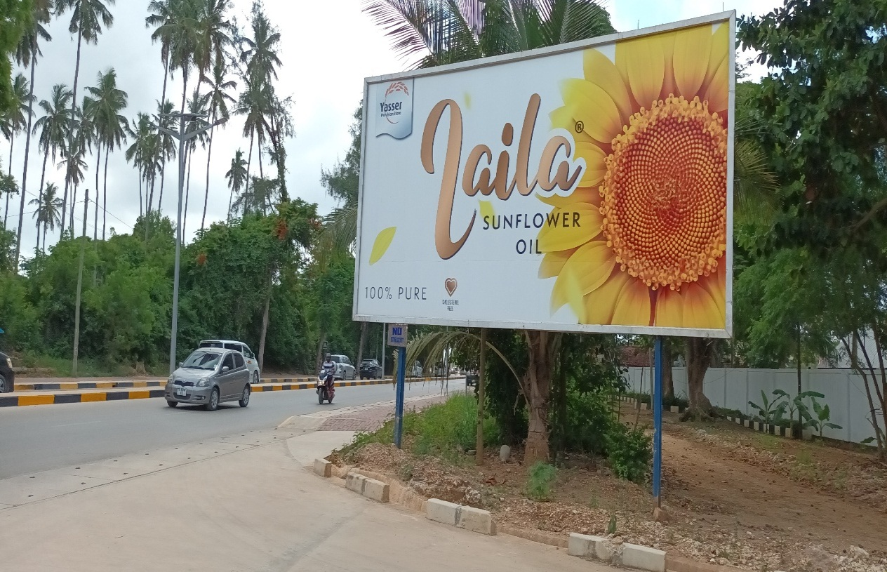
The image shows a still billboard of product promotion of Laila Sunflower Oil with an exciting contest to drive immediate sales and engagement in Mazizini, Urban district, Unguja. The advertisement lacks the necessary contact details for customers to provide their feedbacks
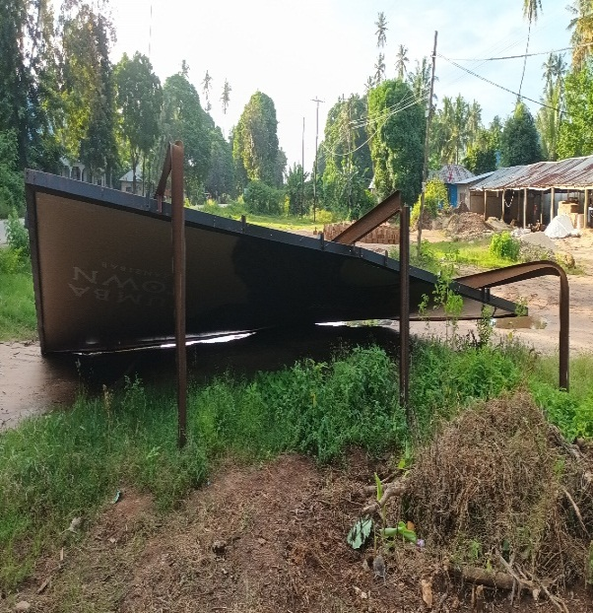
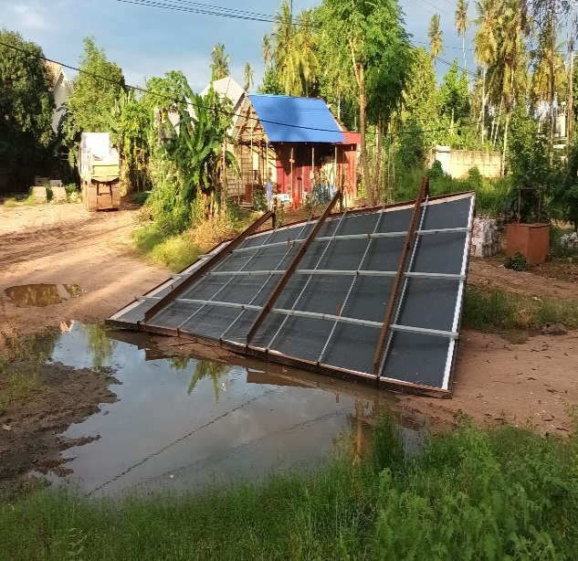
This image shows a collapsed outdoor billboard lying on the ground in Fumba, West “B” district, Unguja, a clear example of infrastructure failure in the management of billboard advertisement
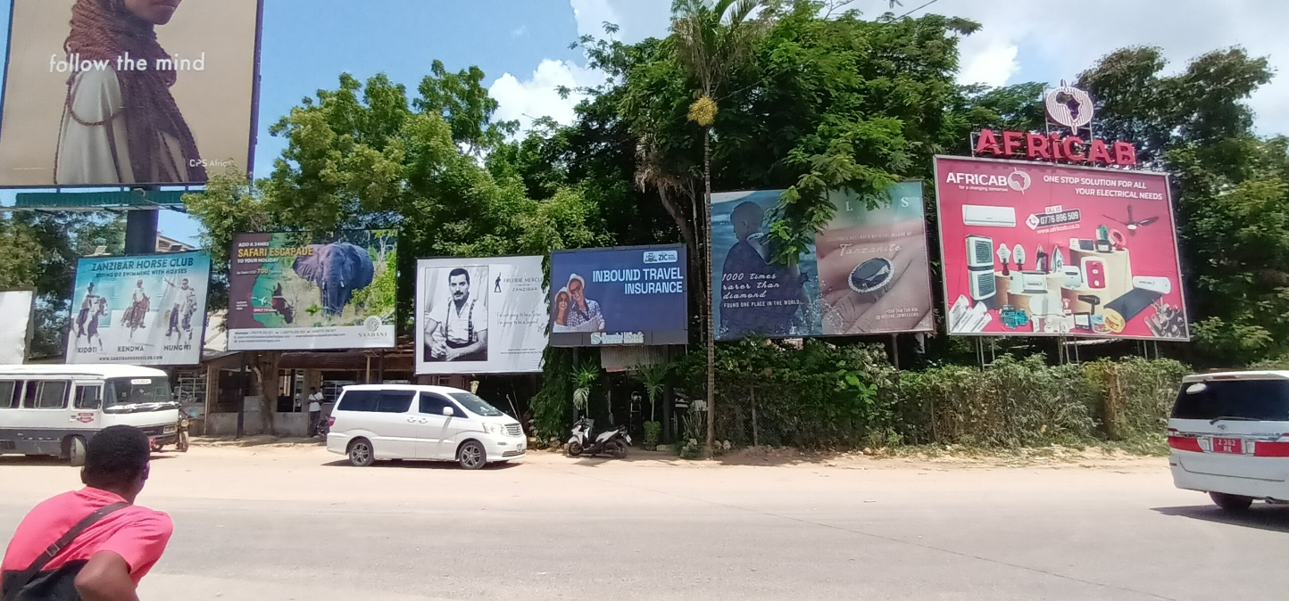
The image shows the clutter of outdoor billboard advertisements outside Abeid Amani Karume International Airport in Zanzibar, which is perceived by many as visual pollution


The image of this billboard tends to promote sales of Hyatt Jasmine Rice, which is a famous rice available and used by many residents in Unguja and Pemba islands (Zanzibar). The advertisement lacks contact details for customers to give their feedback

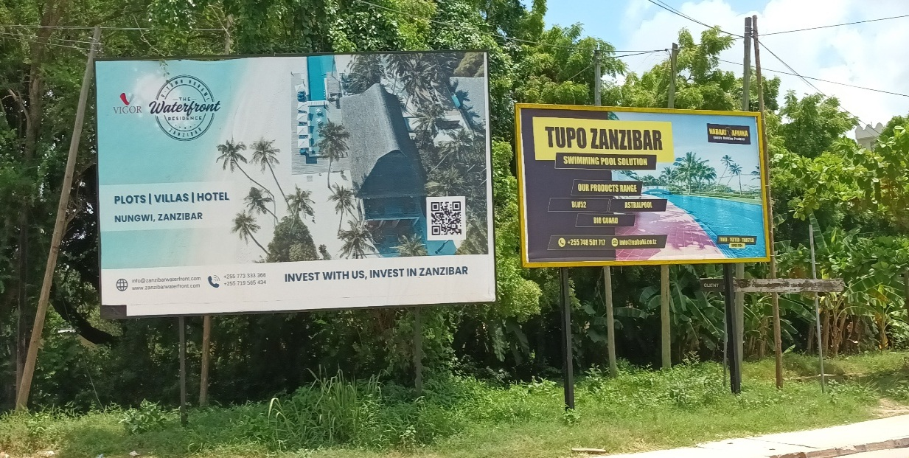
The image shows the strategic placement of billboard advertisements, including the use of QR codes as a means to get valuable insights in promoting the Real Estate business in Zanzibar
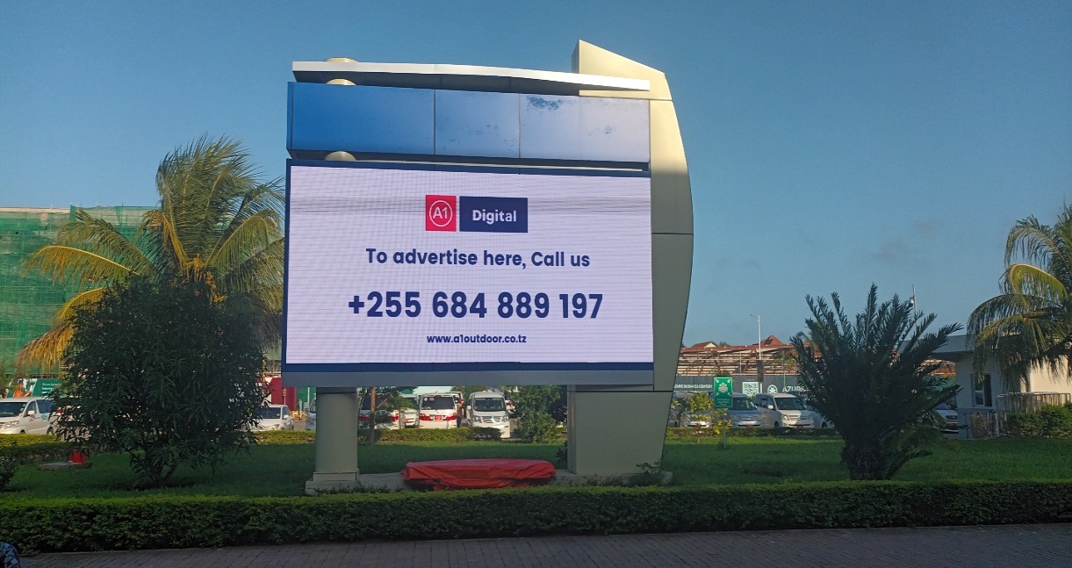
The digital billboard platform promotes Tourism, Real Estate, and local culture, located at Terminal III in Abeid Amani Karume International Airport, Zanzibar, which boosts the Tourism sector in Zanzibar


The billboard image promotes the sale of construction equipment and offers valuable information, including guaranteed price, mode of delivery, as well as contact address to the targeted clients.
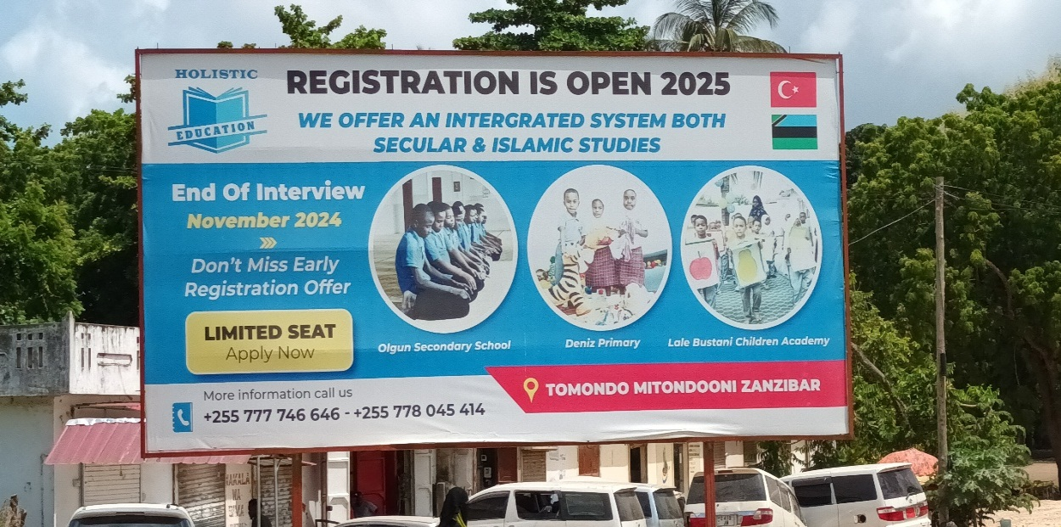
The image of this outdoor billboard advertisement tends to promote school enrollment to new students at Turkish-owned private schools located in Zanzibar. The advertisement contains a contact address, which is important in promoting their business
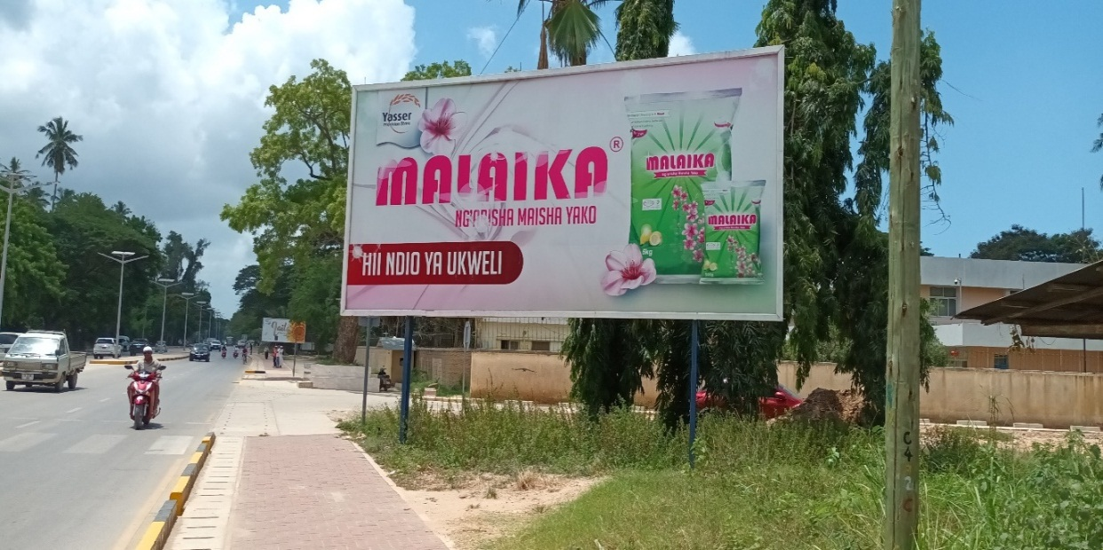
The image shows the promotion of MALAIKA washing powder with various packages available and a promising message to persuade clients to purchase in the West “B” district of Unguja. Advertisement lacks contact details, which is a crucial aspect in advertising
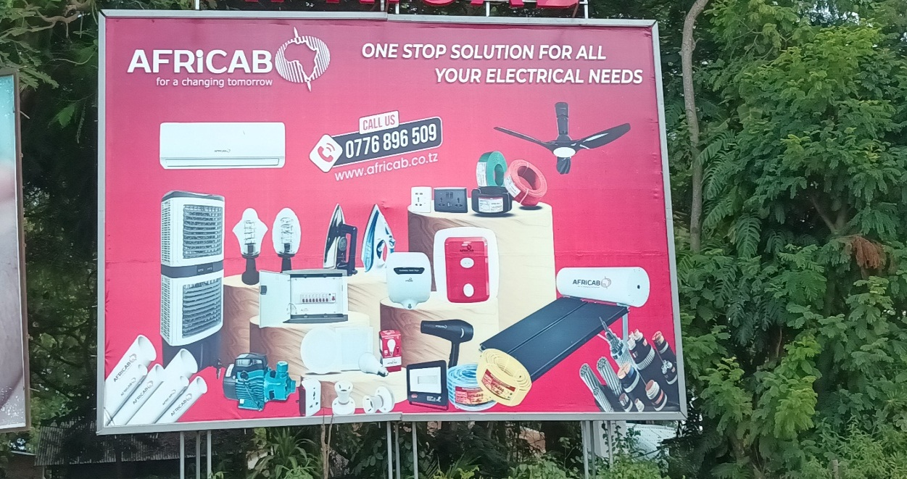
This image shows the sales promotion of AFRICAB Electronic Equipment Company with the contact address in the Urban district, Unguja, Zanzibar


This is an image of a billboard with traditional Zanzibari wedding wearing belonging to Yas, a new telecommunication company in Isles, located at the main entrance gate of Abeid Amani Karume International Airport in Zanzibar.

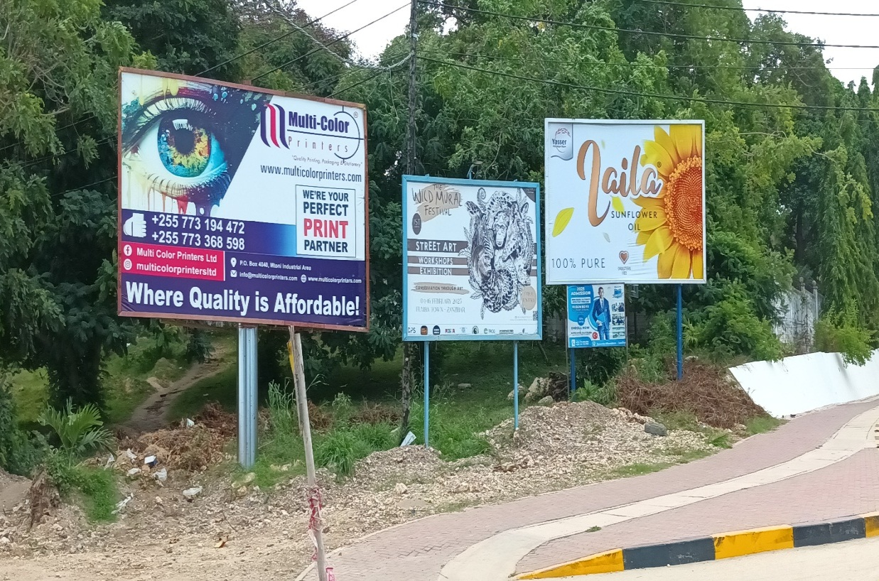
The image shows a clutter of still outdoor billboard advertisements that face motorcycles and pedestrians along the highways of Julius Nyerere Road in the Urban District, Unguja
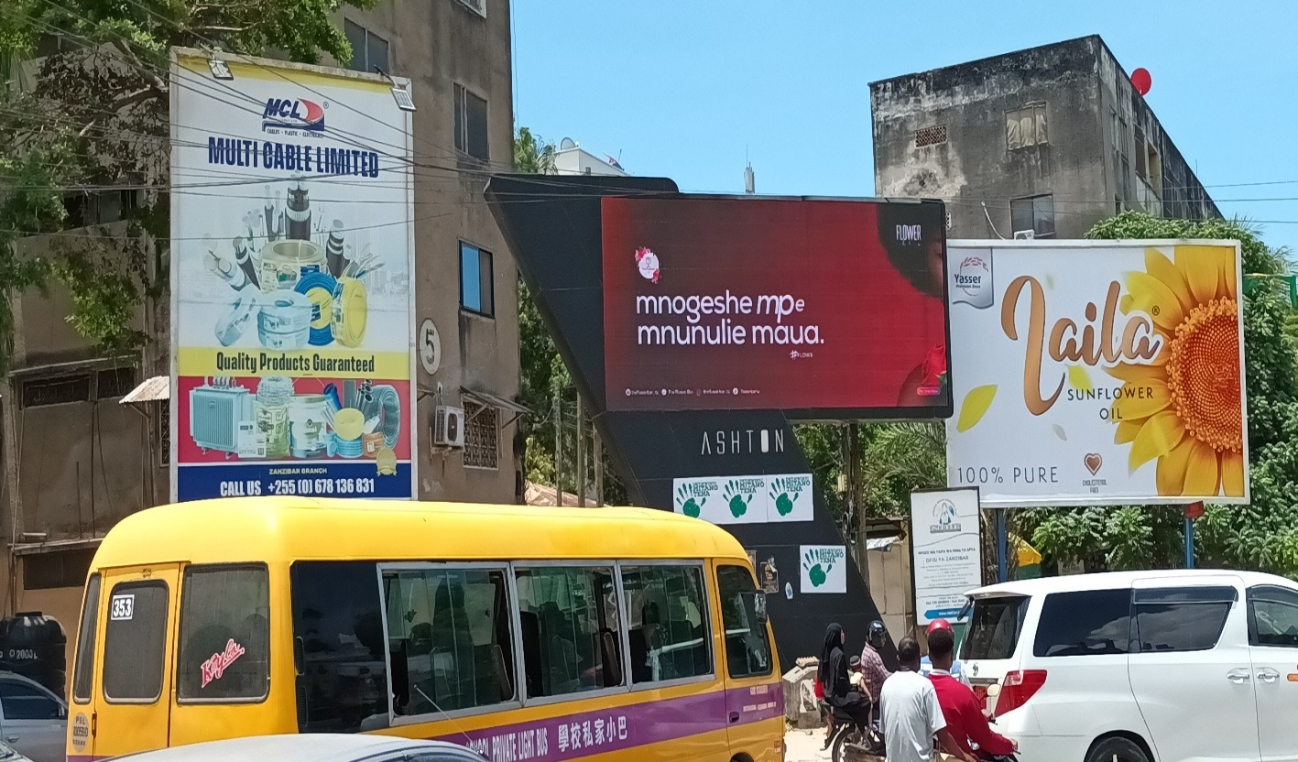
The image shows the combination of both still and digital outdoor billboard advertisements located at the Michenzani roundabout in Zanzibar Town

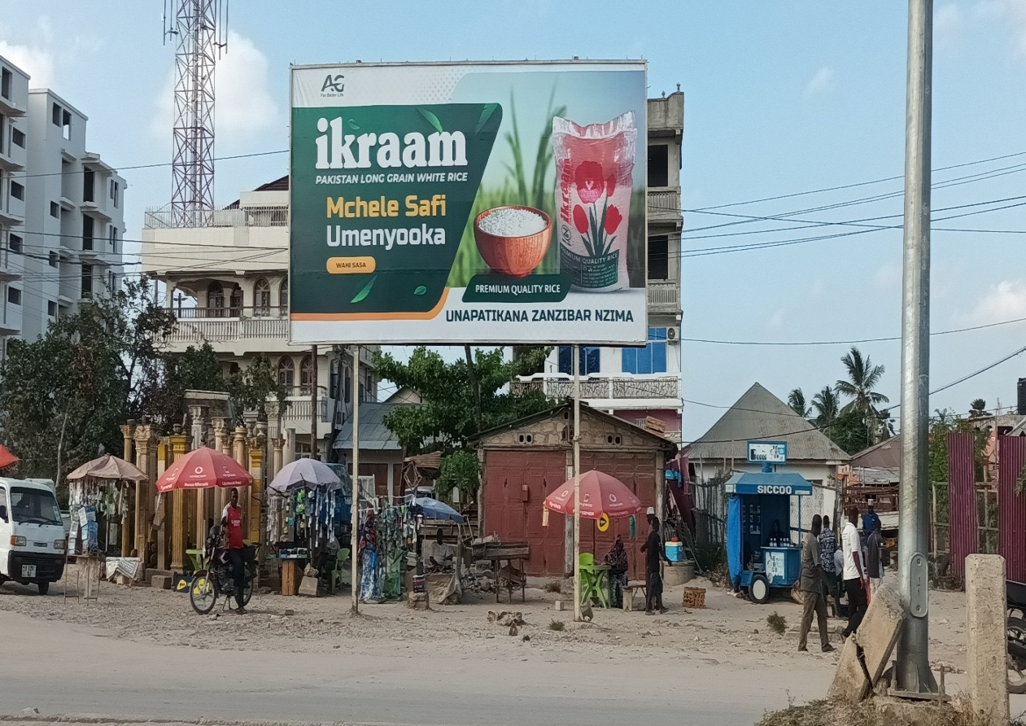
This is an image of the outdoor billboard advertisement that promotes sales on Ikraam rice, originating in Pakistan, located at the West “A” district, Unguja, with valuable information that consumer needs to understand, though it lacks contact details for customers
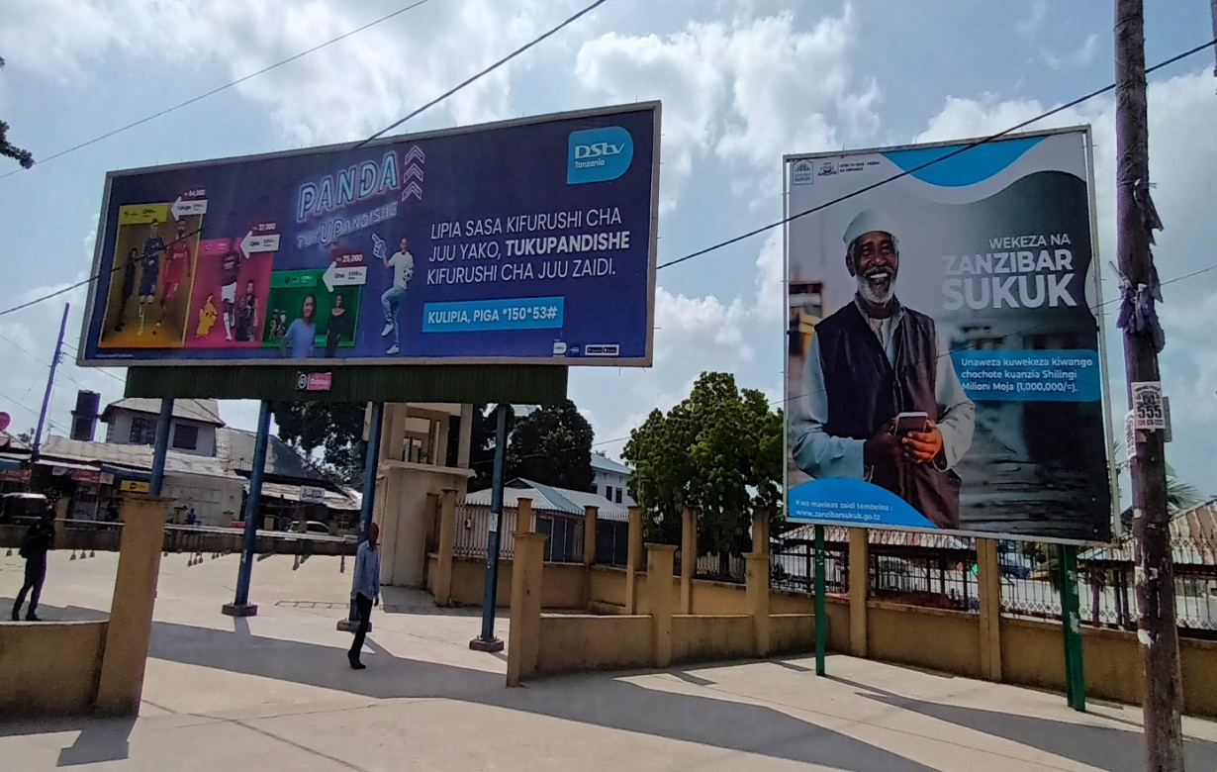
The image shows two outdoor billboard advertisements that promote DSTV use among clients, and another promotes investment in SUKUK as a financial bonding with long-term benefits under the People's Bank of Zanzibar, located outside ZSSF Kariakoo playing grounds in Unguja
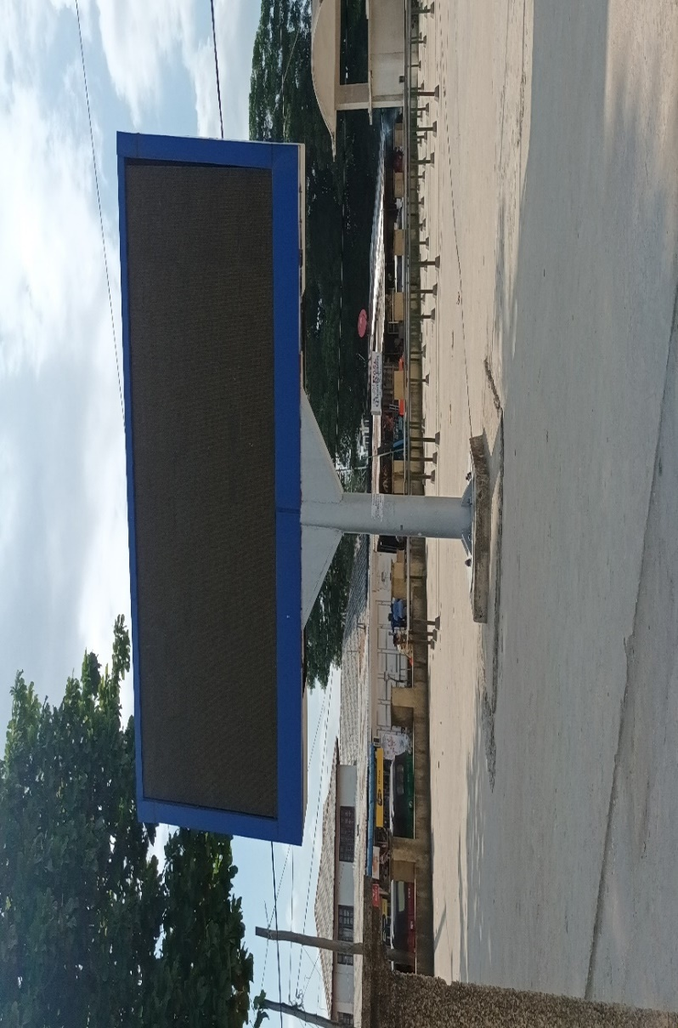
The image shows a digital billboard installed in an urban public area with a busy pedestrian. The billboard appears to be inactive due to unreliable electricity or electrical failure. This is among the challenges in managing outdoor billboard advertisements in Zanzibar
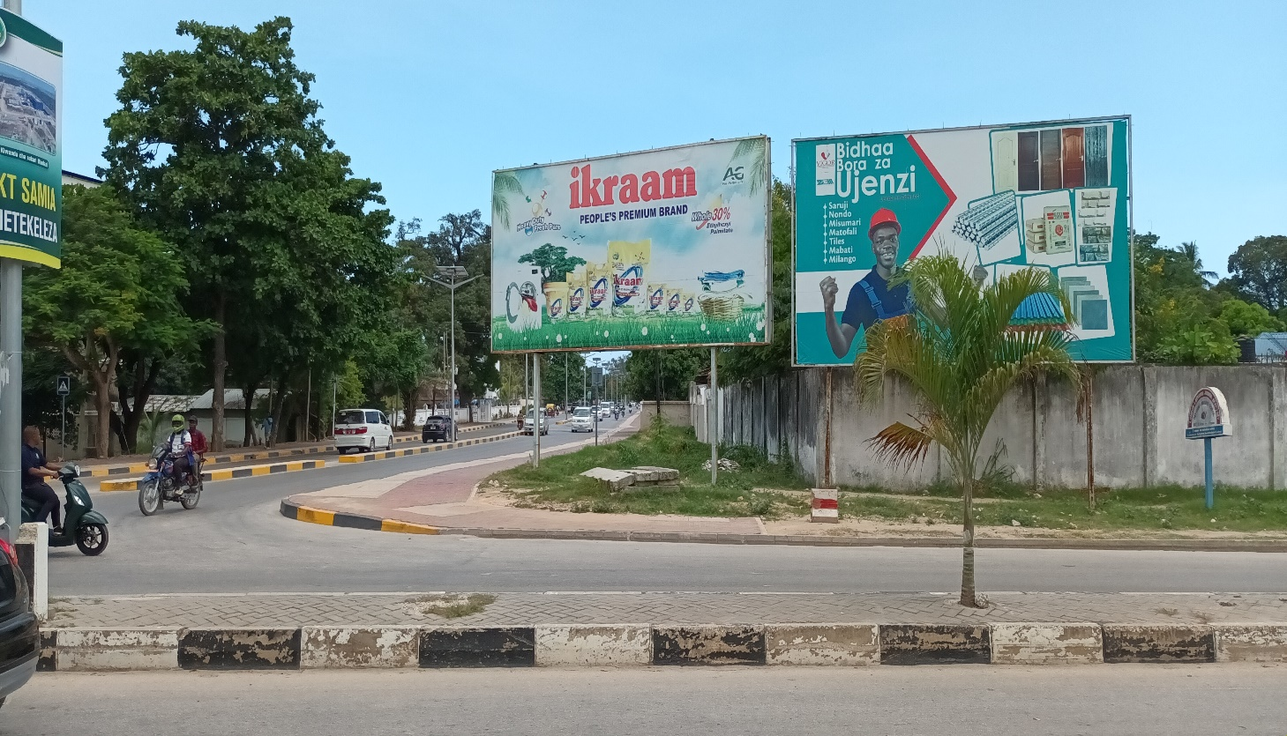
The image shows outdoor billboard advertisements that promote the use of Ikraam washing powder and construction equipment located along interconnected roads in the Urban district of Zanzibar.
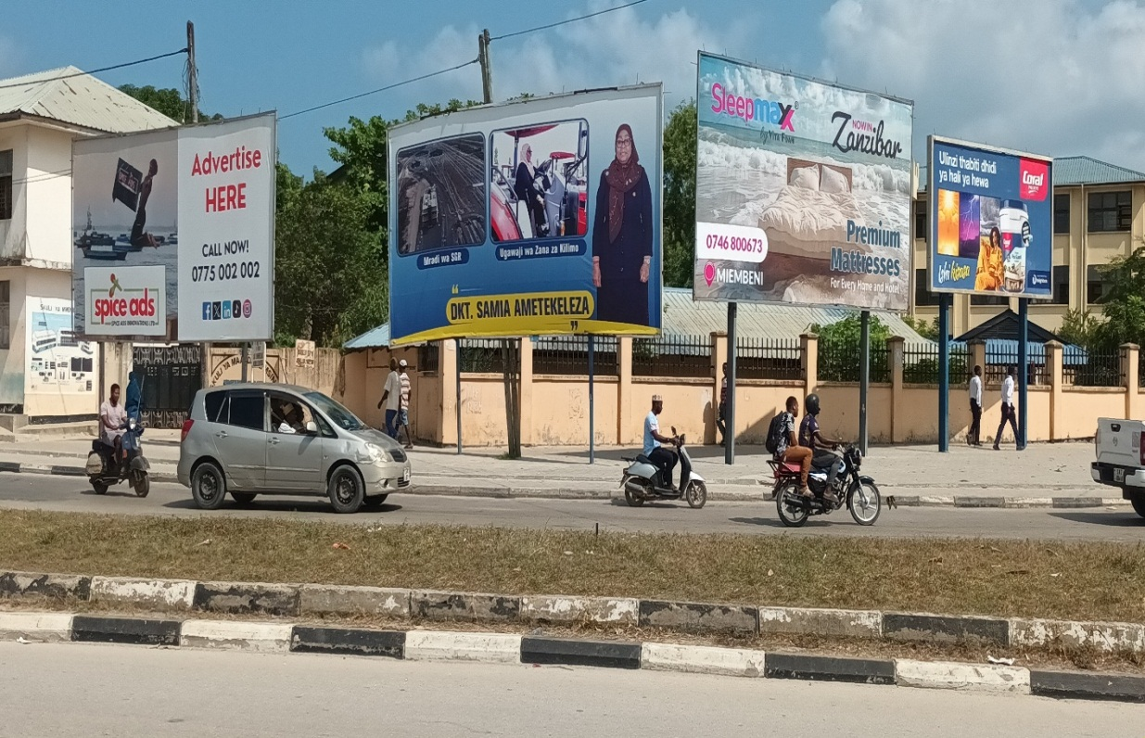
The image shows a clutter of outdoor billboard advertisements with a variety of information for customers to see, located in Zanzibar Town
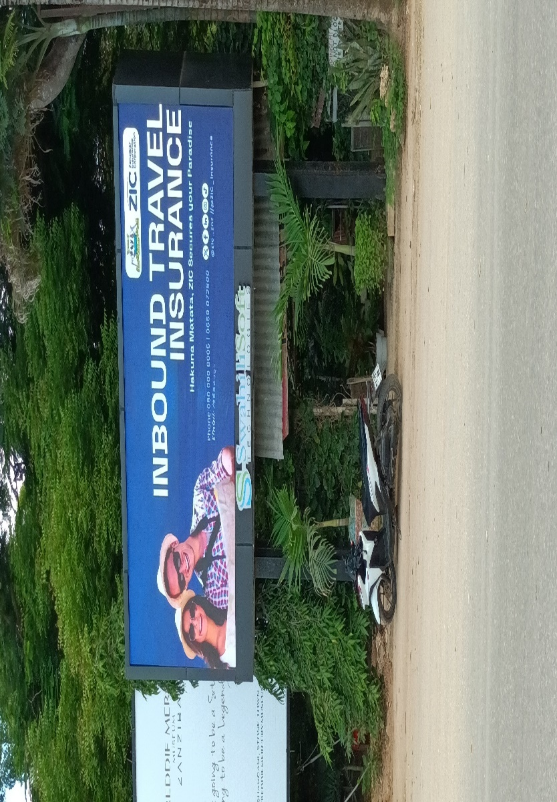
The image shows a digital outdoor billboard advertisement that promotes inbound travel health insurance to tourists visiting Zanzibar. The billboard is located outside Abeid Amani Karume International Airport in Zanzibar.

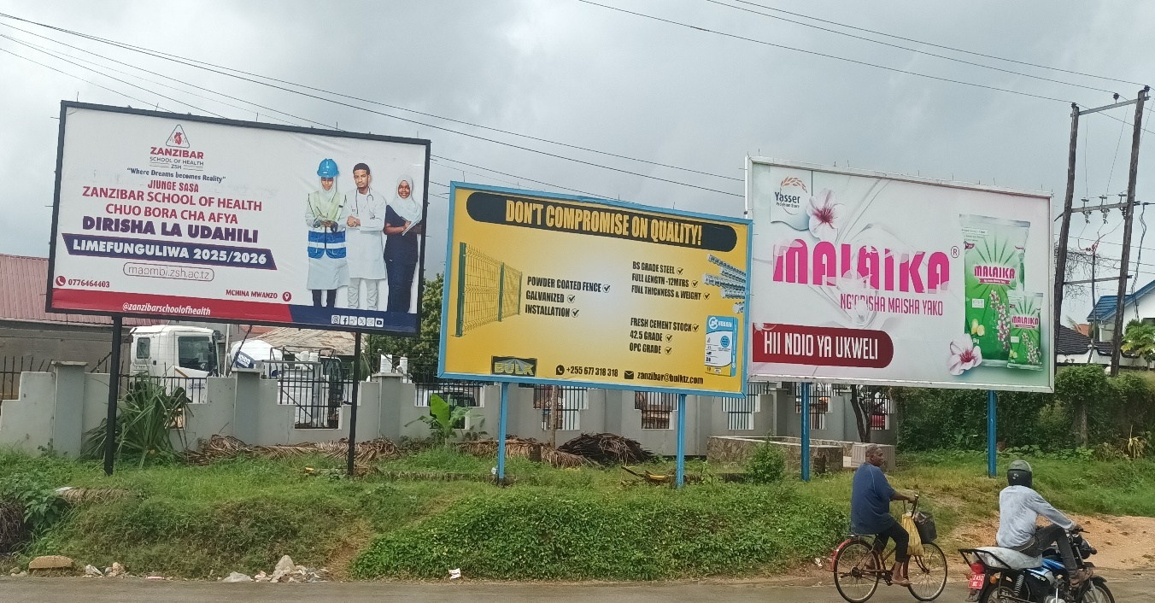
The image shows a clutter of outdoor billboard advertisements that promote school enrolment for new students in health programs, promote the use of construction equipment’s as well as the use of washing powder for domestic use
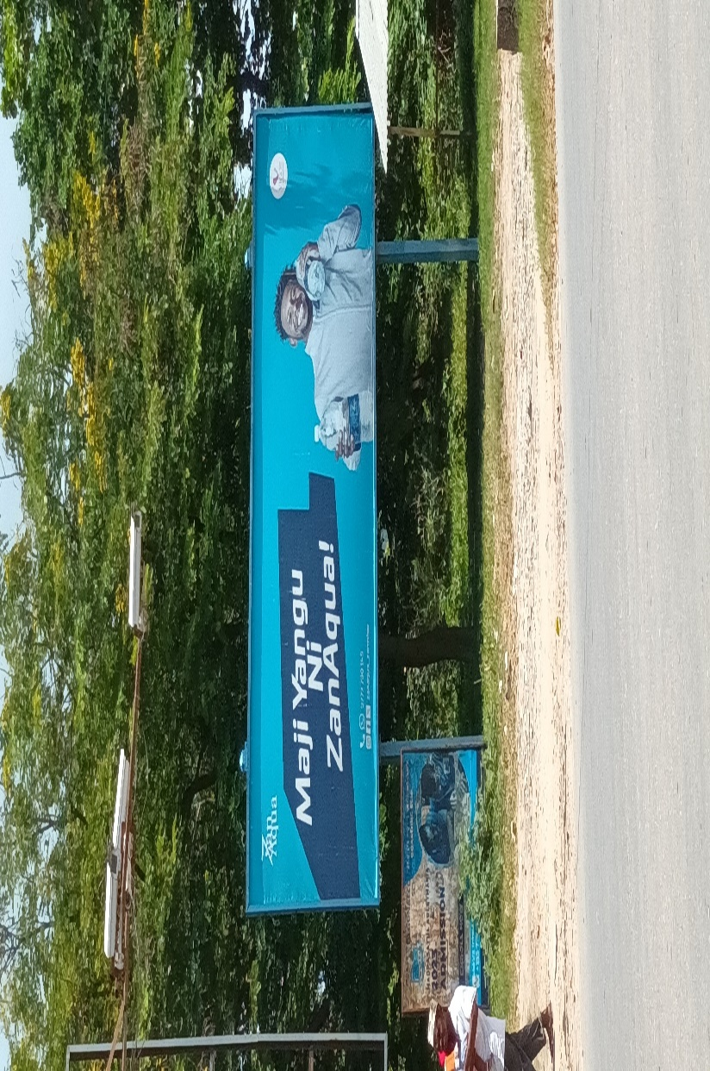
The image shows the outdoor billboard advertisement that promotes the drink of ZanAqua mineral water in the Zanzibar Islands using the influence of a local famous football player, Mudathir Yahya, who plays in the Young Africa Football club.
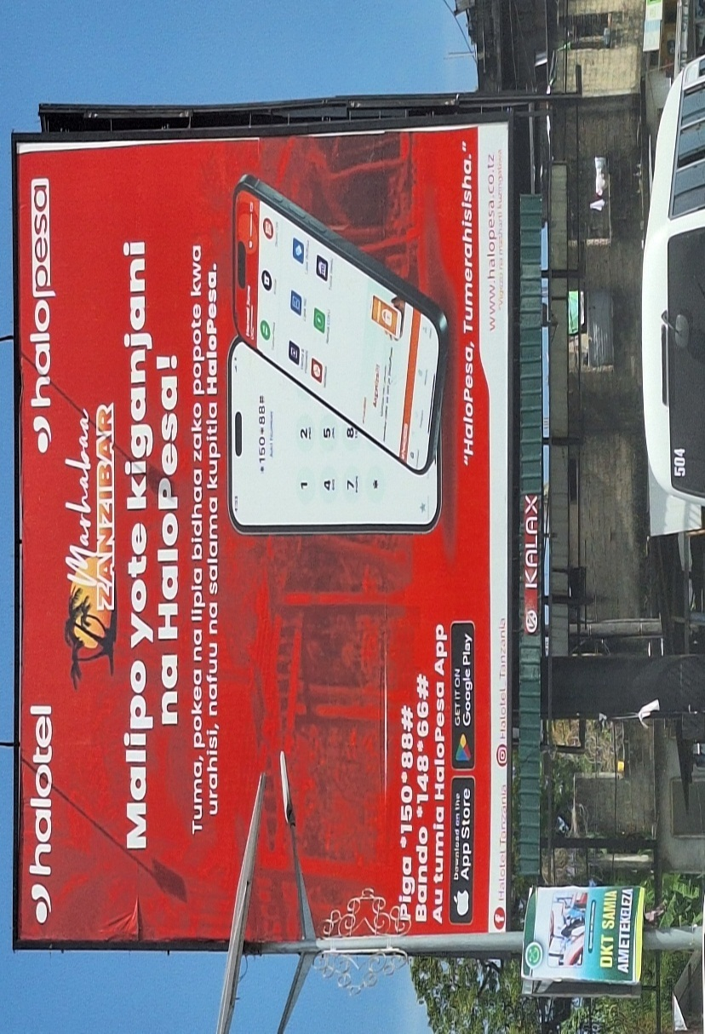
A vibrant billboard by Halotel promoting Halopesa mobile money services in Zanzibar. Strategically placed in Kariakoo, Zanzibar. This large-format red billboard uses bold fonts, a clear visual of a smartphone interface, and a localized message to emphasize convenience, affordability, and safety in digital transactions. Ideal for targeting daily commuters and urban shoppers in a high-traffic area.

