EXPLORING MEN’S PERCEPTIONS OF MODERN CONTRACEPTIVE USE IN TARIME DISTRICT, TANZANIA

RASHIDI MAULIDI

A DISSERTATION SUBMITTED IN PARTIAL FULFILLMENT OF THE REQUIREMENTS FOR THE DEGREE OF MASTER OF SOCIAL WORK
DEPARTMENT OF SOCIOLOGY AND SOCIAL WORK
OF THE OPEN UNIVERSITY OF TANZANIA
2025

CERTIFICATION
The undersigned certifies that they have read and hereby recommends for acceptance by the Open University of Tanzania (OUT) a dissertation titled: “Exploring Men's Perceptions of Modern Contraceptive Use in Tarime District, Tanzania”, in partial fulfillment of the requirements for the Degree of Master of Social Work of the Open University of Tanzania.

…….………………………..….
Dr. Johnas Buhori
(Supervisor)

………….…….…………..
Date

……………………………….
Dr. Straton Ruhinda
(Supervisor)

………………..………….
Date

COPYRIGHT
No part of this dissertation may be reproduced, stored in any retrieval system, or transmitted in any form by any means, electronic, mechanical, photocopying, recording or otherwise, without prior written permission of the author or the Open University of Tanzania on that behalf.

DECLARATION
I, Rashidi Maulidi, do hereby declare that this dissertation is my original work and it has not been presented for a similar or any other award to any other University. Where other people’s works have been used, and references have been provided. It is in this regard that I declare this work as originally mine. It is hereby presented in partial fulfillment of the requirements for the Degree of Master of Social Work of the Open University of Tanzania.

………………..………..……….
Signature

……………………………….
Date

DEDICATION
This work is dedicated to my beloved parents, Mr. and Mrs. Rashidi, my beloved wife, my beloved Son Athumani, my daughter Latifa, my son Alfan, my brothers, Ramadhani, Rashidi, my young brothers Zuberi, Abdalah, Athumani, Adamu, Amiri and my young sister Jasmini. May the almighty ALLAH bless them.

ACKNOWLEDGEMENTS
I want to thank the Almighty ALLAH for giving me the privilege of life and for His blessing and enabling me to work on this research.

Moreover, I would like to give my special thanks to my supervisors, Dr. Johnas Buhori and Dr. Straton Ruhinda of the Open University of Tanzania, for their invaluable supervision and guidance on this dissertation. Their academic support was crucial to the successful completion of this study. I would also like to extend my sincere thanks to the staff of the Faculty of Arts and Social Sciences, whose contributions were essential at various stages of this study.

Special appreciation goes to all the respondents from Ganyange Ward in Tarime district who generously and willingly provided the information necessary for this research. Their cooperation and time were instrumental in achieving the objectives of this study. I am also thankful to my colleagues and friends who offered their voluntary assistance during the research proposal writing, fieldwork, and report writing stages. Their support played a significant role in the successful completion of this project.

Finally, while I would like to acknowledge everyone who contributed to this work, space constraints limit my ability to do so. Please accept my heartfelt thanks, and may Almighty God bless you all.

ABSTRACT
This study aims to explore men’s perceptions of modern contraceptive use in Tarime District, Tanzania. Specifically, the study seeks to assess the level of awareness regarding modern contraceptive use among men in the district, examine the cultural factors influencing men’s attitudes toward modern contraceptive use, and explore men’s involvement in decision-making related to contraceptive use. Using a Mixed -Methods Approach, the research integrates Quantitative data from local Surveys with qualitative interviews to explore men’s perceptions of modern contraceptive use. quantitative data was analyzed using Descriptive with the aid of Scientific Package for Social Science (SPSS). The findings were presented in percentages, graphs, tables, and charts. The findings reveal that men with higher level of awareness modern contraceptive are more likely to use condoms, whereas those with limited religious leaders encounter substantial obstacles. A sample of 356 respondents participated in the study. The study concludes with recommendations for the government to strengthen policies and programs that promote male involvement in family planning through culturally sensitive and gender-transformative approaches.

Keywords: Men’s perception, Modern Contraceptive use, Tarime District, Tanzania Mixed- Methods Approach, Outreach Campaigns.

TABLE OF CONTENTS
CERTIFICATION ii
COPYRIGHT iii
DECLARATION iv
DEDICATION v
ACKNOWLEDGEMENTS vi
ABSTRACT vii
LIST OF TABLES xiv
LIST OF FIGURES xv
LIST OF ABBREVIATIONS xvii
CHAPTER ONE 1
INTRODUCTION AND BACKGROUND TO THE STUDY 1
1.1 Chapter Overview 1
1.2 Background of the Study 1
1.3 Statement of the Problem 9
1.4 Research Objectives 11
1.4.1 Main Objective 11
1.4.2 Specific Objectives 11
1.5 Research Questions 11
1.6 Significance of the Study 12
1.7 Scope of the Study 12
1.8 Organisation of the Study 13
CHAPTER TWO 14
LITERATURE REVIEW 14
2.1 Chapter Overview 14
2.2 Conceptualisation of the Key Terms 14
2.2.1 Men's Perceptions 14
2.2.2 Modern Contraceptive 14
2.2.3 Cultural Factors 15
2.2.4 Men’s Involvement in Decision Making 15
2.3 Theoretical Literature Review 16
2.3.1 Health Belief Model (HBM) 16
2.3.2 Relevance of the Theory to each Specific Objective 18
2.4 Empirical Literature Review 21
2.4.1 Awareness Regarding Modern Contraceptives used among Men 21
2.4.2 Cultural Factors Influencing Men's Attitudes toward the use of
Modern Contraceptives 26
2.4.3 Men’s Involvement in Decision-Making in the use of
Modern Contraceptives 33
2.5 Research Gap 39
2.6 Conceptual Framework 40
CHAPTER THREE 44
RESEARCH METHODOLOGY 44
3.1 Chapter Overview 44
3.2 Research Philosophy 44
3.3 Research Design 44
3.4 Research Approaches 45
3.5 Study Area 46
3.6 Study Population 47
3.7 Sampling Procedure and Sample Size 48
3.7.1 Sampling Procedure 48
3.7.1.1 Simple Random Sampling Technique 48
3.7.1.2 Purposive Sampling Technique 48
3.7.2 Sample Size 49
3.7.3 Inclusion and Exclusion Criteria 50
3.8 Secondary Data Source 51
3.9 Primary Data Source 51
3.10 Data Collection Methods 52
3.10.1 Questionnaire 52
3.10.2 Interview Guide 53
3.10.3 Focus Group Discussion Guide 53
3.11 Validity and Reliability of Research Instruments 54
3.11.1 Validity 55
3.11.2 Reliability 55
3.12 Qualitative Data Rigour 55
3.12.1 Transferability 56
3.12.2 Confirmability 57
3.12.3 Trustworthiness 57
3.12.4 Credibility 58
3.13 Data Analysis 59
3.13.1 Analysis of Quantitative Data 59
3.13.2 Analysis of Qualitative Data 59
3.14 Data Presentation 60
3.15 Ethical Consideration 60
3.15.1 Research Clearance from the Open University of Tanzania 61
3.15.2 Informed Consent 61
3.15.3 Voluntary Participation 61
3.15.4 Confidentiality 62
3.15.5 Anonymity 62
3.15.6 Do not Harm Principle. 63
CHAPTER FOUR 64
DATA PRESENTATION AND DISCUSSION 64
4.1 Chapter Overview 64
4.2 Questionnaire Response Rate 64
4.3 Socio-Demographic Characteristics of Respondents 65
4.3.1 Age of Respondents 65
4.3.2 Education of Respondents 66
4.3.3 Marital Status of Respondents 67
4.3.4 Main Occupation of Respondents 68
4.4 Level of Awareness Regarding Modern Contraceptives used
among Men 70
4.4.1 Knowledge of Available Male Contraceptive Methods 70
4.4.2 Source of Contraceptive Information 74
4.4.3 Awareness of Contraceptive Access Points 76
4.4.4 Understanding of Modern Contraceptive Side Effects 79
4.4.5 Perceived Effectiveness of Contraceptive Methods 81
4.5 Cultural Factors Influencing Men's Attitudes toward
Modern Contraceptive Use 84
4.5.1 Traditional Gender Roles for Family Planning in the Community 84
4.5.2 Traditional Gender Roles Influence Men’s Involvement in
Family Planning Decisions 87
4.5.3 Religious beliefs on the Use of Modern Contraceptives 89
4.5.4 Stigma around Modern Contraceptive use in the Community 92
4.5.5 Belief Concerning Contraceptive Use Challenges a Man's
Masculinity within their Community 94
4.5.6 Stigma for Supporting or Using Modern Contraceptives 96
4.5.7 Community Perceptions of Men who promote or use Contraceptives 98
4.6 Men’s Involvement in Decision Making Regarding
Modern Contraceptive Use 102
4.6.1 Men's Attendance in Family Planning Counselling Sessions 102
4.6.2 Men's Participation in Family Planning Counselling Sessions 104
4.6.3 Frequency for Discussing Family Planning Options with Partners 106
4.6.4 Joint Decision-Making about Family Planning Options with the
Partner 107
4.6.5 Final Decision maker Regarding Modern Contraceptive use in
the Family 109
4.6.6 Participation in Family Planning Awareness Campaigns for Men 111
4.6.7 Male Involvement in Accompanying Partners to Family Planning
Clinics 114
4.6.8 Advocacy by Male Community Leaders for Male Contraceptive
Use 116
CHAPTER FIVE 122
SUMMARY, CONCLUSION AND RECOMMENDATIONS 122
5.1 Chapter Overview 122
5.2 Summary of the Findings 122
5.2.1 Level of Awareness Regarding Modern Contraceptives used
among Men in Tarime District 122
5.2.2 Cultural Factors Influencing Men's Attitudes toward
Modern Contraceptive use in Tarime District 122
5.2.3 Men’s Involvement in Decision Making Regarding
Modern Contraceptive Use in Tarime District 123
5.3 Conclusion 124
5.4 Recommendations 125
5.4.1 Recommendations to the Government 125
5.5 Recommendations for Further Study 126
REFERENCES 127
APPENDICES 140

LIST OF TABLES
Table 4.1: Questionnaire Response Rate 64
Table 4.2: Distribution of Respondents by Age Groups 65
Table 4.3: Distribution of Respondents by Education Levels 66
Table 4.4: Distribution of Respondents by Marital Status 67
Table 4.5: Distribution of Respondents by Main Occupation 69
Table 4.6: Respondents’ Knowledge of Available Male Contraceptive
Methods 70
Table 4.7: Respondents’ Understanding of Contraceptive Side Effects 79
Table 4.8: Traditional Gender Roles Influencing Men’s Involvement in
Family Planning Decisions 88
Table 4.9: Responses on the Belief that Contraceptive Use Challenges a
Man's Masculinity within their Community 95
Table 4.10: Community Perceptions on Men who promote or use
Contraceptives 99
Table 4.11: Response on Frequency for Discussing Family Planning
Options with Partners 106
Table 4.12: Response on the Frequency of Joint Decision Making about
Family Planning Options with the Partner 108
Table 4.13: Responses on Final Decision Makers Regarding Contraceptive
Use in the Family 110
Table 4.14: Response on Male Leaders' influence for Men to engage in
Family Planning 118

LIST OF FIGURES
Figure 2.1: Conceptual Framework for this Study 43
Figure 4.1: Percentage responses on Source of Contraceptive Information 74
Figure 4.2: Percentage responses on Awareness of Contraceptive
Access Points 77
Figure 4.3: Percentage responses on perceived Effectiveness of
Contraceptive Methods 81
Figure 4.4: Responses on Traditional Gender Roles for Family Planning 85
Figure 4.5: Response on the Belief that Family Planning is Primarily a
Woman’s Responsibility 86
Figure 4.6: Responses Regarding Religious Belief on the use of
Modern Contraceptives 90
Figure 4.7: Responses on stigma around Modern Contraceptive use
in the Community 93
Figure 4.8: Responses on stigma for Supporting or Using Modern
Contraceptives 97
Figure 4.9: Response to Men’s Attendance at Family Planning
Counselling Sessions 103
Figure 4.10: Response to Men's Participation in Family Planning
Counselling Sessions 105
Figure 4.11: Response to Participation in Family Planning Awareness
Campaigns for Men 112
Figure 4.12: Response on Male Involvement in Accompanying Partners to
Family Planning Clinics 114
Figure 4.13: Response regarding Advocacy by Male Community Leaders
for Contraceptive Use 117

LIST OF ABBREVIATIONS
CHW | Community Health Worker
DMO | District Medical Officer
FGD | Focus Group Discussion
FP | Family Planning
HCP | Health Care Provider
HIV | Human Immunodeficiency Virus
IEC | Information, Education, and Communication
KI | Key Informant
KII | Key Informant Interview
LARC | Long-Acting Reversible Contraceptives
MoH | Ministry of Health
NBS | National Bureau of Statistics
NFPCIP | National Family Planning Costed Implementation Plan
NGO | Non-Governmental Organization
RCH | Reproductive and Child Health
SRH | Sexual and Reproductive Health
STI | Sexually Transmitted Infection
TDHS | Tanzania Demographic and Health Survey
UNFPA | United Nations Population Fund
USAID | United States Agency for International Development
VCT | Voluntary Counselling and Testing
WHO | World Health Organisation

CHAPTER ONE

INTRODUCTION AND BACKGROUND TO THE STUDY

Chapter Overview
The study titled “Exploring men's Perceptions of Modern Contraceptive Use in Tarime District, Tanzania” aims at assessing the level of awareness regarding modern contraceptive use among men, examining the cultural factors influencing men's attitudes toward modern contraceptive use and the roles of men’s involvement in decision making on modern contraceptive use. Further, the chapter covers subsections like background to the study, statement of the problem, specific objectives, research questions and significance of the study.

Background of the Study
The historical evolution of men's perceptions of modern contraception reflects shifting societal norms, gender roles, and advancements in contraceptive technology. Traditionally, contraception was viewed predominantly as a woman's responsibility, with men playing a limited role in family planning decisions (Adane et al., 2024). However, over time, men's involvement and attitudes toward contraception have undergone significant changes (Mejía-Guevara et al., 2021). In the early 20th century, contraceptive methods were primarily designed for women, and societal expectations reinforced the notion that women should manage birth control. Men's limited involvement was partly due to a lack of male contraceptive options and prevailing gender norms that assigned reproductive responsibilities to women (Rahayu et al., 2023). Condoms, one of the few male contraceptives, were often associated with disease prevention rather than family planning (Oni, 2024).
The development of the oral contraceptive pill in the 1960s further emphasised contraception as a woman's domain. Men's perceptions during this period were influenced by the sexual revolution and changing gender dynamics, leading to increased acceptance of contraception but still viewing it largely as a women's issue (Anderson & Johnston, 2023). The introduction of the pill provided women with more control over their reproductive health, inadvertently reinforcing the perception that contraception was primarily a female concern (Rahayu et al., 2023).

In recent decades, there has been a growing recognition of the importance of involving men in family planning. Studies have shown that men's attitudes toward contraception significantly influence contraceptive use within relationships. Positive male engagement has been linked to higher rates of contraceptive uptake and more effective family planning outcomes. Men's support and communication about contraception with their partners are crucial factors in successful contraceptive use (Anderson & Johnston, 2023).

Despite this progress, challenges remain in shifting perceptions and increasing male participation in contraception. The limited availability of male contraceptive methods beyond condoms and vasectomy contributes to the perception that contraception is a woman's responsibility (Ahmed et al., 2024). Ongoing research into male contraceptives, such as hormonal pills and non-hormonal methods, aims to provide more options and promote shared responsibility between partners (Wang et al., 2024). Cultural and societal factors continue to influence men's perceptions of contraception. In some communities, traditional gender roles and misconceptions about contraceptive methods hinder male involvement. Educational initiatives and public health campaigns targeting men are essential to address these barriers and promote a more equitable approach to family planning (Adane et al., 2024).

The World Health Organisation (WHO, 2022a) states that men's perceptions and use of contraception vary across different global contexts. Studies show that traditional gender roles often dictate reproductive health decisions, with many men perceiving contraceptive use as primarily a women's issue United Nations Population Fund [UNFPA, 2023). Globally, in 2022, 874 million women worldwide, which equals 77.5% of women of childbearing age, use a modern contraceptive method (WHO, 2022a). On the other hand, only about 10% of married couples rely on modern male contraceptive methods, which mainly include condoms (16.8%) and vasectomy (0.5%). Among these methods, condoms are the predominant choice, especially among young men aged 15-24, who represent most users (UNFPA, 2022). This is due to several interrelated socio-cultural, psychological, economic, and institutional factors that contribute to the limited uptake of modern male contraceptive methods globally.

In the United States, Kaur et al. (2024) reported that male condom use has been recorded at a relatively high level of 34% among reported contraceptive methods. Most countries in Latin America and the Caribbean have at least a moderate level of contraceptive use. Among 39 countries or areas with available estimates in Latin America and the Caribbean, only Guyana and Haiti had prevalence levels below 50 per cent in 2015, and 16 countries had prevalence levels of 70% or more (Nicaragua had the highest level at 80%) (WHO, 2015). This trend may also underscore increased awareness and willingness among men to participate more actively in reproductive planning, especially in contexts where female contraceptive options may face barriers.

In Europe, contraceptive use has reached substantial levels, with a prevalence rate exceeding 70% in 13 countries as of 2015, indicating broad access to and acceptance of family planning methods across much of the continent (WHO, 2022a). However, there remain significant disparities, as Bosnia and Herzegovina, Montenegro, and North Macedonia had prevalence levels below 50% during the same period, suggesting barriers in access or cultural acceptance of contraception in these regions. In Germany specifically, data from 2018 shows that 67% of women aged 15-49 reported using contraception, highlighting consistent engagement in family planning measures among women of reproductive age. The significantly higher contraceptive use among women compared to men is driven by a complex mix of historical, medical, socio-cultural, and systemic factors (Balakrishnan et al., 2023).

In Asian countries, studies indicate that while awareness of family planning is relatively high among men, active participation remains limited. The study by Hamdan-Mansour et al. (2016) found that although 93.5% of men in Jordan were knowledgeable about family planning methods, only 45.1% reported current use of any form with their spouses. Additionally, there was strong support for family planning principles, with 71.2% endorsing contraception post-childbirth, and 90.2% supporting joint decision making in family planning. However, in India, male contraceptive methods, primarily condoms and sterilisation, make up only 17% of the modern contraceptive prevalence rate, according to NFHS-5, meaning 83% of contraceptive responsibility falls on women, with female sterilisation alone constituting 67% of use among married couples (UNFPA, 2022).

In Sub-Saharan African countries, male acceptance of family planning (FP) methods remains relatively low, as evidenced by reports from WHO (2022b) and Sait et al. (2021). In Nigeria, Adanikin et al (2017) found that approximately 20% of men viewed contraceptive use as exclusively a woman’s responsibility, with 40% expressing concerns that women who use family planning might become promiscuous. The emphasis on women in family planning discussions often overshadows men’s potential contributions, which is concerning in regions like sub-Saharan Africa, where reproductive health challenges are acute. The study by Naidoo et al. (2024) reported that, in South Africa, there were high rates of unintended pregnancies and related mortality. Among surveyed men, 47% reported no contraceptive use, 40% used male-oriented methods, and only 13% relied on their partner’s contraceptive practices. The low acceptance of family planning (FP) methods among men is due to a combination of cultural, psychological, informational, structural, and technological barriers.

In the Southern African Development Community (SADC) countries, studies indicate the region has one of the lowest contraceptive prevalence rates, currently at 24%, with a substantial unmet need for contraception at 25% (Radzuma et al., 2022). South Africa faces reproductive health challenges influenced by socio-political factors, especially in rural areas where many women depend on men for essential daily needs. Other studies, such as those conducted by Osuafor et al. (2023), found male involvement in family planning decision-making varies significantly, with a prevalence of 53.0% in Malawi and 26.6% in Tanzania, underscoring regional disparities in male participation in family planning across Southern Africa.

In East African countries like Kenya, research highlights that approximately 15% of young women reported using male condoms as their current contraceptive method, with around 25% using other modern methods. On the other hand, about 40% of young men reported condom use, while only 3% indicated that their partners used another modern contraceptive method, including withdrawal and vasectomy (Calhoun et al., 2022). Further, Koome et al. (2023) found that contraceptive knowledge influenced Kenyan men’s participation in family planning, revealing that only 37.9% of married or in-union men knew three or more modern contraceptive methods, with a higher awareness (75.2%) of oral contraceptive pills. Additionally, a study by Kibonire and Mphuthi (2023) in Uganda reported that all (100%) indigenous Ugandan men surveyed held negative perceptions that created barriers to the utilisation of long-acting reversible contraceptives (LARCs) by rural women.

In Tanzania, particularly in rural areas, cultural beliefs and socio-economic factors have a substantial influence on men’s attitudes toward modern contraceptive use (Msovela et al., 2020). Msovela et al. (2020) reported that approximately 60% of male respondents in Kibaha district, Coast region were using some form of family planning with their partners, with male condoms being the most common method (24.6%), followed by injectable contraceptives (22%) and oral pills (20.6%). In contrast, Fedrick (2020) highlighted a notably lower family planning uptake among men in Chato district, Geita Region, with only 17.5% of men participating in family planning efforts. These findings reflect the varied levels of family planning engagement across different regions in rural Tanzania.

In Tarime District, a study by Machinda et al. (2020) found that despite high awareness of family planning methods among residents (94.6% among women and 96.0% among men), actual usage was low, with only 26.9% of women and 52.8% of men reporting they practised family planning. Common reasons for non-use included fears of side effects, such as concerns about congenital disabilities, cancer, severe pain during childbirth, and suspicions that contraceptive use might encourage marital infidelity. Additionally, data from the Tanzania District Health Information System 2 (2018) reported a low contraceptive prevalence rate of 6.3% and a modern contraceptive use rate of 24% for 2017, highlighting the need for addressing barriers to family planning in the region.

The Tanzanian government has actively implemented national family planning programs to enhance access to contraceptive methods and foster shared responsibility between men and women (MoH, 2017). Initiatives such as the National Family Planning Costed Implementation Plan (FP-CIP) aim to expand contraceptive options, including male contraceptives, and address cultural and social barriers to male participation according to the United Nations Population Fund (UNFPA, 2019). Collaborative community-based health programs, developed with NGOs, target both men and women to shift cultural norms and encourage male responsibility in family planning. These programs involve training health workers to engage men in discussions about reproductive health, emphasising shared decision-making and the importance of male involvement (UNFPA, 2019; MoH, 2017). These programs are intended to increase awareness, gradual shifts in cultural norms, improve male engagement in reproductive health discussions, and enhance shared decision-making in family planning among couples in Tanzania.

Additionally, the government conducts education and awareness campaigns through various media platforms, community meetings, and outreach initiatives to challenge gender norms and stereotypes surrounding contraception (MoH, 2017). These campaigns highlight the significance of men’s active participation in family planning and promote awareness of available contraceptive options.

Efforts to integrate family planning into broader health and gender policies further support these goals, aligning strategies with gender equality objectives. In the broader policy frameworks, Tanzania’s approach aligns closely with the National Health Policy (2017), which underscores reproductive health and family planning as key priorities for achieving universal health coverage and improving maternal and child health outcomes. Moreover, these initiatives contribute directly to the Sustainable Development Goals (SDGs), particularly Goal 3 (Good Health and Well-being), which calls for universal access to sexual and reproductive health services, and Goal 5 (Gender Equality), which promotes shared decision-making and equal participation of men and women in reproductive health.
However, despite these efforts, significant challenges persist in achieving widespread male involvement in family planning. Cultural and social norms that assign reproductive responsibilities primarily to women remain deeply rooted in many communities, limiting the impact of awareness campaigns and community-based health programs (Machinda et al., 2020). Despite government-led education and awareness campaigns to promote male involvement in family planning, deeply rooted gender norms continue to hinder progress, a challenge that social work best practice addresses through culturally sensitive community engagement, gender-transformative advocacy, and empowerment strategies that foster shared reproductive responsibility. Based on this background information, the study aims to explore men's awareness levels, examining the influence of socio-cultural factors on their attitudes, and assessing their involvement in decision-making regarding modern contraceptive use in Tarime District.

Statement of the Problem
Equality between men and women in awareness of modern contraceptives and involvement in family planning decisions would lead to better reproductive health outcomes and more balanced family structures (UNFPA, 2019). The active participation of men in family planning not only supports shared responsibility but also enhances the effectiveness and acceptance of various contraceptive methods (Kabagenyi et al., 2014). When men and women collaborate in reproductive health decisions, it fosters stronger relationships and ensures that family planning choices reflect the needs and preferences of both partners (MoHCDGEC), 2019; TDHS, 2022).
However, despite substantial efforts such as government-led education and awareness campaigns to promote family planning in Tarime District, fertility rates remain high, with an average of over five children per woman. Contraceptive prevalence has shown limited progress, recorded at just 6.3% in 2017, alongside a modest 24% rate for modern contraceptives (Tanzania District Health Information System 2, 2018). Despite ongoing efforts to promote family planning, male involvement in modern contraceptive use remains limited in many communities, including Tanzania (Fedrick, 2020).

The district's low contraceptive prevalence rate, ranging from 5.7% in 2015 to 6.3% in 2017, underscores a need for further intervention to address these persistent gaps in family planning adoption and understanding. The unique cultural dynamics of Tarime, particularly among the Kuria and Jaluo tribes, present additional challenges to male participation in family planning. Consequently, there remains limited understanding of how these unique cultural contexts shape men’s perceptions of modern contraceptive use in Tarime District.

Consequently, there exists a limited understanding of men's awareness of modern contraceptive use, the ways in which cultural norms factor influence their attitudes, and their roles in decision-making regarding contraceptive use. This gap highlights the need for targeted research to explore these dimensions more thoroughly, particularly within the context of the Kuria and Jaluo communities in Tarime District. Therefore, the study aims to fill these knowledge gaps by exploring men's awareness levels, examining the influence of socio-cultural factors on their attitudes, and assessing their involvement in decision-making regarding modern contraceptive use in Tarime District.

Research Objectives

Main Objective
The main objective of this study is to explore men's perceptions of modern contraceptive use in the Tarime district, Tanzania.

Specific Objectives
- To assess the level of awareness regarding modern contraceptives used among men in Tarime District
- To examine the cultural factors influencing men's attitudes toward modern contraceptive use in Tarime District.
- To explore men’s involvement in decision-making regarding modern contraceptive use in Tarime District.

Research Questions
- What is the level of awareness regarding modern contraceptive use among men in Tarime District?
- How do the cultural factors influence men's attitudes toward modern contraceptive use in Tarime District?
- How are men involved in decision-making regarding modern contraceptive use in Tarime District?

Significance of the Study
This study provided a better understanding of men’s awareness regarding modern contraceptive use and cultural factors influencing men's attitudes toward modern contraceptive use in Tarime District. The findings of this study added to the growing body of knowledge on men's perceptions of modern contraceptive use, specifically in a rural Tanzanian context. It may provide a foundation for future research in other regions with similar cultural settings. This study can contribute to cultural and behavioural change by enhancing the understanding of how cultural norms and socio-economic factors influence men’s attitudes and involvement in contraceptive decisions. This knowledge supports the development of educational campaigns aimed at challenging existing stereotypes and promoting healthier, more informed reproductive choices among men.

The study will help healthcare providers and organisations involved in family planning programs to tailor their services to address men's attitudes and misconceptions. By assessing men's awareness and examining cultural, social, and economic factors influencing their attitudes, the study provided critical insights into the barriers that limit male involvement in reproductive health. These findings will guide policymakers in designing male-inclusive interventions that promote gender-equitable participation through targeted education, community engagement, and integration of men into reproductive health policy frameworks.

Scope of the Study
This study focused on exploring men’s perceptions of modern contraceptive use in the Tarime District of the Mara Region, Tanzania. The investigation specifically targeted men of reproductive age (18–60 years) residing in the study area, examining three key areas: their level of awareness about modern contraceptive methods; the cultural and traditional factors influencing their attitudes and beliefs toward contraceptive use; and their level of involvement in household decision-making regarding family planning. In geographical scope, the study was conducted in Ganyange Ward, located within Tarime District of the Mara Region, in northern Tanzania. In methodological scope, a mixed research approach was employed, integrating both quantitative and qualitative methods to ensure a comprehensive understanding of the research problem.

Organisation of the Study
This study is organised into five chapters. Chapter one outlines the background to the research problem, statement of research problem, research objectives, scope and significance of the study. Chapter two focuses on the literature review, providing an overview of relevant theoretical and empirical reviews, research gaps and conceptual framework for this study. Chapter three explains the research methodology, detailing the approaches and techniques deployed in this study. Chapter four presents and discusses the findings, while Chapter five offers a summary of the findings, along with conclusions and recommendations.

CHAPTER TWO

LITERATURE REVIEW

Chapter Overview
This chapter covers the literature review for this study. Specifically, it includes the conceptualisation of the key terms, theoretical literature review, empirical literature review, research gap and conceptual framework.

Conceptualisation of the Key Terms
This section provides the conceptualisation of the key terms, including men’s perceptions, modern contraceptive use, cultural factors, and men’s involvement in decision making, which are explained below.

2.2.1 Men's Perceptions
According to Kabagenyi et al. (2014), men's perceptions refer to the beliefs, attitudes, and interpretations men hold about specific issues, such as modern contraceptive use. These perceptions are shaped by various factors, including their knowledge levels, societal norms, and cultural influences. In the context of family planning, men’s perceptions significantly affect their willingness to support or participate in the adoption of modern contraceptives.

2.2.2 Modern Contraceptive
World Health Organisation (WHO, 2022), modern contraceptive use involves the application of scientifically developed methods to regulate fertility and plan pregnancies. These methods include options such as oral contraceptives, implants, IUDs, condoms, and sterilisation. Modern contraceptive use is vital for improving maternal and child health outcomes, yet its acceptance and utilisation depend on access to healthcare services and societal acceptance. In the context of this study, modern contraceptives among men include the use of condoms, vasectomy and withdrawal methods.

2.2.3 Cultural Factors
According to Shattuck et al. (2011), cultural factors encompass the beliefs, traditions, and social norms that guide behaviour within communities. These factors are pivotal in influencing attitudes toward modern contraceptive use, particularly in patriarchal societies where traditional gender roles and societal expectations can discourage men from supporting family planning initiatives. In the context of this study, cultural factors include traditional gender roles, religious beliefs, patriarchal family structures, social expectations of masculinity, and stigma associated with contraceptive use.

2.2.4 Men’s Involvement in Decision Making
According to Ditekemena et al. (2012), men’s involvement in decision making refers to their active participation in reproductive health discussions and choices. This includes their willingness to communicate with partners and make shared decisions on family planning. Engaging men in this process not only increases the likelihood of successful contraceptive adoption but also fosters gender equity in reproductive health matters. In the context of this study, men's involvement in decision-making includes participation in counselling sessions, joint decision-making in family planning discussions, engagement in targeted awareness campaigns, attending family planning clinics with their partners, and advocacy by male community leaders for contraceptive use.

Theoretical Literature Review

Health Belief Model (HBM)
This study was guided by the Health Belief Model (HBM) by Rosenstock (1974). The Health Belief Model (HBM), developed by Rosenstock in 1974, is a psychological framework that seeks to explain and predict health-related behaviours. The model is based on the assumption that individuals are more likely to engage in health-promoting behaviours, such as using modern contraceptives, if they perceive themselves to be at risk for a health problem and believe that taking a specific action will reduce that risk. In other words, people make health decisions based on their perceptions of the seriousness of the problem, the benefits of taking action, and the barriers to adopting the behaviour (Rosenstock, 1974).

The HBM consists of several key constructs that guide the decision-making process. The first construct is Perceived Susceptibility, which refers to an individual's belief about the likelihood of experiencing a health issue. For example, in the context of contraceptive use, men’s perception of the risk associated with unplanned pregnancies (such as financial burdens, health complications for their partner, or increased family responsibilities) can influence their willingness to adopt or support contraception. If they do not see themselves as vulnerable to these risks, they may be less likely to engage in family planning. The second key construct is Perceived Severity, which involves an individual’s belief about the seriousness of the consequences of not adopting a health behaviour. In the case of contraception, if men believe that unintended pregnancies lead to significant negative consequences, such as economic hardship or poor maternal health outcomes, they may be more inclined to support and use contraception. On the other hand, if they view large families as beneficial or if they do not see unintended pregnancies as severe, they may not view contraception as necessary (Janz & Becker, 1984).

Perceived Benefits refer to the perceived advantages of adopting a specific health behaviour. In the case of contraceptive use, men who understand the benefits of contraception, such as improved family well-being, better financial stability, and healthier outcomes for women and children, may be more likely to support its use. When the benefits are clearly understood and valued, men are more likely to adopt the behaviour. However, even if the perceived benefits are high, there may be Perceived Barriers, which refer to the obstacles that prevent individuals from adopting a behaviour. These barriers can be physical, emotional, or societal. For example, in many cultures, men may face cultural or religious opposition to contraception, fear of side effects, or concern about a loss of masculinity or fertility.

These barriers must be addressed through education, counselling, and community engagement to help men overcome their doubts and concerns (Janz & Becker, 1984).
Another important construct is Cues to Action, which are external factors that prompt individuals to take action. Cues to action could include media campaigns, advice from healthcare providers, or encouragement from peers or community leaders. Lastly, Self-Efficacy refers to an individual’s confidence in their ability to take action. If men feel empowered to make informed decisions about contraception and discuss it with their partners, they are more likely to support and use contraception. Self-efficacy can be enhanced through education, skill-building, and the creation of supportive environments where men feel their participation is encouraged and valued (Janz & Becker, 1984).

Relevance of the Theory to each Specific Objective
The Health Belief Model (HBM) applies to the first objective as it emphasises the role of perceived susceptibility and perceived severity in influencing health behaviours. In this context, men’s awareness of modern contraceptive methods influences how they perceive the risks associated with unplanned pregnancies and the benefits of using contraception.

According to the HBM, if men are more aware of the risks of unintended pregnancies and the potential negative impacts on their families, they are more likely to perceive contraceptive use as beneficial and take action to use it (Rosenstock, 1974). The model’s constructs of perceived benefits and perceived barriers are also relevant here; the level of awareness may affect how men weigh the advantages of using contraceptives against any perceived obstacles or disadvantages, such as social stigma or cultural resistance. For example, suppose men perceive the benefits of using contraceptives (such as preventing unintended pregnancies) as outweighing the cultural resistance or social stigma. In that case, they may be more likely to adopt the behaviour (Champion & Skinner, 2008).
Further, HBM applies to the second objective by focusing on how perceived barriers and cultural beliefs impact attitudes toward contraceptive use. Cultural norms and beliefs can create barriers that shape how men perceive contraception, either as a necessary health intervention or as something that goes against cultural or social expectations. According to the HBM, if men view the cultural norms around masculinity and fertility as a barrier to contraception use, they may be less likely to adopt modern contraceptives. For instance, in many cultures, traditional gender roles may place the responsibility of fertility solely on women, thereby discouraging men’s involvement in contraceptive decision-making (Gage, 1998). The model suggests that addressing these perceived barriers and providing information on the perceived benefits of contraception could help shift attitudes and encourage greater acceptance and use of modern contraceptive methods (Janz & Becker, 1984). In particular, educating men about the health benefits and shared responsibility in family planning could reduce the impact of these cultural barriers and lead to greater contraceptive use.

HBM applies to the third objective by emphasising self-efficacy, the confidence individuals have in their ability to make health-related decisions. In the context of contraceptive decision-making, men’s involvement in these decisions is influenced by their perceived ability to take action. The model suggests that if men believe they have the power to make decisions regarding contraception and perceive it as beneficial, they are more likely to be actively involved in decision-making (Rosenstock, 1974). The HBM also highlights cues to action, such as encouragement from health professionals or community leaders, which can prompt men to participate more in contraceptive decisions (Rosenstock, Strecher, & Becker, 1988). If men feel empowered by these cues and perceive contraceptive use as a valuable and manageable choice, they are more likely to take an active role in family planning decisions. The model helps explain how men’s involvement in decision-making is tied to their perception of self-efficacy and the support they receive from their environment.

In overall, the construct of the Health Belief Model (HBM) informs and explains the factors shaping men’s perceptions of contraceptive use through its interaction with socio-cultural, economic, and demographic variables in the study’s conceptual framework. Perceived Susceptibility explains how men’s awareness of the risks of unintended pregnancies such as financial strain, social instability, and adverse health outcomes affects their motivation to adopt contraception, with this perception often shaped by education level, marital status, and exposure to reproductive health information. Perceived Severity highlights how cultural and social norms influence men’s interpretation of the seriousness of unintended pregnancies; in societies where large families symbolize wealth or masculinity, men may downplay the severity of these risks. Perceived Benefits link directly to men’s socio-economic conditions and knowledge of family planning outcomes; those who recognize economic and health advantages of smaller families are more likely to perceive contraceptive use positively. Conversely, Perceived Barriers such as religious beliefs, gender norms, misconceptions about side effects, and fear of social stigma are culturally embedded deterrents that limit men’s engagement in family planning. Cues to Action, including health campaigns, peer discussions, and advice from healthcare providers, act as external triggers that translate awareness into behavioural intent, with their effectiveness depending on men’s access to media and health services.

Finally, Self-Efficacy, men’s confidence in making and discussing contraceptive decisions is shaped by prior experience, education, and partner communication dynamics. Within the conceptual framework, these constructs are operationalized as mediating variables linking socio-demographic characteristics (such as age, education, income, and marital status) and cultural context to men’s contraceptive attitudes and behaviours. The framework guides data collection by structuring questionnaire and interview items around these constructs, directs data analysis by categorizing responses according to perceived risk, benefit, and barrier dimensions, and supports interpretation by connecting observed behavioural patterns to the motivational pathways described by the HBM, thereby translating theory into an empirically testable model.

Empirical Literature Review
This section presents the empirical literature review, focusing on previous studies addressing the level of awareness among men regarding modern contraceptive use, the influence of cultural factors on men's attitudes toward modern contraceptive methods, and men's involvement in decision-making related to contraceptive use.

2.4.1 Awareness Regarding Modern Contraceptives used among Men
The Centres for Disease Control and Prevention (CDC) (2020) reported that 65.3% of women aged 15–49 in the United States were using some form of contraception during 2017–2019. Male-oriented methods, such as condoms and vasectomy, accounted for a significant portion of this usage, indicating a degree of male involvement in contraceptive practices. However, specific data on men's awareness of the full spectrum of modern contraceptive options remains limited. The disparity between the number and types of contraceptive methods available for men and women is notable, with women having multiple options, including hormonal methods and long-acting reversible contraceptives (LARCs). In contrast, men primarily have condoms and a vasectomy. This limited range may influence men's awareness and utilisation of contraceptive methods.

The study conducted by the World Health Organisation (WHO) in 2024 across European countries examined condom use among teenagers, revealing a significant decline from 70% to 61% among boys and from 63% to 57% among girls between 2014 and 2022. This trend indicates a decrease in awareness and use of male-controlled contraceptive methods among adolescents. The WHO expressed concern over these findings and highlighted the need for comprehensive sex education programs addressing contraception, sexually transmitted infections (STIs), consent, gender equality, and LGBTQIA+ issues. The report also noted that almost a third of adolescents (30%) reported using neither a condom nor the contraceptive pill at last intercourse, a figure that has barely changed since 2018.

The study by Mkwananzi (2022) examined gender differences in contraceptive use and knowledge of sexually active young people (15–24 years) in sub-Saharan African countries. This study used data from nine countries in sub-Saharan Africa through the Demographic and Health Surveys (DHSs) of Benin, Democratic Republic of Congo, Lesotho, Namibia, Niger, Rwanda, Senegal, South Africa and Zimbabwe. Data analysis entailed frequency distributions and cross-tabulations to describe the gender-differentiated levels of contraceptive use and knowledge among youth. Additionally, logistic regression showed the gender-specific predictors of contraceptive use for African youth. Our findings present the gender-specific predictors of contraceptive use and will contribute to policy and programme formulation for African countries and organisations that promote contraceptive use.

The study by Marcell et al. (2022) aimed to describe awareness of modern female and male contraceptive methods, information sources, outreach exposures, and acquisition source awareness among young men aged 15–24 in sub-Saharan Africa. Cross-sectional surveys were conducted with unmarried young men in Abidjan, Côte d’Ivoire, Nairobi, Kenya, and Lagos, Nigeria. Most respondents were aged 15–20 (59%), sexually active (65%), and had secondary or higher education (89%).

Awareness of contraceptive methods was low for most methods, including short-acting reversible contraception (47%), emergency contraception (35%), long-acting reversible contraception (32%), and withdrawal (18%), except for condoms (85%). Respondents reported limited contraception information sources, recent outreach exposures, and acquisition location awareness, with higher levels among sexually active individuals. Common factors associated with method awareness included information sources such as teachers, friends, the Internet, and social media, and acquisition locations like private healthcare, pharmacies, and markets. Sexually active respondents preferred contraception sources like doctors/nurses, while non-sexually active respondents favoured teachers. The findings highlight gaps in awareness and access to contraceptive methods among young men.

Mulamba (2023) examined the role of male partners in modern contraceptive use by women across clusters in South Africa. Its main objective was threefold. First, the present paper sought to test whether South African married women’s modern contraceptive use is related to the influence of their husbands or male partners. Second, it examined whether modern contraceptive use is similar within clusters. Third, it tested whether group effects are spatially dependent among neighbouring clusters. It used the recent Demographic and Health Survey for South Africa as the data source to carry out the empirical analysis. On the one hand, the results confirm a positive and significant relationship between South African married women’s modern contraceptive use and their partners’ secondary education level, irrespective of the cluster in which they reside. On the other hand, the hypothesis that spatial dependence of random effects is not confirmed, leading to the conclusion that space only matters when it comes to spatial heterogeneity or group effects.

Msovela et al. (2020) conducted a cross-sectional, community-based study in Kibaha, Pwani region, Tanzania, to investigate factors influencing men's use of modern family planning (FP) methods with their partners. The study involved 365 randomly selected married and cohabiting men aged 18 to 60 years with at least one child under five years. Structured questionnaires were used to collect data, and logistic regression analysis identified significant factors. The results revealed that 59.7% of men reported using modern FP methods. Factors significantly associated with FP use included education level, knowledge of contraceptive methods, awareness of nearby FP clinics, number of children, and the presence of a provider during clinic visits.

However, in multivariable analysis, only knowledge of FP methods and the number of children a man had remained significantly associated with FP use. The study concluded that knowledge about FP methods and the number of children are critical determinants for men using FP methods with their partners. Additionally, visiting FP centres, either alone or with a spouse, and the availability of FP providers during visits also influence this practice. These findings highlight the importance of increasing awareness and access to FP services among men.

The reviewed studies across global and African contexts, reveal a consistent pattern of limited male awareness and engagement in modern contraceptive use, despite evidence of increasing advocacy for shared reproductive responsibility. The CDC (2020) and WHO (2024) reports highlight declining condom use and persistent gender imbalances in contraceptive knowledge, underscoring the global challenge of sustaining male involvement. In sub-Saharan Africa, Mkwananzi (2022) and Marcell et al. (2022) provide complementary insights, both identifying low awareness of modern methods beyond condoms among young men and emphasizing the influence of education, sexual activity, and access to information sources such as peers, teachers, and social media. While Mkwananzi (2022) relied on DHS data across nine African countries, offering strong generalizability through its large sample and multivariate analysis, Marcell et al. (2022) used cross-sectional surveys in urban settings, which, though contextually rich, may limit representativeness for rural populations. Mulamba (2023) further strengthens this evidence by linking men’s educational attainment to women’s contraceptive uptake, showing that partner awareness and support are critical determinants, though its cluster-based spatial approach reveals that contextual factors may vary locally.

Tanzanian evidence from Msovela et al. (2020) aligns with these findings, demonstrating that men’s knowledge, number of children, and accessibility of FP services strongly influence contraceptive use. However, methodological differences such as variations in age groups, urban versus rural focus, and the predominance of cross-sectional designs limit causal inference and obscure longitudinal patterns of male behavioural change. Collectively, the studies converge on the conclusion that men’s contraceptive awareness is shaped by socio-demographic factors (especially education and marital status), access to information, and prevailing gender norms, yet they also expose persistent research gaps in understanding how cultural and structural barriers interact over time to influence men’s reproductive health decisions.

2.4.2 Cultural Factors Influencing Men's Attitudes toward the use of Modern Contraceptives
D’Souza et al. (2022) conducted a synthesis of systematic reviews to explore factors influencing contraceptive choice and use globally. The study reviewed 24 systematic reviews, published between 2000 and 2019, by systematically searching PubMed and other specialised databases. Using a social determinants of health framework, the study identified key factors influencing contraceptive use. Male partners, peers, and family expectations were found to influence contraceptive choices strongly. Additionally, lack of education, poverty, and social and cultural norms were associated with lower contraception use and shaped expectations about family size and timing. Availability, accessibility, confidentiality, costs of health services, and the attitudes and skills of health practitioners also significantly impacted contraception use.

Mejía-Guevara et al. (2021) conducted a study using data from the 2015–2016 National Family Household Survey in India to assess the impact of men’s attitudinal norms on women’s contraceptive use. The study found that men’s negative attitudes towards contraception, such as beliefs that contraception is women’s responsibility or that women using contraception may become promiscuous, were associated with reduced contraceptive use among women. A 1 standard deviation increase in the proportion of men who viewed contraception as women’s responsibility decreased contraceptive use by 12%. Moreover, women’s empowerment, measured by education, job status, and marital status, did not enhance contraceptive uptake in communities with strong male attitudinal norms. However, women who were employed or married as children were more likely to use contraception, even in communities with restrictive norms. The study highlights that while women’s empowerment can influence contraceptive use, men’s attitudinal norms have a strong impact, and addressing both gender norms and women’s employment opportunities is crucial for improving family planning choices.
The study by Ali et al. (2022) analysed predictors of modern contraceptive use among Pakistani men using data from the Pakistan Demographic and Health Survey (PDHS) 2017–18. The study included 3,691 ever-married men aged 15–49 years. Findings indicated that uneducated men who resided in Sindh, Baluchistan, or FATA, or belonged to the poorest wealth quintile, were less likely to use modern contraceptives. Conversely, men who did not wish for another child were more likely to use modern contraceptives. Additionally, men who believed contraception was solely a woman’s responsibility or who had not discussed family planning with a health worker were also less likely to use modern contraceptives. The study concluded that reproductive health education for males, targeting both men and women in family planning efforts, and improving family planning services in socioeconomically disadvantaged regions could enhance contraceptive use among couples.

Kpegba-Fiaboe & Kotoh (2025) utilised a cross-sectional quantitative approach to analyse primary data collected from two communities in Togo. A two-stage cluster sampling technique was employed to select participants, and self-administered questionnaires were used for data collection. The data were analysed using Stata version 15.0, incorporating descriptive statistics and logistic regression to determine prevalence rates and key factors influencing male contraceptive use. Findings revealed that 50.6% of participants reported using modern contraceptives, with condoms being the primary method. Multivariate logistic regression identified significant associations between male contraceptive use and various factors, including residency in Tabligbo, being Muslim, cohabiting with a partner, believing that contraception is beneficial for men, and partner’s contraceptive use. The study underscores the need to enhance awareness of modern contraceptive options beyond condoms and implement targeted interventions that consider residence, religion, and male contraceptive behaviour. These efforts can improve male contraceptive use and contribute to better reproductive health outcomes in Togo.

The study by Akinyemi et al. (2023) examined factors influencing contraceptive use and non-users' perceptions of family planning among Nigerian men, using data from the 2018 Nigeria Demographic and Health Survey. The retrospective cross-sectional study analysed modern contraceptive use and perceptions about contraception through statements like “contraception is a woman’s business” and “women who use contraception may become promiscuous.” Results showed that the mean age of participants was 37 years, and 71% did not use any modern contraceptive method. Additionally, 19.9% believed contraception is solely a woman’s responsibility, while 38.1% believed that women who use contraceptives might become promiscuous. Key factors influencing non-use and negative perceptions included older age, lower education levels, Islamic religion, lack of exposure to family planning messages, desire for more children, and residence in Northern Nigeria. The study concluded that a large proportion of non-users held negative perceptions of contraception. It emphasised the need for educational interventions and advocacy targeting Nigerian men to improve contraceptive uptake.

The study by Anaman-Torgbor et al. (2025) examined factors influencing male acceptance of modern contraceptive methods in Ghana through a cross-sectional study employing systematic random sampling of 503 participants. Data were collected using a structured, pre-tested questionnaire and analysed with STATA version 17. The majority (91.19%) recognised contraceptives as a means of preventing pregnancy, identifying birth control pills (64.94%), female condoms (15.71%), IUDs (4.79%), and implants (4.21%) as common methods. Key determinants of male acceptance included affordability, employment status, income level, and accessibility.

While 84.67% of men agreed to their partners using contraceptives post-intercourse, only 37% supported pre-intercourse use, with fear of side effects (65.13%) being the primary reason for rejection. Men who found contraceptives affordable were significantly more likely to use them, whereas unemployed men and those with lower income (50–900 cedis monthly) were less likely to use them. The study underscores the need for interventions to reduce contraceptive costs, urging collaboration between the government, healthcare agencies, community leaders, and family planning organisations to enhance accessibility and male involvement in contraceptive use.

The study by Tumwesigye et al. (2023) conducted a community-based cross-sectional study between November 12 and December 12, 2022, among men aged 18 years and above in Lira City, Uganda. A multi-stage sampling technique was used to select participants from 12 cells across the East and West divisions of the city. Data were collected through interviewer-administered structured questionnaires, and male contraceptive uptake was defined as the use of any contraceptive method, such as periodic abstinence, withdrawal, condoms, or vasectomy, within the previous four weeks. A modified Poisson regression analysis was performed to identify factors associated with male contraception uptake. Among the 401 participants, the mean age was 30.4 (± 9.3) years, and the overall male contraceptive uptake was 46.4%. Key factors associated with uptake included prior awareness of male contraception, willingness to adopt a novel contraceptive method, and joint contraceptive decision-making within couples. The study highlights the need for comprehensive education and awareness initiatives to promote male contraception, emphasising shared decision-making among couples and the introduction of innovative contraceptive options.

The study by Kraft et al. (2022) combined data from health facility assessments conducted in 2018 and 2019, along with a regional household survey from 2018 involving married and in-union women aged 15–49 in the Kigoma Region of Tanzania. The aim was to assess the associations between contraceptive use and factors related to service access (availability of methods, personnel) and individual characteristics of women (demographics, fertility experiences, attitudes toward family planning). In this predominantly rural sample, 21.7% of women reported using modern reversible contraceptive methods.

In bivariate analyses, most factors showed associations with contraceptive use. In multivariate analyses, living within 2 km of a service provider that offered at least five contraceptive methods and having access to facilities with basic amenities increased the likelihood of using contraception. Individual factors, such as believing that family planning benefits the family and that contraception is safe and effective, were strongly associated with contraceptive use. The study concludes that both service-related factors and individual beliefs are key to contraceptive use, underscoring the need for coordinated efforts to enhance service access while also addressing social and behavioural factors related to knowledge, attitudes, and motivations for family planning.

The reviewed studies collectively highlight that cultural, religious, and gender norms play a critical role in shaping men’s attitudes toward modern contraceptive use, with consistent evidence showing that patriarchal beliefs and misconceptions remain significant barriers across contexts. Globally, D’Souza et al. (2022) identify the influence of social norms, male dominance in decision-making, and limited education as key determinants reducing contraceptive uptake, a finding supported in South Asian contexts by Mejía-Guevara et al. (2021) and Ali et al. (2022), who demonstrate that men’s perceptions of contraception as a woman’s responsibility significantly lower usage rates. Similarly, African studies by Akinyemi et al. (2023) and Kpegba-Fiaboe & Kotoh (2025) reaffirm that male attitudes rooted in religion, education, and gender ideology strongly predict contraceptive behaviour, with negative perceptions such as beliefs linking contraception to promiscuity common among less educated and Muslim men.

However, evidence from Tumwesigye et al. (2023) in Uganda and Anaman-Torgbor et al. (2025) in Ghana suggests a gradual shift toward more inclusive and joint decision-making, particularly among younger, better-informed men, highlighting the potential impact of awareness campaigns and socio-economic empowerment. Despite these convergences, contextual contradictions exist: for instance, while some studies (Ali et al., 2022; Akinyemi et al., 2023) underscore religion as a constraining factor, others (Kpegba-Fiaboe & Kotoh, 2025) reveal higher male participation among Muslims in specific settings, indicating the moderating influence of local norms and programme exposure.

Methodologically, most studies employ cross-sectional survey designs useful for identifying associations but limited in establishing causality or temporal change while few, such as D’Souza et al. (2022), provide broader generalization through systematic synthesis. A key gap across the literature is the limited inclusion of men’s voices in qualitative depth, which could illuminate how cultural norms and masculinity ideals are negotiated in contraceptive decision-making. Collectively, these findings suggest that effective family planning interventions must integrate culturally sensitive male engagement strategies, address gendered misconceptions, and strengthen access to reproductive health education across socio-economic and religious divides.

2.4.3 Men’s Involvement in Decision-Making in the use of Modern Contraceptives
Amidei et al. (2023) conducted a study to explore attitudes toward contraceptive methods, decision-making processes, and desired improvements in family planning in Italy. Semi-structured interviews were carried out with 42 participants (aged 18–50 years, mean age 29.1 ± 7.9) living in or near Florence between May and June 2019. Thematic analysis techniques, supported by Hyper Research for data management, were used to identify three key themes: (1) dynamics of family planning decision-making, (2) external influences on family planning decisions, and (3) desired improvements in family planning practices. Participants reported using various family planning methods but highlighted knowledge gaps and misinformation about the efficacy and long-term health effects of hormonal contraceptives. Family, general practitioners, and intimate partners were identified as the primary sources of information about family planning methods. The findings provide actionable recommendations to inform social marketing and behaviour change interventions, emphasising the need for improved messaging strategies to address knowledge gaps and enhance family planning decision-making among couples in Italy.

Osuafor et al. (2023) examined family planning decision-making among young males in Southern Africa, emphasising the crucial role male partners play in reproductive health and their contribution to poor reproductive outcomes experienced by their female partners. The study utilised data from Demographic and Health Surveys conducted in seven countries: Lesotho, Malawi, Mozambique, South Africa, Tanzania, Zambia, and Zimbabwe. Factors such as age, education, wealth status, religion, occupation, media exposure, contraceptive knowledge, and household headship were found to significantly influence male involvement in family planning decisions, though these associations varied by country. Socio-economic factors like wealth and occupational status were positively linked to male participation in countries like Malawi, South Africa, and Mozambique. The study highlights the need for strategies that include joint couple-targeted programs and family planning education for men delivered by male outreach workers, particularly at the community level. To reduce stigma and misconceptions while promoting awareness of family planning benefits, community-based interventions specifically targeting men are recommended.

Butame (2019) conducted a cross-sectional study using data from the 2014 Ghana Demographic and Health Survey to estimate the prevalence of modern contraceptive use (MCU) and its associated sociodemographic factors among 3,373 sexually active Ghanaian men aged 15–59 years. The study found that only 26.2% of men used modern contraceptives. Factors positively associated with MCU included discussing family planning with a health worker, being undecided about having more children, having at least a primary education, and having multiple sexual partners. The study concluded that MCU prevalence among Ghanaian men was low and influenced by factors such as education and age.

Geltore et al. (2022) conducted a community-based cross-sectional study in Durame Town, Southern Ethiopia, to assess factors associated with men's participation in family planning. The study used systematic random sampling to select participants, and data were collected through a pretested, structured, interviewer-administered questionnaire. Descriptive analysis described the study population, while bi-variable and multivariable logistic regression identified influencing factors. The response rate was 96%, and the mean age of participants was 34 years. The majority of respondents were Kembata by ethnicity (85%) and Protestant by religion (70.2%). Regarding occupation, 41.8% were merchants, and more than half of the respondents reported a monthly income above 2500 Ethiopian birr. The prevalence of male participation in family planning was 69.7%. Participation was significantly associated with education, the number of living children, information sources, and respondents' knowledge and attitudes. The study concluded that strategies to increase contraceptive prevalence should address male involvement and integrate their use of contraceptive methods.

Mulatu et al. (2022) conducted a community-based cross-sectional survey to assess male involvement in family planning among 555 currently married men in rural Eastern Ethiopia, achieving a response rate of 96.2%. The study found that 59.3% of men were involved in family planning use. Key factors associated with greater male involvement included a spouse's prior use of family planning, discussions between spouses about sexual and reproductive health, and the husband’s approval of family planning. The study concluded that male involvement in family planning remains low and emphasised the need to incorporate men into family planning programs through targeted messaging, sensitisation, and services to improve uptake among both men and women.

Osuafor et al. (2023) assessed the prevalence and determinants of male involvement in family planning (FP) decision-making within households in Malawi and Tanzania, using data from the 2015–2016 Demographic and Health Surveys. The study analysed responses from 7478 males in Malawi and 3514 in Tanzania, aged 15–54 years, with a mean age of 32 years in Malawi and 36 years in Tanzania. The prevalence of male involvement in FP decisions was 53.0% in Malawi and 26.6% in Tanzania. Determinants in Malawi included being aged 35–44 or 45–54 years, having secondary or higher education, access to media information, and living in a female-headed household. In Tanzania, predictors included primary education, middle wealth index ranking, being married, and being employed. The study emphasises that increasing male involvement in FP decisions can enhance uptake and continuity of FP utilisation. These findings underscore the need for strategic FP programs that consider socio-demographic factors to improve male involvement, particularly at the community level in Malawi and Tanzania.

Fedrick (2020) conducted a descriptive cross-sectional study in Chato District to examine factors influencing family planning utilisation among men. The study collected data from 496 participants across four wards using questionnaires, focus group discussions, and key informant interviews. Quantitative data were analysed using SPSS, including square tests, bivariate analysis, and multiple logistic regression to account for confounding variables. The findings revealed a very low level of family planning utilisation among men (17.5%), indicating limited male involvement. Key factors contributing to this low utilisation included distance to family planning clinics, men's approval of family planning, and concerns about side effects. The study recommends integrating men into existing family planning programs to improve usage rates and ensure sustainability.

The reviewed studies collectively underscore that men’s involvement in decision-making regarding modern contraceptive use remains limited but is shaped by a complex interplay of socio-demographic, cultural, and informational factors. Evidence from Africa (Osuafor et al., 2023; Geltore et al., 2022; Mulatu et al., 2022; Fedrick, 2020) and beyond (Amidei et al., 2023) consistently highlights education, communication between partners, and exposure to family planning information as key enablers of male participation. Cross-national analyses, such as those by Osuafor et al. (2023), reveal that male involvement varies considerably by country, with higher participation in Malawi than in Tanzania, reflecting contextual differences in education, gender norms, and media access. Similarly, Ethiopian studies (Geltore et al., 2022; Mulatu et al., 2022) show that open spousal discussions and positive attitudes toward family planning predict higher male engagement, aligning with Butame’s (2019) Ghanaian findings that dialogue with health workers and educational attainment significantly increase modern contraceptive use.

In contrast, Fedrick (2020) in Tanzania found very low male participation due to logistical barriers and fear of side effects, echoing Amidei et al. (2023), who noted persistent misinformation and reliance on informal sources such as family or peers in Italy. Methodologically, most studies employ cross-sectional survey designs, allowing broad generalization but limiting causal inference and temporal analysis, while few (e.g., Amidei et al., 2023) incorporate qualitative depth that captures the nuances of decision-making dynamics within relationships. Across the literature, there is consensus that socio-economic empowerment, health education, and couple communication are central to improving men’s decision-making involvement, yet contradictions remain regarding the relative weight of cultural versus structural barriers. The overall evidence indicates that increasing male participation in contraceptive decision-making requires multi-level interventions that address misinformation, enhance accessibility, and foster equitable gender dialogue within family planning programs.

Research Gap
The reviewed studies have largely focused on women’s perspectives, leaving a gap in understanding men’s awareness of modern contraceptive methods and the socio-cultural dynamics that shape their attitudes and behaviours. Further, studies such as Amidei et al. (2023), Osuafor et al. (2023), Geltore et al. (2022), and Mulatu et al. (2022) in other regions have highlighted the importance of male involvement in family planning. However, there is limited evidence on the level of awareness regarding modern contraceptive use, the cultural factors influencing men's attitudes toward modern contraceptive use, and how men in Tarime District participate in contraceptive decision-making within their households.

Consequently, there is limited understanding of how men's awareness of modern contraceptive methods influences their attitudes and behaviours toward family planning in Tarime District. Additionally, the cultural factors that shape men's perceptions, such as traditional gender roles, societal norms, and community attitudes, remain underexplored. This gap hinders the development of effective strategies that could increase male involvement in family planning decision-making and improve the overall uptake of modern contraceptives. Understanding these dynamics is crucial for creating interventions that are both culturally appropriate and effective in promoting shared responsibility in reproductive health within the community. This study aims to fill this research gap by exploring the level of awareness regarding modern contraceptive use, cultural factors influencing men's attitudes toward modern contraceptive use, and how men participate in contraceptive decision-making in Tarime District.

Conceptual Framework
The conceptual framework (Figure 2.1) for this study explores how various independent variables, such as the level of awareness regarding modern contraceptives, cultural factors influencing men's attitudes toward contraceptive use, and men’s involvement in decision-making, affect the dependent variable modern contraceptive use. The level of awareness is a crucial determinant of contraceptive use. It encompasses several factors, such as the knowledge of available contraceptive methods, where men are aware of the different types of contraceptives available, such as condoms, vasectomy, and withdrawal methods.

Additionally, the source of contraceptive information plays a significant role, as men obtain information about contraceptives from healthcare providers, media, family, or social networks. Perceived effectiveness refers to how men view the reliability of contraceptive methods, which might influence their willingness to use them. Furthermore, awareness of contraceptive access points where men can obtain contraceptives, such as clinics or pharmacies, can also affect their use of these methods. Lastly, men’s understanding of contraceptive side effects is important, as concerns about potential health risks or side effects could deter men from adopting modern contraceptive methods.
Cultural factors significantly shape men’s attitudes toward modern contraceptive use. Traditional gender roles often define masculinity and influence men’s decisions regarding family planning. In many societies, religious beliefs dictate whether contraceptive use is acceptable, with some religious groups opposing certain methods. Patriarchal family structures also affect men’s attitudes, as the dominance of male authority in decision-making may limit the involvement of women in family planning discussions. Social norms surrounding masculinity may discourage men from discussing or using contraceptives, associating them with weakness or a lack of control. Additionally, a stigma around contraceptive use may exist in certain cultures, with negative perceptions of men who use contraceptives, affecting their willingness to adopt modern methods.

Men’s involvement in decision-making and family planning discussions is another key factor influencing contraceptive use. Engaging men in counselling sessions with healthcare providers ensures they receive proper guidance on contraceptive methods and their benefits. Encouraging joint decision-making in family planning between partners helps foster shared responsibility, which can improve contraceptive use. Targeted awareness campaigns for men that educate them about the importance of family planning and the available methods can also play a significant role. Moreover, men’s attendance at family planning clinics with their partners can promote open communication about contraceptive options, leading to more informed decisions.

Finally, the advocacy of male community leaders for contraceptive use can help challenge cultural norms and encourage other men to participate in family planning. The dependent variable in this study, modern contraceptive use, measures the actual adoption of contraceptive methods by men. This includes methods such as condoms, which provide protection against both unwanted pregnancies and sexually transmitted infections (STIs), vasectomy, a permanent and highly effective male contraceptive, and the withdrawal method, which, although less reliable, is still used by some men. In conclusion, the conceptual framework suggests that an increase in men’s awareness, greater cultural acceptance, and active involvement in family planning decisions can lead to higher rates of modern contraceptive use.
MODERN CONTRACEPTIVE USE
- Condoms
- Vasectomy
INDEPENDENT VARIABLES
DEPENDENT VARIABLES
LEVEL OF AWARENESS
- Knowledge of Available Contraceptive Methods
- Source of Contraceptive Information
- Perceived Effectiveness of Contraceptive Methods
- Awareness of Contraceptive Access Points
- Understanding of Contraceptive Side Effects

CULTURAL FACTORS
- Traditional gender roles
- Religious beliefs
- Patriarchal family structures
- Social norms regarding masculinity
- Stigma around contraceptive use
MEN’S INVOLVEMENT
- Men's involvement in counselling sessions
- Joint decision-making in family planning discussions.
- Targeted awareness campaigns for men.
- Men's attendance at family planning clinics with partners.
- Advocacy by male community leaders for contraceptive use.
Figure 2.1: Conceptual Framework for this Study
Source: Research’s construct (2025)

CHAPTER THREE

RESEARCH METHODOLOGY

Chapter Overview
The chapter covers research methodology. It specifically includes research philosophy, research design, research approach, study area, study population and sampling procedure. It further includes data collection methods, primary and secondary data sources, data analysis, data presentation and ethical considerations.

Research Philosophy
The study adopted a pragmatist research philosophy, which emphasises the use of both quantitative and qualitative research methods (Creswell & Plano-Clark, 2017). Pragmatism allows for the combination of numerical data collection with in-depth understanding of social phenomena, making it suitable for exploring complex issues like men's perceptions of modern contraceptive use (Tashakkori & Teddlie, 2010). This philosophy provided a more comprehensive understanding of the men’s awareness regarding modern contraceptive use, cultural factors influencing men's attitudes toward modern contraceptive use and their involvement in decision making regarding modern contraceptive use in Tarime District (Creswell & Plano-Clark, 2017; Tashakkori & Teddlie, 2010).

Research Design
This study adopted a parallel convergent mixed research design. This design was chosen because it allows for the simultaneous collection and analysis of both quantitative and qualitative data, enabling the researcher to compare, contrast, and triangulate findings to achieve a deeper and more comprehensive understanding of men's perceptions of modern contraceptive use (Creswell, 2018).

The quantitative component provided measurable data on awareness levels, attitudes, and involvement, while the qualitative component explored contextual factors, cultural beliefs, and individual experiences in greater depth. By integrating both forms of data during interpretation, the design ensured that numerical trends were enriched by contextual insights, thereby enhancing the validity, reliability, and practical relevance of the study outcomes in Tarime District (Creswell, 2018).

Research Approaches
The study adopted mixed research approaches. These approaches enabled a comprehensive exploration of men’s perceptions of modern contraceptive use in the study area. The quantitative approach involved assessing the Likert scale on the level of awareness, cultural factors, and decision-making involvement to collect numerical data, allowing for statistical analysis of patterns and correlations of study variables.

The qualitative approach, through in-depth interviews and focus group discussions, explored the social, cultural, and personal aspects influencing attitudes and practices regarding contraceptive use. This combination is consistent with the pragmatism research philosophy, which values using multiple methods to address research questions practically and holistically, providing a richer and more nuanced understanding of the subject matter (Bryman, 2016; Tashakkori & Teddlie, 2010).

Study Area
The study was conducted in Ganyange Ward, located in Tarime District, in the northwestern region of Tanzania. Tarime District Council lies between latitudes 1°00” - 1°45” S and longitudes 33°30’ – 35°00’ E, covering a total area of 1,404.37 km². Approximately 270 km² of this area is occupied by the Serengeti National Park (Lamai Area). The district is bordered to the north by Kenya (Trans-Mara and Kurya Districts), to the east by Serengeti District, to the west by Rorya District, and the south by Butiama District. Administratively, the district comprises four divisions, 26 wards, 88 villages, and 500 hamlets (TDC, 2021).Tarime District is selected for this study due to its persistently high fertility rates, with an average of over five children per woman, and its low contraceptive prevalence.

In 2017, the contraceptive prevalence rate stood at just 6.3%, while the adoption of modern contraceptives was recorded at 24% (Tanzania District Health Information System 2, 2018). Despite ongoing efforts to promote family planning, male involvement in the use of modern contraceptives remains minimal, as observed in many Tanzanian communities (Fedrick, 2020).

From 2015 to 2017, the contraceptive prevalence rate in the district showed only marginal improvement, increasing from 5.7% to 6.3%. These statistics highlight significant gaps in the adoption and understanding of family planning methods. Additionally, the district's unique cultural context, particularly among the Kuria and Jaluo tribes, poses further challenges to male participation in family planning initiatives.

Study Population
The study population consisted of all men residing in Ganyange Ward, located within Tarime District. Ganyange Ward is comprised of three villages: Ntagacha, Borega "A," and Nyakalima. According to the National Bureau of Statistics (NBS, 2022), these villages collectively account for a total of 1,862 households, housing a population of 9,717 individuals. Of this total population, 4,696 are males, and 5,021 are females, indicating a slightly higher number of females compared to males in the ward (NBS, 2022).

The male population was distributed across the following villages: Ntagacha with 1,800 males, Borega “A” with 1,954 males, and Nyakalima with 942 males. The focus on men in Ganyange Ward is essential due to their significant role in decision-making processes, including those related to family planning and modern contraceptive use. This demographic is particularly relevant in the cultural context of the area, where societal norms and traditions often position men as primary decision-makers in household matters.

Moreover, the inclusion of all men in the study ensures a comprehensive understanding of the factors influencing male involvement in family planning within the ward. By targeting the male population across the three villages, the study aims to capture diverse views and experiences, thereby providing valuable insights into the men's perceptions of modern contraceptive use among men in the study area. According to the NBS (2022), there were 4,696 men in the study area.

Sampling Procedure and Sample Size
This section explained in detail the sampling procedure, sample size, and inclusion and exclusion criteria to be used to include or exclude the study participants.

Sampling Procedure
This study employed both probability and non-probability sampling techniques to ensure a comprehensive and representative data collection process (Creswell, 2018; Leavy, 2017).

Simple Random Sampling Technique
Simple random sampling, a probability-based method, was utilised to select men from the study population for administering questionnaires. This approach ensures that everyone has an equal chance of being included in the study, thereby minimising selection bias and enhancing the generalizability of the findings (Leavy, 2017).

Purposive Sampling Technique
The purposive sampling method, a non-probability technique, was applied to select five key informants for interviews and participants for three focus group discussions (FGDs). Five (5) key informants were chosen based on their knowledge, experience, or roles related to family planning and modern contraceptive use in the study area. These included the District Family Planning Program Coordinator, 3 Community Health Workers (one from each village), and one influential community leader in the study area (Creswell, 2018; Leavy, 2017).

Sample Size
The sample size for the study was determined using Yamane's statistical formula (Yamane, 1967). Given a study population of 4,696 males, with a confidence level of 95% and an error margin of 5%, the estimated sample size was 356 males. A detailed calculation of the sample size is provided below.

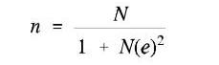
Where:
N = population size
e = error margin
n = sample size

Therefore, the estimated sample size was 356 respondents.

Proportional Probability to Size (PPS) sampling was adopted to ensure an equitable and accurate distribution of the 356 respondents among the three villages: Ntagacha (136), Borega "A" (148), and Nyakalima (72). This method considers the population size of each village, ensuring that the sample is representative of the population distribution within the ward. By using PPS, the number of respondents selected from each village was proportional to the respective population size, thereby minimising bias and enhancing the reliability of the findings. This approach ensures that larger villages contribute more respondents to the sample, reflecting their greater population size, while smaller villages contribute fewer respondents accordingly. This sampling strategy provided a well-balanced representation of the study population across the three villages, allowing for accurate comparisons and insights into the variations in attitudes, practices, and perceptions related to the research topic.

Inclusion and Exclusion Criteria
The inclusion criteria for this study are designed to ensure the selection of participants who are relevant to the research objectives. This study participant must be a resident of Ganyange Ward, specifically from the villages of Ntagacha, Borega "A," or Nyakalima. This is to ensure the findings reflect the perspectives of individuals living within the study area. Then, only men were included in the study, as the research focuses on male involvement in modern contraceptive use. Additionally, participants must be aged 18 years or older, ensuring they are of legal age and capable of providing informed consent. Moreover, only individuals who voluntarily agreed to participate in the study and provide informed consent were included. Lastly, key informants, such as community leaders, health practitioners, and influential figures with relevant knowledge or experience regarding family planning practices in the ward, were also included.

The exclusion criteria outline the groups that were not eligible to participate in the study. Men who are not permanent residents of Ganyange Ward were excluded to ensure that the findings are specific to the target population. Similarly, women and individuals under the age of 18 were excluded, as the study focuses specifically on adult male involvement in family planning. Furthermore, individuals who decline to provide informed consent or are unwilling to participate were excluded from the study. Men with severe mental or physical conditions that impair their ability to respond to questionnaires or participate in interviews were also excluded. Finally, temporary visitors or men who are not permanent residents of the ward were not considered in the sample.

Secondary Data Source
According to Creswell (2014), secondary data sources refer to data that are collected by someone other than the primary user or for a different purpose than the current one. Secondary data were obtained from libraries, including books, journal articles, and other publications posted on websites (Kothari, 2004). The secondary data helped to determine the existing knowledge about men’s awareness regarding modern contraceptive use, cultural factors influencing men's attitudes toward modern contraceptive use and their involvement in decision making regarding modern contraceptive use in Tarime District.

Primary Data Source
Primary data were collected using survey questionnaires, key informant interviews, and focus group discussions (FGDs). Survey questionnaires gathered quantitative data on participants’ awareness of men’s awareness, cultural factors, and their involvement in decision-making regarding modern contraceptive use. Key informant interviews provided in-depth qualitative insights from community leaders, healthcare workers, and family planning advocates. FGDs explored group dynamics, shared experiences, and cultural influences on male involvement in family planning. These methods ensure comprehensive and robust data collection for the study.

Data Collection Methods
The study used multiple data collection methods, including surveys, interviews and focus group discussions to ensure comprehensive data gathering. The data collection tools to be used in his study are explained below.

Questionnaire
A questionnaire is a research instrument consisting of a series of questions for the purpose of gathering information from respondents. It is a relatively inexpensive, quick, and efficient way of obtaining large amounts of information from a large sample of people (Wilson, 2014). Questionnaire (Appendix 1) collected quantitative data from the randomly selected 356 respondents from the study villages of Ntagacha, Borega "A," or Nyakalima in Ganyange Ward.

The tool included both closed and open-ended questions designed to assess respondents’ demographic information, men’s awareness regarding modern contraceptive use, cultural factors influencing men's attitudes toward modern contraceptive use and their involvement in decision making regarding modern contraceptive use in Tarime District. This tool is justified by its ability to systematically gather standardised data from many respondents, ensuring reliability and consistency in the responses (Sekaran and Bougie, 2016).

Interview Guide
Interview Guide (Appendix 2) facilitated in-depth interviews with the purposively selected five key informants, including the District Family Planning Program Coordinator, 3 Community Health Workers (one from each village), and one influential community leader. The guide included a series of open-ended questions to explore specific themes, gain expert opinions, and uncover detailed perspectives on male involvement in family planning. This approach allows the researcher to delve deeper into issues that may not emerge from quantitative methods, offering a more comprehensive understanding of the subject matter. The average duration of each interview did not exceed one hour.

It enables the collection of detailed and context-specific information from individuals with specialised knowledge or experience in the field of family planning. Further, open-ended questions facilitate a deeper exploration of cultural, social, and structural factors influencing male participation in family planning. Additionally, the guide allows for follow-up questions and probing, which can clarify responses and reveal underlying factors that may not be evident in survey data (Saunders et al., 2012).

Focus Group Discussion Guide
Focus Group Discussion (FGD) is a qualitative research method that involves a structured conversation among a small group of participants, guided by a moderator, to explore their perceptions, opinions, attitudes, and experiences on a specific topic (Creswell & Poth, 2018). Focus Group Discussion Guide (Appendix 3) was used to guide the three focus group discussions conducted in the study villages of Ntagacha, Borega "A," and Nyakalima. In each village, the FGD participants were purposively chosen to represent gender, occupation, age group, marital status, and level of education to ensure a diverse range of perspectives on modern contraceptive use. Each FGD consisted of small groups of 8–10 participants to facilitate an in-depth exploration of qualitative data related to shared experiences, cultural influences, and community dynamics surrounding contraceptive use.

The average duration of each FGD session did not exceed one hour. The tool included carefully designed prompts and open-ended questions to encourage interaction, stimulate discussion, and elicit diverse perspectives within the group setting. Specific attention was given to fostering an environment where participants feel comfortable sharing their views and experiences. The use of this tool is justified by its ability to uncover rich, detailed insights that may not emerge through individual surveys or interviews. FGDs allow for the exploration of group norms, attitudes, and shared values, providing a comprehensive understanding of community-level factors influencing male involvement in family planning. Furthermore, the interactive nature of FGDs encourages participants to build on each other's contributions, generating a broader range of viewpoints and enhancing the depth of the data collected. This tool is particularly suitable for understanding complex, culturally sensitive issues, such as contraceptive use, where group dynamics and shared experiences play a significant role (Sekaran and Bougie, 2016).

Validity and Reliability of Research Instruments
This section presents the validity and reliability of the data collection tools used in the study.

Validity
According to Leavy (2017), validity ensures that the data collection tools measure what they are intended to measure accurately. In this study, content validity was achieved by designing the survey questionnaire, interview guide, and FGD guide to comprehensively address male involvement in family planning, aligned with the research objectives. Experts in reproductive health and research methodology reviewed these tools to confirm their relevance and completeness. The study design also emphasises external validity to ensure findings can be generalised to similar populations with comparable characteristics (Sekaran & Bougie, 2016).

Reliability
According to Sekaran & Bougie (2016), reliability focuses on the consistency and stability of the tools in producing similar results under the same conditions. To ensure this, test-retest reliability was conducted by administering the tools to a small group of respondents twice to assess response consistency over time. Internal consistency was evaluated using Cronbach’s Alpha to confirm that survey items measure the same construct reliably. Additionally, pilot testing of all tools was conducted in a neighbouring ward with similar demographics, allowing for the identification and resolution of potential issues. These measures collectively ensure the tools are both reliable and valid, providing credible and replicable findings.

Qualitative Data Rigour
According to Creswell and Poth (2018), qualitative rigour encompasses the trustworthiness, credibility, and overall integrity of the research process and findings. It requires ensuring that the research design, methods, and conclusions are well-structured, transparent, and free from bias. Key elements of rigour in qualitative research include credibility, transferability, trustworthiness, and confirmability (Leavy, 2017; Kothari, 2004).

Transferability
According to Creswell and Poth (2018), transferability refers to the extent to which a study's findings can be applied or generalised to other contexts, settings, or populations. It is achieved by providing comprehensive descriptions of the research context, participants, and processes, enabling readers to assess the applicability of the findings to their situations. The significance of transferability lies in offering detailed contextual and participant descriptions, helping researchers and policymakers determine the relevance of the findings to similar communities or settings. This is particularly crucial for understanding men's perceptions of modern contraceptive use across different regions.

Transferable findings can guide policy decisions and interventions in other communities facing comparable challenges. By examining men's perceptions of modern contraceptive use in Tarime District and comparing them with those in other regions, researchers can identify patterns and differences that contribute to broader social and economic policy development. Additionally, understanding transferability enhances community engagement by ensuring that study recommendations align with the local context, thereby increasing their effectiveness and the likelihood of successful implementation (Leavy, 2017).

Confirmability
According to Creswell and Poth (2018), confirmability refers to the extent to which a study’s findings are shaped by participants' responses rather than the researcher’s biases, motivations, or perspectives. As a key criterion for establishing trustworthiness in qualitative research, confirmability ensures that data and interpretations are derived directly from participants' input rather than the researcher’s viewpoints. Its relevance to the study lies in maintaining objectivity by ensuring that findings accurately reflect respondents' perceptions of modern contraceptive use without researcher influence. This is achieved by maintaining a clear audit trail of data collection and analysis, allowing other researchers to verify conclusions and enhance the study’s credibility.

Confirmability also strengthens trustworthiness by demonstrating that findings are grounded in participants' experiences and perspectives, which is particularly crucial in qualitative research where interpretation plays a significant role. Furthermore, ensuring confirmability allows other researchers to replicate the study in different contexts or populations, validating the findings and assessing their applicability in other settings. Ultimately, by upholding confirmability, the study can provide a reliable and unbiased representation of men's perceptions of modern contraceptive use, contributing to informed policy decisions and effective interventions (Leavy, 2017).

Trustworthiness
According to Creswell and Poth (2018), trustworthiness refers to the credibility, reliability, and overall quality of qualitative data and the research process, ensuring that findings are accurate, consistent, and dependable. In the context of this study, trustworthiness is essential in accurately capturing men's perceptions of modern contraceptive use, thereby fostering confidence in the results among stakeholders and policymakers. It also enhances the applicability of findings to similar communities or settings, allowing for broader implementation of insights and recommendations. Additionally, trustworthiness strengthens the study’s reliability by ensuring that findings are shaped by participants' responses rather than researcher biases or assumptions, thereby promoting objectivity and impartiality. By upholding these principles, the study can generate reliable and meaningful insights that contribute to informed policies and effective interventions related to men's perceptions of modern contraceptive use (Leavy, 2017).

Credibility
According to Creswell and Poth (2018), credibility refers to the extent to which a study’s findings accurately reflect participants' experiences and perspectives. It is established through methods such as triangulation, member checking, and providing detailed descriptions of the research context, ensuring that the qualitative data collected is reliable and authentic. In this study, credibility is crucial for accurately capturing men's perceptions of modern contraceptive use in Tarime District, thereby fostering trust in the findings among stakeholders and policymakers. Additionally, it enhances the overall trustworthiness of the study by demonstrating that the data is both valid and dependable, which is essential for gaining acceptance and support for the study's conclusions and recommendations (Leavy, 2017).

Data Analysis
Data analysis refers to the process of systematically using statistical and logical methods to describe, summarise, and compare data (Sekaran & Bougie, 2016). This process encompasses data preparation, descriptive statistics, inferential statistics, and the interpretation of data (Sekaran & Bougie, 2016). In this study, data analysis involved both quantitative and qualitative methods to address the study objectives.

Analysis of Quantitative Data
Quantitative data were analysed using the Statistical Package for Social Sciences (SPSS) software to generate descriptive and inferential statistics. Descriptive statistics, such as frequencies, percentages, and means, were used to summarise respondents' demographic information and assess their awareness regarding modern contraceptive use. Inferential statistics, such as chi-square tests, were employed to examine relationships between cultural factors, men’s attitudes, and their involvement in decision-making regarding modern contraceptive use.

Analysis of Qualitative Data
Qualitative data to be collected through interviews and Focus Group Discussions (FGDs) were analysed using thematic analysis (Bran and Kracke, 2006). This process involved transcribing data, coding responses, and categorising emerging themes related to cultural influences, awareness levels, and decision-making dynamics. The qualitative findings complemented the quantitative results, providing a comprehensive understanding of men’s perspectives on modern contraceptive use in Tarime District.

Data Presentation
Data presentation is the process of organising and displaying data clearly and effectively. It involves utilising various tools and techniques to ensure the data is understandable and accessible to the audience (Kothari, 2004). The findings from quantitative data were presented using tables, charts, and graphs to ensure clarity and accessibility. Key insights from qualitative data were presented narratively, supported by direct quotes from respondents to highlight significant views and experiences. Together, the analysis and presentation addressed the study questions and offered evidence-based recommendations for improving male involvement in family planning.

Ethical Consideration
According to Bryman (2016), ethical considerations refer to the principles and guidelines that govern the conduct of research, ensuring that it is carried out in a responsible, transparent, and respectful manner. These considerations are essential for protecting the rights, well-being, and dignity of participants, as well as maintaining the integrity of the research process.

Key ethical considerations in research typically include obtaining informed consent, ensuring voluntary participation, maintaining confidentiality and anonymity, avoiding harm to participants, and adhering to legal and institutional regulations. These principles aim to ensure that the research is conducted ethically, without exploitation, harm, or bias. These ethical issues are detailed in the subsections below.

Research Clearance from the Open University of Tanzania
The researcher applied for ethical clearance from the Open University of Tanzania (OUT) prior to conducting the study. This clearance ensures that the research adheres to established ethical standards and guidelines set by the institution. The process involves reviewing the study's methodology, objectives, and potential risks to participants, ensuring that all aspects of the research meet the ethical requirements of OUT. The researcher commenced the study until formal approval was received, which guarantees compliance with institutional ethics.

Informed Consent
Informed consent is a cornerstone of ethical research, ensuring that participants are fully aware of the nature of the study and agree to participate voluntarily (Bryman, 2016). According to Creswell (2014), informed consent involves providing participants with clear, understandable information about the research, including its purpose, procedures, potential risks, and benefits. Participants must be given the opportunity to ask questions and must voluntarily agree to participate without coercion. The informed consent process protects participants' autonomy, allowing them to make an informed decision about their involvement (Bryman, 2016). The researcher obtained written consent from each participant, ensuring their comprehension and voluntary agreement.

Voluntary Participation
Voluntary participation refers to the principle that participants should freely choose whether or not to take part in research, without any form of coercion or undue pressure. As highlighted by Flick (2018), researchers must ensure that participants understand they are free to withdraw from the study at any point without facing any negative consequences. This principle upholds the autonomy and dignity of participants, as they are not compelled to partake in research they do not wish to be involved in (Neuman, 2014). The researcher ensured that the participants were fully informed about their right to participate or withdraw without penalty voluntarily. During the data collection, participants received no any form of support or compensation for their time and contributions, their participation in this study was totally voluntary.

Confidentiality
Confidentiality in research ensures that personal data and information provided by participants are protected from unauthorised access or disclosure. According to Saunders et al. (2019), confidentiality safeguards the privacy of participants by ensuring that any sensitive information collected is kept secure and is only accessible to those authorised. Researchers must take appropriate measures to secure the data, such as encrypting electronic files and storing physical documents in locked facilities. The researcher also informed participants about how their information would be stored and used, and any identifiable data would be kept confidential throughout and after the study (Babbie, 2013).

Anonymity
Anonymity in research ensures that participants' identities are not linked to the data they provide. According to Polit and Beck (2017), maintaining anonymity means that researchers do not collect or record any personally identifiable information from participants. This protects participants from potential harm or negative consequences that might arise if their identity were disclosed. The researcher ensured that participants' personal information was never recorded alongside their responses, and any reports or publications present findings in a manner that prevents any identification of individual participants (Neuman, 2014).

Do not Harm Principle.
The "Do No Harm" principle in research emphasises the researcher’s responsibility to protect participants from any physical, emotional, or psychological harm. According to Diener and Crandall (1978), this ethical principle ensures that researchers actively consider the potential risks involved in their studies and take steps to minimise harm. The researcher conducted a thorough risk assessment and ensured that appropriate precautions were taken to minimise discomfort, distress, or harm to participants. In addition, participants were informed about any potential risks in the informed consent process, allowing them to make an informed decision about their participation (Gibbs, 2016).

CHAPTER FOUR

DATA PRESENTATION AND DISCUSSION

Chapter Overview
This chapter presents the results and discussion on the socio-demographic characteristics of the respondents, followed by an analysis of the level of awareness regarding modern contraceptive use among men, cultural factors influencing men's attitudes towards modern contraceptive use, and men’s involvement in decision-making concerning modern contraceptive use.

Questionnaire Response Rate
A total of 374 questionnaires, including an additional 5% to account for potential non-responses, were distributed to the selected respondents in the study area. Out of these, 356 questionnaires were properly filled and successfully retrieved by the researcher, resulting in a high response rate of 95.2% as presented in Table 4.1.

Table 4.1: Questionnaire Response Rate
Item | Frequencies | Percentages
Distributed questionnaires | 374 | 100
Non-response rate | 18 | 4.8
Response rate | 356 | 95.2
Source: Field data, 2025

This high response rate indicates that the study achieved a very high level of participant engagement and data reliability, thereby enhancing the validity and generalizability of the findings.

Socio-Demographic Characteristics of Respondents
The respondents’ socio-demographic characteristics covered in this study include age, level of education, marital status, and main occupation. The socio-demographic characteristics in this study are important for understanding the context in which men make decisions about modern contraceptive use, as factors such as age, education level, marital status, and occupation have been shown to significantly influence awareness, attitudes, and involvement in reproductive health matters (Kabagenyi et al., 2014; Amuzie et al., 2022). These characteristics help to identify patterns and predictors of contraceptive behaviour, which are critical for developing effective, targeted interventions (Nmadu et al., 2024).

Age of Respondents
The results (Table 4.2) showed that the respondents aged between 46 and 60 years were the largest age group (44.4%), followed by those aged 36 to 45 years (30.1%). Respondents aged between 26 and 35 years accounted for 15.7%, while those aged 18 to 25 years made up 6.5%. The smallest age group was respondents aged above 60 years, representing only 3.4% of the total sample.

Table 4.2: Distribution of Respondents by Age Groups
Age category (years) | Frequencies | Percentages
18-25 | 23 | 6.5
26-35 | 56 | 15.7
36-45 | 107 | 30.1
46-60 | 158 | 44.4
Above 60 | 12 | 3.4
Total | 356 | 100.0
Source: Field data, 2025
The findings suggest that all age groups were fairly represented in this study, providing a comprehensive understanding of men’s perspectives across different stages of adulthood. Age is a critical socio-demographic variable that can influence study outcomes and the interpretation of reproductive health behaviours. It affects awareness, attitudes, and levels of involvement in contraceptive decision-making. As noted by Cohen and Janicki (2016), understanding the age distribution of respondents enables researchers and policymakers to design age-appropriate interventions and policies that are both culturally and contextually relevant. Recognising the distinctions in how age impacts reproductive health engagement is essential for tailoring public health programs and increasing their effectiveness across diverse age groups (Kabagenyi et al., 2014).

Education of Respondents
The findings (Table 4.3) indicated that the majority of respondents (47.8%) had attained primary education, followed by 25.0% with secondary education. A smaller proportion had attained college-level education (21.3%), while only 4.2% held a bachelor’s degree, and just 1.7% had postgraduate qualifications.

Table 4.3: Distribution of Respondents by Education Levels
Education levels | Frequencies | Percentages
Primary education | 170 | 47.8
Secondary education | 89 | 25.0
College | 76 | 21.3
Bachelor degree | 15 | 4.2
Postgraduate | 6 | 1.7
Total | 356 | 100.0
Source: Field data, 2025
This distribution of education level suggests that most participants had relatively low levels of formal education, which may have implications for their awareness and understanding of modern contraceptive methods. Educational attainment is a well-documented predictor of reproductive health behaviour, including contraceptive use. A systematic review by Blackstone et al. (2017) showed that formal education was consistently associated with higher uptake of modern contraceptives in sub-Saharan Africa. Moreover, a recent study by Osuafor et al. (2023) examining male involvement in family planning decision-making in Malawi and Tanzania found that men with secondary or higher education had significantly increased odds of engaging in contraceptive decisions. These findings reinforce the need for educational interventions such as media campaigns and school-based programs that target less-educated men to enhance their awareness and participation in modern contraceptive use.

Marital Status of Respondents
The analysis showed that the majority of respondents (71.1%) were married, followed by 27.5% who were single. A very small proportion of respondents were divorced (0.8%) or widowed (0.6%), as presented in Table 4.4.

Table 4.4: Distribution of Respondents by Marital Status
Marital status | Frequencies | Percentages
Single | 98 | 27.5
Married | 253 | 71.1
Divorced | 3 | 0.8
Widower | 2 | 0.6
Total | 356 | 100.0
Source: Field data, 2025
This distribution of marital status highlights that most participants were in marital unions, which is significant in understanding patterns of contraceptive decision-making. Married men are more likely to be involved in family planning discussions and to use modern contraceptive methods, as they often face direct reproductive responsibilities and long-term family planning goals. According to Kabagenyi et al. (2014), married men were significantly more likely to adopt modern contraceptives compared to single or formerly married men, primarily due to their engagement in stable relationships and the necessity to manage family size.

Similarly, Amuzie et al. (2022) found that marital status was a strong predictor of male involvement in contraceptive use, with married men showing greater participation in family planning services. In contrast, single men often exhibit lower involvement, driven by less perceived need and limited joint decision-making scenarios. These findings suggest that marital status is a critical variable that shapes attitudes, awareness, and participation in contraceptive use, thus necessitating relationship-specific reproductive health strategies.

Main Occupation of Respondents
The results in this study (Table 4.5) showed that the majority of respondents (66.6%) were agro-pastoralists, followed by pastoralists (25.0%). A small proportion were engaged in business (3.9%) and farming (3.7%), while only 0.8% were formally employed.

Table 4.5: Distribution of Respondents by Main Occupation
Main occupation | Frequencies | Percentages
Agro-pastoralist | 237 | 66.6
Pastoralist | 89 | 25.0
Farming | 13 | 3.7
Business | 14 | 3.9
Employment | 3 | 0.8
Total | 356 | 100.0
Source: Field data, 2025

This occupational distribution suggests that most participants relied on subsistence-based livelihoods, particularly livestock rearing and mixed farming. Occupation is an important socio-economic factor influencing access to reproductive health services and information. Individuals in informal or rural-based occupations such as agro-pastoralism and pastoralism often face structural barriers, including limited health infrastructure, long distances to health centres, and lower exposure to family planning programs (Blackstone et al., 2017).

In a study conducted in northern Nigeria, Amuzie et al. (2022) found that formal employment was positively associated with male involvement in contraceptive use due to increased access to health information, greater autonomy, and more interaction with healthcare systems. Conversely, rural and pastoralist communities often demonstrate lower contraceptive uptake, attributed to traditional norms, mobility patterns, and low literacy levels (Osuafor et al., 2023). Therefore, targeted interventions tailored to the realities of agro-pastoralists and pastoralist communities are essential to improve male involvement in modern contraceptive use.

Level of Awareness Regarding Modern Contraceptives used among Men
The results on the level of awareness regarding modern contraceptive use among men cover several key aspects that contribute to understanding how informed men are about family planning options. Specifically, this section presents findings on men's knowledge of available contraceptive methods, their primary sources of contraceptive information, awareness of where contraceptive services can be accessed, understanding of potential side effects associated with contraceptive use, and perceptions of the effectiveness of various contraceptive methods. These components are essential in assessing not only the extent of awareness but also the quality and reliability of information that informs men’s attitudes and behaviours toward modern contraceptive use.

Knowledge of Available Male Contraceptive Methods
Out of the 356 respondents (Table 4.6), all (100%) reported being aware of the condom method. In comparison, only 194 respondents (54.5%) were aware of vasectomy as a male-centred long-term contraceptive method, while 162 respondents (45.5%) were not aware of the vasectomy method.

Table 4.6: Respondents’ Knowledge of Available Male Contraceptive Methods
Modern Contraceptive | Awareness | Frequencies | Percentages
Condom | Yes | 356 | 100.0
Vasectomy | Yes | 194 | 54.5
Vasectomy | No | 162 | 45.5
Source: Field data, 2025

The Family Planning Program Coordinator elaborated that while condoms are widely known due to sustained public health campaigns and their dual role in preventing both pregnancy and sexually transmitted infections, vasectomy remains poorly understood and culturally sensitive. Many community members perceive vasectomy as a permanent loss of masculinity or associate it with reduced sexual performance. The informant emphasised that the lack of targeted education and persistent myths surrounding vasectomy contribute to its low uptake, despite its safety, cost-effectiveness, and long-term reliability as a contraceptive method. The Family Planning Program Coordinator emphasised:

“Everyone knows about condoms because they are talked about everywhere, even on the radio. But when it comes to vasectomy, many people don’t understand it. Some men think it means they will no longer be real men, so they fear it without even knowing what it really is (Family Planning Program Coordinator, Interview, June 2025).

These findings have the implications that while awareness of short-term male contraceptive methods like condoms is widespread due to consistent media messaging and public health outreach, long-term methods such as vasectomy remain marginalised due to cultural misconceptions and limited education. This suggests that family planning programs need to intensify targeted education and myth-busting efforts specifically around vasectomy, especially among men.

The findings in the present study on awareness of contraceptive methods are consistent with previous research that highlights limited male awareness of long-term contraceptive methods such as vasectomy, despite widespread knowledge of condoms. For instance, Marcell et al. (2022) found that while 85% of young men in sub-Saharan Africa were aware of condoms, awareness of other modern contraceptive methods, including vasectomy, was significantly lower. Similarly, Msovela et al. (2020) reported that knowledge of family planning methods among men in Kibaha, Tanzania, was a critical factor influencing their use of contraceptives, with many men being unfamiliar with male-specific options beyond condoms.

Further, the findings in this study align with global trends reported by the CDC (2020), which noted that although male methods like condoms and vasectomy contributed meaningfully to contraceptive use in the United States, awareness of the full spectrum of male methods remains limited. The WHO (2024) also expressed concern over declining condom use among adolescents in Europe, emphasising the need for comprehensive sexuality education that includes male-controlled methods. Overall, the present study supports the broader body of literature showing that male awareness and involvement in contraception remain constrained by limited knowledge and the narrow range of available methods.

In addition, the findings of this study on awareness of contraceptive methods align closely with the Health Belief Model (HBM) proposed by Rosenstock (1974). In the context of men's awareness and use of modern contraceptives in Tarime District, the high awareness of condoms (100%) suggests that men perceive themselves as susceptible to unintended pregnancies and possibly sexually transmitted infections (STIs). This awareness may also indicate that men view these outcomes as serious enough to warrant preventative action, reflecting the HBM’s components of perceived susceptibility and severity. However, the low awareness of vasectomy (54.5%) suggests that men may not consider long-term contraceptive responsibility as relevant to them or may not perceive the consequences of avoiding such methods as severe.

The perceived benefits and barriers play a critical role in shaping males’ behaviour. While condoms are widely recognised for their immediate benefits, such as ease of access, dual protection against STIs and pregnancy, and non-permanence, vasectomy is likely viewed with scepticism due to limited knowledge, misinformation, or cultural misconceptions. These perceptions create significant psychological and social barriers. For instance, beliefs that vasectomy undermines masculinity may contribute to negative attitudes toward this method. This corresponds to the HBM construct of perceived barriers, which can prevent behaviour change even when individuals recognise potential benefits.

Unless these barriers are addressed, through counselling or culturally sensitive information dissemination, uptake of vasectomy will likely remain low. Cues to action and self-efficacy are also central to understanding the observed findings on the awareness of modern contraceptive methods. The limited awareness of vasectomy points to a lack of adequate cues to action, such as media campaigns, healthcare provider counselling, or community engagement activities focused on male contraceptive options.

Many men may not feel empowered to initiate discussions about contraceptives or access services like vasectomy due to fear, stigma, or social norms. Therefore, the study's findings reflect key constructs of the HBM, emphasising the need for targeted interventions that reduce perceived barriers, increase self-efficacy, and enhance cues to action to promote male participation in contraceptive use.

Source of Contraceptive Information
The results (Figure 4.1) show that media (radio, TV, newspapers) was the main source of information on modern contraceptives (48.0%), followed by health facilities (18.7%), community health workers (14.9%), friends or relatives (14.6%), and other sources such as religious or civic forums (3.7%).

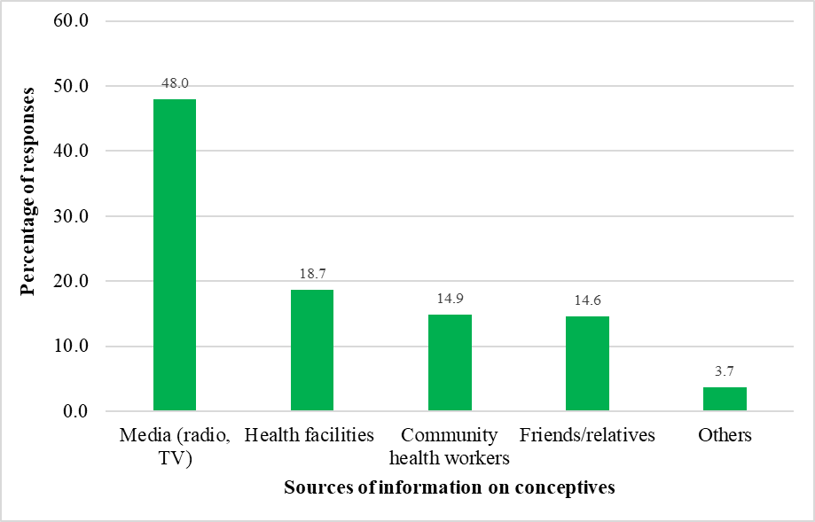
Figure 4.1: Percentage responses on Source of Contraceptive Information
Source: Field data, 2025

The Health Community Workers added that media platforms have a broader reach and are often more trusted by the public, especially in rural areas where formal health education may be limited. They emphasised that radio, in particular, is highly accessible and regularly used to disseminate family planning messages in local languages. However, they also noted that messages from health professionals tend to be more influential when it comes to correcting myths and encouraging long-term contraceptive use, especially for methods like vasectomy or implants, which require more explanation and reassurance. One of the Health Community Workers stressed:

“People hear about family planning mostly through the radio, which reaches even the most remote places. But for things like vasectomy, many still have doubts. That’s where health workers play a big role, because they can sit down and explain things clearly and answer questions face to face” (Health Community Worker, Interview, June 2025).

These results about the source of contraceptive information are essentially consistent with those of Marcell et al. (2022), who found that young men in sub-Saharan Africa most commonly received contraceptive information from informal and media sources, including teachers, peers, the internet, and social media, with more sexually active individuals reporting higher exposure. Similarly, Msovela et al. (2020) found that men in Kibaha, Tanzania, were more likely to use modern family planning methods when they were aware of nearby family planning clinics and had exposure to health providers, highlighting the critical role of institutional sources such as health facilities and community health workers.

However, in the present study, these health facilities were secondary to mass media, suggesting potential underutilization or limited reach of health system-based education efforts in the community. This contrast underlines a need to enhance and integrate health worker-led communication with ongoing media campaigns. Moreover, the reliance on media in this study may reflect broader access and trust in mass communication in rural Tanzania, especially where interpersonal or health facility outreach may be constrained by staffing, infrastructure, or cultural norms. The relatively low percentage of respondents citing community health workers and civic forums indicates an opportunity to scale up community-based education efforts. These findings collectively suggest that while media remains a powerful and accessible channel for disseminating contraceptive information, a multi-channel approach, strengthening health facilities, community engagement, and peer-led education, is essential to ensure comprehensive and inclusive contraceptive awareness among men.

Awareness of Contraceptive Access Points
The results (Figure 4.2) show that pharmacies were cited by 61.7% of respondents as the most commonly known access points for contraceptives. This was followed by health facilities (26.8%), community health programs (7.1%), and other sources such as mobile clinics or outreach events (4.4%).
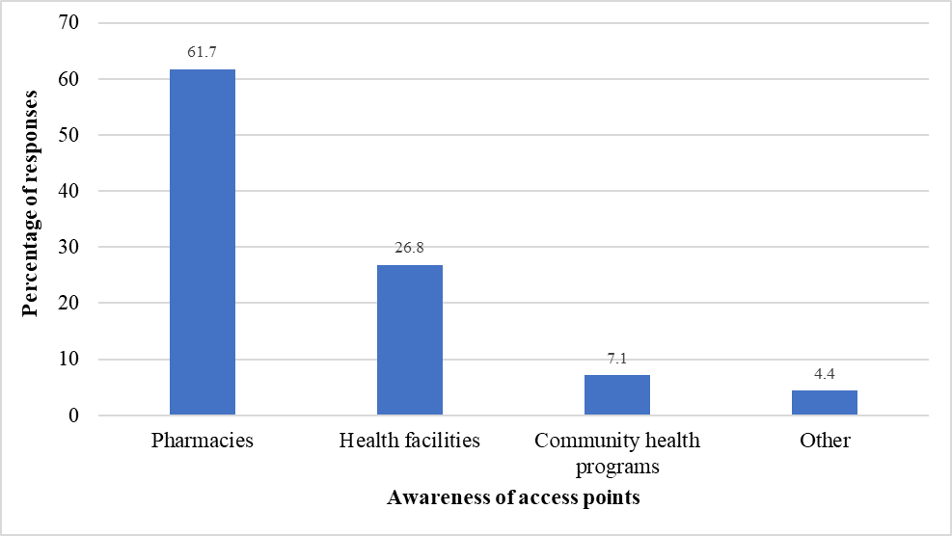
Figure 4.2: Percentage responses on Awareness of Contraceptive Access Points
Source: Field data, 2025

The FGD participants elaborated that pharmacies are often preferred due to their accessibility, extended operating hours, and the privacy they offer. One participant noted:

“Pharmacies are everywhere and open for longer hours, so many people prefer to get their contraceptives there without having to wait or go through complicated procedures. Health facilities can sometimes be far or crowded, so pharmacies offer a more convenient and discreet option (FGD Participant, June 2025).

Other participants added that community health programs and outreach services, while less frequently accessed, play an important role in reaching underserved populations, particularly in remote areas where health infrastructure is limited. However, participants also expressed concerns about the lack of counselling and follow-up services in pharmacies compared to formal health facilities, underscoring the need for integrated approaches to contraceptive service delivery.

This result on awareness of contraceptive access points is in agreement with Marcell et al. (2022), who found that among unmarried young men aged 15–24 in Côte d’Ivoire, Kenya, and Nigeria, private healthcare, pharmacies, and markets were frequently recognised as contraceptive acquisition sources. Their study revealed that awareness of acquisition points was higher among sexually active respondents, who favoured more discreet and accessible channels such as pharmacies and doctors over public health facilities. This reflects a preference for informal or semi-formal settings that offer convenience and privacy. Pharmacies are the first point of contact for young people and women seeking contraceptives, often because they perceive them as less judgmental and more accessible than public clinics.

Furthermore, the findings of the present study align well with the constructs of the Health Belief Model (HBM) (Rosenstock, 1974). The high awareness of contraceptive access points such as pharmacies reflects men’s recognition of both the perceived benefits and perceived accessibility of these contraceptive access points. Pharmacies, often seen as private, convenient, and non-judgmental, may lower the perceived barriers typically associated with visiting public health facilities, such as stigma, long waiting times, or lack of confidentiality. The HBM construct of cues to action is evident in the role that awareness of access points plays in prompting contraceptive use. When men know where they can easily obtain contraceptives, particularly in settings that respect their privacy, they are more likely to take action. This supports the importance of improving the visibility and acceptability of various contraceptive distribution channels. Furthermore, self-efficacy, the belief in one’s ability to successfully acquire and use contraceptives, is strengthened when men are familiar with and confident in accessing these points, such as pharmacies or private clinics. Therefore, this study’s findings support the HBM's applicability in understanding and improving male awareness and utilisation of modern contraceptives, especially in contexts where informal and semi-formal access points play a dominant role.

Understanding of Modern Contraceptive Side Effects
The results (Table 4.7) showed that out of 356 respondents, only 153 (42.98%) were aware of the modern contraceptive side effects. It was found that reduced sexual desire was the most commonly reported side effect of contraceptive use, mentioned by 44.4% of respondents. This was followed by mood changes (32.7%), weight gain (15.0%), and other side effects such as headaches or fatigue (7.8%).

Table 4.7: Respondents’ Understanding of Contraceptive Side Effects
Contraceptive side effects | Frequencies | Percentages
Reduced sexual desire | 68 | 44.4
Mood changes | 50 | 32.7
Weight gain | 23 | 15.0
Other | 12 | 7.8
Source: Field data, 2025

These results have the implications that side effects, particularly those that affect sexual health and emotional well-being, play a significant role in influencing contraceptive satisfaction, continued use, and method switching. The high prevalence of reported reduced sexual desire suggests that contraceptive choices are not merely a matter of access or availability, but are also deeply linked to users’ quality of life and relationship dynamics. Side effects such as mood changes and weight gain further underscore the need for personalised contraceptive counselling that acknowledges and addresses potential physical and psychological concerns.

These findings on awareness of modern contraceptive side effects align with prior research, such as Machinda et al. (2020) in Tarime District, who found that despite high levels of general awareness of family planning, actual contraceptive usage was challenged by perceived side effects. One of the major barriers reported was fear of side effects, including concerns about congenital disabilities, cancer, severe pain during childbirth, and suspicions that contraceptive use might encourage marital infidelity. These perceptions significantly contributed to men’s reluctance to support or participate in modern contraceptive use.

Similarly, the study by Anaman-Torgbor et al. (2025) in Ghana reported that fear of side effects was the most cited reason for rejection of contraceptive use, particularly before sexual intercourse. In their study, more than half of the male respondents who opposed contraceptive use attributed their concern to perceived side effects. Although the majority recognised contraceptives as effective in preventing pregnancy, many were hesitant to support their partners' use due to affordability concerns, employment status, income level, and fears about health risks. Together, these findings suggest that while awareness of modern contraceptive methods may be high, misinformation or limited understanding about their side effects continues to hinder widespread usage, particularly among men.

Perceived Effectiveness of Contraceptive Methods
The findings (Figure 4.3) indicated that most respondents were of the view that condoms are an effective contraceptive method, with 56.5% rating them as very effective and an additional 27.8% as effective. Only 15.7% perceived condoms as not effective. In contrast, perceptions of vasectomy were markedly less favourable, with only 12.6% of respondents viewing it as very effective and 25.8% as effective, while a majority (61.5%) rated it as not effective.

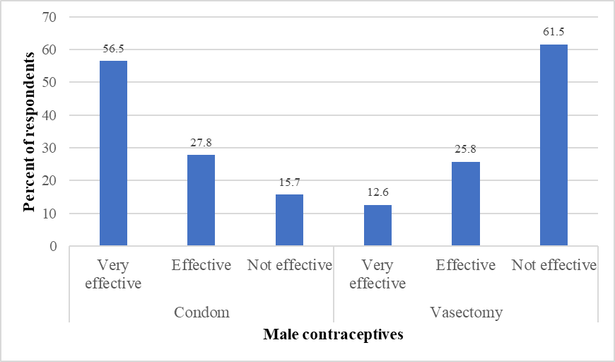
Figure 4.3: Percentage responses on perceived Effectiveness of Contraceptive Methods
Source: Field data, 2025

The Health Community Workers added that while condom use is widely accepted and promoted due to its dual role in preventing both pregnancy and sexually transmitted infections, it is often viewed as a short-term or situational method, rather than a reliable long-term solution. In contrast, vasectomy, despite being medically recognised as a highly effective and permanent method, remains poorly understood and surrounded by social stigma. Informants emphasised that deep-rooted cultural beliefs and a lack of male-targeted education have contributed to the perception that vasectomy compromises masculinity or leads to sexual weakness. As a result, many men are reluctant to consider it, and public discussions around it are minimal or non-existent. One of the Health Community Workers noted:

“While condoms are accepted because they’re easy to use and people understand their purpose, vasectomy is a different story. Many men think it will make them less of a man, or that it will affect their strength and sexual ability (Community Health Worker, Interview, June 2025).

These findings on the perceived effectiveness of contraceptive methods align with prior research, such as Marcell et al. (2022), who found that condoms were the most widely recognised and accepted male contraceptive method among young men aged 15–24 in Côte d’Ivoire, Kenya, and Nigeria. Their study revealed that most respondents were aware of condoms, while significantly fewer were familiar with other methods like vasectomy or long-acting contraception. This suggests a strong association between method familiarity and perceived effectiveness, with condoms being viewed as both accessible and effective due to widespread promotion and availability through private pharmacies and healthcare outlets. Similarly, the Centres for Disease Control and Prevention (CDC, 2020) reported that male-oriented methods such as condoms and vasectomy accounted for a substantial portion of contraceptive use in the United States. However, the limited range of available male methods and men's lower awareness of vasectomy compared to condoms were also highlighted as barriers to broader utilisation.

Further, the findings of the present study align well with the constructs of the Health Belief Model (HBM) (Rosenstock, 1974). The HBM posits that individuals’ health-related behaviours, such as the use of contraceptives, are influenced by their perceptions of susceptibility to a health issue, the perceived severity of the consequences, perceived benefits of taking action, and perceived barriers to action. In the context of this study, the respondents’ perception of condoms as highly effective reflects a strong belief in the benefits of using this method to prevent unwanted pregnancies and sexually transmitted infections. Conversely, the low perception of vasectomy effectiveness and fear of side effects represent perceived barriers, which discourage adoption despite its long-term reliability.

Furthermore, the relatively high awareness of condoms and their accessibility through pharmacies reinforces the importance of cues to action, such as mass media, health providers, and social networks, in promoting contraceptive use. Overall, these findings support the relevance of the HBM in understanding men’s attitudes and behaviours toward modern contraceptive use, particularly the roles of perceived effectiveness, barriers, and cues to action in shaping contraceptive decisions.

Cultural Factors Influencing Men's Attitudes toward Modern Contraceptive Use
This section presents findings on traditional gender roles for family planning within the community, the influence of religious beliefs on the acceptance or rejection of modern contraceptives and the presence of stigma or societal judgment surrounding contraceptive use among men. These cultural dimensions are crucial for understanding the barriers to male participation in reproductive health and for designing culturally sensitive strategies to improve contraceptive uptake and shared decision-making in family planning.

Traditional Gender Roles for Family Planning in the Community
The results (Figure 4.4) indicated that 44.1% of respondents believed that both men and women are equally responsible for family planning within their community. However, 28.4% viewed family planning as primarily a woman’s role, while 27.0% considered it a man’s responsibility. A small fraction (0.6%) selected other responses.

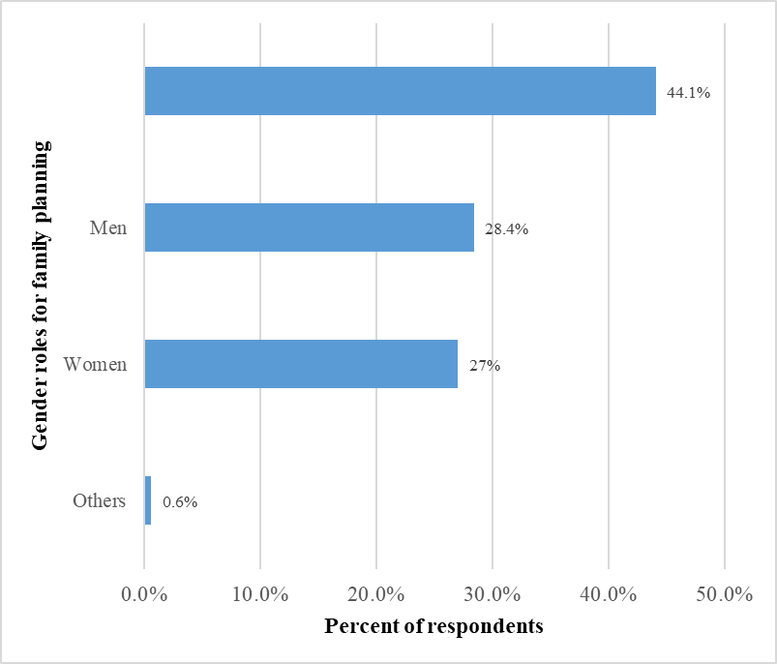
Figure 4.4: Responses on Traditional Gender Roles for Family Planning
Source: Field data, 2025

Further, the researcher assessed the belief that family planning is primarily a woman’s responsibility within the respondents’ cultural context. The results (Figure 4.5) showed that the majority of respondents (71.6%) disagreed with this belief, while 28.4% still believed that family planning is primarily a woman’s responsibility within the respondents’ cultural context.

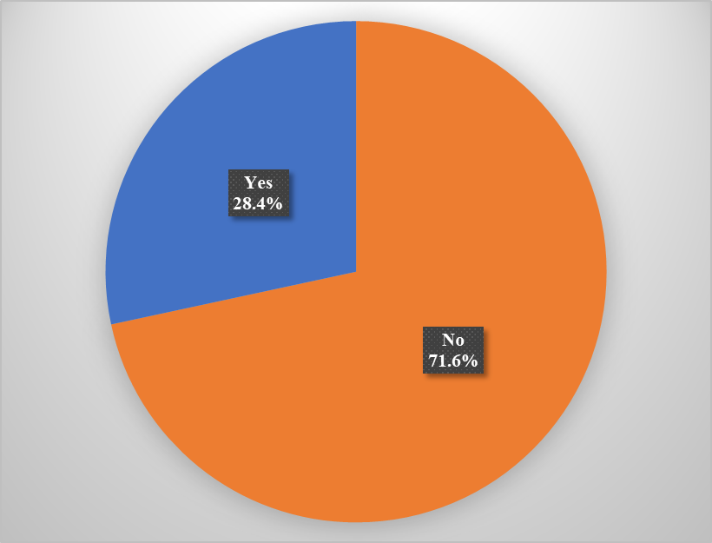
Figure 4.5: Response on the Belief that Family Planning is Primarily a Woman’s Responsibility
Source: Field data, 2025

These findings on traditional gender roles for family planning are consistent with prior research, such as Mejía-Guevara et al. (2021), who found that men's attitudinal norms, especially the belief that contraception is solely a woman’s responsibility, significantly reduced women’s contraceptive use in India. Their study demonstrated that a one standard deviation increase in men holding such beliefs resulted in a 12% decrease in contraceptive use among women. Similarly, Ali et al. (2022), using data from the Pakistan Demographic and Health Survey (PDHS) 2017–18, found that men who believed contraception was solely a woman’s responsibility were significantly less likely to use modern contraceptives. Their findings highlighted that socio-cultural perceptions, especially those rooted in traditional gender roles, serve as critical barriers to male involvement in family planning.
Further, the study by Akinyemi et al. (2023) in Nigeria further supports this finding. They reported that nearly 20% of male respondents believed contraception is a woman’s business and that such beliefs were among the strongest predictors of non-use of modern contraceptive methods. These negative perceptions, often shaped by age, religion, and education level, reinforce the view that men remain secondary actors in reproductive health decisions.

In the Ghanaian context, Anaman-Torgbor et al. (2025) reported that although a large majority of men supported their partners’ use of contraceptives post-intercourse, fewer supported proactive contraceptive use, with gendered perceptions and fear of side effects acting as barriers. Overall, the current study’s findings support a broader body of literature indicating that while there is increasing recognition of the need for shared responsibility in family planning, traditional gender norms still heavily influence perceptions and practices around contraceptive use.

Traditional Gender Roles Influence Men’s Involvement in Family Planning Decisions
The researcher also assessed how often traditional gender roles influence men’s involvement in family planning decisions. The findings (Table 4.8) revealed that a majority of respondents (61.2%) stated that traditional roles always influence their decision-making regarding family planning, while 34.6% reported that such roles sometimes influence their decisions. A small proportion said traditional roles rarely (3.4%) or never (0.8%) play a role in inferring family planning decisions.

Table 4.8: Traditional Gender Roles Influencing Men’s Involvement in Family Planning Decisions
Traditional roles influence decisions | Frequencies | Percentages
Always | 218 | 61.2
Sometimes | 123 | 34.6
Rarely | 12 | 3.4
Never | 3 | .8
Total | 356 | 100.0
Source: Field data, 2025

These results suggest that traditional gender norms remain a strong determinant of male engagement in reproductive health matters, with most men acknowledging the influence of culturally assigned roles in shaping their level of involvement. These findings on traditional gender roles for family planning are consistent with prior research, such as Mejía-Guevara et al. (2021), who found that men’s attitudinal norms, particularly the belief that contraception is a woman’s responsibility, significantly influenced women's contraceptive use in India. Their study demonstrated that in communities where traditional gender norms were dominant, women were less likely to use contraception, even when empowered by education or employment.

Similarly, Ali et al. (2022), using data from the Pakistan Demographic and Health Survey, reported that men who perceived family planning as a woman’s responsibility were less likely to use modern contraceptives. Their findings also showed that such traditional beliefs were more common among men with lower education levels and limited exposure to family planning messages, further reinforcing the impact of cultural norms on contraceptive decisions.
Additionally, Akinyemi et al. (2023) in Nigeria found that 19.9% of male respondents believed contraception is solely a woman’s duty, and these beliefs significantly contributed to the low uptake of modern contraceptives among men. The authors emphasised that traditional norms continue to shape men’s perceptions of family planning.

In Togo, Kpegba-Fiaboe and Kotoh (2025) reported that male contraceptive use was significantly associated with cultural and religious values, particularly beliefs about male dominance in reproductive decision-making. Overall, these findings highlight that traditional gender norms continue to play a dominant role in shaping reproductive health decisions, limiting male participation and reinforcing unequal expectations in family planning across various contexts.

Religious beliefs on the Use of Modern Contraceptives
The respondents were asked whether their religion permits the use of modern contraceptives. The results (Figure 4.6) showed that the vast majority (86.8%) stated that their religion does not permit the use of modern contraceptives, while only 9.0% indicated that their religion does allow it. An additional 4.2% were unsure about their religion’s position on the use of modern contraceptives.

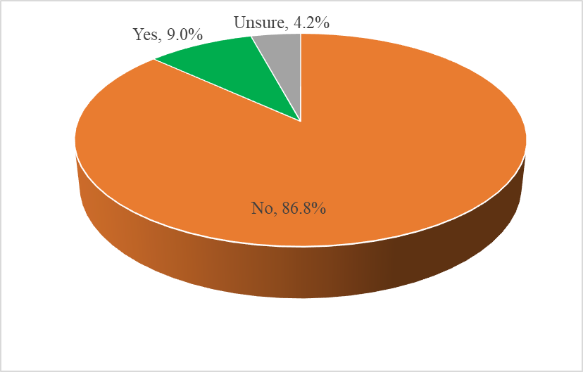
Figure 4.6: Responses Regarding Religious Belief on the use of Modern Contraceptives
Source: Field data, 2025

The study participants expounded that religious teachings and interpretations by local faith leaders play a significant role in shaping community attitudes toward contraceptive use. Many reported that their religious doctrines emphasise procreation and view the use of modern contraceptives as interfering with divine will or natural processes. Some participants mentioned that religious leaders often discourage open discussions about family planning, labelling it as morally or spiritually inappropriate. Others highlighted that even where official religious texts may not explicitly prohibit contraceptives, community-level interpretations tend to be conservative. As a result, followers are reluctant to use or even inquire about modern contraceptives for fear of spiritual condemnation or social judgment. These findings highlight the substantial role that religious beliefs play in shaping attitudes toward family planning. The dominance of negative religious perceptions may contribute to hesitation or refusal to use modern contraceptive methods among men, especially in communities where religious teachings strongly influence daily behaviour.

These findings on religious beliefs on the use of modern contraceptives are consistent with prior research, such as Ali et al. (2022), who found that men residing in more religiously conservative regions of Pakistan, particularly in Sindh, Baluchistan, and FATA, were significantly less likely to use modern contraceptives. The study revealed that religious beliefs, combined with low exposure to family planning messaging, contributed to negative attitudes toward contraception, with many men expressing that their faith did not support its use.

Similarly, Akinyemi et al. (2023) reported that among Nigerian men, Islamic religious affiliation was significantly associated with lower rates of modern contraceptive use. The study showed that men who adhered to conservative religious views were more likely to believe that contraception was immoral or unnecessary, reinforcing the influence of religion on reproductive behaviour.

Further, Kpegba-Fiaboe and Kotoh (2025) also found that in Togo, religious affiliation, particularly among Muslim participants, was a key predictor of male contraceptive use. Their study showed that men from religious backgrounds who viewed contraception unfavourably were less likely to use modern methods, further underscoring the role of religious teachings in shaping contraceptive behaviour.
In addition, Mejía-Guevara et al. (2021) emphasised that in communities with strong religious and cultural norms, both men and women were less likely to use contraception, even when empowered by education or employment. Their findings support the current study’s observation that a large proportion of respondents view contraceptive use as incompatible with their religious values. Collectively, these studies affirm that religious beliefs remain a powerful barrier to the uptake of modern contraceptive methods, particularly in settings where faith-based teachings heavily influence personal and community health decisions.

Stigma around Modern Contraceptive use in the Community
The researcher asked respondents whether, in their community, men face criticism or judgment for participating in family planning. The results (Figure 4.7) revealed that 16.3% of the respondents affirmed that men do face criticism or judgment, while a significant majority (83.7%) reported that men do not face such negative social reactions.

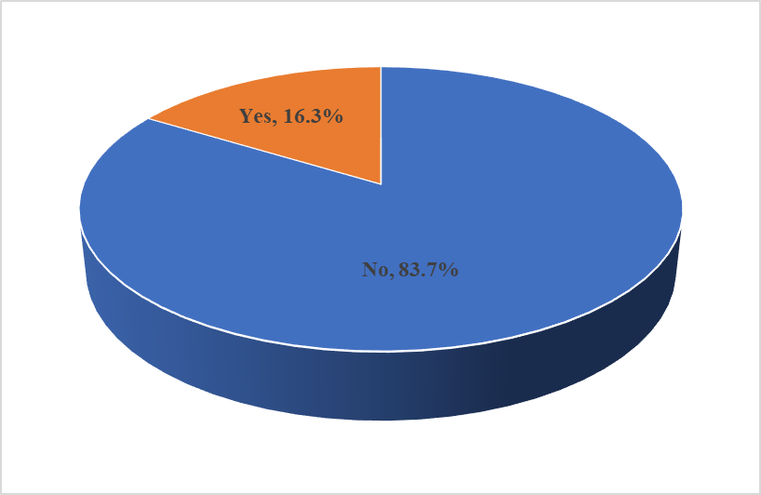
Figure 4.7: Responses on stigma around Modern Contraceptive use in the Community
Source: Field data, 2025

These findings on stigma around modern contraceptive use in the community are consistent with prior research, such as D’Souza et al. (2022), who found that male partners, family expectations, and community-level norms play a significant role in influencing contraceptive decisions globally. Their synthesis of 24 systematic reviews revealed that negative social perceptions, cultural expectations, and fear of criticism were key barriers discouraging male involvement in family planning, particularly in conservative communities.

Similarly, Mejía-Guevara et al. (2021) found that in India, men's attitudinal norms had a profound effect on contraceptive use among women. Communities where men believed contraception was exclusively a woman’s responsibility often discouraged male participation, partly due to social stigma and fear of being judged as weak or unmanly. The study by Ali et al. (2022) also highlighted that in Pakistan, male involvement in contraception was hampered by societal norms and a lack of discourse around male reproductive roles. Men who had not discussed family planning with health workers or believed contraception was solely a woman’s role were less likely to participate, reflecting the influence of stigma and traditional gender expectations.

Furthermore, Akinyemi et al. (2023) reported that a significant proportion of Nigerian men viewed contraception as a woman’s business, with 38.1% believing that women who used contraceptives might become promiscuous. These negative community perceptions discouraged men from openly supporting or using contraceptives, underscoring the persistent stigma surrounding male involvement in family planning. Collectively, these studies confirm that although a majority in the present study did not report facing criticism, the few who did reflect a persistent undercurrent of stigma, which is consistent with findings across various socio-cultural contexts where masculinity norms and fear of social judgment deter men from actively engaging in contraceptive decision-making.

Belief Concerning Contraceptive Use Challenges a Man's Masculinity within their Community
The researcher assessed the level of agreement or disagreement with the belief that contraceptive use challenges a man's masculinity within their community. The findings (Table 4.9) revealed that a majority of respondents either strongly disagreed (39.6%) or disagreed (34.6%), indicating that over 74% of participants disagree with the belief that using contraceptives undermines male masculinity. Meanwhile, 15.7% of respondents held a neutral position, and a smaller proportion agreed (6.7%) or strongly agreed (3.4%) with the belief that contraceptive use challenges a man's masculinity within their community.

Table 4.9: Responses on the Belief that Contraceptive Use Challenges a Man's Masculinity within their Community
Contraceptive use challenges a man's masculinity | Frequencies | Percentages
Strongly disagree | 141 | 39.6
Disagree | 123 | 34.6
Neutral | 56 | 15.7
Agree | 24 | 6.7
Strongly agree | 12 | 3.4
Total | 356 | 100
Source: Field data, 2025

These findings on the belief that contraceptive use challenges a man's masculinity within their community are consistent with prior research such as Tumwesigye et al. (2023), who found that in Lira City, Uganda, joint contraceptive decision-making among couples was positively associated with male contraceptive uptake, suggesting that many men no longer perceive family planning as a threat to their masculinity. Their study emphasised the growing acceptance of male involvement in reproductive health and a shift away from traditional notions equating masculinity with reproductive dominance.

Similarly, Anaman-Torgbor et al. (2025) in Ghana reported that while fears of side effects and economic constraints were major barriers to male acceptance of contraceptive use, the perception that contraception undermines masculinity was less prevalent among educated and employed men. Their findings indicated that men who supported contraceptive use, particularly post-intercourse, did so without feeling that their masculinity was compromised, reflecting evolving gender norms in certain populations.

Moreover, the study by Kpegba-Fiaboe and Kotoh (2025) in Togo demonstrated that male participants who cohabited with a partner and believed that contraception was beneficial for men were significantly more likely to use modern contraceptives. Together, these studies highlight a regional and generational shift toward greater male acceptance of contraceptive use, reinforcing the finding that most respondents in the present study disagreed with the belief that contraception undermines male masculinity.

Stigma for Supporting or Using Modern Contraceptives
The respondents were asked if they had ever faced stigma for supporting or using modern contraceptives. The findings (Figure 4.8) show that the vast majority of respondents (87.6%) reported they had not experienced any stigma, while 12.4% indicated they had faced stigma.

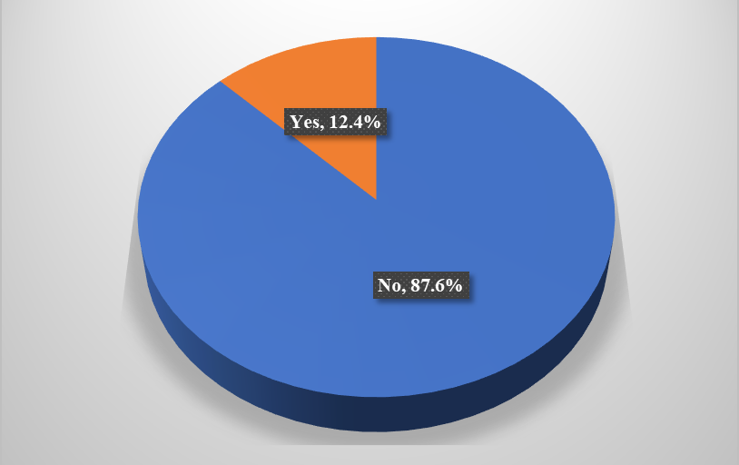
Figure 4.8: Responses on stigma for Supporting or Using Modern Contraceptives
Source: Field data, 2025

This suggests that although overt stigma is not widespread, a notable minority of men still encounter negative social reactions for their involvement in contraceptive use. Such stigma may arise from traditional gender expectations or misconceptions that associate contraceptive use with weakness, immorality, or deviation from masculine norms. These findings on stigma for supporting or using modern contraceptives are consistent with prior research, such as Tumwesigye et al. (2023), who reported that in Lira City, Uganda, most men did not experience negative social reactions for participating in contraceptive use or decision-making. Their study revealed that male contraceptive uptake was largely influenced by awareness and joint decision-making within couples, rather than by fear of community stigma.
Similarly, Anaman-Torgbor et al. (2025) in Ghana found that while fear of side effects and cost were key barriers to male acceptance of contraceptive use, overt stigma or ridicule for supporting family planning was reported by a minority of participants. The study noted that among men who supported contraceptive use by their partners, especially post-intercourse, the perception of stigma was low, particularly in communities with better access to reproductive health education.

Furthermore, Akinyemi et al. (2023) observed that although negative perceptions about contraception, such as it being a woman’s responsibility, persisted among Nigerian men, actual stigma for male involvement in family planning was less frequently reported. Their findings highlighted that the key challenges were related more to socio-cultural beliefs and misinformation rather than direct social sanction or stigma for participation.

Community Perceptions of Men who promote or use Contraceptives
The researcher investigated community perceptions of men who promote or use modern contraceptives. The findings (Table 4.10) indicated that the majority of respondents (80.9%) believed that such men are viewed positively within their communities. Meanwhile, 12.6% expressed neutral perceptions, and only 6.5% stated that these men are viewed negatively.

Table 4.10: Community Perceptions on Men who promote or use Contraceptives
Community perceptions | Frequencies | Percentages
Positive | 288 | 80.9
Neutral | 45 | 12.6
Negative | 23 | 6.5
Total | 356 | 100
Source: Field data, 2025

This finding suggests a growing level of community acceptance and support for male involvement in family planning, which may contribute to reducing stigma and encouraging greater male participation. The high rate of positive perceptions may reflect the impact of reproductive health education, awareness campaigns, and shifting gender norms that increasingly recognise men as partners in contraceptive decision-making.

These findings on community perceptions of men who promote or use contraceptives are consistent with prior research, such as Tumwesigye et al. (2023), who found that in Lira City, Uganda, a significant proportion of men who participated in contraceptive use were positively perceived within their communities, especially when decisions were made jointly with their partners. The study emphasised the importance of community awareness and education in fostering supportive attitudes toward male involvement in family planning.

Similarly, Kpegba-Fiaboe and Kotoh (2025) in Togo reported that men who actively used or supported the use of modern contraceptives were more likely to be seen as responsible and caring partners, particularly in communities where health education and partner communication were emphasised. Their study demonstrated that positive perceptions were associated with greater contraceptive use among men, especially those cohabiting or in committed relationships.

In addition, the study by Anaman-Torgbor et al. (2025) in Ghana observed that men who supported contraceptive use, especially those who facilitated access for their partners, were generally viewed favourably, particularly in urban areas where family planning programs were more prevalent. The findings indicated that positive social attitudes toward such men increased their willingness to engage in reproductive health decisions and encouraged broader male participation in contraceptive initiatives. Collectively, these studies affirm the present finding that most respondents viewed men who promote or use modern contraceptives positively within their communities, highlighting an encouraging shift in gender roles and societal acceptance of male participation in reproductive health.

In addition, the findings of the present study align well with the constructs of the Health Belief Model (HBM) (Rosenstock, 1974), particularly in relation to how cultural factors shape men’s attitudes toward modern contraceptive use. Cultural norms and beliefs such as traditional gender roles, religious expectations, and perceptions of masculinity play a central role in influencing the perceived barriers and benefits of contraceptive use among men. For instance, while the study found that a majority of respondents disagreed with the belief that contraceptive use challenges masculinity, a smaller but notable proportion expressed neutrality or agreement, suggesting lingering cultural scripts that associate contraception with diminished male dominance or control over fertility.

Traditional beliefs that assign family planning responsibility to women, as reported by over a quarter of respondents, illustrate how perceived social norms (a form of barrier in the HBM) may discourage men from engaging in or supporting contraceptive practices. Similarly, the finding that over half of participants said traditional roles "always" influence their family planning decisions highlights the influence of culturally constructed gender expectations on behaviour. These cultural influences often intersect with religious doctrines, as evidenced by the majority of respondents who stated their religion does not permit modern contraceptive use, further reinforcing barriers to uptake.

However, the study also revealed cues to action embedded in community perceptions, such as the overwhelmingly positive view of men who promote or use modern contraceptives, which can serve as a motivating factor for changing behaviours and challenging cultural norms. This suggests a potential shift in attitudes, particularly in communities where public discourse and outreach efforts present male involvement in family planning as acceptable or even commendable. Overall, the HBM effectively explains how cultural constructs of masculinity, tradition, and religion influence men's perceived barriers and benefits regarding contraceptive use.

Men’s Involvement in Decision Making Regarding Modern Contraceptive Use
The findings on men’s involvement in decision-making regarding modern contraceptive use include several key aspects that reflect the extent and nature of male participation in reproductive health matters. These include men’s attendance in family planning counselling sessions, joint discussions on family planning options with their partners, final decision makers regarding contraceptive use in the family, participation in targeted awareness campaigns specifically designed for men, attendance at family planning clinics alongside their partners, and advocacy by male community leaders encouraging the use of male contraceptive methods. These elements provide insight into how actively men engage in the decision-making process and how social structures and interventions influence their level of involvement in modern contraceptive use.

Men's Attendance in Family Planning Counselling Sessions
The respondents were asked whether they had ever attended family planning counselling sessions. The results (Figure 4.9) indicated that only 14.6% of the respondents reported having attended such sessions, while a significant majority (85.4%) had not participated in any form of family planning counselling.

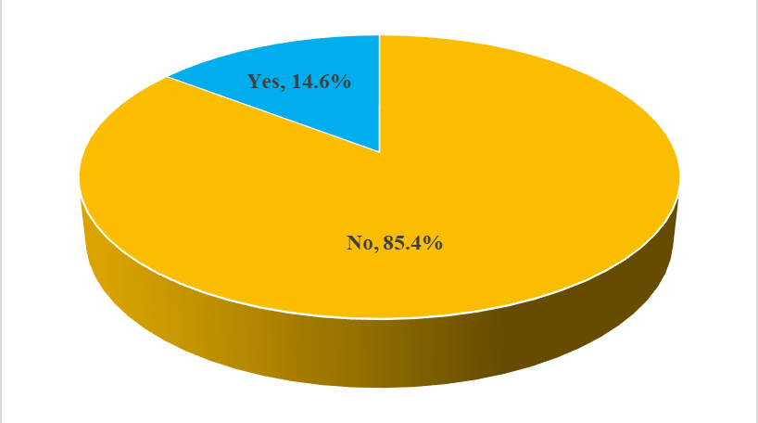
Figure 4.9: Response to Men’s Attendance at Family Planning Counselling Sessions
Source: Field data, 2025

This low level of male attendance of family planning counselling sessions reflects a broader pattern of limited male engagement in reproductive health services, often influenced by societal perceptions that family planning is primarily a woman’s domain. These findings on men's attendance in family planning counselling sessions are consistent with prior research, such as Amidei et al. (2023), who found that despite the availability of contraceptive options, participants reported significant knowledge gaps and misinformation, with few citing formal counselling or structured education as a source of information. Instead, many relied on informal sources such as family, partners, or general practitioners, underscoring the limited engagement with professional counselling services. Similarly, Fedrick (2020), in a study conducted in Chato District, Tanzania, reported a low family planning utilisation rate among men, partly attributed to poor access to counselling services and limited male-focused interventions. The study concluded that low attendance in family planning counselling and inadequate inclusion of men in such programs contributed to the overall low uptake of contraceptive use among males.

Additionally, Osuafor et al. (2023) also highlighted that in Southern African countries, male participation in family planning was significantly influenced by media exposure, education, and targeted outreach, suggesting that a lack of structured counselling sessions directly limits male involvement. Their findings stressed the importance of implementing community-based interventions and education initiatives specifically aimed at men to bridge these gaps. In Geltore et al. (2022), a study from Southern Ethiopia revealed that male participation in family planning was strongly associated with prior exposure to information, including counselling. It emphasised that awareness and understanding gained through structured communication channels were vital in increasing male involvement. Overall, the present study’s finding that only a few men had ever attended a counselling session aligns with this body of evidence, which collectively underscores the persistent gaps in male-oriented counselling and education services.

Men's Participation in Family Planning Counselling Sessions
The respondents were asked whether they believe men should participate in family planning counselling sessions. The results (Figure 4.10) indicated that a majority (91.9%) of respondents supported male participation in family planning counselling sessions, while only 8.1% expressed opposition to the belief.
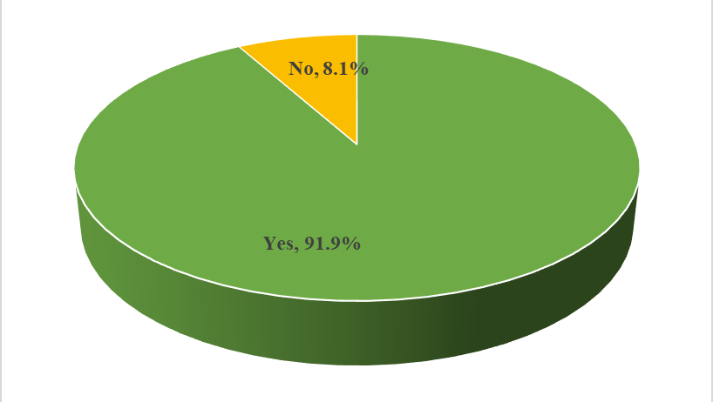
Figure 4.10: Response to Men's Participation in Family Planning Counselling Sessions
Source: Field data, 2025

This majority support for men’s participation in family planning counselling sessions reflects a growing recognition among men of the importance of shared responsibility in reproductive health matters. It also suggests a positive shift in attitudes toward male involvement in family planning, even though actual participation (as shown earlier) remains low. The discrepancy between belief and practice may be due to structural or cultural barriers, such as a lack of male-friendly services, social stigma, or limited access to counselling opportunities. These findings align with Amuzie et al. (2022), who found that men who supported joint decision-making and attended family planning counselling sessions were more likely to practice modern contraceptive use. Encouragingly, this strong endorsement presents an opportunity for policymakers and health practitioners to design inclusive interventions that build on men’s willingness to engage and address the practical barriers limiting their participation.

Frequency for Discussing Family Planning Options with Partners
The respondents were asked how often they discuss family planning options with their partners. The results (Table 4.11) showed that 55.6% of respondents reported they sometimes engage in such discussions, while 27.5% stated they always do. Meanwhile, 15.7% said they rarely discuss family planning with their partners, and only 1.1% reported they never have such discussions with their partners.

Table 4.11: Response on Frequency for Discussing Family Planning Options with Partners
Discussion on family planning options | Frequencies | Percentages
Always | 98 | 27.5
Sometimes | 198 | 55.6
Rarely | 56 | 15.7
Never | 4 | 1.1
Total | 356 | 100.0
Source: Field data, 2025

This result has the implication that although a majority of respondents are involved in some level of partner communication regarding family planning, consistent and open dialogue remains limited. The relatively low percentage of those who “always” engage in such discussions suggests that barriers such as cultural norms, lack of confidence, or limited knowledge may still hinder frequent communication. These findings on frequency for discussing family planning options with partners align with prior research, such as Mulatu et al. (2022), who found that in rural Eastern Ethiopia, spousal communication was a key determinant of male involvement in family planning.

The study reported that men who frequently discussed sexual and reproductive health matters with their partners were significantly more likely to be involved in contraceptive decision-making and use, highlighting the importance of dialogue in promoting shared responsibility. Similarly, Geltore et al. (2022) emphasised that open discussions between partners positively influenced men’s participation in family planning in Southern Ethiopia. Their findings showed that men who engaged in conversations with their spouses about contraceptive options were more informed and supportive, leading to higher rates of modern contraceptive use.

Furthermore, in a cross-sectional study by Butame (2019) using data from the 2014 Ghana Demographic and Health Survey, discussing family planning with a health worker and one’s partner was associated with increased use of modern contraceptives among men. The study concluded that such interpersonal communication plays a critical role in influencing men's decisions and promoting contraceptive uptake. Moreover, Osuafor et al. (2023) reported that male involvement in family planning in Southern African countries was significantly shaped by communication dynamics within couples. The study recommended the promotion of joint decision-making and couple-centred educational programs as a strategy to increase contraceptive use.

Joint Decision-Making about Family Planning Options with the Partner
The respondents were asked how often decisions about contraceptive use are made jointly with their partners. The findings (Table 4.12) revealed that only 16.9% reported that such decisions are always made jointly, while 36.0% stated that they are made sometimes. A substantial proportion (34.6%) indicated that joint decisions are made rarely, and 12.6% stated that they never make these decisions together.

Table 4.12: Response on the Frequency of Joint Decision Making about Family Planning Options with the Partner
Joint decision-making with partners | Frequencies | Percentages
Always | 60 | 16.9
Sometimes | 128 | 36.0
Rarely | 123 | 34.6
Never | 45 | 12.6
Total | 356 | 100.0
Source: Field data, 2025

These results have the implication that joint decision-making regarding family planning remains relatively low among couples, with the majority of respondents either making such decisions infrequently or not at all with their partners. This suggests the presence of gendered power dynamics, communication barriers, or limited male involvement in reproductive health discussions. The lack of consistent joint decision-making may hinder informed contraceptive choices and affect overall reproductive health outcomes. These findings on joint decision-making about family planning options with the partner align with prior research, such as Mulatu et al. (2022), who reported that in rural Eastern Ethiopia, spousal discussion and joint decision-making significantly influenced male involvement in family planning. Their study revealed that men who made contraceptive decisions jointly with their spouses were more likely to participate actively in family planning programs. Similarly, Osuafor et al. (2023), using data from Demographic and Health Surveys in Malawi and Tanzania, found that male involvement in family planning decisions was often limited, with only a modest proportion of men reporting regular joint decision-making with their partners. The study emphasised that cultural expectations and gender roles often restrict male participation, suggesting a need for targeted interventions to improve couple-based contraceptive planning.

Furthermore, in Uganda, Tumwesigye et al. (2023) found that joint contraceptive decision-making within couples was a significant predictor of male contraceptive uptake. Their community-based study in Lira City showed that men who discussed and agreed on family planning choices with their partners were more likely to use or support modern contraceptive methods. Additionally, Geltore et al. (2022) found that joint decision-making between spouses was strongly associated with increased male involvement in family planning in Durame Town, Southern Ethiopia. The study concluded that promoting mutual dialogue and decision-making enhances shared responsibility and improves contraceptive use outcomes. These findings collectively support the present study’s results, where only a minority always made joint decisions about contraceptive use. In contrast, the majority made such decisions either sometimes or rarely, indicating persistent gaps in collaborative reproductive health decision-making among couples.

Final Decision maker Regarding Modern Contraceptive use in the Family
The researcher investigated who in the family has the final say in decisions regarding contraceptive use. The results (Table 4.13) revealed that in the majority of households (71.9%), the husband was reported to have the final say regarding modern contraceptive use. In comparison, only 12.6% indicated that the wife made the final decision. About 14.3% of respondents reported that decisions were made jointly by both partners, and 1.1% identified other individuals (e.g., elders or extended family members) as the final decision-makers.

Table 4.13: Responses on Final Decision Makers Regarding Contraceptive Use in the Family
Final decision maker | Frequencies | Percentages
Husband | 256 | 71.9
Both equally | 51 | 14.3
Wife | 45 | 12.6
Other | 4 | 1.1
Total | 356 | 100.0
Source: Field data, 2025

These findings indicate that contraceptive decision-making remains highly male-dominated in many families, with limited participation from women or joint deliberation. These findings on the final decision-maker regarding modern contraceptive use in the family are in agreement with prior research, such as Ali et al. (2022), who found that reproductive health decisions, including contraceptive use, were predominantly male-dominated, with a majority of respondents reporting that husbands had the final say in such matters. This male-dominant pattern significantly influenced the low uptake of modern contraceptives, particularly in patriarchal communities. Similarly, Mejía-Guevara et al. (2021) highlighted how men’s attitudinal norms, such as the belief that contraception is solely a woman’s responsibility, translated into male-dominated decision-making. Despite women's empowerment indicators like education and employment, contraceptive use remained constrained in communities where men controlled reproductive decisions.

Further, in Ethiopia, Mulatu et al. (2022) found that in rural areas, male partners frequently assumed control over family planning decisions, often overriding joint consultation with their spouses. The study emphasised that male approval and decision-making authority were central to women’s ability to access and use modern contraceptives. Kpegba-Fiaboe and Kotoh (2025) in Togo also reported that male authority in reproductive health decisions was prevalent, particularly among cohabiting couples, where men often determined the use or non-use of contraceptives. The study found that joint decision-making was comparatively low, reflecting entrenched gender norms around male dominance in family matters. These findings affirm the results of the present study, which revealed that in most households, the husband had the final say in contraceptive decisions. In contrast, only a few families practised joint decision-making.

Participation in Family Planning Awareness Campaigns for Men
The respondents were asked whether they had participated in family planning awareness campaigns specifically targeting men. The results (Figure 4.11) indicate that a majority (71.6%) had participated in family planning awareness campaigns specifically targeting men, while 28.4% had not participated in such campaigns.

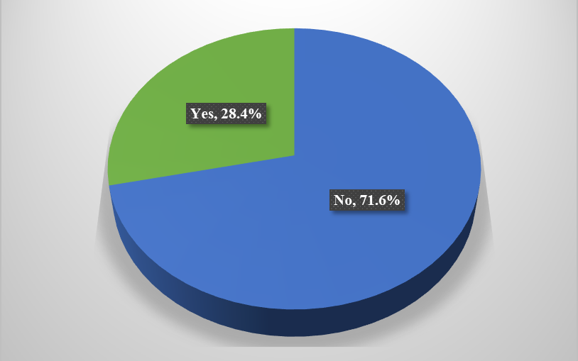
Figure 4.11: Response to Participation in Family Planning Awareness Campaigns for Men
Source: Field data, 2025

These results suggest that efforts to engage men in family planning through targeted awareness campaigns have achieved substantial reach among the population, potentially contributing to increased knowledge and involvement in reproductive health matters. However, the fact that over a quarter of respondents had not been reached indicates the need to expand such initiatives to ensure broader male participation, particularly in underserved or hard-to-reach areas.

These findings on participation in family planning awareness campaigns for men are in agreement with prior research, such as the study by Osuafor et al. (2023) in seven Southern African countries, which found that exposure to media and targeted awareness campaigns significantly influenced male participation in family planning decisions. The study noted that men who were exposed to family planning messages through media or community outreach were more likely to be involved in contraceptive discussions and decisions with their partners. Similarly, Tumwesigye et al. (2023) conducted a community-based cross-sectional study in Lira City, Uganda. They revealed that participation in family planning outreach programs targeting men was significantly associated with increased contraceptive uptake. Men who had attended awareness activities or engaged with health workers during community events showed a higher willingness to support or adopt male contraceptive methods.

Furthermore, Mulatu et al. (2022), in rural Eastern Ethiopia, also highlighted that participation in family planning awareness campaigns positively impacted male involvement. Their findings showed that men who were aware of or had been reached through community-based family planning programs were significantly more likely to support their partners’ contraceptive use and engage in joint decision-making.

In addition, Butame (2019), using data from the 2014 Ghana Demographic and Health Survey, found that discussing family planning with a health worker, a common component of targeted awareness campaigns, was one of the strongest predictors of modern contraceptive use among men. The study emphasised the need for male-specific education programs and outreach campaigns to increase awareness and break down misconceptions. These studies support the present findings, which show that a substantial proportion of respondents had participated in family planning awareness campaigns targeting men. This underscores the growing reach and impact of male-centred reproductive health education initiatives in influencing attitudes and promoting male involvement in family planning.

Male Involvement in Accompanying Partners to Family Planning Clinics
The respondents were asked whether they had ever accompanied their partner to a family planning clinic. The results (Figure 4.12) showed that 59.6% of men reported having done so, while 40.4% had not ever accompanied their partner to a family planning clinic.

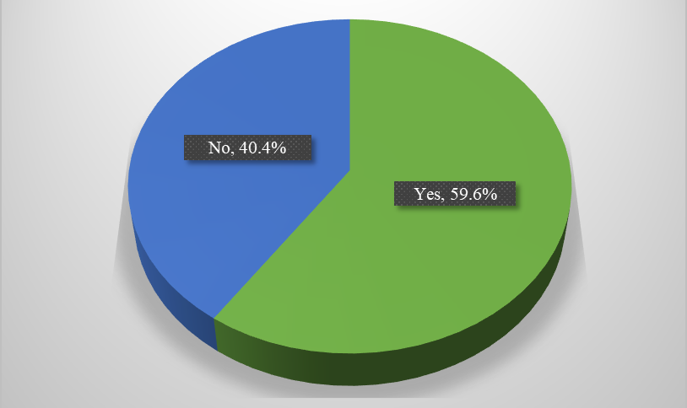
Figure 4.12: Response on Male Involvement in Accompanying Partners to Family Planning Clinics
Source: Field data, 2025

The Health Community Workers added that men who accompany their partners to family planning clinics are more likely to be supportive, better informed, and actively engaged in reproductive health decisions. They emphasised that such involvement helps build trust and improves communication between partners, ultimately leading to more effective and sustained use of contraceptive methods. However, the informants also noted that some men refrain from accompanying their partners due to cultural perceptions that family planning is a woman’s responsibility, fear of being judged by peers, or lack of male-friendly services at the clinics. One of the Health Community Workers emphasised:

“When men accompany their partners to family planning clinics, it strengthens communication and shared responsibility. But many still believe it's a woman’s issue, and some fear being judged by other men in the community” (Community Health Worker, Interview, June 2025).

These findings on male involvement in accompanying partners to family planning clinics align with prior research, such as Mulatu et al. (2022), who conducted a community-based cross-sectional study in rural Eastern Ethiopia and found that the majority of men were involved in family planning. A significant predictor of this involvement was whether the man had accompanied his partner to a health facility. Men who accompanied their spouses to family planning clinics were more likely to support contraceptive use and engage in joint reproductive health decision-making.

Similarly, Geltore et al. (2022), in their study in Durame Town, Southern Ethiopia, reported that men’s attendance at family planning clinics, either alone or with their partners, was strongly associated with higher levels of male participation in reproductive health matters. The study emphasised that clinic visits helped dispel myths, improved knowledge, and enhanced men’s acceptance of contraceptive use. In Msovela et al. (2020), a study conducted in Kibaha, Tanzania, involving married and cohabiting men, found that male involvement in family planning was significantly associated with having visited a family planning centre.

Furthermore, Osuafor et al. (2023), using data from multiple Southern African countries, highlighted that men's physical involvement, such as attending clinics with their spouses, was a crucial factor in increasing family planning uptake and reducing misinformation. They noted that such involvement reinforced shared responsibility and improved communication between partners. These studies corroborate the current findings, where the majority of respondents reported accompanying their partners to family planning clinics, suggesting a promising level of male involvement in reproductive health services in the study area.

Advocacy by Male Community Leaders for Male Contraceptive Use
The respondents were asked whether male community leaders in their area had advocated for contraceptive use. The results (Figure 4.13) revealed an almost even split, with 50.8% of respondents stating that male community leaders in their area had advocated for contraceptive use. In comparison, 49.2% said they had not advocated for it.

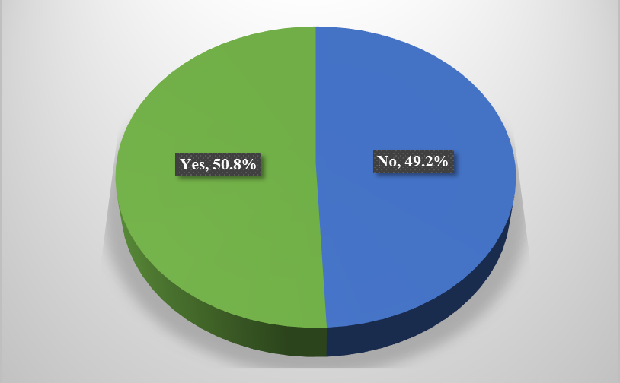
Figure 4.13: Response regarding Advocacy by Male Community Leaders for Contraceptive Use
Source: Field data, 2025

Further, the respondents were asked whether they believe male leaders can influence other men to engage in family planning. The results (Table 4.14) show that a majority of respondents expressed positive views, with 59.6% stating they strongly agree and 15.7% stating they agree, a combined 75.3% who believe in the potential influence of male leaders. Meanwhile, 3.4% remained neutral, while 5.9% disagreed, and 15.4% strongly disagreed with the belief that male leaders can influence other men to engage in family planning.

Table 4.14: Response on Male Leaders' influence for Men to engage in Family Planning
Male leaders influence other men to engage in family planning | Frequencies | Percentages
Strongly agree | 212 | 59.6
Agree | 56 | 15.7
Neutral | 12 | 3.4
Disagree | 21 | 5.9
Strongly disagree | 55 | 15.4
Total | 356 | 100.0
Source: Field data, 2025

The FGD participants added that male leaders can play a critical role in challenging the entrenched patriarchal system, which traditionally assigns family planning and reproductive health responsibilities mostly to women. In communities where patriarchal norms are dominant, men often wield decision-making power, and their engagement or lack thereof significantly affects household-level choices on contraception. Participants emphasised that when respected male leaders openly support family planning, it not only encourages dialogue among men but also helps dismantle cultural taboos and reshape perceptions about gender roles in reproductive health. One FGD participant informed:

“When a village chairperson or religious leader talks about family planning, more men start to listen. It changes how people think because it shows that family planning is not just for women” (FGD participant, June 2025).

These findings underscore the importance of leveraging male authority figures to challenge patriarchal dynamics and promote shared responsibility in family planning. Integrating male leaders into advocacy efforts could be key to increasing male participation and transforming reproductive health norms at the community level. These findings on advocacy by male community leaders for male contraceptive use align with prior research, such as Osuafor et al. (2023), who emphasised the pivotal role of male community leaders in influencing public attitudes toward family planning.

In contexts where male leaders actively advocated for contraceptive use, men were more likely to participate in family planning decisions and adopt modern contraceptive methods. The researchers concluded that leveraging the authority and influence of community leaders could help dismantle cultural barriers and normalise male involvement in reproductive health. Similarly, Kraft et al. (2022), in a study conducted in the Kigoma Region of Tanzania, noted that local male leaders who endorsed contraceptive use significantly contributed to increased awareness and acceptance of family planning practices. Their advocacy played a vital role in shaping community norms and encouraging couples, especially men, to access services and participate in family planning programs. In Mulatu et al. (2022), conducted in rural Eastern Ethiopia, the study highlighted that community-based initiatives led by respected male figures were essential for increasing male involvement. Men were more likely to engage in family planning when leaders within their communities publicly supported such practices and debunked misconceptions surrounding contraceptive use.

These studies reinforce the current findings, where about half of the respondents reported advocacy by male leaders, indicating a growing but still uneven pattern of leader involvement. In patriarchal-dominated societies, men are traditionally regarded as the primary decision-makers in households, particularly concerning matters like fertility, household size, and access to health services. Without active efforts to involve them through trusted figures such as village elders, religious leaders, or ward councillors, family planning initiatives often remain sidelined. Furthermore, engaging male leaders may also contribute to reducing stigma and reshaping masculinities, encouraging men to see involvement in reproductive health not as a threat to their authority but as an act of responsibility and partnership. When community leaders model equitable attitudes, it creates a ripple effect that legitimises male participation and gradually dismantles deeply rooted gender biases.

In the theoretical context, the findings of the present study align well with the constructs of the Health Belief Model (HBM). The HBM posits that individuals are more likely to engage in health-related behaviors such as contraceptive use when they perceive themselves to be susceptible to a health issue (perceived susceptibility), believe that the issue has serious consequences (perceived severity), believe that taking a particular action would reduce their susceptibility or the severity of the condition (perceived benefits), and perceive few barriers to taking that action (perceived barriers) (Rosenstock, 1974).

In this study, men’s involvement in family planning counselling, joint decision-making with partners, and participation in awareness campaigns reflects a growing recognition of the benefits of shared contraceptive responsibility and the reduced barriers to accessing accurate reproductive health information. Furthermore, the influence of community leaders advocating for male contraceptive use may serve as cues to action. At the same time, attendance at clinics with partners and participation in discussions may increase self-efficacy, empowering men to engage in reproductive health decisions actively. These patterns demonstrate how the HBM constructs are manifested in the behaviours and attitudes of male respondents toward modern contraceptive use.

CHAPTER FIVE

SUMMARY, CONCLUSION AND RECOMMENDATIONS

Chapter Overview
This chapter presents the summary of the key findings, the conclusion drawn from the study, and recommendations based on the results.

Summary of the Findings
5.2.1 Level of Awareness Regarding Modern Contraceptives used among Men in Tarime District
The findings on men's level of awareness regarding modern contraceptive use revealed that all respondents were familiar with condoms. In contrast, awareness of long-term male contraceptive methods such as vasectomy was notably lower. Media outlets such as radio, television, and newspapers emerged as the dominant sources of contraceptive information, followed by health facilities, community health workers, and social networks like friends or relatives. Pharmacies were identified as the primary points of access for contraceptives, followed by health facilities and community-based programs. When asked about perceived side effects of contraceptives, many respondents cited reduced sexual desire, mood changes, weight gain, and other physical discomforts. Overall, there was stronger confidence in the effectiveness of condoms compared to vasectomy.

5.2.2 Cultural Factors Influencing Men's Attitudes toward Modern Contraceptive use in Tarime District
Cultural factors were also found to play a significant role in shaping men’s attitudes toward modern contraceptive use. While a notable number of respondents believed that both men and women share equal responsibility in family planning, others still viewed it as either primarily a woman’s or a man’s responsibility. Traditional gender roles were reported to strongly influence men’s involvement in contraceptive decision-making strongly. Religious beliefs were also a barrier, with many respondents indicating that their faith does not permit the use of modern contraceptives. In terms of social perception, most respondents reported that men do not face stigma for supporting or using contraceptives, and that men who advocate for family planning are generally viewed positively in their communities.

5.2.3 Men’s Involvement in Decision Making Regarding Modern Contraceptive Use in Tarime District
Regarding male involvement in family planning, the findings showed widespread support for the idea that men should participate in counselling sessions. However, active involvement in decision-making and communication with partners varied, with most men engaging in such discussions occasionally or infrequently. Joint decision-making between partners was relatively low, with many respondents indicating that the husband typically has the final say in contraceptive matters. Participation in male-focused family planning awareness campaigns was fairly high, and a majority of men had accompanied their partners to clinics. Community leadership also emerged as an important influence, with about half of the respondents reporting that male leaders in their area had promoted family planning, and many expressing beliefs in the ability of such leaders to influence other men to become involved.

Conclusion
The study concludes that the level of awareness regarding modern contraceptive use among men in Tarime District is generally high, particularly concerning short-term methods such as condoms. However, awareness of long-term male contraceptive methods like vasectomy remains relatively low. The mass media are the most common source of information, while health facilities and community networks play secondary roles. Although men are well informed about where to access contraceptives, primarily pharmacies, there are persistent concerns about side effects, which may influence their willingness to use or support certain methods.

Cultural factors significantly influence men's attitudes toward modern contraceptive use in Tarime District. Traditional gender norms continue to affect men's perceptions, with some viewing family planning as primarily a woman’s responsibility. Although a portion of the population acknowledges shared responsibility, the influence of deeply rooted patriarchal roles remains evident. Religious beliefs further reinforce negative attitudes, as many men reported that their faith does not support contraceptive use. Despite this, community perception of men who promote or use contraceptives is largely positive, and experiences of stigma appear limited, indicating a gradual shift in social norms.

The study finds that while there is strong support for male involvement in family planning, particularly through counselling and awareness campaigns, actual involvement in decision-making remains limited. Men occasionally discuss family planning with their partners, but joint decision-making is not consistently practised. In most households, the final decision on contraceptive use tends to rest with the husband, suggesting a gender imbalance in decision-making power. Nonetheless, participation in awareness campaigns and clinic visits indicates a growing trend of male engagement, and the influence of male leaders presents a valuable opportunity for enhancing shared reproductive responsibility.

Recommendations

Recommendations to the Government
Strengthen male-focused family planning campaigns
The government should invest in expanding and institutionalising male-centred family planning awareness campaigns, particularly through mass media, community outreach, and health education programs. These campaigns should emphasise the shared responsibility of family planning, correct misconceptions about methods like vasectomy, and promote the benefits of joint decision-making.

Integrate male engagement strategies into national reproductive health policy.
The Ministry of Health, in collaboration with local government authorities, should incorporate targeted male engagement strategies into the implementation of the National Family Planning Costed Implementation Plan (NFPCIP). This should include training health workers on male-friendly service provision and creating safe spaces within health facilities where men feel welcomed and encouraged to participate.

Empower local and religious leaders to champion family planning
The government should partner with local and religious leaders to serve as advocates for male involvement in family planning. By leveraging their influence within patriarchal communities, these leaders can help shift public perceptions, challenge harmful gender norms, and promote more inclusive and supportive family planning environments.

Recommendations for Further Study
Future research should explore how specific religious teachings and leadership influence men’s attitudes and behaviours toward modern contraceptive use, especially in regions where faith-based beliefs strongly affect reproductive health decisions. Further, there is a need for longitudinal research to assess the long-term effectiveness of male-targeted family planning interventions such as counselling sessions, community campaigns, and leader advocacy on sustained contraceptive use and shared decision-making in households.

REFERENCES
Adane, B., Kefale, B., Damtie, Y., Arefaynie, M., Addisu, E., Dewau, R., Mitiku, K., Tsega, T. D., Andualem, A. A., Awoke, M., Asfaw, T., Wasihun, Y., & Yalew, M. (2024). Male involvement in family planning and its association with knowledge and spouse discussion in Ethiopia: a systematic review and meta-analysis. BMJ open, 14(4), e082094. https://doi.org/10.1136/bmjopen-2023-082094
Adanikin, A. I., McGrath, N., & Padmadas, S. S. (2017). Impact of men’s perception on family planning demand and uptake in Nigeria. Sexual & Reproductive Healthcare, 14, 55-63.
https://doi.org/10.1016/j.srhc.2017.10.002
Adelekan, A., Omoregie, P., & Edoni, E. (2014). Male involvement in family planning: Challenges and way forward. International Journal of Population Research. https://doi.org/10.1155/2014/416457
Afachung, O. A., Oluwasanu, M. M., & Akande, S. (2013). Men’s awareness, support, and uptake of modern family planning: A case study of Oyo State, Nigeria. Texila International Journal of Public Health, 12(3), Article 049. https://doi.org/10.21522/TIJPH.2013.12.03.Art049
Ahmed, J.M., Abrejo, F.G., Gul, X. et al. (2024). Men’s involvement in family planning programs: an exploratory study from Karachi, Pakistan. Reprod Health 21, 140 https://doi.org/10.1186/s12978-024-01875-1
Ajah, L.O., Dim, C.C., Ezegwui, H.U., Iyoke, C.A., Ugwu, E.O. (2015). Male partner involvement in female contraceptive choices in Nigeria. J Obstet Gynaecol. 2015;35(6):628–31.
Akinyemi, J. O., Salawu, M. M., Afolabi, R. F., & Adebowale, A. S. (2023). Nigerian men and modern contraceptives: Who are the non-users and what are their perceptions about family planning? Pan African Medical Journal, 46(64). https://doi.org/10.11604/ pamj.2023.46.64.37248
Ali, A., Zar, A., & Wadood, A. (2022). Factors associated with modern contraceptive use among men in Pakistan: Evidence from Pakistan demographic and health survey 2017-18. PLoS ONE 17(9): e0273907. https://doi.org/10.1371/ journal. Pone.0273907
Amidei, A., Raff, T., & DeMaria, A. L. (2023). We have to improve our culture about this: Family planning decision-making among women and men living in Florence, Italy. Health Behaviour Research, 6(3). https://doi.org/10.4148/2572-1836.1196
Anaman-Torgbor, J. A., Anaman, M. F. N. A., Kale, E. R., et al. (2025). Factors associated with male acceptance of modern contraceptive methods: A descriptive cross-sectional study in a peri-urban municipality. Contraception and Reproductive Medicine, 10(7). https://doi.org/10.1186/s40834-025-00338-7
Anbesu, E.W., Aychiluhm, S.B. & Kahsay, Z.H. (2022). Male involvement in family planning use and its determinants in Ethiopia: a systematic review and meta-analysis protocol. Syst Rev 11, 19 (2022). https://doi.org/10.1186/s13643-022-01891-x
Anderson, D. J., & Johnston, D. S. (2023). A brief history and prospects of contraception. Science (New York, N.Y.), 380(6641), 154–158. https://doi.org/10.1126/science.adf9341
Babbie, E. (2013). The practice of social research (13th ed.). Cengage Learning.
Balakrishnan, P., Kroiss, C., Keskes, T., & Friedrich, B. (2023). Perception and use of reversible contraceptive methods in Germany: A social listening analysis. Women's health (London, England), 19, 17455057221147390. https://doi.org/ 10.1177/ 17455057221147390
Becker, M. H., & Maiman, L. A. (1975). Socio-behavioural determinants of compliance with health and medical care recommendations. Medical Care, 13(10), 32-46.
Bryman, A. (2016). Social research methods (5th ed.). Oxford University Press.
Calhoun, L.M., Mirzoyants, A., Thuku, S. (2022). Perceptions of peer contraceptive use and its influence on contraceptive method use and choice among young women and men in Kenya: a quantitative cross-sectional study. Reprod Health 19, 16 (2022). https://doi.org/10.1186/s12978-022-01331-y
Champion, V. L., & Skinner, C. S. (2008). The Health Belief Model. In Health Behaviour and Health Education: Theory, Research, and Practice (4th ed., pp. 45-65). Jossey-Bass.
Creswell, J. W. (2014). Research design: Qualitative, quantitative, and mixed methods approaches (4th ed.). Sage Publications.
Creswell, J. W., & Plano-Clark, V. L. (2017). Designing and conducting mixed methods research (3rd ed.). Sage Publications.
Creswell, J. W., & Poth, C. N. (2018). Qualitative inquiry and research design: Choosing among five approaches (4th ed.). SAGE Publications.
D’Souza, P., Bailey, J. V., Stephenson, J., & Oliver, S. (2022). Factors influencing contraception choice and use globally: a synthesis of systematic reviews. The European Journal of Contraception &amp; Reproductive Health Care, 27(5), 364–372. https://doi.org/10.1080/13625187.2022.2096215
Demeke, H., Legese, N., & Nigussie, S. (2024). Modern contraceptive utilisation and its associated factors in East Africa: Findings from multi-country demographic and health surveys. PloS one, 19(1), e0297018. https://doi.org/10.1371/ journal. Pone. 0297018
Denzin, N. K., & Lincoln, Y. S. (Eds.). (2018). The SAGE handbook of qualitative research (5th ed.). SAGE Publications.
Diener, E., & Crandall, R. (1978). Ethics in social and behavioural research. University of Chicago Press.
Eborka, K., Akarawak, E. E. E., Owolabi, T. J., Chibuzor, E. F., & Adeleke, O. A. (2021). Examining males’ perceptions and concerns about adopting modern family planning methods in Delta State, Nigeria. African Journal of Reproductive Health / La Revue Africaine de La Santé Reproductive, 25(6), 68–75. https://www.jstor.org/stable/27233199
Ezeanolue, E.E., Iwelunmor, J., Asaolu, I. et al. (2015). Impact of male partner’s awareness and support for contraceptives on female intent to use contraceptives in southeast Nigeria. BMC Public Health 15, 879 (2015). https://doi.org/10.1186/s12889-015-2216-1
Fedrick, F. D. (2020). Factors Influencing Male Involvement in the Utilisation of Family Planning In Chato District, Geita Region, Tanzania. A Thesis Submitted In Fulfilment of The Requirements For The Degree of Doctor of Philosophy of The Open University Of Tanzania
Flick, U. (2018). An introduction to qualitative research (6th ed.). Sage Publications.
Gage, A. J. (1998). Women’s role in decision-making and its effect on contraceptive use in Kenya. International Family Planning Perspectives, 24(1), 28-34.
Geltore, T. E., & Lakew, Y. Y. (2022). Prevalence of male participation in modern contraceptive use among married men in Durame Town, Southern Ethiopia: a community-based cross-sectional study, 2021. The Pan African Medical Journal, 41, 307.
https://doi.org/10.11604/pamj.2022.41.307.32402
Gibbs, G. R. (2016). Analysing qualitative data (2nd ed.). Sage Publications.
Glanz, K., Rimer, B. K., & Viswanath, K. (2008). Health Behaviour and Health Education: Theory, Research, and Practice (4th ed.). John Wiley & Sons.
Gss, G.H. & Macro, I.C. (2023). Ghana demographic and health survey 2022. Ghana Statistical Service, Ghana Health Service, and ICF International; 2023.
Gupta, U. (2022). Understanding Patriarchal Ideology in Decision-Making on Induced Abortion in Jharkhand’s Korwa Tribe. The Oriental Anthropologist, 22(1), 51-66.
https://doi.org/10.1177/0972558X221095188
Hamdan-Mansour, A. M., Malkawi, A. O., Sato, T., Hamaideh, S. H., & Hanouneh, S. I. (2016). Men’s perceptions of and participation in family planning in Aqaba and Ma’an governorates, Jordan. Eastern Mediterranean Health Journal, 22(2).
Ijadunola, M. Y., Abiona, T. C., Ijadunola, K. T., Afolabi, O. T., Esimai, O. A., & Olaolorun, F. M. (2010). Male involvement in family planning decision-making in Ile-Ife, Osun State, Nigeria. African Journal of Reproductive Health, 14(4), 45–52.
Janz, N. K., & Becker, M. H. (1984). The Health Belief Model: A Decade Later. Health Education Quarterly, 11(1), 1-47.
Johnson, R. B., & Onwuegbuzie, A. J. (2004). Mixed methods research: A research paradigm whose time has come. Educational Researcher, 33(7), 14–26.
Jonas, K., Duby, Z., Maruping, K., Harries, J., & Mathews, C. (2022). Rumours, myths, and misperceptions as barriers to contraceptive use among adolescent girls and young women in South Africa. Frontiers in reproductive health, 4, 960089. https://doi.org/10.3389/frph.2022.960089
Kabagenyi, A., Reid, A., Ntozi, J. & Atuyambeet, L. (2016). Socio-cultural inhibitors to use of modern contraceptive techniques in rural Uganda: a qualitative study. Pan African Medical Journal. 2016;25:78. [doi: 10.11604/pamj.2016.25.78.6613]
Kaur, J., Rohini, D. V., Chang, L. C., Gugliotti, A., & Kretschmer, S. (2024). Assessment of demand for male contraceptives: A multi-country study. Andrology, 12(7), 1512-1524. https://doi.org/10.1111/andr.13726
Kibonire, R.A., Mphuthi, D.D. (2023). Perceptions of indigenous Ugandan men on the use of long-acting reversible contraceptives (LARCs) by rural women. Contracept Reprod Med 8, 50 (2023). https://doi.org/10.1186/s40834-023-00246-8
Koome, A. N., Gitonga, L. K., & Kiongo, J. (2023). Contraceptive knowledge among men and its influence on their participation in their partner’s modern contraceptive use in Dallas Sub-location, Embu County, Kenya. International Journal of Health Sciences and Research, 13(8), 8. https://doi.org/10.52403/ijhsr.20230802
Kpegba-Fiaboe, E. E., & Kotoh, A. M. (2025). Prevalence and determinants of male modern contraceptive use in Togo: A quantitative study in the maritime region. Department of Population, Family and Reproductive Health, School of Public Health, University of Ghana. https://doi.org/
Kraft, J. M., Serbanescu, F., Schmitz, M. M., Mwanshemele, Y., Ruiz C, A. G., Maro, G., & Chaote, P. (2022). Factors Associated with Contraceptive Use in Sub-Saharan Africa. Journal of women's health (2002), 31(3), 447–457. https://doi.org/10.1089/jwh.2020.8984
Leavy, P. (2017). Research Design: Quantitative, Qualitative, Mixed Methods, Arts-Based, and Community-Based Participatory Research Approaches. The Guilford Press, New York, London
Ling, J. E. S., & Tong, S. F. (2017). The roles of men in family planning–a study of married men at the UKM primary care clinic. Malaysian family physician: The Official Journal Of The Academy Of Family Physicians Of Malaysia, 12(1), 2.
Machinda, Z., Mbonile, M., & Mtae, H. (2020). Determinants of Male Involvement in Family Planning Services in Tarime District, Tanzania. Tanzania Journal for Population Studies and Development, 27(2), 93-108. https://doi.org/10.56279/tjpsd.v27i2.114
Marcell, A. V., Byrne, M. E., Yao-N'dry, N., Thiongo, M., Gichangi, P., OlaOlorun, F. M., Radloff, S., Anglewicz, P. A., & Tsui, A. O. (2022). Males’ awareness of female and male contraception methods, information, outreach, and acquisition locations in Abidjan, Côte d’Ivoire, Nairobi, Kenya, and Lagos, Nigeria. Journal of Adolescent Health, 71(3), 351–359. https://doi.org/10.1016/ j. jadohealth. 2022.03.013
Mejía-Guevara, I., Cislaghi, B., & Darmstadt, G. L. (2021). Men's Attitude Towards Contraception and Sexuality, Women's Empowerment, and Demand Satisfied for Family Planning in India. Frontiers in sociology, 6, 689980. https://doi.org/10.3389/fsoc.2021.689980
Mkwananzi, S. (2022). Contraceptive use and knowledge among youth in sub-Saharan Africa. Frontiers in Global Women's Health. https://doi.org/10.3389/fgwh.2022.880056
Morgan, D. L. (2007). Paradigms lost and pragmatism regained: Methodological implications of combining qualitative and quantitative methods. Journal of Mixed Methods Research, 1(1), 48–76.
Msovela, J., Tengia Kessy, A., Rumisha, S.F. (2020). Male partner approval on the use of modern contraceptive methods: factors determining usage among couples in Kibaha district, Tanzania. Contracept Reprod Med 5, 3 (2020). https://doi.org/10.1186/s40834-020-00107-8
Mtae, H.G. (2018). Fertility preferences in Tanzania. In Assessment of Determinants of Couples’ Decisions on Fertility Preferences in Kishapu and Mvomero District, Tanzania; The Open University of Tanzania: Dar es Salaam, Tanzania, 2018.
Mulamba, K.C. (2023). The role of male partners in modern contraceptive use by women in South Africa: Does space also matter? J Pop Research 40, 6 (2023). https://doi.org/10.1007/s12546-023-09297-9
Mulatu, T., Sintayehu, Y., Dessie, Y., & Dheresa, M. (2022). Male involvement in family planning use and associated factors among currently married men in rural Eastern Ethiopia. SAGE open medicine, 10, 20503121221094178. https://doi.org/ 10.1177/20503121221094178
Naidoo, Y., Joubert, L., Nhakaniso, K., Nzeribe, E., Akinsolu, F. T., Okova, D., Chiwire, P., & Lukwa, A. T. (2024). Socioeconomic determinants of male contraceptive use in South Africa: a secondary analysis of the 2016 SADHS data. BMC Public Health, 24(1), 2756. https://doi.org/10.1186/s12889-024-20295-1
Neuman, W. L. (2014). Social research methods: Qualitative and quantitative approaches (7th ed.). Pearson.
Ochako, R., Temmerman, M., Mbondo, M., Askew, I. (2017). Determinants of modern contraceptive use among sexually active men in Kenya. Reproductive Health, 14(56), 1-15.
Oni, T.O., Petlele, R., Banjo, O.O. et al. (2024). Measurement and conceptualisation of male involvement in family planning: a bibliometric analysis of Africa-based studies. Contracept Reprod Med 9, 29. https://doi.org/10.1186/s40834-024-00293-9
Osuafor, G. N., Akokuwebe, M. E., & Idemudia, E. S. (2023). Family planning decision-making among young males in Southern Africa. African Journal of Reproductive Health, 27(10), 16–35. https://www.jstor.org/stable/27274993
Osuafor, G. N., Akokuwebe, M. E., & Idemudia, E. S. (2023). Male Involvement in Family Planning Decisions in Malawi and Tanzania: What Are the Determinants? International journal of environmental research and public health, 20(6), 5053. https://doi.org/10.3390/ijerph20065053
Polit, D. F., & Beck, C. T. (2017). Nursing research: Generating and assessing evidence for nursing practice (10th ed.). Wolters Kluwer.
Radzuma, N.D., Marincowitz, G.J.O. & Marincowitz, C. (2022). Male attitudes towards family planning in the Limpopo province of South Africa. South African Family Pract. 2022;64:5587.
Rahayu, S., Romadlona, N.A., Utomo, B. et al. (2023). Reassessing the level and implications of male involvement in family planning in Indonesia. BMC Women's Health 23, 220 https://doi.org/10.1186/s12905-023-02354-8
Rosenstock, I. M. (1974). Historical origins of the Health Belief Model. Health Education Monographs, 2(4), 328-335.
Rosenstock, I. M., Strecher, V. J., & Becker, M. H. (1988). Social learning theory and the Health Belief Model. Health Education Quarterly, 15(2), 175-183.
Roudsari, R.L., sharifi, F. & Goudarzi, F. (2023). Barriers to the participation of men in reproductive health care: a systematic review and meta-synthesis. BMC Public Health 23, 818 (2023). https://doi.org/10.1186/s12889-023-15692-x
Sait, M., Ajarbou, A., Almannie, R., Binsaleh, S. (2021). Knowledge, attitudes, and perception patterns of contraception methods. Urol. Ann. 2021, 13, 243–253.
Saunders, M., Lewis, P., & Thornhill, A. (2019). Research methods for business students (8th ed.). Pearson.
Sekaran, U., & Bougie, R. (2016). Research methods for business: A skill-building approach (7th ed.). Wiley.
Takyi, A., Sato, M., Adjabeng, M. (2023). Factors that influence modern contraceptive use among women aged 35 to 49 years and their male partners in Gomoa West District, Ghana: a qualitative study. Trop Med Health 51, 40 (2023). https://doi.org/10.1186/s41182-023-00531-x
Tanzania Ministry of Health, Community Development, Gender, Elderly, and Children. (2017). National Family Planning Costed Implementation Plan 2017–2022. Ministry of Health, Community Development, Gender, Elderly, and Children, United Republic of Tanzania.
Tashakkori, A., & Teddlie, C. (2010). SAGE handbook of mixed methods in social & behavioural research (2nd ed.). Sage Publications.
Thummalachetty, N., Mathur, S., Mullinax, M., DeCosta, K., Nakyanjo, N., Lutalo, T., Brahmbhatt, H., & Santelli, J. S. (2017). Contraceptive knowledge, perceptions, and concerns among men in Uganda. BMC Public Health, 17(1), 792. https://doi.org/10.1186/s12889-017-4815-5
Tumwesigye, R., Kigongo, E., Nakiganga, S., Mbyariyehe, G., Nabeshya, J., Kabunga, A., Musinguzi, M., & Migisha, R. (2023). Uptake and associated factors of male contraceptive method use: A community-based cross-sectional study in Northern Uganda. Open Access Journal of Contraception, 14, 129–137. https://doi.org/10.2147/OAJC.S418820
United Nations (UN) (2024). Family Planning Indicators: Estimates and Projections of Family Planning Indicators 2024. United Nations. 2024. https://www.un.org/development/desa/pd/data/family-planningindicators. Accessed 24 October 2024.
United Nations Population Fund (UNFPA) (2022). Expanding Choices Ensuring Rights in a diverse and changing world: UNFPA Strategy for Family Planning 2022–2030. NewYork; 2022.
United Nations Population Fund (UNFPA) (2023). Men’s Participation in Family Planning & Reproductive Health: Learnings and Opportunities for India. B-28, Qutab Institutional Area, New Delhi – 110016. https://india.unfpa.org/sites/default/files/pub-pdf/brief3_-_mens_ participation_in_fp_and_rh.pdf
United Nations Population Fund (UNFPA) (2020). State of World Population 2020: Against My Will. https://www.unfpa.org/press/confronting-silent-and-endemic-crisis-harmful-practices
United Nations Population Fund (UNFPA) (2019). Family planning: A fundamental human right. UNFPA. https://www.unfpa.org/family-planning
Vouking, M. Z., Evina, C. D., & Tadenfok, C. N. (2014). Male involvement in family planning decision making in sub-Saharan Africa- what the evidence suggests. The Pan African Medical Journal, 19, 349. https://doi.org/10.11604/pamj.2014.19.349.5090
Wang, C., Swerdloff, R. S., & Nieschlag, E. (2024). Hormonal male contraception. Andrology, 12(7), 1234–1245. https://doi.org/10.1111/andr.13699
WHO (2022a). World Family Planning 2022: Meeting the changing needs for family planning: Contraceptive use by age and method, Department of Economic and Social Affairs, United Nations, New York, 2022
WHO (2022b). WHO Updates Recommendations to Guide Family Planning Decisions. WHO. 2022. Available online:
https://www.who.int/news/item/15-11-2022-who-updates-recommendations-to-guide-family-planning-decisions.

APPENDICES
Appendix 1: Questionnaire for the Study
EXPLORING MEN'S PERCEPTIONS OF MODERN CONTRACEPTIVE USE IN TARIME DISTRICT, TANZANIA
Introduction
My name is Rashidi Maulidi, and I am pursuing a Master of Social Work at the Open University of Tanzania. The main objective of my study is to explore men's perceptions of modern contraceptive use in Tarime District, Tanzania. This project research is for partial fulfilment of the requirements for the above-mentioned degree programme. We kindly request you to fill in this questionnaire honestly and to the best of your knowledge.
SECTION A: RESPONDENT’S DEMOGRAPHIC INFORMATION (Put a tick (√) where applicable)
- Study village of the respondent:
- Ganyange
- Borega "A"
- Nyakalima
- Age of respondent (in years):
- 18-25
- 26-35
- 36-45
- 46-60
- Above 60
- Education level of respondent:
- Primary education
- Secondary education
- College
- Bachelor Degree
- Postgraduate
- Marital status of respondent:
- Single
- Married
- Divorced
- Widow
- Respondent’s main occupation
- Farming
- Pastoralist
- Agro-pastoralist
- Business
- Employee
- Student
- Others (specify)
SECTION B: LEVEL OF AWARENESS REGARDING MODERN CONTRACEPTIVES
- Which contraceptive methods do you know? (Select all that apply.)
- Condoms
- Vasectomy
- Other (Specify) ……………
- Where do you get information about contraceptives? (Select all that apply.)
- Health centres/clinics
- Community health workers
- Media (radio, TV, newspapers)
- Friends/relatives
- Other (Specify)…………..
- How effective do you believe the following contraceptive methods are?
Type of modern contraceptives | Very effective | Effective | Not effective
- Condoms
- Vasectomy
- Others
- Are you aware of where to access contraceptives in your area?
- Yes
- No
If yes, where?
- Hospitals/health centres
- Pharmacies
- Community health programs
- Other (Specify
- Are you aware of any side effects of modern contraceptives?
- Yes
- No
If yes, where?
- Weight gain
- Mood changes
- Reduced sexual desire
- Other (Specify)

SECTION C: CULTURAL FACTORS INFLUENCING MEN’S ATTITUDES TOWARD MODERN CONTRACEPTIVE USE
- Who is traditionally expected to take responsibility for family planning in your community?
- Men
- Women
- Both equally
- Other (Specify)…………..
- Do you believe that family planning is primarily a woman’s responsibility in your culture?
- Yes
- No
- How often do traditional roles impact your involvement in family planning decisions?
- Always
- Sometimes
- Rarely
- Never
- Does your religion permit the use of modern contraceptives?
- Yes
- No
- Unsure
- What specific religious beliefs or practices in your community discourage contraceptive use?
……………………………………………………………………………………………………………………………………………………………………………………Who in your family has the final say in decisions regarding contraceptive use?
- Husband
- Wife
- Both equally
- Other (Specify)
- In your community, do men face criticism or judgment for participating in family planning?
- Yes
- No
- Do you agree with the belief that contraceptive use challenges a man's masculinity?
- Strongly agree
- Agree
- Neutral
- Disagree
- Strongly disagree
- Have you ever faced stigma for supporting or using modern contraceptives?
- Yes
- No
- How does the community perceive men who promote or use contraceptives?
- Positively
- Neutral
- Negatively
SECTION D: MEN’S INVOLVEMENT IN DECISION-MAKING REGARDING MODERN CONTRACEPTIVE USE
- Have you attended family planning counselling sessions?
- Yes
- No
- Do you think men should participate in family planning counselling sessions?
- Yes
- No
- Do you discuss family planning options with your partner?
- Always
- Sometimes
- Rarely
- Never
- How often are decisions about contraceptive use made jointly with your partner?
- Always
- Sometimes
- Rarely
- Never
- Have you participated in family planning awareness campaigns targeting men?
- Yes
- No
- Have you accompanied your partner to a family planning clinic?
- Yes
- No
If yes, how was your experience?
……………………………………………………………………………………………………………………………………………………………………………………
- Have male community leaders in your area advocated for contraceptive use?
- Yes
- No
- Do you think male leaders can influence other men to engage in family planning?
- Strongly agree
- Agree
- Neutral
- Disagree
- Strongly disagree

***THANK YOU FOR YOUR PARTICIPATION***
Appendix 2: Interview Guide
- What do you know about modern contraceptive methods? Can you name any?
- Where do you or other men in your community typically get information about modern contraceptives?
- How effective do you think the available contraceptive methods are in preventing pregnancy?
- Are you aware of where modern contraceptives can be accessed in this area?
- What is your understanding of the potential side effects of modern contraceptives?
- Do you think men in your community are generally well-informed about modern contraceptives? Why or why not?
- In your culture, who is traditionally responsible for family planning decisions? Why?
- How do religious teachings in your community influence attitudes toward contraceptive use?
- Are there any specific religious beliefs or practices that discourage men from supporting contraceptive use?
- How do patriarchal family structures influence men’s involvement in family planning?
- Do you think there is stigma or criticism toward men who actively participate in family planning? Why?
- How does the concept of masculinity in your community influence men’s attitudes toward contraceptive use?
- How often do you discuss family planning options with your partner?
- Are you aware of any family planning awareness campaigns targeting men in your community?
- How effective do you think these campaigns are in changing men’s attitudes and involvement?
- Have you ever accompanied your partner to a family planning clinic? If yes, what was your experience?
- What barriers prevent men from attending family planning clinics with their partners?
- In your opinion, what could be done to increase men’s awareness and involvement in family planning?

Appendix 3: FGD Guide
- What do you understand by the term "modern contraceptives"?
- Can you name some of the modern contraceptive methods commonly used in this community?
- Where do people in your community typically get information about modern contraceptives?
- How reliable do you think the sources of information about contraceptives are?
- What are some misconceptions or myths about modern contraceptives in this community?
- How do men in this community perceive the effectiveness and side effects of modern contraceptives?
- What are the traditional gender roles in your community regarding family planning and decision-making?
- How do cultural expectations or norms affect men's attitudes toward contraceptive use?
- Are there religious teachings or beliefs in your community that influence attitudes toward contraceptives?
- How do patriarchal family structures impact men's participation in family planning?
- Do men in this community face stigma or criticism for supporting or using contraceptives? If yes, why?
- How does masculinity in this community shape men’s attitudes and behaviours toward family planning?
- How often do men and women in this community discuss family planning together?
- What role do men currently play in decision-making about family planning in your community?
- Have you noticed any family planning campaigns specifically targeting men? How effective do you think they are?
- What barriers prevent men from accompanying their partners to family planning clinics?
- In what ways can male community leaders advocate for increased contraceptive use among men?
- What strategies do you think would increase men’s involvement in family planning discussions and decisions?

Appendix 4: Research Clearance
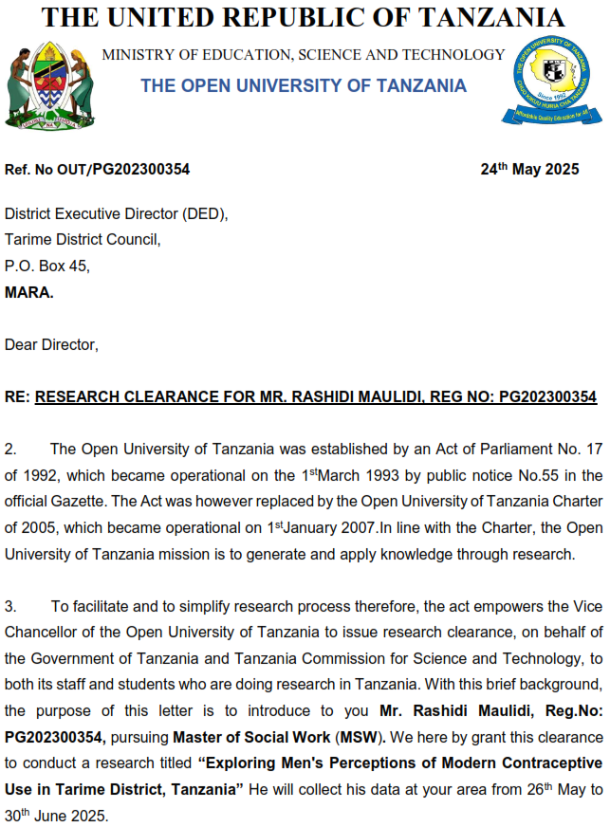



Appendix 5: Research Permit


