BAMBOO VARIETIES UTILIZATION FOR INCOME OF WOMEN IN RUNGWE DISTRICT, MBEYA REGION

DONALD D. KIBHUTI

A DISSERTATION SUBMITTED IN PARTIAL FULFILLMENT
OF THE REQUIREMENTS FOR THE DEGREE OF MASTER OF ARTS IN NATURAL RESOURCES, ASSESSMENT AND MANAGEMENT
DEPARTMENT OF GEOGRAPHY, TOURISM, AND HOSPITALITY STUDIES
OF THE OPEN UNIVERSITY OF TANZANIA
2025
CERTIFICATION
The undersigned certifies that, they have read and hereby recommends for acceptance by the Open University of Tanzania a dissertation titled: “Bamboo Varieties Utilization for Income of Women in Rungwe Districts, Mbeya Region”, in partial fulfilment of the requirements for the Degree of Master of Arts in Natural Resources, Assessment and Management (MANRAM).

…………………….………………
Dr. Cosmas Haule
(Supervisor)

…………………..…………
Date

………………….………………
Dr. Reguly Mushy
(Supervisor)

………………..……………
Date

COPYRIGHT
None of the content in this dissertation may be reproduced, stored in a retrieval system, or transmitted in any form in any manner, electronic, mechanical, or on photocopying, recording, or any other by means whatsoever without the prior permission of the author or the Open University of Tanzania on his behalf

DECLARATION
I, Donald Dickson Kibhuti, declare that the work presented in this dissertation is original and it has never been presented to any other University or Institution. Where other people’s works have been used, references have been provided. It is in this regard that I declare this work as originally mine. It is hereby presented in partial fulfilment of the requirements for the Degree of Master of Arts in Natural Resources, Assessment and Management.

………………………….
Signature

…………………..…….
Date

DEDICATION
This work is dedicated to my beloved friend Jayaraman Durai who laid the foundation of my masters’ education.

ACKNOWLEDGEMENTS
First and foremost, I would like to thank the Almighty God for his blessings and guidance throughout the period of the study. Thanks to my supervisors Dr. Cosmas Haule and Dr. Reguly Mushy for their scholarly advice, support and exhaustive supervision throughout the course of this study. They taught me more than I could ever give them credit for here. Had given me by example what a good Field Study dissertation should be.

My sincere gratitude is extended to all academic staff in the Department of Geography for their valuable suggestions and supervision during the entire study period. Many thanks to my classmates and colleagues at the Course of Management of Natural Varieties and Assessment for their love and cooperation.

Special appreciations go to my beloved family. Most importantly, I wish to thank my wonderful wife, Theresia V. Mlingi, and our children, Joshua, Aviela, Dorcas, and Zoe, who provide unending inspiration.

ABSTRACT
The study assessed the utilization of various bamboo species as a means for women to generate income through economic activities. A sequential explanatory design was employed to collect and analyze data. Data were gathered at a specific point in time using a cross-sectional study design as a sub-design, which was relatively quick and cost-effective for a field-based survey. Systematic random sampling was utilized to obtain a total sample size of 200 individuals residing in five villages, which were identified as the main locations for bamboo varieties in the district. Data collection methods included questionnaires, key informant interviews, focus group discussions, and observations. The study identified Yushania alpine, Oxythenanthera abyssinica, and Bambusa vulgaris as the primary bamboo species used by women in the area. The key bamboo products manufactured were handicrafts and furniture. Specifically, handcrafted items included dustbins, baskets, and trays, while furniture items comprised stools, tables, and sofa sets. The findings revealed that the utilization of bamboo varieties contributed to 15.1% of women's income in the study area. Additionally, the average monthly income generated from bamboo resources was 100,000 shillings per woman. The outcomes of the study are significant for understanding theories related to natural resource utilization and the Sustainable Livelihood Framework (SLF) which explains resource use as a function of economic growth. Consequently promoting bamboo knowledge and practising to include bamboo entrepreneurship, processing skills, formulation and implementation of policies that encourage bamboo resources and supporting women economic participation in bamboo economic activities for income generation.
Keywords: Bamboo, Bamboo diversity, Women’s empowerment, Livelihoods
TABLE OF CONTENTS
CERTIFICATION ii
COPYRIGHT iii
DECLARATION iv
DEDICATION v
ACKNOWLEDGEMENTS vi
ABSTRACT vii
LIST OF TABLES xiii
LIST OF FIGURE xiv
LIST OF PLATES xv
LIST OF ABBREVIATIONS xvii
CHAPTER ONE 1
INTRODUCTION 1
1.1 Overview 1
1.2 Background to the Study 1
1.3 Statement of the Research Problem 4
1.4 Objectives 5
1.4.1 General Objective 5
1.4.2 Specific Objectives 5
1.5 Research Questions 6
1.6 Justification of the Study 6
1.7 Significance of the Study 6
1.8 Limitations 7
1.9 Scope of the Study 8
1.10 Organization of the Dissertation 8
CHAPTER TWO 9
LITERATURE REVIEW 9
2.1 Introduction 9
2.2 Definition of Key Terms 9
2.2.1 Bamboo 9
2.2.2 Resource 10
2.2.3 Income 11
2.3 Theoretical Frameworks Review 11
2.3.1 Natural Varieties and Economic Growth Model 11
2.3.2 Sustainable Livelihoods Framework (SLF) 15
2.4 Empirical Literature Review 18
2.4.1 Bamboo Varieties Existing/Available in Rural Areas 18
2.4.2 Bamboo Products, Traded by Women in Rural Areas 20
2.4.3 Proportion of Income Earned to Women from Sale of Bamboo
Products 22
2.5 Research Gap 24
2.6 The Conceptual Framework 25
CHAPTER THREE 27
RESEARCH METHODOLOGY 27
3.1 Introduction 27
3.2 Description of the Study Area 27
3.2.1 Population and Area 28
3.2.2 Climate 28
3.2.3 Vegetation 28
3.2.4 Economic Activities 28
3.3 Research Approach 30
3.4 Research Design 31
3.5 Sampling Procedures 31
3.6 Data Collection Methods 32
3.6.1 Sources of Data 32
3.7 Data Collection Instruments 33
3.7.1 Questionnaires/Surveys 33
3.7.2 Interview 33
3.7.3 Observation 34
3.7.4 Focus Groups Discussion 34
3.7.5 Key Informants Interviews 35
3.7.6 Document and Record Reviews 35
3.8 Validity 35
3.8.1 Clear Research Design 35
3.8.2 Reliable and Valid Data Collection Instruments 35
3.8.3 Representation of the Population 36
3.8.4 Data Triangulation 36
3.9 Data Analysis 36
3.9.1 Quantitative data 36
3.9.2 Qualitative data 37
3.10 Ethical Consideration 37
CHAPTER FOUR 38
RESULTS AND DISCUSSION 38
4.1 Introduction 38
4.2 Social-economic characteristics of the Respondents 38
4.2.1 Age of the Respondents 38
4.2.2 Sex of the Respondents 38
4.2.3 Marital Status of the Respondents 39
4.2.4 Level of Education of the Respondents 40
4.2.5 Occupation of the Respondents 41
4.3 Assessment of the Bamboo Existing in the Study Area 42
4.3.1 Yushania Alpine 45
4.3.2 Lowland Bamboo (Oxytenanthera Abyssinica (sny. braunii)) 47
4.3.3 Bambusa Vulgaris (Green and Yellow with Green Strips Bamboo) 49
4.4 Examination of Bamboo Products Traded by Women in Rural Areas 50
4.4.1 Bamboo Wine 53
4.4.2 Furniture 55
4.4.3 Handcrafts 57
4.4.4 Firewood and Charcoal 59
4.4.5 Construction Materials 61
4.5 Bamboo Products Traded 61
4.5.1 Dustbin 62
4.5.2 Bamboo Wine 63
4.5.3 Basket 65
4.5.4 Ceiling Board 67
4.5.5 Chair 67
4.5.6 Table 67
4.5.7 Curtains 68
4.5.8 Ear Rings and Rings 68
4.5.9 Jug or Cups 69
4.5.10 Sofa Set 69
4.5.11 Stool 70
4.5.12 Table Mat Set 71
4.5.13 Winnower 72
4.6 Proportion of Income Earned by Women from Bamboo Products 73
CHAPTER FIVE 76
SUMMARY, CONCLUSION AND RECOMMENDATIONS 76
5.1 Summary of Major Findings 76
5.2 Conclusion 77
5.3 Recommendations 79
5.3.1 Local Government 79
5.3.2 National Institutions (Ministry of Trade and Industry, Ministry
of Tourism and Natural Resources and Small and Medium
Enterprises Development Authorities) 80
5.3.3 Non-Governmental Organizations (NGOs) and Financial Institutions 80
5.4 Recommendations for Further Studies 81
REFERENCES 82
APPENDICES 86

LIST OF TABLES
Table 4.1: Respondent’s Distribution by Age 38
Table 4.2: Respondent’s Distribution by Sex 39
Table 4.3: Respondent’s Distribution by Marital Status 40
Table 4.4: Respondents Distribution by Level of Education 41
Table 4.5: Respondents Distribution by Occupation 42
Table 4.6: List of Bamboo in Rungwe Districts 45
Table 4.7: List of Bamboo Products Processed and Produced by
Women in Rungwe Districts 53
Table 4.8: List of Bamboo Products Traded in the Study Area 62
Table 4.9: Source of Income of Women in Study Area 73
Table 4.10: Average Income Received by Women from Bamboo Activities
per Months 74

LIST OF FIGURE
Figure 3.1: Map of Rungwe District Showing Villages involved in the Study 30

LIST OF PLATES
Plate 4.1: Isongole Women Group Members at Kiwila Forest,
Harvesting Arundinaria Alpine Bamboo 47
Plate 4.2: Lowland Bamboo (Oxytenanthera Abyssinica) at Different
Stages of Utilization, Observed at Household Farm, Ndanto
Village 48
Plate 4.3: Bambusa Vulgaris Observed at Unyamwanga, Isongole Village 50
Plate 4.4: Bamboo Wine Harvesting Process Observed at Ndaga,
Ndanto Village: (left) Harvester Cutting Young Shoot with
sharp Knife Ready for Collecting Wine, (centre) is Bamboo
with Mbeta (cup) Collecting Bamboo Wine and (right) is
Bamboo Wine Collected on Jug Made by Glass Ready for
Drinking 55
Plate 4.5: Bamboo Furniture Made by Isongole Women Bamboo Group 57
Plate 4.6: Member of Mbeya Women Bamboo Group, Making
Bamboo Handcrafts and Finished Product at Show Room 59
Plate 4.7: Bamboo for Firewood and Charcoal Making (upper, left)
Bamboo Collected for Charcoal and Firewood Use
(upper right) Bamboo Charcoal Dome Kiln Making Bamboo
Charcoal and (bottom) Bamboo Charcoal Made from Drum
Processed by WODGRA Briquette Company 60
Plate 4.8: Bamboo House (upper) and Fenced Area (bellow) built by
Household in Kyimo Village 61
Plate 4.9: Bamboo Dustbins Made by Isongole Women Group 63
Plate 4.10: Tapped Bamboo Wine in Glass Bottle by Household at
Kinyala Village 64
Plate 4.11: Bamboo Baskets made by Household at Unyamwanga,
Isongole Village 66
Plate 4.12: Bamboo Chairs made by Isongole Women Group 70
Plate 4.13: Bamboos Stools Made by Isongole Women Group 71
Plate 4.14: Bamboos Table Mats Found at Kiwila Market 72
Plate 4.15: Winnower Found at Kiwila Market 73

LIST OF ABBREVIATIONS
CATI Computer-assisted Telephone Interview
FAO Food and Agriculture Organization
FGD Focus Group Discussion
GDP Gross Domestic Product
INBAR International Network for Bamboo and Rattan
NGOs Non-government Organization
NTFPs Non-timber Forest Products
PRA Participatory Rural Appraisal
UNCED United Nations Conference on Environment and Development
UNEP-WCMC United Nation Environment World Conservation Monitoring Centre
WCED World Commission on Environment and Development
WHO World Health Organization

CHAPTER ONE

INTRODUCTION

1.1 Overview
This chapter presents the background of the study, statement of the research problem, and research objective: The general objective and the specific objectives. It also presents the significance, limitations and the scope of the study and ends by presenting the organization of the dissertation.

1.2 Background to the Study
Globally, bamboo forests cover about 36 million ha with a large part (24 million hectares) located in sixteen Asian countries. Ten American countries account for over 10 million hectares and the remaining 2.8 million hectares are found in five African countries (Scheba et al., 2017). This ancient woody grass is widely found in tropical, subtropical, and mild temperate zones of the world. It is a tremendously diverse plant, which can adapt to any extreme climatic and soil conditions. There are about 90 genera and about 1200 species of bamboo found in the world (Hossain et al., 2015). China's bamboo production areas are mainly located in mountainous areas that bring together vast rural villages (Wang et al., 2021).

Bamboo is one of non-timber forest products (NTFPs) that plays important economic and cultural roles in Asian, American and African countries (Selvan, 2018). More than half of world’s population shares in trade and subsistence utilization, with an estimated value of USD 7 billion per year (Aswandi et al., 2020). Zhang et al. (2015), reported the involvement of rural communities in bamboo cultivation, management and marketing generates rather good income for them. Vuspitasari, et al., (2022), reported that women who are involved in woven bamboo are able to create job and income opportunities for themselves and their families, able to manage a business to form an entrepreneurial spirit.

Among millions of poor people in East and Southern Africa, bamboo has seen to have huge potential to alleviate poverty, protect the environment and help achieve the Sustainable Development Goals (IFAD, 2019). Women involved in bamboo weaving created employment and income opportunities for themselves and their families. They produce various woven products that are in demand by local and international markets, such as baskets, bags, mats, and home ornaments. By selling these products, they generated additional income and reduce economic dependence on others (Vuspitasari, 2022).

IFAD (2019) reported NCPP model enterprise for household charcoal in Ethiopia, Madagascar and Tanzania, women participated in bamboo briquette charcoal production reached a number of 5072 (50.72 per cent), and were mobilized and trained on quality, bamboo-based charcoal production for clean household energy. One thousand four hundred (1400) women are now directly involved across the supply chain through newly established bamboo cooperatives, improving livelihoods and developing important leadership skills (INBAR, 2022).

In Tanzania, bamboo occurs in different land use types and covers about 1,025,033 hectares. Four major bamboo species occur naturally: Yushania alpina, Oreobambos buchewaldii, Hickelia Africana and Oxytenanthera abyssinica while introduced species are Dendrocalamus strictus, Dendrocalamus nutans, Bambusa vulgaris, Bambusa multiplex, Bambusa nutans, Bambusa bambos and Bambusa spp (Lyimo et al., 2019).

Resourceful female artisans have joined forces to purposefully craft their own destiny and the Mbeya Bamboo Women’s Group, working in the vanguard of Tanzania’s equitable and sustainable development (W4, 2012). The bamboo wine business was noted to improve livelihoods through the utilization of the income generated in the acquisition of basic items and services such as shelter, school fees, foodstuff, bicycles, and motorcycles (Michael, 2015).

Lyimo et al., (2019), reported that bamboo is among unique resource which can be used to address Sustainable Development Goals (SDGs). In their study they found six of the 17 SDGs can be achieved through sustainable use of bamboo varieties in Tanzania, the sustainable use of bamboo, SDG 1 (End poverty in all its forms everywhere) and other several targets can be achieved including poverty reduction; energy; housing and urban development; sustainable energy production and consumption; climate change and land degradation. Bamboo stands as non-wood resources which are having values to the socio-economic of local communities to gain income (Rahim, et al., 2018).

However, the sector is facing challenges including limited information and poor knowledge and technology (Lyimo et al., 2019). The non-identification or exclusion of bamboo sector in the livelihood development of women, contributes to imperfect information of the bamboo sector and their contribution for women income through utilization of bamboo varieties for economic activities. Therefore, this study was necessary to provide perfect information on the contribution of bamboo varieties to generate women income for their livelihood development purposes.

1.3 Statement of the Research Problem
Bamboo is widely recognized as one of the most important non-timber forest resources due to its high tensile strength and the socioeconomic benefits associated with bamboo-based products (Prajwal et al., 2016). It has played a crucial role in the daily lives of millions in tropical countries, providing environmental, social, and economic advantages.

The Government of Tanzania is committed to developing the bamboo sector; it included bamboo in its forest policy in 2021 and established a 10-year Bamboo Strategy and Action Plan. This plan emphasizes the importance of involving women and other disadvantaged groups in utilizing bamboo varieties for income generation, stating, “encourage and support women, youth, and people with disabilities to participate in all aspects of bamboo sub-sector development.”

However, the lack of comprehensive and updated information on the contribution of bamboo varieties to women's income, as well as their potential for income generation in Tanzania, hinders effective understanding and utilization of bamboo resources. Given the promising opportunities bamboo presents, this study aims to explore its contributions to women's income, identify their roles in income generation, and highlight existing gaps in knowledge and support.

According to Vuspitasari et al. (2022) women produced various woven products that are in demand by local and international markets, such as baskets, bags, mats, and home ornaments and by selling these products, generated additional income and reduced economic dependence on others. In this case, bamboo varieties had become a significant source of income for the women. Additionally, literature on the potential uses of bamboo resources for sustainable women income in Tanzania is scarce. Therefore, this study aimed to explore the role of bamboo varieties in generating income for women for the sustainable development in Tanzania. Specifically, the study aimed to determination of the available bamboo varieties, their utilization to produce various bamboo articles or products and their potential contribution to creating income when utilized by women for economic activities.

1.4 Objectives

1.4.1 General Objective

To assess the contribution of bamboo varieties in generation of income for women in rural areas.

1.4.2 Specific Objectives
The Specific objective of this study were:
    - To assess the existing bamboo varieties utilized by women in rural areas.
    - To examine types of bamboos based products produced by women in rural areas.
    - To determine the proportion of income generated by women from bamboo varieties utilization.

1.5 Research Questions
The Research Questions of this study were:
- Which bamboo varieties are most commonly utilized by women for income generating activities?
- What types of products do women produce using different bamboo varieties?
- What is the income derived from bamboo economic activities received by women in rural areas?

1.6 Justification of the Study

This study is linked to the international Sustainable Development Goals (SDGs) and highlights how the use of bamboo varieties contributes to achieving two of the 17 SDGs: SDG 1, which aims to end poverty in all its forms everywhere, and SDG 5, which focuses on gender equality. The involvement of women in bamboo-related economic activities provides them with income for livelihood development, while also encouraging men to participate. The establishment of this study significantly benefits bamboo stakeholders by assessing how bamboo varieties can generate income for women in rural areas of Tanzania.

1.7 Significance of the Study
This study evaluated how the use of different bamboo varieties contributes to generating income for women in rural areas. The specific aim was to gather detailed information about the various bamboo types available in the study area, including their benefits, quantities, and the areas where they are cultivated. This information about the available bamboo stock will be valuable for government agencies, non-governmental organizations, bamboo stakeholders, and foresters in planning for the development of bamboo varieties that involve women's participation.

The findings provide bamboo stakeholders with crucial information and statistical data regarding the economic contribution of bamboo varieties to women's income. With this knowledge, the sector could be prioritized as a key area for development by both the government and stakeholders, promoting the use and application of bamboo resources for income generation. This process would start with sustainable bamboo management, value-added products, and increasing consumer consumption.

Additionally, the findings related to the study's third objective help assess the role of bamboo in generating income for women, thereby improving their economic welfare. The results of this study can assist bamboo stakeholders in designing strategies to enhance bamboo production for women's income generation. This improvement will focus on enhancing bamboo varieties and the sector overall to achieve sustainable productivity, generate employment, increase rural incomes, and ultimately reduce poverty in the country.

1.8 Limitations
The study required much time to find insight into the analysis of the contribution of bamboo varieties to generating income for rural women. This required a long time and has limited the field study to cover a large area.

1.9 Scope of the Study
The study examined how the utilization of different bamboo varieties contributes to generating income for women in rural areas. First, it assessed the types of bamboo varieties that women in the study area were using. Next, it evaluated the bamboo products made by these women for sale in order to generate income. Finally, it analyzed how the use of bamboo varieties impacts the income generated by women in rural communities.

1.10 Organization of the Dissertation
This dissertation consists of five chapters. Chapter One includes the introduction, the statement of the problem, the general objectives of the study, research questions, the scope, and the significance of the study. Chapter Two presents a review of theoretical and empirical literature as well as the conceptual framework. Chapter Three outlines the research methodology used in this study, which encompasses the research design, study area, sampling technique, data collection methods, and data analysis and presentation techniques. Chapter Four presents the findings and provides a discussion of the results. Finally, Chapter Five summarizes the findings, draws conclusions, and offers recommendations based on the results.

CHAPTER TWO

LITERATURE REVIEW

2.1 Introduction
This chapter starts by providing definition of key terms used in the study. Then, it provides the theoretical and empirical review related to the study. The section is followed by provision of the research gap and the conceptual framework that guided this study.

2.2 Definition of Key Terms

2.2.1 Bamboo
Bamboo is a monocotyledon plant with a hollow trunk. There are many species of bamboo depending on the geographical location, (Michael, 2015). Kaminski, et al. (2016) defined bamboo as a strong, fast-growing and very sustainable material, having been used structurally for thousands of years in many parts of the world. With the development up to 75 cm in a solitary day, bamboo has enrolled its name as quickest developing plants on the planet (Kumar, et al., 2021).

It is a “wonder plant” that is uniquely blessed (Kumar, et al., 2021). Agronomists in Africa believe it can restore degraded landscapes while economists think it is a potential “green gold,” and a silver bullet for design and architecture that is already attracting a global market and bamboo explained as the highly versatile giant grass that can grow in almost any kind of climate and thrive in the poorest of soils and has been in existence for hundreds of years in Asia, Latin America and Africa (Musau, 2016).

2.2.2 Resource
According to Amoo, et al. (2020), resources are those things which are endowed by nature, which are of great value to man. The resources are any physical materials, which constitute part of the earth and which people need and value. The resources cover a large field and can be environmental, material or energy resources. The resource is a form of energy and/or matter which is essential for the functioning of organisms, populations and ecosystems.

According to him (Amoo et al., 2020), natural resources are naturally occurring materials that are useful to man or could be useful under conceivable technological, economic or social circumstances or supplies drawn from the earth supplies such as food, building and clothing materials, fertilizers, metals, water, and geothermal power. The exploitation of natural resources has been an essential condition of human existence, throughout the history of mankind. Humans have exploited natural resources to produce the materials they needed to sustain growing human populations (Amoo et al., 2020). Chan (2016) mentions many benefits of resource utilization, including health, increased wealth, meeting needs or wants, proper functioning of a system or enhanced well-being of societies. Resources are supplies from which benefits are produced (Chan, 2016). Further resources include materials, water, energy, minerals, services, staff, knowledge or others that can be transformed to produce benefits.

Lyimo et al. (2019) provides that bamboo are non-timber forest resource potential contribution to industrial development of Tanzania. From a dissertation perspective, studied of bamboo varieties contribution to generate income to women and bamboo termed as a natural resource obtained from the forest that can be used to satisfy human needs and wants. Natural resources are very useful for nations development and need to be properly managed. A large part of natural resources are non-renewable, meaning that they are depleted over time without being replaced, therefore care must be applied in the exploration of the natural resources.

2.2.3 Income
Brooks (2018), defined income as generally labour earnings that are the function of ability and effort. Explained different definition according to their use, like the Census Bureau, through the Current Population Survey that measures families' "money income," which, as the name implies, is intended as a measure of the resources that a family has for consumption. Ultimately, income is simply the name that we use to describe a set of things that we measure for purposes of making normative comparisons. According to this study, the income relates to money received by women from utilization of bamboo varieties due to the utilization of these bamboo varieties for the economic activities.

2.3 Theoretical Frameworks Review

2.3.1 Natural Varieties and Economic Growth Model
Neoclassical and endogenous growth models have developed significantly since their inception and do a good job at incorporating important considerations around the constraints imposed by natural resource scarcity (Stiglitz, 1974a). The theory developed from a one-sector endogenous growth model in which renewable natural varieties are both a factor of production and a measure of environmental quality. Along the balanced growth path, sustained economic growth and a non-deteriorating environment are shown to coexist. Moreover, steady-state economic growth and natural resource utilization are positively related, (Smulders et al., 2024). The theory is consistent with the findings of Havranek et al. (2016), in their meta-analysis of 43 studies, who focused on the natural varieties and economic growth relationship elaborated during two recent decades and found that 20% of studies, found a positive relationship between natural varieties and economic growth, however 40% found negative relationship while the another 40% found no effect.

The major assumptions of the theory are:

The strong substitutability
The majority of neoclassical and endogenous growth models that incorporate natural varieties (Stiglitz 1974a; Nordhaus, Stavins and Weitzman 1992; Acemoglu et al., 2012; Smulders, Toman and Withagen 2014) still assume a high degree of substitutability between natural and physical capital. While we do not necessarily take ‘strong sustainability’ (none of the four capital stocks produced, social, human and natural can decrease) to be a requirement, we argue that current growth models allow for too much substitutability. We argue that critical stock levels for natural varieties and natural capital must be maintained to allow for long-run sustainability and economic growth. Once depleted beyond certain levels (for example, beyond ‘planetary boundaries’ or past 2.0ºC above pre-industrial temperatures) many respected scientists predict catastrophic ecosystem collapse (Rockström et al., 2009; Costanza et al., 2017).

Reconsidering the GDP and Environment Trade-Off
Another key limitation of current neoclassical and endogenous growth theory's ability to address the constraints of scarce natural varieties is the inherent trade-off that is implied (or explicitly outlined) in the models. More recently, Boly et al. (2022), describe an endogenous growth model where public debt is used to fund pollution abatement. Underlying this model is the premise that pollution abatement is a drag on economic activity and a drain on varieties.

Further, Basu et., (2020) examine whether sustainable growth is possible by substituting between man-made and natural capital. Undeniably, there is currently a trade-off between achieving higher GDP and higher environmental quality. This is, in large part, because ecosystem services and environmental externalities are not priced into markets and economic activity. As a result, the value of natural capital is not fully incorporated into aggregate income and production (GDP) (Dasgupta et al., 2021).

Models that Fully Incorporate the Relationship between Growth and Natural Capital
It was argued that there is not enough growth modelling and theory that incorporates the complex relationship between pollution and natural capital. For example, Brock and Taylor (2010) model pollution but do not show how this pollution affects natural capital and how this may feed back into the production function. Moreover, in Smulders, Toman and Withagen's (2014) model (which incorporates exhaustible natural varieties and a stock of natural capital), natural capital is only diminished by using up the exhaustible natural resource. As such, this model does not sufficiently represent the damages caused by certain types of production to other aspects of natural capital (like the capacity to provide regulating ecosystem services). And, while Acemoglu et al. (2012) endogenous growth model is an excellent approach for modelling investment in technology with varying degrees of environmental sustainability, there is still the question of how those investments and (ultimately) production feed back into the stocks of natural capital.

The theory linked with this study on natural resource utilization of NTFPs. The study specifies bamboo as among the natural resources; its utilization has provided income to women. Likewise, the natural resource utilization, according to the theory, has positive relationship with economic growth. According to the forest policy of Tanzania, the bamboos are mentioned as NTFPs. The theory linked with the study in explaining the relationship between the natural varieties utilization and the economic growth and this study explore the contribution of existing bamboo varieties to women income, economic activities derived from products produced by women from bamboo varieties for use and sell and finally the contribution of bamboo varieties for income generation of women in rural areas. In specific objective one, the study assessed the existing bamboo varieties utilized by women in rural areas. The objective is linked to the theory which identifies existing bamboo varieties as the renewable natural varieties and its benefits to human development.

The second specific objectives examine types of bamboo varieties product produced by women in rural areas which are linked with the theory of a natural forest products which utilized to produce different economic products for income generating activities for economic growth. Another application of the theory is on technology relationship with growth of the economy, as low technology and skills among bamboo utilizers led to low growth of the economy. The third specific objective determined the proportion of income generated by women from bamboo varieties which are linked with the theory as natural forest products which utilized to produce different economic products for income generating activities for economic growth.

2.3.2 Sustainable Livelihoods Framework (SLF)

The Sustainable Livelihoods approach was developed by Chambers & Conway in 1991 and the United Kingdom’s Departments of International Development (DFID) in 1999 and complemented by the work of Norton & Foster in 2001 and Thennakoon in 2012. It provides a comprehensive approach for understanding how individuals and communities sustain themselves economically, socially, and environmentally. The major assumptions of the theory are:

- People-Centered Approach
The framework assumes that development should be focused on people, not resources or institutions. It puts individuals and communities at the center of development efforts.

- Livelihoods are Multi-Dimensional
Livelihoods are understood as the combination of the capabilities, assets, and activities required to make a living. It assumes that these are influenced by multiple dimensions economic, social, political, environmental, etc.
- Five Capital Assets are Essential
The framework assumes that people draw on five types of capital (assets) for their livelihoods: Human capital refers to skills, knowledge and health while social capital are networks and relationships. More over natural capital includes land, water and biodiversity. Physical capital includes infrastructure and tools and then financial capital includes income, credit and savings.

- Livelihoods are Dynamic and Vulnerable to Shocks
It assumes that livelihoods are constantly influenced by trends (e.g., population growth), shocks (e.g., natural disasters), and seasonal variability. These changes can either strengthen or weaken livelihood strategies.

- Sustainability is Crucial
The framework assumes that a livelihood is sustainable if it can cope with and recover from stresses and shocks, maintain or enhance its capabilities and assets, then not undermine the natural resource base.

- Policies, Institutions, and Processes Matter
The framework assumes that the context in which people live including laws, markets, governance, and policies affects their ability to achieve sustainable livelihoods.

- Empowerment and Participation are Necessary
It assumes that meaningful development requires empowering individuals and communities to participate in decisions affecting their lives.
The theory linked with this study by explaining, evaluating, and improving on how bamboo contributes to income generation for women by mapping it across five key livelihood components. It provides a structured way to understand not just that bamboo helps, but how and why it does and what can be done to make its contribution more sustainable and empowering.

In specific objective one, the study assessed the existing bamboo varieties utilized by women in rural areas. This specific objective is linked to the theory on Natural Capital & Livelihood Strategies. This theory supports this specific objective by highlighting the role of natural capital in sustaining livelihoods and the theory assumes that natural capital like bamboo is a foundational asset for rural livelihoods. Therefore, assessing bamboo varieties used by women helps to understand their access to natural resources and how these shape their livelihood strategies. It also reflects how women adapt to local environmental conditions and available biodiversity to sustain their daily needs and income-generating activities.

The second specific objective examined the types of bamboo varieties product produced by women in rural areas. These specific objective are linked with the theory in Livelihood Strategies, Human and Physical Capital. In this view, the specific objective fits into how the theory explained the diversification and value addition as pathways to more sustainable livelihoods and therefore supports this specific objective by framing how individuals use and transform assets to pursue livelihood outcomes and stressing the importance of knowledge, tools, and innovation in enhancing productivity and resilience. Also links to how rural women convert natural capital into usable or marketable products like bamboo products as an example of livelihood strategies. Thus reflects the application of human capital like skills and knowledge of bamboo processing and also physical capital like tools and infrastructure used in production.

The third specific objective determined the proportion of income generated by women from bamboo varieties which a linked with the theory in Financial Capital and Livelihood Outcomes. It supports this specific objective by focusing on livelihood outcomes through increased income and economic security and encouraging analysis of how different strategies like bamboo product and production contribute to improved livelihood sustainability. The theory helped in evaluating whether womens engagement with bamboo is economically viable and sustainable over time.

2.4 Empirical Literature Review

2.4.1 Bamboo Varieties Existing/Available in Rural Areas
Bamboo is a globally recognized, versatile, and sustainable natural resource for climate-smart economic solutions (Jember et al., 2022; Pan et al., 2022; Cortinovis et al., 2022; S. Abebe et al., 2021). Due to its rapid growth, perceived ecological benefits, favourable material properties, and diverse products and applications (Alemayehu et al., 2022; Pan et al., 2022; S.Abebe et al., 2021). In the past, these varieties were viewed as minor forest products but are currently receiving high attention due to their potential (Lin et al., 2019). According to Jiang, et al. (2024), traditional bamboo weaving embodies the love and aspirations of women in Chishui for their hometown and forging a better life. A successful of INBAR /IFAD, a community led enterprise WODGRA mobilized 3,029 women-led households to produce bamboo charcoal, enabling participants to increase their incomes by US$40-45 a month (IFAD, 2019).

According to Bahru et al. (2021), the African region has untapped bamboo resource potential with immense socioeconomic, cultural, and ecological significances. A study conducted in Cimahpar indicated women in woven bamboo craftsmen in India are local communities who depend on bamboo for their livelihoods because their domestic and economic needs come from bamboo (Kumalasari, et al., 2021).

Lyimo et al. (2019) conducted a study in Tanzania which indicated that bamboo varieties cover about 1,025,033 hectares in both lowland and highland areas which receive good rainfall. Natural species include Yushania alpina, Oreobambos buchewaldii, Hickelia Africana and Oxytenanthera abyssinica while introduced species are Dendrocalamus strictus, Dendrocalamus nutans, Bambusa vulgaris, Bambusa multiplex, Bambusa nutans, Bambusa bambos and Bambusa species.

The highest proportion of occurrence is in woodland (66%) followed by cultivated land (12%) and forest (10%). Bamboo has been used for various purposes including house construction, handicrafts, ornaments and aesthetics, furniture, fuel and food (Pande et al., 2016). In many developing countries, more than 80% of rural communities rely on bamboo for their housing and furniture (Abebe et al., 2021). From an ecological balance point of view, bamboo is a keystone or flagship plant for Red Panda and Mountain Monkeys (Mekonnen et al., 2022).
FAO (2018) reported that bamboos are mostly found around homesteads and are mainly utilized by men and women in making various products for income diversification. Therefore, many governments and the private sector in Africa are taking steps towards bamboo commercialization due to its potential (Musau, 2016).
However, existing bamboo varieties and their contribution to generate income to women is still unrealized to stakeholders and in many parts of Tanzania. Therefore, the study observed imperfect information or inefficient utilization of bamboo varieties.

2.4.2 Bamboo Products, Traded by Women in Rural Areas
Bamboo, renowned for its versatility, stands as a botanical marvel with extensive applications in agriculture, manufacturing, construction, and environmental initiatives (Brand et al., 2019; Kadivar et al., 2020; Kumar et al., 2022). Data compiled from the UN’s Comtrade Database show that average trade value (both import and export) for year 2014, 2015 and 2016 was about USD 3 billion with China being the major exporter of the products, accounting for 72.6% of total exports in the world, whereas its imports are less than one percent. Among the importing countries, the EU is the largest importer (27.8%) followed by the USA (20.4%). There are 12 commonly traded bamboo products; among them, preserved bamboo shoots are the most exported item (20.4 %), followed by bamboo ﬂooring (19.4 %), bamboo basketry (14.2 %) and bamboo and rattan furniture (10.3 %). In all the cases, the EU and the USA are the major importers, accounting for 28% and 21% of imports, respectively (Gauli et al., 2018). Aswandi, (2020) in his study conducted in Lake Toba, in Batak community where bamboo processing had become one of a few money-making opportunities for women in rural areas. Today some 5,000 women in these rural communities produce crafts and desks for local schools and sell charcoal briquettes (INBAR, 2016).

According to Aswandi, et al. (2020) and Liufu et al. (2022) the rural women's participation in bamboo weaving not only promoted income-generating endeavors, but also contributed to environmental management and community coherence at a collective level. Bamboo skill development in rural areas of Balaghat district, Madhya Pradesh, India also led to women employment, improve productivity, reduce drudgery, improve health and give an identity outside of the house by becoming earning members of their families and having community support to be independent (Dhingra et al., 2018).

The adaptability of bamboo allows small entrepreneurs to create a variety of products with little to no initial investment (ISFR, 2019). Additionally, literature on the potential uses of bamboo varieties to sustainable development of Tanzania is scarce (Lyimo et al. 2019). Kumar et al. (2022), said bamboo also provides various environmental benefits as used for self-work, utilized by local handicraft industries and other small-scale industries or is transferred to manufacturing units (including bamboo-based industries, government or non-government organizations, handicrafts, furniture units etc.) through traders and/or wholesalers or through third parties.

In the study of Mahonya et al. (2019) in Malawi, reported there was a wide mean annual income (USD 20-456) from selling NTFPs based on the product, whether the trader sold casually or on full time basis so they were an important part of the household economy. Bamboo has been used for various purposes including house construction, handicrafts, ornaments and aesthetics, furniture, fuel and food (Pande et al., 2016). However, bamboo varieties produced products by women for sale are still unrealized in many parts of Tanzania thus little or no information regarding the contribution of bamboo varieties made products which was sold illustrating that bamboo varieties utilization to provide income to women observed.

2.4.3 Proportion of Income Earned to Women from Sale of Bamboo Products
Globally, about 836 million people still live in extreme poverty (Zhang et al., 2015). Though extreme poverty rates have been cut by more than half since 1990, one in five people in developing regions still live on less than $1.25 a day, and there are millions more who make little more than this amount daily, plus many people risk slipping back into poverty (Hickel, 2015). The overwhelming majority of these people are in South Asia and sub- Saharan Africa especially in small, fragile and conflict-affected countries (Hickel, 2015).

Viloune et al. (2024), in their study on economics of sustainable bamboo in Nam Pheng Village of northern Laos, indicated that 36 out of 42 families were short of rice for 4-6 months of the year. Two years into the project, rice shortage occurred in only 12 out of the 42 families and lasted for only 1-2 months prior to bamboo harvesting. Although the income gains from this activity are second to income from other activities, it provides cash that helps cover daily expenses of a household to reduce poverty (INBAR, 2015 b).
Solomon et al., 2021 and Cuenca et al., 2020) indicate that bamboo is an ideal sector for generating income, creating employment opportunities, and promoting skills transfer, particularly in rural and marginalized areas. Over 2.5 billion people worldwide depend on bamboo sectors for their well-being. Its international market was worth USD 60 billion in 2022, with a projected annual growth of 4.5%, reaching USD 88.43 billion by 2030 (INBAR, 2021). Bamboo based initiatives are promoting sustainable land management, climate mitigation, and social inclusion have sparked interest in bamboo forests’ role in sustainable development (Alemayehu, 2022; Ayer et al., 2022; Isukuru et al., 2022).

Bamboo plays an important role in the daily life of people and in improving the socioeconomic status of the poor and under privileged population. The value of the international bamboo market is estimated to be around 68.8 billion US dollars, affecting 2.5 billion people around the world (Aswandi, · 2020). This underscores the pivotal role of bamboo forest resource in sustainable economic development, environmental enhancement, and poverty reduction (Atandaa et al., 2015).

Many field studies have explored the social, economic, and ecological benefits of bamboo (Chantarat et al., 2022). Despite these efforts, critical and comprehensive evaluations, synthesizing evidence of bamboo's contribution to women income and livelihood at a global scale remain scarce.

Selvan, et al. (2021) reported that economic status of rural women involved in bamboo stick making undergo skill development training on bamboo incense stick making 51% of the women started earning up to Rs 2500, 21% earned Rs 2500-3500, 6 % earned Rs 3500-4500, and 3% women earned Rs 4500 – 6000 per head per month. The involvement of women in the livelihood generation programme of incense stick production has led to a rise in the level of income among women. In addition, Vuspitasari, et al. (2022), have shown that women who were involved in woven bamboo were able to create job and income opportunities for themselves and their families, able to manage a business so as to form an entrepreneurial spirit.

Benedhikta (2021) supports and appreciates that women's skills are essential to ensure the survival and development of the bamboo sector, as well as the empowerment of women in the economy as a whole. Bamboo supports individuals and communities involved in forest-related activities through interconnected benefits of provisional (Ren et al., 2022; Andriarimalala et al., 2019), regulatory, and sociocultural benefits, which can be clustered into various types of livelihood capital (Shakeel et al., 2022).

2.5 Research Gap
The bamboo varieties that rural women use to create income are not well-documented. This study aims to gather information about these bamboo varieties utilized by women in rural areas to generate income. In the study area, bamboo varieties employed in handicrafts, furniture making, construction, fencing, and the production of bamboo wine. However, there is a significant lack of information regarding the economic contribution of these bamboo resources to women's income. This study addresses this gap by exploring how different bamboo varieties contribute to generating income for women in rural communities.

2.6 The Conceptual Framework
The analysis of how different bamboo varieties contribute to economic activities and generate income for rural women is crucial for understanding their applications in various bamboo product categories. It is important to recognize the economic benefits that these bamboo varieties provide specifically how they enhance women's income through their utilization. This encompasses the income generated from engaging in bamboo-related economic activities, such as selling bamboo products like furniture, handicrafts, and wine.

Additionally, it is essential to assess how the income earned from the bamboo sector contributes to improving the livelihoods of women in rural areas. The information at hand includes the amount of income women earn from utilizing bamboo varieties and producing different products. This involves women's participation in the bamboo sector, which includes farming, harvesting, processing, and selling bamboo products. Understanding the income derived from bamboo utilization is a significant aspect of analyzing how these bamboo varieties contribute to creating income for women's livelihood development.

The model for this study (Fig.2.1) is based on the relationships between variables.
Bamboo Products and Trade
Existing Bamboo Varieties
Utilization of Bamboo Resources

Income from Bamboo resources to women in rural areas

Determinants of practicing Bamboo related activities
- Age
- Sex
- Marital status
- Education level
- Occupation

/
Figure 2.1: Conceptual Framework of the Study
Source: Own (2022)

CHAPTER THREE

RESEARCH METHODOLOGY
3.1 Introduction

This chapter outlines the methodological approaches used in this study. It describes the study area, including its geographical location, population characteristics, climate, vegetation, and economic activities. Additionally, it details the sampling procedure, data collection methods and instruments, data analysis and presentation procedures, as well as the ethical considerations involved.

3.2 Description of the Study Area
Rungwe District was specifically chosen for this study due to its active bamboo-related activities. Five villages Isongole, Kiwila, Kyimo, Kinyara, and Ndanto were selected because they are among the top bamboo-producing areas in the district, as noted by Masisi et al. (2022). Rungwe district (Fig. 3.1) is located in southern highlands zone of Tanzania, between latitude 8⁰ 30’ East and 90 30’ South of the Equator and the longitude 33⁰ 30’ and 34⁰ 30’ East of Green wich Meridian. Rungwe District is one of Mbeya’s four districts, others being Mbeya, Kyela and Mbalali. The district council headquarters is located at Tukuyu Township, which is about 72 km from Mbeya District along Uyole highway, which passes through Kyela District Council to the Republic of Malawi. The district shares borders with Kyela District in the south and Ileje District to the west in Songwe Region to the East and Busokelo District and Mbeya Rural District to the North. Rungwe District located on the summit of an extinct volcano, surrounded by varied topographical features, including the Rungwe volcanic mountain and Mount Livingstone escarpments (URT, 2017).

3.2.1 Population and Area
According to the 2022 census, the district has a population of 273,536 people (URT, 2022). The district occupies a total area of 1,441 square kilometers.

3.2.2 Climate
Temperature and humidity; The District is mountainous with Rungwe Mountain and Livingstone ranges rising from an altitude of 770 meters to 2265 meters above the sea level. Temperatures are generally modest and range from 18⁰C – 25⁰C throughout the year. Rainfall average ranges from 900 mm in the low land areas to 2700 mm on the highland.

3.2.3 Vegetation
The surrounding lowlands are mostly miombo woodlands. Whereas, on the lower slopes of the forest reserve, particularly in the southeast we find evergreen lower montane forests. The common trees include Aphloia theiformis, Ficalhoa laurifolia, Maesa lanceolata, Trichocladus ellipticus, Albizia gummifera, and Bersama abyssinica.

3.2.4 Economic Activities
Agriculture is the main economic activity of the people in Rungwe district. The main export crops produced in the two districts are coffee, tea and cardamom. Other crops such as rice, bananas, beans and maize are produced on small-scale peasant farms for local consumption. Trade is another economic activity. There are a few privately-owned tea plantations and several tea-processing factories in Rungwe district. The Katumba and Mwakaleli tea factories are owned by the Tanzania Tea Authority (TTA) and the Musekela, Chivanjee, and Mwasoni factories are owned by private companies.

Trading in agricultural produce is also an economic activity which has been gaining in importance in recent years. A sizeable proportion of the populations, particularly women, are engaged in trading rice and bananas. It is becoming such an important business that bananas are increasingly being grown for sale rather than for consumption, particularly in areas along the main tarmac road. Industrial activities in the two Districts are minimal. Coal is mined on the banks of the Kiwira River in the Ilima hills in Rungwe district and from the Kyejo hills east of Tukuyu Township. It is used in the few industries within the region as well as in neighbouring Iringa

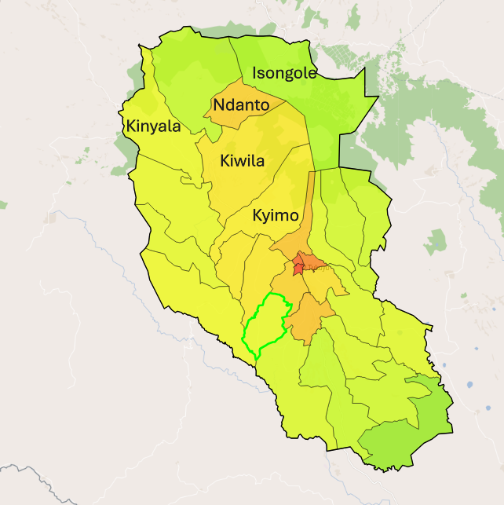
Key
Study Village
District boundary
Figure 3.1: Map of Rungwe District Showing Villages involved in the Study

3.3 Research Approach
This study used a mixed-methods approach to evaluate how different bamboo varieties contribute to generating income for women in rural areas. Both quantitative and qualitative methods were employed to gather comprehensive information related to the study's objectives. Data were collected from five rural villages in the Rungwe District. The assessment of bamboo utilization for income generation among women was based on interviews with bamboo users, stakeholders, and government officials.

3.4 Research Design

A Sequential Explanatory design was employed, starting with the collection and analysis of quantitative data, followed by qualitative data collection and analysis, which ultimately leads to interpretation (Alele et al., 2022). Quantitative data were analyzed first, and the results were further interpreted through explanatory methods (Creswell et al., 2017). The data were collected at a specific point in time using a cross-sectional study design as a sub-design; this approach was chosen for its speed and cost-effectiveness (Setia, 2016). The researcher conducted a field-based survey in the study area to gather data. Questionnaires and statements of confidentiality were utilized to reduce social desirability bias. This design aimed to assess the contribution of various bamboo varieties to income generation for women, with the survey conducted in the designated study area.

3.5 Sampling Procedures
The sampling unit for this study consisted of rural households engaged in economic activities within the selected villages that are rich in bamboo resources. The total enumeration technique was employed, meaning that all individuals in the surveyed households were interviewed. In each village, 40 interviewees were randomly selected for interviews, regardless of gender, as long as they were involved in economic activities. This selection aimed to gather information on the utilization of bamboo varieties and their contribution to women’s income. Consequently, the total sample size comprised 200 households, randomly chosen from the study area. Random sampling was used to give each member an equal chance of being selected, thereby reducing bias, improving representation that reflects population characteristics, and enhancing external validity. For the Focus Group Discussions (FGDs), bamboo stakeholders, local users of bamboo resources, and group leaders with relevant knowledge were requested to organize groups of five to ten participants. It was important that these individuals had not participated in the individual interviews. According to Rahman, M.M. (2022), it is suggested that sample sizes larger than 30 and less than 500 are appropriate for most research. Therefore, this study used a sample size of two hundred (200) respondents.

3.6 Data Collection Methods
Data collection in this research was done in two phases; the first phase was pre-testing which aimed at testing the validity of data collection tools, the questionnaire and checklist. The pre-testing first phase was done to eight (8) members of Isongole Women Bamboo Group. The group located at Isongole Village in Rungwe District where the pre-testing phase helped to modify tools for actual data collection during the field survey in the second phase, which involved a field survey conducted from November 2021 to February 2022.

3.6.1 Sources of Data
Sources of data were both primary and secondary data. Sources of primary data obtained through Scheduled Interviews using questionnaires which were supplemented by personal observation of activities done in the field and key informant interviews (Appendices 1, 2 and 3). The sources of secondary data were obtained from various sources which included unpublished and published documentary sources, reports of various studies in hard copies and also electronically and other sources like the internet. The information searched was useful for the study to supplement the information obtained from the field.

3.7 Data Collection Instruments
3.7.1 Questionnaires/Surveys
Semi-structured questionnaires were used for collecting quantitative data, while PRA discussions were carried out using interview guide. Sets of structured questions, often with predefined answers. A questionnaire with closed and open-ended questions was used to collect quantitative data from the respondents of the study. The information collected with questionnaire include age, sex, education levels, existing bamboo varieties, product made and sold made from bamboo varieties and the income generated from utilisation of bamboo varieties in the study area (Appendix 1).

3.7.2 Interview
A prepared set of standardized questions was asked to the respondents in the field in the same order and wording for every participant. A pre-test was conducted to assess the clarity, relevance and reliability of the questionnaire before the main data collection (Creswell, J.W., Creswell, J.D, 2018). The aim of conducting pre-test was to identify ambiguous wording and formatting issues that could affect the quality of data.

The pre-testing phase was done to eight (8) members of Isongole Women Bamboo Group. The group located at Isongole Village in Rungwe District where the pre-testing phase helped to modify tools for actual data collection during the actual study. The questionnaire was administered under condition that mirrored those of the actual study. Respondents were encouraged to provide feedback on item clarity and overall usability of the instrument.

Results from the pre-test revealed that three items contained unclear wording, language barriers, since questionnaires were drafted in English and the respondents preferred Kiswahili. In response, the problematic items were reworded for improved clarity, and the translated questionnaire was translated into Kiswahili for suitable use. Additionally, formatting changes were made to enhance the flow and user-friendliness of the instrument.

3.7.3 Observation
Data collected by watching and recording behavior, events and conditions of bamboo utilisers in the field of study. It was unstructured observation notes used for recording behaviours or events as they occur I the field to get direct data.

3.7.4 Focus Groups Discussion
This was for group discussions guided by a moderator. It was used for diverse perspectives and interactive for in-depth information. Focus group discussions consisted of 5 to 10 participants per group and the FGD was adopted to collect information concerning the contribution of bamboo varieties utilisation for economic activities to generate income of women (Appendix 3).

3.7.5 Key Informants Interviews
It was used to collect qualitative data from key informants such as village leaders, District Community Development Officers (CDOs), Community based groups of bamboo utilizers in the district (CBOs), District Forest Officer (DFO) and other bamboo stakeholders in the district.

3.7.6 Document and Record Reviews
Perusing and analysis of existing data like reports and databases.

3.8 Validity
Validity encompasses of the entire experimental concept and establishes whether the results that obtained meet all of the requirements of the scientific field study method.

3.8.1 Clear Research Design
To ensure internal validity, employed simple random sampling was employed for selecting respondents and purposive sampling for choosing the study area, aiming to minimize bias. Controlled for confounding variables such as education level, age, sex, occupation, land ownership, and access to markets, all of which can influence income. Then established causal relationships by clearly linking bamboo utilization to the increase in women's income, rather than merely identifying a correlation.

3.8.2 Reliable and Valid Data Collection Instruments
Used standardized questionnaires or interviews to gather consistent data on income, bamboo production, and other socio-economic indicators. The pilot test instruments before full deployment to ensure clarity and relevance.
3.8.3 Representation of the Population
Individuals of various ages, sexes, and educational levels are engaged in bamboo activities selected randomly. Additionally, the study sites where specific bamboo varieties are dominant have been selected.

3.8.4 Data Triangulation

Utilized multiple sources of data, including surveys, interviews, focus groups, and direct observations of existing bamboo varieties and the economic activities pursued by women involved in bamboo production and sales. I also included perspectives from stakeholders such as district forest officer and local leaders, NGO staff, cooperatives, and market buyers to validate the findings.

3.9 Data Analysis
For quantitative data, descriptive statistics of the collected data were analysed through Statistical Package for Social Sciences (SPSS) software, while qualitative data were analysed by using the content analysis method.

3.9.1 Quantitative data
The quantitative data collected from this study were summarized, coded, and analyzed to obtain descriptive statistics that addressed the research objectives. The data gathered through the questionnaire were carefully checked for completeness and edited in the field prior to being coded and entered into SPSS for analysis. Since the study aimed to assess the contribution of bamboo-based economic activities to women's income, it was essential to identify the economic activities associated with bamboo that correlate with women's earnings, along with other significant variables in the study.

3.9.2 Qualitative data
Qualitative data collected from focus group discussions (FGDs) and key informant interviews were analyzed using content analysis in line with the study's objectives. Care was taken to interpret the qualitative data to identify any facts that align with both the closed and open-ended questions in the questionnaire survey.

3.10 Ethical Consideration
The ethical principle guiding this research was that participants should not be harmed as a result of their involvement and must provide informed consent. To ensure this, the study applied for a permit from the Mbeya Region Office, where the regional administrative officer (RAS) facilitated an introduction to the Rungwe District Administrative Officer (DAS) through a formal letter. The DAS then issued a formal letter that was presented to the chairperson of the surveyed villages.

The objectives of the study were communicated to the executives of Isongole, Kiwila, Kyimo, Kinyara, and Ndanto villages. Village leaders informed the community about the research aims, and further arrangements were made for conducting the study. Additionally, respondents were given the option to withdraw from the study at any time and were not required to provide their names on the questionnaires.

CHAPTER FOUR

RESULTS AND DISCUSSION

4.1 Introduction

This chapter provides socio-demographic information about the respondents and findings from the field study, aligned with the specific objectives of the research.

4.2 Social-economic characteristics of the Respondents

4.2.1 Age of the Respondents
Table 4.1 presents the findings on the age groups of respondents. It shows that individuals aged between 31 and 40 years account for 43.7% of all participants. This is followed by those aged 20 to 30 years at 34%. Respondents aged between 41 and 50 years represent 2.6%, while those aged 51 and above make up just 1% of the total. These results indicate that bamboo-related activities are primarily dominated by younger and middle-aged individuals, who tend to be more active and adaptable in engaging with bamboo varieties for income generation.

Table 4.1: Respondent’s Distribution by Age
Age | Frequency (n=192) | Percentages
20-30 | 34 | 34
31 -40 | 85 | 43.7
41-50 | 5 | 2.6
>51 | 2 | 1
Source: Field Data (2022)

4.2.2 Sex of the Respondents
Table 4.2 presents data from a sample of 192 respondents, revealing that 40.2% were male and 58.8% were female. This female-dominated sex composition indicates that the activity was particularly convenient for women in the study area, aligning with the study’s objective of assessing bamboo's contribution to generating income for women in rural areas. The results suggest that bamboo production activities are primarily undertaken by women as a means to improve their livelihoods.

In contrast, a study conducted in Songea by Haule (2015) reported that 62% of male households were engaged in bamboo wine production, while only 28% of female households participated in the bamboo wine business. Additionally, 10% of the households reported that only men were involved in the business, highlighting a dominance of males in production and a greater female participation in retailing.

Table 4.2: Respondent’s Distribution by Sex
Sex | Frequency (n=192) | Percentages
Male | 78 | 40.2
Female | 114 | 58.8
Source: Field Data (2022)

4.2.3 Marital Status of the Respondents
According to Table 4.3, the findings indicate that approximately 67.5% of the 131 respondents were married. In addition, 41 respondents were single (21.1% of all respondents), and 20 respondents were widowed (10.3% of all respondents). This suggests that married individuals are more likely to participate in income-generating activities, such as bamboo production, as they need to ensure the daily basic needs of their families are met. In contrast, a study conducted in the Ruvuma region found that bamboo trade engages both men and women and does not involve any gender-specific activities, unlike those performed by processors and producers. Furthermore, in that study, 88% of the respondents were married, while the remaining 12% were single, highlighting that married individuals are often involved in income-generating activities that contribute to their subsistence (Magafu, 2020).

Table 4.3: Respondent’s Distribution by Marital Status
Marital status | Frequency (n=192) | Percent
Married | 131 | 67.5
Single | 41 | 21.1
Widowed | 20 | 10.3
Source: Field Data (2022)

4.2.4 Level of Education of the Respondents
The findings in Table 4.4 indicate that 84.8% of respondents have attained a primary level of education, 7.3% have completed secondary education, and 7.9% have no formal education. This suggests that the majority of individuals (84.8%) involved in bamboo economic activities have completed at least the basic level of education, positioning bamboo-related endeavors as a viable income-generating option for those willing to engage in them, be it through formal or self-employment.

However, in Nairobi, it was observed that education level significantly impacts bamboo-related income. As educational attainment increases, so does the average monthly income. For example, processors with primary school education earn an average of Ksh 7,000 (equivalent to TZS 150,000), while those with secondary education earn Ksh 11,000 (equivalent to TZS 236,000). Meanwhile, individuals with college education receive an average of Ksh 19,700 (equivalent to TZS 423,000). This data implies that entrepreneurial skills improve with higher levels of education in Kenya (Magafu, 2020).

In interviews with bamboo users regarding how education levels affect their bamboo utilization for income generation, respondents noted that educational attainment impacted their ability to sell bamboo products outside of Rungwe district. Some customers from Kenya face communication barriers when purchasing bamboo goods from Rungwe, as they primarily use English rather than Kiswahili. Despite these communication challenges, products sold to external customers are priced higher than local ones, attracting significant interest from investors. Conversely, prices within the domestic market are lower, making the importation of bamboo products more profitable. One respondent from Isongole village mentioned that better communication skills could allow them to negotiate directly without needing translators, resulting in better prices and increased profits.

Table 4.4: Respondents Distribution by Level of Education
Level of education | Frequency (n=192) | Percent
No formal education | 14 | 7.9
Primary School | 151 | 84.8
Secondary School | 13 | 7.3
Source: Field Data (2022)

4.2.5 Occupation of the Respondents
According to the results presented in Table 4.5, bamboo-related economic activity was not the primary source of income for those utilizing bamboo resources in the study area. Data collected revealed that about 51.0% of respondents engaged in multiple occupations, primarily as farmers or craftsmen. Only 15.1% of respondents indicated that they worked solely as bamboo craftsmen, while 24.0% had a mix of occupations, including agriculture, craftsmanship, and other economic activities. Additionally, 9.9% of respondents reported agriculture as their only main occupation. This suggests a diverse occupational distribution among respondents in the study area, with the majority relying on multiple income sources outside of bamboo.

These findings contrast with the study conducted in Toba village, Nigeria, where bamboo served as the main source of income for 69.5% of women. Moreover, research by Aswandi et al. (2020) indicated that bamboo-based activities were the primary income source for women in Indonesia, followed by agriculture. This is in stark contrast to our findings, reinforcing the notion that, while bamboo is important, it is not the main income-generating activity in our study area, as highlighted by respondents during focus group discussions.

Table 4.5: Respondents Distribution by Occupation
Occupation | Frequency (n=192) | Percentages
Bamboo activities | 29 | 15.1
Agriculture activities | 19 | 24.0
Both Agriculture and bamboo activities | 98 | 51.0
Total | 192
Source: Field Data (2022)

4.3 Assessment of the Bamboo Existing in the Study Area
During a field survey conducted in the Rungwe district, several bamboo varieties were identified. The surveyed bamboo species included Yushania alpine, Oxytenanthera abyssinica, and Bambusa vulgaris. The bamboo variety observed growing naturally in the mountainous areas of Isyonje and the Rungwe forest; however, they were not well managed. Local residents and individuals from nearby regions harvested them for various uses. Notably, the bamboo did not grow in clumps but was scattered throughout the landscape. Locally, these species are referred to as "highland bamboo," with the Yushania alpine variety specifically called “Mianzi ya msituni,” which translates to "forest bamboo."

Another variety, known locally as "Mianzi ya ulanzi" (wine bamboo in Kiswahili), was observed growing along farm boundaries and home yards. This variety was well managed by farmers and grew in clumps, primarily used for wine production.

Additionally, a third variety was seen growing in both highland and lowland areas, characterized by its yellow color with green stripes. Locally called "Mianzi ya Njano" (yellow bamboo), this variety was found along steep slopes, riverbanks, gullies, and valleys, as well as in household yards. However, it was not managed properly.

Findings from a Focus Group Discussion (FGD) conducted in the area revealed that villagers commonly used these bamboo varieties for various activities. The highland bamboo (Yushania alpine) was noted for being used in the processing of handicrafts and furniture by local artisans and craftswomen. The bamboo stems are cut in the forest, brought to the Isongole bamboo factory for processing into slivers, and then dried in the sun. After drying, the slivers are woven into various handcrafted items, such as kiota boms, trays, baskets, and mats for furniture covering. Finally, these products are varnished and made ready for sale.

Participants in the FGD also mentioned the lowland bamboo (Oxytenanthera abyssinica), referred to as “Mianzi ya Ulanzi” in the local language. This bamboo is primarily used for producing bamboo brew and is propagated vegetatively (through rhizomes) close to households. According to the FGD, Oxytenanthera abyssinica generates income through the sale of bamboo wine, with high production occurring during the rainy season. It was observed that Yushania alpine grows scattered in mountainous areas, unlike the other species, which tend to grow in clumps—specifically, Oxytenanthera abyssinica and Bambusa vulgaris.

As summarized in Table 4.6, 54.6% of respondents identified highland bamboo (Yushania alpine), 14.4% identified lowland bamboo (Oxytenanthera abyssinica), and 27.4% noted both types. Therefore, highland bamboo was found in greater quantities, with only 3.3% of respondents mentioning the presence of all three bamboo varieties: highland bamboo (Yushania alpine), lowland bamboo (Oxytenanthera abyssinica), and yellow bamboo (Bambusa vulgaris). Additionally, 14.4% of respondents indicated that only lowland bamboo exists in their areas.

These findings align with the study conducted by Masisi et al. (2022) in Rungwe and Kyela districts, which identified dominant bamboo species including Oxytenanthera abyssinica (syn. Oxytenanthera braunii), Bambusa vulgaris var. vitata, and Yushania alpine. According to the District Forest Officer (DFO), highland bamboo grows naturally in forest reserve areas, and communities are prohibited from harvesting bamboo without legal authorization.

The DFO mentioned that organized groups pay a fee of TZS 150,000.00 per year to access the bamboo varieties, while individuals pay TZS 1000 per bamboo culm. The Isongole women’s bamboo groups were highlighted as one of the groups using bamboo from Rungwe forest reserves, with annual fees of TZS 150,000.00. The women in the study areas expressed the value of bamboo for its potential in generating income.

Table 4.6: List of Bamboo in Rungwe Districts
Bamboo varieties | Frequency (n=192) | Percentages
Yushania Alpine & Oxythenanthera abbysinica | 51 | 27.4
Yushania Alpine | 106 | 54.6
Yushania Alpine, Oxythenanthera abbysinica and bambusa vulgaris | 7 | 3.6
Oxythenanthera abbysinica | 28 | 14.4
Source: Field Data (2022)

4.3.1 Yushania Alpine
Yushania alpina has emerged as a valuable bamboo variety in the study area, particularly known for its use in handicrafts and furniture. According to the findings presented in Table 4.6, the majority of respondents (54.6% of producers) primarily work with highland bamboo (Yushania alpina). Observations indicate that highland bamboo covers extensive areas of Mount Isyonje and Rungwe. This aligns with the research conducted by Lyimo et al. (2019), which noted that the mainland of Tanzania is predominantly populated by species such as Yushania alpina, Bambusa vulgaris, Bambusa bambos, and Oxytenanthera abyssinica. The results suggest that Yushania alpina is a dominant bamboo species utilized by women for income-generating activities in the Rungwe district.

In a personal interview with the chairperson of the Idweli Bamboo Association, it was noted that while he does not process bamboo products himself, he receives requests to harvest bamboo poles from Kiwira Forest. He sells these poles to the Mbeya Women Bamboo Multipurpose Cooperative Society, which then processes them into various products. He charges TZS 1000 as a labor fee for each pole and the cooperative pays TZS 500/= per pole to the Isongole village government.

The total cost incurred per bamboo pole, including village fees, amounts to TZS 1500. He has been providing this service to the Mbeya Women Bamboo group for 15 years, and the income generated has helped him cover household expenses and support the village, which benefits from dues related to the bamboo varieties found in the village bamboo forest located in Isyonje. These activities create income not only for those supplying bamboo poles but also for the women who transform them into various products.
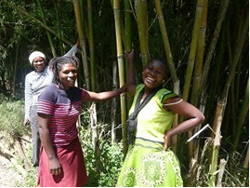
Plate 4.1: Isongole Women Group Members at Kiwila Forest, Harvesting Arundinaria Alpine Bamboo
Source: Field Data (2022)

The illustration in Plate 4.1 shows women in the study area in bamboo forest, harvesting bamboo in the kiwila bamboo forest.

4.3.2 Lowland Bamboo (Oxytenanthera Abyssinica (sny. braunii))
Lowland bamboo (Oxythenthera abyssinica) has been identified as a valuable resource in the study area, primarily due to its use in the production of bamboo wine and alcohol. This type of bamboo is commonly cultivated on household farms, where it is well-pruned and meticulously cared for by local communities. It plays a significant role in local brewing, with bamboo wine being collected and consumed by villagers. Additionally, it is transported to Mbeya town in various containers, such as drums of different sizes, using bicycles, motorcycles, and cars to reach urban dwellers, as reported during focus group discussions (FGDs).
The community members explained that freshly tapped bamboo wine has no alcohol content. However, once it sits for a day or more, it ferments and develops alcohol. According to their accounts, the price of one liter of bamboo wine is TZS 500 in the village and TZS 1000 per liter in town. This bamboo product is an important source of income for households, particularly for women in the community. As indicated in Table 4.6, many respondents recognized the presence of lowland bamboo in their localities, specifically in their home gardens, along farm boundaries, and near river sources. Some respondents also noted the existence of both highland and lowland bamboo (27.4%), while a smaller group reported the presence of other varieties in highland, lowland, and Bambusa vulgaris (3.6%).

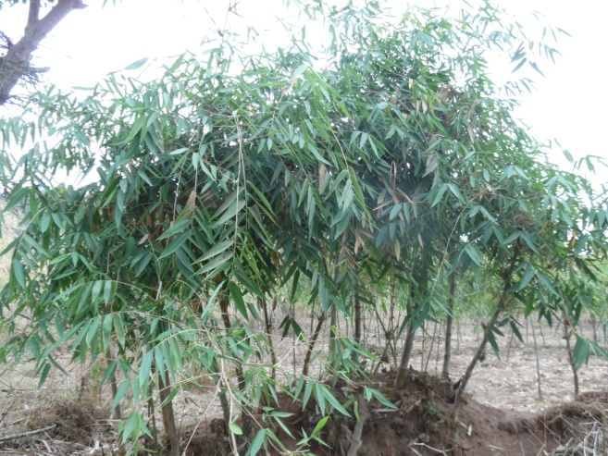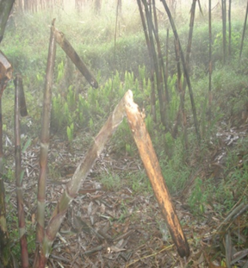
Plate 4.2: Lowland Bamboo (Oxytenanthera Abyssinica) at Different Stages of Utilization, Observed at Household Farm, Ndanto Village
Source: Field Data (2022)

According to the survey conducted in the study area, the bamboo that produces wine is depicted on the left side of the picture. It features emerging shoots that are attached to a bamboo cup designed for tapping and collecting bamboo wine, as shown in Plate 4.2. A producer of bamboo wine describes the Oxythenanthera Abbysinicca bamboo variety, which is well-managed by a farmer. The farmer ploughs around the clump to remove weeds and covers the base with soil to allow sunlight to penetrate. This cultivation method facilitates the easy emergence of new shoots, which are tapped for bamboo wine. On the right side of the picture in Plate 4.2, a farmer is illustrated collecting bamboo wine from the emerging shoots. The shoots are trimmed at the top with a sharp knife and tied with bamboo cups made from bamboo stems to collect the wine. The harvested wine is then sold at local brew shops and town markets.

4.3.3 Bambusa Vulgaris (Green and Yellow with Green Strips Bamboo)
Bambusa vulgaris, commonly known as yellow bamboo, was found in small quantities within the study area. It grows in both highland and lowland regions and occurs naturally. However, the management and harvesting of these bamboo varieties by local people are poor, with its primary uses being for fencing and house construction. According to the results presented in Table 6, only 3.6% of respondents reported the availability of Bambusa vulgaris as a distinct category; most mentioned it alongside other bamboo species.

Observations indicated that local households primarily utilize yellow bamboo for fencing livestock sheds, creating house fences, and constructing small huts, which are built using cement mixed with mud. Respondents noted that these bamboo varieties germinate along valleys, riverbanks, and steep slopes at no cost. Harvesting requires only permission from the landowner. Respondents also mentioned that this type of bamboo can easily germinate when planted in suitable conditions with good soil and adequate rainfall. It was noted that women in the area often make bamboo cups and jugs from this variety, as it has a wider diameter compared to others. Nevertheless, the predominant use of yellow bamboo remains in the construction of fences and houses.

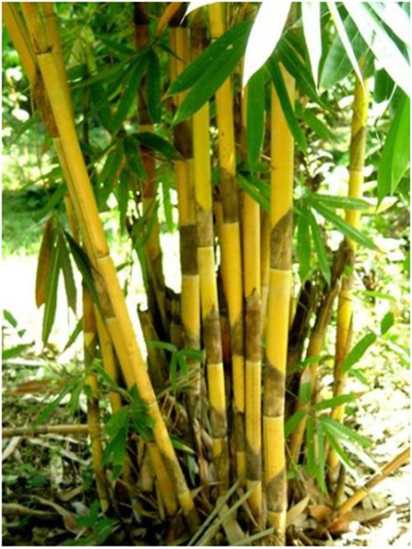
Plate 4.3: Bambusa Vulgaris Observed at Unyamwanga, Isongole Village
Source: Field Data (2022)

4.4 Examination of Bamboo Products Traded by Women in Rural Areas
Bamboo offers a variety of products for women in the Rungwe district. According to a survey conducted in the area, three bamboo species are widely processed by the women: highland bamboo (Yushania alpina), lowland bamboo (Oxythenanthera abyssinica), and yellow bamboo (Bambusa vulgaris). The main products identified include handcrafts such as baskets, dustbins, egg trays, fruit trays, Kiota booms, lamp holders, round trays, winnowing trays, and firewood. Yushania alpina is the primary species used for handicrafts and furniture, while lowland bamboo is preferred for wine and alcohol production; it is also used as firewood when dried.

Another species of bamboo is commonly utilized in local housing construction and for making house fences. It is also used, to a lesser extent, in handicrafts and furniture. At the village level, this bamboo has a selling price of TZS 1000/stem for an 8-meter length, with prices increasing nearly threefold to TZS 3000/stem in the city. Each craftsman produces, on average, 30 baskets measuring 30 x 30 x 40 cm each day, selling at a price of TZS 10,000 per basket. In an interview with the Development Officer of Rungwe District, it was noted that the district council promotes women's participation in economic activities to empower them financially.

Regarding bamboo utilization, the officer mentioned that the district has registered women's bamboo groups to mobilize support and was officially inaugurated by the National Torch. Furthermore, loans (interest-free) totaling TZS 58,000,000 have been provided to these special groups to purchase machines for processing bamboo toothpicks. The district council also supports advertising efforts for these groups by facilitating their participation in district, regional, and national trade exhibitions like SABASABA, NANE NANE, and other trade fairs, covering the associated costs. This sponsorship has helped the Isongole Bamboo Women Group increase its sales revenue, with an average income per woman rising from TZS 4,800,000 in 2021 to TZS 5,900,000 in 2022, thereby improving women's welfare, according to the group chairperson's report.
These findings are relevant to a similar study conducted in Chisui, China, where traditional bamboo weaving embodies women's love and aspirations for their hometowns and their pursuit of a better life. Many local women have found meaning in their lives through bamboo weaving, infusing new vitality into this craft (IFAD, 2019). In the current study (Table 4.7), it was found that women in the Rungwe district produce bamboo products in community-based groups.

They have formed cooperative groups to engage in economic activities centered around bamboo, creating a variety of products such as baskets, winnowing trays, jugs, sofa seats, stools, mats, and rings. Value addition activities are common in the area, with women undertaking much of the work before selling the products. These activities include harvesting bamboo from the forest, transporting it to processing facilities, and slicing raw bamboo into strips suitable for crafting various items. It was noted that while men assist in furniture making, women excel at weaving due to their superior skills. The quality of woven crafts is typically judged based on appearance.

For instance, the sliced strips should not be too light, as overly light strips are less durable. Additionally, it is important that there are no gaps between the strips, and proper threading is required to hold the crafts together. To prevent damage from pests, products are treated with a mixture of poison oil and varnish. This quality control is why handcrafts from Rungwe are often more durable than those from Mbeya. Supporting the study's findings, a study conducted in Cimahpar, Indonesia, observed that women were fully responsible for the weaving process, from cutting bamboo into flat pieces to creating woven patterns and assembling items (Kumalasari et al., 2021).

Several value-added products have been identified that resemble those reported by Teshale et al. (2017) in Ethiopia, which include beds, tables, chairs, shelves, cupboards, traditional mats, flower baskets, lamp holders, trays, and cultural houses. However, fewer products were observed in the Rungwe district, likely due to a lack of awareness regarding the potential products that can be made from bamboo to contribute to women's income, as well as the underutilization of bamboo resources in Tanzania.

Table 4.7: List of Bamboo Products Processed and Produced by Women in Rungwe Districts
Items/Products | Respondents | Percentage
Bamboo Wines | 21 | 10.8
Charcoal & Fire wood | 12 | 6.2
Furniture | 3 | 1.5
Furniture & handcraft | 29 | 14.9
Furniture, firewood, handcrafts & Ulanzi | 7 | 3.6
Furniture, handcraft & firewood | 14 | 7.2
Furniture, handcrafts, ulanzi | 7 | 3.6
Handcraft | 88 | 45.3
Handcraft & fire wood | 7 | 3.6
Handcraft, firewood, alcohol & construction | 4 | 2.3
Total | 194 | 100.0
Source: Field Data (2022)

4.4.1 Bamboo Wine
Bamboo wines are among the bamboo products produced in the study area, primarily due to their popular use as an alcoholic beverage, especially during the wet season. These wines are mainly consumed in the district for local brews. Table 4.7 reveals that some respondents indicated the availability of bamboo wine, while others mentioned bamboo wine alongside other products such as furniture, firewood, handicrafts, and Ulanzi (bamboo wine), accounting for about 3.6% across different villages in the study area. Additionally, 10.8% of producers noted bamboo wine in conjunction with other bamboo products and reported that town dwellers are their main customers.

The means of transportation for delivering the wine to town included bicycles, motorcycles, and buses. Within the farmer's node, two types of bamboo wine were observed. The first type is unfermented, while the second type is fermented after being stored for more than one day (as shown in Plate 4.4). These findings contrast with a study conducted in Songea, which reported that the production and sale of bamboo wine were predominantly carried out by men, highlighting the need for efforts to address this gender imbalance. Not only are there few women involved in the tapping and wholesale of bamboo wine, but they also tend to be marginalized in benefiting from the proceeds generated from its sale (Haule, 2015).
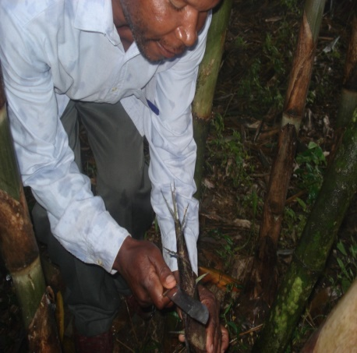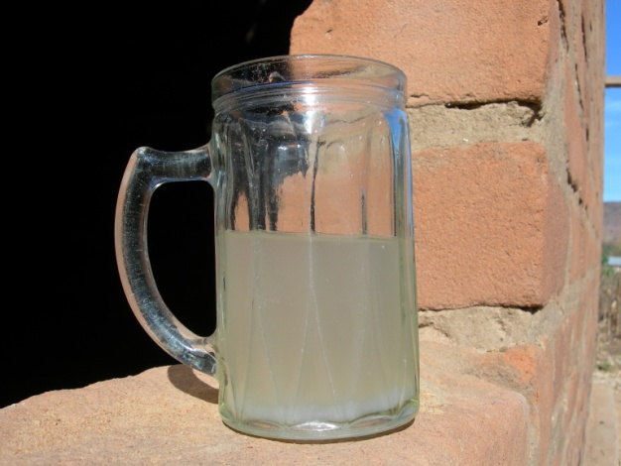
Plate 4.4: Bamboo Wine Harvesting Process Observed at Ndaga, Ndanto Village: (left) Harvester Cutting Young Shoot with sharp Knife Ready for Collecting Wine, (centre) is Bamboo with Mbeta (cup) Collecting Bamboo Wine and (right) is Bamboo Wine Collected on Jug Made by Glass Ready for Drinking
Source: Field Data (2022)

4.4.2 Furniture
Bamboo furniture is found as bamboo products produced in the study area as another economic activity. It is according to bamboo enterprises visited in the study area and have seen the bamboo furniture produced by women groups (Isongole bamboo women Cooperative Society – Isongole CPTC) were bamboo sofa, table, stool, cupboard, bed in the district however men was reported also in the study area producing a variety of bamboo furniture of better quality compared to women furniture. Also, men reported having more designs of furniture while women's designs remained limited; this is according to the focus group discussion held in the study area. It was seen that women were good at producing furniture that needed weaving materials, because they are good at weaving, as observed in the group during bamboo product making. According to the results in Table 4.7, the respondents mentioned bamboo furniture as another product produced, where 1.5% of respondents said bamboo furniture was produced, while other respondents mentioned both bamboo furniture and handicrafts were 14.9% and 3.6% respectively.

According to the discussion in the FGD, the producers of bamboo furniture mention that the bamboo chair is sold at TZS 20,000 per unit, the table is sold at TZS 40,000 per unit, the Sofa set is sold at TZS 400,000 per unit, and the stool is sold at TZS 15,000 per unit. Bamboo furniture is among the bamboo varieties of products that contribute to the income of women in the study area, since it has high profit. These results are consistent with the findings of the study conducted in Southeast Asian region which revealed that rate of return on bamboo furniture is highly encouraging, this is even slightly above 60% and the Cost Benefit Ratio is above 1, therefore, bamboo furniture production is a laudable and a viable project and a veritable means of employment for youth in the country (Adejoba, et al., 2016). In addition, Hasamnis et al. (2017) said that the investments in bamboo furniture can be paid back within a year and a half if made in order 1, provided all the design factors are favorable.
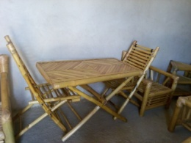
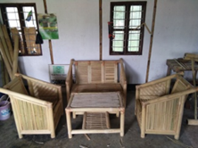
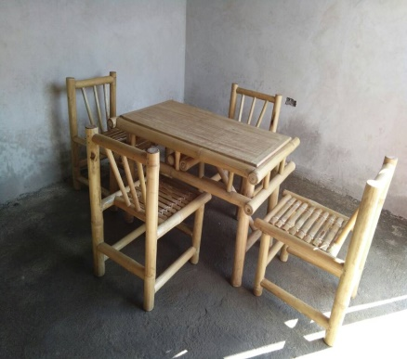

Plate 4.5: Bamboo Furniture Made by Isongole Women Bamboo Group
Source: Field Data (2022)

4.4.3 Handcrafts
Bamboo handcrafts were identified as a significant product in the study area due to their widespread use. These handcrafts are primarily utilized for household items, including winnowing trays, baskets, round or egg-shaped trays, dustbins, and cups. According to the results presented in Table 4.7, a majority of the respondents (45.3%) noted the availability of various types of handcrafts produced by local artisans, with the townspeople being the main customers for these products. Additionally, a small percentage of respondents (1.5%) mentioned that bamboo handcrafts are produced alongside other crafts, while 14.9% indicated that both bamboo furniture and handcrafts are made.

Furthermore, 3.6% of respondents affirmed that only handcrafts are produced in their locality. These findings align with a study conducted in India, which indicated that women involved in bamboo weaving created employment and income opportunities for themselves and their families through the production of various woven products. These items, such as baskets, bags, mats, and home ornaments, are in demand in both local and international markets (Vuspitasari, 2022). By selling these products, these artisans can generate additional income and reduce their economic dependence on others. Consequently, bamboo plays a vital role in improving the lives of women weaving artisans, while also serving as a plant that contributes to ecosystem protection (Kumalasari et al., 2021).
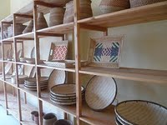
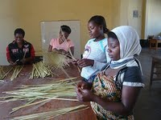
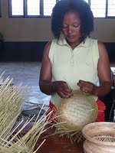
Plate 4.6: Member of Mbeya Women Bamboo Group, Making Bamboo Handcrafts and Finished Product at Show Room
Source: Field Data (2022)

4.4.4 Firewood and Charcoal
Firewood from bamboo materials was another common product used in the study area (Plate 4.7). Its use prevailed in all seasons to warm and cook food in local stoves. This firewood was collected from the forest, and others from household farms by women, and therefore used as a source of energy. This was explained for about 24.9% of respondents when mentioning bamboo as firewood, and charcoal was available at their places; however, it was included with other bamboo articles. Moreover, the product faced competition from other woods that come from trees which were mostly preferred by households or families.

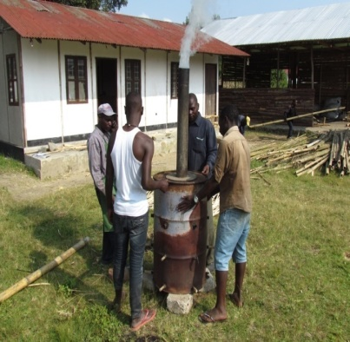
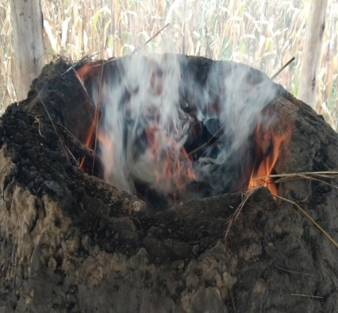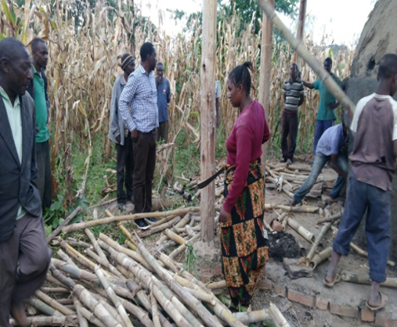
Plate 4.7: Bamboo for Firewood and Charcoal Making (upper, left) Bamboo Collected for Charcoal and Firewood Use (upper right) Bamboo Charcoal Dome Kiln Making Bamboo Charcoal and (bottom) Bamboo Charcoal Made from Drum Processed by WODGRA Briquette Company
Source: Field Data (2022)

4.4.5 Construction Materials
Bamboo is noted as a common construction material (see Plate 4.8). It was widely used to build local houses and fencing in the study area. Most of the houses observed were seasonal structures, typically lasting no more than a single season. Additionally, there were buildings made of bamboo that served as local bars and shops, which were also present in the study area.

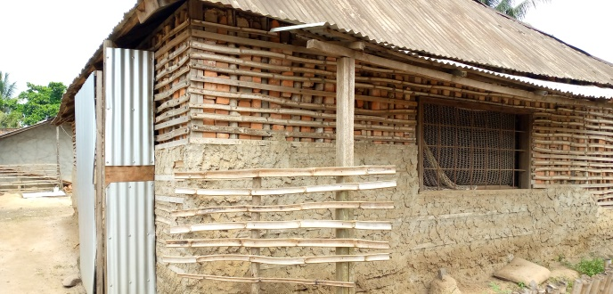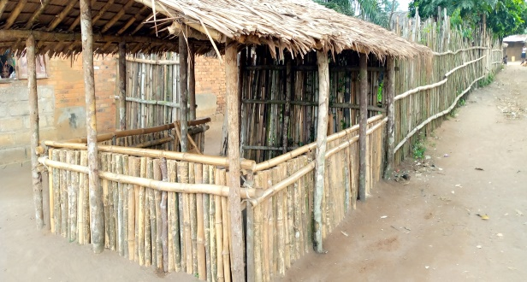
Plate 4.8: Bamboo House (upper) and Fenced Area (bellow) built by Household in Kyimo Village
Source: Field Data (2022)

4.5 Bamboo Products Traded
The markets in the Rungwe district offer a diverse selection of bamboo products. Bamboo has emerged as a valuable economic resource due to its versatility, being utilized in various applications such as furniture, handicrafts, and construction. According to a survey conducted in Rungwe district, the bamboo products available for trade include bamboo wine, furniture, and handicrafts (see Table 4.8).

Table 4.8: List of Bamboo Products Traded in the Study Area
Items | Responses (N=194) | Percentage (%)
Dustbin | 18 | 9.3
Bamboo wine (Ulanzi) | 18 | 9.3
Basket & Stool | 18 | 9.3
Ceiling board | 7 | 3.6
Chair, basket & Table | 7 | 3.6
Chairs, Table, handcrafts | 4 | 2.1
Cup, Jug, Table mat, pazia, ceiling board, ear rings, bangili | 7 | 3.6
Jug | 7 | 3.6
Sofa set | 17 | 8.8
Sofa set, dustbin & cups | 7 | 3.6
Sofa set, stool & Table | 7 | 3.6
Stool, | 8 | 4.1
Table mat set | 7 | 3.6
Winower | 14 | 7.2
Total | 194 | 100
Source: Field Data (2022)

4.5.1 Dustbin
Dustbins are bamboo products that are processed in the study area, as shown in Table 4.8 and Plate 4.9. These items are created by the Isongole Women’s Bamboo Group and other household enterprises in the Rungwe District. The raw materials are sourced from the Kiwila Forest, where they are crafted into finished products. According to an interview with the chairperson of the Isongole Women’s Group, the dustbins are sold for TZS 8,000.00. This price is higher than that of regular baskets and tomato-carrying baskets, which are sold for TZS 5,000.00, due to the dustbins' attractive appearance and larger size.
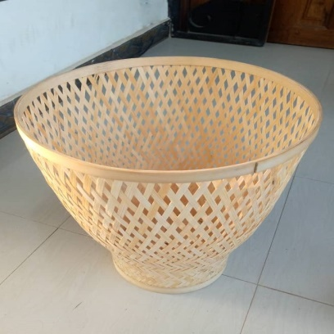 Plate 4.9: Bamboo Dustbins Made by Isongole Women Group
Source: Field Data (2022)

4.5.2 Bamboo Wine
Bamboo wine is a product made from bamboo that is primarily consumed as an alcoholic beverage, especially during the wet season. It is mainly used for drinking local brews within the district. According to the data presented in Table 4.8, some respondents specifically mentioned the availability of bamboo wine, while others noted that bamboo wine is often found alongside other bamboo products such as furniture, firewood, handicrafts, and Ulanzi (another term for bamboo wine), with a prevalence of about 3.6% in different villages within the study area. Additionally, 9.3% of respondents highlighted the connection between bamboo wine and other bamboo products. During the focus group discussion (FGD), participants reported that locally brewed bamboo wine sells for TZS 500 per liter in the village, while in town, local traders sell it for TZS 1000 per liter. This indicates that bamboo wine is a lucrative business, as it provides employment opportunities for women in the study area who are involved in the production and sale of the wine for profit.

According to the findings in Table 4.8, 10.8% of respondents are engaged in the bamboo wine trade, identifying town dwellers as their primary customers. In the study area, bamboo wine is collected and transported to town using bicycles, motorcycles, and small cars, further indicating that the main customers are indeed town residents. Two types of bamboo wine were observed on the farmers' side: one that is produced and not fermented, and another that is fermented after being left for more than one day (Plate 14).

Plate 4.10: Tapped Bamboo Wine in Glass Bottle by Household at Kinyala Village
Source: Field Data (2022)

4.5.3 Basket
The bamboo basket is another product found in the study area. There are various shapes of bamboo baskets, including geoid or spherical forms, as well as traditional round baskets. According to the results in Table 4.8, respondents indicated that they have seen bamboo baskets made by women in the area. Specifically, 9.3% of the respondents mentioned bamboo baskets alongside other bamboo items like stools, while another 9.3% reported the availability of baskets, chairs, and tables made from bamboo in their regions. Photos of bamboo baskets can be found in Plate 4.9. During the focus group discussion, the producers of bamboo handcrafts stated that the selling price of a bamboo basket is TZS 5,000 per unit.
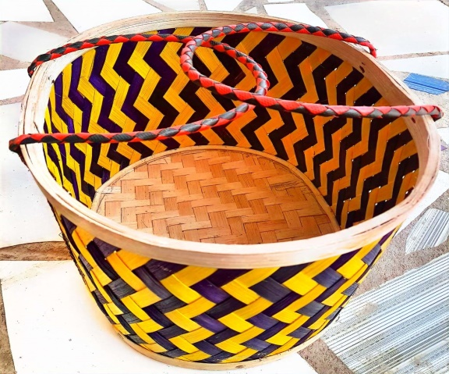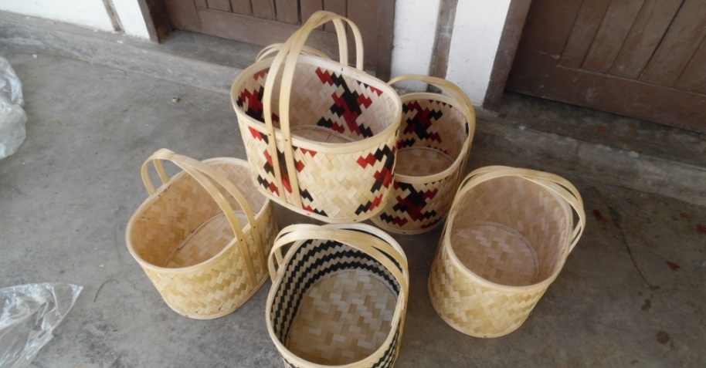
Plate 4.11: Bamboo Baskets made by Household at Unyamwanga, Isongole Village
Source: Field Data (2022)

4.5.4 Ceiling Board

Bamboo ceiling boards were identified as another bamboo product in the study area. According to Table 4.2, respondents mentioned bamboo ceiling boards twice, accounting for approximately 3.6% of the responses in total. The respondents indicated that bamboo ceiling boards are crafted by weaving bamboo slivers. These boards are mats made from bamboo slivers, commonly used as ceiling panels in residential homes and institutional buildings, such as primary schools. Additionally, they are utilized in constructing house roofs.

4.5.5 Chair
Bamboo chairs were another product identified in the study area. As shown in Table 4.2, respondents mentioned bamboo chairs twice, accounting for approximately 3.6% and 2.1%, respectively, of other items. These chairs are constructed from bamboo poles that have been treated with chemicals to protect against insects and borax damage. Respondents noted that the chairs are made from mature bamboo, typically aged between 3 to 5 years, and they come in various designs, as illustrated in Plate 4.10. During the focus group discussion (FGD), bamboo furniture producers indicated that the selling price for a bamboo chair is TZS 20,000.that the bamboo chair is sold at TZS 20,000.

4.5.6 Table

Bamboo tables were among the various bamboo products identified in the study area. As shown in Table 4.2, respondents mentioned the bamboo table four times, which corresponds to 3.6%, 2.1%, 3.6%, and another 3.6% of their responses. Bamboo chairs, also made from bamboo poles, have been treated with chemicals to protect against insect damage and borax attacks. According to respondents, these tables are constructed from mature bamboo that is 3 to 5 years old. The tables come in different designs, as illustrated in the study area (see Plate 4.11). During discussions in the focus group, bamboo furniture producers indicated that the bamboo tables are sold for TZS 40,000 each.

4.5.7 Curtains

Bamboo curtains, known as "pazia" in Kiswahili, emerged as another notable bamboo product identified in the study area. As outlined in Table 4.7, these curtains were mentioned by a respondent, representing about 3.6% of the overall responses. Made from treated bamboo poles, these curtains effectively combine aesthetic appeal with functionality, as the treatment safeguards them against insect infestations and borate damage. Their presence highlights the potential for further exploration and promotion of bamboo-based products in the region.

4.5.8 Ear Rings and Rings

Bamboo earrings and rings, which are worn on the hands, are additional bamboo items traded in the study area. According to Table 4.7, the respondents mentioned bamboo earrings and rings (bangili) once, accounting for approximately 3.6% of the items listed. These bamboo rings for the ears and hands are crafted from bamboo culms.

4.5.9 Jug or Cups

Bamboo jugs and cups are among the bamboo products found in the study area. According to Table 4.8, respondents mentioned these jugs and cups three times, indicating they accounted for approximately 3.6% of the total items reported. These jugs and cups are crafted from bamboo culm, which has been traditionally treated to prevent insect infestations and damage from borax. Respondents noted that the jugs and cups are made from mature bamboo that is 3 to 5 years old and come in various designs and sizes, as illustrated in Plate 4.12.

4.5.10 Sofa Set

Bamboo Sofa set was bamboo furniture traded in the study area. According to Table 8, the bamboo Sofa set was mentioned three times by respondents, where about 8.8 % mentioned bamboo sofa as bamboo furniture found and traded in the study area alone, and others mentioned it with other items two times, with the same percentage of 3.6% and 3.6% respectively. Bamboo sofa sets are among bamboo articles made from bamboo poles, which were treated with chemicals to avoid attacks from insects and borax. According to the respondents, the Tables are made from mature bamboo ranging from 3-5 years, and sofa sets are made of different designs, as seen in the study area, as seen in plate 4.12.

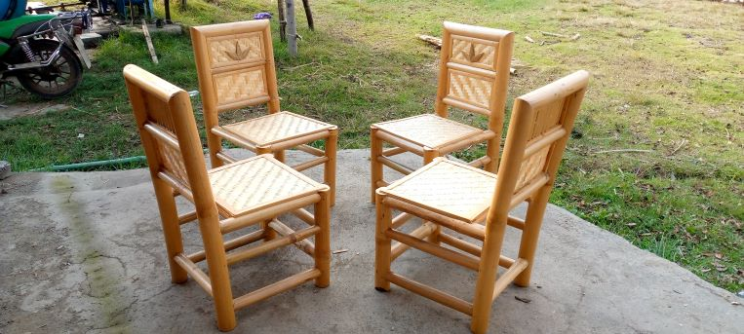
Plate 4.12: Bamboo Chairs made by Isongole Women Group
Source: Field Data (2022)

4.5.11 Stool
Bamboo stool was a type of bamboo furniture traded in the study area. According to Table 4.8, the bamboo stool was mentioned three times by respondent where about 4.1 % mentioned bamboo stool as bamboo furniture found and traded in the study area alone and others mentioned with other items two times like about 9.3% of responded mentioned bamboo stool with basket seen traded in the study area while others about 3.6% mentioned bamboo stool with other articles found traded in the study area. Bamboo stools are among bamboo articles made from bamboo poles, which were treated with chemicals to avoid attacks from insects and borax. According to the respondents, the stools are made from mature bamboo ranging from 3-5 years and Tables are made of different designs, as seen in the study area, as seen in plate 4.13.
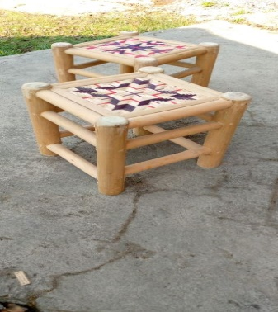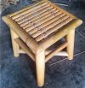
Plate 4.13: Bamboos Stools Made by Isongole Women Group
Source: Field Data (2022)

4.5.12 Table Mat Set
Table mats (Plate 4.14) were another bamboo-made product found in the study area. According to Table 4.8, it was mentioned two times by my respondents. At first, 3.6% said it was traded and the second 3.6% said the same, totaling 7.2% of the respondents. According to the Isongole bamboo processing centre, the spokesperson said there are two women in the group who specialize in making Table mats. Mention Ms Suzane Kashela and Tulafilika as the main producers of the product in the group.

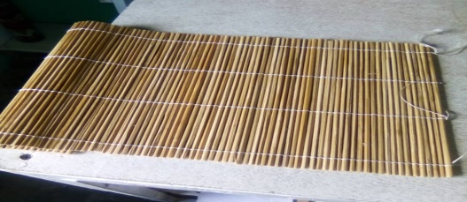
Plate 4.14: Bamboos Table Mats Found at Kiwila Market
Source: Field Data (2022)

4.5.13 Winnower
Winnower (Plate 4.15) made from bamboo is also found in the study area due to its usage, especially in the dry season. It was used mainly for winnowing cereals, which were maize, beans, and rice. According to the results in Table 4.8, the majority of the respondents, 7.2%, were dealing with this product and mentioned women as the main customers. This is because women are responsible for preparing and preserving food for the family; thus, to them, a winnower is a necessary appliance.
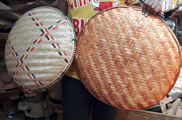
Plate 4.15: Winnower Found at Kiwila Market
Source: Field Data (2022)

4.6 Proportion of Income Earned by Women from Bamboo Products
Bamboo variety utilizers had three main sources of income, as displayed in Table 4.9. Bamboo was mentioned as an activity that provides income to women in the study area. Other activities were agriculture and other economic activities. According to the results in Table 4:9, bamboo economic activities contribute 15.1% of women's income in the study area, therefore indicating that bamboo contributes to women's income in the study area.

Table 4.9: Source of Income of Women in Study Area
Economic activities | Frequency | Percentages
Bamboo activities | 29 | 15.1
Agriculture activities | 19 | 24.0
Both Agriculture and bamboo activities | 98 | 51.0
Total | 192
Source: Field Data (2022)
Table 4.10: Average Income Received by Women from Bamboo Activities per Months
Income (Tshs) | Frequencies | Percentages
10,000.00 – 100,000.00 | 101 | 52.06
101,000.00-200,000.00 | 62 | 31.95
201,000.00 – and above | 31 | 15.9
Total | 194 | 100.00
Source: Field Data (2022)

The results in table 4.10 shows that majority of women utilizing bamboo resources in the study areas received an average income per months, ranged from shillings 10,000.00 to shillings 100,000.00 which is 52.06%, followed by women who earn an average income ranged from shillings 101,000.00 to shillings 200,000.00 which is 31.95% and few are women who received income an average income which is ranged from shillings 201,000.00 and above which is 15.9%. According to the respondents results in Table 4.10, the majority of women in the study area obtained income ranging from Shillings 10,000.00 to 100,000.00 per month to support their livelihood.

In accordance to Aswandi, et al., (2020) in the study which was done in North Sumatra Province of Indonesia, stated bamboo was the main source of income (69.5%), followed by agriculture (15.4%), paid work (10.6%) and trade (4.5%) which supports the findings of this study which indicated bamboo utilization in the study area contributed 15.1% of women income. Also, the findings of the study are consistent with the study of Jiang et al. (2024), which indicated that the bamboo weaving training program has significantly improved the scientific literacy and technical skills of rural women, enhancing their self-confidence, income generation, and entrepreneurial endeavors.

However, it was observed that women in the study area were also doing other economic activities like agriculture, which contributes 51% of their income, and other trading activities; hence, doing multiple activities reduces efficiency and leads to a decline in productivity since specialization leads to comparative advantage (Madiedo et al., 2019). The findings of the study are relevant with theories which supported this study of the analysis of the contribution of bamboo varieties to the income of women. The first theory was the theory of Natural varieties utilization growth model and the theory of Sustainable Livelihood Framework in the areas utilization of natural resources.

The natural utilization theory had the positive relationship with utilization of natural resources like bamboo and the economic growth since use utilization of natural resources in production of goods resulted in income generation as it shown in the result of utilization of bamboo varieties by women in the study area has generated income to women. Second, the theory of Sustainable Livelihood Framework (SLP) helped to explain, evaluate, and improve how bamboo contributes to income generation for women by mapping it across five key livelihood components. It provides a structured way to understand not just that bamboo helps, but how and why it does and what can be done to make its contribution more sustainable and empowering. Therefore bamboo resources play an important role in improving the income status of the women population.

CHAPTER FIVE

SUMMARY, CONCLUSION AND RECOMMENDATIONS

5.1 Summary of Major Findings
In the Rungwe district, three bamboo varieties are found utilized by women, which exist in mountainous (highland) and lowland areas. The Yushania alpine was the bamboo resource found on highland areas, growing naturally and not managed and is the bamboo variety used for handcrafts and furniture making while the oxythenanthera abbysinica was found growing in lowland areas along household farms, farm boundaries, river source areas and was well maintained and managed by households and mostly used to produce bamboo wine (bamboo blew) and the third was bamboo variety was Bambusa vulgaris which was found both in highland and in lowland areas but not well managed and was used for construction of compound fence and housing.

It was found that bamboo varieties were utilized by women to produce various products in the study area. The products included handcrafts (baskets, dustbin, egg tray, fruit tray, kiota boom, lamp holder, round trays, winnowing trays, round trays, poles, firewood) and also furniture (sofa set, chair, stools, table). The manufactured products are sold locally at village in retail price to individual customers who consume in smaller units for home use and sold in large quantity to traders in whole price and traders who bought at wholesale price sold it to the final customers in town’s areas in retail price and other products are sold in neighboring countries like Kenya, Malawi and Zambia. Other women organized in community groups like Isongole Bamboo Women community group, which was found in the study area, organized women who work in teams, and the group received a legal registration certificate from the director of Rungwe district council as a bamboo women's group. At the same time, there are individuals’ households doing bamboo activities at the family level at their home as individual traders.

The findings show that bamboo varieties bring income to women in the study area, and there is a remarkably wide and diverse range of uses for the bamboo that is present, and the products play an important role in improving the socioeconomic status of the women's population. List of handcrafts and furniture produced are dustbin with an average price of TZS 8000, baskets with an average price of TZS 5000, trays with an average price of TZS 3,000, stools with an average price of TZS 15,000, tables with an average price of TZS 40,000, chairs with an average price of TZS 20,000 per unit and sofa sets with an average price of TZS 400,000/=. Bamboo poles per stem were sold at TZS 1000 per unit at village and in town were sold TZS 3000 per unit. Also the average income received by women ranges from shillings 10,000.00 to shillings 100,000.00 per months and bamboo varieties found contributing 15.1% of women income in the study area.

5.2 Conclusion
Findings of this study indicate that there are three existing bamboo varieties utilised by women in study area for economic activities to generate income. The results have not specified the use of each bamboo variety in specific bamboo products but only mentioned oxytenanthera abbysinica used to produce bamboo wine while others varieties are used in manufacture of furniture, handcraft and construction. These findings are relevant with the theories guided the study which states that the utilisation of natural resources has impact on economic growth which are the relevant with the results of the study pointing out that bamboo varieties utilization has contribution to generate income of women in the study area.

This implies that the theories and the results of the study discussed had shown that bamboo resource utilization according to theories of Natural resource utilization growth model and the Sustainable Livelihood Framework has relationship with women income which leads to economic growth through use of natural capital. The forest policy of Tanzania supports bamboo sector development, since the policy of forest included and mentioned bamboo as a not-timber forest product (NTFPs) which is attached with its value for livelihood development, therefore the policy supports the development of bamboo varieties for income generation of women by providing good environment of the utilizer of bamboo varieties for income generation as it seen in the findings of the results.

Further findings indicated that, there are bamboo varieties traded and the list of bamboo handcrafts and furniture identified in the findings indicated there are bamboo economic activities from existing bamboos that provides jobs to women in the study area and earned income. The results have not identified the bamboo products that are demanded more than others in the market or which provide high revenue. The findings of the study were supported by the guiding theories which explained the utilisation of natural resources like bamboo on the economic growth.
The respondent had shown bamboo varieties to have contributed to the generation of income in the study area. Furthermore, the study revealed the status of income before women engaged in bamboo economic activities was low compared to income status when started engaging in bamboo economic activities. The results of the study agreed with the theories guiding this study in their application on natural resource utilization that has positive relation with economic growth at first which are similar with the results of the study indicating bamboo varieties utilization by women to have positive impact on income generation.

5.3 Recommendations
5.3.1 Local Government
It is recommended that the Rungwe District Council support the conservation and sustainable management of the three existing bamboo varieties in the district. This can be achieved by providing training to individuals familiar with the bamboo forest, bamboo forest-dependent and stakeholders in the bamboo industry. This includes local community members who rely on bamboo forest resources for their livelihoods, bamboo forest utilizers and bamboo products traders, Community leaders, Forest management officials, and Environmental stakeholders or NGOs involved in bamboo awareness creation, promotion and development. Furthermore is technical assistance and resources to women engaged in bamboo-related economic activities. Additionally, the agricultural and forestry departments should promote bamboo cultivation to enhance sustainability and prevent over-harvesting.

5.3.2 National Institutions (Ministry of Trade and Industry, Ministry of Tourism and Natural Resources and Small and Medium Enterprises Development Authorities)

Further, it is recommended that national institutions (Ministry of Trade and Industry, Ministry of Tourism and Natural Resources and Small and Medium Enterprises Development Authorities like SIDO support the development of the bamboo value chain. This includes facilitating access to markets, organizing trade fairs, and connecting women producers to buyers at the regional and national levels. Further, efforts should be made to improve the design and quality of bamboo furniture and handicrafts through skills development and innovation programs. In addition, the Ministry of Tourism and Natural Resources has to formulate and make a bamboo policy separate from forest policy, addressing the support of bamboo sector development, since bamboo is attached with its value for livelihood development; therefore, the bamboo supports the development of livelihood.

5.3.3 Non-Governmental Organizations (NGOs) and Financial Institutions
Given the positive impact of bamboo economic activities on women’s income, it is recommended that Non-Governmental Organizations (NGOs) and Financial Institutions expand financial and technical support to women entrepreneurs in this sector. This includes offering affordable credit, savings schemes, and entrepreneurship training tailored to the needs of women engaged in bamboo production and trade. Additionally, the higher learning institution like Open University of Tanzania (OUT), Sokoine University of Agriculture (SUA), Research Institution like Tanzania Forest Research Institute (TAFORI) conduct more studies on bamboo resource utilization to increase more number different studies on bamboo to keep awareness of the public about the economic potential of utilizing bamboo forest for livelihood development.

5.4 Recommendations for Further Studies
This study examines how the use of bamboo resources affects women's income, showing that different bamboo varieties significantly contribute to income generation for women. Future research should focus on specific bamboo varieties and their various applications in producing different bamboo products, as each variety has unique characteristics. Additionally, further investigations could identify which bamboo products are in high demand and command premium prices, potentially generating greater revenue compared to other products. Moreover, exploring bamboo processing techniques and finding ways to improve these processes could lead to the production of higher-quality bamboo products for both local and international markets.

REFERENCES
Akoto, D. S., Denich, M., Partey, S. T., Frith, O., Kwaku, M., Mensah, A. A. and Borgemeister, C. (2018). Socioeconomic indicators of bamboo use for agroforestry development in the dry semi-deciduous forest zone of Ghana. Sustainability 10(2324): 1 – 13.
Akwada, D. R., Akinlabi, E. (2018). Economic, social and environmental assessment of bamboo for infrastructure development. In: Proceedings of the 5th International Conference on Infrastructure Development in Africa. At South Africa Project: Bamboo as a Sustainable Engineering Material. International Conference on Infrastructure Development in Africa, South Africa. 15pp.
Aswandi, A., Kholibrina, C,R. (2017). Restoring the Lake Toba Ecosystem; Bina Media Perintis: Medan, Indonesia, 2017.
Bahru, T., Yulong, D. (2021). A Review on Bamboo Resource in the African Region for Special Focus and Action. International Journal of Forestry Research.
Brooks John R. (2018). The Definitions of Income. Tax Law Review, Vol. 71, Pp. 253- 309, Available at SSRN: https://ssrn.com/abstract=2928972 or http://dx.doi.org/10.2139/ssrn.2928972
Chaudhary, U., Malik, S., Rana, V., & Joshi, G. (2024). Bamboo in the pulp, paper and allied industries. Advances in Bamboo Science, 7, 100069. https://doi.org/10.1016/j.bamboo.2024.100069

Dwivedi, A. K., Kumar, A., Baredar, P. and Prakash, O. (2019). Bamboo as a complementary crop to address climate change and livelihoods – Insights from India. Forest Policy and Economics 102: 66 – 74.
FAO (2018). Bamboo for land restoration. Food and Agriculture Organization, Rome, Italy. 67pp,
Gauli, K., Durai, J. and Oduor, N. (2018). Value Chain Analysis and Market Assessment of Bamboo Products in Kenya. International Bamboo and Rattan Organization, Addis Ababa, Ethiopia. 81pp.
Gebrekidan S., Lemma T. and Muatu Y. (2018). Indigenous knowledge on highland bamboo (Yashania alpina) management, utilization practises; Scientific Research and Essays; College of Agriculture and Veterinary Science, Ambo University, Ambo, Ethiopia.
INBAR. (2015). International Network for Bamboo and Rattan. Bamboo to tackle climate change. https://www.inbar.int/2014/12/inbar-releases-policy-report-on- bamboo-to-tackle-climate-change.
Jiang, Y., Zhu, L., Goulão, L. F., Li, X., Su, L., Chen, L., & Li, A. (2024). The bamboo weaving training as a strategy for women's empowerment toward sustainability in rural revitalization: Practices, challenges and perspectives. Women's Studies International Forum, 106, 102975. https://doi.org/10.1016/j.wsif.2024.102975
Kumar, S., Rawat, D., Singh, B., & Khanduri, V. P. (2022). Utilization of bamboo varieties and their market value in the western Himalayan region of India. Advances in Bamboo Science
https://doi.org/10.1016/j.bamboo.2022.100019
Lee B.; Rhee, H.; Kim, S.; Lee, J.-W.; Koo, S.; Lee, S.-J.; Alounsavath, P.; Kim, Y.-S (2021). Assessing Sustainable Bamboo-Based Income Generation Using a value Chain Approach, Case Study of Nongboua Village in Lao PDR. Forests
Haule, M., (2015). Bamboo wine business and rural livelihood of Songea District, Tanzania. Business Education Journal, Volume 1, Issue 1, 25 Pages. www.cbe.ac.tz/bej
Maris, R., Holmes, M. (2022). Economic Growth Theory and Natural Resource Constraints: A Stocktake and Critical Assessment. Australian Economic Review, 56(2), 255-268. https://doi.org/10.1111/1467-8462.12505
Mbwambo, L., Balama, C., Richard, J. Laswai, F. and Msalilwa, U. (2016). Monitoring of vegetation recovery following massive death of bamboo stands in the Uzungwa Scarp Nature Reserve, Kilolo District, Iringa, Tanzania. Progress physical and financial report (project number: 57/2012/RS/UD) submitted to the Eastern Arc Mountains Conservation Endowment Fund (EAMCEF), Morogoro. 11pp.
Rahman, M.M. (2022). Sample Size Determination for Survey Research and Non-
probability Sampling Techniques. A Review and Set of Recommendation. Journal of Entrepreneurship, Business and Economics, 11(1), 42-62:
Sythud, P. Zhang, Y., Mukete, B. (2015). Bamboo Varieties Utilization: A Potential Source of Income to Support Rural Livelihoods. Applied Ecology and Environmental Sciences:
Singh, S., Sharma, G., Radulescu, M., Lorente, D., Bansal, P. (2024). Do natural varieties impact economic growth: An investigation of P5 + 1 countries under sustainable management. Geoscience Frontiers, 15(3), 101595. https://doi.org/10.1016/j.gsf.2022.101595
URT (2022), Ministry of Finance and Planning, Tanzania, Tanzania National Bureau of Statistics and President’s Office - Finance and Planning, Office of the Chief Government Statistician, Zanzibar. The 2022 Population and Housing Census: Administrative Units Population Distribution Report; Tanzania Zanzibar
Zishan, A., Upadhyay, U., Yulong, D. Abolghassem E.,Anwar, Anwar. S. (2021). Bamboo: Origin, Habitat, Distributions and Global Prospective. 10.1007/978-981-16-1310-4_1.

APPENDICES

Appendix 1: Questionnaire for bamboo utilisers in Rungwe Districts, Mbeya region, Tanzania
BAMBOO VARIETIES UTILIZATION FOR INCOME OF WOMEN IN RUNGWE DISTRICTS, MBEYA REGION
This questionnaire is for MANRAM study purposes. The information and data that will be obtained from this field survey will be used to draft MANRAM Dissertation for submission to OUT.
Questionnaire for bamboo utilisers
Questionnaire number………………………..............................
Date of interview………………………………………………..
District…………………Village……………………………….
Section A: Personal information of a respondent:
      - Name of the respondent..……………………………………………………....
      - Age in years……………………………………………………………………
      - Gender: 1=Male [ ], 2= Female [ ]
      - Marital status:1= Married [ ], 2= Single [ ],3= Divorced [ ] 4= Widowed [ ]
      - Level of education: 1 = No formal education [ ]; 2 = Primary school [ ]; 3 = Secondary school [ ]; 4 = College [ ], 5 =University [ ], 6 = others [ ] (specify)……………….
      - How many people are in your household (Household size)…………………..

Section B: Information on bamboo production
      - Mention types of bamboo available in your area?
(i) ……………………………………………
(ii)……………………………………………
(iii)…………………………………………...
(iv)…………………………………………...
(v)……………………………………………
      - List the utilization bamboo in your area.
(i) ………………………………………………………………………………
(ii) …………………………………………………………………………………..
(iii) ………………………………………………………………………………….
(iv)…………………………………………………………………………………..
(v)…………………………………………………………………………………
(vii) …………………………………………………………………………………
      - Who own the bamboo plantation? 1= Government [ ], 2= Private [ ], 3= Others
[ ]; Specify……………………………………
      - What is the nature of the growth of the bamboo varieties?
1= Natural Growing [ ], 2= Planted [ ], 3= both Natural & Planted [ ],
      - Do you participate in Bamboo production (farming)?1= Yes [ ], 2= No [ ]
If Yes,
      - What is total area in acreages under bamboo production………………………...
      - What is the source of labour? 1=family labour [ ], 2=hired [ ], contract [ ].
      - How often do you engage in bamboo activities in a year? 1 = Dry season [ ], 2 = When in need of money [ ], 3 = All the time [ ]
      - Do you harvest and sell bamboo poles to the bamboo products producers?
1= Yes [ ], 2= No [ ], If Yes, fill the Table provided below:
S/No | Type of bamboo poles(s) | Price per unit (bamboo pole) | Market (middlemen wholesalers, retailers, others) list the name
1.
2.
3.
4.

- Please indicate the costs involved in bamboo production activities:
S/No | Type of bamboo poles(s) | Cost (TZS)
1.
2.
3.
4.

- Have you ever received training on how to improve bamboo production (Farming)?
1=Yes [ ], 2= No [ ]
- If Yes, list the training and who trained you
Types of training | When trained | Who trained

- List value addition activities you perform in bamboo production
(i)………………………………………………
(ii)……………………………………………..
(iii)…………………………………………….
- As producer, do you have any association in your area? 1 = yes [ ], 2 = no [ ]
- If yes, to question 29 above,
- What is the name of the association …………………………………
- What are the benefits of the association/organization?
………………………………………………………………………………………….
Section C: Information on bamboo trading
- Where are your customers coming from
1= Inside the country [ ], 2= Outside the country [ ], Both [ ]
- What is the most traded species?
1= Highland Bamboo (Yushania Alpina) [ ], 2= Lowland bamboo (Oxytheranthera abysinica) [ ], 3= Yellow bamboo with green strips (Bambusa Vulgaris) [ ], 4= Others [ ]; Specify …………………………………………………………………..
- List bamboo products that you produce and its cost of production:
S/No | Product(s) | Cost of production (TZS) | Selling price  (TZS) | Source (village) | Market (category and place)
1
2
3
4
5
6
7
8
- What are the main sources of income?
1 = Bamboo products [ ], 2 = Agriculture [ ], 3 = Both 1& 2 [ ], 4= None of the above [ ], Explain which is other source………………………………………
- Have you ever received training on how to improve bamboo trading?
1=Yes [ ], 2= No [ ]
- If yes to question 29, List the training and who trained you
Types of training | When trained | Who trained

- Do you get market information? 1 = Yes [ ], 2 = No [ ]
- If yes to question 12 above, how do you obtain such information?
1 = friends [ ], 2 = from media [ ], 3 = direct visit to the markets [ ],
4 = others specify…..............................................................
- Who sets the price for the bamboo products when selling? 1=buyer [ ], 2=seller (trader) [ ], 3=others [ ]specify)………………………………………………………..
- What factors are considered in setting up the price of bamboo products?
1 = production costs [ ], 2= transportation costs [ ], 3= quality [ ], 4=others (specify)……………………………………………………………
- Are you satisfied with the current bamboo products prices? 1 = Yes[ ], 2 = No [ ] If no, why?.............................................................................................................
1 = price is low [ ], 2 = operational costs are very high [ ], 3 = buyers offer price which are in their favour [ ], 4 = other specify)……………………………………

Section D: Information on bamboo cost and benefits
- Before started utilizing bamboo on economic activities, what was your income status? 1=Low [ ], 2= High [ ], 3= Average [ ]
- How many times your households get meals per day before employed on bamboo activities? 1= One times per day [ ], 2= Two times per day [ ], 3= Three times per day [ ], 4 = None of the above [ ], Please Specify………………………………………
- For how long have you been doing bamboo products business?
1= Less than 2 years [ ], 2= Between 2-5 years [ ], More than 5 years [ ]
- Do you think Bamboo trade is profiTable?
1=Yes [ ], 2= No [ ]
- After started doing bamboo business, what is your income status?
1= Highly increased [ ], 2= Average increased [ ], 3= Not increased [ ]
- Which bamboo products do you trade? Specify the source and market for each product in the provided Table:
S/No | Product(s) | Buying price (TZS) | Selling price  (TZS) | Source (village) | Market (category and place)
1
2
3
4

- Please indicate the costs involved in your business in the provided Table:
S/No | Item/Activity | Cost (TZS)
1.
2.
3.
4.
- Do you think as bamboo trade is an alternative employment?
1=Yes [ ], 2= No [ ]
If yes, how bamboo job improved your standard of living?……………………………………………………………………………….
- Indicate the amount of income generated from bamboo products and other economic sources per month.
Economic Sources | Amount
      - Bamboo
Others, Specify
      - ………………………………………..
      - ………………………………………...
      - …………………………………………
      - …………………………………………

Appendix 2: Checklist for government officials
- What are the production areas of bamboo – (private, government)?
- What is the licensed area to be harvested or quantity to be harvested? (species-wise, if possible)
- How many farmers or companies are involved in cultivation and harvesting?
- What is the production quantity? (species-wise, if possible)
- Who are the key farmers and traders of bamboo?
- How is harvesting and transportation done?
- What are the harvesting and transporting costs?
- What are the challenges in harvesting and transporting?
- Where are bamboo products sold?
- What are the administrative obstacles in transporting?
- Discuss on the laws that govern bamboo production
- Do farmers comply to these laws?
- What are the opportunities and challenges in the bamboo sector?
- How many input suppliers are there in the area, and what is their capacity?

Appendix 3: Focus group discussions for bamboo stakeholders (farmers, traders, district officers, villages officers)
Guiding questionnaires
- What are the types of bamboo available in the area
- How many uses of bamboo plants?
- Who utilise bamboo for economic purpose?
- List types of bamboo products produced by women & youth in the study area
- Is bamboo products made and sold is an alternative source of income to women & youth?
- What are the price of each bamboo product listed in question four (4) above
- What are cost of making each bamboo products mention in questions four (4)
- What is the average income received by women per months obtained from bamboo economic activities
- What are challenges facing bamboo producers?
- Is any policy that promotes bamboo sector development

Appendix 4: Bamboo utilisers gross margin (Isongole bamboo women group)
S/N | Item | Normal Basket | Trays – rectangle | Flower oval (Round) | Round trays | Oval trays | Basket (Belts) | Dustbin (Large) | Lampshade (Walls) | Total
A. | Preparation and processing | 4,000 | 4,500 | 3,500 | 3,500 | 3,500 | 5,500 | 4,000 | 3,500 | 32,000
B. | Average production per year | 1,200 | 1,080 | 2,400 | 2,400 | 2,400 | 1,200 | 1,800 | 1,800 | 14,280
C. | Total cost= A*B | 4,800,000 | 4,860,000 | 8,400,000 | 8,400,000 | 8,400,000 | 6,600,000 | 7,200,000 | 6,300,000 | 54,960,000
D. | Average sales per year | 1200 | 1080 | 2400 | 2400 | 2400 | 1200 | 1800 | 1800 | 14,280
E. | Price per product | 8000 | 9000 | 6000 | 6000 | 6000 | 9000 | 10,000 | 6500 | 60,500
F. | Revenue per year=D*E | 9,600,000.00 | 9,720,000.00 | 14,400,000.00 | 14,400,000.00 | 14,400,000.00 | 10,800,000.00 | 18,000,000.00 | 11,700,000.00 | 103,020,000
G. | Gross profit =F-C | 4,800,000.00 | 4,860,000.00 | 6,000,000.00 | 6,000,000.00 | 6,000,000.00 | 4,200,000.00 | 10,800,000.00 | 5,400,000.00 | 48,060,000
H. | Gross margin=G/F*100(%) | 50% | 50% | 41.70% | 41.70% | 41.70% | 38.90% | 60% | 46.20% | 46.65%

Appendix 5: Clearance Letter
