EXAMINING THE DIMENSIONS OF HUMAN TRAFFICKING IN TANZANIA CASE STUDY OF DEPARTMENT OF IMMIGRATION TANZANIA

DIANA CONRAD FARANSA

A DISSERTATION SUBMITTED IN PARTIAL FULFILMENT OF THE REQUIREMENTS FOR THE DEGREE OF MASTER IN INTERNATIONAL COOPERATION AND DEVELOPMENT
DEPARTMENT OF POLITICAL SCIENCE, PUBLIC ADMINISTRATION, HISTORY AND PHILOSOPHY
THE OPEN UNIVERSITY OF TANZANIA
2025

CERTIFICATION
We, the undersigned, certifies that we have read and hereby recommend for acceptance by the Open University of Tanzania a dissertation entitled, examining the dimension of human trafficking in Tanzania, in partial fulfilment of the requirements for award of the degree of Master of International Cooperation and Development of Open University of Tanzania.

………….…………..…….
Dr. Jacob Lisakafu
Supervisor

…………….………..
Date

COPYRIGHT
This dissertation is copyright material protected under the Berne Convention, the Copyright Act 1999 and other international and national enactment, in that behalf, on intellectual property. It may not be reproduced by any means in full or in part, except for short extracts in fair dealings, for research or private study, critical scholarly review or discourse with an acknowledgment, without the written permission of the Open University Tanzania, on behalf of the author.

DECLARATION
I, Diana Conrad Faransa, do hereby declare that this thesis is my own original work and that it has not been presented and will not be presented to any other university for a similar or any other degree award.

………………..……….
Signature

…………….………..
Date:

DEDICATION
This work is dedicated to my Late young sister Cynthia Faransa.

ACKNOWLEDGEMENT
I thank Almighty GOD for the guidance, protection, compassionate and magnificence blessings to me throughout the entire period of my study and the time I was engaged in writing this dissertation. To God is the glory.

Secondly, I would like to extend my sincere and most heartfelt gratitude to my supervisor Dr. Jacob Lisakafu for his immeasurable assistance and tireless guidance throughout the whole process of formulating and writing this dissertation.

My sincere gratitude and thanks be also extended to all staff and management at Tanzania Immigration service headquarters who responded to research questionnaires.

My heartfelt gratitude and appreciation also go to my beloved husband for his spiritual and encouragement and support throughout my entire study period.

I should make it clear however, that any error, misrepresentation, omission, or unfair opinion that might have appeared in this text, should remain solely my responsibility and should not be vested to anyone acknowledged.

ABSTRACT
This research investigates the dimensions of human trafficking in Tanzania, drawing on experiences from the immigration. The Dar es Salaam region was chosen as the study area due to its status as a hub for domestic and international travellers and a focal point for frequently reported human trafficking incidents. The study used a probability sampling design with simple random sampling which arrived at a target of 57 immigration officers as respondents. Data were collected using questionnaires, summarized, and analyzed using MS Excel 2007, then coded and entered into SPSS version 22 for further analysis. The data were analyzed using Pearson Correlation Coefficients and multiple linear regression analysis. Analysis was utilized to derive descriptive statistics and draw conclusions. Findings were organized and presented through narrative descriptions, frequency tables, histograms, charts, and simple percentage methods. The study highlights the extent and harms of human trafficking both internationally and within Tanzania. It identifies key drivers and forms of the problem, emphasizing two fundamental barriers: poverty and gender discrimination, which perpetuate the supply of trafficked individuals, and the increasing demand for human trafficking exploitation, driven by lifestyles in developed countries that undermine human dignity. With these findings, the research recommends that the Tanzanian government implements targeted measures to address human trafficking, such as enhancing law enforcement capabilities, increasing public awareness, and strengthening international cooperation to combat this issue effectively.
Key words: Human Trafficking, Economic, Social, Political Factors, and Forms
of Human Trafficking.

TABLE CONTENTS
CERTIFICATION i
COPYRIGHT ii
DECLARATION iii
DEDICATION iv
ACKNOWLEDGEMENT v
ABSTRACT vi
LIST OF TABLES xii
LIST OF FIGURES xiii
LIST OF ABBREVIATION xiv
CHAPTER ONE 1
INTRODUCTION 1
1. Overview 1
1.1 Background of the Study 1
1.2 Human Trafficking Globally 2
1.3 Human Trafficking Flows in East Africa 3
1.4 Human Trafficking in Tanzania 5
1.5 Problem Statement 12
1.6 General Objective 13
1.7 Specific Objectives 13
1.8 Research Questions 14
1.9 Significance of the Study 14
1.10 Significance of the Study 14
1.11 Organization of the Study 15
1.12 Limitation of the Study 15
CHAPTER TWO 17
LITERATURE REVIEW 17
2 Overview 17
2.1 Conceptual Definitions 17
2.1.1 Human Trafficking 17
2.1.2 Smuggling 18
2.2 Reviewing Theories 18
2.2.1 Modern Slavery Theory 19
2.2.2 Cumulative Causation Theory 20
2.2.3 Push and Pull Theory 21
2.2.4 Elite Theory 23
2.3 Empirical Review 25
2.3.1 Stimulus Factors/Drivers to Human Trafficking 25
2.3.1.1 The Market-Based Industry Frame: Economic Drivers 25
2.3.1.2 The Criminal Activity Frame: Political Drivers 26
2.3.1.3 The Human Rights Frame: Social Drivers 27
2.3.1.4 Proximate Factors 30
2.3.2 Forms of Human Trafficking 30
2.3.3 Community Awareness of Human Trafficking 31
2.4 Research Gap 34
2.5 Conceptual Framework 36
2.6 Summary 37
CHAPTER THREE 38
RESEARCH METHODOLOGY 38
3 Overview 38
3.1 Research Philosophy 38
3.2 Research Approach 39
3.3 Research Design and Strategy 40
3.3.1 Area of Study 40
3.3.2 Population of the Study 40
3.4 Sample Size and Sampling Techniques 41
3.4.1 Sample Size 41
3.4.2 Simple Random Sampling 42
3.5 Method of Data Collection 43
3.5.1 Primary Data 44
3.5.2 Secondary Data 45
3.5.2.1 Documentary Review 45
3.6 Tools Used in Data Collection 46
3.6 Tools Used in Data Collection 47
3.7 Data Analysis 47
3.7.1 Variables and Measurement Procedures 48
3.8 Data Validity and Reliability 48
3.8.1 Validity of Data 48
3.8.2 Reliability of Data 49
3.8.3 Model Specification 50
3.9 Conclusion 51
CHAPTER FOUR 52
INTERPRETATION, ANALYSIS AND DISCUSSION OF THE FINDINGS 52
4 Introduction 52
4.1 Demographic Profile of Respondents 52
4.1.1 Gender Distribution 52
4.1.2. Age of Respondents 53
4.1.3 Marital Status 54
4.1.4 Academic Qualification 54
4.1.5 Work Experience 55
4.2 Descriptive Statistics 57
4.2.1 Human Trafficking Caused by Economic Drivers 58
4.2.2 Human Trafficking Caused by Political Drivers 58
4.2.3 Human Trafficking Caused by Social Drivers 59
4.2.4 Human Trafficking Caused by Proximate Drivers 60
4.2.5 Forms of Human Trafficking in Tanzania 61
4.2.6 Community Awareness on the Presence of Human Trafficking in Tanzania 62
4.3 Regression Analysis 63
4.3.1 Model Summary 63
4.3.2 ANOVA 65
4.3.3 Coefficients 66
4.3.4 Collinearity Diagnostics 67
4.3.5 Correlation Analysis 68
4.3.6 Correlation Heatmap 70
4.3.6.1 Community Awareness and Proximate Factors 70
4.3.6.2 Political and Proximate Factors 70
4.3.6.3 Human Trafficking Outcomes and Other Factors 70
4.3.7 Summary 71
4.4 Ethical Issues 72
4.5 Discussion of the Findings 72
4.6 Conclusion 75
CHAPTER FIVE 76
FINDINGS, CONCLUSION AND RECOMMENDATIONS 76
5.1 Introduction 76
5.2 Summary of Findings 76
5.3 Conclusion 77
5.4 Recommendations 78
5.5 Suggestions for Further Studies 80
REFERENCES 81
APPENDICES 89

LIST OF TABLES
Table:3.1: Reliability Statistics 50
Table: 3.2: Case Processing Summary 50
Table 4.1: Descriptive statistics of Respondent's Biographical data. 56
Table 4.2.: Human Trafficking Caused by Economic Drivers 58
Table 4.3.: Human Trafficking Caused by Political Drivers 59
Table 4.4: Human Trafficking Caused by Social Drivers 60
Table 4.5. : Human Trafficking Caused by Proximate Drivers 61
Table 4.6: Forms of Human Trafficking in Tanzania 62
Table 4.7: Level of Community Awareness on Human Trafficking in Tanzania 63
Table 4.8: Regression Table Summary 65
Table 4.9 : ANOVA 66
Table 4.10 : Correlation Coefficients 67
Table 4.11: Collinearity Diagnostics 68
Table 4.12. .:Summary of Correlation Analysis of Significant Variables 69

LIST OF FIGURES
Figure 2. 1: Conceptual Framework on Human Trafficking 37
Figure 4.1 .: Respondents Distribution by Gender 52
Figure 4.2 Respondents Distribution by Age 53
Figure 4.3: Respondents Distribution by Marital Status 54
Figure 4.4: Respondents Distribution by Education Level 55
Figure 4.5: Respondents Distribution by Work Experience 56
Figure 4.6 : Correlation Heatmap of Key Variables 71

LIST OF ABBREVIATION
AIDS Acquired immunodeficiency syndrome
DRC Democratic Republic of the Congo
ENACT Enhancing Africa's Response to Transnational Organized Crime
HIV Human immunodeficiency virus
ILO International Labour Organization
IOM International Organization for Migration
NGO Non-Governmental Organization
NACP National AIDS Control Program
NAP National Action Plan
OHCHR Office of the United Nations High Commissioner for Human Rights
SPSS Statistical Package for Social Sciences
UAE United Arabs Emirates
UNICEF United Nations International Children's Emergency Fund
UNODC United Nations Office on Drugs and Crime

CHAPTER ONE

INTRODUCTION

Overview
This study examines the dimension of human trafficking in Tanzania. This chapter introduces the background of the study, the statement of the problem, the objectives of the study, the research questions to guide the study, the significance of the study and the scope of the study.

Background of the Study
Human trafficking is the third largest illicit international commerce, after illegal drug and weapon smuggling (U.S. Department of State, 2023). It creates an underground economy of illegal labour markets and businesses where both enormous profits and great suffering are made and experienced. Bryant, (2020) estimates that human trafficking generates around one billion dollars every year in industrialized countries alone. It is estimated that annual global profits are approximately 31.61 billion dollars (ILO, 2022). The International Labour Organization calculates that around 20.9 million people are victims of trafficking in persons at any point in time (ILO, 2022). These victims are either exploited in the sex industry or work under forced exploitative conditions in the private sector.

Human trafficking is a crime against the human rights of each victim because they are used as commodity. They are abused through exploitation and coercion and deprived of the freedom to move or choose their place of living (UNODC, 2024). Besides the suffering of its victims, human trafficking causes on the individual level to lose their freedom also Trafficking may affect the health and future life opportunities of the individual, since at every stage of the trafficking process it can involve physical, sexual, and psychological abuse and violence, deprivation, and torture, forced use of substances, manipulation, economic exploitation, abusive working and living conditions. Countries are also affected by the international cross border nature of human trafficking that raises security concerns and threatens national sovereignty through international active criminal organization (Bryant et al, 2020). Thus, corruption of civil society is facilitated by transnational criminal activities, such as human trafficking, as they bypass borders, undermine state sovereignty, and threaten state governance and human security (UNODC, 2024).

Human Trafficking Globally
Human trafficking is a global problem, affecting every region in the world. According to the US Department of State (2023), Trafficking in Persons Report, an estimated 600,000 to 800,000 individuals are trafficked across international borders, with millions more trafficked within their own countries, each year. Information gathered from 155 countries and territories as part of the Global Initiative to Fight Human Trafficking under the auspices of the United Nations Office on Drugs and Crime (UNODC, 2024) reveals that: Over the past few years, the number of countries that have taken steps to implement the UN Protocol against Trafficking in Persons has doubled. However, there are still many countries that lack the necessary legal instruments. The number of convictions is increasing; however, this is not in proportion to the growing awareness of the trafficking problem – two out of every five countries covered in the report had not recorded a single conviction (UNODC 2018).
Sexual exploitation is by far the most commonly identified form of human trafficking followed by forced labour. The exploitation of women usually tends to be more visible in city centres or along highways. In comparison, other forms of exploitation are under-reported, forced, or bonded labour, domestic servitude and forced marriage, organ removal and the exploitation of children in begging, sex trade and warfare.

Human Trafficking Flows in East Africa
Tanzania is a source, transit, and destination country for men, women, and children subjected to forced labour and sex trafficking (U.S. Department of State, 2024). The incidence of internal trafficking is higher than that of transnational trafficking, and is usually facilitated by family members, friends, or intermediaries whose pretence border around offers of assistance with education or finding lucrative employment in urban areas. The exploitation of young girls in domestic servitude continues to be Tanzania's largest human trafficking problem (U.S. Department of State, 2024). Cases of child trafficking for commercial sexual exploitation are increasing along the Kenya-Tanzania border.

Boys are subjected to forced labour, primarily on farms, but also in mines, in the informal sector, and possibly on small fishing boats. Smaller numbers of Tanzanian children and adults are trafficked often by other Tanzanians into conditions of domestic servitude and sex trafficking in other countries like South Africa, Oman, United Arabs Emirates (UAE), Saudi Arabia, United Kingdom, United States of America, and France (U.S. Department of State, 2024). Trafficking victims typically children from Burundi and Kenya, as well as adults from Bangladesh, Nepal, Yemen, and India are forced to work in Tanzania's agricultural, mining, and domestic service sectors, while some are also forced into prostitution. Citizens of neighbouring countries may voluntarily migrate through Tanzania before being forced into domestic service and prostitution in South Africa, Europe and the Middle East.

The Government of Tanzania does not fully comply with the minimum standards for the elimination of trafficking; however, it is making significant efforts to do so. Reversing several years of virtual inaction and a demonstrated laxness in implementing existing victim protection and prevention provisions of its anti-trafficking law, the government launched both an anti-trafficking committee and anti-trafficking secretariat to coordinate its national activities in late 2022 (U.S. Department of State, 2024). Within three months, the committee enacted a detailed national action plan to guide its anti-trafficking interventions over the next three years. It also initiated prosecutions of four cases involving five suspects under its anti-trafficking act and referred an increased number of victims for protective services in partnership with Non-Governmental Organizations. Despite these significant efforts, the judicial system continued to lack understanding of what constitutes human trafficking, no trafficking offenders were convicted, and most government officials remained unfamiliar with the 2018 Anti-Trafficking in Persons Act's provisions or their responsibilities thereunder, perhaps due to the lack of counter-trafficking budget allocations (U.S. Department of State, 2024).

According to the literature, Eastern Africa is affected by both internal and international trafficking (IOM, 2023). Fourteen sources reviewed refer to internal trafficking in Kenya, ten in Tanzania, and eight in Uganda. Urbanization and strong urban/rural connections are suggested as important factors in all Kenya, Tanzania, and Uganda, as is the concentration of labour-intensive industries in certain areas and military recruitment in Uganda (IOM, 2023). Rural and poor slum communities are mentioned as points of origin and urban, intensive agricultural and tourist centres as destinations in Tanzania and Kenya, as are mining areas in Tanzania (ILO, 2023). Northern and western Kenya is named as points of origin (U.S. Department of State, 2024).

Human Trafficking in Tanzania
According to reports and research studies, both internal and transnational trafficking exist in Tanzania, although the magnitude varies, with internal trafficking exceeding the later. Internal trafficking refers to the illegal trade and exploitation of individuals within a country's borders. On the other hand, transnational trafficking is the illegal trade and movement of goods or people across international borders. Tanzania has also been used as a transit or passage country for people trafficked or smuggled through to other countries in Africa and beyond the continent (Tairo, tanzania-named-key-path-for-human-trafficking-1390000, 2018). For example, recent report from Tanzania police force indicated that about 100 Ethiopian immigrants sneaked into Tanzania via Nairobi and Mombasa on their way to South Africa (Tairo, tanzania-arrests-63-ethiopian-migrants-4195136, 2023). In refence to this, Tanzania has been rated as the leading entry point for illegal immigrants from Eastern Africa sneaking to Southern African states to seek economic fortunes.
The borders between Kenya and Tanzania in Kilimanjaro, Arusha and Tanga regions are most known entries for illegal immigrants, with a few sneaking through the Indian Ocean from Lamu, Mombasa into Pangani in Tanga, according to immigration reports (Tairo, tanzania-named-key-path-for-human-trafficking-1390000, 2018; Tairo, tanzania-decries-rising-number-of-immigrants-3675734, 2022). Thus, Tanzania is a country of origin, transit, and destination for trafficked persons. It is a country of origin in that it is the source from which persons are trafficked internally or to other countries. It is also a transit country as people trafficked and even smuggled from other countries of origin pass through Tanzania on their way to destination countries where exploitation ultimately takes place. Tanzania is also a destination country in that persons trafficked from other countries end up in Tanzania where they are exploited. While the geographical location and economic position might influence the nature of trafficking operations in Tanzania, most countries affected by trafficking exhibit similar characteristics of being the origin, transit and destination points (Nickson, 2021).

Internal trafficking mostly occurred in the course of rural-urban movement and migration. Trafficking has transpired in the context of people moving from rural areas in search of better living and economic opportunities in urban areas where they end up being exploited in various sectors. This form of trafficking has also happened in the context of people being recruited and moved from rural settings to an urban environment on the promises of a better life, good education, apprenticeship, good-paying jobs and formal employment, only to end up in the most exploitative situations. Tanzania Islands also, being a tourist destination, has witnessed many persons, especially young girls, and women, being recruited from Mainland Tanzania to end up in exploitative conditions there.

While the existence of criminal groups and trafficking networks is uncertain, it has been reported that family members such as parents, relatives and even guardians and some intermediaries have played a significant role in the facilitation of internal trafficking in Tanzania. It has been accounted that Dar es Salaam, Tanga, Arusha, Morogoro, Iringa, Manyara, Singida, Mbeya, Kagera and Dodoma represent the regions most affected. Persons thus trafficked have primarily ended up being exploited in domestic services, agriculture, informal sectors and petty business, mining, fishing as well as sexual exploitation and prostitution. While men have been exploited in agriculture, mining and other informal sectors, reports indicate that children, young persons, and women are the most victims of trafficking for domestic services, prostitution, petty business, and sexual exploitation as well as forced labour and sex tourism. Furthermore, incidents have also been reported of persons with albinism who are either trafficked for the removal of their organs or body parts or forcefully having their body parts chopped off their bodies alive for reasons connected with myth and witchcraft. Children with albinism have so far been the most affected, with Tanzania notoriously leading worldwide by far at some time.

Reports also outline that children from the refugee populations residing in the refugee camps in Tanzania have been trafficked to work on Tanzania’s plantations and farms while others have been recruited, transported, and trained to fight as child soldiers in the neighbouring countries. For that matter, there have been several reported instances where Tanzanians and even foreigners engaged in internal trafficking have been caught and prosecuted in the courts of law in Tanzania and other jurisdictions (Nickson, 2021).

According to UNODC (2018) report, Tanzania as a transit country has witnessed both trafficked and smuggled persons being moved through its borders to other countries in Africa and outside the continent. Persons have been trafficked through Tanzania to other African countries such as South Africa and countries in Europe, the Middle East and North America from as far as China, Pakistan, Ethiopia, Somalia, Eritrea and India. In cases of migrant smuggling, persons have been smuggled to Southern Africa through Mozambique, Kenya, and Tanzania. To avoid detection and risks, smugglers from the Horn of Africa, for example, use Kenya’s southern coastal towns and Tanzania’s southern coasts to smuggle people further south of Africa. While most smuggled persons via Tanzania predominantly come from Somalia and Ethiopia, persons from the Democratic Republic of Congo, South Sudan, and other countries, mostly in the Great Lakes Region as well as the Asian countries of Pakistan and Bangladesh are also smuggled through Tanzania to other countries.

Persons from South Asian countries have been smuggled overland through Tanzania and Mozambique to South Africa and North America with the aid from and facilitation of their fellow citizens and relatives already living in South Africa and the North American countries. UNODC (2018) report on the Global Study on Smuggling of Migrants has indicated that land, sea, and air transport have all been employed by smugglers in transporting people to their destination countries, sometimes using one of the means or a combination of the others. It has been detailed that some persons thus trafficked and smuggled have been deliberately killed either by traffickers and smugglers or by diseases and other perils of the journey such as extreme weather conditions and storms for those who have pursued the sea route. They also have been subjected to several other crimes such as trafficking itself, rape, torture, abandonment on the way, required to pay huge sums of money, extortion, sexual and physical abuse, and reselling, even before arriving at the countries of destination. This has also resulted in having many unaccompanied children in the countries of destination. Those who thus reach their destinations have been subjected to and exploited in commercial sex and prostitution, domestic work, agriculture and forced labour.

In the Tanzanian context, persons smuggled have been found abandoned in trucks, others dumped dead by the roadsides and those rescued being in dire health condition. Investigating authorities have been able, on several occasions, to prosecute persons both Tanzanians and foreigners involved in trafficking and smuggling of migrants in and through Tanzania. Tanzania has also witnessed smuggled and trafficked persons being detained and languishing in Tanzanian prisons pending the determination of their charges of illegal entry in violation of the immigration laws. In broader perspectives, this practice reveals a lack of proper methods for screening and identification of persons who might have been subjected to trafficking and who are generally entitled to support, protection and assistance accorded to trafficked persons under international, regional, and national law.
The practice also raises other pertinent legal questions such as the legality of detaining persons for a long and unspecified time in Tanzania’s prisons as remand prisoners without formal prosecution as well as whether this practice by the Tanzanian authorities adheres to and is in conformity with its international obligations flowing from the Organized Crime Convention 2018, the Migrant Smuggling Protocol and other international instruments of similar effect and character. As discussed in the next chapter, the practice by Tanzania in this regard raises clear issues of violation of its international commitments with respect to smuggled migrants (UNODC, 2018).

As a destination country, reports, and research studies as well as police investigations in Tanzania and other countries have shown that persons have been trafficked to Tanzania from Kenya, Uganda, Rwanda, Burundi, South Sudan, Ethiopia, Somalia, Mozambique, Zambia, Malawi, and the DRC. According to UNODC (2018) report Tanzania has also received persons from as far as China, Pakistan, Bangladesh, Nepal, Yemen, India, and several other South Asian countries who are brought by their relatives already living in Tanzania on the promises of good jobs and better life opportunities but only to end in exploitative environments. While persons trafficked to Tanzania are adults, there have been a considerable number of trafficked young children as well, especially from Kenya, Rwanda, Malawi and Burundi as indicated by several United States Department of State’s Trafficking in Persons Reports. Generally, persons trafficked to Tanzania as a country of destination have ended up being exploited in the sectors of agriculture, mining, commercial sex and prostitution, petty business, forced labour, forced marriages and domestic services. It has also been unveiled that persons, especially young children with albinism, have been trafficked to Tanzania for forcible organ removal or traffic of their body parts for witchcraft purposes. It is, therefore, not surprising that persons of other nationalities have been prosecuted in Tanzania for trafficking (UNODC, 2018).

Transnationally, Tanzanians have been trafficked to other countries both within the African continent and outside. Within the African continent, Tanzanians have substantially been trafficked to Ethiopia, Kenya, Uganda, Malawi, Zambia, DRC and other countries in the south of Africa, including South Africa. Outside of the African continent, Tanzanians have been subjected to trafficking in the European, Middle Eastern, North American and Asian countries, especially the United Kingdom, Sweden, France, Oman, the United Arab Emirates, Saudi Arabia, Pakistan, Macau, the United States of America, China and Cyprus. In these countries, Tanzanians have ended up being exploited in forced begging as in the case of children with physical disabilities transported from Tanzania to Kenya, domestic services and sexual exploitation in the Gulf and Middle Eastern countries (Tairo, uk-tanzania-fight-child-trafficking-3775388, 2022) as well as prostitution and commercial sex in several European countries. It has been uncovered that this trafficking has been facilitated by some Tanzanians in co-operation with foreigners and other persons in different countries. Furthermore, there have been several instances in which foreigners and Tanzanians engaged in trafficking activities in other countries have been apprehended and prosecuted by investigation and police authorities of the concerned countries (Nickson, 2021).

Problem Statement
A healthy transnational migration might be useful for the migrant as well as the source and receiving countries as it might meet the demands of all sides. However, a considerable proportion of global migrants are involved in illegal migration, mainly through human smuggling or trafficking (ILO, 2022). According to Enhancing Africa’s Response to Transnational Organized Crime (ENACT) (2021), organized criminals are facilitating the illegal movement of people overland from Ethiopia to South Africa via Kenya, Tanzania, Malawi and Mozambique. Victims are sourced in Ethiopia by agents offering work opportunities in South Africa due to its position as the industrial powerhouse of the continent. The primary demographic picture of the victims are Ethiopian males aged between 18 and 30 years, which reflects the dominant age range of the working population (Kedida, Shibru and Mamo, 2023).

Tanzania has enjoyed peace and stability for a long period of time, the country has in the past attracted many immigrants. Due to that fact, the immigrants enter Tanzania through the north-eastern corridor which involve regions such as Kilimanjaro, Musoma, Arusha and Tanga whereby some of them stay in the country and greater part of them use Tanzania as a transit corridor going to southern countries of Malawi, Zambia, Mozambique, and South Africa (Urassa & Magweiga, 2017). Another entry point to Tanzania is through Northwestern regions like Rukwa, Kigoma and Kagera from countries such as DRC, Burundi, Rwanda and Uganda. According to IOM (2020), there were 1400 Ethiopian irregular migrants stranded in Tanzania in Dar es Salaam region only in the year 2018.
The problem of unemployment, unequally affecting women and children, poverty, limited assistance, corruption in public organs, inadequate protection and support services has as well exposed persons to exploitation and trafficking. It has resulted in rural-urban movement and migration which has ended up subjecting people to trafficking (TNBS, 2016). However, scanty studies have brought forth the magnitude of human trafficking in Tanzania. Literature on human trafficking is relatively scarce due to the complex and nuanced nature of trafficking, which limits the availability of comprehensive data (Blanton & Blanton, 2020). This means that very little is known about human trafficking in Tanzanian context leaving the country unexplored in the human trafficking literature. This study filled that gap by studying the magnitude of human trafficking in Tanzania. This involves the most salient global factors contributing to human trafficking namely: stimulus to human trafficking (composite of economic, political, and social factors), forms of human trafficking and community awareness of human trafficking (Bales, 2012).

General Objective
The general objective of this study was to examine the dimension of human trafficking by taking an experience from Tanzania.

Specific Objectives
- To examine stimulus factors of human trafficking in Tanzania.
- To examine different forms of human trafficking in Tanzania.
- To assess the level of community awareness on human trafficking in Tanzania.

Research Questions
- What are stimulating factors for human trafficking in Tanzanian community?
- What are the different forms of human trafficking in Tanzania?
- What is the level of community awareness on human trafficking in Tanzania?

Significance of the Study
Data obtained from this study will add to the existing knowledge body on the issues related to human trafficking in Tanzania. A bridge in terms of literatures for future studies has been identified. Information obtained from this study will help the government of Tanzania to take serious measures in order to tackle the problem of human trafficking. A researcher will be awarded a master’s degree in international cooperation and development as a partial fulfilment of the requirements for the award of master’s degree and lastly, findings obtained from this study will be used by policy makers as a policy tool. Also, the study might be important to take measures on human trafficking.

Scope of the Study
This research investigates the dimensions of human trafficking in Tanzania, with a focus on the Dar es Salaam region, a key hub for domestic and international human trafficking activities. The primary objectives include assessing the extent and nature of human trafficking, identifying key drivers such as poverty and gender discrimination, and examining the role of international demand in perpetuating the problem. The study is grounded in socio-economic and gender inequality theories, aiming to provide actionable recommendations for the Tanzanian government. These recommendations focus on enhancing law enforcement, raising public awareness, and fostering international collaboration to combat human trafficking. While the research is limited by its regional focus and specific respondent group, it lays the groundwork for broader future studies. By addressing these key areas, the study offers a structured approach to understanding and mitigating the complex issue of human trafficking in Tanzania.

Organization of the Study
This study is organized in five chapters. Chapter one provided the introduction which consist of background to the problem, human trafficking in global prospective, human trafficking in East Africa, human trafficking in Tanzania, statement of the problem, research objectives, research questions and significance of the study. Chapter two will present the review of related literature on human trafficking in Tanzania, covering such aspects as theoretical framework, empirical part and conceptual framework. Chapter three described the methodology employed in the study. Chapter four discusses the findings of the study and chapter five makes summary, conclusions, and recommendations of the study.

Limitation of the Study
The researcher was confronted with a number of challenges in executing this task which includes but not limited to inadequate financial resources, research requires enough resources but since the researcher was financing herself, shortage of resources were inevitable, therefore to overcome this challenge the researcher made full utilization of the available resources, time available for preparing and submitting the research paper found to be not enough, the researcher utilized all days including weekends so that to complete the study according to the time schedule. Lack of transparency by some respondents as they felt uncomfortable to provide useful information to the study with the main argument that their privacy was being interrupted. As such, a lot of time was taken in explaining that the study was for academic purposes only.

CHAPTER TWO

LITERATURE REVIEW

Overview
This chapter provides conceptual definitions used in this study. Again, the chapter unveils the empirical and theoretical literature organized according to study themes obtained from objectives. The study themes in this research are the stimulus to human trafficking, the forms of human trafficking and level of community awareness to human trafficking in Tanzania. The chapter also contains theoretical and conceptual frameworks showing the knowledge gap identified from the literature reviewed.

Conceptual Definitions

Human Trafficking
Human trafficking is a multifaceted phenomenon, which has been analysed from a variety of perspectives. Some authors view human trafficking as a criminal activity by transnational organized groups (Bruckert & Parent, 2022). While others analyse human trafficking as a public health concern or a human right issue within the framework of modern-day slavery or modern forced labour (Ruggiero, 2014). Human trafficking is also seen through the lenses of irregular migration. The first internationally recognized and legally binding definition of human trafficking was adopted by the United Nations in November 2018, and was part of the United Nations Convention against Transnational Organized Crime. The UN Protocol to Prevent, Suppress and Punish Trafficking in Persons (the Palermo Protocol) defines human trafficking as:
‘Trafficking of persons as the recruitment, transportation, transfer, harbouring, or receipt of persons, by means of the threat or use of force or other forms of coercion, of abduction, of fraud, of deception, of the abuse of power or of a position of vulnerability or of the giving or receiving of payments or benefits to achieve the consent of a person having control over another person, for the purpose of exploitation. Exploitation shall include, at a minimum, the exploitation of the prostitution of others or other forms of sexual exploitation, forced labour or services, slavery or practices similar to slavery, servitude or the removal of organs (UNODC a,n.d).’ The United Nations (UNDOC, 2012) describes human trafficking as the recruitment, transportation, transfer, harbouring or receipt of persons by improper means for an improper purpose including forced labour or sexual exploitation. In this study the definitions of human trafficking by United Nations shall apply.

Smuggling
Refers to involve the provision of a service, albeit illegal, to people who knowingly buy the service in order to get into a foreign country” (Troubnifkoff, 2022). Many advocates argue that the process of smuggling can be turned into trafficking. There have been cases where the individuals that have purchased to be transported out of the country have been forced to work in other locations. In this study definition of Smuggling by (Troubnifkoff, 2022) shall apply.

Reviewing Theories
This research was grounded on four interrelated theories namely, Modern slavery theory, Cumulative Causation Theory, Push and Pull Theory and Elite Theory.
Key variables derived from this theory include migration chain effects, family and social networks abroad, and perceived safety due to communication with diaspora communities. A limitation of this theory is that it fails to adequately consider the vulnerability and exploitation risks faced by migrants en route or at destination points.

Modern Slavery Theory
The Modern Slavery Theory introduces several specific variables relevant to this study, including corruption, poverty, unemployment, poor distribution of resources, and demographic pressures. These are directly linked to the drivers of human trafficking in Tanzania. However, this theory tends to overlook the structural and policy-driven aspects of trafficking, such as migration laws and international labor dynamics.

Kevin Bales developed the theory of modern slavery in 2012. In his arguments, Bales discuss the notion of the nature of modern slavery. Modern slavery theory notes that contemporary slavery has the same attribute that mirrors slavery of the past, albeit it is more advanced and complicated. The modern slavery states that even though every case of human trafficking is unique, they all share similar aspects. Most factors associated with human trafficking are corruption, unemployment, poor distribution of resources, economic wellbeing, and demographic profiles (Fitzgibbon, 2022). The theory sits well with the study in that human trafficking is a problem that affects the fabric of human security through how it is conducted and its impacts. Human Trafficking poses serious security threats not only to the state but also to individuals. Human Trafficking is a crime that leads to many other crimes.
Trafficking of human beings has significantly grown to become a massive threat to the economic development of the original nations and the recipient nations. At the same time, it has serious security and safety impact on individuals. Therefore, it will be essential to look at human trafficking from a securitization point. Human trafficking can be seen as a national security threat how it impacts human security. This theory is relevant to this study because the researcher will use it to analyse the magnitude of human trafficking in Tanzania. Human trafficking has been identified as a security threat to both the state and individual. Therefore, the study will apply the theory to examine how human trafficking continues to cause harm and severe physical psychological effects that affect how individuals live their lives. To this end, modern human trafficking slavery is the primary threat to human security.

Cumulative Causation Theory
Key variables derived from this theory include migration chain effects, family and social networks abroad, and perceived safety due to communication with diaspora communities. A limitation of this theory is that it fails to adequately consider the vulnerability and exploitation risks faced by migrants en route or at destination points.

Cumulative causation theory attempts to explain why migration continues to happen. This theory argues that one migration leads to another; in the words of Massey, “causation is cumulative”. When one migration occurs, it changes the social context of the origin in a way that instigates subsequent or additional decisions of migration (Massey, 2023). For instance, people who have friends, family members, or relatives abroad have a relatively lower risk after migration which prompts them to migrate. The constant communication with relatives and friend in South Africa is a great pull factor influencing the irregular migration trends today. The cumulative causation theory explains the pull factor phenomena. However, the theory fails to explain the state of welfare of the regular migrants on their way to their destination or in their destination. There is however an assumption that, the sociological perspective explained by this theory carries with it the surrounding vulnerabilities associated with irregular immigrants.

Push and Pull Theory
This theory contributes variables such as economic hardship, lack of opportunity (push), and attractive prospects abroad (pull). A major critique is its generalization of motivations, potentially ignoring context-specific factors like gender-based discrimination or state-level failures.

Push and pull theories have been utilized in cross cutting disciplines to explain how internal and external factors motivate action toward certain desires. In simplicity, every motivation can be driven by a will to attain something desired (pull), or to avoid something undesired (push). Push factors are external forces that motivate individuals to make significant effort to avoid undesirable situations, while pull factors are internal incentives that drive individuals towards a desired result (Airth, 2022). Many scholars have used Push and Pull Theory to investigate driving factors to human trafficking (Cho, 2015). Scholars hold different theoretical stances on push and pull factors that contribute to human trafficking. Some emphasize migration-based and criminal justice-based approaches that prioritize strategies such as legalization and prosecution (Stanojovska & Petrevski, 2012).
This theory contributes variables such as economic hardship, lack of opportunity (push), and attractive prospects abroad (pull). A major critique is its generalization of motivations, potentially ignoring context-specific factors like gender-based discrimination or state-level failures.

In critique, the human rights-based approach situates the root causes of trafficking in corruption, state failure and discrimination, while the feminists approach considers the intersectionality of factors such as sex, race, and class. The latter argues that alternative approaches may lack the necessary nuance to fully examine factors contributing to trafficking, and thus calls for a comprehensive analysis (Stanojovska & Petrevski, 2012). Therefore, this thesis departs from the feminist point of view, as it recognizes the importance of treating each case of trafficking as unique in terms of its causes and effects, which underscores the need for a comprehensive and nuanced analysis (Bales, 2012).

This thesis adopts Stanojovska and Petrevski (2012) framework of organizing push and pull factors into structural and proximate factors to identify direct and indirect linkages between them. Structural factors explain drivers for vulnerability and are exemplified as economic deprivation, attitudes on gender, the effects of globalization, and the demand for sexual exploitation. Proximate factors refer to the immediate and direct factors that foster trafficking and include regimes, poor law enforcement, organized crime, corruption, and weak education institutions (ibid). Understanding the conjunction of the structural context and the relationship to proximate factors helps explain why and where people are rendered vulnerable to trafficking (ibid).

Elite Theory
Elite Theory introduces policy influence, economic inequality, and political exclusion as variables. Its limitation lies in its deterministic view of elite control, which may oversimplify the multi-actor dynamics involved in trafficking processes.
This theory’s origin is most clearly documented in the writings of Gaetano Mosca (1858 – 1941), Robert Michels (1876 - 1936), Wilfredo Pareto (1848 – 1923) and Marx Weber (1864 – 1920), (Higley, 2010) Mosca stressed ways in which the minorities in the democracy out-organize large majorities. He further added that political classes or in other words the political elites usually have certain material (property) or intellectual or even the presence of moral superiority over those that are governed. The theorists further insist that the society a truly unobstructed mobility, the elites would consist of the most talented and deserving individuals. However, in a cultural society, elite are those that are well adapted at the use of the two modes of political rule, persuasion and force. These elite few according to (Higley, 2010) enjoy important advantages such as wealth and family connections that enable them in the end to make or influence policies made by those others in the camp or in the authority.

Through the control of financial, industry, government, and educational institutions the elite few can make or influence government policies in that direction that favors them (Permaloff & Grafton, 2023). Their powers come from the corporations and the industries that they own that the government see crucial in the continued economic growth of the country therefore their ability to win and an ear. Effective leaders from these corporates create an inner circle in government that provide advocacy to the government on what policies to implement and put in place thereby making the elite few be able to further forward their interests in the country that they operate in.

This theory perfectly illustrates the need for citizens of a country to migrate from one area to another, preferably another country where they think that the system will be more favourable to them (Janda, Berry, & Goldman, 2022). When elite few make government policies that make them worse off than they already were makes them want to shift to a different location. The very view that the government is controlled by very few that make decision for the majority but seems the majority create the government through voting, is the reality on the ground. The elite few fail to recognize the suffering and needs of the many who cause the migrations. The need for this migration and the policies involved in the migration of persons then creates the need or presence of Human Trafficking to bypass the strict migration laws that are gazette in each country’s migration laws.

The integration of these four theories offers a multidimensional lens to address human trafficking. Modern Slavery Theory contextualizes personal vulnerabilities, Cumulative Causation Theory addresses social dynamics, Push and Pull Theory outlines migration motivations, and Elite Theory explains systemic policy and structural influences. Their combined use is justified by the complexity and multifaceted nature of trafficking in Tanzania, which cannot be fully explained by a single theory.

Empirical Review
This section outlines and discusses the literature of relevance to the thesis. First, a comprehensive literature review of the drivers known to foster human trafficking is presented. Part two entails the identified research gap followed by a conceptual framework.

Stimulus Factors/Drivers to Human Trafficking
Empirical literature on human trafficking is relatively scarce due to the complex and nuanced nature of trafficking, which limits the availability of comprehensive data (Blanton & Blanton, 2020). Legislative and enforcement measures have outpaced social science research on human trafficking; however, more recent academic work offers multiple perspectives on human trafficking drivers (Russell, 2018). Blanton and Blanton’s research found that the literature on human trafficking is typically presented as a criminal activity, a violation of human rights, or as an illicit industry. Although these frames tend to overlap, they provide distinct causes of trafficking and how to structure responsive mechanisms. By drawing from these frames, Bales (2012) has organized the most salient global factors contributing to human trafficking into three categories: economic, political, and social factors. By examining these dimensions, a comprehensive understanding of the complex dynamics surrounding human trafficking can be achieved.

The Market-Based Industry Frame: Economic Drivers
The market-based approach is used to analyse human trafficking as an illicit industry, with business and economics researchers modelling the market structure of the trade to explain its profitability due to low capital investment, high demand, and low operating costs (Blanton & Blanton, 2020). The approach attributes the challenges in detecting and preventing trafficking to the complexity of global supply chains and the involvement of multiple private and public actors (Blanton & Blanton, 2020). The economic market system approach is commonly used in academia to understand human trafficking. The approach utilized rational choice to explain the driving factors of human trafficking, where traffickers sell or trade people like commodities to feed different kinds of demands abroad or domestically (Bernat & Tatyana, 2010).

Economic influences on human trafficking can be detected on both micro- and macro levels. At the micro level, factors such as border control, criminalization of trafficking, and open borders can influence trafficker’s decisions. On a macro level, poverty is seen as a significant determinant of human trafficking, with trafficking often flowing from low-income to higher-income countries. Hence, globalization and neoliberal policies, aiming to increase global economic competitiveness, also contributes to trafficking ((Siddharth, 2017); Shelley, 2010). More specifically, globalization is often explained to foster trafficking since it acts like a catalyst for the demand of cheap labour and products, which in extension, catalyses a demand of trafficked persons (Aronowitz & Anneke, 2014).

The Criminal Activity Frame: Political Drivers
The criminal activity frame views human trafficking as a transnational or domestic criminal activity. As such, trafficking is placed as a problem within criminal networks that transcend national borders alongside illicit enterprises such as illegal trade and money laundering (Blanton & Blanton, 2020; (Simmons, McEwan, Purcell, & Ogloff, 2018)). However, the criminal activity approach is often criticized for being too narrow. The approach has been criticized for overlooking broader threats to trafficking, while neglecting economic and social factors influencing trafficking (Blanton & Blanton, 2020; Kreidenweis & Hudson, 2015).

Furthermore, government efforts and policies related to human trafficking can inflict the risk of trafficking as corruption and criminal activity levels are affected by the policies at hand and can, therefore, influence the prevalence of human trafficking. For instance, crisis, armed conflicts, institutional strength and governmental and NGOs effectiveness are noted to create circumstances conducive to human trafficking (Cho, 2015). Additionally, a state’s revenue sources may also play a role in their capacity to combat human trafficking, as states that rely on taxation are noted to be less likely to be source or destination country for trafficking. Generally, these states are better able to address underlying vulnerabilities to trafficking, such as economic insecurity and education.

The Human Rights Frame: Social Drivers
Human trafficking vulnerability is influenced by a vast of social factors, such as socioeconomic status, family structure, gender, structural inequality, discrimination, gender-based violence, the will to get a better life, and lack of alternatives (Ortega, Gordon, Gordon-Achebe, & Robitz, 2022); (Viuhko, 2019)). Understanding these underlying conditions is crucial to address human trafficking. For instance, discrimination based on social status can limit access to education, employment, and social protection, leading to deprivation of basic economic, social, and cultural rights, which in extension, sustains human trafficking (Chuang, 2017). The feminization of poverty is particularly relevant in this context, as women are often more vulnerable to trafficking due to social structures that fail to provide equal opportunities for education and employment (Worsnop, 2019). Furthermore, discrimination against women in the labour market is usually driven by inequality and traditional gender roles, which can limit women’s access to economic opportunities. More particularly, structural adjustment policies have been noted to reduce social services to women, which exacerbates their economic difficulties. This pushes women to seek additional sources of income in unregulated and informal sectors known to increase vulnerability to trafficking, such as prostitution, domestic work, and low-wage production work (Ferrell-Schweppenstedde, Hunt, & Matekaire, 2019).

Domestic violence and gender-based violence are seen as vulnerabilities to human trafficking as it impels women and children to flee their homes. Often driven by desperation, they may fall into the hands of traffickers who lure them with the promise of better livelihood opportunities (Chuang, 2017); European Union, 2016). Moreover, violence inflicts physical and emotional trauma, which increases vulnerability to exploitation. Hence, the migration of women lies at the intersection of economic difficulties and a need to escape gender-based oppression, highlighting the multifaceted burden of oppression they face (Chuang, 2017); European Union, 2016). Furthermore, the demand for sexual service is entrenched in a bigger question of inequality and social norms, which dictates how prostitution is perceived. Drawing from radical feminist notions, the increased demand for sexual services is rooted in a patriarchal system that objectifies and commodifies women and children’s bodies, which fosters a demand for sexual services and in extension drives trafficking for sexual exploitation (Levy & Jakobsson, 2014).

The human rights frame focuses on the impact of trafficking on the individual survivors and highlights the violations of human rights (Blanton & Blanton, 2020). The human rights frame incorporates gendered elements of trafficking, particularly in sex trafficking, where females are considered to be more vulnerable. Approaches based on human rights tend to hold states responsible for their failure to safeguard vulnerable populations from the risk of trafficking. However, policies prioritizing trafficking survivors’ rehabilitation and care are often less likely to gain political support and resources compared to policies on prosecution (Blanton & Blanton, 2020). Moreover, social and cultural factors are emphasized to create vulnerabilities that drive people into trafficking (Bales, 2012). For example, social norms accepting child labour has reportedly assisted in the exploitation of children (ibid). Cultural practices and attitudes toward girls are noted to increase their vulnerability to exploitation. For instance, child marriage can feed into trafficking when families receive dowry to relieve economic pressures (UoN, 2021).

Furthermore, traffickers use internet platforms to lure potential targets, with adults being targeted by fraudulent job offers and minors being groomed through deceptive processes of gaining their trust and desensitizing them to sexual contact (Winters, Jeglic, & Kaylor, 2020). The selection of potential grooming targets is based on specific internal and external vulnerabilities, including exposure to trauma, inhospitable home environments, and unmet basic needs. Studies have shown that a majority of children exploited in sex trafficking typically grow up in environments characterized by different types of violence, such as physical, sexual, verbal, and emotional abuse. These social factors increase the vulnerability of children to sexual grooming strategies.

Proximate Factors
Proximate factors refer to the immediate and direct factors that foster trafficking (Stanojovska & Petrevski, 2012). To fully comprehend the underlying causes of human trafficking, it is crucial to account for the involvement of the state. First, states have a fundamental responsibility to safeguard their citizens, as such, their policies and efforts can significantly impact the trafficking prevalence (Worsnop, 2019). The rule of law, bureaucratic efficiency, institutional strength, border control, and corruption, is shown to impact the implementation of anti-trafficking laws and policies (Akee et al., 2014; Barasa Asekenye et al., 2022; Hernandez & Rudolph, 2015). Second, crises and conflicts are noted to create circumstances that are conducive to human trafficking (Cho, 2015). This is particularly true for forcibly displaced populations as these individuals are vulnerable to traffickers, who often exploit their lack of resources and desperation (ibid). Hence, the governmental inability to detect, suppress and control human trafficking tends to escalate the issue of trafficking (Hughes, 2017). Finally, these claims become particularly of interest as Worsnop (2019) highlights how diverted governmental attention to mend disease outbreaks, can come at the expense of other sectors, such as human trafficking.

Forms of Human Trafficking
Human traffickers, whether they are large scale organized criminal groups, or small-scale networks utilize a variety of tactics and methods to recruit potential targets. The general modus operandi in Tanzania is through deception, manipulation, familiarity, forced recruitment and forced migration (OHCHR, n.d). Recruiters tend to use debt-based coercion to force foreign women, particularly from South Asian countries, to work in dance clubs, where they are forced to pay off debts through commercial sex (U.S Department of State, 2022). Additionally, false promises of fraudulent jobs, education, or marriage are common tactics used to lure individuals into trafficking (U.S Department of State, 2022). Hence, many traffickers’ preys on individual’s vulnerabilities and desires for a better life by manipulation (ibid). Some traffickers exploit their trust and familiarity to recruit potential targets through personal connections. As such, traffickers are commonly known to be acquainted with the potential target, this is particularly prevalent in informal settings in Tanzania where friends or families are often seen to facilitate the recruitment process (U.S Department of State, 2022). In some instances, traffickers force the targeted person through the use of violence and coercion by threat or abduction (OHCHR, n.d).

Furthermore, another prevalent recruitment tactic is through recruitment agencies or employment bureaus, who help Tanzanians find employment opportunities abroad, often in the Middle East. However, these agencies are commonly used as fronts to recruit and evaluate potential targets of human trafficking, where the recruiters exploit their desperation to traffic them abroad (Munania et al., 2022). Hence, human trafficking is recognized as a sophisticated and a complex crime, where traffickers adapt their recruitment methods to the occurring circumstances.

Community Awareness of Human Trafficking
A study published in 2009 by the National AIDS Control Program (NACP) estimated that 8 in every 1000 people in Tanzania was a victim of trafficking. Nearly one third of the 799 households participating in a household survey conducted by the NACP reported “at least one member in their families to be a victim of human trafficking. Individuals interviewed as part of this study noted that the number of house girls, barmaids, female sex workers, and young men working in petty businesses was rapidly increasing in their communities. Most often the victims were women, girls, and young males with young women and girls aged 10 to 26 being the most targeted group. Nevertheless, trafficking remains underreported, partially due to a low level of awareness among Tanzanians of what constitutes trafficking.

The rise in trafficking has been fuelled by an increased demand for cheap labour in urban areas in the domestic sector, agriculture, mining, construction industry and for sexual exploitation Sometimes parents struggling to support themselves and their children in rural towns misguidedly send their children to work in urban areas in exchange for “money or material goods” from a trafficker. 81.9% of the victims evaluated by the NACP had been sent “outside their region of residence. A trafficked youth might then be ordered to return home wearing nice clothing and other material goods to lure more victims. The vulnerability of children to trafficking is especially troubling because nearly half of the population is under 15 years of age.

In a 2018 study by the International Organization for Migration (IOM), only 56% of Tanzanians surveyed believed that members of their community knew what human trafficking is. The NACP survey found that some Tanzanians did not consider recruitment of girls and boys for employment in urban areas to be a possible form of human trafficking. Survey participants living in rural areas in Tanzania admitted that they were aware of young people’s migration to distance destinations but did not believe it resulted in any human rights violations. Respondents in urban and semi-urban areas seemed to be more aware of the extent of trafficking, particularly the fact that it has been increasing in magnitude and complexity. The rise in human trafficking is correlated with mounting poverty and lower levels of education in the so-called source communities. In the NACP survey, trafficking victims most frequently cited increased poverty among family members as one of the reasons they were subjected to some form of trafficking.

29.5% of victims cited poor social support, and 23.1% cited having wanted to get a better life somewhere. The IOM study found that low-income levels in a community often lead to migration by some members and then exposure to trafficking. The IOM study found that almost all trafficking victims were lured by false promises, the most common of which were assurances of a job with a good salary and an education. Correspondingly, higher percentage of trafficked girls and women had attained lower levels of education in their home communities. In every community surveyed by the NACP, there were reports of trafficking victims dying of AIDS, living with HIV/AIDS, or having children to unknown fathers. Trafficking victims also showed a higher rate of substance abuse. House girls are often forced to work extremely long hours, sometimes reportedly from 5:00 am to midnight or later. Furthermore, many are not paid regularly, lack freedom and time to relax, some are sexually abused some get unwanted/unexpected pregnancies and are then expelled and in some cases, they get killed by their bosses. Girls working in brothels are sometimes not paid at all.

Perpetrators of trafficking often use a position of authority or familiarity to obtain their victims. The NACP study found that the majority of reported traffickers are older than their victims, and, perhaps surprisingly, equal numbers of men and women perpetrate or facilitate trafficking. In 84.5% of cases the trafficker is known, formally or informally, by the victim, and nearly half of the trafficking reported is perpetrated by relatives of the victims. Some traffickers have even coordinated to form “informal and semi-organized agencies that recruit boys and girls from rural areas to semi-urban and urban centres. These agencies may send fake company agents to lure victims from their home communities. In order to combat the mounting problem of human trafficking, Tanzania has ratified the United Nations Anti-Trafficking Protocol, voluntarily binding itself to fulfil the treaty’s mandate. The government passed its first anti-human trafficking law in 2018.

Research Gap
While literature broadly discusses drivers and patterns of human trafficking, little empirical work has modelled these dimensions specifically within Tanzania. Most studies rely heavily on qualitative or cross-country approaches, often lacking precision in capturing localized socio-economic and institutional dynamics. Furthermore, the application of statistical modelling, such as regression analysis, remains underutilized in Tanzanian contexts. This study addresses these gaps by applying a multi-theoretical framework and quantitative analysis to test the influence and interplay of identified drivers in a localized setting.

Despite the growing global attention on human trafficking, empirical literature on the subject remains limited, particularly in the context of Tanzania. This scarcity is largely due to the clandestine and complex nature of human trafficking, which poses significant challenges to data collection and analysis (Blanton & Blanton, 2020). Existing studies often rely on generalized frameworks, such as the push-pull theory (Bales, 2012; Cho, 2015), which, while useful, fail to capture the multifaceted and context-specific drivers of human trafficking. Notably, there is no standardized or widely accepted theoretical model to guide research in this area, leaving a critical gap in understanding the interplay of socio-economic, cultural, and institutional factors that perpetuate trafficking. This study addresses this theoretical gap by proposing an integrated multi-theoretical framework that combines Modern Slavery Theory, Cumulative Causation Theory, Push-Pull Theory, and Elite Theory. This approach provides a more holistic lens to examine the dimensions of human trafficking, offering testable variables and deeper insights into its root causes and dynamics.

The Modern Slavery Theory introduces several specific variables relevant to this study, including corruption, poverty, unemployment, poor distribution of resources, and demographic pressures. These are directly linked to the drivers of human trafficking in Tanzania. However, this theory tends to overlook the structural and policy-driven aspects of trafficking, such as migration laws and international labor dynamics.

Methodologically, many studies on human trafficking are constrained by their reliance on either purely quantitative or qualitative approaches, each with inherent limitations. Quantitative studies often struggle with non-stationary time-series data, while qualitative studies may lack generalizability. Furthermore, there is a notable absence of research in Tanzania that employs advanced statistical methods, such as regression models, to analyze human trafficking. Many existing studies are cross-country in scope, which may not accurately reflect the unique socio-economic and cultural realities of individual countries like Tanzania. This study seeks to fill this methodological gap by employing regression analysis to provide precise, context-specific insights into the dimensions of human trafficking in Tanzania. By addressing these theoretical and methodological limitations, this research not only advances academic understanding but also offers practical, evidence-based recommendations for policymakers and stakeholders working to combat human trafficking in Tanzania and beyond.

Conceptual Framework
The interrelationships between study variables are conceptualized as shown in figure 1 below. As indicated in the conceptual model, the extent of the relationship between independent variables in terms of drivers to human trafficking, forms of human trafficking and level of community awareness on human trafficking and the dependent variable human trafficking (composite of employment opportunities, better education and better life) is tested. The drivers of human trafficking being factors for the desire to migrate illegally is studied in this research. A review of empirical literature on the stimulus for human trafficking, forms of human trafficking and level of community awareness on human trafficking has clearly illustrated a significant relationship. However, the extent of this influence and their subsequent interplay in the study area has not been critically examined in any literature. The extent of this interplay was tested.
Figure 2.2 1: Conceptual Framework on Human Trafficking
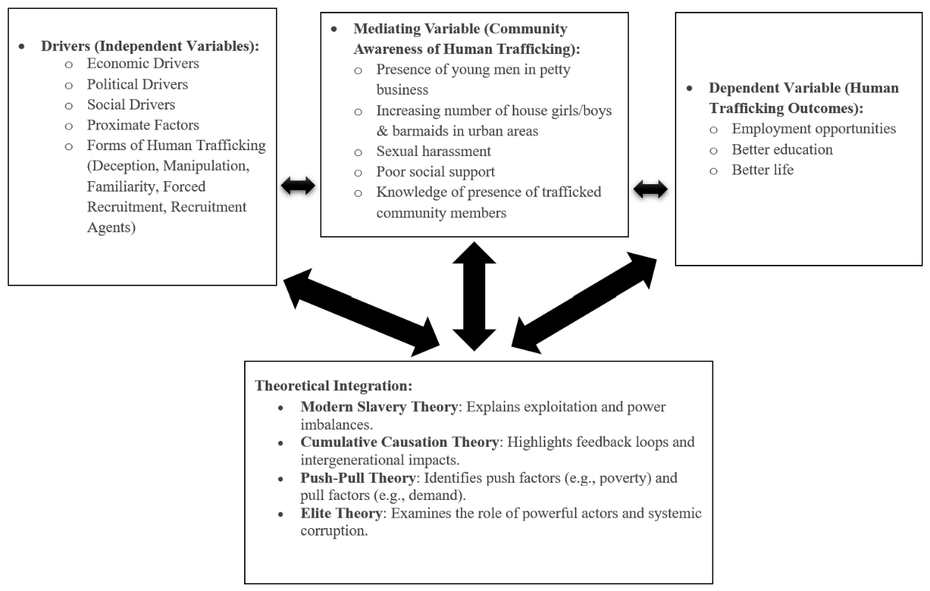
Source: Field Data 2024

Summary
This chapter provided an extensive review of the study of human trafficking in Tanzania. The reviewed multilevel theories of Modern Slavery, Cumulative Causation, Push & Pull and Elite were done to develop a conceptual framework as a foundation of research to determine the dimension of human trafficking in Tanzania.

CHAPTER THREE

RESEARCH METHODOLOGY

Overview
This chapter presents research methods and techniques that have been used in data collection and analysis. It comprises details about the research design, research techniques, research area, population, sample size and sampling techniques that have been used to select respondents and data collection techniques that were used to collect relevant information, data validity and reliability as well as data analysis of the study.

Research Philosophy
Philosophy refers to a system that embeds beliefs or assumptions regarding knowledge generation (Saunders, et al., 2019). However, scholars will have mixed feelings regarding value neutrality in research practices (Jakobsen aet al., 2020). The study’s intent was to conduct causal or explanatory research using a positivist philosophical approach. Positivism posits insights on nomothetic outcomes, which set law-like generalizations regarding the causal and effect of a phenomenon in the study that can act as a basis for predictions (Jakobsen et al., 2020). In line with this, a review of existing literature and empirical studies provided variables that establish the nature of the cause effects on the magnitude of human trafficking in Tanzania as summarized in the Conceptual Framework.

Shah et al., (2013) suppose positivism is related to various schools of thought such as empiricism, naturalism, behaviourism, determinism, and reductionism. This philosophy stems from the assumption that the object's reality is free from the researcher’s influence, and the researcher’s role is limited to data collection and interpretation only. Park et al., (2020) claim that the hypothetical- deductive model explains positivism philosophy. Positivist researchers mainly prefer using the quantitative method for data analysis (Thornhill, et al., 2016). This philosophy seems relevant to suit this study.

Research Approach
Research approaches can be inductive, abductive, and deductive (Saunders, et al., 2019). This research employed the inductive approach which began with data collection to investigate the phenomena and to produce theory presented in conceptual framework, while abductive approach combined inductive and deductive approaches whereby it started with gathering of data to investigate phenomena, identify themes, and explain pattern to produce a new or modify the prevailing theory that was subjected to testing through additional gathered data (Saunders et al., 2019).

In addition, the deductive approach used in this research involved testing theory (Mohajan, 2020). The study used a deductive approach where the relationship between dependent and independent constructs were examined. The deductive method involved careful testing and validating the theory by responding the research questions derived from the theory (Bahari, 2010; Park et al., 2020; Thornhill, et al., 2016). Furthermore, deductive approach possesses the following characteristics, causal relationship between concepts and variables, operationalized concepts measured quantitatively, and generalization Saunders et al., 2019 which was greatly employed in this research.

Research Design and Strategy
This study adopted a case study design whereby information and data were collected from the field and analysed through text and then tabulated into excel. It allowed the collection and description of the nature of the demographic segments. This study further used quantitative techniques to analyse research data and extract findings from. The use of cross – sectional survey was deemed useful in this case for gathering data since the target population had a relatively large number of cases at that time as argued by Lim et al, (2012). Furthermore, the research data in this study recorded the respondent’s sentiments and opinions about the study from the field.

Area of Study
The study was conducted at the Immigration Department Headquarters in Dar es Salaam region. The region was selected because it is the highest mandated office to handle both domestic and international arrivals and is also a resource centre where most of the human trafficking events are reported and recorded. This therefore provided the researcher with a treasure trove of information and other resources concerning the dimensions of human trafficking in Tanzania.

Population of the Study
The population is the entire set of cases from which the researcher’s sample is drawn (Taherdoost, 2016). It refers to all elements that meet certain criteria for inclusion in a given universe. The population under survey constituted of 126 employees from Tanzania migration department Headquarters in Dar es Salaam to get knowledge on the magnitude of human trafficking in Tanzania.

Sample Size and Sampling Techniques

Sample Size
The sample size refers to the number of participants or observations included in a study, which serves as a representative subset of the population from which findings can be generalized (Alvi, 2016). In this study, the sample size was determined using the single population proportion formula:
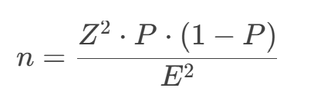
Where:
n = required sample size
Z = Z-score (1.96 for a 95% confidence level)
P = estimated proportion of the population (assumed to be 50% for maximum variability)
E = margin of error (5% or 0.05)

Given the total population of 126 immigration staff, the formula yielded a sample size of 57 participants. This sample size ensures a balance between statistical precision and practical feasibility, allowing the study to generalize findings with a 95% confidence level and a 5% margin of error.

Simple Random Sampling
This study employed simple random sampling, a probability-based technique where each individual in the target population had an equal chance of selection (Lim et al, 2012). This was appropriate for ensuring that the views of immigration staff on human trafficking were represented without bias. To operationalize this method, a numbered list of all 126 staff was compiled, and a random number generator was used to select 57 participants. This approach ensured the sample was representative and minimized selection bias, enhancing the generalizability of the findings.

Simple random sampling is a method where each individual in a population has an equal chance of being selected for a study. When applied to research on human trafficking, this approach can offer important advantages, particularly in studies aiming to estimate prevalence, understand general attitudes, or analyze patterns among a defined and accessible population. Because the selection process is entirely random, it reduces the risk of selection bias, thereby increasing the likelihood that the findings can be generalized to the broader population. This statistical validity is especially valuable when researchers are attempting to produce data that can inform policy or shape intervention strategies on a large scale.

However, in the context of human trafficking, the choice of study population is critical. Victims of trafficking are part of a hidden, vulnerable, and often highly mobile group. Reaching them through simple random sampling is not only logistically difficult but also ethically problematic. These individuals may still be under the control of traffickers, may fear retaliation, or may be experiencing trauma that makes participation unsafe or inappropriate. Engaging them through random sampling risks violating their privacy, compromising their safety, and potentially causing further harm.

For these reasons, simple random sampling is more appropriate when applied to populations that are structured, accessible, and less vulnerable—such as immigration officials. Immigration officers play a key role in identifying and responding to trafficking cases at borders and entry points. They operate within formal institutions, making it feasible to develop a sampling frame and randomly select participants. This allows researchers to gain an unbiased understanding of the knowledge, attitudes, and practices of frontline personnel involved in combating trafficking. Such insights are vital for evaluating institutional responses and improving policies, procedures, and training programs.

In this way, simple random sampling supports research that enhances systemic responses to human trafficking, while respecting ethical boundaries and recognizing the practical limitations of directly involving victims through this method. Alternative approaches, such as purposive or snowball sampling, are better suited for studies that aim to include survivors' perspectives in a safe and respectful manner

Method of Data Collection
In order to enable researcher to attain research objectives to a sound level, both primary and secondary data were collected relating to this study in order to know the views of respondents and also referred to the records to understand about the dimension of human trafficking in Tanzania.

Primary Data
In primary data collection, original data was collected by a researcher from the respondents, using questionnaire method. A researcher used structured questionnaire as a tool of gathering relevant data and information from the study. Self-administered. Questionnaires were used as research instrument to address issues of the impact of human trafficking in Tanzania. The questionnaire was structured with both open and closed ended questions and administered as the appropriate tools for the data collection exercise. The questions were in form of Likert-type scale questions (closed-ended questions) consisted of series of statements that were concise with respect to all levels of academic qualification to ensure there was no ambiguity nor misrepresentation of facts to enable collection of data from the 57 respondents targeted.

The statements comprised a 5-Lickert scale question items expressed as belief, preference, judgment or opinion that the respondents agreed or disagreed with in each question statement. The response variety for each statement was a linear scale indicating the extent respondents agreed or disagreed with each statement i.e. 1 = Strongly Disagree, 2 = Disagree, 3 =Neither Agree nor Disagree, 4 = Agree and 5 = Strongly Agree. The 5 Likert-type items were combined into a single composite variable during analysis to provide a quantitative measure of characters. The results as per each specific research objective of the study were then presented for tabulation and analysis.

The Researcher used different Techniques to analyse the data as follows:
The researcher conducted exploratory analysis and used descriptive statistics (frequency and percentage) to describe and analyse the demographic information’s of the study. Furthermore, the researcher employed the use of descriptive statistics (mean and standard deviation) to further express the opinions of the respondents based on the different variables used in the survey tool. Finally, the researcher used Pearson’s correlation a statistical measure used to assess the strength and direction of the linear relationship between two continuous variables to determine whether there is a relationship between the dependent and independent variables. Descriptive statistics of the level of agreement of the respondent’s perception towards different variables of the research were used by the researcher in discussing the specific objectives of this study.

Secondary Data

Documentary Review
This information was obtained from various sources of documented artefacts, most of which were public records in custody of the immigration department, university library and the internet. The trove of documents enabled the researcher to access a myriad of accurate and reliable content. Documents utilized comprised of guidelines, directives, policies and regulations (regarding the dimension of human trafficking in Tanzania), books and journals (as literatures) and information from Immigrations headquarters, various websites including Google Scholar, Science Direct and Research Gate in order to gather more information about the study. Lastly, all information that was observed by the researcher from the study area environment was included to present valid information by the researcher.

Tools Used in Data Collection
Primary data was obtained through structured questionnaires administered to selected employees and administrative staff at the Immigration Department Headquarters in Dar es Salaam. These questionnaires contained both open-ended and closed-ended questions. The closed-ended questions were based on a five-point Likert scale to quantitatively assess respondent attitudes, while the open-ended questions allowed participants to elaborate on their views, providing richer qualitative insights. The questionnaires were self-administered, and respondents were given adequate time to complete them in a confidential setting to promote honest and thoughtful responses.

To complement the primary data, secondary data was collected through a detailed documentary review. This included reports, legal frameworks, institutional policies, academic publications, and other official documents from the Immigration Department and scholarly databases. The documentary review offered historical and contextual background on human trafficking trends, enabling the researcher to interpret the findings within an institutional and policy-based framework.

For data handling and analysis, two main software tools were used: Microsoft Excel and SPSS (Statistical Package for the Social Sciences). Microsoft Excel played a critical role in the early stages of data management. It was used for data entry, cleaning, and tabulation. It also enabled the creation of simple visualizations such as charts and tables to summarize demographic variables.

SPSS was employed for more advanced statistical analysis. It facilitated the calculation of descriptive statistics such as frequencies, means, and standard deviations, and was also used to perform correlation and regression analyses. These analyses were essential in identifying relationships between variables and testing the study’s hypotheses. SPSS proved to be a powerful tool due to its capacity to manage large datasets and perform complex statistical procedures, making it well-suited for the analytical needs of this research.

The study employed triangulation by integrating both primary (questionnaires) and secondary (document review) data sources to enhance validity and enrich understanding. The questionnaire provided firsthand insights from immigration officers, while document reviews supplemented this with historical and institutional context. Each method was selected based on its capacity to contribute uniquely to the research objectives, ensuring a comprehensive view of the human trafficking dimensions in Tanzania.

Data Analysis
While regression is traditionally used to test the relationship between variables, its application in this study was aimed at going beyond just identifying dimensions. Here, regression was used to measure the strength and significance of influence that different dimensions (economic, political, social, and proximate factors) exert on human trafficking occurrences. This aligns with the study’s explanatory objectives, making regression a relevant tool for quantifying and validating the impact of these dimensions, not just identifying them. Regression suits the analysis of dimensions of human trafficking particularly those that are quantifiable, such as patterns in identification, reporting behaviour, institutional response, or risk factors associated with trafficking vulnerability.

Variables and Measurement Procedures
The sampling procedure was used to obtain a sample that is studied or to select items from the population. Single population proportion sampling technique was applied to obtain the required sample size. The Characteristics of the studied population and access to information required by the researcher. In this case, most of the primary data collected involved employees of Immigration headquarters in Dar es Salaam, where a specific number of interviewees was sought. This helped the researcher to be specific on how many of the interviewees were required.

Data Validity and Reliability

Validity of Data
Validity refers to the degree to which an instrument accurately measures what it is intended to measure. It reflects how well the collected data represents the phenomenon under investigation (Saunders et al., 2019). In this study, construct validity was prioritized, focusing on the appropriateness of inferences made from observed measurements.

Construct validity ensures that the measurement tool aligns with theoretical expectations and accurately captures abstract concepts such as perceptions and attitudes toward human trafficking. This was achieved by designing the questionnaire based on a thorough review of relevant literature and ensuring that the items aligned with the study's objectives. Moreover, the formulation of questions was guided by existing validated instruments in related studies to enhance the credibility of the measurements.

To further strengthen validity, the questionnaire underwent expert review before deployment, ensuring content accuracy, relevance, and clarity. This process helped ensure that the instrument reflected the actual differences among participants in relation to the key constructs being measured.

Reliability of Data
Reliability refers to the extent to which a research instrument consistently produces stable and consistent results across repeated trials and various conditions (Creswell & Creswell, 2018). In quantitative studies, this concept is critical in ensuring that the measured constructs are dependable and reproducible.

In this study, the reliability of the research instrument was evaluated using internal consistency analysis, specifically through Cronbach’s Alpha—a widely accepted measure for Likert-type scale instruments. The structured questionnaire contained multiple items organized into construct-specific groups, each measuring various dimensions related to human trafficking in Tanzania. Respondents rated their agreement with each item using a five-point Likert scale, ranging from “Strongly Disagree” (1) to “Strongly Agree” (5).
The analysis produced a Cronbach’s Alpha coefficient of 0.970 across 8 items, which indicates excellent internal consistency (Basu, 2021). According to conventional thresholds, a value above 0.70 is considered acceptable, while values above 0.90 reflect outstanding reliability. This result suggests that the questionnaire items were highly correlated and consistently measured the intended constructs.

Table:3.1: Reliability Statistics

Cronbach's Alpha | N of Items
.970 | 8
Table: 3.2: Case Processing Summary
 |  | N | %
Cases | Valid | 57 | 100.0
Cases | Excludedª | 0 | .0
Cases | Total | 57 | 100.0
a. Listwise deletion based on all variables in the procedure.

Model Specification
The researcher used multiple linear regression (MLR) models because it accommodates the use of more than one independent variable influencing the dependent variable (HT – Human Trafficking).

Mathematically the model is expressed as follows.
From objective 1 to 3:
HT=α₀​+α₁​E+α₂​P+α₃​S+α₄​PF+ϵ

Conclusion
In this multiple linear regression model, Human Trafficking (HT) serves as the dependent variable, representing the primary outcome of interest. The equation includes an intercept (α₀), which represents the baseline level of human trafficking when all independent variables are equal to zero. The model incorporates four independent variables, each with its respective coefficient. Economic drivers (E), Political drivers (P), Social drivers (S), and Proximate factors (PF) which are the key factors believed to influence human trafficking. Their corresponding coefficients (α₁, α₂, α₃, and α₄) quantify the strength and direction of their impact on human trafficking. Lastly, ε (the error term) accounts for any variations in human trafficking that cannot be explained by the included independent variables, capturing random fluctuations and unobserved factors affecting the model.
CHAPTER FOUR
ANALYSIS, INTERPRETATION AND DISCUSSION OF THE FINDINGS

Introduction
This chapter provides data analysis and discusses the findings for the objectives in the first chapter. It starts by presenting data collected from the field. It proceeded by providing analysis of what was found in the field and finalize by providing discussion though making comparison with what other scholars have found in their studies.

Demographic Profile of Respondents

Gender Distribution
The gender distribution table shows that 64.9% of respondents are male (37 officers), while 35.1% are female (20 officers). This reflects a male-dominated workforce among the immigration officers surveyed. The valid percent and cumulative percent confirm that there are no missing responses, ensuring data completeness. The results suggest that men are more represented in immigration roles, though a significant proportion of women also participate.

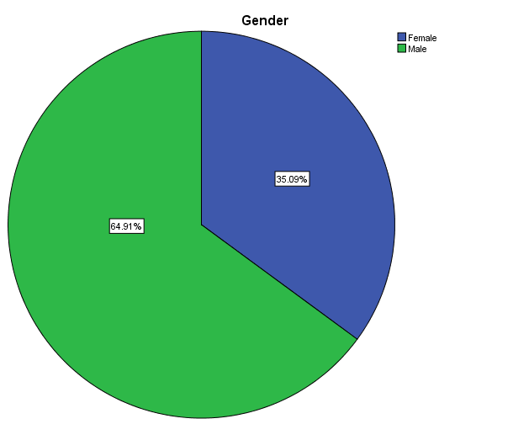
Figure 4.1.1 : Respondents Distribution by Gender

Age Distribution
The age distribution shows that the majority of respondents (59.6%) are aged 41-50, indicating that most immigration officers are in mid-career stages. 17.5% are aged 31-40, while 14% are between 51-60, showing a balanced mix of experienced officers. Only 3.5% are 21-30 years old, suggesting limited young recruits, and 5.3% are over 60, indicating some senior officers nearing retirement. The cumulative percentage confirms a progressive increase across age groups, with all responses accounted for. This distribution highlights an experienced workforce with fewer younger officers.

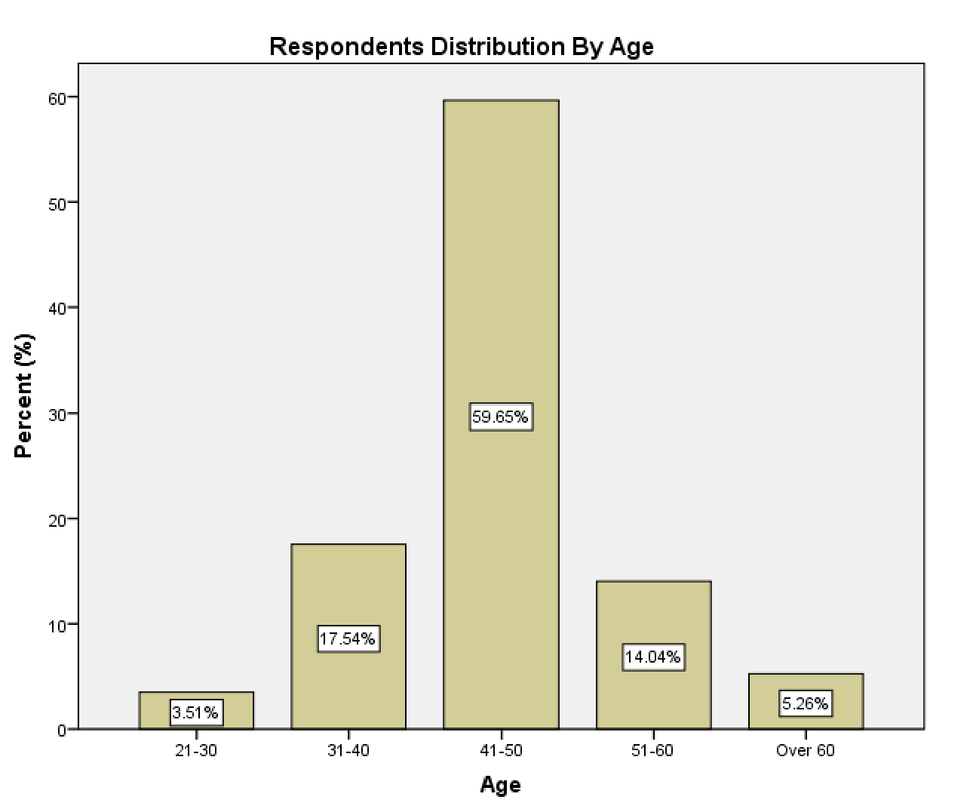
Figure 4.1.2 Respondents Distribution by Age

The findings show that majority of the respondents at Immigration department Headquarters in Dar es Salaam Tanzania who were aged between 41-50 years, from this study the findings implies that the immigration department Headquarters in Dar es Salaam is composed by matured staff who likely to have sufficient experience in executing their daily duties and are believed to be more energetic, talented, ambitious, and assertive.

Marital Status
The marital status distribution shows that the majority of respondents (64.9%) are married, indicating that most immigration officers have family commitments. 31.6% are single, representing a significant proportion of younger or independent officers. Only 1.8% are divorced and 1.8% are widowed, suggesting that separation or loss of a spouse is uncommon among this group. The cumulative percent confirms a steady increase, with all responses accounted for. This distribution highlights a workforce with a strong presence of married individuals, likely reflecting career stability.

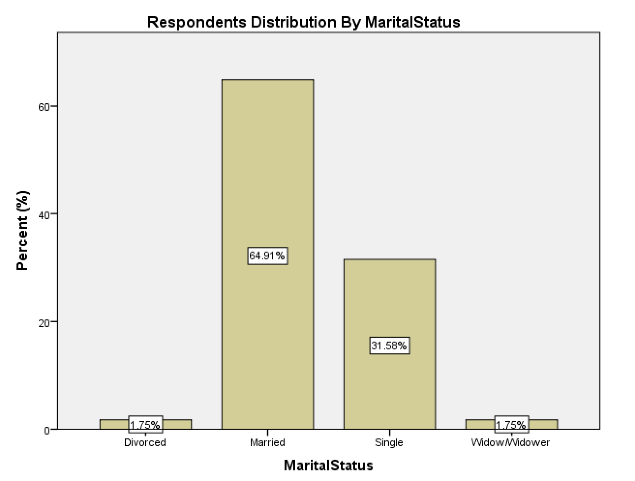
Figure 4.1.3: Respondents Distribution by Marital Status

Academic Qualification
The education level distribution shows that the majority of respondents (54.4%) hold a Bachelor's degree, indicating a well-educated workforce. 26.3% have a Diploma, while 7.0% hold a Certificate, suggesting that a significant portion have practical training. 8.8% have a Master’s degree and 3.5% hold a PhD, reflecting a smaller group with advanced education. The cumulative percent confirms that most officers have at least a Diploma or higher, emphasizing the role of formal education in immigration services.

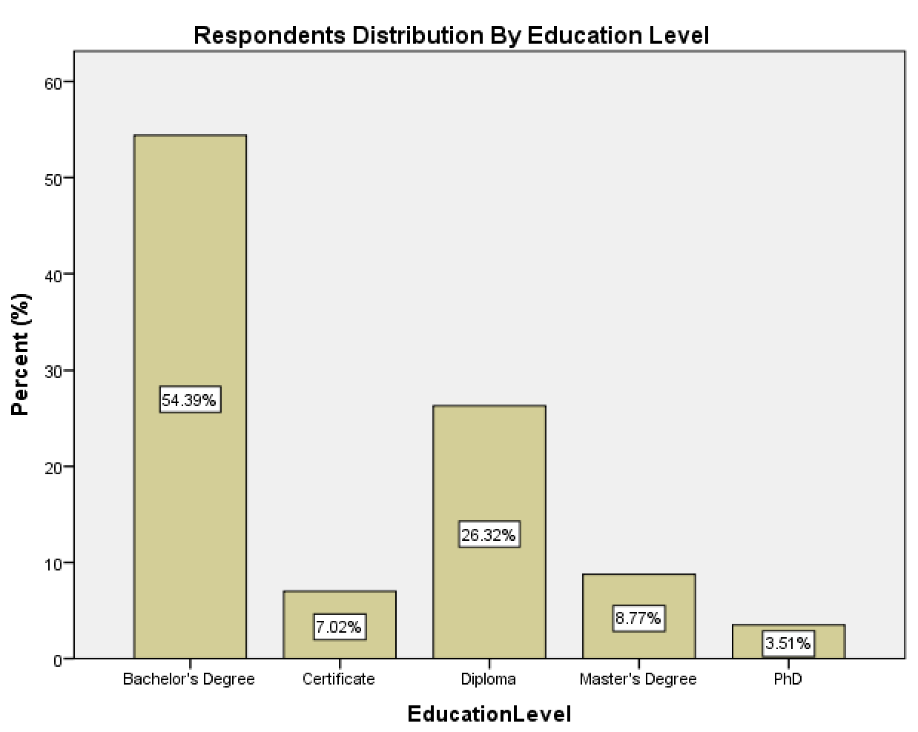
Figure 4.1.4: Respondents Distribution by Education Level

Therefore, 31% were university graduates and the least group of 3.5% were holders of PHD. The level of education for each group shows that majority of respondents were educated and having different professionals, that gives the department an influence in different service provisions.

Work Experience
The working experience distribution indicates that immigration officers have a balanced mix of experience levels. The largest group, 28.1%, have 11-15 years of experience, followed by 26.3% with over 15 years, suggesting a significant presence of seasoned officers. 21.1% have 5-10 years of experience, while 24.6% have less than 5 years, reflecting a steady influx of newer recruits. The cumulative percentage confirms a progressive distribution, showing that while many officers have extensive experience, a notable proportion are relatively new to the field. This balance suggests a workforce with a blend of expertise and fresh perspectives.

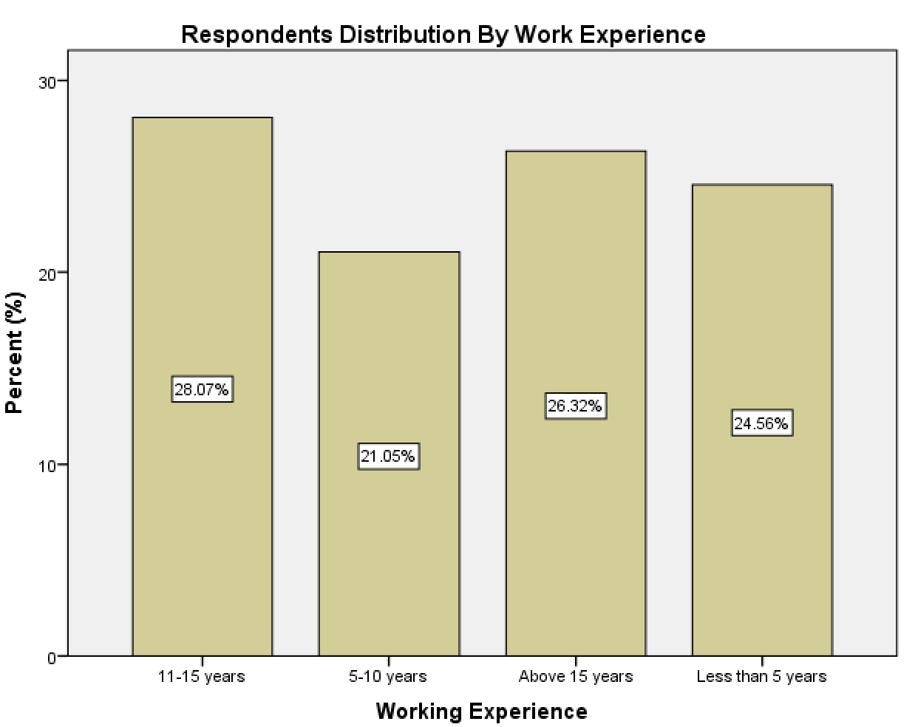
Figure 4.1.5: Respondents Distribution by Work Experience

Table 4.1.51: Descriptive statistics of Respondent's Biographical data.
Statistics
 |  | Poverty | Corruption | Forced labour recruitment
N | Valid | 57 | 57 | 57
N | Missing | 0 | 0 | 0
Mean |  | 2.95 | 2.98 | 3.23
Median |  | 3.00 | 3.00 | 3.00
Std. Deviation |  | 1.432 | 1.541 | 1.376
Minimum |  | 1 | 1 | 1
Maximum |  | 5 | 5 | 5

Descriptive Statistics
The dataset, based on 57 responses, reveals that poverty (M = 2.95), corruption (M = 2.98), and forced labour recruitment (M = 3.23) are perceived as moderate contributors to human trafficking. The median values (3.00) indicate a balanced distribution of opinions, while the relatively high standard deviations (1.376–1.541) suggest diverse perspectives among respondents. The full range of responses (1 to 5) confirms varying perceptions, with corruption showing the greatest variation. These findings highlight the need for further analysis, such as demographic comparisons, correlation assessments, and regression modeling, to identify key predictors of human trafficking prevalence.

The interrelationships between study variables in terms of drivers to human trafficking, forms of human trafficking and level of community awareness is presented. The drivers of human trafficking (composite of economic drivers, political drivers, social drivers, and proximate drivers) being factors for the desire to migrate illegally are studied and discussed in this research.

Objective one wanted to examine the stimulus factors of human trafficking in Tanzania. The study identified four stimulus/drivers to human trafficking in Tanzania to include economic drivers, political drivers, social drivers, and proximate factors. To respond to study objective one respondents were asked to explain different drivers necessary for human trafficking in Tanzania as follows:

Human Trafficking Caused by Economic Drivers
Respondent were asked to identify the economic drivers necessary for human trafficking in Tanzania from among the following: ``border control, poverty, globalization, and demand for cheap labour``. From the table 4.2, 27(47.4%) of respondent agree on the question that economic drivers cause increase the extent of human trafficking in Tanzania, 21(36.8%) strongly agree, while 5(8.8%) respondents disagree on the question and 4(7%) of respondents strongly disagree. From the respondents above, it can be said here that economic drivers cause to an increased rate of human trafficking victims in Tanzania. These findings are in line with the findings by (Aronowitz & Anneke, 2014) who asserts that globalization foster trafficking since it acts like a catalyst for the demand of cheap labour and products, which in extension, catalyses a demand of trafficked persons.

Table 4.2.1 : Human Trafficking Caused by Economic Drivers
 |  | Frequency | Percent | Valid Percent | Cumulative Percent
Valid | Strongly disagree | 4 | 7.0 | 7.0 | 7.0
Valid | Disagree | 5 | 8.8 | 8.8 | 15.8
Valid | Agree | 27 | 47.4 | 47.4 | 63.2
Valid | Strongly agree | 21 | 36.8 | 36.8 | 100.0
Valid | Total | 57 | 100.0 | 100.0
Source: Field survey 2023

Human Trafficking Caused by Political Drivers
Respondent were also asked to identify the political drivers necessary for human trafficking in Tanzania from among the following: “crisis, armed conflicts, institutional strength, economic insecurity, poor education”. Table 4.7 shows that, 37(64.9%) of respondents agree that human trafficking is caused by political drivers, 7(12.3%) of respondents are strongly agree and disagree, while 3(5.3%) of respondents are strongly disagree and not sure. Therefore, from the results above we can conclude at this point that human trafficking is caused by political drivers. These findings concur with the study findings by Worsnop, (2019) who revealed that government efforts and policies related to human trafficking can inflict the risk of trafficking as corruption and criminal activity levels are affected by the policies at hand and can, therefore, influence the prevalence of human trafficking.

Table 4.2.2: Human Trafficking Caused by Political Drivers
 |  | Frequency | Percent | Valid Percent | Cumulative Percent
Valid | Strongly disagree | 3 | 5.3 | 5.3 | 5.3
Valid | Disagree | 7 | 12.3 | 12.3 | 17.5
Valid | Not sure | 3 | 5.3 | 5.3 | 22.8
Valid | Agree | 37 | 64.9 | 64.9 | 87.7
Valid | Strongly agree | 7 | 12.3 | 12.3 | 100.0
Valid | Total | 57 | 100.0 | 100.0
Source: Field survey 2023

Human Trafficking Caused by Social Drivers
Respondent were further asked to identify the social drivers causing human trafficking in Tanzania from among the following: ``socioeconomic status, family structure, gender, structural inequality, discrimination, gender-based violence, the will to get a better life, and lack of alternatives``. From table 4.8 and figure 4.3 below shows that, 16(28.1) of respondents strongly agree from the question that human trafficking in Tanzania is caused by social drivers, 14(24.6%) of respondents were not sure, while 12(21.1%) of respondents are strongly disagree on the question and 10(17.5%) of respondent agree from the question and 5(8.8%) of respondents disagreed. Majority of respondents has agreed; thus, we can conclude here that human trafficking is caused by social drivers. These findings concur with the findings by (Ortega, Gordon, Gordon-Achebe, & Robitz, 2022); (Viuhko, 2019)) who stated that; human trafficking vulnerability is influenced by a vast of social factors, such as socioeconomic status, family structure, gender, structural inequality, discrimination, gender-based violence, the will to get a better life, and lack of alternatives.

Table 4.2.3: Human Trafficking Caused by Social Drivers
 |  | Frequency | Percent | Valid Percent | Cumulative Percent
Valid | Strongly disagree | 12 | 21.1 | 21.1 | 21.1
Valid | Disagree | 5 | 8.8 | 8.8 | 49.1
Valid | Not sure | 14 | 24.6 | 24.6 | 73.7
Valid | Agree | 10 | 17.5 | 17.5 | 91.2
Valid | Strongly agree | 5 | 28.1 | 28.1 | 100.0
Valid | Total | 57 | 100.0 | 100.0
Source: Field survey 2023

Human Trafficking Caused by Proximate Drivers
Respondent were asked to identify the proximate drivers causing human trafficking in Tanzania from among the following: ``the rule of law, bureaucratic efficiency, institutional strength, border control, and corruption``. Results from table 4.5 shows that, 35(61.4%) of respondents agree that human trafficking is caused by proximate drivers, 11(19.3%) of respondents are strongly agree, 6(10.5%) of respondents are disagree, 4(7.0%) of respondents are strongly disagree and 1(1.8%) are not sure. It can be concluded in this part that proximate drivers cause human trafficking in Tanzania. These findings are in line with the findings by Hughes, (2017) who asserted that the governmental inability to detect, suppress and control human trafficking tends to escalate the issue of trafficking.

Table 4.2.4 : Human Trafficking Caused by Proximate Drivers
 |  | Frequency | Percent | Valid Percent | Cumulative Percent
Valid | Strongly disagree | 6 | 10.5 | 10.5 | 10.58
Valid | Disagree | 4 | 7.0 | 7.0 | 17.5
Valid | Not sure | 1 | 1.8 | 1.8 | 19.3
Valid | Agree | 35 | 61.4 | 61.4 | 80.7
Valid | Strongly agree | 11 | 19.3 | 19.3 | 100.0
Valid | Total | 57 | 100.0 | 100.0
Source: Field survey 2023

Forms of Human Trafficking in Tanzania
Object two was on different forms of human trafficking in Tanzania. To respond to objective two respondents were required to answer a research question which asked them to identify the forms of human trafficking in Tanzania from among the following: (deception, manipulations, familiarity, forced labour/recruitment and forced migration). The findings in table 4.6 below tell us that, 30(52.6%) of respondents agree about forced labour accelerate human trafficking in Tanzania, 6(10.5%) were disagree from the question, 5(8.8%) strongly disagree and 4(7%) of respondent were not sure from the question asked to them. Finally, we can say that any kind of forced labour can increase the rate of human trafficking.

Table 4.2.5: Forms of Human Trafficking in Tanzania
 |  | Frequency | Percent | Valid Percent | Cumulative Percent
Valid | Strongly disagree | 5 | 8.8 | 8.8 | 8.8
Valid | Disagree | 6 | 10.5 | 10.5 | 19.3
Valid | Not sure | 4 | 7.0 | 7.0 | 26.3
Valid | Agree | 30 | 52.6 | 52.6 | 78.9
Valid | Strongly agree | 12 | 21.1 | 21.1 | 100.0
Valid | Total | 57 | 100.0 | 100.0
Source: Field survey 2023

Community Awareness on the Presence of Human Trafficking in Tanzania
Objective three was about the level of community awareness on human trafficking in Tanzania. To respond to third objective respondents were required to answer a question that wanted to explore respond`s level of awareness on human trafficking in Tanzania. The results from table 4.7 show that, 39(68.4%) of respondents, agree that Tanzania is having a large number of domestic human trafficking cases, 12(21.1%) were strongly agreed, while 3(5.3%) of respondents disagree from the question, 2(3.5%) of respondents were strongly disagree and 1(1.8%) of respondents were not sure from the question. It can be concluded in this part that the level of community awareness on the presence of human trafficking in Tanzania is high.

Table 4.2.6: Level of Community Awareness on Human Trafficking in Tanzania
 |  | Frequency | Percent | Valid Percent | Cumulative Percent
Valid | Strongly disagree | 2 | 3.5 | 3.5 | 3.5
Valid | Disagree | 3 | 5.3 | 5.3 | 8.8
Valid | Not sure | 1 | 1.8 | 1.8 | 10.5
Valid | Agree | 39 | 68.4 | 68.4 | 78.9
Valid | Strongly agree | 12 | 21.1 | 21.1 | 100.0
Valid | Total | 57 | 100.0 | 100.0
Source: Field survey 2023

Regression Analysis
The researcher employed Multiple Linear Regression (MLR) because of the need to understand how different factors (economic, political, social, and proximate) affect human trafficking outcomes. This method helps us see which factors have the biggest impact and whether they increase or decrease the likelihood of certain outcomes. Since we had multiple independent variables and one dependent variable, MLR was the best choice. The "Enter" method was applied to include all four factors in the model at the same time. This allows for the comparison of their effects fairly and see which ones are significant. If some factors are not important, we can later refine the model by removing them.

Model Summary
The model summary provides important details about how well the independent variables (economic, political, social, proximate factors, forms of human trafficking, and community awareness) explain variations in human trafficking outcomes. The R-value (0.541) shows a moderate positive relationship between the independent variables and human trafficking outcomes. This means that as factors like economic instability, political instability, or community awareness change, human trafficking outcomes are also affected. The R-Square (R²) value of 0.292 indicates that 29.2% of the variation in human trafficking outcomes can be explained by the independent variables included in the model. The remaining 70.8% of the variation is due to other factors not included in this analysis. The Adjusted R-Square (0.207) accounts for the number of independent variables used in the model. It suggests that after adjusting for the number of predictors, only 20.7% of the variation in human trafficking outcomes is explained by these variables. The difference between R² and Adjusted R² suggests that some independent variables might not be strong predictors and could be removed to improve the model. The Standard Error of the Estimate (0.474) tells us how much the predicted human trafficking outcomes differ from the actual values. A lower value indicates better accuracy. In this case, a standard error of 0.474 suggests that the model predictions are somewhat close to the real-world data but still have some margin of error.

The Change Statistics help us determine whether this model significantly improves our ability to predict human trafficking outcomes. The R-Square Change (0.292) confirms that adding these independent variables has improved the ability of the model to explain variations in human trafficking outcomes by 29.2%. The F-Change value (3.442) measures whether adding these independent variables significantly improves the prediction of human trafficking outcomes. A higher F-value suggests a stronger relationship between the independent and dependent variables. The degrees of freedom (df1 = 6, df2 = 50) show that the model includes six independent variables and 50 remaining degrees of freedom, meaning the calculations were performed on a dataset with 57 respondents. The p-value (Sig. F Change = 0.006) is the most critical value in this section. Since 0.006 is less than 0.05, it confirms that the model is statistically significant. This means that at least one or more of the independent variables significantly contribute to predicting human trafficking outcomes.

Table 4.3.1: Regression Table Summary
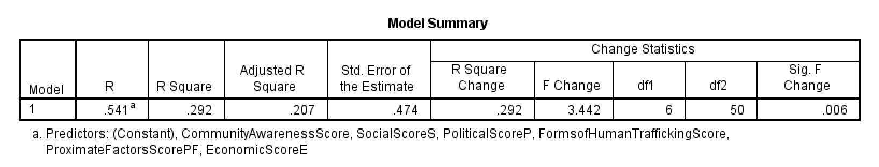

In concluding, the model is statistically significant (p = 0.006), meaning the independent variables explain human trafficking outcomes better than random chance. The R² value (29.2%) shows that the independent variables contribute to human trafficking outcomes, but other unmeasured factors may still play a larger role. The Adjusted R² (20.7%) suggests that some independent variables may not be strong predictors.

ANOVA
The ANOVA table confirms that the overall regression model is statistically significant (p = 0.006), meaning the independent variables meaningfully explain variations in human trafficking outcomes. The F-statistic (3.442) indicates that the model performs better than random chance in predicting the dependent variable. The Sum of Squares for Regression (4.642) shows that the independent variables account for 29.2% of the total variation in human trafficking outcomes. However, the Residual Sum of Squares (11.239) is still high, meaning that 70.8% of the variation remains unexplained, suggesting that other factors outside this model may also influence human trafficking outcomes. The R-Square value (0.292) further supports that 29.2% of the changes in human trafficking outcomes can be attributed to economic, political, social, proximate factors, forms of human trafficking, and community awareness. The Adjusted R-Square (0.207) suggests that some independent variables may be weak predictors.

Table 4.3.2 : ANOVA
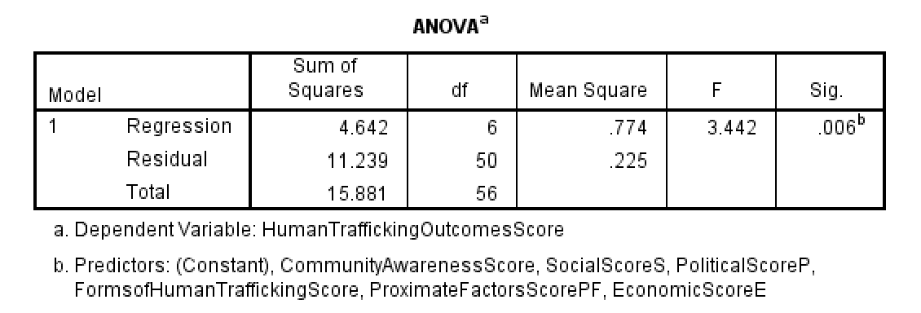

Coefficients
The regression results show that economic and political factors significantly impact human trafficking outcomes, while other variables (social, proximate, forms of human trafficking, and community awareness) are not statistically significant. The economic score (B = 0.299, p = 0.002) suggests that poor economic conditions, such as poverty and unemployment, increase human trafficking risks. Similarly, the political score (B = 0.335, p = 0.001) confirms that political instability, corruption, and weak governance contribute to worsening human trafficking outcomes. These two factors have the strongest effect on the dependent variable. The remaining variables—social, proximate factors, forms of human trafficking, and community awareness—do not show significant effects (p > 0.05). This indicates that, in this model, they do not have a measurable influence on human trafficking outcomes. A multicollinearity check (VIF values all below 5) confirms that the independent variables are not too similar to each other, meaning the model is stable and reliable.

Table 4.3.3 : Correlation Coefficients
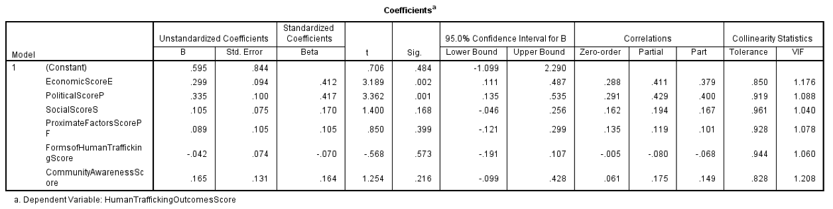

Collinearity Diagnostics
The Collinearity Diagnostics table checks whether the independent variables are too closely related, which can make it difficult to determine their individual impact on human trafficking outcomes. The Condition Index shows that most dimensions are within safe limits, but Dimension 7 has a high value (38.626), which indicates severe collinearity. This suggests that some independent variables are strongly related, making the model less reliable. The Variance Proportions reveal that Proximate Factors Score has a high variance proportion (0.64), meaning it overlaps with other predictors. Additionally, Economic and Political Scores show collinearity in Dimension 7, which suggests they may be too strongly correlated.

Table 4.3.4: Collinearity Diagnostics
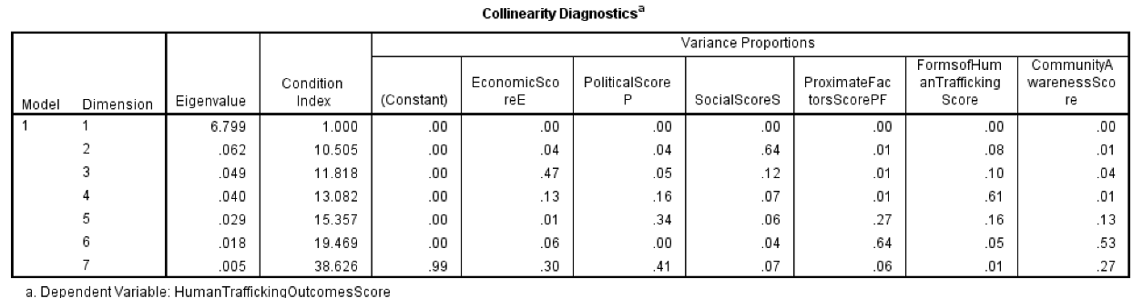

Correlation Analysis
The correlation analysis examines the relationships between Community Awareness, Human Trafficking Outcomes, Economic, Political, Social, and Proximate Factors Scores using Kendall’s tau-b and Spearman’s rho tests. These correlations help identify whether these factors are statistically associated with each other.

One of the key findings is that Community Awareness has a significant positive correlation with Proximate Factors (rule of law, corruption, and governance). The correlation values (Kendall’s tau-b = 0.201, p = 0.041; Spearman’s rho = 0.271, p = 0.041) indicate that as awareness of human trafficking increases, concerns about governance issues also rise. This suggests that officers who recognize trafficking problems are also more likely to acknowledge weaknesses in law enforcement and governance structures.
Table 4.3.5:Summary of Correlation Analysis of Significant Variables
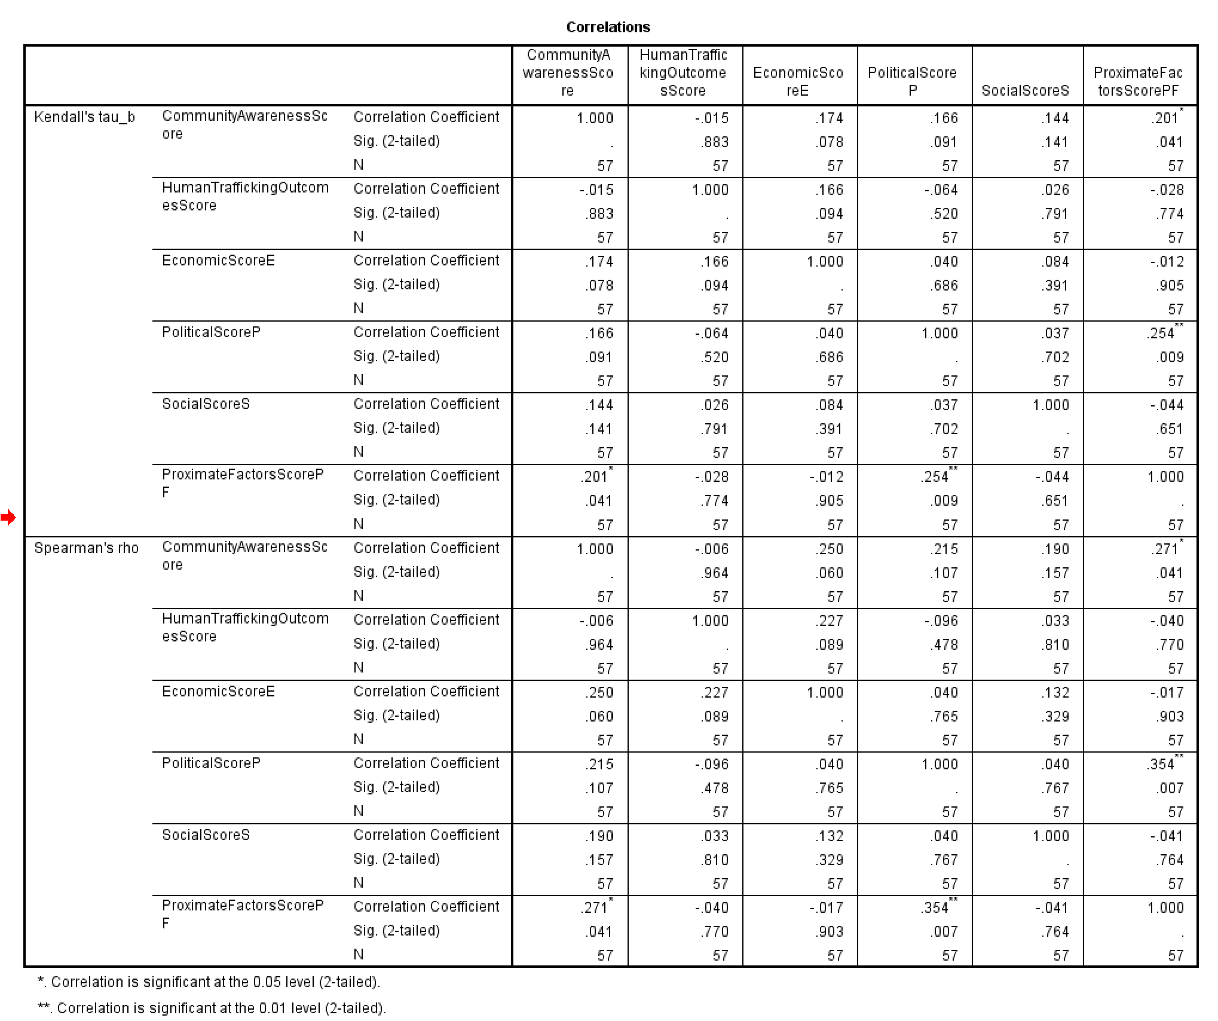

Another strong relationship exists between Political Factors and Proximate Factors, with a moderate positive correlation (Kendall’s tau-b = 0.254, p = 0.009; Spearman’s rho = 0.354, p = 0.007). This indicates that political instability, such as internal crises and conflicts, is closely linked to weak governance and corruption, which are known to contribute to human trafficking risks.

Interestingly, the Human Trafficking Outcomes Score does not show significant correlations with economic, political, social, or proximate factors (all p-values > 0.05). This suggests that these factors alone do not directly determine trafficking outcomes, meaning additional factors such as enforcement efficiency, regional migration trends, or social interventions may play a more critical role.

Correlation Heatmap
The correlation heatmap visually represents the relationships between Community Awareness, Human Trafficking Outcomes, Economic, Political, Social, and Proximate Factors Scores using Kendall’s correlation method. The color intensity indicates the strength and direction of relationships, where red shades represent negative correlations, and blue shades represent positive correlations.

Community Awareness and Proximate Factors
A moderate positive correlation (0.20) suggests that greater awareness of trafficking is linked to concerns about governance, rule of law, and corruption.
This implies that officers who recognize trafficking issues are also more likely to perceive governance weaknesses.

Political and Proximate Factors
A stronger positive correlation (0.25) indicates that political instability is closely related to governance issues. This aligns with the idea that weak institutions and internal crises contribute to trafficking vulnerabilities.

Human Trafficking Outcomes and Other Factors
No strong correlations are observed between human trafficking outcomes and economic, political, social, or proximate factors (all correlations are weak or near zero).
This suggests that trafficking outcomes are influenced by additional factors not included in this model, such as law enforcement efficiency or border control policies.

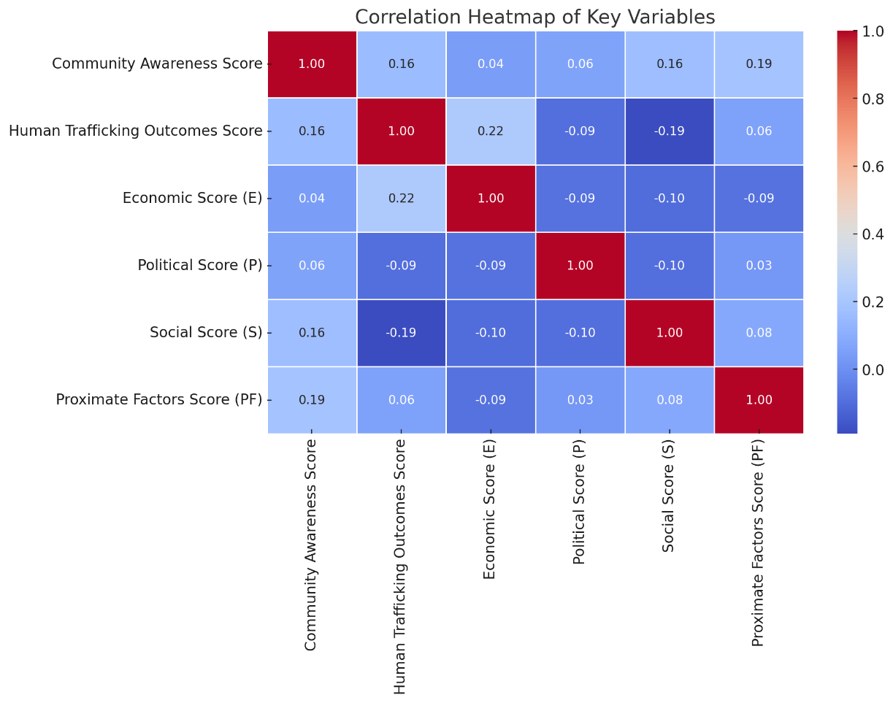
Figure 4.3.6.36: Correlation Heatmap of Key Variables

Summary
The regression analysis confirms that economic and political factors significantly impact human trafficking outcomes (p = 0.002 and p = 0.001, respectively). Higher economic instability and political crises contribute to worsening human trafficking conditions. However, social factors, proximate factors, forms of human trafficking, and community awareness are not statistically significant (p > 0.05), indicating they do not strongly influence human trafficking outcomes in this model. The ANOVA test (p = 0.006) confirms that the overall model is statistically significant, meaning the independent variables explain a meaningful portion of human trafficking outcomes (R² = 29.2%). However, 70.8% of the variation remains unexplained, suggesting other critical factors should be considered. The Collinearity Diagnostics reveal severe collinearity (Condition Index = 38.626), particularly affecting Proximate Factors, Economic, and Political Scores, indicating that some variables may be overlapping in their effects.

Ethical Issues
The researcher considered every requirement of research ethics to establish trust with the participants and to respect them independently, thus enabling them to make sound decisions to the data collection tools. Ethical measures were important in ensuring the validity and reliability of data collection. Other ethics were considering informant consent, confidentiality, privacy, dissemination of results, by ensuring the information that was provided by respondents is used for research purpose only and the respondents have right to withdraw from the study partially or completely. This study took into consideration ethical rules according to the Open University regulations of conducting research/dissertation.

Discussion of the Findings
The present study examines the dimension of human trafficking in Tanzania. The findings show that most of the respondents feel relaxed on their situation of trafficking and have high affective and normative cultural distortion which entailed to high unstable state in terms of political and economic conditions. Research objective 1 contends the drivers causing human trafficking in Tanzania, and outcomes found a significant correlation with economic drivers causing human trafficking by 84.2%. These findings are in line with the findings by (Aronowitz & Anneke, 2014) who asserts that globalization foster trafficking since it acts like a catalyst for the demand of cheap labour and products, which in extension, catalyzes a demand of trafficked person. On the other hand, political drivers cause human trafficking for more than 77.2%, again; these findings concur with the study findings by (Worsnop, 2019) who revealed that government efforts and policies related to human trafficking can inflict the risk of trafficking as corruption and criminal activity levels are affected by the policies at hand and can, therefore, influence the prevalence of human trafficking. Proximate drivers causing human trafficking in Tanzania accounts for more than 80.7% the findings which are in line with the empirical work by (Hughes, 2017)who asserted that the governmental inability to detect, suppress and control human trafficking tends to escalate the issue of trafficking while social drivers were found to cause human trafficking by 45.6%, the findings which supports previous empirical works of (Ortega et.al., 2022; Viuhko, 2019) who stated that, human trafficking vulnerability is influenced by a vast of social factors, such as socioeconomic status, family structure, gender, structural inequality, discrimination, gender-based violence, the will to get a better life, and lack of alternatives.

With reference to research objective 2 where respondents were required to identify the different forms of human trafficking in Tanzania among deception, manipulations, familiarity, forced labour/recruitment and forced migration, the findings show positive and significant relationship between human trafficking and the levels of exploitation of human rights for women and children. However, results further revealed significant skewed relationship between women and children trafficking as compared to men. These findings are in line with previous empirical works of UNICEF, (2014) internal trafficking for domestic work has also been human trafficking on agriculture and another sector.

Research objective 3 assed the level of community awareness on human trafficking in Tanzania, and findings confirmed that 89.5% of respondents agree that Tanzania is experiences a large volume of domestic human trafficking, where young men are engaged in petty business and agricultural activities, while young girls and boys are engaged in domestic chores, women are involved in sexual harassment and early sexual engagement which are occurrences termed as normal in the community. The results are line with the previous empirical work of ILO (2022), that community are looking for better work in other or just trying to escape their current situation.

Furthermore, the study revealed that many participants (70%) identified that education was a key factor to slowing and breaking the chain of human trafficking. One interesting finding indicates that 53.3% of participants recognized that the poor were the most vulnerable to human trafficking, yet under “Employment” the participants (50%) chose not to answer the question. This seems to demonstrate a lack of knowledge about the employment status of those who are most trafficked. Employment is a key factor in how people are recruited for trafficking and can help reduce poverty which would make some potential victims less vulnerable to traffickers. There are many entities that can lure a victim into human trafficking. One such entity was listed on the survey as “Private Company”. These are False - Front Agencies that facilitate the luring of victims into human trafficking by appearing to be a legitimate companies or employment agencies; however, 83.3% of participants felt that “Private Companies”, are least likely to be involved in human trafficking.

Conclusion
This demonstrates that there is less knowledge about this type of recruiting tactic compared to other types such as drugging or kidnapping which have been the most discussed in popular media. In terms of general knowledge of trafficking, most participants correctly identified the experiences that are common to trafficking, however, just over 40% of participants stated it was false that victims make a conscious decision to go abroad for a better life. This shows a lack of understanding about a key factor in recruiting trafficking victims. Many victims do unintentionally contact trafficking recruiters hoping for legitimate work in another country where they have hope of improving their life situation. In not understanding this as an element of trafficking, immigration officers run the risk of not understanding the depth of betrayal and guilt that many victims may experience.

CHAPTER FIVE
FINDINGS, CONCLUSION AND RECOMMENDATIONS

Introduction
This chapter presents a comprehensive discussion of the study's findings on human trafficking in Tanzania. It is structured into four main sections: an overview of the study, a summary of the key findings, conclusions based on each research objective, and policy recommendations. It also outlines areas for future research and highlights the contributions this study makes to the broader discourse on human trafficking in East Africa.

The study was conducted with the aim of understanding the underlying causes, forms, and levels of community awareness regarding human trafficking in Tanzania. The findings provide insights into the institutional, economic, and social dynamics that facilitate trafficking and inform actionable interventions for prevention, protection, and policy reform.

Summary of Findings
The findings of the study reveal that human trafficking in Tanzania is driven by a complex interplay of structural, institutional, and social factors. Economically, poverty and unemployment were found to be key drivers, especially in marginalized communities. Politically, the study identified weak governance structures, corruption, and inadequate enforcement mechanisms as significant enablers of trafficking. These factors create environments where traffickers can operate with minimal risk and accountability.
In terms of the forms of trafficking, the study identified forced labor, forced prostitution, and child trafficking as the most common in Tanzania. Victims are primarily women and children who are trafficked into sectors such as agriculture, mining, domestic service, and informal trade. These exploitative practices are often disguised as legitimate employment opportunities, facilitated by inadequate labor inspection systems and societal acceptance of practices such as child labor in some regions.

The research also explored the level of awareness within communities. While a general awareness of trafficking exists—especially with respect to domestic trafficking—many individuals lack a deep understanding of how trafficking operates. There are significant gaps in knowledge regarding recruitment tactics, psychological coercion, and the use of digital platforms. This limited understanding impairs the ability of communities to detect and prevent trafficking at an early stage.

Conclusion
Based on the three core objectives of the study, several conclusions can be drawn. First, in relation to identifying the drivers of human trafficking in Tanzania, the findings indicate that the root causes are predominantly structural and institutional in nature. Economic hardship and political fragility were consistently cited as the most influential factors. Weak governance, corruption, and limited institutional capacity allow traffickers to act with relative impunity. Although social drivers such as gender inequality and family disintegration were also noted, they appeared to be secondary in influence compared to the economic and political environment.
Second, regarding the forms of trafficking, the study confirmed that forced labor, sexual exploitation, and child trafficking are widespread. These practices are facilitated by poor oversight in labor-intensive sectors and often operate under the pretense of legitimate work. Vulnerable groups, especially women and children, are disproportionately affected, and there is a lack of effective institutional mechanisms to identify and protect victims.

Third, the assessment of community awareness showed that although people recognize human trafficking as a problem, their understanding of the tactics and strategies used by traffickers is often superficial. Most respondents were unaware of how traffickers manipulate trust, deceive victims with false promises, or use digital means for recruitment and exploitation. This gap in awareness limits the ability of communities to contribute meaningfully to prevention and early detection efforts.

5.4 Recommendations
To address the challenges identified in this study, several targeted recommendations are proposed. First, in addressing the root causes of human trafficking, it is essential to promote inclusive economic development through sustainable livelihood initiatives, especially in poverty-stricken and high-risk communities. These programs should prioritize youth and women. Furthermore, there is a need for comprehensive governance and anti-corruption reforms aimed at enhancing institutional transparency and accountability, particularly in the judiciary, immigration, and law enforcement sectors. Community-level surveillance systems should also be strengthened to create early-warning networks that can detect and respond to trafficking activities. Anti-trafficking efforts should be integrated into broader social protection programs, including poverty alleviation and educational access strategies.

Second, to mitigate the specific forms of trafficking identified, the government should strengthen labor inspection frameworks targeting vulnerable sectors such as agriculture, domestic work, and artisanal mining. Public awareness campaigns should be launched to educate vulnerable populations—especially in rural areas—about deceptive recruitment tactics and trafficking indicators. Support services for victims must be expanded through partnerships with civil society organizations and NGOs, offering shelter, psychological support, legal aid, and reintegration programs. In addition, a national trafficking victim registry should be developed to enhance data collection, monitor victim recovery, and inform policy decisions.

Third, to address gaps in community awareness, it is recommended that anti-trafficking training programs be institutionalized across sectors. These programs should be mandatory for immigration officers, police, social workers, and healthcare providers. Educational curricula should include age-appropriate modules on human trafficking, developed in partnership with the Ministry of Education and tailored to local contexts. A centralized reporting system, including a national information portal and hotline, should be established to disseminate accurate information and enable real-time reporting. Additionally, media platforms and community influencers should be mobilized to conduct localized awareness campaigns in various languages and formats to reach diverse audiences.

Suggestions for Further Studies
While this study provides valuable insights, it was limited in geographic scope and sample size. It focused exclusively on the Immigration Department Headquarters in Dar es Salaam and involved a relatively small number of respondents. To strengthen future research, it is recommended that studies expand their geographic coverage to include both urban and rural regions of Tanzania. Increasing the sample size would allow for more diverse and representative perspectives.

Longitudinal studies could also be beneficial in understanding the evolving nature of trafficking patterns and the impact of interventions over time. Furthermore, employing mixed-method research designs that combine qualitative and quantitative approaches would provide a more nuanced understanding of the dynamics of human trafficking. In-depth interviews, focus group discussions, and ethnographic methods could enrich the data collected through surveys.
REFERENCES
Akee, R., Basu, A. K., Bedi, A., & Chau, N. H. (2014). Transnational Trafficking, Law Enforcement, and Victim Protection: A Middleman Trafficker’s Perspective. The Journal of Law & Economics, 57(2), 349–386. https://doi.org/10.1086/675404.
Aronowitz, A., & Anneke, K. (2014, 01). Understanding human trafficking as a market system: Addressing the demand side of trafficking for sexual exploitation. Revue internationale de droit pénal, 669. doi:10.3917/ridp.853.0669
Bales, Kevin. (2012). Disposable People: New Slavery in the Global Economy (3rd ed.). University of California Press. Retrieved from http://www.jstor.org/stable/10.1525/j.ctt1pp4n3
Barasa, et al. (2022). This Pandemic Has Opened Another Box of War”: COVID-19, Safeguarding, and Research on Human Trafficking and Modern Slavery in Kenya and Uganda. (A. C. Barasa, A. Balch, W. Okumu, G. Omony, L. Renton, & J. Sandhar, Eds.) Journal of Human Trafficking, 17(1). doi:doi: 10.1080/23322705.2022.2066873
Basu, A. (2021). Cronbach's alpha. Qeios. https://doi.org/10.32388/3XOD6Z
Bernat, F. P., & Tatyana, Z. (2010). Human Trafficking: The Local Becomes Global. Women & Criminal Justice, 20(1-2), 2–9. doi:doi:10.1080/08974451003641289
Blanton, Robert G.; Blanton, Shannon Lindsey;. (2020, 07). The Global Economic and Political Causes of Human Trafficking. doi:10.1093/acrefore/9780190846626.013.561
Bruckert, Chris; Parent, Colette;. (2022). Trafficking in human beings and organized crime: A literature review. Research and Evaluation Branch, Community, Contract and Aboriginal Policing.
Bryant, K., & Landman, T. (2020). Combatting Human Trafficking since Palermo: What Do We Know about What Works? Journal of Human Trafficking, 6(2), 119–140. https://doi.org/10.1080/23322705.2020.1690097
Cho, S.-Y. (2015, July). Human Trafficking, A Shadow of Migration - Evidence from Germany. Journal of Development Studies, 51(7), 905-921. doi:10.1080/00220388.2015.1010158
Cho, Seo-Young;. (2015, 07 15). Modelling for Determinants of Human Trafficking. (3). doi:http://dx.doi.org/10.2139/ssrn.2117838
Chuang, J. A. (2017). USING GLOBAL MIGRATION LAW TO PREVENT HUMAN TRAFFICKING. AJIL Unbound, 111, 147–152. https://www.jstor.org/stable/27003719
ENACT Africa. (2021, 06 30). Human trafficking into the Southern African region. Human trafficking. Retrieved February 12, 2024, from https://enactafrica.org/research/interpol-reports/: https://enactafrica.org/research/interpol-reports/human-trafficking-into-the-southern-african-region
Ferrell-Schweppenstedde, S., Hunt, J., & Matekaire, T. (2019). How Lifelong Discrimination and Legal Inequality Facilitate Sex Trafficking in Women and Girls. The Palgrave International Handbook of Human Trafficking. Retrieved from https://api.semanticscholar.org/CorpusID:159128564
Global report on trafficking in persons New York The United Nations. United Nations. 2022. URL: https://www.unodc.org/documents/data-and-analysis/tip/2021/GLOTiP_2020_15jan_web.pdf [accessed 2023-11-02]
Haradhan, Mohajan;. (2020, 10). Quantitative Research: A Successful Investigation in Natural and Social Sciences. Journal of Economic Development, Environment and People. Retrieved from https://ideas.repec.org/p/pra/mprapa/105149.html
Higley, J. (2010). Elite Theory and Elites. In J. Higley, K. T. Leicht, & C. J. Jenkins (Eds.), Handbook of Politics: State and Society in Global Perspective (pp. 161-176). New York, NY: Springer New York. doi:10.1007/978-0-387-68930-2_9
Hughes, D. M. (2017). URI professor launches online journal about sexual exploitation, violence, slavery. University of Rhode Island Office of External Relations and Communications. http://works.bepress.com/donna_hughes/102/
ILO. (2012). A global estimation of forced labour: result and methodology. international labour conference. Geneva.
IOM. (2018). HUMAN TRAFFICKING IN EASTERN AFRICA: Research Assessment and Baseline Information in Tanzania, Kenya, Uganda, and Burundi. International Organization for Migration. Retrieved from https://publications.iom.int/system/files/pdf/kenyahumantraffickingbaselineassessment.pdf
IOM, .. (2018). Human trafficking in Eastern Africa: A research of baseline survey. Geneva: international organization migration.
Jakobsen, Michael; Worm, Verner;. (2020, 01 01). The Need for a Phenomenological Perspective in International Business Studies: Different Philosophies of Science and Their Consequences; Adapting to Environmental Challenges. (A. Torben Juul, & S. S. Torp, Eds.) Emerald Publishing Limited.
Janda, K., Berry, J., & Goldman, J. (2022). The Challenge of Democracy: American Government in a Global World (10 ed.). Cengage Learning. Retrieved from https://books.google.co.tz/books?id=KZEDnrzMHFIC
Kara, S. (2017). Modern slavery: A global perspective. Columbia University Press. https://doi.org/10.7312/kara15846
Kedida, Shibru Mamo;. (2023, 07). Experiences and the welfare of Ethiopian irregular migrants on their transit to South Africa17 (Post COVID-19 Recovery and Sustainable development). International Journal of Social and Development Concerns, 20-26. Retrieved from https://doi.org/10.5281/zenodo.8126621
Kreidenweis, Alex; Hudson, Natalie F.;. (2015, 02). More Than a Crime: Human Trafficking as Human (In)Security. International Studies Perspectives, 16(1), 67-85. doi:10.1111/insp.12066
Levy, J., & Jakobsson, P. (2014). Sweden’s abolitionist discourse and law: Effects on the dynamics of Swedish sex work and on the lives of Sweden’s sex workers. Criminology & Criminal Justice, 14(5), 593-607. doi:10.1177/1748895814528926
Lim, W. M., & Ting, D. H. (2012). Research methodology: A toolkit of sampling and data analysis techniques for quantitative research. Munich, Germany: GRIN Verlag. https://www.grin.com/document/188658
Michels, R;. (1915). Political Parties; a Sociological Study of the Oligarchical Tendencies of Modern Democracy. New York: Hearst's International Library Co. Retrieved from https://tile.loc.gov/storage-services/public/gdcmassbookdig/politicalparties00mich/politicalparties00mich.pdf
Mohsin, Alvi;. (2016). A Manual for Selecting Sampling Techniques in Research.
Mosca, Gaetano;. (1939). The ruling class. (H. D. Kahn, & A. Livingston, Eds.) London: McGraw-Hill book company.
Ortega, J., Gordon, M., Gordon-Achebe, K., & Robitz, R. (2022). Survivors of Human Trafficking. In J. Ortega, M. Gordon, K. Gordon-Achebe, & R. Robitz, Diversity in Action: Case Studies in Cultural Psychiatry (pp. 33-56). Springer International Publishing. doi:10.1007/978-3-030-85401-0_3
Park, Yoon Soo; Konge, Lars; Artino, Anthony R. Jr;. (2020). The Positivism Paradigm of Research. Academic Medicine. Retrieved from https://journals.lww.com/academicmedicine/fulltext/2020/05000/the_positivism_paradigm_of_research.16.aspx
Ruggiero, Vincenzo;. (2014). Movements in the City: Conflict in the European Metropolis. Taylor & Francis. Retrieved from https://books.google.co.tz/books?id=0mmPBAAAQBAJ
Russell, A. (2018). Human Trafficking: A Research Synthesis on Human-Trafficking Literature in Academic Journals from 2000–2018. Journal of Human Trafficking, 4(2), 114–136. doi:doi:10.1080/23322705.2017.1292377.
Saunders, Mark; Lewis, Philip; Thornhill, Adrian; Bristow, Alex;. (2019). Chapter 4: Understanding research philosophy and approaches to theory development. In Research Methods for Business Students (pp. 128-171).
Shah, Sayyed Rashid; Al-Bargi, Abdullah;. (2013). Research Paradigms: Researchers’ Worldviews, Theoretical Frameworks and Study Designs. Arab World English Journal, 4(4), 252-264. Retrieved from https://api.semanticscholar.org/CorpusID:34745731
Shelley, Louise;. (2010). Human Trafficking: A Global Perspective. Cambridge University Press. Retrieved from https://books.google.co.tz/books?id=XY8uJoYkNBsC
Simmons, M., McEwan, T. E., Purcell, R., & Ogloff, J. R. (2018). Sixty years of child-to-parent abuse research: What we know and where to go. Aggression and Violent Behavior, 38, 31-52. doi:https://doi.org/10.1016/j.avb.2017.11.001
Taherdoost, Hamed;. (2016). Sampling Methods in Research Methodology; How to Choose a Sampling Technique for Research. International Journal of Academic Research in Management. doi:http://dx.doi.org/10.2139/ssrn.3205035
Tairo, Apolinari. (2018, April 21). tanzania-named-key-path-for-human-trafficking-1390000. Retrieved February 8, 2024, from https://www.theeastafrican.co.ke: https://www.theeastafrican.co.ke/tea/news/east-africa/tanzania-named-key-path-for-human-trafficking-1390000
Tairo, Apolinari. (2022). tanzania-decries-rising-number-of-immigrants-3675734. Retrieved from https://www.theeastafrican.co.ke/tea/news/east-africa/tanzania-decries-rising-number-of-immigrants-3675734: https://www.theeastafrican.co.ke/tea/news/east-africa/tanzania-decries-rising-number-of-immigrants-3675734
Tairo, Apolinari. (2022, April 08). uk-tanzania-fight-child-trafficking-3775388. Retrieved April 18, 2024, from www.theeastafrican.co.ke: https://www.theeastafrican.co.ke/tea/news/east-africa/uk-tanzania-fight-child-trafficking-3775388
Tairo, Apolinari. (2023, April 11). tanzania-arrests-63-ethiopian-migrants-4195136. Retrieved from https://www.theeastafrican.co.ke/tea/news/east-africa/tanzania-arrests-63-ethiopian-migrants-4195136: https://www.theeastafrican.co.ke/tea/news/east-africa/tanzania-arrests-63-ethiopian-migrants-4195136
UN. (2018). Protocol to prevent, suppress and punish trafficking in persons, especially women and children, supplementing the United Nations convention against transnational organized crime. General Assembly resolution 55/25. New York: United Nations General Assembly.
UNICEF. (2024, April 17). IOM, Save the Children and UNICEF call for concerted efforts to combat child trafficking in East and Southern Africa. UNICEF Eastern and Southern Africa. https://www.unicef.org/esa/press-releases/iom-save-children-and-unicef-call-concerted-efforts-combat-child-trafficking-east.
UNODC. (2018). Global Report on Trafficking in Persons (2018). United Nations Office on Drugs and Crime.
UNODC. (2024). An introduction to human trafficking: Vulnerability, impact, action. Vienna: United Nation office of drugs and crime.
Urassa, J. K., & Magweiga, S. R. (2017, 06). Factors contributing to irregular migration: A case of Kasulu District, Tanzania. Journal of African Studies and Development, 9, 67-81. doi:10.5897/JASD2016.0422
USDS. (2012). 2012 Trafficking in Persons Report - Tanzania. United States Department of State. Retrieved from https://www.refworld.org/reference/annualreport/usdos/2012/en/86646
Viuhko, M. (2019). Just Trust Me and You’ll Make a Fortune – Relationships between Offenders and Victims of Human Trafficking. Nordic Journal of Criminology, 20(2), 196–212. doi:doi:10.1080/2578983X.2019.1591036
Weber, Max, 1864-1920;. (1947). Max Weber, the theory of social and economic organization. London: Collier Macmillan. Retrieved from https://search.library.wisc.edu/catalog/999697724602121
Winters, G., Jeglic, E., & Kaylor, L. (2020, 10). Validation of the Sexual Grooming Model of Child Sexual Abusers. Journal of Child Sexual Abuse, 29, 855-875. doi:10.1080/10538712.2020.1801935
Worsnop, C. Z. (2019). The Disease Outbreak-Human Trafficking Connection: A Missed Opportunity. Health Security, 17(3), 181-192. doi:10.1089/hs.2018.0134.

APPENDICES

Appendix I: Research Questionnaire
Dear respondent,
This research study wants to gather data to examine the dimension of human trafficking I n Tanzania. The researcher assures you of your contribution safety and will not be shared with anybody else rather than yourself. Please assist to answer the asked questions
SECTION A: RESPONDENT’S SOCIAL DEMOGRAPHIC INFORMATION
1. Gender (1) Male (2) Female

2. Age:
(1) 21-30 years (2) 31 - 40 years
(3) 41 – 50 years (4) 51 – 60 years
(5) Over 61 years

3. Marital status
(1) Single (2) Married
(3) Divorced (4) Widow

4. Level of Education
(1) Certificate (2) Diploma
(3) Bachelor degree (4) Master degree
(5) PhD
5. Working experience
(1) Less than 5years (2) 5 – 10 years
(3) 11 – 15 years (4) Above 15 years

6. On a scale of 1 – 5, please rate your level of agreement with each of these statements in relation to economic drivers to human trafficking. With 1 – Least Agreement and 5 – Highest Agreement
 | Factors | 1 | 2 | 3 | 4 | 5
i | Poor boarder control
ii | Poverty
iii | Globalization
iv | Demand for cheap labour
Note: 1 = (Strongly disagree), 2 = (Disagree), 3 = (Neutral), 4 = (Agree), 5 = (Strongly agree).
- On a scale of 1 – 5, please rate your level of agreement to each of these statements in relation to Political drivers to human trafficking. With 1 – Least Agreement and 5 – Highest Agreement
 | Factors | 1 | 2 | 3 | 4 | 5
i | Internal crises
ii | Armed conflicts
iii | Institutional strength
iv | Economic insecurity
v | Poor education
Note: 1 = (Strongly disagree), 2 = (Disagree), 3 = (Neutral), 4 = (Agree), 5 = (Strongly agree).
- On a scale of 1 – 5, please rate your level of agreement with each of these statements in relation to Social drivers to human trafficking. With 1 – Least Agreement and 5 – Highest Agreement
 | Factors | 1 | 2 | 3 | 4 | 5
i | Social economic stutas
ii | Family structure
iii | Gender based violence
iv | Discrimination
v | The will to get better life
vi | Lack of alternatives
Note: 1 = (Strongly disagree), 2 = (Disagree), 3 = (Neutral), 4 = (Agree), 5 = (Strongly agree).

- On a scale of 1 – 5, please rate your level of agreement with each of these statements in relation to proximate drivers to human trafficking. With 1 – Least Agreement and 5 – Highest Agreement
 | Factors | 1 | 2 | 3 | 4 | 5
i | The rule of law
ii | Structural equality
iii | Institutional strength
iv | Government ability to detect, suppress and control immigrants
v | Corruption
Note: 1 = (Strongly disagree), 2 = (Disagree), 3 = (Neutral), 4 = (Agree), 5 = (Strongly agree).
- On a scale of 1 – 5, please rate your level of agreement with each of these statements in relation to forms of human trafficking. With 1 – Least Agreement and 5 – Highest Agreement
 | Factors | 1 | 2 | 3 | 4 | 5
i | Deception
ii | Manipulation
iii | Familiarity
iv | Forced labour/recruitment
v | Recruitment agents
Note: 1 = (Strongly disagree), 2 = (Disagree), 3 = (Neutral), 4 = (Agree), 5 = (Strongly agree).

- On a scale of 1 – 5, please rate your level of agreement with each of these statements in relation to level of community awareness of the problem of human trafficking. With 1 – Least Agreement and 5 – Highest Agreement
 | Factors | 1 | 2 | 3 | 4 | 5
i | Presence of family members who have been trafficked
ii | Knowledge of trafficked community members
iii | Appearance of trafficked community members on their way back home
iv | Presence of human trafficking agents within the community
v | Increasing demand for cheap labour for home servants
Note: 1 = (Strongly disagree), 2 = (Disagree), 3 = (Neutral), 4 = (Agree), 5 = (Strongly agree).
THANK YOU FOR YOUR PARTICIPATION

Appendix II: Images of Human Trafficking perpetrators and victims

Figure 6.0.1: Tanzanians suspected of child trafficking during arrest.
Source: chttrust-eastafrica.org

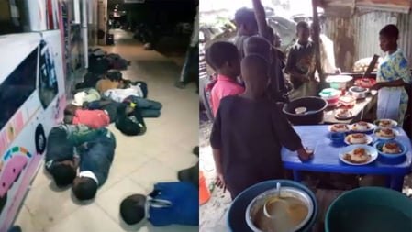
Figure 6.0.2: 19 young boys who had been trafficked into forced labour and then evicted from their jobs due to the COVID-19 pandemic
Source: www.lovejustice.ngo

Research Clearance Letter
