AN ANALYSIS OF NEWSPAPERS' ROLE IN RAISING PUBLIC AWARENESS ABOUT SUSTAINABLE DEVELOPMENT GOALS: A CASE OF HABARI LEO AND MWANANCHI (2022)

AHMAD SAID MOHAMEDI

DISSERTATION SUBMITTED IN PARTIAL FULFILMENT OF THE REQUIREMENTS FOR THE DEGREE OF MASTER OF ARTS IN MASS COMMUNICATION (MAMC) DEPARTMENT OF MEDIA AND LIBRARY STUDIES OF THE OPEN UNIVERSITY OF TANZANIA
2025
CERTIFICATION
The undersigned certifies that he has read and hereby recommends for acceptance by the Open University of Tanzania a dissertation entitled: “An Analysis Of Newspapers' Role In Raising Public Awareness About Sustainable Development Goals: A Case Of Habari Leo and Mwananchi.” in partial fulfilment of the requirements for the degree of Master of Arts in Mass Communication of the Open University of Tanzania.

…………………………
Dr. Kaanaeli Kaale
Supervisor 1
…………………………
Date

…………………………
Dr. Henry Mambo
(Supervisor 2)
……………………………
Date

COPYRIGHT
No part of this dissertation may be reproduced, stored in any retrieval system, or transmitted in any form by any means, electronic, mechanical, photocopying, recording or otherwise without prior written permission of the author or the Open University of Tanzania in that behalf.

DECLARATION
I, AHMAD SAID MOHAMEDI, do hereby declare that this is my original work, except where stated otherwise, and that the same work has not been submitted for an academic award to any University or Institution of Higher Learning.

……………………………
Signature

……………………
Date

DEDICATION
I would like to dedicate this research work to Almighty God, my family which include father of faith Sheikh Mahmoud Amri Waziri, my Parents Said Ahmad Ismail and Salma Abdallah Ismail who always encouraged me to pursue the highest levels of education without forget Ms. Wardat Ramadhani Simba and my young brothers and sisters for their understanding and support for the time that I used not to stay with them due to the project work.

My appreciation goes to all who participated in one way or another in providing moral and material support during my studies and always I ask God’s blessings upon them.

Lastly, I dedicate this work to all Members of Parliament of the United Republic of Tanzania, Government officials, students, friends, media practitioners, and everyone that would prefer to use this work as a catalyst to achieving goals and acquiring knowledge in general.

ACKNOWLEDGEMENT
Firstly, I express my acknowledgement to the Almighty God, who gave me the power and strength that enabled me to undertake this academic work. My heartfelt appreciation goes to my lovely supervisors Dr. Kaanaeli Bariki Kaale and Dr. Henry Mambo for their unconditional support during my research proposal and report writing.
Many thanks go to my mentor brother Honourable Ridhiwani Jakaya Kikwete (Minister of state, Prime minister’s Office Labour, Youth, Employment and Person with disability, Tanzania Member of Parliament Chalinze Constituency) who was by my side making sure that I complete this academic work.
It is also an honor to recognize the good work done by officials and workers from the Parliament of Tanzania, Tanzania standard newspaper (TSN) and Mwananchi Communication Limited as they provided moral and material support especially in providing useful information to support my academic work.
I also give my thanks to all the people who responded to my questionnaires during data collection since without them my work wouldn’t have been accomplished. Lastly, my thanks go to everyone who supported me in whatever way hence ensuring the successful completion of my academic work.

ABSTRACT
This study assessed the role of newspapers in raising awareness on sustainable development goals using Habari Leo and Mwananchi. The study utilized a mixed research approach, incorporating both quantitative and qualitative methods, to investigate three specific objectives: firstly, to examine the extent to which Habari Leo and Mwananchi covered Sustainable Development Goals, secondly, to identify themes covered by Habari Leo and Mwananchi newspapers about of Sustainable Development Goals and lastly to explore the readers’ perception on Habari Leo and Mwananchi regarding to Sustainable Development Goals coverage. The results indicated that in 2020, Habari Leo and Mwananchi produced a total of 647 news articles and 337 photos related to the Sustainable Development Goals. The articles addressed societal concerns, resulting in targets for Goals 2: Zero Hunger, 3: Good Health and Well-being, 4: Quality Education, and 5: Gender Equality are receiving the most attention in positive, neutral, and negative news tones. Goal 1: No Poverty, Goal 6: Clean Water and Sanitation, Goal 7: Affordable and Clean Energy, Goal 8: Decent Work and Economic Growth, Goal 9: Industry, Innovation and Infrastructure Goal 10: Reduced Inequality, Goal 11: Sustainable Cities and Communities, and Goal 13: Climate Action, Goal 15: Life on Land Goal 16: Peace and Justice, Strong Institutions got subpar coverage, while goals Goal 12: Responsible Consumption and Production, and Goal 14: Life Below Water received no coverage in the two publications. The study examined four SDGs news themes, and the results showed that out of 637 news items, 424 (54%) were about information, 163 (23%) focused on implementation, 46 (below average) on news analysis, and 12 (2%) on project evaluation, which is insufficient coverage. The results indicate that 60% of respondents see the overall coverage as ordinary, while 40% consider it below average. All participants want to see more media coverage of the Sustainable Development Goals (SDGs). The study recommended that Tanzanian media should enhance coverage of all objectives and provide informed news, analysis, interpretation, and evaluation to comprehend successes and facilitate the attainment of the SDGs by 2030.
Keywords: Newspapers, Sustainable Development Goals (SDGs), and Awareness
TABLE OF CONTENTS
CERTIFICATION i
COPYRIGHT ii
DECLARATION iii
DEDICATION iv
ACKNOWLEDGEMENT v
ABSTRACT vi
LIST OF FIGURES xii
LIST OF TABLES xiii
ABBREVIATIONS xiv
CHAPTER ONE 1
INTRODUCTION 1
1.1 Overview 1
1.2 Background of the Study 1
1.2.1 The Role of Media in Sustainable Development Goals 2
1.3 Statement of the Problem 3
1.4 Research Main Objectives 4
1.4.2 Specific Objectives 4
1.5 Research Questions 5
1.6 Significance of the Research 5
1.7 Scope of the Study 6
1.8 Summary 6

CHAPTER TWO 7
LITERATURE REVIEW 7
2.0 Overview 7
2.1 Conceptual Definitions 7
2.2.1 Sustainable development 7
2.2.2 Media 7
2.2.3 Coverage 7
2.2.4 Print media 8
2.2.5 National Agenda 8
2.2.6 Themes 8
2.3 Theoretical Framework 8
2.4 Importance of Communication in Development 9
2.5 Empirical Literature Reviews 10
2.6 Conceptual Framework 13
2.7 Research Gap 14
2.8 Chapter Summary 14
CHAPTER THREE 15
RESEARCH METHODOLOGY 15
3.1 Overview 15
3.2 Research Design 15
3.3 Area of the Study 16
3.4 Population of the Study 16
3.5 Sample Size 17
3.6 Sampling Procedure 18
3.7 Data Collection Methods 19
3.7.1 Content Analysis 19
3.7.1.1 Quantitative Content Analysis 19
3.7.1.2 Qualitative Content Analysis 20
3.7.2 Questionnaire 20
3.8 Data Analysis 21
3.8.1 Descriptive Analysis 21
3.8.2 Thematic Data Analysis 21
3.9 Validity 22
3.10 Reliability 22
3.11 Ethical Considerations 23
3.12 Chapter Summary 23
CHAPTER FOUR 24
PRESENTATION OF FINDINGS AND DISCUSSION 24
4.1 Chapter Overview 24
4.2 Objective One: To Examine the Extent to Which Habari Leo and Mwananchi Covered Sustainable Development Goals 24
4.2.1 General Coverage 24
4.2.2 Habari Leo and Mwananchi SDGs Monthly Reporting 25
4.2.3 News Classification 26
4.2.4 News Writers 28
4.2.5 News Placement 30
4.2.6 Themes Categories 30
4.2.7 SDGs News Tone 31
4.2.8 Habari Leo and Mwananchi SDGs Coverage 32
4.3 Objective Two: To Identify themes covered by Habari Leo and Mwananchi Newspapers About of Sustainable Development Goals 35
4.3.1 GDGs Informed News 35
4.3.2 SDGs News Analyses 35
4.3.3 SGD News about Projects Evaluation 37
4.3.4 News Tones for Each Goal 39
4.3.5 Positive News Tone 40
4.3.6 Neural News Tone 40
4.3.7 Negative News Tones 41
4.3.8 Photographs About SDGs 44
4.3.9 Photo News Tones 47
4.4 Objective Three: To explore the Readers’ Perception on Habari Leo and Mwananchi Regarding to Sustainable Development Goals Coverage 49
4.4.1 Gender of the Respondents 50
4.4.2 Age of the Respondents 51
4.4.3 Marital Status of the Respondents 52
4.4.4. Respondents Level of education 53
4.4.5 Newspapers' Role in Raising Public Awareness About Sustainable Development Goals 54
4.4.5 Availability of Newspaper 54
4.4.6 Time Spent on Reading Newspapers 55
4.4.7 Reading the newspapers for Information About SDGs 2030 Agenda 56
4.4.8 Habari Leo and Mwananchi’s Coverage of the SGDs 58
CHAPTER FIVE 68
SUMMARY, CONCLUSIONS AND RECOMMENDATIONS 68
5.1 Chapter Overview 68
5.2 Summary of the Key Findings 68
5.3 To Examine the Extent to Which Habari Leo and Mwananchi Covered Sustainable Development Goals 68
5.4 To Identify Themes Covered by Habari Leo and Mwananchi Newspapers About of Sustainable Development Goals 69
5.5 To Explore the Readers’ Perception on Habari Leo and Mwananchi Regarding to Sustainable Development Goals Coverage 70
5.6 Conclusion 71
5.7 Recommendation 73
5.8 Areas for further study 74
REFERENCES 77
APPENDIX I: CONTENT ANALYSIS GUIDE 83
APPENDIX II: QUESTIONNAIRE FOR THE READERS 86

LIST OF FIGURES
Figure 2.1 Conceptual Framework. 13
Figure 4.1 Mwananchi and Habari Leo SDGs Coverage 25
Figure 4.2 Habari Leo and Mwananchi SDGs monthly coverage in 2020 26
Figure 4.3 New Writers 28
Figure 4.4 News Writer 29
Figure 4.5 News Placement 30
Figure 4.6 Themes Categories 31
Figure 4.7 News Tones 32
Figure 4.8 Habari Leo and Mwananchi SDGs coverage in 2020 33
Figure 4.9 Habari Leo and Mwananchi SDGs News CAtegories 39
Figure 4. 10 News Tone 43
Figure 4. 11 Photographs about SDGs 47
Figure 4. 12 Photo News Tones 48
Figure 4.13 Respondents rates 59

LIST OF TABLES
Table 4. 1 Respondents Gender 50
Table 4. 2: Distribution of the Respondents by Age 51
Table 4.3: Distribution of the Respondents by Marital status 52
Table 4. 4 Distribution of the Respondents by Academic Level of education 53
Table 4. 5 Newspaper regularly available in your area 55
Table 4.6 Time Spent on reading newspapers 56
Table 4. 7 Days a week reading the newspapers for information about SDGs 2030 agenda 57

ABBREVIATIONS
COP21 - Paris Climate 21st Conference.
MCL - Mwananchi Communications Limited
MDGs - Millennium Development Goals
SDGs - Sustainable Development Goals
TSN - Tanzania Standards Newspapers
UN - United Nations
URT- United Republic of Tanzania
US - United State

CHAPTER ONE

INTRODUCTION

1.1 Overview
This chapter introduces the study to examine the contribution newspapers played in raising public awareness about sustainable development goals, particularly Habari Leo and Mwananchi. It describes the background of the study, statement of the problem, research questions, research objectives, scope and significance of the study.

1.2 Background of the Study
After many countries failed to achieve the Millennium Development Goals (MDGs) implemented in 2000 to 2015, the United Nations announced the Sustainable Development Goals (SDGs) in 2014 (Kannengießer, 2023). This transition from the MDGs to the SDGs supplanted the term development with the concept of sustainability. According to (Kannengießer, 2023) the SDGs adopted in 2015 as 2030 a Sustainable Development Goals agenda which consist 17 goals and 169 targets. The 17 concrete goals listed and explained in the Agenda 2030 are: 1. End poverty in all its forms everywhere, 2. End hunger, achieve food security and improved nutrition and promote sustainable agriculture, 3. Ensure healthy lives and promote well-being for all at all ages, 4. Ensure inclusive and equitable quality education and promote lifelong learning opportunities for all, 5. Achieve gender equality and empower all women and girls, 6. Ensure the availability and sustainable management of water and sanitation for all. Goal 7 ensures access to affordable, reliable, sustainable and modern energy for Goal 8. Promote sustained, inclusive, sustainable economic growth, full and productive employment and decent work for all, Goal 9. Build resilient infrastructure, promote inclusive and sustainable industrialization and foster innovation, Goal 10. Reduce inequality within and among countries, Goal 11. Make cities and human settlements inclusive, safe, resilient and sustainable, Goal 12. Ensure sustainable consumption and production patterns, Goal 13. Take urgent action to combat climate change and its impacts, Goal 14. Conserve and sustainably use the oceans, seas and marine resources for sustainable development, Goal 15. Protect, restore and promote sustainable use of terrestrial ecosystems, sustainably manage forests, combat desertification, and halt and reverse land degradation and halt biodiversity loss, Goal 16. Promote peaceful and inclusive societies for sustainable development, provide access to justice for all and build effective, accountable and inclusive institutions at all levels and goal 17 is to strengthen the means of implementation and revitalize the Global Partnership for Sustainable Development (General Assembly of the United Nations, 2015, p. 1).

1.2.1 The Role of Media in Sustainable Development Goals
Over the past 25 years, there have been numerous instances when free media has aided in sustainable development. Scholars in communication, political science, sociology and anthropology, among other subjects, have explored the evidence of the media's influence, from studies on media effects and influence to studies on the role of the media in development and democracy (Singh, Grizzle, Yee & Culver, 2015). The study of (Singh, Grizzle, Yee & Culver, 2015) connection between media and the Sustainable Development Goals (SDGs) of the United Nations in the brief that follows. The importance of independent media in attaining the SDGs is evident as the fight to implement Agenda 2030 becomes increasingly more urgent. In addition to being directly mentioned in SDG 16 (public access to information is included in Target 16.10), independent media also aid in achieving other SDGs by serving as a prerequisite for advancement and a multiplier that amplifies change. However, media play a more significant role than SDG 16 and are necessary to achieve all development goals5. Journalism catalyses change and is the cornerstone of a healthy information environment that can help the world deal with current issues and build a sustainable society10. From SDG 2 No Poverty (a low level of press freedom is strongly associated with a high percentage of people living below the poverty line7) to SDG 5 Gender Equality (high exposure to mass media is positively associated with an increase in women's empowerment 8), journalism acts as a driver of change.
For instance, Nashombe (2015) argued that the widespread use of media has reduced the information divide and contributed to nations' economic development. Research indicates that the media in Kenya and Zimbabwe play a crucial role in national development (Munyoro et al, 2016). US and European media coverage of SDG issues increased during UN conferences and events and decreased when there were none. In the interim, coverage in developing nations such as India, South Africa, and Nigeria has stayed the same. In Tanzania reports (URT, 2015; The National Voluntary Review (2019) show the media played significant contribution in promoting SGDs.

1.3 Statement of the Problem
Diverse studies (Hamidi & Mielke Möglich, 2021; Melkote & Steeves, 2015; Wilkens, Tufte, & Obregon, 2014) demonstrate that the media is crucial in promoting public dialogue, enhancing knowledge of sustainable development strategies, and holding governments accountable. Media opponents such (Schudson, 2008; Herman & Chomsky, 2008) as claim media do not prioritize news about development policies because they are more concerned with media proprietors' profits than the nation's development. Despite the importance of media in promoting development program, Tanzania failed to meet the MDGs, which were implemented between 2000 and 2015 (URT, 2015). The United Nations replaced MDGs with SDGs for implementation between 2015 and 2030 (Kannengießer, 2023). The National Voluntary Review (2019) indicates that Tanzania did not perform well in SDGs implementation and has pledged to increase SDGs implementation awareness and capacity building. Although the National Voluntary Review (2019) indicates that Tanzanian media has played an essential role in promoting SDGs, still is not known how much Tanzanian newspapers have covered the SDGs. This study aims to investigate the role that newspapers, specifically Habari Leo and Mwananchi, play in increasing public awareness of sustainable development objectives.

1.4 Research Main Objectives
To assess the role of newspapers in raising awareness on sustainable development goals using Habari Leo and Mwananchi.newpapers

1.4.2 Specific Objectives
The specific objectives of this study are as follows;
- To examine the extent to which Habari Leo and Mwananchi covered Sustainable Development Goals
- To identify themes covered by Habari Leo and Mwananchi newspapers about of Sustainable Development Goals
- To explore the readers’ perception on Habari Leo and Mwananchi regarding to Sustainable Development Goals coverage

1.5 Research Questions
The research aims to provide answers of the following questions
- To what extent did Habari Leo and Mwananchi newspapers report on Sustainable Development Goals?
- What are the themes covered by Habari Leo and Mwananchi newspapers on Sustainable Development Goals?
- What are readers’ perceptions of on Habari Leo and Mwananchi newspapers regarding to Sustainable Development Goals coverage?

1.6 Significance of the Research
To government. This study is an academic contribution which will came up with recommendation of how to create awareness among the media practitioners on the importance of publishing articles on Sustainable development goals for the benefit of the country and its people.
To researcher. The findings might be used as a contribution to literature review and adding knowledge to the media practitioners on the role of educating the public on how to participate in sustainable development goals.
To policymakers. The study might help the policymakers on how to use media for the successes of the programs concerning sustainable development goals in Tanzania as well as implementation of various policies.
To media practitioners. The study will help media to know its performance in promoting in sustainable development goals.

1.7 Scope of the Study
The study will focus on articles published by Habari Leo and Mwananchi on Sustainable development goals between January and December 2020 to 2022. Therefore, principal researcher will visit Tanganyika National Library in Dodoma to study Habari Leo and Mwananchi. The researcher will visit Tanzania parliament located at 2 Barabara ya Bunge, Tambukareli street, Dodoma municipal council, Dodoma to study policy maker’s awareness about on Sustainable development goals and their perception about media in promoting the mentioned goals.

1.8 Summary
Chapter one presents general background, as well as a justification of the study and its rationale. Chapter Two is a literature review which discusses theoretical studies and empirical studies which study Sustainable development goals.

CHAPTER TWO

LITERATURE REVIEW

2.0 Overview
This chapter focuses on theoretical review, empirical studies, conceptual framework, and research gap.

2.1 Conceptual Definitions

2.2.1 Sustainable development
Sustainable development is a development that meets the needs of the present without compromising the ability of future generations to meet their own needs (Kannengießer, 2021; World Commission on Environment and Development, 1987).

2.2.2 Media
Refers to the means of communication channels through which news, entertainment, education, data, or promotional messages are disseminated. Media includes every broadcasting and narrowcasting medium such as newspapers, magazines, television, radio, billboards, direct mail, telephone, fax, and internet, (Brooks, et al, 2010).

2.2.3 Coverage
Coverage is defined as the process of reporting a particularly important event or subject, (Trenz, 2004). Sometimes it seems that press coverage of an event is inversely proportional to its true importance. Therefore, coverage in this study refers to those articles published by Habari Leo and Mwananchi on Sustainable Development Goals.

2.2.4 Print media
It is a collective term expressing all means of communication that disseminate news in the form of printed text. Examples of print media include books, newspapers, magazines, journals, brochures, banners and fliers (Brooks et al., 2010). Print media in the study means Habari Leo and Mwananchi.

2.2.5 National Agenda
It is a country’s strategic plan aiming at achieving a certain development in a specific period. It can also be a set of policies and objectives which need implementation in order to achieve certain goals. In this study national agenda means Sustainable Development Goals.

2.2.6 Themes
Is the subject of the story or piece of writing. The theme in a story is its underlying message, or big idea what is the message that the writer is trying to tell. In this study, theme is the message on Sustainable Development Goals articles published by Habari Leo and Mwananchi Newspapers

2.3 Theoretical Framework
This study was guided by Agenda Setting Theory to describe media coverage and reader’s perception about Sustainable Development Goals. According McCombs (2014) agenda setting means "the ability of the news media to select important issues for the public." Agenda-setting is the study of how the media work to influence audiences and make a list of what news is most important (McCombs, & Reynolds, 2002).
These perspectives increased due to the rise of agenda-setting and laissez-faire aspects of communication research, which prompted their rapid spread. Agenda-setting requires a precise sequence of steps to be successful (McCombs (2005). Walter Lippmann who is the father of this theory, cited by many communication authors such as Nikata, (2016) claimed that media have a great power to create and present images to the public. McCombs and Shaw argued that media instruct audiences about what the public issues are and, also how much importance to be given to these issues.
Agenda Setting Theory is the practice whereby the media establishes what the audience thinks about and worries about (Nashombe, 2015). According to Nikata (2016), the media agenda tend to affect the public agenda at one level, and the public agenda in return affects the policy agenda. Editors and broadcasters are instrumental in deciding what goes to the public and vice versa. In other words, when it comes to agenda setting, the press has given itself the mandate of selectively choosing what the audience will see and listen to McQuail (2020), argued that the media agenda has great influence on the public since the public's perception and opinions will take the media’s presentations of facts.

2.4 Importance of Communication in Development
The concept of "development communication" emerged within the context of the media's contributions to the development of Third World nations during the 1950s. Several researchers, like Moemeka (2000), Servaes (2008), and Melkote and Steeves (2001), have discussed communication for growth at length. Moemeka (2000) says that development communication is closely related to the idea of sustainable development, which means improving a community through the use of information and technology and that community's ability to make a state that meets the needs of its residents without hurting its natural resources. He insisted that the progress of communication relies mainly on community and people's participation, which is the voluntary involvement of a group of individuals in a development action with full awareness of its aim. Servaes (2008) says that communication is essential for development because it involves people and the process needed to help them share their knowledge and ideas to make positive changes.
Even though forty years have passed since the Tanzanian media began focusing on communication for development, it still needs to deliver appropriate information to promote national development, particularly in rural areas, where 80 percent of the population resides. Other African countries have shown that people in rural areas suffer when a policy implementation gap is closed. This is because people in rural areas need more information to participate in the development process and get the most out of it.
Hence, media coverage has neither influenced nor encouraged any significant advancement. This negligence has reduced or nullified any potential impact on improving conditions in rural communities lacking access to water, food, education, health care, sanitation, information, and security, resulting in a short life expectancy and high infant mortality.

2.5 Empirical Literature Reviews
According to Nwanwene (2017) the media plays a crucial role in educating and making individuals, communities, and society conscious about sustainable development, the need for more sustainable patterns of production and consumption, and encouraging them to take action directed towards change and a more sustainable future. It is generally acknowledged that not scientists nor politicians, but rather the common man is the most effective agent of change. Once the civil society is familiar with the complex environment and development related issues, it will gain the confidence to act appropriately, leading towards sustainability. A major point for understanding the role of the media in achieving a sustainable society
The International Council for Science (2002:9) also states that “encouragement should be given to the publication of popular books and magazines, as well as theatrical presentations, radio and television programs and other forms of mass communication, intended to help the public become sufficiently informed about the nature and impact of key scientific and technical developments to participate effectively in debates about them.” The mass media, especially the radio, are seen as the most cost-effective way of providing information and a voice to all members of society including the marginalized sections (Department of Information and Media 2005). According to the findings of the International Conference on Education for a Sustainable Future (Centre for Environmental Education 2005), the media has an important role in fostering debate, influencing public opinion, and encouraging people to make behavior changes towards sustainability. Thus even in Bhutan the mass media are widely seen to play a pivotal role in educating and shaping public opinion as well as influencing policy decisions.
A study by Neverla et al. (2012) focused on developing countries' challenges in covering climate change in the mass media. The study highlighted that providing knowledge on climate change issues in Bangladesh is difficult because of the low literacy rate. It has been found that media extensively represent government policymakers, environmental activists, scientists, and laypeople's voices that are under-represented.
Einseidel and Coughlan (1993) did a content analysis of environmental stories in Canadian newspapers. They found that keywords tended to frame environmental issues globally, and discourse analysis was used to identify metaphors in environmental coverage. Based on studies, a set of frames identified by many professionals was further adopted by Nisbet (2009) in the generalizable typology of frames applicable to science-related 209 Climate Change and Sustainability Issues in The Hindu and Daily Thanthi: A Comparative Study policy debates.
In her study, Nambiar (2014) used data-derived frames to analyze sustainability discourse in the Indian English language press. This paper uses quantitative and qualitative content analysis to examine climate change and sustainability issues. The period for the analysis is selectively limited between September 2015 and December 2015 as major events Paris Climate Summit (COP21), UN Sustainable Development Summit and disastrous floods in Chennai happened during the period. Each article is a unit of analysis. This study analyses news articles' textual and visual representations to identify frames and their frequencies. The findings show 120 articles focused on climate change in the newspapers and the differences between the periods studied and between newspapers. More articles (87) were published in The Hindu than in Daily Thanthi (33). Both The Hindu and The Daily Thanthi published more than half (62) of the articles in December. The Hindu is more consistent in covering the issues than Daily Thanthi. (Xalxo) has researched the Coverage of Sustainable Developmental Issues in the Editorials of the Hindu and the Times of India (Chennai Edition). Xalxo used content analysis to collect data from the Hindu and the Times of India newspapers based in Chennai. The data was collected from March 2016 to June 2016. The findings show that political news has the maximum coverage in The Times of India's editorial, followed by coverage on 'Policy on strong scientific evidence'. Health and just society have 13% of coverage by the editorial. Besides this, the coverage of terror and corruption is 9% each. The study shows that neither Newspaper has sufficiently covered sustainable development issues.

2.6 Conceptual Framework
The diagram below depicts Sustainable Development goals as a dependent variable that the media should focus on so that people may comprehend it and follow the 2030 agenda to achieve the objective of eradicating poverty. Using the concept of the media, which is an independent variable, depends on bringing about change through mobilizing the Sustainable Development goals. Malcolm McCombs and Donald Shaw assert that the issues that receive the most excellent media coverage will be seen as the most significant. The study investigated citizens' views regarding the media's role in facilitating citizens' comprehension of the SDGs.as indicated in Figure 1.
Figure 2.1 : Conceptual Framework.
Peoples’ involvement in SDGs implementation for development

Seventeen Sustainable Development Goals

Habari Leo and Mwananchi Newspapers coverage

Public Awareness
and
Perceptions

Source: Researcher, 2025

2.7 Research Gap
Scholars such as Nwanwene (2017); Neverla et al. (2012); Einseidel and Coughlan (1993) and Nisbet (2009) have undertaken written several studies concerning the role of media in promoting national agenda and SDGs in particular. The studies used content analysis and agenda setting theory. However, previous studies focused in development countries. The media report on SDGs in less development countries is little known. Previous scholars did not assess the extent the media covered news on Sustainable Development Goals especially in Sub Sahara Africa. Therefore, this study sought to research and fill in this gap in literature.

2.8 Chapter Summary
Chapter two of this study covers covered relevant past and current studies related to communication in fostering sustainable development goals. The next section (chapter three) will cover the methodologies and strategies that will be used to conduct the study.

CHAPTER THREE

RESEARCH METHODOLOGY

3.1 Overview
This chapter focuses on the research methodology that was used and touched on several areas, which include research design, study area, sampling techniques, sample size, methods of data collection and data analysis.

3.2 Research Design
This study used descriptive research technique based on mixed methods approach. The researchers will build their knowledge on pragmatic grounds, asserting that truth is "what works" (Creswell, 2009; Howe, 1988). Researchers choose the approaches, as well as variables and units of analysis, that are most appropriate for finding an answer to their research questions (Teddlie & Tashakkori, (2009). A significant tenet of pragmatism is that quantitative and qualitative methods are compatible. The rationale for choosing this research design is based on the study's nature, which requires multiple sources and mixed methods to investigate the chosen problems. Thus, researching newspapers concurrently to collect numerical and textual data simultaneously or sequentially can help better understand the research problem, producing significant research findings (Onwuegbuzie & Leech, 2004). According to Creswell, (2014) the strategy of employing both approaches enables the researcher to get the best information because of the nature of the research which aimed at assessing the coverage of Habari Leo and Mwananchi on Sustainable Development Goals.

3.3 Area of the Study
The study used Habari Leo and Mwananchi published on 2020. Habari Leo, published by Tanzania Standards Newspapers (TSN), a government-owned company, and Mwananchi newspapers, owned by privately Mwananchi Communications Limited (MCL). Both selected due to their wide coverage of issues and wider national readership (RSF, 2018). The researcher conducted a public opinion survey in Dodoma municipal, where many newspaper consumers and SDGs stakeholders reside. The study used a newspaper published in 2020 following the report that Tanzania did not perform well in 2019. In this regard, the researcher aimed to study the contribution of newspapers in the following Year means in 2020. The year was for the general election, usually, the outgoing government provide the general report for its performance. Also, the candidate used the government’s reports and manifesto during the election campaigns. Therefore, the publications for 2020 is suitable to assess newspaper coverage on SDGs.

3.4 Population of the Study
Target population is the entire population or group, that a researcher is interested in researching and analyzing. The target population of this study consisted of 730 mainstream Kiswahili newspapers (Maelezo, 2018) and 1,500 newspaper readers from Dodoma Municipal. The content analysis was two Swahili mainstream newspapers namely Habari Leo and Mwananchi. The study used the total of 730 copies of the mentioned newspapers published from January to December 2021 as unit of analysis. The total unit comprised of 365 copies of Mwananchi and 365 copies of Habari Leo.

3.5 Sample Size
The sample size for mainstream Kiswahili newspapers for this study was determined using the proportion formula. To calculate the sample size using the proportion formula, one needs to know the total population size and the proportion of interest. In this case, in determining the sample size for Swahili newspapers, which have a total population of 730 newspapers, with 365 each for Mwananchi and Habari Leo.
The formula for proportion formula is:
$$n=\frac{z^{2}×p×(1-p)}{E^2}$$
Where:
- n = sample size
- Z = Z-score corresponding to the desired confidence level
- p = proportion in the population
- E = margin of error (expressed as a proportion)
Since the 95% confidence level (standard in many cases), the Z-score is approximately 1.96. For this case, since we want to estimate the proportion of Swahili newspapers accurately, let's assume a proportion of 0.5 (50%). This is the most conservative estimate and gives the maximum sample size required.
Substituting the values into the formula:
$$n=\frac{z^{2}×p×(1-p)}{E^2}$$
$$n=\frac{{1.96}^{2}×0.5×(1-0.5)}{0.05^2}$$
$$n=\frac{3.8416×0.25}{0.0025}$$
$$n=\frac{0.9604}{0.0025}$$
$$n=384.16$$
Rounding up to the nearest whole number (because you can't have a fraction of a newspaper), the recommended sample size is 385. So, the sample needed is 385 Swahili newspapers to estimate the proportion accurately with a 95% confidence level and a margin of error of 5%.
Now, to find the actual number of the sample size for Swahili newspapers, we used proportional allocation. Since Swahili newspapers constitute 730 out of 1500 readers, they make up about 48.67% of the total population.
$$n=\frac{730}{1500}×385$$
$$n=186.77$$
Sample size for survey research was 187 Swahili newspapers readers particularly politicians, journalists and public servants who also understand government policies particularly SDGs.

3.6 Sampling Procedure
The researcher used purposive sampling to select the sample for content analysis. According to Kumar (2011) purposive sampling allows the researcher to apply the best sample according to the purpose of the study. In this study, purposive sampling enabled the researcher to select useful cases only for the subject. It can also save time and money as it allows the researcher to go straight to the reliable source which are Habari Leo and Mwananchi Newspapers.
Also, the study used simple random sampling technique to draw 150 sample from newspaper readers. According to Wimmer & Dominick, (2011) simple random sampling enables the researcher to ensure that each member of the target population has an equal and independent chance of being included in the sample. It produced a random sample to avoid bias.

3.7 Data Collection Methods
This study used content analysis, a common research technic for mass communication to study newspaper coverage and questionnaire

3.7.1 Content Analysis
Content analysis is a method of text analysis among the set of empirical methods of social investigation, (Merriane & Huston, 2014). According to Krippendorff, (2018) Content analysis is potentially one of the most important research techniques in the social sciences. The study employed both quantitative and qualitative content analysis to obtain information on the assessment of newspapers coverage on Sustainable Development Goals agenda in Tanzania.

3.7.1.1 Quantitative Content Analysis
The study used a quantitative method to assess news coverage on the Sustainable Development Goals. Qualitative content analysis will enable the researcher to measure news frequencies and size of news articles, determined by the length and location of the article in the newspaper.

3.7.1.2 Qualitative Content Analysis
Qualitative content analysis seeks to discover underlying themes in materials being analyzed (Wimmer & Dominick, 2011). The researcher used qualitative content analysis to examine the content of the news coverage on Sustainable Development Goals agenda in Tanzania. Through qualitative content analysis, the study examined the themes which identified each SDGs goal, messages about the story including implementation, advocacy, evaluations, and news tones (positive, negative or neutral).

3.7.2 Questionnaire
The study used questionnaire to obtained data from Habari Leo and Mwananchi readers. (Saunders & Thornhill, 2009) argued that questionnaire is considered in general terms to include all techniques of data collection in which each person is asked to respond to the same set of questions in a predetermined order. This study used structured questionnaire by using both open and close-ended questionnaires to obtain information on the assessment of newspapers coverage on Sustainable Development Goals 2030 agenda in Tanzania. The questionnaire presented in written question-and-answer format. This technique enabled the researcher to distribute the questionnaire to individuals (Cozby & Bates, 2011). The questionnaire allowed the researcher to contact large numbers of respondents quickly because each respondent filled out the questionnaire themselves and returned it to the researcher.
Standardized questions were asked in a predetermined order (Wimmer & Dominick, 2011). Researchers used close-ended questions because they provide greater uniformity of response and are easily quantified. Open-ended questions used to give the respondents more freedom in answering questions and an opportunity to provide in-depth responses where that was appropriate. Generally, open-ended questions are more suitable for exploratory or qualitative research, while closed-ended questions are more suitable for descriptive or quantitative research. However, a combination of both types of questions can be used to balance breadth and depth or to triangulate or validate findings. This enabled the researcher to align questions with your research purpose and to test and refine them before launching survey.

3.8 Data Analysis
Data analysis is the process of evaluating data using analytical and statistical tools to discover useful information. The study use descriptive for quantitative and thematic for qualitative data analysis.

3.8.1 Descriptive Analysis
Quantitative data analysis may include the calculation of frequencies of variables and differences between variables (Taherdoost, 2020). The study used descriptive statistics to reduce the data for easier interpretation of frequency distributions. These measurements provide frequency distribution summaries by using tables, chart and percentages.

3.8.2 Thematic Data Analysis
Thematic analysis is a technique for analyzing qualitative data that involves skimming through a set of data and searching for patterns in the data's meaning to identify themes. It is an active process of reflexivity in which the researcher's subjective experience is central to making sense of the data (Braun & Clarke, 2022)
Firstly, the researcher used NVivo, a software for qualitative data analysis to organizing and code all variables used in this study such Secondly, the researcher identified themes and patterns and then interpret it to get a precise meaning in order to know about readers’ perception of Habari Leo and Mwananchi covered Sustainable Development Goals and 2030 agenda in Tanzania.

3.9 Validity
Two sorts of validity exist: internal and external (Creswell, 2014). Researchers must ensure their studies meet internal and external validity requirements (Duncan & Harrop, 2006). According to Trochim (2006), only studies that look at a cause-and-effect link between the independent and dependent variables are concerned with Internal validity. Internal validity, therefore, was not addressed in this study. (Cozby, 2007). External validity is how well the results of a study can be applied to the whole population (Yu & Ohlund, 2010; Weisberg, Hayden, and Pontes, 2008). This study examined newspapers' coverage of SDGs using multisource and triangulation research methodologies. The study's results could be used in other places where the population, media, politics, and economy are similar.

3.10 Reliability
This study was reliable because the researcher used different methods to enhance the results of the findings. The study used quantitative and qualitative approaches to provide a better understanding of research problems instead of using a single approach alone (Creswell, 2014; Creswell & Clark 2009). Quantitative and qualitative news contents analysis also was used to analyze news media coverage of SDGs. According to Lincoln and Guba (2000), dependability is a better criterion to assess reliability in qualitative research. The key issue in dependability deals with whether the process of the study is consistent, reasonably stable over time and across researchers (Fawcett, 1999, Wimmer & Dominick, 2003). The study was used structured questionnaires with both open-ended and close-ended questions in order to minimize errors and bias.

3.11 Ethical Considerations
The ethical behavior in research incorporates good manners that a researcher needs to observe when conducting a study (Creswell, 2014; Roper et al. 2018). The researcher was open and honest at all time in the field. Therefore, before conducting this study the researcher submitted an official letter to Habari Leo and Mwananchi Newspapers to request the primary data to be used in the study. The researcher examined the articles published and interpreted them in an ethical manner. Also the researcher will seek permission from Dodoma municipal where many public offices located. In the course of this study, respondents will be informed in advance on the purpose of the study and will be assured that the confidentiality would be maintained, and information collected would be used for academic purposes and not otherwise.

3.12 Chapter Summary
Chapter three describes the methodologies and strategies that used to conduct the proposed study. It demonstrated multiphase mixed research design, which combines sequential and concurrent mixed research designs by using quantitative and qualitative methods to examine the content analysis and public knowledge in relation to subject. The next chapter presented present and discuss the results obtained from the data analysis.

CHAPTER FOUR

PRESENTATION OF FINDINGS AND DISCUSSION

4.1 Chapter Overview
This chapter presents the findings of the study on an analysis of newspapers' role in raising public awareness about sustainable development goals: a case of Habari Leo and Mwananchi. The chapter has two parts, the first section presents content analysis of data collected from Mwananchi and Habari Leo's coverage of the Sustainable Development Goals, while the second part focuses on readers' perspectives regarding reporting Sustainable Development Goals in Tanzania.

4.2 Objective One: To Examine the Extent to Which Habari Leo and Mwananchi newspaper Covered Sustainable Development Goals
This study analysed the overall coverage of both newspapers in terms of news categorisation, monthly reporting, news positioning, and authorship.

4.2.1 General Coverage
The researcher conducted a meticulous and thorough analysis of Sustainable Development Goals news articles published in the issues of Mwananchi and Habari Leo newspapers throughout 2020. The data indicate that the total number of articles published the issues in both newspapers is 647, whereby Mwananchi published 327, equivalent to 52% of the articles, and Habari Leo newspaper issues published 320 (48%) articles, as Figure 2 indicates.
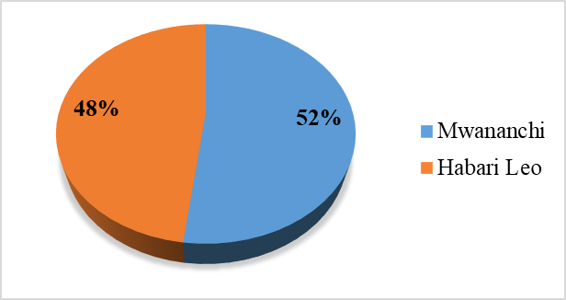
Figure 4.1: Mwananchi and Habari Leo SDGs Coverage

4.2.2 Habari Leo and Mwananchi SDGs Monthly Reporting
Researcher conducted an objective comparative analysis of the monthly reporting on the Sustainable Development Goals (SDGs) by Habari Leo and Mwananchi newspapers in 2020. The study indicates that both newspapers released the highest proportion of news articles in April (12%), followed by June (11%) and May (10%) of the total articles published. November exhibited the highest coverage at 9%, followed by January and March at 8%. The remaining months—February, July, August, September, and December—each averaged 6% in terms of coverage of the SDGS as indicated in figure 3. The findings indicated that Mwananchi newspapers had more coverage than habari Leo. The results align with the study by (11), which indicated that private media ownership correlates with improved governance, enhanced political rights for people, more developed markets, and superior outcomes in education and health. The disparity is merely 2%, indicating that although Habari Leo is government-owned, it operates as an independent newspaper. The findings align with the study (12), which asserts that independent news organisations, free from governmental, political, and other partisan influences, promote dialogue, uphold individual rights, and provide society with a platform to articulate diverse perspectives. Besides improving democratic governance and transparency, the media facilitate development by instigating positive behavioural changes in people, communities, and organisations, while also serving as a conduit for the exercise of human rights.
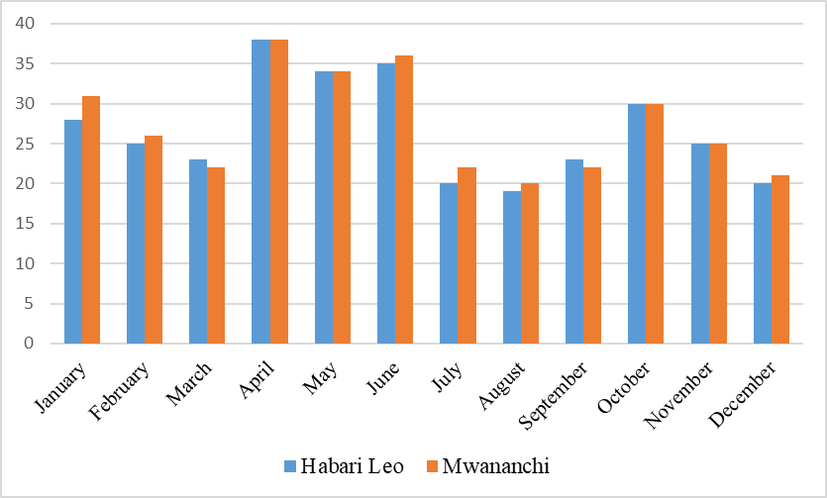
Figure 4.2 . Habari Leo and Mwananchi SDGs monthly coverage in 2020

4.2.3 News Classification
There were 320 SDG news pieces in the Habari Leo newspaper. There were 170 current news stories, which made up 53% of the total articles. There were also 90 feature items, which made up 28%. There were 34 news analyses (11%), 12 opinions (4%), 10 editorials (3%), and 4 columns (1%). The Habari Leo Newspaper offers a comprehensive overview of Sustainable Development Goals (SDG) reporting, showcasing a diverse array of 320 news pieces that reflect the complex nature of these global objectives.
There were a total of 327 SDG news stories in Mwanchi. Of these, 176 were current news stories, which is 54% of the total articles. Ninety-eight of the published articles were feature pieces, accounting for 30% of the total. As seen in the chart, news analysis accounted for 33% of the total, opinion for 10% (3%), editorial for 4% (1%), and column for 4% (3%). The percentages provided for each category illustrate the distribution of different types of articles within the total published SDG news stories, highlighting the variety of content produced. This breakdown allows for a clearer understanding of the focus areas in the news coverage. The Mwanchi SDG News Analysis reveals robust engagement with sustainable development topics, as evidenced by the publication of 327 news stories, with an impressive 320 focusing specifically on the Sustainable Development Goals (SDGs) as indicated in Figure 4.
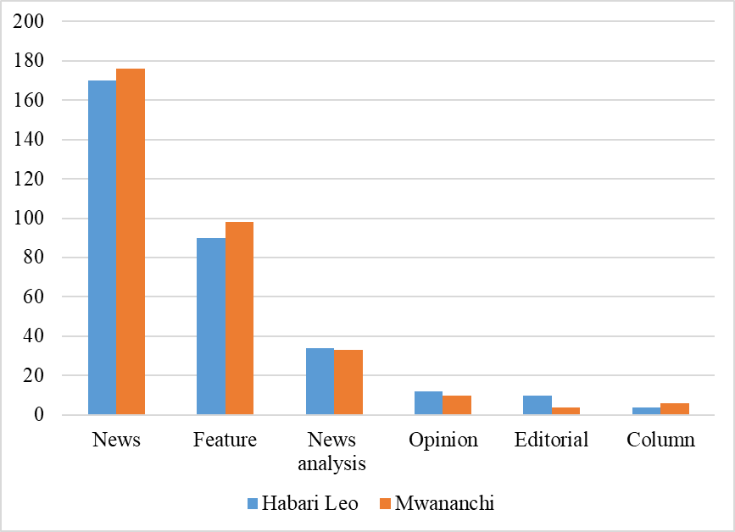
Figure 4.3 . New Writers

4.2.4 News Writers
The Habari Leo newspaper published a total of 320 SDG news articles. Among these, 108 were authored by Correspondents, representing 34% of the total articles. Of the total news articles, 190 were authored by writers, accounting for 59%. There were six articles, or 2%, that were anonymous. Additionally, 12 articles, representing 4%, were produced by news analysts, while four articles, or 1%, were written by columnists. In Mwanachi, there were 327 SDG news articles in total. Of these, 102 were authored by Correspondents, accounting for 31%. Writers contributed 181 articles, making up 55%. Additionally, there were 28 anonymous articles (9%), 10 from News analysts (3%), and six from Columnists (2%). This breakdown illustrates the diverse range of authors contributing to the SDG news articles in Mwanachi, highlighting the significant role played by both Correspondents and Writers in shaping the content. The presence of anonymous contributions and pieces from analysts and columnists further emphasises the varied perspectives within the reporting landscape.
The landscape of SDG news articles in Mwanchi reveals a vibrant tapestry woven by a variety of contributors, each playing a unique role in shaping the narrative around sustainable development goals. With writers dominating the scene at 55%, their collective voices serve as the cornerstone of content creation, while the presence of 28 anonymous articles adds an intriguing layer of complexity, inviting readers to engage with diverse viewpoints without the influence of authorial identity. The contributions from news analysts and columnists, though modest at 3% and 2% respectively, underscore the importance of expert analysis and opinion, enriching the discourse with specialised insights. Collectively, these elements not only highlight the multifaceted nature of reporting but also demonstrate how diverse perspectives foster a more comprehensive understanding of pressing global issues as indicated in Figure 5.
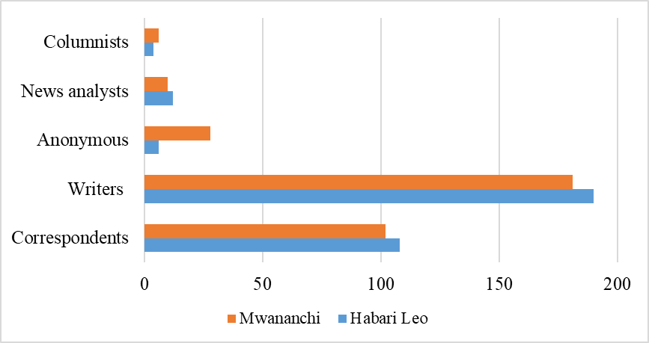
Figure 4.4 News Writer

4.2.5 News Placement
The Habari Leo newspaper published a total of 320 SDGs news articles. Among these, 102 (31%) appeared on upper of newspaper, middle 61 (19%), lower 57 (18) and 90 (28%) please in the full page of the newspaper. In Mwanchi, there were 327 SDG news articles in total. Among these, 112 (35%) appeared on upper of newspaper, middle 60 (18%), lower 50 (21) and 95 (28%) please in the full page of the newspaper.as indicated in figure 6.
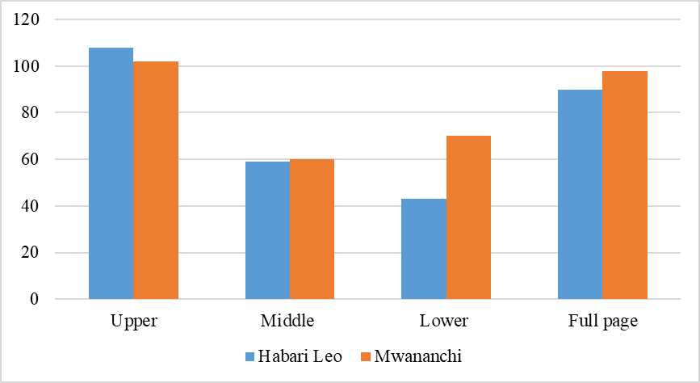
Figure 4.5 News Placement

4.2.6 Themes Categories
Research on SDG news published in the newspapers Habari Leo and Mwananchi has identified four key themes. The information theme covers SDG events; the implementation theme relates to the execution of various SDG projects; news analysis comes from journalists who provide in-depth explanations and interpretations of SDG-related news, enabling citizens to understand and engage in discussions; and evaluation involves assessing projects to highlight successes and challenges to develop effective strategies for achieving the SDG objectives by 2030. Of the 657 SDG news stories, 424 (66%) pertain to information, 165 (25%) to implementation, 46 (7%) to news analysis, and 12 (2%) to evaluation as indicated in Figure 7. This distribution demonstrates the media's focus on providing information and insights about the progress and challenges of SDG implementation. It highlights the crucial role of journalism in promoting public understanding and fostering dialogue around the Sustainable Development Goals.
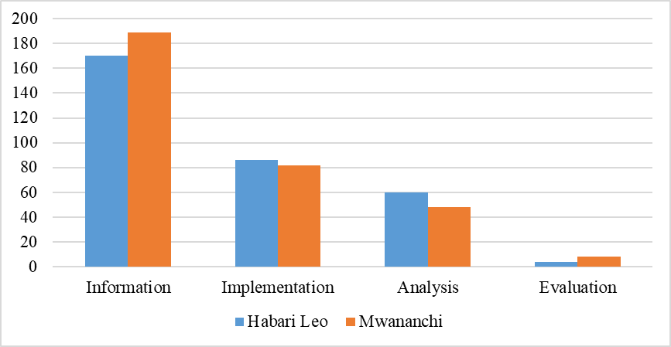
Figure 4.6 Themes Categories

4.2.7 SDGs News Tone
The findings indicate that 173 (54%) of the SDG news published by Habari Leo was positive, 53(17%) was neutral, and 94 (29%) was negative. In the case of Mwananchi, the breakdown shows 92 (28%) as positive, 45 (14%) as neutral, and 190 (58%) as negative. The findings have significant implications, as they reveal that Habari Leo prioritized the reporting of success stories, whereas Mwananchi emphasised the challenges encountered by citizens and the obstacles in implementation as indicated in Figure 8.
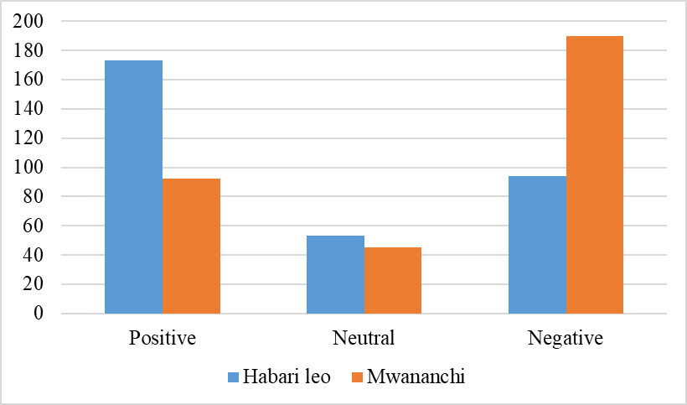
Figure 4.7 . News Tones

4.2.8 Habari Leo and Mwananchi SDGs Coverage
Findings indicated that Goal 3: Good Health and Well-being received the highest coverage, at 19%, followed by Goal 4: Quality Education, at 18%, and Goal 1: No Poverty, at 12%. The findings also showed that Goal 5: Gender Equality received 9% coverage for Habari Leo and 7% for Mwananchi. The coverage of Goals 6: Clean Water and Sanitation, 13: Climate Action, and 7: Affordable and Clean Energy was similar, averaging 7% for both Habari Leo and Mwananchi while Goal 2: Zero Hunger. Goal 10: Reduced Inequality Goal 11: Sustainable Cities and Communities. Goal 12: Responsible Consumption and Production, Goal 15: Life on Land Goal 16: Peace and Justice, Strong Institutions, and Goal 17: Partnerships for the Goals received an average of 2% each in both newspapers, as indicated in Figure 4. The findings illustrated that Goal 14: Life Below Water received the lowest coverage of one percent in both newspapers,
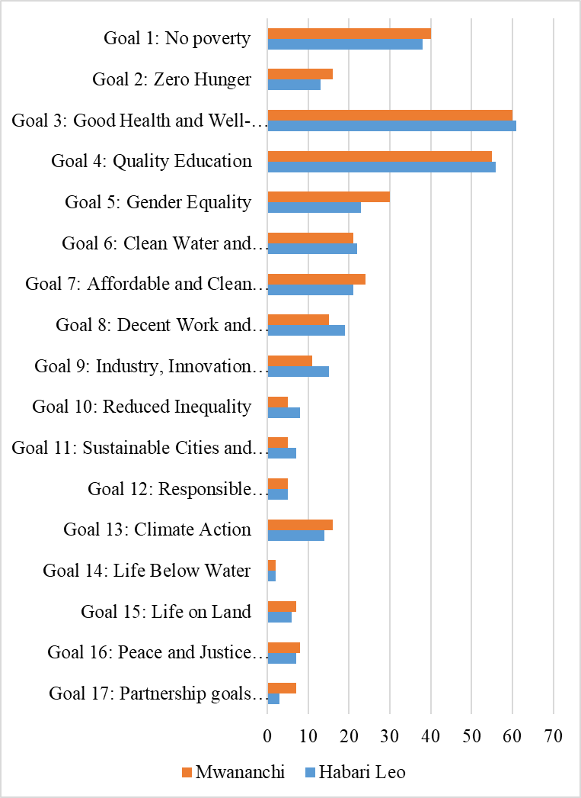
Figure 4.8 . Habari Leo and Mwananchi SDGs coverage in 2020
The findings of this study support the conclusions drawn by Bodt (2009) that the media serves as a vital two-way instrument, disseminating information from policymakers to the general public at the grassroots level and allowing the public's thoughts, ideas, and opinions to be communicated back to policymakers. According to communication development analysts, Habari Leo and Mwananchi's coverage is crucial in ensuring that residents are provided with reliable information coverage, enabling them to participate in the implementation of the SDGs as demonstrated in The International Conference on Education for a Sustainable Future (Centre for Environmental Education, 2005) serves. The media has a vital role in fostering debate, influencing public opinion, and encouraging people to make behavioural changes towards sustainability. Additionally, the Tanzanian media coverage aligns with the themes outlined by UN Secretary-General Kofi Annan (UN, 1997), which state that information and knowledge are central to democracy and serve as conditions for development. UN (1997). “Address to World Bank Conference Global Knowledge 1997”
The findings revealed that Tanzanian media focused on social issues and provided minimal coverage of development goals that promote economic growth, such as Goal 8: Decent Work and Economic Growth and Goal 9: Industry, Innovation and Infrastructure, which aim to achieve standards of living above those goals. Goal 8: Decent Work and Economic Growth Goal 9: Industry, Innovation and Infrastructure Goal 10: Reduced Inequality Goal 11: Sustainable Cities and Communities Goal 12: Responsible Consumption and Production Goal 13: Climate Action. Goal 14: Life Below Water. Goal 15: Life on Land. The findings are similar to those of Neverla et al. (2012), which focused on the challenges faced by developing countries in covering climate change in the media. Tanzanian media is supposed to incorporate the findings of research done by Bodt (2009), emphasising the need for media in promoting the Sustainable Development Goals, which aim to address global challenges by prioritising decent work, economic growth, and addressing inequality. They encourage equitable opportunities, responsible consumption, and environmental protection. By committing to these goals, Tanzania will improve the quality of life and preserve the natural world for future generations, fostering a sustainable future that benefits both people and the planet. The study highlighted that providing knowledge about climate change issues in Bangladesh is challenging due to the country's low literacy rate.

4.3 Objective Two: To Identify themes covered by Habari Leo and Mwananchi Newspapers About of Sustainable Development Goals
The researcher identified the categories of material documented to determine whether it pertains to information, project implementation, project developments analysis, or project evaluation news analysis.

4.3.1 GDGs Informed News
The study's findings for each Sustainable Development Goal (SDG) demonstrate that findings indicated that Goal 3: Good Health and Well-being received the highest coverage of 25% followed by Goal 2: No Poverty (19%, Goal 4: Quality Education, (13%), Goal 5: Gender Equality (7%)Goal 6: Clean Water and Sanitation and 7: Affordable and Clean Energy, (6%), Goal 8: Decent Work and Economic Growth, 2 (5%) Goal 9: Industry, Innovation and Infrastructure (4%) and the rest goals has lowest coverage of 1%as figure 10 indicated.

4.3.2 SDGs News Analyses
The researcher examined whether Habari Leo and Mwananchi published news analyses concerning the SDG goals. The results indicated a total of 46 articles concerning news analysis. Goal 3: Good Health and Well-being led with 17%, followed by Goal 4: Quality Education at 13%, and Goal 1: No Poverty at 11%. Goal 8: Decent Work and Economic Growth (9%); Goal 7: Affordable and Clean Energy (7%). Objective 5: Gender Equality, Goal 9: Industry, Innovation, and Infrastructure. Goals 10: Reduced Inequality, 11: Sustainable Cities and Communities, 13: Climate Action, 16: Peace, Justice, and Strong Institutions, and 17 each received 2% coverage. The news analysis did not address Goal 12: Responsible Consumption and Production, nor Goal 14: Life Below Water as indicated in Figure 10. The pursuit of sustainable development hinges on a multifaceted approach that addresses both immediate needs and long-term aspirations. With 11% of the global population still living in poverty, prioritising Goal 1 remains crucial for equitable progress. Concurrently, the focus on Goal 8 underscores the importance of fostering decent work and economic growth, which is essential for lifting communities out of poverty and enabling them to thrive. Furthermore, the commitment to Goal 7 highlights the pressing need for affordable and clean energy solutions, which are vital for both economic stability and environmental sustainability. Equally important are Goals 5, 10, and those related to infrastructure, innovation, and gender equality; these elements collectively contribute to a more just society while addressing systemic inequalities. Although Goals 12 and 14 regarding responsible consumption and life below water warrant greater attention, it is evident that an integrated strategy encompassing all these goals is necessary for achieving a holistic vision of sustainable development. Embracing this comprehensive framework will enhance resilience against current challenges and pave the way for future generations to flourish in a fairer world.

4.3.3 SGD News about Projects Evaluation
The study's results indicate that both publications covered SGD assessment news very minimally. Only 12 of the 424 news pieces addressed assessment difficulties. This underscores a significant gap in media coverage of critical issues related to the Sustainable Development Goals. This lack of attention could impede public understanding and engagement with the challenges of achieving these goals. To encourage a more informed dialogue, media outlets need to prioritise comprehensive reporting on both successes and obstacles in sustainable development. As a result, there is a need for increased awareness and, importantly, broader reporting on these issues to inform and involve the public effectively.
This emphasis on broader reporting highlights the importance of transparency and accountability in SDG reporting. Of these, 25% related to goal number 9, while 17% addressed issues linked to objectives. Goal 1: No Poverty, 2: Zero Hunger, 4: Quality Education, 7: Affordable and Clean Energy, and 8: Decent Work and Economic Growth. No reports evaluated Goal 3: Good Health and Well-being, Goal 5: Gender Equality, Goal 6: Clean Water and Sanitation 9: Industry, Innovation and Infrastructure Goal 10: Reduced Inequality, Goal 11: Sustainable Cities and Communities, Goal 12: Responsible Consumption and Production, Goal 13: Climate Action. Goal 14: Life Below Water, Goal 15: Life on Land Goal and 16: Peace and Justice, Strong Institutions. The landscape of sustainable development reporting reveals an urgent necessity for a more inclusive and transparent approach. Although some progress is evident—such as in the 25% of reports focused on Goal 9 and the 17% on Goals 1, 2, 4, 7, and 8—the notable absence of evaluations for key targets like Goals 3, 5, and 17 underscores significant gaps in our understanding of both achievements and challenges. To genuinely foster public engagement and stimulate collective action, future reports must present a comprehensive overview covering all aspects of sustainable development. Addressing these overlooked areas can mobilize support from diverse sectors of society and cultivate a more meaningful dialogue around the sustainable future we aspire to achieve as indicated in Figure10.
(Talabi,& Adaja, & Sanusi, (2024).) Came to a similar conclusion, arguing that addressing social amenities, poverty, healthcare, and climate change through the implementation of practical methods is the essence of development in Africa. To encourage long-term development and raise living standards throughout the continent, these factors are essential. Africa can build a better future for its people by focusing on five critical areas. Despite the importance of SDG 15, the media provided less coverage of it. The goal can foster Tanzania's development because it addresses the protection, restoration, and promotion of the sustainable use of terrestrial ecosystems; the sustainable management of forests; combating desertification; halting and reversing land degradation; and halting biodiversity loss. SDG 16: Promote peaceful and inclusive societies for sustainable development; provide access to justice for all; and build effective, accountable, and inclusive institutions at all levels.

Figure 4.9. Habari Leo and Mwananchi SDGs News Categories
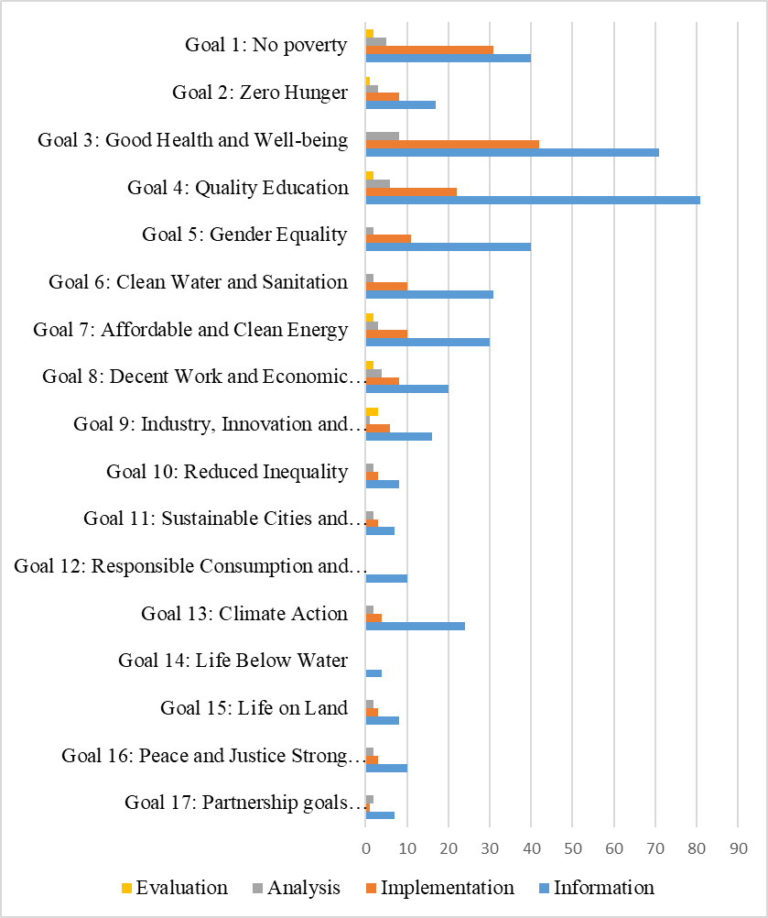

4.3.4 News Tones for Each Goal
The researcher's evaluation of news tones is a significant step in understanding the media's role in developmental issues. The analysis includes published articles with a positive tone regarding developmental successes, neutral articles concerning implementation and general information, and adverse reports that underscore various challenges encountered by citizens, including project implementation issues such as resource scarcity, inadequate tools, insufficient skills, funding deficits, and subpar performance that obstruct strategies aimed at achieving the 2030 sustainable goals.

4.3.5 Positive News Tone
The findings indicated that for a positive news tone, Goal 3: Good Health and Well-being received 19%, Goal 1: No Poverty 15%, Goal 4: Quality Education 14%, Goal 5: Gender Equality and Goal 7: Affordable and Clean Energy 8%, Goal 6: Clean Water and Sanitation and Goal 13: Climate Action 5%. The findings indicated that Goal 9: Industry, Innovation and Infrastructure received 4% of Neutral news tones while Goal 2: Zero Hunger, Goal 8: Decent Work and Economic Growth, Goal 10: Reduced Inequality, Goal 11: Sustainable Cities and Communities, Goal 15: Life on Land Goal 16: Peace and Justice, Strong Institutions and 17 received only 2% media coverage regarding news tone. The findings indicated that Goal 12: Responsible Consumption and Production and Goal 14: Life Below Water were did not received any coverage under neutral news tones as indicated in Figure 11.

4.3.6 Neural News Tone
The researcher has examined SDGs news coverage in relation to neural news tone. The findings revealed that Goal 4: Quality Education received 21%, Goal 3: Good Health and Well-being (11%), and Goals 2: Zero Hunger and 5 received 8%. Goal 1: No Poverty and Goal 8: Decent Work and Economic Growth 7%, Goal 6: Clean Water and Sanitation 6%, Goal 7: Affordable and Clean Energy 5%, Goal 9: Industry, Innovation and Infrastructure 4%. The findings revealed 10: Reduced Inequality, Goal 15: Life on Land, Goal 16: Peace and Justice, Strong Institutions received 3%. While Goal 11: Sustainable Cities and Communities, Goal 12: Responsible Consumption and Production, and Goal 13: Climate Action and Goal 14: Life Below Water got 2% of media coverage, as indicated in Figure 11. The final part of the input highlights several Sustainable Development Goals that received a lower percentage of focus or achievement, indicating that while progress has been made in some areas, significant work remains to be done in promoting sustainability and addressing pressing global challenges. This suggests a need for increased attention and resources to ensure these goals are adequately addressed.

4.3.7 Negative News Tones
Regarding negative news tones, Goal 3: Positive Health and Well-being received 21%. Goal 4: Quality Education (18%), Goal 1: No Poverty (11%), Goal 5: Gender Equality (9%), Goal 6: Clean Water and Sanitation (8%), Goal 7: Affordable and Clean Energy, Goal 8: Decent Work and Economic Growth (7%). Goal 2: Zero Hunger received (5%) of negative news coverage. Goal 9: Industry, Innovation and Infrastructure received 4% coverage, while Goal 13: Climate Action received 4%. Additionally, Goals 11: Sustainable Cities and Communities and 16: Peace, Justice, and Strong Institutions each received (2%) coverage, as did Goal 6: Clean Water and Sanitation. Goal 15: Life on Land and Water received (1%) coverage, while Goal 10 focused on reducing inequality. Goal 12: Responsible Consumption and Production, and Goal 14: Life Below Water did not receive any coverage under negative news tones as indicated in Figure…... The interplay between negative news coverage and the Sustainable Development Goals (SDGs) illuminates the challenges faced in achieving a more equitable and sustainable world. Goal 9, which emphasises industry, innovation, and infrastructure, often receives scant attention amid reports that highlight failure rather than progress. Similarly, the urgent calls for climate action under Goal 13 can be overshadowed by sensationalist portrayals of environmental crises, which detract from the success of these initiatives. The aspiration for Sustainable Cities and Communities (Goal 11) frequently encounters obstacles in public perception due to negative narratives about urban challenges. Furthermore, the pursuit of Peace and Justice (Goal 16) and the promotion of Reduced Inequality (Goal 10) are similarly hindered by a focus on conflict and disparity rather than constructive dialogue and solutions. Responsible Consumption and Production (Goal 12), along with efforts to safeguard Life on Land (Goal 15) and Life Below Water (Goal 14), also struggles against a backdrop of pessimism that can stifle public engagement.

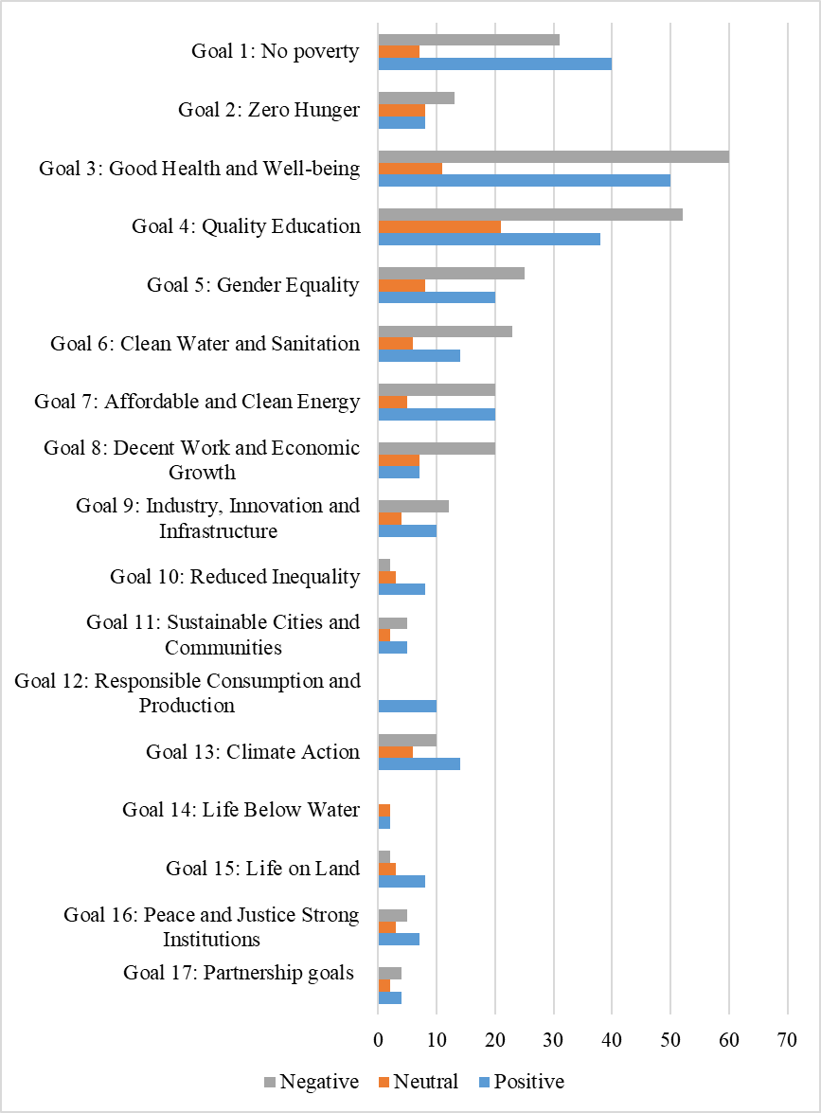
Figure 4. 10. News Tone

4.3.8 Photographs About SDGs
The research examined photos accompanying news about the SGDS and the study's findings, which indicate that they appeared in the Habari Leo newspaper. The findings revealed that Goal 3: Improved Health and Well-being received 45 photos (25%), Goal 4: Quality Education received 26 photos (22%), Goal 5: Gender Equality received 17 photos (10%), and Goal 6: Clean Water and Sanitation received an unspecified number of photos. Goal 13: Climate Action received 12 photos, which is equivalent to 7%. Goal 7: Affordable and Clean Energy received 9 photos (6%); Goal 8: Decent Work and Economic Growth received 8 photos (4%); and Goal 9: Industry, Innovation and Infrastructure received seven photos (4%). Goals 1: No Poverty, 2: Zero Hunger, 10: Reduced Inequality, 11: Sustainable Cities and Communities, and 16: Peace, Justice, and Strong Institutions each received three photos, amounting to 2%. Goals 14: Life Below Water, 15: Life on Land, and 17 each received one photo, representing 1%. However, Goal 12: Responsible Consumption and Production did not receive any images.
Regarding Mwananchi, The findings revealed that Goal 3: Improved Health and Well-being received 45 photos (26%), Goal 4: Quality Education received 36 photos (21%), Goal 5: Gender Equality received 15 photos (9%), and Goal 6: Clean Water and Sanitation and Goal 7: Affordable and Clean Energy received received 10 photos (6%).
Goal 13: Climate Action received 12 photos, which is equivalent to 7%. 9 photos (6%); Goal 8: Decent Work and Economic Growth received 8 photos (4%); and Goal 9: Industry, Innovation and Infrastructure received seven photos (4%). Goals 1: No Poverty, 2: Zero Hunger, 10: Reduced Inequality, 11: Sustainable Cities and Communities, and 16: Peace, Justice, and Strong Institutions each received three photos, amounting to 2%. Goals 14: Life Below Water, 15: Life on Land, and 17 each received one photo, representing 1%. However, Goal 12: Responsible Consumption and Production did not receive any images.
This distribution of photos highlights the varying levels of emphasis placed on different goals, reflecting priorities in visual representation. The absence of Goal 12 suggests a potential oversight or lesser focus on responsible consumption and production in this context. The analysis of the distribution of photos across the various sustainability goals reveals both commendable efforts and notable gaps. Goals 14 and 15, which address life below water and life on land, respectively, each garnered a modest share of 1% of the total images, highlighting their presence in the visual narrative surrounding sustainability. In contrast, Goal 12, which emphasises responsible consumption and production, was conspicuously absent from this visual representation, suggesting a significant oversight that could undermine broader awareness and engagement with this critical issue. This uneven distribution calls for a reevaluation of how different goals are prioritised in public discourse and visual media, ensuring that all aspects of sustainable development receive equal attention and fostering a more comprehensive understanding of our global challenges.
Goal 1: No Poverty, Goal 2: Zero Hunger, Goal 10: Reduced Inequality, Goal 11: Sustainable Cities and Communities and Goal 16: Peace and Justice, Strong Institutions
Each received three photos, equivalent to 2%, while Goals 14: Life Below Water, 15: Life on Land, and 17 received one photo each, which is 1%. However, Goal 12: Responsible Consumption and Production did not receive any images. This distribution of photos highlights the varying levels of emphasis placed on different goals, reflecting priorities in visual representation. The absence of Goal 12 suggests a potential oversight or lesser focus on responsible consumption and production in this context. The analysis of the distribution of photos across the various sustainability goals reveals both commendable efforts and notable gaps. Goals 14 and 15, which address life below water and life on land, respectively, each garnered a modest share of 1% of the total images, highlighting their presence in the visual narrative surrounding sustainability. In contrast, Goal 12, which emphasises responsible consumption and production, was conspicuously absent from this visual representation, suggesting a significant oversight that could undermine broader awareness and engagement with this critical issue. This uneven distribution calls for a reevaluation of how different goals are prioritised in public discourse and visual media, ensuring that all aspects of sustainable development receive equal attention and fostering a more comprehensive understanding of our global challenges.

Figure 4. 11Photographs about SDGs

4.3.9 Photo News Tones
The researcher analysed the tonal quality of the news photos, revealing that they exhibited positive, neutral, and negative tones. Images, often conveying a reporting tone, play a crucial role in shaping public perception and articulating their significance within the story of each goal. This research underscores the importance of visual communication in the context of sustainable development. The study further analyses the tone of the images used in news articles concerning the SDGs. Of the 163 photos published in Habari Leo, 72 photos (44%) conveyed a positive tone regarding the achievements made, 27 photos (17%) maintained a neutral news tone, and 64 photos (39%) expressed a negative tone. Mwananchi published 174 photos, revealing that 55, or 32%, exhibited a positive tone, 33 (19%) displayed a neutral tone, and 86 (49%) conveyed a negative tone, as indicated in Figure 3. The findings reveal that there is a higher prevalence of images conveying a negative tone in comparison to those that depict positive achievements or neutral tones that offer information or education regarding the SDGs. Images characterised by negative tones illustrate a range of challenges, including insufficient social services, such as access to clean and safe water; inadequate road infrastructure; limited availability of clean energy; a shortage of desks and laboratory equipment; and subpar healthcare services.
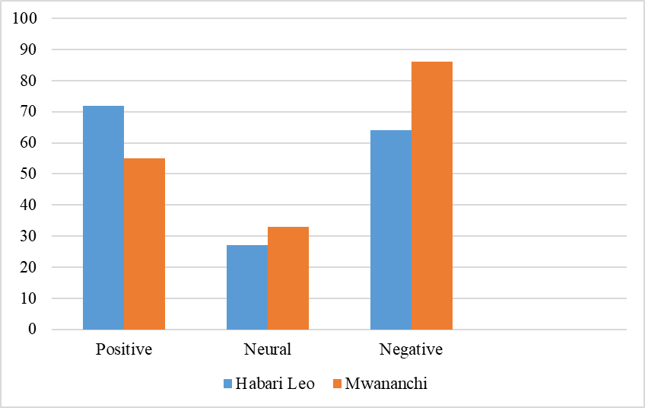
Figure 4. 12 Photo News Tones
The findings regarding Habari Leo and Mwananchi themes coverage indicated that Tanzania media is participating in SDGs campaign particularly social issues and address and resolve the needs and challenges faced by the community. The research findings align with previous research done by Rahim, 1994, Servaes, 1995; Bakke & Subedi, 2008 78) which stated that effective and efficient dialogue is essential for achieving the objectives of the development project (Melfalopulos, 2005: 254). However, Habari Leo and Mwananchi are expected to expand their coverage of news analysis and evaluation of the project, enabling the public to engage with the SDGs to incorporate previous researchers such Chitnis (2005a:239) who defines empowerment as the capacity to influence decision-making in issues and circumstances that affect our lives. Dialogue empowers individuals and communities by giving them a voice and the power to shape their destinies. To further this endeavor, media outlets like Habari Leo and Mwananchi must broaden their scope by enhancing news analyses and project evaluations, thereby facilitating informed public engagement with the Sustainable Development Goals (SDGs). By doing so, they nurture an empowered citizenry and cultivate a culture of active participation that is essential for achieving sustainable development in our communities. Ultimately, it is this synergy between knowledge, engagement, and empowerment that will pave the way for a more inclusive and equitable future.

4.4 Objective Three: To explore the Readers’ Perception on Habari Leo and Mwananchi Regarding to Sustainable Development Goals Coverage
In an analysis of newspapers' role in raising public awareness about sustainable development goals: a case of Habari Leo and Mwananchi, assessing demographic factors was vital for the purpose of understanding the nature of the respondents.

4.4.1 Gender of the Respondents
The study analysis of newspapers' role in raising public awareness about sustainable development goals revealed insightful findings based on gender distribution. The results were presented in Table 4.1.
Table 4. 1 Respondents Gender
 |  | Frequency | Percent | Valid Percent | Cumulative Percent
Valid | Male | 82 | 43.9 | 43.9 | 43.9
Valid | Female | 105 | 56.1 | 56.1 | 100.0
Valid | Total | 187 | 100.0 | 100.0
Source; Field Data (2024)

A sample population of 187 individuals, with 82 being male (43.9%) and 105 being female (56.1%). This distribution suggests a slightly higher representation of females within the sample. While the study doesn't directly correlate gender with awareness levels about Sustainable Development Goals (SDGs), the gender distribution could imply varying levels of engagement or interest in sustainable development issues, at least within the context of newspaper readership. Understanding this demographic difference is pivotal for tailoring communication strategies to effectively promote SDGs through newspapers, ensuring inclusivity and broad societal engagement. The discussion highlights the need to address potential biases in awareness campaigns and media consumption patterns, emphasizing the importance of considering diverse audiences to enhance campaign effectiveness. Furthermore, it underscores the necessity for future research to explore underlying factors influencing gender differences in awareness levels and media consumption patterns related to sustainable development, thereby informing more targeted communication strategies and fostering broader societal engagement with SDGs.

Table 4. 2: Distribution of the Respondents by Age
Age categorises |  | Frequency | Percent | Valid Percent | Cumulative Percent
 | 25 – 29 | 19 | 10.2 | 10.2 | 10.2
 | 30 – 34 | 48 | 25.7 | 25.7 | 35.8
 | 35 – 39 | 22 | 11.8 | 11.8 | 47.6
 | 40 – 44 | 89 | 47.6 | 47.6 | 95.2
 | 45 – 49 | 9 | 4.8 | 4.8 | 100.0
 | Total | 187 | 100.0 | 100.0
Source; Field Data (2024)

4.4.2 Age of the Respondents
This study requires the respondents to indicate their aged as the basis of understanding the aged group of the respondents which are more dominance in findings. The results of age of the respondents are as shown in the Table 4.2.
The findings revealed that the majority of respondents fell within the age brackets of 30 to 44 years old, comprising 86.1% of the sample. Among these, the highest frequency was observed in the 40-44 age group 89(47.6%), followed by the 30-34 age group 48(25.7%), and the 35-39 age group 22(11.8%). The youngest age group represented in the data was 25-29 years old, constituting 19(10.2%) of respondents, while the 45-49 age group comprised the smallest portion at 9(4.8%). This distribution suggests that the readership engaging with the newspapers for information on SDGs predominantly consists of individuals in their thirties and forties, indicating a significant demographic segment interested in sustainable development issues.

4.4.3 Marital Status of the Respondents
The study examined the efficacy of newspapers, specifically Habari Leo and Mwananchi, in fostering public awareness about Sustainable Development Goals (SDGs) included an examination of participants' marital status. Out of the 187 respondents, the data revealed diverse marital status distributions.
Table 4.3: Distribution of the Respondents by Marital status
Marital status |  | Frequency | Percent | Valid Percent | Cumulative Percent
 | Single | 13 | 7.0 | 7.0 | 7.0
 | Married | 158 | 84.5 | 84.5 | 91.4
 | Divorce | 16 | 8.6 | 8.6 | 100.0
 | Total | 187 | 100.0 | 100.0
Source; Field Data (2024)
The findings regarding respondents' marital status indicate that the majority of participants are married, accounting for 158(84.5%) of the sample. Conversely, single individuals constitute a smaller proportion, comprising 13(7.0%) of respondents, while those who are divorced represent 16(8.6%) of the total. This distribution suggests that married individuals are more likely to engage with newspapers for information on SDGs compared to single or divorced individuals. The high percentage of married respondents underscores the importance of targeting this demographic in awareness-raising efforts through newspapers, as they constitute the largest audience segment. Furthermore, the presence of single and divorced individuals within the sample indicates the need for tailored messaging strategies to effectively engage diverse marital status groups in sustainable development discourse facilitated by newspapers.
Table 4. 4 : Distribution of the Respondents by Academic Level of education
Level of education |  | Frequency | Percent | Valid Percent | Cumulative Percent
Valid | Primary | 3 | 1.6 | 1.6 | 1.6
Valid | Secondary | 18 | 9.6 | 9.6 | 11.2
Valid | College | 141 | 75.4 | 75.4 | 86.6
Valid | University | 25 | 13.4 | 13.4 | 100.0
Valid | Total | 187 | 100.0 | 100.0
Source; Field Data (2024)

4.4.4. Respondents Level of education
As part of the study examining the contents of newspapers, specifically Habari Leo and Mwananchi, in fostering public awareness about Sustainable Development Goals (SDGs, participants were surveyed regarding their academic levels. The data, collected from 187 respondents, reflects a varied distribution across different academic levels.
Regarding respondents' academic levels, the data indicates that the majority hold a college-level education, constituting 141(75.4%) of the sample. University-educated individuals represent a smaller proportion at 25(13.4%), while secondary education holders make up 18(9.6%) of respondents. Primary education holders are the least represented group, comprising only 3(1.6%) of the total. This distribution suggests that individuals with college-level education are the primary audience engaging with newspapers for information on SDGs. The relatively low representation of university-educated individuals highlights a potential area for outreach and engagement to ensure broader dissemination of sustainable development information among this demographic. Furthermore, the presence of individuals with secondary and primary education underscores the importance of employing diverse communication strategies to cater to audiences across different academic levels effectively.

4.4.5 Newspapers' Role in Raising Public Awareness About Sustainable Development Goals
This study delves into the role of two prominent Tanzanian newspapers, Habari Leo and Mwananchi, in promoting understanding and engagement with Sustainable Development Goals (SDGs). With a specific focus, the study aims to assess the newspapers' coverage of SDGs, examining the extent to which these goals are addressed. Additionally, it seeks to identify the thematic areas emphasized within the coverage of SDGs by both newspapers. Furthermore, the research endeavors to capture readers' perceptions regarding the newspapers' efforts in disseminating information about SDGs. By addressing these objectives, the study aims to provide valuable insights into the effectiveness of Habari Leo and Mwananchi in contributing to public discourse and awareness on sustainable development issues within the Tanzanian context.

4.4.5 Availability of Newspaper
The type of Newspaper regularly available in area was assessed through a structured questionnaire, Participants were likely asked a question such as "Which newspaper is regularly available in your area?" and provided with options to select from, including "Habari Leo" and "Mwananchi." The data, collected from 187 respondents, revealed a regularly Newspaper available in your area.
Table 4. 5: Newspaper regularly available in your area
Newspaper |  | Frequency | Percent | Valid Percent | Cumulative Percent
Valid | Mwananchi | 103 | 55.1 | 55.1 | 55.1
Valid | Habari Leo | 84 | 44.9 | 44.9 | 100.0
Valid | Total | 187 | 100.0 | 100.0
Source; Field Data (2024)
The study reveals that Mwananchi is more readily available in the surveyed area, with 103(55.1%) of respondents reporting its regular availability, compared to 84(44.9%) for Habari Leo. This distribution underscores Mwananchi's potentially greater influence in shaping public awareness and discourse on Sustainable Development Goals (SDGs). However, both newspapers play significant roles in disseminating information on SDGs. Understanding their availability is vital for stakeholders aiming to leverage media platforms for SDG advocacy. Strategic use of both newspapers can maximize outreach and effectiveness in raising public awareness and fostering sustainable development initiatives within the community.

4.4.6 Time Spent on Reading Newspapers
The respondents answered questions related to the time spent on reading newspapers, where they could express their agreement or disagreement with statements. The statements focused on different aspects of the participants' interaction with newspaper reading. The study's findings reveal insights into the frequency of newspaper readership among respondents in the context of raising public awareness about Sustainable Development Goals (SDGs) through Habari Leo and Mwananchi.
Table 4.6: Time Spent on reading newspapers
 |  | Frequency | Percent | Valid Percent | Cumulative Percent
Valid | Daily | 57 | 30.5 | 30.5 | 30.5
Valid | Often | 130 | 69.5 | 69.5 | 100.0
Valid | Total | 187 | 100.0 | 100.0
Source; Field Data (2024)
A significant majority, comprising 130(69.5%) of participants, reported reading newspapers often, indicating a high level of engagement with print media as a source of information. Additionally, 57(30.5%) of respondents indicated reading newspapers daily, demonstrating a consistent habit of staying informed through print media channels. This distribution underscores the importance of newspapers, including Habari Leo and Mwananchi, in disseminating information about SDGs and suggests that they play a crucial role in shaping public awareness and discourse on sustainability issues within the community.

4.4.7 Reading the newspapers for Information About SDGs 2030 Agenda
The survey assessed respondents' engagement with newspapers for information on the Sustainable Development Goals (SDGs) 2030 agenda by inquiring about their reading frequency. Participants were asked, "How many days a week did you read the newspapers for information about the Sustainable Development Goals 2030 agenda?" This variable aims to gauge the frequency of newspaper readership specifically concerning SDGs awareness and information dissemination.
Table 4. 7 : Days a week reading the newspapers for information about SDGs 2030 agenda
Days a week reading |  | Frequency | Percent | Valid Percent | Cumulative Percent
Valid | More than ten times | 66 | 35.3 | 35.3 | 35.3
Valid | Less than ten times | 51 | 27.3 | 27.3 | 62.6
Valid | Often | 70 | 37.4 | 37.4 | 100.0
Valid | Total | 187 | 100.0 | 100.0
Source; Field Data (2024)
The study's findings indicate varying levels of engagement with newspapers for information about the Sustainable Development Goals (SDGs) 2030 agenda among respondents. A significant proportion, comprising 70(37.4%) of participants, reported reading newspapers often for information on SDGs. Furthermore, 77(35.3%) indicated reading newspapers more than ten times a week for this purpose, demonstrating a high frequency of engagement. Conversely, 51(27.3%) of respondents read newspapers for SDG information less than ten times a week. These results highlight the importance of newspapers, such as Habari Leo and Mwananchi, in facilitating public awareness and discourse on sustainability issues, with a considerable portion of readers actively seeking information about the SDGs through print media channels.

4.4.8 Habari Leo and Mwananchi’s Coverage of the SGDs
The findings from the assessment of Habari Leo and Mwananchi's coverage of all 17 Sustainable Development Goals (SDGs) for the year 2021 provide valuable insights into the newspapers' role in raising public awareness about various aspects of sustainable development. Across the goals, there were variations in the perceived level of coverage, with some goals receiving higher ratings than others. When asked whether media coverage enable you to know how Tanzania implementing all 17 Sustainable Development Goals, all respondents stonily agreed. The finding aligns with the perspective of Guy Berger, Director for Freedom of Expression and Media Development at UNESCO (UNESCO, 2019), who emphasises that the achievement of SDG Goal 16, Target 10, which focuses on public access to information and fundamental freedoms, is contingent upon the presence of independent media. This media is essential for advancing all SDGs, including gender equality, climate change mitigation, poverty elimination, reduction of inequalities, and the development of sustainable cities. The findings showed that the media in Tanzania are doing a good job in supporting SDG 16, which is necessary for achieving all development goals. The role of Tanzanian media in advancing Sustainable Development Goal 16 is not only vital but multifaceted, serving as a cornerstone for fostering an informed and engaged society. The synergy between robust media practices and the objectives of SDG 16 underscores the importance of nurturing this sector to ensure that the aspirations of all Tanzanians can be realised.

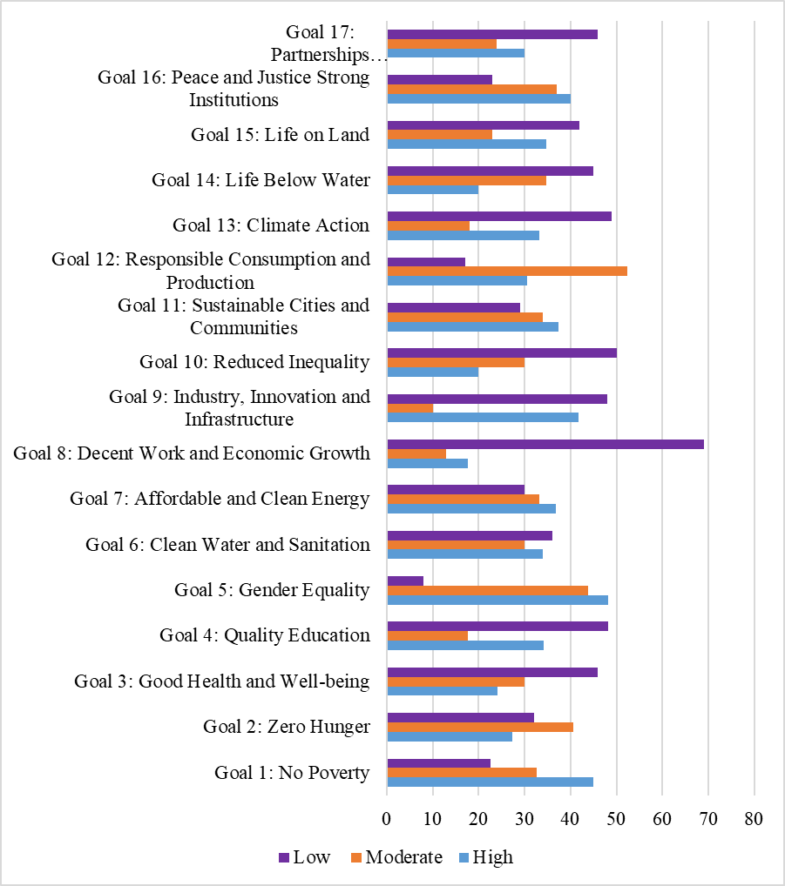
Figure 4.13 . Respondents rates
Goal 1: No Poverty: 84(44.9%) of respondents rated the coverage as high, 61(32.6%) as moderate, and 42(22.5%) as low. This suggests that the newspapers have been successful in highlighting the challenges and solutions associated with poverty alleviation, contributing to public awareness and discourse on this critical issue. The implication is that sustained coverage by these newspapers can help mobilize support for poverty reduction efforts and policy initiatives aimed at addressing economic inequality.
Goal 2: Zero Hunger: 51(27.3%) rated coverage as high, 76(40.6%) as moderate, and 60(32.1%) as low. While both newspapers received moderate coverage ratings for Goal 2, there is room for improvement in addressing issues related to food security and nutrition. Enhancing coverage in this area could involve highlighting the causes of hunger, showcasing successful interventions, and raising awareness about the importance of sustainable agriculture. By doing so, Habari Leo and Mwananchi can contribute to efforts to eradicate hunger and malnutrition.
Goal 3: Good Health and Well-being: 45(24.1%) rated coverage as high, 56(29.9%) as moderate, and 86(46%) as low. This suggests that while Habari Leo and Mwananchi have addressed health-related issues to some extent, there is potential for increased reporting on topics such as access to healthcare, disease prevention, and mental health. Improving coverage in this area can help raise awareness about health challenges and promote initiatives to improve health outcomes in the community. While health-related issues have been addressed, there's potential to increase reporting on access to healthcare and disease prevention.
Goal 4: Quality Education:64(34.2%) rated coverage as high, 33(17.6%) as moderate, and 90(48.1%) as low. However, there is an opportunity to expand coverage on education-related issues, including access to quality education, teacher training, and educational infrastructure. By increasing reporting in this area, Habari Leo and Mwananchi can contribute to efforts to ensure inclusive and equitable quality education for all, as outlined in the SDGs. There's room to improve coverage on education-related issues such as access to quality education and educational infrastructure.
Goal 5: Gender Equality: 90(48.1%) rated coverage as high, 82(43.9%) as moderate, and 15(8%) as low. This indicates effective reporting on gender-related issues, including women's rights, gender-based violence, and women's participation in decision-making. The implication is that sustained coverage by Habari Leo and Mwananchi can help advance gender equality and empower women and girls, contributing to broader efforts to achieve the SDGs. Effective reporting on gender-related issues indicates a strong contribution to promoting gender equality.
Goal 6: Clean Water and Sanitation: 75(40.1%) rated coverage as high, 104(55.6%) as moderate, and 8(4.3%) as low. While there has been some reporting on water and sanitation issues, there is an opportunity to increase coverage on topics such as access to clean water, sanitation infrastructure, and water scarcity. By raising awareness about these issues, Habari Leo and Mwananchi can support efforts to ensure universal access to clean water and sanitation, as outlined in the SDGs.
Goal 7: Affordable and Clean Energy: 69(36.9%) rated coverage as high, 62(33.2%) as moderate, and 56(29.9%) as low. This suggests that while there has been some reporting on energy-related issues, there is potential for increased coverage on topics such as renewable energy, energy efficiency, and access to electricity. By highlighting the importance of affordable and clean energy, Habari Leo and Mwananchi can contribute to efforts to combat climate change and promote sustainable.
Goal 8: Decent Work and Economic Growth: 33(17.6%) rated coverage as high, 129(69%) as moderate, and 25(13.4%) as low. However, there is an opportunity to increase reporting on issues such as job creation, labor rights, and economic empowerment. By highlighting the importance of decent work and economic growth, Habari Leo and Mwananchi can support efforts to promote inclusive and sustainable economic growth, as outlined in the SDGs. There's room for improvement in reporting on job creation and labor rights.
Goal 9: Industry, Innovation and Infrastructure: 78(41.7%) rated coverage as high, 91(48.7%) as moderate, and 18(9.6%) as low. While there has been reporting on issues related to industry, innovation, and infrastructure, there is potential for increased coverage on topics such as infrastructure development, technological innovation, and sustainable industrialization. By highlighting the importance of these issues, Habari Leo and Mwananchi can support efforts to build resilient infrastructure, promote inclusive and sustainable industrialization, and foster innovation, as outlined in the SDGs. While there's been reporting on industry and innovation, there's potential to increase coverage on infrastructure development.
Goal 10: Reduced Inequality: 91(48.7%) rated coverage as high, 96(51.3%) as moderate, and 0% as low. This suggests effective reporting on issues related to reducing inequalities within and among countries, including income inequality, social inclusion, and policies to address disparities. The implication is that sustained coverage by Habari Leo and Mwananchi can help advance efforts to reduce inequalities and promote social justice, contributing to the overall goals of the SDGs. Effective reporting indicates a strong contribution to reducing inequalities.
Goal 11: Sustainable Cities and Communities: 70(37.4%) rated coverage as high, 100(53.5%) as moderate, and 17(9.1%) as low. However, there is potential for increased reporting on topics such as urbanization, sustainable transportation, and access to affordable housing. By highlighting the importance of sustainable cities and communities, Habari Leo and Mwananchi can support efforts to promote inclusive, safe, resilient, and sustainable cities and communities, as outlined in the SDGs. There's potential to increase reporting on sustainable urban development.
Goal 12: Responsible Consumption and Production: 57(30.5%) rated coverage as high, 98(52.4%) as moderate, and 32(17.1%) as low. While there has been reporting on issues related to responsible consumption and production, there is potential for increased coverage on topics such as sustainable consumption patterns, waste management, and corporate responsibility. By raising awareness about these issues, Habari Leo and Mwananchi can support efforts to promote sustainable consumption and production patterns, as outlined in the SDGs. There's room to improve reporting on sustainable consumption and production patterns.
Goal 13: Climate Action: 62(33.2%) rated coverage as high, 110(58.8%) as moderate, and 15(8%) as low. While there has been reporting on climate-related issues, there is an opportunity to increase coverage on topics such as climate change mitigation, adaptation, and resilience-building efforts. By highlighting the urgency of climate action, Habari Leo and Mwananchi can support efforts to address climate change and its impacts, as outlined in the SDGs. There's an opportunity to increase reporting on climate change mitigation and adaptation efforts.
Goal 14: Life Below Water: 45(24.1%) rated coverage as high, 65(34.8%) as moderate, and 77(41.2%) as low. However, there is potential for increased reporting on topics such as marine conservation, sustainable fisheries management, and pollution prevention. By raising awareness about these issues, Habari Leo and Mwananchi can support efforts to conserve and sustainably use the oceans, seas, and marine resources, as outlined in the SDGs. There's potential to increase reporting on marine conservation and sustainable fisheries management.
Goal 15: Life on Land: 65(34.8%) rated coverage as high, 114(61%) as moderate, and 8(4.3%) as low. his indicates a relatively satisfactory level of attention given to issues such as biodiversity conservation, land degradation, and wildlife protection. However, there is still room for improvement, particularly in providing more in-depth coverage and raising awareness about the importance of preserving terrestrial ecosystems and combating deforestation and desertification. There's room to improve reporting on land-related issues such as biodiversity conservation.
Goal 16: Peace and Justice Strong Institutions: 75(40.1%) rated coverage as high, 88(47.1%) as moderate, and 24(12.8%) as low. While aspects related to peacebuilding and conflict resolution may have received relatively high coverage, other elements such as access to justice and the rule of law might have been overlooked. Enhancing coverage in these areas could help promote transparency, accountability, and inclusivity, ultimately contributing to the development of strong and resilient institutions. Effective reporting indicates a strong contribution to promoting peace, justice, and strong institutions.
Goal 17: Partnerships to achieve the Goal: 56(29.9%) rated coverage as high, 87(46.5%) as moderate, and 44(23.5%) as low. The findings suggest that while Habari Leo and Mwananchi may have covered partnerships and multi-stakeholder cooperation to some extent, there is still room for improvement. Strengthening coverage of initiatives that foster collaboration between governments, civil society, and the private sector could facilitate knowledge sharing, resource mobilization, and collective action towards achieving the SDGs more effectively. There's potential to increase reporting on partnerships for sustainable development.
These findings have several implications. Firstly, they highlight the newspapers' influence in shaping public discourse on sustainable development issues. By providing extensive coverage of certain goals, Habari Leo and Mwananchi can contribute to increasing public awareness and understanding of these issues, potentially leading to increased support for related initiatives and policies.
However, the disparities in coverage across different goals also point to areas where the newspapers can improve. For goals with lower coverage ratings, there may be opportunities for Habari Leo and Mwananchi to increase their reporting and raise awareness about these overlooked issues. This could involve dedicating more resources to researching and reporting on these topics or collaborating with experts and organizations working in these areas to provide more in-depth coverage.
Overall, the findings underscore the importance of media outlets like Habari Leo and Mwananchi in advancing the SDGs by informing and engaging the public. By addressing the identified gaps in coverage and continuing to prioritize reporting on sustainable development issues, these newspapers can further contribute to progress towards achieving the SDGs and promoting a more sustainable future.
When asked to rate how Habari Leo and Mwananchi Newspapers promote the Sustainable Development Goals (SDG) 2030 agenda, 62% of 150 respondents described their performance as 'average', 20% as 'below average', and 8% as 'very poor'. When asked, aside from Habari Leo and Mwananchi, how they assess other Tanzanian media promoting the SDGs 2030 agenda, all respondents said they performed below average. This result indicates that respondents generally see Habari Leo and Mwananchi as underperforming in promoting the SDGs and that other Tanzanian media outlets also fall short of expectations in this regard. The overall sentiment emphasises a pressing need for improvement in media engagement with the SDGs. Furthermore, all respondents strongly agree that the Tanzanian press needs to increase its coverage of the SDG 2030 agenda. The consensus highlights a shared understanding of the media's vital role in raising awareness and understanding of the SDGs. Consequently, there is a clear need for stronger journalistic efforts to effectively communicate these important global objectives to the Tanzanian public.
The findings of this study align with previous studies by Boydstun (2013), which indicate that the media, with their persuasive power and ability to advocate, set the agenda and bring attention to social issues, thereby establishing them as the Fourth Estate. While public information campaigns (Boydstun, 2013) aim to raise awareness of a specific social or public policy issue, social movements use media attention to further their cause. The study also incorporates the work of Andrews and Caren (2010), as well as the collaboration between government agencies, civil society, and NGOs with the media to achieve the same goal. The media also have a role in advancing development pledges (Hunt and Gruszczynski, 2019). They may facilitate conversations and join forces with other interested parties to establish change coalitions, which will help bring about the development goals (Jacob, Sapienza, and Lister, 2019). Specifically, they have the potential to raise awareness about the SDGs (Mulholland, 2019) and encourage citizens to demand that their governments fulfil their national promises (Portal, 2019). The impact of media on development goals is profound and multifaceted, catalysing meaningful dialogue and collective action. By fostering conversations that resonate with diverse audiences, media not only raises awareness about the Sustainable Development Goals (SDGs) but also galvanises citizens to hold their governments accountable for national commitments. This dynamic interplay between information dissemination and civic engagement empowers communities to advocate for change, ensuring that development initiatives are not only recognised but also actively pursued. Ultimately, the media emerge as a crucial ally in the journey towards sustainable progress, illuminating paths to accountability and inspiring a shared vision of a better future for all.

CHAPTER FIVE

SUMMARY, CONCLUSIONS AND RECOMMENDATIONS

5.1 Chapter Overview
This chapter presents summary of the findings, conclusion of the research findings and also depict recommendations based on research findings. Summary of the findings briefly explain by considering the data and analysis of the finding. The conclusions and recommendations are focused on four objectives of the study.

5.2 Summary of the Key Findings
The study was led by three specific objectives:
- To examine the extent to which Habari Leo and Mwananchi covered Sustainable Development Goals
- To identify themes covered by Habari Leo and Mwananchi newspapers about of Sustainable Development Goals
- To explore the readers’ perception on Habari Leo and Mwananchi regarding to Sustainable Development Goals coverage
The following is a summary of the findings of the study:

5.3 To Examine the Extent to Which Habari Leo and Mwananchi Covered Sustainable Development Goals
The analysis of news coverage surrounding the 2020 Sustainable Development Goals reveals a notable division between the two primary publications, with Mwananchi leading the discourse by publishing 52% of the total 647 articles, while Habari Leo contributed 48%. This disparity highlights the differing editorial priorities and engagement levels of these outlets in addressing such crucial global initiatives. The substantial volume of articles produced underscores the importance placed on sustainable development within the media landscape, providing a platform for public awareness and discourse on these vital issues. Habari Leo newspaper published 320 Sustainable Development Goals (SDGs) news articles, with 31% of them appearing on the upper page, 19% on the middle page, 18% on the lower page, and 28% on the full page. In Mwanchi, 327 articles were published, with 35% on the upper page, 18% on the middle page, 21% on the lower page, and 28% on the full page. The newspaper's approach to presenting critical information is nuanced, with 31% of articles prominently displayed on the upper page, 19% on the middle page, 18% on the lower page, and 28% on the full page. This strategic distribution reflects Habari Leo's editorial choices and emphasizes the importance of engaging with SDG narratives across multiple levels within its readership. Overall, the publication's varied placement highlights its role in fostering dialogue around sustainable development in an accessible manner.

5.4 To Identify Themes Covered by Habari Leo and Mwananchi Newspapers About of Sustainable Development Goals
Of the 657 SDG news stories, 424 (66%) pertain to information, 165 (25%) to implementation, 46 (7%) to news analysis, and 12 (2%) to evaluation. This distribution demonstrates the media's focus on providing information and insights about the progress and challenges of SDG implementation. It highlights the crucial role of journalism in promoting public understanding and fostering dialogue around the Sustainable Development Goals. The landscape of Sustainable Development Goals (SDG) news distribution reveals a significant emphasis on informing the public about both the progress and hurdles associated with SDG implementation. With 66% of the stories dedicated to information dissemination, it is evident that media serves as a crucial conduit for raising awareness and fostering understanding. Furthermore, the 25% of content centred on implementation highlights journalism's role in not only reporting but also scrutinising the effectiveness of strategies employed towards achieving these goals. The remaining segments—news analysis and evaluation—underscore the importance of critical discourse in enhancing public dialogue around sustainable development. Collectively, these insights illustrate how journalism not only informs but also engages citizens, ultimately galvanising support for a more sustainable future.

5.5 To Explore the Readers’ Perception on Habari Leo and Mwananchi Regarding to Sustainable Development Goals Coverage
A sample population of 187 individuals includes 82 males (43.9%) and 105 females (56.1%). This distribution indicates a slightly higher representation of females within the sample. While the study does not directly link gender to awareness levels of the Sustainable Development Goals (SDGs), the gender distribution may suggest differing levels of engagement or interest in sustainable development issues, particularly within the context of newspaper readership.
The study's findings reveal varying levels of engagement with newspapers regarding information about the Sustainable Development Goals (SDGs) 2030 agenda among respondents. A significant proportion, comprising 70 (37.4%) participants, reported often reading newspapers for SDG information. Additionally, 77 (35.3%) indicated reading newspapers more than ten times a week for this purpose, demonstrating a high frequency of engagement. Conversely, 51 (27.3%) of respondents reported reading newspapers for SDG information less than ten times a week. These results emphasise the role of newspapers, such as Habari Leo and Mwananchi, in fostering public awareness and discussion about sustainability issues; a considerable portion of readers actively seek SDG-related information through print media.
All respondents said Habari Leo and Mwananchi concentrate more on news related to the SDG goals. Goal 1: No Poverty, Goal 3: Good Health and Well-being; Goal 4: Quality Education, 5: Gender Equality; Goal 8: Decent Work and Economic Growth Goal 7: Affordable and Clean Energy. All responded said they not satisfied with news coverage on Objective Goal 9: Industry, Innovation, and Infrastructure. Goals 10: Reduced Inequality, 11: Sustainable Cities and Communities, 12: Responsible Consumption 13: Climate Action, 14: Life Below Water. 16: Peace, Justice, and Strong Institutions, and 17.

5.6 Conclusion
Research indicates that Habari, Habari Leo, and Mwananchi have disseminated news articles and photos about the Sustainable Development Goals (SDGs) to varying extents. The prioritised news emphasises social concerns; hence, it concentrates on objectives. Goal 1: No Poverty, Goal 3: Good Health and Well-being, Goal 4: Quality Education, Goal 5: Gender Equality, Goal 6: Clean Water and Sanitation, and Goal 7: Affordable and Clean Energy, which collectively accounted for 60% of total coverage. Both newspapers provide coverage below the average for the following Sustainable Development Goals: Goal 8: Decent Work and Economic Growth, Goal 9: Industry, Innovation and Infrastructure, Goal 10: Reduced Inequality, Goal 11: Sustainable Cities and Communities, Goal 13: Climate Action, Goal 16: Peace, Justice and Strong Institutions. However, it is crucial to recognize that while many goals receive significant attention, Goals 12 and 14—focused on responsible consumption and the health of aquatic ecosystems—remain underreported yet vital for long-term sustainability.
The research reveals that the media have provided little coverage of analytical news crucial for enhancing individuals' comprehension of the execution of the SDGs. Furthermore, there is a lack of news coverage on the evaluation of the Sustainable Development Goals, which is essential for understanding the accomplishments and challenges associated with their implementation. The discourse surrounding the execution of Sustainable Development Goals (SDGs) is often marred by a scarcity of analytical news coverage, which hampers public understanding of both the achievements and challenges faced in this crucial arena. Without comprehensive evaluation and reporting, the media fails to illuminate the nuances of progress and setbacks, leaving a significant gap in awareness and engagement. A more robust approach to media coverage is essential, as it informs citizens and holds stakeholders accountable, fostering a more informed dialogue about sustainability efforts. By prioritizing in-depth analysis and evaluation in their reports, media outlets can play a pivotal role in shaping a more transparent narrative around the SDGs, ultimately empowering communities to advocate for sustainable practices and policies that are vital for our collective future.

5.7 Recommendation for Action
Based on the findings and discussions presented in this research, the following detailed recommendations are proposed for media organizations and stakeholders involved in promoting sustainable development:
- Enhance Coverage Diversity: Encourage newspapers to broaden their coverage to encompass a wider spectrum of SDGs beyond commonly addressed goals like health and sanitation. This can provide comprehensive insights into all aspects of sustainable development, fostering a more holistic understanding among readers. Foster interdisciplinary collaborations within newsrooms to ensure balanced and inclusive reporting across various SDGs, incorporating diverse perspectives and expert insights.
- Audience Engagement Strategies: Implement tailored audience engagement strategies based on nuanced tone and coverage variations observed in this study. Conduct audience surveys and feedback sessions to better understand preferences and perceptions, adapting communication strategies accordingly. Leverage multimedia platforms and interactive content formats to enhance audience engagement and facilitate deeper understanding of complex sustainability topics.
- Impact Assessment Studies: Conduct rigorous impact assessment studies to quantitatively measure the direct influence of media coverage on public awareness, attitudes, and behaviors towards sustainability issues. Utilize data analytics and survey methodologies to evaluate the reach and effectiveness of SDG communication efforts. Share findings from impact assessments with stakeholders to inform evidence-based strategies for maximizing the impact of media initiatives and refining communication approaches.
- Collaborative Partnerships: Foster collaborative partnerships between media organizations, policymakers, NGOs, and private sector entities to amplify SDG messaging and promote collective action towards achieving sustainability goals. Establish formal networks or coalitions dedicated to advancing sustainable development through media advocacy, facilitating knowledge sharing and resource mobilization.
- Capacity Building: Invest in capacity building programs for journalists and media professionals to enhance their understanding of sustainability concepts, global development agendas, and best practices in SDG reporting. Provide training workshops, seminars, and fellowships focused on sustainability journalism to equip media practitioners with the skills and knowledge needed to produce impactful and credible SDG-related content.
- Transparency and Accountability: Advocate for transparency and accountability in media coverage of SDGs, ensuring accuracy, fairness, and ethical reporting practices. Establish guidelines or codes of conduct for responsible journalism on sustainability issues, promoting integrity and credibility in SDG reporting.

5.8 Areas for further study
This research has provided valuable insights into the coverage of Sustainable Development Goals (SDGs) by Habari Leo and Mwananchi newspapers. However, there are several areas that warrant further study to deepen our understanding and inform future research efforts:
- Conduct longitudinal studies to assess the sustained impact of media coverage on public awareness, attitudes, and behaviours towards sustainable development. This could involve tracking changes in readership perceptions over time and correlating media exposure with tangible outcomes related to SDG implementation.
- Extend the scope of the study to include newspapers from diverse cultural contexts or regions to compare how SDGs are covered and perceived across different media landscapes. This comparative analysis can reveal variations in media framing, thematic emphasis, and audience responses
- Undertake qualitative studies such as focus group discussions or interviews with readers to delve deeper into audience perceptions of SDG coverage. Explore how specific articles or themes resonate with different demographic groups and identify factors influencing reader engagement with sustainability issues.
- Expand the analysis to include online platforms and social media channels to examine the digital footprint of SDG coverage by newspapers. Investigate how newspapers utilize digital tools to disseminate SDG-related content and interact with online audiences.
- Investigate the journalistic practices and ethical considerations involved in reporting on sustainability issues. Explore challenges faced by journalists in covering complex topics like climate change or biodiversity conservation and assess the role of media in promoting responsible reporting.
- Explore the impact of collaborative initiatives between media organizations, NGOs, and government agencies in advancing SDG communication. Assess the effectiveness of joint campaigns or partnerships in mobilizing collective action and fostering stakeholder engagement
- Analyse media framing techniques and agenda-setting processes employed in SDG coverage to understand how newspapers shape public perceptions and policy discourse on sustainability. Investigate the role of media in setting the agenda for sustainability priorities at local, national, and global levels.
- Investigate the role of emerging technologies such as artificial intelligence, data visualization, and interactive storytelling in enhancing SDG communication. Examine innovative media approaches that leverage technology to engage audiences and drive impact.
Exploring these areas for further study can contribute to advancing knowledge in media communication of sustainability issues and inform evidence-based strategies for leveraging media as a powerful catalyst for achieving the SDGs. By addressing these research gaps, scholars and practitioners can enhance the effectiveness and reach of media initiatives aimed at promoting global sustainability and social change.

REFERENCES
Almalki, S. (2016). Intergrating Quantitative and Qualitative Data in Mixed Methods Research - Challenges and Benefits. Journal Education and Learning, 5(3).
Anaeto, S. G. and Anaeto, M. S. (2010). Development communication: principles and practice. Ibadan: Stirling-Horden Publishers Ltd.
Andrews, K. T., and Caren, N. (2010). Making the news: Movement organizations, University of Chicago Press. media attention, and the public agenda” American sociological review
Boydstun, A. E. (2013). Making the news: Politics, the media, and agenda setting”. University of Chicago Press.
Braun, V., & Clarke, V. (2022). Conceptual and design thinking for thematic analysis. Qualitative Psychology, 9(1), 3–26.
Brooks, B., S., Kennedy, G., Moen, D. R., & Ranly, D. (2010). Workbook for News Reporting and Writing. Macmillan.
Centre for Environmental Education (2005) Report on the International Conference on Education for a Sustainable Future, Ahmedabad, 18-20 January, New Delhi: CEE
Cozby, C. P., & Bates, C. S. (2011). Methods in Behavioral Research (11th ed.). McGraw-Hill Education.
Creswell, W. J. (2014). Research Design: Qualitative,Quantative and mixed methods approaches (4th ed.). California USA: SAGE.
Dearing, J; Rogers, E (1988). "Agenda-setting research: Where has it been, where is it going?". Communication Yearbook. 11: 555–594.
Edmonds W. Alex. (2012). Research Designs: Quantitative, Qualitative and Mixed Methids. New York: SAGE Publications, Inc.
Grizzle, Alton (2014). Enlisting media and informational literacy for gender equality and women’s empowerment. in Media and Gender: A Scholarly Agenda for the Global Alliance on Gender (ed.) Aimee Vega Montiel. UNESCO & IAMCR. Kumar, K. J. (2007). Media Education, Regulation and Public Policy
Hamidi, K., & Mielke Möglich, A. (2021). Kommunikationfür Sozialen Wandel [Communication for social change]. Publizistik, 66(3–4),565–588. https://doi.org/10.1007/s11616- 021-00679-8 Harvey, B. (2011).
Hunt, K. Gruszczynski, M (2019). The influence of new and traditional media coverage on public attention to social movements: the case of the Dakota Access Pipeline protests. Information, Communication & Society.
International Council for Science (2002) ICSU Series on Science for Sustainable Development No. 5: Science Education and Capacity Building for Sustainable Development, Paris: ICSU
Jacob, R. B., Sapienza, E., & Lister, S (2019). “UNDP’s Engagement with the Media for Governance, Sustainable Development and Peace”
Kannengießer, S. (2023_. From Millennium Development Goals to Sustainable Development Goals: Transforming development communication to sustainability communication. Studies in Communication Sciences 23.1 (2023), pp. 121–135
Kombo, K. D., & Tromp, L. A. D. (2014). Proposal and thesis Writing: An Introduction. Nairobi GPO Kenya: Paulines Publications Africa.
Krippendorff, K. (2012). Content Analysis: An Introduction to Its Methodology (2nd ed.). USA: SAGE Publications, Inc.
Kumar, R. (2011). Research Methodology; a step -by-step guide for beginners (3rd ed.). New Delhi: SAGE Publication India Pvt Ltd.
McCombs, M (2005). "A look at agenda-setting: Past, present and future". Journalism Studies. 6 (4): 543–557.
McCombs, M; Reynolds, A (2002). "News influence on our pictures of the world". Media Effects: Advances in Theory and Research.
McCombs, Maxwell; Shaw, Donald (Spring 1993). "The Evolution of Agenda-Setting Research: Twenty-Five Years in the Marketplace of Ideas"
McQuaiL, D., Deuze, M. (2020). McQuails’s Mass Communication Theory (7th ed.). New York: SAGE Publication Ltd.
Melkote, S. R. and Steeves, H. L., 2001. Communication for Development in the Third World: Theory and Practice for Empowerment. 2nd ed, New Delhi: SAGE Publications India Pvt Ltd.
Merriane, G., & Huston, L. C. (2014). Communication Research Methods (3rd Edition). USA: Oxford University Press.
Ministry of Information and Communications (2005a) Application Guidelines for the Introduction of Private Newspapers in Bhutan, Thimphu
Ministry of Information and Communications (2005b) (updated 24/02/2005), Bhutan Information, Communications and Media Act 2005 (A Bill), Thimphu
Moemeka, A.A. (2000). Development communication in action; Building understanding and creating participation. University Press of America, Inc.
Mulholland, E (2019). Communicating sustainable development and the SDGs in Europe: good practice examples from policy, academia, NGOs, and media”. ESDN quarterly report SDG Accountability
N.n. (2006b) Editorials: Understanding the Media, Kuensel, 05/04/2006, Thimphu: Kuensel Corporation
N.n., (2006a) Editorials: Media: Good Trends, Kuensel 04/02/2006, Thimphu: Kuensel Corporation
Nashombe, R. W. (2015). Media and National Development: Bechmarking Socialization and Agenda Making Process of the Kenyan Media towards the Kenyan Vision 2030. 3(1), 225–261.
National Voluntary Review (2019). Empowering people and ensuring inclusiveness and equality: A Report on the Progress of the Sustainable Development Goals (SDGs) Implementation in the United Republic Tanzania;
Nikata, C. (2016). Mass Communication Theory. Dar es Salaam: Karljamer.
Norris, P (2006). The Role of the Free Press in Promoting Democratization, Good Governance, and Human Development.
Nwanwene, T. (2007). Communication and sustainable development in Nigeria: implications for the electronic media. International Journal of Communication, 6: 434 – 449.
Okello-Orlale, R (2006). Looking back and ahead: The media and the struggle for gender equality after the Nairobi UN women’s conference. Agenda.
Onwuegbuzie, A. J., & Leech, N. L. (2004). Enhancing the Interpretation of Significant Findings: The Role of Mixed Methods Research. The Qualitative Report, 9(4), 770-792.
Portal (2019). Engaging with the Media
Saunders M., Lews P., & Thornhill H. (2009). Research Methodology for Business Student. Harlow: Pearson Education Limited.
Servaes (1989). One World, Multiple Cultures: A New Paradigm on communication for Development. Leuven, Belgium: Acco.
Singh,Grizzle, Yee & Culver (2015). Media and information literacy for the Sustainable Development Goals. International Clearinghouse on Children, Youth and Media: Sweden).
Sturmer, M. (1998). The Media History of Tanzania. Songea: Ndanda Mission Press.
Taherdoost, H. (2020). Different Types of Data Analysis; Data Analysis Methods and Techniques in Research Projects Authors.International Journal of Academic Research in Management (IJARM),9(1),pp.1-9.
Trenz, H.-J. (2004). Media coverage on European governance: Exploring the European public sphere in national quality newspapers. European Journal of Communication, 19(3), 291–319.
UNDP, UNESCO (2019). Entry points for media development to support peaceful, just and inclusive societies and Agenda 2030
UNESCO. (2013). Global Media and Information Literacy Assessment Framework: Country Readiness and Competencies. Paris, France: UNESCO.
Warburton, D. (2005) Learning and Action for Sustainable Living- A Summary of Initial Research Findings, London: WWF-UK

APPENDIX I: CONTENT ANALYSIS GUIDE
No. | Item |  | Item category | Code
1 | Month |  | January | 1
1 | Month |  | February | 2
1 | Month |  | March | 3
1 | Month |  | April | 4
1 | Month |  | May | 5
1 | Month |  | June | 6
1 | Month |  | July | 7
1 | Month |  | August | 8
1 | Month |  | September | 9
1 | Month |  | October | 10
1 | Month |  | November | 11
1 | Month |  | December | 12
2 | Newspapers |  | Mwananchi | 1
2 | Newspapers |  | Habari Leo | 2
3 | SDGs |  | GOAL 1: No Poverty | 21
3 | SDGs |  | GOAL 2: Zero Hunger | 22
3 | SDGs |  | GOAL 3: Good Health and Well-being | 23
3 | SDGs |  | GOAL 4: Quality Education | 24
3 | SDGs |  | GOAL 5: Gender Equality | 25
3 | SDGs |  | GOAL 6: Clean Water and Sanitation | 26
3 | SDGs |  | GOAL 7: Affordable and Clean Energy | 27
3 | SDGs |  | GOAL 8: Decent Work and Economic Growth | 28
3 | SDGs |  | GOAL 9: Industry, Innovation and Infrastructure | 29
3 | SDGs |  | GOAL 10: Reduced Inequality | 30
3 | SDGs |  | GOAL 11: Sustainable Cities and Communities | 31
3 | SDGs |  | GOAL 12: Responsible Consumption and Production | 32
3 | SDGs |  | GOAL 13: Climate Action | 33
3 | SDGs |  | GOAL 14: Life Below Water | 34
3 | SDGs |  | GOAL 15: Life on Land | 35
3 | SDGs |  | GOAL 16: Peace and Justice Strong Institutions | 36
5 | Treaty |  | News | 1
5 | Treaty |  | Editorial/tahariri | 2
5 | Treaty |  | Feature/makala | 3
5 | Treaty |  | Profile/makala-wasifu | 4
5 | Treaty |  | Column/safu zote | 5
5 | Treaty |  | Opinion/Wazo/uchambuzi | 6
5 | Treaty |  | News analysis -nyambua | 7
 |  |  | Cartoon | 8

No. | Item | Item category | Code
6 | Byline | Correspondents | 1
6 | Byline | Write -waajiriwa | 2
6 | Byline | Anonymous/mwandishi wetu | 3
6 | Byline | Mwandishi maalum | 4
6 | Byline | Columnist/mwenye safu | 5
7 | Page | Pages | 1-32
8 | Position -nafasi | Upper - juu | 1
8 | Position -nafasi | Middle - kati | 2
8 | Position -nafasi | Lower - chini | 3
8 | Position -nafasi | Full page | 4
8 | Position -nafasi | right | 5
8 | Position -nafasi | left | 6
9 | Width/upana | Column 1 | 1
9 | Width/upana | Column 2 | 2
9 | Width/upana | Column 3 | 3
9 | Width/upana | Column 4 | 4
9 | Width/upana | Column 5 | 5
9 | Width/upana | Column 6 | 6
9 | Width/upana | Column 7 | 7
9 | Width/upana | Column 8 | 8
9 | Width/upana | Quadrant 9 | 9
10 | Length | Pima na rula
11 | Color | Black/ Nyeusi | 1
11 | Color | Red/ Nyekundu | 2
11 | Color | Green/kijani | 3
11 | Color | Gray/ kijivu | 4
11 | Color | Blue | 5
11 | Color | Yellow/ Njano | 6
11 | Color | BW | 7
11 | Color | Various | 8

No. | Item | Item category | Code
12 | Theme | Information | 1
12 | Theme | Implementation | 2
12 | Theme | evaluation | 3
12 | Theme | analysis | 4
13 | Tone | Extreme Negative | 1
13 | Tone | Negative | 2
13 | Tone | Slightly Negative | 3
13 | Tone | Balanced | 4
13 | Tone | Slightly Positive | 5
13 | Tone | positive | 6
13 | Tone | Extremely positive | 7
13 | Tone | No evaluation | 8
14 | size | Very large | 1
14 | size | large | 2
14 | size | medium | 3
14 | size | small | 4
PHOTOS
No. | Item | Item category | Code
15 | Photos for SDGs | GOAL 1: No Poverty | 1
15 | Photos for SDGs | GOAL 2: Zero Hunger | 2
15 | Photos for SDGs | GOAL 3: Good Health and Well-being | 3
15 | Photos for SDGs | GOAL 4: Quality Education | 4
15 | Photos for SDGs | GOAL 5: Gender Equality | 5
15 | Photos for SDGs | GOAL 6: Clean Water and Sanitation | 6
15 | Photos for SDGs | GOAL 7: Affordable and Clean Energy | 7
15 | Photos for SDGs | GOAL 8: Decent Work and Economic Growth
15 | Photos for SDGs | GOAL 9: Industry, Innovation and Infrastructure
15 | Photos for SDGs | GOAL 10: Reduced Inequality
15 | Photos for SDGs | GOAL 11: Sustainable Cities and Communities
15 | Photos for SDGs | GOAL 12: Responsible Consumption and Production
15 | Photos for SDGs | GOAL 13: Climate Action
15 | Photos for SDGs | GOAL 14: Life Below Water
15 | Photos for SDGs | GOAL 15: Life on Land | 8
 |  | GOAL 16: Peace and Justice Strong Institutions
16 | Tone | Extreme Negative | 1
16 | Tone | Negative | 2
16 | Tone | Slightly Negative | 3
16 | Tone | Balanced | 4
16 | Tone | Slightly Positive | 5
16 | Tone | positive | 6
16 | Tone | Extremely positive | 7
16 | Tone | No evaluation | 8
No. | Item | Item category | Code
17 | P.colour | colored | 1
17 | P.colour | Black and White | 2
18 | P.By line | Photographer | 1
18 | P.By line | Correspondent | 2
18 | P.By line | Anonymous | 3
18 | P.By line | Special Photographer | 4
18 | P.By line | Other | 5
19 | P. Pages | Indicate each page | 1-31
20 | P.Position | Top left -juu shoto | 1
20 | P.Position | Top Right- juu kulia | 2
20 | P.Position | Bottom left/ Chini kushoto | 3
20 | P.Position | Bottom Right/ Chini kulia | 4
20 | P.Position | Centre- kati | 5
21 | P. size | Very Large | 1
 |  | Large | 2
 |  | Medium | 3
 |  | Small | 4
 |  | Passport | 5
22 | P. no | Total number of photos | Weka namba

APPENDIX II: QUESTIONNAIRE FOR THE READERS
Dear respondent,
I am a student at Open University of Tanzania (OPEN), pursuing a Master’s degree in Mass communication, Registration number Pg202000565. I am doing research on a topic, “An Analysis of Newspapers' Role in Raising Public Awareness about Sustainable Development Goals: A Case of Habari Leo and Mwananchi: You are asked to read the questions carefully and then answer them accordingly. This is a part of the academic work, as such, I promise you that whatever information given here, will be held confidential and no identity of the respondent will be released to anyone. Your participation is highly appreciated.

- Profile of the Respondents
- What is your gender? (please tick)
- Female ( )
- Male ( )
- What is your age?
- 21 – 27 ( )
- 28 – 34 ( )
- 35 – 41 ( )
- 42 +Above ( )
- Education level?
- Primary ( )
- Secondary ( )
- College
- University ( )
- Your occupation?
- Employed ( )
- Self-employed ( )
- Non-employed ( )
- Student ( )
- Which newspaper is regularly available in your area?
- Habari Leo
- Mwananchi
- Both
- How often do you read newspapers (Please tick the appropriate answer)?
- Daily
- Often
- Never

- How many days a week did you read the newspapers for information about Sustainable Development Goals 2030 agenda? (Please tick the appropriate answer)
- More than ten times
- Less than ten times
- Often
- Never
Does media coverage enable you to know how Tanzania implementing all 17 Sustainable Development Goals?
Strongly Agree
Agree
Undecided
Disagree
Strongly Disagree

- How do you rate Habari Leo and Mwananchi’s coverage of the Sustainable Development Goals 2030 agenda in 2021?

Themes | High coverage | Moderate | Low coverage | No  coverage
GOAL 1: No Poverty
GOAL 2: Zero Hunger
GOAL 3: Good Health and Well-being
GOAL 4: Quality Education
GOAL 5: Gender Equality
GOAL 6: Clean Water and Sanitation
GOAL 7: Affordable and Clean Energy
GOAL 8: Decent Work and Economic Growth
GOAL 9: Industry, Innovation and Infrastructure
GOAL 10: Reduced Inequality
GOAL 11: Sustainable Cities and Communities
GOAL 12: Responsible Consumption and Production
GOAL 13: Climate Action
GOAL 14: Life Below Water
GOAL 15: Life on Land
GOAL 16: Peace and Justice Strong Institutions
GOAL 17: Partnerships to achieve the Goal

- How do you rate Habari Leo and Mwananchi Newspaper in promoting Sustainable Development Goals 2030 agenda?
- Excellent
- Above Average
- Average
- Below Average
- Very Poor
- Apart from Habari Leo and Mwananchi, how do you rate other Tanzania media promoting Sustainable Development Goals 2030 agenda?
- Excellent
- Above Average
- Average
- Below Average
- Very Poor

- There is a need for Tanzania media to increase coverage of the Sustainable Development Goals 2030 agenda?
Strongly Agree
Agree
Undecided
Disagree
Strongly Disagree

Thank you for your cooperation

