THE EFFECTS OF PASSION FOR WORK ON INDIVIDUAL WORK PERFORMANCE OF MEDICAL RESEARCH INSTITUTIONS EMPLOYEES IN TANZANIA

ABIE SIGAUKE

A DISSERTATION SUBMITTED IN PARTIAL FULFILLMENT OF THE REQUIREMENTS FOR THE DEGREE OF MASTER OF HUMAN RESOURCE MANAGEMENT, DEPARTMENT OF MARKETING, ENTREPRENEURSHIP AND MANAGEMENT OF THE OPEN UNIVERSITY OF TANZANIA
2025

CERTIFICATION
The undersigned certify that they have read and hereby recommend, for seminar presentation, at the Open University of Tanzania a thesis entitled “the effects of passion for work on individual work performance of medical research institutions employees in Tanzania”, in fulfilment of the requirements for the award of Degree of Master of Human Resource Management of the Open University of Tanzania.

Dr Proches Ngatuni
Supervisor 1
28/10/2025.
Date


Dr Salum Mohammed
Supervisor 2
28/10/2025
Date

COPYRIGHT
No part of this thesis may be reproduced, stored in any retrieval system, or transmitted in any form by any means, electronic, mechanical, photocopying, recording or otherwise without prior written permission of the author or the Open University of Tanzania in that behalf

DECLARATION
I, Abie Sigauke, declare that the work presented in this thesis is original. It has never been presented to any other University or Institution. Where other people’s works have been used, references have been provided. It is in this regard that I declare this work as originally mine. It is hereby presented in partial fulfilment of the requirement for the Degree of Master of Human Resource Management of the Open University of Tanzania.


Signature
…………28/10/2025……………
Date

DEDICATION
To my grandson, Brighton James and the milestones he may have to conquer in the future, my late father, Winfield Sigauke, and his slow but sure principle; My Mother, Witness Mwinuka, and her unfailing prayers for my health. My children, Victorious, Nason, and Benjamin, your understanding, support, love, and encouragement were way out of measure. Love you all.

ACKNOWLEDGEMENTS
With utmost sincerity, I am grateful to God Almighty, for I have gained His favour, good health, and inner strength to accomplish a step in my career path, I owe this success to Him. To my employer, NIMR Mbeya, thank you for the permission and all the time granted to pursue my studies, I am blessed to work in such an organization that encourages and inspires personal career growth. To my supervisors, Dr. Proches Ngatuni and Dr. Salum Mohamed, you are God send, your support and guidance have been outstanding, and I am and will forever be grateful. My co-workers and acquittances at NIMR Mbeya, MZRH, Baylor -Mbeya and UDSM-MCHAS, your support throughout my data collection exercise, is highly appreciated
I thank you all.

ABSTRACT
The purpose of this study was to assess the effects of passion for work on employees’ work performance among employees of medical research institutions in Tanzania. Specifically, the study assessed the level of passion for work and determined the effect of its two dimensions of harmonious and obsessive passion for work on employees’ work performance among employees in medical research organizations in Tanzania. The study was illuminated by the self-determination theory. Guided by the positivism philosophy with a deductive research approach, the study employed a quantitative method with an explanatory research design. A cross-sectional survey strategy was used where a structured questionnaire link (through Google Forms, was shared with the intended population of all 180 employees through their emails and WhatsApp group accounts. In total, 140 questionnaires were individually received and qualified for data analysis. A linear multiple regression analysis technique was used to test the two hypotheses and sub-hypotheses of the study after the model's underlying assumptions were tested and satisfied. The results showed employees exhibited a high passion for work (harmonious and obsessive) and individual work performance (task, contextual, adaptive and counterproductive work behaviour). Harmonious passion for work significantly positively affected the overall employee performance and its dimensions of task, contextual and adaptive performance but negatively the employees counterproductive work behaviour. Obsessive work performance was found to have a positive and significant effect on employees’ counterproductive work behaviour. The conclusion, therefore, is that the more employees are harmoniously passionate about their work the more they perform and the lesser their likelihood of engaging in counterproductive work behaviour. The study recommends organizations to inculcate working environments that promote passion for work among employees.

Keywords: passion for work, individual work performance, medical institution employees, Tanzania.

TABLE OF CONTENTS
CERTIFICATION ii
COPYRIGHT iii
DECLARATION iv
DEDICATION v
ACKNOWLEDGEMENTS vi
ABSTRACT vii
LIST OF FIGURES xiii
ABBREVIATIONS xiv
CHAPTER ONE 1
INTRODUCTION 1
1.1 An Overview 1
1.2 Background Information 1
1.3 Statement of the Research Problem 5
1.4 Research Objectives 6
1.4.1 General Research Objective 6
1.4.2 Specific Research Objectives 6
1.5 Specific Research Questions 7
1.6 Significance of the Study 7
1.7 Scope of the Study 8
1.8 Organization of the Dissertation 9
CHAPTER TWO 10
LITERATURE REVIEW 10
2.1 An Overview 10
2.2 Conceptual Definitions 10
2.2.1 Employees’ Individual Work Performance 10
2.2.2 Passion for Work 11
2.3 Theoretical Literature Review 13
2.3.1 Self-Determination Theory 13
2.4 Empirical Literature Review 13
2.4.1 Passion for Work and Employee’s Performance 13
2.4.2 Harmonious Passion for Work and Employee Performance 15
2.4.3 Obsessive Passion for Work and Employee Performance 15
2.5 Research Gaps 16
2.6 Conceptual Framework 17
CHAPTER THREE 18
RESEARCH METHODOLOGY 18
3.1 An Overview 18
3.2 Research Philosophy 18
3.3 Research Approach 18
3.4 Research Methods 19
3.5 Research Design 19
3.6 Research Strategy 20
3.7 Study Area 20
3.8 Study Population 21
3.9 Sampling Procedures 21
3.9.1 Sample Size Determination 21
3.10 Data Collection 22
3.10.1 Variables and Their Measurements 22
3.10.2 Questionnaire Design and Administration 23
3.10.3 Validity and Reliability of the Instrument 23
3.11 Data Analysis 24
3.11.1 Data Preparation and Processing 24
3.11.2 Data Analysis Method 24
3.11.3 Underlying Assumptions’ Testing 25
3.12 Ethical considerations 26
CHAPTER FOUR 27
RESULTS AND DISCUSSIONS 27
4.1 An Overview 27
4.2 Sample Description 27
4.3 Validity and Reliability of the Instrument 29
4.3.1 Validity 29
4.3.2 Reliability 29
4.4 Levels of Passion for Work and Employees’ Individual Work Performance 30
4.5 Assumptions Testing 31
4.5.1 Linearity Assumption 31
4.5.2 No Multicollinearity Assumption 33
4.5.3 Test Results for the Distribution of Regression Residuals 34
4.5.4 No Outliers Assumption 37
4.5.5 Homoscedasticity (Constant variance) Tests Results 37
4.6 Hypotheses Testing 42
4.7 Discussion 45
4.7.1 Levels of Passion for Work and Work Performance. 45
4.7.2 The Effect of Harmonious Passion for Work on Individual Work Performance and its Dimensions 45
4.7.3 The Effect of Obsessive Passion for Work on Individual Work Performance and its Dimensions 48
CHAPTER FIVE 52
CONCLUSIONS AND RECOMMENDATIONS 52
5.1 An Overview 52
5.2 Research Conclusions 52
5.3 Contributions of the Study 53
5.4 Limitations of the Study 54
5.5 Recommendations for Future Studies 55
APPENDICES 62
Appendix 1. QUESTIONNAIRE 62

LIST OF TABLES
Table 4.1 Sample Characteristics 28
Table 4.2 Sace test for reliability analysis results 29
Table 4.3 Descriptive statistics results 30
Table 4.4 Correlation Analysis Results 32
Table 4.5 Collinearity diagnostic test results 33
Table 4.6 Skewness and kurtosis statistics for normality assumption 36
Table 4.7 Breusch-Pagan and Koenker Test Results for Homoscedasticity 42
Table 4.8 Linear Multiple Regression Analysis Results 44

LIST OF FIGURES
Figure 2.1 Conceptual Framework 17
Figure 4.1 Histograms and Normal P-P plots for IWPQ and Task Performance 34
Figure 4.2 Histograms and Normal P-P plots for Contextual and Adaptive Performance 35
Figure 4.3 Histograms and Normal P-P plots for Counterproductive Work Behaviour 36
Figure 4.4 Regression residuals scatter plots for IWQ and Task performance 40
Figure 4.5 Regression residuals scatter plots for Contextual and Adaptive Performance 41
Figure 4.6 Regression residuals scatter plots for Counterproductive Work Behaviour 41

ABBREVIATIONS
BCM : Baylor College of Medicine - Children Foundation,
CB : Counterproductive Behavior
CP : Contextual Performance
ICT : Information and communication technology
IWP : Individual Work Performance
MCHAS : Mbeya College of Health Sciences
MRA : Multiple regression analysis
MZRH : Mbeya Zonal Referral Hospital
NIMR-MMRC : National Institute for Medical Research- Mbeya Medical Research Center
OCB : Organization Citizen Behaviors
SDT : Self Determination Theory
TP : Task Performance
UDSM : University of Dar es Salaam

CHAPTER ONE

INTRODUCTION

1.1 An Overview
This chapter provides background to the research problem and states the research problem, research objectives, and questions. It also outlines the significance of the study as well as its scope.

1.2 Background Information
Employees' work performance is how employees complete their assigned work and perform required responsibilities with the effectiveness, quality and efficiency needed (Omar et al., 2022). The performance of employees justifies why they are frequently interpreted as representative of the organization and has a direct impact on the organization’s image (Pradhan et al., 2017). Extending the scope of employee performance has been a major domain of human resource effectiveness (Pradhan & Jena, 2017). Besides, performance is important to individual employees because performing at a high level and accomplishing tasks is a source of their intrinsic reward and satisfaction (Juliani & Purba, 2019). However, in many organizational settings, employees’ performance has been questioned, and many researches have been conducted in an attempt to understand its antecedents as well as consequences.

Studies investigating predictors of employees’ performance have linked it to various factors, such as training (Yimam, 2022), motivation (Ibrahim et al., 2022), and work-life balance (Borgia et al., 2022), to name a few. However, fewer studies have linked employees’ performance to passion for work. Passion for work is not inherent in everyone (Koopmans et al., 2012). For example, while 29% of employees were found to have passion for work in the initial period of the 21st century, 2.5% out of a sample of 1,060 employees in China maintained passion for work. The call to investigate the link between passion for work and work outcomes in different cultures as well as its predictors, moderators and mediators are found in several studies. An example of such studies is that of Mehmood et al. (2023). In Tanzania, employees’ performance is also debatable. However, despite the growing research efforts to explain employees’ performance in the literature, there is a scarcity of empirical evidence linking it to work passion. It is even scantier in employees of medical research institutions. Given the nature and consequences of their research outputs (assurance, safety, accuracy), medical researchers require good work passion to increase their spirit, avoid work saturation, and improve their work quality (Indriasari & Setyorini, 2018).

Interestingly, in the Tanzanian context, the report by Benjamin Mkapa HIV /Aids Foundation (2015) reported that 70.5% of the workers mentioned passion for their jobs as the most important motivator, regardless of the fact that there was also a lot of absenteeism and complaints about too much work in the reported findings. Focusing on the nature of the medical research institutions, and building on the report from the Benjamin Mkapa HIV /Aids Foundation (2015), it can be agreed that the majority of workers are passionate about their jobs. Additionally, they are also driven by a psychological need for satisfaction which provides the necessary nourishments for human growth while facilitating psychological adjustment and the internalization of extant values.
Vallerand and Houlfort (2003) define passion for work as strong inclination or desire towards work-related activities that people like, and a willingness to spend a great deal of time and effort to achieve work-related goals. This conceptualization aroused a captivating interest in understanding the link between passion for work and employees’ work performance, especially in the medical research sector in Tanzania.

Past studies like those of Astakhova and Porter (2014), Forest et al. (2011, 2012), Newman et al. (2021) and Vallerand (2015) have shown that passion for work is linked to various affective, behavioural, and cognitive outcomes; causing employees with passion for work to excel, influence individuals' motivations, create significant strength and wellness at work. Passion for work has also been shown to have the potential to trigger a wide range of emotions for impassioned individuals as well as for those who are directly and indirectly affected. Integrating passion for work by Vallerand and Houlfort (2003) and Deci and Ryan‘s (1985) self-determination theory (SDT) which highlights the importance of humans' evolved inner resources for psychological growth and behavioural self-regulation, it can be said that people engage in activities to satisfy psychological needs of autonomy, competence and relatedness (Vergauwe et al., 2022). That is, experiencing a choice and feeling of being the initiator of one’s actions, succeeding at challenging tasks to attain desired outcomes and achieving a sense of mutual respect and reliance with others. However, focusing on the dual model of passion for work, conflicting results have been reported. For example, Ho et al. (2018) found that harmonious passion leads to better performance but only when the supervisor is also passionate. Additionally, Astakhova and Porter (2015) suggest that although harmonious passion and obsessive passion for work are distinct constructs, they affect performance differently, perhaps because they have different antecedents and consequences. Chummar et al. (2019) also noted that the efforts of harmonious passionate employees may be more sustainable over time because of the autonomous internalization process in it.

Although work performance in the medical research field is gauged on the number and quality of publications, Steen (2012) indicates the essence of publication to be innovative, honest, organized, clear-minded, modest, persistent, rigorous and realistic among many, which Vallerand and Houlfort (2003) view as traits for passion. Therefore, putting aside work ethics, energy, and resourcefulness traits which are qualities that are certainly important in employees of medical organizations, passion for work can be an essential ingredient for employees’ performance.

This research, therefore, sought to (i) assess the levels of passion for work as well as medical researchers’ work performance; (ii) determine the effect of harmonious passion for work on medical researchers’ work performance; and (iii) determine the effect of obsessive passion of work on medical researchers’ work performance. Two extensions were implemented in the analysis. The first was to determine which of the two dimensions of passion for work contributed more effect; and second was the disaggregation of the individual work performance into its four dimensions of task, contextual, adaptive and counterproductive work performance. The findings are expected to help direct the human resource management efforts to the right dimension of passion for work between the two as drivers of employees’ work performance.

1.3 Statement of the Research Problem
Medical research organizations, like any other organization, depend on their employees’ work performance to be competitive and be able to achieve or meet their targets. According to Viera dos Santos et al. (2023), individual work performance denotes a crucial factor in determining an organizations performance. Work passion, characterized by enthusiasm, emotional commitment, and dedication to one’s job has been recognized as a potential driver of exceptional individual job performance within the organization domains (Astakhova & Porter, 2014). Additionally, individuals who feel that their job impacts other people will be encouraged to spend time and energy doing the job, which will enhance their performance (Julian & Purba, 2019)

The performance metrics for medical research organizations are measured by the number of publications, grants awarded, collaborations and partnering with other organizations, clinical breakthroughs, degree of co-authorship, and peer reviewed publications (Patel et al., 2011). Consequently, employee performance in medical research organizations needs to be high, proactive, and focus mainly on the ability and interest of employees to accept delegated tasks, receive a pay raise, and meet employer's set targets (Kasaya & Munjuri, 2018; Mwita & Andrea, 2019; Songstad et al., 2012). Some people merely view their work as labour, and hence they fulfil their tasks without enthusiasm. On the other hand, others see their work as part of who they are, and can easily refer to it as their passion (Vergauwe et al., 2022). Still, the specific mechanism through which passion influences work performance and in turn impacts success in medical organizations remains underexplored in the Tanzanian work-related setting. Therefore, the purpose of this study was to assess the effect of passion for work on the individual work performance of the employees of medical research organizations in Tanzania and to uncover the dimension of work passion that drives it more. Additionally, an extension was done by disaggregating the individual work performance into its four dimensions of task, contextual, adaptive and counterproductive work performance and reporting the results separately.

1.4 Research Objectives

1.4.1 General Research Objective
The main objective of this study was to assess the effect of passion for work on employees’ work performance

1.4.2 Specific Research Objectives
The following three research objectives were pursued:
- To assess the level of passion for work among, and individual work performance of, employees in the medical research organizations of Tanzania.
- To determine the effect of harmonious passion for work on employees’ work performance.
- To determine the effect of obsessive passion for work on employees’ work performance.

1.5 Specific Research Questions
In pursuing the preceding specific research objectives, the study sought to answer the following three research questions.
- What is the level of passion for work and individual work performance among employees in the medical research organizations of Tanzania?
- What is the effect of harmonious passion for work on employees’ work performance?
- What is the effect of obsessive passion for work on employees’ work performance?

1.6 Significance of the Study
This research aimed to assess the level of passion for work and individual work performance and to determine the effect of the two dimensions of passion for work (harmonious and obsessive) on overall individual work performance as well as on its four dimensions of task, contextual, adaptive and counterproductive work behaviour, separately. The study found that harmonious passion for work consistently positively affected the employees’ overall work performance as well as negative effect on their counterproductive work behaviour. Despite obsessive passion for work positively affecting the employees’ work performance overall, it only positively affected their counterproductive work behaviour. The rest of the performance dimensions were not affected significantly. Therefore, these findings are significant because they will benefit Human resource practices in the area of employee performance by understanding employee passion thus helping employers understand their workforce behaviors and how to allocate them.

For scholars and academicians intending to conduct the study on the same topic, the findings will serve as a base or add to the already available literature from other countries on the same. It raises the argument on the need to understand the mechanism through which these effects occur – but also extending the investigation to other sectors as well, especially those of high human sensitivity like medical doctors, nurses, teachers at all levels, practicing lawyers, etc.

1.7 Scope of the Study
This study investigated the link between passion for work and employee’s work performance among employees of medical research organizations in Tanzania. It covered medical research institutions’ employees located in Mbeya City. Although Mbeya city is home to several medical research organizations - a medical university, hospital, children's centre and a medical research centre - the area alone may not be representative of the entire medical research institutions spectrum. Therefore, this limited scope may hinder the generalizability of the study’s findings. However, regardless of this limitation, the study contributed insights into the extent to which passion for work might affect the sector’s work performance of its employees, which in turn will inform various human resource management practices within the sector.

1.8 Organization of the Dissertation
The remaining part of the dissertation is organized as follows: Chapter Two presents a review of relevant literature and Chapter Three presents the research methodology used to pursue the research objectives. Chapter Four presents and discusses the findings. Lastly, Chapter Five summarizes the conclusions, outlines the implications of the study’s findings and offers recommendations for practical applications as we as for future research.

CHAPTER TWO

LITERATURE REVIEW

2.1 An Overview
This chapter presents the outcome of the review of previous studies that are relevant to the present study. It covers the conceptual definitions, as well as the review of both the theoretical and empirical literature, followed by a synthesis and summary of the research gaps identified. Finally, the chapter presents the conceptual framework that guided the investigation and summarizes the study’s hypotheses that were tested in the research process.

2.2 Conceptual Definitions

2.2.1 Employees’ Individual Work Performance
Employee performance is a metric that indicates how well employees adhere to both explicit and implicit standards, objectives, and priorities (Omar et al., 2022). Campbell (1990) defines employees’ individual work performance as “behaviors or actions that are relevant to the goals of organizations (p.704). Koopmans et al. (2012) further expanded the individual work performance to include four subdimensions – namely; task, contextual, adaptive performance as well as counterproductive work behavior. This study adopted the Koopmans’ expanded definition, because its multidimensionality provided a way of understanding which dimension is more affected by passion for work dimensions.

2.2.2 Passion for Work
Perrewé et al. (2014) defines passion for work as an enduring, positive internalized state of contentment resulting from favorable cognitive work appraisals, where time and energy investments are made while focusing on activities that are enjoyed and considered important, and, with vigorous immersion in rewarding activities that build self-efficacy. Also, Astakhova and Porter (2015) defined passion for work as a strong inclination towards work that one loves and finds important, that is self-defining, and that individuals invest a significant amount of time and energy. Moreover, Pradhan et al. (2017) argue that passion for work is characterized by a deep and intense emotional attachment to one’s job or profession giving a strong inclination, enthusiasm, and dedication associated with one’s purpose for the responsibility, task and duties at hand. An earlier study by Vallerand and Houlfort (2003) had classified passion for work into two dimensions of harmonious and obsessive passion for work each of which is defined in the following sub sections.

2.2.2.1 Harmonious Passion for Work
Vallerand and Houlfort (2003) define harmonious passion for work as the passion that is derived from an internalization process in which an individual is free to choose the amount of time and effort spent on their passion. They further expanded that such individuals are able to not only maintain autonomous control over the passionate activity but also maintain relative harmony with other important life endeavours, i.e., those passionate activities do not interfere with the individual’s other work-related or work unrelated activities and demands. Vallerand et al. (2014) subsequently expanded that harmonious passioned individuals do not feel compelled to engage in an activity – instead, they pursue such an activity out of love for it and because it represents who they are. Consequently, harmonious passion for work has been associated with positive organizational outcomes such as a high level of well-being, work engagement, and task performance (Forest et al., 2012; Vallerand, 2015).

2.2.2.2 Obsessive Passion for Work
Vallerand et al. (2010) define obsessive passion for work as a passion resulting from the controlled internalization of passionate activity into ones’ identity and that individuals who are obsessively passionate will invest considerable amount of time into the activity, they are passionate about because they love it, find it important, and define themselves by it. However, the controlled internalization of the activity into one’s identity results into an uncontrollable urge to engage in it. Consequently, the key difference between an obsessively passionate and harmoniously passionate individual is that the former partakes in the activity at the expense of other aspects of his/her life. Vallerand et al. (2010) expand that they do so because of their feeling of social acceptance and self-esteem which are derived from doing the activity. Moreover, Astakhova and Porter (2015) elaborated that obsessive passion for work will engage in work activity because they perceive work is instrumental in achieving desired outcomes, such as group acceptance, pay rises, promotions or other rewards that would reinforce their self-worth. As a result, these obsessively passionate individuals often experience conflict with other activities and aspects of their life as well as negative feelings when partaking in non-passionate activity (Marsh et al., 2013).

2.3 Theoretical Literature Review

2.3.1 Self-Determination Theory
The study was guided by the Deci and Ryan’s (1985) self-determination theory (SDT) which emphasizes on psychological aspects associated with physical activity. SDT assumes that motivational factors influencing self-identifying behaviors may vary significantly in relative autonomy and may range from compliance with external rules and regulations to personal endorsement, from controlled identification like promotion and rewards which is short-lived to autonomous identification. Juliani and Purba (2019) argued that based on SDT, when individuals perceive tasks as significant, they occupy themselves with these jobs to fulfil their basic psychological needs of autonomy, competence and relatedness and in both autonomous motivation and controlled motivation lead to high performance because even individuals with obsessive passion are compelled to pursue success and avoid failure. Accordingly, Astakhova and Porter (2015) found that SDT thwarts individual attitudes and behaviors, but posits intrinsically motivated individuals which is a match for work passion.

2.4 Empirical Literature Review

2.4.1 Passion for Work and Employee’s Performance
Passion can fuel motivation, which hastens the power of work passion and helps employees find fulfilment and meaning in their roles (Cabrita & Duarte, 2023; Vallerand, 2015). Work passion is an important determinant of work performance and establishing employee competence and expertise is made possible by way of building up work passions (Indriasari & Setyorini, 2018).

Some studies have investigated the effects of passion for work as a unidimensional construct on employees’ performance. An example of such studies is that of Srijaya et al. (2020), who investigated the effect of work passion on the performance of the employees of PT.XYZ, a health safety environment and security department within an occupational safety and health company in Jarkata India. Adopting a quantitative survey of 162 employees, and a multiple regression analysis technique, the study showed that work desire has the most significant effect on employee performance explaining 50.5% of its variance.

Pradhan (2017) found a positive relationship between purpose and performance with passion as the moderating factor, showing that when passion is missing there is no direct purpose for performance. Vallerand (2007) contended that passion was the main source of energy that drove individuals to persist through difficult periods in their activities and even help them achieve their optimal performance level. Other studies disaggregated passion for work into its two dimensions of harmonious and obsessive passion for work and assessed the effect of each on employee’s performance. The next section reviews a few of such studies.

2.4.2 Harmonious Passion for Work and Employee Performance
Hussain (2022) reported harmonious passion for work to increase the task and contextual performance of employees in Pakistan. The study was based on a sample of 234 higher education institution employees. Pollack et al. (2020) revealed that when passion is lacking, individuals are urged to re-discover their passion for work and life, because passion is positively related to performance. Additionally, work passion represents a positive source of activity investment that leads to performance attainment, which can be resolved by the findings that work passion is a fundamental factor in employees’ daily motivation to work well. Vallerand and Houlfort (2003) concluded that employees need to be passionate about their roles, responsibilities, and tasks to attain high performance. Individuals with harmonious work passion tend to freely accept work as important to them without any contingencies attached. One shortcoming of these studies is that although Husain covered both task and contextual performance dimensions, the other two dimensions of individual work performance were left out. From the evidence presented here it can be hypothesized that;
H1: Harmonious passion for work will positively affect employees’ job performance as well as their dimensions of task (H1.1), contextual (H1.2) adaptive (H1.3) and negatively affect counterproductive work behaviour (H1.4).

2.4.3 Obsessive Passion for Work and Employee Performance
A study by Viera dos Santos et al. (2023) related work passion to the organizational consequences of engagement, job crafting and individual performance. Through non-probability sampling, the employee work appraisal model was used to collect data by online questionnaire from a sample of 305 employees from March to October 2020 to facilitate a transversal and quantitative study design. Partial structural equation models were employed and revealed high individual performance, high obsessive passion and consequently a significant increase in structural labor resources, a significant decrease in harmful labor demands and high absorption. In the discussion section, it was advised to promote harmonious passion and manage the potential negative effects of obsessive passion for enhancing positive job-related behaviors and performance. Similarly, the effect of passion for work was limited to overall job performance, lacking and examination of the extent to which passion for work affected the individual dimensions of work performance. From this discussion, therefore, it can be hypothesized that:
H2: Obsessive passion for work will positively affect employees’ job performance as well as their dimensions of task (H2.1), contextual (H2.2) adaptive (H2.3) and positively affect counterproductive work behaviour (H2.4).

2.5 Research Gaps
The review demonstrated that although several studies have examined the effect of passion for work on employee’s performance, there is a paucity of such studies in developing countries like Tanzania. Equally important, is the paucity of such studies in the medical research institutions employees, despite the importance of their individual work performance in driving the institutional performance. Moreover, a significant gap is observed in the scarcity of studies that have disaggregated individual work performance and examined the effect of passion for work on each of these dimensions. Thus, this study sought to fill these gaps by investigating the effect of passion of work’s dimensions on individual work performance overall as well as on each of its four dimensions of task, contextual, adaptive and counterproductive work behavior. The main focus was on employees of the medical research sector of Tanzania.

2.6 Conceptual Framework
Figure 2.1 Conceptual Framework
H₂
H₁
Employees’ individual work performance
Harmonious passion for work
Obsessive passion for work
Independent variables
Dependent variable
Figure 2.1. Conceptual Framework
.

CHAPTER THREE

RESEARCH METHODOLOGY

3.1 An Overview
This chapter presents the research philosophy, approach and the research design that was used the study. It also describes the study area, population and sampling procedure. Finally, it describes the data collection and analysis procedures, the expected results and the ethical considerations observed.

3.2 Research Philosophy
Research philosophy is a system of beliefs and assumptions on knowledge development (Saunders et al., 2019). Although several such philosophies exist, this study adopted the positivism philosophy, for its guide on how to measure study concepts objectively and its ability to establish causal explanations and predictions in which the researcher maintains an objective stance (Saunders et al., 2019). It is from that angle that the philosophy leads to the quantification of observable and measurable variables, determining how they are related to one another and resulting in law-like generalization. It is therefore, a preferred philosophy because this study aimed at establishing a causal relationship between passion for work and employees' individual work performance.

3.3 Research Approach
A research approach is the way in which the study conducted the investigation and gathered relevant data. There are three main research approaches, namely – deductive, inductive, and abductive research approaches. This study adopted a deductive research approach, which aligns perfectly with the positivism philosophy, as it begins with a theoretically backed hypothesis, collects data and analyses it to determine whether the outcome of the analysis will provide sufficient evidence to support those hypotheses (Saunders et al., 2019). The other two approaches are more aligned with the interpretivism and pragmatism research philosophies, respectively.

3.4 Research Methods
There are three distinct research methods. Saunder et al. (2019) classify them as quantitative, qualitative and mixed methods. Consistent with the already chosen research philosophy and approach, this study employed the quantitative research method. These scholars characterize this research method as one in which the data used is numeric collected is such techniques or tools such as survey questionnaire, and such data is analyzed quantitatively using statistical tools. From its employment of predetermined and highly structured data collection techniques, the quantitative research method is associated more with the positivism research philosophy and deductive research approach. Consequently, it was employed in this study for its ability to examine relationships between variables, focusing on generalizability of outcomes of statistical analysis of numerical data collected rigorously and by using a highly structured toll and presenting such outcomes in numbers.

3.5 Research Design
Saunders et al. (2019) define research design as a general plan or strategy of how the researcher will go about answering research questions by specifying the source from which data collection is intended. There are several research designs. However, based on the purpose, these designs have been grouped into three types -namely, descriptive research design, exploratory research design and explanatory research design. This study the explanatory design because it intended to establish a causal effect of passion for work on employees’ individual work performance.

3.6 Research Strategy
Generally, strategy is considered to be a plan of action to achieve a goal. Therefore, in research, a research strategy is a plan for collecting data from participants at a single point in time, capturing a snapshot of a population or phenomenon at a specific time (Saunders et al. 2019). A research strategy is also viewed as the methodological link between the researcher’s chosen research philosophy and the subsequent choice of methods to collect and analyse data (Denzin & Lincoln, 2018). The survey research strategy is the one that is consistent with the deductive approach already chosen, hence the reason for its selection by this study. It is also famously used for exploratory and descriptive research as well as allowing the collection data that can be analysed quantitatively using descriptive and inferential statistics. All these benefits are in addition to those of timesaving and independency of the researcher.

3.7 Study Area
The study was conducted within the Mbeya city council, situated in the Mbeya region located in the southern part of Tanzania. Mbeya Zonal Referral Hospital is a home to several medical research institutions - a medical university, a hospital, a children's center, and a medical research center.

3.8 Study Population
The study units were the employees (researchers) of medical institutions sited within Mbeya Zonal Referral Hospitals. There are four units, namely - National Institute for Medical Research - Mbeya Medical Research Center (NIMR-MMRC), Baylor College of Medicine - Children Foundation (BCM), University of Dar es Salaam – Mbeya College of Health Sciences (UDSM-MCHAS), and The Mbeya Zonal Referral Hospital (MZRH). In each institution the study targeted employees from the following cadres; Research scientists, medical doctors, study nurses, data managers, laboratory and ICT personnel who are involved in medical research-related works. In total, there were 180 employees distributed across the institutions as follows; NIMR MMRC a total of 120 employees, BCM a total of 10 employees, UDSM-MCHAS a total of 20 employees and MZRH a total of 30 employees.

3.9 Sampling Procedures

3.9.1 Sample Size Determination
Sample size determination is the process of choosing the minimum number of objects/cases/units from a larger group to use in a statistical sample (Saunders et al., 2019). Sample size determination helps in increasing the quality of evidence-based research. The minimum sample size will be 66 (i.e., $50+8m$) where $m$ is the number of independent/explanatory variables in the model (Tabachnick & Fidell, 2013). Since the list of these medical researchers was available, a probability sampling technique could have been applied – for example, simple or stratified random sampling techniques. However, given the size of the population (180), and the potential nonresponse behavior among some of the target participants, the study adopted a census approach and promoted high response rate through reminders at intervals (Saunders et al., 2019).

3.10 Data Collection

3.10.1 Variables and Their Measurements
The two constructs – employee’s work performance and passion for work - were measured using measurement scales containing measured indicators adapted from past studies. Employees' work performance was measured by 24 items adapted from Koopmans et al.’s. (2012) individual work performance questionnaire (IWPQ) with four subdimensions – task (6 items), contextual (7 items), adaptive performance (6 items) as well as counterproductive behavior (5 items). A sample item was “I managed to plan my work so that I finished it on time”. Harmonious and obsessive passion for work was measured using (7 and 6 items, respectively) adapted from Vallerand and Houlfort (2003). Sample items are respectively “My work is in harmony with the other things that are part of my life” and “My work is so exciting that I sometimes lose control over it”. All items were responded to on a scale of 1= strongly disagree to 5 = strongly agree”. (Appendix 1). Scores in all IWPQ scale items were aggregated into a composite score to measure individual work performance as it was also used in Kravariti et al. (2023). It was also disaggregated into its four sub-constructs of task performance, contextual performance, adaptive performance and counterproductive work behaviour subscales as it was also used in Budhiraja (2023).

3.10.2 Questionnaire Design and Administration
A structured questionnaire with closed-ended questions was administered to the study population. Structurally, the questionnaire contained an introduction section together with the consent section. The second part contained the measured indicators for employee performance and passion for work. The last part contained demographic characteristics. The questionnaire was distributed to the target respondent via Google forms. This procedure was adaptively used in replacement to the original plan in which it was planned to be distributed through their administrative personnel who were to be asked to share it with the participants within his/her organization. The respondents filled and submitted the questionnaires electronically.

3.10.3 Validity and Reliability of the Instrument
The validity of a scale refers to the degree to which it measures what it is supposed to measure and the reliability of a scale refers to how free it is from random error (Pallant, 2020). An expert opinion was sought from the two supervisors. A follow-up test was done through the Pearson Product Moment Correlations analysis between each indicator and the total score of the underlying scale. An indicator was judged to validly measure the construct if its correlation with the total score of the construct’s scale was statistically significant and higher than the cutoff point specified by the correlation’s critical value with a degree of freedom equal to N-2, where N is the sample size. A scale test for reliability analysis was used to test for the reliability of each construct’s measurement scale where Cronbach’s alpha of at least 0.7 would indicate that the measurement scale has acceptable reliability level (good if it is above .8) in measuring the underlying construct (George & Mallery, 2022).

3.11 Data Analysis

3.11.1 Data Preparation and Processing
From the questionnaire, a codebook (Appendix 2) was prepared to guide data entry in MS Excel after which these data were exported into IBM SPSS Statistics software version 20. Data screening and cleaning was done to check for missing cases and data entry errors as well as univariate normality. The findings show that 140 questionnaires were duly filled and there were no missing cases.

3.11.2 Data Analysis Method
Descriptive analysis was applied to evaluate the level of passion for work and individual work performance (Objective 1), before hypothesis testing was conducted. Each variable was judged, based on their composite score, to be low ($Mean < 2.0$), moderate ($2.0≤Mean<3.5$) or high ($Mean≥3.5$) (Albdour & Altarawneh, 2014). A Multiple Regression Analysis (MRA) technique was employed to assess the effects of passion for work on employee performance. It estimates the explanation of the variability of a single dependent variable by a group of independent variables (Pallant, 2020). Five models were specified as follows and estimated;
$IW_PERF= β_{0}+β_{1}HPW+β_{2}OPW+ε$ (1)
$Task_PERF= β_{0}+β_{1}HPW+β_{2}OPW+ε$ (2)
$Cont_PERF= β_{0}+β_{1}HPW+β_{2}OPW+ε$ (3)
$Adapt_PERF= β_{0}+β_{1}HPW+β_{2}OPW+ε$ (4)
$CWB_PERF= β_{0}+β_{1}HPW+β_{2}OPW+ε$ (5)
Where, $IW_PERF$ = individual work performance; $Task_PERF$ = Task Performance, $Cont_PERF$ = Contextual performance, $Adapt_PERF$ = Adaptive Performance, $CWB_PERF$ = Counterproductive work behavior performance,
HPW = harmonious passion for work; OPW = obsessive passion for work. In addition, $β_{0}, and ε$; are respectively the constant and residual term of the regression model.

3.11.3 Underlying Assumptions’ Testing
The MRA’s estimated parameters are robust if its underlying assumptions are met. These assumptions include no outliers, no multicollinearity among the independent variables, normality, linearity, and homoscedasticity. Cases with standard deviation $>\left|3.3\right|$ in the residual (detected from the scatter plots) were considered outliers (Pallant, 2020).

In a follow-up test, items with $Mahalanobis Distance>χ_{(df)}$ with $p<.001$, where degree of freedom (df) was the number of independent variables in the model, were considered multivariate outliers and deleted from the data. The normal distribution of the residuals of the MRA was assessed by inspecting the histogram and the normal P-P plots. Additionally, non-normality was assessed by residual’s $skewness >\left|2\right|$ and $kurtosis > \left|7 \right|$ (Kline, 2023).

The linearity assumption was assessed by Pearson correlation between the dependent variable and each of the independent variables). The linearity assumption was considered satisfied if some of the correlation coefficients between the independent variables and the dependent variable should be $≥\left|.3\right|$ and statistically significant (Pallant, 2020). The no-multicollinearity assumption which refers to the absence of unusually high relationships among the independent variables were assessed first by Pearson correlation using a threshold of $r < .8$, followed by collinearity diagnostics with a rule of thumb of $VIF < 10$ (Pallant, 2020) or $VIF > 5$(Rogerson, 2001). Finally, the homoscedasticity (constant variance) assumption was assessed by examining the scatter plots, followed by the Breusch-Pagan’s tests and Koenker tests at $p <.05$.

3.12 Ethical considerations
Consent from sampled organizations and individuals was sought before conducting the study using an integrated consent form in the questionnaire (Appendix 1). In return, they were guaranteed confidentiality, honesty, and accountability. Participants’ voluntary participation was ensured. Above all, research clearance and introduction letters (Appendices 3-6) was obtained from the Open University of Tanzania.

CHAPTER FOUR

RESULTS AND DISCUSSIONS

4.1 An Overview
This chapter presents the results of data analysis. It begins with a sample description, followed by descriptive, reliability and correlation analysis results. Lastly, it discusses the findings as per the research objectives and the associated research hypotheses.

4.2 Sample Description
Out of the 180 questionnaires distributed, 140 well-filled questionnaires were received representing a 77.8% response rate. These were subjected to the screening process and were all retained for analysis. They were then descriptively analysed to describe the respondents’ characteristics, covering their age, gender, job tenure, and highest education level. Institution of origin as well as job title were also analysed. The results (Table 4.1) show that the majority (80.7%) of the respondents came from NIMR-Mbeya. There were more male (52.9%) than female (47.1%) respondents, with the majority (58.6%) falling into the youth employees group, followed by those who were middle-aged (26.4%). Out of the five categories based on the highest education level, bachelor holders made up 47.1% of the sample followed by diploma and Master degree holders who made up 25% and 21.4% of the sample respectively. Respondents who had been on the job for between one and five years constituted 36.4% of the sample followed by those who had been on the job for over ten years. Respondents who had been on the job for between six and ten years constituted 22.9% of the sample.
Table 4.1 Sample Characteristics
Characteristic | Frequency | Percentage
Institution
NIMR-Mbeya | 113 | 80.7
MZRH and Baylor- Mbeya | 23 | 16.4
UDSM-MCHAS | 4 | 2.9
Gender
Male | 74 | 52.9
Female | 66 | 47.1
Age group
18-35 | 82 | 58.6
36-45 | 37 | 26.4
≥46 | 21 | 15.0
Education Level
Basic Certificate | 3 | 2.1
Diploma | 35 | 25.0
Bachelor Degree | 66 | 47.1
Master Degree | 30 | 21.4
PhD | 6 | 4.3
Job title category (N=139)
ICT | 1 | 0.7
Data Manager | 9 | 6.5
Nurse | 30 | 21.6
Medical Doctor | 37 | 26.6
laboratory Personnel | 20 | 14.4
Social Scientist | 9 | 6.5
Pharmacist | 3 | 2.2
Research Scientist | 30 | 21.6
Tenures
< 1 year | 16 | 11.4
1-5 years | 51 | 36.4
6-10 years | 32 | 22.9
> 10 years | 41 | 29.3
Source: Field Data, 2024

4.3 Validity and Reliability of the Instrument

4.3.1 Validity
A validity test was done through the Pearson Product Moment Correlations analysis between each indicator and the total score of the underlying scale. An indicator was judged to validly measure the construct if its correlation with the total score of the construct’s scale was statistically significant and higher than the cutoff point specified by the correlation’s critical value with a degree of freedom equal to N-2, where N is the sample size.

4.3.2 Reliability
A scale test for reliability analysis was used to test for the reliability of each construct’s measurement scale where Cronbach’s alpha of at least 0.7 would indicate that the measurement scale has acceptable reliability level (good if it is above .8) in measuring the underlying construct (George & Mallery, 2022). The results (Table 4.2) show that the Cronbach's alpha value threshold was above 0.8, ranging from .83 to .89, indicating that all measurement scales attained a good reliability level in measuring the underlying constructs. which was significantly reliable.

Table 4.2 Sace test for reliability analysis results
Variable | No. of Items | Cronbach’s alpha | Remark
Task Performance | 6 | .83 | Good
Contextual Performance | 7 | .85 | Good
Adaptive Performance | 6 | .83 | Good
Counterproductive Behavior | 5 | .89 | Good
Harmonious Passion | 7 | .85 | Good
Obsessive Passion | 6 | .88 | Good
Source: Field data, 2024

4.4 Levels of Passion for Work and Employees’ Individual Work Performance
The first objective of the study was to assess the levels of passion for work and work performance of the respondents. Descriptive statistics were used and the composite mean scores were evaluated against Albdour and Altarawneh’s (2014) cut-off points of low ($Mean < 2.0$), moderate ($2.0≤Mean<3.5$) and high ($Mean≥3.5$).

The results (Table 4.3) show that the mean score for the individual work performance scale (Mean = 3.73, S.D. = 0.41) as well as the mean score of the three dimensions of task (Mean = 4.08, S.D. = 0.63), contextual (Mean = 4.16, S.D. = 0.59), and adaptive performance (Mean = 4.17, S.D. = 0.55), were above 3.5 indicating the medical institutions employees exhibited high work performance overall as well as task, contextual and adaptive performance. However, they exhibited moderate counterproductive work behaviour (Mean = 2.16, S.D. = 1.08). The employees exhibited a high harmonious passion for work (Mean = 4.02, S.D. = 0.68), but moderate obsessive passion for work (Mean = 2.48, S.D. = 0.97).

Table 4.3 Descriptive statistics results
 | Variable | Mean | S.D.
1 | Individual work performance | 3.73 | 0.41
2 | Task performance | 4.08 | 0.63
3 | Contextual Performance | 4.16 | 0.59
4 | Adaptive performance | 4.17 | 0.55
5 | Counterproductive work behaviour | 2.16 | 1.08
6 | Harmonious passion for work | 4.02 | 0.68
7 | Obsessive passion for work | 2.48 | 0.97

4.5 Assumptions Testing
Objectives One and Two were pursued by multiple linear regression analysis. Before the regression models were run, its assumptions were tested. The assumptions include linearity, multicollinearity normality homoscedasticity and no outliers. The following subsections presents the results of assumption testing.

4.5.1 Linearity Assumption
Pearson correlation analysis was employed to assess the linear correlation between individual work performance overall (as well as each of its four dimensions) and harmonious and obsessive passion for work. The results (Table 4.4.) show that harmonious passion for work was significantly positively correlated with individual work performance (overall), $r=0.58, p<.001$, task performance, $r=0.52, p<.001,$contextual performance, $r=0.56, p<.001,$ and adaptive performance$,r=0.63, p<.001,$but insignificantly negatively correlated with employees' counterproductive work behaviour, $r=-0.11, p=.181$. Obsessive passion for work was significantly positively correlated with individual work performance (overall), $r=0.26, p<.01$ and employees' counterproductive work behaviour, $r=0.43, p<.001$. However, obsessive passion for work was insignificantly negatively correlated with contextual performance, $r=-0.04, p=.685$ and adaptive performance $r=-0.03, p=$.752, and insignificantly positively correlated with task performance, $r=0.13, p=.128$. Since some of the correlations were statistically significant and higher than $r = .3$ (Pallant, 2020), it was concluded that the linearity assumption was met.

Table 4.4 Correlation Analysis Results
 | Variable | 1 | 2 | 3 | 4 | 5 | 6
1 | Individual work performance | --
2 | Task performance | .724*** | --
3 | Contextual Performance | .763*** | .613*** | --
4 | Adaptive performance | .747*** | .601*** | .739*** | --
5 | Counterproductive work behaviour | .284*** | -.212* | -.249** | -.231** | --
6 | Harmonious passion for work | .583*** | .524*** | .562*** | .629*** | -0.114 | --
7 | Obsessive passion for work | .261** | 0.129 | -0.035 | -0.027 | .430*** | 0.150
***. $ρ<.001$ level (2-tailed); **. $ρ<.01$ level (2-tailed); *. $ρ<.05$ (2-tailed).

4.5.2 No Multicollinearity Assumption
The regression analysis assumes that there is no multicollinearity in the data. This assumption was tested in two ways. First was by the correlation between the independent variables – harmonious and obsessive passion for work. Second was by carrying out the collinearity diagnostics in the regression analysis process which generated both the Variance Inflation Factor (VIF) and Tolerance statistics. The two are inversely related. In the correlation analysis, the results (Table 4.4) show that harmonious and obsessive passion for work were positively correlated, but this relationship was statistically insignificant, $r=0.15, p=.077$. Since this correlation is less than the cutoff of $r=.8$ (Pallant,2020) it was concluded that there was no multicollinearity n the data. Moreover, the collinearity diagnostics (Table 4.5) returned a VIF of 1.023 (Tolerance statistics = 0.977) which are respectively lower than the cut-off point of VIF = 5.0 (Rogerson, 2001) and higher that the Tolerance Cutoff statistics of 0.20. These statistics confirm the correlation-based results which showed that there are no multicollinearity problems in the data.
Table 4.5 Collinearity diagnostic test results
Dependent variable | Tolerance | VIF
Individual work performance | .977 | 1.023
Task performance | .977 | 1.023
Contextual performance | .977 | 1.023
Adaptive performance | .977 | 1.023
Counterproductive work behaviour | .977 | 1.023

4.5.3 Test Results for the Distribution of Regression Residuals
The normal distribution of the residuals of the MRA was assessed by inspecting the histogram and the normal P-P plots. Secondly, a follow-up tests was carried out by generating and interpreting the skewness and Kurtosis Statistics. Figures 4.2 - 4.4 Shows the distributions using the histogram and the associated P-P plot for each estimated regression model.
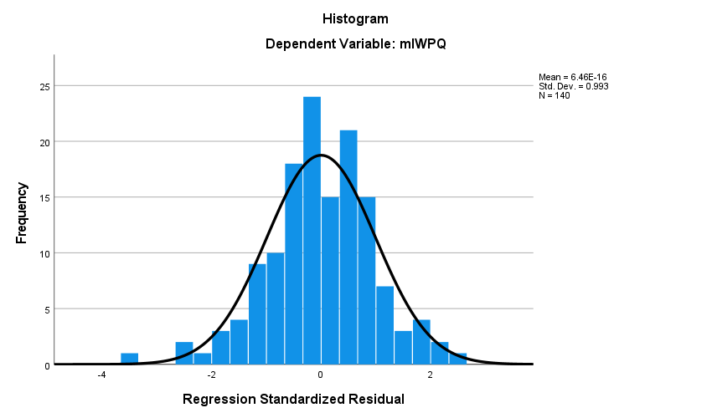 | 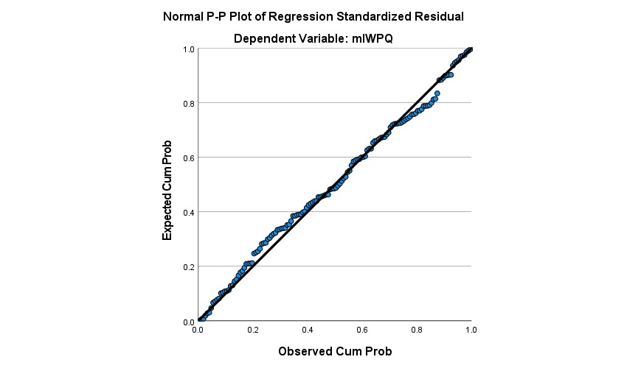
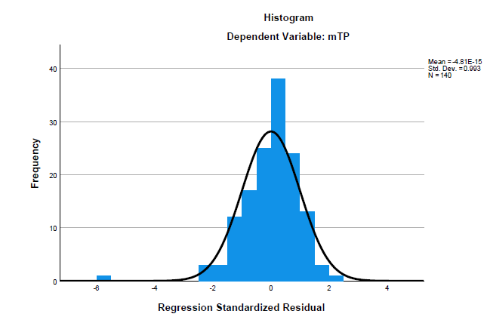 | 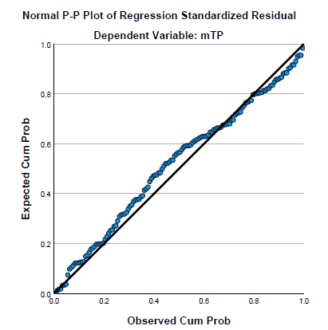
Figure 4.1 Histograms and Normal P-P plots for IWPQ and Task Performance
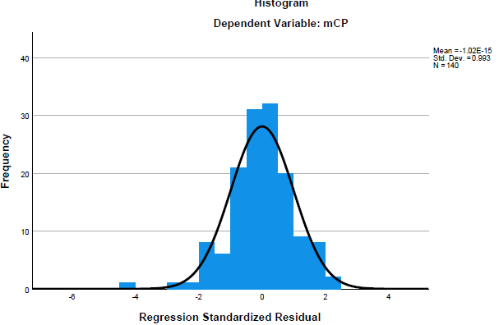 | 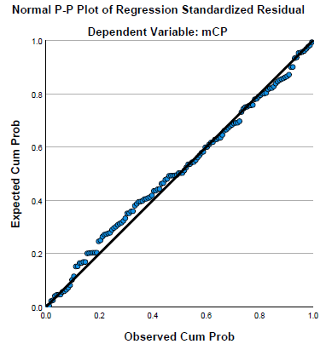
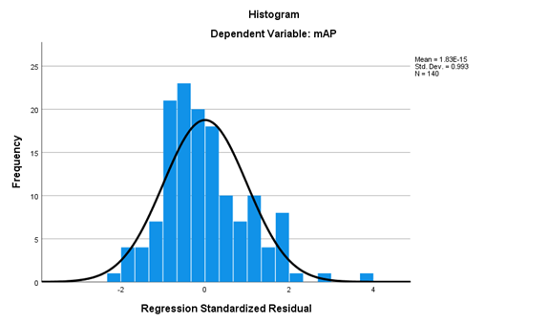 | 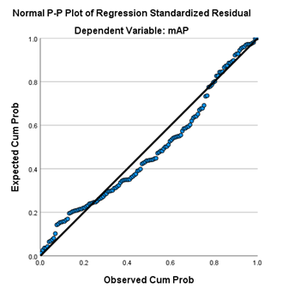
Figure 4.2 Histograms and Normal P-P plots for Contextual and Adaptive Performance

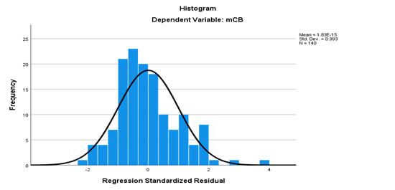 | 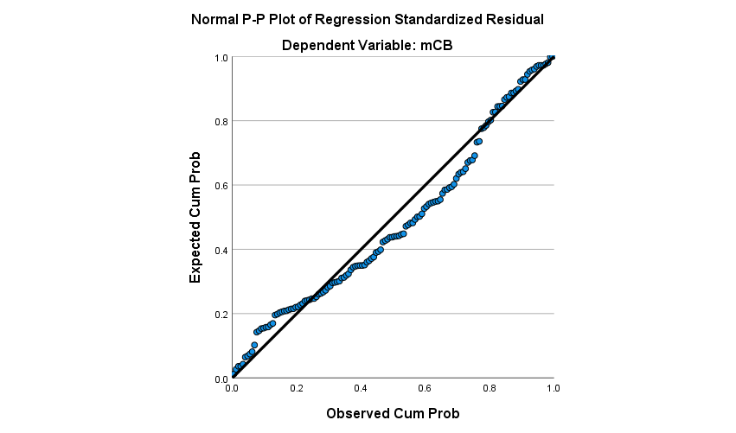
Figure 4.3 Histograms and Normal P-P plots for Counterproductive Work Behaviour

The skewness and kurtosis statistics were generated and evaluated against the cut offs of 2 and 7 respectively recommended by Kline (2023). The results (Table 4.6) show that the skewness statistics ranged from –1.96 to +1.07, all smaller than 2. The kurtosis statistics ranged from 0.03 to 6.26, all less than 7 except for the adaptive performance which had a kurtosis statistic of 7.83. Therefore, since almost all skewness and kurtosis statistics were within the recommended range, it was concluded that the data was normally distributed.

Table 4.6 Skewness and kurtosis statistics for normality assumption
Variables | Skewness |  | Kurtosis
Variables | Statistics | Std. error | Statistics | Std. error
Individual work performance | -.653 | .205 | 2.697 | .407
Task performance | -1.244 | .205 | 3.382 | .407
Contextual performance | -1.753 | .205 | 6.257 | .407
Adaptive performance | -1.964 | .205 | 7.825 | .407
Counterproductive work behaviour | 1.071 | .205 | .254 | .407
Harmonious passion for work | -.789 | .205 | .703 | .407
Obsessive passion for work | .637 | .205 | .032 | .407

4.5.4 No Outliers Assumption
Cases with standard deviation $>\left|3.3\right|$ in the residual (detected from the scatter plots) were considered outliers (Pallant, 2020). At least one or two cases had standard deviations above $\left|3.3\right|$ (Figures 4.5 - 4.7). In a follow-up test, items with $Mahalanobis Distance>χ_{(df)}$ with $p<.001$, where degree of freedom (df) was the number of independent variables in the model, were considered multivariate outliers and deleted from the data. Through the regression analysis the Mahalanobis distance 16.634 with $df=2$ and $p<.001$ was returned. This was evaluated against the cutoff Chi-square valuer from Chi-square distribution Table of 13.816 (Tabachnick & Fidell, 2019). Only one case was higher that this cut-off point. Following the advice in Gaskin (2021), this case was retained in the analysis.

4.5.5 Homoscedasticity (Constant variance) Tests Results
The homoscedasticity (Constant variance) assumption test was carried out by examining the scatter plots from the regression analysis. Since it is hard to conclusively interpret that scatter plots visually, the test was followed by both Breusch-Pagan’s and Koenker’s tests for homoscedasticity. Heteroscedasticity problems are assumed present in the data if the null hypotheses of “the residuals are homoscedastic” is rejected i.e. $p<.05$(Daryanto, 2020). Figures 4.5 t 4.6 show the scatter plots for each of the five regression estimations. Unequal variance in the residual plots is visually suspected in all but the task performance estimates. These results were confirmed by the both the Breusch-Pagan and Koenker tests. These results in Table 4.7 Show that significant LM Chi-square statistics of the Breusch-Pagan and Koneker tests respectively for individual work performance $\left(χ^{2}=14.56, ρ<.001\right)$, $\left(χ^{2}=10.21, ρ=.006\right)$contextual performance $\left(χ^{2}=44.76, ρ<.001\right)$, $\left(χ^{2}=22.58, ρ<.001\right),$adaptive performance $\left(χ^{2}=61.67, ρ<.001\right), \left(χ^{2}=20.60, ρ<.001\right)$ and counterproductive work behaviour $\left(χ^{2}=10.55, ρ=.005\right)$, $\left(χ^{2}=7.44, ρ=.024\right)$ , but in significant for task performance $\left(χ^{2}=3.15, ρ=.207\right)$, $\left(χ^{2}=0.75, ρ=.689\right)$. It was therefore concluded that heteroscedasticity problems existed in the regression estimations for all individual work performance, contextual, adaptive performance and counterproductive work behaviour, but not in the regression estimation for task performance. To address the violations of the assumptions of homoscedasticity, regression estimates with heteroscedasticity-robust standard errors were reported.

Individual Work Performance
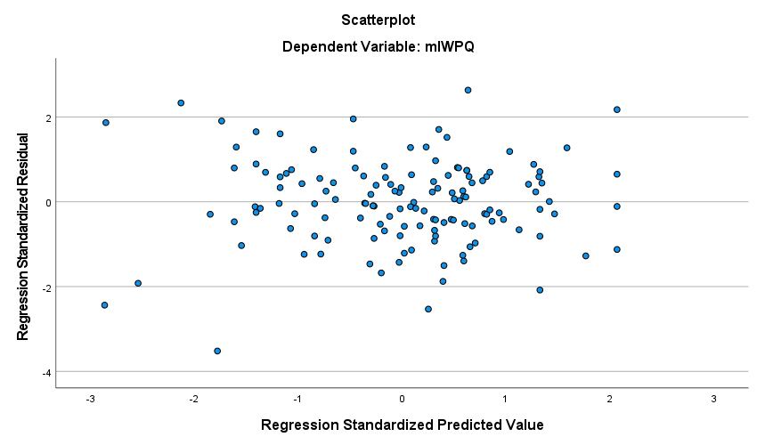

Task Performance
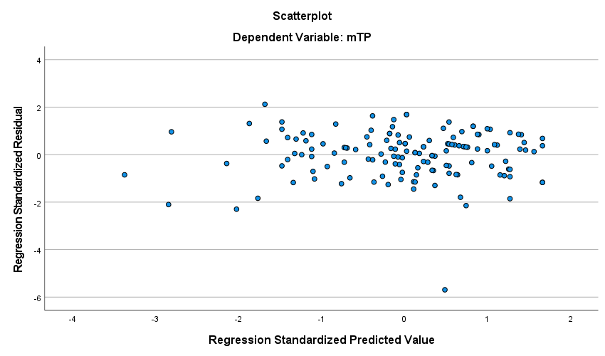

Figure 4.4 Regression residuals scatter plots for IWQ and Task performance
Contextual Performance
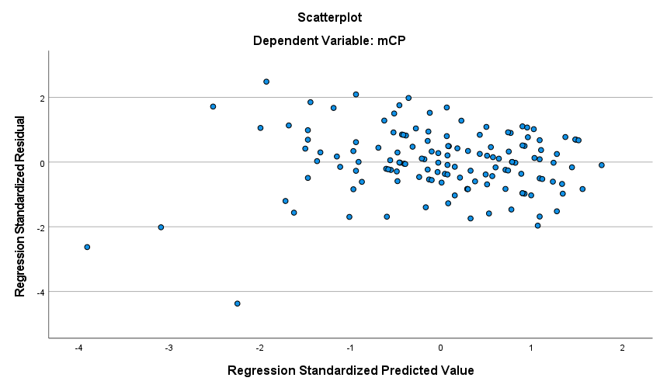

Adaptive Work Performance
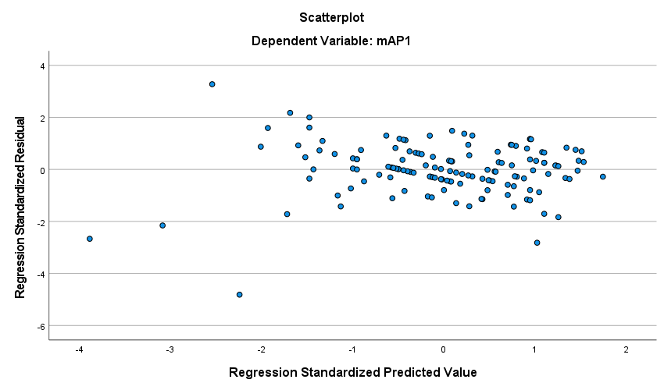

Figure 4.5 Regression residuals scatter plots for Contextual and Adaptive Performance
Counterproductive Work Behaviour
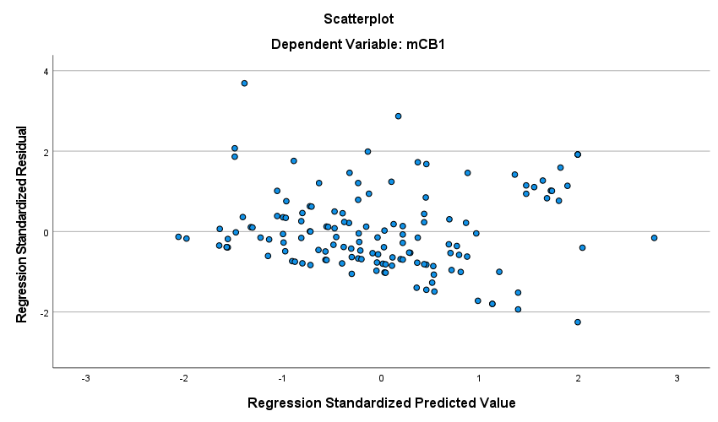

Figure 4.6 Regression residuals scatter plots for Counterproductive Work Behaviour
Source: Field Data, 2024
Table 4.7 Breusch-Pagan and Koenker Test Results for Homoscedasticity
Dependent variable | Breusch-Pagan |  | Koenker
Dependent variable | $$LM$$ | $$p$$ | $$LM$$ | $$p$$
Individual work performance | 14.56 | <.001 | 10.21 | .006
Task performance | 3.15 | .207 | 0.75 | .689
Contextual performance | 44.76 | <.001 | 22.28 | <.001
Adaptive performance | 61.67 | <.001 | 20.60 | <.001
Counterproductive work behaviour | 10.55 | .005 | 7.44 | .024

4.6 Hypotheses Testing
To investigate the effect of passion for work on individual work performance a series of linear multiple regression analyses were performed. The first one assessed the effect of both passion for work dimensions on individual work performance overall (as a unidimensional construct). The other four models tested the effect of the passion for work dimensions on each of the individual work performance dimensions of task performance, contextual performance, adaptive performance and counterproductive work behaviour. Table 4.8 presents the results.

In the results (Model 1), the two dimensions of passion for work explained 37% of the variance in individual work performance, $R^{2}=.37, F_{\left(2,137\right)}=40.44, ρ<.001$. Both Harmonious passion for work and obsessive passion for work had a positive and statistically significant effect on individual work performance, $b=0.34, p<.001$ and $b=0.08, p=.033$, respectively. These results support both H1 and H2. However, harmonious passion for work contributed more of the explanatory power, $beta=0.56, p<.001$ than obsessive passion for work, $beta=0.18, p=.033$

In the results (Model 2), the two dimensions of passion for work explained 28% of the variance in Task performance, $R^{2}=.28, F_{\left(2,137\right)}=26.29, ρ<.001$. Harmonious passion for work had a positive and statistically significant effect on task performance, $b=0.48, p<.001$ but obsessive passion for work did not, $b=0.03, p=.481$. These results supported H1.1 but not H2.1. In Model 3, the results show that the two dimensions of passion for work explained 33% of the variance in contextual performance, $R^{2}=.33, F_{\left(2,137\right)}=33.79, ρ<.001$. Harmonious passion for work had a positive and statistically significant effect on employees' contextual performance, $b=0.50, p<.001$ but obsessive passion for work did not, $b=-0.07, p=.130.$ These results support H1.2 but not H2.2.

The results (Model 4) show that the two dimensions of passion for work explained 41% of the variance in employees’ adaptive performance, $R^{2}=.41, F_{\left(2,137\right)}=47.80, ρ<.001$. Harmonious passion for work had a positive and statistically significant effect on employees' adaptive performance, $b=0.52, p<.001$, but obsessive passion for work did not, $b=-0.07, p=.090$. These results supported H1.3 but not for H2.3. The results (Model 5) show that the two dimensions of passion for work explained 22% of the variance in counterproductive work behaviour, $R^{2}=.22, F_{\left(2,137\right)}=19.05, ρ<.001$. Both harmonious and obsessive passion for work had a significant but opposite effect on employees’ counterproductive work behaviour. While harmonious passion for work had a negative and statistically significant effect on employees' counterproductive work behaviour, $b=-0.29, p=.021$, obsessive passion for work had a positive and statistically significant effect on counterproductive work behaviour, $b=0.51, p<.001$. These results supported both H1.4 and H2.4.

Table 4.8 Linear Multiple Regression Analysis Results
Variable | b | se(b) | Beta | $$ρ$$
Individual work performance (Model 1)*
Constant | 2.19 | 0.27 |  | <.001
Harmonious Passion for Work | 0.34 | 0.07 | 0.56 | <.001
Obsessive Passion for Work | 0.08 | 0.04 | 0.18 | .033
$$R^{2}=.37, F_{\left(2,137\right)}=40.44, ρ<.001$$
Task performance (Model 2)
Constant | 2.08 | 0.28 |  | <.001
Harmonious Passion for Work | 0.48 | 0.07 | 0.52 | <.001
Obsessive Passion for Work | 0.03 | 0.05 | 0.05 | .481
$R^{2}=.28, F_{\left(2,137\right)}=26.29, ρ<.001$
Contextual Performance (Model 3)*
Constant | 2.34 | 0.42 |  | <.001
Harmonious Passion for Work | 0.50 | 0.11 | 0.58 | <.001
Obsessive Passion for Work | -0.07 | 0.05 | -0.12 | .130
$R^{2}=.33, F_{\left(2,137\right)}=33.79, ρ<.001$
Adaptive performance (Model 4)*
Constant | 2.25 | 0.42 |  | <.001
Harmonious Passion for Work | 0.52 | 0.11 | 0.65 | <.001
Obsessive Passion for Work | -0.07 | 0.04 | -0.12 | .090
$R^{2}=.41, F_{\left(2,137\right)}=47.80, ρ<.001$
Counterproductive work behaviour (Model 5)*
Constant | 2.05 | 0.6 |  | <.001
Harmonious Passion for Work | -0.29 | 0.12 | -0.18 | .021
Obsessive Passion for Work | 0.51 | 0.11 | 0.46 | <.001
$R^{2}=.22, F_{\left(2,137\right)}=19.05, ρ<.001$
*OLS outputs with heteroscedasticity-robust standard errors (HC4 variant)
Source: Field data, 2024

4.7 Discussion

4.7.1 Levels of Passion for Work and Work Performance.
The first objective of the study was to assess the level of bot passion for work and employees' work performance. Using the cut-off points suggested by Albdourand Altarawneh (2014) and descriptive statistics, the study found that employees in the medical research institutions involved exhibited not only high individual work performance but also task, contextual and adaptive work performance which are all desirable work outcomes. These were comparable to those reported in Vergauwe et al. (2022). Conversely, they exhibited moderate counterproductive work behaviour, which is an undesirable work outcome. Additionally, employees exhibited high harmonious passion for work but moderate obsessive passion for work. These results are similar to those that were reported in Vergauwe et al. (2022) as well as Amarnani et al. (2020). These findings indicate that employees of the medical research institutions in the study area exhibited performance and passion for work which ranged from moderate to high.

4.7.2 The Effect of Harmonious Passion for Work on Individual Work Performance and its Dimensions
The second objective was to determine the effect of harmonious passion for work on employees’ work performance. Thus, the first hypothesis posited that harmonious passion for work would positively affect the individual work performance of employees (H1) as well as their dimensions of task performance (H1.1), contextual performance (H1.2), and adaptive performance (H1.3) but negatively affect counterproductive work behaviour (H1.4).

The study found that harmonious passion for work positively and statistically significantly affected employees’ work performance, supporting H1. This finding was similar to what was reported in past studies like those of Vergauwe et al. (2022). Also, the findings are consistent with the suggestions in other previous studies (Cabrita & Duarte, 2023; Srijaya et al, 2020; Indriasari & Stroyini, 2018; and Vallerand, 2015); that passion for work can fuel motivation, has the most significant effect on employee performance, is an important determinant of work performance and is a source of energy.

The study found that relationship between Harmonious Passion for work (HPW) and Task performance (TP) was positive and statistically significant, supporting H1.1. This finding indicates that employees with high harmonious passion for work are more likely to exhibit higher task performance. The results are also in line with the suggestions in Vallerand (2015) and Forest et al., (2012) that harmonious work passion has is associated with positive organizational outcomes such as a high level of well-being, work engagement, and task performance (Hussain, 2020).

The findings also showed that harmonious Passion for work (HPW) positively affected contextual performance indicating that employees with high harmonious passion for work are more likely to performing contextually, supporting H1.2 That is, they are more likely to extend their assigned tasks and job-related skills, take extra responsibilities as well as take challenging tasks and come up with creative solutions to work-related problems.

The relationship between harmonious passion for work and employees’ adaptive performance was found to be positive and statistically significant, supporting H1.3. The findings suggests that employees with higher harmonious passion for work are more likely to exhibit a higher adaptive performance. These may include working to update their job knowledge and job skills so that they can handle difficult work situations and setbacks, uncertainties, and generate creative solutions to work related problems as they arise.

Furthermore, harmonious passion for work negatively and significantly affected the employees counter productive work behaviour, supporting H1.4. The results indicate that employees with high harmonious passion for work were less likely to engage in counterproductive work behaviour. The findings are in line with the idea that employees who are harmoniously passionate about their work will resist engaging in negative work outcomes as suggested in Pradhan et al, (2017). They will tend to disengage with such behaviours like prioritizing unimportant matters or negative aspects of work, exaggerating problems, and spoke negatively about own organization.

4.7.3 The Effect of Obsessive Passion for Work on Individual Work Performance and its Dimensions
The second hypothesis posited obsessive passion for work would positively affect the individual work performance of employees (H2) as well as their dimensions of task performance (H2.1), contextual performance (H2.2), adaptive performance (H2.3) and counterproductive work behaviour (H2.4).

From the analysis, the individual employees’ work performance was positively affected by obsessive passion for work and this effect was statistically significant. Hence Hypothesis H2 was supported. The findings are in line with the idea proposed in previous studies e.g. Astakhova and Porter 2015 and Marsh et al., 2013, that obsessively passionate individuals will engage in work activity because they perceive work is instrumental in achieving desired outcomes, such as group acceptance, pay rises, promotions or other rewards that would reinforce their self-worth; but will often experience conflict with other activities and aspects of their life as well as negative feelings when partaking in non-passionate activity

The findings show that the relationship between Obsessive Passion for work (OPW) and Task Performance was positive but not statistically significant. Hence H2.1 was not supported. These findings suggest that people engage in activities to satisfy psychological needs of autonomy, competence and relatedness, that is experiencing a choice and feeling of being the initiator of one’s actions, succeeding at challenging tasks to attain desired outcomes and achieving a sense of mutual respect and reliance with others (Vergauwe et al., 2022). They also suggest that the more obsessive employees are with their work, the more likely they are to plan, prioritize, and execute their roles according to preset time line. However, this was not statistically significant.

The relationship between Obsessive Passion for work (OPW) and Contextual Performance was negative but not significant. Therefore, H2.2 was not supported. Employees who are obsessive with their work are likely to exhibit lower contextual performance. The results are in line with the suggestion by Juliani and Purba (2019) that when individuals perceive responsibilities as significant, they occupy themselves with these jobs to fulfil their basic psychological needs of autonomy, competence and relatedness and in both autonomous motivation and controlled motivation. They become less likely to take personal initiatives, challenging tasks, updating their job-related knowledge and skills. They become less creative and hesitant to take on challenging tasks.

Moreover, the relationship between Obsessive Passion for work (OPW) and Adaptive Performance (AP). The analysis shows that the impact of Obsessive Passion for work (OPW) and adaptive performance was negative and statistically non-significant. Hence H2.3 was not supported. The findings suggest that employees who are passionately obsessive about their work are less likely to engage adaptively with their work leading to lower performance. They will be less likely to update job knowledge and skills, adapt to difficult and challenging work situations, and or adjust themselves to accommodate changes in their work schedule.

Finally, the he relationship between Obsessive Passion for work (OPW) and Counterproductive Work Behavior (CWB) was positive and statistically significant, supporting H2.4. These findings suggest that employees who are passionately obsessive with their work are more likely to engage in counterproductive work behaviours. The results are in line with the suggestions by Vergauwe et al. (2022) who argued that some people merely view their work as labor hence fulfill their tasks without enthusiasm. Passionately obsessive employees are more like to engage with such behaviours as prioritizing unimportant work-related matters, spreading negative word of mouth to outsiders about their organizational and amplifying negative aspects of their work and or exaggerating unimportant work matters.

Overall, harmonious passion for work contributed more impact on individual work performance and its dimensions of task, contextual and adaptive work performance. However, for the counterproductive work behaviour, observe passion for work contributed more impact than the harmonious passion for work. The results of the analysis suggest that the level of passion for work on employees’ individual work performance for employees in medical research institutions of Tanzania is high except in the cases of obsessive passion from work and counterproductive work behaviour, which were moderate.

Regarding the effect of harmonious passion for work on employees’ individual work performance, the results suggest that it was more effect on Task performance, Contextual performance, Adaptive performance but less on counterproductive work behavior. However, in relation to the effect of obsessive passion for work on employees’ individual work performance, results show that it was more impactful on Counterproductive behavior than on the other dimensions.
.

CHAPTER FIVE

CONCLUSIONS AND RECOMMENDATIONS

5.1 An Overview
This chapter concludes the study by summarizing the key research findings in relation to the research aim and questions as well as the value and contribution thereafter. It also outlines the limitations of the study and propose opportunities for future research.

5.2 Research Conclusions
This study aimed to assess the effects of passion for work on individual employee job performance and its constructs of task, contextual, and adaptive performance as well as counterproductive behavior. The study was done in the Tanzanian context where there has been a paucity of studies linking passion for work and employees’ performance. More specifically, it focused on employees of medical research institutions where the availability of such studies is even scantier despite the importance of passion of work in cultivating performance outcomes in such sector. A multiple linear regression analysis technique was employed in testing the hypotheses regarding the relationship between passion for work (and each of its two dimensions) and individual work performance (and its four dimensions).

Following the analysis, discussion and interpretation of the results, it was concluded that (i) harmonious passion for work positively affect overall employees’ performance, and its dimensions of task, contextual and adaptive performance, but negatively affected employees counterproductive work behaviour. All these relationships were statistically significant. Consequently, employees who are harmoniously passionate about their work are more likely to exhibit higher overall, task, contextual and adaptive performance, but less likely to engage in counterproductive work performance. (ii) obsessive passion for work positively affected the overall employees work performance. However, it had a nonsignificant effect on the dimensions of task, contextual and adaptive performance. Consistent with the expectation, obsessive passion for work positively and significantly affected employees’ counterproductive work behaviour. That is employees who are obsessively passionate about their work as more likely to engage in counterproductive work behaviour.

5.3 Contributions of the Study
Theoretically, this study contributed to the passion for work literature especially in the Tanzanian context and the medical research field where currently there is little to none such literature. Also, this study contributes to the existing literature on the passion for work – employees performance nexus by disaggregating the effect by showing that it differs depending on the dimension of performance. This approach was relatively under-researched. So overall the study showed that the self-determination theory is relevant in the Tanzanian context as well as in the medical research institutions. Hence it should be used to illuminate the relationship between passion for work and employees work performance.

Practically, this study contributes to the management of human resource in the medical research field. The evidence shows that for these institutions to enhance performance of their employees, they have to adopt human resource management practices that cultivate harmonious passion for work among them and care should be taken to ensure that they do not become obsessive. Moreover, this study analysis results backs the theory that work passion dimensions related differently as was discovered by Vallerand and Houlfort (2003) but they both contribute to individual job performance as was stated by Koopmans, 2012.

5.4 Limitations of the Study
This study has a few limitations especially limited scope of participants. The population of this study was focused only on employees of medical research institutions within the Mbeya city specifically residing within Mbeya zonal referral hospital grounds, the area alone may not be representative of the entire medical research institutions spectrum and, may hinder the generalizability of the study’s findings. Also, the data collection was done on one point in time. Additional even though the study adopted the census approach to encourage more response, there was still some non-response from the study population. Still, following the almost consistent findings on the harmonious passion for work – performance nexus, there is room to investigate the “how” question – i.e. whether the effect is only direct of there is also an indirect effect through other variables – sequential or parallelly.

The findings are also interesting in the sense that they were obtained in a human sensitive context i.e. the medical research institutions. This raise the need to investigate the nexus in other disciplines/ sectors that are equally human sensitive – e.g. nurses and doctors, teachers at all levels from primary schools to institutions of higher learning, etc. However, regardless of the above limitations, the findings were significant in answering the research questions and drawing conclusion on the need to promote harmonious passion as opposed to obsessive passion since it was witnessed in previous findings to relate to workers mental health and may affect commitment as was suggested by Forest et al, (2011). Also, from Veira dos Santos et al, (2023) it was advised to promote harmonious passion and manage the potential negative effects of obsessive passion for enhancing positive job-related behaviors and performance.

5.5 Recommendations for Future Studies
Given the fact that passion is internalized into an individuals’ identity and may be prone to change, future research can build on this study findings and develop a longitudinal study on the current organization’s outcomes. Future research can also conduct a similar study on a wider scope to incorporate a larger sample size and other professions to make a comparison. Given the findings that obsessive passion has more of the effect on employee’s individual work performance especially adaptive and counterproductive behavior, and Harmonious has more effect on task and contextual performance, future research can build on these findings and also consider adding intention to quit component and or, individual output to draw a clear picture on these dimensions. The study about effects of passion for work and employee individual performance is crucial in helping employees understand how they feel about their tasks, daily work environment and what they desire them to be. Also, it helps the employer understand why some employees behave the way they do. But all in all, as Indriasari and Setyorini, (2018) put it, “work passion is an important determinant of work performance and establishing employee competence and expertise is made possible by way of building up work passions”. The areas already outlined in the limitations section are also important in future studies.

REFERENCES
Albdour, A. A., & Altarawneh, I. I. (2014). Employee engagement and organizational commitment: Evidence from Jordan. International Journal of Business, 19(2), 192-212.
Appienti, W. A., & Chen, L. (2020). Empowerment, passion, and job performance: implications from Ghana. International Journal of Manpower, 41(2), 132-151. https://doi.org/10.1108/IJM-10-2018-0348
Astakhova, M. N., & Porter, G. (2014). When and Why Does Harmonious Passion Lead to Increased Performance. In Academy of Management Proceedings (Vol. 2014, No. 1, p. 10193). Briarcliff Manor, NY 10510: Academy of Management.
Astakhova, M. N., & Porter, G. (2015). Understanding the work passion–performance relationship: The mediating role of organizational identification and the moderating role of fit at work. Human Relations, 68(8), 1315–1346. https://doi.org/10.1177/0018726714555204
Borgia, M. S., Di Virgilio, F., La Torre, M., & Khan, M. A. (2022). Relationship between work-life balance and job performance moderated by knowledge risks: Are bank employees ready?. Sustainability, 14(9), 5416. https://doi.org/10.3390/su14095416
Budhiraja, S. (2023). Continuous learning and employee performance: a moderated examination of managers’ coaching behavior in India. Personnel Review, 52(1), 200-217. https://doi.org/10.1108/PR-04-2020-0272
Benjamin W. Mkapa HIV/AIDS Foundation. (2015. September) Assessment of health worker productivity in Tanzania. Dar es Salaam, Tanzania. https://pdf.usaid.gov/pdf_docs/PA00M2C6.PDF
Cabrita, C. & Duarte, A.P. (2023). Passionately demanding: Work passion’s role in the relationship between work demands and affective well-being at work. Front. Psychol., 14,1053455. https://doi.org/10.3389/fpsyg.2023.1053455
Deci, E. L., & Ryan, R. M. (1985). Intrinsic motivation and self-determination in behavior. Plenum Press.
Forest J., Mageau, G. A., Sarrazin, C., & Morin, E. M. (2011). Work is my passion”: The different affective, behavioral, and cognitive consequences of harmonious and obsessive passion toward work. Can. J. Admin. Sci., 28, 27–40. https://doi.org/10.1002/cjas.170
Forest, J., Mageau, G. A., Crevier-Braud, L., Bergeron, É., Dubreuil, P., & Lavigne, G. L. (2012). Harmonious passion as an explanation of the relation between signature strengths’ use and well-being at work: test of an intervention program. Hum. Relat. 65, 1233–1252. https://doi.org/10.1002/cjas.170
Gaskin, J. (2021). Data preparation. Gaskination's StatWiki. http://statwiki.gaskination.com
George, D., & Mallery, P. (2022). IBM SPSS statistics 27 step by step: A simple guide and reference. (17th Ed.). Routledge.
Hussain, S. (2022) Impact of Harmoniuos passion on Task performance and organizational citizenship behaviours through the mediating role of work engagement. Pakistan Journal of Social Sciences, 42(2),431-444
Ibrahim, M., Karollah, B., Juned, V., & Yunus, M. (2022). The effect of transformational leadership, work motivation and culture on millennial generation employees performance of the manufacturing industry in the digital era. Frontiers in psychology, 13, 908966. https://doi.org/10.3389/fpsyg.2022.908966
Indriasari, I., & Setyorini, N. (2018). The impact of work passion on work performance: The moderating role of P-O fit and meaningfulness of work. Diponegoro International Journal of Business, 1(1), 26-32. https://doi.org/10.14710/dijb.1.1.2018.26-32
Juliani, R., & Purba, D. E. (2019). The Mediating Role of Passion for Work on the Relationship between Task Significance and Performance. Pertanika Journal of Social Sciences & Humanities, 27(2), 1945-1958.
Kasaya, M. A., & Munjuri, M. G., (2018) Effect of employee involvement on job performance in the medical research industry in Kenya. International Journal of Economics, Commerce & Management, 5, 826 – 847, SSN 2348 0386
Keller, G. (2018). Statistics for management and economics, (11th Ed.), Cengage Learning®. ISBN: 978-1-337-29694-6
Kline, R. B. (2023). Principles and practice of structural equation modelling. (5th Ed.). Guilford publications.
Koopmans, L., Bernaards, C., Hildebrandt, V., Van Buuren, S., Van der Beek, A. J., & De Vet, H. C. (2012). Development of an individual work performance questionnaire. International Journal of Productivity and Performance Management, 62(1), 6-28.
Kravariti, F., Tasoulis, K., Scullion, H., & Alali, M.K. (2023). Talent management and performance in the public sector: The role of organisational and line managerial support for development, The International Journal of Human Resource Management, 34(9), 1782-1807. https://doi.org/10.1080/09585192.2022.2032265
Mwita, K., & Andrea, P. (2019). Assessment of employee performance management in Tanzania public health facilities. Journal of Management Research and Analysis, 6,169-173. https://doi.org/10.18231/j.jmra.2019.035
Newman, A., Obschonka, M., Moeller, J., & Chandan, G. G. (2021). Entrepreneurial passion: A review, synthesis, and agenda for future research. Applied Psychology, 70(2), 816-860. https://doi.org/10.1111/apps.12236
Omar, S. N. Z., Cob, C. M. S. C., Sakarji, S. R., Thani, A. K. A., & Bakar, A. A. (2022). A preliminary study of factors influencing employee performance. International Journal of Academic Research in Business and Social Sciences, 12(1), 1880–1891. http://dx.doi.org/10.6007/IJARBSS/v12-i1/12234
Pallant, J. (2020). SPSS survival manual, a step-by-step guide to data analysis using IBM SPSS. (7th Ed.). https://doi.org/10.4324/9781003117452, eBook ISBN: 0781003117452
Patel, V., Ahmed, K., Nicholson, J.K., & Athanasious, T. (2011) How has healthcare research performance been assessed? A systematic review. Journal of the royal society of medicine. https://doi.org/10.1258/jrsm.2011.110005
Perrewé, P. L., Hochwarter, W. A., Ferris, G. R., McAllister, C. P., & Harris, J. N. (2014). Developing a passion for work passion: Future directions on an emerging construct. Journal of Organizational Behavior, 35(1), 145-150. https://doi.org/10.1002/job.1902
Pollack, J. M., Ho, V. T., O'Boyle, E. H., & Kirkman, B. L. (2020). Passion at work: A meta‐analysis of individual work outcomes. Journal of Organizational Behavior, 41(4), 311-331.
Pradhan, R. K., & Jena, L. K. (2017). Employee performance at workplace: Conceptual model and empirical validation. Business Perspectives and Research, 5(1), 69-85. https://doi.org/10.1177/2278533716671630
Pradhan, R. K., Panda, P., & Jena, L. K. (2017). Purpose, passion, and performance at the workplace: Exploring the nature, structure, and relationship. The Psychologist-Manager Journal. Advanced online publication. http://dx.doi.org/10.1037/mgr0000059
Riyanto, S., Endri, E., & Herlisha, N. (2021). Effect of work motivation and job satisfaction on employee performance: Mediating role of employee engagement. Problems and Perspectives in Management, 19(3), 162-174. https://doi.org/10.21511/ppm.19(3).2021.14
Rogerson, P. A. (2001). Statistical methods for geography: A student's guide. Sage Publications Ltd
Saunders, M. N. K., Lewis, P., & Thornhill, A. (2019). Research methods for business students. (8th Ed.) Pearson Education Limited. ISBN: 978-1-292-20878-7
Songstad, N. G., Lindkivst, I., Moland, K. M., Chimhutu, V. & Blystad, A. (2012) Assessing performance enhancing tools: experiences with the open performance review and appraisal system (OPRAS) and expectations towards payment for performance (P4P) in the public health sector in Tanzania. Globalization and Health, 8(33). https://doi.org/10.1186/1744-8603-8-33.
Srijaya F., Zamralita., Basaria D., (2020). The work passion effect on PT. XYZ’s employees' performance in Jakarta. Atlantis press. Advances in Social Science, Education and Humanities Research, 478, 544-548
Steen, R.G. (2012). Writing for publication in a medical journal. Indian J Endocrinol Metab, 16(6):899-903. https://doi.org/10.4103/2230-8210.102988. PMID: 23226633; PMCID: PMC3510958
Tabachnick, B.G., & Fidell, L.S. (2013). Using multivariate statistics. Pearson New International Edition. Pearson Higher Education.
Taber, K. S. (2018). The use of Cronbach’s alpha when developing and reporting research instruments in science education. Res Sci Educ 48, 1273–1296. https://doi.org/10.1007/s11165-016-9602-2
Vallerand, R. J. (2015). The psychology of passion: A dualistic model. Series in positive psychology. Oxford University Press. ISBN 978–0–19–977760–0
Vallerand, R. J., & Houlfort, N. (2003). Passion at work: Toward a new conceptualization. In S. W. Gilliland, D. D. Steiner, & D. P. Skarlicki (Eds.), Emerging perspectives on values in organizations (pp. 175–204). Greenwich, CT: Information Age Publishing
Vallerand, R. J., Paquet, Y., Philippe, F. L., & Charest, J. (2010). On the role of passion for work in burnout: A process model. Journal of personality, 78(1), 289-312.
Vallerand, R. J., Salvy, S. J., Mageau, G. A., Elliot, A. J., Denis, P. L., Grouzet, F. M., & Blanchard, C. (2007). On the role of passion in performance. Journal of personality, 75(3), 505-534.
Vergauwe, J., Wille, B., Caluwé, De E., & Fryut, De F. (2022). Passion for work: relationships with general and maladaptive personality traits and work-related outcomes. https://doi.org/10.1016/j.paid.2021.111306
Vieira dos Santos, J., Gomes, A., Rebelo, D.F.S., Lopes, L.F.D., Moreira, M.G., & da Silva, D.J.C. (2023). The consequences of job crafting and engagement in the relationship between passion for work and individual performance of Portuguese workers. Front. Psychol. 14,1180239. https://doi.org/10.3389/fpsyg.2023.1180239
Yimam, M. H. (2022). Impact of training on employees performance: A case study of Bahir Dar university, Ethiopia. Cogent Education, 9(1), 2107301. https://doi.org/10.1080/2331186X.2022.2107301

APPENDICES

Appendix 1. QUESTIONNAIRE
Dear participant,
My name is Abie T Sigauke, an MHRM student at the Open University of Tanzania. I am conducting research titled Effects of Work Passion on Employee Performance - A Quantitative Analysis, focusing on employees of medical research institutions. The research will lead to a dissertation and a publication as part of the requirements for the award of the MHRM degree. I therefore request you to kindly participate in the survey by filling out this questionnaire. Your participation is anonymous and voluntary. Please do not indicate your name or any identification number anywhere in this questionnaire. The information you provide will be used solely for the purposes stated above and the outcome of its analysis will be reported in aggregate terms without disclosing your identity.
I anticipate that you will agree to the stated terms as well as participate in filling out the questionnaire. If so, please sign the consent section below and proceed with filling out the questionnaire.
It is estimated that it will take about 15 to 20 minutes of your time to complete this questionnaire. There are no right or wrong answers. I only need to know how you rate your perception of your job performance and your passion for it. Finally, to increase our understanding of participants’ characteristics, you are requested to also respond to the last section of the questionnaire (demographic information).
Should you need to discuss the study further, please do not hesitate to contact us as follows: 0753686720 and abbysig2003@yahoo.com. My research supervisor can also be contacted at proches.ngatuni@out.ac.tz; 0754 609 596

Consent form
I certify that I have read and understood the description of the research project as detailed above, and it is on this basis that I willingly and voluntarily agree to participate in it by responding to this questionnaire. I also understand that I do not have to answer any or all questions. I expect that in publishing the results, my anonymity will be preserved, as promised.
Signed……………………………... Date…………………….

Section 1: Employee performance
- TASK PERFORMANCE (TP)
Against each statement listed in the table below, please tick or circle the number that indicates your rating of the extent to which you agree with it; where;
1= strongly disagree; 2 = disagree, 3 = neither disagree no agree; 4 = agree, 5 = strongly agree
In the past 12 months…
TP1 | … I managed to plan my work so that I finished it on time | 1 | 2 | 3 | 4 | 5
TP2 | … I kept in mind the results that I had to achieve in my work | 1 | 2 | 3 | 4 | 5
TP3 | … I was able to set priorities and meet deadlines | 1 | 2 | 3 | 4 | 5
TP4 | … I was able to carry out my work efficiently and effectively | 1 | 2 | 3 | 4 | 5
TP5 | … I was able to separate main issues from side issues at work | 1 | 2 | 3 | 4 | 5
TP6 | … It took me no longer than the intended time to complete my work tasks | 1 | 2 | 3 | 4 | 5

- CONTEXTUAL PERFORMANCE (CP)
Against each statement listed in the table below, please tick or circle the number that indicates your rating of the extent to which you agree with it; where;
1= strongly disagree; 2 = disagree, 3 = neither disagree no agree; 4 = agree, 5 = strongly agree

In the last twelve months …
CP1 | On my own initiative, I started new tasks myself when … my old tasks were completed | 1 | 2 | 3 | 4 | 5
CP2 | … I took on challenging tasks when they were available | 1 | 2 | 3 | 4 | 5
CP3 | … I worked on keeping my job-related knowledge and skills up-to-date | 1 | 2 | 3 | 4 | 5
CP4 | … I took the initiative when something had to be organized. | 1 | 2 | 3 | 4 | 5
CP5 | … I always came up with creative solutions for solving work-related problems | 1 | 2 | 3 | 4 | 5
CP6 | … I took on extra responsibilities | 1 | 2 | 3 | 4 | 5
CP7 | … I continually seek new challenges in my work activities | 1 | 2 | 3 | 4 | 5

- ADAPTIVE PERFORMANCE (AP)
Against each statement listed in the table below, please tick or circle the number that indicates your rating of the extent to which you agree with it; where;
1= strongly disagree; 2 = disagree, 3 = neither disagree no agree; 4 = agree, 5 = strongly agree
In the past 12 months…
AP1 | … I worked at keeping my job knowledge up-to-date | 1 | 2 | 3 | 4 | 5
AP2 | … I worked to keep my job skills up-to-date | 1 | 2 | 3 | 4 | 5
AP3 | … I was able to cope well with difficult situations and setback at work | 1 | 2 | 3 | 4 | 5
AP4 | … I came up with creative solutions to new problems | 1 | 2 | 3 | 4 | 5
AP5 | … I was able to cope well with uncertain and unpredictable situations at work | 1 | 2 | 3 | 4 | 5
AP6 | … I easily adjusted to changes in my work | 1 | 2 | 3 | 4 | 5

- COUNTERPRODUCTIVE WORK BEHAVIOR (CB)
Against each statement listed in the table below, please tick or circle the number that indicates your rating of the extent to which you agree with it; where;
1= strongly disagree; 2 = disagree, 3 = neither disagree no agree; 4 = agree, 5 = strongly agree

In the past 12 months…
CB1 | … I complained about unimportant matters at work | 1 | 2 | 3 | 4 | 5
CB2 | … I made problems at work larger than they were | 1 | 2 | 3 | 4 | 5
CB3 | … I focused on the negative aspects of a work situation instead of focusing on the positive aspects | 1 | 2 | 3 | 4 | 5
CB4 | … I spoke with colleagues about the negative aspects of my work | 1 | 2 | 3 | 4 | 5
CB5 | … I spoke with to people outside the organization about the negative aspects of my work | 1 | 2 | 3 | 4 | 5

Section 2: Work Passion
A: HARMONIOUS PASSION FOR WORK (HPW)
Against each statement listed in the table below, please tick or circle the number that indicates your rating of the extent to which you agree with it; where;
1= strongly disagree; 2 = disagree, 3 = neither disagree no agree; 4 = agree, 5 = strongly agree
HPW1 | For me, it is a passion that I still manage to control it | 1 | 2 | 3 | 4 | 5
HPW2 | My work is in harmony with the other things that are part of my life | 1 | 2 | 3 | 4 | 5
HPW3 | The new things that I discover with my work allow me to appreciate it even more | 1 | 2 | 3 | 4 | 5
HPW4 | My work reflects the qualities I like about myself | 1 | 2 | 3 | 4 | 5
HPW5 | My work allows me to live a variety of experiences | 1 | 2 | 3 | 4 | 5
HPW6 | My work is well integrated with my life | 1 | 2 | 3 | 4 | 5
HPW7 | My work allows me to live memorable experiences | 1 | 2 | 3 | 4 | 5

b: OBSESSIVE PASSION FOR WORK (OPW)
Against each statement listed in the table below, please tick or circle the number that indicates your rating of the extent to which you agree with it; where;
1= strongly disagree; 2 = disagree, 3 = neither disagree no agree; 4 = agree, 5 = strongly agree
OPW1 | My work is so exciting that I sometimes lose control over it | 1 | 2 | 3 | 4 | 5
OPW2 | I am emotionally dependent on my work | 1 | 2 | 3 | 4 | 5
OPW3 | I have difficulties controlling my urge to do my work | 1 | 2 | 3 | 4 | 5
OPW4 | I have almost an obsessive feeling for my work | 1 | 2 | 3 | 4 | 5
OPW5 | My work is the only thing that really turns me on | 1 | 2 | 3 | 4 | 5
OPW6 | I can not live without my work | 1 | 2 | 3 | 4 | 5

Section 4: Respondent Information
Please tick where necessary
- Gender:
  - Male [__] Female [__]
- Age:
  - ≤ 35 years [__] 36-45 years [__] Above 45 years [__]
- Education Level:
  - Basic certificate [__] Diploma [__] Bachelor Degree [__]
  - Master’s Degree [__] Ph.D. [__]
- Length of Employment in Medical Research Activities:
  - Less than 1 year [__] 1-5 years [__] 6-10 years [__]
  - More than 10 years [__]
- Your Job title is………………………………………………………………
- Which research institution are you from? …………………………………….

Thank you for taking part in responding to the above statements.

APPENDIX 2: CODE BOOK
VARIABLE | CODE | CODING INSTRUCTIONS
Identification number | ID | Subject Identification number
Research institution | Inst | 1=NIMR, 2=MZRH, 3=Baylor, 4=UDSM.
Age Group | Agegp | 1=≤35 years, 2=36-45 years, 3=Above 45 years
Gender | Gender | 1=Male, 2=Female
Education level | Edulevel | 1=Basic Certificate, 2=Diploma, 3=Bachelor Degree, 4=Master’s Degree, 5=PhD
Length of employment in medical research activities | employlength | 1= Less than 1 year, 2=1-5 years, 3=6-10 years, 4= More than 10 years
Job title Category | JobCat | 1=Research scientists, 2=medical doctors, 3=study nurses, 4=data managers, 5=ICT, 6=laboratory personnel
Task Performance | TP1 – TP6 | 1= strongly disagree to 5 = strongly agree
Contextual performance | CP1 – CP7 | 1= strongly disagree to 5 = strongly agree
Adaptive performance | AP1 – AP6 | 1= strongly disagree to 5 = strongly agree
Counterproductive work behavior | CB1 – CB5 | 1= strongly disagree to 5 = strongly agree
Harmonious passion for work | HPW1 – HPW7 | 1= strongly disagree to 5 = strongly agree
Obsessive passion for work | OBW1 – OBW6 | 1= strongly disagree to 5 = strongly agree

Appendix 3. Request for research clearance letter


Appendix 4. A sample of the research clearance letters




Appendix 6. Permission letter for data collection


