**IMPROVED LIVELIHOOD OF JALIMAISHA YOUTH GROUP THROUGH CAR WASH PROJECT AT KIBONDO WARD IN KIBONDO DISTRICT.**

**RODA FRANK MANZI**

**PG201700344**

**A PROJECT SUBMITTED IN PARTIAL FULFILLMENT FOR THE**

**REQUIREMENTS FOR THE DEGREEE OF MASTER OF ARTS IN COMMUNITY ECONOMIC DEVELOPMENT OF THE OPEN UNIVERSITY OF TANZANIA**

**2024**

# CERTIFICATION

The undersigned certifies that, I have read the community needs assessment report and hereby recommend for acceptance by the Open university of Tanzania (OUT), a CNA title, ***‘’Improved livelihood of Jalimaisha youth group through car wash project at kibondo ward in kibondo district’’*** in partial fulfilment of the requirement for the degree of masters in community economic development at the Open university of Tanzania.

Supervisors name: Dr. HARRIETH G. MTAE

Signature: ………………………………………….

Date: ………………………………………………….

# COPYRIGHT

No place of this dissertation may be reproduced or stored in any transmitted form by any means, electronic, mechanical, photocopying, recording or otherwise without the written permission of the director of postgraduate studies on behalf of both the author and the Open University of Tanzania.

# DECLARATION

I Roda Frank Manzi, do hereby declare that this CED project report is my own and original work which has not been submitted for a similar degree or any other degree award in any university.

Signature:

Date:

# DEDICATION

This work is dedicated to my parents, Mr. and Mrs. Frank Manzi and my family for their formation and support throughout my life.

# ACKNOWLEDGEMENT

The completion of this work has involved contribution from different people and institutions. The best way to thank them would have been mentioning them all, had it not been space limitation.

I give glory to God for the journey mercies and provision throughout the time of this course. I am indebted to my supervisor, Dr. Harrieth Mtae for her professional and moral guidance without which the success of this study would have not been achieved.

I am grateful for all staff of the department of economics and social science, at the Open university of Tanzania especially the lecturers for the untiring support towards accomplishing this master’s degree program. I further extend my gratitude to my employer, UNHCR, through my supervisor Mr. Patrick Mutai and U aye Maung for endorsement of my leave requests to support my academic engagements including face to face and exam sessions.

Sincere appreciations go to my parents Mr. Frank E Manzi and Ms. Pilli S. Maulidi, for not only laying strong foundation for my education but also for their encouragement, care and moral support during the whole period of execution of this program. Further, not to be forgotten for thanks is my very own family, Lincolin B Kawiche and our sons Jayden and Jotham for their love and care that really contributed to my mental and general health stability.

Finally, I am grateful for the support from my lovely young sister, Maisara F. Manzi and my friends notably Regina Kajala, David Mlote, Baba Diana, Majaliwa Magono and Shukuru for their peer support and advice.

# ABSTRACT

This study aimed at ‘improved livelihood of Jalimaisha youth group’ through carwash project for unemployed youth in Kibondo ward for the purpose of increasing income for themselves. CNA participatory methods including focus group discussion, interviews, observation and documentary review were used to collect data related to the needs of the target community and the potential employment creation opportunities. Implementation was conducted following the assessment which indicated what initiatives to undertake to achieve the intended goals. The researcher identified three appropriate strategies namely, the establishment of carwash project, capacity building for carwash group members on micro-enterprise development and to empower project members on management and supervision skills. Findings revealed existence of several needs including lack of; capital, entrepreneurship skills, empowerment programs, market & market information, capacity for establishment of cooperative society and income poverty. Through pair-wise model, income poverty was identified as the most pressing need of the community. Hence, several interventions were proposed including establishment of vegetable gardens, salon and carwash project, whereby through pairwise ranking it was decided that establishment of car wash project would be the most feasible intervention to meet the identified need. In the course of project implementation 12 youth were trained and established an economic group named Jalimaisha youth group. Adequate progress of the key aspects including income, has been realized as the clients keep increasing on the product of the project initiated. Project monitoring and evaluation activities involved all key stakeholders including local government authorities and NGOs.

**TABLE OF CONTENTS**

CERTIFICATION ii

COPYRIGHT iii

DECLARATION iv

DEDICATION v

ACKNOWLEDGEMENT vi

ABSTRACT vii

TABLE OF CONTENTS viii

LIST OF TABLES xiv

LIST OF FIGURES xv

LIST OF ABBREVIATIONS xvi

CHAPTER ONE 1

PARTICIPATORY NEEDS ASSESSMENT 1

1.0 Background information 1

1.1 Community profile 2

1.2 Community Needs Assessment (CNA) 3

1.2.1 CNA overall objective 4

1.2.1.1 Specific objectives 5

1.2.2 CNA questions 5

1.2.3 Research methodology 5

1.2.3.1 Research design 5

1.2.3.2 Sampling techniques 6

1.2.3.3 Data collection methods 7

1.2.3.3.1 Key informants Interview 7

1.2.3.3.2 Focus group discussion 8

1.2.3.4 Data analysis methods 8

1.3 CNA findings 9

1.3.1 Age of respondents 9

1.3.2 Level of education 10

1.3.3 Marital status 10

1.3.4 Number of dependents 11

1.3.5 Needs of Kibondo ward youths 12

1.3.6 Entrepreneurship skills 12

1.3.7 Suggested projects 13

1.3.8 Findings from key informants 14

1.3.9 Awareness of the available resources in the community 15

1.4 Community needs prioritization/levelling of needs 16

1.4.1 Prioritization of needs 16

1.4.2 Project identification and prioritization by the community 17

1.5 Chapter conclusion 18

CHAPTER TWO 20

PROBLEM IDENTIFICATION 20

2.0 Background to research problem 20

2.1 Problem Statement 20

2.2 Project Description 21

2.2.1 Target Community 21

2.2.2 Stakeholders 21

2.2.3 Project Goal 22

2.2.3.1 General Objectives 22

2.2.3.2 Specific Objectives 22

2.3 Host organization CBO/Profile 23

2.3.1 Vision 23

2.3.2 Mission 23

2.3.3 Kibondo ward organization Structure 23

2.3.4 The Jalimaisha group SWOT analysis. 24

2.3.5 Sources of Funds for the Group 24

2.3.6 The Role of CED Student’s in the Project 25

2.3.7 Role of Ward as host organization. 25

CHAPTER THREE 26

LITERATURE REVIEW 26

3.0 Overview 26

3.1 Theoretical literature 26

3.1.1 Definition of key concepts 27

3.1.1.1 Poverty 27

3.1.1.2 Youth unemployment 27

3.1.1.3 Car wash 27

3.2 Empirical literature review 28

3.2.1 Role of car wash services in income generation 29

3.2.2 Carwashes in MDCS’ and how it can reduce poverty 31

3.2.3 Contribution of entrepreneurship on economic growth and development 31

3.2.4 Problems that hinder youth’s empowerment 32

3.3 Policy review 34

3.4 Literature review summary 36

CHAPTER FOUR 38

PROJECT IMPLEMENTATION 38

4.0 Overview 38

4.1 Products and outputs 38

4.1.1 Project products 39

4.1.2 Project output 39

4.2 Project planning 39

4.2.1 Implementation plan 40

4.2.2 Inputs 42

4.2.2.1 Project logical framework for car wash services 43

4.2.3 Staffing Pattern 48

4.2.4 Project budget 49

4.3 Project implementation 54

4.3.1 Project implementation report 54

4.3.2 Project implementation Gantt chart 54

CHAPTER FIVE 57

PROJECT PARTICIPATORY MONITORING, EVALUATION AND SUSTAINABILITY 57

5.0 Overview 57

5.1 Participatory monitoring 57

5.1.1 Monitoring information system 59

5.1.2 Participatory monitoring methods 60

5.1.2.1 Documentary analysis 60

5.1.2.2 Observation 60

5.1.3 Participatory monitoring plan 61

5.2 Participatory Evaluation 64

5.2.1 Performance indicators 65

5.2.2 Participatory Evaluation Methods 69

5.2.2.1 Meeting 69

5.2.2.2 Interview 70

5.2.2.3 Focused group discussion 70

5.2.3 Project evaluation summary 71

5.3 Project Sustainability 73

5.3.1 Institutional sustainability 73

5.3.2 Financial sustainability 73

5.3.3 Political sustainability 75

CHAPTER SIX 76

CONCLUSION AND RECOMMENDATION 76

6.0 Overview 76

6.1 Conclusion 76

6.2 Recommendations 79

REFERENCES 82

APPENDICES 84

# LIST OF TABLES

Table 1. 1: Education centers in the ward 6

Table 1. 2: Sample size composition 11

Table 1. 3: Age of respondent 13

Table 1. 4: Level of education 14

Table 1. 5: Marital Status 15

Table 1. 6: Number of dependents 15

Table 1. 7: Needs of ward youth in Kibondo, identified during CNA 16

Table 1. 8: Entrepreneurship skills 17

Table 1. 9: Suggested projects 18

Table 1. 10: The findings from the key informants 19

Table 1. 11: Awareness of the resource available within the community 19

Table 1. 12: Prioritization of needs through pairwise raking 20

Table 1. 13: Project identification and prioritization through pair wise ranking 22

Table 2. 1: Stakeholders analysis 26

Table 2. 2: SWOT analysis 29

Table 4. 1: Project Implementation Plan 46

Table 4. 2: Project Inputs 47

Table 4. 3: Logical Framework Matrix 49

Table 4. 4: Staffing plan and training needs 53

Table 4. 5: Project budget 54

Table 4. 6: Project Implementation Gantt Chart 60

Table 5. 1: Participatory Monitoring Plan 67

Table 5. 2: Performance indicators 72

Table 5. 3: Project Evaluation Summary 76

# LIST OF FIGURES

Figure 1. 1: Jalimaisha youth group washing car in their area of work 8

Figure 2. 1: Ward Organization Structure 28

Figure 4. 1: Mobilizing funds for Jalimaisha group from the stakeholders/well-wishers. 55

Figure 4. 2: CED students with youths during entrepreneurship training (group discussion) 57

Figure 4. 3: Car washing activity in progress 58

Figure 5. 1: Awareness on HIV AIDS prevention open session in Kibondo ward 66

Figure 5. 2: Community development officer elaborating on how to get loan from local government authorities 71

Figure 5. 3: Youth washing motorcycle 72

# LIST OF ABBREVIATIONS

AIDS Acquired Immunodeficiency Syndrome

JMG Jalimaisha Youth Group

CED Community Economic Development

CNA Community Needs Assessment

FGD Focus Group Discussion

FIFO First in First Out

HIV Human Immunodeficiency Virus

ILO International Labour Organization

LDCs Least Developed Countries

MDG Millennium Development Goals

MIS Monitoring Information System

M & E Monitoring and Evaluation

MDC Most Developed Countries

O & OD Opportunity and Obstacles to Development

OUT Open University of Tanzania

OVIs Objectively Verifiable Indicators

PRA Participatory Rural Appraisal

SELF Small Entrepreneurs Loan Facility

SPSS Statistical Package for Social Scientist

TANESCO Tanzania Electric Supply Company

URT United Republic of Tanzania.

VBA Village Business Areas

WEO Ward Executive Officer

VEO Village Executive Officer

YDF Youth Development Fund

NGO Non-government organization

KPI Key Performance Indicators

TACAIDS Tanzania Commission for AIDS

RUWASA Rural Water Supply Authority

IGA Income Generating Activities

SWOT Strength, Weakness, Opportunity and Threats

TZS Tanzanian Shillings

CBO Community Based Organizations

CWA Car Wash Activities

ICA International Car Wash Authority

MDG Millennium Development Goals

NEMC National Environment Management Council

MKUKUTA National Strategy for Growth and Reduction of Poverty

UN United Nations

AGC Assemblies of God Church

NEC National Election Committee

OVI Objectively verifiable indicators

MOV Means of verification

# CHAPTER ONE

# PARTICIPATORY NEEDS ASSESSMENT

## 1.0 Background information

The Participatory need assessment (PNA) is a method for determining from the communities of actual needs aspects. The aim of conducting participatory needs assessment for the present study was to collect information in Kibondo district, which would assist in identifying the needs that the community is facing and formulate a possible project to address the main and most pressing need based on their ranking. The project that will play a major role in sustaining the livelihood of majority of the youth in the community members within the study area; hence, execution of the proposed project renders substantial importance for the current study to have focus on it.

The problem of youth unemployment is more critical in developing countries due to high poverty level requiring almost all people to work in order to ensure survival. According to international labor organization’s statistics, global youth unemployment has increased by 3.8 million from 2013 to 2015 and is expected to continue increasing in future (ILO 2013). Additionally, Tanzania as a developing country, has been using the fiscal policy framework as a tool to alleviate the high rates of unemployment (Irira, 2014)

Although there have been several initiatives engaged by government, other stakeholders and youth themselves, still the gap exists. Kibondo district and Kibondo ward in particular, have been experiencing these challenges and several other of socio-economic status. Understanding that attending all soci0-economic needs in the community would be challenging or close to impossible due to several factors including limitation on resources, the community needs assessment was conducted through participatory approach where several needs were identified and prioritized through pairwise ranking model, by the community itself and consequently several initiatives were proposed as ways to tackle the identified need hence lead the way to financial freedom. The initiative/intervention focuses on community economic development strategies, specifically to the concept of developing the sustainable economic activity which will create and enhance better life for youth themselves and their families. This strategy focused on the unemployed youth to stop financial leakage and promote community economic development, to create ways on how to access capital to enhance community economic needs.

## 1.1 Community profile

Jalimaisha group is the male youth group, composed of youth within the age bracket of 18 years to 30 years old and it is found in Kibondo ward particularly in Kumwerulo street. The group was established in February 2023 with twelve (12) members of the group, the registration process of Jalimaisha group was done by the MCED student in collaboration with Jalimaisha members and different stakeholders in the community to provide their views on how the project was supposed to be implemented. The group’s activities started in June 2023 with Jalimaisha group in which the activities improved the wellbeing of the group members and its community, the project work plan was participatory in nature and the approach was prepared by involving various stakeholders, who were consulted to provide their views on how the project was supposed to be implemented and improve the income of the group and the community as whole. The host organization is Kibondo ward in Kibondo District. The Ward is led by the ward executive officer. The Jalimaisha youth group is working under the leadership of the WEO offices. However, for management of the project, the group has its own leaders, among of them are; chairperson, secretary and the treasurer selected by all members through voting.

Additionally, members of this group were and are still engaging in other small-scale economic activities which enable them to sustain their lives including livestock keeping, poultry farming and gardening at the household levels. Few among many key characters that the youths of this group have in common include determination, flexibility in learning new things, opportunistic, cooperation and hard working.

## 1.2 Community Needs Assessment (CNA)

Community Needs Assessments (CNA) was done in Kibondo ward in Kibondo district. The CNA was performed in order to get information about the economic situation of the community in this area that would assist in identifying the needs the community is facing and formulate a project to address the main need based on their ranking. The CNA involved youth who are the sufferer of economic crises in this area of concern. The CNA adopted a participatory approach in which survey method and group discussions were used. This led the researcher at Jalimaisha youth group to assess the need of the community particularly youths and to identify the availability of resources which can be beneficial to youth and be utilized.

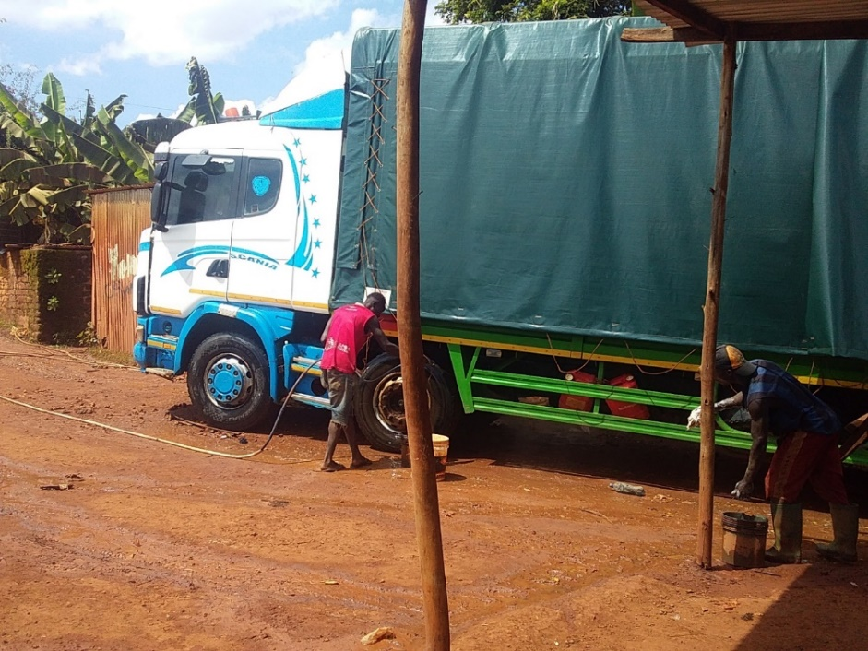

Figure 1. 1: Jalimaisha youth group washing car in their area of work

Essentially, this can be done simply by the indigenous/residents interacting to pose their opinions about the development of services within the community, how they satisfy with the services, and what particular services are needed. Their opinions and suggestions can be used in building an agenda aims at community change that can build the capacity of community-based organizations that are designed to provide services and development opportunities to residents. Community needs assessment was conducted basing on this principle of participatory approach.

### 1.2.1 CNA overall objective

The overall objective was to improve the livelihood of youth in Kibondo ward through collecting information that would assist youth in identifying the socio-economic needs and formulate a project to address the most pressing need based on their ranking.

### 1.2.1.1 Specific objectives

1. To identify types of economic activities conducted within the Kibondo ward.
2. To identify and prioritize needs of youth within the Kibondo ward community.
3. To identify the type of assets/resources available within the community and among community members in Kibondo ward.
4. To identify and prioritize suitable intervention for improving socio-economic status hence livelihood of youth for identified most pressing need in Kibondo ward.

### 1.2.2 CNA questions

1. What are the problems facing youth/community members involved within the area?
2. What is the most problem of socio- economic status of youth at Kibondo ward?
3. What is the type of assets available within the youths and among community members?
4. What are the suitable interventions for the identified problems?

### 1.2.3 Research methodology

### 1.2.3.1 Research design

Research design is a plan aimed at answering specific research question. This research design definition concerns proper research data management and brings together several components, strategies and methods to collect data and analyse it. In this study the cross-sectional design was used, in which purposive sampling was used to select the representative sample to collect information. The design is considered to save time and resources and is eventually used for the determination of relationship between variables (Raimo Streefkerk, June 22, 2023). Both qualitative and quantitative data were obtained through this design. The main emphasis was on the discovery of ideas and views. The process of conducting CNA involved three methods namely; survey, interview and observation methods. The factor here is the most convenient tool strategy in collecting primary research also if people are to be asked directly about their behaviours, belief, and for surveys or interviews was used to collect information or data about the community in Kibondo ward.

### 1.2.3.2 Sampling techniques

The sampling technique which was used to get the required sample size was purposive sampling. The technique was used to obtain 12 respondents who are car washers, 62 youths from Kibondo ward, two streets (A & B) in the study area and 10 other stakeholders including local government representatives from the DC’s office, customers, suppliers, trade association and communities.

This study was conducted in Kibondo district, particularly in Kibondo ward where 526 youths and 57 key informant / staff wards were involved, whereby through purposive sampling 84 individuals and 10 key informants were acquired as respondents. Kibondo ward is one of the 19 wards in Kibondo district which is in Kigoma region and it has voluminous number of jobless youths. It was therefore considered appropriate to conduct community needs assessment in this community so as to get the information on the actual community needs hence identify appropriate project for improving their livelihood.

Table 1. 2: Sample size composition

|  |  |
| --- | --- |
| **Category of respondents** | **Number of respondents** |
| Street A | 31 |
| Street B | 31 |
| Car washers | 12 |
| Other stakeholders (local government representatives from the DC’s office, customers, suppliers, trade association and communities) | 10 |
| **Total** | **84** |

**Source:** Researcher field data, 2023

### 1.2.3.3 Data collection methods

The methods used in data collection for this study was interview and focus group discussions whereby the information was collected from the community through questionnaire for the selected 84 respondents and semi structured interviews checklist questions for 10 key informants.

### 1.2.3.3.1 Key informants Interview

An interview is among the techniques of data collection in which information is obtained in a face-to-face situation. The interview was conducted to gather primary data from 10 key informants. This was done for individual respondents separately using a semi-structured checklist questions this helps to guide the interview process, to get challenges facing youths and sustainable solutions to ward community development officer, ward executive officer, religious leaders and trade officers who principally deal with the community daily hence some of the community problems are clearly known to them.

When asked about the suitable measures for improving the livelihood status of this community, they proposed that “youth should be supported with the income generating activities (IGAs), simply because the market is available within their local area.” With this notion they said that “though youth will be supported with the income generating activities, that should be collaborated with the entrepreneurship trainings as this will help them to run their projects properly.

### 1.2.3.3.2 Focus group discussion

This method involved the use of self – administered questionnaires (structured) which were distributed to 84 respondents. For some of illiterate respondents, the researcher assisted them. The questionnaire technique for gathering data is widely used in most of research studies. This method employed the use of questionnaire in this study to determine opinions and attitudes of the respondents on problems facing youth’s members who are involved in socio-economic issues. In this study the open-ended questions were included in the questionnaire to enable the respondent to state her/his case freely and allowed to give reasons as well. Finally, the data collected was cleaned and validated whereby the researcher went through all the questionnaires to remove all the obvious typo and other errors so that to ensure the accuracy of the collected data is not compromised.

### 1.2.3.4 Data analysis methods

Data were exported to SPSS (Statistical Package for Social Scientist) windows version 16.0, which offered statistical tools applied to social sciences programs pair-wise ranking tool. The descriptive analysis was done to get frequencies and percentages. The analysed data were presented by using tables and qualitative data were thematically analysed to make meaningful interpretation.

## 1.3 CNA findings

The community needs assessment was made on getting to know problems facing youth in Kibondo ward, level of livelihood, economic activities that the youth are engaging in, income earning per month, as well as measures undertaken to intervene the problem.

### 1.3.1 Age of respondents

The findings revealed that only 11.9% of the respondents were of the age above 30years while the 88.1% of the respondents were of the age group of 18 – 30 years, which is an active group for business operations if they receive the relevant trainings and other capacity building supports. This age group shows dominance of active manpower and the potential of the society in economic productivity.

Table 1. 3: Age of respondent

|  | **Age** | **Frequency** | **Valid Percent** |
| --- | --- | --- | --- |
|  | 18 - 30 | 74 | 88.1% |
|  | 31 - 43 | 8 | 9.5%% |
|  | 44 and above | 2 | 2.4%% |
| Total |  | 84 | 100.0% |

**Source:** Researcher field data, 2023

### 1.3.2 Level of education

Table 1.4 shows that, among 84 respondents in the study area, 50.0 % proved to access primary education, 25.0% does not attain any education level while 17.9% of the respondents have secondary education, and 7.1% attend adult education. Generally, the results show that most of the respondents (75.0%) received at least basic education which will facilitate the adoption of entrepreneurial skills and the implementation of new technologies when applied and if they are supported with proper trainings.

Table 1. 4: Level of education

|  | | **Frequency** | **Valid Percent** |
| --- | --- | --- | --- |
| Valid | Not attended school | 21 | 25.0% |
| Adult education | 6 | 7.1% |
| primary education | 42 | 50.0% |
| Secondary education | 15 | 17.9% |
| Total | 84 | 100.0% |

**Source:** researcher field data, 2023

### 1.3.3 Marital status

Table 1. 5 show marital status of respondents within the study area. The findings show that most of respondents by 84.5% were single and 15.5% of the respondents were married. Most of the respondents were single, this was explained by a significant number of respondents that they fear to marry because of cost of living although they still have to support their parents and siblings as well. The few who were married, revealed that they face even more challenges than single one. This means that kibondo ward do face the similar socio – economic challenges despite of their marital status.

Table 1. 5: Marital Status

|  | | Frequency | Valid Percent |
| --- | --- | --- | --- |
| Valid | Single | 71 | 84.5% |
| Married | 13 | 15.5% |
| Total | 84 | 100.0% |

**Source:** researcher field data, 2023

### 1.3.4 Number of dependents

The table 1.6 shows the respondent’s number of dependents from the study area. The data shows that 39.3% of the respondents have one dependent and the remaining 60.7% of the respondents have two or more dependents, which imply that apart from their personal life, these youths have to provide for other members of their families. They play many roles such as domestic, economic, and social roles in order to make sure that they support their lives, their families and community in general. Hence acquisition of necessary business/project management skills will highly be beneficial in improving their livelihoods.

Table 1. 6: Number of dependents

|  | | **Frequency** | **Valid Percent** |
| --- | --- | --- | --- |
| Valid | 1 | 33 | 39.3% |
| 2 | 42 | 50.0% |
| 3 | 6 | 7.1% |
| 4 and above | 3 | 3.6% |
| Total | 84 | 100.0% |

**Source:** researcher field data, 2023

### 1.3.5 Needs of Kibondo ward youths

Table 1.7 shows that, despite many challenges facing the youth in Kibondo ward, income poverty was identified as the main problem facing them as it displays 38.1% followed by lack of capital by 28.6%, lack of entrepreneurial skills by 15.5%, lack of improved technology by 9.5% and lack of special area for their petty business by 8.3%. Although majority of youths are engaged in small-scale businesses in the informal sector, they still lack adequate moral and material support in their struggles for economic and social makeup.

Table 1. 7: Needs of ward youth in Kibondo, identified during CNA

|  | | Frequency | Valid Percent |
| --- | --- | --- | --- |
| Valid | Lack of entrepreneur skills | 13 | 15.5% |
| Lack of special area for their petty business | 7 | 8.3% |
| Lack of capital | 24 | 28.6% |
| Income poverty | 32 | 38.1% |
| Lack of improved technology | 8 | 9.5% |
| Total | 84 | 100.0 % |

**Source:** researcher field data, 2023

### 1.3.6 Entrepreneurship skills

Table 1.8 shows that 86.9% of all respondents don’t have any entrepreneurship skills and only 13.1% at least are knowledgeable. This reveals that, most youth in Kibondo ward who are engaged in different petty businesses and other income generating activities have no entrepreneurship skills. This needs the specific objective number 2 to be considered. During the interview and focused group discussion, respondents suggested that youth should be provided with entrepreneurship trainings. through which Youth will be able to generate business ideas, carry out market research, and develop a business plan, set up the business, manage and monitor the business initiated.

Table 1. 8: Entrepreneurship skills

|  | | **Frequency** | **Valid Percent** |
| --- | --- | --- | --- |
| Valid | Yes | 11 | 13.1 |
| No | 73 | 86.9 |
| Total | 84 | 100.0 |

**Source:** researcher field data, 2023

### 1.3.7 Suggested projects

Table 1.9 shows that, a larger number of respondents’ equivalent to 42.9%, suggested car wash project as the most convenient initiative for improving their livelihood. 22.6% of the respondents needed a vegetable garden project, 17.9% soap making project, 11.9% needed a saloon project and 4.8% needed entrepreneurship skills. Through the focus group discussion with youth, the researcher used the time to ask the respondents to identify the possible opportunities through which they can improve their livelihoods in Kibondo ward. Most of them suggested the establishment of a car wash project and its’ services as an income-generating activity (IGA) according to their domicile. Car wash- services is very marketable for these youth as it costs less capital to establish but also the availability of many cars all the time in Kibondo district which its environment is dusty-muddy in nature, proves the presence of a market all the time. This exercise and evidence helped the researcher to know what is supposed to be done and emphasized when planning the suggested project.

Table 1. 9: Suggested projects

|  |  | Frequency | Valid Percent |
| --- | --- | --- | --- |
| Valid | Establishment of vegetable garden | 19 | 22.6% |
| Establishment of car wash | 36 | 42.9% |
| Establishment of saloon | 10 | 11.9% |
| Soap making skills | 15 | 17.9% |
| Entrepreneurship skills | 4 | 4.8% |
| Total | 84 | 100.0% |

**Source:** researcher field data, 2023

### 1.3.8 Findings from key informants

Key informants involved were 10, which included WEO, VEO, local leader, hamlet leader and religious leaders who their interview had identified the problems and challenges facing the community and suggested measures to overcome them. Some of the major challenges identified by the key informants included income poverty, inadequate entrepreneurial skills and limited knowledge in establishment and management of businesses. They said that “the youth in Kibondo ward do depend much on petty business including selling scrappers though others do engage in collar jobs, begging, as well as vendors”. During the discussions, WEO’s office declared its readiness to provide moral and material support to the youth in the project they have proposed. These findings helped the researcher to understand what will have to be emphasized more during the project planning, as it was revealed that the priority was on the establishment of car wash project for improving the livelihood of this community.

Table 1. 10: The findings from the key informants

|  |  |  |  |
| --- | --- | --- | --- |
| Key informants | Female | Male | Total |
| WEO/ VEO | 00 | 02 | 02 |
| Local leader/ Hamlet leader | 01 | 01 | 02 |
| Religious leaders/parents | 03 | 03 | 06 |
| Total | 04 | 06 | 10 |

**Source:** researcher field data, 2023

### 1.3.9 Awareness of the available resources in the community

Table 1.11 shows that 89.3% of all the respondents know the resources available in their ward and only 10.7% have no idea about the available resources in their area. This reveals that, if youth will be provided with adequate guidance, these resources can be used sustainably for their economic progress. Various resources available in Kibondo ward were identified through discussions which also included the community leaders like WEO, VEO, local leaders, and religious leaders who were asked on the resources available and they said that“Kibondo ward has many resources including the large and fertile land, motorcycles and vehicles, water bodies, human resources and township location. These resources can be utilized for economic development of youth in Kibondo ward who depend much on petty business including selling scrappers, though others do engage in collar jobs.

Table 1. 11: Awareness of the resource available within the community

|  | | **Frequency** | **Valid Percent** |
| --- | --- | --- | --- |
| Valid | Yes | 75 | 89.3% |
| No | 9 | 10.7% |
| Total | 84 | 100.0% |

**Source:** Researcher field data, 2023

## 1.4 Community needs prioritization/levelling of needs

### 1.4.1 Prioritization of needs

From the community needs assessment of this study, it was vivid that the target community had diverse needs, including but not limited to inadequate capital for business operations, income poverty and lack of entrepreneurship skills. Hence pairwise ranking was used to facilitate the process of this community’s needs prioritization by the community itself based on several factors including feasibility and availability of resources. Members of the group were supposed to mention as many issues as possible which hinder their socio-economic development and consequently propose the intervention to help them to resolve and meet their needs. Frequently the exercise was paused to give time for consensus of the audience on comparative of identified areas.

Table 1. 12: Prioritization of needs through pairwise raking

|  |  |  |  |  |  |  |  |  |
| --- | --- | --- | --- | --- | --- | --- | --- | --- |
| **Community needs** | Income poverty | Lack of capacity in establishment of cooperative society | Lack of modern car wash services | Lack of entrepreneurship skills | Inadequate capital for business operations | Lack of book keeping skills | Score | Ranking |
| Income poverty |  | Income poverty | Income poverty | Income poverty | Income poverty | Income poverty | 5 | 1 |
| Lack of capacity in establishment of cooperative society |  |  | Lack of capacity in establishment of cooperative society | Lack of entrepreneurship skills | Lack of capacity in establishment of cooperative society | Lack of capacity in establishment of cooperative society | 3 | 2.5 |
| Lack of modern car wash services |  |  |  | Lack of modern car wash services | Lack of modern car wash services | Lack of modern car wash services | 3 | 2.5 |
| Lack of entrepreneurship skills |  |  |  |  | Lack of entrepreneurship skills | Lack of entrepreneurship skills | 2 | 4 |
| Inadequate capital for business operations |  |  |  |  |  | Inadequate capital for business operations | 1 | 5 |
| Lack of bookkeeping skills |  |  |  |  |  |  | 0 | 6 |

### 1.4.2 Project identification and prioritization by the community

During the discussions with the community (youth), several interventions were proposed as means to tackle the most pressing need identified in this study. These included projects like soap making, establishment of unisex saloon, and car wash. According to the results of pair wise ranking, establishment of car wash project, handling and quality control for the youth in Kibondo town was identified as the most feasible project to help them in improving their income and consequently their livelihood. Table 1.13: shows the pair wise ranking exercise which involved members of the group and the exercise was done successfully because each member participated fully and freely by asking, arguing and making decision according to her/his wishes.

Table 1. 13: Project identification and prioritization through pair wise ranking

|  |  |  |  |  |  |  |  |
| --- | --- | --- | --- | --- | --- | --- | --- |
| **Need** | Establishment of car wash project | Entrepreneurship skills | Establishment of vegetable garden | Soap making skills | Entrepreneurship skills | Score | Ranking |
| Establishment of car wash project |  | Establishment of car wash project | Establishment of car wash project | Establishment of car wash project | Establishment of car wash project | 4 | 1 |
| Entrepreneurship skills |  |  | Entrepreneurship skills | Entrepreneurship skills | Entrepreneurship skills | 3 | 2 |
| Establishment of vegetable garden |  |  |  | Establishment of vegetable garden | Establishment of vegetable garden | 2 | 3 |
| Soap making skills |  |  |  |  | Soap making skills | 1 | 4 |
| Establishment of salon |  |  |  |  |  | 0 | 5 |

**Source:** Researcher field data, 2023

## 1.5 Chapter conclusion

This chapter on participatory needs assessment has presented the community profile of the CED community and Kibondo ward at large, where the community needs assessment (CNA) was done. The CNA used a participatory approach in undertaking the study. The sample from the target population was purposively selected from among community members and got involved in the identification of the problem as far as the car wash project is concerned. Through CNA it was found out that the pressing need is income poverty whereby through pair wise ranking it was indicated that in order to improve the livelihood of youth of this community, establishment of car wash project is the most feasible intervention that requires immediate attention. Thus, the anticipated project will focus on addressing issues related to car wash handling and quality control as well as car wash day- to-day business in the area.

# CHAPTER TWO

# PROBLEM IDENTIFICATION

## 2.0 Background to research problem

The identified most pressing need facing the Jalimaisha group was income poverty. Essentially, several needs were included and prioritized to determine the most pressing needs in their business which included inadequate capital for business operations, lack of capacity in establishment of cooperative society, tools and equipment for business operations, inadequate knowledge and skills on car wash handling and quality control and marketing, lack of entrepreneurship and cooperative skills and lack of book keeping skills. Based on the participatory findings of the CNA the most feasible intervention to overcome the income poverty was establishment of car wash, which is the focus of the proposed project towards addressing this need.

## 2.1 Problem Statement

Tanzania youth unemployment rate for 2022 was 4.26%, a 0.08% increase from 2021 with the similar pattern of increase for the previous years. (Tanzania Youth Unemployment Rate 2024). According to international labour organization’s statistics, global youth unemployment has increased by 3.8 million from 2013 to 2015 and is expected to continue increasing in future (ILO 2013). This is mostly due to severe household income poverty, hence leading to inability to acquire their basic needs/sustain their lives. Further, failure to use resources available to produce goods and services is another challenge. The increase of vehicles, motorcycles, and bicycles in this town makes the project highly demanded. The current study focuses on hand and pressure washer car wash project for Jalimaisha group as a way forward to solve the problem.

## 2.2 Project Description

The title of the project is “Improved livelihoods of Jalimaisha youth group through establishing car wash project at Kibondo ward in Kibondo District”. The project was undertaken in Kibondo ward, in Kigoma region and the owners of the project are Jalimaisha group who are living in Kibondo ward. This project was the results of CNA and aims to play a crucial role in preserving a vehicles aesthetic appeal and monetary worth. Therefore, this project will increase income to the group as whole because of the availability of customers who are owners or users of motorcycle and cars in the area.

### 2.2.1 Target Community

Kibondo ward and Kigoma region at large are composed of diverse groups of people with diverse profile of needs. For this project, the target community was unemployed male youth within the age bracket of 18 to 30 years’ old who live in Kibondo ward. The consultations and discussions with the community leaders, government officials in the area and the youth residing in this area led to reaching it.

### 2.2.2 Stakeholders

Various stakeholders have contributed in the implementation and success of the project. The main stakeholder was the Kibondo district council includes: trade officer; WEO & VEO; youth development officer, the stakeholders of the project everyone was assessed depending on what stakeholder can contribute strengths, weaknesses, threats, experience and stakeholder’s needs. Table 2.1 shows the stakeholders analysis.

Table 2. 1: Stakeholders analysis

|  |  |  |  |
| --- | --- | --- | --- |
| **S/N** | **Stakeholder** | **Role** | **Expectations** |
| 1 | Kibondo Council | Financial support through YDF  Facilitate group registration  Advisor of the project | The fund is released at a reasonable time for the implementation of the project. |
| 2 | Jalimaisha youth group | Initiate, manage and operate the project.  Owners of the project | Ensure sustainability of the project  Improve standard of living from car wash services. |
| 3 | Kibondo ward community | Consumers of car wash products | Clients improve condition of their cars |
| 4 | Commercial banks | Loan provision to the group | Improves project growth |

**Source:** researcher field data, 2023

### 2.2.3 Project Goal

The goal of this project is to improve the livelihood of Jalimaisha youths’ group through income generating project of car wash in Kibondo ward.

### 2.2.3.1 General Objectives

To empower youth economically in Kibondo ward by provision of knowledge and skills of car wash handling and quality control to car wash operators, by establishment of hand and pressure washer car wash project by June, 2023.

### 2.2.3.2 Specific Objectives

1. To establish and register Jalimaisha youth group by February 2023.
2. To conduct training to 12 youth of Jalimaisha youth group on entrepreneurship and car wash business operation and management by March 2023.
3. To launch carwash project in Kibondo ward by June, 2023 by constructing the working area and mobilization of items/equipment for carwash activities.

## 2.3 Host organization CBO/Profile

The host organization is Kibondo ward in Kibondo district. The Ward is led by the ward executive officer.

### 2.3.1 Vision

A well-educated community with better livelihood to everyone.

### 2.3.2 Mission

To provide high socio-economic services to the community through efficient and effective use of resources and good governance for improving living standards.

### 2.3.3 Kibondo ward organization Structure

DISTRICT EXECULTIVE DIRECTOR

WARD COUNCIOR

WARD COMMITTEE

MONITORING & EVALUATION UNIT

HEALTH UNIT

LOANS UNIT

FINANCE & ADMINISTRATIVE UNIT

DISCIPLENE COMMETTEE

ENTERPRENUISHIP UNIT

YOUTH DEPARTMENT UNIT

COMMUNITY MEMBERS

Figure 2. 1: Ward Organization Structure

### 2.3.4 The Jalimaisha group SWOT analysis.

SWOT analysis technique was used to assess the aspects of strength, weakness, opportunity and threats to Jalimaisha youth group in relation to the carwash business through identification and analysis of several determinants under each aspect which were considered to ensure successful establishment of the effective and efficient project. Each member of the group participated fully and freely in the discussion that finally gave well elaborated description of each aspect as indicated in table 2.2 below.

Table 2. 2: SWOT analysis

|  |  |
| --- | --- |
| **Strengths** | **Weakness** |
| * The organization has good leadership and cooperative community for progress issues. * The committed & volunteering personnel. * Have experience and hardworking staff. * Positive relationship with other stakeholders as well as local government leaders. | * Solely dependency on donors * Shortage of working capital * Lack of materials/ facilities * Parents dont allow youths to join groups |
| **Opportunities** | **Threats** |
| * Positive participation of youths in advocacy of work. * The readiness of government officials to support the youth group. * The group has good relationship with surrounding community, customers, ward and Kibondo council’s leaders | * Delay in financial release from the donors * Youths not soliciting their subscription fees on time. |

Source: researcher field data, 2023

### 2.3.5 Sources of Funds for the Group

The group has various sources of funds which include:

1. Group membership fees of TZS 100,000/= and other subscription including health and wellness subscription from the group.
2. Earnings from car wash business
3. Aid or grants from donors/NGOs. The organized funds raising from well- wishers

### 2.3.6 The Role of CED Student’s in the Project

1. To assist the youth through CBO leaders to invite expert on carwash.

2. To sensitize Kibondo community members on the importance of car wash.

3. Collaborate with ward office and other stakeholders for monitoring and evaluation of the project.

### 2.3.7 Role of Ward as host organization.

1. To create a conducive environment for the project.
2. To ensure the sustainability of the project.
3. To support technical know-how to the members of the youth group.
4. To assist with administrative activities during the project life.
5. To ensure members of the youth group provide progress report timely.

# CHAPTER THREE

# LITERATURE REVIEW

## 3.0 Overview

This chapter discuss theoretical, empirical and policy review literature. According to (Ngaiza 2013) literature review is a procedure that guides writers to access both published and unpublished source of information in respect to study. Theoretical literature refers to citations of other studies from books, professional journals, reports, etc. which had been made in relation to the research topic. Empirical literature describes how similar projects (in local, national or international) are doing and how others have approached to embark on the similar projects.

Narrative information, which provides empirical literature, were found and cited in books, articles, web sites, reports etc. Policy literature refers regional and national and international policies designed to provide a framework to the entire project. This is the area, which study and review how the current policies provide clear guidelines or promote community economic development initiatives in the area of project intervention. The literature review therefore enables the researcher to conceptualize the research question and point to gaps in existing social research into the chosen area of study. Second, the literature review may improve the researcher’s methodology.

## 3.1 Theoretical literature

This section covers the theoretical aspect related to car wash project under Jalimaisha youth group, describing key concepts and considering reference from various experts and authors.

### 3.1.1 Definition of key concepts

### 3.1.1.1 Poverty

Poverty as cited by Davis and Sanchez-Martinez (2014) is a situation where the resources of a person or a group of people in particular material resources are not adequate to meet their minimum needs. Davis and Sanchez-Martinez (2014) extended the definition further by indicating that poverty is defined as pronounced deprivation in well-being, comprising many dimensions such as low incomes, inability to acquire the basic goods and services necessary for survival with dignity, low levels of good health and education, poor access to clean water and sanitation, and inadequate capacity and opportunity to better one’s life.

### 3.1.1.2 Youth unemployment

Youth unemployment refers to people within the youth age brackets who are unemployed, according to the ILO (2015) guidelines and Global employment trends for youth 2024, gives a clear condition that a person is unemployed if that person is not working, currently available for work and/or actively seeking for work hence it reflects the inability of the economy to generate employment for them. Some of the factors that drive youth unemployment include emerging of pandemics like Covid-19 and large number of entrants to the job markets compared to its capacity of absorbing it.

### 3.1.1.3 Car wash

A car wash  is a facility used to clean the exterior and, in some cases, the interior of [motor vehicles](http://en.wikipedia.org/wiki/Motor_vehicle) or is a business where you pay to have someone wash your car or to use car washing equipment (Quy, D Shilley 2013). Car wash is among the simple and easy work to young people with low start-up capital, and the customers are available due to advancement of technology and increment of transportation facilities/equipment including motorcycles and vehicles.

## 3.2 Empirical literature review

Entrepreneurship has long been recognized as a catalyst for economic growth. Due to many challenges facing young people in Tanzania and elsewhere after their academic accomplishment, employing themselves in different sector is vital (Croce, 2016). According to Barot (2015), entrepreneurship is a key to success, and everybody who starts a new company organization is entering a new paradigm of entrepreneurship. Nonetheless, entrepreneurship is a disciplined and self-sufficient activity that has converted old behaviours into new ones. Youth who complete secondary and postsecondary school in the hopes of finding work are the ones that suffer the most. In this setting, youth unemployment is linked to the more recent emergence of entrepreneurial informal business initiatives in some contribution and growth of small car wash business to addressing youth unemployment DOI: 10.9790/487X-2405041926 www.iosrjournals.org 21 | Page cases, job insecurity leads to undesirable anti-social consequences such as crime and drug use (Ancho, 2014). When young people are excluded from mainstream political and economic activities, they become apathetic and alienated. Okorie et al. (2013) looked into the impact of youth participation in car wash activities (CWA) on agricultural labour. They discovered that, while CWAs provided youth with daily earnings, 82.2% of respondents said that their involvement with CWAs barely supplied their basic needs, and that 93 percent of respondents did not perceive CWAs as having a future (Okorie, et al., 2013). In terms of job satisfaction, the majority of respondents (84.1%) were dissatisfied with their job satisfaction in CWAs, and the researchers concluded that "lack of skills for alternative livelihood strategies among the respondents, as well as the daily earnings that their engagement in CWAs guarantees" kept respondents in CWAs.

### 3.2.1 Role of car wash services in income generation

There is a parallel increase, as the number of cars on the road continues to increase the need for car wash businesses should also increase, according to the international carwash association website (ICAW). A car wash can also be a good business for someone who enjoys working with his hands and enjoys working with the public. Anyone can make money running a car wash!” you might have thought. Many people think a car wash is a great business opportunity because they see it as a business that doesn’t require a great deal of hands-on work but that still produces a great return on your investment.

A car wash can be a good business for an entrepreneur with little previous business experience. According to the International carwash association, 37% of car wash owners have owned their business for less than five years in USA. According to a survey in auto laundry news, profits can range from $55,000 to $100,000 per year for a self-service car wash and $500,000 to $900,000 for a full-service business. The trend in this business is offering extra services. For example, you can sell car spare parts and lubricants alongside other motor vehicle accessories. You can also set up a shop selling snacks and drinks as well as the more usual air fresheners and key chains. This is a business that can be combined along with others. For instance, it works very well with a petrol station, entertainment joints, among others. Further, you can offer carpet cleaning services. (International Carwash Association [www.eynacarwash.com](http://www.googleadservices.com/pagead/aclk?sa=L&ai=CM0cNmS9BVb76CIyYZKXRgfAMyNSP1AWgmsX01gHAjbcBEAEg3Y-QGGDDBqAB5O2R-APIAQGpAk8s-2NWvrI-qAMBqgSiAU_QR5wNq-eK-1WpgRzJo4S0-U5uFyG9A_jBZ8qG_nhnnqLbdvjM8u2iuA1abwXIRelumNaHU8oQ6YsRqoTR9gTEprx7215QMe0Cl-m5SoT3n4D_tU8D7Ysr_jGXTyrfxhfcBEYixxuoRI6zSPzLo0yyAY2kYvfI1kFO60msKRQqyTS6ACDygMQsznxop7aBEStT4XTsPO0uRWTc2l4tBtG5a4gGAYAHhJLuB9gHAQ&num=1&cid=5Gg8CcVY3U-6qcYRzIRLWDeb&sig=AOD64_15wwymFg5CGByN1KKq-PrqJT0CSg&client=ca-pub-3235755782694080&adurl=http://www.eynacarwash.com)).

Starting a car wash is one of the easiest and low-cost types of business. This is a business venture that can be started with just a bucket, soap and washing cloth at the bank of a river, although this has an environmental concern. Hence, if someone desire a more professional and environmentally friendly service, higher standards should be considered. One of the most important aspects of starting this business is location. You need a convenient location that has some space mostly around residential areas. For those with large capital can invest in an automatic car washing machine. This type consisting of a machine that literally “rolls over” a stationary car parked in a washing bay. Waxing: you can also offer waxing services mostly targeting the top of the range vehicles.

Finally, a nation's development should be people-centred, based on sustainable and shared growth and be free from abject poverty. For Tanzania, this development means that the creation of wealth and its distribution in society must be equitable and free from inequalities and all forms of social and political relations which inhibit empowerment and effective democratic and popular participation of social groups (men and women, boys, and girls, the young and old in society by the year 2025, such that economic activities will not be identifiable by gender, race, law, politics, employment, education or culture and will have been reformed.

### 3.2.2 Carwashes in MDCS’ and how it can reduce poverty

In most developed countries in different areas will demand different types of car washes. While an affluent neighbourhood may have a greater market for full-service car washes, a moderate- to low-income area might have greater market demand for in-bay automatic or self-service car washes. In short, services must match with the demands of the neighbourhood of the business location. Beyond these basics, there are the factors that determine the success of any business including marketing and selling skills, keeping costs under control and hiring quality employees.

### 3.2.3 Contribution of entrepreneurship on economic growth and development

Reinforcement on promotion of small enterprises including small industries development put in place under the small enterprise policy which intends to prioritize small business in the countries plans (Shaidi 2013). The purchase of pressure washer car wash machine project which is planned to be used at Kibondo ward this will be the modern car wash for income generating activities (IGA) hence aligning with the newly launched Tanzania youth development policy (2024) which vouch for modern and technology-based initiatives for the youth participating in socio-economic activities. The project is also in hand to hand with Millennium Development Goals (MDG) 2015, the MKUKUTA II under the section of poverty reduction. MKUKUTA II builds on the predecessor strategy (MKUKUTA I), it is more oriented towards growth, and give better productivity, with greater alignment of the interventions towards wealth creation as way out of poverty (URT, 2010:2).

It also in line with the Tanzania five years’ development plan (2015/12-2020/16) as well as the nation development vision 2025, focusing on poverty reduction through SMEs involvement. However, with the basic issues in the development vision are elaborated, which focus on increasing production and market availability for the products. These objectives mainly deal with economic issues, and also increasing involvement of the people in working for their own development. The thrust of these objectives is to attain a sustainable development of the people with high quality livelihood. Therefore, the car wash project is here as a driving force contributing to poverty reduction goals and creates self-employment through those strategies. Vision 2025.

### 3.2.4 Problems that hinder youth’s empowerment

According to (URT,2012), and the integrated labour force survey (2019), young people who constitute about 67.2% of the total labour force and require economic enfranchisement and equitable access to resources that provide a solid economic and material base for their development. One of the key resources is land. Young people have limited access to land ownership. Customary practices discriminate young ones to own and even to inherit land in some locations. There is limitation on equity of resource allocation and capital accessibility for youth development, which affect their effective participation in economic activities.

On the other hand, the major challenges facing youth are the same viewed by Simon Amenya et al; (2019) Young people are provoked to start their own business with small capital, this is due to the chance of finding jobs in the current labour market is very limited, however, lacking of support on sustainability governed by other factors such as, availability of investment capital, risk absorption capacity, and lack of know how in terms of financial management, enterprises development and market accessibility (Edwin A. Locke). The ineffectiveness of enforcing regulations with respect to registering, monitoring and coordination of labour migration poses a serious challenge for Tanzania to provide employment opportunities for its youths.

According to (Ngowi et al., 2014) access to finance for youths is very challenging in the context of accessing the available funds for initial capital, particularly in banks. Youth entrepreneurs do face more challenges most of the time compared to mature people. Some of the challenges are as follows and more others: required to have formal business with license and address, required to have good business plan, required to have collateral/fixed asset, required to have business transactions documentations such as sales, sales revenues, profit and loss, required to have good referee, required to pay for loan fees, need to get approval of male members of the family (family head) before accessing a loan to financial institutions.

According to (Jonathan, 2015) attests that “despite of the increased role that youths are playing in the growth and development of the nation’s economy it is depicted that development programs totally not involved to the need of this special group”. In Tanzania the government and other stakeholders has taken tremendous efforts to empower youths and other vulnerable groups, but they are still facing major challenges in accessing employment opportunities in many sectors. The other challenges are on how to facilitate access to information and technology to the majority of youths (URT, 2012).

The United Nations, since its inception, has continuously called for the increased participation of youth. Historically, youth participation has been very limited. However, recently it has gained momentum and they are now seen and heard at various levels of the UN. Youth from all parts of the world participate actively in all relevant levels of decision-making processes because this affects their lives today and has implications for their lives today and in futures. Moreover, they should establish mechanisms that permit youth access to information and provide them with the opportunity to present their perspectives on government decisions for their destiny, (UN 2018).

The major problem faced by many youths today is lack of enough capital to run their business. The income poverty has said to be the phenomenon whereby majority of people are concentrated on small business by using little capital and poor transport. Household’s consumption reports have been mainly used in establishing poverty status by matching it with the established poverty lines in the particular time. Expenditure patterns tend to be more stable than income and commonly used as the best indicators of income poverty. The term income poverty has been used throughout since it is in more common usage than the more technically correct consumption poverty.

## 3.3 Policy review

The amended national youth development policy of 2024, defines youth as all young men and women aged 15 to 35 years. Consequently, according to 2022 PHC, the proportion of population aged 15 to 35 years for Tanzania mainland was 34.4%. The policy mainly focuses on economic empowerment of youths and eradication of poverty and hunger as one of its four main areas of focus by the government of Tanzania through the national response of micro-finance policy, as regards to the MDGs for action. The policy has enabled mainstreaming of youth concerns in the other government policies like the national health policy, the education and training policy, the labour development policy and youth development policy included. Contemporarily, every effort took place in Tanzania should focus on the national development vision of 2025.

The newly launched policy aims to address the diverse needs of young Tanzanians by providing a framework for educational advancement, job creation and entrepreneurial opportunities with due consideration on the digital space. To realize the national development vision, deliberate and conscious efforts should focus on youth’s development. The envisioned status of Tanzanians is substantially developed one with a high-quality livelihood.

The national youth development policy recognizes that the youth who constitute about 65% of the labour force and 35% of the total population are not represented in various forums and do not participate adequately in decision making bodies. For instance, according to Inter-parliamentary union, only 0.6% are parliamentarians aged under 30 while as per the National Election Committee (2015)-NEC, the number of voters between the age of 18 to 35 were 6,155,613 (27% for young men) and 6,738,964 (30% for young women). This shows that, in spite of to be key in deciding votes for those seeking power, they are still lagging behind in terms of themselves being in the ballot box, as a result, most of the decisions which have been made do not take concerns of the youth. In addition, there is inadequate involvement of youth at national and international forums.

The national youth development policy reveals that, young people have limited equitable access to resources that provide a solid economic and material base for their development; however, the issue is more critical to young ones that are not allowed to inherit land. The policy directs a promotion of equitable access to land and other resource allocations. Emphasis shall be put on rural youth and gender equity, nevertheless there is limitation on equity of resource allocation and capital accessibility for youth development, which affect their effective participation in economic activities. The policy directs that there shall be an affirmative action by the ministries of concern to allocate funds which will enhance satisfactory direction with a view of having sustainable funds, to support youth with specific focus on their income generating activities. Furthermore, there shall be mechanism to promote the establishment of youth friendly credit support services and empower youth on credit.

According to the integrated labour force survey (2015), young people also lack skills on marketing and production of quality products. The Policy statement states that “There shall be a promotion of equitable access to land and other resource allocations, emphasis shall be put on small and medium enterprise policy, but this is not practical to youth in most cases. This was proved by the leader of youth district commissioner who said, ‘there is no land even a small one which has been located by the local council for youth’’ (April, 2023).

## 3.4 Literature review summary

Following review of various literatures, the researcher observed the gap in practical translation of the policies by the target groups which for this case were youth. Literally, most of the information are hidden in the papers and not really known and understood by the target groups. Hence, with reference made from the literature review and community needs assessment (CNA), the researcher vouchered for intense capacity building trainings during the course of project implementation to ensure that youth acquire adequate knowledge and skill on their fingertips leading to enhancing capacity of meeting their needs mostly through community-based approach and improve their living standards particularly through car wash project for the case of this study.

# CHAPTER FOUR

# PROJECT IMPLEMENTATION

## **4.0 Overview**

Implementation plan is a design that indicates the table/sequence of activities, time and resources required to implement the project and responsible persons who will execute the activities. The car wash project owned by Jalimaisha youth group aims at improving the livelihood of this group consequently Kibondo ward at large. The overall objective of the project was to provide knowledge and skills of hand and pressure washer car wash, its operation and maintenance for owners and users/ clients by the end of June, 2023. The implementation of the project begun in March 2023.The project planning involved CNA and situational analysis of the Jalimaisha youth group to identify capacity building gaps hence prepare an implementation plan to address the gaps which were identified. In this case, the project plan was provided through a logical frame work analysis, the actual implementation that took place and the project Gantt chart. Therefore, this chapter represents the actual work done in implementing the car wash project and describes planning schedule, what have been done and report what was accomplished. It itemizes expected and actual products, outputs and staffing pattern.

## 4.1 Products and outputs

During the preparation of the implementation plan a list of output indicators describing project activities were also developed according to specific objectives. Such list of indicators was important in the process of measuring the desired success.

### 4.1.1 Project products

The major product among many others is livelihood improvement of Jalimaisha youth group members at Kibondo ward.

### 4.1.2 Project output

The project is expected to accomplish the following outputs by the end of 2023. This include;

1. Jalimaisha youth group members skilled in both hand and pressure car washing services.
2. Carwash owners skilled in business and operation management.
3. Primary stakeholder’s self-employed as car washers
4. Car wash owners and community equipped with knowledge of the importance of car wash storage and handling.
5. Good networking between car washers and consumers of car washing services

## 4.2 Project planning

Project planning is a discipline for stating how to complete a project within a certain timeframe, usually with defined stages, and with designated resources. This section shows project implementation plan, inputs needed to accomplish activities, the staffing pattern of the Jalimaisha youth group and project budget which will enable the project to be implemented. Not only have that but also logical framework and budgeting parted of planning process. Project planning generally consists of; identifying deliverables and creating the work breakdown structure, identifying the activities needed to complete those deliverables and networking issues and the activities in their logical sequence, estimating the resource required, time and cost for activities under taken.

### 4.2.1 Implementation plan

The participatory planning of the project was done by the MCED student in collaboration with Jalimaisha members and different stakeholders in the community to provide their views on how the project was supposed to be implemented; a work plan shows a number of activities to be conducted within the located time also available resource, and the person responsible for each project objective. The project work plan was participatory in nature and the approach prepared by involving different stakeholders, and others people were consulted to provide their views on how the project was supposed to be implemented. In nutshell the project implementers were Jalimaisha members, NGO members, VEO, WEO, and district leaders. The CED student was collaborating with all project implementers in planning, implementation, monitoring and giving advice to the right direction on the project.

Table 4. 1: Project Implementation Plan

|  |  |  |  |  |
| --- | --- | --- | --- | --- |
| **Objective** | **Activities** | **Resource/**  **Input** | **Responsible**  **Persons** | **Time**  **Frame** |
| To establish and register Jalimaisha youth group by February 2023 | To:   * Identify requirements for registration * Orientation sessions with the group members * Collect and submit all the required information for registration from Jalimaisha group members * License acquisition * Stakeholders mapping * Fund acquisition sessions, both physical and virtual | -Transport  -Funds  -Stationeries  -Venue | CED  Student, WEO and Jalimaisha group members. | By February,  2023 |
| To conduct training to 12 youth of Jalimaisha youth group on entrepreneurship and car wash business operation and management by March 2023 | To conduct training on;   * Car wash overheads * Car washing tools and chemicals selection and management, e.g. Brushes, soaps/detergents * Steps in car washing, * Handling of the car washing machines, * Precautions to be taken when washing, * How to operate the machine. * Preparation and dissemination of marketing tools such as brochures and radio adverts * Identifying potential customers | Transport  -Funds  -Stationeries  -Training  materials  -Experts/NEMC costs | CED  Student,  Trainers,  District environmental officer, WEO | By March  2023 |
| To launch a car wash project in Kibondo ward by June 2023 by constructing the working area and mobilizing items/equipment for car wash activities. | * Electrification of the site which owned by UVCCM kibondo ward office * Installation of car washing equipment * Procure the necessary consumables * Environmental issues/ (NEMC) * Construction/set up of car wash house and infrastructures including water and sewage system installation | Transport  -Funds  -Stationeries  -Training  materials  -Experts/NEMC costs | CED  Students,  Technicians,  District environmental officer | By June,2023 |

**Source:** Survey field data, 2023

### 4.2.2 Inputs

The inputs of project implementation involve various things, such as materials resources, financial, time and human, were employed to meet the expected planned goals. Human resources were experts from Kibondo local government, Ward officer from Kibondo ward and Jalimaisha chairperson from Kibondo. The inputs required for accomplishing the above planed objectives and activities are shown in Table 4.2.

Table 4. 2: Project Inputs

|  |  |
| --- | --- |
| **Inputs** | **Cost (TZS)** |
| Trainers cost | 60,000 |
| Training costs | 703,000 |
| Training venue | 50,000 |
| Training materials/manual | 40,000 |
| Purchasing & Transport of Pumps for car wash from one place to site | 1,100,000 |
| Car wash construction & materials purchase | 1,220,600 |
| **Total input (costs)** | **3,173,600** |

Source: Researcher field data, 2023

### 4.2.2.1 Project logical framework for car wash services

Logical framework is a management tool for effective planning and implementation of developmental projects. It provides clear, concise and systematic information about a project through a framework. We know about various components of a project such as goal, objectives, activities, results and indicators concerned. The logical framework helps in connecting all these components in one framework, presenting the clear relationship between these components and leading to the achievements of the expected results. It is also widely known as goal-oriented project planning/ objectives-oriented project planning. Logical framework for car wash services project were tools for concisely describing the results of project design process, as it gives a summary in a standard form as follows: -

1. What the project is going to perform & achieve
2. What activities will be involved in the project
3. What are resources or inputs (human, technical, infrastructural) needed
4. What are predictions/ potential problems could affect / hinder the success of the project to take off
5. How the progress and success of the project will be measured and verified

The details on activities, inputs (resources) and outputs are described in the project logical framework (Table 4.3).

Table 4. 3: Logical Framework Matrix

| **Summary of Objectives and Activities** | **Objectively Verifiable Indicators (OVI)** | **Means/Source of Verification (MOV)** | **Assumptions** |
| --- | --- | --- | --- |
| **Goal:** To improve the livelihood of Jalimaisha youth group through income generating project of car wash in Kibondo ward. | -Youth group members income status | -Business operation and revenue reports (monthly, mid- year and annual)  -CBO reports  - Observation | -Adequate youth’s capacity to correctly state/estimate their income |
| Objective 1: To establish and register Jalimaisha youth group by February 2023. | | | |
| Output 1.1: One youth group established and registered by February 2023 | -Time expended to process and complete registration of the youth group  -Number of support system/stakeholders identified and approached to facilitate establishment of the youth group | -The acquired license/registration  -Signed registration forms  -Meeting reports | -Timely acquisition of  -Stakeholders are willingly available and ready to support ie. release/donate the required resources |
| Output 1.2: One fundraising campaign conducted to acquire the working site/land and Tzs 5,436,600 to cover training costs, acquisition of machines, and construction of car wash infrastructures. | -Funds/resources acquired | -Fundraising report | -Stakeholders and Jalimaisha youths are willingly available and ready to contribute and support ie. release/donate the required resources |
| Activities | | | |
| Fill out all the registration requirements and acquisition of the license | Registration completed and license acquired. | -The license acquired | The project acquire clearance from relevant authorities including NEMC |
| Prepare project budget | A budget of Tzs 5,436,600 prepared | -Needs assessment report  -Project budget report | Comprehensive budget prepared |
| Stakeholders mapping and conduct project introduction sessions with stakeholders | Stakeholders identified and approached | -Signed attendance list forms  -Meeting reports | Relevant stakeholders show positive response |
| Conduct funds/resources acquisition campaign for establishment of Jalimaisha youth group | Funds/resources acquired | Fundraising report | Resources released on time and all the pledges are fulfilled |
| Objective 2: To conduct training to 12 youth of Jalimaisha youth group on entrepreneurship and car wash business operation and management by march 2023 | | | |
| Output 2.1: One skill acquisition training on entrepreneurship and car wash management and operation conducted to Jalimaisha youth group | Jalimaisha youth group members acquire skills and knowledge on entrepreneurship and car was operations and management | -Pre and post training evaluation results.  -Training report  -Training documents | The training contents are simplified enough to be comprehended by the training attendees |
| Output 2.2: Twelve youth of Jalimaisha youth group attend the training | All twelve members of Jalimaisha youth group attend the training | -Signed attendance list forms  -Training report including the photos | All members of Jalimaisha youth group are willing and able to attend the training |
| Activities | | | |
| Acquisition of training experts and venue | -Experts from HAZINA and district environment department engaged and conducted the training | -Formal communication documents including invitation/introduction letters  -Signed agreement with experts  -Receipts | Trainers readiness and acceptance to charge fair and affordable training costs |
| Conduct the training | -Twelve members of Jalimaisha youth group attended the training | -Signed attendance list forms  -Training report including the photos | -CBO officials and Jalimaisha youth group members attended and participated fully in the training |
| Objective 3: To launch car wash project in Kibondo ward by June 2023 constructing the working area and mobilizing the items/equipment for car wash project | | | |
| Output 3.1: Complete set of car wash machines and infrastructures mobilized, constructed and fixed. | -Car wash infrastructures constructed including one water storage system, wash bay, one drainage system, one shed, one masonry wash stand and the fixed pressure and hand car washers | -Infrastructures construction report with pictures | -Qualified technician finish the construction works up to the required standards and on time. |
| Output 3.2: Complete set of car wash machines mobilized and fixed | -Functional car wash machines fixed on site including pressure and hand car washers | -Signed delivery notes  -Technical reports | -Acquisition of durable good set of machines |
| Activities | | | |
| Setting out and construction of car wash infrastructures | -Infrastructures constructed | -Project progress report and photos  -Site visit and physical verification | -Qualified technician finish the construction works up to the required standards and on time. |
| Setting out and fixing of equipment | -Equipment fixed | -Project progress report and photos  -Site visit and physical verification | - Acquisition of durable good set of machines |
| Execution of car washing activities | -Car washing activities implemented  -Consumables purchased and expended.  -Monitoring and evaluation conducted  -Adverts disseminated through posters and media channels (radio and social media handles). | -Project progress report and photos  -Site visit and physical verification  -Monitoring and evaluation report | -Services provided up to standards and to the satisfaction of customers.  -Availability of adequate customers |

### 4.2.3 Staffing Pattern

The project has five voluntary staff being a program coordinator, program accountant officer, technical officer, M&E officer, and field officer. Kibondo district offered the land as project site. The project implementation was getting high support from community development department, cooperative and trade and market department and human resource department.

Table 4. 4: Staffing plan and training needs

|  |  |  |  |
| --- | --- | --- | --- |
| **No** | **Position** | **Duties /Supervisory roles** | **Training needs** |
| 1 | Chair person | * To ensure the management committee functions properly * To ensure the project/ group is managed effectively * To provide supervision to the project * To represent the group as public relations * To call special meetings of the group where appropriate * To review and sign minutes of group meetings/Jalimaisha * To act as chairperson for meetings of shareholders | * Skills of leadership * Job descriptions |
| 2 | Vice Chair Person | * To assist the chair person * To serve as chair person in the absence of the chair person * To take the important role in monitoring the implementation of the project strategies | * Job descriptions. |
| 3 | Secretary | * [Ensuring meetings are effectively organized and minute](http://www.diycommitteeguide.org/article/what-role-secretary#Ensuring) * [Maintaining effective records and administration](http://www.diycommitteeguide.org/article/what-role-secretary#Maintaining) * [Upholding the legal requirements of governing documents](http://www.diycommitteeguide.org/article/what-role-secretary#upholding) * [Communication and correspondence](http://www.diycommitteeguide.org/article/what-role-secretary#communication) issues | * Responsibility of the secretary. * Accountability * Recording & keeping |
| 4 | Vice secretary | * Directly assist the Secretary in all matters pertaining the group issues | * Job descriptions. * Responsibility |
| 5 | Treasure | * To maintain an overview of the project financial status for all transactions and * To ensure that proper financial records and procedures are maintained | * Financial skills. * Accountability * Book keeping * Business management |

**Source:** Researcher field data, 2023

Also, the project has more support from the district council office of youth’s development department and the office of land department and CED student for technical know-how. For effective and smooth running of the project, the positions are voluntary and on yearly rotational basis whereby each leader and member of the group adhered to his or her responsibilities and duties.

### 4.2.4 Project budget

A project budget is the total amount of authorized financial resources allocated for the particular purpose(s) of the project for a specific period of time. It is the primary financial document that constitutes the necessary funds for implementing the project and producing the deliverables. The budget planned for the car wash project was TZS 5,436,600.

Table 4. 5: Project budget

|  |  |
| --- | --- |
| **Activity** | **Budget (TZS)** |
| Identification of training needs | 35,000 |
| Preparation of training materials/ manual | 130,000 |
| Identification of training resources (Human and financial resources) | 40,000 |
| Identification of training venue/hiring | 100,0000 |
| Acquiring required training resources | 45,000 |
| Meeting with target group leaders to discuss and agree the training schedule | 55,000 |
| Trainers’ costs | 80,000 |
| Purchasing materials and construction of car wash site | 3,173,600 |
| Conducting training on maintenances, car wash installation & handling. keeping records & running car wash business. | 325,000 |
| Conducting training on installing system of car wash business. | 85,000 |
| Purchasing pump machine for a car wash business. | 1,300,000 |
| Designing/ disseminate of advertisement through posters and local radio PM & E | 68,000 |
| **Total budget (TZS)** | **5,436,600** |

**Source:** Researcher field data, 2023

Kibondo ward council contributed a total of TZS 2,000,000/= as photocopying and training venue cost and some building materials while TZS 1,904,600/= was contributed by AGC Church, TZS 12,000/= WEO office, TZS 1,000,000/= solicited from well-wishers and TZS 520,000/= contributed by Jalimaisha youth group. The fund obtained were expected to be enough for the completion and implementation of the planned project activities as per work plan as stipulated in table 4.5.

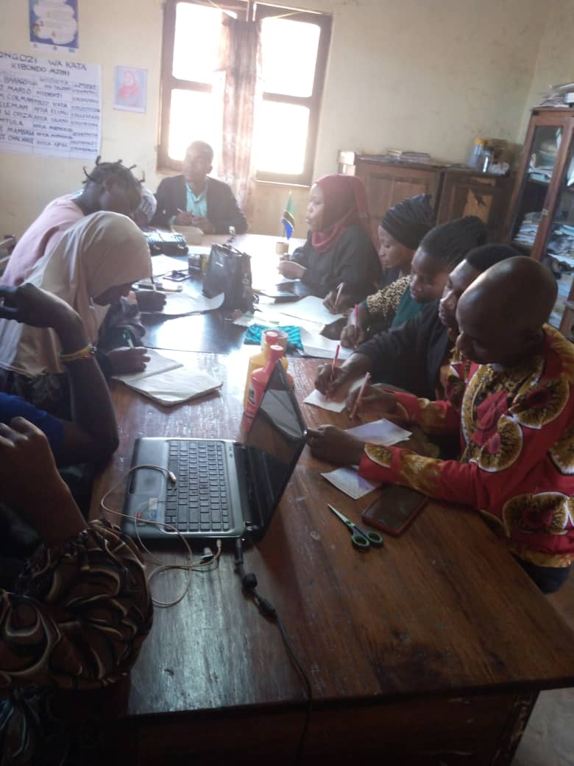

Figure 4. 1: Mobilizing funds for Jalimaisha group from the stakeholders/well-wishers.

The Kibondo ward meetings were organized for sensitization of the community members about the project and mobilization of Jalimaisha youth group to establish the car wash services project. The program/activity was done by the CED student who was in charge/ researcher for this project.

Formation of a group of 08 town youths was organized and formed a group which will be the key in dealing with the project. CED student was there to assist youths to form entire group.

Formalization and selection of leaders, after the group being reformed, members decided to run it officially by the name Jalimaisha and they have opened up the bank account. The CED student assisted the group to reform a group constitution and connect them to district council especially to community development department for registration, training manuals were prepared to be used for training. These manuals were entrepreneurship education training manual and car wash services training manuals. The CED student monitored the activity which was done by the community development officer and trade district officer. Community development officer prepared entrepreneurship education training manual and trade officer prepared car wash services training manual. In fact, two manuals were prepared for catering the intervention of car wash services.

Conduct training, this was the three days training of which the youth group was trained on entrepreneurship skills and how to run the car wash services. The members were imparted skills on how to run the car wash services project as well to be good entrepreneurs. Some topics and sub-topics of their kind were taught including how to develop a business plan, set up the business and managing it and carrying out market research. In short, all the above make the sustainability of the project.

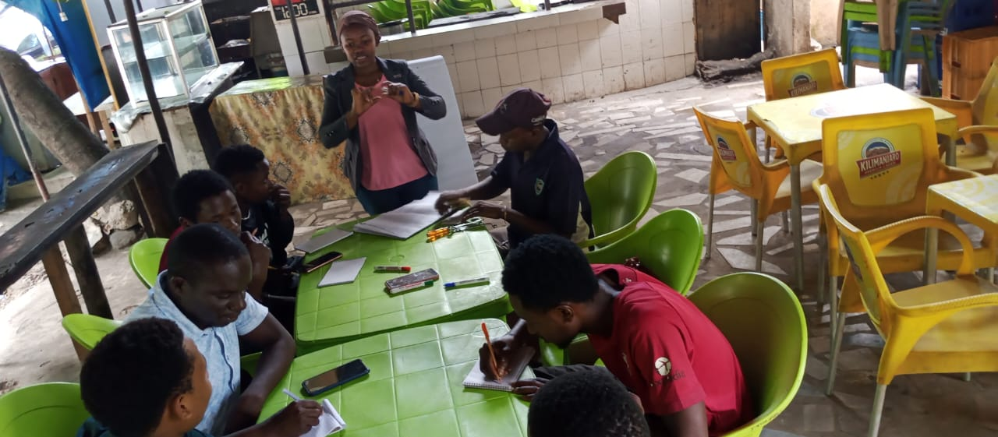

Figure 4. 2: CED students with youths during entrepreneurship training (group discussion)

**Source:** Researcher field data, 2023

The construction of car wash site, two technicians was hired to construct one site for car wash services. The site was ready to be used for car wash services purposes. To purchase two pressure washer car wash were purchased ready to start the business of car wash services. There are various ways to reach your clients and market your business. Word-of-mouth is the fastest and most effective, although you can also place classified pumps according to your power purchase. These two pumps below are some of among eight types of pressure washer car wash. They use both diesel and petrol fuels, each one cost of TZS 600,000/= and 400,000/= respectively. This added the business value and services:

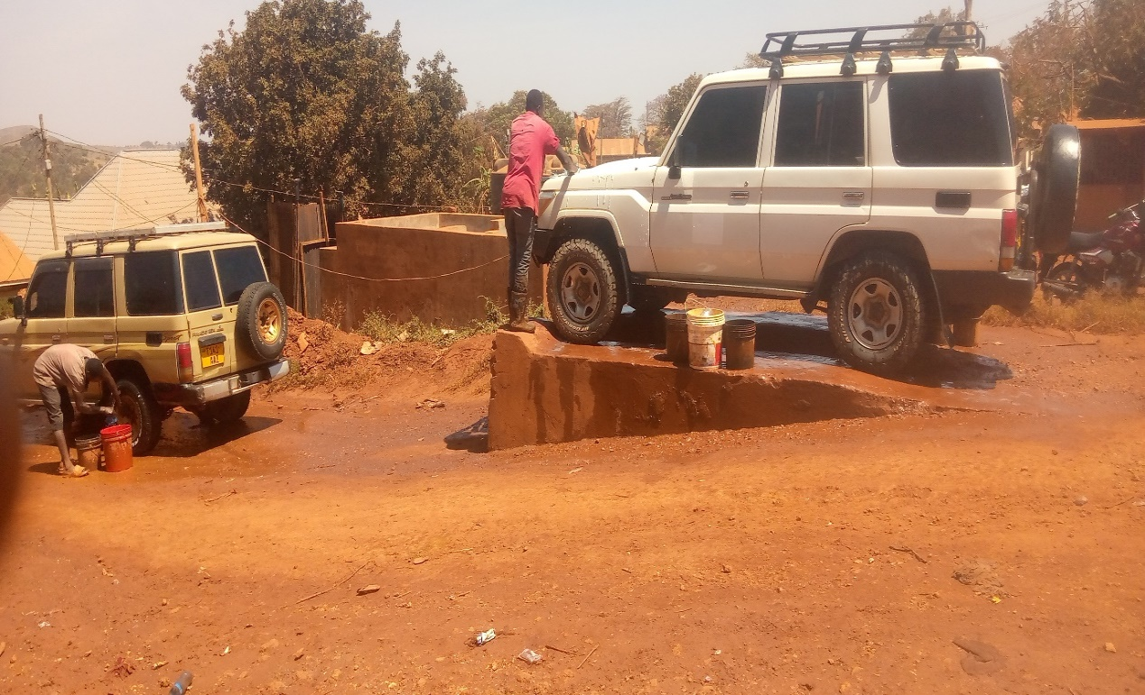

Figure 4. 3: Car washing activity in progress

**Source:** Researcher field data, 2023

Running the car wash services, installing of water systems roller and some connecters were needed and were purchased; the group is guarding the site and using it properly. They have divided themselves in four groups of which each group consists of three people. The division makes them to rotate two times per week for offering services to clients.

Designing of advertisement, the adverts were designed and produced in order to disseminate the information to the community. These adverts were in form of posters. Disseminate advertisement through posters. Posters were distributed within the community and also those who are outside the community they were informed through phones. So, the market was found through these means of communication. The members are in the position of having market for offering car wash services. The checklist for monitoring and evaluation were prepared to monitor the activity. This enabled to see if the project was implemented as planned.

## 4.3 Project implementation

### 4.3.1 Project implementation report

The actual implementation is the process whereby “project inputs are turned to project outputs”. Also, this is putting in action the activities of the project, putting into practice what was proposed in the project document in short is a transforming the project proposal into the actual project, and administration of the project purposes. Car wash services project applied as the involvement approach, whereby Jalimaisha youth group members are the first beneficiaries’ who implemented the project. However, other stakeholders provided the financial resources, including Kibondo council, CED student and technical personnel assistance. The actual implementation also it shows whether the activities implemented as scheduled or planned, objective, output, activities, resources, timeframe, actual implementation and remarks are shown.

### 4.3.2 Project implementation Gantt chart

Gantt chart is a technique in which the activities of the project are drawn as a horizontal bar, the length of which is proportional to the time duration of the activities (Namwata, M.L.2010). During project implementation process Gantt chart method facilitated stakeholders to visualize easier what was taking place showing the primary dependency relationship among activities and the actual time spent from January to June 2021. It also depicted activity progress which obtained towards the completion of each step of activity as summarized in Table 4.6.

Table 4. 6: Project Implementation Gantt Chart

|  |  |  |  |  |  |  |  |  |  |  |  |  |  |  |  |  |
| --- | --- | --- | --- | --- | --- | --- | --- | --- | --- | --- | --- | --- | --- | --- | --- | --- |
| **Activities** | **Implementation period** | | | | | | | | | | | | | | **Resource needed** | **Responsible person** |
| **Year 2022** | | | | | **Year 2023** | | | | | | | | |
| **O** | **N** | | **D** | | **J** | | **F** | **M** | **A** | **M** | | **J** | **J** |  |  |
| Identification of the Community |  | |  |  |  | |  | |  |  | |  |  |  | Stationery | CED student |
| Writing a letter requesting to conduct CNA |  | |  |  |  | |  | |  |  | |  |  |  | Stationery | CED student |
| Conducting CNA |  | |  |  |  | |  | |  |  | |  |  |  | Funds stationery fuel | CED student Community member |
| Identification of problem |  | |  |  |  | |  | |  |  | |  |  |  | Funds stationery | CED student Community member |
| Project formulation |  | |  |  |  | |  | |  |  | |  |  |  | Stationery | CED student Community members |
| Writing CNA report |  | |  |  |  | |  | |  |  | |  |  |  | Stationery, funds | CED student |
| Identification of training needs |  | |  |  |  | |  | |  |  | |  |  |  | Funds stationery | CED student and target group |
| Identification of training resources |  | |  |  |  | |  | |  |  | |  |  |  | Funds, stationery | Facilitator CBO leaders |
| Mobilization of financial resource |  | |  |  |  | |  | |  |  | |  |  |  | Funds stationer | -CED student  CBO leaders |
| Preparation of training materials/ manual |  | |  |  |  | |  | |  |  | |  |  |  | Funds, stationery | CED student  trainers |
| Identification of training venue |  | |  |  |  | |  | |  |  | |  |  |  | Stationery, funds | CED student |
| Acquiring required training resources |  | |  |  |  | |  | |  |  | |  |  |  | Funds | CED student |
| Meeting with CBO leaders to review and confirm training schedule |  | |  |  |  | |  | |  |  | |  |  |  | Funds, stationery | CED student trainers CBO leaders |
| Conducting training on car wash project |  | |  |  |  | |  | |  |  | |  |  |  | Funds, training materials | CED student  trainers |
| Conducting training on better ways of car wash operation & maintenances |  | |  |  |  | |  | |  |  | |  |  |  | Funds, training materials | CED student Trainers |
| Conducting training on methods of improved way of running car wash |  | |  |  |  | |  | |  |  | |  |  |  | Funds, training materials | Trainers  CED student |
| Conducting training on the concept of marketing and entrepreneurship. |  | |  |  |  | |  | |  |  | |  |  |  | Funds, training materials | Trainers  CED student |
| Conducting training on simple book keeping |  | |  |  |  | |  | |  |  | |  |  |  | Funds, training materials | Trainers  CED student |
| Execution and conducting monitoring and evaluation |  | |  |  |  | |  | |  |  | |  |  |  | Funds, training materials | CBO leaders  CED student |
| Writing project report |  | |  |  |  | |  | |  |  | |  |  |  | Funds, training materials | CED student |

# CHAPTER FIVE

# PROJECT PARTICIPATORY MONITORING, EVALUATION AND SUSTAINABILITY

## 5.0 Overview

A successful community project benefits to the end recipients are entirely built on participatory monitoring, evaluation and sustainability. The chapter explains more about the project participatory monitoring, evaluation and sustainability. Participatory monitoring and evaluation are crucial in any project. To determine whether the project is operating within the stipulated limits and within the resources available, monitoring of the activities is required. At the same time to determine whether the activities will lead to the expected objectives, a periodical, midterm evaluation is required and at the end of the project evaluation is required to determine whether the expected objectives and outcomes are compiled/ achieved. PM&E can, therefore, provide more comprehensive information on efficiency, relevance, sustainability, impact, clearness and effectiveness of work in progress/ project. However, the chapter is divided into the following parts: monitoring information system; participatory monitoring methods, participatory monitoring plan, participatory evaluation plan, performance indicator, participatory evaluation methods, project evaluation summary and project sustainability.

## 5.1 Participatory monitoring

This refers to systematic recording and periodic analysis of information which has been chosen and recorded by both insiders with the help of outsiders. Therefore, participatory monitoring is a system that involves the community to monitor the programmer activities. The objectives of participatory monitoring were to analyse current situation, identify problems and find solutions, discover trends and patterns, ensure project activities on timeframe, measure progress towards objectives and formulate the future goals and objectives and make decisions about human, material resources and financial.

The aims of participatory monitoring were to supervise the implementation of planned activities such as sensitization/awareness, meeting to Kibondo ward community members, training on entrepreneurship skill, financial management, governance and leadership, establishing of car wash services, empowering and advocacy meeting. However, various technique and methods were employed to collect information, process and analysis to verify the progress of the planned activities. Participatory monitoring also used various participatory methods and includes various stakeholders such as municipal leaders, ward leaders, local government leaders, and NGOs members themselves. Participatory monitoring was the continuous assessment of the progress of the project towards achieving the desired goal and objectives. Monitoring basically included the project activities implementation, project output and project outcome or impact. Monitoring as per project implementation plan involved the whole process of routine data gathering and giving feedback about the progress of the project to stakeholders.

Another aim of participatory monitoring was to build a spirit of ownership of the project to the target group and to bring the attention of the project implementers to any relevant changes to project implementation. It was conducted to measure the progress and evaluate the project success and get a clear picture of project activities such as sensitization meeting to Jalimaisha members and Kibondo ward community members, training on entrepreneurship skills, financial management, managerial skills, record management, HIV/AIDS and leadership to Jalimaisha members. It was planned to be undertaken throughout of the entire period of the project implementation, to ensure effectiveness of the project activities, to establish indicators and to maintain the standards of the aimed project. It also intends to get information for future evaluation process.

### 5.1.1 Monitoring information system

Monitoring information system is a monitoring tool designed to collect and analysis the project information regarding the planned activities which assists the implementers of that project to assess their performance during the implementation process. For creation employment for the youth project the monitoring information system designed to create data sheet which can record the related information against planned activities within the timeframe. The necessary information includes number of training and sensitization meeting required and actual implementation, records of participants who attended that project activities, information on project materials received from different stakeholders.

Monitoring will also include the amount of loan taken by the target group, loan repayment and type of business ventures established by youth group. The process of recording will be done weekly bases because the youth group met twice per monthly and the youth management are the responsible of writing monthly report and present it to general meeting and CED student will help the group. For improving life standards through business inimproving livelihoods of Jalimaisha youth’s members through a car wash project at Kibondo ward, Kibondo district.

### 5.1.2 Participatory monitoring methods

Participatory monitoring and evaluation are about engaging different stakeholders, especially targeted beneficiaries, in monitoring and evaluation processes. It is done to generate better monitoring and evaluation information and/or to empower stakeholders. The participatory monitoring methods used to engage community in the monitoring of the project. The project employed participatory methods and techniques to ensure that all internal implementers were fully participated in project activities. The PRA and techniques employed to collect information like observation and documentation analysis for secondary data, these methods are explained below.

### 5.1.2.1 Documentary analysis

This method was used to collect data from some document’s sources at the centre and municipal level. The documents used were training report conducted, sensitization and advocacy meeting conducted. Minutes for weekly and monthly meetings from the target group who meet in every week to discuss their achievements, challenges and agreements on how to overcome such challenges and the way forward were also used. Other information’s documented were loan and loan repayment forms. Furthermore, CED students hand book was used as a guiding tool towards this exercise task.

### 5.1.2.2 Observation

Through observation, internal implementers observed the progressive of activities if it had implemented as planned. These included type of training, business ventures and meeting carried out, number of participants attended such training and meeting, number of Jalimaisha group members who joined the groups, and the loan taken from the bank if deemed so, and amount of profit raised by the targeted group.

### 5.1.3 Participatory monitoring plan

Participatory monitoring and evaluation (PM&E) involve the assessment of change through processes that involve many people or groups, each of whom is affecting or affected by the impacts being assessed. Negotiation leads to agreement on how progress should be measured and the findings acted upon. It a challenging process for all concerned, as different stakeholders must examine their assumptions about what constitutes progress and together deal with contradictions and conflicts that can emerge (Greenbarg, J 2020). Monitoring is the process of routine gathering of information on all aspects of the projects.

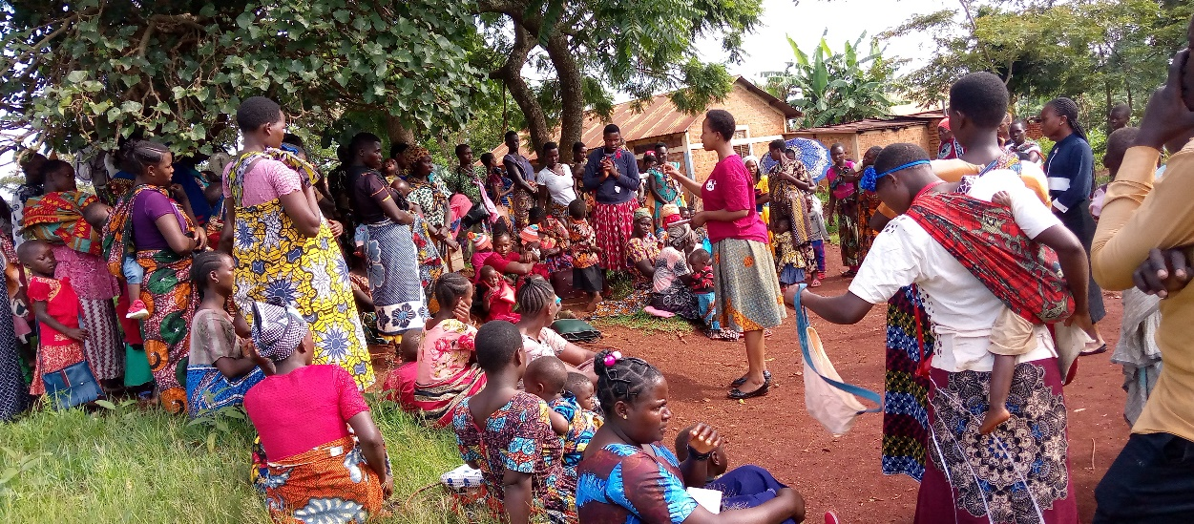

Figure 5. 1: Awareness on HIV AIDS prevention open session in Kibondo ward

**Source:** Researcher, 2023

The project has participatory monitoring plan that includes monitoring methods, activities to be monitored, indicators of progress, responsible person and time frame. All these helped stakeholders to collect information needed to analyse the current situation, identify the problem and find solution, keep the project activities on schedule hence smooth achieving of intended objectives.

Table 5. 1: Participatory Monitoring Plan

|  |  |  |  |  |  |  |
| --- | --- | --- | --- | --- | --- | --- |
| **Work plan Activities** | **Monitoring**  **Objective** | **Objective verifiable indicators** | **Importance of monitoring** | **How the monitoring information was gathered** | **Responsible person** | **Time frame** |
| Identification of training needs | - To know training needs of the target group | -Conducted trainings  -Target groups attended trainings | -Know the gap and train what is real needed by the target group | -Training needs assessment report | -CED student  -Jalimaisha youth group members | Feb 2023 |
| Identification of resources (Human and financial resources) | - To know and get right trainers and funds for training | - Acquired resources  -Conduct training  Opening account. | - To have valuable resources for implementation of the project. | -Human and finance resource report | - CED student, -Jalimaisha members - CBO leaders | Feb,2023 |
| Preparation of training materials/ Training Manual | - To get training manual for guide training. | - Developed training manual | - Having a tool of training | Training report and manual | - CED student | Feb 2023 |
| Identification of training venue | - To have venue for training | - Acquire venue for training | - To avoid inconveniences | -Visiting training venue | - CED student – Jalimaisha youth group members  – CBO Leaders | Feb ,  2023 |
| Acquiring required training resources | - To acquire training materials | - Acquired training materials | To be well organized before starting trainings | -Training resources report | - CED student | Feb,  2023 |
| Meeting with target group leaders to confirm training schedule | - Acquitting group leaders and members the intention of trainings | - Conducting group leaders meeting | To make training move smoothly and as planned | -Visiting the CBO leaders -CBO leaders meeting | -CED student  –Trainers | Feb,  2023 |
| Conducting training on car wash project covering various knowledge areas including  - Car wash operations and maintenance  -Quality control  -Marketing and entrepreneurship  -Basics of book keeping | - To provide knowledge and skills to the target group | -Number of participants attended trainings | Target group acquire knowledge and skills | Training report -relevance of training materials | -CED student  -Trainers | March,  2023 |
| Launch of the project including execution of car wash activities, maintenance, monitoring and evaluation | -Acquire up to standard facility which is operational | - Car wash infrastructures constructed, equipment fixed and functioning. | - Know the income generated, expenditures and the profit margin | - Project progress report | -Jalimaisha youth group members  -CED student  -WEO | June,  2023 |

**Source:** Researcher field data, 2023

## 5.2 Participatory Evaluation

According to Zikoski A. & Luluquisen M. (Aoril, 2015) “Participatory evaluation is a partnership approach to evaluation in which stakeholders actively engage in developing the evaluation and all phases of its implementations”. Also, TACAIDS, (2012) define participatory evaluation as a process that advocates for involvement and participation of community members and other stakeholders in designing and execution of the evaluation process. Participatory evaluation uses data and records during the process of monitoring and other information such as focus group discussion and user survey to review performance and identify ways to make improvement better. Therefore, monitoring and evaluation are complementary project management functions which ensure that the project is running on the right way/ direction.

This aimed at enhancing the best practices of the project. Evaluation was carried out as a continuous activity with the participation of all project stakeholders and most important beneficiaries.Negotiation leads to agreement on how progress would be measured and the findings acted upon, they decided to undertaken the midterm evaluation after six months and one year after ending of the project. The evaluation was carried out by project management committee from village representing the targeted group and some officials from the district and NGO themselves.

Participatory evaluation involves the assessment of change through processes that involve many people/ groups, each of which is affected by the impacts being assessed. Negotiation leads to agreement on how progress should be measured and the findings acted upon. Before the implementation of creation employment for youth project the all implementers discussed and agreed on how to implement the project by setting the project objectives, goals and activities. They decided to undertake the mid-term evaluation after six months and one year after ending of the project.

### 5.2.1 Performance indicators

From the Wikipedia, the free encyclopaedia, (accessed on 28th June, 2023); “A performance indicator or key performance indicator (KPI) is an industry jargon for a type of performance measurement. KPIs are commonly used by an organization to evaluate its success or the success of a particular activity in which it is engaged”. Indicators are signs or variables that show the extent of change that resulted from projects. Indicators help to measure what actually happened in terms of quantity, quality and timelines against what was planned. They measure progress in achieving outputs and outcomes.

The process of identification and indicators was participatory approach, all stakeholders and project management were involved and agreed on quantitative and qualitative as an indicator for creation employment for youth project, these measures based on project objective and overall goal. The input indicators described the means by which the projects are implemented, such as the number of hours of training and the amount of money spent. In turn the output measures the extent to which the project is delivering what it is intended to be delivered.

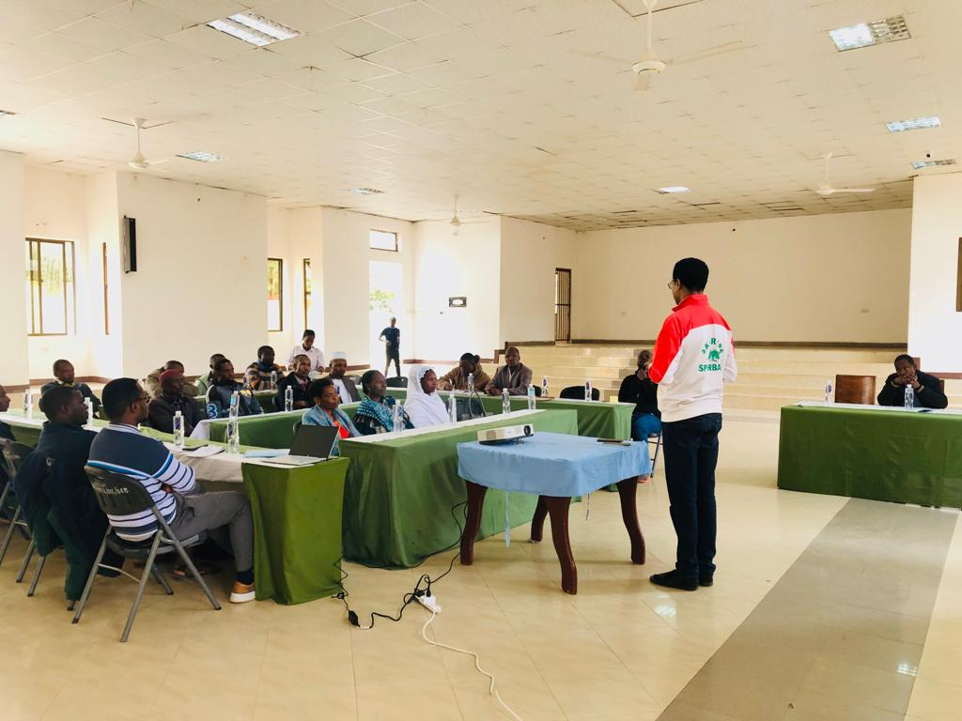

Figure 5. 2: Community development officer elaborating on how to get loan from local government authorities

However, the impact indicators measure the actual change to Jalimaisha members. In general, the youth in Kibondo are expected to employee themselves by establishing income generating activities (IGA)/ business venture hence create self-employment and reduced unemployment as well as poverty and achieve their basic needs.

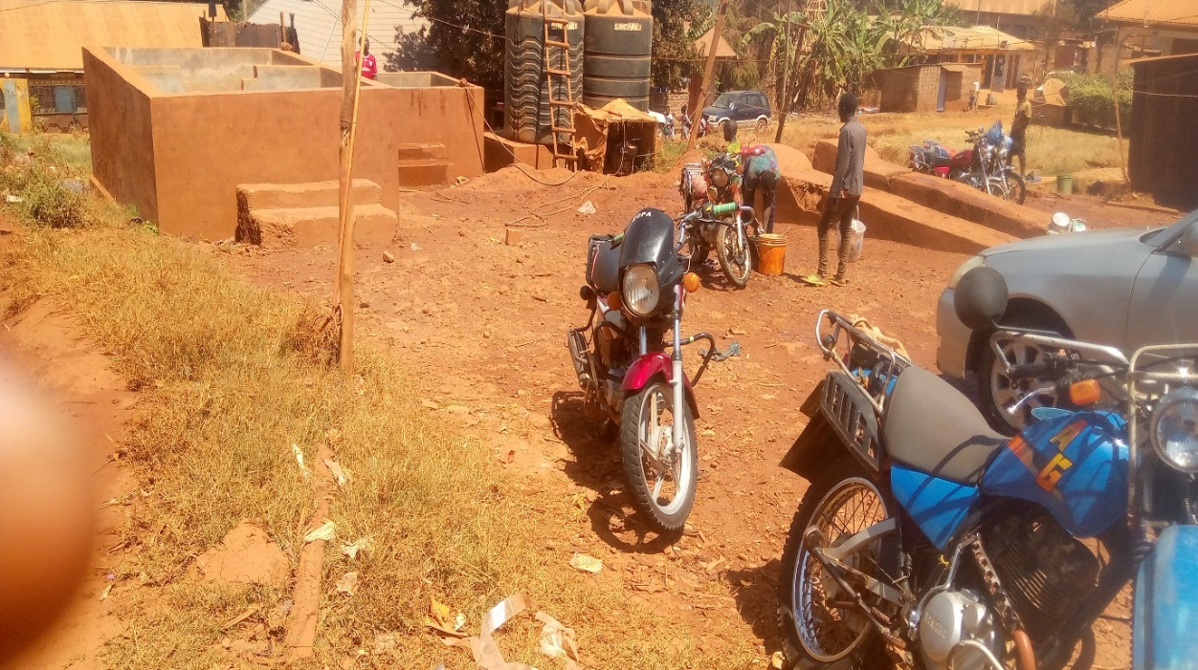

Figure 5. 3: Youth washing motorcycle

The project goal and project objectives performance indicators were summarized in Table 5.2.

Table 5. 2: Performance indicators

|  |  |  |  |  |
| --- | --- | --- | --- | --- |
| **Objective** | **Output** | **Activity** | **Resources Needed** | **Performance Indicator** |
| To establish and register Jalimaisha youth group in Kibondo ward by Feb 2023 | -One youth group established and registered by February 2023  -Three stakeholders’ meetings conducted  -Fundraising campaign conducted to acquire the working site/land and Tzs 5,436,600 to cover training costs, acquisition of machines and construction of car wash infrastructures | -Fill out all the registration requirements and acquisition of the license  -Prepared project budget  -Mapping of stakeholders and execution of project introduction sessions with stakeholders  -Conducted funds/resources acquisition campaign | -Airtime and transport  -Functioning youth group’s bank account  -Stationaries  -Venue | -Time expended to process and complete registration of Jalimaisha youth group  -Number of stakeholders responded positively  - Amount of funds acquired and well managed through the group’s bank account |
| To conduct training to 12 youth of Jalimaisha youth group on entrepreneurship and car wash business operation and management by March 2023. | 12 youth at Kibondo ward trained on car wash and entrepreneurship skills | Preparation of training manual  Conduct training | -Printing and photocopying  -Stationeries  -Facilitators  -Transport (fuel)  -Refreshment  -Airtime | Number of training manual developed  Number of days for training  Number of participants trained |
| To launch a car wash project in Kibondo ward by June 2023 by constructing the working area and mobilization of items/equipment for car wash activities | -One car wash services project established  - Stable market for car wash established by the youth group | Construction of car wash site/ house  Purchase and fixing of car wash equipment  Car wash operation  Designing and dissemination of advertisement  Conduct midterm and end-year M & E of project implementation | -Construction material s  -Technicians  -Transport (fuel)  -Equipment  -Air time | Number of functioning infrastructures constructed  Number of items/consumables stocked and equipment mobilized and fixed  Amount of income generated  Number of reports of monitoring and evaluation produced |

**Source:** Researcher field data, 2023

### 5.2.2 Participatory Evaluation Methods

The methods which are used to undertake participatory evaluation are almost the same as those used in Participatory monitoring, briefly, participatory evaluation can be explained as a partnership approach which stakeholders, “actively engaged in developing the evaluation of all phases of its implementation. Those who have the most at stake in the program – partners, program beneficiaries, funders and key decision markers- play active roles” (Ibid Zioski). Participation occurs throughout the evaluation process including: identification of relevant questions; planning the evaluation design; selecting appropriate measures and data collection methods; gathering and undertaking data analysis.

The participatory evaluation employed and assesses the progress in work plan, implementation of planned activities, achievement of objectives, effectiveness of project and impact of project. It also evaluates the project sustainability. For the case of creation employment for the youth the key informants used for youth management, local government authority officials (WEO and VEO), project officers while focus group discussion used for youth group (target beneficiaries to collect data and information at the same time as observation used to verify collected data and information related to project to see if the intended objectives and activities are collaborated. In the participatory evaluation side, the following results were detected.

### 5.2.2.1 Meeting

During the advocacy meeting, when discussing about ‘‘role of entrepreneurship in Tanzania economy’’ participants discuss and shows evidence, some people in Kibondo ward community who engaged in small generating activities especially youths, such as selling of second hand iron (scrappers), street vendors and among of many others of this type, normally can afford or not to meet their basic needs such as getting food, shelter and sometime can support their family compared to those who do not engaged in any kind of generating activities finally become frustrated and even commits suicide themselves or run away his/her family premises. From that discussion it observed that entrepreneurship as a crucial element for the informal sectors. Capacity building to Jalimaisha group members has a clear mind to project intervention; it gives the implementer skills and knowledge in running out their project profitable oriented.

### 5.2.2.2 Interview

Evaluation team interviewed some of community members to learn more about the implementation and project success. This took place immediately after ending the evaluation meeting and it aimed to collect some information during the meeting. About 87.2% of the interviewees concurred that the project has brought some changes among community members. This was proved by the community itself when it involves more in caring and supporting Jalimaisha group members. The purpose of establishment of car wash project was to enable them to increase/improve their income. The project has undergone a participatory evaluation. The internal and external stakeholders gave their own views concerning the project performance.

### 5.2.2.3 Focused group discussion

The Focus group discussion (FGD) was used for target group (target beneficiaries) to collect data and relevant information through observation method which was used to verify the collected data and information related to project to prove whether the intended objectives and activities are achieved. The launching of the project was also associate with establishing the feasible market for car wash services to serve and support to 5 local government community leaders and 12 Jalimaisha committee members on improvement livelihood through car wash projects which proved the positive outcome. The district council will include youths in its budget from own source to support Jalimaisha for the financial year 2023/2024.

### 5.2.3 Project evaluation summary

Table shows the project evaluation summary based on the project goal, objectives, performance indicators, expected outcomes and actual outcome. Based on the project goal, objectives and activities planned have been met with exception of terminal and annual evaluation that will be done after six months of project implementation. Generally, the evaluation shows that there are strong commitments of various stakeholders from the planning stage to the implementation stage/ activities. This proves that the project is very important to both beneficiaries and community based.

Table 5. 3: Project Evaluation Summary

|  |  |  |  |  |  |
| --- | --- | --- | --- | --- | --- |
| **Objective** | **Output** | **Activity** | **Performance Indicator** | **Expected outcome** | **Actual Outcome** |
| To establish and register Jalimaisha youth group in Kibondo ward by February 2023 | -One youth group established and registered by February 2023  -Stakeholders meetings conducted  -Fundraising campaign conducted  -Funds and resources acquired | -Fill out all the registration requirements and acquisition of the license  -Prepare project budget  -Mapping of stakeholders  -Project introduction sessions with stakeholders conducted  -Conducted funds and resources acquisition campaign | -Time expended to process and complete registration of the youth group  -Number of stakeholders responded  - Amount of funds acquired  -Number of in-kind resources acquired | -Registration processed and acquired by February 2023    -Relevant stakeholders identified and approached  -Required funds and resources acquired | - Registration processed and acquired by February 2023  -Stakeholders identified and engaged  -Funds acquired  -In-kind resources acquired |
| To conduct training to 12 youth of Jalimaisha youth group on entrepreneurship and car wash business operation and management by March 2023 | 12 youth at Jalimaisha trained on car wash and entrepreneurship skills | Preparation of training manual  Conduct training | -Number of training manual developed  -Number of days for training  -Number of participants trained | -12 group members acquired skills on car wash services and entrepreneurship | -Jalimaisha trained on car wash services and entrepreneurship skills. |
| To launch a car wash project in Kibondo ward by June, 2023 by constructing the working area and mobilization of items/equipment for car wash activities. | -One car wash project established | -Construction of car wash facility  -To purchase and fix/stock equipment and other car washing items  -Execution of the car washing activities  - Design and disseminate advertisement  -Conduct monitoring and evaluation of the project implementation | -Standard of the car wash facility constructed  -Amount of income generated  -Number of monitoring and evaluation reports prepared  -Number of project progress reports produced | -Viable economic activity established  -Availability of market/ clients | Car wash project established and functional |

**Source:** Researcher field data, 2023

## 5.3 Project Sustainability

The project sustainability refers to the capacity of a project to maintain or keep on functioning, supported by its own resources (human, material, and financial), even external sources of funding have ended. The implementers (Jalimaisha group members) are responsible for planning to make the project sustainable on institutional, financial as well as political. Further, by considering the muddy-dusty nature of Kibondo environment, the need for car wash will always be there, hence this is the all season project. Additionally, stands a better position to easily access financial support because they already have a formal running business, own assets/collateral and have the assured support from the ward office.

### 5.3.1 Institutional sustainability

The capacity building was given to youth through entrepreneurship training which helps in strengthening the implementation of their income generating activities established by managing properly their business/ income generating activity. This will result to create self-employment for the Jalimaisha ward youth by applying knowledge and establish business centres. In fact, every member of youth will understand and resume his/ her responsibilities patterning to leadership and good governance, training provided to them during the implementation stage of the project, this knowledge/ experience will be a good contribution to work hard and produce more.

### 5.3.2 Financial sustainability

The improving livelihoods of Jalimaisha group youths’ group through a car wash project at Kibondo ward will sustain even after the phase out of project, first, the car wash services for the youth has started and registered, this will be easy for them to access loans from bank like CRDB, and other credit financial systems to maintain financial stability for car wash. Second, every beneficiary contributed TZS 30,000/= as entry fees and involves in supervision in rotation bases/ weekly, this gives the assurance to know the money issues, third, each member is able to borrow the money after two months as a loan and repay in four months (allowed to loan up to TZS 100,000/=) because one of the aim of the project allow youth to access loan at reasonable interest rate and establish small income generating activities (selling snacks, oil, aerated drinks). Fourth, the pressure pump car wash is used to first and wash more cars in a short time. This also will attract many clients, hence generate more income and sustain the project.

The idea of establishing the project catches the attention of youth ministry and agreed the national call of self-employment. This income generating activities managed by the group members will be sustainable because, the site of car wash project for the youth in Kibondo ward is surrounded by many cars, motor cycles and bicycles, this will help the project beneficiaries to establish good system of market and serve more clients within and outside the Kibondo ward headquarter) this will increase the capital. Also, the members putting on written the mechanism of ensuring there is no any defaulters by constructing a constitution which is leading the institution. For those who will pay a loan repayment late will be required to pay loan plus interest as well as penalty of five percentage of the total loan taken. Further, within the constitution each group the member is subject to leadership after every two years.

### 5.3.3 Political sustainability

The establishment of a car wash project at Kibondo ward for improving livelihoods of Jalimaisha youths’ group, is significance to the Tanzania economic because the project is relay with national strategy for growth and reduction of poverty II, millennium development goal, national youth development policy 2024, due to these, the leaders from grass root to district council/ municipal council level are in support of the project. The political leaders have shown their interest in this project; especially youths’ project. Additionally, the project has been supported by different stakeholders (NGOs) who created a bridge to local government, community members and youths in general.

# CHAPTER SIX

# CONCLUSION AND RECOMMENDATION

## 6.0 Overview

This chapter describes the summary of this study and the aspects of the established car wash project under Jalimaisha youth group, providing the information on the whole project cycle which involved community needs assessments, project appraisal, planning and execution, project monitoring and evaluation including the aspects of project sustainability and environmental protection. Further, the impact that this project has brought to the youth and Kibondo community at large. It further gives the summary of the achieved objectives following project selection, findings and challenges encountered during the planning and execution of the project. Nevertheless, it provides the researcher’s recommendations aiming at fostering positive impact and sustainability of the same and similar projects launched for several developmental purposes especially in improving the livelihood of communities.

## 6.1 Conclusion

Through the community needs assessment that the researcher conducted, several needs were identified, however, it was revealed that income poverty among of many youths stood to be the most critical problem which led to the setup of this project. Through pairwise ranking, the car wash project was identified as the most feasible intervention to meet the most pressing need of the targeted community. Thus, the project focused on addressing issues related to establishment of car wash, quality control and car wash marketing. The lack of car washes not only leads to income poverty of the youths, but also attributes to high rate of poverty. This problem has existed regardless of the presence of few and inadequate car wash centres presently available in the study area. Further, the management of car wash in connection to district environment department office was well addressed by the high authority to youth group members. Project intervention was mainly addressing to fight against income poverty situation of the Jalimaisha youth group members. So, the project had three specific objectives, which are;

1. To establish and register Jalimaisha youth group in Kibondo ward by February 2023.
2. To conduct training to 12 youth of Jalimaisha youth group on entrepreneurship and car wash business operations and management by March 2023.
3. To launch a car wash project in Kibondo ward by June, 2023 by constructing the working area and mobilization of items/equipment for car wash activities.

The project is expected to achieve and accomplish the objectives by the following outputs by the end of 2023. This includes;

1. Jalimaisha youth group registration completed and license acquired.
2. Required funds and resources acquired
3. Twelve Jalimaisha youth group members skilled in basics of entrepreneurship and car wash business operation and management.
4. Car wash infrastructures constructed and machines fixed to the required standards.
5. Car wash business take off hence generate income and consequently lead to improvement of the livelihood of the 12 Jalimaisha youth group members and Kibondo ward at large.
6. Car wash owners and community equipped with knowledge of the importance of car wash services.
7. Good networking between car washers and consumers of car washing services

It is very important to note that, great progress has been achieved on the project objectives. The activities planned have been accomplished in the right time as scheduled. Adequate progress of the key aspects including income has been realized as the clients keep increasing as the product of the project initiated. It is also important to note that, the services like lubricants, aerated drinks, shoe polish and snacks added value to business. These available resources helped the Jalimaisha youth group members in developing their skills and creating sustainable income with less inputs for more output. The project is growing well, and is expected to be an answer for economic empowerment to Jalimaisha youth group members in Kibondo which will in turn improve their livelihood.

Further, by considering the muddy-dusty nature of Kibondo environment (ie. Muddy during rainy season and dusty during the dry season), the need for car wash will always be there, hence this is the all season project. Additionally, stands a better position to easily access financial support because they already have a formal running business, own assets/collateral and have the assured support from the ward office. According to (Ngowi et al., 2014) access to finance for youths is very challenging in the context of accessing the available funds for initial capital, particularly in banks because are required to have formal business with license and address, good business plan, collateral/fixed asset, business transactions documentations such as sales, sales revenues, profit and loss, good referee and required to pay for loan application fees before accessing a loan to financial institutions, however Jalimaisha youth group who are running the established car wash project already meet most of these criteria which with other factors explained above translates to assured sustainability of this project.

## 6.2 Recommendations

Considering the experience from the implementation of creation of employment for the youth was proved, that the participatory community needs assessment (PCNA) is very crucial in planning of any development project. Therefore, it creates the feelings of ownership, and builds a strong sense of accountability for the intervention in the community; also create trust among youth’s and ensures that the intervention will have more credibility in all sector of the community. I would suggest and recommended, to use participatory rural appraisal when someone is interested to ascertain creation employment for the youth project because it gives a room for the local people and other stakeholders to plan together (participatory approach) on proper ways.

From existing literature review challenges and suggestion on creating youth employment, the government should continue to collaborate with other stakeholders including NGOs and other well-wishers to improve the living standard of communities, youth included. Furthermore, Jalimaisha members and their families in Kibondo still face various social problems, in order to eradicate or rather minimize it, the following are recommended;

* Jalimaisha group member’s needs should be tackled collectively by home and community itself, churches, private sectors and some stakeholders, NGOs, the existing community structure should be firm enough to meet Jalimaisha members’ basic needs.
* The established car wash project under Jalimaisha youth group should continue to receive all the necessary support including continuous trainings several knowledge areas including entrepreneurship skills development, project management and environmental protection. Centres in town settings should be encouraged and supported as one of important stage for the unemployment problem facing youth by either providing them land/ special areas for their business or giving them soft loans for their small income generating activities, and make sure that no youth is left out without being supported.
* The society should continue to support youth initiatives and being stewards of the facilities established and the efforts invested.
* The government should continue to assess the needs and promote sustainable solutions for the best of the community and the country and the country at large. There are still number of critical needs that youth are facing but did not fall in the first position of the priority list following the pairwise ranking. Hence, support to youth should be a continuous process including inclusion of youth in decision making platforms ie. Considering youth as partners rather than beneficiaries.
* Lastly but not least, the findings obtained in this study should be the initial stage and act as base for policy/ decision makers to put emphasis on the community participation at all levels in fighting income poverty, unemployment and several other issues which are negatively affecting our communities.

Although, youth development policy 2024 and vulnerable youth national data management system are some of the initiatives that have been undertaken by the government of Tanzania to address the issue of vulnerable youth, there are still challenges in fully practical transformation. This implies that there is a need to have other significant policies that provide guideline and education to stakeholders on criteria that influence proper identification of and access to vulnerable groups, minority groups and the crucial and significant groups which are truly in need. Since the study have proved its significance toward solving Jalimaisha youth group problem in the society, one may decide to carry out an investigation on the role of Jalimaisha members towards replicating the efforts in assisting other community dockets, hence provide wider views on the community-based approaches in solving and meeting a wider spectrum of community needs in the society. Purposive sensitization to group members may be highly needed.Self - service[Touch free systems](http://www.eynacarwash.com/index.php/products/touch-free-systems)[Soft touch rollovers](http://www.eynacarwash.com/index.php/products/soft-touch-rollovers)[Drive Through Fleet Wash](http://www.eynacarwash.com/index.php/products/drive-through-fleet-wash)

[Conveyor tunnel](http://www.eynacarwash.com/index.php/products/conveyor-tunnel)

[Truck & Bus wash](http://www.eynacarwash.com/index.php/products/truck-bus-wash)

[Accessories](http://www.eynacarwash.com/index.php/products/accessories)

[Chemical products](http://www.eynacarwash.com/index.php/products/chemical-products)

[Water treatment](http://www.eynacarwash.com/index.php/products/water-treatment)

# REFERENCES

VETA, (2014). Addressing Youth Unemployment through TVET: Policy Perspective in Tanzania; retrieved on 21st March, 2017 from; <http://www.veta.go.tz/assets/uploads/b7cd9-Final-Paper-on--Addressing-youth-unemployment-through-TVET--Policy-perspective-in-Tanzania-(2)-1.pdf>

Kasaija, J. and Nsabagani, X. Community HIV counseling and testing a Handbook, retrieved on 30th March, 2017 from; Retrieved from: http://www.worlded.org/docs/Publications/.

Kiria, J. youth development in Tanzania. retrieved on 30th March, 2017 from; [www.infoyouth.or.tz](http://www.infoyouth.or.tz).

Mancorda and Kondylis, Youth in the labour Market and the Transition from School to Work in Tanzania, retrieved on 20th March, 2017 from; <https://books.google.co.tz/books?isbn=0857240005>.

Simon, G. (2011). The Effects of Unemployment among Youth in the Society of South Africans, Pictorial, South Africa.Britain:Oxford University Press.

United Nations, (2007). World Development Report: WHO. Retrieved on 15th March, 2017 from; [http://www.unodc.org/pdf/research/Cr_and_Vio_Car_ E.pdf](http://www.unodc.org/pdf/research/Cr_and_Vio_Car_E.pdf).

URT, (2024). “National Youth Development policy”, Dar es Salaam, Tanzania.

URT, (2024). “Poverty and Human Development Report, Research and analysis”, Dar es Salaam, Tanzania.

URT, (2024). National Youth Development Policy, Ministry of Labour, Employment and Youth Development United Nation, Dar es Salaam, Tanzania.

URT, (2010). Millennium Development Goals, ministry of Ministry of Finance and Economic. Dar es Salaam, Tanzania.

URT, (2010). National Strategy for Growth and Reduction of Poverty II, Ministry of Finance and Economic Affairs, Dar es Salaam, Tanzania.

URT, (2011). “Tanzania Country Report on the Millennium Development Goals 2010”. Dar es Salaam, Tanzania.

URT, (2011). Tanzania Five Years Development Plan, President’s Offices Planning Commission, Unleashing Tanzania’s latent growth potentials, Dar es Salaam Pp 1-11. Dar es Salaam, Tanzania.

Zioski, A. & Luluquisen, M. Participatory evaluation: Community based public health- Policy Practice for Participatory Evaluation, retrieved on 23rd May, 2017 from; http/depts. Washingtong.edu/pdf files/Evaluation.pdf.

# APPENDICES

**Appendix 1: Structured questionnaire for vulnerable youth in the area of study.**

Topic: Improved livelihood of youth’s in Kibondo ward.

**Instructions**

Dear respondent,

I salute you in the name of God.

My name is Mrs. Roda Frank Manzi I’m from Open University of Tanzania, I would like to invite you to this good exercise of answering some questions about youths in the aspect of socio-economic matters. The information you give in this questionnaire will be useful for developing a tool that will help you to address the needs of your community. Your participation in this survey is completely voluntary and your answers will be   
kept confidential

**General information: Tick (√) the correct answers where applicable**

1. What is your age?

(a) 18-23yrs

(b) 24-29yrs

(c) 30 and above

2. The level of education

1. Not attended school
2. Adult education
3. Primary education
4. Secondary education

3. Marital status

1. Single
2. Married

4. The number of dependants

1. 1
2. 2
3. 3
4. 4 and above

5. What are the main problems facing youths in this area?

1. Lack of entrepreneur skills
2. Lack of special area for their petty business
3. Lack of capital
4. Income poverty
5. Lack of improved technology

6. Do you have any entrepreneurship skills?

1. Yes...........
2. No............

7. What should be done to improve the livelihood of the youths in Kibondo ward?

1. .........................................................................................
2. .........................................................................................
3. ..........................................................................................
4. ..........................................................................................
5. ..........................................................................................

**THANK YOU FOR GOO****D COOPERATION AND GOD BLESS YOU.**

**Appendix 2: QUESTIONS USED IN INTERVIEW/Key informants to Identify the socio-economic status of youth.**

1. What are the sources of your household income?

2. What is the level of livelihood of youth in Kibondo, generally and Kibondo ward in particular?

1. What are the existing income generating activities (IGAs)?
2. What are the main problems facing youth in this area?

5. How many jobless youths in your street?

6. How do Youths have their daily needs?

7. Did you have any plan for youth to help them economically? YES / NO.

8 How many families are solely dependents on youth?

9. What is the economic status of youths is it increasing/ decreasing and why?

**THANK YOU FOR YOUR CO-OPERATION**