IMPACTOF HUNTING ACTIVITIES ON THE SPATIALPATTERN OF AFRICAN CAPE BUFFALO POPULATION: THE CASE OF KINGUPIRA SECTOR IN SELOUS GAME RESERVE

JOSEPH AUGUSTINE MNYARI

A DESSERTATION SUBMITTED IN PARTIAL FULFILMENT OF THE REQUIREMENT FOR THE DEGREE OF MASTER OF ARTS IN NATURAL RESOURCES ASSESMENT AND MANAGEMENT
DEPARTMENT OF GEOGRAPHY
THE OPEN UNIVERSITY OF TANZANIA
2024

CERTIFICATION
The undersigned certifies that, she has read and hereby recommend for acceptance of a dissertation entitled: “Impact of Hunting Activities on the Spatial Pattern of African Cape Buffalo Population: The Case of Kingupira Sector in Selous Game Reserve“in the partial fulfillment of the requirement for the Degree of Master of Arts in Natural Resources Assessment and Management (MANRAM) of the Open University of Tanzania.

………………………………………
Dr. Anna Ibrahimu Wawa
(Supervisor)

………………………………………..
Date

COPYRIGHT
No part of this dissertation may be reproduced, stored in any retrieval system, or transmitted in any form by any means, electronic, mechanical, photocopying, recording or otherwise without prior written permission of the author or the Open University of Tanzania in that behalf.

DECLARATION
I, Joseph Augustine Mnyari, declare that the work presented in this dissertation is originally mine. It has never been presented to any other university or institution. Where other people’s works have been used, references have been provided. It is hereby presented in partial fulfillment of the requirement for the Degree of Master of Arts in Natural Resources Assessment and Management (MANRAM).

…………………………………….
Signature

…………………………………
Date

DEDICATION
I dedicate my dissertation work to Almighty God for giving me strength, power and courage to accomplish this work despite of the challenges I faced. Also, to my family with special feeling of gratitude whoever left my side in a very special way.

ACKNOWLEDGEMENT
Foremost, I thank The Almighty God for His endless mercy on me and for bringing me through to this achievement. I thank my supervisor Dr. Anna Wawa for her best advice and mentorship, which I have ever had throughout my academic training careers.

I wish to extend my sincere thanks to my work station supervisor (Mr. Shabani I. Chande) who have been supportive to my career goals and who worked actively to provide me with the protected academic time to pursue those goals.

Finally, to all people whose names do not appear here but undoubtedly contributed toward the success of my training, thank you.

ABSTRACT
An increase of human population in the world causes the pressure on the utilization of the existing limited resource. The extinction rate of wildlife resources is reported to increase up to 10,000 times rate in the next century century (22nd Century). The existing data shows that trophy qualities of the African Cape Buffalo are reducing in terms of its size, which is hypothetically caused by over harvesting. Therefore, this study aimed to assess the impact of hunting activities on the spatial pattern of African Cape Buffalo population in Selous Game Reserve at Kingupira Sector. During study the primary and secondary data were used and accessed from TAWA. The simple linear regression, QGIS and Content analysis were used to analyze the data. The linear regression has shown the strong positive relationship between the hunted male African Cape Buffalos and the observed African Cape Buffalos at the period of five years with R²= 50.2. Nevertheless, the study has shown that population of the A. Cape Buffalo is stable with the small variability in terms of numbers where its demography has shown that, the African Cape Buffalo female was more compared to the male. The off-take numbers of African Cape Buffalos per year from 2013 to 2018 were very minimal compared to the number of A. Cape Buffalo locate per quota. The study concludes that, although there is no guideline document on place that govern the hunting activities in Tanzania but quotas setting, and allocation of off take level is promising to ensure the sustainability of wildlife populations and continue to be generating economy of the country from the tourism activities. It is recommended that TAWA should conduct different studies on assessing the off-take levels for different species and to evaluate the potential effects of other anthropological factors to help maintain the population of such species.
Key words: Hunting, Spatial Pattern, African Cape Buffalo Index
TABLE OF CONTENTS
CERTIFICATION ii
COPYRIGHT iii
DECLARATION iv
DEDICATION v
ACKNOWLEDGEMENT vi
ABSTRACT vii
LIST OF TABLES xii
LIST OF FIGURES xiii
LIST OF ABBREVIATIONS AND ACRYNOMS xiv
CHAPTER ONE 1
INTRODUCTION 1
1.1 Overview 1
1.2 Background of the Research Problem 1
1.3 Statement of Research Problem 5
1.4 Objectives of the Study 6
1.4.1 General Objective 6
1.4.2 Specific Objectives 6
1.5 Research Question 7
1.6 Significance of the Study 7
1.7 Scope of the Study 8
1.8 Limitation and Delimitation of the Study 8
1.9 Organization of the Study 9
CHAPTER TWO 10
LITERATURE REVIEW 10
2.1 Chapter Overview 10
2.2 Conceptual Definitions 10
2.2.1 Wildlife 10
2.2.2 Quota 10
2.2.3 Off-take 10
2.2.4 Abundance 11
2.2.5 Native species 11
2.2.6 Exotic Species 11
2.3 Theoretical Literature Review 11
2.3.1 Malthusian Population Theory 11
2.3.2 Cost-benefit Analysis (Capital Theory) 13
2.4 Theoretical Framework 13
2.5 Empirical Literature Review 15
2.5.1 Tourism Hunting in Tanzania 15
2.5.2 The Threats of Wildlife Species 17
2.5.2.1 Habitat Loss 17
2.5.2.2 Human Wildlife Conflict 18
2.5.2.3Unsustainable Hunting Practices and Illegal Hunting 18
2.6 Conceptual Framework 19
2.7 The Status and Criterion Set for Trophy Hunting in Tanzania 21
2.8 Research Gap 21
CHAPTER THREE 23
RESEARCH METHODOLOGY 23
3.1 Overview 23
3.2 Research Design 23
3.3 Description of the Study Area 23
3.4 Characteristics of the Study Area 24
3.4.1 Vegetation 24
3.4.2 Animal species 24
3.4.3 Justification for Selection of the Study Area 25
3.5 Targeted Population 26
3.6 Sampling Procedure 26
3.7 Variables and Measurement Procedures 27
3.8 Sources of Data 27
3.9 Data Collection Methods 28
3.10 Data Analysis and Presentation 29
3.11 Reliability and Validity of Data 29
CHAPTER FOUR 31
FINDINGS AND DISCUSSION 31
4.1 Overview 31
4.2 The Trend and the Spatial Patten of African Cape Buffalo at Kingupira
sector in Selous Game Reserve from 2013 to 2018 31
4.3 Spatial Patten of the Distribution of African Cape Buffalo at Kingupira
Sector 33
4.4 Relationship between off-take and Population Index of African
Cape Buffalo 38
4.5 Criteria’s of Quota Setting 42
CHAPTER FIVE 44
CONCLUSION AND RECOMMENDATIONS 44
5.1 Overview 44
5.2 Summary of Findings 44
5.3 Conclusion 44
5.4 Recommendations 45
5.5 Recommendation for Further Studies 47
REFFERENCES 48
APPENDICES 53

LIST OF TABLES
Table 4.1: African Cape Buffalo Population Index as per their Sex
from 2013 to 2018 32
Table 4.2: African Cape Buffalo Population Index as per their
Age from 2013 to 2018 33

LIST OF FIGURES
Figure 2.1: Conceptual Framework showing the Impact of Hunting on the
Population of Cape African Buffalo 20
Figure 3.1: Selous Game Reserve 25
Figure 4.1: Spatial Distribution of African Cape Buffalo at Kingupira Sector from2013 to 2018 35
Figure 4.2: Trend of the African Cape Buffalo Allocated Quota Compared
to its off-take at Kingupira Sector from 2013 to 2018 37
Figure 4.3: Comparison of Population Index Trend, Off-Take and Quota
Allocated of the Male African Cape Buffalo at Kingupira from 2013 to 2018 39
Figure 4.4: Linear Relationship between African Cape Buffalo Population Index
and Off Take Number 40
Figure 4.5: The Spatial Pattern on the Distribution and off take points of African Cape Buffalo at Kingupira sector from 2013 to 2018
(Researcher Work) 41

LIST OF ABBREVIATIONS AND ACRYNOMS
CITES Convention on International Trade in Endangered Species
GPS Global Position System
IUCN International Union for Conservation of Nature
PH Professional Hunter
TAWA Tanzania Wildlife Management Authority
TAWIRI Tanzania Wildlife Research Institution
WMA Wildlife Management Area

CHAPTER ONE

INTRODUCTION

1.1 Overview
This chapter presents the background of research problem, a statement of a research problem, objectives of the study, research questions and then the significance of the study, and organazation of the study.

1.2 Background of the Research Problem
Wildlife throughout Africa is subject to widespread loss of habitat, prey depletion, and human–animal conflicts that are associated with rapid human population growth (IUCN 2008). In Tanzania, human population growth has been particularly high along the borders of the wildlife areas, and deforestation has accelerated in the past 15 years (Packer et al., 2009) with concomitant declines in herbivore populations (Stoner et al. 2007); however, habitat loss and retaliatory killing have been mentioned to the primarily threats of wildlife in Africa (IUCN 2006; Bauer et al., 2008), but the legal hunting can also deplete animal populations (Fryxell et al., 2010).

For example, overhunting for animal trophy appears to cause a massive decline of wild species both the ungulates and the carnivores e.g. Lion (Panthera leo), American cougars (Felis concolor), and possibly African Elephants etc., (Loxodonta Africana) (Packer et al. 2009). Across the Africa Continent, studies have shown the steepest proportional declines in harvests. For example, the growing use of dogs to hunt leopards in Zimbabwe, and declining leopard harvests in Zambia and Zimbabwe (Balme et al. 2010) have also raised concerns about wildlife management and trophy hunting. Tanzania has an extensive network of protected areas under different categories and management such as Protected areas, including Ngorongoro Conservation Area, Game Reserves, Game Controlled Areas and Wildlife Management Area, it has been endowed many biodiversity after Madagascar and the first country in East Africa. Furthermore, Tanzania has been granted as one of the biggest exporter quotas for trophies by CITES. Nevertheless, it is the most popular destination for sport hunting of larger carnivores (Panther Leo, and Panthera pardus) and other wild games in the world.
Among characteristics of biodiversity conservation is the relationship between human exploitation of wildlife resources and its conservation (Milner et al. 2007), however, the conservation of wildlife resources is aiming to protect wild plants, animal’s species and their habitat to ensure insure the sustainability of natural resources for the presents and future generation. Generally human depends on the planet’s resources for their survival, but in many cases, animals are becoming overexploited due to the human needs.
Human exploitation of wildlife resources through hunting or harvesting, same times adds selective pressures that can strongly influence the life histories of individual’s animals to reach an extinct level (Milner et al. 2003). Wildlife is hunted for food, trophies (most often skins, teeth, antlers and horns), pets, medicine and other traditional uses, also provides source of income in rural communities and beyond (Nasi et al. 2008).
Furthermore, hunting tourism is considered economically viable as it contributes to national economic growth through stimulation of other economic industries and raise employment level, for example in 1985 hunting tourists in USA spent over $ 10 billion for the purposes of hunting expedition (Edwards and Allen, 1992; Lindsey et al. 2006). According to Wilkie and Carpenter, (1999) state that hunters from Europe and USA pays over $14 000 to $60 000 for 10 to 21 days hunting expedition in Africa.
In African countries Hunting Tourism contributes 0.06% to Global Domestic Product (GDP) in the eleven (11) main big game hunting countries (IUCN, 2009). This generates an estimate of $ 200 million, which is equivalent to 100 billion, whereby half of it generated in South Africa and the rest from other Sub-Saharan countries (IUCN, 2009). In 2004 hunting tourism generated approximately $ 28 million in Tanzania (Baldus and Cauldwell, 2004)) and $ 30 million in 2006 according to Economic Survey (2006). This contributes of 0.3 % to Tanzanian GDP yearly (IUCN, 2009).
Beside all these benefits of hunting to human population, the concern remains to the declining population of the hunted species. According to Baillie et al. (2004), many mammals species are listed in World Conservation Union (IUCN) red list of endangered species where more than 30% of the total species was expected to be endangered.
Furthermore, Naveena, 2014 revealed that, Worldwide the Buffalo population is estimated to be 198.88 million, spreading across 42 countries, of which 96.4% are distributed in Asia, 2.9% in Africa, and the rest in Europe and Latin America. Population growth of Buffaloes is dynamic; it has been observed to gradually decreased In Thailand from 4.8 million in 1992 to 1.54 million in 2012.
In Asia by 1980, the population of Saiga antelope was decline to 200,000 from one million animals (Milner - Gulland et al. 2001). In America the numbers of American bison were quite many before for approximate 30 million animals but up to 2008 remains fewer (Bolger et al. 2008). Also, at Lake Nakuru and Lake Baringo the decline of migratory herds of zebra and Thomson’s gazelle were observed (Bedelian, 2013). As per this history, the picture of the reflection on the animals’ population trend is very clear indicted and every organization, which deals with the conservation it has to assess its trend of animal’s population which supervised.
Tanzania is one among the few countries in Africa, which have large number of wildlife species in term of species richness as well as species abundance (Mbote, 2005). According to Wildlife Conservation act of 2009, tourist hunting is allowed and carried out in Game Reserve, Game Controlled Areas, Forest Reserves and Open Areas. Trophy hunting is controlled by provision of hunting quota to hunting companies per hunting block. Under section 40 (4) of The Wildlife Conservation Act (CAP. 283) Regulations, 2012: Each company is responsible to control its hunting quota in its hunting blocks. This is aimed at controlling population of hauntable species such as Buffalo.
Tanzania and most of the African countries apply different efforts on the protection of wildlife resources but still due to the overharvesting, droughts and habitat fragmentation, heavy burning, weak hunting policies and illegal hunting activities leads to the extinction of some wildlife species.
According to TAWIRI (2018), animal census shows that the Buffalo was the most abundant species in the survey area of Selous Mikumi ecosystem, its Population remained stable from 2013 to 2018 but the long trend from the 1990s indicates a major shift of buffalo population from over 150,000 to less than 70,000 in 2010s. If the wildlife conservators are not careful on assessing all the existing plans of conservation, such as assessing the rate of harvesting on the reflection of the animals’ population changes, so as to set the sustainable utilization of wildlife resources, it will get to the point of species extinction. Thus, the monitoring of the changes of animal’s population size to the reflection of what to take off (harvested) over time is very critical for effective conservation as it will help to maintain the number of wildlife species for the presents and future generation (Stoner et al. 2006).

1.3 Statement of Research Problem
According to Tanzania Wildlife Act of 1974, the tourist hunting is allowed and carried out in some of the protected areas under a very high restriction by the supervision of TAWA in the Ministry of Natural Resources and Tourism. Despite of this effort played by TAWA still year after year records of trophy size of the African Cape Buffalo are reducing its size as the indication of matured ones are being removed out which are capable on reproduction compared to the young Male African Cape Buffalo (Frisina, 2012).

Though the populations of animals’ species are normally affected by many factors such as pollution, predation, climate change, diseases etc. but the big sight are caused by human activities especial hunting which is mostly causing massive extinction of biodiversity species. Shah (2014) states that “currently extinction rates of wildlife species get to 1,000 times the background rate and expected to get up to 10,000 times rates during the next century (22nd Century) if this trend continues”.
This happen because the species are unable to withstand pressure that placed on them by humans. The continuous daily verbal perception from many people especially Wildlife expertise at Selous Game Reserve, hunting is predicted to be the main causes of reducing the animal’s population.

Thus, this study tends to come up with answers on the trend of Buffalo off- take on the reflection of the variations of buffalo population sizes. This aims to oversee if the planned off take number is matching with the trend of population change of African Cape Buffalo.

1.4 Objectives of the Study

1.4.1 General Objective
Generally, the study intends to provide an understanding on the impact of hunting activities on spatial pattern of African Cape Buffalo population.

1.4.2 Specific Objectives
Specifically, the study focuses on the following:
- To assess the trend of African Cape Buffalo at Kingupira Sector in Selous Game Reserve from 2013 to 2018.
- To assess the off-take number of African Cape Buffalo (legal and illegal) at Kingupira Sector in Selous Game Reserve from 2013 to 2018.
- To assess the criteria of quota setting of African Cape Buffalo from 2013 to 2018 at Kingupira Sector in Selous Game Reserve.

1.5 Research Question
The study answers the following questions:
- What are the trends of African Cape Buffalo population index at Kingupira Sector in Selous Game Reserve from 2013to 2018?
- What is the actual number of African Cape Buffalo taken out from the population at Kingupira Sector in Selous Game Reserve from 2013 to 2018??
- What are the criteria used on setting up the quota of African Cape Buffalo at Kingupira in Selous Game Reserve?

1.6 Significance of the Study
The study tends to find out if there is any relationship between the off-take rate and population index of African Cape Buffalo. This is done by assessing the level of African Cape Buffalo off take rate if is quite parallel or non-parallel to its population index variation. If the level of off-take rate is high compared to the population index, this reflects that the existing harvest rate is not sustainable as planned. Thus, the study will advise TAWA to figure out the best way of regulating the quota setting for sustainable harvesting of animals’ species as well us improving means of protecting illegal hunting.

Therefore, this study will create a room/opportunity of the population monitoring which seen as a key component of conserving the large mammal diversity in Tanzania. The findings will also help policy makers to review the existing policy related to wildlife management. Finally, the study contributes to the body of knowledge on the subject matter.

1.7 Scope of the Study
The scope of the study was based on the population change of African Cape Buffalo in six hunting blocks located at Kingupira Sector in Selous Game Reserve in Tanzania. Kingupira sector has been chosen due to its size, virginity and long history area of hunting in the world. The population change on the subjected hunting activity gives the reflection on the off-take rate if is suitable or not. This study act as a benchmark and cut across all Game/Reserves which perform the hunting activity to check if it is suitable at a time or unsuitable and lead to a sustainable utilization of resources.

1.8 Limitation and Delimitation of the Study
The study limitations were unavoidable regardless it was handled in order to achieve the objectives of the study. One of the limitations encountered during the study was the complexity of GIS data from TAWIRI, which comprised the census data of African Cape Buffalo for the whole ecosystem of Mikumi – Selous, these results to change the objective and relay on the population index data from ecology department of Kingupira, which were collected by rangers. The collected data are limited as were collected at the specified range of time depending on the directives from their patrol supervisors and supporters.

The remoteness of the study area which is a working station of a researcher had no electricity as well as internet connectivity but the power bank was used to back up the charge for the laptop during the data collection and organization of the study, however, the data sheet was used to make sure the data ware well collected and kept, furthermore the radio call from TAWA was used to communicate with the respondents before arriving the site.

1.9 Organization of the Study
This study is organized into five chapters; chapter one presents a background of the research problem statement of the research problem, research objectives, research questions, significance, scope and limitation of the study. Chapter two on this study gives the theories, literature review, conceptual framework and research gap according to the literature, which comes from the existing objectives.

Chapter three presents the research methodology; description of the study area, characteristic of the study area, justification for selection of study area, targeted population, sampling procedure, variables and measurement procedures, source of data, data collection methods, data analysis and reliability and validity while chapter four presents’ findings and discussion according to study objectives. Chapter five presents conclusion and recommendation of the study.

CHAPTER TWO

LITERATURE REVIEW

2.1 Chapter Overview
This chapter consist of theories used in this study as it was used by other scientist to build the foundation of what they intending to find out. This chapter provides the pillars to stand on, where in this study Malthusian population theory and capital theory is used to direct the way forward. This part gives out the way on predicting different outcomes of hunting activities on how is affecting population of the African Cape Buffalo by citing different articles, papers and books to fulfilling research objectives. Also, this part shows up the expected results by visualizing what will be the results after doing this research.

2.2 Conceptual Definitions

2.2.1 Wildlife
Refers to all living things outside human beings control which includes plants, fish, insects, invertebrates and the constitute habitat and ecosystem. The living organism will be either native or exotic which was introducing to the wild (Chandrakar, 2018).

2.2.2 Quota
Quota represents the number of animals that can be sustainably removed or harvested from a population each year without biologically damaging that population (TAWA 2020).

2.2.3 Off-take
Refers to the number of hunted buffalos out of the total population from the allocated quota (TAWA 2020).

2.2.4 Abundance
The total number of animals’ species at a confined area (Nas2011).

2.2.5 Native species
Native species: “is an organism, plant or animal that currently lives in an area due to naturally occurring acts without any human involvement” (Bialowas 2021).

2.2.6 Exotic Species
Refers to a plant species or an animal species that is non-native. It is introduced into an area where it does not occur naturally (Biology Dictionary 2022).

2.3 Theoretical Literature Review
The theoretical literature reviews are pillars of the research project. It states the existing theories and what have been investigated which give out the room to find out the answers from the designed research problem. Malthusian population theory and Cost-benefit analysis (Capital theory) were used in this study.

2.3.1 Malthusian Population Theory
According to Chan (2016), Malthusian proposed the theory that human population is growing exponentially (i.e. doubling with each cycle e.g. 1, 2, 4, 8, 16, 32) while food production at an arithmetical progression (i.e. repeated addition of a uniform increment in each uniform interval of time e.g. 1, 2, 3, 4, 5, 6). The increase of human population pressure has a direct impact on animal species population as they depend on getting proteins and other ornaments like skins and horns from utilization of the animals through hunting.
The rapid growth of human population has a big impact on existing wild animals’ resources on the earth as it will encroachment to the protected areas and blockage of migratory roots. This was explained in Malthus population theory. People multiplying in number as well as demanding of protein increasing as the results decline of wild animal’s population due to legal and illegal hunting which leads to the big impacts on the next generation. Normally the growing population would outrun the levels at which renewable resources could be sustained, and the resource bases would deteriorate.

This scenario predicts the future of wildlife resources when a human being would have no resources to survive on as they were utilizing the existing one up to the extinction level. If the poaching pressure is very high as well as overutilization through legal hunting, that leads to the rapid continuity of the decline of herbivores species populations.

The only way to cutter this problem is through developing a proper way of managing herbivores like African Cape Buffalo utilization by assessing the current trend and placing the future measures. The Strength of Malthusian population theory is that if the population of people goes up over carrying capacity may lead to the overexploitation of herbivores species and environmental distractions but through proper management on the utilization of these resource by assessing and placing the proper ways of utilization, the existing and future generation will benefit on it. Harvesting factor is very strong because it is in high demand due to a rapid growth mainly sought to get protein and ornaments.

2.3.2 Cost-benefit Analysis (Capital Theory)
A French engineer and economist - Jules Deposit, introduced the concepts behind Cost Benefit Analysis (CBA) in the 1840s as a way of weighing up project such as hunting activities costs and benefits, this help to determine whether to go ahead with a hunting activity or find another way of carrying it on (Mind tools, 2019).
The Capital theory basing on elements of time, connects present with future, as well as values the decisions which we make today on the basis of expected results of tomorrow. For a case of this study, it was seeking to assess the impacts of African Cape Buffalo off-take which taking place now in Tanzania on the reflection of the population trend of African Cape Buffalo (abundance) for the period of five years.
This study helps to score an existing picture on the off take of the African Cape Buffaloand give out the chance to determine if hunting activity is worth fully at a time on not. Every action which is performed today such as overharvesting it is having the cost on tomorrow; thus, we need to figure out the best way of utilizing the existing resources especially on regulating the African Buffalo quota allocation and setting up good criteria for trophy hunting for the betterment of current and future generation. Thus, this research creating a chance to assess what was utilized for the period of five years back on the reflection of the population index of African Cape Buffalo and suggest the best way of utilization for the good seek of the next generation.

2.4 Theoretical Framework
Legal off-takes are the hunting activities which are legally implemented by government agencies including wildlife government agencies, protected area managers, indigenous and local community bodies, private landowners, or conservation and development organizations for the aim of generating revenues for law enforcement or providing community benefits (IUCN 2016). Typically, trophy hunting involves hunters who are looking for the largest males of individual species in a specific geographic area (Frisina et al. 2000). The harvesting pressure for males is more important than for females, because of lower life expectancy of males (Mysterud 2011), this predetermination of sex and/or age classes have a direct effect on reducing the population size and affecting populations demography by altering age and sex structures of a specific individuals (Ginsberg and Milner-Gulland, 1994).

The selective harvesting of males leads to female biased adult sex ratios although is not necessarily resulted to a fecundity reduction rate. The most harvested game species have polygamous mating systems in which a single mature male is capable of inseminating many females (Milner et al.2007), but it was being observed differently for some of animals’ population such as crash of Saiga antelope population.

Saiga antelope has a sex ratio between 0.025 and 0.009 males per female, which was resulted from lower off, take rates of males (Milner-Gulland et al. 2003). Normally many populations of animal species with low male-to-female ratios tend to have a low mean male age, which may be a contributing factor to lower fecundity and hence population decline (Solberg et al. 2002).

Currently there is a mass extinction of wildlife population due to poaching in the world, which is linked to the rapid increase of human population around the protected areas (Bolger et al. 2008; Harris et al. 2009; Wake and Vredenburg, 2008). Increment of hunting of wildlife species (mostly illegal/unplanned harvesting) especially for meat and income has been recognized as one among a key factors of wildlife population decline across the world particular African countries, Asia and South America (Herruzo and Jauregui 2013). Such clues are clearly shown at Mara area of Kenya and Serengeti-Mara ecosystem, which leads to the declines in the wildebeest population (Bedelian, C. 2013).

2.5 Empirical Literature Review
The empirical session gives detailed information on tourism hunting in Tanzania, threats of wildlife species, status and criterion set for trophy hunting in Tanzania and the research gap based on the related studies.

2.5.1 Tourism Hunting in Tanzania
Behavior of each species of herbivores has a big implication on a management or conservation of such specie and make easy to conserve it as the results of increasing population growth rate of an individual population (Blumstein and Fernández-Juricic 2004). The relationship between behavior and conservation should be explicitly experimental (Blumstein 2007). Greene et al 1998, state that hunting has direct impact on animals mating systems, it interacts mating system to both monogamous and polygamous animals’ species. The populations of monogamous breeders have a large effect as both sex which have low chance on ability of fertilization compared to polygamous breeders, thus, polygamous species are less susceptible to hunting-related mortality.

However, Stoner et al., (2006) revealed that, the changes in large herbivore populations across large areas of Tanzania such as the declined of African Cape Buffalo species population is associated with variability of the seasons. However, according to Dodge 1877; In America population of buffalo Bison species declined almost to extinction in 1884 from the hunting.

In Tanzania, the tourism industry is the biggest and fastest growing sector of the world economy (Mazumder et al. 2012). According to World Travel and Tourism Council (2010) in 2009, the industry contributed to about 3.8% of the global domestic product (GDP). The industry is considered as a pivotal of many country economies the industry can be in form of nature tourism i.e. photographic and hunting tourism (Lindberg, 1991).

In Tanzania hunting tourism has being taking place in hunting blocks located in game reserves, wildlife management areas, game-controlled areas, Wildlife management Areas and open areas under the framework of Investment Policy of Tanzania based on quotas set by the Wildlife Division (URT, 2010).

Trophy hunting is important as a way of earning revenue from wildlife in remote areas, which lack infrastructure, scenic attractions and dense wildlife populations that photographic tourists generally demand (Baldus and Cauldwell, 2005). This makes trophy hunting to remain the best wildlife use option particularly in lower potential wildlife tourism areas where it is found. Furthermore, it has been recognised as a major tool for conservation as it adds economic value not only to hunted species but also to the habitat. Through trophy hunting even species considered as vermin can provide incentive for conservation as something without value is defenceless and may decline or even become extinct (Damm, 2011).
Some authors doubt if a truly scientific basis for setting hunting quotas can ever be developed in the complex multi-species ecosystems in Africa (Whitman, 2002; Packer et al. 2009). Instead the cumulative experience of setting quotas over many years that relies on several verifiable indicators (population estimates, trophy quality, age, abundance and off-take levels) that allow for the confidence of setting future hunting quotas through an adaptive management approach has been suggested (Baldus and Cauldwell, 2005)

2.5.2 The Threats of Wildlife Species
The main threats facing wildlife species include habitat loss, human-wildlife conflicts and unsustainable hunting and illegal hunting activities.

2.5.2.1 Habitat Loss
It has been identified in Tanzania, like elsewhere in the world that, the main challenge wildlife conservation is facing is loss of habitats due to increase of human activities (MNRT, 2007; TAWIRI, 2012; Adams, 2012). The best available scientific data suggest that the country has shown strong commitment to wildlife and biodiversity conservation, setting aside 33.6% of its land as PAs closed to human settlements (MNRT, 2007). However, it has been shown that, these parks and reserves are often insufficient for conserving wildlife in any given area. Many species need resources during certain times of the year, which are found outside the protected areas (TNRF, 2008). Also, much wildlife always lives outside the PAs. Therefore, human population pressure is a challenge to conservation as sometimes conservation interferes with humans’ economic interests leading to human-wildlife conflicts (Dickman, 2010).

2.5.2.2 Human Wildlife Conflict
Findings have highlighted the increase of permanent settlements of about eight percent of iron corrugated sheets, increase in permanent as well as temporary huts close to Protected areas (Pas) (TAWIRI, 2012). In line with this, livestock keeping has been noted to increase let alone cultivation and dependency on PAs for raw materials like grass and wood (TAWIRI, 2012). These activities pose actual and/or potential human-wildlife conflicts. Livestock keeping, for example, not only attracts conflicts through depredation of livestock by carnivores (Dickman, 2010) but also sometimes carnivores get wounded or even die due to snares set by pastoralists who graze their livestock inside PAs. Since in the SGR lions are more in the north due to habitat type preferences (MNRT, 2003) they are more expected to experience the conflict as the same part of the reserve and its surrounding areas are said to have more livestock (Twaibu, 2009) compared to the southern part, posing a challenge to lions’ survival in the long run.

2.5.2.3Unsustainable Hunting Practices and Illegal Hunting
The trophy hunting and unsustainable practices have been mentioned as the major factor for decline of species (Songorwa and du Toit, 2007); where some species such as Lion and leopard has fall in the CITES regulated list (CITES, 2000) and are ranked as vulnerable by IUCN (2009) while the African elephant is on IUCN’s red list (IUCN, 2009).
According to the study conducted in western Tanzania by Caro, in 2008 has shown a slight increase in rainfall was observed and no remarkable outbreak of diseases. However, there was a decline in some wildlife populations, including Hippopotamus amphibious and Phacochoerus aethiopicus, as a result of illegal hunting. Also, the study discovered that the decline was partly caused by trophy hunting for lions, which was probably unsustainable. This was the same case for resident hunting whose quotas were claimed to be too high in partially protected areas in (Caro, 1998). However, Balmeet al. (2010) argue that trophy hunting adds pressure on hunted species by adding rather than being a substitute. This is because even when an adaptive approach is used in setting quotas, normally other sources of mortalities, for example through poaching, are not considered. Other unsustainable hunting practices include the use of baits, which - as an unintended effect has been reported to habituate carnivores with easy hunts, causing human-wildlife conflicts to increase after the hunting season to end up (Twaibu, 2009).

2.6 Conceptual Framework
The population of African Cape Buffalo might be dynamic on either increasing, decreasing or static. In nature, wild animals’ species population size and growth are limited by many factors such as Pollution, predation, climate change, diseases etc. but the big sight are caused by human activities especial hunting which is mostly causing massive extinction of biodiversity species (Figure 2.5) as per Malthus theory fact.

On the other hand, if the population of animals’ species decline, the Government will be forced on either to re-introduce the targeted species/provision of very restricted hunting quota/bunning of hunting activities or introducing private land ownership like America in which is very cost fully to recover the population of targeted specie. As per capital theory state, currently it’s better for the government to regulate the setup of hunting quota to have a sustainable utilization and even to increase the quota if the population of targeted species increases.
All these were considered in the study and notified the situation and open the chance to plan ways for the best management of African Cape Buffalo utilization to suite the current and future needs. It might happen the human activities (Hunting) has no impact on the population decline, this will open the door to other researchers to assess other factors such as predation, pollution, habitat destruction, climate change and other few to mention. So as to make sure the existing population of our animals are maintained. Figure 2.1 shows the relationship of variables related to assessing the impact of hunting activities on spatial pattern of African Cape Buffalo population.

Drivers
Hunting activity
(Legal & Illegal)
Population of buffalo remains static (Sustainable utilization)

Increase population of buffalo

Decrease Population of buffalo
Probably due to high hunting quota and poor monitoring of buffalo
Constant factor : Prédations, Pollution, Habitat, diseases, climate change
Encourage conservation strategies such as;
Re-introduction of buffalo sp.
Bunning of hunting activities/ provision of very restricted hunting quota
Introducing private land ownership

Increase quota setting to a sustainable level while doing monitoring.

Constant Factors

Figure 2.1: Conceptual Framework showing the Impact of Hunting on the Population of Cape African Buffalo
Source: Researcher Construct from Malthus Population Theory and Capital theory

2.7 The Status and Criterion Set for Trophy Hunting in Tanzania
In recent times the government of Tanzania has set minimum criteria to guide trophy hunting of key species, this includes restriction on hunting a lion under six years of age, elephant with tusks weighing under 18 kg per tusk (URT, 2010). However, studies have indicated the effects from trophy hunting. According to Songorwa and du Toit (2007) they have discovered that, with the exception of hippo, for which there was no clear pattern, there has been a decline in trophy quality in four of the big five species (lion, leopard, elephant and buffalo). Also, some outfitters admit that it is becoming increasingly difficult to get good trophies of lion and buffalo and also that trophy quality has declined over the past years (Whitman, 2002; Packer et al., 2011).

2.8 Research Gap
Overhunting can have serious ecological effects, and it's an issue that we continue to grapple with today (Paredes 2016). Stoner et al. (2006),studied the changes in large herbivore populations across large areas of Tanzania and came up with findings of the significantly declined of African Cape Buffalo species population basing on a different season. The research was based on the protected areas where hunting is allowed as well areas where hunting is not allowed (Photographic areas). His study based on the multiple factors which cut down the population of herbivores species such as heavy burning, large groups of organized poachers, lack ranger patrolling, encroachment and food availability.

Stoner approach is very complex and requires interdisciplinary knowledge. It requires well-grounded expertise in methodology and putting together a dataset with a variety of variables across space and time, which is expensive. A wide range of results is possible by omitting relevant factors and influences from empirical models (Guangqing, 2011).

Therefore, this study focuses on specific factor and influence within disciplinary boundaries and omit others. It focuses on assessing the impact of hunting activities on the special pattern of African Cape Buffalo population index and it’s only stands on one factor of harvesting and formulates the baseline information. This will open the door for other researcher to assess other factors such as predation, pollution, habitat destruction, climate change and other few to mention on their impact on Buffalo population. The focus was due to the rapid changes of advanced hunting methods such as the use of guns and the introduction of market forces, which led to higher demand for wildlife products on the reflection of human population growth. This is because of a worry that harvesting (legal and illegal) has been a major factor in reducing the population of African Cape Buffalo.

CHAPTER THREE

RESEARCH METHODOLOGY

3.1 Overview
This chapter contains research strategies which look on the research design, how data were collected, presented and analysed on considering the targeted specie;African Cape Buffalo population index. Also, this section stipulates clearly the area of conducting research as well as activities, which were in place during research period.

3.2 Research Design
This study was undertaken by using field survey and documentary reviews on buffalo population index trend, hunting quota settled and off take number of African Cape Buffalo from 2013up to 2018. The Quantitative method was used to modeling statistical trends of the obtained data and been analyzed through simple linear regression statistical formula to examine relationships among variables. The indicators of this method were in numerical form, which is amenable to statistical analysis and it was more easily to be standardized and aggregated or compared across temporal and geographic scales (Schreckenberg 2010). Despite of all these merits of quantitative method, this method has less opportunities of standardizing data which are scored at the regional, national, or global scale as its fails to fit complex datasets properly. Thus, the situation for the trend of buffalo species population at Kingupira sector will be displayed at the small scale as planned.

3.3 Description of the Study Area
Kingupira sector is located in the eastern side of Tanzania (Latitude 38°32´55E and longitude 08°28´37S), which covers an area of 7246.7 Km². The sector is amongst three wildlife sectors of Selous Game Reserve after inauguration of Nyerere National Park in 2019 (Figure 3.3).

Kingupira area is divided into six hunting blocks which are invested by three hunting company which conducting hunting activities. Specifically, the study covers all six hunting blocks, which was under Luka Samaras hunting company and PPS. These blocks are mainly surrounded by other hunting blocks of Miguruwe sector, Liwale sector and two WMA’s (MungataWMA and JuhiwangumwaWMA).

3.4 Characteristics of the Study Area
Climate Kingupira sector has a tropical climate with little monthly variation in temperature between 24-31 Cand an average annual experienced precipitation of 1000 mm/annum (Jimwaga 2002). The floods occur during the wet season (long rain period) between March and May and short rain period between Novembers to December,

3.4.1 Vegetation
Kingupira sector have a complex mosaic of vegetation, which provides habitat for a large diversity of flora and fauna. This vegetation cover is mixed woodland, miombo woodlands, wooded grassland, Riverine, marshes and open grassland. Also, the sector has a number of lakes, rivers, dams and wells.

3.4.2 Animal species
According to Kingupira Ecological Department, the documented data shows that; there were 40 mammals’ species, 58 birds’ species and 93 plants species which were identified around the sector’s Headquarter. The most commonly mammals’ species observed were Buffalo, Baboons, Impalas, Zebras, Wildebeests, Hippos, Warthogs, Hartebeests just a few to mention.

3.4.3 Justification for Selection of the Study Area
Selous Game Reserve before spited to Nyerere National Park in 2019 cover an area of an approximately 48,000 km² (more than 5% Tanzania total land) and it was one of the largest and oldest reserve in Africa since its foundation at 1896 (Baldus at el. 2003).

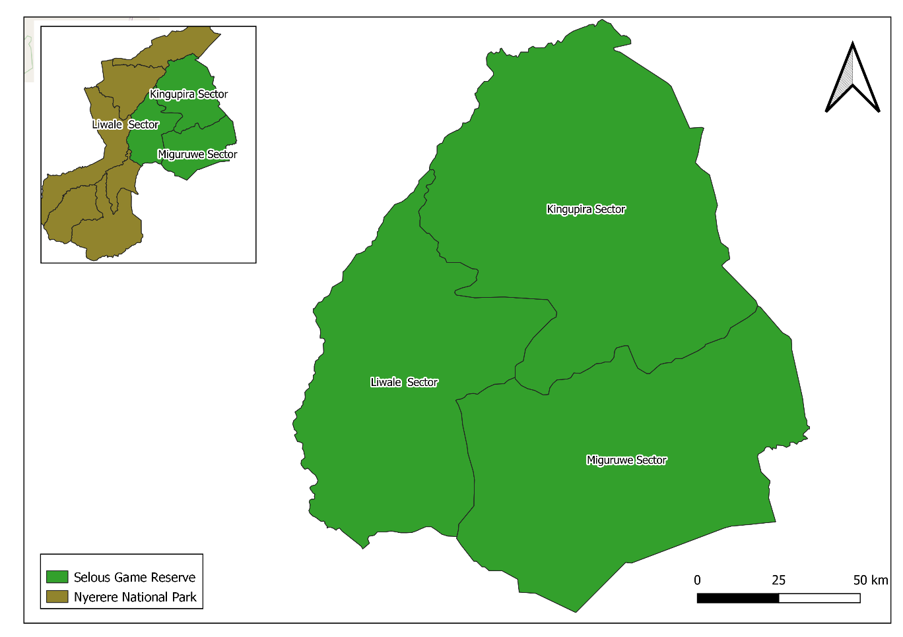
Figure 3.1: Selous Game Reserve
Source: GIS department of TAWA
The study was conducted at Kingupira Sector, which is currently among three sectors of Selous Game Reserve conducting wildlife hunting activities (Figure 3.1). Being the oldest reserve, which conducting hunting since then, was a big reason on why is selected to be study area on this study?

3.5 Targeted Population
Muposhi 2016 found that; one among the mega herbivores in Africa, which are most commonly hunted, is African Buffalo. Its densities were estimated to be 1.6 per square kilometer, which is quite high compared to the other herbivores’ species. The existing data shows if the male populations of herbivores are hunted, only 2.3 % of that population will be removed but if both male and female are hunted together only 6.2% of their population will be removed (Caro at el. 2018). Thus, the African Cape Buffalo is most suitable for studying as will indicate clearly the trend of its whole population.

3.6 Sampling Procedure
The sample of African Cape Buffalo at Kingupira sector was collected on the whole population number according to the ecology form records which was carried out by Tanzania Wildlife Management Authority (TAWA) rangers daily on their patrol; this helped to oversee the population index trend of buffalo for five years consecutively. The process was more systematical as the animal data collected out on every patrol day from 2013 to 2018.

On the other hand, the fixed quota of African Cape Buffalo, which was been developed out from the Wildlife Division (WD) on each year was used to develop the picture of what is planned to be harvested out of the existing buffalo population. Another data of actual number of buffalos, which has been hunted on each year was developed from the existing hunting permits plus the incidence of buffalo poaching reports from the Kingupira sector.

3.7 Variables and Measurement Procedures
The data was grouped into dependent and independent variables, where dependent variable stands to examine the population index trend of African Cape Buffalo. The data was obtained from the records of ecology form, which was carried out by TAWA (Kingupira sector) rangers daily on their patrol. The independent variable stands for the number of animals planned to be harvested (Buffalo quota) on each year and actual number of hunted buffalos on each (closed hunting permits and poaching records). All these variables were testing data and computed by using a simple linear regression.

3.8 Sources of Data
This research was based on both primary and secondary data, where data from different institution records were used; such as the population index of African Cape buffalo was obtained through the report of patrols from TAWA.

As well as the hunted data was obtained from Dar es Salaam Convention on International Trade in Endangered Speciesoffice (CITES). However, the Primary data was obtained from the Key informants; who were interviewed during the data collection guided by research question developed.

3.9 Data Collection Methods
This study was focused on both primary and secondary data; the primary data in which is qualitative data were obtained through key informant interview where ten informants were interviewed from both the hunting companies and TAWA. Furthermore, the Professional Hunters and the rangers from TAWA were involved in the interview; this was very crucial on understanding their opinion on the criteria for quotas setting, and the hunting process in general. Nevertheless, the secondary data which were the quantitative data for five years consecutively (2013-2018) were obtained from TAWA (Northeast Sector on Selous Game Reserve – Kingupira) on the hunted African Buffalos where the population index census were selected at the hunting blocks level, which were under Luka Samaras and PPS hunting companies.

The off-take level was considered as the number of harvested buffalos from the allocated quota and poaching data of Buffalo on each year. This helped on the assessing of growth rate on the off take of African Cape Buffalo on the reflection of Buffalo population index changes. Thus, the secondary data, in form of annual utilization data of African Cape Buffalo was used according to the quota allocation for five hunting blocks (U4, MS1, LR1, LR2 and LR3) from 2013to 2018.

This helped to make comparison and tell if it is wealth on harvesting such number on the reflection of buffalo population change. Also, criteria which were used on setting up the quota on each year was been analyzed and compared to the off-take rate and population index change so as to check which one(s) is/are the better to use on setting up the quota.

3.10 Data Analysis and Presentation
The content analysis was done where the views and opinions by officials were sorted to understand the hunting process in Tanzania. However, the secondary data collected from records at TAWA and CITES in Dare es Salaam were presented in a table form and analyzed by using a simple linear regression via the Statistical Package for Social Science (SPSS) version 20.0 after being grouped into Independent variables; quota size and off take levels (summation of legal and illegal hunted African Cape Buffalo) from five years respectively and dependent variable of buffalo population index; this aimed to examine the temporal trends of population index of the male African Cape Buffalo on the reflection of harvesting rate from 2013 to 2018 in Kingupira. The results were presented by using linear graph, tables and spatial pattern maps.

3.11 Reliability and Validity of Data
Reliability refers to the extent to which data collection technique or techniques were able to yield consistent findings. In other words, similar observations would be made or conclusion reached by other researcher or where there is transparency made from the raw data to ensures reliability (Saunders et al. 2007). Validity refer to the extent to which data collection method or methods accurately measure what they were intended to measure or the extent to which research findings are really about what they profess to be about (Saunders et al. 2007).

Both the primary and secondary data were reliable based on the source which was reliable, the secondary data were collected from the documented data of the released Quota and hunted of African Cape Buffalo from TAWA -CITES and from the department of ecology at Kingupira Sector in Selous Game Reserve which were collected for five years consecutive (2013-2018). However, the collected data was valid because it meets the expectation of the study by answering the specific objectives after being processed and analyzed, furthermore, the key informant checklist were tested for its validity before the key informant interview.

CHAPTER FOUR

FINDINGS AND DISCUSSION

4.1 Overview
In this chapter the spatial population of African Cape Buffalo in Selous Game Reserve is clearly indicated together with its population index and it’s off take points and numbers, and the relationship between off-take and population index of African Cape Buffalo.

4.2 The Trend and the Spatial Patten of African Cape Buffalo at Kingupira sector in Selous Game Reserve from 2013 to 2018
During the study the secondary data were used to assess the trend and spatial distribution of the African Cape Buffalo at Kingupira Sector in Selous Game reserve for about five years. The Age, Sex, GPS location and numbers of the African Cape buffalo were chosen from the raw data as the parameters which were collected by TAWA rangers during Patrol for the past five years (Table 4.1).

The findings have shown that population of the A. Cape Buffalo is stable with the small variability in term of numbers where its demographic has shown that, the African Cape Buffalo female is in large number compared to the male perhaps of its hunting status as male are the mostly hunted animals based on the hunting criteria.

This implies that the population will continue to be stable once the hunting criterion are mate However, the population of A. Cape Buffalo in 2015was very high 18.11%compared to other years especially 2016 where the population was very low 15.40% and 2018 were 16.22. This variation appeals were due to the variation of the number of patrols, which was carried out by TAWA.

Table 4.1: African Cape Buffalo Population Index as per their Sex from 2013 to 2018
Sex Vs Year | 2013 | 2014 | 2015 | 2016 | 2017 | 2018
Male | 1790 | 1814 | 2031 | 1901 | 1916 | 1951
Female | 3655 | 3366 | 3689 | 2964 | 3336 | 3173
Total | 5445 | 5180 | 5720 | 4865 | 5252 | 5124
% Total | 17.24 | 16.40 | 18.11 | 15.40 | 16.63 | 16.22
Source: Data compiled by Researcher from Kingupira monthly ecology field survey from Jan 2013 to Dec, 2018

Also, Age as the one of the demographic data that were collected to assess the population trend of the A.C ape Buffalo; the range of animalsage were categorized into three groups which are Adults, sub adults and Juveniles (Table 4.2). These categories were placed as per the guidelines developed for Cape buffalo to age individuals calves: <12 months old; juveniles: 12–24 months old; Sub adults: 3–5 years old; adults: >5 years old (Megaze. et al. 2017).

As per field visual sight, The African cape Buffalo age determination is presented based on horn characteristics and relative body size. It was found that, the group of Adults African Cape Buffalo has a large population number (47.94%) followed by Sub adults (34.42%) and Juveniles (17.64%).
Table 4.2: African Cape Buffalo Population Index as per their Age from 2013 to 2018
Age vs Year | 2013 | 2014 | 2015 | 2016 | 2017 | 2018 | Total | % Total
Adult | 2289 | 2642 | 2173 | 2381 | 2974 | 2684 | 15143 | 47.94
Sub adult | 2178 | 1709 | 2117 | 1754 | 1608 | 1506 | 10872 | 34.42
Juvenile | 978 | 829 | 1430 | 730 | 670 | 934 | 5571 | 17.64
Total | 5445 | 5180 | 5720 | 4865 | 5252 | 5124 | 31586 | 100
Source: Data compiled by Researcher from Kingupira monthly ecology field survey from Jan 2013 to Dec, 2018

4.3 Spatial Patten of the Distribution of African Cape Buffalo at Kingupira Sector
The findings has shown that, the African Cape Buffalo were more distributed north east of Kingupira sector and on the southern and central part (Figure 4.1). This is perhaps due to the river present in the northern part of the area, as the species are more philiac to water (hydrophilic); where water sources were primary focal point for the daily feeding and resting activities of ungulates including African Cape Buffalo as they prefers to maximize nutrients intake, minimize travel effort and maximize thermo comfort (George et al. 2005).

Also, according to Daniel et al. 2014, the availability of surface water and cover are commonly cited as the main constraints on habitat use of savanna buffalo. For example,” a GPS-tracking protocol undertaken in West Africa showed that buffalo herds spend 95% of their time within 5.3 km of permanent water areas and around 50% of their time within 1.4 km” These factors motivate breeding success as the results of the growth of animals’ population. This was the same to the study which was conducted at Didessa-Dabena River Valleys and JorgoWato Protected Forest in Ethiopia which revealed that, the spatial and temporal distribution of species are affected by the synergistic interactions of multiple factors (Thomson et al. 1996).
Biotic factors such as forage quality and quantity (Redfern et al. 2003) and water (Bailey et al.1996) play a primary role in the distribution of ungulates. Kingupira sector has a big permanent water bodies such as Rufiji River and Lake Utunge, which located at the Northern part. Also, Kingupira has a seasonal big river (Lung’onya River) on its eastern part which reserves water under its sand all year around. This is one of the factors, which attract animals to migrate to the water points especially on dry season and make them easier to be counted by patrol rangers. However, the distribution of species is also associated with habitat selection, species interactions, resource variations and anthropogenic pressure (Thomson et al.1996).
Nevertheless, the vegetations in the northern part of Selous Game Reserve was seen to be the reasons for the A Cape buffalo to be more distributed; During wet season there is growth of the vegetation which reduces visibility of animals to all over the area (Stoner et al. 2006) as buffalo tend to roam around water point areas which covered by dense vegetation; which affecting the accurate number and their age and sex due to the visibility. All these are indications of the presence of the A. Cape buffalo population index are high more than what we get from the field as the result of the population growth.
However, the study by Erena et al.2019, Didessa-Dabena River Valleys (DDRVs) and JorgoWato Protected Forest in Ethiopia he contraction of buffalo ranges was evident from the reduction of buffalo habitats such as shrubland and savanna woodland habitats and the increase of farmland and residential areas over the former ranges. Hence, the impacts of human induced pressures in the DDRVs might have forced buffaloes to partially migrate to the nearby forested areas.
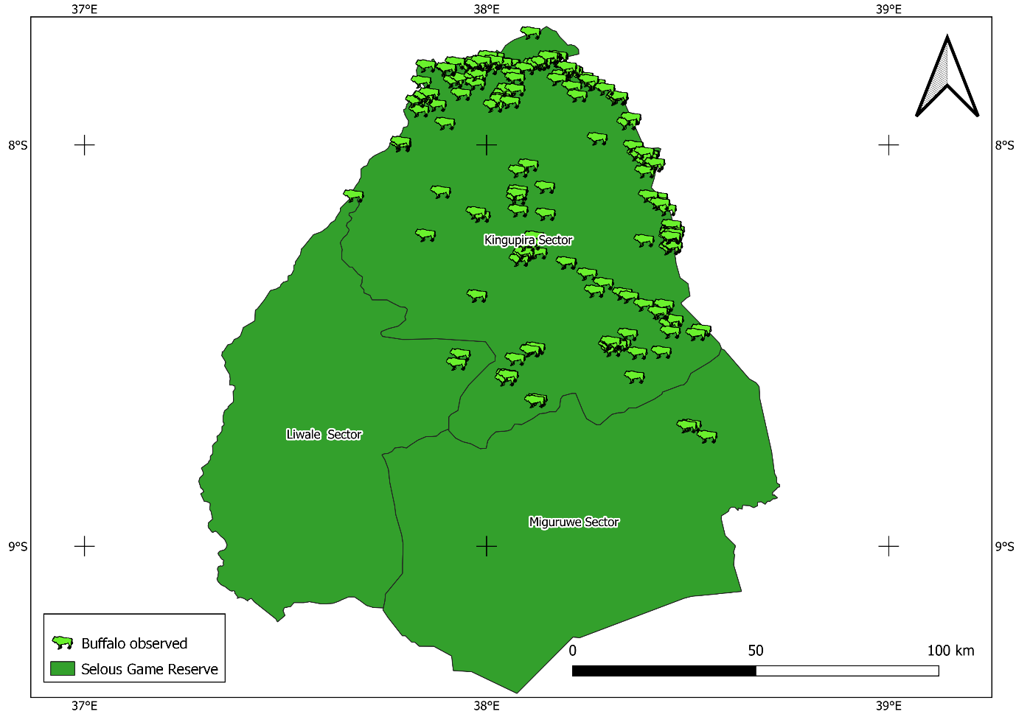
Figure 4.1: Spatial Distribution of African Cape Buffalo at Kingupira Sector from2013 to 2018
Source: TAWA (GIS Department) sported by researchers

The off-take number of African Cape Buffalo (legal and illegal) at Kingupira Sector in Selous Game Reserve from 2013 to 2018, have shown to be very small per year compared to the number of A. Cape Buffalo locate per quota as assigned by CITES office (Figure 4.2). The graph indicates that, the graph line of the off-take and quotas were parallel. However, in 2015 the high number of assigned A. Cape Buffalo in a quota which was129 buffalos compared to number assigned in 2016 (67 buffalos); Although an average of 42 and 94 buffalos was allocated to be hunted (quota) respectively (Figure 4.3b). This is perhaps the lower number of game animal hunted which was contributed by the low marketing of the products, or the presence of few hunting companies and the high operational cost and hunting in the country compared to other countries in Africa like South Africa. For instance, Kingupira sector has only two hunting company which operates in all hunting blocks. This low number of hunting companies makes their clients to hunt illegally in all blocks depending on their preferences as per allocated quota on each block; this has made companies to fail to get many clients as per blocks carrying capacity.

Also, the high operational and hunting cost compared to other country in SSA like South Africa which is the cheapest country in term of hunting activities, this was similar to study done by Songorwa in 2007who revealed that, the shortage of trophy animals and low hunting success rates (low hunting skill or the safari operator’s failure to market the entire quota) in 2015 were the main indicators for the part of the hunting quota allocated to remain during hunting. Also setting up the quota cannot be accurately predicted because of variations in hunting effort and success.

Quota setting depends on the number and distribution of animals, and on uncontrollable factors such as the weather and hunting skill (trackers, Professional hunters and hunters). This was contrary to study conducted by Francisca (2013), in Selous Game Reserve which found that, regarding the indicative quotas set by Wildlife Division, results of this study indicate that the quotas of all study species have not been fully utilized except for buffalo in years 2004 and 2005 where they were over utilized. It has been reported that populations of species which were most shot experienced sharp declines compared to those less short (Brink, 2010).

However, the number of hunted animals peaked in 2005 and the drop afterwards was thought to be associated with the economic recession in western countries in the second half of the last decade though some authors are of the opinion that negative publicity could be responsible (Brink, 2010) and others highlight the decline in trophy quality (Songorwa and du Toit, 2007). Though buffalo was the most preferred species (Lindsey et al., 2006) and, on average, each hunter shot 1.5 (Baldus and Caudwell, 2005), its entire quota for SGR was not fully utilized except years 2004 and 2005, which were exceeded.

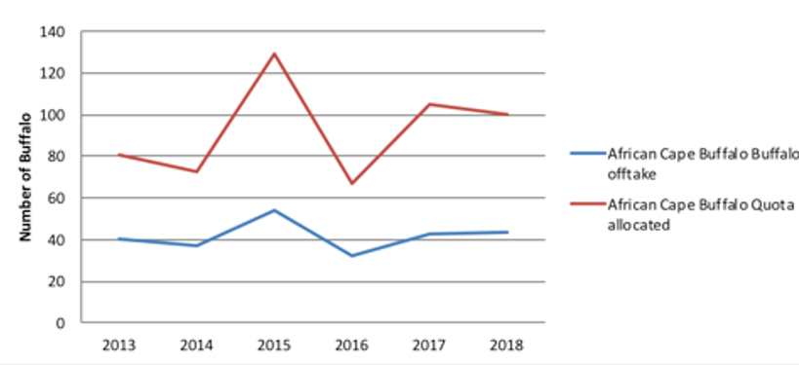
Figure 4.2: Trend of the African Cape Buffalo Allocated Quota Compared to its off-take at Kingupira Sector from 2013 to 2018
Source: Data compiled by Researcher from Kingupira monthly ecology field survey from Jan 2013 to Dec, 2018

4.4 Relationship between off-take and Population Index of African Cape Buffalo
According to the linear regression analysis (Figure 4.4) show the strong positive relationship between the hunted male African Cape Buffalos and the observed African Cape Buffalos at the period of five years between 2013 and 2018; with R² = 0.502which is more than50.2%. This implies that, the population index of African Cape Buffalo was increased in number from 2013 to 2015 and slightly drop in 2016 (Figure 4.3) where the African Cape Buffalo was underutilized as the off-take numbers was very minimum compare to the allocated quota (Quota setting) and its very constant compare to the observed population of African Cape Buffalo, this is perhaps of inadequate clients for Buffalo trophies and high demand of other species which indirectly affects the number of Buffalo hunted.

This was the same to the study by Bodmer (1995) in northeastern Peru who revealed that, Preferences of game by hunters of Tahuayo were correlated with animal body mass, larger animals being preferred over smaller ones. Game preferences were not correlated with biomass from hunters' preferences while in others actual harvests reflected preferences for example, peccaries and paca were the most frequently hunted mammals and were also preferred species. In contrast hunter preferences for deer and tapir were similar to those of peccaries and paca; however, deer and tapir were hunted less than half as frequently as peccaries and paca. The actual harvest reflects hunters’ preferences but depends on the reproductive productivity of species measured.

In contrast, if hunters do not related Realizing that intrinsic rate of natural prefer a species and that species requires increase is the major variable of production clarifies a decrease in hunting pressure then setting up man- this relationship (Robinson and Redford1991). Furthermore, Preferences of game by hunters of Tahuayo were correlated with animal body mass, larger animals being preferred over smaller ones (Bodmer, 1995).

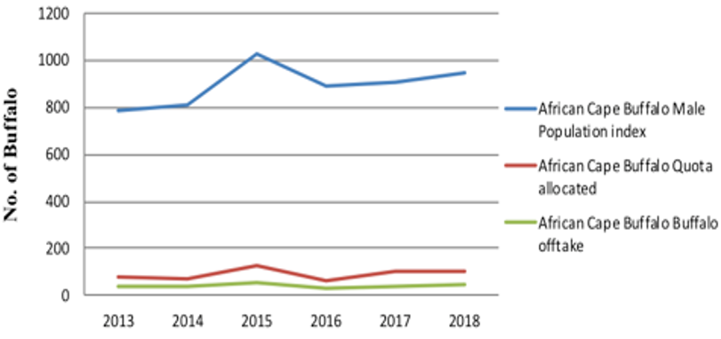
Figure 4.3: Comparison of Population Index Trend, Off-Take and Quota Allocated of the Male African Cape Buffalo at Kingupira from 2013 to 2018
Source: Data compiled by Researcher from Kingupira monthly ecology field survey from Jan 2013 to Dec, 2018.

Likewise, the linear model has explained the hunting activities on the population index of African Cap Buffalo by 50.2%and49.8% being explained by other factors which were not included in model to explain the stability of the African Cape Buffalo population and supporting the caring capacity of the blocks in Kingupira Sector such ashabitat destruction and pollution and climate change which needs a study as the harvesting pressure for males African Cape Buffalo is more important than for females, because of lower life expectancy of males and the reproduction frequencies of the female (Mysterud, 2011).
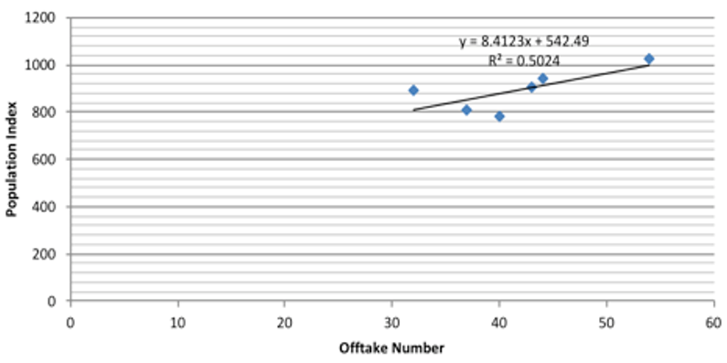
Figure 4.4: Linear Relationship between African Cape Buffalo Population Index and Off Take Number
Source: Data compiled and analyzed by Researcher from Kingupira monthly ecology field survey from Jan 2013 to Dec, 2018

Although the relationship between theoff-take and population index of African Cape Buffalo were strong positive but also, the hunted African Cape buffalo’s points were similar to the points where the groups of African Cape buffalos were sighted. This was contrary to the study by Francisca, 2013, who revealed the over utilized of buffalo quotas in 2004 and 2005; due to missing quotas for 14 blocks in 2004 and five blocks in 2005; however, the buffalo quota was mostly used in 2001.

On the other hand, the population of buffalo in Selous Game Reserve (SGR) declined from 71970 buffaloes in four years (2006 - 2009) and 239208 buffaloes in seven years (2002-2009). However, the study by Metzger et al.2010, in Serengeti ecosystem have revealed that, the trends in the buffalo population was primarily due to illegal hunting, and that enforcement of wildlife laws reduced the illegal off-take (Hilborn et al. 2006) a conclusion also reached for other areas (Hilborn et al. 2006; Keane et al, 2008). Nevertheless, Hilborn et al. (2006) revealed that for the past 50years, the illegal hunting and enforcement activities could account for the overall trends in buffalo population, yet examination of the buffalo total counts indicated variation in the buffalo population recovery.

The quota setting maintains the wildlife populations and continues to survive into the future (Booth and Chardonnet, 2015). However, only 49.8% of the population will be removed out if Tanzania Wildlife Authority (TAWA) will decide to keep on the same trend of quota for buffalo for these six hunting blocks at Kingupira Sector; this implies that, the hunting rate is worth full and quite sustainable for the blocks carrying capacity.
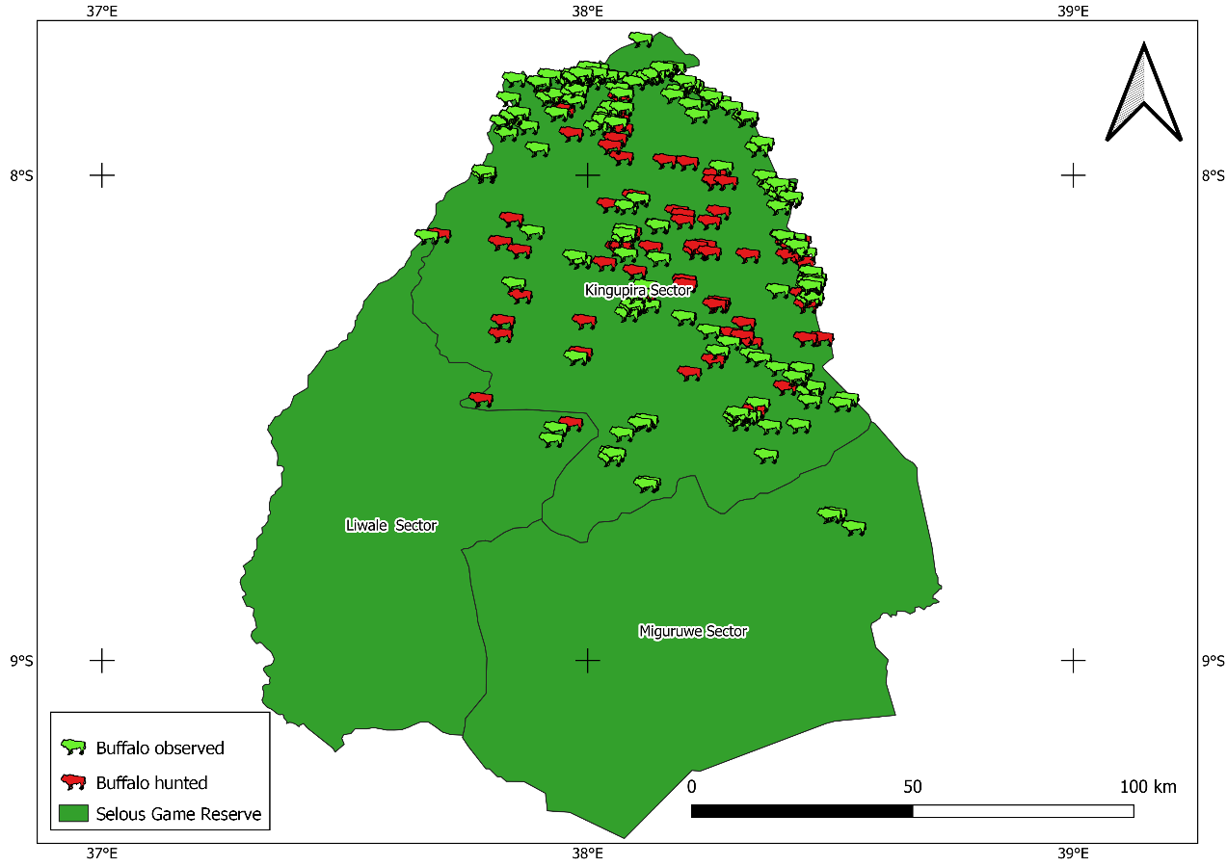
Figure 4.5: The Spatial Pattern on the Distribution and off take points of African Cape Buffalo at Kingupira sector from 2013 to 2018 (Researcher Work)
Source: TAWA (GIS Department) sported by researchers
Thus, as per the results of this study, the population index of African Cape Buffalo was expected to expand due to the adult female population to be high and is not the one which is targeted to be hunted compared to the Male. Also, the Male, which are hunted, are the one, which are full, matured and still their numbers are worth fullon reproduction. Altogether, both male and female, adults, Sub adult and juvenile are evenly distributed all over Kingupira sector due to the availability resources such as pastures and water in the area (Figure 4.5).

4.5 Criteria’s of Quota Setting
Based on the finding obtained from the key informants; it has shown that, the main criteria used to set up quota were the number of animals observed and counted in the field by either census data from TAWIRI as well as recommendation of the hunting supervisors from the site of hunting every year. Generally, these criteria’s of setting out the quota are not uniform and most of the time they use to approximate the number of Buffalos, which are supposed to be hunted on hunting blocks. However, according to the, Hunting regulations of 2015, the allocation of quotas and hunting block depends on the wildlife resources available and its sustainability for tourist hunting, diverse animal species and habitats, and its potentiality for wildlife recover upon a given time frame, also the size of the area is 200 km² minimum except where the hunting block is designated in a Wildlife Management Area which size shall be determined in the Resources Management Zone Plan, whereas the maximum size of the area are determined by the area’s score of the above criteria.

Furthermore, the Sex and age ratio is one of the crucial criteria this is more useful to measures the breeding success, relative motility rate and other aspect of population fluctuation (Petrides 1950). Reproductive effort should negatively correlate with reproductive value, yielding a pattern of increased effort with age. According to the terminal investment hypothesis, females near the end of their reproductive life span should devote more resources to reproduction than those near the start of their reproductive careers (Bercovitch et al. 2009). This has reflected the growth of African Cape Buffalo population as their adult’s female is observed to be high in all categories of age and sex, which reflect the growth of the population.

However, according to the interviewed officers from TAWA station through personal communication, during the field survey they said that, sometimes quota have setting based on the previously experiences and individual opinions and recommendations from the hunting company and the Professional Hunters (PH) and Rangers who mostly people spent their time in the field than the scientific data where the trends of harvesting previously add up to the quota according to request from the hunting company. This was the same to the study by Milner et al. (2009) in Zimbabwe, who revealed that, the quota sizes allocated were based on previous experiences and individual opinions and not based on scientific Principles.

Furthermore, the allocation of the quotas is likely to be affected by the different factors, including financial factors, the important factors for setting and allocating quotas and hunting blocks. In Zimbabwe, the study by Gandiwa et al. (2013) have shown that, economic decline, may not affect the size of quota allocation levels in some hunting areas. However, it was evident that the economic decline also seriously incapacitated the Zimbabwe Parks and Wildlife Management Authority to do periodic surveys and monitoring programs, which are critical in the quota setting process.

CHAPTER FIVE

CONCLUSION AND RECOMMENDATIONS

5.1 Overview
This chapter provides the conclusion and recommendations of this study about the impact of hunting activities on the spatial pattern of African Cape Buffalo population index, and the suggestions for the managements and other conservation stakeholders to take into consideration for sustainable of the natural resources in the Selous-Nyerere ecosystems.

5.2 Summary of Findings
The study characteristics has shown that, the African Cape Buffalo female is in large number of 20,183 (63.89%) compared to the male of 11,403 (36.10%) as well as the number of adults is high 15,143 (47.94%) compared to Sub Adult 10,872 (34.42%) and Juvenile 5,571 (17.64%). Total of 250 Male African Cape Buffalo was hunted from the period from 2013 to 2018 which is equivalent to 45.05% of the planned released quota.

5.3 Conclusion
The findings have shown that population of the A. Cape Buffalo is stable with the small variability in term of numbers where its population has shown that, the African Cape Buffalo female is in large number compared to the male, this is perhaps of its hunting status as male are the mostly hunted animals based on the hunting criteria. This is the good indicator for the sustainability of the African Cape Buffalo by ensuring stable population due to the expected productivity of the population as the hunting criterion is met.
Furthermore, the study has shown that, the African Cape Buffalo were more distributed north-east of Kingupira sector and on the southern and central part. This is perhaps due the presence of the river in the northern part of the area, as the species are more hydrophilic; where water were primary focal point for the daily feeding and resting activities of African Cape Buffalo as the preference for them to maximize nutrients intake and thermo comfort.

However, the off-take numbers of African Cape Buffalos per year from 2013 to 2018 were very small compared to the number of A. Cape Buffalo locate per quota as assigned by CITES office. This implies that there is no effect of hunting activities on the population index of African Cape Buffalo at Kingupira Sector in Selous Game Reserve.

Although, there is no guideline document on place that govern the hunting activities in Tanzania but quotas setting and allocation of off take level is promising to ensure the sustainability of wildlife populations and continue to exist for the future generation while generating economy of the country from the tourism and benefits to the local community.

5.4 Recommendations
Based on the major findings of this study, the following recommendations will help to maintain the population of African Cape Buffalo and other animal’s species on this pressure of hunting activities.
- TAWA should carry out different studies of this type on assessing the off-take level for different species of animals through Ecological department. Also, it is recommended for TAWA to evaluate the potential effects of other anthropogenic factors, such as conversion of natural vegetation to agriculture, human population density and growth, the presence of ritual and retaliatory killings, and proximity of wildlife habitat to human-occupied areas. This will help to get a clear insight on how to plan the quota for sustainable consumption and even assessing the capacity of hunting company on bring up the clients so as to sell the whole planned quota.

- Study findings indicated that the quota of African Cape Buffalo was underutilized compared to the allocated quota. This has resulted from the lower off-take of the allocated quotas per year due to the lower number of hunting companies in the area and high demands of other species, therefore it is recommended for Game Reserves management to continue advertising the available quotas and if possible to increase the number of hunting companies in the area so that we can have more customers and hunt the allocated number of quotas per year.

- This study was viable because of the SECAD project (Selous Ecosystem Conservation Development project), which was in place at the period of 2013 to 2018 in Selous Game reserve. Each Park Rangers were being paid monthly dry ration after submitting the filled ecological data as is indicated in TAWA ecological manual. This is the reason of having clear data for animals population index for the period of 2013 to 2018. After the SECAD project phase out, the exercise of recording ecological data also stopped as of now. Thus, it is recommended for Kingupira sector and other stations of TAWA to keep on filling ecological forms as will help to know the population index of each species of animals and even know their distribution on placing up the distribution map.

5.5 Recommendation for Further Studies
This study stands on one factor of harvesting and formulates the baseline information and influence within disciplinary boundaries. The study omits other factors such as pollution, predation, climate change, and diseases. This opens the door for other researcher to assess other factors on their impact on Buffalo population. Further study is also needed on how the establishment of the Nyerere National Park can have impacts on the population of African Cape Buffalo and other herbivores in Selous Game Reserve.

REFFERENCES

Bailey, D.W.; Gross, J.E.; Laca, E.A.; Rittenhouse, L.R.; Coughenour, M.B.; Swift, D.M. and Sims, P.L. (1996). Mechanisms that result in large herbivore grazing distribution patterns. Journal of Range Management 49: 386–400.

Baldus, R.D. and Cauldwell, A.E. (2005). Tourist hunting and its role in development of wildlife management areas in Tanzania. Game and Wildlife Science Journal 21: 519 – 614.

Balme, G. A., L. T. B. Hunter, P. Goodman, H. Ferguson, J. Craigie, and R. Slotow. (2010). An adaptive management approach to trophy hunting of leopards Panthera pardus: a case study from Kwazulu- Natal, South Africa. Pages 341–352 In press in D. W. Macdonald and A. J. Loveridge, editors. Biology and conservation of wild felids. Oxford University Press, Oxford, United Kingdom.

Bodmer, R. E. (1995). Managing Amazonian wildlife: biological correlates of game choice by detribalized hunters. Ecological Applications, 5(4), 872-877.

Caro, T. M. (2008). Decline of large mammals in the Katavi-Rukwa ecosystem of western Tanzania. Journal of African Zoology 43(1): 99 – 116.

Caro, T.M., Pelkey, N., Borner, M., Severre, E.L.M., Campblell, K.L.I., Huish, S. (1998). The impact of tourist hunting on large mammals in Tanzania, an initial assessment. African Journal of Ecology 36: 321 – 346

Damm, G. R. (2011). Sustainable Hunting – a Major Conservation Tool in the 21st Century. African Indaba Special Release, pp. 2.

Dickman, A. J. (2010). Complexities of conflict: The importance of considering social factors for effectively resolving human–wildlife conflict. Animal Conservation Journal 13: 458 – 466.

Erena, M. E., Jebessa, H., and Bekele, A. (2019). Consequences of land‐use/ land‐cover dynamics on range shift of Cape buffalo in Western Ethiopia. International Journal of Ecology and Environmental Sciences, 45(2), 123-136.

International Union for Conservation of Nature. 2006. Conservation strategy for the lion (Panthera leo) in easternand southern Africa. IUCN, Gland, Switzerland.

Lindsey, P.A., Alexander, R., Frank, L.G., Mathieson, A., and Romañach, S.S. (2006). Potential of trophy hunting to create incentives for wildlife conservation in Africa where alternative wildlife-based land uses may not be viable. Animal Conservation 9: 283 – 291.

Metzger, Kristine, Sinclair, A., Hilborn, Ray, Hopcraft, J. Grant C. and Mduma, Simon. (2010). Evaluating the protection of wildlife in parks: The case of African buffalo in Serengeti. Biodiversity and Conservation. 19. 3431-3444. 10.1007/s10531-010-9904-z.

Milner-Gulland, EJ, Bunnefeld, N, Proaktor, G. (2009). The science of sustainable hunting. In: Dickson B, Hutton, J., Adams, B, editors. Recreational hunting, conservation and rural livelihoods. Oxford: John Wiley and Sons.

Milner-Gulland, E. J. (2003). Reproductive collapse in saiga antelope harems. Nature 422:135.

Ministry of Natural Resources and Tourism, (2003). Selous, Tanzania Wildlife Division. African Publishing Group, Harare, Zimbabwe. 72pp.

Ministry of Natural Resources and Tourism, (2007). The Wildlife Policy of Tanzania. Wildlife Division, Government Printer, Dar es Salaam, Tanzania. 50pp

Muposhi, V. K., Gandiwa, E., Bartels, P., Makuza, S. M., and Madiri, T. H. (2016). Trophy Hunting and Sustainability: Temporal Dynamics in TrophyQuality and Harvesting Patterns of Wild Herbivores in a Tropical Semi-Arid Savanna Ecosystem. PLoS ONE 11(10): e0164429. doi: 10.1371/journal.pone.0164429

Nasi, R., Brown, D., Wilkie, D., Bennett, E., Tutin, C., van Tol, G., and Christophersen, T. (2008). Conservation and use of wildlife-based resources: the bushmeat crisis. Secretariat of the Convention on Biological Diversity, Montreal, and Center for International Forestry Research (CIFOR), Bogor. Technical Series no. 33, 50 pages.

Packer, C. (2009). Sport hunting, predator control and conservation of large carnivore. Public Library of Science ONE 4DOI: 10.1371/journal.pone.0005941

Packer, C., Kosmala, M., Cooley., S.H., Brink, H., Pintea, L., Garshelis, D., Purchase, G., Strauss, M., Swanson, A., Balme, G., Hunter, L. and Nowel, K. (2009). Sport hunting, predator control and conservation of large carnivores. Plos One Journal 4(6): e5941.doi10.137/journal.pone.005941

Packer, C., Kosmala, M., Cooley, S.H., Brink, H., Pintea, L., Garshelis, D., Purchase, G., Strauss, (2009). Sport hunting, predator control and conservation of large carnivores. Plos One Journal 4(6): e5941.doi10.137/journal.pone.005941

Redfern, J. V., Grant, R., Biggs, H., and Getz, W. M. (2003). Surfacewater constraints on herbivore foraging in the Kruger National Park, South Africa. Ecology 84: 2092–2107.

Songorwa, A.N., and du Toit, M. (2007). Hunting in Tanzania: Has science played its role? Tanzanian Journal of Agricultural Sciences 8(1): 31 – 38

Stoner, C. J., T. Caro, S. Mduma, C. Mlingwa, G. Sabuni, and M. Borner. 2007. Assessment of the effectiveness of protection strategies in Tanzania based on a decade of survey data for large herbivores. Conservation Biology 21:635–646.

Tanzania Natural Resource Forum, (2008). Wildlife for all Tanzanians: Stopping the loss, nurturing the resource and widening the benefits, an information pack and policy recommendations. Jumiko la Maliasili Tanzania, Arusha, Tanzania. 58.

Tanzania Wildlife Research Institute, (2012). Aerial Census of the Selous-Mikumi Ecosystem, Dry Season, 2011. TAWIRI Aerial Survey Report. Arusha, Tanzania. 77pp.

Tanzanian National Bureau of Statistics. (2002). 2002 Tanzanian National Census. Dar es Salaam, Tanzania.

Thomson, J. D., Weiblen, G., Thomson, B.A., Alfaro, S., and Legendre, P. (1996). Untangling multiple factors in spatial distributions: lilies, gophers, and rocks. Ecology 77: 1698-1715.

Twaibu, T. (2009). Impact of tourist hunting on the livelihoods of local communities around Selous Game Reserve, Tanzania. Dissertation for Award of MSc Degree at Sokoine University of Agriculture, Morogoro, Tanzania, 100pp.

United Republic of Tanzania, (2010). The Wildlife Conservation Tourist Hunting Regulations. Government Printer, Dar es Salaam, Tanzania. 35pp.

United Republic of Tanzania, (2010). The Wildlife Conservation Tourist Hunting Regulations. Government Printer, Dar es Salaam, Tanzania. 35pp.

United Republic of Tanzania, (2015). The Wildlife Conservation (Tourist Hunting) Government Printer, Dar es Salaam, Tanzania. 55pp.

Whitman, K.L. (2002). Safari hunting of lions: A review of policies, practices, and industry concerns submitted to African lion working group. University of Minnesota, USA. 29pp.

APPENDICES

Appendix 1: Interview Guide for Key Informants

- How do you set the hunting quotas?
- What are the criteria used to set the quotas?
- How do you monitor the quotas?
- Do you think the criteria used to site the quotas sustain the game population for future generation? Yes, No
If yes, Why ………………………………………………………
If no, why ………………………………………………………..
- Is there any guideline or regulation for hunting?
- What are your views about the criteria for setting quotas in Tanzania?

Thank you for your time

Appendix 2: Research Clearance letter

