INFLUENCE OF ENTREPRENEURSHIP EDUCATION ON EMPLOYABILITY OF GRADUATES FROM TECHNICAL AND VOCATIONAL EDUCATION AND TRAINING IN TANZANIA: THE MODERATING ROLE OF SELF-EFFICACY

MAHIJA WAZIRI

A THESIS SUBMITTED IN FULFILMENT OF THE REQUIREMENTS FOR THE DEGREE OF DOCTOR OF PHILOSOPHY (PhD) IN ENTREPRENEURSHIP EDUCATION
DEPARTMENT OF MARKETING, ENTREPRENEURSHIP AND MANAGEMENT
THE OPEN UNIVERSITY OF TANZANIA
2024

CERTIFICATION
The undersigned certify that they have read and hereby recommend for acceptance by the Open University of Tanzania a thesis entitled; “Influence of Entrepreneurship Education on Employability of Graduates from Technical and Vocational Education and Training in Tanzania: The Moderating Role of Self-Efficacy” in fulfilment of the requirements for the award of the Degree of Doctor of Philosophy (PhD) of The Open University of Tanzania.

…………………………………..
Prof. Deus D. Ngaruko
(1st Supervisor)

…………………………………..
Date

…………………………………..
Dr. Proches Ngatuni
(2nd Supervisor)

…………………………………..
Date

COPYRIGHT
No part of this thesis may be reproduced, stored in any retrieval system, or transmitted in any form by any means, electronic, mechanical, photocopying, recording or otherwise without prior written permission of the author or The Open University of Tanzania in that behalf.

DECLARATION
I, Mahija Waziri, declare that the work presented in this thesis is original. It has never been presented to any other University or Institution. Where other people’s works have been used, references have been provided. It is in this regard that I declare this work as original mine. It is hereby presented in fulfillment of the requirement for the Degree of Doctor of Philosophy (PhD) of the Open University of Tanzania.

.………………………..
Signature

.………………………..
Date

DEDICATION
I dedicate this thesis to the loving memory of my father Mr. Waziri Bakari Seifu and my Mother Ms. Mwanahawa Omari Mwindadi, whose wisdom, support, and encouragement have been a guiding light throughout my life. Though my father is no longer with me, his values and dreams continue to inspire me each day. This work is a testament to the foundation he helped build, and I carry forward his legacy with pride and gratitude.

ACKNOWLEDGMENT
This thesis would not have been completed without the support, motivation, collaboration, and sacrifices made by several people. First of all, I begin with the humble acknowledgement to Almighty God, whose unwavering grace, and blessings have illuminated my path throughout this research journey.
Also, I extend my deepest gratitude to my esteemed supervisors, Prof. Deus D. Ngaruko and Dr. Proches Ngatuni, whose mentorship, expertise, and unremitting support have been instrumental in shaping the path of this research. Their profound insights, invaluable guidance, and tireless dedication to my academic and personal growth have not only enriched the quality of this study but have also left an indelible mark on my intellectual journey.
The advice and constructive comments of Dr. Sophia Mbura and Dr. Bahati Mbilinyi cannot be left unmentioned. They spent much time reviewing my work to ensure clarity and proper methodological approach. I am very grateful to them our might Allah will pay back your effort for the betterment of this cosmos.
Moreover, I would like to express my heartfelt appreciation to the dedicated staff members of the Faculty of Business Management at the Open University of Tanzania. Their continuous commitment to fostering a culture of academic excellence has been pivotal to my academic development.
Furthermore, I offer my deepest gratitude to my husband Mr. Abdon Salim Mapunda and our sons and daughters, (Juma, Jamil, Zamda and Zawadi) for their unwavering support, boundless encouragement, and countless sacrifices that have enabled me to pursue this research endeavor. Their belief in my aspirations, their understanding during demanding times, and their enduring love has been the cornerstone of my success. Special thanks to my lovely Parents, for their support and encouragement in all my career roots. Your guidance will never be forgotten stay blessed.
Last but not least, I extend my sincere thanks to the respondents who are graduates from Technical and Vocational Education and Training (TVET) institutions, whose valuable insights and willingness to participate in this research have significantly enriched its depth and breadth. Their perspectives and experiences have shed light on critical aspects of this study, and I am truly grateful for their time and contributions.

ABSTRACT
The study aimed to examine the influence of entrepreneurship education items of knowledge, training and competence on the employability of Technical and Vocational Education and Training graduates in Tanzania using self-efficacy as a moderating variable. The Human Capital Theory and Self-efficacy Theories were employed to inform the theoretical framework. The research was conducted in Tanzania under a survey strategy that employed 353 respondents. The Convenience and snowball sampling techniques were used to gather representative. Structural Equation Modelling was used to test the postulated hypothesis of the study. All relevant model assumptions were tested to ensure that the estimates were not biased by their deviations in the data. The moderation analysis on self-efficacy was conducted using the multi-group moderation technique using Structural Equation Modelling was used. The findings showed that entrepreneurship knowledge, training and competence positively and significantly influence graduates’ employability. The results of the multi-group moderation analysis suggest a positive and insignificant effect on the relationship of entrepreneurship knowledge and employability, while suggesting positive and significant moderating effect on entrepreneurship training and competence on employability of graduates. The study concluded that, Human Capital Theory can be moderated by the levels of self-efficacy, hence improves its ability to predict employability. In summarily, results indicated that, entrepreneurship competence contributes more on graduate’s employability than others. Thus, study recommends training institutions to focus on building entrepreneurial competence to endure graduates’ employability.
Keywords: Entrepreneurship education, employability, TVET graduates, Tanzania
TABLE OF CONTENTS
CERTIFICATION ii
COPYRIGHT iii
DECLARATION iv
DEDICATION v
ACKNOWLEDGMENT vi
ABSTRACT viii
LIST OF TABLES xvi
LIST OF FIGURES xviii
LIST OF ABBREVIATIONS xix
CHAPTER ONE 1
INTRODUCTION 1
1.1 Overview 1
1.2 Background to the Study 1
1.3 Research Problem Statement 5
1.4 Research Objectives 7
1.4.1 General Objective 7
1.4.2 Specific Objectives 7
1.5 Significance of the Study 8
1.6 Scope of the Study 9
1.7 Organization of the Study 10
CHAPTER TWO 11
LITERATURE REVIEW 11
2.1 Overview 11
2.2 Definition of the Key Concepts 11
2.2.1 Entrepreneurship Education 11
2.2.2 Entrepreneurship Knowledge 12
2.2.3 Entrepreneurship Training 13
2.2.4 Entrepreneurship Competence 14
2.2.5 Self-Efficacy 14
2.2.6 2.Employability 15
2.2.7 Technical and Vocational Education and Training (TVET) 15
2.3 Theoretical Literature Review 16
2.3.1 Human Capital Theory (HCT) 16
2.3.2 Self-Efficacy Theory 19
2.4 Empirical Literature Review 22
2.4.1 The Influence of Entrepreneurship Knowledge on Employability 22
2.4.2 The Influence of Entrepreneurship Training on Employability 26
2.4.3 The Influence of Entrepreneurship Competence on Employability 30
2.4.4 The Moderating Role of Self-Efficacy 34
2.5 Research Gap 35
2.6 Conceptual Framework 36
CHAPTER THREE 38
RESEARCH METHODS 38
3.1 Overview 38
3.2 Research Philosophy 38
3.3 Research Approach 39
3.4 Research Design and Strategy 39
3.5 Study Area 40
3.6 Population of the Study 41
3.7 Sampling Design and Procedure 42
3.7.1 Sample Size 43
3.7.2 Sampling Frame 44
3.7.3 Response Rate 44
3.7.4 Unit of Analysis 44
3.7.5 Variable and Measurement Procedures 45
3.7.6 Data Collection Method 46
3.7.7 Validation of Research Instruments 47
3.8 Data Analysis Techniques 48
3.9 SEM Assumptions 50
3.9.1 Normality Test 50
3.9.2 Linearity Test 50
3.9.3 Homoscedasticity Test 51
3.9.4 Handling of Missing Data and Outliers 51
3.10 Descriptive Analysis 52
3.10.1 Inferential Analysis 52
3.10.2 Evaluation of the Measurement Model 52
3.10.3 Structural Model 54
3.10.4 Multi-Group Moderation Analysis 54
3.10.5 Validity and Reliability Test 55
3.10.6 Reliability Test 55
3.10.7 Validity Test 56
3.10.8 Content Validity 56
3.10.9 Convergent Validity 56
3.10.10Ethical Consideration 58
CHAPTER FOUR 59
RESEARCH FINDINGS 59
4.1 Overview 59
4.2 Data Preparation 59
4.3 Demographic Characteristics of the Respondents 60
4.3.1 Respondents Distribution by Gender 60
4.3.2 Respondents Distribution by Age 60
4.3.3 Respondents’ Distribution by Education Level 60
4.3.4 Respondents’ Distribution by the Institutions 60
4.3.5 Distribution of Participants Based on year of graduation 61
4.3.6 Distribution of Participants Based on Employment Status 61
4.3.7 Distribution of Participants Employment Alignment with studies 61
4.3.8 Distribution of Participants Based on Duration to Employment 61
4.3.9 Distribution of Participants Based on Effectiveness of Training 62
4.4 Descriptive analysis of the study constructs 63
4.4.1 Descriptive Statistics of Entrepreneurship Knowledge 64
4.4.2 Descriptive Statistics of Entrepreneurship Training 65
4.4.3 Descriptive Statistics of Entrepreneurship Competence 65
4.4.4 Descriptive Statistics of Self - efficacy 66
4.4.5 Descriptive Statistics of Employability 66
4.5 Assumptions Underlying SEM 67
4.5.1 Results from Normality Test 67
4.5.2 Result from Linearity Test 69
4.5.3 Result from Homoscedasticity 69
4.5.4 Result from Multicollinearity 70
4.6 Model Evaluation 71
4.6.1 Exploratory Factor Analysis 72
4.6.2 Factor Correlation Analysis 75
4.7 Confirmatory Factor Analysis 76
4.7.1 Confirmatory Factor Analysis (CFA) 76
4.7.2 The Overall Measurement Model 82
4.8 Validity and Reliability Test 84
4.8.1 Construct Validity Results 84
4.8.2 Convergent Validity Test Results 85
4.8.3 Discriminant Validity Test Results 85
4.9 Reliability Test Results 86
4.10 The Overall Structural 88
4.10.1 Structural Equation Model 88
4.10.2 Model Path Coefficients and Hypothesis Testing 90
4.11 Multiple Group Moderation Analysis 92
4.11.1 Descriptive Statistics for the Moderating Variable 93
4.11.2 Testing for Measurement of Invariance (MI) 94
4.11.3 Testing for Configural Invariance 95
4.11.4 Chi-Square Test Difference for Moderation 98
4.11.5 Path by Path Moderation Analysis 99
4.11.6 Moderation Effects of Determinants of Entrepreneurship Education 100
4.11.7 Moderating effect of Self-efficacy on Entrepreneurship Knowledge and Employability of Graduates 102
CHAPTER FIVE 105
DISCUSSION OF FINDINGS 105
5.1 Overview 105
5.2 Descriptive Statistics for Respondents’ Demographic Factors 105
5.3 Hypothesis Tests and Validation 106
5.3.1 The Influence of Entrepreneurship Knowledge on Employability of TVET Graduates 107
5.3.2 The Influence of Entrepreneurship Training on the Employability of TVET graduates 108
5.3.3 The Influence of Entrepreneurship Competence on Employability of TVET Graduates 109
5.4 Moderating Effects of Determinants of Entrepreneurship Education on Employability of Graduates 111
5.4.1 The Effect of Moderation on the Relationship between Entrepreneurship Knowledge and Employability of Graduates 112
5.4.2 The Effect of Moderation on the Relationship between Entrepreneurship Training and Employability of Graduates 113
5.4.3 The Effect of Moderation on the Relationship between Entrepreneurship Competence and Employability 115
5.5 The Final Model of the Study 116

CHAPTER SIX 118
SUMMARY CONCLUSION AND RECOMMENDATIONS 118
6.1 Overview 118
6.2 Summary of Key Findings of this Study 118
6.3 Conclusion 120
6.3.1 Determinants of Entrepreneurship Education 120
6.3.2 Moderation Effect on Determinants of the Entrepreneurship Education 121
6.4 Study Implications 124
6.4.1 Theoretical Implications 124
6.4.2 Practical Implications 126
6.4.3 Contextual Implications 127
6.5 Recommendation from the Study 128
6.6 Limitation of the Study and Area for Further Study 129
REFERENCES 131
APPENDICES 149

LIST OF TABLES
Table 2.1: Studies on the influence of entrepreneurship knowledge on employability 25
Table 2.2: Studies on the influence of entrepreneurship training on employability 29
Table 2.3: Studies on the influence of entrepreneurship competence on employability 33
Table 3.1: Population distribution 42
Table 3.2: Sample distribution 44
Table 3.3: Measurement of the variables 46
Table 3.4: Reliability Test Results for Items in the Pilot Study 48
Table 3.5: Criteria for acceptance of model fit 53
Table 4.1: Sample description 63
Table 4.2: Descriptive statistics results for entrepreneurship knowledge 64
Table 4.3: Descriptive statistics for entrepreneurship training 65
Table 4.4: Descriptive analysis of entrepreneurship competence 66
Table 4.5: Descriptive analysis of Self - efficacy 66
Table 4.6: Descriptive analysis of employability 67
Table 4.7: Summary on linearity test 69
Table 4.8: Correlation analysis for Multicollinearity 71
Table 4.9: Collinearity Test Results 71
Table 4.10: Table showing sample adequacy and correlation of the variable 73
Table 4.11: Total variance explained by study variables 73
Table 4.12: Factor pattern matrix 75
Table 4.13: Bivariate correlation analysis of study constructs 76
Table 4.14: Covariance between Studies Constructs After Standardization 84
Table 4.15: Average Variance Extracted Values for the Measurement Model 85
Table 4.16: Discriminant Validity Criterion 86
Table 4.17: Reliability statistics 87
Table 4.18: Composite Reliability for the Measurement Model 88
Table 4.19: Path estimates between ENK, ETR, ECO and Employability 90
Table 4.20: Description of SEC in three groups 94
Table 4.21: Description of SEC in two groups 94
Table 4.22: Assessment of the Configural Invariance Model 96
Table 4.23: Chi-square test for moderation analysis output 98
Table 4.24: Statistical tool package Chi-square output 99
Table 4.25: Regression weights for low SEC group 101
Table 4.26: Regression weights for high Self Efficacy Group 101

LIST OF FIGURES
Figure 2.1: Conceptual framework 37
Figure 4.1: Standardized residual VS standardized predicted residuals showing homoscedasticity assumptions 70
Figure 4.2: Screen plot graph 74
Figure 4.3: Measurement model fit for EKN 77
Figure 4.4: Standardized model fit for entrepreneurship knowledge 78
Figure 4.5: Model fit for Entrepreneurship Training (ETR) 79
Figure 4.6: Model fit for Entrepreneurship Competence (ECO) 80
Figure 4.7: Model fit for Self-efficacy 80
Figure 4.8: Standardized Model fit for Self-Efficacy (SEC) 81
Figure 4.9: Model fit for employability 82
Figure 4.10: The overall Measurement Model 83
Figure 4.11: The Structural model 89
Figure 4.12: The Structural model for multi group CFA 97
Figure 5.1: The final model of the study 117

LIST OF ABBREVIATIONS
AVE Average Variance Extracted
CFA Confirmatory Factor Analysis
CFI Comparative Fit Index
CR Composite Reliability
DIT Dar es Salaam Institute of Technology
ECO Entrepreneurship Competence
EE Entrepreneurship Education
EFA Explanatory Factor Analysis
EKN Entrepreneurship Knowledge
EMP Employability
ETR Entrepreneurship Training
HCT Human Capital Theory
IAA Institute of Accountancy Arusha
IT Information Technology
KMO Kaiser Meyer Oklin
PCA Principal Component Analysis
PFA Principal Factor Analysis
SEC Self-efficacy
SEM Structural Equation Modelling
SPSS Statistical Package for Social Sciences
TLI Tucker-Lewis Index
TVET Technical and Vocational Education and Training
VIF Variance Inflation Factor

CHAPTER ONE

INTRODUCTION

Overview
This study examines the influence of entrepreneurship education on employability on graduate from technical and vocational and training in Tanzania using self- efficacy as a moderating variable. Thus, this chapter introduces the background of the study, statement of the problem, research objectives, and research hypotheses, significance of the study, scope of the study and organization of the study.

Background to the Study
Employability is described as a situation in which an individual, in particular graduate, possess a set of skills, knowledge, understanding and personal attributes (Mgaiwa, 2021). Such set skill and knowledge should enable a graduate to choose and secure occupations that deemed fit for her/his career satisfaction and success (Okafor & Enemuo, 2022). In the context of this study, graduate, is referring to workforce completed their college and university programme, from diploma level and above. Over the past two decades, increased number of graduate employability has increased tremendously (Wei et al., 2023) . This has raised a serious concern across the globe on the set of employability package possessed by graduates, in both developed and developing countries (Hosain et al., 2021).

According to Jafari-Sadeghi et al., (2020) employability among graduates depends on the level of formal education, which Becker (1964) consider to be essential and necessary to improve human labour as an input to the productive capacity of a population with respect to employability. In the context of this study, entrepreneurship education is central in this research as a formal education with effect on employability. Along the same thinking, proponents of the human capital theory view formal education such as entrepreneurship education in terms of knowledge, training and competence as factors that increase graduate employability (Aboobaker, 2020; Jafari-Sadeghi et al., 2020). Therefore, knowledge, training and competence equipped to graduates through entrepreneurship education may individually or collectively have effect on employability trend (Liao et al., 2022), nonetheless, with individual graduate’s self-efficacy into consideration.

However, basing on the empirical review conducted, the finding indicated contradicting finding on the theory of Human Capital in Predicting employability of graduates. For example, Cho and Honorati (2014), Galvão et al. (2020) and Mittal and Raghuvaran (2021) reported a positive and significant relationship, contrarily, other studies like Karlan and Valdivia (2011) and Popescu and Roman (2018) reported a positive but non-significant relationship. This indicated the need of the additional variable on the theory of Human Capital in Predicting employability of graduates.

Basing on the above, Self-efficacy Theory employed to strengthen the power of Human capital theory in predicting employability of graduates. Self – efficacy theory, was described as crucial aspect in the study of employability of graduates (Ma et al., 2023; Schunk & DiBenedetto, 2021). Studies conducted by Doanh, (2021) and Wang et al., (2023) insisted that high level of self-efficacy enhance graduates' confidence in their abilities. As such, leading to more proactive engagement in job search activities, networking, and entrepreneurial endeavours hence facilitates employability. It is argued that individuals with less self-efficacy level are unlikely to persevere and exert effort to overcome obstacles and enhancing their employability prospects (Schunk & DiBenedetto, 2021). In such perspectives and as encouraged by previous scholars, Wang et al., (2023) and Doanh, (2021) claimed that the influence of entrepreneurship knowledge, training and competence on employability could either be moderated or mediated by different variables. Thus, self-efficacy from self-efficacy theory was employed to moderate the relationship between entrepreneurship education items of knowledge, training and competence and employability of TVET graduates.

The Moderation analysis was preferred over mediation analysis due to the fact that, mediation analysis seeks to understand the process linking the Independent variable and dependent variable through a mediator, while moderation analysis examines how the relationship between independent and dependent variables is affected by the presence of moderator variable. Thus, to understand how the relationship between the variable self-efficacy as moderator was employed.

This research builds on the theory of human capital by using self-efficacy to moderates the relationship between entrepreneurship knowledge, training and competence on employability. Additionally, the use of self-efficacy as a moderating variable is geared to improve the ability of human capital theory to predict graduate employability.
On the other hand, there is disagreement among scholars on the influence of entrepreneurship knowledge on employability. For example, previous studies (Kozlinska et al., 2020; Malhotra et al., 2022; Sehgal & Nasim, 2018) found positive and significant relationship, while Danibrahim et al. (2022) and Rahmat et al. (2012) found positive and insignificant relationship between entrepreneurship knowledge and employability. Moreover, there is no consensus regarding the influence of entrepreneurship training on employability. For example, studies by (Cho & Honorati, 2014; Suryawan et al., 2022) found positive and significant relationship, while Karlan & Valdivia, (2011) and Popescu & Roman, (2018) found positive and insignificant relationship between the constructs. Likewise, there is disagreement among scholars on the influence of entrepreneurship competence on employability. Studies by (Blokker et al. 2019; Hodzic et al. 2015; Iglesias-Sánchez et al. 2019) found positive and significant relationship, while Jackson, (2014) and Moreira et al. (2022) found positive and insignificant relationship between entrepreneurship competence and employability. This disagreement creates research gap that need to be filled.

In the context of Tanzania, the country has been undergoing substantial educational reforms in recent years, with a growing emphasis on entrepreneurship education as a means to enhance graduates' employability Suleman & Kagoro, (2024) . Despite such changes, there is a notable scarcity of research that specifically addresses the Tanzanian Technical and Vocational Education and Training (TVET) system (Garaba & Kumar, 2023; Suleman & Kagoro, 2024). As such, this research is undertaken to fill that gap, through examining the influence of entrepreneurship knowledge, training and competency on employability of Technical and Vocational Education and Training (TVET) graduates while considering self-efficacy as moderating variable.

Research Problem Statement
The concern of graduate employability in Tanzania has been one of the most debated topics in recent years. Technical and vocational education training institutions in Tanzania had been shaking out graduates that have continued, to be congested up to the labour market while increases unemployment rate (Kessy, 2020). Rising incidence of unemployment results in loss of income for individuals, reduces revenue for governments, hinders economic growth and increases pressure on government- spending on social benefits in countries (Nwosu & Chukwudi, 2018). Besides, efforts proposed to improve graduates’ employability including provisional of entrepreneurship education to TVET institutions, yet, number of graduate unemployment is still growing up (Mwaitete, 2024). Thus, further researchers need to be conduct to assess what is missing to the offered entrepreneurship education in relationship graduates’ employability.

However, Despite the fact that entrepreneurship education plays significant contribution to increase employability of graduates, previous studies conducted on Technical and Vocational Education and Training (Aboobaker, 2020; Baah-Boateng, 2015; Raphael, 2021; Suryawan et al., 2022) have not researched on entrepreneurship knowledge, training and competency collectively and the role of self-efficacy as moderating variable on graduate employability. For instance, studies by Ojule & Oliobi (2024), focuses on assessing entrepreneurial education in tertiary institutions for Graduate Employability in a competitive society. While, Kwami (2024), outlines the need for repositioning technical vocational education and training (TVET) for youth empowerment and entrepreneurship as an agenda for renewed hope in Nigeria. Accordingly, Saibon et al. (2019), discusses the issue of unemployment, people's well-being, entrepreneurial intentions and entrepreneurship education in Malaysia.

Additionally, the majority of current research on the influence of entrepreneurship education and employability of graduates were done in other developing and developed nations, such as South Africa, Alexander, (2021); conducted study on entrepreneurship education focused in TVET engineering studies while, Saibon et al., (2019) in Malaysia, focused on Entrepreneurship education, Unemployment issues, people’s wellbeing and entrepreneurial intentions among TVET graduates. Further, Asghar et al., (2019) in Turkey, focused on validating entrepreneurial intentions questionnaire to assess the impact of entrepreneurship education. Likewise, Ncube & Matlala, (2024), in South Africa, assessed the impact of entrepreneurship education on the entrepreneurial competences of students in TVET Colleges. Furthermore, others existing studies on the influence of entrepreneurship knowledge, training and competency on graduate employability are from Spain, Netherland and Australia (Blokker et al., 2019; Iglesias-Sánchez et al., 2019; Moreira et al., 2022).

On the other hand, previous scholars who studied the influence of entrepreneurship knowledge, training and competency on employability indicated mixed findings among them and inconsistent findings on the ability of human capital theory to explain employability of graduates. Thus, SEC was used as moderator variables to strengthen the relationship of HCT to explain employability of graduates.

However, to the best of the researcher’s knowledge, no study has been conducted globally, and specifically in Tanzania to assess the contribution moderating role of self-efficacy on the influence of entrepreneurship knowledge, entrepreneurship training and entrepreneurship competence collectively on the employability of graduates from technical and vocational education and training in Tanzania. The introduction of self-efficacy as a moderator, accelerate the strength of human capital theory in predicting employability of graduates from technical and vocational education and training. In that line, this validates carrying out this study in order to fill in the theoretical and contextual gaps.

Research Objectives

General Objective
The current study aimed to analyse the influence of entrepreneurship education on employability of Technical and Vocational Education and Training (TVET) graduates in Tanzania using self-efficacy as moderating variable.

Specific Objectives
Specifically, this study intended;
- To examine the influence of entrepreneurship knowledge on employability of TVET graduates in Tanzania.
- To examine the influence of entrepreneurship training on employability of TVET graduates in Tanzania.
- To examine the influence of entrepreneurship competence on employability of TVET graduates in Tanzania.
- To examine the moderating role of self-efficacy on the influence of entrepreneurship knowledge, on employability of TVET graduates in Tanzania.
- To examine the moderating role of self-efficacy on the influence of entrepreneurship training on employability of TVET graduates in Tanzania.
- To examine the moderating role of self-efficacy on the influence of entrepreneurship competency on employability of TVET graduates in Tanzania.

Significance of the Study
The findings from this study will contribute to the body of knowledge on understanding the role of entrepreneurship knowledge, training and competence on influencing the employability of TVET graduates’ literature. The findings also serve as a source of reference to further researches in understanding entrepreneurship education on employability of TVET graduates. The study enhances a broad understanding of the influence entrepreneurship education on employability of TVET graduates based on the theory of human capital as far as theoretical perspective was concerned. It also contributes to the theory of self –efficacy by adding a level self-efficacy as a moderating variable on expanding its predicting power on employability of graduates. More importantly, the introduction of self-efficacy was believed to provide a significant influence on the relationship between the determinants of EE and employability of graduates.

Practically, study findings provide information to the stakeholders who are the regulators of technical and vocational education, curriculum developers and trainers of technical and vocational education institutions. The insights obtained from this study helped the curriculum developers to develop entrepreneurship curriculum that focuses on the creation of competences as well as inculcating the self-efficacy competences in the curriculum. The regulators should monitor training institutions on curriculum implementation strategy that will streamline the teaching process to ensure that, teachers teach students focusing on building competence. The involvement of self-efficacy as a moderato on the relationship between independent and dependent variables will steer the performance of graduates from TVET institutions, as high level of self-efficacy leads people to work hard and persist in the face of setbacks, as illustrated by many greater innovators, Heslin,& Klehe, (2006).

Scope of the Study
The focus of this study was to examine the influence of entrepreneurship education on employability of TVET graduates in Tanzania, using self-efficacy as moderating variable for the relationship between the variables in human capital theory while moderated by level of self-efficacy. The study is quantitative in nature; employed survey to gather primary data through the use of structured questioner. The graduates from TVET institutions with bachelor degree and above were used as respondents in study. Structural equation modelling techniques was employed for data analysis.
The study provides significant contribution on expanding the understanding of the human capital theory on explaining employability of graduates using self-efficacy as a moderating variable. However, the current study does not cover graduates from higher training institutions (university) and graduates with technician level, regardless of their level of entrepreneurship education acquired.

Organization of the Study
The remaining part of this study comprised on five chapters, including chapter two, which chapter provides a literature review in which definition of the key concepts, theoretical and empirical literature review, research gap and conceptual framework are covered. Chapter three dwells on research methodology which provides research philosophy, design, approach and strategy, study area, population and sample size as well as data collection methods. Moreover, it provides reliability and validity tests, measurement of the variables and data analysis techniques. Chapter four covers the results of the study and hypotheses testing. Chapter five provides discussion of the findings based on the objectives of the study. Chapter six provides conclusions, recommendations and limitations of the study and proposes the suggestions for further research. A list of referenced material and appendices are provided at the end of this report.

CHAPTER TWO

LITERATURE REVIEW

Overview
This chapter, reviewed literatures related to entrepreneurship knowledge, entrepreneurship training entrepreneurship competence, employability of TVET graduates and the moderating role of self-efficacy. It provides the definition of the key terms, theoretical literature reviews where by Human Capital Theory and Self-Efficacy Theory were discussed and evaluated to see how best fit the proposed model of the study. The critical empirical literature was carried out and presented linking the main objective of the study, which was to analyse the influence of entrepreneurship education on employability of Technical and Vocational Education and Training (TVET) graduates in Tanzania using self-efficacy as moderating variable. Grounded on the empirical literature review the research gap that necessitates the undertaking of this study is identified, the hypotheses were developed, and the study’s conceptual framework was formulated. Sets of hypotheses were formulated and tested to present the relationship among the variables of the entrepreneurship education on employability of graduates using Self efficacy as a moderating role.

Definition of the Key Concepts

Entrepreneurship Education
Entrepreneurship education is explained as a collection of formalized teachings that informs, trains, and educates people to participate and success in entrepreneurial activities (Rudhumbu et al., 2020). Another definition was provided by (Bell & Bell, 2020) who defined entrepreneurship education as the discipline that is concerned with methods of teaching and learning which seeks to develop attitudes, behaviours and capacities that can be applied during an individual’s career as an entrepreneur. Previous studies such as (Adom & Asare-Yeboa, 2016; Jafari-Sadeghi et al., 2020) conceptualizes entrepreneurship education as knowledge, training and competence. However, this study, adopted definition by (Adom & Asare-Yeboa, 2016) as it fit well with focus of the study.

Entrepreneurship Knowledge
Entrepreneurial knowledge refers to individual’s appreciation of the concepts, abilities, and attitudes that are expected of entrepreneurs (Liao et al., 2022). In the same vein, (Bell & Bell, 2020) described entrepreneurial knowledge as the ability of an individual to recognize the concepts, skills and mentality required to be an entrepreneur. Similarity, (Karyaningsih, 2020) considers entrepreneurial knowledge as the combination of practical know-how and theoretical insights that entrepreneurs and aspiring business founders acquire to establish and operate successful businesses. The study by (Aboobaker, 2020) described entrepreneurial knowledge as understanding of issues related to recognizing market gaps, developing innovative solutions, securing resources, and navigating the complex landscape of entrepreneurship. It involves a deep understanding of market trends, customer behavior, financial management, and risk assessment to foster successful entrepreneurial endeavors. Preceding studies such as (Al Mamun et al., 2019; B. Roxas, 2014) conceptualizes entrepreneurship knowledge as legal knowledge, resources knowledge, marketing knowledge. However, this study adopted the definition by (Liao et al., 2022) as it is the current one and suits well with this study.

Entrepreneurship Training
The study by Gavigan et al., (2020) provides entrepreneurship training as the structured programme which intends to equip participants with the important skills and mindset for conducting entrepreneurial activities. On the one hand, (Kotha et al., 2023) describe entrepreneurship training as special courses designed to help employees to gain business knowledge and strengthen their entrepreneur skills. The studies by (Cho & Honorati, 2014) consider entrepreneurship training as an organized educational effort that provides individuals with the theoretical understanding, practical skills, and mindset necessary to foster entrepreneurship. While, (Popescu & Roman, 2018) explain entrepreneurship training as a structured and systematic process designed to impart knowledge, skills, and competencies to individuals who aspire to become entrepreneurs or who want to enhance their entrepreneurial abilities. The primary objective of entrepreneurship training is to equip participants with the necessary tools and insights to identify, create, manage, and grow successful businesses (Karlan & Valdivia, 2011). Entrepreneurship training is conceptualization as motivation training, personal initiative training, soft skill training and business training (Glaub & Frese, 2011). However, this study adopted the definition by (Kotha et al., 2023) as it is the current one and suits well with this study.

Entrepreneurship Competence
Entrepreneurship competence is described as the set of demonstrable features and skills that enable and improve the efficiency or performance of a job (Jafari-Sadeghi et al., 2020). Additionally, it is explained by (Al Mamun et al., 2019) as the abilities to use resources for improving the performance of the firm. Moreover, the study by Iglesias-Sánchez et al., (2019) see entrepreneurship competence as comprehensive set of abilities, which involve both technical and soft skills, required for individuals to excel in entrepreneurial activities. According to refers to (Blokker et al., 2019) a combination of knowledge, skills, attitudes, and personal attributes that enable individuals to effectively recognize, create, manage, and grow entrepreneurial ventures. It represents the overall capability to succeed in the complex and dynamic world of entrepreneurship (Hodzic et al., 2015). (González-López et al., 2021) conceptualized entrepreneurial competencies by using six competency areas (opportunity, relationship, conceptual, organizing, and strategic and commitment). This study adopted the definition by (Jafari-Sadeghi et al., 2020) because it is widely accepted by entrepreneurship researchers.

Self-Efficacy
This is the extent in which individual is confident about their own entrepreneurial skills to complete various tasks (Wang et al., 2023). Furthermore, the study by (J. Ma et al., 2023) describes self-efficacy as individual’s confidence in their ability to start a business venture successful. Nonetheless, the study by (Doanh, 2021) expounds entrepreneurial self-efficacy as an individual's belief in their personal ability and capacity to successfully undertake entrepreneurial tasks, activities, and challenges. It is a psychological construct that reflects one's confidence in their entrepreneurial skills and their belief that they can effectively manage and navigate the complexities of entrepreneurship (Blokker et al., 2019) . The study by (Schunk & DiBenedetto, 2021) conceptualization entrepreneurial self-efficacy as mastery experiences, vicarious experiences, social persuasion and physiological feedback. This study adopted the definition by (Wang et al., 2023) because it is widely accepted by entrepreneurship researchers.

2.Employability
Employability refers to ability of an individual to achieve self-sufficiency in the labour market through sustainable employment (Wei et al., 2023). Another definition was provided by (Okafor & Enemuo, 2022) who defined employability as the ability to keep a current job or obtain a desired job. Employability refers to an individual's overall capacity and readiness to gain and maintain meaningful employment (Kozlinska et al., 2020). It encompasses a combination of skills, qualifications, knowledge, personal attributes, and attitudes that make a person valuable and attractive to potential employers (Rahmat et al., 2012). (Hosain et al., 2021) conceptualization graduate employability as employability skills, personality and academic performance. However, this this study adopted the definition by (Okafor & Enemuo, 2022) because it is widely accepted by entrepreneurship researchers and it encompasses all aspects of future success and personal status.

Technical and Vocational Education and Training (TVET)
Technical and Vocational Education and Training (TVET) is the term officiated in
1999 in Seoul, Republic of Korea at the World Congress, the term encompassing education and training activities (Mesuwini et al., 2023; Sohn et al., 2017) added that TVET encompasses education, training and technical skills development relating to a wide range of occupational fields, production, services and livelihoods. Therefore, this study adopted the working definition by (Mesuwini et al., 2023) because it is widely accepted by TVET researchers.

Theoretical Literature Review
In this study, the influence of entrepreneurship education on employability of TVET graduates using the moderating role of self – efficacy was explained by two theories, the Human Capital Theory (HCT) and Self- Efficacy Theory (SEC). These theories assisted the researcher in understanding the variables that predict entrepreneurship education on employability of graduates moderated by self – efficacy from the theoretical perspective that led to the development of conceptual framework of the study.

Human Capital Theory (HCT)
The origins of HCT can be traced back to the 17th and 18th centuries, where economists had an interests of quantifying labour productivity and earnings (Blaug, 1976; García‐Zúñiga & López Losa, 2021; Hadley, 2019). In the mid-20th century work by Mincer, (1958), Schultz (1961), and Becker (1962), viewed human as a capital in the production process; and that improvement of human capital as a factor of production requires investment in training, education, skills and health. However in this study independent variable (knowledge, competence, and training) were drown from HCT living other variables of the human capital theory which has no direct relation with the focus of the study. Other variables like Health, intelligence, loyalty and social factors was not employed in this study as their not directly relate with the focus of the study.

Formal education is the central factor for HCT (Adom & Asare-Yeboa, 2016; Jafari-Sadeghi et al. 2020), which believes that performance is always influenced by education acquired by an individual. The HCT is increasingly being used in the domain of entrepreneurship (Aboobaker, 2020; Becker, 1962); where human capital is a set of skills, knowledge and other attributes that contribute to an individual’s capacity to perform productive work (Aboobaker, 2020; Schultz, 1961, 1980). This means that human capital outcomes rather than investments may have a better predictive value on employability outcomes. Studies by Aboobaker, (2020); Jafari-Sadeghi et al., (2020); Martin et al., (2013); and Suleman, 2021) applied HCT on explaining employability of graduates. In that context, this study uses HCT in-terms of knowledge, training and competence to assess the influence of entrepreneurship education on employability of TVET graduates. The word competence was used in this study as a combination of knowledge, skills and attitude as were used in human capital theory independently.

Likewise, the study by McLean & Kuo, (2014) links the strength of HCT with increased productivity and performance as a result of knowledge, skills, and experience gained from education orientation. Moreover, HCT strengths are well explained by its linkage to education and skills development, economic growth, individual and social benefits, policy formulation, and flexibility across context (Li, 2019).

Regardless of its strength, HCT is being criticized on its little focus on informal education, social networks, attributes and on-job training, which as well contribute significantly on individual’s performance Marginson, (2019). It is further linked to economic reductionism, it is more focus on employee wage rather than the entirety of an individual (Winterton & Cafferkey, 2019). Despite of its criticisms, the HCT is reliable to a number of researchers in explain entrepreneurship knowledge, training, competence and employability (Adom & Asare-Yeboa, 2016; Jafari-Sadeghi et al., 2020).

On the contrary, a study by Rodokanakis, (2021) on Human Capital Theory, Matching Theory and The Greek Labour Market showed that HCT is not applicable in a job market where high skilled employee cannot be absorbed. Furthermore, study by Adejumo et al., (2013) on the role of human capital in industrial development in Nigerian revealed insignificant contribution of human capital in boosting industrial performance. As such, researchers (Doanh, 2021; Wang et al., 2023) further argued that, human capital alone cannot fully support graduates' smooth transition to an employability setting.

Studies have identified that the human capital of entrepreneurs is a critical factor determining the success or failure of graduates’ employability (Estrin et al., 2024). Few studies have identified that perceptions of formal learning from entrepreneurship educations have a positive relationship with new venture planning and start-up intentions, through the mediation of entrepreneurial self-efficacy (Bai & Wang, 2023; Saptono et al., 2021). Recent studies have identified that personal initiative plays a mediating role in the relationship between self-efficacy and entrepreneurial intentions (Solesvik & Westhead, 2019). Hsiao et al. (2016) identified that human capital mediates the relationship between an individual’s internal locus of control and entrepreneurship. This study focuses on gaining a deeper understanding of the moderating role of self-efficacy through which entrepreneurial education influences employability of graduates. On the basis of empirical review conducted by the researcher, no study that has examined the influence of entrepreneurship education (knowledge, training and competence) on graduate employability from technical and vocational institutions.

Self-Efficacy Theory
Self-efficacy theory was originally developed by Bandura & Adams, (1977). The theory state that a person's self-efficacy can be improved by those psychological procedures, which enhance the level and the strength of the self-efficacy. Self-efficacy theory explicitly focuses on how individuals and communities can be empowered with a sense of agency that will facilitate goal attainment (Bandura & Adams 1977). At its core, self-efficacy revolves around the concept of self-efficacy beliefs, which represent an individual's assessment of their competence to successfully perform specific tasks or achieve particular outcomes. These beliefs serve as a dynamic and influential cognitive construct that impacts numerous facets of human functioning (Wang et al., 2023).
The theory suggests that self-efficacy beliefs are influenced by four primary sources of information. First, individuals draw from their own mastery experiences, which encompass past successes and failures (Ciptono et al., 2023). Positive experiences typically boost self-efficacy, while repeated failures may diminish it. Second, vicarious learning, or observing others who succeed or struggle in similar tasks, can shape one's self-efficacy. Third, social persuasion, such as encouragement or discouragement from peers, mentors, or authority figures, can sway self-efficacy beliefs (Gielen et al., 2019). Lastly, emotional and physiological states, like anxiety or relaxation, play a role in influencing self-efficacy perceptions (Raharjo et al., 2023). Therefore, entrepreneurship self-efficacy is a function of mastery experiences, vicarious experiences, social persuasion and physiological feedback (Schunk & DiBenedetto, 2021).

Because of the self-efficacy pertains to specific task; people may concurrently have high self-efficacy for some tasks and low self-efficacy for others. High degree of self-efficacy leads people to work hard and persist in the face of obstructions Bandura & Wessels (1997). Furthermore Heslin & Klehe (2006), commented that, high self-efficacy assisted individuals to masterly their experiences hence increase interest with their work. It influences individual employees to improve capacity to collect relevant information, make sound decision, and take a propriety action. In contrary low self–efficacy can lead to unpredictable analytic thinking that undermines the quality of the problem solving. Higher self-efficacy helps individuals to react less defensively when they receive negative feedback. Self-efficacy is crucial for sustaining the considerable effort required to master skills involved in for instance public speaking, losing weight and becoming effective manager. In the areas where there was low self- efficacy, people often seeing a negative outcome as confirming the incompetence they perceived in themselves with low self-efficacy.
Biglan, (1987) criticized self-efficacy theory by indicating that it disregarded the role of the environment on an individual. The theory ignored the effect of the surrounding environment on individuals' behaviours in his study of self-efficacy. The criticisms argue that it tends to overemphasize individual factors at the expense of external and contextual influences, potentially overlooking cultural variations in self-efficacy beliefs. Moreover, the theory is criticized because of the measurement challenges and the potential for self-report bias have also been raised as concerns, and some argue that self-efficacy alone may not fully explain behaviour. On the other hand, emotional states and the influence of past experiences are aspects that the theory does not extensively address, and it may not fully account for the role of collective efficacy in shaping behaviour (Schunk & DiBenedetto, 2021).

Despite of its criticism the theory has withstood those criticisms and still used by researchers in understanding the construct of self-efficacy (Wang et al., 2023). Self-efficacy theory's strengths lie in its robust predictive power, broad applicability, and empowerment potential, as it underscores personal agency and modifiability of beliefs. The theory is widely used in the entrepreneurship field to study entrepreneurship self-efficacy (Schunk & DiBenedetto, 2021). This study will also use this theory to guide entrepreneurship self-efficacy in TVET. Thus, the theory will provide predictive power to Human Capital Theory in predicting employability of TVET graduates.

Empirical Literature Review

The Influence of Entrepreneurship Knowledge on Employability
The relationship between entrepreneurship knowledge on employability has been tested by previous researchers in different context and provides inconclusive findings. For example, a study by (Malhotra et al., 2022) from India, examined the relationship between entrepreneurship knowledge on employability in retail sector. The study used stratified sampling to obtain a sample of 3,600 respondents. Using multiple regression analysis, the results show that entrepreneurship knowledge and employability are positively and significant related. However, study is based on the perspective of employees, students, faculties and trainers. This calls for additional studies on specific group such as graduate.

Similarly, the study by (Sehgal & Nasim, 2018) from India, examined the influence of entrepreneurship knowledge on employability in Information Technology (IT) sector. Samples of 200 university graduates were selected by using random sampling technique. The result from Structural Equation Modelling (SEM) indicates that there is positive and significant relationship between entrepreneurship knowledge and employability. However, the study did not use multidimensional approach of employability.

Another study by Kozlinska et al. (2020) from Latvia, established the effect of entrepreneurship knowledge on employability of university graduates. Using random sampling technique, a sample of 454 university graduates was selected. Data were analysed by using multiple regression technique. The results show that entrepreneurship knowledge and employability are positively and significant related. However, the study used only two universities, other studies should use more than two universities.

On the other hand, the study by Rahmat et al. (2012) from Malaysia, examined the effect of entrepreneurship knowledge on employability of university graduates. The study used purposive sampling to select a sample of 156 graduates. The results from multiple regression analysis show that there is positive and insignificant relationship between knowledge and employability. However, the use of non-probability sampling limits generalization of the findings.

Moreover, the study by Ibrahim et al. (2022) from Malaysia, investigated the influence of entrepreneurship knowledge on employability in TVET. The study used Random sampling technique to select a sample of 513 students and utilized multiple regressions. The results indicate that positive and insignificant relationship exists between entrepreneurship knowledge and employability. However, the study used TVET students to measure employability, future studies should use graduates. Hence, the first hypothesis of the study is formulated as follows:
H₁: Entrepreneurship knowledge positively influenced employability of TVET graduates in Tanzania.

Table 2.1 provides a summary of the previous studies on influence of entrepreneurship knowledge on employability. It shows that studies have been conducted in various sectors such as Retail, IT, Universities and TVET. However, the study conducted in TVET based on student perspective. Moreover, previous studies used multiple regression analysis and SEM as analytical methods. Furthermore, probability sampling techniques are appeared to be dominants sampling technique and the reviewed studies indicate there are contradictory findings on the influence of entrepreneurship knowledge on employability.
Table 2.1: Studies on the influence of entrepreneurship knowledge on employability
Author(s) | Country | Industry | Sampling unit | Sampling method | Sample size | Analytical method | Relationship
Malhotra et al., (2022) | India | Retail | Employees, students, faculties and trainers | Stratified sampling | 3,600 | Multiple regression analysis | Positive and significant
Sehgal & Nasim (2019) | India | Information technology sector | University graduates | Random sampling | 200 | SEM | Positive and significant
Rahmat et al., (2012) | Malaysia | University | University graduates | Purposive sampling | 156 | Multiple regression | Positive and insignificant
Ibrahim (2022) | Nigeria | TVET | TVET students | Random sampling | 380 | PLS – SEM | Positive and insignificant
Source: Researcher, 2024.

The Influence of Entrepreneurship Training on Employability
Studies on the influence of entrepreneurship training on employability include that of (Cho & Honorati, 2014) who established the relationship between entrepreneurship training and employability among small scale entrepreneurs in Afghanistan. The study used convenience sampling to select a sample of 400 youth, women and microcredit clients. The results from pooled regression show that there is positive and significant relationship between entrepreneurship training and employability. However, findings from this study were limited to small scale entrepreneurs in Afghanistan because the study used non-probability sampling.

Another study by (Suryawan et al., 2022) from Indonesia, assessed the relationship between entrepreneurship training and employability in Polytechnic College. The entire population of 162 employees was sampled in this study. The results from SEM indicate there is positive and significant relationship between entrepreneurship training and employability. However, the study was based on single polytechnic college; other studies should be conducted in more than one institution.

Similarly, the study by (Yan et al., 2023) from China, aimed to explore the effect of entrepreneurship training on employability in public hospitals. The study utilized convenience sampling to select a sample of 859 nurses. Data were analyzed by using hierarchical regression analysis technique. The results show that entrepreneurship training and employability are positively and significant related. However, findings from this study were limited to studies sample in public hospitals because the study used non-probability sampling.
On the other hand, the study by (Karlan & Valdivia, 2011) from Peru assessed the link between entrepreneurship training and employability in microfinance. The study utilized purposive sampling technique to select 1326 clients. The results from multiple regressions indicate that there is positive and insignificant relationship between entrepreneurship training and employability. However, the use of purposive sampling technique, limits generalization of the findings. Thus, the findings are limited to the studied area.

Moreover, (Popescu & Roman, 2018) from Romania examined the effect of entrepreneurship training on employability in vocational education. Convenience sampling was used to select a sample of 116 students. The results from probit regression analysis show that there is positive and insignificant relationship between entrepreneurship training and employability. However, findings from this study were limited to the studies area because it used non-probability sampling. Therefore, the second hypothesis is formulated as follows:
H₂: Entrepreneurship training positively influenced employability of TVET graduates in Tanzania.

Table 2.2 show previous studies on the influence of entrepreneurship training on employability. The general observation various analytical methods were used in previous studies such as pooled regressions, SEM, hierarchical regression, multiple regression. Moreover, previous studies were conducted in various sectors such as small-scale entrepreneurs, polytechnic college, public hospital, microfinance and vocational education. Furthermore, mixed findings were observed from the previous studies. Some studies reported positive and significant relationship, while others studies found positive and insignificant relationship between entrepreneurship training on employability.
Table 2.2: Studies on the influence of entrepreneurship training on employability
Author(s) | Country | Industry | Sampling unit | Sampling method | Sample size | Analytical method | Relationship
Cho & Honorati (2014) | Afghanistan | Small scale entrepreneurs | Youth, women and microcredit clients | Convenience sampling | 400 | Pooled Regressions | Positive and significant
Suryawan et al., (2022) | Indonesia | Polytechnic College | Employees | Census | 162 | SEM | Positive and significant
Mittal & Raghuvaran, (2021) | India | Higher Education | Students | purposive sampling | 185 | PLS – SEM | Positive and significant
Karlan & Valdivia (2011) | Peru | Microfinance | Clients | Purposive sampling | 1326 | Multiple regression | Positive and insignificant
Popescu & Roman (2018) | Romania | Vocational education | Students | Convenience sampling | 116 | Probit regression | Positive and insignificant
Aboobaker, (2020) | India | Higher Education | Students | Purposive Sampling | 330 | Meta-Analysis | Negative and insignificant
Source: Researcher, 2024

The Influence of Entrepreneurship Competence on Employability
Previous studies on entrepreneurship competence and employability ware conducted in developed countries such as Spain, Netherlands and Australia. The findings of these studies indicate mixed findings results. For example, a study by Hodzic et al., (2015) from Spain, aimed to examine the effect of entrepreneurship competence and employability among unemployed adults. The study used random sampling technique to select a sample of 113 respondents. Data were analysed by using simple chi-square analysis. The study found that entrepreneurship competence and employability are positively and significant related. However, the study used relatively small sample size, this hinder generalization of the findings. Likewise, the study by (Iglesias-Sánchez et al., 2019) from Spain, studied the effect of entrepreneurship competence and employability in public universities. A sample of 329 students was selected by using cluster sampling and multiple regressions were used for data analysis. The findings show that there is positive and significant relationship between entrepreneurship competence and employability. However, the study covered only one university, the inclusion of more universities will provide vital findings.

Another study by was conducted in Netherland by (Blokker et al., 2019), with the aim of examining the influence of entrepreneurship competence on employability in informal sector. The study used convenience sampling to select 704 young professionals and utilized SEM for data analysis. The study found that entrepreneurship competence and employability are positively and significant related. However, the use of convenience sampling technique limits generalization of the findings.

On the other hand, (Jackson, 2014) from Australia explores the effect of entrepreneurship competence on employability among university students. A sample of 1008 undergraduate students were selected by using convenience sampling. Data were analysed by using multiple regression technique. The results show that entrepreneurship competence and employability are positively and insignificant related. However, findings from this study were limited to the studies area because it used non-probability sampling.

Furthermore, the study by (Moreira et al., 2022) from Portugal, established the relationship between entrepreneurship competence and employability in service organizations. Convenience sampling was used to select a sample of 2099 employees and utilized SEM for data analysis. The results show that entrepreneurship competence and employability are positively and insignificant related. However, findings from this study were limited to the studies area because it used non-probability sampling. Therefore, the third hypothesis is formulated as follows:
H₃: Entrepreneurship competence positively influenced employability of TVET graduates in Tanzania

Tables 2.3 show the reviewed studies on the influence of entrepreneurship competence on employability. It indicates that previous studies were conducted in developed countries such as Spain, Netherlands and Australia and there are mixed findings. The first stream has found significant relationship; while the second stream found an insignificant relationship exist between the two constructs.
Table 2.3: Studies on the influence of entrepreneurship competence on employability
Author(s) | Country | Industry | Sampling unit | Sampling method | Sample Size | Analytical method | Relationship
Hodzic et al., (2015) | Spain | Employment and training offices | Unemployed adults | Random sampling | 113 | Simple chi-square  analysis | Positive and significant
Iglesias-Sanchez et al., (2019) | Spain | Public universities | Student | Cluster sampling | 329 | Multiple regression | Positive and significant
Blokker et al., (2019) | Netherlands | Informal sector | Young professionals | Convenience sampling | 704 | SEM | Positive and significant
Jackson (2014) | Australia | University | Undergraduate students | Convenience sampling | 1008 | Multiple regression techniques | Positive and insignificant
Moreira et al., (2022) | Portugal | Service organizations | Employees | Convenience sampling | 2099 | SEM | Positive and insignificant
Source: Researcher, 2024

The Moderating Role of Self-Efficacy
Various researchers have shown that entrepreneurship education accelerate individual interest by influencing self- efficacy for employability (Baiti et al., 2017; Doanh, 2021; Kusumojanto et al., 2021; J. Ma et al., 2023; Schunk & DiBenedetto, 2021; Wang et al., 2023; Wardana et al., 2020; Wilson et al., 2007). Preceding studies suggest level self-efficacy is a crucial aspect in the study employability of graduates (Ma & Bennett, 2024; Schunk & DiBenedetto, 2021). In the same line, previous studies, insisted that, high level of self-efficacy can enhance graduates' confidence in their abilities, leading to more proactive engagement in job search activities, networking, and entrepreneurial endeavours which facilitates employability, (Doanh, 2021; Pollack & Lilly, 2008; Wang et al., 2023; Zhang et al., 2022).

While, Schunk and DiBenedetto (2021) argued that individuals with less self-efficacy level are unlikely to persist and apply effort to overcome hurdles and enhancing their employability prospects. In this view and as encouraged by previous scholars, Wang et al., (2023); and Doanh, (2021) claimed that the influence of entrepreneurship knowledge, training and competence on employability could either be moderated or mediated by different variables. Basing of the empirical review conducted, that informed about contradicting results on the studies that, employed human capital theory, thus self-efficacy as moderator was employed to strengthen the power of HCT in realization of employability of graduates.

In the same note, series of studies have showed that self-efficacy is a positive
mediator of entrepreneurship education and employability of graduates (Pérez-López et al., 2019; Rosique-Blasco et al., 2018; Wujema et al., 2022; Yousaf et al., 2021). Nevertheless, some research indicated an insignificant impact between entrepreneurial education and employability of graduates (Daradjat & Asman, 2020; Soomro & Shah, 2022). Following the contradictory finding, and recommendation by previous scholars, Doanh, 2021 and Wang et al., (2023) on the suggestion that, the influence of entrepreneurship knowledge, training and competence on employability can either be moderated by different variables, the study employed self- efficacy to moderate the relationship of entrepreneurship knowledge, training and competence and employability of graduates. With regard to the reviewed literature, the study hypothesized that,
H₄: Self-efficacy positively moderated the relationship between entrepreneurship knowledge and employability of TVET graduates.
H₅: Self-efficacy positively moderated the relationship between entrepreneurship training and employability of TVET graduates.
H₆: Self-efficacy positively moderated the relationship between entrepreneurship competence and employability among TVET graduates.

Research Gap
Empirical studies indicated there is disagreement among scholars about the influence entrepreneurship knowledge on employability (Ibrahim et al., 2022; Kozlinska et al., 2020; Malhotra et al., 2022; Rahmat et al., 2012; Sehgal & Nasim, 2018). This makes difficult to create solid theoretical foundation between the constructs. Likewise, disagreement findings were also observed on the influence of entrepreneurship training on employability (Cho & Honorati, 2014; Karlan & Valdivia, 2011; Popescu & Roman, 2018; Suryawan et al., 2022; Yan et al., 2023) and between entrepreneurship competence and employability (Blokker et al., 2019; Hodzic et al., 2015; Iglesias-Sánchez et al., 2019; Jackson, 2014; Moreira et al., 2022). These mixed results created research gaps that need to be filled.

Moreover, previous studies such as (Ma & Bennett, 2024) and (Schunk & DiBenedetto, 2021) suggest that level self-efficacy could be used as a moderator to the variables of human capital theory. However, to the researcher best of knowledge has never been applied as the moderator variable in the influence of entrepreneurship knowledge, training and competence on employability. This increases the strength of human capital theory in predicting employability.

On the other hand, most of the study on the influence of entrepreneurship knowledge, training and competence on employability concentrated in developed countries such as Spain, Netherland and Australia. Few studies have been conducted in developing countries; however, these studies were conducted in other sectors such as universities, polytechnic college and public hospital. Therefore, this study fills this contextual gap.

Conceptual Framework
This study proposed a conceptual model (Figure 2.1) and developed number of hypotheses to spinal the argument on the relationship between entrepreneurship education and employability of TVET graduates. The frame work had been constructed based on the determinants of human capital theory and self-efficacy theory. The framework comprised of five variables namely entrepreneurship knowledge, entrepreneurship training and entrepreneurship competences and employability being independent variables as well as self- efficacy being the moderating Variable. In this study also, Hypotheses were formulated based on critical review of both theoretical and empirical literature as presented prior. The hypotheses formulation was then, considered after conceptual framework was drown, which shows the expected relationships between independent and dependent, as presented in Figure 2.1

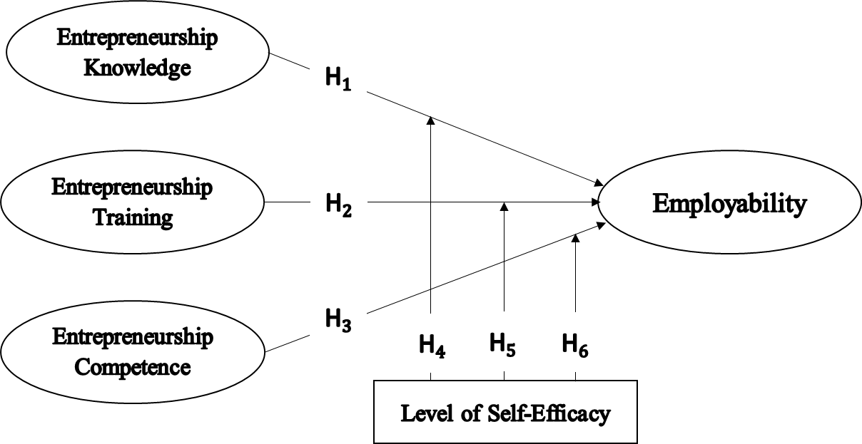
Figure 2.1: Conceptual framework
Researcher, 2024

CHAPTER THREE

RESEARCH METHODS

Overview
This chapter provides the methodologies that are used in this study. The chapter explains research philosophy, approach, and research design and strategy. It also covers area of the study, survey population, sample and sampling techniques, data collection techniques and unit of analysis, measurement of the variables. Moreover, the chapter provides data analysis technique, validity and reliability tests as well as ethical consideration.

Research Philosophy
A research philosophy is a belief about the way in which data about a phenomenon should be gathered, analysed and used (Alharahsheh & Pius, 2020). Research philosophy in business and Management field has four main categories that include pragmatism, positivism, realism, and interpretivism (Saunders et al., 2015). This study adopted positivism research philosophy. According to Buch‐Hansen, (2023), positivism is a philosophical perspective and approach that emphasizes the importance of empirical observation and scientific methods as the primary means of acquiring knowledge about the world. It advocates for the use of the scientific method as the most reliable way to acquire knowledge (Alharahsheh & Pius, 2020).

This method typically involves formulating hypotheses, conducting experiments or observations, collecting and analysing data, and drawing conclusions based on empirical evidence as suggested by (Buch‐Hansen, 2023). In addition, the philosophy was used due to its ability to associate deductive approach, the use of large samples size and adoption of quantitative methods (Saunders et al., 2015). Therefore, the mentioned features of the positivism philosophy suit the study as it allows test for casual relationships between variables, and made a general conclusion based on observed reality during data collection (Mbanaso et al., 2023).

Research Approach
Deductive approach was used in this study. The approach designed to demonstrate the relationship between theory and reality (W.-T. Tsai & Chen, 2019). The deductive approach involves beginning with a theory, developing hypotheses from that theory, and then collecting and analysing data to test those hypotheses (Benitez-Correa et al., 2019). Likewise, this study starts with a theoretical understanding of the influence of entrepreneurship education on employability of Technical and Vocational Education and Training using (TVET) graduates in Tanzania using self-efficacy as moderating variable. This study used quantitative methodology because it is positivistic in nature. It focuses on quantifying the collection and analysis of data. It is formed from a deductive approach where emphasis is placed on the testing of theory (W.-T. Tsai & Chen, 2019).

Research Design and Strategy
Research design is the procedure that enabled the researcher to gather appropriate data and analysed them accurately. It is a type of research that aims to uncover the underlying causes and relationships between different variables and it is applied when the study used deductive approach (Benitez-Correa et al., 2019). It confers to what is to be done from writing research questions and its processes to the final analysis of data (Kothari, 2004). This study uses explanatory research design. Explanatory research design clarifies the causal and effect relationship between variables related to the problem (Saunders et al., 2015). Thus, it enabled the researcher to establish the effects of independent variables (Entrepreneurship Education) on dependent variable (Employability).

Therefore, this study used explanatory design because it aims to examine the effect of entrepreneurship knowledge, entrepreneurship training, and entrepreneurship competence on employability of TVET graduates and using self-efficacy as moderating variable. Survey strategy was used as research strategy in this study for the purpose of gaining useful information and better finding of the study. This method was suggested due to its fitness in making inferences regarding population and its association with numeric responses. It was also regarded as useful strategy due to its ability to establish causal relationship between variable (Benitez-Correa et al., 2019). Profoundly the survey strategy was employed due to the nature of the respondents, that graduates are many and scattered all over the country. The KoboTool box, the survey electronic tool was used to gather primary data from the respondents through the use of structured questioner imbedded in.

Study Area
The study covered all regions in Tanzania as the study area. This is because graduates from the named institutions are scattered everywhere in the country looking for employment opportunities. The study used the graduates from two institutions, namely Dar es Salaam Institute of Technology (DIT) and Institute of Accountancy Arusha (IAA) to represent the rest. The choice of DIT and IAA was based on the fact that both are well established institutions champion on the provision of technical education under TVET system, government owned institutions with high quality mechanism on academic quality assurance systems, competent academic and administrative staff, regulatory compliance procedures, and consistence graduate delivery in various areas of specialization (Dar es Salaam Institute of Technology, 2024, Institute of Accountancy Arusha, 2024). The graduates from both institutions were trained on entrepreneurship education on their course of learning, (NACTVET approved curriculum for both IAA and DIT) Regardless of the portfolio of the institutions; their graduates are still facing unemployment challenge. This was evidenced on the Dar es Salaam Institute of Technology Cohort 2022 graduated tracer study report which narrated that, out of 400 graduates responded the survey, results indicate, 33.1% of graduates reported that they were not employed more than six months after graduation. Therefore, the chosen study area and population provide useful information on influence of entrepreneurship education on employability of graduate in TVET institutions using moderating role of self-efficacy.

Population of the Study
The population is the entire group from which a researcher draws a sample to be studied (Marsonet, 2019). Therefore, the population of the study involved the graduates from DIT and IAA in Dar es Salaam and Arusha region in three academic years from 2017/2018, 2018/2019 and 2019/2020. The three academic years were used because the graduates are considered to be unemployed if they are not in employment for three years from the date of graduation (Mwiti et al., 2021). According to data from DIT and AIA, the two institutions have a total number of 3042 graduates in three academic years. The survey population was 3042 graduates illustrated in Table 3.1.

Table 3.1: Population distribution
SN | Institute Name | Number of Graduates |  |  | Population Size
SN | Institute Name | 2018 | 2019 | 2020
1 | Dar es Salaam Institute of Technology (DIT) | 465 | 484 | 520 | 1469
2 | Arusha Institute of Accountancy (AIA) | 580 | 526 | 467 | 1573
3 | Total | 1,045 | 1,010 | 987 | 3042
Source: Data from DIT and AIA (2022)

Sampling Design and Procedure
This study used snowball sampling to select graduates from DIT and AIA in Dar es Salaam and Arusha region. Snowball sampling is a non-probability sampling technique used in research to identify and recruit participants who are difficult to be accessed or identified, (Saunders et al., 2015). Non probability sampling procedure is useful especially when randomization is impossible like when the population is very large., (Etikan et al., 2016). The researcher started with a small group of graduates from DIT and AIA in Dar es Salaam and Arusha region, and then using their social networks to identify and recruit additional participants who meet the study criteria. The study used snowball sampling because the populations of the study are difficult to access or locate. This study used snowball sampling because there is no sampling frame available for graduates and the population is dispersed geographically. According to Etikan et al., (2016), snowball sampling is a non-probability sampling technique that is useful when the target population is difficult to access or identify. Snowball sampling allows leveraging the connections and networks of existing participants to reach others within the target population, who may otherwise be difficult to locate. This study employed a snow ball technique to identify respondents.

Sample Size
According to Etikan et al., (2016)sample size estimation is required to be derived from a specific formula. Therefore, Taro Yamane formula is used to estimate sample size. According to (Hasan & Kumar, 2024; Yamane, 1967, 1973) the sample size of the study is calculated as follows:

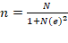 …………….Eqn. 1
Where;
n = sample size
N = total number population
e = margin of error with confidence level of 5%
Therefore, the total sample size, can be estimated as follows:
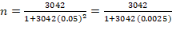
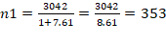
Therefore, the total sample size for this study was 353 graduates from DIT and AIA.
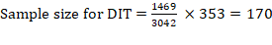
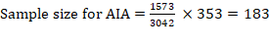
Table 3.2: Sample distribution
SN | Institutions | Population size | Sample Size
1 | Dar es Salaam Institute of Technology (DIT) | 1469 | 170
2 | Institute of Accountancy Arusha (IAA) | 1573 | 183
 | Total | 3042 | 353
Source: Researcher, 2023.

Sampling Frame
A sampling frame refers to a list or an organized representation of the target population from which a sample is drawn in a research study (Saunders et al., 2015). The sampling frame for this study was based on registered graduates from DIT and IAA in Dar es Salaam and Arusha region in three academic years from 2017/2018, 2018/2019 and 2019/2020.

Response Rate
The study used the online tool for data collection. The tool was designed in a manner, that through the snowball sampling technique, the respondent was able to share the link to someone he/she knows might be the right respondent. The researcher observed the online data collection tool, by assessing the number of respondents who filled the questionnaire till 353 respondents were achieved, and then the link was dismantled. In this manner, the response rate was 100%.

Unit of Analysis
The unit of analysis refers to the entity or level of observation that is being studied in a research project (Benitez-Correa et al., 2019). In this study, a unit of analysis involved graduates from DIT and IAA in Dar es Salaam and Arusha region in three academic years from years from 2017/2018, 2018/2019 and 2019/2020. The use of this sampling unit emanates from the fact that graduate from these academic years have been trained on entrepreneurship education, there for they are supposed to be engaged in social economic activities by being employed or self-employed.

Variable and Measurement Procedures
This study involves three categories of variables, namely independent variables, dependent variable and moderator variable. The independent variable involves; entrepreneurship knowledge, entrepreneurship training and entrepreneurial competencies, while the dependent variable is employability, and moderator variable is self-efficacy, as illustrated in Table 3.3. The variables were measured by using existing scales from the previous studies. Responses for entrepreneurship knowledge, entrepreneurship training, entrepreneurial competencies, self-efficacy and employability variables were measured by using 5-point Likert scales ranging from 1= strongly disagree to 5= strongly agree. The literatures suggested that, the five-point Likert scale is more useful in survey because it appears to be less confusing and to increase response rate and have higher reliability to the respondents, (Batterton & Hale, 2017; Joshi et al., 2015; Kusmaryono et al., 2022).

Table 3.3: Measurement of the variables
SN | Variables | No. of Items | Measurement Item | Sources
1 | Entrepreneurship Knowledge (EK) | 10 | EKN1-Resource for business  EKN2-Financial resources,  EKN3-Use of technology,  EKN4-Work on team  EKN5-Target customers,  EKN6-Create market plan  EKN7-Increase sales,  EKN8-Commercialization business idea,  EKN9-Intellectual property right  EKN10 -Tax laws and regulations, | Karyaningsih (2020); Al Mamun et al., (2019)
2 | Entrepreneurship Training (ETR) | 8 | ETR1-Confidence building,  ETR2-Motivate to pursue goal,  ETR3-Strategy to overcome obstacles,  ETR 5-Achieve entrepreneurial journey  ETR6-Proactive approach for problem solving,  ETR7-Creation of business plan,  ETR8-Legal and regulatory,  ETR9-Promoting product and services | Glaub & Frese (2011); Kotha et al., (2023)
3 | Entrepreneurial Competencies (ECO) | 7 | ECO1-Overcoming obstacles  ECO2-Monitor progress,  ECO3-Coordinate tasks,  ECO4-New ideas,  ECO5-Negotiating  ECO6-Business opportunities,  ECO7-Customers’ needs, | González-Lopez et al., (2021); Jafari-Sadeghi et al., (2020)
4 | Self-efficacy (SEC) | 6 | SEC1-Doing well tasks related to business,  SEC2-Doing well complex business problems,  SEC3-Motivated by success of others  SE4-Admiring Colleagues and peers,  SEC5-Interested by others' success stories,  SEC6-Motivated by Friends and family, | Schunk & DiBenedetto (2021); Wang et al., (2023)
5 | Employability (EMP) | 7 | EMP1-Communication skills,  EMP2-Problem-solving skills,  EMP3-Analytical skills,  EMP4-Adaptable to changes,  EMP5-Meet deadlines,  EMP6-Proactive person,  EMP7-Completed studies | Hosain et al., (2021); Enemuo (2022),(Matonya, 2018

Data Collection Method
Data were collected using self-administered structured questionnaire. The study was aided by KoboToolbox survey due to the nature of respondents that, they were scattered everywhere in the country. Researcher shared a link that bears instrument to the identified respondents at the two colleges, and there after the respondents identify their fellow graduates and goes on sharing until the point of saturation. The Kobotool box allows mobile data collection, enabling researchers to collect data directly on smart phones. Also, allows for offline data collection, enabling researchers to collect data in areas with limited or no internet connectivity. The questionnaire was designed into two parts where the first part comprised of general respondents’ information questions age, gender, level of education, and the second part is made up of several statements on entrepreneurship knowledge, entrepreneurship training, entrepreneurial competencies, self-efficacy and employability in the form of five-point Likert-like scales.

Validation of Research Instruments
To ensure validity of the research instrument, pilot study was conducted to 30 graduates. To reach the graduates, a link was used to share the research questionnaire to conveniently selected sample of graduates from two colleges. The involved colleges were Tanzania Institute of Accountancy (TIA), and Arusha Technical College (ATC, the sampled graduates shared a link to their fellow graduates until the sampled reached 30 graduates. The pilot study aimed at increasing validity and reliability of the questionnaire (Saunders et al., 2015). The content validity was used to verify whether the instrument measure what exactly was intended to measure by the researcher. The feedback from the returned questionnaires were examined to see if the respondents understood and answered the questions as per intended research. The results from the pilot lead to the adjustment of the questionnaire and omission of other statement that were repeatedly during formulation. Adjustment was done on the measurement scale for self – efficacy, which had more missing values. Only six out of the nine items used were fully responded by respondents, therefore, the items were retained during the actual survey.

Furthermore, reliability test was done from the data collected from the pilot study. Reliability test was performed using scale test for reliability analysis in IBM SPSS v. 26 whereby Cronbach Alpha was used to measure the internal consistency between the items in a scale. The result indicated that all value of Cronbach Alpha was acceptable because it is above 0.7 as seen in Table 3.4. Therefore, based on the reliability test for the pilot study the research instrument is reliable and could be used for the actual data collection. The value of Cronbach’ alpha which is above 0.7 indicates that items indicated that all item measure well employability of graduates. Cronbach alpha is a vital tool for researcher to ensure that their measurement instrument yielded consistent reliable data.

Table 3.4: Reliability Test Results for Items in the Pilot Study
Constructs | Cronbach’s Alpha
EKN | 0.952
ETR | 0.948
SEC | 0.968
EMP | 0.927
EOC | 0.938
Source: Field Data, 2024

Data Analysis Techniques
Version 22 of the Statistical Package for Social Scientists (SPSS) was used to enter and analyse the data. To make sure the data were of high quality, the researcher examined the outliers and missing data before doing the real data analysis. The data were analysed using both inferential and descriptive analysis. The primary purpose of descriptive data analysis was to provide data statistics, such as frequency, mean, and percentage. To be more precise, the researcher analyzed the data using basic frequencies and percentages to determine the characteristics of the respondents in terms of age, gender, employment, and educational attainment. Consequently, the data derived by descriptive statistics.

Inferential analysis was used in research to evaluate the strength of the suggested association as well as to determine whether a relationship existed between the independent and dependent variables. In this research, the hypothesis testing and significant variable assessment were completed by the application of structural equation modelling (SEM). SEM was used because, according to (Hair et al., 2021) it was a detailed statistical method for examining the link between latent and observable variables that were demonstrated by multiple measurements. As a result, SEM used a confirmatory strategy to identify inter-variable connections, while other previous multivariate techniques could not.

In order to ascertain the link between the constructs, the researcher in the current study developed six hypotheses based on the conceptual framework. These hypotheses were then examined concurrently. SEM takes simultaneous equations into consideration, meaning that a variable might be a criterion in one equation and a predictor in another, making the analysis simple to do. When compared to other multivariate approaches, it is hence more adaptable. This study's three independent variables and one dependent variable made SEM appropriate. Furthermore, SEM was preferably used because of its ability to detect and correct errors compared to the other techniques.). Hence, the Additionally, SEM overcomes the presence of multicollinearity as many measures were needed to explain the latent constructs.

SEM Assumptions
For the researcher to produce intended results during data analysis with the application of SEM technique, fundamental assumptions of the modal, were identified and recommended appropriate ways of handling them. These assumptions are multivariate normality, linearity and multicollinearity, homoscedasticity, missing data and outliers (Hair Jr et al., 2021; Kline, 2023; Kothari, 2004).

Normality Test
SEM assumed that variables were in the form of normal distribution. In structural equation modelling (SEM), the normality assumption refers to the assumption that the observed variables or the residuals (errors) in the model are normally distributed (Schunk & DiBenedetto, 2021). Test for multivariate normality is essential for ensuring the validity and normality of the modal estimates and statistical analysis, Abu-Bader (2021). The study tested whether data were normally distributed by using kurtosis and skewness statistics where the cut off ± 2 was used for both (Hair et al., 2016).

Linearity Test
SEM assumes that the relationships between variables are linear. This means that changes in one variable are associated with proportional and constant changes in other variables (Hair et al., 2016). This study tested for linearity assumption by using Bivariate scatter plot as suggested by (Schunk & DiBenedetto, 2021) to check for linear relationships between variables. If the data points are near to the straight line indicates linearity assumption is not violated (J. F. Hair et al., 2016; Hair Jr et al., 2021).

Homoscedasticity Test
According to Hair et al., (2010) and Hair et al., (2016), homoscedasticity occurs when there is an equal statistical variance of the dependent variable across the range of the independent variable. In this study, the homoscedasticity assumption was assessed by using scatter plot of regression standardized residuals versus the standardized predicted values to ensure that the variance of error is constant across all levels of the predicted values. Multicollinearity occurs when two or more independent variables in a regression analysis are highly correlated with each other leading to difficulties in estimating the effect of each variable independently. Multicollinearity was measured using Pearson correlation techniques or collinearity diagnostics test. The resulting statistics were evaluated against correlation of <.9 (Pallant, 2020) and Variance Inflation Factor (VIF) < 5 (Akinwande et al., 2015) for the no multicollinearity assumption to be met.

Handling of Missing Data and Outliers
In the event of missing data, list-wise deletion of the case method was used to handle as suggested, so as their existence could not affect the final results. On the other hand, outliers refer to data values which were out of range in a given data set ( Hair et al., 2016; Hair et al., 2021). In the case of outliers, the researcher produced box plots from IBM SPSS 22 for each individual variable to test for the presence of extreme outliers as proposed by (Kline, 2023).

Descriptive Analysis
After revealing that data cleaning and coding was well conducted and that the absence of missing values and outliers were proven, the descriptive analysis followed. The data was summarized using the frequencies and percentages for categorical data while mean and standard deviations were used for continuous data. The results were presented using the frequency distribution tables for demographic characteristics as well as individual study constructs pertained to observable items.

Inferential Analysis
It is a comprehensive statistical approach for the relationship among observed and latent variables that were shown by multiple measures (Glaub & Frese, 2011). In this study, six hypotheses based on the conceptual framework were formulated and analysed simultaneously so as to determine the relationship between construct.

Evaluation of the Measurement Model
Inferential data analysis was used to test the relationship between dependent and independent variables together with determining the strength of the proposed relationship. This indicates that, inferential analysis was used by the researcher to ascertain the effects of the independent variable on the dependent variable and its underlying strength of relationship, considering P values < or to 0.05. Structural Equation Modelling (SEM) was used to establish the relationship between variables. SEM is a statistical technique used to analyse and test complex relationships between observed and latent variables. In the current study, Confirmatory Factor Analysis (CFA) was used to test the measurement models. CFA was done to inspect the contribution of each scale items and see how well these items measure observable and unobserved variables. As per (J. Hair et al., 2010), each scale items was measured independently to determine its contribution on the degree of validity and reliability of the scale items of the constructs assessed on CFA. The study used a combination of indices in evaluating the model fit as recommended by previous studies such as (Wang et al., 2023)and (Y. Ma & Bennett, 2024). The absolute fit indices that were used in the study are presented in the table number Table 3.5

Table 3.5: Criteria for acceptance of model fit
Name of Category | Name of Index | Index Name | Threshold Values
Absolute Fit | Chi-square | Discrepancy chi-square | P ≥ 0.05
Absolute Fit | RMR |  | ≤ 0.08
Absolute Fit | GFI | Goodness of Fit Index | ≥0.90
Incremental Fit | NFI |  | ≥0.90
Incremental Fit | CFI | Comparative Fit Index | > 0.95
Incremental Fit | TLI | Tucker-Lewis Index | > 0.90
Incremental Fit | RFI |  | ≥0.90
Incremental Fit | PCFI |  | ≥0.50
Parsimonious Fit | CMIN/DF | Chi-square/Degree of freedom | ≤ 3
Standalone Fit Index | RMSEA | Root mean square error of approximation | ≤ 0.08
Source: Awang (2011).

The purpose of assessing the measurement model is to test the reliability and validity of the model. It was recommended to present a report on various indices because different indices could express each aspect of the model fit, Tabachnick and Fidell (Cangur & Ercan, 2015; Kenny, 2015; Shi et al., 2019).

Structural Model
The structural model was tested after performing measurement model. All goodness of fit indices which are involved in the evaluation of the measurement model were used on the structural model (Hair et al., 2016; Hair et al., 2021; Kline, 2023). The purpose was to examine the direct effect of independent variable to the dependent variable. Therefore, researcher conducted the analysis of hypothesis one to three testing the relationship between variable. Under this procedure, this study tested for the direct effect of entrepreneurship knowledge, training and competencies on employability that is testing structural modes without moderator variable. The second steps test the relationships of the moderator variable. This involved the additional of the moderator variable in the structural models where the hypothesis four to six was tested.

Multi-Group Moderation Analysis
The study used a number of indicators statements which makes self-efficacy to be latent construct. In the same vein, the study by (Z. Awang, 2011) alerted that, moderation analysis for the model with latent components is very challenging. Additionally, it may result in issues with model convergence and standard error, the conventional modelling technique employing interaction term is not applicable to latent construct. Instead, Multi-Group CFA will be used in the study to examine the influence of moderator variable’s latent nature. This study will examine H4 to H6 using step by step multi-group CFA approach process. Those alternatively, the study used Multi-Group CFA for examining the effect of moderator variable which is latent in nature. Moderation effect was tested using multi – grouping of the level of self – efficacy and its moderation effect using measures of fit indices.

Validity and Reliability Test
To ensure data quality you need to have valid and reliable instrument (Hair et al., 2016). Multiple indicators were used to make it possible to capture the meaning of most social science constructs (Hair et al., 2010)Validity and reliability were associated with measurement error, (Hair et al., 2016)(Hair et al., 2016). Therefore, to have accurate, the findings must be reliable and valid. In this study, the Researcher addressed validity and reliability matters as explained in the following sections.

Reliability Test
Reliability refers to the extent to which a measurement instrument produces the same results when used repeatedly under the same conditions. Reliability tests are conducted to determine whether the instrument or scale yields consistent and reproduce credible results over multiple administrations or measurements (Elsayed, 2012). This study used Cronbach's Alpha for testing reliability with the cut-off points of 0.7 and above (Hair et al., 2016). The degree of correlation between the respondents who responded to questioner items was read at 0.00 to 1.00. The value of alpha increases in the correlation between the items (E. Cho & Kim, 2015; Vaske et al., 2017) stated that, an Alpha of 0.65 into 0.8 is considered sufficient.

Validity Test
Validity refers to the degree to which the data gathered measures what it is projected to be measure (Heale & Twycross, 2015; Kusmaryono et al., 2022). The test was referred to be valid if it measured what it is required to be measure (Hair et al., 2010). Researcher tested several validity tests to check the compliance of the data. The following validity test were considered; convergent validity (Average Variance Extracted), internal and external validity, face validity, construct validity as well as discriminant validity using Fornell and Larker method. This was done before structural analysis through confirmatory factor analysis to reduce different measurement errors and thus enhance the quality of data.

Content Validity
Content validity refers to the extent to which a measurement instrument, such as a survey or test, accurately measures the intended construct or domain of (Kusmaryono et al., 2022). To ensure content validity, all variables were derived from theory and comprehensive literature was conducted regarding the domain of entrepreneurship knowledge, entrepreneurship training, entrepreneurial competencies, self-efficacy and employability as suggested by (Glaub & Frese, 2011).

Convergent Validity
Convergent validity is a type of construct validity that assesses the degree to which different measurements of the same construct are positively related to each other (Saunders et al., 2015). Convergent validity was measured by using factor loadings, Average Variance Extracted (AVE) and Composite Reliability (CR) with the cut-off point of 0.5 or above for factor loadings and AVE value, and 0.7 or above for CR value (Hair et al., 2016).

Validity: Discriminant validity is a type of validity assessment used in research and measurement to determine whether a measurement instrument can effectively distinguish between the construct it is intended to measure and other unrelated constructs (Saunders et al., 2015). It is a critical aspect of construct validity, which evaluates whether a measurement instrument accurately measures the specific construct it is designed to assess and no other constructs or variables (Heale & Twycross, 2015). Discriminant validity ensures that a measurement instrument does not produce inflated correlations with unrelated variables. Fornell-Larcker was used to measure discriminant validity. To attain discriminant validity, AVE value should be higher than squared correlation (Fornell & Larcker, 1981).

Face Validity: Face validity is a type of validity that refers to the extent to which a measurement instrument appears to measure what it is intended to measure (Saunders et al., 2015). This is a type of validity assessment used in research and measurement to evaluate whether a measurement instrument appears on the surface to measure what it is intended to measure. It is the simplest and most basic form of validity and does not involve complex statistical analyses Thus, to ensure face validity, questionnaires were sent to three experienced researchers in the field of entrepreneurship.

Ethical Consideration
The researcher observed various ethical issues. The researcher ensures voluntary participation of respondents, anonymity and confidentiality as recommended by (Saunders et al., 2015). Moreover, the researcher used of proper citation of all published and non-published documents. All works of other researchers were properly acknowledged and not expressed as researcher’s own work to avoid plagiarism. Plagiarism test was conducted, respondents voluntarily participation was encouraged, falsification and fabrication were also observed to observe ethical consideration. Furthermore, before the data collection, the researchers requested a clearance letter from the University and submit it to the relevant TVET institutions that helped in getting the graduates contacts.

CHAPTER FOUR

RESEARCH FINDINGS

Overview
The purpose of this chapter is to presents the results of data analysis including hypothesis testing. The descriptive statistics methods were used to analyse the profile of the respondents as well and the items of the constructs. The subsequent analysis tested three hypotheses on the influence of entrepreneurship education on employability of TVET graduates in Tanzania. Moreover, hypotheses focused on testing the moderating effect of the levels of self-efficacy on the entrepreneurship knowledge, training, competence and employability of TVET graduates were all assessed. These analyses were preceded by factor analysis through Explanatory Factor Analysis (EFA) and Confirmatory Factor Analysis (CFA). The finding for validity and reliability of research instrument are also presented.

Data Preparation
Data cleaning was done, that embrace the checking and correcting errors, removing duplication data and detecting the missing data that may lead to inaccuracy data in the data file, (Tabachnick and Fidell, (2013.) The researcher checked for incompleteness and inconsistency of the data during data preparation to ensure the data are clean. The data were then coded and entered into statistical tool IBM SPSS software v.22, which were used to simplify the whole processing of data entry and minimized data entry errors before exported to further statistical analysis.

Demographic Characteristics of the Respondents
This section presents the respondents demographic characteristics based on gender,age, educational level, institutional background, year of graduation, employment status and duration taken up to employment.

Respondents Distribution by Gender
The results (Table 4.1) show that male respondents dominated in the survey. The study received a higher percent of males (61.2%) compared to females (38.8%). These results imply that that there were more male than female respondents in the sample.

Respondents Distribution by Age
The results (Table 4.1) show that slightly less than half of the respondents (49%) belonged to 21 - 30 years age category followed by those who belonged to the 31 – 40 years category (45.6%).

Respondents’ Distribution by Education Level
In this survey, more than half of the respondents (58.4%) were holders of a bachelor's degree education. This was followed by those who hold a Master’s degree (36.5%).

Respondents’ Distribution by the Institutions
The targeted two institutions contributed respondents about half each. DIT contributed 170 (48, 2%) respondents while IAA contributed 180 (51.1%) respondents (Table 4.1). The finding revealed that, there was equal chance of participation on respondents between institutions as planned.

Distribution of Participants Based on year of graduation
The results in table (4.1) shows that, 146 (41.4 %) graduated on year 2020, followed by 133 (37.7%) graduated in the year 2019. The results indicated that the respondents followed on the targeted group by the researcher.

Distribution of Participants Based on Employment Status
From Table 4.1, it is evident that unemployment rates still a challenge that need to be addressed. The demographic finding from the study showed that 53.5% graduates still seeking for employment. Results indicated that, employability to the graduates still an issue for discussion.

Distribution of Participants Employment Alignment with studies
The findings in Table 4.1 show that 88 (24.9 %) respondents indicated that their employment has a direct relationship with their college studies. Sixteen (16) (4.5%) of the respondents indicated that their employment had nothing to do with their college studies.

Distribution of Participants Based on Duration to Employment
Out of 164 graduates who are employed participated in the survey, 105 (29.7%) remarked that it took them 4-5 years to be employed. While (12.5%) of the respondents revealed that, it took them 1-3 years after graduation to get employed. This confirms that, graduate employability is still problems that need to be addressed.

Distribution of Participants Based on Effectiveness of Training
The finding in Table 4.1, indicated that 148 (41.9%) of the respondents claimed that the entrepreneurship training offered in TVET institution its effectiveness is very high, while 96 (27.2%) claimed that its effectiveness is very high. The survey findings revealed that, however there was effective training programme on entrepreneurships education yet graduate employment rate is still growing.
Table 4.1: Sample description
Gender | Frequency | Per cent
Male | 216 | 61.2
Female | 137 | 38.8
Age Interval
2 1– 30 | 173 | 49.0
31 – 40 | 161 | 45.6
41 – 50 | 17 | 4.8
51+ | 2 | .6
Education Level
Bachelor | 206 | 58.4
Masters | 129 | 36.5
PhD | 18 | 5.1
College Name
DIT | 170 | 48.2
IAA | 183 | 51.8
Years of graduation
2018 | 74 | 21.0
2019 | 133 | 37.7
2020 | 146 | 41.4
Participants Based on employment status
Employed | 108 | 30.6
Self-employed | 56 | 15.9
Seeking Employment | 189 | 53.5
Employment aligns with college studies
Yes, directly | 88 | 24.9
Yes, somehow | 60 | 17.0
No | 16 | 4.5
Duration from graduation to employment
1-3 years | 44 (12.5 %)
4-5 years | 105 (29.7%)
6+ years | 15 (4, 2%)
Effectiveness of the Training
Very low | 25 | 7.1
Low | 23 | 6.5
Moderate | 61 | 17.3
High | 148 | 41.9
Very high | 96 | 27.2
Confidence in Skills Application
Not Confident at All | 47 |  | 13.3
Slightly | 56 |  | 15.9
Moderate | 34 |  | 9.6
Very Confident | 19 |  | 5.4
Extremely. Confident | 8 |  | 2.3
Source: Field Data, 2024

Descriptive analysis of the study constructs
The Descriptive statistics analysis of the study construct refers to the summary of the statistics that visualized data that describe the basic features of the variable being studied in a survey to help a researcher to understand tendencies, variability and distribution of the responses for each construct studied. Tables 4.2 to 4.6 summarize the results of the analysis.

Descriptive Statistics of Entrepreneurship Knowledge
The Descriptive statistics analysis was performed to determine the initial insights t of the construct of Entrepreneurship Knowledge as presented in Table 4.2. The mean and standard deviation for each indicator of entrepreneurship knowledge were presented. Ten indicator variables were used to gauge entrepreneurship knowledge. EKN10 possess a higher mean score than the rest with a standard deviation of 0.979, while EKN9 possess the lowest mean score of 3.46 with a standard deviation of 1.033. The standard deviation happened to be smaller than the mean, this indicates that the respondents’ choices were not much dispersed.

Table 4.2: Descriptive statistics results for entrepreneurship knowledge
 | N | Minimum | Maximum | Mean | Std. Deviation
EKN1 | 353 | 1 | 5 | 3.54 | .991
EKN2 | 353 | 1 | 5 | 3.58 | 1.003
EKN3 | 353 | 1 | 5 | 3.59 | .988
EKN4 | 353 | 1 | 5 | 3.60 | 1.023
EKN5 | 353 | 1 | 5 | 3.60 | 1.075
EKN6 | 353 | 1 | 5 | 3.56 | 1.001
EKN7 | 353 | 1 | 5 | 3.59 | 1.008
EKN8 | 353 | 1 | 5 | 3.58 | 1.017
EKN9 | 353 | 1 | 5 | 3.46 | 1.033
EKN10 | 353 | 1 | 5 | 3.69 | .979
Valid N (listwise) | 353
Source: Field Data, 2024

Descriptive Statistics of Entrepreneurship Training
Results presented in Table 4.3 descriptive summary of the statistics analysis along with the mean value for each of the eight indicators variables of the entrepreneurship training. To gauge entrepreneurship Training eight items were employed as shown in Table 4.3 The descriptive statistics presented in the named table indicate that, the higher mean score of 3.76 was recorded with a standard deviation of 1.005 on ETR8 and ETR2 where the standard deviation was taken at 0.980. The reading under this construct indicates that the response choices are very close since there was a slight discrepancy between variables.

Table 4.3: Descriptive statistics for entrepreneurship training
 | N | Minimum | Maximum | Mean | Std. DV
ETR1 | 353 | 1 | 5 | 3.64 | .994
ETR2 | 353 | 1 | 5 | 3.76 | .980
ETR3 | 353 | 1 | 5 | 3.69 | .926
ETR4 | 353 | 1 | 5 | 3.69 | .982
ETR5 | 353 | 1 | 5 | 3.74 | .973
ETR6 | 353 | 1 | 5 | 3.68 | .978
ETR7 | 353 | 1 | 5 | 3.76 | 1.005
ETR8 | 353 | 1 | 5 | 3.73 | 1.048
Valid N (listwise) | 353
Source: Field Data, 2024

Descriptive Statistics of Entrepreneurship Competence
The testing of descriptive statistical analysis of entrepreneurship competence was conducted and the results were presented in Table 4.4. The higher mean score of 3.66 was recoded with standard deviation of 1.032 on ECO7 and lowest mean score for ECO1 where’s the standard deviation was taken at 1.035. The reading under this construct indicates that the responds choices are very close since there was slightly discrepancy between variables.
Table 4.4: Descriptive analysis of entrepreneurship competence
 | N | Min. | Max. | Mean | Std. Dev.
EOC1 | 353 | 1 | 5 | 3.44 | 1.035
EOC2 | 353 | 1 | 5 | 3.51 | 1.050
EOC3 | 353 | 1 | 5 | 3.59 | 1.043
EOC4 | 353 | 1 | 5 | 3.57 | .986
EOC5 | 353 | 1 | 5 | 3.56 | 1.040
EOC6 | 353 | 1 | 5 | 3.48 | 1.028
EOC7 | 353 | 1 | 5 | 3.66 | 1.032
Valid N (listwise) | 353
Source: Field Data, 2024

Descriptive Statistics of Self - efficacy
Table 4.5 presents a summary of the statistical analysis along with the mean value for each of the six indicator variables. The self-efficacy was measured using six items. of these items, SEC 5 produce the highest mean score, of 3.47 at a standard deviation of 1.250. While SEC 4 produced the lowest mean score of 3.32 with a standard deviation of 1.427. This result recorded a mean average of 3 for all constructs and a standard deviation smaller than the precise mean. This communicates that there was little variation in the results.

Table 4.5: Descriptive analysis of Self - efficacy
 | N | Min. | Max. | Mean | Std. Dev.
SEC1 | 353 | 1 | 5 | 3.44 | 1.251
SEC2 | 353 | 1 | 5 | 3.42 | 1.293
SEC3 | 353 | 1 | 5 | 3.39 | 1.245
SEC4 | 353 | 1 | 5 | 3.32 | 1.249
SEC5 | 353 | 1 | 5 | 3.47 | 1.250
SEC6 | 353 | 1 | 5 | 3.38 | 1.235
Source: Field Data, 2024

Descriptive Statistics of Employability
Results presented in Table 4.6 descriptive summary of the statistics analysis along with the mean value for each of the seven indicators variables of the employability. To measure employability seven items were employed as shown in Table 4.6 The descriptive statistics presented in the named table indicates that, the higher mean score of 3.82 was recoded with standard deviation of 0.9.37 on EMP and EMP 5 where’s the standard deviation was taken at 0.996. The reading under this construct indicates that the responds choices are very close since there was slightly discrepancy between variables.

Table 4.6: Descriptive analysis of employability
 | N | Min. | Max. | Mean | Std. Dev.
EMP1 | 353 | 1 | 5 | 3.81 | .941
EMP2 | 353 | 1 | 5 | 3.81 | .936
EMP3 | 353 | 1 | 5 | 3.76 | .930
EMP4 | 353 | 1 | 5 | 3.82 | .937
EMP5 | 353 | 1 | 5 | 3.71 | .996
EMP6 | 353 | 1 | 5 | 3.76 | .967
EMP7 | 353 | 1 | 5 | 3.80 | .999
Source: Field Data, 2024

Assumptions Underlying SEM
The assumptions underlying SEM was tested using IBM SPSS Statistics software version 26 as well as IBM SPSS AMOS version 23. The SPSS was used to evaluate the assumptions of SEM which are built in multiple linear regressions including the linear relationship between independent and dependent variables. The results for the normality test, linearity, the homoscedasticity of variances, and the absence of multicollinearity are presented.

Results from Normality Test
The commonly statistical methods in the social science based on the assumption that the data collected are normally distributed. Thus, it is imperative to test for normality of the data before hypothesis testing to avoid statistical mistakenness in the findings. Skewness refers to the measure of asymmetry, indicating how the data are cantered on the average (Kothari, 2004). In the case where data are more clustered on the right side of the mode means there is positive skewness. Similarly, if the data are more clustered in the left-hand side of the mode means there is negative skewness. Both positive and negative skewness shows that there is no normal distribution of the data, a condition known as asymmetrical distribution reflecting the presence of skewness (Kothari, 2004). Kurtosis refers to the peskiness of the distribution which can either be too peaked or too flat as compared to the normal bell-shaped curve (Tabachnick and Fidell, 2013). Therefore both skewness and kurtosis should be normal in order to to insure proper statistical inferences during data analysis (J. Hair et al., 2010; Saunders et al., 2015).

Therefore, it is very important to test for normality of the data before testing the hypothesis to avoid statistical incorrectness in results (J. Hair et al., 2010).The study also used the measurement of Skewness and Kurtosis with the acceptance level of ± 2 value for measured of skewness and kurtosis through IBM SPSS Statistics version 23). In this study, the normality test of the collected data was carried out by gauging the skewness and kurtosis through IBM SPSS version 22. The values of skewness ranged from -0.084 to -0.957 while that of kurtosis ranged from -0.034 to 0.749, as shown in Appendix II The results indicate that skewness and kurtosis are centred within the recommended critical values (±2) as proposed by Hair et al. (2010) which implied that data were normally distributed, and assumption of SEM with regard normality is perfectly met. The results indicated that the data were approximately normally distributed, as shown in appendix II.

Result from Linearity Test
Structural Equation Modelling (SEM) assumed that, data are linear so as to produce good statistical inference during the analysis (Hair et al., 2010). Linearity is a statistical term which implies that correlations between the observed variables and their constructs and between one construct and another are in linear form. Linearity can be expressed by graphical layout showing a straight line that connects variable and the constant (Hair et al., 2010). In this study Bivariate scatter plots was used to present linear relationship using graphical representation of a straight line connecting the variables and the construct. Appendix IV A to D, presented the scatter plots that indicated that, data are in linear form. The study used EKN, ETR and EOC as independent variables, EMP as the dependent variable; and SEC as moderating variable. Generally, the results revealed a positive linear relationship between independent variables and the dependent variables. While Table 4.7 provides a summary on the type of relationship, coefficient of determination and slope of coefficient, the scatter plot on each to the relation is provided.

Table 4.7: Summary on linearity test
Variables | Type of Relationship | Coefficient of Determination (%) | Slope of Coefficient
EKN and EMP | positive relationship | 30 | 0.51
ETR and EMP | positive relationship | 36 | 0.56
ECO and EMP | positive linear relationship | 50 | 0.64
SEC and EMP | positive relationship | 17 | 0.29
Source: Field Data, 2024

Result from Homoscedasticity
Homoscedasticity occurs when there is an equal statistical variance of the dependent variable across the range of the independent variable (Hair et al., 2010); this indicates that the residual or error term in the regression model has a constant variance. In this study, the homoscedasticity assumption was assessed using the graph of the regression standardized residuals versus the regression standardized predicted residuals. The graph revealed to have a shape running from left to right in a manner that containing horizontal band of points. Therefore, we had enough evidence of concluding that the data attained homoscedasticity as presented in figure 4.10
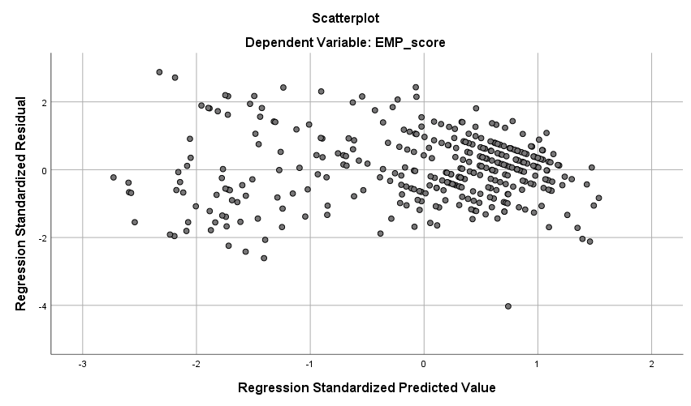
Figure 4.1: Standardized residual VS standardized predicted residuals showing homoscedasticity assumptions
Source: Field data, 2024

Result from Multicollinearity
Multicollinearity is defined as unnecessary inter-correlation among the independent variables (Hair et al., 2010; Kline, 2023). It occurs when two or more variables are connected in such a way that they both represent the same basic entity (Hair et al., 2010; Kline, 2023). The researcher also used Pearson's correlation matrix analysis of variables and Variance Inflated Factor (VIF) to test the existence of multicollinearity. Table 4.8, indicate that, the correlation coefficient of the paired variable ranged between 0.299 and 0.704, this communicate that the reading is between the recommended ranges. Kline, 2023 and Tabachnick &Fidell (2007) argued that, the correlation of any paired independent variable should not exceed 0.9.

Table 4.8: Correlation analysis for Multicollinearity
 | Variable |  | 1 2 |  | 3 |  | 4
1 | EMP | 1
2 | SEC | .420** |  | 1
3 | EKN | .544** |  | .299** |  | 1
4 | EOC | .704** |  | .554** |  | .477** |  | 1
5 | ETR | .602** |  | .275** |  | .571** |  | .552**
Source: Field Data, 2024

The researcher also tests the absence of multicollinearity by measuring the level of tolerance and variance inflation factor (VIF). Normally, when variance inflation factor is less than 10 and the tolerance value is less than 1, then it indicates the significance of the multicollinearity within independent variables, (Hair et al., 2010). The results in (Table 4.9) indicate the Variance Inflation Factor (VIF) ranging 1.522 and 1.746 and the tolerance value of ranging to 0.573 to 0.657.

Table 4.9: Collinearity Test Results
 | Collinearity Statistics
Variables | Tolerance | VIF
EKN | .636 | 1.572
ETR | .573 | 1.746
EOC | .657 | 1.522
Source: Field data, 2024

Model Evaluation
This section presents the results of analyses which were carried out to determine the factor structures and model fit based on the collected data. First, factor analysis trough Exploratory Factor Analysis (EFA) was carried out to determine how the measured indicators (variables) group together into the proposed structures. Second, confirmatory factor analysis (CFA) was carried out to confirm the factor structure generated by the EFA as well as to determine the extent to which the model fits the collected data. The first subsection (4.5.1) presents the results of the EFA.

Exploratory Factor Analysis
Exploratory Factor Analysis is a statistical tool that is used to measure interrelations between measured indicators (variables) and present the resulting factor structures (Hair et al., 2010). EFA aimed to ensure that, each item is loading into specific factor loading to accurate final results analysis of the modal. It is also useful in construct validity of a set of measurements by determine whether the items are associated with measurement. This is useful when the study involved a large set of variables i.e., data reduction. By reducing the large set of measured variables into factors, each measured indicator is shown to fall under the factor it measures best. This goes hand-in-hand with an assessment of sampling adequacy. The presence of correlation between the variables was assessed using the Kaiser-Meyer-Olkin (KMO) and Bartlett's Test of Sphericity. The results were presented in (Table 4.10) The results showed that, the sample is adequacy by0.966, which is higher than the threshold of 0.6 indicating that the sampling adequacy is met. The Bartlett’s test of sphericity returned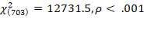. This is statistically significant showing that the correlation matrix is statistically different from an identity matrix. Both findings imply that, the data qualify for EFA.
Table 4.10: Table showing sample adequacy and correlation of the variable
Kaiser-Meyer-Olkin Measure of Sampling Adequacy. | .966
Bartlett's Test of Sphericity:
Approx. Chi-Square | 12731.533
Df. | 703
Sig. | .000
Source: Field Data, 2024

In deciding the number of factors to be retained, the Principal Component Analysis (PCA) was conducted, due to its ability of transforming a lager set of variables to smaller set of uncorrelated variables called principal components. The purpose is to maximize the variance explained by these components in order to attained to few manageable study items or constructs. The results (Table 4.11) show that out of 38 study items, five, constructs with Eigenvalue above 1 (Hair et al., 2010) were identified. The three factors cumulatively explained a total of 74.4% of the variance.

Table 4.11: Total variance explained by study variables
Component | Initial Eigenvalues |  |  | Extraction Sums of Squared Loadings |  |  | Rotation Sums of Squared Loadings
Component | Total | % of Variance | Cumulative % | Total | % of Variance | Cumulative % | Total | % of Variance | Cumulative %
1 | 17.009 | 44.761 | 44.761 | 17.009 | 44.761 | 44.761 | 7.293 | 19.193 | 19.193
2 | 4.695 | 12.354 | 57.115 | 4.695 | 12.354 | 57.115 | 5.956 | 15.675 | 34.868
3 | 3.050 | 8.028 | 65.142 | 3.050 | 8.028 | 65.142 | 5.477 | 14.414 | 49.282
4 | 2.145 | 5.644 | 70.786 | 2.145 | 5.644 | 70.786 | 4.838 | 12.731 | 62.014
5 | 1.389 | 3.655 | 74.441 | 1.389 | 3.655 | 74.441 | 4.723 | 12.428 | 74.441
6 | .709 | 1.866 | 76.308
Extraction Method: Principal Component Analysis.
Source: Field Data 2024

Furthermore, the scree plot criterion considers factors after inflection point to be retained. The scree plot (Figure 4.2) identified five factors above the inflection point with Eigen values greater than one. Beyond the inflection point (i.e., the 5th factor onwards,), there is no steep slope from one component to the other implying that the subsequent constructs did not have much variability to form another independent construct, and should be dropped (Hair et al., 2010).
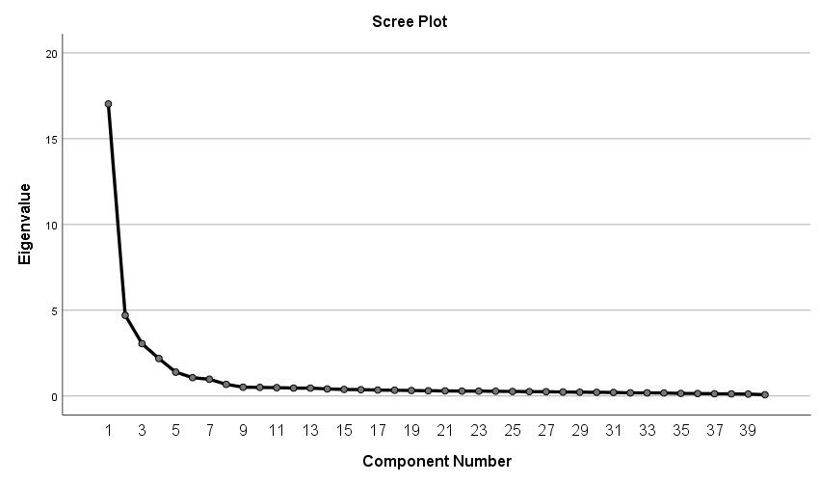
Figure 4.2: Screen plot graph
Source: Field Data, 2024

In addition, factor loading criterion was used to assess whether the factors (measured indicators) grouped onto their respective hypothesized factors/constructs, with no cross loading as well as having factor loadings of 0.50 and above (Hair et al., 2010). The results (Table 4.12) show that each measured indicator grouped onto its respective construct – EKN (10 items) with factor loadings ranging from 0.58 to 0.84; ETR (8 items) with factor loading ranging from 0.74 to 0.81; SE (6items) with factor loadings of 0.88 to 0.898; EMP (7 items) with factor loadings ranging from 0.659 to 0.74; and EOC (7 items) with factor loadings ranging from 0.67 to 0.75. No cross-loadings of the measured indicator variables were observed. Again, The Hair et al.’s (2010) criterion that a factor should have at least three items loading onto it to be retained was met in all constructs. Hence, all factors were retained for confirmatory factor analysis (CFA).
Table 4.12: Factor pattern matrix
Indicators | Factors
Indicators | 1 | 2 | 3 | 4 | 5
EKN8 | .841
EKN2 | .824
EKN3 | .815
EKN5 | .809
EKN1 | .796
EKN7 | .794
EKN4 | .788
EKN10 | .776
EKN6 | .774
EKN9 | .580
ETR3 |  | .805
ETR6 |  | .792
ETR2 |  | .785
ETR1 |  | .784
ETR7 |  | .770
ETR8 |  | .762
ETR4 |  | .757
ETR5 |  | .736
SEC5 |  |  | .898
SEC2 |  |  | .889
SEC1 |  |  | .883
SEC6 |  |  | .883
SEC4 |  |  | .878
SEC3 |  |  | .876
EMP6 |  |  |  | .743
EMP2 |  |  |  | .727
EMP7 |  |  |  | .721
EMP5 |  |  |  | .715
EMP3 |  |  |  | .704
EMP1 |  |  |  | .703
EMP4 |  |  |  | .659
EOC5 |  |  |  |  | .746
EOC2 |  |  |  |  | .738
EOC1 |  |  |  |  | .721
EOC7 |  |  |  |  | .720
EOC6 |  |  |  |  | .719
EOC4 |  |  |  |  | .707
EOC3 |  |  |  |  | .670
Source: Field data, 2024

Factor Correlation Analysis
The factors analysis was examined, to determine the relationship between variables to a smaller number of factors that capture the underlying structure of the data. The intentions here are to establish how factors are related to each other. The factors here are referred to the latent variables that share observed variable. The purpose is to reduce the multiple correlations between factors. A high relationship implied that two or more factors have a compact relationship with each other, whereas a little relationship implied that the factors are scarcely related. In this study, the correlation matrix between the factors was inspected for a reason of surveying their interrelationship, (Kline, 2023). Table 4.13 demonstrated moderate relationships among the variables, consequently recommending that the variables for these investigations were different and had limited inter-relationship.

Table 4.13: Bivariate correlation analysis of study constructs
Factor | EKN | ETR | EOC | SEC
EKN | 1
ETR | .571** | 1
EOC | .477** | .552** | 1
SEC | .299** | .275** | .554** | 1
EMP | .544** | .602** | .704** | .420**
Source: Field Data, 2024

Confirmatory Factor Analysis

Confirmatory Factor Analysis (CFA)
A multivariate statistical technique was employed to establish the extent to which the measurement model fitted the data. This was done to ensure the validity and reliability of the study constructs. The technique, driven by the theoretical relationship among the observed variables, was used to confirm the measurement model suggested by the EFA (Hair et al., 2010). Hooper et al., (2008), remarked that, CFA is employed to analyse the hypothetical construct through surveying the error variances, covariance and loadings of the measures. The CFA involved two steps. The first was to construct a measurement model for each of the study’s constructs, and the second was to construct an overall model of all constructs. The models were then assessed based on the model fit indices (Table 3.4) in Chapter Three. Confirmation of the Measurement Models for each Construct. Hair et al. (2010) and Kline, 2023 suggest that the measurement models for each construct should be created and tested independently before the overall model is created and tested. The following subsections report the findings for the individual construct-based models.

Measurement Model for Entrepreneurial Knowledge (EKN)
Ten (10) indicators (EKN1- EKN10) were tested for the EKN model. The model fit test results (Figure 4.3) show the fit indices of CMIN/df = 6.75, CFI = 0.938, RMR = 0.028, TLI = 0.920, RFI = 0.908, PCFI = 0.730, RMSEA = 0.128, NFI = 0.928, and GFI = 0.884. Judging from CFI, RMSEA and GFI indices, the model was poorly fitted, requiring standardization.
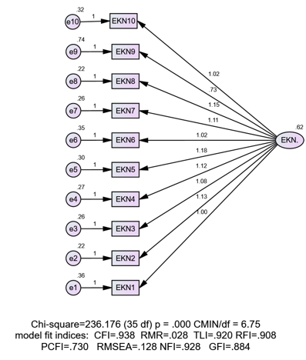
Figure 4.3: Measurement model fit for EKN
Source: Field data, 2024
Therefore, the model’s improvements were carried out by covarying the statistically recommended errors e7 and e8 and then e2 and e8. The output (Figure 4.4) shows that CMIN/df = 0.163, CFI = 0.999, RMR = 0.014, TLI = 0.999, RFI = 0.985, PCFI = 0.733, RMSEA = 0.014, NFI = 0.989, and GFI = 0.981. These results show a significant improvement in the model fit indices, and all met the recommended thresholds.
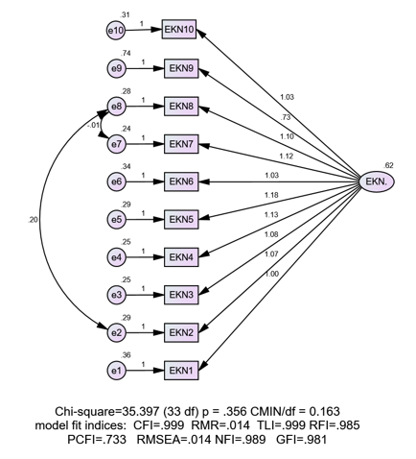
Figure 4.4: Standardized model fit for entrepreneurship knowledge
Source: Filed data, 2024

Model Fit for Entrepreneurship Training (ETR)
Eight (8) measure indicators (ETR1 – ETR8) were tested for the ETR model. The results (Figure 4.5) show the resulting model fit indices where, all indicator items had regression weights of above 0.5 and statistically insignificant at p = .059. The model fit indices were CMIN/df = 1.536, CFI = 0.995, RMR = 0.015, TLI = 0.994, RFI = 0.982, PCFI = 0.711, RMSEA = 0.039, NFI = 0.987, , and GFI = 0.979, all within the recommended thresholds. The results indicate a perfect model fit, and therefore all the items were retained for the entrepreneurship training construct.
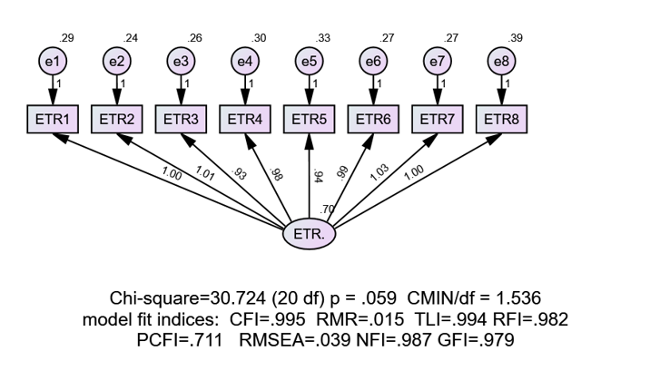
Figure 4.5: Model fit for Entrepreneurship Training (ETR)
Source: Field data, 2024

Model fit for Entrepreneurship Competence (EOC)
The seven (7) measured indicators (EOC1 – ECO7) were tested for the EOC construct. The results (Figure 4.6) show that all the regression weights were above 0.5 and statistically significant at p ≤ .05. The model fit indices were CMIN/df = 2.625, CFI = 0.988, RMR = 0.019, TLI = 0.982, RFI = 0.972, PCFI = 0.659, RMSEA = 0.068, NFI = 0.981, and GFI = 0.973, all are within the recommended thresholds.
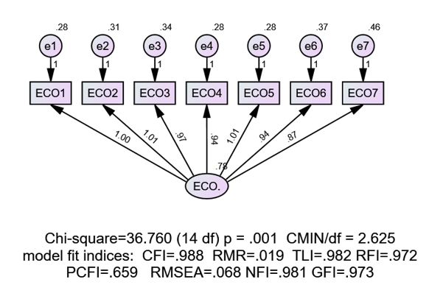
Figure 4.6: Model fit for Entrepreneurship Competence (ECO)
Source: Field data, 2024

Model Fit for Self-efficacy (SEC)
The six (6) measured indicators (SEC1 – SEC6) were tested for the SEC model’s fit. The results (Figure 4.7) show that all the regression weights were above 0.5 and significant at p ≤ .05. The model fit indices were; CMIN/df = 4.431, CFI = 0.988, RMR = 0.020, TLI = 0.980, RFI = 0.975, PCFI = 0.593, RMSEA = 0.099, NFI = 0.985, GFI = 0.963. Since the RMSEA and CMIN/df fit index were out of the recommended threshold, further improvement (standardization) on the model was necessary.
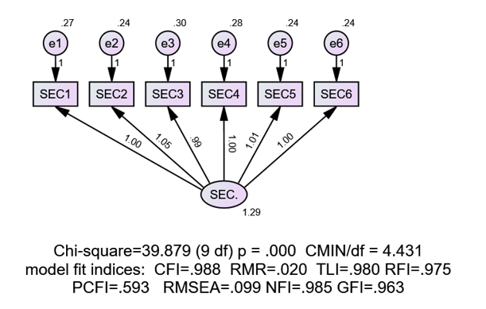
Figure 4.7: Model fit for Self-efficacy
Source: Field data, 2024
Improvements were conducted by covering the statistically recommended error terms, first, e3 and e5 and second, e3 and e4. The model was re-run and the results (Figure 4.8) show improvements in the model with CMIN/df = 0.647, CFI =1.000, RMR = 0.007, TLI = 1.002, RFI = 0.996, PCFI = 0.467, RMSEA = 0.000, NFI= 0.998, and GFI = 0.996, All indices were now within the recommended thresholds except PCFI. However, the model was retained because each fit category had a supported fit index and PCFI was only slightly less than the recommended threshold of .5.
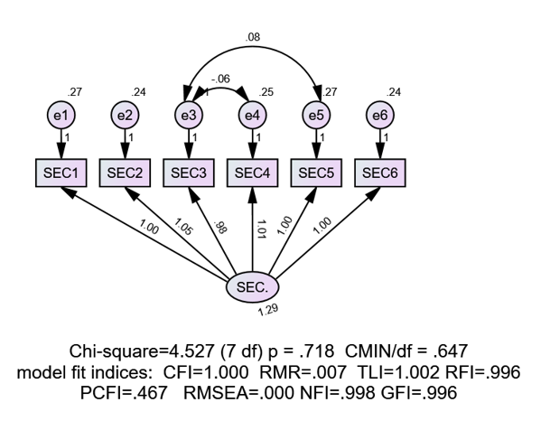
Figure 4.8: Standardized Model fit for Self-Efficacy (SEC)
Source: Field data, 2024

Model fit for Employability (EMP)
The seven (7) measured indicators (EMP1-EMP7) were tested for the EMP’s model fit. The results (Figure 4.9) show that all the regression weights were higher than .5 and statistically significant at . The model fit indices were CMIN/df = 0.647 CFI =0.989, RMR = 0.019, TLI = 0.984, RFI = 0.972, PCFI = 0.660, RMSEA = 0.059, NFI= 0.981, and GFI = 0.975. It is therefore concluded that the measurement scale for employability met the recommended thresholds.
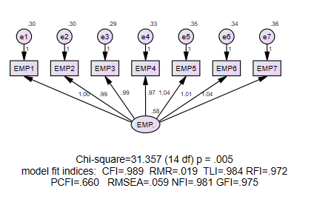
Figure 4.9: Model fit for employability
Source: Field data, 2024

The Overall Measurement Model
The measurement model fit showing all five study constructs is presented in Figure 4.10. Findings revealed that all of the model fit indices were met based on their stipulated cut-off points. The standardized regression weights were above 0.5 and statistically significant at p<.001. The model’s fit indices (Figure 4.13) were CMIN/df = 1.663, CFI = 0.991, RMR = 0.034, TLI = 0.990, RFI = 0.937, PCFI = 0.0,97, RMSEA = 0.023, NFI = 0.942, GFI = 0.900. These results imply that the data fitted well the model under consideration.
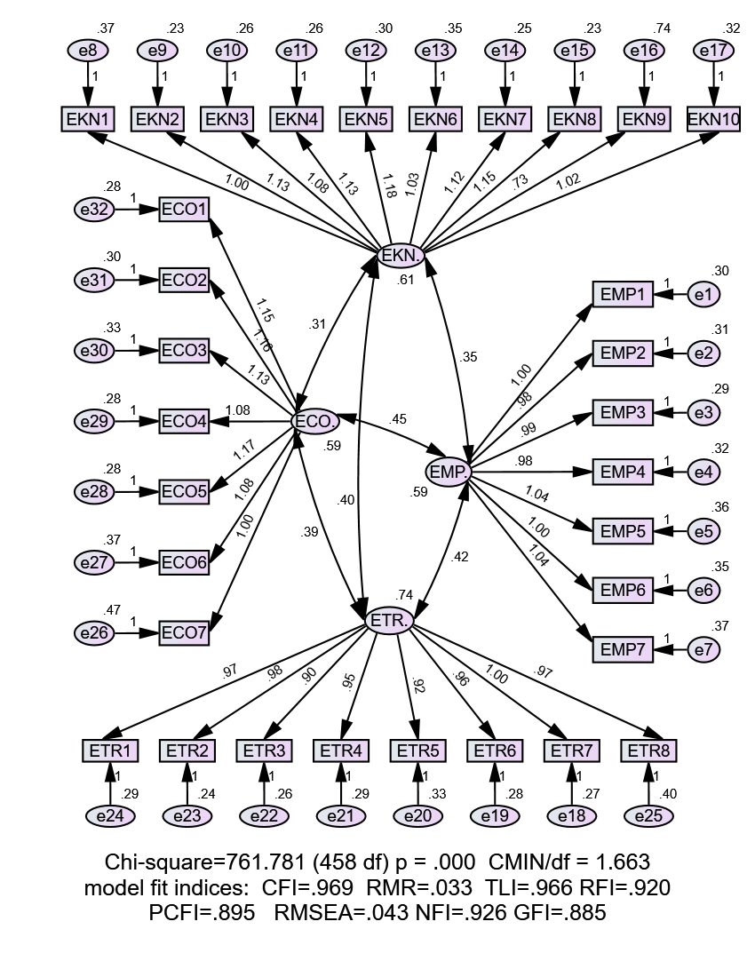
Figure 4.10: The overall Measurement Model
Source: Field data, 2024

The covariance as obtained from the measurement model of all five studies constructs after standardization were also presented as in table 4.13. We revealed a positive statistically significant covariance between any of the two studies constructs, as expected. This means that, to any increase of latent variable the other latent variable increases as well. The maximum covariance was 0.497 between ECO and SEC while the minimum covariance was 0.277 between ETR and SEC.

Table 4.14: Covariance between Studies Constructs After Standardization
 |  |  | Estimate | S.E. | C.R. | P | Label
EKN. | <--> | SEC. | .278 | .053 | 5.245 | *** | par_28
EKN. | <--> | ETR. | .406 | .048 | 8.451 | *** | par_29
ETR. | <--> | ECO. | .383 | .048 | 8.063 | *** | par_30
ETR. | <--> | SEC. | .277 | .057 | 4.834 | *** | par_31
EMP. | <--> | SEC. | .389 | .056 | 6.993 | *** | par_32
EMP. | <--> | ETR. | .421 | .048 | 8.775 | *** | par_33
EMP. | <--> | ECO. | .445 | .049 | 9.107 | *** | par_34
EMP. | <--> | EKN. | .353 | .043 | 8.153 | *** | par_35
EKN. | <--> | ECO. | .306 | .042 | 7.287 | *** | par_36
ECO. | <--> | SEC. | .497 | .061 | 8.150 | *** | par_47
Source: Field Data, 2024

Validity and Reliability Test
After the development of the model fit for both latent and observed variables were achieved, the next stage was to proceed with validity and reliability checks for the retained factors. A reliability test was carried out to establish whether the same results could be achieved if repeated. Construct validity, convergent validity, and discriminant validity were therefore tested in the study.

Construct Validity Results
Construct Validity test was done to confirm that, the actual data collection was in line with the proposed theory of the study. Construct validity was employed to test the validity of the results to verify their investigation in the study. In this study, construct validity was attained through monitoring the required level of model fit indices of a particular latent construct. Table 3.5 provides the threshold values of each category of the fit indices. Following this criterion, the overall measurement model indicated that all fit indices attained construct validity.

Convergent Validity Test Results
Convergent validity was based on the notion that a test should be similar to the construct it is supposed to measure. This is observed in the measurement model at the point where all the items reached the level of statistical significance (Hair et al., 2010). To measure convergent validity, it is recommended that the required standardized factor loadings should be 0.5 or above and ideally 0.7 as presented in Figure 4.10. The Average Variance Extracted (AVE) was also calculated for convergent validity. A value of 0.5 or above is regarded as enough to indicate a good convergent validity among items in the measurement scale for a specific construct (Hair et al., 2016). Table 4.15 indicates that all AVE values were above the recommended threshold of 0.5, ranging from 0.513 to 0.784. Therefore, a convergent validity was attained in each construct.

Table 4.15: Average Variance Extracted Values for the Measurement Model
Constructs | No. items | Cronb. Alpha | Comp. reliability | AVE
EKN | 10 | 0.952 | 0.940 | 0.613
ETR | 8 | 0.948 | 0.923 | 0.599
SEC | 6 | 0.968 | 0.956 | 0.784
EMP | 7 | 0.927 | 0.877 | 0.505
ECO | 7 | 0.938 | 0.880 | 0.513
Source: Field Data, 2024

Discriminant Validity Test Results
Discriminant validity refers to the extent to which the measures of latent variables are different from one another (Hair et al., 2016). In this study, the discriminant validity was assessed by employing two different approaches. The first was to determine the correlation between the constructs. Kline, 2023 suggests that discriminant validity is attained if the correlations between the constructs < .90. Therefore, by examining the results of correlations among the constructs, it was found that the correlations of all the constructs underlying the study were below .90, indicating that discriminant validity was attained. Secondly, the discriminant validity was assessed by the use of comparison between the square root of the average variance extracted (AVE) and the correlation of latent constructs as recommended by Fornell-Lacker (1981). According to (Awang & Mohammad, 2015; Awang, 2011), the discriminant validity of a construct would be attained when the square root of the AVE values is higher than the correlation estimates between it and the other constructs. Table 4.16 shows the results and they indicate that all AVE values are higher than the correlation coefficients between the target construct and the rest of the construct. Hence discriminant validity was achieved for all.

Table 4.16: Discriminant Validity Criterion
Factors | EKN | ETR | SEC | EMP | ECO
- EKN | 0.7829
- ETR | .57I | 0.7739
- SEC | .477 | .552 | 0.8854
- EMP | .299 | .275 | .554 | 0.7106
- ECO | .544 | .602 | .704 | .420 | 0.7162
Source: Field Data, 2024

Reliability Test Results
Reliability is referred to as the degree to which results are consistent over time and represent the studied population accurately. In other words, it means, if the study is replicated by using the same methodology by another researcher and yield similar results indicate the reliability of the research instrument. The researcher assessed the reliability of a set of items used to measure particular attributes of a factor by checking the internal consistency using the Cronbach's Alpha value. A scale test for reliability analysis was carried out on each of the constructs to assess its internal consistency and generated Cronbach’s Alpha coefficients. . The reliability analysis was done in IBM SPSS version 22, whereby Cronbach's Alpha value was calculated In addition, the reliability of these latent constructs was measured by composite reliability (C.R.) statistics. A measurement scale is considered to have adequate internal consistency if its Cronbach’s Alpha is ≥ .70 (Hair et al., 2010). Table 4.17 shows Cronbach’s Alphas ranged from .927 to .968 for all five constructs. All the Cronbach’s Alpha values obtained from the measured variables were above 0.7, confirming that the research instrument was reliable.

Table 4.17: Reliability statistics
Constructs | Cronbach’s Alpha | No. items
EKN | 0.952 | 10
ETR | 0.948 | 8
SEC | 0.968 | 6
EMP | 0.927 | 7
ECO | 0.938 | 7
Source: Field Data, 2024

Through CFA, composite reliability statistics were also generated for the same purpose. Hair et al. (2010) and Tabachnick and Fidell (2019) suggest that 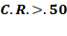 indicate a good composite reliability and 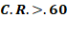 represents acceptable reliability. Results (Table 4.17) show that the C.R. statistics for all five constructs were >.70, ranging from .877 to .956. These results indicate that all five constructs attained acceptable reliability. Thus, based on the two statistics of Cronbach’s alpha and composite reliability, the measurement scale for all five constructs were reliable.

Table 4.18: Composite Reliability for the Measurement Model
Latent Variable | EKN | ETR | SEC | EMP | ECO
Composite Reliability | 0.940 | 0.923 | 0.956 | 0.877 | 0.880
Source: Field Data, 2024

The Overall Structural
Following the results of the overall measurement modal, the overall structural model containing different measurement models of independent variables (EKN, ETR, and ECO) and dependent variable (EMP) was analysed. The model fit indices were evaluated, and the path coefficient showing the relationship between the EE and EMP were evaluated. The results are summarized in the following subsections.

Structural Equation Model
The structural model consisting of different measurement models of independent constructs (EKN, ETR, and ECO) and dependent construct (EMP) was run and the hypothesized paths were evaluated. The results of the analysis are shown in Figure 4.12. At this point the purpose was to evaluate the path coefficients from each of the three independent constructs (EKN, ETR and ECO) to the dependent construct (EMP). Before that the model structure statistics is re-evaluated and the model fit statistics were CMIN/df = 1.198, CFI=0.991, RMR =0.031, TLI=0.990, RFI= 0.942 PCFI=0.909, RMSEA= 0.024, NFI = 0.947 and GFI = 0.914, representing a good model fit.
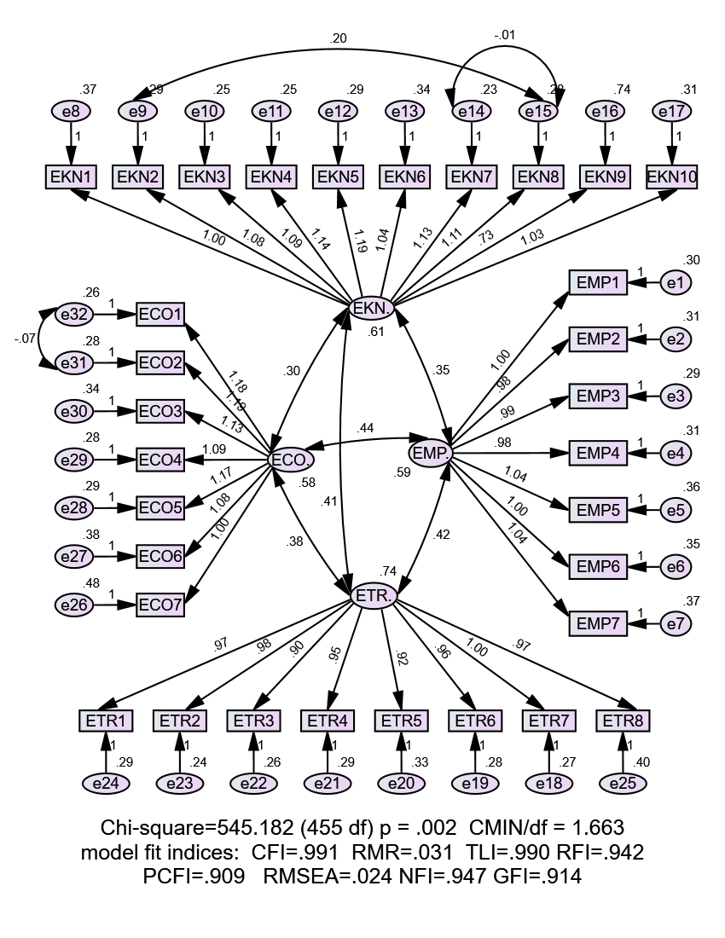
Figure 4.11: The Structural model
Source: Researcher, 2024
Then to establish the influence of each of the independent constructs on employability, the path coefficient estimates were evaluated for significance at  the results are presented in Table 4.18

Table 4.19: Path estimates between ENK, ETR, ECO and Employability
H. No. | Paths | Estimate |  | S.E. | C.R. | P | Remarks
 |  | Unstandardized | Standardized
H1 | Employability < entrepreneurial knowledge | .181 | .185 | .048 | 3.769 | *** | Supported
H2 | Employability < Entrepreneurial training | .191 | .214 | .047 | 4.080 | *** | Supported
H3 | Employability < Entrepreneurial competence | .541 | .540 | .058 | 9.397 | *** | Supported
Source: Field data, 2024

Model Path Coefficients and Hypothesis Testing
The Structural Equation Modelling (SEM) was used to test the postulated hypothesis of the study. The following subsections present the results of the path analysis.

Influence of Entrepreneurship Knowledge on Employability
This study argued that there will be a positive relationship between entrepreneurship knowledge and the employability of TVET graduates. Hence it hypothesized that:
H1: Entrepreneurial knowledge has positive influence the employability of TVET graduates.
The results (Table 4.18) show that entrepreneurial knowledge is positively and significantly associated with employability, (β = 0.181, ρ <.0.01) this implies that for each unit increase in EKN, the EMP is increased by 0.18. Moreover, based on the standardized estimate (beta = 0.185), relative to those of the other two independent variables, entrepreneurial knowledge was the least contributor in explaining the variability in employability. Therefore, H1 is supported, implying that entrepreneurial knowledge had a positive and significant influence on the employability of the graduates of TVET institutions in Tanzania.

Influence of Entrepreneurship Training on Employability
From the literature review it shown that there was a relationship between Entrepreneurship Training and Employability of graduates. As results, the study hypothesized that:
H2: Entrepreneurial training has positively influenced the employability of TVET graduates.
The results (Table 4.18) show that entrepreneurship training is positively and significantly associated with employability, 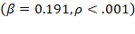 this implies that for each unit increase in ETR, the EMP is increased by 0.19. Moreover, based on the standardized estimate, 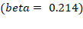, relative to those of the other two independent variables, entrepreneurial training was the second contributor in explaining the variability in employability. Therefore, H2 is supported, implying that entrepreneurial training had a positive and significant influence on the employability of the graduates of TVET institutions in Tanzania.

Relationship between Entrepreneurship Competence and Employability
This study proposed a positive relationship between entrepreneurship competence and employability. It was argued that entrepreneurship competence increases the graduate’s level of employability and therefore the following was hypothesized:
H3: Entrepreneurship competence have positive influence employability of TVET graduates

The results (Table 4.18) show that entrepreneurial competence is positively and significantly associated with employability, 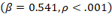, this implies that for each unit increase in ECO, the EMP is increased by 0.541. Moreover, based on the standardized estimate, 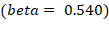, relative to those of the other two independent variables, entrepreneurial competence contributes more than the other two variables in explaining the variability in employability. Therefore, H3 is supported, implying that entrepreneurial competence had a positive and significant influence on the employability of the graduates of TVET institutions in Tanzania.

Multiple Group Moderation Analysis
To examine the effect of the moderation on the relationship between entrepreneurship education and employability, multiple group moderation analysis was carried out using IBM Amos version 23 and the Chi- square different test. The moderation analyses were conducted to test hypothesis four, five and six. A multi-group analysis measurement was included in the structural equation modal framework to test any type of construct between similar models. The initial step in the multi-group analysis was the split-up of data into two groups depends on the moderating variable (Memon et al., 2019). Using the theory of Human Capital and the theory of Self- Efficacy, this study assessed how self- efficacy moderating entrepreneurship education on employability of graduates of TVET institutions. The 5-point Likert scales using 6 determinant of self – efficacy was used to measure the impact. The respondents were requested to rate their position with regard statement on the scale of 1 to 5 (1= strongly disagree, 2=disagree, 3= neutral, 4= agree and 5= strongly agree. The descriptive analysis of the moderating variable (SEC) was done after presenting the variable on three groups, namely low, medium and high self-efficacy. A respondent was classified as having low SEC if the average score was below 3, having medium level of SEC if the average score was 3 and having high SEC if the average score was above 3. Majority were 223 (63.2%) with high levels of SEC while minority were 9 (2.5%) with medium levels of SEC and the low SEC were 121(34.3%). Table 4.19 gives more details.

Descriptive Statistics for the Moderating Variable
The moderating variable was Self – efficacy (SEC) measured using 6 observable items at a 5- point Likert scale. Using the average point score, the SEC was grouped into three categories namely; low self-efficacy group, moderate self-efficacy group, and high self- efficacy group. Following this clustering, the study revealed that, the majority was 223 (63.2%) group with high SEC, while the minority was 9 (2.5%) moderate SEC group and 121(34.3%) was the low SEC group as shown in Table 4.19.
Table 4.20: Description of SEC in three groups
SEC |  | Frequency | Percent | Valid Percent | Cumulative Percent
Valid | Low | 121 | 34.3 | 34.3 | 34.3
Valid | Medium | 9 | 2.5 | 2.5 | 36.8
Valid | High | 223 | 63.2 | 63.2 | 100.0
Valid | Total | 353 | 100.0 | 100.0
Source: Field Data, 2024

Kline, 2023 commented that, for a group to be considered during multi-group moderation analysis at least have 100 cases to be considered in the multi-group moderation analysis. Based on the above findings as presented in Table 4.19, it was revealed that the medium SEC had 9 cases thus requiring to be dropped during analysis.

Table 4.21: Description of SEC in two groups
SEC |  | Frequency | Percent | Valid Percent | Cumulative Percent
Valid | Low | 121 | 34.3 | 35.2 | 35.2
Valid | High | 223 | 63.2 | 64.8 | 100.0
Valid | Total | 344 | 97.5 | 100.0
Source: Field Data, 2024

Testing for Measurement of Invariance (MI)
Measurement invariance refers to whether an instrument is interpreted in the same way across different groups of individuals. According to (Hair et al., 2010), the measurement invariance test's main goal is to make sure that measurement models run under various circumstances provide an identical representation of the same construct. In addition, for each group, all parameters have to be freely estimated (Kline, 2023). Testing for measurement invariance is a dependable technique for evaluating equivalence in multi-group data. This is the initial stage of comparing structural models amongst groups to test theories. Kline (2023) asserted that the configure model's main function is to provide a standard by which all other invariance tests are measured. Therefore, before analysing various interactions of the construct among groups, it is imperative to assess the construct's invariances. According to Xu et al. (2017), measurement invariance with configurable metric and scalar invariance being the most common conditions to addresses the important question of whether measurement of a latent concept differs across groups. Because of this, (Kline, 2023)Kline, 2023 and Hair et al. (2010) assert that there are at least three essential phases in the stepwise process of assessing invariance. These involve;

Testing for Configural Invariance
The configural invariance test is the first test designed to confirm that all groups achieved the same overall factor structure derived from the proposed measure. In this specific instance, the researcher confirmed that every CFA model group had the same unobserved components and associated indicators. According to Byrne & Van de Vijver, (2017), a researcher can test for invariance in configural model after verifying that each group has the same number of construct and item associated with each construct. It was therefore advised that all of the factors and indicators related to the factors be the same during the configural invariance testing. Under each group, all parameters should be simultaneously freely estimated (unconstrained) (Kline, 2023). Multi-group CFA analysis was Performed, which involved fitting the model under freely unconstrained estimate after including the overall models for groups with low and high Self- efficacy under the same data file, followed by fitting the model under freely unconstrained approximation. The study revealed that, the two models attained the configural non –invariance as evidenced by the model fit indices and corresponding CMIN values of 1140.988 which was statistically significant at less than 1% level (p = 0.000). The configure model’s summary for composite chi-square was indicated in Table 4.22

Table 4.22: Assessment of the Configural Invariance Model
Model | NPAR | CMIN | DF | P | CMIN/DF
Unconstrained | 152 | 1140.988 | 904 | .000 | 1.262
Measurement weights | 124 | 1266.995 | 932 | .000 | 1.359
Structural weights | 121 | 1288.587 | 935 | .000 | 1.378
Structural covariance’s | 115 | 1495.835 | 941 | .000 | 1.590
Structural residuals | 114 | 1531.058 | 942 | .000 | 1.625
Measurement residuals | 82 | 1631.579 | 974 | .000 | 1.675
Saturated model | 1056 | .000 | 0
Independence model | 64 | 9999.279 | 992 | .000 | 10.080
Source: Field Data, 2024

In line with Table 4.24, the multi- group CFA created the readings of TLI = 0.926, CFI = 0.927, RMSEA = 0.044, NFI = 0,837, PCFI = 0.910 GFI = 0.784 and CMIN/df = 1.675 as indicated in the figure 4.20. This made a researcher to affirm that, the goodness of fit indices was satisfactory and configure model fit has been accomplished. Therefore, the researcher declared that, the multi-group CFA model for both level of self- efficacy group had similar number and indicator variables related with each construct hence conformity of the model fit was declared.
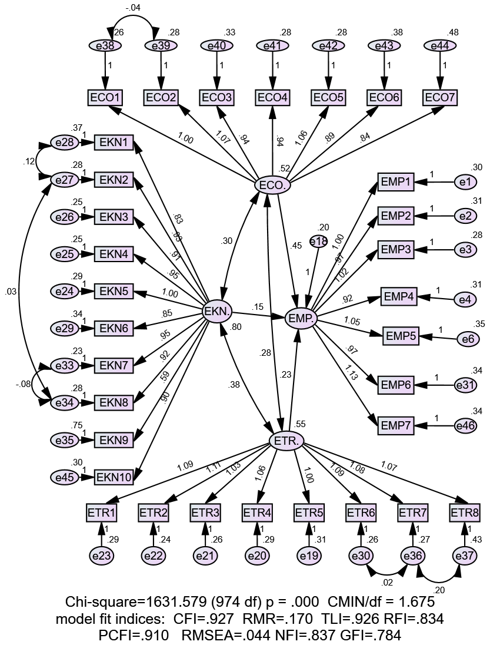
Figure 4.12: The Structural model for multi group CFA
Source: Researcher, 2024

Chi-Square Test Difference for Moderation
Analysis of Chi- square different test among constrained and fully constrained employing IBM Amos modal was performed. The Chi-square difference test for moderation analysis between the fully constrained and the unconstrained model was undertaken. The non-invariance is achieved given that the hi-squared difference between the two stipulated models is statistically significant. We revealed the Chi-squared difference of 144.217 being statistically significant at p <0.0001 hence implying that the non-invariance between the fully constrained and unconstrained model was achieved. The results indicate that there are model-level differences between the two groups, suggesting the possibility of moderation and opening the door for additional route by path analysis to identify the paths causing the moderating. The results are summarized in 4.22 and 4.23.

Table 4.23: Chi-square test for moderation analysis output
Model | DF | CMIN | P | NFI  Delta-1 | IFI  Delta-2 | RFI  rho-1 | TLI  rho2
Measurement weights | 28 | 126.007 | .000 | .013 | .014 | .010 | .011
Structural weights | 31 | 147.599 | .000 | .015 | .016 | .012 | .013
Structural covariances | 37 | 354.847 | .000 | .035 | .039 | .032 | .036
Structural residuals | 38 | 390.070 | .000 | .039 | .043 | .036 | .040
Measurement residuals | 70 | 490.591 | .000 | .049 | .054 | .041 | .045
Source: Field Data, 2024

According to this perspective, moderation occurred as evidenced by the large Chi-square difference that was found between the constrained model and the constrained model. As a result, in order to ascertain the precise path that moderation has taken, the researcher moves on to a subsequent analytical stage known as path-by-path analysis.
Table 4.24: Statistical tool package Chi-square output
 | Chi-square |  | df |  | p-value | Invariant?
Overall Model
Unconstrained |  | 1288.587 |  | 935
Fully constrained |  | 1432.804 |  | 962
Number of groups |  |  |  | 2
Difference |  | 144.217 |  | 31 | .000 | NO
Constrained path
EMP <--- EKN |  | 1982.1 |  | 936 | .000
EMP <--- ETR |  | 1936.981 |  | 936 | .000
EMP <--- ECO |  | 1897.974 |  | 936 | .000
Chi-square Thresholds
90% Confidence |  | 991.86 |  | 936
Difference |  | 296.727 |  | 1 | 0.100
95% Confidence |  | 1,008.28 |  | 936
Difference |  | 280.307 |  | 1 | 0.050
99% Confidence |  | 1,039.58 |  | 936
Difference |  | 249.007 |  | 1 | 0.010
Source: Field Data, 2024

Path by Path Moderation Analysis
The path-by-path moderation analysis was done by comparing the Chi-square values based on the constrained and unconstrained models. The study had three independent variables and one dependent variable making a total of three paths. The path analysis was conducted by restricting one path after another and hence making comparisons of the computed chi-squared value to critical values. In case, the computed chi-squared values were larger as compared to a critical value, then the statistically significant moderation effect was reported. The study stated by constraining path EMP <--- EKN, while other paths were set free for estimation, The computed model Chi-square value was 1982.1 which was statistically significant at p<0.001 as shown in Table 4.23 compared to the threshold Chi-square value, it was found that the 1982.1 was greater not only at 10% level but also at the 5% and 1% levels the results mean that there was a statistically significant moderating effect SEC on the relationship between EKN and EMP.

The second path for the constrained path was for the EMP <--- ETR, leaving other paths freely estimated from the model. The computed model Chi-square value was 1936.981 which is greater as compared to the threshold Chi-square value even at 1% level shown in Table 4.23. Therefore, these results imply there is a statistically significant moderating effect of SEC on the relationship between ETR and EMP. The third and lastly path for constrained was EMP <--- ECO, leaving another path to be estimated freely from the model. The computed Chi- squared value was 1897.974 which were even larger as compared to the threshold Chi- squared value of 1,039.58 at 5% level shown in Table 4.23. The results mean that there was statistically significant moderating effect of SEC on the relationship between ECO and EMP.

Moderation Effects of Determinants of Entrepreneurship Education
Hypotheses four to six (H4 – H6) aimed at determining which group (low or higher) of self–efficacy is more affected by the moderator variable. To attain this assumption, the unconstrained model was performed independently using the dataset for both low and high levels of self-efficacy. Then the structural modal was performed independently using the two datasets to test for the hypothesis. Following the fact that the two-dataset archived configure invariance then the two models produced significant estimates through comparable structure. Then the researcher employs the dataset for the two groups' (low and high) self-efficacy to run the unconstrained model for hypothesis testing. The strengths of the corresponding estimates of the standardized parameters and significance level for the both datasets were then compared. In assessing the moderating effect of SEC on the effect of EE on EMP, the structural model for the two-group analysis was set. Then the modal estimation was undertaken to determine the effect of each construct of EE (EKN, ETR and ECO) on EMP. The estimates including unstandardized as well as standardized estimates were reported for each group. Tables 4.27 and 4.28 present the effect of each indicator of entrepreneurship education on Employability for the low and high Self-efficacy groups respectively.

Table 4.25: Regression weights for low SEC group
 |  |  | Unstandardized Estimate | Standardized estimate | S.E. | C.R. | P | Label
EMP. | <--- | EKN. | .055 | .080 | .062 | .885 | .376 | b3_1
EMP. | <--- | ETR. | .206 | .286 | .072 | 2.864 | .004 | b2_1
EMP. | <--- | ECO. | .301 | .362 | .080 | 3.754 | *** | b1_1
Source: Field Data, 2024

This study had argued in chapter two that the relation between entrepreneurship education (EE) and (EMP) is stronger in higher self-efficacy than in low self-efficacy.

Table 4.26: Regression weights for high Self Efficacy Group
 |  |  | Unstandardized estimate | Standardized estimate | S.E. | C.R. | P | Label
EMP. | <--- | EKN. | .186 | .222 | .070 | 2.657 | .008 | b3_2
EMP. | <--- | ETR. | .388 | .316 | .111 | 3.508 | *** | b2_2
EMP. | <--- | ECO. | .465 | .435 | .080 | 5.782 | *** | b1_2
Source: Field Data, 2024

Moderating effect of Self-efficacy on Entrepreneurship Knowledge and Employability of Graduates
As indicated in the previous discussion the influence of EKN on EMP was assessed based on the two groups of low and high self-efficacy. The effect of EKN on EMP was also discussed as follows.

The Moderating Effect of EKN on EMP of Graduates for The Group with Low and High Self- Efficacy
Based on the group of high SEC, the study revealed that, for each unit increase in EKN the EMP increases by 0.186 and the increases were statistically significant at P ≤ 0.05 (0.008). Conclusively, using standardized estimates, the finding indicates a positive and significant effect of EKN on EMP. In the same line, based on the group of low SEC, the study revealed that for each unit increase in EKN, the EMP increased by 0.055. The observed increase was statistically Insignificant at P ≤ 0.05 (P = 0.376) similarly, using the scandalized estimates the study revealed that for each unit score increase in EKN, the employability increases by 0.222 in the low self-efficacy and 0.316 in the high self-efficacy group. Table 4.25 presents the findings.

The Moderating Effect of ETR on EMP of Graduates for The Group with Low and High Self-Efficacy
Based on the group with high self-efficacy, the results revealed that, each unity increase of entrepreneurship training employability is increased by 0. 388. The increase was statistically significant at p = 0.000. The observed positive effect of ETR and EMP using unstandardized estimates was also evidenced by a positive effect of 0.316 for standardized estimates. Comparing the results of the effect of ETR on EMP for both groups, it was indicated that, the effect of ETR on EMP among group with low SEC was lower by 0.206. The decrease was statistically at Significant at p ≤ 0.05 (0.004). Under these circumstances, we have stronger evidence of concluding that self-efficacy moderate positively the relation between entrepreneurship competence and employability of TVET graduates.

The Moderating Effect of ECO on EMP of Graduates for the Group with Low and High Self–Efficacy
The study revealed that, for each unity increase in entrepreneurship competence, employability increases by 0.495 among high self-efficacy group and this association was statistically significant at (p = 0.000) similarly evidence was reached using the standardized estimates for each unity increase in entrepreneurship competence employability, increases by 0.435, Table 4.25. In summary, we revealed that the effect of entrepreneurship competence on employability is higher among the high SEC group as compared to low SEC group. Thus, the finding support the hypothesis that, Self-efficacy positively moderates the relationship between entrepreneurship competence and employability among TVET graduates. Comparing the results on the moderating effect of SEC on the relationship between (EKN, ETR and ECO) and EMP, the finding revealed that effect of self – efficacy, on entrepreneurship competence is higher compared to other factors such entrepreneurship training and entrepreneurship knowledge. However, in the group of low self-efficacy, the study revealed that, for each unit score increase in entrepreneurship competence, the employability increases by 0.301 and observed increase was statistically significant at (p = 0.000). Further using standardized estimates, the positive relationship between entrepreneurship competence and employability was revealed. To conclude the moderating effect in low SEC has low effect compared to high level of SEC group. Generally, the relationship between Entrepreneurship Competence and Employability is stronger in the group of higher SEC group compared to group with low SEC group.

CHAPTER FIVE

DISCUSSION OF FINDINGS

Overview
This chapter discusses the descriptive and inferential findings of the study. It elaborates on the information generated in the previous chapter of data analysis and compares and constructs the current findings with the previous related studies. This helps to develop an in-depth understanding of the direct effect of entrepreneurship education on the employability of TVET graduates as well as its associated moderation effects of self-efficacy. The chapter is presented by considering descriptive statistics of the respondents, Inferential Statistics Analysis, and the effect of independent variables (EKN, ETR, and ECO) on employability. Furthermore, the chapter discusses how self-efficacy moderate’s entrepreneurship education for employability.

Descriptive Statistics for Respondents’ Demographic Factors
The study employed descriptive analysis to determine demographic information of the respondents such as, as age, gender, level of education, year of graduation, employment status, name of the college studied, and duration from graduation to employment were exposed to descriptive analysis. The result showed that, the majority of the respondents who participated in the survey were male by (61.2%), leaving women with 39%. The majority of respondents being male suggest a gender imbalance in the surveyed population. This indicates a potential bias in the survey results, as the experiences, opinions, and behaviours of men are likely to be more represented than those of women. To address this, future surveys could aim for a more balanced gender representation to ensure that the findings are more generalizable across both genders.

According to the age statistics, 94% of the respondents were aged between 20 and 40. This justifies the sample’s composition of the respondents are matured enough to provide reliable information about their employability status. The results also noted that, 50.6 % of the respondents had bachelor degree. This rationalizes that, the survey reflects a well-educated segment of the population. This influenced the results, as education level often correlates with specific attitudes, behaviours, and access to resources. This necessitates the future surveys to consider stratifying respondents by educational level to ensure that the perspectives of those with varying degrees of educational attainment are captured as well as graduates from technician levels. This can help in understanding how educational background influences the responses and in making more inclusive recommendations.

Overall, to improve the representativeness of the survey findings, future research should strive for a more balanced sample in terms of gender, age, and education level. This may involve employing different sampling techniques, outreach strategies, or weighted adjustments in the analysis phase.

Hypothesis Tests and Validation
In this section, the findings are compared to the hypotheses. They are confirmed to conclude the findings and results about the hypothetical predictions

The Influence of Entrepreneurship Knowledge on Employability of TVET Graduates
Objective one of this study aimed at examining the influence of entrepreneurship knowledge on employability of TVET graduates in Tanzania. Hypothesis one (H1) predicted that entrepreneurship knowledge has significant positive effects on employability of TVET graduates in Tanzania. The results in testing this hypothesis showed that entrepreneurship knowledge has significant positive effects on employability of graduates in Tanzania (γ = 0.185; C.R = 3.769; p = 0.000). This implies that for each unit increase in EKN, the EMP is increased by 0.18. Moreover, based on the standardized estimate, (beta = 0.185), relative to those of the other two independent variables, entrepreneurial knowledge was the least contributor in explaining the variability in employability. These findings supported H1. These findings also prove the human capital theory argument, which postulates a positive effect of entrepreneurship knowledge on the employability. Human capital theory emphasizes the acquisition of individual skills and knowledge as a means to enhance employability (Aboobaker, 2020; Jafari-Sadeghi et al., 2020). The theory suggests that, acquisition of knowledge and skills to individual through training increases individual abilities of doing new things hence become innovative. These findings are consistent with those from previous studies such as (Buana et al., 2017; Karyaningsih, 2020; Kozlinska et al., 2020; Malhotra et al., 2022; Tshikovhi & Shambare, 2015; Wibowo et al., 2023) whose findings supported the argument that the entrepreneurship knowledge has positive and significant impact on employability.
However, the findings are in contrary with the findings of (Roxas et al., 2008) whose findings showed entrepreneurial knowledge has insignificant effect on employability.
On the other hand, Ibrahim et al., (2022) and Rahmat et al. (2012) revealed insignificant relationship between EKN and Employability. These contradictory finding could be caused either by the studies being conducted in a different country with diversity in social, political, and economic factors as well as methodological approach. Thus, this signifies that, not only entrepreneurship knowledge is required for graduate’s employability there might be other important knowledge to be acquired by graduates to be employable.

The Influence of Entrepreneurship Training on the Employability of TVET graduates
Objective two of this study aimed at examining the influence of entrepreneurship training on employability of TVET graduates in Tanzania. Hypothesis two (H2) predicted that entrepreneurship training has positive effect on employability of graduate in Tanzania. The finding from tested hypothesis revealed that, (γ = 0.214; C.R = 4.080; p = 0.000). This implies that for each unit increase in ETR, the EMP is increased by 0.19. Moreover, based on the standardized estimate, (beta = 0.214), , native to those of the other two independent variables, entrepreneurial training was the second contributor in explaining the variability in employability. Therefore, H2 is supported, implying that entrepreneurial training had a positive and significant influence on the employability of the graduates of TVET institutions in Tanzania. These findings also proved by human capital theory which argued, that, there is a positive effect between entrepreneurship training and employability.
This result is consistent with the previous studies by Gavigan et al., (2020) who assessed the impact of entrepreneurship training on self-employment of rural female entrepreneurs in Tanzania. The results of this study revealed, positive relationship between of entrepreneurship training and self-employment. On the other hand, Kline, (2023) investigate the role of entrepreneurship training on job creation and youth empowerment in Somalia. The finding revealed that, entrepreneurship training positively influences job creation and youth employment. These findings were consistent with the findings of ( Cho & Honorati, 2014; Mittal & Raghuvaran, 2021; Suryawan et al., 2022; Yan et al., 2023) whose findings indicated that there is a significant positive effects of entrepreneurship training and employability. However, other previous studies showed contradictory finding such as (Popescu & Roman, 2018) in Romania which aimed at evaluating the effects of vocational training on employability in the labour market in Romania. The findings of his study indicated that the training has negative effects on employability in Romania. The contradictory finding on this study might be caused by several reasons including a variation of locality with diversity in social economic factors and policies in comparison with the locality of the current study.

The Influence of Entrepreneurship Competence on Employability of TVET Graduates
Objective three of this study aimed to examine the influence of entrepreneurship competence on the employability of TVET graduates in Tanzania. Hypothesis three (H3) anticipated that, entrepreneurship competence has positive influence on employability of TVET graduates in Tanzania. The results (Table 4.19) show that entrepreneurial competence is positively and significantly associated with employability, this implies that for each unit increase in ECO, the EMP is increased by 0.541. Moreover, based on the standardized estimate, (beta = 0.540), relative to those of the other two independent variables, entrepreneurial competence contributes more than the other two variables in explaining the variability in employability. This finding was positively supported (Blokker et al., 2019; Hodzic et al., 2015; Iglesias-Sánchez et al., 2019) whose findings showed that there is a significant positive effect of entrepreneurship competence on employability of graduates. These findings also prove the human capital theory on the argument, which postulates a positive effect of entrepreneurship competence on employability. The results revealed that ECO had a positive significant influence on employability of TVET graduates.

Regardless of the above, studies conducted by Jackson, (2014) and Moreira et al., (2022) in Australia and Portugal, which focuses on university, undergraduates students and employee of the service organization, revealed positive and insignificant relationship, between entrepreneurship competence and employability. However, Malebana & Vhukeya, (2023) assessed the relationship between Entrepreneurial Competencies and Entrepreneurial Intention among South African University Students a gender perspective. The finding postulates that, entrepreneurship education had an insignificant relationship with entrepreneurial competencies, and no significant differences were found between entrepreneurial competencies of the respondents who had had entrepreneurship education and those who did not. The inconsistent finding between studies might be resulted on the different in samples, methodologies, contextual factors and theoretical framework employed in the studies.

Furthermore, the study findings demonstrate that, entrepreneurship knowledge, training and competence had positive and significant impact on employability of TVET graduates in Tanzania. Therefore, as shown in structural equation modeling, a unit increase in this independent variable (entrepreneurship knowledge, training and competence) would result in a significant unit increase in employability of graduates from technical and vocational education and training. In that line, the policy makers, practitioners’ educators of TVET institutions, and community at larger should embrace the provisional of entrepreneurship competence which revealed larger contribution on graduate employability compared to entrepreneurship knowledge and training. The results of this study can also provide a focal point for policy reflection on the part of the state, with the goal of increasing investment in education to facilitate the entrepreneurship education.

Moderating Effects of Determinants of Entrepreneurship Education on Employability of Graduates
To ascertain the moderating effect of levels of self - efficacy, the entire sample was split into two groups, the group with low self - efficacy and those with high self-efficacy. According to the multi-group moderation analysis, the results of the Chi-square difference test did not show an invariant that demonstrated how the two models differed based on which Groups between the two have higher effect on employability of graduates. The following sections provide further details on the model comparison results.

The Effect of Moderation on the Relationship between Entrepreneurship Knowledge and Employability of Graduates
The multi-group analysis employing both low and high self-efficacy groups was used to analyse the relationship between entrepreneurship knowledge and employability of graduates in order to determine which groups of self-efficacies strengthen the relationship. Both low and high group of self-efficacies had a positive relationship results on the effect of moderation analysis. The finding revealed that, there was a stronger relationship between entrepreneurship knowledge and employability of graduates in the high level of SEC group with y = 0.186 and p = 0.008 compared to low level of SEC group. These confirm that the graduates with higher levels of SEC have more possibilities of employment. They view obstacles as opportunities to learn rather than as dangers to be avoided. This result supported the finding revealed by previous researchers such, Wang et al. (2023) and Doanh (2021) supported the results that, having low self-efficacy may alter graduates’ responsiveness to employability. Researchers such as Schunk and DiBenedetto (2021) argued that individuals with less self-efficacy level are unlikely to persevere and exert effort to overcome obstacles and enhancing their employability prospects.

The finding also indicated a positive and insignificant relationship in low level of SEC group y = 0.055 and p = 0.376 as displayed in Table 4.24 in the previous chapter. This means the group of graduates with higher level of SEC demonstrated high level of entrepreneurship knowledge hence increases the level employability; there are clear signs that the level of self-efficacy strengthens and improve this path from the entrepreneurship knowledge towards predicting employability of TVET graduates. Theoretically, the results of moderation analysis supported by empirical evidence that, self-efficacy positively moderate the relationship between entrepreneurship knowledge and employability of TVET graduates. The study added the understanding of the theory and entrepreneurship knowledge on estimating the predictive power of self- efficacy on estimating the contribution of human capital theory in predicting the employability of TVET graduates. Furthermore, the indication of the impact of the level of self-efficacy for each group and its effect on entrepreneurship knowledge on the employability of graduates prolonged the researchers understanding on the level of impact of self- efficacy on entrepreneurship knowledge towards employability of graduates. Empirically the researcher has taken into consideration and establish the relative influence of the levels of self-efficacy in moderating entrepreneurship knowledge and found that higher level self-efficacy promotes graduates’ employability. It indicates further that, individuals with high confidence in their abilities are more likely to translate entrepreneurship knowledge for employability, even if they have the necessary knowledge.

The Effect of Moderation on the Relationship between Entrepreneurship Training and Employability of Graduates
In order to test H5, the association between entrepreneurship training and employability of graduates were intergraded into multi group analysis comparing two groups. The high self – efficacy and the low self–efficacy groups were exposed to multiple group moderation analysis, to ascertain which group among the two is more influential than the other on moderation effect. After moderation, each group experiences a positive and significant relationship. The finding concluded that, both low and higher level of SEC possesses positive and significant relationship as a result of moderation. The study found that for the group that comprises with higher SEC, EMP increases by 0.388 `for every unit increase of ETR. The results confirm that, group with higher level of SEC, assumed to have higher relation with employability compared with group with low level of SEC. Statistically significant increase was noted at p ≤ 0.05(p = 0.000). In the same line the Table 4.24 standardized estimates revealed a positive and significant relationship between entrepreneurship training. Furthermore, the researcher looked for the group opted to score for low self- efficacy, the finding revealed that, to every unit of increase of entrepreneurship training, increased by 0.206. This relationship was statistically significant at p ≤ 0.05 (P= 0.004). The standardized estimates produce similar results, showing that EMP increases by 0.286 for every unit increase of ETR.

The results of this multi-group analysis were based on the fact that individuals with high level of self-efficacy were more confident about their own entrepreneurial skills and ability to start their own entrepreneurial ventures for the employability (Blokker et al., 2019). It was further argued that individual with higher level of self-efficacy have also ability and capacity to usefully undertake entrepreneurial tasks activities and overcome challenges (Blokker et al., 2019). Theoretically, this study assesses how the level of self - efficacy moderate relationship between level of self-efficacy knowing that there was a slightly difference in the level of significant between high and low group of SEC. Hence, SEC partially moderates the relationship between ETR and EMP and partially strength the path on HCT in predicting EMP.

The Effect of Moderation on the Relationship between Entrepreneurship Competence and Employability
The Relation between entrepreneurship competence and employability of graduates was integrated into a multi-group analysis by comparing the two groups, one that has high self-efficacy and the other one with low self-efficacy in order to ascertain which group is more impacted by the moderation effect. Both high level group of SEC and low-level group of SEC turned into a positive and significant relationship as a result of the effect of moderation analysis. The results indicated that y = 0.495 and p < 0.05 (0.000) under the high level of high SEC group. Subsequently, the results for the low SEC group were y = 0.301 and p < 0.05 at a significant level of p = 0.000. The ndings confirmed that the level of self – efficacy did not moderate the relationship between entrepreneurship competence and employability of TVET graduates. The findings suggested that low and highly level of self-efficacy holds entrepreneurship competence and employability in a similarly way. This showed that both group of low and high self- efficacy perceived entrepreneurship competence on similar way. This showed that there is no significant difference between high and low group of self-efficacies that influence entrepreneurship competence on employability of TVET graduates. Evidence showed that graduates with a high level of SEC possess some degree of resisting the temptation in performing actions which were influenced by their performance (Zhao & Zhao, 2021). Most importantly the behavior of an individual towards performance could be viewed in the literature to have both internal control and external control types (Abelha et al., 2020; Blokker et al., 2019).
With internal control, graduates were assumed to have adequate knowledge, abilities, skills and some discipline (competence) embedded when performing the behavior or task. In this context, graduates are considered the approval of peers and referenced groups to influence them into coming up with a positive attitude towards the behavior. The external control includes information patterning to employment, the ability to solve challenges they encountered when securing chances for their employment, reflecting the levels of self – efficacy attained (Abelha et al., 2020; Blokker et al., 2019; Zhao & Zhao, 2021). In connection to theoretical contribution, the Self - efficacy in relation to entrepreneurship competence and employability had no developed effect since there is no difference in the significance levels between the two groups, as such the strength of the relationship between entrepreneurship competence and employability in Human Capital Theory remained as it was in for both groups. This is because both low- and high-level groups of self-efficacies do not seem to affect employability in different significant manner.

The Final Model of the Study
This study intends to add information on the influence of entrepreneurship education on employability of TVET graduates in Tanzania. The study specifically assesses the relationship of entrepreneurship knowledge, entrepreneurship training and entrepreneurship competence on employability of TVET graduates using self – efficacy as a moderating variable. The Human Capital Theory was used to determine how entrepreneurship education influence employability, while moderated by self – efficacy in realizing employability of TVET graduates. The finding of the study revealed that, the entrepreneurship knowledge, entrepreneurship training and entrepreneurship competence positively influence employability of graduates in TVET institutions. Therefore, the study results confirm the theory of human capital. Further the finding of this study confirms that, the self-efficacy moderate some of the proposed relationship as presented in the final model in figure 5.1. The study also demonstrated that the level self-efficacy (low and high) moderated some of the proposed relationships as exhibited in the final model of the Study (Figure 5.1).
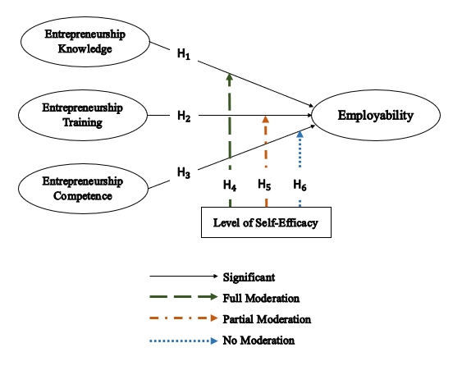
Figure 5.1: The final model of the study
Source: Field Data, 2023

CHAPTER SIX

SUMMARY CONCLUSION AND RECOMMENDATIONS

Overview
This chapter presents the conclusions of the study based on the analysis of the findings and discussions generated from the research objectives. There were four objectives presented in this study which are the following: to examine the influence of entrepreneurship knowledge on employability of TVET graduates in Tanzania; to examine the influence of entrepreneurship training on employability of TVET graduates in Tanzania; to examine the influence of entrepreneurship competence on employability of TVET graduates in Tanzania; to examine the moderating role of self-efficacy on the influence of entrepreneurship knowledge, training and competency on employability of TVET graduates in Tanzania. It also provides recommendations, theoretical and practical implications to policy makers, TVET regulators, Curriculum developers, and trainers of entrepreneurship education. Lastly, the chapter highlights the limitation of the study and area for further research.

Summary of Key Findings of this Study
Basing on the findings of the study, entrepreneurship knowledge, entrepreneurship training and entrepreneurship competence were identified as major determinants of graduates’ employability in TVET sector. This implied that the three determinants were strong factors that influenced graduate’s employability. Specifically, the study confirmed a positive and significant relationship between entrepreneurship education (entrepreneurship knowledge, Training and Competence) and employability of TVET graduates.

The study further confirmed the positive and significant relationship between entrepreneurship knowledge and employability. This implies that, as entrepreneurship knowledge increases, employability of graduates also increases. It also appeared that as entrepreneurship training had positive and significant relationship with employability. This implied that, the increases entrepreneurship training influences the increase of employability of graduates. The finding reconfirms a positive and significant relationship between ETR and EMP of graduates. This implied the increase of entrepreneurship training led to the increase of employability of TVET graduates. It was also confirmed in this study that there was positive relationship between Entrepreneurship competence and employability of graduates from TVET institutions. This implied that the increase of ECO led to the increases of EMP of TVET graduates in Tanzania. Thus, this justifies that, entrepreneurship education (entrepreneurship knowledge, Training and Competence) had influence on employability of graduate’s form TVET institutions. In a nutshell, the finding of this study confirms the theory of human capital on predicting employability of graduates. Additionally, the study revealed that the level of self -efficacy fully and positively moderated the relationships between entrepreneurship knowledge and employability of graduates. The findings revealed that there was a stronger relationship between Entrepreneurship knowledge and employability in high level of SEC group compared low level group of SEC. Further level SEC partially and positively moderates the relationship between entrepreneurship training and Employability of graduates, whereby the relationship between entrepreneurship training was slightly strong in high level of SEC than in low SEC group. It was further revealed that; the level of SEC partially moderates the relationship between ETR and EMP of graduates. Correspondingly, the findings confirm that there was no moderating effect between entrepreneurship competence and employability of graduates from TVET institution. This justified the fact that the level of SEC strengthens some relationship in the theory of human capital model hence improving its predicting power with respect to employability of graduates.

Conclusion
The study conclusion is divided into two subsections as follows; the first is the conclusion based on influence of entrepreneurship education on employability of graduates. The second conclusion is based on assessing the moderating effect when subjecting the determinants of entrepreneurship education (EKN, ETR, ECO) into multi-group moderation analysis using the level of self-efficacy. The comprehensive explanations of these conclusions are shown in the proceeding subsection.

Determinants of Entrepreneurship Education
Referring to the data analysis results, this study concluded by validating and confirming that entrepreneurship education was determined by entrepreneurship knowledge, entrepreneurship training and entrepreneurship competence. More broadly, this study sought to test the theory of Human Capital under the context of the employability of TVET graduates in Tanzania. The study found that all three factors of Human Capital Theory were positively related to the employability of graduates. The findings of this study supported the predictions of HCT. Hence, it’s clear that HCT is the most important theory in examining and predicting the employability of TVET graduates as in the case of this study.

The conclusion is also drawn by using specific objectives of determinants of entrepreneurship education; the first specific objective was to examine the influence of entrepreneurship knowledge on employability of TVET graduates in Tanzania. The results found that there is a positive and significant relationship between entrepreneurship knowledge and employability of graduates of TVET institution. Therefore, the study concluded that more increase of entrepreneurship knowledge to graduates the more employable they become. In relation to the second objective, the study concluded that entrepreneurship training had a positive and significant effect on employability of TVET graduates in Tanzania. The study hypothesized that there is a positive and significant relationship between entrepreneurship training and employability of graduates from TVET institutions. This concludes that, the increase of entrepreneurship training led to the increase of employability of graduates. Concerning the third specific objective, the study concluded that entrepreneurship competence had a positive and significant effect on the employability of graduates of TVET institutions. The increase of entrepreneurship competence led to an increase employability of graduates.

Moderation Effect on Determinants of the Entrepreneurship Education
Moderation analysis attempted to assess the effect of the level of self-efficacy on the relationship between Entrepreneurship Education (entrepreneurship knowledge, training, and competence) and employability of TVET graduates. The established results from moderation analysis are geared to strengthen the theory of the Human Capital in explaining employability of graduates. The moderation analysis indicated different results in the low and high level of self - efficacy groups from different paths of determinants of Entrepreneurship education and employability of graduates.
The results of this study revealed that the level of self-efficacy moderated the link between entrepreneurship knowledge and employability of graduates. This is because it displayed a very strong, positive and significant effect on the relationship between entrepreneurship knowledge and employability of graduates under high level of self- efficacy group but positive and insignificant relationship under the low level of the self- efficacy group. In addition, the effect of EKN on EMP was statistically significant among the high SEC group while a non-statistical in low SEC. In this view, the study has drawn up the conclusion that SEC moderates the effect of EKN on EMP. In connection to moderation effect on the relationship between entrepreneurship knowledge and employability of graduates, the full moderation result was attained because all the relationships turned to be positive and significant under both low and high level of self- efficacy groups with different levels of significant. Surprisingly, the results indicated a stronger relationship in the high level of self – efficacy group than low level of self – efficacy group. This proposed that graduates with higher level of self- efficacy are knowledgeable and inquisitive on matters related to entrepreneurship hence create chances for their employments maintain their employability status. Furthermore, in connection to moderation effect on the relationship between entrepreneurship training and employability of graduates, the partial moderation results were attained because all the relationship turned to be positive and significant under both low- and high-level group of SEC in different level of significant within a parameter. Surprisingly, the finding indicates a strong relationship in the higher level of SEC group than the low-level group of SEC. This indicates that, graduates with higher level of self-efficacy are likely to influence their personal motivation and performance towards works hence employable. With respect to the moderation effect on the relationship between entrepreneurship competence and employability of graduates, the results proved that level of SEC had no effect. This indicated that both low and high level of SEC entrepreneurship competence holds the same way the employability of graduates.

In summing up the conclusion, it can be said that this study has adopted some factors to analyse the influence of entrepreneurship education on employability of TVET graduates in Tanzania. Even though employability of graduates is among the challenges that have been expanding broadly in both developing and developed countries, the previous studies put much attention on the developed countries than in developing countries. Hence, the present study found a few fundamental insights based on the sector of TVET graduates that were not captured within the past research conducted on Influence of entrepreneurship education on employability of graduates in Tanzania.

The study also concludes that the theory of human capital can be improved by level of self-efficacy group. The moderation effect on this theory increases prediction power in explaining employability of graduates. Thus, this becomes a significant contribution to this study in the theoretical perceptive and in body of knowledge of academicians. This is so because the examination of moderation effect of level of self - efficacy to the theory of human capital has not considered (to the best of author’s knowledge).

Study Implications
This section provides the implications derived from findings, discussion and conclusions of this study. The implications are categorized into three groups, namely theoretical, practical as well as contextual implications. Theoretical Implication covered the contributions of the study in updating the methodology of the previous studies and theory on entrepreneurship education and its influence on employability of graduates from TVET institutions. The practical implication stressed on suggestions of TVET institutions, policymakers, curriculum developers and different stakeholders fighting against unemployment. Contextual implications concentrated on dynamics of the environment, TVET System variations, as well as access to perception of TVET.

Theoretical Implications
The theoretical contribution of any research is of great importance session that required to be addressed by the researcher Whetten (1989). Further, argued that acknowledging the relationship between the variables is among the method to advance a theory. In this study, the implication on theory was expressed on the fact that the study provided an Entrepreneurship education model which has been confirmed in Figure 5.1 and can be used as a source of reference for different scholars. The current researcher proposed incorporating the moderation effect of the level of self–efficacy in the theory of human capital to strength its predictive power on realizing employability of graduates. The theoretical contribution is also indicated by confirming that level of self-efficacy moderated the relationship between entrepreneurship education and employability of TVET graduates. This suggested that, individual confidence in applying their skills influence how well entrepreneurship education translates into job outcomes. It futher indicates that, human capital theory highlighted that, knowledge and skills alone are not sufficient for employability, personal factors like self-efficacy also play a role, although their influence may vary depending on the type of entrepreneurship factor (knowledge, training, competence). Therefore, to the best of author’s knowledge, level of self-efficacy has never been used as a moderator variable using HCT factors on entrepreneurial study relation to employability conducted in TVET sector in Tanzania. Therefore, the findings address a gap from the literature and contribute to theory by pointing out that level of self-efficacy strengthens the relationship between entrepreneurship educations and employability of graduates in TVET institutions in Tanzania.

Another theoretical contribution is to reconfirm the use of HCT in the employability of graduates of TVET institutions. The study tested HCT using its factors to examine the determinants of entrepreneurship education. The results indicated positive and significant relationships between the factors hence validated the HCT factors as the main determinants of the entrepreneurship education. However, the study addressed the pointed gap that there are contradictory results of HCT factors against employability of TVET graduates. Hence the current study supported the scholars who indicated that all the HCT factors have a significant effect employability of graduates.

Practical Implications
This study may help policy developers such as government and educational institutions to develop policies that emphasize the important of entrepreneurship education to enhance graduate employability, further the finding of the study may lead to the adjustment of TVET educational curricula, incorporating more practical competences to better preparedness of graduates for the evolving job market. Further practically the students with lower self-efficacy should be provided by with targeted programme that provide extra support in building confidence and practical experience, career counselling services department can use research finding to provide more targeted guidance to students, helping to understand the value of entrepreneurship education in enhancing their employability. The finding also creates need for professional development for graduates to continually train to update their skills and competences regarding factors of entrepreneurship education. This was revealed by the measured significant levels of each indicator used in the study that yielded positive significance to the employability of graduates. They may be also encouraged to engage in continuous learning and professional development recognizing the dynamic nature of the job market and the need for ongoing skill acquisition. Efforts for training should focus on providing knowledge to carry out business operations, financial monitoring, and use of technology in business, teamwork, knowledge of commercialization of business ideas, as well as knowledge of tax laws and regulations to secure the business. Practically, the increase of entrepreneurship education on graduate’s employability depends on many factors including student’s readiness to learn, (self-efficacy), entrepreneur training environment that includes available infrastructures for entrepreneurship training, availability of materials for practical training, Skilled facilitator to train and assess attained entrepreneurship competence-based training, among others. Policymakers and curriculum developers can use the findings as reference to address the economic issues resulted to graduates unemployment. Thus, government and social economic agencies should enhance entrepreneurial competencies, market-oriented approach, networking, and business ideas generation through suitable policies and developing training programmes. More effort should also concentrate on the creation of know-how knowledge for carrying out business operations. Practically also findings call for the purpose of joint effort for the creation of a platform for various entrepreneurship training providers and practitioners to create networking platforms for enhancing entrepreneurial capabilities, as suggested by Afzal et al. (2018).

Contextual Implications
Contextually the study finding provides an understanding of the variables of entrepreneurship education on the employability of graduates. The finding of this study also reflects Tanzania context. This is because Tanzania is among the county affected by graduate’s unemployment. This study provides an understanding of the determinants and entrepreneurship education have impact employability. The contribution of this study is also reflected in the Tanzania context. Therefore, the study widens the insights to the literature about the influence of entrepreneurship education on employability of TVET graduates using the moderating role of self- efficacy. Additionally, the previous studies conducted in Tanzania did not consider the moderation effect of level self-efficacy on the relationship between determinants of EE and EMP of graduates, hence, by incorporating a level of self-efficacy to that analysis more knowledge is revealed used as a source of reference by many scholars.

Recommendation from the Study
Study demonstrated clear influences of entrepreneurship education on employability of TVET graduates and expanded the literature on entrepreneurship education. This was very influential in increasing attention to the coming researchers in understanding the relationship between entrepreneurship education and employability of TVET graduates. This implied that, not all the determinants or measurements of EE may or may not be essential for employability of graduates under all level of self – efficacy of graduates. Therefore, it is recommended that TVET institutions curriculum developers, employers, trainers and policymakers should understand the entrepreneurship knowledge, skills and competence as principal determinants of employability of TVET graduates. Practically, the study discovered that entrepreneurship knowledge had stronger effects on employability of graduates with higher level of self-efficacy than the group of low-level self-efficacy. In the same note, Entrepreneurship Competence had more effect on the employability of a group of graduates with higher level of self- efficacy. Hence, the study recommended that policy makers and curriculum developers should concentrate impacting entrepreneurship competence when training students on entrepreneurship education programme that focuses to equip learners on understanding customers need, business opportunities, negotiation skills, ability of organizing business tasks, ability to monitor business progress and ability of overcoming obstacles. This research also recommended that graduates should be equipped with skills and ability to design goods and service that meet market test and demand. Therefore, government and private investors should enhance the entrepreneurship competence through policies and training programme to equip learners with required skills for their engagement. TVET institutions should design entrepreneurship programmes that cater to different levels of self-efficacy (low and high) that offers more hands-on practice and mentorship to boost their confidence and application of knowledge.

Limitation of the Study and Area for Further Study
This study had various limitations which may provoke starting point for further researches. Firstly, the study used three factors to assess the influence of entrepreneurship education on employability of graduates utilizing the level of self-efficacy as a moderator variable in Tanzania. The study suggests that future studies should use additional variables so as to improve the predication power of the model.
Secondly, In spite of generalization of the study, the research revealed the significant effect of the level of self - efficacy to graduate employability, the study recommends that more studies to be conducted employing level of self -efficacy in different settings using different methodologies to see if similar results will be obtained. Thirdly, the study draw sample from two technical public institutions, namely Dar es salaam Institute of Technology and Arusha Institute of Accountancy to generalize the finding, hence other researchers may opt to choose other institutions including vocational and private. The study further designated that, the entrepreneurship education plays a vibrant role in influencing employability of TVET graduates; there may be disparities with other factors for employability such as, soft skills, technology skills, professional certification and relevant work experience. This study selected only one factors for employability of graduates (entrepreneurship education); hence further research may choose another factor influencing employability of graduates to improve the findings.

REFERENCES

APPENDICES
Appendix I: Research Questionnaire
Dear respondents,
My name is Mahija Waziri, a PhD student from The Open University of Tanzania. I am researching on The Influence of Entrepreneurship Education on Employability of Technical and Vocational Education and Training Graduates in Tanzania: The Moderating Role of Self-Efficacy, targeting graduate from DIT and IAA who graduated on 2018, 2019, 2020 and 2021. Please note that the information provided will be kept confidential and strictly used for academic purposes. I also assure you that there will be no part of the report that will disclose your identity.

Section 1: Respondents Profile
Please tick [√] where appropriate
- Your gender
- Male [ ]
- Female

- Your age
- 20 - 30 years [ ]
- 31 - 40 years [ ]
- 41 - 50 years [ ]
- 51 or above [ ]

- The college from which you graduated
- DIT [ ]
- IAA

- Your graduation year
- 2018 [ ]
- 2019
- 2020

- Your current level of education
- Bachelor degree [ ]
- Masters [ ]
- Phd [ ]

- What is your current employment status
- Employed
- Self-employed [ ]
- Not Employed

- Is your current employment/self-employment aligned with your college studies?
- Yes, directly related to my field of study
- Yes, somehow related to my field of study [ ]
- No, not related to my field of study at all

- How long, on average, did it take for you to be employed after graduate from the college?
- 1-3 years [ ]
- 4-5 years [ ]
- 6 and above [ ]

Section II: Entrepreneurship Knowledge and Employability
Please tick [√] where appropriate

- Have you received any entrepreneurship education or training during your college studies?
[ ] Yes
[ ] No
- If you received any entrepreneurship education or training please rate, how effective was the entrepreneurship training in preparing you for the job market or entrepreneurial activities?
1 - Very Low,
2 - Low,
3 - Moderate, [ ]
4 - High,
5 - Very High

- How confident do you feel in your ability to apply entrepreneurial skills and knowledge in real-world work settings?
1 - Not confident at all,
2 - Slightly confident, [ ]
3 - Moderately confident,
4 - Very confident,
5 - Extremely confident
- Do you believe that your productiveness has influenced the relationship between your entrepreneurship knowledge, training, and competence, and your employability?
1 - Not at all,
2 - Slightly,
3 - Moderately,
4 - Significantly,
5 - Very significantly

Please tick [√] where appropriate
- Please indicate the extent to which you agree or disagree with the following statements by applying a tick (√) using the following guidelines:
1 = strongly disagree; 2 = disagree; 3 = neutral; 4 = agree; 5 = strongly agree
SN | Entrepreneurship knowledge- (Resources knowledge)
 |  | 1 | 2 | 3 | 4 | 5
 | I know how to find the resources (e.g. financial) to set up a business
 | I have a good understanding of how to manage financial resources
 | I am aware of how to use technology to achieve business goals
 | I have good understanding on how to work on team
 | I am knowledgeable about how to identify and target potential customers
 | I am aware of how to create a marketing plan
 | I understand how to increase sales
 | I have sufficient knowledge in commercializing a business idea
 | I have knowledge of how to protect intellectual property rights for a new business
 | I understand the importance of complying with tax laws and regulations

Section III: Entrepreneurship Training and Employability
- Please indicate the extent to which you agree or disagree with the following statements by applying a tick (√) using the following guidelines:
1 = strongly disagree; 2 = disagree; 3 = neutral; 4 = agree; 5 = strongly agree
 | Entrepreneurship training
 |  | 1 | 2 | 3 | 4 | 5
 | I received training that was helpful in building my confidence
 | I received training that motivated to pursue my goals
 | I received training that provided me with practical strategies for overcoming obstacles and setbacks
 | I received training on how to develop a proactive approach to problem-solving
 | I received training on how to set and achieve entrepreneurial goals
 | I received training on how to become more self-directed and take ownership of my entrepreneurial journey
 | I received training on how to manage my time effectively
 | I received training on how to promote product and service

Section IV: Entrepreneurship Competence and Employability
- Please indicate the extent to which you agree or disagree with the following statements by applying a tick (√) using the following guidelines:
1 = strongly disagree; 2 = disagree; 3 = neutral; 4 = agree; 5 = strongly agree
 | Entrepreneurship Competence
 |  | 1 | 2 | 3 | 4 | 5
 | I am able to identify customers’ needs
 | I am capable of developing business opportunity
 | I am capable of negotiating with others
 | I am able to treat new problems as opportunities
 | I am able to take reasonable business-related risks
 | I am capable of planning the operations of the business
 | I am able to determine strategic actions and overcoming obstacles

Section V: Self-Efficacy and Employability
- Please indicate the extent to which you agree or disagree with the following statements by applying a tick (√) using the following guidelines:
1 = strongly disagree; 2 = disagree; 3 = neutral; 4 = agree; 5 = strongly agree
 |  | Self-Efficacy | 1 | 2 | 3 | 4 | 5
 |  | I have always been successful on doing well tasks related to business
 | I do well on even the most complex business problems
 | I admire peers who are professional in conducting business activities
 | I enjoy learning about new things by observing or hearing about others' experiences.
 | I find it interesting to listen to others' stories and learn from their mistakes.
 | I am more likely to adopt new ideas or beliefs when they are endorsed by influential individuals

Section VI: Employability
- Please indicate the extent to which you agree or disagree with the following statements by applying a tick (√) using the following guidelines:
1 = strongly disagree; 2 = disagree; 3 = neutral; 4 = agree; 5 = strongly agree
 | Employability Questions
 |  | 1 | 2 | 3 | 4 | 5
 | I have good communication skills (verbal and written)
 | I possess good problem-solving skills
 | I have strong analytical skills
 | I am adaptable to changes
 | I am able to handle pressure and meet deadlines
 | I am a proactive person
 | I have consistently achieved good academic grades

Thank you
Appendix II: Assessment of Normality for the Study Variables
 | N | Minimum | Maximum | Mean | Std. Deviation | Skewness |  | Kurtosis
 | Statistic | Statistic | Statistic | Statistic | Statistic | Statistic | Std. Error | Statistic | Std. Error
EKN1 | 353 | 1 | 5 | 3.54 | .991 | -.431 | .130 | -.385 | .259
EKN2 | 353 | 1 | 5 | 3.58 | 1.003 | -.520 | .130 | -.295 | .259
EKN3 | 353 | 1 | 5 | 3.59 | .988 | -.571 | .130 | -.193 | .259
EKN4 | 353 | 1 | 5 | 3.60 | 1.023 | -.730 | .130 | -.036 | .259
EKN5 | 353 | 1 | 5 | 3.60 | 1.075 | -.579 | .130 | -.348 | .259
EKN6 | 353 | 1 | 5 | 3.56 | 1.001 | -.578 | .130 | -.097 | .259
EKN7 | 353 | 1 | 5 | 3.59 | 1.008 | -.640 | .130 | -.144 | .259
EKN8 | 353 | 1 | 5 | 3.58 | 1.017 | -.449 | .130 | -.458 | .259
EKN9 | 353 | 1 | 5 | 3.46 | 1.033 | -.084 | .130 | -.678 | .259
EKN10 | 353 | 1 | 5 | 3.69 | .979 | -.609 | .130 | -.044 | .259
EKN11 | 353 | 1 | 5 | 3.71 | 1.182 | -.753 | .130 | -.345 | .259
ETR1 | 353 | 1 | 5 | 3.64 | .994 | -.603 | .130 | -.129 | .259
ETR2 | 353 | 1 | 5 | 3.76 | .980 | -.729 | .130 | .214 | .259
ETR3 | 353 | 1 | 5 | 3.69 | .926 | -.715 | .130 | .364 | .259
ETR4 | 353 | 1 | 5 | 3.69 | .982 | -.644 | .130 | .034 | .259
ETR5 | 353 | 1 | 5 | 3.74 | .973 | -.839 | .130 | .576 | .259
ETR6 | 353 | 1 | 5 | 3.68 | .978 | -.851 | .130 | .516 | .259
ETR7 | 353 | 1 | 5 | 3.76 | 1.005 | -.697 | .130 | -.104 | .259
ETR8 | 353 | 1 | 5 | 3.73 | 1.048 | -.624 | .130 | -.301 | .259
ETR9 | 353 | 1 | 5 | 3.72 | .785 | -.283 | .130 | -.249 | .259
EOC1 | 353 | 1 | 5 | 3.44 | 1.035 | -.524 | .130 | -.261 | .259
EOC2 | 353 | 1 | 5 | 3.51 | 1.050 | -.485 | .130 | -.489 | .259
EOC3 | 353 | 1 | 5 | 3.59 | 1.043 | -.488 | .130 | -.381 | .259
EOC4 | 353 | 1 | 5 | 3.57 | .986 | -.542 | .130 | -.070 | .259
EOC5 | 353 | 1 | 5 | 3.56 | 1.040 | -.628 | .130 | -.201 | .259
EOC6 | 353 | 1 | 5 | 3.48 | 1.028 | -.399 | .130 | -.415 | .259
EOC7 | 353 | 1 | 5 | 3.66 | 1.032 | -.778 | .130 | .107 | .259
SEC1 | 353 | 1 | 5 | 3.44 | 1.251 | -.509 | .130 | -.840 | .259
SEC2 | 353 | 1 | 5 | 3.42 | 1.293 | -.434 | .130 | -.962 | .259
SEC3 | 353 | 1 | 5 | 3.39 | 1.245 | -.407 | .130 | -.919 | .259
SEC4 | 353 | 1 | 5 | 3.32 | 1.249 | -.366 | .130 | -.935 | .259
SEC5 | 353 | 1 | 5 | 3.47 | 1.250 | -.487 | .130 | -.882 | .259
SEC6 | 353 | 1 | 5 | 3.38 | 1.235 | -.526 | .130 | -.783 | .259
EMP1 | 353 | 1 | 5 | 3.81 | .941 | -.771 | .130 | .403 | .259
EMP2 | 353 | 1 | 5 | 3.81 | .936 | -.722 | .130 | .368 | .259
EMP3 | 353 | 1 | 5 | 3.76 | .930 | -.675 | .130 | .305 | .259
EMP4 | 353 | 1 | 5 | 3.82 | .937 | -.497 | .130 | -.306 | .259
EMP5 | 353 | 1 | 5 | 3.71 | .996 | -.674 | .130 | .146 | .259
EMP6 | 353 | 1 | 5 | 3.76 | .967 | -.669 | .130 | .072 | .259
EMP7 | 353 | 1 | 5 | 3.80 | .999 | -.957 | .130 | .749 | .259

Source: Researcher, 2024

Appendix III: Box Plot showing the Status of Outlies
A: Box plot showing the status of outlies for EKN variable
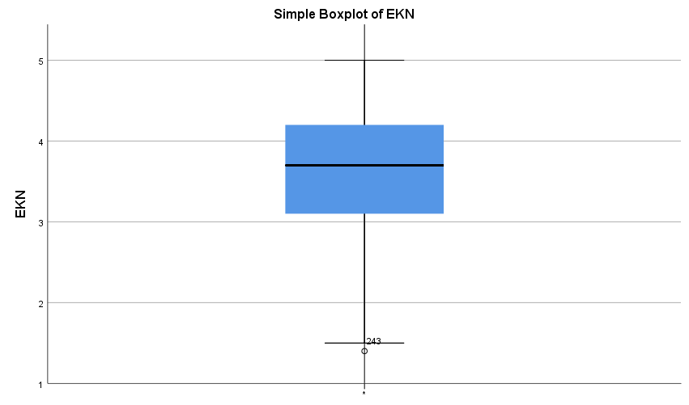
Source: Field Data, 2024

B: Box Plot showing the status of outliers for ETR variable
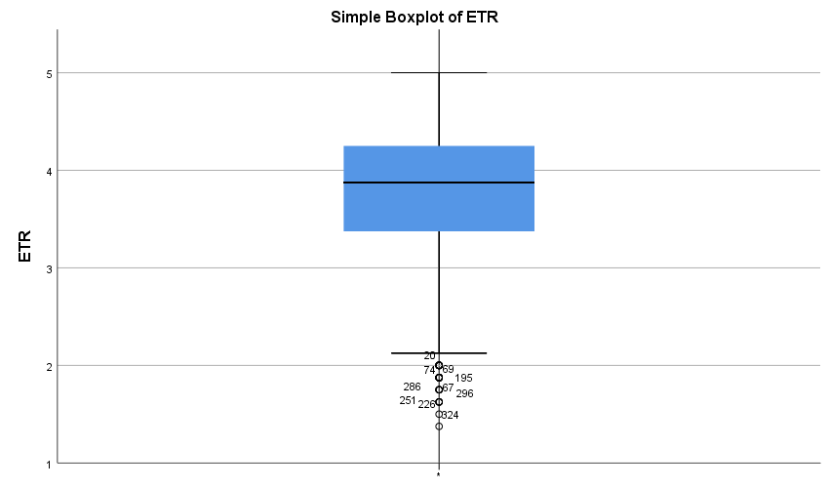
Source: Field Data, 2024

C: Box plot showing the status of outliers for the ECO variable
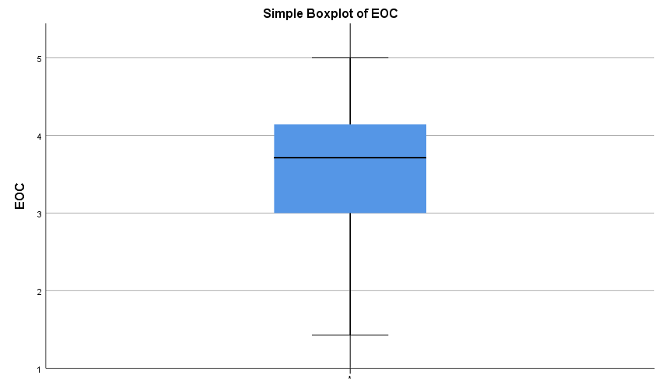
Source: Field Data, 2024

D: Box plot showing the status of outliers for SEC variable
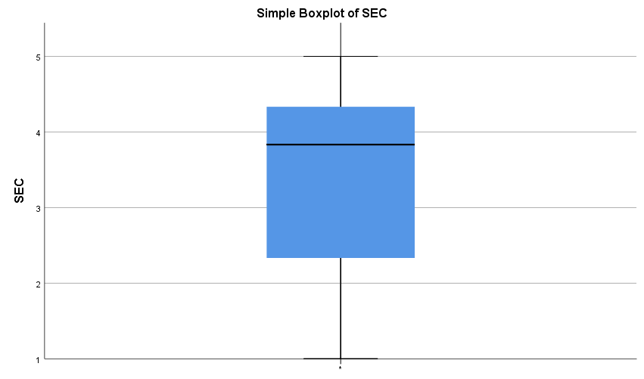
Source: Field Data, 2024

E: Box plot showing the status of outliers for EMP variable
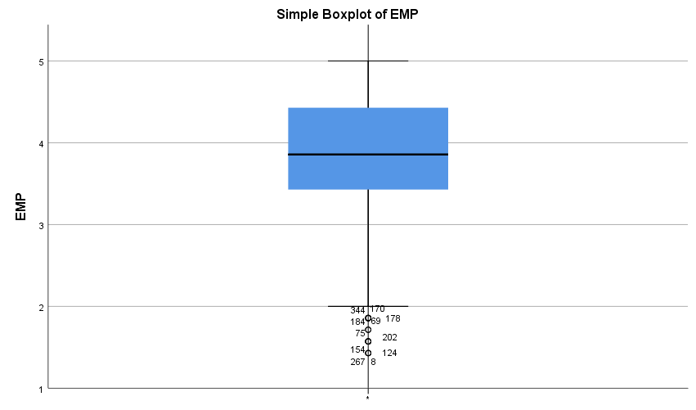
Source: Field Data, 2024

Appendix IV: Scatter plots for linear relationships figure 4.1 up 4.4
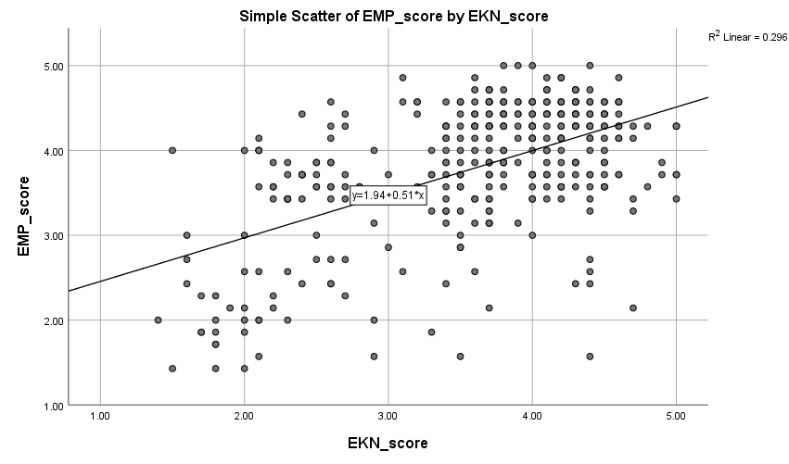
Figure A: Linearity relationship between EKN and EMP
Source: Researcher, 2024
Figure B: Linear Relationships between ETR and EMP 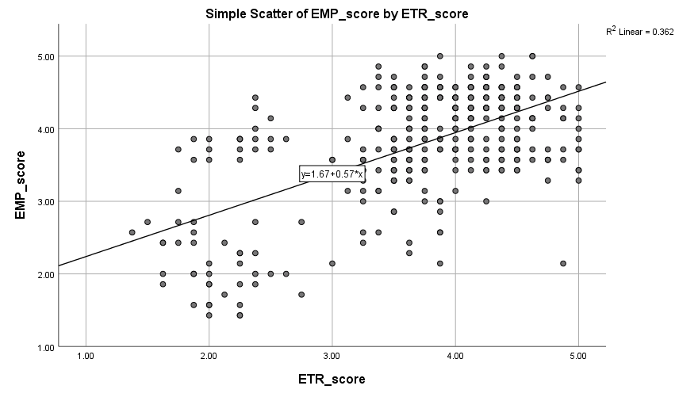Source: Researcher, 2024

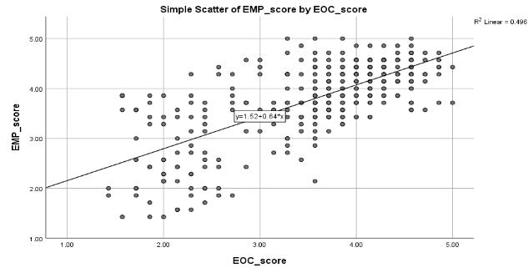
Figure C: Linear Relationships between ECO and EMP
Source: Researcher, 2024

Figure D Linear Relationships between SEC and EMP
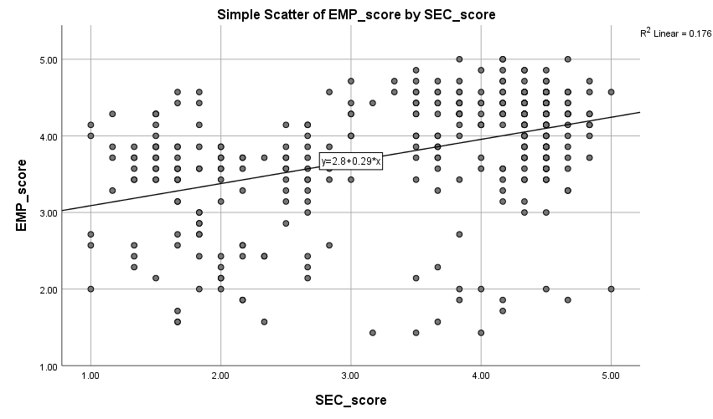
Source: Researcher, 2024
Appendix V: Table Showing Regression weights as from the structural model
 |  |  | Unstandardized Estimate | Standardized Estimate | S.E. | C.R. | P | Label
EMP2 | <--- | EMP. | .982 | .804 | .056 | 17.460 | *** | Significance
EMP3 | <--- | EMP. | .990 | .815 | .056 | 17.814 | *** | Significance
EMP4 | <--- | EMP. | .979 | .800 | .056 | 17.350 | *** | Significance
EMP5 | <--- | EMP. | 1.040 | .800 | .060 | 17.346 | *** | Significance
EMP6 | <--- | EMP. | 1.002 | .793 | .058 | 17.121 | *** | Significance
EKN4 | <--- | EKN. | 1.142 | .873 | .060 | 19.102 | *** | Significance
EKN5 | <--- | EKN. | 1.186 | .864 | .063 | 18.803 | *** | Significance
EKN6 | <--- | EKN. | 1.035 | .809 | .060 | 17.209 | *** | Significance
EKN7 | <--- | EKN. | 1.130 | .878 | .059 | 19.228 | *** | Significance
ETR6 | <--- | ETR. | .957 | .842 | .046 | 20.605 | *** | Significance
ETR5 | <--- | ETR. | .916 | .809 | .048 | 19.238 | *** | Significance
ETR4 | <--- | ETR. | .952 | .833 | .047 | 20.223 | *** | Significance
ETR3 | <--- | ETR. | .899 | .834 | .044 | 20.265 | *** | Significance
EOC6 | <--- | EOC. | 1.076 | .799 | .070 | 15.470 | *** | Significance
EOC5 | <--- | EOC. | 1.167 | .858 | .070 | 16.736 | *** | Significance
EOC4 | <--- | EOC. | 1.087 | .842 | .066 | 16.398 | *** | Significance
EOC3 | <--- | EOC. | 1.132 | .830 | .070 | 16.126 | *** | Significance
EOC2 | <--- | EOC. | 1.188 | .865 | .071 | 16.788 | *** | Significance
EKN1 | <--- | EKN. | 1.000 | .790
EKN2 | <--- | EKN. | 1.079 | .842 | .059 | 18.154 | *** | Significance
EKN3 | <--- | EKN. | 1.088 | .862 | .058 | 18.745 | *** | Significance
EKN10 | <--- | EKN. | 1.032 | .825 | .058 | 17.650 | *** | Significance
EKN9 | <--- | EKN. | .731 | .554 | .067 | 10.837 | *** | Significance
EKN8 | <--- | EKN. | 1.105 | .851 | .060 | 18.395 | *** | Significance
EOC1 | <--- | EOC. | 1.179 | .871 | .070 | 16.916 | *** | Significance
EOC7 | <--- | EOC. | 1.000 | .740
EMP1 | <--- | EMP. | 1.000 | .814
EMP7 | <--- | EMP. | 1.038 | .796 | .060 | 17.201 | *** | Significance
ETR1 | <--- | ETR. | .971 | .840 | .047 | 20.536 | *** | Significance
ETR2 | <--- | ETR. | .983 | .863 | .046 | 21.538 | *** | Significance
ETR8 | <--- | ETR. | .973 | .799 | .052 | 18.828 | *** | Significance
ETR7 | <--- | ETR. | 1.000 | .856 |  |  |  | Significance
Source: Researcher, 20244
Appendix VI: Table Showing Standardized and Unstandardized Estimates for Determinants of EMP
 |  |  | Unstandardized Estimate | Standardized Estimate | S.E. | C.R. | P | Label
EMP. | <--- | EKN. | .181 | .185 | .048 | 3.769 | *** | par_24
EMP. | <--- | ETR. | .191 | .214 | .047 | 4.080 | *** | par_25
EMP. | <--- | EOC. | .541 | .540 | .058 | 9.397 | *** | par_26
EMP2 | <--- | EMP. | .982 | .804 | .056 | 17.460 | *** | par_1
EMP3 | <--- | EMP. | .990 | .815 | .056 | 17.814 | *** | par_2
EMP4 | <--- | EMP. | .979 | .800 | .056 | 17.350 | *** | par_3
EMP5 | <--- | EMP. | 1.040 | .800 | .060 | 17.346 | *** | par_4
EMP6 | <--- | EMP. | 1.002 | .793 | .058 | 17.121 | *** | par_5
EKN4 | <--- | EKN. | 1.142 | .873 | .060 | 19.102 | *** | par_6
EKN5 | <--- | EKN. | 1.186 | .864 | .063 | 18.803 | *** | par_7
EKN6 | <--- | EKN. | 1.035 | .809 | .060 | 17.209 | *** | par_8
EKN7 | <--- | EKN. | 1.130 | .878 | .059 | 19.228 | *** | par_9
ETR6 | <--- | ETR. | .957 | .842 | .046 | 20.605 | *** | par_10
ETR5 | <--- | ETR. | .916 | .809 | .048 | 19.238 | *** | par_11
ETR4 | <--- | ETR. | .952 | .833 | .047 | 20.223 | *** | par_12
ETR3 | <--- | ETR. | .899 | .834 | .044 | 20.265 | *** | par_13
EOC5 | <--- | EOC. | 1.167 | .858 | .070 | 16.736 | *** | par_14
EOC4 | <--- | EOC. | 1.087 | .842 | .066 | 16.398 | *** | par_15
EOC3 | <--- | EOC. | 1.132 | .830 | .070 | 16.126 | *** | par_16
EMP1 | <--- | EMP. | 1.000 | .814
EMP7 | <--- | EMP. | 1.038 | .796 | .060 | 17.201 | *** | par_23
EKN1 | <--- | EKN. | 1.000 | .790
EKN2 | <--- | EKN. | 1.079 | .842 | .059 | 18.154 | *** | par_27
EKN3 | <--- | EKN. | 1.088 | .862 | .058 | 18.745 | *** | par_28
EKN10 | <--- | EKN. | 1.032 | .825 | .058 | 17.650 | *** | par_29
EKN9 | <--- | EKN. | .731 | .554 | .067 | 10.837 | *** | par_30
EKN8 | <--- | EKN. | 1.105 | .851 | .060 | 18.395 | *** | par_31
EOC1 | <--- | EOC. | 1.179 | .871 | .070 | 16.916 | *** | par_32
EOC2 | <--- | EOC. | 1.188 | .865 | .071 | 16.788 | *** | par_33
EOC7 | <--- | EOC. | 1.000 | .740
EOC6 | <--- | EOC. | 1.076 | .799 | .070 | 15.470 | *** | par_34
ETR8 | <--- | ETR. | .973 | .799 | .052 | 18.828 | *** | par_35
ETR7 | <--- | ETR. | 1.000 | .856
ETR1 | <--- | ETR. | .971 | .840 | .047 | 20.536 | *** | par_36
ETR2 | <--- | ETR. | .983 | .863 | .046 | 21.538 | *** | par_37
Source: Researcher, 2024
Appendix VII: Research Clearance for Arusha Institute of Accountancy


Appendix VIII: Research Clearance for Dar es Salaam Institute of Technology




PUBLICATIONS

