MICROSEEPAGE APPRAISAL AND CONTROL OF TAILINGS ST0ORAGE FACILITY: A CASE OF GEITA GOLD MINE, TANZANIA

JOHN A. MATARO

A DISSERTATION SUBMITTED IN PARTIAL FULFILLMENT OF THE REQUIREMENTS FOR THE DEGREE OF MASTER OF ENVIRONMENTAL STUDIES (SCIENCE)
DEPARTMENT OF PHYSICAL AND ENVIRONMENTAL STUDIES
OF THE OPEN UNIVERSITY OF TANZANIA
2024

CERTIFICATION
The undersigned certify that he has read and hereby recommend for acceptance by the Open University of Tanzania (OUT) a dissertation titled “Microseepage Appraisal and Control of Tailings Storage Facility: A Case of Geita Gold Mine, Tanzania”, in partial fulfilment of the requirements for the degree of Master of Science in Environmental Studies (Science) of the Open University of Tanzania.

…………………………….
Prof. Matobola Joel Mihale
(Supervisor)

……………………………
Date

………..……….…………….
Dr. Harieth Hellar-Kihampa
(Supervisor)

……………………………
Date

COPYRIGHT
This dissertation is a copy right material protected under the Berne Convention, the Copyright Act 1999 and other international and national enactments on that behalf of intellectual property. In this regard, “No part of this dissertation may be reproduced, stored in any retrieval system, or transmitted in any form by any means, electronic, mechanical, photocopying, recording or otherwise without prior written permission of the author or the Open University of Tanzania in that behalf”.

DECLARATION
I, John Astony Mataro, do hereby declare that this dissertation is my own original work and that it has not been presented and will not be presented to any other University for a similar or any other degree award. It hereby presented in partial fulfilment of the requirements for the degree of Master of Science in Environmental Studies (Science) of the Open University of Tanzania.

…………..………………
Signature

………………………….
Date

DEDICATION
This piece of work is provided as special dedication to my wife Lucy L. Lubala, daughter Jasmine and my lovely sons Joshua and Jonathan Mataro for their relentless supports, understanding and encouragement whenever I was busy, unavailable, and occupied with this work. I appreciate the contribution of my mentor and brother Dr. Mussa D. Budeba for his enormous support towards the completion of this study. I am grateful to each and every one that I may not be able to mention and appreciate for everything they have done to me, thus far.

ACKNOWLEDGEMENT
The research is a piece of work that I could not accomplish without an eternal and external supports. Praise be to the Almighty God for his protection, wisdom and spiritual guidance. I am also thankful for being part of the Open University of Tanzania’s Master of Environmental Studies (Science) student which only Devine can explain.

I am grateful to my employer, The Mining Commission under Eng, Yahya I. Samamba for the financial support that I greatly appreciate. I know the Commission has various equally important financial commitments, but they manage to include and implement my study programme in their tight financial obligations.

I am honoured and thankfully to be under my supervisors Prof. Matobola Joel Mihale the Dean of the Faculty of Science, Technology and Environmental Studies and Dr Harieth Hellar-Kihampa both from the Open University of Tanzania for their great psychological and emotional supports. They provided me with, constructive criticisms that were timely and promptly given, throughout my research.

My sincere gratitude to GGM Management team, and Sustainability Department especially Dr. Kiva Mvungi, Mr. Yusuph Mhando, Mr. Adili Lukumay and Ms. Josephine Kimambo for their great support. Firstly, I thank the management for the permission to conduct my research on their Special Mining Licence. Secondly, I thank them for secondary data that they provided to me, which were vital throughout my study. I really appreciate for their great contribution they offered to me to the completion of this work.
I would like to thank Dr Mussa D. Budeba – Chief Executive Secretary from GST for his support regarding machine learning and data analytics expertise. Furthermore, I would like to thank his institution and the people that he has created but I will not be able to mention all of their names one by one.

I will also want to thank Dr Abdulrahman Shaaban Mwanga, Commissioner for Minerals, and Ministry of Minerals for his immense support, advice encouragement and directives. I greatly thank the staffs from the Ministry for their support whenever I needed it.

Finally, My special appreciations to my lovely wife Lucy L. Lubala, my lovely sons Joshua and Jonathan Mataro as well as my lovely daughter Jasmine Mataro. The great support, encouragement, prayers, and sacrifices that they showed me with, throughout my Master of Environmental Studies (Science), are simply amazing.

ABSTRACT
Mining operations generate substantial volumes of waste, often stored in tailings storage facilities (TSF). The TSF are notorious for their potential to cause environmental pollution, especially when tailings enter surface or ground waters. Effective monitoring of the TSFs is therefore crucial for sustainable mining operations. This study investigated potential microseepage at the Geita Gold Mine (GGM) in north-western Tanzania, in the Lake Victoria goldfields of Geita Region. The TSF performance was assessed by analysing water quality parameters (pH, sulphate, nitrate, and total dissolved salts) in upstream and downstream boreholes. The findings reveal noteworthy variations in the readings between upstream and downstream boreholes. The boreholes located upstream the TSF showed parameter concentrations in the ranges of pH (5.5 – 7.3), sulphate (0.42 – 7.90 mg/L), nitrate (0.02 – 2.8 mg/L), and TDS (40 – 221mg/L). In contrast, the downstream boreholes showed parameter concentrations of pH (5.5 – 7.1); sulphate (160 – 613 mg/L); nitrate (0.02 – 19.9 mg/L) and TDS (360 – 1,167 mg/L). These variations suggest the existence of microseepage downstream of the TSF, exceeding Tanzania Bureau of Standards limits in some cases. To assess and mitigate potential microseepage risks, correlation analysis and artificial neural network modeling were employed. While correlations between variables were generally weak, the model achieved 91.32% accuracy in predicting water quality based on historical data. These findings highlight the importance of continuous monitoring and advanced modeling techniques for managing TSFs and preservation of the local ecosystems.

TABLE OF CONTENTS
CERTIFICATION ii
COPYRIGHT iii
DECLARATION iv
DEDICATION v
ACKNOWLEDGEMENT vi
ABSTRACT viii
LIST OF TABLES xiii
LIST OF FIGURES xiv
LIST OF ABBREVIATIONS xvii
CHAPTER ONE 1
INTRODUCTION 1
1.1 Background to the Study 1
1.2 Statement of the Research Problem 6
1.3 Research Objectives 6
1.3.1 General Research Objective 6
1.3.2 Specific Research Objectives 7
1.4 Research Questions 7
1.5 Significance of the Study 7
CHAPTER TWO 9
LITERATURE REVEW 9
2.1 Tailings Storage Setup and Design 9
2.2 Microseepage in TSF 11
2.2.1 Physical Processes 11
2.2.2 Chemical Processes 12
2.3 Effects of Microseepage 14
2.4 Methods for Seepage Control 14
2.4.1 Darcy Law Method 14
2.4.2 Finite Element Method (FEM) 15
2.4.3 Machine Learning (ML) 15
2.5 Research Gap 16
CHAPTER THREE 18
RESEARCH METHODOLOGY 18
3.1 Research Design 18
3.2 Study Area 18
3.2.1 Geology and Hydrogeology 19
3.2.2 Climate 20
3.2.3 Topography 20
3.3 Sampling and Sample Analysis 21
3.6 Quality Assurance and Quality Control 25
3.7 Data Analysis 25
3.7.1 Descriptive Statistical Analysis 25
3.7.2 Modelling 25
CHAPTER FOUR 28
RESULTS AND DISCUSSION 28
4.1 Geochemical Parameters in Boreholes 28
4.1.1 Sulphate Levels 29
4.1.2 pH 30
4.1.3 Nitrate Level 31
4.1.4 Total Dissolved Salts 32
4.1.4 Distribution of Input Variables 34
4.2 Correlation between Variables 35
4.2.1 Correlation between Sulphate and Tailings Weight 36
4.2.2 Correlation Between pH and Tailings Weight 37
4.2.3 Correlation of TDS and Tailings Weight 38
4.2.4 Correlation between Tailings and Nitrate 39
4.2.5 Correlation between Sulphate and Rainfall 40
4.2.6 Correlation Between pH and Rainfall 41
4.2.7 Correlation between TDS and Rainfall 43
4.2.8 Correlation between Nitrate and Rainfall 45
4.2.9 Correlation between Sulphate and Wind Speed 46
4.2.10 Correlation Between pH and Wind Speed 46
4.2.11 Correlation between TDS and Wind Speed 47
4.2.12 Correlation between Nitrate and Wind Speed 48
4.4 Seepage Modelling 49
4.4.1 Model Variables 49
4.4.2 Model Training and Testing 51
4.4.3 Microseepage Prediction 52
CHAPTER FIVE 54
CONCLUSION AND RECOMMENDATIONS 54
5.1 Conclusion 54
5.2 Recommendations 54
REFERENCES 55
APPENDICES 70

LIST OF TABLES
Table 3.1 Sample Parameters and Sampling Frequency 22
Table 4.1: Concentration Profiles of the four Parameters in the Wet
and Dry Seasons 28
Table 4.2: Some of the Values between Input and Output Parameters 51
Table 4.3: Seepage Prediction for the First Four Values 52

LIST OF FIGURES
Figure 2.1: Types of TSF Constriction Designs 9
Figure 2.2: The Upstream TSF Outlining Phreatic Surfaces and Possible
Failure Risk 10
Figure 2.3: Conceptual Hydrogeochemical Processes at the TSF 12
Figure 2.3: Conceptual Hydrogeochemical Processes at the TSF 12
Figure 3.1: Modified Map of Tanzania that Shows Study Location and
Sampling Points of the TSF 18
Figure 3.2: Modified Map showing Greenstone belts and Sections of Rock 19
Figure 3.3: Modified Google Map of Topographical view for GGM 21
Figure 3.4: Layout of Modified Google Map that Shows Sampling Points. 22
Figure 3.5: Weather Station (L) and pH/EC/DO Multiparameter instrument
during Sampling Exercise at GGM (R). 23
Figure 3.6: The purging Process prior Water Sampling at Shallow
Borehole Number 76 (Top left), the Climate Data Download
at the Weather Station Instrument (Top right), the Sampling
Bottles (Bottom left), borehole ID (Bottom centre)
and $ClimaVUETM50$ data processing box (Bottom right) 24
Figure 3.7: Conceptual Flow Illustration of Data Analytics and Modelling. 26
Figure 4.1 Sulphate levels in Selected Boreholes 29
Figure 4.2: pH Variations in Shallow and Deep Boreholes 31
Figure 4.3: Concentration of Nitrate in Selected Boreholes 32
Figure 4.4: TDS Levels in Selected Boreholes 33
Figure 4.5: Distribution of Average Input Parameters which their
Respective Mean. 34
Figure 4.6: Relationship Overview of Triangle Heat Map between
selected Variables of an Environmental Interest 36
Figure 4.7: Relationships between Sulphate and Tailings Weight in
Selected Boreholes 37
Figure 4.8: Relationships between pH and Tailings Weight in Selected
Boreholes 38
Figure 4.9: Relationships of TDS and Tailings weight in Selected Boreholes 39
Figure 4.10: Relationships between Nitrate and Tailings Weights in
Selected Boreholes 40
Figure 4.11: Relationships between Sulphate and Rainfall Selected Boreholes 41
Figure 4.12: Relationships Between pH and Rainfall in Selected Boreholes. 42
Figure 4.13: Relationships between TDS and Rainfall in Selected Boreholes 44
Figure 4.14: Concentration of Nitrate and Rainfall in Selected Boreholes 45
Figure 4.15: Relationships between Sulphate and Rainfall in Selected
Boreholes 46
Figure 4.16: Relationships between pH and Wind Speed in Selected
Boreholes 47
Figure 4.17: Relationships between TDS and Wind Speed in Selected
Boreholes 48
Figure 4.18: Relationship between Nitrate and Wind Speed in Selected
Boreholes 49
Figure 4.19: Artificial Neural Network Model which Outlines Bootstrap
Re-sampling results of the Training and Testing Data. 52
Figure 4.20: Model Loss which Outlines the Validation Prospect for
Model Improvement 53

LIST OF ABBREVIATIONS
AMD | Acid Mine Drainage
ANN | Artificial Neural Network
EMP | Environmental Protection Plan
ESIA | Environmental and Social Impact Assessment
FEM | Finite Element Method
GA | Genetic Algorithm
GB | Greenstone Belt
GGM | Geita Gold Mine
LoM | Life of Mine
LVBWB | Lake Victoria Basin Water Board
ML | Machine Learning
MoW | Ministry of Water
NAF | Non -Acid Forming
PAF | Potential Acid Forming
pH | Potential of Hydrogen
TDS | Total Dissolved Salts
TSF | Tailings Storage Facility
WRD | Waste Rock Dump

CHAPTER ONE

INTRODUCTION

1.1 Background to the Study
The mining industry undoubtedly contributes largely to economic growth and advancement of science and technology worldwide (Litvinenko, 2020). It is estimated that in 2023 alone the world produced more than 2.5 billion tons of iron ore, 182 Million tons of industrial metals, 1.5 Million tons of technology and precious metals (Lederer et al., 2024). The quantities of mineral production explicates the significant amount of funds generated from the mining activities in which respective country’s benefits from tax revenue, royalties as well as employment opportunities (Dubey, 2017). In Tanzania on the other hand, strategic review of the Mining Acts and Regulations, among others, witnessed an ongoing formalisation of artisanal small scale miners and increase large scale mining investments (Pedersen et al., 2019) . In recent years, the investment surge has significantly increased mineral production and result into numerous economic benefits to the country (Huggins & Kinyondo, 2019).

However, such economic benefits leave behind environmental footprints that affect air, soil, and water sources (Jia & Dai, 2021). In the long run, such pollution threatens not only the existence of mankind but also the biological and ecological attributes of other living organisms (Jia & Dai, 2021). Mining produces voluminous amount of waste that are stored as waste rock dump (WRD) and tailings storage facility (TSF) (Shengo, 2021). In a finite context, during mineral commodity recovery, 1g of metal results into 1 ton or even more of wastes (Kalisz et al., 2022). Majority of the wastes end up to the surrounding environment with devastating environment impacts (Aznar-Sánchez et al., 2018). The mine wastes are mostly stored on the earth’s sub-surfaces in which are prone to leaching and oxidation activities (Sundar, Padmini, & Devi, 2023).

TSF is one of the major structures that stores tailings mostly of metallic minerals (Shengo, 2021). Tailings are known for environmental pollution behaviour as a result of potential acid-forming (PAF) and heavy metals discharge at the surface or/and in underground water bodies (Lemos et al., 2020). Mitigation measures i.e environmental and social impact assessment (ESIA), environment management plan (EMP), environmental audit (EA) etc are conducted with little perceptible output especially in areas surrounding the mining activities (Gilsbach et al., 2019).

TSF requires complex scientific and engineering considerations before and during construction to guarantee the best performance of the facility (Owen et al., 2020) (Chovan et al., 2021). The design consideration include but not limited to site selection, topology, permitting procedure, soil profile, geotechnical investigations, tailings mineralogy, soil and rock tests, weather condition and information of flooding activities (Adamo et al., 2021) (Clarkson & Williams, 2021) (Franks et al., 2021) (Franks, 2021) (Hancock and Coulthard, 2022). Design categories must ensure safety in terms of stability and appropriate liner placement to protect unprepared environment from tailings discharge (Reddy et al., 2019). In general, the design includes failure analysis, sequential raise of embankment/wall as per the projection of life of mine (LoM) (Williams, 2021). It is theatrically certain that robust designs and appropriate TSFs management provide stable, safe, and pollution-free structures (Cacciuttolo & Atencio, 2022) (Chen et al., 2021) .

However, with all the theories and routine construction practices, studies show that TSFs are still one of the major sources of surface and underground aquifer contamination (Keskin & Ozler, 2020). The contamination occurs because of lateral or/and vertical seepage (Liang et al., 2017). For example, (Acheampong & Nukpezah, 2016) observed seepage concentrations levels particularly of heavy metals and pH values at the Nzema gold mine, in Ghana that exceeded the standards when analysed by means of statistical approach. The concentration levels of Fe and Mn at the surface and underground water downstream were higher than the acceptable thresholds at the TSF located at Bumadinho area in Brazil where the concept of MODFLOW were employed (Lima et al., 2024) . Further, heavy metals pollution to surface and underground water due to leachates and seepage observed at the downstream of the TSF of Sabie - Pilgrims's Rest Goldfields in the Republic of South Africa even after the closure of the mining operations (Lusunzi, 2018).

Furthermore, a study conducted at Katoma village located in Geita Region in the United Republic of Tanzania along the downstream area shows elevated levels of chromium and sulphate beyond baseline values (Emel et al., 2014). These are some of the study findings which provide evidences of TSF behaviours of discharging mineralogical substances that have significant environmental adverse (Dong et al., 2020) . The mineralogical substances existing in solution mostly depends on the parent rocks (Trifi et al., 2019). For, instance, Iron and Manganese concentrations in Bumadinho, Brazil originated from hematite rocks which eventually produced Fe-rich rock fragments that when in aqueous form dissipated into downstream water sources (Lima, et al., 2024). The observation of elevated level of sulphate and chromium supports the fact that parent rocks in Geita (known to be rich in gold deposits) consist of sulphide minerals that enhance heavy metals mobility at low pH (Emel at al., 2014 ; Kicińska et al., 2022).

Researchers have proposed different methods as alternatives to minimise seepage from different water and tailings storage facilities. The methods include; Darcy’s Law, Finite Element Modelling (FEM) as well as more advanced methods which include machine learning (ML) (Fetisov et al., 2020; Li et al., 2019; Yang et al., 2019). Darcy’s Law method analyses the permeability of rock fragments at the wall for linear seepage control of the hydropower embankment dam (Li et al., 2019). FEM involves the use of drainage holes to create simulated curtains that prevent microseepage at the TSF (Xu, 2019). Darcy Law and FEM methods can also be combined efficiently for seepage control at different hydraulic water levels (Zhou, Chen, Hu, & Yang, 2023). The combination considers the pressure differences between down and upstream aquifers (Salmasi et al., 2020). Machine learning (which include supervised and unsupervised) is one of the state-of-the-art data analytics tools (Berry et al., 2019). It can solve both linearity and nonlinearity problems with great accuracy score (Berry et al., 2019). Machine learning was used in solving natural science problems through modelling technique to attain optimal solutions (Sarker, 2021). However, control of microseepage has never considered monitoring data gathered from TSF operation for environmental protection.
In that regard, this research focuses on Geita Gold Mine (GGM) case study to provide solution to microseepage control. GGM lies within greenstone belts known to host massive gold deposits from sulphide-rich minerals (Kabete et al., 2012) (Katz et al., 2021). Greenstone belts are geologically known to host large amount of Archean gold deposits that can economically be extracted (Hastie et al, 2020) . The evidence of these gold deposits being within or in a close proximity to the greenstone belts found in various parts of the world such as Western Australia, Canada, South Africa, Zambabwe, and Tanzania to name just a few (Baranov & Bobrov, 2018; Kwelwa et al, 2018).

The gold within greenstone belts at GGM is associated with sulphide minerals such chalcopyrite, pyrite, and galena (Van Ryt et al., 2017). Some of the sulphide minerals are known to undergo oxidation processes under the supply of unlimited oxygen and water. Such chemical processes are worthy to monitor. Surface and underground water monitoring using shallow and deep boreholes can be used (Banks et al., 2021). Consequently, this extends to monitoring of surface water runoff due to leachate problems and other sediments washouts from the TSF, pits and WRD (Karlović et al., 2023).

In this study, the use of the dataset from 2016 to 2022 related to monitoring activities will be used for assessment of pollution footprint especially along the downstream of the TSF. The analysis of the monitoring samples will be used through a combination of statistical approach and the use of the state of the art modelling techniques to outline possible cause and effect of microseepage as well as restructure the operating procedures of the TSF.

1.2 Statement of the Research Problem
Studies have shown that seepage is a problem in most TSFs as can occur during mine operations, closure and even decommission of the mining projects (Fetisov & Menshikova, 2020; Lusunzi, 2018; Nordstrom, 2019). Some of adverse environmental effects include oxygen decrease in water, low pH, and mobility heavy metals (i.e Lead, Chromium, and Arsenic etc) that are dangerous to terrestrial, aquatic organisms and human beings at large (Rahman & Singh, 2019).

Different mechanism used to control microseepage in TSF at different context. However, they have not been directly linked with seepage control from monitoring activities. For example, Darcy’s Law method does not provide complete solution for microseepage within the TSF (Zhu et al., 2017) .

Similarly, FEM has not been effective enough in microseepage control particularly in the protection of underground water bodies (Wu et al., 2022). The need for more effective alternatives emanating from predictive modeling using sophisticated approaches like machine learning is crucial to eliminate all sorts of setbacks resulted from seepage problems at the TSF (Zhu et al., 2017).

1.3 Research Objectives

1.3.1 General Research Objective
The main objective of the discourse was to develop an appraisal and control of microseepage at the operating TSF in Geita in relation to surface and underground water pollution in Tanzania.

1.3.2 Specific Research Objectives
The specific objectives of the study were:
- To assess environmental status for shallow and deep monitoring boreholes at the TSF using sulphate, pH, nitrate, and total dissolved salts (TDS).
- To evaluate relationships between input (wind speed, rainfall, and tailings weight) and output (sulphate, pH, TDS, and nitrate) variables; and
- To develop a scientific model with an optimal solution to control microseepage at the TSF.

1.4 Research Questions
The following questions were answered to achieve the specific objectives of the study.
- What are the current contaminants and pollution levels of shallow and underground water downstream?
- What roles do input, and output variables have towards microseepage control of TSF during mining operations?
- How can microseepage control of the TSF be monitored effectively using a model?

1.5 Significance of the Study
The research was focused on the control mechanism of the microseepage of the sulphide rich tailings of an active TSF at the GGM to appropriately manage surface and underground water contamination. It is vital that modern mining operations incorporate environment considerations for mining sustainability.
This study provided valuable insights into contamination and control mechanisms within mining operations. By utilizing advanced tools and analysing both historical and current monitoring data, the research highlighted the importance of proactive environmental pollution detection and mitigation. The findings emphasized the need for mining companies to critically assess their monitoring information and implement timely preventative measures.

Furthermore, the study revealed seasonal variations in pollution levels, prompting the development of effective strategies for managing tailings storage facilities (TSF) during and after operation. This knowledge contributes to improved TSF construction guidelines, mineral policy implementation plans, and potential amendments to Mining Acts and Regulations. The study also underscored the crucial role of regulatory authorities, NGOs, and civil society in ensuring responsible and sustainable mining practices.

CHAPTER TWO

LITERATURE REVEW

2.1 Tailings Storage Setup and Design
Tailing storage facility (TSF) contains remnant of rock particles (i.e. sulphide, oxide minerals etc) from process plant during commodity recovery (Gibson et al., 2023). The facility divided into three groups namely as downstream upstream as well as centreline (Figure 2.1) (Lyu et al., 2019) . It is constructed by phases through embankments raise using Non-Acid Forming (NAF) rocks (Naeini & Akhtarpour, 2018). NAF materials are widely used because are cost effective and environmentally friendly (Adamo et al., 2021). Mostly include waste rocks found on site during mining excavation and pit development.

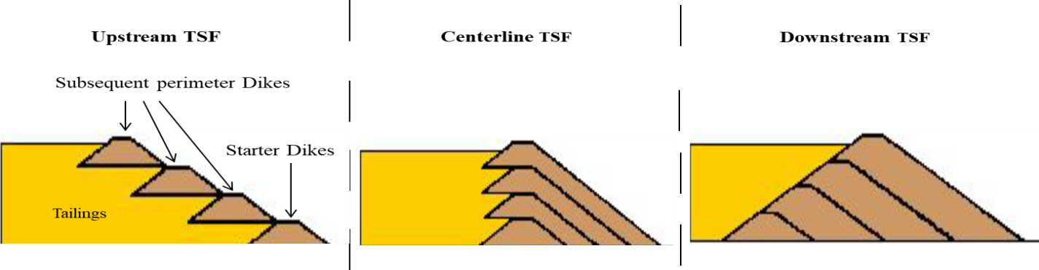
Figure 2.1: Types of TSF Constriction Designs
Source: (Lyu et al., 2019)

The upstream design carries the highest safety risks among the rest though is the most preferred option (Islam & Murakami, 2021). The safety risks include, phreatic surface factor, liquefaction (when subjected to seismic events) in consideration of the limit for embankments raise per annum (Tyagunov et al., 2018). Phreatic surface factor occurs when the breadth of the beach and decant pond are below the minimum. Some of researchers have suggested that the number of embankment to < 15m per year, for stability purposes (Figure 2.2) (Tyagunov et al., 2018). Moreover, seismic events are still considered with an assumption of 1 in 100 years chance to occur (Adamo et al., 2021).

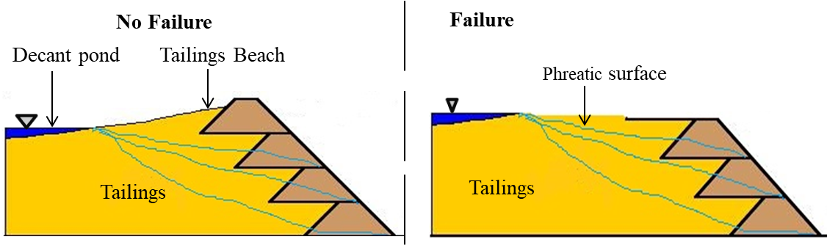
Figure 2.2: The Upstream TSF Outlining Phreatic Surfaces and Possible Failure Risk
Source: (Stefaniak et al., 2018)

The recent improvement of microseepage control employs appropriate hydrogeochemical considerations, and liner (materials with very low porousness that separates tailings from impervious barrier) for stability monitoring (Birle et al., 2022). Hydrogeochemical consideration include tailings mineralogy from parent rocks (Kalonji-Kabambi et al., 2020).Liners can either be natural (clay with permeability not less than ${10}^{-8}$ m/s) or man-made (with permeability not less than${ 10}^{-11}$ m/s) selected based on the price and historical performance (Eid et al., 2023). In mining operations, clay is widely used compared to synthetic liner, even though its performance may be affected by cracks, hydraulic deformations, consolidation, and even fissures (He et al., 2021).

2.2 Microseepage in TSF
Tailings from metallic origins such as Iron, Copper, Gold, Silver etc, are mostly originated from sulphide, and oxides rocks (Kalonji-Kabambi et al., 2020). In this case, consideration is from the greenstone belts which run through the study area. Greenstone belts compositions have minerals i.e., pyrite minerals known for their potential acid forming behaviour (Xie et al., 2018). Microseepage is a vertical discharge of tailings from the TSF to shallow and/or deep aquifers (Fortuna et al., 2021). The discharge is a result of physical and/or chemical processes which occur within the tailings that affects the base of the facility and allow vertical movement. The physical and chemical influences can further be facilitated by weathering conditions such as rainfall, wind speed and direction, sunlight, and temperature, to name just few.

2.2.1 Physical Processes
Physical factors mainly include design flaw and/or construction oversite mostly during placement of the liner as well as embankment raise (Skinner et al., 2023). The design outlines several embankments raise, storage capacity, consideration of earthquakes or seismic events, weather conditions, and overflow spillway (Tschuschke et al., 2020). These attributes ensure that the facility is safe and free from pollution during operations and beyond (Lemos et al., 2020). The design also, accommodates lateral seepage using under drain system to ensure that all water from the process plant is careful collected and recycled back to the process plant for other processing purposes (Williams, 2021).

2.2.2 Chemical Processes
Chemical processes include tailings reactions which lead to acid mine drainage (AMD) and movement of heavy metals because of hydrogeochemical processes (Figure 2.3). The rocks once exposed from the earth are subjected to air and water that support hydrogeochemical reactions.

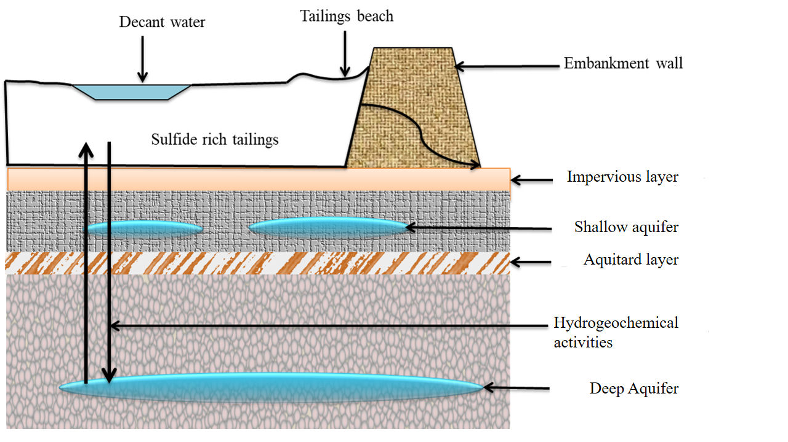
Figure 2.3: Conceptual Hydrogeochemical Processes at the TSF
Source: (Kalonji-Kabambi et al., 2020)

The by-products emanating from the chemical reactions affects soil and water sources when seep into the environment. Pyrites undergo a series of chemical reactions which produce AMD that supports heavy metals mobility (Xie et al., 2018). The reactions are favoured when water and oxygen are available in large quantities (Xie et al., 2018) . For example, pyrites oxidises to iron (II) and produce hydrogen ions ($H^{+}$) which act as an acidic condition for the dissolution of more metals as shown in Eq. 1 bellow.

${2FeS}_{2}(s)$+${7O}_{2 }\left(g\right)$+${2H}_{2}O (l)$${2Fe}^{2+} (aq)$ + ${4SO}_{4}^{2- }(aq)$ + ${4H}^{+} (aq)$……. (1)

Furthermore, iron (II) is oxidised to iron (III), which further oxidises the pyrites to produce more hydrogen ions.

${4Fe}^{2+}$+${ 4H}^{+}\left(aq\right)+O_{2 }\left(g\right)$${4Fe}^{3+} (aq)$+${2H}_{2}O (l)$……………………….. (2)
${FeS}_{2 }\left(s\right)$+${14Fe}^{3+}\left(aq\right)$+${8H}_{2}O (l)$${15Fe}^{2+} (aq)$+${2SO}_{4}^{2-}\left(aq\right)$+ ${16H}^{+}(aq)$….... (3)

The formation of more AMD facilitates heavy metals mobility from one point to another and results in the contamination of surface and underground water sources (Qiao et al., 2020). These hydrogeochemical activities produce dangerous complex contaminants that can seep into surface and underground water bodies when managed inappropriately (Kalonji-Kabambi et al., 2020). These reactions produce chemicals which then transported to various environmental compartments, resulting into surface and underground water contamination.

2.3 Effects of Microseepage
Microseepage increases acid levels (low pH) in soil and aquatic environment, leading to pollution of drinking water, fertility decrease in soil, and decrease in reproduction rate (Singh et al., 2020). Microseepage leads to dissociation of hazardous metallic minerals that ultimately affect human beings and other living organisms (Singh & Steinnes, 2020). Heavy metal mobility is effective under acidic condition (low pH) and travel far beyond mining operations downstream (Elmayel et al., 2020). The pollution potential of these minerals is significant with long-term negative environmental impacts (Netshiongolwe, 2018). Moreover, the oxidation of pyrite, ferric and ferrous ions produce various precipitates of salt by-products. The salts of sulphates and chlorides produced also affect soil and water quality.

The changes in oxidation and reduction conditions facilitate the movement of chalcophilic parameters such as Arsenic (As), Lead (Pb), and Iron (Fe) (Martı́nez-Alcalá & Bernal, 2020). These metals are common in acidic media and affect living organisms found in both soil and water environments. Mining activities exposes the rocks and consequently the reactive metals to react at specific conditions to form chemical complexes that are toxic to humans, aquatic life, and the environment (Liang et al., 2017).

2.4 Methods for Seepage Control

2.4.1 Darcy Law Method
Darcy’s law is used by geotechnical engineers, engineering geologists, hydrogeologists, and hydrologists in various contexts to determine underground flow rates within an earth dam for seepage control (Stephens et al., 2018). The method is applicable under the assumption of a two-dimensional flow of water movement at the porous medium within sand and clay soil materials of various permeability (Stephens et al., 2018). Its application is based on the amount and rate of water that mostly seep from unconventional fluid reservoirs (Yekeen et al., 2018). It assumes that seepage is inevitable and accommodated through under drain systems where the water from the TSF is collected at the pond and pumped back or recycled to the process plant (Condon et al., 2021). This method works mostly with lateral seepage control and does not provide a solution to microseepage within the TSF that leads to underground water pollution (Jiao et al., 2021) .

2.4.2 Finite Element Method (FEM)
The model forms part of numerical method and simulation that works on solving complex problems in small patterns or fine elements. Using FEM in microseepage control, drainage holes are used to create simulated curtain that prevents vertical seepage (Xu, 2019). FEM can also be combined with Darcy Law to improve vertical seepage management of the TSF in which calculation of pore pressure distributions are considered (Yang et al., 2022). The FEM provides knowledge on the amount of water discharged though the facility without effective control microseepage (Ouzaid et al., 2020).

2.4.3 Machine Learning (ML)
The ML methods have been applied in various disciplines such as science, business, medical, law etc where predictive modelling is used to obtain an optimal solution of various problems (Dinov, 2018). Examples of such methods include but not limited to artificial neural networks (ANN), genetic algorithm (GA), and swamp optimisation etc (Chiroma et al., 2017). The ANN mimics the coordination system of neurons; GA uses genes and chromosomes whereas swamp optimisation mimics the flock of beds or fish when in search of food, and water (Tayfur, 2017).

Machine learning approaches depend on the nature of the problem. For example, ML applied in solving various hydrological problems by various researchers in recent time (Fetisov & Menshikova, 2020). The ML provides solutions to complex problems based on inputs and output of the data using an objective function to produce series of models from which a perfect fit will be drawn. Machine learning technique has ability to process data with intricate relationships. The main requirement to attain best result in ML is that large quantity of dataset is needed to attain the best fit (Ren et al., 2018). In this discourse, there are sufficient facts that ML can effectively be employed to investigate environmental issues from TSF monitoring information.

2.5 Research Gap
Studies show that design consideration of hydrogeochemical activities together with existing knowledge of TSF construction suffice to prevent underground water contamination (Chen et al., 2021). It then follows that the routine and long-term hydrometric monitoring data indicates that microseepage exists to the TSF (Fetisov & Menshikova, 2020). Despite all the engineering, hydrogeochemical, hydrological efforts and other scientific considerations, further research still needed.
This study investigates further into other factors and solutions thereof from the previous works that were conducted in an attempt to control seepage (Zhang et al., 2017). Investigation of geochemical activities whether affects clay liner performance or impervious layer in respect to season variations (Clemente & Huntsman, 2019) . The study will also outline the consideration of all input parameters under specific climate conditions, output parameters from monitoring boreholes along the downstream to produce predictive seepage modelling using available machine learning tools.

CHAPTER THREE

RESEARCH METHODOLOGY

3.1 Research Design
This is an exploratory study where both primary and secondary data were used. Both datasets were used categorically as inputs and outputs variables. The information gathered at the TSF categorised as input whereas the measurement from TSF performance regarded as output data. The research includes study area, sampling data analysis and modelling.

3.2 Study Area
The research study focused on the GGM which is owned by subsidiary companies Anglo and Ashanti Gold to form Anglo Gold Ashanti. The area is located about 4.1 km from Geita District, South of Lake Victoria and approximately 91 km from Mwanza City in the South-Western direction (Figure 3.1).

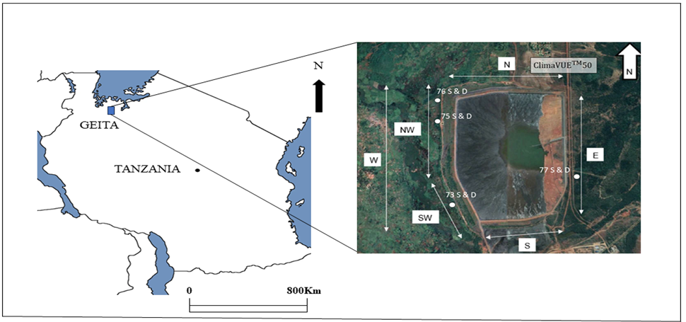
Figure 3.1: Modified Map of Tanzania that Shows Study Location and Sampling Points of the TSF
Source: (Google, 2022) (Reddit, 2023)
The GGM is one of the largest gold mining operations in Tanzania and East Africa. The operations include both multiple open pits of which some of them comprise underground portals or workings.

3.2.1 Geology and Hydrogeology
Geita Region is within the Greenstone Belt (GB) of the Tanzanian Archean Craton that constitutes three (3) supergroups of Dodoman, Nyanzian and Kavirondian (Sanislav et al., 2015) . The GB contains six sections (Figure 3.2) that include Sukumaland (SU), Nzega (NZ), Shinyanga – Malita (SM), North – Mara (NM), Kilimafedha (KF) as well as Iramba – Sekenke (IS) (Sanislav et al., 2018).
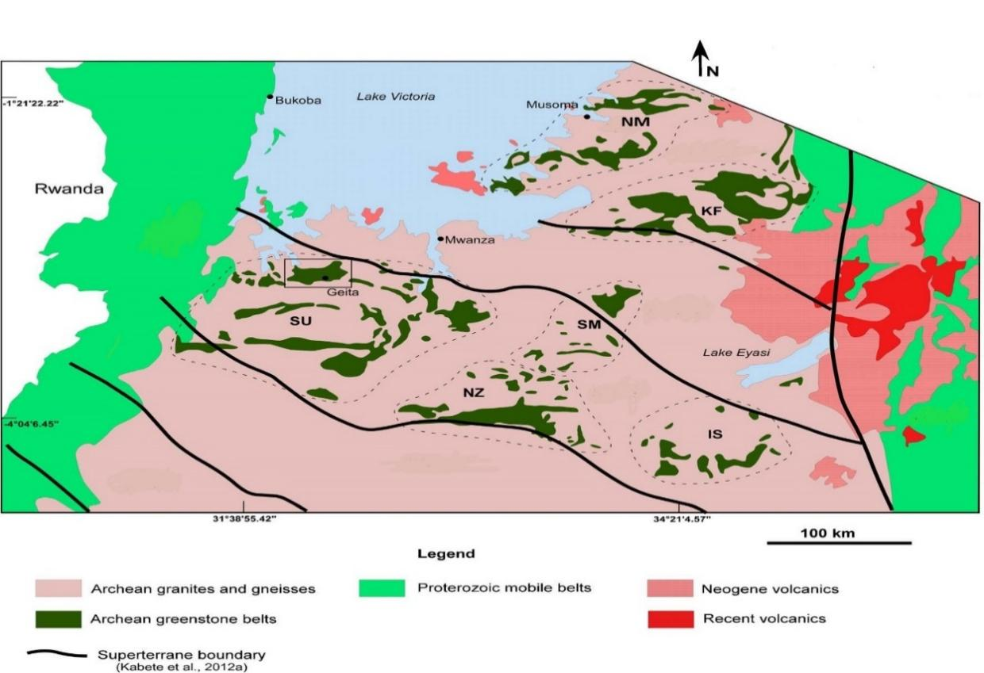
Figure 3.2: Modified Map showing Greenstone belts and Sections of Rock
Source: (Kabete et al., 2012)
Geita lies on the Nyanzian Supergroup which is further divided in two groups i.e Lower Nyanzian (containing gabbro, basalt, and amphibolite minerals) and Upper Nyanzian (containing bended iron formation minerals) (Sanislav et al., 2018). GGM is found in SU which is also characterised by Geita Greenstone Belts (GGB) and is known to contain largest amount of gold deposits in Eastern Africa (Sanislav et al., 2015) . Hydrogeological features of GGM are characterised by the transportation of underground water recharge with ferricrete and saprock composition (Davies et al., 2014). The aquifers are shallow and deep with both being colluvium and saprolite in nature. The ferricrete and saprock composition are known for their low permeability properties (Mather et al., 2019).

3.2.2 Climate
The GGM contains bimodal climatic conditions with rain periods (0.5 to 245.5 mm) from October to February that tails until mid-May. The dry season starts in June and ends in September with maximum temperature range between 24.3ºC and 37.7ºC and minimum temperature range between 18.8ºC and 24.7ºC (Luhunga & Songoro, 2020). GGM humidity is high during wet season especially from November to April (up to 95.5%) and lower in dry season that ranges between June and October (up to 31.5%) (Luhunga & Songoro, 2020).

3.2.3 Topography
GGM is at the mountains area that include Katoma (rises to 1583m above the sea level) and Nyamonge hills (rises to 1570m above the sea level). Some of these mountains contain open pits, which are major sources of sulphide rocks that end up in the TSF (Figure 3.3).

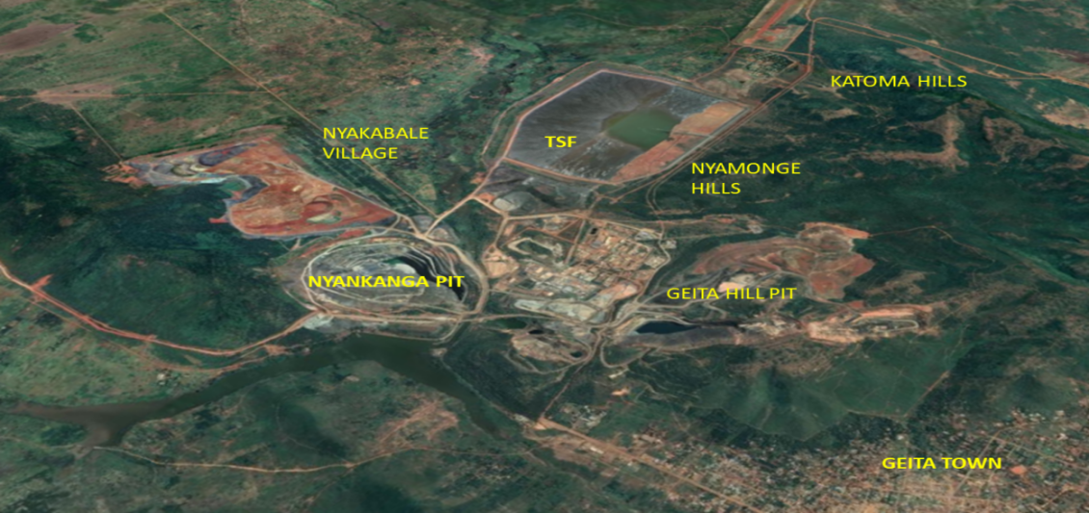
Figure 3.3: Modified Google Map of Topographical view for GGM
Source: (Google, 2022)

3.3 Sampling and Sample Analysis
Sampling was done two folds, which included automation and physical data collection. The automation data were collected from the ${ClimaVUE}^{TM}50$ instrument that measures multiparameter of climate information of temperature, rainfall, wind speed and direction etc. Primary automation datasets were collected from June to December 2022 whereas secondary automation data from January 2016 to June 2022 were sought from the GGM management. Sampling data from ${ClimaVUE}^{TM}50$ were recorded daily while water quality data were recorded monthly (Table 3.1).

Table 3.1 Sample Parameters and Sampling Frequency
Data Collection area | Monitoring Requirement | Frequency
Compliance Monitoring
 | Tailings weight (tons) | Monthly
Monitoring Boreholes | Water Quality (mg/L) | Monthly
Performance Monitoring
Climatic conditions | Rainfall (mm) | Daily
 | Wind Speed (m/s) | Daily
Source: (GGM, 2022)

Physical data collection involved tailings weight from processing facility and water quality from monitoring boreholes. One (1) processing plant, one (1) weather station, and eleven (8) monitoring boreholes were selected as sampling sites around the TSF (Figure 3.4). Samples from processing plant and weather station were categorised as inputs whereas samples collected from monitoring boreholes were regarded as outputs.

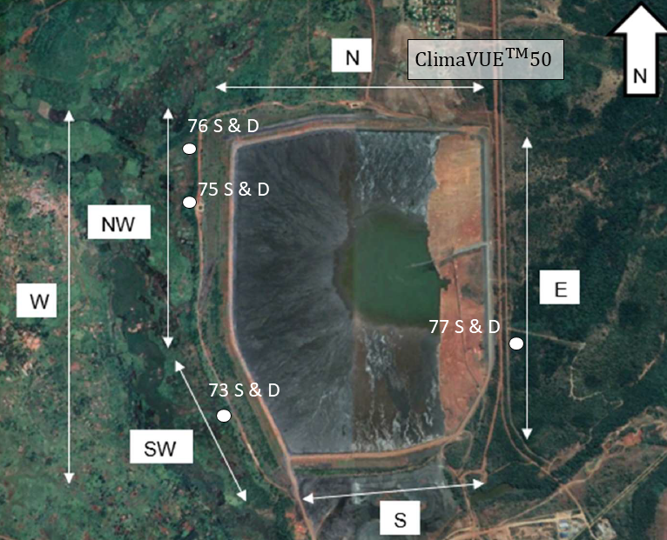
Figure 3.4: Layout of Modified Google Map that Shows Sampling Points.
Source: (Google, 2022)
Samples from these boreholes were collected by the following standardised procedure to avoid sampling contamination. The procedure involved sampling bottles preparation, labelling and preliminary measurement of pH before taking the sample to the laboratory for further analysis. These processes (bottle decontamination, sample identification code, appropriate purging, and storage) are very crucial while errors are kept at an acceptable range (Figure 3.4).

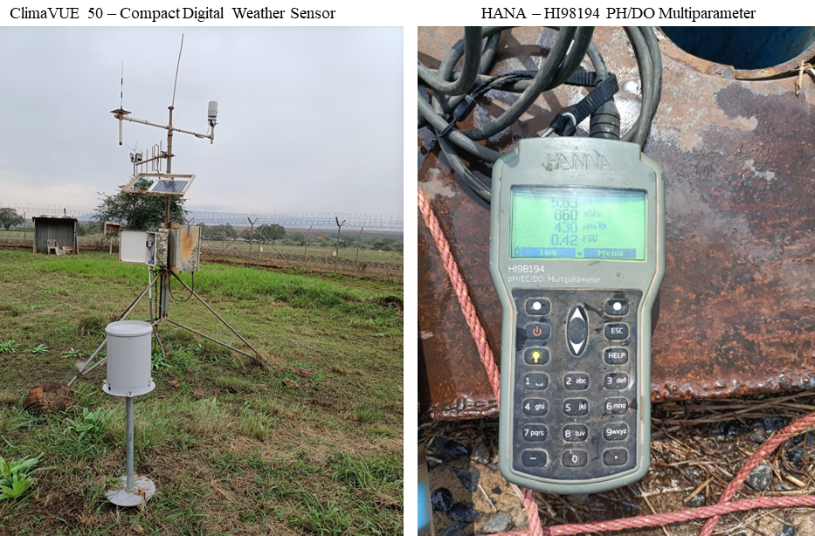
Figure 3.5: Weather Station (L) and pH/EC/DO Multiparameter instrument during Sampling Exercise at GGM (R).
Source: Field Survey (2022)

The collected samples were stored based on the nature of the sample. Samples recorded at the electronic weather instrument were stored daily within a storage device embedded at the station (Figure 3.4).

Samples from monitoring boreholes were collected and stored in clean labelled bottles (Figure 3.5). Samples were stored in cooler box at the temperature between 4º C - 5ºC and transported to SGS for laboratory analysis (Annex 1). Monitoring boreholes exclusively focus on pH, sulphate, nitrate, and TDS. The results were then delivered within 2-4 weeks after each round of 8 boreholes. Secondary datasets were provided by GGM through compliance performance monitoring and sample analysis were carried out at SGS and Lake Victoria Basin Water Board laboratories.

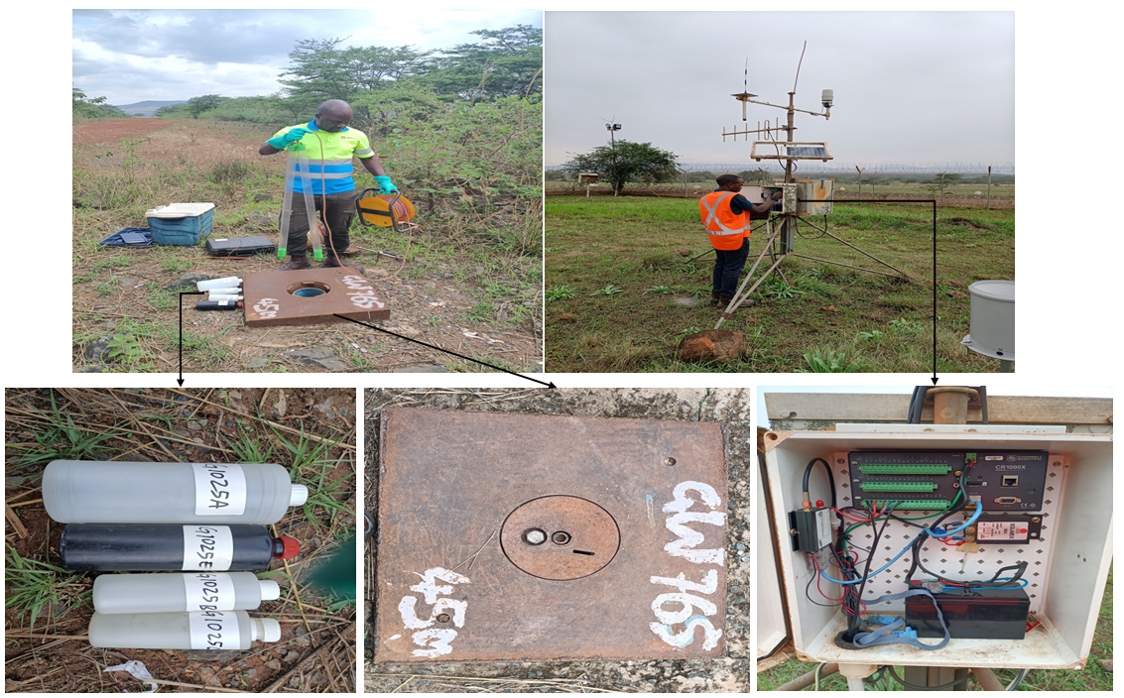
Figure 3.6: The purging Process prior Water Sampling at Shallow Borehole Number 76 (Top left), the Climate Data Download at the Weather Station Instrument (Top right), the Sampling Bottles (Bottom left), borehole ID (Bottom centre) and ${ClimaVUE}^{TM}50$ data processing box (Bottom right)${ClimaVUE}^{TM}50$
Source: Field Survey (2022)

3.6 Quality Assurance and Quality Control
The samples for quality assurance and control (QA/QC) purposes were collected and treated in a similar manner as the real samples. The collected water samples for QA/QC were given unique codes and analysed at two different laboratories: Water Institute, a state-owned facility (i.e Ministry of Water (MoW) and SGS, which is a privately owned. The results from both laboratories were compared for QA/QC.

3.7 Data Analysis

3.7.1 Descriptive Statistical Analysis
Descriptive statistics (range, mean and standard deviation) were used to summarise the findings. The seasonal variation of the study variables in respect to season variations are summarised using python software. The statistical significance of 0.05 at 95% confidence level was used.

3.7.2 Modelling
The raw data from the analysis of the water, historical data from the GGM as well as weathering information are used to create a database. The database of samples which contain primary and secondary data then stored in excel in CSV (comma delimited) format further model analysis and investigation.

The datasets were further analysed using ML to provide a model that predict and control discharge of chemicals from the facility. The processed data were used to predict a control mechanism of the microseepage at the TSF. The tailing weights from process plant combined with natural factors (such as wind speed and rainfalls) were used to create the input data in a model. The borehole observation at the downstream boreholes categorised as output variables. Using the concept of ML, the model was created to produce output under an environmental influence. The mathematical equation for the model with inputs and outputs functions is given by:
S = β₀ + β₁X₁ + β₂ X₁² +……………. + ${βₙX₁ }^{n}$ (3)
Where S is the seepage parameter, β₀ are β are different coefficients generated from the computer using the input parameters. The input data measured and quantified were split into two parts during modeling (Figure 3.6). 70% of the data will be used for training the model while the 30% will be used to test the model (Gholamy, Kreinovich, & Kosheleva, 2018).

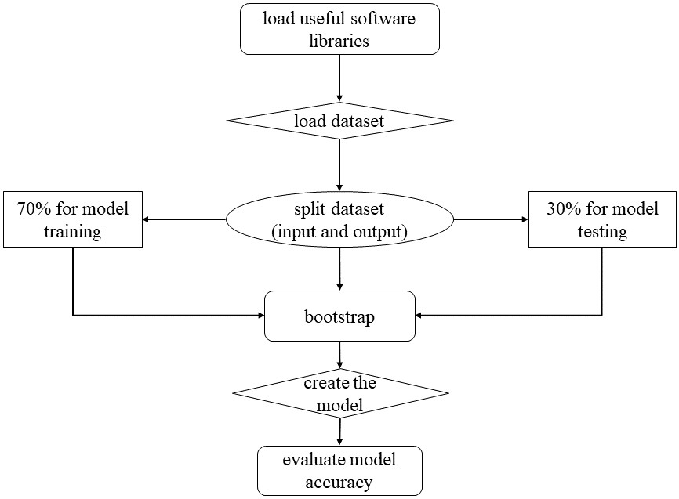
Figure 3.7: Conceptual Flow Illustration of Data Analytics and Modelling.
Source: (Gholamy et al., 2018)
The datasets stored as CSV file were used for data analytics and modelling in python software. Python software contains multiple specific libraries (small software package(s) for a particular task). In this project, several libraries such as numpy, pandas, os, seaborn, sklearn, matplotlib and TensorFlow were used. The findings from data analysis are presented in different outputs such as pictorials, graphs, plots, as well as tables.

CHAPTER FOUR

RESULTS AND DISCUSSION

4.1 Geochemical Parameters in Boreholes
The descriptive statistics of the investigated parameters in the eight boreholes during the two seasons that include ranges, means and standard deviations (SD), are summarized in Table 4.1.

Table 4.1: Concentration Profiles of the four Parameters in the Wet and Dry Seasons
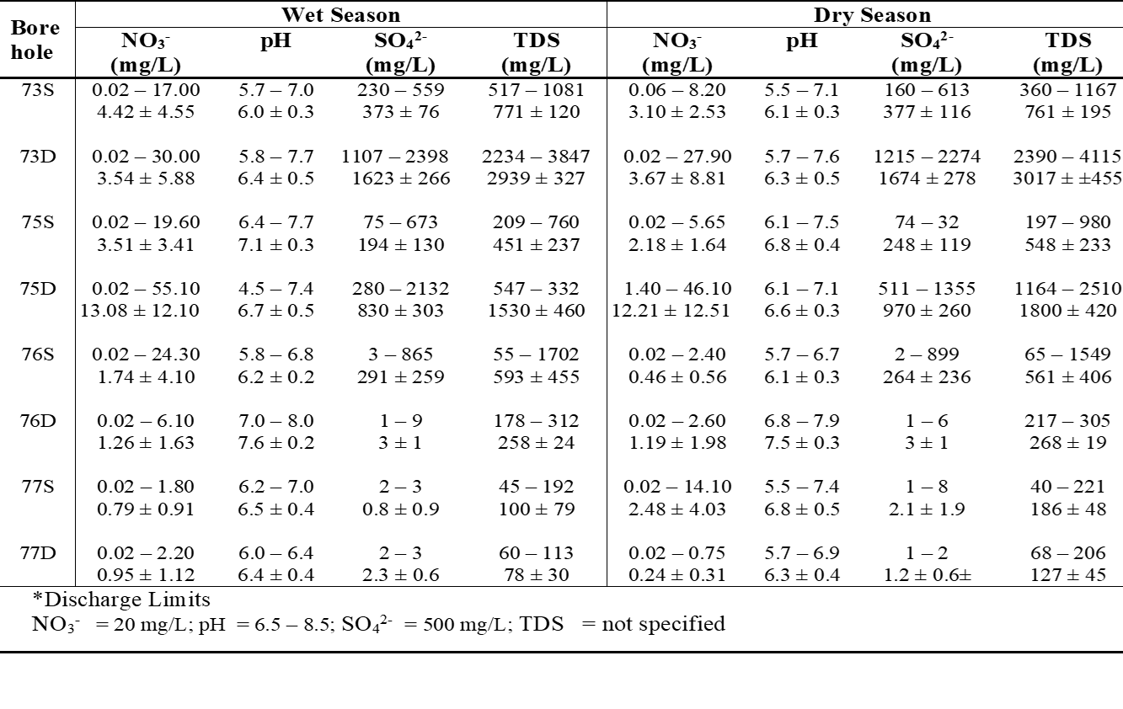* TZS 860: 2006 (TBS, 2006)

Table 4.1 show that the upstream boreholes, i.e., 77S and 77D had the lowest levels of NO₃⁻, SO₄²⁻, and TDS, suggesting the existence of microseepage that affect the downstream boreholes. When compared to the discharge limits for the GGM in (Annex 2) and according to the Tanzania Bureau of Standards (TBS), various deductions were drawn as shown in the next subsections.

4.1.1 Sulphate Levels
The monitoring boreholes along the downstream of the TSF indicates different ranges of sulphates concentration (Figure 4.1).

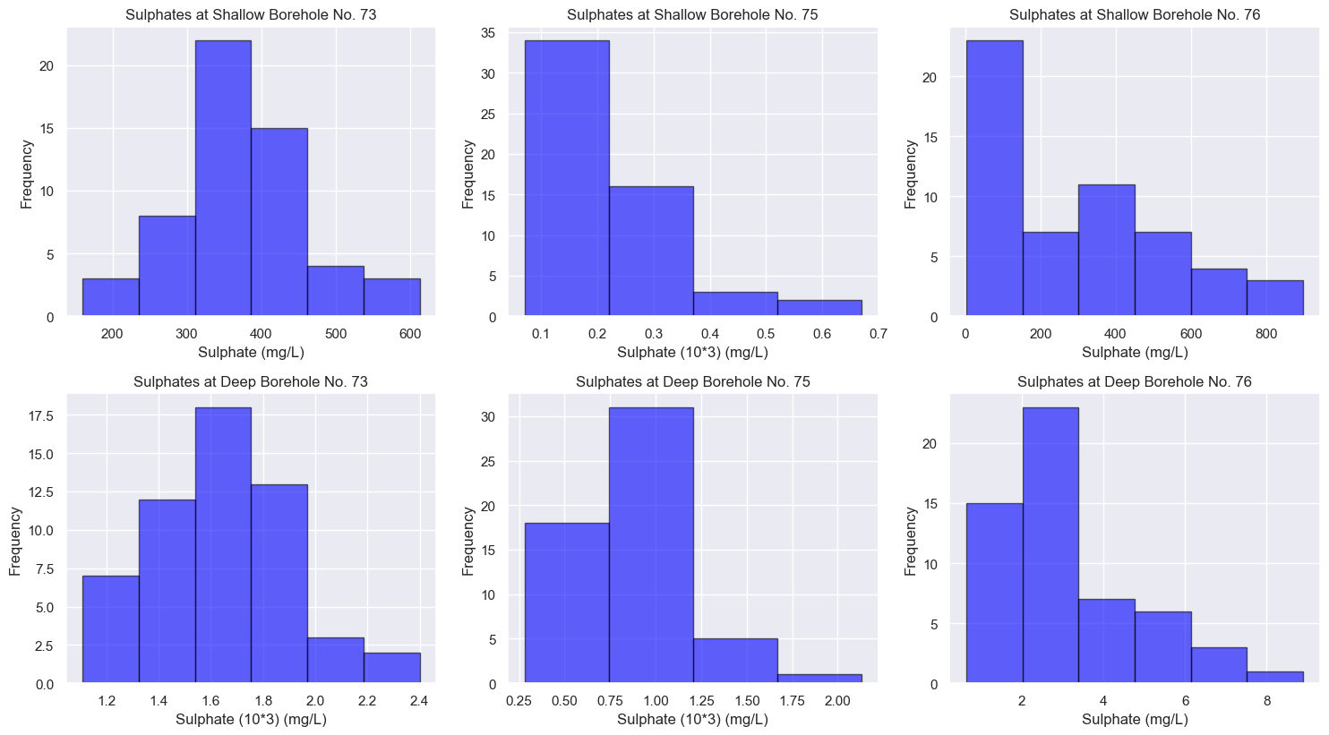
Figure 4.1 Sulphate levels in Selected Boreholes
Source: Study Findings

The shallow monitoring boreholes number 73 contains readings that range from 200 mg/L to 600 mg/ with normal distribution characteristics. Most of the SO₄²⁻ results were within the TBS limits. Moreover, some had 600mg/L which are slightly above the effluent discharge limit (500 mg/L) of the TBS. Shallow boreholes number 75 and 76 showed positive lognormal distribution with readings from 100 mg/L to 700 mg/L in borehole number 75 and from 200 mg/L to 800 mg/L in borehole number 76. The concentrations have increased up to 800 mg/L which are way above 500mg/L of the effluent discharge limit according to TBS. Furthermore, the shallow aquifers at boreholes no. 73, 75 and 76, the SO₄²⁻ concentrations increased from South - North of the TSF.

Like in shallow boreholes, deep boreholes showed similar characteristics. Borehole number 73 has normal distribution whereas boreholes 75 and 76 positive lognormal distributions. Sulphate concentration level at borehole number 75 ranged from 1200 mg/L to 2400 mg/L whereas at borehole number 76 the values were relatively small (less than 8 mg/L). The concentrations of sulphates were relatively much higher at boreholes number 73, 75 and much lower at borehole number 76. The concentrations of sulphates were much lower in the shallow boreholes than in the deep boreholes and borehole number 76 had the lowest levels.

4.1.2 pH
Shallow and deep boreholes number 73, 75 and 76 showed different values of pH (Figure 4.2). The pH observed to be between 5.6 - 7.0 in shallow borehole number 73, 6.2 - 7.6 in shallow borehole number 75 and 5.8 - 6.8 in shallow borehole number 76. The deep boreholes had pH levels as low as 5.75 - 7.75 in borehole number 73 from 4.5 -7.5 in borehole number 75 and from 6.8 - 8.0 in borehole number 76. The comparison between pH indicated that is below the TBS thresholds.
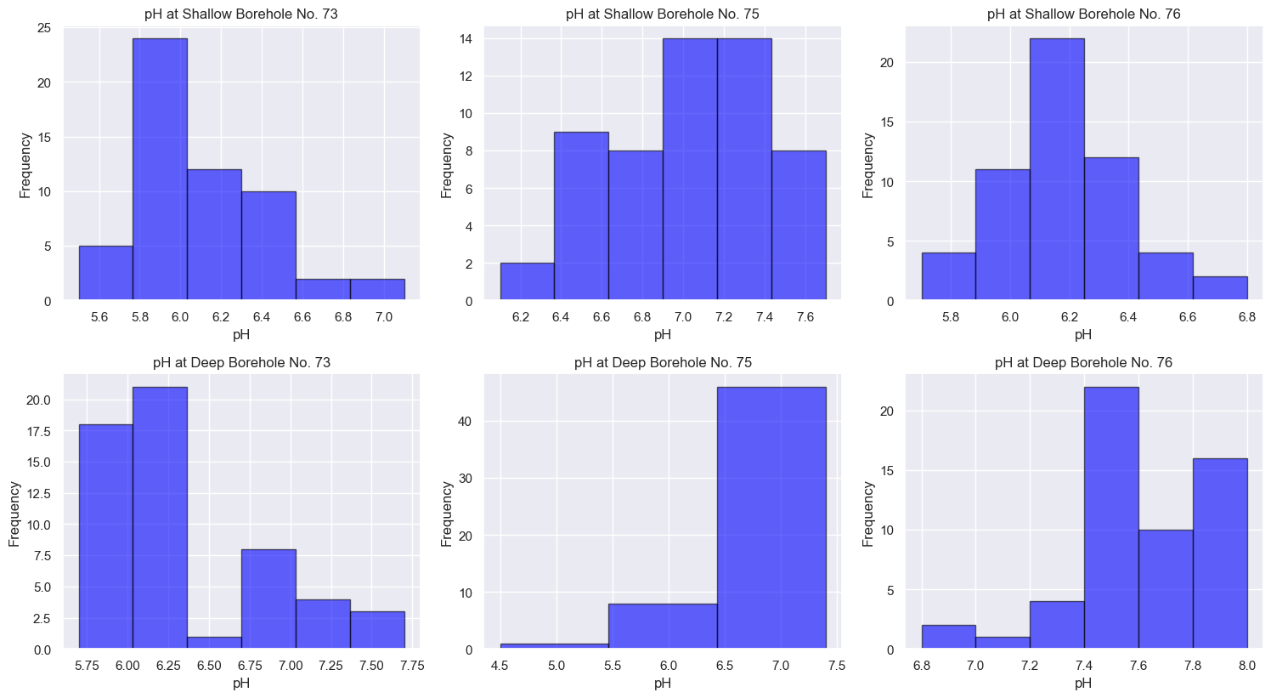
Figure 4.2: pH Variations in Shallow and Deep Boreholes
Source: Study Findings

The pH levels for the boreholes showed both acidic and alkalinity properties. The very low acidity of 4.5 was recorded in deep borehole number 75 while the highest alkalinity of 8.0 was recorded in deep borehole number 76.

4.1.3 Nitrate Level
The nitrate levels in both shallow and deep boreholes have shown quite unique concentration readings (Figure 4.3). Nitrate levels in all boreholes registered concentrations below 50 mg/L. The concentrations showed positive distribution for both boreholes at shallow as in deep. When compared to TBS limit of 20 mg/L there is slightly variation to few reading as the majority of results are within the thresholds.
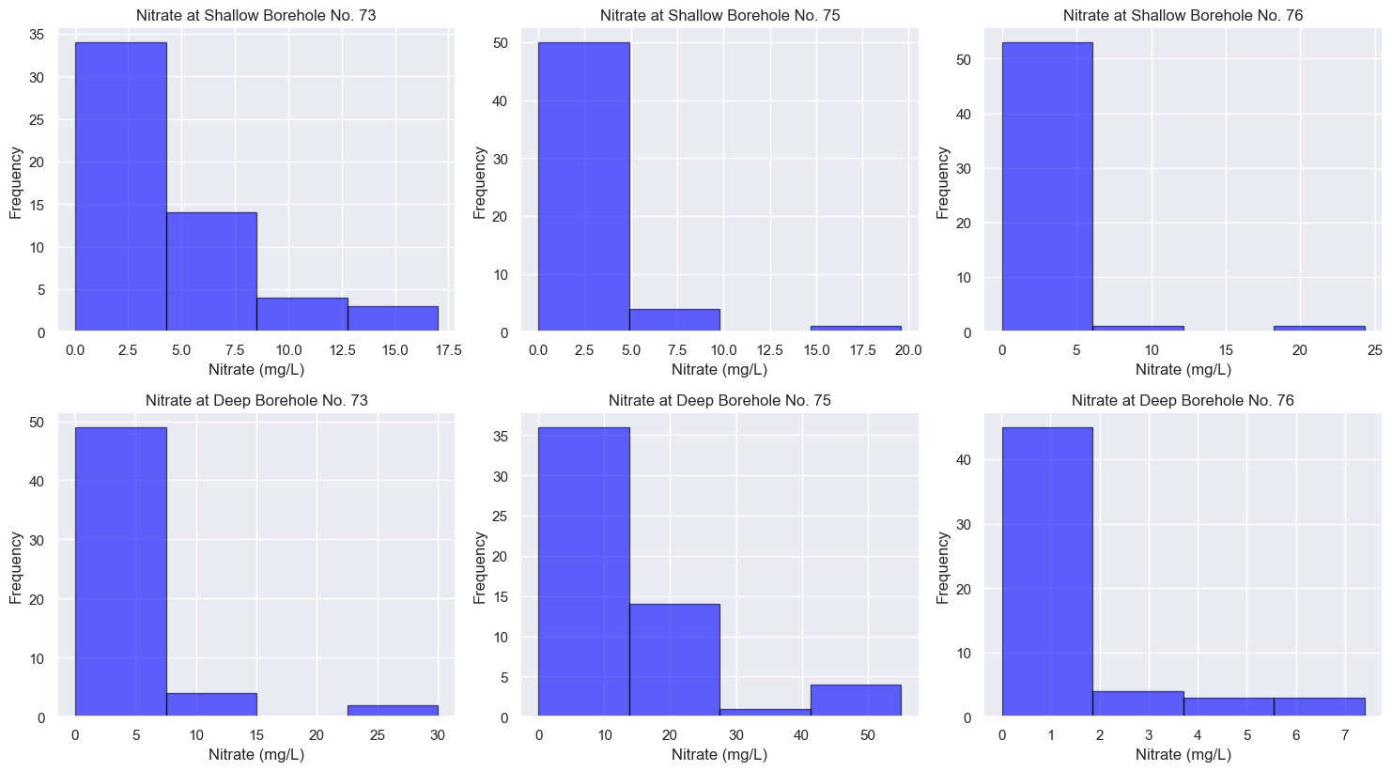
Figure 4.3: Concentration of Nitrate in Selected Boreholes
Source: Study Findings

4.1.4 Total Dissolved Salts
Concentration of TDS from shallow to deep boreholes are multifaceted with high level of concentration readings (Figure 4.4). The TDS levels in shallow boreholes ranged 400 to 1200 mg/L in borehole number 73, 200 to 1200 mg/L in borehole number 75 and from 250 to 1750 mg/L in borehole number 76. The TDS levels in deep boreholes were between 2250 and 4000 mg/L in borehole number 73, 500 and 3000 mg/L in borehole number 75 and 180and 300 mg/L in borehole number 76. This showed significant increase of TDS in shallow boreholes from Southern part (borehole number 73) towards Northern part (borehole number 76) of the TSF while there is a decrease in deep boreholes from South - North (Figure 4.4).
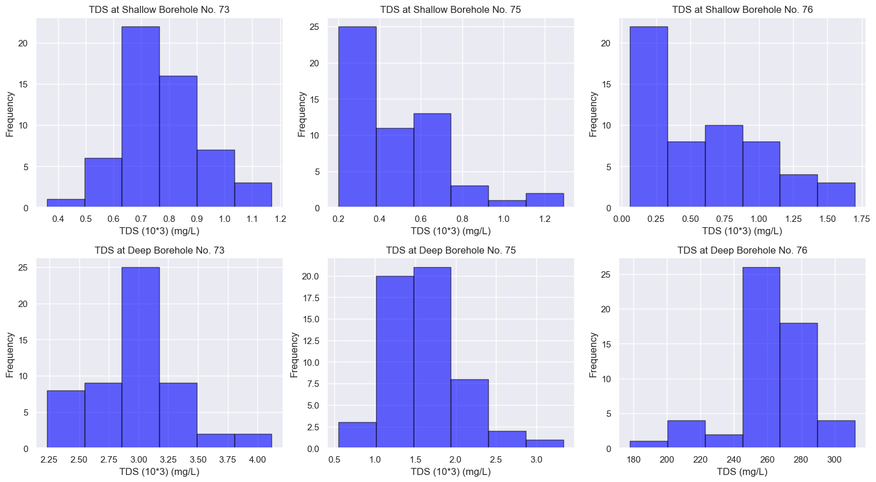
Figure 4.4: TDS Levels in Selected Boreholes
Source: Study Findings

Deep boreholes number 73 and 75 showed significantly high values of TDS whereas deep borehole number 76 had TDS values below 500 mg/L. This suggests that in the shallow boreholes aquifer mixes as they move from South moving to North directions whereas in the deep boreholes there is an existence of an aquitard that separate deep borehole number 75 and 76. So, microseepage of TDS is much higher in all boreholes except in deep borehole number 76. There is no indication of underground aquifers movement from South all the way to Northern side as indicated by the concentration of TDS. The levels of sulphate and TDS concentrations showed significant variations compared to pH and nitrate. The TDS limit for TBS is not specified. Moreover, when TDS results compared to upstream boreholes the variation is quiet significant. These environmental data were used as output variables in the model.

4.1.4 Distribution of Input Variables
The distribution of wind, rainfall and tailings weight were in various mean of averages. The consideration of these relationships occurs at an average of 6.7 m/s, 80 mm of rainfall and 96Mt of tailings weight (Figure 4.5).

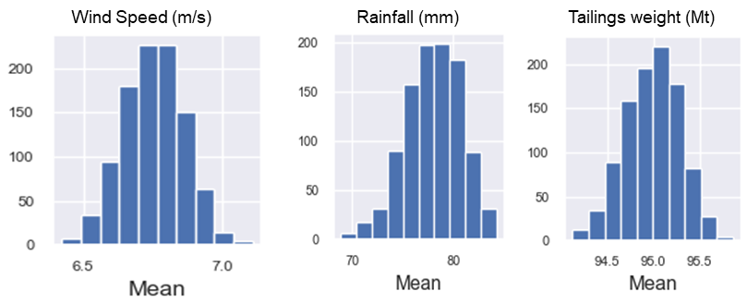
Figure 4.5: Distribution of Average Input Parameters which their Respective Mean.
Source: Study Findings

These values of input variables were used during the modelling with insignificant variation throughout the study. The observation of environmental status from the sample provides a general relationship of all variables. In principle, as tailings increase under the influence of a particular climate conditions, rock fragments undergo various chemical reactions. These reactions are due to different mineralogy that exists or originated from parent rocks. Chemical reactions are due to oxidations, reduction or redox in nature. GGM contains varieties of sulphides minerals which supports oxidation reactions due to unlimited supply of rainfall and water (Rybnikova & Rybnikov, 2019).

4.2 Correlation between Variables
The correlation of the variables outlines even more detailed relationships through a triangle heatmap analysis. The heatmap provides an existing relationship between independent (input) and dependent (output) variables, which ranged from negative to positive (Figure 4.6).

The heatmap can categorize the correlation of the variables as extremely weak (0.0 – 0.19), weak (0.2 – 0.39), fair (0.4 – 0.59), strong (0.6 – 0.79), and very strong (0.8 – 1.0) (Thakur et al., 2018).The correlations between inputs (wind speed, tailings weight and rainfall) and output (Sulphate, pH, Nitrate and TDS) observed to range from weak to strong correlation. The most notable correlations are described between pH and Tailings weight at shallow boreholes no. 73 of 0.02 (regarded as very weak), Wind speed and TDS at shallow borehole no. 76 of 0.59 (regarded as moderate) as well as Tailings weight and TDS at shallow borehole no.73 of 0.83 (regarded as strong). The behaviour portrayed at the heatmap outlines the fact that the relationship between these variables are non-linear.

Generally, the sulphate, pH, TDS and nitrate (output variables) are correlated with in both shallow and deep boreholes with detailed descriptions from Section 4.2.1 – 4.2.4. The correlations are presented in graphs provide detailed relationships between variables.

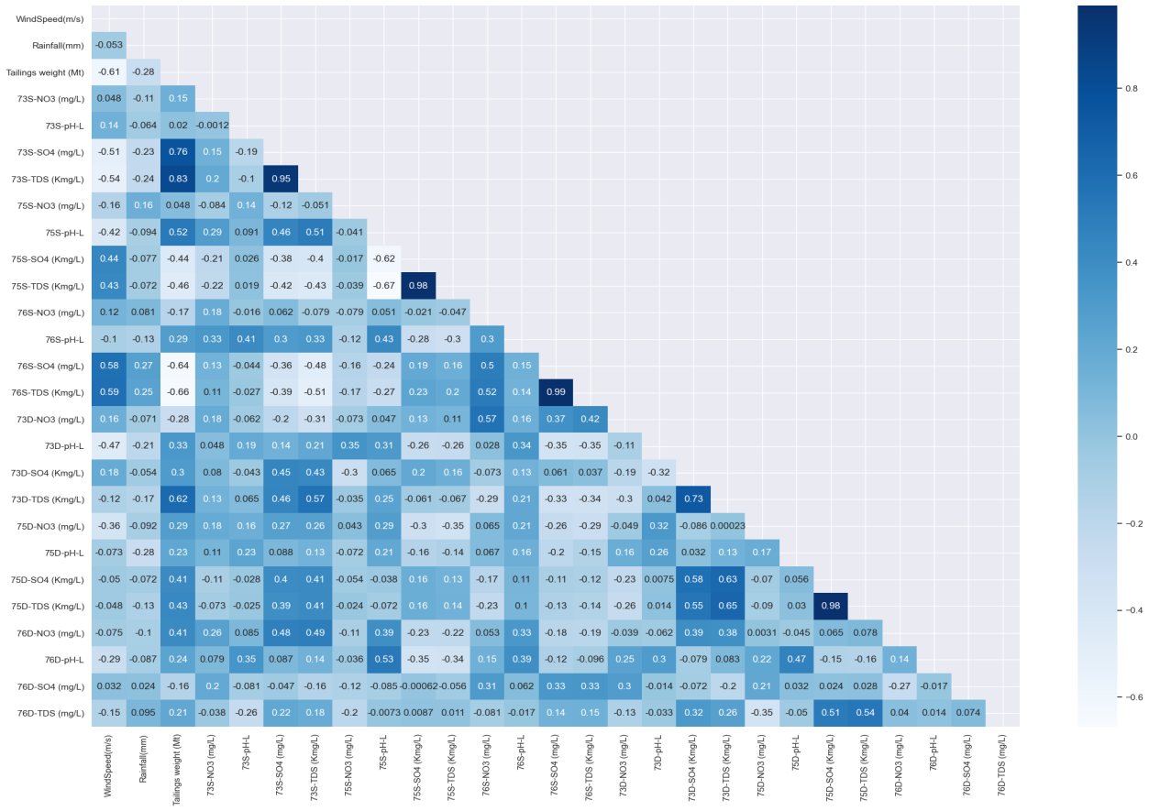
Figure 4.6: Relationship Overview of Triangle Heat Map between selected Variables of an Environmental Interest
Source: Study Findings

4.2.1 Correlation between Sulphate and Tailings Weight
Variable relationships between sulphate and tailings were observed in all shallow and deep boreholes. The shallow borehole number 73 indicated a gradual increase of sulphates as tailings increase while sulphates in shallow boreholes number 75 and 76 showed gradual decreases (Figure 4.7). In the deep boreholes number 73 the relationship was nonlinear with sharp increase of sulphate levels just above 97Mt. In the deep borehole number 75 sulphate levels increased somewhat linearly whereas at deep borehole number 76 there was no observable trend.
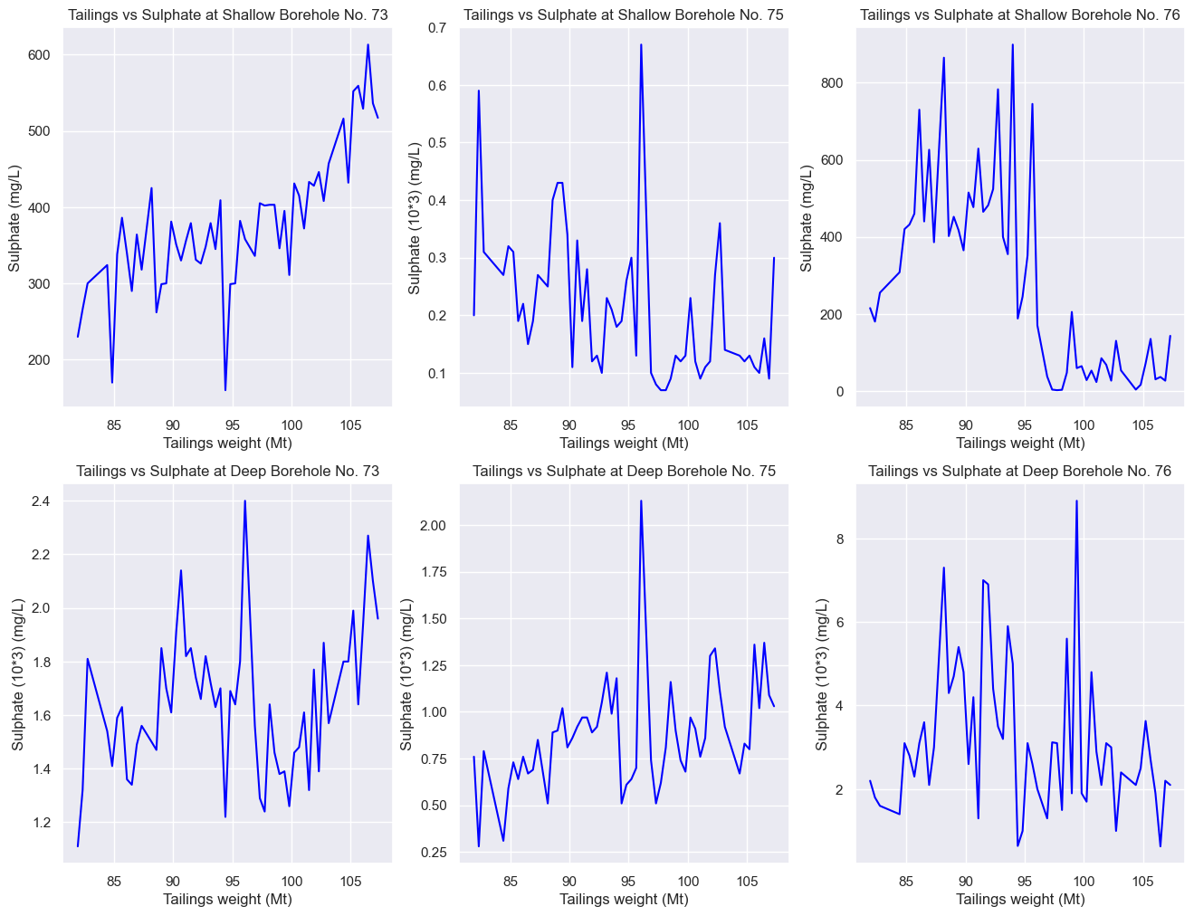
Figure 4.7: Relationships between Sulphate and Tailings Weight in Selected Boreholes
Source: Study Findings

Generally, an increase in tailings weight with the results sulphate results does not exhibit linear relationships along the downstream boreholes.

4.2.2 Correlation Between pH and Tailings Weight
The correlations between pH and tailings weight varied from nonlinear to relatively positive linearity for shallow and boreholes at deep aquifer (Figure 4.8). The relationship between tailings and pH was nonlinear in shallow borehole number 73 and positive linear in shallow boreholes number 75 and 76. In all the deep boreholes, the relationship was nonlinear. The results show non-linearity characteristics between pH and Tailings weight. An increase in tailings weight may increase or decrease the pH levels depending somewhat on other factors such as availability of oxygen or water and dilution of oxide rocks which do not support oxidation.

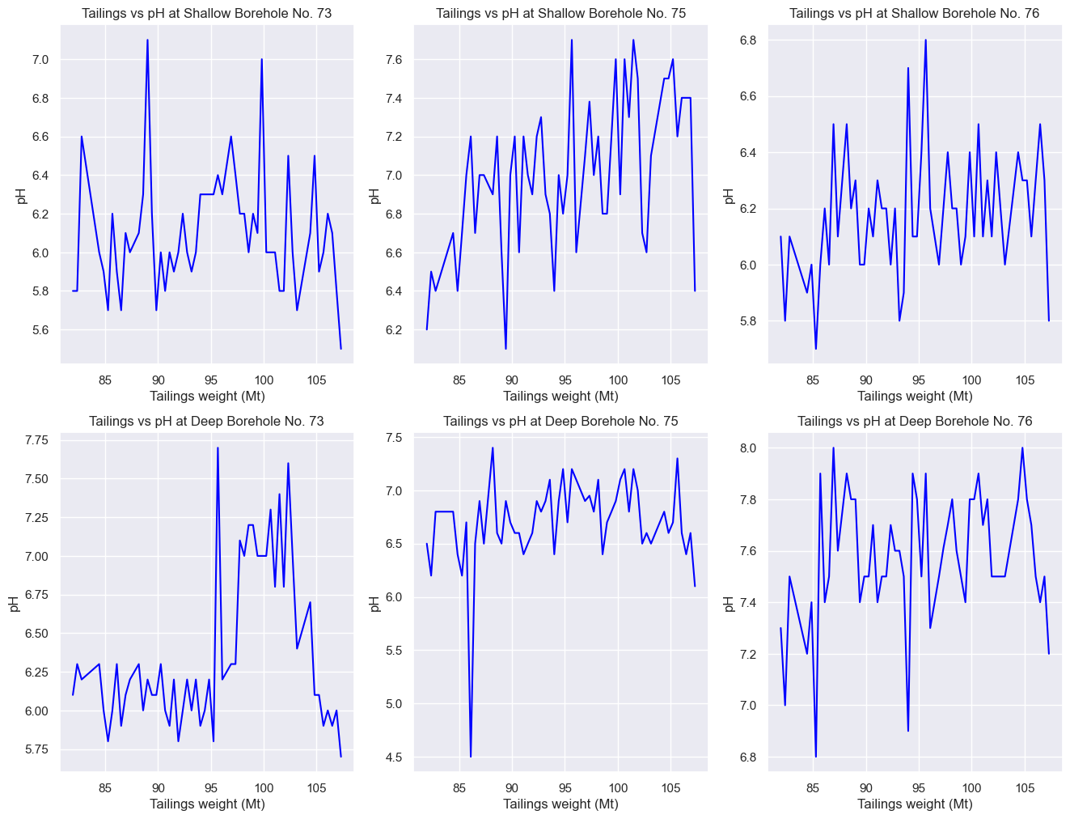
Figure 4.8: Relationships between pH and Tailings Weight in Selected Boreholes
Source: Study Findings

4.2.3 Correlation of TDS and Tailings Weight
Likewise, to relationship between pH and tailings weight, the relationship between TDS and tailings weight was relatively linear in shallow boreholes number 73 and in all deep boreholes (Figure 4.9). However, the relationship was negatively correlated in shallow boreholes number 75 while nonlinear in shallow borehole number 76.
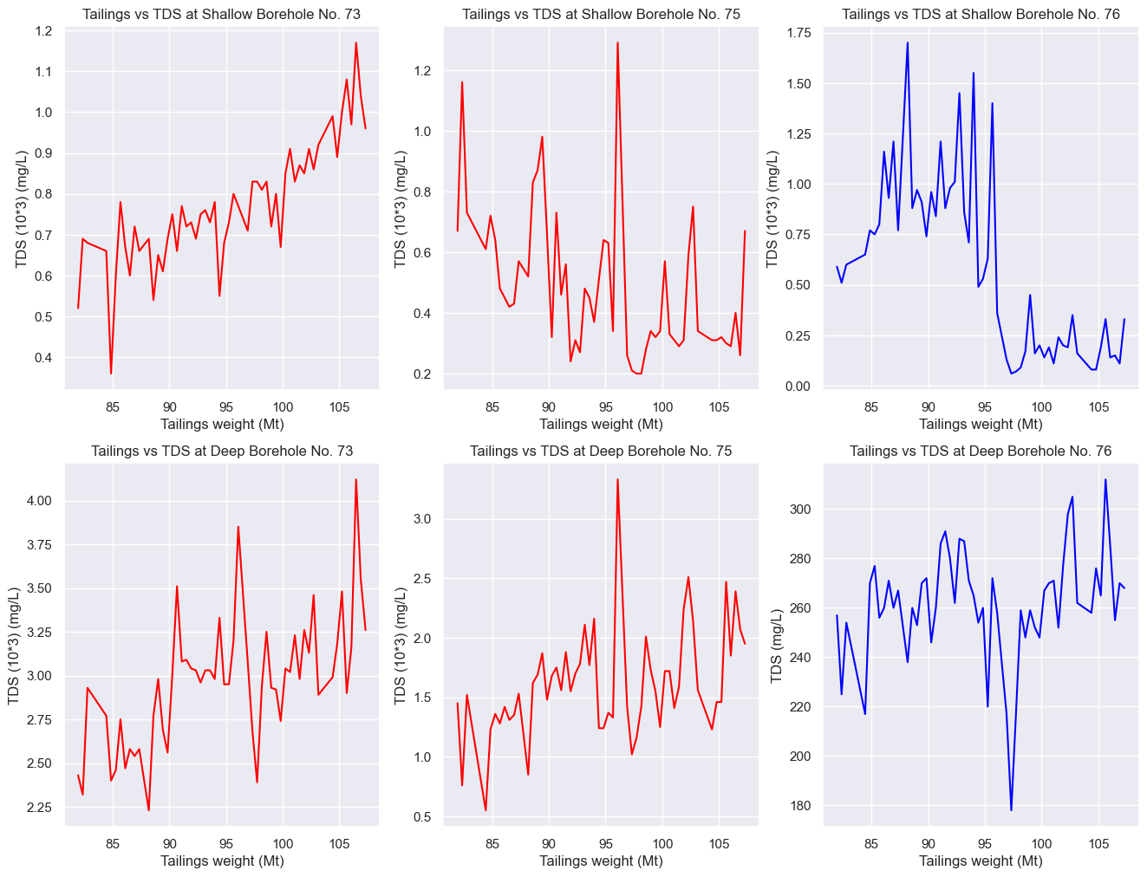
Figure 4.9: Relationships of TDS and Tailings weight in Selected Boreholes
Source: Study Findings

4.2.4 Correlation between Tailings and Nitrate
Nitrate shows concentration results which are significantly low as tailings weight increases. The concentration fluctuates and remains low for all boreholes except deep borehole number 75 with up 55.1mg/L (Figure 4.10). The changes of nitrate levels in the TSF could be due to other factor other than the parent rocks. GGM uses explosives during mining activities to breakdown hard rocks. The explosives are manufactured when ammonium nitrate (AN) (${NH}_{4}$ ${N0}_{3}$) mixed with fuel oil (FO) to form a combination AN-FO (Diaz & Hahn, 2020). The by-products of these explosive are also stored in the TSF.
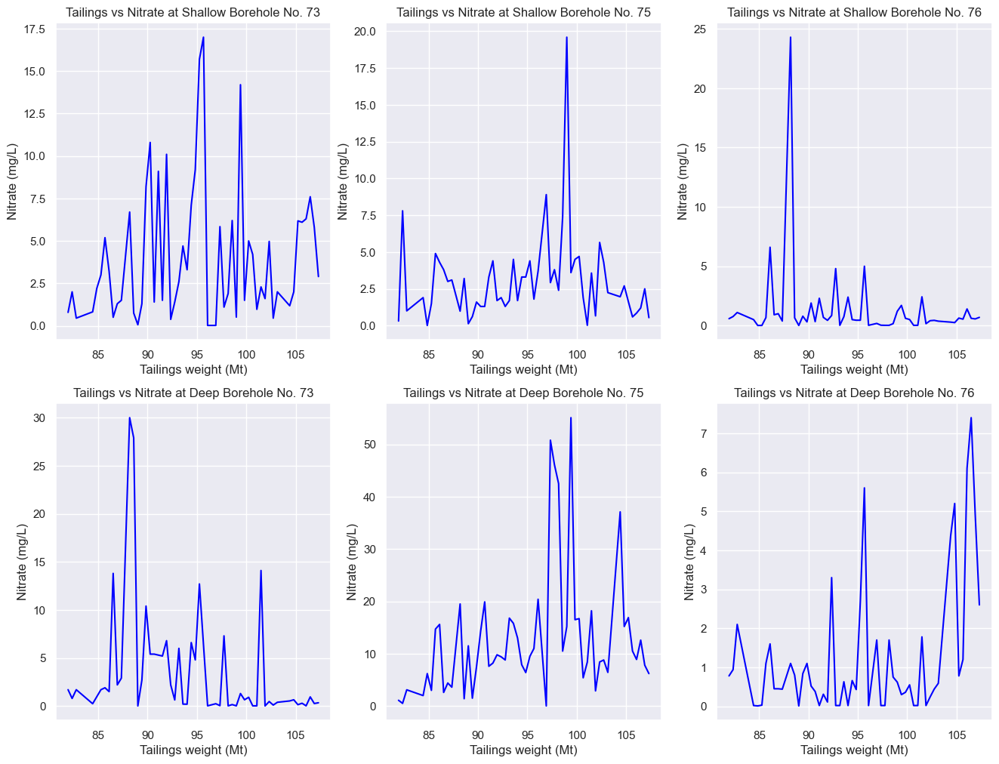
Figure 4.10: Relationships between Nitrate and Tailings Weights in Selected Boreholes
Source: Study Findings

4.2.5 Correlation between Sulphate and Rainfall
Sulphate concentrations were determined during both each season (Figure 4.11). The sulphate concentrations in shallow borehole number 73 showed normal distribution while shallow boreholes number 75 and 76 the relationship of sulphate and rainfall was in a positive lognormal pattern. The deep boreholes number 73 and 75 have normal distribution behaviour whereas number 76 has positive lognormal behaviour. The pattern concentrations of sulphates were higher during wet season than dry season for all boreholes.
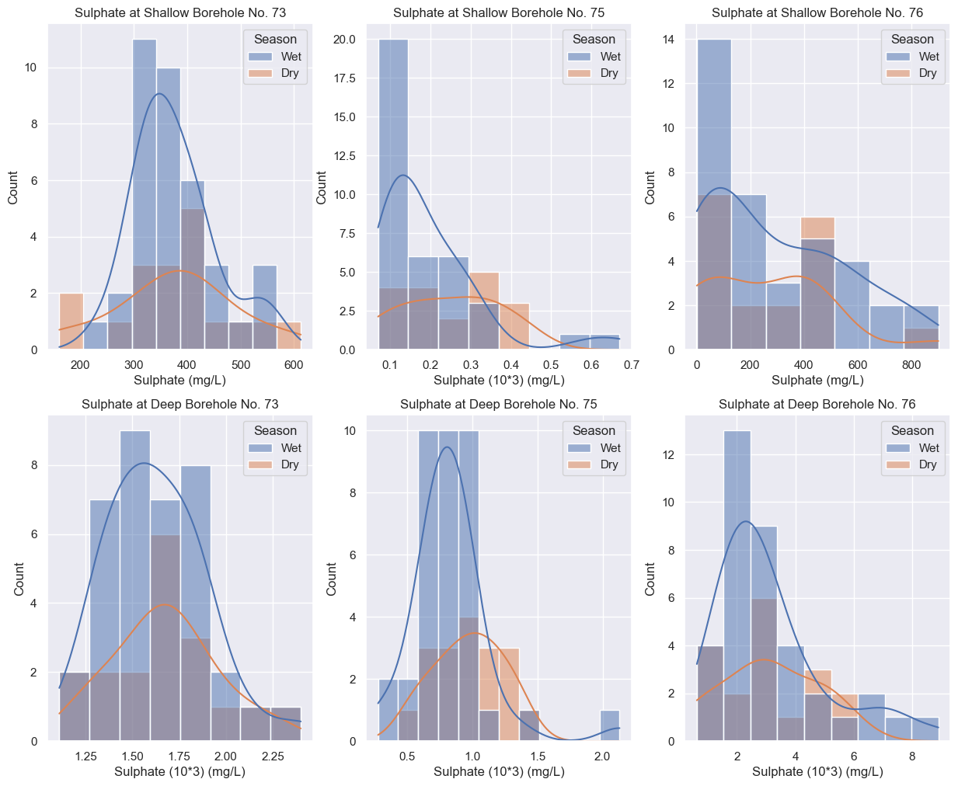
Figure 4.11: Relationships between Sulphate and Rainfall Selected Boreholes
Source: Study Findings

4.2.6 Correlation Between pH and Rainfall
The relationship of pH levels and rainfall is related to the changes in seasons (Figure 4.12). The pH values in all boreholes were relatively higher (more basic) in wet season than in dry season. During the wet season the pH values were slightly higher as compared to dry season. This is indicative of the dilution effect. Similarly, during wet season the shallow borehole has low pH that increases to basic condition as depth increases. The boreholes number 76 (shallow and deep) had relatively higher pH (alkaline) throughout the year, probably due to limited supply of oxygen or acid forming substances from South to North. Furthermore, results suggest that, from Southern part to Northern part of the TSF pH changes from less acidic to alkaline medium. This also provide an information that as the pH becomes more alkaline with depth due to either limitation of oxygen supply or reactions with carbonaceous rocks (Dold, 2017). The pH is lower during dry season compared to wet season during for all boreholes. So, there is no direct relationship that suggests a linear pattern as pH changes from shallow borehole number 73 all the way towards borehole number 76.

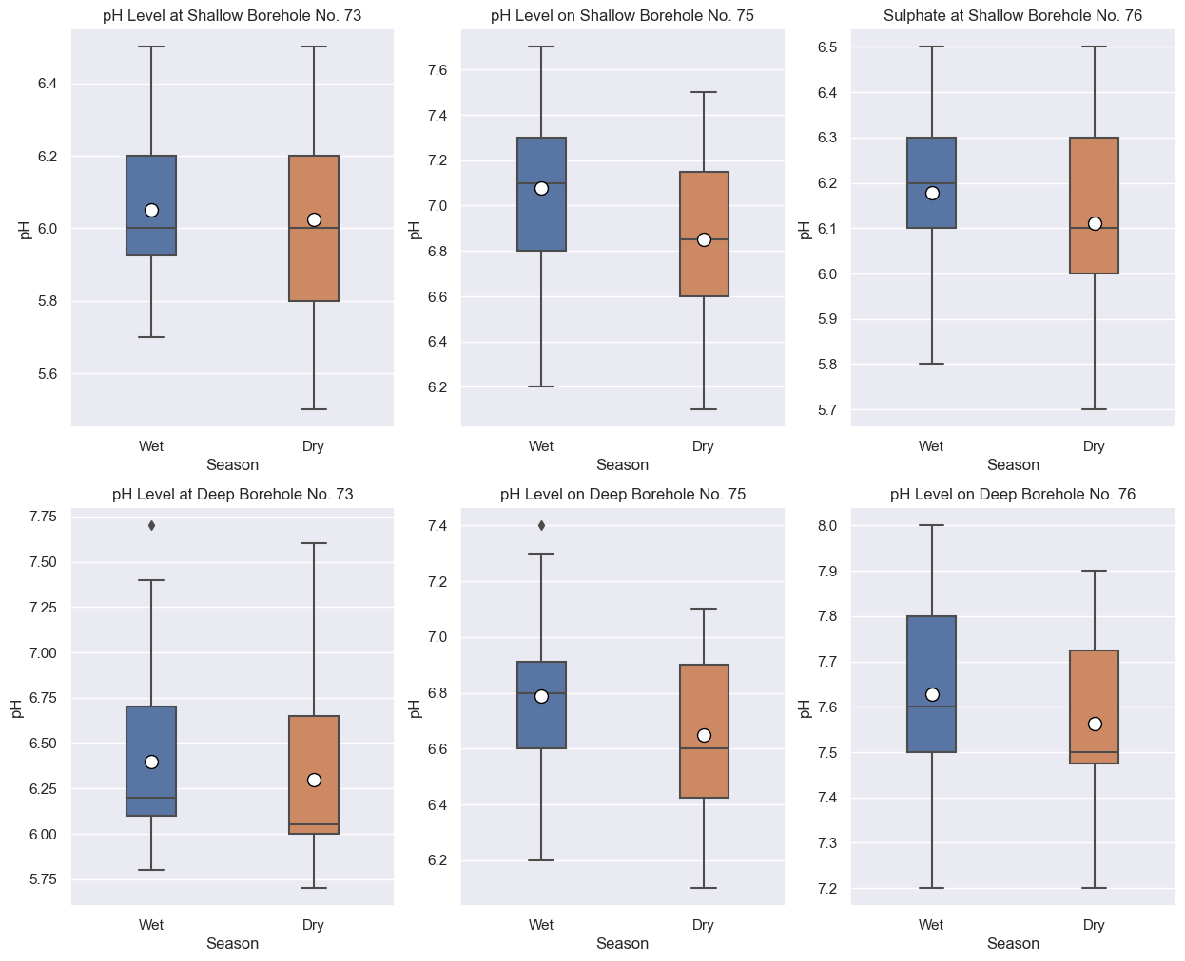
Figure 4.12: Relationships Between pH and Rainfall in Selected Boreholes.
Source: Study Findings

In general, pH was observed to be between 5.4 – 6.5 at the lowest especially at shallow borehole no. 73. This observation is not as worse as expected considering the rate of tailings that has been poured annually for the past 7 years. pH reading are just below discharges limit within suggests that oxidation of pyrites is neutralized by rocks with basic characteristics such as rocks with high content of carbonates (Dold, 2017).The neutralizations are observed at shallow borehole number 75 as well as deep boreholes numbers 75 and 76. It is also observed that, pyrites oxidised more during wet season as compared to the dry season.

In this context, appropriate water control at the TSF will significantly reduce pyrites oxidation. Strong recycling mechanism of water from the TSF to process plant during wet and dry season is paramount for oxidation control.

4.2.7 Correlation between TDS and Rainfall
Geita region experiences bimodal rain distribution annually. The rain provides sufficient to support various chemical equations. Seasonal variations between wet and dry season result into more TDS except for deep borehole number 76 (Figure 4.13). Variation can be observed at various boreholes along the downstream. Shallow borehole number 73 shows normal distribution while boreholes number 75 and 76 showed lognormal correlations. Concentrations of TDS were higher during wet season than during dry season except for deep borehole number 76.
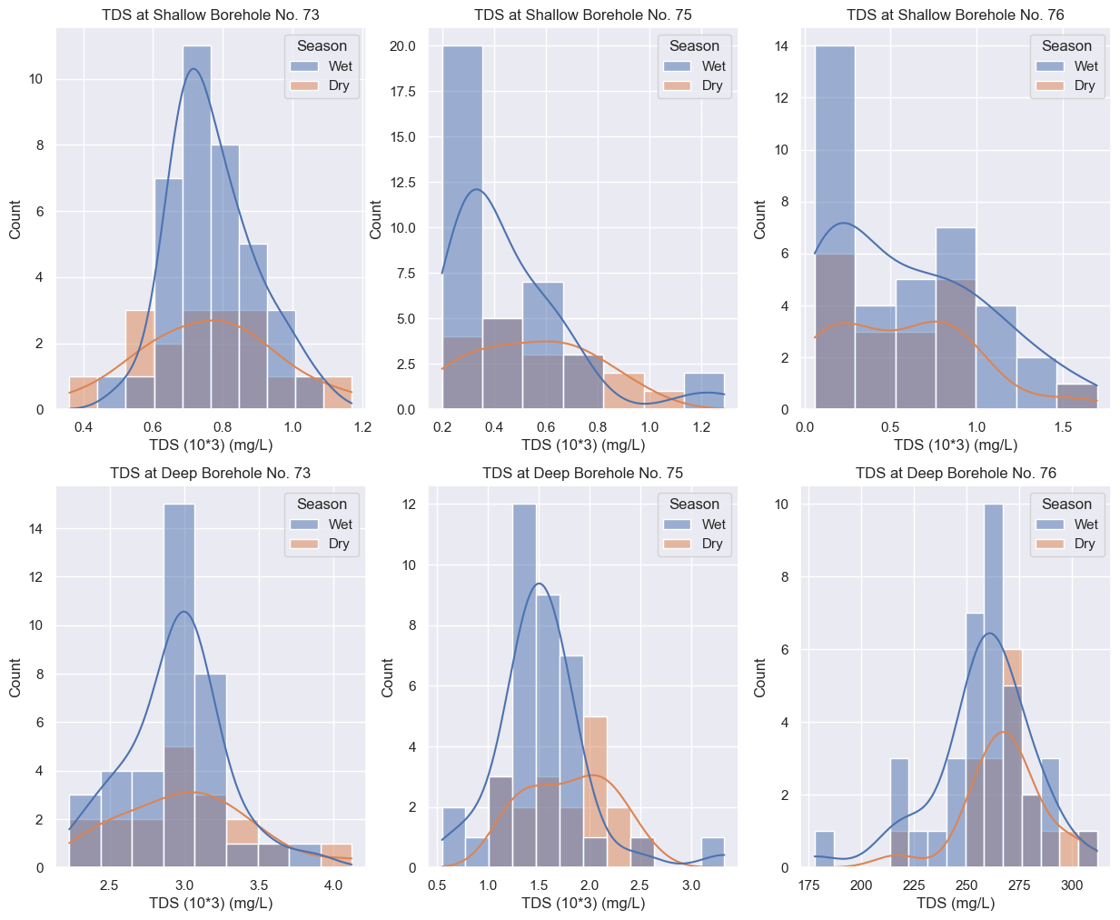

Figure 4.13: Relationships between TDS and Rainfall in Selected Boreholes
Source: Study Findings

All deep boreholes showed normal distribution with high concentrations of TDS except in deep borehole number 76. Significant decrease in microseepage behaviour at deep borehole number 76 suggests that geological features such as ferric rete and sap rock with low permeability lies beneath the TSF hence reduces microseepage at this area (Mather et al., 2019). In all boreholes high concentrations of TDS during wet season than dry season were observed.

4.2.8 Correlation between Nitrate and Rainfall
Nitrate levels in shallow boreholes showed lognormal distribution in both seasons (Figure 4.14). The nitrate levels in all deep boreholes were relatively low in both seasons. However, borehole number 76 had much higher nitrate values.

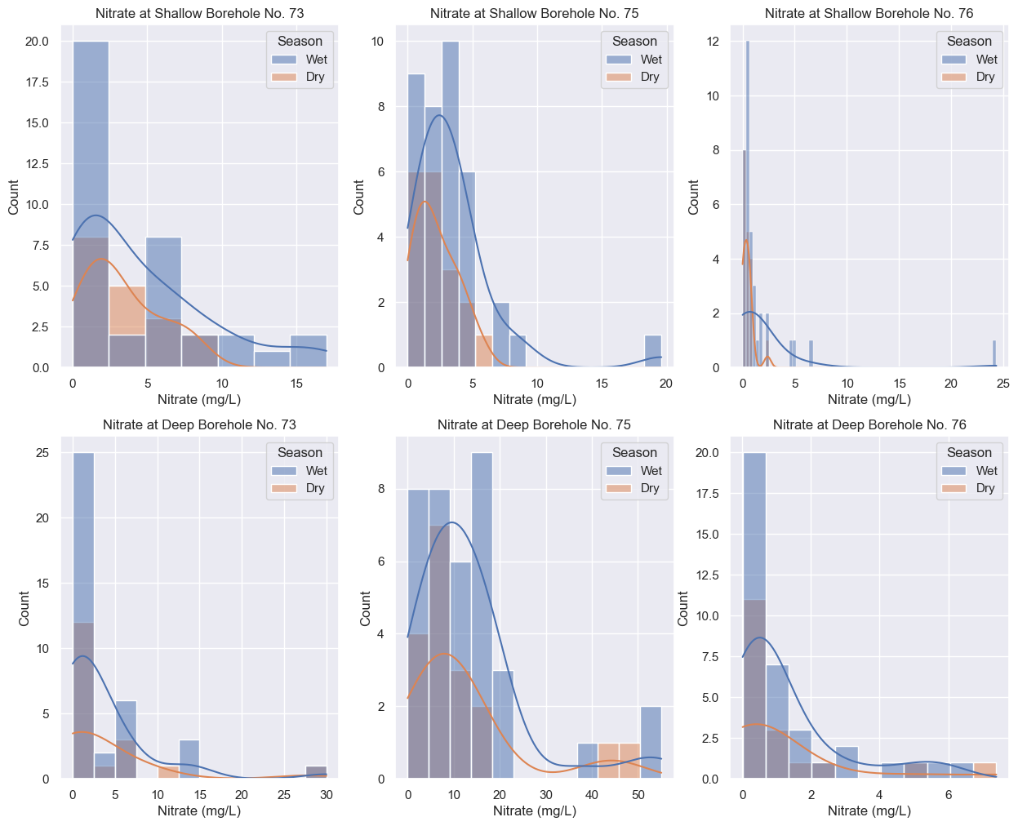
Figure 4.14: Concentration of Nitrate and Rainfall in Selected Boreholes
Source: Study Findings

Nitrate concentration indicated that there is less seepage for both dry and wet season. This observation suggests that nitrates does not originated from natural source rather from deposition of the explosives remains used by GGM as a result of blasting activities. The remains of explosives materials are normally stored at the TSF (Kuykendall, 2023). In both cases neither shallow nor deep monitoring boreholes are significantly affected by nitrate concentration levels in relation to TBS limit.

4.2.9 Correlation between Sulphate and Wind Speed
Boreholes showed unique result pattern which for each borehole. There is clear relationship between wind speed and sulphate level in all boreholes (Figure 4.15).

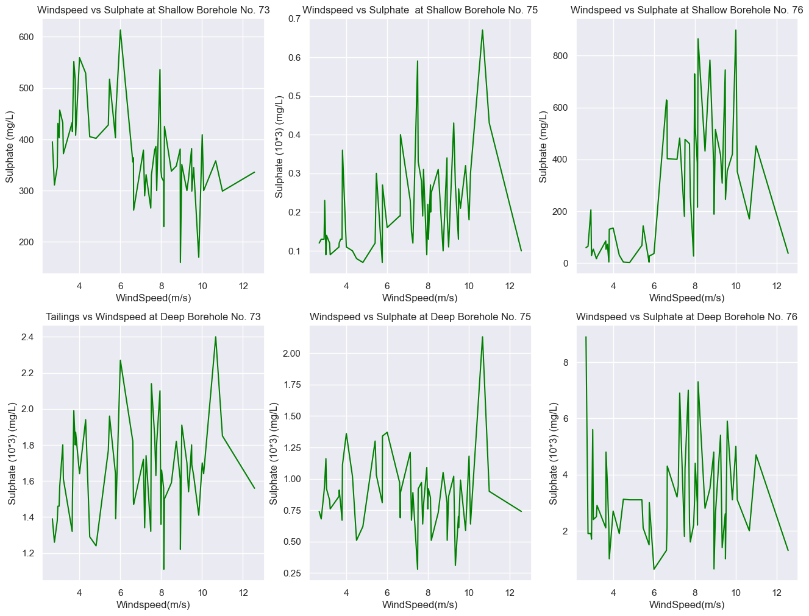
Figure 4.15: Relationships between Sulphate and Rainfall in Selected Boreholes
Source: Study Findings

4.2.10 Correlation Between pH and Wind Speed
Results from monitoring boreholes does not portray a direct relationship as indicated in Figure 4.16. The relationship of pH and wind speed in both shallow and deep boreholes was weak.
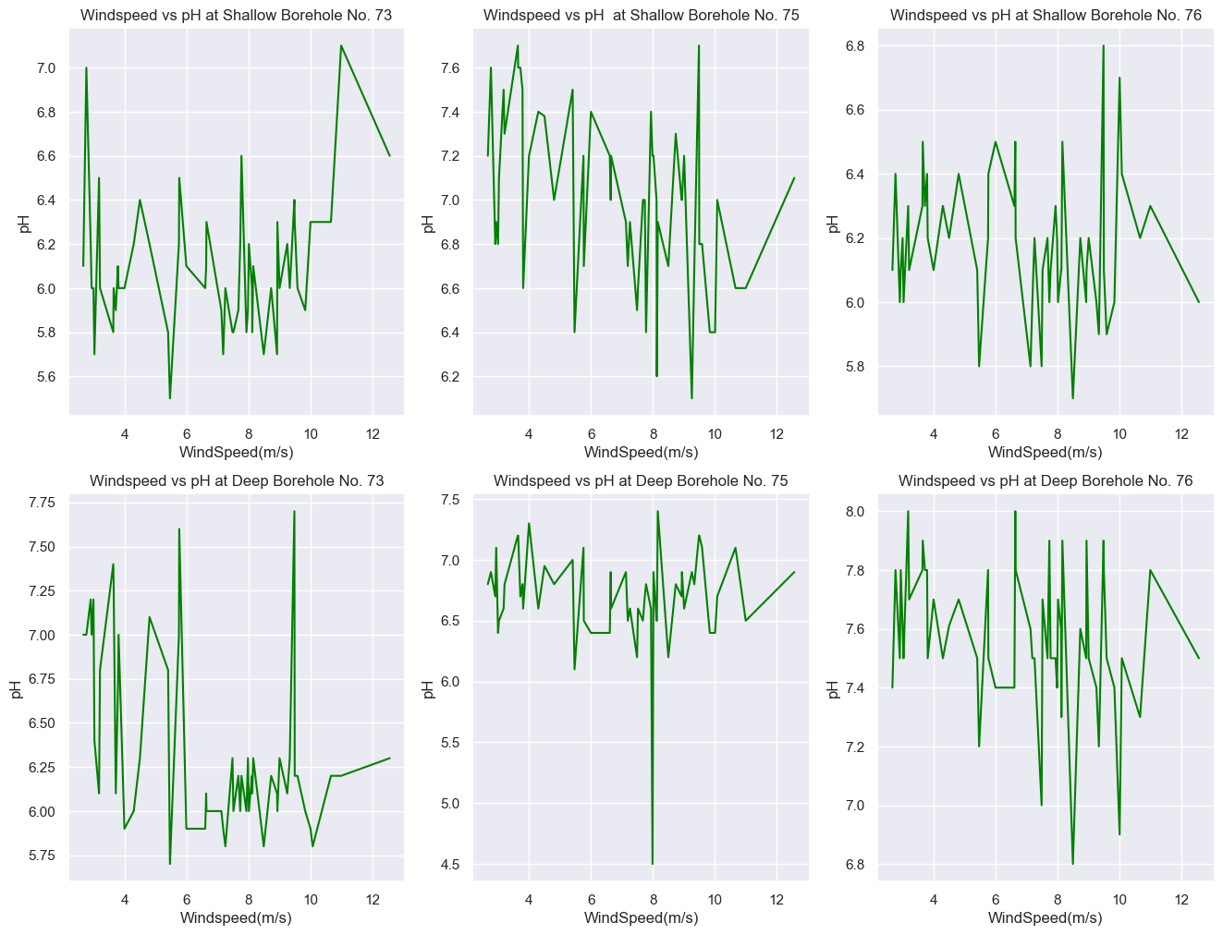
Figure 4.16: Relationships between pH and Wind Speed in Selected Boreholes
Source: Study Findings

4.2.11 Correlation between TDS and Wind Speed
Results of TDS and wind speed outlines relationships that varies from positive to negative (Figure 4.17). Correlation values between TDS and Wind Speed for shallow boreholes no. 73, 75 and 76 are - 0.54, 0.43 and 0.59 whereas deep boreholes are -0.12, - 0.05 and - 0.15. Shallow borehole no. 76, shows a moderate correlation where deep boreholes are very weak with negative correlations (r² < -0.05). This is contrast to the fact that wind speed can be a driving force towards oxygen supply to accelerate the oxidation of pyrites.
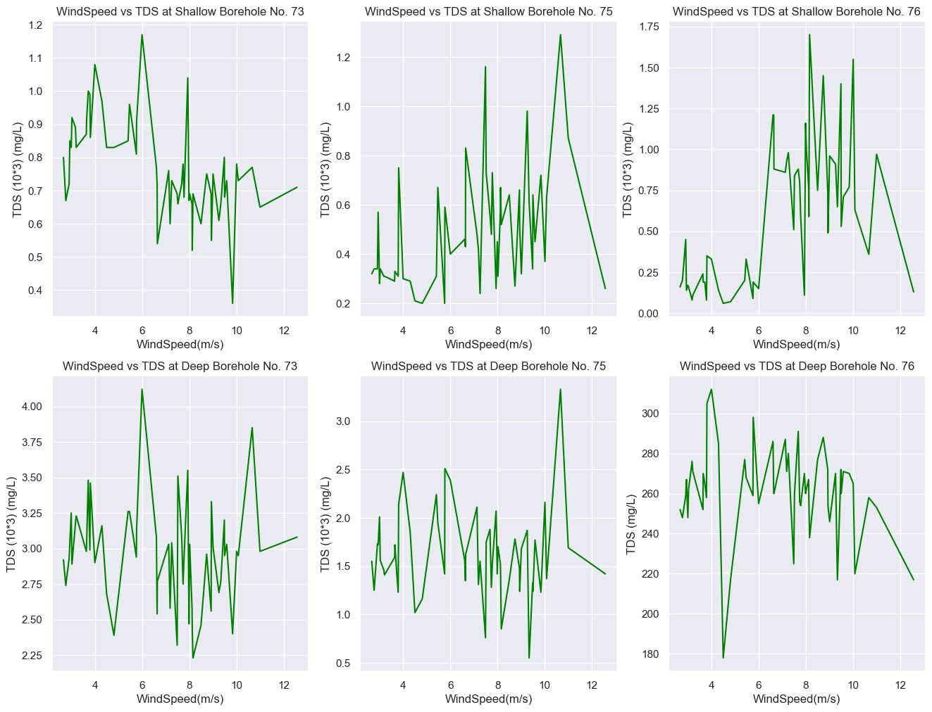
Figure 4.17: Relationships between TDS and Wind Speed in Selected Boreholes
Source: Study Findings

4.2.12 Correlation between Nitrate and Wind Speed
Figure 4.18 showed that nitrate is equivocally not affected by wind speed. All boreholes indicated low nitrate values except deep borehole number 75 (Figure 4.18). Triangle heatmap showed that the correlations between nitrate levels and wind speed in all boreholes were relatively weak.
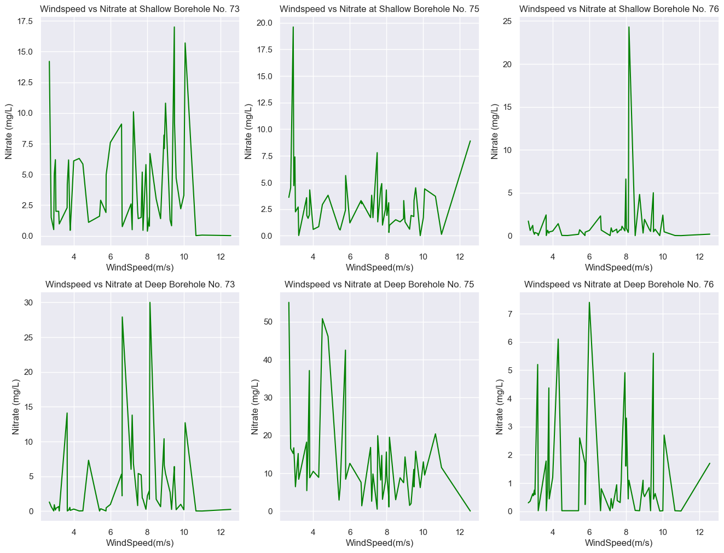
Figure 4.18: Relationship between Nitrate and Wind Speed in Selected Boreholes
Source: Study Findings

Relationships between these variables show an interesting fact. These facts are crucial in understanding the impacts of weather pattern towards tailings reactions, aquifers movement and directions.

4.4 Seepage Modelling

4.4.1 Model Variables
Relationship between input (wind speed, rainfall, and tailings weight) and selected output (sulphate, pH, nitrate and TDS) variables have shown various information towards shallow and deep boreholes behaviour. Seepage prediction from these variables was used for modelling of pH, Sulphate and TDS. These parameters show significant level of concentration beyond baseline data. The input variables and the data from output variables in shallow and deep boreholes number 73 and 75 (except nitrate) were used in seepage modelling. The data from shallow and deep borehole number 76 were not used to avoid over fitting as the results were too small or dropped rapidly as tailings weight decreased. So, a total of 3 inputs variable and 10 output variables were used in seepage modelling, training, and testing. Since the number of input variables were fewer than the outputs, artificial neural networks were used for model creation, validation, and prediction of the seepage.

The model was operated under the assumption that:-
- Wind speed provides unlimited supply of oxygen to the tailings;
- Rainfall considers water supply from the process plant;
- Bootstrap samples originated from the same samples; and
- The average tailings deposition was 415,927.8 tonnages per month.

The input and output data for the model are outlined as part in a Table 4.3 and presented in wholly at Appendix 2, respectively. The output features are the readings from the monitoring boreholes where number 1 indicates that there is microseepage and 0 no microseepage.
Table 4.2: Some of the Values between Input and Output Parameters
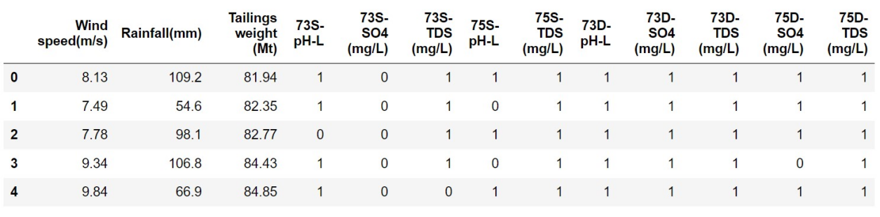
Source: Study Findings

4.4.2 Model Training and Testing
Using the bootstrap re-sampling techniques and artificial neural network, data training and fitting was performed (Kline & Santos, 2012). The model showed that the fitting between training and test dataset gave an accuracy score of 91.32% (Figure 4.19). The result shows the efficiency bootstrap technique for model fitting when small number of datasets are used (Zhu, Gong, Xu, & He, 2017). The model was created from 150 cycles of complete datasets for training the model with an algorithm that are indicated below as an epoch.
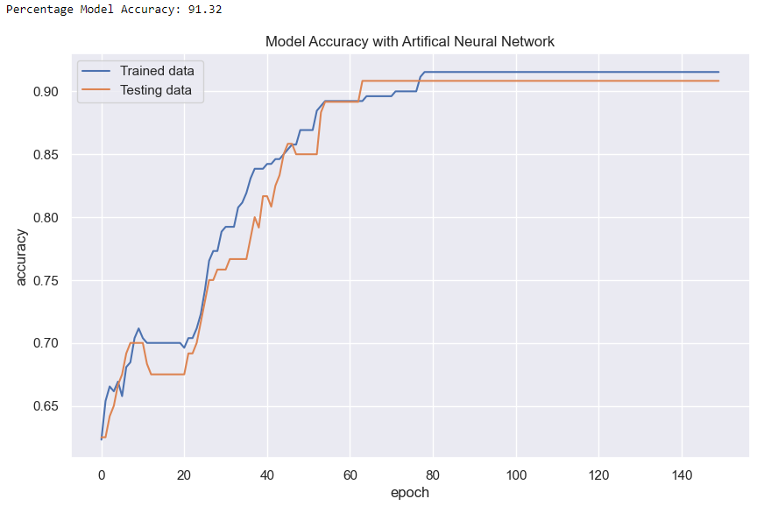
Figure 4.19: Artificial Neural Network Model which Outlines Bootstrap Re-sampling results of the Training and Testing Data.
Source: Study Findings

4.4.3 Microseepage Prediction
Prediction of microseepage from 55 observations is not that straight forward. The first four values that predicted seepage are shown in the Table 4.3. Seepage is indicated by value number 1 and 0 shows that there is no seepage. Values of 1 and 0 were taken from output readings that are more and less than the standard discharge limit.

Table 4.3: Seepage Prediction for the First Four Values
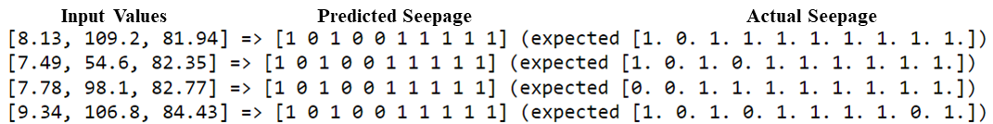
Source: Study Findings
The results from model loss shows that with more available datasets the model can be improved to provide more optimal solution for prediction (Figure 4.20)

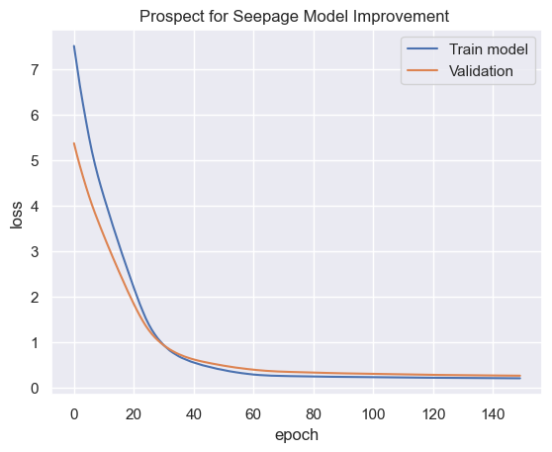
Figure 4.20: Model Loss which Outlines the Validation Prospect for Model Improvement
Source: Study Findings

CHAPTER FIVE

CONCLUSION AND RECOMMENDATIONS

5.1 Conclusion
Higher levels were observed during wet season as opposed to dry season for sulphate and TDS. During wet season’s pH varied from acidic to alkaline. Lower pH levels were observed in shallow borehole number 73. Nitrate exhibits low concentrations in all boreholes, indicating that they do not originate from tailings deposition or parent rock. These findings have evidenced the fact that water plays an important role towards sulphates and total dissolved salts formation at GGM TSF. The findings from the monitoring boreholes have indicated existence of microseepage. The model has enabled prediction of the seepage at 91.32% accuracy.

5.2 Recommendations
Further studies on mineralogical information and their percentage composition are needed. This will provide information to the neutrality behaviour of the TSF at the monitoring points. With increased acidity, rocks with more basic characteristics can be deposited to neutralize the acidity.

The model for microseepage control can be improved on the availability of more monitoring datasets from ongoing monitoring activities. More datasets for TSF monitoring are needed to obtain improved model in terms of training and fitting. Moreover, further research is also recommended to other TSFs in Tanzania using similar assumptions. The datasets from other TSFs with similar properties of that of GGM can be used to refine the model and improve prediction accuracy.

REFERENCES
(TBS), T. B. (2006). Municipal and Industrial Wastewaters General Tolerance Limits for Municipal and Industrial Wastewaters (TZS860:2006). Dar es Salaam: National Environment Standards Compendium Tanzania, Bureau of Standards, Dar es Salaam, 1-8.
Acheampong, E. A., & Nukpezah, D. (2016). Assessing the impact of an operating Tailings Storage Facility on Catchment Surface and Groundwater quality in the Ellembele District of the Western region of Ghana. Environ Pollut, 5, 26–40.
Adamo, N., Al-Ansari, N., Sissakian, V., Laue, J., & Knutsson, S. (2021). Dam safety: The question of tailings dams. J. Earth Sci. Geotech. Eng, 11, 1–26.
Aznar-Sánchez, J. A., Garcı́a-Gómez, J. J., Velasco-Muñoz, J. F., & Carretero-Gómez, A. (2018). Mining waste and its sustainable management: advances in worldwide research. Minerals, 8, 284.
Banks, E. W., Cook, P. G., Owor, M., Okullo, J., Kebede, S., Nedaw, D., . . . others. (2021). Environmental tracers to evaluate groundwater residence times and water quality risk in shallow unconfined aquifers in sub Saharan Africa. Journal of Hydrology, 598, 125753.
Baranov, A. A., & Bobrov, A. M. (2018). Crustal structure and properties of Archean cratons of Gondwanaland: similarity and difference. Russian Geology and Geophysics, 59, 512–524.
Berry, M. W., Mohamed, A., & Yap, B. W. (2019). Supervised and unsupervised learning for data science. Springer.
Birle, E., von der Straten, E., & Melsbach, M. (2022). Water Balance of an Earth Fill Built of Compacted Clay: Field Data and Numerical Modeling. Journal of Geotechnical and Geoenvironmental Engineering, 148, 04022011.
Cacciuttolo, C., & Atencio, E. (2022). Past, Present, and Future of Copper Mine Tailings Governance in Chile (1905–2022): A Review in One of the Leading Mining Countries in the World. International Journal of Environmental Research and Public Health, 19, 13060.
Chen, G., Ye, Y., Yao, N., Hu, N., Zhang, J., & Huang, Y. (2021). A critical review of prevention, treatment, reuse, and resource recovery from acid mine drainage. Journal of cleaner production, 329, 129666.
Chiroma, H., Noor, A. S., Abdulkareem, S., Abubakar, A. I., Hermawan, A., Qin, H., Herawan, T. (2017). Neural networks optimization through genetic algorithm searches: a review. Appl. Math. Inf. Sci, 11, 1543–1564.
Chovan, K. M., Julien, M. R., Ingabire, E.-P., James, M., Masengo, É., Lépine, T., & Lavoie, P. (2021). A risk assessment tool for tailings storage facilities. Canadian Geotechnical Journal, 99, 1898–1914.
Clarkson, L., & Williams, D. (2021). An overview of conventional tailings dam geotechnical failure mechanisms. Mining, Metallurgy & Exploration, 38, 1305–1328.
Clemente, J. S., & Huntsman, P. (2019). Potential climate change effects on the geochemical stability of waste and mobility of elements in receiving environments for Canadian metal mines south of 60° N. Environmental Reviews, 27, 478–518.
Condon, L. E., Kollet, S., Bierkens, M. F., Fogg, G. E., Maxwell, R. M., Hill, M. C., . . . others. (2021). Global groundwater modeling and monitoring: Opportunities and challenges. Water Resources Research, 57, e2020WR029500.
Coudert, L., Bondu, R., Rakotonimaro, T. V., Rosa, E., Guittonny, M., & Neculita, C. M. (2020). Treatment of As-rich mine effluents and produced residues stability: Current knowledge and research priorities for gold mining. Journal of hazardous materials, 386, 121920.
Davies, J., Robins, N., & Cheney, C. (2014). Similarities in groundwater occurrence in weathered and fractured crystalline basement aquifers in the Channel Islands and in Zimbabwe. Fractured rock hydrogeology. IAH Selected Papers, 47–60.
Diaz, D., & Hahn, D. W. (2020). Raman spectroscopy for detection of ammonium nitrate as an explosive precursor used in improvised explosive devices. Spectrochimica Acta Part A: Molecular and Biomolecular Spectroscopy, 233, 118204.
Dinov, I. D. (2018). Data science and predictive analytics. Cham, Switzerland.
Dold, B. (2017). Acid rock drainage prediction: A critical review. Journal of Geochemical Exploration, 172, 120–132.
Dong, L., Deng, S., & Wang, F. (2020). Some developments and new insights for environmental sustainability and disaster control of tailings dam. Journal of Cleaner Production, 269, 122270.
Dubey, K. (2017). Socio Economic Impact Study of Mining and Mining Polices on the Livelihoods of Local Population in the Vindhyan Region of Uttar Pradesh. Dehradun: Centre for Social Forestry and Eco-Rehabilitation.
Eid, H. T., Elshafie, M. Z., O'Sullivan, B., Mahmoud, A., & Stollberg, R. (2023). Estimating the permeability of fractured rock masses for design of construction dewatering systems. Engineering Geology, 323, 107231.
Elmayel, I., Esbrı́, J. M., Efrén, G.-O., Garcı́a-Noguero, E.-M., Elouear, Z., Jalel, B., . . . Higueras, P. (2020). Evolution of the speciation and mobility of Pb, Zn and Cd in relation to transport processes in a mining environment. International journal of environmental research and public health, 17, 4912.
Emel, J., Plisinski, J., & Rogan, J. (2014). Monitoring geomorphic and hydrologic change at mine sites using satellite imagery: The Geita Gold Mine in Tanzania. Applied Geography, 54, 243–249.
Fetisov, V. V., & Menshikova, E. A. (2020). Evaluation and Prediction of Seepage Discharge Through Tailings Dams When Their Height Increases. In Applied Geology (pp. 21–41). Springer.
Fortuna, J., Waterhouse, J., Chapman, P., & Gowan, M. (2021). Applying practical hydrogeology to tailings storage facility design and management. Mine Water and the Environment, 40, 50–62.
Franks, D. M., Stringer, M., Torres-Cruz, L. A., Baker, E., Valenta, R., Thygesen, K.,Barrie, S. (2021). Tailings facility disclosures reveal stability risks. Scientific reports, 11, 5353.
Gholamy, A., Kreinovich, V., & Kosheleva, O. (2018). Why 70/30 or 80/20 relation between training and testing sets: A pedagogical explanation.
Gibson, B. A., Nwaila, G., Manzi, M., Ghorbani, Y., Ndlovu, S., & Petersen, J. (2023). The valorisation of platinum group metals from flotation tailings: A review of challenges and opportunities. Minerals Engineering, 201, 108216.
Gilsbach, L., Schütte, P., & Franken, G. (2019). Applying water risk assessment methods in mining: Current challenges and opportunities. Water Resources and Industry, 22, 100118.
Google. (2022, March 24). Google Earth. Retrieved from https://earth.google.com: https://earth.google.com/web/@-2.86321028,32.18871149,1250.97615356a,8474.07298356d,35y,-36.00107103h,45.04716386t,0r
Hancock, G. R., & Coulthard, T. J. (2022). Tailings dams: Assessing the long-term erosional stability of valley fill designs. Science of The Total Environment, 849, 157692.
Hastie, E. C., Kontak, D. J., & Lafrance, B. (2020). Gold remobilization: Insights from gold deposits in the Archean Swayze greenstone belt, Abitibi subprovince, Canada. Economic Geology, 115, 241–277.
He, K., Song, C., & Fell, R. (2021). Numerical modelling of transverse cracking in embankment dams. Computers and Geotechnics, 132, 104028.
Huggins, C., & Kinyondo, A. (2019). Resource nationalism and formalization of artisanal and small-scale mining in Tanzania: evidence from the tanzanite sector. Resources Policy, 63, 101436.
Islam, K., & Murakami, S. (2021). Global-scale impact analysis of mine tailings dam failures: 1915–2020. Global Environmental Change, 70, 102361.
Jia, R., & Dai, L. (2021). Analysis of economic benefits of mineral resources development ecological environment based on ecological footprint. Arabian Journal of Geosciences, 14, 1–19.
Jiao, H., Wu, Y., Wang, H., Chen, X., Li, Z., Wang, Y., . . . Liu, J. (2021). Micro-scale mechanism of sealed water seepage and thickening from tailings bed in rake shearing thickener. Minerals Engineering, 173, 107043.
Kabete, J. M., Groves, D. I., McNaughton, N. J., & Mruma, A. H. (2012). A new tectonic and temporal framework for the Tanzanian Shield: implications for gold metallogeny and undiscovered endowment. Ore Geology Reviews, 48, 88–124.
Kalisz, S., Kibort, K., Mioduska, J., Lieder, M., & Małachowska, A. (2022). Waste management in the mining industry of metals ores, coal, oil and natural gas-A review. Journal of environmental management, 304, 114239.
Kalonji-Kabambi, A., Bussière, B., & Demers, I. (2020). Hydrogeochemical behavior of reclaimed highly reactive tailings, part 2: Laboratory and field results of covers made with mine waste materials. Minerals, 10, 589.
Karlović, I., Marković, T., Smith, A. C., & Maldini, K. (2023). Impact of gravel pits on water quality in alluvial aquifers. Hydrology, 10, 99.
Katz, L. R., Kontak, D. J., Dubé, B., McNicoll, V., Creaser, R., & Petrus, J. A. (2021). An archean porphyry-type gold deposit: The côté gold Au (-Cu) deposit, swayze greenstone belt, superior province, Ontario, Canada. Economic Geology, 116, 47–89.
Keskin, T. E., & Ozler, E. (2020). Heavy metal contamination in groundwater and surface water due to active Pb-Zn-Cu mine tails and water-rock interactions: A case study from the Kure mine area (Turkey). Turkish Journal of Earth Sciences, 29, 878–895.
KESKİN, T. E., & Ozler, E. (2020). Heavy metal contamination in groundwater and surface water due to active Pb-Zn-Cu mine tails and water-rock interactions: A case study from the Kure mine area (Turkey). Turkish Journal of Earth Sciences, 29, 878–895.
Kicińska, A., Pomykała, R., & Izquierdo-Diaz, M. (2022). Changes in soil pH and mobility of heavy metals in contaminated soils. European Journal of Soil Science, 73, e13203.
Kline, P., & Santos, A. (2012). A score based approach to wild bootstrap inference. Journal of Econometric Methods, 1, 23–41.
Kuykendall, S. T. (2023). CHARACTERIZATION OF EXPLOSIVES TESTING RANGES: ENVIRONMENTAL IMPACTS AND REMEDIATION CONSIDERATIONS.
Kwelwa, S. D., Dirks, P. H., Sanislav, I. V., Blenkinsop, T., & Kolling, S. L. (2018). Archaean gold mineralization in an extensional setting: The structural history of the Kukuluma and Matandani Deposits, Geita Greenstone Belt, Tanzania. Minerals, 8, 171.
Lederer, G., Jones, J., McPhee, D., Mauk, J., Seal, R., Campbell, K., . . . others. (2024). USGS critical minerals review. Mining Engineering, 76.
Lemos, M., Valente, T., Reis, P. M., Fonseca, R., Delbem, I., Ventura, J., & Magalhães, M. (2020). Mineralogical and geochemical characterization of gold mining tailings and their potential to generate acid mine drainage (Minas Gerais, Brazil). Minerals, 11, 39.
Li, H., Tian, H., & Ma, K. (2019). Seepage Characteristics and Its Control Mechanism of Rock Mass in High-Steep Slopes. Processes, 7, 71.
Liang, Y., Yi, X., Dang, Z., Wang, Q., Luo, H., & Tang, J. (2017). Heavy metal contamination and health risk assessment in the vicinity of a tailing pond in Guangdong, China. International journal of environmental research and public health, 14, 1557.
Lima, V. H., Moura, J. P., Pissarra, T. C., do Valle Junior, R. F., de Melo, M. M., Valera, C. A., . . . others. (2024). Groundwater flow and transport of metals under deposits of mine tailings: A case study in Brumadinho, Minas Gerais, Brazil. Case Studies in Chemical and Environmental Engineering, 9, 100690.
Litvinenko, V. S. (2020). Digital economy as a factor in the technological development of the mineral sector. Natural Resources Research, 29, 1521–1541.
Luhunga, P. M., & Songoro, A. E. (2020). Analysis of climate change and extreme climatic events in the Lake Victoria Region of Tanzania. Frontiers in Climate, 2, 559584.
Lusunzi, R. (2018). Geochemical and mineralogical characterization of gold mine tailings for the potential of acid mine drainage in the Sabie-Pilgrims's Rest Goldfields. Ph.D. dissertation.
Lyu, Z., Chai, J., Xu, Z., Qin, Y., & Cao, J. (2019). A comprehensive review on reasons for tailings dam failures based on case history. Advances in Civil Engineering, 2019, 4159306.
Mahadevan, E. G. (2013). Ammonium nitrate explosives for civil applications: slurries, emulsions and ammonium nitrate fuel oils. John Wiley & Sons.
Martı́nez-Alcalá, I., & Bernal, M. P. (2020). Environmental impact of metals, metalloids, and their toxicity. Metalloids in Plants: Advances and Future Prospects, 451–488.
Mather, C. C., Nash, D. J., Dogramaci, S., Grierson, P. F., & Skrzypek, G. (2019). Geomorphic and hydrological controls on groundwater dolocrete formation in the semi-arid Hamersley Basin, northwest Australia. Earth Surface Processes and Landforms, 44, 2752–2770.
Naeini, M., & Akhtarpour, A. (2018). A numerical investigation on hydro-mechanical behaviour of a high centreline tailings dam. Journal of the South African Institution of Civil Engineering, 60, 49–60.
Netshiongolwe, K. E. (2018). Geochemical characterisation of gold tailings footprints on the Central Rand Goldfield. Ph.D. dissertation.
Nordstrom, D. K. (2019). Geochemical modelling for mine site characterization and remediation. E3S Web of Conferences, 98, p. 05013.
Ouzaid, I., Benmebarek, N., & Benmebarek, S. (2020). FEM optimisation of seepage control system used for base stability of excavation. Civil Eng J, 6, 1739–1751.
Owen, J. R., Kemp, D., Lébre, É., Svobodova, K., & Murillo, G. P. (2020). Catastrophic tailings dam failures and disaster risk disclosure. International journal of disaster risk reduction, 42, 101361.
Pedersen, R. H., Mutagwaba, W., Jønsson, J. B., Schoneveld, G., Jacob, T., Chacha, M., Njau, M. G. (2019). Mining-sector dynamics in an era of resurgent resource nationalism: Changing relations between large-scale mining and artisanal and small-scale mining in Tanzania. Resources Policy, 62, 339–346.
Qiao, D., Wang, G., Li, X., Wang, S., & Zhao, Y. (2020). Pollution, sources and environmental risk assessment of heavy metals in the surface AMD water, sediments and surface soils around unexploited Rona Cu deposit, Tibet, China. Chemosphere, 248, 125988.
Rahman, Z., & Singh, V. P. (2019). The relative impact of toxic heavy metals (THMs)(arsenic (As), cadmium (Cd), chromium (Cr)(VI), mercury (Hg), and lead (Pb)) on the total environment: an overview. Environmental monitoring and assessment, 191, 1–21.
Raju, N. J. (2022). Arsenic in the geo-environment: A review of sources, geochemical processes, toxicity and removal technologies. Environmental research, 203, 111782.
Reddit.(2023,December4).Retrievedfrom https://www.reddit.com/r/Maps/comments/16xriw7/blank_map_of_tanzania/
Reddy, K. R., Cameselle, C., & Adams, J. A. (2019). Sustainable engineering: Drivers, metrics, tools, and applications. John Wiley & Sons.
Ren, M., Zeng, W., Yang, B., & Urtasun, R. (2018). Learning to reweight examples for robust deep learning. International conference on machine learning, (pp. 4334–4343).
Rybnikova, L. S., & Rybnikov, P. A. (2019). Regularities in the evolution of groundwater quality at abandoned copper sulfide mines at the Levikha ore field, Central Urals, Russia. Geochemistry International, 57, 298–313.
Salimi, H. (2017). Extraction and recovery of gold from both primary and secondary sources by employing a simultaneous leaching and solvent extraction technique and gold leaching in acidified organic solvents. Ph.D. dissertation, University of Saskatchewan.
Salmasi, F., Nouri, M., & Abraham, J. (2020). Upstream cutoff and downstream filters to control of seepage in dams. Water Resources Management, 34, 4271–4288.
Sanislav, I. V., Brayshaw, M., Kolling, S. L., Dirks, P. H., Cook, Y. A., & Blenkinsop, T. G. (2017). The structural history and mineralization controls of the world-class Geita Hill gold deposit, Geita Greenstone Belt, Tanzania. Mineralium deposita, 52, 257–279.
Sanislav, I. V., Dirks, P. H., Blenkinsop, T., & Kolling, S. L. (2018). The tectonic history of a crustal-scale shear zone in the Tanzania Craton from the Geita Greenstone Belt, NW-Tanzania Craton. Precambrian Research, 310, 1–16.
Sanislav, I. V., Kolling, S. L., Brayshaw, M., Cook, Y. A., Dirks, P. H., Blenkinsop, T. G., . . . Ruhega, R. (2015). The geology of the giant Nyankanga gold deposit, Geita Greenstone Belt, Tanzania. Ore Geology Reviews, 69, 1–16.
Sarker, I. H. (2021). Machine learning: Algorithms, real-world applications and research directions. SN computer science, 2, 160.
Shengo, L. M. (2021). Review of practices in the managements of mineral wastes: The case of waste rocks and mine tailings. Water, Air, & Soil Pollution, 232, 1–31.
Singh, B. R., & Steinnes, E. (2020). Soil and water contamination by heavy metals. In Soil processes and water quality (pp. 233–271). CRC Press.
Skinner, H., Toll, D. G., Higgins, K., Brown, M., & Burland, J. (2023). ICE Manual of Geotechnical Engineering Volume 2: Geotechnical design, construction and verification (Vol. 2). Emerald Group Publishing.
Stefaniak, K., & Wróżyńska, M. (2018). On possibilities of using global monitoring in effective prevention of tailings storage facilities failures. Environmental Science and Pollution Research, 25, 5280–5297.
Stephens, D. B., Kron, A. J., & Kron, A. (2018). Vadose zone hydrology. CRC press.
Sundar, H., Padmini, S., & Devi, P. B. (2023). Bioremediation of nuclear waste effluent using different communities of microbes. Metagenomics to Bioremediation, 403–444.
Tayfur, G. (2017). Modern optimization methods in water resources planning, engineering and management. Water Resources Management, 31, 3205–3233.
Thakur, D., Bartarya, S. K., & Nainwal, H. C. (2018). Groundwater quality assessment of the Soan basin in outer Himalaya, Himachal Pradesh, India. Himalayan Geology, 39, 197–211.
Trifi, M., Charef, A., Dermech, M., Azouzi, R., Chalghoum, A., Hjiri, B., & Sassi, M. B. (2019). Trend evolution of physicochemical parameters and metals mobility in acidic and complex mine tailings long exposed to severe Mediterranean climatic conditions: Sidi Driss tailings case (NW-Tunisia). Journal of African Earth Sciences, 158, 103509.
Tschuschke, W., Gogolik, S., Wróżyńska, M., Kroll, M., & Stefanek, P. (2020). The application of the seismic cone penetration test (SCPTU) in tailings water conditions monitoring. Water, 12, 737.
Tyagunov, S., Vorogushyn, S., Muñoz Jimenez, C., Parolai, S., & Fleming, K. (2018). Multi-hazard fragility analysis for fluvial dikes in earthquake-and flood-prone areas. Natural hazards and earth system sciences, 18, 2345–2354.
Van Ryt, M. R., Sanislav, I. V., Dirks, P. H., Huizenga, J. M., Mturi, M. I., & Kolling, S. L. (2017). Alteration paragenesis and the timing of mineralised quartz veins at the world-class Geita Hill gold deposit, Geita Greenstone Belt, Tanzania. Ore Geology Reviews, 91, 765–779.
Vincent, K. K., Muthama, M. N., & Muoki, S. N. (2014). Darcy’s law equation with application to underground seepage in earth dams in calculation of the amount of seepage. American Journal of Applied Mathematics and Statistics, 2, 143–149.
Williams, D. J. (2021). Lessons from Tailings Dam Failures—Where to Go from Here? Minerals, 11, 853.
Wu, Y., Li, Y.-Z., Qiao, W.-G., Fan, Z.-W., Zhang, S., Chen, K., & Zhang, L. (2022). Water Seepage in Rocks at Micro-Scale. Water, 14, 2827.
Xie, Y., Lu, G., Yang, C., Qu, L., Chen, M., Guo, C., & Dang, Z. (2018). Mineralogical characteristics of sediments and heavy metal mobilization along a river watershed affected by acid mine drainage. PLoS One, 13, e0190010.
Xu, C. (2019). Long-Term Seepage Assessment Using Numerical Modeling for Upstream-Type Tailings Dams. Ph.D. dissertation, Concordia University.
Yang, J., Hu, J., Wu, Y., & Zhang, B. (2022). Numerical simulation of seepage and stability of tailing dams: A case study in ledong, China. Sustainability, 14, 12393.
Yang, Y., Chu, J., Xiao, Y., Liu, H., & Cheng, L. (2019). Seepage control in sand using bioslurry. Construction and Building Materials, 212, 342–349.
Yekeen, N., Padmanabhan, E., & Idris, A. K. (2018). A review of recent advances in foam-based fracturing fluid application in unconventional reservoirs. Journal of Industrial and Engineering Chemistry, 66, 45–71.
Zhang, K., Zhang, B., Liu, J., Ma, D., & Bai, H. (2017). Experiment on seepage property and sand inrush criterion for granular rock mass. Geofluids, 2017, 9352618.
Zhou, C.-B., Chen, Y.-F., Hu, R., & Yang, Z. (2023). Groundwater flow through fractured rocks and seepage control in geotechnical engineering: Theories and practices. Journal of Rock Mechanics and Geotechnical Engineering, 15, 1–36.
Zhu, Q.-X., Gong, H.-F., Xu, Y., & He, Y.-L. (2017). A bootstrap based virtual sample generation method for improving the accuracy of modeling complex chemical processes using small datasets. 2017 6th Data Driven Control and Learning Systems (DDCLS), (pp. 84–88).

APPENDICES
Annex 1: Some of Laboratory analysis from SGS.
Table A 1:Laboratory analysis of the data from monitoring boreholes.
Source: Laboratory Findings

Annex 2: Discharge Limit and ESIA from GGM
Table A 2: Discharge Limit and Environmental Impact Statement for Nyamulilima.
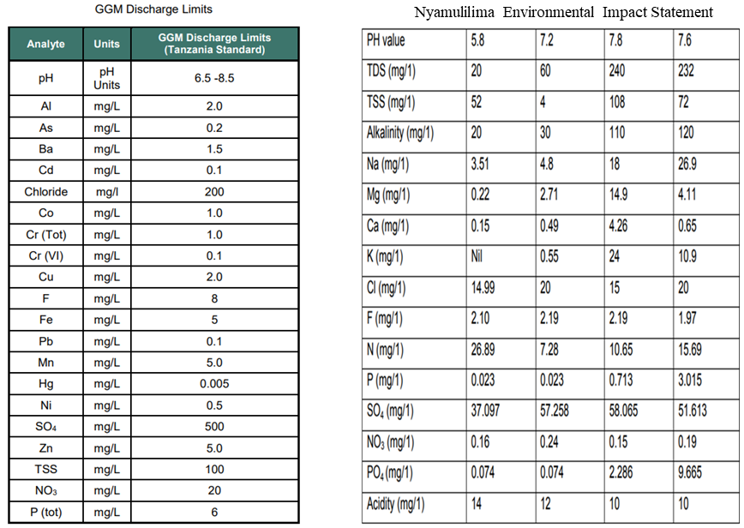
Source: GGM Findings

Table A 3: Dry tonnages deposited at the TSF from 2008 – 2014 at GGM.
Source: GGM Findings

Table A 4: Dry tonnages deposited at the TSF from 2020 – 2021 at GGM
Source: GGM Findings

Table A 5: Useful Libraries for this Research.
S/N | Library | Package
1 | numpy | np
2 | pandas | pd
3 | os | os
4 | matplotlib.pyplot | plt %matplotlib inline
5 | tensorflow.keras.models | Sequential
6 | from tensorflow.keras.layers | Dense

Source: Study Findings

Table A 6: Some of datasets from GGM
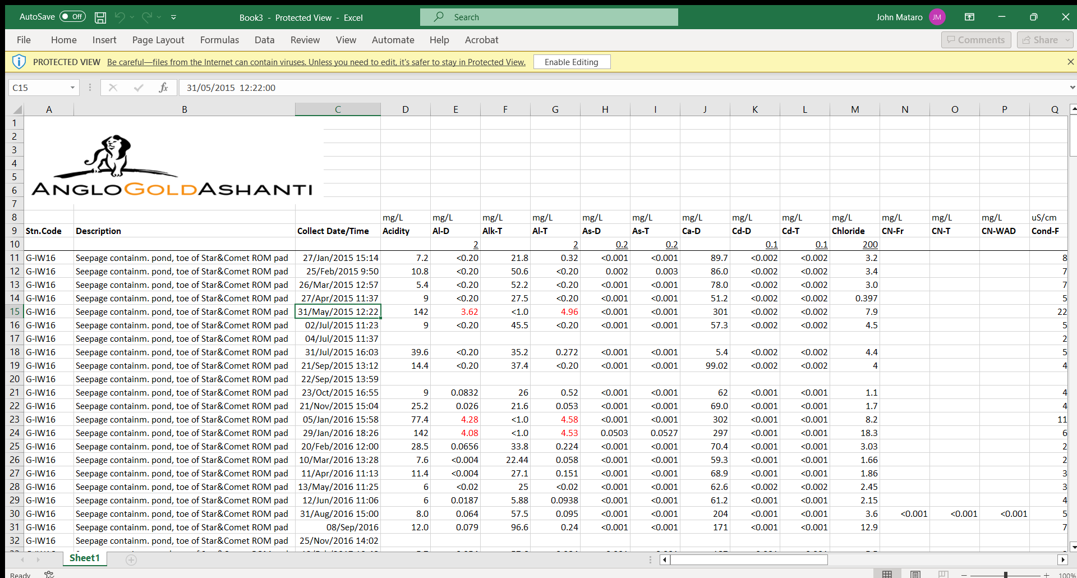
Source: GGM

Table A 7: Input Variables for the Model (X).
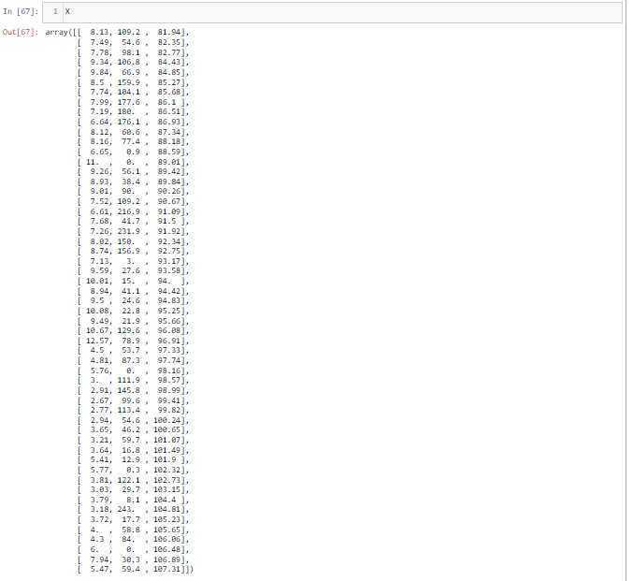
Source: Study Findings

Table A 8: Output Variables for the Model (y).
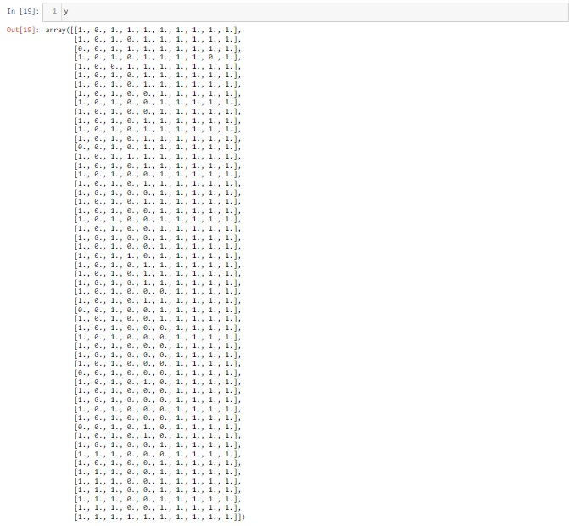
Source: Study Findings

