EXAMINING THE ROLE OF DEVELOPMENT PARTNERS IN FACILITATING EFFECTIVE HUMANITARIAN INTERVENTION IN THE EAST AFRICAN COMMUNITY

SELEMAN YUSUPH KITENGE

A DISSERTATION SUBMITTED IN PARTIAL FULFILMENT
OF THE REQUIREMENTS FOR THE DEGREE OF MASTER OF
HUMANITARIAN ACTION, COOPERATION AND DEVELOPMENT
DEPARTMENT OF POLITICAL SCIENCE, PUBLIC ADMINISTRATION, HISTORY AND PHILOSOPHY
THE OPEN UNIVERSITY OF TANZANIA
2024

CERTIFICATION

The undersigned certify that they have read and hereby recommend for acceptance by the SENATE of the Open University of Tanzania a dissertation entitled “Examining the Role of Development Partners in Facilitating Effective Humanitarian Intervention in the East African Community” in partial fulfilment of the requirements for the award of the Master in Humanitarian Action, Cooperation, and Development Degree of the Open University of Tanzania.

………………………….
Dr. Jacob Lisakafu
Supervisor

……………………….
Date

COPYRIGHT

No part of this dissertation may be reproduced, stored in any retrieval system, or transmitted in any form by any means, electronic, mechanical, photocopying, recording, or otherwise without prior written permission of the author or The Open University of Tanzania in that behalf.

DECLARATION
I, Kitenge, Seleman Y, declare that the work presented in this dissertation is original. It has never been presented to any other University or Institution. Where other people’s works have been used, references have been provided. It is in this regard that I declare this work as originally mine. It is hereby presented in partial fulfilment of the requirements for the award of the Master in Humanitarian Action, Cooperation, and Development Degree.

……………………………
Signature

…………………………..
Date

DEDICATION
This research is solemnly dedicated to my late father, Mr. Kitenge Yusuph Kilezi, and my mother, Ms. Riziki Selemani Milunga, for their invaluable contributions to my upbringing and my education in the sphere of diplomacy. I extend this dedication to the President of the United Republic of Tanzania, Her Excellency Dr. Samia Suluhu Hassan, in acknowledgment of her transformative efforts in revitalising various sectors to promote productivity and inclusivity. Additionally, this work honours the mentorship and guidance of His Excellency Dr. Ibrahim Mayaki, Former Prime Minister of Niger and AU Special Envoy on Food Systems; Ambassador Said Mshana, Tanzania's Ambassador to the Democratic Republic of the Congo; and Ambassador Togolani Mavura, Tanzania’s Ambassador to the Republic of Korea as well as Mr Juma Dossa from the Aga Khan Hospital in Dar es salaam. I also dedicate this research to the development partners who have tirelessly supported the developmental objectives of the East African Community and its member states. Lastly, a special dedication is made to my esteemed colleagues at the African Union Development Agency-NEPAD for their on-going support and collaboration.

ACKNOWLEDGEMENT

I want to express my profound gratitude to all who have supported and guided me throughout this journey. First and foremost, my deepest appreciation goes to the Almighty God for the blessings of life, as well as for continuous provisions and protection throughout this endeavour. Secondly, I owe a great debt of gratitude to my supervisor, Dr Jacob Lisakafu, whose unwavering support and invaluable guidance have been instrumental in bringing me to this stage of my research. I also thank Dr Bernard Achiula, the former Director of the Centre for Foreign Relations, for allowing me to learn and complete my diplomatic studies, which gave me a foundation to pursue this Master's Degree. In addition, I extend heartfelt thanks to my sisters, who have constantly uplifted me through their prayers and emotional support.

I’m also immensely grateful to my friends, with special mention to Mr Jolson Masaki, as well as my esteemed work supervisors at AUDA-NEPAD, Prof Olalekan Akinbo, Mr Mohamed Abdisalam, Mr Simon Kisira, and Prof Aggrey Ambali, for the unwavering moral support and encouragement they have graciously extended. Lastly, I would like to express my sincere appreciation to my employer, who has been exceedingly accommodating in providing me the flexibility to pursue my academic goals amidst a demanding work schedule. Your collective contributions have been pivotal in the completion of this research, and for that, I am eternally grateful.

ABSTRACT

Since independence and the creation of the East African Community (EAC), Tanzania, Kenya, and Uganda have received Official Development Assistance (ODA) from development partners. Despite financial and technical support from development partners, the EAC and its member states face funding duplication, poor budget execution that returns funds to donors, insufficient capacity, conflicts of interest, and bureaucratic impediments that hinder economic, social, and political development programmes. This study aims to examine the role of development partners in facilitating effective humanitarian interventions within the EAC, concentrating on ODA.The study aims to identify the types of assistance offered by development partners in the EAC for humanitarian aid delivery, evaluate the effectiveness of the interventions executed by these partners, and ascertain the challenges encountered in providing humanitarian assistance within the EAC. The study employs a qualitative approach and a descriptive research design to examine the topic. The study identifies various forms of assistance provided by development partners, achievements and challenges, strategies and future opportunities as well as the implications for the future. The study concludes by advocating for a comprehensive approach that considers both the internal dynamics of the EAC and the wider global context regarding humanitarian intervention. Enhancing coordination, resolving resource imbalances, integrating cross-cutting concerns, increasing capacity, leveraging technology and innovation, encouraging regional integration, and boosting monitoring and evaluation are recommended.

Keywords: Development Aid, Humanitarian Intervention, East African Community,

Official Development Assistance
LIST OF ABBREVIATIONS
AFRITAC EAST Africa Regional Technical Assistance Centre in East Africa
CFR Council on Foreign Relations
DFI Development Finance International
DPG East African Community Development Partners Group
DRC Democratic Republic of the Congo
EAC East African Community
EU European Union
GIZ Deutsche Gesellschaft für Internationale Zusammenarbeit
HAP Humanitarian Accountability Partnership
JICA Japan International Cooperation Agency
KfW Kreditanstalt für Wiederaufbau
MARKUP Market Access Upgrade Programme
ODA Official Development Assistance
OECD Organisation for Economic Cooperation and Development
OXFAM Oxford Committee for Famine Relief
PEPFAR U.S. President's Emergency Plan for AIDS Relief
SESRIC Statistical, Economic and Social Research and Training Centre for Islamic Countries
UNHCR United Nations High Commissioner for Refugees
UNOCHA United Nations Office for the Coordination of Humanitarian Affairs
USAID United States Agency for International Development
WEF World Economic Forum

TABLE OF CONTENTS
CERTIFICATION ii
COPYRIGHT iii
DECLARATION iv
DEDICATION v
ACKNOWLEDGEMENT vi
ABSTRACT vii
LIST OF ABBREVIATIONS viii
LIST OFA TABLE xiii
LIST OF FIGURES xiv
CHAPTER ONE 1
INTRODUCTION 1
1.1 Introduction 1
1.2 The Background of the Study 2
1.3 Statement of the Problem 11
1.4 Research Objectives 12
1.4.1 General Objective 12
1.4.2 Specific Objectives 12
1.4.3 Research Questions 12
1.5 Significance of the Study 13
1.5 Limitations of the Study 14
CHAPTER TWO 16
LITERATURE REVIEW 16
2.1 Introduction 16
2.2 Definition of Key Terms 16
2.2.1 Development 16
2.2.2 Development Partners 16
2.2.3 Humanitarian Intervention 17
2.2.4 Official Development Assistance 18
2.3 Typologies of Official Development Assistance (ODA) 18
2.3 Theoretical Framework 19
2.3.1 Humanitarian Accountability Partnership Standard 19
2.3.2 The Concept of Systems Thinking Approach 20
2.3.3 The Concept of Soft Power 22
2.4 Empirical Literature Review 23
2.5 Research Gap 27
2.6 Conceptual Framework 28
CHAPTER THREE 33
RESEARCH METHODOLOGY 33
3.1 Introduction 33
3.2 Research Philosophy 33
3.3 Research Approach 34
3.4 Research Design and Strategy 35
3.4.1 Area of the Study 36
3.4.2 Population of the Study 36
3.5 Data Collection 38
3.5.1 Literature Review 38
3.5.3 Interviews 38
3.6 Data Analysis 39
3.6.1 Variables and Measurement Procedures 40
3.7 Data Cleaning and Processing 40
3.8 Validity and Reliability 41
3.9 Ethical Considerations 41
CHAPTER FOUR 44
FINDINGS AND DISCUSSION 44
4.1 Introduction 44
4.2 Analysis of the Composition of Respondents 44
4.3 Humanitarian Intervention Vs ODA, Is it the Two Sides of the Same Coin? 46
4.10 Development Partners' Evaluation Metrics in Humanitarian Intervention 55
4.7 Development Partners’ Successes 57
4.8 Development Partners' Challenges 61
4.11 Unexplored Opportunities in EAC Humanitarian Interventions 67
4.12 The Future Role of Development Partners in EAC and the Member States 69
CHAPTER FIVE 75
SUMMARY, CONCLUSION AND RECOMMENDATIONS 75
5.1 Introduction 75
5.2 Summary 75
5.3 Conclusion 79
5.4 Recommendations 82
5.5 The Study Contribution to Body of Knowledge 88
5.6 Areas for Further Research 89
REFERENCES 92
APPENDICES 103
LIST OFA TABLE
Table 1.1: Top EAC Contributor as of October 2018 6
Table 1.2: EU Support to Tanzania, Kenya, and Uganda from 2014 -2020 6
Table 1.3: JICA Support to Tanzania, Kenya, and Uganda from 2014 -2020 7
Table 1.4: USAID Support to Tanzania, Kenya, and Uganda from 2014 -2020 8
Table 4.5: Composition of the Respondents 44

LIST OF FIGURES
Figure 1.1: Net official development assistance and official aid received (current
US$) - Tanzania, Uganda, Kenya 5
Figure 2.2: Development Partners’ Influence on Humanitarian Effectiveness: EAC
Framework 31
Figure 4.3: JICA Development Assistance Framework 47
Figure 4.4: Ministry of Foreign Affairs Emergency Assistance Framework 48

CHAPTER ONE
INTRODUCTION
  - Introduction
The East African Community (EAC) and its member states, namely the three founding members—Tanzania, Kenya, and Uganda—have received Official Development Assistance (ODA) from development partners since their independence and the inception of the regional bloc. Despite receiving financial and technical assistance from development partners, the EAC and its member states encounter challenges including funding duplication, suboptimal budget execution leading to the return of funds to donors, insufficient capacity, conflicts of interest, and bureaucratic obstacles to name a few that hinder the implementation of economic, social, and political development programmes. Hence, this research seeks to investigate the role of development partners in improving the effectiveness of humanitarian interventions within the EAC, focusing on Official Development Assistance (ODA) aimed at fostering long-term impact rather than short-term humanitarian assistance outcomes. Additionally, it aims to comprehensively comprehend the potential opportunities and obstacles associated with their engagement in the region.

This chapter offers an overview of the EAC and its member states, with a specific focus on Tanzania, Kenya, and Uganda. It examines the Official Development Assistance (ODA) received by these countries and the EAC as a whole from development partners like Japan International Cooperation Agency (JICA), United States Agency for International Development (USAID), Deutsche Gesellschaft für Internationale Zusammenarbeit (GIZ), and the European Union (EU) during the period from 2014 to 2020. The chapter also highlights the humanitarian and socio-economic challenges faced by EAC partner states, with a special emphasis on the role of ODA in facilitating effective humanitarian interventions within the region.

1.2 The Background of the Study
The EAC officially came into existence in 1999 and commenced its operations on 7 July 2000, upon the treaty ratification by its three foundational partner states: Kenya, Tanzania, and Uganda (EAC, 2002). As of now, the membership of the EAC has expanded to encompass eight partner states, namely: the Republic of Burundi, the Democratic Republic of the Congo, the Republic of Kenya, the Republic of Rwanda, the Republic of South Sudan, the Republic of Uganda, the United Republic of Tanzania (Parliament of Kenya, 2023, p.3) and the Federal Republic of Somalia which was officially admitted in November 2023 and became a full member in March 2024 (EAC,2024).

Collectively, this regional bloc represents a populace of approximately 300 million individuals and boasts a combined Gross Domestic Product amounting to USD 240 billion (Parliament of Kenya, 2023, p.3). In line with this potential of the regional bloc, Article 130 of the Treaty for the Establishment of the EAC stresses the imperative of forging alliances with development partners to champion sustainable development within the community (EAC, 2002).

Yet, for all its potential, the East African region is prone to humanitarian crises resulting from natural disasters such as droughts, floods, and earthquakes, as well as armed conflicts and infectious diseases such as COVID-19, cholera, and the Ebola virus to name a few (see, e.g., UNHCR, 2021; USAID, 2020; OECD, 2017; UNOCHA, 2022; Bwire et al, 2021; McPake et al, 2015). Notably, among its eight partner states, four namely, the Republic of Burundi, the Democratic Republic of the Congo, Somalia and South Sudan still confronts serious political instability and humanitarian crises that threaten the stability of the entire region due to the spillover effects. Such crises are the main drivers of the root causes of significant humanitarian challenges, encompassing state fragility, economic downturns, infrastructure devastation, pervasive human deprivation, food insecurity, forced migrations and displacements, health emergencies, and rampant human rights violations (SESRIC, 2017).

Amid these challenges, it is noteworthy that most East African countries have registered commendable reductions in poverty over the past two decades, coupled with impressive economic growth (DFI & Oxfam, 2022). Nevertheless, the region still grapples with significant economic disparities; as of March 2021, a staggering 44.2% of its population subsisted on less than $1.90 per day (Borgen Project, 2022).

Addressing the pressing challenges of the East African region, numerous bilateral and multilateral development partners have actively stepped in, channelling official development assistance towards bolstering socio-economic development and initiating humanitarian responses. A testament to this commitment was in May 2022, when the East African Community Development Partners Group (DPG) pledged their support for pivotal areas delineated in the 6th EAC Development Strategy, the Comprehensive COVID-19 recovery plan, and the financial requisites for the EAC's array of programmes and projects (EAC, 2022). Within this commitment was a concerted focus on integrating cross-cutting dimensions such as gender inclusivity, youth empowerment, social safeguards, and poverty alleviation strategies (EAC, 2022). Viewing these efforts within the broader regional context is imperative, particularly considering the tumultuous landscape marked by civil unrest, terrorism, and famine in nations like DRC, South Sudan, Somalia and Burundi. The ripple effects of these crises have been profoundly felt, especially by neighboring states like Kenya, Tanzania, and Uganda, which bear the substantial burden of providing refuge to over two million displaced individuals (Kairu, 2018) as well as experiencing the brunt of Al-Shabaab terrorist attacks (ISS, 2020). In this context, Al-Shabaab entail a Somalia-based Islamist insurgent group (CFR, n.d).

Amid such daunting challenges, the essence and objectives of humanitarian action come to the fore. Defined by its intent to save lives, alleviate suffering, and uphold human dignity amid and in the wake of both human-induced crises and natural calamities (Pringle and Hunt,2015), humanitarian action also emphasises proactive efforts to preclude such adversities and bolster readiness for potential future occurrences (OECD, 2012). Adding empirical weight to this narrative, World Bank (n.d) data as indicated in Figure 1.1 below reveals that between 2014 to 2020, Tanzania, Kenya, and Uganda received substantial financial aid, with net official development assistance (ODA) and official aid amounting to USD 17.01 billion, USD 15.14 billion, and USD 18.41 billion, respectively.

Figure 1.1: Net official development assistance and official aid received (current
US$) - Tanzania, Uganda, Kenya
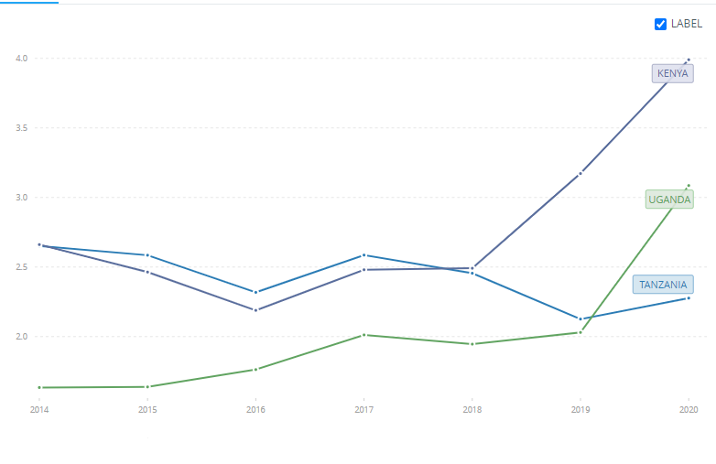
Source: World Bank Data extracted from 2014 – 2020

Figure 1, sourced from World Bank data spanning the years 2014 to 2020, provides empirical evidence supporting the assertion of substantial financial aid directed towards Tanzania, Kenya, and Uganda. This data indicates the magnitude of external financial support channelled into the region and illustrates the importance of understanding the implications and effectiveness of such aid in fostering socio-economic development and regional stability within the East African context.

Tables 1.1, 1.2,1.3, and 1.4 presented below provide a comprehensive overview of development partners' contributions to the socio-economic development trajectory within the EAC and its founding partner states, specifically Tanzania, Kenya, and Uganda. This analysis accentuates the strategic use of soft power humanitarian interventions in fostering socio-economic progress.

Table 1.1: Top EAC Contributor as of October 2018
Development Partner | (Amount in USD & Euro) | Priority areas
EU | €65 million | Regional economic integration, peace and security and natural resource management.
Germany (GIZ & KfW) | €287 million | Peace and security, economic and social integration, health, training and employment, population policy, and social protection.
USAID | $238 million | Regional economic integration (trade and customs), agriculture, environment, health, energy, and regional political integration.
Source: EAC (2018)

Table 1.2: EU Support to Tanzania, Kenya, and Uganda from 2014 -2020
Development Partner |  | Member State |  | (Amount in Euro) |  | Timeframe |  | Priority Areas
EU | Tanzania |  | €626 million |  | 2014 - 2020 |  | Energy, good governance, agricultural sector.
EU | Kenya |  | € 435 million |  | 2014 - 2020 |  | Food security and resilience to climate shocks, good governance, transport sector.
EU | Uganda |  | €578 million |  | 2014 - 2020 |  | Transport infrastructure, food security and agriculture, and good governance.
Source : EU GSP (n.d)

Table 1.3: JICA Support to Tanzania, Kenya, and Uganda from 2014 -2020
Development Partner | Member State | (Amount in USD) | Timeframe | Priority Areas
JICA | Tanzania | $466.32 million | 2014-2020 | Development of road infrastructure, industrial development, electricity generation, food self-sufficiency, energy, water, and development of education.
JICA | Kenya | $912.28 million | 2014-2020 | Economic infrastructure development, industrial development, agriculture development, universal health coverage (UHC), environment, and regional stabilization.
JICA | Uganda | $284.90 million | 2014-2020 | Economic infrastructure development, agriculture development, BHN-Health improvement, and access to safe water. reconstruction and supporting refugees in northern Uganda.
Source: JICA Annual Reports, 2015, 2016, 2017, 2019, 2020,2021

Table 1.4: USAID Support to Tanzania, Kenya, and Uganda from 2014 -2020
Development Partner | Member State | (Amount in USD) | Timeframe | Priority Areas
USAID | Tanzania | $4.20 billion | 2014 - 2020 | Health, economic development, agriculture and food security, good governance, trade, education, energy, environment, gender equality, and youth. water and crisis and conflict.
USAID | Kenya | $4.59 billion | 2014 - 2020 | Health, economic development, agriculture, education, infrastructure, good governance.
USAID | Uganda | $3.72 billion | 2014 - 2020 | Good governance, economic growth, health and HIV, humanitarian assistance and transitions, conflict, education, youth, and children development.
Source: Department of State, Researcher’s Calculations from the Congressional
Budget Justifications, 2014,2015,2016,2017,2018,2019,2020

The selection of development partners featured in Tables 1.1, 1.2,1.3, and 1.4 of this study is based on their significant contributions to supporting socio-economic development projects within the EAC and its founding partner states: Tanzania, Kenya, and Uganda, through bilateral and multilateral cooperation. Additionally, our selection criteria incorporate geopolitical considerations to ensure a representation of development partners from different continents, thus avoiding generalisation and potential bias in our research findings. For instance, we have included partners such as the European Union (EU) and Deutsche Gesellschaft für Internationale Zusammenarbeit (GIZ) from Europe, United States Agency for International Development (USAID) from America, and Japan International Cooperation Agency (JICA) from Asia, effectively encompassing diverse geopolitical landscapes.

Furthermore, these development partners have been chosen due to their prolonged and substantial involvement in socio-economic development sectors within the EAC, particularly in Tanzania, Kenya, and Uganda. For instance, JICA initiated its operations in Tanzania as early as 1962, merely one year after the country's independence (JICA, 2022), in Uganda in 2004 (JICA, n.d) and in Kenya in 1971 respectively (JICA, n.d). Similarly, GIZ has consistently supported the regional integration process in East Africa since the revival of the East African Community (EAC) in 1996 (GIZ, n.d). These enduring partnerships accentuate why these particular entities have been singled out as key samples for this study, even though there are emerging partners and other longstanding contributors. Practical constraints, including time limitations, preclude an exhaustive examination of all development partners.

Moreover, during the 2nd East African Community Development Partners Consultative Forum in October 2018, former EAC Secretary General Amb. Liberat Mfumukeko revealed that USAID, Germany through GIZ and KfW, and the EU rank among the top contributors to EAC development Programmes (EAC, 2018). Ambassador Liberat Mfumukeko's statement regarding the significant contributions of USAID, Germany through GIZ, and the EU to EAC development Programmes align with our selection rationale for these development partners. This alignment is further substantiated by their extensive and sustained engagement in socio-economic development initiatives within the EAC region, particularly in Tanzania, Kenya, and Uganda.

These partners' long-standing commitments have not only facilitated the implementation of various projects but have also fostered institutional memory, continuity, and deep-rooted collaboration, making them pivotal actors in the EAC's socio-economic development landscape. Their sustained involvement offers valuable insights into the dynamics of international development cooperation and its impact on regional integration and progress. Incorporating the perspectives of these key partners enriches the depth and comprehensiveness of our research, shedding light on the complexities and nuances of EAC development efforts. By analysing their contributions, we gain a holistic understanding of the multifaceted dimensions of socio-economic development in the EAC, which extends beyond mere financial support to encompass capacity-building, policy harmonisation, and sustainable development practices.

Notwithstanding the significant contribution of development partners to the facilitation of humanitarian interventions within the EAC, specifically in Tanzania, Kenya, and Uganda, there exists a necessity to evaluate the impact of their efforts in effecting enduring and substantial change. This study endeavours to scrutinise the involvement of development partners in promoting efficacious humanitarian interventions within the EAC, while also striving to comprehend the obstacles and opportunities associated with their role in the region.

1.3 Statement of the Problem

Development partners frequently offer financial, technical, and other types of assistance to local stakeholders, such as governments, NGOs, and community-based organisations, to aid in the delivery of humanitarian aid as well as implement long term socio-economic development projects. Nonetheless, such assistance, specifically ODA in this context, may be provided to beneficiaries to advance the interests of donors and fulfill their aspirations (Breeze, 2013), as highlighted by the concept of soft power, wherein states or their entities seek to influence the agenda, attract others to a specific perspective, and alter the preferences of others (Smith, Hadfield & Dunne, 2016). Nonetheless, the effectiveness of these initiatives is contingent upon many aspects, notably the calibre of collaborations between development partners and local stakeholders (United Nations & WEF, 2007; Altahir, 2016). The importance of these partnerships, according to Altahir (2016), can open up chances to combine skills, expertise, and resources that improve the efficiency of aid delivery and boost the leadership ability of local organisations.

Despite the myriad obstacles faced by development partners when administering ODA within the EAC, there exists a notable research gap regarding the challenges intrinsic to these partners' roles in regional humanitarian interventions. Predominant studies have predominantly concentrated on "hard power" methodologies, which encompass direct and often forceful interventions. Conversely, there has been a comparative oversight of "soft power" strategies, which encapsulate mechanisms like ODA. Such strategies not only address imminent humanitarian concerns but also seek to foster long term socio-economic advancement, especially in nations like Tanzania, Kenya, and Uganda within the bloc. Therefore, this study aims to address this research gap by exploring the role of development partners in facilitating effective humanitarian intervention in the EAC and to understand the prospects and challenges related to their role in the region.

1.4 Research Objectives

1.4.1 General Objective
The main purpose of this study is to examine the role of development partners in facilitating effective humanitarian intervention in the EAC and to understand the prospects and challenges related to their role in the region.

1.4.2 Specific Objectives
- To identify the types of assistance provided by development partners in the EAC to help in the delivery of humanitarian aid.
- To assess the effectiveness of the interventions implemented by development partners in the EAC.
- To determine the challenges faced by development partners in delivering humanitarian assistance in the EAC.

1.4.3 Research Questions
- What types of assistance do development partners provide to help in the delivery of humanitarian aid in the EAC?
- How effective are the interventions implemented by development partners in addressing humanitarian needs in the EAC?
- What are the challenges encountered by development partners in delivering humanitarian aid in the EAC?

1.5 Significance of the Study
The significance of this study lies in its focus on examining the role of development partners in facilitating effective humanitarian intervention in the EAC and identifying the prospects and challenges associated with their role. The East African region frequently grapples with humanitarian crises, driven by natural calamities, armed confrontations, and infectious disease outbreaks. These adversities manifest in substantial humanitarian requisites, including but not limited to, food scarcity, mass displacements, and urgent health crises. While numerous development partners have embarked on initiatives to alleviate these concerns, it remains crucial to assess their effectiveness in delivering long-lasting and significant interventions.

The prevailing research landscape predominantly centres on the activities of individual development partners, thus leaving a gap in scholarship that could offer a comparative analysis. This study aims to fill that void by scrutinising the roles of multiple development partners in the EAC with respect to humanitarian interventions. By doing so, the study seeks to provide nuanced insights into the relative effectiveness and strategies of various partners in the region, thereby contributing to a more comprehensive understanding of multilateral engagement in humanitarian efforts.

The insights gleaned from this study possess the potential to shape the formulation of strategies and policies that amplify the efficacy of humanitarian interventions in the region. By pinpointing the obstacles confronted by development partners when executing humanitarian interventions, this research can provide guidance in crafting interventions that target the underlying causes of these challenges. Furthermore, the evaluation of the effectiveness of interventions undertaken by development partners can serve as a compass for identifying exemplary practices and areas requiring enhancement. In essence, this study has the capacity to contribute towards elevating the calibre of humanitarian intervention implementation within the EAC. Lastly, the findings of this study not only invite other researchers to actively engage with the subject matter, but also encourage them to both challenge and expand upon the topic, thereby fostering a richer exploration of the research landscape.

1.5 Limitations of the Study
The limitations of this study must be considered when interpreting the findings. First, the study is limited in its scope as it focuses solely on the role of development partners in facilitating effective humanitarian intervention in the EAC. Other factors that may contribute to effective humanitarian interventions, such as the role of governments and local communities, are not explored in this study which can be overcomed through recommendations from this study that will allow other parts to be examined.

Finally, the sample size of the study only focuses on development partners operating in Tanzania, Kenya, and Uganda, which may also limit its generalisability to other contexts beyond the East African region. However, these three countries are chosen due to time constraints which may not allow to focus in all eight (8) EAC partner states. These limitations suggest the need for further research to expand on these findings and provide a more comprehensive understanding of effective humanitarian interventions in the other five (5) EAC Member States namely: The Democratic Republic of the Congo (DRC), South Sudan, Somalia, Burundi and Rwanda.

The chapter presented the subject of the role of development partners in supporting effective humanitarian intervention in the EAC and provided an overview of the three research questions and objectives. It also emphasised the importance of the study and the necessity of its conduct. The researcher will review the literature in the next chapter to present a critical investigation of the subject.

CHAPTER TWO

LITERATURE REVIEW

2.1 Introduction
The purpose of this chapter is to review relevant literature related to the role of development partners in enabling effective humanitarian interventions in the East African Community (EAC). It is divided into five major sections: definition of key terms, theoretical literature review, empirical studies, research gap, and conceptual framework.

2.2 Definition of Key Terms
2.2.1 Development
The United Nations (UN) defines development as a multidimensional undertaking to achieve a higher quality of life for all people. Sumner (2007) on the other hand, defines development as a long-term process of structural societal transformation. According to online Cambridge Dictionary (n.d), development is a process of growing or changing and becoming more advanced. This research study aligns with the UN's definition of development, as it concentrates on examining how soft power humanitarian programmes contribute to the well-being of local communities within the EAC, with a specific focus on Tanzania, Kenya, and Uganda.

2.2.2 Development Partners
Suleiman and Benna (2019) define a development partner as a state, entity, or institution that engages in collaborative developmental efforts with another party. Conversely, Law Insider (2004) defines a development partner as a third party from whom a party either in-licenses a target for development and/or commercialisation or with whom a party shares the economic risk of development or commercialisation of a target or product being developed or commercialised on behalf of the applicable party. The definition provided by Suleiman and Benna closely aligns with the focus of this study, which centres on states, entities, or institutions collaborating in concerted developmental initiatives with other parties. In the context of this research, entities such as the EU, GIZ, USAID, and JICA are recognised as development partners among the member states of the EAC.

2.2.3 Humanitarian Intervention
Wolf (1988) describes humanitarian intervention as the warranted application of force aimed at shielding citizens of a foreign state from actions that are consistently and egregiously unjust, surpassing the boundaries within which a sovereign is assumed to operate reasonably and justly. Wilson-Roberts (2000) characterises it as a military engagement in another nation, executed without the consent of that nation, with the intent of mitigating a humanitarian crisis, often triggered by severe, widespread infringements of basic human rights. Nonetheless, this research concentrates on soft power approaches to humanitarian intervention, specifically via Official Development Assistance (ODA), with the objective of advancing socio-economic growth. In a nutshell, the research characterizes humanitarian intervention on a non-coercive strategy that excludes the use of conventional military tactics, focusing instead on other types of support aimed at fostering socio-economic development and mitigating human suffering.

2.2.4 Official Development Assistance
As outlined by the OECD's Development Assistance Committee (DAC), ODA refers to financial aid from governmental bodies designed explicitly to foster economic growth and improve well-being in developing nations (OECD, 2018). This aid is channelled to countries and global development organisations listed as ODA recipients by the DAC. These resources come from formal entities, including various levels of government and their executive agencies, and are concessional in nature, meaning they consist of grants and favorable loans. The primary aim of these resources is to enhance economic progress and general welfare in recipient countries (OECD, 2018). Notably, ODA explicitly excludes components of hard power, such as military aid or initiatives that advance the donor's security or primarily commercial objectives, like export credits. The OECD’s definition resonates with the focus of this study as it emphasises the soft power aspect of aid.

2.3 Typologies of Official Development Assistance (ODA)
Official Development Assistance (ODA) is categorised as bilateral aid, where support is directly allocated to poor nations, and multilateral aid, which is dispensed via international organizations (JICA, n.d). Bilateral assistance includes financial and investment cooperation (ODA loans and private sector investment finance) as well as grants (grant aid and technical cooperation) (JICA, n. d). While humanitarian aid is a component of ODA (Development Initiatives, 2010), the two terms are distinct. ODA targets long term impact while humanitarian aid aims for short term impact (NORAD,2024). Other forms of ODA include project aid, which is allocated for a specified objective such as training, building initiatives, or equipment procurement. Conversely, programming aid refers to assistance allocated inside a particular sector to facilitate initiatives that tackle a wider issue (e.g., support for reforms in an economic sector or for a specific component of such reforms, such as in education or health). Budget support constitutes assistance for a nation's overarching policy or development plan. It entails the direct allocation of monies to the national budget for distribution via the public finance system. Tied aid allows a partner nation to acquire products or services from the donor nation. Programme- or project-based technical assistance entails using the knowledge and skills of individuals from a donor nation (such as officials, physicians, engineers, etc.) to facilitate the growth of a partner country. Food aid: assistance provided via food donations to nations with restricted food availability. Loans, borrowings, and debt forgiveness provide a partner nation with concessional financial aid. They may also constitute tied aid in the form of a tied loan. Loans qualify as Official Development Assistance (ODA) when they include a grant component of no less than 25% of the total sum (Republic of Poland, n.d).

2.4 Theoretical Framework
This research endeavours to present an all-encompassing comprehension of the role of development partners in enabling effective humanitarian interventions in the East African Community by utilising established theories and frameworks. The research is directed by the Humanitarian Accountability Partnership (HAP) Standard created in 2007 by the HAP (2010), the Systems Thinking Approach introduced by Professor Jay W. Forrester (1958) as well as the Concept of Soft Power led by Joseph Nye (Nye, 2004). The utilisation of these theories aims to establish a strong basis for the successful completion of this study.

2.4.1 Humanitarian Accountability Partnership Standard
In addition to providing a comprehensive understanding of the role of development partners in facilitating effective humanitarian interventions in the East African Community, the study also analyses the issue through the lens of the HAP. This theoretical framework offers an in-depth analysis of accountability in humanitarian response and guides how to establish a commitment to accountability and the processes necessary to deliver quality programmes for those affected by crises (HAP, 2010). The HAP Standard provides guidance to entities involved in aiding individuals impacted by or vulnerable to disasters, conflict, poverty, or other emergencies. It facilitates the creation, execution, evaluation, enhancement, and acknowledgment of responsible programmes. This framework outlines the steps to establish a dedicated commitment to accountability, outlining the procedures that lead to the delivery of high-quality programmes for those who directly experience them. This framework will lay a good foundation on finding the effectiveness of the humanitarian interventions in understanding prospects and challenges in the East African Community especially in Kenya, Tanzania and Uganda.

2.4.2 Systems Thinking Approach
The concept of Systems Thinking Approach, first introduced by Professor Jay W. Forrester (1958) is another relevant theoretical framework for this study. The Systems Thinking Approach is a methodology used to understand complex systems and their behavior, with a focus on “the relationships between groups of different interacting or interdependent things that combine to achieve some purpose (parts of a system, unlike a heap) and the value of multiple and diverse perspectives” (Campbell, 2022, p.5). It is a holistic and interdisciplinary approach that seeks to identify and address the root causes of problems rather than just treating the symptoms. Campbell (2022) argued that “Systems Thinking is used to address complex problems, where linear (think log frames) and reductionist (think sector siloes) approaches don’t work” (p.5).

The Systems Thinking Approach is particularly pertinent to the study's subject since it helps in understanding “the interconnectedness and complexity of the humanitarian system” (Campbell, 2022, p.5) as well as the role of development partners in enabling successful humanitarian interventions in the EAC. This is simply because “Systems Thinking is seeing situations and experience as a whole” (Sherwood, 2002, p.141). As a result, this approach provides a thorough and interdisciplinary analysis of the issue that considers the numerous interconnected factors that influence whether humanitarian interventions are successful or not. By identifying the root causes of problems and recognising the connections and interdependencies between system elements, the Systems Thinking approach provide a greater understanding of the challenges posed by the role of development partners in humanitarian assistance in the region.

The study additionally references the body of literature concerning humanitarian action and development partnerships in the EAC to provide a contextual understanding of the challenges related to the role of development partners in the region. This involves a review of relevant academic and policy literature on the subject, as well as an analysis of data from reports and case studies on past and ongoing humanitarian responses and socio-economic development support offered by development partners in the region. The literature review also explores best practices and lessons learned from successful development partnerships in the region, as well as identify gaps and areas for improvement in the current approaches to humanitarian action.

2.4.3 The Concept of Soft Power
The concept of soft power by Nye (2004) is another significant theoretical framework applied in this study. As quoted by Smith, Hadfield, & Dunne (2016), Nye described soft power “as the influence and attractiveness a nation can acquire and wield when others are drawn to its culture, political values, institutions, and ideas” (p.176). Nye argues that soft power rests in the ability of states to set the agenda, to attract others to a position or way of thinking, and to influence the preference of others (Smith, Hadfield & Dunne,2016). In this case, foreign aid which also encompasses official development assistance is another form of soft power applied by development partners in their quest to implement their foreign policy. For instance, a country like South Korea which provide longstanding assistance to developing countries is a vivid example of soft power (Smith, Hadfield & Dunne,2016). That is why, Smith, Hadfield and Dunne (2016), contend that “an impressive range of foreign policy practices now reflect a duty to strangers, including foreign aid, human rights promotion, development assistance, global health initiatives” (p.244) which is a form of humanitarianism (p.244). The assertion by Smith, Hadfield and Dunne finds support in Carbonnier's (2010) idealist perspective, wherein ODA is characterised as foremost an ideal and moral imperative.

According to this viewpoint, aid assumes a selfless nature, driven by humanitarian considerations and a commitment to democratic values. Carbonnier's conceptualisation posits aid as a strategic instrument in the concerted effort against poverty and as a safeguard for the preservation of human rights. This idealistic framework underlines the altruistic motivations that ought to underpin the provision of aid, emphasising its role not merely as a transactional tool but as a catalyst for positive societal transformation grounded in ethical principles. Therefore, the concept of soft power enabled the investigation to dissect the involvement of development partners in effecting enduring and impactful interventions within the EAC. This consideration acknowledges the prevalent practice of development partners extending sustained aid to developing nations, including Tanzania, Kenya, and Uganda, all of which are integral components of the regional alliance.

2.5 Empirical Literature Review
The empirical literature review encompasses “a critical survey of academic and scholarly references, such as articles, journals, books, research reports, seminal papers, important documents, and other sources (printed and/or electronic), which are relevant to the study area selected by the researcher” (Neupane, 2021.p.2). These previous studies provide a “strong theoretical foundations and empirical evidence for the research work” (Neupane, 2021.p.2). In this context, this section focuses on empirical studies that have explored the role of development partners in facilitating successful humanitarian intervention in East Africa.

Numerous studies have investigated the role of development partners in humanitarian intervention in East Africa. For example, Suphian and Kim (2016) analysed Official Development Assistance (ODA) and its impact on economic growth in East African countries, covering Tanzania, Kenya, and Uganda. They found that ODA flowing to East African countries is vital for economic development in the region. Suphian and Kim (2016) argued that policies should be directed toward improving the utilisation of ODA, especially for creating a conducive environment for human development. Similarly, other studies have found that foreign aid can be a double-edged sword, but in the right economic and political environment, it can help support economic and social progress (Lancaster, 1999; Mwega, 2009).

Furthermore, Howes' 2011 research offers an insightful examination of the multifaceted issues surrounding aid effectiveness. The study contends that a definitive verdict on the efficacy of aid remains elusive. Instead, it suggests a more nuanced inquiry: how can the efficacy of aid be enhanced? Howes (2011) adeptly categorises the various determinants of aid effectiveness and strategies for its augmentation under three distinct umbrellas: the proficiency of the recipient (developing) country's government, the efficacy of the donor (developed) country's aid agency, and the synergy between the two entities. However, a limitation of Howes' research is its broad scope, which lacks a focused exploration of specific regions, notably East Africa. This underscores a research void that merits further investigation.

Additionally, a conspicuous research void exists concerning the precise role of development partners in driving effective humanitarian interventions in the EAC, as well as the challenges inherent to this setting. Pusterla and Pusterla (2021) highlighted that the European Union's dedication to humanitarian aid has encountered novel and critical hurdles in the wake of the COVID-19 pandemic, with a marked surge in the global populace affected by humanitarian crises. Notably, their study zeroes in on the challenges confronting the EU in its global humanitarian interventions, without a targeted exploration of the East African milieu. This further underlines the importance of research tailored to this specific region.

Ndikumana and Pickbourn (2016) delve into the intriguing realm of aid effectiveness in Sub-Saharan Africa. While Africa has garnered substantial aid volumes post-independence, the pivotal query surrounding its contribution to the continent's economic ascent remains elusive. Broadly, the discourse in economic literature offers no unanimous stance on the nexus between aid and development. The ambiguity deepens when considering African economies: the exact magnitude of positive returns from aid, especially in the context of long-term socio-economic development, is not firmly established. However, a silver lining emerges at the micro level, where increasing empirical data suggests that aid directed at specific sectors and activities reaps beneficial outcomes. Ndikumana and Pickbourn advocate those future inquiries into aid efficiency in the continent should capitalise on the unique insights of country-centric studies, thereby illuminating the intricate relationships between sector-specific aid allocation and developmental results.

While Ndikumana and Pickbourn's (2016) study provides valuable insights into aid effectiveness in Sub-Saharan Africa, there remains a distinct gap in the literature specifically targeting the EAC. This region, with its unique socio-economic and political dynamics, may offer varied experiences and outcomes related to aid effectiveness as far as development partners’ humanitarian interventions are concerned. Consequently, there is a pressing need for research that hones in on the EAC, evaluating both the overarching and sector-specific impacts of aid on its development trajectory. In the realm of humanitarian aid effectiveness in post-conflict scenarios, Ssengooba, Namakula, et al. (2017) highlight that such aid offers significant prospects for rebuilding and restoring functionality in societies scarred by conflict. However, a critical concern they elucidate is the recurrent misalignment of external aid with local contexts.

Within the domain of humanitarian aid distribution in East Africa, distinct challenges emerge, as highlighted by various research endeavors. A notable study by Choi & Beresford et al (2010) delves into the intricacies of these challenges. They identified that service disruptions, capacity deficits, and infrastructural damage stand out as primary impediments to relief operations in this region. Their research further underscores a specific vulnerability: the transportation systems of both Kenya and Tanzania, which are highly susceptible to natural calamities like floods, adding layers of complexity to humanitarian response efforts.

To summarise, the empirical literature discussed in this section emphasises the role of development partners in fostering effective humanitarian interventions in East Africa. While an array of research illustrates the influence of ODA on economic evolution and the possible advantages of foreign aid in spurring socio-economic advancement, a noticeable void exists concerning the precise role of these partners in effective humanitarian interventions in the area and their accompanying challenges. Notably, while various studies have shed light on the effectiveness of humanitarian aid in contexts post-conflict, a recurring theme is the misalignment of external aid with indigenous settings. This is complemented by research pinpointing operational impediments in East African humanitarian ventures, ranging from service discontinuation, lacking capacity, to infrastructural devastation. Therefore, this accentuates an imperative for augmented research focusing precisely on development partners' roles in streamlining effective humanitarian endeavors in the EAC and discerning the obstacles they confront.

2.6 Research Gap
The examination of empirical literature stresses that numerous research endeavors have delved into the contributions of development partners in humanitarian operations within the East African landscape. Yet, a discernible research void emerges concerning the precise functions these partners play in ensuring efficacious humanitarian initiatives in the region, coupled with the specific challenges they grapple with. While there exists, substantive evidence underscoring the positive impact of ODA in bolstering economic expansion, it is equally paramount to recognise the intricacies and potential drawbacks when such foreign aid does not resonate or integrate seamlessly with the indigenous milieu. This highlights the necessity for more nuanced, region-specific studies to bridge this existing research chasm.

While existing literature has thoroughly explored humanitarian aid distribution in East Africa, spotlighting salient challenges like service disruption, capacity deficits, and infrastructural damages, a notable research lacuna persists regarding the specific adversities encountered by development partners in actualising effective humanitarian interventions in the region. The work of Pusterla and Pusterla (2021) provides insights into the quandaries experienced by the European Union as a global development partner amidst contemporary humanitarian interventions. Nonetheless, their research conspicuously lacks a thorough exploration of the specific dynamics within the EAC context. This omission accentuates the pressing need for dedicated research initiatives that specifically delve into the intricate role of development partners in fostering successful humanitarian interventions within the EAC. Simultaneously, such endeavours should meticulously analyse the inherent challenges unique to this geographical region.

2.7 Conceptual Framework
The purpose of this research is to comprehend the role of development partners in enabling effective humanitarian intervention in the EAC and to understand the prospects and challenges related to their role in the region. This study aims to establish a strong basis for the successful completion of this research by utilising three established theoretical frameworks, namely the Humanitarian Accountability Partnership (HAP) Standard, the Systems Thinking Approach and Soft Power.

The HAP Standard provides an in-depth analysis of accountability in humanitarian response, guiding how to establish a commitment to accountability and the processes necessary to deliver quality Programmes for those affected by crises (Humanitarian Accountability Partnership International, 2010). This framework offers a contextual understanding of the challenges related to the role of development partners in facilitating effective humanitarian intervention in the EAC. The Systems Thinking Approach methodology is used to understand complex systems and their behavior, focusing on the interrelationships and interdependencies between system components (Campbell,2022; Forrester,1958). It seeks to identify and address the root causes of problems rather than just treating the symptoms. This approach is particularly pertinent to the study's subject as it helps to comprehend the role of development partners in enabling successful humanitarian interventions in the EAC.

Incorporating the Concept of Soft Power into this research framework is pivotal. This concept, as elucidated earlier, offers a lens through which the study can critically examine and unpack the nuanced strategies employed by development partners. Rather than just focusing on overt financial or material aid, the Soft Power framework allows for a deeper understanding of the persuasive, collaborative, and cultural approaches used by these partners to foster enduring and impactful humanitarian interventions within the EAC. By integrating this perspective, the research seeks to provide a holistic view of the myriads of tools at the disposal of development partners and how they can be harnessed most effectively in the context of the East African region.

Furthermore, by grounding the investigation in the extensive body of literature centred on humanitarian action and development partnerships specific to the EAC, the study aims to paint a comprehensive picture of the existing landscape. This multifaceted approach involves not only a rigorous examination of academic contributions but also an in-depth analysis of policy documents, ensuring the research remains relevant and applicable to real-world challenges and strategies. The inclusion of data from reports and case studies enables a tangible assessment of the effectiveness of past and present interventions, further enriched by insights into best practices and notable successes. Conversely, through a meticulous evaluation of these sources, the research also pinpoint deficiencies in current methodologies, thereby highlighting potential avenues for future enhancements in humanitarian strategies within the East African context.

Venturing further into the empirical literature review, a range of sources, including research reports, research-based articles, master's theses, and doctoral dissertations, come under scrutiny. These documents provide a robust understanding of the impact of ODA on economic growth and elucidate the multifarious benefits of foreign aid in buttressing economic and societal advancements. Notwithstanding the wealth of information present, a discernible gap persists, particularly in the niche area of this study, underscoring the significance and timeliness of the current research endeavour. Therefore, this research intends to provide an all-encompassing comprehension of the role of development partners in facilitating effective humanitarian interventions in the EAC and to understand the prospects and challenges related to their role in the region. It aims to achieve that through the lens of the HAP Standard, the Systems Thinking Approach, and the Concept of Soft Power.

Figure 2.2: Development Partners’ Influence on Humanitarian Effectiveness:
EAC Framework
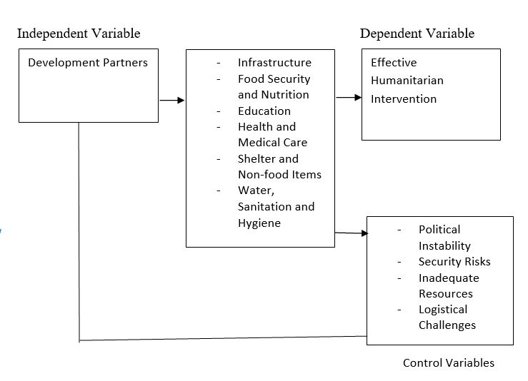
Source: Researcher’s Model (2023)

The literature underscores the multitude of challenges that often undermine effective humanitarian intervention, including political turbulence, security threats, resource constraints, and logistical complications to name a few. Key players in the landscape of humanitarian assistance encompass international organisations, donor agencies, and non-governmental organisations, all of whom play pivotal roles in extending aid to populations in dire straits.

Within the purview of this study's conceptual framework, the development partners are postulated as independent variable. These are countries or donor agencies that offer funding and resources to the EAC and the member states particularly Tanzania, kenya and Uganda. The framework highlights the types of interventions supported by development partners namely: Infrastructure development; food security and nutrition; education, health and medical care; shelter and non-food items (e.g., blankets, clothing); water, sanitation, and hygiene to name a few. While effective humanitarian intervention is designated as the dependent variable. The main objective of these interventions is to make aid effective in helping communities. The efficacy is assessed by the extent to which such efforts meet local demands and enhance the well-being of people in the EAC and its member states specifically. The conceptual framework also integrates control variables such as political instability, security risks, logistical challenges and resource availability. These are external factors that may impact the effectiveness of humanitarian interventions. The intent behind this inclusion is to scrutinise their potential influence on the symbiotic relationship between development partners and the outcomes of humanitarian interventions in the EAC milieu. Centred on illuminating the crucial contribution of development partners in strengthening the effectiveness of humanitarian interventions, this study aims to provide nuanced insights that could enhance the quality of humanitarian endeavours within the EAC. Moreover, the outcomes of this research have the potential to enrich the global understanding of humanitarian efforts in both crisis-afflicted regions and those grappling with other development-related issues.

The chapter provided a robust backdrop for the study, weaving together definitions, theories, empirical evidence, and identified gaps in the current body of knowledge. Having set the academic stage, the next chapter will delve into the research methodology. This chapter will present the methods and techniques employed for data collection and analysis, aiming to address the research gaps identified in this literature review chapter.
CHAPTER THREE

RESEARCH METHODOLOGY

3.1 Introduction
This chapter describes the research design and methodology to be used by the researcher to carry out the study. It is divided into the following sections: research philosophy, research approach, research design and strategy, research instruments, data collection procedures, data analysis techniques, and data cleaning and processing

3.2 Research Philosophy
According to Saunders, Lewis, and Thornhill (2009, p.107), the term "research philosophy" refers to the origins and nature of knowledge. When academics begin their research initiatives, they are growing their knowledge about a particular issue, which is known as knowledge development (Saunders et al., 2009, p.107). The research philosophy contains crucial assumptions about how the researcher perceives the world. The research philosophy for this study is interpretivism. Interpretivism is a research philosophy that holds that social reality is constructed and that the task of the researcher is to understand this reality from the perspective of the people being studied (Saunders et al., 2016).

The interpretive approach is appropriate for this research as it allows for an in-depth understanding of the role of development partners in facilitating effective humanitarian interventions in the EAC as well as the prospects and challenges related to their role in the region. While a substantial portion of this study leveraged a desk review approach, relying on existing sources such as books, journals, articles, reports, and other published or online resources, it also involves interaction with research participants through interviews. Concurrently, the study actively engaged with research participants via interviews structured around a questionnaire. These interviews provided firsthand insights, complementing the secondary data sourced from the literature and enhancing the depth and breadth of understanding regarding the research topic.

3.3 Research Approach
The research approach for this study is a qualitative research design. Qualitative research is an approach that is used to explore and understand human experiences, behaviours, and social phenomena in a natural setting (Saunders et al., 2016). It is particularly useful for gaining an in-depth understanding of complex social phenomena, such as the role of development partners in facilitating effective humanitarian intervention and to understand the prospects and challenges that can hamper such a process.

The data collection methods used in this research include a literature review, interviews structured around a questionnaire, and document analysis. The literature review is used to gather information on the research subject. Document analysis is used to gather information from academic and policy literature on the subject, as well as an analysis of data from reports and case studies on past and ongoing humanitarian interventions in the region. Interviews provide firsthand insights, complementing the secondary data sourced from the literature and enhancing the depth and breadth of understanding regarding the research topic. The data collected is analysed using thematic analysis, which is a common method used in qualitative research. The thematic analysis involves identifying patterns and themes in the data, and it is used to identify the key issues related to the role of development partners in facilitating effective humanitarian intervention and understand the prospects and challenges they face that can affect their contribution. In conclusion, the research approach for this study is a qualitative research design that uses a combination of interviews, and document analysis to gather data, and thematic analysis to analyse the data. This approach is chosen as it allows for an in-depth understanding of the research problem and the perspectives of various researchers who investigated a similar subject matter.

3.4 Research Design and Strategy
According to Creswell (2012), “research design is a master plan that provide[s] the techniques on how the researcher would gather answers when performing a study," (p. 61). The research process depends heavily on the study design, which specifies the precise procedures and tools to be utilised for data collection and analysis to address the research questions. For the study to be well-structured and the data to be high-quality and pertinent to the research question, it is crucial for researchers to carefully evaluate and prepare their research design. A descriptive research design is used for this investigation. Calderon (2006) defined descriptive research as a systematic process of collecting, analysing, classifying, and tabulating data regarding existing conditions, practices, processes, trends, and causal relationships, followed by precise interpretation of the data, with or without minimal reliance on statistical methods. A literature review, primary and secondary sources is used to gather qualitative data.

The document analysis is used to gather information on relevant issues that address the subject matter. To supplement these secondary data sources and bring a human perspective to the research, interviews has been conducted. These direct interactions intended to gather genuine and immediate insights, providing a firsthand account of experiences and challenges faced on the ground. The deliberate choice to undertake document analysis, and interviews in the research strategy aims to fortify the study's validity and reliability. Such a comprehensive approach ensures a rigorous and well-rounded exploration of the subject, enhancing the credibility of the findings. The collected data underwent thematic analysis, a widely utilised qualitative research method that involves identifying patterns and themes within the data. This method enabled the study to identify and explore the key issues related to the subject matter being investigated.

3.4.1 Area of the Study
The research has a specific focus on the EAC, with a particular emphasis on three countries: Tanzania, Kenya, and Uganda.

3.4.2 Population of the Study
The research sample encompasses a variety of documents and reports, including but not limited to the Congressional Budget Justification, EAC Annual Reports, EU GSP Reports, JICA Annual Reports, GIZ publications, World Bank publications, OECD reports, United Nations reports, and materials from its affiliated agencies as well as government reports from the EAC member states specifically Tanzania, Kenya and Uganda. These documents and reports are selected based on their relevance to the central theme of inquiry, ensuring a comprehensive examination of the subject matter. In addition to this document-based data, the study also gathered primary data through interactions with seasoned experts and key officials from the European Union (EU), United States Agency for International Development (USAID), Japan International Cooperation Agency (JICA), and Deutsche Gesellschaft für Internationale Zusammenarbeit (GIZ). Furthermore, to gain a holistic understanding, the research engages with representatives from the EAC, civil society, and independent experts from its member states with a specific focus on Tanzania, Kenya, and Uganda.

Building on the previously mentioned strategy to engage with seasoned experts and key officials from prominent development agencies, the study further delved into an extensive body of literature pertinent to the central theme. While the study population encompasses a vast array of literature on the topic, a rigorous selection process is employed to finalise the sample. This selection prioritised sources based on their direct relevance to the research questions and the overarching aim of the study. Additionally, the credibility of the authorship, the reputation of the publishing source, and the reliability of the information contained within is pivotal criteria for inclusion. Such a meticulous approach ensures that the literature underpinning the study meets high standards, offering valid and trustworthy insights into the research topic.

3.5 Data Collection
Data for this research is amassed from both primary and secondary sources. Accordingly, the study utilised an array of methods for data collection, encompassing:

    - Documents Review
A comprehensive examination of existing research on a particular topic, including academic articles, books, and other published materials (Creswell, 2012). This method enabled the identification of key themes, issues, and trends related to the role of development partners in facilitating effective humanitarian intervention in the EAC.

Moreover, the study involved the examination and interpretation of written materials, such as government reports, policy documents, and media articles, to gather information on a specific topic (Creswell, 2012). This approach allowed for the collection of relevant data and information on the specific topic of interest, which helped to shed light on the role of development partners in facilitating effective humanitarian intervention in East Africa. As highlighted by Creswell (2012), document review is a valuable method for gathering information in research studies, particularly in cases where the researcher aims to investigate how policies, practices, and discourses are constructed and communicated through written materials.

    - Interviews
Interviews are used in the study as a way of gathering information from the participants and participants. According to Kothari (2004,2008,2019), an interview is helpful in a study since it helps in the explanation, understanding, and exploration of research opinions, behavior, experiences, and phenomena. Interviews are chosen by the researcher because, as Saunders et al (2012) point out, they are a reasonably quick, easy, and effective approach to collecting a lot of data from a wide sample of people. The clearance letters required to solicit interviews from the participants have been provided as Appendices 5 (EAC), 6 (EU), 7 (GIZ),8 (JICA) and 9 (USAID) respectively. However, the inclusion of participants' acceptance responses to the interviews has been omitted from this thesis. This decision is rooted in ethical considerations as disclosure of their identities would occur, potentially compromising their confidentiality and violating ethical standards. However, this information is available, if necessary, needed for examination purposes.

3.6 Data Analysis
The data analysis method for the research study is thematic analysis. Thematic analysis is a common method used in qualitative research and it involves identifying patterns and themes in the data (Braun & Clarke, 2006). Thematic analysis is used to identify the key issues related to the research topic. Data gleaned from the literature review, interviews, and document analysis is meticulously transcribed. Following this, the data underwent several reviews to discern emerging themes. These identified themes subsequently organised and systematically coded. The researcher then scrutinised the data for patterns and interconnections among the themes. In the concluding phase, the key issues pertinent to the research problem are discerned and interpreted by the researcher.

3.6.1 Variables and Measurement Procedures
The research study involves several variables that can be measured using various procedures. One variable that could be examined in this research is development partners (i.e., independent variable). This variable could be measured through a literature review, in which the researcher conducts a comprehensive examination of existing research on a particular topic, including academic articles, books, and other published materials as well as via interviews. Moreover, the effective humanitarian intervention (i.e., Dependent variable) is also examined by document analysis, interviews, and literature review. The control variables which include challenges such as political instability, security risks, inadequate resources, and logistical challenges are analysed through document analysis, interviews, and literature review to identify how they hamper development partners’ role in facilitating effective humanitarian intervention in the EAC and to understand the prospects and challenges related to their role in the region. Overall, many different variables and measurement procedures could be employed in a research study. However, the specific measures chosen to depend on the research questions being addressed and the resources available for the study.

3.7 Data Cleaning and Processing
Data processing and analysis necessitate categorising, altering, and summarising data in order to answer research questions (Kothari, 2004, 2008,2019). Before beginning of the analyses, the researcher checked the data for outliers, input errors, and missing data. The researcher used the data cleaning procedures of tidying the data, confirming the data quality, de-identification, correction, and annotation.
3.8 Validity and Reliability
According to Messick (1989, p. 6), validity is defined as "the degree to which empirical evidence and theoretical rationales support the adequacy and appropriateness of interpretations and actions based on test scores." Bond (2003, p. 179) further elaborates that validity is the cornerstone of any assessment that can be considered both trustworthy and accurate. Reliability, as delineated by Drost (2011, p. 106), is "the extent to which measurements are repeatable when different persons perform the measurements, on different occasions, under different conditions, with supposedly alternative instruments which measure the same thing." Messick (1989) further clarifies that reliability represents the dependability of the collected data, suggesting that the data should accurately reflect the situation being studied. Significantly, Messick has posited a unified concept of validity that incorporates reliability as a subtype, thereby contributing to the overall construct validity.

In the context of the current research study, a multi-faceted approach has been employed to ensure both validity and reliability. The study utilises a comprehensive literature review, document analysis, and expert interviews as primary methods for data collection. Furthermore, thematic analysis is applied for data interpretation, focusing on the identification and analysis of key issues within the scope of the study. This robust methodology enhances the credibility of the research findings, ensuring that they are both valid and reliable.

3.9 Ethical Considerations
While this research entails both desk review and direct interactions through interviews, there remains a set of ethical considerations to uphold. Initially, for any information, whether it's government documents, policy papers, or media stories, the researcher ensured the necessary permissions and authorisations are acquired prior to analysis. This involved seeking formal permissions from institutions, organisations, or authorities overseeing the content. Furthermore, the researcher committed to upholding the tenets of academic integrity, diligently avoiding plagiarism or any form of academic malfeasance. This commitment requires proper attribution, citation, and referencing of all sources utilised, ensuring the original authors' contributions are accurately and transparently acknowledged.

When addressing data from both document analysis and interviews, it is paramount for the researcher to act ethically and responsibly. The information is used strictly in alignment with the research's objectives, and care is taken to avoid misinterpretation or misrepresentation of the data. Interviewees are accorded particular attention. Prior to the commencement of interviews, informed consent was sought, ensuring participants are fully aware of the research's objectives and their rights. The anonymity and confidentiality of all interview participants is guaranteed, ensuring no personal or sensitive information is inadvertently disclosed. This safeguards the participants from potential risks or harms. In sum, the cornerstone of this research rests upon rigorous adherence to ethical guidelines. These measures not only fortify the study's credibility but also ensure the integrity and reliability of its findings.

The chapter provided a comprehensive overview of the study's methodology, encompassing its research philosophy, approach, design, and strategic focus, as well as detailing the specific area and population targeted. Various data collection methods were outlined, along with the analytical techniques to be employed, ensuring the study's validity and reliability. Ethical considerations were also elaborated upon to safeguard the rights and well-being of the participants. Building on this methodological foundation, the subsequent chapter will present and discuss the research findings.

CHAPTER FOUR

FINDINGS AND DISCUSSION
4.1 Introduction
This chapter presents and analyses the data derived from depth interviews with officials from development partners, the EAC, civil society, and independent experts as indicated in section 3.4.2. The main objective of this chapter is to assess the involvement of development partners in promoting effective humanitarian interventions in the context of soft power intervention such as the provision of ODA within the EAC, while also striving to comprehend the obstacles and opportunities associated with their role in the region. The results primarily reflect the perceptions and attitudes of the participants obtained through in-depth interviews. The discussion and analysis of the results are divided into eleven (11) broad sections based on the themes identified to be addressed in the data collected from the interviews. In a nutshell, thematic analysis is used to analyse the data to produce the findings in this chapter.

4.2 Analysis of the Composition of Participants
Table 4.5: Composition of the Participants
Category | Number of Participants
EU Officials | 1
USAID Representatives | 1
JICA Experts | 1
GIZ Officials | 1
EAC Representatives | 2
Civil Society Representatives | 6
Independent Experts | 2
Total Number of Participants | 14
Source: Field data (2023)
Table 4.5 provides an overview of the diverse range of participants engaged in the study, categorised according to their affiliations. The composition reflects a balanced representation of key stakeholders involved in development and humanitarian efforts within the EAC and its member states, with a specific focus on Tanzania, Kenya, and Uganda. The EU officials, USAID representatives, JICA experts, and GIZ officials each contributed valuable perspectives, bringing a nuanced understanding of the strategies and interventions employed by major international development partners. With one representative from each organisation, this ensured a comprehensive and varied insight into the approaches and initiatives taken by these entities.

The engagement with EAC representatives further enriched the study by including the regional perspective. With two representatives contributing, the study acknowledged the significance of understanding the collective efforts and policies at the regional level, providing insights into collaborative initiatives and regional strategies. Civil society representatives, comprising six individuals, played a crucial role in representing the non-governmental sector. Their diverse backgrounds and experiences offered a grassroots perspective, shedding light on the challenges, successes, and recommendations from the communities directly impacted by development and humanitarian interventions.

Additionally, the inclusion of independent experts (two individuals) further diversified the participant pool. These experts, unaffiliated with specific organisations that are targeted by the study, provided impartial viewpoints, offering critical insights into the broader socio-political landscape and challenges faced at the national level. In total, the study engaged fourteen (14) participants, ensuring a well-rounded and inclusive representation of stakeholders involved in the discourse on development assistance and humanitarian intervention within the EAC. The variety of perspectives gathered from these participants contributes to the richness and depth of the study's findings, enhancing the credibility and applicability of the research outcomes.

4.3 Types of Assistance Provided by Development Partners in the EAC
Chapter 2, section 2.2.3, delves into the exploration of soft power strategies for humanitarian intervention, specifically through ODA, with the overarching objective of fostering socio-economic growth. This analysis is influenced by the perspectives of researchers like Smith, Hadfield, and Dunne (2016), along with Carbonnier (2010), who have connected foreign aid and development assistance to an expression of humanitarian values, as revealed by their findings. However, despite this association, findings from interview participants, particularly development partners, uncover a noteworthy differentiation between humanitarian intervention and ODA.

The participant from JICA draws a distinction between development assistance and humanitarian assistance. The interviewee provides an overview of JICA's organizational framework and the execution of Japanese Official Development Assistance (ODA). As per the participant, development assistance is categorized into bilateral and multilateral aid. JICA handles bilateral aid through technical cooperation and capital grant aid, the latter being extended as a grant without any expectation of repayment. Additionally, the participant points out that finance and investment cooperation entail repayments along with associated interest.
The findings regarding the participant from JICA's distinction between development assistance and humanitarian assistance can be linked with the Systems Thinking Approach theory which as explained by Campbell (2022) emphasises understanding complex systems and their behavior by examining the relationships between various interconnected components. For instance, the participant describes bilateral and multilateral aid within JICA's framework. This categorisation aligns with the Systems Thinking Approach's emphasis on understanding how different components of a system interact to achieve a particular purpose. Furthermore, the participant's explanation of different types of aid, such as technical cooperation, capital grant aid, and finance and investment cooperation, highlights the multifaceted nature of development assistance.

Figure 4.3: JICA Development Assistance Framework
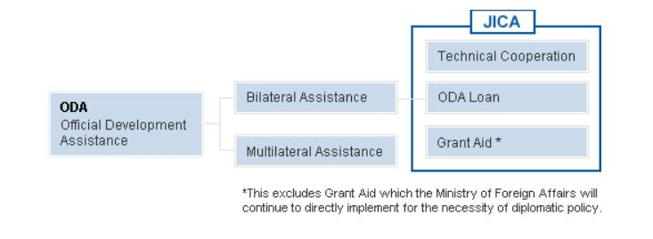
Source: JICA (n.d)

Additionally, the participant highlights that within the Japanese system, humanitarian assistance usually takes the form of non-need-based aid, often delivered through humanitarian agencies such as UNHCR. While JICA is tasked with development activities, the focus on humanitarian assistance, particularly emergency relief, falls under a distinct jurisdiction. Furthermore, the participant clarifies the constrained role of a development agency like JICA in implementing humanitarian assistance, as this duty is primarily entrusted to the Ministry of Foreign Affairs. The ministry provides financial support to humanitarian agencies for the execution of humanitarian aid.

The participant's clarification regarding the distinction between development assistance and humanitarian assistance within the Japanese system highlights the interconnectedness and interdependencies inherent in international aid frameworks. According to the Systems Thinking Approach theory, understanding such interconnectedness is crucial for comprehending complex systems.

Figure 4.4: Ministry of Foreign Affairs Emergency Assistance Framework

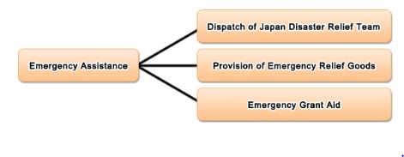
Source: Japanese Ministry of Foreign Affairs (MOFA) (n.d)

Figure 4.4 supports the argument made by the participant from JICA who identified the Ministry of Foreign Affairs as the entity responsible for humanitarian intervention. This involvement is characterised by short-term support provided in the form of emergency assistance for overseas disasters. The specific components of this intervention include (i)the dispatch of Japanese disaster relief teams; (ii) the provision of emergency relief goods; and (iii) emergency grant aid. The differentiation between humanitarian intervention and ODA is also evident within USAID, a prospective development partner for the EAC and its partner states. Moving on, participant from USAID pointed out a clear divide within the agency, with humanitarian assistance overseen by the Bureau of Humanitarian Assistance and longer-term development assistance addressed separately. Notably, the participant recognised a historical difficulty in the lack of effective coordination between the two entities, drawing from past role as mission director in the Malawi country office. The participant highlighted that the challenge stems from the humanitarian mandate, which often prioritises rapid emergency response without ensuring a smooth transition to long-term development.

The participant's description of USAID's organisational structure, with humanitarian assistance overseen separately from longer-term development assistance, highlights the existence of distinct yet interrelated components within the agency's operations. This separation reflects the need to address immediate crises while also fostering sustainable development efforts. By applying the Systems Thinking Approach, researchers can explore how these different components interact and influence each other, identifying potential challenges and opportunities for improved coordination and effectiveness in aid delivery. On the other hand, the HAP Standard provides guidelines for ensuring accountability and quality programming in humanitarian response. The participant's recognition of historical difficulties in coordinating humanitarian assistance and development efforts within USAID underscores the importance of accountability mechanisms outlined in the HAP Standard.

The participant further extends their argument by emphasising the acknowledged importance of this transition for sustainability and resilience. Furthermore, they highlight the agency's dedicated efforts to enhance this shift, emphasising a move from purely humanitarian initiatives to a more sustainable and resilient long-term development approach. Despite recognising that the transformation is not without its flaws, the participant notes the implementation of structural changes. Particularly noteworthy is the adjustment in reporting lines, with the Bureau of Humanitarian Assistance now accountable not only to the Washington DC headquarters but also to the mission director in the country. This alteration facilitates better integration into ongoing programmes.

The participant's emphasis on the importance of transitioning from purely humanitarian initiatives to sustainable and resilient long-term development aligns with the System Thinking Approach. By recognizing the need for a shift in approach, USAID acknowledges the dynamic nature of the aid landscape and the necessity of addressing underlying systemic factors to promote sustainability and resilience. The adjustment in reporting lines, as highlighted by the participant, reflects an effort to integrate humanitarian assistance and development efforts more effectively, thereby fostering better coordination and synergy between different components of the aid system. Moreover, the implementation of structural changes, such as adjusting reporting lines to enhance integration into ongoing programmes, reflects efforts to improve accountability and ensure that humanitarian assistance and development initiatives are aligned with the principles of the HAP Standard. In conclusion, the participant's emphasis on this distinction likely underscores USAID's strategy of addressing immediate humanitarian needs independently of its longer-term development assistance initiatives. Recognising and effectively navigating this separation is imperative for fostering successful collaboration and coordination with USAID as a development partner within the EAC and its member states.

In examining the types of assistance both bilateral and multilateral aid that include technical and financial support offered by development partners in the EAC and its member states, Chapter 1, Section 1.3 establishes a fundamental comprehension. The chapter articulates that development partners are seen as actively engaging with local stakeholders, including governments, NGOs, and community-based organisations, in a collaborative effort aimed at facilitating both humanitarian aid delivery and the implementation of socio-economic development projects. Participant from the European Union, aligns with this perspective, emphasising the diverse nature of assistance provided by the EU. This encompasses financial support, technical expertise, and capacity-building programmes. For instance, notable projects, such as support for AFRITAC EAST, MARKUP, and True-Fish Farming Story in Lake Victoria Basin illustrate the EU's commitment to addressing various developmental aspects within the East African region.
Furthermore, Participant from GIZ contributes to this narrative by highlighting technical assistance as a key form of support to the EAC and its partner states. As a service provider for sustainable development under the German Federal Ministry for Economic Cooperation and Development (BMZ), GIZ's role spans economic development, employment promotion, and environmental considerations, showcasing its multifaceted contributions to sustainable development. Participant from USAID outlines the expansive portfolio of activities undertaken, with a particular emphasis on the health sector, encompassing maternal and child health programmes, PEPFAR for HIV/AIDS initiatives, and a comprehensive approach to malaria and tuberculosis. Beyond health, the participant emphasises USAID's involvement in primary education programming, economic growth initiatives, livelihood support, youth engagement, private sector development, and democracy and governance efforts. Notably, there is a mention of an increased focus on democracy assistance during the tenure of President Magufuli, though the programme itself has been longstanding, encompassing democracy, human rights, and governance initiatives. This multifaceted approach accentuates the breadth of USAID's engagement, integrating health, education, economic development, and governance aspects within their programmes.

The data analysis from interviews, particularly emphasised by the participant from the Tanzania Bora Initiative, further enriches our understanding. The participant stresses the multifaceted nature of assistance, including financial, technical, and capacity-building support. Noteworthy is the recognition of the active role played by local organisations, exemplified by the Kenya Red Cross Society and Tanzanian NGOs like BRAC Tanzania, demonstrating the collaborative efforts on the ground. This argument is reinforced by participant who is a Kenyan expert working with the Royal Commonwealth Society. The participant identification of forms of assistance such as human capital development, work opportunities, grants, donations, and new technologies aligns with the multifaceted support provided by development partners in the region, particularly within member states like Tanzania, Kenya, and Uganda.

The participant from JICA clarified that the entity is fundamentally a development-oriented organisation, distinguishing between development assistance and humanitarian assistance as two separate activities. The participant highlighted the division of ODA into bilateral and multilateral aid. The interviewee noted that JICA's responsibility lies in bilateral aid, which is further categorised into three instruments and modalities: technical cooperation, capital grant aid, and finance and investment cooperation. The first and third types are provided on a grant basis without expecting repayment, while the second involves financing with repayment expectations and minimal interest.

The participant said that under Japan's system development initiatives, including technical cooperation and capital grant aid, are within JICA's jurisdiction, while humanitarian aid is generally given via non-repayable aid involving other humanitarian agencies. The presentation clarified that JICA is responsible for development activities, and its role in executing humanitarian assistance is limited. Participant one (1) from the EAC delineates key forms of assistance rendered by development partners, with a specific focus on financial and technical support. The participant highlights the pivotal role played by prominent development partners in providing both financial and technical support to the community and its individual member states. The interviewee sheds light on the diverse sources of support crucial for the EAC's developmental endeavors, acknowledging the collaborative efforts between the community and these influential development partners.

The responses from various entities such as the EU, GIZ, USAID, JICA, and EAC highlight the extensive and diverse support provided to the East African region, encompassing financial, technical, and capacity-building assistance. These efforts underscore the soft power dynamics at play, wherein nations and organisations exert influence and attractiveness through their developmental initiatives. By offering aid in various forms, from economic development to healthcare and education, these entities not only address critical needs but also shape perceptions and foster goodwill among the recipient nations and communities. This multifaceted approach aligns with the concept of soft power, as described by Nye (2004), wherein the influence and attractiveness of a nation or organisation extend beyond mere economic or military might, encompassing cultural, political, and developmental dimensions. In essence, through their assistance programmes, these entities not only contribute to the development of the region but also enhance their standing and influence in the global arena, exemplifying the soft power dynamics at play in international relations.
Collectively, the evidence from these participants paints a comprehensive picture of the collaborative and impactful efforts of development partners and local organisations in fostering sustainable development and resilience within the East African region. This synthesis highlights the multifaceted nature of support and the active involvement of both international and local entities in shaping the developmental landscape of the region.

4.4 Development Partners' Evaluation Metrics in Humanitarian Intervention
Participants have outlined diverse measurements for evaluating the effectiveness of humanitarian intervention in the EAC, with variations observed among different development partners. As highlighted by the participant from JICA, a comprehensive assessment is conducted for each project at the conclusion of its designated period. Subsequently, three years post-completion, projects undergo a meticulous evaluation process, encompassing terminal and post-terminal assessments, marking a mandatory step for all implemented projects.

Furthermore, the participant emphasises the significance of periodic evaluations conducted by the Ministry of Foreign Affairs. At intervals ranging from five to ten years, both sectoral and national evaluations are undertaken for all ODA programmes within the country. This comprehensive evaluation framework ensures a thorough and ongoing assessment of the impact and effectiveness of humanitarian efforts in the region.

When asked about how development partners' interventions in the EAC are measured for effectiveness, a representative from USAID explained that they rigorously follow predefined metrics and measures when implementing a program, especially if it aligns with the country's development cooperation strategy. The participant emphasised that the feasibility of measurement varies depending on the parameter; for example, tracking vaccination rates is more straightforward than assessing progress in democratic advancements. Establishing a direct correlation between invested funds and achieved outcomes is a challenge. Nevertheless, USAID's efforts are focused on quantifiable aspects, such as directly allocating funds to local organisations and using clear metrics in areas like health, education, and test scores. The participant acknowledged the complexity of contemporary issues, stating that addressing challenges requires collaboration among the government, other donors, and USAID. Despite these complexities, USAID maintains stringent metrics that surpass those of many other agencies, aiming to develop and achieve predetermined goals in partnership with the host country. In contrast, a representative from the EU expressed the evaluation approach as follows:
"We assess effectiveness through various indicators, including improved living conditions, increased income, reduced poverty rates, and enhanced capacity of local institutions."

A participant from GIZ, when responding to the same question, voiced concerns about the effectiveness of humanitarian intervention with the following statement:
"Qualitatively, I would say in general development projects, mainly funded by donors, are often effective during implementation but not very sustainable. This is primarily due to a lack of effective sustainable financing mechanisms, operations and maintenance, and a governance challenge in management, which is complex and cannot be addressed by a single actor."

Conversely, participant one (1) from the EAC highlighted key metrics and indicators employed to assess the effectiveness of interventions by development partners. These include the relevancy to real issues affecting local communities, the number of beneficiaries across different social cadres, and the geographical coverage of the intervention.

Despite the diverse approaches highlighted by the participants to measure the effectiveness of humanitarian interventions in the EAC and its member states, these approaches collectively align with the HAP Standard. This standard emphasises the importance of accountability and quality programming in humanitarian response, ensuring a comprehensive evaluation framework for humanitarian efforts in the region (HAP, 2010). As outlined in the literature review, the HAP framework facilitates the creation, implementation, evaluation, improvement, and recognition of accountable programmes (HAP,2010). This framework delineates the steps necessary to establish a dedicated commitment to accountability, outlining procedures that lead to the delivery of high-quality programs for those directly affected by them (HAP,2010).

4.5 Development Partners’ Successes
The research findings highlight a multitude of successes stemming from the interventions carried out by development partners within the EAC. Both participants affiliated with development partners and independent experts from various organisations underscored these noteworthy milestones achieved in the region. The participant from Kenya Coalition on Youth Peace and Security elucidated several key successes in humanitarian interventions across the EAC. Notable achievements encompass healthcare and disease control initiatives, where development partners have played a crucial role in supporting immunisation campaigns, disease prevention measures, and the development of healthcare infrastructure. Their efforts extend to controlling the spread of diseases such as malaria, HIV/AIDS, and Ebola through comprehensive awareness programmes and medical assistance. In the realm of education, the participant noted that development partners have made significant contributions by constructing schools, providing essential educational materials, and offering teacher training programmes. Moreover, there is a concerted focus on promoting girls' education, reducing dropout rates, and overall, enhancing the quality of education in the EAC region. While acknowledging these achievements, the participant also emphasises the ongoing need for sustained efforts, asserting that there is still considerable work to be done. The improvement of citizens' livelihoods, a collective responsibility shared by both member states and development partners, remains a critical area that warrants continued attention and collaborative action. This nuanced perspective underscores the complexity of development challenges and the ongoing commitment required from all stakeholders to bring about lasting positive change in the lives of the citizens within the EAC.

Participant from USAID provides a compelling illustration of successes in development assistance within the EAC. Notably, USAID played a pivotal role in the development of Kenya's new constitution, a contribution that might not be widely known but stands as a significant achievement. Additionally, the participant highlights the remarkable success of the President's Emergency Plan for AIDS Relief (PEPFAR) in substantially reducing the prevalence of HIV/AIDS over the past two decades. The programme has achieved remarkable results, with nearly 95 percent of individuals now aware of their HIV status, on anti-retroviral treatment, and no longer contagious. This demonstrates a transformative shift in the trajectory of the epidemic. Furthermore, substantial gains have been made in the fight against malaria, showcasing the tangible impact of development assistance. These examples serve as clear and tangible instances where development interventions, particularly those led by USAID, have yielded substantial and enduring positive outcomes in critical areas of public health within the East African region.

The participant from the EU underscores significant achievements in specific projects within the EAC. Notably, the EU-EAC True Fish Farming Story in Lake Victoria Basin project has witnessed tangible outcomes, including the growth of aquaculture-related businesses. The initiative has also enhanced the capacity of local fishermen through training and brought about improvements in regional aquaculture production systems. Similarly, the EU-EAC Market Access Upgrade Programme has demonstrated notable results. This includes a reduction in trading costs within the EAC, a crucial accomplishment that facilitates more seamless and cost-effective trade. Additionally, the program has contributed to the strengthening of regional Small and Medium Enterprises (SMEs) and has played a role in enhancing service delivery by the private sector. These achievements exemplify the impactful outcomes resulting from EU-led initiatives, showcasing advancements in economic sectors and fostering regional development within the EAC.

Participant from GIZ highlights notable milestones achieved through their interventions within the EAC. One significant accomplishment is the enhanced capacity of individuals and institutions in fulfilling their responsibilities. This improvement is attributed to a range of capacity development programmes and institutional strengthening activities, including the formulation of policies and guidelines. Moreover, the participant emphasises the positive shift in collaboration dynamics. There is an observed improvement in cooperation between various agencies, countries, and companies. Particularly noteworthy is the gradual departure from the traditional colonial donor-recipient approach. Instead, there is a transition towards a more mutually beneficial socio-political and economic cooperation between states. This transformation underscores the evolving nature of partnerships and the establishment of collaborative frameworks that prioritise shared benefits and reciprocal contributions.

Therefore, responses provided by the participants are consistent with findings from Ndikumana and Pickbourn (2016), who observed that targeted aid towards specific sectors and activities yields favourable outcomes. Additionally, another instance of success is underscored by Ssengooba, Namakula, et al. (2017), who emphasised that aid presents significant opportunities for reconstructing and revitalising societies affected by conflict. This signifies that despite the existing challenges, development partners have achieved certain successes in their interventions in the EAC and its partner states. In conclusion, scholars such as Lancaster (1999) and Mwega (2009) have also emphasised the significance of development partners' assistance, contending that foreign aid plays a pivotal role in fostering both economic advancement and social development.

4.6 Development Partners' Challenges
Previous studies conducted by Choi & Beresford et al (2010) identifies service disruptions, capacity deficits, and infrastructural damage as significant obstacles to humanitarian assistance in East Africa. While Choi & Beresford et al (2010) acknowledge the presence of challenges within the humanitarian landscape, they do not specifically delve into the hurdles affecting long-term humanitarian interventions in the development domain. In contrast, insights from Participant two (2) from the EAC shed light on a critical challenge related to the sustainability of donations from development partners in humanitarian intervention efforts. The participant's perspective emphasises the need for a sustained and consistent flow of contributions from development partners to ensure the longevity and effectiveness of humanitarian initiatives. This viewpoint is in agreement with the assertion made by the HAP Standard, which highlights the importance of accountability and high-quality programming in humanitarian responses. It's crucial to note that without accountability and quality programming, development partners' willingness to support the EAC and its member states will remain uncertain.

Building upon this, Participant one (1) from the same organisation provides additional layers to the challenges faced by development partners in supporting humanitarian intervention. The identified bottlenecks include bureaucratic hurdles, challenges in timely project implementation, and conflicts of interest. Participant from USAID articulates the complexities associated with providing humanitarian assistance in the EAC. The interviewee specifically points to challenges within the realm of democracy, human rights, and governance. A significant hurdle highlighted is the navigation of diverse perspectives among the governments in the region. The participant notes that leadership changes, such as transitions from figures like Uhuru to Ruto and from Magufuli to Samia, introduce varying viewpoints on the trajectory of democracy.

The interviewee underscores the issue of alignment, highlighting instances where the government's stance does not necessarily align with the priorities USAID aims to address through its funding. This lack of alignment introduces challenges in effectively addressing the identified priorities and fostering democratic values. Furthermore, the participant notes the presence of vested interests, adding an additional layer of complexity. The existence of these vested interests contributes to tensions in USAID's efforts to support and promote democratic principles within the region. These insights shed light on the intricate dynamics and potential conflicts that humanitarian agencies face when working in contexts where political perspectives and priorities may diverge.

Moreover, the participant went on to say that:
“Another challenge pertains to the disparity in the absorptive capacity of local organisations within the region. In Kenya, for instance, local organisations and the private sector exhibit a higher capability to absorb funds compared to their counterparts in Tanzania and Uganda. Factors such as educational levels and the entrepreneurial environment contribute to this discrepancy. In Tanzania, specifically, the capacity of organisations to handle significant funding is constrained. However, it's crucial to acknowledge that our internal processes at USAID also play a role. Our stringent criteria and high-risk tolerance thresholds can hinder the effective flow of funds, creating barriers for organisations in Tanzania.”
Moreover, a participant from Tanzania Bora Initiative, in response to a question regarding challenges, articulated the following:
“Through various regional development consultations and working groups I have interacted with, development partners seem to face challenges in delivering effective humanitarian aid in East Africa and the Horn due to logistical obstacles, political instability, and resource constraints. In Somalia and the Democratic Republic of Congo, for example, the presence of armed groups has hindered access to vulnerable populations, impeding the delivery of aid and increasing the risks to aid workers. Also, the cyclical nature of crises such as droughts and food shortages, demands sustained and predictable funding, which has often been a challenge for donors. Also, coordination among stakeholders, including governments, NGOs, and international agencies, can be complex due to misaligned focus and priorities, leading to inefficiencies and gaps in aid delivery. East Africa’s diverse political landscape and regional conflicts also present challenges as seen in South Sudan, where humanitarian access can be restricted.”

A participant from GIZ highlighted the political nature of decisions related to financing, emphasising that these decisions primarily serve to advance foreign policy objectives. This assertion is supported by Smith, Hadfield, and Dunne (2016), who argued that a diverse array of foreign policy actions now demonstrates a commitment to addressing global issues, including foreign aid, human rights advocacy, development assistance, and global health initiatives. The participant noted that changes in political priorities can significantly impact projects, influencing both their funding and perceived importance. Additionally, the interviewee underscored that the willingness to cooperate among certain stakeholders is often driven more by personal interests and allowances than a genuine commitment to the work at hand. Another challenge identified by the participant is poor coordination, with projects frequently being implemented in silos and occasionally duplicated.
Consequently, initiatives by development partners in the region often fall short of reaching their full potential, thereby leaving most beneficiaries largely unaffected by their interventions. On the other hand, in response to the question about the primary challenges encountered by JICA in providing assistance, the participant from JICA acknowledged that a significant hurdle lies in ensuring the sustainability of their ODA programmes. The inherent limitation of ODA interventions, constrained by fixed implementation periods, poses a formidable challenge. Most JICA programmes span four to five years, with the possibility of extension through additional phases. However, the conclusion of any project necessitates the transfer of responsibilities back to the recipient government. The central issue arises when, upon project completion, the country's resources and capacity are insufficient to maintain the same level of activities conducted during the project period. This, the participant emphasises, is a universal challenge faced by all ODA development partners. Hence, deliberate efforts to ensure sustainability and capacity of the recipient government are crucial in addressing the limitations of ODA interventions, as these endeavours can enhance the long-term impact and effectiveness of aid programmes, fostering enduring development outcomes.

The participants when asked about the strategies used to address the challenges they identified as bottlenecks to both short-term and long-term humanitarian interventions in the development sphere each of them provided different approaches. The participant from USAID outlines a nuanced approach to address the identified challenges impacting both short-term and long-term humanitarian interventions in the development sphere. The interviewee emphasises the importance of diplomatic engagement to navigate governmental differences. In dealing with varying political perspectives, the approach involves prioritising diplomatic efforts to find common ground and align objectives with the prevailing political climate. This approach acknowledges the significance of respecting the sovereignty of each nation while striving to uphold the values USAID aims to promote in the region.

By emphasising diplomatic engagement to navigate governmental differences and prioritise finding common ground amidst varying political perspectives, USAID is leveraging its influence to align objectives with the prevailing political climate. This approach not only respects the sovereignty of each nation but also seeks to uphold the values and objectives that USAID aims to promote in the region. In doing so, USAID demonstrates the use of soft power by exerting influence through diplomatic means to achieve its goals in the face of complex challenges.

A previous study conducted by Choi & Beresford et al. (2010) identified capacity deficits as a significant challenge affecting both short-term and long-term humanitarian interventions. Regarding the challenge of absorptive capacity disparities, the interviewee underscored ongoing efforts to streamline processes at USAID. This includes revisiting risk tolerance thresholds to strike a balance between accountability and facilitating effective assistance. Moreover, active engagement with local organisations in Tanzania is highlighted as a crucial strategy. By understanding their specific challenges, collaborative solutions are sought to enhance their capacity to implement humanitarian initiatives. The overall approach involves a combination of diplomatic efforts to navigate governmental dynamics and internal reforms aimed at optimising the efficiency of assistance programmes within the EAC. This multifaceted strategy reflects a commitment to adaptability, collaboration, and responsiveness to the unique challenges presented in the humanitarian landscape.

A participant from JICA emphasised addressing the sustainability challenge. The participant highlighted the paramount importance JICA places on capacity building for partner countries. Recognising that projects have a finite lifespan, JICA places significant emphasis on enhancing the capacity of recipient countries. According to the interviewee, the goal is to equip them with the skills and resources needed to take over and continue the activities initiated during the project period. The participant further stressed that the focus on capacity building stems from the anticipation of the day when the project concludes, and all activities transition into the hands of the recipient government.

In addressing challenges such as bureaucratic hurdles, logistical issues, and changing political landscapes, a participant from the EU emphasises a proactive and adaptive approach. The participant notes that these challenges are tackled through the implementation of diplomacy, flexibility, and strategic planning. This response highlights the EU's commitment to navigating complex and dynamic contexts by employing diplomatic skills, adapting to changing circumstances with flexibility, and strategically planning interventions to overcome logistical and bureaucratic obstacles. This approach demonstrates the importance of agility and foresight in successfully managing and mitigating challenges within the realm of humanitarian and development assistance.
4.7 Unexplored Opportunities in EAC Humanitarian Interventions
Many participants emphasised that there are untapped opportunities that have the potential to enhance the effectiveness of humanitarian intervention in the EAC. Some of the suggestions from the participants include:
- Possibilities for enhanced effectiveness in humanitarian intervention within the EAC may include increased engagement with local communities, leveraging digital technologies, and advocating for sustainable practices.
- The robust economies and government ownership in EAC countries present opportunities to bolster the sustainability of ODA programmes.
- EAC governments should establish clear goals in their discussions with development partners, implementing a coordination mechanism to delineate roles and build upon existing capacities.
- Emphasis on human development is crucial, focusing on enhancing the capacities of individuals to implement and sustain projects beyond their designated implementation periods.
- Development partners can enhance the efficacy of humanitarian interventions in the EAC through innovative approaches and a focus on long-term resilience building.
- Investing in climate-resilient agriculture and sustainable resource management, exemplified by initiatives like the East African Climate Smart Agriculture Project, can mitigate the impact of recurring issues such as droughts and food insecurity.
- Leveraging technology, such as mobile banking and data analytics, has the potential to improve the efficiency and transparency of aid distribution, as demonstrated by Kenya's successful use of mobile money platforms for cash transfers to refugees.
- Building stronger partnerships with local communities and governments, emphasising ownership and local capacity-building, is a pathway to more sustainable outcomes, as seen in Tanzania's Community-Based Forest Management programs empowering communities to manage and conserve natural resources.
- Despite ongoing improvements, the transition from humanitarian assistance to long-term development is acknowledged to be an evolving process, with room for further enhancement.
- Notably, changes in reporting structures, such as having the Bureau of Humanitarian Assistance report to the mission director in the country, aim to improve coordination and integration with ongoing programmes on the ground.
- The inclusion of youth as key stakeholders remains tokenistic, lacking substantive involvement in decision-making processes.
- Recognising the importance of learning and respecting the local culture is crucial for effective engagement, avoiding the imposition of a new culture that may not align with the community's values and traditions.
Nevertheless, to harness the untapped potential of the above-mentioned opportunities within the humanitarian ecosystem, it is imperative to underscore the significance of partnerships among pivotal stakeholders as emphasised by HAP standard. This includes development partners, government entities, civil society, and communities. As highlighted by Altahir (2016), partnerships serve as a catalyst for amalgamating diverse skills, expertise, and resources, thereby enhancing the effectiveness of aid distribution and augmenting the leadership capacities of local organisations. This underscores the argument that fostering strong partnerships is essential for maximising the impact of humanitarian efforts.

4.8 The Future Role of Development Partners in EAC and the Member States
Regarding the future role of development partners in the EAC, the participants' comments provide insightful viewpoints on how the field of development and humanitarian work is changing. Their answers provide insights into expected paths, difficulties, and opportunities that could affect the type and efficacy of development partnerships in the regional bloc. The GIZ participant emphasised a shift in perception, highlighting that development partners are increasingly viewed as cooperative partners rather than mere donors stepping in to address government shortcomings. The participant likened development projects to 'painkillers,' asserting that the true remedy for developmental challenges lies in effective governance and public participation. The sentiment expressed highlights the pivotal role of governments and the public in driving sustainable development within the EAC.
The EU participant noted the Union's enduring commitment to supporting the development goals of the EAC. Emphasising a strategic focus on innovation, sustainability, and adaptability, the EU aims to address the ever-evolving challenges within the region. This commitment reflects the Union's dedication to fostering positive and transformative change in collaboration with the EAC. The participant from USAID envisions a significant shift in the future role of development partners like USAID in the EAC. Specifically, USAID aims to allocate a substantial portion of its resources, targeting 25% by 2025, to local organisations. Although the current achievement stands at approximately 15%, there is a strong commitment to reaching this ambitious goal. Additionally, by 2030, USAID plans for 50% of its programmes, totalling around 2000 programmes annually, to be led by local entities, including host governments and local NGOs.

According to the participant, the shift reflects a strategic move towards empowering local organisations and promoting sustainability. However, the participant acknowledges challenges in East Africa, where governments may prefer direct funding rather than channelling resources through local organisations. The tension arises from differing interpretations of "local organisations" across countries, necessitating coordination from governments to ensure effective resource utilisation. Furthermore, the interviewee from USAID emphasises moving away from traditional humanitarian assistance models focused solely on immediate needs like food aid. Instead, there is a strong push towards sustainability, seeking to address the root causes of issues. The participant identified private sector as a crucial but underutilised partner. In this context, USAID envisions fostering partnerships that leverage the private sector's potential as an engine for economic development, facilitating access to capital for sustainable growth. The participant from JICA underscores the formidable challenge of transforming African economies, historically reliant on natural resources, into more diversified and sustainable structures. In the past, economic booms in African countries were closely tied to resource dependence, and when global economies stagnated, the subsequent fall in natural resource prices led to economic downturns in Africa. To break this cycle, the participant advocates for a crucial shift in the economic structure of African nations.
While acknowledging improvements in infrastructure and human resources over the past few decades, the participant highlights the pressing need for economic structural transformation. African countries now face the challenge of accommodating a burgeoning youth population, which presents both economic and social challenges. The current resource-dependent economy is deemed insufficient to absorb the youth bulge, necessitating the creation of secondary or tertiary industries that can provide employment opportunities for the youth. To achieve this, the participant emphasises the importance of creating or developing industrial sectors with higher productivity than existing agriculture or industries. Importantly, the transformation requires collaboration beyond domestic efforts, involving foreign countries and private sector investments. However, the participant emphasises that attracting private sector investments necessitates a solid foundation, encompassing security, infrastructure, and human capital, which must be strategically provided to foster sustainable economic growth.

The participant from Tanzania Bora Initiative envisions a dynamic and adaptive role for development partners in the EAC, shaped by the evolving humanitarian and socio-economic landscape in the region. In response to ongoing challenges, including the impacts of climate change, conflict, and the COVID-19 pandemic, development partners are expected to intensify their efforts to build resilience and address the root causes of crises. Anticipating this evolution, the participant suggests potential shifts in development partner strategies, such as an increased focus on supporting climate adaptation and mitigation strategies, prioritising conflict prevention and peace-building initiatives, and investing in healthcare systems to enhance pandemic preparedness. Additionally, development partners may emphasise strengthened partnerships with local governments and organisations, promoting ownership and sustainability in their interventions.

The envisioned future role goes beyond crisis response, extending into long-term development planning that fosters inclusive growth, education, and economic opportunities. Initiatives like the East African Trade and Investment Hub are cited as examples, reflecting the potential for development partners to contribute to regional economic integration and trade, ultimately aiming for shared prosperity within the EAC. A participant from the EAC Youth Ambassadors Network emphasises the growing population as a significant factor posing a substantial threat to humanitarian issues across the region. The participant suggests that while development partners may focus on global agendas such as the Ukraine war, there is a need for member states within the EAC to contribute membership fees to support regional activities. This contention is further substantiated by the arguments put forth by Milante and Lilja (2022), who posit that the landscape of humanitarian assistance is subject to transformation in response to dynamic factors such as evolving international focus, shifting geostrategic priorities, and alterations in access conditions. This viewpoint stresses the importance of regional support and financial contributions from member states to address the specific humanitarian challenges arising from the increasing population within the EAC. In conclusion, the insights gathered from the diverse range of participants in this chapter shed light on the complexities and nuances of humanitarian intervention and development assistance within the EAC. Participants provided valuable perspectives on the challenges, successes, and opportunities inherent in these initiatives.

The discussions highlighted the need for improved coordination and synergy between humanitarian assistance and long-term development efforts. Various participants emphasised the importance of transitioning smoothly from emergency responses to sustainable, resilient development. Challenges such as a lack of linkage between short-term and long-term goals, bureaucratic hurdles, and shifting political landscapes were acknowledged. On a positive note, the chapter illuminated numerous successes achieved by development partners, ranging from advancements in healthcare and disease control to notable strides in education and economic growth. The multifaceted nature of support, encompassing financial, technical, and capacity-building assistance, emerged as a recurring theme.

Moreover, participants pointed out the critical role of local organisations and communities in driving initiatives, showcasing their capacity for disaster preparedness, microfinance, and livelihood support. Looking ahead, the chapter underlines the potential for improvement in effectiveness through the adoption of innovative approaches, digital technologies, and sustainable practices. Opportunities to engage local communities more deeply, leverage technology for efficient aid distribution, and foster stronger partnerships for local ownership were identified. Furthermore, the future role of development partners is critical in addressing emerging challenges and aligning interventions with evolving socio-economic landscapes. Participants offered diverse views on the evolving role of development partners, emphasising adaptability, resilience building, and a shift toward sustainability. This forward-looking perspective provides a comprehensive understanding of how development partners envision their contribution to the future of the EAC. In a nutshell, the findings and discussions punctuate the intricate landscape of humanitarian and development efforts in the EAC, emphasising the importance of ongoing collaboration, adaptability, and a holistic approach for meaningful and sustainable impact in the region. To draw an objective conclusion on the role of development partners in enhancing the efficacy of humanitarian interventions within the EAC, the next chapter provides the conclusion, recommendations, and suggestions for further research.

CHAPTER FIVE
SUMMARY, CONCLUSION AND RECOMMENDATIONS
5.1 Introduction
In alignment with the objectives outlined in Chapter 1, this study endeavours to scrutinise the involvement of development partners in facilitating effective humanitarian intervention within the EAC, with a particular focus on Tanzania, Kenya, and Uganda. Primary data was meticulously gathered through interactions with distinguished experts and key officials affiliated with prominent entities such as the EU, the USAID, the JICA, and the GIZ. To ensure a comprehensive perspective, engagement also transpired with representatives from the EAC, civil society, and independent experts.

Following the presentation of study findings in Chapter 4, Chapter 5 presents the summary of the study based on the main specific objectives. It also presents a comprehensive conclusion and offers recommendations and suggestions for future research. The chapter is structured into four main segments. The initial segment focuses on providing the summary of the study while the second part focuses on drawing overarching conclusions. Subsequently, the third part provides specific recommendations. The final part of the chapter delineates potential avenues for further research.

5.2 Summary
This study aimed to comprehensively evaluate the role of development partners in facilitating effective humanitarian intervention within the EAC, with a specific focus on Tanzania, Kenya, and Uganda. The research was guided by three specific objectives: identifying types of assistance provided by development partners, assessing the effectiveness of interventions, and understanding the challenges faced by development partners in delivering humanitarian aid. It employed theories such as HAP Standard, Systems Thinking Approach and Soft Power to scrutinise the subject under investigation. The findings revealed a distinct organisational separation between humanitarian intervention and ODA. Development partners engaged in diverse forms of assistance across economic development, healthcare, education, and environmental initiatives. However, concerns regarding imbalances in resource distribution and the sustainability of development projects were prominent. Challenges identified encompassed service disruptions, capacity deficits, infrastructural damage, sustainability issues in long-term interventions, bureaucratic hurdles, conflicts of interest, and complexities in democracy, human rights, and governance. Disparities in absorptive capacity among local organisations, logistical obstacles, and resource constraints further compounded the challenges. Despite these hurdles, the study unveiled strategic approaches employed by development partners to address the identified challenges. These included diplomatic engagement, process streamlining, revisiting risk tolerance thresholds, and active collaboration with local organizations. Capacity building for partner countries, along with proactive and adaptive approaches through diplomacy, flexibility, and strategic planning, emerged as crucial strategies.

Evaluation metrics varied among development partners, with comprehensive assessments, post-terminal evaluations, predefined metrics, collaboration with governments and other agencies, and indicators like improved living conditions and reduced poverty rates being employed. The study also highlighted unexplored opportunities to enhance humanitarian intervention efficacy, emphasising increased engagement with local communities, leveraging digital technologies, and advocating for sustainable practices.

In contemplating the future role of development partners within the EAC and its member states, the insights gleaned from participant perspectives delineate a landscape characterised by evolving perceptions and strategic shifts. Development partners are increasingly viewed not merely as donors but as collaborative partners integral to addressing regional challenges. This shift is reinforced by the acknowledgment that development projects, akin to 'painkillers,' offer relief but effective, sustainable solutions require robust governance and public participation. The commitment of the European Union (EU) to supporting the development goals of the EAC is evident in its strategic focus on innovation, sustainability, and adaptability, reflecting an enduring dedication to transformative change in collaboration with the EAC.

USAID envisions a significant transformation in its role, aiming to allocate a substantial portion of resources to local organisations, signifying a strategic move towards empowerment and sustainability. However, challenges arise, particularly in the East African context, where governments may prefer direct funding over channelling resources through local entities. The envisaged shift extends beyond traditional humanitarian models, emphasising sustainability and addressing root causes, with a notable focus on leveraging the private sector as a catalyst for economic development. JICA's emphasis on economic structural transformation aligns with the recognition of the need to move African economies away from historical reliance on natural resources toward diversified and sustainable structures.
Development partners are expected to play a dynamic and adaptive role in response to evolving humanitarian and socio-economic landscapes. Anticipated shifts include a heightened focus on climate adaptation, conflict prevention, and peace-building initiatives. Furthermore, development partners are urged to invest in healthcare systems to enhance pandemic preparedness, fostering inclusive growth, education, and economic opportunities. The growing population within the EAC emerges as a significant factor, requiring regional support and financial contributions from member states.

Consequently, the diverse array of participants' perspectives collectively paints a nuanced picture of the intricate interplay between development partners, humanitarian intervention, and the socio-economic dynamics within the EAC. The future role of development partners holds promise for transformative change, with an emphasis on collaboration, adaptability, and a holistic approach to fostering sustainable impact in the region. In conclusion, the study provides a robust foundation for understanding the dynamics of development partner involvement in humanitarian intervention within the EAC. The identified challenges, coupled with strategic approaches and unexplored opportunities, lay the groundwork for informed decision-making and policy formulation. The comprehensive recommendations derived from the study offer actionable insights to enhance the effectiveness of humanitarian interventions in the region.
5.3 Conclusion
In conclusion, the integration of perspectives from theories such as Soft Power (Nye, 2004), Systems Thinking Approach (Forrester, 1958), and the HAP Standard (HAP, 2010) provides a framework for understanding the complexities of humanitarian intervention and ODA within the EAC. For example, the study's emphasis on the need for improved coordination within organisations echoes the discussions around Systems Thinking (Forrester, 1958), which emphasises understanding complex systems and their interdependencies. Moreover, the study's identification of challenges such as imbalances in resource distribution and project sustainability aligns with previous literature highlighting similar issues in development interventions (Smith, Hadfield, Dunne, 2016; Carbonnier, 2010). These findings underscore the importance of addressing structural barriers and enhancing collaboration among stakeholders, consistent with the principles of the HAP Standard (HAP, 2010), which emphasises accountability and quality programming in humanitarian response. Additionally, the study's exploration of evaluation metrics and collaborative frameworks reflects the literature's emphasis on the importance of comprehensive assessments and predefined metrics in gauging intervention effectiveness (Smith, Hadfield, Dunne, 2016; Carbonnier, 2010). By aligning with existing theories and literature, the findings of the study are reinforced and contextualised within broader scholarly discussions on humanitarian intervention and development assistance.

The study's challenges—which include capacity shortages, conflicts of interest, bureaucratic roadblocks, infrastructural damage, and service disruptions—present a complicated terrain that necessitates strategic and adaptable methods. The development partners' initiatives, which include capacity building, proactive planning, and diplomatic engagement, are worth highlighting as they provide useful insights into addressing these issues and improving the effectiveness of interventions. Notably, for other development partners not included in the study, these tactics can act as a model. Furthermore, the study shed light on the evaluation metrics utilised by development partners, emphasising the need for comprehensive assessments, predefined metrics, and collaboration with governments and other agencies. These analytical frameworks provide a basis for gauging the effectiveness of interventions and aligning them with overarching development goals. The unexplored opportunities identified, such as increased engagement with local communities, leveraging digital technologies, and advocating for sustainable practices, serve as potential avenues for bolstering the impact of humanitarian interventions. These opportunities, when harnessed effectively, can contribute to a more resilient and adaptive approach to addressing the dynamic challenges faced within the EAC.

As a result, a more sophisticated understanding of the connections between development aid and humanitarian intervention is provided by this study. It gives decision-makers in the EAC—policymakers, development experts, and humanitarian organisations—a solid basis on which to make decisions. The study's extensive recommendations function as a guide for augmenting the effectiveness of development partners in manoeuvring through the complex terrain of humanitarian assistance and promoting sustainable development in the area. This research provides relevant insights that can guide future plans and actions in the field of development support and humanitarian assistance as the international community struggles with ever-changing difficulties.

Furthermore, one noteworthy aspect illuminated by the findings is the evolving nature of the partnership paradigm. Beyond the traditional donor-recipient dynamic, development partners are increasingly perceived as collaborative entities, actively engaging with local governments and organizations. This paradigm shift is indicative of a more inclusive and participatory approach, emphasising shared responsibility in driving sustainable development. Additionally, the study delves into the transformative potential of technology in humanitarian and development efforts. The unexplored opportunities identified, such as leveraging digital technologies for aid distribution, open up new frontiers for innovation.

The integration of cutting-edge technologies, including artificial intelligence, blockchain, and data analytics, could revolutionise the efficiency, transparency, and impact of interventions. Acknowledging and investing in these technological advancements is crucial for staying ahead of the curve and ensuring that development efforts remain adaptive and effective in the face of emerging challenges. A critical aspect that warrants attention in the conclusion is the interconnectedness of global issues and their impact on regional humanitarian concerns. The study recognises the importance of a holistic approach that considers not only the internal dynamics of the EAC but also the broader global context. As the world grapples with challenges such as climate change, geopolitical shifts, and health crises, development partners must adopt strategies that are not only regionally tailored but also globally mindful. This interconnected approach ensures that interventions are resilient and responsive to the multifaceted challenges that transcend national boundaries.

5.4 Recommendations
As per the findings and discussions in Chapter 4, distinct organisational characteristics shape the landscape of humanitarian intervention and ODA. Participants from JICA and USAID accentuated the structural separation between humanitarian intervention and ODA, prompting initiatives for enhanced coordination within these organisations. Diverse forms of assistance from the EU, JICA, GIZ, and USAID were identified, spanning economic development, healthcare, education, and environmental initiatives to name a few. The imperative of strategic resource allocation emerged as a critical factor in maximising the impact of development interventions. Concerns were raised about imbalances in resource distribution, leading to a call for coordinated efforts through Development Partners Working Groups. The holistic integration of cross-cutting issues such as gender inclusivity, youth empowerment, and peace building into development initiatives found unanimous agreement, though challenges were identified in translating policies into tangible outcomes at the community level.

Chapter 4 also highlighted significant successes in healthcare, disease control, education, and constitutional development within the EAC. USAID's transformative impact on reducing HIV/AIDS prevalence in Kenya and its contributions to the country's constitution were emphasised. EU-led projects in aquaculture and market access showcased tangible outcomes, and GIZ underscored enhanced capacity and improved collaboration dynamics. However, the chapter unveiled a range of challenges faced by development partners in East Africa. Service disruptions, capacity deficits, and infrastructural damage emerged as significant obstacles to humanitarian assistance. Sustainability challenges in long-term interventions, bureaucratic hurdles, and conflicts of interest were identified. Issues in democracy, human rights, and governance, including diverse regional perspectives and political changes, added complexity. Disparities in the absorptive capacity of local organisations, logistical obstacles, and resource constraints were noted as challenges, along with the need to ensure the sustainability of ODA programmes.

To address these challenges, strategies were outlined. Diplomatic engagement, streamlining processes, revisiting risk tolerance thresholds, and active engagement with local organisations were identified approaches. JICA emphasised capacity building for partner countries, and the EU adopted proactive and adaptive approaches through diplomacy, flexibility, and strategic planning. The evaluation metrics employed by development partners varied, with JICA conducting comprehensive assessments and post-terminal evaluations. USAID focused on predefined metrics, collaborating with governments and other agencies, while the EU assessed effectiveness through indicators like improved living conditions and reduced poverty rates. Concerns about the sustainability of development projects were raised, emphasising a need for effective financing mechanisms, operations, maintenance, and governance.
Unexplored opportunities for enhancing efficacy included increased engagement with local communities, leveraging digital technologies, and advocating for sustainable practices. Bolstering the sustainability of ODA programmes through clear goals, coordination mechanisms, and human development focus were suggested. Additionally, opportunities to invest in climate-resilient agriculture, leverage technology for aid distribution, and build stronger partnerships with local communities were identified. Looking towards the future role of development partners, a shift from being perceived as mere donors to cooperative partners was noted. Commitment to supporting development goals with a focus on innovation, sustainability, and adaptability was highlighted. USAID envisioned empowering local organisations and allocating resources locally, while JICA stressed the need for economic structural transformation and collaboration for sustainable growth. Anticipated shifts in development partner strategies included increased focus on climate adaptation, conflict prevention, and strengthened partnerships with local governments. The growing population within the EAC was acknowledged as a significant factor, requiring regional support and financial contributions from member states. It is therefore recommended that:

- There is a need to enhance coordination between humanitarian intervention and ODA in order to address the structural separation highlighted by JICA and USAID by implementing initiatives for improved coordination within organisations, fostering synergy between humanitarian intervention and ODA.
- There is a need to continue to utilise existing Development Partners Working Groups identified in Chapter 1 and 4 to address concerns related to imbalances in resource distribution, ensuring strategic resource allocation for maximum impact in development interventions.
- There is a need to actively promote the holistic integration of cross-cutting issues, such as gender inclusivity, youth empowerment, and peacebuilding, into development initiatives, addressing the identified challenges in translating policies into tangible community-level outcomes.
- It is critical to strengthen capacity-building efforts, as emphasised by JICA, to enhance the sustainability of interventions, focusing on addressing challenges like service disruptions, capacity deficits, and infrastructural damage in East Africa.
- There is a need to develop and implement strategies to overcome sustainability challenges in long-term interventions, including diplomatic engagement, streamlined processes, and revisited risk tolerance thresholds.
- Encourage active engagement with local organisations, in line with strategies outlined in Chapter 4, to address challenges faced by development partners, such as bureaucratic hurdles, conflicts of interest, and disparities in absorptive capacity.
- Adopt proactive and adaptive approaches, as exemplified by the EU in Chapter 4, through diplomacy, flexibility, and strategic planning to navigate challenges in democracy, human rights, and governance within the East African context.
- It is essential to standardise and employ comprehensive evaluation metrics for development projects, drawing inspiration from varied approaches highlighted in Chapter 4, such as JICA's assessments, USAID's predefined metrics, and the EU's indicators for effectiveness.
- Address concerns about the sustainability of development projects by establishing effective financing mechanisms, ensuring proper operations, maintenance, and governance to support the longevity of interventions.
- There is a need to support innovative financing mechanisms, e.g. impact bonds and social impact investing to attract private sector engagement and diversify funding sources as was done by Kenya, where the use of social impact bonds has facilitated private sector investment in sectors like education, demonstrating potential for scalable impact.
- There is a need to promote multisectoral approaches and encourage development partners to recognise that challenges in the EAC are often interconnected. In Uganda, for example, programmes that address both healthcare and education are implemented simultaneously, to attain a broader impact on child well-being and educational outcomes.
- The EAC member states need to foster regional integration and use it as a driver to encourage development partners to support their efforts, and to promote cross-border cooperation and trade. A good lesson can be drawn from the East African Trade and Investment Hub highlighted in section 4.12 which facilitated trade and economic growth by reducing trade barriers and promoting investment in the region.
- The EAC member states need to strengthen Monitoring and Evaluation to effectively and efficiently track progress and impact projects supported through ODA from development partners.
- Exploit unexplored opportunities by increasing engagement with local communities, leveraging digital technologies, and advocating for sustainable practices, aligning with the potential outlined in Chapter 4.
- Strengthen the sustainability of ODA programmes by establishing clear goals, coordination mechanisms, and a focused human development approach, addressing the identified challenges in resource constraints and logistical obstacles.
- Seize opportunities to enhance efficacy by investing in climate-resilient agriculture, aligning with unexplored opportunities, and contributing to sustainable development in the East African region.
- Leverage technology for aid distribution, as suggested in Chapter 4, to enhance the efficiency of relief efforts and address challenges related to service disruptions, logistical obstacles, and resource constraints.
- Foster stronger partnerships with local communities, as outlined in section 4.11, to ensure a bottom-up approach in development initiatives, addressing disparities in absorptive capacity and enhancing community-level outcomes.
- Facilitate the anticipated shift in the perception of development partners from mere donors to cooperative partners by promoting a commitment to innovation, sustainability, and adaptability in supporting development goals within the East African Community.

5.5 The Study Contribution to Body of Knowledge
As per the objectives of the study highlighted in Chapter 1, this dissertation makes a crucial contribution to the body of knowledge particularly on the role of development partners in facilitating effective humanitarian intervention in the EAC. The study assessment of the humanitarian assistance and ODA landscape at the regional bloc level as well as in individual member states such as Tanzania, Kenya, and Uganda provide valuable insights into the multifaceted engagement of development partners, shedding light on challenges, successes, and unexplored opportunities.
The study’s contribution lies in the examination of development partners' evaluation metrics for development projects which identified varied approaches. Because of that in section 5.4 of the recommendations, it is proposed to standardise evaluation metrics in order to assess the effectiveness of humanitarian intervention implemented by development partners. This emphasises the need for consistency and comparability in evaluating the impact of interventions, ensuring a more comprehensive and streamlined approach to assessing their success and guiding future initiatives. Furthermore, the study’s systematic investigation of the distinct organisational separation between humanitarian intervention and ODA further contributes to the body of knowledge. This understanding backed by findings in Chapter 4 addresses the gap in the extant literature. The recognition of various forms of assistance offered by development partners and the discovery of disparities in resource distribution and sustainability hurdles add depth to the discourse, guiding potential stakeholders such as policymakers and decision-makers in upgrading interventions for sustainable impact.
Moreover, the study's recognition of challenges contributes to a broader understanding of the challenging landscape faced by development partners in the context of humanitarian intervention. The proposed strategies, drawn from the experiences of JICA, USAID, and the EU, offer a practical model for addressing these challenges. These findings provide a practical guide for development partners not featured in the study, fostering a more effective and adaptable approach. The study’s recommendations offered in Chapter 5 section 5.4 act as practical measures for policymakers and decision-makers as well as development partners at large. The detailed recommendations address various aspects such as enhancing coordination to leveraging technology and promoting regional integration provide a roadmap for refining the efficacy of humanitarian interventions in East Africa. To sum up, as development partners struggle with ever-changing difficulties, the insights from this study play a critical role in providing a valuable resource for shaping future plans and actions in the field of development support and humanitarian assistance in the region.

5.6 Areas for Further Research
The realm of development assistance and its intersection with both short-term and long-term humanitarian concerns within the EAC, with a specific focus on member states like Tanzania, Kenya, and Uganda, remains an area ripe for continued exploration. While development partners play a pivotal role in providing ODA to address multifaceted challenges, the existing body of research lacks sufficient depth in linking ODA with humanitarian intervention in this particular regional bloc. The gap in the literature becomes more apparent when considering the predominant understanding of humanitarian intervention, often framed within the context of force application to protect foreign citizens from severe and persistent injustices that exceed the reasonable and just boundaries of sovereign operations (Wolf,1988; Wilson-Roberts,2000). However, this conventional definition tends to overlook the potential role of soft power measures, such as the provision of ODA, as a form of humanitarian intervention. The complex interplay between development assistance and humanitarian efforts necessitates a more nuanced examination of the interconnectedness and impact of these interventions.

Therefore, further research in this domain is essential to unravel the intricate dynamics and implications of utilizing ODA as a humanitarian tool. Investigating the effectiveness of ODA in preventing and mitigating humanitarian crises, understanding the diplomatic and strategic dimensions of ODA as a humanitarian intervention, and evaluating the long-term impact of development assistance on the resilience of communities facing recurrent challenges are avenues that warrant in-depth exploration. Additionally, future studies could delve into the evolving role of development partners in the face of emerging global challenges, such as climate change, pandemics, and geopolitical shifts. Exploring innovative approaches and strategies employed by development partners to adapt to changing circumstances and address contemporary humanitarian issues can provide valuable insights for policymakers and practitioners. In conclusion, the identified gaps and complexities in understanding the relationship between ODA and humanitarian intervention underscore the need for continuous scholarly inquiry. By embarking on further research endeavors, scholars can contribute to a more comprehensive understanding of the multifaceted role of development partners in navigating humanitarian challenges and fostering sustainable development within the EAC and similar contexts.

REFERENCES
Altahir, A.A. (2016). Rethinking the Relationship of International NGOs and Local Partners. Advanced Training Programme on Humanitarian Action. https://www.orange.ngo/wp-content/uploads/2016/09/rethinkingtherelationshipofinternationalngoslocalpartners.pdf
Borgen Project (2022, May 16). How a Development Impact Bond is Alleviating Poverty in East Africa. https://borgenproject.org/tag/poverty-in-east-africa/
Bond, T. (2003). Validity and Assessment: A Rasch Measurement Perspective. Metodoliga de las Ciencias del Comportamento, 5(2), 179-194.
Braun, V., & Clarke, V. (2006). Using Thematic Analysis in Psychology. Qualitative Research in Psychology, 3(2), 77-101.
Breeze, B. (2013). How donors choose charities: The role of personal taste and experiences in giving decisions. Voluntary Sector Review, 4(2), 165–183. https://doi.org/10.1332/204080513X667792
Bwire, G., et al. (2021). Cholera Risk in Cities in Uganda: Understanding Cases and Contacts Centered Strategy (3CS) for Rapid Cholera Outbreak Control. Pan African Medical Journal.
Calderon, J. (2006). Methods of research and thesis writing (2nd ed.). National Bookstore.
Campbell, L. (2022). Systems thinking for humanitarians. ALNAP Paper. London: ODI/ALNAP.
Cambridge Dictionary (n.d.). Development. https://dictionary.cambridge.org/dictionary/english/development
Carbonnier, G. (2010). Official development assistance once more under fire from critics. International Development Policy | Revue Internationale de politique de development [Online], Online since 11 March 2010, connection on 15 November 2023. http://journals.openedition.org/poldev/141; DOI: https://doi.org/10.4000/poldev.141
CFR (n.d.). Al-Shabaab in East Africa. https://www.cfr.org/timeline/al-shabaab-east-africa
Choi, A., & Beresford, A., et al. (2010). Humanitarian Aid Distribution in East Africa: A Study in Supply Chain Volatility and Fragility. Supply Chain Forum: An International Journal, 11(3), 20-31. DOI: 10.1080/16258312.2010.11517237
Creswell, J.W. (2012). Educational research: Planning, Conducting, and Evaluating Quantitative and Qualitative Research (4th ed.). Upper Saddle River, NJ: Pearson Education.
Department of State (2020). Congressional Budget Justification. https://2017-2020.usaid.gov/results-and-data/budget-spending/congressional-budget-justification
Department of State (2019). Congressional Budget Justification. https://2017-2020.usaid.gov/results-and-data/budget-spending/congressional-budget-justification
Department of State (2018). Congressional Budget Justification. https://2017-2020.usaid.gov/results-and-data/budget-spending/congressional-budget-justification
Department of State (2017). Congressional Budget Justification. https://2017-2020.usaid.gov/results-and-data/budget-spending/congressional-budget-justification
Department of State (2016). Congressional Budget Justification. https://2017-2020.usaid.gov/results-and-data/budget-spending/congressional-budget-justification
Department of State (2015). Congressional Budget Justification. https://2017-2020.usaid.gov/results-and-data/budget-spending/congressional-budget-justification
Department of State (2014). Congressional Budget Justification. https://2017-2020.usaid.gov/results-and-data/budget-spending/congressional-budget-justification
Development Initiatives (2010). Humanitarian aid in the DAC context. Development Initiatives. https://devinit.org/blog/humanitarian-aid-in-the-dac-context/
DFI & Oxfam (2022). The Inequality Crisis in East Africa: Fighting Austerity and the Pandemic. https://oxfamilibrary.openrepository.com/bitstream/handle/10546/621348/rr-inequality-crisis-east-africa-090222-en.pdf
Drost, E., A. (2011). Validity and reliability in social science research. Education Research and Perspectives, 38 (1), 105-124.
EAC. (2022). Development partners reaffirm support to the EAC, as the bloc embraces new development strategies. East African Community. https://www.eac.int/press-releases/155-resource-mobilization/2469-development-partners-reaffirm-support-to-the-eac,-as-the-bloc-embraces-new-developemnt-strategies
EAC. (2018). 2nd EAC development partners forum held in Arusha. East African Community. https://www.eac.int/press-releases/155-resource-mobilization?start=21
East African Community. (2002). The Treaty for the Establishment of the East African Community. EAC Publication No. 1. ISBN: 9987 - 666-01-9.
EAC. (2024). Somalia finally joins EAC as the bloc’s 8th partner state. East African Community. https://www.eac.int/press-releases/3049-somalia-finally-joins-eac-as-the-bloc-s-8th-partner-state
EU GSP. (n.d.). EU-Tanzania bilateral development assistance. EU GSP Hub. https://gsphub.eu/country-info/Tanzania#:~:text=The%20EU%20supported%20Tanzania%20with,rights%20and%20for%20economic%20governance
EU GSP. (n.d.). EU-Kenya bilateral development assistance. EU GSP Hub. https://gsphub.eu/country-info/Kenya
EU GSP. (n.d.). EU-Uganda bilateral development assistance. EU GSP Hub. https://gsphub.eu/country-info/Uganda
Forrester, J. W. (1958). Industrial dynamics – A major breakthrough for decision makers. Harvard Business Review, 36(4), 37-66.
Germany Embassy in Kenya. (2017). Development cooperation with Kenya. Germany Embassy in Kenya. https://nairobi.diplo.de/ke-en/general-information/germany-in-kenya/development-cooperation-kenya/develop-cooperation/1677072
GIZ. (n.d.). Promotion of peace and security in the East African Community (EAC). GIZ. https://www.giz.de/en/worldwide/15668.html
Howes, S. (2011). An overview of aid effectiveness determinants and strategies. Discussion Paper 1. Development Policy Centre.
HAP. (2010). The 2010 HAP standard in accountability and quality management. Humanitarian Accountability Partnership.
ISS. (2020). Somalia, terrorism and Kenya’s security dilemma. Institute for Security Studies.https://issafrica.org/iss-today/somalia-terrorism-and-kenyas-security-dilemma
Jennings, R., & Watts, A. (1992). Oppenheim's international law (9th ed., Vol. 1): Peace. https://doi.org/10.1093/law/9780582302457.001.0001
Japan International Cooperation Agency. (2021). Japan International Cooperation Agency annual report. https://www.jica.go.jp/english/about/disc/report/index.html
Japan International Cooperation Agency. (2020). Japan International Cooperation Agency annual report. https://www.jica.go.jp/english/about/disc/report/index.html
Japan International Cooperation Agency. (2019). Japan International Cooperation Agency annual report. https://www.jica.go.jp/english/about/disc/report/index.html
Japan International Cooperation Agency. (2018). Japan International Cooperation Agency annual report. https://www.jica.go.jp/english/about/disc/report/index.html

Japan International Cooperation Agency. (2017). Japan International Cooperation Agency annual report. https://www.jica.go.jp/english/about/disc/report/index.html
Japan International Cooperation Agency. (2016). Japan International Cooperation Agency annual report. https://www.jica.go.jp/english/about/disc/report/index.html
Japan International Cooperation Agency. (2015). Japan International Cooperation Agency annual report. https://www.jica.go.jp/english/about/disc/report/index.html
Japan International Cooperation Agency. (2022). 60 years’ history of JICA cooperation in Tanzania. https://www.jica.go.jp/Resource/tanzania/english/office/others/pnjn3r000000o6ha-att/60th_anniversary_01_en.pdf
Japan International Cooperation Agency. (n.d.). Activities in Uganda. https://www.jica.go.jp/Resource/uganda/english/activities/activity02.html
Japan International Cooperation Agency. (n.d.). Brief history of JICA Kenya office. https://www.jica.go.jp/english/overseas/kenya/office/index.html
Japan International Cooperation Agency. (n.d.). Official development assistance (ODA) and ODA loans. https://www.jica.go.jp/english/activities/schemes/finance_co/overseas/index.html
Kairu, P. (2018). East Africa host countries at a crossroads: Are refugees welcome or not? ReliefWeb. https://reliefweb.int/report/uganda/east-africa-host-countries-crossroads-are-refugees-welcome-or-not

Kothari, C. R. (2004). Research methodology: Methods and techniques (2nd ed.). New Age International.
Kothari, C. R. (2008). Research methodology: Methods and techniques (2nd ed.). New Age International.
Kothari, C. R. (2019). Research methodology: Methods and techniques (4th ed.). New Age International.
Lancaster, C. (1999). Aid effectiveness in Africa: The unfinished agenda. Journal of African Economies, 5(4).
Law Insider. (2004). Development partner definition. https://www.lawinsider.com/dictionary/development-partner
McPake, B., et al. (2015). Ebola in the context of conflict-affected states and health systems: Case studies of Northern Uganda and Sierra Leone. Conflict and Health, 9(5). https://doi.org/10.1186/s13031-015-0052-7
Messick, S. (1989). Validity. In R. L. Linn (Ed.), Educational measurement (3rd ed., pp. 13-104). American Council on Education and Macmillan.
Milante, G., & Lilja, J. (2022). Chronic crisis financing? Fifty years of humanitarian aid and future prospects. SIPRI Insights on Peace and Security, No. 2022/5.
Mwega, F. M. (2009). A case study of aid effectiveness in Kenya: Volatility and fragmentation of foreign aid, with a focus on health. The Brookings Global Economy and Development.
Ndikumana, L., & Pickbourn, L. (2016). The future of aid effectiveness in Sub-Saharan Africa – A research agenda. Global Development Network Paper Series. USAID.
Neupane, N. (2021). Conceptualizing the pathways of literature review in research. Journal of Practical Studies in Education, 2(1), 1-7. https://doi.org/10.46809/jpse.v2i1.16
NORAD. (2024). What is aid? https://www.norad.no/en/norwegian-aid/about-aid/what-is-aid/
Nye, J. S. (2004). Soft power: The means to success in world politics. Public Affairs.
Organisation for Economic Co-operation and Development. (2018). Official development assistance (ODA). https://www.vr.se/download/18.514d156f1639984ae0760d62/1529480566788/What-is-ODA.pdf
Organisation for Economic Co-operation and Development. (2017). Increased effectiveness in humanitarian contexts. https://www.oecd.org/development/humanitarian-donors/docs/INCREASED_%20EFFECTIVENESS.pdf
Organisation for Economic Co-operation and Development. (2012). Towards better humanitarian donorship: 12 lessons from DAC peer reviews. https://www.oecd.org/dac/peer-reviews/12lessons.pdf
Pusterla, F., & Pusterla, E. (2021). The future of humanitarian aid in a new context full of challenges. PE 653.651.

Pringle, J. D., & Hunt, M. R. (2015). Humanitarian action. Encyclopedia of Global Bioethics. Springer. https://doi.org/10.1007/978-3-319-05544-2_235-1
Republic of Poland. (n.d.). Types of development assistance. https://www.gov.pl/web/polishaid/types-of-development-assistance
Saunders, M., Lewis, P., & Thornhill, A. (2016). Research methods for business students (7th ed.). Pearson.
Saunders, M., Lewis, P., & Thornhill, A. (2012). Research methods for business students (6th ed.). Pearson.
Sherwood, D. (2002). Seeing the forest for the trees: A manager’s guide to applying systems thinking. Nicholas Brealey Publishing. https://www.alnap.org/help-library/seeing-the-forest-for-the-trees-a-manager%E2%80%99s-guide-to-applying-systems-thinking
Smith, S., Hadfield, A., & Dunne, T. (2016). Foreign policy: Theories, actors, and cases (3rd ed.). Oxford University Press.
SESRIC. (2017). Humanitarian crises in OIC countries: Drivers, impacts, current challenges, and potential remedies. https://doi.org/978-975-6427-57-6
Ssengooba, F., & Namakula, J., et al. (2017). Sub-national assessment of aid effectiveness: A case study of post-conflict districts in Uganda. Globalization and Health.
Suleiman, M. A., & Benna, U. G. (2019). The integration of urban growth and industrial policies in Africa. In U. G. Benna (Ed.), Industrial and urban growth policies at the sub-national, national, and global levels (pp. 100-123). IGI Global. https://doi.org/10.4018/978-1-5225-7625-9.ch006
Sumner, A. (2007). What is development? https://www.sagepub.com/sites/default/files/upm-binaries/18296_5070_Sumner_Ch01.pdf
Suphian, R., & Kim, S. (2016). Official development assistance and economic growth in East African countries. The Journal of Peace Studies.
Parliament of Kenya. (2023). Report of the committee on regional integration on visit to semi-autonomous institutions in the East African Community in Arusha, Tanzania. http://www.parliament.go.ke/sites/default/files/2023-06/Report%20of%20the%20Committee%20on%20Regional%20Integration%20on%20visit%20to%20Semi-autonomous%20institutions%20of%20the%20East%20African%20Community%20in%20Arusha%2C%20Tanzania.pdf
UNHCR. (2021). East and Horn of Africa and the Great Lakes. https://reporting.unhcr.org/sites/default/files/ga2020/pdf/Chapter_EastHornGreatLakes.pdf
United Nations & World Economic Forum. (2007). Guiding principles for public-private collaboration for humanitarian action. https://interagencystandingcommittee.org/system/files/legacy_files/World%20Economic%20Forum%20-%20OCHA%20Guiding%20Principles%20for%20Public-Private%20Collaboration%20in%20Humanitarian%20Action.pdf
United Nations. (n.d.). Concept of development. https://research.un.org/en/docs/dev
UNOCHA. (2022). Global humanitarian overview 2022. https://2022.gho.unocha.org/appeals/southern-and-east-africa/
USAID. (2020). Humanitarian assistance in review: East Africa and Sudans | Fiscal years (FYs) 2011–2020. https://reliefweb.int/report/world/humanitarian-assistance-review-east-africa-and-sudans-fiscal-years-fys-2011-2020
Wilson-Roberts, G. (2000). Humanitarian intervention: Definitions and criteria. Strategic Briefing Papers, 3(1). CSS. https://www.wgtn.ac.nz/strategic-studies/documents/strategic-briefing-papers/hi.pdf
Wolf, D. (1988). Humanitarian intervention. Michigan Journal of International Law, 9(1), 333-366.
World Bank. (n.d.). Net official development assistance and official aid received (current US$) - Tanzania, Uganda, Kenya. https://data.worldbank.org/indicator/DT.ODA.ALLD.CD?end=2020&locations=TZ-UG-KE&name_desc=true&start=2014

APPENDICES

APPENDIX 1: KEY INFORMANT INTERVIEW GUIDELINE – DEVELOPMENT PARTNER
Interviewer’s Introduction and Instructions to Interact with the Participant
Welcome and thank you for volunteering to take part in this interview. You have been requested to participate because your point of view and insights are important. I realise you are busy, and I appreciate your time.
Introduction: This interview session is designed to assess your thoughts and views about the Role of Development Partners in Facilitating Effective Humanitarian Intervention in the East African Community. The interview seeks to gather insights on the role of development partners in enhancing the efficacy of humanitarian interventions (Soft power interventions on socio-economic aspects) within the East African Community (EAC). It also seeks to understand the prospects (expectations) and challenges related to the role of development partners in the region. This interview session will take no more than 45 minutes.
Anonymity: Despite being recorded, I would like to assure you that the discussion will be anonymous. The notes of the interview will contain no information that would allow individual subjects to be linked to specific statements. You should try to answer and comment as accurately and truthfully as possible. If there are any questions or discussions that you do not wish to answer or participate in, you do not have to do so; however please try to answer and be as involved as possible.

Guiding Questions for the Key Informant Interview
- How long have you been involved in humanitarian interventions within the East African Community (EAC) as well as partner states such as Tanzania, Kenya, and Uganda?
- What specific forms of assistance (financial, technical, etc.) does your organisation offer within the EAC and partner states such as Tanzania, Kenya, and Uganda?
- Can you share some examples of Official Development Assistance (ODA) projects that your organisation has undertaken in Tanzania, Kenya, and Uganda?
- How do you prioritize the allocation of resources to different types of assistance?
- Are there any cross-cutting dimensions like gender inclusivity, youth empowerment, etc., that your organisation focuses on while providing assistance?
- Can you share some key successes and milestones achieved through your organisation's projects in the EAC?
- How do you measure the effectiveness of your interventions in the region?
- Are there any collaborations with local stakeholders (governments, NGOs, etc.) that have proven particularly effective? Please provide examples.
- What are the main challenges your organisation encounters in providing humanitarian assistance in the EAC and what strategies are used to address them?
- Are there unexplored opportunities for enhancing the efficacy of humanitarian interventions in the EAC?
- What policy recommendations would you make to improve the engagement and effectiveness of development partners in the region?
- How do you envision the future role of development partners like your organisation in the EAC?
Conclusion: Thank you for participating. This has been a very useful session. Your views and contributions will be a valuable asset to the study. We hope you have found the discussion interesting. I would like to remind you that any comments featuring in the research report will be anonymous.

APPENDIX 2: KEY INFORMANT INTERVIEW GUIDELINE – EXPERTS
Interviewer’s Introduction and Instructions to Interact with the Participant
Welcome and thank you for volunteering to take part in this interview. You have been requested to participate because your point of view and insights are important. I realise you are busy and I appreciate your time.

Introduction: This interview session is designed to assess your thoughts and views about the Role of Development Partners in Facilitating Effective Humanitarian Intervention in the East African Community. The interview seeks to gather insights on the role of development partners in enhancing the efficacy of humanitarian interventions (Soft power interventions on socio-economic aspects) within the East African Community (EAC). It also seeks to understand the prospects (expectations) and challenges related to the role of development partners in the region. This interview session will take no more than 45 minutes.

Anonymity: Despite being recorded, I would like to assure you that the discussion will be anonymous. The notes of the interview will contain no information that would allow individual subjects to be linked to specific statements. You should try to answer and comment as accurately and truthfully as possible. If there are any questions or discussions that you do not wish to answer or participate in, you do not have to do so; however please try to answer and be as involved as possible.

Guiding Questions for the Key Informant Interview
- How familiar are you with the roles played by development partners in humanitarian interventions in the East African Community (EAC), specifically in Tanzania, Kenya, and Uganda?
- From your perspective, what kinds of assistance (financial, technical, etc.) are most frequently provided by development partners in the EAC?
- Can you point to any successful or impactful Official Development Assistance (ODA) projects in Tanzania, Kenya, and Uganda? Who were the development partners involved?
- In your view, how well are development partners allocating their resources among various types of assistance? Are there areas that are getting too much or too little focus?
- Do development partners adequately address cross-cutting issues like gender inclusivity and youth empowerment in their Programmemes? Can you provide some examples?
- What do you consider to be key successes or milestones achieved by development partners in their humanitarian interventions in the EAC?
- What metrics or indicators should be used to measure the effectiveness of development partners' interventions in the EAC?
- Are you aware of any collaborative efforts between development partners and local stakeholders (governments, NGOs, etc.) that have been particularly effective or ineffective? Please elaborate.
- What challenges do you think development partners face in delivering effective humanitarian aid in the EAC?
- Are there areas of opportunity that you think development partners are not yet fully exploring to improve the efficacy of their humanitarian interventions in the EAC?
- What policy recommendations would you propose to improve the efficacy and engagement of development partners in the EAC?
- How do you foresee the evolving role of development partners in the EAC, especially given the current humanitarian and socio-economic landscape?

Conclusion: Thank you for participating. This has been a very useful session. Your views and contributions will be a valuable asset to the study. We hope you have found the discussion interesting. I would like to remind you that any comments featuring in the research report will be anonymous.

APPENDIX 3

Work Plan
Activities | Apr 2023 – May 2023 | May – Jun 2023 | Jun – Oct  2023 | Oct – Nov  2023 | Nov –Dec  2023 | Dec 2023 – Jan  2024 | Jan – Feb  2024
Preparation of research title
Preparation of a first draft proposal
Submission of the second and final proposal for presentation
Data Collection
Data Analysis and Interpretation
Preparation for the final report and defending the report

APPENDIX 4
Estimated Budget
Particulars | Price Per Unit | Sub-total (in Tshs)
Transport | 2,000/= x 30*2 | 120,000/=
Stationaries | 2 rims | 20,000/=
Ruled papers | 5,000/= x 4 | 20,000/=
Photocopying | 50/= x 1000 | 50,000/=
Binding | 3 copies | 15,000/=
Contingency budget | 380,000/= | 380,000/=
Hiring 1 assistant researcher | 30,000*1*30 | 900,000
Printing | 500 pages * 200 | 100,000/=
Grand Total |  | 1,605,000/=

SIGNATURES
Student………………………… Date………………
Supervisor’s comments

Supervisor……………………………Date……………….

APPENDIX 5: EAC RESEARCH CLEARANCE
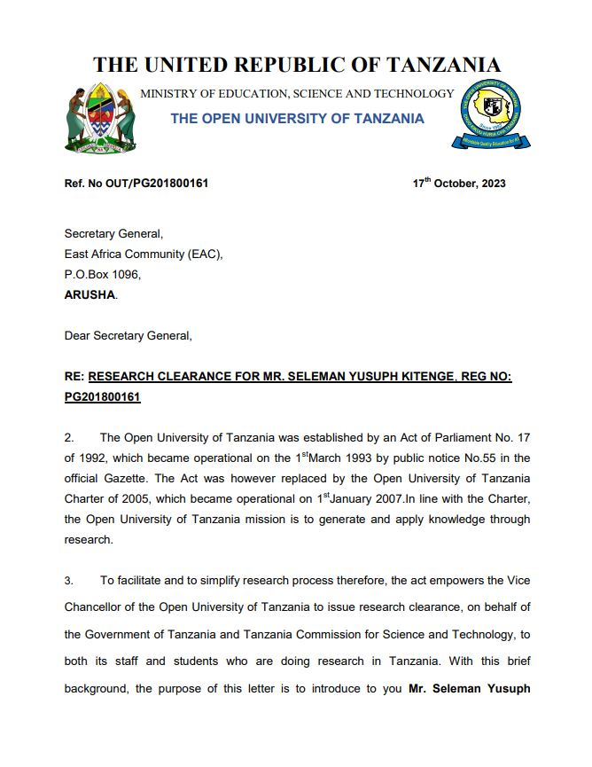
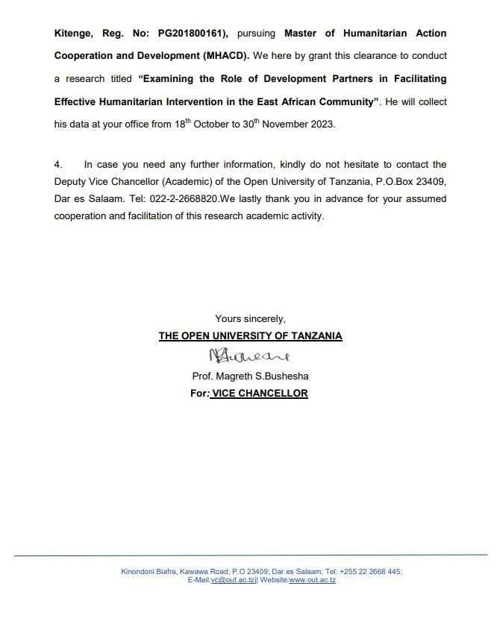

APPENDIX 6: EU RESEARCH CLEARANCE
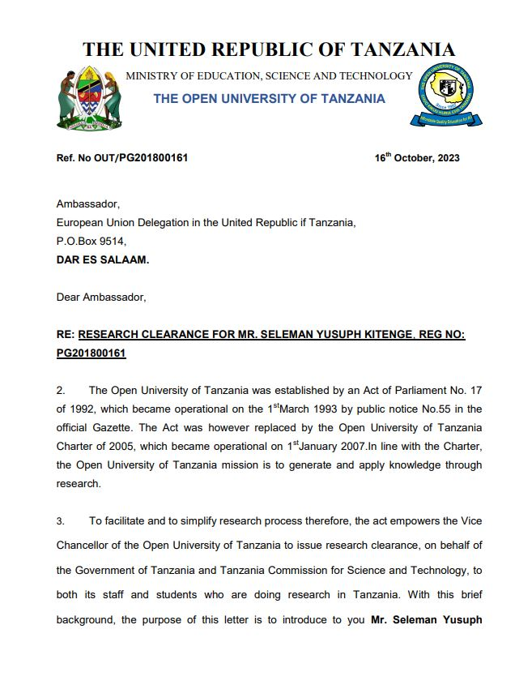
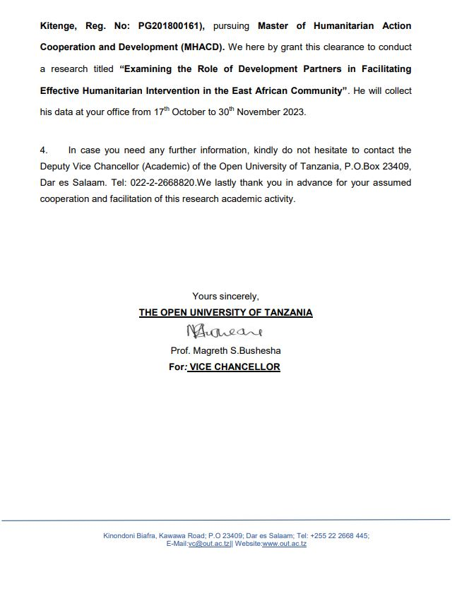

APPENDIX 7: GIZ RESEARCH CLEARANCE
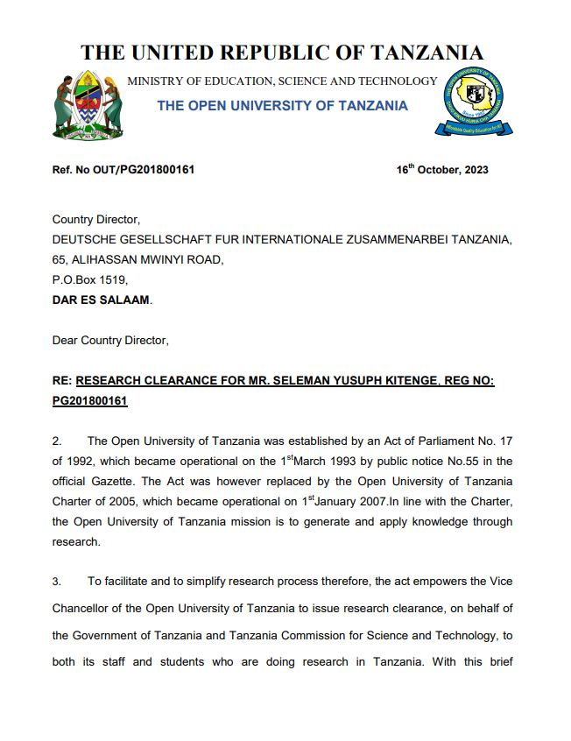

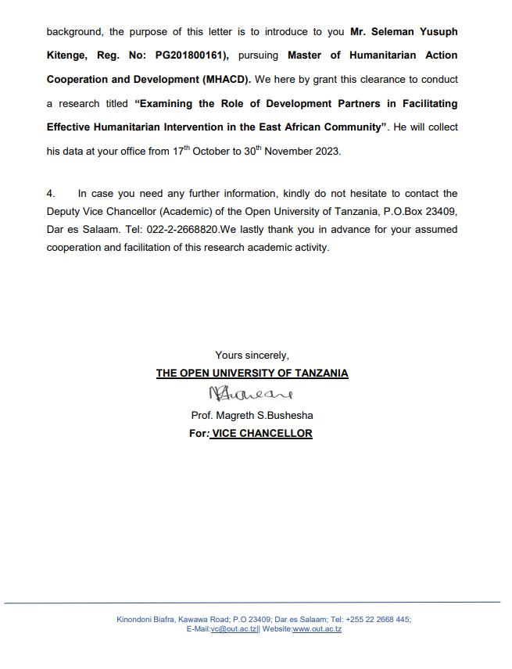
APPENDIX 8: JICA RESEARCH CLEARANCE
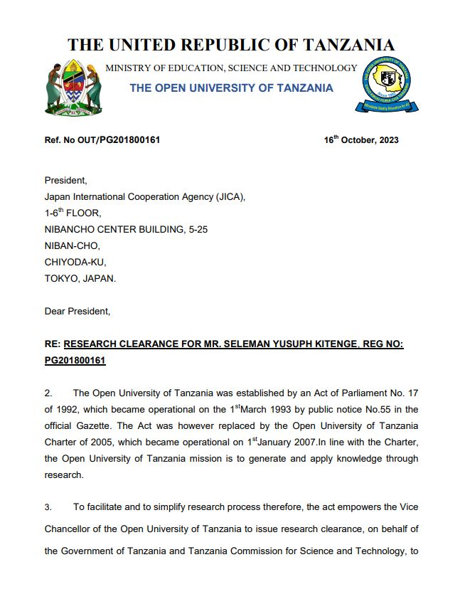
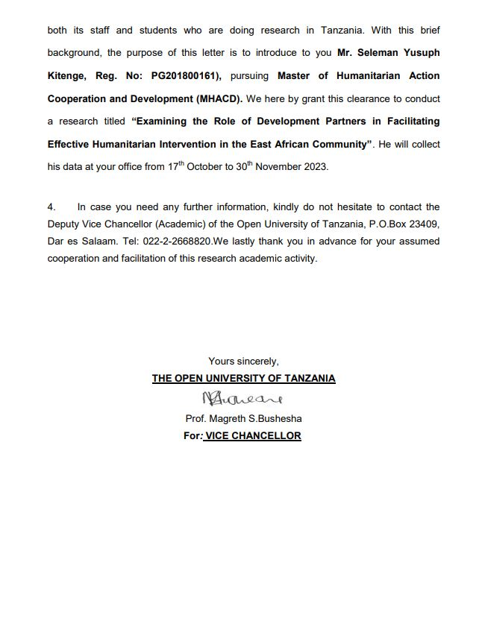

APPENDIX 9: USAID RESEARCH CLEARANCE LETTER
