ASSESSMENT OF FACTORS AFFECTING THE COMPLETION OF THE TANZANIA RURAL AND URBAN ROADS AGENCY PROJECT IN THE CITY OF DAR ES SALAAM

MUSA ZUMBE MZIMBIRI

A DISSERTATION SUBMITTED IN PARTIAL FULFILMENT OF THE REQUIREMENTS FOR THE DEGREE OF MASTER IN PROJECT MANAGEMENT
DEPARTMENT OF MARKETING ENTREPRENEURSHIP AND MANAGEMENT
THE OPEN UNIVERSITY OF TANZANIA
2024

CERTIFICATION
The undersigned certifies that they have read and hereby recommends for acceptance by the Open University of Tanzania the dissertation entitled: “Assessment of Factors Affecting the Completion of the Tanzania Rural and Urban Roads Agency Project in the City of Dar es Salaam” in partial fulfilment of the requirements for the Degree of Master of Project Management (MPM) of the Open University of Tanzania.

…………………………………….
Dr. France Shayo
(Supervisor)

……………..…………………………
Date

……………………………………….
Dr Sophia Mbura
(Supervisor)

…………………………….……….…
Date

COPYRIGHT
No part of this dissertation may be reproduced, stored in any retrieved system, or transmitted in any form by any means, electronically, photocopying, recording or otherwise without prior permission of the author or The Open University of Tanzania in that behalf.

DECLARATION
I, Musa Zumbe Mzimbiri, declare that the work presented in this dissertation is original. It has never been presented to any other university or institution. Where other people’s work has been used, references have been provided. It is in this regard that I declare this work to be originally mine. It is hereby present in partial fulfilment of the requirement for the degree of Master of Project Management (MPM) of the Open University of Tanzania.

………………………………
Signature

………………….…………..
Date

DEDICATION
This study is dedicated to my lovely family, father, sister and brothers for the great care that they are giving to me; I do wish them a happy life with a lot of success.

ACKNOWLEDGEMENT
This study would not be possible without the support of my family members and friends. Much honour is given to my almighty God who gave me life, and good health and enabled me to conduct this study up to its finalisation. My supervisor Dr. France Shayo deserves special thanks for conscientious work to make sure this study was completed timely and with success. I would like to offer thanks to my wife Hafsa Alphonce Mjema, my daughters Nasra, Lulu and Faizah Musa Mzimbiri, and my son Ibrahim Musa Mzimbiri for their constant bearing with me and many sacrifices through this journey.

Appreciation should go to all respondents for taking time and trouble to complete the questionnaires and to sit for their interview, which brought forth ideas that largely compose this report. Lastly, I say thanks to all who have facilitated this successful study.

ABSTRACT
This study intended to assess the factors affecting the completion of TARURA Projects in Dar es Salaam City. A quantitative study approach and a descriptive survey design were employed to achieve the study purpose. This research was conducted at TARURA offices in Dar es Salaam City. It targeted TARURA employees responsible for implementing TARURA projects in Dar es Salaam City. There were a total number of 90 employees of TARURA in Dar es Salaam. Slovin’s formula was used to calculate the sample size and determined that 73 employees out of 90 employees of TARURA was the optimum sample size for the study. A simple random sampling technique was used in this study to select employees of TARURA in Dar es Salaam city. The questionnaire method was used in this study for quantitative data collection from the sampled employees of TARURA in Dar es Salaam City. Quantitative data collected through questionnaires were analysed through descriptive and inferential statistics with the aid of Statistical Package for Social Science (SPSS version 21.0). The current study found that the predictor variables such as technical competency, resource allocation, and external environment have a positive and significant influence on the outcome variable, which is the completion of the TARURA projects in Dar es Salaam City. The variable that has the strongest influence on project completion among the three predictor variables was technical competence, followed by resource allocation and external environment. It is strongly recommended that project staff’s technical abilities be improved to uplift their technical competency, resources should be allocated sufficiently and on time, and the project schedule should be estimated with strong consideration to the external environment like weather conditions to avoid delays.
Keywords: Project completion, Resource allocation, and Technical competency
TABLE OF CONTENTS
CERTIFICATION ii
COPYRIGHT iii
DECLARATION iv
DEDICATION v
ACKNOWLEDGEMENT vi
ABSTRACT vii
LIST OF TABLE xiii
LIST OF FIGURE xiv
LIST OF ABBREVIATIONS AND ACRONYMS xv
CHAPTER ONE 1
INTRODUCTION 1
1.1 Overview 1
1.2 Background to the Study 1
1.3 Statement of the Problem 4
1.4 Objectives of the Study 6
1.4.1 General Objective 6
1.4.2 Specific Objectives 6
1.5 Research Questions 6
1.6 Significance of the Study 6
1.7 Scope of the Study 7
1.8 Organization of the Study 7
CHAPTER TWO 9
LITERATURE REVIEW 9
2.1 Overview 9
2.2 Definitions of the Key Terms 9
2.2.1 Project Completion 9
2.2.2 Resource Allocation 10
2.2.3 Technical Competency 10
2.2.4 External Environment 11
2.3 Theoretical Literature Review 11
2.3.1 Contingency Theory 11
2.3.2 Relevance of the Theory to the Study 13
2.4 Empirical Literature Review 13
2.4.1 Global Studies 13
2.4.2 Studies Conducted in Africa 15
2.4.3 Studies Conducted in Tanzania 16
2.5 Research Gap 17
2.6 Conceptual Framework 18
2.6.1 Resource Allocation and Project Completion 19
2.6.2 The Relationship between Technical Completion and Project
Completion 20
2.6.3 The Relationship between Environmental Factors and Project
Completion 20

CHAPTER THREE 22
RESEARCH METHODOLOGY 22
3.1 Overview 22
3.2 Research Philosophy 22
3.3 Research Approach 22
3.4 Research Design 23
3.5 The Study Area 23
3.6 The Study Population 23
3.7 Sampling Procedures and Sample Size 24
3.7.1 Sampling Procedures 24
3.7.2 Sample Size 24
3.8 Variables and Measurement 25
3.9 Instruments of Data Collection 26
3.10 Data Analysis 26
3.11 Reliability and Validity 27
3.11.1 Reliability 27
3.11.2 Validity 27
3.11.3 Ethical Considerations 28
CHAPTER FOUR 29
PRESENTATION OF RESEARCH FINDINGS 29
4.1 Overview 29
4.2 Response Rate 29
4.3 Data Preparation 29
4.4 Characteristics of the Respondents 30
4.4.1 Gender 30
4.4.2 Age 31
4.4.3 Academic Qualifications 31
4.4.4 Position 32
4.4.5 Working Experience 33
4.5 Descriptive Statistics’ Findings 34
4.5.1 Respondents’ Opinions on Resource Allocation 34
4.5.2 Respondents’ Opinions on Technical Competency 35
4.5.3 Respondents’ Opinions on External Environment 36
4.5.4 Respondents’ Opinions on Project Completion 37
4.6 Inferential Analysis’s Findings 38
4.6.1 Multiple Regression Assumptions 38
4.6.1.1 Test of Autocorrelation Assumption 38
4.6.1.2 Multicollinearity Assumption 38
4.6.1.3 Normality Assumption 39
4.6.2 Correlation Analysis 40
4.6.3 Model Summary 41
4.6.4 ANOVA 41
4.6.5 Multiple Regression Analysis Results 42
4.6.6 Multiple Regression Analysis Results 43
4.6.6.1 Coefficients for the Influence of Technical Competency on the
Completion of TARURA Projects 43
4.6.5.2 Coefficients for the effect of Resource Allocation on the
Completion of TARURA Projects 44
4.6.5.3 Coefficients for the Influence of External Environmental
Factors on the Completion of TARURA Projects 45
CHAPTER FIVE 46
SUMMARY, CONCLUSION AND RECOMMENDATION 46
5.1 Overview 46
5.2 Summary of the Research Findings 46
5.3 Conclusion 47
5.4 Recommendations 47
5.5 Limitations of the Study 48
5.6 Areas for Further Research 48
5.7 Areas for Further Research 48
REFERENCES 49
APPENDICES 55

LIST OF TABLES
Table 3.1: Variables and Measurements 25
Table 4.1: Respondents’ Opinions on Resource Allocation 35
Table 4.2: Respondents’ Opinions on Technical Competency 36
Table 4.3: Respondents’ Opinions on External Environment 37
Table 4.4: Respondents’ Opinions on Project Completion 37
Table 4.5: Model Summary 38
Table 4.6: Multicollinearity Assumption 39
Table 4.7: Descriptive Statistics 39
Table 4.8: Correlation Analysis Results 40
Table 4.9: Model Summary 41
Table 4.10: ANOVA 42
Table 4.11: Coefficients for Factors Affecting Completion of TARURA Projects 43

LIST OF FIGURES
Figure 2.1: Conceptual Framework 18
Figure 4.1: Gender 30
Figure 4.2: Age 31
Figure 4.3: Education Level 32
Figure 4.4: Position 33
Figure 4.5: Working Experience 34

LIST OF ABBREVIATIONS AND ACRONYMS
CPs Construction Projects
CRB Contractors Registration Board
NAO National Audit Office
PLS Partial Least Square
PMS Performance Measurement System
PORALG President’s Office Regional Administration and Local Government
SDGs Sustainable Development Goals
SEM Structural Equation Modelling
SPSS Statistical Package for Social Science
TANROADS Tanzania National Roads Agency
TARURA Tanzania Rural and Urban Roads Authority
TOC Theory of Constraints
URT United Republic of Tanzania

CHAPTER ONE

INTRODUCTION

1.1 Overview
This chapter describes the background of the study, the research problem, and both the general and specific objectives of the study. It also presents the research questions, the significance of the study and the organisation of the entire study.

1.2 Background to the Study
Construction projects (CPs) refer to coordinated efforts aimed at building structures or infrastructures. In the realms of architecture and civil engineering, construction projects entail the physical creation of a structure, involving various contractors working towards interrelated goals and tasks (Amoah, 2021). These projects significantly contribute to Sustainable Development Goals 9 and 13, which focus on building sustainable cities and communities by fostering a sustainable built environment (Konzo, 2020).

Globally, empirical research, such as the study conducted by Maktoumi, Khan, and Maktoumi (2020) within Oman's construction industry, highlights that factors related to clients, equipment, and materials such as delays in raw material delivery, lack of supplies, and damaged goods greatly influence the timely completion of construction projects. Similarly, Anastasopoulos et al. (2017) conducted research on Indian highway projects, finding that variables like project cost (contract bid), project scale, expected duration, and adverse weather conditions considerably affect the likelihood and extent of project delays.
In Africa, Bitamba and An’s (2020) research on the factors affecting the performance of construction projects in the Democratic Republic of Congo identified key elements such as project design, client management, contractor efficiency, scheduling, and contract terms as primary determinants of project success. In Kenya, a study by Murithi, Makokha, and Otieno (2017) on the timely completion of public construction projects in TransNzoia County revealed that successful project delivery relies on efficient resource allocation, competent leadership, and diligent monitoring.

In the context of Tanzania, Konzo’s (2020) study on delays in road construction projects found that incomplete project specifications or designs are directly responsible for project delays, rather than the consultants’ lack of onsite investigation. Additionally, unclear project purposes and changes to project scope often result in road construction delays. Further, research by Kullaya, Alemu, and Yeom (2021) identified six primary causes of delays in Tanzanian construction projects, including insufficient financing, delayed payments for completed work, poor site management, political interference, unrealistic work schedules, and the contractors’ inability to continue operations during extended periods of nonpayment.

In developing nations, urbanization has led to a surge in demand for construction projects. Specifically, in Tanzania, the construction sector's growth rate (67%) surpasses the overall economy, spurred by investments in commercial, residential, and infrastructure projects. The country has also seen an increase in registered engineering consulting firms, with 71% being local and 29% foreign. In 2015, foreign firms handled 165 projects, while local firms managed 3,217 projects (Kikwasi & Escalante, 2020). The Contractors Registration Board (CRB) reported that between 2011 and 2017, foreign contractors completed 1,019 projects worth TZS 17,085.29 billion (US$7.43 million), while local contractors handled 17,344 projects valued at TZS 8,239.03 billion (US$3.58 million) (Kikwasi & Escalante, 2020).

The success of construction projects hinges on effective planning, management, and oversight. It is essential for both private and public organizations to recognize the critical role these factors play in the success of CPs (Dlamini, 2018). Timely project completion is considered a crucial indicator of success, while delays are one of the most widespread and costly challenges faced globally (Fakinle & Fashina, 2020; Adam et al., 2015).

Despite notable progress in CPs, there are significant differences between projects in the private and public sectors. Public projects often encounter numerous challenges, including limited financial resources, poor coordination, design changes during construction, labor shortages, and material scarcity, which can hinder progress (Sambavisan & Son, 2017). The time, cost, and scope of quality, often referred to as the triple constraints, are key metrics for evaluating CP success (Ogutu & Muturi, 2017).

The Tanzania Rural and Urban Roads Agency (TARURA) undertakes various projects aimed at achieving the 2023 Sustainable Development Goals. These projects are crucial for improving the nation’s livelihoods and security. However, concerns have been raised about TARURA’s underperforming projects, particularly regarding time, quality, and resource allocation, leading to negative social and economic impacts (URT, 2011).
To support urban road development across Dar es Salaam’s districts, the Central Government allocated TZS 44.35 billion and TZS 57.95 billion to TARURA DSM during the fiscal years 2021/2022 and 2022/2023, respectively. Given the substantial financial investment, it is crucial to ensure these projects are completed on time so the community can benefit. Otherwise, the expected outcomes may not be realized promptly by the intended beneficiaries (NAO, 2019).

According to contingency theory, developed by Fred Edward Fiedler, factors such as resource allocation, staff technical competency, and external environmental conditions significantly impact project completion and other goals. This theory underpins the current study, suggesting that these variables influence project outcomes, such as timely completion. Further research is needed on the factors affecting project completion, given the large investments made by governments and donors (Konzo, 2020; Kazabe, 2019).

This study aims to assess the factors contributing to the timely completion of selected TARURA construction projects in Dar es Salaam City. It aligns with Sustainable Development Goal 9, focusing on industry, innovation, and infrastructure, as well as Tanzania’s National Construction Acts, the Roads Act of 2007, the Land Act of 1999, and the Occupational Health and Safety Act No. 5 of 2003.

1.3 Statement of the Problem
Like other African nations, Tanzania is experiencing growth in construction projects (CPs) due to increasing urbanization and the effects of climate change. The Tanzania Rural and Urban Roads Agency (TARURA), operating under the President's Office, Regional Administration and Local Government (PORALG), was established under the Executive Agencies Act Cap. 245. It is tasked with developing and maintaining a district road network spanning 109,000 km by 2023 and beyond. TARURA is currently executing its second five-year Strategic Plan (2021/22, 2026/27), which aims to construct and rehabilitate 25,000 km of roads, including 950 km of tarmac and 16,850 km of gravel roads (World Bank, 2022). Despite the government's initiative to establish TARURA for overseeing road construction projects at the local government level, and its provision of financial and other crucial resources, delays in project completion still persist (Konzo, 2020).

The contingency theory, which forms the theoretical basis for this study, highlights key variables critical to project completion and overall project success. These variables include resource allocation, technical competency, and external environmental factors. However, no existing studies in Tanzania have explored how these contingency variables influence the completion of TARURA projects. Most studies, including those by Konzo (2020) and Simon (2017), have concentrated on factors affecting the completion of TANROADS projects rather than TARURA. Given the contextual differences between the two agencies, it became essential to conduct a study specifically focused on TARURA projects in Dar es Salaam. This research, therefore, examined the factors influencing the completion of TARURA projects in Dar es Salaam. Importantly, the findings and conclusions of the study contributed valuable insights to aid in developing and implementing a comprehensive strategy to mitigate the issues causing contractors to fall behind on their project timelines.

1.4 Objectives of the Study

1.4.1 General Objective
The general objective of this study was to assess the factor affecting the completion of TARURA Projects in Dar es Salaam City.

1.4.2 Specific Objectives
The specific objectives of the study that address the subject matter are as hereunder:
- To examine the influence of technical competency on the completion of the TARURA projects in Dar es Salaam City.
- To examine the effect of resource allocation on the completion of TARURA projects in Dar es Salaam City.
- To examine the effect of external environmental factors influence completion of TARURA projects in Dar es Salaam City.

1.5 Research Questions
- How does technical competency influence the completion of TARURA projects in Dar es Salaam City?
- What is the effect of resource allocation on the completion of TARURA projects in Dar es Salaam City?
- How do external environmental factors affect the completion of TARURA projects in Dar es Salaam City?

1.6 Significance of the Study
The findings of this study will knowledge to the existing literature. The study might be useful in reviewing contracts, and policy formulation for ensuring successful construction projects. The study supports the national and global goals specifically Goal number 9. This study can also assist stakeholders in identifying characteristics that have an impact on the completion of government funded projects. Once these elements were recognized, crucial controls were developed. It can also help researchers to understand what has been done already and areas for further or future studies. In addition, data provided by this study can be used as a base for the foundation of the research problems by other researchers and this study can be cited by future researchers who intend to conduct this study in the future.

1.7 Scope of the Study
This study was based on TARURA projects in Dar es Salaam. This study focused on three independent variables including resource allocation, technical competency and external environment and one dependent variable which is project completion. This study was conducted within the timeframe ranging from January, 2023 up to September 2024. The theory that guided the study was Contingency theory.

1.8 Organization of the Study
This study comprises of five chapters: introduction, literature review, research methodology, discussion of research findings, and summary, conclusion, and recommendations. Chapter one, the introduction, addresses the background of the study, the problem statement, research objectives and questions, significance of the study, and the organization of the study. Chapter two, the literature review, encompasses both theoretical and empirical sections. Chapter three, focusing on research methodology, details the methods used to achieve the study's objectives, covering aspects such as research philosophy, approach, design, study area and population, sampling procedures and sample size, data collection methods, data analysis techniques, validity and reliability measures, and ethical considerations. Chapter four presents the research findings related to the study objectives and discusses these findings in relation to the research objectives. The final chapter offers a summary, conclusion, and recommendations aligned with the study's objectives.

CHAPTER TWO

LITERATURE REVIEW

2.1 Overview
This chapter provides a comprehensive overview of the factors affecting the completion of TARURA projects in Dar es Salaam City. It begins by defining key concepts and theoretical frameworks relevant to the study. The chapter then reviews existing literature, highlighting global and local research findings on project management challenges and success factors. It identifies gaps in the current research and introduces a conceptual model to examine how variables such as resource allocation and technical competency influence project outcomes.

2.2 Definitions of the Key Terms
This study understands the variables considered in this study including project completion, resource allocation, technical competency and external environment as:

2.2.1 Project Completion
Maktoumi, Khan & Maktoumi, (2020) defined project completion as the process through which a project is systematically completed at a required time frame. Anastasopoulos et al. (2017) postulated that project completion means satisfaction of all requirements of a project agreement as determined after review and inspection of the project owners or granters. Yeom, (2021) asserted that project completion is all about the last phase of the project life cycle, whereby all activities planned have been done, the stakeholders are satisfied and all acceptance criteria have been met. This study will adopt the definition by Maktoumi, Khan & Maktoumi, (2020) who defined project completion as the process through which a project is systematically completed at a required time frame.

2.2.2 Resource Allocation
The term "resource allocation" is conceptualized by Basheka & Byaruhanga (2017) as the process of distributing and managing resources in a way that supports the successful execution and completion of projects. In the field of economics, this term refers to the distribution of available resources across various applications. According to Kazabe (2019), in the context of project management, resource allocation involves the planning of tasks and the resources needed for those tasks, while also considering the availability of resources and the project's timeline. For this study, "resource allocation" will be understood as the process of planning and assigning resources to tasks, ensuring both their availability and alignment with the project's schedule, as defined by Kazabe (2019).

2.2.3 Technical Competency
The concept of "technical competency" is conceptualized by Rahsid et al. (2016) as the fundamental set of knowledge, skills, and abilities essential for executing project tasks effectively. Anastasopoulos et al. (2017) describe it as the skills typically gained through educational settings or practical experience on the job. Furthermore, Simon (2017) characterizes technical competencies as capabilities shaped by input from subject matter experts and informed by consultations with professionals in the field. For the purposes of this study, the term "technical competency" will be defined according to Rahsid et al. (2016), focusing on the core knowledge, skills, and abilities necessary for performing project related tasks.

2.2.4 External Environment
Murithi, Makokha & Otieno, (2017) defined external environment) as the array of factors or conditions beyond the organization that exert an influence on it. Mezher et al. (2016) describe it as the various elements outside the project's control that can affect its operations. Additionally, Kullaya, Alemu, and Yeom (2021) view the external environment as the variables that shape project decisions by defining the opportunities and risks involved. In this study, the term "external environment" will be referred to according to Murithi, Makokha, and Otieno (2017), emphasizing the external factors and conditions impacting the organization.

2.3 Theoretical Literature Review
A theoretical framework is a group of interconnected thoughts and ideas that demonstrate an effective perspective on wonders by establishing relationships between variables (Kothari, 2014). This study was guided by the contingency theory which addressed the way contingency factors such as project resource allocation, technical competency of project teams and external environment affect project completion and other project goals.

2.3.1 Contingency Theory
Developed by Fred Edward Fiedler in 1967, Contingency Theory asserts that managers must consider all relevant factors when making decisions, prioritizing those most crucial to the current context. Each construction project presents unique challenges and must be managed according to its specific attributes and the circumstances at that time (Sawega, 2015). Contingency theory acknowledges this variability and seeks to determine the most effective approaches to address the unique requirements of different projects. It challenges the notion of a universal best practice for project management, recognizing the diverse management contexts. As noted by Mutema (2013), contingency theory examines the interplay between the organization and its environment.

This approach acknowledges a wide range of contextual variables, often termed risk factors, which can influence project objectives differently. Examples of these variables include the external environment, technology, organizational size and structure, costs, and the necessary measures to prevent projects from exceeding budgets or falling behind schedules (PMS, 2006). By effectively managing these contingencies, project managers can significantly mitigate project uncertainties.

Contingency theory suggests that various external factors can impact project outcomes, including the successful completion of projects. It identifies contingency factors such as project resources, technology/technical skills, and the external environment as key variables. These factors will be utilized in the current study to evaluate their influence on project completion, aiming to minimize project uncertainty through appropriate contingency management.

The theory has several weaknesses; for instance, it fails to explain how to proceed when the leader and the scenario at hand do not coincide. It is claimed that the theory does not explain why some leaders with specific leadership philosophies succeed in some situations but fail miserably in others, (Lazarus, 2014). According to the theory, the project management team should handle any problems that endanger the achievement of project objectives.
However, the theory does not outline the management actions that should be done to address the external environmental factors that jeopardise project objectives, (Toku, 2014). The theory also has its strengths as it assesses how contingent factors including project resources, technology/technical competency and external environment affects attainment of project goals including project completion. Through discussing the weaknesses and strengths that this theory has, the researcher is confident that contingency theory is relevant to the current study and will properly guide this study.

2.3.2 Relevance of the Theory to the Study
The contingency theory was very relevant and important to this study as it postulated that the contingency factors such as project resources, technical competency and external environment affect completion of a project as one of the important project goals. This made this study hypothesise that project resource allocation, technical competency and external environment have significant association with completion of projects, hence, it was up to the current study to use research methods properly in order to confirm what the study envisaged.

2.4 Empirical Literature Review
This section explores prior research relevant to the current study, encompassing both international and Tanzanian contexts. It is organized into two main subsections: global studies and Tanzanian studies. Analyzing this literature assists in identifying gaps that the current research aims to address.

2.4.1 Global Studies
Maktoumi, Khan, and Maktoumi (2020) investigated factors contributing to delays in construction projects within Oman. They collected data from 210 stakeholders, including consultants, contractors, and clients, through a structured questionnaire. The analysis, conducted using SmartPLS for Structural Equation Modeling (SEM), revealed that delays related to clients, equipment, and materials such as interruptions in material supply, equipment malfunctions, and material damage significantly impact project completion times. While this study provides valuable insights into these delay factors, it is based in Oman, presenting a different context from Tanzania’s construction environment. The current study seeks to address this gap by exploring similar factors within the Tanzanian context and considering additional variables.

In a similar vein, Mezher et al. (2016) assessed the causes of delays in Lebanon’s construction sector from the perspectives of owners, contractors, and architecture/engineering firms. Their study identified that delays attributed to client decisions, service delivery issues, equipment inefficiencies, and material shortages significantly influence project timelines. However, their research did not consider external environmental factors or the technical competencies of project teams, which are critical for understanding the full scope of project delays. This study aims to fill this gap by including these additional factors in its analysis.

Anastasopoulos et al. (2017) utilized data from 1,722 highway projects in India to explore factors affecting project delays. Through the use of mathematical models with random parameters, they determined that project cost, size, expected duration, and the potential for adverse weather conditions notably impact delay likelihood and duration. While their study highlighted the importance of environmental factors like weather, it did not address the impact of technical competencies on project completion, which is a gap this study seeks to fill.

2.4.2 Studies Conducted in Africa
Bitamba and An (2020) examined the factors influencing construction project performance in the Democratic Republic of Congo. By applying the relative importance index (RII), they identified key performance indicators including design, client management, contractor productivity, scheduling, and contract management. Their findings underscored the significance of these factors but overlooked the role of environmental conditions such as weather, which this study will address by exploring its effects on project completion.

Murithi, Makokha, and Otieno (2017) analyzed the factors affecting the timely completion of public construction projects in TransNzoia County, Kenya. Utilizing survey research across 32 projects, and analyzing the data with descriptive and inferential methods in SPSS, they found that effective resource allocation, strong project leadership, and vigilant monitoring are crucial for on time project delivery. However, their study did not consider how external environmental factors or technical competencies might influence project outcomes, areas which the current research will investigate. Basheka and Byaruhanga (2017) focused on the performance of road infrastructure projects in Uganda, identifying issues such as poor contractor relationship management, communication breakdowns, and delays in contractor payments.

Their study highlighted the impact of these relational factors on project performance but did not address external environmental factors or technical competencies, which are essential for a comprehensive understanding of project completion. This study aims to address these overlooked aspects.

2.4.3 Studies Conducted in Tanzania
Konzo (2020) assessed the causes of delays in road construction projects in Tanzania using a case study approach. The research involved 49 participants, including engineers, consultants, contractors, and procurement officers. Data were gathered through questionnaires, interviews, and document reviews, and analyzed using descriptive and logistic modeling techniques.
The study found that inadequate project specifications and scope changes contribute significantly to delays. However, it did not address external environmental factors such as weather and political influences or technical competencies, which are crucial for a thorough understanding of project delays. This research will address these gaps by examining how these additional factors impact project completion.
Kazare (2019) explored factors affecting construction project performance in Musoma and Butiama Districts, Mara Region, Tanzania. Employing an explanatory research design, the study gathered data from 114 respondents using questionnaires and document reviews. Analysis revealed significant relationships between project planning, scheduling, trust, communication, political interference, and technical competence with project success.
While providing valuable insights, Kazare’s study did not investigate the impact of resource allocation on project completion. This study intends to fill this existing gap by exploring how resource allocation affects project outcomes. Simon (2017) investigated delays in road construction projects in Dar es Salaam City, Tanzania. Using questionnaires distributed to TANROADS officials, contractors, and stakeholders, the study employed both qualitative and quantitative analysis methods. The findings indicated that political interference, stakeholder involvement, and environmental conditions were significant contributors to project delays. Given that this study was conducted in 2017, updating the research to reflect current conditions and addressing gaps related to resource allocation and technical competencies is essential for a more accurate understanding of project completion factors.

Kullaya, Alemu, and Yeom (2021) analyzed the causes of delays in road construction projects in Tanzania. Through structured questionnaires and interviews with industry experts, they identified six major delay factors: poor financing access, delayed payments, financial issues, unrealistic work schedules, poor site management, and political interference. While this study provides comprehensive insights into delay causes, it does not address the impact of technical competencies, which this research will explore in depth to fill the existing gap.

2.5 Research Gap
Based on the reviewed literature, both international and Tanzanian studies reveal notable gaps that underscore the necessity of this research. Firstly, existing local research has not focused on TARURA projects in Dar es Salaam, leaving a void in understanding the specific challenges impeding the completion of these projects in that context. Consequently, the issues unique to TARURA projects in Dar es Salaam remain unexplored. Secondly, there is a gap concerning the impact of resource allocation on project completion, as highlighted by Kazare (2019), whose study did not address this crucial variable. Moreover, Konzo (2020) omitted significant factors such as external environmental influences like weather and political factors as well as technical competencies and resource allocation, which are vital for a comprehensive analysis. This study aims to bridge these gaps by examining how technical competencies, resource allocation, and external environmental factors affect the completion of road construction projects, thus providing a more complete understanding of the variables influencing project success.

2.6 Conceptual Framework
The conceptual framework for this study as indicated in Figure 2.1 envisaged that resource allocation affects completion of TARURA projects in Dar es Salaam. Resource allocation was measured by total cost spent on construction caused by access to credits, variability on prices, as well as by delays in payment of the interim certificates.
Dependent Variables

Independent Variables

Resource Allocation
Access to credits
Variability on prices
delays in payment of the interim Certificate

Project Completion
Time
Scope
Budget

Technical Competency
Competency in resource management
Competency in estimating project budget and schedule
Competency in project supervision

Environment Factors
Severe Weather
Community Involvement
Political Interference

Figure 2.1: Conceptual Framework
Source: Researcher’s Own Construct (2024)

It was also conceptualised that technical competency effects TARURA project completion in Dar es Salaam City. Technical competency was measured by technical competency in resource management, in community mobilisation, in estimating project schedule and budget, in project supervision and monitoring and evaluation. This study also envisaged that environment factors such as severe weather, community involvement, and political interference are the main factors that affect TARURA projects completion in Dar es Salaam City.

2.6.1 Resource Allocation and Project Completion
The distribution of resources is a crucial aspect of project management that has a direct impact on the chance of project completion. It entails allocating available resources including personnel, funds, time, and materials against different project tasks in order to guarantee that every facet of the project is sufficiently supported. By ensuring that the most important tasks have the resources they need to move forward quickly, efficient resource allocation helps to prevent bottlenecks and guarantees that deadlines are met. Effective resource allocation allows the project to move forward smoothly and complete each phase on time, which is crucial for meeting the project's overall goals and timeline (Kikwasi & Escalante, 2020).

On the other hand, inefficient resource management can cause serious delays in project completion. Inadequate or improperly handled resources can result in work that is incomplete or of low quality, as well as delays and increased expenses. For instance, a project team lacking sufficient resources may rush or overlook important tasks, leading to subpar results and possibly the need for rework. The project's progress may also be hampered if resources are diverted from more crucial tasks to less crucial ones, which could result in missed deadlines and budget overruns. As a result, allocating resources wisely is essential to keeping the project moving forward and guaranteeing that it is finished on schedule and within budget (Fakinle & Fashina, 2020).

2.6.2 The Relationship between Technical Completion and Project Completion
The point in a project where all technical elements such as design, development, testing, and integration have been completed is referred to as technical completion. Since all technical specifications and deliverables have been satisfied, the system or product should now operate as intended. Technical completion by itself, however, does not imply project completion. Although it excludes other crucial elements like training, documentation, and user acceptability, it indicates that the technical work has been completed (Ogutu & Muturi 2017).
Project completion, on the other hand, is a more comprehensive milestone that entails successfully completing all project requirements and objectives in addition to technical completion. This entails making certain that all deliverables are turned in, stakeholders are happy, documentation is finished, and any necessary training or transitional tasks are carried out. Therefore, even though technical completion is an essential component of project completion, the two are not the same. A more comprehensive definition of project completion is when all work has been completed, approved, and prepared for implementation or operational use (Konzo (2020).

2.6.3 The Relationship between Environmental Factors and Project Completion
Environmental factors, which include organisational and physical components that can affect project outcomes, are critical to the successful completion of projects. For example, physical environmental factors can affect project timeliness and execution, such as weather, location, and availability of natural resources. Unfavourable weather can delay construction projects, and problems with accessibility in remote areas can complicate logistics and raise costs. The availability of resources, such as energy or raw materials, can also have a big impact on the budget and timeline of a project. These physical characteristics frequently call for adaptive strategies and contingency planning to make sure that projects continue on schedule in spite of environmental obstacles (Kazare, 2019).

In terms of organisational factors, these include things like sociopolitical stability, public opinion, and the possibility of civil unrest. Regulatory frameworks, for instance, dictate compliance standards and approval processes that can affect project timelines and costs. Economic conditions, on the other hand, can change financial planning and budgetary constraints. Finally, sociopolitical stability affects project execution through elements like government support and public opinion. Knowing and anticipating these organisational factors is crucial for project managers to manage potential risks and align project strategies with external influences (Simon, 2017).

CHAPTER THREE

RESEARCH METHODOLOGY

3.1 Overview
This chapter provides a comprehensive overview of the research methodology employed in the study. It details the methodological framework and outlines the procedures used to conduct the research. Key elements discussed include the research philosophy, approach, design, study area, target population, sampling techniques, sampling frame, sample size, data collection methods and tools, data processing and analysis, as well as considerations related to reliability, validity, and ethical issues.

3.2 Research Philosophy
Research philosophy pertains to the underlying perspective regarding the collection, analysis, and application of empirical data. Two primary research philosophies are commonly recognized: positivism (sometimes referred to as scientific) and interpretivism (also known as ant positivism) (Galliers, 1991). Positivism posits that reality is consistent and can be objectively observed and described without interference (Levin, 1988). This approach values all methods when used correctly, thus this study embraced positivism as it aligns with the quantitative approach utilized.

3.3 Research Approach
This study employed a quantitative approach, utilizing quantitative methods for data collection and analysis. Specifically, questionnaires were administered to gather data, and both descriptive statistics and inferential analysis were performed using software such as Statistical Package for Social Science (SPSS). This approach facilitated the assessment of how factors such as resource allocation, technical competency, and external environmental conditions impact project completion.

3.4 Research Design
To address the research objectives, a descriptive survey design was adopted. This design allowed for the evaluation of the impact of independent variables (resource allocation, technical competency, and external environment) on the dependent variable (project completion). It provided a cost-effective way to generate empirical data and enabled the use of various data collection instruments, such as questionnaires. The choice of this design not only maximized information retrieval but also addressed budget constraints, given that the study’s funding was sourced internally.

3.5 The Study Area
The research was conducted at TARURA offices in Dar es Salaam City. In 2023, TARURA implemented 86 projects across Dar es Salaam with different contractors. The researcher visited TARURA offices and, with the assistance of TARURA management, accessed TARURA projects to engage with employees. This location was selected due to the researcher’s access to the target population and Dar es Salaam's status as Tanzania's fastest growing city with a high demand for improved road infrastructure. Consequently, the timely completion of construction projects is crucial.

3.6 The Study Population
The focus of the study was on TARURA employees involved in the execution of projects in Dar es Salaam City. The total number of TARURA employees in the city is 90. This population size, which includes both male and female employees across various roles such as engineers, technicians, department heads, artisans, accountants, procurement officers, human resource officers, and record officers, was used to calculate the sample size for the study.

3.7 Sampling Procedures and Sample Size

3.7.1 Sampling Procedures
The study employed a simple random sampling method to select TARURA employees in Dar es Salaam City. TARURA was asked to provide a list of employees, though their names were kept confidential for ethical reasons. The names were placed on slips of paper, which were then mixed. Through a lotterylike process, the researcher randomly drew slips to select 73 employees for participation in the quantitative data collection. This technique ensured fairness and provided an equal opportunity for each employee to be included in the study

3.7.2 Sample Size
This part presents the number of samples to participate in data collection and provides a description on the way sample size has been obtained. In this study, a total number of 73 employees out of 90 employees of TARURA were used as samples to participate in quantitative data gathering. The study used Slovin’s formula to calculate the number of samples that participated in quantitative data gathering. The workings are as shown below. A total number of 73 employees was optimum in collection of data concerning the factors affecting TARURA project completion in Dar es Salaam City.
n = N / (1+N (e) 2)
Whereas: n = sample size; N = Population of the study; e = Error term
Particulars: N = 90; e = 5% error term; n =?
Thus,
n = 90/ (1+ 90 (0.05)2
n =90/1+ 90 (0.0025)
n = 90/1+ 0.225
n = 90/1.225
n = 73.47
n= 73

3.8 Variables and Measurement
Table 3.1 details the variables of interest in this study and their respective measurement criteria. The independent variables include technical competency, resource allocation, and external environmental factors, while the dependent variable is the completion of TARURA projects. The study employed a Likert scale due to its simplicity and adaptability in capturing respondent opinions.

Table 3.1: Variables and Measurements
Variable to be Measured | Number of Scale Items | Measurement Scale | Source
Completion of TARURA Projects | 3 Items (Time, Scope, and Budget) | 5point Likert scale | Konzo (2020)
Technical Competency | 3 Items (Competency in Resource Management, Competency in Estimating Project Budget and Schedule, and Competency in Project Supervision) | 5point Likert scale | Kazabe (2019)
Resource Allocation | 3 Items (Access to Credits, Price Variability, and Delays in Payment of Interim Certificates) | 5point Likert scale | Kullaya, Alemu, and Yeom (2021)
External Environmental Factors | 3 Items (Severe Weather, Community Involvement, and Political Interference) | 5point Likert scale | Simon (2017)

3.9 Instruments of Data Collection
The study utilized a questionnaire for collecting quantitative data from TARURA employees in Dar es Salaam City. The questionnaire featured closed ended questions on a 5point Likert Scale (1 = Strongly Disagree, 2 = Disagree, 3 = Neutral, 4 = Agree, and 5 = Strongly Agree). It included demographic queries (age, sex, education level, position, and years of experience) and questions related to resource allocation, technical competency, external environmental factors, and project completion indicators. The questionnaires were distributed and self-administered, under the assumption that respondents could accurately interpret and respond to the questions. This method was chosen for its cost-effectiveness and efficiency in gathering quantitative data within a short timeframe.

3.10 Data Analysis
This section describes the analytical methods used for quantitative data. Data collected via questionnaires were analyzed using descriptive and inferential statistics with the aid of Statistical Package for Social Science (SPSS version 21.0). Prior to analysis, the data were entered into the software and cleaned to address errors such as incorrect, corrupted, or duplicate entries. Descriptive statistics were presented in tables showing frequencies and percentages, while inferential statistics included multiple regression analysis, correlation analysis, and ANOVA.

The multiple regression equation incorporated an error term to account for unobserved variables and measurement errors. The regression equation is as follows:
Y = β1X1 + β2X2 + β3X3 + e
Where:
Y = Completion of TARURA Projects
β1, β2, β3 = Coefficients or unknown parameters
X1 = Resource Allocation
X2 = Technical Competency
X3 = External Environmental Factors
e = Error Term

3.11 Reliability and Validity

3.11.1 Reliability
Reliability refers to the consistency of the research findings when the study is repeated (Quinlan, 2011). In this study, reliability was initially tested through a pilot study involving 10% of the respondents, who were surveyed three times to ensure consistency in responses. To ensure the instrument's reliability, a consistent standard for scoring and repeated data analysis was applied (Creswell, 2009). Additionally, Cronbach's alpha was used to assess internal consistency, with an alpha value above 0.7 indicating acceptable reliability.

3.11.2 Validity
Validity pertains to the accuracy and robustness of the research findings, ensuring they are logical and meaningful (Quinlan, 2011). The study adhered to content, criterion, face, and construct validity criteria. Content validity was ensured through consultations with the supervisor and academic experts who reviewed the questionnaires and interview guides. Their feedback helped align the research tools with the study objectives. Criterion validity was maintained by employing distinct tests separate from those used for test-retest reliability.

3.11.3 Ethical Considerations
Ethical standards were upheld by securing permission letters from the university and sending them to the research site to obtain research authorization. Respondents' anonymity was preserved, and they were informed about the study’s academic intent, ensuring no harm or misuse of their information. Additionally, proper acknowledgment of other researchers' work was provided using the APA referencing style.

CHAPTER FOUR

PRESENTATION OF RESEARCH FINDINGS

4.1 Overview
Chapter Four details the results of the research in relation to the study's specific aims. The primary objectives of this investigation are to evaluate the impact of technical skills on the successful completion of TARURA projects in Dar es Salaam City, to analyze the effect of resource distribution on the completion of TARURA projects in Dar es Salaam City, and to examine how external environmental factors affect the completion of TARURA projects in Dar es Salaam City. The chapter is organized into various sections, including an overview of respondent characteristics, findings from descriptive statistics, and results from inferential analyses.

4.2 Response Rate
This study has succeeded to collect data from all 73 respondents that were proposed at the design stage. This accounts for the response rate of 100%. Different scholars including Mugenda and Mugenda (2003) suggested that the response rate of 60% is satisfactory for the study to reach into the valid inference. Hence, the response rate of 100% is satisfactory as it is above the recommended response rate of 60%.

4.3 Data Preparation
After the data collection process, data from 73 questionnaires that were administered by the researcher were entered into Microsoft excel data sheet. Since the questionnaires were administered by the researcher, he ensured that there was no missing data in all questionnaire variables. Data was then cleaned in excel and imported to the statistical package for social science (SPSS Version 21) for further analysis. The researcher runs descriptive statistics through frequency and percentage and inferential analysis through correlation analysis, ANOVA and multiple regression analysis.

4.4 Characteristics of the Respondents
To provide a comprehensive overview of the respondents' profiles, various demographic variables were analyzed. These variables encompass gender, age, educational qualifications, job roles, and professional experience.

4.4.1 Gender
The data illustrated in Figure 4.1 reveals that 57.5% of the study participants were male, while 42.5% were female. This gender distribution reflects a moderate balance, with a slightly higher proportion of male respondents compared to female ones. This balance is essential for ensuring diverse perspectives within the study, although the higher number of male respondents indicates a marginal gender imbalance. The study's gender distribution was considered adequate for the analysis, given that the male respondents' numbers slightly exceeded those of their female counterparts.
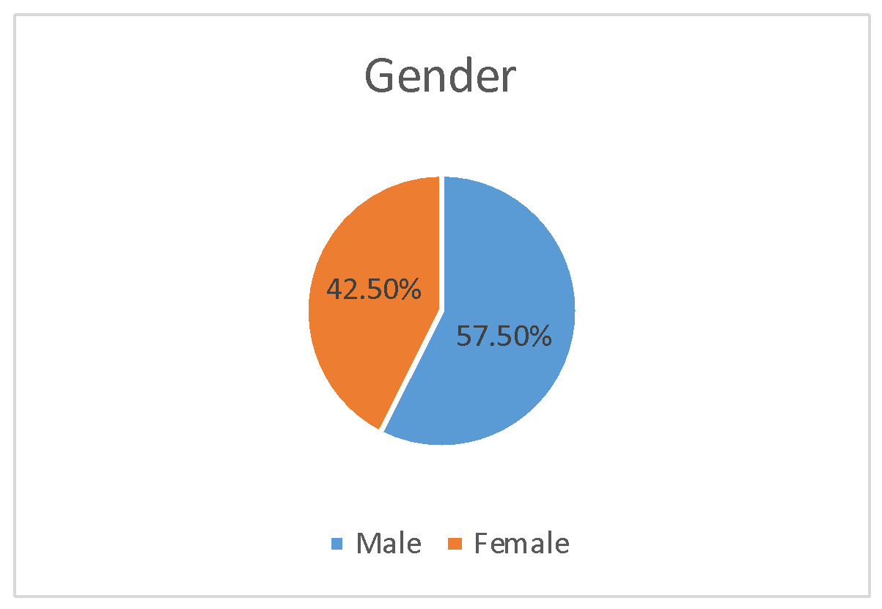
Figure 4.1: Gender

4.4.2 Age
The age distribution of respondents in this study is detailed in Figure 4.2. Notably, 43.8% of participants were between the ages of 29 and 39 years. This was followed by those in the 40 to 50 age range, then respondents aged 18 to 28, and finally those over 50 years old. The data indicates a well-rounded representation of different age groups, providing a comprehensive view of perspectives across various life stages. The inclusion of both younger and older respondents ensures a diverse range of opinions, reflecting a balanced age demographic within the sample.

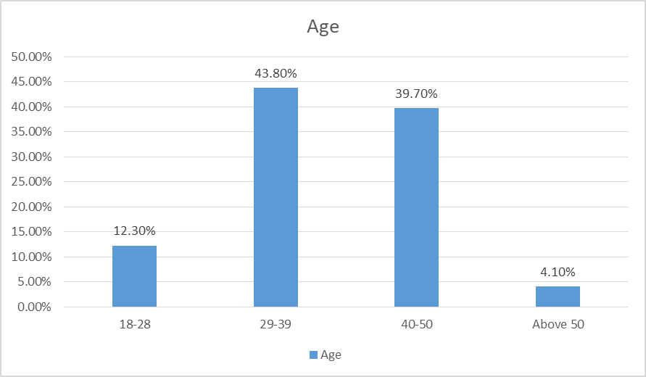
Figure 4.2: Age

4.4.3 Academic Qualifications
The educational background of respondents is depicted in the findings, showing that approximately 28.8% held bachelor’s degrees, representing the largest proportion. This was followed by individuals with diplomas, postgraduate degrees, certificates, and those with secondary education. The results reveal a well distributed representation across various educational qualifications. By including respondents from secondary education through to postgraduate degrees, the study ensured a broad spectrum of educational perspectives, thereby facilitating a diverse array of insights from individuals with varying levels of academic achievement.

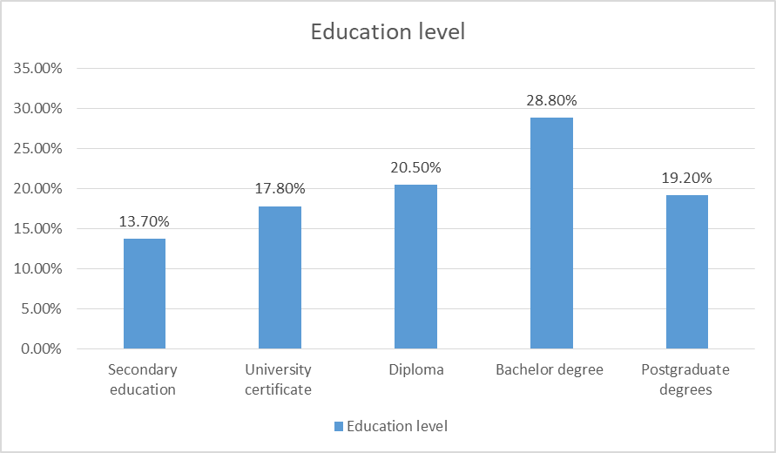
Figure 4.3: Education Level

4.4.4 Position
This section presents data about the positions of respondents included in this study. Data shows that engineers were 31.5%, technicians were 24.7%, heads of departments 12.3%, artisans and accountants constituted 8.2% respectively, procurement officers constituted 6.8%, human resource officers and record officers constituted 4.1% respectively.

This implies that there was no bias in this research as the study had opinions from respondents with different positions at the office.
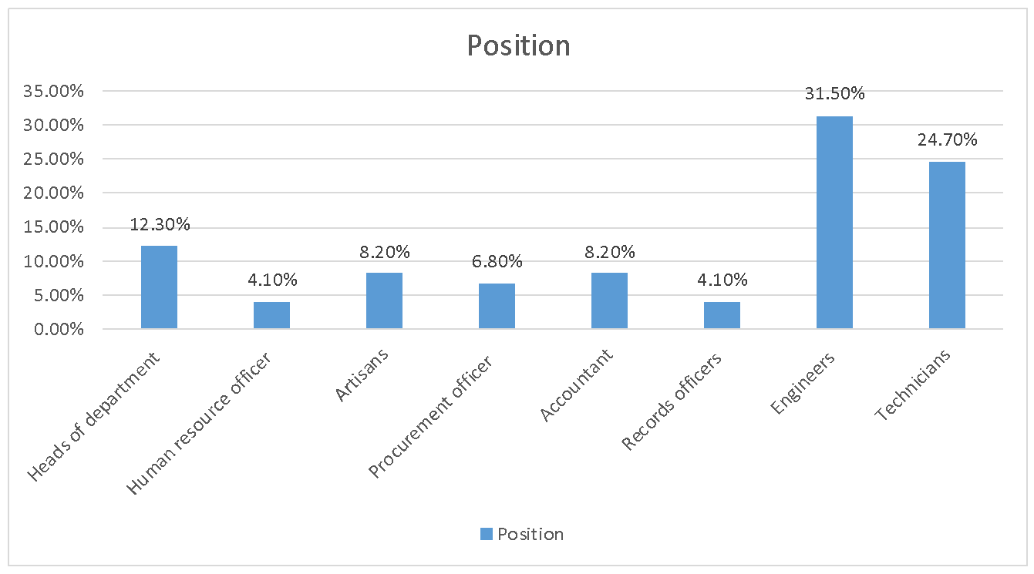
Figure 4.4: Position

4.4.5 Working Experience
The distribution of work experience among respondents reveals that 58.9% had between 6 and 10 years of professional experience, making this the most common range. This was followed by those with 0 to 5 years of experience, who constituted 28.8% of the sample, and those with 11 to 15 years of experience, accounting for 12.3%.

These results suggest that the study captured a broad range of perspectives by including input from employees with varying levels of experience, from relatively new to more seasoned professionals. This approach provided a comprehensive view of opinions across different experience levels.
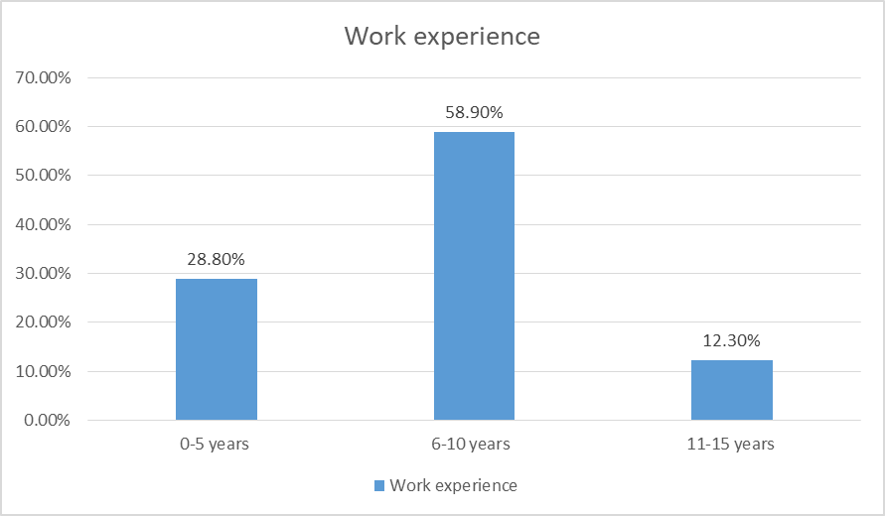
Figure 4.5: Working Experience

4.5 Descriptive Statistics’ Findings
This section describes the respondents’ opinions on the study variables including resource allocation, technical competency, external environment and project completion with the aid of descriptive statistics including frequencies and percentage.

4.5.1 Respondents’ Opinions on Resource Allocation
This section depicts the respondents’ opinions on resource allocation. The findings of this study indicated that the highest percentage of respondents (38.4%) agreed that there are delays in payment of the contractors ahead of project completion at a required time frame and there is some variability of prices which raise project spending beyond expectations (38.4%). Additionally, the highest percentage of respondents (28.8%) agreed that there is timely access to funds through different sources such as government, donor, credits etc. these findings are presented in detail in Table 4.1.
Table 4.1: Respondents’ Opinions on Resource Allocation (N=73)
Statements | Strongly Disagree |  | Disagree |  | Neutral |  | Agree |  | Strongly Agree
Statements | F | % | F | % | F | % | F | % | F | %
There are delays in payment of the contractors ahead of project completion at a required time frame | 14 | 19.2 | 3 | 4.1 | 14 | 19.2 | 28 | 38.4 | 14 | 19.2
There are some variability of prices which rise project spent beyond expectations | 7 | 9.6 | 17 | 23.3 | 9 | 12.3 | 28 | 38.4 | 12 | 16.4
There is timely access to funds through different sources such as government, donor, credits etc. | 6 | 8.2 | 16 | 21.9 | 13 | 17.8 | 21 | 28.8 | 17 | 23.3

4.5.2 Respondents’ Opinions on Technical Competency
This study describes the opinions of respondents about technical competency. The findings of this study indicated that highest percentage of respondents (43.8%) disagreed that employees of TARURA and contractors have technical competency in resource management, employees of TARURA and contractors have technical competency in community mobilisation (39.7%) and employees of TARURA and contractors have technical competency in project supervision (31.5%).

Additionally, the highest percentage of respondents strongly agreed (38.4%) that employees of TARURA and contractors have technical competency in estimating project schedule and budget. Furthermore, the highest percentage of respondents strongly disagreed (31.5%) that employees of TARURA and contractors have technical competency in monitoring and evaluation. These findings are presented in detail in Table 4.2.
Table 4.2: Respondents’ Opinions on Technical Competency (N=73)
Statements | Strongly Disagree |  | Disagree |  | Neutral |  | Agree |  | Strongly Agree
Statements | F | % | F | % | F | % | F | % | F | %
Employees of TARURA and contractors have technical competency in resource management | 23 | 31.5 | 32 | 43.8 | 6 | 8.2 | 10 | 13.7 | 2 | 2.7
Employees of TARURA and contractors have technical competency in community mobilisation | 21 | 28.8 | 29 | 39.7 | 9 | 12.3 | 11 | 15.1 | 3 | 4.1
Employees of TARURA and contractors have technical competency in estimating project schedule and budget, | 6 | 8.2 | 12 | 16.4 | 5 | 6.8 | 22 | 30.1 | 28 | 38.4
Employees of TARURA and contractors have technical competency in project supervision | 21 | 28.8 | 23 | 31.5 | 15 | 20.5 | 11 | 15.1 | 3 | 4.1
Employees of TARURA and contractors have technical competency in monitoring and evaluation | 23 | 31.5 | 13 | 17.8 | 21 | 28.8 | 11 | 15.1 | 5 | 6.8

4.5.3 Respondents’ Opinions on External Environment
This part presents the findings based on respondents’ opinions about the external environment. The findings indicated that the highest percentage of respondents (30.1%) agreed that there are seasons with bad weather which in some way affects timely completion of projects and there is community involvement in TARURA projects which in some way affects timely completion of projects (28.8%).

Additionally, the highest percentage of respondents (35.6%) disagreed that there is political interference in project design and implementation, which in some way affects timely completion of projects. These findings are presented in detail in Table 4.3.
Table 4.3: Respondents’ Opinions on External Environment (N=73)
Statements | Strongly Disagree |  | Disagree |  | Neutral |  | Agree |  | Strongly Agree
Statements | F | % | F | % | F | % | F | % | F | %
There are season with bad weather which in some way affects timely completion of projects | 7 | 9.6 | 7 | 9.6 | 20 | 27.4 | 22 | 30.1 | 17 | 23.3
There is community involvement in TARURA projects which in some way affects timely completion of projects | 19 | 26.0 | 11 | 15.1 | 19 | 26.0 | 21 | 28.8 | 3 | 4.1
There is political interference in project design and implementation which in some way affects timely completion of projects | 16 | 21.9 | 26 | 35.6 | 10 | 13.7 | 21 | 28.8

4.5.4 Respondents’ Opinions on Project Completion
This section depicts respondents’ opinions on project completion. The findings indicated that the highest percentage of respondents (35.6%) disagreed that there is timely completion of projects in respect to the expected time frame and the projects are completed within a required budget forecasted (39.7%). Additionally, the highest percentage of respondents (28.8%) agreed that the project is completed at a required scope in km and the quality of projects completed by TARURA is satisfactory (46.6%). These findings are presented in detail in Table 4.4.

Table 4.4: Respondents’ Opinions on Project Completion (N=73)
Statements | Strongly Disagree |  | Disagree |  | Neutral |  | Agree |  | Strongly Agree
Statements | F | % | F | % | F | % | F | % | F | %
There is timely completion of projects in respect to the expected time frame | 16 | 21.9 | 26 | 35.6 | 10 | 13.7 | 21 | 28.8
The project is completed at a required scope in km | 6 | 8.2 | 16 | 21.9 | 13 | 17.8 | 21 | 28.8 | 17 | 23.3
The quality of projects completed by TARURA is satisfactory | 5 | 6.8 | 10 | 13.7 | 10 | 13.7 | 34 | 46.6 | 14 | 19.2
The projects are completed within a required budget forecasted | 21 | 28.8 | 29 | 39.7 | 9 | 12.3 | 11 | 15.1 | 3 | 4.1

4.6 Inferential Analysis’s Findings
This section covers several subsections including multiple regression assumptions test results, correlation analysis, model summary, ANOVA and multiple regression analysis results.

4.6.1 Multiple Regression Assumptions

4.6.1.1 Test of Autocorrelation Assumption
The expected range for the Durbin Watson (d) statistic value is 1.5 to 2.5 (Field, 2009). The Durbin Watson value in Table 4.5 is 2.097, indicating that there were no autocorrelation errors in the regression model and, consequently, no highly correlated variables in the overall model. The value ranges between 1.5 < d < 2.5.

Table 4.5: Model Summary
Model | Durbin Watson
1 | 2.097
a. Predictors: (Constant), external environment, resource allocation, technical competency
b. Dependent Variable: project completion

4.6.1.2 Multicollinearity Assumption
This is measured in order to determine whether there is a strong correlation between the predictor variables. The model is considered to suffer from multicollinearity if the tolerance is less than 0.1 and the VIF value is greater than 10. Because the VIF varies from 1.053 to 1.917 and tolerance is not less than 0.1 in all variables, the model is not multicollinear. To examine this further, refer to Table 4.6. Furthermore, the correlation results have verified that there is no correlation between the independent variables, suggesting that multicollinearity does not exist in the model.
Multicollinearity Assumption.

Table 4.6: Multicollinearity Assumption
Model |  | Collinearity Statistics
 |  | Tolerance | VIF
1 | (Constant)
1 | Resource allocation | .950 | 1.053
1 | Technical competency | .530 | 1.888
1 | External environment | .522 | 1.917
a. Dependent Variable: project completion

4.6.1.3 Normality Assumption
This regression assumption needs to be verified because the regression residual needs to follow the normal distribution for a valid inference to be drawn from a regression model. The normalcy statistics were determined using the skewness and kurtosis tests. According to Field (2009), data is deemed normally distributed when its skewness and kurtosis values fall between 2 and +2, making it suitable for interpretation. The test results in Table 4.7 show that the residuals are normal, and the researcher was able to make a valid inference using this regression model.

Table 4.7: Descriptive Statistics
 | N | Std. Deviation | Skewness |  | Kurtosis
 | Statistic | Statistic | Statistic | Std. Error | Statistic | Std. Error
Resource allocation | 73 | .85165 | .462 | .281 | .183 | .555
Technical competency | 73 | .74378 | .234 | .281 | .007 | .555
External environment | 73 | .79748 | .212 | .281 | .318 | .555
Project completion | 73 | .73796 | .629 | .281 | .107 | .555
Valid N (listwise) | 73

4.6.2 Correlation Analysis
This section outlines the results obtained from the correlation analysis conducted using SPSS version 21.0. The analysis examined the relationships between the independent variables resource allocation, technical competency, and external environmental factors and the dependent variable, project completion. According to Wileman & Jary (1997), correlation coefficients are interpreted as follows: coefficients from 0.00 to 0.10 are deemed very weak, from 0.20 to 0.39 are weak, from 0.40 to 0.59 are moderate, from 0.60 to 0.79 are strong, and from 0.80 to 1.0 are very strong.

Table 4.8: Correlation Analysis Results
 |  | 1 | 2 | 3 | 4
- Project completion | Pearson Correlation | 1
- Project completion | Sig. (2tailed)
- Project completion | N | 73
- Resource allocation | Pearson Correlation | 0.438 | 1
- Resource allocation | Sig. (2tailed) | 0.021
- Resource allocation | N | 73 | 73
- Technical competency | Pearson Correlation | 0.750 | 0.045 | 1
- Technical competency | Sig. (2tailed) | 0.000 | 0.352
- Technical competency | N | 73 | 73 | 73
- External environment | Pearson Correlation | 0.595 | 0.132 | 0.672 | 1
- External environment | Sig. (2tailed) | 0.000 | 0.133 | 0.000
- External environment | N | 73 | 73 | 73 | 73

The analysis revealed that the correlation coefficient between resource allocation and project completion was 0.438, with a significance level of 0.021, which is below the 0.05 p-value thresholds. This indicates a moderate and statistically significant correlation between resource allocation and project completion. In contrast, the correlation coefficient between technical competency and project completion was 0.750, with a p-value of 0.000. This result demonstrates a strong and highly significant correlation.
Lastly, the correlation coefficient between external environmental factors and project completion was 0.595, with a p-value of 0.000, indicating a moderate and significant correlation. Detailed results are provided in Table 4.8.

4.6.3 Model Summary
This section provides insights into the R values, which indicate the extent to which the model accounts for the data. In this study, the model explained 80.0% of the data, reflecting a substantial degree of explanatory power. The R square value signifies the proportion of variability in the dependent variable that is accounted for by the independent variables. In this instance, resource allocation, technical competency, and external environmental factors together explained 64.1% of the variation in the timely completion of projects. Furthermore, the adjusted R square value was calculated at 62.5%, indicating that 62.5% of the variability in the dependent variable is accurately explained by the independent variables, after adjusting for the number of predictors in the model. These results are detailed in Table 4.9.

Table 4.9: Model Summary
Model | R | R Square | Adjusted R Square | Std. Error of the Estimate | Change Statistics
 |  |  |  |  | R Square Change | F Change | df1 | df2 | Sig. F Change
1 | .800ª | .641 | .625 | .45190 | .641 | 41.002 | 3 | 69 | .000
a. Predictors: (Constant), external environment, resource allocation, technical competency

4.6.4 ANOVA
This section discusses the ANOVA results following the linear regression analysis of the independent variables resource allocation, technical competency, and external environment against the dependent variable project completion. The ANOVA results indicated that the model’s significance value, or p-value, was 0.000, which is below the threshold of 0.05. This indicates that the independent variables significantly and consistently explain the variation in the dependent variable, project completion. Detailed findings are provided in Table 4.10.

Table 4.10: ANOVA
Model |  | Sum of Squares | Df | Mean Square | F | Sig.
1 | Regression | 25.120 | 3 | 8.373 | 41.002 | .000^{b}
1 | Residual | 14.091 | 69 | .204
1 | Total | 39.211 | 72
a. Dependent Variable: project completion
b. Predictors: (Constant), external environment, resource allocation, technical competency

4.6.5 Multiple Regression Analysis Results
Multiple regression analysis is employed to examine the relationship between a single dependent variable and multiple predictor variables (Kothari, 2014). According to Pallant (2010), a Sig. value (p-value) of less than 0.05 signifies that the predictor variable makes a significant and unique contribution to predicting the dependent variable. Conversely, if the p-value exceeds 0.05, it suggests that the predictor variable does not significantly contribute to the prediction of the dependent variable. Additionally, a positive beta coefficient indicates that the predictor variable has a positive effect on the dependent variable, and a negative coefficient indicates the opposite. In this study, the independent variables include resource allocation, technical competency, and external environment. Detailed results from the multiple regression analysis are provided in Table 4.11.
Table 4.11: Coefficients for Factors Affecting Completion of TARURA Projects
Model |  | Unstandardized Coefficients |  | Standardised Coefficients | T | Sig. | Collinearity Statistics
 |  | B | Std. Error | Beta | T | Sig. | Tolerance | VIF
1 | (Constant) | .139 | .294 |  | .473 | .038
1 | Resource allocation | .223 | .064 | .257 | 3.477 | .001 | .950 | 1.053
1 | Technical competency | .696 | .098 | .701 | 7.070 | .000 | .530 | 1.888
1 | External environment | .083 | .092 | .090 | .903 | .037 | .522 | 1.917
a. Dependent Variable: project completion

4.6.6 Multiple Regression Analysis Results

4.6.6.1 Coefficients for the Influence of Technical Competency on the Completion of TARURA Projects
The multiple regression analysis results indicated that technical competency significantly and positively affects the completion of TARURA projects. Specifically, technical competency accounts for 70.1% of the influence on project completion, with a p-value of 0.000. This finding aligns with several previous studies, such as those by Murithi, Makokha, and Otieno (2017), Kazare (2019), and Simon (2017). For example, Murithi, Makokha, and Otieno (2017) found that effective project leadership, characterized by the necessary qualifications and technical skills, is crucial for timely project delivery in public construction projects. Kazare (2019) reported a significant correlation between the technical competence of project staff and overall project success in Musoma and Butiama district councils.

Additionally, Simon (2017) identified a lack of technical competency in project leadership as a major factor contributing to delays in road construction projects in Tanzania. Konzo (2020) also highlighted that inadequate technical specifications and designs, due to insufficient site investigations, adversely affect project completion. Conversely, studies by Elemicin et al. (2021) and Usman (2021) reported insignificant or negative impacts of technical competency on project completion. These discrepancies may be attributed to varying respondent perspectives and study contexts.

4.6.5.2 Coefficients for the effect of Resource Allocation on the Completion of TARURA Projects
The results from the multiple regression analysis revealed a positive and significant effect of resource allocation on the completion of TARURA projects. Resource allocation was found to influence project completion by 25.7%, with a p-value of 0.001. These results are consistent with previous research, such as Mezher et al. (2016), Kazimoto (2016), Mashauri (2018), and Maswi and Pius (2018). Mezher et al. (2016) identified insufficient funding as a key cause of delays in Lebanon’s construction industry.

Kazimoto (2016) emphasized the importance of adequate resource allocation for successful project outcomes in Arusha. Mashauri (2018) highlighted resource allocation as a critical factor in the timely completion of public construction projects in Dar es Salaam. Similarly, Maswi and Pius (2018) reported a positive influence of resource allocation on project completion in Tanzania. However, contrasting findings were reported by Elmezain et al. (2021) and Usman (2021), who found that resource allocation had an insignificant or negative impact on project completion. These variations could be due to differences in respondent opinions and contextual factors.

4.6.5.3 Coefficients for the Influence of External Environmental Factors on the Completion of TARURA Projects
The analysis indicated that external environmental factors positively and significantly influence the completion of TARURA projects, with an effect size of 9.0% and a p-value of 0.037. This finding is supported by studies such as Anastasopoulos et al. (2017) and Simon (2017). Anastasopoulos et al. (2017) demonstrated that adverse weather conditions significantly impact project delays. Simon (2017) also found that environmental conditions, alongside political interference and other factors, are major contributors to road construction delays in Tanzania.

In contrast, Mols (2021) found a negative and insignificant impact of external environmental factors on project completion. Liu et al. (2018) and Usman (2021) also reported no significant influence of environmental factors on timely project completion. The differences between these studies and the current research may stem from varying respondent perspectives and study contexts.

CHAPTER FIVE

SUMMARY, CONCLUSION AND RECOMMENDATION

5.1 Overview
This chapter covers several sections including summary of the research findings and conclusion in respect to the study’s specific objectives. Additionally, this chapter covers recommendations reached after getting the research findings.

5.2 Summary of the Research Findings
The influence of technical competency on the completion of TARURA projects in Dar es Salaam City was assessed through multiple regression analysis, which revealed that technical competency significantly impacts project completion by 70.1%, with a p-value of 0.000. Despite this positive correlation, respondents had varied opinions. A notable portion disagreed that TARURA employees and contractors possessed technical competency in resource management (43.8%), community mobilization (39.7%), and project supervision (31.5%). On the other hand, a significant percentage strongly agreed that the competency in estimating project schedules and budgets was high (38.4%), while a considerable number strongly disagreed regarding technical competency in monitoring and evaluation (31.5%).
The effect of resource allocation on the completion of TARURA projects was also examined. The analysis showed that resource allocation positively influences project completion by 25.7% with a p-value of 0.001. Respondents indicated issues with delays in contractor payments and price variability, which were reported by 38.4% of them. However, 28.8% noted timely access to funds from various sources, including government and donor support, which positively affects project completion.
Regarding external environmental factors, the study found that they have a positive and significant influence on project completion, accounting for 9.0% of the variance with a p-value of 0.037. Respondents identified adverse weather conditions and community involvement as factors affecting project timelines, with 30.1% and 28.8% acknowledging their impact. Conversely, 35.6% disagreed that political interference notably affects project completion.

5.3 Conclusion
The study concludes that technical competency, resource allocation, and external environmental factors all have a positive and significant impact on the completion of TARURA projects in Dar es Salaam City. Among these variables, technical competency was found to have the strongest influence on project completion, followed by resource allocation and external environmental factors.

5.4 Recommendations
Based on the study’s findings, it is recommended that the technical abilities of project staff be enhanced to improve project completion outcomes. Improving technical competency among project leaders and contractors is crucial for successful project delivery. Additionally, ensuring timely allocation of resources, particularly financial resources, is essential to support project activities and avoid delays. Resources should be allocated from the budget estimation stage and timely payments to contractors should be ensured to facilitate smooth project execution. Lastly, project schedules should be carefully estimated with consideration of external factors such as weather conditions to mitigate potential delays and uncertainties.

5.5 Limitations of the Study
The study faced several limitations, including time constraints, which were managed by extending working hours and employing research assistants. Additionally, the use of questionnaires posed some challenges in respondent comprehension, which was addressed by piloting the questionnaire with a small sample before full-scale deployment.

5.6 Areas for Further Research
Future research could explore similar topics in different geographical areas within Tanzania to determine if there are regional variations in project completion factors. Further investigation into additional variables such as stakeholder involvement, management skills, and technology could also provide valuable insights into their influence on project completion.

5.7 Areas for Further Research
This study opens avenues for further studies in order to add empirical evidence about this topic. Interested researchers can conduct the same study at other geographical areas apart from Dar es Salaam City so as to see if there are some disparities in results obtained from other regions in Tanzania. Additionally, other researchers interested in conducting research about factors affecting project completion can concentrate on other variables including stakeholder involvement, management skills and technology employed to observe their influence on timely completion of projects.

REFERENCES
Akinradewo, O., Akinshipe. O., and Aigbavboa, C. (2022). Human factors, business management and society, 56, 2022, 447454.
AlaghbariWa'el, R., A. (2017). The Significant Factors Causing Delay in Building Construction Projects in Malaysia. Retrieved from https://www.academia.edu/ 336983/The_significant_factors_causing_delay_of_building_construction_projects_in_Malaysia on January 2023
Amoah, A.; BerbegalMirabent, J.; Marimon, F. (2021). What makes the management of a project successful? The case of construction projects in developing countries. Journal of Construction Engineering and Management, 147(12), 04021166.
Andrew, D. P., Pedersen, P. M., & McEvoy, C., D. (2011). Research Methods and Design in Sports Management. Human Kinetics. Retrieved from https://cmc.marmot.org/Record/.b64018751 on February 2023
Augustino Konzo (2020). An Assessment of the Causes for Delay in Completion of Road Construction Projects in Tanzania. Masters’ Dissertation. Mzumbe University. Retrieved from http://scholar.mzumbe.ac.tz/bitstream/handle/11192/ 4443/MBACMDCC_Augustino%20Konzo_2020.pdf?sequence=1 on February 2023.
Bernstein, J., C. (1994). Psychometric theory (3rd edition.). New York: McGraw-Hill.
Bitamba, B.F. and An, S.H. (2020) Study on Factors Affecting the Performance of Construction Projects in the Democratic Republic of the Congo. South African Journal of Industrial Engineering, 31, 1225.
Buzana Kazare (2019). The Determination of Factors Influencing Construction Project Performance in Public Institutions. A Case of Musoma & Butiama District Council. Masters Dissertation. Mzumbe University. Retrieved from URI: http://hdl.handle.net/11192/4332 on January 2023
Calmorin, L., P. C. (2017). Research Methods and Thesis Writing. Manila: REX Book Store.
Chandran (2004). Research Methods; A Quantitative Approach, Daystar University, Nairobi, Kenya. Retrieved from https://www.worldcat.org/title/56834567 on December 2022
Cherwenyi, K., B. (2018). Influence of Project Design Errors on Project Time Run in Kenya. International Journal of Social Sciences and Information Technology. Retrieved from https://www.ijssit.com/main/wpcontent/uploads/2018/10/ InfluenceOfProjectDesignErrorsOnProjectTimeRun.pdf in January 2023.
Demeulemeester, E. (2009). Robust Project Scheduling. M.A: Clearance Centre, Inc.
Dlamini M., (2018). The difference between private sector and public sector management. The CORE, Open University. Retrieved from https://core.ac.uk/ download /pdf/158611324.pdf on February 2023
Donati Michael Kullaya, Muluken Kassahun Alemu and Chun Ho Yeom (2021). An Analysis of the Main Causes of Delays in the Completion of Road Construction Projects: A Case Study of Tanza. The Open Transportation Journal, 2022, 16.
Elmezain, Maryam & Baduruzzaman, Wan & Khoiry, Muhamad. (2021). The Impact of Project Manager’s Skills and Age on Project Success. Brazilian Journal of Operations & Production Management. 18. e2021950. 10.14488/BJOPM.2021. 017.
Enshassi, A. (2009). Factors affecting the performance of Construction projects in the Gaza Strip. Journal of Civil Engineering and Management. Retrieved from https://www.researchgate.net/publication/42622404_Factors_affecting_the_performance_of_Construction_projects_in_the_Gaza_Strip on January 2023.
Fakunle F. and Fashina A., (2020). Major delays in construction projects: A Global review. PM World Journal
Frimpong, Y., Oluwoye, J., & Crawford, L. (2013). Causes of Delay and Cost Overruns in Construction of Groundwater Projects in Developing Countries. International Journal of Project Management, 321326. Retrieved from https://www.academia.edu/2458027/ on February 2023
Gitonga, J., W. (2018). Factors Affecting Sustainability of Nongovernmental Organisations in Nairobi, County Kenya. Doctoral Thesis, United States International UniversityAfrica, Nairobi. Kenya. Retrieved from https://www. semanticscholar.org/paper/ on January 2023.
Goldratt, E., M. (1990). What is this thing Called the Theory of Constraints? New York: North River Press. Retrieved from https://www.researchgate.net/ publication/ on January 2023.
Gudda, P. (2011). A Guide to Project Monitoring & Evaluation. Bloomington: ArthurHouse.
Harris, J., Dearman, C., Roussel, L., & Thomas, P., L. (2016). Project Planning and Management. Burlington: Jones & Bartlett Learning. Retrieved from https://www.amazon.com/ProjectPlanningManagementNursesInterprofessional/dp/1284147053 on February 2023
Hasseb, M., Bibi, A., & Rabbani, W. (2011). Problems of Projects and Effects of Delays in the Construction Industry of Pakistan. Australian Journal of Business and Management Research.
https://doi.org/10.4236/ajibm.2016.64047
https://doi.org/10.7166/3042193
Kazimoto, P. (2016) Employee Engagement and Organisational Performance of Retails Enterprises. American Journal of Industrial and Business Management, 6, 516525.
Kikwasi G. and Escalante C., (2020). The Construction Sector in Tanzania. Retrieved from https://doi.org/10.1093/oso/9780198851172.003.0012 in January 2023.
Kothari, C. R. (2014). Research Methodology: Methods and Techniques (3rd ed.). New Delhi: New Age International (P) Limited.
Kullaya. D. M, Alemu. M. K., and Yeom. C. H. (2022). An Analysis of the Main Causes of Delays in the Completion of Road Construction Projects: A Case Study of Tanzania. The Open Transportation Journal DOI: 10.2174/18744478v16e2208190, 2022, 16, e187444782208190
Liu, Liqiong & Zhang, Liyi & Ye, Pinghao & Liu, Qihua. (2018). Influencing Factors of University Students’ Use of Social Network Sites: An Empirical Analysis in China. International Journal of Emerging Technologies in Learning (iJET). 13. 71. 10.3991/ijet.v13i03.8380.
Moore, D., Price A., and Ochieng E., (2013). ‘Management of global construction projects’. ISBN 9780230303218.
Murith S. et al., (2017). ‘Factors Affecting Timely Completion of Public Construction Projects in TransNzoia County’. International Journal of Scientific and Research Publications. Retrieved from https://www.ijsrp.org/researchpaper 0417.php?rp= P646363 on February 2023.
Murithi. S.H, Makokha. E.N and Otieno. C (2017). Factors Affecting Timely Completion of Public Construction Projects in TransNzoia County. International Journal of Scientific and Research Publications, 7(4), 34-51.
Ogutu, B. O., & Muturi, W., 2017, Factors Influencing Successful Completion of Road Construction Projects in Kenya: The Case of Kisumu County, International Journal of Economics, Commerce and Management, 5(6), 657698.
Pallant, J. (2010). SPSS Survival Manual: Step by step guide to data analysis using SPSS 4th edition. New York: McGraw Hill.
Sambasivan, M. and Soon, Y. W. (2007). Causes and effects of delays in Malaysian construction industry. International Journal of Project Management Vol. 25, pp. 517–526. Accessed from www.nosazimadares.ir/fanni/doclib/causes on 4/9/2012.
Shammah Kiteme Munyoki. (2014). Factors Influencing Completion of Construction Projects; A Case of Construction Projects in Nairobi Kenya. Masters Dissertation. University of Nairobi. Retrieved from http://erepository. uonbi.ac.ke/bitstream/handle/11295/76078 on February 2023.
Simon. J. (2017). The Factors Causing Delays in Road Construction Projects in Tanzania: A Case of TANROAD Dar es Salaam City. Masters Dissertation. Open University of Tanzania. Retrieved from https://core.ac.uk/download/pdf/ 79425368.pdf in January 2023.
Suleiman, A. l. Maktoumi, Rahman Khan. F and Rashid Suwied A. l., Maktoumi. A (2020): Assessing the Factors causing Project Completion Delays in the Construction sector of Oman using SEMPLS. Humanities and Social Sciences Reviews, 8(3), pp. 900912. Doi:10.18510/hssr.2020.8394.
World Bank, (2022). Tanzania Roads to Inclusion and Socioeconomic Opportunities (RISE) Program (P164920).

APPENDICES

Appendix I: Questionnaire

- CHARACTERISTICS OF RESPONDENTS
No | Questions/Variable | Response | Code
a) | Gender | Male 42  Female 31 | 1  2
b) | Age | 18-28 9  29-39 32  40-50 29  Above 50 years 3
c) | Education level | Secondary education 10  University certificate 13  Diploma 15  Bachelor degree 21  Postgraduate degrees 14 | 1  2  3  4  5
d) | Position | Heads of department 9  Human resource officer 3  Engineer 6  Procurement officer 5  Accountant 6  Records officers 3  Artisans 23  Tariff collectors 18 | 1  2  3  4  5  6  7  8
e) | Work experience | 0-5 years 21  6-10 years 43  11-15 years 9  Above 15 years | 1  2  3  4

- RESOURCE ALLOCATION
Kindly indicate the extent to which you agree with the following statements concerning resource allocation indicators. Use the scale of (1-Strongly disagree 2-Disagree 3-Neutral 4-Agree 5-Strongly agree)
 | STATEMENT | 1 | 2 | 3 | 4 | 5
 | There are delays in payment of the contractors ahead of project completion at a required time frame
 | There are some variability of prices which rise project spent beyond expectations
 | There is timely access to funds through different sources such as government, donor, credits etc

- TECHNICAL COMPETENCY
Kindly indicate the extent to which you agree with the following statements concerning technical competency. Use the scale of (1-Strongly disagree 2-Disagree 3-Neutral 4-Agree 5-Strongly agree)

 | STATEMENT | 1 | 2 | 3 | 4 | 5
 | Employees of TARURA and contractors have technical competency in resource management
 | Employees of TARURA and contractors have technical competency in community mobilisation
 | Employees of TARURA and contractors have technical competency in estimating project schedule and budget,
 | Employees of TARURA and contractors have technical competency in project supervision
 | Employees of TARURA and contractors have technical competency in monitoring and evaluation
- EXTERNAL ENVIRONMENT
Kindly indicate the extent to which you agree with the following statements concerning the external environment in water projects. Use the scale of (1-Strongly disagree 2-Disagree 3-Neutral 4-Agree 5-Strongly agree)

 | STATEMENT | 1 | 2 | 3 | 4 | 5
 | There are season with bad weather which in some way affects timely completion of projects
 | There is community involvement in TARURA projects which in some way affects timely completion of projects
c) | There is political interference in project design and implementation which in some way affects timely completion of projects

- PROJECT COMPLETION
Kindly indicate the extent to which you agree with the following statements concerning project completion. Use the scale of (1-Strongly disagree 2-Disagree 3-Neutral 4-Agree 5-Strongly agree)
 | STATEMENT | 1 | 2 | 3 | 4 | 5
 | There is timely completion of projects in respect to the expected time frame
 | The project is completed at a required scope in km
 | The quality of projects completed by TARURA is satisfactory
 | The projects are completed within a required budget forecasted

Appendix IV: Research Clearance Letter





