Assessment of Community Participation in Municipal Solid Waste Management in Urban Areas: A Case Study of Karatu Town, Tanzania

EGBERT FABIAN LAURENT

A DISSERTATION SUBMITTED IN PARTIAL FULFILMENT OF THE REQUIREMENTS FOR THE DEGREE OF MASTER OF ART IN NATURAL RESOURCE ASSESSMENT AND MANAGEMENT
DEPARTMENT OF GEOGRAPHY, TOURISM AND HOSPITALITY STUDIES
THE OPEN UNIVERSITY OF TANZANIA
2025

CERTIFICATION
The undersigned certifies that he has read and here by recommends for acceptance by the Open University of Tanzania a dissertation entitled; “Assessment of Community Participation in Solid Waste Management in Urban Areas: A Case Study of Karatu Town, Tanzania” in partial fulfillment of the requirements for the award of Master of Art in Natural Resource Assessment and Management.

…………………….…………….
Prof. Jumanne Daudi Kalwani
(Supervisor)

……………………
Date

COPYRIGHT
No part of this Dissertation may be reproduced, stored in any retrieval system, or transmitted in any form by any means, electronic, mechanical, photocopying, recording or otherwise without prior written permission of the author or The Open University of Tanzania in that behalf.

DECLARATION
I, Egbert Fabian Laurent, declare that, the work presented in this report is original. It has never been presented to any other University or Institution. Where other people’s works have been used, references have been provided. It is in this regard that I declare this work as originally mine. It is hereby presented in partial fulfillment of the requirement for the Master’s Degree of Art in Natural Resource Assessment and Management.

………………………………….
Signature

……………………….
Date

DEDICATION
I dedicate this dissertation to my wife Magreth William, and my kids Hope and Gianna. This dedication is also with no exclusion of my friends John Nade, Jemin Laurent, and Protas Mkiri.

ACKNOWLEGEMENTS
In a course of writing I have received many support and assistance from many people. I am gratefully to my God almighty, and the unfailing father making many journey of life and my journey of life and my MANRAM study possible. I learned the can do all through him who give me strengths.
Special thanks to my supervisor Prof, Jumanne Daudi Kalwani for his advices and guidance in revising, connecting and maintaining accuracy to his research. This research could not have come successfully conclusion without the assistance from him let my almighty God bless you.
I would like to express my feeling to member of my family, who never sealed to encourage and support me during my MANRAM studies my father Fabian Laurent, my mother Faith Silas, my wife Magreth William, and my kids Hope Egbert, Gianna Egbert, and Jemin Laurent you will always live in my heart be blessed.
I am also indebted to my classmate who meticulous critiques on my heart remain exceptional. Those include Joan John, Sara Jembe, Jum Murshid and Amperius Novart, be blessed friends of mine.
I would like also to express thanks to Karatu District Council for making the opportunity available to all who aspire to work for betterment of the town and the realization of environmental conservation.

ABSTRACT
This study aimed at assessing the community participation (CP) in municipal solid waste management (MSWM) in urban areas, in Karatu Town, Tanzania. The study thought to in investigate the extent of CP in planning and decision-making in MSWM; community practice in MSWM programmes; as well as assessing the effects of CP in MSWM programmes. A total of 90 respondent’s community members were obtained using systematic sampling technique for quantitative data. Then in-depth interview was conducted to 10 government officials to obtain quantitative data. Quantitative data were analysed using descriptively (frequencies and percentages), as inferential statistical using linear regression to establish the statistically significant between the study variables moreover for qualitative data thematic were used. The study found that community members were involved in waste management through planning and decision-making. The community were less engaged in providing opinions, participation in discussion, sensitization programmes as well setting goals. The further found that community practiced in MSWM through various ways such as mobilizing themselves, information dissemination, and contributing on transporting wastes. Similarly the study revealed that the government made some efforts concerning community participation in MSWM specifically making the community understanding the designed MSWM programmer’s design, participatory policies which used sharing and implementation of MSWM. However, the study identified some isolated technical and institutional weaknesses were identified and called for rectification the study came up with recommendations for improvement of MSWM in Karatu Town.
Key Words: Community, Participation, Municipal Solid Wastes, Management

TABLE OF CONTENTS
CERTIFICATION ii
COPYRIGHT iii
DECLARATION iv
DEDICATION v
ABSTRACT vii
TABLE OF CONTENTS viii
LIST OF FIGURES xiv
LIST OF ABBREVIATIONS AND ACRONYMS xv
CHAPTER ONE 1
INTRODUCTION 1
1.1 Introduction 1
1.2 Background to the Research Problem 1
1.3 Statement of the Problem 3
1.4 General Research Objective 4
1.4.1 Specific Research Objectives 4
1.5 Research Questions 4
1.6 Significance of the Study 5
1.7 Organization of the Study 5
CHAPTER TWO 7
LITERATURE REVIEW 7
2.1 Introduction 7
2.2 Operational Definition of the Key Concepts 7
2.2.1 Community 7
2.2.2 Participation 7
2.2.3 Municipal Solid Waste 8
2.2.4 Municipal Solid Waste Management 8
2.3 Theoretical Literature Review 9
2.3.1 Community Participation Theory 9
2.3.2 Justification for Choosing the Theory 10
2.4 Empirical Literature 10
2.4.1Community Participation in Planning and decision making for MSWM……...10
2.4.2 Community Practice in MSWM 11
2.4.3 Effect of Community Participation in MSWM 12
2.5 Research Gap 15
2.6 Conceptual Framework 15
2.7 Chapter Summary 16
CHAPTER THREE 18
RESEARCH METHODOLOGY 18
3.1 Introduction 18
3.2 Research Design 19
3.3 Study Population 20
3.5 Sampling Strategies 21
3.6 Scope of the Study 22
3.7 Variables and Measurement Procedures 22
3.8 Data Collection Methods 23
3.8.1 Questionnaire 23
3.8.2 Semi-Structured Interview 23
3.9 Data Analysis Methods 24
3.9.1 Reliability 24
3.9.2 Validity 24
3.9.4 Descriptive Statistics 24
3.10 Data Cleaning Process 26
3.11 Ethical Consideration 26
3.12 Chapter Summary 26
CHAPTER FOUR 28
RESULTSAND DISCUSSION 28
4.1 Introduction 28
4.2 Socio-Demographic Characteristics 28
4.2.1 Age of Respondents 29
4.2.2 Sex/Gender of Respondents 30
4.2.3 Level of Education of Respondents 30
4.2.4 Marital Status of Respondents 31
4.3 Description Statistics on CP in Planning and Decision-making in MSWM 32
4.3.1 Participation in Problem Identification 32
4.3.2 Participation in Finding Solutions 34
4.3.3 Participating in Sensitization 36
4.3.5 Participating in Discussion 41
4.3.6 Participating in Setting Goals 42
4.3.7 Participating in Decision-making 43
4.4 Description Statistics of Community Practice in MSWM Programmes 45
4.4.1 Practicing Mobilization 45
4.4.2 Practicing Information Dissemination 46
4.4.3 Contributing on Transporting Solid Wastes 47
Source: Data Analysis (2024) 48
4.4.4 Putting Cover to Containers 49
4.5 Description Statistics of the Effect of Community Participation in MSWM 50
4.5.1 Effective Implementation of Designed Programmes 52
4.5.2 Local Ownership of Designed Programmes 53
4.5.3 Cost Sharing for Designed Programmes 54
4.5.4 Effective Implementation of Policies and Programmes 55
4.6 Inferential Analysis 56
4.6.1 Reliability Results 56
4.6.2 Validity Results 57
4.6.3 Assumption of Multiple Linear Regression Model 57
4.6.3.1 Linearity 57
4.6.3.2 Absence of Multicollinearity 58
4.6.3.3 Homoscedasticity of Variances 59
4.6.3.4 Residuals are Normally Distributed 60
4.6.4 Multiple Linear Regression Analysis Results 61
4.6.4.1 Model Summary 61
4.6.4.2 ANOVA Results 62
4.6.4.3 Regression Analysis Coefficient Results 63
CHAPTER FIVE 65
CONCLUSION AND RECOMMENDATION 65
5.1 Introduction 65
5.2 Summary of the Study Findings 65
5.3 Conclusions 66
6.5 Limitations and Areas for Further Studies 68
REFERENCES 69
APPENDICES 78

LIST OF TABLES
Table 2. 1: Summary of the Previous Related Studies 14
Table 3. 1: Distribution of the Study Sample……………………………...………..21
Table 4. 1: Age Distribution of Respondents………………………………………..29
Table 4. 2: Gender/Sex Description Results .30
Table 4. 3: Level of Education Description Results 31
Table 4. 4: Marital Status 32
Table 4. 5: Participation in Identification of the Problem Description Results 33
Table 4. 6: Participation in Sensitization of awareness in MSWM 37
Table 4. 7: Participation in Giving Opinions Description Results 38
Table 4. 8: Participation of local community in Discussions on MSWM with local Government representatives 41
Table 4. 9: Given Rights to Participate Description Results 44
Table 4. 10 : Practice in MSWM Programmes 48
Table 4. 11: Reliability Test of the Study Variables 56
Table 4. 12: KMO Test 57
Table 4. 13 : Multicollinearity Test 59
Table 4. 14: Model Summary 62
Table 4. 15: ANOVA Results 63
Table 4. 16: Regression Analysis Coefficient Results 64

LIST OF FIGURES
Figure 2. 1: Conceptual Framework 16

Figure 3. 1: Map of Tanzania to Show Location of Karatu District……… ………..19

Figure 4. 1: Participating in Finding Solutions Description Results………………..35
Figure 4. 2: Participating in Setting the Goals Description Results (n=90) 43
Figure 4. 3: Effects of Community Participation in MSWM Description Results (n=90) 51
Figure 4. 4: Linearity Test Enlarge this figure it is minute. 58
Figure 4. 5: Homoscedasticity of Variances Test 60
Figure 4. 6: Normally Distributed 61

LIST OF ABBREVIATIONS AND ACRONYMS

CP Community Participation
KIs Key Informants
KMO Kaiser-Meyer-Olkin
MSWM Municipal Solid Waste Management
SPSS Statistical Package for the Social Sciences
SWM Solid Waste Management
UNEP United Nations Environmental Programme
VIF Variance Inflation Factor

CHAPTER ONE

INTRODUCTION

1.1 Introduction
This chapter covers the background information of the concept of community participation in solid waste management in urban areas. Besides, the chapter briefly gives details on the problem statement, problem statement and research questions. Furthermore, the chapter covers a part of the significance of the study. Thereafter, in the end the chapters provide a summary of the whole chapter.

1.2 Background to the Research Problem
Globally, solid wastes generation is increasing as the time goes on, there was 635 metric tons in 1965, further this is projected to be increased to 3,539 metric tons by 2050 (Chen et al., 2020). Besides, recent studies predict the solid waste generation to be 2.24 billion tons in 2020 worldwide, moreover it is estimated to reach 3.88 billion tons by 2050 (World Bank, 2022). The issue of municipal solid waste management (MSWM) is challenging world in both small and large cities including in towns and municipalities (Abdel-Shafya & Mansour, 2018). Besides, the issues of MSWM results to negative effects environment and public health concern (Sharma & Jain, 2020). In Pakistan for example, the problem is very big, moreover it is associated with poor planning of community development especially in major cities where environmental sanitation has been very complex. Lack of MSWM system leads to environmental degradation. In fact, this situation is associated by illegal dumping of communal solid, which later results to eruption of diseases in Pakistan (Naila, 2017).
In Africa, the statistics of solid wastes generation show an estimation of 125 million tons in each year (Niekerk and Weghmann, 2019), it is also predicted to be doubled by 2025 (United Nations Environment Programm-UNEP, 2020). For example, in a country of Ghana, its cities generate a large volume solid wastes per day, however there is neither mechanism to collect the generated wastes on a right time nor disposed properly (Kofi et al., 2023). Moreover, the large volume of solid wastes is caused by the growth of population and urbanization which makes the task of collecting solid wastes to be tough (Lissah et al., 2021).
In Tanzania, MSWM is faced with several barriers such as poor collection systems and methods, lack of institutional arrangement and information resources, inflexible work schedules, and insufficient information on quantity and composition of waste (Chonge, 2016). Additionally, Ussi, (2021) stipulates that in Tanzania MSWM problems is experienced in cities and towns, moreover the source include management at source, system of collection, system of transporting wastes, disposal, and fund.
Moreover, the government has done efforts for MSWM by introducing the Environmental Management Act 2004. This Act needs the local government authorities (LGAs) to take measures to manage both solid and liquid wastes through the Public Health Act of 2009 (Shabani, 2015). Despite of having the good law and regulation as well as by law on SWM, the implementation of (SWM) is severely constrained by lack of awareness, community participation and appreciation of best practices for SWM. Besides, lack of keeping people aware and involving them, makes households to delay contributing with fees which later results to poor relationships of waste collector and household members, hence poor SWM (Kaseva & Mbuligwe, 2005). It is therefore through this background, the current study intends to assess the community participation in solid waste management in urban areas specifically in Karatu town, Tanzania.

1.3 Statement of the Problem
Karatu Town, like many other towns in Tanzania, is facing challenges related to municipal solid waste management (MSWM) as it continues to grow and become a significant concern. According to the Local Government Act, No. 8 of 1982, local authorities are responsible for managing municipal solid waste. However, they have observed a general decline in MSWM effectiveness, with most local authorities able to collect and dispose of only about one-third of the municipal solid waste generated (Chonge, 2016). Since 1992, governments have been encouraged to promote community participation in public services, including MSWM (UN Earth Summit, 1992). A study conducted by Kalwani (2009) in Morogoro aimed to assess community participation in solid waste management. The study found that effective community participation had not yet been achieved due to various technical and institutional barriers on both community and local government sides.
To address the waste issues, the local government authority of Karatu Town has implemented a strategy that involves engaging urban communities at the planning and decision-making levels in MSWM. However, the effectiveness and status of this strategy remain unclear due to conflicting reports. One study indicated that the strategy had led to improvements such as the recruitment of garbage collectors, increased awareness among locals regarding waste management, and the installation of garbage containers (Allen, 2018). Conversely, the same study also reported challenges; community participation in MSWM, particularly through user fees for garbage collection, has resulted in illegal dumping, an increase in plastic containers, and accumulating household waste throughout the town (Allen, 2018). Given these contrasting findings, this study aims to evaluate the status of community participation in municipal solid waste management in Karatu Town.

1.4 General Research Objective
The main objective of this study is to assess community participation in municipal solid waste management in Karatu town.

1.4.1 Specific Research Objectives
- To find out the extent of community participation in planning and decision-making in municipal solid waste management programmes in Karatu town.
- To examine community practice in municipal solid waste management programmes implementation in Karatu town.
- To evaluate the effect of community participation in municipal solid waste management programmes in Karatu town.

1.5 Research Questions
- To what extent does the community participate in planning and decision making in municipal solid waste management programmes in Karatu town?
- How does the community practice in municipal solid waste management programmes implementation in Karatu town?
- What is the effect of community participation in municipal solid waste management in Karatu town?

1.6 Significance of the Study
Although the study is done at Karatu town, its significance is of national and global interest. Furthermore, the findings of this study emphasize awareness among policy makers and decision makers at all levels in relation to community participation (CP) in MSWM. The results obtained are useful to improve community accountability, responsibility and involvement in MSWM programmes. Moreover, the current study recommends the best programmes of municipal solid waste management which will satisfy the community to participate.
The results of this study have research contributions to other studies which are conducted under a similar topic. Specifically, the current study is helpful to literature and methodology which could be applied by other scholars to accomplish their studies. Besides, it is through this study that other scholars could get a lot of references on CP in MSWM.

1.7 Organization of the Study
This work is organized into five chapters. Chapter one introduces the background of the study, statement of the problem, general and specific research objectives, research questions as well as significance of the study and study area. Chapter two covers concept definitions, theoretical as well as empirical literature, research gap and conceptual framework guiding this study. In the end, a brief chapter summary is provided. Chapter three covers research design, and study population, sample size, sampling strategies, scope of the study, variables and measurement procedures, data collection methods as well as data analysis methods for this study. It also covers data cleaning processes, ethical consideration and limitations and areas for further studies. Chapter four gives analysis and findings of the study. Furthermore, chapter five is for discussion of the obtained findings. Lastly, the study comprised of chapter six which gives conclusions and recommendations.

CHAPTER TWO

LITERATURE REVIEW

2.1 Introduction
This section covers the definition of key terms, theoretical and empirical literature. In the theoretical literature review the chapter presents the theory guiding the current study and justification for choosing selection theory. However, in empirical literature the chapter describes different studies based on objectives of the current study. Furthermore, this chapter also provides a knowledge gap and conceptual framework for a study.

2.2 Operational Definition of the Key Concepts

2.2.1 Community

Luyimbazi (2015) show community as individuals, in particular people who live in a group, in a specified and a same place and they live by sharing the common interests. Besides, (MacQuesn et al., (2001) explain a community as a term used to identify a certain group of people possessing different characteristics who live by sharing social lives, perspectives, and doing joint actions in a specific geographical location. In this study, community is referred to people who live in Karatu town by sharing common interest including solid waste management activities.

2.2.2 Participation

Participation is defined as the situation where stakeholders take roles to contribute by any means in planning, implementing, monitoring, and evaluation a certain programme for development (Njau & Mruma, 2004). However, (Daniel et al., 2014) define participation as the involvement of individuals and communities about things that affect their lives. In this study, participation means an action of communities to involve themselves in the whole process of MSWM.

2.2.3 Municipal Solid Waste
Municipal Solid waste refers to as household refuse, market waste, street sweeping, and waste material from institutions such as schools, medical and commercial (APO, 2007). Similarly, Shabani (2015) defines municipal solid waste to include refuse from households, non-hazardous solid waste from industrial and commercial establishment refuse from institutions markets waste, yard waste and street sweeping.
In this study, whenever the word ‘municipal solid waste’ is used it refers to unwanted product in solid state from various human activities confined to domestic, commercial, and street sweeping waste within urban context. .

2.2.4 Municipal Solid Waste Management
Municipal solid waste management is just part of the generic term called solid waste management. These two concepts are different. On one side, solid waste management involves all different types of solid wastes such as according to Ussi (2021) defines solid waste management as the generation, collection, processing, transport, minimizing of the production of solid wastes. However, Demirbas (2011) defines SWM as a process by which wastes are gathered, transported, and processed before disposal of any remaining residues. On the other hand, Municipal solid waste management according to Kalwani (2009) entails management of waste generation, collection, processing, transport, minimizing production. However, due to technical reasons including human safety, community participation is confined to municipal solid waste management where households are involved by local government in managing the domestic solid waste they generate. In this study SWM is defined as a process by which wastes are gathered, transported, and processed before disposal of any remaining residues.

2.3 Theoretical Literature Review

2.3.1 Community Participation Theory
The Community Participation Theory was developed from the philosophical ideas of John Stuart Mill in his book titled “Liberty” in 1986 (Claridge, 2004). In his idea of community participation theory, the founder of the theory states that communities for participation may be done in different groups where as individuals are enabled to select their leaders, sharing their views, and given an opportunity to take part in decision making for all issues they are directly concerned with (Zakaras, 2007). Furthermore, the theory describes CP as the action of including individuals in particular people in doing activities of all programmes which have directly outcome in their daily lives. In addition, the theory gives out the principles of participation that it holds “those who are affected by the decision have the right to be involved in the decision-making process”. In that case, participation is necessary because it always involves public in making decisions to improve service provision including services like water, education, health, and energy (Atlee, 2008).
Strength of the theory; the theory emphasizes involvement of stakeholders in development activities. The theory is useful in assessing the factors influencing community participation in public service provision (Cheruiyot, 2016).
Weakness of the theory; the theory does not show clearly how the community can participate in various stages of management of public programmes. Hence, the theory is complemented with bottom up approach to development (Nabatchi & Leighninger, 2015).

2.3.2 Justification for Choosing the Theory
In reflective of the current study, community participation theory is found to be more applicable in municipal waste management. Municipal waste management largely needs community involvement, this is also highlighted in the community participation theory that implementation of public service programmes needs community participation. The theory has linked community participation with effective provision of public services including municipal waste management. In addition, the theory offers the principles of community participation which is necessary in this current study to evaluate variables for community participation in waste management.

2.4 Empirical Literature

2.4.1 Community Participation in Planning and Decision Making for MSWM

Ingabire et al. (2022) conducted a study on promotion community participatory approach to MSWM, strategies, challenges and recommendations in Uganda. The author stipulated that although the leaders participated in planning for municipal waste management; they never consulted the community members on issues to do littering waste including plastic bottles, food waste, and polythene bags. Moreover, Luyimbazi, (2015) argues that succession in municipal solid waste management depends much on inclusion of community in planning especially in setting goals and objectives, decision making (meetings), and corrective action.

David (2019) conducted a study to assess of community participation in MSWMA in Mbale, Eastern Uganda. The author applied a case study strategy and a descriptive research design. Furthermore, it is argued that it is better to involve community in planning for waste management probably in identification of problems, finding solutions, gathering information, sensitizing community on dangers of illegal disposal and also in coming with a way forward community action plan. Atienza (2017) adds that through involving community in waste management, the community is enabled to give opinion, participating in discussion for SWM programmes, developing strategy for SWM, and community is kept aware that poor handling of solid waste affects their health directly.

2.4.2 Community Practice in MSWM
Solomon (2018) conducted a study on the current MSWM practices problems in Woliata Sodo Town, Southern Ethiopia. Moreover, the results found that; waste collection containers were not enough waste collection containers had no cover, and there was absence of fixed schedule for transporting the collected waste. In addition, the study found that the method of disposal included; burning, burying in the ground, and open dumping outside disposal site of the town. Sharma and Jain (2020)had written that a practice in solid waste management in community involves, community mobilization, situation analysis, realization of community action plans, and dissemination of information.
Birhanu and Berisa (2015) did an assessment of MSWM practices and the role of public participation in Jigjiga Town, Somali Regional State, Ethiopia. The study applied a cross-sectional research design with different sampling methods which include; stratified sampling, systematic random sampling, and purposive sampling. The content analysis was employed in qualitative information; there after the study found MSWM is affected poor designing of collection system, open burning refuse, and poor dumping sites. It is also associated by lack of fund for recycling, and promotion of on-waste reduction.
Moreover, according to(United Nations Environmental Programme-UNEP (2002) practice in solid waste management include; developing of a public involvement framework, establishing stakeholders’ representatives, establishing techniques of community involvement, and disseminating information to community to make them understand easily and taking a part in planning at the right time. This can be helpful to them because they can get a chance to initiate strategies to ensure decision makers’ views and opinions are considered.

2.4.3 Effect of Community Participation in MSWM
Prajapati (2017) determine the effect of community participation CP in municipal solid waste management MSWM in Kathmandu city in Nepal. The study employed a mixture approach. Thereafter, the author highlighted the effects of CP in MSWM to include effective implementation of programmes, increased local ownership of programmes to enhance responsibilities, enhance understanding and agreement of cost sharing, prevention of conflicts and stimulate cooperation. Others include increase of awareness, facilitating decision making, and giving people the opportunity to device and initiate strategies to improve the situation.
Ofili and Edward (2023) conducted a study on community participation CP in Uyo, Nigeria whereas different variables such as knowledge, attitudes, and practices of domestic waste management were considered. The study found that community participation plays a critical role in improving solid waste management in communities. In addition, Shair et al., (2020) argue that the CP plays an important role in ensuring that all policies and programmes implemented by the government are done effectively. In fact, a successful community participation CP comes up with strategies to reduce MSW because it is optimizing awareness among community people.

Table 2. 1: Summary of the Previous Related Studies
S/N | Authors’ Name & Year | Aim of The Study | Variables Examined | Data Analysis Methods Used | Main Findings
1 | Ingabire et al., (2022) | Promotion community participatory approach to solid waste management, strategies, challenges and recommendations | Community participation in planning for solid waste management | Descriptive statistics & content analysis | Setting goals, setting objectives, decision making, corrective action
2 | David (2019)&Atienza (2017) | CP in MSWM in Mbale, Uganda |  | Descriptive statistics | Problem identification, finding solution, gathering information, sensitizing community, give opinion, participate in discussion.
3 | Solomon (2018)&Sharma and Jain (2020) | Current solid waste management practices problems in Ethiopia | Community practice in waste management | Descriptive statistics | Community mobilization, situation analysis, realization of community action plans, dissemination of information, transporting wastes, putting cover to containers
4 | Birhanu and Berisa (2015) | Waste management practices and the role of public participation in Ethiopia |  | Content analysis | Collection system, dumpsite, waste recovery, framework, representatives, mechanisms, responses and feedback
5 | Prajapati (2017) | Effect of CP in MSWM in Nepal | Effect of CP in MSWM | Descriptive statistics & content analysis | Effective implementation, local ownership, enhanced understanding, agreement cost sharing, prevention of conflicts, cooperation, awareness
6 | Ofili and Edward (2023) | Effect of CP on knowledge, attitude, and practice of domestic SWM in Nigeria |  | Descriptive analysis | Ensuring policies programmes are implemented

2.5 Research Gap

There is a lack of a consensus on the matter of CP in MSWM. For example, based on the empirical evidences, there are various scholars who highlighted about issues of CP in MSWM (Atienza, 2017; David, 2019; Ingabire et al., 2022; Luyimbazi, 2015). However, few studies have written on actual community practices in MSWM. (Birhanu & Berisa, 2015; Solomon, 2018). Further studies have written on the effect of community participation in municipal waste management.

In this view, many scholars have written on the community participation in municipal solid waste management in different countries (Ofili & Edward, 2023; Prajapati, 2017). While; Kalwani (2009) surveyed CP in MSWM in Morogoro Tanzania; he established that, effective community participation in MSWM has not taken off due to various technical and institutional factors. There was a need to conduct a study on MSWM too in this study area to assess the status problems and challenges of CP in Karatu town, Tanzania with a view for improvement.

2.6 Conceptual Framework
The conceptual framework in Figure 2.1 indicates that MSWM (dependent variable) is influenced by three independent variables which include CP in planning, community practice in waste management, and effect of CP in MSWM.

Figure 2. 1: Conceptual Framework
Independent variables Dependent variable
CP in planning
Problem identification
Finding solution
Gathering information
Sensitizing community
Give opinion
Participate in discussion
Setting goals

Community Practices in MSWM
Mobilization
Situation analysis
Realization of community action plans
Dissemination of information
Transporting wastes
Putting cover to containers
Collection system dumpsite

Municipal Solid Waste Management
Collection and storage
Waste transportation
Waste disposal
Encourage re-use
Recycling

Effect of CP in MSWM
Effective implementation
Local ownership
Cost sharing
Awareness
Ensuring policies and programmes are implemented

Source: Constructed by the researcher (2024).

2.7 Chapter Summary
This chapter comprises of definitions key terms, theoretical literature review, and empirical literature review. In the theoretical literature one theory known community participation theory has been described. In the empirical literature review, the variables of the current study have been highlighted, these include; community participation in planning, community practices in MSWM, and effect of community participation in MSWM. Finally, the chapter is also organized to provide the conceptual framework.

CHAPTER THREE

RESEARCH METHODOLOGY

3.1 Introduction
The chapter describes the study area, research design, study population, and sample size. The chapter also gives details on sampling strategies, scope of the study, and data collection methods. Besides, the chapter highlights data analysis methods, reliability, and validity.

3.2 Study area
This study was conducted at Karatu in Karatu district, Arusha region. The district is located South of the Equator between Latitudes 3º10'4º00'Sand Longitudes 34º47'E-35º56'E. Besides, the district has four divisions known as Mbulumbulu, Eyasi, Karatu, and Endabash). The district has also 14 wards, 58 registered villages; moreover Karatu town comprises 5 villages. The main social economic activities carried in Karatu are agriculture and livestock keeping which occupies 85%. Some people are doing petty business-employed in retail shops(Karatu District Council, 2023).
Karatu district has been selected to be a study area because it is a growing town a high population which generates municipal solid wastes due to different human activities, a lot of shops, bars and restaurants found in the area.
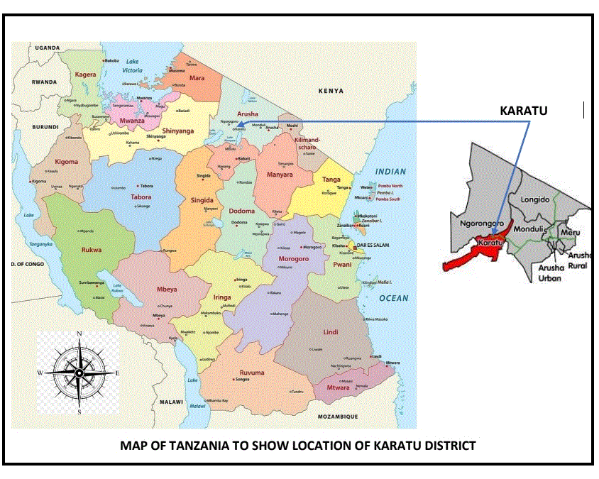
Figure 3. 1: Map of Tanzania to Show Location of Karatu District
Source: Field Data (2024)

3.2 Research Design
This study employed a cross-sectional research design, in which Thomas (2020) also stipulates this type of research design to be known as survey design. In description, in this type of research design information are gathered at once, this is how was done in this study. This kind of research design was employed because it always saves time and fund during data collection.

3.3 Study Population
Population is described as the complete set of individuals, moreover that group is always with a common characteristics (Murry et al., 2022). The target population for this study included community members who are residing in Karatu town in particular in two wards of Karatu and Ganako. Others are government officers such as; District Health Officers, District Health Management Officers, Ward Executive Officers and Street leaders. According to the National Household Population Census, the population of the Karatu district is 280,454 (NBS, 2023).

3.4 Sample Size
The sample size in this study was obtained by using the Yamane’s formula of 1967 for calculating sample size as adopted from Adam (2020) who describes about sample size determination in survey research. Therefore, in order to reach the applicable sample size, the following calculation had been done.

Yamane’s formula n =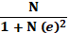

Whereas: n = Sample size

N = Population

e = Probability of error (0.05), assuming 95% confidence level, and with a precision of 1%.
Therefore:
=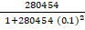
= 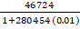
=
=
n = 100
Thus, a sample size involved a total of 100 people in two wards of Karatu and Ganako. The description of the involved population is provided in Table 3.1.

Table 3. 1: Distribution of the Study Sample
Category | Sample
Community members | 90
District Health Officers | 1
District Health Management Officers | 1
Ward Executive Officers | 2
Street leaders | 6
Total | 100
Source: Field Data (2024)

3.5 Sampling Strategies
In this study both probability and non-probability sampling techniques were employed to obtain participants to get involved in the study. For probability sampling, a systematic sampling technique was employed to obtain households to be involved in the study. When a researcher reaches a study area in particular in a street, the arrangement of households in the street was considered. A researcher observed how the households are arranged, then the picked household was always the ninths (9th) from the first household which was near to the researcher, this was done after spiraling the bottle for getting the direction to start with. Then the process was repeated until the required number is obtained. The main reason for applying systematic sampling technique is to avoid biasness in obtaining households to involve the sample size. As McCombes (2021) stipulates that systematic sampling is similar to simple random sampling, however in systematic sampling technique, every member in population is listed in numbers, then respondents are selected by interval to avoid biasness. Apart from probability sampling technique, a researcher employed a non-probability sampling particularly purposively sampling technique to select government officials to involve in the study. Here, a respondent was selected according to his/her position, accessibility and availability. The justification of using purposive sampling was to gather information based on different opinions, attitudes, and suggestions from people with detailed information.

3.6 Scope of the Study
This study was focused on CP in MSWM in Karatu town. The community members were selected because they are the key deliveries for municipal solid waste management.

3.7 Variables and Measurement Procedures
In this study, all three independent variables (community participation in planning, community practices in implementation, and effect of community participation in MSWM) and one dependent variable (MSWM) were measured by using the Likert Scale. The used Likert Scale consisted of five options (strongly disagree, disagree, neither agree nor disagree, agree, and strongly agree). The reason of applying a Likert Scale was to obtain opinions, attitudes, or behaviors of community members which allow the study to easily conceptualize personality traits concerning the topic under study.

3.8 Data Collection Methods

3.8.1 Questionnaire
In this study, questionnaire was involved to collect information from 90 community members in Karatu Town. Satya (2022) describes questionnaires as a tool comprising series of questions for gathering information from a target individual. In this study, the employed questionnaire was designed with only close-ended questions. The justification of doing so was to emphasize only for specific answers. In addition, the designed questionnaire was administered to respondents by a researcher, the reason behind it was to allow a researcher to do clarification of questions whenever is needed to do so.

3.8.2 Semi-Structured Interview
This study employed semi-structured interview as a data collection instrument. It is purposely intended for government officials who work in Karatu town. Specifically, this interview was done with 10 key informants (government officials). Only open-ended questions were designed to gather data on CP in MSWM. The logic of using semi-structured interviews was because it is an operational data collection method when investigators want to collect the information. In addition, being considerate provides an opportunity to avoid pressure and inconvenience for respondents or to miss useful data (Kallio et al., 2016). Furthermore, the semi-structured interview was selected to be applied in this study because it allows flexibility of asking questions during in-depth interviews. The interview was done in between 45-90 minutes

3.9 Data Analysis Methods

3.9.1 Reliability
Surucu and Maslakci (2020) stipulate that reliability refers to an action of determining consistency of collected information. The cronbach’s Alpha (α ) was used in the current study to understand constancy of information. Moreover, reliability is measured in a range of 0 to 1, whereas 1 is the highest score, meaning perfect consistency. Henceforth, the score of higher that 0.7 indicates reliable compared to less than 0.7. In fact, α ≥ 0.7 is acceptable (Babbie 2010).

3.9.2 Validity
The study employed a Kaiser-Meyer-Olkin test to understand the suitability of data analysis. This test is to determine if the data collected is suitable for analysis. Furthermore, the KMO is measured at a score of 0.5 and above which shows the data concerned data are adequate for analysis.

3.9.4 Descriptive Statistics
The current study considered descriptive statistics specifically frequencies and percentages. Furthermore, data presentation involved tables and graphs which show frequencies and percentages.
3.9.5 Multiple Linear Regressions
In the current study, a multiple linear regression was used to find the relationship between independent variables (CP in planning, community practices, and effect of CP) and dependent variable (municipal solid waste management).
Whereas:
Y = Dependent variable (Municipal solid waste management).
X_{s} = Independent variables (Community participation in MSWM)
B₀ = Regression constant
B₁ = the partial slope for X₁ on YƐ_i
X₁ = Community participation in planning for MSWM.
X₂ = Community practices in MSWM.
X₃ = Effects of community participation in MSWM.
Ɛ_{i}= Random error term

3.9.6 Qualitative Analysis
For qualitative data analysis, content analysis was employed. In reflective to this content analysis, the researcher created codes, sub-codes, then themes. Additionally, four steps were employed during analysis. First, the collected information was broken down into individual meaning units. Second, information with the same meanings was put into the same category. Third, in the developed categories, similar characteristics were identified and used to create themes. Fourth, in the emerged themes ‘quotes’ were developed and used to generate findings of the study.

3.10 Data Cleaning Process
Quality data checks were an on-going process started at the data gathering stage, data entry and analysis. In data gathering stage, the questionnaire was translated to Kiswahili to enable most of the targeted respondents to understand the questions through their vernacular language. At the data entry and analysis stage, the researcher ensured that the collected data were entered into respective rows and columns. Thereafter, the total number of columns in spreadsheet was quickly matched to the total number of questions in a questionnaire. Furthermore, the Statistical Package for the Social Sciences (SPSS) program was used for analysis.

3.11 Ethical Consideration
For ethical consideration, the researcher submitted a proposal in The Open University for reviewing before going to the field. Then, the university provided a clearance letter and data collection permit letter to the researcher. Thereafter, they used the provided letters to look for permission for collecting information. This permission was sought from Karatu District Council. Additionally, during data collection, participants were given a consent form to declare their willingness to provide information.

3.12 Chapter Summary
This chapter has included research strategies, research philosophy, study population, and sample size. Moreover, the chapter also covers sampling strategies, scope of the study, variables and measurement procedures. Further, the section has included data collection methods, data analysis, and data cleaning. In addition, the chapter also covers reliability, validity, ethical consideration, and limitations.

CHAPTER FOUR

RESULTSAND DISCUSSION

4.1 Introduction
The main objective of this study was to assess CP in MSWM to complement local government’s resources in managing wastes in Karatu town. The specific objectives of the study were: first, to find out the extent of CP in planning and decision making; second, and lastly, to examine community practice in MSWM practice programmes implementation; and to evaluate the effect of community participation CP in municipal solid waste management MSWM.
Therefore, this chapter gives details based on the obtained results in respective specific objectives and research questions. In this case, the chapter comprises of four sections: the first section indicates the findings of 100 participants of this study based on their socio-economic characteristics. The second section highlights the results achieved of the first objective on community participation CP in planning and decision making. In addition, the third section describes results of the second objective based on community practice in MSWM programmes implementation. Then, the fourth section presents results and discussion of the third objective on effect of CP in MSWM.

4.2 Socio-demographic Characteristics
The study comprised a total of 100 respondents during data collection in description of 90 community members and 10 key informants. The findings concerning socio-demographic characteristics involved both community members and key informants. This section presents findings of socio-demographic characteristics based on a total of 100 respondents. Besides, it is also important to note that the socio-demographic characteristics in this study involve: age, gender, educational level, and marital status.

4.2.1 Age of Respondents
The findings in Table 4.1 indicate that 37(37.0%) of respondents had 46 and above years, followed by 25 (25.0%) ranged from 36-45 years old, 24 (24.0%) from 26-35 years old and 14 (14.0%) 46 and above years old, and 14 (14.0%) ranged from 18-25 years old. These findings implied that municipal solid waste management in Karatu town involved people of all age groups.

Table 4. 1: Age Distribution of Respondents
Age Group | Frequency | Percent
18-25 | 14 | 14.0
26-35 years | 24 | 24.0
36-45 years | 25 | 25.0
46 and above years | 37 | 37.0
Total | 100 | 100.0
Source: Field survey (2024)

4.2.2 Sex/Gender of Respondents
The findings show that 51 (51.0%) of respondents were males, whereas 49 (49.0%) were females. Moreover, the findings revealed that at least both genders were involved in MSWM in Karatu district.

Table 4. 2: Gender/Sex Description Results
Gender/Sex | Frequency | Percent
Male | 51 | 51.0
Female | 49 | 49.0
Total | 100 | 100.0
Source: Field survey, (2024)

4.2.3 Level of Education of Respondents
Table 4.3 illustrates that 31 (31.0%) of respondents had primary educational level, 27 (27.0%) degree level, 22 (22.0%) had attended to secondary level, 12 (12.0%) certificate, and 8 (8.0%) diploma.
These results implied that people in Karatu district participated in municipal solid waste management regardless of their education levels.

Table 4. 3: Level of Education Description Results
Level of education | Frequency | Percent
Primary | 31 | 31.0
Secondary | 22 | 22.0
Certificate | 12 | 12.0
Diploma | 8 | 8.0
Degree | 27 | 27.0
Total | 100 | 100.0
Source: Field survey, (2024)

4.2.4 Marital Status of Respondents
Marital status indicates that 55 (55.0%) of respondents were married, 41 (41.0) single, and 4 (4.0) separated. (Table 4.4).
It shows that the sample constituted households with more married adults expected to be responsible in MSWM participation. Besides, the sample shows residents of different education levels. It implies that the study community is educated enough ranging from elementary to tertiary levels, therefore, it is supposed to know the importance of cleaning the environment if it is adequately mobilized and involved by the local government in MSWM planning and decision making process.
Table 4. 4: Marital Status
Marital status | Frequency | Percent
Single | 41 | 41.0
Married | 55 | 55.0
Separated | 4 | 4.0
Total | 100 | 100.0
Source: Field survey, (2024)

4.3 Description Statistics on CP in Planning and Decision-making in MSWM

4.3.1 Participation in Problem Identification
Community participation in identification of the problem is presented in Table 4.5. It indicates that, more than three-quarter 70(77.8%) of community members who were interviewed in this study strongly agreed that they participated in identification of the problem, 9(10.0%) neither agreed nor disagreed, 6(6.7%) agreed, 3(3.3%) disagreed, and 2(2.2%) strongly disagreed. It implied that, most of the respondents participated in identification of MSWM problems partly explained due to their primary and above literacy levels. Furthermore, the findings were in line with the findings obtained by Luyimbazi, (2015)that government authorities involved community people in identification of problems concerning solid waste management in Uganda.
Table 4. 5: Participation in Identification of the Problem Description Results
Identification of problem |  | Frequency (n=90) | Percent (100%)
We participate in identification of the problem
 | Strongly disagree | 2 | 2.2
 | Disagree | 3 | 3.3
 | Neither agree nor disagree | 9 | 10.0
 | Agree | 6 | 6.7
 | Strongly agree | 70 | 77.8

Source: Field survey, (2024)

Furthermore, responses from key informants who were mainly government officials; they confirmed that, community partly participated in identification of the problem through their selected councilors who represented them in local council meetings to discuss various social economic problems including MSWM issues. Moreover, community discussed and identified the problems during meetings in Mtaa. The decisions reached were submitted upward to the council via ward executive officer, street committee; and respective counsellors. One of the respondents reported that:
“You know, although it is difficult to gather all people in problem identification but we use the findings obtained from their street meetings to determine the existed problems concerning MSWM, of course it is correct to say that the community participates in identification of problems concerning their environment” (Participant No. 6).

These results implied that in Karatu Town, the community was given a right to participate in problem identification concerning different community issues including the issue of MSWM. The results also revealed that, community participation in problem identification was practiced through Mtaa meetings. Furthermore, these results concurred with the results obtained by Kiiza (2009) that Mtaa meetings make it easy for the community to find a suitable MSWM plan by involving community to identify problems.

4.3.2 Participation in Finding Solutions
Figure 4.1 presents statistics on respondents’ participation in finding solutions in various aspects of MSWM. It shows that, over 50(55.6%) of community members strongly agreed that they were involved in finding solutions for municipal solid waste management as compared to 20 (22.2%) agreed, 14(15.6%) disagreed, 4(4.4%) neither agreed nor disagreed, and 2(2.2%) strongly disagreed respectively. These results confirmed that, on average, community members were involved in one way or the other in finding solutions related to MSWM.

Figure 4. 1: Participating in Finding Solutions Description Results
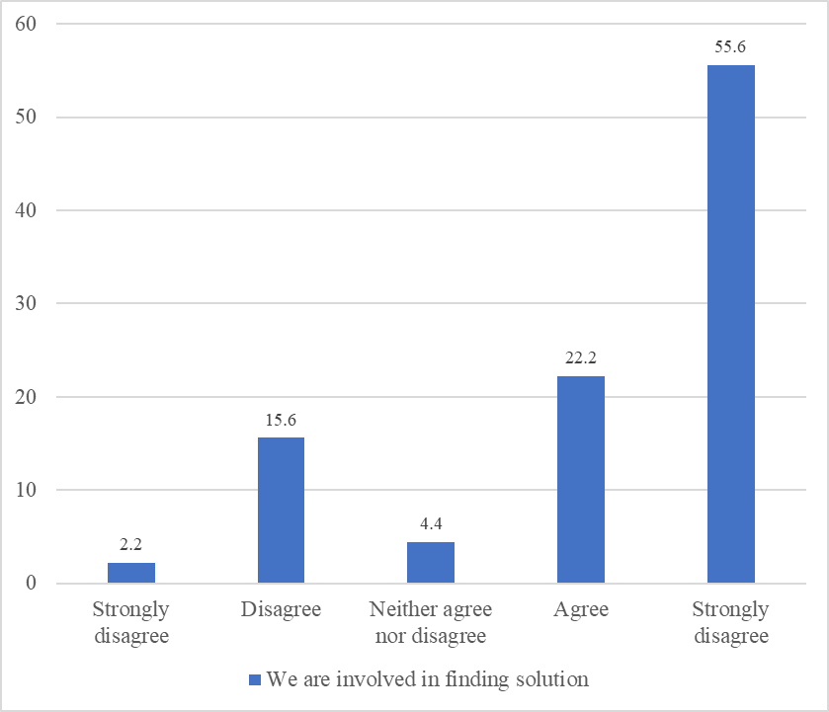
Source: Field survey, (2024)

These results tallied with the responses of some selected councilors who said community participatory approach often was employed in discussing MSWM problems and finding solutions to them. Alternatively, counsellors directly discussed such community issues related to MSWM during council meeting sessions. The other one was when individual counsellors visited and convened Mtaa meetings with community members in their respective constituencies. Furthermore, some community members could convene in their day today activities and hold meetings intended to solve a certain developmental issue including assembling to solid wastes in primary collection points to facilitate secondary municipal solid waste collectors to transfer the waste-to-waste disposal dumps.

4.3.3 Participating in Sensitization
Out of 90 respondents of this study, 53(58.9%) strongly disagreed on their involvement in sensitization of local community members to be aware with purchase and installation of garbage containers for municipal solid waste management, 12(13.3%) disagreed, 11(12.2%) strongly agreed, 8(8.9%) agreed, and 6(6.7%) neither agreed nor disagreed (Table 4.6). It indicated that a substantial proportion of local community members were not involved in sensitization programmes. However, one of the key informants (government officials) stated that, there were already designed programmes of sensitization for solid waste management drawn through community involvement in Karatu Town in place. As it was supported by one respondent who clashed that:
“We always sensitize residents of Karatu Town and give them education on the importance of managing their municipal waste in proper and sustainable manner” (Participant No. 8)
This controversial response the researcher to seek further information on this matter. Further probing of FGD on the negative response of the majority community members’ participation in sensitization programmes as revealed in Table 4.6. FGD’s views were that, government officials did not sensitize and build enough awareness on involvement of the community in preparing participatory sensitization programme on MSWM leading to some of community members decline to participate in that programme.

Table 4. 6: Participation in Sensitization of awareness in MSWM
Community participation in sensitization and awareness |  | Frequency (n=90) | Percent (100%)
We, as a community, are involved in sensitization of being aware for MSWM
 | Strongly disagree | 53 | 58.9
 | Disagree | 12 | 13.3
 | Neither agree nor disagree | 6 | 6.7
 | Agree | 8 | 8.9
 | Strongly agree | 11 | 12.2
Source: Field survey, (2024)

As a result, several community members did not attend sensitization seminars, training/workshops and awareness creation issues which were sometimes provided freely by Non-Governmental Organizations in cooperation with the local government authorities. The other reason is that some people simply ignored such training by pretending to be too busy with their individual affairs. Furthermore, these results matched with the results obtained by Ussi, (2021)that community members did not adequately attending in street meetings for MSWM due to the perception that it is largely a responsibility of local government authorizes. In consideration of the results presented in Table 46 and FGDs views; this study established, the lack of local authorities’ involvement of local communities in MSWM sensitization programmes largely contributed to several community members neglecting effective implementation of MSWM resulting in a dirty urban environment as observed by the study.

4.3.4 Participation in giving Opinions on MSWM
Table 4.7 shows that, out of 90 respondents 47(52.2%) of them strongly disagreed that they are always given a chance to give their opinions, 24(26.7%) disagreed, 10(11.1%) agreed, 5(5.6%) strongly agreed, and 4(4.4%) neither agreed nor disagreed.

Table 4. 7: Participation in Giving Opinions Description Results
Opinions |  | Frequency (n=90) | Percent (100%)
We are always given a chance to give our opinion
 | Strongly disagree | 47 | 52.2
 | Disagree | 24 | 26.7
 | Neither agree nor disagree | 4 | 4.4
 | Agree | 10 | 11.1
 | Strongly agree | 5 | 5.6
Source: Field survey, (2024)

The study wanted to establish reasons for community members who either disagreed or strongly disagreed to have been given a chance to air their opinions. On the government officials side they admittedly said that, it was difficult for them to collect opinions from each community member without giving the reason. Further, they relied on opinions given by counsellors, and local government leaders at street and ward levels. At this juncture, the study established a communication gap between the top government officials in getting direct opinions and the bottom or grassroots community in getting opinions related to MSWM improvement. The local authority heavily relied on counsellors, and low local government cadres. In this way, they hardly shared with community members’ opinions through the streets meetings as it was thus invalidated the assertion made by one of the government officials that:
“There is a special platform to share their opinions concerning municipal solid waste management; there are street meetings which allow everyone to come up with suggestions and opinions for community issues” (Participant No. 10)
The study probed furthermore on the reason(s) why most of the community members said that they did not participate in in giving their opinions. On the other side, when key informants from within the community was interviewed on this matter; most of them frequently did not attend street meetings due to various social economic reasons. As a result, they did not know decisions reached on MSWM in their respective residential areas as supported by the following series of key informants in response during interview sessions:
“Actually, it is difficult to share your opinions if you don’t attend in street meetings where all matters are discussed there. In fact, most of those who complain that they are not given a chance to share their opinions are those who always do not attend meetings” (Participant No. 1)
Another interviewee argued that:
“The truth is that most of the community members don’t participate in waste management meetings. This caused them not to present their opinions on municipal waste management matters” (Participant No. 4)
The foregoing responses of key informants aggregately implied that, although the government has introduced a practice of street participatory meetings to involve the public participating in finding solutions to their social economic issues including MSWM; it is not yet implemented effectively in Karatu Town. For as evidenced above, the majority of the community members did not attend street meetings for one reason. It indicates that the local officials and community leaders have not yet motivated and mobilized the local community enough to see the importance of participating in MSWM and implementing basic public health ethics and cost sharing in keeping the urban environment aesthetically clean and healthy. Although, Niyirera & Nkurunziza (2023)observed and recommended to local government to introduce community participation in MSWM for improvement; however, this study added knowledge by establishing that; community participation per se without implementing it fully; cannot improve MSWM in Karatu town.

4.3.5 Participating in Discussion
A total of 90 (100%) of local community members were interviewed by the study on matters related to their participation in discussing MSWM with local Government representatives. Table 4.8 indicates that, out of 90 community members 45(50.0%) disagreed they were involved in MSWM discussions; 17(18.9%) strongly agreed, 14(15.6%) strongly disagreed, 10(11.1%) agreed; and 4(4.4%) neither agreed nor disagreed (neutral).

Table 4. 8: Participation of local community in Discussions on MSWM with local Government representatives
Engagement in discussion on MSWM |  | Frequency (n=90) | Percent (100%)
We are sometimes involved in discussions on MSWM
 | Strongly disagree | 14 | 15.6
 | Disagree | 45 | 50.0
 | Neither agree nor disagree | 4 | 4.4
 | Agree | 10 | 11.1
 | Strongly agree | 17 | 18.9
Source: Data Analysis, (2024)

When key informants and street leaders were asked by the study to explain why it was so. To summarize their views, they concertedly said, as in the case of involvement in street meetings seen earlier, several community members have the tendency of absconding the street public meetings more or less for the same reasons advanced as in the previous section. Moreover, a reasonable segment of the community members, according to FGDs and key informants, they still hold the notion that; MSWM is largely a responsibility of local government authorities and not theirs. Furthermore, the findings were in line with the results obtained by Birhanu & Berisa (2015)who found that community participation was a good approach towards solving social economic problems including implementation of MSWM provided that: community members were made aware of importance of the issue at stake and that it result in community welfare; and were fully involved in all aspects of MSWM. In more or less the same vein; Issam, (2017)argued that community participation can be a wide range of activities which include also sharing of views, this means people’s views have direct effect on municipal solid waste management in the community.

4.3.6 Participating in Setting Goals
In a total of 90 community members who participated in this study, 53(58.9%) strongly disagreed that they got chance to participate in setting goals for municipal solid waste management, 12(13.3%) disagreed, 11(12.2%) strongly agreed, 8(8.9%) agreed, and 6(6.7%) neither agreed nor disagreed. (Figure 4.3). These results reveal that communities in Karatu Town were involved in social development activities especially on setting the goals for good practice of municipal solid waste management. Here, the implication was that people got a chance to come with the good ideas of how they wanted to reach concerning the issue of MSWM within their area. Moreover, it is also argued by other scholars in their conducted studies that achievement of tangibles goals on municipal solid waste management depends much on the level of CP during setting those goals (Kalwani, 2009).

Figure 4. 2: Participating in Setting the Goals Description Results (n=90)
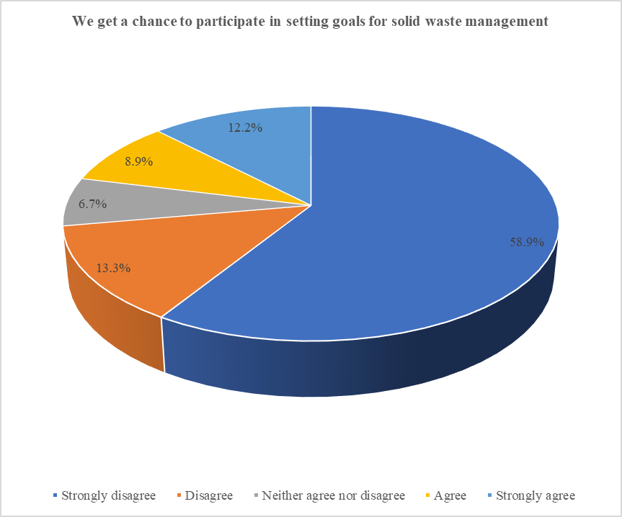Source: Data Analysis, (2024)

4.3.7 Participating in Decision-making
Out of 90 community members who participated in this study, more than half 48(53.3%) of them strongly disagreed that the community members are always given rights to participate in decision making for municipal solid waste management, 14(15.6%) disagreed, 14(15.6%) agreed, 10(11.1%) strongly agreed, and 4(4.4%) neither agreed nor disagreed. (Table 4.9). These results implied that people in Karatu Town were not fully involved in municipal solid waste management, as they were not involved in decision making this could affect the whole process of municipal solid waste management in the area. In addition, these results differed from principles of public participation which hold that, “those who are affected by the decision have the right to be involved in the decision making process” (Maganga, 2022). This means, public participation suggests that decisions are influenced by the public contribution. In that case, participation seeks to facilitate the engagement of the public in making decisions for improving public service provision including municipal solid waste management.

Table 4. 9: Given Rights to Participate Description Results
Community participate in decision making |  | Frequency (n=90) | Percent (100%)
The community is always given rights to participate in decision making for MSWM
 | Strongly disagree | 48 | 53.3
 | Disagree | 14 | 15.6
 | Neither agree nor disagree | 4 | 4.4
 | Agree | 14 | 15.6
 | Strongly agree | 10 | 11.1
Source: Data Analysis, (2024)

4.4 Description Statistics of Community Practice in MSWM Programmes
Descriptive statistics (frequency and percentage) were computed for the community practice in MSWM. This was the second objective of this study; the obtained findings are illustrated in Table 4.10.

4.4.1 Practicing Mobilization
In a total of 90 community members who participated in this study, 35(38.3%) agreed that they always mobilize themselves for municipal solid waste management, followed by 18(20.0%) who disagreed, 14(15.6%) strongly disagreed, 12(13.3%) neither agreed nor disagreed, and 11(12.2%) strongly agreed. In the interview, the interviewees in particular the Mtaa leaders explained that the work of mobilizing community is left to the local leaders in the streets. The council has a task of encouraging these local leaders to mobilize community participation in MSWM, especially by attending meetings and participating equally through sharing and exchanging ideas. In this case, local leaders in Karatu Town in the two wards of Karatu and Ganako which were involved in this study make efforts to organize people in groups, especially every Saturday to collect municipal solid wastes from their environment. The results implied that municipal solid waste management in Karatu town depends on how the community is involved in mobilizing themselves for different activities based on municipal solid waste management. Besides, these results concurred with that of Kalwani (2009) that, municipality’s organization and community mobilization have a positive influence on municipal solid waste management. However, it needs some efforts and time to emphasize mobilization of community members in their areas for social issues(Niyirera & Nkurunziza, 2023).

4.4.2 Practicing Information Dissemination
Table 4.10 also indicates that among 90 community members who participated in this study 35(38.9%) agreed that they disseminated information to the whole community on how to practice municipal solid waste management, 19(21.1%) strongly agreed, 14(15.6%) disagreed, 11(12.2%) strongly disagreed, and 11(12.2%) neither agreed nor disagreed. In interviews with key informants, the interviewees specifically the ward executive officers explained that although some community members got information about municipal waste management, most of them are still lacking that kind of information because they don’t participate in meetings where the dissemination of information is always done to the whole community.
“We, local government authorities talk about MSWM in meetings, that is the right platform to disseminate information to the whole community, unfortunately most of community members never attend to the meetings, this affects the process of disseminating information” (Participant No. 8)
It was also added that, due to poor attendance in street meetings which discuss MSWM, most community members do not have adequate knowledge about solid waste practices. They were only aware of the need to dispose of waste by dumping to the collection centers; they were not knowledgeable about reuse or recycling of waste. Furthermore, these results revealed that although the community could effectively get knowledge about municipal solid waste management in meetings, this has been cumbersome to implement because of the poor attendance of community members when are needed to attend in street meetings. Moreover, these results matched to the results obtained by Mohamed (2011) that there was a direct effects of poor of knowledge of community member and uncontrolled solid wastes within their areas.

4.4.3 Contributing on Transporting Solid Wastes
The findings in Table 4.10 indicate that exactly half 45(50.0%) of community members who participated in this study agreed that they contribute on transporting municipal solid wastes to select waste management areas, 21(23.3%) disagreed, 9(10.0%) strongly disagreed, 9(10.0%) strongly agreed, and 6(6.7%) neither agreed nor disagreed. In the interview with the key informants especially the street leaders, it was described that the Karatu Town has designed a programme of door-to-door municipal solid waste collection whereas community members are to contribute on that programme through paying one thousand Tanzania shillings (1000/= TZS) per month. Moreover, the interviewees who participated in this study continued to state that the collected money is used for paying municipal solid waste collectors and transporting solid waste to Bashai where dumping is done.
“It is correct that community members contribute on transporting solid waste to dump site, this is because they pay 1000/= TZS that is used to pay waste collectors who are responsible to transport solid waste to dumping site” (Participant No. 6).
Here, the implication of the results was that in Karatu Town there is a designed programme to enable community members to contribute for municipal solid waste transportation from households to dumping sites. However, the obtained results were different from the results obtained by Ussi, (2021)that in Zanzibar solid wastes are collected and transferred to the dumpsite by the municipal authority.
Table 4. 10 : Practice in MSWM Programmes
Variable |  | Frequency (n=90) | Percent (100%)
Mobilization for MSWM
 | Strongly disagree | 14 | 15.6
 | Disagree | 18 | 20.0
 | Neither agree nor disagree | 12 | 13.3
 | Agree | 35 | 38.9
 | Strongly agree | 11 | 12.2
Inform action dissemination information on how to practice MSWM
 | Strongly disagree | 11 | 12.2
 | Disagree | 14 | 15.6
 | Neither agree nor disagree | 11 | 12.2
 | Agree | 35 | 38.9
 | Strongly agree | 19 | 21.1
Contributing on transporting solid wastes to selected waste management areas
 | Strongly disagree | 9 | 10.0
 | Disagree | 21 | 23.3
 | Neither agree nor disagree | 6 | 6.7
 | Agree | 45 | 50.0
 | Strongly agree | 9 | 10.0
Covering containers that are used to collecting solid wastes
 | Strongly disagree | 9 | 10.0
 | Disagree | 7 | 7.8
 | Neither agree nor disagree | 9 | 10.0
 | Agree | 19 | 21.2
 | Strongly agree | 46 | 51.1
Existence a good collection system to dumpsite
 | Strongly disagree | 9 | 10.0
 | Disagree | 59 | 65.6
 | Neither agree nor disagree | 4 | 4.4
 | Agree | 9 | 10.0
 | Strongly agree | 9 | 10.0

Source: Field survey (2024)

4.4.4 Putting Cover to Containers
Out of 90 community members who participated in this study, 46(51.1%) strongly agreed that they have put cover to all containers that are used for collecting solid waste, 19(21.2%) agreed, 9(10.0%) strongly disagreed, 9(10.0%0 neither agreed nor disagreed, and 7(7.8%) disagreed. (Table 4.10).
In the interview with the key informants, it was confirmed that the community members are encouraged in meetings to use containers with covers in particular buckets to put municipal solid wastes before collecting to dump site.
“Most of community members always put covers into their containers which are used for keeping the domestic solid wastes. They use buckets with cover and put them outside their households to enhance the process of collecting to the dump site” (Participant No. 2)
Furthermore, other interviewees who were the key informants in this study argued about the reason for putting cover into the containers which were used for keeping domestic wastes produced in households. The interviewees with this view stated that containers should be covered to prevent the entry of rain waste into wastes.
“As you know, rain will accelerate the rate of decomposition leading obnoxious odor. It will also increase the weight of solid waste stored within the container. That’s why we encourage community members to use covered containers” (Participant No.9)
Although the findings from questionnaire and key informant interviews indicated that people in Karatu town used covered containers to collect domestic solid waste from the households, this study observed the different. It observed that, most of the households used bags which contains solid wastes outside their households, besides other wastes were observed to spread around the households’ areas. When the study enquired on the causes for this, the key informants in particular the mtaa leaders said that, the situation of using bags was accepted due to prevailing insecure environment thieves stole dust bins/containers with cover such as plastic buckets for sale. It caused some isolated households in Karatu Town to have few highly protected MSWM covered containers under household confinement.
Furthermore, these findings concurred with the findings obtained by Mughal (2014)in Northern Towns of Namibia that metal and plastic containers cannot be consider as the suitable waste containers in a long run, as for example metal containers get rusty and animals can easily spread waste out of them. Henceforth, both metal containers and plastic containers attract thieves, for example metal containers attract thieves for scrap metal selling.

4.5 Description Statistics of the Effect of Community Participation in MSWM
The descriptive statistics (frequency and percentage) were computed for the effect of CP in MSWM. The results are illustrated in Figure 4.4.
Figure 4. 3: Effects of Community Participation in MSWM Description Results (n=90)
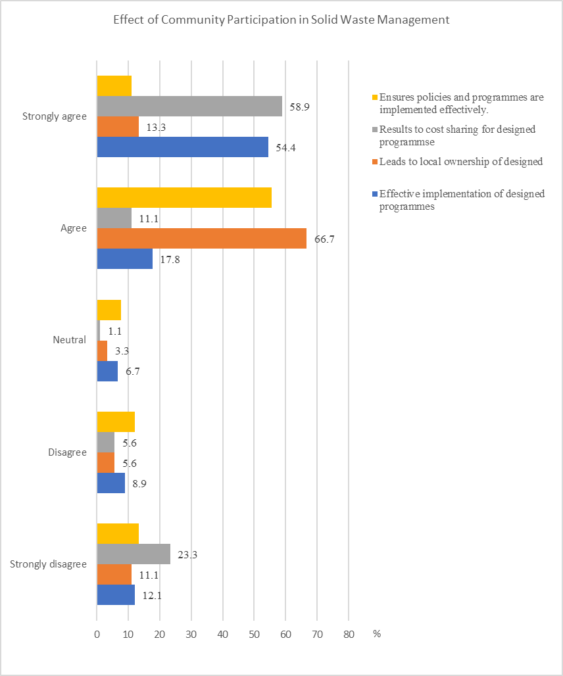
Source: Field survey (2024)

4.5.1 Effective Implementation of Designed Programmes
Figure 4.4 indicates that amongst 90 community members who participate in this study, more than half 49(54.4%) strongly agreed that CP in municipal solid waste management leads to effective implementation of designed programmes, 16(17.8%) agreed, 11(12.2%) strongly disagreed, 8(8.9%) disagreed, and 6(6.7%) neither agreed nor disagreed.
In the interview with the government officials it was reported that community participation in Karatu Town has resulted in effective implementation of programme of collecting municipal solid wastes. The community members, through meetings got the opportunity to participate in identifying the problem, determining potential hazards, and identifying methods for municipal solid wastes management in their environment. For example, it is through the meeting, community members came up with door to door programme as a means of MSWM. Moreover, because the programme was initiated by the community members, they also made their own efforts to implement the programme, they collected wastes produced in the households and put them in the covered containers to facilitate the process of collecting them to dump site.
“Of course, the participation of community in designing this programme of door-to-door municipal solid waste collection leads to positive impact towards implementation of that programme. There has been effective municipal solid waste collection through door to door because when the community members prepare solid wastes in containers and put them outside their households this makes collection crew to move quickly from one collection to another” (Participant No. 10)
The obtained findings implied that community participation through door-to-door municipal waste collection results to effective MSWM in areas. The findings were supported by Mbwilo & Mahenge (2022) who found that although door-to-door municipal solid waste collection was limited, and it is only applied to families that were reachable, this system is very useful in formal settlements, and is expedited by a high degree of community participation and awareness. Kirunda, (2009) also argues door-to-door solid waste collection methods support waste sorting and recycling.

4.5.2 Local Ownership of Designed Programmes
The findings in Figure 4.4 show that, out of 90 community members who participated in this study, 60(66.7%) agreed that CP in municipal solid waste management led to local ownership of designed projects, 12(13.3%) strongly agreed, 10(11.1%) strongly disagreed, 5(5.6%) disagreed, and 3(3.3%) neither agreed nor disagreed.
It was also reported in the interview by key informants that the strategy of involving community members in all programmes concerning municipal solid wastes management enhanced the sense of ownership among the community members. The community members felt motivated to participate in the programme that was initiated in their meetings; in this case they considered that whenever a programme failed it implied a failure of the community who designed it: In asserting this one key informant asserted that:
“We involve community members in municipal solid waste management to increase local ownership towards the designed programme, this enhances a sense of responsibility in facilitating service provision” (Participant No. 3)
These findings implied that implementation of the MSWM programmes which are designed by communities depends on how the community feel the sense of ownership of the designed programmes. Also, Ebekozien et al., (2022)argues that, active household engagement in waste management systems can benefit more sustainable waste management practices that society and other stakeholders can identify with increased sense of ownership. In addition, involving community in solid waste management approaches always motivates a sense of ownership of active participation across different segments of society.

4.5.3 Cost Sharing for Designed Programmes
Figure 4.4 illustrates that in a total of 90 community members who participated in this study, 53(58.9%) strongly agreed that CP in municipal solid waste management has resulted to cost sharing for designed programmes, 21(23.3%) strongly disagreed, 10(11.1%) agreed, 5(5.6%) disagreed, and 1(1.1%) neither agreed nor disagreed.
In the interview with the key informants in particular the district health officers, it was reported that CP in MSWM has been used in Karatu town to enhance understanding and agreement to cost sharing. The interviewees continued to state that CP in MSWM was applied in Karatu Town to stimulate cooperation and agreement between community members and waste collectors.
“Community participation in Karatu Town has been applied as a means to enhance both financial and physical contribution among community members” (Participant No. 5)
The findings implied that in Karatu Town people participated in MSWM through both in-kind and financial contribution. These results were different from the findings obtained by Kalwani (2009) in the study which was conducted in Morogoro municipal, the author found the key informants reported that, it was not an easy task to approach people with an idea of sharing cost in MSWM. However, it is important to note that, provision of MSWM in any town or large city is an expensive undertaking that makes huge demands on the finances of local government. In fact, money is required for the day to day operational cost of the service in the procurement of fuel and paying the waste collectors(Boateng et al., 2016).

4.5.4 Effective Implementation of Policies and Programmes
Figure 4.4 shows that, among 90 community members who participated in this study, 50(55.6%) agreed that CP in municipal solid waste management ensured policies and programmes were implemented effectively, 12(13.3%) strongly disagreed, 11(12.2%) agreed, 10(11.1%) strongly agreed, and 7(7.8%) neither agreed nor disagreed. It can be inferred that, over average the community members said that CP in MSWM prevailed and the respective policies and programmes were implemented accordingly. Further, when Key informants were interviewed on this matter, one of them agreed that community members participated in municipal solid wastes management thereby facilitated the implementation of the National Environmental Policy (NEP) of 1997pursuant one of the policy clauses which stated that “environmental management must be everybody’s responsibility”. Since local community members in Karatu urban are equally civilians of the nation; also should comply with the stipulated National Environmental Policy statement.

4.6 Inferential Analysis

4.6.1 Reliability Results
In this study, three determinants were considered: community participation in planning, community practices in MSWM, and effects of community participation in MSWM. The results showed that the first test of community participation in planning had a relatively highest consistency of 0.842, community practices in MSWM 0.764, and effects of community participation in MSWM 0.788. Here the implication was that the coefficient alpha in all variables was consistency and acceptable (Table 4.11).

Table 4. 11: Reliability Test of the Study Variables
Variable | Cronbach's Alpha in item
Community participation in planning | 0.842
Community practices in MSWM | 0.764
Effects of community participation in MSWM | 0.788
Source: Data Analysis, (2024).

4.6.2 Validity Results
The results in Table 4.12 for a Kaiser-Meyer-Olkin (KMO) indicate that community participation in planning 0.679 which was higher than 0.5, thus it is considered as excellent result that it exceeds 0.5. The second test based on community practices in MSWM shows a score of 0.756 which is appropriate for going on with analysis. Besides, the effects of CP in MSWM showed 0.785, this was also acceptable.

Table 4. 12: KMO Test
Variable | KMO
Community participation in planning | 0.679
Community practices in SWM | 0.759
Effects of community participation in SWM | 0.785
Source: Data Analysis, (2024).

4.6.3 Assumption of Multiple Linear Regression Model

4.6.3.1 Linearity
Before regressing for relationship of variables, the study determined linearity of the model. The scatter plots were used to show linearity of the model, while y-axis was for dependent variables, x-axis was independent variables. Based on the scatter plot in Figure 4.5, data was distributed in the form of a linear trend line. Additionally, this trend is shown to take part from the bottom to the top. This means the model proves linearity of variables.

Figure 4. 4: Linearity Test Enlarge this figure it is minute.
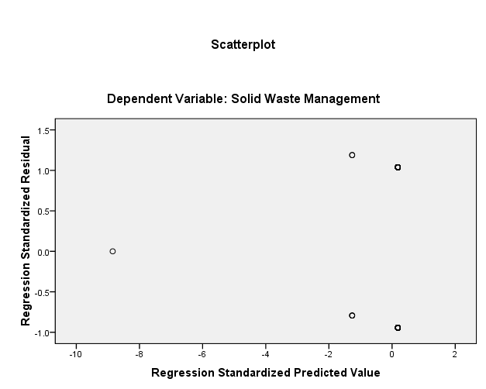
Source: Data Analysis (2024)

4.6.3.2 Absence of Multicollinearity
Multicollinerity happens when independent variables do not show the characteristics of independent variables from each other.
In the current study, multicollinearity was determined through Variance Inflation Factor (VIF) and the level of Tolerance. Moreover, the value of score for tolerance was given a range of 0 to 1. However, for VIF, a formula was considered, the applied formula indicates that VIF is VIF=1/(1-R²). Multicollinearity is possible in the model when R>= +-0.9; Where R squared is the coefficient of determination.
Based on the coefficient output in Table 4.13, VIF indicates a score that ranges from 1.072-1.214, this means the obtained scores are in between 1 to 10. Hence, no multicollineriaty symptoms observed.

Table 4. 13 : Multicollinearity Test
Model |  | Collinearity Statistics
 |  | Tolerance | VIF
 | Community participation in planning | .826 | 1.210
 | Community practices in MSWM | .823 | 1.214
 | Effects of community participation in MSWM | .933 | 1.072
Source: Data Analysis, (2024).

4.6.3.3 Homoscedasticity of Variances
The plots of standardized scores were used to determine homiscedasticity of variance. The result in Figure 4.6 indicates the plots were randomly arrayed, meaning no funnel shape happened. The observed rectangular shape indicating homoscedasticity (equality of variance). Therefore, there was no any justification to suspect about un-equal variance in collected information (heteroscedasticity)

Figure 4. 5: Homoscedasticity of Variances Test
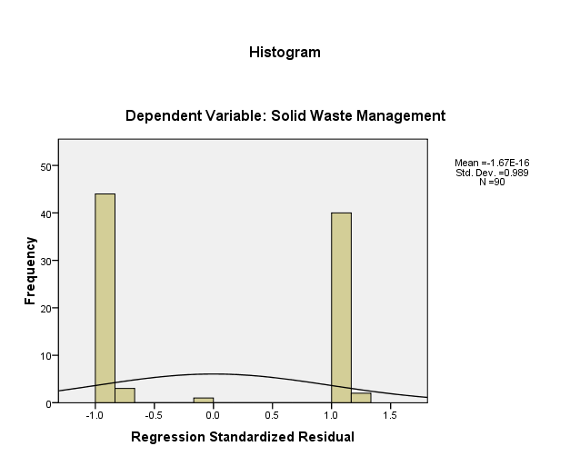

Source: Data Analysis (2024).

4.6.3.4 Residuals are Normally Distributed
The assumption highlights that when the residuals are not normally distributed, the confidence interval becomes unpredictable either will give high results or low results, that affects the model performance. Therefore, in this study normally distributed was observed by using P-P plots to show straight relationship of data. It is important to note that the assumptions become valid if the dots lie very closer to the diagonal line, then the residual will be said to be normally distributed(Figure 4.7).
Figure 4. 6: Normally Distributed
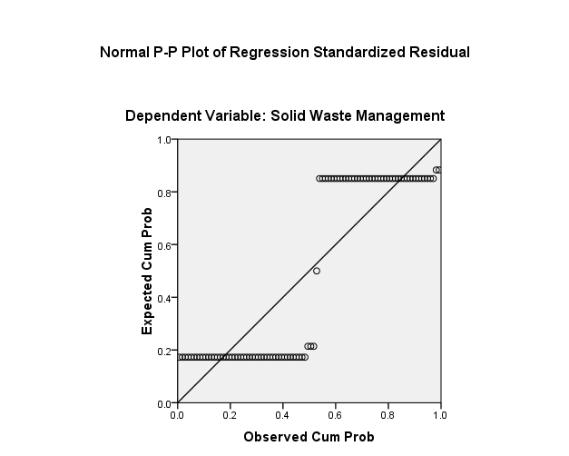

Source: Data Analysis (2024)

4.6.4 Multiple Linear Regression Analysis Results
The study employed a multiple linear regression to regress the independent variables (community participation in planning, community practices in MSWM, and effects of CP in MSWM) and dependent variable (MSWM).

4.6.4.1 Model Summary
The multiple linear regression analysis was applied for the intention of estimating the influence of community participation in planning, community practices in MSWM, and effects of CP in MSWM (Independent variables) on MSWM (dependent variable). Table 4.14 illustrates a summary of the model in which item interest is R² statistics which is 0.533. This encounters that determinant influencing municipal solid waste management accounts for 53.3%.

Table 4. 14: Model Summary
Model | R | R Square | Adjusted R Square | Std. Error of the Estimate
1 | .730ª | .533 | .513 | .52661
a. Predictors: (Constant), CP in planning, C practices in MSWM, Effects of CP in MSWM
b. Dependent Variable: Municipal solid waste management

Source: Data Analysis (2024)

4.6.4.2 ANOVA Results
Table 4.5 illustrates the analysis of variance (ANOVA) findings. It is also known as model fit results. Of interest in this table were the F-statistics and its associated sig. The findings indicated that F-statistics was 5.305 = 0.002, p<0.05. The findings showed that model’s hypothesis that there were influence that affected municipal solid waste management, this means the model had the power to predict municipal solid waste management.

Table 4. 15: ANOVA Results
ANOVAª
Model |  | Sum of Squares | df | Mean Square | F | Sig.
1 | Regression | 3.498 | 3 | 1.166 | 5.305 | .002^{b}
1 | Residual | 18.902 | 86 | .220
1 | Total | 22.400 | 89
a. Dependent Variable: Municipal solid waste management
b. Predictors: (Constant), CP in planning, C practices in MSWM, Effects of CP in MSWM

4.6.4.3 Regression Analysis Coefficient Results
Table 4.16 presents the findings on the coefficients of the regression model. The coefficients results show the influence of such as CP in planning, C practices in MSWM, and effects of CP in MSWM; it positively predicted municipal solid waste management. The influence of CP in planning was found positively, statistically and significantly related to municipal solid waste management (B = .041***, p = .041<0.05). The influence of C practices in MSWM was found to be positive, statistically, and significantly related to municipal solid waste management (B = .503***, p = .000<0.05). Effects of CP in MSWM were found to be positively, statistically and significantly related to municipal solid waste management (b = .098***, p = .030<0.05).
Multicollinearity statistics indicated tolerance figures ranging from 0.823 to 0.933 while Variance Inflation Factors (VIFs) ranged from 1.072 to 1.214. These figures suggested that multicollinearity was not suspected amongst the independent variables.

Table 4. 16: Regression Analysis Coefficient Results
Model |  | Unstandardized Coefficients |  | Standardized Coefficients | T | Sig. | Collinearity Statistics
 |  | B | Std. Error | Beta | T | Sig. | Tolerance | VIF
1 | (Constant) | 1.209 | .469 |  | .000 | .000
1 | CP in planning | .041 | .218 | .021 | .188 | .041 | .826 | 1.210
1 | C practices in MSWM | .503 | .131 | .394 | 3.845 | .000 | .933 | 1.072
1 | Effects of CP in MSWM | .098 | .520 | .021 | .189 | .030 | .823 | 1.214
a. Dependent Variable: Municipal solid waste management

Source: Data Analysis (2024)

CHAPTER FIVE

CONCLUSION AND RECOMMENDATION

5.1 Introduction
The chapter provides summary of the study findings. The chapter also presents conclusions of the study based on objectives. In addition, the chapter also gives details on recommendations based on the obtained findings.

5.2 Summary of the Study Findings
The results indicated involvement of community members in planning and decision making for municipal waste management is very important in Karatu Town. Most of community members agreed that they were involved in identification of the problem concerning MSWM, finding solutions, and disseminating information. However, the findings indicated that there were some components of MSWM programmes in which community members were not effectively involved with, these include: giving opinions, participating in discussion, sensitization programmes, and in setting goals.
The study also found that community practices in municipal solid waste management to some extent was done well in Karatu town. There were other practices that were agreed to be done effectively, these include mobilization, dissemination of information, contribution on transporting wastes to selected waste management areas, and good collection system to the dumpsite. However, the practice of putting cover to containers is not done properly, hence most of the respondents disagreed on this term.
The study found that community members practices in municipal solid waste management programmes through: mobilizing themselves for MSWM, information dissemination, contributing on transporting of solid wastes, and putting cover to all containers that were used for collecting solid wastes.
Besides, the study also found that there were positive effects of community participation in MSWM in Karatu Town. Community participation in MSWM programmes resulted to: effective implementation of designed programmes, enhanced understanding of the designed programmes, resulted to cost sharing for designed programmes, and enhanced policies are implemented effectively.

5.3 Conclusions
The study concludes that although there was CP in MSWM in planning and decision-making in Karatu Town but the community members were involved in only some of the stages of implementing the designed programmes. The community members were only involved in identification of the problem, disseminating information, and finding solutions. However, in other implementation stages of the designed programmes community members were not involved effectively. For example, community members were not involved effectively during sensitization, giving opinions, participating in discussion, and in setting goals. Additionally, it is concluded that community participation in planning and decision-making was needed to influence municipal solid waste management.
The study also concludes that community practices in MSWM programmes played a role in municipal solid waste management in Karatu Town. Most of the community practiced municipal solid waste management through mobilizing themselves, information dissemination, contributing in financial and in-kind, and putting solid waste into covered containers.
Furthermore, the study concludes that municipal solid waste management in Karatu Town was influenced by effects of community participation. Community participation in MSWM programmes led to: effective implementation of designed programmes, enhanced understanding of the designed programmes, resulted to cost sharing for designed programmes, and enhanced policies were implemented effectively.

5.4 Recommendations
Community members should be involved in all stages/procedures of solid waste management programmes, the stages/procedures to involve them should include: the process of designing the programmme, setting the goals, setting objectives, dissemination of information, sensitization, and evaluation. This would enable the community members to be aware with each stage/procedure of solid waste management in their environment.
Because the study have found the significant between community practices and solid waste management, the government officials in Karatu Town should add efforts to educate the community members to practices different methods of MSWM in their environment. Different from door to door waste collection to dumpsite, the community members should be educated to practice other methods depending on the kind of wastes, people should be educated to apply the concept of “reduce, reuse, and recycle” this method helps to reduce burden of disposal cost, and it helps to avoid unnecessary and unhealthy disposal technologies.
The study also recommends that more effective environmental governance is required to reverse the effects of poor waste management planning. This can be done through emphasizing collaboration between community and government to share responsibilities and information.

6.5 Limitations and Areas for Further Studies
This study was done in Arusha region, Karatu District Council in particular in Karatu Town, however, in the country there are more than 26 regions and many district councils. This means, the sample might not be the overall representation of the whole population in the country of Tanzania. Therefore, this study recommends future studies should be done in other regions of Tanzania to obtain actual information for generalization of findings.

REFERENCES
Abdel-Shafya, H., & Mansour, S. (2018). Solid waste issue: Sources, composition, disposal, recycling, and valorization. Egyptian Journal of Petroleum, 27(4), 1275–1290.
Adam, A. (2020). Sample Size Determination in Survey Research. Journal of Scientific Research and Reports, 26(5), 90–97. https://doi.org/DOI:10.9734/JSRR/2020/v26i530263
Allen, T. (2018). Restoring Eden: The Role of Christianity on Environmental Conservation: A Case of Karatu District, Arusha, Tanzania. Portland State University.
APO. (2007). Solid Waste Management: Issues and Challenges in Asian. Asian Productivity Organization.
Atienza, V. (2017). Review of the Waste Management System in the Philippines: Initiative to Promote Waste Segregation and Recycling through Good Governance.
Atlee, T. (2008). Principles of Public Participation. Retrieved from The Co-Intelligence Institute. Retrieved from Https://Www.Co-Intelligence.Org/CIPol_publicparticipation.Html on February 17, 2024.
Babbie, F. (2010). Research Methods. New York: Thornhill Publishers.
Birhanu, Y., & Berisa, G. (2015). Assessment of Solid Waste Management Practices and the Role of Public Participation in Jigjiga Town, Somali Regional State, Ethiopia. International Journal of Environmental Protection and Policy, 3(5), 153–168.
Boateng, S., Amoako, P., Poku, A., Appiah, D., & Garsonu, E. (2016). Household Willingness to Pay for solid Waste Disposal Services in Urban Ghana: The Kumasi Metropolis Situation. Ghana Journal of Geography, 8(2), 1–17.
Chen, D., Bodirsky, B., Krueger, T., Mishra, A., & Popp, A. (2020). The world’s growing municipal solid waste: trends and impacts. Environmental Research Letters, 17(7).
Cheruiyot, S. (2016). Factors Influencing Performance of Community Based Water Projects in Bomet County. Dissertation. Nairobi: University of Nairobi.
Chonge, M. (2016). Assessment of Community Participation in Solid Waste Management in Bagamoyo Town, Tanzania. The Open University of Tanzania.
Claridge, T. (2004). Designing social capital sensitive participation methodologies. Report, Social Capital Research, Brisbane, Australia.
Daniel, C., Polly, W., Turner, C., & Mills, H. (2014). The Participation of Children and Young people in developing social care. 2(1), 22–37.
David, N. (2019). An assessment of community participation in waste management, a case of northern division, Mbale Municipality, Eastern Uganda. Kampala International University.
Demirbas, A. (2011). Waste management, waste resource facilities and waste conversion processes: Energy Conversion & Management, 52(2), 1280–1287.
Ebekozien, A., Aigbavboa, C., Nwaole, A., Aginah, I., & Aigbedion, M. (2022). Sustainable cities through household waste management: an unexplored approach to challenges confronting private solid waste managemen. Facilities, 40(5), 365–379.
Greene, W. . (2010). Econometric Analysis (Fifth Edit). New York University.
Ingabire, J., Alinda, F., & Kiganda, G. (2022). Promotion community participatory appraoch to solid waste management: strategies, challenges and recommendations. International Journal of Management Studies and Social Science Research, 4(4), 135–143.
Issam, A. (2017). Trends and problems of solid waste management in developing countries: A case study in seven Palestinian districts. Waste Management, 27(12), 1910–1919.
Kallio, H., Pietilä, A. M., Johnson, M., & Kangasniemi, M. (2016). Systematic methodological review: developing a framework for a qualitative semi‐structured interview guide. Journal of Advanced Nursing, 72(12), 2954–2965.
Kalwani, J. D. (2009). Community Participation in Municipal Solid Waste Management: A Case study of Morogoro Municipality, Tanzania. PhD Thesis. Published. University of Dar es Salaam.
Karatu District Council. (2023). History. Retrieved from Https://Karatudc.Go.Tz/Historia on February 16, 2024. https://karatudc.go.tz/historia
Kaseva, M., & Mbuligwe, S. (2005). Appraisal of solid waste collection following private sector involvement in Dar es Salaam city, Tanzania. UCLAS Dar es Salaam.
Kiiza, C. (2009). The Challenges of Solid Waste Management: A Case Study of Kawempe and Rubaga Division Kampala District, Uganda.
Kirunda, P. (2009). Public Participation in Solid Waste Management: Challenges and Prospects. A case of Kira Town Council, Uganda. University of Agder.
Kofi, A., Kwame, B., Kwabena, A., Francis, G., Christopher, G., Richard, A., & Asabre, A. (2023). Challenges of Public Participation in Solid Waste Management at Nkanfoa Landfill Site in the Cape Coast Municipality of Ghana. Journal of Sustainable Development, 16(5), 63–75.
Kothari, C. R. (2014). Research methodology: Methods and techniques (2nd ed.). New Age International.
Lissah, S., Ayanore, M., Krugu, J., Aberese-Ako, M., & Ruiter, R. (2021). Managing urban solid waste in Ghana: Perspectives and experiences of municipal waste company managers and supervisors in an urban area. Https://Doi.Org/10.1371/Journal.Pone.0248392.
Luyimbazi, J. (2015). Community Participation and Solid Waste Management in Urban Councils: A case of Masaka Municipal Council. Uganda Management Institute.
MacQuesn, K., McLellan, E., David, M., Kegeles, S., Straus, R., Scott, R., Blanchard, L., & Trotter, R. (2001). What Is Community? An Evidence-Based Definition for Participatory Public Health. National Library of Medicine, 91(12), 1929–1938.
Maganga, B. (2022). Analyse the community based water supply organization (CBWSOs) in rural water project management: A case study of RUWASA-Karatu district. The Institute of Accountancy Arusha.
Mbwilo, C. ., & Mahenge, Y. . (2022). Municipal Solid Waste Collection Services in Rapidly Growing Cities of Tanzania. Journal of the Geographical Association of Tanzania, 42(1), 83–105.
McCombes, S. (2021). An introduction to sampling methods. Retrieved from https://www.scribbr.com/methodology/sampling-methods/ on October 23, 2021.
Mohamed, K. (2011). Factors affecting community participation in solid waste management: A case study of Walukuba Division, Jinja District. Kampala International University.
Mondal, P., & Mondal, S. (2018). Quantitaive and qualitative research: A mixed method approach in educational science. International Journal of Technical Research & Science, 6(2), 68–72. https://www.researchgate.net/publication/327421738
Mughal, I. . (2014). Waste Management Northern Towns of Namibia. Tempere University of Applied Sciences.
Murry, C., Momoh, O., & Rathburn, C. (2022). Population Definition in Statistics and How to Measure It. Https://Www.Investopedia.Com/Terms/p/Population.Asp.
Nabatchi, T., & Leighninger, M. (2015). Public Participation for 21st Century Democracy. New Jersey: Jossey-Bass.
Naila, T. (2017). Negative Impacts of Discarded Polythene Bags on Environment”, International Conference. ESDev 2017, COMSATS Abbottabad, 26-28 August 2007, 1, 973–980.
Niekerk, S., & Weghmann, V. (2019). Working paper municipal solid waste management services in Africa. 22, 267–288.
Niyirera, J., & Nkurunziza, P. (2023). The Contribution of Community Practices to Solid Waste Management in Rwanda: The Case of Musanze District Town. International Journal of Advances in Engineering and Management (IJAEM), 5(4), 395–408.
Njau, A., & Mruma, T. (2004). Gender and Development in Tanzania: Past, Present and Future. In Proceedings of Research and Documentation Project (WRDP). Gender Seminar Series, No.1. 278pp.
Ofili, A., & Edward, E. (2023). Effect of community participation on knowledge, attitude and practice of domestic solid waste management in Uyo, Nigeria. Ibom Medical Journal, 16(3), 237–245.
Prajapati, M. (2017). Community Participation for Solid Waste Management - A case of Traditional Core of Kathmandu City. Tribhuvan University.
Satya, M. (2022). Questionnaire Designing for a Survey. The Journal of Indian Orthodontic Society, 46(4), 37–41.
Saunders, M., Lewis, P., & A, T. (2009). Research methods for business students (5th ed.). Pearson Education Limited.
Shabani, R. (2015). Factors Affecting Community Participation in Solid Waste Management in Lindi Municipal Counsil in Tanzania. The Open University of Tanzania.
Shair, N., Mohammad, S., Sallehudin, N., & Kamarudin, N. (2020). Impacts of Community Participation in Waste Reduction and Separate-at-Source Campaign in Solid Waste Management. University of Technology MARA.
Sharma, K., & Jain, S. (2020). Municipal solid waste generation, composition and management, the global scenario. Social Responsibility Journal, 16(6), 917–948.
Solomon, S. (2018). Current Solid Waste Management Practices and Problems in Woliata Sodo Town, Southern Ethiopia. J. Appl. Sci. Environ. Manage, 22(7), 1097 –1104.
Street, K. (2014). Community Participation in Solid Waste Management at Guluka. Doctoral Dissertation, The Open University.
Sultana, S., Islam, S., Jahan, F., & Khatun, F. (2021). Awareness and Practice on Household Solid Waste Management among the Community People. Open Journal of Nursing, 11, 349–366.
Surucu, L., & Maslakci, A. (2020). Validity and Reliability in Quantitative Research. Business and Management Studies an International Journal, 8(3), 2694–2726.
Thomas, L. (2020). Cross-Sectional Study | Definition, Uses & Examples. Retrieved from Https://Www.Scribbr.Com/Methodology/Cross-Sectional-Study/ on January 23, 2024.
United Nations Environment Programm-UNEP. (2020). Africa waste management summary for decision makers. Retrieved from Https://Wedocs.Unep.Org/Bitstream/Handle/20.500.11822/25515/Africa_WMO_Summary.Pdf?Sequence=1&i SAllowed=y on February 15, 2024.
United Nations Environmental Programme-UNEP. (2002). EIA Training Resource Manual. Section 3, “Public Involvement.”
Ussi, H. (2021). Local Community Participation in Solid Waste Management in Urban West Region-Zanzibar. The Open University of Tanzania.
World Bank. (2022). Solid waste management. Retrieved from Https://Www.Worldbank.Org/En/Topic/Urbandevelopment/Brief/Solid-Waste-Management on February 15, 2024.
Zakaras, A. (2007). John Stuart Mill, Individuality, and Participatory Democracy. In N. Urbinati, & A. Zakaras, J.S. Mill’s Political Thought: A Bicentennial Reassessment. New York: Cambridge University Press.

APPENDICES
Appendix 1: Questionnaire for Community
ASSESSMENT OF COMMUNITY PARTICIPATION IN MUNICIPAL SOLID WASTE MANAGEMENT TO COMPLEMENT LOCAL GOVERNMENT’S RESOURCES IN MANAGING SUCH WASTES IN KARATU TOWN

SECTION A: DEMOGRAPHIC INFORMATION
Personal details
- Age (Years)

- 18-25 years
- 26-35 years
- 36-45 years
- 46 years and above
- Level of education
- Non-formal
- Primary level
- Secondary level 
- Certificate
- Diploma
- Degree
- Masters degree
- Your marital status is
  - Single
  - Married
  - Separated
  - Widow/widowed
  - Divorced
SECTION B: COMMUNITY PARTICIPATION IN PLANNING AND DECISION MAKING
- Kindly tick (√) in the appropriate box.
S/N | Statement | 1 | 2 | 3 | 4 | 5
i | We participate in identification of the problem
ii | We are involved in finding solution
iii | We always participate in gathering information concerning waste management
iv | We, as community, are involved in sensitization for waste management
vi | We are always given a chance to give our opinion
vii | We are sometimes involved in discussion based on solid waste management
viii | We get a chance to participate in setting goals for solid waste management
ix | We also get a chance to participate in setting objectives for solid waste management
x | The community are always given rights to participate in decision making for solid waste management

SECTION C: COMMUNITY PRACTICE IN SOLID WASTE MANAGEMENT PROGRAMMES IMPLEMENTATION IN KARATU TOWN
- Kindly tick (√) in the appropriate box.
S/N | Statement | 1 | 2 | 3 | 4 | 5
i | We always mobilize ourselves for solid waste management
ii | We sometimes do situation analysis for solid waste management
iii | Realization of community action plans
iv | We disseminate information to the whole community on how to practice solid waste management
vi | We participate by contributing on transporting solid wastes to selected waste management areas
vii | We have put cover to all containers that are used to collect waste
viii | We have a good collection system to dumpsite
ix | We always prepare a framework for solid waste management
x | We are active in responses and feedback concerning solid waste management

SECTION D: EFFECT OF COMMUNITY PARTICIPATION IN SOLID WASTE MANAGEMENT PROGRAMMES IN KARATU TOWN

- Kindly tick (√) in the appropriate box.
S/N | Statement | 1 | 2 | 3 | 4 | 5
i | Community participation in solid waste management leads to effective implementation of designed programmes.
ii | Community participation in solid waste management leads to local ownership of designed programmes.
iii | Community participation in solid waste management enhances understanding of the designed programmes.
iv | Community participation in solid waste management has resulted to cost sharing for designed programmse.
vi | Community participation in solid waste management prevents conflicts in implementation of the designed programmes.
vii | Community participation in solid waste management creates awareness of designed projects.
viii | Community participation in solid waste management ensures policies and programmes are implemented effectively.

Thank you for your cooperation

