TO ASSESS THE INFLUENCE OF ACCOUNTING INFORMATION SYSTEM ON FINANCIAL PERFORMANCE OF SMALL SCALE ENTREPRISES: THE CASE OF TEMEKE MUNICIPAL TRADERS

ROSE AHMED KOMBORA

A DISSERTATION SUBMITTED IN PARTIAL FULFILLMENT OF THE REQUIREMENTS FOR THE DEGREE OF MASTER OF BUSSINESS ADMINISTRATION (FINANCE)
DEPARTMENT OF ACCOUNTING AND FINANCE
THE OPEN UNIVERSITY OF TANZANIA
2025

CERTIFICATION
The undersigned certifies that, he has read and hereby recommends for acceptance by the Open University of Tanzania a dissertation entitled: "To Assess the Influence of Accounting Information System on Financial Performance of Small Scale Enterprises: The Case of Temeke Municipal Traders” in partial fulfillment of the requirements for Award of the Degree of Master of Business Administration in Finance (MBA) of the Open University of Tanzania.

.

…………………………....………..
Prof. Saganga Kapaya
(Supervisor)

………………..……........................
Date

COPYRIGHT
No part of this dissertation may be reproduced, stored in any retrieval system, or transmitted in any form or any means, electronic, photocopying, recording or otherwise without prior written permission of the Author or The Open University of Tanzania or behalf

DECLARATION
I, Rose Ahmed Kombora, declare that, the work presented in this dissertation is original. It has never been presented to any other University or Institution. Where other people’s works have been used, references have been provided. It is in this regard that I declare this work as originally mine. It is hereby presented in partial fulfillment of requirement for the Degree of Masters of Business Administration (MBA- Finance).

………………………………….
Signature

………………………………………..
Date

DEDICATION
This work is dedicated to my children and my parents for their great support during the time of writing this paper

ACKNOWLEDGMENT
My sincere gratitude is extended to those who assisted me to facilitate the production of this report. Many thanks go to my Supervisor Prof. Saganga Kapaya who provided valuable input and guidelines to this study. His contribution has been useful to make this study meet the program standards.

I thank my fellow students provided assistance during the time of conducting this research activity. I also would like to thank my family for the support they gave me during the all-time when i was writing this dissertation. I return Glory to God for his care and protection that enabled me to successfully completes this study.

ABSTRACT
The main objective of this study is to assess the influence of accounting information system on financial performance of small scale enterprises. In order to come up with the intended study results, researcher used the following specific objectives. To evaluate the current status of the accounting information system in small and medium enterprises, to evaluate the current status of decision making efficiency in small and medium enterprises and investigate the level of integration of the AIS impact on decision making efficiency. Researcher targeted 150 study respondents who were small and medium enterprises located in Dar es Salaam. Researcher Temeke district. Researcher used purposive sampling technique as a data collection technique. Descriptive statistics using tables and bar graphs and pie charts and regression statistical tool used to analyze data collected from the field. The findings from the frequency tables and pie chart indicate that most of respondents agree with the statement saying that “AIS contributes to the accuracy of financial data and financial performance of small and medium enterprises. In case of the efficiency of decision making in organization the overall results indicate that the decision making process in organization is efficient after using the accounting information system. Regression results found that the integration of accounting information systems with other business systems also contributes to business performance of small anf medium enterprises. Researcher concludes that specific decision making areas integrated with accounting information system positively influenced efficiency of the organization.
Keywords: Accounting Records, Small-scale Businesses and Types of Accounting Records

TABLE OF CONTENTS
CERTIFICATION ii
COPYRIGHT iii
DECLARATION iv
DEDICATION v
ACKNOWLEDGMENT vi
ABSTRACT vii
LIST OF TABLES xii
LIST OF FIGURES xiii
LIST OF ABBREVIATIONS xv
CHAPTER ONE 1
INTRODUCTION 1
1.1 Introduction 1
1.2 Statement of the Problem 3
1.3 Main Objective of the Study 3
1.3.1 Specific Objectives 4
1.4 Significance of the Study 4
1.5 Scope of the Study 5
1.6 Organization of the Study 5
CHAPTER TWO 6
LITERATURE REVIEW 6
2.1 Overview 6
2.2 Definition of Key Concepts 6
2.2.1 Accounting Records 6
2.2.2 Profitability 6
2.2.3 Small-scale Businesses 7
2.2.4 Types of Accounting Records 7
2.2.4.1 Manual Accounting Records 7
2.2.4.2 Computerized Accounting Records 8
2.3 Theoretical Literature Review 8
2.3.1 The Decision Usefulness Theory 8
2.4 Empirical Literature Review 8
2.5 Conceptual Framework 12
CHAPTER THREE 14
RESEARCH METHODOLOGY 14
3.1 Overview 14
3.2 Research Philosophy 14
3.3 Research Approach 15
3.4 Research Design 15
3.5 Target Population 15
3.6 Sampling 16
3.7 Sample Size 16
3.8 Data Collection Methods 16
3.9 Data Analysis 17
3.10 Validity and Reliability 17
3.10.1 Validity 17
3.10.2 Reliability 17
CHAPTER FOUR 19
RESEARCH FINDINGS AND DISCUSSION 19
4.1 Overview 19
4.2 Results and Findings from Demographic Information 19
4.2.1 Age of Respondents 19
4.2.2 Gender of Respondents 20
4.2.3 Marital Status 21
4.2.4 Level of Education 22
4.2.5 Business Experience 23
4.2.6 Type of Business Surveyed 24
4.3 Results and Findings Derived from Research Objectives 25
4.3.1 Descriptive results Objective Number One 26
4.3.1.1 System Design 27
4.3.1.2 The Accounting Information System Architecture is Flexible and can Accommodate Future Changes 28
4.3.1.3 Functionality 30
4.3.2 Descriptive Results Objective Two 33
4.3.2.1 Quality of Decision Making Efficiency 34
4.3.3 Descriptive Results Objective Number Three 42
4.3.3.1 System Integration 42
4.3.3.1 Decision Making Efficiency 46
4.4 Regression Results 48
4.4.1 Objective One: To Evaluate the Current Status of the AIS in Small and Medium Enterprises 48
4.5 System Design 48
4.6 Functionality 49
4.7 Effectiveness 50
4.7.1 Objective Two: System Integration 51
4.7.2 Objective Three: System Integration 52
4.8 Discussion of Findings and Results 54
4.8.1 Descriptive Results 54
4.8.2 Regression Results 58
CHAPTER FIVE 59
CONCLUSION AND RECOMMENDATIONS 59
5.1 Conclusion 59
5.2 Recommendations 60
REFERENCES 61
APPENDICES 65

LIST OF TABLES
Table 4.1: Age of Respondents 19
Table 4.2: Gender of Respondents 20
Table 4.3: Marital Status 21
Table 4.4: Level of Education 22
Table 4.5: Business Experience 23
Table 4.6: Type of Business Surveyed 24
Table 4.7: System Design 48
Table 4.8: Functionality 49
Table 4.9: Effectiveness 50
Table 4.10: Quality of Decision Making Information 51
Table 4.11: Effectiveness of Decision Making Process 52
Table 4.12: System Integration 52
Table 4.13: Decision Making Efficiency 53

LIST OF FIGURES
Figure 2.1: Conceptual Framework 12
Figure 4.1: Age of Respondents 20
Figure 4.2: Gender Respondents 21
Figure 4.3: Marital Status 22
Figure 4.4: Level of Education 23
Figure 4.5: Business Experience 24
Figure 4.6: Type of Business Surveyed 25
Figure 4.7: System Design 27
Figure 4.8: The Accounting Information System Architecture if Flexible and
can Accommodate Future Changes 28
Figure 4.9: The Accounting Information System Adheres to Industry Standard Design Principles 29
Figure 4.10: Functionality 30
Figure 4.11: Financial Data Entered in the AIS is Accurate and Complete 31
Figure 4.12: Accounting Information System Process Data without Frequent
Errors of Glitches 32
Figure 4.13: Accounting Information System Provide Relevant Information 33
Figure 4.14: Quality of Decision Making Efficiency 34
Figure 4.15: Accounting Information System Provide Relevant Information
for Effective Decision Making 35
Figure 4.16: Accounting Information System Provide Relevant Information for Effective Decision Making 36
Figure 4.17: Effectiveness of Decision Making Process 37
Figure 4.18: Decision Made using Accounting Information System Data led to Positive Outcomes of the Organization 38
Figure 4.19: Organization Key Performance 39
Figure 4.20: Organization Performance Metrics 40
Figure 4.21: Stakeholders Perceived Decision Making Processes 40
Figure 4.22: Overall how would you Rate the Efficiency Of Decision Making
Process in Organization 41
Figure 4.23: System Integration 42
Figure 4.24: Data Interfaces between the Accounting Information System and External System Operate Smoothly 44
Figure 4.25: The Accounting Information System Facilitates Efficient Data Flow 44
Figure 4.26: Integration of the Accounting Imforamtion System 46
Figure 4.27: Integration of the Accounting Imforamtion System 46
Figure 4.28: Stakeholders Perceived a Positive Impact of Decision Making
Efficiency Due to Integration 47

LIST OF ABBREVIATIONS
AAA American Accounting Association
ICS Information and Communication System
AIS Accounting Information System
ROI Return on Investment
SMEs Small and Medium Enterprises
SPSS Statistical Package for Social Sciences
SWOT Strengths, Weaknesses, Opportunities and Threats

CHAPTER ONE

INTRODUCTION

1.1 Introduction
The accounting information system is a framework used by commercial organizations to gather, organize, process, retrieve and report their financial data for use by accountants, consultants, business analysts and managers Malongo P. (2023). The development of accounting information system in the world is in most cases related with the development of technology.

Susanto A. (2019) with his journal on the evolution of accounting information system, stated that “technological development are indispensable for human life, because with the development of technology, the development of human civilization began to develop and also social changes in human in various fields. Some of these changes is the change from the use of manual accounting up to the use of accounting information system by Small businesses. The majority of small and medium businesses in from different parts of the world fail to keep accurate accounting records, which result in producing incomplete accounting information. Amosah J. and lukman T.(2023) stated that financial record keeping is important because it provides recorded information critical in business entities strategic development.

Most of owner managers of these small and medium enterprises are either lack skills of using a structured accounting information system or not using the system which could assist them to produce accurate financial information for users. Lack of proper accounting information limits their capacity to get bank loans and lowers their prospects of obtaining grants from donors and failure to identify their business performance and their financial position. Any business' success or failure is determined by its accounting records. Accounting systems are in charge of keeping track of, analyzing, monitoring, and evaluating a company's financial health. Poor financial performance of the firm will result from inaccurate accounting information Lidovolo P (2023) in Kenya.

This accounting data is required for tax purposes, as well as the acquisition of loans and the solicitation of funds from development partners. Accounting information system is now making a significant contribution to assist small firms in managing their short-term difficulties in areas such as cash flow, costing, income, and expenditure. Small enterprises have contributed to Tanzania's and the world's economic progress. The majority of small business owners in Tanzania use a single entry system to track their daily business operations, particularly sales and expenses.

These records aren't correct since they don't show all of the financial data in a double-entry format. It's past time to recognize the problems that small business owners have when recording transactions and recommend the best solution. One of the major challenges that small businesses face is combining company and personal expenditures. The majority of researches have looked at the impact of accounting records on corporate performance by determining whether the accounting system is manual or electronic.

This study intended to investigate the level of integration of the AIS impact on decision making efficiency in these small and medium enterprises. That means researcher’s intention is to reveal how decision making efficiency is affected by the accounting information system.

1.2 Statement of the Problem
Financial statements such as income and expenditure, as well as cash flow statements, enable a business owner maintain track of his or her finances. There will be mismanagement of business resources and bad cash management if effective record keeping is not followed. Many small firms in both developed and developing countries have failed as a result of this issue. Despite the importance of small and medium firms, their failure rate in Tanzania is very high due to a number of causes, one of which is poor accounting records. Bannerman J. (2023) with his study does record keeping matter in business revealed that 74% of the respondents recorded their business operations manually. Jonah Amosah (2023) also revealed that financial record keeping practices were not widely encouraged among small scale enterprises. These results indicate that there a problem in recording business transactions where accounting information system not used by small business firms.

Due to failure of using accounting information systems has resulted in business owners failing to apply for tax clearances, obtain bank loans, obtain grants from donors, analyze their business performance and financial status, and bid for government contracts, among other things. Many firms have failed as a result of faulty accounting records, increasing the problem of unemployment in both developed and developing countries like Tanzania.

1.3 Main Objective of the Study
The primary goal of this study was to determine the impact of accounting information system on financial performance of small and medium enterprises

1.3.1 Specific Objectives
- To identify the effect of AIS effectiveness on financial performance of small and medium enterprises
- To find out the effect of decision making efficiency on financial performance of small and medium enterprises
- To determine the effect of AIS Integration on financial performance of small business enterprises.

1.4 Significance of the Study
This study will assist owner managers of small scale enterprises to reveal different financial record challenges facing them and being able to get solutions after reading this paper. This paper will assist Government authorities create policies, which encourage financial record keeping training to owners of small enterprises with the purpose of recommending the best accounting system for small businesses to employ.

Other researchers and students will utilize the findings of this study as a reference for their future studies and reference for their field reports. Also curriculum developers will use this study as a reference on the significance of introducing practical accounting course for both primary and secondary students in Tanzania. Financial institutions like banks and micro credit institutions will use this document to create training policies on financial record keeping to their customers who in most cases are small scale enterprises.

1.5 Scope of the Study
This study covered Dar es Salaam region in Temeke district. The area was selected because it consisted of the large number of study respondents of the study who were the owner managers of small and medium enterprises.

1.6 Organization of the Study
This study is divided into different sections; which is introduction section in chapter one, literature review in chapter two, research methodology in chapter three, research findings and discussion in chapter four and conclusion and recommendations in chapter five.

CHAPTER TWO

LITERATURE REVIEW

2.1 Overview
Part one of this chapter discussed the definition of essential research topics and theoretical literature, while part two discussed the application of these principles in practice. Theoretical literature clarified several earlier theories connected to the subject in light of the study's goals. The second section of this chapter examined the previous researchers' perspectives and perceptions of the study.

2.2 Definition of Key Concepts
In order to gain a better knowledge of the study topic, key study concepts were defined below.

2.2.1 Accounting Records
The original source documents, journal entries, and ledgers that describe a company's accounting transactions. There are two types of accounting records: manual and electronic. Financial statements such as the revenue and expenditure statement, balance sheet, cash flow, and statement of changes in equity are produced using these records. Journals, ledger books, bank statements, and trial balances, which provide closing balances required for financial statement production, are examples of accounting records.

2.2.2 Profitability
This is a measure of a company's success that takes into account profit after subtracting revenue from expenses. A business's sales increase from time to time is another sign of its performance.

2.2.3 Small-scale Businesses
There is no commonly agreed definition of small and medium enterprises, and they are classified differently depending on their development stage. The most widely utilized criterion, however, is the overall number of employees. SME is defined by the Tanzanian government as a business that operates in a specific sector, employs a certain number of people, and invests in machinery. A micro business is described as a company with fewer than five employees, whereas a small business has five to 49 employees, and a medium business has 50 to 99 employees. Capital invested in machinery (category 2) Micro businesses with a revenue of up to $5 million, and small businesses with a revenue of up to $200 million.

2.2.4 Types of Accounting Records
Manual accounting records and computerized accounting records are the two forms of accounting records.

2.2.4.1 Manual Accounting Records
A manual system is an accounting method in which records are kept by hand rather than utilizing a computer. Instead, transactions are recorded in journals, and the data is manually compiled into a set of financial statements. These systems have a high rate of error and are significantly slower than computerized systems. These manual systems are particularly frequent in small businesses with a limited number of transactions. Single entry and double entry are the two most common types. Single entry is a considerably more straightforward strategy that is better suited to smaller processes. The double entry approach is more complicated, requiring two entries for each transaction, one credit and one debit.

2.2.4.2 Computerized Accounting Records
Is a method of keeping track of commercial transactions through the use of a computer application, the use of computerized accounting has resulted in a reduction in the complexity, speed, and precision with which accounting data is gathered for the operation of businesses. Accounting programs for businesses, such as quick book and sage accounting packages, have sprung up as a result of the use of computerized accounting. These systems make work easier by generating all financial statements after accounting data is entered into the software.

2.3 Theoretical Literature Review
The definition of important ideas and discussion of theories linked to the study were included in the theoretical literature review. The study theories were discussed in relation to the study results to see if they were consistent with the theories.

2.3.1 The Decision Usefulness Theory
According to this theory, accounting information is closely related to decisions and to the decisions making problems that users face Rural Y.(2021). This implies that decision making made by small business enterprises has positive impact on financial information which is financial performance. According to the notion, information gleaned from record-keeping methods will have a positive impact on the performance of micro businesses.

2.4 Empirical Literature Review
Study by Amosah J.and Lukman T (2023) on record keeping and its effect on the development of small scale enterprises in the Sissala West District in the upper west Region of Ghana, revealed that record keeping practices are not widely encouraged among small scale enterprises and that businesses can not appreciate the benefits of record keeping because it is not widely used. Their study also revealed that small business owners lack the experience and knowledge needed on the use of modern technology to keep records. Because majority of them do not practice financial record keeping, that means they also not aware of using accounting information system in their financial transactions.

Duong A.T (2023) conducted a study on the impact of accounting information system on performance of Vietnam construction enterprises. The results of the study show that AIS availability, AIS security and integrity, AIS confidentiality and privacy and AIS itself has a positive impact on the performance of Vietnam construction enterprises. These results are in line with the AIS effectiveness, which is one of the variables tested in this study, which indicate positive results when related with financial performance of small and medium enterprises.

Akinadewo, I. (2023), studied the impact of accounting information system on the performance of SMEs in Nigeria. Their study adopted the survey research method through structured questionnaire; purposive sampling technique was used in the process of drawing sample frame form the population. Their study discovered that AIS provided by internal control, information quality, and cost reduction has positive and significant effect on performance of SMEs in Nigeria. These results are similar with this study results in one variable called information quality, which is within decision making efficiency and indicated positive influence on financial performance of small and medium enterprises.
Olawole I.O (2021) in Nigeria evaluated the effect of AIS on performance of SMEs in Nigeria, and revealed that using accounting information system leads to better financial reports and decision making. They also discovered that they is a link between AIS and better credit access. His results is in line with this study current result which reveal that accounting information system has positive influence on financial report and hence increase financial performance of small and medium enterprises.

Another study by Gayaza K (2021) evaluated the impact of characteristics of accounting software on business performance of small and medium enterprises in Kurunegala District, Sri-Lanka. The overall research findings of the study indicate that the characteristics of accounting software and business performance were positively related. That means the use of accounting software increased business performance of SMEs in Sri-Lanka. Variables tested in this study are similar with this study variable especially when AIS integration related with financial performance and positive results indicated.

Kwame V.A (2021) tested the relationship between dependent variable, which was small business performance against the independent variables, which was AIS effectiveness and Information communication system (ICS) effectiveness. Researcher used descriptive statistics and inferential statistics to analyze data; also multiple regressions and sober test were performed. The study found that effectiveness of internal controls systems positively affects AIS of the firm and performance. His findings is similar
Jebreel M. (2024) with the study titled factors influencing accounting information system usage in oil companies. His study evaluated the effect of top management support, trust, training, technical support and ease of usage on company performance. Researcher conducted survey of 215 employees collected data. The study supported all three hypotheses tested and demonstrates that AIS usage significantly enhances both financial and non-financial performance.

Weng T. and Shabri M.S (2024) with their study titled the influence of accounting information system on financial performance of small and medium sized enterprises in Kangar, Perlis. Their study used three variables, timeliness, transparency and accuracy, study employed questionnaire survey with a total sample size of 357 respondents. The collected data analyzed using correlation and multiple regressions. The results revealed highly significant impact of timeliness, transparency and accuracy of AIS on SMEs financial performance.

Kwame V.A (2021) conducted a study titled “Accounting information system and performance of small business”. The dependent variable of the study was small business performance while AIS effectiveness and information communication system effectiveness were independent variables. Data were analyzed using descriptive statistics and inferential statistics. Multiple regression analysis and sober test was performed. The study found that effectiveness of internal control system significantly affects small business performance. Moreover, the study found indirect effect of AIS effectiveness on firm performance. Also the study found no significant effect of AIS effectiveness on firm performance.
Akhter (2022) his study titled the impact of accounting information system on organizational performance”. The findings revealed strong relationship between Accounting information system and organizational performance. Researcher selected 30 banks listed in Dhaka stock exchange as targeted sample. Researcher employed regression analysis to investigate causal relationship between AIS and organizational performance.

These findings contrast with prior findings that demonstrated a weak or non-existent link between accounting records and business performance. Such circumstances allow a researcher to expand their knowledge base by investigating a relevant topic and producing outcomes that are either linked or unrelated to these results.

2.5 Conceptual Framework
The following conceptual framework is a researcher’s idea concerning the relationship between the variables, which used to test the variables in data processing tool during data analysis process.

1. AIS effectiveness
2. Decision making efficiency
Financial performance
3. AIS integration

Figure 2.1: Conceptual Framework
Source: Field Data, (2024)
Researcher used three variables above to assess the influence of accounting information system on financial performance of small and medium enterprises. This conceptual framework is related with research objectives, which consist of independent variables of AIS effectiveness, decision making efficiency and AIS integration and dependent variable so called financial performance. These variables were analyzed using descriptive statistics and regression statistics. Okalang J.(2024) defined the conceptual framework as a framework which draws relationship between the variables, it clearly indicates how dependent and independent variables relate.

CHAPTER THREE

RESEARCH METHODOLOGY

3.1 Overview
This section described the various approaches that a researcher employed during the data collection, analysis, and interpretation phases. The target population, sample size, research design, sampling methodology, data analysis techniques, and study assumptions are all listed in this section.

3.2 Research Philosophy
This is the underlying belief system that influences how a researcher sees the world and engages with it. This is an approach, which assumes that knowledge emerges or come from the real facts, objectivity, measurement and outcome. It describe stages of research activity from theory, objectives, data collection, data analysis, data interpretation and study results. This study uses theory to support the methodology.

The facts discovered by researcher are measured using questionnaire in order to get results. This approach assumed that knowledge emerges spontaneously from real facts, objectivity, measurement, and outcome validity. The researcher's duty in this technique is to collect data and interpret it objectively. This study's findings are usually tangible and quantitative.

The findings of this investigation were compared to existing ideas to see if they are related. This is the positivist method where researcher relies on measurement and reasoning. It assumes that variables are measurable

3.3 Research Approach
This study used deductive approach which involved stating the hypotheses based on theory of research literature, collection of data to test the hypothesis and make decision to accept or reject the hypothesis. This approach deals with explaining the relationships between variables, establishing control for testing hypothesis, concept arranged for quantitative measurement and generalization.

3.4 Research Design
Is a research method used by a researcher during data collection process and during data analysis process. Researcher in this study used survey research design during data collection process where data were collected from areas, which are spread. Researcher used descriptive research design and association research design during data analysis process. Descriptive research design based on data analyzed by descriptive statistics while association research design based on data analyzed by regression statistics.
A survey is a questioning-based study of the characteristics of a sample that allows the researcher to make generalizations about the population of interest.. The study was carried out using a combination of descriptive research design and association research design to find out the relationship between the variables. The survey design is also important since it helps a researcher to obtain a huge amount of primary data from respondents. Another reason to use survey design was that it gathered data from respondents in terms of their opinions, attitudes, and behavior about a topic.

3.5 Target Population
The owners and managers of small size businesses in Temeke Municipal Dar es Salaam would be the study's target demographic. The location was chosen because it has a high concentration of small traders who were required for the study's completion. The study will focus target 240 small business owners and managers from Temeke Municipality as a study population.

3.6 Sampling
The sampling strategy used in this study was the purposive sampling method. Purposive sampling is a sort of sampling in which a researcher collects data from a limited area in order to represent a bigger area. In terms of both time and money, this type of sampling is efficient. Costs and time are increased when a study is conducted in a broader area.

3.7 Sample Size
In this proposed study, a researcher used sample size formula to get a useful sample from the target population as follows:
Sample size (n) = N ÷ (1+ Ne^2)
Where: N=Target population
e = Level of precision (0.05)
n = Sample size
: n = 240 ÷ (1+240(0.05^2)
n = 240÷1.6= 150

3.8 Data Collection Methods
In order for the study to be well understood by the readers, the researcher collected both primary and secondary data. Primary data is information gathered expressly for a study project by a researcher. These types of information must be gathered in order to develop study results, but they are not made public. These were original data that the researcher collected after delivering questionnaires to respondents and collecting them for analysis after they have been completed. Secondary data is information gleaned from previously published materials such as books, dissertations, and articles.

3.9 Data Analysis
A rigorous evaluation of gathered and sorted data for evaluating the properties of the object under investigation and discovering patterns of association between variables is known as data analysis. Data obtained from the field were analyzed using descriptive statistics to analyze the demographic information of respondents, and objectives were analyzed using regression analysis. Following the collection of study data, the data were processed using Excel and SPSS, a statistical package for social scientific software.

3.10 Validity and Reliability

3.10.1 Validity
Validity refers to how exact, correct, true, and relevant the process or instrument utilized in the study is. To maintain authenticity, the researcher observed and reviewed data on a regular basis. Using the cronbach Alfa test, this assumption will be utilized to test the correctness of data during the data analysis time.

3.10.2 Reliability
If a study and its attributes are trustworthy, subsequent researchers using the same procedure will get the same results. On the other hand, after fieldwork, the variables' reliability was examined to see if they were relevant for rigorous qualitative analysis. The Cronbach test was used to determine this. Arumugan D. (2021) stated that reliability and validity of the test are two technical characteristics of the test that show the test of accuracy and usefulness.

CHAPTER FOUR

RESEARCH FINDINGS AND DISCUSSION

4.1 Overview

This chapter introduces the results and discussions of the study to answer the research questions as derived from the study objectives. This chapter is divided into two parts; personal information of respondents, which indicate demographic information of the study respondents and part two which display the results derived from study objectives.

4.2 Results and Findings from Demographic Information

The below tables indicate demographic results collected from study respondents. Data were analyzed using descriptive statistics, which produce frequency tables processed by SPSS and converted into bar graphs, which were processed using Microsoft excel. Age, Gender, marital status, age, business experience and education level were analyzed as follow:

4.2.1 Age of Respondents

Table 4.1: Age of Respondents
 |  | Frequency | Percent | Valid Percent | Cumulative Percent
Valid | Less than 18 years | 14 | 9.3 | 9.3 | 9.3
Valid | 18-35 years | 56 | 37.3 | 37.3 | 46.6
Valid | 36-45 years | 50 | 33.34 | 33.4 | 80
Valid | Above 45 years | 30 | 20 | 20 | 100
Valid | Total | 150 | 100.0 | 100.0 | 100
Source: Field Data, (2024)
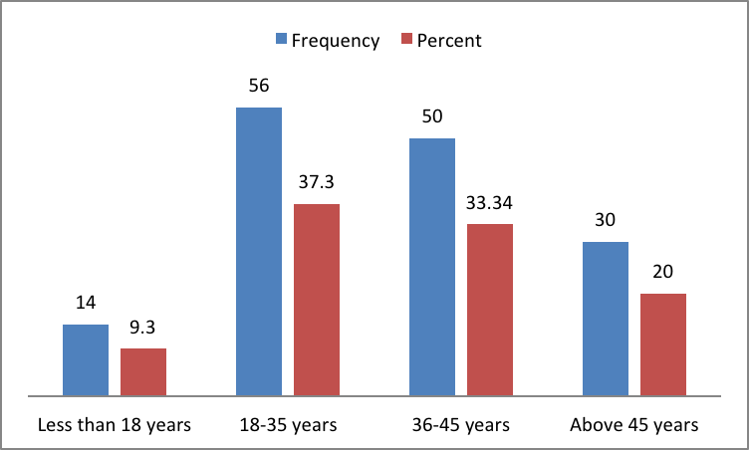
Figure 4.1: Age of Respondents
Source: Field Data, (2024)

Age means length of time, which is number of years the person has lived since he/she was born. The results from the above bar graph indicate that 10(16.9 %) of the respondents were less than 18 years, 24(40.7%) fall within the age group from 18 to 35 years, 16 (27.1%) were between 36 to 45 years, and 9(15.3%) were above 45 years. From the above information, majority of the respondents lied between 18 to 35 years while respondents with smallest age group were those who were above 45 years.

4.2.2 Gender of Respondents
Table 4.2: Gender of Respondents
 |  | Frequency | Percent | Valid Percent | Cumulative Percent
Valid | Female | 76 | 50.6 | 50.6 | 50.6
Valid | Male | 74 | 49.4 | 49.4 | 100.0
Valid | Total | 150 | 100.0 | 100.0
Source: Field Data, (2024)
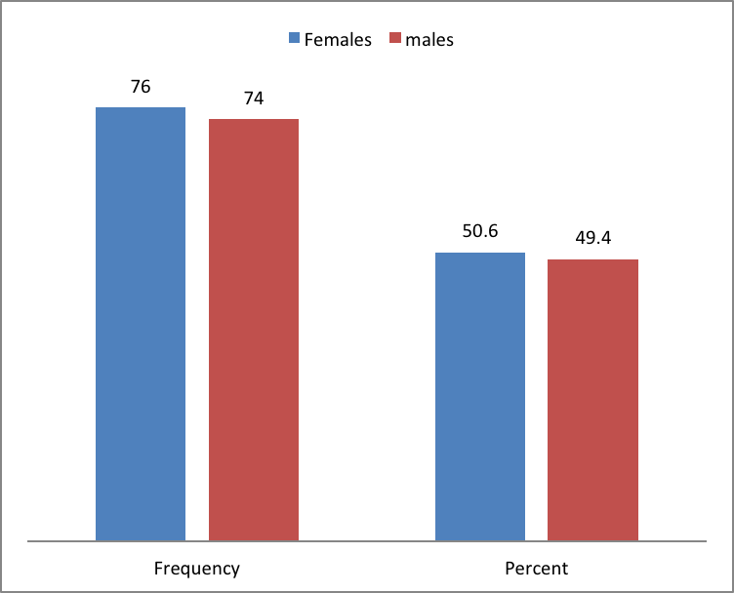
Figure 4.2: Gender Respondents
Source: Field Data, (2024)

Gender means the fact of belonging to either male or female category base on the reproductive functions. The researcher collected data from respondents of different sex. The results from the frequency table and bar graph above indicate that 74 (49.4%) of the study respondents were males while 76 (50.6%) were females.

4.2.3 Marital Status

Table 4.3: Marital Status
 |  | Frequency | Percent | Valid Percent | Cumulative Percent
Valid | Single | 106 | 70.7 | 70.7 | 70.7
Valid | Married | 44 | 29.3 | 29.3 | 100.0
Valid | Total | 150 | 100.0 | 100.0
Source: Field Data, (2024)
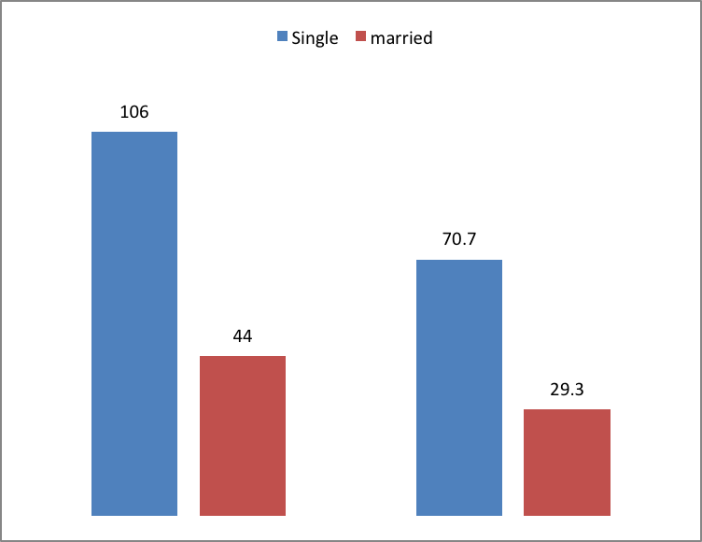
Figure 4.3: Marital Status
Source: Field Data, (2024)

Marital status is the state of being married or not married or is the personal status of each individual in relation to the marriage laws or customs of the country. 106 (70.7%) were single while 44 (29.3%) were married. This implies that the majority of respondents were single.

4.2.4 Level of Education

Table 4.4: Level of Education
 |  | Frequency | Percent | Valid Percent | Cumulative Percent
Valid | Primary | 24 | 16 | 16 | 16
Valid | Secondary | 66 | 44 | 44 | 60
Valid | College/University | 60 | 40 | 40 | 100.0
Valid | Total | 150 | 100.0 | 100.0
Source: Field Data, (2024)
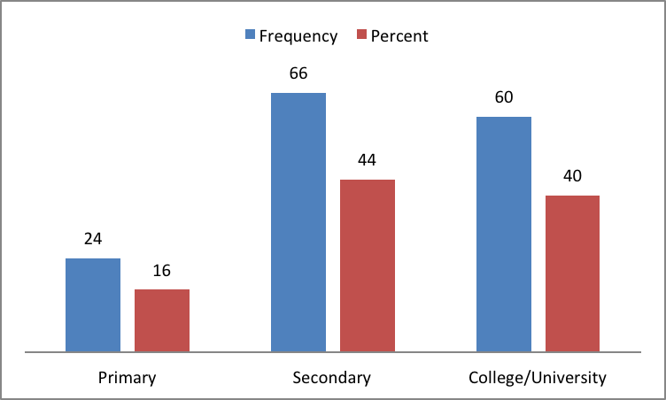
Figure 4.4: Level of Education
Source: Field Data, (2024)

The results from the above frequency table and bar graph indicate that education level of respondents were as follows; 24 (16%) of the respondents reached primary education, 66 (44%) reached secondary education and 60 (40%) reached university level. From the above information, majority of the respondents reached secondary education level followed by primary level and very few respondents reached college/university level;

4.2.5 Business Experience

Table 4.5: Business Experience
 |  | Frequency | Percent | Valid Percent | Cumulative Percent
Valid | Less than ten years | 64 | 42.7 | 42.7 | 42.7
Valid | Ten to twenty years | 48 | 32 | 32 | 74.7
Valid | More than twenty years | 38 | 25.3 | 25.3 | 100.0
Valid | Total | 150 | 100.0 | 100.0
Source: Field Data, (2024)
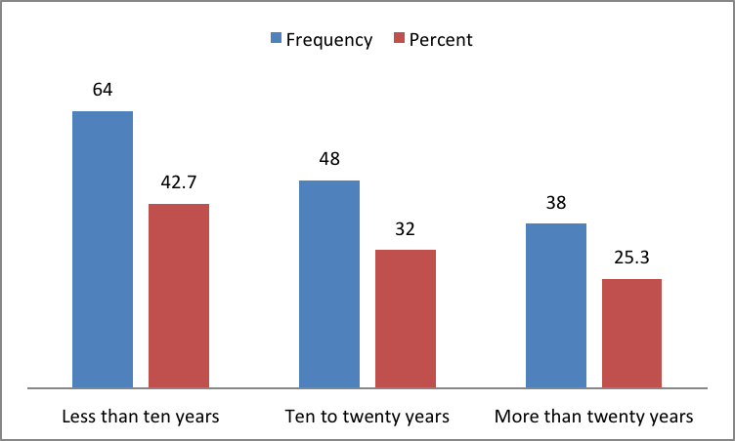
Figure 4.5: Business Experience
Source: Field Data, (2024)

The results from the above table and bar graph indicate business experience of the respondents were as follow; 64 (42.7 %) of the respondents had less than ten years business experience, 48 (32%) had ten to twenty years business experience, and 38 (25.3%) had more than twenty years business experience.

4.2.6 Type of Business Surveyed

Table 4.6: Type of Business Surveyed
 |  | Frequency | Percent | Valid Percent | Cumulative Percent
Valid | Stationery | 31 | 20.6 | 20.6 | 20.6
Valid | Shops | 66 | 44 | 44 | 66.6
Valid | Offices | 37 | 24.7 | 24.7 | 91.3
Valid | Cafeteria | 16 | 10.7 | 10.7 | 100.0
Valid | Total | 150 | 100.0 | 100.0
Source: Field Data, (2024)
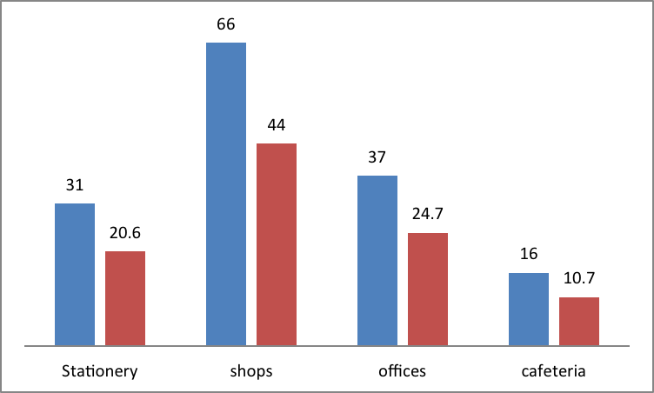
Figure 4.6: Type of Business Surveyed
Source: Field Data, (2024)

The results from the above table and bar graphs indicate kind of small and medium enterprises surveyed by a researcher were as follow; 11 (20.6%) were stationeries, 66(44%), were shops, 37 (24.7%) were offices and 16 (10.7%) were cafeteria.

4.3 Results and Findings Derived from Research Objectives
In reaching study results and findings, researcher analyzed data collected from the field using different statistical tools at the same time researcher processed data using statistical package for social science (SPSS). Descriptive statistics of tables and bar graphs were used to analyses demographic data of study respondents while regression analysis used to test the relationship between independent and dependent variables.

The below results indicate the findings of the study after entering data in SPSS and process them. The results are shown in two types of regression statistical tables; model summary table, which consist of R Square change, F-Change, degree of freedom, significance of change and Durbin Watson. Another statistical table is coefficient table, which consist of under standardized coefficients, standardized coefficients, t-value and significance level. All of these tables provide statistical indicators, which describe the relationship between independent and dependent variables.

Researcher tested the relationship between variables of accounting information system as independent variables against the financial performance of small and medium enterprises as a dependent variable. Researcher analyzed the following results derived from research objectives using descriptive statistics and linear regression statistics. Variables at each research objective were analyzed and the results were displayed.

4.3.1 Descriptive results Objective Number One
To Evaluate the effect of AIS effectiveness on Financial Performance of Small and Medium Enterprises
In this objective researcher evaluated the AIS effectiveness using different variables derived from system design and functionality of accounting information system. In each variable researcher prepared questions, which were asked to respondents who were owner managers of small and medium enterprises in Temeke Municipality. Researcher used likert scale to test the attitude of respondents on evaluation of current status of the accounting information system in small and medium enterprises.

From the above statistical table and pie chart, researcher tested the statement stated that “the accounting information system provide relevant information for effective decision making. The results indicate that 31% strongly disagree with the statement, 25% disagree with the statement, 12% provided neutral response, 17% agree with the statement and 15% strongly agree with the statement. In general most of the respondents agree with the statement saying that the accounting information system provides relevant information for effective decision making.

4.3.1.1 System Design
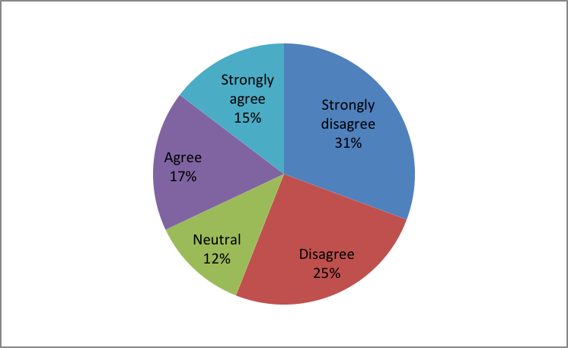
Figure 4.7: System Design
Source: Field Data, (2024)

Nshombo B. (2023), Response for the question stated that “I find it easy to use the system control” the answer from the respondents was mean 3.00 standard deviation 0.973 satisfactory. According to this response, researcher found that the accounting information system used by respondents was user friendly. This is opposite with the current study results which indicate that the accounting information system is not user friendly. Previous study found that respondents considered features of accounting information system like accessibility and reliability while the current study results did not find these features among SMEs.

4.3.1.2 The Accounting Information System Architecture is Flexible and can Accommodate Future Changes

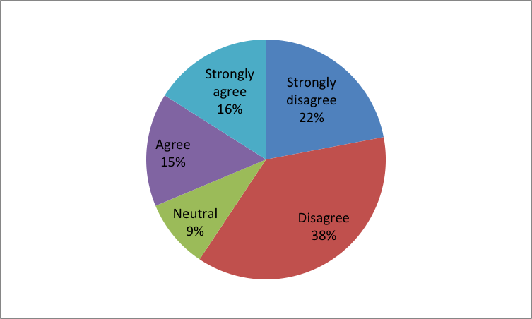
Figure 4.8: The Accounting Information System Architecture if Flexible and can Accommodate Future Changes
Source: Field Data, (2024)

From the above statistical table and pie chart, researcher tested the statement stated that “the accounting information system provide relevant information for effective decision making. The results indicate that 22% strongly disagree with the statement, 38% disagree with the statement, 9% provided neutral response, 15% agree with the statement and 16% strongly agree with the statement.

In general most of the respondents agree with the statement saying that the accounting information system provides relevant information for effective decision making “The accounting information system has helped companies keep up with the rapid change in price as results of the intense competition between companies. These results were opposite with the study results by Kwame V. A (2021) who revealed no significant effect of AIS effectiveness on firm performance.
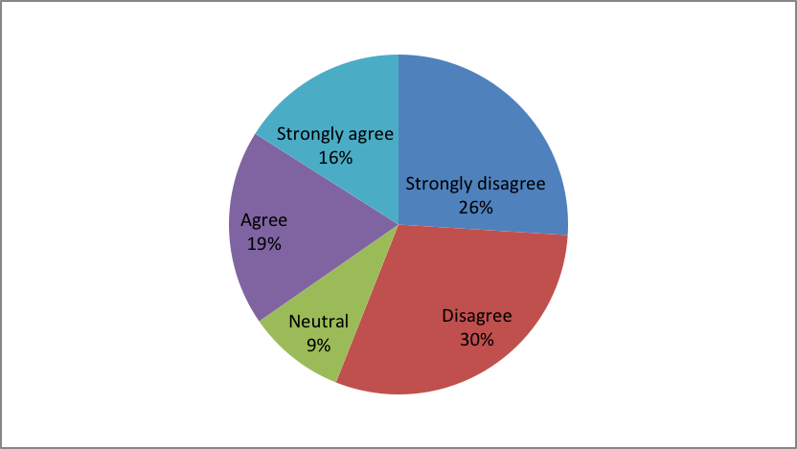
Figure 4.9: The Accounting Information System Adheres to Industry Standard Design Principles
Source: Field Data, (2024)

From the above statistical table and pie chart, researcher tested the statement stated that “the accounting information system provide relevant information for effective decision making. The results indicate that 26% strongly disagree with the statement, 30% disagree with the statement, 9% provided neutral response, 19% agree with the statement and 16% strongly agreed with the statement. In general most of the respondents disagree with the statement saying that the accounting information system provides relevant information for effective decision making.
Study by Nshombo B. (2023), Response to the question “there are effective controls that prohibit illegitimate access to the system” the answer from respondent was 2.62 mean and 1.119 standard deviation satisfactory. This means they followed accounting information system industrial standard something different with the current study results where respondents do not follow accounting system industrial standard.

4.3.1.3 Functionality
I actively use most of the models/features in the accounting information system

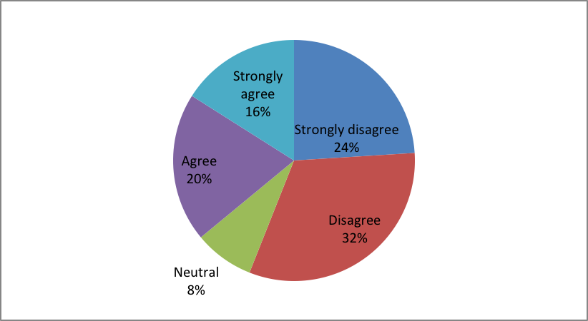
Figure 4.10: Functionality
Source: Field Data, (2024)

From the above statistical table and pie chart, researcher tested the statement stated that “the accounting information system provide relevant information for effective decision making. The results indicate that 24% strongly disagree with the statement, 32% disagree with the statement, 8% provided neutral response, 20% agree with the statement and 16% strongly agree with the statement.

In general most of the respondents agree with the statement saying that the accounting information system provides relevant information for effective decision making. These results are in line with the results of Weng L.T (2024) who revealed the strong correlation between accounting information system and effective decision making which resulted financial performance of small and medium enterprises.
The Financial data entered into the AIS is accurate and complete

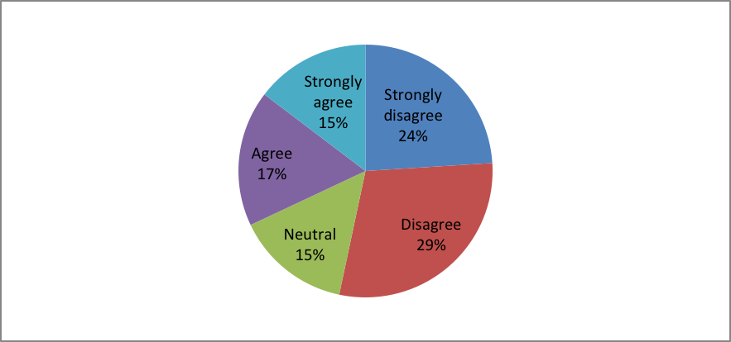
Figure 4.11: Financial Data Entered in the AIS is Accurate and Complete
Source: Field Data, (2024)

From the above statistical table and pie chart, researcher tested the statement stated that “the accounting data entered in information system is accurate and complete. The results indicate that 24% strongly disagree with the statement, 29% disagree with the statement, 15% provided neutral response, 17% agree with the statement and 15% strongly agree with the statement. In general most of the respondents disagree with the statement which means data entered in AIS of SMEs are not accurate and complete these results are opposite with Arumugan D.(2021) who discovered that accounting knowledge and recording performance was accurate in organizations tested.

From the above statistical table and pie chart, researcher tested the statement stated that “the accounting information system provide relevant information for effective decision making. The results indicate that 20% strongly disagree with the statement, 36% disagree with the statement, 11% provided neutral response, 23% agreed with the statement and 10% strongly agree with the statement.
The accounting information system process data without frequent errors or glitches

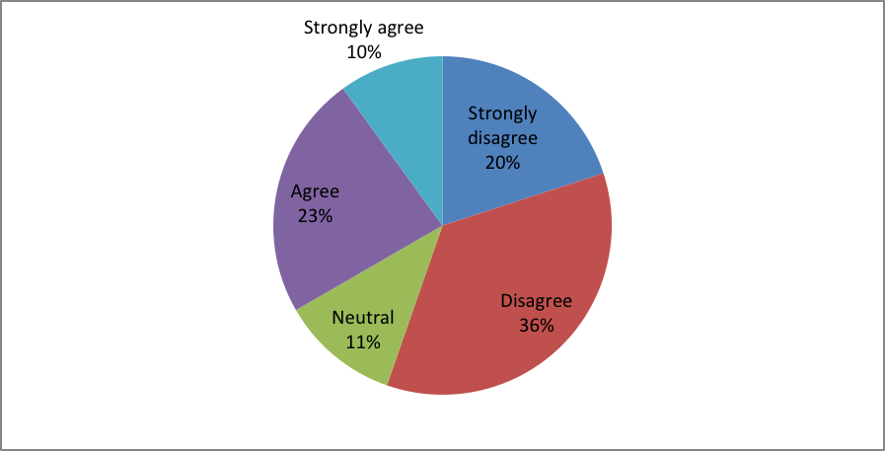
Figure 4.12: Accounting Information System Process Data without Frequent Errors of Glitches
Source: Field Data, (2024)

In general most of the respondents agree with the statement saying that the accounting information system provides relevant information for effective decision making. Kedir S. (2023) from Wolio University found that, Information must be free from material errors. Material errors exist when the amount of inaccuracy in information causes the user to make poor decisions or to fail to make necessary decisions.

According to above results shown in the table, majority of SMEs maintain financial data in the accounting system, which contain errors, which cause inaccurate data. The accounting information system contributes to the accuracy of financial data through regular reconciliations.
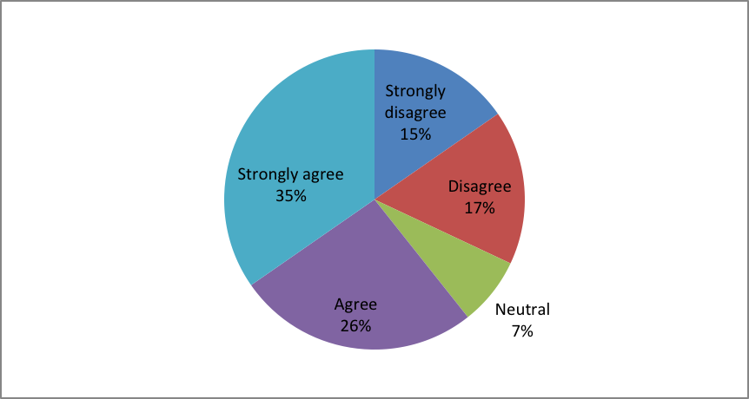
Figure 4.13: Accounting Information System Provide Relevant Information
Source: Field Data, (2024)

From the above statistical table and pie chart, researcher tested the statement stated that “the accounting information system provide relevant information for effective decision making. The results indicate that 15% strongly disagree with the statement, 17% disagreed with the statement, 7% provided neutral response, 26% agree with the statement and 35% strongly agreed with the statement.
In general most of the respondents agree with the statement saying that the accounting information system provides relevant information for effective decision making. Lodinya D and Mabonga E (2022) discovered that the accounting information system has safe data storage, retrieval and accuracy. The results from this study also indicate that the accounting information system contribute to accuracy data therefore the previous results are similar with the current results discovered.

4.3.2 Descriptive Results Objective Two
To evaluate the effect of decision making efficiency on financial performance of small and medium enterprises.

4.3.2.1 Quality of Decision Making Efficiency
The information provided by the accounting information system for decision making is accurate.

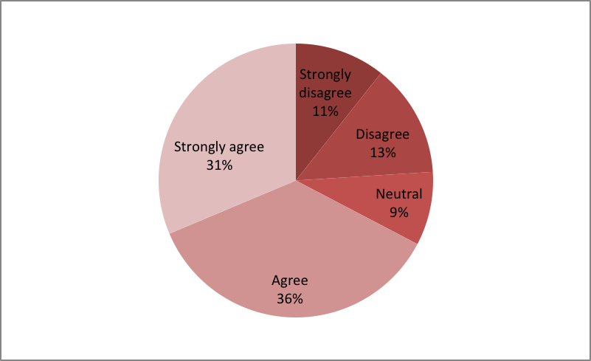
Figure 4.14: Quality of Decision Making Efficiency
Source: Field Data, (2024)

From the above statistical table and pie chart, researcher tested the statement stated that “the accounting information system provide relevant information for effective decision making. The results indicate that 11% strongly disagree with the statement, 13% disagree with the statement, 9% provided neutral response, 36% agree with the statement and 31% strongly agreed with the statement.

In general most of the respondents agree with the statement saying that the accounting information system provides relevant information for effective decision making. Mahmood M. (2022) Researcher used quantitative research method and the results of the statistical analysis confirmed that the contribution to making an administrative decision is necessary for rationalizing and enhancing decision –making and ensuring its effectiveness by 91.5%, which is substantial percentage –report based on accounting information. His results are similar with the current study results where researcher discovered that accounting system improve decision making efficiency in organization.

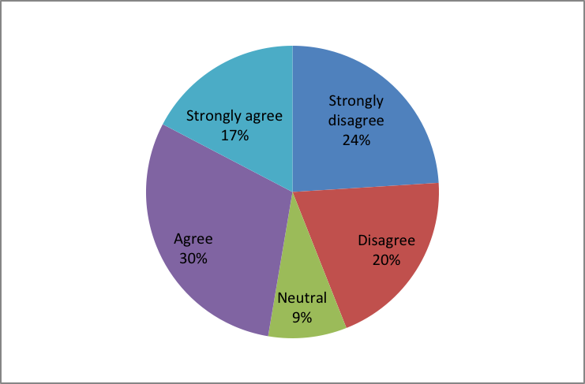
Figure 4.15: Accounting Information System Provide Relevant Information for Effective Decision Making
Source: Field Data, (2024)

From the above statistical table and pie chart, researcher tested the statement stated that “the accounting information system provide relevant information for effective decision making. The results indicate that 24% strongly disagree with the statement, 20% disagreed with the statement, 9% provided neutral response, 30% agreed with the statement and 17% strongly agreed with the statement. In general most of the respondents agree with the statement saying that the accounting information system provides relevant information. Merke C. (2022) revealed that accounting information system positively related to decision making efficiency.

Decision making express confidence in the data presented by the accounting information system
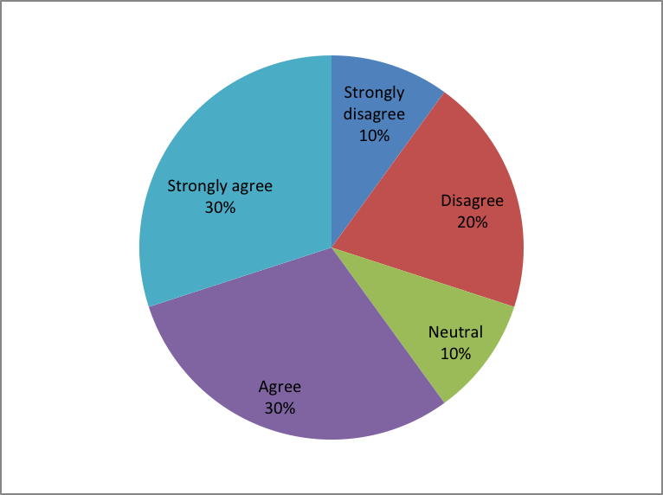
Figure 4.16: Accounting Information System Provide Relevant Information for Effective Decision Making
Source: Field Data, (2024)

The results indicate that 10% strongly disagreed with the statement, 20% disagreed with the statement, 10% provided neutral response, 30% agreed with the statement and 30% strongly agreed with the statement. In general most of the respondents agree with the statement saying that decision making express confidence in the data presented by the accounting information system. These results are similar with the findings by Okalang J. (2024) who discovered that AIS is vital for small and medium enterprises as it enables to improve decision making process.
Effectiveness of decision making process
Key decisions are made in a timely manner with the organization

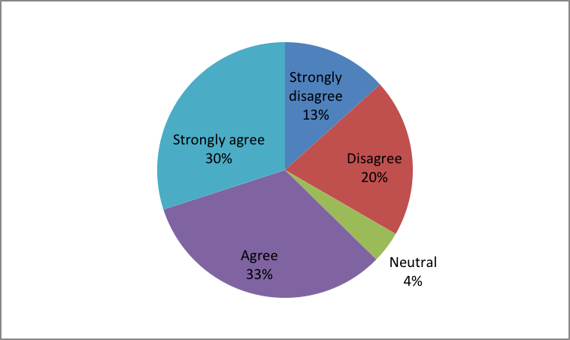
Figure 4.17: Effectiveness of Decision Making Process
Source: Field Data, (2024)

From the above statistical table and pie chart, researcher tested the statement stated that “Key decisions are made in a timely manner with the organization”. The results indicate that 13% strongly disagree with the statement, 20% disagreed with the statement, 4% provided neutral response, 33% agreed with the statement and 30% strongly agreed with the statement. In general most of the respondents agree with the statement saying that key decisions are made in a timely manner with the organization

Decision made using accounting information system data have led to positive outcomes of the organization.
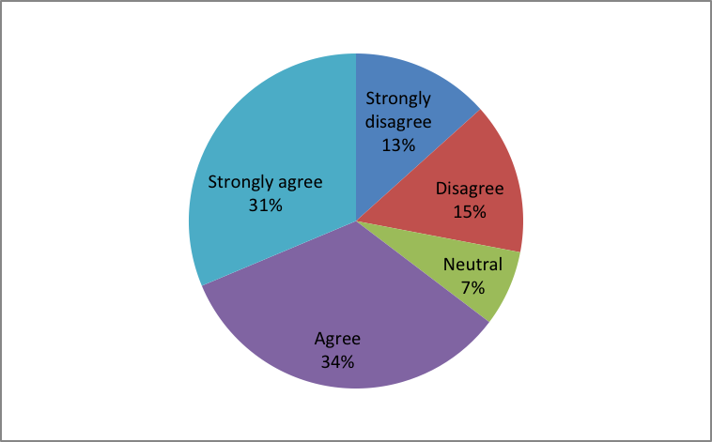
Figure 4.18: Decision Made using Accounting Information System Data led to Positive Outcomes of the Organization
Source: Field Data, (2024)

From the above statistical table and pie chart, researcher tested the statement stated that “decisions made using accounting information system data have led to positive outcomes of the organization”. The results indicate that 13% strongly disagree with the statement, 15% disagree with the statement, 7% provided neutral response, 34% agree with the statement and 31% strongly agree with the statement. In general most of the respondents agree with the statement saying that decisions made using accounting information system data have led to positive outcomes of the organization.

These results are similar with the study by Musana J. (2022) who revealed that a change in AIS triggers a change in positive change in financial performance of SMEs.
The organization key performance indicators have improved due to effective decision making process.
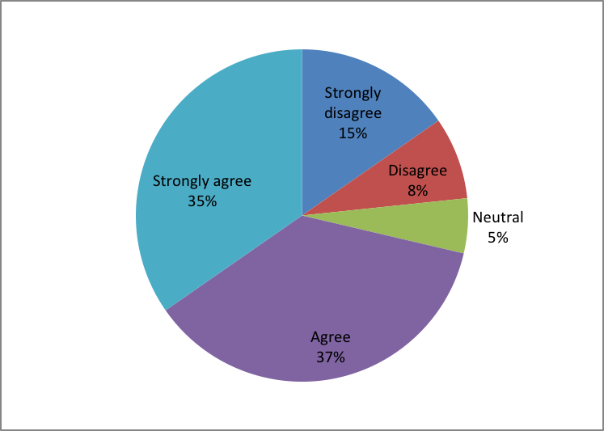
Figure 4.19: Organization Key Performance
Source: Field Data, (2024)

From the above statistical table and pie chart, researcher tested the statement stated that “the organization key performance indicators have improved due to effective decision making process”. The results indicate that 15% strongly disagree with the statement, 8% disagree with the statement, 5% provided neutral response, 37% agree with the statement and 35% strongly agree with the statement. In general most of the respondents agree with the statement saying that the organization key performance indicators have improved due to effective decision making process.

The results indicate that 13% strongly disagree with the statement, 7% disagreed with the statement, 10% provided neutral response, 40% agreed with the statement and 30% strongly agreed with the statement. In general most of the respondents agree with the statement saying that the organization performance metrics have improved over time.
The organizations performance metrics have improved over time

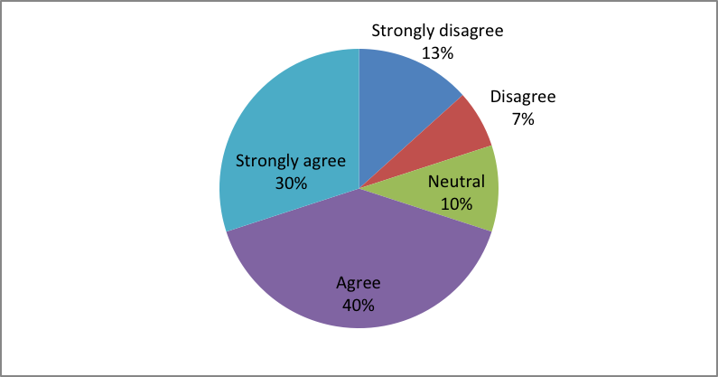
Figure 4.20: Organization Performance Metrics
Source: Field Data, (2024)

Odero, O. A (2024), found the major findings of the study where most of enterprises had a high linkage of financial performance as measured by the change in Return on Investment (ROI) being influenced by the nature of records and reports, nature of accounting information system adopted.

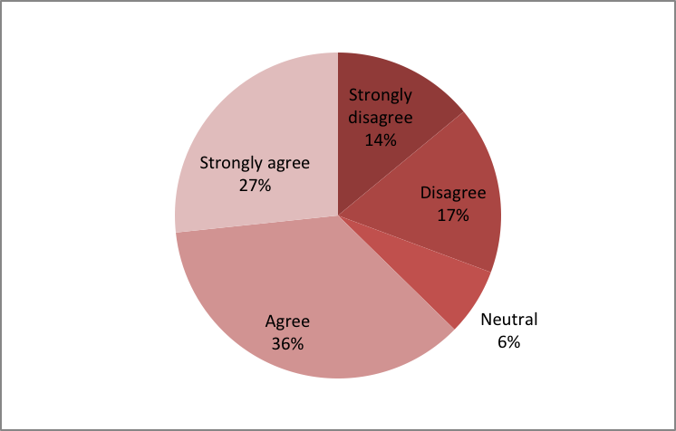
Figure 4.21: Stakeholders Perceived Decision Making Processes
Source: Field Data, (2024)
From the above statistical table and pie chart, researcher tested the statement stated that “stakeholders perceived decision making process is efficient and effective”. The results indicate that 14% strongly disagree with the statement, 17% disagree with the statement, 6% provided neutral response, 36% agree with the statement and 27% strongly agree with the statement. In general most of the respondents agree with the statement saying that stakeholders perceived decision making process is efficient and effective.
Overall how would you rate the efficiency of decision making process in an organization.
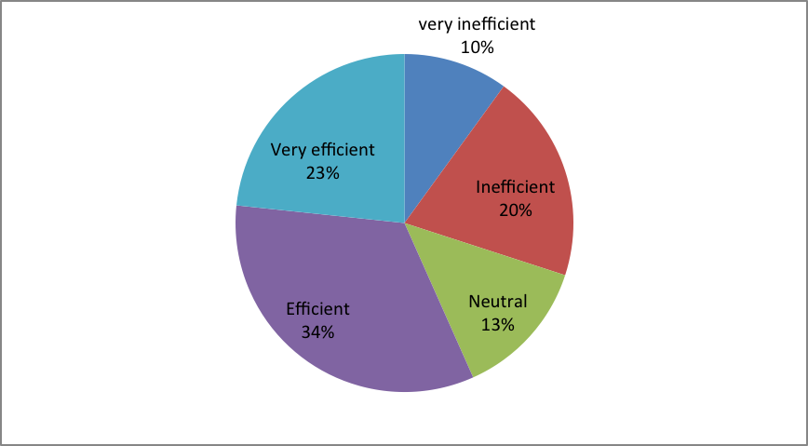
Figure 4.22: Overall how would you Rate the Efficiency Of Decision Making Process in Organization
Source: Field Data, (2024)

From the above statistical table and pie chart, researcher tested the statement stated that “overall how would you rate the efficiency of decision making process in organization”. The results indicate that 10% said very inefficient, 20% said inefficient, 13% said neutral, 34% said efficient and 23.% said very efficient. In general most of the respondents agree with the statement hence researcher conclude that decision making process in organization is efficient.

The study concluded that the strategic decision making process plays an important role in the effective performance of an organization. Olalekan Asikhia (2021), His findings is similar with this current study results which show the high rate of decision making efficiency.

4.3.3 Descriptive Results Objective Number Three
To evaluate the effect of AIS integration on financial performance of small scale enterprises.

4.3.3.1 System Integration
The accounting information system is well integrated with other relevant business systems

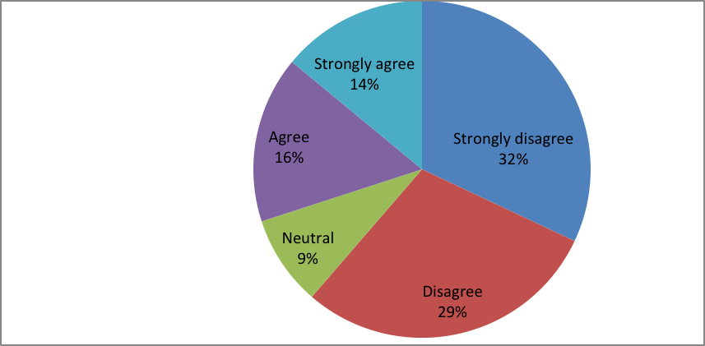
Figure 4.23: System Integration
Source: Field Data, (2024)
From the above statistical table and pie chart, researcher tested the statement stated that “overall how would you rate the efficiency of decision making process in organization”. The results indicate that 10% said very inefficient, 20% said inefficient, 13% said neutral, 34% said efficient and 23% said very efficient.

In general most of the respondents agree with the statement hence researcher conclude that decision making process in organization is efficient. The study concluded that the strategic decision making process plays an important role in the effective performance of an organization. Olalekan Asikhia (2021), His findings is similar with this current study results, which show the high rate of decision making efficiency.

From the above statistical table and pie chart, researcher tested the statement stated that “the Accounting information system is well integrated with other business systems. The results indicate that 32% strongly disagree with the statement, 29% disagreed with the statement, 9% provided neutral response, 16% agree with the statement and 14% strongly agreed with the statement. In general most of the respondents disagree with the statement saying stakeholders perceived.

Data interfaces between the accounting information system and external system operate smoothly.

From the above statistical table and pie chart, researcher tested the statement stated that “data interfaces between the accounting system and external system operate smoothly. The results indicate that 23% strongly disagree with the statement, 30% disagree with the statement, 14% provided neutral response, 20% agree with the statement and 13% strongly agree with the statement.

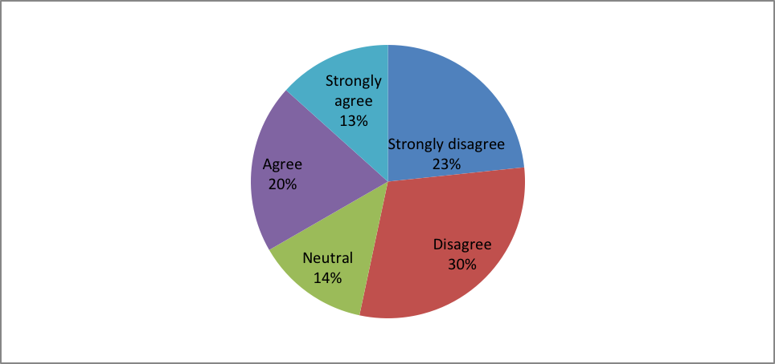
Figure 4.24: Data Interfaces between the Accounting Information System and External System Operate Smoothly
Source: Field Data, (2024)

The accounting information system facilitates efficient data flow
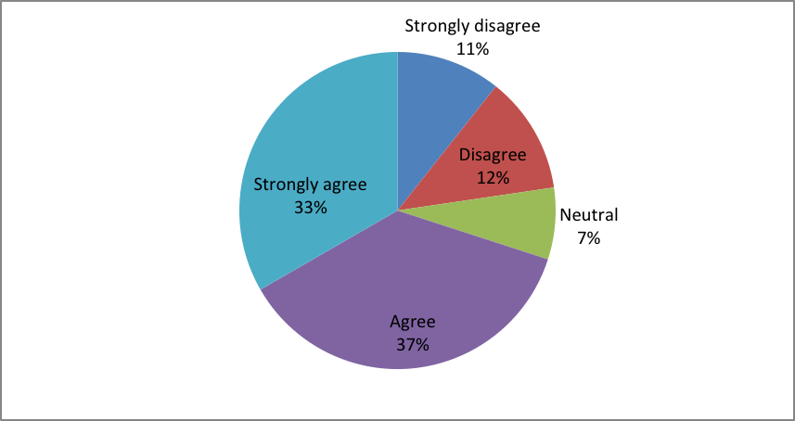
Figure 4.25: The Accounting Information System Facilitates Efficient Data Flow
Source: Field Data, (2024)
In general most of the respondents disagree with the statement saying data interfaces between the accounting information system and external system operate smoothly.Arunas Butkevicius (2024), discovered that the degree of integration of the accounting information system of small and medium enterprises with their business partners remains low, although prerequisites for the integration in some cases are in place.
From the above statistical table and pie chart, researcher tested the statement stated that “the accounting information system facilitates efficient data flow and connection with other system. The results indicate that 11% strongly disagree with the statement, 12% disagree with the statement, 7% provided neutral response, 37% agree with the statement and 33% strongly agree with the statement.
In general most of the respondents agree with the statement saying that the accounting information system facilitates efficient data flow and connection with other system.www.runeleven.com (2024), integrated systems enable effortless syncing of transactions across various platforms, maintaining consistency and accuracy in financial data.
The integration of the accounting information system has saved time in decision making process.
From the above statistical table and pie chart, researcher tested the statement stated that “the integration of the accounting information system has saved time in decision making process. The results indicate that 19% strongly disagree with the statement, 8% disagree with the statement, 6% provided neutral response, 40% agree with the statement and 27% strongly agree with the statement.
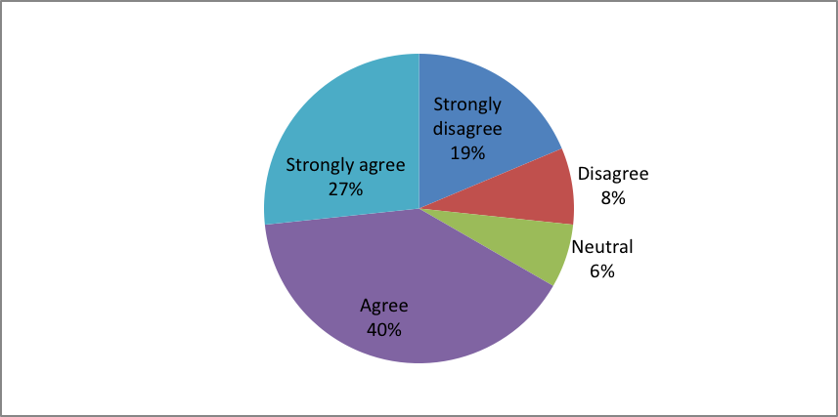
Figure 4.26: Integration of the Accounting Imforamtion System
Source: Field Data, (2024)

In general most of the respondents agree with the statement saying that the integration of the accounting information system has saved time in decision making.

4.3.3.1 Decision Making Efficiency
Stakeholders perceived a positive impact on decision making efficiency due to AIS Integration.
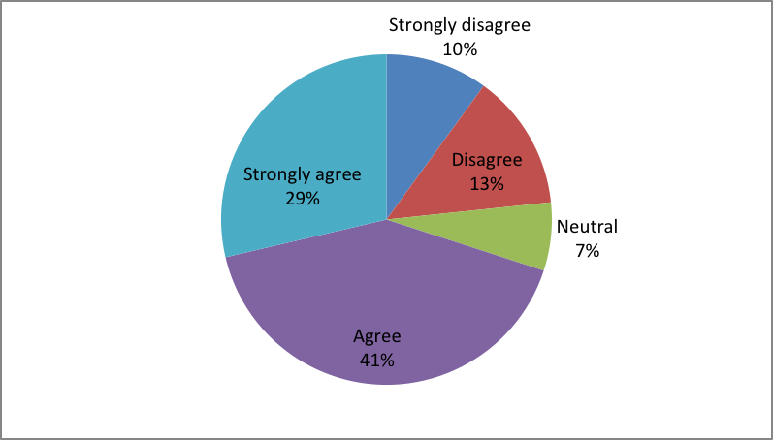
Figure 4.27: Integration of the Accounting Imforamtion System
Source: Field Data, (2024)
From the above statistical table and pie chart, researcher tested the statement stated that “stakeholders perceived a positive impact of decision making efficiency due to integration. The results indicate that 29% strongly agree with the statement, 13% disagreed with the statement, 7% provided neutral response, 41% agreed with the statement and 10% strongly disagreed with the statement. In general most of the respondents agree with the statement saying stakeholders perceived a positive impact of decision making efficiency due to integration.

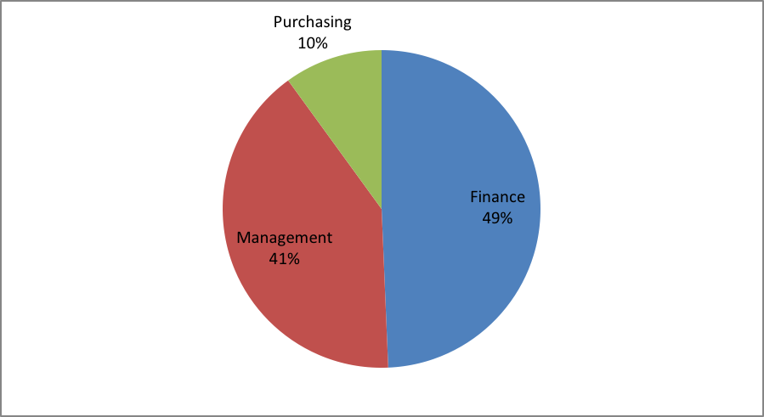
Figure 4.28: Stakeholders Perceived a Positive Impact of Decision Making Efficiency Due to Integration
Source: Field Data, (2024)

In which specific decision making areas has AIS integrated positively influenced efficiency. The above results indicate specific decision making areas integrated positively influenced efficiency. The first area is Finance area (49%), the second area is Management (41.%) and the third area is purchasing (10%).

4.4 Regression Results

4.4.1 Objective One: To Evaluate the Current Status of the AIS in Small and Medium Enterprises
In this objective researcher evaluated the current status of accounting information system using two variables, which is evaluation of system design and evaluation of functionality of AIS. In this objective researcher used regression test statistic to determine the relationship between independent variables and dependent variable.

4.5 System Design

Table 4.7: System Design
Coefficientsª
Model |  | Unstandardized Coefficients |  | Standardized Coefficients | t | Sig.
 |  | B | Std. Error | Beta | t | Sig.
1 | (Constant) | 1.272 | .356 |  | 3.569 | .001
1 | The design of accounting information is user friendly | .280 | .108 | .255 | 2.606 | .012
1 | The accounting information system architecture is flexible and can accommodate future changes | .582 | .114 | .505 | 5.082 | .000
1 | The accounting information system adheres to industry standard design principles | .271 | .101 | .270 | 2.675 | .010
Source: Field Data, (2024)

From the above results researcher used linear regression statistic to analyze the relationship between the independent variables which is the design of AIS , flexibility of the AIS architecture and AIS adheres to industry standard design principles and dependent variable which is business performance of SME. The results indicate positive regression between the variables at 0.255 between design of AIS and performance, at 0.505 between flexibility of AIS architecture and business performance, at 0.270 between the AIS adheres to industry standard and business performance.

4.6 Functionality

Table 4.8: Functionality
Coefficientsª
Model |  | Unstandardized Coefficients |  | Standardized Coefficients | t | Sig.
 |  | B | Std. Error | Beta | t | Sig.
1 | (Constant) | 1.319 | .286 |  | 4.603 | .000
1 | I actively use most of the modules/features in the accounting information system | .399 | .112 | .360 | 3.570 | .001
1 | The financial data entered into the accounting information system is accurate and complete | .406 | .083 | .472 | 4.881 | .000
1 | The accounting information system process data without frequent errors or glitches | .127 | .094 | .130 | 1.352 | .182
Source: Field Data, (2024)

From the above results researcher used linear regression statistic to analyze the relationship between the independent variables which is modules/features entered in the AIS, accurate financial data entered in the AIS, and the AIS data processed without errors and dependent variable which is business performance of SME. The results indicate positive regression between the variables at 0.360 between modules/features in the AIS and business performance, at 0.472 between accurate financial data entered in the AIS and business performance of SME, at 0.130 between the AIS data processing without errors and business performance.

4.7 Effectiveness

Table 4.9: Effectiveness
Coefficientsª
Model |  | Unstandardized Coefficients |  | Standardized Coefficients | t | Sig.
 |  | B | Std. Error | Beta | t | Sig.
1 | (Constant) | 1.304 | .282 |  | 4.627 | .000
1 | Financial data is entered and processed in the accounting information system in a timely manner | .079 | .092 | .059 | .858 | .394
1 | The accounting information system ensures compliance with regulatory requirements in capturing data | .159 | .082 | .143 | 1.948 | .057
1 | The accounting information system contributes to the accuracy of financial data through regular reconciliations | .632 | .058 | .797 | 10.876 | .000
Source: Field Data, (2024)

The above results indicate positive regression between the variables at 0.059 between financial data processed in the AIS in timely manner and business performance, at 0.143 between AIS compliance with regulatory requirements and business performance and finally coefficient at 0.797 between accuracy of AIS through regular reconciliations and business performance

4.7.1 Objective Two: System Integration

Table 4.10: Quality of Decision Making Information
Coefficientsª
Model |  | Unstandardized Coefficients |  | Standardized Coefficients | t | Sig.
 |  | B | Std. Error | Beta | t | Sig.
1 | (Constant) | -.347 | .240 |  | -1.449 | .153
1 | The information provided by the accounting information system for decision making is accurate | .076 | .053 | .067 | 1.437 | .156
1 | The accounting information system provided relevant information for effective decision making | .740 | .175 | .718 | 4.232 | .000
1 | Decision making express confidence in the data presented by the accounting information system | .223 | .178 | .212 | 1.257 | .214
Source: Field Data, (2024)

From the above results researcher used linear regression statistic to analyze the relationship between the independent variables which is AISfor decision making, relevant information provided by AIS for decision making and decision making confidence provided by AIS and dependent variable which is business performance of SME.

The results indicate positive at 0.067 between AIS for decision making and business performance, 0.718 between relevant information of AIS and business performance and at 0.212 between decision making confidence provided by AIS and business performance.
Table 4.11: Effectiveness of Decision Making Process
Model |  | Unstandardized Coefficients |  | Standardized Coefficients | t | Sig.
 |  | B | Std. Error | Beta | t | Sig.
1 | (Constant) | -.622 | .247 |  | -2.522 | .015
1 | Key decisions are made in a timely manner with the organization | 1.080 | .060 | .922 | 17.970 | .000
Source: Field Data, (2024)

From the above results researcher used linear regression statistic to analyze the relationship between the independent variables, which is, key decision making made in time and dependent variable, which is business performance of SME. The results indicate positive regression between the variables at 0.922standardized coefficients and 1.080 unstandardized coefficients both of them at 0.000 significance level.

4.7.2 Objective Three: System Integration

Table 4.12: System Integration
Coefficientsª
Model |  | Unstandardized Coefficients |  | Standardized Coefficients | t | Sig.
 |  | B | Std. Error | Beta | t | Sig.
1 | (Constant) | 1.677 | .302 |  | 5.549 | .000
1 | The AIS is well integrated with other relevant business systems | .320 | .124 | .364 | 2.578 | .013
1 | Data interfaces between the AIS and external system operate smoothly | .446 | .119 | .523 | 3.757 | .000
1 | The AIS facilitates efficient data flow and connection with other system | .000 | .076 | .000 | -.007 | .994
Source: Field Data, (2024)

From the above results researcher used linear regression statistic to analyze the relationship between the independent variables, which is integration of AIS with other business systems, data interfaces of AIS and efficient flow of data and dependent variable, which is business performance of SME. The results indicate positive regression between the variables at 0.364 between AIS integration with business system and performance, at 0.523 between data interfaces integrated with external system and performance and finally at 0.000 between efficient data flow and connection with other system and performance.

Table 4.13: Decision Making Efficiency
Coefficientsª
Model |  | Unstandardized Coefficients |  | Standardized Coefficients | t | Sig.
 |  | B | Std. Error | Beta | t | Sig.
1 | (Constant) | .380 | .146 |  | 2.609 | .012
1 | The integration of the accounting information has saved time in decision making process | .497 | .086 | .559 | 5.750 | .000
1 | Stakeholders perceived a positive impact on decision making efficiency due to AIS Integration | .413 | .095 | .421 | 4.331 | .000
Source: Field Data, (2024)

From the above results researcher used linear regression statistic to analyze the relationship between the independent variable which is integration of AIS and stakeholders perception on decision making efficiency due to integration of AIS and dependent variable which is business performance of SME. The results indicate positive regression between the variables performance at 0.497 unstandardized coefficients for AIS integration and AIS for stakeholder’s perception is 0.413.

4.8 Discussion of Findings and Results

4.8.1 Descriptive Results
The main objective of the study was to assess the influence of accounting information system on financial performance of small scale enterprises, the case of Temeke municipal traders. Primary Data was collected from a sample of 150 business enterprises in Temeke municipal council. Researcher used structured questionnaire as data was collection tool. Secondary data were collected by review of journals, books and previous studies. Collected data were processed using statistical package for social science (SPSS) and Microsoft Excel. Data were analyzed using descriptive statistics and regression statistics. Researcher set the option of using the regression model to determine the relationship between the study variables (Independent variables against dependent variable, which is business performance of small and medium enterprises. The researcher derived the study findings from three research objectives which is to evaluate the current status of the accounting information systems in small and medium enterprises, to evaluate the current status of decision making efficiency in small and medium enterprises as supported by accounting information system and to investigate the level of integration of the AIS impact on decision making efficiency.

Objective number three was based on the evaluation of the current status of AIS of small and medium enterprises, the study results were categorized into the following categories; which is system design and functionality after testing the attitude of respondents using five Likert scale which is strongly disagree, disagree, neutral, agree, and strongly agree.
System design
Under system design, different questions were used to test the attitude of respondents concerning the quality of system design of accounting information system. The results were as follows; Majority of respondents 31% strongly disagree with the statement which said that AIS is user friendly, that means AIS in most cases is not user friend when used by small and medium enterprises.

Majority of respondents 38% disagree with the statement stated that AIS of SME is flexible and can accommodate future changes. Majority of them SMEs 30% disagree with the statement, which stated that AIS adheres to industry standard design principles. According to above results, system design of accounting information system does not favor majority of respondents (SMEs) when they use the system. This might be caused by the lack of enough skills or complicates design of the system.

Functionality
Under functionality, the following results were found; majority of respondents who were 32% disagree with statement, which stated that I actively use modules/features in AIS. Majority of respondents 29% disagree with the statement stated that the financial data entered in AIS is accurate and complete. 36% of study respondents disagree with the statement said that the AIS stress data without frequent errors. Majority 30% disagree with the statement which stated that financial data financial data is entered and processed in the AIS in a timely manner. Majority of respondents 35.3% disagree with the statement, which stated that the AIS ensures compliance with regulatory requirements in capturing data. Majority of SMEs 34.7% strongly agree with the statement stated that the AIS contributes to the accuracy of financial data through regular reconciliations.

Objective number two was based on the evaluation of the current status of decision making efficiency in small and medium enterprises as supported by accounting information system the study results were categorized into the following categories; the quality of decision making efficiency and effectiveness of decision making process.

Quality of decision making efficiency
Under quality of decision making efficiency, different questions were used to test the attitude of respondents who were the small and medium enterprises. The results were as follows; Majority of respondents 36% agree with the statement which said that the information provided by the AIS for decision making is accurate. Majority of respondents 30% agree with the statement stated that the AIS provide relevant information for decision making. Finally majority of study respondents 30% agree with the statement stated that the decision making express confidence in the data presented by the AIS.

Effectiveness of decision making process
Under the above category, the following results were found; majority of respondents who were 30.7% agree with statement which stated that key decisions are made in timely manner in organization.Majority ofrespondents 33.3% agree with the statement stated that the decisions made using AIS data have led to positive outcome of organization. Majority of respondents 36.7% agree with the statement said that the organization key performance indicators have improved due to effective decision making process Majority of SMEs 40% agree with the statement which stated that the organizational performance metrics have improved.Majority of SMEs 36% agree with the statement which stated that the organizational performance metrics have improved over time.Majority of respondents 34% agree with the statement which stated the overall rate of efficiency of decision making process.

The objective number three was based on the investigation of the level of integration of the AIS impact on decision making efficiency. The study results were categorized into the following categories; which is system integration and decision making efficiency after testing the attitude of respondents using five Likert scale which is strongly disagree, disagree, neutral, agree, and strongly agree.

System Integration
Under system integration, different questions were used to test the attitude of respondents concerning the capacity of system integration of accounting information system. The results were as follows; Majority of respondents 32% strongly disagree with the statement which stated that the AIS iswell integrated with other relevant business systems. That means most of SMEs do not integrate their AIS with other business systems. Majority of respondents 30% disagree with the statement stated that “data interfaces between the accounting information system and external system operate smoothly”. That means according to their response, data interfaces between these two operating areas do not operate smoothly. Majority of them SMEs 36.7% agree with the statement, which stated that AIS facilitates efficient data flow and connection with other systems. Majority of study respondents (SMEs) 40% agree with the statement stated that, “the integration of the AIS has saved time in decision making process”.

Decision making efficiency
In testing the decision making efficiency the following results were found; majority of respondents who were 41.3% agree with statement which stated that “shareholders perceived a positive impact on decision making efficiency due to AIS integration”. Researcher also tested three specific areas, which integrated with AIS to see their influence on efficiency. The first specific area, which influenced efficiency, was Finance 49.3%, Management area 40.7% and finally purchasing area 10%.

4.8.2 Regression Results
Researcher also used regression statistical model to test the influence of different independent variables on business performance of SMEs. The first objective tested the current status of AIS in small and medium enterprises and its influence on business performance. According to regression results, system design, functionality of AIS modules and system effectiveness all positively affected business performance. In second objective, which tested the quality of decision making information, both the decision making information and effectiveness of decision making process have positive effect on business performance. In objective number three, researcher tested the influence of system integration and decision making efficiency and all two variables have positive impact on business performance of SMEs.

CHAPTER FIVE

CONCLUSION AND RECOMMENDATIONS

5.1 Conclusion
The study conclusion of this study is based on three objectives; the first objective talks about impact of accounting information system on business performance. After testing the findings from the frequency table and pie chart indicate that most of respondents agree with the statement saying that: “AIS contributes to the accuracy of financial data through regular reconciliations. These results mean that AIS contributes to the accuracy of financial data through regular reconciliations.
The second objective talks about the efficiency of decision making in organization and the through overall results conclude that the decision making process in organization is efficient after using the accounting information system. The third objective was about the integration of accounting information system with other systems and their contributions to business performance. Researcher concludes that specific decision making areas integrated with accounting information system positively influenced efficiency of the organization. The first area is Finance area (45%), the second area is Management (28.8%) and the third area is purchasing (25.4%).
Descriptive results shows that majority of small enterprises do not use system design tools and functional tools of accounting information system although they understand the importance of using accounting information system and AIS integration on decision making efficiency. Researcher also discovered that most of small enterprises do not use AIS integration in their accounting activities.
In case of regression results, researcher discovered that all independent variables of AIS effectiveness, Decision making efficiency and AIS integration have positive impact on financial performance of small enterprise.

5.2 Recommendations
Researcher recommends to the Government of Tanzania and the management of small and medium enterprises to install accounting information systems in their decision making areas like management, finance and procurement areas in order to improve efficiency in their organizations. The ministry responsible for technology issues in Tanzania should survey to these SMEs and provide accounting system training and workshops to staffs something which will improve their accounting information system awareness these areas.

The AIS knowledge should be taught from the grassroots level that means from primary schools and secondary schools in order to spread AIS awareness to youths from the earlier stages of their growth. Media tools in Tanzania have a great responsibility to spread AIS awareness to Tanzanian community especially consideration of decision making in different management areas.

Researcher recommends for further study to determine the involvement of financial institutions on provision of AIS training to small scale enterprises. This is recommended because most of respondents are still using manual accounting which in most cases produces accounting errors. Some of limitations met by researcher are cooperation from respondents were some do not have research knowledge; this happened during data collection process.

REFERENCES
Adase, V. K. (2021). “Accounting information system and performance of small business”, The mediating role of international control. Lagos: SAGE.
Akhter A. (2022), “Impact of accounting information system on organizational performance”, Private Commercial banks in Bangladesh, International journal of scientific and research publications, 3(1), 71-78.
Alphonce, O. O. (2024). The effect of accounting information system quality on financial performance of SMEs in Kenya. Nairobi: University of Nairobi
Arunas, B. (2024). Assessment of the integration of the accounting information system in small and Medium enterprises, Department of economic information, Vilnus University, Lithuania.
Baraka, N. J. (2023). “Accounting information system and decision making in selected banking I Industry in Kampala Uganda, Kampala University.
Charles, M. (2022). Influence of accounting information system on decision making process in audit firms in USA. New York: University of Chicago.
Daniel, L. and Mabonga E. (2022). Relationship between accounting information system quality and organ.sation performance in selected NGOs in Juba, South Sudan
Dhamayanthi, A. (2021). “The impact of accounting information system on organizational Performance in China, electronic journal of business and management, 6(4), 18-33.
Gayaza K, (2021), Characteritics of accounting software on business performance of
Small and medium Enterprise, kurunegala District, Sri-Lanka
Ibrahim, M., Mohamed, J. (2024). “Factors influencing accounting information system usage in oil Companies and performance outcomes, Journal of cogent business and Management, 11(1), 33-45.
Israel, A.(2023). “Impact of accounting information system on the performance of SMEs in Nigeria.
Jackob, B. (2023. “ Does record keeping matter in business? Expert Journal Of Business and Management, 2(1), 10-18.
Jonahm A., and Tahiru, L. (2023). “ Record keeping and its effect on the development of small scale Enterprises in the Sissala West District in the upper west Region of Ghana, American Journal of economics and business innovation, Ghana, 2(2), 31-37.
Lidovolo P. (2023), “Infuence of accounting information system on financial performance of Tea manufacturing companies in Kenya”, Madete tea factory, Kenya.
Lin Tian Weng Edwin, Shafawaty Mohamed Shabri (2024), “The influence of accounting information system Financial performance of small and medium sized enterprises in Kangar, Perlis, International journal of business and technopreneurship, 14(1), 41-47.
Mohamed, M. (2022), “Importance of accounting information in management decision-making process”, Journal of studies in science and engineering, 3(1). 67-72.
Musana, J. (2022). “The impact of accounting information system on financial performance of SMEs, Busitema University, Department of Economics
Okalang, J. B. (2024). “The impact of AIS on the performance of SMEs, a case of selected SMEs in Kampala, International journal of current research, 2(1), 11-23. ISSN 09750833x, Kampala, Uganda.
Olajire Olawole (2021), “effect of AIS on performance of small and medium enterprises in Nigeria, International journal of Academic management science research, 5(10), Nigeria.
Olalekan, A. (2021), “The influence of strategic decision making on organizational performance, International journal of business management, Caleb University, Lagos, Nigeria.
Olufemi, A. (2019). “The impact of record keeping on the performance of selected small and Medium enterprises, Lagos Metropolis, Journal of small business and entrepreneurship Development, Volume 7, no1, 28-40, ISSN2333-6374, American Research Institute, Nigeria.
Patrick, M. (2023), “Influence of AIS on financial performance of tea manufacturing companies in Kenya, European Journal of economics and financial research, Kenya, 2(1), 44-51.
Sanga, D. (2014). “A challenge of business record keeping for Tanzania small and medium Enterprises: A case of Madukani Ward-Dodoma Region, European Journal of business and Management, Volume 6, no.38, ISSN222-1905,
Susanto A. (2019), “The evolution of Accounting Information Systems”, International
Journal of scientific and technology research, Volume 8, Accounting Depertiment, Indonesia
Thi Van, D. (2023). “Impact of accounting information system on performance of Vietnamese construction Enterprises, Vietnam, International Journal of professional business review, Vietnam www.runeleven.com (2024), Integrating your accounting software with other business systems
Yohanis, R., and Santiadji, M. (2021). Decision usefulness paradigm, OSR Journal of Business and Management (IOSR-JBM), 23(1), 30-34 e-ISSN: 2278-487X, p-ISSN: 2319-7668. 23(1), Ser. VI PP 30-34

APPENDICES
Appendix I: Questionnaires for SMES Owner Managers Temeke Municipal, Dar es Salaam

Introduction

Dear Sir/Madam
This questionnaire is a guide to this study, titled “The influence of accounting information on financial performance of small scale enterprises”. You are humbly asked to spend a few minutes of your valuable time to answer the questions provided in this sheet; your answers will contribute for the completion of my MASTERS studies. You are hereby informed that the answers will be kept confidential and only be used for academic purpose.

SECTION A: DEMOGRAPHIC INFORMATION
1. Age of respondents
18 to 35 years ( )
36 to 45 years ( )
Above 45 years ( )

2. Gender of respondents
Female ( )
Male( )
- Marital status
Single ( )
Married ( )

4. Level of Education
Primary level ( )
Secondary level ( )
C ollege/University ( )

5. Business Experience
Less than ten years ( )
Ten to twenty years ( )
More than twenty years ( )

6. Type of business
Stationeries ( )
Shops ( )
Offices ( )
Cafeteria ( )

Objective 1: Evaluate the current status of the Accounting Information System (AIS) implementation:
1. System Design
- The design of the Accounting Information System (AIS) is user-friendly.
Strongly Disagree ( ) Disagree ( ) Neutral ( ) Agree ( ) Strongly Agree ( )
- The AIS architecture is flexible and can accommodate future changes.
Strongly Disagree ( ) Disagree ( ) Neutral ( ) Agree ( ) Strongly Agree ( )
- The AIS adheres to industry-standard design principles.
Strongly Disagree ( ) Disagree ( ) Neutral ( ) Agree ( ) Strongly Agree ( )

2. Functionality
- I actively use most of the modules/features in the AIS.
Strongly Disagree ( ) Disagree ( ) Neutral ( ) Agree ( ) Strongly Agree ( )

- The financial data entered into the AIS is accurate and complete.
Strongly Disagree ( )Disagree ( ) |Neutral ( ) Agree ( ) Strongly Agree ( )

- The AIS processes data without frequent errors or glitches.
Strongly Disagree ( ) Disagree ( ) Neutral ( ) Agree ( ) | Strongly Agree ( )

3. Effectiveness in Capturing Financial Data
- Financial data is entered and processed in the AIS in a timely manner.
Strongly Disagree ( ) Disagree ( ) Neutral ( ) Agree ( ) Strongly Agree

- The AIS ensures compliance with regulatory requirements in capturing financial data.
Strongly Disagree ( ) Disagree ( ) Neutral ( ) Agree ( ) StronglyAgree ( )

- The AIS contributes to the accuracy of financial data through regular reconciliations.
- Strongly Disagree ( ) Disagree ( ) Neutral ( ) Agree ( ) Strongly Agree ( )

Objective 2: Evaluate the current status of Decision-making efficiency:
1. Quality of Decision-Making Information

- The information provided by the AIS for decision-making is accurate.
Strongly Disagree ( ) Disagree ( ) Neutral( ) Agree ( ) Strongly Agree ( )

- The AIS provides relevant information for effective decision-making.
Strongly Disagree ( ) Disagree( ) Neutral ( ) Agree ( ) Strongly Agree ( )

- Decision-makers express confidence in the data presented by the AIS.
Strongly Disagree ( ) Disagree( ) Neutral ( ) Agree ( ) Strongly Agree ( )

-The accounting information system contributes to the accuracy of financial data through regular reconciliations
Strongly Disagree ( ) Disagree ( ) Neutral ( ) Agree ( ) Strongly Agree ( )

2. Effectiveness of Decision-Making Processes
- Key decisions are made in a timely manner within the organization.
Strongly Disagree ( ) Disagree ( ) Neutral ( ) Agree ( ) Strongly Agree ( )

- Decisions made using AIS data have led to positive outcomes for the organization.
Strongly Disagree ( ) Disagree ( ) Neutral ( ) Agree ( ) Strongly Agree ( )

- The organization's key performance indicators have improved due to effective decision-making processes.
Strongly Disagree ( ) Disagree ( ) Neutral ( ) Agree ( ) Strongly Agree ( )

-The information provided by the accounting information system for decision making is accurate
Strongly Disagree ( ) Disagree ( ) Neutral ( ) Agree ( ) Strongly Agree ( )
3. Overall Performance
- The organization's performance metrics have improved over time.
Strongly Disagree ( ) Disagree ( ) Neutral ( ) Agree ( ) Strongly Agree ( )

- Strongly Disagree | Disagree | Neutral | Agree | Strongly Agree
- Stakeholders perceive decision-making processes as efficient and effective.
Strongly Disagree ( ) Disagree ( ) Neutral ( ) Agree ( ) Strongly Agree ( )

- Overall, how would you rate the efficiency of decision-making processes in the organization?
Very Inefficient ( ) Inefficient ( ) Neutral ( ) Efficient( ) Very Efficient ( )

Objective 3: Investigate the level of integration of the AIS impact on Decision-making efficiency:
1. System Integration
- The AIS is well-integrated with other relevant business systems.
Strongly Disagree ( ) Disagree ( ) Neutral ( ) Agree ( ) Strongly Agree ( )

- Strongly Disagree | Disagree | Neutral | Agree | Strongly Agree
- Data interfaces between the AIS and external systems operate smoothly.

Strongly Disagree ( ) Disagree ( ) Neutral ( ) Agree ( ) Strongly Agree ( )
- Strongly Disagree | Disagree | Neutral | Agree | Strongly Agree
- The AIS facilitates efficient data flow and communication with other systems.
Strongly Disagree ( ) Disagree ( ) Neutral ( ) Agree ( ) Strongly Agree ( )

2. Impact on Decision-Making Efficiency
- The integration of the AIS has saved time in decision-making processes.
Strongly Disagree ( ) Disagree ( ) Neutral ( ) Agree ( ) Strongly Agree ( )

- Stakeholders perceive a positive impact on decision-making efficiency due to AIS integration.
Strongly Disagree ( ) Disagree ( ) Neutral ( ) Agree ( ) Strongly Agree ( )

- In which specific decision-making areas has AIS integration positively influenced efficiency?……………………………
Appendix I: Research Clearance Letter

Ref. No. OUT/PG201505751 18th May, 2024
Municipal Director
Temeke Municipal Council
DAR ES SALAAM

Dear Municipal Director,

RE: RESEARCH CLEARANCE FOR MS. ROSE AHMED KOMBORA, REG NO. 201505751

2. The Open University of Tanzania was established by an Act of Parliament No. 17 of 1992, which became operational on the 1st March 1993 by public notice No. 55 in the official Gazette. The Act was however replaced by the Open University of Tanzania Charter of 2005, which became operational on 1st January 2007. In line with the Charter, the Open University of Tanzania mission is to generate and apply knowledge through research.

3. To facilitate and to simplify research process therefore, the act empowers the Vice Chancellor of the Open University of Tanzania to issue research clearance, on behalf of the Governmnet of tanzania and Tanzania Commission for Science and Technology, to both its staff and students who are doing research in tanzania. With this brief background, the purpose of this letter is to introduce to you Ms. Rose Ahmed Kombora,
Reg. No: PG PG201505751), pursuing Masters of Business Adminstration in Finance (MBA-Finance). We here by grant this cearance to conduct a research titled: To Assess The Influence of Accounting Information System on Financial Performance of Small Scale Enterprises: The Case of Temeke Municipal Traders”. She will collect her data at your office from 20th May 2024 to 31st July 2024.

- In case you need any further information, kindly do not hesitate to contact the Deputy Vice Chancellor (Academic) of the Open University of Tanzania, P. O. Box 23409, Dar es Salaam, Tel: 022-2668820. We lastly thank you in advance for your assumed cooperation and facilitation of this research academic activity.

Yours sincerely,
THE OPEN UNIVERSITY OF TANZANIA


Prof. Cwahula Raphael Kimamala

For: VICE CHANCELLOR

_____________________________________________________________________
Kinondoni Biafra, Kawawa Road, P.O. Box 23409, Dar es Salaam, Tel: +255 22 2668 445;
E-mail:vc@out.ac.tz: Website:www.out.ac.tz

  Kumb: Na: DCC/ | JAMHURI YA MUUNGANO TANZANIA  OFISI YA RAIS  TAWALA ZA MIKOA NA SERIKALI ZA MITAA  HALMASHAURI YA MANISPAA YA TEMEKE |   Tarehe: 18/5/2024
Makamo Mkuu wa Chuo
Chuo Kikuu Huria Cha Tanzania
S.L.P 23409
DAR ES SALAAM

Yah: RUHUSA YA NDUGU ROSE AHMED KOMBORA YA KUFANYA UTAFITI

2. Tafadhali rejea somo tajwa hapo juu

Halmashauri ya Temeke imemruhusu ndugu Rose Ahmed Kombora kutoka Chuo Kikuu Huria cha Tanzania kufanya utafiti kwenye Wilaya ya Temeke kuanzia tarehe 20/05/2024 hadi 30/7/2024.

3. Hivyo amepokelewa na kumpa ushirikiano kulingana na mahitaji yake..

4. Nakutakia kazi njema.

Mussa B. Ally
Kny: Mkurugenzi wa Halmashauri ya Temeke

Nakala: Ndugu Rose Ahmed Kombora

