**THE CONTRIBUTION OF COMMUNITY INCOME ON THE GROWTH OF CONSUMER MARKETING BY INITIATING SMALL AND MEDIUM ENTERPRISES THE CASE OF MUUNGANO HOUSING COOPERATIVE IN CHAMAZI- TEMEKE DISTRICT DAR ES SALAAM REGION**

**TUMAINI IDDI SETUMBI**

**A DISSERTATION SUBMITTED IN PARTIAL FULFILMENT OF THE REQUIREMENTS FOR THE DEGREE OF MASTER OF COMMUNITY ECONOMIC DEVELOPMENT (MCED)**

**DEPARTMENT OF ECONOMIC DEVELOPMENT**

**OF THE OPEN UNIVERSITY OF TANZANIA**

**2020**

# CERTIFICATION

The undersigned certifies that he has read and hereby recommends for acceptance by the Open University of Tanzania a dissertation entitled; “The Contribution of Community Incomeon the Growth of Consumer Marketing by Initiating Small and Medium Enterprises the Case of Muungano Housing Cooperative in Chamazi- Temeke District Dar es Salaam Region” in partial fulfilment of the requirements for award of the Degree of Master of community economic development.

………………………………………….

Dr. Hamidu A. Shungu

(Supervisor)

…………………………………...

Date

# DECLARATION

I, Tumaini Iddi Setumbi, do hereby declare that this dissertation is my own work and that it has not been presented and will not be presented to any other University for a similar or any other award.

……………………………………….

Signature

……………………………….

Date

# COPYRIGHT

No part of this Dissertation may be reproduced and stored in any retrieval system or transmitted in any form or by any means ofelectronic, mechanical, photocopying  or Otherwise, without prior written permission of the Author or the Open University of Tanzania on behalf of.

# DEDICATION

This work is dedicated to my husband Stanley A. Joseph who, throughout my Master's program encouraged, supported and understood the importance of my pursuing and completing the program at the same time allowing less time and resource for him. I also dedicate to my Parents and Mrs Iddi Setumbi for encouraging me to join the program and other support in my study. I thank them a lot.

# ACKNOWLEDGEMENT

I would like to acknowledge the contributions made to the content of this project by various people and institutions. I therefore wish to thank the following; Project supervisor Dr. Hamidu Shungu, for his valuable inputs and guidance to my project work. His contribution has always been very useful to make my project meet the Dissertation standards. I thank the CED Program coordinator Mr. Noel Matemba, Professor Deus Ngaruko and Felician Mutasa for their useful lectures in mainstreaming the class and field work. Also Ms. Halima Sumwa for her support in administrative issues.

I acknowledge the Temeke Municipal community development officers and staff of Center for Community Initiatives (CCI) for their resource contribution and other supports and also my colleague for various supports in office work during my course. I am indebted to extend my special thanks to my husband Stanley Anthony Joseph my daughters Tumsime and Magreth and all my family members for being so kind to me during the entire effort of my work. Lastly but not leastI acknowledge Mr. Sajile and others, who have provided direct or indirect assistance to my work. The preparation of this dissertation would not have been possible without the support and valuable contributions of these individuals and organizations

# ABSTRACT

Muungano housing Cooperative is the one of housing cooperatives which currently exists. This community live in new area whereby population of that area are very scattered and they lack basic social needs which cause them to go for further kilometers to find them and its costly. Majority of members in Muungano Housing Cooperatives depend on petty trade and casual labor. All these jobs are not high paying jobs. Income generated from these jobs is thus low and cannot meet day to day costs of living and repayment of their housing loans. This project was developed out to support the community members of Muungano Housing Cooperatives and their families to improve the living standard characterized by low income, formal education, knowledge on entrepreneurship, and capital contribute to low participation of community economic activities in Chamazi area, which lead to failure of housing loan repayment. The low income at household and individual level in Muungano Housing Cooperatives members is a major community concern. The social and economic condition in Muungano Housing Cooperatives is not good thus the income from the main economic activities (Petty trade and Casual laborer) their members are low educated to be engaged in formal employment, and therefore the population of Muungano Housing Cooperatives is caught in a trap of low income, abject poverty and low education.

Keywords: *Community Income, Consumer Marketing, Enterprises, Income.*

**TABLE OF CONTENTS**

**CERTIFICATION ii**

**DECLARATION iii**

**COPYRIGHT iv**

**DEDICATION v**

**ACKNOWLEDGEMENT vi**

**ABSTRACT vii**

**TABLE OF CONTENTS viii**

**LIST OF TABLES xiii**

**LIST OF FIGURES xiv**

**LIST OF ABBREVIATIONS xv**

**CHAPTER ONE 1**

**PARTICIPATORY COMMUNITY NEEDS ASSESSMENT 1**

1.1 Introduction 1

1.1.1 Profile of Muungano Housing Cooperatives in Chamazi 2

1.1.2 Geographical Location 2

1.1.3 Administrative Structures 3

1.1.4 Population 3

1.1.5 Socio-Economic Situation 3

1.2 Community Needs Assessment 3

1.2.1 Objectives of the CNA 4

1.2.1.1 General Objective 4

1.2.1.2 Specific Objectives 4

1.2.2 CNA Questions 4

1.2.3 CNA/ Research Methodology 5

1.2.3.1 Research Design 5

1.2.3.2 Sampling Technique 6

1.2.3.3 Data Collection Method 7

1.2.3.4 Data Analysis 8

1.3 CNA Findings 9

1.3.1 Response Rate 9

1.3.2 Opportunities for Community Development at Muungano Housing Cooperative 10

1.3.3 Obstacles for Community Development at Muungano Housing Cooperative 10

1.3.3.1 Lack of Formal Education 11

1.3.3.3 Inadequate Land for Agriculture and Access to Agricultural Inputs 14

1.3.3.4 Lack of Capital 15

1.3.4 Recommendations to Minimize Obstacles and Maximize Opportunities for Community Development at Muungano Housing Cooperatives 15

1.4 Community Needs Prioritization 16

1.4.1 Priority Problem 17

1.4.2 Appropriate Intervention 18

1.5 Chapter Conclusion 19

**CHAPTER TWO 20**

**PROBLEM IDENTIFICATION 20**

2.1 Background to Research Problem 20

2.2 Problem Statement 23

2.3 Project Description 23

2.3.1 Target Community 24

2.3.2 Stakeholders 24

2.3.3 Project Goals in Community Economic Development Terms 25

2.3.4 Project Objectives 26

2.4 Host Organization Profile 26

2.4.1 Organization Profile 26

2.4.2 Organization Structure of the Host Organization 26

2.3.3 Organization Mission 27

2.3.4 Organization Vision 27

**CHAPTER THREE 28**

**LITERATURE REVIEW 28**

3.1 Introduction 28

3.2 Theoretical Review 28

3.2.1 Definition of Low Income Generation 28

3.2.2 Structure of Poverty Perspective 29

3.2.3 Cumulative and Cyclical Interdependencies Theory 30

3.3 Empirical Literature Review 32

3.3.1 Income Generation 33

3.3.2 The Review on Housing Cooperatives 34

3.3.3 Review of Studies done in Tanzania 37

3.3.4 Review of Studies Done Outside Tanzania 37

3.3.5 National Strategy for Growth and Reduction of Poverty 39

3.4 Policy Review 40

3.4.1 Promoters of Income Generating Groups 46

3.5 Review Summary 47

**CHAPTER FOUR 48**

**PROJECT IMPLEMENTATION 48**

4.1 Introduction 48

4.2 Products and Outputs 48

4.3 Project Planning 50

4.3.1 Community Benefits Plan 51

4.3.2 Implementation Plan 51

4.3.3 Inputs 52

4.3.4 Staffing Pattern 53

4.3.5 Project Budget 53

4.4 Project Implementation 54

4.4.1 Project Implementation Report 55

4.4.2 Project Implementation Gantt Chart 57

**CHAPTER FIVE 58**

**PROJECT PARTICIPATORY MONITORING, EVALUATION AND SUSTAINABILITY 58**

5.1 Introduction 58

5.2 Participatory Monitoring 58

5.2.1 Monitoring Information System 59

5.2.2 Participatory Monitoring Methods 59

5.2.3 Participatory Monitoring Plan 60

5.2.4 Performance Indicators 63

5.2.5 Participatory Evaluation methods 65

5.2.3 Project Evaluation Summary 66

5.3 Project Sustainability 68

5.3.1 Community Project Sustainability 69

5.3.2 Institutional Sustainability Plan 69

5.3.3 Political Sustainability 70

**CHAPTER SIX 71**

**CONCLUSION AND RECOMMENDATION 71**

6.1 Introduction 71

6.2 Conclusions 71

6.3 Recommendations 75

**REFERENCES 78**

**APPENDICES 81**

# LIST OF TABLES

Table 1.1: Population and Sample Distribution 7

Table 1.2: Response Rate 9

Table 1.3: Level of Education of Commercial Farmers 12

Table 1.4: Problem Prioritization 17

Table 1.5: Priority Problem 18

Table 1.6: Appropriate Intervention as per Preferential Ranking 18

Table 1.7: Mode of Financing as per Preferential Ranking 18

Table 2.1: Stakeholders 25

Table 4.1: Project Planning 50

Table 4.2: Community Benefits Plan 51

Table 4.3: Logical Framework Analysis Matrix 51

Table 4.4: Projects Budget 53

Table 4.5: Project Implementation 54

Table 5.1: Participatory Monitoring Plan 61

Table 5.3: Project Evaluation Summary 67

**LIST OF FIGURES**

Figure 1.1: Respondent’s Economic Activities 10

Figure 1.2: Education Level for Petty Traders 11

Figure 1.3: Level of Education of Petty Traders 12

Figure 1.4: Level of Education of SMEs Managers 13

Figure 1.5: Level of Education of Casual Employee 13

Figure 1.6: Level of Education of Respondents with Formal Employment 14

# LIST OF ABBREVIATIONS

AMCOS Agricultural Multi-Sectorial Cooperative Societies

CBO Community Based Organization

CED Community economic development

CNA Community needs assessment

MEMKWA Mpango wa Elimu ya Msingi kwaWaliokosa

MMD Mata MasaDubara (Hausa language of Niger).

MFI Microfinance Institution

NGO Non-Governmental Organization

SACCOS Savings Association and Credit Cooperative Societies

SIDO Small Industries Development Organization

SPSS Statistical Package for Social Scientist

TASAF Tanzania Social Action Fund

CCI Center for Community Initiatives

VICOBA Village Community Bank

**CHAPTER ONE**

# PARTICIPATORY COMMUNITY NEEDS ASSESSMENT

## 1.1 Introduction

Muungano Housing Cooperatives formed by group of tenants who are affected by Kurasini project where by the people of that area are evicted to allow expansion of Dar es salaam Port. In this case, the Kurasini land was part of what the government wanted to use for the development of the Dares Salaam port. As a result, it evicted some of the occupants and is still in the process of this staged eviction. It is worth noting that 70% of the inhabitants in the Kurasini settlement are tenants, mostly in illegally built structures, making it hard to get compensation from the government.

In 2008, the affected Federation through savings and the support of CCI and Federation members elsewhere purchased 30 acres of land at Chamazi for the resettlement. Slum International Dwellers provide loans for constructions of houses through NGO known as Center for Community Initiatives. They were provided 2,500.000 for house of one bedroom and 5,000,000 for house of two bedrooms. The duration of payment is 5years, Majority of people at Muungano Housing Cooperative in Chamazi depend on, petty trade and casual labor. All these jobs are not high paying jobs. Income generated from these jobs is low and cannot meet increasing costs of living in urban as well as repayment of their loans.

Much-worse, land for agricultural is always becoming small due to increased urbanization as more and more of land for agriculture is taken for new settlements. Moreover, production of breaks which is the major activities done by Muungano. Housing Cooperatives would offer an opportunity for increase of income at Muungano Housing Cooperative in Chamazi due to lack of awareness on the uses of breaks they lack market to purchase their production. This worsens the situation. An alternative is thus needed.

One of the alternative is to capitalize on opportunity to establish small market whereby there is market for it. But small market finds difficult to start, are constrained by lack of capital and knowledge on entrepreneurship. It is difficult to have savings from its earnings that can be used for housing loan repayment and other development. In order to strike balance between the need of community and available opportunities and obstacles for development, we need to come up with the intervention that can use what is relevant, feasible and applicable within the community. Participatory Needs Prioritization identified “Small Market business” as the most viable intervention in terms of profit generation, relevancy, feasibility and applicability.

## 1.1.1Profile of Muungano Housing Cooperatives in Chamazi

This section provides an account of geographical location, administrative structures, population and socio-economic situation of Muungano Housing Cooperatives.

### 1.1.2 Geographical Location

Geographically, Muungano Housing Cooperative is located in the southwest of Temeke district headquarters, between longitude 39 o – 40o East and latitude 10o -11o south. It is bordered to the West by Nangwala village, to the East by Julia village, to the North by Majengo village and to the South by the Makote village.

### 1.1.3 Administrative Structures

The Ward is divided into six mitaa namely; Msufini, Mwembe Bamia, Kiponza, Rufu, Kisewe, and Magengeni. The ward executes its administrative duties through Ward Development Committee under Chairmanship of the Councilor.

### 1.1.4 Population

Chamazi is an administrative ward in the Temeke district of the Dar es Salaam Region of Tanzania. According to the 2002 census, the ward has a total **population** of 8,313 Among them, males are 4,110and females are 4,203.

**1.1.5 Socio-Economic Situation**

Small business, fisheries, livestock keeping and agriculture. In agriculture they are mainly concentrated in horticultural crops such as vegetables and root crop such as cassava and sweet potatoes. The practice is carried out on open spaces, around their homestead and along the roads. Vegetables are grown for family consumption and the surplus is sold for income generating. Livestock kept includes dairy cattle, poultry (broilers and layers and local chickens which are kept by most households. General retail businesses include general merchandize, retail shops, milling machine and, hardware retail shops. Other businesses include: pharmacies, hotels and guest houses, mobile telephone services and salon, barber shops, boutiques, charcoal selling, welders, stationeries, contractors, and recreation and liquor business like bars and social halls.

## 1.2 Community Needs Assessment

The Community Needs Assessment (CNA) involved community members, their leaders and researcher as the facilitator. The assessment basically aimed at finding out of the opportunities and obstacles for the community development.

**1.2.1 Objectives of the CNA**

The objectives of the CNA were divided into two, namely; general and specific objectives.

### 1.2.1.1 General Objective

The general objective of the CNA was to identify opportunities and obstacles for community development at Muungano Housing Cooperative. The assessment intended to provide an answer to the question “What are the opportunities and obstacles for community development at Muungano Housing Cooperative?”

### 1.2.1.2 Specific Objectives

They included the following:

1. To recognize opportunities for development from the community at Muungano Housing Cooperative.
2. To identify obstacles for development available in the community.
3. To recommend ways to minimize obstacles and maximize opportunities for the community development at Muungano Housing Cooperative.

### 1.2.2 CNA Questions

The aim of conducting CNA was to find out opportunities and obstacles for community development as well as seek opinions of the community on what should be done in solving the problem. In order to explore information in these areas, open ended questions were asked to target people. The questions asked including:

1. What are the opportunities for development available Muungano Housing Cooperative at?
2. What are the obstacles for development that limit development at Muungano Housing Cooperative?
3. What else can the community do to fast-track development?
4. What is the government and other stakeholders’ support the community needs?

### 1.2.3 CNA/ Research Methodology

This section presents methodologies that were used in the CNA. They included research design, sampling technique, data collection method, data analysis methods and CNA findings.

### 1.2.3.1 Research Design

Burns and Grove (2001:223) argue that the research design:

Is the blueprint for conducting the study that maximizes control over factors that could interfere with the validity of the findings? Designing a study helps the researcher to plan and implement the study in a way that will help the researcher to obtain intended results, thus increasing the chances of obtaining information that could be associated with the real situation. Design that was used for this study was a cross-sectional survey since all data were collected from the same unit of the part of the population (therefore; Muungano Housing Cooperatives members). The research applied both qualitative and quantitative approaches in collecting data in the field. Community members and their leaders provided information on obstacles and opportunities for development as well as provide opinions on how to reduce obstacles and maximize utilization of available opportunities for their own and community development.

### 1.2.3.2 Sampling Technique

**Population:** In this particular study, population is made by people of all races, age, educational level, socio-economic status and residential status who were community members of Muungano Housing Cooperative during the time of survey.

**Eligibility Criteria:** For this particular study, criteria for participation included:

1. Permanent resident of Muungano Housing Cooperative
2. Community member aged 18 between 60years old
3. Sound mind
4. Muungano Housing Cooperative members and Muungano Housing Cooperative Board Members

Permanency in Residency means guarantee of stay at Muungano Housing Cooperative at least for the longevity of the project. Respondents should be of sound mind to provide correct answers. Community members aged 18 – 60years old have been considered since it forms part of the population that is considered to be more productive according to the researcher’s opinion. Muungano Housing Cooperative members and Muungano Housing Cooperative Board Members have been selected disregard of their age.

**Sampling Procedure:** Sampling is the process of selecting a portion of the population to represent the entire population (Polit and Hungler, 1999). The study used both random and purposive sampling. Community leaders were selected on purpose because of their leadership positions in the community that in the opinion of the researcher give them a wide understanding of opportunities and obstacles of development at Muungano Housing Cooperative. Other community members were selected by convenience sampling because it was the easiest way to reach respondents and interview them in a timely manner given the largest sample under study and difficult in accessing the interviewees.

**Sample and Sample Distribution:** Choice of sample size is influenced by confidence needed in the data, margin of error that can be tolerated, types of analyses to be undertaken and size of the sample population and distribution (Saunders et al., 2009). The samples were determined as detailed in table 1.1. Taro Yamane formula provided below was used where applicable:

n = N/1+N (e) 2 where n = sample, size N = population and e = limit of tolerance error.

**Table 1.1: Population and Sample Distribution**

| **Muungano Housing Cooperative** | **Respondents** | **Universe (N)** | **Sample (n)** |
| --- | --- | --- | --- |
| Muungano Housing Cooperative Board Members | Board Members | 8 | 4 |
| Muungano H. Cooperatives Committee Members | Committee Members | 9 | 4 |
| Members |  | **300** | **100** |

**Source**: Field Survey 2016

## 1.2.3.3 Data Collection Method

Two methods were used to collect data for this particular study, namely; interviewing and observation. These methods were used to collect primary data.

**Interviewing:** Interviewing was used in this CNA to seek opinions and views from respondents on obstacles and opportunities for development and what can be done to reduce obstacles and maximizes opportunities utilization by the community and the government. Researcher used structured interviews with open-ended questions. The structured interviews were adopted to focus the study within its variables. Open-ended questions were adopted to avoid interviewer bias by asking lead questions. Interviewer bias was also reduced by jotting down information as presented by interviewees themselves.

**Observation:** Observation is defined as the systematic recording, analysis and interpretation of people’s behavior (Marshall and Rossman, 2003). Observation collects data where and when an event occurs. It does not rely on people’s willingness to provide information. It directly sees what people do rather what people say. Observation was used in this study particular study for evaluating how community members at Luchingu village utilized available development opportunities.

## 1.2.3.4 Data Analysis

Data were analyzed by both qualitatively and quantitatively. Data were checked for completeness, accuracy and validity before they were used for analysis. Open-coding procedure was used for analysis. Open-coding involved naming and categorization of phenomena through case examination of data. The first step was to categorize data based on research objectives. Data analysis begin with individual response and responses from different respondents were purposively sorted and grouped to make them tally with research objectives and research questions (Enon, 1998). This reduced data into small manageable and analytical packages which were used for analysis and drawing conclusion (Saunders et al, 2009; Kothari, 2004). Descriptive analysis was used to measure and arrive at conclusion on the accuracy of information. Data analysis involved detailed case write-ups and reflection on the descriptions. Quantitative data were analyzed using Statistical Package for Social Scientists.

# 1.3 CNA Findings

The purpose of this section is to present and analyze data obtained in the field in simpler measures of statistics so that the data can be interpreted and understood majority of people.

**1.3.1 Response Rate**

Among one thousand four hundred fifty-nine respondents, one thousand thirty-one respondents equal to seventy-one percent agreed to be interviewed and were interviewed. The response rate was thus seventy-one percent. The responses per respondents are provided in Table 1.2.

**Table 1.2: Response Rate**

|  |  |  |  |  |
| --- | --- | --- | --- | --- |
| **Village/ sub village** | **Respondents** | **Sample (n)** | **Response** | **Percentage** |
| Village leader | Village Executive Officer | 1 | 1 | 100% |
| Sub-village leaders | Sub-village Chair persons | 4 | 4 | 100% |
| **Muungano Housing Cooperaative Members** | **Members** | **100** | 75 | 75% |

**Source**: Field Survey 2015

**1.3.2 Opportunities for Community Development at Muungano Housing Cooperative**

The survey revealed that there were business, agriculture and employment opportunities available at Chamazi area. People were engaging into these activities at different levels as constrained by their level of education, entrepreneurship, access to land, agricultural inputs and capital. Among seventy-five respondents, equal to seventy-five percent were deal with petty business. One hundred fifty equal to fifteen percent were petty traders.

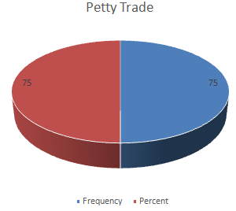

**Figure 1.1: Respondent’s Economic Activities**

**Source:** Field Survey 2015

Majority were petty traders. They were living from hand to mouth and found difficult to save for their housing loan repayment and development that of the community.

**1.3.3 Obstacles for Community Development at Muungano Housing Cooperative**

The survey found that people needed formal education, knowledge on entrepreneurship and capital for them to utilize available opportunities but short supply of the same was the major limiting factor for community development at Muungano Housing Cooperatives. Findings presented under sub-headings below and their analysis provides details of each constraint and how it acts as the limiting factor for community development.

**1.3.3.1 Lack of Formal Education**

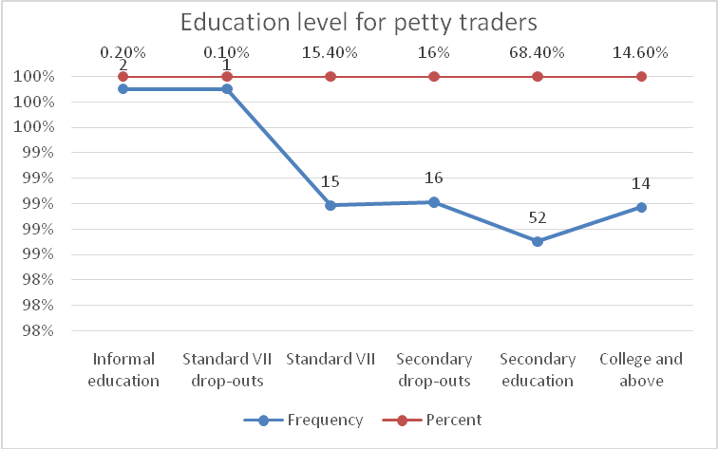

**Figure 1.2: Education Level for Petty Traders**

**Source**: Field Survey 2014

Among respondents who were petty traders, fifty respondents equal to fifty percent were standard VII levers. Twenty equal to twenty-six point six were form four leavers. Eleven equal to one point six percent of respondents were secondary school drop-outs. None of respondents who were subsistence farmers were secondary school or college leavers. Therefore, subsistence farming was found to associate with lower level of formal education. All thirteen commercial farmers attended formal education. Among them seven equal to fifty-three-point percent were secondary school leavers. Five equal to thirty-eight point five percent were college graduates. One equal to seven point seven percent was standard VII leaver. Commercial farming was found to associate with lower level of formal education.

**Table 1.3: Level of Education of Commercial Farmers**

| Level of education | Frequency | Percent |
| --- | --- | --- |
| Informal education | 0 | 0.0% |
| Standard VII drop-outs | 0 | 0.0% |
| Standard VII | 1 | 7.7% |
| Secondary drop-outs | 0 | 0.0% |
| Secondary education | 7 | 53.8% |
| College and above | 5 | 38.5% |

**Source**: Field Survey 2014

One hundred and nine of petty traders equal to seventy-three percent were standard VII leavers. Petty traders with informal education and who were standard VII drop-outs were fourteen each equal to nine percent a piece. Twelve equal to eight percent were secondary school drop-outs. One equal to one percent was secondary school leavers. Majority were standard VII leavers, standard VII drop-outs and those with informal education. Therefore, petty trading was found to associate with lower level of formal education.

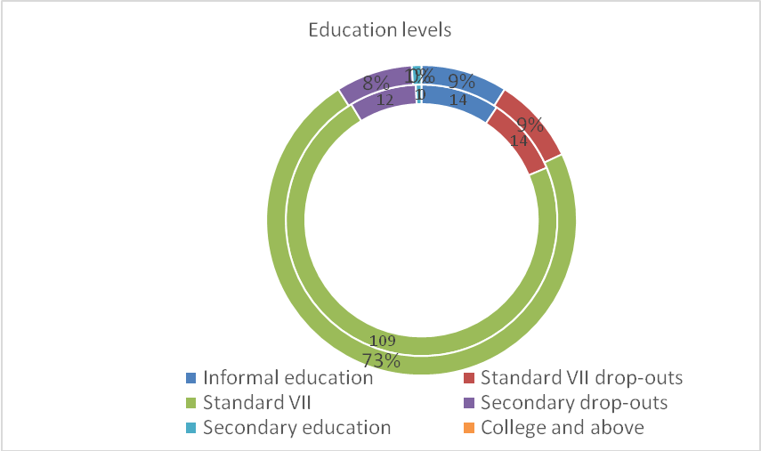

**Figure 1.3: Level of Education of Petty Traders**

**Source**: Field Survey 2014

Majority of SMEs managers were college graduates (12, 34%) and secondary school leavers (12, 34%). In the middle were standard seven leavers (6, 17%) and secondary school drop-outs (5, 14%). None had informal education or dropped out of standard VII.

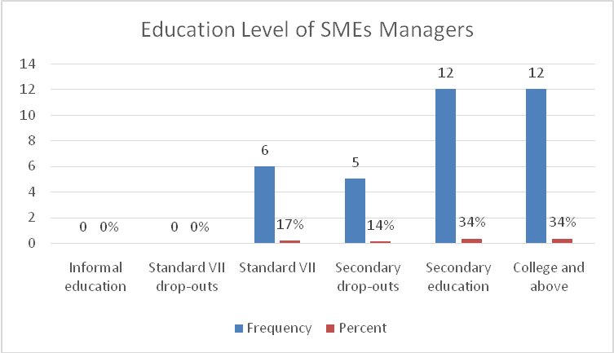

**Figure 1.4: Level of Education of SMEs Managers**

Majority of casual laborers had informal education (39, 36%), were standards VII drop-outs (52, 48%), standard VII leavers (12, 11%) and secondary school drop-outs (6, 6%). Neither was a secondary school leaver nor college graduate suggesting that casual laborers as a form of employment was associated with lower level of formal education.

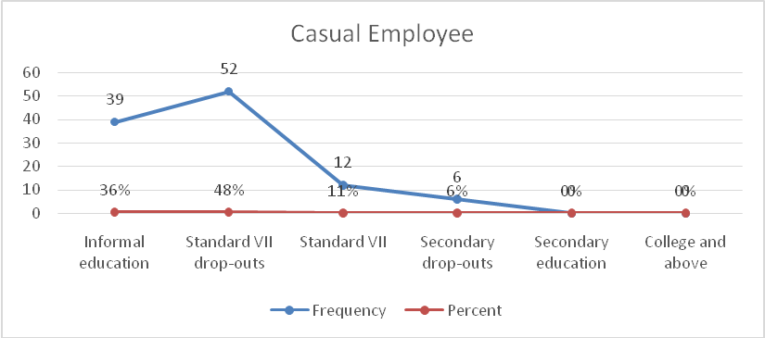

**Figure 1.5: Level of Education of Casual Employee**

**Source**: Field Survey 2014

**Figure 1.6: Level of Education of Respondents with Formal Employment**

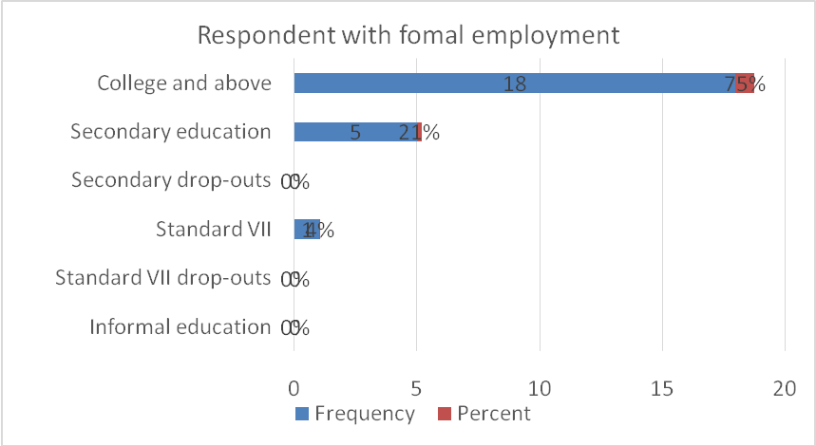

**Source**: Field Survey 2014

Majority of respondents with formal employment were college graduates (18, 75%), secondary school leavers (5, 21%) and standard VII (1, 4%). Formal employment was thus found to associate with higher level of formal education. The findings of this study suggest that education is one of determinants of high paying businesses, jobs and successful agriculture.

**1.3.3.2 Lack of Knowledge on Entrepreneurship**

Among one thousand thirty-one respondents, only forty equal to four percent had received training on entrepreneurship and were knowledgeable. The rest did not receive any training on entrepreneurship.

**1.3.3.3 Inadequate Land for Agriculture and Access to Agricultural Inputs**

All respondents equal to hundred percent agreed that land for agriculture was scarce at Chamazi as more land had been used for settlements this is due to urbanization. Also the urban planning act does not allow agriculture practice in urban.

**1.3.3.4 Lack of Capital**

All respondents equal to hundred percent considered lack of capital as one of the limiting factors in their engagement in business, agriculture and self-employment. Micro-finance ventures were a few and immature largely in forms of VICOBA. Commercial banks lent to people with collateral. Majority who afforded to provide collateral were relatively well-off.

**1.3.4 Recommendations to Minimize Obstacles and Maximize Opportunities for Community Development at Muungano Housing Cooperatives**

The survey revealed that SMEs, commercial farming and employment were more rewarding ventures among ventures identified by the community at Muungano.But, utilization of these ventures by the community waslargely constrained by lack of capital (especially SMEs and commercial farming), land (largely commercial farming), agricultural inputs (commercial farming), entrepreneurship (SMEs and commercial farming) and formal education (all commercial farming, SMEs and formal employment).

Fortunately; there were societal organizations and government programs that offered first-hand solutions to the identified problem. Such programs were in the forms of Agricultural Multi-Sectorial Cooperative Societies (AMCOS) for commercial farming, "Mpango wa Elimu ya Msing ikwa Waliokosa (MEMKWA) for formal education, Tanzania Social Action Fund (TASAF) providing entrepreneurship training and start-up capital for community development project targeting poor households, Village Community Banks (VICOBA) and Saving Credit Cooperative Societies (SACCOS) for capital generation.

As the problem and solution were already known, fostering community development at Luchingu needed to link the problem to intervention that was relevant, feasible and applicable. Relevant intervention is the one that addresses the problem that befalls the large part of the population and especially the vulnerable section of that particular population. In this particular survey, the large section of the population that is as well vulnerable is subsistence farmers, petty traders and casual laborers. Therefore, relevant intervention should target them. Intervention is feasible if it takes into consideration the complexity of the problem and the resources required to fix that problem. Locally available resources/ opportunities are thus more cherished because they are already there and are not to be fetched from elsewhere. In this particular survey, there are local arrangements in forms of VICOBA, AMCOS, MEMKWA, TASAF and SACCOS that can be used to fix gaps in capital, entrepreneurship, land access, agricultural inputs and formal education.

Intervention is applicable if it is the most likely to provide intended results of all its other alternative interventions given resource and management constraints as well as support it receives from the authorities/ financiers, group targeted by the project and administrators of that particular project. It is therefore important to Community Needs Prioritization involving important stakeholders in the project, namely; administrators, beneficiaries and financiers of the project in design, implementation and evaluation.

## 1.4 Community Needs Prioritization

Community Needs Prioritization targeted to identify priority need, appropriate intervention to address the need and mode of financing the intervention. Pair wise ranking method was used to rank all the need, intervention and mode of financing. The details of each ranking were as provided under appropriate sub-heading below.

**Table 1.4: Problem Prioritization**

| Problem | Low household income | Inadequate water supply | Inadequate health facilities | Inadequate School facilities | Poor Road network and transportation | Score | Rank |
| --- | --- | --- | --- | --- | --- | --- | --- |
| Low household income | Low household income | Low household income | Low household income | Low household income | Low household income | 5 | 1 |
| Inadequate and unsafe water supply |  | Inadequate and unsafe water supply | Inadequate health facilities | Inadequate School facilities | Inadequate health facilities | 2 | 3 |
| Inadequate health facilities |  |  | Inadequate health facility | Inadequate School facilities | Poor road network | 1 | 4 |
| Poor road network |  |  |  | Inadequate School facilities | Inadequate School facilities | 1 | 5 |
| Inadequate School facilities |  |  |  | Low household income | Poor road network | 4 | 2 |

### 1.4.1 Priority Problem

As it can be seen from table 1.5, low household’s income scored 4 as compared to the rest of the other problems and therefore it was the priority needs for Muungano Housing Cooperative. The second priority was inadequate school facilities and inadequate and unsafe water supply as it ranked 3.Poor road network1 while Poor road net work scored 1. From the problem prioritization below, the related issue for the Muungano Housing Cooperative is the low households’ income generation.

**Table 1.5: Priority Problem**

|  |  |  |
| --- | --- | --- |
| **Need** | **Score** | **Position** |
| Low household income | 45 | 1 |
| Inadequate and unsafe water supply | 15 | 3 |
| Inadequate health facilities | 10 | 4 |
| Poor road network | 10 | 5 |
| Inadequate School facilities | 20 | 2 |
| **Total** | **100** | **-** |

**Source**: Field Survey 2014

**1.4.2 Appropriate Intervention**

**Table 1.6: Appropriate Intervention as per Preferential Ranking**

|  |  |  |
| --- | --- | --- |
| **Intervention** | **Scores** | **Position** |
| Small Market business | 38 | **1** |
| Bricks Production | 17 | 3 |
| Poultry raising business | 29 | 2 |
| Sewing business | 10 | 4 |
| Min Supermarket | 6 | 5 |
| **Total** | **100** |  |

**Source**: Field Survey 2014

The appropriate intervention as per ranking was “small market business”. The actual scores and ranking were as provided in Table 1.6.

**1.4.3 Mode of Financing**

VICOBA was prioritized as the mode of financing the intervention. The details of the scores were as provided in Table 1.7.

**Table 1.7: Mode of Financing as per Preferential Ranking**

|  |  |  |
| --- | --- | --- |
| **Mode of financing** | **Scores** | **Position** |
| VICOBA | 42 | 1 |
| Government's support | 15 | 3 |
| Donor's support | 38 | 2 |
| SACCOS | 5 | 4 |
| **Total** | **1031** |  |

**Source**: Field Survey 2014

## 1.5 Chapter Conclusion

Community Needs Assessment reveals that there are opportunities for community development in forms of business, agriculture and employment opportunities at Muungano Housing Cooperative. Their current utilization is low as community members are constrained by inadequate capital and knowledge on entrepreneurship Muungano Housing Cooperative community through participatory needs assessment has Prioritized consumer marketing to establishment of Small and Medium Enterprises as the best option for them to diversify livelihood options for the community members since it is going to help people to involve in income generation through various entrepreneur activities in their perspective areas by the full utilization of available economic resources.

# CHAPTER TWO

# PROBLEM IDENTIFICATION

# 2.1 **Background to Research Problem**

Sub-Saharan Africa region is among of the world’s fastest growing populated region. The region has plentiful wealth of natural resources which could sustain the region’s growing population and helped fuel development if are well managed and utilized(Lelo and Makenzi, 2000, McKinley, 2005). However, the economic growth in Sub-Saharan Africa region has improved over the last 10-15 years, but has remained low and in last few decades has had the worst growth performance of any region in the world. This weak performance of their economies has led to extreme poverty and low investments (World Bank, 2006).

The livelihood of the majority of the population, which is mostly poor, is being threatened by cross-cutting issues particularly low income generation. Low income generation increases the vulnerability of poverty and off courses can lead to the escalation of extreme poverty in the community. (Guarcello, Lyon, Rosati and Valdivia, 2004). The path for poverty reduction among the people is clearly concerned with changing positively human welfare beings who are mesmerized into absolute poverty (Kakwani and Pernia, 2000)**.**Poverty reduction requires a combination of economic growth and a reduction in inequality (Okojie and Shimeles, 2006).

Unfortunately, scholars have indicated that both income and non-income inequalities are high in Sub-Saharan Africa region (Blackden, Canagarajah, Klasen, and Lawson, 2006) with the level of inequality lower in rural areas (Okojie and Shimeles, 2006). In the recognition of the problem, the world countries have agreed that the first Millennium Development Goal to be their leading motto to halve, by 2015, the proportion of the population who live in extreme poverty (United Nations, 2000). Also, every nation has accepted to initiate her own strategies for reducing extreme poverty for instance in Tanzania, there is National Strategy for Growth and Reduction of Poverty which aims at reducing poverty by 50% by the year 2010 (URT, 2007).

According to the 2011 Human Development Report about 1.7 billion people live in Multidimensional poverty, and the number of people living under the international poverty Line US$ 1.25 a day is estimated to be 1.3 billion people (UNDP 2011a). In Tanzania the number of people living under the international poverty line is almost 68%3. Tanzania is ranked 152 out of 187 countries in the Human Development Index 2011 and belongs to the countries with Low Human Development (UNDP 2011b). There are a number strategies and policies, both short-term and long-term, within the field of poverty reduction in Tanzania. UNDP Tanzania writes that the National Strategy for Growth and Reduction of Poverty (NSGRP) is “a second generation of Poverty Reduction Strategy” (UNDP Tanzania 2010)***,*** and that it compared to earlier strategies and policies focuses more on growth, governance and accountability.

The first National Strategy for Growth and Reduction of Poverty (NSGRP I), running between 2005/2006 stated that income poverty was reduced during the 1990s, but more in the urban than the rural areas and that women have been more disadvantaged in the rural areas. One of the actions it mentioned to reduce income poverty in rural areas was: At the moment the second National Strategy for Growth and Reduction of Poverty (NSGRP II) is running in Tanzania. It was published in year 2010 and is to be implemented before 2014/2015. Even though GDP grew about 7% annually during the period of NSGRP I it is stated in NSGRP II that not enough was achieved regarding reduction of income poverty between these years (URT 2010: vii-viii).

Compared to the first strategy, this second strategy”is oriented more towards growth and enhancement of productivity, with greater alignment of the interventions towards wealth creation as a way out of poverty” (URT 2010: ix) and SACCOS and VICOBA are mentioned within the financial sector that needs to be increased in order to create and enhance employment and empowerment, especially for women, youths and disadvantaged (URT 2010:57). The NSGRP II also points out the importance of agriculture in reducing poverty, since many of the poor in rural areas depend on it, and mentions MFIs and SACCOS among the ways to improve the access to agricultural financing (URT 2010:134).

The agricultural sector is important and dominated in the country’s economy. More than three quarters of the labour force is working within the agricultural sector and its share of the GDP is 28%5 (WB 2012). According to UNDP Tanzania the slow development of the agricultural sector is a challenge in reaching the first Millennium Development Goal (MDG), to eradicate extreme poverty and hunger. This is because the majority of the poor people in the country live in rural parts and they are mainly dependent on agriculture. One of the actions mentioned in order to increase people’s income is to increase the access to microcredit schemes (UNDP Tanzania 2010).

## 2.2 Problem Statement

Low income generation has been critical and persisting problem which face large population in Tanzania especially those live in rural areas where about 85% depending on small scale agriculture which is not sustainable because of dependent on rain seasons which is not reliable for their agricultural products thus led for them to generate enough income to support their lives. Tanzania government has been trying to develop various strategies to reduce poverty among communities such as establishment of microfinance intuition as Cooperatives, SACCOs and VICOBA so that community members to have loan, support and capital such effort has shown low impact towards community income generation due the fact that most of the members are those with low income.

While contribution of Cooperatives, VICOBA and SACCOs towards poverty alleviation has been well documented both theoretically and empirically, the existing literature largely ignores the contribution of community project investments so there is a need to initiate community project towards sustainability in community income generation in Tanzania.

### 2.3 Project Description

Community empowerment through initiating consumer marketing by establishing Small and Medium enterprises for the sustainable livelihood: the case of Muungano Housing Cooperativein Chamazi Ward- Temeke District at Dar es Salaam Region. This project aims to give the Muungano Housing Cooperative members capacity to generate more income, particularly in small economic group headed by community members, access to better Economic activities services.

It seeks to initiate consumer marketing by establishing Small and Medium enterprises, by providing these services along with socio-economic support. It aims to help 300 villagers from Muungano Housing Cooperative through entrepreneur programs and services, by increasing the knowledge and skills by local partners trained in evidence-based on Small Market Business. The project will increase income generation and engagement of the community members from Muungano Housing Cooperative.

### 2.3.1 Target Community

The project wishes to serve the Muungano Housing Cooperative especially from poor household in Muungano Housing Cooperative and secondary beneficiaries will be Muungano Housing Cooperative members at large. As the project initiated by the community themselves, the community will participate in the project activities as follows; manpower, volunteer in project activities, attending training, seminar and workshops, monitoring and evaluation of the project activities.

### 2.3.2 Stakeholders

Stakeholders and other targeted groups were participated actively during the preparation and implementation of the project. The project has the following major players: Council Community development department in Temeke district provides training on capacity building.

**Table 2.1: Stakeholders**

| **Stakeholder group** | **Role of the Stakeholder** | **Concerns of Stakeholder** | **Expectations**  **Of Stakeholder** |
| --- | --- | --- | --- |
| Individual | Community mobilization and sensitization,  -Monitoring the implementation of the  project activities, | Common understanding of the project objective,  - Imparted with skills e.g. monitoring skills. | Gain knowledge and skills,  - share experience |
| CBOs, FBOs | leadership,  - provide training and training materials  - Provision and facilitation the availability of soft loans.  - provision of Technical support,  - provision and facilitate availability of working tools,  - Financial support especially during the training.  - community mobilization and sensitization,  -Monitoring the implementation of the  project activities, | ensure the  effectiveness and  efficiency of the  project implementation,  -Tracking the progress of the project and pick the best practices, challenges and lesson learned.  - capacity building | Networking with other stakeholders,  -Increase Credibility and visibility.  - understanding the  Community |
| Government  Agencies | provide training and training materials  - Provision and facilitation the availability of soft loans.  - Provision of Technical support and registration of the group.  - facilitate the linkage with other organizations and institutions,  - Monitoring and evaluation of the implementation of the project activities. | Ensure and  facilitate smooth running of the project activities,  - Tracking the progress of the project and pick the best practices, challenges and lesson learned | Networking with other stakeholders, |

### Source: Field Data, 2019

### 2.3.3 Project Goals in Community Economic Development Terms

To support Muungano Housing Cooperative to increase income generation by involve them into socio economic activities through initiating Small Market Business as the one of method to intervene low income generation by using their economic groups (Cooperative Group).

### 2.3.4 Project Objectives

1. To mobilize community to participate on Small Market Business activities.
2. To facilitate Training for the trainers and community trainee’s member on techniques of small market business.
3. To mobilization raw materials for project implementation.
4. To implement Project phase one activities in the project sites

**2.4 Host Organization Profile**

### 2.4.1 Organization Profile

In 2009, the Muungano Housing Cooperative was established with 300 members where 25 are male and 275 are female. The group is situated in Chamazi aea at Chamazi ward in Temeke district about 19.5km from City Center. One of the main objectives of the group is to reduce poverty among member themselves through their own initiatives, joint efforts, time and resources. However, the group aims to improve the standard of living through community economic empowerment and participation which lead to employment creation, income – generation and skill transfer.

### 2.4.2 Organization Structure of the Host Organization

The organization structure is formed by member’s general assembly, board members that are formed by Chairman, Vice Chairman, Secretary and Treasurer. The structure shows the group office bearers who were elected in 2009 and according to group constitution handout, the new leaders would be elected in 2 years’ time. The general assembly is the annual member’s meetings and according to constitution the assembly would meet at the end of the year.

**2.3.3 Organization Mission**

To provide decent shelter, quality non holistic social services so as to improve the livelihood of Muungano Housing Cooperative in Chamazi through advocacy, capacity building, social presence and public private partnership.

**2.3.4 Organization Vision**

To ensure Muungano Housing Cooperative is becoming one of the strongest economic group among available economic groups and is in a position to cover wide geographical area in the promotion of affordable housing and socio economic activities in Chamazi community. The project will contribute to attaining Muungano Housing Cooperative which are well established, understand and aware of their responsibilities and value.

# CHAPTER THREE

# LITERATURE REVIEW

**3.1** Introduction

This chapter presents the review of theoretical and empirical literature review, policy review and summary of the chapter. The researcher discussed past research done on the topic and other related ones in order for the researcher to analyze, summary of, cite, and relate previous studies explicitly. This enabled the researcher to establish theoretical framework for the problem and to establish the significance project.

## 3.2 Theoretical Review

**3.2.1 Definition of Low Income Generation**

**Low Income** is the state or condition of having little or no money, goods or means of support condition of been poor, “poverty”. Therefore, low income generation refers to the state of an individual or community having incapability to produce workable or sufficient income to support their lives required basic needs such as food, shelter, medical care and safety. (Free dictionary). Paul Ryan (2012) Poverty is structural phenomenon: On this view, people are in poverty because they find themselves in condition in the economic systems that deliver them inadequate income. Because individual lives are dynamic, people don't sit in those conditions forever.

One year they are in a low-income hole, but the next year they've found a job or gotten a promotion, and aren't anymore. But that hole that they were in last year doesn't go away. Others inevitably find themselves in that hole because it is a persistent defect in the economic structure. It follows from this that impoverished people are not the same people every year. It follows further that the only way to reduce poverty is to alter the economic structure so as to reduce the number of low-income holes in it. (www.demos.org visited on April 2015)

**3.2.2 Structure of Poverty Perspective**

Much of the literature on poverty now suggests that the economic system is structured in such a way that poor people fall behind regardless of how competent they may be. Partly the problem is the fact that minimum wages do not allow single mothers or their families to be economically self-sufficient (Jencks 1996:72). The problem of the working poor is increasingly seen as a wage problem linked to structural barriers preventing poor families from getting better jobs, complicated by limited numbers of jobs near workers and lack of growth in sectors supporting lower skilled jobs (Tobin 1994). Interestingly research is showing that the availability of jobs to low income people is about the same as it has been, but wages workers can expect from these jobs have fallen.

Fringe benefits including health care and promotions have also become scarce for low skilled workers. These and related economic changes documented by Blank (1997) and Quigley (2003) show the way the system has created increasingly difficult problems for those who want to work. Poverty is a large and multifaceted set of explanations that focus on the individual as responsible for their poverty situation. Typically, politically conservative theoreticians blame individuals in poverty for creating their own problems, and argue that with harder work and better choices the poor could have avoided their problems. Other variations of the individual theory of poverty ascribe poverty to lack of genetic qualities such as intelligence that are not so easily reversed. The belief that poverty stems from individual deficiencies is old. Religious doctrine that equated wealth with the favor of God was central to the Protestant reformation (Weber 2001). And blind, crippled, or deformed people were believed to be punished by God for either their or their parents’ sins.

Gwartney and McCaleb (1985: 7) In a Cato Journal article argue that the years of the war on poverty actually increased poverty among working age adults in spite of unprecedented increases in welfare expenditures. The economic theory that the poor lack incentives for improving their own conditions is a recurrent theme in articles that blame the welfare system’s generosity on the perpetuation of poverty. They conclude that “the application of simple economic theory” suggests that the problem lies in the war on poverty programs. They have introduced a perverse incentive structure, one that penalizes self-improvement and protects individuals against the consequences of their own bad choices.

**3.2.3 Cumulative and Cyclical Interdependencies Theory**

Jonathan Sher (1977) define poverty clearly in a book on rural education which focus on the cycle by which education and employment at the community and individual level interact to create a spiral of disinvestment and decline, while in advancing communities the same factors contribute to growth and well-being. For example, at the community level, a lack of employment opportunities leads to out migration, closing retail stores, and declining local tax revenues, which leads to deterioration of the schools, which leads to poorly trained workers, leading firms not to be able to utilize cutting edge technology and to the inability to recruit new firms to the area, which leads back to a greater lack of employment. This cycle also repeats itself at the individual level. The lack of employment leads to lack of consumption and spending due to inadequate incomes, and to inadequate savings, which means that individuals can not invest in training, and individuals also lack the ability to invest in businesses or to start their own businesses, which leads to lack of expansion, erosion of markets, and disinvestment, all of which contribute back to more inadequate community opportunities.

Health problems and the inability to afford preventive medicine, a good diet, and a healthy living environments become reasons the poor fall further behind. The cycle of poverty also means that people who lack ample income fail to invest in their children’s education, the children do not learn as well in poor quality schools and they fall further behind when they go to get jobs. They also are vulnerable to illness and poor medical care. Helping poor people achieve “self-sufficiency” is an increasingly significant phase in poverty reduction. While called various names, the emphasis is on providing both “deep and wide” supports and services for people. A full step from poverty requires six interdependent elements (Income and economic assets Education and skills, Housing and surroundings (safe, attractive), Access to healthcare and other needed social services, Close personal ties, as well as networks to others, Personal resourcefulness and leadership abilities.) of self-sufficiency that can be identified and tracked (Miller et al, 2004).

A key piece of this comprehensive approach to helping individuals from poverty is that there is no way the public can do all of this for every person without first increasing social capital among communities or subcultures of the poor. Miller has a strong belief that strong interpersonal ties as in villages or organized groups can provide shared assistance that professionals cannot. The key is helping groups of poor people build supportive communities with shared trust and mutuality. This program consciously seeks the benefits of building social capital based on ‘affinity groups’ where people share common interests from their ethnicity, religion, family history, living area, or other sources of friendship.

## 3.3 Empirical Literature Review

Community development practice, implanted in decades of welfare and social policy, frequently deals with programs aiming to reduce poverty based on individual deficiency theories. Explicitly or implicitly, individual deficiencies have been an easy policy approach not always carefully explored as they get implemented. The key initiatives today are to push poor into work as a primary goal, what Maskovsky calls the “workist consensus.” Indeed, this move is accompanied by an increasing emphasis on “self-help” strategies for the poor to pull themselves from poverty, strategies encouraged by the elimination of other forms of assistance (Maskovsky, 2001:472-3).Earned income tax credits are one aspect of the strategy to assure that the poor work even at below living-wage jobs.

However, from a community development perspective, addressing poverty by focusing on individual characteristics and bad choices raise fundamental conflicts in philosophy and in what is known to succeed. The compassion of community development shies away from blaming the individual, and individual level programs are usually embedded in community efforts by the very nature of community development. Thus, anti-poverty programs in community development tend to oppose strategies that punish or try to change individuals as a solution to poverty, though working with individual needs and abilities is a constant objective. This tension runs through all anti-poverty programs.

**3.3.1 Income Generation**

The Meaning of Income Generation Income generation takes many forms. Originally it was a term used only by economists to explain the details of a nation’s economy. However, it is now quite widely used to cover a range of productive activities by people in the community. Income generation simply means gaining or increasing income. There are three ways income can be generated. Firstly, income generation does not always mean the immediate getting of money, although in the end we use money to place a measurable value on the goods and services people produce. An example of income generation which does not lead to getting money would be a situation where a productive person produces enough food to feed him or her and the family.

Skills have been used to meet immediate needs and thus savings have been achieved. A money value can be placed on the food produced and so the food can be seen as income. A second way a person can generate income is by astute investment of existing resources. An example would be development of a piece of land through planting a crop for sale. The money gained is income. An indirect form of investment is to bank savings or to purchase part ownership (shares) in a productive enterprise such as a business. Money generated from such investments is income. A third way to generate income is for people to use their skills by serving another person who pays for the use of those skills. (UNESCO 1993)

**3.3.2 The Review on Housing Cooperatives**

Housing co-operatives defined as “any form of organization and action in which small or large groups of people undertake co-operatively to obtain housing to be owned by those who occupy it, is a new phenomenon in Ethiopia. In the rural areas of the country, there exists a traditional mutual aid scheme whereby the people work jointly to assist one of their members build his/her own house. Such schemes are locally known as “debo”. In urban areas, such “debo” type of mutual aid schemes did not exist and in their place, other traditional mutual aid associations such as “idir:, “iquib” and “mahber” formed for the purpose of catering ofr the general welfare of members prevail.

The absence of housing as one of these associations’ undertakings may be attributed to the land holding system that prevailed before the 1974 popular revolution. Prior to this date, most of the urban lands and houses in the country were owned or controlled by a few aristocrats, landlords, high government officials and wealthy businessmen. The 1974 revolution changed dramatically the economic, social and political relationships that existed in the country. Proclamation No. 47 of July 1975 which nationalized urban land and extra houses heralded a new era in the building industry. The housing co-operative movement in Ethiopia is therefore closely linked up with the post 1974 era of the Ethiopian Revolution.

*X united Nations Development of Economic and Social Affairs, Non-profit Housing Organizations ESA/OTC/SEM/75/2, New York, 1975 p. 69.*

In an incisive article, Elster (1989) raised an interesting paradox for cooperatives in general: if cooperative ownership is so desirable, why there are so few cooperatives? He argued that the internal collective action problems of cooperatives are not insurmountable. Rather, according to him, cooperatives face institutional constraints in a capitalist context. Cooperatives are not preferred and they are discriminated against in a capitalist economy. They need to swim against the tide to survive in such an economy. Does Elster’s paradox apply to housing cooperatives? Extant empirical studies provide two sets of explanations. First, like Elster, Marxis to critiques focus on the political economy of the state and the consequent institutional context.

Chouinard (1989; 1990a; 1990b), for example, emphasizes the uneven development of the capitalist state in Canada. She argues that the growth of housing cooperatives is contingent on the politics of class struggles. Second, agency theorists emphasize the internal collective action problems endemic to housing cooperatives. For example, Hansmann (1991) focuses on transactional efﬁciency and Williams (1993) focuses on agency issues in their analyses of condominiums and cooperatives vis-à-vis rentals in the United States. Goodman and Goodman (1997) argue that cooperatives entail greater risk sharing, ﬁnancing costs and search costs as compared to condominiums; hence, housing cooperatives are fewer in number than condominiums.366 Sukumar Ganapati. International Journal of Urban and Regional Research 34.2 © 2010 The Author. Journal Compilation © 2010 Joint Editors and Blackwell Publishing Ltd.

Applying Elster’s paradox to Sweden, Bengtsson (1999) observes that the country represents a deviant case of successful growth of housing cooperatives. However, a single country study does not fully resolve Elster’s paradox. Sweden’s deviancy would be known only if it were compared to other countries. As Bengtsson (1999: 273) himself admits, ‘comparative historical research on the interaction between co-operative organizations and their environment’ is required to better understand Elster’s paradox. Yet, despite the long history of cooperatives internationally, there is no such cross country study of the institutional conditions in which housing cooperatives have evolved. The present article aims to ﬁll this gap. I chose two countries in addition to Sweden for the comparative analysis: India and the United States.

Several similar and contrasting features of the three countries inﬂuenced the choice. First, housing cooperatives have had a long history in all three countries, as they emerged in the context of a post-ﬁrst-world-war urban housing crisis. Second, while Sweden is a small European country, India and the United States are large countries that have tried to draw lessons from it. Third, to examine Elster’s paradox, it would be useful to consider countries representing a continuum in the political economic spectrum. Sweden’s social democracy is in-between India’s democratic socialism and the United States’ advanced capitalism. Social democracy refers to the ‘substantive historical process of modifying and shaping market patterns’; democratic socialism refers to the outcome of ‘social command of capital’; and advanced capitalism refers to private control of capital (Katznelson, 1978: 77, emphasis in the original).

In Esping Anderson’s (1990) model of welfare state regimes, India can be categorized as a ‘corporatist’ welfare state (where the state is ready to displace the market as a welfare provider), whereas Sweden is a ‘social democratic’ welfare state (which promotes equality and beneﬁts accrue across the board) and the United States is a ‘liberal’welfare state (where beneﬁts accrue to speciﬁc clientele based on means). Interestingly, housing cooperatives had gained prominence in major urban areas of all three countries during the interwar period. However, after the second world war, housing cooperatives grew phenomenally in Sweden and India, but had limited growth in the United States. Hence, the central question is: Why did housing cooperatives grow signiﬁcantly in Sweden and India, and not in the United States?

**3.3.3 Review of Studies done in Tanzania**

The Tanzania’s PRSP (URT, 2000) defines poverty to include “income” and “non income” human development attributes. Income poverty refers to lack of minimum income that is required to sustain a person’s basic needs of food, shelter and clothing. Income Poverty is described to be: largely a rural phenomenon, a factor of subsistence agriculture where the poor are concentrated, also widespread and increasing in urban communities, afflicting more intensely the youth, the elderly and persons in large households, having different impacts between men and women; while female-headed households are not necessarily poorer than male-headed households, women are generally perceived to be poorer than men. Non-income poverty on the other side is a function of access to livelihood enhancing factors including aspects of social services like access to education, health, nutrition, clean and safe drinking water, social wellbeing and vulnerability to diseases.

**3.3.4 Review of Studies Done Outside Tanzania**

Empirical evidences on diversification of income sources in rural areas have been shown by various authors. For example, Ellis (2005) found that in sub-Saharan Africa, a range of 30% to 50% reliance on non-farm income sources is common; but it may attain 80% to 90% in southern Africa. He also states that in south Asia, on average roughly 60% of rural households’ incomes are from non-farm sources. However, this proportion varies widely between, for example, landless households and those with access to land for farming. In sub-Saharan Africa reliance on agriculture tends to diminish continuously as income levels rise, i.e. the more diverse the income portfolio, the better-off is the rural household. (Barrett et al. (2001) and Davis et al. (2010)

Income Generation interventions attempt to address poverty, unemployment, and lack of economic op­portunities to increase participants’ ability to gener­ate income and secure livelihoods. These interventions can take a wide variety of forms, including microcredit programs that provide small loans to individuals or groups who would not normally qualify for loans from conventional financial institutions. Microcredit is one form of microfinance, which involves the provision of a wider range of financial services, such as access to sav­ings, credit, and insurance to poor people.

In addition to microcredit, other income generation interventions focus on business and vocational skills training for par­ticipants, either for positions within existing industries or to develop small businesses of their own. Both mi­crocredit and vocational skills training programs may include additional components not related to income generation, such as health education, women’s em­powerment, critical thinking, and communication skills. Many also have strong social support components. (Kennedy et al 2004).

**3.3.5 National Strategy for Growth and Reduction of Poverty**

At the moment the second National Strategy for Growth and Reduction of Poverty (NSGRP II) is running in Tanzania. It was published in year 2010 and is to be implemented before 2014/2015. Even though GDP grew about 7% annually during the period of NSGRP I it is stated in NSGRP II that not enough was achieved regarding reduction of income poverty between these years (URT 2010). Compared to the first strategy, this second strategy is oriented more towards growth and enhancement of productivity, with greater alignment of the interventions towards wealth creation as a way out of poverty” (URT 2010) and SACCOS and VICOBA are mentioned within the financial sector that needs to be increased in order to create and enhance employment and empowerment, especially for women, youths and disadvantaged (URT 2010:57).

The NSGRP II also points out the importance of agriculture in reducing poverty, since many of the poor in rural areas depend on it, and mentions MFIs and SACCOS among the ways to improve the access to agricultural financing (URT 2010:134). The agricultural sector is important and dominated in the country’s economy. More than three quarters4 of the labor force is working within the agricultural sector and its share of the GDP is 28% (World Bank report 2012).

According to UNDP Tanzania the slow development of the agricultural sector is a challenge in reaching the first Millennium Development Goal (MDG), to eradicate extreme poverty and hunger. This is because the majority of the poor people in the country live in rural parts and they are mainly dependent on agriculture. One of the actions mentioned in order to increase people’s income is to increase the access to microcredit schemes (UNDP Tanzania 2010). Deaton (2004) considers the lack of income or consumption as one aspect of poverty, while other aspects of poverty include lack of access to education and exclusion from political participation.

According to Sen (1999), poverty needs to be considered more broadly than inadequacy of income. He argues that poverty is the absence of one or more of the basic capabilities that are needed to achieve minimal functioning in the society in which one lives. These include not having enough income to ensure being adequately fed, clothed, or sheltered (income poverty) or being unhealthy (health poverty), as well as being denied access to education, political participation, or a full role in society.

**3.4 Policy Review**

Policy implications discussed below are geared towards analyzing how relevant policies promote Housing Cooperatives as essential vehicles for poor households‟ access to decent housing. Policies discussed include the cooperative development policy (2002), Poverty Eradication Strategy (1998), the Nation Development Vision (2025) and the Human Settlement Development Policy (2000). Housing Cooperatives in the Context of Cooperative Development Policy (2002) The Cooperative Development Policy (2002) highlights the main constraints facing cooperative development in the country as; inability of the cooperatives to operate under liberalised economy due to weak structural and financial positions, weak institutional management, misappropriation of resources and political intervention (URT, 2002: 2-3). Therefore, the present situation on the level of operations of most housing cooperatives is largely associated with these major factors.

The Cooperative Development Policy envisions having a cooperative system that is geared towards improved and sustainable cooperatives that are capable of fulfilling members‟ economic and social needs (ibid). Section 2.4 of the Policy identifies the bias on marketing and agricultural sectors with little emphasis to other sectors housing being one of them. In view of this weakness, the policy provides for the government to encourage establishment of cooperatives in other sectors. Similarly, section 4.0 provides for structural framework of the cooperative movement. The policy statement emphasizes on the autonomy of primary societies to establishing flexible horizontal and vertical structures that ore economically viable**.**

**Housing Cooperatives in the Context of the Tanzania Development Vision 2025** The fivebasic issues that have been enunciated in the Tanzania Development vision (2025) include high quality livelihood; peace, stability and unity; good governance; a well-educated and learning society and competitive economy capable of producing sustainable growth and shared benefits (URT, 1999:2-3). Of direct relation with Housing Cooperative Projects is the quality of livelihood. Under this issue, the national vision is to achieve people – centred development based on sustainable and shared growth that is free from abject poverty. This vision focuses on creating wealth and its distribution among the society in which racial and gender imbalances are addressed.

Emerging from the four Housing Cooperative Societies is essentially an asset building process (housing) that is centred on the people – the cooperative members. A 50-50 men and women membership pattern in Nala Makazi is a clear manifestation that this cooperative society is non-gender biased and attempts to redress gender imbalances that has prevailed in other sectors for a long time. Where women are empowered in equal terms as men is a success story that policy makers and development agents will need to emulate in other developmental projects and programmes. Nala Makazi is such an example that has shown the way and there are a lot more to learn from this Housing Cooperative Society.

On the issue of education and learning society, the vision endeavours to build a nation whose people have positive mindset and culture of hard work, entrepreneurship, innovativeness and creativity, community spirit that is balanced with individual initiative (URT, 1999:5). Despite the fact that not much in terms of physical development has been achieved in Nala Makazi, the establishment, operations and community spirits and innovations that have been developed by this Housing Cooperative are worth emulating in other communities. The establishment of local financing mechanisms and resource mobilization by the Nala Makazi is quite consistent with this vision. The challenge to the government is how such initiatives and innovations can be supported to realise a wide–embracing coverage as a strategy to achieving the vision. Housing Cooperatives in the Context of the National Poverty Reduction Strategy (1998)

One of the indicators of poverty as highlighted in the National Poverty Reduction Strategy (1998) is poor quality houses. It has been stated that while by 1995 about 70% of the population in Dar es Salaam lived in squatter settlements, the same rate (70%) applied for Arusha and Mbeya municipalities. Pertinent to the causes of poverty that relates to cooperative societies, this paper indicates that erosion of democratic institutions and marginalization of people such as local councils and cooperatives denied the participation of the people in the management of the economy and their contribution to development activities (URT, 1998). Emily P, at al (2014) contends that, income and services impede families access to decent, safe and affordable housing.

In addressing the issue of decent housing for all as one of the strategies for poverty eradication, the government underscores the need to support people’s initiatives to establish and strengthen local cooperatives. Despite these renewed strategies, presently very little is being done to en-liven the collapsed Housing Cooperatives of the 1970s and 1980s. Housing as an important component of the cooperative movement and restructuring does not seem to emerge prominently from this end. Emphasis has for many years centered on agricultural and marketing cooperatives. To date, there is no umbrella organ that coordinates housing cooperatives at city and town levels. In Kenya for example, the National Cooperative Housing Union (NACHU) was established in 1978 as an apex organization that unites the Nguluma Huba Kenyan Primary Housing Cooperatives (UNHS, 2003:11). The need for establishing an apex housing cooperative is therefore calling as a strategy towards operationalizing recommendations raised in the poverty eradication strategy paper.

However, the establishment of such a society ought to be bottom up, free from government influence and should not constitute a burden to secondary and primary societies in terms of operations as stipulated in the Cooperative Development Policy (2002). Housing Cooperatives in the Human Settlements Development Policy (2000) Human Settlement Development policy recognizes the role played and potentials inherent in housing cooperatives and other organized groups. This policy further acknowledges the diminishing trend in terms of housing cooperatives contributions in the provision of decent housing to low income earners.

Further, the policy cites the causes to this trend as the lack of clear policy on how housing cooperatives should operate and lack of implementation structure which could ensure accountability. Another obstacle has been cited as the centralization of the cooperative movement. In order to address these issues, the policy provides for the following statements. Promote, support, and encourage the development of housing through cooperatives, CBOs, NGOs, and building societies. • Initiate research to establish reasons for the poor performance of organized groups in housing production with a view to find out how best to support and assist those groups. • Review the institutional set-up for preventing cooperative housing so as to involve more the cooperative unions and local authorities. Besides, these statements, the policy further provides for the strategies to facilitate realization of these statements.

Some of these strategies included; encouraging formation of CBOs, NGOs in areas where people have already shown interest of developing their housing, educate people of building technologies, government to make building plots available, make housing credit facilities available and training in elementary book keeping and administration (URT, 2000). While it is notable that the government partly played its role in such aspects as making plots available, to the large extent it has not lived to the expectation of these policy statements and strategies. It is more than ten years since when the only housing financing institution collapsed (THB) in 1995. Virtually there have been no efforts to establish alternative housing financing institution to date. While the Nala Makazi has been struggling to solicit housing finance from their own means, there has been little support from the government to spearhead these initiatives apart from allocation of unserviced plots to the members. Members under phase III of Sigara Housing Cooperative were not successful in acquiring surveyed plots. They were compelled to mobilise own resources to pay for the compensation and survey costs in Yombo Vituka area in Dar es Salaam.

Infrastructure services were not provided. These examples show that the government is yet to play its role and input required to support housing cooperatives as stipulated in this policy. Compounded with the macro-economic changes and the limited governments‟ role in the housing cooperative projects, members in these societies continue to navigate through with many difficulties. There is therefore a need for the government to specifically and clearly state as to how these policy statements can be operationalised by for example developing programmes to support grassroot housing projects.

Legally, MFIs in Tanzania are not allowed to mobilize savings but many of the NGO-MFIs engage in the mobilization of “savings” in the guise of “loan insurance funds”. All provide loans to ongoing businesses and only very few provide start-up capital. None of them directly provide loans for other purposes such as consumption, education or health. Some provide credit to women only. In any case, some 77% of all the loans from NGO-MFls are received by women (J.M.L Kilonde, 2002). In order to put into operation microfinance, the need for having guiding framework is essential. To this effect, in Tanzania the National Microfinance policy was established in the year 2000 in order to guide the establishment and operations of Micro finance institutions (The National Microfinance Policy in 2000).

**3.4.1 Promoters of Income Generating Groups**

Many development projects are increasing facilitating the formation of these groups. For example, Lema and Kapange (2006) state that agricultural development projects have acted as catalysts toward formation and working with groups in various ways, often building on indigenous, mostly informal village producers’ groups. It is increasingly the policy and practice of district development service providers to work with groups. At national level, various policy documents on promotion of community based groups or socioeconomic groups are available. They include: Cooperative Development Policy (1996), Community Development Policy (1996), Agriculture and Livestock Policy (1997), and Agricultural Sector Development Strategy (2001).

According to the National Micro-Finance policy among other things the importance of microfinance in Tanzania has increased due to the following reasons:

1. The majority of Tanzanians, whose incomes are very low, access to financial services offers the possibility of managing scarce household and enterprise resources more efficiently, protection against risks, provision for the future, and taking advantage of investment opportunity etc.
2. Savings services from the MFIs benefits the low-income people.
3. Credit services can perform as the same as savings and can help some enterprises and families to make some important investment.
4. To reduce the increasing poverty this is prevalent in the rural and urban settings.
5. It addresses the financial needs of major sector of Tanzanian population.

The operation of microfinance in form of SACCOS is made under the Cooperative Societies Act, 2003 which became operational in February, 2004. The Act provides for the formation, making a constitution, registration and operation of cooperative societies and for other matters incidental to or otherwise connected with those purposes. A credit society means a registered society whose principal objects are to encourage thrift among its members and to create a source of credit to its members at fair and reasonable rate of interest. The Registrar of cooperatives may register financial cooperatives, microfinance institutions, and cooperative banks whose primary activities are to mobilize savings and furnish secured and unsecured loans or credit to households, smallholder producers and market entrepreneur, micro-enterprises in rural and urban areas (Cooperative Societies Act 2003 section 22b).

## 3.5 Review Summary

From the discussion in theoretical, empirical and policy literature reviews, most of the authors and researchers insisted on the significant need of microfinance as a key tool to those employed in informal sector for poverty reduction. However, access to credit by itself is not enough to solve the problem of poverty through informal sector rather create a relief towards poverty alleviation. Now due to the fact that establishment Housing Cooperatives projects envisaged the same goals and objectives it is important to assess the contribution of Cooperatives sustainability on whether there is significance change to community economy empowerment towards income poverty eradication at the grassroots level.

# CHAPTER FOUR

# PROJECT IMPLEMENTATION

## 4.1 Introduction

This section is about project implementation. It covers the planned project activities and actual implementation to date. It also shows the comprehensive project proposal including the planned project activities and its actual cost.

### 4.2 Products and Outputs

The project aims to initiate the small market business by staring with small products and small market facility available at the area which are able to accommodate the community surrounding the Muungano Housing Cooperative. The Market is able to take commodity which are must needed by the community which will be sold cheaper in the competing market at Chamazi area and other place near Chamazi ward. The following isthe Market facility available at Muungano Housing Cooperative

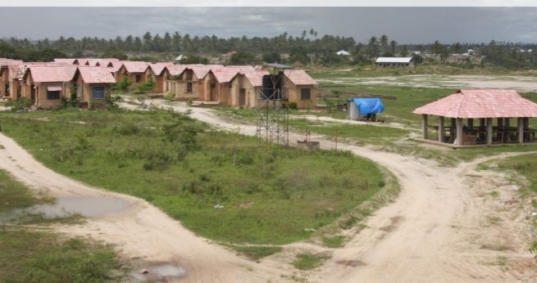

**Figure 4.1: Houses and Market Place in Muungano Housing Cooperatives in Chamazi – Temeke Dar es salaam**

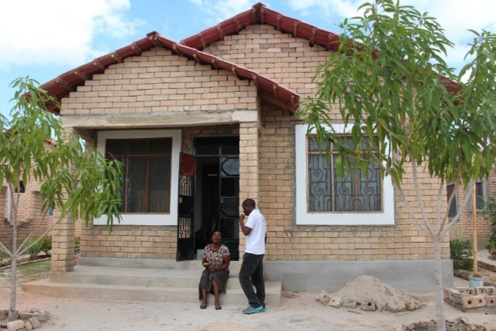

**Figure 4.2: One of the Houses owner Rose Liheta**

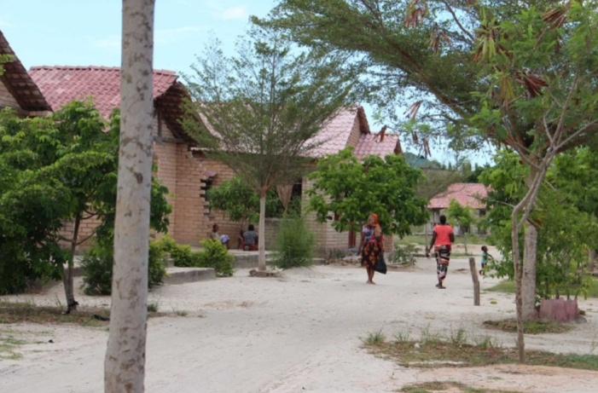

**Figure 4.3: Streets in Chamazi Houses**

## Project Planning

## Table 4.1: Project Planning

| **Phase** | **Activity** | **Intervention** | | **Participants** |
| --- | --- | --- | --- | --- |
| **Planning** | Registration of members | Agreement | | Community members |
| Provision of skills and knowledge on cement brick production | train | |
| Selection of site location center | Discussion and field survey on where to be centers for project implementation | | |
| **Implementation** | Provision of Market facilities; for community members | Compilation of list of working tools | 1. Accumulation of lists of commodities. 2. Finalization of Market area to be used. |  |
| Provision of basic commodities to be sold | Selling commodities |  |  |
| Skill up gradation (Small Market Business advanced techniques and management) | To delegate persons for training at Small Market Business advanced techniques. | Training on use management of small capital for business | Selected community members to be trained. |
| **Operations** | Provision of raw material | Required for Construction of Market. | 1. Collection of timber, sand, cements water and other materials needed 2. Sensitization of community members workers about project benefits |  |
| Stakeholders to be advocated and lobbed | Supportive material resource contribution from stakeholders | Contributing capital to run the Small Market Business.  Monitoring the project | Community and stakeholders |
| Equipping project members with skill and knowledge on Small Market Business for a longer period (up to 150 days/ year). | Operating the training and continuous monitoring and evaluation | Technology support | Support to the project implementation for longer operations. |
| Skill up gradation (small market business advanced techniques with and management) | Investing in selective Business techniques. | Education support |  |

**Source:** Research Findings, 2019

### Community Benefits Plan

**Table 4.2: Community Benefits Plan**

| **Benefit** | **Beneficiaries** | **Locations** | **Time Period** |
| --- | --- | --- | --- |
| i. Increase of household income | Muungano Housing Cooperative members | At Chamazi area | July 2019 onwards |
| ii. Provision of basic techniques, skill and knowledge on Small Market Business. | Muungano Housing Cooperative members | At Chamazi area | July 2019 onwards |
| iii. Market Facilities | Muungano Housing Cooperative members | At Chamazi area | July 2019 onwards |
| iv.Self-Employment opportunity | Muungano Housing Cooperative members | At Chamazi area | July 2019 onwards |
| v.Availability of basic domestic commodities | Muungano Housing Cooperative members | At Chamazi area | July 2019 onwards |

### 4.3.2 Implementation Plan

**Table 4.3: Logical Framework Analysis Matrix**

|  |  |  |  |  |  |  |  |
| --- | --- | --- | --- | --- | --- | --- | --- |
| **Objective 1: To mobilize community to participate on cement bricks production activities** | | | | | | | |
| **Outputs** | | **Activities** | **Indicators** | **Methods of Verification** | **Responsible** | | **Assumption** |
| 1.1: 300 total of the Muuungano Housing Cooperative members attended the cooperative meetings | | To conduct community awareness | List of attendant attended the cooperative meetings | respondent number in the register | ChamaziCommunity leaders members, community development officers & CED student | | community members willingness and interest to be organized |
| 1.2. one week advocacy meeting conducted | | To conduct Small Market Business advertisement | at least basic commodities to be in place | field and expert report | Project coordinator, community members and CED student. | | community member would be participate in advertisement |
| **Objective 2: To facilitate Training for the trainers and community trainees member on techniques of cement bricks making** | | | | | | | |
| **Outputs** | **Activities** | | **Indicators** | **Methods of Verification** | **Responsible** | **Assumption** | |
| Train for trainers of the trainees and two weeks training for community members | 1. To conduct training for the 10 community trainers | | Training report list of participants | trainer report | Project manager CED student & Muungano Housing Cooperative members | community member will active participate | |
| 2. To facilitate training for the community members | | Training report list of participants |
| **Objective 3: To mobilization Raw materials** | | | | | | | |
| **Outputs** | **Activities** | | **Indicators** | **Methods of Verification** | **Responsible** | **Assumption** | |
| 1. different commodities were collected | 1.To prepare market area for implementation | | Commodities available to the Market place. | The number of market commodities available | community members and project manager | positive collaboration between stakeholders and community members | |
| 2.To put commodities to the market place. | |
| **Objective 4: To implement Project phase one activities** | | | | | | | |
| **Outputs** | **Activities** | | **Indicators** | **Methods of Verification** | **Responsible** | **Assumption** | |
| About basic Commodities available to the Market Place | To sell more commodities to the community surrounding. | | Number of the commodities to be sold to the surrounding community | field visit report | Project manager CED student &Muungano Housing Cooperative members | Market commodities would sell accordingly | |

**Source**: Field Data, 2019

### 4.3.4 Inputs

|  |  |  |  |
| --- | --- | --- | --- |
| S/N | Type of inputs | quantity | Cost/Unit |
| 1 | Sand | 40 tons | 200000 |
| 2 | Water | 200,000 | 200 |
| 3 | Cements | 430 bags | 16,000 |
| 4 | Truck/ transport | 1truck | 40,000 |
| 5 | Manpower | 10 | 256,200 |

**Table 4.3: Projects Inputs**

**Source**: Research Findings, 2019

The project aims to produce the various bricks types by using simple technology where there is use of sand, water, cements and small brick machines, trains, funds, manpower, truck

### 4.3.5 Staffing Pattern

The project was conducted under the Muungano Housing Cooperative members where people with various qualifications such as skills and knowledge on Small Market Business and those with ability and willingness to learn and support was involved. The project will be carried out for Muungano Housing Cooperative with the whole of Muungano Housing Cooperative members.

### 4.3.6 Project Budget

**Table 4.4: Projects Budget**

|  |  |  |  |  |  |
| --- | --- | --- | --- | --- | --- |
| **s/n** | **Activity** | **Activity description** | **Quantity** | **Unity coast** | **total cost(Tsh)** |
| 1 | training | conducting train for community members | 300 | 12,000 | 6,000,000 |
| 2 | transport | Truck | 1 | 1,000,000 | 1,000,000 |
| 3 | raw materials | Water | 10,000 | 200 | 2,000,000 |
| sand(tons) | 40 | 100,000 | 4,000,000 |
| cement bags | 430 | 16,000 | 6,880,000 |
|  | **Total** |  | | | **19,880,000** |

**Source**: Research Findings, 2019

### Project Implementation

### Table 4.5: Project Implementation

| **Activity** | **Stepwise Implimentation** | **Resources** |
| --- | --- | --- |
| 1. Community mobilization | Creation of awareness on the significant of small market project for increase of community income generation | 1. Muungano Housing Cooperative meetings (cooperative members will be sensitized on the importance of them to engage on the project as a part to let them to increase their income generation hence rise of their community development) 2. Leaflets (providing education/knowledge on how to do the business process 3. Funds (to support meeting costs such as community advertisement, entertainments |
| 1. Training | 1. Conducting training to trainers of trainees | 1. Funds (to support food and training allowances) 2. Muungano Housing Cooperative members( People who to be trained) 3. Stationeries (pens, notebooks, projector and flipchart ) |
| 1. conducting training to Muungano Housing Cooperative members who are to participate on running the project | 1. funds (to support food and training allowances) 2. stationeries (pens,notebooks and flipchart ) 3. Muungano Housing Cooperative members (Cooperative members to be trained) |
| 1. Project site location | Selection of center area for project implementation process | 1. site/land (use for project activities) 2. transport (transportation of member from one place to another during sitting project center) 3. funds ( payment of transport, allowance and project site) |
| 1. Product mobilization | Gathering of products such as tomato, rice, potatoes, vegetable, onions, bananas, coconuts, maize, and beans to the project site | 1. Funds (payment on product, transportation) 2. Transport (moving of raw materials from other place to project site) 3. village community members ( those who are to participate on project) |
| 1. Project phase one implementation | First step on small market project | 1. Products such as tomato, rice, potatoes, vegetable, onions, bananas, coconuts, maize, and beans to the project site 2. That be used on as products to be sold for start project implementation |
| 1. Monitoring process | Supervision of community members on running business | 1. Transport(moving expertise from their place to project site 2. Project expertise (people with more experience and skills on bricks production process techniques to supervise other community members |
| 1. Evaluation | Evaluation of project outcome products | 1. Project expertise (people with more experience and skills on bricks production process techniques to evaluate project development and to provide the result of the project) and suggest interventions that could improve production. |
| 1. Project reporting | Writing of project development outcomes status and its challenges | 1. Stationeries (ream, pen, laptop and notebooks) 2. Fund (to support stationary payment, transport and communication cost [phone and internet]) |
| 1. Project phase two implementation | Second phase activities (production, up gradation of techniques) on running business | 1. Products such as (tomato, rice, potatoes, vegetable, onions, bananas, coconuts, maize) That be used on start project implementation |

**Source**: Research Findings, 2019

### 4.4.1 Project Implementation Report

Community mobilization: four village community meeting were carried out for different time in the Muungano Housing Cooperative where about 300 members were present during Cooperative meetings, community development officer from Temeke district council provided education and sensitize the community on the importance of their involvement in project activities thus enhancing and improving their income generation that will led them to reduce poverty in the community through promotion of community development and the nation. And also it will help them to have income which they can use to repay their housing loans landed by CCI.

Training**:** Ten trainees were trained on modern techniques of running and managing the business for 3 days where the training was bases on how to manage, run, and do marketing on small market business, after training trainees were distributed to the members to train them who were divide into ten groups of 30 members only those who were willing to participate in project.

**Project Site Location:** One main project site was selected whereby Market Facility were already built by CCIand it located near to the members houses.

**Project Phase One Implementation:** Exbhition of the product was carried at the market and all members of Muungano Housing Cooperative groups that were participated fully and the bought the product where byproduct of 300,000 shillings where sold.

**Monitoring Process:** Each step of brick production was monitored with close supervision of trainers and participation of the community members at each group in the Cooperative, where the challenges arisen during implementation process were addressed hence led to smooth progress of the project.

**Evaluation**: evaluation activities such as business techniques used, quality and quantity of product sold were evaluated and sometime ways or technique used to to advertise products were modified where was necessary. Project reporting**:** report was written in each product sold steps where members was required to submit a report in every two to three weeks of the project implementation in their respective to the project coordinator where about 3-4 reports were written and submitted to the project coordinator.

**Project Phase Two Implementation:** Addressing challenges of project phase one and additional of activities were developed to sustain small market project thus will lead to the project goals achievement which intended to increase Muungano Housing Cooperative income.

### Table 4.6: Project Implementation Gantt Chart

|  |  |  |
| --- | --- | --- |
| S/N | ACTVITIES | PERIOD |
| 1 | Community awareness | July 2015 |
| 2 | registration | Last two weeks of July 2015 |
| 3 | Train | August 2014 |
| 4 | Area setting | First week of September 2015 |
| 5 | Raw material mobilization | September 2015 |
| 6 | First stage on bricks production | October 2015 |
| 7 | Monitoring and evaluation | Last week of October and December 2015 |
| 8 | reporting | Two weeks of January 2016 |
| 9 | Continuation of bricks production | February 2016 + |

# CHAPTER FIVE

# PROJECT PARTICIPATORY MONITORING, EVALUATION AND SUSTAINABILITY

## 5.1 Introduction

This chapter covers participatory monitoring and evaluation, also project sustainability. Participatory monitoring in this chapter is the key issue of analyzing the project development, identifying problems and finding solutions to all discovered inclinations and design, keeping project activities on plan, measuring progress towards objectives, formulating future goals and objectives and making decision about manpower, financial and material resources. On the other hand, participatory evaluation examines information to determine whether the project is carried out as it is intended and to what extent that project is a success through indicated objectives and the activities to find out how effectiveness the project is to be learning from experience for the future improvement.

## 5.2 Participatory Monitoring

The participatory monitoring is a systematic recording and periodic analysis of the information that has been chosen and recorded by insiders in the help of outsiders. Participatory monitoring was intended to monitor all project activities which included mobilizing the Muungano Housing Cooperative members on importance of engaging on small market business as a part to increase income so as to improve their living standard hence community development, this was done in collaboration with the district community development officers, village leaders and member from CCI to ensuring the community involvement, preparation of training materials engaging community development officers and project coordinator, as training facilitator to train Muungano Housing Cooperative members on small market project techniques, monitoring of training progress on small market business techniques, preparation and implementation of the project activities monitoring sheet together with project committee conduct formative evaluation of the project with the project coordinator after one months of the project implementation, conduct a summative evaluation of the project together with the project committee during the end of the project phase one and conduct phase two implementation strategy workshop to project community with other key stakeholders in the project.

### 5.2.1 Monitoring Information System

Monitoring information system based on the monthly recording process relating to the implementation of project activities, it included Muungano Housing Cooperative leaders participated in mobilizing Muungano Housing Cooperative members agreed to join to the project and ready to participate on implementation of project, provided with good information for project monitoring process. In this case monitoring information such as number of the activities implemented when the project started and its continuation and there on giving monitoring information which shows how the small market business activities is scheduled. Preparing files that provide information on participatory monitoring so as monitoring team can see and read through. For example, project implementation structure file which can easily be accessed and its contents are well systematized while observing what is contained in.

### 5.2.2 Participatory Monitoring Methods

Two participatory methods were applied in monitoring the project implementation. These were field visiting and focused group discussion. They were taken as the primary data sources from which were data collected directly. Field visiting was used to observe the progress of the project implementation activities by the Muungano Housing Cooperatives members and its project results. Focused group discussion was applied to consider time as important element so as to share project implementation experience with community members were asked as to whether every activity was implemented according to the plan and if there was a need to reserve the implementation plan. During the discussion every member was given an opportunity to evaluate how time was used in project operation and hence responses were recorded for further analysis. The project coordinator (CED student) acted as a facilitator to keep the discussion active.

### 5.2.3 Participatory Monitoring Plan

Participatory monitoring was planned so as to monitor project objectives, implemented activities and project results, also project inputs assessment as the action plan was implemented as a result and whether the project stakeholder were kept informed of the progress, challenges and lessons learnt during the implementation. Table 5.2 indicate participatory plan as agreed by the team involved in project execution and implementation. Muungano Housing Cooperative members participation in the project implementation process shows ownership of the project. But still we are to answer the question why should we evaluate the project and community members’ expectation?

**Table 5.1: Participatory Monitoring Plan**

| **Objectives** | **Output** | **Activities** | | **Indicators** | **Data sources** | **Methods** | **Responsible** | | | **Time frame** |
| --- | --- | --- | --- | --- | --- | --- | --- | --- | --- | --- |
| 1.To mobilize community to participate in Small Market Business Activities | 1. 300 community members attended the Cooperative meetings | 1.To conduct community awareness | | List of attendant during the village meetings | Housing Cooperative records | Meetings | Muungano Housing Cooperative Community leaders members, community development officers & CED student | | | July 2015 |
| 2. one week advocacy meeting conducted | 1.To conduct brick production demonstration | | Number of the demonstrations conducted | Community development officers and Field experts report | Community involvement | Project coordinator, community members and CED student | | | July 2015 |
| 2.To facilitate Training tothe trainees and community member on techniques of running small market business | 1.Four days train to trainers of the trainees and two weeks training to community members | 1.To conduct training to the 5 community trainers  2. To facilitate training to the community members | | Training report and list of participants | Mentor progressive report | Project coordinator progressive report | Project manager CED student &Muungano Housing Cooperative members | | | August 2015 |
| 3.Product mobilization | 1. 20 tons of sand and 400 bags of cement were collected | 1.To gather market product for project implementation  2.To distribute those to put product to the market area | | The number market product for project distributed. | Market place supplied with product | Donation made by stakeholders,  loans | Village leaders community members, district community development officer and CED student | | | September2015 |
|  | 2.100 membes to carry 9 bags of products. | 1.to organize facilities used to carry the products to be used on project implementation | | Amount products project site | Group leaders Progress report | Uses of different facilities to carry the product | Village leaders , Muungano Housing cooperative leader and members and CED student | | September 2015 | |
| 4. To implement Project phase one | 1. About 10 bag and 300 packets and 2 of bricks were available | | 1. Four 100 Muungano Housing Cooperative carried the product | Number of the productscarried to the market place | Members project reports | Running and Manage the business . | Community development officers and CED student & project coordinator | October 2015 | | |
| 5.  Monitoring activities | Carrying out three to five field supervision monitoring | | To conduct field monitoring supervision to the Market area | Number of field supervision attended | Field report | Field visiting | Community development officers, village leaders and project coordinator | October 2014 | | |
| 6. Project reporting writing | Two project reports were produced | | To write two project activities reports | Number of the project reports produced | Community implementation reports | Data recording | Project coordinator | January 2015 | | |

**Sources**: Field Survey 2015

First is to collect confirmation on the effectiveness of a project, second is to identify ways to improve a project so as to determine what works and what does not works and why evaluating future needs and improving the usefulness of project output and outcomes. Finally is to compare a project with other projects. Participatory evaluation was conducted by focusing on project goal which used target group based initiatives through cement bricks production activity to improve their income that enable household to support their children with school requirements, food, clothing and good shelter.

### 5.2.4 Performance Indicators

The performance indicators are variable that show the extent of change that resulted from the project. They help to measuring what actually happened in terms of quantity, quality and timelines against what planned. They measure progress in achieving outputs and outcomes. They show relevance, performance and effectiveness of the project as well as progress towards meeting its output and outcomes. Based on the project objective and project goal performance indicators, indicators were developed as shown in the table below:

**Table: 5.2: Performance Indicators**

| **Objective** | **Output** | **Activity** | **Resources needed** | **Performance indicators** |
| --- | --- | --- | --- | --- |
| 1.To mobilize Muungano Housing Cooperative Members | 1.A total of 300 community members attended Cooperative meeting | 1.Outsources experts  2.To conduct community awareness | facilitators allowance | 1.Number of participant advocated |
| 2. four days advocacy meeting developed and two weeks training trainees | 1.To training 10 trainers 2.To train 300Muungano Housing Cooperative members | Stationary facilitators allowance | 1. list of trainers  2. List of trainees |
| 2. To facilitate Training for the trainers and community trainees member on techniques running and managing small market business | 1. Four days train for trainers of the trainees and two weeks training for community members | 1.To conduct training for the 10 community trainers  2. To facilitate training to the community members | Stationary facilitators allowance and food refreshment | 1. Number of the training sessions conducted 2. Number of the community attended to the training |
| 3. Products mobilization | 1. 9 bags, 300 packets and 2 of marets productscollected | 1.To gather markets products for project implementation  2.To distribute market prduct to the market area. | 1. fund to purchase market products  2. truck for products transportation | 1. number of the bags and packets of different market product bought  2. number no of market product supplied to the market area |
|  | 2. 100 Cooperative memberscarried 10 bags, 300 packets and 2 from the treck the market area. | 1.To organize carrying facilities to be used on project implementation | Truck,, mkokoteni, vikapu | Number of products available on the project site |
| 4. To implement Project phase one activities | 1. About 10 bags, 300 packets and 2 carried by 100 cooperative members. | 1. 10 bags, 300 packets and 2 carried by 100 cooperative members. | 1.Funds  2.Facilitator allowance  3.Transport | Number of the product carried. |
| 5.Monitoring activities | Carrying out three to five field supervision  monitoring | To conduct field monitoring supervision to Muungano housing Cooperative Chamazi | Transportation  Facilitator allowance | Number of the field visit report  . |
| 6.Project reporting writing | Two project reports were produced | To write two project activities reports | stationary | Number of the report produced |

**Sources**: Field Survey 2015

### 5.2.5 Participatory Evaluation methods

A combination of data collection methods and technique were used such as checklist, interview, observation and group discussion to find out whether the project is on schedule. Focused group discussions were conducted to beneficiaries by the use checklist. Individual interview with the selected individuals and direct observation as means of data collection were also engaged in order to have a wide variety of information on the progress and achievement of the activities and objectives. Any information gathered was shared with all project stakeholders for assistance and to keep them all up dated to increase contribution of new ideas for progress and for better performance of the project.

Based on participatory evaluation implementation the following results were observed:

1. Objectives three were hardly achieved through beneficiaries’ participation in accomplishing the activities which were planned. Still there are a lot to be done as far as fourth objective is concerned. Resources were effective utilized through the members of participant thought attend training was not meet to 100%. The training was for 10 trainer’s members and 300 members but the attendance showed 7 trainers and 210 participants which is equivalent to 80% for trainers and 70% which also indicate a success in the application.
2. Small Market Business project were runt as the Muungano Housing Cooperative Place in Chamazi community member started project phase one on their respective project site.
3. Success in adapting different advantages including small market business for individual and serve other community surrounded Muungano Housing Cooperative area in Chamazi where there in no Market facilities before.
4. Muungano Housing Cooperative members participant in project implementation is improved and has attracted other community members to join the small market business project.
5. A project performance promise household income improvement as members continue implementation and request loans to increase and improve existing small market business scheme through applying simple business skills which enables them to run the project effectiveness and getting any opportunity in the area. This would improve life standard in the future especially on improving the accommodations and repayment of their housing loans.

### 5.2.3 Project Evaluation Summary

During evaluation three major project objectives were examined using several performance indicators for each objective. Expected outcomes and actual outcomes were also examined and noted in detail during the midterm evaluation implementation which was conducted in November 2015. Table indicates the project evaluation summary based on the project goal. Objectives, performance indicators, expected outcomes and actual outcomes.

**Table 5.3: Project Evaluation Summary**

| **Objective** | **Output** | **Activity** | **Performance indicator** | **Expected outcomes** | **Actual outcome** |
| --- | --- | --- | --- | --- | --- |
| 1.To mobilize community of Lunching village | 1.A total of 1500 community members attended village meetings | To conduct community awareness | 1.Number of participant that were advocated | Positive responses | Lunching village community were mobilized |
| 2. To facilitate Training for the trainers andcommunity trainees member on techniques of bricks production | 1. Four days train for trainers of the trainees and two weeks training for community members | 1.To conduct training for the 10 community trainers  2. To facilitate training for the 250 community members | 1.Number of the training sessions conducted  2.Number of the community member who attended to the training | Community members were provided with bricks production techniques skills | Lunching village community members were trained |
| 3. Raw material mobilization | 1. 20 tons of sand and 430 cement bags were collected | 1.To gather sand and cement for project implementation  2.To distribute raw material to four Lunching sub villages | 1. number of the sand tons and cement bags bought  2. number of sub village supplied with raw materials | All material were mobilized and supplied to the project sites | Almost all material were available |
|  | 2. Four sub village community members to fetch 200,000 liters of water | 1.To organize source of water to be used on project implementation | Number of water liters available on the project site | All Lunching village community members were positive responded |  |
| 4.To implementProject phase one activities | 1. About 15,000 bricks were construct from four Lunching sub villages | 1. Four Lunching sub villages to produce 15,000 bricks | Number of the sub village completed project implementation and bricks produced | Almost all project sites were producing bricks | All targeted bricks production were produced timely |
| 5.Monitoring activities | Three to five project field supervision  monitoring | To conduct project field supervision monitoring | Number of the field visit reports | Five field supervision monitoring were conducted | About four field supervision monitoring were completed |
| 6. Project reporting writing | Two project reports were produced | To write two project activities reports | Number of the report produced | Two project report were produced | All project report were submitted |

**Source**: Field survey 2015

## 5.3 Project Sustainability

Project sustainability is the capacity of a project to continue functioning being supported by its own sources, even when external sources of funding have gone dry. According to the nature and design of this project Muungano Housing Cooperative members it is jointly owned by the community people and the government. The project strategy is creating awareness and enhancing capacity of stakeholders on income generation initiatives, participatory planning of interventions and by using local resources available all these created a sense of ownership of supported intervention.

These initiatives would be expressed more in ways of household income generating. Achievements of these initiatives needed investigation and creativity changing variation and addition of different sustainable initiatives. Therefore, a sustainable project is one and only that can distribute benefits to the target community for a prolonged period of time after the main support has come to an end however sustainability of this project can be observed under the following aspects.

### 5.3.1 Community Project Sustainability

The sustainability of bricks production project at Muungano Housing Cooperative is most likely to be maintainable since community members are willing and are equipped with skill on business techniques and provide with market facility for project implementation. The project involve local government authority which includes district community development office, Chamazi village chairperson, village executive secretary has been well trained business techniques, monitoring and evaluation on project mechanisms. Thus establishment of small market business project it would enable the community to increase their income and enable them to run other socio-economic activities due to availability of capital from surplus generated income.

Also it will help them to repay their housing. Also availability of market products such as tomatoes, beans and nearby would contribute to the project sustainability since cheap to run in terms of costs and easier to increase profit and self-employment. The community participation in identifying, designing, planning, implementation, monitoring and evaluation of the project is the key issue that creates sense of ownership that leads to sustainability of the project. Also the situation made by laws that were set by the Muungano Housing Cooperative members themselves as specified in their regulations, the bylaws provide penalties thus are given to any member who goes against them as result sustainability of the project is ensured.

### 5.3.2 Institutional Sustainability Plan

Muungano Housing Cooperative leaders and Temeke district council on the other hand is working with community members in mobilizing and sensitizing other community members to view the project as their own and it is for the aim of reducing economic difficulties. The council also planned to train more Muungano Housing Cooperative members on the importance of income generation and there on save money for future through local government authority, hence gain support and participation of the community. Also the Center for Community Initiative (CCI) planned to train more Muungano Housing Cooperative members on the importance of income generation while will help them to repay their housing loans. Moreover, also project supplements long-term policies of the Tanzanian government to improve the economy of its people.

### 5.3.3 Political Sustainability

There is a noble environment for relations existing between local government and community members at Muungano Housing Coopertive thus promote the engagement of the community with full support from different angle of administration. Since the project is well known by the local government authorities, local leader and even the councilors in the area it is much easier to get support from the government whenever possible. The project utilizes an opportunity of functioning with different people. The sub village and village leaders who were involved from the beginning stage of the project design. Also policy status in Tanzania for many years have ensures political sustainability of the project.

# CHAPTER SIX

# CONCLUSION AND RECOMMENDATION

## 6.1 Introduction

This chapter is important due to the fact that it presents the summary of findings participatory assessment, which was used to undertake this project. Participatory assessment is the way of involving targeted community to identify their community problems and propose solution to the problem concern. Also this chapter consist of the summary of the literature review which is base much on various findings about the concerns of community problem and ways applied to solve from different perspectives, also explain the reason why this project has been implemented as the way to solve the community problem, how this project has been doing so far, how community manage to engage on monitoring, evaluating and sustain the project.

## 6.2 Conclusions

**Summary of the findings of Participatory Assessment:** The research team which was composed of the researcher, NGO known as Center of Community Initiatives, Community Development Officer, village executive officer, sub village chairpersons, Village managed to conduct participatory assessment in different areas of the community economic, environment and health. The assessment used different methods and tools which included, focused group discussion, questionnaires, documents review, observation and the transect walk in the sub villages.

The finding of the assessment were many, which included; low income, lack of entrepreneurship skills, poor health facilities, roads networks, school facilities, lack of reliable market for their product, lack of capital and poor prices for their products offered by business people. However, it was revealed by the team that, there exist untapped assets in the sub villages if they are utilized can contribute to the improvement of the livelihoods of the Muungano Housing Cooperative members at Chamazi area. These assets included, land, cultural resource base and tourism attraction potentials, water resources, as well as favorable weather condition which can support growth of economy for the Chamazi area. The Village also is missing development partners which are willing to engage the indigenous in various development initiatives.

**Summary of the Literature Review findings:** From the discussion in theoretical, empirical and policy literature reviews, most of the writers and researchers insisted on the significant need of microfinance as a key tool to those employed in informal sector for poverty reduction. However access to capital is not enough to solve the problem of poverty through informal sector and rather creates a relief towards poverty alleviation. Now due to the fact that establishment of Housing Cooperatives project envisaged the same goals and objectives it is important to assess the contribution of Housing Cooperatives sustainability on whether there is significant change to community economic empowerment towards income poverty reduction at the grassroots level.

**Summary of the Reasons which guided the choice of the Project:** Muungano Housing Cooperative community through participatory needs assessment has selected small market as the best option for them to diversify livelihood options for the community members since it is going to help people to get involved in income generation through various bricks making activities in their respective areas by fully utilizing available economic, human and natural resources.And also the choose small market business because the market facility was already built by th doner through NGO of Center of Community Initiatives (CCI).

**Report on the Project Implementation of the project:** Six community meeting were carried out on different time at the Muungano Housing Cooperative in Chamazi where about 210members attended, Ten trainers were trained in modern techniques on business techniques for four days based on how to run and manage small market business, after training trainers were went to subgroups to train community members whose were divide into tengroups of 30 members who are willing to participate in small market project. One main project site were located where near the members houses. About 9bags of products and 300 packets, and 3 of different market products were collected and first phase implementation. Demonstration of market at the market place available at Muungano Housing Cooperative area in Chamazi, community members bought themselves and a total of 300,000 shillings’ products were sold.

Each step of running business was monitored with close supervision of trainers with participation of the community members at each groups where the challenges arose during implementation process were addressed hence led to the continuation of the small market business process, Evaluation activities such as products consumption, quality and quantity of products were evaluated and at times the business techniques were modified where was necessary. Report where written in each small market business steps where members were required to submit the report in every two to three weeks of the project implementation in their respective site to the project coordinator where about 5-6 reports were produced and submitted to the project coordinator. Addressing of the challenges which came up during phase one of the project implementation andAdditional of small market business activities were designed so as to sustain market facility available in place and hence led to project goals achievement were most of the focus on additional income generation activity and economic empowerment.

**Summary of the Findings of Participatory Monitoring, Evaluation and the Sustainability Plan:** Muungano Housing Cooperative members responded positively on the project monitoring Evaluation and at end coming up with sustainable strategy which was every one member of the family from the participant community should provide his/her manpower and when he/she failed to participate should be penalized to market products which will be used to push the project although the process of contribution in term of money to support the project was very low due to the reason Muungano Hoousing Cooperative members has poor economies that is why the establishment of the project was necessary to rescue the community and empower it. Chamazi area Environment has contribute much for the project progress and success due to lack of market facilities so that there is availability of customers for product sold this lead to generation of income in short period of time.

**The unexpected Occurrences that greatly affected your Ability to complete the Project and achieve all your stated Goals:** The presence of the low contribution of the fund from the stakeholders and poor road infrastructure have led to the delay of the project implementation at maximum expectations were for the first project phase one implementation their low effort made by the community to meet the project goals where some of the community members did not believe on the project because of their ignorance about the outcomes and profit that will be earned from the project.

**Description of the outcomes that may be expected if your project was successfully completed:** Project aimed to increase the Muungano Housing Cooperative members income improve their life and living standards by involving community into economic activities such as small market business to serve themselves and earned income from the products that has been sold con be used to repay their housing loans ,support social services such school fees, health services, food, clothes and sometime to increase the capital in other business therefore if the project would be a success to the Muungano Housing Cooperative members would change from most poor people to at middle and other at the high level of the income generation.

### 6.3 Recommendations

**Participatory Assessments:** In order for any project for the community to work and to be sustainable community involvement is highly advised from the begging to the end of the project. This in long run leads to sense of ownership and community feels an obligation and acquire sense of responsibility together with that is help in achieving intended goals and smooth operations finally when a need assessment is done it should involve the community to impart sense of responsibility hence leading to clear community problems solutions.

**Project Design and Implementation:** For the project to be effective it must be designed according to the nature of the respective area and community because if the project design did not consider the nature of the community and its environment then the project will fail to achieve its goals, also the implementation of the project should be consider the community to be aware of project time frame to know when the project will be executed and will proceed without the neglecting the presence of other project within the community it is important for stakeholders and other experts who are to design and implement project to involve the community in order for them to provide the information and the way the project will be and what method will be suitable for implementation.

For the project to work and meet its goals the very important thing to do is to review on what other have been doing to address the same problem in whether in the same community or in other community and what were the successes and the challenge which face their project implementation, this will help on how the project would be address the community problem without failure to meet its targeted objectives. Expert opinion is a key source for any project to success.

**Monitoring, Evaluation and Sustainability:** Community should be involved in the monitoring and evaluation plan the methods and implementation process the best way to rise community experience and ownership hence promotion of sustainability of the project in the community thus would led towards the project goals achievement which will change community social and economic status, the most important issue is to prepare worksheet for monitoring and evaluation process. Also sustainability of the project depends much on availability of resources and the responses of the community through the project benefits, if project does not produce what community expect then the project tend to end without attain its objectives, so it better for the project to produce outcomes that community expect.

**Strategies, best Practices or Models that was particularly helpful:** Community members sensitization process would much contribute to the community to recognition of importance of their to engagement in the project and at times to plan on how to be run the project in order to make participant to be involved fully without neglecting any able community member. The research methods which were more helpful for the data collected in various areas of the work. Interview, observation and focused group discussion where the method were used and were very effective in data collection for different respondent but these methods might be not suitable for the other implication if the targeted group or community is not friendly it is advised before application of any of these methods the researcher should be familiar with the nature of the targeted group or community of his/her study.

The data obtained from the community can be used to implement other projects in the same community but depending on the nature and time of implementation due to the changing nature of the community and economic status of the societies, if the data can be used to implement other projects one should revise the community nature at that time before application of those data also should focus on the outcome of this project and compare its impact toward the community changes.

**REFERENCES**

Bailey, K. (1988). The federal government and the cooperative housing movement, 1917– 1955. Unpublished PhD dissertation, Department of History, Carnegie-Mellon University.

Bandy, D. & Wiener, R. (2002). California’s Farmworker Housing Cooperatives: Lessons on Farm worker Ownership and Management UC Davis Center for Cooperatives.

Bandy, D. (1992). Structure and Agency: Grassroots Planning and Development Under Structurally Adverse Conditions, unpublished master dissertation, University of California, Los Angeles.

Bengtsson, B. (1999). Not the middle way but both ways Cooperative housing in Sweden. *Scandinavian Housing and Planning Research,* 9(2), 87104.

Berkeley, C. V. (1989). Class formation, conﬂict and housing policies. *International Journal of Urban and Regional Research,* 13.3, 390–416.

Birchall, J. (2003). *Rediscovering the cooperative advantage: poverty reduction through self-help.* Geneva: International Labor Ofﬁce,

Catanach, I. J. (1970). *Rural credit in western India, 1875–1930: rural credit and the co-operative movement in the Bombay Presidency.* London: Routledge,

Deaton, A. (2004). Measuring poverty. Research Program in Development Studies Princeton University. Working Paper, retrieved on 21st March, 2020 from; orking Paper, Available at SSRN: <https://ssrn.com/abstract=564001>.

Free State Youth Commission, (2005). Brick Making Business Plan on Poverty Alleviation Project Maluti A Phofung Local Municipality. Retrieved on 12th June, 2019 from; https://www.montometservice.pl/operation/Jan-2610/.

Houghton, M. (2011). *Free dictionary of the English language,* 5th edition, Ayaland: Harcourt publishing company.

Josaphat, K. & Louise, F. (2011). The Household Enterprise Sector in Tanzania, The World Bank Africa Region Policy Research Working Paper 5882.

Kennedy, C, Fonner, V., Reilly, K. & Sweat, M. (2004). A systematic review of income genera­tion interventions, including microcredit and vocational skills training, for HIV pre­vention.

Kihongo, R. M. (2005). Impact Assessment of Village Community Bank (VICOBA), a Microfinance Project Ukonga Mazizini. Unpublished Master Thesis. The Open University of Tanzania, Dar es Salaam, Tanzania.

Kothari, C. R. (2004). *Research Methodology and Techniques,* 2nd revised Ed., New Delhi: New Age International Publishers.

Marathon Cooperative, Marathon Cooperative Annual Report for the period Mayo 1, 2002 to June 30, 2003.

Marshall, C. & Rossman, G. B. (2006). *Designing qualitative research,* Beverly, Hills: SAGE.

Ministry of finance and Economic Affairs report, (2009). Status of Village Community Bank (VICOBA) in Tanzania. A Survey Done in March – April 2009. Documentation Report. URT.

Ministry of Finance, (2000). *Tanzania National Microfinance Policy.* Dar es Salaam: Government printer.

Mkombe A. D. (2005). Evaluation of village community bank groups in Matombo ward, Morogoro rural district. Unpublished master thesis, Open University of Tanzania, Dar es Salaam, Tanzania.

Polit, D. F. & Hungler, B. P. (1999). *Nursing research: principles and methods,* 6th Ed., Philadelphia J.B: Lippincott.

REPOA, (2012). REPOA's 18th Annual Research Workshop held in April, 2012. REPOA.

Roodman, D. & Morduch, J. (2009). The Impact of Microcredit on the Poor in Bangladesh: Revisiting the Evidence. Working Paper Number 174. Washington, D.C: Center for Global Development.

Saunders, M. (2009). *Research methods for Business student,* 5th Ed., Edinburgh Gate: Pearson.

The United Republic of Tanzania, (2003). The Cooperative Societies Act. 2003: Government Printers, Dar es Salaam: Tanzania.

The United Republic of Tanzania, (2010). National Strategy for Growth and Reduction of Poverty II. Ministry of Finance and Economic Affairs. URT.

United Nations Development Programme Tanzania, (2010). Millennium Development Goals on Eradicate extreme poverty and hunger. Retrieved on 12th October, 2019 from; http://www.tz.undp.org/mdgs_goal1.html.

# APPENDICES

APPENDIX I A: **MASWALI YA UTAFITI KWA AJILI YA MAHOJIANO YA WANACHAMA WA CHA USHIRIKA WA NYUMBA CHA MUUNGANO – KILICHOPO CHAMAZI ILALA , DAR ES SAAAM**

Ndugu mshiriki,

Dhumuni la maswali haya ni kukusanya taarifa ili kutambua mahitaji ya jamii katika kujikwamua katika umasikini. Angalizo taarifa zote zitahusika katika maswala ya taaluma tu na si vinginevyo.

**MUONGOZO**

Kama kuna kitu chochote ambacho kinahusiana na taarifa hizi kuwa hukumshirikisha muhusika wakazi hii.

1. Kiwango cha elimu ulichofikia (tafadhali zungushia jibu sahihi)
2. Msingi
3. Sekondari
4. Chuo cha ufundi
5. Chuo kikuu
6. Nyingine (tafadhali taja)…………………………………………………
7. Uliacha shule?………………………………………………………………..
8. Kama uliacha shule taja sabababu zilizokufanya uache shule
9. Ni shughuli gani unafanya ili kupata kipato …………………………………
10. Je una Elimu ya ujasiriamali?…………………………………………………
11. Kuna fursa gani za kimaendeleo katika eneo la Chamazi?

................................................................................................................................................................................................................................................................................ Je mnapata wapi mitaji ya kujiendesha ki biashara?………………………………..

1. Je mitaji hiyo inapatikanaje?

……………………………………………………………………………………………………………………………………………………………………………………

1. Kuna matatizo gani yanayokikabili chama chenu? …………………………………………………………………………........................................................................................................................................
2. Je ni matatizo gani yanayowakabili mahali hapa mnapoishi?......................................................................................................................................................................................................................................
3. Ni vitu gani vinavyosababisha matatizo haya kuwepo hapa? ……………………………………………………………………………………………………………………………………………………………………
4. Jitihada gani zinafanywe na serikali nawadau wa maendeleo katika kupambana na matatizo haya?

……………………………………………………………………………………………………………………………………………………………………………………

…………………………………………………………………………………………

1. Nini kifanywe na jamii ili kupunguza matatizo?

……………………………………………………………………………………………………………………………………………………………………………………

**AHSANTE KWA USHIRIKIANO WENU**

# APPENDIX I B: INTERVIEW GUIDE QUESTIONS FOR LUCHINGU COMMUNITY MEMBERS

Dear respondents,

The purpose of this questionnaire is to collect data concerning a study on the community needs assessment in Muungano Housing Cooperative at Chamazi. Note that all the data will be treated only for academic purposes and not otherwise

Instructions

1. Please, cycle the correct answer in the provided box.
2. If you feel, you have something more to tell the Researcher about the study, please feel free write in the plain paper attached at the end of this questionnaire.
3. What is your education level?
4. Standard seven
5. Secondary
6. College
7. University
8. Other (Please specify)
9. Did you dropout from school?
10. Yes
11. No
12. If the answer is yes give the reason on why you are school dropout
13. What kind of economic activity do you involve to earn income?
14. Substance farming
15. Petty trade
16. Small scale enterprises
17. Casual laborer
18. Commercial farming
19. Do you have any knowledge and skill on entrepreneurship?
20. Yes
21. No
22. What are opportunities for development available at Chamai area?

……………………………………………………………………………………………………………………………………………………………………………………What are obstacles for development that limit development at Chamazi?

……………………………………………………………………………………………………………………………………………………………………………………What else can the community do to promote development?

…………………………………………………………………………………………What is the government and other stakeholders’ support the community needs?

……………………………………………………………………………………………………………………………………………………………………………………What are the factors contributing to poverty in the Muungano Housing Cooperative members?

……………………………………………………………………………………………………………………………………………………………………………………What recommendations would you like to give, which you believe would address the poverty challenges facing Muungano Housing Cooperatives.

…………………………………………………………………………………………

# APPENDIX II: EVALUATION CHECKLIST

1. How many Muungano Housing Cooperative members were trained?
2. How many Muungano Housing Cooperative members participate in production process
3. How were resources mobilized and been used?
4. Which product were sold for first phase of project implementation?
5. How many field supervisions were carried out by expertise?
6. Does the project provide expected outcome in time?
7. What was the challenge arisen during the project implementation process?
8. What should be done in order to improve the production process?

# APPENDIX III: MUUNGANO HOUSING COOPERATIVE MEETING

**MEMBERS OF MUUNGANO HOUSING COOPERATIVES**

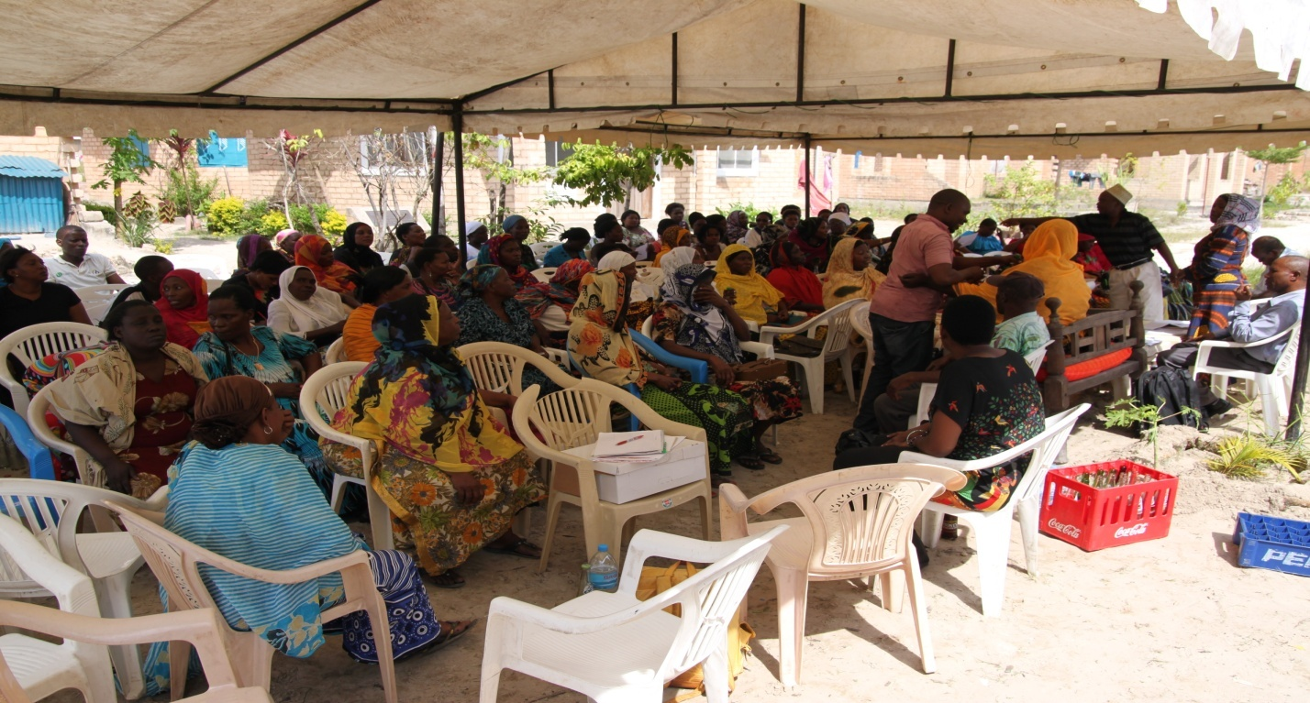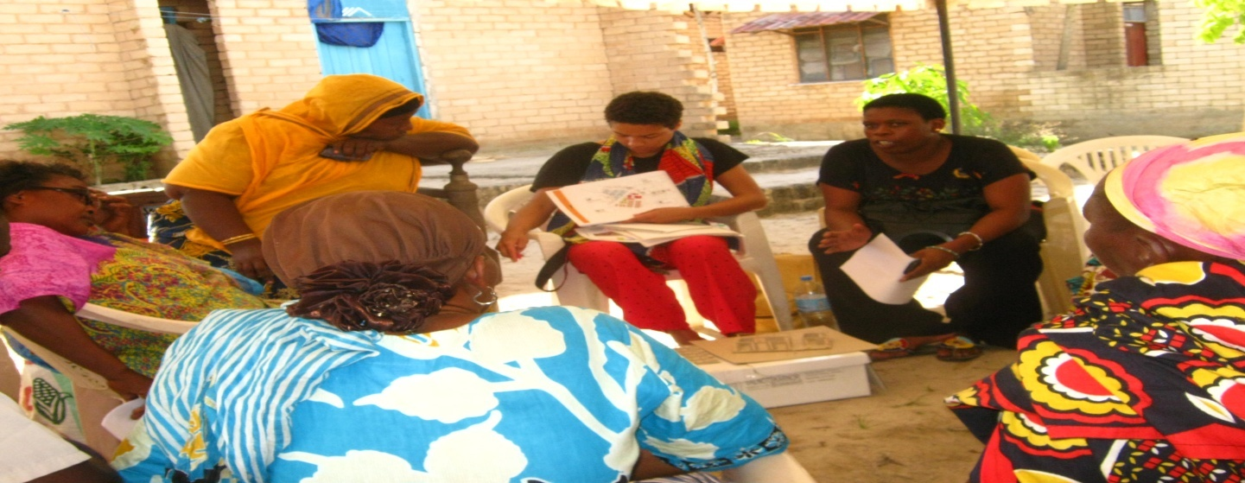

**APPENDIX IV: PROJECT PRODUCTS**

**Product to be sold at Muungano Housing Cooperative sub village mareket place**

