IMPACT OF INSTAGRAM ADS TOWARDS CONSUMER BEHAVIOR AMONG YOUTHS: A CASE OF CONGO STREET CLOTH TRADERS IN DAR ES SALAAM, TANZANIA

DAVID MAYUNGA

A DISSERTATION SUBMITTED IN PARTIAL FULFILLMENT OF THE REQUIREMENTS FOR THE DEGREE OF MASTER OF ARTS IN MASS COMMUNICATION (MAMC)
DEPARTMENT OF MEDIA AND LIBRARY STUDIES
OF THE OPEN UNIVERSITY OF TANZANIA
2023

CERTIFICATION
The undersigned certifies that, he has read and hereby recommends for acceptance by the Open University of Tanzania a dissertation entitled: “Impact of Instagram Ads Towards Consumer Behavior Among Youths: A Case of Congo Street Cloth Traders in Dar es Salaam, Tanzania” in a partial fulfillment of the requirements for degree of Master of Arts in Mass Communication (MAMC).


……….………………
Dr. Henry L. Mambo
(Supervisor)

21th July 2023
……………………
Date

COPYRIGHT
No part of this dissertation may be replicated, distributed in any form or by any means, in full or in part, with the exception of citation in research studies, without written permission of Directorate of postgraduate studies on behalf of the author and Open University of Tanzania.

DECLARATION
I, David Mayunga, declare that the work presented in this dissertation is original. It has never been presented to any other University or Institution. Where other people’s works have been used, references have been provided. It is in this regard that I declare this work as originally mine. It is hereby presented in partial fulfillment of the requirement for the degree of Master of Arts in Mass Communication (MAMC).


…………………
Signature
21st July 2023
…………………..
Date

DEDICATION
I dedicate this work to my late dearest parents, my mother Ms. Magdalene Said and my Father Mr. Pharles Mayunga who gave me all blessings to pursue my higher education to this level. This makes me keep on shining like a morning star. I also dedicate this work to everyone who showed me a lot of support during my Studies may God bless all of them.
Lastly but not least, I dedicate this work to all students, Youths, businessmen, my Government and everyone that would use this work as a bridge to pass through to the knowledge of better using digital platforms especially Instagram for better achievements.

ACKNOWLEDGEMENT
I express my sincere gratitude to Almighty God, who strengthened me and gave me a tolerant mood, which enabled me to undertake this academic work. Without him, I could not have made this work in its present form.
I really appreciate my supervisor Dr. Henry L. Mambo for his advice on various stages of research proposal and report writing; he assisted me to the maximum. It is an honor to give much thanks to the whole administrative desk of Dar es Salaam City, Ilala Municipality, Kariakoo Ward and Congo street officers for their kindness hearts, indeed they all together permitted and guided me during Data collection in the concerned area of Congo Street.
I honestly appreciate the support and cooperation from my fellow students for their kindness in helping me to complete this work. I do appreciate the good support of my co-worker Ezekiel Shamakala for helping me to understand some technical issues.
Lastly, I give my sincere thanks to everyone who has been taking care of me from the beginning and completion of my studies.

ABSTRACT
The study assessed the impact of Instagram Ads towards Consumer Behavior among Youths: A Case of Congo Street Cloth Traders in Dar es Salaam, Tanzania. The study was guided by the general objective of the research that was to assess the Impact of Instagram Ads towards Consumer Behavior among Youths in Tanzania. The study had specific objectives, which included; examining the extent in which youths are using Instagram, to identify the aspect of youths to use Instagram, to establish a relationship between the use of Instagram and purchasing tendency of youths, and also to examine the extent to which young people are affected by Instagram ads in their buying habits. The study used descriptive research design whereas a sample of 66 people were selected from Congo Street. From non-probability sampling, convenience sampling was used to select samples from data collection whereby the sample was selected conveniently because the area is busy with different business activities.
The study used questionnaires and interviews as data collection methods. The study was guided by Media Marketing theory. Findings presented in graphs, tables and charts and analyzed by content analysis. Findings showed that Instagram ads have impacted youths in decision making, since more than 33% of the total respondents said they are affected in buying decisions, (30%) they mentioned that Instagram Ads increased consumer behavior among themselves and 37% of them said they are addicted with social media. The study concludes that youths are affected by Instagram ads as they are affected in their buying decision thus, with the advancement of technology nowadays business people should learn the better ways of using Instagram as a business tool to promote their products and attract customers while buyers should also know the proper use of social media Instagram being a case. The study recommends that the government should control the online businesses so that no one will be harmed, and the revenue will be easily collected.
Keywords: Instagram, Instagram ads, consumer behavior, youths.

TABLE OF CONTENTS
CERTIFICATION ii
COPYRIGHT iii
DECLARATION iv
DEDICATION v
ACKNOWLEDGEMENT vi
ABSTRACT vii
TABLE OF CONTENTS viii
LIST OF TABLES xiii
LIST OF FIGURES xiv
LIST OF ABBREVIATION xv
CHAPTER ONE 1
INTRODUCTION 1
1.0 Introduction 1
1.1 Background of The Study 1
1.2 Statement of the Problem 3
1.3 Objectives of the Study 4
1.4 Specific Objectives 4
1.5. Research Questions 4
1.6 Scope of the Study 5
1.7 Limitations and Delimitations 5
1.8 Significance of the Study 6
1.8.1 To Business people 6
1.8.2 Policy Makers 6
CHAPTER TWO 8
LITERATURE REVIEW 8
2.1 Introduction 8
2.2 Definition of Key Terms 8
2.2.1 Instagram 8
2.2.2 Instagram Ads 8
2.2.3 Consumer Behavior 8
2.2.4 Youth 8
2.2.5 Consumerism 9
2.3 Empirical Review 9
2.3.1 Instagram Uses and Buying Attitudes 9
2.3.2 Impact of Advertisement on Consumption 10
2.3.3 Consumer Behavior as Influenced by Social Media 11
2.3.4 Consumer Attitudes towards Purchasing Power 11
2.3.5 Consumer Behavior among Youths versus Instagram 12
2.3.6 Advertising on Consumer Buying Behavior 13
2.4 Theoretical Framework 15
2.4.1 Social Marketing Theory 15
2.5 Conceptual Framework 17
CHAPTER THREE 18
RESEARCH METHODOLOGY 18
3.1 Introduction 18
3.1.1 Research Design 18
3.2 Area of the Study 19
3.3 Population of the Study 19
3.4 Sample and Sampling Procedure 20
3.4.1 Sampling Technique 20
3.5 Data Collection Methods 22
3.5.1 Questionnaire 22
3.6 Data Collection Procedure 22
3.7 Data Processing and Analysis 22
3.7.1 Data Analysis 23
3.8 Data Quality Control 23
3.9 Ethical Considerations 24
CHAPTER FOUR 25
PRESENTATION, ANALYSIS AND DISCUSSION 25
4.1 Introduction 25
4.1.1 Description of Respondents 25
4.1.2 Respondent’s Personal Information 25
4.1.3 Instagram usage among Youths 26
4.1.4 The Extent of Instagram Usage 26
4.1.5 The Frequency of Instagram Usage 27
4.1.6 Time Spent in Viewing Instagram Ads 27
4.1.7 The Influence of Instagram Ads towards buying Behavior 28
4.1.8 The Impact of Instagram Ads among Youths 28
4.1.9 Source of Information about what to Buy 29
4.1.10 Youths’ Purchasing Habit Before Starting Viewing Ads in Instagram 30
4.1.11 Improvement in Instagram Ads Policies 30
4.1.12 Promotion of Products via Instagram 31
4.1.13. The Response of Buyers after Promoting Goods through Instagram 31
4.1.14. The Impact of Instagram Ads to Business 32
4.1.15 The Strategies used to Create Attractive Ads 32
4.1.16 Improvement of Instagram Ads Policy 33
4.1.17 Ethics Consideration among Business People 34
4.1.18 Awareness on the Business Policies 34
4.1.19 Age Consideration among Instagram Ads’ users 34
4.1.20 Means used by Business People to Deliver Products 35
4.1.21 Tax Paying 35
4.2.1 The Extent in Which Young People were Affected by Instagram Ads towards Buying Behaviour 35
4.2.2 The Relationship between Instagram Ads and Consumerism Behavior 36
4.2.3 The Awareness Level on the Social Media Uses 37
CHAPTER FIVE 39
SUMMARY, CONCLUSIONS AND RECOMMENDATIONS 39
5.1 Introduction 39
5.1.2 Summary 39
5.1.3 The Extent in which Youths are using Instagram 39
5.1.4 The Aspect of Youths using Instagram for 39
5.1.5 The Relationship between Instagram Ads and Consumer Behavior 40
5.1.6 The Extent in which Young People were affected by Instagram Ads towards Buying Behavior 40
5.2 Conclusion 39
5.3 Recommendations 39
REFERENCES 43
APPENDICES 46
INDEX FOR PUBLISHED ARTICLE…………..………………………………58

LIST OF TABLES
Table 4.1: Respondents Personal Information (N=66) 26
Table 4.2: Instagram usage among Youths (N=30) 26
Table 4.3: The Extent of Instagram Usage (N=30) 26
Table 4.4: The Influence of Instagram Towards Buying Behavior (N=30). 28
Table 4.5: The Impact of Instagram Ads among Youths (N=30) 29
Table 4.6: Promotion of Business via Instagram (N=20) 31

LIST OF FIGURES

Figure 2.1: Conceptual Framework 17

Figure 4.1: The Frequency of Instagram usage (N=30) 27

Figure 4.2: Time Spent in Viewing Instagram Ads (N=30) 28

Figure 4.3: Source of Information About where to buy (N=30) 29

Figure 4.4: Youths purchasing Habit before starting viewing Ads in Instagram (N=30) 30

Figure 4.5: The Response of Buyers after promoting Goods through Instagram (N=20) 32

LIST OF ABBREVIATION
4Ps Product, price, place and promotion
Ads Advertisements
BBC British Broadcasting Corporation
DOI Digital Object Identifier
HTTPS Hypertext Transfer Protocol Security
IJAMSCR International Journal of Academic Management Science Research
MAMC Master of Arts in Mass Communication
ORG Organization
OUT Open University of Tanzania
RR Randomized response
TIS Translating and Interpreting Service

CHAPTER ONE

1.0 Introduction
This chapter covers the background of the study, significance and statement of problem; objectives of the study that include main and specific objectives, research questions, and definitions of key terms of the study. Instagram is one of the most attention gaining social media globally since with more than one billion users, many different firms use Instagram for advertising purposes, marketing research and customer relationship supervision (Zhao, Yang, Xie, & Wang, 2017).
1.1 Background of the Study
From this researcher’s personal reflection on the extent to which Youths are using Social media especially Instagram in Tanzanian, he has been exploring to while climbing up in the era of science and technology, it has become clear to him that through the years he had been surfing to and enjoying sharing information, posting videos and photos, he did not realize how Instagram Ads are affecting Youths in their buying decision and addiction of using Instagram among Youths in Tanzania and lead them to become dependents of Social media, until he came up himself with the concept of conducting a research on the topic entitled “Impact of Instagram Ads towards Consumer Behavior among Youths: A Case of Congo Street Cloth Traders in Dar es Salaam Tanzania” so as to assess it.
According to Bergstrom & Backman (2013) Instagram was established in 2010 as a mobile-based application that enables people to share their photos and videos to other users as well as sending private and direct messages. According to Instagram (2014) at first Instagram was allowing people to edit and share photos and later on other functions were added such as sharing videos and photos as well as sending direct messages to the users. In 2012, Facebook owners finally bought the application as a way to connect it with Facebook and WhatsApp (BBC News, 2012). Instagram is believed to be the most admired and popular social network among the students in academic institutions such as schools and colleges. (Solomon, 2013)
According to The Pew Internet and American Life Project as cited in (Tekulve & Kelly, 2013) 13% of the people that use the internet are using Instagram, also from the results by Pew, adults at the age from 18-29 are the ones that show positive response towards Instagram.
According to Statista (2021) on a monthly basis, about 815 million Instagram users accessed photo-sharing platform Instagram. The figure is expected to reach nearly 1.2 billion users in 2023 the potentiality of Instagram marketing is influenced by the audiences' ages since as of July 2021 about 32 percent of global audiences were aged between 34 years and younger (Statista, 2021).
According to TIS (2012) since Instagram involves use of photos it is very suitable for content creators to add more creativity in making pictures and adding less words since photos speak louder than words. Therefore, this makes it easy for brand promotion hence convincing people (customers) to buy/consume that particular product or goods. Most people that are using Instagram to promote their business are lacking ads’ credibility, as they do not consider audiences’ perceptions, feelings, trust and confidence during the selling and buying process of the products (Mackenzie, et al., 1989). According to Awalina (2017) attitudes and behaviors are created by the appearance of the products’ photo or video. Attitudes can be based on emotions that mean someone can form positive feelings about a certain information, products or actions on the preferred basis. Thus, buying behavior or consumerism can be stimulated by someone’s feeling on certain products as displayed on Instagramads, hence a tendency of buying a particular product or service.
1.2 Statement of the Problem
According to Jefferson (2021) people of young ages do spend as much as nine hours per day on social media sites. According to the recent study conducted by Common Sense Media (2021), mind-blogging statistics means when students are not in school they are busy using their smartphones where they surf social media, interacting with friends, passing through different products that are in sales and so many other activities. Jefferson (2021) found out that a brand simply being on Instagram could be having a positive brunt on how audiences perceive that particular brand.
Instagram content clients tend to view brands on Instagram as more popular (78%), relevant (74%), creative (77%), entertaining (76%) as well as committed to building community (72%) than those that are not (Impact, 2019). The relationship between the use of Instagram and consumer behavior among youths is what drives the research. According to Mark (2017) consumerism among youth has many negative impacts such as the increase of debt level among the youths as a result most of these youths are facing depression and stress.
Scholars such as McCombs (2002) in Agenda setting model have clearly showed the power that media messages have towards the attitude changes among the users especially social media users but there is no clear explanation on the relationship between consumerism of behavior of unnecessary buying habit and the power of ads that are displayed in the social media platforms Instagram in particular. This study assessed the impact of these ads, especially in this era where social media usage has taken over among the people of young ages since most of these youths spend most of time searching different trends in the market in order to consume even though they are not so much in need (Mark, 2017).
1.3 Objectives of the Study
The main objective of this study was to assess the impact of Instagram ads towards consumer behavior among youths.

1.4 Specific Objectives
The study was guided by the following specific objectives:
- To examine the extent in which youths in Dar es Salaam are using Instagram;
- To identify in which aspect do youths in Dar es Salaam use Instagram;
- To establish a relationship between the use of Instagram and the purchasing tendency of youths in Dar es Salaam and
- To examine the extent to which young people in Dar es Salaam are affected by Instagram ads in their buying habits.

1.5 Research Questions
- What is the extent in which youths in Dar es Salaam are using Instagram?
- In What aspects do youths in Dar es Salaam use Instagram?
- What is the relationship between the use of Instagram and the purchasing tendency of youths in Dar es Salaam?
- What is the extent in which young people in Dar es Salaam are affected by Instagram ads in their buying habits?

1.6 Scope of the Study
The study was aiming at assessing the impact of Instagram Ads towards Consumer Behavior among Youths in Tanzania. The study had to seek for Instagram users both in marketing and least users therefore the population had to be Instagram users in Congo Street at Kariakoo and the selected sample to accomplish the study had to be 66 respondents including Youths and Businessmen from Congo Street in Dar es Salaam Tanzania.
The geographical location covered in the Study is highly occupied with various businesses and it is surrounded with many dwellers in the City of Dar es Salaam Tanzania that is the reason a researcher selected this area.
The study was carried out between June and July, 2022, however it was out of the planned time frame but it was also influenced by the budget that was fixed.
1.7 Limitations and Delimitations
The researcher faced some challenges in data collection, literature review as well as in data analysis and presentations. Secondary data was somehow difficult to get since the area has got little research. The researcher faced some challenges when collecting data since Congo Street in Kariakoo is one of the crowded areas thus it was a bit challenging to get people who would provide appropriate answers for the completion of this study.
However, to make sure that the research process is accomplished the researcher worked hard on literature as well as in data presentations.

1.8 Significance of the Study
1.8.1 to Business People
The study will be significant to the business people as they would be able to either improve or amend some strategies in business especially in relation to social media usage. They will also be able to use social media properly in promoting their businesses without breaking the laws and ethics in the business arena.
1.8.2 Policy Makers
The study is also significant to the policy makers in both education sector and research areas, the government through its ministries are able to come up with proper syllabus in public relations and marketing schools as a strategy to update syllabuses by considering the advent of technology especially the implication of Instagram in businesses.
The study is going to pave the way to further researchers in the same area especially in East Africa because not so many studies have been done therefore the research is significant in improving the usage of social media and other internet supported network sites so as to have a proper and safe usage of them in all aspects of people's lives.
In addition, the study is important especially in this era of advancement of science and technology. Nowadays so many people are using social media in creating content, sharing with friends as well as finding information. Thus, there are those using social media with no self-control and awareness, perceiving what they see in social media and even imitating some of them. People of young ages probably consume products as they are advertised in social media. That is consumerism behavior. Thus, upon completion of this study there had been found a solution on how these social media users may be using social media with self-control.

CHAPTER TWO

LITERATURE REVIEW

2.1 Introduction
This chapter reviewed both theoretical and conceptual literature concerning the impact of Instagram Ads towards consumer behavior among youth. The chapter starts by presenting the general literature on the topic followed by discussion on the theoretical and conceptual scholarly works on the topic.

2.2 Definition of Key Terms

2.2.1 Instagram
According to Dubovik (2013) Instagram is a program that enables people to share photos and videos to their followers.

2.2.2 Instagram Ads
Instagram ads are the posts that are in the form of videos or photos for which businesses can pay to serve to Instagram users. (Instagram, 2021).

2.2.3 Consumer Behavior
Consumer behavior is the study of how people make decisions on what they buy, want, need or act in regards to a product, service or company (Steven & Tara, 2021). It is important to understand consumer behavior in order to know how potential customers will respond to a product or service.
2.2.4 Youth
According to Merriam-webstar.com (2021) youth is the time when someone is young, especially the period between childhood and maturity.

2.2.5 Consumerism
Consumerism is a cultural model that promotes the acquisition of goods and especially the purchase of goods as a vehicle for personal satisfaction and economic stimulation (WhatIs.com, 2020).

2.3 Empirical Review

2.3.1 Instagram Uses and Buying Attitudes
Maria & Lisa (2017) in their study that aimed at assessing the role of social media in the attitude formation process claim, social media provides not only platforms for uses for personal communication, but rather serves as media for dissemination of promotional messages. Through advertisements, social media is used to convince people to buy even unintentionally simply because of the kind of messages that they are feeding users.
John (2015) claims that social media usage contributes in decision making among youths like how it is in creating addiction behavior among them. Social media is also the source of decision making when attempting to purchase different products through online means. Absence or poor control in the social media usage is mentioned as a threat to most youths since they use social media with no awareness and that is a room for advertisers to attract youths’ attention hence buying intentions. (Jessica & Patti, 2017).
Chevalier & Mayzlin (2006) have evidenced that in the form of online, product reviews have a causal impact or positive influence on consumer purchasing behavior. In a similar vein, Lee (2009) found out that the quality of the arguments i.e. supported with facts versus emotional and subjective arguments used in reviews have a positive impact on purchasing intention; and the quantity of reviews have a positive effect on purchasing intention, since large number of reviews denote popularity of a product.

2.3.2 Impact of Advertisement on Consumption
Arman, Izian & Siti (2020) conducted a study aimed at examining issues that affect the appropriateness of social media advertising with the aim of enhancing Malaysian Millennia’s’ purchase intention. According to the results, social media is increasingly being used as a platform and ground to conduct marketing and advertising activities because people are much tied with the uses of new technologies that accommodate social media. Companies and organizations spend much money on social media ads in turning prospects into actual consumers. There are companies that might face challenges in creating effective social media advertising aiming at motivating and stimulating consumers to purchase the advertised products. The findings under this study show that there are four factors that have a positive power on the people’s intention to purchase the advertised products (Neti, 2011).
Some firms are now basing their use of social media use, especially Instagram to promote their products and maintain a friendly and handsome relationship with their customers (Saravanakumar & Lakshmi, 2012). Despite having an account in Facebook and Twitter, Instagram as a platform, becomes a tool to provide business ground for many marketers. Currently, there are many businesses that are starting to integrate their business with the Instagram experience (Tekulve& Kelly, 2013). According to an article published on BBC News (2012) a large number of the top brands around the world are using Instagram as one of their marketing strategies to attract people by creating demand attitudes in their minds and finally consuming the products that are being announced. The study lacks the negative impact of being influenced by these ads in the social media especially for those who have no control over social media uses therefore this study is going to find the awareness level of social media users and the ads that stimulate their buying behavior.

2.3.3 Consumer Behavior as Influenced by Social Media
John (2015) in the study titled the impact of social media usage on the consumer behavior before, during and after the trip, claimed that social media enjoys phenomenal success in terms of adoption and usage levels. Social media usage became paradigm shifts on how people connect and communicate with each other, on how they express and share ideas, and even on how they engage with products, brands and organizations. The study’s findings suggested the four contributions to knowledge; firstly to consumer behavior theory by proposing information exchange as enlarged consumer behavior construct consisting of nine components.
Thomas (2020) in the study named Instagram influencers’ impact on online consumer behavior claimed that social media influencers are affecting the purchasing habit of Instagram users as they properly promote their advertising messages. It is confirmed that the degree of loyalty among the people can be affected by the relationship between a person and the influencer. They succeed in attracting the attention of a consumer as most of them have their portion of followers that to some extent have common interests.

2.3.4 Consumer Attitudes towards Purchasing Power
Abbas, Ally, Reza & Soheila (2017) there are three fundamental strategies that can be used by marketers to make changes in cognitive structure of consumer’s perspectives; change in beliefs, change in importance, and level of characteristics as well as increasing in beliefs. The study holds that most companies are trying to influence consumers’ interest and feelings towards a brand positively without having direct influence on consumers’ beliefs and behaviors.
The process is said to increase the tendency towards buying behavior as a buyer is going to buy a product and increase the buying behavior of consumers. In some cases, audiences unemotionally welcome such advertisements, because they associate baseless claims of the company with the audiences' mindsets and this can result in negative attitudes among audiences (Herman, 2014).

2.3.5 Consumer Behavior among Youths versus Instagram
Chahat & Sachin (2020) in their study that aimed at assessing the role of social media in consumers’ decision-making processes, researched to what extent experiences are distorted by the social media usage. According to the results, web-based social networking has occupied purchasers that have no control over certain degree experiences that are altered by the use of social media. The study found out that web-based social networking has occupied purchasers who have no control over the stuff, timing or recurrence of online discussions among shoppers.
Results show that social media usage stimulates consumer satisfaction in the stages of information search and substitute evaluation, with satisfaction being amplified as the consumer moves along the process towards the final purchase decision and the post- acquire evaluation.
Rashad & Souk (2015) have said that Instagram is now one of the popular and important tools that are being used by the marketers to announce and promote different products and services as it enables people to interrelate locally and internationally. Instagram has gathered all the people around the world that are interested in photography since it focuses on photographic functions. Users of Instagram are sometimes affected in terms of psychology and in a social way. Some are facing addiction to social media, they have no control at all rather they are controlled by social media sites, psychologically some people are forcing themselves to change lifestyle and that is the beginning of having attitudes of buying whatever is promoted in Instagram.
Instagram as one of the fastest growing social media has a very close relationship with consumer behavior since it has good qualities for business people to create promotional posts that stimulate customers’ intention of buying products or services. (Mahatma Vidya & Ni, 2020). Social media sites, depending on their accessibility, have been an open ground for youths to choose whatever they want since most of these youths are addicted to social media sites (Jacqueline &Sanjukta, 2018). However, different studies such as Hamidah (2017) do not show the motive behind the product's consumers since most of these buyers are attracted by the ads that always appear in the social media walls especially Instagram, thus it is still an open ground for researchers to find out the relationship between them.

2.3.6 Advertising on Consumer Buying Behavior
Bandara (2020) says that in recent year’s social media promotion has become the keystone of the most successful fashion brands’ marketing strategy. Companies that are dealing with fashion have now realized the usefulness and importance of creating values of their brands using social media platforms. According to Bandara’s study, the aim is to explore the impact of social media advertising on buyer buying behavior towards fast fashion, it also examines and measures the consumer buying behavior aligned with the consumer decision-making process.
According to Bandara (2020), findings show that social media ads are completely influencing consumer-buying behavior in the fashion industry. Three independent variables namely; entertainment, familiarity, and social imaging have highly influenced consumers behavior and there is no statistically significant influence from the remaining variable, advertising expenditure.
Hassan (2014) noted that social media is an online community that gives space for people to interrelate has become a most preferred channel for brand marketing. Following the establishment of Facebook and Twitter and later in 2010 after the introduction of Instagram there are already more than 150 million people that are using Instagram. According to Costill (2014) social media are not for social interaction only rather nowadays business people are using social media especially Instagram because it deals with photos. Therefore, most of the business people are promoting their products and services in order to attract people. Social media especially Instagram is affecting people in their buying habits as they create a desire and finally the demand of buying a particular product as posted in Instagram (Blackman, 2009). However, there is no any suggestion on how these media create ads to convince people and the study does not show a way forward on how users can control their attitudes of buying unnecessarily therefore in the completion of this study the impact of Instagram ads towards consumerism behavior will be accomplished.

2.4 Theoretical Framework

2.4.1 Social Marketing Theory
According to Philip & Gerald (1970) Social marketing theory is explained as marketing ideology preferred when advertising consumers products can also be applied to stimulate and promote concepts, feelings and behaviors. The theory explains that it seeks to influence social behaviors not to help the marketer, but rather to benefit the target audience and the broader society. The marketing approach has proven its effectiveness in convincing people in consuming dissimilar services and products that they are in need and wanting (Weinreich, 2006).
Consumer marketing is characterized by key principles also known as “four P’s” that consist of product, price, place and promotion whereas the “product” is not always a tangible object, sometimes it is physical ones are included, it frequently comes in the form of providing a service, promoting a practice, or raising awareness about an thought. The succession of a product depends largely on public belief that there is a real problem, and that this new invention will help to solve the issue. The “price” in social marketing refers to what the user must do to acquire the product (National Social Marketing Centre, 2010).
The benefits must be better than the costs in order to be of significant value. “Place” is defined as the manner in which the commodities reach the buyer. For tangible items, this means the means of dissemination (such as free distribution, trucks, stores, etc.), while for intangible items; this represents choices about how the information is spread (such as media use, training demonstrations, and public postings). Researchers must observe the routine schedule of their market group in order to classify the paramount way to suggest their message. “Promotion” consists of publicity, media support, personal sales techniques, and attention-grabbing ploys, all of which should concentrate on promotion and maintaining sufficient demand for the items.
According to Goethals, et al., (2010) social marketing are interventions are more likely to achieve goals if they follow a planning model since planning models help social marketers to get a better understanding of the causality of the social problem they are aiming to tackle and the barriers to the change in behavior (Wyner, 2011). In social media marketing there are different approaches that are proposed to deal with social market marketing, some of them including the benchmark criteria (Andreasen, 2002), social marketing process and model and the hierarchical model of social marketing (Lee & Kotler, 2011).
Andreasen’s (2002) standard criteria proposed that while designing social marketing intervention; Behavior change should be the focus of the intervention, consumer research should be conducted at the beginning, segmentation and targeting should be carefully considered, the 4 Ps of the marketing mix should be taken into account, the design of the intervention should be focused on creating attractive/motivational exchanges with the target audience and competing behaviors should be acknowledged.
Social media theory was helpful in the completion of this study because it suggested the better ways of understanding the techniques and tactics that are used by these advertisers in social media to promote their customers as a means to consume their products thus despite of collecting data from the sample but there was prior information based on the attraction power found in the social media ads Instagram in particular. I do not find sufficient connection of this theory with Instagram advertising.

2.5 Conceptual Framework
In the studies dealing with marketing and social sciences, a bivariate model of testing variables is more likely to be implied (Echambadi & Hess, 2007) a dependent variable is predicted from another independent variable. However, with the increasing complexity of marketing phenomena, bi-variate models do not adequately capture underlying interrelationships among constructs. It can also be referred to that the variance of a dependent variable can be better explained by more than one independent variable (Fitzsimons, 2008). The dependents variable here, which is “consumer behavior among youths and youths” are impacted from independent one that is “impacts of Instagram ads” thus its correlation effects were helpful also in testing hypothesis as shown in Figure 2.1
Impacts of Instagram Ads (Independent Variables)

Youths (Dependent Variables)

Consumer behavior among Youths (Dependent Variables)

Figure 2.1: Conceptual Framework
Source: Adopted from Consumer behavior Approach, 2022.

CHAPTER THREE
RESEARCH METHODOLOGY
3.1 Introduction
The chapter presented methods and techniques that were used to conduct this study. The methodologies comprise of research design, area of study, population sample size, sampling procedures, data collection and data analysis.

3.1.1 Research Design
According to Cresswell & Plano (2007) Research design is the process of collecting, analyzing, interpreting and reporting data in research. It is the plan that links the conceptual research problem with the achievable empirical research. Since the study used a mixed research approach, descriptive research design was most preferred since under this research design a researcher is interested in describing and explaining the situation or case under research study.
According to Cresswell & Plano (2007) a theory-based design method that is created by gathering, analyzing and presenting collected data, it is also allowing a researcher to provide insights into the important items of ‘why’ and ‘how’ of the research, therefore this research design aided the completion of this study and coming out with the appropriate solution for the researched problem.
Descriptive research design is important since it aids the researchers when looking for an explanation for the existence of an observable fact. When using descriptive design a researcher is able to understand ‘why’ something happened. The implication of descriptive design is important since it involves using a range of qualitative and quantitative research methods to collect data that aids in accurately describing a research problem (Voxco, 2018).

3.2 Area of the Study
According to John (2016) it is very important to select a research area that is appropriate for the study since that is the place where a researcher conducted his/her studies. The area of this study was Congo Street that is located at Ilala Municipality in Dar es Salaam city. The area of this study was chosen due to reason that it is the entire part of Tanzania and considered as the most part of the city where there is a high number of dwellers. That being the case there are so many social media users especially those buying products by the means of online stimulated by the use of social mediawhereby a researcher conducted his study between June and July 2022.

3.3 Population of the Study
According to Showkat (n.d) a population refers to any collection of specified groups of people or non-human entities like objects, instructive institutions, time units and environmental areas. A population can also be defined as the people with characteristics which the researcher wants to study within the context of a particular problem (Rwegoshora, 2006).
In this study, the population was youth who dwell in the mentioned area. Therefore, youths were the respondents. Youths were the ones that mostly use social media, especially Instagram. It was also easy to measure the relationship between the ads that are displayed in Instagram and the way they affect their buying habits. Thus with them it was easy to obtain important information from them in order to fulfill the demand of the study.

3.4 Sample and Sampling Procedure
Sample is defined as a selected group of some basics from the entirety of the population (Showkat, 2020). Sample is also explained as the selected elements such as human beings or objects chosen to contribute in a study; people are referred to as subjects or participants. According to Kothari (2006) sample size is defined as the number of items to be selected from the universe. Therefore sample size for this study was determined using the Rule of Thumb formulae which states: (N ≥ 50+8M)
Whereby N = sample size,
M = number of study independent variables. Therefore, the study had two independent variables that were Instagram usage and consumerism.
Therefore:
N ≥ 50 + 8 * 2 = 66. Based on rule of thumb computation, the sample size for this study was 66 respondents that included buyers and sellers of different products at Congo Street in Kariakoo.
3.4.1 Sampling Technique
According to Ranjit (2011) the accuracy and efficiency of someone’s results depend on the way he/she chooses a sample. The most important objective of a sampling design is to reduce within the limitation of cost, the gap between the standards obtained from the sample and those prevalent in the study population. The underlying premise in sampling is that a relatively small number of units, if selected in a manner that they genuinely represent the study population, can provide with a sufficiently high degree of probability a fairly true reflection of the sampling population that was being studied. When selecting a sample a researcher has to attempt achieving two key goals of sampling the avoidance of bias in the selection of a sample; and the attainment of maximum precision for a given outlay of resources (Shalabh, 2017).
Sampling consequently, is the technique of choosing some (a pattern) from a larger organization (the sampling population) to end up the premise for estimating or predicting the prevalence of an unknown piece of facts, scenario or final results concerning the bigger organization. A sample is a subgroup of the population that a researcher was inquisitive about. There are masses of sampling techniques that are used to select samples that may be categorized into organizations, namely possibility and non-probability sampling.
The study therefore used a non-randomized method that is convenience sampling since this is the type of non-probability sampling, whereby a researcher prefers participants as per their own convenience. Under this method, a researcher chooses the closest live persons as respondents therefore a researcher is selecting participants conveniently (Doherty, 1994). Based on the nature of population the technique was suitable since the area is crowded with a lot of shops and other business centers thus a researcher had to get his sample conveniently from Congo Street, Kariakoo hence the accomplishment of the study.
The technique involves judgment whereby participants were selected because they are easy to access. The method is considered as less expensive, complicated and easy to apply as compared to its counterpart (Huma & Nayeem, 2017). The reasons for using this sampling technique is that; it is inexpensive since a researcher is choosing samples conveniently, also their sampling method is supportive in easy data collection because a researcher is selecting samples by considering his/her own judgments (QuestionPro, 2021).
3.5 Data Collection Methods
In data collection, questionnaire was used to collect data from the selected sample as stated below;
3.5.1 Questionnaire
Questionnaires are an appropriate method, especially when the researcher needs to collect specific information about people's opinions, thoughts, experiences, and feelings. Questionnaires are useful when the subject of a survey involves issues that require complex questioning and considerable probing. (Easwaramoorthy & Fataneh, 2006). In addition, the method is not expensive since it doesn’t require a venue, rather the sheets in hard copy or online form are distributed to the respondents thus the researcher is able to conduct data collection exercises anywhere and anyhow, and at any time.
3.6 Data Collection Procedure
Warner (1965) in his development of data collection procedure, he claimed that the randomized response (RR) technique enables researchers to get reliable information while maintaining and guaranteeing solitude to respondents. The method facilitates greater cooperation from respondents and reduces their motivation to falsely report their attitudes. Therefore, Randomized Response (RR) was used in the study.
3.7 Data Processing and Analysis
Data processing refers to a sequence of movements or approaches performed on data for the aim of verifying, organizing, remodeling, integrating and extracting data in the best output form for subsequent use. To ensure the utility and integrity of the information, choice of techniques of processing have to be rigorous. Information analysis involves movements and techniques accomplished on records that help describe facts, detect patterns, increase factors and check hypotheses. This consists of data exceptional assurance, statistical records analysis, modeling, and interpretation of results.
3.7.1 Data Analysis
Analysis of data involves different operations that are done with the aim of shortening the obtained data and organizing them in such a manner that they answer research questions and objectives (Kothari, 2004). Under this study content analysis and data coding methods were preferred in order to organize data in a logical way. These methods were used because they were simple enough to come up with true and accurate answers but also they were not complicated rather helping the accomplishment of the study.
3.8 Data Quality Control
According to Paul (2008) quality control in research refers to the hard work and measures that survey researchers imply to make sure that the quality and accuracy of data collected using the methodologies selected for a particular study. Quality control may vary from one study to another depending on the type of data collection methods. It can also be applied to questionnaires and the mechanized programs that control them, sample management systems to ensure there is a proper case processing.

Quality Data control is the application of methods or processes that establish whether data meets quality objectives and defined quality criteria for individual values. In order to examine and determine whether or to what extent the data is "right" or "wrong," we need to have a set of qualitative goals and specific criteria against which the data is evaluated. In this research, rapid data scanning methods can be used to recognize records or sets of records that do or do not meet certain criteria. Quality control is closely related to quality assurance because when a researcher finds errors, he can use quality assurance to prevent errors.

3.9 Ethical Considerations
According to Georgia &Marianna research ethics involves requirements on daily work, the protection of dignity of subjects and the publication of the information in the research. Therefore, in this study there was the consideration of the ethical stuff such as observing confidentiality, privacy, secrecy, humanity consideration and other ambiguity that could happen during the processes of conducting a study.

CHAPTER FOUR

PRESENTATION, ANALYSIS AND DISCUSSION

4.1 Introduction
This chapter presents, analyzes and discusses the research findings regarding how Instagram Ads are impacting consumer behavior among Youths in Tanzania. It examines how different stakeholders are dealing with Instagram in Tanzania through collected information which was presented and analyzed.

4.1.1 Description of Respondents
The study used Instagram users between Youths and Businessmen from Dar es Salaam. The respondents’ age was between 15 and 55 years old. Both males and females were included in the study in terms of percentages of how many were men and how many were women.

4.1.2 Respondent’s Personal Information
Amongst 66 respondents, only 50 respondents used questionnaires while 16 respondents were interviewed. Table 4.1 shows the demographic characteristics of the respondents that are also categorized in terms age, gender, and occupation as well as education status.

Table 4.1: Respondents Personal Information (N=66)
Item | Category | Number of Respondents | Percentage
Age | 15-25 | 23 | 34.8
Age | 26-35 | 25 | 37.8
Age | 36-45 | 13 | 19.6
Age | 46 and above | 5 | 7.5
Gender | Male | 40 | 60.6
Gender | Female | 26 | 39.3
Education Level | Educated | 66 | 100
Education Level | Non- educated | 0 | 0
Occupation | Employed | 18 | 27.2
Occupation | Self-Employed | 23 | 34.8
Occupation | Unemployed | 15 | 22.7
Occupation | Students | 10 | 15.1
Source: Field Data, 2022

4.1.3 Use of Instagram usage among Youths
This part intended to explore the use of Instagram among the youths in relation to its influence in buying behavior. Table 4.2 illustrates the findings as follows;
Table 4.2: Instagram usage among Youths (N=30)
Item | Number of Respondents | Percentage
YES | 30 | 100
NO | 0 | 0
Source: Field Data, 2022

4.1.4 The Extent of Instagram Usage
The question intended to know the extent to which young people were using Instagram, as it wanted to know what Instagram was for. Therefore out of 30 respondents 10 (33.3%) said they were using it for searching information, four (13.3%) said socializing, 12 (40%) said they used to look for new products while the rest four (13.3%) said they were just using it for refreshment. Table 4.3 illustrates the findings as follows;
Table 4.3: The Extent of Instagram Usage (N=30)
Item | Information | Socializing | New products | Refreshing | Total
Number of respondents | 10 | 4 | 12 | 4 | 30
Percentage | 33.3 | 13.3 | 40 | 13.3 | 100
Source: Field Data, 2022

4.1.5 The Frequency of Instagram Usage
This part intended to explore the frequency of Instagram usage by youths. Therefore, out of 30 respondents interviewed, ten (33%) noted that they used it regularly, five (17%) used it irregularly, seven respondents (23%) used Instagram frequently while eight (27%) used it regularly. The chart below illustrates;

Figure 4.1: The Frequency of Instagram usage (N=30)
Source: Field Data, 2022

4.1.6 Time Spent in Viewing Instagram Ads
The intention was to find out time consumed by youths on Instagram especially in viewing Instagram ads. From the findings, 30 respondents were requested to answer. Nineteen 19 (63.3%) respondents said they spent 0-2 hours a day, six (20%) said they spent 2-8 hours a day while the other five respondents (16.6%) said they spent 8-12 hours a day viewing Instagram. The figure 4.2 summarizes their responses.

Figure 4.2: Time Spent in Viewing Instagram Ads
Source: Field Data, 2022

4.1.7 The Influence of Instagram Ads towards buying Behavior
The objective of this question was to know the effect of Instagram ads in buying behavior among youths. Out of 30 respondents that were asked to state if their buying behavior had in any way influenced by Instagram ads, 22 (73%) agreed while eight (27%) disagreed as illustrated in Table 4.4.
Table 4.4: The Influence of Instagram Towards Buying Behavior (N=30).
Item | Agreed | Disagreed | Total
Number of respondents | 22 | 8 | 30
Percentage | 73 | 27 | 100
Source: Field Data, 2022

4.1.8 The Impact of Instagram Ads among Youths
The intention of this part was to find out how Instagram ads have impacted youths in decision making when buying products. Out of 30 respondents 10 (33%) said they were affected in buying decisions, 9 (30%) they mentioned that Instagram Ads increased consumer behavior among Youths and the last 11 (37%) said that they were addicted to social media. Table 4.5 below summarizes the findings as follows;

Table 4.5: The Impact of Instagram Ads among Youths (N=30)
Impact | Affecting buying decision | Increasing Consumer behavior | Social Media addiction | Total
Number of respondents | 10 | 9 | 11 | 30
Percentage | 33 | 30 | 37 | 100
Source: Field Data, 2022

4.1.9 Source of Information about what to Buy
This part intended to understand a source of information that was mostly used by youths to get information on what to buy. Out of 30 respondents that attempted the question 23 (76.6%) said Instagram, four (13.4%) said friends, three (10%) said electronic media and there was no one that mentioned Newspaper. In addition, from the findings, two respondents mentioned other sources of information about what they want to buy apart from that are Ali Baba and Kikuu App. The chart below illustrates the findings;

Figure 4.3: Source of Information about where to buy (N=30)
Source: Field Data, 2022

4.1.10 Youths’ Purchasing Habit before Starting Viewing Ads in Instagram
The question aimed at revealing the habits of youths before using Instagram to view ads. Out of 30 respondents 17 (56.7%) of respondents mentioned window-shopping, seven (23.3%) said they visit shops physically mostly at Kariakoo while six (20%) respondents said that they did not have consumerism habits by then but now they depend on Instagram.
Figure 4.4: Youths’ Purchasing Habit before Starting viewing Ads in Instagram Source: Field Data, 2022

4.1.11 Improvement in Instagram Ads Policies
The question intended to find out what the respondents’ thoughts on what should be improved in Instagram ads policy. The findings showed that mostof the respondents had contributed their views that sellers must post actual products, some advised that bundle costs among service providers should be reduced, and customer policies should be considered to protect their rights, purchasing more ads to consumers so that they can see more products if they wanted.
Some respondents had suggested that ads policies should match with customer’s needs; there must be a possibility to skip an ad if they do not need to view it. Some respondents said business accounts should be verified and qualified by the government to avoid cybercrime while others said that the current Instagram ads policies are favorable.

4.1.12 Promotion of Products via Instagram
The aim of this part was to examine the extent to which business people promote their products via Instagram. Out of 20 respondents 18 (90%) agreed while two (10%) disagreed as table illustrates;
Table 4.6: Promotion of Business via Instagram (N=20)
 | Agreed | Disagreed | Total
Number of respondents | 18 | 2 | 20
Percentage | 90 | 10 | 100
Source: Field Data, 2022

4.1.13 the Response of Buyers after Promoting Goods through Instagram
The question intended to find out the feedback of buyers to sellers after promoting goods through Instagram, whether it was positive, negative, moderate or others. From 20 respondents who answered, seven (35%) said it was positive, nine (45%) said moderate, two (10%) said negative and the last two (10%) indicated others as illustrated in Figure 4.5;

Figure 4.5: The Response of Buyers after Promoting Goods through Instagram (N=20)
Source: Field Data, 2022.

4.1.14 the Impact of Instagram Ads to Business
The question intended to find out the impact of Instagram ads to business. Therefore from the collected data, the findings indicated that 3(15%) respondents said Instagram ads increased number of buyers, 5(25%) said Instagram ads increased viewership of products, 10(50%) respondents said that, they increased the market ground while the rest 2(10%) respondents declared that they didn’t use Instagram for advertising their products as were not aware of Instagram ads.

4.1.15 The Strategies used to Create Attractive Ads
This area intended to know different strategies used by business people to create Instagram ads Thus; out of 20 respondents, eight respondents said they had been posting photos of high quality with an attractive and supportive caption to grab attention of their customers. Seven respondents mentioned that they do post proper information with a price tag of their products so that their customers could easily decide whether to buy or not and they host their customers with good services. Three respondents said that they produced attractive visual adverts and paid people with influence on social media (Instagram) to post and then reach the majority of audiences while the remaining two said that they boosted their contents by sponsoring ads through online payment so that the products reach people randomly and they go viral.

4.1.16 Improvement of Instagram Ads Policy
In assessing the Instagram ads policy the question aimed at understanding respondents’ views on what should be improved in the ads policy applied by Instagram. The questionnaires were distributed to 20 respondents who were business people. Findings showed that, six respondents suggested that, Instagram owners must make an affordable price for ads so that both retailers and customers can simply afford the expense on accessing the ads, Instagram should make a monthly offer to a new advertiser to post ads before starting paying tax in order to post more ads for customers.
Further taxi policies must be reduced to impress retailers to do business in a friendly environment. Four respondents suggested that more education should be provided by Instagram to educate young people about the benefits of using Instagram for earning money through the internet by making business instead of wasting time on social media. Others said that Instagram should improve ads policies to protect personal privacy and prevent people from creating inaccurate accounts that might be used to cheat customers. From the findings, also there were respondents who suggested that, there must be a policy of recommending sellers to advertise branded contents that identify a personal copyright that can help to build a trust to both retailers and buyers through the availability of laws and policies guiding the sale of patented products by third parties.

4.1.17 Ethics Consideration among Business People
The interview was conducted with respondents so that they could also give out data to accomplish the study. The question intended to know if business people were considering ethics when posting their products. Most business people said they did not even know what kind of ethics had to be considered since the only thing they knew was to post goods for their businesses. Others said they considered ethical issues when posting since some products had to be posted wisely in order to avoid misuse among the users, "there are some products that have to be sold with instructions in order to avoid misconception". Said Mandewa Mwaruba a businessperson from Congo Street Kariakoo.

4.1.18 Awareness on the Business Policies
Another question asked to respondents was about business policies of Instagram since a researcher wanted to measure the level of awareness among the business people if they know the business policies of Instagram ads. The question was asked to sixteen respondents and the most repeated answer was "I don't know these Instagram business policies" and just few of them seemed to know the policies, "I just started to use Instagram with no awareness but as time goes on I'm learning more things" said Fatuma Mtunya. Most of Instagram ads' users are just using it without being aware of so many different things.

4.1.19 Age Consideration among Instagram Ads’ users
There was a question of age consideration among Instagram ads users when posting their goods/products. This aspect was important, as there are some adverts that should not be viewed by a certain age level.
Most respondents said they were just posting without considering age, as they believed people would be filtering themselves when attempting to view these ads.

4.1.20 Means used by Business People to Deliver Products
Researchers also wanted to know which means business people used to deliver products to the buyers or customers. Most of these respondents said they did deliver products door to door by either motorcycle or motor cars even though customers had to pay for delivery services. Some respondents said customers came physically to their shops and business centers, "I do deliver products to customers according to what he/she wants using motor cars or motorcycles" said Mduma Kilenza when he was interviewed.

4.1.21 Tax Paying
Most business people escape paying taxes to the Tanzania Revenue Authority, especially those who are doing digital business or online services. Thus, the question intended to know if they were paying taxes. Most of the respondents said they were paying since their businesses were done both physically and online so some of them did not have business shops in Congo, Kariakoo so they only used Instagram to promote their products. Some of the respondents said their businesses had not reached the level that they were supposed to pay tax as they still had small businesses.

4.2.1 The Extent in Which Young People were affected by Instagram Ads towards Buying Behavior
The objective sought to measure the extent to which people of young ages were affected by these Instagram ads when viewing for their personal purposes. From the findings, most of the respondents seem to be affected in one way or another since there were some people’s buying decisions based on the Instagram ads. For instance, in the question that intended to find out how Instagram ads had influenced youths in decision making more than 33. % said they were affected in buying decisions, (30%) they mentioned that Instagram Ads increased consumer behavior among themselves and 37% of them said they were addicted to social media. According to Amanda, Thomas & Wenlin (2017) Social network theory focuses on the function of social relationships in disseminating information, channeling personal or the influence of media and enabling attitudinal or behavioral change. The theory argues that attitudinal and behavioral change caused by the social media contents, and therefore consumers are affected by interpersonal communication rather than personal. He claimed that social media enjoys phenomenal success in terms of adoption and usage levels.
According to John (2015) the usage of social media causes paradigm shifts on how people interrelate and communicate with each other, on how people do express and share different ideas and even how they engage with products, brands and business. Social media has become an open community for people to dwell in, most especially people of young ages are following the brands that are being advertised via social network channels hence taking action to consume the products (Hassan 2014).

4.2.2 The Relationship between Instagram Ads and Consumerism Behavior
The aim under this objective was to measure the relationship between Instagram ads and consumerism behavior since they are inseparable in operation. The findings show that these two variables are causing each other, business people that are attaching themselves in the use of social media depend on Instagram Ads to promote their products while customers who are ordinary people depend on Instagram to find different information about what to buy in their daily consumption. There was a question about where did these people get information about where to buy a product. In this case, 76.6% of the respondents mentioned Instagram as their social network site that they used to search for the proper products to consume.
In the two-step flow of communication hypothesis, the weak ties theory, and the theory of diffusion of innovations, these three major theoretical approaches integrate network concepts in understanding the flow of mediated information and its effects. In this approach, people tend to redesign content before transmitting it to its people or target audiences.
Mandara (2020) has noted that the relationship between the use of social media and consumer behavior can be determined by independent variables that are amusement, acquaintance and social imaging have highly influenced consumers’ behavior and there is no statistically significant power from the remaining variable, advertising expenditure. Rashad & Sook (2015) it is through Instagram ads where people can generate a tendency to buy a productregardless of his or her needs and demand since these ads are made with a convincing power to attract viewers.
Marketers are now using the loophole of this massive enrollment of people in social media since most of these people are starting to use social media without being aware and having self-awareness and control over the power that new media have on the users.

4.2.3 The Awareness Level on the Social Media Uses
This particular objective measured the awareness level of people in social media usage i.e. how aware they were in using social media use. According to the results, most social media users seem to be not aware of the proper uses of social media. That is why sometimes some of them are using social media irresponsibly. For instance, most business people when asked if they are aware of the ads policies in Instagram, they said they are not aware thus it shows the awareness is still needed to order them to use social media properly so that they won’t cause any damage especially cyber bullying.
Ally, Abbas, Reza & Soheila (2018) cyber space increases the tendency towards buying a product and buying behavior of consumers. In some cases, audiences coldly welcomed such advertisements, because they associated baseless claims of the company with the audiences' mind and this can result in negative attitudes among audiences. Thomas (2020) level of awareness on the social media usage is sometimes affected by the loyalty created by the social media influencers to their publics to the extent that customers do not need to be aware of the products or services rather to trust the processes hence consuming the product or service that is being promoted.
Social media users should be provided with education and awareness especially Instagram ads viewers both those using for business purpose and those who are buying or doing window shopping through Instagram ads have to understand the different issues on the proper use of social media.

CHAPTER FIVE

SUMMARY, CONCLUSIONS AND RECOMMENDATIONS

5.1 Introduction
This chapter provides a general summary of the study on the “assessment on the impact of ads in Instagram towards consumerism behavior among the people of young ages”. This chapter presents the summary of the study as per the objectives, recommendations and conclusion as well as areas for further study.

5.1.2 Summary
The summary of the study results is determined by considering the specific objectives that are used in the specific study. Therefore, the summary of the study provides general output that was produced in this study.
5.1.3 The Extent in which Youths are using Instagram;
The first objective was to know the usage of Instagram among the youths, all the respondents that were required to answer the question said they have Instagram accounts and they are using them. In the findings most people said the reason for using Instagram is viewing different products for consumption.
5.1.4 The Aspect that Youths use Instagram For
This was the second objective that assessed aspects that respondents used Instagram for. Most of the respondents mentioned that they used Instagram in various things such as; looking for information, perusing different celebrities’ pages and accounts but the main issue that was mentioned by many people was business areas whereby business people do use Instagram to promote their products and customers use Instagram to simplify their buying activities. The most important thing is to make sure that there is a balanced relationship so that both promoters and buyers of the products should benefit the same way hence the development of the business at large.

5.1.5 The Relationship between Instagram Ads and Consumerism Behavior
This was the third objective that measured the relationship between Instagram ads and consumerism behavior since they are inseparable in operation. The findings showed that these two variables were causing each other, business people that are attaching themselves in the use of social media depend on Instagram Ads to promote their products while customers who were ordinary people depend on Instagram to find different information about what to buy in their daily consumption. The study also established the reasons for people to depend on social media such as Instagram when choosing what to buy. Most product buyers like easy accessibility of information about the products and some avoid time wastage. The study suggests that there must be an equal and balanced relationship among these two; Instagram ads and consumer behavior.

5.1.6 The Extent in which Young People were affected by Instagram Ads towards buying Behavior
This was the fourth objective that aimed at measuring the extent to which people of young ages are affected by Instagram ads. The findings show that most of the respondents seem to be affected in one way or another since there were some people’s buying decisions based on the Instagram ads. The study suggests that education and awareness should be provided to Instagram users including business people and people who depend on it in making some shopping in order to use Instagram properly.
5.2 Conclusions
Generally by referring to the objectives of the study that measured the relationship between Instagram ads and consumer behavior, the aspect which youth were using Instagram, the extent in which users were affected by the Instagram usage in relation to the consumer behavior, the study findings indicated that most of business people in Congo street were using Instagram ads to promote their products and customers depended on those ads in choosing which products to buy. Conclusively, findings affirmed that people were using Instagram in fulfilling buying and selling activities. The study suggests that people’s awareness level was still low thus; there should be an education provision to both business people and buyers in order to use Instagram effectively.

5.3 Recommendations
(a) Recommendations for action

Government of Tanzania
Tanzania's Government should consider Instagram as a source of income and self-employment to Youths; hence, it has to set different standards to its users and enact different policies that will be guiding people into proper and productive use of Instagram.

Tanzania Revenue Authority (TRA)
TRA should come up with a strategic plan to recommend Instagram as a source of revenue through tax collection since most of these business of people interviewed were not registered thus they were likely to escape paying tax accordingly.

Business People
Youths should consider Instagram as an important tool and source of income. Therefore, they have that role to design creative ads that will be considering ethical issues in order to attract more customers hence the growth of their businesses rather than using it as a luxury platform. As the world turns up into digital technology error, everyone must know how to use Instagram for beneficial targets rather than considering it as a place for posting and searching for stories written by non-mainstream media.

Instagram Owners
Instagram owners should make efforts to educate people on the proper usage of the platform through consideration of ethics, profits and taking it as one of the strongest among digital media. Further, there must be strong restrictions for those who will be breaking laws and regulations especially in relation to business issues. Therefore, the study suggested that people have to be taught the proper ways of using social media networks such as Instagram to avoid improper use that might result in increased consumer behavior and cyber bullying as well.
(b) Recommendation for further studies
The area seems to have few researches that are exploring the relationship between Instagram ads and the way it affects people’s behavior especially in relation to the increasing or decreasing consumer behavior. Thus the findings of this study are going to pave the way for researchers to conduct more studies in the same area in order to ensure the proper use of social media, especiallyInstagram, in promoting businesses and avoiding bad conduct.

REFERENCES
Abbaspour, A., Farhangi, A., Farahani, S. & Ghasemi, R. (2017). Analyzing the impact of Social Media on Consumer Attitudes towards the Brand and their intention to purchase. Retrieved from https://www.csus.edu/faculty/m/ fred.molitor/docs/attitudes%20and%20purchase.pdf.
Arsenis, T. & Chatzopoulou, E. (2020). Instagram Influencers' impact on online consumer behavior: An Empirical study of the Greek market, International Journal of Academic Management Science Research (IJAMSCR). 4. 31-39.
Bandara, D. (2020). Impact of Social Media Advertising on Consumer Buying Behavior: With Special Reference: https://ssrn.com/abstract=38629 41 or http://dx.doi.org/10.2139/ssrn.3862941.
Dahl, S. (2018). Social media marketing: Theories and applications. Sage
John, S. (2017). 5 Examples of Quality Control. Simplicable. Retrieved from: https://simplicable.com/new/quality-control-examples
Domegan, et al., (2016). Systems-thinking social marketing: Conceptual extensions and empirical investigations. Journal of Marketing Management, 32(11–12), 1123 1144.
Donovan, R. (2011). Social marketing’s myth understandings. Journal of Social Marketing, 1(1), 8–16.
Ewing, M. (2012). Social marketing (First Edition). Routledge.
Firestone, R., Rowe, C. J., Modi, S., & Sievers, D. (2017). The effectiveness of social marketing in global health: A systematic review. Health Policy and Planning, 32(1), 110–124. https://doi.org/10.1093/heapol/czw088
Fotis, J. (2015). The use of Social Media and its Impacts on Consumer Behavior: the context of holiday travel. Bournemouth University. Retrieved from https://eprints.bournemouth.ac.uk/22506/1/JOHN%20FOTIS%20-%20PhD.pdf
French, J. (2017). Social marketing and public health: Theory and practice (2nd Ed.). London: Oxford University Press.
French, J. & Gordon, R. (2020). Strategic social marketing: For Behavior and Social change (2nd Ed.). New York: SAGE Publications, Inc.
French, J. & Russell-Bennett, R. (2015). A hierarchical model of socialmarketing. Journal of Social Marketing, 5(2), 139–159.
Glaser, B., & Strauss, A. L. (2017). Discovery of grounded theory: Strategies for qualitative research (First Edition), Aldine Transaction... https://doi.org/ 10.4324/9780203793206
Hamed, T. (2016). Sampling Methods in Research Methodology; How to Choose a Sampling Technique for Research. International Journal of Academic Research in Management. 5(2), 67-91. 10.2139/ssrn.3205035
Idris, I., Ahmad, H. &Siti, A. (2020) the Impacts of Social Media Advertisement on Millennials'' Consumption. Journal of Test Engineering and Management. 82(5), 45-92
Lavrakas, P. (2008). Survey Research Methods. Retrieved fromhttps://dx.doi.org/10.4135/9781412963947.n422
Mahatmavidya, P.A. &Yasa, N. (2020). Advertising value of Instagram Stories and the Effect on millennial’s attitude. Russian Journal of Agricultural and Socio-Economic Sciences. 3. 29-39. 10.18551/rjoas.2020-03.04.
Pookulangara, S., Parr, J., Tanoff, L. & Nix, K. (2018). The Instagram Effect:Exploring Consumers’ Shopping Behavior and its Impact on Purchase Intention. 2018. 906-906. 10.15444/Gmc2018.08.01.03.
West, P. (2016). Simple random sampling of individual items in the absence of a sampling frame that lists the individuals. New Zealand Journal of Forestry Science. 46. 10.1186/s40490-016-0071-1.

APPENDICES

APPENDIX I: QUESTIONNAIRE FOR RESPONDENTS (YOUTHS)
SECTION A:
- CONSENT
I David Mayunga; I am a student of the Open University of Tanzania, undertaking a degree of Master of Arts in Mass Communication. I am kindly asking you to answer my questionnaires which aim at fractional fulfillment of the research entitled: “Impact of Instagram Ads towards Consumer Behavior among Youths: A Case of Congo Street Cloth Traders in Dar es Salaam, Tanzania”. The information that you will provide in these questionnaires will be confidential and will not be given out to any other persons
- PERSONAL INFORMATION
Name of the researcher: David Mayunga.
Date............................
Name of respondent (optional).............................................................................
What is the type of your Instagram account? ................................................................
1. What is your age group? (✓) Tick.
(a) 15-25 ( ) (b) 25-35 ( ) (c) 35-45 ( ) (d) 45-55 ( ) (e) above 55 ( )
2. Gender (tick where applicable (✓))
(a) Male ( ) (b) Female ( )
3. What is your marital status? (Tick where applicable)
(a) Single ( )
(b) Married ( )
(c) divorced/separated ( )
(d) Widowed ( )
4. What is your level of education? (✓)Tick.
(a) Primary education ( )
(b) Secondary education ( )
(c) Diploma ( )
(d) University degree ( )
(e) Above University degree ( )
SECTION B: INTERVIEW GUIDELINE FOR YOUTHS
1. Do you use Instagram?
YES ( )
NO ( )
2. What do you use Instagram for?
Searching information ( )
Socializing with friends ( )
Looking for new products ( )
Refreshing ( )
3. What is your frequency of using Instagram?
Regularly ( )
Irregularly ( )
Frequently ( )
Normal ( )
Others mention………………………………………………………….
4. How much time do you spend viewing Instagram ads that promote products?
0-2 hours a day ( )
2-8 hours a day ( )
8-12 hours a day ( )
Others………………………………………………………………………….
5. Do you think Instagram ads have influenced you in buying behavior?
YES ( )
NO ( )
Somehow ( )
Others mention……………………………………………………….
6. What do you think will be the impact of Instagram ads among youths?
Affecting buying decisions ( )
Increasing consumer behavior ( )
Social media addiction ( )
Others mention…………………………………………………………..
7. Is there any relationship between your purchasing behavior and Instagram ads?
YES ( )
NO ( )
8. If yes from the question (6) above, what is that relationship?
In advertising ( )
In products promotion ( )
Stimulating consumer behavior ( )
Others mention……………………………………………………………
9. Where do you get information about what you want to buy?
Electronic media ( )
Newspapers ( )
Social Media (Instagram) ( )
Friends ( )
Others mention………………………………………………….
10. What was your purchasing habit before starting viewing ads on Instagram?
…………………………………………………………………………………….
11. What do you think should be added/improved in Instagram ads policy?
…………………………………………………………………………………….

APPENDIX II: QUESTIONNAIRE FOR RESPONDENTS (TRADERS)
SECTION A: PERSONAL INFORMATION
Name of the researcher: David Mayunga
Date............................
Name of respondent (optional).............................................................................
What is the type of your Instagram account? ................................................................
1. What is your age group? (✓) Tick.
(a) 15-25 ( ) (b) 25-35 ( ) (c) 35-45 ( ) (d) 45-55 ( ) (e) above 55 ( )
2. Gender (tick where applicable (✓)
(a) Male ( ) (b) Female ( )
3. What is your marital status? (Tick where applicable)
(a) Single ( )
(b) Married ( )
(c) divorced/separated ( )
(d) Widowed ( )
4. What is your level of education? (✓)Tick.
(a) Primary education ( )
(b) Secondary education ( )
(c) Diploma ( )
(d) University degree ( )
(e) Above University degree ( )
SECTION B: INTERVIEW GUIDELINE FOR TRADERS
1. Do you use Instagram in promoting your commodities?
YES ( )
NO ( )
2. What is the response of buyers after promoting goods through Instagram ads?
(a) Positive ( )
(b) Negative ( )
(c) Moderate ( )
Others mention………………………………………………..
3. What do you think the impact of Instagram ads has on your business?
(a) The increase number of buyers
(b) Increase viewership of products
(c) Increase the market ground
Others mention……………………………………………………
4. What are the strategies you are using to create attractive ads?
………………………………………………………………………
………………………………………………………………………..
5. What do you think should be Improved in Instagram ads policy to favor both Retailers and Buyers?
………………………………………………………………………………………..
………………………………………………………………………………………

APPENDIX III: RESEARCH CLEARANCE LETTER
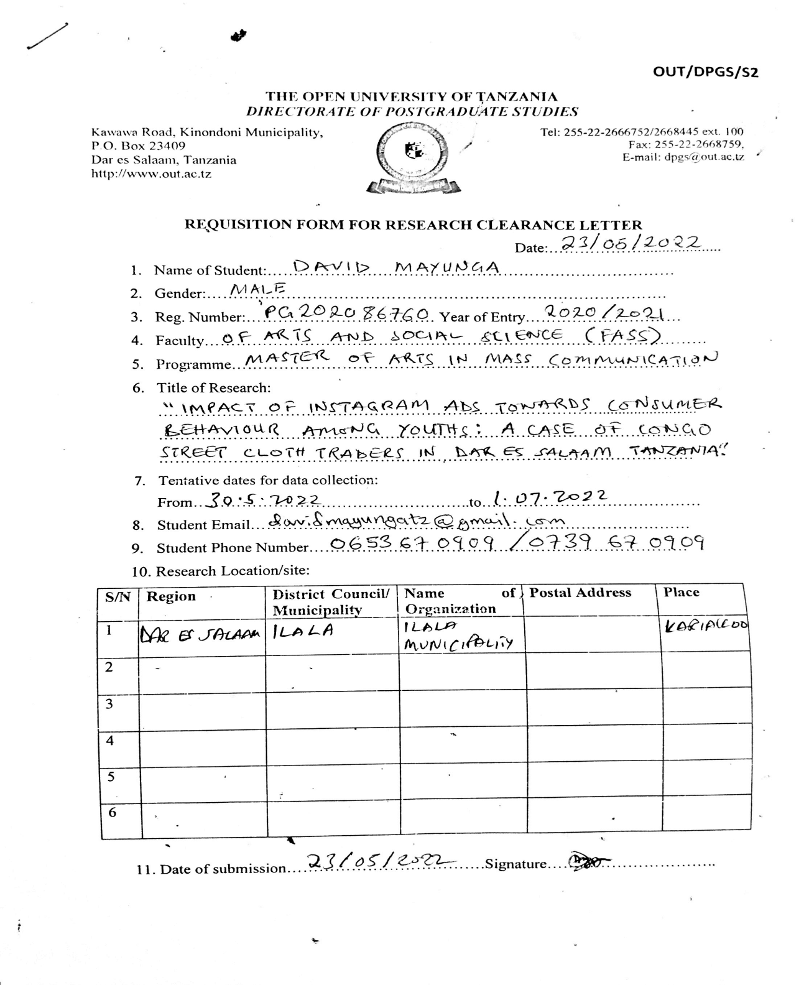
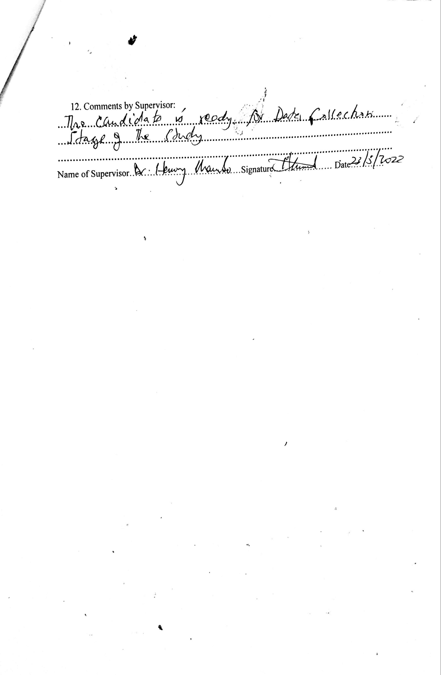

APPENDIX IV: RE RESEARCH CLEARANCE
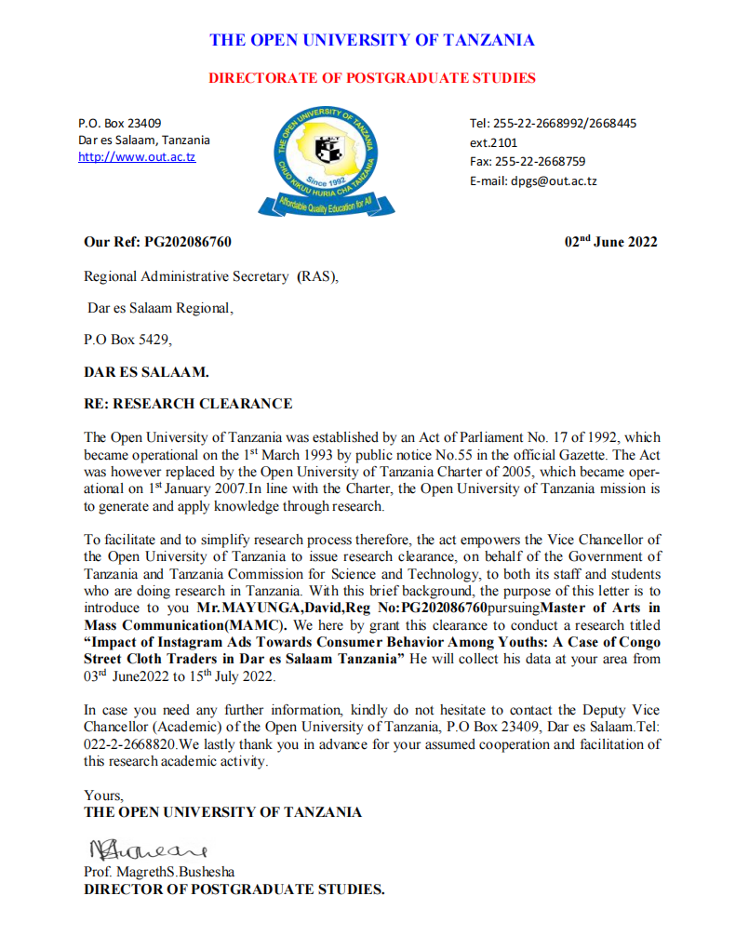

APPENDIX V: RECOMMENDATION LETTER FROM DAR ES SALAAM REGION OFFICE
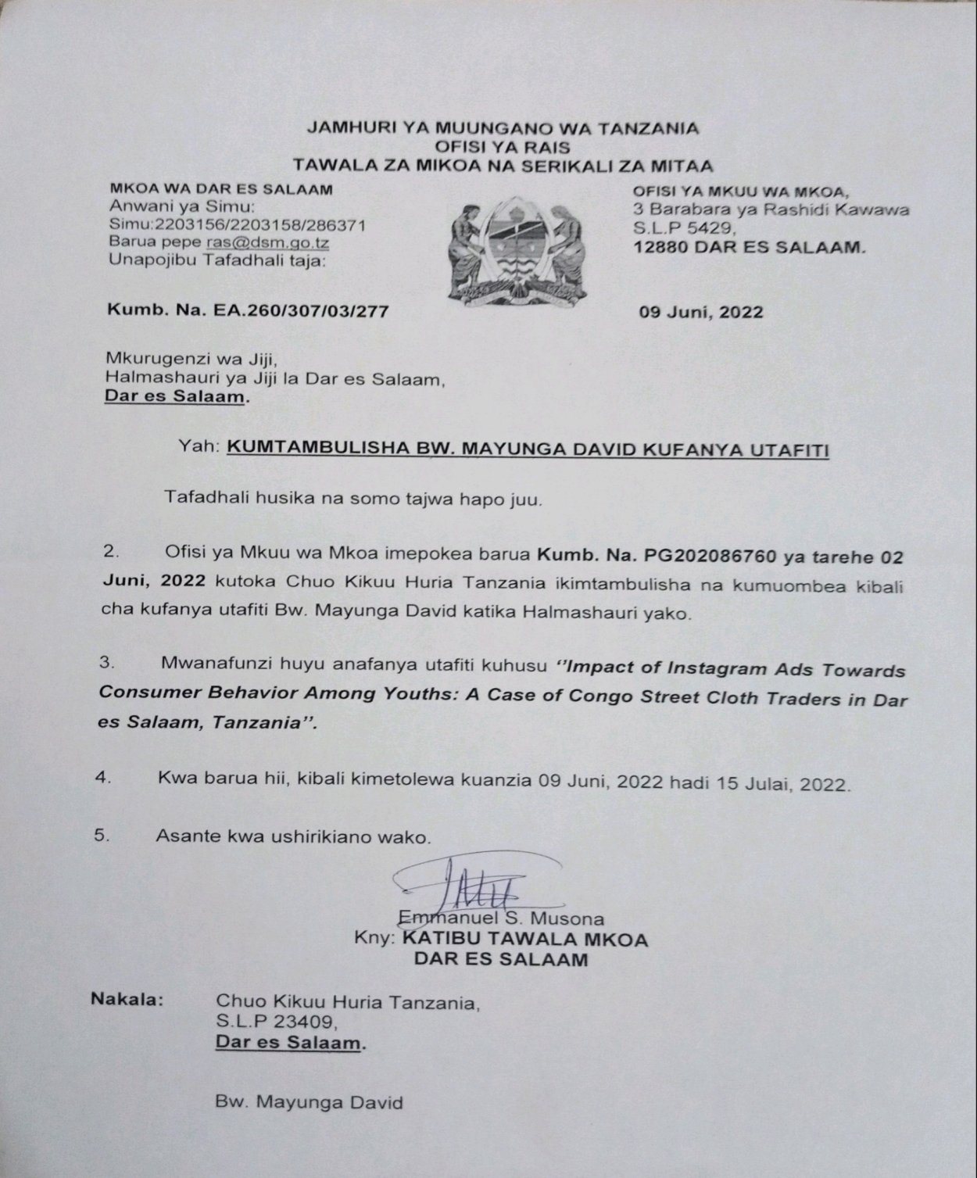

APPENDIX VI: RESEARCH PERMIT FROM DAR ES SALAAM CITY COUNCIL OFFICE
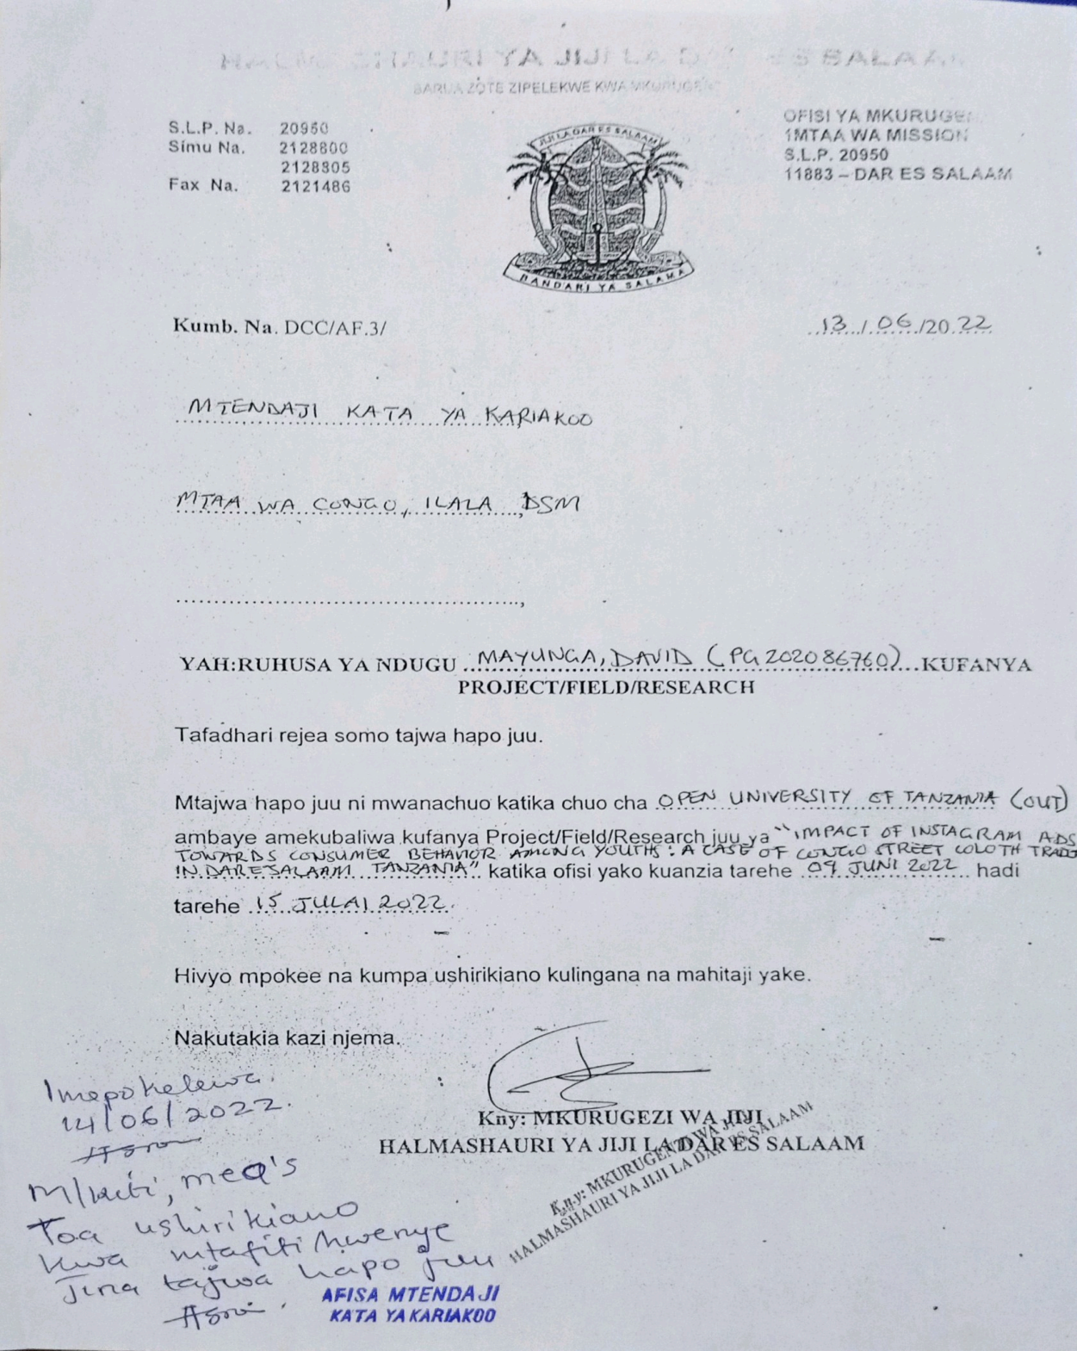

INDEX I: THE PUBLISHED ARTICLE INTEKU JOURNAL OF INTERDISCIPLINARY STUDIES (TJIS) 30thJUNE 2023

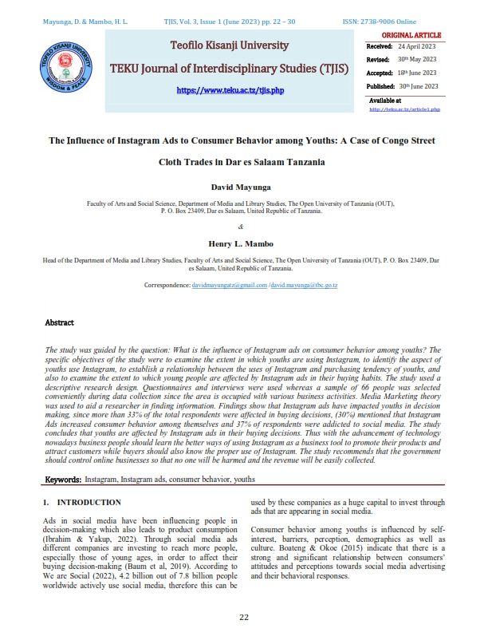

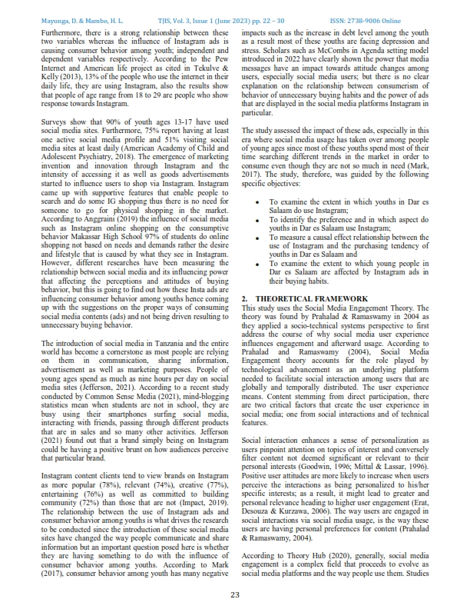

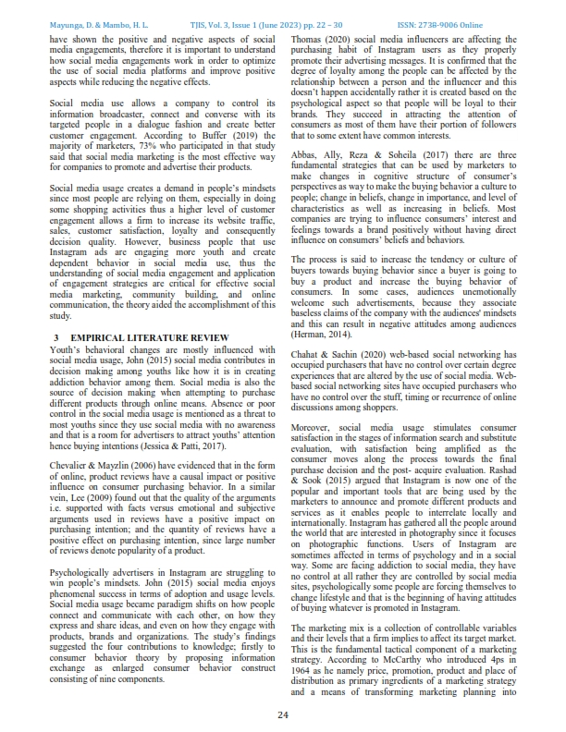

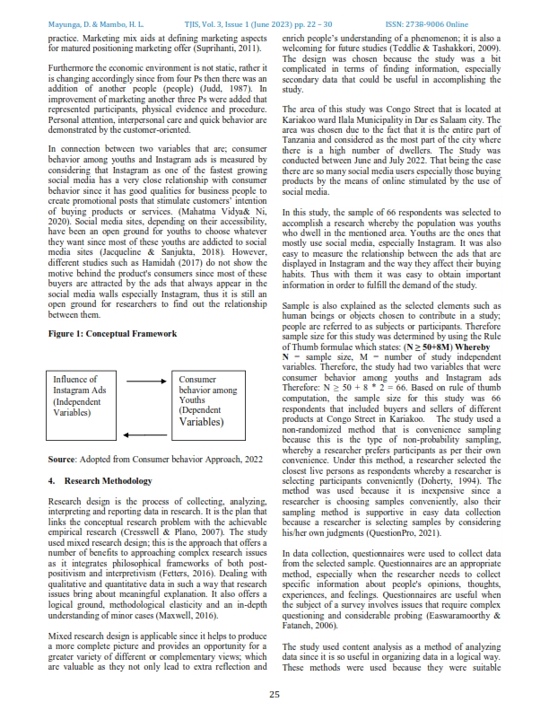

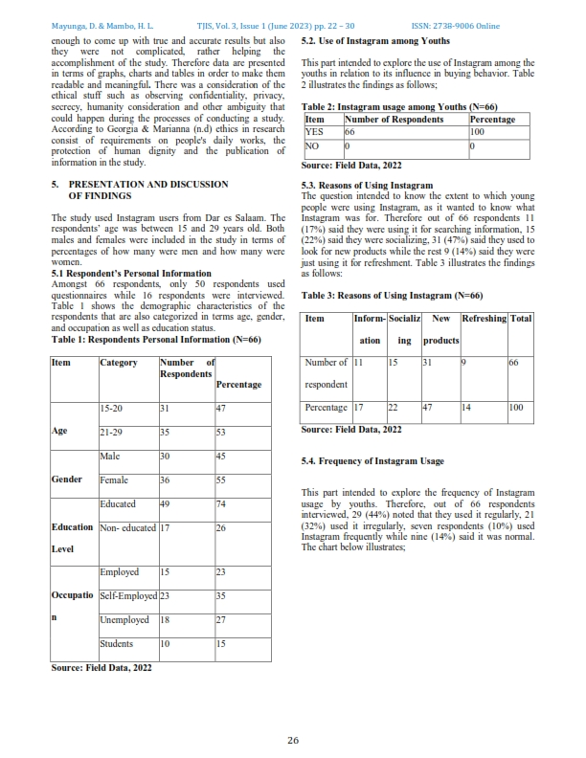

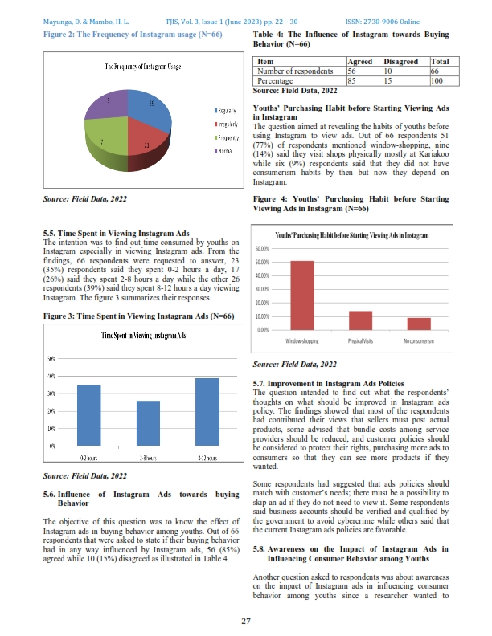

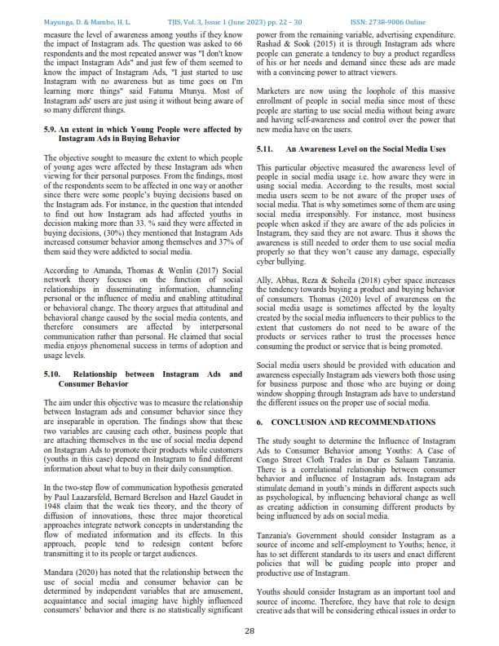

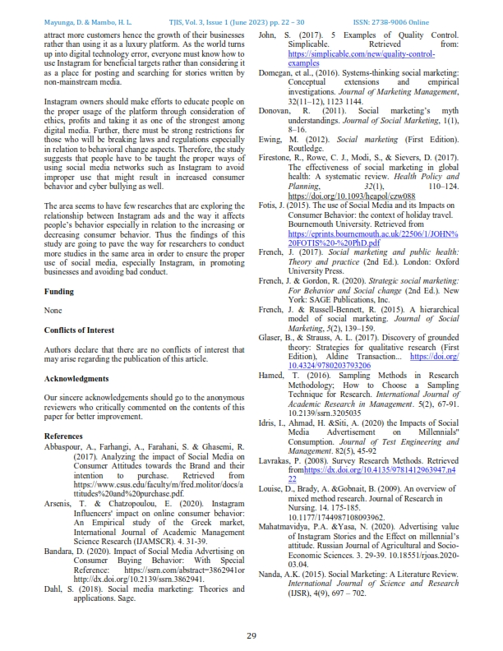

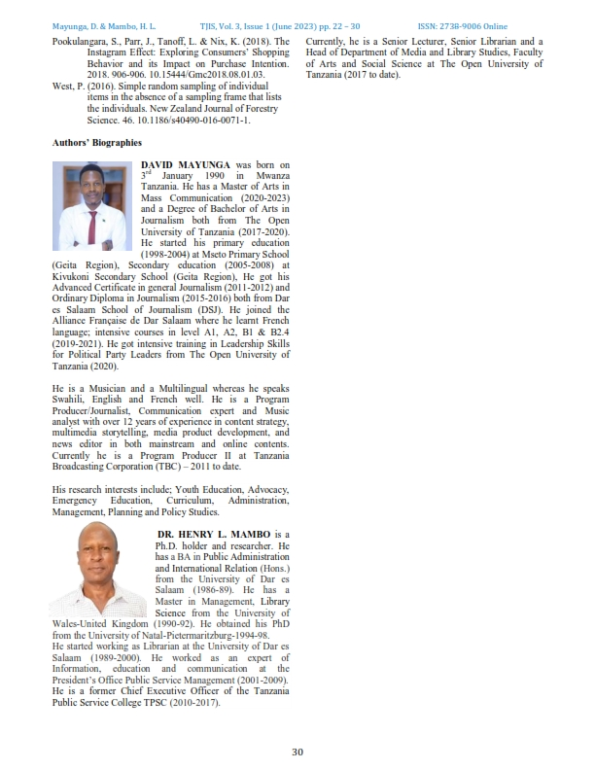

INDEX II: ACCEPTANCE LETTER OF ARTICLE PUBLICATION IN TEKU JOURNAL OF INTERDISCIPLINARY STUDIES (TJIS) JUNE 2023
