THE ROLE OF TBC FM RADIO ON PROMOTING CHILDREN RIGHTS IN TANZANIA: A SURVEY OVER SIMIYU REGION

MOMBA SAIMON ISAYA.

A DISSERTATION SUBMITTED IN PARTIAL FULFILLMENT OF THE REQUIREMENT FOR THE DEGREE MASTERS OF ARTS IN MASS COMMUNICATION DEPARTMENT OF MEDIA AND LIBRARY STUDIES OF THE OPEN UNIVERSITY OF TANZANIA
2022

CERTIFICATION
The undersigned certifies that he has read and here by recommends for acceptance by the Open University of Tanzania a dissertation entitled, The role of TBC FM in Promoting Children Rights in Tanzania: A Survey over Simiyu Region. In partial fulfillment of the requirements for the award of Degree Masters of Arts in Mass Communication.

……………………………..
(Supervisor)

Signature

……………………………
Date

COPYRIGHT
No part of this Dissertation may be reproduced, stored any retrieval system, or Transmitted in any form by any Means, electronic, photocopying, recording or otherwise without prior written permission of the author or The Open University of Tanzania in that behalf.

DECLARATION
I, declare that, the work presented in this dissertation is original. It never been presented to any other University or Institution. Where other people`s Works have been used, references have been provided. It is in this regard that I declare this work as originally mine. It is hereby presented in partial fulfillment of the requirement for the Degree of Masters of Art in Mass Communication.

…………………………………………
Signature

……………………………..
Date

DEDICATION
This dissertation is dedicated to my Wife Madam Rose Martin Masala, may Almighty God bless her abundantly for her efforts, guidance, love, care and sacrifice for my education journey.

ACKNOWLEDGEMENT
First and foremost, I am thankful to the Almighty God foe enabling me throughout my life course. Most importantly, I want to extend my deep profound gratitude to my Supervisor for his guidance, supervision, encouragement and constrictive challenges throughout the research on process of the Dissertation writing stage. I further extend my gratitude to my family in particular my wife Madam Rose Martin Masala for being tolerance when I was busy with research activities; I really appreciate her supportive efforts to enhance my desire.
I extend my appreaction and gratitude to my tutorial for never stopping in believing in me and investing their efforts to impart knowledge which has been helpful in accomplishment of this study. I am indebted thankful to TBC FM Radio and all respondents who participated in this Study for their Unlimited cooperation throughout the data collection process by providing me with relevant information needed by to make this task successful.

ABSTRACT
This study sought to examine the role of TBC FM Radio on promoting children rights to the public. Specifically, this study focuses on identifying the programs aired on TBC FM Radio which promote children rights, determining the contribution of the programs aired on TBC FM Radio on promoting children rights, and exploring people’s views on the programs on promoting children rights aired on TBC FM Radio. In case of the methods, this study was conducted in Simiyu region, whereas a cross-sectional research design with both quantitative and qualitative approach was employed during data collection. Additionally, two instruments of data collection which include questionnaire and interviews were employed to gather data from 100 respondents. Data analysis in all three objectives employed descriptive statistics to generate frequencies and percentages. Thereafter, inferential analysis, in particular the Binary Logistic Regression was employed to find the statistical significant between the role of media (independent variable) and promoting of children rights (dependent variable) whereas the value of score was (p-value≤0.05). The obtained findings show that TBC FM Radio had designed programs for promoting children rights. The results also indicate that the designed programs had contributed on promoting children rights. Furthermore, the results indicate that people had perceived the aired programs on TBC FM Radio to have positive contribution on promoting children rights. The inferential findings show that among the nine determinants, six determinants (educational programs, respect of children rights, protect children from neglect or abuse, sensitization of children rights, reading and writing, and parental awareness) show the statistical significant association ((p-value≤0.05) with promoting of children rights. The study concludes that TBC FM Radio plays its roles to promote children rights through different aired programs. The study recommends the parents to encourage their children to listen to the aired programs. Also, other radio media should learn from TBC FM Radio on how children rights could be promoted in media.

TABLE OF CONTENTS
CERTIFICATION i
COPYRIGHT ii
DECLARATION iii
DEDICATION iv
ACKNOWLEDGEMENT v
ABSTRACT vi
TABLE OF CONTENTS vii
LIST OF TABLES xii
LIST OF FIGURES xiii
LIST OF ABBREVIATIONS AND ACRONYMS xiv
CHAPTER ONE 1
INTRODUCTION 1
1.1 Introduction 1
1.2 Background to the Study 1
1.3 Statement of the Research Problem 4
1.4 Research Objectives 5
1.4.1 General Objective 5
1.4.2 Specific Objectives 5
1.5 Research Questions 5
1.6 Significance of the Study 6
1.7 Limitation and Delimitation 6
1.8 Organization of the Study 7
CHAPTER TWO 8
LITERATURE REVIEW 8
2.1 Introduction 8
2.2 Conceptual Definitions 8
2.2.1 Radio 8
2.2.2 Child 8
2.2.3 Rights 9
2.3 Theoretical Framework 9
2.3.1 Theory of Change 10
2.3.2 The Theory of Media Convergence 11
2.3.3 Program for Promoting Children Rights in Media 12
2.3.4 Contribution of Media in Promoting Children Rights 13
2.3.5 People’s Views on Programmes of Promoting Children Rights 13
2.4 Empirical Studies 14
2.5 Conceptual Framework 16
2.6 Research Knowledge Gap 19

CHAPTER THREE 20
RESEARCH METHODOLOGY 20
3.1 Introduction 20
3.2 Research Design 20
3.3 Research Approach 21
3.4 Area of the Research 22
3.5 Target Population 22
3.6 Sampling Procedure 23
3.6.1 Non-probability sampling 23
3.7 Sample Size 24
3.7.1 Inclusion and Exclusion Criteria 25
3.7.1.1 Inclusion criteria 25
3.7.1.2 Exclusion Criteria 26
3.8 Variables and Measurements 26
3.8.1 Independent Variables 26
3.9 Methods/Instruments of Data Collection 28
3.9.1 Questionnaire 28
3.9.2 Interview 28
3.10 Data Processing and Analysis 29
3.10.1 Quantitative Data Analysis 29
3.10.2 Qualitative Data Analysis 29
3.11 Validity and Reliability of Research Instruments 30
3.11.1 Validity 30
3.11.2 Reliability 30
3.12 Ethical Considerations 30
CHAPTER FOUR 32
RESULT AND DISCUSSION 32
4.1 Introduction 32
4.2 Demographic Characteristics of Respondents 32
5 Table 4.1: Socio-Demographic Information of Respondents 33
4.3 Programs which Promote Children Rights in TBC FM 35
4.3.1 Entertainment Programs 36
4.3.2 Educational Programs 38
4.3.3 Drama Programs 39
4.3.4 Critical Thinking Programs 40
4.3.5 Cultural Programs 40
4.4 The Contribution of Programs Aired by TBC FM Radio on Promoting 41
Children Rights 41
4.4.1 Communicating with Children 42
4.4.2 Respect of Children 43
4.4.3 Protecting Children from Neglect and Abuse 44
4.4.4 Sensitizing on Children Rights 45
4.5 People’s Views on the Programs Aired by TBC FM Radio to Promote 45
Children Rights 45
4.6 Binary Logistic Results 49
CHAPTER FIVE 52
CONCLUSION AND RECOMMENDATION 52
5.1 Introduction 52
5.2 Summary 52
5.3 Conclusions 53
5.4 Recommendations 54
REFERENCES 57
APPENDICES 63

LIST OF TABLES
Table 3.1: Sample of Informants and its Distribution 25
Table 3.2: Independent Mariables and Measurements 27
Figure 4.3: Illustration of the findings 46
Table 4.2: Binary Logistic Regression Results 51

LIST OF FIGURES
Figure 2.1: :Conceptual Framework 18
Figure 4.1: Programs aired by TBC FM to promote children rights 36
Figure 4.2: Contribution of aired programs on promoting children rights. 42
Figure 4.3: Illustration of the findings 46

LIST OF ABBREVIATIONS AND ACRONYMS
RTD |  | Radio Tanzania Dar es Salaam
TBC |  | Tanganyika Broadcasting Corporation
UICEF |  | United Nation Children‟s Fund
URT |  | United Republic of Tanzania
USA |  | United States of America
WHO |  | World Health Organization
ICHRP International Council on Human Rights Policy

CHAPTER ONE

INTRODUCTION

1.1 Introduction
Chapter one has been designed to give elaboration of the topic and factors behind, which forced a researcher to develop this study. In fact, the chapter gives information to clear the aim of conducting this study. Apart from giving aim of conducting this study, the chapter also provides detailed information on background, research problem, and objectives of the study, research questions, and significance of the study, delimitations and limitations of the study. Lastly, the chapter provides information about concept terms and organization of the study.

1.2 Background to the Study
Globally, radio is the most important source of information about many things including human rights (Teweldebirhan,2011). The reason is that, in any place where there is a radio, there is a source of information (Melisandre and Middleton 2009), as a result a radio posse a power to select issues and information in the world we get to know, radio also filter and frame issues, and create both the consciousness on matters that include human rights (International Council on Human Rights Policy, 2010).
Moreover, the history of radio in the World is considered to be the complex issue due to the fact that it differs from one country to another. Most of textbooks, scholars and authors argue that, the development of radio in the World can be traced back in the 20th Century, as Kitzinger and Skidmore (1995) stipulate that at the last years of the 19th century in 1896, Marcon started radio with the invention of first wireless telegraph link. Moreover, it took 10 years since then for the first demonstration of radio broadcasting to establish but it was hard to distinguish words from music. However, the development of radio in the World did not erupt like fire in the bush, thus it developed stage by stage (Noose, 2013). For example, Morse (1992) argues that the development of radio began with the discovery of pulses of electricity in 1844. This stage was geared by Christian in 1882 when he discovered the relationship between electricity and magnetism. Morse further argues that the development of radio in the world was geared by a large number of scholars who discovered various technologies related to radio. Again, Maxwell (2000) argues that another stage of the history of radio was discovery of electromagnetic waves known as radio waves.
The development and history of radio did not end there, simply because in 1887 Heinrich Hertz used electromagnetic signals without wires termed as wireless radio waves. Moving in the same vein, Lee (2009) illustrates that the word "radio" also appears in a 1907 article by Lee De Forest and was adopted by the United States Navy in 1912, to distinguish radio from several other wireless communication technologies, such as the photo phone. Again, most sources reveal that radio broadcasting firstly began in New York, USA in 1916 whereby voice and music transmission were made. To sum up, Andrew (2009) argues that radio broadcast begun by British Broadcast Corporation (BBC) in 1922 in which radio sets were bulky and expensive. That is to say, radio began when the first radio broadcasting service was launched for the first in the world when BBC, on 15th December 1922 began to broadcast. Scholars such as Ng‟wanakilala (1981), Head (1974) and Matumaini (2006) state that the history of radio in Tanzania dates well back to British colonial era when Dar es Salaam was born. However, Sturmer (1998) argues that the development of radio in According to Mwaffisi(2011), Tanzania can be traced back during the colonial phase whereby the idea for establishing radio goes back to the Second World War (WW II) in which Tanganyika by then was under colonial rule. It must be noted that, the radio station was an instrumental for propagating colonial propaganda in the colonies. For the reason, the first radio station in Tanzania Main land (Tanganyika), was Sauti ya Dar es Salaam that was established on 1stJuly 195. The station broadcast only for one hour per week in Kiswahili. The founding of the station did cost 11,320 British Pounds (about TShs.26, 000,000/=).
Additionally, Karol (2013) states that, it is important to note that, Radio Tanzania Dar es Salaam (RTD) changes its name and hands of government ministers several times, in 1956 the name changed to Tanganyika Broadcasting Corporation (TBC), with little autonomy from the government/Colonial regime. After independence, in 1965 Sauti ya Dar es Salaam was transformed to Radio Tanzania Dar es Salaam (RTD) whereby the station was closely controlled and monitored by the government. Today, there are many Radio stations state/public, private, community, religious, political and special radio stations established. These include Radio Free Africa (RFA), Radio One, Kiss FM, East Africa Radio, Uhuru FM, TBC Taifa, TBC FM, just to mention a few.
The existence of radio is tremendous potential and needed for communication to contribute to the promoting and creating of awareness the children rights. However, in reality of achieving this is not simple, as scholars describe a range of factors currently inhibit media including radio in many developed and developing countries including Tanzania. Crucial issues identified across the world include; lack of children‟s voices, lack of coverage, lack of professionalism to report child rights, and lack of rules (Daftari et al., 2014). Additionally, in the case of Tanzania, despite the presence of many radios, there is a shortage of radio programming for children. Generally, radio programming is nearly exclusively focused on music and news rather than protecting children`s rights. Therefore, this study intends to examine the role of radio on promoting children rights in Tanzania.

1.3 Statement of the Research Problem
Nowadays, the violence against children is becoming observable (Mwakilasa,2020). Moreover, according to the World Health Organization (WHO, 2002) violence is not only threatening children health, but also their ability to learn and grow into adults.
In Tanzania, the country has come up with National Plan of Action for ending Violence against Women and Children from 2017-2022 (URT, 2016). However, according to (Mwakilasa,2020), children in Tanzania have experienced psychological abuse and sexual violence in their life time from the age of 15.
For that reason, children rights are violated and eventually lead to insecurity and lack peace in the society. So, for the sake of promoting children rights radio is an important medium to play such role. Radio creates pictures into peoples‟ minds, it speaks to a single person, it is portable, less costing, easy to prepare programs and cheap, Brosseu (1998). In that regard, radio is the right medium that can be used in creating awareness to the public on children rights. However, there is a lack of information concerning the role of radio in promoting children rights (Daftari et al., 2014), therefore, to clear the gap, this study is going to develop a bank of information concerning the role of radio in promoting children rights to the public in Tanzania.

1.4 Research Objectives

1.4.1 General Objective
The general objective of this study was to examine the role of radio in promoting children rights to the public.

1.4.2 Specific Objectives
The specific objectives of this study are as follows: -
- To identify programs which promote children rights aired by TBC FM in Simiyu Region.
- To determine the contribution of the programs aired by TBC FM on promoting children rights aired in Simiyu Region.
- To explore people’s views on the programs aired by TBC FM to promote children rights in Simiyu Region.

1.5 Research Questions
- What are the programs aired by TBC FM for promoting children rights in Simiyu Region?.
- What are the contributions of programs aired by TBC FM on promoting children rights to the public in Simiyu Region?
- What are the people’s views about the programs of promoting children rights aired by TBC FM in Simiyu Region?.

1.6 Significance of the Study
The study is significant to media practitioners and society at large due to the fact that, it critically promotes human rights and creates peace and harmony in the society. The study also, not only raises public awareness on children rights, it helps media practitioners to produce programs which educate the masses on children rights. Again, the study is useful to parents and guardians simply because it awakens them on fighting against children violence. Finally, the study is important to other researchers as it provides Literature and research findings for further studies.

1.7 Limitation and Delimitation
This study may be faced with some limitations during data collection. The time factor may appear to somehow limit the study because of late access to respondents due to their personal time table. To mitigate this limitation, a researcher will send a letter for requesting appointments particularly at TBC FM office. The time factor may also be associated with a station of a researcher to work alone in the study. To take measures on this limitation, a researcher will recruit two research assistants to help in data collection. Response bias is also expected to limit a study, other respondents may respond untruthfully or misleadingly to questions due to either feelings of pressure or afraid to give a proper answer for questions he/she thinks that are not socially acceptable. To mitigate this kind of biasness, a researcher will assure the respondents with privacy and confidentiality all the time of data collection and after data collection. Additionally, a researcher will ensure that all questions are asked properly and politely to avoid misleading. Moreover, this study is delimited only in one radio i.e., TBC media. This is because the matter of protecting and promoting children rights would be done in similar way in other radios, therefore only TBC media may help a researcher to accomplish the aim of this study. In addition, this delimitation helps also to minimize time constraints and limited funding to cover other media.

1.8 Organization of the Study
This proposal has been organized into three chapters. Chapter one includes background to the study, statement of the research problem, research objectives, research questions, relevance of the research, limitation and delimitation and organization of the study. Chapter Two covers literature review, conceptual definitions, critical review of supporting theories, empirical analysis of relevant studies, research gap identified, and analytical conceptual framework. Chapter Three includes research design and methods. It shows the research strategies, survey population, and area of the research, sampling strategies, methods of data collection, data processing and analysis. Chapter Four Present the findings and discussion, while Chapter Five presents Conclusion and recommendation of the study.

CHAPTER TWO

LITERATURE REVIEW

2.1 Introduction
This chapter presents different concepts reviewed from different documents and researches which relate to the topic of the study. The first part presents the theoretical literature review. The second part gives detailed information based on the empirical review.

2.2 Conceptual Definitions

2.2.1 Radio
Mishra(2020) defines radio as the medium of sending and receiving messages through the newline air, using electromagnetic waves. Additionally, radio has always been a part of people’s life. Apuke (2017) explains radio as a device which we can carry around, this device never need internet data streaming and is free of cost. Brosseu (1998) defines Radio as a medium of information which creates pictures into peoples‟ minds, it speaks to a single person, it is portable, less costing, easy to prepare programs and cheap. In this study whenever the word radio is used, it means a medium of sending and receiving messages as defined by Mishra (2020).

2.2.2 Child
According to Aries (1962) a child is defined a person with years between infancy and adolescence. Moreover, according to (Bisht, 2008) a child is one who can’t take his decision due to age factor, is totally dependent on his parent or guardian. According to UNICEF (1997) a child is a person under the age of eighteen (18). UNICEF points that children constitute approximately 37 percent of the total world population. Generally, Gilani (1994) argues that, a child is perceived as a tiny little thing who is supposed to learn what the teachers or parents say. He/she should eat, sleep, play or study as and when told to do so. In this study, whenever the word child is used, it means a person eighteen years.

2.2.3 Rights
Gladius (2009) defines rights as legal, social, or ethical principles of freedom or entitlement; that is, rights are the fundamental normative rules about what is allowed of people or owed to people according to some legal system, social convention, or ethical theory. “In perusing children’s right has been taken for granted in most of medium of communications including radio, children are been exposed without acknowledgment of their rights, something that make most of children being at risks that could be avoided‟‟. ICMEC (2020)

2.3 Theoretical Framework
This part is based on the various reviews of written documents on variables understudy. Specifically, two theories have been reviewed and used as guidelines in this study, these two theories include; “Theory of Change” and “Theory of Media Convergence”. Moreover, this part also discusses the three-variable understudy, these include; program on children rights, contribution of the programs on aired in media on children rights, and people’s views about the programs of children
rights.

2.3.1 Theory of Change
Scholars like Gujit and Retolaza (2012) depicts the theory of change as a good technique to the plan and evaluation of social programs. This theory was initiated in 1990s as a means to model community to initiate programs for changes. According to Daftari(2014), the theory of change underlies individual belief in the power of communication for protecting rights. The theory suggests that, if media, civil society and children youth themselves are empowered to provide valid, credible and realistic information that is widely disseminated to others, this will be better education of people across a society on the rights of all people including children as full and protected members based on the international standards. According to this theory of change, any new innovative program for disseminating information to protect children rights, will make a society to gain understanding of appropriate standards for treating and protecting children, moreover pressure will be brought to improve legal protection and individuals as parents, teachers, and neighbors which later improves the protection of human rights of their children (Daftari et al,2014).
Here, the theory of change is seen to provide the assumptions of making what is possible in reaching the long-term objectives (Gujit and Retolaza, 2012). As the theory shows links between program activities and outcomes. According to Loveridge(2011), the theory influences organizations including media and program makers to put efforts in developing new programs for changing community to reflect the practice of social change.
This theory of change is very useful in this study because it provides insights of social change through provided information. Additionally, the theory identifies outcomes of social change based on promoting children rights. Therefore, it would be easy to develop variables under study based on the topic of study.

2.3.2 The Theory of Media Convergence
This research is also going to apply the theory of media convergence, according to Jenkins (2006) the theory of convergence refers to the converging models that blurs the lines between media forms. This convergence mode is to reshape a popular culture and changing audience’s relationship with media and media content. With this theory, more choice is handed back to the user, or radio’s case, the listener. This means audiences who are community always select to listen or watch a particular program based on their tradition and culture.
Moreover, Jenkins (2006) continues to explain that, the theory of media convergence has logic to it, and it occurs regularly in our day-to-day lives. This type of access to needed communication based on popular culture and traditional can even be a good strategy to promote human rights in multiple platforms. Therefore, with this theory, media are required to develop multiple platforms with educative program to present to communities based on their culture and tradition.
The theory is very essential in this study, it could be applied to determine how TBC media has developed different programs in multiple platforms to promote culture and tradition hence opposes all kind of violence to children. The theory will help to determine the influence of developed program in multiple platforms on the promoting human rights in particular children rights. Therefore, programs which are special for children, parents and guardian for promoting children rights should be determined with reflections on this theory of media convergence.

2.3.3 Program for Promoting Children Rights in Media
The media of mass communication is indispensable to any development task including society change in behaviors (Samuel, 2009). It is therefore very right for media to set agenda and programs for the rights of children, as well as other development agenda. The Millennium Development Goals (SDGs) are also about children, as the six of the eight millennium development goals can be met as the rights of children health, protection and equality, and to meet them effectively, the rights of children are to be realized (UNICEF, 2003).
According to Jacomy and Stevens (2004) media can participate effectively in their role of promoting children rights if they can also develop programs targeted towards children, parents, teachers, educational institutions, policy-makers and civil society organizations. Moreover, measures taken to develop programs for minority audiences like children should be in language understood by audience, offering entertainments for all kids, offering a variety of culture, and educational information programs (Karol, 2013). According to Ozturk and Dogan (2017) children also could be involved and being kept with awareness on their rights through programs in media which include; drama which teach about rights and responsibilities, games which create awareness, artistic activities, participatory activities and actions for critical thinking.

2.3.4 Contribution of Media in Promoting Children Rights
The media are termed as undoubtedly persuasive tools in people’s struggle for their liberation and development (Awosola and Omoera, 2008). With respect to children rights, the media including radio has been used as a weapon of awareness creation through promotion. But in order for the media to match on the stated view as a weapon for awareness, most of programs coverage are to be geared towards promoting different matters including on children rights, the evils of child abuse and call on the public debate about thes,e issues (Omoera, 2004).
According to Ozturk and Dogan (2017), the change in social structure depends on the efforts of preventing children which are to be done by states, parents, guardians, teachers, families and media. However, unlike the roles in other understandings, media are expected to take active roles to inform society about children rights to avoid violence against children. The society is expected to give the children the rights and value that they deserve, and the necessary culture should be established for the survival of rights and responsibilities and to ensure appropriate life standards. For example, media can emphasize the public on how to communicate with children, ensuring respect to children, protecting from neglect and abuse, and avoiding punishments that involve physical and psychological violence (Lansdown, 2014).

2.3.5 People’s Views on Programmes of Promoting Children Rights
Guru et a., (2013) stipulate that media is a powerful tool in raising awareness of people and their rights, mostly for children rights. The broadcast journalists have a task to uncover stories which include dramas, documentaries and news of child abuse occurring in the society. According to Oyero and Salawu (2018) stories of children abuse result to overwhelming impact on individuals‟ attitudes towards children, therefore has been an issue to concern to media practitioners to raise of these children‟s issues though sometimes they are faced with challenges from people themselves.
The society perceives a media as significant tool for promoting children rights. (Choudhury, 2014), however it is also a society that challenges media in reporting fairly, honestly and accurately, as the society does not like to listen about violence against children reported, sometimes the parents and guardians need to negotiate with a person who has made violation to his/her child, when a journalist plays his/her role to report the story, it becomes a conflict between a parent and a journalist (Choudhury, 2014).

2.4 Empirical Studies
Various researches and studies have been conducted in the field media and protection and promotion of child rights. For example, Greyson (2008) did a research on the role of radio in creating awareness to the public on children rights. The study was conducted in England in which qualitative approach was applied. The Sample Size of the study was 1000 respondents with Questionnaires and interview as data collection tools. The study revealed that 66% of radio audience get information related to children rights, meanwhile 34% of respondents said that radio stations in England base on politics, sport, economy, science and technology and rarely report on children rights. Thus, grant‟s research generally focused on assessing the role of radio in creating awareness to the public on children rights in England. In that regard, there is a need to conduct research in Tanzania related to children rights. James (2010) surveyed on the role of radio in promoting children rights in Thailand.
The researcher used both qualitative and quantitative approaches with Questionnaire, Focused Group Discussion, and Interview. The study data indicates that, people in
Thailand get information related to children rights via different radio programs. That is to say, the study done by James in 2010 successful explored the role of radio in promoting children rights in Thailand. For that reason, there is a need to conduct a research in Tanzania trying to examine the role of radio in creating awareness on children rights.
Different from James (2010), Lenhart (2011) conducted the research of the uses and significance of radio in promoting children rights in USA.The study used Mixed approach. In other words, both qualitative and quantitative approches were used. In data collection tools the researcher used interview, and questionnaires. The sample of the study was 2000 respondents, in which most of them were university students. The study revealed that 70% of radio listeners were exposed into children rights, while 30% of radio audiences were not satisfied on how radio promotes children
rights.
Osmond (2013) researched on the role of radio in promoting children rights in Kenya. The study was conducted in Nairobi. The findings show that radio plays a significant role in fighting against children violation of rights. Firstly, radio enables people to get immediate, and update information related to children rights. Secondly, radio helps social workers to provide education to the public on the negative impacts of violating children rights. By that considering, another study should be conducted in Tanzania in examining the role of radio in creating awareness to the public on children rights.
Madillo (2012) is another researcher who did a study in determining the role of radio in creating awareness to the public on children rights. The study was conducted in
Uganda. The sample of the study was 150 respondents from Makerere University.
Qualitative approach with questionnaire and interview was used. The results showed that radio to the large extent play a vital role in promoting children rights in Uganda.
Furthermore, Omote (2014), investigated the influence of radio in fighting against children violence. The study was conducted in Nigeria. Researchers used six different universities randomly selected from the six geo-political zones in Nigeria. The findings of this study indicate that radio in Nigeria plays a significant role in fighting against children violence. In addition, radio stations in Nigeria promote children rights through different educative radio programs. From that point of view, there is a need to make an investigation on the role of radio in creating awareness to the public on children rights in Tanzania.

2.5 Conceptual Framework
With the help of the two theories of “Theory of Change” and “Theory of Media Convergence” and other reviewed documents. This study has developed a conceptual framework shown in Figure 2.1. The theory of change has shown how media including radio can develop programmes to promote children rights for society change. According to the theory of change the created programs could be for educating parents/guardians and children themselves for their rights. Moreover, the theory of media has shown that the matter of promoting children rights needs the multiple media which could develop different programs to emphasize on the children rights. However, it has been very difficult for all media to work on the same ambition of promoting children rights; this is taken as among the challenges which minimize efforts of media to promote children rights.
Therefore, with the arguments produced in the identified two theories; theory of change and theory of media convergence, the study has developed a conceptual framework which shows that promoting of child rights (dependent variable) is the product of three independent variables (programmes for promoting children rights, contribution of programmes aired in media on promoting children rights, and views of people on children rights).

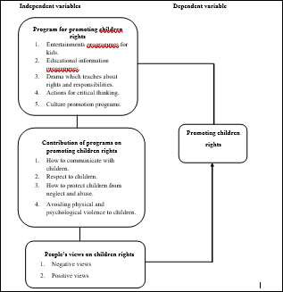
Figure 2.1: : Conceptual Framework
Source: Constructed by the researcher (2021)

2.6 Research Knowledge Gap
Researchers such as Greyson, (2008), James, (2010), Lenhart, (2011), just focused on role of radio in promoting children rights in England, Thailand and USA. This implicates that such studies have not been conducted in Tanzania. For example, James (2010) his study revealed, people in Thailand get information related to children rights via different radio programs. That is to say, the study done by James in 2010 successful explored the role of radio in promoting children rights in Thailand. Again, Osmond (2013) and Madillo (2011) conducted researches on the uses and significance radio in fighting against children violence in Kenya, Uganda and Nigeria. From that point of view, none of the researchers conducted studies examining the role of radio in creating awareness to the public on children rights. Consequently, there is a need to make an investigation on the role of radio in promoting of children rights to the public in Tanzania.

CHAPTER THREE

RESEARCH METHODOLOGY

3.1 Introduction
This chapter focuses on the description of all techniques which will be employed to accomplish this study. The chapter entails the description of research design, target population, sample size, sampling procedures, instruments for obtaining data, and data analysis.

3.2 Research Design
A research design is a comprehensive research plan on how a study is going to be undertaken. A research design enables the research process to yield valid results because of the clear path of the study outlined. A research design can also be defined as a method, structure or technique that guides and directs the collection of data and its analysis . Moreover, the research design can be defined as a sketch employed to gather appropriate data to enable the achievement of research objectives. Therefore, in general, the research design is defined as methods or techniques followed to collect the data, as well as analyse and present the results so as to attain the research objectives. In another way, the research design comprises the framework for data collection and analysis, sources of data, procedures for data collection, as well as data analysis and its presentation so as to attain the objective of the research. Therefore, the research design of the current study involves the identification of the research problem, investigating and examining the research problem with appropriate techniques, gathering of data, analysing the data, presenting the results, drawing conclusions and making recommendations.
Furthermore, the research design of this study is quantitative in nature. Quantitative research involves gathering of information that yields statistical data. Therefore, Collis and Hussey (2009) depict that quantitative research engages the measurement of data and analysis of the causal relationship among variables of interest. Moreover, the current study employs secondary data, suggesting that the data is already available and collected for a different purpose (Creswell & Creswell, 2017). Therefore, if there are enough secondary data that respond to the intended research objectives, it is not necessary to gather primary data.
Mugenda(2010) describes research design as a guide to the process of data collection, data analysis, and interpretation of the findings via dialect and inference which reflects to the collected data. This study will apply a cross-sectional research design, which is also known as social survey design (Bryman and Bell, 2011). This means a researcher will collect data at once. The opted research design is helpful to the researcher hence it saves time and fund during data collection, a researcher was not supposed to collect data for more than one period of time.

3.3 Research Approach
The study will employ a mixed approach (both quantitative and qualitative) in collection of relevant information. Quantitative approach will enable a researcher to hold numeric data and measurement techniques in order to explore analyze and address research questions in this study (Babbie 2010). Moreover, a qualitative approach will be employed because it is often providing a better understanding of the topic to discuss; this approach also makes the researcher to be in a situation of describing the whole phenomenon understudy (Bryman and Bell, 2011).

3.4 Area of the Research
This study will be located and conducted at Simiyu region. According to Tanzania Demographic and Health Survey 2015, Simiyu is the third region in where its people conduct child violence in particular early marriage. The region is behind the two regions of Shinyanga and Tabora in child violence. Therefore, the third position in children violence in Tanzania has justified a researcher to conduct this study in Simiyu, to examine the contribution of radio in protecting and promoting children
Rights in Bariadi , Maswa and Busega Ditrict in Simiyu Region.

3.5 Target Population
A population is the total collection of elements about which we wish to make references. Population can also be said to be the entire set of people, things, services, elements, events or objects to be studied. Target population refers to specific population about which information is desired (Cooper and Schindler, 2008). Saunders et al.(2009) defined population as the full set of cases from which a sample is taken. The target population in this study is comprised of parents/guardians of children and TBC FM staff members at Bariadi , Maswa and Busega Districts in Simiyu region. The justification of involving parents/guardians of children is because, parents / guardians get chances to experience daily life of their children with inclusion of their responses on media programs which are designed special for children. However, staff members of TBC are included in population because they are responsible for designing the programs which promote and protect child rights, so it will be easy to obtain their experiences and challenges they face. Additionally, According to (URT, 2013), National Bureau of Statistics, Simiyu had a population of 1,317,879 in the population and housing census of 2012.

3.6 Sampling Procedure

3.6.1 Non-probability sampling
Based on the nature of this study, only non-probability sampling method will be applied to select respondents to participate in the study during data collection. According to Rwegoshora (2008), non-probability sampling makes no claim for representatives, as every unit does not get the chance of being selected. It is the researcher who decides which sample units should be chosen. Among the types of non-probability sampling are purposive sampling also known as judgmental sampling and snowball sampling. In purposive sampling the researcher chooses a person who, in his/her judgment has some appropriate characteristics required of the sample members. On the other hand, in snowball sampling the researcher begins the research with few respondents who are known and available to him. Subsequently, these respondents give other names of the respondents who meet the criteria of the research, who in turn give more new names. This process is continued until an adequate number of persons are interviewed or until no more respondents are discovered.
Thus, in this study, purposeful sampling method will be used to select key informants (staff members of TBC FM) to include in the study. Specifically, a researcher will select a staff member of TBC who will be available and accessible during data collection.
On the other hand, snowball sampling will be employed to get parents/guardians to involve in the study. The researcher will first consult the village/street leaders to identify few households with children less than 18 years, then after collecting information from each parent/guardian in the household, he/she will be required to identify another household with children, this procedure will be repeated until the required number will be obtained.

3.7 Sample Size
According to (URT, 2013), National Bureau of Statistics 2012 indicates that Simiyu had a total of 1,317,879 populations. Therefore, this population has been used to calculate sample of the study. The sample size for the study has been calculated by using the formula recommended by Yamane (1973) as cited by Jigme (2007) which is as described below.
n = N
1 + N (e)²
Whereas:
n= size of the sample (portion number of households).
N = population of sample (total households).
e= is probability of error of (0.1).
Therefore:
n = 1,317,879
1 + 1,317,879 (0.1)²
n = 1,317,879
1,317,879 (0.01)
n = 1,317,879
13,178.79
n = 100
Thus, sample size of this study will be 100 respondents in a description of 90 parents/guardians and 10 staff members of TBC FM.
Table 3.1: Sample of Informants and its Distribution
Target Population | Sample Size
Parents/guardians | 90
Staff members of TBC | 10
Total | 100

3.7.1 Inclusion and Exclusion Criteria

3.7.1.1 Inclusion criteria
The sample size will include both male and female. Moreover, the sample will include respondents with ages of eighteen and above years. Additionally, only respondents who have a tendency of listening to TBC FM radio will be considered, to know the respondents will be asked to state if they often listen to TBC FM. Lastly, only respondents with children of five to eighteen years will be included in the study.

3.7.1.2 Exclusion Criteria
Parents/guardians who had not lived with their children for more than three months frequently will be excluded from this study. The study will also exclude parents who were not aware with TBC FM. Moreover, parents/guardians who will not be with capability to respondent for asked questions due to any circumstance including sickness will be excluded from the study.

3.8 Variables and Measurements

3.8.1 Independent Variables
The independent variables as shown in the conceptual framework include three variables namely; awareness on children rights, program for promoting children, and challenges facing TBC FM in creating awareness. Each independent variable consist some indicators as illustrated in Table 3.2. However, the Table also illustrates the kind of data collected in each variable, the source and methods used to obtain such kind of data.

Table 3.2: Independent Mariables and Measurements
S/ N | Kind of data | Source | Independent Variables | Indicators | Measurement  /  Tool of data collection
1. | Quantitative | Parents/ guardians | Awareness on ●  children rights | Communicating with children | Questionnaires (open-ended
 | Qualitative | TBC FM  staffs | ●  ●  ● | Respect to children Protecting children from neglect and abuse  Avoiding physical and psychological violence to children. | and closedended)  &  Interviews
2. | Quantitative | Parents/ guardians | Program for ●  promoting children rights ● | Entertainments program for kids Educational informational programs. | Questionnaires  (open-ended and closedended)  &
 | Qualitative | TBC FM staffs | ● | Drama which teaches about rights and responsibilities. | Interviews
 |  |  | ● | Actions for critical thinking.
 |  |  | ● | Culture promotion program.

3. | Qualitative | TBC FM staffs | Challenges facing TBC FM in creating awareness | ●  ● | Lack of other media interest on promoting child rights.  Discharge from  political leaders. | Interviews
 |  |  |  | ● | Cooperation between who conduct child abuse and parents/guardians
 |  |  |  | ● | Financing arrangement

3.9 Methods/Instruments of Data Collection
This study will use two kinds of research instruments to collect primary information from participants. These instruments include questionnaire for obtaining quantitative data and in-depth interview for qualitative information.

3.9.1 Questionnaire
Abawi (2013) defines questionnaire as an instrument of data correction composed of series of questions and other prompts for obtaining information from respondents. In this study questionnaire will be used to collect information from 90 parents/guardians. Questionnaire will be used in this study because it is relatively economical because a larger sample will be covered quickly and reasonably with low cost (Mason and Bramble, 1997).
Moreover, questionnaire will be designed to compose both close-ended and openended questions. The closed-ended questions will be employed because it is quicker to analyze than word-based data and often directly to the point. Additionally, openended questions will be used because they enable participants to generate opinion and suggestion based on the problem (Joseph, 2015).

3.9.2 Interview
According to Maxwell (2012) an interview refers to a venture in which two individuals exchange and share their ideas regarding a specific theme or subject matter. It also refers to the opinion through which the qualitative interview, the point of the view of individual regarding certain situations of experiences are easily reviewed and analyzed, and allowing a researcher to gain an insight in the general perspective of the interviewees. In this study, the in-depth interviews will be used to collect data from the 10 key informants (TBC FM staff members). To get detailed information, the interviews will be conducted accordingly to the well-structured interview checklist as guided in my area of study by conducting and follow interview guide. Also I applied semi structured interview.

3.10 Data Processing and Analysis

3.10.1 Quantitative Data Analysis
According to Olive and Abel (2010) data analysis refers to a process of bringing order, structure and meaning to the mass information. In this study, the responses to the closed-ended questions in the questionnaire will be assigned, coded, and labeled through quantitative approach with the help of Statistical Package for the Social Sciences (SPSS) version 23. Additionally, frequency and percentages will be obtained to generate descriptive information. Finally, data will be then be summarized and presented in tables, graphs and charts of frequencies and percentages to interpretation and discussion. Additionally, inferential analysis will employ a binary logistic regression to develop a statistically significant level between dependent and independent variables. The considered value of score will be p-value≤0.05.

3.10.2 Qualitative Data Analysis
Qualitative data will be subjected to content analysis. The researcher will thoroughly and repeatedly read the written responses of each respondent from interview and opens ended questions, underlines the main ideas and then extracts the core meaning. Then, data will be transcribed, organized, and scrutinized into related patterns and themes for further interpretation.

3.11 Validity and Reliability of Research Instruments

3.11.1 Validity
To maintain validity, a researcher will design data collection tools (questionnaire and interview-checklists) which matched with the research questions. However, all tools will be designed simply with short questions that could be understood easily. Thereafter, all questions will be translated into Kiswahili to enable respondents to understand all questions easily. The sample size is also designed to be suitable and manageable.

3.11.2 Reliability
In order for research to maintain consistency measurements, the tools for data collection will be pre-tested before they are used in the study. This will give the researcher with ability to identify ambiguity in questions. However, a researcher will be able to eliminate all ambiguities and made the questions clear.

3.12 Ethical Considerations
The researcher will observe all the research procedures to ensure that ethical matters are adhered to. The Open University will review the proposal for ethical issues and for approval before data collection. After that a researcher will be given the research clearance letter, and research data collection permit letter. However, permission for data collection will also be sought from Simiyu region. To consider ethical issues, the study will also involve participants who will agree with consent to indicate their willingness to participate in the study.

CHAPTER FOUR

RESULT AND DISCUSSION

4.1 Introduction
This chapter presents and discusses the obtained findings based on the questions that guided the study. The chapter is comprised of two main parts; the first part describes the demographic characteristics of respondents. The second part presents and discusses the findings reflecting to the specific research objectives.

4.2 Demographic Characteristics of Respondents
The description of the findings starts with general analysis on demographic characteristics data of all participants of this study. These demographic characteristic variables include; sex, age, marital status and education level. The variables are very significant in expressing and giving responses about the problem. Therefore, in this study a set of personal characteristics (socio-demographic information) of 100 respondents had been examined and presented in Table 4.1.

Table 4.1: Socio-Demographic Information of Respondents
Variable | Category | Frequency  (n=100) | Percentage  (%)
Age | 18-25 years | 12 | 12.0
 | 26-35 years | 40 | 40.0
 | 36-45 years | 22 | 22.0
 | 46-55 years | 10 | 10.0
 | Above 55 years | 16 | 16.0
Gender/sex | Male | 42 | 42.0
 | Female | 58 | 58.0
Marital status | Single | 22 | 22.0
 | Married | 72 | 72.0
 | Widow/widower | 4 | 4.0
 | Divorced | 2 | 2.0
Education level | Primary | 17 | 17.0
 | Secondary | 45 | 45.0
 | College | 20 | 20.0
 | University | 18 | 18.0
Source: Field Data, 2021.

The findings in Table 4.1 indicate that 40 (40.0%) of respondents their ages ranged from 26-35 years, 22 (22.0%) ranged from 36-45 years, 16 (16.0%) were above 55 years old, 12 (12.0%) ranged from 18-25 years, while 10 (10.0%) ranged from 46-55 years. These findings imply that the participants of this study were people with different ages. Therefore, this also may imply that because parents/guardian who were involved in this were from different ages, the researcher was able to obtain different views and experience concerning promotion of children rights through programs aired by TBC FM Radio. Furthermore, the findings are online with the findings obtained by (Wanjiru, 2016) who found that parents input in providing family support and promoting children rights depends on the experience of a parent in taking care on his/her child rights accordingly to the social characteristics such as age and household capital.
Table 4.1 indicates that among 100 respondents who participated in this study to provide information, more than half 58 (58.0%) of them were females, the remained 42 (42.0%) were males. The findings reveal that the parents/guardians who participated in this study were from both genders. However, females were larger in number compared to males because most of women in families used to follow up for their children life style compared to men. Therefore, when it comes to the matter of explaining about children life in the family, men are likely to tell their wives/females to be the main speaker. This situation happened during data collection.
The findings in Table 4.1 illustrate that 72 (72.0%) of respondents were married, 22
(22.0%) were single, 4 (4.0%) were widow/widower, and 2 (2.0%) were divorced. This implies that nearly to three-quarter of respondents who participated in this study were in marriage institution; this means the matter of promoting for children rights was done by both parents in the family.
The findings based on educational level show that 45 (45.0%) of respondents had secondary educational level, 20 (20.0%) had college level of education, 18 (18.0%) had university educational level, and 17 (17.0%) had primary educational level. The findings imply that all people who were involved in this study had formal education; therefore, it was very easy for them to link the messages delivered through the programs aired by TBC FM to activity of promoting children rights. According to
Mansoora (2017), education attained by a person has generally observed important socio-demographic characteristic to determine the way of providing services and the way in which a person who is provided with service may perceive about the role of the service. This means, the involved participants were with ability to determine the role of programs aired by TBC FM Radio on promoting children rights.

4.3 Programs which Promote Children Rights in TBC FM
The first objective of this study intends to identify the programs aired in TBC FM Radio to promote children rights. Therefore, this part entails the presentation of findings based on different categories of programs concerning; entertainments, educational information, drama for rights and responsibilities, action thinking, and culture promotion. Data based on this part were gathered through questionnaire and key informants‟ interview. In the questionnaire, a Likert scale with five options (1= strongly disagree, 2=disagree, 3=neutral, 4=agree, and 5= strongly agree) was used to collect information. The findings are illustrated in Figure 4.1.

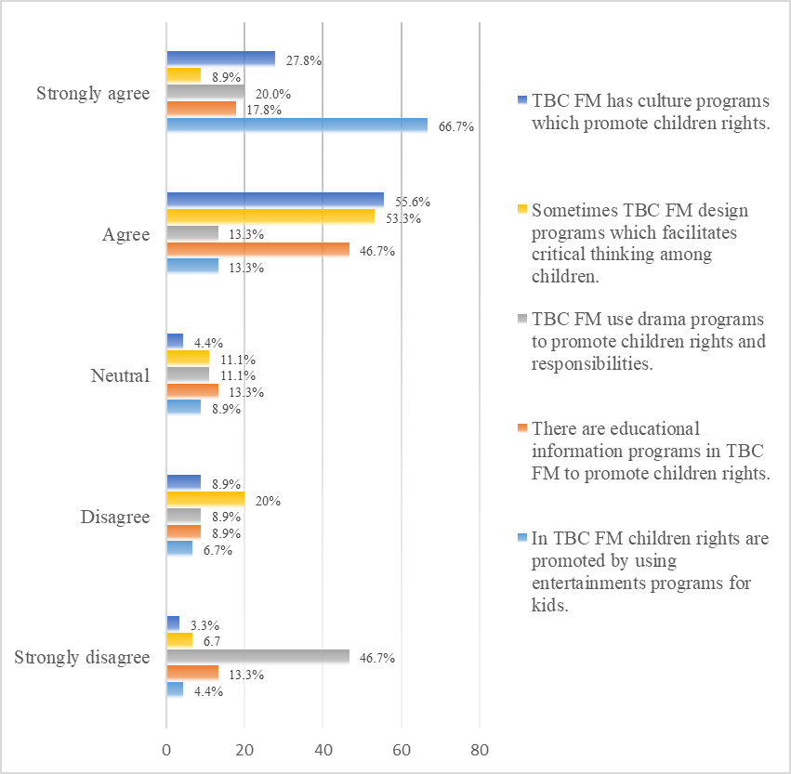
Figure 4.1: Programs aired by TBC FM to promote children rights
Source: Field Data, 2021.

4.3.1 Entertainment Programs
The findings in Figure 4.1 illustrate that among 90 respondents who responded on this part of the study to provide information, more than half 60 (66.7%) strongly agreed that TBC FM had entertainments programs for kids, 12 (13.3%) agreed, 8 (8.9%) neither agreed nor disagreed (neutral), 6 (6.7%) disagreed, and 4 (4.4%) strongly disagreed. In the interview with the key informants, the researcher understood that in TBC FM Radio there is a program known as Ubongo kids which is aired in both radio and TV for edutainment purpose. For example, one of the interviewees stated that:
“We have programs for kids to promote their rights of getting better education and facilitating their entertainments, for example, we have a program called Ubongo Kids, it is very helpful for children to learn about their rights and carrying their talents”.
Another respondent in the open-ended questions confirmed that:
“I feel more proud when I find my children listening about Ubongo Kids, I know that through this program my children could be very intelligent”.
Both the quantitative and qualitative findings imply that the TBC FM Radio had developed and aired the entertainment program known as Ubongo kids which is applied as the edutainment program to the children. This means the children are able to improve their talents also they obtain education which is among the rights of all children. However, through the aired program, parents/guardians are able also to understand about the children rights and how they could be practiced. Furthermore, the findings are online with findings found by Mtandika (2013), who found that an electronic media including radio had evolved into a potent force to be reckoned with the transmission of social values and norms in a civilized society. It has become a part of everyday life of children which serves as a variable source of education and entertainments.

4.3.2 Educational Programs
Figure 4.1 indicates that among 90 respondents who participated in this study, 42
(46.7%) of them agreed that there are educational information programs aired by TBC FM Radio to promote children rights, 16 (17.8%) strongly agreed, 12 (13.3%) were neutral, 12 (13.3%) strongly disagreed, and 8 (8.9%) were neutral.
During the interview session, the researcher was able to understand that in TBC FM Radio there are programs aired to promote values and beliefs that improve education and social relationship between children and parents/guardians/societies.
One of the interviewees from TBC FM Radio stated that:
“We take measures to promote children rights through different programs which educate both parents/guardians and children. For example, when schools were closed due to COVID-19, through Ubongo Kids we initiated different programs in our media to provide education to children”.
Another staff member of TBC FM Radio pointed out that:
“To promote children rights when schools were closed due to COVID-19, we created a full season of new learning through play radio show for kids”.
When the researcher was collecting information from parents/guardians, most of them stated that, the Ubongo kids program had been helpful in promoting the children rights through the programs known as “Mlinde mtoto” and “Akili and me”.
“I like Akili and Me because my children are learning something new every day, this has made them to improve academically and morally as their basic rights”.
The obtained findings reveal that in TBC FM Radio there are educative programs for kids to promote children rights in societies. The programs have been helpful in encouraging the parents/guardians to understand that education is among the rights of children. The findings match with the recommendation by UNESCO (2005) that Public Service Broadcasting could be a meeting place where all citizens including children can obtain information and education.

4.3.3 Drama Programs
The findings in Figure 4.1 indicate that among 90 respondents who participated in this study by proving information via questionnaire, 42 (46.7%) strongly disagreed that TBC FM Radio uses drama programs to promote children rights, 18 (20.0%) strongly agreed, 12 (13.3%) agreed, 10 (11.1%) were neutral, and 8 (8.9%) disagreed.
In the interview with the key informants who were the TBC FM Radio staff members, it was known that in TBC FM the program known as Akili and Me includes drama where children are learning by doing and experience. The program had been designed to teach children rights whereby they learn better by having fun programs which include drama and games. The findings imply that among the methods used by TBC FM Radio to promote children rights is to develop and implement programs like drama and games which enable both parents/guardians and children to learn by doing activities. Furthermore, the findings are matching with the findings obtained by (Choudhury, 2014) who found that media especially radio and television are powerful tools in raising awareness to promote children rights by using different strategies including drama, painting and games.

4.3.4 Critical Thinking Programs
Figure 4.1 indicates that more than half 48 (53.3%) of respondents agreed that sometimes TBC FM Radio designs programs which facilitates critical thinking among children, 18 (20.0%) disagreed, 10 (11.1%) neither agreed nor disagreed (neutral), 8 (8.9%) strongly agreed, and 6 (6.7%) strongly disagreed.
Moreover, one of the parents wrote on a questionnaire that:
“The program like Akili and Me develops my children with skills of critical thinking, as they are sometimes listen the participated children in the program are asked questions which need them to think critical before responses”
The findings imply that TBC FM Radio had developed the Akili and Me to promote children thinking skills to meet the children rights. Additionally, the findings are the same as the finding obtained by Leon (2016) who found that median in Bogota develops programs of questioning and discussing to promote critical thinking among children as their basic rights to obtain in education programs.

4.3.5 Cultural Programs
The findings in Figure 4.1 show that 50 (55.6%) agreed that TBC FM has culture programs which promote children rights, 25 (27.8%) strongly agreed, 8 (8.9%) disagreed, 4 (4.4%) were neutral, and 3 (3.3%) strongly disagreed. The findings imply that the TBC FM Radio promotes Tanzanian indigenous cultures through broadcasting to promote children rights. As the interviewees stated that through
Ubongo kids and protect a child commonly known as “Mlinde mtoto” programs,
children were told different cultures then were asked to interpret the learnings which are found in the story. Furthermore, the findings concur with the findings by Ozturk & Dogan, (2017) who found most respondents to perceive media as an important tool which can be used to give the children the rights and value that they deserve, and necessary culture for the survival of rights and responsibilities to ensure the appropriate life standards of children.

4.4 The Contribution of Programs Aired by TBC FM Radio on Promoting

Children Rights
The second objective needed a researcher to determine the contribution of children programs aired by TBC FM Radio on promoting children rights. In this part, it was indispensable to understand how the implemented program in radio in particular TBC FM succeeds to promote a broad range of awareness about children rights in the whole society. In order for the researcher to achieve the goal of the objective, respondents were required to identify and explain about the contribution of aired children‟s programs on promoting children rights. The findings are shown in Figure

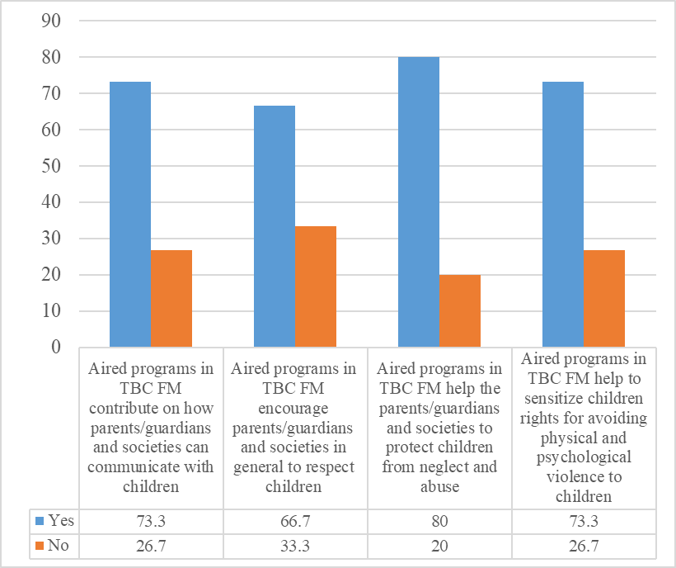
Figure 4.2: Contribution of aired programs on promoting children rights Source: Field Data, 2021.

4.4.1 Communicating with Children
Figure 4.2 indicates that among 90 respondents who provided their responses via questionnaire, 66 (73.3%) of them said yes when they were needed to state if the aired children programs on TBC FM Radio contribute on how parents/guardians and societies can communicate with children.
When the key informants from TBC FM Radio were required to explain about how the aired children programs contribute on how the communication with children could be done, it was stated that, the programs are listened to both children and parents, therefore the conversation which are done in the programs encourages changes to parents/guardians who used to apply a poor communication system within the family set-up, and perspective regarding children‟s rights issues.
“Through the aired programs parents/guardians are able to listen on how children ask questions, and how the parents or teachers talk with children… actually this promotes child rights issues”.
The findings imply that the children programs aired in TBC FM Radio are necessary to help children communication as a way to establish social relationships. This means children are kept with ability to share their talents and ideas to parent/guardians. The findings are online with the findings obtained by Kajuna, (2015), who found the program of Ubongo Kids for children contribute at teaching social related skills which makes children to be with great communication and can connect with different groups of people like parents, local keepers, religious leaders, and community radio station owners.

4.4.2 Respect of Children
The findings in Figure 4.2 illustrate that 60 (66.7%) of respondents who provided information through questions commented yes when they were needed to state if the aired children programs in TBC FM Radio encourage parents/guardians and societies in general to respect children. In the interview, the researcher knew that in families the tradition never allows children to talk or to make conversation with the parents/guardians or other older people. However, the programs like Akili and me, Ubongo kids and tuwalinde watoto have influenced the societies to change and learn how to interact with their children and respecting them. For example, one of the interviewees noted that:

“The program of Ubongo kids and Akili and me encourage audience to change their behaviors overtime, as the program includes more content for promoting discipline and respects to children and their rights”.
The findings imply that among the contribution of children program aired by TBC FM Radio is to influence changes to parents from traditions which do not allow children to be respected to good behaviors which protect children rights in the societies.

4.4.3 Protecting Children from Neglect and Abuse
Figure 4.2 shows that more than three-quarter 72 (80.0%) of respondents commented yes when they were needed to state if the aired children programs in TBC FM Radio help parents/guardians to protect children from neglect and abuse. In addition, the staff members of TBC FM who were involved in the study pointed out that the program enable parents/guardians from using violence to discipline their children, and instead practicing positive parenting.
The findings reveal that TBC FM Radio promotes children rights for achieving positive changes among parents‟/guardians behaviors to understand and respect children rights. The media uses children program to inject an ideology children rights into parents‟ brains. This means, the TBC FM Radio participates in influencing good cultural and social practices which promotes children rights to avoid neglect and abuse. Furthermore, the findings contrast with findings obtained by Jacques and Villeneuve (2012) who found that media including radio had nothing impact on influencing changes among the societies to avoid neglect and abuse among children.

4.4.4 Sensitizing on Children Rights
The findings in Figure 4.2 indicate that nearly to three-quarter 66 (73.3%) of respondents commented yes when they were needed to comment if children programs aired in TBC FM Radio help to sensitize on children rights to avoid physical and psychological violence.
In the interview with the TBC FM Radio staff members, it was known that the TBC FM Radio had widely sensitized parents and other people about the area of children rights by using different programs which are designed special for both children and parents. When the interviewees were asked to mention the concerned programs, three programs were mentioned which include Ubongo kids, Akili and me, and Tuwalinde watoto (we are to protect children).
The findings imply that, through the aired programs in TBC FM Radio, parents and communities in general are enabled to understand what, how, and when to protect the child rights, this means the program of protecting the children rights is promoted and sensitized. In addition, the findings concur with the findings obtained by (Nalwoga, 2005) who found 36.67% of the people in Makindye West in Uganda agreed that among the contributions of radio against child abuse is to sensitize on children rights through promoting those rights.

4.5 People’s Views on the Programs Aired by TBC FM Radio to Promote

Children Rights
The media radio may create new perceptions/attitudes/views towards children rights, in particular for the dated, existing oppressive cultures and traditions. With regards to this statement, in reflection to the third objective, this study explored people‟s views on the program aired by TBC FM Radio to promote children rights. The respondents were required to comment to what extent they perceive about children programs aired on TBC FM Radio to promote children rights. The scores were rated in five options (1=very great extent, 2=great extent, 3=moderate extent, 4=low extent, 5=very low extent). The findings are illustrated in Figure 4.3.
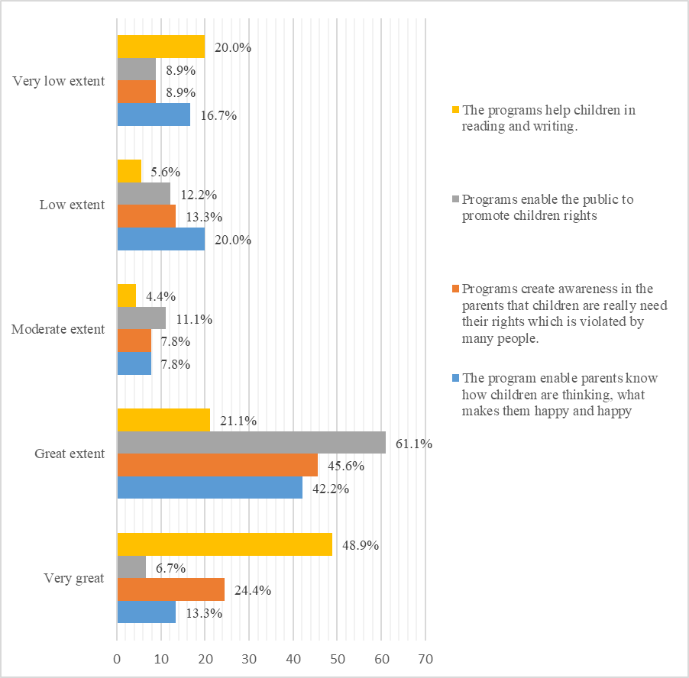
Figure 4.3: Illustration of the findings
Source: Field Data, 2021.
The findings in Figure 4.3 indicate that 44 (48.9%) of respondents said that to very great extent the aired programs help children in reading and writing, 19 (21.1%) great extent, 18 (20.0%) very low extent, 5 (5.6%) low extent, and 4 (4.4%) moderate extent.
Moreover, when probing, one of the respondents was found to perceive that through the aired program of Ubongo kids, the children learn English words, alphabets and numbers.
“You know, among the rights of children is learning, my little children always want to watch Akili and me and Ubongo kids and I always watch with them learning English words, alphabets and numbers”.
The findings imply that TBC FM Radio is perceived to promote the rights of children to learn different things including academic issues. This means, through media learning parents and children are directly involved to participate in learning whereas the parents are very motivated with the program. In addition, the findings concur with the findings obtained by (Wanjiru, 2016) who found that parental involvement in children‟s learning increases motivation, sense of competence and the belief that children have rights to learn new things.
The findings in Figure 4.3 show that more than half 55 (61.1%) of respondents commented to great extent the aired programs enable the public to promote children rights, 11 (12.2%) low extent, 10 (11.1%) moderate extent, 8 (8.9%) very low extent, and 6 (6.7%) very great extent. In addition, during data collection the researcher was able to understand that, other parents perceive the aired programs to promote children rights because in the programs children can freely express their views about traditional attitudes which lead to violation in children rights. The findings imply that, the aired children‟s programs on TBC FM Radio are perceived by people to promote child‟s rights because the programs promote freedom of expression, as children had an unfettered freedom to express themselves in their own language, on their own terms, and at the times of their choosing. Moreover, the study by (Fayoyin, 2011), found also among the role of media on promoting child‟s rights is to promote freedom of expression among young people.
Figure 4.3 indicates that 41 (45.6%) of respondents perceived that to great extent the aired programs create awareness in the parents that children are really need their rights which is violated by many people, 22 (24.4%) very great extent, 12 (13.3%) low extent, 8 (8.9%) very low extent, and 7 (7.8%) moderate extent.
According to the respondents‟ perception, the aired programs create awareness on the children need their rights because most of the animation and conversation of cartoons are usually directly to against children violence. Moreover, other respondents had written on their given questionnaire that sometimes the TBC FM Radio greatly promotes the rights of children through reporting on the cases of child abuse, which helps to create awareness among the leaders, parents, and teachers about child abuse. Furthermore, the findings match with the findings obtained by Prossy (2019), who also found that among the perceptions of respondents on the role of Dunamis Radio in Mukono-Uganda on promoting child rights is to greatly creating of awareness among communities on child sacrifice among the school children. Figure 4.3 also illustrates that 38 (42.2%) of respondents perceived that to great extent the aired programs enable parents to know how children are thinking, and what makes them happy, 18 (20.0%) low extent, 15 (16.7%) very low extent, 12
(13.3%) very great extent, and 7 (7.8%) moderate extent.
The findings imply the inclusion of parents as listeners to the aired programs raises potential content to influence and understand clearly how the children are thinking, what things make them happy. This means, parents get chances of knowing how children are thinking and some of the issues that they cannot tell them directly. Hence the TBC FM Radio is performed to play the role of promoting rights of children. Moreover, the findings also match with the findings by Prossy (2019) who found that the program aired in Dunamis Radio for children helps parents to know things which were not spoken by their children at home.

4.6 Binary Logistic Results
The study runs a binary logistic regression to find the association between dependent variable (promoting children rights) and independent variables (role of TBC FM Radio). This test involved nine determinants as the role played by TBC FM to promote children rights.
The findings in Table 4.2 indicate that, among the nine determinants, six determinants show the statistical significance (p-value≤0.05) with promotion of children rights. The determinants include: educational programs (p=0.018), respect of children rights (0.000), protect children from neglect or abuse (0.006), sensitization of children rights (0.009), Reading and writing (0.006), and parental awareness (0.030). However, three variables show non-significant association (pvalue>0.05), these variables include culture programs (p=0.074), critical thinking programs (p=0.093), and entertainments programs.
Moreover, among the seven variables which indicate the statistical significant (pvalue≤0.05) the four variables show the positive association with promoting children rights, these variables include; educational programs with the positive coefficient (0.780) and odd ratio (1.058), protect children from neglect or abuse with the positive coefficient (0.643) and odd ratio (1.903), reading and writing with the positive coefficient (1.189) and odd ratio (1.409), and parental awareness with the positive coefficient (0.631) and odd ratio (1.032). The implication of these findings is that whenever the TBC FM plays its role to implement about the programs based on the mentioned variables (education, protect children from neglect and abuse, reading and writing, and parental awareness) there is the positive change on promoting children rights.
However, the two variables show the negative statistical association with promoting of children rights. These variables include; respect of children with a negative coefficient (-0.075) and odd ratio (0.928), and sensitization of children rights with the negative coefficient of (-0.872) and odd ratio (0.418). These findings imply that, whenever the TBC FM increases efforts in its role by implementing programs for respecting of children and sensitization of children rights, the status of promoting children rights decreases.

Table 4.2: Binary Logistic Regression Results
 | B | S.E. | Wald | df | Sig. | Exp(B) | 95.0% C.I.for  EXP(B)
Determinants |  |  |  |  |  |  | Lower | Upper
Culture programs | -0.103 | 0.272 | 0.144 | 1 | 0.704 | 0.902 | 0.530 | 1.536
Educational programs | 0.780 | 0.330 | 5.579 | 1 | 0.018 | 1.058 | 0.240 | 0.876
Critical thinking programs | 0.388 | 0.231 | 2.827 | 1 | 0.093 | 1.474 | 0.938 | 2.318
Entertainment programs | 0.246 | 0.242 | 1.036 | 1 | 0.309 | 0.782 | 0.487 | 1.256
Respect of children | -0.075 | 0.012 | 41.048 | 1 | 0.000 | 0.928 | 0.907 | 0.949
Protect children from neglect or abuse | 0.643 | 0.235 | 7.515 | 1 | 0.006 | 1.903 | 1.201 | 3.014
Sensitization of children rights | -0.872
Sensitization of children rights | -0.872 | 0.334 | 6.810 | 1 | 0.009 | 0.418 | 0.217 | 0.805
Reading and writing | 1.189 | 0.432 | 7.584 | 1 | 0.006 | 3.284 | 1.409 | 7.654
Parental awareness | 0.631 | 0.290 | 4.736 | 1 | 0.030 | 1.032 | 0.302 | 0.939
Constant | 4.251 | 0.849 | 25.075 | 1 | 0.000 | 70.172
Source: Field Data, 2021.

CHAPTER FIVE

CONCLUSION AND RECOMMENDATION

5.1 Introduction
This chapter describes summary of the methods and findings. It also presents conclusions regarding the findings in the former chapter. Thereafter, the chapter proposes the recommendation to both parents and media.

5.2 Summary
This study sought to examine the role of radio on promoting children rights to the public. Specifically, this study focuses on identifying the programs aired on TBC FM which promote children rights, determining the contribution of the programs aired on
TBC FM on promoting children rights, and exploring people‟s views on the programs aired on TBC FM Radio to promote children rights. In order to meet the goals of this study, the TBC FM Radio was selected as the case study.
In case of the methods, this study was conducted in Simiyu region, whereas a crosssectional research design with both quantitative and qualitative approach was employed during data collection. In each objective, the quantitative and qualitative methods were used to generate data. Additionally, two instruments of data collection which include questionnaire and interviews were employed to gather data from 100 respondents. Data analysis employed descriptive statistics to generate frequencies and percentages in all three objectives. Thereafter, inferential analysis, in particular the Binary Logistic Regression was employed to find the statistically significant between the role of media (independent variable) and promoting of children rights (dependent variable).
The obtained findings show that TBC FM Radio had designed programs for promoting children rights, the programs include; culture issues, critical thinking among the children, drama, educational programs, and entertainments. The results also indicate that the designed programs had contributed on promoting children rights. The mentioned kinds of contribution include; facilitating communication with children, respect of children, protecting children from neglect and abuse, and sensitizing on children rights. Furthermore, the results indicate that people had perceived the aired programs on TBC FM Radio to have positive contribution on promoting children rights. The respondents were found to perceive that; the help children in reading and writing, enable public to promote children rights, create awareness in the parents that children are really need their rights which is violated by many people, and enable parents to know how children are thinking, and what makes them happy. The inferential findings show that among the nine determinants, six determinants (educational programs, respect of children rights, protect children from neglect or abuse, sensitization of children rights, Reading and writing, and parental awareness) show the statistically significant association ((p-value≤0.05) with promoting of children rights.

5.3 Conclusions
The study concludes that TBC FM Radio had designed programs for promoting children rights. The radio implemented different programs with similar target of promoting children rights to the community. Children had been delivered with programs based on education, entertainments, and culture which all enable them to be able to speak out about what they think, what they experience, and what makes them happy.
The study also concludes that, the aired programs on TBC FM Radio had been the influential factor on promoting children rights. This is because, the aired programs had been also listened to parents who had been also facilitated to respect their children, protect them from any kind of neglect and abuse, and sensitized to understand children rights.
Lastly, this study establishes the conclusions that people in particular the parents had positive views concerning the programs aired on TBC FM Radio for promoting children rights. In fact, the programs had been perceived to influence changes in community from neglecting or abusing children to protecting children rights. Additionally, the conclusion is made that there is an association between the roles played by TBC FM Radio and the promoting of children rights. This means, when TBC FM Radio adds more efforts to design children programs, the children rights are being promoted.

5.4 Recommendations
(a) Recommendation for action
Based on the obtained findings and conclusion drawn, the following recommendations are made to media and parents/guardians.
Because the findings have shown the TBC FM Radio to air programs which promote children rights, the parents should encourage their children to listen to the aired programs. This may be done effectively if a parent could set a timetable for his/her children with inclusion of listening to their programs in
TBC FM Radio and reinforce what they have learnt into daily practice to until it brings meaning/reality into their lives
- Because the findings have shown the aired programs to have positive impact to both parents and children, the parents should also take a chance to join their children into listening the aired programs as they can be able to understand about their children and make them aware of what and how to help their children to become productive members of the society. Yet the parents should lead by being the example to their children.
- Because the findings show that the aired programs are perceived to be an influential factor for change of community from neglecting and abusing the children, other media radio should learn from TBC FM Radio and design better programs for promoting children rights. However the Government through its respective department(Ministry of Community Development and Women, Youth and Children) should give more empowerment to the media to draw more seriousness and attention to listeners.
(b) Recommendation for further studies
Children are basically expected to take over all aspects of life this include science and technology, Tourism, Social cultural aspects and economy.Simiyu was taken as a case study to represent children in general especially in the country Tanzania ,Tanzanians need to be stimulated to be sensitive enough to foresee the wellbeing of children’s rights this includes right to be educated, right to decide, right to speak and to be heard. Otherwise we would create the generation that lack self love and violence will be rampant hence our society would be at risky and the welfare of our country might be at stake.

REFERENCES
Abawi K. (2013) “Data Collection Instruments”. Geneva Foundation for Medical
Advocacy and Development in Nigeria. Federal University of Technology,
Agboola, K.A. (2020). Constraints and Challenges of the Media in Child Rights
Analysis. Applied Research and Training Services. Nairobi.
Apuke, O.D. (2017). Introduction to radio production. Lap Lambert Academic
Aries, P (1962). Centuries of Childhood: A social History of Family Life. New York:
Awosola, K.R., and Omoera, S.O. (2008). Child Rights and the Media: The
Babbie, F. (2010). Research Methods. New York: Thornhill Publishers.
Bishit, R. (2008). Who is A Child?: The Adults‟ Perspective within Adult-Child
Brosseu, A. (1998). The Significance of radio in promoting children rights. New York. Mc Graw-Hill
Brown Benchmark, USA.
Bryman, A. and Bell, E. (2011). Research Designs. In: Business Research Methods. New York. Oxford University Press.
Challenge Of Human Rights Reporting.
Cooper, D.R., and Schindler, P.S (2008).Business research Methods (10th
Daftari, N., Herkenhoff, G., Regattiri, L.L., Sam, S. and Carreira, S.L. (2014). Protecting the rights of children: The role of the media, lessons from Brazil, India and Kenya. Published by IKEAFOUDATION.
Development. The International Institute for Science, Technology and Ed).Boston: McGraw Hill.
Education (IISTE). New Media and Mass Communication, (18):38-44. Retrieved from https:// www.iiste.org/Journals/index.php/NMMC/ article/ view/8412/8512 on September 19, 2021
Education and Researches, Geneva.
Evaluation, Melbourne Graduate School of Education, The university of Melbourne.
Geneva: OMCT and Cleen Foundation.
Greyson, G (2008) “The Study examining the role and usage of Radio in regard to age”, London: Oxford Press.
Guijit,.andI.Retolaza (2012).Defining Theory of change. Hivos, E-dialogues(March), 1-7-Available at http://www.hivos.nl/eng/Hivos-Knowledge Programme/Themes/Theory-of-Change/E-dialogue
Guru, B. P. M. C., Nabi, A., & Raslana, R. (2013). Role of Television in Child
Head, S. (1974). Broadcasting in Africa. A Continental Survey of Radio and International Council on Human Rights Policy (2010). Journalism, Media and the International Media Ethics CIME, Oxford University PCMLP), p 2. Italy
Jacomy, S. and Stevens A. (2004). Rights of the child in Nigeria: Report on the implementation of the Convention on the Rights of the Child by Nigeria.
James, G. (2010) “The survey on the negative impacts of Radio in the society”, an article retrieved on 10th, August, 2021.
Jenkins, H. (2006). Convergence Culture: Where Old and New Media Collide. New
Joseph, J. (2015). An investigation of the effect of geographical location of schools to the students’ academic performance: a case of public secondary schools in Muleba district. The Open University of Tanzania
Karol, M.K. (2013). Assessment of programming in African public service broadcasters. A Case study of TBC1 in Tanzania. A ResearchReport in
Kitzinger, J., and Skidmore, P. (1995). Playing Safe: Media Coverage of Child
Lansdown, G., Jimerson, S. R., and Shahroozi, R. (2014). Children‟s rights and school psychology: Children‟s right to participation. Journal of School
Lenhart (2011) “Application in promoting children rights”. London: Oxford Press
Loveridge, D.L.(2011). Theories of change: monitoring and evaluation capacity development in the government of Tanzania. Doctorate, centre of program
Madillo, G. (2011). “Radio can be used for communicating people’ views, opinions and ideas” an article retrieved on 09th, August, 2021
Mason, J. and Bramble, J. (1997). Research Education and the Behavior Sciences,
Master of Science in Interactive Digital Media
Matumaini, J. (2006). The Role of Radio in the Process of Development in Tanzania: A Comparative Study of Radio Tanzania Dar es Salaam, Radio Tumaini and Clouds FM. Pontifical Gregorian University.
Maxwell, A. (2000). “The development of radio in promoting children rights. Rome-
Maxwell, J. A. (2012). A realist approach for qualitative research. Sage, 15
Melisande Middleton, (2009). Social Responsibility in the Media, Center for
Ministry of Finance Dar es Salaam
Minna, Nigeria
Mishra, A. (2020). A Study of Private FM Radio Channels with Special Reference to their content and audience feedback. Chitkara University, Punjab. Retrieved from https://shodhganga.inflibnet.ac.in/handle/10603/306638 on September 9, 2021
Morse, D. (1992). The history of radio in Europe. Rome: Roman Printing Press
Mugenda, A.G (2010). Researching Methodology. Data Collection, Preparation and
Mwaffisi, M (2011), Performance of Public Broadcasting in Zanzibar in the Age of
Mwakilasa, T.K. (2020). Efficacy of national plan of action on eradicating violence against children: a case of kinondoni municipality. A Dissertation Submitted in Partial Fulfillment of the Requirements for the Award of the Degree of Master of Public Administration (MPA) of Mzumbe University.
New Media Era. A Dissertation submitted to the University of Dublin, Ng‟wanakilala, N. (1981). Mass Communication and Development of Socialism in
Nigerian and Ghanaian newspapers (1999-2003). Covenant University.
Nigerian Experience. Stud Home Comm Sci, 2(2): 125-131
Noose, L. (2013). Radio in the Digital Age: The Evolution of Radio Culture in A
Olive, M. M., & Abel, G. M. (2010). Research Methods. Actis Publishers.
Omoera, O.S. (2004). Child Abuse and the Media: A Survey of the Oredo Local Government Area Situation. An Unpublished M.A Dissertation submitted to the Postgraduate School, University of Benin, Benin City, 2004.
Omote, H. (2014), “Research on the radio usage on research skills of undergraduates”, Nigeria
Open, 8(1):1–10. doi:10.1177/2158244018763930
Oyero, O., and Salawu, A. (2018). Building media capacity for children sustainability in Africa: Educational and partnership imperatives. SAGE
Ozturk, A. and Dogan, O.G. (2017). Effective Children’s Rights Education from the Perspectives of Expert Teachers in Children’s Rights Education: A Turkish
Partial Fulfillment of the Requirements for the Degree of Bachelor of Arts in Journalism of the University of Dar es Salaam.
Psychology, 52(1), 3-12. https://doi.org/10.1016/j.jsp.2013.12.006 Publishing.
Relationship in India. Interpersonal 2(2): 151-172 Research and Marketing. Volume 3, Issue 1,
Sample. Faculty of Education, Gaziantep University, Gaziantep, Turkey.
Samuel, O.O. (2009). A comparative study of child rights coverage in selected
Saunders, M., Lewis, P., & Thornhill, A. (2009). Research methods for business students (5th Edition). United Kingdom: Pearson Education Limited.
Sexual Abuse Prevention Strategies. Children Abuse Review, 4(1): 47-56
Stiff Competition, Media Council of Tanzania Sturmer, M. (1998). Media History in Tanzania. Mtwara. Ndanda Press
Tanzania. Dar es salaam: Tanzania Publishing House. Television. Philadelphia. Temple University Press.
Teweldebirhan, S. (2011). The role of media in the promotion of human rights in Ethiopia. A thesis submitted in the partial fulfillment of the requirement for the degree of masters of laws in human rights law, faculty of law. Signed approval sheet by the board of examination.
Trinity College in partial fulfilment of the requirements for the degree of
UNICEF (2003). The millennium development goals: They are about children. New York: Unicef.
URT (2013). National Bureau of Statistics. 2012 population and housing census.
URT (2016). National Plan of Acton to end Violence against Women and Children in Tanzania, 2017/18-2021/22. Dar Es Salaam: Government Printers. Vintage Books.
Yamane, Taro (1967). Statistics: An Introductory Analysis, 2nd Edition, New York. New York University Press.
York: Harper and Raw , Collis & Hussey, 2013)

APPENDICES
Appendix I: Questionnaire parents/guardians
These questions have been designed to acquire information that will be used to investigate the role of radio in protecting and promoting children rights, a case of TBC FM. The questions asked in this questionnaire will be used for academic purpose only. The information gathered will be treated confidential and will not be used for any other purpose.
A: Background Information
1.What is your age? (Years)…………..
2.Your gender/sex is……..
- Female
- Male
- Your marital status is………..
  - Single
  - Married
  - Separated
  - Widow/widower
  - Divorced

Your highest level of education is…….
  - Non-formal
  - Primary
  - Secondary
  - College
  - University
  - Others (specify)…………
- Your occupation status…..
  - Employed
  - Self-employed
  - Unemployed
  - Others (specify)………
- Do you have a tendency of listening to TBC FM?
    - Yes
    - No
B: Contribution of TBC MF in creating awareness on children rights to the public.
- Do you think there is any role played by TBC FM to create awareness on children rights in the public?
  - Yes
  - No
If “yes” identify and explain about that role ……………..
- To what extent does TBC FM plays a role to create awareness on child rights through the following terms? Put tick in a box. (Use: 1=low extent, 2=medium extent, and 3=high extent)

No. | Statement | 1 | 2 | 3
8a. | TBC FM plays great role in shaping the community on how to communicate with children without causing abuse or psychological problem to them
8b. | Through listening to TBC FM, parents/guardians and other people are encouraged to respect children.
8c. | TBC FM often talks on how to protect children from neglect and abuse.
8d. | TBC FM has got programs which create awareness to people on how they can avoid physical and psychological violence to children.
C: Programs for promoting children rights to the public
- Are there programs in TBC FM which promote children rights?
- if the answer for question 9 is „yes‟ please identify and explain those programs
i. …………………………………………………….
ii. ……………………………………………………
iii. ……………………………………………………
iv. ……………………………………………………..
v. …………………………………………………….
- How do you agree with the following statements about programs which promotes children rights in TBC FM?. Please tick in the box that is relevant to statements. (Use: 1= strongly disagree, 2=disagree, 3=neutral, 4=agree, and 5= strongly agree
Na. | Statements | 1 | 2 | 3 | 4 | 5
11a | In TBC FM children rights are promoted by using entertainments programs for kids.
11b | There are educational information programs in TBC FM to promote children rights.
11c | TBC FM use drama programs to promote  children rights and responsibilities.
11d | Sometimes TBC FM design programs which  facilitates critical thinking among children.
11e | TBC FM has culture programs which promote  children rights.

D: Challenges facing TBC FM in promotion and protecting child rights
- In your opinion, do you think TBC FM faces with any challenges in promoting and protecting child rights? If „yes‟ identify those challenges and explain
them ……….
- Any other comments …………………………………………….

Thank you for your cooperation
Appendix II: Interview Guidelines for TBC FM staff members
  - Your age in years ……………………..
  - Marital status …………………….….
  - Educational level ……………………….
  - Years of experience in TBC FM ……………………….
  - Working department ……………………………
  - Do you use TBC FM to create awareness on children rights to the public?
How ……………………………………………..
  - If you use TBC FM to create awareness on children rights to the public, what is the reason behind for doing so?
  - Do you have any programs in TBC FM for promoting children rights? What are those programs? Can you explain how do they function?
  - Do you think the programs designed for promoting children rights have impacts in Simiyu and Tanzania in general? How?
  - Are there any challenges which face TBC FM in promoting awareness on children rights? What are those challenges? How do you encounter them?

Thank you for cooperation

Appendix III: Permission Letter for Data Collection.
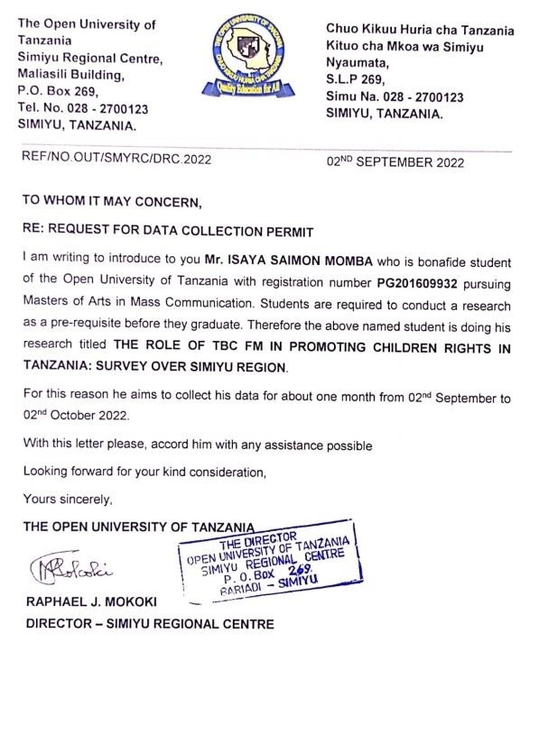

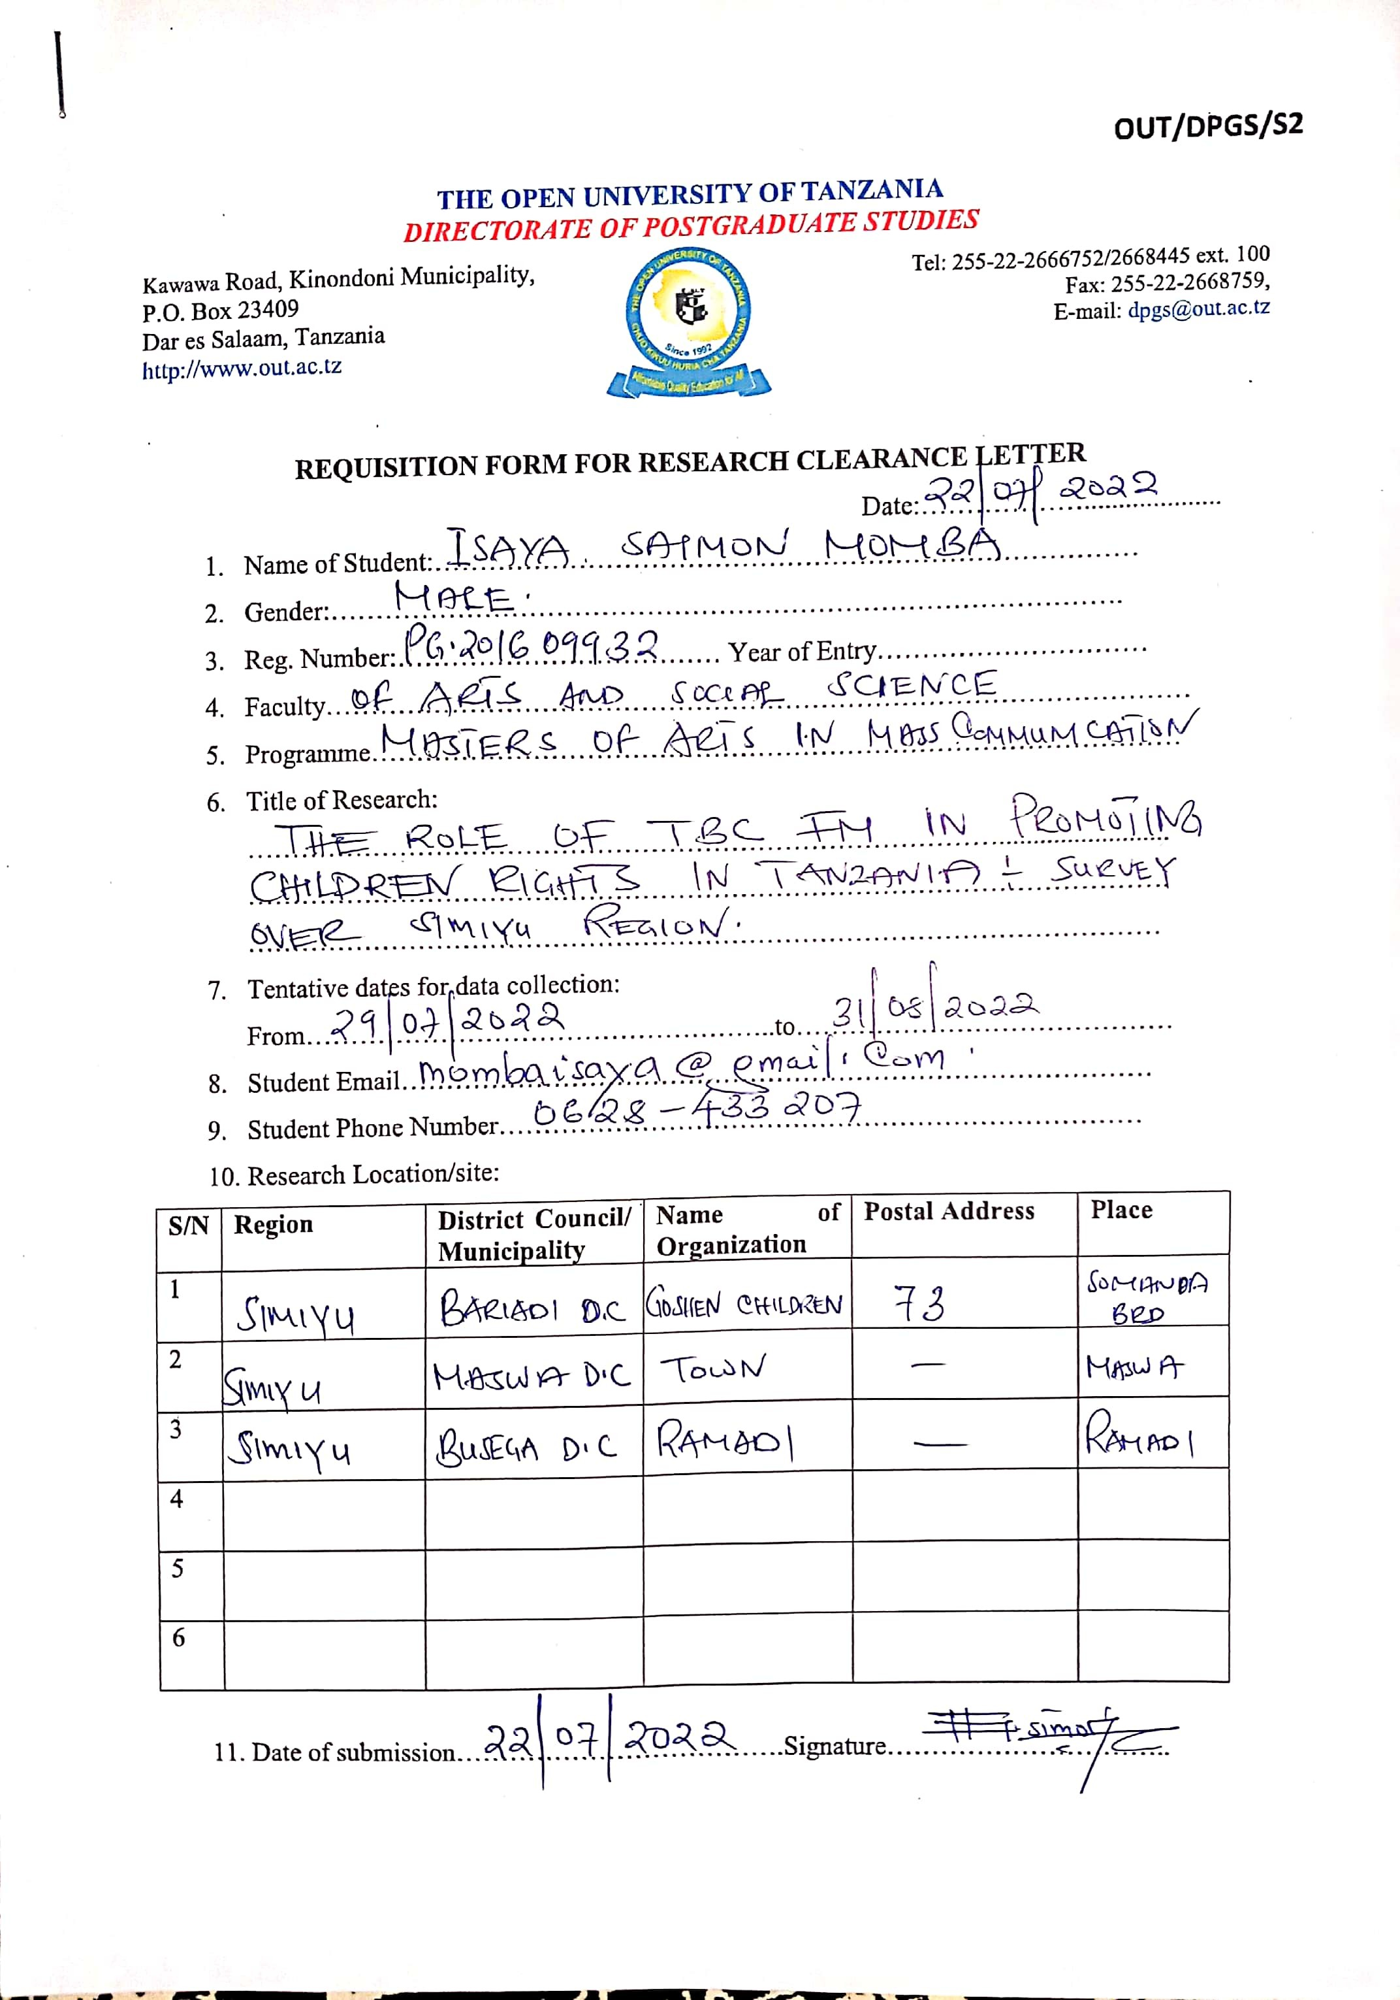
Appendix IV: Permission Letter for Data Collection.

