ANALYSIS OF FACTORS AFFECTING GIRLS’ ACADEMIC PERFORMANCE IN ZANZIBAR PUBLIC SECONDARY SCHOOLS: A CASE OF MKOANI DISTRICT AT PEMBA

MAHMUDU AWESI MAULID

A DISSERTATION SUBMITTED IN PARTIAL FULFILLMENT OF THE REQUIREMENTS FOR THE DEGREE OF MASTER OF EDUCATION IN CURRICULUM DESIGN AND DEVELOPMENT
DEPARTIMENT OF CURRICULUM AND INSTRACTION
THE OPEN UNIVERSITY OF TANZANIA
2023

CERTIFICATION
The Undersigned certifies that she has read and hereby recommends for acceptance by the Open University of Tanzania a dissertation entitled: “Analysis of Factors Affecting Girls’ Academic Performance in Zanzibar Public Secondary Schools: A Case of Mkoani District at Pemba” in partial fulfillment of the requirements for the Degree of Master of Education in Curriculum Design and Development (MEDCDD) of the Open University of Tanzania.

………………………………………
Dr. Ogondiek, M
(Supervisor)

...............................................................
Date

COPYRIGHT
No part of this Dissertation may be reproduced, stored in any retrieval system or transmitted in any form or by any means electronically, recording, photocopying and/or without prior written permission of the author or The Open University of Tanzania in their behalf.

DECLARATION
I, Mahmudu Awesi Maulid, declare that, the work presented in this dissertation is original. It has never been presented to any other university or institution. Where other people’s works have been used, references have been provided. It is in this regard that I declare this work as originally mine. It is hereby presented in partial fulfillment of the requirement for the Degree of Master of Education in Curriculum Design and Development (MEDCDD).

………………………………….
Signature

……………………..…………
Date

DEDICATION
This study is dedicated to my brother Moh’d Awesi Maulid, Ali Awesi Maulid, Maulid Awesi Maulid, Khamis Awesi Maulid and Abass Awesi Maulid for their support and more importantly inspiring me to continue with my studies.

ACKNOWLEDGEMENT
In the name of Allah the Most Gracious the Merciful.
My faithful thanks to the Almighty God who granted me the ability and power to complete this work. I also extend my thanks to my parents especially my mother for encouraging me to study at this level, my supervisor Mrs. Mary Ogondiek that whose advice, encouragement, enthusiasm and demand for good scholarly work have facilitated the completion of this study, Mr. Machano Ame for proof reading and editing this work. Also I wish to express my sincere gratitude to the coordinator of MEDCDD Faculty for helping me to perform well in this work, all my course lecturers for their commitment throughout the course for their support and encouragement, all my best friends for their assistance as well as all other people who in one way or another have supplied their great support to the effective completion of this study. May God bless them and reward them abundantly.
Finally, specific thanks to my friends Ali Bakar Ali, and Saleh Abdulla Adam as well as Statistician staff members for their moral support that encouraged me in whole period of my research work and report writing.

ABSTRACT
The research was conducted to analyze the factors that affect girls’ academic performance in public secondary schools of Mkoani District. The study was guided by three objectives: to assess the communities’ awareness on girls’ academic performance, to explore the factors that affect girls’ academically and to identify the strategies taken to improve their performance in public schools. Descriptive survey and questionnaire were used. The questionnaire was administered to students, parents, subject teachers, head teachers from five secondary schools and DEO of Mkoani District. The sample constituted 126 respondents who were selected by systematic sampling. The data collected were analyzed descriptively using the IBM SPSS 20 vision. This study revealed that Girls’ academic performance is low due to the love disturbance, domestic activities, poverty, misuse of mobile phone, and long distance, family conflict, poor family and diseases, truancy, lack of motivation, teachers’ efforts and geographical location and child labor. The results on the conclusions, the recommends the government and community consider educating girls and motivating so as to perform better, provide hostels to schools and create conducive environment for learning. The study found that some parents, students, teachers and other stakeholders noted that girls’ academic performance have faced a lot of factors like distance from home to schools, domestics activities, misuse of mobile phone, absences of boarding schools, poor environment, low awareness and lack of supports. The study advices teachers to finish their syllabuses on time to help students perform better in their examination, parents and other stakeholders should educate girls on proper use of mobile phone for effective learning and not otherwise.
Keywords: Academic Performance, Secondary school and Female educational situation

TABLE OF CONTENTS
CERTIFICATION ii
COPYRIGHT iii
DECLARATION iv
DEDICATION v
ACKNOWLEDGEMENT vi
ABSTRACT vii
LIST OF TABLES xii
LIST OF FIGURES xiii
LIST OF ABBREVIATIONS xiv
CHAPTER ONE 1
INTRODUCTION AND BACKGROUND TO THE PROBLEM 1
1.1 Introduction 1
1.2 Background to the Problem 2
1.3 Statement of the Problem 6
1.4 Objectives of the Study 7
1.4.1 General Objective 7
1.4.2 Specific Objectives 7
1.5 Research Questions 8
1.6 Significance of the Study 8
1.7 Scope of Study 9
1.8 Limitation of the Study 9
1.9 Definitions of Significant Terms 10
1.9.1 Academic Performance 10
1.9.2 Public School 10
1.9.3 Secondary School 10
1.10 Organization of the Study 10
CHAPTER TWO 12
LITERATURE REVIEW 12
2.1 Introduction 12
2.2 Theoretical Literature 12
2.2.1 Female Educational Situation 13
CHAPTER THREE 27
RESEARCH METHODOLOGY 27
3.1 Introduction 27
3.2 Research Approach 27
3.3 Research Design 27
3.4 Area of Study 28
3.5 Study Population 28
3.6 Sampling and Sample Size 28
3.6.1 Sampling Techniques 29
3.7 Data Collection Methods and Instruments 29
3.8 Data Analysis 33
CHAPTER FOUR 34
DATA PRESENTATION, ANALYSIS AND DISCUSION 34
4.1 Introduction 34
4.2 Demographic Characteristics 34
4.2.1 Gender of the Respondents 34
4.2.1 Community Understanding of the Concept of Girls’ Academic
Performance in Mkoani District (Subject Teachers) 35
4.2.2 Community Understanding of the Concept of Girls’ Academic
Performance in Mkoani District (Parents) 36
4.2.3 Community Understanding of the Concept of Girls’ Academic
Performance in Mkoani District (Students) 37
4.2.3.1 Community Understanding of the Concept of Girls’ Academic
Performance in Mkoani District (Students) 37
4.2.4 Community Understanding of the Concept of Girls’ Academic
Performance in Mkoani District (Head teachers) 38
4.3 Factors Affecting Girls’ Academic Performance in Public Secondary
Schools (School Teachers) 40
4.3.1 Factors Affecting Girls’ Academic Performance in Public Secondary
Schools (Parents) 42
4.3.2 Factors Affecting Girls’ Academic Performance in Public Secondary
Schools (Students) 45
4.3.3 Factors Affecting Girls’ Academic Performance in Public Secondary
Schools (Head teachers) 46
4.4 Suggest Good Ways for improving Girls’ Academic Performances in
Public Secondary School (School teachers) 47
4.4.1 Suggest Good Ways for Improving Girls’ Academic Performances in
Public Secondary School (Parents) 49
4.4.2 Suggest Good Ways for improving Girls’ Academic Performances in
Public Secondary School (Students) 51
4.4.3 Suggest Good Ways for Improving Girls’ Academic Performances in
Public Secondary School (Head Teachers) 52
4.4.4 Suggest Good Ways for Improving Girls’ Academic Performances in
Public Secondary School (DEO) 53
4.4.5 Comments from DEO for Improving Girls’ Academic Performances in
Public Secondary School 54
CHAPTER FIVE 55
SUMMARY, CONCLUSION AND RECOMMENDATIONS 55
5.1 Introduction 55
5.2 Summary of Chapter 55
5.3 Conclusion 57
5.4 Recommendations 58
5.4.1 Recommendations for Action 58
5.4.2 Recommendations for Further Studies 59
REFERENCES 61
APPENDICES 68

LIST OF TABLES
Table 3.1: The Sample Distribution of the Study 29
Table 4.1: Demographic Characteristic 34
Table 4.2: Ways we can Promote Academic Performance, (Students) 51
Table 4.3: Ways for improving Girls’ Academic Performances in Public
Secondary School (Head Teachers) 52
Table 4.4: Suggest Good ways for improving Girls’ Academic Performances
in Public Secondary School (DEO) 54
Table 4.5: Comments from DEO’s for Improving Girls’ Academic Performances in Public Secondary School 54

LIST OF FIGURES
Figure 2.1: Conceptual Framework of the Study 26
Figure 4.1: Teacher Response on Girl’s Academic Performance in Public 35
Figure 4.2: Community Understanding of the Concept of Girls’ Academic 36
Figure 4.3: Awareness on Girls' Academic Performance, (Students) 37
Figure 4.4: Understanding of Girls’ Academic Performance (Students) 38
Figure 4.5: Community Understanding of the Concept of Girls’ Academic 39
Figure 4.6: Factors affecting Girls’ Academic Performance in Public Secondary 40
Figure 4.7: Criteria contribute on Poor Academic Performance for Girls in Public Schools (Parents) 43
Figure 4.8: Factors Contributing Poor Performance of Students (Students) 45
Figure 4.9: Factors Affecting Girls’ Academic Performance in Public Secondary Schools (Head Teachers) 47
Figure 4.10: Suggest Good Ways for Improving Girls’ Academic Performances 48
Figure 4.11: Ways Forward to Improve Girls’ Academic Performance (Parents) 50

LIST OF ABBREVIATIONS
OUT Open University of Tanzania
MEDCDD Master of Education in Curriculum Design and Development
RGZ Revolutionary Government of Zanzibar
FAWE Forum for African Women Educationalist
ZEDP Zanzibar Education Development Program
MDPZ Mkoani District Pemba – Zanzibar
CSEE Certificate Secondary Education Examination
UNESCO United National Educational, scientific and Cultural Organization
SBFs School Based Factors
HBFs Home Based Factors
UNICEF United Nations International Children’s Fund
SACMEQ Southern and East Africa Consortium for Monitoring Educational Quality
IEA International Evaluation of Education Achievement
NAEP National Assessment of Education Program
IJERE International Journal of Educational Research Review

CHAPTER ONE

INTRODUCTION AND BACKGROUND TO THE PROBLEM

1.1 Introduction
This chapter basically focuses on the factors affecting girls’ academic performance in public secondary schools. The chapter presents the background of the problem, the 0statement of the problem, objectives of the study, research questions also, it show the significances of the study, limitations and identify the definitions key terms used in the study. The final section of the chapter presents the organization of the study.

In historical perspective had shown that the academic performance of girls generally is poor compared with boys. This situation till now is a major challenge that faces to the nation, especially in the developing countries. There is a notion that if you educate women, you educate the whole society. Various efforts have been undertaken by individual countries, regions, even globally to educate girls. Efforts to improve girls‟ education have significantly increased in the previous two decades.

In Africa, female education got more emphasis in 1990s after the Conference in Thailand on Education for All (EFA). World leaders agreed to improve the quality of education for girls and women and remove obstacles, which hinder their active participation. They had to make efforts to end gender inequalities within the educational system. This led to the establishment of organizations such as Forum for African Women Educationalists (FAWE), a Pan-African Non-governmental organization (Kombo & Waiyaki, 2002). It was established in 1992 to support girls and women’s education. It was to make sure girls have access to education, perform well and complete their studies so that gender inequalities in education are eradicated. This was to be done by supporting gender parity in education in Africa by fostering positive policies, practices and attitudes towards girls‟ education. Within the context of the international momentum of improving girl’s education, Tanzania has made it a priority to raise students‟ enrollment and academic performance in schools at the secondary level, especially girl students. This chapter basically studies on the background, statement of the problem, objectives of the study, research questions, limitation of the study and significances of the research, as well as organization of the proposal.

1.2 Background to the Problem
Education is an important foundation for any developing process in the country and world in generally on which in social, economic, political and cultural development in a nation is based. The problem of poor performances for girl students in public secondary schools is predominant and still persists despite of various measures taken by government and other stakeholders in Tanzania today. This indicates that the precise factors have not been realized thus why there could not be correct measures.
It is equally believed that all nations have to educate their citizens, male or female to achieve a meaningful sustainable development. Therefore, there is no gain saying the fact that education opens doors to economic and social prosperity to a given nation, encouraged by a dynamic motivation to the citizen that enable to make competition and to cooperate in the global market areas (Kimondo, 2013).

According to the National Assessment of Education program (NAEP, 1990) US girls’ performance marked or fallen in most subjects since 1970 with targets and most thoroughly established computing in basic literacy. The results from the international Evaluation of Education Achievement (IEA 1998) which tested performance of girls from numerous schools in both 1970 and 1990 showed that their academic performance was low (Stedman 1991).

All Global Monitoring Report of 2012 indicates that Sub-Saharan Africa has the lowest total secondary school enrolment (UNESCO, 2012). It also states that among the 68 countries lacking gender parity in education, girls are more disadvantaged in 60 of them.

In 2006 Osakwe, observed that Nigerian girls, for various bordering on religious, cultural, social-economic and school related factors, are not given a fair chance in the educational sector. Education is a basic human right which should be accessible to all Gambians irrespective of their gender, religious, disability, ethnicity, age, wealth and location. The government of the Gambia is committed to fulfilling this right and meeting the education for all and the millennium development goals by 2015.This is the efforts of the government to provide nine years of good basic quality education for all Gambians. To support and complement government efforts to ensure that all children go to school and complete the basic education cycle, UNICEF Supported the FAWEGAM so as to make girl student improve their performance, (FAWE, 2010-2011).

According to Mbele and Katabaro, (2003) in their study of school enrolment performance and Access Education in Tanzania government; funding of primary and secondary education was low compared to many Sub-Sahara countries. There is gender disparity and the performance was more determined by school characteristics than individual student characteristics. Females were disadvantaged at the level of schooling as well as absorption in the economy after completing school. Education is animate into all initiatives for establishment of civilized social systems. So, it provides the tool for struggle against poverty, ignorance, diseases and other vices (Okumbe, 2001).

Many countries have made progress towards achieving gender equality in education girls continue to face many challenges that impede their path of learning some of the factors include cultural factors, availability of role models, sexuality and family background. The girls are also discriminated on the basis of gender, unequal rates of investments, ladies are not given any inheritance by parents in some communities and several hardships while undergoing through the education process (Hyde, 2001).

The last decades of the twentieth century saw many concerted efforts in research into gender issues all over the world. In Africa, international bodies and educationalists began in the 1960’s to look into the ways girls and women were fairing in education. Their findings were depressing. By 1970’s pro female initiatives by some African governments to encourage enrolment of girls in schools was started. Consequently, low enrolment figures indicated in the earlier years (1960 –70) were in the 1990’s shown to have improved.

Kenyan females constituted nearly 50% of the children enrolled in grade one Forum for Africa Women Educationist (FAWE 1996). What about performance? Researchers and teachers have to recognize prejudicial practices which may still disadvantage girls particularly within classrooms, even where policy and statistics suggest that equality has been achieved (KNEC, 2004).

The majority of teachers in Secondary Schools with the exception of all girls’ Schools are men, especially in science, technology and math subjects. For example in eighteenth Dar-es-Salaam upper level Secondary School 90% of technical teachers 81% of math and 66% of science teacher were men, compared to early 42% male arts teachers (Sekwao, 1989).

This must have a powerful impact on girls, boys experience in the classroom, particularly in terms of providing models and the resulting dynamics in teacher- student relation. Thus, with the exception of all girls’ schools Secondary students operate as a minority with in macho environment at F5 and F6 level women taking science subject were truly a minority. For example in 1988 there was only one woman out of 117 science students in F5. This situation was best at Tambaza with 25 women out of 86 in F5 and 15 out of 66 in F6 Science. But the MOE has discontinued the women’s’ stream at Tambaza, arguing that their members were too small and there was so suitable hosting (MOE meeting June 13,1990, interview).

This conflicted with the fact that many more girls had enrolled at Tambaza then else, where and that the government had just finished building new men’s hostels at the same schools. Girls experience a similar minority status according to subject Proportionately fewer girls than boys enter the science at F4 and F6 levels. This has usually been attributed to gender typing (see papers in the women science workshop, Diyament 1989, Dambhal 1983, kakaga 1990, sekwao 1986, TADREG 1989, Malekela (1983). Through Zanzibar Education Development program (ZEDP) 2008/09-2015/16).

The government of Zanzibar recognizes that education is a fundamental human right as explicit set out in the Universal Declaration of human right (1964) and in the international conventions, such as conventions on the right of the child and the convention against discrimination in education. Education is a right in itself and is central in eliminating all kinds of discrimination being on the bases of color, races, religious, gender or on socio and economic status.

Since 1964 the Revolutionary government of Zanzibar has taken the position that every child has the right to receive quality basic education of minimum acceptable standard needed in order for her/him to live a life of dignity. Zanzibar strategy for growth and reduction of poverty, provision education for all, challenges of globalization and the event of democratization and good governance of the society.

1.3 Statement of the Problem
The exact factors that affect girl performance in certificate of secondary education in public schools in Zanzibar have not yet to be explored. Many female students get a marginal pass of division four or failing completely. Girl students face many challenges in academic matter because there are negative perceptions among the people surrounding them. For example, people believe that female learners are not well performing in education therefore investigating of factors that affect girls in academic performance is wise decision. This is because it can encourage girl learners to participate fully in high education.
Despite the fact that girls are enrolled in Zanzibar public schools compared to boys, gap exists between the performance of boys and girls. The boys were performing better than girls as directed in the report analysis of examination result of NECTA for CSEE in Mkoani district from 2016 to 2020. Generally in real life situation; it shows that there were differences in performance between boys and girls especially in certificate secondary education results in Public schools of Zanzibar Girls’ academic performance in Form Four National Examination.

1.4 Objectives of the Study
This section comprises of general and specific objectives.

1.4.1 General Objective
To determine the factors that affect girls’ academic performance in public secondary schools in Mkoani District.

1.4.2 Specific Objectives
The following are specific objectives of the study:
- To assess the communities awareness on girls’ academic performance in public secondary schools.
- To mention the factors that affect girls’ academic performance in public secondary Schools.
- To identify the strategies taken to improves girls’ academic performance in public secondary schools.

1.5 Research Questions
- What is communities’ awareness on girls’ academic performance in public secondary Schools?
- What are the factors that affect girls’ academic performance in public Secondary Schools in Mkoani District?
- What are the strategies should be taken to improve girls’ academic performance in public Secondary Schools in Mkoani District?

1.6 Significance of the Study
This study was intended to benefit teachers, policy makers, curriculum developers, learners, community and other educational stakeholders in different aspects:
In this study in order to improve student performance in CSEE in Mkoani district. The study was to the Ministry of Education on the factors that affecting girl performance in CSEE especially in public secondary school students in Mkoani district.

Also, the information was providing awareness to public secondary teachers about the factors that affect students’ performance in CSEE in Mkoani district. The study also was reveal to the researcher on how to explore further factors surrounding performance in CSEE in Mkoani district.

Then, this study will help policy makers to use the data obtained in the study so as to set goals on education, to know the system of education in the country and to monitor and practice in the society.
Furthermore, this study will provide a room for other researchers to conduct more studies for betterment of girl education. Then the study will act as a source of reference for those who will need to improve girls in education. In addition, this study will help the curriculum developers to understand different challenges that face girls’ academic performance and to suggest suitable ways to improve girls’ academic performance.

1.7 Scope of Study
This study was conducted in south region of the island of Pemba at Mkoani District, where by five secondary schools were involved and the respondents of this research was District education officer, head teachers, school subject teachers, parents and students were selected around the study areas.

1.8 Limitation of the Study
Generally research work could not be a success without limitations. So, it faced a number of challenges. Firstly, there was lack of funds for transport, stationery and other important materials needed for the study. Therefore, it was obliged to borrow money from different sources for the completion of the entire data collection process.

Secondly corona virus or covid 19 is another challenge for researcher to make interaction with respondents either in case of lockdown. So I was waiting for the government to announce on reducing of covid 19. This made to exceed an extra weeks in the field in order to get valid and reliable data.

1.9 Definitions of Significant Terms

1.9.1 Academic Performance
Academic performance is how well scholars does during their academics, refers to both behavior sand results, and adjusting organizational behaviors and actions of work to achieve results or outcomes (Armstrong 2006). In this study academic performance means a qualification ranges from grade ‘A’ to ‘E’. Grade ‘D’ and ‘E’ are considered as poor academic performance in certificate secondary education in leaving examinations.

1.9.2 Public School
Public School is a school that runs on public funds, usually government- imposed taxes. It’s free for everyone to go to a primary or secondary public school (Dictionary.net). In this study public school is all school under control by the government.

1.9.3 Secondary School
Secondary school is an institution that provides secondary education and also usually includes the building where this takes place; some secondary schools provide lower secondary education and upper secondary school education, (Wikipedia, 2020). In this study secondary school is an educational institution including school management and building that make school environment for provide the education that means teachers, learners and buildings.

1.10 Organization of the Study
The study is organized in five chapters. Chapter one has outlined the background to the problem, statement of the problem, objectives of the study, research questions, significance of the study, scope of the study, limitations of the study, definitions of significant terms as used in the study and organization of the study.

Chapter two contains the theoretical literature, empirical review section where the factors affecting girls’ performance have been discussed globally, regionally and locally. The research gap also included in this chapter. The conceptual frame work of the study was also included in the chapter.

Chapter three contains the research methodology which comprised of the introduction, approach, research design, study areas, study population, sampling and sample size sampling technique, research instrument, data collection procedures and data analysis Chapter four contains data presentation, analysis and interpretations of the findings while chapter five contains the summary of the findings, discussions, conclusions and recommendations of the study and suggestions for further study

CHAPTER TWO

LITERATURE REVIEW

2.1 Introduction
This chapter attempts to carefully review literature related to the study by observing the present overviews of girls’ academic performance in public secondary schools in particular. The chapter also presents a theoretical literature, empirical review and research gap. Finally, the conceptual frame was discussed.

2.2 Theoretical Literature
The study based on Pearson’s theory. The theory was developed by Pearson in 1995 (Rwegasira, 2017). The theory contends that society views all activities that are carried out to be based on social roles and interactions of male and female. This is an assumption of gender roles as dictated by society. The society seems to have ultimate authority on the precise nature of what female and male actually do, and their real contribution to production and reproduction, which turns out to be biased against women according to Orodho (2004). This theory argues that because of biases, the performance of women and men is affected in nearly all spheres of life like, business, education, and environmental conservation and development projects (Orodho, 2004).

Pearson’s gender relations’ framework was found appropriate for this study because it emphasizes the various social, cultural and economic norms and standards, which must be considered when girls or females take the opportunities to participate in social activities such as education.
The economic and social opportunities suggested in the theory are the factors that affect girl students’ academic achievements in school. In a traditional set up like that of patriarchal, families are headed by households, a position normally held by male parents. Under this system women’s roles are narrowly assigned, mostly they become subordinates and education for them becomes less important. This situation affects girl participation in education. Even when they get access to education as studies on gender and education have revealed, they do not get it equally as boys do. The only hindering factor said to be parental attitudes on girls‟ education that; its return cannot be compared with that of boys (Rwegasira, 2017).

This theory for that reason, gives a picture of girls’ education in the society. On the other hand, the theory indicates that girls are more underprivileged by factors operating within the home and school than boys regarding education and of course the understanding of community to such concept is little. The theory also gives a direction on how girls are involved in social, political and economic activities in the society.
- Awareness on girls’ academic performance in public secondary schools.
- Factors affect girls’ academic performance in public secondary Schools.
- Strategies taken to improve girls’ academic performance in public secondary schools.

2.2.1 Female Educational Situation
World Bank (2006) Stated that the nature of gender in equalities in education has changed profoundly over recent decades and with regard to attainment in particular has become more complex. The one way for developing countries like Tanzania to bring a better standard of living of the people is to invest in education of girls. Not only well- educated women are more productive, but they also will bring up better educated and healthier children. The proportion of females to make higher education academic achievement and participation has not yet reached the same. This shows that the higher education females are still a long way off, as compared to what is desired by the country (MOE, 2005).

The academic performance of the female students seems to be one of the major deep rooted and prevalent problems in Ethiopia. Despite of the policy, the pattern of female academic achievement is still very low in the country, especially in the countryside or rural parts of Ethiopia (TADESSE, 2009). In many countries female students are expected to contribute to children care and household chores rather than go to school (Kassa, 2006).

2.3 The Empirical Review
Empirical studies are systematic literature review and it examine past empirical studies to answer a particular research question. They are usually Random Controlled Trials (RCTs), because most of them have low sampling sizes, a researcher can often see mixed results from study to study and hope to provide more clarity by combining the results of all existing studies, Deschamps (2018).

2.3.1 Global Empirical Review
According to UNESCO in many countries, enrollment in tertiary education slightly favors young women; however, better learning outcomes are not translating into better work and life outcomes for women. There is a large gender gap in labor force participation rates globally. It is especially stark in regions such as South Asia and the Middle East and North Africa, which have some of the lowest female labor force participation rates at 24% and 20% per region, respectively. These are appallingly low rates, considering what is observed in other regions like Latin America (53%) or East Asia (59%), which are still below rates for men.

From to Karemera (2003) in the study about the effects of academic environment and background characteristics on students’ satisfaction and performance founded that students’ performance is significantly correlated with satisfaction with academic environment and services received and others suggested that school infrastructure and staffing is a factor that affect to low school attendance and poor academic performance among girls in secondary schools. The most schools have few or no books, classroom, sanitation, toilets, libraries, laboratories and water. (Sumra and Lockheed et al. (1991) indicated that lack of motivation and professional commitment produce poor attendance and unprofessional attitudes towards students, which in turn affect the performance of students academically.

According to Williams (2014) home, school and community factors that contribute to the educational resilience of urban schools include low income, single-single -parent families revealed that protective factors across multiple contexts of students’ lives contributed to their academic success despite adversity. Therefore, the eight themes submerged from participants responds; education specific parenting practices, non- traditional ways of supporting education, maintained kinship networks, school as an agent of families, resilience promoting features of schools, supportive relational networks within the community, promoting ecological resilience to improve student’s outcomes and relational strategies to promote educational resilience.

Finally give girls a strong foundation through early childhood development (ECD). Disadvantages built early in life are difficult to remedy, but effective ECD programs can avoid such disadvantages and thereby yield high payoffs. ECD programs build the technical, cognitive, and behavioral skills conducive to high productivity later in life. Successful interventions emphasize, among other areas, nutrition, stimulation, and basic cognitive skills.

According UNICEF works with communities, governments and partners to remove barriers to girls’ education and promote gender equality in education even in the most challenging settings. Because investing in girls’ secondary education is one of the most transformative development strategies, we prioritize efforts that enable all girls to complete secondary education and develop the knowledge and skills they need for life and work.

This will only be achieved when the most disadvantaged girls are supported to enter and complete pre-primary and primary education.
Tackles discriminatory gender norms and harmful practices that deny girls access to school and quality learning.
Supports governments to ensure that budgets are gender-responsive and that national education plans and policies priorities gender equality.
Helps schools and governments use assessment data to eliminate gender gaps in learning.
Promotes social protection measures, including cash transfers, to improve girls’ transition to and retention in secondary schools.
Focuses teacher training and professional development on gender-responsive pedagogies.
Removes gender stereotypes from learning materials.
Addresses other obstacles, like distance-related barriers to education, re-entry policies for young mothers, and menstrual hygiene management in schools.

2.3.2 Empirical Review in Africa
In many countries female students are expected to contribute to children care and household chores rather than go to school (Kassa, 2006). The different authors have discussed the lengths the cultural constraints as they operate to limit education for girls in the world.

SACMEQ (2005) identified the home background as the quality of the house, possession at home and the parent education and income Kitavi (2005) in his thesis observes that parents and the community influence are the two most important components in the home background affecting both learning and performance in schools. He argued that good home environment supplements teacher’s efforts in school and in related studies UNESCO (2001), observes that quality education requires strong support from the home of the learner. If a home is poor, there will be minimal support. Eliab, (2010) Most Kenyan children work due to poverty, to supplement household budget, to assist the parent, pay rate, pay school fees and meet basic needs like food and clothes.

Similarly, Rothstein (2000) argues that; learning is not only a product of formal schooling but also of communities, families and peers. Socio-economic and socio-cultural forces can affect learning and thus school achievement. A great deal of research on the determinants of school achievement has centered on the relative effects of home-related and school-related factors. As suggested in most research findings family background is an important determinant of school outcomes, whereas school characteristics have minimal effects (Heinemann and Loxley, 1983).

Fatuma and Daniel (2006) also reported that there is high rate of male teachers having love affairs with female students; such behaviour decreases the learning process because it affects learners’ psychologically. Not only that teacher who are having in love affairs with their students are said to give award them good marks but also when it comes to final examination the same students perform poorly. As we know that teacher is an important organ for students to acquire the knowledge but until now these characteristics is taken by some male teachers.

In addition Lewis et al. (1990) suggested that, the time spent to walk to and from school might be prohibitive in case of girls‟ academic achievement. Girls completing demands at home constrain them from concentrating with academic affairs. Omoyemi (1978) in Olatunde et al. (2011) discovered that locations of schools in Odo state in Nigeria were not based on sound principles of distributions of population because of the initial community participation.
Sexual abuse of children generally need not cause injury; any sexual act performed on a child can be considered abuse (Ahearn and James, 2003). Similarly, state statutes categorize as child abuse as any neglect of a child that places the child at risk, regardless of whether the child is actually injured (Ahearn and James, 2003). Poor performance of girls is attributed to per- marital pregnancies (Fatuma and Daniel 2006). Most girls sit for their exams when they pregnant or when they are fulfilling their responsibilities as mothers thus making them have divided attention leading to poor performance.

A research carried out indicated that the most overwhelming data in girls’ problems in their schooling is the high rate of teachers having love relationship with students (Fatuma and Daniel 2006). Over 85% of the students reported that teachers try to have love relations with students ……all of whom are male teachers dating female students (Fatuma and Daniel 2006) such behavior disrupts the learning process.

According to a study by (Guha and Sengupta, 2002) the necessity of a girl to work, in order to supplement family income, reduced by a third her chance of ever attending school and raised five times the probability of dropping out. (Mwiti, 2006) psychological effects include learning disabilities, extreme depression, sense alienation and emotional breakdown and distrust, feeling of rejection, fear and confusion. Socially abused children tend to exhibit low self-esteem lack of confidence and slow intellect (Eliab, 2010).

The center for domestic training and development 2009 one in two of the estimated 2.3 M households in the capital city of Nairobi alone engage the services of a domestic worker. Four out of every five of these are female and 84 % of those workers are children who have no prior education, have dropped out of school or are still in school but frequently miss classes thus affecting their performance. The nation's divorce rate is increasing, it is estimated that about 60 percent of all children spend at least some of their childhood in a single-parent family, the researchers reported (Sheila Fitzgerald Krein and Andrea H. Beller, 2012). Single parents families have typically fewer resources as compared two- parent families the resources include time and money. 'Educational advancement is one route out of poverty, but the children in these families get significantly less of it,'' the report said. ''Thus, this lower level of education will have longterm consequences for the economic well-being of the future family of this young adult.''(Sheila Fitzgerald Krein and Andrea H. Beller reported.

On other hand Sexual behavior can have undesirable significances such as sexually transmitted infections including HIV/AIDS; unplanned pregnancy leading to drop out or interrupted learning; high risk of pregnancy complication, illegal abortion, child abandonment and high mortality rate of children born to the teenage mothers (Nyatuka and Wasongo, 2010). Reports by the forum for Africa women educationist (FAWE) indicate that more than 12,000 girls drop out of Kenyan schools yearly due to pregnancy. Hostile environment for girls discourage students from attending lessons, which greatly affects their academic performance.

Furthermore, from different studies including Lewis et al (1990), Omoyemi (1978) and Wainaina (2009) have indicated that long distance to and from school has a negative impact on students‟ health and on their education achievement level. It has been said that as a learner take a long journey to or from school he/she losses his/her strength in reading and finally performs poorly. Girls are said to be more vulnerable to long distance because in most African societies particularly Tanzania, girls are more subjected to domestic activities than boys. If they walk for a long distance to or from school and being assigned domestic activities once they reach their homes this will results to their poor academic performance because they will not get chance to review what they have learnt.

Stella et 19 al (2014) identified that different traditions and customs can affect students‟ academic performance. It has been identified that in Kisumu district in Kenya girls performed poorly academically compared to boys in their last examinations. This performance has been related to traditions and customs which undermine girls by making them unable to compete with boys. This in the end may lead to low girls academic achievement in National examinations, which will impact negatively on the society because lack of education for girls has a negative influence on child mortality, economic growth and fertility rate.

Ademola (1989) in the study about Culture and girl education noted that in Sisala tribe in Ghana, girls are given powerful skills of being home wives yet denied that part of education that will make them more favorably in other sectors as opposed to boys. With this view, even when girls get access of schooling, they fail to get motivation on what they do hence poor academic performance.

Finally from to Mampele (1994) also identified that, parents have different attitudes toward their daughters and sons. Daughters are brought up for female roles such as domestic activities and taking care of children while males or sons have a whole working life to devote to career building. This reason has affected much female education especially in rural areas where education is taken as a male privilege

2.3.3 Tanzania Empirical Review
Many studies have been conducted in Tanzania to address the situation the study of Limbe, (2017) showed the factors effecting students’ performance in certificate of secondary education examination. There are different studies that indicate a number of factors that affects girls’ academic performance, through these are different studies, which have been conducted in different areas, but these factors can be divided into two major categories that include; School-Based factors and Home- based factors.

Butter (1987) found homework to be a correlate of academic performance. The author has stated that homework bears positive relationship with learning outcomes when it is relevant to the learning objectives. Babyegeya (2002) has revealed a number of factors that affect students’ academic performance. One of the factors is how students actually learn or intend to learn and what teachers actually teach. In his view, other factor like shortage of books and materials, teaching and teacher education affect students’ academic performance.

He adds that the type of teachers, their experience professional, qualifications and commitment to work may contribute to the students’ achievements. In addition to his findings, he insists on instruction time in which students spend in actual learning activities. The author contends that the more they understand the better they perform, Katabaro, 2014). School environment seemed to affect the girls in particular. Teachers’ attitudes, behaviours and teacher practices are most significant implication for females’ persistence and academic performance (Odaga 1995-31).

According to Naz (2013) et al, evidenced that, Physical infrastructure facilities (including school buildings, class rooms etc.) were the compulsory components of any educational institution and research have proved that student’s performance and academic achievements in tests scores etc. were correlated with better building quality, newer 18 school buildings, proper lighting and thermal comfort and air quality along-with advanced laboratories and libraries (McGuffey's, 1982, Earthman and Lemasters, 1998). Plumley (1978) and Chan (1979) have assessed students studying in modernized or new buildings and concluded that the students of modern schools scored consistently higher grade across a range of standardized tests as compared to students of non-modernized schools. New and facilitated buildings provide greater opportunity to students in their academic progress, grade up-gradation and other personality traits.

Dale (1969, 1971, and 1974) in his studies noted that girls in mixed schools perform poorly because of social attitudes where society does not advocate boys and girls living together. He feels that education should be mixed because according to him both boys and girls were more satisfied with mixed schools, seeing it as a more natural environment and feeling it helped their relationships with the opposite sex. School environment seemed to affect the girls in particular. Teachers‟ attitude, behaviour and teaching practices are perhaps the most significant implication for female persistence and academic achievement (Odaga, 1995: 31).
Moreover, the long distance from home to school generally discourage girls and also exposed them to risk like rape in bushy areas and others evils. This led for girls to miss classes or entire school days, and to drop out of school thus leading to low school attendance and poor performance on form four national examinations (Okkolin et al, 2010).

Another issue that has been raised by some authors is the concern that, with advances in telecommunication technology, girls who own cell phones are distracted and cannot concentrate on schoolwork (Mbelwa and Isangula, 2012). Money and goods they receive from men, such as expensive telephones, tempt girls lacking in maturity. Desires for expensive and modern materials, which include perfumes and clothes, accelerate the involvement of some school girls in sexual activities with wealthy as well as older males. If they risk unsafe sex and have unplanned pregnancies, they are more likely to reduce school attendance, academic performance, and even to drop out from school (Mbelwa and Isangula, 2012).

2.4 Research Gap
Not only that there were different efforts taken by many stakeholders in education with the purpose of identifying the factors affecting girl academic performance in public secondary education but also until now these problems are not yet solved. It was consequently to conduct research in the area in order to explore the factors affecting girls’ academic performance in public secondary schools in the district. Therefore, it is needed to study on factors affecting girls’ academic performance in certificate secondary school and to find the solution on this problem because no any study has been done at Mkoani district that concerning factors affecting girls’ academic performance in certificate secondary school until 2020 in this area

2.5 Conceptual Framework
Conceptual framework is a basic structure that consists certain abstract blocks, which represent the observational results. It is the experiential and analytical/synthetic aspect of a process or system being conceived (Enon, 1998). A conceptual framework is a research tool intended to assist a researcher to develop awareness and understanding of the situation under scrutiny and to communicate it (Kombo et al, 2006); This study used the conceptual frame work that connects all aspects of empirical inquiry linking to the problem definition, purpose, literature review, methodology, data collection and analysis in three aspects such as input, process and output.

According to Liehr & Smith (1999), the conceptual framework presents an integrated way of looking at a problem under study. It shows the series of actions that the researcher intends to carry out in a research study. It can be graphical or in a narrative form showing the key variables or constructs to be considered and the presumed relationships between them. For the current study, the conceptual framework was presented in figure 2.1.

The conceptual framework of this study as it is shown in fig 1 above includes Independent, Dependent and Intervening Variables. Independent variable denotes the factors affecting girls’ academic performance. The variable is subdivided into School based and home-based factors. Within these two; school-based factors include infrastructure, long distance, administration, students’ attitude, love and teachers and home-based factors include poverty, culture, child labor, early marriage, and parents/ family background these two groups of variables tend to control the way the academic performance of girl students appear.

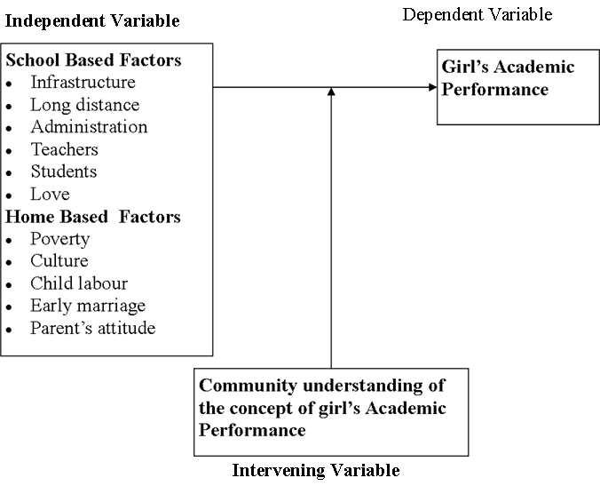
Figure 2.1: Conceptual Framework of the Study
Source: Adopted from Auma (2014) and modified

The conceptual framework describes the relationships between these two factors that depend on each other and involving or through this lack of them may cause either positive or negative performance.

CHAPTER THREE

RESEARCH METHODOLOGY

3.1 Introduction
This chapter describes how the study was carried out. The chapter covers the approach and design of the study, area of the study, population of the study, sampling and sample size, sample techniques and also it gives the descriptions of instruments used for data collection methods and data analysis considered when conducting the research.

3.2 Research Approach
The methodology of this study was guided by phenomenology design. In other words, this design attempts to understand people perceptions, perspectives and understanding people of a particular phenomenon. In this study Phenomenology design was guide interview as one among methods of data collection, for appropriate generating in depth meaning on how the factors affect girls’ academic performance in public secondary schools in Mkoani district, Zanzibar. The research methods namely: interview, questionnaire and documentary analysis.

3.3 Research Design
Research design is the arrangement of conditions for the collection and analysis of information in a manner that aims to combine relevance to the researcher purpose with economy in procedures (Kothari, 2004). The study used qualitative approach. Denzin & Lincoln (1994) defined that qualitative research involves studying things in their natural setting, attempting to make sense of or interpret phenomenon in term of the meaning people bring to them. Qualitative research is based on the view that reality is constructed by individual interaction with their social words.

3.4 Area of Study
This study was conducted in Mkoani District, south region of the island of Pemba. There are about 22 public secondary schools, where by five secondary schools involved (Maendeleo, Chambani, Wambaa, Mtambile and Mizingani Secondary schools). These schools were involved in the study as representative part to all public secondary schools, which were found in Mkoani district. The reason to include these schools is that they are very accessible and situate very close to me. They were selected purposely to minimize the cost and maximize efficiency.

3.5 Study Population
Population of the study refers to all constituents of any clearly described group of people, events which are the focus of an investigation (Kothari, 2004). The targeted population of the study was based on Secondary Education stakeholders in Mkoani district. The accessible population of this study was district education officers’ Secondary schools girls’ students from form one, two, three and form four, subject teachers, head teachers and parents making a totals of one hundred and twenty sixty.

3.6 Sampling and Sample Size
Sample is a selection from the population that the researcher wants to study (Kombo et al, 2006). Kothari (2004) states that, “a decision has to be taken concerning a sampling unit before selecting sample”. This study used 12 students from each of the five schools to make a total of 60 students, 8 subject teachers from each school making a total of 40 teachers, 1 head teacher from each school making a total of 5 head teachers, 5 parents from within the society in which the sampled schools were selected making a total of 20 parents and 1 district education officer. Therefore, total respondents used in this study were 126 respondents. This sample size was selected with the assumption that it would provide good representation of the population because this study would not be able to access every member of the population in the study area.

Table 3.1: The Sample Distribution of the Study N= 126
S/No | Respondents |  | Percentage
S/No | Category of Respondents | Number of Respondents | Percentage
1. | DEO’s | 1 | 0.79
2. | Head Teachers | 5 | 3.97
3. | Teachers | 40 | 31.75
4. | Parents | 20 | 15.87
5. | Girls’ students | 60 | 47.62
Total |  | 126 | 100

3.6.1 Sampling Techniques
Sampling is a procedure of selecting a number of individuals or objects from a population such that the selected group contains elements representative of the characteristics found in the entire group (Orodho and Kembo, 2005). This sampling technique was used in deciding about the study area and the population of the study.

3.7 Data Collection Methods and Instruments
Data collection is the process of gathering information to serve or prove some facts (Kombo et al, 2006). Therefore, in this process of collecting information from different sources such as from the fields, newspapers, journals and etc. (Kothari, 2003). The data were collected by using primary and secondary data.
3.7.1 Primary Data
Data that has been collected from first-hand-experience is known as primary data. Primary data has not been published yet and is more reliable, authentic and objective. Primary data has not been changed or altered by human beings; therefore its validity is greater than secondary data. The following are some ways of collecting of primary data.

(i) Questionnaires
A questionnaire is a tool of data collection which consists of a number of questions printed or not in definite order on a form or set of forms (Kothari, 2007). The questionnaires enable to collect more information from a big number of people. Most commonly used method when respondents can be reached and are willing to co-operate. Questionnaires were preferred for this study because according to Gay (1981) descriptive date are typically collected through questionnaires to be administered.

Questionnaires were provided to Sixty (60) students. These students are those girls mentioned above (form one, two, three and form fours). Questionnaires are used so as to save the time and make it possible to reach them easily with less cost and minimizing the possibility of biasness. Teachers were also provided with questionnaires. Their questionnaires were different from that of students.

(ii) The interviews
Kathuri (1993) defines an interview schedule as an outline of questions that form a basis for and guide the interviewing process.
Interview is a face-to-face conversation with a respondent (Kabir, 2016). During an interview, the discussion progress beyond the surface talks to a richer level of thoughts, feelings and probe as well as explore within the predetermined inquiry areas. The lists of questions were prepared in the piece of paper and the researcher used it to ask the questions orally to the respondents. The schedule provides a structure that aids in obtaining the necessary information efficiently and in a business-like atmosphere. Enables you to gather in-depth information, to counter check/confirm the information obtained through questionnaire.

Head teachers’ Interview schedule. The interview guides was used to respond to verbal responses from the head teachers of the six selected schools regarding poor performance of girls. The researcher went for this because the head teachers also teach the students. They are the ones who collect fees so they know the financial problems as they interact with parents personally. They are also directly involved with disciplinary cases involving the students.

Piloting once the questionnaire has been constructed, it should be tried out in the field. The questionnaires were pre-tested to a selected sample of four schools outside the selected samples in Mkoani district. Piloting ensures that research instruments are stated clearly and have the same meaning to all respondents (Mugenda and Mugenda 1999; 186). Interview was used to explore the factors affect girls’ academic performance in certificate secondary school Mkoani District Pemba. This method enables to get depth information when the researcher was collect the information directly from the respondents.
3.7.2 Secondary Data
Data collected from a source that has already been published in any form is called as secondary data. The review of literature in any research is based on secondary data. It is collected by someone else for some other purpose (but being utilized by the investigator for another purpose). For examples, Common sources of secondary data for social science include censuses, organizational records and data collected through qualitative methodologies or qualitative research. Secondary data is essential, since it is impossible to conduct a new survey that can adequately capture past change and/or developments. Through the documents of result reviews from District education officer and individual report from head of school for five selected schools in Mkoani District.

Sources of Secondary Data:
The following are some ways of collecting secondary data.
Books, records, biographies, newspapers, Internet articles Published censuses or other statistical data, Research articles by other researchers (journals), Databases, etc

(i) Documentary Reviews Method
The use of documents often entails a specialized analytic approach called content analysis. The raw materials for content analysis may be any form of communication, usually written materials (textbooks, novels newspaper, e-mail massages) and other forms of communication music, picture, or political speeches may also be included. Historically, content analysis was viewed as an objective and neutral way of obtaining quantitative description of the content of various forms of communication (Berelson, 1952). In this document it was used together information from different academic results of CSEE and others related documents as district educational office, regional educational office, Schools wise and result from final examination results and to make comparison between boys and girls performance in different years from 2016 up to 2020.

3.8 Data Analysis
Kombo et al (2006) defined data analysis as an attempt by researcher to summarize collected data in dependable and accurate manner. Therefore after collection of data, they presented in a manner, which is acceptable and understandable.

According to Patton, (2002) data analysis is the search for patters in the data. It is the process of giving the information collected for the study a meaning, which involves arranging and organizing the data in such a way that research questions are answered. Descriptive method in a narrative manner was used to analyses data, which gave the researchers opportunity for answering the researcher questions.

Related to Kothari (2004), the researcher needs to conduct coding, editing, classification and tabulation of data for the purpose of summarizing and making it accurate into small number and arrange it into homogeneous groups. This study used both quantitative and qualitative data analysis procedures. For quantitative data from questionnaire were analysed by using descriptive statistics, where frequency, percentages, pie charts and tables were used to present data. The objectives of the study were used to guide data presentation. The qualitative data from the interview were analyzed by using the thematic approach. Middleton (2019) defines thematic analysis as a method for identifying and reporting patterns/themes in the data.

CHAPTER FOUR

DATA PRESENTATION, ANALYSIS AND DISCUSION

4.1 Introduction
This chapter presents and discusses the research findings of this study. The data presented, analyzed and discussed in this Chapter were collected through questionnaires and interview guides.

4.2 Demographic Characteristics

4.2.1 Gender of the Respondents
Table 4.1: Demographic Characteristic
Categories | Gender | Frequency | Percentages (%)
Subject teachers | Males | 15 | 37.5
Subject teachers | Female | 25 | 62.5
Students | Male | 21 | 35.0
Students | Females | 39 | 65.0
Parents | Males | 11 | 55.0
Parents | Females | 9 | 45.0
Head teachers  District Educational Officer | Males  Male | 5  1 | 100.0  100.0
Source: Field data, 2022

The result showed that 37.5% were male and 62.5 % were female in subject teacher, 35.0% were male and 65.0% were females, in students, 55.0 % were male and 45.0% were females in parents, 100.0% were male in head teacher and 100.0%were male District Educational Officer. This suggests that females were dominating in many areas compare to the males, and therefore female play an important part in the society especially in education. This is because traditionally most of Zanzibarian, female having a high number of populations in many sectors.

4.2.1 Community Understanding of the Concept of Girls’ Academic Performance in Mkoani District (Subject Teachers)
The result from the respondent on girls academic performance to the subject teacher revealed that most of them suggested that the performance is poor compared with the boys. Example 32.5% said is low, 30.0% said is poor, 20.0% said is moderate, 12.5% said is better and 5.0% said is high. Hence we can justify that the academic performance of girls were poor according to the subject teachers compared with the boys as shown in the Figure 4.1.

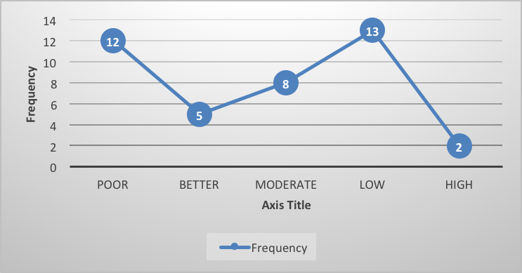

Figure 4.1: Teacher Response on Girl’s Academic Performance in Public
Secondary Schools
Source: Field data, 2022

Similarly with Margaret (2013) on his study of factors influencing the academic performance of girls in secondary schools her found that more than a half (51.4%) of the girls believed that boys performed better than girls, 41.5 % believed that girls perform better while 7.1 % said that both genders were capable of performing thus their performance was competitive. From the findings above the boys are believed to perform better than the girls while a small proportion of the respondents believe that both genders had equal chances of performing.

4.2.2 Community Understanding of the Concept of Girls’ Academic Performance in Mkoani District (Parents)
The result from the parents on girls’ academic performance they revealed that, most of them were said girl academic development for the 60%, followed by the girls successful in her examination for the 30% and change of academic performance for the 10% in the Figure 4.2.
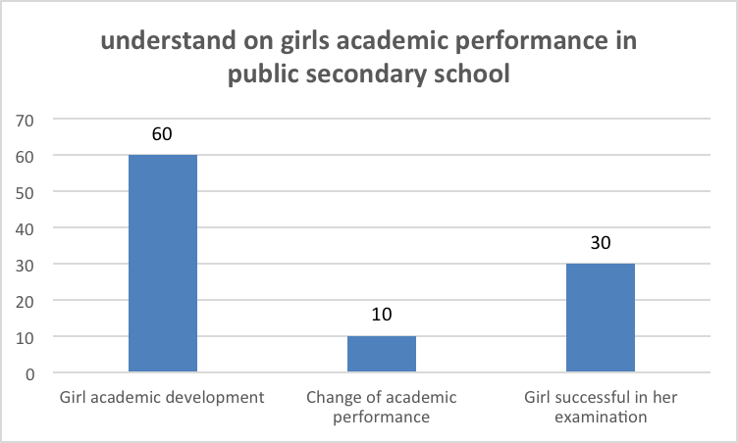

Figure 4.2: Community Understanding of the Concept of Girls’ Academic
Performance in Mkoani District (Parents)
Source: Field data, 2022

Related to the study of Analyzing gender difference in the academic performance of student by the Mankumari Parajuli and Ajay Thapa (2017), the study found that among the students scoring distinction position in the district level standard exam of grade eight, females hold a significantly greater percentage 38.33% compared to their male counterparts 23.33%. However, among the students passed in first division, the percentage of male students was relatively greater 47.50% compared to female students 33.33%. Below the first division, the difference between male and female seems negligible.

4.2.3 Community Understanding of the Concept of Girls’ Academic Performance in Mkoani District (Students)
When the students asked on awareness in girl’s academic performance, most of them said that having awareness for the 90% said yes and 10% were not awarded and when asked on what is it the just said that in their explanations as shown in the Figure 4.3.

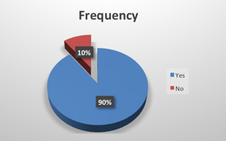

Figure 4.3: Awareness on Girls' Academic Performance, (Students)
Source: Field data, 2022

4.2.3.1 Community Understanding of the Concept of Girls’ Academic Performance in Mkoani District (Students)
It educational changing from one class to another for the 24% and is the achievement of student from their study for the 23% and is a good examination results for the 13%, as shown in the Figure 4.4.
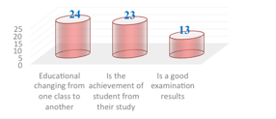
Figure 4.4: Understanding of Girls’ Academic Performance (Students)
Source: Field data, 2022

According to Wanyama (2017) Academic performance refers to the quality and quantity of knowledge, skills techniques and positive attitudes, behavior and philosophy that learners achieve or acquire. This ability is evaluated by the marks and grades that the pupils attain in a test or examination which is done at the end of a topic, school term, and year or education cycle. The scores and grades that each pupil obtains measure the degree of achievement. The quality of the grade and the number of candidates who pass in various grades determine the level of academic performance in a given class or institution in a given period in a particular examination, be it internal or public.

4.2.4 Community Understanding of the Concept of Girls’ Academic Performance in Mkoani District (Head teachers)
When the head teachers asked about girls academic performance in public secondary schools, they said that, the academic performance is low for the 60% and not good for the 40%, this indicate that the performance of the student were monitored by the head of school and they mention is not good as shown in the Figure 4.5.
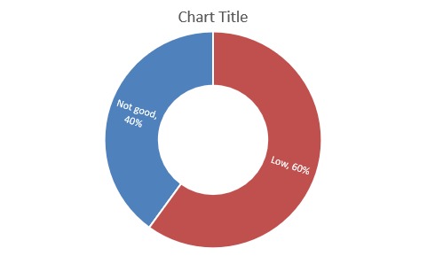
Figure 4.5: Community Understanding of the Concept of Girls’ Academic
Performance in Mkoani District (Head teachers)

Academic performance of students is a key feature in education (Rono, 2013). It is considered to be the center around which the whole education system revolves. Narad and Abdullah (2016) opined that the academic performance of students determines the success or failure of any academic institution. Signh, Malik and Signh (2016) also argued that academic performance of students has a direct impact on the socio-economic development of a country. Similarly, Farooq, Chaudhry, Shafiq and Behanu (2011), asserted that students’ academic performance serves as bedrock for knowledge acquisition and the development of skills.

Additionally, Farooq et al., (2011) emphasized that the top most priority of all educators is academic performance of students. According to Narad and Abdullah (2016) academic performance is the knowledge gained which is assessed by marks by a teacher and/or educational goals set by students and teachers to be achieved over a specific period of time. They added that these goals are measured by using continuous assessment or examinations results.

4.3 Factors Affecting Girls’ Academic Performance in Public Secondary Schools (School Teachers)
Result from respondents showed that girl’s academic performance in public school were affected with the factors like love disturbance with the 22.5%, home domestic activities for the 17.5%, poverty and misuse of mobile phone were 12.5%, long distance from home to school and family conflict were 10%, luck of self- identification and poor family support were 7.5%, Figure 4.6.
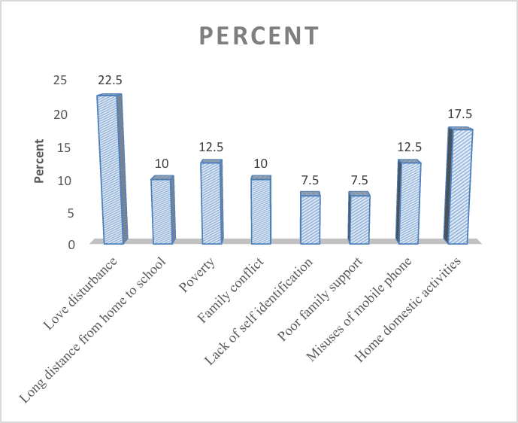
Figure 4.6: Factors affecting Girls’ Academic Performance in Public Secondary
Schools (School teachers)

This similarly with the King and Hill (1991) on the other of the factors such they state as domestic chores that girls attend to when they go home from school have a lot of impact on their academic performance. Girls get involved in such household activities like fetching water, firewood, washing utensils, cooking and serving members of the family. In order to fulfill these roles, girls from poor households perform poorly and are the first to drop out of school. In this way they miss education and get training that could enable them to have better lives as future mothers.

Also, Okkolin et al., (2010) state that long distance walks from home to school cause many girls to miss classes or entire school days and to drop out of school, thus leading to low school attendance and poor performance on Form Four national exams.Similarly, with the Mbelwa and Isangula, (2012).

In most rural areas, each ward has approximately 10 villages, but only one secondary school to serve members from all these villages and the majority of these schools are day schools, where students are required to walk long distances each day to and from school. In such an environment girls fall into temptations by non-school males and school boys as they make their way to and from school. Exposure to sexual violence is a greater risk for girls commuting longer distances.

Another issue that has been raised by some authors is the concern that, with advances in telecommunication technology, girls who own cell phones are distracted and cannot concentrate on schoolwork (Mbelwa and Isangula, 2012). Money and goods they receive from men, such as expensive telephones, tempt girls lacking in maturity. Desires for expensive and modern materials, which include perfumes and clothes, accelerate the involvement of some school girls in sexual activities with wealthy as well as older males. If they risk unsafe sex and have unplanned pregnancies, they are more likely to reduce school attendance, academic performance, and even to drop out from school (Mbelwa and Isangula, 2012).
Poverty and the impoverished condition of the citizenry serve as a barrier to girl-child education. Most mothers preferred street hawking and early marriage, then sending their children to school (Richard, 2008). Conflicts and Disputes – There are numerous instances that take place among the families that are responsible for low academic achievement. There have been cases of families that experience conflicts and disputes on a frequent basis. The occurrence of conflicts and disputes are regarded as major barriers within the course of academic achievement.

Normally, parents look for best opportunities for their children, give them good education and make provision of all the requirements and opportunities that lead to a good living. But research has indicated that parents, who are not educated, are engaged in minority jobs and are, residing in the conditions of poverty and backwardness, get engaged into fights and as a result children get discouraged from acquisition of education. Therefore, occurrence of conflicts and disputes not only hinder academic performance, but also discourage children from acquisition of education (Dr. Radhika Kapur (2018).

4.3.1 Factors Affecting Girls’ Academic Performance in Public Secondary Schools (Parents)
The results from the field about the contribution on poor performance for girls in public secondary school from the parents showed that love affair were 30%, family conflict were 20%, poverty, living with single parent and inferiority were 15% and diseases were 5%. These indicate that love was mostly affect the performance of the students in the reading and learning process, Figure 4.7.
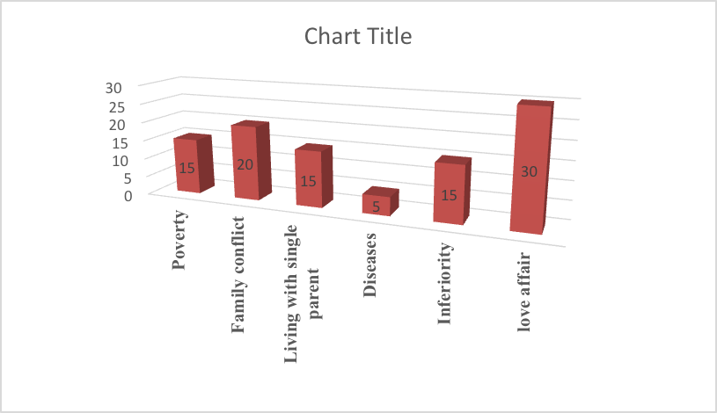
Figure 4.7: Criteria contribute on Poor Academic Performance for Girls in Public Schools (Parents)
Source: Field data, 2022

According to Endalsasa (2019) on factors affecting female students’ academic performance in second cycle of primary schools in Bahir Da, Ethiopia, as observed in Table 3.14, item 1, 32.4 % and 25.6% of the respondents replied that the level of impact of time spent that, female students with their boyfriend and / girlfriend on their academic performance is medium and high respectively.

İn line with this, Lawson (2011) cited in Sara et al (2017) stated students at school face various peer pressure that affect their life either in positive or negative way. As the responses to item 2, 33.5% and 21% of respondents responded that the level of impact of thinking about family and related issues on female students’ academic performance is medium and high respectively. 21% of the respondents also replied that the level of impact of thinking about family and related issues on female students’ academic performance is very high.
Regarding item 3 of the Table, 24.4% of the respondents responded that the level of impact of engaging in income generating activities on female students’ academic performance is high. Item 4 of the same Table, 26.7% of the respondents replied that the level of impact of time spent that, female students spent on issues related with people approaching them for love affairs on their academic performance is very low. From this Table, one can understand that factors such as the time that female students spending with boyfriend / girlfriend, thinking about family and related issues and engaging in income generating activities significantly affect female students’ academic performance.

According to Kapur (2018) the problem of poverty is regarded as one of the major barriers within the course of academic achievements. The individuals residing in the conditions of poverty and backwardness experience the major problem in terms of finances. When their per capita income is low, then they experience problems in not only meeting the educational and school requirements, but also in meeting their living requirements, such as diet and nutrition, health, medical and so forth. Therefore, the problem of poverty is considered as one of the critical factors that hinder the academic performance of the students. When they do not possess the essential sources to enhance their learning, then they are unable to improve their grades as well.

According to Ajibade Basit Olalekan (2016) In a single parent home where responsibility of taking care of the child falls on either the mother`s or father`s shoulder and where they are busy working for means of survival, the child could also be influenced to a large degree by his peers.

4.3.2 Factors Affecting Girls’ Academic Performance in Public Secondary Schools (Students)
The results from field on the factors contributing poor performance of students to the students showed that low effort and truancy with misuse of mobile phone were 21.7%, lack of motivation were 18.3%, large number of domestic activities were 15%, poor respect were 10%, love affair were 8.3%, teachers’ effort and his/her attendance were 3.3% and geographical location of the school were 1.7%. This indicates that the mobile phones in side of students were having the negative effects to their learning process, Figure 4.8.

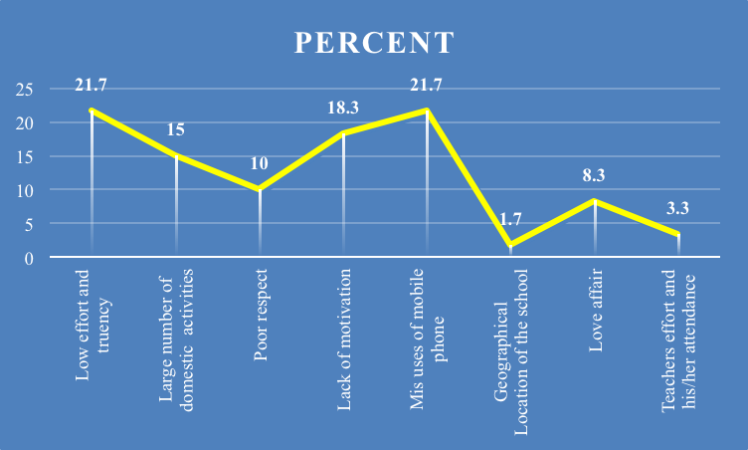
Figure 4.8: Factors Contributing Poor Performance of Students (Students)
Source: Field data, 2022

According to Hezron (2014) There are arguments that school environments are at times not conducive to effective learning of girls and this might ultimately lead to underachievement which resulted in repetition; a precursor for drop out. Arguments against repetition basically stressed that repetition has potential harmful effect on students‟ self- esteem and attributes towards schooling and this increases the likelihood of dropping out of school.

School environment also seemed to affect the girls in particular. Teachers‟ attitude, behavior and teaching practices are perhaps the most significant implication for female persistence and academic achievement. This problem was rooted in societal beliefs, which teachers bring into the classroom scenario. This could therefore, be linked to the cultural beliefs which tended to look at females as having less ability than males and hence leads to the marginalization of girls in the classroom and further de-motivates girls in their academic pursuits. In tackling the issue of school environment, it had also become popular to investigate the presence and conditions of such school facilities such as toilets. This was especially in view of the potentially negative effect that the absence of such facilities may have on girls‟ persistence in schools

4.3.3 Factors Affecting Girls’ Academic Performance in Public Secondary Schools (Head teachers)
The results from the field about factors affecting girls’ academic performance, the head teachers identify that love affair were 27%, family conflict and child labor were 20%, overworking were 13% and diseases, long distances with misuses of mobile phone were 7%, Figure 4.9.

According to CEMASTEA who undertook a gender survey in 2013, which identified that most training structures are not gender-responsive and that there are many factors preventing women’s involvement in science. These include socio-cultural factors, attitudes and practices, poverty, the lack of role models, classroom pedagogy, and child labour, among others.

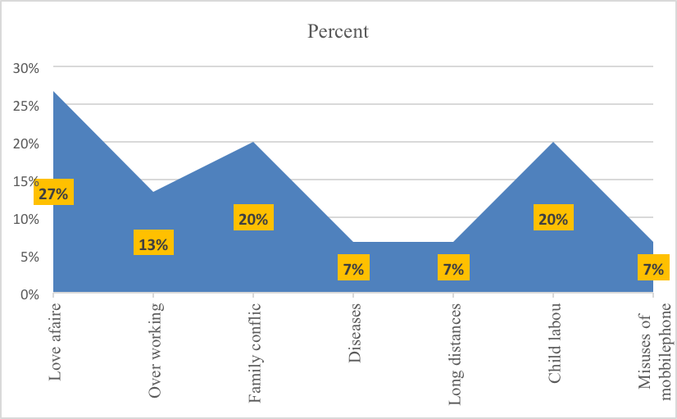
Figure 4.9: Factors Affecting Girls’ Academic Performance in Public Secondary Schools (Head teachers)
Source: Field data, 2022

According to Endalsasa (2019) on factors affecting female students’ academic performance in second cycle of primary schools in Bahir Da, Ethiopia, one can understand that factors such as the time that female students spending with boyfriend and / girlfriend, thinking about family and related issues and engaging in income generating activities significantly affect female students’ academic performance.

4.4 Suggest Good Ways for improving Girls’ Academic Performances in Public Secondary School (School teachers)
Suggestion from the field which suggested by the school teachers on the ways of improving girls’ academic performance in public secondary school were minimizing home domestic activities 27.5% which attempted 11 frequency, redness of student her- self were 22.5% which attempted 9 frequency, guidance and counseling were 20.0% which attempted 8 frequency, availability of boarding school were 17.5% which attempted 7 frequency and good government support for girl students were 12.5% which attempted by the 5 frequency, Figure 4.10.

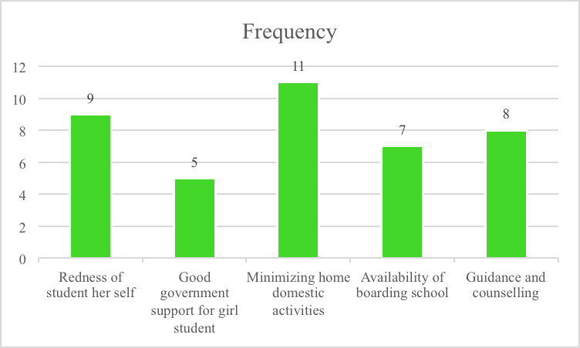

Figure 4.10: Suggest Good Ways for Improving Girls’ Academic Performances
in Public Secondary School (School teachers)
Source: Field data, 202

Ndalichako & Komba (2014) in the study titled “Students’ subject choice in secondary Schools in Tanzania: A matter of students’ Ability and Interests or Forced Circumstances?” found that the reasons for students’ preference of a particular subject included the inspiration from significant others, commitment and support provided by the subject teachers, the availability of teachers and their teaching approaches and relevance of the subject to their daily life experiences.
According to Maganga, (2016). Counseling and Guidance Services – In secondary schools, there are numerous problems and difficulties that students experience. Some may even get involved into violent and criminal acts, drug abuse, HIV, other sexually transmitted infections, teenage pregnancies, induced abortions and unemployment. These factors have a direct impact upon not only their academic performance, but also their lives.

These may hamper their psychological approach and they may even experience problems of depression, trauma or stress to a major extent. Counseling and guidance services need to be established in schools to help the students to provide solutions to their problems, focus upon their studies, and become responsible members of the community (Maganga, 2016). It is vital for the individuals, who work as counselors to specialize in a particular area and possess adequate knowledge, expertise and skills. Counseling is related to various areas, such as career, academics, depression, stress, health, family issues and so fort

4.4.1 Suggest Good Ways for Improving Girls’ Academic Performances in Public Secondary School (Parents)
Suggestion from the field which suggested by the parents on the ways of improving girls’ academic performance in public secondary school were learning camp 30%, motivation and gender equality were 25%, friend language and redness of the students were 10.0% which mean that the most important thing for the performing well of the students in their learning process is the grouped discussion or learning camp, Figure 4.11.
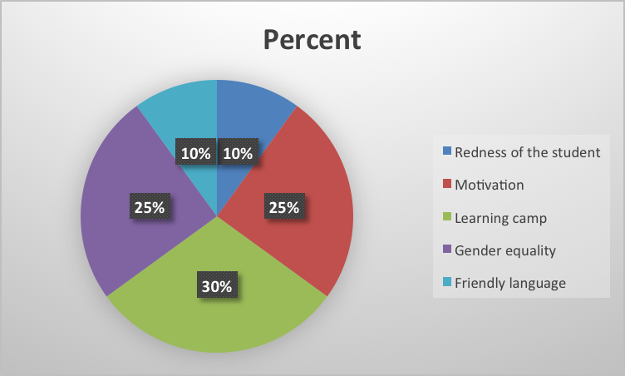
Figure 4.11: Ways Forward to Improve Girls’ Academic Performance (Parents)
Source: Field data, 2022

Rehman & Haider (2013) in the study titled “The impact of motivation on learning of secondary school students in Karachi: An analytical study”, noted that teachers knew how could student be involved in classroom activities before giving knowledge. Teachers and parents should develop mutual confidence. That confidence developed motivation in students to learn.

According to Kapur (2018) Rewards are regarded as one of the most important factors that are used in motivating the students. In secondary schools, students usually enjoy playing and getting engaged in recreational and leisure activities. They in some cases neglect their studies, especially when they are unable to understand the concepts or have to watch a television show or go out with friends and so forth. Usually, parents at home create means of motivating their children by saying that they will give them their favorite ice-cream or take them out for dinner or give them a gift etc. On the other hand, teachers make use of motivating forms to the students by giving them, stars or sweets or planning a picnic and so forth. Rewards are considered as stimulating factors that contribute in improving the academic performance of the students. When the teachers communicate about rewards within the classroom, then students develop the keenness to work hard and score good grades. They believe that through their good performance, their parents and teachers, both would get pleased

4.4.2 Suggest Good Ways for improving Girls’ Academic Performances in Public Secondary School (Students)
Suggestion from the field which suggested by the own students on the ways of improving girls’ academic performance in public secondary school were reduce domestic activities for girl’s student 31.7%, Increase more effort in academic were 18.3%, Leave unnecessary issues were 16.7%, avoiding truancy were 15%, advising and counseling on academic issues were 11.7% and availability of boarding school for girl’s student were 6.7%. This mean that home domestic activities were taken a large number in affecting performance for the girls academic. Table 4.2.

Table 4.2: Ways we can Promote Academic Performance, (Students)
 | Frequency | Percent
Reduce domestic activities for girl’s student | 19 | 31.7
Availability of boarding school for girl’s student | 4 | 6.7
Increase more effort in academic | 11 | 18.3
Leave unnecessary issues | 10 | 16.7
Avoiding truancy | 9 | 15.0
Advising and counseling on academic issues | 7 | 11.7
Total | 60 | 100.0
Source: Field data, 2022

Ontario (2013) in the study titled “Learning for all; A guide to effective assessment and instruction for all student, kindergarten to Grade 12” noted that all educators, students, and parents hoped that their schools would have brought out the very best in their students and encouraged them to reach their full potential. Much progress had been made, but they had more work to do. The effort to raise the bar and reduce the gap was a shared responsibility. It required engagement, innovation, and partnership between parents, the school, and its community to create learning opportunities for all students.

4.4.3 Suggest Good Ways for Improving Girls’ Academic Performances in Public Secondary School (Head Teachers)
Suggestion from the field which suggested by the head teachers on the ways of improving girls’ academic performance in public secondary school were using boarding and educating the community 25 %, keeping busy on studying were 18.8%, motivation with minimizing the home activity 12.5% and guidance and counseling were 6.3%. This mean that boarding and educating the community were taken a large number in promoting performance for the girls academic followed by keeping busy on studying, Table 4.3.

Table 4.3: Ways for improving Girls’ Academic Performances in Public Secondary School (Head Teachers)
 | Responses
 | N | Percent
Using boarding | 4 | 25.0%
Motivation | 2 | 12.5%
Guidance and counseling | 1 | 6.3%
Educating the community | 4 | 25.0%
Minimizing the home activity | 2 | 12.5%
Keeping busy on studying | 3 | 18.8%
Total | 16 | 100.0%
Source: Field data, 2022
According to Angela E. Nyalusi (2013) on his study also intended to assess the role of girls’ hostels on girls’ academic performance in community secondary schools. As revealed in the reviewed literature (see for example, Section 2.2.2.2), hostels tend to foster academic performance through expanded opportunity for integration into the academic system such as interaction with faculty social system, frequency of peer conversations and informal social activities of the school (Cerid, 1996).

Also, hostels tend to have more extensive staff, thus offering opportunities for students to participate in activities programmed in residence halls (Lyndon, 2006). Likewise, school hostels provide important protection for children from being at risk of natural disasters and other calamities (Davis, 2001). More important hostels save more time that would be spent by girls walking long distances to school and prevent girls from domestic chores at home (Danida, 1999). More precisely, hostels provide friendly learning conditions for girls to improve their academic performance as they will be access to group discussion, away from bottleneck domestic activities, protected from pregnancies, sexual harassment, raping etc.

4.4.4 Suggest Good Ways for Improving Girls’ Academic Performances in Public Secondary School (DEO)
Suggestion from the field which suggested by the District Education Officer on the ways of improving girls’ academic performance in public secondary school were reduce home responsibility for girls student 33.3%, protect from gender violence 33.3% and gender education 33.3%. This mean that DEO had seen and suggest the possible ways of promoting performance for the girls academic in different aspect in term of their responsibility from home, in term of protected herself and in term of provided life skills education as shown in Table 4.6.

Table 4.4: Suggest Good ways for improving Girls’ Academic Performances in Public Secondary School (DEO)
 |  | Responses
 |  | N | Percent
 | To reduce home responsibility for girls student | 1 | 33.3%
 | To protect from gender violence | 1 | 33.3%
 | Gender education | 1 | 33.3%
Total |  | 3 | 100.0%

4.4.5 Comments from DEO for Improving Girls’ Academic Performances in Public Secondary School
Comments from the field which suggested by the District Education Officer on the ways of improving girls’ academic performance in public secondary school were having special public secondary school for girls 33.3%, parent should have positive attitude on education 33.3% and guidance and counseling 33.3%. This mean that DEO had seen and try to give just a some comment on promoting performance for the girls academic in different aspect in side of the government, parents and other educational stakeholders.
Table 4.5: Comments from DEO’s for Improving Girls’ Academic Performances in Public Secondary School
 |  | Responses
 |  | N | Percent
 | Having special public secondary school for girls | 1 | 33.3%
 | Parent should have positive attitude on education | 1 | 33.3%
 | Guidance and counseling | 1 | 33.3%
Total |  | 3 | 100.0%

CHAPTER FIVE

SUMMARY, CONCLUSION AND RECOMMENDATIONS

5.1 Introduction
This Chapter summarizes key findings established in Chapter Four. Further, the Chapter provides conclusion and recommendations.

5.2 Summary of Chapter
Basing on the specific objectives of this study, the following were the major findings established a number of facts:

In respect with the first specific objective that aimed at assess the community’s awareness on girls’ academic performance in public secondary schools, it was seen that public secondary schools had a poor performance to the girls’ students. This study found that public secondary schools the performance is poor compared with the boys. Example 13(32.5%) said is low, 12(30.0%) said is poor, 8(20.0%) said is moderate, 5(12.5%) said is better and 2(5.0%) said is high according to subject teachers. Parents when asked about understanding of the concept of girls’ academic performance they said girl academic development for the 60%, followed by the girls successful in her examination for the 30% and change of academic performance for the 10%. Students when asked about understanding of the concept of academic performance most of them said that having awareness for the 90% said yes and 10% were not awarded by changing from one class to another with achievement of student from their study and is a good examination results. But head teacher they said the academic performance is low for the 60% and not good for the 40%.
In the specific objective two which deals with the factors that affect girls’ academic performance in public secondary schools, the findings revealed that some girls were affected with these factors according to school teachers, love disturbance, home domestic activities, poverty, misuse of mobile phone, long distance from home to school and family conflict, luck of self- identification and poor family support.

Percentage mention that love affair 30%, family conflict 20%, poverty, living with single parent and inferiority 15% and diseases 5%. Students them -selves said that; low effort and truancy with miss use of mobile phone 21.7%, lack of motivation 18.3%, large number of domestic activities 15%, poor respect 10%, love affair 8.3%, teachers effort and his/her attendance 3.3% and geographical location of the school 1.7%. Head teachers identify that identify that love affair 27%, family conflict and child labor 20%, overworking 13% and diseases, long distances with misuses of mobile phone7%.

In the specific objective three which deals with the identify strategies taken to improves girls’ academic performance in public secondary schools. The findings revealed that some of the strategies from the subject teachers were minimizing home domestic activities 27.5% which attempted 11 frequency, redness of student her- self were 22.5% which attempted 9 frequency, guidance and counseling were 20.0% which attempted 8 frequency, availability of boarding school were 17.5% which attempted 7 frequency and good government support for girl students were 12.5%. From the parents were learning camp 30%, motivation and gender equality were 25%, and friend language and redness of the students were 10.0%. From the students them- selves were reduce domestic activities for girl’s student 31.7%, Increase more effort in academic 18.3%, Leave unnecessary issues 16.7%, avoiding truancy 15%, advising and counseling on academic issues 11.7% and availability of boarding school for girl’s student 6.7%. But head teachers suggest that; using boarding and educating the community 25 %, keeping busy on studying 18.8%, motivation with minimizing the home activity 12.5% and guidance and counseling 6.3% and finally DEO suggest that reducing home responsibility for girls student 33.3%, protect from gender violence 33.3% and gender education 33.3%.

5.3 Conclusion
Keeping in mind the findings presented and discussed in Chapter Four, it suffices to conclude that the government and the society should put more efforts to improve girls’ academic performance. It is really disappointing to find that girls perform poorly due to reasons, which would be eliminated on investing in girls’ education.

What seems also very surprising is the kind of award perception that still holds strongly among some individuals, head teachers, subject teachers and parents that girls’ performance in education is poor while those stakeholders were the responsible to make sure that the performance of girls in public secondary schools becomes well.

When the world speaks of empowering women, development of economy, new millennium, globalization, scientific and technological advancements, equality and equity, and human rights, among others, as important aspects in marking development of mankind the development still never come about in local communities until the communities change the attitude towards one another. That is providing equal chance, equal effort, equal and friendly infrastructure which can favors all gender to access services, especially education, equal time spends, friendly and friend environment for studying to all especially girls.

However, this study found that some parents, students, teachers and other educational stakeholders noted that girls’ academic performance have faced factors like distance from home to schools, many home domestics activities for girls, misuse of mobile phone, absences of boarding schools, poor environment for studying, awareness and lack of supports for girls students.

5.4 Recommendations

5.4.1 Recommendations for Action
This study makes the following recommendations that require practical actions:
(i) Since it is revealed in this study that performance in public secondary schools, it is recommended that the government and the community- including parents should be taken consideration to educate the girls and motivate them in order them to perform better.

(ii) Also, this study recommends the government to provide boarding to public secondary schools. The claim that public secondary schools are day schools and that they therefore do not having full facilities and are not having a friendly environment for studying. It should always be remembered that both public secondary school have nearly same demands, given the fact that the matter of boarding are needed to all schools.
(iii) The society around public secondary schools should be educated and criticized on the negative attitudes that girls are just labor of doing of a lot of home domestic activities at home and not for studying, so important education should be provided to people to change the perception. This education should also be directed, among other things, on identifying social practices that maltreat girls considering them as just the people responsible for households.
(iv) Moreover, this study recommends a note on school teachers in public secondary schools to accommodate their period, syllabus and should educate the girls on how to face and solve their problems especially examination through best techniques, methods and best examples and perfect structure of constructing the answers.
(v) Girls should be encouraged to add effort in academic studies in spite the challenges currently existing in the educational system in public secondary schools and Mkoani district in general.
(vi) The parents, stakeholders of education should be educate and direct the girls on how to utilize mobile phone for the purpose of searching learning materials only or otherwise should be stopped to manipulate the mobile phone until they have finished their study.

5.4.2 Recommendations for Further Studies
This study recommends for the studies in the following research areas
(i) Since the present study confined itself in five public secondary schools in Mkoani district, further studies that cover the whole of the region, and possibly Pemba should be carried out to address problem of poor academic performance resulting from the factors that uniquely affect girls learning environments.
(ii) The present study focused only on factors affecting girls’ academic performance. Therefore, it is recommended that studies that focus on the solutions of the problem of girls’ academic performance be carried out.
(iii) Also this study recommend further studies that will investigate the consequences resulting from girls poor academic performance on the economic, political, socio- cultural and psychological aspects of girls and women in particular, but also Pemba as a whole.

REFERENCES
Abitew, E. B. (2019). Factors affecting female students’ academic performance in second cycle of primary schools in Bahir Dar, Ethiopia. International Journal of Educational Research Review, 4(3), 403-419
Achola, P. (1987). Social Science Research Methods Hand Book for Africa. Nairobi: Government Printers.
Ahsan, M. U., Nasir, M., and Abbas, J. (2020). Examining the Causes of Plastic Bags Usages and Public Perception about its Effects on the Natural Environment. International Journal of Academic Research in Business and Social Sciences, 10(10), 80–96. http://dx.doi.org/10.6007/IJARBSS/v10-i10/7919
Ajibade B. O. (2016). Influence of Peer Group Relationship on the Academic Performance of Students in Secondary Schools.
Anthony, A. (2018). Factors contributing to academic performance of students in a Junior High School
Arias, E., & De Vos, S. (1996). Using housing items to indicate socioeconomic status:
Aro, M. (2006). Learning to read: The effect of orthography. In M. Joshi & P.G. Aaron (Eds.), Handbook of orthography and literacy, (pp. 531-550). Mahwah, NJ: Lawrence Erlbaum Associates.
Ayal Hezron Auma (2014). An assessment of factors affecting girls’ performance in secondary schools in rachuonyo south sub county, homa bay county, Kenya
Babyegeya, E. K. (2002). Education Planning and Administration, Dar es Salaam: Open University of Tanzania.
Balfanz, R., and Byrnes, V. (2012). Chronic Absenteeism: Summarizing What We Know From Nationally Available Data. Chronic Absenteeism Report, Baltimore: Johns Hopkins University. Certificate of Secondary Education Examinations in mixed Secondary schools in lower Nyokal division Homa - bay district, Kenya
Damball, B. (1983). “Performance of Girls in science subjects in Secondary Schools with Physics and math taken in Representative subjects UDM, ED 338 Independent study.
Denzin, N. K., and Lincoln, Y. S. (1994). Hand book of qualitative research. Thousand Oaks, CalifSage. Eskişehir: Anadolu Üniversitesi Yayınları.
Deschamps, R. (2018). What is the difference between theoretical and empirical literary reviews? www.quora.com
Diyamett, B. D. L. (1989).” Factors contributing to low participation of women in science and Technology in Tanzania, Dar es Salaam, Jangwani Secondary School.
Radhika, K. (2018). Factors Influencing the Student’s Academic Performance in Secondary Schools in India. New Delhi: Sage Publications Inc.
Enon, J. C. (1998). Education Research, Statistic and Measurements. Nairobi: department of psychology school of education
Egbert Mulokozi Rwegasira (2017) factors influencing girls’ poor academic performance in community secondary schools: the case of Kishapu district
Sara, A., Elias, K., & Charbel, S. (2017). How to enhance awareness on bullying for Special Needs Students using ‚Edpuzzle‛ a web 2.0 tool. International Journal of Educational Research Review, 3(1)
Egbert, M. R. (2017). Ffactors influencing girls’ poor academic performance in Community Secondary Schools:the case of Kishapu District
Endalsasa Belay Abitew (2019). Factors Affecting Female Students’ Academic Performance in Second Cycle of Primary Schools in Bahir Dar, Ethiopia. International Journal of Educational Research Review
Fatuma, C., and Daniel, N. (2006). Girls and Women education in Kenya.Gender perspectives and trends.
FAWE, (1995). Girls and African Education Research and Action Keep Girls
FAWE, (2003). The Quest for Quality in Girls' Education: FAWE Centres of Excellence - Mgugu Secondary School, Kilosa District, Tanzania. Nairobi: Hathi Trust Publisher
Gay, L. R. (1981). Educational Research- Competencies for Analysis and Application. Ohio: Bell, Howell.
Ginsburg, A., Jordan, P. and Chang, H, (2014). Absences Add Up: How School Attendance Influences Student Success. Attendance Works. Accessed from www.attendanceworks.org/wordpress/wp.../2014/.../ on April 2015.
Grace, A. K. (2017). Assessment of factors contributing to girls’ school attendance and academic performance on form four national examinations in Mbeya region, Tanzania.
Hassanzadeh, R., and Rezaei, A. (2011). Effect of sex, course, and age on SMS addiction in students. Middle East J Sci Res. 2011;10:619–25. [Google Scholar]http ://dx.doi.org/10.2139/ssrn.2028369
Kabir, S. M. (2016). Methods of Data Collection, Curtin University from www.researchgate.net/publication/325846997
Kagaruki, S. R. F. and Sekwao, C. (1990). “Opportunities for Women scientists in Education” paper presented to WSST Workshop Dar es Salaam.
Karemera, D. (2003). The effects of academic environment and background characteristics on student satisfaction and performance. The South Carolina state University school of Business.
Kassashurke, (2006). Factors affecting female participation in education.
Kimondo, M. W. (2013). Factors influencing The Academic Performance of Girls in Secondary Schools: in Embakasi Nairobi Kenya.
King E. & Hill A. (1991). Women in developing countries barriers, benefits and policies – New York: Baltimore University Press.
Kombo, K., & Tromp. A. (2006). Proposal and thesis writng, an introduction. Nairobi: Paulines publication.
Latin America. Journal of Social Indicators Research, 38, 53-60.
Liehr, P. & Smith, M. J. (1999) Middle-Range Theory: spinning research and practice to create for the new millennium. Advances in nursing science.
Lockheed, M. E. & Verspoor, A. (1991). Improving Primary Education in Developing Countries. Oxford: World Bank/OUP.
Maganga, J. H. (2016). Factors Affecting Student’s Academic Performance: A Case Study of Public Secondary Schools in Ilala District, Dar-es-salaam, Tanzania. University of Tanzania. Retrieved April 25, 2018 from http://repository. out.ac.tz/1732/1/Jamillah__Maganga-Dissertation_14-10-2016-Final.pdf
Malekela George A. (1983). Acess to Secondary Education in Sub-Sahara Africa. The Tanzania experiment university of Chicago.
Mankumari P., and Ajay, T. (2017). Gender Differences in the Academic Performance of Student
Margaret, W. K.(2013). Factors Influencing the academic performanceof girls in secondary schools: A case of Embakasi district, Nairobi County, Kenya
Mbele, A. & Katabaro, J. (2003). School Enrolment, Performance and Access Education in Tanzania. Dar es Salaam: Mukukina Nyota Publisherrs Ltd.
Mbelwa, C., & Isangula, K. G. (2012). Teen Pregnancy: Children Having Children in Tanzania. The purpose of this paper is to construct and describe the conceptual framework. Dar es Salaam, Tanzania.
Mugenda, O., & Mugenda, (1999). Research Methods, Qualitative and Qualitative Approaches. Nairobi: Nairobi Acts Press.
Nayak, J. K. (2018). Relationship among smartphone usage, addiction, academic performance and the moderating role of gender: A study of higher education students in India. Computers & Education, 123, 164 173.
Ndalichako J. & Komba, A. (2014). Students’ Subject Choice in Secondary Schools in Tanzania: A Matter of Students’ Ability and Interests or Forced Circumstances? Open Journal of Social Sciences. Accessed on 21st March, 2015 from ile.scirp.org/pdf/JSS_2014082509082694.pdf.
Obilo Benter Anyango (2012). Factors Influencing Girls' Performance in Kenya
Okkolin, M. A., Lehtomäki, E., & Bhalalusesa, E. (2010). The successful education sector development in Tanzania–comment on gender balance and inclusive education. Gender and Education 22(1), 63-71.
Orodho, J. A. (2009). Elements of Education and Social Science, Research Methods. Nairobi: Kanezja Hp Enterprises.
Rai Y., Beck J. & Heffernan N. (2009). Does Self-Discipline impact students’ knowledge and learning? Educational Data Mining. 61-70. Accessed from www.educationaldatamining.org/EDM2009/uploads/proceedings/gong.pdfon 9th June, 2015.
Rehman, A. & Haider, D. (2013). The impact of motivation on learning of secondary school Students in Karachi: An analytical study. Educational Research International Educational Research International. 2(2), 139-147. Accessed from on www.erint.savap.org.pk/PDF/.../.pdf on 11th Feb, 2015.
SACMEQ. (2005). A study of the condition of Schooling quality of Education. Nairobi, Kenya.
Srinivas, P., & Venkatkrishnan, S. (2016). Factors Affecting Scholastic Performance in School Children. IOSR Journal of Dental and Medical Sciences, 15(7), 47-53. Retrieved April 25, 2018 from http://www.iosrjournals.org/iosr-jdms/papers/Vol15-Issue%207/Version-1/J150714753.pdf
Stephen, P. H., & William A. L. (1983). The Effect of Primary -School quality on Academic Achievement Across twenty- nine High and Low -Income countries. American Journal of sociology,
Sumra. M., & Katabaro, A. (2014). Declining quality of education: suggestions for arresting and reversing the trend: Dar es Salaam. The economic and social research foundation.
Sumra, S., & Katabaro, J. K. (2014). Declining Quality of Education: Suggestions for Arresting And Reversing The Trend Special THDR Issue: ESRF Discussion Paper 631 Published by Economic and Social Research Foundation Dar es Salaam Tanzania. Quality Assurance in Education.
Tadesse S. (2009). Understanding female students’ academic performance: An exploration of the situation in south Nations Nationalities and people regional state, Addis Ababa.2006. Education in Ethiopia: strengthening the foundation for sustainable progress. The World Bank Washington, D.C.
TADREG, (1989). Girls Educational opportunities and performance in Tanzania Dar es Salaam, Research Report No.2. Tanzania. Available at SSRN: https://ssrn. com/abstract=2028369 or
UNESCO. (2012(a). EFA Global Monitoring Report: Youth and skills: Putting education to work. Paris: UNESCO.
UNESCO-HNA Partnership for Girls’ and Women’s Education Experience-Sharing Workshop Enhancing Institutional Capacity for Gender Mainstreaming in Education Nairobi, 24-25 November 2016.Kenya Institute for Curriculum Development
UNICEF. (2022). Global Development Commons work to promotes girls’ education. Paris: UNESCO.
Wanyama, F. (2017). Factors influencing academic performance of girls in public primary schools, a case study of Buyinja sub county, Namayingo district, Uganda

APPENDICES

Appendix 1: Questionnaire for Subject Teachers

Dear teacher, the purpose of this questionnaire is to “examine the factors affecting girls’ academic performance in certificate secondary education for public schools”. The information gathered will be useful for improving quality of girls’ academic performance for public secondary schools. Your responses will be totally anonymous at the highest degree.

Thank you for your cooperation.

SECTION A: General Information
- Fill the blanks below.
District.......................School................................
Date......................Sex.............Job Position.........................................
- Put a tick (V) to the right place
- Age
Below 20 ( ), 20-34 years ( ), 35-49 years ( ), 50-60 ( )
- Working experience
< 5 years ( ), 6-20 years ( ), 20+ years ( )
© Educational level: Diploma ( ), Bachelor ( ), Masters ( ), PhD ( )

SECTION B: ANSWER THE QUESTIONS BELOW
- What do you know about girls’ academic performance in public secondary schools? ......................................................................................................................................................................................................................................................................................................................................................................................................
- How do you compare the girls’ academic performance with boys? ......................................................................................................................................................................................................................................................................................................................................................................................................
- What factors affecting girls’ academic performance in public secondary schools? ......................................................................................................................................................................................................................................................................................................................................................................................................
- Suggest good ways of improving girls’ academic performances in public secondary school ......................................................................................................................................................................................................................................................................................................................................................................................................
- Give any comment(s) on girls’ academic performance in public secondary schools. ........................................................................................................................................................................................................................................................................................................................................................................................................................................................................................................................................

Thank You for Participation
Appendix II: Interview Guide for DEO and Head of Schools

Dear respondent, the purpose of this interview is to “examine the factors affecting girls’ academic performance in certificate secondary education for public schools”. The information gathered will be useful for improving quality of girls’ academic performance for public secondary schools. Your responses will be totally anonymous at the highest degree.

Thank you for your cooperation.

SECTION A: General information for the Respondent.
- (i). District Name...................................
- (ii). School Name: ...................................
(iii).Gender.............................................
(iv). Age......................................................
(v).Position..............................................
(vi).Working Experience.............................
(vii).Educational level..................................
SECTION B
- How do you measure the rates of students’ performance at school?
……………………………………………………………………………………………………………………………………………………………………………………………………………………………………………................................................................................................................................................................
- What do you say on girls’ academic performance in public secondary schools?
……………………………………………………………………………………………………………………………………………………………………………………………………………………………………………………………………………………………………………………………….……………………
- How do you compare the girls’ academic performance with boys? ...................................................................................................................................................................................................................................................................................................................................................................................................... 6. In your experience, what factors do you think contribute to girls’ poor performance in public secondary schools?
………………………………………………………………………………………………………………………………………………………………………………………………………………………………………………………………
7. In your opinion, which strategies should be taken for improving the quality of girls’ academic performance in secondary school?
......................................................................................................................................................................................................................................................................................................................................................................................................
- Give any comment(s) on girls’ academic performance in public secondary schools. ...................................................................................................................................................................................................................................................................................................................................................................................................... Thank You for Participation
Appendix III: Interview Guide for Parents

Dear parent, the purpose of this interview is to “examine the factors affecting girls’ academic performance in certificate secondary education for public schools”. The information gathered will be useful for improving quality of girls’ academic performance for public secondary schools. Your responses will be totally anonymous at the highest degree.

Thank you for your cooperation.

Kindly answer the following questions.
- District..............................Village........................... Date...................... Sex................
Occupation........................................... Age …………………….
- How do you treat girls compared to boys?
........................................................................................................................................................................................................................................................................................................................................................................................................................................................................................................................................
- What do you understand on girls’ academic performance in public secondary schools?
………………………………………………………………………………………………………………………………………………………………………………………………………………………………………………………
4. What criteria do you think will contribute to poor academic performance of girls in public secondary schools?
………………………………………………………………………………………………………………………………………………………………………………………………………………………………………………………………………………………………...............................................................................
5. What do you think are the ways forward to improve girls’ academic performance in public secondary schools?
………………………………………………………………………………………………………………………………………………………………………………………………………………………………………………………………………………………………………………………………………
6. Please provide any comment(s) on girls’ academic performance in public secondary schools.
…………………………………………………………………………………………………………………………………………………………………………………………………………………………………………………………………………………………………………………………………………………….

Thank You for Participation

Appendix IV: Questionnaire for Students

Dear student, the purpose of questionnaire is to “examine the factors affecting girls’ academic performance in certificate secondary education for public schools”. The information gathered will be useful for improving quality of girls’ academic performance for public secondary schools. Your responses will be totally anonymous at the highest degree.

Thank you for your cooperation.

SECTION A: General information for the Respondent.
- Choose the correct alternative and put a tick in the space provided
- Gender. Boy ( ), girl ( ).
- Your age. 15-20 ( ), 21-25 ( ), 26-30 ( ) , 31-35 ( )
- Class level FI ( ), FII ( ), FIII ( ) , FIV ( )

SECTION B
- (a) Do You Aware of Girls’ Academic Performance?
YES ( ), NO ( )
- If the answer is Yes, briefly explain
…………………………………………………………………………………………………………………………………………………………………………………………………………………………………………………………………………………………………………………………………………
- Who perform most in your class? (a) boys ( ), girls ( ), same ( ). Give reasons to your answer
……………………………………………………………………………………………………………………………………………………………………………………………………………………………………………………………………………………………………………………………………………………
- What factors affect the poor performance of the other group in question 3 above?
……………………………………………………………………………………………………………………………………………………………………………………………………………………………………………………………………………………………………………………………………………………
- In which ways can we promote the academic performance of other group in public secondary schools in question 4 above?
……………………………………………………………………………………………………………………………………………………………………………………………………………………………………………………………………………………………………………………………………………………
- Explain briefly how do you spend your time after class hours.
……………………………………………………………………………………………………………………………………………………………………………………………………………………………………………………………………………………………………………………………………………………
- Please give any comment on girls’ academic performance in public secondary schools in your area. ……………………………………………………………………………………………………………………………………………………………………………………………………………………………………………………………………………………………………………………………………………………

Thank You for Participation

Appendix IV: Work Plan and Estimated Research Budget
S/N | ACTIVITIES | TIME FRAME
1 | Topic formulation | 6 AUG.....9 SEPT 2020
2 | Proposal development | 11 SEPT......18FEBR 2021
3 | Data Collection | 22 FEBR.....27 APR 2021
4 | Data analysis | 29 APR......26 MAY 2021
5 | Research report writing | 28MAY......27 JULY2021
6 | Submission, defending and Final correction | 29JULY......25 AUG 2021

ESTIMATED RESEARCH BUDGET
In the completion of this study some financial resources will be needed to cover all costs. Therefore the following chart show the breakdown of the budget requirement. Source of fund will be researcher himself.
Description | Quantity | Measurement | Cost Per Unit | Sub Total
Printing Materials | 1 | General | 300,000 | 800,000
Communication | 1 | General | 150,000 | 200,000
Transport | 5 | Trips | 700,000 | 3,500,000
Others | 1 | General | 500,000 | 500,000
GRAND TOTAL |  |  |  | 5,000,000

Appendix V: Research Clearance Letter

