ASSESSMENT OF THE EFFECTS OF URBAN TRAFFIC CONGESTION IN DAR ES SALAAM CITY, TANZANIA

BAHATI A. MTANGO

A DESSERTATION SUBMITTED IN PARTIAL FULFILMENT FOR THE REQUIREMENTS OF THE DEGREE OF MASTER OF PROJECT MANAGEMENT (MPM)
DEPARTMENT OF MARKETING AND ENTREPRENEURSHIP
OF THE OPEN UNIVERSITY OF TANZANIA
2020

CERTIFICATION
The Undersigned certifies that she has read and hereby recommends for acceptance by the Open University of Tanzania a dissertation titled; “Assessment of the Effects of Urban Traffic Congestion in Dar es Salaam City, Tanzania” in partial fulfillment of the requirements for the degree of Master of Project Management of the Open University of Tanzania.

…………………..……………
Dr. Janeth Isanzu
(Supervisor)

………………………………
Date

COPYRIGHT
No part of this dissertation may be reproduced, stored in any retrieval system, or transmitted in any form by any means, electronic, electrical, mechanical, photocopying, recording or otherwise without prior any written permission of the author or the Open University of Tanzania in that behalf.

DECLARATION
I, Bahati Athuman Mtango, do hereby declare that, this dissertation is my own original work, and that it has not been presented and will not be presented to any other University or Institution for a similar or any other degree award.

……………………………..
Signature

…………………………………
Date

DEDICATION
This dissertation is dedicated to my family that supported me morally and materially during the entire period of this study. I really dedicate them for their love, players and patience.

ACKNOWLEDGEMENTS
I am honoured to thank Allah for giving me life and keeping me healthy and strength throughout my life and during the period of study. I also thank my family for inspiring me, being persistent and supporting me during my study.

Special thanks go to my supervisor Dr. Janeth Isanzu for her direction, untiring guidance and criticism of this work from research proposal stage to the analysis of this dissertation. I also give much thanks to my Course Programmed Lecturers including Dr. Ngatuni, Professor Jaensson, Dr. Macha and Dr. Salum for their administrative and learning support.

Finally, I thank the Dar es Salaam region TANROAD Manager for assisting me during the actual fieldwork. I also thank the Dar es Salaam Zonal Traffic Manager for much clarification on the topic in study. However, I thank the Ward Excutive Officers (WEOs) and Hamlet Executive Officers from Kunduchi, Kawe and Makumbusho wards for their social assistance during my information-gathering. Finally, I acknowledge the respondents from the mentioned wards for their collaboration which enabled me to get the appropriate information.

ABSTRACT
With the increased traffic congestion in the developing countries, these countries are struggling to reduce social effects, challenges and increase the effectiveness of the strategic measures to alleviate traffic congestion in their respective countries. The field survey that was conducted Kunduchi, Kawe and Makumbusho wards in DSM City, Tanzania deployed IBM-SPSS software statistical analysis. Excel was also used to assist IBM-SPSS for production of graphs, tables and pie charts. A total number of 96 respondents was randomly drawn to respond to the household level questionnaires. The study findings showed that the majority of the population are socially affected through deterioration of quality of their life, inability of forecast travel and delay; and family separation. However, they faced lack of time for parents to be with their children, reduced visitation and poor relationship among community members due to lack of time to participate in social affairs. However, the study determined the major challenges facing traffic congestion in DSM City. These were rapid urbanization, increased number of cars; and increased demand for right of a way. Others were one sided development, parking difficulties; and insufficient road space. Finally, the findings revealed that the measures that are actively involved are awareness building, construction of flyovers, public transportation, strict traffic laws implementation, waterway; and construction of bridges. The study recommended the provision of education, capacity building, and exchange of information, communication, implementation of laws; and the use of CCTV cameras for traffic management.
Keywords: Traffic Congestion, Social Effects, Transportation System, Road.

TABLE OF CONTENTS
CERTIFICATION ii
COPYRIGHT iii
DECLARATION iv
DEDICATION v
ACKNOWLEDGEMENTS vi
ABSTRACT vii
TABLE OF CONTENTS viii
LIST OF TABLES xii
LIST OF FIGURES xiii
LIST OF ABBREVIATIONS xiv
CHAPTER ONE 1
INTRODUCTION 1
1.1 Chapter Overview 1
1.2 Background of the Study 1
1.3 Statement of the Research Problem 4
1.4 Objective of the Study 5
1.4.1 Specific Objectives of the Study 5
1.5 Research Questions 6
1.6 Significance of the Study 6
1.7 Scope and Limitations of the Study 6
1.8 Delimitation 7
1.9 Organization of the Study 7
1.10 Summary of the Chapter 7
CHAPTER TWO 9
LITERATURE REVIEW 9
2.1 Chapter Overview 9
2.2 Definition of the Key Concept 9
2.3 Theoretical Literature Review 10
2.3.1 Mathematical Theory of Traffic Congestion 11
2.3.2 The Three Phase Traffic Congestion 12
2.3.3 Economic Theory 13
2.4 Traffic Influencing Events 14
2.5 Impact of Transportation on Growth of the Economy 14
2.6 Empirical Literature Review 15
2.7 Research Gap 21
2.8 Conceptual Framework 21
2.8.1 Urban Traffic Congestion 22
2.8.2 Social Effects of Traffic Congestion 22
2.8.3 Challenges of Urban Road Transport 22
2.8.4 Policy, Plans and Programs 23
2.8.5 Strategies against Traffic Congestion 23
2.9 Summary of the Chapter 23
CHAPTER THREE 24
RESEARCH METHODOLOGY 24
3.1 Chapter Overview 24
3.2 Research Philosophy 24
3.3 Research Design 24
3.4 Area of the Study 25
3.5 Target Population 26
3.6 Sample Size and Frame 26
3.7 Sampling Techniques 28
3.7.1 Simple Random Sampling 28
3.7.2 Purposive Sampling 29
3.8 Methods of Data Collection 29
3.8.1 Primary Sources of Data 29
3.8.2 Questionnaires 29
3.8.3 In depth-Interview 30
3.8.4 Observation 30
3.8.5 Secondary Sources of Data 31
3.9 Validity and Reliability of Data 31
3.10 Data Analysis 33
3.10.1 Quantitative Data Analysis 34
3.10.2 Qualitative Data Analysis 34
CHAPTER FOUR 35
DATA ANALYSIS AND FINDINGS 35
4.1 Chapter Overview 35
4.2 Demographic Characteristics 35
4.2.1 Gender of the Respondents 35
4.2.2 Marital Status 36
4.2.3 Number of People in Household 37
4.2.4 Age of the Respondents 37
4.2.5 Education Level 38
4.2.6 Occupation of the Respondents 39
4.2.7 Type of Employment of the Respondents 39
4.2.8 Location Distribution of the Respondents 40
4.3 Objective One: Social Effects of Traffic Congestion 40
4.3.1 Awareness of Traffic Congestion 42
4.3.2 Time Spent Daily in Traffic Congestion 43
4.4 Objective Two: Challenges of Traffic Congestion 43
4.4.1 Time to Wake up Daily 44
4.4.2 Alternative mode of Transport during Traffic Congestion 45
4.5 Objective Three: Recommended Strategic Plans to Alleviate Traffic Congestion 45
4.6 Summary of the Chapter 47
CHAPTER FIVE 48
SUMMARY OF FINDINGS, CONCLUSIONS AND RECOMMENDATIONS 48
5.1 Chapter Overview 48
5.2 Summary of the Findings 48
5.3 Conclusions 49
5.4 Implications of the Results 50
5.5 Limitations 51
5.4 Recommendations for Further Research 51
REFERENCES 52
APPENDICES 57

LIST OF TABLES
Table 3.1: The Study on Population for Households Size 27
Table 3.2: The Study Sample Size for Households Questionnaire on Traffic Congestion. 28
Table 4.1: Number of People in Household 37
Table 4.2: Age of the Respondents 38
Table 4.3: Occupation of the Respondents 39
Table 4.4: Type of Employment of the Respondents 40
Table 4.5: Location Distribution of the Respondents 40
Table 4.6: Percentage Distribution of Time spent daily in Traffic Congestion 43
Table 4.7: Percentage Distribution of Time to Wake up Daily 44
Table 4.8: Percentage Distribution of Alternative mode of Transport during Traffic Congestion 45

LIST OF FIGURES
Figure 2.1: Effects of Urban Traffic Congestion 21
Figure 3.1: A Map Showing Selected Study Wards of Kinondoni Municipality 25
Figure 4.1: Gender of the Respondents 35
Figure 4.2: Marital Status of Respondents 36
Figure 4.3: Education Level of the Respondents 38
Figure 4.4: Summary of Social effects of Traffic Congestion 41
Figure 4.5: Summary of Awareness of Traffic Congestion 42
Figure 4.6: Summary of Challenges of Traffic Congestion 44
Figure 4.7: Summary of Strategic Plans to Alleviate Traffic Congestion 46
Figure 4.8: TAZARA Junction 48
Figure 4.9 TAZARA Flyover 49

LIST OF ABBREVIATIONS
BRT Bus Rapid Transit
CCTV Closed-Circuit Television
CEP Centre for Economic Prosperity
DSM Dar es Salaam
IBM-SPSS International Business Machine-Statistical Package for
Social Scientists
SUMATRA Surface and Marine Transport Regulatory Authority
TANESCO Tanzania Electric Supply Company
TANROAD Tanzania National Roads Agency
TPTCT Three-Phase Traffic Theory
UN United Nations
URT United Republic of Tanzania
USA United States of America
VKT Vehicle-Kilometers Travelled

CHAPTER ONE

INTRODUCTION

1.1 Chapter Overview
This chapter consists of background of the study, the statement of the problem, objective of the study and research questions. It is also consisting of significance of the study, the scope and limitation; delimitation of the study, organization of the study as well as summary of the chapter.

1.2 Background of the Study
Traffic congestion happens in both the developed and developing countries when a volume of traffic or modal split generates demand for space greater than the available road capacity (Ankeli & Ankeli, 2019). There are a number of specific circumstances which worsen congestion; most of them reduce the capacity of a road at a given point or over a certain length, or increase the number of vehicles required for a given volume of people or goods. For example, in the United States of America (U.S.A) half of traffic congestion is recurring, and attributed to sheer weight of traffic; most of the rest is attributed to traffic incidents, road work and weather events (Somuyiwa et al., 2015).

Traffic congestion has become an inevitable part of everyday life and that it is the city authorities that have to devise policies to help manage congestion on reasonable basis to relief commuters of the difficulties imposed upon them by traffic congestion (Harriet & Emmanuel, 2013). African countries are mostly vulnerable to traffic congestions. For example, Nigeria is facing challenges of development and its associated traffic congestion. Traffic congestion brings about economic loss due to delayed travel times, air pollution and accidents in her cities. Although laws area enforcement agents are available and implemented, traffic congestion is still existing (Ankeli & Ankeli, 2019).

Traffic congestion is the capacity of the road network as a result of regular and irregular reductions in service quality demonstrated by increased travel times, variation in travel times and interrupted travel (Ankeli & Ankeli, 2019). It is a disproportion between the inflow and the outflow of vehicles into and out of a particular space when urban road network could no longer accommodate the volume of traffic on it (Olagunju, 2015). Olagunju & Presented, (2015) classifies traffic congestion into three types namely recurring, non-recurring and borderline congestion. Recurring congestion occurs at consistent times at a site. This can be anticipated by road users that normally use the route during those times. A good example of recurrent congestion is that occurs during the morning or evening peak hour congestion. Another example is the congestion resulted to a regular events including open market at street on a specific day of the week respectively.

Non-recurrent congestion happens at irregular times at a site. It is unexpected and unpredictable by the drivers and is normally due to incidents such as accidents, vehicle breakdowns or other unforeseen loss of carriageway capability. Pre-congestion happens where free-flow condition breakdown but full congestion has not yet occurred. This may occur either side of the time period when congestion occurs or upstream or downstream of congestion that is already happening (Somuyiwa et al., 2015). However, currently, the literature reviews show that majority of the population in cities from the developing countries are mostly affected by traffic congestion. Therefore, the researcher’s discussion excluded non-recurrent and pre-condition (borderline) congestion because they have been discussed a lot (ibid).

The primary drivers of traffic congestion are considered by voyages which are rarely made due to an essential desire to travel. Generally, it is because of the need to travel to the place where various kinds of activities are carried on. These activities includes work, shopping, studies, recreation, relaxation and the related; all of which take place in different locations. Another driver is the demand for transport which is extremely variable and has very noticeable uttermost periods. A large number of journeys are concentrated because of the desire to make the best use of hours of the day. This involves carrying on various forms of activities and to have a chance to make contact with other individuals (Kumarage, 2016).

Transport takes place in limited road spaces which are stationary and invariable in the short term. It is well known that it is impossible to store up unexploited later capacity for later use at times of great demand. However, public transport is characterized by security, comfort, reliability and autonomy. Furthermore, private vehicles use most road space per passenger in urban areas. This creates the provision of road infrastructure to satisfy rush hour demand to be tremendously expensive within the country (Prasad, 2017).

In Uganda, traffic congestion costs millions of dollars every year hence affecting the development of road network throughout the country. Traffic congestion affects the day-to-day operations for both formal and informal businesses in different geographical localities. Managers lose person-hours for shuttling employees. In Kampala City there is a cross road of the Trans-Africa highways running in the North-South and East-West directions. This city is under menace because of traffic congestions. The situation influenced commercial enterprises of capital investments to prefer other sites in the Great Lakes region of East Africa to Kampala (Kwikiriza, 2016). In Tanzania, traffic congestion is observed as a foremost problem of the customers that exists in her growing towns including Dar es Salaam City. Poor road network, increased number of vehicles and location of many offices at one place; lack of parking places and poor traffic management are viewed as major causes of traffic congestion that exists (Kiunsi, 2013).

1.3 Statement of the Research Problem
Various research problems were identified during the assessment of urban traffic congestion in DSM city. Respondents and the final results revealed that, the majority of the population of households are socially affected through deterioration of quality of their life, inability of forecast travel and delay; and family separation. However, they faced lack of time for parents to be with their children, reduced visitation and poor relationship among community members due to lack of time to participate in social affairs. This is supported by Elisonguo, (2013).

According to him, road traffic congestion affects highly the resident of Dar es Salaam, institutions and the government as a whole in various aspects/magnitudes. A study done by Msigwa, (2013) also estimated that urban transportation problem, especially traffic jams eat up to 20 percent of the annual profit of most businesses. Also, he revealed that Dar es Salaam Rapid Transit (DART) indicates that about 4 billion Tanzanian Shillings lost every day in the city due to challenges associated with urban transportation.

A study by the Centre for Economic Prosperity (CEP) indicates that a motor vehicle often spends up to two hours to cover a 16- kilometer trip, a distance which could have taken only 15 minutes if there were no traffic congestions (Kiunsi, 2013). Traffic congestion is a sensitive issue in major cities in Tanzania and around the world. Anyone who spends any time commuting knows that the time and fuel wasted while sitting in traffic can be not only annoying, but can also lead to other real costs. A quick review of literature shows that many previous analyses have estimated costs of congestion based on fuel and time wasted. It is therefore the aim of this study to assess effects of urban road traffic congestion in Dar es Salaam City in Tanzania. Specifically, the study aims to identify social effects of traffic congestion, to determine challenges of traffic congestion and analyze strategic measures to alleviate traffic congestion to fill the knowledge gap.

1.4 Objective of the Study
The main objective of this study is to assess the effects of traffic congestion in Dar es Salaam City, Tanzania.

1.4.1 Specific Objectives of the Study
- To identify the social effects of traffic congestion in Dar es Salaam.
- To determine the challenges of traffic congestion in Dar es Salaam City.
- To evaluate strategic measures to alleviate traffic congestion in the study area.

1.5 Research Questions
- What are the social effects of traffic congestion in the study area?
- What are the challenges of traffic congestion in Dar es Salaam City?
- What are the strategic measures to alleviate traffic congestion in the study area

1.6 Significance of the Study
The findings from the study created a foundation for further studies on the effect of traffic congestion and help the policy makers to develop appropriate solution to the problem. The findings from the study disclosed the degree and the extent to which traffic congestion socially affects the life of people. This helps the government to take responsive measures on the alternative. The study could be helpful to upcoming researchers who may like to pursue the similar study. However, this study is essential for the government, donors and program implementers with information and lessons learnt for planning the projects.

1.7 Scope and Limitations of the Study
The scope to make assessment of effects of urban traffic congestion was limited to recurring congestion. Language barrier was one of the limitations that happened during pre-testing of the study. The study adjusted and overcame it by translation of the instruments that were used by some of the respondents. For example, some household questionnaire surveys were written in Kiswahili language. Finally, because of limited financial and time constrained the original budget to become sufficient to support the research in terms of intensity and coverage. This was rectified by using the local leaders to distribute and collect the questionnaire surveys from their respective areas of authority.

1.8 Delimitation
The study was conducted in Dar es salaam City. Kunduchi, Kawe and Makumbusho wards that are found in Kinondoni Municipal Council had been selected as case studies to represent the whole of Dar es Salaam City. However, the researcher visited Mwai Kibaki road, Bagamoyo road, Kawawa road and Ali Hassan Mwinyi road. The researcher travelled along those roads and made an observation on the existed traffic congestions.

1.9 Organization of the Study
This dissertation is organized in five chapters. Chapter one introduces the study by giving introduction, background of the study and statement of the problem. It also presents research objectives, research questions and significance of the study. However, it gives the scope and limitations of the study; delimitation of the study and summary of the chapter. Review of the literature related to the study is presented in chapter two by giving introduction, definition of key concepts, theoretical framework, empirical reviews, conceptual framework, research gap and summary of the chapter. Chapter three presents the research methodology adopted in conducting the study. Chapter four contains the research findings, results and discussion. Finally, chapter five covers the conclusions and recommendations.

1.10 Summary of the Chapter

This chapter has dealt with the background to the research problem, statement of the research problem, research objectives and research questions. Furthermore, it dealt with the significance of the study, scope and limitations of the study, delimitations and organization of the study.

CHAPTER TWO

LITERATURE REVIEW

2.1 Chapter Overview
This section presents the literature review related to the study on the impacts of traffic congestion and its effect employee’s productivity in Dar es Salaam. However, it gives the definition of some key concepts, demonstrates the theoretical framework and it describes the research gap.

2.2 Definition of the Key Concept

Some of the key concepts that are involved in this literature review are as follows:-

2.2.1 Traffic Congestion
There is no single broadly agreed definition of traffic congestion due to the fact that it is both a physical and a relative phenomenon. As a physical phenomenon traffic congestion can be defined as situation where demand for road space exceeds supply and is reflected by slower speed, longer trip times and increased motor vehicular queuing (Popoola et al., 2013). Traffic congestion is the impedance vehicle impose on each other due to the speed-flow relationship, in conditions where the use of a transport system approaches capacity (Popoola et al., 2013).

Traffic congestion occur when vehicles travel at slow speeds because there are more vehicles than the road can handle. This makes travel time longer, slower speed and increase vehicular queuing (Uniyal, 2012). Traffic congestion as a relative phenomenon it can be defined as a difference between road performance and road user’s expectations. Traffic congestion is a problem in many cities of the World, both in developed and developing countries and it is predicted that it will get worse in the future (Jain & Sharma, 2012). From the definitions stated above, the definition provided by Uniyal, (2012) can fit for this study. This view traffic congestion as a situation of increasing number of vehicles in a road that lead to the reduction of speed, delaying of journey hence inadequate control and leading poor management of traffic.

2.2.2 Social Effects
According to the oxford Dictionary of Human Geography, Social effects is how organizations, businesses and individuals’ actions affect the surrounding community. It may be the result of an activity, project, program or policy and the effect can be intentional or unintentional, as well as both positive and negative.

2.2.3 Transportation System
This is a system for moving persons or goods consisting of vehicle (equipment), guideway on which vehicles move along and operations plan that contains the set of procedures by which the vehicles and traffic are moved over the guideway of which transport systems either existing or envisaged for the future, can be classified according to these components and their relations to the larger economic, social, and physical systems in which they occur (Duguma et al., 2018).

2.3 Theoretical Literature Review
Creswell, (2012) defines theory as an explanation whose status is still hypothetical and subject to experimentation, in contrast to well established propositions that are regarded as reporting matters of actual fact. Transportation researchers have long struggled to find satisfactory ways of describing and analyzing congestion, as evident from the large number of often competing approaches and models that have been developed. This study will debate on the three theories related to Traffic Congestions namely Mathematical Theory, the Three Phase Traffic Congestion and Economic Theory.

2.3.1 Mathematical Theory of Traffic Congestion
Some traffic engineers have attempted to apply the rules of fluid dynamics to traffic flow, likening it to the flow of a fluid in a pipe. Congestion simulations and real-time observations have shown that in heavy but free flowing traffic, congestions can arise spontaneously, triggered by minor events ("butterfly effects"), such as an abrupt steering maneuver by a single motorist. Traffic scientists liken such a situation to the sudden freezing of super cooled fluid (Koslowsky and Moshe, 1993). However, unlike a fluid; traffic flow is often affected by signals or other events at junctions that periodically affect the smooth flow of traffic.

Because of the poor correlation of theoretical models to actual observed traffic flows, transportation planners and highway engineers attempt to forecast traffic flow using empirical models (Homburger, 1992). Their working traffic models typically use a combination of macro-, micro- and mesoscopic features, and may add matrix entropy effects, by "platooning" groups of vehicles and by randomizing the flow patterns within individual segments of the network. These models are then typically calibrated by measuring actual traffic flows on the links in the network, and the baseline flows are adjusted accordingly (Aworemi, J., et al., 2009).

2.3.2 The Three Phase Traffic Congestion
This study will employ Three-Phase Traffic Congestion Theory (TPTCT) as the guiding theory. The Theory of Three Phase Traffic Congestion was introduced by Kerner (1953). Sometimes this theory is also known as “Boris Kerner's Three Phase Traffic Theory”. The Theory of Three Phase Traffic Congestion had been used in many areas of concern. Among of them is on a study of a huge number of measured data from many German and Holland freeways made during the author’s work in 1995-1996 at the traffic consulting and software-development firm “Heusch-Boesefeldt” in Germany.

In the Three Phase Theory, the traffic phenomena are explained by three phases; free flow, synchronized flow, and moving congestion. The Three Phase Traffic Theory offers qualitative explanation of real traffic. (Agyapong & Ojo, 2018). In this theory, the three phases in traffic consist of free flow and two congestion phases: synchronized flow and wide moving congestion. However, the three phases offer qualitative features of traffic congestion phenomena. Further, because of the complexity of traffic system, such as in homogeneity among vehicles and behavior of drivers, the theory is limited to provide quantitative correspondence with reality although recent simulations have been able to reproduce qualitative features.

The justification of this study to employ the TPTCT is because this theory relates to my study as the data collected provided the knowledge and how traffic congestions was sustainably managed in Dar es Salaam City. However, in DSM city the effects of traffic congestion would improve under the conditions of three phase traffic management. The study produced useful knowledge to households, planners and policy makers. They could express and implement the policy intrusions designed to encourage sustainable traffic management. Furthermore, they can help in environmental conservation and other sustainable development efforts.

2.3.3 Economic Theory
Congested roads can be seen as an example of the tragedy of the commons (Hardin, 1968). Because roads in most places are free at the point of usage, there is little financial incentive for drivers not to over-use them, up to the point where traffic collapses into a jam, when demand becomes limited by opportunity cost. Privatization of highways and road pricing has both been proposed as measures that may reduce congestion through economic incentives and disincentives. Congestion can also happen due to non-recurring highway incidents, such as a crash or road works, which may reduce the road's capacity below normal levels. Rush hour traffic congestion is inevitable because of the benefits of having a relatively standard work day (Steven, 1990).

In a capitalist economy, goods can be allocated either by pricing (ability to pay) or by queuing (first-come first-serve); congestion is an example of the latter. Instead of the traditional solution of making the "pipe" large enough to accommodate the total demand for peak-hour vehicle travel (a supply-side solution), either by widening roadways or increasing "flow pressure" via automated highway systems, Downs advocates greater use of road pricing to reduce congestion (a demand-side solution, effectively rationing demand), in turn plowing the revenues generated, there from, into public transportation projects (ibd).
A 2011 study in the American Economic Review indicates that there may be a "fundamental law of road congestion." The researchers, from the University of Toronto and the London School of Economics, analyzed data from the U.S. Highway Performance and Monitoring System for 1983, 1993 and 2003, as well as information on population, employment, geography, transit, and political factors. They determined that the number of vehicle-kilometers traveled (VKT) increases in direct proportion to the available lane-kilometers of roadways. The implication is that building new roads and widening existing the ones only results in additional traffic that continues to rise until peak congestion returns to the previous level (Duranton & Turner, 2011).

2.4 Traffic Influencing Events
External events have major effect on traffic flow. These include traffic incidents such as crashes and vehicles breakdown; work zones, bad weather such as heavy rainfall; special events like passing of government officials; and poorly timed traffic signals. When these events occur, their main impact is to steal physical capacity from the road way. Such events cause travelers to rethink their trips. The level of congestion on a roadway is determined by the interaction of physical capacity with the events that are taking place at a given time (Kumarage, 2016).

2.5 Impact of Transportation on Growth of the Economy
Nelson, (2013) argued that within the context of developing economies like Tanzania, public bus services have been instrumental for social economic mobility. The introduction of BRT has contributed to Tanzania’s economy through provision of transport Services in the city although it has not been covered the whole city. While vehicular traffic congestion reduction has been one of the key drivers of investment in mass transportation in Tanzania, what we currently do not know is empirical evidence to support the notion that greater private car usage accounts for greater variation in Traffic congestion in urban centers and that mass transportation helps lower vehicular traffic congestion. In addition, while a lot has been said with respect to the consequences of vehicular Traffic congestion on the economy, lack information on its effects on key economic related forces: energy consumption and workforce productivity levels.

2.6 Empirical Literature Review
A problem of traffic congestion in high congestion hotspot in developing regions found that the road congestion follow-on in massive delays, increased fuel wastage and monetary losses. This is accredited by poorly planned road networks. A common outcome in many developing regions is the presence of small critical areas which are common hot-spots for congestion; poor traffic management around these hotspots potentially results in extended traffic congestion. This study which based on the analysis of traffic images from live traffic feeds evidenced that it took a very long time periods to breakdown the traffic congestion.

However, it is found that a critical road segments when exposed to short eruptions in traffic can bring the consequence in the detailed sections operating at low-capacity levels for long time periods. This problem can partially be alleviated by developing a local de-congestion protocol that controls the flow of traffic into near congested regions. This can eventually preventing collapse caused by little eruption of traffic (Agyapong & Ojo, 2018).
A study done in China by Road et al., (2018) proclaims that traffic congestion along Hadaspar road, Magarpatta and Pune roads in China caused by a large number of vehicles due to population increase. It also recognized development of the economy to be the main reasons for increasing traffic congestion from that area. However, traffic demand that exceeds the operational capacity when vehicles got breakdown of the roadway mentioned to be among the causes of traffic congestion. Further, the study’s solution involved the encouragement of people to use public transport to reduce traffic congestion. The street parking should also be restricted. Finally, the study proposed that in the time of peak hour the vehicles using the congested road should be changed due to changing condition may reduce the traffic congestion (ibd).

Traffic congestion is among the major problems facing town and cities over the world. It can extend voyage time, increase energy consumption, increase environmental pollution and may contribute to the intensification of accidents. Therefore, if the government will not take measures to control it, the city councils, municipalities and town councils may fail to attain a sustainable development because transport sector will collapse (Road et al., 2018).

A study on the influence of road traffic congestion to the performance of employees in Tanzania. Data collection for this study was carried out through questionnaires and interviews, whereby questionnaires were distributed to 60 respondents while interviews were administered to three heads of departments. The respondents were sampled through simple random sampling techniques for those respondent questionnaire and purposive sampling technique for those who were interviewed. Also, data was analyzed through qualitative method. The study discovered that there is negative statistical relationship between time spent in traffic congestion on efficiency of work, quality of work, effectiveness of work and carrier progress of workers among employees at TANESCO. It is also found that there is insignificant relationship between times spent in traffic congestion on satisfactions of work among employees at TANESCO.

Further, the result found positive and statistically significant relationship between times staff spent working at the office on efficiency of work, the quality of work, the effectiveness of work, the carrier progress of workers and satisfaction of work among employees at TANESCO. However, the findings revealed that the time spent on traffic congestion has significant impact on quality of work, effectiveness of work, efficiency of work and career progress of workers (Benjamin, 2017). A study conducted in Michigan, USA on exposures and health risks due to traffic congestion revealed that congestion alters time allocation patterns of commuters since more time spent in traffic congestion and thus was found to be elsewhere.

The study also concluded that arterial roads and freeways found air pollution and health impacts are attributable to congestion are significant although limitations and the information and models available led to large uncertainties especially when estimating the emissions that are attributable to congestion and dose-response relationships (Nature & Losses, 2016). In Nigeria, a study conducted on the causes, effects and remedies of traffic congestion on highways. The result from this study indicated the causes of traffic congestion as inadequate road capacity, poor road pavement, poor traffic management and poor drainage systems. Others include poor driving habit, poor design junctions/round about, presence of heavy trucks, lack of pedestrian facilities, lack of road furniture and lack of parking facilities (Olagunju & Presented, 2015). However, the effects of road congestion from the study are waste of time, delay movement, stress, accident and inability to forecast time. Other effects includes fuel consumption, road rage and relocation; night driving and environmental pollution.

Moreover, to considerably decrease these negative effects the study recommended numerous methods to be assumed. These are the provision for parking space, construction of proper drainage, enlarging the width of the road and rehabilitation of the destructed roads. Others comprises of public enlightment, traffic education, hack down all illegal buildings/shops built on the light of the way and create a separate/ alternative route for trucks and heavy vehicles. Finally, provision of pedestrian facilities, in-depth training of transport/ traffic personnel, ban all form of trading/ hawking; and reduce the number of bus stop where necessary (Popoola et al., 2013).

Traffic congestion has far reaching impacts in the developed countries. For example, in the United States of America traffic congestion has been a common core transport policy objective. It remains unclear under which conditions universal byproduct of urban life and also hinders the economy. However, traffic congestion slows job growth above thresholds of approximately 4.5 minutes to delay per one-way auto travel and 11,000 average daily traffic per lane on average across the regional freeway network (Sweet, 2013). The study that was conducted in Kumasi Metropolis, Ghana on assessment of traffic congestion and its effects on productivity shown that congestion is a symbol of growth in an economy. As the economy grows and real income of households increases, vehicle population flows up, contributing to traffic congestion particularly within cities. However, the study’s result indicated that mobility in Kumasi Metropolis is restricted due to traffic congestion, causing excessive travel delays, particularly during peak hours and negatively affecting productivity (Harriet & Emmanuel, 2013).

An effective transportation system is significantly important in sustaining economic growth in contemporary economies since it provides linkages between different parts of the country and the global world. It links to work, deliver products to market, underpins logistics and supply chain, and support local and international trade. A good-established transportation system is not only key to national growth but also serves as catalyst for economic development of a country. Thus, there is a relationship between transportation and productivity (Harriet & Emmanuel, 2013).

A social-economic impact of road traffic congestion study in Dar es Salaam region, Tanzania revealed that road traffic congestion affects highly the resident of Dar es Salaam, institutions and the government as a whole in various aspects/magnitudes. Qualitative approach was used to give more description on what was obtained from intensive interviews which was quantitatively done by presenting it in tables and frequencies. In this study 60 respondents were interviewed. Meanwhile, the study perceived that the current public transport system in Dar es Salaam has difficulties in coping with the demographic and spatial growth of the city and in meeting the basic needs of its residents. However, access to affordable and quality public transport services is critical for the urban population (Elisonguo, 2013).
Another study from Tanzania dealt with traffic jam and its social impacts in Dar es salaam City. Its findings showed that traffic jam exists and it is a major problem to the commuters in DSM city. The study identified poor roads, increased number of cars, location of many offices at a single direction, lack of parking sites and poor traffic management were exposed to be among the sources of traffic jam. However, traffic jam to have health impacts such as airborne diseases and fainting. The study revealed that traffic jam led to misunderstanding among family members, separation and divorce; and lack of time for parents to be with their children.

Other impacts include poor relations among community members due to lack of time to participate in social affairs, reduced visitation, late coming of fire and rescue tracks during the existence of calamities in the community and late of arrival at work or school. Furthermore, the study suggested improvement of infrastructures like construction of flyovers, reallocation of offices and services from the city Centre; establishment of other means of transport like train and water transport (Nelson, 2013).

A study carried in Ghana publicized that traffic congestion impairs people from moving freely and disrupts business activities in cities and reduces productivity. Congestion affects speed and smooth traffic flow. It affects a wide range of activities, services, goods, markets opportunities in the cities which can best be delivered through transport mobility. Further, traffic congestion reduces productivity through increased inventory holding by manufacturers and retailers as a result of unreliable travel conditions within cities. Business activities depend on timely delivery of logistics. Moreover, freight movement in cities is impaired by traffic congestion, thus making productivity suffer (Harriet & Emmanuel, 2013).

2.7 Research Gap
Despite the fact that there have been various studies conducted at international and national levels, traffic congestion is stand still and largely effects the production. Studies from Tanzania that have been carried out by (Benjamin, 2017), (Elisonguo et al., 2013) and (Nelson, 2013) on traffic congestion have dealt with the influence of traffic congestion to the performance of employees. They also dealt with the social and economic impacts of traffic congestion in Dar es Salaam. With the rapid urban population growth, traffic congestions have significantly enlarged. The problem is further complicated with increased vehicles. There is still a crucial need to report these complications of urban traffic congestion because of their undesirable impacts on well-being, social, economic and to the environment. Therefore, this study deals with assessment of the effects of urban traffic congestion in urban areas predominantly in Dar es Salaam city to fill the gap.

2.8 Conceptual Framework
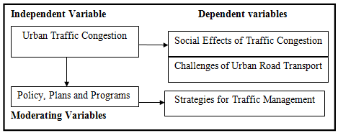

Figure 2.1: Effects of Urban Traffic Congestion
Key:
Interlinks
Source: Modified from Agwanda and Amani (2014)
A conceptual framework is the logical structure of meaning consists of concepts that are placed within a logical and sequential design, represents less formal structure and used for studies in which existing theory is inapplicable or insufficient (Andrea et al., 2011). Figure 2.1 illustrates the conceptual framework of this study.

2.8.1 Urban Traffic Congestion
This is termed as an independent variable that occurs mostly during certain times of the delay called peak periods or rush hours.

2.8.2 Social Effects of Traffic Congestion
These are secondary drivers for traffic congestion. They includes deterioration of quality of life, family separation, inability of forecast travel and delay movement, lack of time for parents to be with their children, reduced visitation, poor relation among the community members due to lack of time to participate in social affairs, late arrival of fire and rescue tracks during the occurrence of calamities in a community; and late arrivals at working place (Kwikiriza, 2016).

2.8.3 Challenges of Urban Road Transport
They are also secondary drivers. These includes rapid urbanization, increased number of cars, increased demand for right of way, pedestrian safety and comfort; one sided development and increased a need for parking space. These challenges will negatively influencing traffic congestion if traffic congestion will be poorly managed in one side but in the other side if traffic congestion will be sustainably managed hence traffic congestions will be reduced (Das & Keetse, 2015).

2.8.4 Policy, Plans and Programs
These are regarded as moderating variables. Good policy, plans and programs influences sustainable traffic congestion management systems. However, integration of environmental impact assessment and environmental auditing; and proper land use planning and management will lead to sustainable road traffic management in our country. They can not only formulate and implement the policy interventions but also adoption of environmental conservation measures and other sustainable development efforts (Zanule, 2015).

2.8.5 Strategies against Traffic Congestion
In this conceptual framework, strategies against traffic congestion includes awareness building, the integration of other transport infrastructures including railway, the construction of flyovers at the main junctions, the use of rapid bus transit, construction of other roads, public transportation, strict traffic law implementation, waterway and bridges (Haq & Schwela, 2012).

2.9 Summary of the Chapter
This chapter has explored the literature related to the study. It has given the theoretical literature based on Theory of Social Development. The empirical literature reviews were mostly drawn from different parts of Africa. The conceptual framework is based on variables of interest in the study. However, this chapter described the research gap. The next chapter presents the methodology of the study.

CHAPTER THREE

RESEARCH METHODOLOGY

3.1. Chapter Overview
This chapter outlines the research methodologies that were used in the study. It described the research design, area of the study, target population, sample size and frame; and sampling procedures. It also provides information on data collection methods, data collection instruments, variables and their measurement; and data analysis.

3.2. Research Philosophy
A research philosophy is a belief about the way in which data about a phenomenon should be gathered, analyzed and used (Cresswell, 2003). This study’s outlook used the interpretive type of research philosophy due to the fact that the study was conducted on people but not on objects. This study also comprised the application of both qualitative and quantitative research approaches. Finally, this research philosophy helped the researcher to design the research approaches and strategies.

3.3 Research Design
A research design as a conceptual structure within which the research is conducted. It constitutes the blue print of collection, measurement, and analysis of data (Kothari, 2007). In this context, the research design is a structure of the research, which is used to show how all the major parts of the research project work together and try to address the central research question. As such, the design includes an outline of what the researcher did from the beginning to the final analysis of data. In this study the researcher used the descriptive design because the nature of this study is to describe effects of urban traffic congestion faced by households.

3.4 Area of the Study
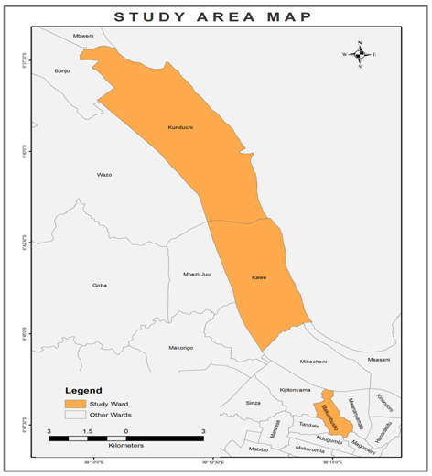

Figure 3.1: A Map Showing Selected Study Wards of Kinondoni Municipality

Source: Arc GIS Map Construction

This study was carried out in Dar es Salaam city. This study area was chosen because it is the city with highest population and vehicles compare to other cities. It is also chosen because it is easily accessible by the researcher in terms of less financial and time constraints. It has been discovered that Dar es Salaam city is the most preferred destination for people searching for economic fortunes. Kinondoni was stratified earmarked for the study in Dar es Salaam city. In Kinondoni Municipality the research was conducted in three wards namely Kunduchi, Kawe and Makumbusho that were randomly sample selected.

3.5 Target Population
Targeted population refers to all members who meet the particular criterion specified for a research investigation (Kothari, 2007). In this case the researcher selected respondents from household members of Kunduchi, Kawe and Makumbusho wards. However, it involved the Ministry of Transport, SUMATRA, TANROAD and Ministry of Home Affairs as key informants. Both the respondents and the key informants helped the study to assess effects and challenges of urban road traffic congestion. These targeted population selected to the extent that these people have experiences on traffic congestion.

3.6 Sample Size and Frame
A sample size is a subset of the individuals in a population. However, sampling frame is a list of all objects from which a sample is drawn, it is extremely important for the list to be representative of the population as possible (Kothari, 2004). Kinondoni Municipality has a population of 1,775,049 people of which 860,082 are males and 914,247 are females. Its average household size is 4.0 and her sex ratio is 94 (URT, 2012). The sampling frame of this study comprises a total number of 53044 households. The calculation to acquire the sample size is shown in Table 3.1.

Table 3.1: The Study on Population for Households Size
Ward Name | Total Number  of Population | Average  Household Size | Computation to  Get Number of  Households | Total Number  of Households
Kunduchi | 75016 | 4.2 | 75016/4.2 | 17861
Kawe | 67115 | 4.0 | 67115/4.0 | 16779
Makumbusho | 68093 | 3.7 | 68093/3.7 | 18404
TOTAL | 210224 | X | X | 53044
Source: Modified from (URT, 2012)

This study has limited resource and time budget. Therefore, it was expensive to interview the whole population of household members in the sampling frame. However, the sample size formula by (Kothari, 2004) based on Precision Rate and Confidence Level used for estimating a percentage or proportion in calculating and determining the sample size needed to be representative of a given population and is given as:
n = z².p.q
e²
Where z = the value of standard variate level score corresponding to 95% Confidence Interval = 1.96
p = the sample study assumed a population proportion of 50% since this provided the maximum sample size. Therefore, the value of p = 0.5 whereby q = 1 – p
e = the precision error (+/-10%)
n = size of sample
From: n = z².p.q
e²
n = (1.96²) (0.5²) = 96.04
(0.1²)
n = 96

Therefore, the sample size set to cover drawn from household population of 53044. Interviewed households were 32 respondents from Kunduchi, 30 from Kawe and 33 from Makumbusho. The sampling frame for households’ representative for each ward is shown in Table 3.2

Table 3.2: The Study Sample Size for Households Questionnaire on Traffic Congestion.
Ward Name | 96 Proportional Representative  Sample (PRS) of Households | Number of Households  Sampled
Kunduchi | 17861/53044 X 100 | 32
Kawe | 16779/53044 X 100 | 30
Makumbusho | 18404/53044 X 100 | 33
TOTAL | X | 96
Source: Modified from (URT, 2012)

3.7 Sampling Techniques
The study adopted two sampling techniques. These are simple random sampling and second purposive sampling.

3.7.1 Simple Random Sampling
This study used simple random sampling to manage questionnaire survey to 96 household members. A simple random sample is meant to be an unbiased representation of a group. In this context simple random sampling has the advantage of being free from an equal bias and classification error remains one of the biggest advantages. Simple random sampling also offered each member from a population an equal chance of being selected (Kothari, 2004).

3.7.2 Purposive Sampling
This technique applied to SUMATRA office, Region TANROADS, Ministry of Transport and the Ministry of Home Affairs office. This technique was applied to ensure that the researcher would obtain detailed information about the study topic.

3.8 Methods of Data Collection
Data collection is the process of obtaining evidence in a systematic way to ascertain answers to the research problem (Kitchin and Tate, 2007). Moreover, Kothari (2004), argues that data collection methods refer to the process of obtaining evidence in a systematic way to ascertain educational and other problems. Multiple sources of information are necessary in order to obtain information. Data was collected from both primary and secondary sources. For the purpose of this study, interviews and questionnaire and observation were used to collect primary data. A wide variety of secondary data were collected from different written sources. These comprised data from books, journals, reports, files, publications, brochures, unpublished materials and through the internet and websites

3.8.1 Primary Sources of Data
Primary data was gathered through interview and questionnaires. All these methods enabled the researcher to capture useful original data for the study.

3.8.2 Questionnaires
The design of questionnaires was largely based upon the research objectives or research questions that guided the study. Both structured and unstructured questions were used. Semi structured questions were designed in such way that they allowed the respondents to give as much detail as they liked and also to facilitate the clarification and qualification of their answers as much as possible. The questions permitted the respondents to answer freely and fully in their own words and in their own frame of reference. Structured questions have advantages of being easy to handle and their codification is automatic (Williams, 2007). A combination of both structured and unstructured questions is a well- established method of obtaining data, and is believed to increase the reliability of the responses. The questionnaire method was 100 household members of 18 years and above.

3.8.3 In depth-Interview
Kothari (2004) defines in depth-interview as a purposeful interaction among two or more people, focused on one person trying to get information among the other person. It is divided into structured, semi- structured and unstructured interviews. In this study semi- structured interviews will be used to collect data. Semi- structured interview is a method of collecting data which involves the presentation of verbal stimuli and reply in terms of verbal responses of face to face relationship between a researcher and the respondents (ibid). In this regard an interview guide for key informants used to explore detailed information.

3.8.4 Observation
This method was used to supplement other methods used in this study and both Participant and Structured Observations employed to meet the demands of this study’s research questions and objectives (Saunders et al., 2008). Observation was used by a researcher to assess traffic congestion in different roads of Dar es Salaam City without asking from the respondents for more clarification. Therefore, the researcher used this method correctly so as to eliminate subjective bias which may arose in questionnaire method and in depth-interview.

3.8.5 Secondary Sources of Data
Secondary data was collected to obtain further insights on the topic from such documents such as the published and unpublished dissertations, books, reports, newspapers, and journal articles, teaching and learning resources and other resources retrieved from the Internet. Such data helped the researcher to make critical analysis on the problem under investigation. Finally, this method enabled the researcher to confirm and validate the information provided by the respondents during the conducted study, specifically household members through questionnaire surveys.

3.9 Validity and Reliability of Data
Validity and Reliability of instrumentation are significantly considered for research in the achievement of goal. However, validity and reliability are accomplished partly by a push for quality item writing.

3.9.1 Validity
Saunders et al., (2008) defines validity as a state of concerned with whether the findings are really about what they appear to be about. A measure is valid if it measures what it is supposed to be measured, and does so cleanly-without accidentally including other factors. In this study validity of instruments were improved by using pilot study in order to assess the clarity of items controlled. Alteration was made where the instruments were found to be insufficient thus clear instruments were applied during the actual field research survey. Validity in this study was done by confirming that data analysis, interpretation and discussion together with inferences, conclusions and recommendations was made on the basis of collected data to make the study suitable and expressive. Finally, the use of quantitative approach helped to demonstrate validity and open up new perspective about the topic under investigation.

3.9.2 Reliability
Cooper & Schindler, (2014) in their book of “Business Research Method”, defines reliability as the degree to which measures are free from error and therefore yield consistent results (i.e. the consistency of a measurement procedure). If a measurement device or procedure consistently assigns the same score to individuals or objects with equal values, the instrument is considered as reliable. Reliability involves also the consistency or reproducibility. In addition, for the data to be reliable it must meet other tests for evidence including consistency, stability, or dependability of data. In this study, the researcher attempted to gather accurate, complete and consistent so as to get relevant findings. However, data reliability was safeguarded by using multiple sources of data including questionnaires, interview, observation and secondary data.

Conversely, data obtained was compared to similar data available in order to ensure reliability. It was confirmed by using SPSS software version 23 with the assistance of Microsoft Excels for coding and analyzing data. For example, the majority of respondents, 72% said yes to deterioration of the quality of life; and inability of forecast travel and delay while 75% said yes to family separation. Also, 84% said yes to lack of time for parents to be with their children, 81% said yes to reduced visitation; and 78% said yes to poor relationship among community members due to lack of time to participate in social affairs.

3.9.3 Issue of Ethics
Cooper & Schindler, (2014) defines ethics as norms or standards of behavior that guide moral choices about our behavior and our relationship with others. The aim of ethics in research is to ensure that no one is harmed or suffered adverse consequences from research activities. There are number of key phrases that describe the system of ethical protections that the contemporary social research establishment are created to try to protect better rights of the research participants, under this the followings were considered:-

3.9.3.1 Voluntary Participation
The research adhered to the principle of voluntary participation which require the participants not to be coerced into participating in research.

3.9.3.2 Confidentiality
The researcher guaranteed participants’ confidentiality; they were assured that the collected information was not going to be made available to anyone who is not directly involved in the study. It is thus important to assure the participants that personal information provided is not going to be released.

3.10 Data Analysis
Kitchin and Tate (2007), describe data analysis as a process of systematically working with data or applying statistical and logical techniques to describe, organize, summarize, compare data collected and divide them into small manageable portions. Since the researcher employed different methods of data collection, this means that both qualitative and quantitative analysis techniques were employed as described below.

3.10.1 Quantitative Data Analysis
The data from semi-structured questionnaires was edited and coded through assigning each answer with a numerical value. The computer aided software (Statistical Package for Social Scientists-SPSS. Version 23 was used to create database for analysis purpose where by percentage analysis were used in this study to present the findings.

3.10.2 Qualitative Data Analysis
The qualitative information collected through in-depth interviews were coded, edited and analyzed to obtain meaningful patterns in order to be described accordingly. The key conclusions were outlined and compared to the findings from the questionnaires.

CHAPTER FOUR

DATA ANALYSIS AND FINDINGS

4.1 Chapter Overview
This study planned to organize Three Phase Traffic Congestion (TPTC) to predict the three phases on traffic congestion in Dar es Salaam city. Meanwhile, the Three Phase Traffic Congestion as explained in 2.3.2 set for the intention to assess the free flow, synchronized flow and moving congestion was tied to a series of questions related to their respective objectives.

4.2 Demographic Characteristics
In this study the demographic characteristics of respondents that were considered involves sex, marital status, number of people in household, age, education level and occupation of the respondents. These variables were important to this study

4.2.1 Gender of the Respondents
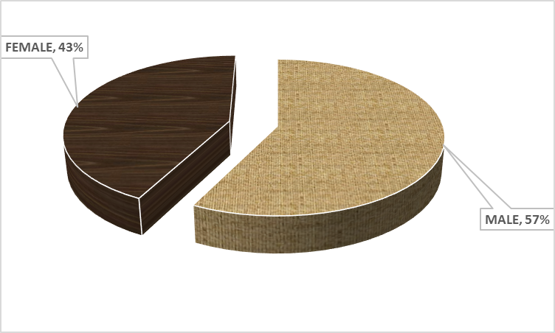

Figure 4.1: Gender of the Respondents
Source: Field Data, (2019)
The results in figure 4.1 show that men have a superior representation than women, where among all people involved in management of urban traffic congestion at the study areas 57% were males whereas 43% are females. Though, it indicates that most of households in which respondents were drawn are headed by men as contradicted to women, since heads of families were regarded as respondents.

4.2.2 Marital Status
The results of this study show that the majority 49% were married whereas 34% were single (unmarried), the widowed were 16% and 1% were divorced as presented in figure 4.2. From the figure, it shows that marital status is not a significant factor for urban traffic congestion in Dar es Salaam city. The greatest affected people in traffic congestion are married.
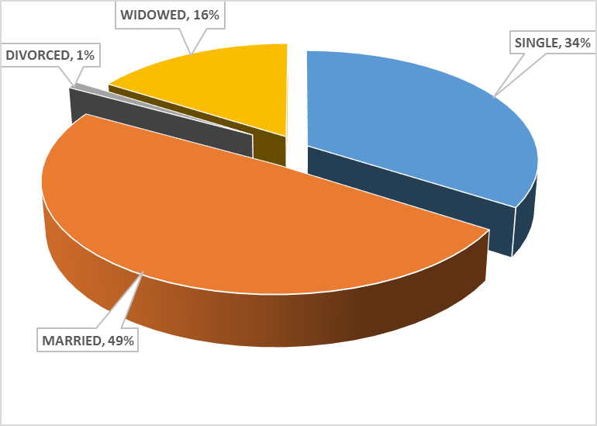

Figure 4.2: Marital Status of Respondents
Source: Field Data, (2019)

4.2.3 Number of People in Household
The findings of this study show that the number of people in households with 3 persons was 20%, households with 4 persons occupied 18%, households with 2 persons was 16% while households with 6 persons was 13.5%. However, household of respondents with 1 person occupied 12.5%, households with 5 persons occupied 9%, those with 7 persons occupied 8% and households with 9 persons and above occupied 3%. Table 4.1 show that the majority of households had low population, consisted 1 to 4 persons.

Table 4.1: Number of People in Household
 |  | Respondents | Percent
 | 1 Person | 12 | 12.5
 | 2 Persons | 15 | 16.0
 | 3 Persons | 19 | 20.0
 | 4 Persons | 17 | 18.0
 | 5 Persons | 9 | 9.0
 | 6 Persons | 13 | 13.5
 | 7 Persons | 8 | 8
 | 9 and above | 3 | 3
 | Total | 96 | 100
Source: Field Data, (2019)

4.2.4 Age of the Respondents
The majority of the respondents were young, energetic and productive persons aged between 21-30 years (31.3%) followed by mature and reputed productive aged between 31-40 years (28.1%). However, the age group between 51-60 years occupied 20.8% while the middle aged group between 41-50 years occupied 18.8% and the minority of respondents were elderly persons above 60years of age who occupied 1%. From illustration in Table 4.2, this shows that the age is not a noteworthy influence in urban traffic congestion in all areas of study. It verifies that all groups are essential but the most affected people for urban traffic congestion are those of age between 21-30 years.

Table 4.2: Age of the Respondents
 |  | Respondents | Percent
 | 21-30 Years | 30 | 31.3
 | 31-40 Years | 27 | 28.1
 | 41-50 Years | 18 | 18.8
 | 51-60 Years | 20 | 20.8
 | Above 60 Years | 1 | 1.0
 | Total | 96 | 100.0
Source: Field Data, (2019)

4.2.5 Education Level
The results show that 32.3% of the respondents were educated up to primary school level, followed by secondary school level (26%). Though, 24% of the respondents attended above secondary school level, some respondents attended adult education level (12%) whereas 5.2% were illiterate.
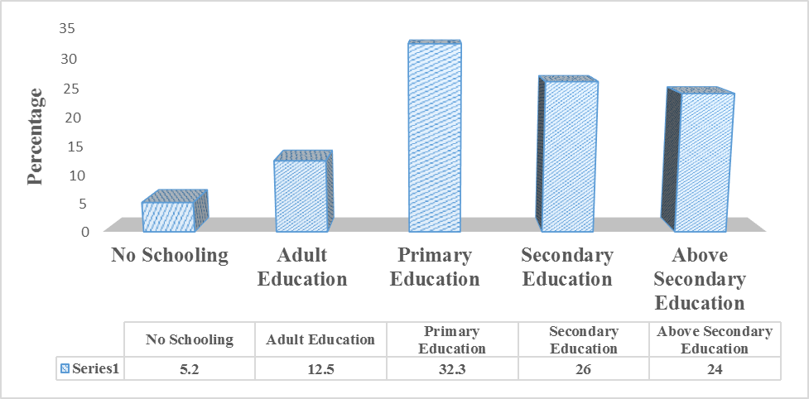

Figure 4.3: Education Level of the Respondents
Source: Field Data, (2019)
As it is illustrated in Figure 4.3, the level of education plays a major role in the development of any society economically, politically and socially. Proper education influences proper strategic measures to alleviate urban traffic congestion at the grassroots level. Since the majority of the respondents’ education ranges from no schooling to secondary education, it can also bring social effects and challenges of traffic congestion in their respective areas.

4.2.6 Occupation of the Respondents
The result show that the majority of the respondents were formal traders (29.2%), followed by the technicians (26%). Informal business persons occupied 21.9%, both teachers and managers occupied 7.3% each while messengers occupied 5.2%, smallholder farmers occupied 2.1% and others were the minority who occupied 1%.

Table 4.3: Occupation of the Respondents
 |  | Frequency | Percent
 | Manager | 7 | 7.3
 | Technician | 25 | 26.0
 | Formal Trader | 28 | 29.2
 | Teacher | 7 | 7.3
 | Messenger | 5 | 5.2
 | Informal Business | 21 | 21.9
 | Smallholder Farmer | 2 | 2.1
 | Other | 1 | 1.0
 | Total | 96 | 100.0
Source: Field Data, (2019)

4.2.7 Type of Employment of the Respondents
The results of this study indicates that the majority of the respondents were self-employed (57.3%), followed by private sector employees who occupied 32.3% though the minority of the respondents were government employees (10.4%).

Table 4.4 Type of Employment of the Respondents
 |  | Respondents | Percent
 | Government Employed | 10 | 10.4
 | Private Sector Employed | 31 | 32.3
 | Self Employed | 55 | 57.3
 | Total | 96 | 100.0
Source: Field Data, (2019)

4.2.8 Location Distribution of the Respondents
The geographical position of the three study areas (wards) where data was collected show that most of the respondents were from Makumbusho by 34% followed by Kunduchi with 32% and Kawe by 30% as it is shown on Table 4.5

Table 4.5: Location Distribution of the Respondents
Wards | Frequency | Percent
Kunduchi | 32 | 33.3
Kawe | 30 | 31.3
Makumbusho | 34 | 35.4
Total | 96 | 100
Source: Field Data, (2019)

4.3 Objective One: Social Effects of Traffic Congestion
This study intended to identify the social effects of traffic congestion. The respondents were supposed to say yes or no corresponding to deterioration of the quality of life, inability of forecast travel and delay, family separation, lack of time for parents to be with their children, reduced visitation and poor relationship among community members due to lack of time to participate in social affairs. The result revealed that 72% of the respondents said yes and 28% said no on deterioration of the quality of life and inability of forecast travel and delay. This can be concluded that the majority of the respondents agreed on deterioration of the quality of life and inability of forecast travel and delay effects where the minority disagreed. The majority of the respondents said yes for family separation in the study areas by 75% while the minority 255 said no. This proposes that the majority of the households are regularly affected by traffic congestion. congestion and time spent daily in traffic congestion.

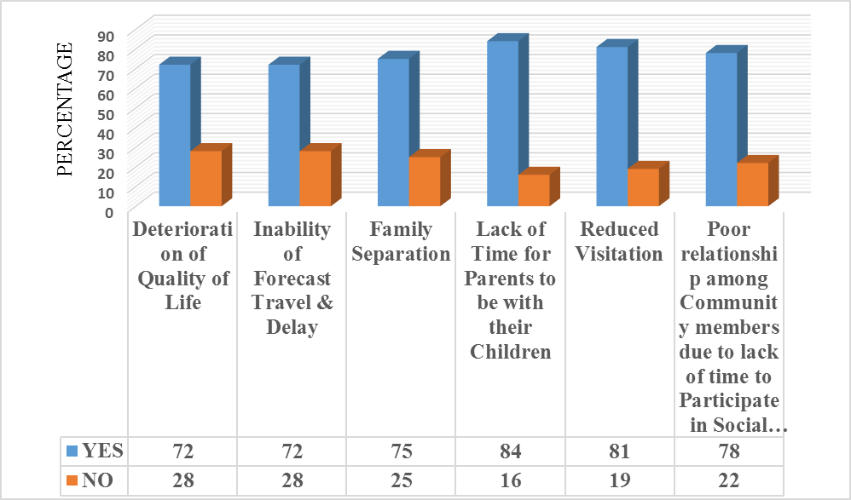Figure 4.4: Summary of Social effects of Traffic Congestion
Source: Field Survey, (2019)

The results on lack of time for parents to be with their children show that 84% said yes while 16% said no. This proposes that the majority of the respondents are mostly affected by both synchronized flow and moving congestions. However, the results on reduced visitation shows that 81% said yes and 19% said no. this reveals that the majority of the respondents are frequently affected by traffic congestion and the minority disagreed. Finally, the results on poor relationship among community members due to lack of time to participate in social affairs indicates that 78% agreed by saying yes and 22% disagreed by saying no. This specifies that the majority of households in the study areas are commonly affected by traffic congestion. The social effects of traffic congestion can also be perceived through identifying awareness of traffic.

4.3.1 Awareness of Traffic Congestion
The respondents were asked to say either yes or no to awareness of traffic congestion. As it is exposed on Figure 4.5, it showed that the majority of the respondents said yes on awareness of traffic congestion by 98% and the minority of them said no (2%). This denotes that most of the households are experiencing the two phases of traffic congestion namely, synchronized flow and moving congestion while the least are experiencing free flow movement of vehicles.
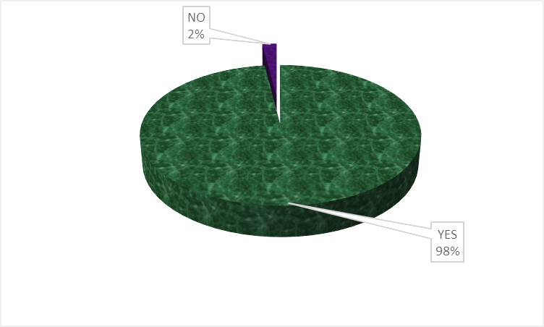

Figure 4.5: Summary of Awareness of Traffic Congestion
Source: (Field survey, 2019)

4.3.2 Time Spent Daily in Traffic Congestion
The respondents were asked to name the time spent daily in traffic congestion. As it revealed on Table 4.6, the respondents presented that the majority were consuming 2-3hours (54.2%). These were followed by those who consumed 1hour (30.2%) and the rest expended more than 3hours (15.6%). From these results it implied that majority of the households were greatly affected by synchronized flow and moving congestion throughout their livelihood.

Table 4.6: Percentage Distribution of Time spent daily in Traffic Congestion
 |  | Frequency | Percent
 | 1 Hour | 29 | 30.2
 | 2-3 Hours | 52 | 54.2
 | More than 3 Hours | 15 | 15.6
 | Total | 96 | 100.0
Source: Field Data, (2019)

4.4 Objective Two: Challenges of Traffic Congestion
To determine the challenges of traffic congestion was likewise among the specific objectives of this study. The study intended to determine the challenges such as rapid urbanization, increased number of cars, increased demand for right of a way, one sided development, parking difficulties and insufficient road space. The results showed that 65% said yes while 35% said no to rapid urbanization. However, 85% said yes whereas 15% said no to increased number of cars. Meanwhile, 77% said yes but 23% said no to increased demand for right of a way. Moreover, 67% said yes then 33% said no to one sided development. 72% said yes though 28% said no to parking difficulties. Finally, 97% said yes although 3% said no to insufficient road space. The results imply that the majority of the respondents accepted the challenges of traffic congestion while a few of them did not accept. The challenges of traffic congestion can also be determined through observation of time to wake up daily and alternative mode of transport during traffic congestion.
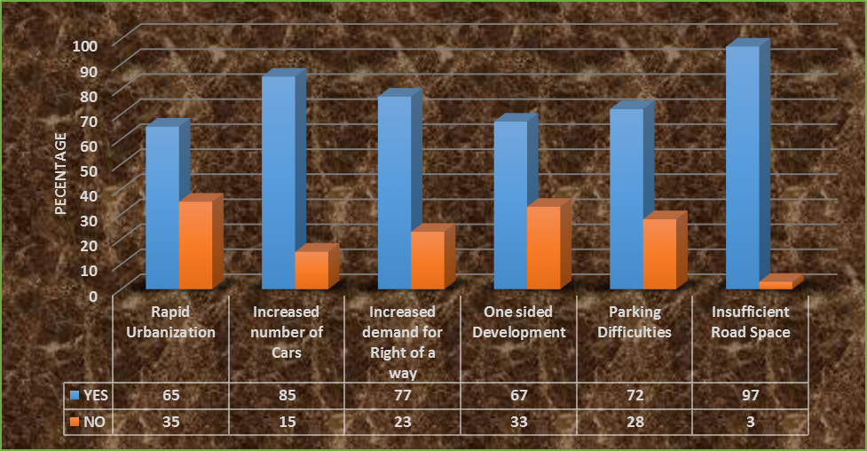

Figure 4.6: Summary of Challenges of Traffic Congestion
Source: Field Data, (2019)

4.4.1 Time to Wake up Daily

Table 4.7: Percentage Distribution of Time to Wake up Daily
 |  | Frequency | Percent
 | Between 3:00am and 4:00am | 12 | 12.5
 | Between 4:00am and 5:00am | 28 | 29.2
 | Between 5:00am and 6:00am | 56 | 58.3
 | Total | 96 | 100.0
Source: Field Data, (2019)

As revealed on Table 4.7, the result show that the majority of the respondents wake up daily between 5:00 am and 6:00am by 58.3% followed by 29.2% who wake up between 4:00am and 5:00am whereas the minority 12.5% of the households wake up between 3:00am and 4:00am. This proposes that most of the households were suffering synchronized flow and moving congestion compared to a few who practiced a free flow phase of traffic congestion.

4.4.2 Alternative mode of Transport during Traffic Congestion
The researcher further intended to determine the alternative mode of transport during traffic congestion. The result showed that 83.3% of households preferred hiring motor cycles while 11.5% preferred to walk by foot and the rest 5.2% preferred hiring taxi. This can be inferred that the majority of the respondents preferred hiring motor cycle, followed by those who preferred to walk by foot and the minority were preferred to hiring taxi as it is illustrated on Table 4.8.

Table 4.8: Percentage Distribution of Alternative mode of Transport during Traffic Congestion
 |  | Frequency | Percent
 | Hiring Taxi | 5 | 5.2
 | Hiring motor cycles | 80 | 83.3
 | Walk by foot | 11 | 11.5
 | Total | 96 | 100.0
Source: Field Data, (2019)

4.5 Objective Three: Recommended Strategic Plans to Alleviate Traffic Congestion
This study wanted to evaluate effectiveness of the strategic measures to alleviate traffic congestion in Dar es Salaam City. Some strategic measures were the outcomes implemented by the government and others were outcomes implemented in the respondents’ society through practice and feelings. They were based on awareness building, construction of flyovers, public transportation, and strict traffic law implementation. Others were water way and construction of bridges. Plate 4.1 and 4.2 shows TAZARA Flyover that was built to alleviate traffic congestion in DSM city. Another flyover is Ubungo interchange which is found at the junctions of Sam Nujoma and Morogoro roads, its construction is still in progress and it is expected to be completed in 2020 construction.
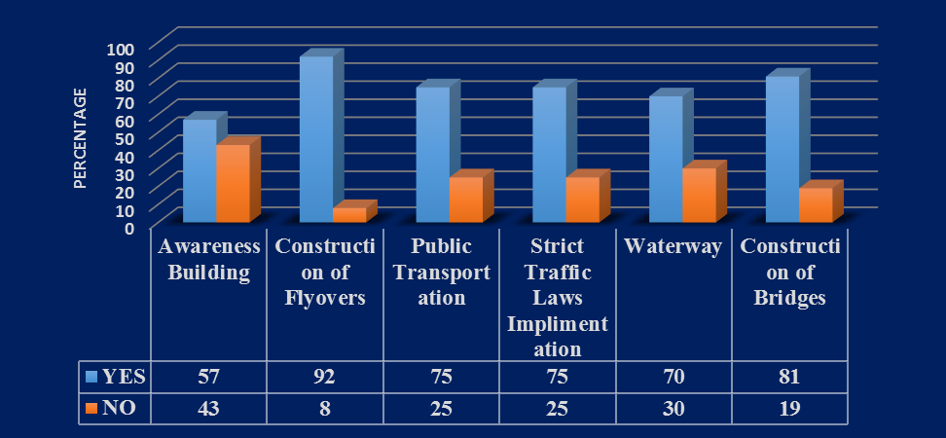

Figure 4.7: Summary of Strategic Plans to Alleviate Traffic Congestion
Source: Field Data, (2019)

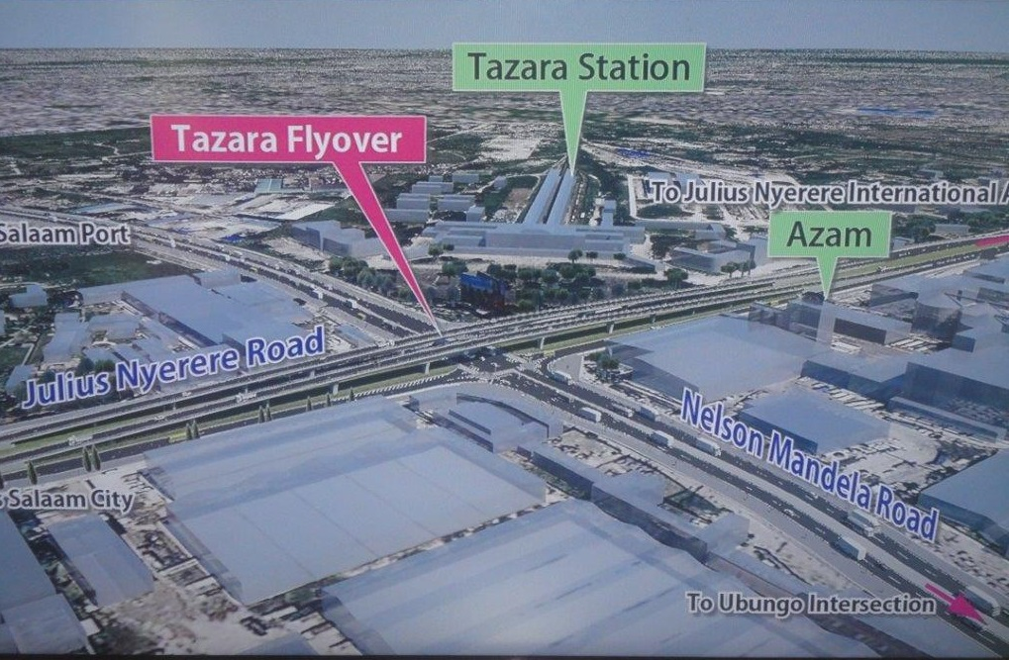Figure 4.8: TAZARA Junctio
Source: (2017). http://i313.Photobucket.com/albums/t542/tanzan2015/fly_zpse791cb75.jpg
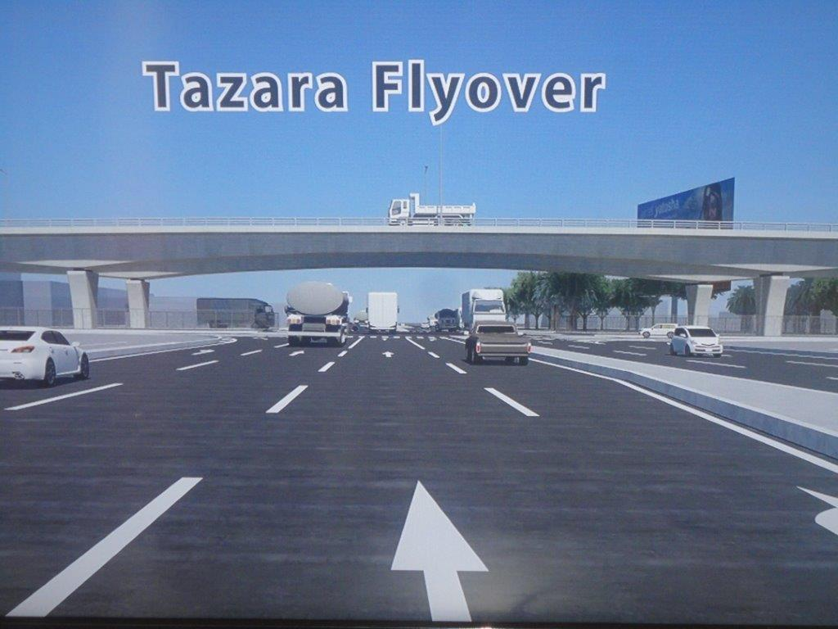

Figure 4.9 TAZARA Flyover
Source: (2017). http://i1313.photobucket.com/albums/t542/tanzan2015/DSC00013_zps6fed62a7.jpg

4.6 Summary of the Chapter
The present chapter has dealt with the study findings, results and discussion. This chapter particularly dwelt on descriptive analysis of sample characteristics as well as the quantitative of the study variables. The data presentation and analysis concentrated on testing the three research questions to accomplish the preferred objectives of the study. The qualitative analysis was used to scrutinize the association of interested variables

CHAPTER FIVE

SUMMARY OF FINDINGS, CONCLUSIONS AND RECOMMENDATIONS

5.1 Chapter Overview
This chapter presents summary of findings; and conclusions of the study presented in chapter four. Finally, the chapter presents recommendations for administrative actions and recommendations for further study.

5.2 Summary of the Findings
The findings of the study revealed that urban traffic congestions in Dar es Salaam city have brought a number of effects. The urban dwellers are aware of the traffic congestion and they spent some hours daily in traffic congestion. The evidence showed that traffic congestions have brought many challenges including the rapid urban population growth because it does not match with technology and development.

The first objective of the study identified the social effects of traffic congestion in Dar es Salaam city. The study has shown that the majority of the population are socially affected through deterioration of quality of their life, inability of forecast travel and delay; and family separation. However, they faced lack of time for parents to be with their children, reduced visitation and poor relationship among community members due to lack of time to participate in social affairs. Although the majority of the population has aware of traffic congestion, they are mostly affected by synchronized flow and moving congestion. Finally, the majority of the households spent 2-3 hours daily in traffic congestion.
The basis of objective number two was to determine the challenges of traffic congestion in Dar es Salaam city. The study determined rapid urbanization, increased number of cars; and increased demand for right of a way. Others were one sided development, parking difficulties; and insufficient road space. The majority of the population resorted to wake up very early in the morning daily in order to avoid traffic congestion. Finally, the majority of the population proffered hiring motor cycles when they face moving congestion.

The last objective of this study was to evaluate the effectiveness of the strategic measures used to alleviate traffic congestion. These strategies were awareness building, construction of flyovers; and public transportation. Strict traffic laws implementation, waterway; and construction of bridges were also involved. The findings revealed that the measures that are actively involved are awareness building, construction of flyovers, public transportation, strict traffic laws implementation, waterway; and construction of bridges.

5.3 Conclusions
According to the opinions of the respondents and the findings of this research it concluded that deterioration of the quality of life, inability of forecast travel and delay, family separation, lack of time for parents to be with their children, reduced visitation and poor relationship among community members due to lack of time to participate in social affairs are the social effects of traffic congestion that happen at the community level in Dar es Salaam city. However, rapid urbanization, increased number of cars, increased demand for right of a way, one sided development, parking difficulties and insufficient road space are the challenges facing traffic congestion. Finally, awareness building, construction of flyovers, public transportation, and strict traffic law implementation. Others were water way and construction of bridges. The study generally concluded that the effectiveness of these measures may alleviate traffic congestion in Dar es Salaam city.

5.4 Implications of the Results
The following implications were drawn on the basis of this study.
- Implications for the Academics in terms of Development of the Theory
Subsequently, education is a modernized and socialized tool which improve raising awareness, exchange of information and communication, it should be provided on community level in order to alleviate traffic congestion. However, education should also be provided on road safety in order to reduce accidents.
- Implications for Policy makers
- Policy makers and planners should consider the immediate adoption of proper planning and management in order to alleviate traffic congestion and increase traffic management.
- Implementation of government laws, bylaws, regulations and policies related to traffic management. They should be implemented, supervised and controlled in order to lessen traffic congestion. Likewise, traffic management is not only a matter of implementation and use of technology but also enforcement, involvement, funding and capacity building instruments.

- Implications for the Industry
The government should establish the implementation of technological advancement especially the use of CCTV cameras along the roads. This will help monitor all incidences happening along the road and also will help to take actions immediately the unpredicted matters that may arise. Further, the government should increase facilities to the police in order to enhance traffic management at the same time when they are working to alleviate traffic congestion especially during rainfall.

5.5 Limitations
- This study only focused on the assessment of the effects of urban traffic congestion in Dar es Salaam city and the researcher does not claim that it can be generalized to other areas in Tanzania or other parts of Sub-Saharan Africa. Research done on this topic in other areas of Tanzania and other parts of Africa might have quite different findings.
- Some of the respondents should have been interviewed, for example the public bus drivers, conductors and motor vehicle owners could have given questionnaires. This searching of answers could have been done through qualitative research method. Another research method could therefore have generated different findings.
- For a more complete picture the opinions of the public bus drivers, conductors and motor vehicle owners could also have been obtained.

5.4 Recommendations for Further Research
This study dealt with the assessment of the effects of urban traffic congestion in Dar es Salaam city, Tanzania. It is suggested that, further research should be done to assess other related facets on traffic congestion.

REFERENCES
Agwanda, A. & Amani, H. (2014). Population Growth, Structure and Momentum. In Tanzania Human Development Report. Background Paper No.7, Economic and Social Research Foundation Discussion Paper 61. ESRF, Dar es Salaam, Tanzania.
Agyapong, F., & Ojo, T. K. (2018). Managing Traffic Congestion in the Accra Central Market. Journal of Urban Management, 7(2), 85–96.
Aworemi, J. R., AbdulAzeez, I. A., Oyedokun, A. J. & Adewoye, J. O. (2009). A Study of the Causes, Effects and Ameliorative Measures of Road Traffic Congestion in Lagos Metropolis, European Journal of Social Sciences, 11(1), 119-128.
Benjamin, J. (2017). The Influence of Road Traffic Congestion to the Performance of Employees in Tanzania : The Case of Tanzania Electric Supply Company. unpublished master dissertation, Muzumbe University, Dar es Salaam Cumpus, Tanzania.
Cooper, & Schindler. (2014). Business Reseach Methods. New York: McGraw-Hill Companies, Inc.
Creswell, J. W. (2012). Research design:Qualitative and Quantitative Research Approaches. Thousand Oaks, C.A: Sage Publishers.
Dora, C. & Hosking, J. (2012). Urban Transport and Health: A Review. Dar es Salaam: GIZ SUTP.
Das, D., & Keetse, M. (2015). Assessment of Traffic Congestion in the Central Areas of South African Cities: A Case Study of Kimberley City. Paper presented at the 34th Annual Southern African Transport Conference 6-9 July 2015 "Working Together to Deliver - Sakha Sonke", CSIR International Convention Centre, Pretoria, South Africa.
Duguma, L. A., Atela, J., Ayana, A. N., & Environment, E. (2018). Community Forestry Frameworks in Sub-Saharan Africa and the Impact on Community Forestry Frameworks in Sub-Saharan Africa. Ecology and Society, 23(4), 21.
Elisonguo, A. D., Es, D., & Campus, S. (2013). The Social-Economic Impact of Road Traffic Congestion in Dar Es Salaam Region. unpublished master dissertation, Mzumbe University, Dar es Salaam Campus, Tanzania.
Haq, G., & Schwela, D. (2012). Transport and Environment in Sub-Saharan Africa, SEI Policy Brief, York, UK.
Harriet, T. & Emmanuel, A. K. (2013). An Assessment of Traffic Congestion and Its Effect on Productivity in Urban Ghana, 4(3), 225-234.
Isaac, S. & Michael, W. B. (1997). Handbook in Research and Evaluation: A Collection of Principles, Methods, and Useful in the Planning, Design, and Evaluation of Studies in Education and the Behavioral Sciences, (3rd Ed), San Diego: Educational and Industrial Testing Services.
JICA, (2008). Dar es Salaam Policy and System Development Master Plan. Dar es Salaam: URT.
Kerner, B. S. (2011) Modern Approaches to basic Traffic flow modeling - the Three- Phase Traffic Theory, 1st Ed., Hrdcover: Springer-Verlag Berlin Heidelberg.
Kiunsi, R. B. (2013). A Review of Traffic Congestion in Dar es Salaam City from the Physical Planning Perspective, 6(2), 94–103.
Kothari, C. R. (2004). Research Methodology: Methods and Techniques, 2nd edition. New Delhi: New Age International (P) Limited, Publishers.
Kolowksky, M., & Moshe, K. (1993). Relationship between Commuting stress symptoms and Altitudinal measures. Journal of Applied Behavioral Science, 29, 485 – 492.
Kumarage, A. S. (2016). Urban Traffic Congestion : The Problem & Solutions Urban Traffic Congestion: The Problem & Solutions Paper Published in the Economic Review, Sri Lanka Transportation Engineering Division.
Kwikiriza, B. C. (2016). Mobility Management-Causes and Effects of Traffic Congestion in Kampala City. unpublished master dissertation, Hasselt University, Hasselt, Belgium.
Mahmud, K., Gope, K., & Chowdhury, S. M. R. (2012). Possible Causes and Solutions of Traffic jam and their Impact on the Economy of Dhaka City. Journal of Management and Sustainability, 2(2), 112-135.
Mpogole H. & Msangi, S. (2016). Traffic Congestion in Dar es Salaam: Implications for Workers’ Productivity. Journal of Sustainable Development, 9(6), 103-110.
Masaoe, E. (2013). Road safety and death toll in Kinondoni District, Dar es Salaam, Unpublished report, University of Dar es Salaam, Department of Transport and Geotechnical Engineering.
Msigwa, R. E. (2013). Challenges facing Urban Transportation in Tanzania. Journal of Mathematical Theory and Modeling, 3(5), 18-26.
Nelson, E. (2013). Traffic Jam and its Social Impacts , unpublished master dissertation, Mzumbe University, Dar es Salaam Compus, Tanzania.
Neuman, W. L. (2014). Social Research Methods: Qualitative and Quantitative Approaches, Seventh Edition. Edinburgh Gate: Pearson Education Limited.
OECD, (2007). Managing urban traffic congestion: Summary document. Retrieved on 01st July, 2019 from; http://www.internationaltransportforum.org/jtrc/ Congestion Summary. pdf.
Olagunju, K. (2015). Evaluating Traffic Congestion in Countries: A Case Study of Nigeria. A paper presented at the 2015 Chartered Institute of Logistics and Transport (CILT) Africa forum held at Mount Meru Hotel Arusha Tanzania.
Osoba, S.B (2012). A geographical Analysis of intra-urban Traffic Congestion in some selected Local Government Areas of Lagos Metropolis. Journal of Geography and Regional Planning, 5(14), 362-368.
Popoola, M. O., Abiola, S. O., & Adeniji, W. A. (2013). Traffic Congestion on Highways in Nigeria Causes, Effects and Remedies, (11), 524–529.
Prasad, K. S. B. (2017). Study on Traffic Congestion: Congestion Cost. International Journal of Civil Engineering and Technology, 8(7), 774-779.
Road, H., Pawar, S., Gupte, S. & Bhatt, K. (2018). Traffic Congestion- Cause and Solutions. Engineering and Technology, 4(1), 953–955.
Saunders, M., Lewis, P., & Thornhill, A. (2009). Research Methods for Business Students, 5th Ed., England: Pearson Education Limited.
Somuyiwa, A. O., Fadare, S. O. & Ayantoyinbo, B. B. (2015). Analysis of the Cost of Traffic Congestion on Worker’s Productivity in a Mega City of a Developing Economy, International Review of Management and Business Research, 4(3), 644-656.
Sweet, M. (2013). Traffic Congestions Economic Impacts : Evidence from US Metropolitan Regions, 1–23. retrieved on 20th June, 2019 from; https://doi.org/10.1177/0042098013505883
The United Republic of Tanzania, (2012). National Bureau of Statistics: Population and Housing Census. Dar es Salaam: Government Printer.
Uniyal, H. (2018). Traffic Congestion-Causes and Solutions: A Study of Kota City. International Journal of Trend in Scientific Research and Development, IJTSRD, 2(2), 250-253.
Wang, C. (2013). Institutional Repository: The Relationship between Traffic Congestion and Road accidents : an econometric approach using GIS. retrived on 12th October, 2019 from; ( https://dspace.lboro.ac.uk/.
Zanule, P. G. (2015). Road Management System and Road Safety in Uganda. unpubublished PhD thesis, University of Liverpool, UK.

APPENDICES

Appendix 1: General Survey Questionnaire
Dear Respondent, you are invited to participate in an academic research study conducted by Bahati Athuman Mtango. The purpose of this study is to undertake a comprehensive assessment of the impacts of traffic congestion and its effects on employees’ productivity. Please your name will not appear on the questionnaire and the answers you will give will be treated as strictly confidential. Also, the results of the study will be used for academic purposes only and may be published in an academic journal.

………………………………. ………………………
Respondent’s Signature Date

Appendix 2: Questionnaire for Household members
General Information of Household
Date of Interview .......................... Questionnaire number ………….
District ………………………Ward……………………………..

Section A: Demographic Characteristics of the Respondent:
Please tick (√) the appropriate answer and fill the blanks in space provided in this questionnaire.
- Sex of the head of household:
1 = Male ( )
2 = Female ( )
- Marital Status:
1= Single ( )
2= Married ( )
3= Divorced ( )
4= Widowed ( )
- How many people live in this household?
1=( ), 2=( ), 3=( ), 4=( ), 5=( ), 6=( ), 7=( ), 8=( ), 9 and above=( )
- Age of head of household in years
1 = 11 – 20 years ( )
2 = 21 – 30 years ( )
3 = 31 – 40 years ( )
4 = 41 – 50 years ( )
5 = 51 – 60 years ( )
6 = Above 60 years ( )
- Highest level of education attained
1 = No schooling ( )
2 = Adult Education ( )
3 = Primary Education ( )
4 = Secondary Education ( )
5 = Above Secondary Education ( )
- Occupation of head of household
1 = Manager/Administrator ( )
2 = Technical ( )
3 = Formal trade ( )
4 = Teacher/Clerk ( )
5 = Messenger ( )
6 = Informal business ( )
7 = Smallholder farmer ( )
8 = Other (specify) ..............................................................
- Please indicate your kind of employment
1= Government employed ( ) 2= Self employed ( )
3= Private sector employed ( )

B: Traffic Jam Awareness
- Are you aware of traffic jam problem in Dar es Salaam city?
1=Yes ( ) 2=No ( ) 3= I don’t know ( )
- How much time do you spend daily in traffic jam, when going to and coming from work? 1=1 hour ( ) 2= 2 – 3 hours ( ) 3= More than 3 hours ( )
- What is your primary mode of transport when going to and coming from work?
1 = Private car ( ) 2 = Public transport/Daladala ( )
3 = Motor cycle ( ) 4 = Bicycle ( )
11. What time do you wake up daily to go to work/school?
1 = Between 3:00 am and 4:00 am ( )
2 = Between 4:00 am and 5:00 am ( )
3 = Between 5:00 am and 6:00 am ( )
12. What alternative mode of transport do you normally opt for during heavy traffic jam?
1 = Hiring a tax ( )
2 = Hiring a Motor cycle ( )
3 = Walk by foot ( )
13. Please list down 3 locations (roads) where you experience congestion on a consistent basis
1. ……………………………………………………………………………
2. ……………………………………………………………………………
3. ……………………………………………………………………………
14. In your opinion, what factors contribute to traffic jams in Dar es Salaam city?
1……………………………………………………………………………………
2……………………………………………………………………………………
3…………………………………………………………………………………..
C: Social Effects of Traffic Jam
15. What are the social effects of traffic jam on your family?
S/N | Event | Tick (√)
1 | Deterioration of quality of life
2 | Family separation
3 | Inability of forecast travel and delay movement
4 | Lack of time for parents to be with their children
5 | Reduced visitation
6 | Poor relation among community members due to lack of time to participate in Social affairs
7 | Late arrival of fire & rescue tracks during the occurrence of calamities in a community
8 | Late arrival at working place

D: Challenges Of Road Urban Transport In Dar Es Salaam City
16. What are the challenges of urban road transport in your area?
S/N | Event | Tick (√)
1 | Rapid urbanization
2 | Increased number of cars
3 | Increased demand for right of a way
4 | Pedestrian safety and comfort
5 | One sided development
6 | Parking difficulties
7 | High frequency of accidents
8 | Insufficient road space
9 | Environmental and noise pollution

E: Strategies for Traffic Management
17. What are the strategies for traffic management? (Tick (√) in appropriate box)
S/N | Indicators | Yes | No
1 | Awareness building
2 | Construction of Flyovers
3 | Public transportation
4 | Strict traffic law implementation
5 | Waterway
6 | Construction of Bridges
APPENDIX 3: KEY INFORMANT DISCUSSION GUIDE
Research Topic:
Effects and Challenges of Urban Road Traffic Congestion in Dar es Salaam City
General Information of Informant
Identification
- Name of Interviewer……………………………………………..
- Name of Supervisor..........................................................................
- Date of Interview..............................................................................
- Institution ……………………………………………………..
- Questionnaire Number……………………………………
Open- ended questions.
- What is the role of your institution on Traffic management?
- Which authorities are concerned with traffic management in this area?
- What traffic management facilities do you have in this area?
- Who are the providers (actors) of these facilities?
- Which organization/institution is contributing most towards the provision of those facilities in this area?
- What are the social effects of traffic congestion facing road users at your area and Dar es Salaam City?
- What are the challenges of urban road transport in Dar es Salaam City?
- What are the strategies that should be taken to improve urban road traffic management in Dar es Salaam City?

