IMPROVING LIVELIHOOD FOR UNEMPLOYED YOUTH OF MAVOVO VILLAGE THROUGH CHALK MAKING IN MKINGA DISTRICT COUNCIL, TANGA REGION

SAID SWALEHE

A DISSERTATION SUBMITTED IN PARTIAL FULFILMENT FOR THE REQUIREMENTS FOR THE DEGREE OF MASTER IN COMMUNITY ECONOMIC DEVELOPMENT (MCED)
DEPARTMENT OF ECONOMIC AND COMMUNITY ECONOMIC DEVELOPMENT
OF THE OPEN UNIVERSITY OF TANZANIA
2023

CERTIFICATION
The undersigned certifies that she has read and hereby recommends for acceptance by the Open University of Tanzania A project entitled; “Training on improving livelihood for unemployed youth of Mavovo Village through chalk making in Mkinga District Council, Tanga Region” in partial fulfilment of the requirements for the Degree of Masters of Community Economic Development (MCED).

………………………………
Dr. Herieth Mtae
(Supervisors)

………………………………
Date

COPYRIGHT
No part of this Dissertation may be reproduced, stored in any retrieval system, or transmitted in any form by any means, electronic, mechanical, photocopying, recording or otherwise without prior written permission of the author or The Open University of Tanzania in that behalf.

DECLARATION
I, Said Swalehe, declare that, the work presented in this dissertation is original. It has never been presented to any other University or Institution. Where other people’s works have been used, references have been provided. It is in this regard that I declare this work as originally mine. It is hereby presented in partial fulfillment of the requirement for the Degree of Master in Community Economics Development (MCED).

………………………..…………
Signature

………………………..…….
Date

DEDICATION
This study is affirmatively dedicate to my beloved wife,Fatuma Muhaji and a close best friend who had toiled day and nights in rendering comfort, support advice and courage towards the completion of this work and Ipray to God to reward her best in her entire life.

AKNOWLEDGEMENT
Conducting a research or a study like this one is not a simple task. Indeed it requires social and academic assistance and or advice, hard work, determination, being objective and above all determination and absolute trust in God.

Further, I understand that many people in their respective capacities have contributed a lot in helping me to complete this work, however due to circumstances beyond my anticipation and control, I decline to mention them all, but, I am thankful for all their efforts and endeavours. Further, I am very obliged to mention and acknowledge the contribution of the following people. My daughter Hawa and my son Samir, Salmin and Sabil and my sister Safia for their support during the preparation of my research.

At foremost, I greatly thank God for his immeasurable guidance he has bestowed upon me throughout the process of this study and for granting me wisdom, strength and health and indeed to him everything is possible. Secondly and with special recognition, I ultimately thank and acknowledge the professional and broad guidance received from my Supervisor Madam Dr. Herieth Mtae for her objective endeavours towards shaping my mind for a clear research study and for giving me the best research skills towards the writing and completion of this study.

Further, I find it prudent to acknowledge the assistance and advice received from my academic friends Prof Nyankweli, Madam Modesta Malima Hadiaand Liberata Cosmas for their endless, immeasurable but visible efforts through which I have been able to compile this work. Further, I also thank my fellow employees and especially my District Director for spending much of his time discharging my office duties and assignments especially during the process of data collection and all his efforts stand as immeasurable inputs in this study. Lastly, I extend thanks to all those who have assisted me in one or the other and I affirmatively pray to the God reward them abundantly and create simplicity in all their social and academic problems and endeavours.

ABSTRACT
The CAN was conducted with overallof gathering facts from Mavovo village communityon the existence of real live hood of the opportunities which available in Mavovoas reflected by the problem in the it also aimed causes of the problems needs of the assets which was help to enable to identify the project that effectively enable to address the problem within the community of limited live hood improvement. Based on the participatory findings of the CAN it was concluded to come up with the project of production of chalk with a low cost, capital, and low income earning due toinadequate knowledge and skills on business lead to the selection of this project of chalk production which was cheapest compared to others and was the most pressing need for the CBO to cover their income gaps. To address this problem the project titled “improving livelihood for unemployed youth of MavovoVillage through chalk making in Mkinga District Council, The primary objective of Tanga Region was to enhance the standard of living for the Mavovo Village Community. Mobilising financial resources, creating a training manual that meets the needs of the target group, and conducting training for the target community are some of the strategies employed to carry out this project. Participants in the workshop were involved parties in the Mavovo Village, Mkinga District chalk manufacturing project. The main outputs of the project were improving livelihood of unemployed youth at Mavovo Village through chalk making project with production of high-quality chalk goods, a sufficient supply of chalk, improvements to group members' social well-being, increased production capacity as a result of innovation and training, and the acquisition of sophisticated manufacturing methods for chalk are all desirable.
Keywords: Livelihood, Unemployed, Youth, Mavovo Village.

TABLE OF CONTENTS
CERTIFICATION viii
COPYRIGHT ix
DECLARATION x
DEDICATION xi
AKNOWLEDGEMENT xii
ABSTRACT xiv
TABLE OF CONTENTS xv
LIST OF TABLES xx
LIST OF FIGURES xxi
LIST OF ABBREVIATION xxii
CHAPTER ONE 1
PARTICIPATORY NEEDS OF ASSESSMENT 1
1.1 Background of the Information 1
1.2 Community Profile of Mavovo Village 1
1.2.1 Location 1
1.2.2 Demographic Features 3
1.2.3 Ethnicity 3
1.2.3 Economic Activities in Mavovo Village 3
1.2.3 Social Services Available in Mavovo Village 4
1.3 Community Needs Assessment 4
1.3.1.1 Overall Community Need of Assessment Objective 5
1.3.1.2 Specific Objectives of the Community Needs Assessment 5
1.3.2 Research Questions 5
1.3.3 Research Methodology 5
1.3.3.1 Research Design 6
1.3.3.2 Sampling Techniques and Sampling Size 6
1.3.3.3 Data Collection Methods/Tools 7
1.3.3.3.1 Questionnaire 7
1.3.3.3.2 Interview 7
1.3.3.3.3 Focused Group Discussion 8
1.3.3.3.4 Observation 8
1.3.3.3.6 Documentary Review 8
1.3.3.4 Validity and Reliability 9
1.3.5 Data Presentation 10
1.4 Community Needs Assessment Findings 10
1.4.1 Demographic and Social Characteristics of Respondents 10
1.4.1.1 Age 10
1.6 Major Challenges of the Community 14
1.7 Community Needs Identification and Prioritization 15
1.9 Conclusion 16
CHAPTER TWO 18
PROBLEM IDENTIFICATION 18
2.1 Background to Research Problem 18
2.2 Problem Statement 18
2.3 Problem Description 19
2.3.1 Stakeholders Analysis 19
2.3.2 The Target Community 20
2.3.3 Project Goal (Overall Objective) 20
2.3.4 Project Objectives 21
2.3.4.1 Specific Objectives 21
2.4.1 The Host Organization 21
2.4.2 Location 22
2.4.3 Membership 22
2.4.4 Vision of the Host Organization 22
2.4.6 Company Activities 22
2.4.7 Organization Annual Income 22
2.4.8 The Company Value Statement 23
2.4.9 Employment 23
2.4.10 SWOT 23
2.4.11 Project Challenges 24
2.5 Conclusion to the Chapter 24
CHAPTER THREE 26
LITERATURE REVIEW 26
3.1 Overview 26
3.2 Theoretical Review 26
3.2.1 The Livelihoods System Framework 26
3.2.2 The Sustainable Livehood System Framework 27
3.2.1.3 Maslow’s Theory 27
3.3 Empirical Literature Review 29
3.3.2 Small -Scale Chalk Making in Developing Economies 31
3.4 Policy Review 34
3.4.1 The Tanzania Review 2003 Development Policy 34
3.4.2 Community Development Policy 34
3.4.3 National Strategy for Growth and Reduction of Poverty 35
3.5 Literature Review Summary 36
CHAPTER FOUR 38
PROJECT IMPLEMENTATION 38
4.1 Overview 38
4.2 Production and Output 38
4.2.1 Products 38
4.2.2 Outputs 39
4.3 Project Planning 40
4.3.1 Project Implementation Plan 40
4.3.1 Implementation Plan 40
4.3.3 Budget Assessment 42
4.4 Staffing Pattern 44
4.6 Project Budget 44
4.7 Project Implementation Report 44
4.8 Project Implementation Ghantt Chart 50
4.9 Summary 52
CHAPTER FIVE 53
PARTICIPATORY MONITORING, EVALUATION AND 53
SUSTAINABILITY 53
5.1 Overview 53
5.2 Participatory Monitoring 53
5.2.1 Monitoring Information System 54
5.2.2 Participatory Monitoring Methods 56
5.2.3 Participatory Monitoring Plan 57
5.3 Participatory Evaluation 57
5.3.1 Types of Evaluation 59
5.3.2 Evaluation Objectives 60
5.3.3 Evaluation Focus Area 60
5.3.4 Evaluation Design 61
5.3.5.1 Performance Indicators 61
5.3.6 Participatory Evaluation Method 63
5.3.7 Project Evaluation Summary 64
5.4 Project Sustainability 64
5.4.1 Project Sustainability Plan 65
5.4.2 Summary 67
CHAPTER SIX 68
CONCLUSION AND RECOMMENDATIONS 68
6.1 Overview 68
6.2 Conclusion 68
6.3 Recommendations 69
REFERENCES 72
APPENDICES 74

LIST OF TABLES
Table 1.1: Age of Respondent 11
Table 1.2: Education Level of the Respondents (N=30) 11
Table 1.3: Economic Activity Types Performed by Gender 12
Table 1.4: Marital Status 12
Table 1.5: Size of Households 13
Table 1.5: Community Needs of Respondent 14
Table 1.6: Challenges facing Mavovo Community 14
Table 1.7: Pair Wise Ranking Needs Identification and Prioritization 15
Table 1.8: Project Identification 16
Table 2.1: Stakeholders Analysis and their Roles 20
Table 4.1: Project Output 39
Table 4.2: Project Implementation Plan 40
Table 4.3: Budget Assessment 42
Table 4.4: Project Staffing 44
Table 4.7: Project Implementation Gantt Chart 50
Table 5.1: Information for Monitoring Project Activities 55

LIST OF FIGURES
Figure 1.1: A Map Showing Location 2
Figure 3.1: Mastow’s Motivational Model 28
Figure 4.1: An Expert of Chalk Making Lecturing to Unemployed Youth Members during Class Session training 45
Figure 4.2: Chalk Powder as Common Garment Materials for Chalk Making 46
Figure 4.3: Machine which used to produce Chalk 47
Figure 4.4: Unemployment Youth Conducting Practical Training during Chalk Making 47
Figure 4.5 Unemployed Youth Members Observing Site for Draying Chalk 48
Figure 4.6: This picture show the Chalk which is in Process of draying on Sunlight 49
Figure 4.7: Unemployment Youth Carrying Chalk Which Was Ready for Sell in the Market 49

LIST OF ABBREVIATION
AIDS Acquired Immune Deficiency Syndrome
CBOs Community Based Organization
MCED Masters of Community Economic Development
CAN Community Needs Assessment
FGD Focus Group Discussion
ILO International Labour Organization
LFM Logical Framework Matrix
MIS Monitoring Information System
MKUKUTA Mpango wa Kukuza Uchumi na Kupunguza Umasikini Tanzania
MOV Means of Verification
NGO Non Government Organization
NSGRP National Strategy on Growth and Reduction of Poverty
MOV Means of Verification
OVI Objectively Verifiable Indicator
PEDP Primary Education Development Plan
SACCOS Saving & Credit Cooperative Society
SIDO Small Industries Development Organization
SME Small and Medium Enterprises
SPSS Statistical Package for Social Science
SWOC Strength Weakness Opportunities and Challenges
URT United Republic of Tanzania
VICOBA Village Community Bank

CHAPTER ONE

PARTICIPATORY NEEDS OF ASSESSMENT

1.1 Background of the Information
Castro (2012) states that the participatory needs assessment is a procedure for evaluating the current situation that involves asking community members about their daily lives. Its goal is to identify significant issue, challenges and their needs within a given community so that the assessment findings can inform action planning in the future. The participatory needs assessment is the participatoryprocess in which the community members actively participate in recognising their problems and the most urgent needs in order to jointly come up with solutions for both of these issues.

The fundamental goal of the community needs assessment, also known as a participatory process, is to involve the community members in identify the problem and the most urgent requirements. The community members are also assisted by the participative approach in learning about the demands that the society now has and coming up with solutions to meet those needs. By prioritising the chosen activities in the intended action plan, the participative approach assists the community members in creating deliberate action plan on how to meet the community needs. The participatory needs assessment that was carried out in this study sought to determine the issues and requirements of the locals in Mavovo Village and to establish a project to solve the most urgent need that was recognised by the locals.

1.2 Community Profile of Mavovo Village

1.2.1 Location
As a result of their very low income level and limited access to necessities like decent housing, high-quality healthcare, nutrition, education, clean water, and sanitary services, this study will focus on a community of young people from very poor household who are searching for employment opportunities. Mavovo is a community that is close to the communities of Bwiti and KwaJanja. It is located in the Tanga region of the Bwiti ward's Mkinga district. The Lugongo Estate, a large sisal estate, and forest surround the hamlet.
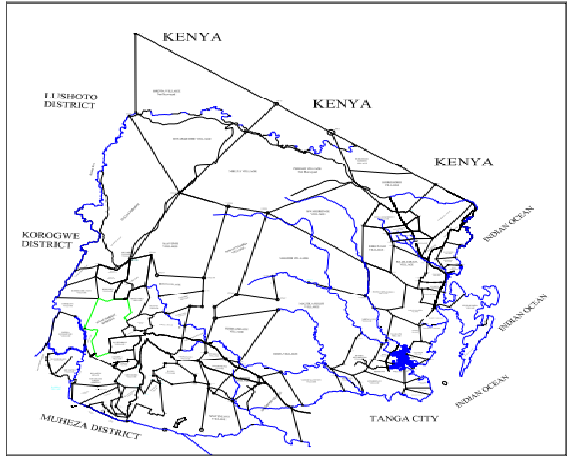

Figure 1.1: A Map Showing Location
Source: https://www.google.com/search?client=firefox-b-d&q=kenya+map.

1.2.2 Demographic Features
According to 2022 population census, Mavovo village has total ofof 700 households with a population of 4069 out of which 1823 were male and 2246 were female, with an average growth rate of 2035. The village is mainly inhabited by the wadigo, wasambaa and wasegeju ethnic groups. However, only 2453 people equal to 60.36% of the total population directly engaged in activities while the rest were children and aged old people, NBS (2012).

1.2.3 Ethnicity
The sambaa, segeju, and makonde, who are the region's indigenous people, are mostly the residents of Mavovo Villages. In Mavovo village, the majority of residents practise Islam, whereas there are hardly any Christians and no Pagans. The Sambaa are recognised for their work ethic, particularly on the sisal farms, and practically all religions stress the value of hard work as well as the need to love one another and collaborate to fight poverty. Given their shared cultural heritage and religious beliefs, it is more likely that the people of Mavovo Village will band together to identify needs and carry out projects that will boost their income.

1.2.3 Economic Activities in Mavovo Village
There are certain economic activities carried out in Mavovo village with the participation of the locals. Agriculture is the main economic activity, although despite the relatively small stock sizes, locals also keep livestock like cows and goats. Sisal, millet, maize, cassava, and potatoes are just a few of the food and cash crops that are grown in Mavovo Village. Nevertheless, some women in the community run small businesses like food stands and kiosks, while young people ride motorcycles and hack down trees to manufacture charcoal that they then sell to customers. Although this enterprise put them in danger because of the government, this is because of the forest's presence.

1.2.3 Social Services Available in Mavovo Village
One of the villages in Bwiti Ward is called Mavovo, and it has two sub-villages called KwaJanja and Mavovo. The village offers the following social services, including Mavovo Primary School and Mavovo Secondary School, a primary school and a single secondary school respectively. Up until now, the hamlet has made an effort to enhance healthcare by building a single dispensary for its residents. Electricity, which is produced, transmitted, and supplied by Tanzania Electric Supply Company (TANESCO) and REA, is the primary energy source for lightning. Charcoal, kerosene, gas and firewood are frequently used by residents of the community as a source of energy and for cooking.

1.3 Community Needs Assessment
Assessment of community needs is a technique for figuring out what initiatives are required and supportable from the inside out. In order to gather accurate information about current problems, underlying causes, understand the community's capacities, and hear their proposed solutions; it is a process of forming partnerships with communities of all genders, ages, and backgrounds. In order to determine the most urgent need, the identified demands were prioritised. Additionally, determining the needs of communities helps them become more active in taking collective action to solve their own problems.

1.3.1 Objectives of Community Need Assessment

1.3.1.1 Overall Community Need of Assessment Objective
The overall goal of conducting the Community Needs Assessment was to find out the major needs, economic status and various opportunities available at Mavovo village community and to identify the various existing opportunities in order to address the identified needs.

1.3.1.2 Specific Objectives of the Community Needs Assessment
- To identify the economic activities conducted in the Mavovo Village community.
- To identify the major pressing needs of the Mavovo Village community.
- To look for various opportunities in order to address the identified needs in Mavovo Village community.

1.3.2 Research Questions
The following were the major research questions for the Community Need of Assessment
- What are the current economic activities of the Mavovo Village Community?
- What are the major pressing needs of Mavovo Village Community?
- What are the various Opportunities available in Mavovo Village?

1.3.3 Research Methodology
Research methodology is the study of how scientific research is conducted. It details the typical actions a researcher takes to explore his research problem, along with the reasoning behind each action. It makes the methodologies used and the reasoning behind employing a specific approach or technique clear so that the researcher may evaluate the research findings (Goedhuys, 2018).

1.3.3.1 Research Design
The study was carried out using a descriptive research design. Descriptive research gives researchers a thorough grasp of the traits and behaviours of a given population or phenomenon and Participatory Rural Research, as well as both qualitative and quantitative methodologies, were used. The methodology made it possible for the researcher and the local community to pinpoint the local conditions that would facilitate the formulation of an intervention. Primary and secondary data about the neighbourhood were acquired utilising a qualitative approach that includes participatory methods employing pertinent methodologies and procedures. A household survey was used to objectively collect primary data using prepared and pre-tested questionnaires.

A descriptive survey will be used as the research design because of this. It also makes data structure possible and explores the subject of study comprehensively. The sample unit was Mavovo village. When collecting data using the qualitative technique, descriptive language will be used, however when using the quantitative method, structured tools will be used, and data analysis will be done deductively, and the information will be numerical. Because the data will be both numerical and declarative, the study will allow a mixed methodology.

1.3.3.2 Sampling Techniques and Sampling Size
The study's techniques for selecting respondents included both random and intentional sampling. The Mavovo Village population was picked randomly using a simple random representative design for survey questions in order to gain a deeper knowledge of the problems and needs that their community is facing.

1.3.3.3 Data Collection Methods/Tools
The study used the following data collection methods:

1.3.3.3.1 Questionnaire
The questionnaire was used as a tool for the study, and to verify its quality, the designed data collection tool was pre-tested on five respondents. Changes were made in terms of clarity, interview length, and identifying items that appeared delicate and required further exploration or explanation. The researcher distributed 30 questionnaires, including both open-ended and closed-ended questions, to the household heads who were required to respond. Questionnaires are written in the Swahili language to make them understandable and administerable to the target community.

1.3.3.3.2 Interview
The researcher recruited important informants in order to conduct in-person question-and-answer sessions with them. These key informants are knowledgeable, experienced, and knowledgeable about specific issues. During the interviews, the researcher asked oral questions and recorded the answers. Researchers verbally or vocally elicited knowledge, opinions, or beliefs from interview subjects. Key informant leaders were also the topic of significant illuminating interviews in order to understand the issues.

1.3.3.3.3 Focused Group Discussion
Focus group discussions (FGDs), which were facilitated by the researcher, had twenty (20) participants. During talks, group members have open, spontaneous conversations about a specific subject, issue, or question. The objective of the FGD was to get more in-depth information about the group's viewpoints and ideas. The discussion also aimed to promote active sharing, two-way communication, and transparency as essential elements in determining what is working and what is not, as well as the areas that need focus during the research period.

1.3.3.3.4 Observation
The researcher directly observed and recorded the various activities of the community members. Along with observation, transect walks, participatory mapping, and background information about the research area were used to provide a full picture of the community. The presence of natural resources, water supplies, human settlements, diverse places of economic activity, locations, and social services like schools, churches, mosques, recreation centres, and infrastructure, to name a few, were among the significant qualities that were noticed.

1.3.3.3.6 Documentary Review
In the Mavovo village, at the council level, and at the regional level, it was conducted by looking through records. These materials contained the Tanga Region Socio-Economic Profile, the Tanga Region Investment Profile, and the Mkinga Council Investment Profile. The survey questions and applicable interview guides were pretested on a small sample of respondents from the host group prior to the actual data collection exercise in an effort to ensure and retain dependability. Additionally, this guaranteed the survey instruments' applicability and their ability to deliver accurate and trustworthy information and data. Validity, which is defined as the "reality and truth of results obtained," has to do with how the internal and external results are presented. Although reliability is a necessary but insufficient requirement for validity

1.3.3.4 Validity and Reliability
The survey questions and applicable interview guides were pretested on a small sample of respondents from the host group prior to the actual data collection exercise in an effort to ensure and retain dependability. Additionally, this guaranteed the survey instruments' applicability and their ability to deliver accurate and trustworthy information and data. Validity, which is defined as the "reality and truth of results obtained," has to do with how the internal and external results are presented. Reliability, which is a necessary but insufficient criterion for validity, refers to the consistency of the data that was gathered using the survey instruments.

1.3.4 Analysis Methods
Tables, visual displays, and factual explanations were used to meticulously document and analyse the study's initial data collection. The quantitative survey data was also evaluated using version 16 of the Statistical Package for Social Sciences (UNDP, 2018). This was used to compile, analyse, and display survey findings as tables and graphs. The survey team handled the data's actual processing and analysis. I also have access to data for the project's monitoring and assessment process thanks to the descriptive approach.

1.3.5 Data Presentation

To illustrate and validate the information provided by the respondents, the analysed data was displayed as percentages. Prioritisation of community needs is also displayed to demonstrate the data gathered.

Community Needs Assessment Findings
The results of the community needs assessment are presented in this section; analysis was done using the scientific package for social science (SPSS) programme. Random sampling and the purposive technique were the methods employed in the assessment, which was carried out in the village of Mavovo.
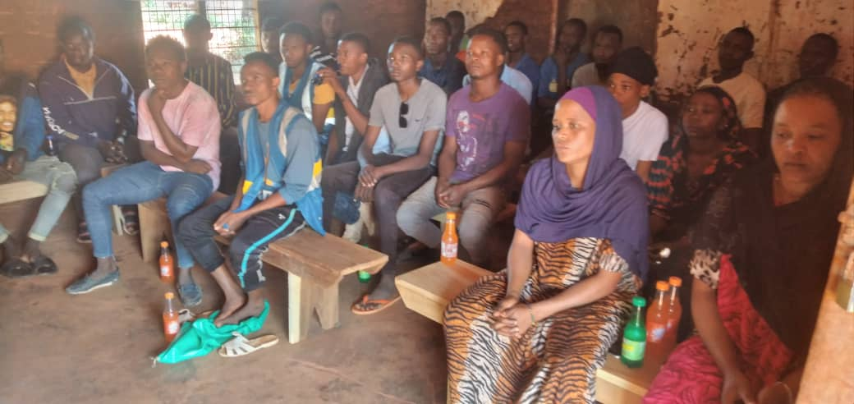
Figure 1.2: Show Community Needs Assessment
Source: Research Findings, 2023

1.4.1 Demographic and Social Characteristics of Respondents

1.4.1.1 Age
The respondent's age was taken into account during assessment because it affects production and development in some way. Most respondents were between the ages of 26 and 40, which are considered to be productive age. This show that most active group (26-40) are engage in economic development as shown in Table 1.1.

Table 1.1: Age of Respondent
 |  | Frequency | Percent | Valid Percent | Cumulative Percent
Valid | 16-25 | 10 | 32.3 | 32.3 | 32.3
Valid | 26-40 | 15 | 51.6 | 51.6 | 83.9
Valid | 41-59 | 5 | 16.1 | 16.1 | 100.0
Valid | Total | 30 | 100.0 | 100.0
Source: Mavovo Field Survey March: (2023)

It was recognized that youth are engaging much in production activities as they have number of responsibilities to their family. Therefore they must struggle in doing economic activities to improve their income for sustaining their family.

1.4.1.2 Education Level
The respondents had a primary education completion rate of 74.2 percent, a secondary completion rate of 19.4 percent, and a college attendance rate of 6.5 percent. The results revealed that people were generally less interested in schooling and wanted more Madras classes. Given their level of education, the respondents can manage the project, take part in campaigns to raise awareness, and receive training in business and entrepreneurial skills, farm work, and entrepreneurship. The report states that farming contributed 45.2% of total income while business made up 25.8%. 9.7% of persons in formal employment and 19.4% of people working in other activities given that their main source of revenue is farming.

Table 1.2: Education Level of the Respondents (N=30)
 |  | Frequency | Percent | Valid Percent | Cumulative Percent
Valid | University | 2 | 6.5 | 6.5 | 6.5
Valid | Secondary | 6 | 19.4 | 19.4 | 25.8
Valid | Primary | 22 | 74.2 | 74.2 | 100.0
Valid | Total | 30 | 100.0 | 100.0
Source: Mavovo Field Survey March: 2023
1.4.1.3 Occupation
The principal pursuits of Mavovo people, as reported by research participants, are presented in Table 1.4. The majority of the participants, or (13) 72%, work in agriculture, particularly in the cashew and sesame plantations. Furthermore, 28% of the population works in unofficial jobs selling things like food, charcoal, nibbles, nuts, and bodaboda motorcycles, among other things. According to research, most women work in agriculture and other small businesses.

Table 1.3: Economic Activity Types Performed by Gender
Main Economic activity | Male | % | Female | %
Farming | 13 | 72% | 8 | 66%
Self-employment | 5 | 28% | 4 | 34%
Total | 18 | 100% | 12 | 100%
Source: Mavovo Field Survey March: 2023

1.4.1.4 Marital Status
The majority of the young people chosen for this project are already married, but since they lack the financial resources, they are unable to provide basic household services like feeding their families and other social services. The remaining group is not yet married, although being old enough to start a family. The primary cause is simply the misery of living brought on by a lack of employment opportunities in a village.

Table 1.4: Marital Status
 |  | Frequency | Percent | Valid Percent | Cumulative Percent
 | Single | 12 | 38.7 | 38.7 | 38.7
 | Married | 18 | 61.3 | 61.3 | 100.0
 | Total | 30 | 100.0 | 100.0
Source: Mavovo Field survey, (2023).
1.4.1.5 Size of House Hold
It was noticed that the married category made up the bulk of survey respondents (61.3%), while singles made up 38.7%. There were no known instances of divorce or widowhood. This demonstrates that the majority of people had families to take care of and were familiar with their surroundings.

Table 1.5: Size of Households
 |  | Frequency | Percent | Valid Percent | Cumulative Percent
 | 1 to 3 Members | 6 | 19.1 | 19.1 | 19.1
 | 4 to 5 Members | 13 | 44.1 | 44.1 | 63.2
 | 6 + Members | 11 | 36.8 | 36.8 | 100.0
 | Total | 30 | 100 | 100.0
Source: Mavovo Field Survey March: 2023

The household size of the respondents ranges from 1 to 6+ individuals. There are three distinct groups of responses. 19.1% of respondents belong to the first category, which includes families with 1-3 members. The second group, which comprises 44.1% of respondents, is made up of families with 4-5 people, and the third group, which is made up of families with 6 or more members, has 36.8% of respondents (Table 1.5). The findings show just how many babies are born each year and how little family planning is actually done.

  - Major needs of the Mavovo Village Community
According to priorities, identified community needs were ordered by numbering utilising an organisation development tool. The first demand was the provision of capital, the second was the development of business skills and entrepreneurship, the third was an increase in household income, and the fourth need was the availability of roads, electricity, and water supplies. These four needs were then ranked in order of importance.

Table 1.5: Community Needs of Respondent
 | Community needs | Frequency | Percent | Cumulative Percent
Valid | Provision of capital, | 20 | 67 | 67
Valid | Business skill and entrepreneurship | 6 | 20 | 87
Valid | Increases of house hold income | 3 | 10 | 97
Valid | access of road, electricity and water supply | 1 | 3 | 100
Valid | Total | 30 | 100.0
Source: Field study, 2023

1.6 Major Challenges of the Community
The overwhelming majority of responders, 84%, indicated they lacked the financial resources to support their activities. While others claimed 10% lacked business skills, the remaining 3% claimed a lack of businesses that generate jobs and a lack of water supplies. This suggests that the government, stakeholders, agents, development businesses, and donors should continue to put greater emphasis on and empower more money to tackle the difficulties outlined.

Table 1.6: Challenges facing Mavovo Community
 | Challenges | Frequency | Percent | Cumulative Percent
Valid | Shortage of access of capital | 25 | 84 | 84
Valid | Lack of business skills | 3 | 10 | 94
Valid | Shortage of economic activities which provide employment  Shortage of water supply | 1  1 | 3  3 | 87  100
Valid | Total | 30 | 100
Source: Field Study, 2023

1.7 Community Needs Identification and Prioritization
The pair wise ranking system was used to prioritise the needs of the community. A structured way for arranging a short list of items in priority order is pair wise ranking. Prioritising a short list and reaching unanimity on choices were helpful. Four needs were identified by the community, and of those four, one was listed as a priority. To lay the groundwork for project ownership and sustainability, the researcher took care to make sure that the research was more participative.

Table 1.7: Pair Wise Ranking Needs Identification and Prioritization
Needs | Needs by number |  |  |  |  | Score | Rank
Needs | 1 | 2 | 3 | 4 | 5 | Score | Rank
- Access to capital |  |  |  |  |  | 4 | 1st
- Business skills |  |  |  |  |  | 3 | 2nd
- Increases of house hold income |  |  |  |  |  | 2 | 3rd
- Access of electricity and water supply |  |  |  |  |  | 1 | 4th

Source: Researcher, (2023)

1.8 Community Project Identification and Prioritization
Members of the Mavovo community have actively participated in the planning process. This action was made to give group members more control so they could own the concept, make decisions, make plans, and carry out the project. In a similar vein, the chalk-making project that will be launched is the result of their initiatives and participation in the decision-making process. Their choice is represented in Table 8 below. They came to an agreement and chose the project to carry out in order to enhance communal livelihood. In the same way, the demand was assessed in order to develop four major initiatives, including manufacturing chalk, making bricks, burning charcoal, and working in sisal estates. Chalk producing production was given top priority during the activity; this is because of the following benefits and causes.

Table 1.8: Project Identification
 | Project | Frequency | Percent | Cumulative Percent
Valid | Chalk making | 15 | 50 | 50
Valid | Burning charcoal | 10 | 33 | 83
Valid | Shoot bricks | 3 | 10 | 93
Valid | Working in sisal estate | 2 | 7 | 100
Valid | Total | 30 | 100
Source: Field Study, 2023)

The community of Mavovo chose and endorsed the chalk-making initiative based on the findings in the table above. After learning that there were issues with the ministry of forests and that obtaining authorization would cost a lot of money, burning charcoal (33%) was not chosen. Due to water issues, shot bricks, which were scored at 10%, were not chosen since they needed more water than Mavovo could supply from its well. Youth were paid poor pay when working in sisal score 7% following care full identification, which was insufficient to provide their fundamental necessities. The rationale for choosing this project, which received a 50% score for manufacturing chalk, is because it has the following advantages

1.9 Conclusion
Community need assessment is the methodology which is active due to the fact that it involves the community in decision making in the whole process of identifying their needs and way forward towards the achievement of the need. Therefore based on above facts community result and prioritized needs the project which will focus on improvement sustainable income in short period of time and that’s why chalk making was pointed out to support the youth to access employment opportunities and income generation at Mavovo Village.

CHAPTER TWO

PROBLEM IDENTIFICATION

2.1 Background to Research Problem
From the result of CAN several problem and needs were identified. The identified problem was Shortage of access of capital Lack of business skills Shortage of economic activities which provide employment and Shortage of water supply. As for the needs, were identified by community members at Mvovo. Also the project which identified were chalk making, shoot bricks, burning charcoal and cultivation of sisal as a cash crops. After carefully analysis we come up with the project of Chalk making which will help to eliminate or reduce those challenges facing community. The project was select to be implemented due to the fact that the rest identified project has many challenge and not affable to environment.

2.2 Problem Statement
Low quality has been an issue to compete with identical products from other competitors despite Chalk Making production operations. Poor sales and earnings as a result of this predicament have prevented producers from scaling up production. The firm has stagnated for years without expanding as a result of this obstacle, and nothing has been done to remedy the issue. The jobless youth who receive training in chalk manufacture will develop their abilities, increase the quality of their output, and gain a competitive edge in the chalk market. Thus the focus of this project was to solve those challenges of capital, and income in general which the MavovoVillage community especial youthwere facing out and using that advantaged of the project to improve their livelihood.

2.3 Problem Description
"Improving livelihood for unemployed youth of Mavovo Village through chalk making" was the project's official name in Tanga Region's Mkinga District Council. Since the youth in Mavovo village are the project's primary target audience, this project aims to improve their welfare. This project aims to enhance the economic situation of youth organisations and the Community as a whole. Since all of the issues in chapter one are related to low household income, it is predicted that some of them will be addressed by this initiative.

A small group of 10 young people killed the project while being generally supervised by the group leaders who were chosen in accordance with the group constitution. The village government oversaw all aspects of group and project management, including the office space. As a significant participant in this project, Mking District Council contributed staff, including a community development officer and a trade officer, who offered guidance on group formation, constitution writing, and general market and business understanding.

2.3.1 Stakeholders Analysis
Many parties made contributions to the successful project implementation. The primary stakeholder is Mkinga District Council, and in accordance with their areas of expertise, the Community Development Officer and Trade Officer provided various technical services. Another significant stakeholder is the Mavovo village government and the Ward Executive office, which organised all correspondence between the group and the experts based at the District headquarters as well as between the youth and other clients directed by the Mkinga District Council and provided general guidance.

Table 2.1: Stakeholders Analysis and their Roles
Stakeholders | Roles
Local government (Mkinga District Council) | Provide consu.These includes Village office and Ward Executive office, Community Development Officer, and District Trade Officer
Group leaders | -to manage business activities of the group  -Supervising operation activities  -Mobilizing resources, follow experts’ guidance and making chalk
Youth | -They are one who the project were targeted
Customers (community) | -Buying chalk products
MCED Student | Conduct research through CNN, Training on chalk making, document all project
Source: Mavovo Field Survey, (2023).

2.3.2 The Target Community
At Mavovo village in Mkinga District, Tanga Region, a group of 10 unemployed youth chosen from 30 beneficiary households carried out the project.Only 10 people were involved in the implementation and daily running of the chalk-making initiative. These people were specifically chosen based on their age, capacity to contribute money, and desire to work as a team. The study found that the group needed to be formally organised with a written constitution, formal name, leadership, and bank account for the project to succeed. In order to formalise the organisation, the village leadership, MCED student, and District Community Development Officer (DCDO) provided assistance.

2.3.3 Project Goal (Overall Objective)
The project's major beneficiaries are the unemployed young in the Mavovo village community, and its purpose is to enhance their standard of living by November 2023 through the manufacture and sale of chalk. The ability of group members to pay for basic household necessities including shelter, food, clothes, education, and medicine will increase as a result of improved livelihood, which will also boost their capital for other businesses.

2.3.4 Project Objectives
The project general objective was to improve livehood of unemployed youth from poor community through chalk making bySeptember 2023.

2.3.4.1 Specific Objectives
- To secure office premises to 10 unemployed youth group members on chalk making by the end of September 2023.
- Tobuild capacity to 10 unemployed youth group members on chalk making by the end of September 2023
- To purchase chalk making moulder for 10 unemployed youth group members by the end of September 2023.
- To Link the group with reliable buyers by the end of September, 2023

2.4.1 The Host Organization

The Mavovo Village Government served as the host agency in charge of daily operations and general management of all issues pertaining to the ward's social and economic development. In addition, the Village Executive Officer offered a supervisory position for the project. The Village leadership was in charge of coordinating and communicating all of the actions of different stakeholders. To ensure the project's successful and long-term implementation, the village kept in touch with the trade officer, the community development officer, and other stakeholders.

2.4.2 Location
Mavovo Village has located in BwitiWard in Mkinga District, Tanga Region

2.4.3 Membership
The project was under the group of unemployed youth under the supervision of MkingaDistrictCouncil.

2.4.4 Vision of the Host Organization
To stipulate the best services in facilitating the members of the villagein using the available social and economic resources to compound their social economic improvement.

2.4.5 Mission of the Host Organization

Mavovo village strives to set an example by offering socioeconomic services to its residents in order to ensure that they have respectable lives and can coexist in harmony and peace.

2.4.6 Company Activities
The major company activities were to produce quality chalks which the company will sell inside and outside of the countries by using local materials.

2.4.7 Organization Annual Income
The total annual income earned for the period of 2022 is Twenty million (Tsh. 20,000,000/=)

2.4.8 The Company Value Statement

The understanding that "profits are by-products of satisfying customers, not the other way around" is a corporate philosophy that demands complete customer happiness. Work as a team and aim for excellence.

2.4.9 Employment
The company provided employment to the Mavovo village aggregate of more than ten youth.

2.4.10 SWOT
STRENGTHS | WEAKNESSES
Young people and women who work only have an elementary or secondary education; they have no college degrees, which reduces their potential for understanding. | Lack of adequate of morden chalk production
The group have strong and capable leadership | Lack of adequate capital and skill on business
Youth are linked to the leaders of village | The industry have weak on organization with other chalk production industry
The production of local materials are easy available within the local community | The chalk production are not certified by TBS
The company have in the process of registration by Brela | The market have not enough to sell the products
OPPORTUNITIES | CHALLENGES
Government action to encourage processing and quality control that adds value to the industry | The project have no proper right hence difficulties to brand
availability of personnel for imparting knowledge about cutting-edge chalk technology | Failure to control quality and safety of chalk production
Availability of chalk market | No enough competition which may challenge the project
Financial support from the stakeholders | Insufficient skills and knowledge of chalk production
Social and cultures acceptance of the project
Source: Mavovo Field Survey, 2023

2.4.11 Project Challenges
The project experienced numerous obstacles, and when a researcher visited the area, they learned that one of those obstacles was the company's small office building, which was occasionally unable to meet the needs of the project. Even though the project has been underway for a while, the project secretary revealed during conversation that there is not enough funding for business expansion. As a result, efforts were made through contributions to assure sustainability. Other issues raised by the project group members include a lack of knowledge and expertise in contemporary methods of producing chalk as well as the lack of a modern moulders.

According to community leaders, women and young people make up the majority of those working on this initiative. Because they lack the education and resources needed to buy a contemporary machine and the materials needed to produce chalk, they are less likely to contribute to improving chalk production. Due to these difficulties, Mkinga's created chalks are of inferior quality and sell for a low price.

Although we were discussed by communities until MCED researcher came to our community, many actions were taken to fix these difficulties but they have still not been fully resolved: The most pressing issues require an urgent response, and these involve training in the production of chalk, marketing, and providing good workspace for our group members.

2.5 Conclusion to the Chapter
This chapter addressed all of the concepts from chapters one and two by identifying the issue and analysing its formulation. It also includes information about the host organisation or community, stakeholders, project purpose, objective, and activities. The initiative was then improving livelihood for unemployed youth of Mavovo village through chalk making in MkingaDistrictCouncil, TangaRegion

CHAPTER THREE

LITERATURE REVIEW

3.1 Overview

This chapter presents the theoretical and empirical literature that was reviewed for the investigation. Online databases, books, reports, dissertations/theses, government publications, and published and unpublished sources are all examples of potential sources.

3.2 Theoretical Review

Theoretical reviews summarise the theoretical ideas of many academics and offer multiple definitions of words and topics related to livelihood opportunities, chalk production, and its impact on reducing poverty and fostering community development.

3.2.1 The Livelihoods System Framework
A livelihood, according to Chambers and Conway (2019), "comprises the capabilities, assets (including both material and social resources), and activities required for a means of subsistence." When a way of life can withstand stresses and shocks, recover from them, and retain or improve its capacities and resources without depleting the natural resource base, it is sustainable. Although the livelihoods framework was initially created to help researchers better understand rural households, it is now thought to be a general paradigm that can be applied to both urban and country settings (Sanderson, 2020). According to the livelihoods framework, disadvantaged households must employ a variety of tactics to combat poverty. These strategies are based on a collection of household 'assets', including natural capital (land and water), financial capital, physical capital (houses, equipment, animals, seeds), human capital (labour force and capacity, or skills), and social capital (networks of trust between different social groups). The usage of assets is also impacted by external variables, including those related to laws, regulations, local governments, and marketing strategies. Households may become more susceptible to stressors and shocks related to the economy, the environment, health, and politics if they are unable to effectively use and employ the different resources at their disposal.

3.2.2 The Sustainable Livehood System Framework

Numerous studies show how rural impoverished people use the production of chalk as a means of generating revenue and giving rural residents jobs. This practise is seen as a crucial technique used by the urban poor to combat poverty and earn revenue Rakoti (2018). Making chalk has grown to be a long-standing cement industry, as well as a social and economic improvement in indigenous communities. The government's assistance of the company has helped Malaysia's chalk sector recover. The majority of chalk producers in Malaysia operate their operations as microenterprises, hence the country's government is interested in enhancing their quality of life. The importance of chalk as a distinctive export product is underlined. a microbusiness instance from Malaysia.

3.2.1.3 Maslow’s Theory
The Maslow theory was developed by Abraham Maslow in 1943. The concept makes clear the developmental stages of people as defined by developmental psychology. The phases of this process are physiological, safe, love and belonging, esteem, and self-actualization. These levels suggest that each level inside a person must first be satisfied in order for motivation to exist at the following level. For instance, if someone is starving to death, they will hunt for food before they bother about finding employment. As a result, it is unnecessary to treat higher requirements first before lesser needs (Kossek and Lautsch, 2018). Maslow's hierarchy of needs will be used to describe the economic contentment of young people who are unemployed, starting with physiological needs like food and safety needs like job security.
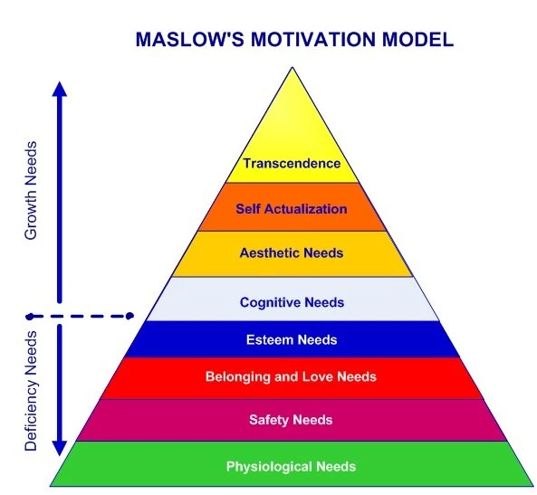

Figure 3.1: Mastow’s Motivational Model
Source: Maslow (1943)

On the grounds that needs might not align with the Maslow hierarchy, several scholars have questioned the idea (Louise, 2003). For example, the physiological need might be met before the need for safety. Consequently, people can continue working even if their dwelling is unsecure. The fact that this Maslow's hierarchy is always suitable has also drawn criticism (Twum-darko, 2013). This hypothesis is relevant to the inquiry because it can explain how the Maslow model will impact the production of green vegetables by single mothers.

3.3 Empirical Literature Review
A study conducted in the United States looked at the opportunities available to young individuals who are unemployed (Francis, 2015). Some of the unemployed young people will leave the welfare system and get a job, which will help them cut back on their dependency on their parents and prepare them for the future. The authors point out that, despite the substantial financial incentives, teenage unemployment had a significantly higher impact on the number of hours they worked than on their decisions to work. The authors contend that fixed costs of labour, such as child care, transportation, and time lost during commutes to, preparation for, or recovery from work, may help to explain these employment patterns.

Several research on young unemployment and the related concerns of welfare use and poverty have used data from the Panel Study of Income Dynamics (PSID). Rendall (2019) claims that the current work uses the PSID Relationship File to quantify the resulting biases in terms of age, race, welfare use, and poverty status. Juvenile unemployment is significantly undercounted at younger ages and significantly overcounted at older ages, especially for those who take advantage of local Opportunities for urban planning projects are projected through Chalk is a common educational resource in developing countries. Tanzania uses a lot of white and coloured chalk, which increases demand for the chalk moulding machine in both public and private institutions.

With a high percentage of locally sourced materials and a competitive price, this design intends to produce a chalk moulding machine that meets the steadily increasing demand for chalk. This will lift the spirits of investors. Tanzania's expanding public and private school system makes chalk production economical. Both private individuals and commercial organisations have become engaged in the production and supply of classroom chalk in an effort to balance the demand. A very significant investment opportunity has been created, particularly forindividuals who intend to go into small scale chalk production business (Ribina, Oada, Fom, and Yakubu (2014).

Chalk is created using one of two methods. In the first method, the chalk is moulded; in the second, it is pushed and extruded, much like toothpaste does when it comes out of a tube. Extruded chalk, whether white or brightly coloured, is most commonly used on school chalkboards since it is typically solid and "dustless." It is quite difficult for students and teachers in underdeveloped countries in Asia and Africa to avoid breathing in the fine dust produced during the writing and erasing process because most of these countries use a lot of chalk sticks in their classrooms. It has been established how chalk dust is produced and how it affects conditions of the lungs.

In India, more than 15 million chalk sticks are used each day, resulting in millions of dust particles. Chalk dust is a health risk to millions of students and educators worldwide. A dustless calcium carbonate chalk and a light, heavily dust-generating conventional chalk made of gypsum were both employed in this experiment. Foreign chalk samples cost 10 times more than Indian chalks made with gypsum. Because of this, most educational institutes in India utilise standard gypsum chalks in their classrooms. Calcium sulphate, also known as gypsum powder, is used as the main raw ingredient in the gypsum-based chalk process and is poured into a mould as a slurry in water. Gypsum powder can absorb water due to its hydrophilic nature and eventually solidify into chalk.

The USA, UK, EU countries, and Korea, on the other hand, make dustless chalks using a high-pressure extrusion technique with polymeric binders. The main basic ingredient for dustless chalk is gypsum, a compound of calcium carbonate and calcium sulphate, together with polymeric binders like PVA, PVP, starch, etc. These chalks are almost two times heavier and denser than gypsum-based chalk. In comparison to ordinary chalk, dustless chalk demonstrated a decreased rate of abrasion (Rakodi, 2018).

3.3.2 Small -Scale Chalk Making in Developing Economies
The thin chalk used in classrooms has a diameter of.35 of an inch (nine millimetres) and a length of 3.15 inches (80 mm). Lessons are commonly taught to entire classes on chalk-boards (or blackboards, as they were originally known), using sticks of chalk, because this technique has proven to be affordable and straightforward. Since prehistoric times, when archaeologists assert that chalk helped create some of the earliest cave drawings, chalk has been used for sketching. Nature contains a material called chalk. Later, artists from many countries and creative styles primarily used chalk for sketching, and some of these drawings that were preserved with shellac or a similar substance have survived. Natural chalk comes in a variety of colours due to impurities, but when painters manufactured their own chalk, they typically added pigments to make the colours more vibrant. For example, ferric oxide (Fe 2 O 3) was employed to produce a more vivid red, and carbon was used to improve black.

Chalk was not typically used in classrooms until the nineteenth century. Teachers required a workable method to instruct many kids at once as class numbers expanded. Students had their own personal chalkboards, which were furnished with chalk sticks and a sponge or piece of cloth that could be used as an eraser, in addition to using large blackboards for instruction. These tiny chalkboards were most frequently utilised for practise by the youngest kids. Final draughts were often drawn using pens dipped in ink wells, but because paper made completely of rags at the time was expensive, these were only provided to more mature students who could be trusted not to produce a mess.

Chalkboards underwent significant alteration at the same time that classroom chalk saw significant modification. Because they were constructed of genuine slate, blackboards used to have that colour. When manufacturers started to create chalkboards from synthetic materials during the twentieth century, they chose the hue green, saying that it was more aesthetically pleasing even though some experts recommended switching to yellow chalkboards with dark blue or purple chalk to resemble writing on paper. Chalk became to be primarily coloured yellow. Today, almost all chalk is made without dust. In the past, softer chalk had a propensity to create a cloud of dust that some believed would aggravate respiratory issues. Dust is still produced by dustless chalk, but it settles more quickly. Manufacturers do this by baking chalk for a longer period of time to make it harder. Another technique to stop dustless chalk from rubbing off onto hands is to soak 80% of each stick in shellac, as done by a French manufacturer.

If classroom chalk satisfies the requirements of the Art and Craft Materials Institute, a non-profit manufacturers' group, it is marked in America as "CP [certified product] non-toxic." This mark attests to the non-toxicity of children's art supplies, their compliance with voluntary performance and quality requirements, and the accurate labelling of the toxicity of adult art supplies. The CP seal also certifies that the item satisfies material, workmanship, working quality, and colour requirements established by the Art and Craft Materials Institute as well as other organisations like the American National Standards Institute and the American Society for Testing and Materials (ASTM).

Most chalk manufacturers are subjected to random tests by an impartial toxicologist who verifies that they are adhering to non-toxic criteria in order to assure honesty. Most manufacturers conform to such exacting standards because knowledgeable schools will not purchase chalk that is not properly labelled. The typical tariff for the Philippines in Chalk in 2020 was 0.95%. Chalk import tariffs were highest in Angola (most-favorable-nation duty rate treatment, 1%), Burundi (most-favorable-nation duty rate treatment, 1%), Benin (most-favorable-nation duty rate treatment, 1%), Burkina Faso (most-favorable-nation duty rate treatment, 1%), and Botswana (most-favorable-nation duty rate treatment, 10%).

3.4 Policy Review

3.4.1 The Tanzania Review 2003 Development Policy
The Tanzania 2003 SME Development Policy overall objective is “to promote the creation of new and improve performance and competitiveness of existing enterprises with a view to ensure faster job creation and income generation. The policy intends to serve as a guide or framework for co-ordinated interventions. It provides the role of implementing agencies and tools for implementation programmes”.

The priority areas of the policy include among other things: “address the legal and regulatory environment on SMEs, physical infrastructure, entrepreneurship and business skills, access to information, access to markets, institution framework and co-ordination for SMEs development and industrialization.”Apart from that, the policy covers all crucial sectors for the expansion of SMEs, but it says nothing about informal small businesses, which account for 50% of all SMEs in Tanzania, including those run by rural youth.

3.4.2 Community Development Policy
Mwalimu Julius K. Nyerere, the first president of the United Republic of Tanzania, emphasises that "True development is development of people not things." The primary resource in achieving progress is people. The idea that "true development is the development of people and is brought by people themselves" becomes obvious as a result of the above. The focus of community development policy is on eradicating poverty by involving those in charge of fostering community growth, by advising and training individual families and households, by encouraging group or cooperative activities, and by consolidating the informal sector by fostering economic activity, industries, small businesses, and group production in both urban and rural areas. The only way to end poverty in the nation is to do this (URT: 1996).
The Community Development Policy aim at enabling Tanzanians to bring about their own development by working to improve production so that they may have increased income which will enable community to build a better life through self reliance and the use locally available resources. This was one of the objectives under review.

3.4.3 National Strategy for Growth and Reduction of Poverty
National Strategy for Economic Growth and Reduction of Poverty (NSGRP II, 2009), in Kiswahili, MKUKUTA, is informed by Vision 2025 and committed to the achievement of the Millennium development Goals (NDGs). It has an increased focus on growth and governance and is an instrument for mobilizing efforts and resources towards its outcomes. Based on MKUKUTA, Growth and Reduction of Poverty is guided by the broad outcome of achieving and sustaining broad-based and equitable growth.

The reduction of income poverty requires sustained GDP growth which is sustainable, equitable and broad-based. To achieve this strategy, MKUKUTA strategy focus on scaling up investments towards modernizing small, medium and large scale agricultural enterprises with emphasis on agro-processing and promoting more sustainable use of natural resources for the benefit of the communities. Some of the objectives of growth and reduction of poverty are; to reduce unemployment, scaling up participation of informal sector and SMEs, reduced negative impacts on environment and peoples’ livelihoods, and reduced urban population below the basic poverty line (URT:2005).

URT strategy much that it also focus to informal sector but it lack practical mechanism to reach and help small informal groups such as rural youth group; no structure and system down to grass roots level to meet, educate and support small non- formal groups which are struggling to alleviate there living through economic development endeavours. In summary, apart that these three policies and strategies namely, 2003 SME Policy, Community Development Policy and MKUKUTA Policy they are aiming at helping small informal Enterprises among others, they lack a clear practical mechanism to reach this group. The government have to streamline these policies and strategies to make them more accessible and practical to informal sectors youth rural group inclusive.

3.5 Literature Review Summary
This section presents literature which was reviewed including theoretical, empirical and policy literatures. Theoretical thinking of scholars viewed livelihood as comprising of assets, and capabilities and activities required for means of living. In order to face poverty, poor household have to depend upon a diversity of strategies based on asset of assets including physical capital, natural capital, financial capital and human capital. Empirical literature reviewed focused on what other researchers did in relation to chalk processing as means of reduced of post harvest losses in chalk making, value addition and as an opportunity to livelihood improvement to various communities outside and within Tanzania. Chalk making were seen to serve as agent for promoting equitable economic growth in various societies. It demonstrated great potential for generating income and a great socio-economic impact in human welfare people who were trained on chalk processing techniques improved their living standard and even received health benefits from its consumption. Different Policies were reviewed such as Community Development Policy and National Strategy for Growth and Reduction of Poverty (NSGRP). Community Development Policy described its directions towards poverty reduction with emphasis on various areas which included formation of self-help groups and cooperative, encouraging economic activities and production groups so that they may increase their commitment to self-development and finally overcome poverty

CHAPTER FOUR

PROJECT IMPLEMENTATION

4.1. Overview

The recommendations from the CNA, literature review, and scientific study presented in chapter one are implemented in this part. It outlines what was actually done and explains how the initiative to create chalk was used to help Mavovo's unemployed youth. Based on the prioritised demands that emerged from the needs ranking in chapter one, the project was carried out from March 2023 to November 2023. The group members decided to start with the chalk-making project in order to make more money as a crucial requirement to address the issue of low income. To increase the quality and value addition of chalk, an intervention was therefore made to conduct training in chalk-making methods.

4.2 Production and Output
The implementation of the project aimed at improving livelihood of unemployed youth through chalk making by improving their income by using available opportunities within a village. By the end of the project of chalk making the following product and output were realized.

4.2.1 Products
After confirmation of payment from the arrangements for the materials that will be used to make chalk, this project will be completed. By explaining the overall goals and the project's goals as they are presented in the next section, we can state the following about the results of completing this task:
- 2 daysof mobilizing 10 unemployment youth to form two groups and 2 days trainingon the chalk production making by July 2023
- 1 day meeting with Village Executive Officer and to secure office premises for chalk making by July, 2023.
- 10 unemployment youth were facilitated trained on chalk making by July, 2023.
- 4 days to market of selling their product and source of materials were identified by July 2023.
- Recast this after changing the objectives in chapter two!

4.2.2 Outputs
Table 4.2 indicate the project outputs

Table 4.1: Project Output
OBJECTIVES | OUTPUT | ACTIVITIES
Objective 1: Training 10 unemployment youth on chalk making for by July 2023 | Output 1: 1 day of mobilizing 10 unemployment youth to form group | Activity 1: Studying different unemployment youth living in Mavovo village
 |  | Activity 2: Selecting unemployment youth to be involved in the project
 | Output 2: 2 days 10 unemployment youth accessed training on the chalk making | Activity 1: Teaching on methods of production
 |  | Activity 2: Teaching on marketing their products
Objective 2: To secure office premises for chalk making group at Mavovo village by July 2023 | Output 1: 1 day meeting with Ward Executive Officer was successful | Activity 1: Learning on how the LGA helps youth groups especially unemployment youth
 |  | Activity 2: Negotiation on helping the sustainability of the project
 | Output 2: Temporarily office were provided by village executive government | Activity 1: Reaching the area for project implementation
 |  | Activity 2: Making agreement on the usefulness of the area
Objective 3:To purchase chalk making moulder for 10 unemployed youth group members by the end of September 2023. | Output 1: 10 unemployment youth forming a group | Activity 1: Elaborating on the importance of forming groups to unemployment youth
 | Output 1: 10 unemployment youth forming a group | Activity 2: Analysing the effects of group towards increasing their income.
 | Output 2: Resources were mobilized | Activity 1: Facilitating on the use of the resources which available
 | Output 2: Resources were mobilized | Activity 2: Linking of the project and the resources mobilized
Objective 4:To Link the group with reliable buyers by the end of September, 2023 | Output 1: Unemployment youth knows how to extend their market | Activity 1: facilitating them on producing quality products
 |  | Activity 2: incentive and frequent training on effective production
 | Output 2: New markets for the products were obtained | Activity 1: Facilitation on acquiring new customers
 | Output 2: New markets for the products were obtained | Activity 2: Making them understand the new markets

Source: Research Data, 2023

4.3 Project Planning

The successful completion of this project's goals demands proper planning to enable the execution of actions that will lead the effort into reality. Execution plan, member organisation, and financial plan review are all included in this section. Project execution includes management, exercise evaluation, and each partner's commitment. Young people who are unemployed in Mavovo, the Mavovo VEO, and MCED students are reliable project partners.

4.3.1 Project Implementation Plan

The project activities' implementation schedule is outlined in the chart below. The timeline, necessary resources, and people in charge of each activity are displayed in the chart's findings.

4.3.1 Implementation Plan
The project execution plan outlines several exercises and resources that will be needed to complete the stated task targets in a specific amount of time.

Table 4.2: Project Implementation Plan
OBJECTIVES | OUTPUT | ACTIVITIES | PROJECT MONTH |  |  |  |  |  |  |  |  |  |  |  | RESOURCES NEEDED | RESPONSIBLE PERSON
OBJECTIVES | OUTPUT | ACTIVITIES | J | F | M | A | M | J | J | A | S | O | N | D
Objective 1: Training 10 unemployment youth on chalk making for by July 2023 | Output 1: 1 day of mobilizing 10unemployment youth to form group | Activity 1: Studying different unemployment youth living in Mavovo village |  |  |  |  |  |  |  |  |  |  |  |  | Human resource  Financial resource | MCED student  CDO  WEO
 |  | Activity 2: Selecting unemployment youth to be involved in the project |  |  |  |  |  |  |  |  |  |  |  |  | Human resource  Financial resource | MCED student  Tandale young single mothers  WEO  CDO
 | Output 2: 2 days 10 unemployment youth accessed training on the chalk making | Activity 1: Teaching on methods of production |  |  |  |  |  |  |  |  |  |  |  |  | Human resource  Financial resource | MCED student  Unemployment  VEO  CDO
 |  | Activity 2: Teaching on marketing their products |  |  |  |  |  |  |  |  |  |  |  |  | Human resource  Financial resource | MCED student  Unemployment  VEO  CDO
Objective 2: To secure office premises for chalk making group at Mavovo village by July 2023 | Output 1: 1 day meeting with Ward Executive Officer was successful | Activity 1: Learning on how the LGA helps youth groups especially unemployment youth |  |  |  |  |  |  |  |  |  |  |  |  | Human resource  Financial resource | MCED student  Unemployment  VEO  CDO
 |  | Activity 2: Negotiation on helping the sustainability of the project |  |  |  |  |  |  |  |  |  |  |  |  | Human resource  Financial resource  Physical resource | MCED student  Unemployment  VEO  CDO
 | Output 2: Temporarily office were provided by village executive government | Activity 1: Elaborating on the importance of forming groups to unemployment youth
 |  | Activity 2: Making agreement on the usefulness of the area
Objective 3:To purchase chalk making moulderfor 10 unemployed youth group members by the end of September 2023. | Output 1: 10 unemployment youth forming a group | Activity 1: Elaborating on the importance of forming groups to unemployment youth |  |  |  |  |  |  |  |  |  |  |  |  | Human resource  Financial resource | MCED student  Unemployment  VEO  CDO
 | Output 1: 10 unemployment youth forming a group | Activity 2: Analysing the effects of group towards increasing their income. |  |  |  |  |  |  |  |  |  |  |  |  | Human resource  Financial resource | MCED student  Unemployment  VEO  CDO
 | Output 2: Resources were mobilized | Activity 1: Facilitating on the use of the resources which available |  |  |  |  |  |  |  |  |  |  |  |  | Human resource  Financial resource | MCED student  Unemployment  VEO  CDO
 | Output 2: Resources were mobilized | Activity 2: Linking of the project and the resources mobilized |  |  |  |  |  |  |  |  |  |  |  |  | Human resource  Financial resource | MCED student  Unemployment  VEO  CDO
Objective 4:To Link the group with reliable buyers by the end of September, 2023 | Output 1: Unemployment youth knows how to extend their market | Activity 1: facilitating them on producing quality products |  |  |  |  |  |  |  |  |  |  |  |  | Human resource  Financial resource | MCED student  Tandale young single mothers  WEO  CDO
 |  | Activity 2: incentive and frequent training on effective production |  |  |  |  |  |  |  |  |  |  |  |  | Human resource  Financial resource  Physical resource | MCED student  Unemployment  VEO  CDO
 | Output 2: New markets for the products were obtained | Activity 1: Facilitation on acquiring new customers
 | Output 2: New markets for the products were obtained | Activity 2: Making them understand the new markets

Source: Research Data, 2023.

4.3.3 Budget Assessment
The project's estimated budgeting plan was TZS 1,200,000/=. Local government officials and the MCED researcher took on the excess expense totaling TZS 300,000/=, which was for writing supplies and preparation materials, and started conducting fund raising. Out of this spending plan, TZS 500,000/= was subsidised by the host organisation as a delicate unique gathering credit.

Table 4.3: Budget Assessment
OBJECTIVES | OUTPUT | ACTIVITIES | Resources | Unit Price | Total Amount
Objective 1: Training 10 unemployment youth on chalk making for by July 2023 | Output 1: 1 day of mobilizing 10 unemployment youth to form group | Activity 1: Studying different unemployment youth living in Mavovo village | Note book  Marker pen  Human  Lunch | 5000  10,000  30,000  5000 | 5000  10,000  30,000  5000
 |  | Activity 2: Selecting unemployment youth to be involved in the project | Note book  Marker pen  Human  Lunch | 5000  10,000  30,000  5000 | 5000  10,000  30,000  5000
 | Output 2: 2 days 10 unemployment youth accessed training on the chalk making | Activity 1: Teaching on methods of production | Expert  Facilitator  Marker pen  Flip chart | 50,000  50,000  10,000  15,000  2000 | 50,000  50,000  10,000  15,000  2000
 |  | Activity 2: Teaching on marketing their products | Expert  Facilitator  Marker pen  Flip chart | 50,000  50,000  10,000  15,000 | 50,000  50,000  10,000  15,000
Objective 2: To secure office premises for chalk making group at Mavovo village by July 2023 | Output 1: 1 day meeting with Ward Executive Officer was successful | Activity 1: Learning on how the LGA helps youth groups especially unemployment youth | Lunch | 30,000 | 30,000
 |  | Activity 2: Negotiation on helping the sustainability of the project | Lunch | 30,000 | 30,000
 | Output 2: Temporarily office were provided by village executive government | Activity 1: Reaching the area for project implementation | Transport  Lunch | 5000  30,000 | 5000  30,000
 |  | Activity 2: Making agreement on the usefulness of the area | Transport  Lunch | 5,000  30,000 | 5,000  30,000
Objective 3:To purchase chalk making moulder for 10 unemployed youth group members by the end of September 2023. | Output 1: 10 unemployment youth forming a group | Activity 1: Elaborating on the importance of forming groups to unemployment youth | Expert  Facilitator  Flip chart | 50,000  50,000 | 50,000  50,000
 | Output 1: 10 unemployment youth forming a group | Activity 2: Analysing the effects of group towards increasing their income. | Expert  Facilitator  Flip chart | 50,000  50,000 | 50,000  50,000
 | Output 2: Resources were mobilized | Activity 1: Facilitating on the use of the resources which available | Hire machine  Facilitator  Flip chart | 300,000 | 300,000
 | Output 2: Resources were mobilized | Activity 2: Linking of the project and the resources mobilized | Expert  Facilitator  Flip chart | 50,000  50,000 | 50,000  50,000
Objective 4:To Link the group with reliable buyers by the end of September, 2023 | Output 1: Unemployment youth knows how to extend their market | Activity 1: facilitating them on producing quality products | Transport  Lunch | 10,000  20,000 | 10,000  20,000
 |  | Activity 2: incentive and frequent training on effective production | Transport  Lunch | 10,000  20,000 | 10,000  20,000
 | Output 2: New markets for the products were obtained | Activity 1: Facilitation on acquiring new customers | Transport  Lunch | 10,000  20,000 | 10,000  20,000
 | Output 2: New markets for the products were obtained | Activity 2: Making them understand the new markets | Transport  Lunch | 10,000  20,000 | 10,000  20,000
Total |  |  |  |  | 1,200,000

Source: Research Data, 2023

4.4 Staffing Pattern
The following table show the pattern and role of each stakeholders

Table 4.1: Project Staffing
SN | Position | Supervisory role | Training needs
 | Supervisor (Group leader ) | -overall supervisor of the project activities  -Top execute officer of the project | -Management skills  -Project planning and management  - Office supervision
 | Accountant | -Prepares and present financial report of the project  -keep the books of accounts of project | -Business Management  -Book keeping knowledge  -Financial management
 | Sales Manager | -Looks for the market of chalk  -Receives tender of making chalk | -Sales skills
 | Quality controller | -Ensures the quality of chalk products | -Quality control and assurance skills
Source: Study Findings, 2023

4.6 Project Budget

The funding for the project's budget came from a variety of sources. 20% of the project's overall budget came from internal sources, while 70% of it came from local stakeholders, particularly the District Executive Direct Office. Youth themselves donated 10% of the funds earned during the project's earliest stages.

4.7 Project Implementation Report
By providing training in contemporary chalk products, the project's implementation aimed to improve the community of Mavovo Village's standard of living. The project's implementation got underway in July 2023, and numerous tasks were carried out as shown in the numbers below. Enhancing abilities on what kind of chalk is needed in relation to quality requirements for contemporary chalk designs was the main objective of providing training on the selection of appropriate materials for chalk. Both classes and practical exercises were part of the training. After attending a theory session, the trainees were divided into five groups and each group began with the preparation and processing procedures. All of the group members' actions were overseen by MCED researchers and chalk-making professionals. During the practical session, members who were unemployed were photographed at various processing stages. Clothing fabrics in various colours that are suited for manufacturing chalk, gypsum powder, chalk, diesel and cooking oil, water, and a chalk-making equipment are the resources used.

(i) Enhance Knowledge and Skills on chalk making
Before beginning chalk production, it was necessary to get knowledge of contemporary methods for making chalk, as well as about product safety and quality assurance.
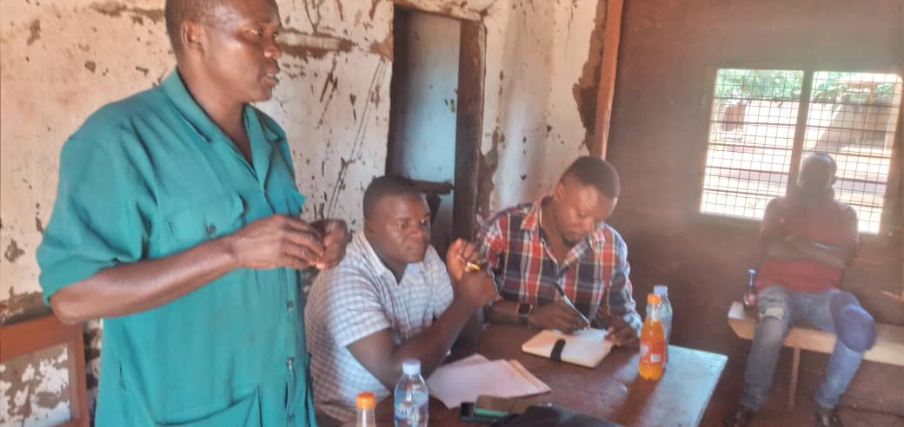

Figure 4.1: An Expert of Chalk Making Lecturing to Unemployed Youth Members during Class Session training
The importance of chalk making production, definitions of key terms, gypsum powder, chalk, mixing ratios, and specific chalk making designs techniques were covered in the classroom session with chalk making experts. Also covered was the significance of preparing clothing materials for chalk making prior to processing activities, including choosing suitable materials for chalk, sorting, the type of water used to mix with gypsum powder, estimating the amount of time needed, drying and packing techniques

(ii) Selection of Good Garment Material for Chalk Production
The meticulous selection of high quality materials for chalk manufacture required the processing of high-grade materials. The choice of gypsum powder that produces dust-free chalk was practised by the trainees. This will guarantee high-quality products that sell for more money in the markets. Figure 4.1 shows members of the unemployed youth group listening to an expert presentation, taking notes, and observing appropriate attire for producing chalk.
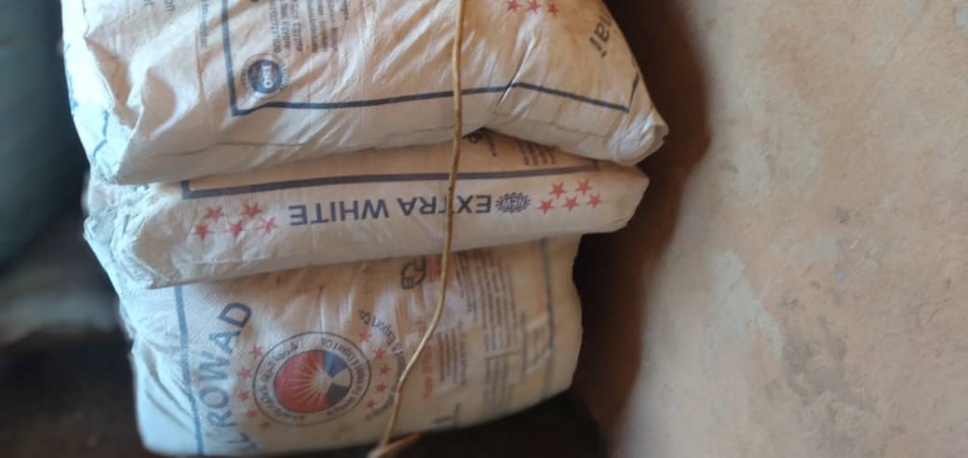

Figure 4.2: Chalk Powder as Common Garment Materials for Chalk Making
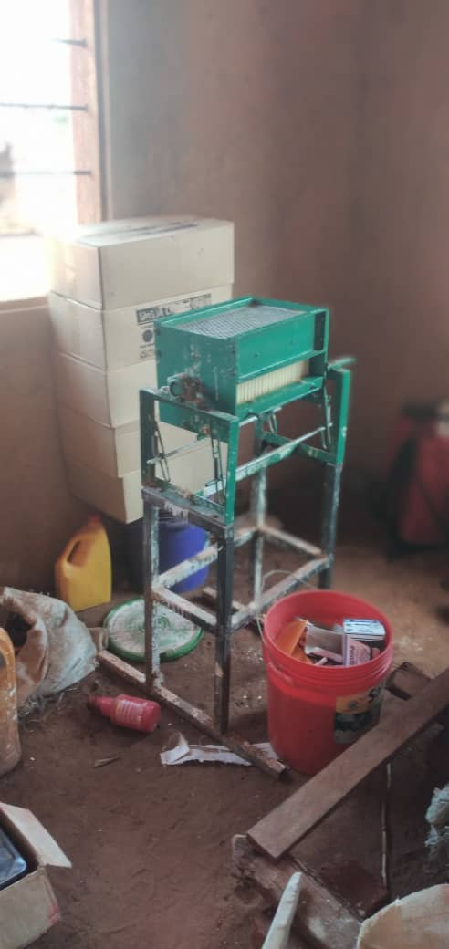

Figure 4.3: Machine which used to produce Chalk

(iii) Practical Training on Modern Chalk Making
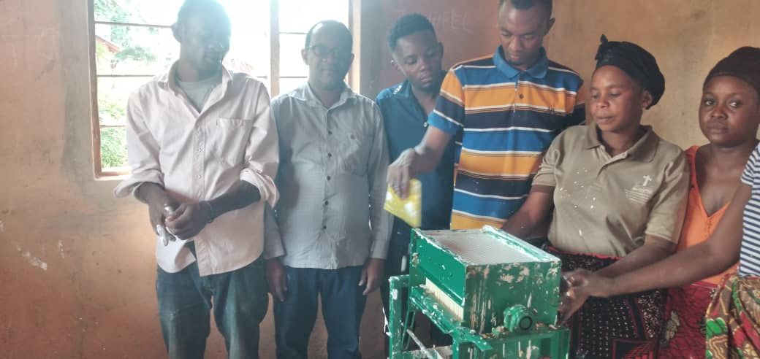

Figure 4.4: Unemployment Youth Conducting Practical Training during Chalk Making

The implementation of what was learned in class was covered during the practical session. Diesel, cooking oil, water, and gypsum powder were employed as fabric materials. For educational purposes, the trainees were separated into smaller groups, and each group received instruction on how to mix the ingredients for manufacturing chalk. The trainer meticulously monitored each sub-group to make sure that everyone followed the processing techniques they had been taught.

(iv)Drying
Youth engaged in draying activities. In this exercise, a piece of chalk material was finished and needed to dry before being finished, which took three days. The steps take more than three days to complete and include setting up a spot for draying chalk and a box for draying materials.
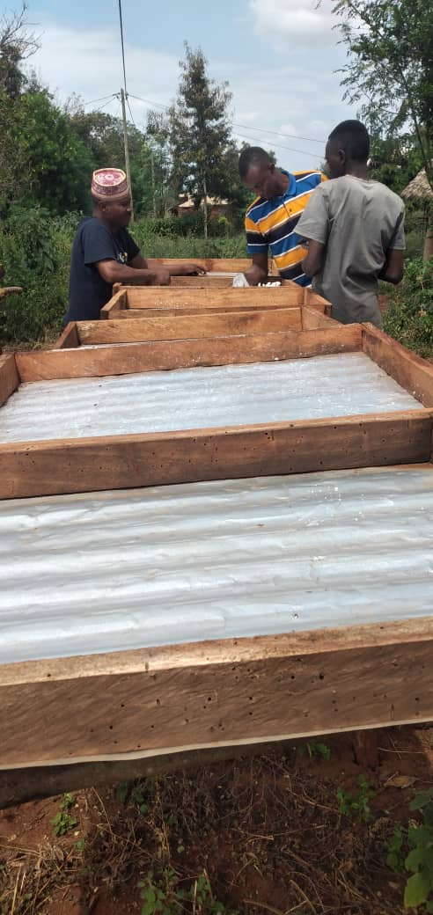

Figure 4.5 Unemployed Youth Members Observing Site for Draying Chalk

(v) Drying Procedures
The chalk was spread out on the ground to dry in the sun. An expert shows students how to dry things in the photos below. Participants in the group also worked with drying chalk throughout the practical training. Figure 4.6



Figure 4.6: This picture show the Chalk which is in Process of draying on Sunlight

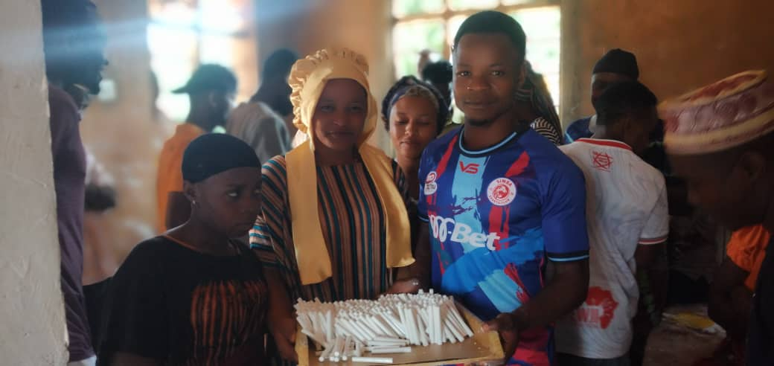

Figure 4.7: Unemployment Youth Carrying Chalk Which Was Ready for Sell in the Market

4.8 Project Implementation Ghantt Chart
A Gantt chart plots the length of a task against the passage of time graphically. It is a helpful tool for project scheduling and planning. Gantt charts are useful for tracking project progress.

Table 4.7: Project Implementation Gantt Chart
Activities | Implementation period |  |  |  |  |  |  |  |  |  |  |  |  |  | Resources needed |  | Responsible Person
Activities | Year 2013 |  |  |  |  |  |  |  |  |  |  |  |  |  |  |  | Responsible Person
Identification of the Community |  |  |  |  |  |  |  |  |  |  |  |  |  |  |  | Stationery | MCED researcher
Writing a letter requesting to conduct project |  |  |  |  |  |  |  |  |  |  |  |  |  |  |  | Stationery | MCED researcher
Conducting project |  |  |  |  |  |  |  |  |  |  |  |  |  |  |  | Funds  Stationery  Fuel | MCED researcher & Community Members
Identification of problem |  |  |  |  |  |  |  |  |  |  |  |  |  |  |  | Funds  Stationery | MCED researcher  Community Members
Project formulation |  |  |  |  |  |  |  |  |  |  |  |  |  |  |  | Stationery | MCED researcher Community Members
Writing CNA report |  |  |  |  |  |  |  |  |  |  |  |  |  |  |  | Stationery, Funds | MCED researcher
Identification of training needs |  |  |  |  |  |  |  |  |  |  |  |  |  |  |  | Funds  Stationery | MCED researcher and Target group
Identification of training resources |  |  |  |  |  |  |  |  |  |  |  |  |  |  |  | Funds,  Stationery | Facilitator  CBO leaders
Mobilization of financial resource |  |  |  |  |  |  |  |  |  |  |  |  |  |  |  | Funds  Stationery | MCED researcher ,  CBO leaders
Preparation of training materials/ manual |  |  |  |  |  |  |  |  |  |  |  |  |  |  |  | Funds, Stationery | MCED researcher Trainers
Identification of training venue |  |  |  |  |  |  |  |  |  |  |  |  |  |  |  | Stationery, Funds | MCED researcher
Acquiring required training resources |  |  |  |  |  |  |  |  |  |  |  |  |  |  |  | Funds | MCED researcher
Meeting with CBO leaders to compromise and confirm training schedule |  |  |  |  |  |  |  |  |  |  |  |  |  |  |  | Funds,  Stationery | MCED researcher Trainers  CBO leaders
Conducting training on selection of materials suitable for chalk making |  |  |  |  |  |  |  |  |  |  |  |  |  |  |  | Funds,  Training materials | MCED rsearcher& Trainers from Mkinga District council office
Conducting training on selection materials for suitable chalk |  |  |  |  |  |  |  |  |  |  |  |  |  |  |  | Funds,  Training materials | MCED researcher & Trainers
Conducting training on mixing materials process |  |  |  |  |  |  |  |  |  |  |  |  |  |  |  | Funds,  Training materials | MCED researcher &Trainers
Identifying marketing sites for selling of chalk |  |  |  |  |  |  |  |  |  |  |  |  |  |  |  | Funds,  Training materials | MCED researcher &Trainers
Conducting training on simple Book keeping |  |  |  |  |  |  |  |  |  |  |  |  |  |  |  | Funds,  Training materials | MCED researcher Trainers
Conducting Monitoring and Evaluation |  |  |  |  |  |  |  |  |  |  |  |  |  |  |  | Funds,  Training materials | MCED researcher &  CBO leaders
Writing project report |  |  |  |  |  |  |  |  |  |  |  |  |  |  |  | Funds,  Training materials | MCED researcher
Source: Research Survey,:2023

4.9 Summary
The numerous planned interventions were discussed in this chapter, along with an update on their progress. The majority of tasks were completed as intended. To spread knowledge about contemporary chalk production, various scheduled trainings were held, including practical instruction on mixing, processing, and packing techniques. Members of the group began by choosing premium materials for the manufacturing of chalk and various designs. They were then instructed on the selection of chalk, given instruction on the procedure, and given information about the markets for chalk products, while attempting to consider their possible clients. However, the trainer claims that by closely monitoring the entire process for at least two successive production cycles, the trainee's skills in processing chalk are effectively improved.

CHAPTER FIVE

PARTICIPATORY MONITORING, EVALUATION AND

SUSTAINABILITY

5.1 Overview
Participatory monitoring and evaluation is a process that involves involving all specified project stakeholders in all stages of execution, taking project planning, daily activity implementation, and ultimate assessment of the project's progress towards attaining the goal. Involving the stakeholders increases the likelihood of sustainability and makes them totally responsible for the project. Participatory monitoring, assessment, and sustainability are covered in this chapter. It examines how the community and different stakeholders utilised resources to make it easier to carry out project activities on a daily basis and to reach the desired project goals. In this chapter, we'll also examine the project's achievement of its predetermined goals, as well as its longevity and continuity.

5.2 Participatory Monitoring
Comparing the development of activities with the original plan was the aim of participatory monitoring. By examining the current situation, identifying issues and resolving them, scheduling project activities, tracking the project's progress towards success, and formulating and making decisions, it was accomplished. The main tool and strategy for all levels of monitoring will be the participatory monitoring method. The actions will be watched over the entire time. The logical framework matrix's set indications will be used to carry it out. Monitoring makes ensuring that project activities are carried out in accordance with the implementation plan and assists project expectants in identifying failure and success during project implementation.
Therefore, a monitoring system should be set up before the project begins, and the actions that will be observed should be scheduled on the work plan for the project.

The following project performance aspects are typically tracked:
- Time schedule performance
- Cost/budget(cost performance/finance) monitoring
- Work quantity(input-output) performance
- Work quality (technical performance) (iv) activity monitoring. Nevertheless, the unemployment Group members in Mavovo village, the youth in community economic development, the Village executive officer, the council technician, MCED researcher and the Council youth officer are the main participants in the project monitoring process. The following objectively verifiable indicators were used to build the monitoring tools used each month.The monitoring process, however, was carried out in a participatory manner, with emphasis paid to those indicators that might be used by the community and from their perspective, and it mainly concentrated on what had been done or accomplished. Even before the project began, it was being monitored.

5.2.1 Monitoring Information System
In order to help the researcher plan, monitor, assess, and report on the project's operations and performance, this section describes a system that was created to gather and report information on project activities. For this project, a consultative process that included, among others, the Unemployed youth Group leaders, Council
Technician, Village Executive officer, and MCED student resulted in the Monitoring Information System. The Group leaders assisted in facilitating talks among Group members and the community at large throughout the early stages of Monitoring Information Development.

Table 5.1: Information for Monitoring Project Activities
Category of information | What to monitor | Records to be kept | Who collects the data | Who uses the data | How to use the information | What decisions  Made
Work plan/activities | Commencement of activities  -Availability of inputs/resources  -Milestone of completed activities | -Agreed work schedule | -MCED researcher  -Group leaders  -VEO | -MCED researcher  -Group leaders | Tracking the project success/failure | Focusing at  Rescheduling  Activities and deployment of resources.
Costs and expenditure | -Budget estimates  -Actual expenditure  -Budget balances | -Budget  -Payment vouchers  -Financial reports  -Receipts | -MCED researcher  -Group leaders  -VEO | -MCED researcher  -Group leaders | -Tracking the  project efficiency and effectiveness by costs/benefits relationship | Authorization of expenditure,  revision of budget and outsource funds.
Staff and supervision | Knowledge,skills,educational level, job performance | Job description | -MCED researcher  -Group leaders | -MCED researcher  -Group leaders | Motivation purpose and job enrichment | Staff development in terms Of training and contract termination
Commodities, tools and equipment | Feeds, drinkers,  equipment, vaccines and drugs | Stock record/bin cards | -MCED researcher  -Group leaders | -MCED reseacher  -Group leaders | -Ensure Economic Order Quantities to avoid sock out | Make replacement to dilapidated tools  and equipment
Results | Increased number of people with increased income, employment opportunity chalk and improved livelihoods | Records/reports kept by the Group Executive Committee | -MCED researcher  -Group leaders | -MCED reseacher  Group leaders | -Ensure objectives are SMART-Quality and appropriateness of project outputs. | Review project objectives and Approach

5.2.2 Participatory Monitoring Methods
The project's development was monitored using three participatory methodologies. These included semi-structured interviews, focus groups, and in-person observations. Due to the fact that they were acquired directly, these were recognised as the primary data sources. In place of traditional surveys and semi-structured interviews, we used check-lists with questions about project success to obtain data. Although it is a flexible tool, it was nonetheless used in a systematic way to provide accurate results. With just 10 participants, a focus group discussion was conducted to thoroughly examine the challenges associated with project performance.

Participants were urged to speak candidly and unprompted about project-related topics. To keep the talk moving and stop one participant from dominating, the MCED researcher acted as a facilitator. A review of recent research, project documentation, project progress reports (which are essential monitoring tools), and other pertinent materials were also used as secondary sources. After the data was processed, a report was created and distributed to the participants in the monitoring process.
- Sampling and Sample Size
In this monitoring exercise, non-probability (deliberate/purposive) sampling was used, with 10 jobless youth group members serving as the key players. The other participants, a total of eight people, were from the MCED study.

- Monitoring Findings and Results
Analysis was necessary since the monitoring procedure's raw data needed to be processed. All data and information detailing how project activities really occurred as opposed to what was intended were recorded in note books. The researcher later utilised a laptop to record all the information and data acquired during the monitoring process and to compare the different responses and data gleaned from the various sources/methods indicated above. Actually, the information was used to evaluate the project's planned activities for success, spot any implementation-related issues, and choose the best course of action.

- Validity and Reliability
Data collected were directly related to the project activities at Mavovo village and the checklist was focused on the project.

5.2.3 Participatory Monitoring Plan

The project was monitored as it was being carried out. It serves as a monitoring tool used by those in charge of a project to ensure that everything goes as smoothly as possible and that no resources are wasted. It provides management with the information they require to analyse the current situation, pinpoint problems and find solutions, spot trends and patterns, keep project activities on schedule, gauge progress towards goals, establish future goals and objectives, and make decisions regarding human, financial, and material resources.To ensure that the numerous tasks, as well as the right strategies and action plans, were completed, monitoring was required.

5.3 Participatory Evaluation
Stakeholders from various levels work together in a collaborative approach to assess a project and take any necessary corrective action. As opposed to evaluation, which often concentrates on a specific point in time and determines whether the project's objectives have been reached and what effect it has had. It entails judging the worth or effectiveness of interventions or outputs, usually focusing on the standard, range, and/or efficacy of a piece of work's results.

In other words, evaluation focuses on establishing how effectively project activities are effective, efficient, relevant, and appropriate in achieving the project's goals. It is an ongoing process that is essential to the project at all times. There are several types of evaluation, depending on the basis for categorization. Possible basis include coverage or scope, timing, who does the evaluation, and a comparison of the input-output relationship. Following are some reasons why project evaluation tasks are important and necessary: Enhancing performance; making use of the evaluation's conclusions and recommendations to enhance implementation; learning from finished initiatives so that those lessons can be used to future plans. It is a tool for management.

Enhancing accountability, evaluation can be used to improve the ways in which projects communicate the goals, strategies, successes, and shortcomings with different stakeholders. Evaluation justifies the allocation of limited resources, time, and efforts by all the project participants. iii. Promoting communication, evaluation promotes effective communication between the various stakeholders in the project, staff, and donors. iv. Promoting learning and empowerment, evaluation can be used to improve the ways in which staff members and donors understand the project's progress.

5.3.1 Types of Evaluation
Depending on the foundation for categorization or the assignment, different forms of evaluation are undertaken. A comparison of the input-output relationship as well as coverage or scope, timing, and evaluation methodology could serve as the basis.
i)Coverage or Scope
This type falls into two categories: partial assessment, which looks at only a component of the project rather than the full project, and comprehensive evaluation, which looks at every area of the project. In order to decide on the project's direction or to determine its influence, thorough evaluations are frequently carried out during the project's implementation.

ii)Timing
This can be divided into four types. The first is the Ex-ante Evaluation, which is done before projects are started or before activities are carried out to determine viability and the need for vital information pertaining to the anticipated results. The project appraisal, also known as a baseline survey, was completed in May 2023. The goal was to determine an idea's viability or practicality, decide whether to pursue it or drop it, determine the nature and scope of a problem (Needs Assessment), and assess the resources that are available. Ex-post Evaluation or Impact Evaluation falls under the second category and is performed after the project has been completed, typically one to ten years later. The project's results will be sustained over time, direct and indirect benefits will be established, and lessons learned will be used to future project design and policy formulation. It is gathered by the researchers or external evaluator.
The Ongoing Evaluation (Formative or Midterm) is the third category.This occurs periodically throughout the project's execution to determine whether the project's underlying assumptions are still true and to determine whether it is on track to achieve its goals. In order to modify or improve work style, as well as to support decisions, evaluate performance. The data assessed includes accountability, financial position, and the usage of inputs and outputs. This kind of assessment will take place in the middle of July 2023.

The fourth step is Terminal Evaluation, which might be summative, post-project, final, or project-ending. To assess its applicability, this is typically done at the conclusion of a project or the last part of the funding cycle. Its goal is to evaluate the outcomes and impacts of intervention efforts, make conclusions, and evaluate impact to support funding and replication. Information on outputs, results, effects, and some impacts is examined. Donors, planners, implementers, and target groups are the main consumers. It is carried out by project workers, beneficiaries, internal or external evaluators. It is anticipated that this will take place in Aug 2023.

5.3.2 Evaluation Objectives
The goal of this midterm (formative) evaluation, which will be conducted in mid-July 2023, is to assess how well the project performed in fulfilling both its individual goals and the overarching objective (developmental goal).The evaluation process will examine the project's implementation's accomplishments, difficulties, and lessons learned.

5.3.3 Evaluation Focus Area
- The extent goal of objective achieved
- Achievement of project objectives
- Challenges that faced the project implementation
- Existing opportunities for the project and
- Suggestion for future implementation and monitoring of the project

5.3.4 Evaluation Design
Stakeholders will have the chance to reflect on the past and make significant decisions about the project's future throughout the participatory evaluation process for this project. Concrete, quantifiable MCED outcomes that will result directly from the project will be of relevance to the evaluator. It will feature formative MCED results such new productivity-enhancing knowledge and skills on stabilised soil blocks project, entrepreneurial and business development know-how, income growth, and job prospects. Additionally, it will seek out advice and suggestions to fortify the project, make it better, more sustainable, and perform better.

      - Performance Indicators

Indicators are objects or phenomena that reveal the degree of the project's impact on change. They aid in comparing what really occurred to what was planned in terms of quantity, quality, and timeliness. They track advancement in reaching outputs and results. They demonstrate the project's relevance, efficacy, and performance as well as the project's progress in achieving its outputs and outcomes.Indicators come in a wide variety of sorts or categories and are frequently used in monitoring and evaluation. In order to ensure that the objectives can be measured successfully and that monitoring and evaluation requirements can be completed, it is advisable to employ a combination.
- Formative indicators, also known as Milestones, are used to gauge the success of an activity, phase, or project.
- Summarising indicators are employed for project evaluation at the conclusion.
- Direct indicators—these gauge the variables directly, such as the quantity of buildings constructed with soil stabilisation, the quantity of equipment purchased, etc.
- Indirect/ Proxy Indicators: These are used to track issues that are hard to measure directly and can be measured after the project is complete. They can provide estimates for impact and outcome indicators.
- Quantitative indicators—who, what, when, where, how much, how many, and how often—are analysed numerically.
- Qualitative indicators, which gauge non-numerical variables,

Stakeholders and the project management team often construct indicators during the project formulation stage based on the significant project variables listed in the project matrix or work plan. These variables should determine the unit/criteria of measurement, indicate the time component, choose the spatial/location aspect, and identify the attributes to be computed. They might be connected to project inputs, outputs, activities, or methods of execution. When choosing the project's indicators, we took into account the following elements. Information that shows whether or not project objectives are being achieved;

Information that addresses the top priorities of the various groups involved in the monitoring and evaluation process; Information that is necessary for efficient management of project activities; Information that can be accurately collected to ensure that the monitoring and evaluation information is current, accurate, timely, relevant, and reliable. The following indicators were utilised for monitoring and evaluating the project in light of the aforementioned six different types of indicators. Input indicators explain the methods utilised to carry out the project and are used to evaluate how effectively resources are being used to accomplish the project's goals. They are also the foundation for performance assessments of outputs.

5.3.6 Participatory Evaluation Method
i)Evaluation Method
Data are crucial for monitoring and project evaluation. Finding adequate and high-quality data requires choosing the appropriate approach and instruments. Data gathering techniques will include semi-structured interviews, participatory observations, focus group discussions, and document and records reviews for the project midterm evaluation exercise, which will be completed in July 2023. The meetings, check-lists, effective listening, group discussions, appreciative inquiry, and analyses of monitoring reports and Executive Committee minutes will be the key evaluation tactics employed throughout the midterm evaluation exercise.

ii) Sampling and Sample Size
The participatory evaluation will use the sample and sample size indicated earlier and includes all of the project's primary stakeholders.

iii) Data Analysis and Presentation
The gathered data will be examined using a summary sheet and presented verbally and in writing. Stakeholders will actively share their opinions about the performance of the project and will be taken into account during the analysis.

5.3.7 Project Evaluation Summary
Four main project objectives will be reviewed during evaluation utilising various performance indicators for each one. The midterm review exercise, which will take place in July 2023, will also thoroughly examine and record both expected and actual results.

5.4 Project Sustainability
The components that will help the project continue to operate and provide benefits to recipients even after funders withdraw is how the sustainability of the project is evaluated. We will examine the strategy in place and the community's capacity to manage the project and create such income-generating ventures in the future utilising internal resources. The CED researcher/student emphasised the use of participatory approach in all phases of project identification, implementation, monitoring, and evaluation in order to ensure sustainability. The community members have been empowered by this strategy to manage the project with a very low reliance on outside assistance.

According to CEDPA (1994), sustainability also refers to a project's ability to continue operating on its own financial, material, and human resources when external funding has dried up. According to the 2023 World Bank Economic Development Report, the majority of civil society projects, particularly those in developing countries, experience difficulties or concerns with project sustainability. A thorough examination of the project's sustainability is supposed to be conducted after the conclusion of the logical framework matrix preparation. Therefore, it is crucial to do a prospective sustainability analysis of the project before investing funding into it. When the project is over, interventions should have produced structures and solutions that will still be institutionally sustainable. When a project can make improvements that continue to provide the intended level of benefits long after the project has completed, those benefits are considered to be sustainable.

Since all group members and the community were involved and agreed to take the project on as a community-based scheme, it is predicted that increasing community livelihood chances through chalk making project will be a sustainable scheme. The primary and most important issue that the community's residents deal with is low income. A strong sense of ownership and accountability is created by community involvement in project planning, implementation, monitoring, evaluation, and decision-making, and this is a crucial factor in the project's longevity. The project's goals are consistent with government initiatives to end poverty (PRSP). The group members decided that each member should participate in the project's implementation in the case of the sustainability plan.

5.4.1 Project Sustainability Plan
They will be able to continue the initiative even when the project's financial support ends thanks to the knowledge and skills they acquired throughout sensitization and training. The project's sustainability plan outlines how planning should make it sustainable over time, as well as the actions already performed and the anticipated future sustainability. Project sustainability indicators are numerous components or variables that are likely to contribute to the sustainability of the project. Nevertheless, an indication is something that reveals your current location, your direction of travel, and your distance from your desired location. The idea can be expanded upon and duplicated in other ambient regions thanks to the following major sustainability indicators.
- Institutional Sustainability
The project was chosen because it met the group's perceived requirement for an intervention against the community of Mavovo village pervasive low income. Given that they would be the project's main beneficiaries, it is anticipated that the Group members will support it wholeheartedly. As there would already be institutional strengthening, the Group also has a well-defined leadership structure and constitution to provide direction to the Group even when the MCED student and the Council Technician leave.

- Financial /Economic Sustainability
The project's sustainability is clearly demonstrated by the rising demand for Modern chalk. The project's income will guarantee its sustainability because it will be used to pay for various project operations, particularly for outdated equipment and inputs. The project appears to be a viable long-term investment because its incremental benefits appear to outweigh its expenses.

- Gender Equality
The initiative would surely lead to sustainable and equitable access by unemployed youth of Mavovo village to the project and would contribute to the objective of eliminating gender inequality since it takes into account the unique requirements and interests of unemployment youth.

iv) Political Sustainability
The peace and quiet of the hamlet and the countryside are absolutely necessary for the projects' sustainability. The project's goal is to increase the wages of young single parents through vegetable production. This goal will play a significant role in political manageability because even legislators and government leaders are constantly considering new strategies for raising local residents' wages in order to reduce destitution.

5.4.2 Summary
In summary, chapter 5 outlines the project's participatory monitoring, evaluation, and sustainability during the period between May 2023 and Aug 2023 at Mavovo village in Mkinga district. Participatory monitoring is covered in the first section, participatory assessment is covered in the second, and project sustainability is covered in the final section. Comparing the development of activities with the original plan was the aim of participatory monitoring. This was accomplished by an analysis of the current situation, the identification of any issues, the discovery of trends and patterns, the maintenance of project operations on schedule, the measurement of project progress towards success, and the making of resource decisions.

CHAPTER SIX

CONCLUSION AND RECOMMENDATIONS

6.1 Overview
This chapter summarises the project's overall findings and offers advice to future researchers considering undertaking similar projects based on the researcher's own experiences. The summary of the project selection criteria, reports on the execution of the monitoring and evaluation plan, and sustainability plan are included in the concluding section. It also includes a summary of the sustainability plan's participatory monitoring and evaluation results. The section on recommendations outlines advice for others who might attempt a project of a similar nature on all fronts, including participatory assessment, project design and implementation, literature study, monitoring evaluation, and sustainability.

6.2 Conclusion
The key findings of the CNA indicated that the most significant issue that motivated the establishment of this project was the lack of knowledge and expertise in chalk making. Since unemployment youth was making chalk, but it was of very poor quality since they had the knowledge and abilities to make it, which caused it to be sold cheaply, the CBO made less money. The project had a number of particular goals, one of which was to train 10 participants in the selection of materials appropriate for creating chalk. Unemployed teenagers in the village of Mavovo were able to learn how to create chalk as a result of this goal.

In addition, 10 members of the group received instruction on the choice of materials for creating chalk, allowing them to understand the many types of mixing materials that are employed in the process. Additionally, Mavovo village's unemployed youth were taught how to locate marketing venues for selling chalk items, enabling them to identify potential clients and sign business contracts.

6.3 Recommendations
The researcher recommended the followings
The neighborhood needs Assessment is a useful exercise for identifying the community's true requirements. The creation and execution of a project is a sensitive and important task that requires the individual's full commitment. One must adhere to all project design and management standards in order for the project to be implemented successfully. Resources are committed at the project level, thus it is important to use them effectively and efficiently. The use of a participatory approach at every level, from the stage of identification to evaluation, should be encouraged.

The implementation of a chalk-making project for unemployed youngsters led to the realisation that local people (community members) are eager to participate in the implementation of any project as long as things are handled in a transparent manner. They are prepared to donate their materials, human resources, and time to the project once they have actively participated in it from the beginning. Effective involvement is therefore crucial since it gives all stakeholders a sense of ownership over the project.

Effective participatory assessment is crucial for developing a real issue that affects the majority of the community in question. Accurate, reliable, and genuine data are crucial when conducting the assessment exercise since they produce sound CNA results, which reveal the community's true underlying issue. Participatory evaluation allows community members the ability to learn about the numerous issues that are specific to their area and jointly identify potential solutions. In order to cover all crucial topics, participatory assessment needs to be representative of the community being studied.

However, issues and difficulties facing Tanzanian young who are unemployed, such as the unreliable market, have been recognised and thoroughly examined. To boost small industrial production as one of the rural areas, the government should take action in cooperation with other stakeholders in response to the difficulties that have been assessed. In addition, it is important to educate the establishment of the processing companies for chalk about the rising amount of damaged chalk. The government should guarantee a steady market for items made from chalk and to ensure the long-term viability of the chalk industry.

The project intervention's monitoring, assessment, and sustainability are all crucial components. Different stakeholders should adhere to participatory monitoring and evaluation, which clearly gives participants the chance to express their opinions and offer contributions on the subject at hand. When a person is actively involved in the entire project design and implementation process, they gain an understanding of all project activities and commit their time and energy to making sure the project is carried out. As a result, the project will become more sustainable because they are now inextricably linked to it. Therefore, it is important to promote participatory monitoring and assessment.
The CNA process strategy and the participatory approach in the project intervention are useful strategies that have been beneficial in the study. The CNA enables the community at large, which frequently becomes the project area, to provide the relevant information. As a result, from the very beginning of the project, a sense of ownership is created.

According to the data gathered, the interview method of data collecting has proven to be effective. A questionnaire tool was utilised to display detailed information from the community and produce meaningful information. Simply entering the data from the questionnaire into SPSS and performing the appropriate analysis was done. The method made it easier to gather and analyse data overall. According to the nature of the project I was working on, the interview method was, in my opinion, the ideal approach. Other approaches, such focus groups and casual observation, are also helpful, but they cannot be used exclusively in order to gather enough data to meet the needs of the study.

REFERENCES
Angladesh Bureau of Statistics, (2020). Statistical Yearbook of Bangladesh, Statistical Division, Ministry of Planning, Government of the People's Republic of Bangladesh, Dhaka, Bangladesh.
Bannock, G. (2018). The Promotion of Small and Medium Firm in Europe, Council of Europe. Discussion series, paper no. ZA DP No. 12936.
Castro, P. A. (2012). Sustainable Livelihoods Analysis: An introduction. Syracuse University: New York
CTI/DI, (2018). The Manufacturing Sector in Tanzania. Confederation of Tanzania Industries. Dar es Salaam: CTI/DI.
Deakins. (2018). Entrepreneurship and Small Firms. New York: McGrawHill.
FAO, (2011). Pro Poor Livestock Policy Initiative Document. Italy: University of Reading.
Gereffi, G. (2011). Shifting Governance Structures in Global Commodity Chains, with Special Reference to the Internet. American Behavioural Scientist. 44(10), 1616-1637.
Goedhuys, M. (2018). Industrial Organization in Developing Countries; Evidence from Cote D’Ivoire, unpublished PhD Dissertation, a Preliminary Draft, Catholic University of Luven, Luven Belgium.
Mbwambo, A. H. &Kuzilwa, J. A. (2020). Tanzania Garment SSE s During SAPs: An Actor’s View Point. Independent Conceptual Study paper on Entrepreneurship and Small Business Development, Faculty of Commerce, University of Nairobi.
Ministry of Finance, (2013). Bangladesh Economic Review, Finance Division, Government of the People’s Republic of Bangladesh.
Ministry of Lands, Housing and Urban Development, (2011). Agricultural Sector Development Strategy.The United Republic of Tanzania (URT).
Saleque, M. A. & Islam, M. M. (2011). Small-Scale Broiler Rearing As an Income Generating for Hard-Core Women in Rural Bangladesh, Bangladesh Res., 9(1&2), 61-70.
UNDP, (2018). Human Development, New York: Oxford University Press.
URT, (2018). Agriculture and Livestock Policy, Ministry of Agriculture and Cooperative, Dar es Salaam: Tanzania.
Williams C. (2017). In ovo vaccination for disease prevention, Pfizer Animal Healt. International

APPENDICES
APPENDIX 1: QUESTIONAIRE
I am Said Swalehe Master’s student in community Economic Development in the Open University of Tanzania. Currently am doing community need assessment at Mavovo village as part of partial fulfilment of the requirement for Master’s degree. The information provided is confidential, Please be free to answer the following question.
Please circle the most appropriate information.
1. Are you the citizen of Kwamsisi Village?
0.1 Yes
0.2. No
2. Age
0.1. 20-25
0.2. 26-40
0.3. 41-65
0.4. 66 -75
3. Sex
0.1. Male
0.2. Female
4. Do you have an employed?
0.1 yes
0.2 No
5. What kind of employment?
0.1 Self employment
0.2 Government employment
0.3 Private sector employment
0.4 Working in the farm
5 Do you provide any services to the community?
0.1 Yes
0.2 No
If yes, what services
a) ………………………………………………………………………….
b)…………………………………………………………………………..
c). ……………………………………………………………………………
d)……………………………………………………………………………….
7. If yes which method do you use to provide services to the community?
a) ………………………………………………… ………………………………….
b) ……………………………………………… …………………………………..
c) ……………………………………………….. ………………………………….
d) ………………………………………………….. ………………………………
8 Who support/fund to the provided service in the community?
a) …………………………………………….
b) ……………………………………………….
c)…………………………………………
9 Do you think providing chalk making service will develop the community?
a) Yes
b) No
If yes please explain………………...
10. To what e extent have you been successful through chalk making?
a) Very successful
b) Successful
c) Uncertain
d) Less successful
11. Do you encounter any problems through the chalk making project?
a) Yes b) No
12. If yes, what are those p problems (please mention them)
a) ………………………………………………………… …………………………
b) ……………………………………………………………………………………
c)……………………………………………………………………………………
d)……………………………………………………………………………………
13. What strategies do you suggest to improve this project?
a) ………………………………………………………… …………………………
b) ……………………………………………………………………………………
c)……………………………………………………………………………………
d)……………………………………………………………………………………

THANK YO U FOR YOUR COOPORATION AND SUPPORT

Appendix 2: Question for focus Group discussion
1. What are your community most pressing needs?
2. What are local resources available to help meet the most community needs you mention above?
3. What are the main Opportunities for projects to meet the most community need you mention above?
4. What are current actions taken to meet the most community need you mention?
5. What are the barriers in implementing projects to meet the most community need you mentioned in your community? Challenges to projects
6. Are you satisfied with the way the most community need tackled?
7. What are your opinions on which method should be used to end the most problem you mention above?
9. Which strategies do you think should be taken to meet your community needs to bring development to your community? (Long -term sustainability of the project by the community)

THANK YOU FOR Y OUR COOPORATION AND SUPPORT.
EXAMINER’S REPORT CORRECTION MATRIX
NAME: SAID SWALEHE
PROGRAM: MCED
DATE: 05/05/2023
# | Observation Area | Examiner’s Comments /Observation | Student Corrections /Explanation
1 | Location | - To improve map  - To remove the word manufacturing in the tittle of chalk making manufacturing | To put the map of Mavovo village instead of Mkinga district  The tittle has been corrected by removing the word manufacturing
2 | Education Level | To omit one part of it after reputation | The comment has been corrected accordingly
3 | Identification and prioritization | To show how the project of chalk making has been arrive/obtained | This area has been improved by showing How did you arrive to the project of the Chalk making. I arrived by listing the main activities which provided by respondents through focused group discussion and identified them by ranking and I decided that most which have high ranking is chalk making and least have many challenges to implement for youth
4 | References | To use the current literature and more than 10 reference | The comment has been taken and I added references and almost are current references and I used APA style as suggested
5 | Data collection tools | To attach data collection tools | I attached data collection toots (appendices A and B)
6 | Demographic features |  | I obtain the number of house holders who engaged in economic activities
7 | Project Identification and Prioritization |  | To add section 1.9 of Project Identification and Prioritization
8 | Tools |  | To remove questions which not in the work
 | 27.08.2023
9 | Chapter 2 | To improve project objective | Project objectives were reformed and arranged

THEUNITEDREPUBLICOFTANZANIA




MINISTRYOFEDUCATION, SCIENCE AND TECHNOLOGY
THEOPENUNIVERSITYOFTANZANIA

Ref.NoOUT/PG202100798 15thAugust,2023

DistrictExecutiveDirector(DED),MkingaDistrictCouncil,
P.O.Box 6005,
TANGA.
DearDistrictExecutiveDirector,

RE:RESEARCHCLEARANCEFORMR.SAIDSWALEHE,REGNO:PG202100798
- The Open University of Tanzania was established by an Act of Parliament No. 17of 1992, which became operational on the 1stMarch 1993 by public notice No.55 in theofficial Gazette. The Act was however replaced by the Open University of TanzaniaCharter of 2005, which became operational on 1stJanuary 2007.In line with the Charter, the Open University of Tanzania mission is to generate and apply knowledge through research.

- To facilitate and to simplify research process therefore, the act empowers the ViceChancellor of the Open University of Tanzania to issue research clearance, on behalf ofthe Government of Tanzania and Tanzania Commission for Science and Technology, to both its staff and students who are doing research in Tanzania. With this brief background, the purpose of this letter is to introduce to you Mr. Said Swalehe, Reg. No: PG202100798), pursuing Masters in Community Economic Development (MCED).
We here by grant this clearance to conduct a research titled “Improving Livelihood for Unemployed Youth of Mavovo Village through Chalk Making in Mkinga District Council, Tanga Region”. He will collect his data at your area from 16th August to 31thSeptember 2023.
- In case you need any further information, kindly do not hesitate to contact theDeputy Vice Chancellor (Academic) of the Open University of Tanzania, P.O. Box 23409, Dar es Salaam. Tel: 022-2-2668820.We lastly thanks you in advance for your assumedcooperation and facilitation of this research academic activity.

Yourssincerely,

THEOPENUNIVERSITYOFTANZANIA

Prof. Magreth S. Bushesha

For: VICECHANCELLOR

