ASSESSMENT OF MATERNAL HEALTH INFORMATION-SEEKING BEHAVIOUR OF PREGNANT WOMEN IN ARUSHA, TANZANIA: A CASE STUDY OF NGARENARO HEALTH CENTER

RAFIKI KILONZO

A DISSERTATION SUBMITTED IN PARTIAL FULFILMENT OF REQUIREMENTS FOR THE DEGREE OF MASTER OF LIBRARY INFORMATION MANAGEMENT (MLIM)
DEPARTMENT OF MEDIA AND LIBRARY STUDIES
OF THE OPEN UNIVERSITY OF TANZANIA
2023
CERTIFICATION
The undersigned certifies that he has read and hereby recommends for acceptance by The Open University of Tanzania a dissertation entitled: Assessment of Maternal Health Information Seeking Behavior of Pregnant Women: Case Study of Ngarenaro Health Center, Arusha City Council in partial fulfillment of the requirements for the award of Degree of Masters in Library Information Management (MLIM).

…………………………
Dr. Henry L. Mambo
(Supervisor)

……………………………
Date
COPYRIGHT
No part of this Dissertation may be reproduced, stored in any retrieval system, or transmitted in any form by any means, electronic, mechanical, photocopying, recording, or otherwise without prior written permission of the author or The Open University of Tanzania on that behalf.

DECLARATION
I, Rafiki Kilonzo, declare that the work presented in this dissertation is original. It has never been presented to any other university or institution. Where other people’s works have been used, references have been provided. It is in this regard that I declare this work as originally mine. It is hereby presented in partial fulfillment of the requirement for the Degree of Master of Library Information Management (MLIM).

………………………………
Signature

………………………………
Date

DEDICATION
This dissertation is dedicated to my late mother and father HALIMA KISUMO and KILONZO MAVURA who passed away in 2020 and 1988 respectively.
May the Lord rest their souls in peace. Amen

ACKNOWLEDGEMENT
Many people deserve my thanks for their valuable assistance in pursuit of this study. I find it impossible to put on record all the people who contributed to the successful completion of this work. However the following deserve special mention;
First, I am thankful to the Almighty God for He has made me alive and guided me throughout my life and especially during this study and preparation of this dissertation.
Second, my heartfelt thanks to my supervisor Dr. Henry L. Mambo for good and close supervision, advice, cooperation and the guidance he offered me during the whole period of this dissertation.
Third, to TLSB my employer for the effort you have done to me in this field. Dr. Mboni Ruzegea A., the Director General, I thank you for your contribution and permission for me to undergo for my Master degree. May good Lord reward you abundantly.
Forth, my family, Grace, Christian and Gabriella must have missed my presence during writing this dissertation. Thank you very much for your patience and the moral support you gave me.
Fifth, all lecturers in this study; Ms C. Mwinyimbegu, Dr. A. Samzugi, Dr. L. Isowe, Mr. A. Kagugu, Mr. M. Kafuma and Mr. B. Mbagala and Mr. Ntimi Kasumo.
Sixth, NHC staff who cooperated well with me while collecting data for my study and allowed this dissertation to be completed in this form.

ABSTRACT
This study was on the maternal health information-seeking behaviour of pregnant women in Ngarenaro Health Centre. The study was guided by general objective and specific objectives. This study used a case study research design with application of both qualitative and quantitative methods. Simple random, purposive, and convenience sampling techniques were employed to 82 respondents. Data were collected using questionnaires, interviews and observation. Data analyzed using MS- Excel and MS- word. The study revealed that the information needs of pregnant women during the antenatal stage were on health risks of early pregnancy 46(59%); during prenatal were information on anaemia 58(74%); during postnatal were information on child caring 48(62%) and others. The study also found that the common sources of maternal health information are doctors 69(88%) and nurses 45(58%). Furthermore, the findings revealed that lack of other sources of information and low levels of education were limiting factors in the information-seeking behaviour. It is identified that long distances to the clinic for check-ups 77(99%), lack of cooperation from husbands 37(47%), and lack of education 33(42%) were among the strongly mentioned challenges. The study recommended changes in NHC strategic plan on maternal health information provision, the health ministry policy reforms health information infrastructures and increase budget in health center. The study concludes by reminding women that information is a weapon in the battle against maternal mortality and pregnancy complications.
Keywords: Maternal Health Information; Information Seeking Behaviour; Pregnant Women; Pregnancy; Maternal Mortality.
TABLE OF CONTENTS
CERTIFICATION i
COPYRIGHT ii
DECLARATION iii
DEDICATION iv
ACKNOWLEDGEMENT v
ABSTRACT vi
LIST OF TABLES xii
LIST OF FIGURES xiii
LIST OF ABBREVIATIONS AND ACRONYMS xiv
CHAPTER ONE 1
BACKGROUND TO THE STUDY 1
1.1 Chapter Overview 1
1.2 Background to the Problem. 1
1.3 Statement of the Problem 3
1.4 Research Objectives. 5
1.4.1 General Objectives 5
1.4.2 Specific Objectives of the Study 5
1.4 Research Questions. 5
1.6 Significance of the Study 5
1.7 Scope and Limitations of the Study 7
1.7.1 Research Scope 7
1.7.2 Research Limitations 7
1.8 Organization of this Study 7
CHAPTER TWO 9
LITERATURE REVIEW 9
2.1 Introduction 9
2.2 Conceptual Definitions 9
2.2.1 Information 9
2.2.2 Information seeking behaviour 9
2.2.3 Information Seeking 10
2.2.4 Information Sources 10
2.2.5 Maternal Health 10
2.2.6 Health Information 10
2.3 Theoretical Review 10
2.3.1 Conceptualizing Information Needs, Information Sources, Information Seeking, and Information Access. 10
2.3.1.2 Information Sources 11
2.3.1.3 Information Seeking Behaviour 11
2.3.1.4 Information Access 12
2.3.1.4 Information Access 12
2.3.2 Information Behaviour Models 12
2.3.2.1 Wilson, 1981 12
2.3.2.2 Ellis, 1989 14
2.4 Empirical Analysis of Relevant Studies 20
2.4.1 General Studies 20
2.4.2 Studies in African Countries 20
2.4.3 Health 1nformation Seeking. 22
2.4.4. Health Information-Seeking Behaviour in Tanzania 23
2.4.5 Maternal Mortality in Arusha Municipality. 24
2.4.6 Sources of Information for Pregnant Women 25
2. 4. 7 Challenges Facing Information Seeking. 27
4.4.8 Research Gap Identified 29
CHAPTER THREE 31
RESEARCH METHODOLOGY 31
3.1 Overview 31
3.2 Research Design 31
3.3 Research Approach 32
3.4 Area of Study and Justification 32
3.6 Sample Size 33
3.7 Sampling Techniques 34
3.7.1 Simple Random Sampling 34
3.7.2 Purposive Sampling 35
3.7.3 Convenience Sampling 35
3.8 Data Collection Methods 36
3.8.1 Secondary Data 36
3.8.2 Primary Data 36
3.8.2.1 Questionnaire 37
3.8.2.2 Interview 37
3.8.2.3 Observation 37
3.9 Instruments for Data Collections 38
3.9.1 Questionnaire Guide 38
3.9.2 Interview Guide 39
3.9.3 Observation Check list 40
3.10 Data Quality Control 40
3.10.1 Pre-testing of Research Instruments 41
3.10.2 Triangulation 42
3.11 Ethical Issues 42
3.12 Data Analysis 42
CHAPTER FOUR 43
DATA PRESENTATION, ANALYSIS AND DISCUSSION
OF THE FINDINGS 43
4.1 Introduction 43
4.2 General Social Demographic Characteristics and Distribution of Respondents 44
4.2.1 Distribution of Respondents 44
4.2.2 Distribution of Respondents by Age 45
4.2.3 Distribution of Respondents by Occupation 45
4.2.4 Education Level of Respondents 46
4.2.5 Importance of Visiting Health Center for Check up. 47
4.3 Purposes of Visiting Health Information Center 48
4.4 Type of Health Information Needs by Pregnant Women 49
4.5 The Availability of Sources of Health Information 52
4.6 Satisfaction with the Methods Used in Maternal Health Information Provision 55
4.7 The Challenges Facing Health Information Seeking Behavior of Pregnant Women. 57
4.8 Ways of Improving Maternal Health Information Seeking Behavior among Pregnant Women 59
4.9 Summary of Chapter Four 61
CHAPTER FIVE 63
SUMMARY, CONCLUSION AND RECOMMENDATIONS 63
5.1 Introduction 63
5.2 Summary of the Findings 64
5.2.1 Health Information Needs of Pregnant Women in NHC 64
5.2.2 Sources of Information Available to Pregnant Women in NHC 64
5.2.3 Methods used in Health Information Provision 64
5.2.4 Challenges Affecting Health Information Seeking Behavior of Pregnant Women 65
5.2.5 Ways of Improving Maternal Health Information Seeking Behavior of Pregnant Women 65
5.3 Conclusion 66
5.4 Recommendations 67
5.5 Area for Further Study 68
REFERENCES 70
APPENDICES 95

LIST OF TABLES
Table 3.1: Population of the Study and Sample Size (N=82) 33
Table 3.1: Population of the Study and Sample Size (N=82) 33
Table 4.1 Antenatal Health Information Needs for Pregnant Women 50
Table 4.2 Prenatal Information Needs by Pregnant Women 51
Table 4.3 Postnatal Information Needs by Pregnant Women 52
Table 4.4 Multiple Responses on the Availability of Health Information Sources 53
Table 4.5 Satisfaction with the Methods Used in Maternal Health Information Sources 55
Table 4.6 The Challenges Affecting Maternal Health Information-Seeking Behavior of Pregnant Women 57
Table 4.7 Ways of Improving Maternal Health Information Seeking Behavior of Pregnant Women (n=78) 60

LIST OF FIGURES
Figure 2.1 Wilson’s model of Information Behaviour 16
Figure 3.1 Pregnant Women at NHC Filling Research Questionnaires 39
Figure 3.2 A Maternal Health Information Provider at NHC Being Interviewed by the Researcher 40
Figure 4.1 A pie chart showing the distribution of respondents 44
Figure 4.2 Distribution of respondents by age 45
Figure 4.3 Distribution of respondents by occupation 46
Figure 4.4. Education level of respondents 47
Figure 4.5 Pie Chart Showing the Importance of Visiting Health Center 47
Figure 4.6 Multiple responses by pregnant women on purpose of visiting health centers 48
Figure 4.7 A nurse giving a seminar on maternal health to pregnant women 56

LIST OF ABBREVIATIONS AND ACRONYMS

ANC Ante Natal Care
CHW Community Health Workers
HIV/AIDS Human Immunodeficiency Virus/Acquired Immune Deficiency Syndrome
MDGs Millennium Development Goals
MIS Malaria Indicator Survey
NHC Ngarenaro Health Center
OUT Open University of Tanzania
TBAs Traditional Birth Attendants
TDHS Tanzania Demographic Health Survey
UN United Nations
UNFPA United Nations Population Fund
UNICEF United Nations International Children’s Fund
WHO World Health Organization

CHAPTER ONE

BACKGROUND TO THE STUDY

Chapter Overview
This study is about the assessment of maternal health information-seeking behaviour of pregnant women in Tanzania. Specifically, the study explores the health information needs of pregnant women, identifies the sources of information available to pregnant women at NHC; challenges facing pregnant women in seeking information, and ways to improve the seeking of maternal health information for pregnant women in Tanzania. Information is power and it can be used to make informed decisions, (Oxford English Dictionary, 1989). To a large extent, information serves as a solution to problems, contributing to solving the problem that individuals and societies face in their day-to-day activities.

Background to the Problem
In the year 2000, the UN summit established eight international development goals that aimed to improve living standards and the socio-economic condition of the population in the developing world. The United Nations set the goals in 1990 and adopted them by the international community in 2000 (UN, 2000). Three of the eight goals focused on improving the population’s health: reducing child mortality (4th); improving maternal health (5th); and combating HIV/AID, malaria, tuberculosis, and other diseases; all these goals could be achieved if the right information is provided to people (Dodd and Cassels, 2006).
Good health which is geared by access to the right information reduces days lost due to illness and decreases hard-earned income spent on medical treatments.
The saved income can be used for other development and growth activities such as education, food, and enhanced production (Khan et al, 1994; Hamoudi and Sachs, 1999; Boom, 2004). It is estimated that globally about 800 women die every day due to labor and pregnancy-related complications and more than a quarter-million more suffer disabling conditions (UNICEF, 2017). These deaths can be eliminated if the right information is available and given to them. Factual information is very important because it can equip a person with power, the power to choose and make a decision-, (Rubin, 2000). Information increases the state of knowledge of a recipient, resolving uncertainty, a body of knowledge, value in decision making, and physical surrogate of knowledge, (Aina, 2004). However, in the case of maternal health, information is a weapon in the battle against pregnancy complications, (Marion, 2002).

In most developing countries, Tanzania in particular, the causes of maternal deaths are usually attributed to cultural and socioeconomic factors which affect women’s living conditions, health status, fertility, health care utilization behaviors, and lack of maternal health information (Urassa et al, 1995; Rogo et al, 2006). Poverty, low education levels, cultural practices and women’s lack of decision-making power significantly contributes to limited access and non-utilization of skilled maternal services and lack of maternal information (WHO, 2012).

However, the set time frame has passed, and yet Tanzania and other developing countries are still far from reaching the target of reducing maternal deaths by three quarters by 2015.
Between 1990 and 2010, the global maternal mortality ratio (that is the number of maternal deaths per 100,000 live births) declined by only 3.1% per year. This is far from the annual decline of 5.5% required to achieve MDG5 (Chou et al, 2012).
These figures are still very high thus emphasis on more actions is needed to improve maternal health in Tanzania particularly increasing pregnant women’s knowledge of maternal health which will eventually improve their utilization of such information by women.
The Tanzania Government declared that Tanzania failed to achieve the 5th MDGs due to the different challenge. The majority of pregnant women especially those from rural areas gave birth at home due to a lack of information caused by inadequate education. (Tanzania Minister of Health, 2017).

Statement of the Problem
It is estimated that about 80% of maternal deaths that occur in the world today are due to preventable causes which could be avoided if women had access to the right information (UN Millennium Project, 2015). However, the limited access and poor utilization of skilled maternal services by pregnant women have resulted in a persistent increase in maternal morbidity and mortality rates in most developing countries. This is mostly caused by the lack of appropriate maternal information (Amin et al, 1989; Chou et al, 2012). According to Udofia and Okonofua (2008), available evidence indicates that Africa accounts for the highest burden of mortality among women and children in the world.
Information has been recognized over the world as an important tool for making decisions and reducing uncertainty. However, despite the abundance of information resources in a variety of sources, literature still reveals that the mortality rate among pregnant women is still high especially in Tanzania and other developing countries.
If such a situation continues to exist, more women are likely to die from preventable pregnancy-related causes, (Okonko and Udeze, 2011). In light of this, this study has assessed the information-seeking behaviour of pregnant women in a selected hospital in the Arusha City Council.

The majority of women usually do not seek skilled health services until the complications are in late stages which most of the time results in the death of a mother or/and a child (Mpembeni et al, 2007). Guindo, et al (2006) argued that maternal health information provision discourages women from seeking information on health care because it’s provided during the weekdays only, without including weekends. Oelman, (2006) reported that health information from care providers is not clear, and leads to delays in seeking maternal health care. This shows that there is a problem in maternal health information-seeking for pregnant women in Tanzania. Health information-seeking situation in developing countries, Tanzania in particular is not clearly understood (Kagaruki, 2009)

Pakenham- Walsh, (2005) pointed out that health care workers have little or no access to practical information which they could provide to pregnant women. Therefore, this study has purposely assessed the maternal health information-seeking behaviour of pregnant women in Ngarenaro Health Centre (NHC) to come up with clear ways to improve maternal health in Tanzania.

1.4 Research Objectives

1.4.1 General Objectives
The general objective of the study was to assess maternal health information-seeking behaviour of pregnant women in NHC, Arusha Tanzania.

1.4.2 Specific Objectives of the Study
The study was guided by the following four specific objectives:
- To explore the health information needed by pregnant women in NHC;-
- Identification of sources of information available to pregnant women in NHC;-
- Identification the challenges pregnant women face when seeking maternal health information in NHC; and-
- To find out ways of improving maternal health information seeking of pregnant women in Tanzania.

Research Questions
The study is guided by the following four research questions:
- What maternal health information is needed by pregnant women in NHC?
- What were the sources of information available to pregnant women in NHC?
- What are the challenges pregnant women faced when seeking maternal health information in NHC?
- What are the possible ways that should be recommended to improve maternal health information-seeking behavior of pregnant women in Tanzania?

1.6 Significance of the Study
Citizen access to health information remains insignificant and not priority of health promotion programs in most developing countries including Tanzania. Health information was only offered when there was serious disease outbreak or epidemic but after the disease was controlled the communities were usually left with no other alternatives to access the information about that disease or any other health concerns this study intends to reverse the situation.

This study contributes knowledge and better understanding of information needed by pregnant women during antenatal, prenatal and post-natal hence will facilitate seeking maternal health information and improve the their health and reduce pregnancy complications. Study will for sure impart knowledge and awareness to the pregnant women on the other sources of health information available and seeking for their health benefit rather than relying on doctors and nurses as their most source of information.

The study also intends to awaken information producers and providers to determine the factors hindering efficient maternal health information seeking behaviour to pregnant women hence formulate the right procedures which will help the entire government to provide enough budget to fulfill the requirements in maternal health.
The findings of this study also adds value to the existing literature on the maternal health information seeking behaviour to the pregnant women.
The study informs policymakers, health care providers, library and information professionals, and other stakeholders in the health sector on how to positively respond to pregnant women when seeking information.
Lastly, the findings of this study are going to inform the health planners and policy makers in planning health promotion programs on skilled maternal utilization improvement and maternal mortality reduction strategies.

Scope and Limitations of the Study

1.7.1 Research Scope
The study was conducted in Arusha Region, particularly in Arusha City Council on only one health centre which is NHC. The researcher selected the Arusha region to represent other regions and Tanzania because the place is easily accessible by the researcher, and also it was easy for the researcher to administer all research instruments.
This study focused only on the maternal health information-seeking behaviour of pregnant women. The conceptual scope of the study is on the information needed by pregnant women, sources of information available, challenges faced by pregnant women in seeking information, and solicited ways to improve maternal health information-seeking behaviour.

1.7.2 Research Limitations
However, the study was limited by slow and failure of some doctors to cooperate with the researcher in giving out some important information at the right time. Not only that, but also low response from pregnant women due to low level of education. Failure of the respondents to fill questionnaires which were in English language, mitigation measure taken to address the issue of language was to prepare Questionnaires in Swahili language.

Organization of this Study
This Research contains the following chapters:
Chapter One consists of the introduction, background of the study, statement of the problem, research objectives, research questions, significance of the study, and scope and limitations of the study.
However, chapter two covers literature review and definitions of conceptual terms used in this study. Chapter three discusses the research design and methodology, whereby a case study was used, both qualitative and quantitative methods used, data from various sources such as primary and secondary are collected and analyzed.
Chapter four presented the findings and discussion of this study whereby major findings covered information on all four specific objectives of this study.
Chapter five covers the conclusion, recommendations, and areas for further study and the last section is on references and appendices.
CHAPTER TWO

LITERATURE REVIEW

2.1 Introduction
This chapter presents relevant literature on maternal health information-seeking behaviour from a global, African, and national perspective to place it in context. The literature review is organized around the following broad themes: definition of terms, maternal information seeking of pregnant; sources of information for pregnant women; the challenges faced by pregnant women in seeking maternal health information; theoretical framework and research gap.

Conceptual Definitions

2.2.1 Information
According to Senn, (2000) Information is data that has been processed into a meaningful form. For the case of this study, information means a message given and understood which is obtained from different sources, such as newspapers, doctors, nurses, the internet, magazines, journals, and from oral media that equips pregnant women with skills, and knowledge to be in a position to solve the pregnancy-related complications.

2.2.2 Information seeking behaviour
In this study, Information seeking behavior accepts the definition defined by Wilson, (2003) as cited in Gaba and Signgh, (2015) as “information behaviour covers all aspects of human information behaviour, whether active or passive. Information seeking behaviour is the act of actively seeking information to answer a specific query”.

2.2.3 Information Seeking
This study adopts Wilson’s (2000) definition of information seeking which refers to the ways people search for and utilize information.

2.2.4 Information Sources
For this study, information sources are the various means/media which pregnant women are informed about maternal health knowledge is availed to them.

2.2.5 Maternal Health
This study adopts Klein, (2003) definition of maternal health as the field of work related to the physical, mental, and emotional health of women before, during, and after childbirth, and of infants and children.

Health Information
In this study health information is defined as a necessary message given to women to improve the general conditions of their bodies, and minds before, during, and after pregnancy.

  - Theoretical Review
This section discusses background information on the theoretical framework and the model of Wilson’s (1999) model of information behavior this study adopts.

2.3.1 Conceptualizing Information Needs, Information Sources, Information Seeking, and Information Access

Information Needs
The term “information need” imply that people are “in need of” information as such but that the use of information can lead to the satisfaction of a more basic need (Wilson 1982). Ingwersen and Jarvelin (2005) note that: information need signifies a consciously identified gap in the knowledge available to the actor.”
Wilson (1981) mentions that the use of information can lead to the satisfaction of a more perceived need and this line of thinking leads to Wilson’s point of view that information is a secondary need rather than a basic need.

Information Sources
Wilson (1997) indicates that there are three important characteristics of good information sources and these include: Accessibility: an information source is expected to be easily accessible to the user. Credibility: an information source is assumed to be reliable in the quality and accuracy of information delivered to a user. Channel of communication: even though it is not strictly a characteristic of an information source as well as the first two features (accessibility and credibility), an information source can reflect the proper channel to be used to effectively communicate or deliver a message.
Agarwal, Xu, and Poo (2011) identify six different types of information sources, which include face-to-face, letters/snail mails, phone/online chat, email/online forums, books/manuals, and online information.

Information Seeking Behaviour
Wilson (2000) defines information-seeking behavior as the purposive seeking for information as a consequence of a need to satisfy a goal.
In the course of seeking, the individual may interact with manual information systems such as a newspaper or a library or with computer-based systems such as the World Wide Web. Wilson’s (2000) definition of information-seeking behaviour, is generally supported by Prabhavathi (2011) and is adopted for this study, in the sense that, pregnant women seek information with the main purpose of satisfying health needs or other related everyday life needs.

Information Access
Information requirements are applied more when information is exchanged and it consists of some aspects such as accessibility and relevance of information (Jarvelin and Ingwersen 2005). Lampert (2008) observes that “access and exchange of information are nearly instantaneous”. This translates to the fact that having access to information is very important for end-users (De la Flor and Ramsden 2004)

Information Behaviour Models

2.3.2.1 Wilson, 1981
Wilson’s first set of three models was published in 1981 but a revised, general model on information-seeking behaviour (based on the second and third models of 1981) was published in 1996. Wilson’s (1981) model (in Wilson 1999) is based on two main propositions: firstly, that information need is not a primary need, but a secondary need that arises out of needs of a more basic kind; and secondly, in the effort to discover information to satisfy a need, the information searcher is likely to meet with difficulties/obstructions of different kinds.
Wilson (1981) theorizes that:
…information-seeking behaviour results from the recognition of some need, perceived by the user that may take several forms.
The assertion above elucidates the developing information need of a person that will lead to making a demand on available information systems if there is an identifiable information need to be met. At this phase, the individual exhibits varying behavior depending on the kind and the level of prior knowledge and the skill that he/she possesses that assists in making helpful information choices.
Wilson (1981) suggests that basic needs can be defined as physiological, cognitive, or affective. Furthermore, he notes that the context of these needs is dependent on the individual, the role demands of the person’s work or life, or the environments (political, economic, technological, etc.) within which that life or work takes place.
Wilson (1999) explains this 1981 model to be a macro model or a model of gross information-seeking behavior.

Wilson (1999) submits that the model implies hypotheses about information context without making them explicit and that it does not indicate the processes whereby a person is affected by context, nor how context then affects his/her perception of barriers to information seeking.
Case (2006) in his criticism of Wilson 1981’s model says that the model ascribes little or no importance to documentary information sources that form the largest information sources.

Wilson (1999) in the assessment of his model also says that the model does not cover a particular group of people’s information behavior thereby limiting it to specific roles for which the information sought is applied. He also adds that the model generalizes information-seeking irrespective of users’ occupation or roles without analyzing the type and extent of information sources or the sufficiency of available information to meet the needs of information users.
The weaknesses of Wilson’s 1981 model of information behaviour made it inappropriate for this study because it does not extensively cover how information can be applied and exchanged among users. In addition, the model ignores personal information preferences, does not consider the situation of individuals, and underestimates documentary sources. The model does not also take into consideration the success or failure of information used as a result of satisfaction or non-satisfaction concerning job outcomes.

Ellis, 1989
On the other hand, Ellis (1989) explains the diverse kinds of behavior that manifest in the act of information seeking in terms of features as dissent to stages. The features he pinpointed include: Starting: the means employed by the user to begin seeking information (searching for information) Chaining: following footnotes and citations in known material or ‘forward’ chaining from known items through citation indexes. Browsing: semi-directed or semi-structured searching. Differentiating: using known differences in information sources as a way of filtering the amount of information obtained. Monitoring: keeping up-to-date or current awareness searching. Extracting: selectively identifying relevant material in an information source. Verifying: checking the accuracy of information. Ending: which may be explained as “tying up loose ends” through a final search.
According to Wilson (1999), Ellis made no claims to the effect that the different kinds of behavior constitute a single set of stages; he only adopted the use of the term ‘feature’ instead of ‘stage’.

Wilson (1999) identifies that the significance of Ellis’s model is enhanced by the fact that it has strong similarities with other influential models, such as that of Kuhlthau (1988, 1991, and 1993), especially in terms of the various types of activities or tasks carried out within the overall information-seeking process. This model was not adopted in this study because Ellis’s grouping of actual information-seeking behavior activities among information users suggests that information retrieval systems could increase their usefulness by including features that directly support the activities mentioned in the model.

This study adopted Wilson’s 1999 model of information-seeking behaviour as its theoretical framework because Wilson’s 1999 model is an updated version of Wilson’s models of information-seeking behaviour from 1981 (the earliest form of the model) to 1999 (the latest form of the model was originally published in 1996). It is the revised general model and is compatible with its previous versions when the user overcomes barriers to seeking information. Also model comprised variables and constructs the variables within the specific research objectives.

Wilson (1999) put forward a problem-solving model as a way of integrating research in the field of information behavior. Wilson’s 1999 model states that information-seeking behaviour can be seen as a goal-determined behavior where a particular type of information helps to solve a set of problems.
Wilson’s 1999 model presents how information needs arise and identifies the factors that can prevent the task of searching for information.

Figure 2.1 Wilson’s model of Information Behaviour
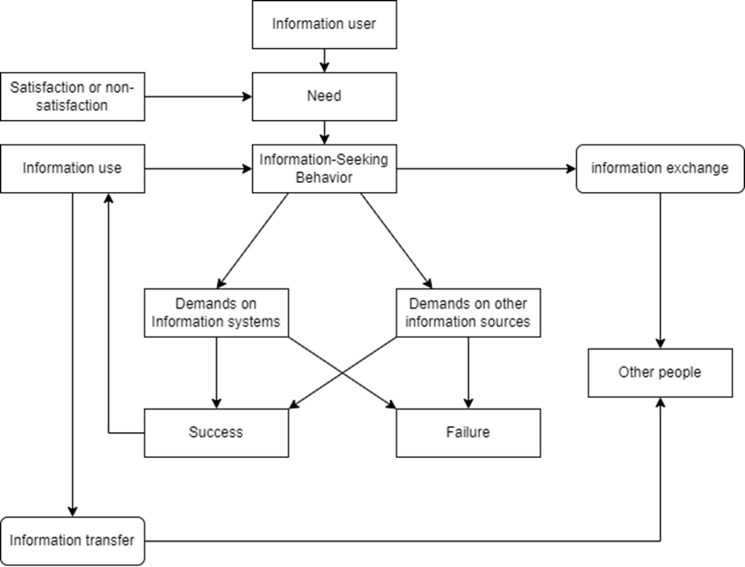

Wilson’s 1999 model indicates that an information user often has different needs and many information-seeking patterns are involved in the process of consulting various sources of information.
Wilson’s 1999 model indicated that information users have needs and these needs may originate from a previous level of satisfaction or non-satisfaction with the acquired information. The first core variable of Wilson’s1999 model is the information user, which was the pregnant woman for this study. It is evident that according to Wilson’s 1999 model, information needs determine the information systems and would be used (information access) or exchanged (information exchange). An information user may personally utilize information or s/he may exchange information received with other people (information transfer). Wilson (1999) notes that an individual makes use of information (information use) found and may either fully or partially satisfy the perceived need.
Wilson’s 1999 model was initially based upon two key points;
Firstly, the model considers information needs as a secondary need and arises out of a more basic or primary need. Secondly, during the process of discovering information, the seeker tends to meet with barriers of different kinds and these barriers include personal, interpersonal, and environmental barriers (Wilson, 1999).
Interpersonal problems are likely to come into play if the information source is a person (Wilson 1997). Wilson’s (1999) model reveals that only an expressed need can be identified and satisfied by information users either by themselves or with support from others usually being frequently information professionals.

Wilson’s 1999 model indicates that an information user (pregnant women in this study) often has different needs where many information-seeking patterns are involved in the process of consulting various sources of information of which in this study the researcher in her first and second objectives was to explore information needs and to identify the sources of information available to pregnant women respectively.

Wilson (2005) indicates that Wilson’s 1999 general model involves three main views of information seeking and these include: the context of the seeker, the system utilized (manually or electronically), and then, information resources that might be drawn upon. Wilson’s 1999 model also highlights the information-seeking process and provides a feedback loop where the information-seeking is thought of as ‘iterative’ in numerous phases, rather than a ‘successive’ total information-seeking process (Wilson1981), which is also an essential part of Wilson’s 1999 model.
Wilson’s model reflects key elements of Wilson’s revised general model concerning its focus on information users, their information needs, their information-seeking behavior, and their context. In particular, it emphasizes the impact of personal and cultural influences on information seeking which relates to Wilson’s intervening variables (psychological, demographic, role-related/interpersonal, environmental, and source characteristics).

A user consults or demands numerous information systems or other sources of information (Wilson 1999). The result of these demands leads either to success/satisfaction due to useful information received or to failure/dissatisfaction due to unhelpful information or poor service, Wilson (1999) further notes that formal or informal information sources can be consulted, by information used to get to the point of satisfaction (success) of the expressed seeking.
Wilson (1999) argues that users may consult multiple sources of information depending on the nature of their information seeking. However, this study revealed that pregnant women categorically and mostly acquired information from Doctor and Nurse.
Wilson’s 1999 model of information behaviour considers the involvement of other people and various Media through information exchange in information-seeking behaviour.
Thus, the information-seeking behaviour of pregnant women in Arusha Tanzania inevitably involved Doctors, Nurses, searching on the internet, and through mobile phones to obtain information. Wilson (1999) specifies that models can be depicted conceptually or theoretically and accordingly, using a model allows the general objectives of the study to be accomplished and the research questions to be answered successfully. Wilson’s 1999 model of information-seeking behavior was specifically applied to this study because the attributes included in this model such as information user, needs, information sources and information seeking behaviour applied to this study for both research objectives and research questions.

The strength of Wilson’s 1999 model is also concerned with the circumstance that it does not simply designate a sequence of events, but it goes beyond that and describes a sequence of human behavior by referring to relevant variables. The attributes of the model include information user, information need, information-seeking behavior, demands on information systems, and other information sources. Other attributes are success or failure, information use, information exchange or transfer, other people, and satisfaction and non-satisfaction.

Wilson’s 1999 model is criticized in that model’s central focus is on the general processes of information seeking and not on the information search context or the types of information that are available (Al-Suqri and Al-Aufi 2015).
For example, Wilson admits that his 1981 model paid inadequate attention to contextual factors: “the limitation of this kind of model, however, is that it does little more than provide a map of the area and draw attention to gaps in the research: it provides no suggestion of causative factors in information behavior and, consequently, it does not directly suggest hypotheses to be tested’’ (Wilson 1999). However, none of these limitations affected the outputs of this study since the study does not primarily focus on either causes or hypothesis.

Empirical Analysis of Relevant Studies

2.4.1 General Studies
According to Annual Health Bulletin, (2002) the term maternal health encompasses all aspects of physical, mental, and social wellbeing of women related to pregnancy, hence including health status during pregnancy, delivery, postpartum period, and health consequences related to pregnancy.
The year 2010 estimates show that about 800 women die every day in the world due to pregnancy and childbirth-related causes. On average every minute, at least one woman dies from complications related to pregnancy and childbirth with 20 others left with serious disabilities such as infertility, severe anemia, fistula, and incontinence (UN, 2008; WHO, 2005& 2010; UNICEF, 2003 & 2009; Waldijk, 1994).
Furthermore, 99% of these deaths occur in developing countries with the majority being from Sub-Saharan Africa and Southern Asia (Chou et al, 2012).
The above statistic revealed that there is a problem and especially in developing countries and it’s the reason that motivated the researcher to further assess the maternal health information-seeking behaviour of women in Tanzania.

2.4.2 Studies in African Countries
Sub-Saharan Africa account for about 85% of the maternal deaths in the developing world while Sub-Saharan Africa alone accounts for 56% of the deaths (Chou et al, 2012). India and Nigeria had the highest maternal mortality rates accounting for 19% and 14% of the global maternal deaths respectively. Other countries with the highest maternal mortality rates include The Democratic Republic of Congo (5%), Pakistan (4%), Sudan (3.5%), Indonesia (3%), Ethiopia (3%), Tanzania (2.9%), and Bangladesh (2.5%) (Chou et al, 2012).
HIV-infected women have a higher risk of dying due to pregnancy and childbirth-related complications than their uninfected counterparts (Terceira et al, 2003). In 2010 Sub-Saharan had the largest number of maternal deaths attributed to HIV. About 91% of the maternal deaths attributed to HIV worldwide were from Sub-Saharan followed by Southern Asia which contributed 5% of the deaths. Health care services and solutions to prevent maternal deaths from these causes do exist making maternal mortality preventable. Only if all pregnant women timely seek and access information and treatment for the arising pregnancy complications then all preventable maternal deaths will be eradicated (WHO, 2012).

World Bank, (2002) pointed out that the vast majority of maternal deaths and disabilities can be prevented through appropriate health services before, during, and after pregnancy.
Key among them is expanding services to allow women to limit or space their birth. But appropriate health services should encompass relevant maternal health information.
Therefore, to expand services to stop or reduce maternal deaths to pregnant women and females of reproductive age maternal health information seeking to pregnant women is inevitable for example information on family planning and other related information will help them to limit or space their birth which will reduce pregnancy complications. Not only that but maternal health-seeking behaviour for pregnant women will help to discover different transmitted sexual diseases in the early stage and be treated. (World Bank, 2002).
In 2007 women in high-income countries 99% were attended by skilled health staff compared to more than half of births in Asia and sub-Saharan Africa that were not attended by skilled health staff. (World Bank, 2008). It shows that Africa lacks suitably skilled health staff to offer relevant maternal health information to pregnant women compared to developed countries.

In Tanzania, trends of maternal mortality have remained high. According to Tanzania Demographic and Health Survey which uses the sisterhood method to estimate maternal mortality, the ratio was 578 per 100,000 live births in 2004-2005 which went down slightly to 454 per 100,000 live births in 2010. However, in Tanzania’s Demographic Health Survey-Malaria Indicator Survey (TDHS-MIS) 2015-16, the ratio had again gone up to 556 per 100,000 live births, a trend which shows that strategies for reduction of maternal mortality have not worked (National Bureau of Statistic, 2010).

2.4.3 Health 1nformation Seeking
Health information seeking represents intentional, active efforts to obtain specific information above and beyond the normal patterns of media exposure and use of interpersonal sources (Atkin, 1973; Griffin, et al., 1999). It includes "any non-routine media use or interpersonal conversation about a specific health topic and thus includes behaviours such as viewing a special program about a health-related treatment, using a search engine to find information about a particular health topic on the Internet, and/or posing specific health-related questions to a friend, family member, or medical practitioner outside the normal flow of conversation" (Niederdeppe, et al., 2007), Bass et. al. (2006) add health information seeking, whether through the Internet or traditional channels, generally reflects motivated behaviours. A health consumer's motivation may stem from a recent diagnosis or a new physical problem that fosters interest in self-care or care giving. In turn, the role of health information seeking (among persons who are not health care providers) may be as a patient, a family member, a friend, or a caregiver. For example, Echlin and Rees (2002) assessed how persons in diverse life roles search for information about a personal cancer diagnosis or treatment decision (e.g., Echlin and Rees, 2002). Health information seeking is a proxy for health seeking behaviour. Health information seeking field is about how people look for information and to create interventions to aid in their searches for information acquisition. Therefore information seeking can positively impact on individual’s morbidity and mortality. (Ministry of Health Malaysia, 2015)

2.4.4. Health Information-Seeking Behaviour in Tanzania
In Tanzania, studies on maternal health information-seeking have primarily centered on rural women. A study by Mwangakala (2012) found that the majority of women chose to get information about their maternal health from qualified healthcare providers. However, the limited accessibility of these providers led many expecting mothers to seek information from traditional birth attendants and other women in society. Much of the information gained therefore was based on personal experiences and opinions rather than expert knowledge, which prevented the women from taking danger signs seriously. Similar findings conducted in rural Tanzania on seeking health information: exploring sources of maternal health information were also reported by Kassim and Katunzi-Mollel, (2017).

Studies on health information-seeking behaviour have also shown large reliance on oral sources of information, with the preference being for skilled health providers; for instance, the study by, Benard and Lwoga, (2017) found out that. However, Mwaisela and Mwantimwa, (2018) have found out that preferences for the source of health information varied from person to person, depending on the reasons for seeking information, although oral sources were also the most frequently used sources among women seeking breastfeeding information.

2.4.5 Maternal Mortality in Arusha Municipality.
Maternal and under-five mortality rates are among the leading killers of females of reproductive age and children in Arusha City Council in the Arusha Region.

Arusha City Council Reproductive and Child Health Coordinator’s report said that maternal deaths are accounting for 25 per 100,000 delivered mothers, while less than five years of age mortality rate is responsible for 46 deaths per 1,000 children. It also concluded that the situation has been attributed to the traditions whereby expectant mothers preferred delivering at home, rather than in hospitals, under the care of ill-equipped traditional birth attendants. (Tanzania Council Project, 2008). Arusha City Council is the area where the researcher conducted research on an assessment of maternal health information seeking behaviour among pregnant women because it showed that there was a problem as Tanzania Council project concluded above.

2.4.6 Sources of Information for Pregnant Women
Agwarwa (2011) describes an information source as a carrier of information that involves both traditional sources such as books and people, and modern sources including predominantly digital libraries and involving the use of electronic resources.
Likewise, Ingwersen and Jarverlin, (2005) describe information sources as physical or digital format entities in a variety of media providing potential information.
Similarly, Tiamiyu (2005) describes information sources as entities that facilitate communication over time and space in a society with these entities conveying information about what they represent.
Medical Library Africa (2016) describes information sources to be the various means by which information is recorded for use by an individual or an organization or how a person is informed about something or knowledge is availed to someone, a group of people, or an organization.
Yusuf (2012) emphasizes that for any meaningful information to be provided, certain relevant information sources must be consulted and it is only through such sources that information seekers can obtain information that is ideal for meaningful decision making.
In research conducted by Aaronson, et al., (1988) on the information-seeking behaviour of pregnant women in selected hospitals of Ibadan Metropolis, revealed that major sources of information were health care providers and books. Information providers topped the list with 1845 points, followed by books (1608 points), friends (925 points), print media (910 points), family (753 points), self (598 points), and audiovisual media (380 points). They finally concluded that multiple channels of acquiring information were used by pregnant women. Shieh, McDaniel, and Ke (2009) in a study of low-income pregnant women affirmed that health care providers were the highest source of information.
In a similar study on women’s health information needs and information sources, Nwagu and Ajama (2011) identified family and friends, local herb hawkers, local drug sellers (hawkers), and traditional healers as the most utilized information sources.

A study conducted in Sri Lanka by Annual Report, (2000) showed that pregnant women used the following as the sources and media of information; the Internet, books, pamphlets from the doctors, electronics books, and electronic newsletters. Others reported that they used web MDbehindin site, and MSN to browse information.

According to Ukonu and Ajaebili, (2021), the study on information-seeking behaviour of pregnant women in Africa revealed that women in Nsukka, Southeast Nigeria, used multiple sources of information with family and friends being the most common source.
Ukonu and Ajaebili, suggested that high reliance on friends and family as a source of information might have been influenced by low-literacy levels and income levels among the respondents. In addition, Ukonu and Ajaebili found that despite the rise of social media and Internet usage, mass media was declining as a primary source of health information which could have been influenced by low literacy and income among the women.

In Tanzania, a study by Mwangakala, (2012) found that the majority of women chose to get information about their maternal health from qualified healthcare providers. However, the limited accessibility of these providers led many expecting mothers to seek information from traditional birth attendants and other women in society.
Much of the information gained therefore was based on personal experiences and opinions rather than expert knowledge, which prevented the women from taking danger signs seriously. Similar findings were also reported by (Kassim & Katunzi-Mollel. 2017)

2. 4. 7 Challenges Facing Information Seeking
A study by Glenton (2002) found that barriers to accessing information include the use of medical terminology by the information source or provider which may not be understood by the information seeker and a lack of communication skills by the information seeker. Van Ryn (2002) affirms that health information professionals can exhibit biases based on race, culture, and socio-economic status when sharing information.
Parker et al., (2003) also affirm that lower levels of literacy and the understanding of medical information constitute a barrier to health information seeking. Gazali et al., (2012), on the other hand, identified low self-esteem and socio-demographic factors among the problems facing women when seeking information.

Findings on the assessment of health information literacy among women in rural lake zone, Tanzania by Ndumbaro and Kassim, (2021) indicates that women are faced with several barriers that deterred them from seeking maternal health information. Respondents mentioned that because of the shortage of health facilities in their villages, they are compelled to travel long distances to where these facilities are available so that they can have access to professional health care and maternal health information. This, according to the women, not only discourages them from seeking maternal health information from skilled health care providers but also affects their utilization of professional health care. Responses obtained revealed that the women received most of their maternal health information from non-professional health care workers, particularly community health workers (CHWs) and traditional birth attendants (TBAs).

Ndumbaro and Kassim, (2021) also mentioned that they got some information from their immediate family members, namely their mothers, grandmothers, mothers-in-law, their spouses, and other female relatives. One respondent said:
The clinic is very far from here...that means you need to be well prepared for you to go there. Sometimes you spend the whole day only attending the clinic. This has even led to poor utilization of maternal healthcare services as many of us now turn to our female relatives for maternal health information.
Decisions to seek maternal health care is another challenge and it is very complex, distressing and a lot of women had to die because decisions had not been made about whether they should go to seek maternal health information or not. The amounts of time, money, and information authority for decisions making women have at their disposal are very essential for their wellbeing, (Sundari, 1992). Decisions to seek medical care are often not made by women on their own but by their husbands, or their family, (e.g., Mothers-in-law, senior sisters among others) and as well as community members. (Prevention of maternal Mortality Network, 1992)

Lack of education is yet another challenge. Widespread ignorance is a result of lack of basic education as well as the result of low-level of awareness and poor knowledge level about maternal health. As a result many women do not know what are the danger signs and effects of prolonged labor therefore they stay in their houses without seeking medical care. (Correa, 1994).

Another challenge has been poverty; direct costs associated with maternal health care services are very high for many who viewed themselves as too poor to deliver in a facility (Ajaebu, 2013). Considering the poverty level in the country many cannot afford to pay their medical bills as such they prefer to stay at home and look for the services of traditional birth attendants who charge less or in some cases are even free of charge. Low-resource households may have trouble acquiring funds to pay for facility-based care at the time of service, particularly those families who rely on seasonal labor. Collecting necessary funds was a difficult task as few moneylenders lent to the poor, and if they did, exorbitant interest rates could make the principle escalate rapidly (Ajaebu, 2013).

4.4.8 Research Gap Identified
Several scholars have studied the concept of maternal health information-seeking behaviour from different perspectives across the globe. Onuoha and Amuda, (2013) did a survey study on the information-seeking behavior of pregnant women in selected hospitals of Ibadan Metropolis/ study emphasized that information should be considered a major ingredient in enhancing the well-being of individuals and is much needed during pregnancy. Mohamed Kasimu, (2020) did exploratory descriptive qualitative research design to investigate maternal health information needs and seeking behavior of women of reproductive age in rural Tanzania.

From the literature, review evidence suggests that studies on maternal health information-seeking behavior have not been compressively covered especially in the African context Tanzania included. Little on the maternal health information-seeking behavior of pregnant women has been covered in Tanzania, especially in Arusha. This study has assessed maternal health information-seeking behavior of pregnant women in Ngarenaro Health Center.

CHAPTER THREE

RESEARCH METHODOLOGY

3.1 Overview
Saunders et al. (2009) describe research methodology as the theory of how research should be undertaken, including the historical and philosophical assumptions upon which research is based and the implications of the method or methods adopted. This chapter provides the research methodology applied in this study. It consists of the following sections research design, area of study and justification, the population of the study, sample size, and sampling techniques. It also provides details on data collection methods and instruments, data quality control, ethical issues, and a data analysis plan.

3.2 Research Design
Kumar (2011) defines a research design as a procedural plan that is adopted by a researcher to answer questions validly, objectively, accurately, and economically. Case study research is an empirical inquiry that investigates a contemporary phenomenon within its real-life context, especially when the boundaries between the phenomenon and the context are not evident (Yin, 2009). The researcher used a case study that looked at Ngarenaro Health Center to understand the real-life situation and assess the maternal health information-seeking behavior of pregnant women. A case study approach allows the researcher to use more than one research method like questionnaires, interviews, observation, and focus groups, depending on the situation. It is also flexible with respect to data collection methods, and it saves both time and costs (Kothari 1990).

3.3 Research Approach
There are two research approaches, the Quantitative approach, which is based on the measurement of quantity or amount, and data are presented through numbers and analyzed using statistics. And the Qualitative research approach, on the other hand, is concerned with the qualitative phenomenon, relating to the quality of data represented through expressions, and pictures and is analyzed using thematic exploration (Kothari, 2004). The justification behind the choice of this approach is research questions, where the use of either quantitative or qualitative approaches does not completely address the problem. Research questions one to four of this study suited both qualitative and quantitative approaches.
In this study, the researcher used a case study research design with the application of both qualitative and quantitative methods.

3.4 Area of Study and Justification
The study was conducted at Ngarenaro Health Center (NHC) which is situated in Arusha urban area, Levolosi Ward along Sokoine/Uhuru Road. Ngarenaro Health Centre was chosen because the researcher is interested in the Maasai and Waarusha women who dominated in the Arusha region and they are still lagging in many aspects of life including maternal health care and education. It was the right area to get research respondents at the health center which is the place whereby the majority of pregnant women visit for clinics and checkups. In addition, little was known about the maternal health information-seeking behavior of pregnant women in Arusha.

3.5 The Population of the Study
The term "population of the study" refers to the social class, urban households, or
electorates from which the researcher chooses a sample to interview in order to answer specific research questions (Kumar, 2005).
Rwegoshora (2006) defines population as people or things with similar characteristics which a researcher intends to study within the context of a particular research problem. The target population for this study was pregnant women and information providers. It was drawn from 488 people whereby 485 were pregnant women and 3 were health service providers. Information providers were included because they were the ones who disseminate information about maternal health. The population of the study and sample size was made up as shown in the Table 3.1

Table 3.1: Population of the Study and Sample Size (N=82)
POPULATION OF THE STUDY |  | SAMPLE SIZE
Categories |  | SAMPLE SIZE
Pregnant Women | 485 | 80
Health Service Providers | 3 | 2
Total Population | 488 | 82
Source: Field Data (September 2022)

3.6 Sample Size
A “sample size” is a subgroup of the population you are interested in from the total population, (Kumar, 2005). The researcher formulates the category of respondents who were information rich about the problem under investigation. The sample size for this study included 82 respondents drawn from 488 of the total population from pregnant women and health information providers.
Eighty out of 485 pregnant women were used as a sample and 2 out of 3 health information providers were used as a sample whereby one was a medical doctor and the other a nurse.
Only 82 sample size was chosen for the study because this was a practical, manageable, and affordable number for gathering data and analyzing collected data in order to get accurate results rather than using more respondents who might be biased and might not be able to accurately represent the population (Rwegoshora, 2006).

3.7 Sampling Techniques
Best and Khan (2006) define sampling techniques as the process of selecting a subgroup from a larger population with elements necessary for the study. There are two types of sampling procedures; probability or random sampling and purposive or non-probability sampling. In this study, both probability and non-probability sampling were used to select the required sample for the study. The use of both techniques ensured equal representation of respondents and assisted the researcher to select the respondents based on the objectives of the study.

3.7.1 Simple Random Sampling
Simple random sampling provides an equal chance for every member of the population to be involved in the study, (Kothari, 2005). A random sample may be chosen in a number of ways depending on the size of the population, also random sampling requires a complete, accurate, and up-to-date sampling frame and this is easy.
The researcher used a sampling frame to get the sampling unit. Arusha City Council has 45 health centers to get sampling unit, therefore the researcher selected Ngarenaro Health Center from the 45 health centers because of its unique characteristic that it is the only health center which specialized in maternal health information provision. Therefore, the researcher got respondents without a problem.

3.7.2 Purposive Sampling
Purposive sampling refers to a judgment as to who can provide the best information to achieve the objectives of the study. A researcher only approaches those individuals she believes are most likely to possess the needed information and be willing to share it with her.
This type of sampling is extremely useful when a researcher wants to construct a historical reality, describe a phenomenon, or develop something about which not much is known. This sampling strategy is more common in qualitative research (Kumar, 2011). Purposive sampling was used in this study to select the maternal health information workers (1nurse and 1doctor) from the health center. They were purposively selected because of their knowledge and experience in the provision of maternal health information to pregnant women.

3.7.3 Convenience Sampling
Convenience sampling which is also known as Accidental sampling involves selecting respondents primarily based on their availability and willingness to respond, (Shaughnessy et al, 2000). The estimated number of pregnant women in the selected health center was 485 per week. That was according to the initial consultation with the Ngarenaro Health Center’s Doctor in charge.
The researcher used convenience sampling to select 80 pregnant women who were accessible in the health center when attending the clinic and they were willing to respond. Again, the researcher used convenience sampling because of time and money constraints.

3.8 Data Collection Methods
Kumar (2011) describes data collection methods as the process of obtaining information from either primary or secondary sources. The study used both secondary and primary data to achieve its objectives and to answer the research questions.

3.8.1 Secondary Data
This study used secondary data through documentary evidence such as published and unpublished materials like books, journals, and articles, as well as electronic sources of information such as the internet.
Secondary data was used because published materials give significant documented information. It also helps to broaden the base from which scientific conclusions can be drawn (Ghauri, 2002).

3.8.2 Primary Data
Kumar (2011) defined primary data as information collected for the specific purpose of a study either by a researcher or by someone else. Primary data in this study were collected through questionnaires, interviews, and observation.

3.8.2.1 Questionnaire
A questionnaire consists of a set of questions or statements to which individuals are asked to respond. The questions frequently ask for facts, opinions, attitudes, or preferences of respondents (Kumar, 2006). The methods involved one category of respondents who answered close-ended questions.
The questionnaires were the main method administered to pregnant women and the researcher collected duly filled forms. This instrument helped the researcher to reach a large number of respondents and obtain information relatively quickly for the study.

3.8.2.2 Interview
According to Kumar (2011), an interview is a method of data collection involving the presentation of oral-verbal stimuli and replies in terms of oral verbal responses. It provides in-depth information, opinions, and views by respondents. The interviews were guided by questions that were asked through verbal conversation between the researcher and respondents and the answers were recorded, respectively. This study used face-to-face interviews in which information providers (Healthcare workers) were interviewed to get accurate information. Through interviews, the researcher managed to explore more and thereby know the inner perspective of the respondents.

3.8.2.3 Observation
According to Doyle and Griffin (2009) observation is a technique that systematically records behavioral patterns of people, objects, and occurrences as they happen.
In the observation method, information is sought by way of an investigator’s direct observation without asking the respondents. The researcher observed the number of pregnant women and husbands who accompanied their wives to attend the clinic, the available sources of health information, methods used to deliver information, and the general behavior of pregnant women and their husbands, and the information providers.

3.9 Instruments for Data Collections
According to Kombo and Tromp (2006), data collection is the process of gathering specific information aimed at providing or refuting some facts. In data collection, the researcher must have a clear understanding of what and how he/she hopes to obtain the required data. Also, the researcher must have a clear vision of the instruments to be used, the respondents, and the selected area. The research instruments for this study included questionnaire, interview, and observation.

3.9.1 Questionnaire Guide
Questionnaires were the main instrument in the data collection for this study. They were distributed to 78 respondents to be filled. The questionnaires included close-ended questions which were prepared by the researcher to be filled by pregnant women.

Swahili and English languages were used in the questions to establish a better understanding of the questions. This in turn helped the researcher to collect data without problems such as language barriers.
The researcher distributed and collected questionnaire forms for almost three weeks consecutively to 78 pregnant women from the 10th of August to the 31st of September 2022 as seen in Appendix VI and VII. Overall, questionnaires were filled by the respondents although there were very few questions that were left unfilled. However, this discrepancy was irrelevant to affect the main themes of the study.
Response to the questionnaires was very high whereby 78 (86%) filled questionnaires out of 80 respondents and 2 (14%) did not return the questionnaires.

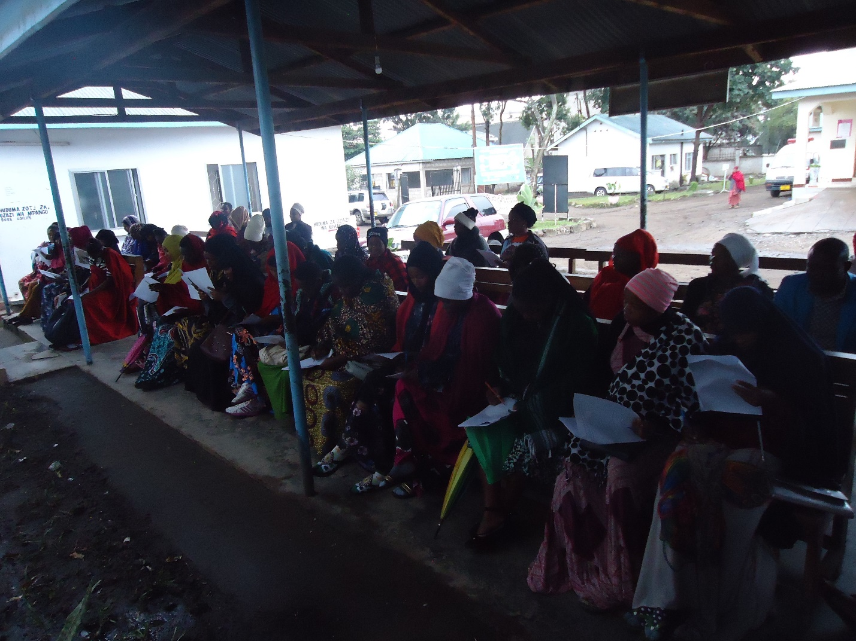
Figure 3.1 Pregnant Women at NHC Filling Research Questionnaires

3.9.2 Interview Guide
According to Kumar (2011) an interview guide is a list of issues, topics or discussion points that a researcher wants to cover in an in-depth interview. This study conducted face to face interviews that included structured and unstructured questions with the two purposively selected doctor and nurse of maternal health information provision because they have knowledge and experiences in maternal health. This assisted the researcher to come up with relevant information as the guide reminds the researcher of the areas to be covered in an interview and to have a clear understanding about the issues under research. The interview guide is attached as Appendix VIII and IX.

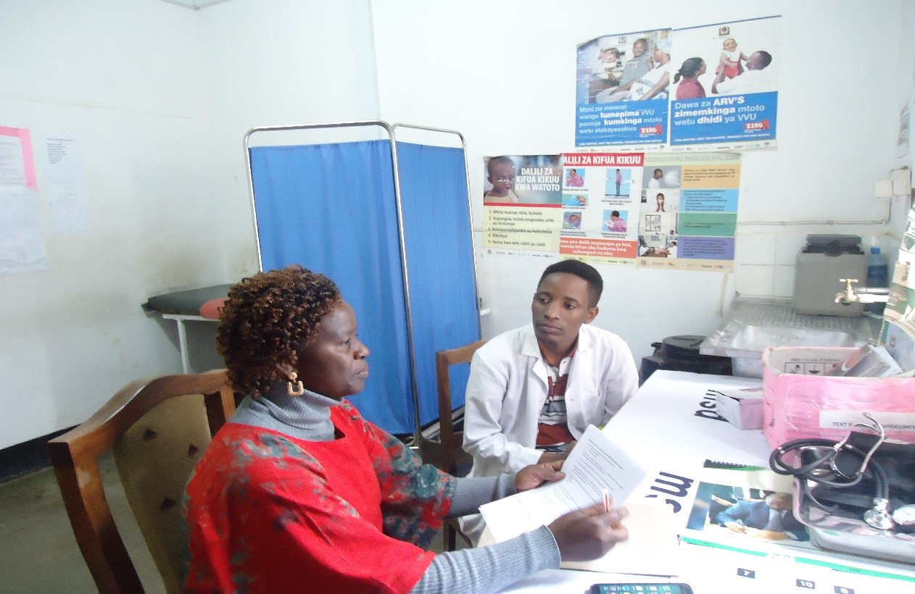
Figure 3.2 AMaternal Health Information Provider at NHC Being Interviewed by the Researcher

3.9.3 Observation Check list
An observation guide serves to keep the researcher on track towards research objectives and facilitates the ethnographic data gathering process (Roller and Lavrakas, 2015). The study used direct observation to improve the validity and reliability of data obtained from questionnaires and interviews.

The observation check list reminds the researcher of key points of observation as well as the topics of interest associated with each-; for example, the methods used to deliver information to pregnant women in NHC. It also helped the researcher to verify the validity of information obtained through other methods. (See Appendix X).

3.10 Data Quality Control
According to Encyclopedia of Survey Research Methods (2008) data quality control refers to efforts and procedures that survey researcher put in place to ensure the quality and accuracy of data being collected using the methodologies chosen for particular study. In this study data reliability and validity were assured by data quality control techniques. Generally, reliability is the consistency with which a measuring instrument yields a certain result when the entity being measured has not changed. The validity of measuring instruments, on another hand, is the extent to which the instrument measures what is supposed to measure (Leedy and Ormrod, 2005). The researcher used this technique in order to avoid bias and ensure the accuracy of data. The following data quality control methods were used in the study;

3.10.1 Pre-testing of Research Instruments
According to Kumar (2011) pre-testing is a practice of testing something developed before its actual use to ascertain the likely problems with it. The purpose of pre-testing is not to collect data but to identify problems that the potential respondents might have in either understanding or interpreting the question. The pre-testing of research instruments entails a critical examination of each question as to its clarity, understanding, wording and meaning as understood by potential respondents with a view to removing possible problems with the question.
A pretest was conducted to five pregnant women whereby 5 questionnaires were distributed. Initially, the questions were found not to be clear and also noted that English Language was difficulty to make clear understanding but with the help of the Supervisor, they were made clear.
For the interview guide, the questions were distributed to the doctors of AICC hospital for their views on the clarity of the questions. Pretesting helps to ensure the validity and reliability of data to be collected for the study and the result was used to review the instruments.

3.10.2 Triangulation
According to O’Donohue and Punch (2003) triangulation is a method of cross-checking data from multiple sources to search for irregularities in the research data. It is the act of combining several research methods to study one thing in order to check the validity of the findings. In this study the researcher used questionnaires, interviews, and observation methods. A big reason for using triangulation is to reduce biasness and ensure quality of data.

3.11 Ethical Issues
Ethical procedures for conducting research were observed during the process of preparation and conducting field study. One of the ethical issues that were considered in conducting research was seeking a research permit from relevant Authority as Appendixes I-V shown. The respondents were also assured beforehand of the confidentiality and privacy of the information they provided and that the findings were to be used for academic purposes only, and not otherwise. The anonymity of respondents was respected when sorting and processing data.

3.12 Data Analysis
Data analysis involved editing, coding, classifying and tabulating the collected data (Kothari, 2004). This study obtained data from qualitative and quantitative instruments whereby quantitative data from closed questions in the questionnaire was analyzed by Microsoft Excel while qualitative data from interview and observation was coded, arranged according to their themes as they emerged and analyzed by using content analysis method.
CHAPTER FOUR
DATA PRESENTATION, ANALYSIS AND DISCUSSION OF THE FINDINGS

Introduction
This chapter presents the data analysis, presentation, and discussions of the research findings. The chapter is organized under the following themes: introduction, demographic characteristics of respondents, age of respondents, education level of respondents, occupation, importance to visit the health centre for a check-up, purpose of visiting information health centre, information needs, availability and rate of sources of maternal health information, methods used in maternal health information provision, challenges facing pregnant women in seeking health information and ways of improving maternal health information seeking behaviour of pregnant women. The analysis and presentation of findings are based on specific objectives which include; exploring the health information needs of pregnant women in NHC, to identify the sources of information available to pregnant women in NHC, to identify the challenges pregnant women face when seeking maternal health and to find out ways for improving maternal health information seeking. The study used a mixed method. The study involved 82 participants among whom 78 were completed filled questionnaire, while 2 questionnaires were neither completed filled nor returned. Furthermore, 3 respondents were subjected to interview among them 1 was not ready for interview. Results and discussion of the study are presented in different figures, tables with frequencies, percentages and narration.

General Social Demographic Characteristics and Distribution of Respondents
This section presents the distribution of respondents, demographic characteristics of the respondents including age, occupation and education level.
Demographic characteristics of the respondents are important because they provide information on background setting of the population where the study took place.

Distribution of Respondents
The researcher was able to get information from the respondents who were involved in the study. Three types of respondents were involved in this study as follows: pregnant women were 78(97.5%) and information providers such as doctors 1 (1.25%) and nurse 1 (1.25%), the presentation is summarized in Figure 4.1.

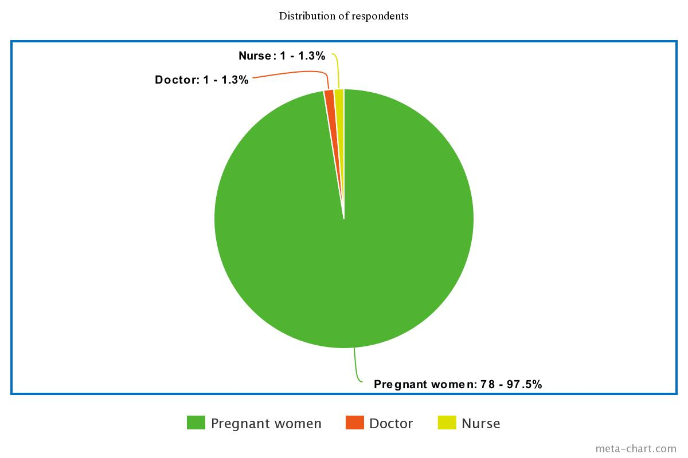
Figure 4.1 A pie chart showing the distribution of respondents

Figure 4.1 shows that pregnant women were at high rate because they are the main target of the researcher.

Distribution of Respondents by Age
The study was about an assessment of maternal health information seeking behavior. Therefore, it was important to know different age group of respondents, because getting pregnancy too early or in old age can cause pregnancy complications which may lead to death. The findings show that 9 (12%) pregnant women were in the age of 18-20, age range 21-30 were 50(64%)
respondents, age range 31-40 were 19(24%) respondents, age range 41-50 and 51-60 none of them were in those groups. Figure 4.2 shows the summarized findings.
The above findings showed that majority 64% of pregnant women ranged 21-30. Therefore, the majority of pregnant women were at the right age not too young and not too old to lead to complications or death.

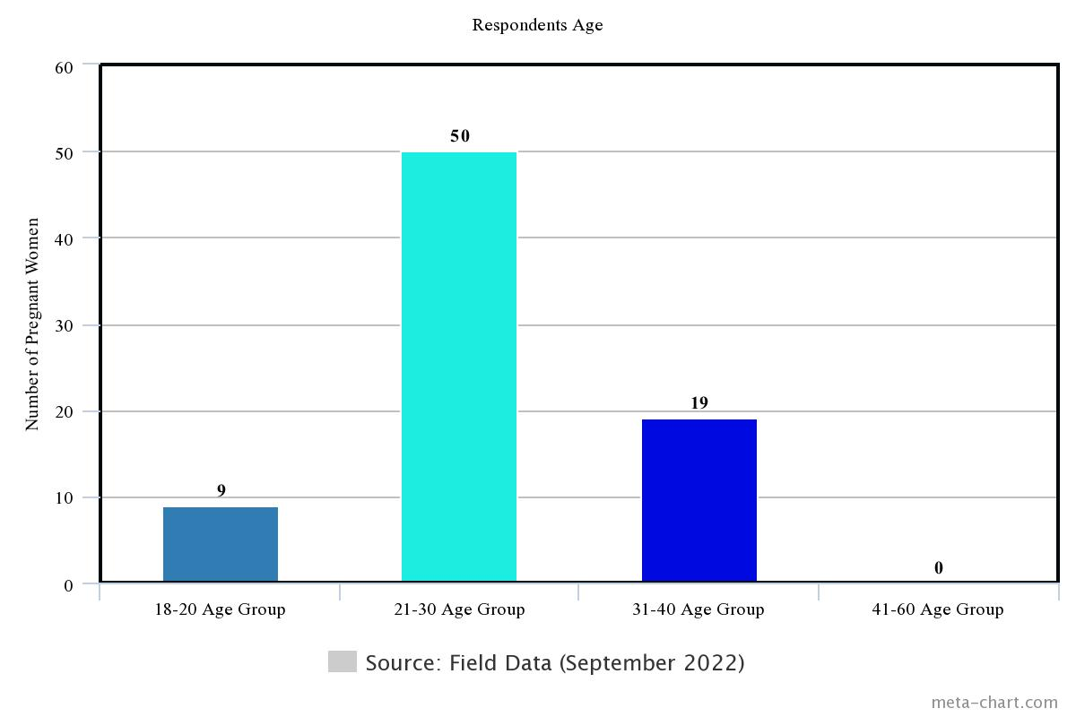
Figure 4.2 Distribution of respondents by age

Distribution of Respondents by Occupation
The respondent were asked to state their occupations. It was necessary because poverty and inadequate fund may have affected maternal health information seeking behaviour of pregnant women during antenatal, prenatal and postnatal. The findings are presented in Figure 4.3
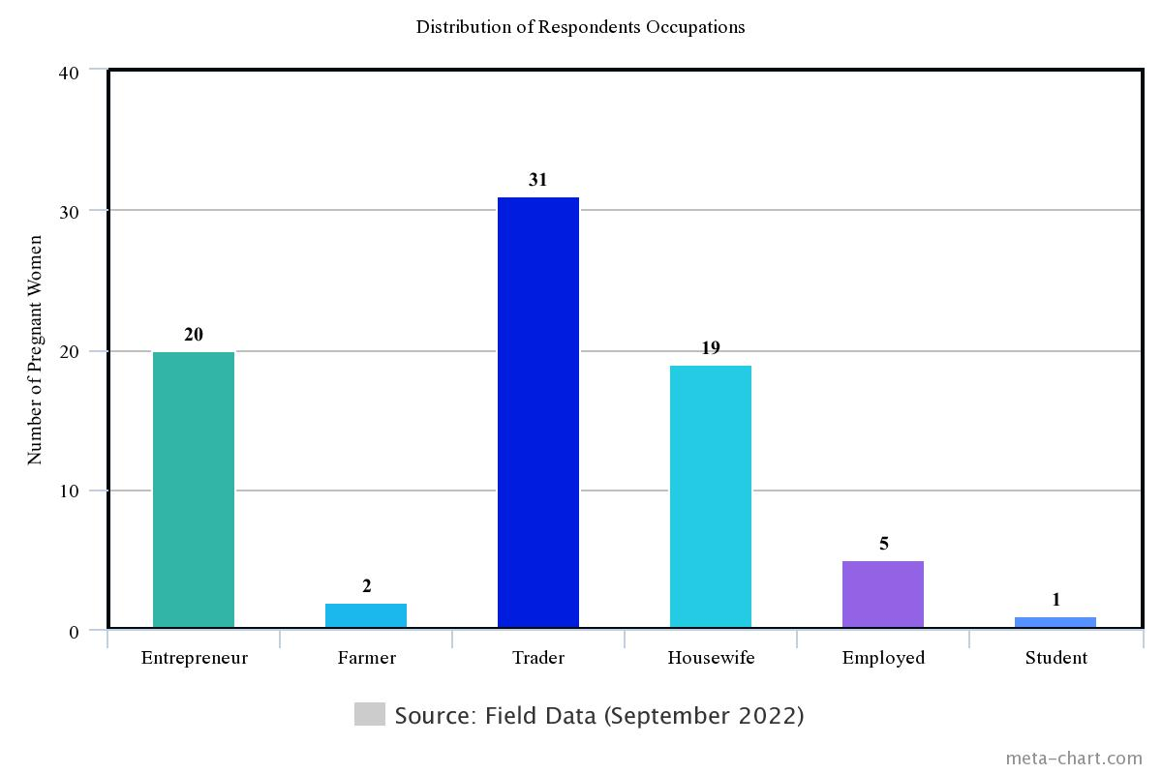
Figure 4.3 Distribution of respondents by occupation

The findings of the study show that 20 (26%) respondents were entrepreneurs, 2(3%) respondents were farmers, 31(40%) respondents were traders, 19(24%) of the respondents were housewife, 5(6%) respondents were employed and 1(1%) was a student. The results show that majority of pregnant women were business oriented whereby poverty and inadequate funds is not a big deal to them.

Education Level of Respondents
The researcher wanted to know about the educational level of the respondents because this has an impact on information-seeking behaviour among pregnant women. The results showed that respondents who had a Ph.D.- were 1(1.3%), none-had a Master’s Degree, First Degree holders were 5(6.4%), Diploma holders were 4 (5.1%), respondents who had certificate holder were 3(3.8%), secondary education were 30(38.4%) and primary education were 35(45%) respondents. The findings are presented in Figure 4.4.

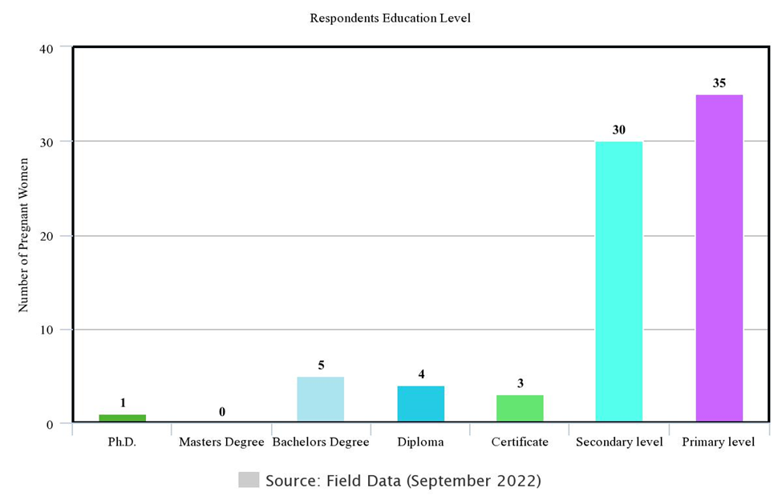
Figure 4.4. Education level of respondents

Importance of Visiting Health Center for Check up.
The researcher inquired on the rate of importance of visiting health center for checkup and was rated as follows: respondents who selected very important were 71(91%), respondents who selected important were 6 (7.7%). Respondent who selected less important was 1(1.3%) and those who selected not important were none. Figure 4.5 present the findings.

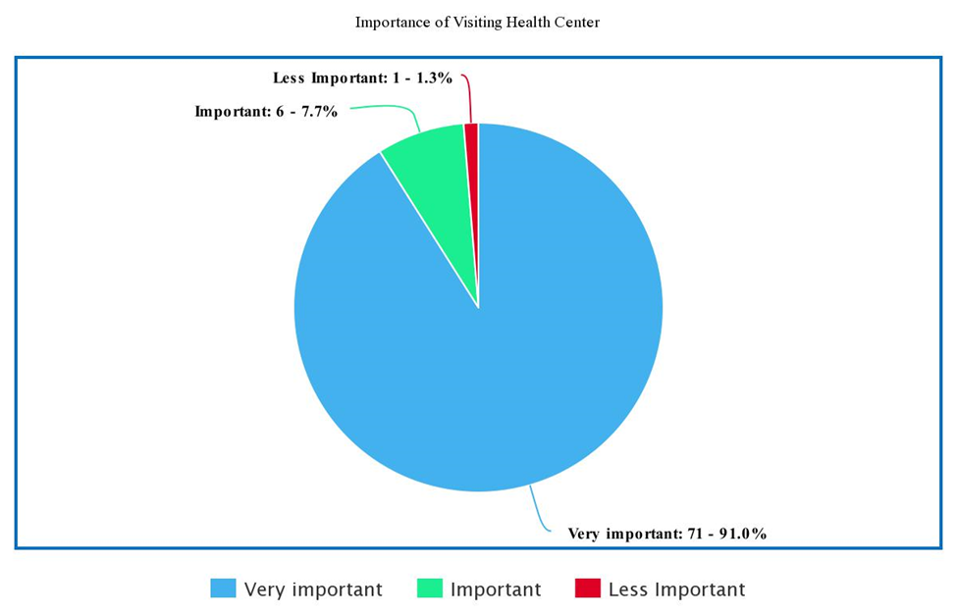
Figure 4.5 Pie Chart Showing the Importance of Visiting Health Center
The findings revealed that 91% of respondents acknowledged that it is very important for pregnant women to visit health centre for check-up.
Observations made by the researcher in seminar and discussion between information providers (doctor and nurse) indicated that majority of pregnant women attended clinic.
During interview, the doctor and nurse mentioned that 485 pregnant women attended clinic per week. This revealed how important it was for pregnant women to visit health centre for check-ups

Purposes of Visiting Health Information Center
Researcher required to classify the purposes for pregnant women to visit health information centre, and pregnant women got opportunity of choosing more than one purpose according to their point of view. The findings are presented in Figure 4.6

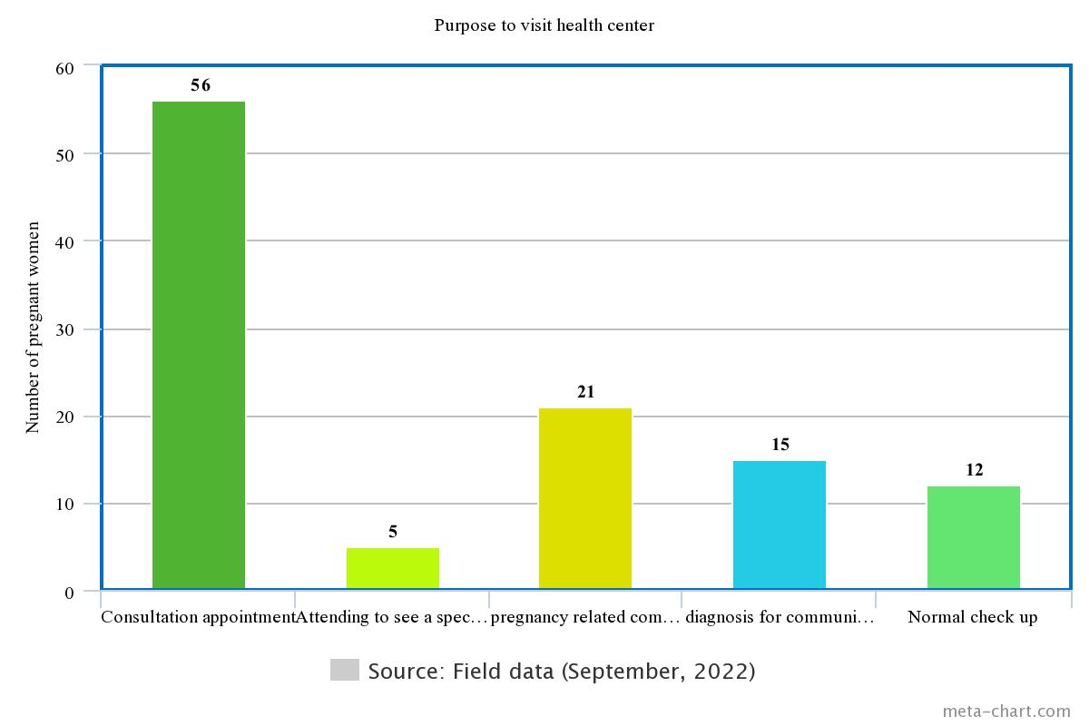
Figure 4.6 Multiple responses by pregnant women on purpose of visiting health centers
The findings from Figure 4.6 show multiple answers on the purposes of visiting health information centre whereby most of pregnant women 56(72%) were selected for consultation appointment as their main purpose and also when they get problem on pregnancy were 21(27%) which also was selected by majority, to seek information on malaria and other related diseases 15(19%) respondents mentioned as their purpose of visiting health centre and researcher observed pregnant women they have given mosquito net for prevention of malaria. During interview, one nurse said that:
“Pregnant women mostly visit health centres to attend clinics for normal check-up and emergency in case of problem during pregnancy, a nurse suggested that women should also have the habit of visiting health centre before and after pregnancy for seeking information about maternal in order to avoid complications during and after pregnancy.”(Interview with nurse on September, 2022).

Furthermore, they can be in a position to know if they have sexually transmitted diseases that can be treated and to get advices on prevention. Findings showed that women have no habit of attending health clinic to seek information for maternal health rather they just attend during pregnancy only. Such a situation may cause women to be pregnant while they have internal problem and as a result, this can cause complications and death for a woman or expectant child or both.

Type of Health Information Needs by Pregnant Women
This was the first specific objective of this study, the researcher needed to know the type of maternal health information needs of pregnant women during antenatal, prenatal, and postnatal. The findings for antenatal information are presented in Table 4.1.
Table 4.1 Antenatal Health Information Needs for Pregnant Women
Antenatal Information | Frequency | Percentage
Information on family planning | 38 | 49%
Information on menstruation cycle | 6 | 8%
Information on problems with bleeding | 19 | 24%
Information on food nutrition | 24 | 31%
Information on health risks of early pregnancy | 46 | 59%
Source: Field Data (September 2022)

The findings from Table 4.1 show multiple answers on the type of Antenatal health information needs by the pregnant women whereby high number of respondents 46(59%) require information on health risks of early pregnancy.
This was followed by information on family planning 38(49%), information on food nutrition 24(31%), information on problem with bleeding 19(24%) and information on menstruation cycle 6(8%) was found to be the least needed.
Some respondents mentioned other antenatal information such as information on the child not playing after six (6) or seven (7) weeks, Information on child growth and development. In interview conducted by the researcher with doctor quoted said that:
“Normally we provide information on medicine to increase blood, information on the prevention of worm, prevention of malaria, information on sexually transmitted diseases and information on HIV/AIDS test”. (Interview with Doctor on September 2022)
Information needs of pregnant women during antenatal were on health risks of early pregnancy, information on family planning, and information on food nutrition.

Table 4.2 Prenatal Information Needs by Pregnant Women
Prenatal Information | Frequency | Percentage
Information on tetanus | 22 | 28%
Information on the age of pregnancy | 28 | 36%
Information on the importance of attending clinics with husbands | 31 | 40%
Information on the prevention of malaria | 17 | 22%
Information on unsafe abortion | 9 | 12%
Information on anemia | 58 | 74%
Information on nausea | 22 | 28%
Information on heartburn | 28 | 36%
Information on varicose vein | 13 | 17%
Source: Field Data (September 2022)

The findings from Table 4.2 show multiple answers on the type of prenatal information needed by pregnant women whereby most respondents 58(74%) mentioned information on anaemia as most needed, followed by 31(40%) respondents who mentioned information on the importance of husbands attending clinics, information on the age of pregnancy 28 (36%), information on heartburn (36%), information on prevention of malaria 17(22%), information on varicose vein 13(17%), and information on unsafe abortion was least needed. However, other respondents mentioned information on loss of appetite was also needed.
The interview conducted by the researcher with nurse and doctor proved that information on the importance of pregnant women attending the clinic with husbands is very important in order for both to know their health, know how to care for the unborn child, and for husbands to know the important diet for their wives. But this is not taken seriously because pregnant women who attend clinic per week are 485 and husbands who attend with their pregnant wives are only 40. The researcher observed that those who attended with their husbands have their special queue and they are prioritized to seek health information before those pregnant women who didn’t attend with their husbands. Also, through seminars and discussion, the researcher observed another important information needed by pregnant women was information on preparation for delivery.

Table 4.3 Postnatal Information Needs by Pregnant Women
Postnatal information | Frequency | Percentage
Information on child caring | 48 | 62%
Information on breastfeeding | 28 | 36%
Information on HIV/AIDS and breastfeeding | 15 | 19%
Information on tetanus to mother and newly born | 17 | 22%
Information on too much bleeding (hemorrhage) | 19 | 24%
Information on the importance of cleanness | 13 | 17%
Information on attending clinic after delivery | 47 | 60%
Source: Field Data (September 2022)

The findings from Table 4.3 show that 48(62%) respondents mentioned information on child care was much needed when pregnant women visit a health centre. Forty-seven (60%) respondents mentioned information on attending clinic after delivery, information on the breastfeeding 28(36%). Information on too much bleeding (haemorrhage) scored 19(24%), information on tetanus to mother and new-born had 17(22%), information on HIV/AIDS and breastfeeding 15(19%) and information on the importance of cleanness recorded 13 (17%).

The Availability of Sources of Health Information
This was the second specific objective of the study. The researcher was eager to know sources of health information. Findings were rated as follows; the respondents who selected books were 5(6%) very poor, 6(8%) poor, 6(8%) good, and 8(10%) very good. Respondents who selected library were 3(4%) very poor, 6(8%) poor, 5(6%) good, 7(9%) very good. Respondents who selected doctor were 3(4%) very poor, none poor, 22(28%) good, 47(60%) very good. Respondents who selected nurse were 1(1%) very poor, 2(3%) poor, 18(23%) good, 27(35%) very good. Respondents who selected midwifery were 4(5%) very poor, 0 poor, 4(5%) good, 3(4%) very good. Respondents who selected family/friends were 0 very poor, 0 poor, 8(10%) good, and 9(12%) very good. Respondents who selected periodicals were 3(4%) very poor, 3(4%) poor, 4(5%) good, 3(4%) very good. Respondents who selected Newspaper were 2(3%) very poor, 1(1%) poor, 5(6%) good, 6(8%) very good. Respondents who selected radio and television were 0 very poor, 0 poor, 10(13%) good, and 9(12%) very good. Respondents who selected magazine were 3(4%) very poor, 2(3%) poor, 4(5%) good, 4(5%) very good. Respondents who selected journal were 3(4%) very poor, 2(3%) poor, 3(4%) good, and 1(1%) very good.
Respondents who selected brochures were 1(1%) very poor, 3(4%) poor, 7(9%) good, 3(4%) very good. Respondents who selected search on the internet were 0 very poor, 0 poor, 16(21%) good, and 13(17%) very good. Respondents who selected mobile phones were 0 very poor, 2(3%) poor, 13(17%) good, and 12(15%) very good. The findings are summarized in Table 4.4.

Table 4.4 Multiple Responses on the Availability of Health Information Sources
Sources | Very poor | Poor | Good | Very good
Books | 5(6%) | 6(8%) | 6(8%) | 8(10%)
Library | 3(4%) | 6(8%) | 5(6%) | 7(9%)
Doctor | 3(4%) | 0 | 22(28%) | 47(60%)
Nurse | 1(1%) | 2(3%) | 18(23%) | 27(35%)
Midwifery | 4(5%) | 0 | 4(5%) | 3(4%)
Families/Friends | 0 | 0 | 8(10%) | 9(12%)
Periodicals | 3(4%) | 3(4%) | 4(5%) | 3(4%)
Newspapers | 2(3%) | 1(1%) | 5(6%) | 6(8%)
Radio and Television | 0 | 0 | 10(13%) | 9(12%)
Magazines | 3(4%) | 2(3%) | 4(5%) | 4(5%)
Journals/Newsletters | 3(4%) | 2(3%) | 3(4%) | 1(1%)
Brochures | 1(1%) | 3(4%) | 7(9%) | 3(4%)
Search on internet | 0 | 0 | 16(21%) | 13(17%)
Mobile phone | 0 | 2(3%) | 13(17%) | 12(15%)
Source: Field Data (September 2022)

The above findings show that majority of the respondents 69(88%) first rated good and verygood to doctor as most available source of information followed by nurses 45(58%). The findings is consistent with findings of Aaronson, Mural & Pfoutz, (1998); Shieh, et al., (2009), whose studies revealed that health care providers are major sources of information for pregnant women.
These results show that pregnant women have no behaviour of seeking information from the other available sources such as books, libraries, brochures, and journals of which also have relevant information for example books rated good and very good 14(18%). The researcher observed lack of other sources of information at the centre such as library, books, newspapers, and brochures which are also important and applicable to be used if are available in the centre. In additional during the interview, Doctor said that:
“In this generation, people have no behaviour of seeking information from different sources of information instead they depend on doctors and nurses” (Interview with Doctor on September 2022)

Also, the findings showed that respondents cannot seek information from other sources due to their low level of education for most respondents 35(45%). On the other hand, librarians have to encourage reading habits in the society and pregnant women to show them that maternal health information can be obtained in books as well.

Satisfaction with the Methods Used in Maternal Health Information Provision
The researcher enquired on the rate of different methods used in maternal health information provision and was rated as follows; Respondents who selected training were 32(41%) highly satisfactory, 8(10%) satisfactory, 8(10%) moderate, 1(1.3%), unsatisfactory, 2(3%) highly unsatisfactory.
Respondents who selected seminar were 30(38%) highly satisfactory, 23(29%) satisfactory, 3(4%) moderate, 2(3%) unsatisfactory, 3(4%) highly unsatisfactory. Respondents who selected workshop were 1(1.3%) highly satisfactory, 2(3%) satisfactory, 3(4%) moderate, 1(1.3%) unsatisfactory, 3(4%) highly unsatisfactory. Respondents who selected discussion were 7(9%) highly satisfactory, 9(12%) satisfactory, 3(4%) moderate, 1(1.3%) unsatisfactory, 1(1.3%) highly unsatisfactory. Respondents who selected story telling were 3(4%) highly satisfactory, 1(1.3%) satisfactory, 2(3%) moderate, 3(4%) unsatisfactory, 3(4%) highly unsatisfactory. The findings are presented in Table 4.5.

Table 4.5 Satisfaction with the Methods Used in Maternal Health Information Sources
Methods | Highly satisfactory | Satisfactory | Moderate | Unsatisfactory | Highly unsatisfactory
Training | 32(41%) | 8(10%) | 8(10%) | 1(1.3%), | 2(3%)
Seminar | 30(38%) | 23(29%) | 3(4%) | 2(3%) | 3(4%)
Workshop | 1(1.3%) | 2(3%) | 3(4%) | 1(1.3%) | 3(4%)
Discussion | 7(9%) | 9(12%) | 3(4%) | 1(1.3%) | 1(1.3%)
Storytelling | 3(4%) | 1(1.3%) | 2(3%) | 3(4%) | 3(4%)
Source: Field Data (September 2022)
The result revealed that training satisfied most pregnant women 32 (41%) followed by seminars 30(38%). In observation, the researcher observed that seminars and discussions were mostly used to provide information at Ngarenaro health centre.
However, observation discovered that pregnant women lacked behaviour on seeking information and they were not well cooperated in discussion, they didn’t ask questions and even when doctor and nurse asked, they didn’t respond clearly. They were not aware on the seminar and researcher also related the issue on low education to the majority. During an interview one of the information providers said that:

“We are most use seminar and discussion to provide information on maternal health to pregnant women and we allow questions and discussion in order to improve the information seeking behaviour between pregnant women because they are free to seek information” (Interview with Nurse on September, 2022).

This proved that seminar and discussion was mostly used methods in NHC although was a challenge that women not selected discussion as a first highly satisfactory. The researcher relate to the low level of education among majority of pregnant women.

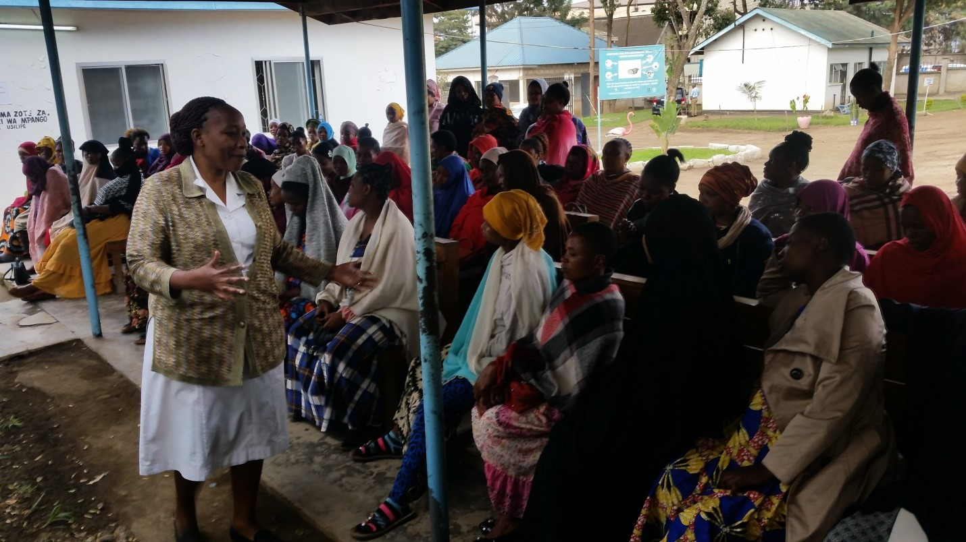
Figure 4.7 A nurse giving a seminar on maternal health to pregnant women
Figure 4.7 shows an information provider giving out maternal health information to pregnant women at NHC in form of a seminar and discussion.

The Challenges Facing Health Information Seeking Behavior of Pregnant Women
Specific study objective No.3, intended to find out the challenges faced by health information seeking behavior of pregnant women. It was important to find out those challenges because; through understanding the challenges it would have been easy for decision makers, parent ministry to find out ways to improve health.
The researcher needed the respondents to tick all challenges accordingly to their views. The responses are presented in Table 4. 6.

Table 4.6 The Challenges Affecting Maternal Health Information-Seeking Behavior of Pregnant Women
Challenges | Frequency | Percentage
Information is not provided on time | 16 | 21%
Lack of education | 33 | 42%
Information providers are too harsh | 8 | 10%
The Language used to present is not clear | 12 | 15%
Lack of cooperation from husband | 37 | 47%
Fear to get information from males doctors | 8 | 10%
Not comfortable seeking information from female doctors | 2 | 3%
Sources used in the provision are not relevant | 4 | 5%
Long distances to the health centre for check-up | 77 | 99%
Lack of library/ information centres | 9 | 12%
Lack of time | 18 | 23%
Source: Field Data (September 2022)

The results in Table 4.6 show that respondents who selected challenge of information was not provided on time were 16(21%) respondents, lack of education were 33(42%) respondents, information providers were too harsh were 8(10%) respondents, language used to present was not clear were 12(15%) respondents, lack of cooperation from husbands were 37(47%) respondents, fear to get information from males doctors were 8(10%) respondents, fear to get information from males doctors were 2(3%) respondents, sources used in provision were not relevant were 4(5%), long distance to go health centre for check-up were 77(99), lack of library/information centres were 9(12%)and lack of time were 18(23%) respondents.

Findings from the study revealed that most challenges pregnant women encountered in information seeking were: Long distance to health centre for check-up 77(99%): the researcher observed most women complaining of long distance from their home to the clinic centre. Doctor and Nurse reported women complaints of long distance from home to hospital as among of the challenges to information –seeking behaviour. Again reported that women are not coming at the centre on the right of which cause provision of information health to become somehow difficult.
This response can be attributed to long distance to health centre which most pregnant women 77 (99%) are facing.

Lack of cooperation from husband scored 37 (47%). The researcher observed that a few number of husbands attended clinic with their wives whereby there was no ratio between those who came with their husbands and those who did not. From the researcher observation statistics, per day 50 pregnant women attended health centre but husbands could not exceed 8.

During interview with doctor said that:
“Our statistics of pregnant women who attending health centre per week are 485 and husbands are 40 respectively “(Interview with Doctor on September, 2022).
However, the researcher observed lack of cooperation from husbands being one among the challenge pregnant women facing when seeking health information.
In addition, the researcher observed complaints from pregnant women about much time spent at the centre and time spent with the information providers, one pregnant woman was quoted saying that:
“They are irritating, I have never been so angry like this, they think I have to come here to boil corn”. (Field Data, 2022)
However, the researcher related referred to an insufficient numbers of information providers who assisting pregnant women compared to the numbers of pregnant women who attending clinic per day but also negative attitude of some of the pregnant women.

Ways of Improving Maternal Health Information Seeking Behavior among Pregnant Women
The last specific objective was ways of improving maternal health information seeking behavior of pregnant women. The researcher collected suggestions from participants on the multiple ways of improving maternal health information-seeking behavior among pregnant women. The findings were as follows: respondents who selected Government to provide necessary infrastructure like library that will serve as a source of health information were 4(5%) strongly disagreed and 33(42%) strongly agreed.

Respondents who selected government to provide free medical care to reduce financial constraints were 3(4%) those who strongly disagreed and 54(69%) strongly agreed. Respondents who selected government to establish more primary health centers in each district and ward to provide maternal health information were 5(6%) strongly disagreed and 70(90%) strongly agreed, ;respondents who selected promoting health information using posters displaying in different places such as hospital premises, schools and markets were 6(8%) strongly disagreed and 27(35%) strongly agreed. Findings are summarized in the Table 4.7

Table 4.7 Ways of Improving Maternal Health Information Seeking Behavior of Pregnant Women (n=78)
Description | Strongly disagree | Strongly agree
Government to provide necessary infrastructure like library that will serve as a source of health information | 4(5%) | 33(42%)
Government to provide free medical care to reduce financial constraints | 3(4%) | 54(69%)
Government to establish more primary health centers in each district and ward to provide maternal health information | 5(6%) | 70(90%)
Promoting health information using posters displaying in different places such as hospital premises, Schools and Markets | 6(8%) | 27(35%)
Source: Field Data (September 2022)

Findings from Table 4. 7 revealed that respondents strongly agreed that the government to establish more primary health centres in each district and ward to provide maternal health information to mitigate the problem of long distance to health centres women are facing.
During the interview the doctor in charge suggested that:
“The government should provide necessary infrastructure like library that will serve as a source of health information and sustainable education to the society, pregnant women and husband” (Doctor in Charge, 2022). The researcher observed that in the health centers they lacked information sources such as library, books, magazines, journals, and alike. Therefore, the government should ensure availability of these sources by increasing budget.

Summary of Chapter Four
The chapter has discussed assessment of maternal health information seeking behavior of pregnant women in NHC, health information needs of pregnant women, source of information available to pregnant women and other sections covered the challenges facing health information seeking behavior of pregnant women and ways to improve maternal health information seeking behavior among pregnant women. The findings revealed that information on health risks of early pregnancy, information on family planning, information on anemia, importance of attending clinic with husband, information on child caring, and information on attending clinic after delivery are most needed. On other hand, the findings showed that most respondents selected doctors and nurses as their sources of maternal health information.
It was also found that respondents received maternal health information through seminar and discussion although some respondents not cooperated well but this led to low level of education to majority of respondents and also lack of awareness that discussion is among of useful method of health information provision.

The findings also revealed that the most of respondents encountered the challenge of long distance to go health center to attend clinic, lack of cooperation from husband and lack of education.

CHAPTER FIVE

SUMMARY, CONCLUSION AND RECOMMENDATIONS

Introduction
This chapter presents the summary of the research findings, conclusion and recommendations of the study which was carried out to assess the information seeking behavior of the pregnant women in Tanzania. The study was guided by four specific objectives to explore maternal health information needs of pregnant women, to identify sources of information available to pregnant women, to identify the challenges facing pregnant women when seeking maternal health information and to find out ways of improving maternal health information seeking behavior of pregnant women. This chapter is divided into five sections; introduction, summary of the study (research findings), conclusion of the study, recommendation and possible areas for further study.
The study limited to assess maternal health information seeking behavior of pregnant women at Ngarenaro Health Centre. It assessed types of information needs, available source of health information, challenges faced pregnant women and ways of improving maternal health information seeking behavior of pregnant women. A case study research design was employed in this study where both qualitative and quantitative data research approach were integrated to obtain better responses from respondents. Data were collected from both secondary and primary sources through the use of face-to- face interviews, questionnaires and observation. Qualitative data were analyzed through content analysis while quantitative data were analyzed with the help of Microsoft word and Microsoft Excel

Summary of the Findings

Health Information Needs of Pregnant Women in NHC
The findings revealed that during antenatal most maternal health information needs of pregnant women were information on health risks of early pregnancy 46 (59%) followed by information on family planning 38 (49%); and information on menstruation cycle was found to be least needed.
During prenatal findings revealed that most maternal health information needs of pregnant women were information on anemia 58 (74%), followed by information on attending clinic with husband 31 (40%) and information on unsafe abortion 9(12%) found to be least in need.
However, the findings revealed that most health information needs of pregnant women during postnatal were information on child caring 48(62%), which followed by information on attending clinic after delivery 47 (60%) whereby information on the importance of cleanness was found to be least needed.

Sources of Information Available to Pregnant Women in NHC
The findings revealed that doctors were the most available sources of information on NHC whereby 69(88%) respondents responded clearly, followed by nurse of which 45(58%) respondents selected and search on internet for maternal health information 29(37%) respondents selected whereby journal was selected to be slightest source of information by 4(5%).

Methods used in Health Information Provision
The findings revealed that training was highly satisfactory whereby 32 (41%) respondents selected, followed by seminar of which 30 (38%) respondents responded while workshop 1 (1.3%) respondent selected and was found to be slightest used method. Researcher also observed seminar and discussion to be the most methods of information provision to pregnant women at NHC.

Challenges Affecting Health Information Seeking Behavior of Pregnant Women
The findings revealed that most respondents 77(99%) selected long distance to go health center for check-up as a most challenged faced information seeking behaviour followed by lack of cooperation from husband of which 37 (47%) respondents selected and lack of education was also challenge hindering information –seeking behaviour of pregnant women in NHC whereby 33(42%) respondents responded on it.

Ways of Improving Maternal Health Information Seeking Behavior of Pregnant Women
The findings revealed that government should establish more primary health centers in each district and ward to provide maternal health information since 70(90%) respondents strongly agreed, followed by government should provide free medical care to reduce financial constraints whereby 54 (59%) respondents strongly agree and government to provide necessary infrastructure like library that will serve as a source of health information 33 (42%) respondents strongly agree, while promoting health information using posters displaying in different places such as hospital premises, schools and markets found to be least selected as a way of improving maternal health information seeking behavior of pregnant women of which 27 (35%) respondents strongly agreed.

Conclusion
This study has captured many issues related to information seeking behavior of pregnant women in NHC. Information is considered a weapon in the battle against maternal mortality and pregnancy complications. Therefore, availability, access to and use of health information would certainly;-interpret to a safe delivery and healthiness life style for a woman during the whole stages of pregnancy such as antenatal, prenatal and post-natal thereby reducing maternal mortality. However, lack of available other sources of information health such as library, books, and alike in NHC has big impact to the health information seeking behavior of pregnant women of which needs the government and other health stakeholders to take into consideration. The real meaning of any investigation activity is to improve performance and in general development by generating new information that will moreover improve the previously existing practices or introduce completely new ways of doing things.

The findings of this study revealed that most information needs during antenatal were information on health risks of early pregnancy and information on family planning; during prenatal were information on anemia and information on attending clinic with husband and during postnatal were information on child caring and information on attending clinic.
The findings of this study also revealed that most available and used source of health information were doctors and nurses who are information providers. The methods used to provide information to pregnant women were seminars and discussion. According to the study done by Shieh, et al., (2009) in a study of low- income pregnant women affirmed that health care information providers were the highest source of information. Thus, according to this study was observed that the information seeking behavior of pregnant women was not satisfied since most of them depended on information providers to get maternal health information.

This study also revealed low level of education to pregnant women of which they were limited on sources of information on maternal health. In additional, a few numbers of maternal health information providers with large number of pregnant women in the health center, might affect health information seeking behavior of pregnant women. The study further noted long distance to health center for check-up, lack of cooperation from husband and lack of education were challenges pregnant women faced. Although, government to establish more health centers, provide free medical health and provide necessary infrastructure strongly selected as a ways to improve maternal health information seeking behaviour.

Recommendations
Based on the findings of the study, the researcher made the recommendations on health information provision and policy issues by addressing four levels like the family level, the information provider’s level, ministry level and the government level to provide a road map on the effective information seeking behavior of pregnant women at NHC and Tanzania in general.

Upgrading information provision by using other sources of health maternal information like books, brochures, journals and others to maximize information seeking behaviour of pregnant women at NHC and Tanzania in general.
Families and especially husbands should cooperate fully with the pregnant women in all pregnancy stages such as antennal, prenatal, and postnatal to assure that pregnant women needs and seeking the right information for good development and good delivery without any pregnancy complications or death.

Health Ministry policy reforms to improve health information infrastructures from the level of wards, districts, and regions to simplify information seeking behaviour of the pregnant women.

Library professionals and especially Tanzania Library Association and Tanzania Library Services Board should recommend the government on the importance of building information centers, special libraries in all health centers so that other sources of information can be available for the pregnant women.

Government should increase budget in maternal health information centers so that some sources of information can be available at the health centers such as newspapers, books, journals, periodicals, brochures and magazines. Also it should take into consideration that seminars and various workshops are important to maternal health information providers and pregnant women.
Lastly, all Tanzanian women should build good health information seeking and reading behavior during antenatal, prenatal and postnatal.

Area for Further Study
This study was conducted at NHC in Arusha City Council which situated in urban area which funded by the government. It is important that a similar study be conducted in other area especially in rural area for example Longido to investigate the availability and use of health sources of information. Another area of interest to examine the challenges encountered information providers in making provision of health information for example at Kibosho hospital in Kilimanjaro region which is a private hospital.
REFERENCES
Aaronson, L. S., Mural, C. M. & Pfoutz, S. K. (1988). Seeking information: Where do pregnant women go? Health Education Quarterly, 15 (3), 335-345.
Adam, J. &Kamuzora, F. (2008). Research methods for business studies. Morogoro: Mzumbe Project.
Agarwal, N. K. (2011). Information source and its relationship with the context of information seeking behavior. Seattle, USA Proceedings of the 2011 conference ACM: 48-55.
Aina L. O. (2004). Library and information text for Africa. 3rd world information services limited. Ibadan: Nigeria.
Ajaebu, O.O., (2013). Perceived Challenges of Using Maternal Healthcare Services in Nigeria. Arts and Social science journal (65) 1-8
Al-Suqri, MN & Al-Aufi, AS. 2015. Information seeking behavior and technology adoption: theories and trends. Hersley, PA: Information Science Reference
Amin, R., Chowdhury, S.A. Kamal, G.M., &Chowdhury, J. (1989). Community Health services and health care utilization in rural Bangladesh. Social Science & Medicine 29(12), 1343–1349.
Annual Health Bulletin, 2002, Sri Lanka: Department of Health Services, Sri Lanka, 2002.
Benard R & Chipungahelo MS. Accessibility of women to health information in Tanzania: a
case study of Morogoro Region. Library Review 2017; 66: 415–429. 20.
Best, J. &Khan, J. V. (2006). Research methods in education. 10th Ed. Pearson
Education Inc.
Brynard, P. (2006). Introduction to research in management-related fields. 2nd Ed. Van Schaik Publishers.
Burnett, G., Jaeger, P.T., & Thompson, K.M. (2008). Normative behavior and information: The social aspects of information access. Library & Information Science Research, 30(1), 56-66.
Case, D.O. (2006). Information behavior. Cronin (ed.) Annual Review of Information Science and Technology. Vol. 40. Medford, NJ: Information Today: 293327.
Chou, D., Inoue, M., Mathers, C., Moller, A. B., Oestergaard, M., Say, L., &Nkata, M. (2012) Trends in maternal mortality: 1990 to 2010. WHO UNICEF UNFPA and the World Bank estimates
Cresswell, J. W. (2009). Research design: Qualitative, Quantitative and Mixed approaches. 3r ed. SAGE Publication Inc.
Dodd, R., & Cassels, A. (2006). ‘Health, Development and the Millennium Development Goals’. Ann Trop Med Parasitol.
Doyle, G. & Griffin, C. (2009). Research snap shot: observation method, Neo Tech. Inc. Retrieved on 17th June 2017, from: http://www.neotech.com
Ellis, D. (1989). A behavioral approach to information science retrieval design. Journal of Documentation, 45(3):171-212.
Encyclopedia of Survey Research Methods, (2008). Quality Control.
Gazali, W. A. Muktar, F. & Gana, M.M. (2012). Barriersto utilization of maternal health care facilities among pregnant and non-pregnant women of child bearing age in Maiduguri Metropolitan Council (MMC) and Jere Igas of Borno State. Continental Journal of Tropical Medicine; 6 (1): 12-21.
http://www.wiloludjournal.com/ojs/index.php/cjtropmed/article/view/452/pdf-149
Ghauri, P. N. (2002). Research methods business studies: a practical guide. Prentice Hall.
Glenton, C. (2002). Development patient-centered information for back pain suffers. Health Expectation, 5 (4), 319-329
Hytten, F. (2001). The physiology of human pregnancy. 2nd ed. Blackwell Scientific Publications.
INASP, (2004). The use of ICTs in African Public Libraries: A survey of ten countries in Anglophone Africa.
Ingwersen, P. & Järvelin, K. (2005). The turn: integration of information seeking and retrieval in context. Springer.
Kassim M and Katunzi-Mollel KRU. Seeking health information in a rural context: Exploring sources of maternal health information in rural Tanzania. University of Dar es Salaam Library Journal.
Khan, Z., Soomro, G. Y., &Soomro, S. (1994). Mother‟s education and utilization of health care services in Pakistan.
Klein, S. (2003). A book for midwives: a maternal for traditional birth attendants and community midwives. Macmillan.
Kombo, D. K. & Tromp, D. L. A. (2006). Proposal and theses writing: an introduction. Paulines Publication Africa, Nairobi.
Kothari, C. R. (1990). Research methodology, methods and techniques. 2nd. ed. Wiley Eastern.
Kothari, C. R. (2004). Research methodology, methods and techniques. 2nd. ed. Wiley Eastern.
Kumar, R. (2005). Research methodology: step-by-step guide for beginners. 2nd. ed. Sage Publications.
Kumar, R. (2006). Research Methodology: step by step guide for beginners, First edition, 6 SAGE Publication Ltd.
Kumar, R. (2011). Research Methodology: step by step guide for beginners, 3rd ed. SAGE Publication Ltd.
Kuhlthau, C.C. (1988, 1991, 1993). Inside the search process: information seeking from the user's perspective. Journal of the American Society for Information Science, 42:361-371.
Leedy, P. D. & Ormrod, J. E. (2005). Practical Research: Planning and Design. Prentice Hall.
Lugalla, J.L.P, (2004). The availability of intervention strategies against HIV/AIDS infection in Kagera Region of Tanzania. International Africa Forum.
Marion, (2002). Importance of information: four case studies. Metuchen. Scarecrow.
McKenzie, P. J. (2002). Communication barriers and Information-seeking counter strategies in accounts of practitioner-patient encounters. Library and Information Science Research, 24 (1), 31-47
Ministry of Health, Community Development, Gender, Elderly and Children (MoHCDGEC), Ministry of Health Zanzibar, National Bureau of Statistics (NBS), Office of the Chief Government Statistician (OCGS) and ICF, 2015 – 16 TDHS-MIS Key Findings, MoHCDGEC,MoH, NBS, OCGS and ICF, Rockville, Maryland, USA, 2016.
Mwakipa, H.] (2007). Use pattern of maternal health services and determinants of skilled care during delivery in Southern Tanzania: implications for achievement of MDG-5 targets.
Mwangakala H. A. Pregnant women’s access to maternal health information and its impact on health care utilization behavior in rural Tanzania. Ph.D. Thesis, Loughborough University, Loughborough, 2012. 18.
Mwaisela N & Mwantimwa K. Breastfeeding information seeking behavior among parents in Mbeya City, Tanzania. Tanzan Journal of Health Research 2018; 20 1–9.
National Bureau of Statics, Dar es Salaam Tanzania; Tanzania Demographic and Health Survey ICF Macro Calverton, Maryland, USA, 2011.
Nwagu, W. E. &Ajama, M. (2011). Women’s health information needs and information sources: a study of a rural oil palm business community in South-Western Nigeria. Annals of Library and Information Studies 58, 270-281
Nzema&Kagaruki, (2009). Urgent actions are needed to cut maternal death.
O’Donoghue, T. & Punch, K. (2003). Quality Educational Research in Action: Doing and Reflecting. Routledge.
Oelman, (2006). Report of the maternal mortality survey. Banjul, Gambia: Ministry of Health.
Okonko, L. O. & Udeze, A. O. (2011). Detection of Hepatitis B surface Antigen (HBsAG) among pregnant women attending Antenatal Clinic at O.L.A. Catholic Hospital, Oluyoro, Ibadan, Oyo State, and Southwestern Nigeria. Nature and Science, 9(11), 54-60.
Oxford English Dictionary, (1989:944). 2nd ed. Oxford: Clarendon Press.

Pakenhan-Walsh, (2005). Comprehensive plan for reducing HIV/AIDS spread in Babati District 2004/2005.
Parker, R. M., Ratzan, S. C., & Lurie, N. (2003). Health Literacy: a policy challenge for advancing high quality health care. Health Affairs, 22 (4), 147-153
Rogo, K. O., Ouch, J. & Mwalali, P. (2006). Maternal Mortality: Disease and Mortality in Sub Saharan Africa. 2nd ed. World Bank, Washington DC.
Roller, M. R. & Lavrakas, P. J. (2015). Applied Qualitative Research Design: A Total Quality Framework Approach. Guilford Press.
Rubin, (2000). Foundation of library and information science. Neal Schuman Publishers.
Rwegoshora H. M., (2006). A Guide to Social Science Research. Mkuki na Nyota Publisher.
Saunders, N. Lewis P and Thornhill A (2007). Research Methods for Business Students: Pearson Professional Limited
Saunders, M., Lewis, P. & Thornhill, A. (2009). Research methods for business students, 5th ed.
Pearson Education Limited.
Senn, J.A. (2000). Information system in management. 4th ed. Belmont: Wadsworth.
Shieh C, McDaniel A, &Ke I. (2009). Information-seeking and its predictors in low-income pregnant women. Journal of Midwifery Women’s Health 54(5), 364-72
Sundari, T. K. (1992). The Untold Story: How the Health care systems in developing countries contribute to maternal mortality. International Journal of Health Services 22(3), 513-528

Terceira, N., Gregson, S., Zaba, B., & Mason, P. (2003). The contribution of HIV to fertility decline in rural Zimbabwe, 1985-2000. Population Studies, 57(2), 149-164.
Tiamiyu, MA. (2005). Information science; concepts, models and applications, Ibadan: University of Ibadan.
Udofia I, Okonofua F (2008). Preventing primary postpartum hemorrhage in unskilled births in Africa. African. Journal. Reproductive. Health, 12(1), 7-9.
Ukonu MO & Ajaebili NC. (2021). Social-cultural determinants of women’s health information opportunities in Nsukka, Southeast Nigeria. Asian Women, 37(1), 25-49.
Urassa, E., Lindmark, G. & Nystrom, L. (1995). Maternal mortality in Dar es Salaam, Tanzania: Socioeconomics, obstetric history, and case accessibility of health care factors. African Journal of Health Sciences, 2, 242–249.
UNICEF, (1998). The progress of Nations. UNICEF, PL&A, Oxford shire, UK. Word Bank.
UN Millennium Project (2005). Who’s got the power? Transforming health systems for women and children. UN Millennium Project Task Force on Child Health and Maternal Health.
Van Ryn, M. (2002). Research on the provider contribution to race / ethnicity disparities in medical care. Medical Care, 40(1), 114-151.
Walliman, N. S. R. (2010). Research Methods: the basics. Routledge.
Wilson, P. (1977). Public knowledge, private ignorance: toward a library information policy. Greenwood Press.
Wilson, TD. (1981), on user studies and information needs. Journal of Documentation, 37(1), 3- 15.
Wilson, TD. (1997). Information behavior: an interdisciplinary perspective. Information Processing and Management, 33, 551-572.
Wilson, TD. (1999). Models in information behavior research. Journal of Documentation, 55(3), 249-270.
Wilson. D. (2000). Human Information Behavior. Information Science, 3(2), 49-55
Wilson, TD. (2005). Evolution in information behavior modeling: Wilson’s model’. In KE, Fisher, S, Erdelez & McKenchie (eds). Theories of information behavior Medford: Information Today: 31-36.
Wilson, TD. (2006). On user studies and information needs. Journal of Documentation, 62(6):658- 670.
World Bank, (2002). World Development Report 2002, investing in health. Oxford University Press.
World Bank, (2008). World Development Report 2002, investing in health. Oxford University Press.
World Health Organization. (1992). Traditional birth attendants: A joint WHO/UNICEF/UNFPA statement. Geneva: World Health Organization.
World Health Organization, (2012). The Top 10 Causes of deaths Fact sheet N°310May 2012. World Health Organization. (2012). Maternal Health.
UNFPA. (2001). Maternal Mortality in 1995: Estimates Developed by WHO, UNICEF, UNFPA. Geneva.
Yin, R. K. (2009). Case study: Design and Methods;Applied Social Research Methods Series, 2nd ed., London: SAGE Publishing.

Yusuf, T.I. (2012). Information seeds, sources, and information-seeking behavior of women artisans in Offa metropolis.

APPENDIX I: PREGNANT WOMEN’S QUESTIONNAIRE
Dear respondent you are kindly requested to respond to this form by filling in the appropriate information. This information will be used for academic purpose and not otherwise.
Please indicate your response by putting √ in the given bracket table and filling in the blank space
1. In which age group do you belong?
A. 18-20……………………………………………………………………… [ ]
B. 21-30……………………………………………………………………… [ ]
C. 31-40…………………………………………………………………… [ ]
D.41-50………………………………………………………………….[ ]
E.51-60…………………………………………………………………….[ ]
Others, please specify………………………………………………
- State your occupation…………………………………………
- What is the highest level of education?
- Masters degree………………………………………………………...[ ]
- First degree………………………………………………………..[ ]
- Diploma……………………………………………………………………[ ]
- Certificate……………………………………………………………….[ ]
- Secondary…………………………………………………………….[ ]
- Primary.………………………………………… ……………………….[ ]
- Other specify…………………………
- Indicate how important it is to visit the health center for check up?
- Very Important………...………………………………………………..[ ]
- Important………………………………………………………………..[ ]
- Less important……………………………………………………………..[ ]
- Not important…………………………………………………………...[ ]
- What are your reasons for visiting the health center?
- For consultation appointment………………………….……………..[ ]
- To attend clinic……………………………….………………………...[ ]
- When I get problem on pregnancy………………….……………...[ ]
- To seek information on malaria and other related diseases………………………[ ]
- For normal checkup……………………………………………....[ ]
- What type of maternal health information you normally need when you visit the center?
- Antenatal information
- Information on family planning…………………….…..[ ]
- Information on menstruation cycle…………………………..[ ]
- Information on problem with bleeding…………………….[ ]
- Information on food nutrition………………………………...[ ]
- Information on health risks of early pregnancy………………....[ ]
Other specify……………………………
- Prenatal information
- Information on tetanus………………………………….[ ]
- Information on the age of pregnancy………………………...[ ]
- Information on the importance of attending clinic with your husband…………[ ]
- Information on prevention malaria...…………… ……………[ ]
- Information on unsafe abortion…………………………[ ]
- Information on common problem during pregnancy such as:
- Anemia…………………………………………[ ]
- Nausea…………………………………………….[ ]
- Heart burn………………………………………[ ]
- Varicose vein……………………………………...[ ]
Other specify……………………………
- Postnatal information
- Information on child caring………………………………..[ ]
- Information on the breastfeeding……………………….[ ]
- Information on HIV/AIDS and breastfeeding…………………..[ ]
- Information on tetanus to mother and newborn...… ………………[ ]
- Information on too much bleeding (hemorrhage)……… ………[ ]
- Information on the importance of cleanness...………… …….[ ]
- Information on attending clinic………………………………[ ]
Other specify…………………………………………………
- How do you rate the availability of the following sources of maternal health information:
 | Very poor | Poor | Good | Very good
- Books
- Library
- Doctors
- Nurse
- Midwifery
- Families/Friends
- Periodicals
- Newspapers
- Radio and Television
- Magazines
- Journals/ News letters
- Brochures
- Search on internet
- Mobile phone

- How would you rate the following methods used in maternal health information provision
 | Highly satisfactory | Satisfactory | Moderate | Unsatisfactory | Highly unsatisfactory
(a) Training
(b) Seminars
(c) Workshops
(d) Discussion
(e) Story telling

- What challenges do you facing when you are seeking information on maternal health?
- Information is not provided on time…………………………………….[ ]
- Lack of education……………………………………………………….[ ]
- Information providers are too harsh………………………………….[ ]
- Languages used to present is not clear………………………………….[ ]
- Lack of cooperation from husbands ……………………………...[ ]
- Fear to get information from males doctors…………………………….[ ]
- Not comfortable to seek information from female doctors………………..[ ]
- Sources used in provision are not relevant……………………………...[ ]
- Long distance to go health center for checkup……………………[ ]
- Lack of library/information center……………………………...[ ]
- Lack of time…………………………………………………….[ ]
- Please indicate how much you agree with each of the following ways of improving maternal mortality in Tanzania.
 | Strongly disagree | Strongly agree
- Government to provide necessary infrastructure like library that will serve as a source of health information
- Government to provide free medical care to reduce financial constraints.
- Government to establish more primary health centers.
- Promoting health information using posters displaying in different places such as:
- Hospital premises
- Schools
- Markets
Thank you for Your Time and Cooperation
APPENDIX II: PREGNANT WOMEN’S QUESTIONNAIRE
Mpendwa muulizwaji maswali, tafadhali unaombwa kujaza maswali kwa usahihi na kuwa uhuru. Taarifa hii itatumika kwa masuala ya kitaaluma na si vinginevyo.
Tafadhali weka alama ya V kwa kujaza sehemu wazi iliyoko kwenye mabano.
  - Umri wako ni upi katika makundi haya?
- 18-20…………………………………………….…[ ]
- 21-30………………………………………………….[ ]
- 31-40…………………………………………….[ ]
- 41-50………………………………………….[ ]
- 51-60………………………………………………….[ ]
Umri mwingine tafadhali eleza………………………………
  - Taja kazi yako………………………………………………
  - Kiwango chako cha juu cha elimu ni kipi?
- Degree ya Uzamivu(PHd)……………………… ………[ ]
- Shahada ya uzamili……………………………………...[ ]
- Shahada ya kwanza………………………………………..[ ]
- Stashahada……………………………………....[ ]
- Astashahada………………………………………..[ ]
- Elimu ya sekondari…………………………………[ ]
- Elimu ya msingi………………………………………[ ]
Elimu nyingine uliyonayo ni ipi, eleza…………………………………
  - Onyesha kuna umuhimu gani wakutembelea kituo cha afya ili kuchekiwa?
- Muhimu sana…………………………………………….[ ]
- Muhimu……………………………………………………….[ ]
- Kuna umuhimu kidogo………………………………………..[ ]
- Sio muhimu………………………………………...[ ]
  - Ni madhumuni gani yanayokufanya utembelee kituo cha afya
- Kwenda kwa ajili ya kupata ushauri…………………………..[ ]
- Kwa kuhudhuria kumuona daktari maalum………………...[ ]
- Wakati ninapopata tatizo nikiwa mjamzito……………………[ ]
- Kupata taarifa ya ugojwa wa malaria na magonjwa mengine yanayohusiana[ ]
- Kwa ukaguzi wa kawaida……………………………...[ ]
  - Ni aina gani ya taarifa ya afya ya uzazi unazohitaji unapotembelea kituo cha huduma.
- Taarifa za ujauzito.
- Taarifa juu ya uzazi wa mpango……………………[ ]
- Taarifa juu ya mzunguko wa hedhi………………....[ ]
- Taarifa juu ya tatizo la kutokwa na damu……………..[ ]
- Taarifa juu ya lishe ya chakula…………………...[ ]
- Taarifa juu ya afya hatarishi kwa mimba ya mapema…………[ ]
Nyingine bainisha………………………………
- Taarifa ya kabla ya kujifungua.
- Taarifa juu ya pepopunda………………………………...[ ]
- Taarifa juu ya umri wa mimba………………………...[ ]
- Taarifa juu ya umuhimu wa kuhudhuria kiliniki na mume wako…..[ ]
- Taarifa juu ya kuzuia malaria……………………….[ ]
- Taarifa juu ya kutoa mimba kusiko salama…………………[ ]
- Taarifa juu ya matatizo ya kawaida kipindi cha ujauzito kama vile:-
- Upungufu wa damu…………………………………………[ ]
- Kichefuchefu………………………………………………..[ ]
- Kiungulia……………………………………………………[ ]
- Mishipa ya varicose…………………………………………[ ]
Nyingine bainisha………………………………………
- Taarifa za baada ya kujifungua
- Taarifa juu ya kutunza mtoto……………………………………….[ ]
- Taarifa juu ya kunyonyesha………………………………………...[ ]
- Taarifa juu ya Ukimwi na kunyonyesha……………………………[ ]
- Taarifa juu ya pepopunda kwa mama na mtoto aliyezaliwa……..[ ]
- Taarifa juu ya kutokwa na damu nyingi(hemoeehage)…………..[ ]
- Taarifa juu ya umuhimu wa usafi………………………………...[ ]
- Taarifa juu ya kuhudhuria kiliniki………………………………..[ ]
Nyingine bainisha…………….……………
  - Unatathimini vipi upatikanaji wa vyanzo vya taarifa za afya ya mama mjamzito vifuatavyo (Jibu kwa Vizuri, vizuri sana, dhaifu sana, dhaifu.
 | dhaifu sana | dhaifu | Vizuri | Vizuri sana
- Vitabu
- Maktaba
- Madaktari
- Wauguzi
- Wakunga wa jadi
- Familia/marafiki
- Majarida
- Magazeti
- Radio na Runinga
- Gazeti
- Jarida (journal)
- Brosha/vipeperushi
- Mitandao
- Simu ya kiganjani
  - Unatathmini vipi njia zifuatazo zinazotumika kutoa taarifa ya afya ya mama na mtoto? Zinatosheleza, Hazitoshelezi

 | Zinatosheleza kwa kiwango kikubwa | Zinatosheleza | Wastani | Hazitoshelezi | Hazitoshelezi kabisa
- Mafunzo
- Semina
- Warsha
- Majadiliano
- Hadithi

  - Ni changamoto gani unazokutana nazo ukitafuta taarifa za afya ya mama na mtoto.
- Taarifa hazikutolewa kwa wakati………………………………[ ]
- Kutokuwepo elimu…………………………………………..[ ]
- Watoaji taarifa niwakali sana………………………………..[ ]
- Lugha iliyotumika kueleza haieleweki………………………[ ]
- Kukosekana kwa ushirikiano kutoka kwa mume………………[ ]
- Hofu ya kupata taarifa kutoka kwa madaktari wanaume…………[ ]
- Kukuwa tayari kuhudumiwa na madaktari wa kike………………[ ]
- Vyanzo vya upatikanaji wa taarifa sio vya usahihi……………….[ ]
- Umbali mrefu wa kwenda kwenye vituo vya afya kwa uchunguzi….[ ]
- Kukosekana kwa maktaba/kituo cha taarifa………………………[ ]
- Ukosefu wa muda………………………………………………[ ]
  - Tafadhali onyesha ni kiasi gani unakubaliana na njia zifuatazo zinazoweza kutumika katika kupunguza vifo vya mama na mtoto Tanzania.
 | Nakubali kabisa | Sikubali kabisa
- Serikali kujenga miundo mbinu muhimu kama vile maktaba ambazo zitasaidia kuwa chanzo cha kupata taarifa za afya.
- Serikali kutoa huduma za bure za afya ya mama mjamzito ilikupunguza tatizo la uhaba wa fedha
- Serikali kuanzisha vituo vingi vya afya ya msingi kwenye kila wilaya ili kutoa taarifa ya mama na mtoto.
- Kukuza taarifa za afya kwa kubandika matangazo sehemu tofauti kama vile:-
- Majengo ya hospitali
- Mashuleni
- Masokoni

Nashukuru kwa Muda na Ushirikiano wako.
APPENDIX III: INTERVIEW GUIDE FOR DOCTORS AND NURSES
- How many community members visit your center per day?
- How many female
- How many male
- What kind of maternal health information do you normally provide when pregnant women come into your center or seek information?
- How do you see pregnant women’s utilization levels of skilled maternal services?
- If it is low, what do you think the causes of low utilization of skilled maternal services?
- It shows that the requirements, that a woman should come with her spouse in the phase of Antenatal clinic is the main cause of delay in starting clinic, what do you think should be done to improve/change the situation?
- How can you describe the pregnant women who come to this health center in terms of
a. Income
b. Education
c. Age
- What are the maternal health information sources available in your health center and which are the most useful and why?
- What is the media of communication you usually use to deliver maternal health information to pregnant women?
- What are the challenges you face when you deliver maternal health information to pregnant women?
- What are the ways to be used to reduce or improve maternal mortality in Tanzania?
Thank you for Your Time and Cooperation
APPENDIX IV: INTERVIEW GUIDE FOR DOCTORS AND NURSES
- Je unapokea idadi ya kiasi gani ya wanajamii wanaokuja kupata huduma ya mama na mtoto kwenye kituo chako?
- Wanaume
- Wanawake
- Je, mama mjamzito anapokuja kwenye kituo cha afya, ni huduma zipi huwa kwa kawaida anapewa?
- Unaonaje kiwango cha utumiaji wa huduma za afya miongoni mwa wajawazito?
- Kama hauridhishi, unadhani nini kinasababisha utumiaji hafifu wa huduma za afya?
- Inaonekana kuwa sharti la kutaka mama mjamzito aje na mwenzi wake kwenye kliniki ya kwanza ni mojawapo ya sababu inayoletea wamama kuchelewa kuanza kliniki, unadhani nini kifanyike ili kupunguza tatizo hili?
- Unaelezeaje wamama wajawazito wanaokuja kwenye hiki kituo cha huduma ya afya kwa upande wa:-
- Kipato chao
- Elimu yao na
- Umri
- Ni vyanzo gani vya taarifa vinapatikana katika kituo chako kuhusu afya ya mama mjamzito na mtoto? na vipi vinatumika zaidi? na ni kwanini?
- Huwa mnatumia njia gani kufikisha taarifa za afya kwa mama wajawazito?
- Ni changamoto zipi mnakutana nazo wakati wa kutoa taarifa ya afya ya mama na mtoto?
- Je, njia au mbinu zipi zifuatwe ili kupunguza vifo vya mama na mtoto Tanzania?
Nashukuru kwa Muda na Ushirikiano wako.
APPENDIX V: OBSERVATION CHECKLIST
 | Item
1 | Number of husbands who accompany their wife to attend clinic
2 | Number of pregnant women
3 | Sources of information available at the clinic:  Books, Newspapers, Nurses,  Doctors, Library, Journals,  Brochures and periodicals.
4 | Type of information pregnant women needs.
5 | Methods used to deliver information to pregnant women:  - Discussion  - seminar  - workshop  - training  - Focus group
6 | Number of Information providers:  - Male  - Female
7 | General behavior of  - Pregnant women  - Information providers  - Husband

APPENDICES
APPENDIX VI.
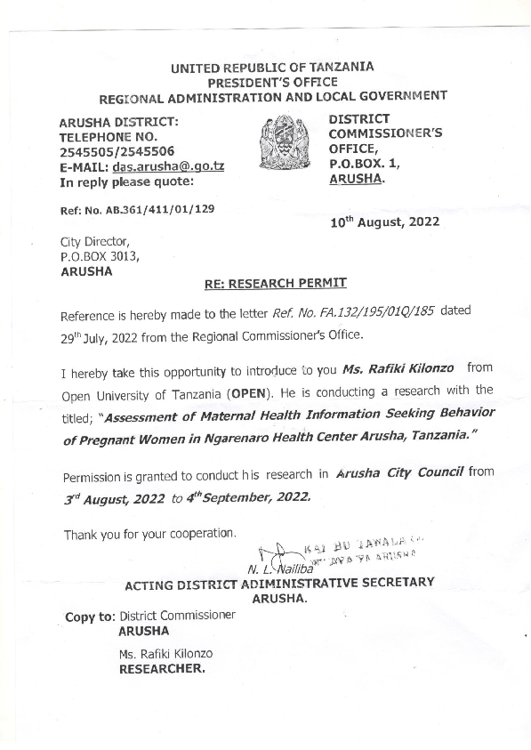
APPENDIX VII
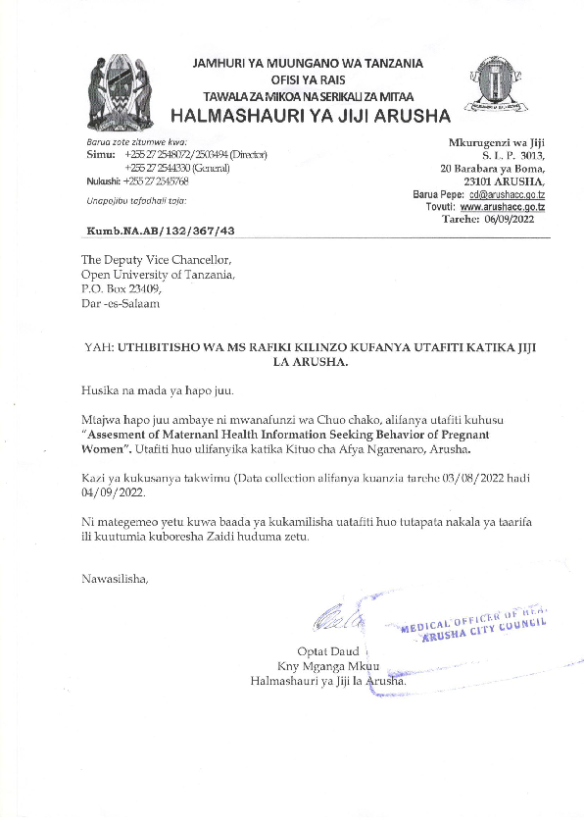
APPENDIX VIII
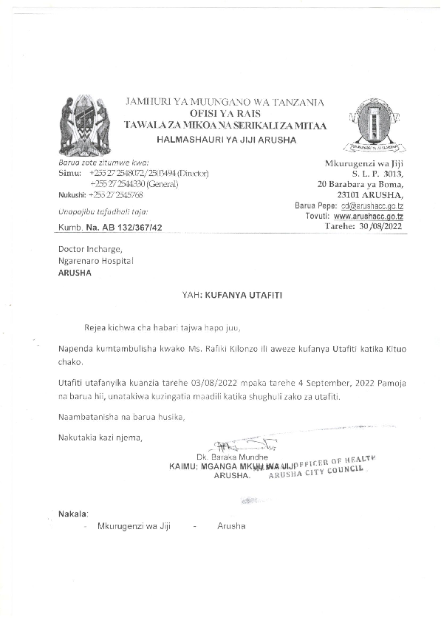
APPENDIX IX
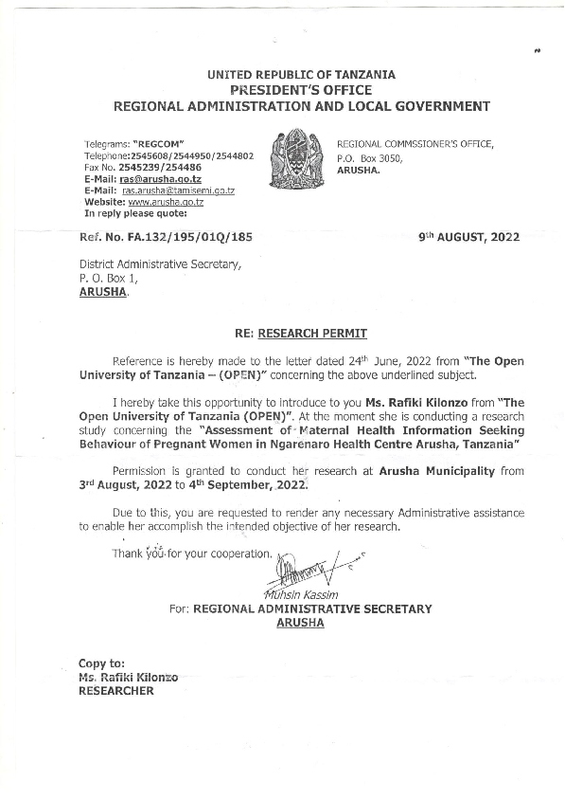
APPENDIX X

