ASSESSMENT ON THE IMPACT OF SOCIAL MEDIA USAGE ON READING CULTURE AMONG STUDENTS WITH SPECIAL REFERENCE TO JANGWANI SECONDARY SCHOOL IN TANZANIA

ANGELLA MICHAEL

A DISSERTATION SUBMITTED IN PARTIAL FULFILMENT OF THE REQUIREMENTS FOR THE DEGREE OF MASTER OF ARTS IN MASS COMMUNICATION (MAMC)
DEPARTMENT OF HISTORY, PHILOSOPHY AND LIBRARY MANAGEMENT
OF THE OPEN UNIVERSITY OF TANZANIA
2023

CERTIFICATION
The undersigned certifies that he has read and hereby recommends for acceptance by the Open University of Tanzania a research entitled: “Assessment on the Impact of Social Media usage on reading Culture among Students with special reference to Jangwani Secondary School in Tanzania” in partial fulfilment of the requirements for the award of the degree of Master of Arts in Mass Communication (MAMC).

…….………………..…………
Dr. Henry L. Mambo
(Supervisor)

………………………………
Date

COPYRIGHT
No part of this Dissertation may be reproduced, stored in any retrieval system, or transmitted in any form by any means, electronic, mechanical, photocopying, recording or otherwise without prior written permission of the author or The Open University of Tanzania in that behalf.

DECLARATION
I, Angella Michael, do hereby declare that, this dissertation is my own original work. It has never been presented to any other University or Institution. Where other people’s works have been used, references have been provided. It is in this regard that I declare this work as originally mine. It is hereby presented in partial fulfilment of the requirement for the Degree of Master in Library and Information Management (MAMC).

………………………………..
Signature

………………………………
Date

DEDICATION
This research report is dedicated to my loving late mother and father who have been wishing to see their daughter get a breakthrough. I also dedicate this work to my family as they have been standing by my side providing moral and material support making sure that I completed my studies and also for their motivation and support which continuosly made me strong. Thank you for always trusting me.

ACKNOWLEDGEMENT
I am grateful to my heavenly God for the blessings He has been providing to me in all aspects of my life, as I afford to complete this master’s degree.

Special gratitude and thanks are going to my Supervisor Dr. Henry L. Mambo for the guidance and encouragement as he was there any time I needed his help. He was more than a supervisor to me as I completed this research. Special thanks and appreciation goes to my beloved Brothers , Sisters and my sons Larry and Kelvin for their moral and material support, motivation and understanding all the time I conducted this study until the completion without forgetting my beloved friend Ezekiel Makala for his great support. Also, special thanks go to all respondents who responded and contributed positively in this study, especially all the community of Jangwani Secondary school including teachers, students and other staff members.

I owe a great debt of gratitude to my friends, all the people who were around to support me during the conduction of this study as well as so many other individuals who have been there to support and contribute to the accomplishment of the study. I am deeply grateful to each one of them.

ABSTRACT
The purpose of this study was to assess the “impact of Social Media usage on Reading Culture among students with special reference to Jangwani Secondary School in Tanzania” Specifically the study wanted to find out the relationship between social media and reading habit in order to measure extent to which students were affected either positively or negatively. The population was school teachers and students of Jangwani Secondary. The study used explanatory research design whereas a sample of 66 respondents was selected from Jangwani Secondary. Convenience sampling was used to select respondents. Data was collected through questionnaires and IBM SPSS version of 2019 used to analyze data thereafter data were presented using tables, graphs and frequency. Based on the findings all 66 (100%) were using social media and 36 (55%) out of 66 were using social media as a tool for academic materials searching and current news and information. Eventually, according to the findings 66 (100%) respondents used social media, 36 (55%) respondents were using social media to search academic materials and current information and news affairs, 60 (91%) respondents were using Facebook, Instagram and Tik Tok. Furthermore 32 (49%) respondents were spending 4-8 hours on social media. Based on the findings it is argued that social media have a positive impact on students especially in increasing reading habits and academic performance because of easy accessibility of academic materials. Teachers, matron and/or parents should guide students to have the proper ways of social media usage in order to avoid negative use that may lead into cyber bullying.
Keywords: Social Media, Social Media Usage, Reading Culture, Secondary Students.

TABLE OF CONTENTS
CERTIFICATION i
COPYRIGHT iii
DECLARATION iv
DEDICATION v
ACKNOWLEDGEMENT vi
ABSTRACT vii
TABLE OF CONTENTS viii
LIST OF TABLES xii
LIST OF FIGURES xiii
LIST OF ABBREVIATION AND ACRONYMS xiv
CHAPTER ONE 1
BACKGROUND OF THE STUDY 1
1.1 Introduction 1
1.2 Statement of the Problem 3
1.3 Research Objectives 4
1.3.1 The General Objective 4
1.3.1 Specific Objectives 4
1.4 Research Questions 5
1.5 Scope of the Study 5
CHAPTER TWO 7
LITERATURE REVIEW 7
2.1 Introduction 7
2.2 Definitions of Key Concepts 7
2.2.1 Social Media 7
2.2.2 Reading Habit 7
2.2.3 Social Media Usage 7
2.2.4 Reading Culture 8
2.3 Theoretical Framework 8
2.3.1 Media Ecology Theory 8
2.4 Empirical Review 9
2.4.1 Social Media Addiction versus Reading Habit 9
2.4.2 Impact of Social Media on the Learning 11
2.4.3 Social Media Addiction in Studying 11
2.4.4 Accessibility to Social Media among the Students 13
2.4.6 Conceptual Framework 14
2.4 Research Gap 16
CHAPTER THREE 17
RESEARCH METHODOLOGY 17
3.1 Introduction 17
3.2 Research Approach 17
3.3 Research Design 17
3.4 Area of the Study 18
3.5 Population of the Study 18
3.6 Sample Size and Sampling Procedure 19
3.7 Methods of Data Collection 19
3.7.1 Questionnaire 19
3.8 Data Collection Procedure 20
3.9 Data Processing and Analysis 20
3.9.1 Data Analysis 21
3.10 Data Quality Control 21
3.11 Ethical Issues 21
CHAPTER FOUR 23
DATA PRESENTATION AND ANALYSIS 23
4.1 Introduction 23
4.2 Demographic Characteristics of Respondents 23
4.2.1 Social Media Usage 24
4.2.2 Reasons for Using Social Media 24
4.2.3 Social Media Sites that Were Used 25
4.2.4 Time Spent in Searching Social Media 25
4.2.5 Time to Read Books 26
4.2.6 Impact of Social Media towards Reading Habit 26
4.2.7 The Relationship between Reading Culture and Social Media usage 27
4.2.8 Challenges when Reading Books 28
4.2.9 Difference between Reading Hard Copies versus Soft Copies 28
4.2.10 Suggestions from the Students 29
4.2.11 Improvement in Social Media 29
4.3 The Impact of Social Media Usage among the Students 30
4.3.1 The Uses of Social Media among the Students 31
4.3.2 The Frequency of Social Media Usage 32
4.3.3 The Relationship Between Reading Habit and Social Media Usage 33
CHAPTER FIVE 35
SUMMARY, CONCLUSIONS AND RECOMMENDATIONS 35
5.1 Introduction 35
5.2 Summary of the Study 35
5.3 Conclusions 36
5.4 Recommendations 37
5.4.1 Recommendations for Action 37
5.4.2 Recommendations for Further Studies 38
REFERENCES 40
APPENDICES 42

LIST OF TABLES
Table 4.1: Respondents General Information 24
Table 4.2: Social Media Usage (N=66) 25
Table 4.3: Reasons for Social Media Usage (N=66) 25
Table 4.4: Time Spent in Social Media (N=66) 26
Table 4.5: Challenges when Reading Books (N=66) 29

LIST OF FIGURES
Figure 2.1: Conceptual Framework 16
Figure 4.1: Time to Read Books 27
Figure 4.2: Impact of Social Media towards Reading Habit 28
Figure 4.3: the Relationship between Reading Culture and Social Media Usage 29
Figure 4.4: Improvements in Social Media 31

LIST OF ABBREVIATION
RR Randomized Response
SPSS Package for Social Sciences
UK United Kingdom

CHAPTER ONE

BACKGROUND OF THE STUDY

1.1 Introduction
This chapter introduces the study topic regarding impact of social media usage on the reading culture among students, the case of Jangwani Secondary school in Tanzania. The chapter consists of background to the study, statement of the problem, research objectives, research questions, scope of the study, limitations of the study and definition of key terms. Social media has now become part of the technological explosion in the information world. Social media sites are online platforms that build and reflect social relations among group of people that are in the same community. The coming of internet in 1990’s and emergence of new media in 1994 many people have been using social media worldwide (Daluba & Maxwell, 2013).

According to Dahlstrom, et al., (2011); Al-rahmi, et al., (2014) social media can be used by people of all ages. Backlinko (2021) since its inception in 1996, social media has managed to penetrate half of the 7.7 billion people in the world. Social media platforms almost tripled total user base in the last decade, from 970 in 2010 to 4.48 billion users in 2021. Global English Editing (2020) gathered statistics from different sources including Pew Research and Amazon that showed 35 percent of web users worldwide were reading social media sites during the Corona pandemic. For instance in China 44 percent of respondents said they increased their reading time on social media due to the Corona viruses.

Kaplan & Halein (2010) have explained social media as a group of internet oriented an application that builds on the ideological and technological foundation of the web allowing the creation and exchange of user’s generated contents. People use social media to share different activities and ideas, cherishing events and other interests. Others are using them to barter ideas, perceptions as well as personal information in terms of pictures and videos (Loving & Ochoa, 2010). The thorough use of social media is probably a causative agent of the decrease in reading culture because reading is one of the better ways of obtaining information and knowledge. According to Oloyede (2005) reading is a behavior that is manifested with no conscious exertion on the part of the learner.

Many issues of our everyday lives need the capability to read. Such ability of reading aids development of the brain and the character of an individual, as it enriches rational ability, provides insights into human issues and brings effects on attitudes and behavior (Behrman, 2009). According to Ndenego & Joseph (2022), social media has been heavily influenced by online learning, providing a stimulating learning environment for students to access academic content, and increasing access to audiovisual materials and other academic topics offers. Research shows that few students were able to devote time to social media and other academic pursuits.
Tanzania has challenges that students face when using websites on social media. These are cyberbullying, exposure to inappropriate content, reduced study time, online dating, and sexual solicitation, especially with strangers and people of different ages (House of Representatives 2019). According to Alfred & Haidari (2014) the social media situation among secondary students in Tanzania is determined by the environment of the particular school. There is an increased use of social media among secondary school students since both positive and negative use of social media among the students was exposed.

Alice, Collins, Constanze & Matthis (2014) social media usage in Tanzania is dominated by youth and the most preferred site is Facebook. For instance in Dar es Salaam and Mtwara most youths are using social media for socialization including chatting and making new friends, information searching as well as playing computer games. Therefore, while social media are mostly used by youths especially school students; it is important to consider that they use them positively and in a proper way in order to increase their academic performances.

1.2 Statement of the Problem
According to the Literacy Centre (2014) reading culture began in 4000 BC with the Sumerian pictographs as it was easy to decode since it was simply pictures of objects and activities. Although verbal communication started earlier still there was a need of establishing reading for people to communicate more formally. Since its inception in 1994, social media has become addictive to users to the extent that it creates addiction and thereby disrupts other important behaviors on people's minds. Nearly 53% of Britons who use mobile phones do so, according to a study conducted by the United Kingdom (UK) Post Office aimed at assessing the potential for anxiety disorders due to excessive mobile phone use. They say they worry about losing their phones when they are out.

Bivin, Mathew, Thulasi and Philip (2013) in their survey that involved medical students, they found that of 547 males, 23% of students were classified as nomophobia, and 64% of students had nomophobia. Found that there is a risk of developing the addiction to smart phones since nearly 77% of students checks their mobile phones more than 35 times in a day.

Middle school and college students have used social media for a variety of purposes, but mostly for non-academic purposes such as chatting with each other and sharing social items (Abdalla, Manjur & Raisa, 2021). Yu, et al., (2010) social media influences the daily lives of students in their relationships with students and social workers. Despite the use and importance of social media, there is still an unaddressed issue in academia in terms of its impact on reading culture, especially in the Tanzanian context.

The use of social media is not a problem at all but the study is posing the question that aim to assess whether social media use is increasing or decreasing reading culture among the students by referring secondary students from Jangwani Secondary in Dar es Salaam. Therefore answers to such questions are going to be used to improve the use of national and international social media, especially for academic purposes in secondary schools especially to motivate reading culture among students.

1.3 Research Objectives

1.3.1 The General Objective
The general objective of this study was to assess the impact of using social media on students’ reading culture.

1.3.1 Specific Objectives
- To determine the impact of social media use among students at Jangwani High School;
- To examine why students of Jangwani Secondary School use social media;
- To gauge how often do students of Jangwani Secondary School use social media; and
- To assess the relationship between reading and social media use among students at Jangwani Secondary School.

1.4 Research Questions
- What is the impact of social media usage among secondary students at Jangwani Secondary school?
- What do students at Jangwani Secondary school use social media for?
- How often do students at Jangwani Secondary school use social media?
- What is the relationship between reading and social media usage among students at Jangwani Secondary school?

1.5 Scope of the Study
The study assessed the impact of using social media on students’ reading culture, there are so many students but the study only picked teachers, matrons as well as students from Jangwani Secondary School as its population and a sample of 66 people that calculated by rule of thumb was selected to present others. Budget of the study was a little bit high compared to the amount of money planned to be used but all the extra expenses were fixed. Time frame for this study was three to four months including the process of collecting data from responses, analyzing and presenting them hence the completion of the report for publication.
1.6 Limitations of the Study
According to Ranjit (2011), the limitations are structural issues related to the methodological aspects of the study. The study design was a little bit unfavorable, especially in relation to the variables, also depending on the design, sometimes the lack of enough researchers with the same study was also a problem, but a researcher worked hard to adapt and eventually complete.

The research was limited in terms of data collection methods, lack of primary data and inconvenience in collecting data from respondents, thus inaccurate data collection analysis, as well as in the process of data analysis, some difficulties, for example, errors in the field can affect the analytical and presentation procedures.
Time was also a problem since the study spent much time compared to what planned earlier thus it was a problem but a researcher fixed in order to accomplish the mission.

CHAPTER TWO

LITERATURE REVIEW

2.1 Introduction
This chapter reviews theoretical, conceptual and empirical literature concerning the impact of social media usage on reading culture with reference to Jangwani Secondary School. The chapter starts by presenting the definition of key terms, followed by discussion on the theoretical and conceptual framework.

2.2 Definitions of Key Concepts

2.2.1 Social Media
Social media is a general term for websites and apps that focus on communicating, contributing to communities, interacting, sharing content and collaborating (WhatIs.com, 2021).

2.2.2 Reading Habit
Reading habit is seen as a repetitive act. According to Shen (2006), reading habits are the frequency, quantity and content of students reading. Reading habits also refer to behaviors that demonstrate reading similarity to individual reading types and tests (Chettri & Rout, 2013).

2.2.3 Social Media Usage
Verduyn, et al., (2017) use of social networks refers to online behaviors that facilitate face to face communication between users. These behaviours include liking, commenting, messaging and interacting with others. The use of social media can be considered as a combined method of communication that keeps people online for various purposes (Burke & Kraut, 2016).

2.2.4 Reading Culture
According to Hannah (2021), reading culture is an environment in which reading is protected, appreciated, respected and encouraged. Reading is central to the school curriculum and is of paramount importance to children’s personal, social and academic success, as well as to their overall health.

2.3 Theoretical Framework

2.3.1 Media Ecology Theory
Media Ecology Theory aims to understand the social impact of technology and communication (McLuhan, 1964). Theory states that the media act directly to shape and organize culture. Media ecology theory as it is the study of how media and communication processes affect one's perceptions, emotions, and values, with a focus on media studies (Parameswaran, 2008).

Marshall McLuhan (1964) understood the influence of technology on watches, radio, television, movies, and games. It focuses on identifying the relationship between technology and members of a particular culture. In media ecology theory, social media has changed society and the public is more likely to rely on these communication technologies. McLuhan felt it was nearly impossible to find a company that could be influenced by the media. As society evolves, so does its technology. Since the first books were published online, the public has been touched by both, and also by the media.

The Media ecosystem rules are defined by the growth, expiration, recovery and reversal - showing how technology affects the growth of media. McLuhan (1964) has noted that media use in education is not only about the increased number of information seekers for learning purposes rather the crisis that can be created. Information ecologies represent the procedures, goals, values of communities which are supported by technologies. Information ecologies are places where people use tools and help each in information activities through social relationships (Williamson, 2005). Information literacy is here regarded as knowledge, skills and efficient information practices in human information behavior, educators all over the world developed learning strategies for students with respect to recognition of information need, development of information strategies, and use of information sources and building of pathways for gaining knowledge. Most important standards of information literacy include standards for students’ learning for schools (AASL & AECT 1998).

According to Oblinger (2005), human information behavior in the electronic environment is characterized by easy access, online browsing and social networking. Changes in users' information behavior are influenced by new digital library tools and services. Therefore, the theory that helps to ensure that research leads to consistent results will support further research, thereby improving students' social lives, especially with regard to reading habits.

2.4 Empirical Review

2.4.1 Social Media Addiction versus Reading Habit
Isaac & Obiora, (2020) conducted a study with the same concept as they aimed to examine the impact of social media addiction on reading habit especially to those students from the high learning academic institutions such as universities and other colleges. The study came up with the results that there is a strong relationship between social media usage and reading habit. However, the study did not show the extent to which these two variables are affecting each other.

A study from Modish (2019) focused on the influence of social media sites on the reading culture among the students in Babcock University. The study found out that it's normal nowadays to find students socializing via social media sites because the accessibility to technology has become easy. Therefore, with this simple technology that enables people to socialize some students are affected either positively or negatively with these social media sites. Thus if it positively increases the reading habit among school students, the authorities, and other education stakeholders will insist on the intensive use of social media during the school time.

Junco, et al., (2011) & Magde, et al., (2009) found that the active use of social media improves students' reading habits and academic performance. On the other hand, Shabir, et al., (2014) & Lubis, et al., (2012) found that there was no significant relationship between social media use and academic performance (Rafiq, et al., 2019). According to Media Ecology Association (2019), media ecology examines how the media influence people's perceptions, understandings, emotions, and values; and how our interactions with the media help or hinder our chances of survival.

The word ecology implies the study of environments: their structure, content, and their impact on humans. Therefore, this theory will help to conduct research and ultimately provide a solution that should create a good environment for students to use social networks as a tool to supplement knowledge or ban it. However, there is no implication from education experts to indicate the level of negative or positive influence of secondary school students when using social networks, therefore, this study aims to evaluate the use of social networks relative to the increase or decrease in reading rates habits of the school's students.

2.4.2 Impact of Social Media on the Learning
Classigit (2018) conducted a study to investigate the impact of social networks on the learning process in schools. According to research findings, the advancement of technology allows students to communicate with each other through social media as a new way of learning; but on the other hand, they also seek companionship and solace on the internet when they have problems. Mohammad et al. (2020) found that social media had a positive impact on reading culture, including supplementing general knowledge, easy access to information, and maintaining contact with other friends. However, distraction during the study period was noted as an adverse effect. Social media use also negatively affects students' reading behavior as they spend more time chatting with friends instead of reading (Shehu & Shehu, 2014).

Although this study is similar to the observation of Shehu (2014), however, the following research focuses on why students use social media excessively instead of the relationship between social media use and reading culture and how these two concepts depend or influence each other.

2.4.3 Social Media Addiction in Studying
Owusu-Acheaw (2016) had an investigation on the use of social media by means of students of Koforidua Polytechnic and the effect on their reading conduct. The study discovered that 92.72% of the respondents visited social media web sites each day and spent at least half-hour to 3 hours, while sixty six (78%) respondents indicated that using social media affected their reading behavior. Similarly, eighty one (92%) of the respondents indicated they had not examine novels or fiction within the final semesters.

The study by Laura (2021) regarding reasons for social media usage among the school college students, mentioned that the most cited purpose turned into “to hold updated” at the same time as others said “it’s exciting” for that reason with those solutions most of those students is probably hooked on social media. There is a courting between time spent on social media and reading conduct and that steady use of social media leads to low analyzing conduct. The study recommended that faculty group of workers need to be recommended to spend less time on social media web sites and alternatively have to be endorsed to channel greater of their time and energies towards educational purposes (Owusu-Acheaw, 2016).

Kullik, (1994) in his study confirmed that on average students who used social media-based education have been expected to attain higher than college students who did not use social media. In some other studies conducted via (Project, 2010) indicated that scholars who used cellular gadgets accomplished higher mathematics take a look at ratings than folks who did now not use those technologies. Additionally those college students regarded to nicely make use of the social media utilization in supporting each other. Secondary education has been exploring the possibilities that technology have introduced to establishments, educators and students. As a end result, there has been fast boom in the availability and uptake of online coaching and mastering by using many faculties and universities.

Currently generation has modified the way people engage and has introduced approximately the emergence of an open social platform in the shape of social media. This permits humans to without difficulty interact and connect with each different, subsequently making the world a international village. The creation of social networks has impacted importantly on college students both in their academic and social life as a manner of making connections for various purposes. Boateng & Amankwaa (2016) showed that social media has encouraged teachers, students, and other stakeholders to band together to advocate and emphasize building knowledge in the classroom. Thus, McLoughlin & Lee (2007) found that the use of social media platforms positively impacts individuals by creating diversity among different groups of people.

The use of social media has gone global and some of the most watched social media platforms include Facebook, WhatsApp, Twitter, MySpace, Instagram, LinkedIn and Google Plus. Academic institutions and researchers are continually exploring social media technologies for collaboration and knowledge building. Today, social media is used in higher education institutions as a platform for students to connect with faculty, fellow students, and other academics around the world.

2.4.4 Accessibility to Social Media among the Students
A study conducted by Negussie & Katema (2014) in Ethiopia found that most students use laptops and smartphones to access social media sites such as Facebook. Ahmed & Qazi (2011) found that most students in the United States use smart phones to access and participate in social networks, especially when they are at school. According to ReachOut.com (2022), the most popular social media platforms are completely free, but may contain paid add-ons and regular targeted advertising. The platform is user friendly. However, some have age restrictions. For example, Facebook requires users to be at least 13 years old. These terms of use are often unknown or ignored.

These platforms are available to students if they have access to a suitable electronic device and an email address or phone number. This easy access makes it difficult to know exactly where students are going online and why and how they are using different platforms. Some students may be banned from using social media because they have been banned by their parents or teachers or because they have limited access to technology, but understanding the complexities remains difficult. ReachOut.Com (2022) however, while most of these studies show social media use, how it affects reading habits is still an issue as it increases or decreases students' reading habits.

2.4.5 Conceptual Framework

2.4.5.1 Variable Measurement
Best & Kaln (1986) said that variables are the conditions or characteristics that an experimenter manipulates, controls and observes. These are the major ingredients of a study and the basis of a research work. It is therefore implying that without variables there would be no research. Furthermore a variable is an object, event, idea, feeling, time period or any category one is trying to measure. A variable is a symbol or property that assumes different values taken from an arranged set of standards at different times or in different situations (Bandele, 2004).

The independent variable is the core of the experiment and is isolated and manipulated by the researcher. The dependent variable is the measurable outcome of this handling, the results of the experimental design. For many physical experiments, separating the independent variable and measuring the dependent is generally easy. If you designed an experiment to determine how quickly a cup of coffee cools, the manipulated independent variable is time and the dependent measured variable is temperature (Martyn, 2019).
Variables
Independent variable School students
(Social Media Usage)

Dependent variable
(Reading habits)

Figure 2.1: Conceptual Framework

Independent variables (the impact of social media usage) and dependent variables (reading habits) are impacting each other to make sure the study is being conducted as shown in the diagram above. There are also other variables that are affecting each other; students and Jangwani Secondary.

2.5 Research Gap
Ethar (2022) a research gap is simply an unanswered question or unresolved problem in a particular field that reflects a lack of existing study in that space. In this study there are different information from others authors in the same field; most of them assessed the impact of social media in different fields such as marketing, health services, political campaigns and other areas. There are also those that show the effect of social media usage in academic areas but there was still a very important area that was the impact of social media in either increasing or decreasing the culture of reading among the students whereas this study has provided the answers.

CHAPTER THREE

RESEARCH METHODOLOGY

3.1 Introduction
This chapter explains and techniques that were used to conduct this study. The chapter consists of research approach, research design, and area of study, population sample size, sampling procedures, data collection and data analysis.

3.2 Research Approach
Mixed approach was used in this study since it comprises the elements of both qualitative and quantitative. This is the process of research in which the researchers integrate qualitative and quantitative methods of data collection and analysis to best understand a research purpose (Timothy 2014).

3.3 Research Design
According to Hassan (1995), a research design is a plan or procedure of activities to be followed in order to obtain the most valuable answer to a research question or to achieve a research goal using optimal controls or variables and strategy specifications. In other words, research design explains research questions at minimal cost. Creswell & Plano (2007) define study research design as the process of collecting, analyzing, interpreting, and reporting data in a study. It is a plan to link conceptual research problems to actionable empirical studies (Creswell & Plano, 2007).

Therefore, an explanatory design was used in this study, as it is important to search for detailed information, especially in areas that have not had sufficient prior researches. Explanatory research seeks causes and reasons and provides evidence to support or refute an explanation or prediction. Explanatory research design aims at explaining descriptive information. Descriptive research can ask “what” questions, whereas descriptive research seeks to ask “why” and “how” questions (Gray, 2014).

3.4 Area of the Study
When conducting research, it is very important to select and describe the characteristics of the research areas that are appropriate for the research, as this is where the research is conducted (John, 2016). The target area for this study is the city of Dar es Salaam, as the study location is located at Janwani Secondary School. Dar es Salaam is Tanzania's most developed region with a large population. This is why so many social media users, especially high school and college students, are positively or negatively affected by their use of social media.

According to Data Reportal (2021), Tanzania has 5.4 million social media users. The number of social media users is increasing day by day, from 2020 to 2021 he will increase by 900,000 (20%). (Year!), the number of social media users in Tanzania equaled his 8.9% of the total population.

3.5 Population of the Study
Population refers to any collection of specified groups of people or objects such as educational institutions, time units and geographical areas (Showkat, 2021). Rwegoshora (2006) also defines population as the people with characteristics which the researcher wants to study within the context of a certain problem. In this research, the population was the students and teachers from Jangwani Secondary School because that is the area where the study was conducted.

3.6 Sample Size and Sampling Procedure
A sample is a group of elements selected from the entire population. Kothari (2006) defines sample size as the number of elements chosen from a universe that is neither too large nor too small. The sample size for this study was determined using simplified sampling. Sample size for this study was determined by using the Rule of Thumb formulae which states: (N ≥ 50+8M) Whereby N = sample size, M = number of study independent variables. Therefore, the study had three independent variables which are social media usage, reading habit and dependent is school students. Therefore: N ≥ 50 + 8 * 3 = 74. Based on rule of thumb calculation, the sample size will be 74 that include students and teachers.

Considering the environment of school, convenience sampling was used since it allows samples to be selected conveniently. This was a type of non-probability sampling method where the sample is taken from a group of people easy to contact or to reach; therefore the sample of this study will be 80 people whereby data from them will be collected conveniently (Lavrakas, 2008).

3.7 Methods of Data Collection
Since the study was both qualitative and quantitative in its approach therefore in data collection, a questionnaire was used to collect data from the selected sample as stated above.

3.7.1 Questionnaire
The socioeconomic and demographic characteristics of the study population play an important role in choosing data collection methods (Kothari, 2006). Consistent with the nature and approach of this study, we used a questionnaire method to collect data. Based on the mixed research design, the selection of this method assured the researcher to explore more information from the sample by considering simplicity and time consuming since the questionnaire sheets mostly contain YES and NO questions and some few explanations to be filled.

3.8 Data Collection Procedure
Warner (1965) developed a data collection procedure. This is because they claim that the randomized response (RR) technique allows researchers to obtain sensitive and authoritative information while protecting and ensuring the privacy of respondents. Therefore through risk ratio the collected data were measured based on the variables of this study whereby the samples answered all the questions to provide useful information for the completion of the research.

3.9 Data Processing and Analysis
Data analysis consists of actions and methods performed on data that help explain facts, identify patterns, develop explanations, and test hypotheses. This includes data quality assurance, statistical data analysis, modeling, and interpretation of results. Data processing can be defined as a series of actions or steps performed on data in order to examine it, organize it, transform it, integrate it, and extract it into a suitable form for later use (Talend, 2021). The main goal is to ensure the usefulness and integrity of the data, and the choice of processing methods must be rigorous.

3.9.1 Data Analysis
Data analysis generally involves a series of closely related operations performed with the aim of summarizing the collected data and organizing them in a way that answers the research question (Kothari, 2004). The collections were qualitatively and quantitatively analyzed, and content analysis was used to analyze the qualitative data by using support from the cited literature and the reviewed literature. Statistical Package for Social Sciences IBM SPSS (2019 version) was used to present qualitative analysis by coding, calculating results and presenting results in counts and percentages using charts, graphs and tables.

3.10 Data Quality Control
In research, quality control refers to the efforts and procedures employed by researchers to ensure the quality and accuracy of data collected using methods chosen for a particular study (Paul, 2008). Quality controls may vary from study to study depending on the nature of data collection methods. It can also be applied to questionnaires, computer programs that drive questionnaires, and sample management systems to ensure proper case handling. In this study, a fast data scan method was used to flag records or groups of records that met or failed certain criteria. Quality control was closely related to quality assurance because if a researcher finds an error, quality assurance can be used to eliminate the error.

3.11 Ethical Issues
Research ethics concerns the demands of routine work, the protection of human dignity, and the disclosure of information in research. Therefore, in this study, ethical issues such as: Privacy, respect for confidentiality, confidentiality, respect for humanity, and other ambiguities that may arise during the conduct of research (Georgia & Marianna, 2021).

CHAPTER FOUR

DATA PRESENTATION AND ANALYSIS

4.1 Introduction
This chapter focuses on the presentation of data on research findings. The presentation of results in this chapter was supported by the questionnaire; therefore, this chapter provided information to explain the data which was then presented in tables, charts, graphs and explanations.

4.2 Demographic Characteristics of Respondents
The questionnaire was sent to students of Janwani Secondary School. Researchers wanted to know the demographic characteristics of respondents in order to determine the relationship between them and their answers. Table 4.1 clearly shows personal information about the age, gender and education level of the respondents.

Table 4.1: Respondents General Information
Item | Category | Number of Respondents | Percentage
Age | 12-20 | 50 | 76
Age | 21-25 | 10 | 15
Age | 26-30 | 6 | 9
Age | 31 and above | 0 | 0
Gender | Male | 30 | 45
Gender | Female | 36 | 55
Class Level | Form 1-2 | 21 | 32
Class Level | Form 3-4 | 22 | 33
Class Level | Form 5-6 | 23 | 35
Source: Field Data, (2022)

4.2.1 Social Media Usage
In this aspect the researcher wanted to know the over usage of social media among the school students of Jangwani Secondary in order to understand the reasons for using social media and its impact on academics.

Table 4.2: Social Media Usage (N=66)
Item | Number of Respondents | Percentage
YES | 66 | 100
NO | 0 | 0
Total | 66 | 100
Source: Field Data, (2022).

Questionnaires were distributed to 66 students who were asked to answer, whether they were using social media or otherwise. All 66 (100%) respondents were using social media as Table 4.2 shows.

4.2.2 Reasons for Using Social Media
Social media usage seems to be taking over in secondary schools nowadays. However, there was a need to establish what were the reasons for the Jangwani Secondary School students to use social media in relation to the increase or decrease of their academic performance.

Table 4.3: Reasons for Social Media Usage (N=66)
Item | Number of Respondents | Percentage
Searching for academic materials and current information | 36 | 55
Socialization/Chatting | 14 | 21
Looking for new friends | 10 | 15
Others | 6 | 9
Total | 66 | 100
Source: Field Data, (2022).
From the findings 36 (55%) respondents indicated that they used social networks for searching information, 14 (21%) respondents said they used social media for socialization or chatting, 10 (15%) said they used social media to look for new friends, while the rest six (9%) said others.

4.2.3 Social Media Sites that Were Used
Under this question students were required to mention at least three social media sites/apps that they were using or have once used. From the findings 60 (91%) respondents mentioned Facebook, Instagram, as well as Tik Tok as their favorite social media sites while the rest mentioned; WhatsApp, Twitter and Snapchat in their answers.

4.2.4 Time Spent in Searching Social Media
The researcher intended to know the time spent in using social media among the school students of Jangwani Secondary school.

Table 4.4: Time Spent in Social Media (N=66)
Item | Number of Respondents | Percentage
Less than an hour | 14 | 21
1-4 hours | 20 | 30
4-8 hours | 32 | 49
Total | 66 | 100
Source: Field Data (2022).

From the findings, the question aimed at knowing time spent by students in surfing social media sites. Out of 66 respondents 14 (21%) said they spent less than an hour, 20 (30%) said they spent 1-4 hours while the rest 32 (49%) said they spent 4-8 hours on social media sites or applications, no one mentioned a day and above.

4.2.5 Time to Read Books
However, students used social media, the question wanted to assess if the students get time to read books.

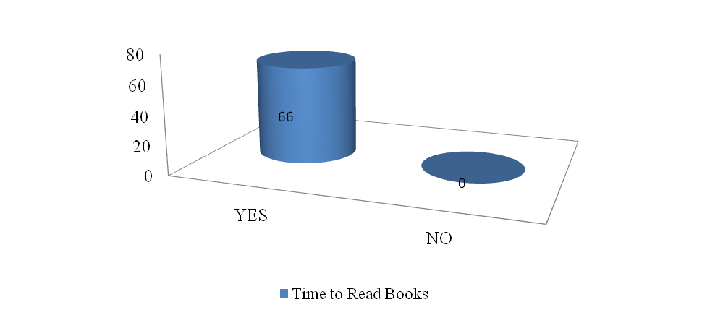Figure 4.1: Time to Read Books
Source: Field Data, (2022).

From the findings all the respondents 66 (100%) said they get time to read books and there was no student that answered NO.

4.2.6 Impact of Social Media towards Reading Habit
Measuring the relationship between Social Media usage and reading habit, the question intended to know whether they are impacting each other since this part is important in knowing whether there is positive or negative impact out of it.
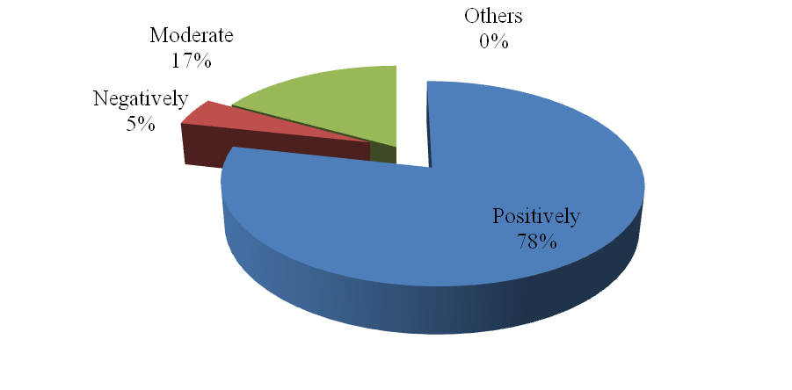

Figure 4.2: Impact of Social Media towards Reading Habit
Source: Field Data, (2022).

From all the respondents that responded to the question, 51 (78%) respondents said social media had positive impacts, three (5%) said it had negatively impacted while 11 (17%) respondents said it was moderate.

4.2.7 The Relationship between Reading Culture and Social Media usage
The researcher intended to understand the advantage and disadvantages of social media usage in relations to the reading habit

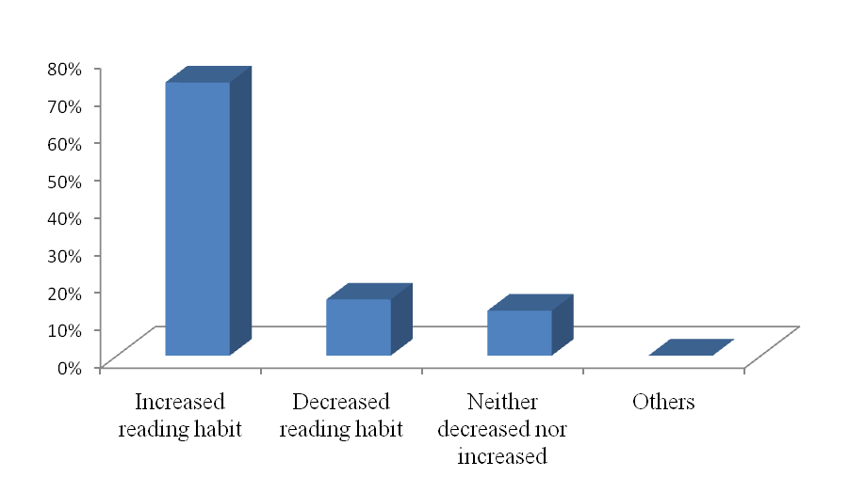Figure 4.3: the Relationship between Reading Culture and Social Media Usage
Source: Field data, (2022).
From the findings, 48 (73%) respondents said social media usage increased their reading habit, ten (15%) said it decreased their reading habit, while the rest eight (12%) respondents said it neither increased nor decreased, thus their reading habit remained the same even after using social media.

4.2.8 Challenges when Reading Books
The question established to know the challenges that face students when reading books in relation to the usage of social media.

Table 4.5: Challenges when Reading Books (N=66)
Item | Number of Respondents | Percentages
Disturbance from notifications | 34 | 51
Pop ups ads | 18 | 27
Desire of doing other staffs | 13 | 20
Others | 1 | 2
Total | 66 | 100
Source: Field Data, (2022).

From the study findings respondents asked about challenges that they are facing when reading e-books, in relation to the usage of social media. 34 (51%) respondents said they were disturbed by notifications, 18 (27%) said pop ups ads, 13 (20%) mentioned desire to do other things as a challenge to them while one (2%) said others.

4.2.9 Difference between Reading Hard Copies versus Soft Copies
The question assessed the differences between reading hard copies and soft copies. Respondents had different answers since some of them said reading hard copies were better because eBooks needed internet connection while hard copies were accessible without it. Others said it was easy to read via online since with the internet one can access more books than in hard copies. There were others who said reading soft copies was a little bit challenging for instance when using devices such as phones and tablets there were some disturbances one could face like incoming calls, notifications for texts as well as pop ups ads. Therefore reading hard and soft copies had challenges.

4.2.10 Suggestions from the Students
The researcher wanted to know the suggestions from the students, as they had to say what should be improved in social media usage among them to increase and make the improvement in reading habit. Most of these students suggested that the implementation should be in reading via social media. However, some of them suggested that there should be a strong commitment in order to focus on studying or reading rather than passing through other staff in an electronic device. Some few respondents said both reading via social media and hard copies should be implemented since some contexts need a student to read hard copies the same with soft ones.

4.2.11 Improvement in Social Media
The respondents were asked to suggest the improvements that they think should be taken into consideration in social media usage.

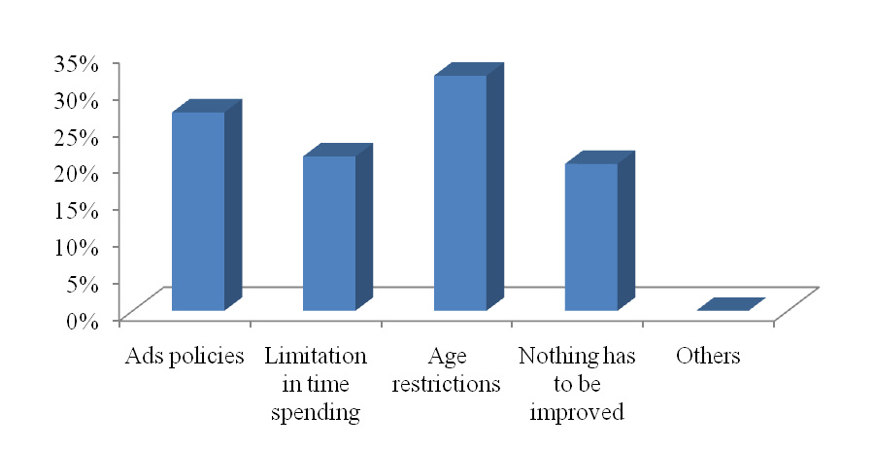Figure 4.4: Improvements in Social Media
Source: Field data, (2022).

Respondents asked the areas that should be improved in social media. Out of 66 respondents 18 (27%) said ads policies should be improved, 21 (32%) said age restriction should be considered in improvements, 14 (21%) respondents said limitation in time spending should be improved while the rest 13 (20%) said nothing had to be improved. The figure above illustrates.

4.3 The Impact of Social Media Usage among the Students
Objective number one assessed the impact of social media usage among the students of Jangwani Secondary School in relation with either the increase or decrease of reading habits among them. According to the findings social media usage have positively impacted on the students’ reading habit since most of them agreed that social media simplify the accessibility of books especially e-books and it was easy to find them compared to hard copies that someone must have it physically or he/she must attend to the library for him/her to read a certain book. For instance, from the findings, sixty six students asked if social media usage had an impact on their habit of reading books, 73% of them said that was the biggest number of the total population that said social media usage had increased their reading habit.

McLuhan (1964), in The Theory of Media Ecology, argues that social media is transforming society and that the public is becoming more dependent on these communication technologies. According to him, it was almost impossible to find a society influenced by the media. Along with the development of society, the technology has also developed. The public has been influenced by both and the media since the first book was published online. Media Ecology Development, Process, Search, Media Rules of Inversion - Shows how technology affects the development of communication.

According to Junco et al. (2011) & Magde, et al., (2009) Active use of social media improves students' reading habits and academic performance. On the other hand, Shabir, et al., (2014) & Rubis, et al., (2012) found no significant association between social media use and academic performance. However, some studies have shown no relationship between these two variables, but the results showed that social media use had a positive impact on the reading habits of students at Jangwani Secondary School.

4.3.1 The Uses of Social Media among the Students
Objective two of the study wanted to know what students used social media for, why it was worth it to them using social media. According to the findings most of these students were using social media as a tool for information searching that was equally proportional to the reading activities, for instance 55% of the total respondents said they were using social media to look for information and few others mentioned socialization as one of their main reason for their social media usage.

AASL & AECT (2020) Information literacy is viewed as knowledge, skills and efficient information practices in human information behavior. According to AASL & AECT (2020), educators around the world are developing learning strategies for their students related to identifying information needs, developing information strategies, leveraging information sources, and building pathways to knowledge acquisition. Muhammad, et al., (2020) showed that social media has a positive impact on reading culture, addition of general knowledge, easily access information, and keep in touch with other friends. However, his
distractions during the study period were identified as adverse effects. Social media use also negatively affected reading behavior as more time was spent chatting with friends than reading (Shehu & Shehu, 2014).

    - The Frequency of Social Media Usage
Objective number three sought to know how frequently Jangwani Secondary students used social media in order to measure the way social media impacted reading habits among them. From the results 49% of all the respondents who attempted the questionnaires said they spent four to eight hours surfing in social media, that is to say these students dedicate most of their prime time is using social media, the most important thing is to make good timetable for them so that they will be using them for benefits, especially for books reading in order to increase reading habit among them.
Laura (2021) mentioned why students use social media. She said the most frequently cited reasons for social media usage were; to stay up to date, while others said it was interesting. Given these answers, most of these students are likely addicted to social media for normal reasons. They found a correlation between time spent on social media and reading habits, with frequent social media use leading to lower reading habits. The study recommends encouraging faculty and staff to spend less time on social media sites and instead devote more time and energy to educational purposes (Owusu-Acheaw, 2016).

From the findings, Jangwani students seem to spend much time surfing social media, in connection to the previous results it seems that most of these students used social media for reading purposes and less for socialization and others.

    - The Relationship Between Reading Habit and Social Media Usage
Objective number four sought to measure the relationship between reading habit and social media usage in relation to the way they affected each other, from the findings social media usage and reading habit they caused each other interchangeably since students had been using social media to access books and other informative materials. For instance, in the question that wanted students to explain whether social media had positive or negative impact on their reading habit, 78% of the total respondents said they helped them positively in adding reading habit.

Reviewing the literature, Boateng & Amankwaa (2016) found that social media influences teachers, students, and other stakeholders to unite with each other to advocate and emphasize the construction of knowledge in the classroom. McLoughlin & Lee (2007) noted that the positive use of social media platforms, impact individuals by bringing diversity to different groups of people, including Google Plus.

CHAPTER FIVE

SUMMARY, CONCLUSIONS AND RECOMMENDATIONS

5.1 Introduction
This chapter draws a summary, conclusions and recommendations of the study. It also suggests areas for further research.

5.2 Summary of the Study
This study assessed the impact of social media usage on reading culture among students with special reference Jangwani Secondary School in Dar es Salaam region. The following objectives guided the study:
- To identify the impact of social media usage among the students in Jangwani secondary school;
- To examine what do students use social media for;
- To assess how often do they use social media; and

The Impact of Social Media Usage among the Students
This study conclude that; social media usage have positively impacted on the students’ reading habit since most of them agreed that social media simplified the accessibility of books especially e-books and it was easy to find them compared to hard copies that someone must have it physically or he/she must attend to the library for him/her to read a certain book. Out of 66 respondents, 48 (73%) of them were the biggest number of the total population that agreed that social media usage had increased their reading habit by stimulating easy accessibility of materials and time spending.
The Uses of Social Media among the Students
The study concludes that social media are very useful in schools since they stimulate reading habits, as 55% of the total respondents were using social media to look for academic materials and current information and few others mentioned socialization as one of their main reasons for their social media usage.

The Frequency of Social Media Usage
This study conclude that; school students spend much time in using social media, from the findings 32 (49%) respondents agreed that they spent four to eight hours surfing in social media, that is to say these students dedicate most of their prime time in using social media, the most important thing is to make good timetable for them so that they will be using them for benefits, especially for books reading in order to increase reading habits among them.

The Relationship between Reading Habit and Social Media usage
This study concluded that; social media usage and reading habits have been causing each other interchangeably since students had been using social media to access books and other informative materials. From the results, 48 (73%) respondents accepted that social media helped them positively in increasing their reading habit.

Therefore it is true to argue that social media usage had a positive and constructive impact on the reading habit and learning process among the school students of Jangwani Secondary.

5.3 Conclusions
Based on the results of this study social media usage is very important among the school students especially in facilitating information searching in order to increase reading culture which is vital in improving individual learning capacity among the students hence increasing academic performance, also from the findings social media is very important in aiding students to obtain different materials especially the academic ones.

Social media usage should be handled with care, thus teachers and matrons/patrons at schools, parents, and other people that are responsible for guidance should make sure students are using social media in a positive and constructive way in order to avoid some negative effects such as cyber crime acts like gender discrimination and cyber bullying among the students in academic institutions.

Policy makers should consider social media sites as one of the important tools that are supportive and suggestive in increasing reading culture among the students therefore they have to come up with the proper means of facilitating students in using social media in a constructive and positive ways hence enhancing academic progression among them. Government should also provide important facilities such as tables, computers as well as smart phones in all schools in order to make the use of social media easy and useful.

5.4 Recommendations

5.4.1 Recommendations for Action
Development in education goes with the advancement of science and technology; the ministry has that role to consider the changes brought by technological advancement when creating syllabuses and educational policies in Tanzania's educational systems. Electronic devices have to be used by secondary students in their studies since social media seem to be helpful in increasing reading habits among the students and also teachers can use them to create social ground for betterment of students’ academic performances.

Parents and teachers are the ones take care for these students at homes and in academic institutions respectively, thus they are the ones that have to take control over social media usage to their children, they have to make sure of the regulations on social media usage therefore students will be using social media positively in relation to the increase of reading habit among the students hence better academic performances

Since this is the official authority that controls and regulates all the communications in the country, they have the role to make sure all the sites that have some elements of nudity materials. In social media there are some sites or applications that allow actions such as cyber bullying, discrimination and other unwanted materials therefore TCRA have to facilitate safety ground for the students to dwell in searching information and other academic staffs

5.4.2 Recommendations for Further Studies
This study has covered only an area of secondary schools with reference of Jangwani Secondary, but there are so many other academic institutions that have to be covered in order to come up with the impact of social media in other academic arenas, thus it is recommended that other studies should be conducted and focus on other youths related areas thereafter it will be easy to measure the results.
This study assessed the impact of social media usage on reading culture among students with special reference to Jangwani secondary school. Different studies from other researchers should be carried out in order to measure to what extent the relationship between social media usage and the increase/decrease of reading habits has to be improved since it will be helpful even to policy makers and other stakeholders.

REFERENCES
Agyenim-Boateng, R. & Amankwaa, A. (2019). The Impact of Social Media on Student Academic Life in Higher Education the Impact of Social Media on Student Academic Life in Higher Education. Global Journals Inc., 16(4), 1-7.

Alaamen, A., Kolhar, M. & Kazi, R. (2021). Effect of social media use on learning, social interactions, and sleep duration among university students. Saudi Journal of Biological Science, 28(4), 2216-2222.
Angwanda, A. & Amani, H. (2014). Population Growth, Structure and Momentum in Tanzania. International Household Survey Network. THDR 2014: Background Paper No. 7 ESRF Discussion Paper 61.
Bivin, B., Mathew, P., Thulasi, C. & Philip, J. (2013). Nomophobia-do we really need to worry about. Reviews of Progress, 1(1), 1-5.

Burke, M. & Kraut, E. (2016). The Relationship between Facebook Use and Well-Being Depends on Communication Type and Tie Strength. Journal of Computer-Mediated Communication, 21(4), 265–281.

Chettri, K. & Rout, K. (2013). Reading habits - An overview. IOSR Journal of Humanities and Social Science, 14(6), 13-17.
Daluba, N. & Maxwell, C. (2013). Effect of Social Media on the Use of Academic Library by Undergraduate Students in Tertiary Institutions: A Case Study of Kogi State University, Anyigba, Nigeria.
Gisondi, A., Barber, R., Faust, S., Raja, A., Strehlow, C., Westafer, M. & Gottlieb, M. (2022). A deadly infodemic: Social media and the power of COVID-19 misinformation. Journal of medical Internet research, 24(2), 35552.
Kaplan, A. & Haenlei, M. (2010). Users of the World, the Challenges and Opportunities of Social Media. Business Horizons, 53, 59—68.

Kumar, R. (2011). Research Methodology: A Step-by-Step Guide for Beginners. 3rd Edition. New Delhi: Sage.
Loving, M. & Ochoa, M. (2011). Facebook as a classroom management solution. New Library World, 112(3–4), 121–130.
McLoughlin, C. & Lee, J. (2007). Social Software and Participatory Learning: Pedagogical Choices with Technology Affordances in the Web 2.0 Era. In: ICT: Providing Choices for Learners and Learning. Proceedings Ascilite Singapore 2007, 664-675.
Oblinger, D. & Oblinger, J. (2005). Is It Age or IT: First Steps towards Understanding the Netgeneration. In D. Oblinger, & J. Oblinger (Eds.), Educating the Net Generation, Boulder, CO: EDUCAUSE.
Pfeiffer, C. Kleeb, M. Mbelwa, A. & Ahorlu, C. (2014). The Use of Social Media among adolescents in Dar es Salaam and Mtwara, Tanzania. Reproductive Health Matters, 22(43), 178-186.
Tharwat, A. (2018). Classification Assessment Methods. Applied Computing and Informatics, Applied Computing and Informatics, 16(1/2), 1-13.

Verduyn, P., Ybarra, O. & Résibois, M., Jonides, J. & Kross, E. (2017). Do Social Network Sites Enhance or Undermine Subjective Well-Being? A Critical Review. Social Issues and Policy Review, 11(1), 274–302.
Waleed, A., Akram, Z., Norma, A. & Ali, S. (2017). Social Media and its Impact on Academic Performance among University Students, Anthropologist, 28(1-2), 52-68.

APPENDICES
Appendix 1: Questionnaire for Students
I am Michael Angella; I am a student at Open University of Tanzania, undertaking a Master's degree in Mass Communications. I am kindly asking you to answer my questionnaire that aims at fulfillment of research project on “Assessment on the impact of social media usage on reading culture among students with special reference Jangwani Secondary School in Dar es Salaam region” the information that you will provide in this questionnaire will be confidential and will not be given out to any other person.

Section A: Personal Information
Choose the correct answer and fill it in the bracket
- What is your age?
a) 10-20
b) 21-30 ( )
c) 31-35
d) 36 and above
2. What is your gender?
a) Male
b) Female ( )
d) Other mention……………..

3. Which class are you studying?
a) Form 1
b) Form II ( )
c) Form III
d) Form IV

Section B: General Information
- Do you use or have you ever used social media?
- YES
- NO
- What do you use social media for?
  - Socializing
  - Searching Information
  - Refreshing
  - Communication
  - Others mention…………
- Can you mention at least 3 social media sites you have ever used/ you are using?
  - …………………
  - …………………
  - ………………….
- How much time do you spend using social media?
  - 0-2 hours
  - 2-6 hours
  - A day
  - Other mention
- Are you getting time to read books?
  - YES
  - NO
- From the above (6) if YES what means do you use?
  - Hard copies
  - Soft copies
  - Mixture
  - Audio books
  - Others mention……………
- What is your schedule for reading books?
  - One book per week
  - One book per two weeks
  - One book per month
  - Other mention………..
- Has social media impacted your reading culture?
  - YES
  - NO
- From the 8 above if YES how has it affected?
  - Increasing reading ability
  - Decreasing reading ability
  - Added accessibility of information (books)
  - Changed nothing
  - Others mention…….
- What is the relationship between your reading culture and social media usage?
  - Positive
  - Negative
  - Normal
  - Others mention……….
- What are the challenges you are facing in reading books in relation to social media usage?
  - Disturbance from people (calls, texts and notifications)
  - Incompleteness of information
  - Portability and readability of texts
  - Others mention………..
- What is your suggestion in either implementing reading via social media or hard copies?
  - …………………………..
  - ……………………………
  - ………………………….
- What do you think should be improved in social media?
  - ……………………………..
  - …………………………….
  - …………………………….
  - ……………………………

Appendix 2: Clearance Letters
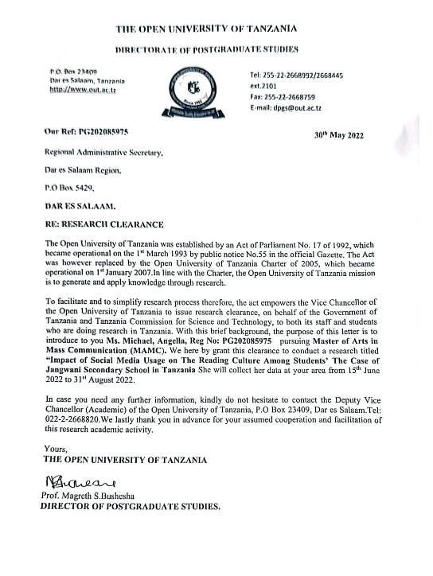
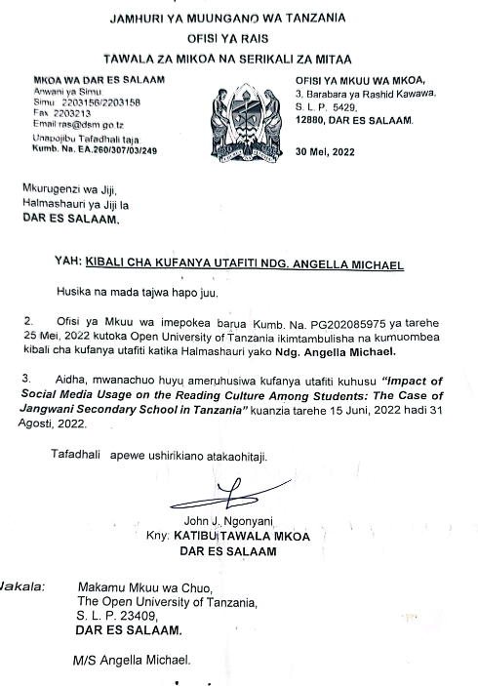

Appendix 3: Manual Script
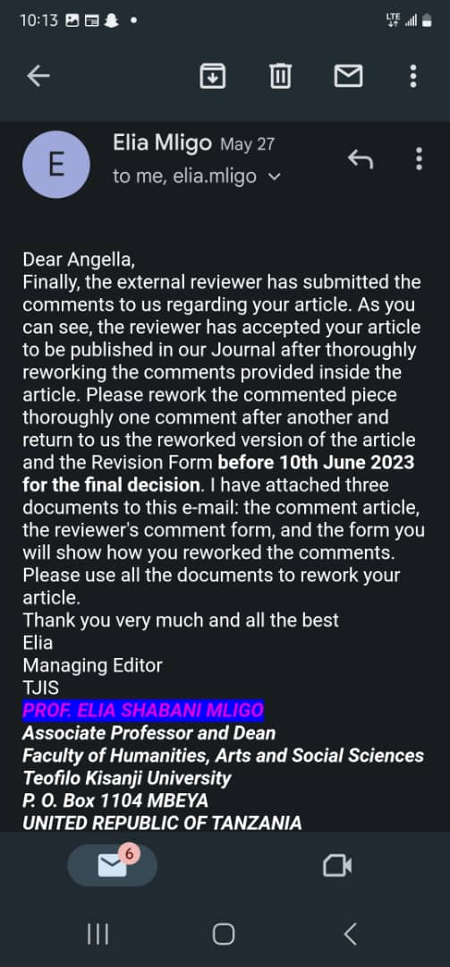
THE OPEN UNIVERSITY OF TANZANIA

Faculty of Arts and Social Science
06th June, 2023
Managing Editor
TEKU Journal of Interdisciplinary Studies (TJIS).

Dear Sir/Madam,
RE: SUBMITION OF A PAPER FOR A JOURNAL PUBLICATION.
Title:
Refer the heading above.
The author(s) agree(s) with the content and approve his/their submission to the TEKU Journal of Interdisciplinary Studies.

Name of first Author/Researcher: Angella Michael.
Reg. No: PG202085975
Mobile no: 0782297408
Email Address:angellamichael69@gmail.com
Year of Study: 2022.
Course/Program:Master of Arts in Mass Communication.
Department: Media and Library Studies.

Signature: 

Name of Supervisor(s)/EditorDr. Henry L. Mambo
Senior Lecturer and Head of Department of Media and Library Studies, Open University of Tanzania.
Mobile no.0789416429
Email Address:hlmarowo@yahoo.com
Signature: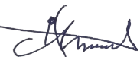
The Impact of Social Media Usage on Reading Culture among Students: A case of Jangwani Secondary School in Dar es Salaam.
Angella Michael¹ and Dr Henry L, Mambo²
- Senior Lecturer and Head of Department of Media and Library Studies, the Open University of Tanzania (OUT).
- Master Student, Faculty of Arts and Social Science, Mass Communication, the Open University of Tanzania (OUT).
Correspondence: angellamichael69@gmail.com&henry.mambo@out.ac.tz
.
Abstract
The purpose of this paper is to present the study that was done to assess the “impact of Social Media usage on Reading Culture among secondary school students in Tanzania”. Specifically, the study wanted to find out the relationship between social media and reading habit in order to measure extent to which students were affected either positively or negatively. The population was school teachers and students of Jangwani Secondary. The study used explanatory research design whereas a sample of 66 respondents was selected from Jangwani Secondary. Simple random sampling was used to select respondents. Data were collected through questionnaires and IBM SPSS version of 2019 was used to analyze data thereafter data were presented using tables, graphs and frequency. Based on the findings, all 66 (100%) were using social media and 36 (55%) out of 66 were using social media as a tool for academic materials searching and current news and information.

Eventually, according to the findings 66 (100%) respondents used social media, 36 (55%) respondents were using social media to search academic materials and current information and news affairs, 60 (91%) respondents were using Facebook, Instagram and Tik Tok. Furthermore 32 (49%) respondents were spending 4-8 hours on social media.

Based on the findings, it is argued that social media have positive impact on students especially in increasing reading habits and academic performance because of easy accessibility of academic materials. Therefore, this paper recommends that there should be a proper way of making school students to use social media positively especially with the aim of increasing reading culture.

Keywords: Social Media, Social Media Usage, Reading Culture, Secondary Students.
- Introduction
In recent years social media have been a corner stone among the people of different ages, since its inception in 1996. Social media have managed to penetrate half of the 7.7 billion people in the world. Further, social media platforms almost tripled total user base in the last decade, from 970 in 2010 to 4.48 billion users in 2021 (Backlinko, 2021).
The number of social media users in Tanzania is increasing since 2023 when there was an equivalent to 7.4 percent of the total population. Also, data indicate that there were 4.90 million users aged 18 and above using social media in Tanzania at the start of 2023, that is equivalent to 14.8 percent of the total population (Data Reportal, 2023). Social media have heavily stimulated online learning, providing a stimulating learning environment for students to access academic content, and increasing access to audiovisual materials and other academic topics offers (Ndenego & Joseph, 2022). These are cyber-bullying, exposure to inappropriate content, reduced study time, online dating, and sexual solicitation, especially with strangers and people of different ages (House of Representatives 2019).
According to Alfred & Haidari (2014), the social media situation among secondary students in Tanzania is determined by the environment of a particular school. There is an increased use of social media among secondary school students since both positive and negative use of social media among the students was exposed.
Alice, Collins, Constanze & Matthis (2014), found that social media usage in Tanzania is dominated by youths and the most preferred site is Facebook. For instance in Dar es Salaam and Mtwara, most youths use social media for socialization including chatting and making new friends, information searching as well as playing computer games.

Some people do use social media to barter ideas, perceptions as well as personal information in terms of pictures and videos (Loving & Ochoa, 2010). The thorough use of social media is probably a causative agent of the decrease or increase of reading culture because reading is one of the better ways of obtaining information and knowledge. According to Oloyede (2005), reading is a behavior that is manifested with no conscious exertion on the part of the learner. Students seek information in different ways as some are reading materials from libraries. Frankwell (2014). Secondary students face many challenges and setbacks in using library including lack of current and up to date reading materials, restricted hours, lack of sitting facilities and lack of book copies. According to BBC report (2018) Tanzania reached the highest level of books reading in 1980s where people were reading books in as a means of obtaining materials and information.

According to Data Reportal (2023) youths are the ones who use social media mostly because of easy accessibility of supportive devices such as smartphones, tablets as well as computers. Therefore, authors intended to know what impact these social media sites bring to students in relation to reading habit. However, Ndenengo & Joseph (2022) argue that social media provide an exciting learning platform where students can access academic materials such as audio-visual materials and enhance learning but most of these students have no balance between social media time and doing other school works.
Poor time management of using social media may result into cyber-bullying, exposure to unsuitable and illegal contents, sleep deprivation, devoting lesser or no time in studies as well as communication with unknown people especially strangers that may lead to sexual solicitation from them (Ndenengo & Joseph, 2022).
In searching of the impact of the social media use towards reading culture among the secondary school students, the researchers were guided by the following questions;
- What is the impact of social media usage among secondary students at Jangwani Secondary school?
- What do students at Jangwani Secondary school use social media for?
- How often do students at Jangwani Secondary school use social media?
- What is the relationship between reading and social media usage among students at Jangwani Secondary school

Therefore, the study aimed at measuring the relationship between social media usage and the increase or decrease of reading culture among secondary school students since the better assessment will be helpful in improving the policies of the government to increase or uplifting student’s desire and culture to read through the use of social media.

- Background of the Study
According to the Literacy Centre (2014), reading culture began in 4000 BC with the Sumerian pictographs as it was easy to decode since it was simply pictures of objects and activities. Although verbal communication started earlier, still there was a need for establishing reading culture for people and to communicate more formally. Reading became one of important means of acquiring new information since most of materials and information are shared from books and other written materials.

Since its inception in 1994, social media has become addictive to users to the extent that it disrupts other important behaviors on people’s minds. Nearly 53% of Britons who use mobile phones do so, according to a study conducted by the UK Post Office aimed at assessing the potential for anxiety disorders due to excessive mobile phone use. They say they worry about losing their phones when they are out. Bivin, Mathew, Thulasi and Philip (2013) in their survey that involved medical students, found that of the 547 males, 23% of students were classified as monophobia, and 64% of students had monophobia. They established further that there was a risk of developing the addiction to smartphones since nearly 77% of students check their mobile phones more than 35 times in a day.

Middle school and college students use social media for a variety of purposes, but mostly for non-academic purposes such as chatting each other and sharing social items (Abdalla, Manjur & Raisa, 2021). Yu, et al., (2010) argue that social media influences the daily lives of students in their relationships with social workers. Despite the use and importance of social media, there is still an undressed issue in academia in terms of its impact on reading culture, especially in the Tanzanian context.

The use of social media is not a problem at all but the study is posing the question that aim to assess whether social media use is increasing or decreasing reading culture among the students by referring secondary students from Jangwani Secondary in Dar es Salaam. Therefore, answers to such questions are going to be used to improve the use of national and international social media, especially for academic purposes in secondary schools specifically to motivate reading culture among students.

- Literature Review
The study had to review other authors’ works, starting with theoretical framework followed by reviews from other authors’ works as a strategy to know what has been covered and observing the gap in between. Media Ecology Theory was used in this study; the theory developed by is Marshall McLuhan. He developed the concept of media ecology in 1964 as he examined how media and communication technologies shape human perception, culture, and social interactions. His ideas have significant impact on the fields of communication, cultural studies, and media theory.

Media ecology is the study of how media and communication processes affects one's perceptions, emotions and values, with a focus on media studies (Parameswaran, 2008). The theory is criticized as some scholars argue that it tends to exhibit technological determinism, the belief that technology is the primary driver of social change. Critics argue that this perspective overlooks the role of social, cultural, economic, and political factors in shaping media and society.

It was helpful in accomplishment of this study since the theory helped the researchers to understand how media technologies and their environments shape and influence human perception, cognition, and behavior. In the digital era, where media consumption is ubiquitous, understanding the effects of social media on individuals and society is crucial for making informed decisions about media use and its consequences.

It focuses on identifying the relationships between technology and members of a particular culture. In media ecology theory, social media has changed society and the public is more likely to rely on these communication technologies. McLuhan felt it was nearly impossible to find a company that could be influenced by the media. McLuhan noted that media use in education is not only about the increased number of information seekers for learning purposes rather than the crisis that can be created.
Information ecologies represent the procedures, goals, values of communities which are supported by technologies. Information ecologies are places where people use tools and help each other in information activities through social relationships (Williamson, 2005). Information literacy is regarded here as knowledge, skills and efficient information practices in human information behavior. Educators all over the world developed learning strategies for students with respect to recognition of information need, development of information strategies, and use of information sources and building of pathways for gaining knowledge. Most important standards of information literacy include standards for students’ learning for schools (AASL & AECT 1998).

Therefore, the theory that helps to ensure that research leads to consistent results will support further research, thereby improving students' social lives, especially with regard to reading habits.
- Research Methodology
The study was conducted quantitatively because of its nature; therefore quantitative research approach was the best choice to support the completion of this study since it aided the researchers to get in-depth information about a particular topic. In seeking of in-depth information that would be useful in accomplishing the study, explanatory research design was implied, since it is conducted when not enough is known about an ill-defined phenomenon or problem (Saunders, et al., 2007). It does not aim to provide definitive answers to research questions, but only deepens the research topic to varying degrees. His theme was therefore, to address emerging problems for which little or no research has been done (Brown, 2006). Even in extreme cases, explanatory research lays the foundation for more meaningful research, driving early study design, sampling methods, and data collection methods (Singh, 2007).

Rwegoshora (2006) defines population as the people with characteristics which the researcher wants to study within the context of a certain problem. In this research, the populations were the students and teachers from Jangwani Secondary School because that is the area where the study was conducted. Therefore, the sample size for this study was determined using simple random sampling whereby everyone had an equal chance of being selected.

The target area for this study was the city of Dar es Salaam, because the case study was Jangwani Secondary School and because the school is one of the oldest schools in Dar es Salaam. Further, the school has supportive facilities that enable students to use social media thus the school has the experience in dealing with social media usage among the students.

The sample size for this study was simple random sampling whereby everyone had a chance to be selected using the Rule of Thumb formula which states: (N ≥ 50+8M) Whereby N = sample size, M = number of study independent variables (Stott, 1986). Therefore, the study had three independent variables which are social media usage, reading habit and dependent is school students. Therefore: N ≥ 50 + 8 * 2 = 66. Based on rule of thumb calculation, the sample size was 66 that include students and teachers. Since the school is single sex therefore for the case of students’ gender only female students were included in the study. Teachers and matrons that make the total number of fifteen were also included.

In the process of data collection, questionnaires were employed since the study was typical quantitative and questionnaires were suitable for the study. The socio-economic and demographic characteristics of the study population played an important role in choosing data collection methods (Kothari, 2006). The selection of this method was based on study design which is a descriptive study design that calls for detailed information on a specific topic. Warner (1965) developed a data collection procedure known as Randomized Response (RR) which is claimed that it allows researchers to obtain sensitive and authoritative information while protecting and ensuring the privacy of respondents? Relative Risk (RR) or risk ratio is the ratio of the probability of an outcome in an exposed group to the probability of an outcome in an unexposed group. Together with risk differences and odds ratios, relative risk measures the relationship between exposure and outcome. This method promotes collaboration among respondents and reduces motivation to misstate one's attitude.
Warner (1965) also produced a rapidly growing body of research on alternative techniques for identifying appropriate RR schemes for estimating population proportions. Data analysis consists of actions and methods performed on data that help explain facts, identify patterns, develop explanations, and test hypotheses. This includes data quality assurance, statistical data analysis, modeling, and interpretation of results.Statistical Package for Social Sciences. IBM SPSS (2019 version) was used to present quantitative analysis by calculating results and presenting them in counts and percentages using charts, graphs and tables.

- Research Findings
The presentation of findings of this study was supported by answered questionnaires from among respondents, who were 66 in number; of whom 51 were students and 15 were teachers and matrons. Based on the nature of the school that is single sex, only female students were available. Therefore, this part provided information to explain the data which was then presented in tables, charts, graphs and explanations.

Social Media Usage
According to the findings, all the students who were 51 (100%) in number agreed that they used social media of whom 30 (59%) respondents indicated that they used social networks for searching information, nine (18%) respondents said they used social media for socialization or chatting, eight (16%) said they used social media to look for new friends, while the rest four (8%) said others. When asked the most preferred sites and social media sites, 49 (96%) out of 51 respondents mentioned Facebook, Instagram and Tik Tok as their favorite social media sites while the rest mentioned WhatsApp, Twitter and Snapchat in their answers. In time spending, according to the findings, out of 51 respondents 18 (35%) said they spent less than an hour, 30 (59%) said they spent 1-4 hours while the rest three (6%) said they spent 4-8 hours on social media sites or applications, no one mentioned a day and above.

Impact of Social Media towards Reading Habit
From all student respondents who responded to the question, 45 (88%) said social media had positive impacts, three (6%) said it had negatively impacted them while the other three (6%) respondents said it was moderate. According to the findings, more than 91% of the respondents said social media usage increased their reading habit, while others said it has nether increased nor decreased their culture of reading. However, 25 (49%) respondents admitted that they were disturbed by notifications, 15 (29%) said pop ups ads, 9 (18%) mentioned desire to do other things as a challenge to them while two (4%) said others.

Figure 1: Impact of Social Media towards Reading Habit
Source: Field Data, 2022

The Frequency of Social Media Usage among the Students
The question was posed to 15 respondents including teachers and matrons aimed at knowing how often the students use social media, for they are the ones who control and manage the use of social media among their students. Out of 15 respondents 13 (87%) said they use according to the time table after religious sessions in the evening while the rest two (13%) said they sometimes use social media conveniently especially when they are outside the school.

Difference between Reading Hard Copies versus Soft Copies
Students had different views on the particular subject since some of them said reading hard copies were better because e-books needed internet connection while hard copies were accessible without internet. Others said it was easy to read via online since with the internet, one can access more books than in hard copies. There were others who said reading soft copies was a little bit challenging for instance when using devices such as phones and tablets there were some disturbances one could face like incoming calls, notifications for texts as well as pop ups ads. Therefore reading hard and soft copies had challenges.

Furthermore, most students suggested that reading should be via social media. However, some of them suggested that there should be a strong reading commitment in order for the students to focus on studying. Few respondents said both reading via social media and hard copies should be applied because some contexts require a student to read hard and soft copies concurrently.Also, 18 (27%) respondents said policies on advertising should be improved, 21 (32%) said age restriction should be considered in improvements, 14 (21%) respondents said limitation in time spending should be improved while the rest 13 (20%) said nothing had to be improved.

The figure below illustrates.
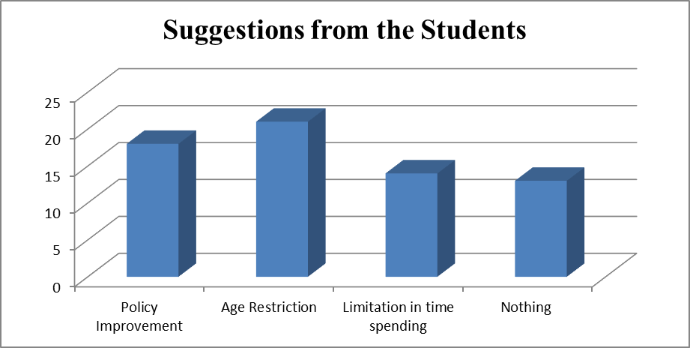
Figure 2: Suggestions from the Students

Source: Field Data, 2022

The researcher’s objective was to get student’s opinion on what should be improved in social media usage to motivate reading habits among students. Most students suggested that some motivations should be made in reading habits via social media. However, some respondents suggested that there should be strong reading commitments on the side of students to focus on studying or reading through electronic devices. Few respondents said both reading via social media and hard copies should be implemented since some contexts need a student to read both hard and soft copies at per.

The Impact of Social Media Usage among the Students
According to the findings, social media usage have positively impacted on the students’ reading habits since most of them agreed that social media simplify the accessibility of books especially e-books and it was easy to find them compared to hard copies that someone must have it physically or he/she must attend to the library. For instance, from the findings, 66 students who were asked if social media usage had any impact on their habit of reading books, 73% of them said, “Yes” social media usage had increased their reading habit.

McLuhan (1964), in The Theory of Media Ecology, argues that social media is transforming society and that the public is becoming more dependent on this communication technologies. According to him, it was almost impossible to find a society influenced by the media. Along with the development of society, the technology has also developed. The public has been influenced by both books and the social media since the first book was published online. Media Ecology Development, Process, Search, Media Rules of Inversion - shows how technology affects the development of communication.

According to Junco, et al. (2011) & Magde et al. (2009) active use of social media improves students reading habits and academic performance. On the other hand, Shabir, et al.,(2014) and Rubis et al. (2012) found no significant association between social media use and academic performance. However, some studies have shown no relationship between these two variables, but the results showed that social media use had a positive impact on the reading habits of students at Jangwani Secondary School.

The Uses of Social Media among the Students
According to the findings, most students were using social media as a tool for information searching that was equally proportional to the reading activities. For instance, 55% of the total respondents said they were using social media to look for information and few others mentioned socialization as one of their main reason for their social media usage. AASL & AECT (2020) Information literacy is viewed as knowledge, skills and efficient information practices in human information behavior. According to AASL & AECT (2020), educators around the world are developing learning strategies for their students related to identifying information needs, developing information strategies, leveraging information sources, and building pathways to knowledge acquisition.

Muhammad, et al. (2020) showed that social media has positive impact on reading culture, addition of general knowledge, easily access information, and keep in touch with other friends. However, his distractions during the study period were identified as adverse effects. Social media use also negatively affected reading behavior as more time was spent chatting with friends than reading (Shehu & Shehu, 2014).

The Frequency of Social Media Usage
From the results, 49% of all the respondents who attempted the questionnaires said they spent four to eight hours surfing in social media, that is to say the students dedicate most of their prime time is using social media. The most important thing is to make good timetable for them so that they will be using the timetable for benefits, especially for books reading in order to increase reading habit among them. Laura (2021) mentioned why students use social media. She said the most frequently cited reasons for social media usage were; to stay up to date, while others said it was interesting.

Given these answers, most of these students are likely addicted to social media for normal reasons. They found a correlation between time spent on social media and reading habits, with frequent social media use leading to lower reading habits. The study recommends encouraging faculty and staff to spend less time on social media sites and instead devote more time and energy to educational purposes (Owusu-Acheaw, 2016). From the findings, Jangwani students seem to spend much time surfing social media. In connection to the previous results, it seems that most students use social media for reading purposes and less for socialization and others.

The Relationship between Reading Culture and Social Media usage
From the findings, social media usage and reading habits caused each other interchangeably since students had been using social media to access books and other informative materials. For instance, in the question that wanted students to explain whether social media had positive or negative impact on their reading habit, 78% of the total respondents said they helped them positively in adding reading habit. Reviewing the literature, Boateng & Amankwaa (2016) found that social media influences teachers, students, and other stakeholders to unite with each other to advocate and emphasize the construction of knowledge in the classroom. McLoughlin & Lee (2007) argue that the positive use of social media platforms, impacts individuals by bringing diversity to different groups of people, including Google Plus hence it is of advantageous.

- Conclusion and Recommendations
Based on the objectives and questions of this study, social media usage and reading culture are inseparable as they are causing each other. Social media use is very important to the school students especially in facilitating information searching in order to increase reading culture which is vital in improving individual learning capacity among the students hence increasing academic performance. Also, from the findings, social media is very important in aiding students to obtain different materials especially the academic ones.

The study concludes that social media usage should be handled with care, thus teachers and matrons/patrons at schools, parents, and other people that are responsible for guidance. Further, policy makers should consider social media sites as one of important tools that are supportive and suggestive in increasing reading culture among the students. Government should also provide important facilities such as tables, computers as well as smart phones in all schools in order to make the use of social media easy and useful.

Policy makers should consider social media sites as one of important tools that are supportive and suggestive in increasing reading culture among the students therefore they have to come up with the proper means of facilitating students in using social media in a constructive and positive way hence enhancing academic progression among them. Development in education goes with the advancement of science and technology; the ministry responsible for education has that role to consider the changes brought by technological advancement when creating syllabuses and educational policies in Tanzania’s educational systems. Electronic devices have to be used by secondary students in their studies since social media seem to be helpful in increasing reading habits among the students and also teachers can use them to create social ground for betterment of students’ academic performances.

Parents and teachers are the ones who take care for students at homes and in academic institutions respectively, thus they are the ones that have to take control over social media usage to their children. They have to make sure that the students adhere the regulations on social media usage. Therefore, students will be using social media positively in relation to the increase of reading habit among students hence better academic performances.

Since the TCRA is the authority that controls and regulates all the communications in the country, it has the role to make sure all the sites that have some elements of nudity materials are uprooted. In social media, there are some sites or applications that allow actions such as cyber bullying, discrimination and other unwanted materials, therefore TCRA have to facilitate safety ground for the students to dwell in searching information and other academic staffs. This study has covered only an area of secondary schools with reference of Jangwani Secondary, but there are so many other academic institutions that have to be covered in order to come up with the impact of social media in other academic arenas, thus it is recommended that other studies should be conducted and focus on other youths related areas thereafter it will be easy to measure the results.

This study assessed the impact of social media usage on reading culture among students with special reference to Jangwani secondary school. Different studies from other researchers should be carried out in order to measure to what extent the relationship between social media usage and the increase/decrease of reading habits has to be improved since it will be helpful even to policy makers and other stakeholders.

Funding
None
Conflict of Interest
There is no any conflict of interest that may rise regarding the publication of this article
Acknowledgement
We genuinely acknowledge the anonymous reviewers of this article for their critical and constructive comments that helped to improve this it to the form it has now.

References
Agyenim-Boateng, R. &Amankwaa, A. (2019). The Impact of Social Media on Student Academic Life in Higher Education the Impact of Social Media on Student Academic Life in Higher Education. Global Journals Inc., 16(4), 1-7.
Alaamen, A., Kolhar, M. &Kazi, R. (2021). Effect of social media use on learning, social interactions, and sleep duration among university students. Saudi Journal of Biological Science, 28(4), 2216-2222.
Angwanda, A. & Amani, H. (2014). Population Growth, Structure and Momentum in Tanzania. International Household Survey Network. THDR 2014: Background Paper No. 7 ESRF Discussion Paper 61.
Bivin, B., Mathew, P., Thulasi, C.& Philip, J. (2013). Nomophobia-do we really need to worry about. Reviews of Progress, 1(1), 1-5.
Burke, M. & Kraut, E. (2016). The Relationship between Facebook Use and Well-Being Depends on Communication Type and Tie Strength. Journal of Computer-Mediated Communication, 21(4), 265–281.
Chettri, K. & Rout, K. (2013). Reading habits - An overview. IOSR Journal of Humanities and Social Science, 14(6), 13-17.
Daluba, N. & Maxwell, C. (2013). Effect of Social Media on the Use of Academic Library by Undergraduate Students in Tertiary Institutions: A Case Study of Kogi State University, Anyigba, Nigeria.
Gisondi, A., Barber, R., Faust, S., Raja, A., Strehlow, C., Westafer, M. & Gottlieb, M. (2022). A deadly infodemic: Social media and the power of COVID-19 misinformation. Journal of medical Internet research, 24(2), 35552.
Kaplan, A. & Haenlei, M. (2010). Users of the World, the Challenges and Opportunities of Social Media. Business Horizons, 53, 59-68.
Kumar, R. (2011). Research Methodology: A Step-by-Step Guide for Beginners. 3rd Edition. New Delhi: Sage.
Loving, M. & Ochoa, M. (2011). Facebook as a classroom management solution. New Library World, 112(3–4), 121–130.
McLoughlin, C. & Lee, J. (2007). Social Software and Participatory Learning: Pedagogical Choices with Technology Affordances in the Web 2.0 Era. In: ICT: Providing Choices for Learners and Learning. Proceedings Ascilite Singapore, 664-675.
Kessy, N. & Cassian, P. (2022) Use of Social Media Among the Students in Secondary Schools in Tanzania, Intern. Journal of Sec Educ., 10(3), 119-126.
Oblinger, D. & Oblinger, J. (2005). Is It Age or IT: First Steps towards Understanding the Netgeneration. Boulder, CO: EDUCAUSE.
Pfeiffer, C. Kleeb, M. Mbelwa, A. &Ahorlu, C. (2014). The Use of Social Media among adolescents in Dar es Salaam and Mtwara, Tanzania. Reproductive Health Matters, 22(43), 178-186.
Tharwat, A. (2018). Classification Assessment Methods. Applied Computing and Informatics, Applied Computing and Informatics, 16(1/2), 1-13.
Verduyn, P., Ybarra, O. & Résibois, M., Jonides, J. &Kross, E. (2017). Do Social Network Sites Enhance or Undermine Subjective Well-Being? A Critical Review. Social Issues and Policy Review, 11(1), 274–302.

Waleed, A., Akram, Z., Norma, A. & Ali, S. (2017). Social Media and its Impact on Academic Performance among University Students, Anthropologist, 28(1-2), 52-68.
Authors’ Biographies

Angella Michael was born in 1979 at Midizini, Kigamboni District in Dar es Salaam region Tanzania. She has a degree in Mass Communication from the Tumaini University Dar es Salaam College (TUDARCO) in 2017. She is a senior Journalist and expert in Communication over 17 years in Journalism and Broadcasting and five years in Public Relations.

She has worked in various organizations in Tanzania such as the National Broadcast, Tanzania Broadcasting Corporation, mainly focusing on journalistic works, broadcasting and communications. Her areas of interest include; Journalism, specifically in news anchoring, programs announcing and public relations and communications. Apart from her daily activities she is also a recognized influencer of balance diet and regular body exercises through social media as a way to fight against Non Communicable Diseases (NCDs).

Currently Angella Michael is a permanent employee as public relations officer at Tanzania Institute of Education (TET).

DR. HENRY L. MAMBO is a Ph.D holder and researcher. He has BA in Public Administration and International Relations (Hons) from the University of Dar es Salaam (1986-89). He has a Master in Management, Library Science from the University of Wales-United Kingdom (1990-92). He completed his PhD studies from the University of Natal-Pietermaritzburg-1994-98. Later he started working as Librarian at the University of Dar es Salaam (1989-2000). From 2001-2009, he worked as an expert of Information, Education and Communication at the President’s Office Public Service Management. He is also a former Chief Executive Officer of the Tanzania Public Service College TPSC (2010-2017).

Currently, he is a Senior Lecturer, Senior Librarian and a Head of Department of Media and Library Studies, Faculty of Arts and Social Science at The Open University of Tanzania (2017 to date).

