**FACTORS AFFECTING THE PERFORMANCE OF SMALL AND MEDIUM ENTERPRISES (SMES) IN TANZANIA: A CASE OF UKEREWE DISTRICT**

**JOSEPH PASCHAL MICHAEL MKUNDI**

**A DISSERTATION SUBMITTED IN PARTIAL FULFILLMENT OF THE REQUIREMENTS FOR THE AWARD OF DEGREE OF MASTER OF BUSINESS ADMINISTRATION (MBA)**

**DEPARTMENT OF ACCOUNTING AND FINANCE**

**OF THE OPEN UNIVERSITY OF TANZANIA**

**2023**

# CERTIFICATION

The undersigned certify that he has read and hereby recommend for acceptance by the Open University of Tanzania (OUT), a dissertation titled, ***Factors Affecting the Performance of Small and Medium Enterprises (SMEs) in Tanzania. A case of Ukerewe District***” in partial fulfillment of the requirements for the award of Master of Business Administration (MBA) of the Open University of Tanzania.

……………………………………

Dr. Savio Macha

(Supervisor)

……………………………………….

Date

**COPYRIGHT**

No part of this dissertation may be reproduced, stored in any retrieval system, or transmitted in any form by any means, electronic, mechanical, photocopying, recording or otherwise without prior written permission of the author or the Open University of Tanzania in that behalf.

**DECLARATION**

I, **Joseph Paschal Michael Mkundi**, declare that, the work presented in this dissertation is original. It has never been presented to any other University or Institution. References have been supplied where other people's work has been used. In this regard, I declare that this is my unique work. It is hereby submitted in partial fulfillment for the Degree of Masters of Business Administration of the Open University of Tanzania.

……………………………..…………

Signature

…………………………….………….

Date

DEDICATIONThis work is dedicated to my dear parents. I thank them for their great support throughout my studies.

# .

**ACKNOWLEDGEMENTS**

I’m so grateful to the Almighty God for his grace in enabling me to successfully complete my dissertation. Many people have been so helpful and instrumental towards the completion of this work, though, it is not possible to mention all of them.

First, I would like to deliver my special thanks to Dr. Savio Macha who tirelessly guided me throughout the research process, without him I would not have reached this stage. It is through his dedication and constructive supervision I have finally reached this stage. To Mr. Michael Mwacha; thank you so much for your administrative guidance you have been giving me making sure that nothing is going to make me stuck somewhere during the process. Thank you!

I also thank my family; my lovely wife Naomi and our children Happy, Innocent and Alice for their love and dedication that encouraged me all the time being working on this research. I would also like to thank my parents Mr. and Mrs. Silvery. M. Mataba for the great love and encouragement, my young brothers and sisters, especially Dr. Peter Mataba for the great assistance he gave me during this research process.

Special thanks to the people of Ukerewe District Council for being cooperative to me all the time and specifically during this research towards making Ukerewe the Great Islands. I love you so much. Madam Evodia and Mr. Faraja were so great and helpful to reach the respondents; Thank you all.

**ABSTRACT**

This study investigates the factors affecting performance of SMEs in Tanzania, specifically in Ukerewe District. The general objective of the study was to examine the factors affecting performance of Small and Medium Enterprises (SMEs). Primary data were collected through structures and unstructured interviews whereby questionnaires were administered to 150 respondents while an interview guide was used to conduct interview to key informants from selected SMEs. Descriptive statistical method was used to analyse data whereby the researcher used SPSS software as tool for data analysis. The main findings indicated that, SMEs in Tanzania are facing a number of challenges: including unfavorable transport networks, unreliable and inefficient cost of electricity services and no-access to finance. The study concludes that, in order to have a robust SMEs sector for Ukerewe District’s economic development, joint efforts are needed from the government, private sector, academic institutions, development partners and any other interested parties to ensure that they join hands to address the main challenges affecting the performance of SMEs in the district. The study recommend policy makers to review the policies governing SMEs in Ukerewe District in order to reflect the current trends; increase budgetary allocation to institutions that are supporting SMEs for effective and efficient delivery of services.

**Keywords:** SMEs, *Performance,* *Business Environment*

# TABLE OF CONTENTS

**CERTIFICATION ii**

**COPYRIGHT iii**

**DECLARATION iv**

**DEDICATION v**

**ACKNOWLEDGEMENTS vi**

**ABSTRACT vii**

**LIST OF TABLES xii**

**LIST OF FIGURES xiii**

**LIST OF ABBREVIATIONS xv**

**CHAPTER ONE 1**

**INTRODUCTION 1**

1.2 Overview 1

1.2 Background to the Study 1

1.2.1 Small and Medium Enterprises (SMEs) in Ukerewe 3

1.3 Statement of Research Problem 4

1.4 Objectives of the Study 5

1.4.1 General Objective 5

1.4.2 Specific objectives 5

1.5 Research Questions 6

1.6 Significance of the Study 6

1.7 Organization of the Study 7

**CHAPTER TWO 8**

**LITERATURE REVIEW 8**

2.1 Overview 8

2.2 Definition of key terms 8

2.2.1 Small and Medium Enterprise (SMEs) 8

2.2.2 Definition of SMEs in Tanzanian Context 9

2.2.3 SMEs Performance 10

2.3 Theoretical Framework 10

2.4 Empirical Literature Review 13

2.5 Research Gap 18

2.6 Conceptual Framework 19

**CHAPTER THREE 20**

**RESEARCH METHODOLOGY 20**

3.1 Overview 20

3.2 Research Philosophy 20

3.3 Research Design 20

3.4 Research Area 21

3.5 Target Population 21

3.6 Sampling Procedures and Sample Size 22

3.7 Data Collection Methods 23

3.8 Data Processing and Analysis 24

3.9 Research Ethics 24

**CHAPTER FOUR 25**

**FINDINGS, ANALYSIS AND DISCUSSION 25**

4.1 Overview 25

4.2 Characteristics of the Respondents 25

4.2.1 Age 25

4.2.2 Gender 27

4.2.3 Education level 28

4.2.4 Experience in business 28

4.2.5 Business location 30

4.2.6 Type of business 31

4.3 Findings from Specific Objectives 32

4.3.1 The Influence of Business factors on Performance of SMEs in Ukerewe District 32

4.3.1.1 Road Transport Networks 33

4.3.1.2 Reliable and cost efficient electricity services: 34

4.3.1.3 Communication infrastructures, networks and services: 35

4.3.1.4 Availability and access of land for investment: 36

4.3.1.5 Policies and interventions that support SMEs: 37

4.3.1.6 Regulations in licenses, permits, and registration: 38

4.3.1.7 Access to finance 39

4.3.2 The Influence of Managerial Factors on Performance of SMEs in

Ukerewe District 40

4.3.2.1 Awareness of SMEs on supportive policies 41

4.3.2.2 Supportive Interventions for SMEs 42

4.3.2.3 Financing of SMEs 47

4.3.2.4 Settling Problems regarding tax with TRA 49

4.3.3 The Influence of Business Technical Services on Performance of

SMEs in Ukerewe District 50

4.5.1 Business Development Services (BDS) 50

4.3.3.3 Targeted customers 53

4.4 Discussion of the Findings 54

**CHAPTER FIVE 60**

**SUMMARY, CONCLUSIONS AND RECOMMENDATIONS 60**

5.1 Overview 60

5.2 Summary of the Main Findings 60

5.3 Conclusion 61

5.4 Recommendations 61

5.5 Areas of future research works 62

**REFERENCES 63**

**APPENDICES 68**

# 

# LIST OF TABLES

Table 4.1: Demographic Characteristics of Respondents 26

Table 4.2: Number of years in business 29

Table 4.3: Type of business for respondents 31

Table 4.4: Statistics on factors affecting business environment of SMEs 33

Table 4.5: How SMEs finance their business 47

# LIST OF FIGURES

Figure 2.1 Conceptual Framework 19

Figure 4.1: Gender of respondents 27

Figure 4.2: Experience of respondents in business 29

Figure 4.3: Business location of respondents 30

Figure 4.4: Type of business for respondents 32

Figure 4.5: Effect of road transport networks on SMSs 34

Figure 4.6: Effect of reliable and cost-efficient electricity services on SMEs 35

Figure 4.7: Effect of communication infrastructures, networks and services on SMEs 36

Figure 4.8: Effect of availability and access to land for investment in SMEs 37

Figure 4.9: Effect of policies and interventions that support SMEs 38

Figure 4.10: Effect of regulations in licenses, permits and registration for SMEs 39

Figure 4.11: Access to finances by SMEs in Ukerewe District 40

Figure 4.12: Awareness on supportive policies by SMEs in Ukerewe District 41

Figure 4.13: Awareness on supportive interventions for SMEs in Ukerewe

District 42

Figure 4.14: Whether supportive interventions improve performance of SMEs in Ukerewe District 47

Figure 4.15: Whether SMEs ever had access to loans from financial institutions 48

Figure 4.16: Easiness to access loans from financial institutions by SMEs in

Ukerewe District 48

Figure 4.17: Whether SMEs in Ukerewe District face problems with TRA regarding tax payments? 49

Figure 4.18: Time spent by SMEs in settling problems regarding tax payment

with TRA 49

Figure 4.19: Change of prices by SMEs due to increase in taxes 50

Figure 4.20: Availability and affordability of business development services by SMEs in Ukerewe District 51

Figure 4.21: Whether SMEs in Ukerewe District market their business 52

Figure 4.22: Level of market competition for SMEs in Ukerewe District 52

Figure 4.23: Targeted customers for SMEs in Ukerewe District 53

Figure 4.24: Targeted customers for SMEs in Ukerewe District 53

Figure 4.24: How SMEs in Ukerewe District get their targeted customers 53

**LIST OF ABBREVIATIONS**

BDSs Business Development Services

CSFs Critical Success Factors

DANIDA Danish International Development Agency

DFID Department for International Development

GDP Gross Domestic Product

ILO International Labour Organization

MSME Micro, Small and Medium Enterprises

OECD Organization for Economic Cooperation and Development

REPOA Research on Poverty Alleviation

SACCOS Savings and Credit Cooperative Society

SIDO Small Industrial Development Organizations

SIDP Sustainable and Industrial Development Policy

SMEs Small and Medium Enterprises

SPSS Statistical Package for the Social Sciences

UNDP United Nations Development Programme

UNIDO United Nations Industrial Development Organizations

URT United Republic of Tanzania

USAID United States Agency for International Development

TCCIA Tanzania Chamber of Commerce Industry and Agriculture

TIC Tanzania Investment Centre

# CHAPTER ONE

# INTRODUCTION

## 1.2 Overview

This chapter provides explanations on the background of the problem, statement of the problem, objective of the study, research questions, significance of the study, limitation and delimitation of the study, as well as organization of the study.

## 1.2 Background to the Study

It is now increasingly recognized that the small and medium enterprises (SMEs) play a crucial role in employment creation and income generation in Tanzania. SMEs all over the world and in Tanzania in particular, can be easily established since their requirements in terms of capital, technology, management and even utilities are not as demanding as it is the case for large enterprises (Ministry of Industry and Trade, Tanzania, 2002). The importance of small and medium sized enterprises (SMEs) in contributing to job creation and output growth is now widely accepted in both developed and developing countries, the main objective is the expansion of those enterprises from very small into medium sized and become large sized that make their most tangible contribution to economic growth and job creation. In this chapter the researcher reviews the factors which affect the growth of SMEs in Tanzania, case study of Ukerewe district. The review investigates the structural characteristics and the financial constraints of SMEs development in different growth stages of the business. The researcher also touched on different areas such as the definition, characteristics and nature of the small and medium firms. This was discussed by looking on the contents of small firms and what makes them different from other firms.

Ukerewe District, located in the Lake Victoria region of Tanzania, has a diverse history of economic activities, with a strong emphasis on agriculture and fishing due to its unique geographical location. The brief overview of the historical economic activities in Ukerewe District:

Agriculture: Agriculture has been a fundamental economic activity in Ukerewe District for generations (Gamba, 2017). The fertile soils around Lake Victoria have supported the cultivation of various crops, including maize, millet, rice, cassava, sweet potatoes, and beans. Traditional farming methods were prevalent, with small-scale farmers producing food primarily for subsistence. Over time, efforts have been made to introduce modern agricultural techniques to improve productivity (Baporicar *et al*., 2016).

Fishing: Given its proximity to Lake Victoria, fishing has been a significant economic activity in Ukerewe District for centuries. The district has a rich tradition of fishing, and the lake provides a vital source of livelihood for many residents. Fish species like Nile perch, tilapia, and catfish are abundant in Lake Victoria, supporting both local consumption and commercial fishing enterprises (Clegg, 2018).**Trade and** Commerce: As a hub for fishing and agriculture, Ukerewe District has also seen the growth of trade and commerce activities. Local markets have historically served as centers for the exchange of goods, with traders and vendors selling a variety of agricultural produce, fish, and other essentials (Ekblom, 2016). Additionally, Ukerewe location as an island in Lake Victoria has facilitated trade by boat with neighboring regions.

Crafts and Handicrafts: Ukerewe District is known for its artistic traditions, including pottery, basket weaving, and boat-building. These crafts have provided additional sources of income for local residents, as these handmade products find markets both within and beyond the district.

Transportation and Tourism: Ukerewe is a unique island and its location has also made it a destination for tourists interested in exploring Lake Victoria and experiencing the local culture. Tourism-related activities, including boat tours, cultural events, and accommodations, have emerged as an economic opportunity in recent years.

Challenges: Despite its economic potential, Ukerewe District has faced challenges over the years, including inadequate infrastructure, limited access to markets, and environmental issues related to Lake Victoria's health. Addressing these challenges has been crucial to promoting sustainable economic development in the region.

In recent years, efforts have been made to enhance the economic activities in Ukerewe District through initiatives aimed at improving agriculture, fisheries management, infrastructure development, and support for small and medium-sized enterprises (SMEs). These efforts aim to harness the district's economic potential while addressing longstanding challenges to improve the livelihoods of its residents.

### 1.2.1 Small and Medium Enterprises (SMEs) in Ukerewe

Ukerewe has many business opportunities through various areas such as fishing and agriculture. People in Ukerewe have been starting businesses using their cash money, loans from other people or loans from governmental institutions and other financial institutions. In the last five years, more than 300 enterprises started operating in Ukerewe. About 40% of these Small and Medium Enterprises (SMEs) were started by cash money from the owners (Bilal, 2016). 45% of these SMEs started from the owners getting loan from governmental institutions and the rest which is almost 15% started from the owners getting loan from other individuals and other financial institutions (Anderson, 2017). Out of 300 SMEs, about 21% of them have collapsed leading to frustrations to owners of these businesses leading to almost 20% of the assets of the owners of collapsed SMEs being sold by financial institutions due to failure to repay loans (Gamba, 2017)

It is imperative to find out which factors cause SMEs to fail in Ukerewe district. It is the aim of this study to uncover these factors.Top of Form

## 1.3 Statement of Research Problem

The performance of Small and Medium Enterprises (SMEs) in Ukerewe District, Tanzania, is hindered by a multifaceted set of challenges, encompassing business environment factors, managerial factors, and technological factors, which collectively limit their ability to thrive and contribute effectively to economic development. These factors include: Business Environment Factors: The district's business environment poses significant obstacles to SMEs. Issues such as inconsistent regulatory frameworks, cumbersome bureaucracy, corruption, and limited access to markets hinder their growth and profitability. Additionally, the impact of climate variability on agriculture and fisheries-based SMEs further compounds the challenges they face. Managerial Factors: Many SMEs in Ukerewe District lack effective management practices and entrepreneurial skills. Inadequate access to training and business development support has resulted in suboptimal business operations, including poor financial management, inefficient resource utilization, and limited capacity for strategic planning. Technological Factors: Technological advancements and digitalization have become essential for modern businesses (Lindvert, 2017) However, a lack of access to appropriate technologies, information, and digital infrastructure hampers SMEs' ability to compete and innovate. This technological gap affects their efficiency, market reach, and competitiveness.

These multifaceted challenges collectively restrict the growth and sustainability of SMEs in Ukerewe District, impeding their potential to create jobs, generate income, and alleviate poverty in the region. Addressing these challenges comprehensively is imperative to foster an enabling environment for SME development, enhance managerial capabilities, and facilitate technology adoption, ultimately unlocking the full potential of SMEs in the district." It is therefore imperative to find out how these factors affect the success or viability of SMEs in Ukerewe District.

## 1.4 Objectives of the Study

### 1.4.1 General Objective

To examine the factors affecting the performance of Small and Medium Enterprises (SMEs) in Tanzania specifically Ukerewe District.

**Top of FormBottom of Form**

### 1.4.2 Specific objectives

The specific objectives of the study were as follows:

1. To examine the influence of business factors on performance of SMEs in Ukerewe District
2. To examine the influence of managerial factors on performance of SMEs in Ukerewe District
3. To examine the influence of technological factors on performance of SMEs in Ukerewe District.

## 1.5 Research Questions

The following specific questions guide the study

1. What is the influence of business factors on performance of SMEs in Ukerewe District?
2. What is the influence of managerial factorson performance of SMEs in Ukerewe District?
3. What is the influence of technological factors on performance of SMEs in Ukerewe District?

## 1.6 Significance of the Study

Significance of the Study Findings of this study is expected to be most important and useful as follows: (i) Knowledge Contribution: The study will be useful for other researchers who would like to do research on the same topic. (ii) Policy Contribution: The study will be useful and point for references by policy makers when reviewing the SMEs policy in case of happening implications. (iii) Personal benefits: The research paper will increase the capacity of research and sharpen his knowledge in solving managerial problems in business undertaking and it is the requirement to get a certificate of Master of Business Administration Degr**ee.**

## 1.7 Organization of the Study

The study was organized in five chapters. Chapter one of this study covered the introduction, historical background of the study, the statement of the problem, objectives of the study, research questions, scope and significance of the study and the organization of the study. Chapter two of this study was about the literature review. Chapter three covered the research methodology that was used. Chapter four covered the data analysis, presentation and interpretation. Chapter five of this study provided a summary of findings, discussion, conclusions and recommendations.

# CHAPTER TWO

# LITERATURE REVIEW

**2.1 Overview**

This chapter provides the surveyed literature presented by different authors on the same topic regarding to the constraints affecting the growth and sustainability of micro and small enterprise in Tanzania. The chapter aims at finding what other researchers have said in relation to the study topic and to identify the literature gap. It starts by defining key issues, followed by theoretical literature review, empirical literature review, research gap, and end up looking at conceptual framework.

**2.2 Definition of key terms**

**2.2.1 Small and Medium Enterprise (SMEs)**

According to Ekblom (2016) there remains to be no universally or agreed definition of SMES. Every country has its own definition and various authors have their own definitions. Bilal *et al.(*2016) argues that the definition of micro and small Enterprises (MSE) is slippery and has not been universally agreed. He defines micro enterprises are those engaging 1-5 persons and small enterprises as those which engage 6 – 20 persons. MSEs therefore are all those enterprises which engage between 1 and 20 persons. Anderson (2017) defines Small and Micro Enterprises as those employing up to 4 persons, small scale enterprises as those employing between 5 and 49 persons and Medium Size Enterprises as those employing between 50 and 99 persons.

**2.2.2 Definition of SMEs in Tanzanian Context**

In the Tanzanian context, SMEs, which stands for Small and Medium Enterprises, are typically defined based on their size, business activities, and financial parameters. The precise definitions and criteria may vary over time and may be subject to government regulations and policies. However, as of the researchers knowledge update in September 2021, SMEs in Tanzania were generally categorized as follows:

**Micro Enterprises:** Micro-enterprises are the smallest category of businesses. They typically have a limited number of employees and operate with relatively low levels of capital and resources. In Tanzania, micro-enterprises are often defined as businesses with:

Fewer than 5 employees.

Low annual turnover and/or asset value, often falling below a specified threshold.

**Small Enterprises:** Small enterprises are larger than micro-enterprises but still relatively small in terms of size and resources. In Tanzania, small enterprises are typically defined as businesses with:

Between 5 and 49 employees.

A higher annual turnover and asset value compared to micro-enterprises but still below a specified threshold.

**Medium Enterprises:** Medium enterprises are larger than both micro and small enterprises but are not considered large corporations. In Tanzania, medium enterprises are often defined as businesses with:

Between 50 and 99 employees.

A higher annual turnover and asset value compared to small enterprises but still below a specified threshold (URT, 2021)

**2.2.3 SMEs Performance**

SMEs’ performance can be understood from a quantitative perspective: efficiency, financial results, level of production, number of customers (Anggadwita & Mustafid, [2014](https://www.tandfonline.com/doi/full/10.1080/1331677X.2019.1636699)), market share, profitability, productivity, dynamics of revenues, costs and liquidity (Gupta & Batra, [2016](https://www.tandfonline.com/doi/full/10.1080/1331677X.2019.1636699); Zimon, [2018](https://www.tandfonline.com/doi/full/10.1080/1331677X.2019.1636699)), etc. and also from a qualitative perspective: goals achievement, leadership style, employee behaviour (Anggadwita & Mustafid,  [2014](https://www.tandfonline.com/doi/full/10.1080/1331677X.2019.1636699)), customer satisfaction (Alpkan, *et al*., [2007](https://www.tandfonline.com/doi/full/10.1080/1331677X.2019.1636699)), product and process innovation, organizational and marketing innovation (Sheehan, [2013](https://www.tandfonline.com/doi/full/10.1080/1331677X.2019.1636699)) etc.

# 2.3 Theoretical Framework

Existing theoretical literature on performance of SMEs and, specifically, an attempt to identify CSFs for SMEs demonstrates a shift in research approach towards measuring the performance of SMEs and in trying to identify the factors critical for SMEs success.

The traditional approach to measuring performance and identifying the CSFs in SMEs determine a number of independent variables that are thought to be the CSFs, determine a suitable dependent variable which represents the performance of the firm and then treat the SMEs as “black boxes”. That is, the SMEs are treated as if they are independent, isolated systems in which an input (independent variable) such as a management intervention or activity change in some area of the business can be success and performance in SMEs monitored by an output (dependent variable) regardless of the business environments in which these firms operate. Hypotheses are then devised and tested and, by using statistical methods on a large sample of SMEs, it is thought that it is possible to establish cause-and-effect relationships between the independent variable and the dependent variable. This view assumes that a scientific experimental approach is possible and that other variables can be ignored or isolated and/or controlled.

In other words, the traditional approach treated SMEs as independent isolated systems in which an input of independent variable such as management intervention or activity change in some business can be monitored by an output of dependent variables such as the performance and success of the business firm regardless of the business environments in which these firms operate. In general, the traditional approach is a purely scientific experimental approach that assumes a cause and effect relationship between independent variable and the dependent variable where other variables can be or are ignored and or controlled.

Recent studies in measuring performance and identifying the CSFs in SMEs have challenged the traditional approach asserting that there is no consensus on how SME business success or performance should be measured or on the CSFs contributing to that performance. The traditional approach has encountered overwhelming criticism from the research community expressing misgivings and serious flaws in their study approach on the relationship between CSFs and performance of SMEs. The criticism focuses specifically on aspects of data collection approach, what they recognize as dependent variables, their perception towards business environment of SMEs and towards the SMEs themselves.

Instead, the new approach concludes that measuring performance and identifying the CSFs in SMEs is complex, the definitions of success are either simplistic or fuzzy at best and the number of factors contributing to the survival and performance of an SME is potentially extremely large. It focuses on the uniqueness of the businesses, their business environments, the aspirations of the owner-managers for their business and the variety of perceptions of success involved in SMEs. In other words, recent studies on the performance of SMEs and identifying CSFs suggest a more critical, holistic approach central to which is the business environment within which the SMEs operate.

They argue that business environment will have a major effect on the behaviour of the owner-manager, the enterprise and the factors critical for success (Clegg, 2018). The CSFs will be determined by the type of industry, the business environment in which the SME operates and the requirements of customers. CSFs will depend on the order qualifying criteria in order to compete in the particular chosen market, order winning criteria and order qualifying criteria which are order losing sensitive and the operational requirements necessary to meet these criteria (e.g. technology, skills and resources) (Haselip *et al.,* 2015). This will then have a clear effect on the definitions of success, some of which will be customer-focused, some of which will be related to the business and some will relate to the personal needs and aspirations of the owner-manager and any moderating role played by the family of the owner-manager (Isaga, 2019). Measurement of performance will therefore consist of a mixture of both financial and non-financial measures directly related to the definitions of success and the CSFs as perceived by the owner-manager (Juma & Said, 2019).

It is also clear that SMEs will have a major influence on the business environment partly because of the very large number of SMEs in the economy but also because of the development of industrial districts and localized economies of SMEs or clusters of SMEs (Gamba, 2017). These clusters can exert considerable market forces and create a strong SMEs sector based on flexibility, a capability for continuous innovation and the creation of a higher level of competitiveness (Sweeney, 1996). These regional networks of SMEs have the capability to survive economic crises where normally individual firms might see considerable difficulties and fail and so we have added a feedback loop from the business to the business environment.

# 2.4 Empirical Literature Review

There are various studies, both globally and locally, which have been conducted by different researchers indicating the theoretical and empirical evidence that the SMEs have different contributions in the economy of the country like job creation, reduction of poverty, reduce dependability, and increase equality among the society.

Shamsuddin *et al*.(2017 carried out a study to investigate the Impact of Employee’s Training Programme on the Performance of Small and Medium Enterprises in Northern Malaysia. The population of the study was the manufacturing SMEs in Northern Malaysia listed in the Federation of Malaysia Manufacturing Directory in Malaysia Industries, 2017. The finding of the study indicates that there is positive relationship between SMEs investment in employees training programme and SMEs performance, and the result indicate that there is no relationship between SMEs application of IT in employees training programme and SMEs performance and between SMEs HR development functions in employees training programme and SMEs performance.

The study by Bouazza *et al*.(2015) who conducted an investigation of factors affecting performance of SMEs in Algeria, found out that, lack of skilled human resources, management skills, economic factors had a significant contribution to how the businesses performs. The study found out the prominent relationship between economic factors and business performance. The study revealed that, the cited internal factors (management, human resources) and external factors (economic factors) affect the performance of SMEs.

Bilal *et al.* (2016) evaluated the impact of social, financial, and human capital on the performance of SMEs in Pakistan. Questionnaires were used as the method of data collection, and three hundred and thirty-two questionnaire was self-administered, but only one hundred and twenty-two was returned, and ordinary least square method were used to test the hypotheses under study. The result of the research work revealed that there is a positive relationship between human, social, financial capital and the performance of SMEs.

Baporikar *et al.* (2016) investigated the factors that limit the growth and survival of SMEs in Namibia: the implication for poverty. This study identified factors related to access to finance, lack of management, corruption, and infrastructure as the main limiting factors towards performance of SMEs. A questionnaire was used to collect data from two hundred and eleven small business owners and managers located in the cities of Aba, Abuja, and Lagos in Nigeria. The results were analyzed through a descriptive analysis and multiple regression analysis, and the result showed that financial constraints, lack of management, corruption, and infrastructure constraints were negatively correlated with small business performance. The results indicated that, small businesses are hindered by lack of financial support, lack of trainings, poor profits, poor infrastructure, and low production that is also associated with low prices and demands of goods and services.

Anderson (2017) had similar findings as to how fast-growing entrepreneurship and SMEs contribute significantly to job creation and fast growing firms survive better than firms that do not grow. They argued that, “high-growth firms are heterogeneous groups, and there are number of factors and definitions that characterize the growth of this phenomenon” (citing Delmar *et al.*, 2013).

According to Kabanda & Brown (2017) the main impediment to an entrepreneur is related to poor infrastructure, insecurity, poor transport systems, and non-access to finance. The study examined the growth performance of a large set of entrepreneurial firms in ten manufacturing sectors of 11 Sub-Sahara African countries including Nigeria. The results revealed that, the growth of entrepreneurship constrained by the mentioned factors.

For Tanzania, there are different researchers who conducted similar studies such as, Mashnene (2015) whose study was based in Dar es Salaam where observed two barriers for the growth of SMEs and categorized into internal and external factors. Internal factors are those factors, which are under the control of the firm itself like lack of managerial skills (leading, organizing, directing and staffing, poor record keeping, theft/cheating, insufficient market information and lacking enough working capital. Also for external factor are such as for this factors are external and they affect SMEs directly like corruption, government policy and regulations, technology, bureaucratic process, infrastructure and unfavorable economic factors.

The studies on SMEs by Mashenene *et al*. (2014) identified key factors that are limiting the success of small businesses in Tanzania. The identified factors included among them being corruption, lack of education and training, government policy, in-access to finances and many more to be revised later on in this particular study. This study will focus on reviewing previous studies made on the subject in question both in and out of Tanzania and later on drawing conclusions, which are relevant for the Tanzanian context.

There are also studies by Nyangarika ( 2017), titled “Opportunities and challenges for rural SMEs Development in Tanzania”, which notes that, supportive institutions are weak in supporting SMEs; their services are not tailor made to address the actual needs of the SMEs as they mainly focus on basic issues such as helping the poor to survive on temporal basis. As a result, there have been variation in SME performance; some SMEs are growing while others are left out and permanently remain in the micro category. In Africa, this phenomenon is referred to as the ‘missing middle” and continues to be a long-term concern for African policy makers.

Mashenene & Rumanyika (2014) in their study classified the factors hindering SMEs development in Tanzania into five categories. These categories included macroeconomic and policy environment, physical and technological infrastructure, the banking and finance structure, legal and regulatory framework, and market conditions. This undesirable situation has persisted for a long time despite the presence of various programs focusing on SMEs development.

Mpunga (2016) conducted his study in the regions of northern part of Tanzania and other parts of Tanzania and not in the southern part of Tanzania. His study identified various challenges related to technical know, power problems, lack of exposure and commitment among SME themselves.

Jumanne (2015) conducted a study to assess business constraints that affect the potential growth of SMEs in Kariakoo market in Dar es Salaam, Tanzania. Variables such as changes in technology, effect of marketing and high taxes, which affect performance of SMEs were measured, discussed and analyzed. The study revealed that most of the respondents agreed that there are challenges to SMEs including Lack of government support, High taxation rate, Limitations on financial access and technological change.

Kasililika (2018) conducted a study to investigate the factors affecting performance of SMEs in Tanzania, with reference to Kinondoni District. Specifically, the study sought: to explore the effect of available policies and interventions on performance of SMEs in Kinondoni District; to explore the effect of infrastructure on performance of SME in Kinondoni District; to analyze the effect of Business Development Services (BDS) support on SMEs performance in Kinondoni District; and, to investigate the effect of legal and regulatory framework on performance of SMEs in Kinondoni District. Eventually, the study established that SMEs in Tanzania are facing a number of challenges including: unfavourable transport networks, unfavorable port services, unreliable and inefficient cost of electricity services, non-access to finance, and unavailability and non-access of land for investment. The study therefore concluded that concludes that, in order to have a robust SME sector for the country’s economic development, joint efforts are needed from the government, private sector, academic institutions, development partners and any other interested parties to ensure that they join hands to address the main challenges affecting the performance of SMEs in the country.

Madata (2020) reveals in his journal that SMEs all over the world and in Tanzania in particular, can be easily established since their requirements in terms of capital, technologies, management and even utilities are not as demanding as it is in case of large enterprises. They are regarded as backborne of economic growth in almost all developed countries. In Tanzania, SMEs contribute over 30% of GDP and employs 3 – 4 million people which is 20 – 30% of total labour force. Therefore, identifies several challenges facing SMEs such as financial access which is consistently reported as one of the major obstacles of SMEs growth and development where only 20% of them have a line credit from financial institutions. And suggests technical approaches to solving them in respect to the developing economy Tanzania.

**2.5 Research Gap**

While there is existing literature on the factors influencing the performance of SMEs in various contexts, there is a limited body of research specifically examining the interplay between business, managerial, and technological factors and their collective impact on the performance of SMEs in Ukerewe District, Tanzania. Most previous studies have focused on one or two of these factors in isolation, and there is a lack of comprehensive research that considers the holistic interaction of these factors within the unique socio-economic and regulatory environment of Ukerewe District. Furthermore, there is a time frame gap as these studies have primarily provided a snapshot of SME performance, whereas a longitudinal analysis is needed to understand how these factors evolve and affect SMEs' sustainability and growth over time in this specific district. Therefore, this study aims to bridge this research gap by conducting a comprehensive investigation into the combined influence of business, managerial, and technological factors on SME performance, considering the unique local context and adopting a longitudinal perspective to capture the dynamics of SMEs in Ukerewe District.

# 2.6 Conceptual Framework

A conceptual framework portrays information of the variables that are to be tested and their predicted relationships with the study. It essentially groups the variables into independent, dependent and intervening variables (Mugenda, 1999). The diagram underneath illustrates variables which are independent and dependent variables. Independent variables are business environment, managerial environment and technical factors while dependent variable is SMEs performance. Therefore, the diagram illustrates SMEs performance depends on the three factors which are independent variables.

*Independent variables**Dependent variable*

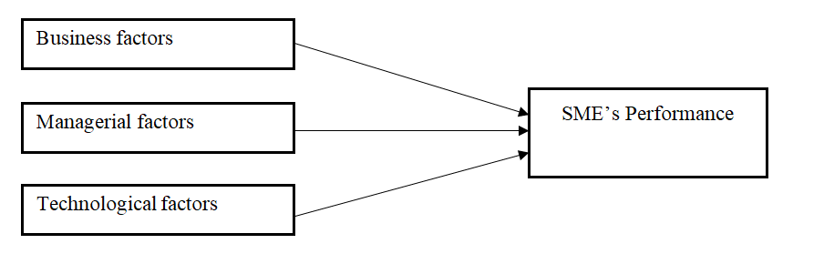

**Figure 2.1 Conceptual Framework**

**Source:** Researcher (2023)

**CHAPTER THREE**

# RESEARCH METHODOLOGY

# 

# 3.1 Overview

Research methodology are the methods and procedures used in conducting research, according to Kothari (2006) research methodology is a way to systematically solve a research problem. Therefore, this chapter presented research philosophy, research design, area of the study, target population, sample size and sampling techniques, data collection methods, research instruments, reliability and validity of research instruments. Data analysis and research ethics.

# 3.2 Research Philosophy

Saunders *et al*. (2016) categorized researches into paradigms which include positivism and phenomenology. This study was based on phenomenology principle of which the findings were derived from the natural facts during the study. Reasons for using one paradigm is because of the nature of study, which required the researcher to observe every activity at the port so that to ascertain the causes of delays in container deliveries and to come with comprehensive analysis that reflecting a real situation happen at the port.

# 3.3 Research Design

In this research, an exploratory research design was used. This was a convenient research design because it provided the researcher with grounded picture of the situation SMEs in Ukerewe District. This research design also enabled the researcher to generate new ideas and assumptions, develop tentative theories or hypotheses, as well as determine about whether the study of SMEs in Ukerewe District is feasible in the future.

**3.4 Research Area**

Due to an element of time, financial reasons, and for easily availability of data, study area was Ukerewe District, Mwanza Region. The researcher deliberately chose SMEs due to easily availability of data as he also deals with SMEs at Ukerewe.

# 3.5 Target Population

The people used in the research are financial institutions such as banks, SACCOs, business peoples such as shop owners and other Small and Medium Enterprises (SMEs), entrepreneurial groups such as women groups, youth groups and disabled groups. These groups were obtained from the department dealing with registration of groups at the Ukerewe District Council. Banks and other financial institutions were used in the research because they are the ones who provide loans and were identified as they are situated in Ukerewe District Council. The Small and Medium Enterprises (SMEs) and other entrepreneurs were chosen randomly and conveniently by visiting their working places. The qualifications to these groups, institutions and people to be interviewed were: they must be doing and involved in business activities; they should be either borrowers or not; and, their business centers must be stationed in Ukerewe District Council. So the total target population of the study was 250 whereby banks and SACCOs officials to be interviewed were 10 (5 from each of the two financial institution) and business people from SMEs and entrepreneurial groups were 240, an average of 60 business people from each division of Ukerewe District, namely: Ukara, Ilangala, Mumbuga and Mumlambo.

# 3.6 Sampling Procedures and Sample Size

Non-probability sampling technique such as purposive sampling was used to obtain key informants from banks and other financial institutions for interviews. This is a technique with regard to which item should be included or excluded in the sample rest on the researcher’s judgment and intuition. Purposive sampling technique enabled the researcher to choose respondents basing on the fact that they have desirable characteristics and variables related to the issue being studied. According to Kothari (2004:59), purposive technique enables the researcher to choose respondents basing on the fact that they have desirable characteristics and variables related to the issue being studied. So, the researcher interviewed the branch manager and one loans officer from National Microfinance Bank (NMB) Nansio Branch. Also, the researcher interviewed two loans officers from each one of the three Ukerewe-based SACCOS namely: WANINGO SACCOs and MABOTO Credit Company Limited and the Head of Departments that deals with providing loans to SMEs at Ukerewe District Council.

On the other hand, cluster sampling technique was used to obtain 120 respondents (30respondents from each cluster, representing four divisions of Ukerewe District namely: Ukara, Ilangala, Mumbuga and Mumlambo. The respondents were picked from different groups of entrepreneurs such as the youth, women and the disabled. Managers and owners of SMEs were also involved in filling in the questionnaire. Therefore the total sample size of the study was 130 respondents.

# 3.7 Data Collection Methods

Structured interview was used as data collection method whereby 120 questionnaires were distributed to SMEs managers and owners in the four divisions of Ukerewe District. The questionnaires were filled in and then collected ready for analysis. A questionnaire is a document designed to collect information appropriate to be analyzed (Kothari, 2004). The researcher used both open and closed ended questions whereby; open questions were used to understand their opinions and allowed respondent to give answers in the own way. Closed ended questions were used because they are easy to code and less consume less time.

On the other hand, unstructured interviews were carried out using guiding questions against the NMB Branch Manager, one NMB loans officer and two loans officials from selected financial SACCOs of Ukerewe District and one Head of Department at Ukerewe District Council. An interview is a two way systematic conversation between an investigator and an informant, intended for obtaining information relevant to a specific study (Krishnaswani, 1983). The interviewer and interviewees engaged in oral questioning. The researcher used interview guide to get information because it gives chances to respondent to express detailed and reliable information concerned the study. This method was used also to those who did not have time to respond the questionnaires in order to get the additional information.

# 3.8 Data Processing and Analysis

Statistical method, particularly descriptive statistics, was used to analyze quantitative data obtained through structured interviews using SPSS as a tool for data analysis. On the other hand, thematic analysis method was used to analyze qualitative data obtained from unstructured interviews, whereby answers were grouped accordingly basing on similarities of the answers.

**3.9 Research Ethics**

The researcher considered moral standards and ethical issues in the overall conduction of the research. Furthermore, the researcher considered the voluntary participation among the respondents, any respondent who was not ready to participate in the study was not forced. Some of the ethical issues that were considered were: anonymity, honesty, informing consent, deception and confidentiality. Respondents were also given assurance on confidentiality that the data collected will be used for the intended study only and not otherwise

# 

# CHAPTER FOUR

# FINDINGS, ANALYSIS AND DISCUSSION

# 4.1 Overview

This chapter presents the main findings of the study, its interpretation, and analysis. Findings from both primary and secondary sources are presented in this section. This part also discusses the main findings in relation to other relevant studies as well as the characteristics of respondents and how they influenced the study. The analysis of the findings was guided by specific research objectives.

# 4.2 Characteristics of the Respondents

In this part, the main characteristics of the respondents have been presented. This was done to ascertain how issues like age, gender, education, location, type of business and experience of respondents on the subject in question does influence the response.

# 4.2.1 Age

This was an important aspect to study as it depicts the maturity of the respondents. It also helps to qualify the results when it is noted that the people involved in the research were at the age of majority.

**Table 4.1: Demographic Characteristics of Respondents**

|  |  |  |
| --- | --- | --- |
| **Age group** | **Frequency** | **Percent** |
| below 18 | 1 | 1.1 |
| 18-25 | 10 | 10.5 |
| 26-35 | 39 | 41.1 |
| above 35 | 45 | 47.4 |
| **Total** | **95** | **100.0** |
| **Gender of Respondents** |  |  |
| Male |  | 29.79 |
| Female |  | 70.21 |
| **Total** | **95** | **100.00** |
| **Educational Level** |  |  |
| Primary level | 13 | 14.21 |
| Secondary level | 37 | 38.68 |
| Diploma | 22 | 23.56 |
| Bachelor degree | 19 | 20.01 |
| Master degree | 4 | 3.54 |
| **Total** | **95** | **100.00** |

**Source:** Field data (2023)

Table 4.1 shows that majority of respondents belong to the age group above 35years of age, represented by 47.4%. This is followed by the age group between 26 and 35 who are represented by 41.1%. Age group between 18-25 years, which is represented by 10.5% .There, was only one respondent (1.1%) with age below 18 years of age. This response reflects the response of matured persons. It shows that most SMEs in Ukerewe District are occupied by youth from the age of 26 years and adults above 35 years of age. The response shows that there is little number of youth below the age of 25 years who are engaged in business operations in Ukerewe District. This is because the youth in that age are in school and are not dealing with SMEs.

# 4.2.2 Gender

Gender was another aspect, which the researcher sought to find. He wanted to establish the inclusion of both males and females in the study findings. Figure 4.1 and Table 4.1 indicate the outcome of gender composition in the study.

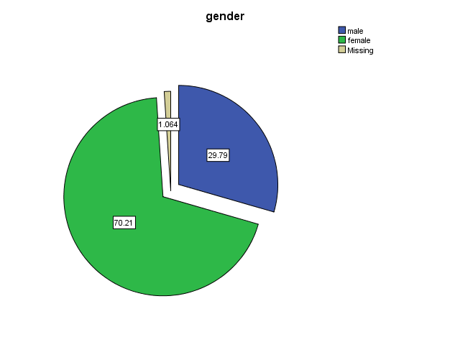

**Source:** Field data (2023)

**Figure 4.1: Gender of respondents**

Figure 4.1 reveals that, both males and females participated in this study, an indication that the study was gender inclusive. The results show that males were represented by only 30% while females were represented by 70%. These results further reveal that, majority of respondents were females leading to the conclusion that most businesses are dominated by females. Probably this is because the government, as well as the private sector, has focused on empowering women whereby women are provided with loans to run small and medium business.

# 4.2.3 Education level

The researcher also kept in mind education level as one of the key aspects needed to study from the respondents to determine the literacy level of SMEs in the district.

Table 4.1 shows that respondents with primary level education constituted about 30% of the total respondents. Those with primary education are 14.21%, secondary education were about 38.7%;diploma education were 23.56%, bachelor’s degree constituted about 20.01% follows this; those with Master degree were 3.56%. From the study, there were no respondents with PhD. These results reveal that the majority of respondents have secondary and diploma education whereas few have primary and bachelor’s degree and almost none with MA’s degree (3.56%). These results are helpful in determining the level of education of SMEs owners and managers in Ukerewe District, which is useful understanding the challenges they face in managing the SMEs competently as well as to policy makers in designing appropriate interventions to support them.

# 4.2.4 Experience in business

The researcher also sought to find out the number of years the SMEs were in the business. This helped to identify experience of respondents in business issues especially in the area where they operate. Figure 4.3 shows the number of years the respondents had been in their businesses.

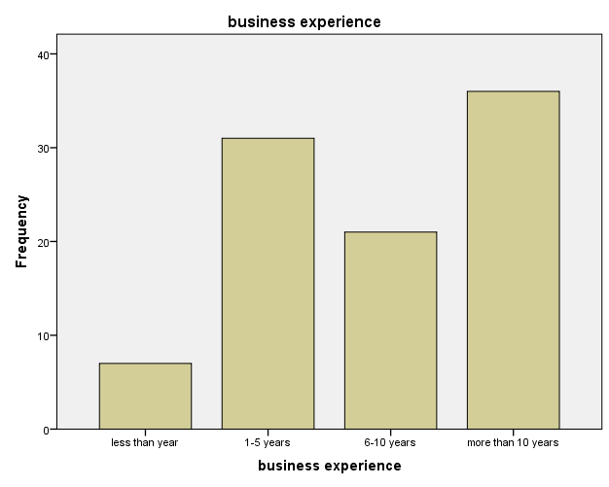

**Figure 4.2: Experience of respondents in business**

**Source:** Field data (2023)

From Figure 4.2 we see that SMEs with different experience in business participated in the study. From the analysis, majority of respondents, equivalent to 38% had an experience in business for more than 10 years; followed by those who had been in their businesses for period between 1 and 5 years constituting about 33%. Respondents who had been in business between 6 and 10 years constituted about 22%. Other respondents had been in business for less than a year that constituted about 7% only. From this analysis, it can be argued that majority of respondents had been in a respective business for more than five years, which is a very good experience, and hence the response based on this experience is likely to be more useful.

**Table 4.2: Number of years in business**

|  |  |  |
| --- | --- | --- |
| **No. of years** | **Frequency** | **Percent** |
| less than year | 7 | 7.4 |
| 1-5 years | 31 | 32.6 |
| 6-10 years | 21 | 22.1 |
| more than 10 years | 36 | 37.9 |
| **Total** | **95** | **100.0** |

**Source:** Field data (2023)

# 4.2.5 Business location

The researcher also sought to find out the business locations of SMEs in Ukerewe District. This helped to identify location of respondents especially the wards and divisions where they operate their businesses. Figure 4.3 shows the four divisions of Ukerewe District where respondents operate their businesses from.

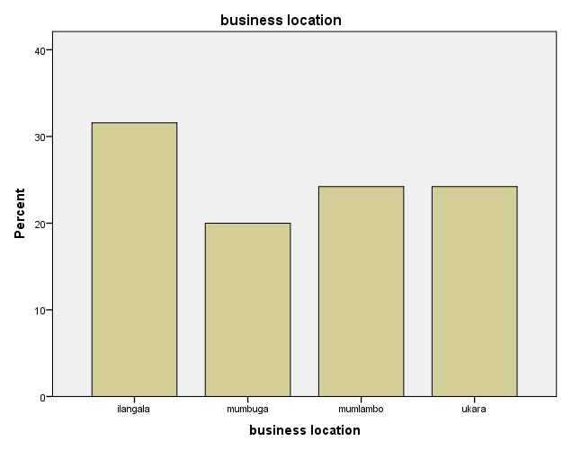

**Figure 4.3: Business location of respondents**

**Source:** Field data (2023)

Figure 4.3 shows that the majority of respondents are located in Ilangala Division with 32%, followed by Ukara and Mumlambo divisions both with 24% each. Respondents from Mumlambo were only 20%. These results reveal the fact that Ilangala Division is the most populated division of Ukerewe District. It also reflects the fact that Ilangala is the division where most of the fishing business and activities take place. Fishing is the main source of income and employment in Ukerewe District.

# 4.2.6 Type of business

The researcher also sought to find out the type of business that SMEs owners and managers in Ukerewe District engage in.

**Table 4.3: Type of business for respondents**

|  |  |  |
| --- | --- | --- |
| **Type of business** | **Frequency** | **Percent** |
| Retail shops | 17 | 17.9 |
| Kioski | 15 | 15.8 |
| Restaurant | 7 | 7.4 |
| Fishing | 8 | 8.4 |
| Hospitality | 3 | 3.2 |
| Beverages | 4 | 4.2 |
| Health services | 6 | 6.3 |
| Saloon | 7 | 7.4 |
| Garment | 10 | 10.5 |
| Transport | 6 | 6.3 |
| Finances | 5 | 5.3 |
| Posho mills | 5 | 5.3 |
| Repair Services | 1 | 1.1 |
| Others | 1 | 1.1 |
| Total | 95 | 100.0 |

**Source:** Field data (2023)

Table 4.3 shows that the majority of SMEs run retail shops and kiosks with 18% and 16% respondents. SMEs in garments are also many, constituting 11% of all respondents. The results reflects the facts that most of the SMEs are not certain or sure about the market of their goods and services. Therefore, they choose to try out everything that sells without positioning themselves to one type of business.

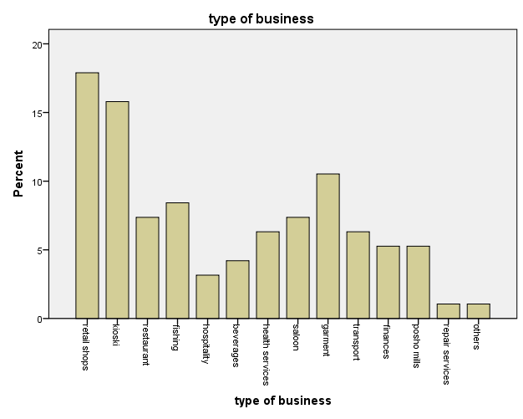

**Figure 4.4: Type of business for respondents**

**Source:** Field data (2023)

# 4.3 Findings from Specific Objectives

# 4.3.1 The Influence of Business factors on Performance of SMEs in Ukerewe District

In this part, the influence of business factors/environment on performance of SMEs in Ukerewe District is presented. The respondents were requested to indicate how the key business factors such as infrastructure including transport networks, ports facilities, electricity and communication facilities, legal and regulatory framework affect their performances. Respondents were also asked to provide their opinions on how other factors such as access to finance and land for investments could affect their performance.

The performance of SMEs was assessed through a Likert Scale from 1 to 5 in which the response from respondents were rated. The results are displayed in Table 4.4. The respondents were asked to give their opinions by ranking the factors that affect performance of SMEs in Ukerewe District especially in their areas where they operate.

The rating was based on the following statements: 1=Very unfavorable; 2=Unfavorable; 3=Uncertain 4=Favorable; 5= Very Favorable. The response has been summarized into frequencies and then presented in percentages. The mean and standard deviation have been presented as well.

**Table 4.4: Statistics on factors affecting business environment of SMEs**

|  |  |  |  |  |
| --- | --- | --- | --- | --- |
|  | Mean | Mode | SD | Skewness |
| 1. Road Transportation Networks | 2.10 | 2 | 1.080 | 1.140 |
| 2. Reliable and Cost Efficient Electricity services | 1.47 | 1 | 0.980 | 2.294 |
| 3. Communication Infrastructures, networks and service | 3.78 | 4 | 1.239 | -.993 |
| 4. Availability and Access to land for investment | 2.13 | 2 | 1.191 | 1.009 |
| 5. Policies and interventions that supports SMEs | 2.70 | 3 | 1.043 | .269 |
| 6. Regulation in licenses, permits and registrations | 1.93 | 1 | 1.274 | .940 |
| 7. Access to finance | 1.85 | 2 | 0.829 | 1.417 |

**Source:** Field data (2023)

# 4.3.1.1 Road Transport Networks

In assessing the performance of SMEs, the results from Table 4.4 reveal that, majority of respondents see that road transport networks are not favorable, where the mode is 2 representing unfavorable score. The mean score of 2.10 further amplifies these results although it stands between 2 and 3 indicating that, the majority respondents have the view that the transport networks are not favorable. However, since the mode is 2 which signifies that the factor is unfavorable, it can be concluded that there is still a challenge in road networks in Ukerewe District making it difficult for the business community to carry out their undertakings smoothly.

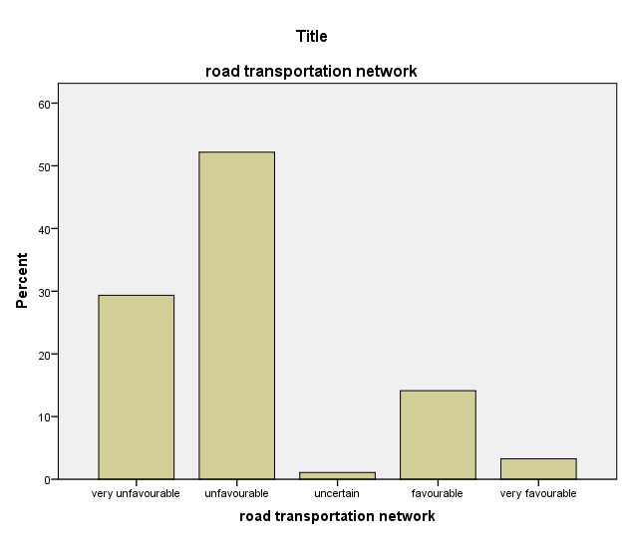

**Figure 4.5: Effect of road transport networks on SMSs**

**Source:** Field data (2023)

Transport networks especially roads is a key factor that facilitates movement of goods and services, without which it is hard to build a vibrant and healthy business sector in any economy. There is need for policy makers to look into these challenges and address them accordingly.

# 4.3.1.2 Reliable and cost efficient electricity services:

From the analysis in Table 4.4, majority of the respondents have the view that, this factor is very unfavorable with a mode score of 1. The mean score indicates 1.47, which also signifies that the factor is very unfavorable.

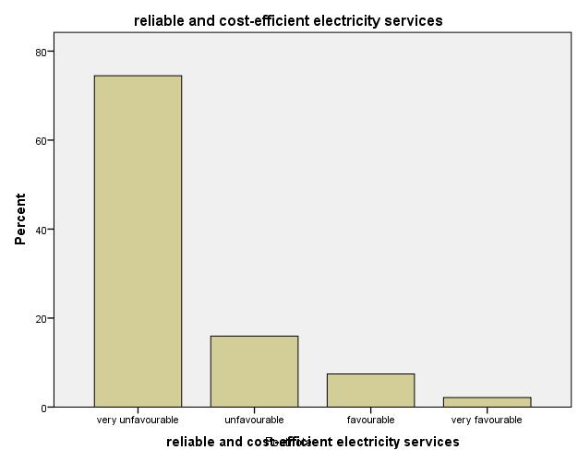

**Figure 4.6: Effect of reliable and cost-efficient electricity services on SMEs**

**Source:** Field data (2023)

From these scores it can be argued that, in Ukerewe District, the supply of electricity is unreliable and the cost is not efficient as well to serve the needs of the business community. Because, electricity supply is vested on TANESCO a sole company under the government with the mandate to generate and distribute electricity throughout the country, then these responses is just a reflection of responses of all business operators across the country. There is a need for the government to prioritize this issue of electricity in ensuring there is reliable and cost efficient generation and supply of power to the citizens and business community in particular.

# 4.3.1.3 Communication infrastructures, networks and services:

From the analysis, majority of respondents indicated that this factor was favourable with a mode scoring the scale of 4. The mean score for this factor was 3.78. The score is between 3 (uncertain) and 4 (favorable) which shows also that there are some respondents who thought that the factor was unfavourable or uncertain. However, the closeness of the mean to 4 signifies that, majority of respondents have the feeling that communication infrastructures, networks and services in their areas are favourable.

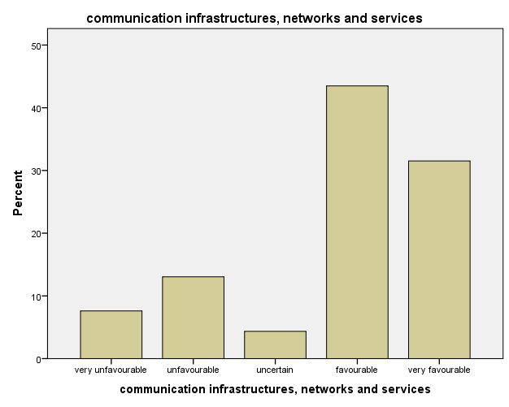

**Figure 4.7: Effect of communication infrastructures, networks and services on SMEs**

**Source:** Field data (2023)

This is a good sign since communication networks and its services is among the key means for smooth operations of any business due to improved flow of information from various actors in the economy.

# 4.3.1.4 Availability and access of land for investment:

The results show that this factor is unfavorable where the mode score is 2 and the mean score is 2.13. In this regard, the response shows that land availability and accessibility for investment is a big challenge to SMEs in Ukerewe District.

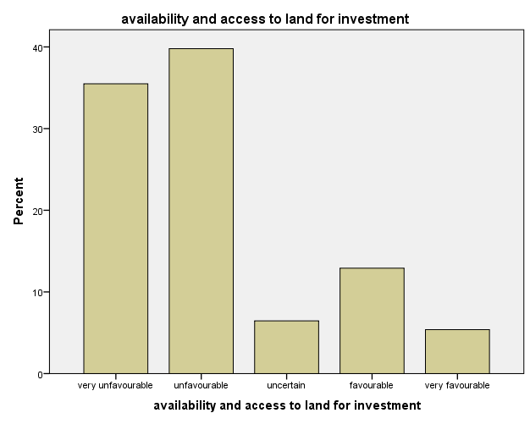

**Figure 4.8: Effect of availability and access to land for investment in SMEs**

**Source:** Field data (2023)

Most of the interviewed respondents indicated to face challenges when they need a land where they could install their business. They end up rending very costly premises, which are also very small. This kind of response could be expected especially from SMEs operating in Ukerewe District, an amalgamation of islands which has a history of land conflicts between and among families due to scarcity of land. However, policy makers have a role to play by allocating a specific area for investments.

# 4.3.1.5 Policies and interventions that support SMEs:

This is another important area where policy makers need to keep an eye on. Supportive policies tend to boost investments in any economy particularly in assisting the growth of the SME category. However, a majority of respondent indicates that they are uncertain with a mode score of 3. The mean score is 2.7 showing the closeness to 3 (uncertain).

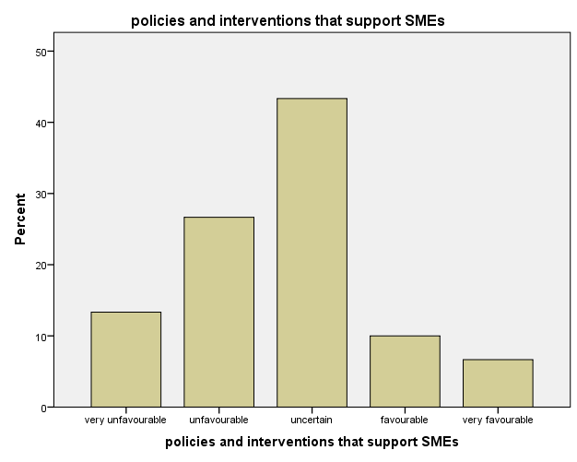

**Figure 4.9: Effect of policies and interventions that support SMEs**

**Source:** Field data (2023)

Based on the mode score it can be argued that the policies that support SMEs in Ukerewe District have not been well integrated into daily operations of SMEs. This could be contributed by number of reasons including lack of awareness by SMEs on availability of policies and interventions that supports them. There is need of raising the public awareness concerning several policies that are supportive to SMEs. There are a number of SME support interventions taking place in the country and district from development partners, but most of SMEs are misinformed as they think these interventions are not for them. Another reason could be little involvement and low level of participation of key stakeholders including SMEs themselves in design and implementation of these policies.

# 4.3.1.6 Regulations in licenses, permits, and registration:

From the analysis, the response on this factor was rated at mode score of 1 indicating very unfavorable score. The mean score is 1.93which is very close to 2 indicating unfavorable, indicating that majority of respondents still considered that the factor was not favorable.

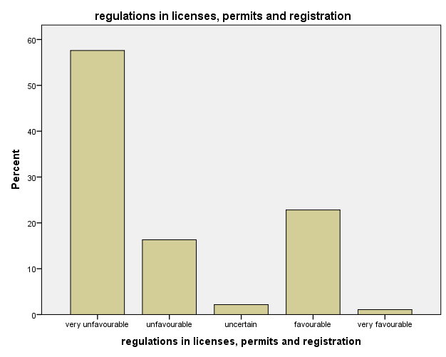

**Figure 4.10: Effect of regulations in licenses, permits and registration for SMEs**

**Source:** Field data (2023)

This shows that most SMEs in Ukerewe District face a lot of challenge when they applied for business licenses and registration for their business.

# 4.3.1.7 Access to finance

From the analysis, respondents indicated that this factor was very an unfavorable. The mode score was 2 indicating unfavorable condition of access to finance by SMEs in Ukerewe District. The mean score from the results is 1.85 which is between 1 (very unfavourable) and 2 (unfavourable) but the closeness to 2 indicates that the factor is unfavorable.

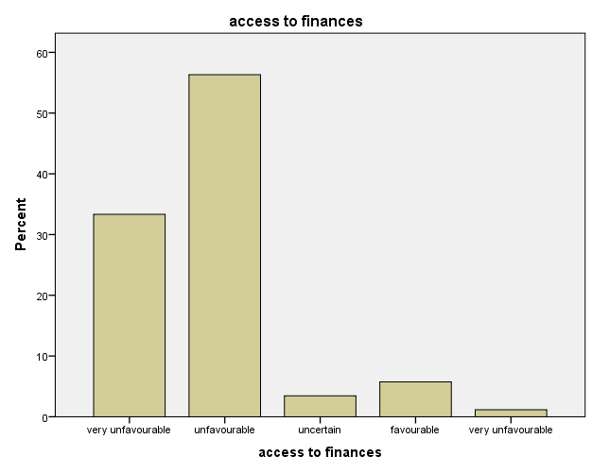

**Figure 4.11: Access to finances by SMEs in Ukerewe District**

**Source:** Field data (2023)

This response indicates that, most SMEs in Ukerewe District face difficulties in accessing finance especially for a start-up business. They face complicated procedures of getting loans from financial institutions. Also financial institutions have very high interest rate that makes it difficult for most SMEs to excel due to heavy burden they are caused by high interest rates demand collateral of high values. From the analysis, access to finance seems to affect not only start-up business but old businesses as well. There is a need to find a way on how best these SMEs could be served for better and improved business operations.

# 4.3.2 The Influence of Managerial Factors on Performance of SMEs in Ukerewe District

This part presents factors that are available and support the managerial factors/ environment of SMEs in the country especially in Ukerewe District. The researcher assessed the awareness of the respondents on the supportive policies and interventions from the government, private sector, and development partners. Then the respondents where requested to indicate how do they find these policies and interventions supportive to their businesses in Ukerewe District.

# 4.3.2.1 Awareness of SMEs on supportive policies

Respondents were asked whether they had been made aware of any supportive policies in the country for SMEs. The response indicated that majority of SMEs are not made aware of any policy that supports them. The response in Figure 4.12 provides a summary of the results. From the analysis, it was revealed that 75.79% of the respondents are not aware of the supportive policies to SMEs while only 18.95% of the respondents admitted that they were aware of the supportive policies to SMEs.

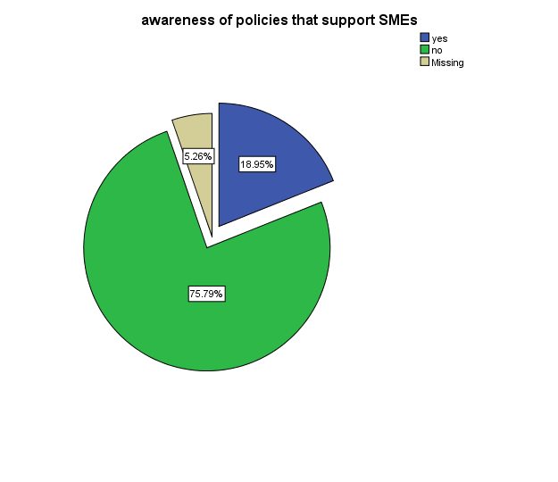

**Figure 4.12: Awareness on supportive policies by SMEs in Ukerewe District**

**Source:** Field data (2023)

As explained earlier, majority of SMEs have no awareness of any policy that supports SMEs. This is a huge number that cannot just be left out. There is high need of increasing awareness programs that will make sure that all stakeholders are taken on board. However, the indication that there is another percentage who are aware of the existence of supportive policies is a good sign that at least there have been efforts made to the raise the level of policy awareness to the public. More efforts are needed to ensure that majority are made aware of these policies, since they are designed and implemented for their sustainability.

# 4.3.2.2 Supportive Interventions for SMEs

In this part, respondents were required to respond whether or not they knew any interventions to support SMEs in their areas. The results revealed that, majority are still not aware of these interventions. The results from Figure 4.14 summarize these findings.

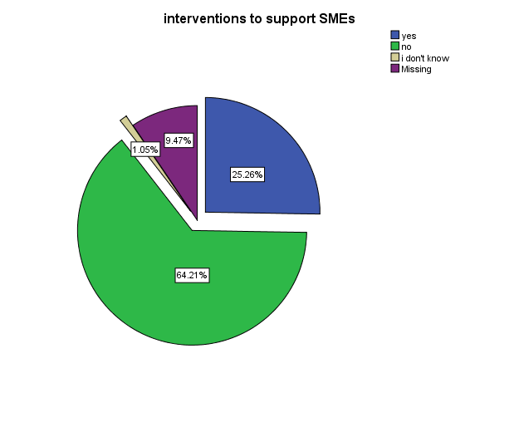

**Figure 4.13: Awareness on supportive interventions for SMEs in Ukerewe District**

**Source:** Field data (2023)

From Figure 4.13 it can be seen that, again the majority (64.21%) are not aware of any interventions in their areas. Only a quarter of the respondents (25.26%) are aware of the interventions that support SMEs in their areas.

This shows that majority of SMEs in Ukerewe District (64.21%) have not been made aware of interventions around their areas of operations. Despite presence of a number of institutions and interventions that support SMEs in various capacities such as trainings and access to finance but most SMEs are not met by these interventions. No wonder that is why the challenges affecting SMEs are still prevailing despite presence of these interventions. There is a need to reduce the conditions or qualifications to these interventions so that a number of SMEs throughout the district are reached by these supportive interventions. However, 25.26% of the respondents are aware of these interventions. This indicates that the presence of these supportive interventions is somehow felt by SMEs in Ukerewe District. More efforts are needed to raise not only the awareness of these interventions but also to make them accessible to all SMEs in the district.

How do the available interventions support SMEs development: There have been several interventions to support SMEs in Ukerewe and the country at large. The mentioned interventions that were cited by respondents include; interventions done by SIDO, through capacity building programs on trainings; UNIDO trainings in small industries development; and the interventions done by TAN-TRADE through giving a room for SMEs to participate into yearly “sabasaba” international exhibitions done in July. From the response, it was shown that these interventions have provided some remarkable assistance to SMEs. However, they recommended for more interventions that will involve more SMEs where currently only few SMEs are reached. The respondents also noted the presence of many organizations doing similar activities, which indicates that these institutions are not well coordinated. There should be a proper coordination to ensure that available resources are maximized and many beneficiaries are reached.

As mentioned earlier, there are a number of interventions to support SMEs in the country. These include; The National Economic Empowerment Council (NEEC), SIDO, TIC, TCCIA, and the Private Sector Foundation. NEEC resides in the prime minister’s office; the main function of this institution is to develop strategies for the mobilization and utilization of resources for economic empowerment activities. In this regard, the role of NEEC is to facilitate and coordinate empowerment and entrepreneurship training programs for various groups of citizens especially SMEs. The main challenges of these interventions are that they are yet to reach to majority of SMEs. This is policy issue to be dealt with urgency, as these interventions are highly needed by intended groups.

The Small Industries Development Organization (SIDO), which is a parastatal organization, vested with the mandate to develop the small industry sector in Tanzania. Its function ranges from policy formulation to direct support to industries, and hands-on involvement in the establishment of SMEs in the country. SIDO has been engaged in various support activities including technological development and transfer services (e.g. cluster initiatives and incubation centers) that are present in some regions; training and regional extension services that are done to SMEs throughout the country. The main limitation of these services is that they are available to some areas especially the technological development centers and incubation centres. There is need to increase budgetary allocation to support these interventions in order to benefit majority of SMEs countrywide.

The Tanzania Investment Centre (TIC) which was established in 1997 by the Tanzania government in order to coordinate, encourage, promote and facilitate investment in Tanzania and to advise the government on investment policy and related matter. Also their mandate is to stimulate and support the growth of entrepreneurship and SMEs in the country. Despite these roles being clearly explained in various documents, yet the function of these institutions is yet to be felt by majority of SMEs. The centre is not yet known to most SMEs, which even make them difficult to access their services.

The Tanzania Chamber of Commerce, Industry and Agriculture (TCCIA), which is the private sector association, established with the support of the government in 1988. TCCIA has regional offices and over 100 district centres. It has been working closely with international organizations and the government to strengthen the private sector. Its main function is to offer its members, information, business linkages, business development services and advocacy. The works of the TCCIA could be felt by many SMEs due to their presence in almost all regions and some districts. There is a need for more intuitional support to insure that this organization has its offices on each district.

The Tanzania Private Sector Foundation (TPSF) which was established in order to promote the private sector-led social and economic development in Tanzania. The main function of TPSF includes government engagement, policy formulation and lobbying. It also functions as a principal interlocutor at the national level on all private sectors issues. The main goal of the organization is to develop the private sector business agenda, positioning the private sector as an engine of growth, and maximizing Tanzania’s competiveness in the global economy. As explained before, the role of the private sector foundations are yet to be felt by SMEs in Ukerewe District. We saw that majority of SMEs are unaware of these interventions including the existence of organizations that provide these interventions. Public awareness is highly recommended including capacitating these institutions to be able to carry out their mandates with ought and difficulties.

There are also other interventions from development partners such as World Bank Group, UNIDO, USAID, DFID, and DANIDA. These institutions have been providing various supports to the community including SMEs. However their interventions are not still well, felt by majority of SMEs. There have been a number of projects aimed at supporting the SMEs, but according the study results it was shown that these supports end ups to just a handful of entrepreneurs. The requirement and qualification to access these interventions could be the main barriers. Another challenges is that, not all these projects reach out the countryside of the district, the providers of these interventions have their interests in some areas and sectors especially in urban areas, where majority of SMEs in rurallike Ilangala Division are left out.

Respondents who indicated to be aware of the supportive interventions for SMEs were also asked to comment whether supportive interventions help to improve the performance of SMEs in Ukerewe District.

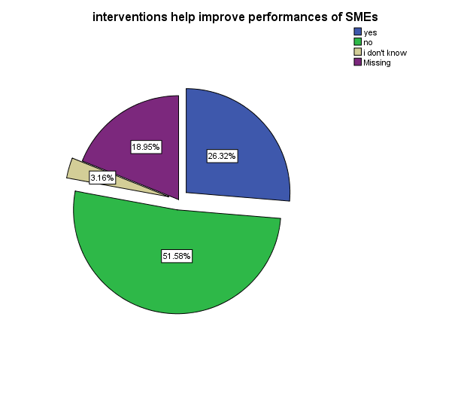

**Figure 4.14: Whether supportive interventions improve performance of SMEs in Ukerewe District**

**Source:** Field data (2023)

# 4.3.2.3 Financing of SMEs

The response indicated that majority of SMEs did not accept that supportive interventions help to improve performance of SMEs. The response in Figure 4.14 provides a summary of the results. From the analysis, it was revealed that 51.56% of the respondents are denied while only 26.32% of the respondents admitted that supportive interventions improve performance of SMEs.

**Table 4.5: How SMEs finance their business**

|  |  |  |
| --- | --- | --- |
| **Source of finance** | **Frequency** | **Percent** |
| from savings | 34 | 35.8 |
| through partnership | 33 | 34.7 |
| Loans | 22 | 23.2 |
| Others | 6 | 6.4 |
| Total | 95 | 100.0 |

**Source:** Field data (2023)

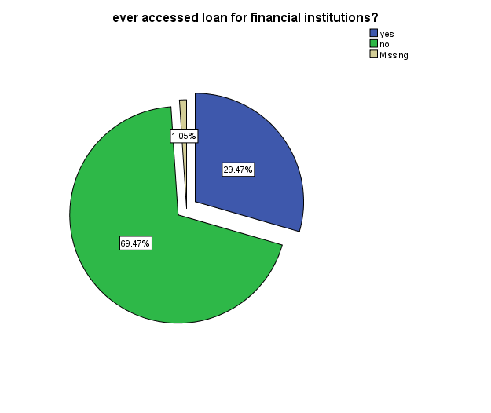

**Figure 4.15: Whether SMEs ever had access to loans from financial institutions**

**Source:** Field data (2023)

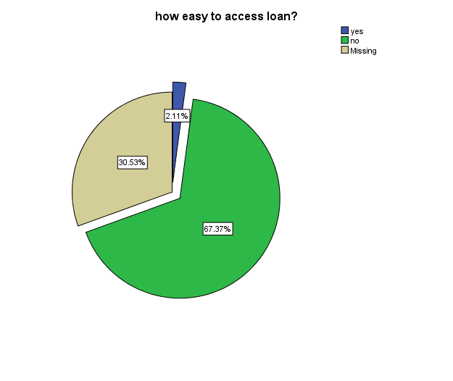

**Figure 4.16: Easiness to access loans from financial institutions by SMEs in Ukerewe District**

**Source:** Field data (2023)

# 4.3.2.4 Settling Problems regarding tax with TRA

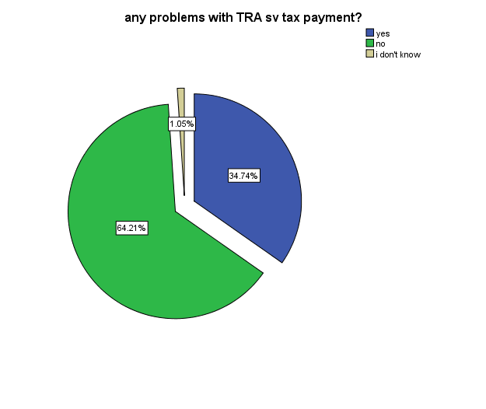

**Figure 4.17: Whether SMEs in Ukerewe District face problems with TRA regarding tax payments?**

**Source:** Field data (2023)

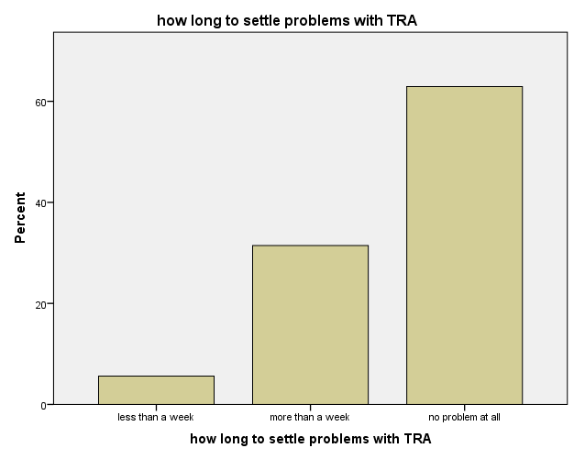

**Figure 4.18: Time spent by SMEs in settling problems regarding tax payment with TRA**

**Source:** Field data (2023)

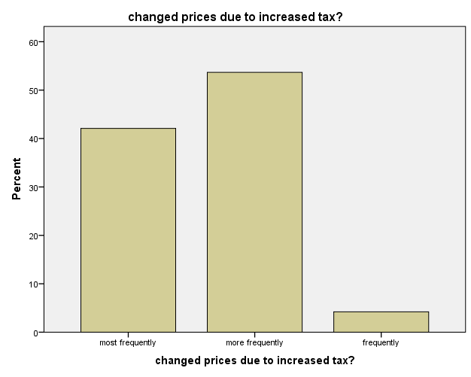

**Figure 4.19: Change of prices by SMEs due to increase in taxes**

**Source:** Field data (2023)

# 4.3.3 The Influence of Business Technical Services on Performance of SMEs in Ukerewe District

# 4.5.1 Business Development Services (BDS)

SMEs require affordable and readily available Business Development Services (BDS), which could assist them in matters such as record keeping, market analysis, and business planning hence good business performance. However, these services need to be available at lowest cost possible for them to access them.

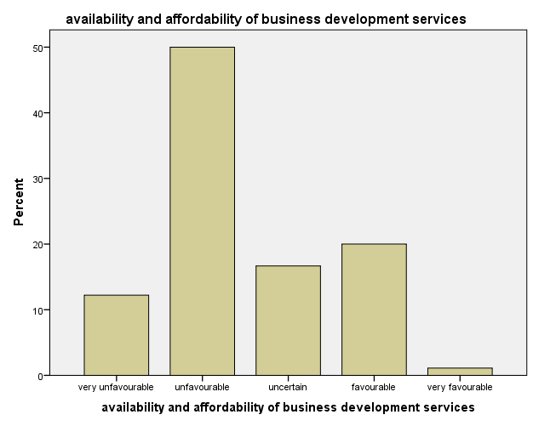

**Figure 4.20: Availability and affordability of business development services by SMEs in Ukerewe District**

**Source:** Field data (2023)

In their response, majority indicated that this factor is favorable as they can access these services at affordable prices. However, there are those who indicated otherwise and were uncertain, as the mean score is 2.48 that signify unfavourable. Since the mode is the deciding factor, it can be argued that at least for Ukerewe SMEs, they cannot easily access business development services. This was due to the mode score of 2. It indicates that there are few individuals and firms that provide very affordable business development services, although some did not agree to that but most of the comments indicated to have access to these services which is a good sign for business growth in the country. However, there is a policy consideration for those who did not think they could access these services with affordability. Policy makers need to identify the challenges and find a way to sort it out.

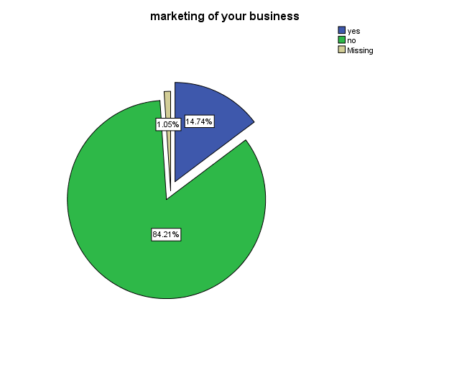

**Figure 4.21: Whether SMEs in Ukerewe District market their business**

**Source:** Field data (2023)

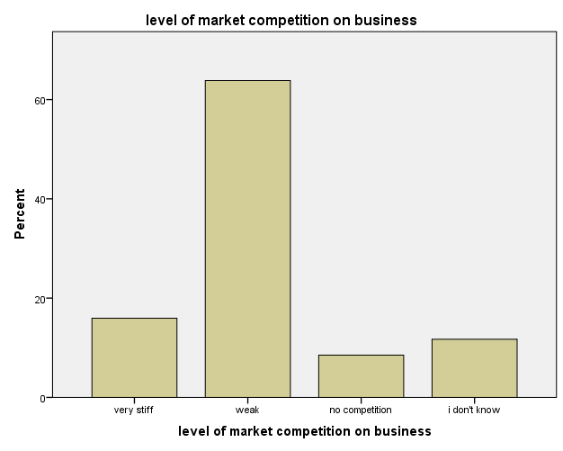

**Figure 4.22: Level of market competition for SMEs in Ukerewe District**

**Source:** Field data (2023)

# 4.3.3.3 Targeted customers

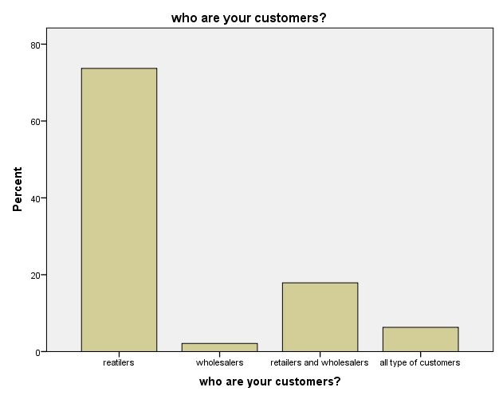

**Figure 4.23: Targeted customers for SMEs in Ukerewe District**

**Source:** Field data (2023)

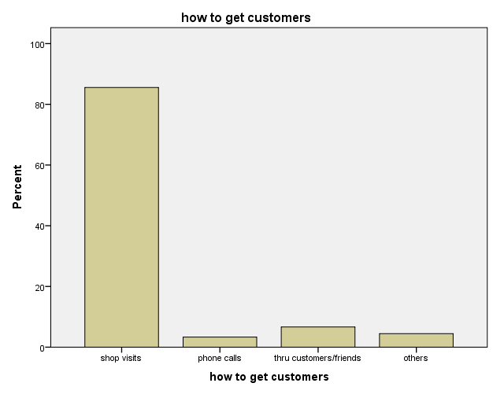

**Figure 4.24: How SMEs in Ukerewe District get their targeted customers**

**Source:** Field data (2023)

# 4.4 Discussion of the Findings

As per study objectives, it has been noted that the performance of SMEs in Ukerewe District is constrained by a number of factors, including unsupportive policies and interventions; unsupportive infrastructures including transport networks, port facilities and services, communication facilities; market places that are not supportive; and unreliable electricity supply. The performance of SMEs was also found to be hindered by costly business development services, unsupportive legal and regulatory frameworks, and non-access to finance and land for investments.

**Infrastructure:** The study findings revealed major challenges related to infrastructure as among key hindrances to business performance. The study noted a challenge in road networks in Ukerewe District making it difficult for the business community to carry out their undertakings smoothly. It was emphasized that, transport networks especially roads is a key factor that facilitates movement of goods and services, without which it is hard to build a vibrant and healthy business sector in any economy. Most of roads in Ukerewe are not passable especially during the rainy season. This calls for whoever is responsible to address the challenge as they arise. Taking a note that, if this is the case for Ukerewe, which is at the heart of the islands, what could be the status of roads in other parts of the district especially in rural areas and smaller islands? The answer is obvious, the condition of rural roads is terrible, the study revealed that, most SMEs in Ukerewe District that are engaged in transportation of goods to and from rural areas faces many challenges in getting raw materials from rural areas especially during the rainy seasons.

Electricity is another factor that is viewed to be most challenging. The supply of electricity is unreliable and the cost is not efficient as well to serve the needs of the business community in the country. From the interview, it was revealed that there have been frequent power interruptions that are affecting processors to larger extent. The interruptions are said to be caused by old infrastructure of the electricity system in the country.

The issue of unreliable electricity supply is major hindrances to the performances of SMEs in the country, it also limiting new investments. Thus, there is a high need of improving generation and distribution of reliable, high quality and low cost electricity in order to boost the country’s economy through improved performances of SMEs.

Concerning communication infrastructures, networks and services, the study findings revealed that the factor was considered favorable. This is a good sign since communication networks and its services is among the key means for smooth operations of any business due to improved flow of information from various actors in the economy. However, there is still a challenge as not all respondents indicated to enjoy the services. There is therefore a need to improve infrastructures related to communication and networks in the country for a greater participation of the business community in using modern and sophisticated means of communication and networking including internet facilities, establishments of trade information portals and enhancements of teleconferencing.

The challenges related to infrastructure were also cited by Kuzilwa (2005) in his study of assessing various challenges facing SMEs in Tanzania. He argued that, SMEs are yet to exploit the full potential of the sector due to the existence of a number of constraints hampering their development due to poor and underdeveloped infrastructure being among the impediments. This is an alert to the policy makers, so that they take appropriate measures to address the challenges. This challenge was mentioned in this study more than 10 years ago, in this current study the same challenge is emerging among the top impediments to the sector development indicating that, little efforts are being done to work on these challenges.

Also in the works of Goedhuys and Sleuwaegen (2009), it was cited that the main impediment to an entrepreneur is related to poor infrastructure, insecurity, poor transport systems, and non-access to finance. This calls for more attention to the 53 importance of having a robust SMEs sector through eradication of main challenges hindering its growth, where infrastructure is among them.

**Business Development Services (BDS):** These are services rendered to the business community in order to improve business performance through improved record keeping, adhering to best practices on business management, human resources business operations. However, the study revealed that these services are hardly accessed by SMEs due to high cost charged. There is a number of institutions and individuals who are providing these services but are said to be costful. Some interventions in terms of BDS are provided by SIDO and NGOs but still are not accessible to the SMEs in Ukerewe District. There is a need to invest in the business development centres that will be specifically for assisting the local SMEs in accessing these services at lowest cost as possible. Also in works of the studies on SMEs by Mfaume and Leonard (2003), the challenges related to training and education was emphasized in order to cub the challenge of lack business skills, management problems facing SMEs. They insisted that, the business development services need to be affordable and readily available to the business sector.

Business development services have been a challenge to many SMEs in Ukerewe who fail to access them at a reasonable price and on timely manner. Thiswas also noted in the study by Nkonoki (2010) concerning the internal and external factors which inhibit the performance of the SMEs. Unlike the external factors, internal factors are directly controlled by the firm as they rest in their powers to control them. These internal factors include; best communication means, the quality of staff, staffing and retention programs; training programs, financial resources and working culture of the organization and so forth. He noted that in order to eradicate the internal factors that are posing challenges to the firm, business development services are highly needed especially in order to equip the SMEs with the capacity to deal with internal factors which are directly controlled by the firm itself.

**Legal and Regulatory Framework**: The legal and regulatory framework seems to be unfriendly to most SMEs. The results show that, most SMEs indicated that they faced a lot of challenge when they applied for business licenses and registration for the first time. While legal and regulatory framework is expected to pave a way toward smooth operations of businesses in the country, the situation is different to some SMEs as they see it as a roadblock rather than being a stepping-stone.

From the interviews, it was suggested that, there is a need to make these procedures as simple as possible to allow a number of business operators formalize their business. The results further revealed that, this factor was among the top reasons as to why majority of micro businesses in Tanzania are not formalized. There is also a challenge during issuance of permits especially when an SME wants to export their products. Most SMEs have failed to pass the borders with their products due to complicated and bureaucratic procedures on issuance of permits. Review of legal and regulatory framework is highly recommended in order to make it supportive to business operation especially during the current industrialization campaigns.

The challenges related to legal and regulatory framework conform to the findings of a joint report by UNDP, ILO and UNIDO (2012) which highlighted several challenges that affects the performance of SMEs in the country. Among these challenges, regulatory barriers came up especially during business registration. It was stated that majority of SMEs face challenges when formalizing the business due to unfavorable and legal and regulatory framework

**Access to Finance:** Non-access to finance has been a roadblock to the success of most SMEs in Ukerewe District, both start-ups and grownups. They both need finance to either fund their operations and starting up a new business. Majority of SMEs can hardly access to the sources of these finances due to high cost of interest or very complicated requirements that only a handful of SMEs can meet. Even the SMEs that can access these finances face many challenges including complicated application procedures and collateral requirements. Since access to finance is at the heart of any business, it is mandatory that this problem need to be properly addressed.

Access to finance has caught the interest of many researchers in the country. This might have been caused by the importance of this factor. Without a reliable source of finance, businesses will not grow. These findings conform to the study by a number of scholars. In the research done by REPOA (2009) several challenges were highlighted as roadblocks towards successfulness of SMEs. The study noted the challenge of non-access to finance as a great challenge facing majority of SMEs. The study noted that only about 15% of the SMEs access formal sector credit, and among micro enterprises, only 6% have that access. There is a need to improve the services of the institutors that provides financial services to SMEs.

**Access to Land for Investment:** the majority of SMEs in Ukerewe District find difficulties when looking for land in order to install their business premises. This has resulted in heavy reliance on rented premises that are costly and difficult to make any production extensions. Land for investment is a key factor to be considered before planning to start any business. However, the study noted that, due to limited availability of land, majority of businesses have failed to be established in the country especially in Ukerewe. Land in Ukerewe District is very small and unavailable because of high population density. The rate of population growth of Ukerewe seems to be high while the land available diminishing. There is a need to reconsider this factor in order to ensure that land becomes readily available to SMEs as well.

The problem related to access for land for investment necessitated the establishment of MKURABITA. The government initiatives aimed at enabling majority of individuals to own and formalize land ownership issues so that they can use it to have access to capital. This problem also is being dealt the donor funded projects including BEST which advocates for more favorable business environment including access to land for investment in the country.

# CHAPTER FIVE

# SUMMARY, CONCLUSIONS AND RECOMMENDATIONS

# 5.1 Overview

This part summarizes the findings as presented in the study, provides conclusions and then recommendations based on the study findings. In the part the recommendation for future research works is also provided to provide a road map on which areas were not covered in the current study that need to be addressed in future research works.

# 5.2 Summary of the Main Findings

The main objective of this research was to assess the factors affecting performance of SMES in Ukerewe District. The study specifically looked at the influence of business environment on performance of SMEs in Ukerewe District; the influence of managerial environment on performance of SMEs in Ukerewe District; and the influence of business technical factors on performance of SMEs in Ukerewe District. A total of 95 respondents from SMEs sector were interviewed where females were represented by 64% while males were represented by 36%. This indicates how business operations are female dominated and reflects efforts by the government policy and private sector interventions to uplift the number of women in business.

In assessing these factors, research questions were devised through a structured questionnaire where responses were coded and presented in tables and figures as already discussed.

# 5.3 Conclusion

The study findings from both secondary and primary data reveal a number of challenges impeding the performance of SMEs in Ukerewe District. The main factors that affect performance of SMEs include non-access to finance; unfavorable transport networks; unfavorable port services; unreliable and inefficient cost of electricity services; and unavailability and non-access of land for investment. Despite the presence of several policies and interventions to support SMEs in the country; the output of these policies and interventions are yet to be fully utilized by the intended beneficiaries including SMEs. Majority of SMEs are unaware of the existence of any policies and interventions to support them. A lot of available interventions are implemented in just few areas, leaving most of the SMEs unreached.

In order for SMEs to have a significant economic contribution to Ukerewe District and the country at large, it is necessary that the main challenges affecting its performance are properly addressed. Joint efforts are needed from the government, private sector, academic institutions, development partners and any other interested parties to ensure that they join hands to address the main challenges affecting the performance of SMEs in Ukerewe District.

# 5.4 Recommendations

Following the challenges revealed in this study, a number of recommendations have been suggested as follows:

• There is a need for the government and Ukerewe District Council to review the business policies to reflect the current needs of the SMEs in Ukerewe District. There should be appropriate budgetary allocation to implementing institutions so that the implementation of the policy is done timely.

• There should be institutional support to institutions that are supporting SMEs in Ukerewe District to access finance. Most financial institutions available in Ukerewe District are charging a high interest in order to cover their operational costs.

• The government should ensure that it allocates enough land for investment in each Division of Ukerewe District. This will help majority of SMEs in the district as it will help to lower the cost of operation and attract more SMEs to invest in Ukerewe District.

• Improve training and education to SMEs across Ukerewe District through trade officers and other actors including academic institutions at the division and ward levels. The government has to ensure that the SMEs in Ukerewe District benefit from the knowledge obtained from these institutions.

# 5.5 Areas of future research works

This study assessed the factors that influence the performance of SMEs in Ukerewe District. The results produced can also be applied to other areas of the country and outside the country as well. However, more studies are needed in this area due to the role that SMEs play in an economy. Future research works should consider looking into more critical factors by conducting the study in different divisions and wards in the district of Ukerewe. This will help to explore more critical factors and find workable solutions that could be helpful in addressing the challenges facing SMEs in different divisions, wards and islands that constitute Ukerewe District.

**REFERENCES**

Anderson, W. (2017). Factors Affecting Small & Medium Enterprises (SMEs) Start- up and Growth in Tanzania. The Pan-African Journal of Business Management, [online] 1(1), pp.1-51.

Baporikar, N., Nambira, G. & Gomxos, G. (2016). Exploring factors hindering SMEs’ growth: evidence from Nambia. Journal of Science and Technology Policy Management, [online] 7(2), pp.190-211.

Bilal, A., Khan, A. & Akoorie, M. (2016). Constraints to growth: a cross country analysis of Chinese, Indian and Pakistani SMEs. Chinese Management Studies, [online] 10(2), pp.365-386.

Bouazza, A., Ardjouman, D. & Abada, O. (2015). Establishing the Factors Affecting the Growth of Small and Medium-sized Enterprises in Algeria. American International Journal of Social Science, 4(2), pp.101-156.

Clegg, B. (2018). Perceptions of growth-impeding constraints acting upon SMEs’ operations and the identification and use of transitionary paths to elevate them. International Journal of Operations & Production Management, 38(3), pp.756-783.

Curran, J. and Blackburn, R.A. (2001), *Researching the Small Enterprise*, Sage Publications, London.

Curran, J., Stanworth, J. and Watkins, D. (1986), *The Survival of the Small Firm*, Vol. 1. The Economics of Survival and Entrepreneurship, Gower, Aldershot.

Ekblom, M. (2016). Challenges Facing Food Processing MSEs in Tanzania: A Qualitative Case Study of the Sunflower Oil Industry in Babati, Manyara. [online] DIVA. Available at:

http://www.divaportal.org/smash/record.jsf?pid=diva2%3A935700&dswid=1978 [Accessed 24 Oct. 2019].

Gamba, F. (2017). Social Capital in Selected Business Associations of Food Processing SMEs in Tanzania and Rwanda: A Synthetic Based Approach. *International Journal of Asian Social Science, 7*(1), pp.63-84.

Haselip, J., Desgain, D. & Mackenzie, G. (2015). Non-financial constraints to scaling-up small and medium-sized energy enterprises: Findings from field research in Ghana, Senegal, Tanzania and Zambia. *Energy Research & Social Science, 5*, pp.78-89.

Isaga, N. (2019). Start-up motives and challenges facing female entrepreneurs in Tanzania. I*nternational Journal of Gender and Entrepreneurship,* 11(2), pp.102-119.

Isaga, N. & Musabila, A. (2017). Challenges to Entrepreneurship Development in Tanzania. Entreprenuership in Africa, 15.

Juma, S. & Said, F. (2019). SME Globalization-Tanzania Case Study. *International Journal Advances in Social Science and Humanities, 4(*6).

Kabanda, S. & Brown, I. (2017). A structuration analysis of Small and Medium Enterprise (SME) adoption of ECommerce: The case of Tanzania. *Telematics and Informatics, 34*(4), pp.118-132.

Kimathi, F. (2015). The Challenges Confronting Small Scale Businesses in accessing Microfinance Services from MFIs Case Study: Rural Tanzania. *International Journal of Academic Research in Business and Social Sciences, 5*(11), pp.299-311.

Lindvert, M. (2017). Financial Barriers and How to Overcome Them: The Case of Women Entrepreneurs in Tanzania. Entreprenuership in Africa, [online] 15. Available at: https://doi.org/10.1163/9789004351615_016 [Accessed 24 Oct. 2019].

Lindvert, M., Patel, P., Smith, C. & Wincent, J. (2018). Microfinance Traps and Relational Exchange Norms: A Field Study of Women Entrepreneurs in Tanzania. Journal of Small Business Management,57(1), pp.230- 254.

Magasi, C. (2016). Factors Influencing Business Succession Planning among SMEs in T anzania. European Journal of Business and Management, 8(3), pp.126-135.

Makorere, R. (2014). The role of microfinance in promoting small and medium enterprises (SMEs) in Tanzania: empirical evidence from SMEs holder who have received microcredit from financial institutions in Morogoro. Global Business and Economics Research Journal, 3(4), pp.1-19.

Mashenene, R. (2015). Proceedings of the Second European Academic Research Conference on Global Business, Economics, Finance and Banking. In: EAR15Swiss Conference. Zurich-Switzerland: Global biz research.

Mashenene, R. & Rumanyika, J. (2014). Business Constraints and Potential Growth of Small and Medium Enterprises in Tanzania: A Review. European Journal of Business and Management, [online] 6(3), pp.72-79.

Mashenene, R., Macha,, J. & Donge, L. (2014). Socio-Cultural Determinants and Enterprise Financial Sources among the Chagga and Sukuma Small and Medium Enterprises in Tanzania. International Review of Research in Emerging Markets and the Global Economy (IRREM), [online] 1(5), pp.265-283.

Mpunga, H. (2016). Examining the factors affecting export performance for Small and Medium Enterprises (SMEs) in Tanzania. Journal of Economics and Sustainable Development, [online] 7(6), pp.41-51.

Nyangarika, A. (2017). Social-Economic Constraints towards Women Business Growth in Tanzania. European Journal of Business and Management, 8(5), pp.130-139. Rumanyika, J. (2015). Obstacles Towards Adoption Of Mobile Banking In Tanzania: A Review. International Journal of Information Technology and Business Management, 3(1), pp.1-17. European Journal of Business and Management www.iiste.org ISSN 2222-1905 (Paper) ISSN 2222-2839 (Online) Vol.11, No.33, 2019

Shamsuddin, J., Sarkawi, M., Jaafar, A. & Rahim, N. (2017). Malaysian SMEs Performance and the Government Business Support Service: The Moderating Effects of Absorptive Capacity. Int. J Sup. Chain. Mgt, 6(4), pp.326-331.

Simpson, M., Padmore, J., and Newman, N. (2010), Towards a new model of success and performance in SMEs, *International Journal of Entrepreneurial Behaviour & Research*, Vol. 18 No. 3, 2012: pp. 264-285.

Tangen, S. (2004), “Performance measurement: from philosophy to practice”, *International Journal of Productivity and Performance Management*, Vol. 53 No. 8, pp. 726-37.

Tillmar, M. (2016). The Lack of Business Dispute Resolution in East Africa: An Unresolved Impediment to SME Development? In: L. Achtenhagen and E. Brundin, ed., Entrepreneurship and SME Management Across Africa. Singapore: Springer. Wang, Y. (2016). What are the biggest obstacles to the growth of SMEs in developing countries? – An empirical evidence from an enterprise survey. Borsa Istanbul Review, 16(3), pp.167-176.

Walker, E. and Brown, A. (2004), “What success factors are important to small business owners?”, *International Small Business Journal,* Vol. 22 No. 6, pp. 577-94

World Bank Blogs. (2017). Improving access to finance for SMEs in Tanzania: Learning from Malaysia’sexperience.[online]Availableat:https://blogs.worldbank.org/eastasiapacific/improving-accessfinance-smes-tanzania-learning-malaysia-s-experience [Accessed 22 Oct. 2019].

Yukhanaev, A., Fallon, G., Baranchenko, Y. & Anisimova, A. (2015). An Investigation into the Formal Institutional Constraints that Restrict Entrepreneurship and SME Growth in Russia. Journal of East-West Business,21(4), pp.313-341.

**APPENDICES**

# APPENDIX 1: QUESTIONNAIRE

Dear Respondent,

My name is **Joseph Mkundi**. I am pursuing Master’s degree in Business Administrationat Open University of Tanzania. Currently I am conducting a research in Ukerewe District, titled; Factors Affecting Performance of Small and Medium Enterprises (SMEs) in Ukerewe District

This questionnaire intends to collect information on performance of SMEs in Ukerewe District. You are kindly requested to spare some time in responding to the questions below by ticking or filling in the spaces provided. This information shall be treated with high confidentiality and applied purely for academic purposes. In addition, the findings will be of great help to SMEs and the public at large.

**PART A: Demographic Profile**

**(Please tick or write answers in full where applicable**)

1. Please indicate your age group through ticking in the space provided;

a) <18 [ ]

b) 18-25 [ ]

c) 26-35 [ ]

d) Above 35 [ ]

2. Please indicate you gender;

a) Male [ ]

b) Female [ ]

3. Please indicate your level of education

a) Primary education [ ]

b) Secondary education [ ]

c) Diploma

d) Bachelor degree /Advance diploma [ ]

d) Master degree [ ]

4. Name of Company / Owner ……………………..……………..………

5. Business Location ……………………..……………..………

6. Type of Business……………………..……………..………

7. Number of years in this business

a) Less that one year [ ]

b) 1- 5 years [ ]

c) 6- 10 years [ ]

d) More than 10 years [ ]

**PART B: Factors affecting Performance of SMEs at your area**

You are kindly requested to respond to this question in a five point scale to indicate the extent to which a particular factor constrains the performance of SMEs in Ukerewe District.

How would you rate the factors affecting performance of SMEs in Ukerewe District through the areas listed below?

**Key notes**:

Please do not select more than one response per row

**Scale definition:**

**1 – Very unfavorable; 2 = Unfavorable; 3 = Uncertain 4=Favorable; 5= Very Favorable.**

|  |  |  |  |  |  |  |
| --- | --- | --- | --- | --- | --- | --- |
| **Factors** | **Responses** | | | | | **Brief description**  **on the reason for**  **the rating** |
|  | 1 | 2 | 3 | 4 | 5 |  |
| 1. Road Transportation Networks |  |  |  |  |  |  |
| 2. Port services |  |  |  |  |  |  |
| 3. Reliable and Cost Efficient Electricity services |  |  |  |  |  |  |
| 4. Communication Infrastructures, networks and service |  |  |  |  |  |  |
| 5. Availability and Access to land for investment |  |  |  |  |  |  |
| 6. Policies and interventions that supports SMEs |  |  |  |  |  |  |
| 7. Governance and Rule of Law |  |  |  |  |  |  |
| 8. Regulation in licenses, permits and registrations |  |  |  |  |  |  |
| 9. Access to finance |  |  |  |  |  |  |
| 10. Availability and affordability of Business Development Services |  |  |  |  |  |  |
| 11. legal and regulatory system of the country |  |  |  |  |  |  |
| 12. Technology |  |  |  |  |  |  |
| 13. High Tax Rates affect |  |  |  |  |  |  |

**PART C**

**(Please tick or write answers in full where applicable**)

1. Which areas need to be improved in order to support SME in Ukerewe and Tanzania in general?

.........................................................................................................................................

.........................................................................................................................................

.........................................................................................................................................

.........................................................................................................................................

.........................................................................................................................................

2. Are you aware of any policies that support SMEs in Tanzania?

a) Yes ( )

b) No ( )

3. If yes, please list down any policy that you are aware of

…………………………………………………………………………………………

…………………………………………………………………………………………

…………………………………………………………………………………………

4. Are there any interventions to support SMEs in your council?

a) Yes [ ]

b) No [ ]

5. If yes, please mention these interventions

…………………………………………………………………………………………

…………………………………………………………………………………………

…………………………………………………………………………………………

6. In your opinion, does this interventions (if any) help to improve the performance of SMEs in your council?

a) Yes [ ]

b) No [ ]

7. Please explain your answer

…………………………………………………………………………………………

…………………………………………………………………………………………

8. How do you finance your business?

1. From my savings [ ]
2. Through partnership [ ]
3. Loan from bank/financial institution [ ]

Other means, please specify _____________________

9. What is the role played by SME in Tanzanian economy?

……………………..……………..……………………………..……………..………

10. What do you think are the challenges facing SMEs in Tanzania?

……………………..……………..……………………………..……………..………

11. Have you changed the prices for your products due to increase in Taxes?

* 1. Most frequently [ ]
  2. More frequently [ ]
  3. Frequently [ ]
  4. Less frequently [ ]
  5. Very less frequent [ ]

12. Did you have any problems with TRA regarding tax payments in past two years?

a) Yes [ ]

b) No [ ]

13. How long does it take you to settle problems with TRA? (Please circle the answer)

* 1. Less than one week [ ]
  2. More than one week [ ]
  3. I do not have any problems with TRA [ ]

14. How do you get your customers?

* 1. Shop visit [ ]
  2. Phone [ ]
  3. e-mail [ ]
  4. From your customers/ friends [ ]
  5. Others (please specify) [ ]

15. Who are your target customers? (Please circle the answer)

* 1. Retailers [ ]
  2. Wholesalers [ ]
  3. Companies [ ]
  4. Retailers and Wholesalers [ ]
  5. All types of customers [ ]

16. Have you ever marketed your business?

a) Yes [ ]

b) No [ ]

17. What is level of market competition on your business?

* 1. Very Stiff competition [ ]
  2. Weak competition [ ]
  3. No competition [ ]
  4. I do not know [ ]

18. In which areas do Government policies and regulations affect the SME businesses? (Please circle the answer)

* 1. Through Taxation [ ]
  2. Through license [ ]
  3. Through liberalization of the economy [ ]
  4. Through creation of support funds [ ]
  5. Through provision of Training and Development [ ]

19. Have you ever accessed loan from any of the financial institution?

a) Yes [ ]

b) No [ ]

What were the reasons for you to opt for loan?

……………………..……………..……………………………..……………..………

20. Was it easy to access loan at the first time when you started to borrow?

a) Yes [ ]

b) No [ ]

**Thank you for your time**

# APPENDIX 2: INTERVIEW GUIDE

1. When did you open your business in Ukerewe District?

2. What’s your business all about?

3. Are you happy with your business?

4. What challenges do you face on your business?

5. Do you think the competition between yourselves is the challenge for the growth of businesses in Ukerewe?

6. Where did you get the money to start a business?

7. Have you ever applied for a loan?

8. Was the process of applying for the loan comfortable to you?

9. Did the amount given to you satisfy your needs?

**Thank you for your time**

**REFERENCES**

A Review of Factors Affecting the Growth of Small and Medium Enterprises (SMEs) in Tanzania

**Abstract**

The growth of Small and Medium Enterprises (SMEs) globally is dependent upon a conducive business environment. However, in Tanzania, SMEs face several constraints such as *limited finances*, *poor market accessibility*, *low entrepreneurial knowledge* and *bureaucracy* which hinders their growth. This paper aims to assess the factors impeding the growth of SMEs in Tanzania. Factors such as a *lack of business training, capital constraints, a lack of finance, poor infrastructure, a lack of collateral, poor production, poor technologies, tight regulations, corruption, poor market accessibility, the motivation of the business owners, limited access to information, a lack of human competencies and inadequate raw materials were measured.* A mixed-method approach was used in this study, inclusive of content analysis to extract the constraints from the 21 items of literature in Tanzania. Thereafter, a quantitative approach was applied where descriptive statistics were used to determine the frequency and percentage of the factors in order to extract the most significant variables affecting SME growth in Tanzania. The findings reveal that Tanzanian SME growth is mostly impacted by *financial constraints*, *capital constraints, poor technology and tight regulations*. The study recommends that financial assistance through lowering the interest rates and simplifying the borrowing procedures must be given to SMEs to enable them to avail the necessary finance and capital for their business Also the government must support SMEs by simplifying the regulations for SMEs such as levying taxes. Business training must be provided to the SMEs by government organisation such as the Small Industries Development Organisation (SIDO) to facilitate business knowledge.

Keywords: SME, challenges, growth.

Introduction

The Tanzanian SME sector has been recognised as a critical sector in the creation of employment opportunities, the generation of income and in its contribution to GDP and economic growth. It is estimated that there are over 3 million SMEs in Tanzania that are engaged in various businesses such as manufacturing, retail and trade, agricultural and services (Mashenene & Rumanyika, 2014). In Tanzania, small scale businesses are defined according to the number of employees and capital invested in machinery. Therefore a micro-enterprise comprises of up to 5 people with a minimum capital requirement of up to 5 million Tanzanian Shillings (TZS), a small enterprise comprises of 5-49 employees with a minimum capital of 5-200 million (TZS) and a medium-scale enterprise comprises up to 100 employees with a minimum capital of 200-800 employees. In 2003, the government introduced the SME development policy that was aimed at alleviating poverty and improving the SME sector. The same policy was reviewed in 2013 which documented that despite the government efforts to improve the sector, SMEs still are faced with challenges such as a failure to compete in international markets, financial constraints, underproduction, poor supply chain management, technological difficulties, a lack of access to raw materials and a low business registration rate. Despite an attempt by previous researchers (Mashenene & Rumanyika, 2014; Kimathi, 2015; Anderson, 2017) to document SME constraints, these issues still persist and as a result, SMEs still undergo challenges which force most of them to go out of business. An explanation of such persistence that can be given is that the country has limited resources and so addressing most of the challenges can prove to be difficult. This research, therefore, aims to evaluate the critical impediments hindering SME growth in order to provide feasible solutions on how these challenges can be tackled to facilitate SME growth.

2.Literature review

Business impediments have been recognised as stumbling blocks standing in the way of SME growth around the globe.

Mashenene & Rumanyika (2014) reported inadequate business training, insufficient capital and an anti-entrepreneurial culture to be the major constraints affecting SMEs in Tanzania.

Bilal, Khan & Akoorie’s (2016) study on South Asian countries reported financial constraints to be the major impediment affecting SMEs in Pakistan and India. The same was reported by Wang (2016), who found external financing to be a major constraint to growth in SMEs in developing nations.

Bouazza, Ardjouman & Abada (2015) reported the business environmental factors, legal and regulatory frameworks, access to external financing and human resource capacities to be the major constraints affecting Algerian SMEs.

Baporikar, Nambira & Gomxos (2016) found that Namibian SMEs are unable to grow due to factors such as stealing and security problems from their customers, a failure to adapt to the latest technology, access to finance, appropriate marketing strategies and a lack of skilled manpower.

Yukhanaev et al. (2015) found that Russian SMEs face political, economic and regulatory challenges which hinder their growth.

Clegg (2018) reported a lack of people-based capability, a lack of competence, a lack of skills and information technology to be the central factors hindering SME growth in the UK. 2.1 Selected studies on SME growth constraints in the Tanzanian Context