FACTORS INFLUENCING THE USE OF DIGITAL INFORMATION RESOURCES AMONG OPEN AND DISTANCE LEARNERS LIVING IN REMOTE AREAS OF TANZANIA: A CASE OF RUKWA BASIN DISTRICTS

PRISCA PAUL MWALONGO

A DISSERTATION SUBMITTED IN PARTIAL FULFILMENT OF THE
REQUIREMENTS FOR THE DEGREE OF MASTER OF LIBRARY AND INFORMATION MANAGEMENT (MLIM)
DEPARTMENT OF MEDIA AND LIBRARY STUDIES
OF THE OPEN UNIVERSITY OF TANZANIA
2023

CERTIFICATION
The undersigned certify that have read and hereby recommend for the acceptance by The Open University of Tanzania a dissertation entitled; “Factors influencing the use of information resources among open and distance learners living in remote areas of Tanzania: a case of Rukwa basin districts’’ in partial fulfilment of the requirements for the degree of the Master of Library and Information Management (MLIM).


…………………..………………
Dr. Bukaza Chachage
(Supervisor)

06/11/2023
………………………………
Date

COPYRIGHT
No part of this dissertation may be reproduced, stored in any retrieval system, or transmitted in any form by any means, electronic, mechanical, photocopying, recording, or otherwise without prior written permission of the author or the Open University of Tanzania on that behalf.

DECLARATION
I, Prisca Paul Mwalongo do hereby declare that, this dissertation is my own original work. It has never been presented to any other University or Institution. Where other people’s works have been used, references have been provided. It is in this regard that I declare this work as originally mine. It is hereby presented in partial fulfilment of the requirement for the Degree of Master in Library and Information Management.

………………………………..
Signature

………………………………
Date

DEDICATION
I would like to dedicate this work to my parents, my supervisor Dr Bukaza Chachage, my lovely brother Godfrid Mwalongo, my instructors; Dr. Henry Mambo, Dr Lilian Isowe, Dr. Athumani Samzugi, Mr. Ntimi Kasumo, Ms Chausiku Mwinyimbegu, Mr. Boniphace Mbangala, and Mr. Mugisha Kafuma and my lovely Children Karen, Kenan, and Shadrack.

ACKNOWLEDGMENTS
Great assistance and contributions were made by different people and institutions toward the successful accomplishment of this work. First and foremost, I am deeply indebted to my supervisor Dr. Bukaza Chachage of the Open University of Tanzania for his guidance throughout the preparation and write-up of this dissertation and his patience, assistance, and constructive criticisms that have eventually made this work the way it is now.

I would also like to recognize the role played by all the Regional Directors of the Open University of Tanzania for the centres of Mbeya, Katavi, Songwe, and Rukwa together with their staff for their good cooperation in organizing Students and creating a conducive data collection environment. I also would like to credit the role of the Open University of Tanzania (OUT) for giving me time and a comfortable working environment, which has eventually enabled me to accomplish this work smoothly and on time. I would like to express my sincere gratitude to all students from the Open University of Tanzania for their responses to the questions administered to them.

Last, but not least, I wish to appreciate the efforts made by the Open University of Tanzania staff members, my fellow students, and friends who in one way or another assisted me in accomplishing this study.

ABSTRACT
The study investigated the factors influencing the use of digital information resources among Open and Distance Learning students in the Rukwa basin districts of Mbeya, Mbozi, Momba, Songwe, Sumbawanga and Mpanda. Specifically, the study addressed four objectives which were concerned with the examination of the perceived levels of digital information usefulness among remotely located ODL students; assessing the perceived ease of use of digital information among remotely located ODL students; examining the perceived social influence of using digital information among remotely located ODL students and assessing the perceived facilitating conditions towards the adoption of digital information amongst ODL students. Data was collected from 101 purposively sampled respondents using questionnaires complemented with documentary sources. Data analysis was conducted using statistical package of social sciences. The multiple linear regression analysis revealed that perceived usefulness and social influences had significant positive effects on the utilization of digital information resources in ODL (β = 0.107, t = 0.661, p < 0.05 and β = 0.044, t = 0.273, p < 0.05, respectively). However, perceived ease of use did not show a significant relationship (β = -0.005, t = -0.031, p > 0.05). The facilitation condition demonstrated a marginally significant negative relationship (β = -0.343, t = -2.10, p = 0.054). Analysis indicated an R-squared value of 0.624, suggesting that the independent variables accounted for approximately 62.4 per cent of the variance in digital information resource utilization. The findings emphasize the importance of perceived usefulness and social influences in promoting the utilization of digital information resources in ODL.
Keywords: Digital Information Resources, Open and Distance Learners, Remote Areas, Digital Information.

TABLE OF CONTENTS
CERTIFICATION ii
COPYRIGHT iii
DECLARATION iv
DEDICATION v
ACKNOWLEDGMENTS vi
ABSTRACT vii
TABLE OF CONTENTS viii
LIST OF TABLES xii
LIST OF FIGURES xiv
LIST OF ABBREVIATIONS xv
CHAPTER ONE 1
INTRODUCTION 1
1.1 Overview 1
1.2 Background to the Research Problem 1
1.3 Statement of the Problem 6
1.4 Objectives of the Study 6
1.4.1 General objectives 6
1.4.2 Specific Objectives 7
1.5 Research Questions 7
1.6 Significance of the Study 8
1.7 Scope of the Study 8
1.8 Organization of the Report 9
CHAPTER TWO 11
LITERATURE REVIEW 11
2.1 Overview 11
2.2 Conceptual Definitions 11
2.3 Theoretical Literature Review 14
2.4 Empirical Literature Review 16
2.4.1 Perceived usefulness of Technology among Remotely located ODL Students 17
2.4.2 The perceived ease of use of Digital Information among ODL Students 22
2.4.3 Perceived Attitudes and Social Influences toward Technology Application 25
2.5 The Research Gap 29
2.6 The Conceptual Framework 29
CHAPTER THREE 34
RESEARCH METHODOLOGY 34
3.1 Overview 34
3.2 Research Philosophy 34
3.3 Location of the Study Area 34
3.4 Research Approach 36
3.5 The Study Population 36
3.5.1 Sample Population 37
3.5.2 Sample Frame 37
3.5.3 Sampling Design 38
3.5.4 The Sample Size 38
3.6 Instruments of Data Collection 40
3.6.1 Collection of Primary Data 41
3.6.2 Secondary Data 41
3.7 Data Analysis 42
3.8 Validity and Reliability of the Research Instruments 42
3.9 Ethical Considerations 44
CHAPTER FOUR 45
FINDINGS AND DISCUSSION 45
4.1 Overview 45
4.2 Age and Occupation of the Respondents 45
4.3 Sex of the Respondents 47
4.4 Respondents' Residence and Study Levels 48
4.5 Perceived Levels of Technological Usefulness 51
4.6 Perceived ease of use of Digital Information in Learning 59
4.6.1 Perceived Levels of ease of use of Online Learning Gadgets 59
4.6.2 Frequency of use of Different Online learning Tools 61
4.6.3 Levels of Affordability of the ODL Learning Tools and Strategies 63
4.6.4 Perceived Level of difficulties in the use of different learning Strategies 67
4.6.5 Perceived Levels of Accessibility to the learning Gears and Strategies 69
4.7 Facilitating Conditions and Perceived Social Influences 71
4.8 Multiple Linear Regression Testing 77
4.8.1 Testing Results for Normality 77
4.8.2 Standardized and Unstandardized Coefficients with p-values of the Multiple Linear Regression Analysis 79
4.9 Summary 80
CHAPTER FIVE 82
SUMMARY, CONCLUSION AND RECOMMENDATION 82
5.1 Overview 82
5.2 Summary 82
5.3 Conclusion 82
5.3.1 Perceived Levels of Technological Usefulness 83
5.3.2 Perceived ease of use of Digital Information among Remotely Located ODL Students 83
5.3.3 Perceived Social Influences and facilitating Conditions behind the use of Digital Information among ODL Students 85
5.4 Recommendations 86
5.4.1 Recommendations for Policymakers 86
5.4.2 Recommendation for Further Research 87
REFERENCES 88
APPENDICES 102

LIST OF TABLES
Figure 2.1: The Conceptual Framework Error: Reference source not found
Figure 3.1: Rukwa Basin Districts Error: Reference source not found
Table 3.1: The Sample Size 40
Table 3.2: Reliability Statistics 43
Table 4.1: Distribution of Respondents by Age 45
Table 4.2: Distribution of the Age of the Respondents with Employment Departments 46
Figure 4.2: Distribution of the Respondents in Terms of Districts of Domicile Error: Reference source not found
Figure 4.3: Trends of visiting Regional Centres per Study Levels and Pursued Courses 51
Figure 4.4: Frequencies of visiting Public Libraries based on their Residence Location Error: Reference source not found
Figure 4.5: Perceived Technological learning support Gears Error: Reference source not found
Figure 4.6: Perceived Electronic Gadgets used by ODL Students for Learning Error: Reference source not found
Figure 4.7 Perceived levels of use of Online learning Gadgets Error: Reference source not found
Figure 4.8: Respondents' Frequency of use of different Online learning Tools Error: Reference source not found
Figure 4.9: Levels of affordability of the ODL Learning Tools and Strategies Error: Reference source not found
Figure 4.10: Respondents Perceived Alternative Learning Strategies Error: Reference source not found
Figure 4.11: Perceived Levels of Difficulties In the Use of Different Learning Gears Error: Reference source not found
Figure 4.12: Perceived levels of Accessibilities to Various Learning Gears Error: Reference source not found
Figure 4.13: Perceived Levels of Institutional Commitment towards the Facilitation of Learning Technology Error: Reference source not found
Figure 4.14: Respondents' other learning Strategies Error: Reference source not found
Figure 4.15: Normal Probability Error: Reference source not found
Table 4.3: Coefficient of Determination and Autocorrelation 78
Table 4.4: Standardized and Unstandardized Coefficients with p-values of the Multiple Linear Regression Analysis 79

LIST OF FIGURES
Figure 2.1: The Conceptual Framework 30
Figure 3.1: Rukwa Basin Districts 35
Figure 4.2: Distribution of the Respondents in Terms of Districts of Domicile 50
Figure 4.3: Trends of visiting Regional Centres per Study Levels and Pursued Courses 51
Figure 4.4: Frequencies of visiting Public Libraries based on their Residence Location 52
Figure 4.5: Perceived Technological Learning support Gears 54
Figure 4.6: Perceived Electronic Gadgets used by ODL Students for Learning 56
Figure 4.7 Perceived levels of use of Online Learning Gadgets 59
Figure 4.8: Respondents' Frequency of use of different Online learning Tools 62
Figure 4.9: Levels of affordability of the ODL Learning Tools and Strategies 64
Figure 4.10: Respondents perceived alternative learning Strategies 65
Figure 4.11: Perceived Levels of Difficulties In the Use of Different Learning Gears 67
Figure 4.12 Perceived levels of Accessibilities to various Learning Gears 69
Figure 4.13: Perceived Levels of Institutional Commitment towards the Facilitation of Learning Technology 71
Figure 4.14: Respondents' other learning Strategies 75
Figure 4.15: Normal Probability 78

LIST OF ABBREVIATIONS
AU Athabasca University
BI Behavioural Intention
BOCODOL Botswana College of Distance and Open Learning
CDE Centre for Distance Education
COL Commonwealth of Learning
DEATA Distance Education Association of Tanzania
GCSE General Certificate in Secondary Education
ICT Information and Communications Technology
IS Information System
NBS National Bureau of Statistics
NOUN National Open University of Nigeria
ODEL open and distance e-learning
ODL Open and Distance Learning
OPAC Online Public Access Catalogue
OUT Open University of Tanzania
PE Perceived Expectancy
PEDP Primary Education Development Program
PEOU Perceived Ease of Use
PU Perceived Usefulness
SA South Africa
SEDP Secondary Education Program
SPSS Statistical Package for Social Scientists
TAM Technology Acceptance Model
TRA theory of reasoned action
UNESCO United Nations Education, Scientific and Cultural Organization
VLE Virtual Learning Environment

CHAPTER ONE

INTRODUCTION

1.1 Overview
This chapter presents the introductory part of the report. It provides historical information about the extent and use of digital information resources available to the Open and distance learners (ODL). It also discusses how over time learners use digital information to manage their studies. It thus provides a coverage of the brief history of the use of technology across the world, Africa in general and Tanzania in particular to benchmark on the knowledge gap addressed by the study. Furthermore, the statement of the problem elaborates the research problem, the significance of the research problem, and finally the scope of the study that provides explanations of where the study was limited and the reasons and the resultant application of the findings.

1.2 Background to the Research Problem
In recent times the world has experienced an increasing number of people wishing to improve their qualifications through Open and Distance learning (ODL). This has thus provided a great impetus for the growth of ODL institutions worldwide (Saima et al, 2012; UNESCO, 2004). Both developed and developing countries are increasingly adopting this education system to meet the 21st-century student's demands (Musingati et al., 2015). As such, many educational institutions are shifting from a purely campus-centred model of higher education services to an ODL model of teaching and learning that capitalizes on information and communication technologies (Arinto, 2016).
In that regard, the global online education market is projected to reach $350 billion by 2025. The increase in ODL student enrolment has in part made it possible by the outbreak of COVID- 19 which has affected more than 1.5 billion students. Before the outbreak of the pandemic, distance education was experiencing modest yet steady growth. According to the National Centre for Education Statistics, 34.7 per cent of college students were enrolled in at least one online course in 2018 compared to 33.1 per cent in 2017. That was less than the 2 percent increase from 2016 to 2017 but it was still an upward trend (Kentnor, 2020).

In Sub-Saharan Africa, the current trends indicate that ODL is being mainly used to widen access to basic education and to maintain and improve quality in the conventional education system, particularly through in-service training of teachers (UNESCO, 2001a). ODL has also been used in non-formal education and community development by national and international organizations. However, there are strong indications that ODL is becoming more central to the education policy of many African countries. This assertion is attested to in a report submitted by Hanover Research (2011) on current trends in global distance learning. In the report, it was found that Africa and India represent two of the growing markets for distance learning programs. Similarly, the report indicated that subjects offered vary based on region and organization but business and technology are frequently offered.

A remarkable phenomenon in South Africa in the early years of the new decade is the shift on the part of learners from single-mode to dual-mode institutions. According to South Africa's Council on Higher Education, enrolment in the long-established single-mode institutions (the University of South Africa and Technikon SA) dropped by 41,000 students, or 21 per cent, from 1995 to 1999 as a result of the growth of new dual-mode institutions drawing more than 31,000 new distance students. According to the council, this was noted to be an increase of 111 per cent.

Besides this, there are universities in South Africa, such as the University of South Africa (UNISA), that have shifted their traditions of admitting only adults to the policy of admitting young people. This has significantly increased the population of students in ODL programs. In Botswana, the foremost institutional ODL provider is the Botswana College of Distance and Open Learning (BOCODOL). BOCODOL currently offers distance education courses for the Junior Certificate which is the end of basic education, and which constitutes the first ten years of formal schooling. In addition, BOCODOL offers distance education courses for the General Certificate in Secondary Education (GCSE).

In 1993 the Zimbabwean Government established the Centre for Distance Education (CDE) at the University of Zimbabwe. The Zimbabwean CDE however became the University College of Distance Education in 1996. The College received its University Charter in 1999, and this led to the transformation of the CDE into a fully-fledged University known as the Zimbabwe Open University. Malawi also has its share of distance education practices. For instance, there are two dedicated distance education providers in Malawi namely a private school and a Department of the Ministry of Education, Sports and Culture.

The University of Malawi has been exploring possibilities of offering distance education programs, and the Domasi College of Education has taken the initiative to adopt distance learning as an approach to the training of Malawian teachers. In Nigeria, the history of the ODL system can be traced to the pre-independence era (i.e. Pre-1960) when some Universities and Colleges established study centres and even conducted examinations in a few Nigerian cities like Lagos and Ibadan. The high rate of enrolment however was made possible through the establishment of the National Open University of Nigeria (NOUN) (Adekanmbi, 1993).

In Tanzania, distance education is organized through the Distance Education Association of Tanzania (DEATA) which is a national association that was established in December 1992. Its members are from the Ministry of Education and Culture, the Open University of Tanzania, the University of Dares Salaam, the Vocational Education and Training Authority, the Muhimbili University College for Health Sciences, the Southern African Extension Unit, the Institute of Adult Education, and the Cooperative College Moshi. These organizations enrol over 18,000 students among them (Commonwealth of Learning, 2000).

To date, the rapid advances in information and communication technology (ICT) have brought about significant changes in the ODL field since the 1990s. ICT has contributed to altering ODL institutions, practices, and cultures of distance education (DE) to the extent that some ODL scholars perceive it as a generational shift (Arinto, 2016). The blending of ICT in the traditional ODL system has necessitated the change of name from Open and Distance learning to open and distance e-learning (Arinto, 2016:2). Using online portals and VLEs further enables DE institutions to support both independent learning and collaborative learning through an increasingly complex pedagogical structure (Haughey et al. 2008).
Across many parts of the world and in Africa in particular, there is evidence which shows how digital information use is moving ahead the educational ladder. In India for example Kumar (2017) reports on how the internet has become an inseparable part of teaching and learning. The author also reports how electronic resources have changed the information seeking among learners. In India education information users have shifted from print resources to electronic resources. This has been evidenced in Nigeria through Ajakaye and Emeahara's (2022) study which shows how university learners are deviating from the use of library to digital information.

Where library information is used, students do so by accessing them through the internet services, online public access catalogue (OPAC) and/or selective dissemination of information (SDI) (Kumar, 2013). This information was as well identical to the findings by Owolabi et al., (2016). All these findings reveal the magnitude of the shift of learners from solely depending on the print materials available in the library to the digital information systems. This shift is even greater in universities that deliver their services through Open and Distance Learning but the magnitude of the shift is yet established empirically.

For Tanzania, these pedagogical changes are complex and often challenging since the adoption of online learning constraints innovative practices by the ODEL institution at large and its students in particular. The challenges become more obvious for some of the ODEL-targeted clients who reside in marginalized rural areas like the Rukwa Basin districts. In this organizational changing nature of the mode of Operandi from ODL to ODEL, one would wish to establish the extent to which ODEL institutions like the OUT maintain their pre-conceived course of development and how learners from marginalized areas manage their studies.

1.3 Statement of the Problem
The rapidly changing nature of the mode of teaching and learning in ODEL due to the improved information and communication technology (ICT) presents new opportunities and challenges to ODL learners especially those residing in remotely located areas of the Lake Rukwa basin districts. As per OUT's current operational system, ODEL students are supposed to learn through blended mode. This includes among others accessing study materials and other learning gears through the Moodle system of learning in combination with online ZOOM lectures.

Similarly, the greater part of the assessments has also shifted from pure reliance on pen and paper to platforms like online tests and examinations. All these reforms reflect a general shift from print materials to digital technology that warrants a better knowledge of the technical know-how involved. Additionally, the current reforms in the government's higher learning funding in which public universities are no longer receiving capitation to run university activities add challenges that warrant learners to switch their reliance on digital information. Such situations force dedicated students to access information sources in ways other than those officially established. For that respect, it is important to assess the perceived adoption and use of digital information for the ODL residing in remotely located areas of Tanzania.

1.4 Objectives of the Study

1.4.1 General objectives
The general objective of this study was to assess the factors influencing the use of digital information resources among open and distance learners living in remote areas of the Rukwa basin districts in Tanzania.

1.4.2 Specific Objectives
To accomplish the above broad objective, the following specific objectives were addressed; -
- To examine the perceived levels of digital information usefulness among remotely located ODL students living and working in the remotely located districts in the Lake Rukwa Basin.
- To assess the perceived ease of use of digital information among remotely located ODL students in the Rukwa Basin Districts.
- To examine the perceived social influence of using digital information among remotely located ODL students.
- To assess the perceived facilitating conditions towards the adoption of digital information amongst ODL students.

1.5 Research Questions
To respond to the above specific objectives, the following questions were addressed by this study
- What are the perceived levels of digital information usefulness among remotely located ODL students living and working in the remotely located districts in the Lake Rukwa Basin?
- How ease is the use of digital information among remotely located ODL students in the Rukwa Basin Districts?
- What is the perceived social influence of using digital information among remotely located ODL students?
- What are the facilitating conditions towards the adoption of digital information amongst ODL students?

1.6 Significance of the Study
The notion of education for all has been the UN's effort to ensure that all the world's citizens access education services. The Open University of Tanzania (OUT) which is the leading institution in the delivery of ODL is guided by the theme of affordable quality education for all. This need has been highly provided for in the 1995 Education and Training Policy which among others came with different reforms including the Primary Education Development Program (PEDP) and the Secondary Education Program (SEDP) intending to provide access to primary and secondary education for all children.

At the tertiary level, it has been OUT that has spearheaded this projection. This study intended to contribute to this policy reform by examining how OUT students use learning technology to manage their studies. This means that the outcome of the study ought to reveal the challenges that these learners are facing and the mechanisms they use to press forward with their studies. Understanding these challenges and mitigative measures deployed would thus help policymakers to advise strategies that if put in place may ensure that the goal of education for all is achieved.

1.7 Scope of the Study
The subject of information services and sources is too wide to be fully captured by a study of this nature. Because of the broadness of the subject studied this study had to limit itself to the sources of information that facilitate ODL students to manage their studies in the most remotely located areas in the selected districts of the Lake Rukwa basin. For that much, the knowledge which is generated by this study applies only to the targeted population and to the localities in which they live, work, and study although the same can be used on a wider scale just for comparative purposes.

1.8 Organization of the Report
This dissertation report has five chapters. Chapter one is an introduction and captures, in brief, the historical trends of the problem and the empirical context in which the study is situated. It shows the problem magnitude globally, regionally, nationally, and locally. From the empirical background, the research problem is defined. It also covers in a nutshell a statement of the research problem, the objective of the study, research questions addressed by the study, the significance of the study, and finally the study scope. Chapter two presents a review of concepts, theories, and past empirical works that broadly define the problem of study. It goes further to review the guiding theory and associated literature across the African continent and Tanzania in particular.

Theoretical and empirical reviews together unveil the knowledge gap from which the conceptual framework that guided the study was constructed. Chapter three is on research methodology. It covers the area of the study in terms of geographical location, and ecologic, and demographic conditions. It also covers the research methodology which is a framework under which this study was conducted. Chapter four provides a comprehensive discussion of the findings in line with the research questions addressed. It begins with a brief elaboration of the socio-demographic factors of the respondents and then progresses further to discuss findings as per the research questions addressed. In the end, a summary of the key findings is provided. Chapter Five provides coverage of the conclusion and recommendations based on the key findings of the study.

CHAPTER TWO

LITERATURE REVIEW

2.1 Overview
This chapter presents the definition of key concepts used in this study. It also discusses the theoretical literature review and empirical literature review which together clarify the gap that is addressed by this study. It ends with a brief account of the conceptual framework that has been used to guide the study.

2.2 Conceptual Definitions
Any research study must include terms that have to be precisely defined, so that readers may understand exactly how they apply in a given study. The major aim of doing so is to remove unnecessary ambiguities. By definition, a conceptual definition is a definition that explains what to measure or observe which is what a word or a term means in the context of the study in focus (First, 2022). The key concepts worth elaborating on in this study included information resources, remote location, library services and Open and Distance learning.

2.2.1 Information Resources
According to Popoola and Haliso, (2009), information resources refer to as that information-bearing material both in printed and electronic formats, such as textbooks, journals, indexes, abstracts, newspapers, magazines, reports, CD-ROM databases, internet/E-mail, video tapes/cassettes, diskettes, magnetic disk, computers and microfilms. In the context of this study, information resources were taken to include all forms of information carriers that can be used to promote and encourage effective learning in the ODEL system.

2.2.2 Digital Information Services
In this study, the term digital information services was conceived in line with Choughule (2007) which describes it as all electronic information resources organized for services, as well as computerized and networked online resources accessed through libraries. It also conceptualized electronic Information Resources to include e-books, e-journals, CDs, DVDs databases, etc. Furthermore, computerized and networked online resources were understood to refer to several reputed and authentic sources available on the Internet.

2.2.3 Remote Areas
Various definitions for remote areas have been developed in line with policy or programme objectives. For example, a programme aimed at delivering basic services to remote areas will define it in terms of distance or travel time from specific population centres. On the other hand, if the policy objective is to provide subsidies or transfers then remote areas are described in terms of development status or income indicators (Andres, 2018) in an economic context, and remote areas are perceived according to the specific and /or local requirements and contexts. For example, Indonesia defines remote areas as districts that are less developed compared to other districts in the economy while in Papua New Guinea, the same is described as geographical locations and populations that are not linked either by air or road transportation and infrastructure, which hinder their access to health and education services and constrain economic development, exacerbating poverty in these areas (Andres, 2018 ibid). In this study, remote areas were considered as a geographic area that is located outside towns and cities.

2.2.4 Library
According to Prasad (2015), a library is a place in which books, manuscripts, musical scores, or other literary and artistic material is kept, for use but not for sale. It is the institution mandated for the custody or administration of such a collection. The American Library Association describes the library as a collection of materials organized to provide physical bibliographical and intellectual access to a group with a staff that is trained to provide services and programs related to the information needs of the target group. In the context of this study, a library is thus taken to refer to a collection of resources in a variety of formats which are organized by the information professionals or other experts who provide convenient physical, digital, bibliographic, or intellectual access and offer targeted services and programs with the mission of educating, informing, or entertaining a variety of audiences and the goal of stimulating individual learning and advancing society as a whole.

2.2.5 Open and Distance Learning
According to the Commonwealth of Learning (2000), the term Open and Distance Learning (ODL) connotes the provision of distance education opportunities in ways that seek to mitigate or remove barriers to access, such as finances, prior learning, age, social, work or family commitments, disability, incarceration or other such barriers. On one hand, open education refers to a commitment that removes any unnecessary barriers to accessing learning. On the other hand, distance education connotes the teaching and learning that temporarily separates teacher and learner in time and/or place; uses multiple media for delivery of instruction; involves two-way communication and possibly occasional face-to-face meeting for tutorials and learner-learner interaction. Open learning is not the same as distance learning, but both are complementary and hence the two terms are often used together as open and distance learning. This study adopts this definition to best describe the two concepts.

2.2.6 Open and Distance E-Learning (ODEL)
E-learning is described as the design, development and delivery of instructional materials by electronic devices, such as computers, mobile, CDs and DVDs (Daniel, and Mackintosh, 2009). In e-learning interaction between the learner, the instructor and the learning content is mediated by the use of information and communication technologies (ICT). Open and Distance E-learning best describes a type of teaching and learning that allows students to pursue studies online (Darinskaia and Molodtsova, 2019). This study utilised the definition to assess how remotely located students utilise the opportunities of technological development to meet their study needs.

2.3 Theoretical Literature Review
Kivunja (2018) describes a theoretical literature review in the context of the study of the theory rather than an application to establish existing theories and their interrelationships to identify the existing research gap used to develop new hypotheses that call for research. In essence, the theoretical review is the identification of the difference between what should be and what is and the development of new theories to bridge that gap. In the context of the above definition, this study was set out using the technology acceptance model (TAM). This theory was developed by Davis in 1989 to examine how technology users come to accept and use it.
It is an extension of the theory of reasoned action (TRA) in which attitude measures are replaced by technology measures, acceptance measures; perceived ease of use, and perceived usefulness. The Model assumes that when someone forms an intention to act, he/she will be free to act without limitation. Additionally, when users are presented with new technology, several factors influence their decision about how and when they will use it. The success of that new technology adoption is then based on positive attitudes towards Perceived Usefulness (PU) and perceived ease of use (PEOU). PU connotes whether or not someone perceives technology to be useful for what he or she wants to do.

On the other hand, PEOU means that, if the technology is easy to use, then the barriers are controlled but if the technology is not easy to use and the interface is complicated, then, no one has a positive attitude towards it. These two perceptions create a favourable Behavioural Intention (BI) toward using innovation that consequently affects its self-reported implementation (Davis et al., 1989). Additionally; the theory explains external factors such as social influence to be important factors that determine the individual attitude. Behavioural intention is also influenced by attitude which is the general impression of the technology. The actual system use is the end-point to using the technology.

This study utilised this model to attain its objectives. This is because TAM has been extensively used in research than many other theories in Information System (IS) adoption. For that much, it was perceived by this study to be a suitable model in the context of how ODL students rely on technology to meet their learning objectives. The same has also been declared to be the best technique that is used in the elaboration of the rationality of users on IS acceptance. Furthermore, TAM is a useful model that helps researchers understands reasons why innovative technology might be acceptable or unacceptable while taking suitable measures besides providing predictions (Lai, 2017).

However, together with its usefulness, TAM still lacks emphasis on the essential measures which might affect users' intention to adopt the IS (Holden and Rada, 2011) as it is weakened in its assumptions that individuals adopt technology without intrinsic and/or extrinsic influence. In the actual sense, this is not applicable in the real world as there are always constraints such as anxiety or physical influences to limit the freedom to act (Ajibade, 2018). TAM also assumes the user's experience on adoption and acceptance of the technological innovation (Chille et al., 2021), which is not true, especially in less developed countries.

Furthermore, the model is criticized on the grounds of being biased in cultural aspects as it is oriented to the Western world. In the West, people use a rational cause-and-effect paradigm to create perceptions (Anandarajan, et al., 2000). Due to these weaknesses, TAM has been extended to include other psychological or physical constructs such as; perceived technology anxiety to effectively predict IS acceptance and use as individuals might have frustration, anxiety, enforced or tempted by others on the intention to learn new technology (Fan et al., 2010; Sun et al., 2009; Kim, 2012). Together with these weaknesses, the model is still valid and its theoretical assumptions are thus employed to guide this study.

2.4 Empirical Literature Review
Nakano and Muniz (2018) define an empirical literature review as a summary of research that has been conducted in the past on a subject of interest. The purpose of the literature review is to discover the gaps in the literature. In this proposal review of the past empirical works was conducted using sub-themes that have been derived from the addressed specific objectives to establish the gap to which this study intended to contribute.

2.4.1 Perceived usefulness of Technology among Remotely located ODL Students
Empirical studies have revealed that the adoption of technology among ODL students depends on the perceived ease of use and the perceived usefulness of such technology in learning. When people view technology as easy to use (perceived ease of use), they are more confident and competent in adopting it (self-efficacy) but when people believe that the technology is useful (perceived usefulness), they are more inclined to use it (response efficacy). According to Davis (1989), perceived ease of use is the degree to which a person believes that using a particular system would be free of effort. Perceived usefulness on the other hand refers to the degree to which a person believes that using a particular system would enhance his or her job performance.

In the context of ODL students, the perceived ease of use would thus mean the degree to which learners believe that its use would be free of effort while at the same time enabling them to meet their learning objectives. In the words of Chen, et al., (2015) and the context of the ODL system, this would entail the belief that such use ends up improving learners' academic performance and completion rates. The increasing rate of student enrolment into various distance learning programs globally and especially from remote areas reflects this reality and in fact, has captured the interest of information service providers with various studies conducted on the various aspects of distance learners’ relationship with the use of e-library. This is because the majority of the students especially those residing in remote rural areas do not have opportunities of accessing learning materials from physical libraries which are located in urban centres. Therefore, determining how much learners meet their learning objectives necessitates the need to understand the role technology facilitates them.

In the ODL context, e-libraries are expected to play a central role in meeting the information needs of the various user groups through the provision of resources in both print and electronic formats. To qualify this, some of the empirical studies have established the frequency to which distance learners use physical libraries but not much on e-libraries. While physical libraries are traditional in the academic arena, the frequency of using them among ODL learners has been daunting. A study conducted by Liu and Yang (2004) reports that only 28 per cent of the ODL students affiliated with Texas A&M University were the ones that were in use of the institution’s libraries. This means that 72 per cent met their learning needs through other ways.

In the case of Larson and Owusu-Acheaw's (2016) study, it was just two per cent of ODL students of the Winneba Study Centre of the University of Education, in Ghana that indicated to be using the institutional library. Working in the same vein, a study conducted in Nigeria by Adetimirin and Omoghen (2011) reveals that the majority of the ODL students admitted to the University of Ibadan rarely used their institutions’ libraries. The authors believe that these students, just like other regular students, have various information needs that can be met by the library. The same view is held by the Commonwealth of Learning report which claimed that libraries and librarians are important to ODL students (COL, 2003) but the rate of users among them is negligible. In the context of the TAM theory, it is obvious that physical libraries and their librarians were not friendly to ODL students because of the barriers created by distance from their homes and the physical location of the said institutional libraries. It also reflects that such learners were in use of other learning technologies that were user-friendly.

Some authors like Nweze (2010) associate the low usage of physical libraries by ODL learners with the fact that in the conception of ODL institutions library access or library resource integration is given very little attention. Heller-Ross (1996) adds by asserting that planners and executors of the ODL programme do not consider that the library should be part of the planning process. It is considered to be “an afterthought”. Reasons adduced for this tendency include lack of funds, technological limitations and work overload. As argued by Oyedipe et al., (2014), this is a disservice and injustice to the ODL students because if one compares the library support received by on-campus students with that of ODL the differences can be regarded as unethical.

The same scenario is reported by Khasseh, et al., (2009) who claim that most of the institutions in Iran did not provide sufficient support for ODL students to pursue their courses successfully while in other institutions like the University of Ibadan ODL, students were not even allowed to borrow information materials (Adetimirin and Omoghen, 2011). While this would be possible for the ODL students residing in urban centres, it would still be impossible for those living and working in remote areas. Adesoye and Amusa (2010) perceive this situation to be below the ODL student's expectations. I think the authors did not take into consideration of the other limiting factors of which distance was one of them. They did not also consider the role played by technological innovation in making learning more affordable.

In the context of the ODL system, accessing physical materials is not much the case as most of the libraries in Africa stock grey materials which are obsolete and not useful. This view is supported by Mcharazo and Olden (1999) who reported that ODL students at the Open University of Tanzania disliked public libraries and even some academic libraries in Tanzania as they contained sometimes irrelevant resources that could not support their coursework. In light of the TAM theory, it means that the perceived usefulness of physical libraries in both public and institutions was less in comparison to the digital libraries in which learners access information through mobile Smartphones, tablets and laptops irrespective of the distance to where they are located.

This scenario where library users must be within the four walls of the library to access library resources and services was described by Oladokun (2006) as an armchair system which can only succeed in making the library irrelevant as the emerging new educational system is redefined, reshaped and refocused. It can only be useful when it is combined with technological advances as is the case for the distance teaching institution of Athabasca University in Canada, where a student can borrow materials from the library by mail, phone, fax, e-mail, or online. At this university, Students have 24-hour access to the Library Information Desk. When the Library is closed, requests for services are left on voice mail or sent by fax or e-mail. Library staff acknowledges all requests within 24 hours. Materials are normally mailed to students’ home addresses with an appropriate return card included for the return of the materials to the AU Library (Athabasca University Library, 2007). While this is possible in developed countries, in the third world the situation is rather different. However, ODL students meet their learning needs in another way round and especially through the use of Technology.

While few empirical works focus on the level of use of technology, especially for ODL students located in remote areas, in sectors other than education where empirical work has been conducted, literature attests to the strength of technology. For example, Sanakulov and Karjaluoto, (2015) noted that TAM was the most frequently used model in the adoption of m-learning. In all cases, perceived usefulness was observed to be the strongest factor that influenced the attitude of users toward mobile data services. However, these models were tested in Eastern and Western countries which in turn raised concern for their applicability and needs in the third world and especially in the education sector. This is because the adoption of such technologies depends on cultural and political conditions (Chitungo and Munongo, 2013).

The perceived usefulness of technology in third-world countries could also be revealed in the business cycle by the study done by Kalugendo, (2018) who observed that the perceived usefulness of the technology was a significant construct in influencing technological adoption. The study assessed the TAM model on the supplier side and concluded the significant effect of PU due to the perception of the increase in profitability and improved financial services. This was also supported by The Abdinoor and Mbamba (2017) study findings that looked at the factors influencing consumers' adoption of mobile financial services in Tanzania in Kinondoni, Dar es Salaam and noted that the perceived level of use of technology was significant in mobile banking adoption.

As can be seen in the above citations, most of the empirical studies done on the subject have had more focus on business with little attention to ODL systems. Since the analysis of the level of library usage indicates the low level of usage of institutional libraries, it is obvious that ODL learners depend on various learning technologies. However, how useful these technologies are in helping them achieve their objectives remains a subject worth this investigation. This is also a factor regarding the issue of perception. Whether that technology is useful for what remotely located ODL learners want to do remains lowly investigated in Tanzanian contexts.

2.4.2 The perceived ease of use of Digital Information among ODL Students
The application of learning technology among ODL students is of paramount importance. This is because these students are separated by distance from their instructors and institutional library services. As already discussed above, the level of usage of such information services is minimal for the reasons already described. As far as the TAM theory is concerned, for a technology to be widely accepted, users should feel comfortable when using it. In line with this, Davis, (1989) describes this phenomenon as the perceived ease of use defined as the degree to which a person believes that using a particular system would be free of effort. In the context of the ODL system, the perceived ease of use here refers to the use of technology in managing the learning process through using digital information obtained from digital libraries.

Essentially, digital libraries refer to the collections of services and information objects that support ODL users to deal with information objects available directly or indirectly via electronic/digital means (Leiner, 1998). They have thus managed collections of information, with associated services, where the information is stored in digital formats and accessible over a network (Arms, 2000). These are the kind of information services frequently used by ODL students in remotely located areas to manage their day-to-day studies accessible through mobile smartphones and/or computers where electricity is available.

In a study on library use and services by distance learners in three Nigerian universities Mabawonku (2004), observed that many ODL students prefer to use digital information accessible through their mobile smartphones and computers rather than visiting institutional physical libraries because of accessibility and ease of use. The reason provided was associated with the tight schedules they had at their workplaces. The majority of such ODL learners were employed and as such, they could only dedicate a fraction of their time to their studies which had to be used productively (Boadi and Letsolo, 2004).

Besides, most of them had limited contact with academic institutions and lacked awareness and requisite skills in library use (Murrumba, 2015; Oladokun, 2002; Khasseh, Moghaddam and Jowkar, 2009; Adesoye and Amusa, 2010). For that much, their information search was guided by the principle of least effort (Liu and Yang, 2004) which would be productively used to access the same through digital libraries. The fact that ODL learners do not consult physical libraries does not mean that they do not search for information.

Khasseh, Moghaddam and Jowkar, (2009) reported that despite the assumption that ODL learners rely only on their course modules, 89 per cent of Iranian ODL students reported using other information sources which included among others digital sources. This fact is supported by Liu and Yang's (2004) findings which attest to the fact that many ODL students chose other information sources as their primary source instead of their home institution libraries because of their affordability and ease of use. Oladokun (2002) listed those sources to include among others mass media accessible through mobile phones and laptop computers.

Several other researchers have shown that ODL students prefer information sources that are remotely accessible and which they can have whenever and wherever they choose (see for example Murrumba, 2015; Dukić and Strišković, 2015; Oladunjoye, Omiunu and Yomi-Owojori, 2018). Furthermore, Liu and Yang (2004) found that ODL student respondents favoured timely and easy online information retrieval over the information seeking associated with a physical information source. This observation attests to the fact that such learners were in favour of digital information because of their flexibility in terms of availability, accessibility and ease of use. Flexibility and convenience are among the attributes that favour learning technology and have been proven strong in other areas. In marketing, for example, Chille et al., (2021) and Hoq and Ghouri (2018) noted that the perceived ease of use had a significant effect on the consumer's perceived mobile marketing. Consumers found it easy to use mobile marketing and hence it has a greater significance and influence on their adoption intentions. In another case, Kazoka and Mwantimwa (2019) observed that the perceived use and the perceived ease of use were significant predictors of the use of Web 2.0 technologies in teaching and learning activities in Tanzania.

These findings attest to the fact that the perceived ease of use of the technology and the perceived usefulness among users were the motivating factors that pushed people to adopt the technology. For remotely located ODL students it may even be stronger as their adaptation to the technology comes out of necessity. Whether the technology was perceived for its easiness of use or not remains a subject of investigation.

2.4.3 Perceived Attitudes and Social Influences toward Technology Application
Attitude has been defined by Au, et al., (2000) as the cognitive process which depicts the prospective adopter's positive or negative affection about adopting foreign technology. On the other hand, Social influence occurs when an individual's thoughts, feelings, and actions are affected by other people. It is a fundamental part of relations both within the group and between groups. It takes many different forms and can be seen in processes of conformity, socialization, peer pressure, obedience, leadership, persuasion, minority influence, and social change (Smith et al., 2011).

Analysis of the empirical data regarding learners' attitude and social influences towards learning technology contends that the precarious environment in which students lives and work plus the pressure of jobs to which one is employed has influenced them to rely heavily on information and communication technology especially the internet as their sole sources of learning information. This has made some researchers like Nwezeh (2010) wonder whether the ODL institutional libraries have any role to play in distance education. Oladokun (2002) and Liu & Yang (2004) in their study expressed their discomfort with ODL students relying solely on public libraries and the internet on the premises that the public libraries may be inadequate in catering to the needs of ODL students.

However, this reliance depends on the user's skills in evaluating information acquired from the internet. On this line, Dukić and Strišković (2015) opine that for the effective use of electronic resources, students must acquire the necessary information literacy skills. Arguing in the same vein, Larson and Owusu-Acheaw (2016) posit that ODL students should be made to see the imperative of using the academic library because the carefully selected and organized collection of the library promotes the acquisition of reading, inquiry and independent thinking through the provision of resources to support learning activities. They are also backed by the assertion by citing Kavulya (2004) who contends that a degree without an in-depth knowledge of the subject through investigative learning is questionable.

But it is not enough to encourage ODL students, especially those residing in remotely located areas to use the institutional library because such services may not be readily available where they live and work. As pointed out by Larson and Owusu-Acheaw (2016) ODL learning is always students centred in the sense that the individual chooses the place of study; learns in a variety of ways and takes control of his and/or her learning, therefore, the information services targeted at these categories of users must be tailored to fit their needs and information seeking behaviour.

In other words, it is the environment which influences the learner's choice of information sources to use to support his or her learning needs. As argued by Gopakumar and Baradol (2009), suitable services to distance learners include (1) Library websites as service points (2) Online Public Access Catalogue (OPAC) (3) Document delivery through regional study centres (4) Electronic reference (5) Access to e-journals (6) E-Reserve (7) Information literacy and (8) Online reference sources. Ofodu and Agim (2017) hinge on the success of library services provision to ODL students through the provision of digital library information.

The author asserts that everything connected to ODL is based on online delivery and for the benefit of distance learners. This means that it is the ODL learning systems which ought to influence learning. The library and its resources, facilities and services ought to be made virtual for easy dissemination and retrieval. This implies that academic libraries can meet their ODL student's information needs by increasing online resources and services and making them readily available to them through better and more accessible library information systems and more effective library instruction and promotion programs (Liu& Yang, 2004). As per Kim (2006), offering web-based services is important, not only for the library users but also for the continuing relevance of the library because of competing with unregulated but easily accessible content on the open internet.
The author opines that; to compete with open Internet searches and facilitate the use of Web-based subscription databases, libraries must increase the convenience of access and awareness of the existence of the databases. This is already happening as Murumba (2015) reported that Kenyan academic libraries are making headway in service provision to ODL students through the creation of institutional repositories where research papers are made available to them, training users on basic computer skills that enable them to use digital resources effectively. It also hinges on the collaboration during information repackaging between faculty, ICT staff and Distance education officials.

Media and information literacy are also considered essential by Ogunmodede, Adio and Adeola (2011) because it enables students to evaluate information and its sources. This training must be targeted at all students since on average; students reacted positively toward acquiring information search skills. If the training is effective, students will choose a library source over any other source any day. The only condition is that it must be easily accessible (Ren, 2000).

As reflected in the preceding empirical discussion, it is the student who has to influence the kind of delivery information services that libraries have to offer. On the other hand, the working and living environment of ODL students influences the choice of ODL learner's information sources and libraries whether institutional or public has to rely on this. However, the extent to which ODL institution's libraries are effective in capturing this and the extent to which learners have aligned themselves to take up the advantage provided by the learning technology remains a matter of investigation to which this study wishes to contribute.

2.5 The Research Gap
The above-reviewed literature has shown that ODL students meet their learning needs not through central and/or institutional libraries as such services are not readily available. Where they are available, they are less used as learners do not have adequate time to access them due to learners' working pressures and other social responsibilities. As such ODL learners have to rely on technology to meet their learning demands. Additionally, most ODL institutions in Africa are constrained by financial difficulties which have forced them to perceive the use of T/L technology as the viable solution for their resilience. In this respect, print materials are frequently replaced by electronic study materials while paper and pen examinations are run alongside the online assessment systems.

All these moves have shaped the attitude of ODL institutions and their respective learners to heavily rely on T/L technology. Such a move raises important questions on the extent to which such technologies are useful to learners and how easy to use the technology in the effectiveness of the teaching and learning processes among remotely located students. Despite the existence of empirical several studies on the subject matter in Tanzania, many of these studies are largely oriented on marketing (see for example Kalugendo, 2018; Kazoka and Mwantimwa, 2019; Kapinga, 2016; Lwoga and Lwoga, 2017; Msonge, 2017; Mfaume, 2019; Mollel and Mwantimwa, 2019). Only a few studies (if any) focus on the application of TAM theory in the field of education concerning information studies.

2.6 The Conceptual Framework
A conceptual framework is described as a written or visual representation of an expected relationship between variables (Swaen, 2021). Variables are simply the characteristics or properties that one wants to study. The conceptual framework is generally developed based on a literature review of existing studies and theories about the topic. It illustrates thus what one wishes to find through the research defines relevant variables for the study and maps out how those variables might relate to each other. In this study, the conceptual framework was conceived along the TAM theory application with the gap established to form the empirical review.
Perceived Usefulness
Perceived Ease of Use
Facilitating Social Influences

Use of Digital Information amongst ODL Students
Facilitating Conditions

Figure 2.1: The Conceptual Framework
Source: Adapted from TAM Theory as modified and used by Rampersad, Plewa and Troshani (2012)

Figure 2.1 depicts a conceptual framework used in this study which is built along several constructs, most prominently, the perceived usefulness of the technology, perceived ease of use and the perceived institutional attitudes towards technology use in the Teaching and learning process. These constructs are perceived to influence ODL students' attitudes towards technology use which, in turn, determines the intention to use the technology.

The perceived technological usefulness is perceived as the degree to which ODL students and instructors believe that using a particular system would enhance learners' and instructors' performance. As such, ODL learners assess the consequences of the technology adoption behaviour based on the ongoing usefulness derived from the innovation. As per conception, a T/L technology is of high usefulness when ODL learners believe that there is a direct relationship between use, on the one hand, and productivity, performance, effectiveness or satisfaction, on the other. Although technology might provide at least some degree of usefulness, a potential reason not to adopt exists when adopters fail to see the ''need'' to adopt. This implies that although there are many learning options as far as learning technology is concerned; ODL learners tend to prefer some option over the other. As argued by Rogers (1995), adopters of learning technology may not be able to recognize their needs until they become aware of the supporting technology or its consequences.

In this respect, need recognition is likely to drive potential adopters to educate themselves to be able to utilize a technology fully before being able to recognize its usefulness. This, in turn, is likely to enhance the rate of adoption. The recognition of usefulness is important because it has been found to have a strong direct effect on the intention of adopters to use technology (Adams et al., 1992; Davis, 1989). Furthermore, the perceived usefulness of technology significantly influences attitudes towards using that technology.
Second, perceived ease of use is described as the degree to which a learner believes that using a particular system would be free of effort. Other constructs that capture the notion of perceived ease of use are complexity and effort expectancy. Perceived ease of use may contribute towards performance, and therefore, perceived usefulness and lack of it can cause frustration, in turn, impairing the intention to adopt a technology. Nevertheless, no amount of ease of use will compensate for low usefulness. Generally, the attitude towards using technology is directly affected by perceptions held by users concerning its ease of use. Perceived ease of use can also directly affect individuals' intention to use technology. Third, the technology user's attitude refers here to positive or negative feelings about performing the target behaviour.

Generally, attitude is a complex multidimensional construct that comprises affective, cognitive, and conative information components concerning behaviour. In the context of the TA research, attitude is described as an evaluative summary judgment or predisposition to respond either favourably or unfavourably to a computer system and software, staff, or procedures related to it (Hong et al., 2008; Melone, 1990). There is evidence to suggest that there is a direct relationship between attitude towards using technology and the user's behavioural intention to continue to use it (Fishbein and Ajzen, 1975; Karahanna et al., 1999; Kim et al., 2008; Nysveen et al., 2005). Attitude is important in this study because it plays an important role in people's judgments, evaluations, and behaviours.

Fourth, measuring the extent to which ODL learners become engaged in using technology may not always be practical in research however, extant research has demonstrated that a strong causal relationship exists between the intention to use technology and the actual targeted behaviour of using it (Sheppard et al., 1988; Venkatesh and Morris, 2000). In summary, perceptions concerning technology's ease of use and usefulness are expected to impact users' attitudes towards it. Attitudes, in turn, affect the intention to use technology. It is this frequent use of T/L technology which eventually enables learners from remotely located areas to manage successfully their learning objectives in the absence of physical libraries.

CHAPTER THREE

RESEARCH METHODOLOGY

3.1 Overview
This chapter presents the location from which the study was conducted and the methodology that was used to achieve the study objectives. The research approach and its associated research design are discussed in detail. The chapter concludes with a presentation of the way the quality of the data collection and the ethical issues considered were handled.

3.2 Research Philosophy
Research philosophy is essentially the outline of the beliefs and values that guide the design, data collection and analysis of the research. In essence, it is what the researcher perceives to be true, reality and knowledge. For that much, research choices regarding the method of inquiry, data collection and analysis should complement philosophical principles (Blackwell, 2018). This study employed positivism as its guiding philosophy. The philosophy favours the use of quantitative methods to analyse large-scale phenomena. Inherent to this is the view that it is possible to measure social behaviour independent of context and that social phenomena are things that can be viewed objectively (Hughes and Sharrock, 2016).

3.3 Location of the Study Area
This study was conducted in four regional centres that share the Rukwa basin namely Rukwa, Katavi, Mbeya and Songwe. The area is located midway between Lake Tanganyika and Lake Nyasa at a height of about 800 metres (2,600 ft). Geographically it covers an area of over 5,760 sq km (2,220 sq mi). One of the distinguishing features of the Rukwa basin is its remoteness. The ruggedness of the landscape and the existence of unreliable means of communication make the area less accessible to many people, especially researchers. Physical infrastructural connectivity such as modern roads and electricity are equally very poor and some authors prefer to refer to it as a cul-de-sac (NBS, 2004).
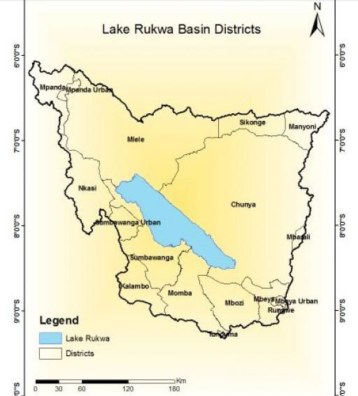

Figure 3.1: Rukwa Basin Districts
Source: Goswami, 2017

Together with these negative connotations, the basin provides habitation to more than 1.5 million people (Goswami, 2017). In these localities, ODL students are on the increase. In the 2020/2021 academic year, students enrolled with OUT totalled more than 771 (OUT, 2021). The knowledge of how such learners pursue successfully their studies in the absence of the expected traditional library services was thus conceived as the justification for the selection of the locality for this study.

3.4 Research Approach
According to Creswell (2014), the research approach refers to the plan and the procedures for research that span the steps from broad assumptions to detailed methods of data collection, analysis, and interpretation. This plan involves several decisions, and they need not be taken in the order in which they make sense. The selection of a research approach is also based on the nature of the research problem or issue being addressed, the researchers' personal experiences, and the audiences for the study. Three research approaches which are normally utilised in social research include qualitative, quantitative and mixed approaches. This study used a quantitative approach to comply with the research philosophy adopted.

3.5 The Study Population
According to Kombo and Tromp (2006), a study population is a group of individuals, objects, or items from which samples are taken for measurement. It is also known as the accessible population. This population is a subset of the target population. It is from the accessible population that researchers draw their samples. In this study, the study population comprised all active students enrolled with the Open University of Tanzania and those who were at one time enrolled to pursue their studies with the OUT whether completed their programs or ended in between who resided in the sampled districts of the lake Rukwa basin (Figure 3.1).

3.5.1 Sample Population
While a population is described as an entire group that a researcher wishes to conclude, a sample population is defined as a specific group from which the collection of data takes place (Kothari, 2019). The size of the sample is less than the total size of the population. A sample is thus the subset of the population. The concept of sample arises from the inability of the researcher to test all the individuals in a given population.

The sample must be representative of the population from which it was drawn and it must have a good size to warrant statistical analysis. The main function of the sample is to allow the researcher to conduct the study on individuals from the population so that the results of their study can be used to derive conclusions that will apply to the entire population. In this study, the sample population comprised ODL students residing in the sampled districts of the Lake Rukwa Basin who are actively pursuing different degrees and non-degree programs at the Open University of Tanzania.

3.5.2 Sample Frame
The term sample frame refers to the actual set of units from which a sample has been drawn (Michael, 2015). It can also be described as the list of sampling units from which the selection of a sample is made. In an actual sense, this list is important as is essential for selecting the elements of the target population. It also provides information for locating and identifying the units. Furthermore, the sample frame provides quantitative information for the estimation of the population parameters based on the sample observation. In this study, a sample frame from which the sample was selected comprised all districts that are located in the Lake Rukwa basin (Figure 3.1).

3.5.3 Sampling Design
The term sampling design refers to the framework, or road map, that serves as the basis for the selection of a survey sample (Lavrakas, 2008). It is a mathematical function that gives the researcher the probability of any given sample being drawn. Two common types of sampling designs are probability sampling design and non-probability sampling design. Probability sampling design refers to a method wherein each member of the population has the same probability of being a part of the sample.

On the other hand, non-probability sampling design refers to a sampling design in which each member of the population does not have an equal chance of being selected. Both sampling techniques are frequently utilized. However, one works better than the other depending on the research needs. This study opted for the mixed approach in which both designs were fully utilised. The study employed a purposive sampling design to select the districts from which the actual samples were depicted while accidental sampling was used to get the sample size based on the proportions of the samples established.

3.5.4 The Sample Size
The term sample size usually refers to the number of individuals included in a research study to represent a population. Usually, the sample size references the total number of respondents included in a study. This number is broken down into sub-groups by demographic elements such as age, gender, and location so that the total sample achieved represents the entire population. Determining the appropriate sample size is one of the most important factors in statistical analysis. If the sample size is too small, it will not yield valid results or adequately represent the realities of the population being studied. On the other hand, while larger sample sizes yield smaller margins of error and are more representative, a sample size that is too large may significantly increase the cost and time taken to conduct the research (Kothari, 2019).

In the original plan, this study planned to have a sample size of 263 ODL students that were expected to be randomly selected from a cohort of 771 registered active students for 2020/21 for the regional centres of Mbeya, Songwe, Rukwa and Katavi using the formula for the finite population as recommended by Yamane (1967) and Glenn (1992) as provided below.
n = N
1+N (e) ² = 771 = 263
1+ 771(0.05)² ⁽¹⁾
Where
n = The sample size
N = Number of households
e = Level of precision (5%)

However, during the actual fieldwork, and given the time and budgetary constraints, it was not possible to reach all targeted respondents. During the fieldwork period, the study was able to collect opinions from only 101 respondents. Proportions of the sample size from each sampled regional centre were as indicated in Table 3.1.

Table 3.1: The Sample Size
S/N | Regional Centre | Active Registered students for the year 2020/21 | Sample Size
 | Mbeya | 429 | 56
 | Songwe | 115 | 15
 | Rukwa | 119 | 16
 | Katavi | 108 | 14
Total |  | 771 | 101
Source: OUT Facts and Figures 2021/22

3.6 Instruments of Data Collection
Data collection is a gathering of scientific information aimed at providing facts about the study (Kombo and Tromp (2006). In this study, quantitative data were collected to generate information that was used to answer the research questions raised. Essentially, the quantitative study to which this study is aligned is a research approach whose focus is to explain phenomena by collecting numerical data that are analyzed using statistical approaches. It is thus an approach in which the researcher employs strategies of inquiry which survey is one of them and then collects data on predetermined instruments that yield statistical data (Creswell, 2003).

The greatest strength associated with quantitative research is that its methods produce reliable and quantifiable data that can potentially be generalized to a large population. In addition, it is suitable to test and validate already constructed theories about how and why phenomena occur through testing hypotheses that are constructed before the data are collected. This study collected both primary data and secondary data to respond to the raised research questions. The study did not use a hypothesis, instead, it utilised research questions that were previously raised.

3.6.1 Collection of Primary Data
Primary data refers to the data generated by the researcher himself/herself. In this study, primary data were obtained using a survey questionnaire which is a technique for gathering attitudes, attributes, or actions of a population using a structured set of questions. Questionnaires are a useful option to consider as they are cheaper in comparison to personal interviewing. They are also quicker if one's sample is large and widely dispersed (Mathers et al., 2007). Although it is weakened in terms of return rate, this study utilised it to generate primary data in regards to the respondent's use and how to ease the use of learning techniques such as smartphones in accessing learning materials in remote areas.

3.6.2 Secondary Data
Secondary data (also known as second-party data) refers to any dataset collected by any person other than the one using it. Secondary data sources are extremely useful. They allow researchers and data analysts to build large, high-quality databases that help solve business problems. Types of secondary data vary. Popular examples of secondary data include tax records and social security data; Census data, electoral statistics, health records, books, journals, or other print media, social media monitoring, internet searches, and other online data, sales figures or other reports from third-party companies, libraries and electronic filing systems and app data, e.g. location data, GPS data, timestamp data, etc.

In this study, secondary data were mostly sourced from the OUT publications, books, related journals and electronic materials relevant to the study. Information generated from these sources was used to complement those obtained from primary sources. The type of data collected focussed on the past and present challenges of learning at a distance and the role libraries have had in influencing learning.

3.7 Data Analysis
According to Johnson (2021), data analysis is defined as a process of cleaning, transforming, and modelling data to discover useful information for business decision-making. The purpose of Data Analysis is to extract useful information from data and make a decision based on the data analysis. In this study data analysis was done using a computer-based program known as the Statistical Package for Social Scientists (SPSS) version 25 to establish patterns and relationships over the responses provided. The study did not venture into measuring relationships between variables but instead dwelt on the description of the data using frequencies and percentage tables. Graphs and charts were also used to display the respondents' opinions. Cross-tabulation of the data was also performed to compare and /or contrast opinions provided by the respondents over the given subject of investigation.

3.8 Validity and Reliability of the Research Instruments
Validity refers to the degree to which an instrument measures accurately what it has been intended to measure (Saunders et al., 2007). To meet this requirement, this study employed Pearson product-moment whereby in each item the based on the count value obtained was greater than the Pearson correlation for each item regarding perceived usefulness, perceived ease of use, facilitation condition and social influence. Hence the P-value for each factor was less than 0.05 to assure that the instrument used in this study was valid.
The reliability of the research instruments was ensured by running the SPSS program using Cronbach alpha. Cronbach's alpha is a measure of internal consistency, that is, how closely related a set of items is as a group. It is considered to be a measure of scale reliability. Cronbach’s alpha measures reliability or internal consistency. “Reliability” is another name for consistency. Statistical Package for the Social Scientists (SPSS) was thus employed to cater for this need.

Table 3.2: Reliability Statistics
Factor | Cronbach’s Alpha
Perceived Usefulness, | 0.89
Perceived Ease of Use, | 0.76
Social Influences, | 0.84
Facilitation Condition | 0.81
Source: Field Data, 2022

Cronbach's Alpha values typically range from 0 to 1, with higher values indicating greater internal consistency. Generally, a Cronbach's Alpha above 0.7 is considered acceptable, while values above 0.8 are considered good. From the table above, the factors "Perceived Usefulness" and "Social Influences" have Cronbach's Alpha values of 0.89 and 0.84, respectively. These values indicate high internal consistency, suggesting that the items within these factors are strongly correlated and consistently measure the same underlying construct.

The factors "Perceived Ease of Use" and "Facilitation Condition" have Cronbach's Alpha values of 0.76 and 0.81, respectively. While these values are slightly lower than the previous factors, they were within an acceptable range, indicating moderate to good internal consistency.

3.9 Ethical Considerations
Being ethical means adhering to the code of conduct that has evolved over the years regarding both research participants and the researcher during the collection of information, seeking consent, the possibility of causing harm to participants, maintaining confidentiality, introducing bias, using unacceptable research methodology, inaccurate reporting and the inappropriate use of information. This study will adhere to the ethical code and conduct of research by observing all procedures required in the field and treatments of collected data.

To conform to the research ethics, the researcher obtained an introduction letter from the Open University of Tanzania as permission to research the respective area. This letter was then taken to the directors of regional centres for Songwe, Katavi and Rukwa where the consent to organise and interview students' respondents was provided. Additionally, the researcher also thought about the respondent's consent before involving them in the study. Respondents were provided with necessary information such as the study objectives and the degree of confidentiality to the information they provided and were also assured of the information's safety.

CHAPTER FOUR

FINDINGS AND DISCUSSION

4.1 Overview
This chapter presents the findings of the study. It provides a comprehensive discussion of the same based on the specific objectives addressed by the study. It starts with recapturing the socio-demographic features of the respondents before the discussion of the study. Important socio-demographic features presented are the age, sex, occupation, marital status, respondents' level of study, regional centres to which they are affiliated and finally location where they live. At the end of the chapter, a summary of the key issues imaging from the study is provided.

4.2 Age and Occupation of the Respondents
Analysis of the data collected in the field reflects the fact that the majority of the respondents that w1ere involved in this study were as indicated in Table 4.1.

Table 4.1: Distribution of Respondents by Age
Age |  | Frequency | Per cent | Valid Percent
 | 20-24yrs | 6 | 5.9 | 6.1
 | 25-29yrs | 21 | 20.8 | 21.4
 | 30-34yrs | 31 | 30.7 | 31.6
 | 35-39yrs | 24 | 23.8 | 24.5
 | 40-44yrs | 11 | 10.9 | 11.2
 | 45-49yrs | 3 | 3.0 | 3.1
 | 50-54yrs | 2 | 2.0 | 2.0
 | Total | 98 | 97.0 | 100.0
Source: Field Data, (2022)

Information presented in Table 4.1 indicates that the majority of the respondents who were involved in this study were in the age range of between 25 years and 54 years. Respondents that were below and above this age were few (6.1 per cent and 5.1 per cent respectively). Also, the majority (87.9 per cent) were employed in the public sector while those who were unemployed comprised only 12.1 per cent. The concentration of respondents in the age range between the ages of 25 and 44 years is a typical characteristic of adult learners (Commonwealth of Learning, 2015). It also reflects the general age of the learners enrolled by OUT (see OUT Fact and Figures, 2021). Further analysis of the data indicates that the leading departments in which the majority of the respondents were employed comprised mainly education and National security (Table 4.2).

Table 4.2: Distribution of the Age of the Respondents with Employment Departments
 |  | Employment Department |  |  |  |  | Total
 |  | Education | Health | Public Security | Local Government | Central Government | Total
Age | 20-24yrs | 0 | 0 | 0 | 0 | 1 | 1
Age | 25-29yrs | 2 | 1 | 7 | 0 | 1 | 11
Age | 30-34yrs | 10 | 0 | 13 | 0 | 0 | 23
Age | 35-39yrs | 14 | 0 | 2 | 1 | 1 | 18
Age | 40-44yrs | 7 | 2 | 1 | 0 | 1 | 11
Age | 45-49yrs | 2 | 0 | 0 | 1 | 0 | 3
Age | 50-54yrs | 2 | 0 | 0 | 0 | 0 | 2
Total |  | 37 | 3 | 23 | 2 | 4 | 69
Source: Field Data, (2022).

The information displayed in Table 4.2 contends that the respondents involved in this study were mostly employed in the education and security sectors. Those in the education sector were mostly teachers while those employed in the national security sectors were people from the police force. The information depicted in this study complies with the normal employability in the public sector expected in remote areas. The concentration of large of the employees in such localities are teachers, health officers and as well as police officers. Other sectors are rarely represented in such localities. It also reflects the general trends of the OUT enrolments. According to the OUT facts and Figures, the proportions of the students enrolled to pursue different levels of studies are mostly teachers (OUT, 2021 Facts and Figures). Localities in which they live and work are remotely located. It is thus the group of individuals in the public office and/or businesses targeted by OUT (see OUT, 2004). This implies that the study findings were consistent with the characteristics of ODL students.

However, in recent times, there has been a rise in young students enrolled on the institution. Adoption of online learning at the University might be one of the motivating factors for this group of learners. It should be understood that the teenage majority prefer campus life to the ODL mode of learning while the greater number of adult learners prefer more ODL system to campus life (Commonwealth of Learning, 2015). While the University emphasises e-learning trimming older people with age above 45 years, the same is increasing the enrolment rate of young people. This observation corresponds with the claims provided by the innovation theory which contends that innovation pioneers are usually young while those who come later are old. This might explain the reasons why the emphasis on online learning at OUT goes hand in hand with the drop in aged learners in recent times.

4.3 Sex of the Respondents
Analysis of the data portrays a unique feature of the respondents. Although the analysis of the national Population and housing reports has indicated the dominance of females over the male population, in this study the proportion of females was very low in comparison to that of the male population. According to the data, the proportion of male respondents was 63.6 per cent while that of females was 36.4 per cent. In the context of this study, the lower proportion of females was a function of the sampling design that was employed as sex balance was not considered.

The use of accidental sampling permitted anyone contacted and who was willing to participate in the survey to be interviewed. This was due to the difficulties of following respondents to where they lived. Secondly, it is a fact that since the inception of the OUT, the majority of the students enrolled with the university are males than females. The number of female enrolments at OUT has not been able to exceed forty per cent despite several efforts made by the University (see OUT, 2021). Thus, the sex ratio observed could be taken to be normal. Although the number of female enrolments has been growing over the years, it has not been able to level off with that of male students. Therefore, the ratio observed in this study reflects the trend at the University itself.

4.4 Respondents' Residence and Study Levels
This study collected information from two types of respondents based on their study status and their residences. In terms of the status of respondents' study levels, the analyzed data indicated that 58.9 per cent of those involved in the study were in level two of their studies while 16.9 per cent were in the first level of their studies. Respondents who were in level three comprised 24.6 per cent only. As far as the objectives of the study were concerned, the dominance of the respondents from level two was not influenced by the demographic structure of the OUT students but rather by the nature of the sampling design used. The use of accidental sampling means that students who appeared first on the scene were the ones who promptly attended. Additionally, the frequency of visiting the centre was higher among students in the second level than in the first level because when data collection was conducted it was the time when students were registering for the end-term examinations. The first drop in the interview used by this study had a greater influence on the polarization of the respondents. It should be understood that, in this study, the ratio in terms of gender and level of study was not considered an important variable.

It did not consider the proportionality of the respondents in terms of rurality and urbanity as the regional centres sampled were all considered by the study as remotely located areas when compared to cities like Dar es Salaam, Mwanza and Dodoma where technological facilities such as the reliability and stability of the internet connectivity and electricity are high. For that much, the proportion of the respondents who resided in urban centres was high (62.6 per cent) when compared to those who resided in rural areas (37.4 per cent). The sampling design employed could also help to explain the disparity observed. In all cases, the distribution of the respondents in terms of district locations was displayed in Figure 4.2.

The proximity of the regional centre to the respondent district of residences determined to a greater extent students' frequency of visiting the centre office. In that case, students from Mbeya, Mbozi, Momba and Sumbawanga rural districts visited their regional centres more frequently than those from Chunya, Kalambo and Nkasi. Additionally, the lack of well-stocked min –libraries at these regional centres could be an additional factor behind this trend. A higher number of students was noted to visit the Mbeya regional centre but the visit was not influenced by the existence of the min-library.
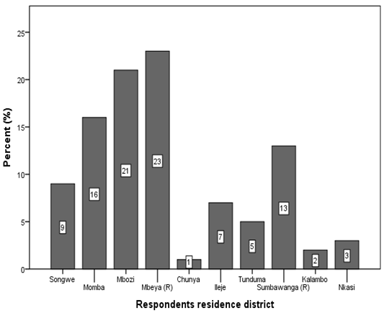

Figure 4.2: Distribution of the Respondents in Terms of Districts of Domicile

A close look at the student's use of min- libraries at Mbeya and Sumbawanga regional centres indicates a very small number of students who turned out to use the service. Those who used the min-library used it for personal study. This observation corresponds with the study findings by Mabowonku (2014) and Mcharazo and Olden (1999) who together assert that ODL students rarely use institutional libraries because they do not have relevant authorities that could support their coursework. The third and most important factor for this study could be found in the higher reliance of ODL students on ICT.

Besides, in some regional centres such as Songwe, remotely located students are served online. Telephone and WhatsApp communications help them to receive services remotely. Thus, these factors could be taken as responsible for defining the low usage of ODL students' regional centre's premises, and public and institutional libraries. Students that had frequencies of visiting OUT centres were more urbanites than rural dwellers. Since the sampling design was flexible, it is not astonishing to have so many respondents from urban centres in comparison to the rural areas. Cross-tabulation of the data in terms of study levels of study and programs pursued, the results were as shown in Figure 4.3.
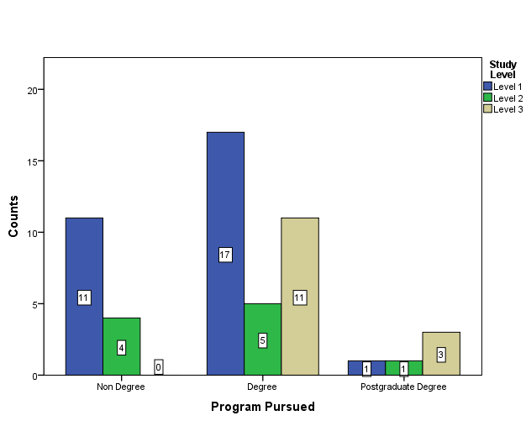

Figure 4.3: Trends of Visiting Regional Centres per Study Levels and pursued Courses

The information displayed in Figure 4.3 reveals the fact that students in level one were the ones who mostly visited the regional centres in comparison to other levels. This might be attributed to the newness of the system. As such, frequent visiting helps them to be receiving useful information which is a part of continuous orientation regarding what is expected of them. Those in the second and third levels had already accumulated enough skills that enable them to study in their place. Therefore, the little reliance on the institutional services provided by the regional centres reflects the extent to which ODL learners have found how useful the use of learning technology thereby confirming the TAM theory that guides this study.

4.5 Perceived Levels of Technological Usefulness
One of the key objectives of this study was to establish perceived levels of use of technology in day-to-day learning among ODL students. To ascertain this, it was important to understand the extent to which ODL students from the sampled localities were in use of public and/or institutional libraries. Analysis of the data collected from the study areas indicated that it was 67 per cent of all the respondents were in use of the library while the rest had never visited such places. However, scrutiny of the data indicated that the frequency of use was still very low as the majority of those indicated to use libraries did so only during the holidays (41.0 per cent).

Respondents who managed to visit the same at least once per week comprised 25.6 per cent only which portrays clearly that ODL students' use of public and/or institutional libraries was at a low level. Cross-tabulation of the same data based on the residence location and number of visits one had to the public libraries indicated that even those who were residing in urban centres did not tend to visit libraries frequently. They only did so once per week. Holiday times were the only time that experienced elevated levels of attendance (Figure 4.4).

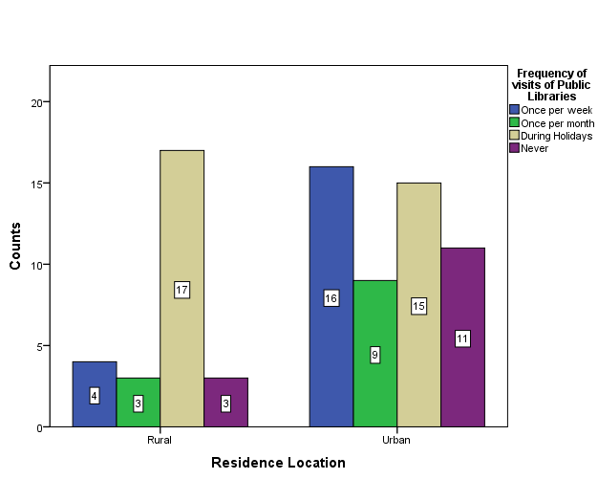

Figure 4.4: Frequencies of visiting Public Libraries based on their Residence Location
The information displayed in Figure 4.4 still contends that the location in which students reside has little influence on the frequency of visiting public libraries to support their studies. Regarding the above data, one could conclusively argue that institutional and/or public libraries hold very little contribution to the ODL student's academic performances. Analysis of the opinion on the library used by those who had already graduated indicates that 20 per cent of all of them graduated without even having a single visit to the public and/or institutional libraries.

The overall findings of this study contend that the proportions of ODL students who were in use of public and/or institutional libraries were at a lower level. Such a finding is not strange as far as open and distance learning is concerned. The results tally well with findings done elsewhere in the world. For example, a study conducted by Liu and Young (2004) on the frequency of visits of ODL students to institutional and /or public libraries came with the results which showed that it was only 28 per cent of the part-time students were affiliated with the Texas A&M University who were in use the institutional library.

According to Larson and Owusu-Acheaw's (2016) findings, it was only 2 per cent of the ODL students at the Winneba Study Centre of the University of Education in Ghana reported having used the library to support their studies. This was also the case for the students from Ibadan Nigeria who also rarely used institutional libraries (Adetrimirin and Omoghen, 2011). All these findings justify the findings revealed by this study. The fact that ODL students rely very little on public libraries reflects the existence of other means of meeting their study needs which is the use of information and communication technology in learning. Analysis of the data regarding the level of learning technology use indicates that most of the ODL students use multiple learning technologies to support their learning needs.

The most preferred mode of learning is the use of soft materials. These resources are currently available in the OUT Moodle learning platform. The second important source of materials is the print materials that are supplemented in part by electronic books accessible from different websites. The use of CD-ROM, OUT websites and Online public access, was noted to be on the lower side probably because of the costs involved in making them available.
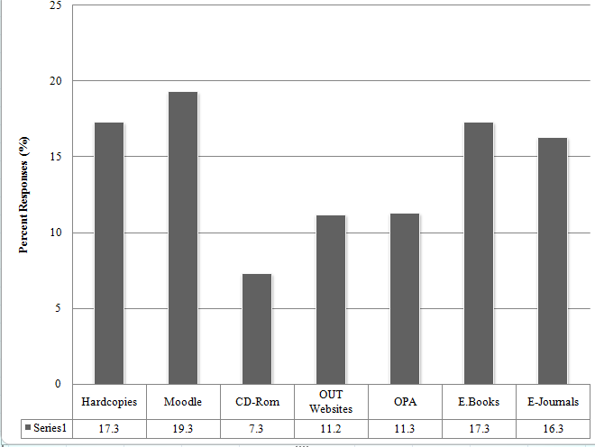

Figure 4.5: Perceived Technological learning support Gears

As indicated in Figure 4.5, the use of print materials as they are no longer produced. However, when asked to comment on where they get the supply of the reading materials, analysis of the opinion provided indicated that the available hard hardcopies are downloaded from the Moodle platform to be read offline. The fact that respondents were benefiting from what had been posted in Moodle is a clear indicator of the technology acceptance among OUT students. The turn toward online learning tallys with what Liang and Chen (2012) earlier commented. The authors commented that the online world was proving to be more flexible and engaging than the physical one.

In this study, even the learners themselves acknowledge the fact that the online world is more intimate than the physical ones as learners can access the same content more than once and this is important for them to monitor their progress. In other studies, it has been discovered that since the ODL majority are also employed, the tight schedules at the workplaces adversely affect the rate of use of the library (Mabawanku, 2004) and since the majority do not have awareness and requisite skills in the use of library they, therefore, opt for the search of information using what Liu and Yang (2004) call the principle of least efforts which is thus the rely on what information and communication technology can offer. It is also a reflection of the high use of technology. In other words, and the context of TAM theory, it means that these technology users believe that there is a direct relationship between the use of the same on the one hand and performance, effectiveness and/or satisfaction on the other hand (Lu, et al., 2003).

The reliance on online materials as an alternative to learning is commented by Nweze (2010) as being caused by the inability of the public and institutional libraries to lack consideration for the integration of the ODL student needs in their service delivery. Planners and executers of ODL programs do not consider that the library is part and parcel of the ODL program (Heller-Ross, 1996). Where such services are provided such libraries do not have relevant resources to support ODL students learning needs as such libraries contain irrelevant materials (Mcharazo and Olden, 1999). It is thus this discrepancy that necessitates ODL students to go online as has been revealed by the findings of this study.
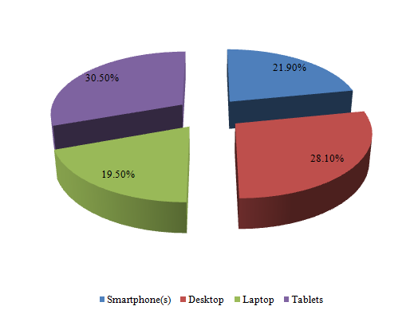

Figure 4.6: Perceived Electronic Gadgets used by ODL Students for learning

To qualify the above-stated conclusion respondents were asked to comment on the kinds of electronic gadgets they depend on to support their learning activities. Analysis of the data indicates the most popular types of gadgets that were in use by ODL students included among others smartphones, desktops, laptops and tablets. It was interesting to note that, although these respondents were remotely located, they were in use of modern learning gadgets (Figure 4.6).

Tablets, smartphones and desktops were reported to be used more frequently. Laptops fetch a low choice among ODL users probably because of the prices to which they are sold while tablets gained popularity mainly because of their portability. In rural areas, networks are not very reliable. In a multiple-response question in which respondents were asked to comment on what they perceived to be the challenges in their day-to-day studies, the internet and costly communication were among the most identified challenges that ODL students were facing. It was further reported that internet connectivity challenges were frequently forcing some of the respondents to spend longer time in isolated places such as on top of a mountain and even on a loft big tree just to search for network connectivity.

The efforts that these learners deployed and the costs they were incurring are thus a reflection of the level of acceptance and use of ICT as a learning technology. In such conditions, the use of lighter gadgets like smartphones and/or tablets was not the exception. Additionally, the popularity of tablets has been influenced by the recently ended National population and housing census in which the majority of the teachers participated. Together with the training received, some of the respondents were lucky to retain tablets. The government's decision to distribute these tablets has elevated the level of usage of tablets among the respondents.

Additionally, the popularity of computer use and related gadgets has received a great impetus following the OUT decision to move toward blended online learning (See OUT, 2021). In this innovation possession of a computer is a necessity. The adoption of a blended mode allows the operations of different academic activities online. These include the administration of different learning services such as tests and assignments as well as real-time Zoom lectures. For that much, any students enrolled with the University are forced to use them.

Besides, OUT has in its all undergraduate and non-degree programs incorporated ICT as a course. All these decisions when coupled with the current efforts of the government to ensure that every village in Tanzania is electrified elevate the level of usage of technological gadgets in learning by the ODL students while at the same time reducing the importance of physical libraries as a precondition for managing studies at the university. Although the smartphone is a universal gadget, the level of usage is however low compared to other gadgets. Technical knowledge and limited applications may be the reason for the low usage. This is thus complying with TAM theory constructs which claim that the perceived usefulness of the technology and the perceived ease of use has a greater impact on the attitude toward the technology (Davis and Baggozi, 1989).

The central idea behind this is the fact that ODL students get support from other knowledge sources other than traditional public libraries. Furthermore, the physical book stocks in libraries are less comparable to books, journals and articles accessible on the internet. As once commented by Mcharazo and Olden, (1999), ODL students prefer the use of public and institutional libraries because they do not have relevant resources to support their coursework as most contain grey knowledge which might be outdated as well. For that reason, online learning is gaining more popularity among ODL students in comparison to traditional physical libraries as the sole source of knowledge.

In this study, 65.5 per cent of all the respondents indicated to have used ICT in learning for more than two years. This also reduced the completion rate period from 6 to 8 years used in the era of analogy to 3 to 4 years in the current digital age. All these observations do support the TAM theory claims that the usefulness of the technology and the degree of ease in using it has a positive impact on the attitude and hence the intention towards using it.

Perceived ease of use of Digital Information in Learning
The use of any technology in the learning processes depends on the level of easiness of the said technology in helping ODL students meet their learning objectives. Given the kind of environments to which they are subjected ODL students deploy different learning technologies.

4.6.1 Perceived Levels of ease of use of Online Learning Gadgets
Respondents were asked to comment on how easy the use of the different learning gadgets was provided by the institution. Analysis of the opinion gathered is presented in Fig. 4.7. Managing studies in the absence of physical libraries among remotely located students forces them to rely on different sources (Fig. 4.7). Lecture notes posted in the Moodle platform and online assignments were the most responded to learning gadgets by the respondents. In the contemporary world, ODL relies as well on chats accessible through laptops, smartphones and even tablets and desktops. Online oral examinations, electronic books, journals and video lectures are some of the learning gadgets which were not highlighted to be used frequently by ODL students.
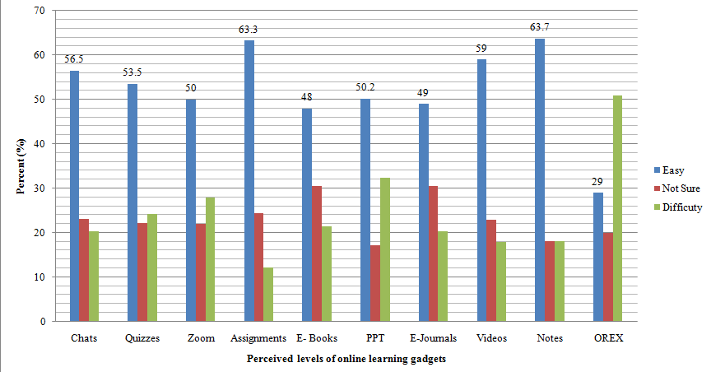

Figure 4.7 Perceived levels of use of Online learning Gadgets
However, there are notable variations among learners themselves across age, gender and even location though this variation was not very significant. When the level of use of the different learning technological gadgets was cross-tabulated with age, the level of difficulties was distributed all over the age groups with the majority being in the age category of 30 to 39 years. However, the results might have been influenced by the nature of the sampling design which purposely concentrated on a specific set of age ranges. Most of the respondents were from the same age group and the kind of sampling design used allowed the inclusion of respondents who were available during the time of the survey. Together with this one cannot deny the fact that age has a significant role in influencing the adoption of technology (Emmanuel and Kohlbacher, 2018).

Further analysis of the data indicates that of the three most responded technological learning modes adopted as a substitute to the physical library information, the use of online notes; online assignments and online videos were also noted to be commonly used in comparison to the rest. However, the necessity of using the Moodle platform was observed to have a greater influence on the degree to which students were motivated to use the learning technology. This necessity was thus conditioned by the institution itself. This observation could thus correlate with the findings by Viraiyan Teeroovengadum, et al., (2016) which stressed that the use of technology by Mauritian students was largely conditioned by external factors rather than the perceived ease of use and perceived usefulness only.

The same observation was shared by Viswanath Venkatesh et al., (2000) who together contend that the perceived ease of use and perceived usefulness of the teaching and learning technology by the users were affected by extrinsic factors including but not limited to self-efficacy on the technology in use. For this study, the external influences could be largely conditioned by the institution's budgetary constraints provided by the government and by the current globalisation trends. Analysis of the various OUT policy documents has indicated that in the inception of ODL learning mode in the country, the central government has committed itself to allocate enough budget for the production and distribution of print materials but as time elapses the supposed budget allocation has continued to shrink and finally phased out altogether (OUT, 2006; OUT, 2021). The use of soft copies of notes available in the Moodle platform came as a coping strategy to the diminishing supply of print materials. As time progresses, students are finding it easier to learn through Moodle than consulting obsolete grey study materials which are also in short supply.

This study thus concluded that ODL students were externally influenced to adopt the learning mode by the circumstances. However, the ease of use of the materials accessible through Moodle largely has become the principal source of knowledge. This situation justifies the contention provided by the TAM theory that technology is seen to be of high use when a potential adopter believes that there is a direct relationship between use on the one hand and performance and/or satisfaction on the other hand (Lu et al., 2003).

4.6.2 Frequency of use of Different Online learning Tools
The degree to which respondents perceived ease of use of technology could also be established along with the frequency of use of the different available learning tools provided by the OUT. Analysis of the responses as per respondents' provided opinions is presented in Figure 4.8. A close look at the information presented in Figure 4.8, reveals the fact that, although ODL students use different learning tools to manage their studies, the most frequently used learning tools were online lecture notes (62.6 per cent) followed by online assignments (56.1 per cent and real-time quizzes (51.5 per cent). Online chats are done through what sups and emails together with electronic materials from Google were reportedly on the lower side. However, the critical discussion with some interviewed respondents indicates that the cause behind the low usage was not found in the difficulties in using the gadgets but rather due to some technical challenges including the unreliability of the internet connectivity due to low bandwidth and costly communications. These were perceived as impediments that hampered smooth learning and the frequency of use of those learning strategies.
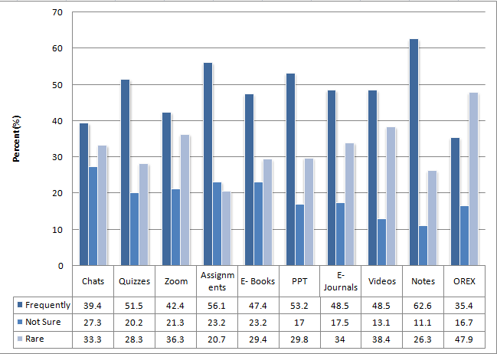

Figure 4.8: Respondents' Frequency of use of different Online learning Tools
Furthermore, the lack of required skills for handling some of the technological facilities could be reported as additional impediments that influenced low usage of the same. However, the discussion made with some sampled OUT staff in those regional centres revealed the fact that students themselves tended to shun online training whenever such training was arranged. Another challenge raised by the respondents during the discussion was associated with the language barriers and the lack of reading skills among remotely located students. It was observed that the majority of the respondents did not possess the required skills that could enable them to scan and skim lengthy web articles. This was thus a challenge which might suggest the need for the university to include in their curriculum a component on the critical analysis of web materials.

What one learns from this observation is that ODL students in remotely located areas use different online learning strategies to manage their learning but they are still constrained by the scholarly analytical skills of the web materials. This causes them to rely heavily on the online notes provided in the Moodle platform which may not be exhaustive enough. In the absence of physical library services, learners need to be well-equipped with the requisite skills for online documentary materials.

4.6.3 Levels of Affordability of the ODL Learning Tools and Strategies
The third indicator of the ease of use of technology in learning in this study was assessed through the analysis of how affordable the use of the different learning technologies by the ODL students is. Analysis of the data in terms of affordability of the different online learning facilities depicts online lecture notes, online assignments, real-time quizzes and online chats as the most affordable strategies in comparison with others (Figure 4.9).

An important facilitator of the affordability was the adoption and use of social media such as WhatsApp. Although what sup is costly, the cost was reported to be manageable as only one needs to make a top-up of any affordable amount provided that the locality in question is facilitated with the network. However, lower preferences were recorded in terms of the use of OREX, zoom meetings and electronic books. When asked to clarify why this was so, the commonly responded answers were associated with the consumption of the internet bundles required to access remote materials and also attend Zoom meetings and attendance to online lectures and oral examinations. This was because for one to benefit from these services, he/she had to spend a long time in the network. Spending much time online means using more internet bundles which are thus costly.
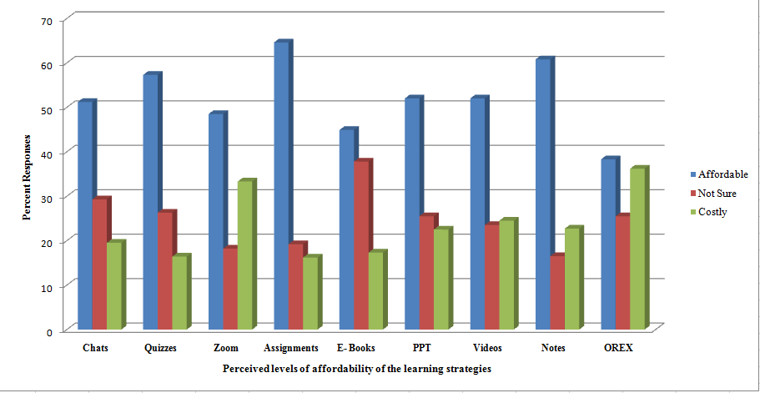

Figure 4.9: Levels of affordability of the ODL Learning Tools and Strategies

Questions about internet instabilities and frequent power cuts were reported by 43.6 per cent of all the respondents as part of the impediments that adversely affect learners' paths. In some localities especially in villages that are closely located along the borders to Malawi and Zambia, especially from the districts of Ileje and Tunduma townships, respondents reported suffering from double charges that emanated from the so-called roaming charges. Although the use of learning technology was noted to facilitate smooth learning because of its ease of use in comparison with the services provided by central libraries located in townships, the technical challenges which were associated with them acted as a de-motivation. However, as Liker and Sindi (1997) once asserted, the use of technology is likely to be successful when users hold a favourable attitude towards it. In this respect, since ODL learners favour more the current learning technology, they have been observed to develop coping strategies which enable them to remain resilient to challenges (Figure 4.10).
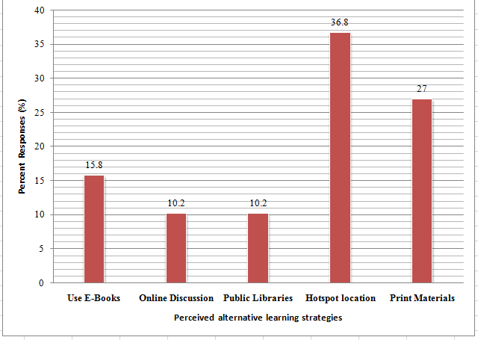

Figure 4.10: Respondents Perceived Alternative Learning Strategies

Information presented in Figure 4.10 contends that although the mainstream learning technology facilitated by OUT frequently fails students in their endeavour to reach their learning goals, the alternative sought strategies to overcome these challenges could not divert much from the favourability of using ICT in learning. For example, instead of turning to the physical libraries located in town centres, respondents found it to be more convenient to search for a location with hotspots where they could easily access the network rather than going to town centres for help from institutional and/or public libraries. Most of these hotspots were reported to be in elevated places and even on top of some tall trees. The risks encountered in the search for hotspot areas are thus a clear reflection of the favour ICT had against traditional library supports.

Observation made by this study reveals that even the print materials that were found to be in use by the respondents comprised those that were downloaded from the Moodle platform. These findings comply with the claims of the TAM theory that the increase in technological use is a function of less effort that technology users require to achieve the desired learning goals. It is also augmented by the empirical findings of Lin and Yang (2004) which in their study noted that ODL students most oftentimes rely on other learning information which they choose as their primary sources. In this respect, the primary sources relied on were the websites and hardbound materials downloaded from the Moodle learning platform and the internet itself.

Such a conclusion could be similar to what other empirical studies by Dukic and Striskavic (2015) and Oladunjoye et al. (2018) once established. As per these authors, ODL students prefer timely and easy online information retrieval over the information seeking associated with a physical information source like the library. As such, one would conclude that the degree of ease of use of the learning technology has a great influence on the choice of the learning gears and learning strategies as well. Although OUT has tried to deploy different learning gears and strategies to adhere to, such strategies and gears are not evenly used. Instead, ODL learners go to the one which demands the least effort to get maximum benefits out of it which conforms to the construct of TAM theory used in this study.

4.6.4 Perceived Level of difficulties in the use of different learning Strategies
Another important factor that influences the choice of use of technology as per respondents' perception was the degree of difficulties presented by the use of the said learning gears and/or strategies. In this respect, the respondents were asked to comment on this aspect. Their responses are illustrated in Figure 4.11.
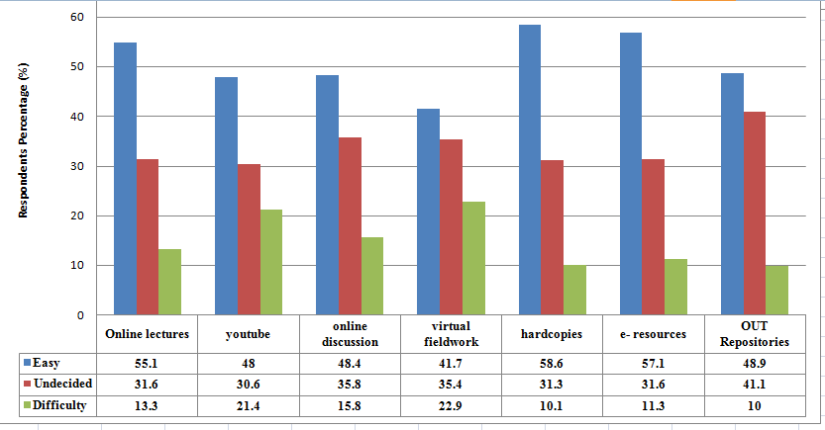

Figure 4.11: perceived levels of difficulties in the use of different learning Gears

Information deduced by Figure 4.12 reflects one important fact the majority of the ODL students living in remote locations do not possess a negative perception of the different learning alternatives presented by OUT despite their precarious location. The majority of the strategies provided by OUT are effectively used to meet their learning needs through their applicability differs from one strategy to another. The findings also reveal that strategies frequently used by the learner are those in which the learner spends less effort to attain desired results. In this respect hardcopies, electronic resources and online lectures were highly used in comparison to the OUT repositories probably because of the accessibility costs and technical know-how of the way the chosen materials ought to be used.

Although the use of the said resources had some significant degree of difficulties, such difficulties did not alter students' motivation toward the use of learning technology as an alternative source of information. The use of different learning technologies other than visiting the physical libraries was thus a clear indicator of how ODL students put low value on the same. This observation complies with the conclusion reached by Zeithaml and Gilly (1987) which contends that although the technology might provide at least some degree of usefulness, a potential reason not to adopt it exists when the adopters fail to see the need to adopt it.

There is no doubt that public libraries and institutional libraries still contain valid information but ODL students find them less useful because of the many factors already earmarked. Difficulties encountered by the ODL students are smoothened by the deliberate efforts students inject into the process of sorting out the challenge at hand. As commented by Rogers (1995) and Saaksajarvi (2003), the need for recognition is likely to drive potential technological adopters to educate themselves on how to manage the technology. Once they recognize its use fully the rate of adoption is therefore enhanced. The recognition of the usefulness of the technology is thus found to have a direct effect on the intention of the adopters to use the technology (Adams et al., 1992; Davis, 1989). This perception is strongly reflected in the findings of this study which has revealed that although ODL students face difficulties in using some technological learning gears, the efforts they deploy enable them to overcome such difficulties and therefore remain resilient to the challenges they encounter and on as well the learning line.

Perceived Levels of Accessibility to the learning Gears and Strategies
The fifth level of ascertaining the ease of technology use in learning among ODL students living in remote areas was examined by looking at the perceived levels of accessibility to the learning gears. The perceived responses are depicted in Figure 4.12.
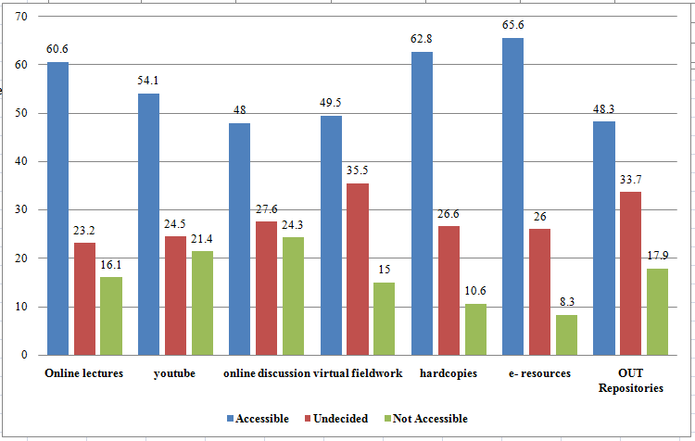

Figure 4.12 Perceived levels of Accessibilities to various learning Gears

Information presented in Figure 4.13 indicates that the three common learning gears used by ODL students comprised electronic resources (65.6 per cent), hardcopies (62.8 per cent) and online lectures (60.6 per cent). The least accessible learning gears on the other hand comprised online discussion (48 per cent), OUT repositories (48.3 per cent) and Virtual fieldwork (49.5 per cent). A close look at the data shows that ODL learners deploy multiple learning strategies but the level of managing them differs from one learning gear to another. Therefore, when deploying the principle of the least effort, learning gears that the student uses fewer efforts were the ones that were frequently used.

Accessibility was thus an important criterion that defined the frequency of use of the learning gear in question which also explains the degree of ease of use of the learning technology in focus. Implicitly, this means that the ease of use of technology in the process of learning for remotely located students depends to a large extent on the level of accessibility. Those learning gears that are not easily accessible were noted to be less preferred while those which are easily accessed were the ones which were frequently used. Therefore, whether easily accessible or not the level of ease of use of the learning technology was higher in comparison to the use of hardbound books stored in public and/or institutional libraries.

This observation is thus in line with the precepts of the TAM theory which claims that the degree to which a person believes that the use of particular systems would be free of effort defines the perceived ease of use of the said technology (Davis, 1989) and this contributes largely towards the perceived usefulness. As commented by Venkatesh and Davis (2000) and Venkatesh and Morris (2000), the perceived usefulness and lack of it can cause frustrations which in turn can impair the intention to adopt a technology. This means that the learning gears which are less favoured impair the intention to use them and hence become less popular as depicted in Figure 4.12. Based on the above discussion it could be established that ODL students use different varieties of learning gears but the one that is easily accessible is the one that is frequently used as they contribute towards desired performances and defined path for the intention of adopting the learning technology.

Facilitating Conditions and Perceived Social Influences

The conceptual model used in this study depicts the question of facilitating conditions as an important variable for this study in the sense that the adoption of technology and its usefulness depend on the prevailing condition. In this respect, this study set out to examine the role played by the institution in creating an enabling learning environment. The analysis of the findings as per respondents' opinions depicts levels that show the degree of the University's commitment to facilitating the learning conditions.

The University's commitment towards the creation of enabling learning conditions is seen in the ICT infrastructural development. Documentary analysis in line with OUT commitments on the improvements of the learning environments reveals that since 2007 when the new OUT charter became operational, several ICT infrastructures have been developed and several learning platforms including Moodle were put into action (Figure 4.13).
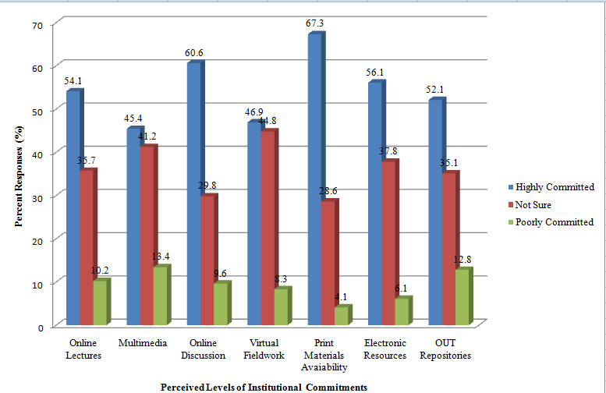

Figure 4.13: Perceived Levels of Institutional Commitment towards the Facilitation of Learning Technology
The documentary analysis further reveals different deliberate efforts made by the University (See for example OUT, 2019; 2021 OUT Rolling Strategic plans). Alongside the efforts is the introduction of skills courses such as communication skills and the basic skills information and communication technology (OCP 100) which aims at providing language skills and the skills for handling computers. The outcome of these efforts is seen in the University's efforts of converting print materials into soft notes accessible through the Moodle platform and the creation of different online discussion forums facilitated through Zoom meetings and WhatsApp.

In all sampled regional centres, this study witnessed retained copies of print materials stored in the min-libraries. Such materials are accessible to students but very few students were in use of them. Furthermore, electronic materials and the OUT repository are made accessible to students through the University Library website. On top of that, the University has subscribed to different journals whose materials are accessible to students through the University library. This study qualified all these efforts as part of the institutional commitments for the creation of facilitating learning conditions for students' safe passage to the effective adoption and use of learning technology.

Although the degree of use of the same differs from one strategy to another, it is obvious that this facilitation has had a great impact on the attitudes toward ODL students' use of the learning technology and this could well explain the reasons why ODL students do longer rely on print materials found in the public libraries. By learning from the information presented above this study concluded that the level of institutional commitment towards facilitating online learning was very high. However, the level of adoption differs from one strategy to another. The proportion of variations could thus be the function of different factors including the costs involved in downloading the said materials and the connectivity challenges. The location of where one lives could be an added factor.

All in all, the perceived use of the technology was noted to be very high among the respondents and this could thus comply with the TAM theory constructs as the technology is seen to be of high use when the potential adopter believes that there is a direct relationship between use on one hand and productivity, performance, effectiveness or satisfaction on the other hand (Lu, et al., 2003). However, the variations in the level of use of the accepted theory could be the function of the perceived level of the usefulness of the technology.

On this point, Zeithaml and Gilly (1987) claim that, although the technology might provide at least some degree of usefulness, a potential reason not to adopt exists when adopters fail to see the need to adopt. This means that some types of online learning strategies observed lack popularity because learners may find them less useful in comparison to the favourable ones. For example, print materials are mostly favoured over any other media because of their portability as one can simply use them offline. Once printed they no longer need internet connectivity and other related factors. OUT repositories are less preferred because of the high costs involved and most of the materials are voluminous. The cost involved in downloading and printing them where deemed necessary is very high.
The use of hard copies does not mean that students still depend on old grey materials. Instead, students download materials from Moodle accounts and print them for future use. This is used as a coping strategy as these students remain resilient to the frequent power cuts and unreliability of internet connectivity. The frequency of other media such as multimedia was not easily verified by this study. However, shreds of evidence of the use of such learning technology could also be verified by the number of online student users of the OUT websites. For example, at one particular time when this report was being prepared online users who were online on the OUT website in the last 15 minutes were 235. This number tends to vary according to the time of the day.

The only shortfalls in this kind of website data could be found in the inability of the study to disentangle the website online users based on their location as the system doesn't delineate users in that fashion. Although the number of online users is high, it was astonishing to note that the same volume of users could not be found during the time instructors were delivering online Zoom lectures. Cross-examination made among different Zoom meetings which the researcher was able to establish during the time this report was being prepared indicated that a prevalence of low turns for the online lectures is an indicator which indicates that although the level of learning technology acceptance and use is high, greater proportions of users preferred still to use hard study materials over other sources as already indicated.

Self-motivation was noted to be an important social factor that influences ODL students to use different learning techniques. This could be indicated by the ability of the ODL learners to use different strategies that bridge the established learning information gap. The most important supplementary materials preferred are as indicated in Figure 4.14.
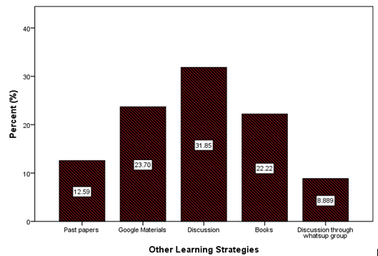

Figure 4.14: Respondents' other learning Strategies

As presented in Figure 4.14 it is no wonder that remotely located ODL students relied heavily on the discussion, materials from Google and hardbound books that they could lay their hands on to support their learning. The fact that students still see the value of Google materials as important knowledge sources proves the power of learning technology in supporting learning other than relying on institutional libraries. The alternative strategies adopted were commented by 70.8 per cent to be very effective.

As inferred in the preceding discussion it could thus be concluded that the degree of acceptance of the learning technology is highly facilitated by the institutional commitments in the creation of the learning facilitating conditions. The high institutional commitment exerts greater influences on the technological receptors' attitude. As defined by Fishbein and Ajzen (1975), these are the positive and negative feelings that one has about performing the target behaviour.

In line with this definition, one would still conclude that the attitude of the ODL learners in the study area is very high and this is as well confirmed by the empirical literature surveyed. There are direct relationships between attitude toward using technology and the behaviour intention to continue using it (Fishbein and Ajzen, 1975; Karahanna, et al., 1999; Kim, et al, 2008; Nysveen et al. 2005). Gamira (2019) and Zarafshani, et al., (2020) contend that the attitude of technological users has a great role in influencing the acceptance of the technology.

In the context of this study, the ODL learners perceived ease of use and perceived usefulness of the learning technology were made possible through the learning environment that has been facilitated by the institutional investments. This could thus comply with the Zhonggen and Xiaozhi (2019) and Venkatesh et al., (2003) findings which together assert that perceived ease of use and perceived usefulness of the learning technology were affected by extrinsic factors such as learners' self-efficacy on computer use.

It is also established by the findings by Bayhan, Olgun and Yellen (2002), which contend that individuals who develop a negative attitude towards technology use did so because of rejecting and shunning away from using it a factor which implies the lack of adequate facilitating conditions. It follows then that when the institution does not have enough preparation the create an enabling learning environment, the degree of acceptance of the said technology is very poor but when the facilitation is right, the same influences the attitude towards the use of technology and eventually the behavioural change in using the said learning technology.

Multiple Linear Regression Testing
Multiple linear regression was fitted to explain Digital Information Resources among ODL based on perceived usefulness, perceived ease of use, social influences, and facilitation conditions. The model equation in this study can be written as:
……………………………
Whereby,
Is digital information resources function of factors “k”, = intercept value, =

Coefficients (weight of each ‘i’ factor based on data) 𝑋𝑖 = independent variables

correlated with the digital information resources.

4.8.1 Testing Results for Normality
From the analysis of the normal probability plot in Fig. 4.1, it can be observed that the data follows normal distribution since from the plot, the residuals are close to the line. This implies that the assumption of normality is satisfied. The plot in Figure 4.1 shows less deviation from nonlinearity than before, though the problem of nonlinearity has not been completely solved yet, meaning other models rather than OLS should be employed in data estimation of the factors influencing the use of information resources among open and distance learners living in remote areas to avoid possible nonlinearity issues.
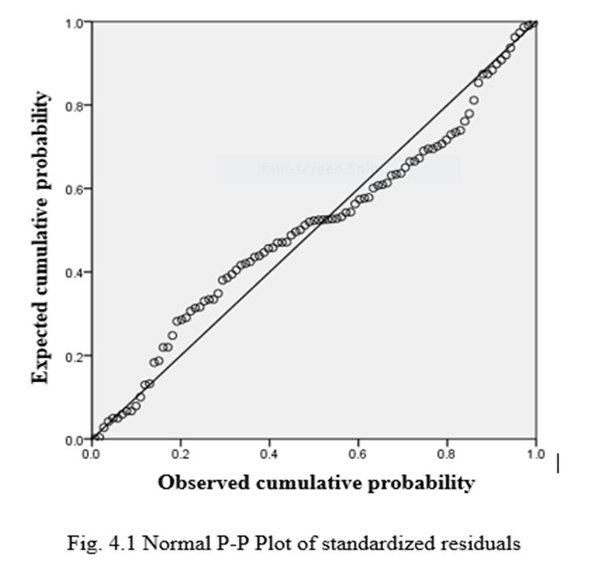

Figure 4.15: Normal Probability
Source: Researcher, (2023).

From table 4.3, R is defined as a multiple correlation coefficient which was 0.952. R squared is defined as a coefficient of determination which is 0.624 to mean that the model explains 62.4% of the variation in the dependent variable. The obtained R squared value indicates that the variations in information resources among open and distance learners are explained by the specified rest of the explanatory variables and the remaining is explained by other variables excluded by the analysis. On another side, the Durbin-Watson assesses autocorrelation and the value of 2.204 indicated that residuals are negatively correlated.

Table 4.3: Coefficient of Determination and Autocorrelation
R | R Squared | Adjusted R squared | Std. error of the estimate | Durbin-Watson
0.952 | 0.624 | 0.536 | 1.228 | 2.204
Source: Field Data, (2022)
    - Standardized and Unstandardized Coefficients with p-values of the Multiple Linear Regression Analysis
From table 4.4, the analysis reveals that the table provides the tolerance values range from 0.826 to 0.864, indicating that multicollinearity is not a problem as the values are above 0.1. The VIF values range from 1.157 to 1.210, further supporting the absence of significant multicollinearity as all values are below 10. Generally, the analysis revealed that perceived usefulness has a statistically significant positive relationship with digital information resources among ODL in Tanzania (β = 0.107, t = 0.661, p < 0.05). As the perceived usefulness of the firm increases, the utilization of digital information resources among ODLs also increases. This implies that when individuals perceive digital information resources as useful, they are more likely to utilize them in the context of open and distance learning (ODL) in Tanzania.

Table 4.4: Standardized and Unstandardized Coefficients with p-values of the Multiple Linear Regression Analysis
Model | Unstandardized coefficients |  | Standardized coefficients | t | Sig | Collinearity statistics
 |  | Std. Error | Beta |  |  | Tolerance | VIF
Constant | 5.062 | 1.113 |  | 4.548 | 0.000
Perceived Usefulness | 0.142 | 0.215 | 0.107 | 0.661 | 0.001 | 0.829 | 1.206
Perceived Ease of Use | -0.006 | 0.194 | -0.005 | -0.031 | 0.000 | 0.864 | 1.157
Social Influences | 0.023 | 0.082 | 0.044 | 0.273 | 0.015 | 0.843 | 1.187
Facilitation Condition | -1.020 | 0.484 | -0.343 | -2.10 | 0.054 | 0.826 | 1.210
Source: Field Data, (2022).

On another side, the analysis shows that perceived ease of use does not have a statistically significant relationship with digital information resources among ODL in Tanzania (β = -0.005, t = -0.031, p > 0.05). Therefore, the perceived ease of using digital information resources does not appear to significantly influence their utilization in ODL settings in Tanzania. Social Influences have a statistically significant positive relationship with digital information resources among ODL in Tanzania (β = 0.044, t = 0.273, p < 0.05). This suggests that the influence of social factors, such as recommendations or opinions from peers, colleagues, or instructors, plays a role in the utilization of digital information resources in ODL in Tanzania.

The analysis suggests that the facilitation condition has a marginally significant relationship with digital information resources among ODL in Tanzania (β = -0.343, t = -2.10, p = 0.054). Although the p-value is slightly above the significance level of 0.05, there is some evidence to suggest that a higher facilitation condition (e.g., availability of necessary resources or support) may be associated with decreased utilization of digital information resources in ODL in Tanzania.

Summary
The overall picture one gets from the discussion above is that ODL students living and working in remote areas rely much on information and communication technology to support their learning. The study has also found that physical libraries hold a very small percentage of the support as in the rural areas where these students live and work such facilities are not available. Even in urban centres where one could access information from public libraries, it is only a small proportion of the respondents indicated using them to support their studies. Together with limitations in terms of power and internet connectivity, a good number of the respondents indicated to possess and effectively use ICT gadgets such as laptop computers, tablets, mobile phones and even desktops. It has also been established from the findings that the most used sources are online lecture notes, discussion and hard study materials downloaded and printed from the OUT Moodle platform.

Materials from Moodle and downloaded notes are the principal sources of knowledge for such kind of learning. It is the heavy reliance on websites' digital information that enables them to attain their completion rate in time. This thus supports the constructs of the TAM theory that ODL students located in remote areas have the acceptance and use teaching and learning technology because learners themselves have found it to be useful. The ease of use of learning technology is thus made possible through the conducive facilitating conditions created by the institution and students' self-motivation which in turn enables them to accomplish their learning objectively and timely.

Furthermore, among the independent variables examined by the model, perceived usefulness and social influences have a statistically significant positive relationship with digital information resource utilization in ODL in Tanzania. These findings suggest that focusing on enhancing the perceived usefulness of digital information resources and considering social influences can contribute to increasing their utilization in ODL settings. The relationship between facilitation condition and digital information resource utilization is marginally significant, indicating the need for further investigation to better understand its impact

CHAPTER FIVE

SUMMARY, CONCLUSION AND RECOMMENDATION

5.1 Overview
This chapter provides the summary, conclusion and recommendation of the key findings of the study. It begins by highlighting the key issues addressed by the study in a much-summarised form and then progresses to provide the conclusion of the study based on the specific objectives addressed by the study. In the end, the chapter ends with the presentation of the perceived recommendations for both policymakers and further research.

5.2 Summary
This study set out to investigate the factors that influence the use of information resources among the open and distance learners living in remote areas of the Rukwa basin districts of Tanzania. The study employed the TAM Theory as a guiding model. Data collection commenced in the study area using questionnaires and was analysed quantitatively through the use of the statistical package for the social scientist (SPSS). Data presentation has been made through the use of tables, graphs and charts. The overall findings indicate there is a high level of acceptance of the current learning technology as a learning support and that the proportion of ODL students that use institutional and/or public physical libraries is very low.

5.3 Conclusion
The conclusion for this study is thus provided based on the above-specified objectives in the subsections presented below.

5.3.1 Perceived Levels of Technological Usefulness
The findings of the study have revealed that, although 67 per cent of all the respondents reported using institutional and/or public libraries as a support for their studies, they did so not always but in certain specific periods of the study duration. For example, 41 per cent reported using public libraries during the holidays while those who were able to visit the institutional and/or public libraries every week comprised 25.6 per cent only. Of those who have already graduated, 20 per cent graduated without having a single visit to the library.

Therefore, the fact that ODL students' respondents rely very little on public libraries reflects the fact that ODL students support their studies with information and communication technology (ICT). They use multiple learning technologies to support their learning needs of which the most preferred mode of learning is the use of soft materials which are readily available in the OUT Moodle learning platform. The second important source of materials is the print materials that are supplemented in part by electronic books accessible from different websites. Therefore, based on the above observation, it can be concluded that ODL students residing in remotely located areas use institutional and/or public libraries very little. Instead, their major learning support is from the technological Moodle learning platform augmented by the intensive use of web materials and print materials extracted from therein.

5.3.2 Perceived ease of use of Digital Information among Remotely Located ODL Students
This objective was evaluated by this study based on the five important variables of frequency of use of the learning gadgets, levels of affordability, frequency of use, levels of difficulties in using the learning gadgets and the levels of accessibility and concludes that; Firstly, the high level of use of multiple learning gadgets by ODL students was externally influenced by the circumstances and the ease of use of the materials accessible through Moodle largely has become the principal source of knowledge. This situation justifies the contention provided by the TAM theory that technology is seen to be of high use when a potential adopter believes that there is a direct relationship between use on the one hand and performance and/or satisfaction on the other hand.

Secondly, ODL students in remotely located areas use different online learning strategies to manage their learning but they are still constrained by the scholarly analytical skills of the web materials. This causes them to rely heavily on the online notes provided by the institutional Moodle learning platform which may not be exhaustive enough. In the absence of physical library services, learners need to be well-equipped with the requisite skills for online documentary materials.

Thirdly, the degree of ease of use of the learning technology has a great influence on the choice of the learning gears and learning strategies as well. Although OUT has tried to deploy different learning gears and strategies to adhere to, such strategies and gears are not evenly used. Instead, ODL learners go to the one which demands the least effort to get maximum benefits out of it which conforms to the construct of TAM theory used in this study. Fourthly, although ODL students face difficulties in using some technological learning gears, the efforts they deploy enable them to overcome such difficulties and therefore remain resilient to the challenges they encounter as well as the learning line.
Based on the above observation, it can be concluded that ODL students use multiple learning gadgets but the ease of use is influenced to greater extents by the degree of accessibility, affordability and manageability. Learning gadgets which are accessible, affordable and manageable are the ones which ODL learners find easy to use and frequently used in supporting learning. For that, although ODL learners use multiple learning gears in supporting their studies, the most frequently used learning gears which they also find easy to use were online electronic resources, print hard copies and augmented online lectures.

5.3.3 Perceived Social Influences and facilitating Conditions behind the use of Digital Information among ODL Students
In line with this objective, the study has established that self-motivation is an important social factor that influences ODL students to use different learning techniques and that this has been indicated by their abilities to navigate different learning strategies and learning gadgets to bridge the established learning information gap created by the lack of access to institutional and/or public libraries.
Secondly, the study can conclude that the degree of acceptance of the learning technology is highly facilitated by institutional commitments in terms of creating an enabling learning environment. The deliberate institutional commitment to the development of different online learning gears and learning strategies has to a greater extent influenced ODL students' acceptance of learning technology other than relying on public libraries.

As far as this objective was concerned, it could be concluded that ODL learners' perceived ease of use and facilitation condition of the learning technology is highly made possible through the learning environment that has been facilitated by the deliberate institutional investment, after using inferential statistics, this part will also have additional information.

5.4 Recommendations
In light of the above findings, the following recommendations are made for both policymakers and further research.

5.4.1 Recommendations for Policymakers
In light of the above conclusion, it suggested that the government and all other stakeholders have to ensure that:
- With the current globalization trends and the recurrence of different issues that affect the global communities such as the pandemic diseases like COVID-19, the world is pushing ahead online learning as the dependable learning mode. For that digital libraries and other related technological learning facilities will eventually replace physical libraries that have been depended on by learning institutions in the past. The importance of digital libraries is more pressing for the remotely located ODL students. Therefore, to ensure that communities living and working in remote places access affordable and quality education, this study recommends that policymakers and the government should increase efforts to ensure that electric power is made available in all villages. It should also make sure that internet bandwidth is increased while at the same time providing subsidies to ensure that the internet bundles are more affordable.
- The current trends indicate that the majority of ODL learners are no longer depending on institutional and public libraries. For that much, the Open University as the custodian of open and learning education should ensure that it makes a deliberate effort to improve its service delivery, especially in terms of the required soft skills for using electronic learning materials including digital libraries. There is also a need to ensure that every year of the commencement of the academic programs all students are properly oriented on the scholarly skills of reading and evaluating website materials. Many ODL students in remotely located areas depend on these materials but they still lack the proper skills of evaluating the materials in use.
- The Open University of Tanzania should also ensure that staff in the regional centres are increased and properly trained in terms of orienting students on the use of online learning platforms. This has been one of the areas that respondents have highlighted as one the problematic areas.

5.4.2 Recommendation for Further Research
This study has evaluated the applicability of the Technological Acceptance Model in the context of the information studies to the ODL students and noted that ODL students living in remote areas depend on what the technology has to offer for them to meet their study needs. What is brought to light by the study is still little. This study recommends that further studies be conducted in the following areas:
- Benefits and challenges of the high dependence of ODL learners on digital libraries for managing studies at a distance.
- Modalities that traditional libraries can use to ensure that they successfully cater for the needs of the ODL learners in the current changing technology in developing countries like Tanzania.

REFERENCES
Abdinoor, A. & Mbamba, U. (2017). Factors influencing consumers’ adoption of mobile financial services in Tanzania. Cogent Business & Management, 4(1), 1-19.
Adams, D. A., Nelson, R. R. & Todd, P. A. (1992). Perceived Usefulness, ease of use and usage information Technology; Replication. MIS Quarterly 16(2), 227-247.
Adekanmbi, G. (1993). Transformation in distance education: In search of a paradigm’ In Scriven, B., Lunden, R. & Ryan, Y. (Eds.) Distance Education in the Twenty-First Century, pp.336-340. Oslo: ICDE.
Adesoye, A.E. and Amusa, O.I. (2011). Investigating the Information Needs have Sandwich and Part-Time Students of Two Public Universities in Ogun State, Nigeria Library Philosophy and Practice. Retrieved on 20th July, 2023 from http://digitalcommons.unl.edu/libphilprac/604.
Adetimirin, A, & Omogbhe, G. (2011). Library Habits of Distance Learning Students of the University of Ibadan, Ibadan, Oyo State, Nigeria. (2011). Library Philosophy and Practice (e-journal). 527, 12.
Ajibade, P. (2018). Technology acceptance model limitations and criticisms: Exploring the practical applications and use in technology-related studies, mixed-method, and qualitative research. Library Philosophy and Practice, 1, 1-13.
Anandarajan, M., Simmers, C. & Igbaria, M. (2000). An Exploratory Investigation of the Antecedents and Impact of Internet Usage: An Individual Perspective, Behavior and Information Technology, 19(1), 69-85.
Andres, E. I., Sat, K. S. & Jenny, A. K. (2018). Development and Integration of Remote Areas in the APEC Region. Heng Mui Keng Terrace. Asia-Pacific Economic Cooperation Secretariat.
Arinto. P., (2016). Issues and Challenges in Open and Distance e-Learning: Perspectives from the Philippines. International Review of Research in Open and Distributed Learning, 1(7), 2.
Arms, W. Y. (2000), Digital Libraries, MIT Press, Cambridge, MA
Athabasca University Library (2007). Circulation Services. Retrieved on September, 2022 from; http://library.athabascau.ca/libservices/libserv.php
Au, A and Peter.E., (2000). A Cognitive Model on Attitude towards Technology Adoption. Journal of Managerial Psychology. 15. 266-282.
Au, Y. A., AU, Y. A., & KAUFFMAN, R. J. (2003). What do you know? Rational expectations in information technology adoption and investment. Journal of Management Information Systems, 20(2), 49-76.
Ayobami, O. B., Adebayo, A., Sunday, O. O., Francis, O. E. & Oluwafemi, O. J. (2018). Survey of Avifauna Species of a Degraded Environment: Case Study of Osun State University, College of Agriculture, Ejigbo, Nigeria.
Blackwell, G. R. (2018). Introduction to Positivism, interpretive and Critical Theory. Nurse Researcher, 25(4), 14-20.
Boadi, B. Y. & Letsolo, P. (2004). Information needs and information seeking behaviour of distance learners at the Institute of Extra-Mural Studies in Lesotho'', Information Development, 20(3), 189-99.
Chen, Y. Yan, X. Fan, W. & Gordon, M. (2015). The Joint Moderating role of trust Propensity and Gender on Consumers’ online Shopping Behaviour. Computer in Human Behaviour 43(2015), 272-283.
Chille, J. F., Shayo, A. F. & Kara, S. N. (2021). Adoption of Mobile Marketing in the Telecommunication Industry of Tanzania: The Effects of Perceived Usefulness, Ease of Use, and Customer’s Knowledge. European Scientific Journal, ESJ, Journal Article
Chitungo, S. K. & Munongo, S., (2013). Extending the Technology Acceptance Model to Mobile Banking Adoption in Rural Zimbabwe. Journal of Business Administration and Education, 3(1), 51-79
Choughule, P. (2007). Role of Digital Information Services in Corporate Libraries. Guwahati University. 5Th Convention Planner.
Commonwealth of Learning (COL), (2003). Developing Library and Information Services for Distance Education. Retrieved on 12th May, 2023 from; http://www.col.org/colweb/site/pid/3131.
Commonwealth of Learning, (2000). An Introduction to Open and Distance Learning. 1-29, Retrieved on June, 2nd 2022 from; http://www.col.org/ODL Intro/introODL.htm.
Commonwealth of Learning. (2015). Open and distance learning: Key terms and definitions. Retrieved from http://oasis.col.org/handle/11599/829.
Cresswell, J. (2014). Research Design: Qualitative, Quantitative and Mixed Methods Approaches. Nebraska-Lincoln: Sage Publishers.
Creswell, J. W. (2003). Research design: Qualitative, quantitative, and mixed methods approaches (2nd Ed.). Thousand Oaks, CA: Sage.
Daniel, J and W. Mackintosh. (2009). E-learning on the far side of the digital divide". Proceedings of the 2nd ACDE conference and general assembly hosted by the National Open University of Nigeria, and held at Eko Hotels, Lagos 8 – 11 July 2009
Darinskaia, L.A. and Molodtsova, G.I. (2019). Modern technologies for teaching and learning in socio-humanitarian disciplines. Saint Petersburg State University, Russia
Davis, D. (1989) Perceived Usefulness, Perceived Ease of Use, and User Acceptance of Information Technology. MIS Quarterly, 13(3) 319-340.
Davis, F. D., Bagozzi, R. P., Warshaw, P. R. (1989). User Acceptance of Computer Technology; A Comparison of Two Theoretical Models. Management Science, 35(8), 982- 1002.
Dukić, Darko & Strišković, Jelena (2015). Croatian university students' use and perception of electronic resources. Library & Information Science Research 37, 244–253.
Emmanuel, A., San, A. & Kai, J. A. (2018). Development and Integration of Remote Areas in the APEC Region. SOM Steering Committee for ECOTECH Asia-Pacific Economic Cooperation.
Emmanuel, C. & Kohlbacher, F. (2018). Older Consumers' Adoption of Innovation in Japan: The Mediating Role of Cognitive Age. Journal of International Consumer Marketing, 4, 244-259.
Fan. J, S. Wang, Y. Wu, J. Li, and D. Zhao. (2015). Buffer effect and price effect of a personal carbon trading scheme, “Energy, 2015, doi 10.1016/j.energy.2015.01.069.
First, B. (2022). Exploration of Preventive Measures of unwanted Pregnancies among teenage Girls in selected Chunya District Rural Secondary Schools Tanzania. Unpublished MA Dissertation. Dar es Salaam. The Open University of Tanzania.
Fishbein, M and Ajzen, I., (1975). Belief, Attitude, Intention and Behaviour: An Introduction to Theory and Research. Addison- Wesley. Reading M.A.
Gamira, D. (2019). The integration of ICT in geography in selected Kadoma high schools, Zimbabwe. I-Manager’s Journal on School Educational Technology, 15(1).
Glenn, I. (1992). Sampling the Evidence of Extension Program Impact. Program evaluation and organisational development. Florida: University of Florida.
Gopakumar, V. & A. Baradol. (2009). Assuring quality in distance education for Library and Information science. The role of the Library. Library Philosophy and Practice. Available: http://unllib.unl.edu/LPP/gopakumar-baradol.htm
Goswami, S. (2017). As Tanzania’s Lake Rukwa continues to dry up, NGOs focus on sensitising locals. The Shared Resources Joint Solutions (SRJS) initiative has been launched to build the institutional capacity of civil society organisations. Retrieved on 10th March, 2019 from; https://www.downtoearth.org.in/news/water/as-tanzania-s-lake-rukwa-continue-to-dry-up-ngos-focus-on-sensitising-locals-58104
Hanover Research, (2012). Best Practices in Personalized Learning Environments (Grades 4 – 9). Retrieved on 01st June, 1923 https://www.hanoverresearch. com/media/Best-Practices-in-Personalized-Learning-Environments.pdf.
Haughey, M., Evans, T. & Murphy, D. (2008). Introduction: From correspondence to virtual learning environments. In T. Evans, M. Haughey, & D. Murphy (Eds.), International Handbook of Distance Education (pp. 1-24). Bingley: Emerald Group Publishing Ltd.
Heller-Ross, (1996). Librarian and Faculty Partnership for Distance Education. A paper delivered at the Inaugural Conference on Interactive Technology in Health Education. Virtual Reality, Distance Education, Electronic Classroom Plattsburg, NY.
Holden, H. & Rada, R., (2011). Understanding the Influence of Perceived Usability and Technology Self-Efficacy on Teachers’ Technology Acceptance. Journal of Research on Technology in Education 43(4), 343-367.
Hong, S. & Lee, H. (2008). Antecedents use continuance in the information system; toward an integrative View. Journal of Computer Information Systems 61- 73.
Hughes, J. A. & Sharrock, W. W. (2016). The Philosophy of Social Research. 3rd edition. London: Routledge.
Johnson, D. (2021). What is data analysis, research types, methods and techniques? Accessed on 25th January 2022 from; retrieved on 20th July, 2022 from; https://www.guru99.com/what-is-data-analysis.html.
Kalugendo, J. (2018). The Influence of Mobile Money Services Usage on Small and Medium Enterprises Operations in Tanzania. Unpublished master thesis, The Open University of Tanzania.
Kapinga, O. & Amani, J. (2016). Determinants of Students’ Academic Performance in Higher Learning Institutions in Tanzania. Journal of Education and Human Development, 5(4), 78.
Karahanna, E., Straub, D. W., Chervany, N. L. (1999). Information Technology adoption across time; a cross-sectional comparison of pre-adoption and post-adoption beliefs. MIS Quarterly, 23 (2), 183- 213.
Kavulya, J. M. (2004). Challenges in the Provision of Library Services for Distance Education: A Case Study of Selected Universities in Kenya. African Journal of Library, Archives and Information Science, 14, 15-28.
Kazoka, J. & Mwantimwa, K. (2019). Facilitation condition and ease of use of Web 2.0 tools in university teaching and learning in Tanzania. University of Dar es Salaam Library Journal, 14(2), 19-37.
Khan, M. & Ghouri, A. M. (2018). Enhancing customer satisfaction and loyalty through customer-defined market orientation and customer inspiration: A critical literature review. International Business Education Journal, 11(1), 25-39.
Khasseh, A. H., Moghaddam, S. & Jowkar, A. (2009). Distance education and the role of library services in Iran: a case study of Shiraz University Distance Learners", Library Hi Tech News, 26(7), 11 – 14.
Kim, D. J., Ferrin, D. L. & Rao, H. R. (2008) A Trust-Based Consumer Decision-Making Model in Electronic Commerce: The Role of Trust, Perceived Risk, and Their Antecedents. Decision Support Systems, 44, 544-564.
Kim, J. (2006). Capturing metrics for undergraduate usage of subscription databases. Online, 30(3), 32-39.
Kim, K. (2012). The Emotional Responses of Older Adults to New Technology. The University of Illinois at Urbana-Champaign, 2012
Kivunja, C. (2018). Distinguishing between theory, theoretical framework and conceptual framework; a systematic review of lessons from the field. International Journal of Higher Education, 7(6), 44-53.
Kombo, D. K. & Trompo, D. L. A. (2006). Proposal and Thesis Writing an Introduction. Nairobi: Paulins Publications Africa.
Kothari, C.R. (2019). Research Methodology: Methods and Techniques. 4th Edition, New Delhi: New Age International Publishers.
Kumar et al. (2017). A Strategic Framework for a Profitable Business Model in the Sharing Economy. Industrial Marketing Management, 69, 147-160.
Lai, C. (2017). The Literature Review of Technology Adoption Models and Theories for the Novelty Technology. Journal of Information Systems and Technology Management, 14(1), 21-38.
Larson, A. G. & Owusu-Acheaw, M. (2016). Information needs of distance learners: A case of Winneba study centre, University of Education, Winneba, Ghana. Turkish Online Journal of Distance Education-TOJDE, 17(3), 62-75.
Lavrakas, P. J. (2008). Encyclopaedia of survey research methods, Vols. 1-0. Thousand Oaks, CA: Sage Publications, Inc.
Leiner, B. M. (1998). The NCSTRL approach to open architecture for the confederated digital library, D-Lib Magazine, available at: www.dlib.org/dlib/december98/leiner/12leiner. html.
Liang, R. Y. H. & Chen, D. T. (2012). Online learning: Trends, potential and challenges. Creative Education, 3(8), 1332-1335.
Liker, J.K. and Sindi, A.A. (1997). User acceptance of expert systems: a test of the theory of reasoned action. J. Eng. Technol. Manage. 14(1997)147-173.
Liu, Z., & Yang, Z. Y. L. (2004). Factors influencing distance-education graduate students' use of information sources: A user study. The Journal of Academic Librarianship, 30(1), 24-35.
Lu, J., Yu., Liu. C. & Yao. J. E. (2003). Technology acceptance model for wireless internet. International Research: Electronic Networking application and Policy 13(3), 206- 220.
Lwoga, E. T. & Lwoga, N. B. (2017). User Acceptance of Mobile Payment: The Effects of User-Centric Security, System Characteristics and Gender. Electronic Journal of Information Systems in Developing Countries 81(3), 1-24.
Mabawonku, I. (2004). Library use in distance learning. A survey of undergraduates in three Nigerian Universities. African Journal of Library, Archival and Information Science, 14(2),151-65.
Mathers, N., Fox, N. and Hunn, A. (2007). Surveys and Questionnaires. The NIHR RDS for the East Midlands / Yorkshire & the Humber.
Mcharazo, A.S.A and Olden, A. (1999). Investigating the learning resource requirements of students at the Open University of Tanzania: research methods. Journal of Librarianship and Information Science, 31 (2) June 1999.
Melone, N. P. (1990). A theoretical assessment of the user-satisfaction constructs in information systems research. Management Science, 36(1), 76-91.
Mfaume, H. (2019). Awareness and Use of a Mobile Phone as a Potential Pedagogical Tool among Secondary School Teachers in Tanzania. International Journal of Education and Development using Information and Communication Technology, 15(2), 154-170.
Michael, I. (2015). Factors Leading to Poor Performance in Mathematics Subject in Kibaha Secondary Schools. Unpublished MA Dissertation. The Open University of Tanzania, Dar es Salaam, Tanzania.
Mollel, M. M. & Mwantimwa, K. (2019). User's acceptance of e-resources usage at the Institute of Finance Management, Tanzania. International Journal of Education and Development using Information and Communication Technology (IJEDICT), 15(4), 5-21.
Msonge, H. (2017). Factors Influencing Consumers’ Adoption of Mobile Commerce in Tanzania: A Case of Ilala District in Dar es Salaam region in Tanzania (Doctoral dissertation, Mzumbe University).
Murumba, J.W. (2015). Distance librarianship in Kenyan universities. Regional Journal of Information and Knowledge Management, 1(1), 39-53.
Musingafi, M. C. C., Mapuranga, B., Kudzai, C. & Shupikai, Z. (2015). Challenges for Open and Distance Learning (ODL) Students: Experiences from Students of the Zimbabwe Open University. Journal of Education and Practice, 6(18), 59-66.
Nakano, D. & Muniz, J. (2018). Writing the literature review for an empirical paper. Production, 28, e20170086.
National Bureau of Statistics (2004). Rukwa Region Socio-economic Profile. Dar es Salaam: Tanzania Ministry of Planning and Development.
Nwezeh, C.M.T. (2010). Libraries and distance education in Nigerian Universities: a revisit. New Review of Academic Librarianship, 16, 102–115.
Nysveen, H., Pedersen, P.E., Thornbjornsen, H., (2005). Intention to use Mobile services: Antecedents and cross-service comparisons. Journal of Academy of Marketing Sciences 33(3), 330-346.
Ofodu, P. N. & Agim, O. A. (2017). The Place of Library and Information Services in Open and Distance Learning in Nigerian Universities. Library Philosophy and Practice (e-journal), 1642.
Ogunmodede, T. A., Adio, G. A. & Odunola, O. A. (2011). Library Use Education as a Correlate of Use of Library Resources in a Nigerian University. Library Philosophy and Practice (e-journal), 604.
Oladokun, O. (2014). The Information Environment of Distance Learners: A Literature Review. Creative Education, 5, 303-317.
Oladokun, O. S. (2002). The practice of distance librarianship in Africa. Library Review, 51(6), 293-300.
Oladokun, O. S. (2006). The Networked World of Lifelong Learning and the Challenging Role of the Library. Information Development, 22, 102-109.
Oladunjoye, M. T., Omiunu, O. G. & Yomi-Owojori, T. O. (2018). Information behaviour of students towards the use of library information resources in Universities in Oyo State, Nigeria. Library Philosophy and Practice, 1834.
Open University of Tanzania (2021). Facts and Figures. Dar es Salaam. OUT
Owolabi, F. O. & Muibi, T. G. (2016). Effectiveness of Information and Communication Technology Tools on Academic Achievement at the Distance Learning Centre, University of Ibadan.
Oyedipe, W. J., Ajiboye B. A. & Olanrewaju F. T. (2014). Library Resources and Services Provision to Undergraduate Sandwich/Part Time Students in Two Selected Universities in Ogun State, Nigeria. Donnish Journal of Educational Research and Reviews 1(1), 018-022.
Popoola S. O. & Haliso, Y. (2009). Use of Library Information Resources and Services as Predictor of the Teaching Effectiveness of Social Scientists in Nigerian Universities. African Journal of Library, Archives and Information Science, 19(1), 65-77.
Prasad, N. N. (2015). Awareness and attitude towards open access sources and services among students’ research scholars and faculty of management colleges in Karnataka a study. Retrieved on 30th July from: http://hdl.handle.net/10603/134581
Rampersad, G., Plewa, C. & Troshani, I. (2012). Investigating the use of Information Technology in Managing innovation; A case study from University Technology Transfer office. Journal of Engineering and Technology Management, 29 (2012). 3-21.
Ren, W. (2000). Library instruction and college student self-efficacy in electronic information seeking. Journal of Academic Librarianship, 26(5), 323-328.
Rogers, E. M., (1995). Diffusion of Innovations. Free Press.
Saaksjarvi, M. (2003). Consumer adoption of technological Innovations. European Journal of Innovation Management 6(2), 90-100.
Saima, G., Joyshree, N., Shalabh, A. & Asoke, N., (2012). Open and Distance Learning (Odl) Education System: Past, Present and Future – A Systematic Study of an Alternative Education System. Journal of Global Research in Computer Science, 3(4), 53-57.
Sanakulov, N. & Karjaluoto, H. (2015). Consumer adoption of mobile technologies: A literature review. International Journal of Mobile Communications, 13 (3), 244-275.
Saunders, M., Lewis, P. & Thornhill, A. (2007). Research Methods for Business Students. 4th Edition, Financial Times Prentice Hall, Edinburgh Gate, Harlow.
Sheppard, B. H., Pau, J. H. & Warshaw, L. R. (1988). The Theory of Reasoned Action: A Meta-analysis of Past Research with Recommendations for Modifications and Future Research. Journal of Consumer Research, 15, 325-343.
Smith, P., Cowie, H. & Blades, M. (2015). Understanding Children’s Development, 6th Ed. New Jersey: Wiley.
Sun, Q., Wang, C. & Cao, H. (2009). An Extended TAM for Analysing Adoption Behaviour of Mobile Commerce. Eighth International Conference on Mobile Business, 1, 52-56.
Swaenn, B. (2021). Developing a Conceptual Framework for Research. Retrieved on 25th January 2022 from https://www.scribbr.com/methodology/conceptual-framework/.
The Open University of Tanzania (2004). The Rolling Strategic Plan. Dar es Salaam, Tanzania.
The Open University of Tanzania, (2006). The Rolling Strategic Plan. Dar es Salaam. Dar es Salaam, Tanzania.
UNESCO (2001a): Distance Education in the E-9 Countries, the Development and Future of Distance Education Programmes in the Nine High-Population Countries, Paris: UNESCO.
UNESCO, (2004). Changing teaching practices using curriculum differentiation to respond to students’ diversity. Fontenoy: UNESCO.
Venkatesh, V. & Morris, M. G. (2000). Why Don’t Men Ever Stop to Ask for Directions? Gender, Social Influence, and Their Role in Technology Acceptance and Usage Behavior. MIS Quarterly, 24, 115-139.
Venketesh, V., Moris, M. G., Davis, G .B. & Davis F. D. (2003). User acceptance of Information Technology. Towards a unified View MIS Quarterly, 27 (3), 425- 478.
Viraiyan, T. T. J., Kamalanabhan, A. & Keshwar, S. (2016). Measuring service quality in higher education, Quality Assurance in Education, 24(2), 244 – 258.
Viswanath, V. & Fred, D. (2000). A Theoretical Extension of the Technology Acceptance Model: Four Longitudinal Field Studies. Management Science, 46(2), 186-204.
Yamane, T. (1967). Statistics: An introductory Analysis. 2nd Ed., New York: Harper and Row.
Yellen, E., Davis, G. C., & Ricard, R. (2002). The measurement of patient satisfaction. Journal of Nursing Care Quality, 16(4), 23-29.
Zarafshani, K., Adel, S., Mike, D., Helms, M. M. & Sanjabi, S. (2020). Evaluating technology acceptance in agricultural education in Iran: A study of vocational agriculture teachers. Social Sciences & Humanities Open journal homepage, 1, 100041.
Zeithaml, V. A., Gilly, M. C. (1987). Characteristics affecting the acceptance of retailing technologies; a comparison of elderly and non-elderly consumers. Journal of Retailing, 63(1), 49- 68.
Zhonggen, Y. & Xiaozhi, Y. (2019). An extended technology acceptance model of mobile learning technology. New Jersey: Willey.

APPENDICES
SURVEY QUESTIONNAIRES
Informant no: ………
A: INTRODUCTION
Dear respondent, my name is Prisca Paul Mwalongo. I am a student at the Open University of Tanzania (OUT) pursuing a Master's degree. I am here to collect information and Data that will help me to accomplish the last part of my degree program. I am therefore doing a research study on the topic titled: Assessment of the availability and use of information resources among open and distance learners living in remote areas of Tanzania. Fortunately, you are among those lucky to be part of this study. I am therefore going to collect information from you using an interview schedule.

Your cooperation in this respect is as crucial as it will enable me to get valuable information that will enable me to meet the study objectives. I wish to assure you that whatever you are going to share was treated with great care and be accorded topmost confidentiality and will thus not be used for any other means other than academics. You are thus warmly welcome to answer a few questions that I am going to ask you.

Thank You Very Much and welcome aboard

SECTION 1: PERSONNAL INFORMATION
- Age (years in the round figure): ________
- Sex: 1= Male [ ] 2: Female [ ]
- Name of Regional Centre: ……………………………………………………
- District of Residence/Workplace: …………………………………………..
- Where residence located: 1= Rural area 2= Urban Area
- Which level of study at OUT are you?
1= Level 1(100 series) 2= Level 2 (200 series) 3= Level 3 (300 series
- If already graduated from OUT, how many years did you spend studying? ………..
- If still in progress, how many years have so far elapsed? ……………………
- Looking at the study pace and available learning technology how many years would you estimate you will use to accomplish your study? ……………………

- Program Pursued
1= Non- Degree Program 2= Undergraduate Degree 3= Postgraduate Degree
- Are you employed? 1= Yes 2= No
- If yes, in which department are you employed? (Specify): ………………………
- Do you usually visit institutional and/or Public Libraries for personal studies?
1= Yes 2 = No
- If the answer is yes, how frequently do you use Public Libraries for your study?
1= Once per week 2= Once per Month 3= During Holidays 4= Never

SECTION 2: INFORMATION RELATED TO INTENTION TO USE T/L TECHNOLOGY
- In the following question, kindly tick (√) in the appropriate box on the statement along, with your response regarding teaching and learning materials that you use to manage your studies. The ratings are on the following scale, 1=Strongly disagree, 2= Disagree,3= Neither agree nor disagree 4= Agree; 5 =Strongly agree.
S/N | STATEMENT | 1 | 2 | 3 | 4 | 5
1 | I mostly use print study materials to support my learning
2 | Soft materials from Moodle are the most dependable sources of learning materials
3 | I frequently use CD-ROM to support my learning process
4 | OUT library website is user friendly
5 | Online Public Access Catalogue helps me to tackle learning
6 | I understand and frequently use Electronic references to support my study
7 | I frequently use e-Journals which are easily accessible through the internet and OUT library
Note; 1(Strongly disagree), 2 = (Disagree), 3= (Neither agree nor disagree),
4= (Agree), 5 = (Strongly agree).

- In this question kindly tick (√) in the appropriate box on the statement along, with your response regarding the use of electronic devices used to access soft materials from the websites. The ratings are on the following scale, 1=Strongly disagree, 2= Disagree,3= Neither agree nor disagree 4= Agree; 5 =Strongly agree.
S/N | STATEMENT | 1 | 2 | 3 | 4 | 5
1 | I frequently use a Smartphone to access learning materials provided by OUT through Moodle
2 | I have a desktop at home/workplace which I use to access soft materials I use to support my studying
3 | I use my laptop to access Moodle materials and other support materials from the internet
4 | I frequently use tablets to get notes from the internet and the Moodle learning platform.
Note; 1(Strongly disagree), 2 = (Disagree), 3= (Neither agree nor disagree), 4= (Agree), 5 = (Strongly agree).
- How long have you been in the use of the device (s) you have indicated to mostly use in question 11 above?
1= Less than a Year 2= within two years 3= More than Two years

SECTION THREE: PERCEIVED EASE OF TECHNOLOGY USE IN LEARNING IN THE ODEL SYSTEM
- Kindly tick (√) in the appropriate box on the statement along, with your response regarding comfort and ability in using online modes of learning to meet the learning needs. The ratings are on the following scale, 1=Strongly disagree, 2= Disagree,3= Neither agree nor disagree 4= Agree; 5 =Strongly agree.
S/N | STATEMENT | 1 | 2 | 3 | 4 | 5
1 | I am comfortable when I interact with students and lecturers through online chats.
2 | I feel comfortable when attempting online quizzes provided by OUT.
3 | I find it easy to receive lectures through Zoom meetings than when I attend a face to limited face sessions.
4 | I feel comfortable getting additional learning materials through electronic books provided by OUT e-library and through other websites.
5 | Online videos provided on the Moodle platforms and through the websites are user friendly
6. | I don't have problems using online power points notes provided by the OUT through Moodle platforms
Note; 1(Strongly disagree), 2 = (Disagree), 3= (Neither agree nor disagree), 4= (Agree), 5 = (Strongly agree).

- Kindly tick (√) in the appropriate box on the statement along, with your response regarding how frequently you use the following learning gears in managing your studies. The ratings are on the following scale, 1=Very frequent, 2= Frequent, 3= Neutral 4= Rare; 5 =Very rare.
S/N | STATEMENT | 1 | 2 | 3 | 4 | 5
1 | Online chats
2 | Online quizzes
3 | Online zoom Meetings
4 | Online Assignments
5 | E-books
6 | Online PowerPoint notes
7 | Electronic Books
8 | Online video lectures
9 | Online lecture notes
10 | Online Oral Examinations
Note; 1(very frequent), 2 = (frequent), 3= (neutral), 4= (rare), 5 = (very rare).

- In this question kindly tick (√) in the appropriate box on the statement along, with your response regarding how easy are the use of the following Teaching and learning support in your daily study progress. The ratings are on the following scale, 1=very easy, 2= easy, 3= neutral 4= difficulty; 5 =very difficult.
S/N | STATEMENT | 1 | 2 | 3 | 4 | 5
1 | Online chats
2 | Online quizzes
3 | Online zoom meetings
4 | Online assignments
5 | Electronic books access
6 | Online PowerPoint notes
7 | Online video lectures
8 | Online lecture notes
9 | Online oral examinations
Note; 1=very easy, 2= easy,3= neutral 4= difficulty; 5 =very difficult.

- In this question kindly tick (√) in the appropriate box on the statement along, with your response regarding how affordable are the use of the following learning gears in your day-to-day learning needs. The ratings are on the following scale, 1=Very affordable, 2= affordable,3= Neutral 4= Costly; 5 =Very Costly
S/N | STATEMENT | 1 | 2 | 3 | 4 | 5
1 | Online chats
2 | Online quizzes
3 | Online zoom Meetings
4 | Online Assignments
5 | E-books
6 | Online PowerPoint notes
7 | Electronic Books
8 | Online video lectures
9 | Online lecture notes
10 | Online Oral Examinations
Note; 1=Very affordable, 2= affordable,3= Neutral 4= Costly; 5 =Very Costly

- In your own opinion, do you think the use of the above T/L strategies smoothens your learning path? 1= Yes 2= No
- If the answer in 17 is NO, what three challenges do you perceive are the impediments towards your smoothing learning at your locality? (Mention three only)
1= ………………………………………………………………………………….
2= ………………………………………………………………………………….
3= ………………………………………………………………………………….
- If the answer in 17 is No, what three Mechanisms do you usually use to overcome these challenges?
1= …………………………………………………………………………………
2= …………………………………………………………………………………
3= ………………………………………………………………………………….
- In your perception is there any relationship between the Moodle learning platforms used by OUT with the completion rates of student's learning programs?
1= Yes 2 = No
- In this question kindly tick (√) in the appropriate box on the statement along, with your response regarding the level of ease regarding the use of the following teaching and learning strategies. The ratings are on the following scale, 1=Very easy 2= easy, 3= Neutral 4= difficult; 5 =Very difficult
S/N | STATEMENT | 1 | 2 | 3 | 4 | 5
1 | Real-time Online Lectures
2 | Recorded Online lectures via YouTube
3 | Online discussion through Moodle
4 | Virtual fieldwork/Practical/Laboratory/Project/Research
5 | Self-instructional Study Materials
6 | Electronic resources
 | OUT Repositories
Note; 1=Very easy 2= easy, 3= Neutral 4= difficult; 5 =Very difficult
- If you were to choose which among the following learning gears would you prefer to use to meet your learning needs in your locality?
S/N | Learning strategy | Tick (V) the appropriate
 | E-books and study materials
 | Hardcopies study materials
 | Online quizzes and assignments
 | Pen and Paper tests and examinations
 | Online Oral Examinations

- In this question kindly tick (√) in the appropriate box on the statement along, with your response regarding the level of availability/accessibility of the following teaching and learning strategies. The ratings are on the following scale, 1=Easily accessible 2= Accessible, 3= Neutral 4= Difficulty to access; 5 =Very difficult to access
S/N | STATEMENT | 1 | 2 | 3 | 4 | 5
1 | Real-time Online Lectures
2 | Recorded Online lectures via YouTube
3 | Online discussion through Moodle
4 | Virtual fieldwork/Practical/Laboratory/Project/Research
5 | Self-instructional Study Materials
6 | Electronic resources
 | OUT Repositories
Note; 1= easily accessible 2= Accessible, 3= Neutral 4= Difficulty to access; 5 =Very difficult to access
SECTION FOUR: PERCEIVED SOCIAL INFLUENCES AND FACILITATING CONDITIONS IN USING DIGITAL INFORMATION
- Kindly tick (√) in the appropriate box on the statement along, with your response regarding the Perceived level of affordability concerning the following teaching and learning gears. The ratings are on the following scale, 1=very affordable, 2= Affordable, 3= Neutral 4= difficulty to afford; 5 =Very difficult to afford.
S/N | STATEMENT | 1 | 2 | 3 | 4 | 5
1 | Real-time Online Lectures
2 | Recorded Online lectures via YouTube
3 | Online discussion through Moodle
4 | Virtual fieldwork/Practical/Laboratory/Project/Research
5 | Self-instructional Study Materials
6 | Electronic resources
 | OUT Repositories
Note; 1=very affordable, 2= Affordable, 3= Neutral 4= difficulty to afford; 5 =Very difficult to afford.

- Kindly tick (√) in the appropriate box on the statement along, with your response regarding how accessible are the following teaching and learning gears. The ratings are on the following scale, 1=easily accessible, 2= Accessible, 3= Neutral 4= difficulty to access 5 =Very difficult to access.
S/N | STATEMENT | 1 | 2 | 3 | 4 | 5
1 | Real-Time online lectures
2 | Recorded online lectures via OUT YOUTUBE
3 | Online Discussion through Moodle
4 | Real-time Practical/Field/Laboratory/ Project/Research
5 | Self-instructional study materials
6 | Electronic E-Resources
7 | Institutional Repositories
Note; 1=easily accessible, 2= Accessible, 3= Neutral 4= difficulty to access 5 =Very difficult to access.

- Kindly tick (√) in the appropriate box on the statement along, with your response regarding how affordable, are the following teaching and learning gears. The ratings are on the following scale, 1=Very affordable, 2= Affordable, 3= Neutral 4= Costly 5 =Very costly
S/N | ITEM DESCRIPTION | LEVEL OF AFFORDABILITY
 | Real-Time online lectures
 | Recorded online lectures via OUT YOUTUBE
 | Online Discussion through Moodle
 | Practical/Field/Laboratory/ Project/Research
 | Self-instructional study materials
 | Electronic E-Resources
 | Institutional Repositories
Note: 1=Very affordable, 2= Affordable, 3= Neutral 4= Costly 5 =Very costly

- In the following question, kindly tick (√) in the appropriate box on the statement along, with your response regarding the University commitments to Teaching and Learning service provisions in regards to the following gears. The ratings are on the following scale, 1=Excellent, 2= Very good, 3= Good 4= Poor 5 =Very Poor
S/N | Item Description | ACCESSIBILITY
S/N | Item Description | Excellent | Very Good | Good | Poor
 | Real-Time online lectures
 | Recorded online lectures via OUT YOUTUBE
 | Online Discussion through Moodle
 | Practical/Field/Laboratory/ Project/Research
 | Self-instructional study materials
 | Electronic E-Resources
 | Institutional Repositories
Note: 1=Excellent, 2= Very good, 3= Good 4= Poor 5 =Very Poor
- Apart from the above T/L gears provided by the institution which other three learning strategies do you personally use to meet your own learning needs?
1= ……………………………………………………………………………………..
2= ……………………………………………………………………………………...
3= ……………………………………………………………………………………
- How effective would you rate them?
1= Very Effective ( ) 2= Effective ( ) 3= Not Effective ( )
END
APPENDIX 2: Research Clearance Letter (s)


