**PROMOTION OF YOUTH EMPOWERMENT THROUGH POULTRY KEEPING FOR INCOME GENERATION AT UBUNGO MUNICIPALITY**

**MAPINDUZI MARO RUGE**

**A DISSERTATION SUBMITTED IN PARTIAL FULFILLMENT OF THE REQUIREMENTS FOR THE DEGREE OF MASTER OF COMMUNITY**

**ECONOMIC DEVELOPMENT**

**DEPARTMENT OF ECONOMIC AND COMMUNITY ECONOMIC DEVELOPMENT**

**OF THE OPEN UNIVERSITY OF TANZANIA**

**2023**

## CERTIFICATION

The undersigned certifies that she has read and hereby recommends for acceptance by the Open University of Tanzania entitled, ***“*Promotion of Youth Empowerment through Poultry Keeping for Income Generation at Ubungo Municipality**” In partial fulfillment of the requirement for the Degree of Masters of Community, and Economic Development of The Open University of Tanzania.

………..……………..….………….

Dr. Harrieth G. Mtae

(Supervisor)

……………………………………

Date

## COPYRIGHT

No part of this Dissertation may be reproduced, stored in any retrieval system, or transmitted in any form by any means, electronic, mechanical, photocopying, recording or otherwise without prior written permission of the author or The Open University of Tanzania in that behalf.

## DECLARATION

I, **Mapinduzi Maro Ruge**, do hereby declare, the work presented in this dissertation is original and that has never been presented to any other University or Institution. Where other people’s works have been used, references have been provided. It is in this regard that I declare this work as originally mine and it has not been presented and will not be submitted to any other university for a similar or any other degree award. It is hereby presented in fulfillment of the requirement for the Degree of Master of Community Economic Development (MCED).

…………………….......……………

Signature

............................................................

Date

## DEDICATION

This work is devoted to the special people that heartened my Academic life in one way another that has contributed positively in my entire carrier studies, singular thanks goes to my beloved Parents, my wife Josephine and my Academic Supervisor Dr. Harrieth G. Mtae, whose tirelessly guided my carrier journey.

## ACKNOWLEDGEMENT

Successful completion of this work is result of both technical and financial support from a number of people and institutions. Particularly, I thank the entire management of the Open University of Tanzania. Very special thanks are focused to my supervisor, Dr. Harrieth G. Mtae, who tirelessly guided me through all steps of conducting this study. It was through her energies that I was able to varnish the work in time.

I wish to thank the leadership and entire staff of Ubungo Municipality, for their understanding, I did my master’s degree on part-time basis but my colleagues understood the situation and continued to supported me. My lovely wife Josephine and our children, Christina, Paulina and Sabina thank you for your understanding that what I did was for our mutual benefit and hence you were always around to encourage me; I count on your inspiration, bond and sustenance.

## ABSTRACT

The study is a result of the Participatory Needs Assessment which was conducted in kibamba ward in Ubungo Municipal Council Dar es-Salaam, to identify needs of the youth who are the beneficiaries of poultry keeping. From the study it was established that the kibamba community member especially youth who are beneficiaries, are affected by income poverty in such a way that they cannot afford basic needs. Apart from various effort by the existing policy framework to combat poverty the reviewed literature proved that many Tanzanians especially youth are still poor while our country is one of the fastest growing young population, whereas 50% are under 18 years of age and over 70% are under the age of 30"NBS2022". Monitoring of the project activities was done in participatory way using various participatory methods including Participatory Appraisal (PA) and Beneficiary Assessment (BA). The youth established commitment towards the realization of the project objectives. Likewise, they worked together with other stakeholder’s in the process of implementing the project. The close involvement of the extension staff (Community development Officer) in the remaining follow-up activities and close supervision was crucial in making sure the goal was attained in order to combat poverty among the youth but as well the sustainability of the project. It is recommended that other beneficiaries in the community at large should follow the same way in order to improve their income and reduce poverty within their households.

**TABLE OF CONTENTS**

CERTIFICATION ii

COPYRIGHT iii

DECLARATION iv

DEDICATION v

ACKNOWLEDGEMENT vi

ABSTRACT vii

LIST OF TABLES xiv

LIST OF FIGURES xv

LIST OF ABBREVIATIONS xvi

CHAPTER ONE 1

PARTICIPATORY NEEDS ASSESSMENT 1

1.0 Background Information 1

1.1 Community Profile 3

1.1.1 Geographical Location 3

1.1.2 Area and Population Size 4

1.1.3 Climate 4

1.1.4 Administration 4

1.2 Community Needs Assessment (CNA) 4

1.2.1 Research Objectives 5

1.2.1.1 General Objective 5

1.2.1.2 Specific Objectives 5

1.2.2 Research Questions 5

1.2.3 CNA Research Methodology 6

1.2.3.1 Research Design 6

1.2.3.2 Sampling Techniques 7

1.2.3.3 Data Collection Methods 7

1.2.3.3.1 Interviews 7

1.2.3.3.2 Focus Group Discussions (FGDs) 8

1.2.3.4 Data Analysis Methods 8

1.3 Community Needs Assessment Findings 9

1.3.1 Respondents’ Profile 10

1.3.2 Available Sources of Income in the Community 12

1.3.3 The Challenges Faced by the Unemployed Youth 12

1.3.4 General Opinion from the Focus Group Discussion 13

1.3.5 Community Needs Identification and Prioritization 14

1.4 Conclusion 15

CHAPTER TWO 17

PROBLEM DEFINITION 17

2.0 Background to Research Problem 17

2.1 Problem Statement 19

2.2 Project Description 20

2.2.1 Target Community 21

2.2.2 Stakeholders 22

2.2.3 Project Goal 23

2.2.4 Project Objectives 23

2.2.4.1 General Objective 23

2.2.4.2 Specific Objectives 23

2.3 Host Organization Profile 24

2.4.1 Kibamba Ward Council Leadership 24

2.4.2 Host Organization Vision 25

2.4.3 Organization Mission 25

2.4.4 Host Organization Objective 25

2.4.5 Organization Structure 25

2.4.6 SWOT Analysis 26

2.4.7 The Role of the CED Student 27

2.4.8 The Role of the Host Organization 27

2.4.9 Role of Unemployed youth Group in the Project 27

2.4.10 Summary 28

CHAPTER THREE 29

LITERATURE REVIEW 29

3.1 Overview 29

3.2 Theoretical Literature Review 29

3.2.1 Poultry Farming 29

3.2.2 Youth and Poultry Farming 30

3.2.3 Importance of Poultry Keeping 31

3.2.4 Income generating project and development 34

3.3 Empirical Literature 34

3.3.1 Youth Unemployment 35

3.3.2 Improved Youth Income 36

3.4 Policy Review 37

3.4.1 Youth Development Policy 37

3.4.2 The Tanzania Youth National Policy 38

3.4.3 The Tanzania Livestock Policy (2006) 39

3.5 Small and Medium Enterprise Development Policy (2012) 40

3.5.1 National Employment Policy (2008 40

3.5.2 The Tanzania Development Vision 2025 40

3.5. 3 Policy Implication 41

3. 6 Literature Review Summary 42

CHAPTER FOUR 43

PROJECT IMPLEMENTATION 43

4.1 Overview 43

4.2 Projects Output and Activities 43

4.2.1 Projects Outputs and Activities 43

4.3 Project Planning 44

4.4 Project Implementation Plan 45

4.5 Logical Framework 50

4.4.2 Project Inputs 53

4.4.3 Staffing Pattern 53

4.4.4 Project Budget 54

4.9 Project Implementation 56

4. 10 Project Implementation Report 56

4.10.1 Youth Group Training and Orientation of Poultry Farming 56

4.10.2 Preparation of a Poultry 56

4.10.3 Project Implementation Gantt chart 57

CHAPTER FIVE 61

PARTICIPATORY MONITORING, EVALUATION AND

SUSTAINABILITY 61

5.0 Overview 61

5. 1 Participatory Monitoring 61

5.2 The Project objectives implementations and findings. 62

5.3 Organizing of unemployed youth in Ubungo Municipality to form an income generating group and formalize by officially registering with the appropriate authority by May 2023. 63

5.3.1 Strengthening the capacity through training on poultry keeping and their related skills and techniques about poultry keeping business by May 2023. 63

5.3.2 Acquiring a piece of land that will be used to build poultry house and a space of the group operation by June 2023. 63

5.3.3 Facilitating the opening of the group bank account and starting the project by June 2023. 64

5.3.4 Assisting the group on the purchase of what is needed to kick start the Project. 64

5.4 Monitoring Information System 65

5.4.1 Participatory Monitoring Methods 65

5.4.2 Focus Group Discussions (FGDs) 65

5.5 Observation 66

5.5.1 Participatory Monitoring Plan 67

5.5.2 Participatory Evaluation 69

5.5.3 Performance Indicators 69

5.5.4 Participatory Evaluation Methods 71

5.6 Project Evaluation Summary 71

5.6.1 Project Sustainability 74

5.6.2 Institutional Sustainability 74

5.6.3 Financial Sustainability 75

CHAPTER SIX 76

CONCLUSION AND RECOMMENDATION 76

6.1 Overview 76

6.2. Conclusion 76

6.3 Recommendations 77

REFERENCES 79

APPENDICES 82

# 

## LIST OF TABLES

Table 1:1: Respondents’ Profile (N = 58) 10

Table 1.3: Major Economic Activities Carried Out in the Area (FGDs) (N=45) 11

Table 1.4: Economic Challenges Faced by the Unemployed Youth 13

Table 1.5: Ranking of Community Needs 15

Table 2.1: Stakeholder Analysis 22

Table 2.2: SWOT Analysis 26

Table 4.1: Input, Process, Output 44

Table 4.2: Project Implementation Plan 46

Table 4.3: Logical Framework. 50

Table 4.4: Staff Pattern 53

Table 4.5: Project Budget 54

Table 4.6: Project Implementation Plan (Gantt chart). 58

Table 5.1: Project Monitoring Plan 67

Table 5.2: Project Performance Indicators 70

Table 5.3: Project Evaluation Summary 72

## LIST OF FIGURES

Figure 2.1: The Project Organization Structure 25

Figure 3.1: Youth Involvement in Poultry keeping 31

Figure 3.2: Importance of Poultry Farming 32

Figure 3.3 Importance of feeding and vaccination of broilers chickens 33

Figure 3.4 Role of Separating Broilers as a way of enhancing feed intake 33

## LIST OF ABBREVIATIONS

BA Beneficiary Assessment

BBT Building a Better Tomorrow

CBO Community Based Organization

CDO Community Development Officer

CED Community Economic Development

CNA Community Need Assessment

FAO Food Agricultural Organization

FGD Focus Group Discussion

GDP Gross Domestic Product

GIS Geographical Information Systems

HBS Household Budget Survey

HBS Household Budget Survey

ILO International Labor Organization

MCED Master of Community Economic Development

MD Municipal Director

MDG Millenium Development Goal

MIS Monitoring Information System

MKUKUTA Mkakati wa Kukuza Uchumi na Kupunguza Umasikini (National strategy for growth and Poverty Reduction)

NBS National Bureau of Standards

NGOs Non-Governmental Organizations

NPES National Poverty Eradication Strategy

OUT Open University of Dar es Salaam

PA Participatory Appraisal

PSSN Productive Social Safety Net

PSSN Productive Social Safety Net

SME Small and Medium Enterprise

SPSS Statistical Package for Social Sciences

SWOT Strength Weakness Opportunity and Threats

TASAF Tanzania Social Action Fund

UNDP United Nations Development Program

URT United Republic of Tanzania

WEO Ward Executive Officer

# 

## CHAPTER ONE

## PARTICIPATORY NEEDS ASSESSMENT

## 

## 1.0 Background Information

Lack of employment opportunities for young people in cities continues to be a significant problem, Youth unemployment is a challenge not only to the government and policy makers but also to the society and respective families. Self-employment and small business development is now seen as an alternative viable option for the young population in urban areas, however, urban areas, especially in developing countries lack economic development support. This project is developed to address employment issues of youth through provision of entrepreneurial skills. Young people in all parts of the world, living in countries at different stages of development and in different socio-economic settings, aspire to full participation in the life of society. Young people represent agents, beneficiaries and victims of major societal changes and are generally confronted by a paradox: to seek to be integrated into an existing order or to serve as a force to transform that order.

This project is developed in response to the lack of employment opportunities for the youth population living in the urban areas. The project functioned with the community in Ubungo municipality, one of the newly established municipalities in Dar es Salaam city. The project dedicated on building capacity to youth through provision of poultry skills and facilitated them to identify business development and employment opportunities.

In this initiative, the researcher toiled with the local youth (aged between 20 to 35 years) residing in Ubungo municipality who are jobless and are living in poor economic conditions. The Ubungo municipal council authority played a strategic role in the project since they identified project leaders, systematized the Community Advisory Panel, and served as a community liaison. About 100 youth were recruited and trained to form the study team that accompanied the assessment.

In conducting the CNA, the researcher came up with solutions to the needs of the youth in the said community. As a way of overcoming youths’ needs, the researcher collaborated with key development actors such as Non-Governmental Organizations (NGOs), Ubungo Municipal Council authority, and target group in a participatory approach from the first point of problems identification, causes, solution to overcome and plans for implementation. In pursuit of identifying the needs, the researcher applied Focus Group Discussion (FGDs) and interviews with the community members. Subsequently, identifying the community needs, an appropriate project of prioritizing the community needs in order to find solutions to them was done.

Further, in an attempt to identify community needs, the researcher used secondary data from office records, formal records, previous research reports and direct observations of events and situations at the field. Assembling data and information smoothed the researcher to prepare the community profile and abstract of community problems and opportunities used to solve them.

## 1.1 Community Profile

Ubungo Municipal Council is one of the Six (6) Councils in Dar-Es Salaam Region. Other Councils are Dar-Es Salaam City, Ilala Municipal, Temeke Municipal, Kinondoni Municipal and Kigamboni Municipal. The Ubungo Municipal Council was officially established through the Government Notes number 512 of 2015 by the President’s Office, Regional Administration, and Local Government as an autonomous body. Ubungo Municipal Council came into existence due the large operating area and rapid increase of population at Kinondoni Municipal Council which in turn affected the council to provide quality services to its citizens. Hence the establishment of the new Council will improve service provision and reach community demands easily. The Municipal Council is responsible, to maintain and facilitate the maintenance of peace, order and good governance within its area of jurisdiction; to promote the social welfare and economic well-being of all persons within its area of jurisdiction for further social and economic development.

## 1.1.1 Geographical Location

This project was conducted in Ubungo Municipality, in Dar es Salaam, Tanzania. Ubungo municipality is bordered by the Kibaha District to the West, Kinondoni Municipal to the East and North, Ilala Municipal and Kisarawe District to the South. The Municipal is well linked by roads and other communication networks to the rest of the city and other parts of the country. Major road links are: - Morogoro Road, Mandela Road and Sam Nujoma Road.

## 1.1.2 Area and Population Size

The Municipal Council has a total area of 210 square kilometers. According to the 2012 population Census, the Municipality had a population of 845,368 where male was 409,149 and female was 436,219 but with the population projection of 2017 Ubungo Municipal Council has a total population of 1,078,928 where by male are 522,190 and female are 556,738 with a growth rate of 5.0 percent per annum and population density of 5,138 people per square kilometer.

## 1.1.3 Climate

The Municipal Council has humid temperatures that vary from 260 C in August to 350 C in December and January each year. The long rain season (March – May), receives an average monthly rainfall of 150 mm – 300 mm. The short rain season is between October and December with monthly average rainfall ranging from 75 mm – 100 mm.

## 1.1.4 Administration

Administratively the Municipality of Ubungo is made up of 2 Divisions, which are subdivided into 14 administrative wards, and these are further subdivided into 91 “streets’. Currently, Ubungo Municipal Council has two constituencies named Ubungo and Kibamba.

## 1.2 Community Needs Assessment (CNA)

This section presents the CNA that had conducted at Ubungo Municipality in Dar es Salaam region. This assessment was done to identify needs and gaps in the community. The CNA exercise involved the community of Kibamba in the Gogoni Street at Ubungo municipality to enable the community to identify their needs and prepare a good plan to overcome the challenges. All this was facilitated by the appropriate research design, approach, and methods to obtain suitable and relevant data.

Results from the research were beneficial, not only to the Ubungo municipal community but also will be used by policy makers, stakeholders and decision makers in their endeavor to solve community economic development difficulties.

### 1.2.1 Research Objectives

## 1.2.1.1 General Objective

The overall objective of this study was to gather information to identify priority needs for income generation and economic development.

## 1.2.1.2 Specific Objectives

Specifically, the study aimed at;

1. Identifying the economic activities carried out at Ubungo Municipality
2. Identifying and prioritizing community needs at Ubungo Municipality
3. Identifying and prioritizing an intervention to address the identified need

## 

## 1.2.2 Research Questions

The research guided by four research questions;

1. What economic activities are taking place in the area?
2. What are the community’s needs in the area that needs to be addressed?
3. What is the possible intervention to address the identified need?

## 

## 1.2.3 CNA Research Methodology

In conducting the CNA, the researcher considered the approach suitable in reaching out to the respondents and obtains data in a more effective way within the limited available time. Description on the methods, tools and instruments used in the assessment as presented in the sections below. In this community assessment, the researcher used FGDs and in-depth interviews in collecting qualitative information. These methods gathered relevant information regarding the source of youth unemployment burden in the area, the effect of unemployment youth burden on the community and the nation at large and the necessary interventions employed to improve youth unemployment burden and empower them through provision of entrepreneurial skills for income generation.

## 1.2.3.1 Research Design

Research design is defined as “the plan and procedures for the study, providing the overall framework for collecting the data. It outlines the detailed steps of the study and provides guidelines for systematic sampling techniques, the sample size, instruments and data gathering decisions from broad assumptions to detailed methods of data analysis” (Creswell, 2012). To ensure the CAN objectives are met, the researcher used a descriptive research design.

## 1.2.3.2 Sampling Techniques

A sample is “a subset of a larger population”. Purposive sampling was used to obtain members for this study (Zikmund, et al, 2013). Both simple random sampling and purposive sampling strategies used to obtain a required number of participants to be involved in this study. Participants will be selected from Ubungo municipality involving the local community, local and government officials. These participants are expected to provide in-depth information about the source of youth unemployment burden in the area, the effect of unemployment youth burden on the community and the nation at large and the interventions to improve youth unemployment burden and empower them through provision of entrepreneurial skills for income generation.

## 1.2.3.3 Data Collection Methods

Data for this CNA had been collected through interviews and FGDs methods.

## 1.2.3.3.1 Interviews

Creswell, (2012) defines an interview as “a purposeful discussion between two or more people”. The interview method helped the researcher to collect valid and reliable data to answer the research questions (Saunders et al., 2019). Semi-structured interview questions prepared to enable the researcher to seek information from the respondents. This method was effective for data collection because it gave room for the researcher to prepare questions or themes to be covered before data collection. This approach allowed the researcher to ask probing questions when he found that a participant does not respond to the question appropriately (Saunders et al, 2019).

In this CNA, interview methods employed to community development officers at Ubungo municipality. They were expected to provide relevant information on the economic activities carried out in the area, identifying and prioritizing community needs in the area, and on an intervention to improve youth unemployment burden and empower them through provision of entrepreneurial skills for income generation.

## 1.2.3.3.2 Focus Group Discussions (FGDs)

FGDs conducted to the local community at Ubungo municipality. Each FGD was comprised 6 participants as it was recommended that FGDs should comprise 6 to 8 people in a single set up for effective interactions (Barbour, 2014). The discussion carried out in a friendly atmosphere with the participants being given the freedom to express themselves. In each session, the researcher took time to elaborate on the topic to the participants for a clear understanding of the topic. The discussion allowed the obtaining of information on the economic activities carried out in the area, identifying and prioritizing community needs in the area, and on an intervention to improve youth unemployment burden and empower them through provision of entrepreneurial skills for income generation (Barbour, 2014; Kothari, 2004).

## 1.2.3.4 Data Analysis Methods

Data analysis is a process through which data is reduced to produce a coherent interpretation (Skovdal & Cornish, 2015). In this study, the analysis of data had done through qualitative data analysis procedure. These techniques used to analyze data from interviews and FGDs (Skovdal& Cornish, 2015). Qualitative data obtained from observation, interviews and FGDs. Content analysis used to identify themes. Content analysis is a research tool used to determine the presence of certain words, themes, or concepts within some given qualitative data (i.e. text). Using content analysis, researchers can quantify and analyze the presence, meanings, and relationships of such certain words, themes, or concepts. Qualitative data analysis helped the researcher to include a large amount of information in terms of themes and response patterns that interpreted and arranged following the objectives of the study.

## 1.3 Community Needs Assessment Findings

In this project, the researcher obtained data using interviews and Focus Group Discussions (FGDs)/Group Interviews. Data were analyzed using content analysis strategy. Interviews were conducted to individual participants. A list of questions (interview guide tool) was prepared and was used to guide the research to ask questions. On the other hand, the researcher conducted group interviews (FGDs) that consisted of 5 participants each. The researcher identified diverse economic challenges and opportunities which were discussed during the discussions. In view of this the findings help to determine what needs to be accomplished to reach the project goals. It is this findings (that occurs too frequently, some lasted for a while – duration and in many cases affect many people – scope and range) inform a project’s overall plan and approaches by helping, identifying targeted strategies and prioritize resources thus allows informed decision about goals and objectives.

## 1.3.1 Respondents’ Profile

Findings on personal particulars were obtained pertaining sex status, age, and education. Respondents’ data helped the researcher to know the characteristics of his respondents. A total of 58 respondents participated in this study.

## Table 1:1: Respondents’ Profile (N = 58)

|  |  |  |  |
| --- | --- | --- | --- |
| **Variables** | **Classification** | **Frequency** | **Percentage** |
| Age of Respondents | 18 – 25 | 21 | 36 |
|  | 26 – 33 | 15 | 26 |
|  | 34 – 41 | 12 | 21 |
|  | 42 – 49 | 8 | 14 |
|  | 50 and Above | 2 | 3 |
| **Total** |  | **58** | **100** |
| Gender of Respondents | Male | 32 | 55 |
|  | Female | 26 | 45 |
| **Total** |  | **58** | **100** |
| Education level | No Education | 3 | 5 |
|  | Primary School | 16 | 28 |
|  | Secondary School | 10 | 17 |
|  | Certificate | 12 | 21 |
|  | Diploma | 10 | 17 |
|  | Degree | 5 | 9 |
|  | Masters | 2 | 3 |
|  | PhD | 0 | 0 |
| **Total** |  | **58** | **100** |

**Source:** Field Study, (2023)

Demographic data (Table 4.1) shows that most respondents (36%) were aged 18-25, (26%) 26-33, and (21%)34-41 age groups. In addition, data shows that the number of male respondents was slightly higher than the female respondents by 10%. The male respondents were 55% of all respondents while the female respondents constituted to 45%.Also, data shows that many respondents had attained basic primary education since 28% had primary education level, 17% secondary level, 21% certificate level, 17% diploma level, 9%-degree level, while 3% had attained masters and 5% had no education.

**Major Economic Activities Carried Out in the Area**

This study sought to identity major economic activities carried out in the study area.

The reason for this assessment was to identify respondents’ source of income. Results showed that the major economic activities in the area were petty business (27%), animal keeping(11%), vegetable farming(16%).

## Table 1.3: Major Economic Activities Carried Out in the Area (FGDs) (N=45)

|  |  |  |
| --- | --- | --- |
| **Economic Activities** | **Frequency** | **Percentage** |
| Petty Business | 5 | 27 |
| Animal Keeping | 5 | 11 |
| Vegetable Farming | 7 | 16 |
| Poultry | 12 | 11 |
| Fishing | 4 | 9 |
| Motorcycle taxi | 9 | 20 |
| Business | 3 | 7 |
| Nothing | 0 | 0 |
| **Total** | **45** | **100** |

**Source:** Field Data, (2023)

Data shows that most respondents were engaged in different economic activities in the area such as petty business, animal keeping and vegetable farming. Despite having some sources for income generation, the study observed that the activities were conducted at a small scale having little small returns. Therefore, most respondents were low-income earners. The intervention done helped the families to expand their businesses and boosted their economic activities, hence enhanced income generation, which in turn improved the wellbeing of the people.

## 1.3.2 Available Sources of Income in the Community

The study revealed different sources income in Kibamba ward. These included poultry farming, petty business, animal keeping, vegetable farming, fishing, motorcycle taxi, and businesses. People in the area utilised these sources of income to stabilize their livelihoods.

|  |  |  |
| --- | --- | --- |
| **Economic Activities** | **Frequency** | **Percentage** |
| Petty Business | 5 | 43 |
| Animal Keeping | 5 | 26 |
| Vegetable Farming | 7 | 31 |
| **Total** | **17** | **100** |

**Source:** Field Data, (2023)

## 1.3.3 The Challenges Faced by the Unemployed Youth

During interviews and FGDs several challenges related to economic growth were identified. These include a large number of unemployed youths (27%), lack of capital or financial resources to establish businesses (11%), lack of poultry entrepreneurial skills on how to establish and manage businesses (16%), lack of market and marketing skills to sell their products (11%). A content analysis (Table 1.4) shows in frequency and percentage of the challenges facing the community.

## Table 1.4: Economic Challenges Faced by the Unemployed Youth

|  |  |  |
| --- | --- | --- |
| **Challenges** | **Frequency** | **Percentage** |
| Unemployment | 5 | 27 |
| Lack of capital or financial resources to establish businesses | 5 | 11 |
| Lack of entrepreneurial education | 7 | 16 |
| Lack of market and marketing skills | 12 | 11 |
| **Total** | **45** | **100** |

**Source:** Field Data, (2023)

During the interviews and discussions, it was explained that there are many varieties of the produced farming products, but they face the challenge of the market and price. This poses a real challenge which relates to the workload and the time they invest on farming. One of the respondents asserted that they work hard using the knowledge they have; however, their products don’t get the market until they get rotten or destroyed in their farms. However, some of the respondents in the FGD stated and argued that

“*At the market they faced high number of flooded eggs while on the other hand the consumers are fewer in compared to our productions volume”*. However another respondent argued that “*other segment of the market belongs to businessmen who has higher capital hence ensures constant supply to their clients and do have contractual agreements thus pose a difficult penetration in that aspect*”

## 1.3.4 General Opinion from the Focus Group Discussion

During the focus group discussion, the youth discussed the available economic opportunities, challenges, their experience and understanding, and how to utilize effectively the available potentials. They mentioned a number of opportunities including: their expertise on growing vegetable crops that have shown to be in a great need at the market place; the land that they possess; availability of water; time, conducive weather and sufficient security in the place. They mentioned challenges include: capital, market for their plenty poultry produced products, the distance to the city or market places, transportation, and Poultry slaughtering and the associated processing facilities. Conversely, it was their outlook that once they are endowed and given the needed aptitude, they would be able to generate their own income and dimensions for their lives.

The respondents were content to be involved in the poultry farming involvement as a way of addressing their income poverty. Consequently, it was of great reputation to institute poultry farming. In the same way the FGD conducted had some concrete arguments that quoted herewith:

*“Availability of credit assurance in accessing start-up capital, stringent credit conditionality and interest rates on credit do pose a serious challenge but if tacked will help them in the facilitation of poultry keeping”.* Similarly one more respondent contended that, *“the production cost generated out of high feed cost as well as susceptibility to disease outbreaks* “additionally supplementary defendant reasoned that *“lack of poultry slaughtering and meat processing facilities and issues around the promotion of poultry meat and egg marketing”*

## 1.3.5 **Community Needs Identification and Prioritization**

Community need prioritization was done by identifying a set of items, in this case needs. These were ranked in order of importance. The identified needs included education, inadequate income generation, food security, market of agriculture products, capacity building. The prioritization aimed at assisting the CED project youth group in focusing to limited resources. Pair wise ranking was used to allow prioritization process to determine needs and concern of the particular community. As it can be seen in Table 1.5, prioritization involved placing of numbers of the items, in this case needs, in rank order based on the perceived importance or significance.

## Table 1.5: Ranking of Community Needs

|  |  |  |  |  |  |  |  |
| --- | --- | --- | --- | --- | --- | --- | --- |
| **Needs** | **Needs** | | | | | **Score** | **Rank** |
| **Poultry Skills** | **Inadequate Income Generation** | **Food Security** | **Market of agriculture products** | **Poultry keeping** |
| Poultry Skills |  |  |  |  |  | 1 | 4 |
| Income generation |  |  |  |  |  | 4 | 1 |
| Food security |  |  |  |  |  | 0 | 5 |
| Market of agriculture products |  |  |  |  |  | 3 | 2 |

**Source:** Field Data 2023

## Conclusion

It was through the community need assessment (CNA) that the researcher was able to identify community needs and hence answer the research questions and corresponding questions.

The youth from Ubungo Municipal Council through the community needs assessment process and tools; assisted youth in identifying appropriate income-generating activities. Additionally, the respondents agreed to form a community-based organization that served as an income generation activity through poultry keeping but as well as opening up the bank account to play a role of Savings and Credit purposes. It is anticipated that, in the foreseeable future, the income echelons of the respondents will endures to improve their social welfare.

## CHAPTER TWO

## PROBLEM IDENTIFICATION

## 2.0 Background to Research Problem

Poverty is defined differently in different contexts. There are also varying types and degrees of poverty. Poverty can be defined as “The state of being extremely poor”. It can as well be defined as the lack of basic necessities such as food, water, shelter, healthcare, and basic education. Using the HBS 2017/18 data and based on the lower poverty line, the estimated Basic Needs Poverty Line for Tanzania Mainland was TZS 49,320 per adult equivalent per month, and the Food Poverty Line is TZS 33,748 per adult equivalent per month (NBS, 2022).With most of Tanzania's population living in rural areas, there is a heavy dependency on rain-fed agriculture. 76% of Tanzanian's rely on agriculture or on access to natural resources for their livelihood (NBS, 2022). The reliance on agriculture leaves Tanzanian's especially susceptible to economic shocks due to climate change. According to MKUKUTA III, the poverty incidence differs significantly between rural and urban areas, with rural areas being worse off than urban areas.

The Community Needs Assessment (CNA) was carried out using interviews and FGDs at Ubungo Municipality to enable the community and stakeholders to identify the community needs and assess available sources of income, economic activities taking place in the area, prevailing available potentials and challenges the community is currently facing. The study also came up with the most burning need that requires intervention through the project that addressed the problem.

The CNA provided the researcher with knowledge of the challenges faced the community. The research found that unemployed youth are challenged by lack of entrepreneurship and more specific poultry skills, low income, lack of financial institutions to access loan, lack of proper income generation activities, and lack of capital to invest in businesses, lack of capacity building. Problems that have been identified are common in most parts of the country. It has been evidenced that most youths especially in developing countries engage in misbehavior and destructive practices that ruin their lives by engaging on unlawful behavior and delinquency. Hence, it is essential to establish an intervention that serves to help unemployed youths to acquire required kills and knowledge for improving their lives and fight poverty (World Bank 2019).

The National Poverty Eradication Strategy (NPES) envisioned to halving poverty by 2022 whereas the Millennium Development Goal MDG (1) targeted to halving the proportion of people living below the poverty line by 2015 at 24.2% being half of 48.4% estimated from the 2017/2018 Household Budget Survey NSGR, (2018). This seems to be ambiguous since income poverty and non-income poverty is growing at large to community members in rural and urban respectively.

Inadequate income results from different factors such as lack of entrepreneurial education and lack of startup capital because many unemployed youths come from poor families that cannot help them to obtain capital to start activities for income generation (NBS, 2022). Therefore, there is a need to empower these youths by creating an enabling environment for them to establish projects that can help them generate income. Among the identified need, poultry farming was identified as a better means for them to generate income. This in turn served as their employment opportunity that will also serve to meet their planned goals through the utilization of the available resources (World Bank, 2019). Consequently, the community needs to be empowered with saving skills so as they can easily access loan which will be invested in income generating activities and hence improve their income.

## 2.1 Problem Statement

There is a close relationship among income, health, wellbeing and economic development. The assumption is the higher the level of income the higher the ability to pay for health services, the better the life standards and the higher the ability to invest and generate more income.

Low income is a serious challenge in many areas especially in developing countries. A number of unemployed youths increase day after day due to lack of entrepreneurial skills and more poultry keeping in this regard and startup capital that can help them establish and manage businesses that can help them fulfill this problem. Lack of income has created many problems to youths such as theft and prostitution. Further, other youths have been engaging in bad behavior that has turned them to be slaves of drug abuses, thugs of petty burgles and robbers.

With inadequate income, Urban youth and for this context at Ubungo they do face livelihood insecurity i.e. difficult for them to meet their basic needs which ultimately upshot dependents rather than self-reliant. This problem of inadequate income among unemployed youth contributed by several factors such as school dropout as a result of peer pressures and end of parental support, cultural dynamics which do not favor female gender, lack of community support to families, lack of youth centers where youth can be mentored and inspired to develop their skills and talents. Self-employment could be seen as a solution to many; however, it faces the challenges of capital, innovation skills, poor infrastructure, and the platform to make it work (WorldBanks, 2019).

Poultry farming is one of the interventions that can help poor and unemployed youths generate and improve their livelihoods. This served as an important opportunity for youths to improve their lives. The study conducted and the researcher findings bridged the knowledge gap and that ensured improvement of the youth income through the establishment of the poultry farming, thus enabled the youth to be self-reliant and change their livelihoods and lifestyles for the better. The Government of Tanzania has been implementing policies, strategies and programs aimed at stimulating economic growth and reducing income poverty. One of these is the Productive Social Safety Net (PSSN) which disburses cash to the identified most vulnerable households. For the young population from Ubungo, this can be an opportunity to get out of the poverty cycle.

## 2.2 Project Description

Promoting of youth empowerment through entrepreneurial skills for income generation is a project that is undertaken to enhance youth by involving them in poultry keeping. The project built youths capabilities in poultry entrepreneurship skills. This project is being undertaken at Ubungo Municipality aimed in utilizing and uses the local available potentials such as land, water, work force, and human experience to change the mindset of the youth who are committed to change their existing income problems and turn it into an opportunity and be agents of change to their society.

It is against this backdrop that, poultry keepers was advantaged of gaining new skills and new ways of making poultry profit. The trained youth were exposed to different dynamics of poultry entrepreneur skills, teamwork, market strategies, savings part of their income, and in that, they will leave legacy that they would became solution to their own challenges. Beneficiaries changed their attitudes towards their family challenges.

## 2.2.1 Target Community

The target community for the project was the unemployed youth of Kibamba ward, Ubungo municipality in Dar es Salaam region who were in need of changing their economic wellbeing by generating income. During the CNA, poultry keeping emerged as number one priority that could change youths’ income options.

The unemployed youth showed commitment of starting the project and agreed to start it in June 2022, following the mobilization and sensitization meetings conducted in the community in since this project period. The active involvement of the unemployed youth of Ubungo community in the project was supported by the Ubungo leadership and a representation of the community, mainly the vegetable farmers, through their participation in the project mobilization sessions, dialogue meetings, and trainings. The unemployed youth benefited greatly in this project, as the project objectives changed their mindset, and as well as their gaining of new skills, knowledge and market experiences. All these led to their new start of income generating activities.

# 2.2.2 Stakeholders

A stakeholder is “an individual, group, or organization that may affect or be affected by, or perceive itself to be affected by a decision, activity, or outcome of the project” (Riahi, 2017). The project stakeholders are all internal or external actors, social and economic partners. Stakeholders are identified as all the interested parties. In the stakeholder analysis, both primary and secondary stakeholders are identified. In this project, the main stakeholders are unemployed youth, Kibamba ward council, financial institutions i.e (microfinance and banks) (Table 2.1).

## Table 2.1: Stakeholder Analysis

|  |  |  |  |
| --- | --- | --- | --- |
| **S/N** | **Name** | **Role of the stakeholders** | **Expectations** |
|  | Unemployed youth group community | Implementing the poultry farming project | Acquire entrepreneurial skills, generate income, and obtain startup capital. |
|  | Kibamba Ward Council | Provision of technical support to the youth | Ensure the effective and efficient project goal achievement. |
| Ensure project sustainability. | Change youth’s mindset  Making follow ups |
| Financial support. (Loans) | Providing startup capital and monitoring |
| Mobilizing and create awareness to the community. | Involvement of youth in economic activities for job creation |
| Mentoring and overseeing of youth on production process. | Youth with financial breakthrough. |
|  | Financial institution(microfinance and banks) | Financial support to the project | Access inputs and equipment |
| 1.2 providing financial education to the youths |  |
| 1.3 Facilitation of the empowerment sessions | Change of mindset and increase of skills and knowledge. |

**Source:** Researcher, (2023)

## 2.2.3 Project Goal

The goal of this project was to increase income generation to Kibamba ward youths through building capacity in poultry skills and enable youths to start poultry farming. The project’s goal is to improve household income of the youth, through poultry production. Results are expected to be seen by July, 2023.

The project seeks to inculcate the social norms and values in delinquent youth group by developing a sense of responsibility and good conduct amongst them. It works towards enhancing the chance of employability as well as promote self-employment and poultry entrepreneurship amongst them.

## 2.2.4 Project Objectives

## 2.2.4.1 General Objective

The general objective of the project is to provide poultry skills by enhancing income generation through poultry farming production at Kibamba ward in Ubungo Municipality.

## 2.2.4.2 Specific Objectives

The project intends to achieve the following objectives.

1. To Organize twenty youths in Ubungo Municipality to form an income generating group and formalize by officially registering with the appropriate authorities by May 2023.
2. To strengthen the capacity through training on poultry keeping and their related skills and techniques about poultry keeping business by May 2023.
3. To acquire a piece of land that will be used to build poultry house and a space of the group operation by June 2023.
4. To facilitate the opening of the group bank account and start the project immediately by June 2023.
5. To assist the group on the purchase of what is needed to kick start the Project.

## 

## 2.3 Host Organization Profile

The host organization is Kibamba ward council. The ward is in Ubungo Municipality, Dar es Salaam region. The Ward Council is led by the Ward Executive Director (WEO) and the ward councilor. In running the project, the council selected 20 members (including 12 males and 8 females) to run the project. The group is working under the leadership of the Ward Council. The project, on the other hand, has its own leadership to ensure effectiveness and efficiency these are chairperson, Secretary, and the treasury. The steering committee is made up with the group leaders with the three selected members to make five members of the steering committee.

## 2.4.1 K**ibamba Ward Council Leadership**

The host organization leadership comprises of: The leaders of the host organization are; Chair Person, Secretary, and Treasurer. Under the ward leaders there are group leaders who are working in collaboration with ward leaders, specifically for the processing project, these are; WEO, Ward business officer, and the ward community development officer.

## 2.4.2 Host Organization Vision

Being exemplary in facilitating the community members in changing their mindset of the youth and enhance socio-economic growth by engaging them actively in the income generating activities.

## 

## 2.4.3 Organization Mission

The organization envisioned to provide the skill & knowledge to the under-privilege Strata of the society so that they can recognize and use the resources around them for their holistic empowerment.

## 

## 2.4.4 Host Organization Objective

To identify, tap and optimally harness the potential of the under-privileged classes of the society, for this context the youth in such a way as to strike a judicious balance between their own quality of life as well as towards their meaningful contribution to the society/nation.

## 2.4.5 Organization Structure

**Figure 2.1: The Project Organization Structure**

## 2.4.6 SWOT Analysis

The acronym SWOT stands for Strengths, Weaknesses, Opportunities, and Threats. This analysis (Table 2.2) tells what the organization does best, and devises a successful strategy for the future (i.e. sustainability of the project).

Table 2.2: SWOT Analysis

| **Strength** | **Weaknesses** | **Opportunities** | **Challenges** |
| --- | --- | --- | --- |
| Strong and committed leadership. | Limited funds for the project. | Youths are eager to learn, work, be empowered, and are teachable. | Lack of self-motivation and seriousness in life matters. |
| Youth have access to financial funding | Bureaucratic release of funds for the project. | Community’s willingness to receive help and support as far as development is concerned. | Low understanding among youth. |
| Good public relations with stakeholders | Bureaucratic processes for approval of projects to be funded. | Access to water and fertile land. | Beggary attitude and the attitude of receiving without working hard. |
| Strong cooperation and networking with development partners and stakeholders. | Few fulltime staff to work solidly with community related projects. | Support from community leaders | Poverty and low income levels in the community. |
| Readiness and willingness to work with communities. | Unsatisfactory visits of the staff to see what is happening in the project field. Much weight of the burden left to the CED student. | Continuation of CED projects to many other youths. |  |

**Source:** Researcher, 2023

## 2.4.7 The Role of the CED Student

The CED student had an overall role of harmonization and act as a technical consultant of the project. Other roles include:

1. Identify the youth community for the project
2. Organizing meetings for project introduction
3. Oversee training for project activities
4. Preparing and writing feedback report to host organization
5. Networking the youth group with local market
6. Supervision of the project
7. Collaborating with host organization to conduct monitoring and evaluation of the project.

## 2.4.8 The Role of the Host Organization

The major role of the host organization is to provide financial and technical support for the project implementation. Other roles include:

1. To help in identifying and mobilizing unemployed youth community for the project
2. Financial support for transportation and equipment
3. Facilitation of the empowerment sessions
4. Play as the link between the student and project beneficiaries.
5. Ensure the project sustainability.

## 

## 2.4.9 Role of Unemployed youth Group in the Project

1. To own the project
2. To attend trainings, meetings and all project sessions
3. To implement the project
4. To market their products
5. To conduct monitoring and evaluation of the project

## 2.4.10 Summary

Chapter two provided the description of identified problem, the background to the problem and description of the intended project. It also described the targeted community The chapter further described the project goal, the beneficiaries and how they were selected goals and objectives of the project. Profile of the host organization was described including its vision, mission and leadership structure. Lastly, a summary of the strengths, weaknesses, opportunities and threats fronting the host organization was also provided.

## CHAPTER THREE

## LITERATURE REVIEW

## 3.1 Overview

This chapter presents an analysis of different literature both published and unpublished that is related to poultry keeping development. The literature is obtained from journals, policy documents, reports, and books. The publications are obtained in offices, library and online.

## 3.2 Theoretical Literature Review

## 3.2.1 Poultry Farming

Poultry refers to the birds that are domesticated by man for egg or meat production. It includes such birds like chicken, ducks, geese, turkeys, pigeon, guinea fowl, quail etc. Poultry production involves the breeding, tending and/or raising of poultry to produce eggs and meat (Nwarieji, Obi and Ejiofor, 2017). The poultry industry has remained the most dynamic and fastest growing segment in the animal husbandry subsector and it is considered efficient and has relatively reasonable and affordable costs, making the industry of great importance to many communities in urban areas at this context. Poultry farming has high value, for example in the United States, it is estimated that >$20 billion per year is yield from poultry farming (Yang and Jiang, 2015). Poultry farming constitutes to income generation to poor families and improves the nutritional status of the people, as eggs are an important source of proteins.

Ministry of Agriculture (2018) 2016/17Annual Agriculture Sample Survey Crop & Livestock Report, Tanzania.

## 3.2.2 Youth and Poultry Farming

Poultry production is influenced by several factors such as types of poultry (birds), housing, family socio-economic background, health and disease, sources of poultry feed and feeding mechanisms, sales and disposal (Adedeji et al 2015). Youths involvement in poultry production is faces challenges such as access to land, lack of start-up capital, high cost of feed, lack of required management skills, and problem of disease resulting to high mortality (Nwigbo et al, 2016). Similarly, Ezeano et al (2017) identified awareness of agriculture programme, years of farming experience, farm size, level of education as significant factors affecting the level of youth participation in poultry production.

Therefore, there is a need to address the challenges facing youth employment in doing poultry production. It is suggested that youths should be provided with required education and expertise in conducting poultry entrepreneual business, be provided with capital to start the business, be able to access land where they can conduct their business. The figure (Figure 3.1) shows, a youth at Gogoni Street in Kibamba Ward. Undoubtedly, if youths are empowered, income poverty to them can be alleviated.

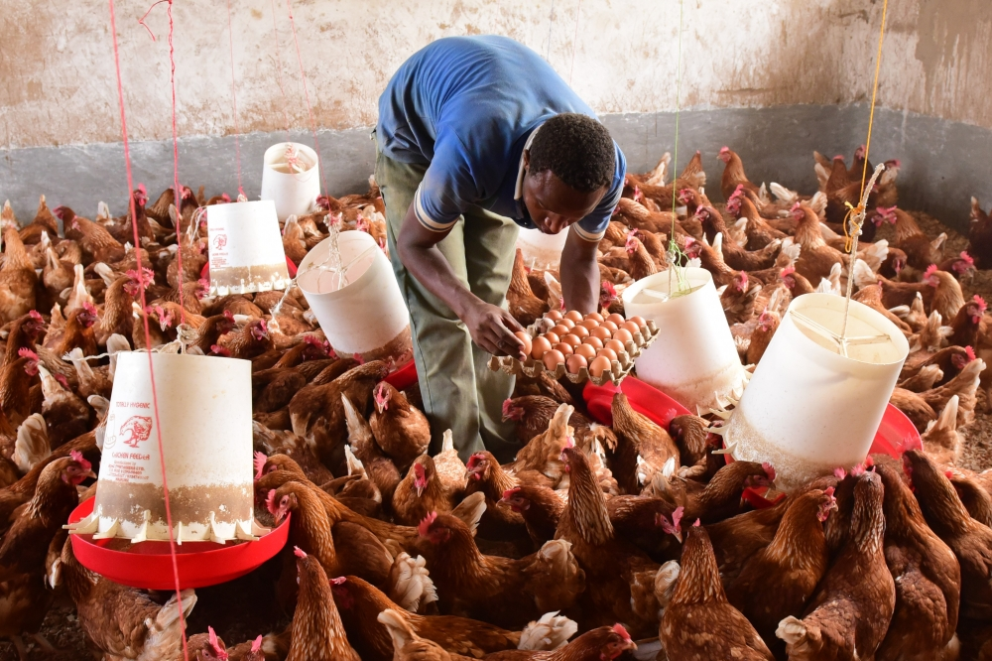

Figure 3.1: Youth Involvement in Poultry keeping

**Source:** Field study (May, 2023)

## 3.2.3 Importance of Poultry Keeping

The importance of poultry to national economy cannot be underestimated as it has become popular for the smallholders that have contributed to the economy of the country. The poultry sub-sector occupies a prominent position in providing the needed animal protein, minerals and vitamins to balance the human diet (Adeniran et al, 2018). Poultry keeping is a significant source of revenue generation for small farmers in developing countries. It plays a vital role in fulfilling the daily protein requirements of humans through meat and eggs consumption. Poultry contributes about 9-10% of agricultural GDP (FAO 2019).

Poultry farming contributes to industrial sector by providing raw materials to industries such as those used in vaccine preparation, leather, soap, cake making, paints, animal feeds, fertilizers, cushions, mattresses. Nevertheless, poultry industry favors’ research, improving income as its contribution to the nation’s GDP is 3.1%, increasing employment opportunities that in turn allay poverty. Finally, poultry industries aids in balancing the environment as it helps to maintain soil fertility, and birds are well known for keeping ecological balance through eating different insects, worms and household waste.

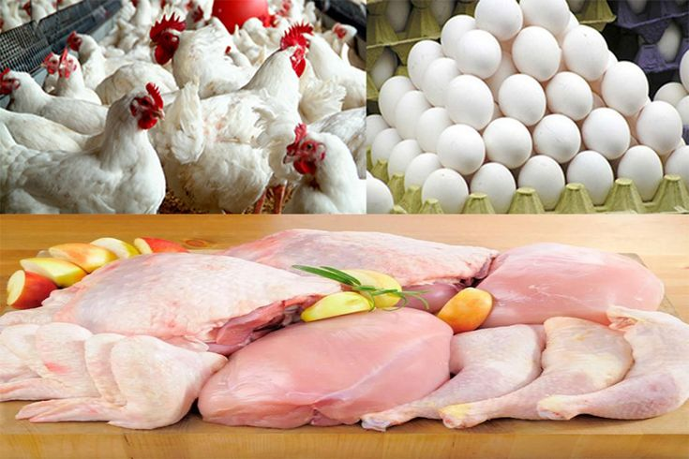

Figure 3.2: Importance of Poultry Farming

**Source:** Field study (May, 2023)

Group photo of the members working in the poultry house feeding the broilers

chicks, which are the one most popular breeds uniquely for fast growth, greatly at

converting feed into muscle weight. Their growth period is between 6 to 8 weeks of age and they are groomed to the tune of 3kgs to 3.5kgs of weight.

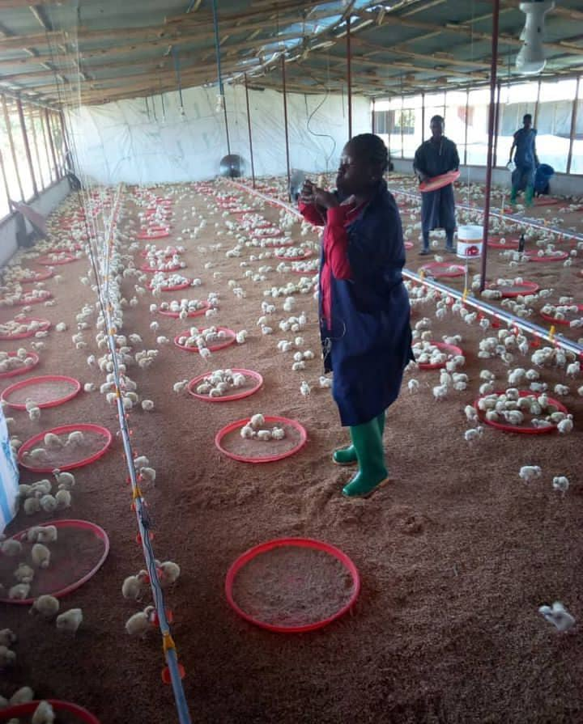

## Figure 3.3 Importance of feeding and vaccination of broilers chickens

**Source:** Field study (May, 2023)

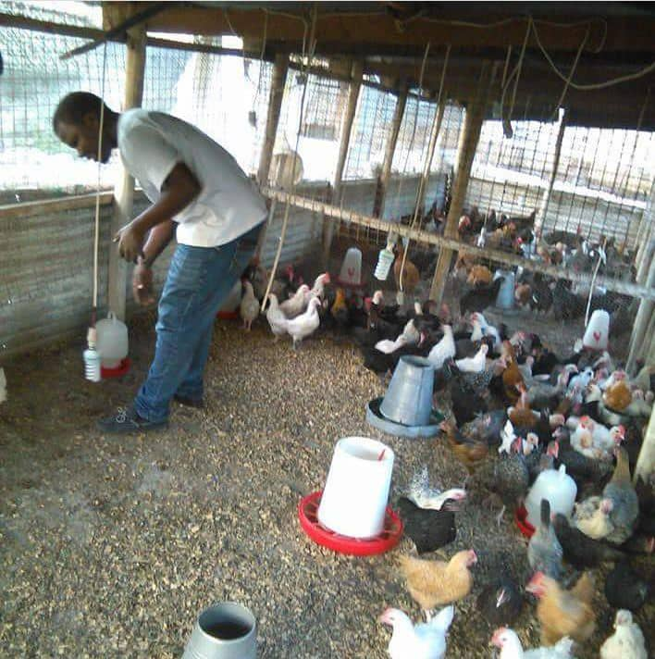Member of the group working in separating the broilers into groups based on their body size and weight, in doing that they are making wonderful broilers feed intake to reach the market preference within a short period of time

## 

## Figure 3.4 Role of Separating Broilers as a way of enhancing feed intake

**Source:** Field study (May, 2023)

## 3.2.4 Income generating project and development

Sachs, J. (2005) conducted a study titled the end of poverty: how we can make it in our lifetime. The findings revealed that, significant changes observed before and after the participation in the income generating projects. When asked whether there were any significant changes before and after participation in the income generating projects, 18 (90%) of participants agreed that there are participation income generating projects did bring significant changes to their lives. Two third, i.e., 12(60%), stated that their skill level had improved, they now had income for their basic needs and their stress levels had decreased. Only a few, i.e., 2(10%) were of the opinion that their participation in income-generating projects did not bring any significant change in the quality of their lives. On being, asked to elaborate, one participant stated that the project in question did not generate any income; hence no significant change could be seen since participating in the income-generating projects. These findings underscore the need for the development of more market driven projects (poultry in particular) will fill a gap in the market and are likely to generate income for participants.

## 3.3 Empirical Literature

Unlike other cities, Dar es Salaam still has abundantly of open space and embryonic plots which can be used for urban agriculture. Dar es Salaam has existing bylaws for urban livestock, with clear guidelines. However, law enforcement is rather weak – a situation, which especially Intra-urban livestock keepers take advantage of. The short distance to the consumers is an advantage compared to the situation of peri-urban producers (JACOBI ET AL. 2000, 273).

On the other hand, the farmers are facing a lot of problems (JACOBI ET AL. 1999). It is obvious that the rapid growth of the city implies an enormous pressure on vacant land which could be used for housing purposes. Therefore, housing projects can be a threat to urban livestock keeping. Many urban dwellers now practicing urban livestock might lose their land because of new residential areas being built in the near future (KYESSI 1997, 31).

In this respect, one of the most important issues is land tenure. Public and private land is widely used for urban agriculture on Dar es Salaam’s open spaces, but sometimes not or only informal agreements exist between the owner and the user of the land. This insecurity of land-use, the sometimes-illegal use, the missing prospect regarding the period over which the land can be used makes open space production highly insecure.

Under the empirical review attention is given to the elements of youth that include challenges of unemployed youth, income generation by youth, poultry farming, livestock policy and youth policy and the contribution of other studies towards income generation by youth for their wellbeing.

## 3.3.1 Youth Unemployment

Studies such as the one presented in Baseline Report (2015) have shown that youth unemployment in any form has proven to drag the economy and the society’s development. It has also shown to undercut productivity, spending, and investment, stunting national growth and it seemingly contributes to inequality. It spurs social tension joblessness and inactivity and the failure to tap into the economic aspirations and resources of youth people carry higher price.

Without income, millions of young people find themselves living in poverty as it affects their future earnings and increase the likelihood of later joblessness. It is asserted that youth unemployment is caused by a number of factors that include: weak or unsupportive macroeconomic environment, inadequate skills and mismatches between education and skills, lack of social networking, household income, lack of information about where the jobs are, lack of access to capital, constrain to business creation and job creation, and economic slowdown (Goldin, 2015).

## 3.3.2 Improved Youth Income

Poverty alleviation efforts could be well enhanced through improved youth income. The need to improve income for poverty alleviation in societies remains to be there to date. An improved youth income could serve well in enhancing the well-being of the youth, and hence the wellbeing of their communities, which in turn could enhance the wellbeing of the society. Monetary income is important as a means to satisfy a wide range of material needs, such as food security and also to increasingly satisfy other needs such as health services, education, safe drinking water and sanitation (Thunberg, 2004). With the prevailing negative economic climate, there is a need for an effective youth social economic engagement as a lot of them are facing hard times. The root causes of poverty in individual deficiencies and how poverty is caused by individual deficiencies should be addressed through improved youth income mechanisms. Improved youth income mechanisms bear the notion that individuals are responsible for the solutions to their poverty situation. One should bear in mind that with hard working and better choices the poor could come up with viable solutions to their problems (Bradshaw 2006).

## 3.4 Policy Review

Young people today live in a globalized society characterized by a wide array of prospects and problems, innovation and challenges, promise and despair. They are an integral part of society, a major resource and a key agent of social change, as well as economic development and technological innovation. Therefore, youth wellbeing becomes an important feature of youth policy and youth development which should be translated into action through various youth development programs and activities with proper coordination of the various sectors (Casimir, 2017).

## 3.4.1 Youth Development Policy

The Nation Policy on Youth Development (2007) intends to create an enabling environment that builds the capacity of young people and promotes employment opportunities and access to social security. The policy focuses on a number of areas including employment, healthcare, and education, the role of local agencies, HIV/AIDS, disability, equality, financial services, juvenile justice, the informal sector, and ICTs. The 2018/2019 national budget’s focus in relation with the improvement of youth workforce skills was to have the proportions of the youth who are highly skilled increased from 3.9% to 12.0% and the ones with medium skills increased from 16.6 to 34.0%. The implementation of this policy through youth training and make them to be employed themselves. However, the presence of national youth development policy of 2007 among of its challenges is that; it has not vividly displayed youth economic inclusion.

Likewise, the strength of the Youth policy in relation to this poultry project is that; it is about indoctrinating youth determinations, persistence, curiosity, building self-confidence and patience. All these are crucial elements in fostering poultry entrepreneurship hence the best breeding environment for poultry keeping being among. The youth policy inculcates and portrays enormous potential for the poultry industry in Tanzania as a way of promoting and enhancing food and nutritional security to the youth while on the other hand contribute towards youth households and their income generation.

## 3.4.2 The Tanzania Youth National Policy

The Tanzania Youth National Policy of 2007 addresses the fact that there should be mechanisms to solicit funds which will enhance adequate coordination with a view of having sustainable funds to support youth in their income generating activities. There shall be mechanisms to promote the establishment of youth friendly credits support services and empower youth on credit management. With agriculture and animal husbandry being the largest employer, the government in collaboration with other stakeholders shall provide favorable environment for the youth to participate effectively (National youth development policy, 2007). The support of organizations such as faith-based organizations in projects aimed at improving the livelihood of the youth, such as the World Vision International; served well the project to thrive as well the implementation and realization of this policy.

## 3.4.3 The Tanzania Livestock Policy (2006)

The Tanzania Development Vision states that, by year 2025, there should be a livestock sector which to a large extent shall be commercially run, modern and sustainable using improved and highly productive livestock to ensure food security, improved income for the household, reducing inequalities, employment opportunities while nurturing the natural resources and the nation while conserving the environmental sustainability. The livestock sector has number of opportunities which if are utilized effectively, will lead to increased production and productivity and thus act as a basis for poverty alleviation in urban and rural areas. The policy specifically related to the poultry project as it strengthen technical support services to the poultry keepers and advocating dissemination and new technologies. Likewise it says about the promotion of production of safe and quality food of animal origin in order to safeguard consumers, More importantly is about mainstream cross cutting and cross sectorial issues such as gender, youth, HIV, land and environment. The policy further argue in the same page with this poultry project as it stipulate the collaboration with other stakeholders to promote improvement of genetic potential in the traditional herds in order to increase poultry productivity. Organic livestock is an emerging concept that advocating minimal or non-use of industrial chemical following the increasing use and misuse of such chemicals resulting into human health hazards.

## 3.5 Small and Medium Enterprise Development Policy (2012)

The policy aims at fostering job creation and income generation by promoting the creation of SMEs and improving the performance and competitiveness of the existing enterprises to increase youth participation and their contribution to the national economy (NSYIA, 2016). It is in this perspective that unemployed such as the youth in this study, are enabled to work in a small group, exercising job creation that generates income to contribute to their household and social welfare in general.

## 3.5.1 National Employment Policy (2008

The National employment policy aims at enhancing skills and competencies for those in formal and informal sector especially in rural areas. It also aims at promoting the goal of decent and productive employment as a national priority and enables all participants in the labor force to gain productive and full employment with equal access to employment opportunities. It also aims at providing equal access to resources endowment for marginalized and vulnerable groups including youth and people with disabilities (NSYIA, 2016). It is in this manner that this policy is supportive of the processes that help the unemployed secure undertakings that help them employ themselves and generate income, such as the project done in this study.

## 3.5.2 The Tanzania Development Vision 2025

The Tanzania Development Vision 2025 aims at achieving a high-quality livelihood for its people, attain good governance through the rule of law, and develop a strong and competitive economy. The vision asserts that high priority must be given to education and continuous learning and the effective transformation of the mindset and culture to promote attitudes of self-development. It is further asserted in the vision that community development and exploit of every opportunity for the improvement of the quality of livelihood is of primary importance (The Tanzania Development Vision, 2025).

In making a competitive economy, the vision aims to ensure that market permits a wide participation for men, women, youth, and the entire citizens in activities which enable the realization of the vision. The government will have to put in place affirmative action programs which provide special support for promoting the participation of all the indigenous population in wealth creation and ownership process. This policy is quite supportive to moves that enhance the efforts to improve the livelihood of people, such as the project that aims at helping the unemployed youth generate income.

## 3.5. 3 Policy Implication

Across the globe and in Tanzania in particular, youth class if well treated and fully engaged are real creating significant contributions as productive forces, entrepreneurs, consumers, best citizens of society and agents of change. The full potential of youth is not realized because they do not have access to productive activities, economic exclusion, poor access to decent jobs that match with their qualification to meet their aspiration hence their expectation evaporates and never lived their dreams thus resort into unwelcomed behavior. International organization, such as ILO, make efforts in engaging, advocacy, and supporting member states in placing better jobs at the center of economic and social policies and growth of development strategies (ILO 2017). This calls for more efforts to be done to engage the youth in the productive prosperity and wealth creation progressions.

It is further noted that youth participation in livestock, faces various encounters including; access to business and market knowledge, information and education, access to land, access to financial services. It is argued that vocational training and extension services are potentially effective tools for teaching Livestock skills and providing capacity training for rural and urban youth. For youth to fully participate in the poultry sub sector, access to both information, education and know how knowledge through appropriate capacity building and training is crucial. Moreover, youth keepers need access to information about finance, land and markets, all of which are of great importance urban areas (FAO, 2020).

## 3. 6 Literature Review Summary

The literature review in this chapter has looked at the youth as an integral part of a community that are to be empowered for active participation in poverty alleviation efforts, and in the income and wealth generation processes. Improved youth income, food access and security, and involvement green vegetable, through empowerment and participation, together with enhancement of skills, could foster the youth’s improved wellbeing and standard of living.

## CHAPTER FOUR

## PROJECT IMPLEMENTATION

## 4.1 Overview

The chapter presents information on how the project was implemented. It shows the analysis of project products and outputs, and activities undertaken at each stage of the project. The chapter also presents the time frame for each activity undertaken in this project and the resources that were used to facilitate the project activities. In this project, stakeholders played a great part by providing support towards the undertaking of the project. The project Promotion of Youth Empowerment through Poultry Skills for Income Generation at Ubungo Municipality, Dar es Salaam was implemented by unemployed youths from Kibamba ward, at Ubungo Municipality.

## 4.2 Projects Output and Activities

Project output are the Community Needs Assessment report, training report on poultry production, acquisition of resources including land, chicken cages, transport crates, incubators and vaccination equipment. Others are report of the process how the youths were empowered to form and register a group, writing a constitution and opening a bank account.

## 4.2.1 Projects Outputs and Activities

In order to achieve the project objectives and outputs, several activities were planned as shown in table 4.1 of this report. While many project activities have been successfully implemented and outputs achieved.

## 4.3 Project Planning

Project planning is first and crucial step as it determines the effectiveness and efficiency of the project. In this project planning comprised of development of the project objectives and outputs, scheduling activities in logical sequence, identifying responsible persons for each activity, identifying resources needed and the amount of money required. Planning tools including the project implementation plan, project budget, Logical Framework and Ghannt chart

## Table 4.1: Input, Process, Output

|  |  |  |
| --- | --- | --- |
| **Objectives** | **Process** | **Outputs** |
| To organize twenty youth at Kibamba in Ubungo Municipality to form an income generating group by May 2023 and formalize by officially registering the group with the appropriate authorities. | * Community Needs Assessment (CNA) * Report 20 youths trained in effective ways for poultry production * Group registered into CBO | * 20 unemployed youths trained on income generating activities. * Prepare CNA report * Make preparations for training * Conduct training on poultry keeping production and identification of Input. * Prepare group constitution and Minutes * Submit application package to the Municipal director for official registration. * To attain group office to facilitate operation. |
| To strengthen the capacity through training on poultry keeping and their related skills and techniques about poultry keeping business by May 2023. | * Community Needs Assessment (CNA) * Conduct training   on Poultry  production and  identification of inputs | * Prepare CNA report * Trained on poultry skills * Equipped with Market techniques * Equipped with financial literacy. |
| To acquire a piece of land to be used to build poultry house and space for operation by end of June 2023 | * 600square meters of land to be acquired. | * Formalities of the handing over 600 SQM of land to the group. * To attain group office to facilitate operation * Extension the dimensions and improving the existing poultry house together with associated infrastructure. |
| To assist the group on the purchase of what is needed to kick start the Project. | * Solicit of funds among the group members * poultry farm equipment purchased * poultry production Started | • Purchases of poultry farm equipment like chicken feeders, hatchery, egg crates, debarking machine, chicken cages, Transport crates, drinkers, vaccination equipment’s and medics as well as brooders were bought.  •Expansion of laying house   * Kick start of the project * Source for market outlets |

**Source:** Field Findings, 2023

## 4.4 Project Implementation Plan

The project implementation plan involves a series of activities that will utilise

available resources to achieve the project goal. The following implementation plan consists of the project goal, project outputs, project activities, time frame, and resources to be utilised and responsible personnel. The sequential arrangement shows how the project goal will successfully be achieved (Table 4.1).

## Table 4.2: Project Implementation Plan

| **Goal** | **Objectives** | **Activities** | **Outputs** | **Time** | **Resources** | **Responsible Person** |
| --- | --- | --- | --- | --- | --- | --- |
| To empower youths unemployed youths through Poultry skills and income generation | i. To organize twenty youth at Kibamba in Ubungo Municipality to form an income generating group by May 2023 and formalize by officially registering the group with the appropriate authorities. | 1.1. Mobilization of unemployed youth at Kibamba ward | * Constitutional write-up * Setting up of the leadership structure | Two weeks | Transport, training materials, facilitator/trainer allowance, refreshments | Host organization, CED student, and unemployed youths, local leaders. |
| 1..2 conducting training on income generating activities |
| ii. To strengthen the capacity through training on poultry keeping and their related skills and techniques about poultry keeping business by May 2023. | 2.1. 600 square meters of land acquired at Kibamba ward | 20 unemployed youths trained on income generating activities  •Obtain group office | Two weeks | Transport, training materials, facilitator/trainer allowance, refreshments | Host organization, CED student, and unemployed youths, local leaders. |
| 2.2 poultry farm equipment purchased  2.3 conduct extensive training on poultry keeping (poultry is viewed an important for mankind by supplying food, economy and generation of employment i.e., income source from poultry business) |
| iii. To acquire a piece of land to be used to build poultry house and space for operation by end of June 2023 | 3.1 Land registered and handed over to the CBO  3.2 poultry farm equipment purchased (e.g., Incubators are devices used for insuring the safe and productive hatching of eggs, brooders is heated structure that provides warmth for chicks)  3.3. 600square meters of land acquired at Kibamba ward | Formalities of the handing over 600 SQM of land to the group   * Obtain group office | Two weeks | Trainer allowance, transport, equipment | Host organization, CED student, and unemployed youths |
|  | iv. To raise some funds that will facilitate the opening of the group bank account and start the project immediately by June 2023. | -To prepare a reasonable budget for handling chickens  -To itemize most popular types of poultry equipment used in a modern chicken farm  -Preparation of fund-raising events  -Have volunteers to circulate and sale raffle tickets  -Design awareness on the marathon concert | -increase recognition for the mission  -raise money from the top down  -personalize your solicitation | One week | -Trainer’s allowance, Transport, equipment  -first aids kits | -Events manages  - Host organization, CED student, and project beneficials leadership |
| **Source:** Field Findings, 2023. | | | | | | |

## 4.5 Logical Framework

The following table (Table 4.3) shows the local framework for the project.

## Table 4.3: Logical Framework.

|  |  |  |  |  |
| --- | --- | --- | --- | --- |
|  | Project Summary | Indicators | Means of Verification | Risks |
| Objectives | A.To identifying the economic activities carried out at Ubungo Municipality.  B.To identify and prioritizing the community needs at Ubungo Municipality.  C.Facilitating the opening of the group bank account and starting the project by June 2023.  D.To identify and prioritizing the intervention to address the identified need.  E.To assist the group on the purchase of what is needed to kick start the Project. | Increased small and medium income generating activities for youth in the municipality. | Municipality statistical data on small and medium entrepreneurs for youth programme. | Unwillingness of unemployed youth to share their daily income generating reports and types of activities. |
| Goal | To empower youths unemployed youths through entrepreneurial skills and income generation | Increased income to unemployed youths | Sales reports, comparison of income status before and after the project, monitoring and evaluation reports | Willingness of unemployed youths to share their income status |
| Output | 1. 20 unemployed youths trained on income generating activities | Increased awareness of unemployed youths on income generating activities | Youths participation in undertaking of the project | Willingness of unemployed youths to participate |
| 2. 20 unemployed youths trained on entrepreneurial skills | Increased awareness of unemployed youths on entrepreneurial skills | Youths participation in undertaking of the project | Willingness of unemployed youths to participate |
| 3. 20 unemployed youths oriented on poultry production | Increased awareness of unemployed youths on poultry production | Youths participation in undertaking of the project | Willingness of unemployed youths to participate |
| 4. 20 unemployed youths empowered to start poultry farming business | Empowered youths to start poultry farming businesses | Businesses established, monitoring and evaluation reports | Willingness of unemployed youths to participate |
| 5. 20 unemployed youths equipped with marketing skills | Ability to undertake the project | Businesses established, monitoring and evaluation reports | Willingness of unemployed youths to participate |
| 6. 20 unemployed youths facilitated with start-up funds for poultry farming business | Funds allocated to unemployed youths | Businesses established, monitoring and evaluation reports | Willingness of unemployed youths to participate |
| Activities | 1. Mobilization of unemployed youth at Kibamba ward | Number of fliers and posters distributed | Monitoring and evaluation reports | N/A |
| 2. Conducting training on income generating activities | Number of youths attended | Monitoring and evaluation reports | Willingness of unemployed youths to participate |
| 3. Mobilization of unemployed youth at Kibamba ward | Number of fliers and posters distributed | Monitoring and evaluation reports | N/A |
| 4. Conducting training on entrepreneurial skills | Number of youths attended | Monitoring and evaluation reports | Willingness of unemployed youths to participate |
| 5. Orientation on farm preparation | Number of youths attended | Monitoring and evaluation reports | Willingness of unemployed youths to participate |
| 6. orientation on meat production (through broilers breeding) | Number of youths attended | Monitoring and evaluation reports | Willingness of unemployed youths to participate |
| 7. orientation on eggs production (through layers breeding) | Number of youths attended | Monitoring and evaluation reports | Willingness of unemployed youths to participate |
| 8. Preparation of project budget for required resources | A budget document in place | Monitoring and evaluation reports | N/A |
| 9. To select the suitable poultry farm location | Number of farms identified | Monitoring and evaluation reports | N/A |
| 10. To purchase equipment required in poultry farming | Number of equipment purchased | Monitoring and evaluation reports, payment receipts | N/A |
| 11. To conduct training workshop on marketing | Number of youths trained | Monitoring and evaluation reports, payment receipts | N/A |
| 12. To provide skills on social media marketing | Number of youths trained | Monitoring and evaluation reports, payment receipts | N/A |
| 13. To provide start-up capital to 20 unemployed youths | Number of youths acquired funds | Available businesses, monitoring and evaluation reports | N/A |

**Source: Field Findings, 2023**

## 4.6 Project Inputs

To enable efficient and effective implementation of the project, various inputs were invested. These include financial, human and material inputs such as project facilitators, funds (for buying equipment, facilities, and paying allowances). These inputs ensured the effective and efficient delivery of the intended results of a project (Table 4.1).

## 4.7 Staffing Pattern

The project is led by the Kibamba ward council under the supervision of the WEO of Kibamba ward. The project leadership is assisted by the ward community development officer, the ward business officer and the project group leaders.

## Table 4.4: Staff Pattern

|  |  |  |
| --- | --- | --- |
| **No** | **Staff position** | **Staff Responsibilities** |
|  | Chairperson | Organise the project activities and make a follow up on the team responsibilities. |
|  | Secretary | Support the team leader in project activities and keeping records of the project. |
|  | Treasurer | Keep records of financial matters and control the budget of the project activities. |
|  | Team Advisor/Facilitator | Gives farming training and technical support and the supervision of the project. |
|  | Youths Group Leader | Provide with mentorship guidance to the youth group member. |

**Source:** Field Findings, 2023

## 4.8 Project Budget

Figure 4.4 provides the budget that enabled the implementation of the project. The project budget was an important part for the implementation of the project, as it defined the needed funding and its availability. It is of vital importance to put into consideration the issue the availability of funding to carry out the activities for the implementation of the project. In this project the budget for all activities and the required inputs was Tsh 13,220,000/=, all of which was given by the host organisation.

## Table 4.5: Project Budget

|  |  |  |  |
| --- | --- | --- | --- |
| **S/N** | **Project Activities** | **Inputs** | **Cost** |
|  | Mobilization of 20 unemployed youth at Kibamba ward | Fliers & brochures, local meeting | 1,200,000 |
|  | Conducting training on income generating activities | Venue, facilitator, refreshments | 700,000 |
|  | Mobilization of unemployed youth at Kibamba ward | Fliers & brochures, local meeting | 1,200,000 |
|  | Conducting training on entrepreneurial skills | Venue, facilitator, refreshments | 700,000 |
|  | Orientation on Poultry farm preparation | Venue, facilitator, refreshments, visiting existing farms | 700,000 |
|  | Orientation on meat production (through broilers breeding) | Venue, facilitator, refreshments, visiting existing farms | 700,000 |
|  | Orientation on eggs production (through layers breeding) | Venue, facilitator, refreshments, visiting existing farms | 700,000 |
|  | Preparation of project budget for required resources | Budget document preparation | 320,000 |
|  | To select the suitable poultry farm location | Transport | 300,000 |
|  | To purchase equipment required in poultry farming | Financial resources | 2,300,000 |
|  | To conduct training workshop on marketing | Venue, facilitator, refreshments, | 700,000 |
|  | To provide skills on social media marketing | Venue, facilitator, refreshments, | 700,000 |
|  | To provide start-up capital to 20 unemployed youths | Financial resources | 3,000,000 |
| **Total Costs** | | | **13,220,000** |

## Source: Field Findings, 2023

## 4.9 Project Implementation

The project's real implementation is described in this section. The planned project activities in the logical framework were used to carry out the implementation. The operations that were carried out as mentioned were done in an effort to help the project reach its anticipated goals by September 2022. The actions are outlined, a Gantt chart is shown, and some pictures that were taken throughout the implementation are also included.

## 4. 10 Project Implementation Report

The implementation of activities is described basing on the implementation plan as described in the sections to follow below.

## 4.10.1 Youth Group Training and Orientation of Poultry Farming

20 youths were trained on income generating activities, entrepreneurial skills and poultry farming. Each training took total of five days and involved all 20 unemployed youths who were identified with the help of the ward leaders and the community. The training involved both theoretical and practical training. Theoretical training took place in special prepared venue and practical training involved visiting sites and study tour to different places carrying out poultry production business.

## 4.10.2 Preparation of a Poultry

The knowledge gained in training, youths easily identified their areas of interests where they could establish their farms. Some youths obtained spaces from the homestead’s backyard while others rented the places from the other locations. The preparation of poultry farms was done with the help of project team and the local community.

## 4.10.3 Project Implementation Gantt chart

## The Gantt chart has been prepared to simplify the project intervention process and indicate a series of activities to be put in place to ensure that all project activities were implemented as it was planned. The chart was prepared to show activities and their respective month to be completed; it further shows the objectives and expected output and the activities. The details of the Gantt chart are shown under Table 4.6.

**Table 4.6: Project Implementation Plan (Gantt chart).**

|  |  |  |  |  |  |  |  |  |  |
| --- | --- | --- | --- | --- | --- | --- | --- | --- | --- |
| **Objectives** | **Output** | **Activity** | **Months** | | | |  |  |  |
| **Dec**  **2022** | **Jan**  **2023** | **Feb**  **2023** | **March**  **2023** | **April**  **2023** | **May**  **2023** | **June**  **2023** |
| To organize twenty youth at Kibamba in Ubungo Municipality to form an income generating group by May 2023 and formalize by officially registering the group with the appropriate authorities. | 20 unemployed youths mobilized. | Mobilization of unemployed youth at Kibamba ward. |  |  |  |  |  |  |  |
| To empower youths unemployed youths through Poultry skills and income generation | 20 unemployed youths trained on income generating activities | Conducting training on income generating activities. |  |  |  |  |  |  |  |
| To raise some funds that will facilitate the opening of the group bank account and start the project immediately by June 2023. | i.Group registered into CBO.  ii.Opening bank account. | Formation of community based organization and opening bank account. |  |  |  |  |  |  |  |
| To acquire a piece of land to be used to build poultry house and space for operation by end of June 2023 | Formalities of the handing over 600 SQM of land to the group | Acquire land for poultry keeping and expansion of laying house. |  |  |  |  |  |  |  |
| To equip 20 unemployed youth with knowledge on poultry production. | 20 unemployed youths oriented on poultry production | Orientation on farm preparation. |  |  |  |  |  |  |  |
| To equip 20 unemployed youth with both practical and theoretical skills and knowledge on meat production through broilers breeding. | Number of youths attended. | Orientation on meat production (through broilers breeding). |  |  |  |  |  |  |  |
| To provide practical and theoretical skills on eggs production (through) layers breeding. | Number of youths attended. | Orientation on eggs production (through layers breeding). |  |  |  |  |  |  |  |
| To provides the budget that enabled the implementation of the project. | The budget was prepared | Preparation of project budget for required resources.. |  |  |  |  |  |  |  |
| To start poultry production by end of May 2023. | 600square meters of land acquired at Kibamba ward. | To select the suitable poultry farm location |  |  |  |  |  |  |  |
| To assist the group on the purchase of what is needed to kick start the project. | Poultry farm equipments purchased | To purchase equipment required in poultry farming. |  |  |  |  |  |  |  |
| Building the practical and theoretical ability to undertake the project. | Number of youths attended and trained | To conduct training workshop on marketing. |  |  |  |  |  |  |  |
| To empower 20 unemployed youth with financial ability and starting up the project. | Number of youths acquired funds | To provide start-up capital to 20 unemployed youths. |  |  |  |  |  |  |  |

**Source:** Researcher, 2023.

## CHAPTER FIVE

## PARTICIPATORY MONITORING, EVALUATION AND SUSTAINABILITY

## 5.0 Overview

This chapter covers three sections, namely, project participatory monitoring participatory project evaluation and the project sustainability. Project monitoring, evaluation, and sustainability are essential tools that ensure effective implementation of the project and sustainability of the project.

## 5. 1 Participatory Monitoring

Project monitoring involves tracking the progress of the project to ensure that the project stays on track the objectives are achieved within the prescribed time, scope and resources and to ensure quality of the execution. It involves monthly to quarterly reporting on outputs, activities, and use of resources. Monitoring helps the project manager to understand whether the projects are progressing in schedule and evaluation helps the project managers to assess the extent in which the project has achieved the objectives.

Participatory monitoring involved engaging of various stakeholders at all stages of project activities. Participatory monitoring enabled monitoring of all project activities including mobilization of unemployed youth at Kibamba ward, conducting training on income generating activities, mobilization of unemployed youth at Kibamba ward, conducting training on entrepreneurial skills, orientation on farm preparation, orientation on meat production (through broilers breeding), orientation on eggs production (through layers breeding), preparation of project budget for required resources, to select the suitable poultry farm location, to purchase equipment required in poultry farming, to conduct training workshop on marketing, to provide skills on social media marketing, to provide start-up capital to 20 unemployed youths.

Stakeholders were involved in monitoring included the ward council, the ward councilor, WEO, the community, and beneficiaries of the project. Monitoring was done through field visit and in which participants became aware of the progress of the project and this gave room for decision-making.

## 5.2 The Project objectives implementations and findings.

The implementation of the objectives of project is one of the key important part for a project achievement. The implementation cannot be done out of the project objectives. Implementation stage show the results and findings needed by the project planners, researchers and stakeholders according to the stated objectives. By doing the participatory monitoring, the project enters into execution stage and need a careful project implementation, monitoring and evaluation according to the planned Objectives. According to this report it revealed that the project objectives were executed successful as it was planned. The executed objectives provides the results and findings needed by both planners, stakeholders and researcher as following objectives explained sequentially its implementations and results as follows:-

## 5.3 Organizing of unemployed youth in Ubungo Municipality to form an income generating group and formalize by officially registering with the appropriate authority by May 2023.

The Organizing of unemployed youth and formalizing of the group was the first key objective for this project. The results of this project shows that 20 unemployed youths were organised, gathered and trained on income generating activities in both theoretical and practical skills. The group was officially registered by the authority as CBOs. The group was registered by Municipal authority with the name called **‘’Kazi iendelee’’** the Certificate of registration is attached on the appendices.

## 5.3.1 Strengthening the capacity through training on poultry keeping and their related skills and techniques about poultry keeping business by May 2023.

Capacity building through theoretical and practical skills is essential part for the project achievement. According to this report, 20 unemployed youths trained on income generating activities and the project obtained group office as it was intended. Therefore the project was implemented by trained unemployed youths from Kibamba ward, at Ubungo Municipality with an obtained office as it was intended.

## 5.3.2 Acquiring a piece of land that will be used to build poultry house and a space of the group operation by June 2023.

Another key objective for a project is land. The Land is essential resource. Formalities of the handing over 600 SQM of land to the group was done with the assistance of the government authorities. The reports revealed that the acquired Land was registered and handed over to the CBO. The letter of handing over the land to the group is available at the appendices. This objective was successfully met.

## 5.3.3 Facilitating the opening of the group bank account and starting the project by June 2023.

Project funds are needed to be safely and professionally managed for successfully implementation of any work. Therefore this project needed a sound financial management for its achievement. The planners aimed to have official project bank account where funds from mobilizations, subscriptions and stakeholesers of the project will be safely and professionally managed and deposited. The project raised some funds that facilitated the opening of the group bank account and started the project in June 2023 as it was planned. The bank account was opened at CRDB Bank Lumumba Branch with the name ‘**’Kikundi cha Uchumi cha kazi Iendelee’’** with bank account number 01524799899800. The Opening account bank slip is available at the appendices of this report.

## 5.3.4 Assisting the group on the purchase of what is needed to kick start the Project.

To ensure the project implementations, the Organizers aimed at assisting the registration of the group and buying all necessary equipments that facilitates the operations of the project. This report revealed that the objective of assisting the group buying project equipments was done. Poultry farm equipment purchased (e.g., Incubators are devices used for insuring the safe and productive hatching of eggs, brooders is heated structure that provides warmth for chicks), the objective was succeeded.

## 5.4 Monitoring Information System

Monitoring Information System (MIS) was designed to help in the gathering and analyzing data and report information on project progress to enable a project manager and stakeholders to plan, monitor and evaluate the operations and performance of the project (Putra, 2019).

The MIS was designed to provide information by relevant information on activities that were planned in a specified period (Camilius et al, 2018). Data required included project facilities required and available, staff required and available, project beneficiaries (required and available), training conducted, and inventory of purchased equipment.

## 5.4.1 Participatory Monitoring Methods

In this project, various methods were used to enable participatory monitoring of the project. Methods used include conducting Focus Group Discussions (FGDs) and observation.

## 5.4.2 Focus Group Discussions (FGDs)

FGD involves conducting group interviews with respondents. In this aspect, the project monitoring team organized youths and other stakeholders in groups of 5 to 10 members. The groups discussed questions related to the progress of the project. A FGD guide was prepared to enable keeping on track on project issues.

## 5.5 Observation

Observation is a method in which the monitoring team observed the events that were taking place during the execution of the project. This was done through visiting the venue where training was taking place and the poultry farms to gather information on the quality, effectiveness and efficiency of the project outputs.

## 5.5.1 Participatory Monitoring Plan

## Table 5.1: Project Monitoring Plan

| **Goal** | **Objectives** | **Activities** | **Outputs** | **Indicator** | **Time** | **Resources** | **Data Source** | **Methods** | **Responsible Person** |
| --- | --- | --- | --- | --- | --- | --- | --- | --- | --- |
| To empower youths unemployed youths through poultry skills and income generation | 1. To build capacity to 20 youths on effective ways for poultry production by the end of April 2023 | 1.1. Mobilization of unemployed youth at Kibamba ward | 20 unemployed youths trained on income generating activities | List of Attendants, Training report | Two weeks | Transport, training materials, facilitator/trainer allowance, refreshments | Project Progress Report | Lectures  Group discussion  Study tour  Case study | Host organization, CED student, and unemployed youths, local leaders. |
| 1..2 conducting training on income generating activities |
| 2.. To start poultry production by end of May 2023. | 2.1. 600square meters of land acquired at Kibamba ward | 20 unemployed youths trained on entrepreneurial skills | List of Attendants, Training report | Two weeks | Transport, training materials, facilitator/trainer allowance, refreshments | Project Progress Report | Lectures  Group discussion  Study tour  Case study | Host organization, CED student, and unemployed youths, local leaders. |
| 2.2 conducting training on entrepreneurial skills |
| 3. To facilitate Community group Formation by June 2023 | 3.1 Group registered into CBO | * Prepare group constitution and minutes   Collection of some fund to open group account | List of Attendants, Training list | Two weeks | Trainer allowance, transport, equipment | Project Progress Report | Lectures  Group discussion  Study tour  Case study | Host organization, CED student, and unemployed youths |
| 3.2 opening up of group bank account |
| 3.3. land acquisition and expansion of laying house |
|  | 1. To assist the group on the purchase of what is needed to kick start the project | 3.4 solicit of funds among the group members  3.5 poultry farm equipments purchased | Poultry production started | lists of poultry equipments | Two weeks | Trainer allowance, transport, equipment | Project progress report | Focused group discussion | Student and group beneficiaries |

## 5.5.2 Participatory Evaluation

Project evaluation is a systematic way of determining the consistency of the project activities with projected outcomes. Participatory evaluation is an approach that involves key stakeholders especially the intended beneficiaries of a project, in the designing and implementation of the evaluation. The participatory evaluation task mainly focused on the whole progress in the implementation of the planned activities so as to realize the predetermined objectives. Among the evaluation areas by the help of readily available work plan was; the extent at which each planned activity is executed, achievement of the set targets and objectives, project development and success, the impact/outcome of the project and the opportunity for project sustainability. The task was facilitated by the prepared checklist at every component/activity which used as a guideline to attain high level of participatory evaluation.

## 5.5.3 Performance Indicators

Performance indicators are the physical values which are used to measures, compare and manage the overall organizational performance. They include quality, financial, flexibility, delivery reliability, employee satisfaction, customer satisfaction, safety, environment, learning and growth (Bhatti et al, 2013). The indicators used for poultry farming project evaluation are given (Table 5.2).

## Table 5.2: **Project Performance Indicators**

| **Objectives** | **Activities** | **Outputs** | **Resources** | **Performance Indicators** |
| --- | --- | --- | --- | --- |
| 1.To build capacity to 20 youths on effective ways for poultry production by the end of April 2023 | 1.1. Mobilization of unemployed youth at Kibamba ward | 20 unemployed youths trained on income generating activities | Transport, training materials, facilitator/trainer allowance, refreshments | Number of participants, Training manual |
| 1..2 conducting training on income generating activities |
| 2. To start poultry production by end of May 2023 | 2.1.600square meters of land acquired at Kibamba ward | 20 unemployed youths trained on entrepreneurial skills | Transport, training materials, facilitator/trainer allowance, refreshments | Number of participants, Training manual |
| 2.2 purchase of poultry farm equipment and tools |
| 3. To facilitate Community group Formation by June 2023 | 3.1 Group registered into CBO | 20 unemployed youths oriented on poultry production | Trainer allowance, transport, equipment | Number of participants, Training manual |
| 3.2 opening bank account |
| 3.3. constitution write up |
| 3.4. to select the suitable poultry farm location |
| 4.2. To purchase equipment required in poultry farming |
| 4.To assist the group on the purchase of what is needed to kick start the project | 3.4 solicit of funds among the group members  3.5 poultry farm equipments purchased | Poultry production started | Trainer allowance, transport, equipments | Number of participants, Training manual |

**Source:** Researcher, 2023.

## 5.5.4 Participatory Evaluation Methods

Participatory evaluation process assessed whether the project activities were on track i.e. in accordance with the schedule and planned resources. Several methods were used to perform participatory evaluation including interviews, FGDs, and meetings. In addition, field visit and observation methods were used to ensure every activity was on track.

## 5.6 Project Evaluation Summary

Project evaluation ensured that each expected outcome matched with the actual outcomes. In case of problems that arose, were discussed and implementers came up with effective solutions to be taken. The project evaluation process based on the extent to which project the overall goal and objectives were achieved. Performance indicators used as a means of verification on the particular variable. The expected outcomes were related by the actual outcomes to see the level of intervention of the particular activity assisted by the predetermined indicators. The planned activities were implemented to achieve the project objectives (Table 5.3)

## Table 5.3: Project Evaluation Summary

| **Objectives** | **Outputs** | **Activities** | **Performance Indicators** | **Expected Outcome** | **Actual Outcome** | **Remarks** |
| --- | --- | --- | --- | --- | --- | --- |
| 1. To build capacity to 20 youths on effective ways for poultry production by the end of April 2023 | 20 unemployed youths trained on income generating activities | 1.1. Mobilization of unemployed youth at Kibamba ward | Number of participants, Training manual | Awareness on income generating activities | Positive response and increased knowledge | Successful training |
| 1..2 conducting training on income generating activities |
| 2. To start poultry production by end of May 2023. | 20 unemployed youths trained on entrepreneurial skills | 2.1. 600square meters of land acquired at Kibamba ward | Number of participants, Training manual | Awareness on entrepreneurial skills | Motivated and skilled youths in entrepreneurship | Successful training |
| 2.2 purchase of poultry farm equipment and tools |
| 3. To facilitate Community group Formation by June 2023. | 20 unemployed youths oriented on poultry production | 3.1 Group registered into CBO | Number of participants, Training manual | Awareness on poultry farming business | Motivated and skilled youths in poultry farming business | Successful orientation |
| 3.2 opening bank account |
| 3.3. constitution write up |
| 4.2. To purchase equipment required in poultry farming |
| 4.To assist the group on the purchase of what is needed to kick start the project | 3.4 solicit of funds among the group members  3.5 poultry farm equipments purchased | Poultry production started | Number of participants, Training manual | The project kicked off. | Poutry farm necessary equipments purchased | Successful orientation |

## 5.6.1 Project Sustainability

Sustainability is defined as “the ability to achieve desired outcomes and maintain the ability to continue activities over time” (Scheirer, 2005). Sustainability is the element in a project that eliminates the possible hazards and makes it reliable. It is the analysis and removal of different forms of redundancy in a given project (Armenia et al, 2019). It is the ability to setup a successful project with little or no opportunity cost. Although though there are uncertainties, however, the project outcomes would be able to minimize the level of uncertainties (Okeniyi, 2013). The youth groups made an agreement of establishing their formed group during the project time, and continue with other projects for their income generation. They also agreed to influence their fellow youth to form such groups for embarking on income generation projects that will change their economic status.

## 5.6.2 Institutional Sustainability

The full participation of stakeholders developed the competency among youth in managing the poultry farming business. The training and empowerment sessions have influenced the youth with the attitude of being flexible and to adapt the internal and external environmental changes. The successful youth engagement in poultry production has tremendously strengthened the support to be given by stakeholders such as local government, host organization, and the society to such youth economic endeavors. The Kibamba ward leadership has developed the sense of ownership of the project for future development of other different projects.

## 5.6.3 Financial Sustainability

The financial sustainability of the project is a maximization of shareholders at an acceptable level of risk, using the best combination of investments and available sources of financing (Zabolotnyy and Wasilewski, 2019). The proper plan of outsourcing funds from the stakeholders has helped the youth group to understand and influence potential donors who will be there for their future sustainable economic wellbeing. Financial opportunities such as access to loans and further grants will help them stay in business. In addition, through investing their profit, the youths’ financial situation will be sustainable for further investment.

## CHAPTER SIX

## CONCLUSION AND RECOMMENDATION

## 6.1 Overview

This chapter presents the conclusion and recommendation of the findings gathered from the CNA. The conclusion gives the summary and priorities to what the project has achieved and provides future direction. In addition, the project recommendations provide necessary suggestion on what should be done in order to improve the economic situation of communities.

## 6.2. Conclusion

The CNA has provided different alternatives for community development in which the most preferred has been prioritized and the project has been formulated and executed. Results from the CNA were key and laid the foundation to the project that has provided changes to youth’s income in general. Poverty is among the most common problems that face the young generation today. Poverty has been the problem of many countries in the World. Income poverty has said to be aggravating other kinds of poverty to majority people (URT, 2022). Many countries have been straggling to pull their people out of poverty but much has not been done. The house Budget Survey conducted in 2022 and the Millennium Development Goal Report, Midi-way Evaluation from 2015 to 2018 show that the poverty status in Tanzania was still high (33.4%). Different effort has been in place to combat the problem including; National Strategy for Growth and Reduction of Poverty (NSGRP) in Swahili Mkakati wa Kukuza Uchumi na Kupunguza Umaskini Tanzania (MKUKUTA) I & II, Millennium Development goals and the current KILIMO KWANZA slogan. It has adopted the Millennium Development Goals and established the nation development vision 2025 intend to halve and alleviate absolute poverty by 2015 and 2025 respectively (URT, 2013, URT, 2015, URT, 2016). Other strategies for Tanzania include; To invest in human capital by providing equitable access to education, health and social services, Formulation of policies that focuses on investment in productive sectors, promotion of efficient economic opportunities for the poor and livestock diversification and the current slogan **“Building a Better Tomorrow”**(2023).

The project goals and objectives were partially achieved in short time. The project implementation went smooth with the active participation of youth. Youth were empowered and trained to improve their skills on poultry production skills. The expected outcome has been enhanced and it is evident that the project will be sustainable and since the local authority has fully participated, other community development projects will be executed to help the youth obtain their basic needs and contribute to the social welfare and building of the nation.

## Recommendations

From the project understanding, the researcher indorses that community needs assessment is crucial to any undertaking since it provides answers to the actual needs of the community. This enhances participation community active involvement in the project or any undertaking.

Provision of training to the youth is very important since it enhances motivation and awareness. Entrepreneurial skills will help many youths both educated and uneducated to be able to overcome financial problems. In addition, Entrepreneur skills should be incorporated in the curriculums for the primary and the secondary levels of education in order to build a strong foundation to the youth for their future investment endeavors.

The phenomena on how to overcome financial problem after having this project is all about inclusivity of the financial services and financial literacy as the best components to be imparted because they provide capability to understand and effectively use various financial skills including personal financial management preparing budget, knowing how much to save, earn, protect, spend, knowing how to invest, deciding favorable loan terms, market technique to exploit market niche, understanding impacts to credit and borrowing. All these skills help individuals project beneficiaries for this context become smarter decisions and acts more responsibly with their personal finances, they possess with actionable insights to enhance their knowledge and make the most discipline of their resources’ and manage their financial wellbeing.

## REFERENCES

Agwanda, A., & Amani, H. (2014). Population Growth, Structure and Momentum in Tanzania. Dar es Salaam: The Economic and Social Research Foundation.

Amadi, B. (2012). Perceptions of capacity building among youths involved in vocational skills development. Journal of Social and Development Sciences, 3(6), 214-222.

Argidius, F. B. (2017). The Entrepreneurship and Enterprise Growth Landscape in Tanzania, Impact report, ANDE

Creswell, J. W. (2012). Educational research: Planning, conducting, and evaluating quantitative and qualitative research (4th Ed.). Boston, MA: Pearson Education, Inc.

Saunders, M.N.K, Lewis, P., & Thornhill, A. (2019). Research Methods for Business Students. (8th Edition) Pearson Education Limited, England.

Zikmund, W. G., Babin, B. J., Carr, J. C., & Griffin, M. (2013). Business research methods. Cengage learning.

Scheirer, M. A. (2005). Is sustainability possible? A review and commentary on empirical studies of program sustainability. American Journal of Evaluation, 26(3), 320-349.

Britto, S. F. (2006). *Poverty in Focus.* Brazil: United Nations development Programme.

Evans D. K. & Hausladen, S. (2013). *Community Based Cash Transfers in Tanzania: Results from a randomized trial.*Sweden.

Fiszbein, S. N. (2009). *Conditional Cash Transfer.* Washngton DC: The World Bank.

McKillip, M. (2007). *Mechanical harvesting of Sweet Cherries resource.* Washington DC: American Society of Agriculture Engineers.

NBS, (2014). Household Budget Survey 2011/2012 Main Report, Dar es Salaam: URT.

NBS, (2014). Tanzania Conditional Cash Transfer (CCT) Impact Evaluation: Final Report. Dar es Salaam.

The United Way of America, (2012). *World Urbanization prospects the 2001 revision,* New York: United Nations.

Todaro, S. C. (2012). *Economic Development,* Washington DC: Pearson.

UNDP, (2011). *HUMAN DEVELOPMENT REPORT.* London: Oxford University Press.

URT, (1996). *Community Development Policy.* Dar es salaam.

URT, (2004). *National Economic Empowerment Policy.* Dar Es Salaam.

URT, (2005). *Poverty and Human Development Report, Research and analysis.* Dar es Salaam: Mkuki na Nyota Publishers.

URT, (2007). *Poverty and Human Development Report, Research and analysis.* Dar es Salaam: Ministry of Planning, Economy and Empowerment.

URT, (2013). Productive Social Safety Net (PSSN) OPERATION MANUAL, Dar es Salaam, Tanzania.

World Bank, (2016). *Poverty and Shared Prosperity: Taking on Inequality,* Washington DC: World Bank Group.

World Bank, (2011). *Poverty, Growth and Public Transfers.* Washington DC: World Bank.

Jacob et al. ( 2000)Money management and the scope of financial Literacy.

Kyessi, (1997) the intervetion of low income erners.

Goldin, C (2015) How To Archive Gender Equality.

Bradshaw(2006)Theories of Poverty and Poverty Programs in Community.

## APPENDICES

**APPENDIX**

## Appendix 1: Questionnaire

QUESTIONAIRE TO BE ADMINISTERED TO THE RESPONDANTS WHO BELONG TO THE YOUTH AGE

Ward: …………………………………………………………………………….. District: ………………………………………………………………………….. Region: ………………………………………………………………………….. Interview: ………………………………………………………………………… Questionnaire: ……………………………………………………………………. Interviewer Name: ……………………………………………………………….. Telephone No: ……………………………………………………………………. 2.Household composition and population

|  |  |
| --- | --- |
| **Age group** | **Number of household member** |
| Children (11-18yrs) |  |
| Adult (≥18 yrs) |  |
| **Total** |  |

**SECTION B: Challenges and needs for the youth at Ubungo municipality**

1. Rank the following challenges facing the youth (1 = least important, 5 = most important)

|  |  |  |
| --- | --- | --- |
| No | challenge | Score |
| 1 | Limited income |  |
| 2 | Land ownership |  |
| 3 | Drought |  |
| 4 | Domestic workload |  |
| 5 | Limited information on how to keep poultry |  |
| 6 | Gender stereotyping |  |

4. Rank the following needs of the youth in Ubungo municipality (1 = less important, 5 = most important)

|  |  |
| --- | --- |
| **Need** | **Score** |
| Startup capital |  |
| Improved income |  |
| Land ownership |  |
| Domestic workload |  |
| Adequate information on to keep poultry |  |
| Youth empowerment |  |

**SECTION C:**

5. Which project do you think is good for you to implement and promote your level of income

|  |  |  |
| --- | --- | --- |
| **No** | **Project (Income generating activity)** | **Tick** |
| 1 | Poultry |  |
| 2 | Hot culture |  |
| 3 | Fruit growing |  |
| 4 | Rice plantation |  |
| 5 | Maize farming |  |
| 6 | Goat rearing |  |
| 7 | Food vendors |  |

6. Why do you think that project is suitable for you in view of promoting your income

|  |  |  |
| --- | --- | --- |
| **No** | **Challenge** | **Tick only three** |
| 1 | Favorable weather condition |  |
| 2 | Availability of poultry care |  |
| 3 | Less disease attacking poultry keeping |  |
| 4 | Domesticated birds |  |
| 5 | Market availability |  |
| 6 | Youth empowerment |  |
| 7 | Easy production processes |  |
| 8 | Skills and experience |  |
| 9 | Capital setback |  |

If there is any other challenge than the one mentioned above, you may put it down

………………………………………………………………………………………

7. If by any accidental you are asked to join a group of youth; will you be willing to join them? (If your answer is no please explain your reasons for not joining)

YES ………………………………………………………………………………..

NO ………………………………………………………………………………….

8. Do you have any submissions/ remarks? ……………………………………….

**Appendix 2: Focus Group Discussion Guide**

1. What are the needs of the Youth of Ubungo

2. How can the needs you have mentioned be addressed

3. Which project do you think is decent for you to implement and improve your income?

4. Why do you think the project you have mentioned is appropriate for you?

## **DATA COLLECTION TOOLS**

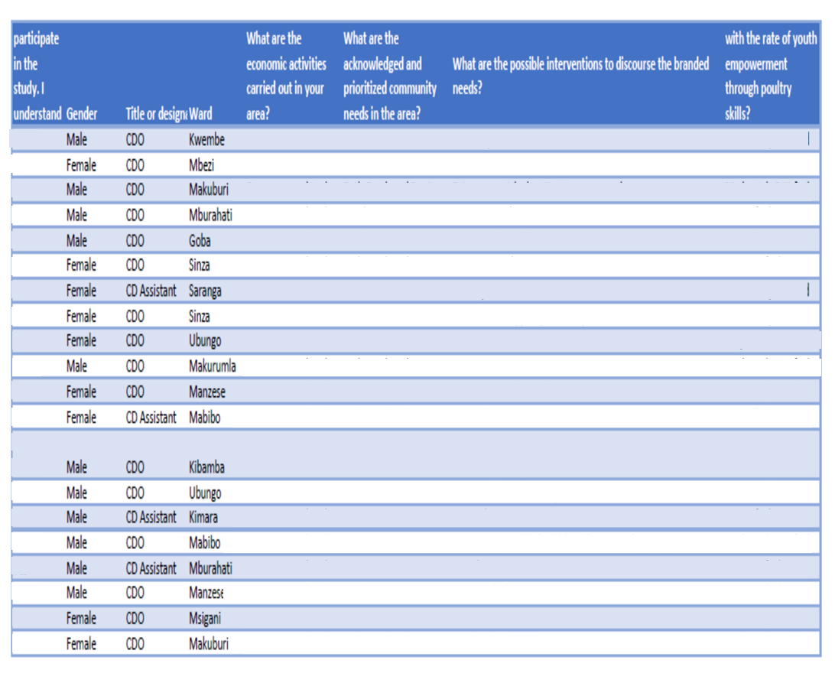

|  |
| --- |
| Self-awareness training |
| Financial support to youth |
| More loans and funding |
| Hands on entreprenuial skills |
| Training |
| More opportunities for learning to be provided to young people |
| Access to loans |
| More training and capacity building |
| Support to youth is needed |
| Skills and tools for entrepreuship |
| More awareness programs to promote self employment |
| Involvement of more stake holders on entrepreurship interventions |
| Government and other stakeholders to support youth |
| Government should provide financial support |
| Lower taxes and fees for us to start business |
| Education to youth is very important |
| Entrepreneurship seminars |
| Training |
| More training to youth |
| More national wide initiatives |
| Favourable policies |
| Entrepreneurship should be taught from primary level |
| Self awareness programs |
| Friendly business environment |

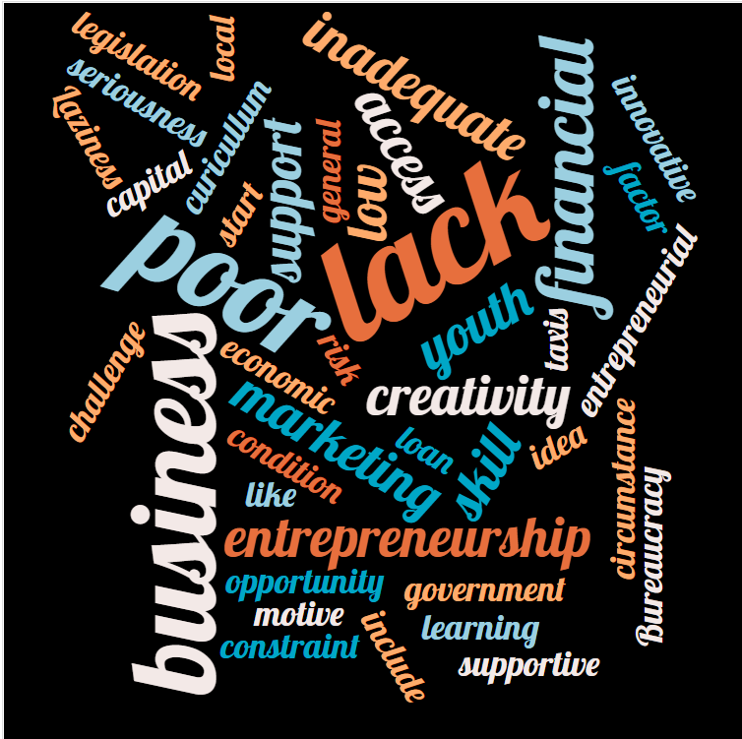

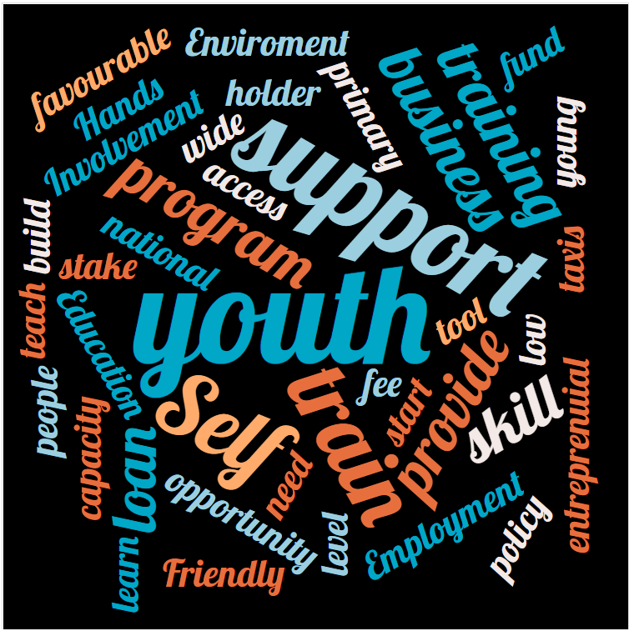A word analysis of the challenges identified as seen above indicate marketing and Poultry keeping skills as a major challenge.

Youth identified that they need support from stake holders in attaining Poultry skills

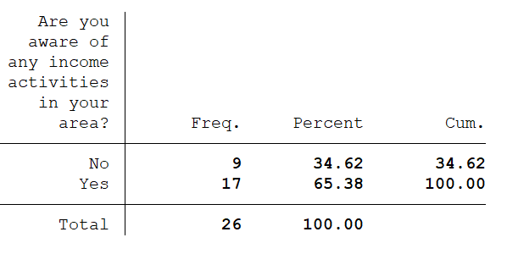

65% of the respondents are aware of income activities in their areas while 35% of the respondents are not aware of income activities in their area.

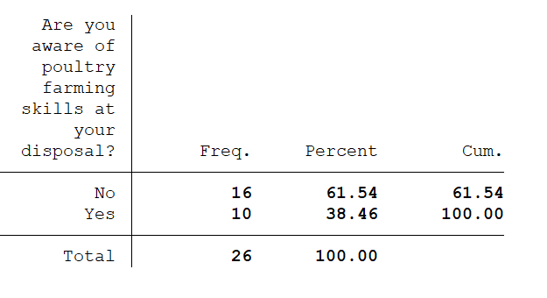

62% of the respondents are not aware of poultry farming skills at their disposal while 39% are aware of poultry skills farming at their disposal.

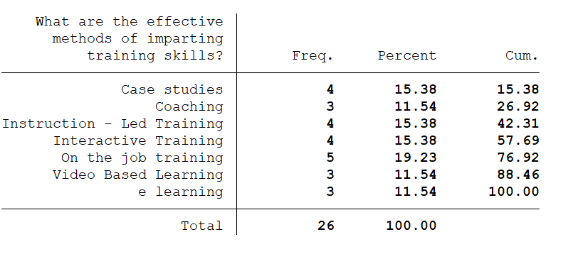

In terms of effectiveness of methods of imparting training skills. 19.23% of the respondents identified on the job training as the best method of imparting skills.

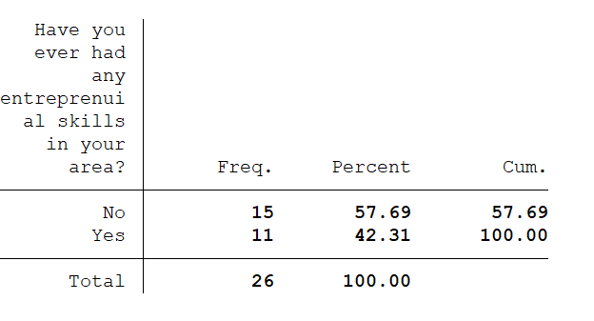

58% of the respondents did not receive entrepreneurship training in their areas while 42% received training on entrepreneurship in their area.

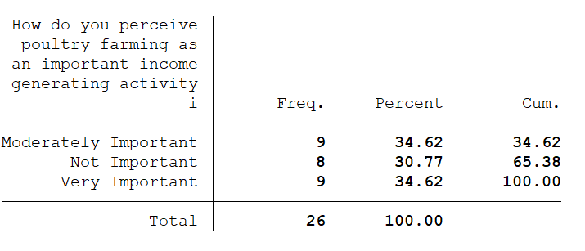

Majority of the respondents identified that poultry farming is moderately important and very important income generating activity.

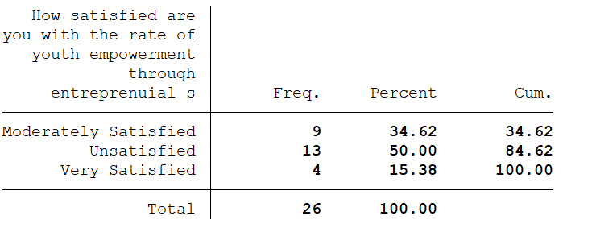

50% of the respondents are very unsatisfied with the rate of youth empowerment through entrepreneurial skills.

**Interview with community development officers**

There was also an interview with community development officers and their assistants in the 14 wards of Ubungo Municipal. The researcher limited the questions due to busy schedules of the officers.

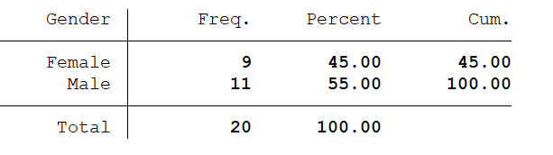

A total of 20 respondents were interview where 55% were male and 45% were female.

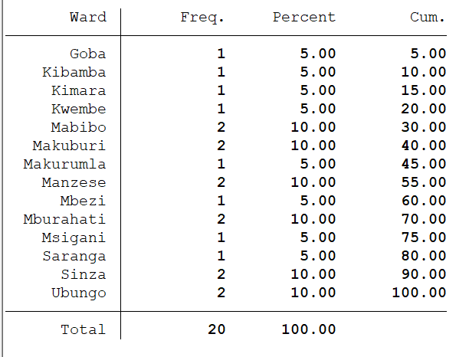

The 14 wards are depicted above as well as the number of respondents.

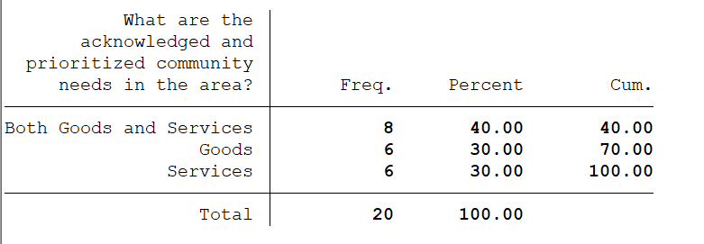

40% of the respondents identified both goods and services are needed in their area.

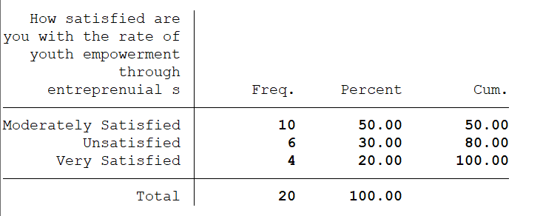

50% of the respondents are moderately satisfied with the rate of youth empowerment through entrepreneurial skills.

|  |
| --- |
| Creativity and innovation courses |
| Entrepreneurship education should be included in curicullums |
| Entrepreneurial education to young people |
| Supportive policies |
| More hands-on skills |
| Entrepreneurship trainings |
| Friendly business environment |
| Low taxes to support youth to open businesses |
| life skills education |
| Training |
| More access to financial services |
| Financial assistance |
| Mentorship and guidance |
| Business incubation programs |
| Parental support |
| More young people should be a decision making organs |
| More loans |
| Vocational Education training programs |
| Financial education |
| Combined Stakeholder support |



Most of the comments were identified poultry education as a major intervention that can assist the youth.

