EVALUATION OF WILDLIFE TOURISM ON WOMEN EMPOWERMENT:
THE CASE OF MIKUMI NATIONAL PARK

UPENDO MAGNUS KIBASA

A DISSERTATION SUBMITTED IN PARTIAL FULFILMENT OF REQUIREMENTS FOR THE DEGREE OF MASTER OF SOCIAL WORK OF THE OPEN UNIVERSITY OF TANZANIA
2023

CERTIFICATION

The undersigned certifies that he has read the entire work and hereby recommends for acceptance by The Open University of Tanzania, a dissertation titled: “Evaluation of Wildlife Tourism on Women Empowerment: The Case of Mikumi National Park” in partial fulfillment of the requirements for the degree of Master of Social Work (MSW) of the Open University of Tanzania.

……………………………..
Rev. Dr. Kimilike, Peter Lechion
(Supervisor)

………………………..
Date

COPYRIGHT

No any part of this dissertation shall by any means be reproduced, stored in any retrieval system, or transmitted in any form being electronic, mechanical, photocopying, recording or otherwise without prior permission of the author or The
Open University of Tanzania on that behalf

DECLARATION

I, Upendo Magnus Kibasa, do hereby declare that, this dissertation is my own work and that it has never been submitted anywhere by any person in either a whole or part of it for the Master of Social Work Degree or in any other field or award related to this.

…………………………..
Signature

……………………….
Date

DEDICATION

This entire work is dedicated to our family with specific attention to my late father Magnus Temelavangi Kibasa, my mother Elda Japhet Mdeka, my beloved husband Linus Valentine Mallya, my children Carissa Linus Mallya, Neema Mtui, and Carlin Linus Mallya, my young sister Violeth Magnus Kibasa and my best friends Diana Mungure, Grace Nkya and Stephen Ambonisye. I also dedicate this work to all social workers and academicians in other related disciplines who tirelessly effort to ensure people, especially the vulnerable populations, appreciate their social welfare.

ACKNOWLEDGEMENTS

This Dissertation is one of the fulfillments of course requirements of Master of Social Work Degree. It has been accomplished through the cooperative work by the helpers, supervisor, respondents from the selected population and the investigator.

Thus, I wish to extend my deepest gratefulness to the Almighty God for the blessings that enabled me make this report a genuineness. Let my sincere deepest appreciation go to Rev Dr Kimilike, Peter Lechion, my research supervisor, who through his supervision, advice, directives and support the report got to its accomplishment. I am grateful to appreciate the academic support from Prof. Hossea Rwegoshora, Dr. Fauzia Mohamed, Dr. Mariana Makuu, head of sociology and social work department and my previously coordinator Dr Johnas Buhori who enhanced me with different significant support towards the completion of this report.

I can’t conclude my acknowledgement without giving my sincere thanks to all the respondents from Mikumi national park for their remarkable qualitative and quantitative information they gave me. Let the spirit of giving, support, sharing and care be irredeemable throughout our lives as we all aim to achieve what we struggle for.

ABSTRACT
This study evaluated wildlife tourism performance on women empowerment at Mikumi National Park in Tanzania. The main focus of the study was to assess the women empowerment, to examine awareness of women on opportunities available in wildlife tourism and to examine women challenges in wildlife tourism at Mikumi National Park. The study approved descriptive research design where both qualitative and quantitative data was collected. A total sample of 84 respondents was involved in the study. Both simple random and purposive sampling techniques were applied. Semi-structured interviews were used to gather qualitative data and questionnaires were administered to collected numerical data. The qualitative data was analysed using thematic technique and results were presented in narratives while quantitative data on the other hand were analysed using descriptive statistics through computer software known as SPSS version 22 where charts, percentages and frequencies were used to present data. The findings revealed that, 80% of the main respondents said that women’s viewpoints are not enough accepted, 81% of the respondents disagree with the statement said women occupy senior posts in tourism sector and a huge percent which is 28% of the main respondents (women’s) said harassment for example to serve drunkard customers they see some of the women’s like prostitutes, therefore is a big challenge to them in Mikumi national park. The study recommended that, the government through the ministry of natural resources and tourism must resolve the unnecessary challenges to women, conduct women's economic empowerment seminars especially to Mikumi national park, giving them loans, find markets for women’s product and also to encouraged the NGO to conduct seminars to women so as to empower them in business tourism.
TABLE OF CONTENTS

CERTIFICATION ii
COPYRIGHT iii
DECLARATION iv
DEDICATION v
ACKNOWLEDGEMENTS vi
ABSTRACT vii
LIST OF TABLES xiii
LIST OF FIGURES xiv
LIST OF ABBREVIATIONS xv
CHAPTER ONE 1
BACKGROUND TO THE STUDY 1
1.1 Introduction 1
1.2 Background to the study 1
1.3 Statement of the problem 8
1.4 Objectives of the Study 9
1.4.1 General Objective 9
1.4.2 Specific Objective 9
1.5 Research Question 9
1.5.1 General Research Question 9
1.5.2 Specific Research Question 10
1.6 Significance of the Study 10
1.7 Organisation of the dissertation 10
CHAPTER TWO 12
LITERATURE REVIEW 12
2.1 Overview 12
2.2 Conceptual Definitions 12
2.2.1 Tourist 12
2.2.2 Tourism 13
2.2.3 Wildlife 13
2.2.4 Wildlife Tourism 14
2.2.5 Women’s empowerment 14
2.3 Theoretical Literature Review 14
2.3.1 Citizen participation theory 14
2.3.2 The Classical Development Theory 16
2.4 Empirical Analysis of Relevant Studies 16
2.4.1 Tanzania Tourism Policy Review 19
2.4.2 Women Empowerment in tourism sector 20
2.4.2.1 Role of tourism in women empowerment 21
2.4.2.2 Types of empowerment 21
2.4.2.2.1 Economic Empowerment 21
2.4.2.2.2 Social Empowerment 22
2.4.2.2.3 Psychological Empowerment 22
2.4.2.2.4 Political Empowerment 23
2.4.3 Women Awareness on tourism sector opportunities 24
2.4.4 Women Challenges in tourism sector 25
2.5 Research Gap 28
2.6 Conceptual Framework 28
CHAPTER THREE 31
RESEARCH METHODOLOGY 31
3.1 Introduction 31
3.2 Research design 31
3.4 Area of the study 32
3.5 Population of the study 33
3.6 Sampling Techniques, Sample Size and Sampling Frame 34
3.6.1 Sampling Techniques 34
3.6.2 Sample size 34
3.6.3 Sampling Frame 35
3.7 Data collection tools 36
3.7.1 Secondary data 36
3.7.1.1 Documentary review 37
3.7.2 Primary data 37
3.7.2.1 Questionnaire 38
3.7.2.2 Interview 38
3.8 Reliability and Validity 39
3.8.1 Reliability 39
3.8.2 Validity 39
3.9 Ethical consideration 40
3.10 Data analysis 40
CHAPTER FOUR 42
DATA PRESENTATION, ANALYSIS AND DISCUSSIONS OF THE FINDINGS 42
4.1 Introduction 42
4.2 Demographic profile of respondents 42
4.2.1 Age of Respondents 42
4.3 Women empowerment in wildlife tourism 44
4.3.1 The questions was: What sort of employment/engagement have you got from tourism activities? 45
4.3.2 Another questions was: Does management of Mikuni national park accepting your viewpoints properly in addressing any matter? 47
4.3.3 Another questions was: Did you attended any education/seminars based on your business or any business for the past three years? 49
4.4 Awareness of women on opportunities available in wildlife tourism 51
4.4.1 The question/statement was: Women occupy senior posts in tourism sector. 52
4.4.2 The question/statement was: I have participated in women congress/meeting in tourism sector. 54
4.4.3 The question/statement was: I know women who have been successful (role model) in life due to tourism activities 56
4.5 The women challenges in wildlife tourism 59
4.5.1 The question/statement was: What challenges do women face in tourism activities? 59
CHAPTER FIVE 62
SUMMARY OF THE STUDY, CONCLUSION AND RECOMMENDATIONS 62
5.1 Introduction 62
5.2 Summary of the Study 62
5.3 Conclusion 64
5.4 Recommendations 66
5.4.1 Government 66
5.4.2 Women’s 67
5.4.3 Family 68
5.4.3 Society 68
5.5 Areas for further Research 69
REFERENCES 70
APPENDICES 77

LIST OF TABLES

Table 3. 1: Sampling Frame 36
Table 4. 1: Age of Respondents 43
Table 4. 2: Education Level of Respondents 44

LIST OF FIGURES

Figure 2. 1: Conceptual Framework 29
Figure 3. 1: Area of the study 33
Figure 4. 1: Sort of employment 46
Figure 4. 2: Viewpoints 47
Figure 4. 3: Education 49
Figure 4. 4: Senior post 52
Figure 4. 5: Women congress/meeting 55
Figure 4. 6: Women congress/meeting 57
Figure 4. 7: Challenges in wildlife tourism 59

LIST OF ABBREVIATIONS

AFDB African Development Bank
AIDS Acquired Immune Deficiency Syndrome
COVID – 19 Corona Virus Diseases of 2019
EABC East African Business Council
EAC East African Community
GDP Gross Domestic Product
HIV Human Immunodeficiency Virus
ILO International Labour Organisation
MINAPA Mikumi National Park
NGO Non – Governmental Organisation
SPSS Statistical Package Social Sciences
TANAPA Tanzania National Parks Authority
UNCTAD United Nations Conference on Trade and Development
UNWTO United Nations World Tourism Organisation
USD United States Dollar
WBG World Bank Group
WID Women in Development

CHAPTER ONE

BACKGROUND TO THE STUDY

1.1 Introduction
This chapter presents introduction, background to the study, statement of the problem, research objectives and research questions. It further presents significance of the study and organization of the proposal.

1.2 Background to the study
World statistics show that the world GDP in 2016 tourism contributed to growth of GDP by 9.9% ‘USD 7.4 trillion’ (UNWTO, 2020). However, the sector supports 305 million employments. Tourism has shown potential in not only contributing to but also championing women empowerment initiatives. UNWTO (2008) for example, reveals that women make 60-70% of the total tourism workforce. From this phenomenon, it is therefore clear that tourism has created chances and opportunities for women empowerment. Adebakin et al, (2012) argue that revenue from tourism has the advantage of reaching out the vulnerable groups both at local and international level.

Aref et al, (2009) argue that, tourism is a special place for women to realise their dreams, this sector has special advantages that accommodates women conditions. Ma’rof et al, (2009) show that, the nature of demand in tourism match women qualities. The sector demand for low-skilled and domestic activities, flexible working hours and the low capital requirements offer opportunities for women employment or to start business of their own (Ateljevic et al, 2008). However, there is no settled argument on the empowerment of women through tourism sector (Bansal et al, 2012). Some scholars see it as a tool accelerating gender inequality between men and women, others emphasize that tourism had a power to close the gap on gender equality. Based on the two extremes on tourism, there is a need to shed more light on the need to empower women through tourism (Anderson, 2011). Although tourism is a sector that grows fast and contributes to more than 30 percent of national Gross Domestic Product (GDP), the opportunities accompanied by the sector have not benefited women at arm’s length (Bansal et al, 2012). Women still occupy low paying jobs and perform less skilled jobs. Globally, though, the effort to empower women can be traced from many fronts (Nwosu, 2014).

The World Tourism Organization (UNWTO) taskforce for women’s empowerment in 2010 recognised the need for women empowerment through tourism (UNWTO, 2010). The task force works to promote equal opportunities for women working in tourism, to raise awareness on the opportunities available in tourism sector, encourage women to join tourism entrepreneurs; provide education and training (Ellis et al, 2007). Global agenda on women empowerment also touch on policies that increase social economic muscle on women to master their lives. Policies focused on poverty alleviation and wealth creation through tourism (Chok et al, 2007). In fact Tucker (2012), shows that women worldwide living in poverty condition accounts for 1.3 billion.

Women in Development (WID) programme recognise that women are a vulnerable group that requires help, especially in accessing employment opportunities and other income-generating activities. In South Asian countries where tourism is performing well, more than 75% of mountain women fall below the poverty line; lack of infrastructure development causes inadequate access to basic services such as health, education, water and electricity (Kwarambaa et al, 2012). Despite many years of tourism activities that generate wealth to few individuals, women in Nepal suffer from discriminatory practices in their society. They are not considered at par with men, which lead to the lack of opportunities for education and employment of the former.

In Europe and Asia the year 2017 saw the contribution of tourism in European Union Countries to be about 9.7% of their total GDP (Aguiar et al, 2017). However, the sector provided 2.9 million jobs. In Asia Pacific countries around 60.6 USD billion was collected in 2018 (ADB, 2018). Asia countries have opened up their doors for tourism activities; however, the situation became worse during Covid-19 pandemic period (Coke, 2020). Countries in the region shut up their doors for visitors, however, countries in Asia are proceeding with a much more cautious approach to inbound travel (Zarrilli, 2020).

According to the World Tourism Organization, the United Nations agency is charged with the promotion of sustainable and universally accessible tourism. Statistics show that in 2014, Asia and the Pacific, which made up 30% of the total, welcomed 263 million international tourists, up by 14 million from 2013 (+5%). The region earned US$ 377 billion in tourism receipts. The World Tourism Organization’s report noted that China has been by far the fastest growing source market in recent years and has been the world’s top spender in international tourism since 2012 (UNWTO, 2020). In 2014, China continued its exceptional pace of growth; Chinese outbound travel has been growing exponentially over the last two decades (CTA, 2020). China currently generates some 13% of global tourism receipts, benefitting many destinations around the world, particularly in Asia and the Pacific, according to UNWTO (2020). Other Asia source markets showed double-digit growth in tourism expenditure including: India, the Philippines and Thailand (NSCB, 2019).

In 2013, India generated USD 128 billion creating 6.7% employment from tourism (Gujarati, 2016). South Africa generated a total of USD 39 billion to its GDP in 2015 while employments share was 10.3%. Uganda's direct contribution of Travel and Tourism was 3.3% of its GDP (Rogerson, 2017).

In Africa Tourism is still an important economic sector (Ayenagbo, 2015). There are many countries that benefit the most from tourism like Uganda, Algeria, Egypt, South Africa, Kenya, Morocco, Tunisia, Ghana and Tanzania (UNWTO, 2018). Africa has been one of the world’s fastest growing tourism regions. There were 14.7 million visitors in 1990, 26 million international tourists in 2000 and 56 million in 2014 (UNCTAD, 2017).

International tourist arrivals in Africa are estimated to have increased by 2% in 2014, in absolute terms, the region welcomed a total of 56 million international tourists (Sharpley et al, 2015). While many countries in Africa benefited from strong economic growth in their tourism sector, the continent´s share of worldwide tourism receipts is relatively modest (UNWTO, 2017). World Economic Forum, (2017) noted that, international tourism contributes 44% to Africa's tourism industry while domestic tourism contributes 56%, according to the World Travel and Tourism Council.

In East Africa, Tourism is considered to be one of the largest foreign exchange earners and fastest-growing sectors in East Africa (AFDB, 2016). East Africa has recorded some impressive achievements in the realm of tourism owing to the conscious efforts by EAC Partner States to work together in promoting growth in the sector (Doran, 2014).

The success of the tourism sector has benefited from immense private sector investments in hotels, transportation, marketing and product development, and dedicated government efforts in conservation (Leibold et al, 2015). East African Community countries such as Rwanda and Burundi are landlocked, with nature and wildlife remaining as the only core tourism assets (Mayaki, 2015). Their Economic Road Map and Visions foresee tourism as a key contributor to transforming their economies in the years to come (Christie et al, 2013). Most tourism revenues have been generated through tourism products, such as wildlife and national parks, based on a few species (i.e. the big five and the mountain gorillas) (Novelli et al, 2011).
The East African Business Council (EABC) has urged countries in the region to make additional funds available for the tourism sector, facing revenue losses of more than $5.4 billion in 2020 due to the novel coronavirus pandemic (ADB, 2020). In Rwanda, where nature tourism contributes substantial revenue, tourism and research, as well as gorilla trekking activities in the country's parks, were suspended effective March 21st 2020 as a preventive measure against the spread of COVID-19 (ILO, 2020).

In Tanzania, Tourism is one of the biggest sectors of the economy that contributes over 20% of the GDP (Kahyarara & Mchallo, 2017). The sector provides foreign exchange and a source for employment, incomes and public revenue (Mayaki, 2015). The country is endowed with many attractions including 16 national parks, game reserves and protected areas.

At present, women are still an underprivileged group in Tanzania, often depending on men to provide for the family necessities (Adili, 2018). Relying on a single source of income (men) means that children cannot go to school because their families cannot afford it (Melita et al, 2013).

In line with global initiative to promote women empowerment, Tanzania signed international protocol for the above purpose (ILO, 2001). The protocol involved includes the Millennium Development Goals (MDGs), Beijing platform for Action, the Cairo Programme of Action and the Convention on the Elimination of All Forms of Discrimination against Women (CEDAW, 2012).

According to the World Travel and Tourism Council (2015) Tanzania government received revenue from tourism sector that increased to 12.9% GDP employing 11.2% of labour force from 2010. The tourism destination is made up of national parks including, Serengeti, Tarangire, Ngorongoro conservation authority area as well as beach areas such as Zanzibar and Mafia. Mountain climbing recreation on Mount Kilimanjaro, Mount Meru and Oldonyo Lengai Mountain is additional to tourism (Okello et al, 2014).

In Tanzania, tourism sector provides a pillar of women empowerment (UNWTO, 2010). The sector gives support to people’s lives by creating job opportunities in different parts of its industry such as hotels, transportation, touring packages, beach excursions, travel agency's activities and curios where people engage themselves into different posts like reservationists, receptionists, human resource officers, procurements and tour guides.

Despite the fact that tourism provides many advantages to both men and women, many tourism companies give low priority to women on the assumption that many duties can only be done by men (Jeffrey, 2018). This negative perception reduces the pace of women empowerment (Keeley, 2019). This gap has directed the researcher to conduct the study in evaluation of wildlife tourism on women empowerment in Mikumi National Park because despite its great potentials and being fourth in Tanzania for preferred tourist destination most women are reported to have missed out the benefits emanating from tourism activities.

1.3 Statement of the problem
Despite the fact that tourism is a fast-growing sector that offer multitude of opportunities to both men and women worldwide, the status of Tanzanian women engaged in tourism sector is still low (Haji, 2012). Most of them are less empowered by still occupying low paying posts and low skills jobs. The United Nations Conference on Trade and Development (UNCTAD) indicated that more than 30 percent of tourism businesses in Africa are run by women, and 36 percent of the continent’s tourism ministers are women, the highest number in the world. This suggests that the proportion of women participating in tourism sector at the decision-making level was low, considering the high number of women working in the lower less skilled jobs (Jeffrey, 2018).

Evidence from literature indicated that women who are less empowered face hurdles in areas of low participation, lack of awareness of the social and economic opportunities available in the sector and little training that limits their growth in the organisation (Madgavkar, 2018). Kashaga (2007) shows that in Tanzania, tourism contributes more that 70 percent of foreign currency. But, the number of women, living in poverty continues to grow reaching more that 60 percent of all the poor people. This indicates a missed opportunity for women to grow using tourism as stepping stone (Luvanga et al, 2003).

Nevertheless, many studies on women empowerment have been done but the problem is still on. This suggests that the above studies have not touched the nerve of the problem, therefore little is known about evaluation of wildlife tourism performance on women empowerment. To bridge the gap between what is already known from previous studies and what is not known; this study aims at evaluating tourism performance on women empowerment: a case of Mikumi national park. This is done in order to shed more light in the subject matter and recommend a lasting solution for the above problem.

1.4 Objectives of the Study

1.4.1 General Objective
The general objective of this study was to evaluate wildlife tourism performance on women empowerment at Mikumi National Park in Tanzania.

1.4.2 Specific Objective
- To assess the women empowerment in wildlife tourism at Mikumi National Park.
- To examine awareness of women on opportunities available in wildlife tourism at Mikumi National Park.
- To examine women challenges in wildlife tourism at Mikumi National Park.

1.5 Research Question

1.5.1 General Research Question
How is the performance of wildlife tourism empowering women at Mikumi National Park in Tanzania?

1.5.2 Specific Research Question
- What is the women empowerment in wildlife tourism at Mikumi National park?
- What is the awareness of women on the opportunities available in wildlife tourism at Mikumi National Park?
- What are the women challenges in wildlife tourism at Mikumi National Park?

1.6 Significance of the Study
Tourism sector provides better opportunities and security to the poor people, and empowering them in this way economic growth is achieved at the individual, national and regional level. Firstly, the findings and recommendations of this study will provide inputs that aid in policy, poverty reduction and decision-making processes. In addition, secondly, the findings will help in-depth understanding of the nature and dynamics of the sector in Tanzania. Thirdly the study will be a reference material to the academicians, researchers as well as other stakeholders engaged in tourism activities. Fourthly, the study results are expected to provide input to various actors who are interested in tourism sector. Finally, the study will help to improve the standard of living of local communities at Mikumi National Park.

1.7 Organisation of the dissertation
This dissertation was organized into five chapters. The first chapter presented introduction, background to the problem, statement of the problem, objective of the study, research questions and significance of the study and organization of the dissertation. The second chapter presented overview and focused on the review of relevant literature with bearing to the research title; specifically, this chapter presented conceptual definitions, theoretical literature review, and empirical review of relevant studies, research gap and conceptual framework. Chapter three presented introduction and concentrated on research methodology; the chapter presented the research design, area of the study, population of the study, sampling techniques, sample size and sampling frame, it further presented data collection tools, reliability and validity, ethical issues and data analysis. Chapter four presented and discussed the findings. Chapter five presented the summary, conclusion and recommendations.

CHAPTER TWO

LITERATURE REVIEW

2.1 Overview
This chapter is all about presenting the review of the related literature that has been drawn from different readings concerning wildlife tourism performance on women empowerment and other related issues on wildlife tourism performance on women empowerment. The chapter consists of conceptual definitions, theoretical literature review, and empirical analysis of relevant studies, factors associated with women empowerment, research gap and conceptual framework.

2.2 Conceptual Definitions

2.2.1 Tourist
The United Nations Conference on International Travel and Tourism of 1963, defined tourists as temporary visitors who spend more than 24 hours in destinations other than their normal place of residence. The motive for the journey should be for holidaymaking, recreation, health, study, religion, sport, visiting family or friends, business or meetings (Buhalis, 2003). This study concurred with the definition above and emphasises that, tourism is an economic activity that exports services to the foreign countries from which the visitors originate. For the domestic tourists, tourism belongs to the internal trade regime.

2.2.2 Tourism
There are a number of ways tourism can be defined. The United Nations World Tourism Organization (UNWTO) defines tourism as a social, cultural and economic phenomenon, which entails the movement of people to countries or places outside their usual environment for personal or business/professional purposes (UNWTO, 2020). From this definition, it can be seen that, tourism is the movement of people for a number of purposes whether business or pleasure. These people are called visitors (which may be either tourists or excursionists; residents or non-residents) and tourism has to do with their activities, some of which imply tourism expenditure (UNWTO, 2008).
Founded in our study, tourism is a social, cultural and economic phenomenon which entails the movement of people to countries or places outside their usual environment for personal or business/professional purposes.

2.2.3 Wildlife
Wildlife refers to undomesticated animal species, but has come to include all organisms that grow or live wild in an area without being introduced by humans (UNWTO, 2016). Wildlife can be found in all ecosystems, deserts, forests, rainforests, plains, grasslands, and other areas, including the most developed urban areas, all have distinct forms of wildlife. Constructed from this study, the term wildlife will refer to all undomesticated animals found in the national park. In Mikumi national park where this study was undertaken to list but few animals found there included lion, giraffe, leopard, cheater and elephant.

2.2.4 Wildlife Tourism
Wildlife tourism can be defined as “tourism that involves encounters with non-domesticated animals either in their natural environment or in captivity” (Caalders, 2002). It includes a wide range of activities, such as bird-watching, whale-watching, general wildlife viewing, visiting zoos and aquaria, snorkelling to view underwater life, hunting and recreational fishing (Scheyvens, 2000). Grounded on the above definition wildlife watching tourism is a type of tourism that is organized and undertaken in order to watch or encounter wildlife.

2.2.5 Women’s empowerment
Built on the assumptions that women differ from men in their social positions and that those differences consist of asymmetric, unequal power relations between the genders, “women’s empowerment” refers to the process of increasing women’s access to control over the strategic life choices that affect them and access to the opportunities that allow them fully to realize their capacities (Chant, 2006). Created from this study, women’s empowerment as an economic, political, and sociocultural process challenges the system of sexual stratification that has resulted in women’s subordination and marginalization in order to improve women’s quality of life.

2.3 Theoretical Literature Review

2.3.1 Citizen participation theory
Citizen participation is a process which provides private individuals an opportunity to influence public decisions and has long been a component of the democratic decision-making process (Edwards, 2013). The roots of citizen participation can be traced to ancient Greece and Colonial New England. Before the 1960s, governmental processes and procedures were designed to facilitate "external" participation. Public involvement is means to ensure that citizens have a direct voice in public decisions (Bingham et al, 2005). The terms "citizen" and "public," and "involvement" and "participation" are often used interchangeably. While both are generally used to indicate a process through which citizens have a voice in public policy decisions. (Bovaird, 2007).

Public participation in governance involves the direct involvement or indirect involvement through representatives of concerned stakeholders in decision-making about policies, plans or programs in which they have an interest (Fung, 2006). Stakeholders are persons, groups or organizations that may influence or be affected by policy decisions (Freeman, 2010) or place a claim on an organization’s or other entity’s attention, resources or outputs (Bryson, 2004). Through public participation, stakeholders may interact with government agencies, political leaders, nonprofit organizations and business organizations that create or implement public policies and programs.

The theory was adopted in this study because empowerment of women is explained to include women entering potential leadership positions in tourism sector. Top positions mean women ability to make decisions that affect their affairs. On top of that decision determines the resource allocation and utilization. Participatory theory is said to improve implementation process, rather than delaying implementation of completed plans.

2.3.2 The Classical Development Theory
The founder of the theory is Ragnar Nurkse (1907–1959). He is one of the founding fathers of classic development economics also called classical economic development theory (Goldin, 2001). The theory is concerned about the empowerment of women as a function of economic development, dispensation of democracy, and the removal of social injustices that increase gender inequalities (Addison, 2002). Studies have shown that there is positive relationship between economic development and an equitable distribution of educational, occupational and agricultural resources (Gershman, 2000). Several studies have shown that economic development empowers women by increasing social services to society and according to women more time for child rearing and domestic work (Todaro et al, 2002). The contribution of the theory to this study is that women empowered through economic development that goes hand in hand with removal of social inequalities. This means a level playground for both females and males.

2.4 Empirical Analysis of Relevant Studies
The study of Kabeer (2005) constitutes a synthesis of the concepts of empowerment, tourism development (especially involving indigenous communities), and sustainable development to take account of the political and socioeconomic environments that postulates five prepositions. First, that without the element of empowerment tourism development at the level of community will have difficulty achieving sustainability. Second, that the exercise of traditional or legitimate empowerment by traditionally oriented communities will of itself be an ineffectual mechanism for attempting sustainable tourism development (Parpart, 2002). Third, that empowerment for such communities will usually require environmental or institutional change to allow a genuine reallocation of power to ensure appropriate changes in the asymmetrical relationship of the community to the wider society. Fourth, that, conversely, empowerment of indigenous communities cannot be ‘taken’ by the communities concerned drawing only upon their own traditional resources, but fifth, will require support and sanction by the state, if it is to avoid being short lived (Mosedale, 2005).
Edwards (2013) found a positive and significant impact of international tourism earnings on the growth rates of GDP per capita by using a panel data, for a sample of 17 Latin American countries from 1995 to 2004. After using a fixed effects estimation method, they have found out that a 10% increase in the level of tourism earnings increases the GDP per capita by 0.4% from its level. They also found out the impact of tourism on the growth of GDP per capita was higher when human and physical capital improvements occurred simultaneously that explains the interrelation of tourism with the other sectors of the economy (Eugenio et al, 2004).

However, as the study that recommends countries in Latin America to work on policies to foster tourism, it does not provide any evidence of the basis for focusing on tourism with regards to other sectors. If the study had included the contributions from other economic sectors as well, then the relative contribution of international tourism to economic growth of these countries would have shed more light on the desirability of tourism other industries (Moreno, 2018b).

Salazar (2007), through a study concerning with the pro-poor tourism development in Viengxay, Laos: current state and future prospects, the study came up with advantages of the pro poor tourism for the local community. There was an increasing of jobs directly related to tourism in Laos that was estimated at 18,000 in 2005, with a total of 321,155 jobs directly or indirectly attributable to tourism.

Tourism businesses in Laos tend to be small and locally run, founded by individuals taking advantage of perceived market opportunities, without much planning and without the support of either government or NGOs (Tato, 2015). While it is advantageous for the goal of poverty alleviation that a greater proportion of the earnings from tourism is thus going directly to the local providers, without government oversight or control the channelling of benefits and the assessment of impacts is far from optimal (Muganda, 2010).

In an example of this phenomenon, following an analysis of the accommodation, food and beverage, handicrafts and excursions sub-sectors in the popular tourist destination of Luang Prabang area, Ashley (2005) estimated that US$ 6 million dollars annually, or about 27 percent of the city’s total receipts from tourism, were going directly to the local producers, suppliers and tourism workers.

Makame (2008) on his study of the participatory natural resource’s management and benefit sharing in Zanzibar, has found that the tourism sector was mostly important to the local community in Zanzibar, in the northern region there was a number of people who came to work in the hotel sector. Different nationalities, mainly from East Africa, were attracted to the job opportunities available in the area (Makame, 2008). Business partners from mainland Tanzania have found a good market for their goods and ‘services’, mainly paintings and wood carvings. However, some of these people came to the area for different purposes (Tato, 2015).
Khadija (2012) through her study on the prospects and challenges facing women entrepreneurs involved in tourism industry in overcoming poverty, she considered the role of the women towards the poverty alleviation at the local level revealed that, tourism had the potential to reduce women poverty and observed that those who had participated had positively benefited from the tourism industry. However, there are several opportunities yet to be utilized by women entrepreneurs. In this respect therefore, it would be more beneficial and profitable for women and men entrepreneurs, to organize themselves to reap maximum benefits from tourism industry (UNWTO, 2008). Indeed, efforts are needed to enable local entrepreneur’s in particular local women to withstand the competition of foreigners (Haji, 2012).

2.4.1 Tanzania Tourism Policy Review
National Tourism Policy of 1999 indicates the overall objective is to assist in effects to promote the economy and livelihood of the people essentially in poverty alleviation through encouraging development of sustainability and quality tourism that is socially acceptable, ecologically friendly, environmentally sustainable and economically viable.

The tourism policy points out the mobilization of resources in order to promote efficient delivery of quality tourist products and services. The policy indicates the role of women in this institutional participation that women, especially in the rural areas, play an important role in the development of tourism. They are generally managers of the environment. They are producers of more than 80% tourist souvenirs which includes pottery, bead work, weaving, cloth art, et cetera. Women are also vendors of local food and active members in cultural tourism activities. Some of the important features of tourism policy include: -
- The government has the duty of supporting and encouraging women initiatives in tourism development activities as well as promoting self-help projects. The role of women therefore, are stated as follows:
- People have to organize themselves and lead the implementation of tourism community projects that will have positive environmental, social and economic impact.
- The policy aims at promoting and ensuring respect for women in development, marketing and promotion of tourism.
- To actively assist in sustainable development of tourism as policy makers, as entrepreneurs, travel agents, tour guides, workers, managers, and other role in tourism business.
- To as mothers, teachers and mentors to create awareness of the importance of tourism among community members.

2.4.2 Women Empowerment in tourism sector
Empowerment of women is the process of uplifting of economic, social and political status of women, traditionally the underprivileged ones, in the society (Gautam, 2008). It is the process of guarding them against all forms of exploitation (Upadhaya, 2008). Women empowerment involves the building up of a society, a political environment, wherein women can breathe without the fear of oppression, exploitation, apprehension, discrimination and the general feeling of persecution that goes with being a woman in a traditionally male dominated structure (UNWTO, 2010). That empowerment of women requires environmental or institutional change to allow a genuine reallocation of power to ensure appropriate changes in the asymmetrical relationship of the community to the wider society.

2.4.2.1 Role of tourism in women empowerment
For local communities, tourism brings globalization. With that, a growing labour market, opportunity for education and training as well as advances in technology and local infrastructure (Josaphat, 2004). It also encourages further developments in justice and human rights as more international non-profit organizations step in to help local communities overcome challenges that inhibit them from bettering their lives (Luvanga, 2003).

2.4.2.2 Types of empowerment

2.4.2.2.1 Economic Empowerment
Economic empowerment is the ability to make and act on decisions that involve the control over and allocation of financial resources (Golla et al, 2011). Taking into consideration whether or not, a community has been economically empowered, it is necessary to consider the available opportunities for employment (both in formal and informal sector); opportunities for business; gaining of control on own/good income; gaining of valuable skills or capacity building; access to productive resources (Ashraf et al, 2010). Besides, economic empowerment also includes ways of enabling earned cash to be shared among the households; visible evidences of livelihood improvement resulting from the earned cash et cetera (Banerjee et al, 2012).

2.4.2.2.2 Social Empowerment
Social empowerment refers to a situation in which a community’s sense of cohesion and integrity has been confirmed or strengthened by an activity in which an empowered community has strong community groups and good participation in community meetings (UNWTO, 2000).

Empowered socially means to enhance community cohesion; deepened knowledge of environmental issues, gain of greater respect within their communities which can indirectly lead to greater freedom reconsideration of gender role stereotypes; gain of wider recognition within their society; greater local access to services and better facilities; supports the upkeep of the village (Ghodsee, 2003).

Besides, social empowerment also includes the reduction of inequalities in terms of income and wealth between different groups; reduction of incidences of negative impacts associated with tourism such as crime, overcrowding, displacement, and prostitution (Hall, 2001).

2.4.2.2.3 Psychological Empowerment
Psychological empowerment is defined as “intrinsic task motivation reflecting a sense of self-control in relation to one’s work and an active involvement with one’s work role” (Seibert et al, 2011,).

In the work of Yukl et al, (2012), a community which is psychologically powerful is seen as people who are optimistic about future, has faith in the abilities of its residents; is relatively self-reliant and demonstrates pride in traditions and culture.
Empowered psychologically means improved self-esteem; developed self-confidence ; having a feeling in control over the pace and direction of development; increased self-reliance and pride; gained confidence and motivation to go back to school themselves; levels of awareness of literacy skills, of project activities, and threats of tourism development and current production practice; self-perception of social status and as perceived by other; impact of status perception on ability to influence decision-making; individual’s role in the group organisation and decision making powers of the marginalized et cetera (Bartunek, 2006). Besides, psychological empowerment also includes recognition of local culture and knowledge resulting in high self-esteem; increased confidence resulting in desire for training and education opportunities (Maynard et al, 2012).

2.4.2.2.4 Political Empowerment
Political empowerment refers to the process of transferring various elements of power (resources, capabilities, and positions) to those who do not have it. Political empowerment requires inclusion in democratic decision-making processes (Budryte, 2010). The empowerment of women in terms of political is found not significant (Pande, 2008). Women normally make decisions in the field of their responsibilities. However, they are active in giving their opinions during the meetings (Daruwala et al, 2007). Women in local community are still influenced largely by the paternal system where for the important decisions, especially at home; they will refer to the male counterparts (Berger, 2009).

Hudock (2003) argues that, if a community is to be politically empowered, their voices and concerns should guide the development of any tourism project form the feasibility stage through to its implementation; involved in monitoring and evaluating the project over time; involved in decision making; diverse interest groups within a community have representation on community and broader decision-making bodies; control over an ecotourism initiatives (Banerjee et al, 2006). It also includes the participation in the whole project cycle from the project’s feasibility to implementation stages; opportunities for the local community’s interests and views to be aired and heard; the role of technocrats and NGOs in decentralizing power (Leach et al, 2007).

2.4.3 Women Awareness on tourism sector opportunities
Women play a significant role in society and have the same abilities as men. However, despite their flexibility of mind, their native finesse and their instinct of elegance, they are often neglected in this world and placed in the background (Christie et al, 2001). McKenzie (2007) argues that, tourism creates opportunities for both tourists and the entrepreneurs. It offers variety of destinations covering almost all types of tourist attractions and explores opportunities to earn from tourism too.

Empowering women through tourism the foundation uses tourism as an opportunity to empower women: firstly, by educating them about the advantages and disadvantages of working in the tourism sector, secondly, to equip women with the skills to become entrepreneurs and teach them how to establish a sustainable business and income source (Miller et al, 2005).
Obadic et al, (2009) argues that, the main focus of tourism awareness building among women is to focus on teaching women to produce high quality cultural handicrafts and to find a stable marketplace for the women to sell their products. Currently, local vendors aggressively sell their handmade products to tourists in markets, and often overcharge them too (Ryan et al, 2010). Scheyvens (2002) argues that, women awareness in tourism sector helps to combat gender disparity. Special programs can be put in place to convince safari companies and travel agencies to hire more female drivers, guides and wildlife experts (Haji, 2012). They hope to create an equal gender balance in the tourism labour market, to ultimately combat the stigma of working women (Makame, 2007).

2.4.4 Women Challenges in tourism sector
Haji (2012) noted that, at the same time, men continue to dominate the tourism sector in Tanzania and this too, negatively impacts the lives of women and girls, for example, female drivers and safari guides are required to leave their houses to make a living. The idea of women not staying at home is widely frowned upon amongst locals and becomes an issue for married couples, a catalyst for divorce (MOFEA, 2010). Fighting against women challenges helps to remove gender disparity that work against women (Tucker, 2007). These disparities exist in the labour market, in entrepreneurship, and in education (Hawkins et al, 2007).

World Economic Forum (2010), argues that, the foundation also wants to engage with men, to educate them about gender equality and encourage a more positive response to women in the workforce. Tourism is a tool to empower women in various ways (Karki, 2007). Tourism could assist women to increase their power and control over the natural resources; economic empowerment; educational empowerment and political empowerment (Gundry et al, 2007).

Ateljevic et al, (2003) argue that women miss out formal employment opportunities in tourism because social norms continue to restrict the type of economic activities in which women may engage. Ampumuza (2008) also mentions that, the representation of women in decision making structures is poor beyond the village level because meetings often necessitate travel. This may be a problem for women, both because it can involve taking them away from their traditional roles and obligations for periods of time, and also because of the suspicion that a woman travelling alone will probably commit adultery.

Tucker (2007) claims that the production of ethnic art by women serves as a viable way to resist cultural assimilation. Most of the women producers seem to be empowered at the household level by the production of ethnic arts (Ferguson, 2010). In communities where culturally and environmentally appropriate forms of tourism are occurring, and where women are involved in running or servicing tourism ventures, this often leads both to greater respect for women and ensuring that women have some control over income (Cole et al, 2015).

Pleno (2006) argues that, in some cases, women’s groups use tourism as a source of revenue for community projects. For example in Nepal, the Langtang women perform cultural dances for tourists and use the funds raised to restore their local monastery (Gautam, 2008). While commenting on tourism and women development, Hawkins et al, (2007) reveal that tourism enterprises such as guiding and providing accommodation and food to the tourists provides the women with an opportunity to communicate and express their views. Bartunek (2006) argues that through their interaction with tourists, communication and expression, the women who have for long been kept in house chores and child rearing get empowered psychologically by learning English.

Many women are exposed to discrimination, poor payment and insecure jobs or fall victim to sexual exploitation “sex tourism” (Kavemann et al, 2007). The focus needs to be on the sustainable development of tourism, in which those involved interact on an equal footing (Reid et al, 2004). Business activities in tourism also tend to place women as part of “tourism package”, the position which leads to misconception and creation of negative image and stereotypes for directly employing women and those who sell tourism products and services (MacDonald et al, 2003). This view presents women as objects of the tourist’s ‟gaze and as passive victims of the dominant socio-cultural structures, such as traditional values and norms, which are informed by gender relations” (Ghodsee, 2003).

Despite the increasing number of women engaged in tourism, the societal position of women in Tanzania is characterized by a number of challenges and highly influenced by religious, marital and educational factors (Muganda, 2009). Similarly, the dominant patriarchal system that primarily defines women’s lives includes their household position and related institutions such as marriages (Bhasin, 2006). In this regard, women’s household positions and marriage contracts enable male family members to have more access to resources, privileges and power to make decisions much in line with patriarchal values (Naila, 2005).

2.5 Research Gap
Tourism sector is an area that many studies had their focus on. However, to the knowledge of the researcher, most of these previous studies looked at National Parks in the northern part of Tanzania like Serengeti and Ngorongoro leaving Mikumi with little attention. This study was focused on Mikumi National Park where literature shows that tourism had little contribution to the whole idea of woman empowerment.

2.6 Conceptual Framework
According to Akintoye (2015), conceptual framework refers to an assembled set of research concepts cum variables together with their logical relationships often presented in form of diagrams, charts, graphs, pictographs, flow charts, organogram or mathematical equations. Focussed in this study a conceptual framework entails a visual or written product, one that explains, either graphically or in narrative form, the main themes to be studied such as the key factors, concepts, or variables and the presumed relationships among them. In this context, the independent variables/concepts of this study was women empowerment, awareness on tourism opportunities and challenges in wildlife tourism at Mikumi National Park while dependent variable/concept was wildlife tourism performance on women empowerment. The figure 2.1 bellow is the conceptual framework of the study.
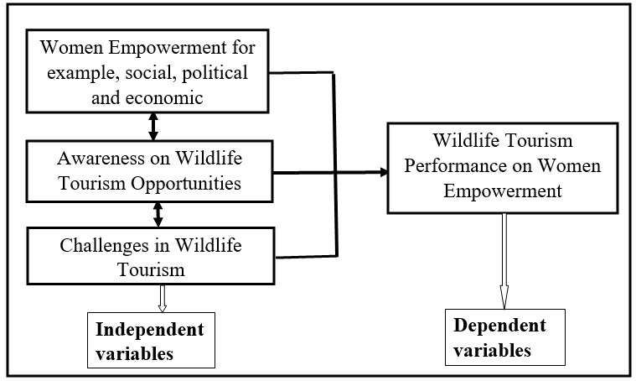
Figure 2. 1: Conceptual Framework
Source: Researcher, 2021

From the figure 2.1 above, evaluation of wildlife tourism on women empowerment covers major themes in wildlife tourism. The variables/concepts in the conceptual framework were derived from both literature review and specific objectives. Naila (2005) maintains that women empowerment is a distant dream among women. Miller et al, (2005) indicate problems in the awareness area. Ghodsee, (2003) shows problems in the area of social, economic and political empowerment. Most women are still not aware of the opportunities available in the wildlife tourism sector.

Literature showed that women at Mikumi National Park are not much aware on the categories of wildlife tourism such as tour guide, driving post and cultural products. General concept of empowerment is still vague. Economically, women still occupy most low paid posts. Socially, women still do not get enough training and not well educated to compete with men. Some of the challenges encountered by women include stereotyping and gender disparity.

CHAPTER THREE

RESEARCH METHODOLOGY

3.1 Introduction
Chapter three explained procedures and methods to be applied in gathering information applicable to the study. Also described the research design, research approach, area of the study, population of the study, sample size and sampling techniques, data collection methods, data analysis plan, validity and reliability of data and ethical issues.

3.2 Research design
The research design refers to the overall strategy that you choose to integrate the different components of the study in a coherent and logical way, thereby, ensuring you will effectively address the research problem; it constitutes the blueprint for the collection, measurement, and analysis of data (De Vaus, 2001). Established in this study, research design entails the overall strategy utilized to carry out research that defines a succinct and logical plan to tackle established research question(s) through the collection, interpretation, analysis and discussion of data. Centred in this study, the researcher employed a descriptive research design basically because it enabled to adopt both quantitative and qualitative research approaches of evaluating wildlife tourism performance on women empowerment at Mikumi National Park in Tanzania.

3.4 Area of the study
The study was conducted in Mikumi National Park. The word “Mikumi” comes from Swahili word “Mikoma” meaning dominant vegetation covered the plain. TANAPA (2015) noted that, Mikumi National Park (MINAPA) was gazetted in 1964 and is Tanzania’s fourth largest park and there are over 32 large mammal species to be found there, for example: giraffe, elephant, lion, buffalo, hippo, baboon, warthog, zebra, waterbuck, wildebeest, impala, eland and more than 400 bird species which can be viewed throughout the year. It is about 283 km west of Dar es Salaam city. Mikumi national park has a size of 3,230 km² (TANAPA, 2015). There is a major road and rail route through Mikumi, along with power and oil pipelines. Mikumi is one of Tanzania’s most attractive parks with various rivers, ravines, forests, wooded grasslands and more makes. The study area was selected purposively. Purposive selection of the area is due to the fact that most of the previous studies looked at National Parks in the northern part of Tanzania like Serengeti and Ngorongoro leaving Mikumi with little attention, that’s why this study was focused on Mikuni National Park (MINAPA).

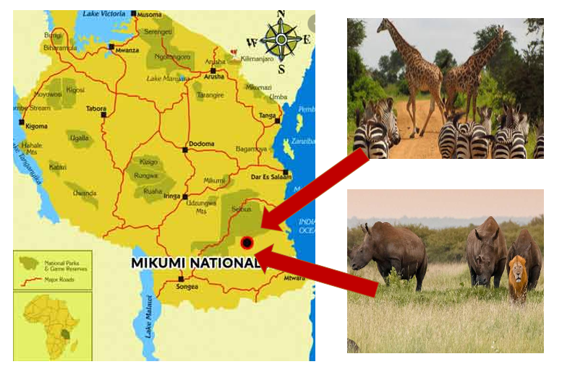
Figure 3. 1: Area of the study
Source: Goggle map

3.5 Population of the study
The population can be defined as the entire group under study as specified by the objectives of the research (Prentice, 2000). Grounded in our study, population is a precisely specified group of cases from which a researcher studies a sample and to which the results from the sample are generalized. Mikumi National Park in Morogoro region it is surrounded by 19 villages some of which are Mkumbi, Kilangali, Mbamba, Chiduhi, Lumango, Luhembe, Kisaki, Doma Chipela and Muharaka. The total population of the area is 22,949 (NBS, 2012). Nevertheless based in this study the population were 77 women’s who were the expected beneficiaries getting their daily bread at Mikumi National Park. Additionally the study included 5 representatives of Mikumi National Park (MINAPA) and the local area leaders like 7 ward executive officers, a local government leader and 7 ten cell leaders who are responsible to govern that area.

3.6 Sampling Techniques, Sample Size and Sampling Frame

3.6.1 Sampling Techniques
Kothari (2004) defines sampling technique as a procedure that the researcher would adopt to select elements to be included in the sample. In selecting the study respondents, one or two techniques might be involved on the same time that is probability sampling and non-probability sampling depend on the subject matter (Etikan et al, 2016). Due to the nature of this study both simple random sampling (probability sampling) and purposive sampling techniques (non- probability sampling) were used in our study. Simple random sampling technique was used in the sample selection for women doing their work at Mikumi national park while purposive sampling techniques was used in the sample selection for Mikumi national park representatives, ward executive officers and ten cell leaders at Mikumi national park.

3.6.2 Sample size
The sample size is defined as the number of observations used for determining the estimations of a given population (Etikan et al, 2016). The sample size is an important feature of any empirical study in which the goal is to make inferences about a population from a sample (McLeod, 2018). Kothari, (2014) argues that, an optimum sample is the one that fulfils the requirements of efficiency, representativeness, reliability and flexibility. Built in our study, sample size entails the number of all respondents included in a study. A sample size of 84 respondents was selected for this study, of whom 65 are women as core respondents who were selected by Sloven's formula/scientific formula (simple random sampling technique), others were selected by purposive sampling technique which are 5 representatives of Mikumi National Park (MINAPA), 7 ward executive officers, and 7 ten cell leaders. So the sample size n of the women (core respondents) was obtained by the Sloven's formula/scientific formula (simple random sampling technique). Slovens’s formula is used to calculate an appropriate sample size from a population.
Which is given by n = N / (1 + Ne2)
Where: n = Number of samples, N = Total population and e = Error tolerance (level).
NB: Confidence level of 95 percent (giving us an Error tolerance level of 5% = 0.05),
In our study N=77 and e= 0.05
Therefore n = 77/ 1+77 x (0.05)2 = 65 women’s.

3.6.3 Sampling Frame
Sampling frame is a list of the items or people forming a population from which a sample is taken (Miller et al, 2010). A sampling frame is the source material or device from which a sample is drawn, it is a list of all those within a population who can be sampled, and may include individuals, households or institutions (Etikan et al, 2016). In our study sampling frame included women as the main respondents, others are representatives of Mikumi National Park (MINAPA), also ward executive officers, and ten cell leaders who responsible to govern that areas.
Table 3. 1: Sampling Frame
S/N | Category of respondents | Sample size | Sampling technique(s)
 | Women | 65 | Simple Random Sampling
 | Mikumi National Park Representatives | 5 | Purposive Sampling
 | Ward Executive Officers | 7 | Purposive Sampling
 | Ten Cell Leaders | 7 | Purposive Sampling
 | Total | 84
Source: Researcher 2021

3.7 Data collection tools
Data collection is a process of collecting information from all the relevant sources to find answers to the research problem, test the hypothesis and evaluate the outcomes (Lavrakas, 2008). Grounded in our study, data collection is the process of gathering quantitative and qualitative information on specific variables with the aim of evaluating outcomes or gleaning actionable insights to ensure the data collected is clean consistent, and reliable. In this study we used questionnaires, semi structured interviews and observations as a tools for data collection.

3.7.1 Secondary data
Secondary data is a type of data that has already been published, to mention a few published in books, newspapers, magazines, journals and online portals (Etikan et al, 2016).Therefore, application of appropriate set of criteria to select secondary data to be used in the study plays an important role in terms of increasing the levels of research validity and reliability (Alkassim et al, 2016).

3.7.1.1 Documentary review
Document review is a way of collecting data by reviewing existing documents (Kabir, 2016). Alam et al, (2015) noted that, documents may be hard copy or electronic and may include research articles by other researchers (journals), published censuses or other statistical data, books, biographies, newsletters, and other related existing documents related to a subject matter (Alam et al, 2015). Centered in our study, the researcher used previous researches, books, and any other material based on the subject matter in evaluating wildlife tourism performance on women empowerment in Tanzania.

3.7.2 Primary data
Field et al, (2006) indicate that, primary data is an original and unique data, which is directly collected by the researcher from a source such as observations, surveys, questionnaires, case studies and interviews according to his/her requirements. Questionnaire, interview and observation as a part of primary data collection methods was used in our study.

Grounded in our study primary data is data originated for the first time (unprocessed and collected for the first time) by the researcher through direct efforts and experience, specifically for the purpose of addressing research problem, in order to make the discovery of additional data and information during collection and to ensure the quality of data. The primary data collection tools for this study was questionnaires, semi structured interviews and observations.

3.7.2.1 Questionnaire
A questionnaire is a research instrument consisting of a series of questions and other prompts for the purpose of gathering information from respondents (McLeod, 2018).
Founded in our study, questionnaire is a research instrument consisting of a series of questions (or other types of prompts) for the purpose of gathering information from respondents (women) that is also pre tested so as to increase the validity of the study. In this study we used a questionnaire as a primary data collection tool to the women in evaluating wildlife tourism performance on women empowerment at Mikumi national park in Tanzania.

3.7.2.2 Interview
Miller et al, (2010) indicate that, an interview is a conversation for gathering information. A research interview involves an interviewer, who coordinates the process of the conversation and asks questions, and an interviewee, who responds to those questions. Interviews can be conducted face-to-face or over the telephone (Alkassim et al, 2016). Established in this study semi structured interview was used in evaluating wildlife tourism performance on women empowerment at Mikumi national park in Tanzania. Semi-structured interviews are characterised by topic guides containing major questions that are used in the same way in every interview, although the sequence of the questions might vary as well as the level of probing for information by the interviewer. Semi structured interviews facilitate the researcher to prepare questions beforehand to help guide the conversation and keep respondents on topic, allows for open-ended responses from participants for more in-depth information and encourages two-way communication as what we deed.

3.8 Reliability and Validity
Thatcher (2010) argues that, reliability and validity are concepts used to evaluate the quality of research. Reliability and validity indicate how well a method, technique or test measures something (Creswell, 2009).Yin (2009) noted that, reliability is about the consistency of a measure, and validity is about the accuracy of a measure.

3.8.1 Reliability
Cohen et al (2000) argue that, reliability relates to the precision and accuracy of the instrument, if used on a similar group of respondents in a similar context, the instrument should yield similar results. Constructed in our study, reliability refers to the consistency of a measure ‘whether the results can be reproduced under the same conditions’. To ensure reliability in our study, the researcher used various approaches of data collection tools such as questionnaires and semi structured interview guide.

3.8.2 Validity
Thatcher (2010) noted that, validity is the instrument capable of measuring what is supposed to measure accurately, effectively and efficiently. Built in our study, to improve the validity the researcher pre-tested the questionnaire over a number of people before officially distributing to the respondents; this was achieved through observing standards on constructing questionnaires, also the procedures of the questionnaire explained to the respondents and translated to national language which is Kiswahili language for more understanding.

3.9 Ethical consideration
Ethical consideration is an accumulation of values and principles that address questions of what is good or bad in human affairs (Bryman et al, 2007). Schensul et al, (2013) noted that, there are six broad ethical areas that need to be considered in research which are voluntary participation, informed consent, confidentiality and anonymity, the potential for harm, communicating the results, and more specific ethical issues. Established on our study, before conducting the research the researcher was to address key issues as follows: Obtain research clearance letter from The Open University of Tanzania (OUT) and then seek approval from the municipality/district council concerned as a study area; also, consent form was given to the respondents who may wish to participate in study voluntarily and their confidentiality was guaranteed as none of them filled their names on a questionnaire and finally, the subject matter was introduced in the introductory note attached to questionnaire so as to make sure that respondents are alerted of what was going on.

3.10 Data analysis
According to Kombo et al, (2015) data analysis refers to examining what has been collected in survey or experiment and making deductions and inferences. The purpose of data analysis is to extract useful information from data and taking the decision based upon the data analysis (Cooper et al, 2006).

Built in this study, quantitative data was collected through questionnaires and was edited, coded, summarized, classified, tabulated and finally was analyzed by descriptive statistics through computer software known as statistical package for social sciences (SPSS). The finding was presented in the form of frequencies, percentages, tables and pie chart while the qualitative data on the other hand was analyzed by thematic technique and results was presented in narratives.

CHAPTER FOUR

DATA PRESENTATION, ANALYSIS AND DISCUSSIONS OF THE FINDINGS

4.1 Introduction
This chapter presents data presentation, analysis and discussions of the findings constructed according to the study objectives only. Precisely the chapter presents the findings on the demographic profile of respondents, women empowerment in wildlife tourism, awareness of women on opportunities available in wildlife tourism and the women challenges in wildlife tourism at Mikumi National Park in Morogoro region, Tanzania.

4.2 Demographic profile of respondents
In our study demographic profile of respondents included age and educational level of the main respondents who were provided with questionnaires. Based in this study, demographic profile of respondents are important because they help a reader to understand a picture of sample representation and composition of the study.

4.2.1 Age of Respondents
Age of the respondents is one of the most important demographic profile of respondents in understanding their views about the particular problems; by and large age indicates level of maturity of individuals in that sense age becomes more important to examine the response. Age boundary between 18-30 years formed 23.1%, 31-40 years accounted for 43.1%, 51-60 years constituted of 9.2% and lastly 61+% years were 17%. The table 4.1 below shows the summary of study results.
Table 4. 1: Age of Respondents
Age | Frequency | Percent
18-30 Yrs. | 13 | 20.0
31-40 Yrs. | 28 | 43.1
41-50 Yrs. | 15 | 23.1
51-60 Yrs. | 6 | 9.2
61+ Yrs. | 3 | 4.6
Total | 65 | 100.0
Source: Field Data (2021)

According to the table 4.1 above, it shows that, the majority of the respondents fell in the age category of 31-40 by 43%. The reason for big percentage is due to dynamic and energetic of that age in the struggling compared to the age of 61+ years who are 5% due to the less dynamic and lower energy they have in struggling, as the results most of that age becomes an advisor.

4.2.2 Educational level
Education perceived as among the factors that influence an individual’s perception of an intervention before making decision. Understanding the educational levels of the respondents was an important factor in assessing their skills and knowledge of respondents for judging about different matters. Hence the variable ‘Educational level’ was investigated by the researcher and the data pertaining to education presented showed that, primary level made up 12%, secondary level accounted for 31%, certificate level formed 25%, diploma level made up 8%, bachelor degree level designed 15% and lastly master’s degree level accounted for 9% as shown in the table 4.2 below.
Table 4. 2: Education Level of Respondents
Education level | Frequency | Percent
Primary level | 8 | 12.3
Secondary level | 20 | 30.8
Certificate level | 16 | 24.6
Diploma level | 5 | 7.7
Bachelor degree level | 10 | 15.4
Master’s degree level | 6 | 9.2
Total | 65 | 100.0
Source: Field Data (2021)

Established on the table 4.2 above, the study revealed that, all respondents in the study had passed the minimum level of education which is primary level. However, the highest level of education was master’s degree. This means that, respondents knew how to read and write, and the level of reasoning was reasonable to respond the study.

4.3 Women empowerment in wildlife tourism
The study assessed the women empowerment in wildlife tourism at Mikumi National Park. Women's empowerment means promoting women's sense of self-worth, their ability to determine their own choices, and their right to influence social change for themselves and others (Mosedale, 2005). Mayoux, (2006) noted that, the goal of empowerment is to provide information and permission for employees/teams to address problems and move forward towards achieving company/business goals. Women’s empowerment is very important because, it helps framework an employee's/member’s expectations and sets goals to accomplish their main purpose of their work and it will enable an employee/teams to take control of their job and use skills they never knew they could use (Parpart, et al, 2004).
Women's empowerment is the process of empowering women. It may be defined in several ways, including accepting women's viewpoints or making an effort to seek them, raising the status of women through education, awareness, literacy, and training. Women’s economic empowerment is the process of achieving women’s equal access to and control over economic resources, and ensuring they can use them to exert increased control over other areas of their lives (Taylor and Pereznieto, 2014). In this study survey the researcher was concentrated on economic empowerment questions as follows below.

4.3.1 The questions was: What sort of employment/engagement have you got from tourism activities?
This question was very important so as to know the employment/engagement they have in Mikumi national park as the area of the study, the results from the above question displayed as 21% of the respondents said tour guide, 2% driving and 77% of the respondents said selling souvenirs as show in figure 4.1 below.

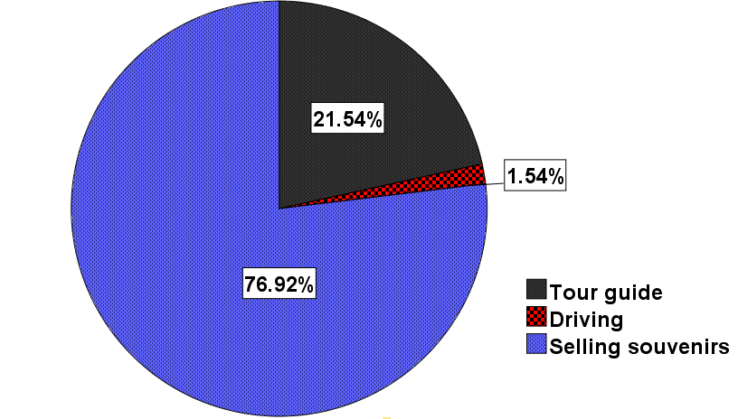
Figure 4. 1: Sort of employment
Source: Field data (2021)

According to the results reported in figure 4.1 above displayed that most women by 77% engaged by selling souvenirs, this shows that most of the women in Mikumi national park are concentrated in selling souvenirs as their opportunity cost and forgone other activities like driving and tour guide which also provide incomes and this might happen due to the lack of communication skills or time to spend with tourist together for a whole day. This is in line with the study by Ahmed, (2016) who reported that selling souvenirs as higher percent in tourism especially to women compared with other activities like tour guide and driving because other activities needs much time and be closely with the tourist while other women had work to do for their families like domestic chores.

A semi structured interview with a ward executive officer from Mikumi national park had the following to say:
....‘Female drivers and safari guides are required to leave their houses to make a living. The idea of women not staying at home is widely frowned upon amongst locals and becomes an issue for married couples, a catalyst for divorce’.

4.3.2 Another questions was: Does management of Mikumi national park accept your viewpoints properly in addressing any matter?
The findings from the field revealed that 80% of the respondents said ‘no’, 11% said ‘yes’ and 9% said ‘I don’t know’ as shown in figure 4.2 below

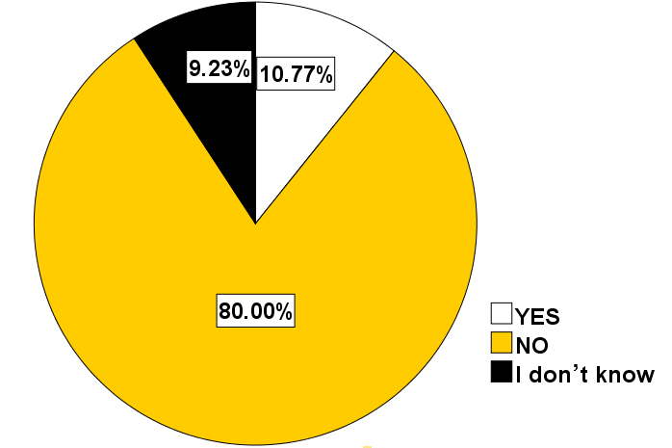
Figure 4. 2: Viewpoints
Source: Field data (2021)
According to the results shown in figure 4.2 above, it is evident that, the management of Mikumi national park they are not accepting enough of the women’s viewpoints properly in addressing any matter and this might happen due to the nonexistence of education, skills development and training to the management of Mikumi national park. ILO, (2014) in their article tourism for development, corresponds with this study noted that, it’s hard for the women’s viewpoints to be accepted easily, the data show that men are almost three times as likely as women to hold leadership positions, such as legislators, senior officials, and managers.

A semi structured interview with the ten cell leaders, it was revealed that, lack of education deprives main respondents (women’s) from being productive in Mikumi national park. One of the ten cell leader from Mikumi national park in our area of the study he had this to say:
...‘ Most of the women’s viewpoints to work in tourism industry especially in Mikumi national park is its challenge. Many women have not reached to the higher education level. In the case of Tanzania, it is common to see many women who had dropped out of school compared to men. However, according to their life stories, Tanzanian women take advantage of training they have been undergoing since they were children about housekeeping. Women have been trained to cook, handcrafts and keeping house in general. They have been trained to do many things in their family because they expected to be good housewives, their family especially mothers assisted most of the women to do chores, cooking, taking care siblings and mat making’.

4.3.3 Another questions was: Did you attend any education/seminars based on your business or any business for the past three years?
Education is the process of facilitating learning, or the acquisition of knowledge, skills, values, morals, beliefs, and habits. Education can take place in formal or informal settings and any experience that has a formative effect on the way one thinks, feels, or acts may be considered educational. The above question was set so as to understand if the respondents have enough current knowledge and skills based on their business performed. The results displayed from the field showed that, 78% said ‘no’, 11% said ‘yes’ and the last 11% said ‘I don’t know’ as shown in the figure 4.3 below:

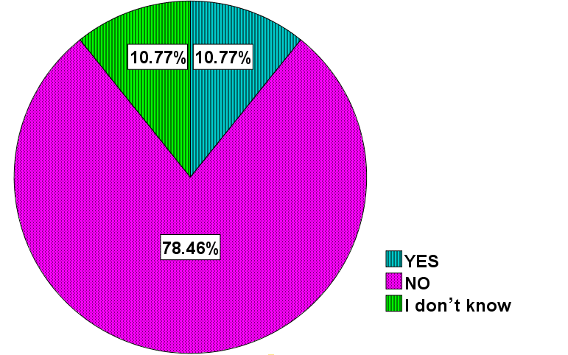
Figure 4. 3: Education
Source: Field data (2021)
Education is the social institution through which society provides its members with important knowledge, including basic facts, job skills, and cultural norms and values. One of the most important benefits of education is that it improves personal lives and helps the society to run smoothly. According to the figure 4.3 above it shows that, there is a need of education for women who are doing their business in Mikumi national park, because respondents who accounted for 78% said they did not attend any education based on their business or any business for the past three years, that is a significant number meaning that more education on the same is needed so as to increase knowledge and skills of their business matter for economic development.

The findings from semi structured interviews with the Mikumi national park representatives revealed that lack of seminars to women reduces their creativity and opportunity to empower them in the tourism business sector. One of the Mikumi national park representative explained that;

...‘Education to women’s in tourism sector is very necessary, because it enhances women’s to produce high quality cultural handicrafts and to find a stable marketplace for them to sell their products. Currently, local vendor’s especially women aggressively sell their handmade products to tourists in markets, and often overcharge them too. The lack of authenticity in their approach makes visitors feel uncomfortable and does not accurately represent Tanzanian culture. This unsustainable business practice negatively impacts their livelihood in the long run. Therefore, through education/seminars could be easily for women to learn how to attract customers especially foreign customers with a general understanding of different target markets and also learn how to overcome seasonal fluctuations for their sustainable economic development’.

Also, one ward executive officer said that:

...’Education/seminars is very important to women in the tourism sector for their sustainable development especially in the seasonal fluctuations, through education will equip women with the skills to become entrepreneurs and teach them how to establish a sustainable business and income source also education/seminars will teach them about the advantages and disadvantages of working in the tourism sector’.

4.4 Awareness of women on opportunities available in wildlife tourism
The study examined awareness of women on opportunities available in wildlife tourism at Mikumi National Park. Awareness is a state of knowing and being informed of something. Being informed about the problems of COVID 19 is an example of having an awareness of the problems, or being informed about the employment opportunity, advantages of tourism senior post or marketing opportunity is an example of having awareness. The questions/statements were set to test the awareness of women’s in tourism sector as surveys bellow-:

4.4.1 The question/statement was: Women occupy senior posts in tourism sector.
The survey results revealed that, 91% of the respondents disagree with the statement, 8% they don’t agree and 1% they agree, as shown in the figure 4.4 below:
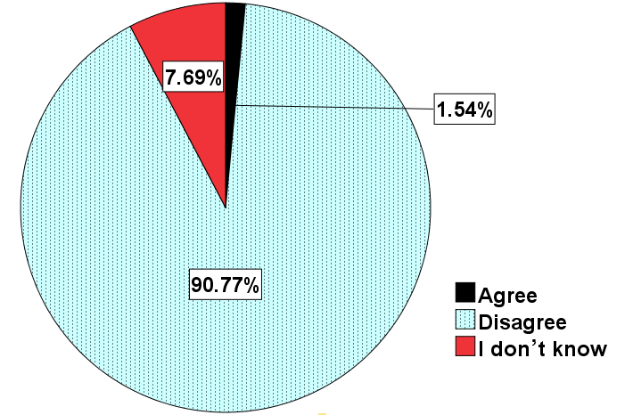
Figure 4. 4: Senior post
Source: Field data (2021)

According to the survey results shown by figure 4.4 above, it showed that most of the respondents by 91% said that, they don’t agree with the statement which said that, women occupy senior posts in tourism companies and this was a big problems in the decision making process, the decision must favour the men because the men there in a big number in the tourism senior posts compared to women, therefore there is a need to balance the gender in the senior posts based on education and performances.

A research by the World Bank Groups, (2017) corresponds with this study who shows that, women occupy lower posts in tourism sector also women lag behind men in nearly all measures of economic opportunity in every country in the world. These inequalities are even more extreme in low income countries. Achieving greater gender equality is a critical step toward the WBG goals of ending extreme poverty and boosting shared prosperity, and tourism is one pathway towards achieving these goals.

A semi structured interview with one of the Mikumi national park representative had the following to say:
…‘Women are less likely to be promoted to managerial positions at Mikumi national park and the worldwide in general due to very few representatives in the top posts especially in developing countries due to historical background of education and ownership, in developing countries like Tanzania women were found to use their household competencies to produce handicrafts and cosmetics for the tourist industry. For many women, the household competencies made up for their limited formal education, fewer women end up on a leadership career path and ILO data showed that men are almost three times as likely as women to hold leadership positions, such as legislators, senior officials and managers’.

Also, about senior posts in tourism sector a ward executive officer had this to say:

...‘Many advancements have been made in empowerment of women, but women are still far from enjoying the same basic rights, privileges and benefits that men do. Women still earn much less than men, do a disproportionate amount of housework, have fewer rights, less social mobility, and limited access to resources. Research by the World Bank shows that women lag behind men in nearly all measures of economic opportunity in every country in the world. These inequalities are even more extreme in low income countries, therefore this kind of research is more needed so as to minimize the gaps of senior posts in tourism sector’.

4.4.2 The question/statement was: I have participated in women congress/meeting in tourism sector.
Meetings give important opportunities for the team members to contribute their ideas and also letting them to know their expectations, needs and wants from them.
The summary results of the survey shown that, a large percent of the respondents which is 81% disagree with the statement which said that, I have participated in women congress/meeting in tourism sector, 11% they don’t know and 8% they agree as shown in figure 4.5 below:

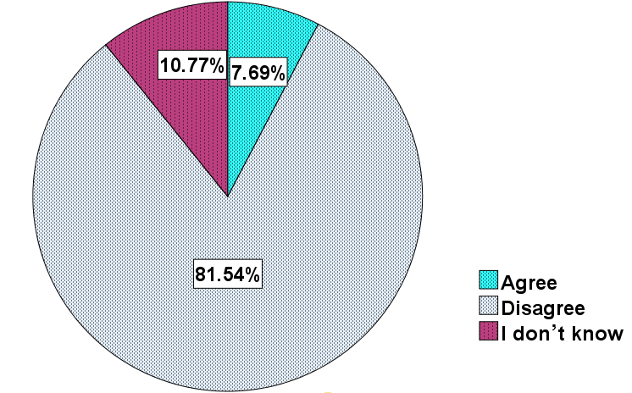
Figure 4. 5: Women congress/meeting
Source: Field data (2021)

According to the findings described by figure 4.5 above, it shows that, the women who doing their business at Mikumi national park lack meetings to discuss their challenges and opportunities together for their economic development and that might be a reason for not to grow well economically, there is a need for women who are doing their business at Mikumi national park to conduct professional meetings with other experts so as to adopt well in business challenges and opportunities for economic development.

A semi structured interview with a Mikumi national park representative had the following to say:

...‘Due to COVID 19 the last two years the meetings for building capacity for women were not there at all, we realise the meetings with women are very important especially in their business concern in order to increase their creativity , their performances and competences, it’s very clear there is a need of meeting for improving women development, removing constraints for more and better jobs, removing barriers to women’s ownership of and control over assets, and enhancing women’s voice and agency for enhancing women’s economic empowerment’.

4.4.3 The question/statement was: I know women who have been successful (role model) in life due to tourism activities
A role model is someone who inspires others, mainly younger generations, to follow a lifestyle, value-system, career path or acumen. A role model shows the younger generation on how to live with integrity and be determinant about goals. A role model is someone others look to as a good example. A role model is someone who is worthy of imitation.
The statement above was very important to women in tourism sector so as to test their awareness at Mikumi national park, the summary of study results disclosed that, 78% of the respondents disagree with the statement that said, ‘I know women who have been successful (role model) in life due to tourism activities’, 14% agree and 8% they don’t know as shown in figure 4.6 below:

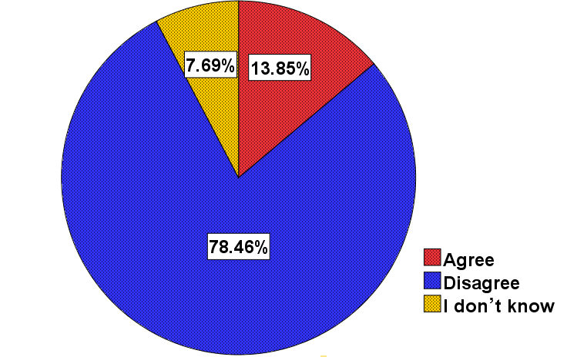
Figure 4. 6: Women congress/meeting
Source: Field data (2021)

The identification of, and comparison with, role models may help individuals define their self-concept or sense of self (Akerlof & Kranton, 2000) and enhance their self-efficacy to engage in a certain (e.g. entrepreneurial) occupation (De Clercq & Arenius, 2006, Gibson, 2004, Lockwood & Kunda, 1997). According to the findings described by figure 4.6 above, it shows that, 78% of business women at Mikumi national park they disagree with the statement which says ‘I know women who have been successful (role model) in life due to tourism activities’ which means there is a need to know or to find out the inspiring women in tourism sector. It is important to have at least one role model. Many people have more than one, depending upon which elements of their lives they're working on at a particular time. Whatever your passion, having a role model will compel you to work harder as you take steps to emulate them in pursuit of your own specific goal.
The findings from semi structured interviews with the Mikumi national park representatives revealed that lack of role model(s) to women reduces their creativity and opportunity to empower them in the tourism business sector. One of the Mikumi national park representative explained that;

...‘A good role model is someone who is always positive, calm, and confident in themselves. You don't want someone who is down or tries to bring you down. Everyone likes a person who is happy with their achievements, but continues to strive for bigger and better objectives. Role models demonstrate their commitment to a desired goal and are willing to invest the necessary time and effort to achieve success, they don't give up easily and they persevere when confronted by obstacles. Their passion to succeed will inspire women to follow through and reach the goals they set for themselves, therefore it’s better to have many role models in this tourism sector for inspirations of other women in tourism sector’.

Also, about role model in tourism sector a ward executive officer had this to say:

...‘A role model in women’s life is always a good idea so as to inspire them to achieve the peak of success. Having a role model in tourism sector can help women to improve their life and their attitude towards it. Emulating a person's actions and values will serve as a guiding light for women when they have bigger goals to achieve in life so it’s better to find out the women who succeed in this sector to put as a reference point and to welcome them for a meeting with other women here at Mikumi national park’.

4.5 The women challenges in wildlife tourism
The study examined women challenges in wildlife tourism at Mikumi National Park.

4.5.1 The question/statement was: What challenges do women face in tourism activities?
The study results from the survey showed that, 28% of the respondents said ‘harassment’, 14% said career opportunity, 8% said ‘lack of training and education’, 21% said ‘lack of women’s network’, 18% said ‘parental responsibility’ and 11% said ‘lack of tourism opportunity awareness’ as shown in figure 4.7 below:
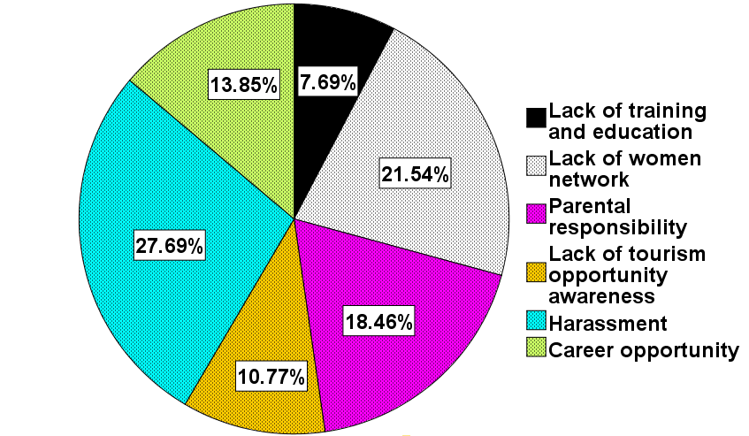
Figure 4. 7: Challenges in wildlife tourism
Source: Field data (2021)
Regardless of the general view that tourism business in Tanzania is friendlier to women than other sectors, challenges still appear to confront those who venture into it by the mere fact that they are women. Harassment means abusing, insulting, or otherwise harming someone on a regular basis. Constructed on the figure 4.7 above a huge percent which is 27% talked about ‘harassment’, this is a big challenge women face in tourism activities, especially at Mikumi National Park followed by 21% who said ‘lack of women’s network’.

The finding from the semi structured interview supports the above results Mikumi National Park Representative recommended on the women’s harassment and had this to say:

...’Some women at Mikumi National Park have reported to us the problem they faced by serving drunkard customers’ attitude. It is sad to see some of customers see the women like prostitutes. Once the customers served, they attempt to take advantage to women which is not acceptable due to undue influence and we have already dealt with it many times and we continue to minimize it to our level best.’

The study results are in line with the study by Makame et al (2008) who found that harassment is the big problem to women in tourism sector, he interviewed a woman from Zanzibar tourism sector and this is what she had to say; “When you are doing something it means you have agreed with your husband but we live with many other people in society. Normally my husband has no problem with me working but the problem is from other relatives and friends. My husband may sometimes change and become furious, restricting me to go anywhere. Imagine this job requires me to move to different places, to receive and send products. But I came to know that it was the influence from relatives. They said that, ‘what a kind of a woman that you have married, she does not stay at home, always walking around like a prostitute, and she disrespects you.’ This harassed me very much at the beginning such that I was about to give up. They even threatened to disown me. But this was God’s way of liberating me. I also thank my fellow women who encouraged me”.

CHAPTER FIVE

SUMMARY OF THE STUDY, CONCLUSION AND RECOMMENDATIONS

5.1 Introduction
This chapter presents summary of the study, conclusion, recommendations and suggestions on areas for further research study. The study intended to evaluate wildlife tourism performance on women empowerment at Mikumi National Park in Tanzania. The summary of the study and conclusion are provided in connection with research objectives that guided the study.

5.2 Summary of the Study
This study intended to evaluate wildlife tourism performance on women empowerment at Mikumi National Park in Tanzania. Precisely, the study assessed the women empowerment, examined awareness of women on opportunities available and examined women challenges in wildlife tourism at Mikumi National Park. The study employed a descriptive research design basically because it enabled to adopt both quantitative and qualitative research approaches of evaluating wildlife tourism performance on women empowerment at Mikumi National Park in Tanzania. The study was conducted in Mikumi National Park, the study area was selected due to the fact that most of the previous studies looked at National Parks in the northern part of Tanzania like Serengeti and Ngorongoro leaving Mikumi with little attention, that’s why this study was focused on Mikumi National Park (MINAPA). A sample of 84 respondents was involved in the study and both simple random sampling and purposive sampling techniques were applied to select the sample of respondents in the study area at Mikumi National Park in Tanzania as described in chapter three in sampling frame table 3.1. In order to meet the information required of the study, data’s were generated from several method of data collection which were documentary review, semi-structured interviews and questionnaires. The quantitative data was analyzed using SPSS version 22 whereby charts and percentages were used to present data. Qualitative data on the other hand were analyzed using thematic technique and results were presented in narratives. The findings of the study add literature for the similar studies and empirical data that can be used by policy and decision makers on women empowerment in tourism sector.

On assessment of women empowerment in wildlife tourism at Mikumi National Park, the study revealed that a large percent which is 77% of the respondents at Mikumi national park engaged in selling souvenirs. On the accepting women’s view points at Mikumi national park 80% of the main respondents said ‘no’. On attending any business education/seminars for the past three years, 78% of women said they did not attend any education based on their business or any business for the past three years.

On examined awareness of women on opportunities available in wildlife tourism at Mikumi National Park. The study results found that, on the statement ‘women occupy senior posts in tourism sector’ 91% of the respondents disagree with the statement. On the statement of women participation on congress/meeting in tourism sector 81% of the respondents disagree with the statement.
On examined women challenges in wildlife tourism at Mikumi National Park. The study results found that, a huge percent which is 28% of the respondents said harassment, 21% of the respondents said lack of women’s network and the lowest percent which is 8% was said lack of training and education.

5.3 Conclusion`
In the light of research findings, the following conclusions are drawn. The conclusions are specific and are linked to the study objectives and the study findings. Under the first objective the researcher assessed the women empowerment in wildlife tourism at Mikumi National Park. It was found out that, 77% of the respondents at Mikumi national park engaged in selling souvenirs. On the accepting women’s view points at Mikumi national park 80% of the main respondents said ‘no’. On attending any business education/seminars for the past three years, 78% of women’s they said they did not attend any education based on their business or any business for the past three years.

In this regard, the government must invest in women’s economic empowerment because it’s crucial for gender equality, poverty eradication, human development and inclusive economic growth, the Government must use tourism as an opportunity to empower women. Firstly, by educating them about the advantages and disadvantages of working in the tourism sector. Secondly, to equip women with the skills to become entrepreneurs and teach them how to establish a sustainable business and income source. Also the Government must focus on how to teach women to produce high quality cultural handicrafts and to find a stable marketplace for the women to sell their products. Currently, local vendors aggressively sell their handmade products to tourists in markets, and often overcharge them too. The lack of authenticity in customer care in their approach makes visitors feel uncomfortable and does not accurately represent Tanzanian culture. This unsustainable business practice negatively impacts their livelihood in the long run. Therefore, women have to learn how to attract foreign customers with a general understanding of different target markets and also learn how to overcome seasonal fluctuations.

In the second objective the researcher examined awareness of women on opportunities available in wildlife tourism at Mikumi National Park. The study results found that, on the statement ‘women occupy senior posts in tourism sector’ 91% of the respondents disagree with the statement. On the statement of women participation on congress/meetings in tourism sector 81% of the respondents disagree with the statement.

It’s therefore, concluded that the government must increase the awareness to women in tourism sector especialy at Mikumi national park, the Government must conduct the congress/meetings so as to make the women aware on tourism business sector concern, also the Government must encouraged the Non Governmental Organization (NGOs) and famous people to conduct seminars and to educate the women in tourism sector based on tourism business and other natural disaster and pandemic diseases like COVID 19 and the like.

In the lastly objective the researcher examined women challenges in wildlife tourism at Mikumi National Park. It was found out that, a huge percent which is 28% of the respondents said ‘harassment’, 21% of the respondents said lack of women’s network and the lowest percent which is 8% was said lack of training and education. Based on these findings
It’s therefore, concluded that the government must educate the society the importance of sharing income in the family development and economic development, because education will help the women to have important knowledge, including basic facts, job skills, and cultural norms and values, subsequently improve personal lives and will help them to run the society smoothly. Also education will help the women to grow and develop and be able to shape a better society to live in by knowing and respecting rights, laws, and regulations.

5.4 Recommendations
Based on the findings of this study, the following recommendations are properly made so as to empower the women in tourism sector, the study recommends the following:

5.4.1 Government
The government through the ministry of natural resources and tourism must conduct the women's economic empowerment seminars especially to Mikumi national park or the Government has to encourage the NGOs to conduct seminars to women so as to empower them in tourism business, find markets for women’s product and to help them to have a general knowledge of business and help them obtain loans so as to have a reasonable capital in order to invest in other businesses during seasonal fluctuations or other factors beyond anyone’s control. For example, when Ebola broke out in West Africa from 2014 to 2016, many travellers cancelled their trips to Tanzania. The lack of income sent many families into financial woes, same applied to COVID 19 many travellers cancelled their trips to Tanzania from 2019 up to now 2021 tourism still not stable.

5.4.2 Women
Women must attend entrepreneurial seminars so as to build their capacity, to overcome customers’ challenges, women must build trust to their husband/relations because prostitution may cause HIV/AIDS and that’s a big challenge that men won’t allow women to do business and especially tourism business even if women are not prostitutes. Therefore the couples must agree together on how to handle tourism business challenges without listening to other outsider persons’ rumours who want them purposely to be disorganised sometimes. And lastly the women must focus on how to produce high quality cultural handicrafts by attending vocational training courses and learn customer care on how to attract customers, especially foreign customers with a general understanding of different target markets. Also learn how to overcome seasonal fluctuations by establishing alternative businesses and saving, they must have and apply business strategies effectively for sustainable business practices.

5.4.3 Family
It is recommended to family members especially the men to balance family responsibilities in order to give relief to women especially that which reduce unnecessary domestic chores and if possible the family must employ housemaid, in order to let the wives struggle for the family development, provided they are not going against the family matters. In other words everybody must follow the family principle and roles agreed together with high trust because every businesses has got challenges therefore the trust to family members is very crucial for household economic development.

5.4.3 Society
Education institutions, human rights foundations and NGOs should educate the society to raise trust to each other and to remove the negative effects while the women are at work provided they are not violating their relationship for those who are married or for those who are in a relations. The society must be educated on the importance of women empowerment, because empowering women is essential to the health and social development of families, communities and countries. When women are living safe, fulfilled and productive lives, they can reach their full potential and contribute their skills to the workforce and can raise happier and healthier children. Therefore the awareness must be raised through mass media and social media so that the effective communication can reach to the whole society.

5.5 Areas for further Research
Based on the study findings from which conclusions are drawn, the researcher recommends research to be done in future on people’s attitudes to women in tourism business and the way other owners or managers perceive them as women.

REFERENCES
Addison, T. (2002). “Structural Adjustment.” In Handbook on Development Policy and Management, eds. Colin Kirkpatrick, Ron Clarke, and Charles Polidano. Cheltenham: Edward Elgar.
Adebakin, M. A. and Raimi, L. (2012). National Security Challenges and Sustainable Economic Development: Evidence from Nigeria. Journal of Studies in Social Sciences. 1 (1), 1-30. ISSN 2201-4624
African Development Bank. (2005).Tourism: Empowering Communities in Africa. Addis Ababa: Ethiopia.
Anatolia – An International Journal of Tourism and Hospitality Research, 22(3), 1-17.
Aref, F. and Ma’rof, R. (2009). Assessing the Level of Community Participation as a Component of Community Capacity Building for Tourism Development. European Journal of Social Sciences. 8(1) 68-75.
Ateljevic, I. and Peeters, L.W.J. (2008). Women empowerment through tourism: Wageningen University; Netherlands.
Bansal, S.P. & Kumar, J. (2012). Women Empowerment and Self-sustainability through Tourism: A case Study of Self-employed Women in Handicraft Sector in Kullu Valley of Himachal Pradesh. Himachal Pradesh University Journal, July 2011.
Bingham, Lisa B., Tina Nabatchi and Rosemary O’Leary (2005), ‘The new governance:
Bolles, A. (1997). Women as a Category of Analysis in Scholarship on Tourism: Jamaican Women and Tourism Employment’. Tourism & Culture:An Applied Perspective. E. Chambers, ed., Albany: State University of New York Press.
Bovaird, T. (2007), ‘Beyond engagement and participation: User and community Coproduction of public services’, Public Administration Review, 67 (5), 846–860.
Bryson, J. M., Barbara C. Crosby and Melissa M. Stone (2006), ‘The design and implementation of cross-sector collaborations: Propositions from the literature’, Public Administration Review, 66 (S1), 44–55.
Buhalis, D., 2003, eTourism: Information Technology for strategic tourism management, Pearson.
Caalders, J & van de Duim, R. (2002). 'Biodiversity and tourism: impacts and interventions', Annals of Tourism Research, 29, (3), p743-761.
Chant, S. (2006). Contribution of a gender perspective to the analysis of poverty. In J. S. Jaquette & G. Summerfield (Eds.), Women and gender equity in development theory and practice. Institutions, resources, and mobilization. Durham/London: Duke University Press.
Chok, S., Macbeth, J, &Warren C. (2007). Tourism as a Tool for Poverty Alleviation: A Critical Analysis of ‘Pro-Poor Tourism’ and Implications for Sustainability. Current Issues in Tourism Review 10 (2), 144–165
Cutrin, S. 2009. Wildlife tourism: the intangible, psychological benefits of human-wildlife encounters. Current Issues in Tourism,
Doran. A. (2014). Empowerment and Women in Adventure Tourism: A Nego7ated Journey. Accessed July 01, 2015, 05:31 PM
Edwards, V.L. (2013), "A theory of participation for 21st century governance", International Journal of Organization Theory & Behavior, Vol. 16 No. 1, pp. 1-28.
Ellis, A., Blackden, M., Cutura, J., MacCulloch, F., & Seebens, H. (2007). Gender and Economic Growth in Tanzania: Creating Opportunities for Women. Washington: The International Bank for Reconstruction and Development.
Eugenio-Martin, Juan Luis, Noelia Martin Morales, and Riccardo Scarpa, 2004, “Tourism and Economic Growth in Latin American Countries: A Panel Data Approach,” FEEM Working Paper No. 26.2004.
Freeman, R. Edward (2010), Strategic Management: A Stakeholder Approach, Cambridge: Cambridge University Press.
Fujikake, Y. (2010). Methodologies for evaluating women’s empowerment in poverty alleviation programmes: Illustrations from Paraguay and Honduras. In S. Chant (Ed.), The international handbook of gender and poverty. Chelteham: Edward Elgar.
Fung, Archon (2006), ‘Varieties of participation in complex governance’, Public Administration Review, 66 (S1), 66–75.
Gershman, John and Alec Irwin. 2000. “Getting a Grip on the Global Economy.” In Dying for Growth, eds. Jim Yong Kim, Joyce V. Millen, Alec Irwin and John Gershman. Monroe, MN: Common Courage Press
Goldin, Ian, Halsey Rogers, and Nicholas Stern. 2001. “The Role and Effectiveness of Development Assistance: Lessons from the World Bank Experience.” World Bank Publications.
Hulme, D. and Murphree, M. (eds.) 2001 African Wildlife and Livelihoods. The Promise and Performance of Community Conservation. James Currey, Oxford,
Hulme, D. and Murphree, M. (eds.) 2001 African Wildlife and Livelihoods. The Promise and Performance of Community Conservation. James Currey, Oxford
Josaphat Kweka (2004) Tourism and the Economy of Tanzania: Economic and Social Research Foundation: Dar es Salaam.
Kahyarara, G. and Mchallo, I. (2017), the strategic environmental assessment (SEA) of tourism development in the northern tourist circuit of Tanzania. International Association for Impact Assessment, Centre for Environmental Economics and Development Research.
Kaltenborn, B. R. P., Nyahongo, J. W. and Kideghesho, J. R. (2011). The attitudes of tourists towards the environmental, social and managerial attributes of Serengeti National Park, Tanzania. Tropical Conservation Science
Kashaga, F., (2007).The role of Cultural Tourism in Poverty Reduction: The case of Arusha Region, MA Dissertation: University of Dar es Salaam.
Kwarambaa, H.M., Lovetta, J.C., Louwb, L., & Chipumuroc, J. (2012). Emotional confidence levelsand success of tourism development for poverty reduction: The South African KwameMakana home-stay project. Tourism Management, 33(4), 885–894.
Luvanga,N., Shitundu, J.(2003), The Role of Tourism in Poverty Alleviation in Tanzania, Research on Poverty Alleviation (REPOA) Dar es Salaam, Tanzania
Makame, M. K. and Boon, E. K. (2008).Sustainable tourism and benefit-sharing in Zanzibar: the case of Kiwengwa-Pongwe Forest Reserve. Journal of Human Ecology,
Mayoux, L. (2006) Women’s Empowerment through Sustainable Micro-Finance: Rethinking “Best Practice”
Michelle, B. (2011). Global report on women in tourism. International congress on ethics and tourism, Madrid
MNRT (2016). An overview of the Natural Resources Sector: Achievement, Challenges and Priorities for financial year 2016/2017. Ministry of Natural Resources and Tourism, Dar es Salaam, Tanzania. 12pp.
Mosedale, S. (2005) Policy arena. Assessing Women’s Empowerment: Towards a Conceptual Framework, Journal of International Development,
Mowforth, M. and Munt, I. 2005. Tourism and Sustainability: Development and new Tourism in the Third World. New York: Routledge, 338 pp.
Muganda, M., Sahli, M. and Smith, K. (2010). Tourism’s contribution to poverty alleviation: a community perspective from Tanzania. Development Southern Africa Journal,
Nwosu, B. (2014). Hospitality education: sustainable empowerment opportunities for Nigerian
ODI. (2006). Tourism Business and the Local Economy: Increasing Impact Through a Linkages Approach. Briefing Paper: Overseas Development Institute, ODI.
Parpart, J. L., Rai, S. and Staudt, K. (2002) Rethinking Empowerment: Gender and Development in a Global/Local World. London: Routledge
Practices and processes for stakeholder and citizen participation in the work of Government’, Public Administration Review, 65 (5), 547–558.
Rose, K. O. (2003). Gender and political economy of sex tourism in kenya's coastal resort.
Salazar, N. B. (2007). Towards a global culture of heritage interpretation? Evidence from Indonesia and Tanzania. Tourism Recreation Research,
Scheyvens, R. (2000). Promoting women's empowerment through involvement in ecotourism: experiences from the third world. Journal of Sustainable Tourism, 8(3), 232-249
TATO (2015). Tanzania travel and tourism directory. Published by Print Plus for Tourism Confederation of Tanzania and Tanzania Tourist Board.
Todaro, Michael and Stephen C. Smith. 2002. Economic Development. Boston: Addison Wesley
Tourism industry in overcoming poverty: The case of Sone town and Nungwi village in Zanzibar. University of Dar es Salaam.
Tucker, H., & Boonabaana, B. (2012). A critical analysis of tourism, gender and poverty reduction. Journal of Sustainable Tourism, 20(3), 1-19.
United Nations World Tourism Organization (UNWTO) & United Nations Women. (2010). Global Report on Women in Tourism 2010. Madrid: UNWTO.
United Nations World Tourism Organization (UNWTO). (2016). How can tourism contribute to the sustainable development goals. Tourism and sustainable goals. Madrid: UNWTO.
UNWTO (2008). Gender and Tourism/Ethics and social responsibility, ITB tourism fair forum on women.
UNWTO (2020). World Tourism Organization, Compendium of Tourism Statistics dataset [Electronic], UNWTO, Madrid, data updated on 20/01/2020.
Women. Worldwide Hospitality and Tourism Themes, 6(1), 62 – 76. Anderson, W. (2011). Enclave tourism and its socio-economic impact in emerging destinations.
Zhao, W. and Ritchie J.R. (2007). Tourism and poverty alleviation: an integrative research framework. Current Issues in Tourism,

APPENDICES
APPENDIX I: CONSENT FORM

THE OPEN UNIVERSITY OF TANZANIA
DEPARTMENT OF SOCIOLOGY AND SOCIAL WORK
PRINCIPLE INVESTIGATOR: UPENDO KIBASA
PHONE NUMBER: +255 762 561 232
The purpose of the study: To evaluate wildlife tourism performance on women empowerment at Mikumi National Park in Tanzania.
Procedures: I will answer all questions accordingly and participate in interview section.
Benefits: There may be no direct benefits to me as a participant in the proposed study but the findings from the study may be beneficial to other stakeholders in my country.
Risk and Discomforts: There will be no any risk from the participating from the proposed study apart from time spent.
Confidentiality: All information obtained in the proposed study will be considered confidential and used only for research purpose. My identity will be kept confidential in so far the laws allow.
Right to refuse or withdraw: My participation in the proposed study is entirely voluntary and is free to refuse to take part or withdraw at any time.
CONSENT: I………………………………………. After considering the explanation of the study and having understood the consent form, I hereby give my informed consent to participate in the study.
Signature………………………Date………………………………………………….
Investigator signature………………………Date…………………………………….
APPENDIX II: QUESTIONAIRES FOR WOMENS AT MIKUMI NATIONAL PARK
Dear Madam/ Sir,
I am currently pursuing master degree of social work at the Open University of Tanzania. As part of my studies, I am doing a research titled “Evaluation of Wildlife Tourism On Women Empowerment, A Case of Mikumi National Park”. I humbly request you to complete this brief questionnaire so as to facilitate research. All information will be treated with strict confidentiality and shall only be used for the purpose of this academic research. Your participation is voluntary and it should take 15-30 minutes to complete this questionnaire. Please answer all the questions on all the pages.

A: GENERAL QUESTIONS.
1. How old are you? …………….
2. What’s your level of education? ..........................
3. What’s your marital status? ...................................

B: ECONOMIC EMPOWERMENT
4. What sort of employment/engagement have you got from tourism activities?
a. Tour guide
b. Driving
c. Selling souvenirs
- Does management of Mikuni national park accepting enough your viewpoints properly in addressing any matter?
a. Yes
b. No
c. I don’t know

- Did you attended any education/seminars based on your business or any business for the past three years?
a. Yes
b. No
c. I don’t know

C: AWARENESS ON TOURISM OPPORTUNITIES
Please rate the words at your work as they apply to you.
1 Agree 2. Disagree 3. I don’t know

S/N | Statement | 1 | 2 | 3
8 | Women occupy senior post in tourism sector
9 | I have participated in women congress/meeting in tourism sector.
12 | I know women who have been successful (role model) in life due to tourism activities

D: WOMEN CHALLENGES IN WILDLIFE TOURISM

13. What challenges do women face in tourism activities?
……………………………………………………………………………………………………………………………………………………………………………………

Thank you for participating in the questionnaire. Do you have any questions?

APPENDIX III: SEMI STRUCTRURED INTERVIEW GUIDE FOR MINAPA REPRESENTATIVES, WARD EXECUTIVE OFFICERS AND TEN CELL LEADERS AT MIKUMI NATIONAL PARK

Dear Madam/ Sir,
I am currently pursuing master degree of social work at the Open University of Tanzania. As part of my studies, I am doing a research titled “Evaluation of Wildlife Tourism on Women Empowerment, A Case of Mikumi National Park”. I humbly request you to complete this semi structured interview so as to facilitate research. All information will be treated with strict confidentiality and shall only be used for the purpose of this academic research. Your participation is voluntary and it should take 30-45 minutes to complete this semi structured interview. Please answer all the questions.

Qn1. Can you explain anything about women’s empowerment?

Qn2. Does management of Mikuni national park accepting enough the women’s viewpoints in addressing any matter?

Qn3. Did the women’s at MINAPA attended any education/seminars based on their business or any business for the past three years here at Mikumi national park?

Qn4. Does Women’s occupy senior post in tourism sector especially in MINAPA?

Qn5. Can you explain in briefly the opportunities available in wildlife tourism at Mikumi National Park?

Qn6. Can you explain challenges do women’s face in tourism activities?

Thank you for participating in the questionnaire. Do you have any questions?

