EFFECTS OF COVID-19 PANDEMIC ON THE HOUSEHOLD INCOME OF TOURISM DEPENDENT COMMUNITIES AROUND IKONA WILDLIFE MANAGEMENT AREA, SERENGETI DISTRICT, TANZANIA

SULEIMAN LEONARD KERARYO

A DISSERTATION SUBMITTED IN PARTIAL FOR FULFILLMENT OF THE REQUIREMENTS FOR THE DEGREE OF MASTER OF TOURISM PLANNING AND MANAGEMENT
DEPARTMENT OF GEOGRAPHY, TOURISM AND HOSPITALITY SERVICES
THE OPEN UNIVERSITY OF TANZANIA
2024

CERTIFICATION
The undersigned certifies that, he has read and hereby recommends for acceptance by the Open University of Tanzania a dissertation titled, “Effects of COVID-19 Pandemic on the Households’ Income of Tourism Dependent Communities Around Ikona Wildlife Management Area, Serengeti District, Tanzania” in partial fulfilment of the requirements for the award of the Degree of Master of Tourism Planning and Management (MTPM) of the Open University of Tanzania.

..............................................................
Prof. Emmanuel Patroba Mhache
(Supervisor)

...................................................
Date

COPYRIGHT
No part of this dissertation may be reproduced, stored or transmitted in any form by any means, electronic, mechanical, photocopying, recording or otherwise without prior written permission of the author or the Open University of Tanzania in that behalf.

DECLARATION
I, Suleiman Leonard Keraryo, declare that, the work presented in this dissertation is original. It has never been presented to any other University or Institution. Where other people’s works have been used, references have been provided. It is in this regard that I declare this work as originally mine. It is hereby presented in partial fulfillment of the requirement for the Degree of Masters of Tourism Planning and Management (MTPM) of the Open University of Tanzania.

……………………………………
Signature

……………………………………
Date

DEDICATION
This dissertation is dedicated to my lovely family for their tolerance in good heart and support they confer on me until I finished this dissertation.

ACKNOWLEDGEMENT
First of all, I would like to thank the Almighty God for keeping me health and strong. I am very grateful to various individuals who made this work possible even though I cannot mention them all here. I would also like to express my sincere appreciation and gratitude to my supervisor Prof. Emmanuel Patroba Mhache of the Open University Tanzania for his endless support, guidance, assistance, encouragement, advice and constructive criticism which have led to the writing and completion of this dissertation.

I am also expressing my appreciation to course lectures and other staff of the Open University of Tanzania for their support during the whole MTPM programme. I further thank the Management of Ikona WMA for warmly welcome and cooperation given during my stay in Seregenti District Council. Moreover, I wish to express my appreciation to all respondents in the three study villages; Robanda, Nyichoka and Makundusi communities around Ikona WMA and other respondents in the study area, for great support during the entire period of the data collections. I would further provide my sincere gratitude to my parents Mr. and Mrs. Keraryo for their encouragement, support and good foundation of education they built on me. Finally, thanks are due to my family; my wife Neema Charles Timasi and my beloved two children Catherine Suleiman and Careen Suleiman for their patience in the hardship they encountered throughout the period of pursuing this work.

ABSTRACT
This study focused on the effects of COVID-19 on the households’ income of tourism dependent communities around Ikona WMA. Three specific objectives were used in this study that is, to determine the effects of the COVID-19 pandemic on households’ income; labour demand; and small-scale enterprises of the tourism dependent communities. The sample size was 226 respondents. The study employed a cross-sectional study design and used both qualitative and quantitative approaches. Both purposive and random sampling techniques were used. Questionnaires, interview guide, site observation, focus group discussion meetings and documentary reviews were used to collect data from respondents. The data collected were analyzed using SPSS statistics version 20 and content analysis. The study revealed that the decline of households’ income could be attributed to business closure, employees’ unpaid leave, compulsory leave and few hours of work. It was also revealed that low labour demand resulted to loss of jobs, reduced wages, and delayed salary payments. The effects of COVID-19 on small-scale enterprises resulted to low demand for tourism products/services, diminished operation capacity and variation in tastes and preferences of tourists, which ultimately resulted to the decline of households’ income. The study recommended that government should promote domestic tourism and encourage local communities to diversify their sources of income. The study concludes that the effects of COVID-19 cut across all sectors of economy however; tourism sector and the communities’ dependent on tourism sector were the most affected.

Keywords: Communities, COVID-19, household income, tourism, Serengeti District
TABLE OF CONTENTS
CERTIFICATION ii
COPYRIGHT iii
DECLARATION iv
DEDICATION v
ACKNOWLEDGEMENTS vi
ABSTRACT vii
LIST OF TABLES xiii
LIST OF FIGURES xiv
LIST OF ABBREVIATIONS xv
CHAPTER ONE 1
INTRODUCTION 1
1.1 Overview 1
1.2 Background of the Research Problem 1
1.3 Statement of the Research Problem 4
1.4 Objectives of the Study 6
1.4.1 General Objectives of the study 6
1.4.2 Specific Objectives of the Study 6
1.5 Research Questions 6
1.6 Significance of the Study 7
1.7 Organization of the Dissertation 7
CHAPTER TWO 8
LITERATURE REVIEW 8
2.1 Overview 8
2.2 Definition of Key Concepts 8
2.2.1 Tourism 8
2.2.2 COVID-19 Pandemic 9
2.2.3 Tourism Dependent 9
2.2.4 Community 9
2.3 Theoretical Literature Review 10
2.3.1 Theory of Demand and Supply 10
2.3.2 General Systems Theory 12
2.4 Empirical Literature Review 14
2.4.1 The Effects of COVID-19 Pandemic On Households’ Income 14
2.4.2 The Effects of COVID-19 Pandemic On Labour Demands 15
2.4.3 The Effect of COVID-19 Pandemic On Small-Scale Enterprises 17
2.5 Policy Review 18
2.5.1 Community Development Policy (1996) 18
2.5.2 National Tourism Policy (1999) 18
2.5.3 The Wildlife Policy of Tanzania (2007) 19
2.6 Conceptual Framework 20
2.7 Research Gap 22
2.8 Chapter Summary 22
CHAPTER THREE 23
RESEARCH METHODOLOGY 23
3.1 Introduction 23
3.2 The study Area 23
3.3 Research Design 24
3.4 Target Population 26
3.5 Sampling Procedures 26
3.5.1 Purposive Sampling Technique 27
3.5.2 Simple Random Sampling 27
3.6 Sampling Frame and Sample Size 28
3.7 Sources of Data 29
3.7.1 Secondary Data 29
3.7.2 Primary Data 30
3.8 Data Collection Methods 30
3.8.1 Survey Household Questionnaire 30
3.8.2 Focus Group Discussion 30
3.8.3 Key Informant Interviews 31
3.8.4 Observation 31
3.8.5 Documentary Literature Review 32
3.9 Data Analysis, Interpretation and Presentation 32
3.10 Validity and Reliability of the Research Instruments 32
3.10.1 Validity of the Research Instruments 32
3.10.2 Reliability of the Research Instruments 33
3.11 Ethical Consideration 34
3.12 Chapter Summary 35
CHAPTER FOUR 36
RESULTS AND DISCUSSION 36
4.1 Introduction 36
4.2 Characteristics of the Respondents 36
4.2.1 Age of the Respondents 36
4.2.2 Gender of the Respondents 37
4.2.3 Marital status of the Respondents 38
4.2.4 Education Level of the Respondents 38
4.2.5 Occupation of the Respondents 39
4.3 Effects of COVID-19 Pandemic on the Households’ Income of the Communities around the Ikona WMA 40
4.3.1 Effects of COVID-19 Pandemic On Household’s Income 40
4.3.2 Employees’ unpaid leave 42
4.3.3 Employees’ compulsory leave 44
4.3.4 Employees’ Fewer Hours of Working 46
4.3.5 Business Closure 48
4.4 The Effects of COVID 19 Pandemic on Labour Demands of the Tourism Dependent Communities around the Ikona WMA 51
4.4.1 Loss of Jobs 51
4.4.2 Reduced Wages 54
4.4.3 Delay in Salary Payment 56
4.5 The Effects of COVID-19 Pandemic on Small-Scale Enterprises 59
4.5.1 Low Demand for Tourism Products/Services 59
4.5.2 Low Operation Capacity of Small and Medium Enterprises 61
4.5.3 Variations in Tourists’ Tastes and Preferences 63
CHAPTER FIVE 66
DISCUSSION OF THE FINDINGS 66
5.1 Introduction 66
5.2 Discussion 66
5.2.1 Effects of COVID-19 Pandemic on the Household’s Income 66
5.2.2 The Effects of COVID 19 Pandemic on Labour Demands 69
5.2.3 The Effect of COVID-19 Pandemic On Small-Scale Enterprises 72
CHAPTER SIX 75
SUMMARY, CONCLUSION AND RECOMMENDATIONS 75
6.1 Overview 75
6.2 Summary 75
6.3 Conclusion 77
6.4 Recommendations 77
6.5 Recommendation for Further Studies 78
REFERENCES 79
APPENDICES 88

LIST OF TABLES
Table 3.1: Sampling frame and sample size 29
Table 4.1: Age of the respondents 37
Table 4.2: Gender of the respondents 37
Table 4.3: Marital status of the respondents 38
Table 4.4: Education level of the respondents 39
Table 4.5: Occupation of the respondents 40
Table 4.6: Criteria for alternative jobs done by the employees on unpaid leave 43
Table 4.7: Criteria for income lost by the employees sent on compulsory leave 45
Table 4.8: Criteria for working fewer hours 47
Table 4.9: Criteria for categorizing business closure 49
Table 4.10: Criteria for categorizing tourism enterprises 52
Table 4.11: Criteria for reduced wages 55
Table 4.12: Criteria for determining delay in salary payment 57
Table 4.13: Criteria for identifying the features of the tourism products/services 60

LIST OF FIGURES
Figure 2.1: Effects of COVID-19 pandemic on the household income 21
Figure 3.1: Location of Ikona WMA 24
Figure 4.1: Effects of COVID-19 on the household income 41
Figure 4.2: Effects of Covid-19 on tourism dependent communities 42
Figure 4.3: Alternative jobs done by respondents who were on unpaid leave 43
Figure 4.4: Allowances that were not earned by employees on compulsory leave 45
Figure 4.5: Effect of COVID-19 on employees’ working hours 48
Figure 4.6: Effect of COVID-19 on business operations 49
Figure 4. 7: Abandoned Robanda tented camp during COVID-19 pandemic 50
Figure 4.8: Effects of COVID-19 pandemic on loss of jobs 53
Figure 4.9: Effects of COVID-19 pandemic on reduced wages 55
Figure 4.10: Effects of COVID-19 pandemic on delayed salary payments 57
Figure 4.11: Effects of COVID-19 pandemic on tourism products/services 60
Figure 4.12: Effects of COVID-19 pandemic on production capacity of SMEs 62
Figure 4.13: Effects of COVID-19 pandemic on variation of tastes and preferences 64

LIST OF ABBREVIATIONS
AA Authorized Association
AUC African Union Commission
CBC Community Based Conservation
CDO Community Development Officer
CDP Community Development Policy
COVID Corona Virus Disease
DGO District Game Officer
FGD Focus Group Discussion
GDP Gross Domestic Product
ILO International Labour Organization
MHCDGEC Ministry of Health, Community Development, Gender, Elders and Children
MNRT Ministry of Natural Resources Tourism
SARS-CoV-2 Severe Acute Respiratory Syndrome CoronaVirus2
SOP Standard Operating Procedure
TTT Travel, Tourism and Transportation
UNCTAD United Nations Conference on Trade and Development
UNDSE Universal Declarations for Sun and Earth
UNSD United Nations Statistics Division
UNWTO United Nations World Trade Organization
URT United Republic of Tanzania
USD United States Dollar
VGS Village Game Scouts
WEF World Economic Forum
WHO World Health Organization
WMA Wildlife Management Area
WTTC World Travel & Tourism Council

CHAPTER ONE

INTRODUCTION

Overview
This chapter provides introduction, background to the research problem and statement of research problem. Other relevant sections in this chapter are the objectives of the study, research questions, significant of the study and the organization of dissertation.

Background of the Research Problem
Tourism industry is among the key drivers of world’s economic growth (Liangju et al., 2012). Over decades tourism has increasingly becoming a largest and fasted growing industry (UNWTO, 2020). According to World Travel and Tourism Council 2019, the globally tourism industry contributes about 10.4% of the GDP and accounts 334 million jobs. Tourism dependent countries are the ones in which travel and tourism sector is the major sources of their economy (Fayissa et al., 2008). Studies have shown a positive causal relationship between tourism spending and economic growth in developing countries (Jafari et al., 2011). Further studies have shown that, increasing tourism activities accelerates economic growth (Samimi et al., 2011). At national level, tourism sector not only drives job creation but it supports sustainable economic growth, plays a role in reducing poverty, provides people with relevant skills for the future and ultimately supports the structures that create peaceful societies (Turner, 2019).

As for Tanzania, tourism industry is an important sector for economic growth.
Studies have shown that tourism contributes to 17 percent of the country domestic product and 25 percent for foreign exchange of the country. Tourism sector also supports about 1.5 million jobs both directly and indirectly (URT, 2021). This is the significant contribution of which any change might bring economic instability of the country. However, despite its significant role in the country’s economy, the most part of it relies on international tourism or travel and the domestic tourism is very minimal (Hawkins & Mann, 2006).

The dependent on tourism particularly international tourism can severely impact the state economy in case of any changes in the movement or travel of tourists which might be caused by changes in the world’s economy or financial markets or eruption of pandemic (Del Valle, 2020; UNWTO, 2020). The phenomenon was evidenced during the world economic crisis during 2007 and 2008 (UNWTO 2013) and in the recent eruption of COVID-19 pandemic at the end of 2019 (UNWTO 2020). However, the scope of this study is limited to the effect of COVID-19 pandemic to tourism dependent communities. The COVID-19 has caused devastating conditions in economic activities in the entire universe. The COVID-19 was first reported in Wuhan China in December 2019 and blowout all over the universe. The World Health Organization (WHO) then affirmed COVID-19 as a pandemic.

Tanzania testified its first imported case in March 2020 and by the end of April it was affirmed by the Ministry of Health to have communal mode of transmission. According to current evidence, COVID-19 virus is primarily transmitted between people through respiratory droplets and contact routes. The virus has reported be changing over time resulting to increased complexity and acute death. The pandemic has led to shutdowns of many business activities and disruption of supply chain (Romagosa, 2020; UNWTO 2020). The consequences of which is the unpredictable global wave effects across most economic sectors including tourism (Romagosa, 2020). Countries which their Gross Domestic Product (GDP) depends on tourism market share were severely affected by the global pandemic. Reports show that, International Tourism Arrivals fell by 72% in January–October 2020 over the same period last year (UNWTO, 2020). This is equivalent to the loss of US $ 935 billion in export revenues from international tourism more than ten times loss during the global economic crisis (UNWTO, 2020). In this context, special attention is placed on developing countries where the prosperity of some communities can be seriously compromised by the fall of tourism revenues, country incomes, trade and employment (UNCTAD, 2020).

Tanzania like any other developing countries, tourism industry was negatively affected by the COVID-19 pandemic. The impact arises due to travel ban that are imposed to travel restricted large number of tourists from visiting Tanzania, including the Ikona Wildlife Management Area (WMA). Ikona WMA was established in 2003 to spread economic benefit derived from tourism to the 5 villages that form part of this community, and to create a buffer zone for the protection of the national park (Africa Safari, 2023). A little-known, but very impressive fact is that this is the assembly point of the wildebeest during their annual migration when the vast herds move in the direction of the northern Serengeti for the famous river crossings (EASL, 2023).
It therefore, follows that most of the communities’ activities at Ikona WMA are associated with tourism and any effect on tourism sector would squarely interrupt the household income of tourism dependent communities such as those at Ikona WMA. This mainly resulted from the human movement restrictions that were imposed globally, nationally and locally due to COVID-19 Pandemic (Skare et al., 2020). In order to rescue the Tourism Industry, in March, 2020 Government of Tanzania resumed from travels ban including the introduction of standard operating procedure (SOPs) to curb the spread of COVID-19. The SOP among other things testing required of COVID-19 before and after arrival (MNRT & MHCDGEC, 2020).

The reviewed literature shows that COVID-19 had a devastating effect on tourism sector. But it is just unfortunate that the findings of most studies focused on well-known tourism destinations in Tanzania and the rest of the world. Therefore, the effect of COVID-19 on tourism dependent communities of the least known tourism area like Ikona WMA drew very little attention of most studies. Based on such background, this study set out to assess the effects of COVID-19 pandemic on the household income of tourism dependent communities around Ikona Wildlife Management Area.

Statement of the Research Problem
The spread of the COVID-19 pandemic caused most countries to impose lockdowns, restricting domestic and international travel (UNWTO, 2020). Since tourism is related to the human movement, the restrictions adversely impacted on the tourism industry from global, regional to local scale (Skare et al., 2020; UNWTO, 2020). Like other tourism dependent countries, Tanzania economy experienced negative effect of COVID-19 pandemic. Most studies conducted so far focuses on the economic impact of COVID-19 at global, regional or national scale while very few or less studies stressed at local scale (Haryanto, 2020; Skare et al., 2020). The scarcity of studies at local level including Ikona WMA implies that the effect of COVID-19 pandemic on tourism dependent communities’ activities would go without being mentioned if the current study was not conducted

Most communities’ around the Ikona WMA depends on tourism activities for household’s income, employments directly and indirectly in transportations, tour guides, village game scouts, selling of agriculture products, food and beverage and accommodations. Studies show that, despite rapid growing tourism sector in the country, its economic growth does not translate into poverty reduction and improved local people income (Mgonja, 2015). Therefore, ascertaining the relationships between tourism and economic activities undertaken by local communities is very essential in determining the key activities, challenges faced and strategies used by communities to responds to the challenges and impacts of the global pandemic and finally contributing to their everyday communities’ livelihood economies. These scenarios finally lead to understand the effect of both domestic and international tourism on the economic activities of local communities and consequently establishing the impacts of COVID-19 on the tourism dependent communities at local level. Thus, COVID-19 affected economic activities of communities surrounding Ikona WMA. Therefore, this study assessed the effects of COVID-19 pandemic on household income of tourism dependent communities living around the Ikona WMA.

Objectives of the Study

General Objectives of the study
The general objective of this study is to assess effects of COVID-19 pandemic on the households’ income of tourism dependent communities around Ikona WMA in Serengeti District, Tanzania.

Specific Objectives of the Study
- To determine the effects of COVID-19 pandemic on households’ income of the tourism dependent communities around the Ikona WMA
- To analyze the effects of COVID-19 pandemic on labour demands of the tourism dependent communities around the Ikona WMA
- To examine the effect of COVID-19 pandemic on small-scale enterprises of the tourism dependent communities around the Ikona WMA.

Research Questions
- What are the effects of COVID-19 pandemic on households’ income to the tourism dependent communities around the Ikona WMA?
- What are the effects of COVID-19 pandemic on labour demand of the tourism dependent communities around the Ikona WMA?
- How does COVID-19 pandemic affect small-scale enterprises of the tourism dependent communities around the Ikona WMA?

Significance of the Study
This study helped in understanding the interrelationship that existed at local level between communities’ economic activities and tourism and consequently the impact of COVID-19 to this relation in Ikona WMA and communities at large. Findings from this study helped to inform the government to make decision for the sustainability of wildlife conservation and community development. To the policy makers, the study would provide the necessary mechanisms for overcoming the effects of disasters on tourism related sector. Finally, to the academicians, the study was serve as the source of knowledge particularly for topics seeking the mitigation measures for the effect of COVID-19 pandemic.

Organization of the Dissertation
This dissertation constitutes five chapters. The first chapter composed overview, background of research problem, statement of the research problem and objectives of the study. Other components of chapter one are research questions, significance of the study and the organization of the dissertation. The second chapter consists of overview, definition of key concepts, theoretical literature review, empirical literature review research gap and conceptual framework. The third chapter constitutes the research methodology which covers the research design, research approach, population of the study, sampling procedures and sample size. Other components of chapter three are data collection methods, data analysis, validity and reliability of the research instruments and ethical considerations. The fourth chapter involves data analysis, interpretation, presentation and discussion. The fifth chapter presents the summary, conclusion and recommendations.

CHAPTER TWO

LITERATURE REVIEW

Overview
This chapter focuses on reviewing of literature associated with the effects of COVID-19 on tourism dependent communities at Ikona WMA. The chapter composed of definition of key concepts, theoretical literature review and empirical literature review. Other constituents of this chapter are research gap and conceptual framework.

Definition of Key Concepts
This section provides the definition of key concepts such as tourism, COVID-19 pandemic, tourism dependent and community.

Tourism
Tourism are the activities of people who travels to and remains in an area away from their regular surroundings for longer than 24 hours and for less than one year for either business, leisure or other purposes (UNWTO, 2010). Tourism is deemed to include any activity concerned with the temporary short-term movement of people to destinations outside the places where they normally live and work, and their activities during the stay at these destinations (Burkart and Medlik, 1974). However, tourism is the study of man away from his usual habitat, the industry which responds to his needs, and the impact that both he and the industry have on the socio-cultural, economic, and physical environments (Jafari, 1977).

COVID-19 Pandemic
The Corona Virus Disease (COVID-19) is caused by a virus known as Severe Acute Respiratory Syndrome CoronaVirus2 (SARS-CoV-2), was first reported in the large animal market in the Chinese City of Wuhan in Hubei Province in December 2019 (Huang et al., 2020). It was declared ‘a Public Health Emergency of International Concern’ and ‘a pandemic’ on 30 January and 11 March, 2020, respectively (WHO, 2020a, and 2020b). As of 23 January 2021, about 9.7 million cases were confirmed in 219 countries with the number of deaths approaching 2.1 million (WHO, 2021).

Tourism Dependent
United Nations Department of Social and Economic Affairs (2020) describe tourism dependent countries as those which their economy rely heavily on tourist arrivals from particular a country. Further Organization for Economic and Cultural Development (2020) argued that tourism directly supports numerous types of jobs and business and underpins many local communities that it is leading a job creator and in normal circumstances can help to provide diverse employment opportunities for many low skilled immigrants, women and other workers particularly in remote, rural, coastal and other often economically fragile locations where alternative opportunities may be limited.

Community
Community is defined by Mattessich and Monsey (2004) as persons who resides in a specific area and depicts certain psychological and social ties with the area they are living and with themselves. Nonetheless, a community may also refer to persons who originated from the similar environment and stay in the same place or persons with related livelihood; people who are linked by some of these elements or others (URT, 1996).

Theoretical Literature Review
This section describes the link between both the Theory of demand and supply and General System Theory and the study.

Theory of Demand and Supply
In 1776, Adam Smith advanced the economic theory which stipulated the law of demand and supply. According to the law of supply and demand, increases in demand normally lead to increases in supply and price while the increase in supply leads to decreases in price. Tourism demand is influenced by many factors (Uysal and Cropmton, 1984; Crouch, 1995; &Lim, 1994). The outbreak of COVID-19 was make tourism demand decrease (Crotts & Mazanec, 2013). Tourism sector provides a large number of employments than any industry (UNWTO/ILO, 2014). The eruption of the Global Pandemic the COVID-19 pandemic has led to substantial drop in tourism and hospitality demand as the customers don’t consume goods, nor do they book rooms or travels. For the case of Tourism, a tourist creates tourism demand in the country of destination and consequently affects it’s the economy. However, the scale and the magnitude of tourism demand differ depending on the time and seasons. Therefore, with the impact of COVID-19 on the tourism and hospitality industry it is anticipated that the demand for tourism facilities will decreases and consequently will results into reduced price or supply. The multiplier effect of it is a decrease in Gross Domestic Product of the country due to reduced foreign exchange and tourism activities.

In tourism, the concept of tourism demand involves individuals whose needs includes the “consumption” and experience of places. Tourists purchase souvenirs and clothing and use services like accommodation and amusement parks. However primary motivation depends on tourism destination attractions, a tourist visiting Paris or Roma it may wish to experience atmosphere and become a party of local community. Therefore, tourism demand is the total number of the people participating in tourism activities, quantified as the number of tourist arrivals and departure, the amount of money spent or other statistical data.

The motivation factors for tourism demand are tourist’s economic power, vacation and person desires. The destination changes of origin, economic crises or political crises affect tourism travel. According to Stepchenkova and Eales, 2011 and Goh, 2012, on the supply side, variation in prices compares to similar destination and services, lack of transport options, a diversity of tourism products, destination image and climate and safety among other thing may affect tourism demand for a particular destination. Tourism demand theory it reached a point when there was no demand for those who liked to travel but would never be able to do because of money, health, time. Moreover, many employees would lose their jobs due to reduced tourism activities and as the prerequisite condition of many facilities to maintain hygiene condition, reducing overcrowding and maintaining social distancing due to outbreak of COVID-19 and tourists would not be able to travel due to health restrictions and bans. The tourism industry was facing severe challenges following restrictions imposed on travel due to the outbreak of COVID-19.

However, some economists criticize the conventional supply and demand theory for failing to explain or anticipate asset bubbles that can arise from a positive feedback loop (Ganti, 2022). Ganti (2022) further asserts that conventional supply and demand theory assumes that expectations of consumers do not change as a consequence of price changes. Despite the weaknesses of the theory of demand and supply, it still stands out to be among the few theories which can adequately explain effect of COVID-19 pandemic on households’ income for tourism dependent communities. Nonetheless, the relevance of the theory of demand and supply to the study is on the aspect of demand of tourism products and services. As the demand of tourism products declined, the demand for labour for tourism dependent communities also decreased leading the collapse of tourism related enterprises and decline of household’s income.

General Systems Theory
Ludwig von Bertalanffy (1967) defined a general systems theory as a complex of elements standing in interaction. Beni (2001) defined a system as an interaction between different parts designed to achieve a certain end, according to plan, principles, procedures or doctrines. The Authors related a general system theory to tourism industry in a manner that it consists of elements or parts which are applicable in tourism industries including Transportation, Lodging, Travel Agencies, Artisans, Tour Guides, Restaurants or Cafes establishments where travelers can obtain foods or beverages and other establishment for entertainments and selling goods that can be consumed by travelers. All these elements interact to form a system in tourism industry or the ripple effect in the economy of a destination area.

However, it is argued by Leiper (1990) that tourism as a system must be linked to three components interacting which are tourism generating origin which is a place of domicile of tourists, tourism transit routes and tourism destination which is a place where a tourist is heading to. These components are the environments, the social-culture and the economic aspects of a particular region or place. Therefore, it is not possible to discuss tourism without considering the above three aspects. The general system theory is working under the assumption that the environmental, social-culture and economic aspect of a destination country is constant. The vagueness of the theories is explained as the weakness to be included in the system theory.

However, the General System Theory is criticized for its failure to consider tourism as part of a large social system. Although the general system theory is criticized for its weaknesses, it still provided the best explanation on the functioning of the tourism sector. Its relevance to the study regards the three components which work as a system. These components are a place of domicile of tourists, tourism transit routes and tourism destination. The effect of COVID-19 pandemic on tourism dependent communities’ household income can be simply associated with the three components. The restrictions on human movements were not only exercised nationally but internationally and locally. The decline in the demand for tourism products and services were direct responses to not only the restrictions that were imposed the place of domicile of tourists but in the tourism transit routes and tourism destination.

Empirical Literature Review
This section provides the studies that are related to the current study by exploring their similarities and differences.

The Effects of COVID-19 Pandemic On Households’ Income
The effects of COVID-19 pandemic on households’ income drew the attention of several studies (Vanda et al., 2021; Masagus et al., 2023; Pinkovetskaia, 2022). For instance, a study that was conducted by Pinkovetskaia (2022) in 43 countries worldwide assessed the impact of the COVID-19 pandemic on the level of household income in modern national economies according to data for 2020. The initial data were the results of a survey of the economically active population in 43 countries. The study revealed that the majority (53%) of households, due to the pandemic, there was a decrease in household income. The difference between the study and the current study is that the study was globally based while the current study focused on Tanzania and Ikona WMA in particular. However, both studies employed survey method by using questionnaire as an instrument for data collection.

A study conducted in Indonesia by Masagus et al. (2023) investigate the causal impact of COVID-19, through lockdowns on household income. The study used high-frequency data from the monthly Bank Indonesia consumer survey with more than 176,000 respondents. The study showed that COVID-19 lockdowns had a large and significant adverse impact on households’ income. One of the significant differences between the study and the current study is that whereas the study was conducted in the Indonesia, the current study was conducted in Tanzania. It follows that both studies employed documentary review. However, the current study went beyond by engaging observation, FGD, and interview as data collection methods. Nonetheless, both studies established the effect of COVID-19 pandemic on households’ income.

As study conducted in EU member states by Vanda et al. (2021) analyzed the impact of the COVID-19 crisis on EU households´ income. The study made use of economic forecasts for 2020 issued by the European Commission in Autumn 2019 and Spring 2020, and of a counterfactual under a no-policy change assumption. The study found that the COVID-19 pandemic likely affected significantly households’ disposable income in the EU, with lower income households being more severely hit. Both the study and the current study used documentary review but the divergence was realized when the current study employed observation, FGD, survey and interview methods of data collection. In addition, whereas the study was conducted in EU member states, the current study was conducted in Tanzania.

The Effects of COVID-19 Pandemic On Labour Demands
Several studies were also conducted on the effects of COVID-19 pandemic on labour demands (Henseler et al., 2022; Masri et al., 2021; Tu et al., 2021). For instance, a study conducted in China by Tu et al. (2021) aimed at empirically examining how and when COVID-19-induced layoff influences employees’ in-role and extra-role performance in the hospitality industry. The study used field data collected from 302 employees and their supervisors in China across two waves. Results revealed that COVID-19-induced layoff increased survivors’ COVID-19-related stress, which in turn led to decrease in-role and extra-role performance. Whereas the study was conducted in China, the current study was conducted in Tanzania. Besides, whereas the study used a sample size of 302 participants, the current study engaged 226 respondents. Nonetheless, both studies explored the effect of COVID-19 on the general demand for labour.

A study conducted in Brazil by Masri et al. (2021) documented the short-term impact of the COVID-19 pandemic on the Brazilian labour market by focusing on employment, wages and hours worked. The study used the nationally representative household surveys PNAD-Continua and PNAD COVID-19. The study found that sectors most susceptible to the shock because they are more contact-intensive and less tele-workable, such as construction, domestic services and hospitality, suffered large job losses and reductions in hours. The usage of documentary review was commonly applied in both the study and the current study. However, the current study also used the FGD, interview and observation. However, both studies were geared towards establishing the effect of COVID-19 on the labour demand and ultimate households’ income.

A study conducted in Tanzania by Henseler et al. (2022) assessed the macroeconomic impacts of COVID-19 on the tourism sector and the Tanzanian economy as a case study of an impacted developing economy. The study used a computable general equilibrium model framework to simulate the economic impacts resulting from the COVID-19 pandemic and quantitatively analyzed the economic impacts. The findings showed a drop in total labour demand from tourism and linked sectors by more than 3.3% in 2021. This drop in labour demand impacts households by reducing their income and then their consumption, ceteris paribus. Both studies used quantitative approaches in analyzing the data. Although the current study used qualitative approach in data analysis as well both studies were conducted in Tanzania.

The Effect of COVID-19 Pandemic On Small-Scale Enterprises
The effect of COVID-19 pandemic on small-scale enterprises further drew the attention of some studies globally. For instance, a study conducted in USA by Bartik et al. (2020) explored the impact of COVID-19 on small businesses. The study used a survey of more than 5,800 small businesses experimental variation to assess take-up rates and business resilience. The study revealed that COVID-19 led to mass layoffs and business closures. Other than the application of survey method by both studies, the current study also engaged interview, FGD, and documentary review. Another significant difference was on the sample size; whereas the study employed 5,800 small businesses in USA, the current study engaged 226 respondents in Tanzania. However, both studies explored the effect of COVID-19 on small-scale enterprises.

Policy Review

Community Development Policy (1996)
The Community Development Policy (CDP) encourages individuals, families, groups and associations to undertake development activities in order to contribute to the pronounced government objectives of self-reliance. To provide advice and train families and seen as an important element in achieving poverty alleviation. One major component of the plan is a community development programme to support rural development and promote good relationships between wildlife and human communities.

National Tourism Policy (1999)
The National Tourism Policy seeks to assist in effort to promote the economy and livelihood of the people, essentially poverty alleviation, through encouraging the development of sustainable and quality tourism that is culturally and socially accepted, ecologically friendly, environmentally sustainable and economic viable. It also sought to market Tanzania as favoured destination for touring and adventure. (a wildlife safaris) in a country renowned for its cultural diversity and numerous beaches. Tanzania is envisaging that the number of tourists will be in 1million range by the year 2010 and that proceeds from the tourism industry are projected to increase from the current average of 8.1% to an annualized average growth rate of 10% by 2005. It also recognized that private sector will play a major role in the industry development with the government playing catalytic role of providing and improving the infrastructure as well as providing a conducive climate for investment.

The Wildlife Policy of Tanzania (2007)
The Wildlife Policy of Tanzania aim to increase conservation of wildlife and their habitats in outside core protected areas through encourage and facilitate communities living in villages to participate in protection and utilization of natural resources found on the village land by establishment of Wildlife Management Areas (WMAs) on village land and devolve management responsibilities of those areas to village communities through Authorized Association (AA). Wildlife contributes significantly to the gross domestic economy, employment and poverty alleviation. The wildlife has cultural importance to local communities. In this respect, cultural and traditional practices in some places have facilitated sustainable management, utilization and conservation of these resources.

In this regard the wildlife policy adopted strategies that integrated rural development with wildlife conservation and therefore, recognize the intrinsic value of wildlife and wetlands on rural communities. Some of the strategies adopted by the policy includes: establishment of Wildlife Management Areas (WMAs) on village land in order to effect Community Based conservation (CBC), Basing on the Wildlife policy specifically on involvement of communities in conservation has put an emphasis on the three major aspects: promote the conservation of wildlife and its habitats outside core protected areas by establishing Wildlife Management Areas (WMAs), transfer the management of WMAs to local communities thus taking care of corridors, migratory routes and buffer zones, and ensure that local communities obtain substantial tangible benefits from wildlife conservation, generate a supporting environment to directly safeguard the beneficial of local communities through the legal and sustainable wildlife structures. The majority of people (70%) live in rural areas where tourism is the source of livelihood for most communities. It is also confirmed that the villages occupy 6% of the land that is also inhabited by wildlife. In this respect, communities’ involvement in supervision and safeguarding of wetland resources and wildlife and welfare received by them serve as compensation for the cost forgone for other land uses by promoting WMA.

Conceptual Framework
The communities around the Ikona WMA are tourism dependent for their livelihood and economic development. The effects of COVID-19 pandemic on tourism dependent have seen by loose of jobs and cuts of wages, reduced markets for goods and services, decline of tourism revenue collection and a benefit sharing scheme accrues from tourism decline pre COVID-19. Studies have shown a positive causal relationship between tourism spending and economic growth in developing countries. Further studies have shown that, increasing tourism activities accelerates economic activities in communities’ areas.

The outbreak of the COVID-19 in the 2019 impacted the global economy due to the nature of which the diseases is transmitted made many countries to impose health measures that restricts mobility or movements of people. The overall goal of the health measures is to prevent further spread of the diseases within and out of the country. However, a travel or transport industry is the fuel for economy growth of any given country. Through travel or movement, we obtain tourism in which clients or tourists have to move from the country of origin to the destination country or center depending on their motivational factor. Therefore, tourism as a sector that significantly contributes to the country DGP and economy relies entirely on the transportation or travel sector and movement of people. National and international bans on the people movement due health measures signifies decreases on the supply and demands of the services and goods in tourism business and finally affects the macro and micro economies of the country. Conceptual framework shows that tourism industry facing challenges on demand of goods and services, decline of demands of labour and household income, close of business and loose of jobs. This study was assessing the effect of COVID-19 pandemic on tourism dependent around the Ikona WMA, strategy of communities and the challenges facing them to respond on it. The data was obtained by using method of questionnaire and interview. The data was analyzed to determine the effect of COVID-19 pandemic on communities around the Ikona WMA at Serengeti District council, Mara Region.
COVID -19 Pandemic
Health restrictions (lockdown, social distancing, wash hands, wearing masks, sanitizer and vaccination)
Travel bans

Household income
Decreased in labour demand
Loss of jobs and
Wages cut
Decline in small scale enterprises
Independent variable
Dependent variable
Mediating variable

Figure 2.1: Effects of COVID-19 pandemic on the household income
Source: Modified from Mbise, 2015

Research Gap
Most of the reviewed studies explored the effects of COVID-19 pandemic on households’ income (Vanda et al., 2021; Masagus et al., 2023; Pinkovetskaia, 2022). Others studies examined the effects of COVID-19 pandemic on labour demands (Henseler et al., 2022; Masri et al., 2021; Tu et al., 2021). Yet other studies assessed the effect of COVID-19 pandemic on small-scale enterprises (Bartik et al., 2020). So far in most of the assessment on the effects of COVID-19 pandemic, none of the literature describes the effect of COVID-19 pandemic on tourism dependent communities living adjacent to Protected Areas and Conservation Areas. Most of the communities in these areas depended on tourism activities for income generation, creation of jobs direct and indirect, benefit sharing schemes, poverty alleviation and tourism investment. Based on this information gap, the study is designed to assess the effect of COVID-19 pandemic on tourism dependent communities, at the Ikona WMA in Serengeti District, Mara Region.

Chapter Summary
Several literatures have been reviewed in the respect to this study. It began by reviewing the definition of key concepts where tourism, tourism dependent, COVID-19 pandemic and community defined. It further presented theoretical literature review. Theories presented in this chapter are Demand and Supply theory, General System Theory, Development Theories and Tourism Demand theory. Furthermore, several empirical literatures were reviewed and discussed that were associated to specific objectives. Finally, other significant components of the study such as policy review, conceptual framework and research gap were presented as well.

CHAPTER THREE

RESEARCH METHODOLOGY

Introduction
This chapter broadly constitutes the research methodology of the study, which covers the research design, research approach, population of the study, sampling procedures and sample size. Other components of the chapter are data collection methods, data analysis, validity and reliability of the research instruments and ethical considerations.

The study Area
This study was carried out in the Ikona Wildlife Management Area (WMA) that is located in the western part of the Serengeti National Park in the Serengeti District, Mara Region (Figure 3.1). The area was chosen for this study due to its potentiality in offering high quality tourist experience through game viewing, walking safaris and hunting safaris. The area was part of a larger Serengeti Ecosystem which included Serengeti National Park, Ngorongoro Conservation Area, Maswa Game Reserve, Ikorongo/Grumeti Game Reserve, Loliondo Game Controlled Area, Makao WMA and Kijereshi Game Reserve. The Ikona WMA was famous out of 22 WMAs and leading WMA in terms of revenue and had eight potential investors compared to Makao WMA which is in the same Serengeti ecosystem but had little revenue collection and one investor. Despite the fact that Ikona WMA generated more income than any WMA in Tanzania, the area was also endowed with cultural and historical values. The presence of German influence in the area was evident with areas like Fort Ikoma and the German bridge. The area could diversify activities that could include cultural tourism to add to visitor experience.
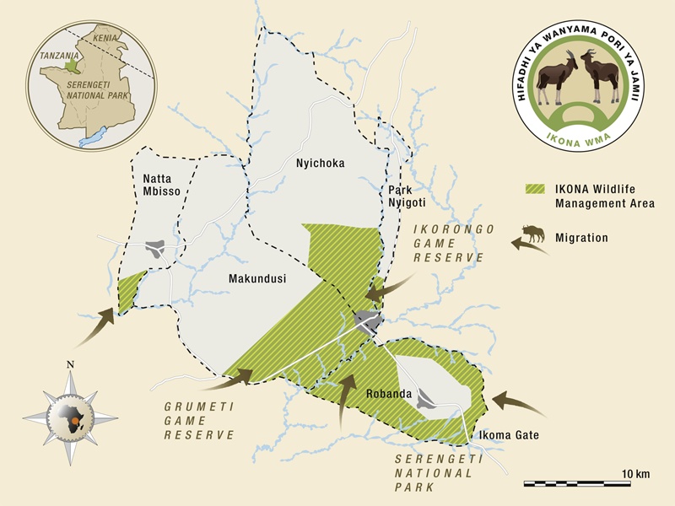
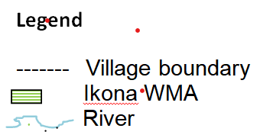
Figure 3.1: Location of Ikona WMA
Source: The General Management Plan for Ikona WMA, 2017

Research Design
A research design refers to the scheme that assists the scholar to identify the types of data to be gathered from the study area, the origin of information and the methods for collecting information (Petzer, 2016). The cross-sectional research design was the method of choice for this study. This design did not require follow-up and therefore was less costly and quicker than other designs (Mills & Wiebe, 2010; Kesmodel, 2018). It is the form of observational study which analyses demographic data or demonstrative subsection at a certain time. In addition, cross sectional design becomes more relevant when carrying out a study whose purpose is to explore ambiguity concept, challenge or outlook of which this study is among them. In addition, the cross-sectional design enables the scholar to make decision regarding the phenomenon to be explored, determine the targeted population and sample size within a limited time and resources (Kothari, 2004). With regard to this study, the researcher used both qualitative and quantitative research approaches. Qualitative research comprised information that was in the form of text, image, picture, words and stories. This approach allowed close interaction between the researcher and participants in the study area thus helping to get a bigger picture and create a room for getting deeper understanding on the concept (Ary et.al, 2017). Qualitative research approach allowed the use of multiple data collection techniques so as to obtain in-depth understanding of the phenomenon.

Quantitative research approach involved collection of data in the form of numbers and these numbers could be presented in mathematical or statistical means and this data was analyzed and quantified using Statistical Package for Social Sciences (SPSS Version 20) and Microsoft Excel. The reasons behind the use of both qualitative and quantitative approaches were based on the fact that the nature of the study comprised descriptive and numeric data. In order to address successfully the three research objectives qualitative and quantitative approaches were employed.

Target Population
Kothari (2004) defined target population as a precise or set of people, elements, services and events, collection of items or families that are explored. Yount (2006) suggests that since it is difficult to access the entire components a target population it is necessary to select a certain amount of the population that is reachable. The availability of time and resources are the determining factors for the structure of population that can be reached by the scholar. The target population for the study included the community members living adjacent to Ikona WMA and leaders of the Ikona WMA. Other target population included Serengeti District Officers (District Game Office, District Community Development Officer, and District Tourism Officer) and Village Government Officers (Village Chairman, Village Executive Officer and Ward Executive Officers).

Sampling Procedures
A two-stage sampling technique was adopted to select the sampling units. The first stage involved purposive sampling (non-probability) to select three villages from a total of five villages forming Ikona WMA. In addition, Ikona WMA leaders, Village Government Officers and participants for focus group discussion were purposively sampled. The selection of the Ikona WMA leaders and Village Government Officers was based on their positions and roles they played in the management of WMA and tourism. The second stage involved simple random sampling (probability) to select community members for the questionnaire survey. The community members consisted of villagers who had no leadership role in the village governments or WMA but who derived benefits from tourism activities taking place in the WMA, directly or indirectly.

Purposive Sampling Technique
Gibson and Brown (2009) states that, purposive sampling describes the process of selecting research participants on the basis of their relevance to the research. The purpose in mind is the most significant criterion when considering employ purposive sampling and only people of interest are selected and ignoring those whom may not be of interest (Cohen et al., 2000). The study engaged purposive sampling by considering the appropriateness of the respondents in terms of information, experience, insights and knowledge in tourism and effect of COVID-19 on tourism dependent communities. The key informants that included Village Executives Officer, Ward Executive Officers, District Game Officer, District Community Development Officer, Ikona WMA leaders and Village Game Scout were obtained with the help of purposive sampling technique. These groups of participants were potentially required to have adequate knowledge regarding the effect of COVID-19 on tourism undertakings. The accessibility of respondents involved visiting their working places and offices.

Simple Random Sampling
A sample is a subset of a population in which all members of a population has equal probability of being chosen (Sekaran, 2003). Simple random sampling was employed in selecting sample; each member of the population had an equal chance of being selected as subject. The entire process of sampling was done in a single step with each subject selected independently of the other members of the population. One of the best things about simple random sampling was the ease of assembling the sample. It was also considered as a fair way of selecting a sample from a given population since every member was given equal opportunities of being selected. Therefore, the study chose 226 respondents from the communities randomly depending on tourism activities around Ikona WMA and 10 respondents randomly from Village Game Scouts (VGS) who were found in main gate and visiting information center of Ikona WMA. The probability sampling technique was used to choose heads of household in communities which had equal opportunity of being chosen and VGS found in the main gate at the time of survey.

Sampling Frame and Sample Size
Generally, the number of participants selected for a research entirely contingent to the kind of study involved; whether correlational, descriptive or experimental (Gay & Diehl, 1992). The sample size of 10% of population criterion is applied to descriptive research and where the population is small, the 20% may be necessary. The selection of 226 respondents is consistent with the suggestion of Mugenda and Mugenda (2003) who pointed out that a sample size of 10% to 20% of the total population is enough for the study. The use of sample size of 226 respondents in the study was also necessary considering the large information that was required by the study to form an informed opinion. The 226 respondents constituted 207 heads of households from Robanda, Makundusi and Nyichoka village, 2 Village Executive Officers and 1 Village Chairman from three villages. Others were 3 District Game Officer, 3 District Community Development Officer, 5 Ikona WMA leaders and 5 Village Game Scouts (Table 3.1).

Table 3.1: Sampling frame and sample size
S/N | Description | Population | Sample size
1 | Robanda Village (Heads of households) | 474 | 42
2 | Makundusi Village (Heads of households) | 1400 | 135
3 | Nyichoka Village (Heads of households) | 385 | 30
4 | Local Authority (Village Chairman, Village Executive Officers) for three villages | 6 | 3
5 | Village Game Scouts | 25 | 5
6 | Ikona WMA leaders (Chairman, Secretary, Accountant, Protection Officer) | 25 | 5
7 | District Game Officer | 5 | 3
8 | Community Development Officer | 5 | 3
 | Total | 2325 | 226
Sources: Researcher computations, 2022

Sources of Data
This section is comprised of secondary and primary data sub-sections which describes the sources data.

Secondary Data
According to Kothari (2009), the secondary data is defined as data available in the document or literature. Secondary data was be obtained from books, journals, e-libraries and official reports from the Village Executive Officer (VEO), Ikona WMA leaders and District Game Officer. The data collected includes the following: population size and structure (sex and age classes); area of village land; price range per unit of various types of crops; types and number of livestock; tourist arrival; employment opportunity; project supported by Ikona WMA; benefit sharing scheme distributed.

Primary Data
Primary data refers to information that can be gathered afresh from the field study area for the first time (Kothari 2009). In this study, primary information were drawn with the help of questionnaire and interview guide as a tool for data collection.

Data Collection Methods
Data collection refers to the process of obtaining evidence in a systematic way to ascertain answers to the research problem (Cohen et al., 2011). The data were collected by using survey household questionnaires, key informant interviews, focus group discussion, observation and documentary literature review in this study.

Survey Household Questionnaire
Questionnaire refers to a document consisting questions and other kinds of information intended to gather information that are necessary for analysis (Babbie, 1990). Household questionnaire was administered to female-headed households and male-headed households. Both closed and open-ended questions were used. A research question is firmly constructed to receive answers related to the chosen variables for analysis.

Focus Group Discussion
Focus group discussion (FGD) is defined as a structured discussion with a small group of people, run by a facilitator or using a moderating team, to generate qualitative data on a precise topic of interest, using a set of open-ended questions (Masadeh, 2012). FGD was conducted to gather information from different groups of male and female, boys and girls, employees, village game scouts and tour guides. As recommended by Walter (2006), each group comprised of a small group of 6 people for effective FGD. FGD captured information on the existing livelihoods and income portfolios and income-generating activities associated with tourism.

Key Informant Interviews
Key informants (KIs) interviews were adopted in this study to seek insight views, suggestions and recommendations from the key respondents regarding the effect of COVID-19 pandemic on the tourism dependent communities around the Ikona WMA. In this study, a face-to-face interview was conducted to obtain and record information from the respondents. The KIs included village leaders in each selected village, WMA leaders, Village Game Scouts (VGS), District Game Officer (DGO) and Community Development Officer (CDO). Guiding questions were used to collect this information from key respondents (Appendix II). This method was used because it provided information from knowledgeable people, gave opportunity to explore unanticipated ideas due to free-exchange of ideas and the method was inexpensive and easy to conduct.

Observation
Observation implies the collection of information by way investigator’s own observation, without interviewing respondents (Kothari 2004). The information obtained related to what was happening and was not complicated by either the past behaviour or future intentions or attitudes of respondents. In this study, observation was done in the study area and saw how tourism activities were conducted and facilities available. This study used observation guide or check list, which helped researcher to observe the role of tourism to the livelihood of communities. The researcher observed the tourism activities and their participation in terms of business, transportations, accommodation and employment opportunity.

Documentary Literature Review
Documentary literature review provided the secondary data or second-hand information. The researcher employed the documentary sources of data so as to have a thorough understanding of the past, present and predict the effect of COVID-19 on communities depend on tourism for their livelihood.

Data Analysis, Interpretation and Presentation
Data analysis means to organize, provide structure and elicit meaning. According to Rwegoshora (2014), data analysis involves ordering of data into constituent parts was obtain answer to the research questions. Quantitative data from structured and semi-structure questionnaires were posted into Microsoft Excel 2020 for analysis. This Microsoft Excel 2020 enabled the analysis for descriptive statistics including mean, frequencies and percentages. Findings were presented and summarized in tables and figures. Content analysis was used for qualitative data collected through KIs and observation. The qualitative data were used to triangulate findings from the quantitative data. Qualitative was presented using narratives.

Validity and Reliability of the Research Instruments

Validity of the Research Instruments
Validity is the capability of the tool to quantify the necessary phenomenon (Sekaran, 2003). Similarly, Ary (1996) referred to validity as the worthiness that an instrument applies in the study in correct and expressive manner. In this study, validity was ensured by collecting information necessary to measure the outlined specific objectives, the sample size in the demonstrative target population. The validity was also ensured by using observation and regular review of information. In addition, the study retained nonjudgmental position as much as possible throughout the study process. The study was carried out precisely and the results were reported in the fairest way. The validity was further ensured by designing questions that were dedicated to the effect of COVID-19 on households’ income of tourism dependent communities, which were not only simple but also short and clear and could be accurately comprehended by the respondents. Furthermore, the interviews were conducted on local government authority and village leaders so that the right, accurate, correct and detailed data associated with the effects of COVID-19 on households’ income of tourism dependents communities around the Ikona WMA was obtained. Research process and data collection tools were planned regularly so as to retain validity of the research. Easily understood questions in the questionnaire and clear questions in interview guide led to the findings which could not alternate frequently upon being re-tested given similar environment and subject matter.

Reliability of the Research Instruments
Reliability is the effectiveness of an instrument applied in the study to yield unchangeable result over a certain time. Reliability is defined as the extent to which there is unfailing extent of the tool (Sekaran, 2003). Silverman (2007) stipulates that, reliability is concerns whether different scholars get equivalent results regarding the same instrument administered by other researchers at given time period. Reliability relies on the on consistent of study process or tool. Reliability is degree to which study outcomes are deemed to be similar over time if a research is carried out was conducted with different samples subject (Bryman, 2012). The most significant issue here is that the results of the instruments are consistent regarding a certain phenomenon within a period of time. Data was collected from Ikona WMA leaders, District Game Officer, Villages leaders, Communities from three villages and Community Development Officer. Moreover, the data were reviewed by the study in order to make sure that the reliability is maintained. In this study, the instruments’ reliability was ensured by applying triangulation of the data method. Triangulation refers to the process of combining data sources or techniques such as interviews, documents and observation in order to understand a research question from various points of views (Ary et al., 2010). In this study triangulation of the data was done by combining three major data collection methods that was questionnaire, interviews and FGDs. This provided the researcher with flexibility in answering the research problems (Creswell, 2015). By so doing, the researcher allows complementarities between among the three methods (Creswell, 2015). Furthermore, to ensure reliability of research, the instruments, that is questionnaire and interview guide was administered twice to the same group of subjects to establish whether the same results can be obtained with a repeated measure of the same attribute.

Ethical Consideration
Ethical values in conducting research constitute obtaining research permission, pursuing consensus from research participants and privacy of respondents’ data (Morrison, 1993). A researcher follows ethical values of research because he/she conducts research which should safeguard the rights of societies in the study area and should seek the acceptance of participants and confidentiality of those not willing to be interrogated in the public. In light of above, researcher had to get clearance letter before conducting research. The questionnaire and interview guides contained part of introduction section that required respondent’s willingness to provide the data and ensure the data collected were treated confidentiality.

Chapter Summary
Chapter broadly constitutes the research methodology study, which covers the research design, research approach, area of study, population of the study, sampling procedures and sample size. The chapter shows that the study employed cross sectional research design and engaged both qualitative and quantitative research approaches. It is also shown that the study was conducted at Ikona WMA in Serengeti District, Mara region which had a population of 2325 people from which a sample of 226 respondents were selected by using both purposive and random sampling techniques. Other components of chapter three are data collection methods which included FGD, questionnaire, interview, observation and documentary review. Finally, the chapter further includes data analysis, validity and reliability of the research instruments and ethical considerations.

CHAPTER FOUR

RESULTS AND DISCUSSION

Introduction
This chapter provides the results acquired from the respondents by using household questionnaires, focus group discussions, key informants’ interviews, site observations and documentary literature review on effects of COVID-19 pandemic on the household income of tourism dependent communities in the area of destination. The chapter start with characteristics of the respondents, presentation of data collected, analysis and discussion.

Characteristics of the Respondents
Parameters examined in this study were gender, age, level of education, marital status and occupation of the respondents.

Age of the Respondents
Respondents with different age categories were noted through analysis and assessment. The majority of the respondent, 31.9% were at the age group of 30-39 years while only few (4.4%) were of the age 60 years and above (Table 4.1). The COVID-19 disease, in itself has hit older adults harder than other age groups because of weak immune system compared to young adults (WHO, 2020). The young adults were active for the economic development but due to social distance, avoiding crowded areas, keeping distance and decline in number of tourists makes them lose jobs. This further implies that the majority of respondents, who also happened to be members of communities which were tourism dependents, was in the youthful age and could endure the changes in whether in different tourism destinations.

Table 4.1: Age of the respondents
S/N | Age | Respondents | Percentages
1 | 18-29 | 42 | 18.6
2 | 30-39 | 72 | 31.9
3 | 40-49 | 65 | 28.8
4 | 50-59 | 37 | 16.4
5 | 60 and above | 10 | 4.4
Total |  | 226 | 100
Source: Field Survey, 2022

Gender of the Respondents
Majority of the respondents, 57.1% were males while 42.9% were females (Table 4.2). This gender categorization was done based on head of household. Results implied that males constituted the head of household as it is in many African families. Having the knowledge of the respondents’ sex was of paramount importance because the benefits accrued from tourism activities are enjoyed by both males and females of different ages and the impacts affect everyone directly and indirectly regardless of the gender. The finding further implies that tourism dependent communities had more males than females since males were needed to work as porters, the jobs that females were always reluctant to be involved.

Table 4.2: Gender of the respondents
S/N | Gender | Respondents | Percentages
1 | Male | 129 | 57.1
2 | Female | 97 | 42.9
Total |  | 226 | 100
Source: Field Survey, 2022

Marital status of the Respondents
The data collected from the field showed that 65.9% of respondents were married and few (2.2%) were divorced (Table 4.3). The majority of respondents were married, this shows that family is one factor which influenced people to engage in various economic activities for earning income and care the family. Knowledge of marital status of respondents was necessary since it would enable the study to determine the extent to which COVID-19 affected the income of community member either family wise or individually.

Table 4.3: Marital status of the respondents
S/N | Marital Status | Respondents | Percentages
1 | Single | 41 | 18.1
2 | Married | 149 | 65.9
3 | Widow | 16 | 7.1
4 | Separated | 15 | 6.6
5 | Divorced | 5 | 2.2
Total |  | 226 | 100
Source: Field Survey, 2022

Education Level of the Respondents
Education serves as development and a tool for making decision of individual perceptions of intercession before decision is made. Comprehensive knowledge of levels of education of respondents was a significant issue for evaluating their knowledge and skills for determining various issues. Study shows that most respondents obtained primary education 47.3% and least (5.3%) had attained University education (Table 4.3). Since 10.2% of total respondents had attained college education and 5.3% had attained University education implied that the study would benefit from informed respondents who would provide more reliable data regarding the effects of COVID-19 on the households’ income. Furthermore, the high number of respondents being the primary school leavers implied that the tourism dependent communities were mainly lowly educated and these would benefit the industry by providing cheap labour.

Table 4.4: Education level of the respondents
S/N | Education level | Respondents | Percentages
1 | University education | 12 | 5.3
2 | College education | 23 | 10.2
3 | Secondary education | 36 | 15.9
4 | Primary education | 107 | 47.3
5 | Non-formal education | 48 | 21.2
Total |  | 226 | 100
Sources: Field Survey, 2022

Occupation of the Respondents
Majority of respondents (42.5%) practices farming food and cash crops while minorities (9.7%) were employed/civil servants (Table 4.5). Findings showed that very few communities engaged in tourism activities directly, but they depended on tourism activities for selling livestock products like milk, meat and cows. Respondents practice farming in order to sell vegetables and fruits. Other respondents were supplying foods and beverage to camps and lodges as small business for generation income for their households. The finding further indicated that most respondents were self-employed and the outputs of their labour were directed towards tourism market hence being dependent on tourism activities.

Table 4.5: Occupation of the respondents
S/N | Occupation | Respondents | Percentages
1 | Farming (food and cash crops) | 96 | 42.5
2 | Livestock Keeping | 42 | 18.6
3 | Small Business | 66 | 29.2
4 | Employment | 22 | 9.7
Total |  | 226 | 100
Source: Field Survey, 2022

Effects of COVID-19 Pandemic on the Households’ Income of the Communities around the Ikona WMA
The assessment of effects of COVID-19 pandemic on households’ income was done by using the actions that were employed by the employers to tackle the effects of COVID-19 on their businesses. Some of the actions employed by the employers included sending employees on unpaid leave and compulsory leave, closing businesses and subjecting employees to few working hours.

Effects of COVID-19 Pandemic On Household’s Income
During COVID-19, most communities around the Ikona WMA had their income decline compared to pre-COVID-19 period (Figure 4.1). About 40% of the respondent experienced a decline of their income from Tshs.101,000-150,000 to Tshs.51,000-100,000, while 17% of the respondents experienced a decline of their income from Tshs.151,000-200,000 to Tshs.101,000-150,000. This implies that during the COVID-19 pandemic, the income of the tourism dependent communities around Ikona WMA tremendously declined. The respondents attributed the decline of their income to the actions that were taken by employers to address the effect of COVID-19 pandemic such as sending them on unpaid leave and compulsory leave, closing businesses and subjecting them to few working hours.

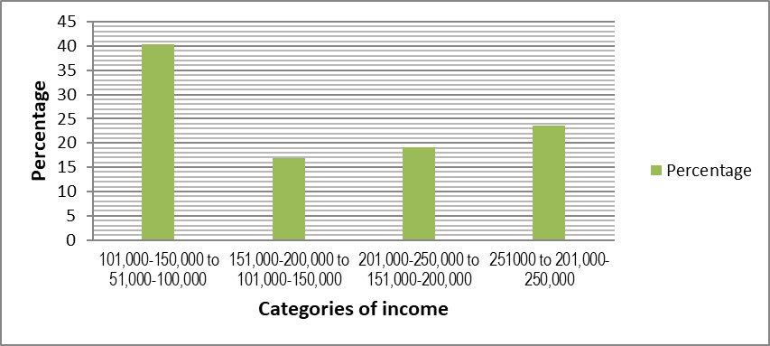
Figure 4.1: Effects of COVID-19 on the household income
Source: Field survey, 2022

About 16.7% of respondents attempted to elaborate on the effect of COVID-19 pandemic on the households’ income. During the interview with Village Game Scouts (VGS) one of them said:
“During COVID-19 pandemic, decline in the income was unavoidable. For example, I used to earn slightly above Tshs.200,000 per month but following the outbreak of COVID-19, my income dropped to almost Tshs.100,000. Pre COVID-19 we used to be paid on times our salaries and allowance but during the pandemic things went difficult following of decline in revenue collection in Ikona WMA”.

Also, Village Executive Officer said that:
“There was no member in the household whose income never declined saves for the civil servants. The collapse of some businesses and reduction of the number of tourists in the area generally led to the decline of household income for the tourists’ dependent communities”.

The decline of revenue of employers forced them to send employees on compulsory leave, unpaid leave or engaging employees for fewer hours per day and closure of business as result of COVID-19 pandemic. Out of 226 respondents, 26.6% had their businesses closed while 22.4% experienced fewer hours of working (Figure 4.2).
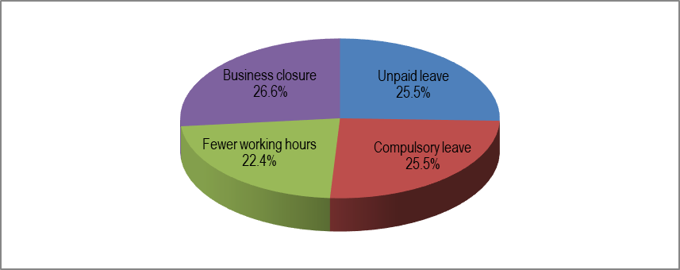
Figure 4.2: Effects of Covid-19 on tourism dependent communities
Source: Field survey, 2022

Employees’ unpaid leave
During the COVID-19 pandemic, employees were either permitted to take unpaid leave or employers issued a mandatory unpaid leave so as to lower company expenses during a difficult economic period customized by the pandemic. In other words, the COVID-19 pandemic had a devastating effect on the tourism and hospitality industries in Ikona WMA, causing some companies to place their employees on unpaid leave. Placing employees on unpaid leave in turn negatively affected the households’ income since they had to engage in other income generating activities which enabled them to earn lower income than they earned from their former jobs.

Focus Group Discussion (FGD) held in Nyichoka village identified some of the alternative jobs that were done by those who were on unpaid leave. Some of the alternative’s jobs included market gardening, poultry farming, motor cycle riding business, food vending, and fruits and vegetable vending. At the beginning of FGD it was difficult to state the alternative jobs that were done by the people who were on unpaid leave, however, eventually the consensus was reached and the alternative jobs noted by following criteria or conditions shown in Table 4.6. It was difficult to continue with the discussion until a consensus was reached. After setting the criteria, the participants in the FGDs listed all the alternative jobs that were readily found in Ikona WMA.

Table 4.6: Criteria for alternative jobs done by the employees on unpaid leave
S/N | Criteria | Ranking
1. | Low initial capital required for investment | 1st
2. | Free entry and exit | 2nd
3. | No elaborate government requirements | 3rd
4. | Does not require any academic qualifications | 4th
Source: Field survey, 2022

About 51.7% of the respondents sent on unpaid leave reported that they got engaged in the market gardening while 1.7% worked as food vendors (Figure 4.3). Furthermore, the results indicated that the mean score of respondents’ responses was 4.2 out of 5 implying that COVID-19 pandemic had highly lowered the income of the respondents following the action of being sent on unpaid leave.
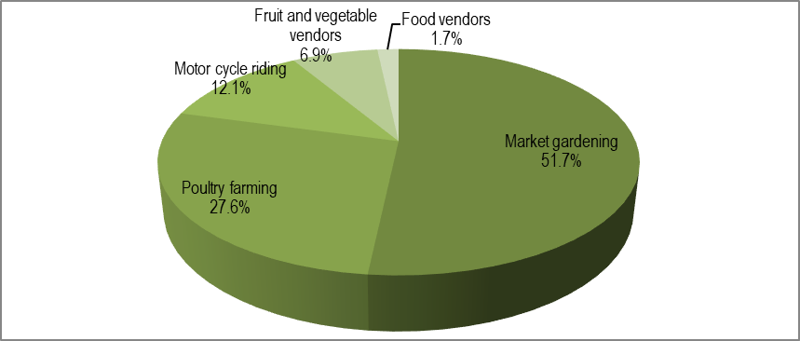
Figure 4.3: Alternative jobs done by respondents who were on unpaid leave
Source: Field survey, 2022
During the interview session, the Village Executives Officers and Ikona WMA Leaders elaborated on the outcome of being on unpaid leave as result of COVID-19 pandemic, one of the Ikona WMA leaders stated that:
“During the COVID-19 pandemic, we did not have any alternative source of income other than sending some employees on unpaid leave so as to enable our firm to cope up with setbacks and re-balance budget”.

The Village Executive Officer stated that:
“COVID-19 pandemic set an attempting moment worldwide. We were surprised to see even those who were working in good hotels and tour firms embark on food, fruit and vegetable vending. Let alone those who decided to work as motor cycle riders and poultry farmers”.

Employees’ compulsory leave
One of the common occurrences in the tourism sector is for the employer to send permanent employees on compulsory leave during the close of a season, commonly known as low season. Compulsory leave is defined as approved leave with or without pay, or a combination of such leave, not to exceed the duration of the illness/injury or one year, whichever is less (Law Insider, 2023). During the COVID-19 pandemic some of employers sent the permanent workers on compulsory leave for a period that could not be determined.

Focus Group Discussion (FGD) held in Robanda village identified forms of income that the employees who were sent on compulsory leave missed and in turn lowered their regular income. Some of the identified income that the employees who were sent on compulsory included commuting allowances, communication allowances, customer tips, hardship allowances and conferences, seminar and workshop allowances. It was not easy to determine what actually constituted the income that was lost by the employees who were sent on compulsory leave until the participants reached a consensus regarding the criteria. Table 4.7 illustrates the criteria for determining the income that the employees lost when they were sent on compulsory leave following the outbreak of COVID-19.

Table 4.7: Criteria for income lost by the employees sent on compulsory leave
S/N | Criteria | Ranking
1. | Earned on monthly daily or monthly basis | 1st
2. | Directly associated with the job for which an employee has been sent on compulsory leave | 2nd
3. | It substantially lowers the income of an employee sent on compulsory leave | 3rd
Source: Field survey, 2022

Majority of the respondents (41.3%) indicated that their income was lowered by the amount of family allowances that they were not paid during the period they were on compulsory leave while few (1.7%) reported that the income dropped because of failure to attend conferences, seminars and workshops during the outbreak of COVID-19 (Figure 4.4).
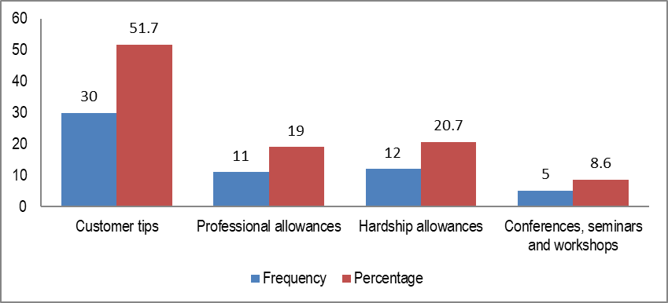
Figure 4.4: Allowances that were not earned by employees on compulsory leave
Source: Field survey, 2022
The respondents’ views implied that COVID-19 pandemic led to employees being sent on compulsory leave hence causing the decline in the income of employees and in turn the households’ income. Furthermore, the results indicate that the mean score of respondents’ views was 4 out of 5 implying that COVID-19 pandemic had highly lowered the income of the respondents following the action of being sent on compulsory leave.

One of the Village Executive Officer who were interviewed said that:
“Employees in the tourism industry are used to being sent on compulsory every year when the tourism sector experience low season but during the COVID-19 pandemic, it was quite different in the sense that they were just tending to high season before they were immediately served with memos to go on leave. Another difference is that this time it was indefinite as compared to other years”.

The Ikona WMA Leader had this to say:
“Although their salaries kept on flowing into their bank accounts as they continued being on compulsory leave, they missed some of the allowances that could boost their income such as holiday allowances and hardship allowances”.

Employees’ Fewer Hours of Working
The variability of work hours contributes to income instability and thus, adversely affects not only household consumption but also macroeconomic performance. Employees who work irregular shift times, in contrast with those with more standard, regular shift times, experience greater loss of income, and sometimes experience greater work stress.

The Focus Group Discussion (FGD) held in Robanda village attempted to categorize the ‘fewer working hours. Five categories of ‘fewer working hours’ were identified as 1-2 hours, 3-4 hours and 5-6 hours. Other categories were 7-8 hours and 9-10 hours. It was very difficult to determine the categories of working hours until the consensus was reached by establishing the criteria for determining ‘fewer working hours. Table 4.8 shows the criteria that were used to determine the categories of ‘fewer working hours.

Table 4.8: Criteria for working fewer hours
S/N | Criteria | Ranking
1. | Employee has work for less than statutory working hours of 8 | 1st
2. | Permanent employee earns full salaries and casual labourers are paid on hourly basis | 2nd
3. | Employee can either be casually or permanently employed | 3rd
4. | It may have indefinite period | 4th
Source: Field survey, 2022

Among the respondents who noted that they were working for fewer hours during COVID-19 pandemic, the majority of respondents (39.2%) of them reported to have worked for 3-4 hours while few (5.9%) respondents reported to have worked for 5-6 hours during COVID-19 pandemic (Figure 4.5). The respondents’ views implied that COVID-19 pandemic caused various firms to engage employees for fewer working hours hence causing the decline in the households’ income. Furthermore, the findings indicate that the mean score of respondents’ views was 3.6 out of 5 implying that COVID-19 pandemic had highly lowered the income of the respondents following the action of employers to engage workers for fewer hours. Working for fewer hours generally meant that the earning per day also dropped something that ended up negatively affecting the households’ income.
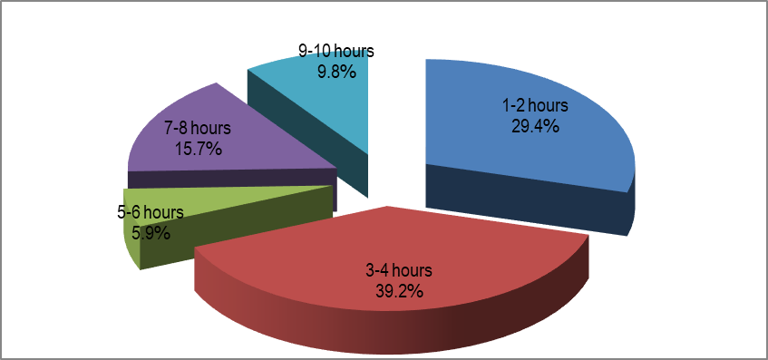
Figure 4.5: Effect of COVID-19 on employees’ working hours
Source: Field survey, 2022

The respondents from Ikona WMA Leaders and the Village Executive Officers attempted to inform the study on whether COVID-19 led to employers to engage employees to work for fewer hours. The respondent from Ikona WMA Leader stated this:
“During COVID-19 pandemic, 10% of the workers were assigned to irregular and on-call work shift times which led to unstable work shift schedules”.

Another respondent from Ikona WMA Leader said that:
“Those employees who were working for few hours during the COVID-19 really had a huge decline of their income considering the fact that their term of employment was ‘causal’. The impact of this engagement on their income was so much devastating”.

Business Closure
Business closure is the termination of the main activity of the business. During COVID-19 pandemic, some of the businesses were closed down as a result of the low demand for their services and goods or when the tourists’ arrivals were restricted. The FGD meeting held at Robanda village had one of contested issues of categorizing the types of ‘business closure’. The participants resolved that ‘business closure’ could be categorized into permanent closure, temporary closure, closed for few hours per day, closed for several hours per day and closed some sections (Figure 4.6). The other significant issue that the participants encountered was to reach a consensus on the criteria for categorizing the ‘business closure’. Table 4.9 shows the criteria that were used to determine the categories of ‘fewer working hours’.

Table 4.9: Criteria for categorizing business closure
/N | Criteria | Ranking
1. | Experience very long shut down | 1st
2. | Opened for less than regular hours | 2nd
3. | Some sections not functioning regularly | 3rd
Source: Field survey, 2022

The study found that during COVID-19, 46.7% of the total business ventures were reported to have been permanently closed while 1.6% business venture were closed for several hours per day (Figure 4.6).
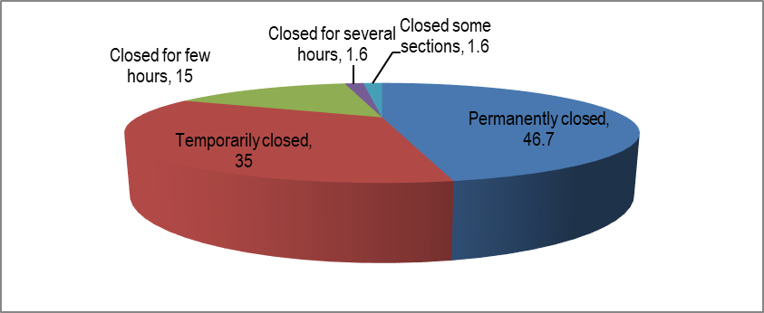
Figure 4.6: Effect of COVID-19 on business operations
Source: Field survey, 2022
The respondents’ views implied that COVID-19 pandemic caused several business ventures to close down leading to some workers either being sent on unpaid leave, compulsory leave or work for fewer hours. This in turn caused the workers to loss some income hence leading to the general decline in the households’ income. Furthermore, the results indicated that the mean score of respondents’ views was 4.2 out of 5 implying that COVID-19 pandemic had highly lowered the income of the households following the closure of several businesses. Further interviews that were conducted in Robanda village indicated that some of the tourism related businesses were abandoned during the COVID-19 pandemic and one of them was Robanda tented camp (Figure 4.7)
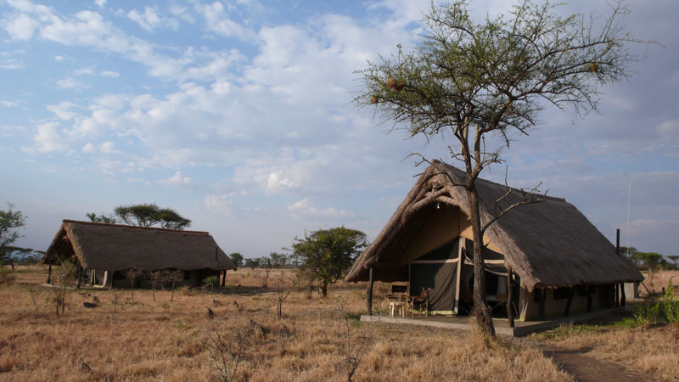
Figure 4. 7: Abandoned Robanda tented camp during COVID-19 pandemic
Source: Field survey, 2022

The interviews that were conducted with Village Executive Officer (VEO), District Game Officer (DGO), and Community Development Officer (CDO) aimed at establishing whether COVID-19 caused the closure of businesses and ultimately the decline of households’ income. The Village Executive Officer stated that:
“Most businesses such as hotels were affected due to low number of guests and most of the guests were equally affected economically and therefore, they could not afford the price charges for some hotel services. All these events caused the reduction of income among the community members”.

Also, the District Game Officer said that:
“Generally, there were no customers during COVID-19 and the employees were either sent on compulsory leave or simply retrenched. The retrenchment of employees led to most services being stopped and some of the services were being rendered below the capacity”.

Another Community Development Officer said that:
“The tourism activities which taking place at Ikona WMA stimulates other business activity like Bar/Grocery, Restaurants and agriculture and livestock products”.

The Effects of COVID 19 Pandemic on Labour Demands of the Tourism Dependent Communities around the Ikona WMA
Analysis of the effects of COVID-19 pandemic on labour demands of tourism dependent communities around the Ikona WMA was done with help of loss of jobs, reduced wages and delayed salary payment.

Loss of Jobs
Job loss refers to a cessation of engagement consequential from company reorganization or restructuring, work reorganization, decrease in force, subcontracting or replacement of works by technology. Nonetheless, during COVID-19 pandemic most employees were laid-off due to the low demand of their services which ultimately saw the reduction of household’s income of tourism dependent communities. For instance, before the emergence of COVID-19 pandemic, Wasinde Pub had 3 waiters and during COVID-19, they were reduced to 1; Moivaro Ikoma Tented Camp had 24 workers only to reduce them to 4 and 10 of them completely lost their jobs; and Well Worth Hotel and Lodge Limited had 18 employees only to dismiss 8 and remained with 12.

Focus Group Discussion (FGD) held in Robanda village identified some of the tourism enterprises whose employees lost jobs. Indeed, the entire group acknowledged the fact that most employees who worked in tourism dependent ventures lost their jobs. Some of the identified enterprises included hotels and lodges, tour firms, curio shops, cultural heritages and game hunting companies. It was not an easy task to identify the category of tourism enterprises whose employees lost jobs until the participants reached a consensus regarding the criteria. Table 4.10 illustrates the criteria for determining the category of tourism enterprise whose employees lost jobs following the outbreak of COVID-19.

Table 4.10: Criteria for categorizing tourism enterprises
S/N | Criteria | Ranking
1. | Job losses was due to low demand for workers’ services | 1st
2. | Enterprises purely survived on tourism | 2nd
3. | Employees being recalled back upon the demise of COVID-19 | 3rd
4. | Most employees were from tourism dependent communities | 4th
Source: Field survey, 2022

When the respondents who had lost their jobs as result of COVID-10 outbreak were asked the category of the tourism enterprises they used to work for, 42.5% of the respondents reported that they worked for hotels and lodges while 4% indicated that they worked for game hunting companies (Figure 4.8).
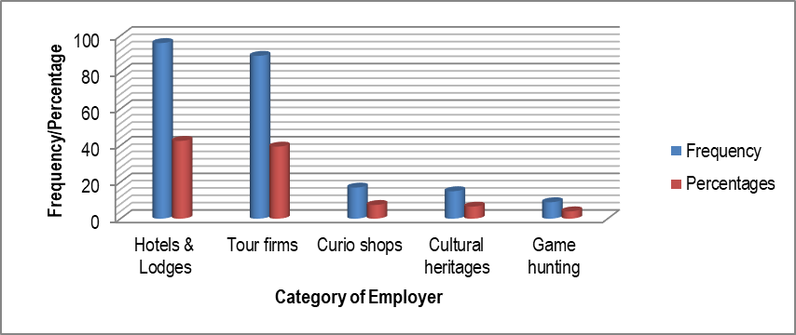
Figure 4.8: Effects of COVID-19 pandemic on loss of jobs
Source: Field survey, 2022

The respondents’ views implied that COVID-19 pandemic caused various tourism enterprises to terminate the duties of their employees hence causing the decline in the households’ income. Furthermore, the findings show that the mean score of respondents’ views was 4.1 out of 5 implying that COVID-19 pandemic had highly lowered the income of the respondents following the action of employers to dismiss their employees. The loss of jobs implies that the earnings of employees suddenly come to a halt something that ended up negatively affecting the households’ income.

The interviews that were conducted with District Game Officer (DGO), Community Development Officer (CDO) and Ikona WMA Leader aimed at establishing whether COVID-19 led to job losses and ultimately decreasing the household’s income.
The District Game Officer stated that:
“During the outbreak of COVID-19 there was wide spread retrenchment in most enterprises including hotel industry, tour firms, and cultural centres where staff were sent on leave without pay hence reduction on the employees’ income”.

Community Development Officer said that:
“Other than losing their jobs, some employees are now experiencing poor health and some have lost lives as well as their beloved ones most likely due to stress and depression”.

Ikona WMA Leader said that:
“During lock down of zero arrivals, as a service tour firm was highly affected by the virtue of being labour intensive as the call for mass layout cropped in. Besides, there was a decrease in the workload, reduction in medical and transport allowances”

Reduced Wages
Pay reduction refers to action employed for corrective causes in which a worker’s pay rate is deducted but the worker still retains his/her job. In the context of this study, reduced wages of employees were not necessary as a result of disciplinary actions but as a way of enabling the firm to cope up with the rising cost of operations and minimum demand for its services.

Focus Group Discussion (FGD) held in Makundusi village reached a consensus that some of the casual workers accepted to work for lesser pay than usual following the reduction of their wages. This resulted to some difficulties considering the fact that even the public were not allowed to freely interact as a precaution against the spread of COVID-19. Arriving at a consensus among the FGD participants was not easy particularly in concluding that indeed an employee had his/her wage reduced until the criteria was established (Table 4.11).

Table 4.11: Criteria for reduced wages
S/N | Criteria | Ranking
1. | The reduction should be from the regular daily income | 1st
2. | Employee must have been earning the reduced wage three months before the outbreak of COVID-19 | 2nd
3. | Reduction should be substantial enough to be regarded as a reduction | 3rd
4. | The reduction of 100% and above would be regarded as real reduction | 4th
Source: Field survey, 2022

In this study, majority of respondents (45.1%) whose wages were reduced during COVID-19 reported that their daily wages decreased from Tshs.8000 to Tshs.7000 while 4.4% of the respondents indicated that their daily wages decreased from Tshs.4000 to Tshs.3000 (Figure 4.9).
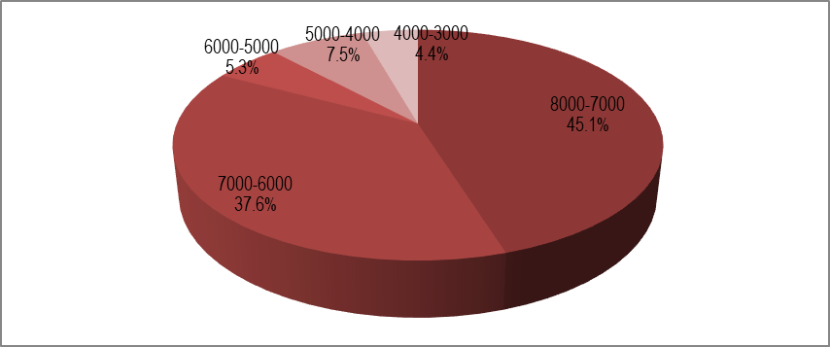
Figure 4.9: Effects of COVID-19 pandemic on reduced wages
Source: Field survey, 2022

The respondents’ views implied that COVID-19 pandemic led to the reduction of wages of several employees, which in turn lowered the households’ income. The results further indicate that the mean score of respondents’ views was 4 out of 5 implying that the respondents’ wages were highly reduced due to the outbreak of COVID-19 pandemic, which ultimately lowered the income of the respondents and households’ income. For instance, the Management of Ikona WMA overcame the scarce of revenue due to pandemic by reducing the allowance and number of working of days for VGS and Staffs but number of employees remained the same.

The interviews that were conducted with Hotel Manager, Village Game Scout (VGS) and Ikona WMA Leader aimed at establishing whether COVID-19 led to reduction of wages and ultimately decreasing the household’s income. This supported by Hotel Manager, who said that:
“Most causal labourers had to accept lower pay rate due to scarcity of jobs that emerged during the COVID-19 pandemic. As the hotel manager, I had to keep my hotel afloat. Even the outsourced services had to accept lower pays”.

The Village Games Scout (VGS) said that:
“Our daily earnings dropped so much that we could not meet some of the necessary bills including paying school fees for our on-going children. To make it worse even those who had food stored for seasonal use was exhausted”.

Another Ikona WMA Leader said that:
“Other than having our salaries delayed for six months, during the pandemic and VGS of Ikona WMA had their salaries reduced due to lose tourism revenue and the decline in the number tourists”.

Delay in Salary Payment
Delayed salary payment refers to those payments that the employee receives long overdue. During COVID-19 pandemic, due to loss of revenue among the enterprises, some of their employees’ salaries were paid in arrears. Participants of FGD meeting held at Robanda village, unanimously agreed that indeed delay in payment of salaries was one of the outcomes of COVID-19 pandemic. This escalated the sudden drop of income of most community members and it was attributed to low demand for the tourism related activities and products. It was equally not easy to arrive at a conclusion that there was a delay in salary payment during the outbreak of COVID-19 until the participants established the criteria for determining the delay in salary payments (Table 4.12).

Table 4.12: Criteria for determining delay in salary payment
S/N | Criteria | Ranking
1. | Any payment made beyond the mandatory 30 days of the month following the previous receipt of salary | 1st
2. | Incomplete receipt of the agreed amount of salary during the month | 2nd
3. | Any receipt of salary in arrears | 3rd
Source: Field survey, 2022

The study also revealed that 42.5% of the respondents reported that their salaries could delay for 7 to 8 months while few respondents (3.1%) reported that their salaries could delay for 3 to 4 months (Figure 4.10).
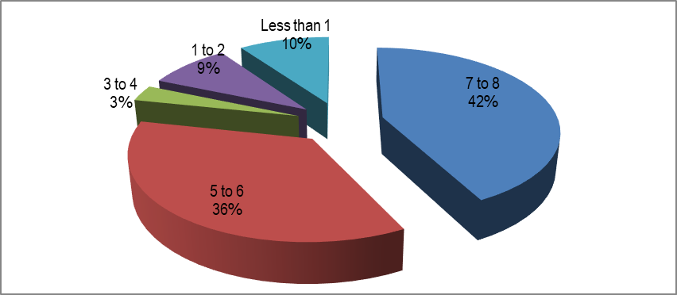
Figure 4.10: Effects of COVID-19 pandemic on delayed salary payments
Source: Field survey, 2022
Since the majority of respondents’ (42.5%) response to the question which sought to establish the length of the period which their salaries delayed indicated that salaries could delay for 7 to 8 months, the decline in the households’ income was actually the outcome of the outbreak of COVID-19. The findings further show that the mean score of respondents’ views was 3.9 out of 5 implying that the respondents were of the view that COVID-19 pandemic lowered the income of the respondents following the delayed salary payments.

The interviews that were conducted with District Game Officer, Village Games Scout and Ikona WMA Leaders aimed at establishing whether COVID-19 led to delayed salary payments and ultimately decreasing the household’s income. This statement was supported by DGO who said that;
“During the COVID-19 pandemic, it was usual to get salary delayed because some of us required negotiating with bankers to arrange for overdraft. This could take time since some of the banks were not certain when the pandemic could end”.

Ikona WMA Leader said:
“It was such a hard time particularly when we could go to work and only to come back without any pay. Sometimes, salary payments could delay as long as three months and even when it was paid we could get salary equivalent to one month only”.

Village Game Scout said that:
“For the 8 years I have been working with Ikona WMA as Village Game Scout (VGS), I have never experienced a situation which we went through during COVID-19 pandemic. During the pandemic we were not being paid on time. The salaries and allowance paid previously was eliminated and this made our life hard and also working days were reduced to 14 days instead of 30 days”.

The Effects of COVID-19 Pandemic on Small-Scale Enterprises
Examination of the effect of COVID-19 pandemic on small-scale enterprises of the communities around the Ikona WMA was done in consideration of three major variables, which included decrease in demand for tourism products/services, diminished operation capacity of tourism enterprises and changes in tastes and preferences of tourists.

Low Demand for Tourism Products/Services
Demand for tourism product or service is the willingness and ability of a tourist to buy a certain product/service at a given fee. During the COVID-19 pandemic, the issue was neither the willingness, ability nor price but the restrictions that various countries had imposed on travelling and interaction among the tourists and the local people. The restrictions included wearing facial mask, maintaining social distance, and regularly washing hands, among others. These restrictions, therefore, were not friendly to traders in small-scale enterprises.

FGD meeting held at Makundusi village, attempted to identify the features of the tourism products/services whose demand decreased as result of the outbreak of COVID-19. Some of the identified features were being natural attractions (wildlife, landscape), man-made attractions (resort), fixed property (accommodation), mobile property (motor vehicles) and natural or man-made conditions (weather, infrastructure). The participants in the FGD meeting had to develop criteria that guided them in identifying the features of the tourism products/services whose demand decreased as result of the outbreak of COVID-19 (Table 4.13).
Table 4.13: Criteria for identifying the features of the tourism products/services
S/N | Criteria | Ranking
1. | Intangible: product cannot be seen or inspected before its purchase (landscape) | 1st
2. | Psychological: the satisfaction derived by the tourists is purely psychological | 2nd
3. | Highly perishable: if a tourist cannot visit a particular place, the opportunity at that time is lost | 3rd
Source: Field survey, 2022

When the respondents were asked to indicate the feature of the products/service whose demand declined during the outbreak of COVID-19, 39.4% of the respondents reported that it was natural attractions (wildlife, landscape) while 6.2% of respondents showed that it was natural or man-made conditions (weather, infrastructure) as illustrated in Figure 4.11.
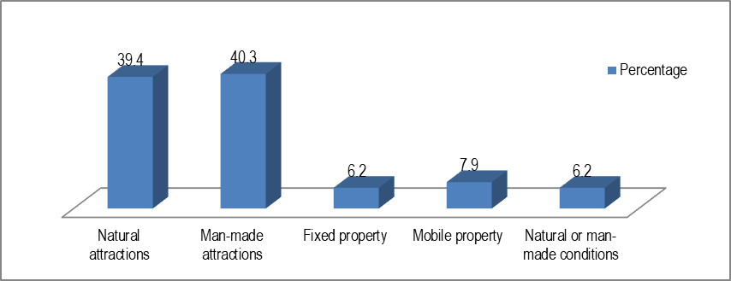
Figure 4.11: Effects of COVID-19 pandemic on tourism products/services
Source: Field survey, 2022

Since the majority of respondents’ (40.3%) response to the question which sought to establish the feature of product/service whose demand decreased was man-made attractions, the decline in the households’ income was actually the outcome of the outbreak of COVID-19. The results further indicate that the mean score of respondents’ views was 4 out of 5 implying that the respondents agreed that COVID-19 pandemic lowered the income of the respondents following the decrease in demand for tourism products/services.

The interviews that were conducted with District Game Officer and Village Games Scout aimed at establishing whether COVID-19 led to decrease in demand for the products/services and ultimately decreasing the household’s income. One of District Game Officer stated that:
“Business activities used to provide enough income for our communities, however, when COVID-19 pandemic emerged our government imposed some restrictions which included avoiding crowds, no shaking hands and emphasized on keeping social distance; something which made conducting of business very difficult and some community members reduced working hours to avoid a transmission of COVID-19 pandemic”.

Village Games Scout said that:
“During the COVID-19 pandemic, there was a devastating decrease in the number of customers and sometimes there was totally no demand at all for our products particularly those products that are highly preferred by the international tourists such as artifacts. Then there is no wonder that the income of most households has gone down”.

Low Operation Capacity of Small and Medium Enterprises
In Ikona WMA, small and medium enterprises were usually owned and managed by a single individual or small teams of people, had a physical location, were the sole employment, had small amount of initial capital and specialized in one sector of the economy. Besides, most of the SME around Ikona WMA were women-led businesses and fell under the informal sector, mostly in agriculture. During the COVID-19 pandemic, most of these businesses were forced to operate below the capacity due to low demand for their products/services. Capacity is the maximum level of output that can be produced by a company in a certain time period.
When the respondents were asked to indicate the business operation outcome that made them realize that they were operating below the capacity as result of outbreak of COVID-19, 68 respondents (30.1%) reported that employees remained idle most of the time while 8 respondents (3.5%) reported that there was reduced competitiveness (Figure 4.12).
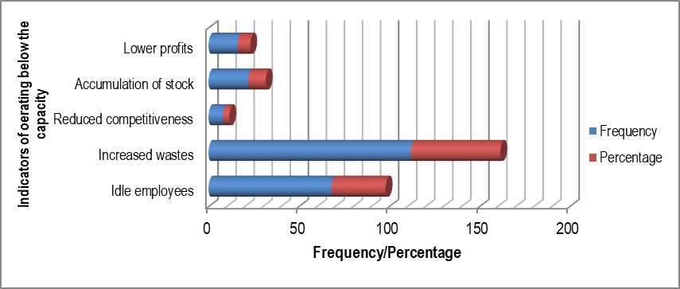
Figure 4.12: Effects of COVID-19 pandemic on production capacity of SMEs
Source: Field survey, 2022

Since majority of respondents (49.6%) indicated that wastes increased and significant number of respondents (30.1%) reported that there were idle employees, it implies that COVID-19 highly affected the production capacity of SMEs hence leading to the decline in households’ income. This was possible because most members of the tourism dependent communities owned small enterprises and therefore, low demand for their products/services would be reflected in the decrease in household’s income. The results further indicated that the mean score of respondents’ views was 3.9 out of 5 implying that the respondents were of the view that COVID-19 pandemic reduced operation capacity of SMEs of the respondents following the decrease in demand for tourism products/services.
The interviews that were conducted with District Game Officer and Ikona WMA Leader aimed at establishing whether COVID-19 reduced operation capacity of SMEs and ultimately decreasing the households’ income. One of District Game Officer stated that:
“The COVID-19 pandemic did not only lead to retrenchment of employees but it left most of the micro enterprises operation below the capacity. For instance, I know of a lodge which had 25 bed capacity and 5 family suites but during the pandemic you would hardly find 5 beds occupied and one family suite”.

Ikona WMA Leader said that:
“Most of the services rendered in lodges have had the wrath of COVID-19 ranging from housekeeping, food and beverage, pool terraces to conference rooms. The low demand for services and products means low income for the directors and households in totality”.

Variations in Tourists’ Tastes and Preferences
One of significant section of tourism management is the preference prediction of tourism destination. Therefore, precise forecast of tourism destination choice preference can develop effectiveness of tourism management. However, during COVID-19 pandemic, most tourists exhibited distinct differences in their tastes and preferences. Besides, regular washing and social distancing called for extra cost in managing tourism services. When the respondents were asked to indicate the significant tastes and preferences that the tourists commonly preferred during COVID-19 pandemic, the majority respondents (43.8%) reported that tourists preferred gloved waiters while 1.3% of the respondents indicated social distancing (Figure 4.13).

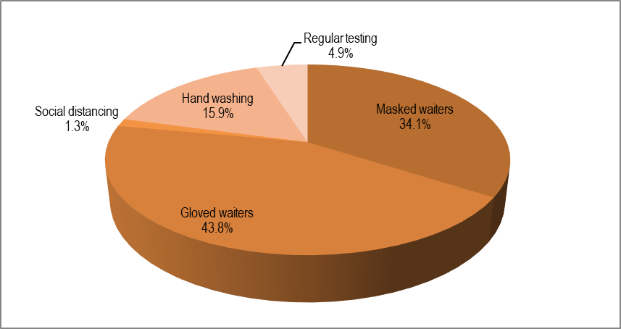
Figure 4.13: Effects of COVID-19 pandemic on variation of tastes and preferences
Source: Field survey, 2022

Since majority of respondents (43.8%) indicated that tourists preferred to be served by gloved waiters and significant number of respondents (34.1%) reported that tourists preferred to be served by masked waiters it implies that COVID-19 led to variation in tastes and preferences of tourists something that escalated the costs of operation hence leading to the decline in households’ income. The results further indicated that the mean score of respondents’ views was 3.9 out of 5 implying that the respondents agreed that COVID-19 pandemic brought tourists’ changes in tastes and preferences something that increased the enterprises’ cost of operations.

The interviews that were conducted with District Game Officer and Community Development officer aimed at establishing whether COVID-19 led to variations of tastes and preferences of tourists and ultimately decreasing the households’ income. One of District Game Officers stated that:
“During COVID-19 pandemic, tourists were very careful with what they drunk and eating. Many acts of carefulness were seen in keeping safe distance, washing hands regularly, wearing facial masks and gloves and using sanitizers”.

Community Development officer said that:
“Because of such precautious lifestyle some of us took some initiatives to work from home by using online services and even some clients were also careful with their health and therefore, most of them were concerned with the way COVID-19 measures were being undertaken”.

CHAPTER FIVE

DISCUSSION OF THE FINDINGS

Introduction
This chapter provides the discussion of the findings regarding the effects of COVID-19 pandemic on the households’ income of tourism dependent communities around the Ikona WMA.

Discussion
This section discusses the overall study findings as was presented and interpreted in Chapter Four. The purpose of this study was to increase knowledge on the effect of COVID-19 pandemic on household income of the tourism dependent communities. The section is composed of Effects of COVID-19 pandemic on the household’s income; the effects of COVID 19 pandemic on labour demands; the effect of COVID-19 pandemic on small-scale enterprises of the communities around the Ikona WMA.

Effects of COVID-19 Pandemic on the Household’s Income
The findings of the study showed that during COVID-19 pandemic, the number of respondents who earned between Tshs.51, 000 and Tshs.100, 000 increased from 50 to 72 as those who were earning Tshs.251, 000 and above decreased from 42 to 31. The respondents' views on the general decline of households’ income at Ikona WMA confirmed that COVID-19 pandemic had devastating effects of their income. The respondents’ opinions were therefore consistent with the study conducted by (Pinkovetskaia, 2022) which revealed that for the majority (53%) of households, due to the pandemic, there was a reduction in households’ income. Similarly, a study conducted by Masagus et al. (2023) found that COVID-19 lockdowns had a large and significant adverse impact on households’ income, expectations, and consumption. Likewise, a study by Vanda et al. (2021) showed that COVID-19 pandemic affected significantly households’ disposable income in the EU, with lower income households being more severely hit. The implication of effects of COVID-19 pandemic on household income is that the communities around Ikona WMA could not regularly meet their bills including paying school fees for the on-going school children and providing other basically needs such as food, clothing and shelter in terms of house rents.

The study also established the four variables which could further describe the effects of COVID-19 on households’ income which included the employees’ unpaid leave, employees’ compulsory leave, employees’ few working hours and the closure of business. The respondents’ opinions showed that the majority of the respondents (25.5%) were sent on unpaid leave due to the spread of COVID-19 pandemic hence leading to sudden loss of their income. The mean score of 4.1 out of 5 further implied that the respondents were of the view that COVID-19 pandemic had highly lowered the income of the respondents following the action of being sent on unpaid leave. The respondents’ opinions were consistent with the study by Chen & Mei-Hui (2021) which revealed that big companies were forced to restructure their workforces, requiring that their workers had to be sent to unpaid leave. The implication of employees’ unpaid leave was that it generated a sense of job insecurity in employees and changed employees’ intention to remain and sense of trust in their company. Furthermore, the income of these employees also fell short of their needs and they leaved in an unsecure life.

Another significant effect of COVID-19 pandemic on households’ income was enhanced when employees were granted compulsory leave. The respondents strongly agreed that indeed some of them (25.5%) were sent on compulsory leave; something that greatly reduced their income. The mean score of respondents’ views being 4.1 out of 5 further implied that COVID-19 pandemic had highly lowered the income of the respondents following the action of being sent on compulsory leave. The respondents’ views were consistent with the study by Herman et al. (2021) which established that COVID-19 provided a catalyst for employers to enact passive and active exit strategies which included sending workers on compulsory leave that made work more precarious. The implication of such action is as narrated in the report by ILO-OECD (2020) which pointed out that once youth loss the connection with the labour market or become marginalized in informal and precarious jobs, re-connecting them with good jobs can be very hard with potentially long-lasting scarring effects.

The households’ income around Ikona WMA can also be described by the actions of employers to subject employees to work for few hours. The majority of respondents (39.2%) indicated that they worked for 3-4 hours during the outbreak of COVID-19 pandemic hence the decline of households’ income. The results further indicate that the mean score of respondents’ views was 3.6 out of 5 implying that the respondents agreed that COVID-19 pandemic lowered the income of the respondents following the action of being engaged few hours. The respondents’ views were consistent with the study by Koebel & Pohler (2020) found that while workers in every quintile experienced a large reduction in hours on average, significant increases in hours were only present among workers in the bottom quintile. Similarly, the report by ILO-OECD (2020) showed that total hours worked fell by more than the decline in the number of employed persons at work in most countries, ranging from a staggering 46% in Mexico to a still substantial decline of around 10% in Australia. Working for fewer hours meant that the income earned by individual worker is lower hence low households’ income.

Finally, the effects of COVID-19 pandemic on households’ income can be further described by the business closure. The majority of respondents (47.3%) reported that their businesses permanently closed down following the outbreak of COVID-19 pandemic and ultimately reducing the household’s income. The mean score of 4.3 out of 5 further implies that the respondents agreed that COVID-19 pandemic lowered the income of the households following the closure of businesses. The respondents’ views concurred with the findings of the study by Bartik et al. (2020) which revealed that within just few weeks into COVID-19 crisis, mass layoffs and business closures had already occurred. This therefore, implied that immediate reduction of households’ income would be reflected in the widespread businesses closure.

The Effects of COVID 19 Pandemic on Labour Demands
The study revealed three major outcomes of the effects of COVID-19 pandemic on labour demands of communities around the Ikona WMA. Those effects included loss of jobs, reduced wages and delayed salary payment. The study showed that the majority of respondents (42.5%) who lost their jobs used to work for hotels and lodges while 39.4% used to work for tour firms implying that COVID-19 had devastating effects on those two categories of tourism enterprises hence resulting to reduced labour demand. The mean score of 4.1 out of 5 further implied that the respondents agreed that COVID-19 pandemic caused job losses due to low labour demands and ultimately reduced households’ income.

The respondents’ responses were consistent with the study of Tu et al. (2021) which revealed that COVID-19-induced layoff, which in turn led to decreased in-role and extra-role performance. Similarly, the study by Masri et al. (2021) found that sectors that were most susceptible to the shock because they are more contact-intensive and less telework able, such as construction, domestic services and hospitality, suffered large job losses and reductions in hours. Likewise, the study by Cortes & Forsythe (2020) found that job losses were substantially larger among workers in low-paying jobs. The implication of such mass layoff is that the business experienced low productivity and in the context of this study job losses meant that the income of households dropped.

The reduced wages were also one of the effects of COVID-19 pandemic on labour demands of communities around the Ikona WMA. These results were drawn from the majority of respondents (45.1%) whose wages were reduced from Tshs.8000 to Tshs.7000 and 37.6% whose wages were reduced from Tshs 6000 to Tshs5000 due to the effects of COVID-19 pandemic which were brought about by low labour demands. The mean score of respondents’ views of 4 out of 5 further implied that COVID-19 pandemic lowered labour demands and eventually led to reduced wages hence low households’ income. The respondents’ views were consistent with the study by Masri et al. (2021) which showed that low income workers experienced the largest decline in earnings, extreme poverty and coefficient based on labour income increased by around 9.2 and 5 percentage points, respectively, due to the immediate shock. The direct implication of such reduced wages is the dramatic increase in inequality in labour earnings during the pandemic; however, in the context of this study the reduced wages due to low labour demand implied a decrease in the households’ income.

The delayed salary payment was also one of the effects of COVID-19 pandemic on labour demands of communities around the Ikona WMA. These results were drawn from the majority of respondents (42.5%) whose salaries were delayed for 7 to 8 months and 35.8% whose salaries were delayed for 5 to 6 months as result of the effects of COVID-19 pandemic which were brought about by low labour demands. The mean score of respondents’ views of 3.9 out of 5 further implied that COVID-19 pandemic lowered labour demands and eventually led to delayed salary payment hence low households’ income. The respondents’ views concurred with the findings of the study by Seyfarth (2022) which revealed that during COVID-19, employers encountered significant which led to some exploring reductions to employee salaries and deferred payments. The implication of delayed salary payments is that the value of money that was received later was low and therefore, the income of the households tremendously reduced.

The Effect of COVID-19 Pandemic On Small-Scale Enterprises
The study revealed three major outcomes of the effects of COVID-19 pandemic on small-scale enterprises of communities around the Ikona WMA as low demand for tourism products/services, low operation capacity of tourism enterprises and variation in tastes and preferences of tourists. The majority of respondents (40.3%) whose employers faced decline in the demand for products/service used to work for man-made attractions (resort) and 39.4% used to work for natural attractions (wildlife, landscape) which ultimately reduced the households’ income. The mean score of 4 out of 5 further implied that the respondents agreed that COVID-19 pandemic reduced the revenue for small-scale enterprises due to decreased the demand for tourism products/services. The respondents’ views were, therefore consistent with the findings of Mulder (2020) which that tourism in the East African region had almost come to a temporary standstill as a result of the COVID-19 pandemic. The implication of extensive decrease in demand for tourists’ goods/services is that the region experienced mass layoff of workers and in turn a drop-in households’ income.

The study also showed that the majority of respondents (49.6%) pointed out that the conditions that made them realize that they were operation below the capacity was when they experienced an increase in wastes and 30.1% of respondent indicated the employees being idle. The reduced operation capacity of SMEs was therefore, one of the effects of COVID-19 pandemic which eventually reduced the revenue for small-scale enterprises and ultimately reducing the households’ income. The mean score of 3.9 out of 5 further implied that the respondents agreed that COVID-19 pandemic reduced the revenue for small-scale enterprises due to reduced operation capacity of SMEs. The respondents’ views were consistent with the findings of the study conducted by Engidaw (2022), which revealed that coronavirus crisis had destroyed many businesses around the globe and it was challenging to survive with reduced revenue, jobs lost and life slowing down and weak marketing performance even difficult to keep a calm head and their business alive. The most obvious outcome of operating below the capacity was a reduction of production and in the context of this study low operation capacity meant low income to the entrepreneurs and in turn the reduced households’ income.

The study also showed that the majority of respondents (43.8%) reported that there was variation of tourists’ tastes and preferences by most tourists preferring to be served by gloved waiters and 34.1% of the total respondents indicating that they preferred to be served by highly masked waiter. The variation in tastes and preferences was therefore, one of the effects of COVID-19 pandemic which eventually reduced the revenue for small-scale enterprises and ultimately reducing the households’ income. The mean score of 3.9 out of 5 further implied that the respondents agreed that COVID-19 pandemic reduced the revenue for small-scale enterprises due to tourists’ variation in tastes and preferences. The respondents’ opinions were consistent with the findings of the study by Więckowski (2020) which revealed that COVID-19 offered the impetus for individuals to transform their travel behaviours, even though a transformation of the tourism system overall was be extremely difficult to achieve. The implication of the changes in tastes and preferences was that the SMEs were required to be as innovative as possible in order to cope up with the needs of tourists; something which would increase the running costs of the enterprises, which in turn would reduce the households’ income.

CHAPTER SIX

SUMMARY, CONCLUSION AND RECOMMENDATIONS

Overview
This chapter presents a summary, conclusion and recommendations of the study.

Summary
The summary of the research results is presented on the basis of the objectives of the study. The main purpose of this study is to assess effects of COVID-19 pandemic on the household’s income of tourism dependent communities around the Ikona WMA. The study was guided by three specific objectives which were to determine effects of COVID-19 pandemic on the households’ income of tourism dependent communities around the Ikona WMA; to analyze the effects of COVID-19 pandemic on labour demands of the communities around the Ikona WMA; and to examine the effect of COVID-19 pandemic on small-scale enterprises of the tourism dependent communities around the Ikona WMA. The study was conducted in three villages which form Ikona WMA in Serengeti District, Mara region. The study collected both primary and secondary data. Different methods were employed to collect information which included survey household questionnaires, focus group discussion, key informant interviews, documentary literature review and observation.

The first objective of this study was to determine the effects of COVID-19 pandemic on the household income of tourism dependent communities around Ikona WMA. The findings of the study showed that during COVID-19 pandemic, the number of community members who earned between Tshs.51, 000 and 100,000 increased from 22.1% to 31.9% as those who were earning Tshs.251, 000 decreased from 18.6% to 13.7%. It was also revealed that the decline of households’ income could be attributed to business closure with a mean score of 4.3; sending employees to unpaid leave with a mean score of 4.1; sending employees to compulsory leave with a mean score of 4.1; and subjecting employees to working for few hours.

The second objective was to analyze the effects of COVID-19 pandemic on labour demands of the tourism dependent communities around the Ikona WMA. During the pandemic the demand of labour declined and many communities’ members encountered loss of jobs, reduced wages, and delayed salary payments. The most significant effects of COVID-19 pandemic on labour demand that was reflected in the declined households’ income were loss of jobs with a mean score of 4.1. The reduced wages was the second effect of the effects of COVID-19 pandemic on labour demands with a mean score of 4 out of 5. The delayed salary payment was also a profound effect of COVID-19 pandemic although it was ranked the third on with a mean score of 3.9.

The third objective of the study was to examine the effect of COVID-19 pandemic on small-scale enterprises of the communities around the Ikona WMA. The study revealed that the three major outcomes of the effects of COVID-19 pandemic on small-scale enterprises, which in turn led to decline of households’ income of communities around the Ikona WMA included the low demand for tourism products/services, diminished operation capacity of tourism enterprises and variation in tastes and preferences of tourists. Among those effects, decreased demand for tourism products/services was the most profound with a mean score of 4. The diminished operation capacity of tourism enterprises and changes in tastes and preferences of tourists emerged second with each having a mean score of 3.9.

Conclusion
The effects of COVID-19 cut across all sectors of economy however; tourism sector and the communities’ dependent on tourism sector were the most affected. As result of the spread of COVID-19 pandemic, international tourists cancelled their bookings, flights were banned, boundaries were closed, and social distance and lockdowns were imposed. In that respect, households’ income of the communities dependent on tourism activities dropped due to low demand for labour and closing up of enterprises. Some of the significant goods that were found around the Ikona WMA included vegetables, maize, fruits, honey, chickens, eggs, milk and meat (butchering) that were being sold to lodges, hotels and restaurants. Other significant tourism activities that faced the wrath of COVID-19 pandemic were cultural dances and local artifacts.

Recommendations
- The study recommends that the Ministry of Natural Resources and Tourism (MNRT) should encourage local communities around Ikona WMA to diversify their source of income such as beekeeping and commercial farming. The excessive reliance on tourism can have negative affect on communities by shrinking their ability to broaden their economic activities and may also result in decreased flexibility and high level of susceptibility of a community’
- The study also recommends that Tanzania Tourism Board (TTB) in collaboration with Ministry of Natural Resources and Tourism (MNRT) and private sector should promote domestic tourism to encourage visitation in destination areas. This will mitigate the effects of COVID-19 on the households’ income since the domestic tourists may not necessarily be affected by the human movement restrictions globally.
- The study further recommends that the Ministry of Natural Resources and Tourism (MNRT) should provide financial support to the WMAs for tourism promotion and conservation activities since an outbreak of COVID–19, WMAs were mostly affected. The tourism dependent communities were generally hit hard since most of their activities relied on tourism.

Recommendation for Further Studies
The study can be carried out in any other Wildlife Management Areas (WMAs) for the purpose of comparing the effects of COVID-19 on the household’s income on dependent tourism communities.

REFERENCES
Africa Safari, (2023). Ikona Wildlife Management Area (WMA). https://africa- safari.com/ikona-wildlife-management-area-wma/
Ary, D., Jacobs, L.C., Sorensen, C. (2010). Introduction to Research in Education (8th Edition). California: Wadsworth
Babbie, E. (1990). Survey Research Methods (2nd Edition). California: Wadsworth Publishing Company.
Beni, M.C. (2001). Analise Estruturaldo Turismo (4th edn.). Sao Paulo: Editora Senac.
Bartik, A. W., Bertrand, M., Cullen, Z. & Stanton, C. (2020). The impact of COVID-19 on small business outcomes and expectations. https://doi.org/10.1073/pnas.2006991117.
Bryman, A. (2012). Social Research Methods. (4th edn.). Oxford: Oxford University Press.
Burkart, A. J. and Medlik, S. (1974). Tourism Past Present and Future. London: Heinemann.
Cohen, L. (2000). Research Methods for Business (3rd edn.). New York: John Wiley & Sons.
Cohen, L., Manion, L. & Morrison, K. (2011). Research Methods in Education. (7th edn). London: Routledge
Cortes, G. M. & Forsythe, E. (2020). Impacts of the COVID-19 Pandemic and the CARES Act on Earnings and Inequality: IZA Discussion Papers, IZA – Institute of Labor Economics: Bonn, Germany. Retrieved from https://docs.iza.org/dp13643.pdf
Creswell, J. W. (2015). A concise Introduction to Mixed Methods Research. New York: Sage Publications Ltd.
Crotts, J. C. & Mazanec, J. A. (2013). Tourism Management Perspectives. Case study, Diagnosing the impact of an event on hotel demand: The case of the BP oil spill. Tourism Management Perspectives, 8, 60-67. https://doi.org/10.1016/j.tmp.2013.07.002.
Crouch, G.I. (1995). A meta-analysis of tourism demand. Annals of Tourism Research, 22, 103–118.
Del Valle, A. S., (2020). The Tourism Industry and The Impact of COVID-19, Scenarios and Proposal, Global Journey Consulting. https://www.scribd.com/document/477307680/GJC-THE-TOURISM-INDUSTRY-AND-THE-IMPACT-OF-COVID-19-pdf
Eco Adventure Safaris Limited (EASL). (2023). Ikona Wildlife Management Area (WMA) https://ecoadventuresafaris.com/ikona-wildlife-management-area/
Engidaw, A. E. (2022). Small businesses and their challenges during COVID-19 pandemic in developing countries: in the case of Ethiopia. J Innov Entrep 11, 1 (2022). https://doi.org/10.1186/s13731-021-00191-3
Ganti, A. (2022). Positive Feedback: What it is, How it Works. Retrieved from https://www.investopedia.com/terms/p/positive-feedback.asp
Gay, L. R, & Diehl, P.L. (1992). Research methods for business and management. New York: Macmillan.
Gibson, W. J. and Brown, A. (2009). Working with qualitative data. London: Sage Publisher.
Goh, C., (2012). Exploring impact of climate on tourism demand. Ann. Tourism Res. 39 (4), 1859-1883.
Hawkins, D. E & Mann, S. (2006). The World Bank’s role in tourism development. Annals of Tourism Research, 34(2), 348-363.
Haryanto, T. (2020). Editorial: Covid-19 Pandemic and International Tourism Demand. Journal of Developing Economies (JDE), 5(1), 1-5.
Henseler, M., Maisonnave, H. & Maskaeva, A. (2022). Economic impacts of COVID-19 on the tourism sector in Tanzania, Annals of Tourism Research Empirical Insights, 3(1). https://doi.org/10.1016/j.annale.2022.100042.
Herman, E., Rubery, J., & Hebson, G. (2021). A case of employers never letting a good Crisis goes to waste? An investigation of how work becomes even more precarious for hourly paid workers under COVID. Industrial Relations Journal. 52. 10.1111/irj.12344.
ILO-OECD (2020). The impact of the COVID-19 pandemic on jobs and incomes in G20 economies. A paper prepared at the request of G20 Leaders Saudi Arabia’s G20 Presidency 2020. https://www.ilo.org/wcmsp5/groups/public/---dgreports/---cabinet/documents/publication/wcms_756331.pdf.
Jafari, A., Somaye, S. & Sadeghi, S. (2011). Tourism and Economic Growth in Developing Countries: P-VAR Approach, Middle East Journal of Scientific Research, 10(1) 28-32.
Kesmodel, U. S. (2018). Cross-sectional studies –what are they good for? Acta Obstetricia et Gynecological Scandinavica. https://doi.org/10.1111/ aogs.13331.
Koebel, K. & Pohler, D. (2020). Labor Markets in Crisis: The Double Liability of Low-Wage Work During COVID-19. Ind Relat (Berkeley). (4):503-531. Doi: 10.1111/irel.12269.
Kothari, C. R. (2004). Research Methodology (Methods and Techniques). 2nd Revised edition. New Delhi: New Age International Publisher Ltd.
Kothari, C. R. (2009). Research Methodology (2nd Edition). London: New Age International Publisher Ltd.
Law Insider, (2023). Compulsory leave definition. https://www.lawinsider.com/dictionary/compulsory-leave
Leiper, N. (1990). Tourism Systems: An Interdisciplinary Perspective. Paper no 2, 0-473-00933-1,1990, Department of Management systems, Massey University, Palmerston North, New Zealand. Retrieved from https://search.worldcat.org/title/Tourism-systems-:-an-interdisciplinary-perspective/oclc/24603849.
Liangju, W, Huihui, Z. & Wanlian, L. (2012). Analysis of Causality between Tourism and Economic Growth Based on Computational Econometrics. Journal of Computer, 7, 2152-2159.
Lim, C. (1997). Review of international tourism demand models. Annals of Tourism Research, 24, 835–849.
Masagus, M. R., Rezki, J. F., Suryahadi, A., Ramayandi, A. & Affandi I. (2023). The Impact of COVID-19 Lockdowns on Household Income, Consumption, and Expectations: Evidence from High-frequency Data in Indonesia, Bulletin of Indonesian Economic Studies, DOI: 10.1080/00074918.2023.2167930.
Mattessich, P. & Monsey, M. (2004). Community Building: What Makes It Work: Review of Factors Influencing Successful Community Building. Saint Paul: Wilder Foundation Centre.
Masri, D. A., Flamini, V. & Toscani, F. (2021). The Short-Term Impact of COVID-19 on Labor Markets, Poverty and Inequality in Brazil. IMF Working Paper No. 2021/066. Retrieved from https://www.imf.org/en/Publications/WP/ Issues/2021/03/05/The-Short-Term-Impact-of-COVID-19-on-Labor-Markets-Poverty-and-Inequality-in-Brazil-50124
Mbise, E. (2015). Service Quality Measurement in Tanzanian Business Schools. Business Education Journal, 1(1), 33, http://hdl.handle.net/123456789/74392
Mgonja, J. T. (2015). Evaluating Local Food-Tourism Linkages as a Strategy for Promoting Sustainable Tourism and Economic Development: A Case for Tanzania. All Dissertations. 1479. https://tigerprints.clemson.edu/all_ dissertations/1479.
Mills, A. J., Eurepos, G. & Wiebe, E. (2010). Encyclopedia of Case Study Research - Volume 1. In Encyclopedia of Case Study Research. https://doi.org/10.4135/9781412957397.
Ministry of Natural Resources and Tourism (MNRT), (2020). National Standard Operating Procedures for the Management of COVID– 19 in the Tourism Business Operations. https://www.jp.tzembassy.go.tz/resources.
Ministry of Health, Community Development, Gender, Elderly and Children (MHCDGEC), (2020). Tanzania NCD Prevention and Control Programme. Guidance on provision of NCD and Mental Health Services in the Context of COVID-19 Outbreak in Tanzania. Retrieved from https://www.worlddiabetesfoundation.org/files/tanzania-ncd-prevention-and-control-program.
Mugenda, O. M., & Mugenda, G. A. (2003). Research Methods: Quantitative and Qualitative approach. Nairobi: Laba Graphics Services.
Petzer, B. (2016). A Contextual Analysis of Cycling Environment Assessment Tools in a Cape Town Mobility Corridor. Master’s thesis, University of Cape Town. South Africa. Retrieved from https://open.uct.ac.za/items/e22e32c4-9dc2-4a3e-a288-18957e261a18.
Pinkovetskaia, I. (2022). Impact of Covid-19 pandemic on household income: Results of a survey of the economically active population. Studia Universitatis Vasile Goldis. Arad – Economics Series. 32, 43-57. 10.2478/sues-2022-0003.
Romagosa, F. (2020). The COVID-19 crisis: Opportunities for sustainable and proximity tourism. Tourism Geographies, 22:3, 690-694.DOI:10.1080/14616688.2020.1763447.
Rwegoshora, H. M. (2014). A guide to Social Research. Dar- es Salaam: Mkuki na
Nyota Publishers.
Samimi, A. J., Sadeghi, S. & Sadeghi, S. (2011). Tourism and Economic Growth in Developing Countries: P-VAR Approach. Middle-East Journal of Scientific Research, 10 (1), 28-32.
Sekaran, U. (2003). Research methods for business (4th Edition). Hoboken, NJ: John Wiley & Sons.
Sirima, A. (2010). Protected Areas, Tourism and Human Displacement in Tanzania: Interests and Challenges behind Ruaha National Park Expansion. Master’s thesis, Wageningen University and Research Centre, the Netherlands. Retrieved from https://docplayer.net/62585632-Protected-areas-tourism-and-human-displacement-in-tanzania-interests-and-challenges-behind-ruaha-national-park-expansion.html.
Sirima, A., Duim, R.V., & Duineveld, M. (2010). Protected Areas, Tourism and Human Displacement in Tanzania: Interests and Challenges behind Ruaha National Park Expansion.
Seyfarth, S. L. L. P. (2022). Legal Update: Salary Payment Issues during COVID-19 Lockdown in China. https://www.lexology.com/library/detail.aspx? g=9f76bfbf-96fd-439b-8db8-3a520041a014.
Skare, M., Soriano, D. R. & Rocho, M. P. (2020). Impact of COVID-19 on the travel and tourism industry, Technological Forecasting and Social Change, Elsevier, vol. 163(C). DOI: 10.1016/j.techfore.2020.120469
Stepchenkova, S., Eales, J. S. (2011). Destination Image as Quantified Media Messages: The Effect of News on Tourism Demand. J Trav.Res.50(2), 198-212.
Tu, Y., Li, D. & Wang, H. J. (2021). COVID-19-induced layoff, survivors’ COVID-19-related stress and performance in hospitality industry: The moderating role of social support. International Journal of Hospitality Management, Vol 95. https://doi.org/10.1016/j.ijhm.2021.102912.
Turner, R. (2019).Travel & Tourism: Generating Jobs For Youth. https://wttc.org/Portals/0/Documents/Reports/2019/Social%20Impact-Generating%20Jobs%20for%20Youth-Jan%202019.pdf?ver=2021-02-25-182754-083
United Nations Department of Economic and Social Affairs (2020). Economic Analysis
United Nations World Tourism Organization (UNWTO). (2020). World Tourism
Barometer, Vol. 18 (7), December 2020.
United Nations World Tourism Organization (UNWTO), (2010). World Tourism
Rankings, [www.unwto.org] retrieved on 8th October.
United Nations Conference on Trade and Development (UNCTAD). (2020). Road to
Recovery. Annual report 2020. https://unctad.org/publication.
United Republic of Tanzania (URT). (1996). Community Development Policy.
United Republic of Tanzania (URT). (2021). Hotuba ya Waziri wa Maliasili na Utalii Bungeni kwenye Makadirio ya Mapato na Matumizi katika Mwaka wa Fedha 2021/2022.
United Republic of Tanzania (URT). (2007). The Wildlife Policy of Tanzania. Dar es Salaam, Tanzania.
Uysal, M., & Crompton, J.L. (1984). Determinants of demand for international tourist flows to Turkey. Tourism Management 5, 288–297.
Vanda, A., Barrios, S. Christ, M., De Poli, S., Tumino, A. & van der Wielen, W. (2021). The impact of COVID-19 on households´ income in the EU. The Journal of Economic Inequality. https://doi.org/10.1007/s10888-021-09485-8
Walter, M. (2006). Social Science methods: an Australian perspective. Oxford: Oxford University Press.
Więckowski, M. (2021). Will the Consequences of Covid-19 Trigger a Redefining of the Role of Transport in the Development of Sustainable Tourism? Sustainability 13(4), 1887. https://doi.org/10.3390/su13041887.
World Health Organization (WHO). (2020a). Director-General’s opening remarks at
the media briefing on COVID-19. https:// www.who.int/dg/speeches/detail/who-director-general-s opening-remarks-at-the-media-briefing-on-covid-19World.
World Health Organization (WHO). (2020b). Statement on the second meeting of the International Health Regulations (2005) emergency committee regarding the outbreak of novel coronavirus (2019-nCoV). https://www.who.int/news-room/detail/30-01-nda/2020/08/world-bank-2020-classifications-low-highincome-countries/.
World Travel and Tourism Council (WTTC). (2020). Global Economic Impact and Trend, June 2020. https://wttc.org/Portals/0/Documents/Reports/2020/Global
Yount, R. (2006). Statistical Analysis for Christian Ministry: Research Fundamentals. California: W.R. Yount Publishers.

APPENDICES
APPENDIX I: Questionnaire for All Respondents
My name is Suleiman Leonard Keraryo. I’m conducting a research on effects of COVID-19 pandemic on the households’ income of tourism dependent communities around the Ikona WMA. You are invited to participate in this questionnaire, a survey which will take about 10 - 20 minutes to complete. Participation in this survey is entirely voluntary and the information you provide will be used for a sole purpose of research work. No name or identity will be disclosed without your consent and no means should it put your wellbeing at risk.
- Personal data
- What is your gender? (√ appropriately)
- Male [ ]
- Female [ ]
- What is your age group? (√ appropriately)
- 18-29 [ ]
- 30-39 [ ]
- 40-49 [ ]
- 50-59 [ ]
- 60 and above [ ]
- What is your marital status? (√ appropriately)
- Single [ ]
- Married [ ]
- Widow [ ]
- Separated [ ]
- Divorced [ ]
- What is your level of education? (√ appropriately)
- Standard seven [ ]
- Form four [ ]
- Form six [ ]
- Diploma [ ]
- University [ ]
- What is your occupation? (√ appropriately)
- Farming activities [ ]
- Small business [ ]
- Livestock [ ]
- Employed/civil servants [ ]

SECTION II: The effects of COVID-19 pandemic on households’ income of tourism dependent communities
This section will determine the effects of COVID-19 pandemic on households’ income of tourism dependent communities around the Ikona WMA
- What was your range of income per month before and during COVID-19 pandemic (√ appropriately)
SN | Range of income  TSHS. | Before COVID-19 pandemic | During COVID 19 pandemic
i | 51,000-100,000
ii | 101,000-150,000
iii | 151,000-200,000
iv | 201,000-250,000
v | 251,000-above

- From the following list, indicate the action that was taken by employers that affected you during the outbreak of COVID-19:
- Sending employees on unpaid leave [ ]
- Sending employees on compulsory leave [ ]
- Reducing the employees’ number of working hours [ ]
- Closing business [ ]
- Which income generating activity did you do upon being sent on unpaid leave?
- Market gardening [ ]
- Poultry farming [ ]
- Motor cycle riding (boda boda) [ ]
- Fruit and vegetable vending [ ]
- Food vending [ ]
- From the following list of employees’ allowances, which one of them that you lost upon being sent on compulsory leave?
- Transportation allowances [ ]
- Customers’ tips [ ]
- Communication allowances [ ]
- Hardship allowances [ ]
- Conferences, seminars and workshop allowances [ ]
- Which of the following range of hours did you work during the outbreak of COVID-19?
- 1-2 hours [ ]
- 3-4 hours [ ]
- 5-6 hours [ ]
- 7-8 hours [ ]
- 9-10 hours [ ]
- Indicate the form of business closure that your firm encountered during the outbreak of COVID-19?
- Permanently closed [ ]
- Temporarily closed [ ]
- Closed for few hours [ ]
- Closed for several hours [ ]
- Closed some sections [ ]
- Is there any additional attribute of the decline of households’ income of tourism dependent communities following the outbreak of COVID-19 pandemic? Please outline them.........................................................................................................

SECTION III: The effects of COVID-19 pandemic on labour demands of the tourism dependent communities
- Indicate from the following list of tourism enterprises you used to work for before you lost your job?
- Hotels & Lodges [ ]
- Tour firms [ ]
- Curio shops [ ]
- Cultural heritages [ ]
- Game hunting [ ]
- The following list shows the range of decrease in daily wages, which one of them describes your range of wage decrease during COVID-19?
- Tshs.8000 to Tshs.7000 [ ]
- Tshs.7000 to Tshs.6000 [ ]
- Tshs.6000 to Tshs.5000 [ ]
- Tshs.5000 to Tshs.4000 [ ]
- Tshs.4000 to Tshs.3000 [ ]
- How long did your salary delay during the outbreak of COVID-19? Choose from the following categories:
- 7 to 8 months [ ]
- 5 to 6 months [ ]
- 3 to 4 months [ ]
- 1 to 2 months [ ]
- less than 1 month [ ]
- Is there any additional effect of COVID-19 pandemic on SMEs leading to the decline of households’ income of tourism dependent communities? Please outline them
......................................................................................................................................................................................................................................................................
SECTION IV: The effect of COVID-19 pandemic on small-scale enterprises of the tourism dependent communities
- 17. Given the following list, indicate the feature of the products/service whose demand declined during the outbreak of COVID-19:
- Natural attractions (wildlife, landscape) [ ]
- Man-made attractions (resort) [ ]
- Fixed property (accommodation) [ ]
- Mobile property (motor vehicles) [ ]
- Natural or man-made conditions (weather, infrastructure) [ ]
- From the following list of business operation outcomes, indicate the outcome that made them realize that they were operating below the capacity as result of outbreak of COVID-19
- Employees remained idle most of the time [ ]
- There were increased wastes [ ]
- There was reduced competitiveness [ ]
- There was rapid accumulation of stock [ ]
- There were lower profits [ ]
- From the following list of tourists’ tastes and preferences, indicate the significant tastes and preferences that the tourists commonly preferred during COVID-19 pandemic?
- Highly masked waiters [ ]
- Gloved waiters [ ]
- Social distancing [ ]
- Hand washing [ ]
- Regular testing [ ]

- Is there any additional effect of COVID-19 pandemic on SMEs leading to the decline of households’ income of tourism dependent communities? Please outline them
......................................................................................................................................................................................................................................................................

APPENDIX II: Interview Guide for District Game Officer, Tourism Officer, Community Development Officer, Investors
My name is Suleiman Leonard Keraryo. I’m conducting a research on effects of COVID-19 pandemic on the households’ income of tourism dependent communities around the Ikona WMA. You are invited to participate in this questionnaire, a survey which will take about 10 - 20 minutes to complete. Participation in this survey is entirely voluntary and the information you provide will be used for a sole purpose of research work. No name or identity will be disclosed without your consent and no means should it put your wellbeing at risk.

SECTION II: The effects of COVID-19 pandemic on households’ income of tourism dependent communities
- What was your range of income per month before and during COVID-19 pandemic? …………………………………………………………………………
- Which action was taken by your employer that affected your monthly income during the outbreak of COVID-19? ………………………………………………
- Which income generating activity did most people do upon being sent on unpaid leave during COVID-19 outbreak?……………………………………………….
- Which employees’ allowances, did most people who were sent on compulsory leave loss during the outbreak of COVID-19?……………………………………
- What is the average hours worked during COVID-19?……………………………
- What closure period did the firm you worked for experience during the outbreak of COVID-9?…………………………………………………………………….
- Is there any additional attribute of the decline of households’ income of tourism dependent communities following the outbreak of COVID-19 pandemic?
...................................................................................................................................

SECTION III: The Effects of COVID 19 Pandemic on Labour Demands of The Tourism Dependent Communities
- Which tourism enterprises subjected most of their employees to job losses during the outbreak of COVID-19?
……………………………………………………………………………………
- Can you describe the decline of daily wages during the outbreak of COVID-19?
……………………………………………………………………………………
- How would you explain the delay of salary payment during the outbreak of COVID-19?………………………………………………………………………
- Is there any additional effect of COVID-19 pandemic on SMEs leading to the decline of households’ income of tourism dependent communities? Please outline them..............................................................................................................................................................................................................................................................

SECTION IV: The effect of COVID-19 Pandemic on Small-Scale Enterprises of The Tourism Dependent Communities
- Which category of tourism attractions that experienced the decline in the demand of its products/service during the outbreak of COVID-19?
……………………………………………………………………………………
- Which outcome of business operation made workers to realize that that their firms were operating below the capacity as result of outbreak of COVID-19?
……………………………………………………………………………………
- Which tastes and preferences did the tourists commonly prefer during COVID-19 pandemic? …………………………………………………………………………
- Is there any additional effect of COVID-19 pandemic on SMEs leading to the decline of households’ income of tourism dependent communities? Please outline them..............................................................................................................................................................................................................................................................

APPENDIX III: Research Time Work Plan
S/N | Activity | 2022 |  |  |  | 2023
S/N | Activity | January to  March | April to June | July to Sept | Oct to Dec | Jan to May | June to July | Aug to Sept
1 | Proposal writing
2 | Data collection
3 | Data processing & analysis
4 | Report writing
5 | Report presentation
6 | Submissions of report

APPENDIX IV: Research budget
S/N | Items | Rate(TZS) | Total(TZS)
1 | Researcher allowance | 1x14@80,000 | 1,200,000
2 | Field Assistant allowance | 2x14@25,000 | 700,000
3 | Driver | 1x14x60,000 | 840,000
4 | Diesel (litter) | 400@2300 | 920,000
5 | Foods and refreshment lampsum (meetings)) |  | 800,000
6 | Production of report |  | 100,000
 | TOTAL |  | 4,560,000/=

APPENDIX V: Research Clearance Letter
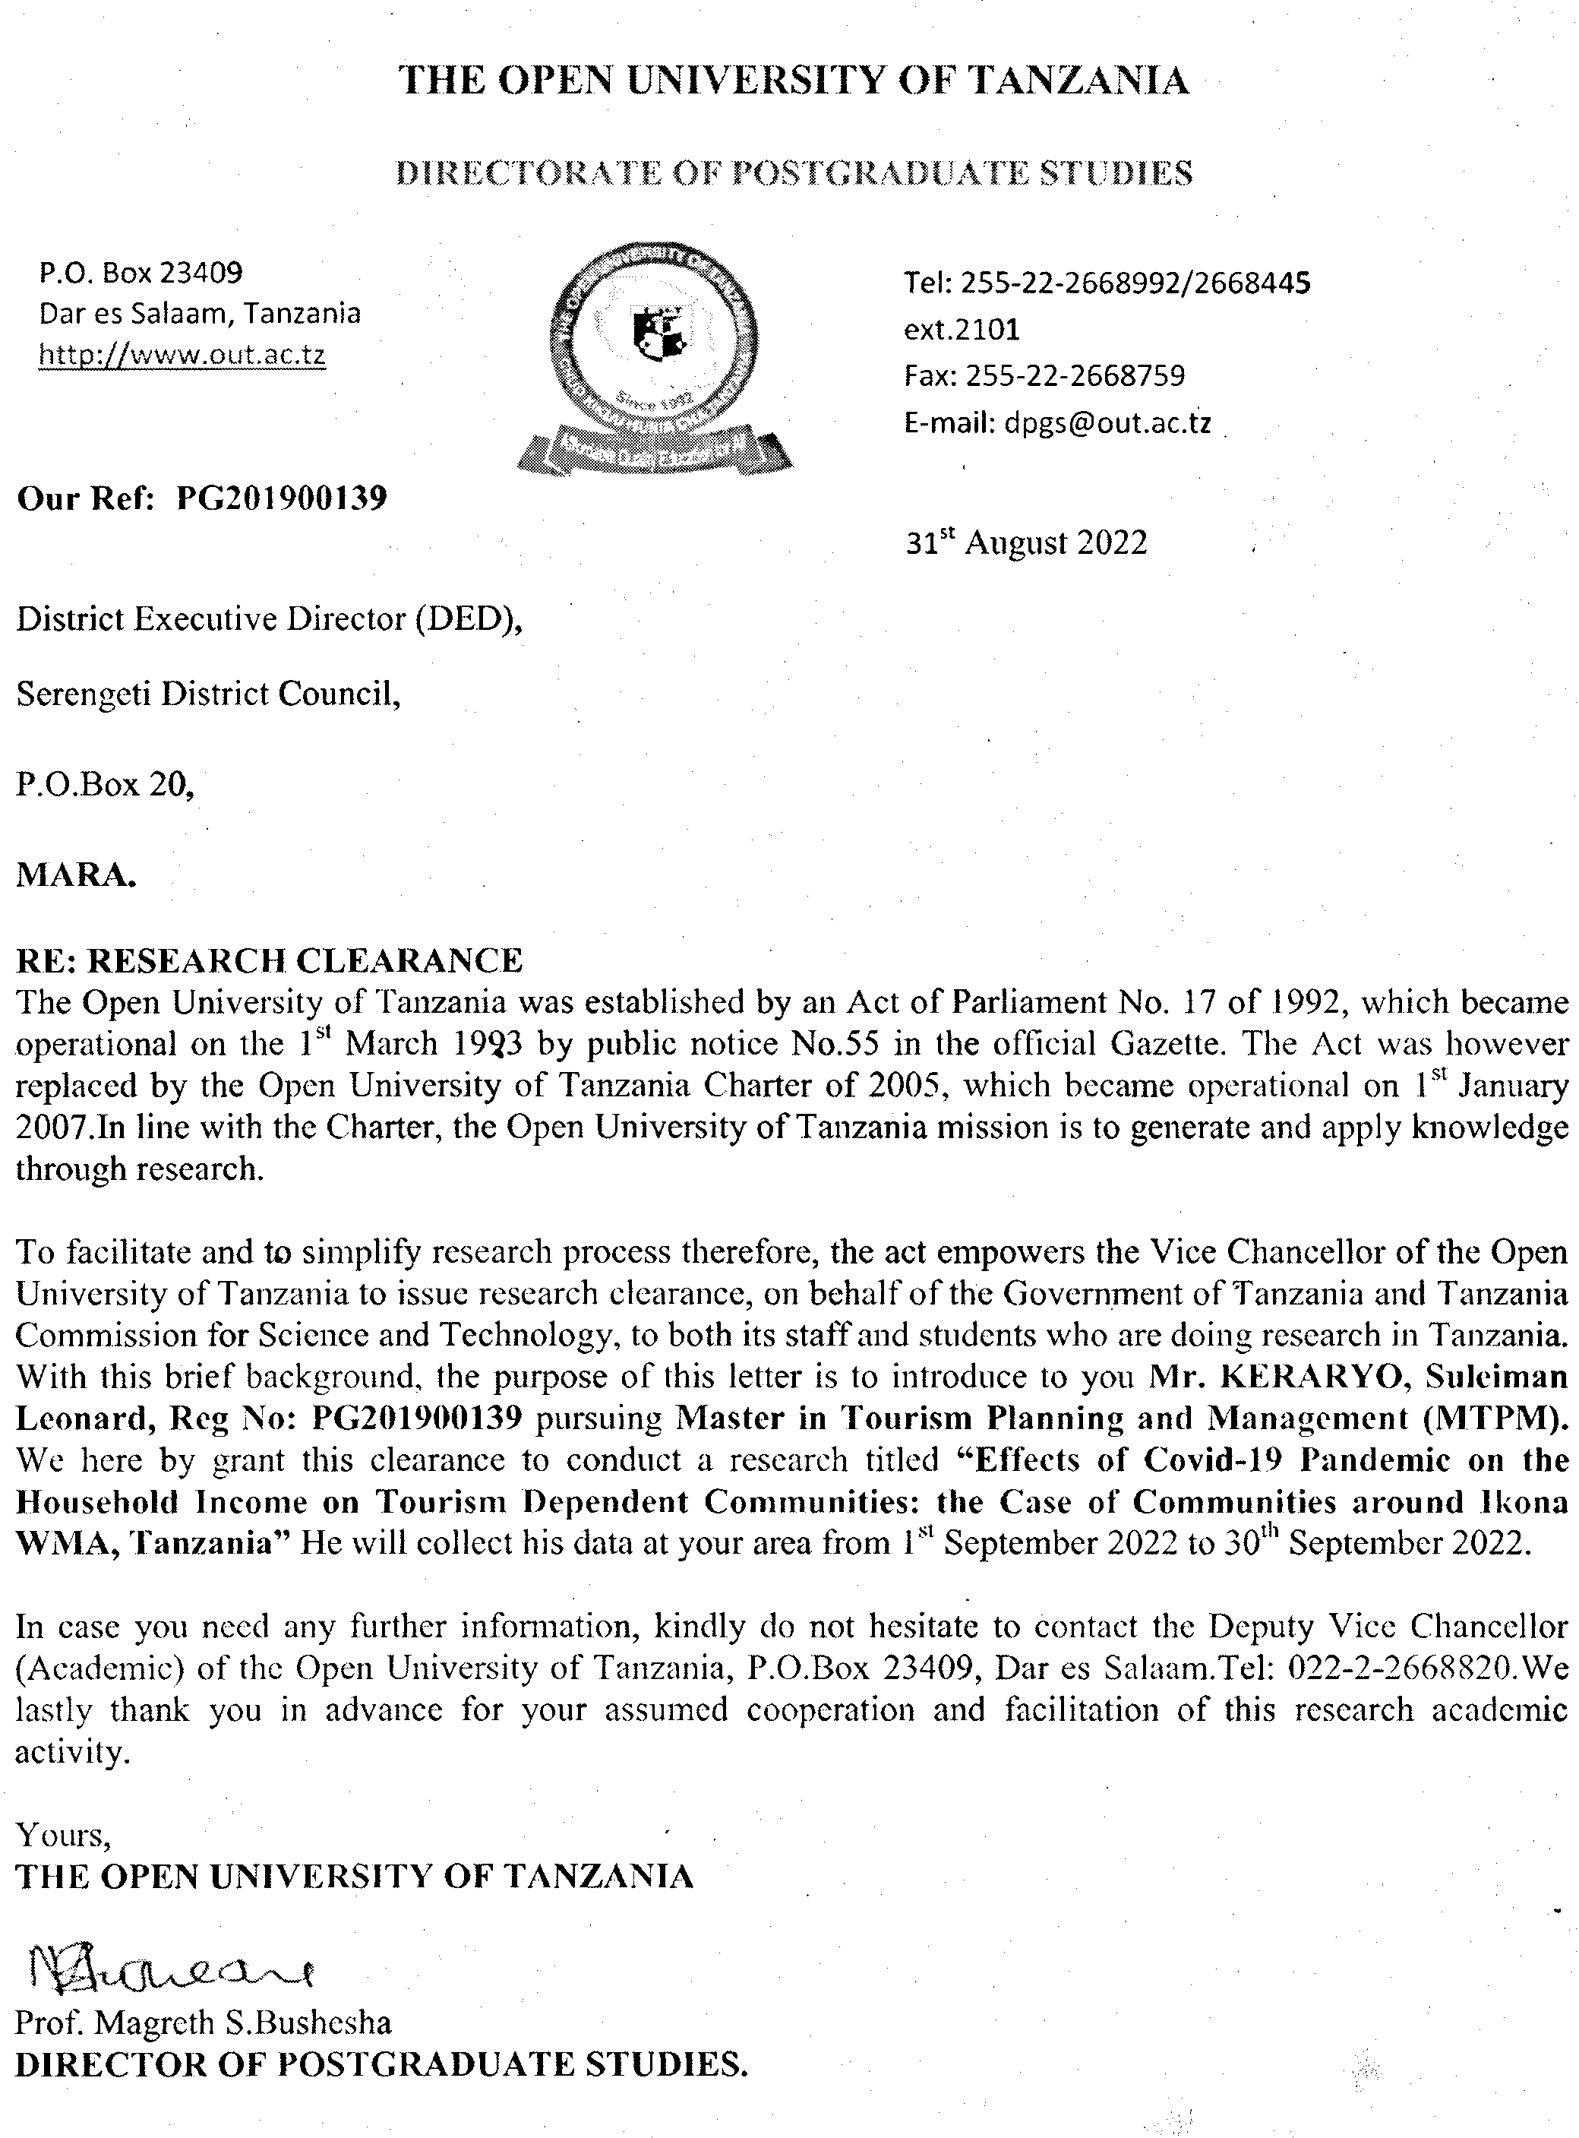
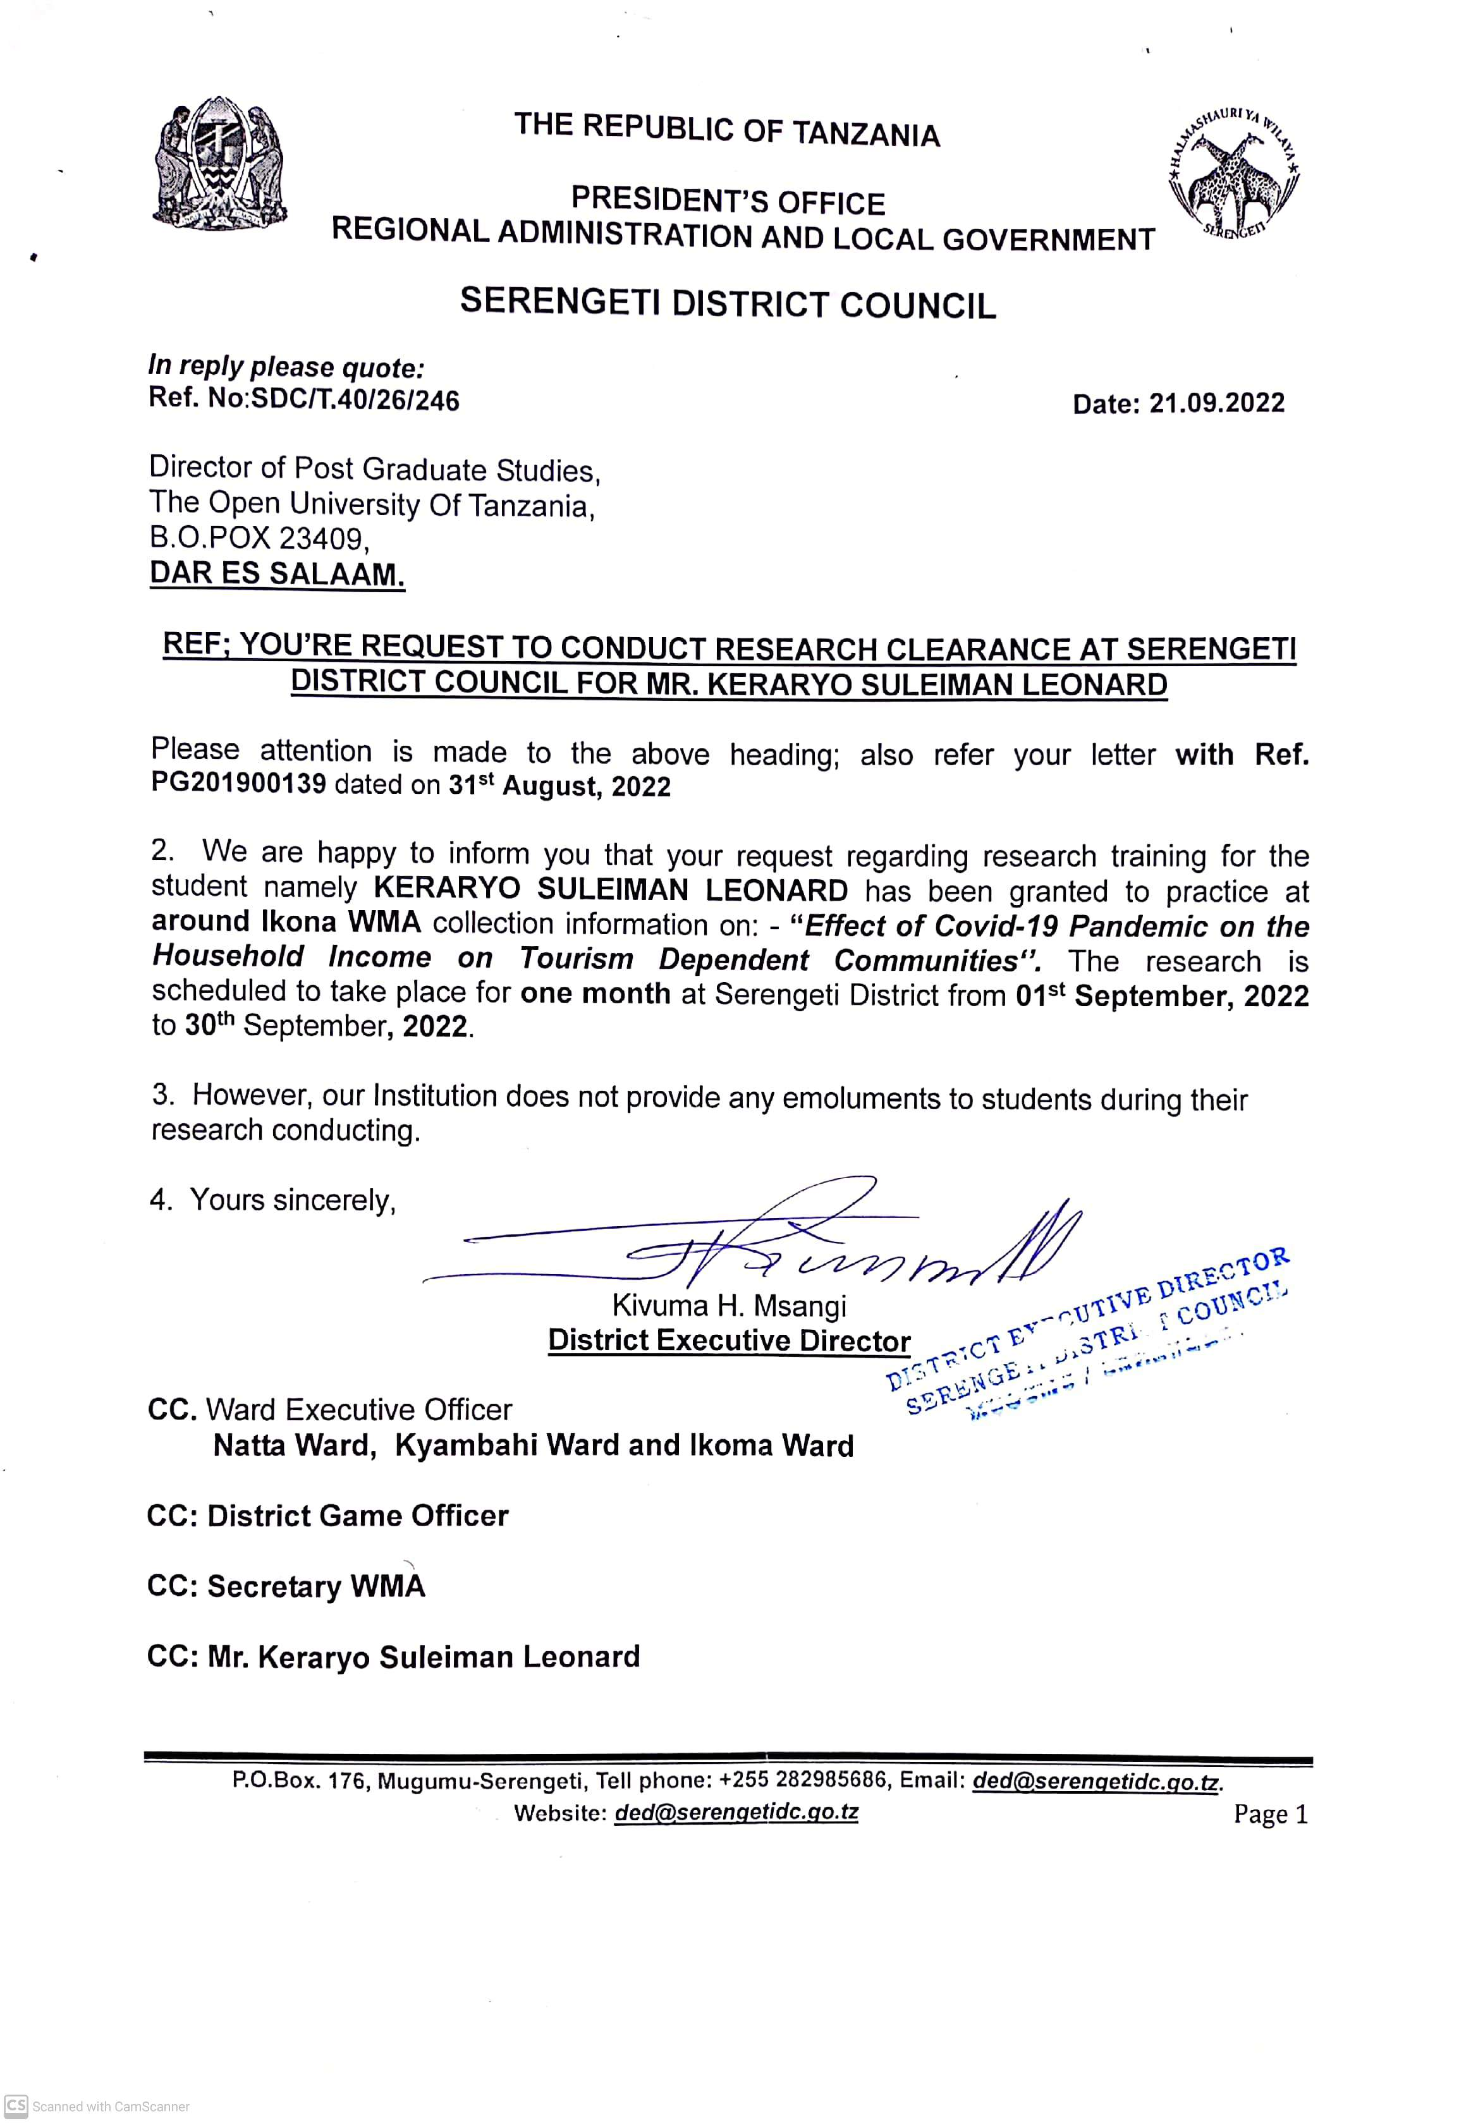
Appendix VI: Research Permit Letter

