IMPROVED HOUSEHOLDS INCOME GENERATION THROUGH IMPROVING QUALITY OF WOMEN FOOD VENDING DISHES: A CASE STUDY OF NYANKUMBU WARD IN GEITA TOWN COUNCIL

MARTHA KALOSO

A DISSERTATION SUBMITTED IN PARTIAL FULFILMENT OF REQUIREMENTS FOR THE DEGREE OF MASTER OF COMMUNITY ECONOMIC DEVELOPMENT (MCED)
DEPARTMENT OF ECONOMICS AND COMMUNITY ECONOMIC DEVELOPMENT
OF THE OPEN UNIVERSITY OF TANZANIA
2023
CERTIFICATION
The undersigned certifies that he has read and here by recommends for acceptance by the Open University of Tanzania a dissertation entitled, Improved Households Income Generation through Improving Quality of Women Food Vending Dishes. A case Study of Nyankumbu Ward in Geita Town Council. In partial fulfilment of the requirements for the award of Degree of Master in Community and Economic Development (MCED).


………………………..………………
DR. Hamidu Shungu
(Supervisor)

…………………………………………..
Date

COPYRIGHT
No part of this Dissertation may be reproduced, stored in any retrieval system, or transmitted in any form by any means, electronic, mechanical, photocopying, recording or otherwise without prior written permission of the author or The Open University of Tanzania in that behalf.

DECLARATION
I, Martha Kaloso, do hereby declare that this dissertation is my own original work and that it has not and will not be presented to any other institution for the award of a Degree or other similar awards.

……………………..……………
Signature

……………………………..
Date

DEDICATION
This work is dedicated to my beloved mother Laitness Yonael, who endured several hardships to have me go to school. Honestly speaking this work is an outcome of my mother’s effort. I pray that the Almighty God bless you abundantly.

ACKNOWLEDGEMENT

I would like to express my sincere gratitude to the Almighty God who gave me the strength, capacity and wisdom to be able to complete this project. I could feel his presence as he assisted me with willpower and courage to carry on.
I would also like to express my heartfelt thanks to Dr. Hamidu Shungu, my supervisor for his amicable professional guidance, tireless devotion, constructive ideas, criticism and encouragements.
Moreover, the patience of my children Bright and Brinah and their beloved father is highly acknowledged. I extend my thankfulness to Moses Nzumile for his collaboration and helpful contribution throughout the study period.
Furthermore, I would like to express my special thanks to Women Food Venders at Nyankumbu Ward in Geita Town Council for their cooperation and commitment in the process of the implementation of this project. Sincerely speaking had it not been the flexibility of these group members, this project could have not been materialized.

ABSTRACT
This project was conducted at Nyankumbu Ward, Geita Town Council in Geita region. The community need assessment conducted identified that women food venders at Nyankumbu ward had a challenge of preserving their food stuffs, hence the need for support on food serving dishes to improve the quality of their service and increase income generation. The methods used include interview and observation. The key participants were women food venders at Nyankumbu ward in Geita Town Council. The project identified the most pressing community want by involving community group members who were left to decide for themselves through votes. The provision of food serving dishes came out as the most pressing need in which the community group members could use in their food vending service to generate income. Other pressing wants identified include the establishment and formalization of the group so as to gain reputation from development partners and the government, business education and need for areas to conduct their daily activities. The implementation of the project put at the forefront establishment and formalization and awareness building to the community followed by assessment which gave room for incorporation of pending needs in the prospective project plan. The operation of all group activities were guided by its constitution.

TABLE OF CONTENT
CERTIFICATION ii
COPYRIGHT iv
DECLARATION v
DEDICATION vi
ACKNOWLEDGEMENT vii
ABSTRACT viii
LIST OF TABLES xiii
LIST OF FIGURES xiv
LIST OF ABBREVIATIONS xv
CHAPTER ONE:PARTICIPARTORY NEEDS ASSESSMENT 1
1.1 Background 1
1.2 Community Profile 3
1.3 Community Needs Assessment 8
1.3.1 Community Needs Assessment Objective 9
1.3.2 Specific objectives 9
1.3.3 Research Questions 10
1.4 Significance of the Study 10
1.5 Research Methodology 10
1.5.1 Research Design 11
1.5.2 Sample and Sampling Techniques 11
1.5.3 Methods of Data Collection 13
1.5.4 Data Analysis 14
1.6 Community Needs Assessment Findings 15
1.7 CAN Findings as per Objectives 17
1.8 Community Needs Prioritization 23
1.9 Conclusion 25
CHAPTER TWO: PROBLEM IDENFICATION 26
2.1 Background to Research Problem 26
2.2 Statement of the Problem 26
2.3 Project Description 27
2.4 Target Community 27
2.5 Community stakeholders 28
2.5.1 Stakeholders 28
2.6 Project Goals in Community Economic Development Terms 29
2.6.1 Project objectives 30
2.7 Host Organization 30
2.8 Institutional Fundamentals 33
2.9 Organization Management Structure 33
2.10 The Role of CED Student in the Project 35
2.11 Role of Community 35
CHAPTER THREE: LITERATURE REVIEW 36
3.1 Introduction 36
3.2 Theoretical Literature Review 36
3.2.1 Conceptualization of groups and group formation 36
3.2.2 Theories of Group Formation 38
3.3 Empirical Literature Review 40
3.4 Policy Reviews 43
3.5 Literature Review Summary 44
CHAPTER FOUR: PROJECT IMPLEMENTATION 45
4.1 Introduction 45
4.2 Background of the Project 45
4.3 Products and Outputs 46
4.4 Project Planning 46
4.4.1 Implementation Plan 46
4.4.2 Project Inputs 48
4.4.3 Staffing Pattern 48
4.5 Project Implementation Report 49
4.5.1 Establishment of women food vending group 50
4.5.2 Project Implementation Gantt Chart 50
4.6 Project Implementation Gantt chart 51
CHAPTER FIVE: PROJECT MONITORING, EVALUATION AND SUSTAINABILITY 52
5.1 Introduction 52
5.2 Participatory Monitoring 52
5.2.1 Participatory monitoring methods 52
5.3 The Actual Monitoring 54
5.4 Project Evaluation 55
5.5 Sustainability 57
5.5.1 The Institutional Sustainability Plan 57
5.5.2 Financial sustainability 57
5.5.3 Technical sustainability 57
5.5.4 Organizational sustainability 57
CHAPTER SIX: PROJECT CONCLUSION AND RECOMMENDATION 58
6.1 Introduction 58
6.2 Conclusion 58
6.3 Project Recommendations 59
6.3.1 Promotion of sustainable livelihood through food vending 59
REFFERENCES 60
APPENDICES 66

LIST OF TABLES
Table 1. 1 Geita Region Population by District Councils 4
Table 1. 2 Distribution of Sample According to Streets 12
Table 1. 3 Demographic Characteristics of the Participants 15
Table 1. 4 Pairwise score and ranking of four Community Needs 24
Table 2. 1 Project Stakeholders Analysis 28
Table 2. 2 SWOT Analysis 34
Table 4. 1 Logical Framework of Project Implementation Plan 47
Table 4. 2 Project Inputs 48
Table 5. 1 Monitoring of the Project Activities 53
Table 5. 2 Participatory Monitoring Plan 54
Table 5. 3 Evaluation Plan I 55

LIST OF FIGURES
Figure 1. 1 A photo showing food vending site at Nyankumbu ward. 19
Figure 1. 2 A Photo showing food vending site waste disposal at Nyankumbu ward 20
Figure 1. 3 A photo showing how food stuffs are being preserving while waiting for customers 21
Figure 1. 4 Food being prepared for packaging in nylon bags for preservation 22
Figure 2.1 Organization Structure of the Host Organization ……………………….33
Figure 2. 2 Organization Management Structure 33

LIST OF ABBREVIATIONS
AIDS Acquired Immune Deficiency Syndrome
CAN Community Assessment Needs
CBO Community Based Organization
CED Community Economic Development
HIV Human Immunodeficiency Virus
MCED Master of Community and Economic Development
NGOs Non-Governmental Organizations
SMEs Small and Medium Enterprises
TMDA Tanzania Medical and Drug Authority
URT United Republic of Tanzania
WHO World Health Organization

CHAPTER ONE
PARTICIPARTORY NEEDS ASSESSMENT

1.1 Background
Global statistics reveal that 2.5 billion of the populace depend on street food every day (Ma et al., 2019). Likewise it is report show that the enterprise contributes enough to the household income for the low socio-economic status and the country’s economy at large (Mm AI et al, 2013).
In Africa report show that food vending has employed many women compared to official employment sector, further individuals who sell food in the street are uneducated and are uninformed and have no regulatory which control their quality of their food (Samapundo et al., 2015). In West Africa the situation is similar to other parts of Africa whereby report show that food vending is growing in urban areas with the main aim of earning a living by those who are unemployed. It is mainly practiced by members of community from low socio-economic class (Okojie & Isah, 2019).
According to Kundu et al.(2021) points out that street food vending enterprise offers community with low cost meals and employment for the unemployed in many of the developing countries. Similarly, it is revealed that though the business offers readymade food for the community, still hygiene, selling sites is a major problem (Seo & Lee, 2021).
Letuka et al (2021) assert that to a large extent majority of street food venders are women. Women food venders are reported to operate their business without being trained and without or with minimal regulation from the government authority. Further, it is reported that few food venders practice preservation. This implies that food quality and safety is jeopardized (Johnson et al., 2020).
Report further reveals that, most of the food venders sell their food in places with crowded population, such as bus stops, market, road sides. This is done for the sake of getting customers who are passerby (Kairuki et al., 2017). Also it is indicated that vending places lack basic infrastructures like toilets, waste disposal system. It is further asserted that in some cases vending sites are close to the waste disposal sites (Johnson et al., 2020). Likewise, Omari and Omari (2019) assert that food sold along road side are prone to dust and contamination with chemical food safety hazards such as polyclic aromatic hydrocarbons as well as lead and arsenic which are carcinogenic.
Since food vending is an informal enterprise, its compliance to with food regulatory authorities’ requirements and enforcement of the stipulated standards by the authority is not always possible. Thus hygiene and sanitary and preservation condition of the infrastructures as well as vending environments are likely to be compromised (Okojie & Isah, 2019; WHO, 2015). Therefore, since the quality of food is jeopardized, customers may be reluctant to buy food; this in a long run may ruin household income generation and country’s income and development at large.
Further, it is asserted that though food vending is largely an informal business practiced all over the world in developing countries, it is an income generation among marginalized groups including women. Despite it is beneficially, street food vending is encountered with a serious concern about hygiene, food safety, the risk of food poisoning, outbreaks linked to street food remains a threat to the enterprise (Thi et al., 2021).Since food vending is usually operated in high foot traffic areas, such as bus stops, industrial areas, construction areas, market places, schools near shopping malls, nightclubs and tourist areas These areas do not meet all the requirements for sanitation and safety, in some cases food, utensils and dishes are exposed to insects and dirt or refrigeration may be lacking (Okumus & Sonmez, 2019). In the today’s world revitalization of food vending enterprise to attract more customers and increase income generation and sustainable employment among marginalized groups is inevitable since it is the convenient enterprise that can employ majority in most of the developing countries (Seo & Lee, 2021).

1.2 Community Profile
The project will be carried out in Geita Town Council, Geita region is bordered by Kagera region in the western part, Lake Victoria in the north, Mwanza in the eastern part, Shinyanga in the south east part, Tabora in the southern part, and Kigoma region in the South west.
The choice of Geita region as the area for the study is based on the national population census of 2022 in which Geita region has a population of 2977608 with 561,942 households. Therefore, the population indicates that Geita is a fast growing region among the recent established region namely Geita, Njombe, Katavi, and Songwe (National Bureau of Statistics (NBS), 2023).
The main economic activities in the region include; agriculture which involves crop cultivation (maize, cassava, paddy, pineapple, sweet potatoes, beans, groundnuts, citrus fruits, and sugarcane), livestock keeping involves (cattle keeping, goat keeping, swine keeping, chicken, duck, guinea fowl) fishing, mining (gold) both small scale and large scale, trade and tourism.
Geita region has six councils namely Geita Town Council, Geita District Council, Nyangh’wale, Bukombe, Mbogwe, and Chato. Among the six council Geita town council has the highest population as revealed in Table 1.1

Table 1. 1 Geita Region Population by District Councils
SN | Council | Female | Male | Total Population | Number of Household
1 | Geita Town Council | 184400 | 177271 | 361671 | 78,531
2 | Geita District Council | 527426 | 507788 | 1035214 | 198,797
3 | Bukombe Council | 207187 | 199915 | 407102 | 74664
4 | Chato District Council | 298825 | 286138 | 584963 | 110156
5 | Mbogwe Council | 183698 | 179157 | 362855 | 63,635
6 | Nyangh’wale Council | 112308 | 113495 | 225803 | 36,159
Source: NBS, (2023).

The choice of Geita Town council as the area of the study was based on the national bureau of statistics in which Geita town council has been pointed out having the highest population in the region compared to other councils in the region. Therefore, the researcher purposively selected Geita town council as the area to conduct the project. Further, Nyankumbu ward was chosen based on the fact that it has the highest population which is 87367 with 19839 households among the thirteen Geita town council wards. The population engage in both formal and informal economic activities, food vending being one of those economic activities.

Administrative structure
Nyankumbu ward administratively is structured like other wards in Tanzania whereas the Ward councilor as the top leader followed by Ward Executive officer (WEO), Ward Development Committee then experts.

Social Services
Nyankumbu ward has social services which facilitates livelihood of the community. There is one Health center namely Nyankumbu health center. On education service there are nineteen (19) primary schools namely; EMACO Vision, Lukaranga, Noble Bridge, Nyankumbu, Nyantorotoro, Precious Blood, True Vision, Golden Valley Modern, Samandito Junior, YEANA, Uwanja, Nyantindiri, AMASHACK, Tumaini, AL-Huda, Geita Adventist, Ukombozi, PEMA Elite, and Mlimani Primary school. There are six (06) secondary schools namely; Kivukoni, Nyankumbu Girls, Lukaranga, Mkolani, Geita Adventist, and Golden Ridge secondary school. Also Nyankumbu ward has one College namely Benchmark Business college which offer intermediate courses from certificate to diploma level.

Safe and Clean water
Nyankumbu ward has access to water services from Geita Urban Water Sanitation (GEUWASA), mainly it is tape water network for domestic use. Some people own bore wells for their home use and for sale. Generally Nyankumbu ward has sufficient availability of water for domestic use.

Energy Sources
The major sources of energy to which the community depend much include; Electricity which is offered by TANESCO, Solar power sold by different companies, petrol sold in different fuel stations, gas, charcoal and firewood. The energy is used for domestic and industrial activities. Although it is an urban community poor traditional sources of energy like firewood are still in use in this community.

Economic Activities
The area is endowed with various economic activities which the community engage in for earning their living. These include,
Agriculture whereby the main activities are crop cultivation and animal keeping. Crop mainly grown include maize, rice, cassava, sweet potatoes, sugarcane, pineapples, citrus fruits. Animal keeping include cattle, goat, donkey, duck, chicken, and pigs.
Mining; this is also one of the major economic activities found in Nyankumbu ward mainly is small scale gold mining activities.
Trade; this is operated in both wholesale and retail sale. Goods involved are both manufactured and farm goods. Services available for facilitating trade are market such as Nyankumbu market, roads this is enabled by the fact that Nyankumbu is found at junction roads to Katoro, Nyangh’wale road and Kakola road, electricity, water, population with purchasing power.

Transport and Communication
Nyankumbu ward has access to transport services which carry passengers and goods from and to other places surrounding the ward. These include buses, lorry, trucks and mini buses. Lorry carries goods and services from other places to Nyankumbu and vise versa. Buses carry passengers from areas like Katoro, Nyangh’wale, Kakola, Mwanza, and other places of Geita. Passenger commuter busses are available from 6.00am in the morning to around 23:00 hours by night. On Communication services Nyankumbu has access to communication service providers like Vodacom, Airtel, Tigo, Halotel, and TCCL. In short communication is not a challenge while at Nyankumbu ward.

Financial services
Financial services available to facilitate money circulation at Nyankumbu ward include Mobile Network Operator such as M-pesa, Tigo pesa, Airtel money, and Halopesa also NMB, CRDB and NBC agents, with such services one can get served with both cash withdrawal and cash deposit and get goods and services while at Nyankumbu ward.

Security
Nyankumbu ward is ensured with good security service whereas the Tanzania police force has established a police post at Nyankumbu ward to ensure peace and tranquillity day and night. This has made the area to be a good place for people to live, invest and open business due to the presence of security services. Similarly private security companies are also available providing security services under agreement with the shop owners, fuel station owners and market manager.

1.3 Community Needs Assessment
A needs assessment is a methodical procedure for identifying and addressing needs, or gaps between the present situation and the desired situation or "wants". To properly define the demand, the difference between the desired condition and the existing condition must be quantified. The desire to enhance existing performance or remedy a deficit can be the necessity (Waters, 2020). Community need assessment is an accurate appraisal of the current situation, through getting first-hand information from the relevant. Needs assessment is a part of planning processes, often used for improvement in individuals, education/training, organizations, or communities. It can refine and improve a product such as training or service a client receives. It can be an effective tool to clarify problems and identify appropriate interventions or solution. By clearly identifying the problem, finite resources can be directed towards developing and implementing a feasible and applicable solution. Gathering appropriate and sufficient data informs the process of developing an effective product that will address the groups’ needs and wants (Waters, 2020).
According to the Tanzania Medical and Drug Authority (TMDA) guidelines instruct that each piece of equipment and utensil used in a food establishment must be fit for its intended use, well made, and easily cleanable, as well as maintain the cold chain for frozen goods. Furthermore, it is mandated that any surface that comes into contact with food be smooth, impervious, free of crevices, pits, and loose scale, non-toxic, and able to endure frequent cleaning, disinfection, and sanitation procedures. However, Women food vendors at Nyankumbu Ward in Geita Town Council practices contrary to the directives by TMDA. Food vendors at Nyankumbu ward are found using nylon bags for food preservation. This is not only risk to the health of consumers but also it reduces the quality of food which will reduce income generation and employment sustainability to the owners. Therefore, this project intends to improve the quality of food and increase income generation by improving serving dishes at Nyankumbu Ward in Geita Town Council.

1.3.1 Community Needs Assessment Objective
The main objective of this project is to improve quality of women food vending dishes for household income generation.

1.3.2 Specific objectives
- To determine women food vending sites at Nyankumbu Ward in Geita Town Council
- To asses women food vendors’ dishes used in their business operation
- To examine measures that can be taken to improve women food vendors serving dishes

1.3.3 Research Questions
- What is the nature of food vending sites at Nyankumbu Ward in Geita Town Council?
- What is the quality of women food vendors’ dishes used in food serving?
- What measures can be taken to improve women food vendors serving dishes?

1.4 Significance of the Study
The project in its implementation will add value and quality of services (food) offered by women food vendors at Nyankumbu Ward, it will increase the turnover of customers since the improved quality of food will attract more customers. Further, the project will contribute positively on the household income generation and the national development at large.

1.5 Research Methodology
Research approach refers to a plan and procedure for research that span the steps from broad assumption to the detailed methods of data collection, analysis and interpretation (Creswell & Creswell, 2018). This project will employ qualitative approach, Neuman, (2017) defines qualitative approach as an approach for exploring and understanding the meaning individuals or groups ascribe to a social or human problem. The researcher involve emerging questions and procedures, data typically collected in the participants’ setting, data analysis is done inductively building from particular too general themes and the researchers making interpretations of the meaning of the data. The choice of the approach is to gain understanding of the setting and experiences of the women food venders by visiting the vending sites and getting information personally (Creswell & Creswell, 2018).

1.5.1 Research Design
A research design serves as a roadmap for the study's execution, enabling the researcher to provide the clearest possible answers to the questions or tests the theories. (Kumar, 2011). Further, Kombo and Tromp (2006) define research design as the "glue that holds all elements in a research project together," demonstrating how all significant components of the study contribute to answering the research question under consideration. The project intends to employ Case study design to make community assessment needs. According to Neuman (2017) cite the fact that a case study design is a type of investigation where the researcher conducts a thorough analysis of a phenomena, event, activity, program, or process involving one or more people. Under this the researcher uses a variety of data collection procedures. The use of case study design by the researcher was aimed at describing the livelihood of women food vendors, the utensils and dishes used for food vending at Nyankumbu ward in Geita Town Council.

1.5.2 Sample and Sampling Techniques
Sample
A sample is a group of people or participants chosen from a broader population whose characteristics are analyzed to learn more about the population as a whole. (Oribhabor & Anyanwu, 2019). Or is a portion representing the population under study. In this study, the resources available, time and saturation point was used to establish the sample size in this investigation. (Dawson, 2009); Cohen et al., 2018). A total number of five streets namely; Nyantorotoro A, Nyantorotoro B, Mwembeni, Mbugani, Elimu, and Uwanja streets at Nyankumbu ward were involved in this project.

Sampling Techniques
The study was conducted in Geita Town Council Geita region. Purposive sampling technique was employed. Denscombe (2010) describes purposive sampling as a sort of sampling in which specific locations, people, or events are chosen on purpose in order to get the crucial information that cannot be found from other options. Therefore, participants who were involved in the study were selected basing on the attribute of engaging in food vending at Nyankumbu ward. Likewise, streets involved in the study were purposively selected due to their characteristics of having women food venders. The distribution of participants according to streets is as shown in Table 1.2

Table 1. 2 Distribution of Sample According to Streets
SN | Street | Frequency | Percentage
1 | Uwanja | 23 | 31.5%
2 | Elimu | 15 | 20.5%
3 | Mbugani | 13 | 17.8%
4 | Nyantorotoro A | 13 | 17.8%
5 | Nyantorotoro B | 9 | 12.4%
 | Total | 73 | 100.00%

1.5.3 Methods of Data Collection
Data collection involved the use of interview and observation.
Interview
An interview is a series of presumptions and an awareness of the situation that is typically connected with a casual talk with the goal of gathering information about the topic at hand (Denscombe, 2010). Interview is suitable in project that investigate issues which involve feelings, emotions, opinion or in depth and detailed information rather than just reporting in words. Therefore, the researcher chose interview due the sensitivity of the project which required detailed information about food vending and opinion on the challenges and support required to uplift those individuals engage in food vending at Nyankumbu.
The researcher obtained consent from the before initiating the interview, whereby the researcher called upon the participant to participate in the study after having been given brief description of the purpose of the study project. The after that those who agreed are the ones who were involved in the interview. Further, the researcher recorded the interview to be used for analysis.

Observation
This is a method of data collection which does not rely on participant’s opinion, feelings or thinking rather the researcher experience the real setting with his or her senses. It can either be direct observation or indirect observation (Creswell & Creswell, 2018). In this project the researcher used direct observation in which the researcher made observation openly while those food vender knowing that they were being observed. The researcher observed the women food vending sites, ways of preserved food, and dishes used for preserving food at Nyankumbu ward.

1.5.4 Data Analysis
Since the collected data could not be presented as whole, the researcher analysed to get meaningful and interpretive data. Therefore, data collected were collected through interview and observations were then analyzed through content analysis.

1.5.5 Trustworthiness of Data
Trustworthiness refers to how credible or trustful the research results are. In this study trustworthiness was ensured through triangulation of methods of data collection where interview and observation was used in data collection. This facilitated critical analysis of data in the questioning of trustworthiness from multiple source of data as a source of convergence. In this project trustworthiness was ensured through transferability, and Dependability. Transferability was ensured through thick description on how the interview and observation was carried out in the process of data collection. Dependability was ensured through the use of multiple methods in data collection. The use of interview and observation triangulated the findings and comparison.

1.6 Community Needs Assessment Findings
The findings presented are in two categories. The first category presents participant’s demographic characteristics which include sex, age, education level, marital status, number of family members, household ownership, and income per month. The second category presents the findings of CAN. The findings for participant’s demographic characteristics are presented in Table 1.3

Table 1. 3 Demographic Characteristics of the Participants
SN | Item | Variables | Frequency | Percentage
1 | Sex | Male | 13 | 17.8%
 |  | Female | 60 | 82.2%
 |  | Total | 73 | 100
2 | Age | 18-25 years | 8 | 10.9%
 |  | 26-33 years | 20 | 27.4%
 |  | 34-41 years | 23 | 31.5%
 |  | 42-49 years | 15 | 20.6%
 |  | 50- 57 years | 7 | 9.6%
 |  | Total | 73 | 100
3 | Marital status | Single | 13 | 18%
 |  | Married | 46 | 63%
 |  | Widow | 11 | 15%
 |  | Divorced | 3 | 4%
 |  | Total | 73 | 100
4 | Number of family members | 1-4 | 41 | 56.2%
 |  | 5-10 | 29 | 39.7%
 |  | More than 10 | 3 | 4.1%
 |  | Total | 73 | 100
5 | Education level | Not attended school | 7 | 9.6%
 |  | Primary school level | 53 | 72.6%
 |  | Secondary school | 13 | 17.8%
 |  | College level | 0 | 00%
 |  | Total | 73 | 100
6 | Household status | Own house | 23 | 31.5
 |  | Rented house | 50 | 68.5
 |  | Total | 73 | 100
7 | Income per month | Low income | 48 | 65.8
 |  | Middle income | 23 | 31.5
 |  | High income | 02 | 2.7
 |  | Total | 73 | 100

Demographic characteristics results in Table 1.5.1 reveals that most of people who engage in food vending business at Nyankumbu Ward are women (60) 82% while male are (13) 17.8% of the food vending community. This implies that women in Nyankumbu Ward depend much on food vending business as their source of income generation activity.
Further, results in the Table 1.5.1 reveal that most people who are engaging in food vending bossiness at Nyankumbu are between age of 26-49 years which account (58) 79.5%.This implies that food vending business at Nyankumbu Ward is being performed by the active group age which is the back born of the economy of any nation including Tanzania .
Similarly, the findings reveal that participants who were found in food vending site by the time of the interview most of them were married (46) 63% of the participants. This means that the income earned is used to run families to which one belong to.
Also results from Table 1.5.1 reveals that many families depend on food vending business due to the fact that most of the participants were coming from families with 1-10 family members by (70) 95% which almost all of them are having families that have dependants.
On education level it has been revealed that larger number of the participants (53) 73% had primary education level, this means that most of the people who have not gone to school depend much on this enterprise of food vending business
Much more, Table 1.5.1 reveal that larger number of those people who engage in food vending business have rented houses (50) 68.5%.This implies the business is not earning them enough income to the extent that they cannot afford building their own houses, Hence business is for making them survive.
Lastly, the results in the Table 1.5.1 show that income level among individuals who are engaged in food vending business is still at lower income level whereas most 48 (65.8%) are earning below 300,000 per month. This indicate that the business though employs many people, it is not paying them enough income. Therefore initiatives to improve the food vending business at Nyankumbu Ward is imperative.

1.7 CAN Findings as per Objectives
The first community need Assessment aimed at determining food vending sites found at Nyankumbu ward.
The researcher collected data through interview and observation. The data were analysed through content analysis and the following were the results;
One woman food vender narrated “…..we conduct our business in these environment you find here the way they are… people are roaming everywhere throughout….you cannot prohibit them to pass here….they are the customers of what we cook…. As they look for their wants around the market they buy something to eat from us…”
Another one explained “….mm!! It is my fifth year working in this area… yes this is our usual environment during rainy season things becomes worse….muds are spread everywhere here, even preserving our food becomes a problem…. No customer is attracted to seat and have a lunch in these places…..it is not their fault it is we who are delivering service like this in such environment…we will keep encroaching here because we at least get something at the end of the day….” Another woman responded; “…but we cook very nice food and mostly are fresh food which may be equal or more super than food sold in town hotels …but the problem is just the environment… it makes some customers hastate to seat and get food simply the environment are not to their level …..” The results from interview were largely confirmed by results from observation in which Figure 1 below reveals more about the food vending sites at Nyankumbu ward
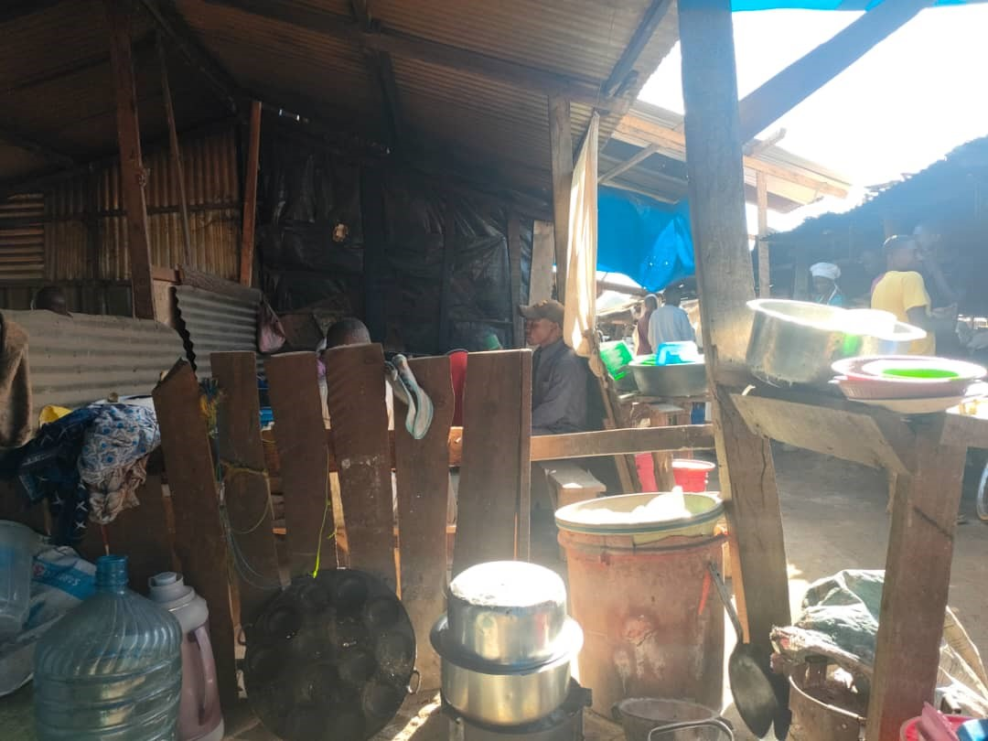
Figure 1. 1 A photo showing food vending site at Nyankumbu ward.
Source: Field Data (2023).

Figure 1 is a photograph portraying one of the food vending sites at Nyankumbu ward, from the picture it can be seen nakedly that the environment from which women food venders conduct their business are not more welcoming to the customers. It is difficult for a person who is a town dweller to decide to get food in such places. Apart from that, most of the food vending sites found at Nyankumbu Ward are located along the road where there is a lot of dust from moving vehicle, other activities and blowing wind. Further, the food vending sites have poor waste dumping places from the market. This can be argued that good care and preservation is highly needed by food venders to safeguard the quality of services and health of customers. Figure 2 reveals further;

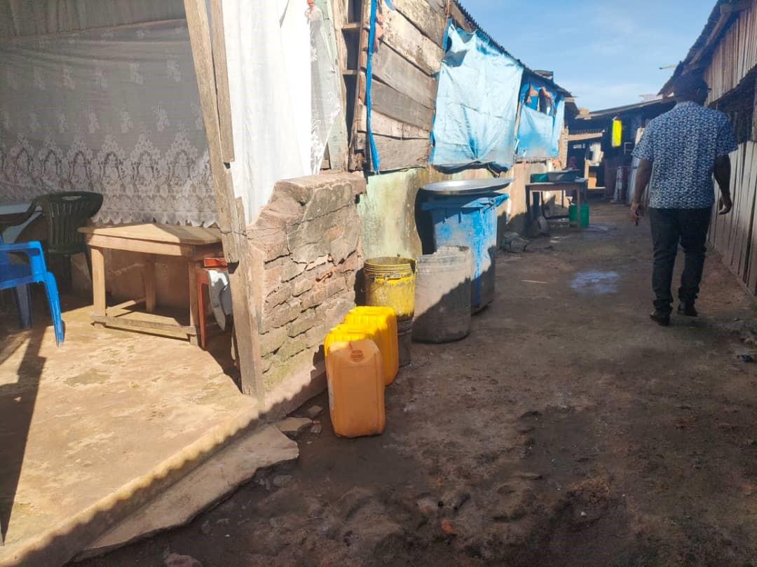
Figure 1. 2 A Photo showing food vending site waste disposal at Nyankumbu ward
Source: Field Data
The second community need assessment aimed at examining methods or techniques used to preserve food while waiting for customers to come.
In this objective the researcher used observation and interview method to collect data. The result from the interview were as follows; one of the food venders narrated “….we normally preserve food by our own methods….the most used methods are two; we use nylon bags these helps to keep the food hot for a long time……eer...the second way is through immersing a container with food into boiling water when the container gets hot even the food kept in the container will become warm….that’s how we preserve….”
Another food vender responded …..we cook different food stuffs ….their preservation do differ for the case of tea we use thermos which are made for keeping tea hot…..but for food like rice, ugali, bananas and others we actually preserve them using local methods such as the use of boiling water and putting into soft nylon bags and immersing the container into boiling water…..”
In line to that one respondent aired “….we are really challenged by customers some even reject coming for lunch just because of the poor methods we use to preserve food…..they tell us that these nylon have side effect on human health….but we have no other means of preserving our food stuff while we are waiting for customers to come….”
The results from interview were largely confirmed by findings from observation as revealed in Figure 3
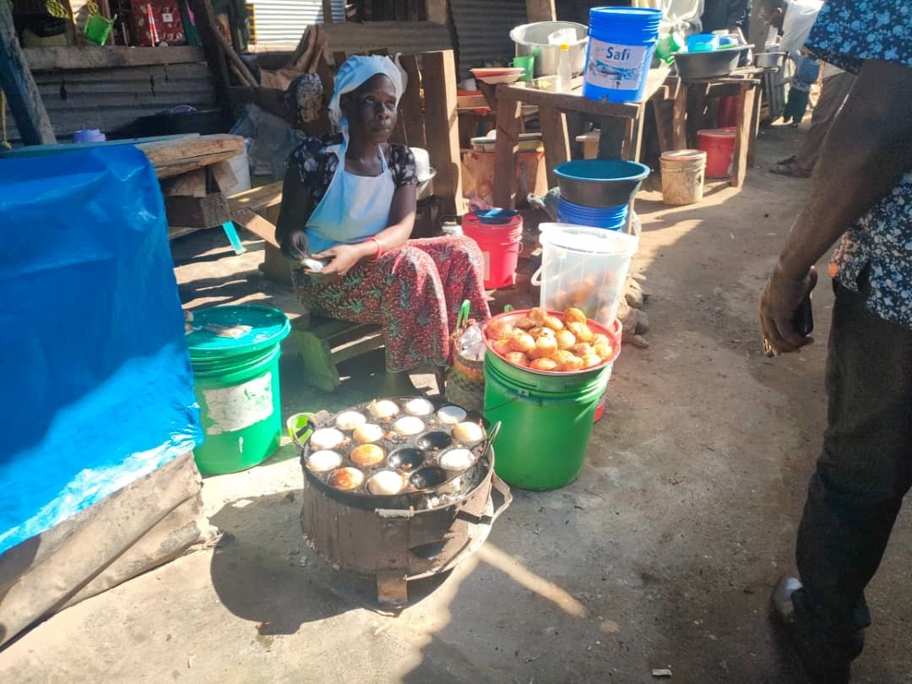
Figure 1. 3 A photo showing how food stuffs are being preserving while waiting for customers
Source: Field Data (2023).

Figure 1. 4 Food being prepared for packaging in nylon bags for preservation
Source: Field Data (2023)

The findings in Figure 3 and Figure 4 show that through observation most of food vendors found at Nyankumbu ward use buckets, pans with hot water and plastics or nylon bags to preserve hotness and safeness of food. This shows that food vendor at Nyankumbu use poor technique of preserving and storing food something which may jeopardize sustainability of the business and health of the customers. Therefore, from the findings it can be argued that food preserving methods are very poor to the extent that the business cannot attract more customers from all walks of life, hence this deprives women food venders the opportunity to increase their income and their households’ income generation at large.

The third community need assessment focused on eliciting data on measures that can be taken to solve challenges in countering food vendors at Nyankumbu Ward
Data were collected through interview. The results were as follows; some food vendors at Nyankumbu ward hinted that “… we needed a help or assistance to get better food serving utensils for preserving their food stuffs so as to get rid of dust and other contaminations….as for me if I get the modern utensils which will help me to keep my food stuffs hot for a longer time I will be glad…..yeah! Another one had the opinion that “….though the place is not suitable but for the moment I need to be supported on the preserving utensils …for my case if you help me with a refrigerator I will also be thankful….since sometimes food which is left cannot be stored because we don’t have refrigerator that can keep food safe for tomorrow …we normally dispose some food which could be kept for further use…”
From the findings it can be argued that women food venders at Nyankumbu sincerely need help on food preserving utensils which could keep their food stuffs warm and safe for further use. It can be noted that lack of food preserving dishes has led women food venders at Nyankumbu deprived of customers since the environment are not attractive. Therefore, supporting them with modern food vending dishes will raise the quality of food and hence increase customer turn up which in a long run will boost their income generation and their household at large.

1.8 Community Needs Prioritization
The community need prioritization was done using pair wise ranking method. Pairwise ranking is a structured method for ranking a small list of items in priority order. It helped to prioritize a small list and make decision in a consensus oriented manner. Nyankumbu Ward food venders identified three major need for conducting their food vending activity. The first was a better place for conducting their food vending activity, the second priority was modernized food storage utensils that can be used to store and keep their food safe and the third priority was business educations.

Table 1. 4 Pairwise score and ranking of four Community Needs
NEEDS | Place | Utensils | Business Ed. | Capital | Score | Ranking
Place | - | 1 | 1 | 0 | 0 | 3
Utensils | 0 | - | 0 | 0 | 3 | 1
Business Ed. | 0 | 1 | - | 0 | 2 | 2
Capital | 0 | 1 | 1 | - | 0 | 3
Source: Designed by Researcher (2023).

From the consensus between the researcher and the community (Nyankumbu ward food Venders). It was agreed that the mostly requirement needed to them is modern utensils for food preservation and business education, and the last but not the list allocated special area for food venders at Nyankumbu ward.
The researcher as facilitator encouraged Nyankumbu ward food venders to opt for the possible immediate help that can boost their business while waiting for other needs that require much cost and time. Then the researcher insisted on seeking help on modern utensils and business education which can be easily attained within a short period of time.

1.9 Conclusion
This chapter has presented background information the project, community profile, community needs Assessment, and Community needs assessment objectives. Also methodology has presented in this chapter and then Community needs Assessment findings have been presented thereafter community need prioritization has also been depicted in this chapter. Further, community project identification has been presented.

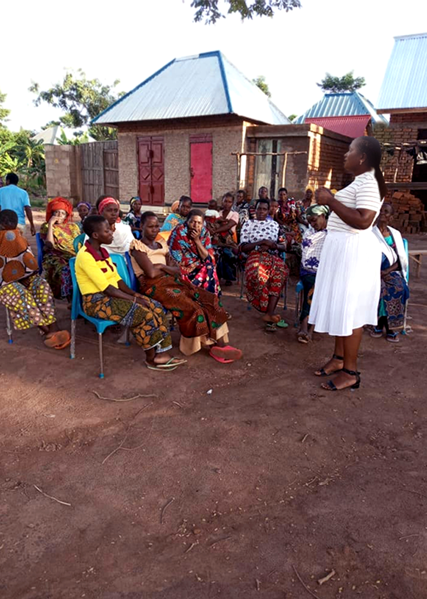
Figure 1.5 Nyankumbu Women Food venders involved in the CAN with the project coordinator
CHAPTER TWO
PROBLEM IDENFICATION

2.1 Background to Research Problem
The community needs assessment ascertained the intervention or measures to improve income generation of women food venders and their household at Nyankumbu ward. Therefore, the intervention will focus on the provision of utensils/ food vending dishes and business education to women food venders at Nyankumbu ward. Generally, the needs to provide food vending dishes was escalated by the fact that food vending enterprise is the main source of employment and household income generation for most of the women at Nyankumbu ward. Further, the location of the area is in commercial centre surrounded by market (Nyankumbu main market), road junction to three major areas namely (Nyangh’wale, Kakola, and Katoro), petrol stations and other social services which act as a source of customers. There has been several reports calling for community economic empowerment through improvement of street food safety and preservation.

2.2 Statement of the Problem
Street food vending enterprise contributes a lot to the household development. It is also provide a sustainable employment to a larger number of unemployed women in many of the developing nations including Tanzania. Although majority of urban dwellers depend on street venders including women food venders at Nyankumbu their food is said not to be safe considering their environment and preservation utensils used. That being the case, this project intends to improve household income generation through improving quality of women food vending dishes at Nyankumbu Ward.

2.3 Project Description
The project is focused on assisting women food venders by providing them with modern food preserving dishes to improve the quality of food so as to increase their income generation and raise the living standard of their households. Since these community group (women food venders) is not formal and lack business education. The project will provide education to women food venders at Nyankumbu three training programme. The three month education programme will include group formation and formalization. Managing business, an improved preservation and storage of food stuffs.

2.4 Target Community
The target group for this project are the women food venders at Nyankumbu Ward, Geita Town Council in Geita region. According to the 2022 census report indicate that, Geita Town council has 361671, and Nyankumbu ward has 87367 inhabitants.
Generally, the community living in this area engage in both formal and informal economic activities but most of them engage in informal economic activities such as trade, crop cultivation, animal keeping, Motor vehicle, garage, food processing mills and gardening.

2.5 Community stakeholders
Project stakeholders in this project include the beneficiaries and all others who in one way or another affect or will affect the project. The community around the project, Women themselves as well as their household members.

2.5.1 Stakeholders
Stakeholders are individuals who have an interest in the project and who may have an impact on or be impacted by its execution. They may be friends, coworkers, neighbors, suppliers, trade partners, members of the community, the government, or non-profit organizations. An internal or external stakeholder is a stakeholder. External stakeholders are those who do not directly work on the project but can still have an impact on or be affected by its operations and outcomes. Internal stakeholders are those whose interests in the project are derived from a direct relationship with the project operations, such as ownership and investment. These are sponsors, community members who benefit, and outside stakeholders who are public organizations.

Table 2. 1 Project Stakeholders Analysis
SN | Name of Stakeholder | Role of Stakeholder | Expectations
1 | Project group and the community at large | -Primary implementers of the project activities  -Primary beneficiaries of the project outcomes | -Improved livelihood and increased household income generation after active participation in the project
2 | NGO’s | -Organize and conduct trainings to the project.  -Conduct time to time monitoring of the project  - Provide technical support to the project group  - Donate toolsthe required for the project group( food serving dishes) | -Continued capacity building and community empowerment programs.  -Ensured effective implementation of the project  -Ensured availability of facilities and trainers
3 | Ward Community Development Officer | -The government’s focal person for nurturing socio-economic groups. | -Pilot project grows to a big project and reach out to more beneficiaries in the community
4 | Ward government | -Provide support in the identification and verification of project beneficiary (women food venders). | -The project is implemented to benefit the targeted population
5 | Health committee officer | -Responsible for regular visit to the project site.  -Provide technical advice to the project group for effective performance of the project | -New methods of food preservation and storage are adopted by the project group  -Ensured improvement in the quality of food
6 | Researcher (MCED) Student | Provide technical advice basing on data collected during CNA. | -Contribute to improved household income generation
Source: Designed by researcher (2023).

2.6 Project Goals in Community Economic Development Terms
The purpose of this project is to improve household income generation of women food venders at Nyankumbu ward. The project intends to provide business education and food serving dishes to women food venders at Nyankumbu which will enable them improve the quality of their service and finally increase their household income generation since there will not be loss due to poor preservation and storage of food stuffs for their business. Therefore, more profit will be gained hence, increased income which will assist in household development in general.

2.6.1 Project objectives
This project will be governed by the following objectives
- 30 women food venders at Nyankumbu ward mobilized, trained on business education by December, 2023.
- To support the group with registration process
- To donate women food venders with food vending dishes so as to improve the quality of their services to increase income generation from 200,000/= to 400,000/= per month through improved preservation and storage of food stuffs by May, 2024.

2.7 Host Organization
The host organization will be RAFIKISDO – NGO which is responsible for household economic empowerment, youth and women economic group support. The host organization is an emerging organization which was established and registered in 2022.
The organization has 20 members of which 15 whereas 09 are male and 06 are female. The organization is headed by the General meeting, Board of directors, executive director, deputy executive director, Followed by units which are the Internal Audit unit, Human resources and administration unit, Legal Unit, Finance Manager, Driver and Logistics, Meals Units, Office attendants, Security guards, Organization growth and development, Health and HIV/AIDS, Education unit, Gender Women and Children Unit, Water Sanitation and Hygiene (WASH), Livelihood and OVC Support.
This organization's primary goal is to raise the standard of living for its members and the neighbourhood it serves through development initiatives. The organization is dedicated to achieving its objectives, but there is a capacity gap that prevents it from achieving the expected aim. The majority of the members are women, and are standard seven leavers, with little to no organizational management and strategic plan preparation skills, which limits their ability to generate income. Members are steadfastly devoted to improving local social services from the ground up.
In enhancing the effectiveness and efficiency of the developmental projects, the establishment of the women's food vending organization and the proposed project are projected to improve the quality of life for those who reside in the project area. The MCED student will do her best to align the project with efforts being made by the civil society sector to boost civic participation and promote economic development through building capacity.
The MCED student anticipated raise 300,000 Tshs, and more backers will contribute 200,000 Tshs. Through CED student activities, the group will be able to connect with the Foundation for Civil Society, and they have submitted an application for institution development money, which will be able to cover the project's expenditures up to Tzs 1,000,000 Tshs. Additionally, the project will help the association of female food vendors to establish itself legally and in accordance with district-level CBO rules, including financial regulations.
This project was carried out together by the researcher, the host organization, and ward-level local government. The researcher's responsibility is to assist in the project's implementation, which entails conducting stakeholder analyses, organizational assessments, facilitating capacity building training, including the creation of strategic plan documents, compiling project reports, and engaging in fundraising to raise money to assist in the implementation of all those plans.
Vision: Is to have community in which women and vulnerable groups are empowered to improve their livelihood.
Mission: To improve household development in Tanzania through awareness raising and community economic empowerment, economic groups creation, strengthen women livelihood for effective household income improvement.
General Meeting

Board of Directors

Internal Audit Unit
Program Manager
Procurement Unit
Human Resources and Administration
Program Officers
Meal Unit
Driver and Logistics
Finance Manager
Legal Unit

IT Unit
Education
Communication Unit
Security guards
Office attendant
Livelihood Support

Figure 2. 1 Organization Structure of the Host Organization
Source: RAFIKISDO
2.8 Institutional Fundamentals
2.8.1 Project Vision; Building household with stable economic status
2.8.2 Project Mission: Making positive change in the lives of household members and making them maintain their economic status.

2.9 Organization Management Structure
The organization structure shown below outlines how tasks including task allocation, coordination, and supervision are focused on achieving the organization's goals. The chairperson, secretary, finance manager/accountant, supportive members, and members make up the executive committee's five members.

ORGANIZATION STRUCTURE
Organization Board
Chairperson

Secretary
Supportive Staff
Financial Manager/Accountant

Members of the Group

Figure 2. 2 Organization Management Structure

Table 2. 2 SWOT Analysis
SN | Strength | Weakness | Opportunities | Threats
1 | -The established group is fully owned by the target communities | -Lack of management and entrepreneurial skills | -Good support from the VICOBA National Office  Redness of the Group members | -The change of leadership may change political leadership and therefore support towards the CBO’s activities be affected
2 | -Low management costs, as costs are all partly taken care of by Community members alone under voluntary basis. | -Constitution for the Community is not yet in place | -Good support from the Geita Town Council | -Wealthier members may feel constrained by the limit placed on savings
3 | -Have established good working relationship with local government leadership | -Not registered, no policies and regulations | -Availability of educated staff and committed community | -Potential loss of money. The threat of possible loss of money is worrisome. This may discourage other members.
4 | -Have established good working relationship with government Office at the national level | -Lack of permanent office | -Available strategies for poverty reduction | -Access to markets insecurity can undermine the functionality of the Community
5 | The Community assist each other in the time of problems, such as death, illness and also cooperate in social events such as weddings, graduation | Lack of funds to establish big projects which can generate big income. | The government policy to support the community group formation as poverty reduction strategies | Lack of information access might undermine the process
6 | The Community members enjoy reasonable level of education | Lack of Bank Accounts | The available information within the community thatcan be accessed for development | Misuse of information and other wrong perceptions in thecommunity or direct stakeholders
Source: Field Data (2023).

2.10 The Role of CED Student in the Project
The CED student's responsibility on the project was to ensure that the plans and activities are carried out as intended.
- Help Nyankumbu's female food vendors organize and carry out their operations as efficiently as possible.
- Make every effort to provide the community with the amenities that best meet their needs.
- Training communities to keep track of the project's progress during implementation is step three.
- Step four is to ask other stakeholders and development partners for both financial and in-kind support.

2.11 Role of Community
The community's role was to take part in the exercise through community mobilization and awareness-building;
- Promote the product
- Ask the facilitator for material and non-material support;
- Use and maintain the provided material properly for sustainable use.

CHAPTER THREE
LITERATURE REVIEW

3.1 Introduction
This chapter reviews the literature on concepts, theories, laws, and empirical research that are relevant to the current study.

3.2 Theoretical Literature Review
3.2.1 Conceptualization of groups and group formation
According to Asçı et al. (2015) define group as a collective of one or more people interacting with one another to achieve a common objective. Similarly, Kocel (2011) defined group as a social reality made up of people that connect with each other and establish norms and behaviours through communication. This means that the interaction between the individuals may be direct or indirect.

Characteristics of a Group
A group must have social interactions and relationships amongst its members and be made up of two or more people who interact and affect one another.
There are shared desires, passions, interests, feelings, or objectives among the group's members.
Members of the group must communicate verbally and nonverbally.
Within the group, there is a sense of cohesion. Members of the group treat one another with consideration and build a sense of brotherhood.
Further, Hogg and Vaughan (2002) identified the following group characteristics; They have a sense of we feeling, a shared interest, a sense of unity, a connection to one another, are impacted by group traits, share values, are in control of the group, have an obligation, and have comparable expectations.
Types of Groups
Hogg and Vaughan (2002) classified groups in different ways these are;
The level of intimacy: Under this aspect they classified groups into two categories namely; primary group and secondary group. Primary groups are those where members have close, face-to-face relationships and are most likely to feel a sense of "we". Family, play groups, and the local community are a few of these. Secondary groups are those who move from one region of the country to another, and they are characterized by anonymous, impersonal, and instrumental interactions. They transition from long-standing connections to pervasive loneliness. Relationships within secondary groups are more or less casual and characterized by a shared interest, such as clubs, trades, unions, etc.
On the basis of relationships: Under this classification we have in-groups/we group. Vs out-group. In group: people members tend to identify themselves within that group. They treat members who do not belong to the group as out group. These are formed on the basis of relationship, country, political and economic interests.
Organised vs Disorganised: In this category there are two groups namely formal and informal. Formal groups are generally formed based on specific rules norms and values. Informal groups these are not formal at all they have flexible rules. Organised groups are formed for specific purpose and carefully planned. Spontaneous groups they are formed without any careful planning. Commands groups are groups specified by the organizational chart.
On basis of tasks: Functional groupings and task groups fall under this category. Task groups are associations of individuals who have gathered to carry out a specific objective. They have a set amount of time. Organizations form functional groups to carry out a certain task within an ambiguous time frame.
Interest group: These are associations that endure over time and can survive longer than the average association.
Friendship groups: These are formed by people who share common interests in politics, religion, social activities, etc.
Reference groups: serve as standards by which other groups and their members are judged.

3.2.2 Theories of Group Formation
Balance Theory
A Balance Theory of group formation is another highly thorough theory. Theodore Newcomb proposed that people are attracted to one another because they share similar viewpoints on common goals and things. It aims to maintain the attraction and shared values in symmetrical balance as soon as a connection is created. When an imbalance occurs, attempts are made to make it right. If the equilibrium cannot be restored, the partnership terminates (Baumeister et al., 2007). As a result, the balance theory is additive in that it adds the balancing component to the proximity and interaction elements. A harmonious relationship between the group members is necessary for the formation and survival of the group. In this project, balance theory is applicable in the notion that women food venders at Nyankumbu ward engage in food vending enterprise for the sake of avoiding imbalanced structures which include low income which brings about negative feeling in their lives. Low income hinders women from accessing daily needs to the required level. In order to get rid or to avoid imbalanced structures is through getting assistance on food serving dishes so as to balance their structures and bring comfort in their households.

Homan’s Theory
George Homans stated that "the more activities people share, the more interactions they will have, and the stronger their shared activities and sentiments will be; and the more feelings people have for one another, the more shared activities and interactions they will have." Homans' theory has made a significant contribution to our comprehension of group formation. It is founded on three interconnected notions, namely activities, interactions, and attitudes. A group's members cooperate and engage in shared activities not just because they are close by but also in order to achieve common objectives. Interaction is crucial since it leads to the development of shared feelings for one another. (Baumeister et al.,2007).

Propinquity Theory
The most basic concept underlying affiliation is propinquity. Simply put, this intriguing term implies that people connect with one another depending on their proximity to one another physically or geographically. Those who work in the same area of the office or facility or whose supervisors share an office are more likely to form groups than those who are not physically close to one another. The propinquity hypothesis has some research to support it, and on the surface, it seems like a very reasonable explanation for how groups form. Due to the fact that both of the women who sell food in Nyankumbu ward operate in the same location, they can easily establish a group in this regard. The drawback of this idea is that it (Baumeister et al., 2007).

Exchange Theory
The reward-cost results of interactions form the foundation of this theory. A person considers what he will gain from interaction with group members while deciding whether to join one. For attraction or affiliation to occur, a result must have a maximum positive level (rewards greater than costs). In contrast to costs, which include anxiety, annoyance, shame, or exhaustion, benefits of interactions satisfy requirements. In the exchange theory, proximity, engagement, and shared attitudes all play a part.

3.3 Empirical Literature Review
Petcho et al.(2019) in a study conducted in Thailand on farmers they conceptualized that marginalized groups/ community face multiple challenges which prevent them from improving their household income generation initiatives and hence they opt for group/collective action as a way towards empowerment. Additionally, numerous characteristics, such as modest land holdings, a variety of rice varieties, engagement in networks, membership in economic groups, access to extension services, access to loans, and closeness to markets, had an impact on members' decisions to join the collective venture.
A survey study conducted in main cities of Pakistan by Noor et al.(2021) which involved 120 women participants. It was reported that women who engage in entrepreneurship do so to support their families. Further, the study revealed that empowering women in the field of entrepreneurship will bring societal revolution and will act as an accelerator to the household income generation.
Similarly, findings from a study conducted in Nithari, Noida, India by Kapoor (2019) reported that, self-help groups helped women in different spheres of life which include change in living standards, awareness about health and nutrition has improved. Generally, there was significant economic, social, health, education and household income generation. Knowledge and self-awareness also increased. Therefore self-help groups act as an essential tool in the initiative to uplift women’s life and the household.
A survey study conducted by Ge et al. (2022) in Australia on women entrepreneurship contribution on family income generation. The study involved snowball sampling technique to get participants, interview was employed to gather information. The results revealed that there was a significant contributions of women entrepreneurial income to the household income generation.
Report by Suzana et al. (2020) conducted in Malyasia show that women entrepreneur from developing countries especially those at the bottom level are forgotten by state authorities and development partners. These women are encountered with inaccessible to finacial, entrepreneurial and business skills bargaining power within the market. This implies that helping women food venders at Nyankumbu through groups will empower them in their entrepreneurial activities and hence boost their household living standards.
A research conducted by Osei and Zhuang (2020) in Sekyere south district in Ghana which involved 333 women entrepreneurs from Agricultural sector, indicated that women entrepreneurs progress rate was positively and significantly associated with rural poverty alleviation. Furthermore, the report shows that relational social capital and social innovation have a beneficial effect on reducing poverty. In other words this implies that since poverty alleviation was positively associated with women entrepreneurs’ growth performance, even household income was positively impacted.
It is asserted that for entrepreneurship it is the backbone for poverty alleviation and empowerment of marginalised population (women) inclusive it is suggested that the following are key issues to be considered by the government and NGO’s; Access to a supportive ecosystem and infrastructure, training for low-income entrepreneurs, growth of opportunities, differentiating the company, using community resources, and putting more than a dent in poverty are some of the other factors (Morris et al., 2020). In additional to that a qualitative study done in Tanzania by Hilmi, (2020) street food marketing which compared 12 countries, reported that among other factors affecting street food venders food market in Tanzania was lack of value creation among women food venders.

3.4 Policy Reviews
In the effort to overcome poverty and create a better household living standard the government of Tanzania has from time to time established policies to raise her citizens' standards of existence. The 2003 Small and Medium Enterprise Development Policy is one of the laws. The National Microfinance Policy seeks to shift the economy from one that is based primarily on agriculture to one that is semi-industrialized. To achieve this objective, the SME sector must play a substantial role. In order for the SME sector to be able to fulfil this important function, the sustainable industrial development policy outlined specific methods aimed at stimulating it. According to this policy, the government is committed to fostering the growth of entrepreneurship by supporting SMEs' enhanced access to financial and non-financial services. In Tanzania, small and medium-sized businesses (SMEs) are essential for generating money and new jobs. SMEs exist worldwide and in Tanzania. (URT, 2003).

Another policy focusing on community empowerment is the Tanzania's 1992 Women in Development Policy. The main goals of this policy are to define the term "concept of women in development," identify issues with planning that doesn't take gender into account, provide guidelines for planning that does, identify barriers to women's participation in development, and provide solutions to those barriers. create systems and techniques to lessen women's onerous workloads, and elaborate on methods that will be utilized to coordinate initiatives for women's development (URT, 1992). Despite of these good policies, achievement have not been realized among women food venders at Nyankumbu ward. In the effort to join the government of Tanzania in the effort to upgrade the living standard of its citizen the implementation of this project will help to bridge the unrealized goal to the women at Nyankumbu Ward in Geita Town Council.

3.5 Literature Review Summary
The reviewed literature on theoretical, empirical studies and policies has vividly indicated that CED among marginalized groups including women can done through groups. Also the literature review has revealed that much emphasis is placed on household empowerment through collective support/group support. Moreover, it is noted that value creation is among major challenges encountered by women street food venders in Tanzania.

CHAPTER FOUR
PROJECT IMPLEMENTATION
4.1 Introduction
This chapter describes how the project was carried out over the course of six months. Implementation is essentially a follow-up to the findings from the community needs assessment. The need for providing assistance on food serving dishes to women food vendors in Nyankumbu ward was discovered during a community needs assessment that was carried out in partnership with members of the community. The project's products, outputs, planning, staffing, budget, and implementation report are all covered in this chapter. Improved Households Income Generation by Improving Women Food Vending Dishes is the project's full title. Nyankumbu Ward in the Geita Town Council: A Case Study.

4.2 Background of the Project
The Nyankumbu Women Food Venders groups comprised of 30 members who make three sub groups of 10 women each. The main activity of the groups is to sell food in a good and hygiene environment through the use of food serving dishes donated to them so as to attract more customers and earn more income for their family prosperity. According to the group there is a number of issues that need to be resolved for the group to operate smoothly. These are;
- The need for the office to efficiently complete their daily group projects
- The requirement for business management and marketing education
- The need for back up from the Town Council and developmental partners to support them during sensitization meetings
- A need for financial resources for purchasing food serving dishes. This is obtained from the donors
- Preparing and preserving food stuffs in the provided food serving dishes and keeping the utensils for sustainable use.

4.3 Products and Outputs
The following were the outputs and products this project aimed to produce after a six-month timeframe.
- Output 1: Community based organization is certified or officially recognized by Geita Town Council.
- 30 community members are imparted with knowledge on business management and marketing.
- 30 group members donated with food vending dishes.

4.4 Project Planning
Group members and Ward representatives have worked together to carry out this project. The total cost for the whole project is about 8,000,000/=Tshs. The budget paid for sensitization meetings (PA), food vending dishes for the 30 group members, remuneration for training, and other expenses.

4.4.1 Implementation Plan
In designing the implementation plan, the project implementation plan comprised the following issues; descriptive summary, performance indicators resources needed, responsible person and time frame. Table 4.1 elaborates in details.
Table 4. 1 Logical Framework of Project Implementation Plan
Narrative Summary |  | Performance Indicators | Resources Needed | Responsible | Time
Project Activities
Activities of Goal 1: Women Food Venders Mobilized and Registered
A1 | A joint discussion was held to address the issue | At least 1 discussion held | NA | Secretaries | January 2023
A2 | Get the registration form from local authority | Secretaries of the groups were tasked to pick the application form | 5000 | Researcher | January 2023
A3 | Fill and sign application form | Members signing/signatures | NA | All groups | February 2023
A4 | Submission of the application form | Evidence of members contribution for the fees | 10000 | Group Secretaries | February 2023
A5 | Obtaining the Registration Certificate | The secretaries tasked to pick the certificate | 10000 | Group Secretaries | March 2023
Activities of Goal 2: Training Group Members on Business Management Skills
A6 | Initiate group members attend | group members' names and phone numbers | 10000 | Secretary | April 2023
A7 | Attendance of the training | Group members’ attendance record | 10000 | All members & Trainers | April 2023
A8 | Groups have skills to establish and manage their business appropriately | timetable of training program events or manuals | NA | All members | May 2023
A9 | Groups are able to improve value chain of their products | Timetable for training program on value adding of products | NA | All members | May 2023
Activities of Goal 3: Women Food Venders Donated with Food Vending Dishes
A10 | Members are trained on how to use the food vending dishes donated | Schedule of activities in training on how to use food vending dishes | NA | All members | June 2023
A11 | Food vending dishes distributed to members of the groups | Women food venders receiving the given sets of food vending dishes and start using them | NA | All members & Donors | June 2023
Source: Field Data 2023

4.4.2 Project Inputs
The project to be done successfully, the project needed some inputs to facilitate its operations. This project had the following inputs used in the project as shown in Table 4.2
Table 4. 2 Project Inputs
SN | Inputs | Unit Cost (Tzs) | Quantity | Cost (Tzs)
1 | Group establishment | 10,000 | 3 groups | 30,000
2 | Trainers facilitation fees | 60,000 | 4 ×5 days | 1,200,000
3 | Communication and PA costs | 334,000 | 5 days | 1,670,000
4 | Food vending dishes | 170,000 | 30 sets | 5,100,000
Total |  |  |  | 8,000,000
Source: Researcher (2023).

4.4.3 Staffing Pattern
Personnel were needed for both the project's planning and execution. As a result, two employees were employed, including a trainer and a support staff member drawn from the group. They performed the following tasks for the project.
Consultants: The concept, creation, and delivery of the training program to the group members was under the purview of the trainer. The trainer made sure that the group members met the requirements necessary for them to be registered as a food vending group.
Support Staff: The group members each chose one person to work with them to complete the group activities successfully and to assist the consultant with logistical issues related to taking attendance, ordering supplies, cleaning the space, and setting up the training session.

4.5 Project Implementation Report
The project's implementation started in January 2023 by determining the issue or challenge that the community faces and the community that would be involved in the initiative. Then, in collaboration with the community members who would eventually take part in the project, a needs assessment of the community was conducted. The initiative had three goals: first, to help the group formalize its operations; second, to teach group members group management, business management, and entrepreneurship skills; and third, to help the group secure donations of food vending equipment.
An introduction to the local authorities was made through registration, and the Ward Health and Environmental Executive Committee attended to acknowledge the organizations on a local level. As the group awaited the registration procedures from Geita Town Council, the ward also gave it an introduction letter and an acceptance letter to continue the process. The group had four weeks of instruction in the same manner, covering topics including business management and entrepreneurship. On every Friday from 15 to 17 hours, training was conducted once a week.
The training took place at the local authority office. The training was conducted by three consultants namely Health, Environmental, Business consultant, and Community development officer. Issues covered in the training include; Introduction to food preparation and hygiene, introduction to sentimental preservation, food marketing, financial management, entrepreneurship, community group formation procedures and leadership skills. As part of the program, members were imparted knowledge on the vicoba model of saving and lending. Members of the group now possess knowledge and skills related to food preparation, processing, and preservation, waste management resulting from daily activities, increasing the value of their food products, managing money, entrepreneurship skills, and creating sustainable groups. The information will be put to use both during group activities and outside the group.
4.5.1 Establishment of women food vending group
All kinds of community organizations and traditional institutions, including churches, schools, and newspapers, are the cornerstones of community capacity building and are anticipated to be included in the process of community development. This group is being established to increase the effectiveness of these organizations and institutions. The community will enjoy the anticipated social and economic progress when organizations and institutions are managed effectively.
In creating the groups, the community ought to choose and use resources in a manner akin to that of a savvy shopper. Communities must strike a balance between current resource consumption and future resource needs. A community must make a lot of decisions when allocating resources. Group members can explore issues from various points of view when they work together. You are compelled to hear other people's solutions to the problems facing the community when you are expected to discuss an issue and negotiate how to address it.

Official registration
The Geita Town council has officially recognized the group in a letter. The group's members have given the group's head the responsibility of continuing to monitor the procedure at the ministry of home affairs. The group has nevertheless steadily kept up its operational activity.

4.5.2 Project Implementation Gantt chart
The project implementation activities are displayed in the Gantt chart. It displays the beginning and ending times of each activity. Each activity's time is calculated, and the variance is explained. This is helpful information that will help the project coordinator make sure the project is carried out according to schedule and directly relates to the scheduled activities.

4.6 Project Implementation Gantt chart
Activities | 2023
Activities | June | July | August
Formalization of the Group
1. A meeting with the community to discuss the community needs assessment
2. Introduce the group to the local authority
3.Filling and signing the application forms
4.Submission of the application forms
Actual training
6.Mobilization of the group members
7.Attendance of the training
8. Members are able to establish and manage their business appropriately
9. Members are able to conduct marketing and improve value chain of their products
Members to manage contracts
11.The training on how to use the donated food dishes
12.Practically using food vending dishes donated to the members
14.Writing Report

Figure 4.1 Nyankumbu Women Food Venders using the donated food vending dishes in their working sites
CHAPTER FIVE
PROJECT MONITORING, EVALUATION AND SUSTAINABILITY

5.1 Introduction
This chapter describes project monitoring and evaluation, in which issues covered include: Participatory monitoring, methods of participatory monitoring, the actual monitoring, project evaluation and project sustainability has been described in detail.

5.2 Participatory Monitoring
Participatory monitoring of the project was done through gathering information regarding the project against the activities. This was done in collaboration with the group members during the project implementation.

5.2.1 Participatory monitoring methods
This describes methods used in monitoring project activities and other related activities. Monitoring of the project is essential since it can help to make changes and incorporate into the project to make the intended goal be achieved successfully. The participatory monitoring used the following methods; Self-assessment, document review, and observation. The monitoring was done on activities that were mutually agreed between the researcher and the community group.

Observation
Various activities were directly eye witnessed by the researcher and other participants in the project. Important information that could be of any help to the project development was recorded.
Review of document
To confirm that project activities, such as attendance and group members' daily routines in the community and the research area, are consistent with the project's report, various documents were reviewed. Reviewing the records was crucial since it confirmed the actions taken and the agreements made by the group members.

Table 5. 1 Monitoring of the Project Activities
Information | The monitoring type | Type of records kept | The person responsible person for data collection | The use of the data obtained | The use of the information obtained | The type of decision made by the project.
Plan out the project activities | Resource availability | Plan out schedules for the activities | Project community members and Researcher | Researcher | Managing time | Balance the time provided
Costs underlying and expenditures | Fund available | Bank account | Researcher and Community members | The community and researcher | Integrity is very important | Decide to drop or revise the budget
Groups involvement in the activities | Skills and attitude required | Feedback and clear activities | Researcher | Project community | Improve the community knowledge and information | Facilitation section table and time required
Commodities | Learning materials and manuals | Ledgers | Project community members | Group Leadership | Improve the community-based management skills | Improve leadership
Results | Look at the number of activities performed | Look upon the authorities | Activities management | leadership | Quality services | Make necessary arrangement for time management

5.3 The Actual Monitoring
The following areas were really monitored to make sure the project activities were carried out to the intended level. In-puts such as community resources' expertise, Process, output, and measurement of the results of all the project's completed operations. These were directly related to the amount of funding available, the training materials, and the number of participants, the schedule, and the location. The number of training sessions held, the number of project participants that underwent training, and the participation of community members are the project's output metrics.

Table 5. 2 Participatory Monitoring Plan
Objective/Activities | Monitoring Method | Performance Indicator | Means of Verification
Objective: To support the group with the registration process at local level
Activities:

- A joint meeting  conducted to discuss the matter | Document Review | At least 1 meeting conducted | Minutes
- Obtain the registration  forms from local authority level | Observation | The researcher assigned to get the application forms | The registration form
- Filling and signing  the registration form | Observation | Members signatures | A copy of filled and signed application form
- Submission of the  application form | Document review | Evidence of members contribution towards the fees | Receipt of application fees
- Collection of  registration certificate | Observation | The researcher assigned to collect the certificate | Registration Certificate
Objective 2: To acquaint the group with the group management, food preservation and value adding chain skills
Objectives/Activities | Monitoring Method | Performance Indicator | Means of Verification
Activities
1.Attendance of the training | Document review | List of names of training participants | Weekly attendance register
3.Members conduct and record minutes of the meeting | Observation | Schedule of activity in training program or handout | Sample of minutes of model meeting
4.Members market and add value to their product | Observation | Schedule of activity in training program and handout | Mode of packaging of their food stuffs
5.Members understand the concepts food preservation and value adding chain and apply | Observation | Members able to model Schedule of activity in training program and handout | Members are preserving food and adding value to their food stuffs

5.4 Project Evaluation
The project participants were required to make sure they spoke about the project's execution and its activities in the community as part of the participatory evaluation approaches, which also included observation, questionnaires, and other informative tactics. The community was asked to evaluate the project's outcomes using a self-assessment method via an evaluation questionnaire.

Table 5. 3 Evaluation Plan I
OUTCOME | Rate the Project Outcome in your own perspective
OUTCOME | V.Good | Good | Average | Poor
Objective 1: To Support the Group with the Registration Process at local and national level
Output 1:  Business Registration Certificate | 100% | 0% | 0% | 0%
Objective 2: To acquaint the group with Business management skills food preservation and value added chain
Output 2: Understanding of concept of food preservation and value adding chain | 100% | 0% | 0% | 0%
Objective 3: To enable the group donated with food vending dishes
Output 4: Management of food vending dishes in their daily activities | 70% | 20% | 5% | 5%
Source: Field Data (2023).
The project members, the local government, and the community worked together to ensure the growth of the community, and the activities of the project were carried out to a 100%, proving its highly successful implementation. The third output's evaluation shows that the group is still behind on the use of the provided serving utensils for food. For example, just 20% of the group believes that the management of group activities is "Good"; therefore, various efforts are still needed to guarantee that the project makes optimal use of its resources and project activities. 5% of the members thought that the use of the provided serving utensils was "Average" at the same time. Similarly, 5% of the members thought that using the provided food serving dishes was "Poor," thus the project stakeholders had a lot of work to do to get the members of the project to agree to utilize the donated food serving dishes in a way that would benefit the community and the project.

5.5 Sustainability
The organization has a sufficient number of members and plans to hold a sensitization meeting to guarantee that new members join the CBO and take part in food vending operations. The initiative must use its available resources, including human resources, community members, and other community development partners, to secure its survival.

5.5.1 The Institutional Sustainability Plan
The members of the community who joined the women's food selling organization have begun making monthly contributions to the group and working with the CBO in the neighborhood.
5.5.2 Financial sustainability
This group will be able to maintain its financial viability because it is establishing a solid financial foundation over time. It's vital to keep in mind, though, that they initially pledged to contribute and eventually become sustainable. Since the community's members have entered into contracts stipulating that they would pay their dues on a monthly basis, the group is also guaranteed long-term financial viability.

5.5.3 Technical sustainability
The group's training-related knowledge and abilities will serve as a solid technical foundation for this group. This will make sure that the group is technically resilient so that the loss of any technical support won't have a significant negative effect on it.

5.5.4 Organizational sustainability
This group is actually at embryonic stage since it has just began as a group in terms of organization. The management of activities hasn't received a great evaluation up to this point. However, there is hope for organizational sustainability because it has been acknowledged by the local government authority and because group members have demonstrated a desire to carry on the good work that it has begun.

CHAPTER SIX
PROJECT CONCLUSION AND RECOMMENDATION

6.1 Introduction
This project was implemented in Geita Town Council, Nyankumbu Ward. The conclusion and recommendations of the project are hinged on the project design, literature review, project implementation, monitoring, evaluation, and sustainability.

6.2 Conclusion
As urban and peri-urban areas experience rapid population growth, services including food vending service experience increased demand too. Initiative to meet the increasing urban population also increase. The increased initiative to meet the demanding population should go together with the improved quality and safety food preservation among street food venders. Since women food venders had been providing food vending service in unconducive set up and preserving in a primitive way. As a means to improve their income generation and improve the quality of their service this project focused on providing support of food vending dishes among Women Food Venders at Nyankumbu Ward. Since many urban residents rely on street food vendors to provide them with a regular supper, helping women food venders in improving their food services it ensures quality services, improved income generation and better customer health of the entire Geita Town Council at large.

6.3 Project Recommendations
6.3.1 Promotion of sustainable livelihood through food vending
- Women Food Venders to have sustainable livelihood there should be initiative put into practice to uphold success attained in the implementation of the project.
- Food vending activities when integrated with life skills becomes a major source of employment to many unemployed women and youth population in urban areas.
- Local government can assist other street food venders in other urban areas by involving development partners by making “safe and healthy street food agenda” permanent agenda and discusses it in all meetings.
- By-laws be in-acted and enforced to discourage poor and improper food vending and food preservation.

REFFERENCES

Asçı, M. S., Çemberci, M., Civelek, M. E. C., & Gunel, D. (2015). Groups and Their Effects in Organizations. European Scientific Journal, 11(32), 1857–7881.
Baumeister, R. ., Bratslavsky, E., Finkenauer, C., & Vohs, K. . (2007). Balance Theory. Advances in Experimental Social Psychology, 5, 323–370.
Cohen, L., Manion, L., & Morrison, K. (2018). Research Methods in Education (8th ed.). Routledge.
Creswell, J. W., & Creswell, J. D. (2018). Research Design: Qualitative, quantitative, and mixed methods approaches (5th ed.). Sage Publications, Inc. http://library1.nida.ac.th/termpaper6/sd/2554/19755.pdf
Dawson, C. (2009). Introduction to Research Methods: A practical guide for understanding a research project (4th ed.). How to Content.
Denscombe, M. (2010). The Good Research Guide (4th ed.). McGraw-Hill.
Ge, T., Abbas, J., Ullah, A., Sadiq, I., & Zhang, R. (2022). Women ’ s Entrepreneurial Contribution to Family Income : Innovative Technologies Promote Females ’ Entrepreneurship Amid COVID-19 Crisis. Frontiers in Psychology, 13(March). https://doi.org/10.3389/fpsyg.2022.828040
Hilmi, M. (2020). Street food vendors’ entrepreneurial marketing characteristics and practices from 12 countries: what lessons can be learnt for improving food marketing in BOP/Subsistence marketplaces. Middle East Journal of Agriculture Research, 321–348. https://doi.org/10.36632/mejar/2020.9.2.27
Hogg, M. ., & Vaughan, G. . (2002). Introduction to Groups: Definition, Characteristics and Types of Groups (p. 17). https://egyankosh.ac.in/bitstream/123456789/23590/1/Unit-1.pdf
Johnson, M., Samuel, I., Irene, O., & Paul, K. (2020). Food safety knowledge and practices of street food vendors in selected locations within Kiambu County, Kenya. African Journal of Food Science, 14(6), 174–185. https://doi.org/10.5897/ajfs2020.1929
Kapoor, S. (2019). Entrepreneurship for economic and social empowerment of women: A Case Study of Self Help Credit Program in Nithari Village, Noida, India. Australasian Accounting, Business and Finance Journal, 13(2), 123–142. https://doi.org/10.14453/aabfj.v13i2.8
Kombo, D. K., & Tromp, D. L. . (2006). Proposal and thesis writing: An introduction. Paulines Publications Africa.
Kumar, R. (2011). Research Methodology A Step-by-Step Guide for Beginners. 3rd Edition. Sage, New Delhi. - References - Scientific Research Publishing. Sage. https://www.scirp.org/(S(oyulxb452alnt1aej1nfow45))/reference/ReferencesPapers.aspx?ReferenceID=1971596
Kundu, S., Banna, M. H. Al, Sayeed, A., Akter, S., Aktar, A., Islam, M. A., Proshad, R., & Khan, M. S. I. (2021). Effect of vendors’ socio-demography and other factors on hygienic practices of street food shops. Journal of Foodservice Business Research, 24(4), 445–456. https://doi.org/10.1080/15378020.2020.1870785
Letuka, P., Nkhebenyane, J., & Thekisoe, O. (2021). Street food handlers’ food safety knowledge, attitudes and self-reported practices and consumers’ perceptions about street food vending in Maseru, Lesotho. British Food Journal, 123(13), 302–316. https://doi.org/10.1108/BFJ-07-2020-0595
Ma, L., Chen, H., Yan, H., Wu, L., & Zhang, W. (2019). Food safety knowledge, attitudes, and behavior of street food vendors and consumers in Handan, a third tier city in China. In BMC Public Health (Vol. 19, Issue 1, pp. 1–13). BMC Public Health. https://doi.org/10.1186/s12889-019-7475-9
Morris, M. H., Santos, S. C., & Neumeyer, X. (2020). ScienceDirect Entrepreneurship as a solution to poverty in developed economies. Business Horizons, xxxx. https://doi.org/10.1016/j.bushor.2020.01.010
Neuman, W.L. (2017). Understanding Research (2nd ed.). Pearson.
Neuman, W Lawrence. (2017). Understanding research second edition (Vol. 32, Issue 5).
Noor, S., Isa, F. M., & Nor, L. M. (2021). Women empowerment through women entrepreneurship: A comparison between women entrepreneurs and fulltime housewife in pakistan. Iranian Journal of Management Studies, 14(2), 347–363. https://doi.org/10.22059/IJMS.2020.302633.674074
Okojie, P. W., & Isah, E. C. (2019). Food hygiene knowledge and practices of street food vendors in Benin City, Nigeria. International Journal of Consumer Studies, 43(6), 528–535. https://doi.org/10.1111/ijcs.12538
Okumus, B., & Sonmez, S. (2019). An analysis on current food regulations for and inspection challenges of street food: Case of Florida. Journal of Culinary Science and Technology, 17(3), 209–223. https://doi.org/10.1080/15428052.2018.1428707
Oribhabor, C. ., & Anyanwu, C. . (2019). Research sampling and sample sizedetermination: A practical application. Federal University Dutsin-Ma Journal of Educational Research, 2(1), 47–56.
Osei, C. D., & Zhuang, J. (2020). Rural Poverty Alleviation Strategies and Social Capital Link : The Mediation Role of Women Entrepreneurship and Social Innovation. https://doi.org/10.1177/2158244020925504
Petcho, W., Szabo, S., Kusakabe, K., & Yukongdi, V. (2019). Farmers ’ Perception and Drivers of Membership in Rice Production Community Enterprises : Evidence from the Central Region , Thailand. Sustainability, 11(19), 5445.
Samapundo, S., Climat, R., Xhaferi, R., & Devlieghere, F. (2015). Food safety knowledge, attitudes and practices of street food vendors and consumers in Port-au-Prince, Haiti. Food Control, 50, 457–466. https://doi.org/10.1016/j.foodcont.2014.09.010
Seo, K. H., & Lee, J. H. (2021). Understanding risk perception toward food safety in street food: The relationships among service quality, values, and repurchase intention. International Journal of Environmental Research and Public Health, 18(13). https://doi.org/10.3390/ijerph18136826
Suzana, A., Mohamed, S., Baqutayan, S., & Mahdzir, A. M. (2020). Enhancing Women Entrepreneurship Development Framework : Policy & Institution Gap and Challenges in the Case of Malaysia. 6(2), 22–33.
Thi, A. N. T., Kittirath, P., Abiola, S. D., Duy, L. N. D., & Ha, N. C. (2021). Evaluation of street food safety and hygiene practices of food vendors in Can Tho City of Vietnam. Current Research in Nutrition and Food Science, 9(1), 158–171. https://doi.org/10.12944/CRNFSJ.9.1.16
URT. (1992). URT 1992 Policy of Women in Development Tanzania.pdf.
URT. (2003). United Republic of Tanzania Ministry of Industry and Trade Small and Medium Enterprise.
Waters, A. (2020). Community Needs Assessment: The Resources and Examples Your Organization Needs. https://www.galaxydigital.com/blog/community-needs-assessment

APPENDICES
Appendix 1. 1 Interview Schedule for Community Members
I am Martha Kaloso, a Master of Community Economic Development student at the Open University of Tanzania. I am conducting a community need assessment. I would appreciate if you could spare few minutes to provide information for this study. The information which you provide will be highly appreciated and will be treated confidential.
Questions
- Gender
- Male/ Female ………………..
- Age i) 15-20 ….. ii) 21-30….. iii) 31-40… iv) 41-50 …. v) 51-above
- Education level
- Informal
- Primary education
- Secondary education
- Vocational training
- Diploma
- Degree
- Where do you live (street name) ……………….
- The house you are living in is it yours or rented? ...........
- How many are you in your household …………..
- What is your daily economic activity …………………..
- What is your daily earning…………..
- What is your monthly income Tshs …………..
- What is your annual income Tshs …………..
- What can you say about your income? Is it Low income, Average income or High income

