IMPACT OF ADMINISTRATIVE BARRIERS TO TRADE BETWEEN TANZANIA AND KENYA: A CASE OF SMALL SCALE TRADERS AT NAMANGA, ARUSHA

HASINATI DAVID YOHANA

A DISSERTATION SUBMITTED IN PARTIAL FULFILLMENT OF THE REQUIREMENTS FOR THE DEGREE OF MASTER OF ARTS IN INTERNATIONAL COOPERATION AND DEVELOPMENT
DEPARTMENT OF POLITICAL SCIENCE, PUBLIC ADMINISTRATION, HISTORY AND PHILOSOPHY
THE OPEN UNIVERSITY OF TANZANIA
2024

CERTIFICATION
The undersigned certify that he has read and here by recommend for acceptance by the Open University of Tanzania a thesis titled: “Impact of Administrative Barriers to Trade Between Tanzania and Kenya: A Case of Small scale Traders at Namanga, Arusha’’ in partial fulfillment of the requirements for the degree of Master of Arts in International Cooperation and Development (MA ICD) of the Open University of Tanzania.
.

………………………………………
Dr. Felician Mutasa
(Supervisor)

.........................................................
Date

COPYRIGHT
No part of this Dissertation may be reproduced in any retrieved system, or transmitted in any form by any means, electronic, mechanical, photocopying, recording or otherwise without prior permission of the author or the Open University of Tanzania in that behalf.

DECLARATION
I, Hasinati David Yohana, do hereby declare that, this dissertation is my own original work and it has not been and will not be submitted for any degree award in any other institution. It is hereby presented in partial fulfilment of the requirements for the award of Master of Arts in International Cooperation and Development (MA ICD) of the Open University of Tanzania

…………………………………………..
Signature

……………………………………………
Date

DEDICATION
This piece of work is dedicated to my late mother Juliana Joseph Kivuyo and my father David Yohana Laizer, for making me the person I am today. My young brother Yohana David Laizer and my children Rachael and Ashery, this is for you too. My young brother Piniel David Laizer, I lost you when I was in the mid of this work, I will always remember you and may your soul rest in eternal peace. Amen.

ACKNOWLEDGEMENTS
The successful completion of this work was made possible by the joint efforts of a number of institutions, organizations and individuals, whose participation I would like to acknowledge with gratitude.

I highly thank the almighty God for making me able to accomplish this work. First and foremost, I have to thank my research supervisor, Dr. Felician Mutasa from The Open University of Tanzania. Without his assistance and dedicated involvement in every step throughout the process, this dissertation would have never been accomplished. I would like to thank them very much for their guidance, positive criticism and understanding.

I would also like to express my sincere gratitude to all those who have contributed to the successful completion of this study, such as my fellow candidates who in one way or another have their role in the preparation of this dissertation.

Most importantly, none of this could have happened without the support of the whole leadership of Arusha region executives, Longido district council executives and Namanga ward executives and all respondents for their cooperation and willingness to give adequate information.

Lastly to my children, my brothers and sisters, my coordinator and all my lecturers for their kind support and patience while pursuing my studies. This dissertation stands as an evidence based to your support and encouragement.

ABSTRACT
This study investigated the impact of administrative barriers to trade between Tanzania and Kenya: a case of small scale traders at Namanga, Arusha. The focus of the study were to examine the business performance in the context of administrative barriers to trade, to determine the type of administrative barriers to trade and to examine the impact of administrative barriers to trade between Tanzania and Kenya. This research adopted descriptive research design with cross sectional study where both qualitative and quantitative data were collected. The study population was the small scale traders and the sample size of 302 respondents selected by simple random sampling while purposive sampling techniques were applied for the selection of key informants (TRA Officers and council business officers). Questionnaires were administered to collected numerical data for small scale traders and the semi-structured interview guide was used to gather qualitative data from key informants. The qualitative data’s were analysed using thematic technique and results were presented in narratives, while quantitative data’s on the other hand were analysed using descriptive statistics through computer software known as SPSS version 22 where charts, percentages and frequencies were used to present data. The findings revealed that, the problem of administrative barriers still exists at Namanga-Arusha, Tanzania. The most reported negative impact that contributing to administrative barriers are mistrust, retaliation, political issues and taxes variation between these two countries. From the field findings it was recommended that, the two countries Tanzania and Kenya must ensure the implementation of common market protocol, these protocols guarantee the free movement of goods, services and investments, and therefore it could be easily to remove or reduce such negative impact.

Keywords: Administrative, Barriers, Trade, Small Scale Traders, Namanga Tanzania.

TABLE OF CONTENTS
CERTIFICATION ii
COPYRIGHT iii
DECLARATION iv
DEDICATION v
ACKNOWLEDGEMENTS vi
ABSTRACT vii
LIST OF TABLES xiv
LIST OF FIGURES xv
LIST OF ABBREVIATIONS xvi
CHAPTER ONE 1
1.1 Introduction 1
1.2 Background to the Study 2
1.3 Statement of Problem 7
1.4 Objectives 8
1.4.1 General objective 8
1.4.2 Specific Objectives 8
1.5 Specific Questions 8
1.6 Relevance of the Study 9
1.7 Organization of the Dissertation 10
CHAPTER TWO 11
LITERATURE REVIEW 11
2.1 Introduction 11
2.2 Conceptual Definitions 11
2.2.1 Administrative Barriers 11
2.2.2 Small Scale Traders 11
2.3 Theoretical Literature Review 12
2.3.1 The Export-Led Growth Theory 12
2.3.2 Standard Theory of International Trade 13
2.3.3 Protectionism theory 15
2.4 Empirical Literature Review 17
2.4.1 Business Performance in the Context of Administrative Barriers to Brade Between Kenya and Tanzania 17
2.4.1.1 Sales Volume 17
2.4 1.2 Customer Availability 17
2.4.3 Impact of Administrative Barriers to trade Between Tanzania and Kenya 19
2.4.3.1 Mistrust 19
2.4.3.2 Price of Imported Goods 19
2.4.3.3 Retaliation 20
2.5 Research Gap 20
2.6 Conceptual Framework 21
CHAPTER THREE 24
RESEARCH METHODOLOGY 24
3.1 Introduction 24
3.2 Description of the Study Area 24
3.3 Research Design 25
3.4 Study Population 25
3.5 Sampling Techniques 26
3.5.1 Simple Random Sampling 26
3.5.2 Purposive Sampling 26
3.6 Sample Size 27
3.7 Sampling Frame 27
3.8 Sources of Data 28
3.8.1 Primary Data Sources 28
3.8.1.1 Questionnaire 28
3.8.1.2 Semi Structured Interview Guide Method 29
3.8.2 Secondary Data 29
3.9 Reliability and Validity of Data 30
3.9.1 Reliability 30
3.9.2 Validity 30
3.10 Ethical Consideration 31
3.11 Data Analysis 32
CHAPTER FOUR 33
DATA PRESENTATION, ANALYSIS AND DISCUSSIONS OF THE FINDINGS 33
4.1 Introduction 33
4.2 Demographic Characteristics of Respondents 33
4.2.1 Age 33
4.2.2 Education Level 34
4.2.3 Business Experience 36
4.3 Business Performance in the Context of Administrative Barriers to Trade Between Kenya and Tanzania 37
4.3.1 Availability of Customers 37
4.3.2 Debts at the Time of Administrative Barriers Between Tanzania and
Kenya, Small Scale Traders Face Debts 39
4.3.4 Awareness of Administrative Barriers Between Tanzania and Kenya 41
4.4 Determination of the Type of Administrative Barriers to Trade Between Tanzania and Kenya 42
4.4.1 Knowledge on Import and Export Limits (Quota) Being Applied in Trade Tanzania and Kenya 42
4.4.2 People Know Custom Procedures, Packaging and Labelling Requirements, Technical Standards and Norms, Sanitary Standards (Business Procedures) Being Applied in Trade Tanzania and Kenya 44
4.4.3 Import Bans, Trade Documents Requirement on Goods Being Traded Between Tanzania And Kenya 46
4.4.4 Satisfaction with Trading Activities Being Conducted Between Tanzania and Kenya 47
4.5 Impacts of Administrative Barriers to Trade Between Kenya and Tanzania 48
4.5.1 Trust Between Tanzania and Kenya 49
4.5.2 Price of Imported Goods (I.E. Clothes) Between Tanzania and Kenya 50
4.5.3 Retaliation on Administrative Barriers 51
4.5.4 Comments by the Study Participants 52
CHAPTER FIVE 54
SUMMARY, CONCLUSION AND RECOMMENDATIONS 54
5.1 Introduction 54
5.2 Summary of Findings 54
5.2.1 Business Performance in the Context of Administrative Barriers to Trade Between Tanzania and Kenya 54
5.2.2 Type of Administrative Barriers to Trade Between Tanzania and Kenya 55
5.2.3 Impact of Administrative Barriers to Trade Between Kenya and Tanzania 55
5.3 Conclusion 55
5.4 Recommendations 56
5.5 Areas for Further Study 58
REFERENCES 59
APPENDICES 65

LIST OF TABLES
Table 3.1: Sampling Frame 28

LIST OF FIGURES
Figure 2.1: Conceptual framework of the impact of administrative barriers to
trade 22
Figure 4. 1: Age of respondents 34
Figure 4. 2: Education Level 35
Figure 4. 3: Business Experience 36
Figure 4. 4: Availability of Customers 38
Figure 4. 5: Debts 40
Figure 4. 6: Awareness 41
Figure 4. 7: Knowledge on import and export limits (Quota) 43
Figure 4. 8: Business procedures 45
Figure 4. 9: Import bans, trade documents requirement on goods 46
Figure 4. 10: Satisfaction 48
Figure 4. 11: Trust between Tanzania and Kenya 49
Figure 4. 12: Price of imported goods (i.e. clothes) between Tanzania and Kenya 50
Figure 4. 13: Retaliation on Administrative Barriers 52
Figure 4. 14: Comments by the study participants to improve business relations 53

LIST OF ABBREVIATIONS

COMESA Common Market for Eastern and Southern Africa
CU Custom Union
EAC East African Community
EU European Union
FDI Foreign Direct Investment
GATT General Agreement on Trade and Tariffs
IFC International Finance and Corporation
NAFTA North America Free Trade Area
OECD Organization for Economic Co-Operation and Development
SADC Southern African Development Community
SMEs Small and Medium-Sized Enterprises
SPSS Statistical Package for Social Sciences
UNCTAD United Nations Conference on Trade and Development
WTO World Trade Organization

CHAPTER ONE
INTRODUCTION

1.1 Introduction
Exporters and importers around the globe face many administrative barriers; administrative barriers to trade are larger in poor countries than in rich ones (UNCTAD, 2018). Even though the WTO advocates trade opening, many WTO members do not liberalize every sector of the economy and instead maintain certain barriers to trade. Many of these barriers take the form of non-tariff barriers, i.e. discriminatory non-tariff measures imposed by governments to favour domestic over foreign suppliers (Nicita et al.., 2013).
The regional bureaus of standards were urged to speed up the harmonization of the remaining standards as East African standards. Hence, Article 13 of the Protocol on the Establishment of the East African Community Customs Union provides for the removal of all the existing NTMs to the importation into their respective territories of goods originating in other partner states, and thereafter not to impose any new NTMs. The partner states also agreed to put in place a mechanism for monitoring the removal of NTMs (Article 13 [2]).

Barriers can also take the form of business performance, i.e. Barriers related to sales volumes as well as customer availability; type of administrative barriers, i.e. assistive policies and the impact of administrative barriers i.e. mistrust and retaliation.
This chapter investigates the impact of administrative barriers to trade in the form of business performance, types of administrative barriers as well as impact of administrative barriers between Tanzania and Kenya.

1.2 Background to the Study
Cooperation in trade opening and development is one of the fundamental pillars of the EAC. For this purpose, by the Treaty for the Establishment of the East African
Community of 1999, the partner states agreed to establish among themselves a customs union, a common market – subsequently a monetary union – and, ultimately, a political federation, the goal being to liberalize and promote cross-border trade among them. According to Article 3 of the Protocol on the Establishment of the East African Community Customs Union (2004), its objectives are to:
• Further liberalize intra-regional trade in goods, on the basis of mutually beneficial trade agreements among the partner states
• Promote efficiency in production within the EAC
• Enhance domestic, cross-border and foreign investment in the EAC
• Promote economic development and diversification in industrialization in the EAC.

The main trade policy instruments of the EAC Customs Union are contained in that
Protocol, the EAC Customs Management Act 2004 and the EAC Customs Management Regulations 2006. Together, these provide for the implementation of a number of measures including, but not limited to, transitional measures and the gradual elimination of internal tariffs, establishment of a common external tariff, introduction of EAC rules of origin and other trade-related aspects and legal and institutional arrangements, a customs valuation system and harmonized customs laws, procedures and documentation.
The history of administrative barriers to trade between Tanzania and Kenya is as old as the history of the two countries and the East Africa Community (EAC) to which they belong (Cooksey, 2016). Trade arrangements between Tanzania and Kenya take place within the framework of the East Africa Community (EACS, 2016). UNCTAD, (2018) provides that when administrative barriers are imposed between countries, the immediate people to be affected is small traders. This group of people depend on export and import business for example clothes and maize products that take place between countries. However, in the event of administrative barriers, they are negatively affected,

In 2005 Members of the East Africa Community signed to the adoption of the Customs Union (CU) protocol. However, in 2010 Tanzania and Kenya along with other members of EAC entered into a Common Market Protocol that aimed at eliminating internal tariffs and providing free movement of goods and services (UNCTAD, 2018).

Trading activities at the regional level are conducted either within the bilateral framework, where trading states engage each other directly or within a multilateral framework (Yang, 2005). The conduct of trade at the inter-states level is done within defined frameworks that allow for predictability and order. At the multilateral level, trade regimes are established to regulate how multiple states can trade with each other harmoniously. The administrative barriers have been a source of trade dispute not only between Tanzania and Kenya but can be traced in most economic regimes (Ogutu, 2019). When trade disputes occur, they hurt the trading activities and distort the economic conditions of the citizens involved. According to National Trade Estimate Report on Foreign Trade Barriers (2021) noted that, administrative barriers to trade indicate the general assumption that states are entities that try to maximize their interest at the expense of common interest at the regional level.

Globally, the World Trade Organization (WTO), which was established in January 1995 as a successor organization to the General Agreement on Trade and Tariffs (GATT), works to minimize trade disputes by emphasizing the elimination of administrative barriers that fall outside the trade agreement and violate world principles of trade that boost economic cooperation among member states through cross-boundary trading.
In Europe and America, the frameworks such as North America Free Trade Area (NAFTA) and the European Union (EU) were designed to provide a predictable legal framework that create a favourable environment for the increase in investment opportunities inside Member States, knowing administrative barriers can happen both EU and NAFTA established clear rules and an effective method of dispute settlement among Member States. The purpose of the NAFTA is to eliminate all administrative barriers on the trade of goods and services. Disputing Parties within NAFTA may request the formation of an arbitral panel, which will examine the matter in light and make findings, determinations and recommendations.

The United Nations Conference on Trade and Development (UNCTAD) which promotes the development-friendly integration of developing countries into the world economy. UNCTAD aims at reducing barriers to trade and achieving true development for all countries in areas of commerce and investment. UNCTAD does so through policy debates and thinking on development, with a particular focus on ensuring that domestic policies and international action are mutually supportive in bringing about sustainable development.

The COMESA is the largest regional economic organization in Africa, with 19-member states and a population of about 390 million. COMESA has a free trade area and launched a customs union in 2009. Free Trade Area that has seen an increase in intra-regional trade and investment in the form of Foreign Direct Investment (FDI). Fighting against trade barriers including administrative ones is one of its agenda. In 2010 saw the dispute between Zambia and Kenya. Zambia had rejected Kenya’s milk, the reason being it had a high level of bacteria that is beyond the country’s required standards. Zambia allows total bacteria count (TBC) of 200,000 while Kenya follows the international benchmark of one million TBC.

Southern African Development Community - SADC is on the verge of implementing the trade protocol which would create a fully-fledged free-trade area and later a customs union. At the same time, SADC member states are engaged in a number of trade negotiations. SADC recognize administrative barriers are obstacle to international trade that is not an import or export duty and restrict trade among Member States. Member states in SADC resolve their dispute through consultations. If consultations are unsuccessful, the complaining Party may request the establishment of an arbitration panel or may seek recourse to a mediation. The mediator's opinion may include a recommendation on how to resolve the dispute consistent with the provisions of the Agreement. The mediator's opinion is non-binding.
In East Africa, The Member States of the East African Community (EAC) are the Republic of Uganda, Burundi, Rwanda, South Sudan, the Republic of Kenya and the United Republic of Tanzania. These Members have established as a mechanisms for solving trade disputes including administrative ones through diplomatic channels. One of the reasons for the collapse of EAC in 1977 which came alive in 2000 was the administrative barriers to trade that caused unbearable consequence to trade and political affairs, for example during COVID 19 the Tanzanian drivers follow all WHO guidelines protocol COVID 19 test and they were passed, once they reached to Kenya borders they were restricted to enter and once they tested again they were found have COVID 19 of which was not true and that was political issues which was a barriers to trade.

In June 2022 Kenya complained that Tanzania has doubled the cost of export permits by 93 percent, a move that opened trade dispute between the two countries (KRA, 2022). The move caused a huge snarl-up of trucks moving to Kenya also traders and truckers were caught off guard by the new requirement (FEAFFA, 2020).

However, Tanzania had in 2020 imposed a 25 per cent import duty on Kenyan confectionery, including juice, ice cream, chocolate, sweets and chewing gums, claiming Kenya had used zero-rated industrial sugar imports to produce them. In return Kenya banned Tanzanian tour vans from accessing the Maasai Mara National Reserve, arguing that Tanzania had banned Kenyan operators from accessing the Serengeti National Park.

1.3 Statement of Problem
Tanzania and Kenya are members of the East Africa Community (EAC) and signatory of trade, and investment protocol known as custom union (CU) and common market protocol (Kasaija, 2004). Small and medium traders contribute to an estimated 30-35% of the gross domestic product in Tanzania (Baragwiha, 2013). These protocols guarantee the free movement of goods, services, and investments (EAC, 2010). In contrary to this, administrative barriers to trade between Tanzania and Kenya lead to the trade dispute. The said dispute frequently occurs and negatively impacts small and medium traders between the two countries (UNCTAD, 2021).
Engel, (2021) argues that, trade disputes between countries for example barriers of the Tanzanian government to stop selling maize in Kenya negatively affect the private sector including small scale traders.
Nevertheless, trade in the EAC is hampered by trade barriers imposed by individual countries. Although the Customs Union has made some progress in its implementation, there are indications that, in spite of the commitments made by the partner states to remove NTBs, they remain a serious barriers to trade within the region. They continue to increase the cost of doing business in the region and have negatively impacted on trade and cooperation.
Previous studies Kalu, et al., (2016); Joram, (2017); Tumaini (2020); & Matias, (2020) focused on other aspects of trade activities such as contribution of trade to economic growth. This study goes beyond by investigating the Impact of Administrative Barriers to Trade between Tanzania and Kenya a case of small Scale Traders at Namanga, Arusha. Empirical data from this study will contribute to improving trade policy between countries.

1.4 Objectives

1.4.1 General Objective
The general objective of the study was to investigate the impact of administrative barriers to trade between Tanzania and Kenya

1.4.2 Specific Objectives
- To examine the business performance in the context of administrative barriers to trade between Tanzania and Kenya
- To determine the type of administrative barriers to trade between Tanzania and Kenya
- To examine the impact of administrative barriers to trade between Tanzania and Kenya

1.5 Specific Questions
- What is the business performance in the context of administrative barriers to trade between Tanzania and Kenya?
- What are the types of administrative barriers to trade between Tanzania and Kenya?
- What are the impact of administrative barriers to trade between Tanzania and Kenya?

1.6 Relevance of the Study
The relevance of any study lies in its ability to solve or address a certain problem or generate further knowledge. This study is relevant to both academicians and policymakers. As an academic work, this study may contribute to the general knowledge of understanding the dynamics of trade as a subset of broader international relations.

The research findings may help to inform how administrative barriers to trade play violate trade agreements between states and create mistrusts between them. The study may contribute toward an understanding of what causes trade disputes, their implications, and measures needed to mitigate them so that the policymakers are better placed in formulating policies that align with broader trade benefits and harmonious co-existence.

This study is important because it may help put more emphasis on solving trade disputes by peaceful means. Small traders may benefit from the findings of this study because they may know how to handle their businesses during a trade dispute. The may be used to explore further knowledge on factors that cause administrative barriers to trade.
Important information may be revealed to stakeholders who directly deal with day-to-day trading activities between Tanzania and Kenya. The completion of this study may enable the researcher to complete the Degree of Master of Arts in International Cooperation and Development (MA ICD) at the Open University of Tanzania.

1.7 Organization of the Dissertation
This dissertation is organized in five chapters.as follows: The first chapter presents the overview, background to the study, statement of the problem, research objectives, research questions, and relevance of the study. The second chapter focuses on the literature review with bearing to the research title; specifically, this chapter presents the overview, definition of the key concepts, theoretical literature review, empirical analysis of relevant studies, study concepts, research gap, and conceptual framework Chapter Three concentrates on the research methodology supporting this study; the chapter presents the overview, research design, research approach, area of the study, the population of the study, sample size, sampling techniques, data collection methods, reliability and validity of data, ethical considerations and data analysis. Chapter Four presents and discussed the findings. Chapter Five presents the summary of the study, conclusion and recommendations.

CHAPTER TWO

LITERATURE REVIEW

2.1 Introduction
This chapter presents information related to the topic under study that touches on the conceptual definitions, the theoretical literature review which contains theories that best inform the subject matter, the empirical literature review based on objectives concern that helped inform this study, research gap and conceptual framework.

2.2 Conceptual Definitions

2.2.1 Administrative Barriers
This refers to restrictions that result from prohibitions, conditions, or specific market requirements that make importation or exportation of products difficult and/or costly (Yu, 2000). Administrative barriers arise from different measures taken by governments and authorities in the form of government laws, regulations, policies, conditions, restrictions or specific requirements that protect the domestic industries from foreign competition (UNCTAD, 2019). In this study, administrative barriers to trade included import bars, quality conditions and trade documents. These administrative requirements add additional difficult to small traders between the two countries.

2.2.2 Small Scale Traders
Small scale traders are persons running Small and medium-sized enterprises (SMEs) (Edmiston, 2010). These enterprises are non-subsidiary, independent firms which employ less than a given number of employees and this number varies across countries (Hillstrom, et al., 2002). The most frequent upper limit designating an SME is 250 employees, as in the European Union (OECD, 2005). However, some countries set the limit at 200 employees, while the United States considers SMEs to include firms with fewer than 500 employees (OECD, 2005).

In Tanzania, based on the Ministry of Industry and Trade of which this study follows, the small and medium Development Policy of Tanzania which establishes that small scale traders are people with formalized undertakings engaging between 5 and 49 employees with capital investment from Tshs. 5.0 million to Tshs. 200 million (MIT, 2003).

2.3 Theoretical Literature Review
Based on this research study which comprises two countries, there is no single theory which is exactly adequate; due to that, we are going to adopt three theories which are suitable based on our research study.

2.3.1 The Export-Led Growth Theory
Being founded by Hesse (1870) the theory of Export-Led Growth advocates that, export is the major source of economic growth. Therefore, the impact of administrative barriers to trade between countries is of greatest importance under this review. The theory advocates that, the more country’s exports are increased the more growth in income is generated in the short run through the multiplier effect. Furthermore, as income generated from export facilitates the country’s purchase of essential goods particularly capital goods that will, in turn, be consumed for investment and further production. These goods include machinery, transport equipment, electrical equipment, and fuel without living aside food commodities.

The significance importance of these commodities is how they stimulate the economic growth of a nation. Besides, export has an indirect contribution to economic growth as enhanced competition, development in technology, intensified capacity utilization, and economies of scale all together form motivation components for growth. Additionally, export trade is associated with various positive externalities such as enhanced managerial efficiency, efficiency on production techniques, adoption of processes, and technical know-how from the trading partners and other foreign competitors in product crafting hence economic growth

The strength of the Export-Led Growth Theory lies on its ability to make a strong call to countries to take necessary actions to maintain and promote export and import trade. The administrative barriers to trade between countries directly affect the performance of business among countries. From the advantages given by the theory on the import and export trade implies that imposition of trade tariffs between nations is discouraged. However, major theme under investigation in this study the impact of administrative barriers to trade being sub divided in specific objective that focus on business performance, type of administrative barriers and application of administrative barriers between Tanzania and Kenya can best be understood in the context of this theory.

2.3.2 Standard Theory of International Trade
In 1776 Adam Smith propounded a theory of international trade called the Wealth of
Nations. The theory followed the unprecedented success of England in the respective fields of industry and trade. According to smith, large scale production provided the base for lowering labor costs, which ensured effective competition across countries. Smith argued that by giving everyone the freedom to produce and exchange goods as they pleased (free trade) and opening the markets up to domestic and foreign competition, people's natural self-interest would promote greater prosperity than could stringent government regulations. Smith believed humans ultimately promote public interest through their everyday economic choices.

This free-market force (demand and supply) which Adam Smith called the invisible hand needed support to bring about its magic. In particular, the market that emerged from an increasing division of labor, both within production processes and throughout society, created a series of mutual interdependencies. These relationships promoted social welfare through individual profit motives. In other words, if one specializes as a baker and produces only bread, you must rely on somebody else for your clothes, your meat, and your beer. Meanwhile, the people that specialize in clothes must rely on you for their bread, and so on. Prosperity emanates from the market that develops when people need goods and services that they can't create themselves.

When governments interfere with this process, unwanted shortages and surpluses tend to occur. Smith believed that a long-term point of view would keep most businesses from abusing customers. When that wasn't enough, he looked to government to enforce laws. Likewise, Smith saw thrift and savings as important virtues, especially when savings were invested. Through investment, industry would have the capital to buy more labor-saving machinery and encourage innovation.

The theory is relevant to this study because it emphasises the common advantage of countries to engage in international trade without restrictions. In such scenario countries stand to benefit by exploiting each other advantages. However, the theory fails to appreciate the need for protectionism which is supported by the fact that free trade destroys jobs in import-competing industries. This means that, when foreign products from low cost-labour countries enter an open country, they are sold more cheaply, giving consumers the opportunity to save money. Increased competition threatens domestic industries. For developing countries, the protection of infant industries is the most invoked argument in favour of protectionism. Deviation from free trade leads to larger costs. For example, the introduction of a tariff, the result is a market distortion.

2.3.3 Protectionism Theory
The theory was first introduced by Alexander Hamilton in 1972. The idea is new manufactures cannot compete with established, extremely profitable companies in developed countries. They may lack the necessary resources, whether economic, financial, or technological, as well as expertise. In order for them to gain market share, the government should grant them with temporary support mechanisms until they reach a condition that allows them to compete. The most common intervention from the governments' part is tariffs on imported goods in the industries in which they want to foster growth.
Although in some cases such action is useful, the absence of competition could result in lower quality products. Developed countries employ barriers to trade also to protect some industries that are deemed strategically important, such as those supporting national security. Because defence industries are vital to state interests, they enjoy significant levels of protection. Bussière et al., (2010) argues that if protectionism is adopted for a short term as a temporary measure, it may succeed in helping growing industries, since it would give them time to learn and develop competitive advantage while being backed by state support. The same reasoning applies to unemployment, if companies are restricted by tariffs or other policies, they would be compelled to hire local workers.

If the protection is provided for too long, industries may end up being weak in terms of innovation and improvement rather than acquiring an advantage. If they do not specialize, the main consequence is unemployment. Furthermore, sometimes foreign producers benefit from protracted restrictive policies, as in the case of quotas, due to increases in their prices which may offset the loss in quantity supplied. In the long run, protectionism is also inefficiency because it doesn’t protect jobs, at least not as much as policymakers intend to, and at large costs that overcome the potential gains in employment. Also, these costs are not equally levied. Typically, they are paid by consumers at large (usually by poorest households) or by sectors and groups without the capacity of defending their interests at the political level.

2.4 Empirical Literature Review

2.4.1 Business performance in the context of administrative barriers to trade between Kenya and Tanzania
Based on the literatures Ismail, (2015); Emmanuel, (2015); Maxim, (2018) & Taylor, (2018) provides that business performance may come from different forms. In the context of this study the forms include the sales volume, business debts and customer availability. Each of these mini-independent variables variable is being observed in detail.

2.4.1.1 Sales Volume
According to Andriamananjara, (2004) noted that, administrative barriers to trade may be prohibitive to sales of small traders, and therefore may have the unintended consequence of reducing the market power of small traders. This can influence the degree of competition in domestic markets within each country. In a study by Torres et al., (2016) in Ghana he found that during the imposition of administrative barriers between Ghana and Nigeria small traders lost their sales because their products were expensive compared to the Nigerians, they recommended that countries have to conduct business consultations more often in order to avoid such confrontation.

2.4 1.2 Customer Availability
Good customer services keep customers coming back. Bad customer services keep customers away. It is important that a business have effective and pro-active customer service personnel and a good policy. Keeping customers happy, and getting them to tell others about the great service they received, will propel a business forward. A good small trader will avoid things that keep customers away. However, Trade barriers are often criticized for the negative effect of slowing down business and keeping customers away.
In a study by Mturi et al.., (2024) in Kenya, he reported that small traders lost customers due to administrative barriers. At times of administrative barriers customers find imported goods for example maize being expensive and start looking for another source of goods or services. This is a negative effect to small traders who struggle to cement themselves in export and import business while taking advantage of trade between countries.

2.4.2 Type of Administrative Barriers to Trade Between Kenya and Tanzania
Administrative barriers come with various administrative barriers. Hayes, (2017) identifies these barriers to include Protectionist Policies, Assistive Policies and Non-Protectionist Policies. In this study we are going to deal with assistive policies only.

2.4.2.1 Assistive Policies
Assistive policies are designed to protect domestic companies and enterprises, they do not directly restrict trade with other countries, but they implement actions that can impede free trade with other countries (UNCTAD, 2013). In a study by UNCTAD, (2015) argues that, in Mozambique reported assistive barriers which slow the pace of business growth among small traders to include custom procedures, packaging and labelling requirements, technical standards and norms, sanitary standards.
According to UNCTAD, (2021) noted that, international companies must meet the requirements before they can be allowed to export or import certain goods into a given country. The governments also help domestic companies by providing subsidies and bailouts so that they can be competitive in the domestic and international markets (Jason et al., 2020).

2.4.3 Impact of Administrative Barriers to Trade Between Tanzania and Kenya

2.4.3.1 Mistrust
The imposition of administrative barriers in business between countries creates a mistrust (Dominic, et al., 2011). Scholars have explained about the sour business relationship between Tanzania and Kenya in business relationship. In a study by Brian (2016) argues that, in Tanzania he reported an environment of mistrust between Tanzania and Kenya. Each country was indicated to impose administrative barriers following an act of another to do so. According to UNCTAD, (2021) administrative barriers limit the scope of trade between countries and push far the promise of common trade among countries. He recommended that countries have to avoid imposing administrative barriers when it is not necessary. When mistrust arise creates disappointment or betrayal on part of small traders. Mistrust is a valid response to feeling betrayed or abandoned. But pervasive feelings of mistrust can negatively impact business transactions.

2.4.3.2 Price of Imported Goods
Engel, (2021) argue that high price can actually harm domestic consumers over time and they could also lead to the imposition of tit-for-tat tariffs among countries on their respective exports that could lead to a damaging trade war. In a study by Muchangi et al.., (2024) noted that, in Kenya administrative barriers imposed by Kenya trough COVID 19 against Tanzania increased the price of imported maize to Kenya two times and in Tanzania the price of imported clothes from Kenya also was very high. Goods like milk and breads imported from Kenya had their prices risen up. He recommended that Countries have to consider the negative effect of administrative barriers before imposing them outright because the final burden lies with the small traders who pass it to final consumers. Small traders who rely on the export and import trade fail to balance their business transaction out of sudden up and downs of goods prices.

2.4.3.3 Retaliation
The act of imposing administrative barriers between countries causes the rival countries to retaliate against each other. If one country imposes an n administrative barrier the other country may follow suit (Ezell, 2013).
In a study by Mturi et al.., (2024) in Kenya indicated that the act of Kenya to imposing administrative barrier against Tanzania provoked retaliation on Tanzania side. When Kenya restricted the importation of maize from Tanzania through COVID 19 testing, Tanzania bans broiler goods imported from Kenya. This reaction and counter reaction in form of retaliation hurt traders who relied on import and export trade between countries.

2.5 Research Gap
Though there are various literatures Joseph et al., (2009); Perisjepkorir, (2016) and Ogutu, (2019) which researched on the promotion of trade between Tanzania and Kenya, but they differ from this study in terms of content. From the above studies reviewed, it is evident that they focused on the general aspect of trade between Tanzania and Kenya. There was very few attempts to study on the impact of administrative barriers to trade which is serious concern between the two countries. However, this current study investigates the impact of Administrative Barriers to Trade between Tanzania and Kenya a Case of Small scale Traders at Namanga, Arusha. This may added fresh empirical knowledge to stakeholders and academia. This information is necessary for improving trade relations between Tanzania and Kenya.

2.6 Conceptual Framework
Akintoye, (2015) noted that, conceptual framework refers to an assembled set of research concepts cum variables together with their logical relationships. It is often presented in form of diagrams, charts, graphs, pictographs, flow charts and organogram. The conceptual framework adopted in this study explains diagrammatically how the administrative barriers to trade impact on the trade. Moreover, the diagram shows how independent variables (business performance, administrative berries and impact of administrative berries) affect the dependent variable (Trade barriers). Therefore, business performance, type of administrative barriers and impact of administrative barriers to trade are directly related to trade barriers. The volume of trade increases when there are less business barriers to small scale traders. However, the same applies to business performance, sales volume increase when there is less business barriers and customers tends to increase by buying goods from small scale traders if there is less administrative barriers that hurts negatively affect their choice and preference. This directly relationship is between independent and dependent variable is depicted by figure 2.1 as shown below:

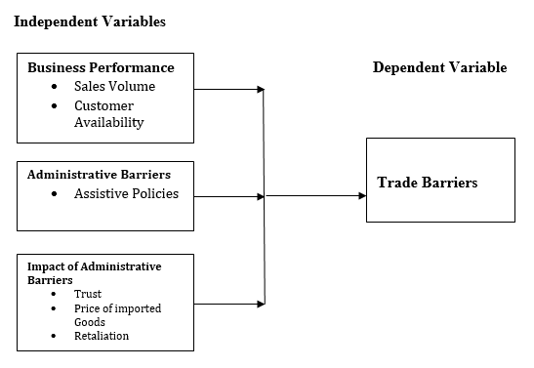
Figure 2.1: Conceptual Framework of the Impact of Administrative Barriers to Trade
Source: Researcher, 2023

The independent variables or otherwise known as the predictor or explanatory variables show the cause side of the problem of Trade. They include business performance (that are sales volume and customer availability); Administrative Barriers (that include assistive policies) and challenges of Administrative Barriers (that includes trust, price of imported goods and retaliation). The Independent Variable which is also known as the response or outcome shows the expected effect of dependent variables, in this study it is the Trade barriers. The two variables (Independent Variables and Dependent Variable) are directly related based on the research empirical evidence.

CHAPTER THREE

RESEARCH METHODOLOGY

3.1 Introduction
This chapter describes the methodology of the study. The chapter discusses the description of the study area, research design, study population, sampling techniques and sample size, sampling frame, sources of data, reliability and validity of data, ethical consideration and data analysis.

3.2 Description of the Study Area
Namanga is a cosmopolitan town divided by the Tanzania-Kenya border. It is in Longido District, Tanzania and Kajiado County, Kenya. It is around 110 kilometers from Arusha, Tanzania. Namanga's economy has been heavily dependent on tourism since 2004 as tourists visiting the nearby Amboseli National Park passed through the town from Nairobi (183 kilometers to the north). The town is surrounded by hills on both sides. Mount Kilimanjaro can be viewed from Namanga town which makes it a scenic place by tourists who lodge in Namanga on their way to either Tanzania or Amboseli. The nearby Ol Doinyo Orok Mountain, also known as Namanga Hills is located northwest of Namanga town. Namanga's latitude is S 2°32'39.8" and longitude E 36°47'20.2". The town has an urban population of approximately 10,000 while the rural population is approximately 5,500. The town is currently dependent both on tourism and on import and export from both Kenya and Tanzania. With the opening of the East African Community borders, the town will benefit from market of both countries which according to the statistical bureau of Kenya will trigger a population growth of the town to an approximate of 30,000. With the recent investment by the financial institutions and the completion of the great north road, the town has grown economical especially in its infrastructure. This development has increased transport activities from the area as it triggered more importation of commodities from Tanzania to Kenya as it is assumed to be cheaper.

Namanga is selected as a study area because trade disputes between Tanzania and Kenya negatively affect trading activities of small scale traders (COMESA, 2016; Republic of Kenya, 2017). Also, (Ajumbo and Afrika, 2012; Brenton et al., 2014; Lesser, 2009) noted that, more than 40% of small traders at Namanga depends on import and export business between two countries which are Tanzania and Kenya.

3.3 Research Design
Kabir, (2016) noted that, research design is the outline or plan that is used to generate answers to research problems. In this study research was a plan for collecting and utilizing data so that desired information can be obtained with sufficient precision and that the research questions can be answered. This study was employed the descriptive research design with cross-sectional study in which both qualitative and quantitative methods were used to collect information of investigating the impact of administrative barriers to trade between Tanzania and Kenya. Qualitative methods were used to conduct key informant interviews through semi structured interview guide method, whereas the quantitative methods were used to conduct a survey questionnaire with small scale traders.

3.4 Study Population
Population refers to a large group of people possessing one or more characteristics in
common on which a research study focuses (Creswell, 2012). The study population comprised of small scale traders from Namanga. From these study population, primary and secondary data was obtained. However, TRA officers at Namanga and council/municipal business officers’ desk concern were added so that to add information.

3.5 Sampling Techniques
Sampling technique is a procedure that the researcher would adopt to select elements to be included in the sample (Singh, et al., 2021). In this study, sampling technique is a definite plan for obtaining sample from a given population. Due to the nature of this study both simple random sampling (probability sampling) and purposive sampling techniques (non- probability sampling) were used.

3.5.1 Simple Random Sampling
Simple random sampling is defined as a sampling technique where every item in the population has an equal chance and likelihood of being selected in the sample (Salehi, et al., 2004). In this study was employed simple random sampling technique to collect data from small scale traders at Namanga.

3.5.2 Purposive Sampling
Purposive sampling also known as judgmental, selective, or subjective sampling, is a form of non-probability sampling in which researchers rely on their own judgment when choosing members of the population to participate in their surveys (Cresswell, 2013). In this study purposive sampling was used to select council business officers’ because they are very few in numbers.

3.6 Sample Size
Sample size refers to the number of items to be selected from the population (Etikan, et al., 2016). The sample size is an important feature of any empirical study in which the goal is to make inferences about a population from a sample (McLeod, 2018). In this study, sample size refers to the number of respondents to be selected from the study. Based on the TRA officer registry, the current small traders based in our criteria at Namanga are 1239 small scale traders. Therefore, the sample size n of the small scale traders was obtained by the Slovin's formula/scientific formula. Slovin's formula is used to calculate an appropriate sample size from a population.

Which is given by n = N / (1 + Ne²)
Where: n = Number of samples, N = Total population and e = Error tolerance (level).
NB: Confidence level of 95% (giving us an Error tolerance level of 5% = 0.05),
In our study N= 1239 and e= 0.05
Therefore n = 1239/ {1+1239 x (0.05)²} = 302 small scale traders

3.7 Sampling Frame
Sampling frame is a list of the items or people forming a population from which a sample is taken (Miller et al., 2010). In our study, sampling frame was included small scale traders from Namanga, TRA officers at Namanga border and council business officers’ desk concern as shown in table 3.1 below
Table 3.1: Sampling Frame
S/N | Category of respondents | Population | Sample size | Sampling Technique(s)
 | Small Scale Traders at Namanga | 1239 | 302 | Simple Random Sampling
 | TRA Officers at Namanga Border | 42 | 38 | Simple Random Sampling
 | Council Business Officers’ | 3 | 3 | Purposive Sampling
Source: Researcher, 2023

3.8 Sources of Data

3.8.1 Primary Data Sources
Primary data is data that is collected by a researcher from first-hand sources, using methods like surveys, interviews, or experiments (Schensul et al., 2013). In this study, primary data is the data that originated for the first time by the researcher through direct efforts, precisely for the purpose of addressing a research problem in order to make the discovery of additional data and information during collection and to guarantee the quality of data. Primary data was collected from the small scale traders at Namanga and other key informants like TRA officers and council business officer. Primary data related to the study were collected using questionnaire and semi structured interview guide method.

3.8.1.1 Questionnaire
A questionnaire is a research instrument consisting of a series of questions and other prompts for the purpose of gathering information from respondents (McLeod, 2018). From this study, questionnaire was a research instrument comprising of a series of questions (or other types of prompts) for the purpose of gathering information from the main respondents (small scale traders) and also the questionnaire was pre-tested so as to increase the validity of the study.

3.8.1.2 Semi Structured Interview Guide Method
A semi-structured interview guide method is a data collection method that relies on asking questions within a predetermined thematic framework (Smith, 2020). In research, semi-structured interviews are often qualitative in nature (Yael, et al.., 2019). In this study semi-structured interview guide method is a qualitative research method that combines a pre-determined set of open questions (questions that prompt discussion) with the opportunity for the interviewer to explore particular themes or responses further. Therefore, semi structured interview guide method was used to key informants that is for TRA Officers at Namanga border and council business officers’ so as to collect qualitative open-ended data, to explore participant thoughts, feelings and beliefs about a particular topic and to allow for a discussion with the interviewee rather than a straightforward questions and answers format in investigating the impact of administrative barriers to trade between Tanzania and Kenya

3.8.2 Secondary Data
Secondary data are information gathered from other previous studies, e.g. published material and information from internal sources such as raw data and unpublished summaries (Mbogo et al., 2012). Thus, the application of appropriate set of criteria to select secondary data to be used in the study plays an important role in terms of understanding of the research problems and also increasing the levels of research validity and reliability (Alkassim et al., 2016). Based in this study secondary data related to the study was used in order to get a broader knowledge about the study and to get a variety of information concerning the subject matter and on what others have been done on the same or associated area.

3.9 Reliability and Validity of Data
Reliability and validity are concepts used to evaluate the quality of research (Thatcher, 2010). Reliability and validity, they indicate how well a method, technique or test measure something (Creswell, 2012). Reliability is about the consistency of a measure, and validity is about the accuracy of a measure (McLeod, 2018). If the two criteria (reliability and validity) are met in a given research, then the chances are high that the research work is of the desired quality and can be used with confidence to whoever the research work is intended to (Kothari, 2004).

3.9.1 Reliability
Reliability is the overall consistency of a measure (Saunders, et al., 2012). A measure is said to have a high reliability if it produces similar results under consistent conditions (Resnik, 2016). If the same result can be consistently achieved by using the same methods under the same circumstances, the measurement is considered reliable (Kabir, 2016). To ensure the reliability of this study the researcher used various approaches of data collection tools such as questionnaires and semi-structured interview guide.

3.9.2 Validity

Validity is the instrument capable of measuring what is supposed to measure Validity is the instrument capable of measuring what is supposed to measure accurately, effectively and efficiently (Singh, 2021). In this study, in order to improve the validity of the research, the researcher was pre-testing the questions/questionnaire over a number of people before officially distributing to the respondents; this were achieved through observing standards on constructing questions/questionnaires, also the procedures of the questions/questionnaire were explained to the respondents and translated to national language which is Kiswahili language for additional understanding.

3.10 Ethical Consideration
Research ethics provide a guideline or set of principles that support researchers in conducting research so that it is done justly and without harming anyone in the process (Resnik, 2016). Ethical issues in research fall into one of the five categories, which are protection from stress, harm, or danger; informed consent; right to privacy; confidentiality; and honesty with professional co-workers (Alkassim et al., 2016). In this study, before conducting the research the researcher addressed important issues as follows: first, to acquire research clearance letter from the Open University of Tanzania (OUT) also approval from the district council concerned as a study area. Secondly, consent form were given to the respondents who may wishes to participate in study voluntarily and their confidentiality were assured, as none of them filled their names on a tool. Finally, the subject matter was introduced in the preliminary note attached to questionnaire to make sure that a respondent was alerted of what is going on.

3.11 Data Analysis
Data analysis refers to examining what has been collected in a survey or

experiment.

3.11 Data analysis
Data analysis refers to examining what has been collected in a survey or experiment and making deductions and inferences (Kombo & Tromp, 2016). The purpose of data analysis is to extract useful information from data and taking the decision based upon the data analysis (Armando, 2017). In this study, data analysis is a process of inspecting, cleansing, transforming, and modelling data with the goal of discovering useful information, informing conclusions, and supporting decision-making.
Based in this study, quantitative data was collected through questionnaires and was edited, coded, summarized, classified, tabulated and finally were analysed by descriptive statistics only through computer software known as statistical package for social sciences (SPSS) version 22 and the finding were presented in the form of frequencies, percentages, tables and pie chart while the qualitative data on the other hand was analysed by thematic analysis and results were presented in narratives.

CHAPTER FOUR

DATA PRESENTATION, ANALYSIS AND DISCUSSIONS OF THE FINDINGS

4.1 Introduction
This chapter presents data presentation, analysis and discussions of the findings based on the research objectives. In that regard this chapter presents demographic characteristics of respondents the business performance in the context of administrative barriers, type of administrative barriers and the impact of administrative barriers to trade between Tanzania and Kenya.

4.2 Demographic Characteristics of Respondents
Demographic characteristics of respondents were considered important aspects for this study. In this study, the relevant demographic characteristics of respondents considered in sample selection were age, education level and business experience at Namanga (duration in a business).

4.2.1 Age
Age was important element in sample selection. Age enabled a researcher to understand the personal impact of the barriers to trade between Tanzania and Kenya among businesspersons. To know the age of respondent at Namanga a question was posed which required respondents to state their age in category form.

The summary of field results is displayed in figure 4.1 below. it was reported that respondents with age category 16-25 years formed 0.33%, those with age category 26-35 years were 2.98%, those with age between 36-45 years were 36.09%, 46-55 years were 40.07%, 56-65 years were 14.90% & and last those with age between 66+ years were 5.63% as shown in figure 4.1 below

. 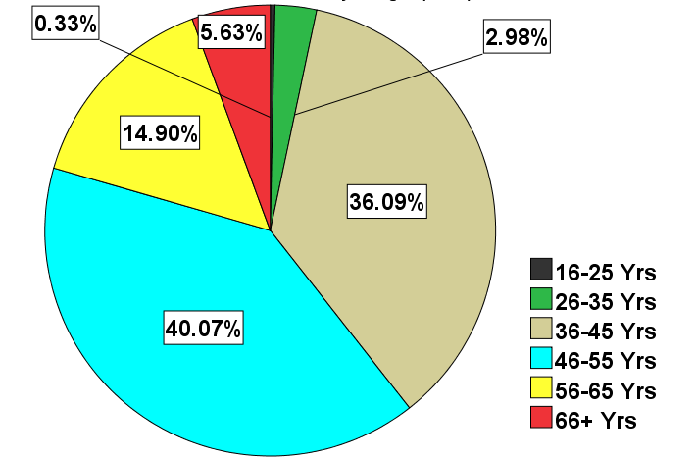
Figure 4. 1: Age of Respondents
Source: Field Data, 2023

According to the study results it was revealed that most of study respondents were mature people with age above 26 years only the few had age between 16-25 years. This suggest that views presented by these people were sincere and fair because they are the people with better experience in business and able to assess the business situation.

4.2.2 Education Level
Education was an important element in sample selection. Education assures respondent knowledge about a research topic. Education enables a respondent to understand some of the technical issues involved in the study such as type of government taxes and barriers imposed by the government. During a study a question was posed to study respondents to state their education level.
The summary of the study results is displayed by figure 4.2 below. Respondents with primary school education were 36.09%, those with secondary school formed about 42.72%, college education was about 10.93% and lastly those with university education were 10.26%.

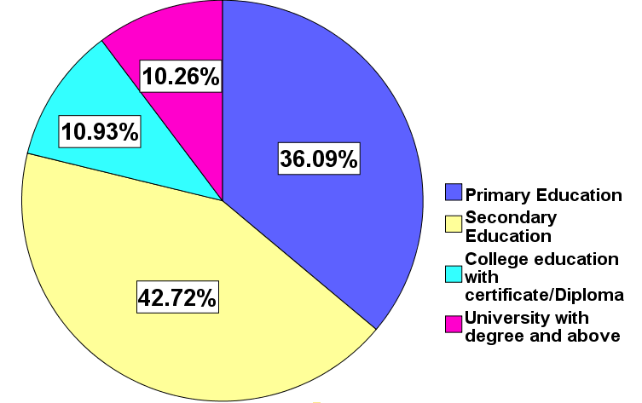
Figure 4. 2: Education Level
Source: Field Data, 2023

According to the figure 4.2 above, the study results suggest that majority of the respondents had education from secondary school and above and the few had the primary school education. It is apparent that study respondents at Namanga had the level of understanding at the level enough to understand the meaning posed during the survey. This finding is in line with the view by Nanjira (2019) who conducted similar study. In his study he reported that basic education such as primary or secondary level was enough to understand survey question in any study.

4.2.3 Business Experience
Business experience was an element considered in the study. According to Rashid (2019) noted that, business experience enables a respondent to notice and understand changes in business. A question was posed to the respondents to indicate their level of experience in business. The field results are displayed by figure 4.3 below. It was found that 79.14% had business experience of 12 to 18 months, followed by those with six to twelve months experience 13.58%, those with business experience of less than six month were 1.66%. Those with two to six months were 5.63%.

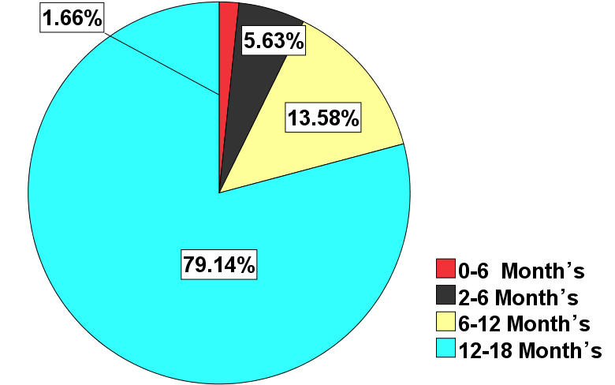
Figure 4. 3: Business Experience
Source: Field Data, 2023

According to the figure 4.3 above, study results indicate that most small traders had business experience of more than one year with exception of the few about 5.63 who had business experience of less than six months. These study results indicate that most of the small traders at Namanga had enough business experience to understand and answer survey questions.
During the semi-structured interview, one of the TRA officer had this to say
“Business experience is an important aspect in our work. Small traders with more than one year of doing business can be good reference in solving barriers to trade between countries. These people can share with us their genuine problems and possible solutions. We normally listen to these people because they know a lot about cross border business. Small traders are the challenge in our effort to improve business environment, unexperienced traders look up on illegal ways of doing business, they use fake methods of doing business and some of the small traders are avoiding to give legal receipts to customers in order to escape from paying the legalized taxes to the authority. In doing that, they provide a receipt known as “risiti za kuondokea” so that they can easily cross the obstacles that TRA has set to inspect them.

4.3 Business Performance in the Context of Administrative Barriers to Trade Between Kenya and Tanzania
Business performance is an indicator of commercial effectiveness, which is the capacity of an organization, a division, or a person to achieve the company's goals and anticipated outcomes (Abeysiriwardana et al.., 2021). Through barriers the business performance can’t be commercial effectiveness.
Business performance in the context of administrative barriers was the first objective of this study to examine the business performance in the context of administrative barriers to trade between Kenya and Tanzania. In that regard respondents were asked to give their views on four different elements related to administrative barriers to trade.

4.3.1 Availability of Customers
The availability of customers was considered important aspect because availability of customers could show the impact of administrative barriers on business performance between Tanzania and Kenya. A question was posed to the respondents to show their level of agreement with the statement whether at the time of administrative barriers between Tanzania and Kenya customers were few in the market.

The results from the field displays as follows, most respondents 79.80% agreed that customers were few, 15.56% did not know about this question and few about 4.64%disagreed with the statement as shown in figure 4.4 below.

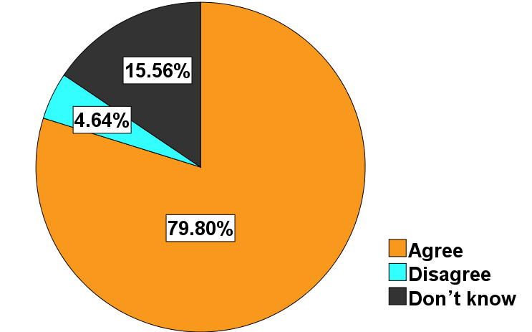
Figure 4. 4: Availability of Customers
Source: Field Data, 2023

Based on the study results shown above, it was noted that most respondents agreed that customers were few at Namanga when trading barriers are imposed by either government of Tanzania or Kenya. It is therefore, most of the small traders are affected by business barriers. Removing these barriers may serve the interest of most small traders and government.
The finding from the semi structured interview supports the above results; one of the TRA officers recommended on the availability of customers and he had this to say:
“I have bitter experience in my memory with administrative barriers, I remember during COVID 19 the business salutation was bad. TRA collection hit low record of all tine and never seen before. The situation was made more serious with administrative barriers in place. Some of the small traders stopped doing business or reduced their operations”. There were very few customers at a time, the situation was beyond nobody control.

Also, one of the council business officers had this to say about number of customers during the administrative berries,

“Administrative berries it’s not good at all, I know the issues of testing for COVID 19 was disputed by two countries. Most businessperson from Kenya who had tested for COVID in their country and were carrying test certificate were allowed to enter Tanzania. However, Tanzanian small traders who tested for COVID 19 at home (Tanzania) were not allowed to enter Kenya for reasons which were not known immediately. I think Kenya used COVID 19 as a pretext to restrict Tanzania businesspersons to enter Kenya”

4.3.2 Debts at the time of Administrative Barriers Between Tanzania and Kenya, Small scale Traders Face Debts
Debt among businessperson was considered important in sample selection, it reflects the business performance. Question was posed to respondents to agree or otherwise on the statement which said at the time of administrative barriers to trade between Tanzania and Kenya small traders face debts. Figure 4.5 displays the field results, it was revealed that respondents agreed with the statement made about 80.46%, those respondents about 14.90% who disagreed with the question were 4.64% and 14.90% remained neutral.
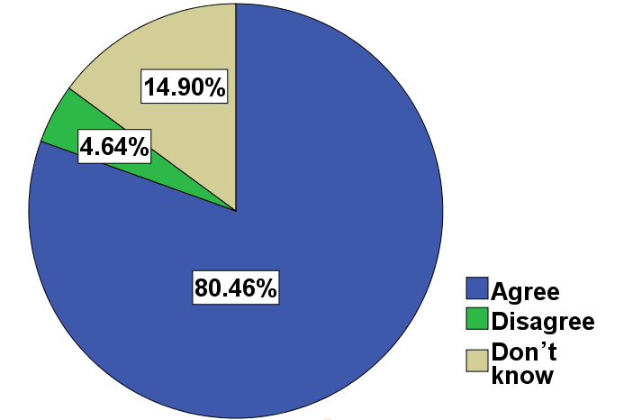
Figure 4. 5: Debts
Source: Field Data, 2023.

According to the results above, it was revealed that large majority of respondents 80.456% were facing debts at Namanga compared to the few who disagreed with the question. This indicates that businessperson at Namanga were going through difficult time and it there was a need for this study to rescue the situation. The above results are supported by Chewe, (2020) in Zambia, who he reported that negative changes in business trend cause some businessperson to experience debts because customers shift their taste and preference. It is apparent that trade barriers cause most business men at Namanga to experience debts.
The finding from the semi structured interview supports the above results; one of the TRA Staffs commented on the issue of debts on business among small traders at Namanga had this to say:
“I remember antagonistic statements coming from both agriculture ministers from Tanzania and Kenya were not consistent with statements given by their officers at the border between Tanzania and Kenya. So, the public was in confusion as they could not make sense of the efforts of these ministers to resolve the situation. The maize crops from Tanzania couldn’t go to Kenya. However, the COVID 19 complicated the situation as some small traders went bankrupt and customers could not make reasonable purchases of products, so the situation was worse”.

4.3.4 Awareness of Administrative Barriers Between Tanzania and Kenya
Awareness of administrative barriers was considered an important measure in a study. Statement was posed to respondents requiring their agreement or otherwise whether business persons were aware of administrative barriers between Tanzania and Kenya. The summary of field results was revealed that, respondents about 87.09% agreed that they were aware of administrative barriers between Tanzania and Kenya 4.30% disagreed with the statement and 8.61% were neutral with the statement as shown below.

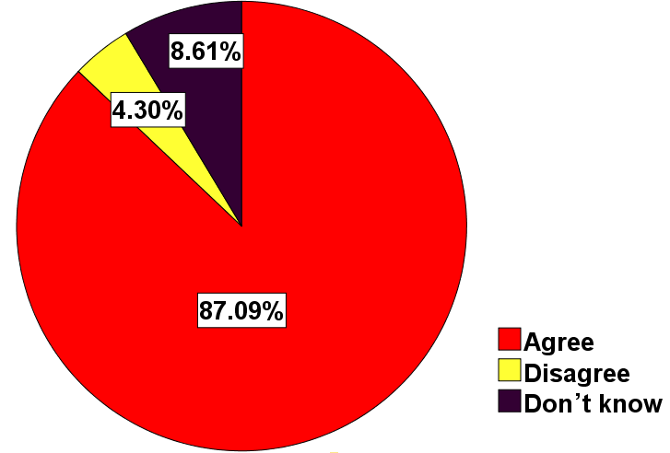
Figure 4. 6: Awareness
Source: Field Data, 2023

From the field findings shown by figure 4.6 above. It is evident that most small traders at Namanga were aware with the administrative barriers, to trade in their area. Coglianese, (2022) argues that the issues of administrative barrier involves administrative actions of states. Therefore, measures to resolve the business situation have to involve states to a larger extent.

The findings from the semi-structured interview supports the above results; the TRA officer commented on the awareness of administrative barriers and he had this to say
“These small traders are very aware of administrative barriers to trade, knowingly that they incur business losses when such barriers occur, few of them resort to illegal ways of doing business such as smuggling. Above all I think these barriers we are talking about is a result of politics between Kenya and Tanzania, it does not appeal to a normal person that the two countries belong to East Africa Community which and have vowed to promote business, but the same countries contradict themselves with trade barriers”

4.4 Determination of the Type of Administrative Barriers to Trade Between Tanzania and Kenya
It was the second objective of the study to determine the type of administrative barriers to trade between Tanzania and Kenya. In that regard four measures were investigated during the study. Respondents were asked to give their views on four different elements related to administrative barriers.

4.4.1 Knowledge on Import and Export Limits (Quota) Being Applied in Trade Tanzania and Kenya
Knowledge on import and export limit was considered important information toward knowing the type of administrative barrier applicable between Tanzania and Kenya. Field results it was revealed that study respondents about 54.64% agreed that they know the import and export limit applicable to Tanzania and Kenya. 34.77% of respondents remained neutral and 10.60% disagreed with the question.
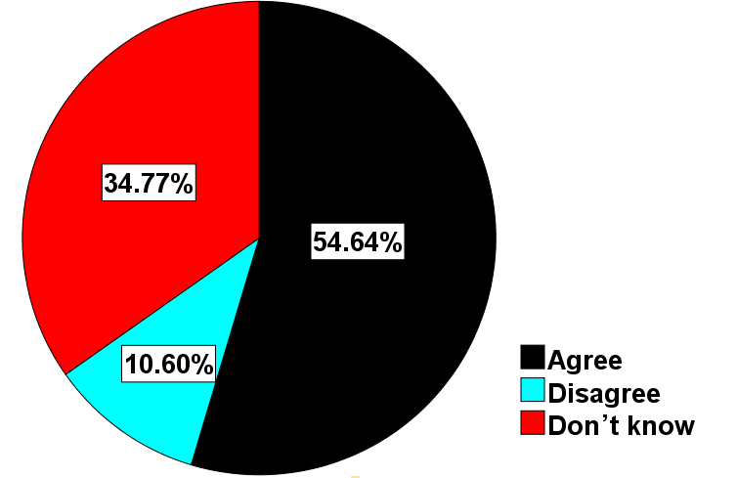
Figure 4. 7: Knowledge on Import and Export Limits (Quota)
Source: Field Data, 2023

According to the results displayed in figure 4.7 above. It was reported that that most small traders (54.64%) at Namanga have knowledge about import and export limits (Quota) being applied in trade Tanzania and Kenya. This suggest that import-export limits are among the type of administrative barriers being applied at Namanga.

The finding from the semi-structured interview supports the above results; the Council Business Officer commented on the Knowledge on import and export limits (Quota) and he had this to say:

“Small traders at Namanga go through many challenges in their business, some go bankrupt and some get disappointed due to administrative measures imposed on their businesses. I think education is the best teacher, so we keep on educating businesspersons now and them and most of them get capture the lesson well.

Also, one of the Council Business Officers had this to say:
“I normally educate small traders and provide friendly working environment. This is to make sure that, small traders are not disappointed and understand the rules of business so that they cannot enter into unnecessary loses. We provide them with leaflets and reading materials in order to improve their understanding on business issues, though some small traders go against our advice. I should admit that the change group is small compared to many who have decided to be resistant and continue doing business as usual. In spite of that, we keep educating them”

4.4.2 People Know Custom Procedures, Packaging and Labelling Requirements, Technical Standards and Norms, Sanitary Standards (Business Procedures) Being Applied in Trade Tanzania and Kenya
Knowledge on custom procedures, packaging and labelling requirements, technical standards and norms, sanitary standards was an important aspect of the study. This Type of administrative barrier to trade could be known by testing the knowledge of respondents. A question was posed to the respondents requiring them to agree or otherwise on whether they know procedures, packaging and labelling requirements, technical standards and norms, sanitary standards being applied in trade Tanzania and Kenya.

The summary of study results is displayed by figure 4.8 below. It was reported that respondents about 64.57% agree to have known on the custom procedures, packaging and labelling requirements, technical standards and norms, sanitary standards. 19.87% of respondents remained neutral and 15.56 % disagreed on posed question as shown in figure 4.8 below
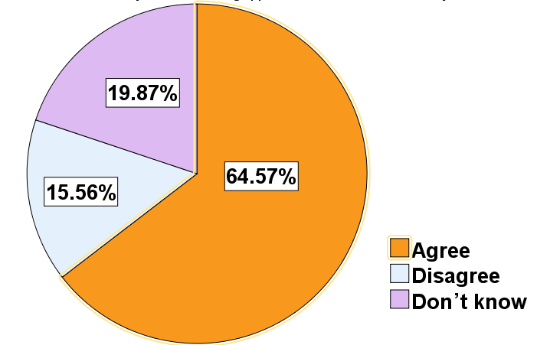
Figure 4. 8: Business Procedures
Source: Field Data, 2023

According to the results displayed by figure 4.8 above. It was found that most respondents 64.57% knew about custom procedures, packaging and labelling requirements, technical standards and norms, sanitary standards (business procedure) being applied in trade between Tanzania and Kenya compared to the few 19.87% who did not agree with the question. The results suggest that custom procedures, packaging and labelling requirements, technical standards and norms, sanitary standards (business procedure) being applied at Namanga. According to Kevin (2022) trade barriers can obstruct free trade, favour rich countries, limit choice of products, raise prices, lower net income, reduce employment, and lower economic output.

One of the TRA officer had this to say:
“Most of our small traders know about know custom procedures, packaging and labelling requirements, technical standards and norms, sanitary standards (business procedure) being applied in trade Tanzania and Kenya because we taught them in order to do well business. I would advise both countries Kenya and Uganda to reduce tax on small traders so as not to push them into bankruptcy. It is our duty to educate them on how to do business and solve business related matters”

4.4.3 Import Bans, Trade Documents Requirement on Goods Being Traded Between Tanzania and Kenya
Import bans, trade documents requirement form examples of administrative barriers. To know whether they are applied at Namanga, a question was set to respondents requiring them to agree or otherwise on whether they know import bans, trade documents requirement on goods being traded between Tanzania and Kenya. The field results are shown by figure 4.9 below. It was reported that about 61.92% of study respondents agreed with the question, 29.80% of respondents remained neutral and 8.28% disagreed

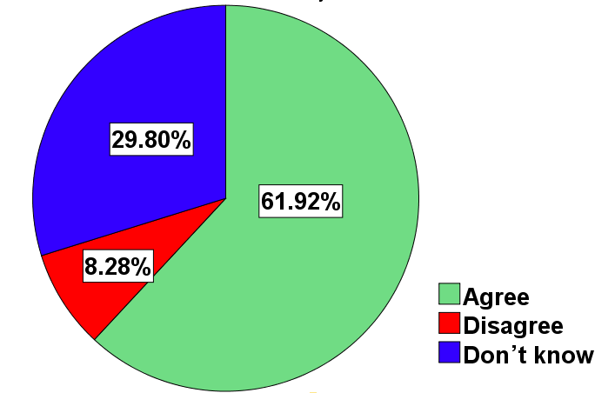
Figure 4. 9: Import Bans, Trade Documents Requirement on Goods
Source: Field Data, 2023

According to the field results displayed in figure 4.9 it is evident that most respondent know about import bans, trade documents requirement are being at Namanga and most businesspersons know them. This suggest these types of administrative barriers are applied at Namanga

During the semi-structured interview, one of the Council Business Officers had this to say
“Majority of small traders know about Import bans, trade documents requirement on goods being traded between Tanzania and Kenya. I think some of these small traders have lived with trade barriers over time and they are used to it. It is common to hear small traders referring to the barriers as in local term as accident on work “Ajali Kazini”. Being a TRA officer my duty is to remind these small traders that, they should abide by what the government is directing on business”.

4.4.4 Satisfaction with Trading Activities Being Conducted Between Tanzania and Kenya
Satisfaction with the administrative barriers was considered important in this study because satisfied businesspersons do not see administrative barriers as a problem compared to those who are not satisfied. To see whether business persons at Namanga are satisfied of not with administrative barriers, a question was set that asked for satisfaction on the trading activities being conducted between Tanzania and Kenya.

The field results are displayed in figure 4.10 below. It was reported that 97.70% of participants are not satisfied with trading activities being conducted between Tanzania and Kenya. 2.65% remained neutral and 1.66% of respondent reported that they agree with the way trading activities being conducted between Tanzania and Kenya
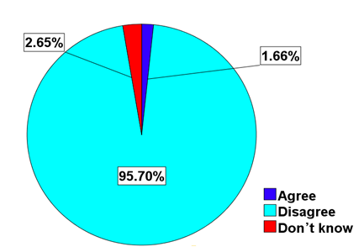
Figure 4. 10: Satisfaction
Source: Field Data, 2023

According to the figure 4.10 above, it was rev revealed that most of the study respondent are not satisfied with trading activities being conducted between Tanzania and Kenya. This finding is supported by the view from council business officer who said that,
“Most small traders in our areas do not feel happy with issues related to taxation. Most of them say that business taxes are so high. In addition, there is so much directives from the government in business activities.

4.5 Impacts of Administrative Barriers to Trade Between Kenya and Tanzania
The third objective of this study was to identify impacts of administrative barriers to trade between Kenya and Tanzania. Information requirement for this study involved measurement of three elements which were trust, price and retaliation. The respondent was required to show their agreement or disagreement or neutral with said measurement.

4.5.1 Trust between Tanzania and Kenya
Trust was considered an important aspect of this study. Trust affects measures and counter measures of doing business between countries. To know whether business trust exist between Tanzania and Kenya, a question was posed to the respondent whether Tanzania and Kenya trust each other in trading activities. The study results are displayed in figure 4.11 below.

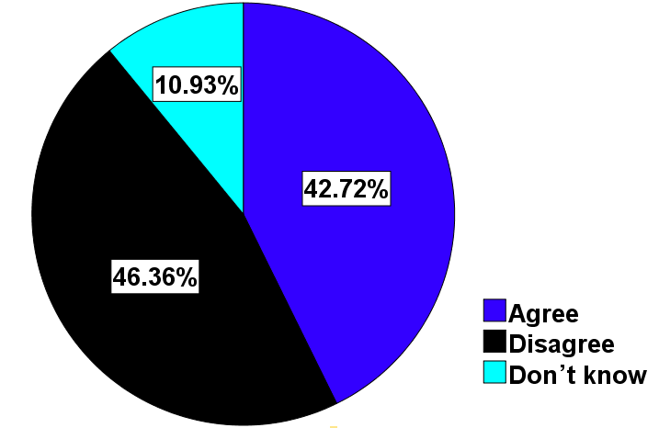
Figure 4. 11: Trust between Tanzania and Kenya
Source: Field Data, 2023

According to summarized study results displayed in figure 4.11 above. It was revealed that, large majority of respondent disagreed with the statement that Tanzania and Kenya trust each other in trading activities. Only a few respondents agreed with the statement. These results suggest that trust between Tanzania and Kenya is still a problem. This justifies a need to correct the situation by appropriate recommendations that can restore trust between the two countries. In a study by Maluwa (2016) in Malawi mistrust was identified as challenge in transnational trade between Malawi and Mozambique.

4.5.2 Price of Imported Goods (i.e. Clothes) Between Tanzania and Kenya
Price was considered an important aspect of this study. Price variation in transnational business affects business person. During high price the customers shy away and negative affect the profit of businessmen, the reverse is true when the price is low. To investigate if challenge of price applies at businessmen at Namanga a question was posed to the respondent whether Price of imported goods have remained fairly stable between Tanzania and Kenya.

The summary of the field’s results reveals that 64.57% of respondents agreed with the statement that Price of imported goods have not remained stable between Tanzania and Kenya. 5.63% of respondent remained neutral and few 29.80% of them disagreed with the statement as shown in figure 4.12 below.

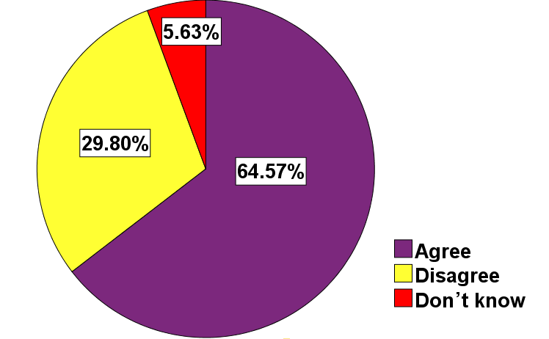
Figure 4. 12: Price of Imported Goods (i.e. Clothes) Between Tanzania and Kenya
Source: Field Data, 2023

According to the results displayed in figure 4.12 above. Large majority of respondents 64.57% have not agreed with the statement that Price of imported goods have remained stable between Tanzania and Kenya. This Suggests that price is a challenge in doing business between Tanzania and Kenya. The above finding is in line with opinion given by TRA officer who had this to say,

“Price variations occur sometimes and small traders have to adjust themselves to prevent losses in their business or lose customers. Sometimes only rumours of new trading directives can trigger price changes. We in the field know this phenomenon very well”.

4.5.3 Retaliation on Administrative Barriers
Retaliation in transnational trade negatively affect good trading practices between countries. Good trading Activities benefit countries and people as well. Good example during the COVID 19 the government of Kenya restrict the Tanzanian drivers who transport maize from Tanzania to Kenya even though that drivers passed the COVID 19 test under WHO guidelines as the results the Tanzanian government bans broiler from Kenya and that was a politics issues .To investigate whether retaliation on administrative barriers to trade exist between Tanzania and Kenya, a question was posed that asked whether Tanzania retaliates if Kenya will impose administrative barriers to trade if the need should arise. The summary of filed results is displayed in figure 4.13 below
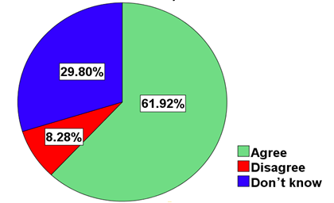
Figure 4. 13: Retaliation on Administrative Barriers
Source: Field Data, 2023

According to the field results displayed above, 29.80% of respondents remained neutral, 61.92% agreed with the statement and 8.28% disagreed with the statement. It is evident that retaliation on administrative barrier is still a problem. The study findings are supported by a study by Kihumba, (2018) in Tanzania, who reported that fear of retaliation between these two countries is a challenge in doing business between these two countries.

4.5.4 Comments by the Study Participants
The study sought comments from the study participants on the ways to improve business relations as far as administrative barriers to trade are concerned. The summary results were reported that 67.22% of respondents suggested taxes to be reduced, 16.23% of participants reported that each country has to observe trading trust, 10.93% of respondents reported that politics have to favour business transactions and 5.63% of respondents suggested currency stabilization
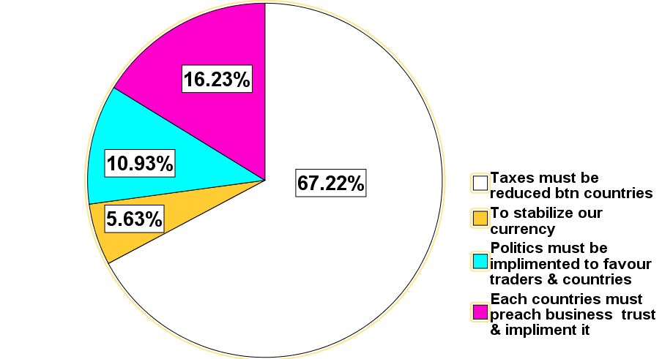
Figure 4. 14: Comments by the Study Participants to Improve Business Relations
Source: Field Data, 2023

According to the results displayed in figure 4.14 above large majority of respondents suggested tax and trust have to be tackled. The few suggested corrections on politics and currency stabilization. These results suggest that taxes and trust from a big problem. Resolving these two issues will help improve the business between Tanzania and Kenya. These findings are supported by views from TRA Officer who had this to say,

“If Tanzania and Kenya have to improve business, areas relating on taxes and politics have to be looked on. Most of the small traders at Namanga cry out on high taxes on their business. It is my sincere request to the government of both countries see a manner on how to resolve the taxes and politics issues which have been going on for a long time”

CHAPTER FIVE

SUMMARY, CONCLUSION AND RECOMMENDATIONS

5.1 Introduction
This chapter presents summary of findings, conclusion and recommendation of the study. Finally, the chapter presents proposed areas for further research.

5.2 Summary of Findings
This section summarizes the major findings of the study. The summary is based on the research objectives as presented above. The main objective of the study was to investigate the impact of administrative barriers to trade between Tanzania and Kenya. Specifically, the findings of this study are presented under three themes as depicted in the research objectives that are to examine the business performance in the context of administrative barriers to trade, to determine the type of administrative barriers to trade and to examine the impact of administrative barriers to trade between Tanzania and Kenya. In achieving the formulated objectives, data were collected from both primary and secondary sources.

5.2.1 Business Performance in the Context of Administrative Barriers to Trade Between Tanzania and Kenya
Based on the data collected at Namanga study area it was revealed that, at the time of administrative barriers to trade between Tanzania and Kenya business persons are negatively affected. Most respondent with overwhelming majority indicated that they are affected by number of customers available at the time of administrative barriers, some faced business debts, customers were not available and awareness of administrative barriers to trade was high meaning that imposition of the said barriers was repetitive between Kenya and Uganda.

5.2.2 Type of Administrative Barriers to Trade Between Tanzania and Kenya
It was found during the study that respondents reported a variety of administrative barriers being applicable in their area. It includes the import and export limits (quota), custom procedures, packaging and labelling requirements, technical standards and norms, sanitary standards, import bans and trade documents requirement. These barriers still act as break to trans-nation business development between Tanzania and Kenya.

5.2.3 Impact of Administrative Barriers to Trade Between Kenya and Tanzania
The summary of the study results revealed that several negative impact lie ahead for businesspersons at Namanga. The most reported negative impact that contributing to administrative barriers to trade includes mistrust, retaliation, political issues and taxes variation between these two countries.

5.3 Conclusion
This study investigated the impact of administrative barriers to trade between Tanzania and Kenya. Based on the study findings, it was indicated that small scale traders at Namanga face negative impact due to administrative barriers to trade between Tanzania and Kenya. Tanzania and Kenya have applied different forms administrative barriers such as import and export limits (quota), custom procedures, packaging and labelling requirements, technical standards and norms, sanitary standards, import bans and trade documents requirement. Negative impacts continue to hold back business person at Namanga, these negative impacts includes mistrust, retaliation, political issues and taxes variation that continue to undermine business growth between Tanzania and Kenya. Therefore Tanzania and Kenya must implement effectively the investment protocol known as custom union (CU) and common market protocol. Because these protocols guarantee the free movement of goods, services, and investments, therefore it could be easily to remove or reduce such negative impacts.

5.4 Recommendations
Based on the study findings the following recommendations are made for Tanzania and Kenya as far as administrative barriers to trade are concerned.

Establishment of sound enforcement mechanisms for State’s non-compliance with administrative barriers to trade elimination obligations
This study proposes the amendment of East Africa community (EAC) legislation governing the establishment of institutions on trading activities in each country to empower such institutions to issue binding recommendations beyond their territorial limits.

Establishment of an alternative approach on reporting administrative barriers to trade complaints between countries
Complaints mechanism may be established through the creation of an online account and registration of an administrative barriers to trade complaint. This study recommends that such a system may be accessible to illiterate and small traders. This system of complaints should be set up to address the concerns of such traders.

Creating new and existing non-tariff barriers to the world trade organization (WTO) Compliance Review Process
This study proposes that all existing administrative barriers to trade barriers should be subjected to the WTO Compliance review. This is to ensure that trading measures are non-discriminatory, transparent and to make sure that trade restrictiveness is also minimized.

Reinforcing the dispute settlement mechanism on administrative barriers to trade
This study propose proper dispute settlement system is created for the resolution of disputes related to administrative barriers to trade. Currently, the trading disputes resolution is based on consultation and mutual recognition agreements. Such measures are not effective as they take long and are largely dependent on the states’ good will. Instead,

Favourable Trading Policy
Governments of Tanzania and Kenya have to concentrate on providing a favourable trading policy and infrastructure which is effective trading activities.

Respect to East Africa protocol on trade
Tanzania and Kenya have to respect the principle of non-discrimination mandates the equal treatment of like products which have either been imported or domestically produced. The second principle obliges members to avoid unnecessary obstacles to trade.

5.5 Areas for Further Study
Other study should be conducted on the influence of politics on the imposition of administrative barriers to trade. Further study with similar nature should be conducted on how administrative barriers to trade affect the welfare of Tanzanians.

REFERENCES
Abeysiriwardana, Prabath Chaminda et al.., (2021). "Role of key performance indicators on agile transformation of performance management in research institutes towards innovative commercial agriculture". Journal of Science and Technology Policy Management. 13 (2).
Adrianamananjara, S., Dean, J. M., Feinberg, R., Ludema, R., Ferrantino, M. J., & Tsigas, M. (2004). The Effects of Non-Tariff Measures on Prices, Trade, and Welfare: CGE Implementation of Policy-Based Price Comparisons (pp. 1-31, Rep. No. 2004-04-A). Washington, DC: U.S. International Trade Commission.
African Union and UNCTAD, (2019). African Continental Free Trade Area Non-Tariff Barriers: Reporting, Monitoring and Eliminating Mechanism – System Manual for Public Users.
Bigsten, A. et al. (1998). Rates of return on physical and human capital in Africa's manufacturing sector. Working Paper 1998-12. Oxford: CSAE.
Bottini, N., Gasiorek, M., Mendez-Parra, M. and Schwartz, A. (2017) Measuring the trade-related constraints to poverty alleviation with the Trade Poverty Constraint Index. Working Paper. London: ODI.
Calabrese, L. & Eberhard-Ruiz, A. (2017). Would more trade facilitation lead to lower transport costs in the East African Community? London: ODI.
Calabrese, L. and Eberhard-Ruiz, A. (2016). What types of non-tariff barriers affect the East African Community? London: ODI.
Cooksey, B. 2016. Tanzania and the East African Community: A comparative political economy.
Creswell, J. W. (2012). Mapping the field of mixed methods research.
Creswell, J.W., 2013. Research Design: Qualitative, Quantitative, and Mixed Methods Approaches, SAGE Publications.
EACS (2014) ‘Status of the elimination of non-tariff barriers in the East African Community’ Vol. 8, December. Arusha: EACS.
EACS (2016) ‘Resolved non-tariff barriers in East African Community as of June 2016’. Report of the 21st EAC Regional Forum on NTBs. Arusha: EACS.
EACS (East African Community Secretariat) (2009) ‘Draft EAC time-bound program for the elimination of identified non-tariff barriers (NTBs)’. Arusha: EACS.
EALA (East African Legislative Assembly) (2015) ‘The East African Community Elimination of Non-Tariff Barriers Act’. Arusha: EALA.
Eberhard-Ruiz, A. and Calabrese, L. (2017) ‘Would more trade facilitation lead to lower transport cost in the East African Community?’ Policy Briefing. London: ODI.
Edmiston, Kelly (2010). "The Role of Small and Large Businesses in Economic Development". Economic Review.
Etikan, I., Alkassim. R., & Abubakar S. (2016). Comparison of Snowball Sampling and Sequential Sampling Technique. Biom Biostat Int J.
Etikan, I., Musa, S. A., & Alkassim, R. S. (2016). Comparison of Convenience Sampling and Purposive Sampling. American Journal of Theoretical and Applied Statistics, 5. 1-4.
https://doi.org/10.11648/j.ajtas.20160501.11
FEAFFA (Federation of East African Freight Forwarders Association). 2020. Low truck drivers COVID-19 testing hurting cross border cargo movement.
Gasiorek, M. and Martuscelli, A. (2017) Regional integration and poverty: A review of the transmission channels and the evidence. Working Paper. Brighton: Centre for the Analysis of Regional Integration.
Grimm, M., Krüger, J., and Lay, J. (2011). Barriers to Entry and Returns to Capital in Informal Activities: Evidence from Sub‐Saharan Africa. Review of Income and Wealth, 57(s1), S27-S53.
Josserand, H. (2013). Assessment of volumes and value of regionally traded staple commodities. Presentation at Food Across Borders Conference, Accra, Ghana, January 2013.
Kabir, S.M.S. (2016). Basic Guidelines for Research: An Introductory Approach for All
Kasaija, P. A., (2006). Regional Integration: A political Federation of the East African Countries? African Journal of International Affairs, Vol. 7, Nos. 1&2, 2004, Council for the Development of Social Science Research in Africa.
Kiriti Nganga, T. W. (2012), “Non-tariff measures in Kenya: A Case Study” in T. W. Kiriti, Nganga and J. A. Okelo (Eds.), Trade discourse in Kenya: Some topical issues, Vol. 1, Nairobi, University of Nairobi, pp. 84-97.
Mathieson, C. (2016) the political economy of regional integration in Africa: The East African Community. Maastricht: ECDPM.
McDonald, S., Thierfelder, K. and Robinson, S. (2007) GLOBE: A SAM-based global CGE model using GTAP data. Working Paper 14. Annapolis, MD: USNA.
McLeod, S. A. (2018). Questionnaire: definition, examples, design and types. Simply Psychology. https://www.simplypsychology.org/questionnaires.html
Miller, P. G., Johnston, J., Dunn, M., Fry, C. L. & Degenhardt, L. (2010). Comparing Probability and Non-Probability Sampling Methods in Ecstasy Research: Implications for the Internet as a Research Tool. Substance use & misuse. 45. 437-50. 10.3109/10826080903452470.
MTIC (Ministry of Trade, Industry and Cooperatives) (2016) ‘Overview of the MTIC’s National Response Strategy for Elimination of Non-Tariff Barriers (NRSE-NTBs)’. Kampala: MTIC.
Muchangi JM, Mturi J, Mukasa H, et al.., (2024). Enablers and barriers to vaccine uptake and hand washing practices to prevent and control COVID-19 in Kenya, Uganda, and Tanzania: a systematic review.
Muluvi, A., Kamau, P., Githuku, S. and Ikiara, Moses. (2012). Kenya’s Trade within the East African Community: Institutional and Regulatory Barriers, Accelerating Growth through Improved Intra-African Trade 20-23.
Nicita, A. and J. Gourdon (2013), A preliminary analysis on newly collected data on non-tariff measures, Geneva, United Nations Conference on Trade and Development (UNCTAD), Policy Issues in International Trade and Commodities Study Series No. 53.
OECD, 2005, OECD SME and Entrepreneurship Outlook: 2005, OECD Paris, page 17.
Ogutu A. O (2019). Kenya-Tanzania Trade Disputes and Its Implications To The East African Community (EAC), 2005-2014
Resnik, D. B. (2016). Employees as research participants: ethical and policy issues. IRB: Ethics & Human Research.
Safari, V. and Knudsen, M. (2014) Review of Rwanda’s National Strategy for Elimination of Non-Tariff Barriers (NTBs). ACE International.
Salehi, M. M., and Seber, G. A. F. (2004) A general inverse. Sampling scheme and its application to. Adaptive cluster. Australian & New Zealand Journal of Statistics.
Saunders, M., Lewis, P. & Thornhill, A. (2012). Research Methods for Business Students: 6th edition. Pearson Education Limited.
Schensul, J. J., & LeCompte, M. D. (2013). Essential ethnographic methods: A mixed methods approach. Lanham, MD: AltaMira Press
Singh, G. N., Jaiswal, A. K., & Pandey, A. K. (2021). Improved imputation methods for missing data in two-occasion successive sampling. Communications in Statistics-Theory and Methods, 1-20
Teravaninthorn, S. and Raballand, G. (2016) Transport prices and costs in Africa: A review of the international corridors. Directions in development; infrastructure. Washington, DC: World Bank.
Thatcher, R. W. (2010). Validity and reliability of quantitative electroencephalography. Journal of Neurotherapy, 14(2), 122-152. doi:10.1080/10874201003773500
The East African Community (2010). Common Market Protocol. EAC. Arusha, Tanzania
UNCTAD (United Nations Conference on Trade and Development) (2013) Non-tariff measures to trade: Economic and policy issues for developing countries. Geneva: UNCTAD.
Versailles, B. (2012) Market integration and border effects in Eastern Africa. Working Paper WPS/2012- 01. Oxford: CSAE.
Wilson, J. (2010). Essentials of Business Research: A Guide to Doing Your Research Project. SAGE Publications
World Bank and WTO (World Trade Organization) (2015). The role of trade in ending poverty. Washington, DC, and Geneva: World Bank and WTO.
World Investment Report 2018
World Trade Organization (WTO) (2013), “Trade finance in periods of crisis: what have we learned in recent years?”, ERSD Working Paper by Auboin, M., and Engemann, M., Geneva: WTO
Zhihao, Y. (2000). A model of Substitution of Non-Tariff Barriers for Tariffs. The Canadian Journal of Economics, Canadian Economics Association. 33(4), 1069 – 1090

APPENDICES
Appendix 1: Introduction and Consent
Dear respondent:
My name is Hasinati David Yohana a student at Open University of Tanzania. I am conducting research on the Impact of Administrative Barriers to Trade between Tanzania and Kenya: A Case of Small Traders at Namanga, Arusha as part of my Master Degree of Arts in International Cooperation and Development (MA ICD). I would very much appreciate your participation in this research. There may be no direct benefits to you as a participant in the proposed study but the findings from the study may be beneficial to other stakeholders in our country, there will be no any risk from the participating from the proposed study apart from time spent, your participation in the proposed study is entirely voluntary and your free to refuse to take part or withdraw at any time. The interview will take not more than 25 minutes to complete. All of the answers you will provide will remain confidential. I hope you will participate effectively in this study since your views are very important.

At this juncture, do you want to ask me anything about this study?
May we start with the interview now?
Interviewer signature……………………… Date……………………...
Respondent agrees to be interviewed ………………………………….
Respondent does not agree to be interviewed……………….................
Investigator signature……………………….. Date……………………

Appendix 2: Questionnaire for Small Traders at Namanga
SECTION A: RESPONDENT IDENTIFICATION

A1. Questionnaire number...................
A2. Interview date.................................

SECTION B: RESPONDENT GENERAL INFORMATION

NB: Always tick/mark the Letter Corresponding to the Response except where stated Otherwise.
B1. What’s your age? (Years)
16- 25 | 26 – 35 | 36- 45 | 46 – 55 | 56- 65 | 65+

B2. What’s Level of educational?
Adult education | Primary Education | Secondary Education | College education with certificate/Diploma | University with degree and above

B3. How long have you working here?
0-6 Month’s | 2-6 Month’s | 6-12 Month’s | 12-18 Month’s | 18+ Month’s

SECTION C: To examine the business performance in the context of administrative barriers to trade between Kenya and Tanzania
Please indicate your level of agreement with the following statements.
Use a likert Scale of 1- 3; where 1 is agree, 2 disagree and 3 don’t know.
S/N | Statement | 1 | 2 | 3
1 | At the time of administrative barriers between Tanzania and Kenya customers are few
2 | At the time of administrative barriers between Tanzania and Kenya small traders face debts
3 | Customers will always be available despite administrative barriers between Tanzania and Kenya
4 | We are aware of administrative barriers between Tanzania and Kenya

SECTION D: Type of administrative barriers to trade between Kenya and Tanzania
Use a likert Scale of 1- 3; where 1 is agree, 2 disagree and 3 don’t know.
S/N | Statement | 1 | 2 | 3
1 | I know about import and export limits (quota) being applied in trade Tanzania and Kenya
2 | People know custom procedures, packaging and labelling requirements, technical standards and norms, sanitary standards being applied in trade Tanzania and Kenya
3 | I know about import bans, trade documents requirement on goods being traded between Tanzania and Kenya
4 | I am satisfied by the way trading activities are conducted between Tanzania and Kenya

SECTION E: Impact of administrative barriers to trade between Kenya and Tanzania
Use a likert Scale of 1- 3; where 1 is agree, 2 disagree and 3 don’t know.
s/n | Statement | 1 | 2 | 3
1 | Tanzania and Kenya trust each other in trading activities
2 | Price of imported goods have remained fairly stable between Tanzania and Kenya.
3 | Tanzania retaliates if Kenya will impose administrative barriers to trade if the need should arise.

Any other comments
…………………………………………………………………………………………………………………………………………………………………………………….

THANK YOU FOR YOUR COOPERATION

Appendix 3: Semi Structured Interview Guide Questions for TRA Officers at Namanga Border and Council/Municipal Business Officers’
- How do you explain the impact of administrative barriers to trade between Tanzania and Kenya on the
- Sales volume……………………………………………………………
……………………………………………………………………………………………………………………………………………………………………………………………………………………………………………………………………………………………………………………
- Customer availability…………………………………………..............
………………………………………………………………………………………………………………………………………………………………………………………………………………………………………

- What are the impacts of each one of the administrative barriers to trade between Tanzania and Kenya
- Assistive policies ……………………………………………………
…………………………………………………………………………………………………………………………………………………………………………………………………………………………………………………………………………………………………………
- In what ways can Tanzania improve trade with Kenya?
………………………………………………………………………………………………………………………………………………………………………………………………………………………………………………………………………………………………………………………………………………………………………..
- In your own opinion, what are causes of administrative barriers between Tanzania and Kenya?
………………………………………………………………………………………………………………………………………………………………………………………………………………………………………………………………………………

THE END: THANK YOU FOR YOUR TIME.


