ESTABLISHMENT OF BLOCKS PRODUCTION AND IMPROVEMENT OF INCOME AMONG YOUTH: A CASE STUDY OF KELAMFUA MOKALA WARD IN ROMBO DISTRICT

MIRIAM JULIUS KIONDO

A DISSERTATION SUBMITTED IN PARTIAL FULFILLMENT OF THE REQUIREMENTS FOR THE DEGREE OF MASTER IN COMMUNITY ECONOMIC DEVELOPMENT (MCED)
DEPARTMENT OF ECONOMICS AND COMMUNITY ECONOMIC DEVELOPMENT
OF THE OPEN UNIVERSITY OF TANZANIA
2024

CERTIFICATION
The undersigned certifies that has read and hereby recommends for acceptance by the Open University of Tanzania a project report entitled, “Establishment of Blocks Production and Improvement of Income among Youth. A Case Study of Kelamfua Mokala Ward in Rombo District” in partial fulfilment of the requirements for the Degree of Master in Community Economic Development (MCED).


……………….…………….
Dr. Felician Mutasa
(Supervisor)

……………………………
Date

COPYRIGHT
No part of this project report may be reproduced, stored in any retrieval system, or transmitted in any form by any means, electronic, mechanical, photocopying, recording or otherwise without prior written permission of the author or The Open University of Tanzania in that behalf.

DECLARATION
I, Miriam Julius Kiondo, declare that, the work presented in this project report is original. It has never been presented to any other University or Institution. Where other people’s works have been used, references have been provided. It is in this regard that I declare this work as originally mine. It is hereby presented in partial fulfilment of the requirement for the Master’s Degree in Community Economic Development (MCED) of the Open University of Tanzania.


……………………………….
Signature

………………………………….
Date

DEDICATION
This work is dedicated to my cherished spouse, Mr. Stanley Andrew Mbago, together with my children, particularly my little daughter Lissa Stanley Mbago, who was born during the exam time, and for their patience while I pursue this master's degree.

ACKNOWLEDGEMENT
This report owes its accomplishment to the individuals whose encouragement, advice, and support were instrumental throughout its preparation and completion.
Special gratitude is extended to Mr. Maroli Patrik Tarimo, the youth of Kelamfua Mokala ward, and their leaders, along with the ward leaders, for their unwavering support and contributions that facilitated the gathering of project-related information, ultimately leading to the success of this dissertation.
I express my sincere thanks to my supervisor, Dr. Felician Mutasa, for his invaluable guidance, patience, and encouragement. Additionally, appreciation is extended to Prof. Deus Ngaruko, the head of my department, Prof. Emmanuel Nyankweli, the head of my faculty, Ms Janeth Gwimile, coordinator of my faculty and the members of MCED who imparted diverse subject knowledge.
I am also grateful to my family, including my husband, Mr. Stanley Andrew Mbago, my friend Gudilla France Shirima, and especially my children, with a special mention to Lissa Stanley Mbago as the youngest, for their continuous guidance, support, tolerance, and encouragement throughout the entire process, from preparation to the completion of the project.

ABSTRACT
This project was conducted at Kelamfua Mokala ward. The project targeted to establish block production group as a way of encouraging youth at KelamfuaMokala ward to engage themselves in economic activities rather than engaging themselves in illegal activities that can lead them to jail. The project involved 20 members of the group, these people were consulted to form a group, they were all from Kelamfua Mokala ward as the ward has been facing climatic change and most of agricultural activities have failed. The project has three objectives; to establish a blocks production group at Kelamfua Mokala ward, to provide training concerning good techniques that help them produce blocks with quality and train them on how they can get access to financial services from financial institutions. All the objectives were achieved as the researcher and the members of the group managed to establish the group, also the group got successfully training on techniques of producing quality blocks. Furthermore, the blocks group received successfully the trainings on how to get financial services from financial institutions. The study recommends that the government through local government authority at ward level should provide trainings to the youth group who are engaging in blocks production so that to make them active towards searching for loans from financial institutions. Lastly, there is a need for government officials at ward level to have an environment that is supportive to the youth particularly on the issue of capital as the current youth group faced a lot of difficulties during early stages of the group.
Keywords: Blocks, Production, Income, Youth Engagement, Challenges

TABLE OF CONTENTS
CERTIFICATION ii
COPYRIGHT iii
DECLARATION iv
DEDICATION v
ACKNOWLEDGEMENT vi
ABSTRACT vii
LIST OF TABLES xiv
LIST OF FIGURES xv
LIST OF ABBREVIATION xvi
CHAPTER ONE 1
PARTICIPATORY NEEDS ASSESSMENT 1
1.1 Introduction 1
1.2 Community Profile 2
1.3 Community Needs Assessment (CNA) 3
1.3.1 Objectives of the CNA 4
1.3.1.1 General Objective 4
1.3.1.2 Specific Objectives 4
1.3.2 Research Questions 4
1.4 CNA Methodology 5
1.4.1 CNA Approach 5
1.4.2 CNA Design 5
1.4.3 Area of the CNA 6
1.4.4 Population of CNA 6
1.4.5 Sample Size and Sampling Techniques 7
1.4.6. Data Collection for the CNA 8
1.4.6.1 Questionnaires 8
1.4.6.2 Interview 9
1.4.6.3 Documentary Review 9
1.4.6.4 Focus Group Discussion 10
1.4.7 Validity and Reliability 10
1.4.8 Data Analysis for the CAN 10
1.5 CNA Findings 11
1.5.1 Personal Information of the Surveyed Respondents 11
1.5.2 Income Generating Activities of the Youth in Kelamfua Mokala Ward 12
1.5.3 Challenges of Income Generating Activities in Kelamfua Mokala
Ward 12
1.5.4 Blocks Production and Youth Income Improvement in Kelamfua
Mokala Ward 13
1.6 Pairwise ranking method for Prioritization 16
1.7 Chapter Summary 17
CHAPTER TWO 19
PROBLEM IDENTIFICATION 19
2.1 Background to the Research Problem 19
2.2 Problem Statement 20
2.3 Project Description 21
2.3.1 Target Community 21
2.3.2 Stakeholders 22
2.3.3 Project Goal 23
2.3.4 Objectives of the Project 23
2.3.4.1 General Objective 23
2.3.4.2 Specific Objectives 23
2.3.5 Host Organization 24
2.3.5.1 Leadership 24
2.3.5.2 Vision of the CBO 24
2.3.5.3 Mission of the CBO 24
2.3.5.4 Objectives of the CBO 25
2.3.5.5 CBO Structure 25
2.4 SWOT Analysis 26
2.5 Roles of researcher in project 26
2.6 The roles of community in project 27
CHAPTER THREE 28
LITERATURE REVIEW 28
3.1 Introduction 28
3.2 Theoretical Review 28
3.2.1 Definition of Key Concepts 28
3.2.1.1 Blocks Production 28
3.2.1.2 Youth 29
3.2.1.3 Income Improvement 29
3.3 Theoretical Review 29
3.3.1 The Expectancy Theory 29
3.3.2 Cultural and Structural Theories of Poverty 31
3.4 Empirical Review 33
3.5 Examination of Policies 35
3.6 Summary of Literature Review 36
CHAPTER FOUR 37
PROJECT IMPLEMENTATION 37
4.1 Introduction 37
4.2 Products and Outputs 37
4.3 Project Planning 39
4.3.1 Project Implementation Plan 40
4.3.2 Project Logical Framework Matrix 41
4.4 Project Implementation 43
4.4.1 Project Implementation Report 43
4.4.2 Establishment of kikundi cha ufyatuaji wa matofali Kelamfua Mokala 44
4.4.3 Official Registration 45
4.4.4 Project Inputs 49
4.4.5 Staffing Arrangement 49
4.4.6 Project Expenditure 49
CHAPTER FIVE 51
PROJECT MONITORING, EVALUATION AND SUSTAINABILITY 51
5.1 Introduction 51
5.2 Participatory Monitoring 51
5.2.1 Methods for Participatory Monitoring 51
5.2.1.1 Observation 52
5.2.1.2 Document Review 52
5.3 Demographic Profile of the Youth Development Group 52
5.3.1 Gender of the Group Members 52
5.3.2 Education Level of the Members of the Group 53
5.3.3 Participatory Evaluation 55
5.4 The actual Monitoring 56
5.4.1 Objective One: To register the youth group dealing with blocks
production 56
5.4.2 Objective 2: To train the youth on the improved production
and management techniques of blocks in Kelamfua Mokala ward 62
5.4.3 Objective Three: To assist the youth on the accessibility of
financial services for block production in Kelamfua Mokala ward 64
5.5 The project Evaluation 65
5.6 Sustainability 66
5.6.1 Financial Sustainability 67
5.6.2 Technical Sustainability 67
5.6.3 Organizational Sustainability 67
CHAPTER SIX 69
PROJECT CONCLUSION AND RECOMMANDTIONS 69
6.1 Introduction 69
6.2 Conclusion 69
6.3 The Project Recommendation 70
6.3.1 Establishment of group of youth for formal production of the
blocks production in Kelamfua Mokala ward 70
6.3.2 To train the youth on the improved production and
management techniques of blocks in Kelamfua Mokala ward 70
6.3.3 To assist the youth on the accessibility of financial services for
block production in Kelamfua Mokala ward 71
REFERENCES 72
APPENDICES 77

LIST OF TABLES
Table 1.1: Personal Information 11
Table 1.2: Income Generating Activities of the Youth 12
Table 1.3: Challenges of Income Generating Activities in Kelamfua Mokala
Ward 13
Table 1.4: Blocks Production and Youth Income Improvement 16
Table 1.5: Pairwise ranking method for Prioritization 17
Table 2.1: The Roles and Responsibilities of Each Stakeholder 22
Table 4.1: Project Outputs and Activities 39
Table 4.2: Project Implementation Plan (PIP) 40
Table 4.3: The Logical frame matrix 42
Table 4.4: Project Time Plan (Gantt) 48
Table 4.5: Project Budget 50
Table 5.1: Gender of the Group Members 53
Table 5.2: Education Level 53
Table 5.3: Age of Members of Youth Group 54
Table 5.4: Monitoring of the project activities 55
Table 5.5: Budget 58
Table 5.6: Participatory Monitoring Plan 60
Table 5.7: Participatory Plan for Objective Two 62
Table 5.8: Participatory Plan for Objective Two 64
Table 5.9: The Evaluation Plan 1 66

LIST OF FIGURES
Figure 4.1: Some Members of the Ufyatuaji wa Matofali Kelamfua Mokala
group at the project 45
Figure 4.2: A Student-Researcher with the youth group in the training on
financial accessibility 46
Figure 4.3: Blocks Produced by the Youth Group at Kelamfua ward in
Rombo district 47
Figure 5.1: A researcher with some members of Ufyatuaji wa Matofali
Kelamfua Mokala group in monitoring of the project activity. 59
Figure 5.2: Showing one of the members of the group standing in front of
blocks 76
Figure 5.3: Blocks Produced by Kikundi cha Ufyatuaji wa matofali
Kelamfua Mokala 61
Figure 5.4: Showin Blocks Production Site for Kikundi cha ufyatuaji wa
matofali Kelamfua Mokala. 61
Figure 5.5: Somemembers of Youth Group in the Training on how
to produceblocks with high quality 63
Figure 5.6: A Researcher providing seminar to the members of the
blocks production at Kelamfua Mokala ward 65

LIST OF ABBREVIATIONS
BP Block Production
CBO Community Based Organization
CNA Community Needs Assessment
DS Descriptive Statistics
FGD Focus Group Discussion
IGA Income Generation Activities
SIDO Small Industry and Development Organization
YDF Youth Development Fund

CHAPTER ONE

PARTICIPATORY NEEDS ASSESSMENT

1.1 Introduction
This chapter establishes the groundwork for the community assessment focused on the study of block production and the enhancement of income among youth in Kelamfua Mokala ward, located in the Rombo district. It specifically introduces background information, a community profile, a youth needs assessment in Kelamfua Mokala ward, and the research methodology.
The community needs assessment occurred in Kelamfua Mokala ward within the Rombo district, specifically targeting the needs of the youth in that ward. To elaborate, this assessment actively engaged the youth in identifying and evaluating their needs, employing a participatory approach. The assessment focused on appraising opportunities arising from youth involvement in block production, with a particular emphasis on the income improvement resulting from youth participation, whether as individuals or groups.
Youth in developing countries encounter numerous challenges during their transition to adulthood, including unemployment, economic restructuring, and health risks (Regina et al., 2020). Addressing these challenges, the Tanzanian government introduced the Youth Development Fund (YDF) to support income-generating activities for the youth (Regina et al., 2020). The youth in Kelamfua Mokala ward, Rombo district, are beneficiaries of the YDF, which specifically supports economic activities such as block production in the ward.

1.2 Community Profile
The community profile focuses on data from the Rombo District Council (2013), primarily centered on the geographical location and socio-economic activities of the area. Rombo District, situated in the northern part of Tanzania within the Kilimanjaro region, is positioned between Latitude: 3°09' South and Longitude: 37° 33' East. Nestled on the eastern slope of Mount Kilimanjaro, the district encompasses a significant portion of the mountain and hosts both peaks, Kibo and Mawenzi.
Covering a total area of 1,440 square kilometers (144,000 hectares), the district's land use is categorized into arable land (44,114 hectares), forests (38,194 hectares), infrastructure (16,692 hectares), human settlements (28,820 hectares), and alpine-grown forest (1,341 hectares). Administratively, Rombo district is divided into five divisions—Tarakea, Usseri, Mashati, Mkuu, and Mengwe—with further subdivision into 24 Wards and 65 villages. Kelamfua Mokala is one of the 24 wards in Mkuu division, comprising three villages: Kelamfua, Mokala, and Ibukoni.
Kelamfua Mokala ward spans an area of 50.05 square kilometers, with an elevation of 2,391 meters. According to the 2012 National Population Census, the ward had a total population of 13,302 (6,097 males and 7,205 females), with an average household size of 4.1. The population density is 265.8/km2, and the annual population change from 2002 to 2012 is 1.8%.
The ward experiences variable rainfall patterns across ecological zones, with short and long rains ranging from 500mm to 1,600mm. However, this rainfall pattern proves inadequate for high agricultural production. Positioned on the leeward side of Mount Kilimanjaro, the main economic activities in Kelamfua Mokala ward include agriculture (both food and cash crops), small businesses, and employment in various sectors. The youth in the ward are engaged in activities such as block production.
Agriculture and animal husbandry, practiced at a subsistence level in rural areas, form the backbone of the ward's economy. The average farm size ranges from 0.25 to 1.0 acres, with household income directly influenced by crop yields. Despite being the primary source of income for the impoverished strata, agricultural activities face challenges such as adverse weather conditions, as indicated by the rainfall pattern. Short-lived rainfalls often leave cultivated crops to wither.
As agricultural activities decline, the youth in Kelamfua Mokala ward increasingly turn to criminal activities, notably theft. This has resulted in a significant number of youths being incarcerated in Rombo district prison, with a prevalence of theft-related cases. Many of these cases involve looting and the use of weapons, often leading to more serious offenses, including murder.

1.3 Community Needs Assessment (CNA)
The CAN, as outlined, serves as a strategy for identifying and assessing the requirements of the target audience and formulating an appropriate plan to address their needs (Kamau & Githinji, 2016; Borroughs, 2011). The data pertaining to these needs is consistently gathered through the utilization of surveys, interviews, and focus group discussions (Wafula & Maina, 2017).
In collaboration with a Ward Councilor, a Ward Executive Officer, a Ward Community Development Officer, three Youth leaders, and 95 youth in Kelamfua Mokala ward, the researcher conducted the CNA. This assessment focused on areas such as income-generating activities, challenges associated with youth engagement in income-generating activities, and the evaluation of block production as an intervention to enhance youth income in Kelamfua Mokala ward. The objective of this initiative was to design and implement a project centered on block production aimed at improving income in Kelamfua Mokala ward.

1.3.1 Objectives of the CNA

1.3.1.1 General Objective
The general objective of the proposed CAN was to assess blocks production and its influence on improvement of income among the youth in Kelamfua Mokala ward.

1.3.1.2 Specific Objectives
- To examine income generating activities of the youth in Kelamfua Mokala ward
- To explore the challenges of youth engagement on income generating activities in Kelamfua Mokala ward
- To investigate blocks production as an intervention for youth income improvement in Kelamfua Mokala ward.

1.3.2 Research Questions
- What is the income generating activities engaged on by the youth in Kelamfua Mokala ward?
- What are the challenges facing youth engagement on income generating activities in Kelamfua Mokala ward?
- What is the influence of blocks production on youth income improvement in Kelamfua Mokala ward?

1.4 CNA Methodology
In this segment, the techniques and processes employed in carrying out the CNA for the youth in Kelamfua Mokala ward, with a specific focus on block production and enhancing their income, are outlined. The detailed coverage encompasses the methodology, design, geographical scope, target population, sample size and selection methods, data collection procedures, and data analysis techniques. Each of these elements is expounded upon in subsequent subsections.

1.4.1 CNA Approach
The utilization of a mixed approach was driven by the nature of the specific objectives accomplished in this study. This methodology enabled a comprehensive exploration of the study problem by incorporating diverse perspectives from both quantitative and qualitative angles. The expectation was that this approach would generate more comprehensive evidence, fostering a broader understanding of the problem through the integration of both quantitative and qualitative insights.

1.4.2 CNA Design
The research employed both exploratory and descriptive survey designs. The exploratory design was chosen due to the lack of pre-existing details on the project of block production among the youth in Kelamfua Mokala ward. Additionally, the descriptive design aided in identifying and describing the characteristics of the youth and the current status of block production in Kelamfua Mokala ward. All the specified research designs adhered to a survey design with a cross-sectional strategy, collecting data at a single point in time.

1.4.3 Area of the CNA
The CNA took place in Kelamfua Mokala ward, situated in Rombo district, which is one of the 20 wards governed by the Rombo district council. This ward, heavily reliant on agriculture as its primary economic activity, has witnessed the impact of climate change, prompting the youth to explore alternative economic avenues, including engagement in block production. Notably, Kelamfua Mokala ward is characterized by youth involvement in block production, either individually or in groups. Moreover, the youth in this ward often benefit from the Youth Development Fund (YDF), a financial support initiative facilitated by the local government. s block production is one of the economic activities in the ward that receives backing from the YDF.

1.4.4 Population of CNA
The primary demographic surveyed in this CNA comprised the youth residing in Kelamfua Mokala ward. It is predominantly the youth who engage in the production of blocks, either individually or collectively. The youth represent the demographic that primarily receives support from the Youth Development Fund (YDF) for their involvement in block production.

1.4.5 Sample Size and Sampling Techniques
According to the 2022 Census, the total number of youth in Kelamfua Mokala Ward is 1218. Therefore, the sample size of this study was calculated using Yamane Formula (1967).
$n=\frac{N}{1+N.e^{2}}$ = $n$
The variables in this formula are: n = the sample size; N = the population of the study
e = the margin error in the calculation
$n=\frac{1218}{1+1218*{0.08}^{2}}$=138
n=138
Hence, the anticipated sample size for this study was 138 youth, reflecting the planned sample size for the youth surveyed in Kelamfua Mokala ward. Nevertheless, the executed CNA successfully gathered 95 completed questionnaires, constituting the data used for analysis. Consequently, the response rate reached 69%. Within the surveyed group of 95 youth, five individuals participated in focus group discussions. Additionally, interviews were conducted with a Ward Councilor, a Ward Executive Officer, a Ward Community Development Officer, and three Youth leaders.
The youth and leaders were selected using stratified simple random and purposive sampling techniques, respectively. Stratified simple random sampling ensured the inclusion and representation of specific sub-groups of youth, guaranteeing comprehensive coverage across all youth categories in the CNA. This method facilitated precise estimations of the characteristics of each subgroup, offering a deeper understanding of variations among different youth sub-populations. In contrast, purposive sampling was employed to identify and choose youth leaders and ward leaders for interviews, as these individuals possessed valuable insights related to the CNA on block production in Kelamfua Makola ward.

1.4.6. Data Collection for the CNA
Diverse methodologies were employed throughout the Community Needs Assessment (CNA), encompassing in-depth interviews, observation, focus group discussions, and document reviews. The assessment of community needs utilized a range of techniques, aligning with the study's objectives to gather both primary and secondary data. The research incorporated a blend of qualitative and quantitative data collection methods, ensuring the authenticity and reliability of the data.
For primary data, direct collection from the sample involved structured questionnaires, supplemented by interviews and observations (Kothari, 2004). On the other hand, secondary data was sourced from various published and unpublished outlets, including library resources, institutions, government offices, and online platforms such as books, journal articles, research reports, and project reports from national and international organizations.

1.4.6.1 Questionnaires
A questionnaire, as defined by Saul (2018), is a research instrument comprising a series of questions aimed at gathering information from respondents. Semi-structured questionnaires were employed to extract information from the field. These tools were chosen because they provided respondents the opportunity to freely express their knowledge without external influence. To cater to the language proficiency of the respondents, the questionnaires were designed and translated into Swahili, given that a significant portion of the respondents were not familiar with English. Both structured and unstructured questionnaires were distributed to enhance the level of detail and reliability of the information collected. The data obtained allowed the researchers to delineate various characteristics of the target group.

1.4.6.2 Interview
The researcher conducted interviews with 11 individuals as representatives of the larger population. Respondents included the ward chairman, committee members, and a few others. Face-to-face interviews were carried out with ward executive officials, considered key informants for this study. These interviews provided the researchers with broader access to data and insights that may not have been captured through questionnaires alone. The interview process afforded the researcher the advantage of probing into emerging issues and clarifying questions for respondents. Interviews were valuable for establishing relationships, elucidating the study's purpose, and addressing issues, ultimately allowing for potential triangulation or the application of other validity-enhancing instruments (Krishnaswami, 2013).

1.4.6.3 Documentary Review
Documentary analysis, also known as document analysis, is a qualitative research method where the analyst reviews documents to assess an evaluation theme (Saul, 2018). The researcher scrutinized various documents, including community development reports, relevant studies, and publications linked to the project. A literature review serves the primary purpose of acquainting the reader with the subject matter and existing literature before forming an opinion or argument. According to Bruce (2014), it is a crucial chapter in the thesis, providing context and rationale for the conducted research.

1.4.6.4 Focus Group Discussion
A Focus Group Discussion (FGD), a qualitative research technique in the social sciences, is employed to assess developmental programs. Led by an experienced moderator, FGDs consist of predetermined semi-structured interviews (Kumar, 2011). Open-ended questions are posed to encourage comments and stimulate conversation among participants. The researcher utilized this technique to gather data from the community under study. To facilitate manageability and encourage participant expression within the limited time available, groups comprised ten individuals from various streets.

1.4.7 Validity and Reliability
Ensuring the validity and reliability of the instruments involved pre-testing through expert assessments, a pilot study, a literature review, correlation analysis using Pearson's Product Moment Correlation Coefficient (r), and the Cronbach Alpha Coefficient formula.

1.4.8 Data Analysis for the CAN
Qualitative data underwent Content Analysis, while Descriptive Statistics (D.S) were employed for quantitative data analysis. Content analysis was used for interview and focus group discussion data collected in Kelamfua Mokala ward, while D.S quantified and described respondents' personal characteristics and overall dataset. D.S, presented through frequencies and percentages, served as the initial step in organizing, simplifying, and summarizing data before further analysis.

1.5 CNA Findings

1.5.1 Personal Information of the Surveyed Respondents
Among the surveyed 95 youth respondents, 60% were male while 40% were female (Table 1). The majority of the survey youth were male Kelamfua Mokala ward. Furthermore, the range of ages of surveyed youth were between 20 and 40 years. 20% of the youth had the age between 20–25 years, 28% had between 25–29 years, 36% had between 30–35 years, 16% had between 35 and 40 years, and 6% had 40 and above years (Table 1). The majority of the surveyed youth had the age between 31-35 years old however, some minimal differences was noted between the age groups. The results further display that, 32% of the youth were single, 60% were married, 4% were widow and 4% of them were divorced (Table 1). Summarily, the majority of the surveyed youth were married.

Table 1.1: Personal Information
Information | Scale | Frequency | Percent
Sex | Male | 57 | 60.0
 | Female | 38 | 40.0
 | Total | 95 | 100.0
Age | 20 – 25 years | 19 | 20.0
 | 26 – 30 years | 27 | 28.0
 | 31 – 35 years | 34 | 36.0
 | 35 – 40 years | 15 | 16.0
 | Total | 95 | 100.0
Marital Status | Single | 30 | 32.0
 | Married | 57 | 60.0
 | Widow | 4 | 4.0
 | Divorced | 4 | 4.0
 | Total | 95 | 100.0
Source: Field Survey, March 2023

1.5.2 Income Generating Activities of the Youth in Kelamfua Mokala Ward
The results in Table 2 indicate that, the income generating activities engaged on by the youth in Kelamfua Mokala ward. The given results reveal that, farming is engaged on by 49%; block production by 30%; animal husbandry by 9%; small businesses by 6%: tour guiding and porting by 5%; paid employment in different sectors by 1%; house chores and children rearing by 1%. The majority of the surveyed youth in Kelamfua Mokala ward engaged mainly on farming as an income generating activity. However, the interview details conducted with some youth and administrative leaders indicate that, farming is now highly affected by the climatic change hence youth have started to shift to alternatives including block production.

“Most of the youth have been engaging on farming activities for the long time but climatic change is now discouraging promising output from the farms, for that reasons many youth are now shift to alternative activity like block production” Y23 on 11th March, 2023.

Table 1.2: Income Generating Activities of the Youth
Scale Category | Frequency | Percent
Farming | 46 | 49.0
Animal Husbandry | 8 | 9.0
block production | 28 | 30.0
Small businesses | 6 | 6.0
Tour guiding and Porting | 5 | 5.0
House chores and children rearing | 1 | 1.0
Paid employment in different sectors | 1 | 1.0
Total | 95 | 100.0
Source: Field Survey, March 2023

1.5.3 Challenges of Income Generating Activities in Kelamfua Mokala Ward
The results in Table 3 show that, the challenges which face income generating activities engaged on by the youth in Kelamfua Mokala ward. The given results disclose that, low farming production is the challenge by 49%; accessibility to financial assistance by 30%; food insecurity by 9%; climate change by 6%: lack of entrepreneurship skills by 5%; unemployment by 1%; crime and wrong barriers by 1%. The majority of the surveyed youth in Kelamfua Mokala ward pinpointed low farming production and accessibility to financial assistance being the major challenges facing them in different income generating activities they engage on. In other words low farming is no longer the promising income generating activity for the youth to engage on in Kelamfua Mokala ward.

Table 1.3: Challenges of Income Generating Activities in Kelamfua Mokala Ward
Scale Category | Frequency | Percent
Low Farming Production | 46 | 49.0
Food Insecurity | 8 | 9.0
Accessibility to financial assistance | 28 | 30.0
Climate change | 6 | 6.0
Lack of entrepreneurial skills | 5 | 5.0
Unemployment | 1 | 1.0
Crime and wrong behaviors | 1 | 1.0
Total | 95 | 100.0
Source: Field Survey, March 2023

1.5.4 Blocks Production and Youth Income Improvement in Kelamfua Mokala Ward
The results in Table 4 show that, the block production (BP) as the intervention to be engaged on by the youth for the improvement of their income in Kelamfua Mokala ward. The given results reveal that, 71% of the youth agreed; 23% of them disagreed while 6% of the youth were neutral that .B.P is not affected by climate change compare to other IGAs like agriculture. Therefore, the majority of the surveyed youth in Kelamfua Mokala ward agreed that, BP has income compare to other IGAs. This implies that, BP is going to pay more in terms of income than other income IGAs in Kelamfua Mokala ward.
Furthermore, 64% of the youth agreed; 28% of them disagreed while 8% of the youth were neutral that the BP is not affected by climate change compare to other IGAs like agriculture. Therefore, the majority of the surveyed youth in Kelamfua Mokala ward agreed that, BP has more stable against climate change compare to other IGAs. This implies that, BP is going to be more stable against climate change than other income IGAs like agriculture in Kelamfua Mokala ward.
Moreover, 64% of the youth agreed; 30% of them disagreed while 6% of the youth were neutral that, the BP raise living standard compare to other IGAs Therefore, the majority of the surveyed youth in Kelamfua Mokala ward agreed that, BP raise living standard compare to other IGAs. This implies that, BP is going to raise standard of living more than other income IGAs like agriculture in Kelamfua Mokala ward.
Besides, 88% of the youth agreed; 6% of them disagreed while 6% of the youth were neutral that, the BP has accessibility to financial services compare to other IGAs. Therefore, the majority of the surveyed youth in Kelamfua Mokala ward agreed that, BP has accessibility to financial services compare to other IGAs. This implies that, BP is going to allow more accessibility to financial services than other income IGAs in Kelamfua Mokala ward.
Besides, 80% of the youth agreed; 16% of them disagreed while 4% of the youth were neutral that, the BP has market compare to other IGAs. Therefore, the majority of the surveyed youth in Kelamfua Mokala ward agreed that, BP have market compare to other IGAs. This implies that, BP is going to have more markets than other income IGAs in Kelamfua Mokala ward.
Besides, 57% of the youth agreed; 42% of them disagreed while 1% of the youth were neutral that, there are already existing potential skills for BP. Therefore, the majority of the surveyed youth in Kelamfua Mokala ward agreed that, there are already existing potential skills for BP compare to other IGAs. This implies that, BP have more existing potential skills than other income IGAs in Kelamfua Mokala ward.
Besides, 62% of the youth agreed; 28% of them disagreed while 1% of the youth were neutral that, BP has readily available raw materials. Therefore, the majority of the surveyed youth in Kelamfua Mokala ward agreed that, BP has readily available raw materials compare to other IGAs. This implies that, BP have BP has readily available raw materials than other income IGAs in Kelamfua Mokala ward.
Apart from the above questionnaire results, the focus group discussion results indicate that the block production can improve youth income in the sense that not easily affected by climate change as farming or tourism; existing potential skills and has easy accessibility of financial services.

“Block production can make income to us, we can easily access to financial services, we already know how to produce blocks and the given activity is not easily affected by climate change as it does in agriculture” FGD 5, 27th February, 2023.
“During the interview to the interviewees, most of them responded that the block production can be the best activity for youth to improve their income in the ward as it raise the living of standard, has the market and the raw materials already available in our ward”. Participant 3, 26th February, 2023.

Table 1.4: Blocks Production and Youth Income Improvement
 | Disagree |  | Neutral |  | Agree
Scale Category | F | % | F | % | F | %
BP increase income compare to other IGAs | 22 | 23.0 | 6 | 6.0 | 67 | 71.0
BP is not affected by climate change compare to other IGAs like agriculture | 27 | 28.0 | 8 | 8.0 | 60 | 64.0
BP raise living standard compare to other IGAs | 28 | 30.0 | 6 | 6.0 | 61 | 64.0
BP has accessibility to financial services compare to other IGAs | 6 | 6.0 | 6 | 6.0 | 83 | 88.0
BP have market compare to other | 15 | 16.0 | 4 | 4.0 | 76 | 80.0
There are already existing potential skills for BP | 40 | 42.0 | 1 | 1.0 | 54 | 57.0
BP has readily available raw materials | 27 | 28.0 | 10 | 10.0 | 59 | 62.0
Source: Field Survey, March 2023

1.6 Pairwise ranking method for Prioritization
In order to encourage an intervention at some point or problem, the community needs are prioritized by allowing those involved in the process to vote for the challenges identified. Voters rank the items in order of importance, from most to least. Pair-wise rating was utilized to assess the offered items and determine which of the two problems was more serious. In addition to ranking, research also looked at why people think one problem is worse than another or favor one solution over another. The sample of 95 people were trained while other activities such as registration and financial training as the best way to get working tools were emphasized to the group after staring to operate officially.
The community needs assessment (CNA) utilized a combination of questionnaires, focus group discussions, and interviews to identify and prioritize the pressing needs within the Kelamfua Mokala ward. The primary focus was on determining the most urgent requirement that warranted immediate attention. The identified need was subsequently treated as a project, designed and managed collaboratively with active participation from the youth in the community.
Within the context of the Focus Group Discussion involving the youth, prioritization during the CNA was achieved through pairwise ranking. This involved comparing various proposed activities, such as block production and other income-generating initiatives within Kelamfua Mokala ward. The income-generating activity that received the highest score was considered the top priority, as suggested by the youth, with a total score range from 1 to 3.
Table 5 presents the outcomes, revealing the prioritized income-generating activities in Kelamfua Mokala ward. The prioritized activities included farming, small businesses, and block production, each receiving specific scores. Notably, block production scored the highest with four points, followed by small businesses with two points, and farming with one point. Conversely, certain activities such as animal husbandry, house chores, children rearing, paid employment in different sectors, tour guiding, and porting did not receive any scores during the prioritization process.

Table 1.5: Pairwise ranking method for Prioritization
Scale Category | Scores | Position
Farming | 1 | 3
Animal Husbandry | 0 | 0
block production | 4 | 1
Small businesses | 2 | 2
Tour guiding and Porting | 0 | 0
House chores and children rearing | 0 | 0
Paid employment in different sectors | 0 | 0
Source: Field Survey, March 2023

1.7 Chapter Summary
The general objective of this CNA was to assess blocks production and its influence on improvement of income among the youth in Kelamfua Mokala ward. It was planned whether the proposed blocks production would be prioritized by the youth as the income generating activity for the youth in Kelamfua Mokala ward to improve their income. From the given findings of conducted CNA, it can be concluded that blocks production is prioritized as the income generating activity for the youth to improve their income in Kelamfua Mokala ward. This proposed activity would become the alternative income generating activity over farming and other activities which are now affected by climate change in the ward. The opportunities of block production are shown to be more than challenges of other income generating activities in Kelamfua Mokala ward.

CHAPTER TWO

PROBLEM IDENTIFICATION

2.1 Background to the Research Problem
A participatory Community Needs Assessment (CNA) was conducted in Kelamfua Mokala ward, Rombo district, to evaluate the impact of block production on the income improvement of the local youth. The study aimed to determine whether the proposed block production could be prioritized as the primary income-generating activity for the youth in Kelamfua Mokala ward to enhance their financial well-being. The findings indicated that, according to the CNA results, block production is indeed prioritized as the key income-generating activity for the youth in Kelamfua Mokala ward.
In addressing the challenges faced by youth in developing countries, such as unemployment, economic restructuring, and health risks during their transition to adulthood, the government of Tanzania introduced the Youth Development Fund (YDF) to support income-generating activities for the youth. The youth in Kelamfua Mokala ward, Rombo district, are recipients of the YDF, with block production being one of the economic activities supported through this fund.
Blocks are widely recognized as a popular construction material used in residential buildings, factories, and multi-storied structures across the globe. The increased demand for blocks is attributed to the scarcity of wood and construction stones, leading to their adoption as a substitute construction material. Typically made from a mixture of cement, sand, and stone chips, blocks have become a go-to choice in construction.
The blocks production industry is acknowledged as a significant contributor to economic growth globally. While unorganized small-scale industries employing traditional, energy-inefficient techniques dominate the sector, large-scale producers in Tanzania and other regions use technology that incorporates both electrical and manual machines. This choice is often driven by the simplicity and economic efficiency of the technological application in comparison to alternative methods.
The block making industry, characterized by its small-scale nature, lacks comprehensive information regarding its operational mode, production procedures, and the environmental and socioeconomic impacts on the host community. Being labor-intensive and operational throughout the year, blocks production is primarily concentrated in urban and semi-urban areas, often carried out by individuals or small groups of people.

2.2 Problem Statement
Young people in developing countries confront various challenges, such as unemployment, economic restructuring, and health risks, as they navigate the transition to adulthood (Regina et al., 2020). In response to these challenges, the Tanzanian government introduced the Youth Development Fund (YDF) to support income-generating activities for the youth (Regina et al., 2020; Khan & Gupta, 2018). The youth in Kelamfua Mokala ward, situated in Rombo district, are beneficiaries of the YDF. Among the economic ventures sponsored by the YDF in this ward is the production of blocks.
The Community Needs Assessment (CNA) revealed that block production was proposed as an alternative activity to generate income for the youth, especially considering the impact of climate change on traditional activities like farming in the ward. The advantages of engaging in block production were found to outweigh the challenges posed by other income-generating activities in Kelamfua Mokala ward.
Presently, block production serves as a viable employment option for numerous youths, offering an alternative to the once-relied-upon agriculture, which has been adversely affected in the ward and across Tanzania (Adaptation Fund Board, 2022; Mwangi & Nyambura, 2019). Notably, the presence of various mineral deposits, including sand crucial for block production, in Rombo District (Rombo District Council, 2013) enables the youth to participate either individually or in groups. Despite this, there is limited understanding of how block production can serve as an opportunity for youth to enhance their income and overall living standards. Consequently, this study aims to assess the impact of block production on the income improvement of the youth in Kelamfua Mokala ward.

2.3 Project Description
This project is about blocks production and improvement of income among youth with a case study of Kelamfua Mokala Ward in Rombo District. The blocks production is the project involving youth in Kelamfua Mokala ward. It is the project done by the youth in the ward either as individual or as a group of youth.

2.3.1 Target Community
The target community for this project are youth in Kelamfua Mokala ward. CNA conducted this project as the alternative activity for generation and improvement of income among the youth in Kelamfua Mokala ward. The involvement of masculinity and energy in the project make the principal reasons of being involving mostly the youth in the ward.

2.3.2 Stakeholders
The main stakeholders of the project are youth, local government, Small Industry and Development Organization (SIDO), and other investors with interest on investment in the project. Roles and responsibilities of each stakeholder is demonstrated in table 6.

Table 2.1: The Roles and Responsibilities of Each Stakeholder
No. | Stakeholder | Role/Responsibility | Expectation
1. | Youth | Production of the blocks | Ensure maximum production
 |  | Performing the marketing of the blocks | Ensure proper marketing
 |  | Distribution and supply of the blocks to the customers | Ensure Effective and efficient distribution and supply
 |  | Improve the quality of the blocks depending on the comments from the customers | Ensure production of quality blocks
2. | Local Government | Register income generation of the individual or group of youth | On-time registration of the income activity
 |  | Provide the loan through YDF | On-time provision of the loan
 |  | Supervising loan repayment from the youth | Effective follow up of the loan repayment
5. | SIDO/CAMARTECC/TEMDO | Designing and supply of the production machines, tools and equipment which are cheaper and local environment friendly to the youth | On-time designing and supply
6. | Mr. Maloli | Inject funds as loans to the youth income generating activities | Provide funds on time
 |  | Train the youth for productivity in their generating income activities | Productive training

2.3.3 Project Goal
The objective of the block production project is to enhance the income of the youth in Kelamfua Mokala ward, situated in Rombo district. Prior to the initiation of this project, the majority of the youth were predominantly involved in farming, with limited participation in various income-generating activities such as animal husbandry, small businesses, tour guiding, porting, paid employment across different sectors, as well as house chores and children rearing. The youth themselves have proposed the block production project as the preferred alternative for generating income over other activities, aiming to uplift their financial status in Kelamfua Mokala ward, Rombo district. This project is implemented either individually or in groups by the youth.

2.3.4 Objectives of the Project

2.3.4.1 General Objective
The general objective of the proposed study is to improve blocks production and its influence on improvement of income among the youth in Kelamfua Mokala ward in Rombo district.

2.3.4.2 Specific Objectives
- To launch group of youth for formal production of the blocks production in Kelamfua Mokala ward
- To train the youth on the improved production and management techniques of blocks in Kelamfua Mokala ward
- To assist the youth on the accessibility of financial services for block production in Kelamfua Mokala ward

2.3.5 Host Organization
Host organization is UFYATUAJI WA MATOFALI KELAMFUA MOKALA group which is a Community Based Organization. This CBO is within Kelamfua Mokala Ward in Rombo district. It’s started February, 2023 with 20 members of youth. It has been registered on July, 2023 and found by researcher.

2.3.5.1 Leadership
The CBO is having leadership of 03 members which are chairperson, secretary as well as an accountant.

2.3.5.2 Vision of the CBO
Members are striving to increase blocks production in order to increase their income for social and economic development, also, to change the mindset of their colleagues who are not engaging in any legal economic activities. Finally, the group is aiming at inform the public that there are alternative economic activities, the youths and other people should not only depend on agriculture that is always affected by climate change.

2.3.5.3 Mission of the CBO
To maintain peace in the group and working hard with morale in order to produce more and to gain more.

2.3.5.4 Objectives of the CBO
- Increase the quality of blocks production
- Increase their income hence raise their living standard of life
- Ensure effective and efficient distribution and supply of blocks production.

2.3.5.5 CBO Structure

ORGANIZATION BOARD
CHAIRPERSON
ACCOUNTANT
SECRETARY

MEMBERS OF THE GROUP

Source: Youth Group (2023)

2.4 SWOT Analysis
The strength, weakness opportunities and challenges were identified as shown below;
NO | STRENGTH | WEAKNESS | OPPORTUNITIES | CHALLENGES
1 | Good leaders | One among them having the production experience | Members are trainable | lack of time for the trainers that were busy for their activities
2 | Availability of raw materials that it’s found in Kelamfua Mokala Ward | High costs of other materials like cement, other costs also like water bills and electricity | Profit gain | Small profit gained
3 | The group is owned by target community | Lack of community with machinist for emergency | Support from ward government leaders | The change of ward government leaders while not all leaders were interested for supporting
4 | High blocks production | High costs of producing | Possibility of distribution and supply accordingly | Lack of reliable markets

2.5 Roles of researcher in project
The role of researcher is to ensure plans and activities are implemented as they are planned.
- Motivate many youth engage in alternative economic activities
- Establishing the group of 20 youths for blocks production
- Register and establish Kikundi cha ufyatuaji wa matofali Kelamfua Mokala
- Prepare the youth training as well as meeting for improving capacity building as well as helps in production of blocks as well as financial assistance
- Directing members on how to prepare loans application letter
- Making consultancies with local government authorities on getting the youth
- Taking attendances of the members
- Train communities to monitor implementation progress
- Identifying areas of weaknesses and improving them to facilitate the success of the project
- Calculation of revenues Vs expenses
- Researcher also is the one who finance project

2.6 The roles of community in project
Support the researcher by playing a part in the identifying their needs and implementation community mobilization as well as responsiveness creation about the project.
- To attend the meeting and training invited
- Helps on seeking of materials used in blocks production
- Helps in financial assistance, here is Mr. Maroli Patrik Tarimo
- Mixing materials for blocks production
- Preparation of the materials used in blocks production
- Marketing their products
- Keeping records for responsible issues

CHAPTER THREE

LITERATURE REVIEW

3.1 Introduction
This chapter presents the information obtained from the review of both theories, policies and previous studies conducted in relation to blocks production and improvement of income among the youth. It contains sections such as theoretical review, empirical review, policy review and summary of the literature review.

3.2 Theoretical Review

3.2.1 Definition of Key Concepts

3.2.1.1 Blocks Production
Block: Similar to a brick but typically larger, a block refers to a rectangular building unit composed of clay or concrete (Mwana & Kamau, 2018). Concrete s, often termed as blocks or concrete masonry units, are generally pale grey and made from dry, small aggregate concrete. They come in various colors and can be produced using sulfate-resisting Portland cement or equivalent (Wikipedia, 2023; Hugh & Spalding, 2004).
Blocks Production: The process involves four steps—mixing, molding, curing, and cubing (Njeri & Ochieng' 2016). This manufacturing process creates blocks using materials mixed either manually or mechanically. Shapes and sizes vary based on the basic principle of consolidating a relatively dry mixture of cement, aggregate, and water under pressure in a block press, allowing it to harden and dry (Q Green Techno & Manage, 2020; Ron, 2022).

3.2.1.2 Youth
Youth: Defined by the United Nations as individuals aged between 15 and 24, this period is characterized as the time between childhood and adulthood. In Tanzania, youth are those aged between 15 and 35, aligning with the East African Community's definition. Youth represents a transitional phase from childhood dependence to adult independence, with age being a convenient but fluid marker, especially in the contexts of education and employment (United Nations, 2008; Webster's New World Dictionary, 2002).

3.2.1.3 Income Improvement
Income: Described by Barr (2004) as the consumption and saving opportunity gained by an entity within a specified timeframe, expressed in monetary terms. Collins Dictionary (2008) defines income improvement as the augmentation of an individual's or organization's income, indicating the money earned or received over a specific period.

3.3 Theoretical Review

3.3.1 The Expectancy Theory
Victor Harold Vroom created the Expectancy Theory of Motivation in 1964. The Expectancy Theory posits that individuals make decisions among alternative courses of action based on their perceptions (expectancies) regarding the extent to which a specific behavior will lead to desired outcomes. There exists a nuanced connection between expectancy, effort, productivity, and reward (Kimani & Mutua, 2019). When an individual believes that exerting effort significantly increases the likelihood of achieving an organizational goal, and that the organizational goal serves as an instrument to fulfill personal goals, they are inclined to invest substantial effort. This theory suggests that individuals surpass personal goals through their efforts to attain expected incentives and rewards (Werner, 2002).
One strength of Expectancy Theory is its emphasis on individual perceptions and beliefs, which can provide valuable insights into employee motivation and behavior. Additionally, the theory's focus on outcomes allows for the customization of motivational strategies to align with employees' preferences and values (Kabiru & Nyambura, 2017). However, a weakness of Expectancy Theory is its reliance on subjective perceptions, which can vary widely among individuals and may not always accurately reflect reality. Moreover, the theory may overlook the influence of external factors such as organizational culture and social context on motivation.
The Expectancy Theory provides valuable insights into the motivational factors influencing youth engagement in income-generating activities. By understanding youths' expectations regarding the relationship between effort, performance, and outcomes, policymakers and stakeholders can design interventions that effectively address motivational barriers and enhance participation. For instance, efforts to improve access to training and resources for block production may increase youths' expectancy beliefs regarding their ability to succeed in this activity. Similarly, ensuring that successful performance in block production leads to tangible rewards, such as increased income or opportunities for skill development, can enhance instrumentality perceptions. Additionally, identifying and addressing youths' valence preferences for specific outcomes, such as financial incentives or community recognition, can further enhance motivation and engagement.
In the context of this study, the theory focuses on the youth in Kelamfua Mokala ward, with the effort centered on block production. The anticipated rewards and incentives pertain to the enhancement of youth income in the ward. Consequently, the theory aligns with the study by incorporating these elements identified from the theory in relation to the specific context.

3.3.2 Cultural and Structural Theories of Poverty
The cultural theory of poverty, proposed by Oscar Lewis in 1959, posits that poverty is perpetuated by the transmission of dysfunctional cultural values and behaviors across generations within impoverished communities. Lewis argued that individuals living in poverty develop a "culture of poverty" characterized by traits such as fatalism, dependency, and lack of future orientation, which hinder their ability to escape poverty (Otieno & Wambui, 2021).
This study is grounded in poverty theories, specifically the cultural and structural classifications (Elesh, 1970; Addae-Korankye, 2019). Cultural theories attribute poverty to the characteristics of the poor themselves, while structural theories attribute poverty to the conditions in which the poor live, encompassing factors such as unemployment, underemployment, inadequate education, and poor health. These theories encompass various perspectives, including the theory of individual deficiencies, cultural belief systems supporting sub-cultures of poverty, economic, political, and social distortions or discrimination, geographical disparities, and cumulative and cyclical interdependencies (Patel & Kimani, 2015).
Both cultural and structural theories offer valuable insights into the complex phenomenon of poverty. The cultural theory highlights the importance of cultural norms and behaviors in shaping poverty dynamics, emphasizing the need for culturally sensitive interventions (Kamau & Ngugi, 2014). However, critics argue that the cultural theory tends to oversimplify poverty by attributing it solely to individual choices and behaviors, overlooking broader structural factors. Conversely, the structural theory provides a comprehensive understanding of poverty as a systemic issue rooted in societal inequalities. It underscores the need for structural reforms and policy interventions to address poverty effectively. However, the structural theory may overlook the agency of individuals and communities in overcoming poverty, potentially leading to a deterministic view of socio-economic disadvantage.
These theories of poverty offered valuable frameworks for analysis. By examining the income-generating activities of youth and exploring the challenges they face, researchers can assess the extent to which cultural factors, such as attitudes towards work and entrepreneurship, contribute to poverty dynamics in the community. Additionally, a structural analysis can help identify systemic barriers, such as limited access to education and economic opportunities, that hinder youth from escaping poverty.
The subjects of these theories in this study are the youth in Kelamfua Mokala ward, whose poverty is attributed to either their traits or the conditions they live in, such as unemployment, underemployment, and poor education. The block production project is envisioned as a means to alter these traits and provide employment, thereby serving as a source of income.

3.4 Empirical Review
The study conducted by Regina et al. (2020) in Tanzania assessed the impact of Youth Development Fund (YDF)-supported income-generating activities on beneficiaries' livelihoods. Employing a mixed-method approach, including qualitative interviews and quantitative surveys, the research revealed significant contributions of YDF-supported activities to improved living standards among beneficiaries, with increased income and enhanced livelihoods observed. Recommendations from the study emphasized the importance of scaling up YDF-supported interventions and enhancing support services to further improve the livelihoods of youth in Tanzania. While the study provided valuable empirical evidence on poverty alleviation strategies, limitations such as potential biases in self-reported data and challenges in assessing long-term impacts beyond the study period should be acknowledged.
The United Nations' study (2018) on youth and prospects for inclusive development in Africa, focusing on Tanzania, utilized qualitative research methods, including interviews and focus group discussions, to explore the challenges and prospects for inclusive development among Tanzanian youth. Despite global economic recovery initiatives, the study identified worsening youth unemployment as a pressing challenge in Tanzania, highlighting the need for targeted interventions to address the issue. Recommendations emphasized policy measures aimed at creating employment opportunities, improving education and skills training, and promoting entrepreneurship among Tanzanian youth. While offering valuable insights into socio-economic challenges, the study's limitations include potential biases in sample selection and data collection methods, as well as challenges in generalizing findings to broader contexts.
Kimaro and Towo's study (2015) investigated the factors influencing rural youth participation in agricultural activities in Tanzania through a quantitative survey approach. The research identified various factors associated with youth participation in agriculture, including age, sex, marital status, education level, family background, access to credit facilities, land availability, agricultural knowledge, lack of job alternatives, and perceptions. Policy recommendations stemming from the findings included targeted interventions to address barriers to youth participation in agriculture, such as improving access to education, credit facilities, and agricultural extension services. While providing comprehensive insights, limitations of the study include potential biases in self-reported data and challenges in measuring causal relationships between identified factors and youth participation in agriculture.
Aikaeli's study (2021) examined the income and employment potential for youth and women in tourism Micro, Small, and Medium Enterprises (MSMEs) in Tanzania using a mixed-method approach. The research highlighted the impact of education on employment incentives for youth and women in the tourism sector, as well as the constraints faced by women and youth-owned enterprises in terms of credit access. Policy implications included addressing gender inequality, improving skills and knowledge through vocational training programs, and enhancing access to credit for youth and women in the tourism sector. While offering actionable recommendations, limitations such as potential biases in sample selection and data collection methods, as well as challenges in generalizing findings to broader contexts, should be considered.

3.5 Examination of Policies
This study undertakes a review of pertinent policies, with a particular focus on the National Youth Development Policy of 2007. This policy comprehensively addresses the escalating impact of socio-economic challenges such as unemployment, poverty, HIV/AIDS, environmental degradation, and drug abuse. It aims to empower, facilitate, and guide youth and other stakeholders in implementing youth development initiatives. The policy emphasizes skill acquisition for employment, fostering responsibility and the practice of good values, creating a conducive environment for youth participation in decision-making, and promoting the establishment and utilization of youth-friendly social services. In the context of this study, the policy is relevant as it addresses socio-economic issues, specifically the improvement of income through block production.
Additionally, the Small and Medium Enterprise Development Policy of 2003 in the United Republic of Tanzania holds relevance to this study. The block production project falls under the category of small and medium enterprises (SMEs) in Tanzania. Thus, the policy serves as a guide to ensure the creation of employment opportunities and income generation for the youth in Kelamfua Mokala ward in the Rombo district. It also aids the youth in the seamless establishment of the project and acquiring the necessary technology, management skills, and utilities, as outlined in the policy.
Furthermore, the National Economic Empowerment Policy of 2004 in the United Republic of Tanzania, under the Prime Minister’s office, provides overarching guidelines to ensure widespread citizen access to opportunities for effective participation in economic activities across all sectors. The youth in Kelamfua Mokala ward are among those citizens set to benefit, gaining access to opportunities for effective participation in economic activities, particularly through the avenue of block production. Essentially, this project serves as an empowerment mechanism for the youth to engage actively in economic activities, thereby enhancing their income.

3.6 Summary of Literature Review
This chapter extensively examined both theoretical and empirical literature pertinent to the study's focus on enhancing youth income. It highlighted the critical role of targeted endeavors in improving youth income, with a particular emphasis on block production as a significant factor in this investigation. Furthermore, the chapter provided a thorough review of youth-related policies in Tanzania, revealing a notable gap in acknowledging "block production" as a concerted strategy for youth to enhance their income. This comprehensive review underscores the importance of addressing this gap in the current policy landscape to better support youth economic empowerment initiatives.

CHAPTER FOUR

PROJECT IMPLEMENTATION

4.1 Introduction
The project implementation plan serves as a timetable outlining the activities scheduled to take place throughout the project implementation period. These activities are strategically arranged in a logical sequence, ensuring that tasks requiring priority are conducted during the initial stages. Implementation plans play a crucial role in timely task completion, optimizing resource allocation, and maintaining budgetary constraints, thereby maximizing the value for money invested in the project. In the case of the block production project, 20 youth from Kelamfua Mokala ward in Rombo district were responsible for its execution, facilitated by the researcher and various stakeholders involved in the project's implementation.

The preceding chapters set the stage for the initiation of the block project designed to enhance the income of youth in Kelamfua Mokala ward, Rombo district. These chapters encompassed sections on products and outputs, as well as project planning and implementation. However, for the purposes of aligning with the study objectives, this chapter is structured based on those specific objectives. These study objectives involve establishing a youth group for formal block production in Kelamfua Mokala ward, providing training on improved production and management techniques, and facilitating access to financial services for block production in the same ward.

4.2 Products and Outputs
The primary products resulting from this project are the blocks manufactured by the
youth in Kelamfua Mokala ward, Rombo district. This production involved a group of 20 individuals supported by Maloli Patrik Tarimo, who contributed the establishment of the block production within his compound. Additionally, the researcher extended a loan of 5,000,000 Tshs to the youth group as a motivational incentive to kickstart the activity and underscore the advantages of engaging in block production.

The project's outputs were aligned with the predefined study objectives, which included the establishment of a youth group for formal block production, providing training on improved production and management techniques, and assisting youth in accessing financial services for block production in Kelamfua Mokala ward.
The outputs of this project were expected to be based on the specific objectives of this study as stated below in the table:

Table 4.1: Project Outputs and Activities
No. | Objective | Activity | Output
1. | To establish group of youth for formal production of the blocks production in Kelamfua Mokala ward | - Submitting an introductory letter form OUT to Ward Executive Officer at Kelamfua Mokala ward  - Identifying 20 youth from KelamfuaMokala ward  - Registering the group in Rombo district  - Consulting Maloli Patrik Tarimo so that to allow the youth group to use his compounds for block production  - Preparing materials for blocks production  - Commencing blocks production | - Given the research permit  - Registered the group called kikundi cha ufyatuaji wa matofali Kelamfua Mokala  - Mr. Maroli Patrik Tarimo allowed the youth group to conduct their activities in his compound  - blocks production has started  - More than 9,000 blocks have been produced
2. | To train the youth on the improved production and management techniques of blocks in Kelamfua Mokala ward | - To find a trainer from Rombo District Prison  - Conducting a training to 20 youth | - Improved blocks production and management techniques were provided to the youth
3. | To assist the youth on the accessibility of financial services for block production in Kelamfua Mokala ward | - To find a financial trainer particularly from SACCOS at Kelamfua Mokala ward | - The trainer was found  - The youth were trained  - The financial skills were imparted to the youth

4.3 Project Planning
Project planning is a crucial stage in life cycle of any project, since it is where setting of activities to be carried out in the course of the project is done. In planning, certain circumstances have to be identified including types of activities, when to be implemented, personnel and stakeholders required to implement them, resources required to enable implementation of the project such as funding, materials etc. The planned activities are as seen in the implementation plan:

4.3.1 Project Implementation Plan
The implementation plan is a document that describes the necessary steps for the execution of a project. It breaks down the project implementation process by defining the timeline, the teams and the resources that was needed.
Being the process of completing tasks to deliver a project successfully, the project implementation/execution, the tasks are initially described in the project plan, a comprehensive document that covers all areas of project management.

Table 4.2: Project Implementation Plan (PIP)
No. | Activities | Responsible | Inputs/Resources | Date
1. | Conducting CNA | Student Researcher | - Time  - Finance  - Personnel | February-March, 2023
2. | Writing a Project Proposal | Student Researcher | - Time  - Internet  - E-resources  - PC  - Stationary | April-May, 2023
3. | Implementing the Proposed Project | -Student Researcher  -Youth  -Local Government Leaders  -Mr. Maloli Patrick Tarimo | - Finance  - Time  - Raw materials for blocks  - Buyers of the s  - Stationary | June-July, 2023
5. | Monitoring and Evaluation | -Student Researcher  -Youth  -Local Government Leaders | - Stationary  - Personnel  - Finance  - Time | August, 2023
6. | Writing Report and Submission | -Student Researcher | - Time  - Internet  - E-resources | September-November, 2023
4.3.2 Project Logical Framework Matrix
The aim of Logical framework matrix is to direct the project implementers through intervention logic and Objective Verifiable Indicators on what to do through reasons. That means by implementing objectives of the project (to establish youth group with the aim of producing blocks, to train 20 youth form Kikundi cha ufyatuaji wa matofali Kelamfua Mokala on techniques that enable them to produce blocks with high quality to help them compete in the market, and also to train the youth about how to access financial resources for their projects), project implementers expected to have the following output; Members of Kikundi cha Ufyatuaji wa matofali Kelamfua Mokala to have skills and knowledge on producing blocks with high quality, earning income that can help them to improve their living standard. The Logical frame matrix also help to track if planned activities implemented at the right way through means of verification.

Table 4.3: The Logical frame matrix
Intervention Logic | Objectively verifiable indicators (OVI) | Means of verification | Assumptions/risks
Goal: To motivate many youths to engage in alternative economic activities rather than depending on illegal activities at Kelamfua Mokala ward | Many youths engaging in blocks production or other economic activities and creating income | National reports and ward reports concerning the number of youths engaged in blocks production or other economic activities | Good cooperation and participation in project implementation among various stakeholders
Objective One: To establish youth group with the aim of producing blocks
Output 1: Youth being organized in a group of twenty people and establishing a group for blocks production | Response from the youth at Kelamfua Mokala ward | Community Needs Assessment Report | Members of the youth group came across of the project through CAN results
Activities:
1.1 Meeting with the group members to discuss the idea of establishing Kikundi cha ufyatuaji wa matofali Kelamfua Mokala | All 20 members of the group attended | Project report | Readiness of the members of the group to establish blocks production project
1.2 Community Needs Assessment was done | The problem was identified that youths are idle because of climate change that have discouraged the agricultural activities | Project report | Readiness of the youth to participate in blocks production
1.3 Establishing a youth group focusing on blocks production | All 20 youth group members | Project report | Readiness of youth group members
Aim 2: to equip the youth with techniques that can help in production of blocks of high quality | All 20 members of youth group | Project report | Group readiness in attending the training
Objective Two: Training the youth on improved blocks production techniques
Output 2: youth to have ability in producing high quality blocks | All 20 members of youth group | Project report | Usefulness of the skills and techniques received by the group members
Activities:  2.1 Preparation of the materials that was used to produce blocks | 9,000 block produced with good quality | Project report | Cooperation among the group members and the use of the knowledge and skills they received during the training
Objective Three: Training Kikundi cha Ufyatuaji wa matofali Kelamfua Mokala on financial skills
Output 3: youth to have ability to seek for finance from financial institutions | All 20 members were trained by a trainer from Rombo District Prison | Project report and group attendance | Corporation between the trainer and the group members
Activities:  3.1 directing group members on how to prepare the loans application letter | All 20 members participated | Project report and demonstration during the training | The financial skills offered to the youth group members are applied

4.4 Project Implementation
This section delineates the executed project activities, commencing in February 2023. Project implementation commenced concurrently with the initiation of the community needs assessment in February, essential for problem identification, a prerequisite for project establishment. Following the identification of issues in the study area, various activities were implemented as interventions to address the existing problems. All project activities were carried out in accordance with the implementation plan and are presented in two main subsections: the project implementation report and the project implementation Gantt chart, illustrating the timeline of activity implementation.

4.4.1 Project Implementation Report
Actual execution of the project started in February 2023 by student-researcher in collaboration with target group of youth at Kelamfua Mokala ward found in Rombo district. The Project implementation was done basing on three objectives; these includes establishment of youth group that will focus of producing blocks to enable them to generate income that will help them in their daily lives and also standing as a motivation to other youth to engage in economic activities rather than engaging themselves in illegal activities, the second aspect was to train the members of the group on the techniques of producing high quality blocks and the last aspect was to train the members of the group on how to get access to the financial resources from financial institutions.
The following activities have been conducted and some have been accomplished and some are still going on. Major task implemented was the establishment of the youth group. The student-researcher in collaboration with the group members and Mr. Maloli Patrick managed to register the youth group through local government authority (Rombo district). After registering the youth group as Kikundi cha Ufyatuaji Tofari Kelamfua Mokala ward, the youth group members were trained on the techniques of producing blocks with good quality in order to win a competitive market.

4.4.2 Establishment of kikundi cha ufyatuaji wa matofali Kelamfua Mokala
The project targeted to establish block production group as a way of encouraging youth at Kelamfua Mokala ward to engage themselves in blocks production as an alternative income generating activity rather than other income generating activities especially agriculture that is mostly faced by climatic change, hence become or force them to engage themselves in illegal activities that can lead them to jail. The project involved 20 members of the group, these people were consulted to form a group, and they were all from Kelamfua Mokala ward with the aim of improving their income through the implementation of this project.

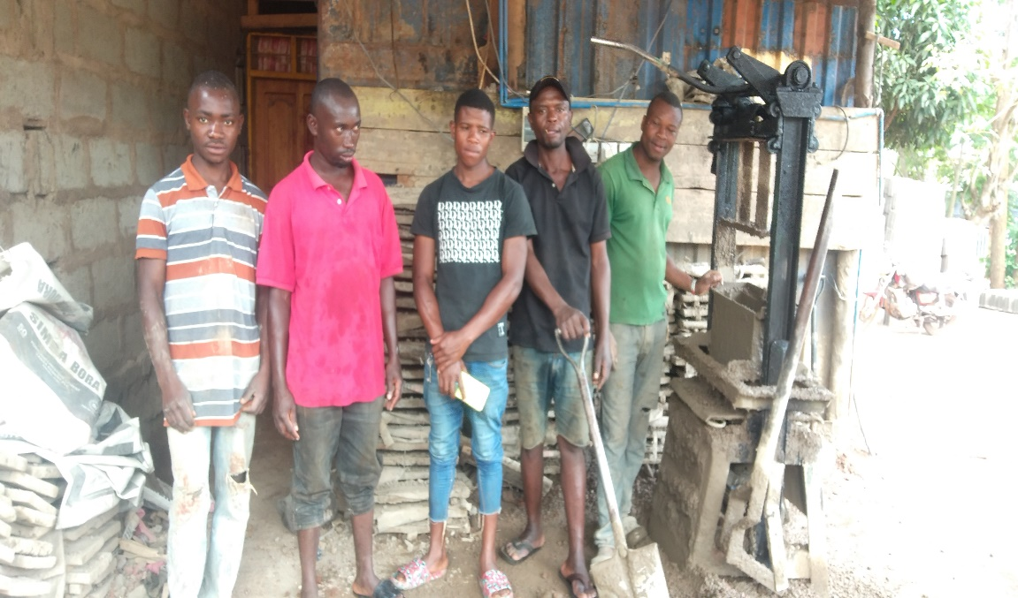

Figure 4.1: Some Members of the Ufyatuaji wa Matofali Kelamfua Mokala group at the project

4.4.3 Official Registration
The group received the registration certificate from Rombo District Council with Registration number HWR/06/2023 of 05 July, 2023 with the aim of youth who is mostly targeted.
Furthermore, the members of the group were trained on how to seek for financial resources from financial institutions. The training was done by one expert from one of the SACCOS at Kelamfua Mokala ward at Rombo district. After they have received these trainings, the main activities that is making blocks started officially by finding the raw materials for blocks production. Mr. Maloli allowed the youth group to use his compound for blocks production. Also Mr. Maloli financed the group by providing a loan of 5,000,000 Tshs with a commitment that the members will be buying cement bags from his hardware.

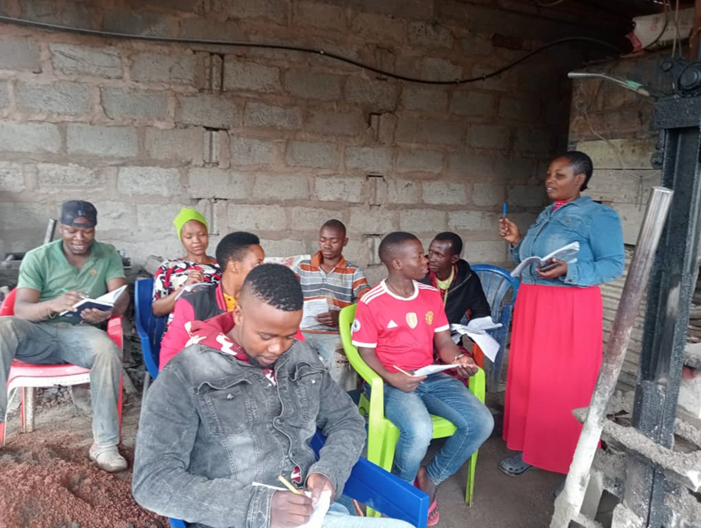
Figure 4.2: A Student-Researcher with the youth group in the training on financial accessibility

According to the current status of the project, more than 13,000 blocks have been produced since the production started in April 2023. This shows that for 8 months the project has created a revenue of 15,600,000 including expenses. When deducting the expenses, the profit was found to be approximately six million. This shows that the project is doing the best and more youth can join the activity in order to create more revenues.
Blocks production is a sustainable project that is expected to impact positively the life of those who are engaged in the activity. With this good beginning of the project, the student-researcher is expecting that many youths will involve themselves in blocks production.

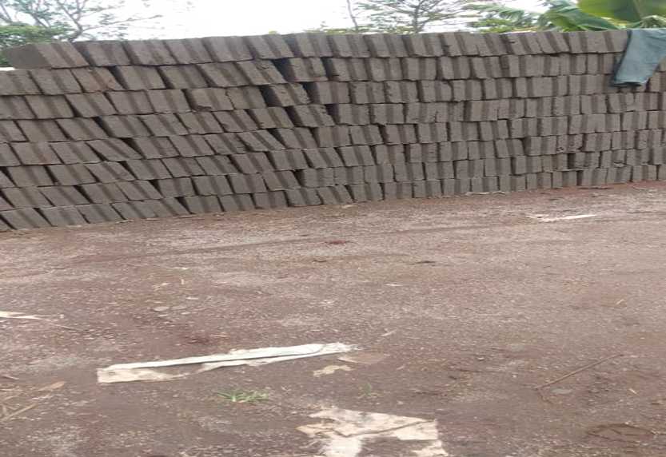
Figure 4.3: Blocks Produced by the Youth Group at Kelamfua ward in Rombo district

Table 4.4: Project Time Plan (Gantt)
Objectives | Output | Activities | Project Months
 |  |  | 2 | 3 | 4 | 5 | 6 | 7 | 8 | 9 | 10
Community Needs Assessment (CAN) | - Identification of the problem | - Data collection and analysis  - Using data to identify the problem
Formulation and registration of youth group of 20 people  Training youth group members on techniques of producing high quality blocks  Training group members on how to get access to finance from financial institutions | - Establish youth group of 20 people that will be producing blocks at Kelamfua Mokala ward  - Receive the certificate of registration  - To equip group members with techniques of blocks production  - To equip group members with financial skills and how to get access in financial institutions | - conducting regular meetings  - making consultancies with local government authorities on getting the youth  - taking attendance of the members  - conducting training for three weeks
Implementing the Proposed Project | - blocks Production | - Producing blocks materials  - Mixing the materials  - Producing blocks
Monitoring and Evaluation | - Effective implementation of the project | - Identifying areas of weaknesses and improving them to facilitate the success of the project
Close of the first phase of the BP | Completion of first phase | - Calculation of Revenues vs expenses

4.4.4 Project Inputs
The facilitators crucial for the project's implementation are referred to as inputs. This project relies on various inputs, including human resources, physical resources like water, sand, and cement, financial resources, and time. Human resources encompass the student researcher and local government leaders of the ward (councilor, ward executive officers, village executive officers, youth, and their leaders). Physical resources comprise a personal computer, internet access, stationery, electronic resources (e-resources), and transportation. Financial resources, particularly funds, serve as the primary input for securing other mentioned resources. Time is also a critical input essential for the successful implementation of the project.

4.4.5 Staffing Arrangement
The successful implementation of the project takes into account human resources. This includes the student researcher and local government leaders of the ward (councilor, ward executive officers, village executive officers, youth, and their leaders). The inclusion of specific human resources depends on the project's stage; for instance, the student researcher is involved throughout the project, and all human resources are engaged in the project's implementation.

4.4.6 Project Expenditure
The allocation of funds for specific activities is detailed in Table 11, illustrating the project budget.
This project prepared under the implementation of the project whereby these overall costs of Tshs.458, 000/= were the researcher costs and also it shows objectives, output, activities as well as the costs and it’s shown below as follow;

Table 4.5: Project Budget
Objectives | Output | Activities | Quantity | Unit price | Total TZS
Community Needs Assessment (CAN) | - Identification of the problem | - Data collection and analysis  - Using data to identify the problem | N/A | 150,000/= | 150,000/=
Formulation and registration of youth group of 20 people | - Establish youth group of 20 people that will be producing blocks at Kelamfua Mokala ward  - Receive the certificate of registration | - conducting regular meetings  - making consultancies with local government authorities on getting the youth | N/A | 300,000/= | 300,000/=
Monitoring and Evaluation | - Effective implementation of the project | - Identifying areas of weaknesses and improving them to facilitate the success of the project | N/A | 6,000/= | 6,000/=
Close of the first phase of the BP | Completion of first phase | - Calculation of Revenues vs expenses | N/A | 2,500/= | 2,500/=
 |  |  | - | Total | 458,500/=

CHAPTER FIVE

PROJECT MONITORING, EVALUATION AND SUSTAINABILITY

5.1 Introduction
This chapter deals with project monitoring, evaluation and sustainability. It explains the monitoring plans that were used in guiding the implementation of the project activities at Kelamfua Mokala ward.

5.2 Participatory Monitoring
The information regarding project monitoring was collected regarding the activities during blocks production activities. The performance indicators were set for the monitoring process. The monitoring information was gathered during the project implementation.

5.2.1 Methods for Participatory Monitoring
The participatory monitoring methods delineate the approaches employed to oversee the activities of the project comprehensively. Monitoring the project is crucial to incorporate changes when necessary and ensure the judicious utilization of resources. The methods utilized for monitoring progress encompass self-assessment, documentary review, and observation as participatory techniques. The execution of activities was guided by the relationship between the researcher and the community. The ensuing methods were deployed to monitor the progress of block production in Kelamfua Mokala ward:

5.2.1.1 Observation
The researcher observed various activities during the implementation of block production in Kelamfua Mokala ward, recording essential details in a notebook. Key aspects under observation included the blocks produced by the youth group, the materials employed in production, and the entire process of block production.

5.2.1.2 Document Review
Monitoring the attendance of youth group members was conducted using an attendance list. Daily reviews of attendance documents were performed to ascertain individual presence. This was crucial for maintaining discipline and ensuring adherence to project timelines. The findings from attendance list reviews revealed a positive attendance record, with all group members consistently present from the project's initiation to its conclusion. Document review was essential for providing assurance regarding activities conducted and contracts made by group members.

5.3 Demographic Profile of the Youth Development Group
Before delving into the presentation of findings based on objectives, it is imperative to present the demographic information of those involved in this project, particularly the youth group. This includes details such as the age of group members, their educational level, and gender.

5.3.1 Gender of the Group Members
The researcher wanted to know the gender of the group members of the group, the following are the results on gender of the group members as shown in the table 12 below.

Table 5.1: Gender of the Group Members
Gender | Frequency | Percentage (%)
Female | 1 | 4.8
Male | 20 | 95.2
Total | 21 | 100
Source: Survey Data (2023)

From table 12, the findings show that 1(4.8%) was a female while 20 (95.8%) were males. These findings show that males were many and one female was the student researcher who was the organizer of the project and the facilitator. Also, the findings in table 12 shows that blocks activity is dominated by the males due to the nature of the work.

5.3.2 Education Level of the Members of the Group
The researcher wanted to know the education background of the members of the group, the following are the results on education level as shown in the table 13 below.

Table 5.2: Education Level
Education Level | Frequency | Percentage
No formal education | 3 | 14.3
Primary Education level | 9 | 42.9
Secondary Education | 8 | 38.1
College or University Education | 1 | 4.7
Total | 21 | 100
Source: Survey Data (2023)

From table 8, the findings show that three group members (14.3%) had no formal education while nine (9) group members (42.9%) had primary education. Furthermore, 8 group members (38.1%) had secondary education level, while one group member (4.7%) had college or university education. The current findings suggest that group members with primary education and secondary education dominated the group.
The researcher wanted to know the age of the members of the group, the following are the results on age of the members of the group as shown in the table 13=4 below.

Table 5.3: Age of Members of Youth Group
Education Level | Frequency | Percentage
16 – 20 | 9 | 42.9
21 – 25 | 7 | 33.3
26 - 30 | 2 | 9.5
31 and above | 3 | 14.3
Total | 21 | 100
Source: Survey Data (2023)

From Table 14, 9 group members equivalent to 42.9% were in 16-20 age group, about seven group members were in the group 21-25 while two people were in age group of 26-30 while three people were in age group 31 and above. These findings suggest that most group members were between 16-30 ages.

Table 5.4: Monitoring of the project activities
Information | The monitoring type | Type of records kept | The person responsible person for data collection | The use of the data obtained | The use of the information obtained | The type of decision made by the project.
Plan out the project activities | Resource availability | Plan out schedules for the activities | Youth Group | Researcher | Managing activities | Balance the time provided
Costs underlying and expenditures | Fund available | Bank account | Youth Group Blocks Production at KelamfuaMokala ward | The youth in the community | Integrity is very important | Decide to revise the budget
Staff and the activity of supervising | Skills and attitude required | Feedback and clear activities | Researcher | The youth in the community | Improve the knowledge of youth concerning the blocks production and their advantage to them | Provision of education through the results from the project
Products ( Blocks Produced) | quality | Ledgers | Researcher | Group leaders and the researcher | Improve the understanding of youth on personal achievement | Encouraging youth to engage in economic activities like block production
Results | Look at the number of activities blocks produced | Profit after selling the blocks | Youth group leadership | Researcher and leadership of the youth group | Quality services | Make necessary arrangement for sustainable youth groups in blocks production at Kelamfua Mokala ward

5.3.3 Participatory Evaluation
The project was evaluated using the self-assessment method the four general activities whose outcomes were evaluated are:
Activity 1: To support the group with the registration process;
Activity 2: To train the group to understands the activities in regard to blocks production at Kelamfua Mokala ward.
Activity 3: To enable the group to understand and manage the group activities
Activity 4: Assist the group members to be able to make contract

5.4 The actual Monitoring
Actual monitoring was done to ensure the project activities have been carried to the expected level and the following were monitored. Inputs such as skills within the community, Process, Monitor the output and Measure the outcome of all the activities of the project carried out specifically the blocks production at Kelamfua Mokala ward. This were having a direct link with amounts of fund available, Training materials, youth group members, Time table, and area for blocks production. The following are the output indicators of the project; training sessions conducted this refers to qualitative numbers of the project members trained here we major the community members involved in the project.

5.4.1 Objective One: To register the youth group dealing with blocks production
The first objective of this project was to establish group of youth that will deal with blocks production in Kelamfua Mokala ward. The need for establishing blocks was influenced by CNA results. During CNA it was found that youth are struggling financially because they depended on agricultural activities but due to climate change, they opted to start involving themselves in different alternatives including blocks production. Their involvement in blocks production was at small scale. With these facts from CNA results, the researcher decided to establish youth group dealing with blocks at Kelamfua Mokala ward, the aim of establishing youth group for blocks production was to use a profit earned from the project as a motivation that will convince many youth to engage in blocks production.
To achieve this objective, the researcher initiated consultations with the Ward Executive Officer and other leaders. This involved submitting an introduction letter provided by the Open University of Tanzania and obtaining a research permit from Kalemfua ward. A total of 21 individuals, including the researcher, were consulted, with twenty of them being youth from Kalemfua ward. In this engagement, the researcher introduced herself and communicated the project's aim, emphasizing the empowerment of youth in income-generating activities for the benefit of their families and personal lives.
The project initiation involved several steps, namely: identifying 20 youth from Kalemfua ward, registering the group, preparing an estimated budget for project implementation, identifying and assessing the availability of raw materials, commencing the primary project activity, monitoring the implementation process, evaluating goal achievement, selling the produced blocks, and calculating the net profit. The established group was named "Kikundi cha Ufyatuaji wa Matofali Kelamfua Mokala."
Initially, the expectation was for the youth group to apply for a loan from the Youth Development Group, but this endeavor proved unsuccessful. Consequently, the group sought an alternative source and successfully obtained a loan of 5,000,000 Tanzanian Shillings from Mr. Maloli Patrik Tarimo, the proprietor of a hardware store in Kelamfua Mokala ward. This financial arrangement required the payment of interest after project completion. Mr. Maloli Patrick informed the youth group that materials, including cement, were purchased from his hardware, with the terms negotiated between the youth group and Mr. Maloli. The primary objective of the project was to encourage numerous youths to participate in economic activities, particularly block production, in Kalemfua ward. The subsequent section details the cost breakdown for block production.

Description of the Budget Used in Establishing and executing the project of blocks production at Kalemfua ward
Table 5.5: Budget
Item | Quantity | Unit Price | Total (Tshs)
Murram 4lorry | 1 | 150,000 | 600,000
Pozzo 3 trip | 1 | 200,000 | 600,000
Dusts 2 trip | 1 | 100,000 | 200,000
Cement 35 bags | 35 | 18,000 | 630,000
Production Machine | 1 | 3,000,000 | 3,000,000
Emergency for Machine Repair | 1 | 20,000 | 20,000
Wiring materials with installation | 1 | 100,000 | 100,000
225 Slabs | 225 | 2,500 | 562,000
Pavilion Roof:
Steel | 15 | 24,000 | 360,000
3′′ X 2′′ Wood | 12 | 7,000 | 84,000
Nails | 2 | 20,000 | 40,000
Barrel | 1 | 20,000 | 20,000
Buckets | 2 | 4,000 | 8,000
Water installation system | 1 | 300,000 | 300,000
Spade | 2 | 10,000 | 20,000
Water ball | 1 | 120,000 | 120,000
Container Stoo | 1 | 600,000 | 600,000
Electric Emergency Machine | 1 | 500,000 | 500,000
Area | 1 | 60,000 | 60,000
Storage Water Tank | 1 | 600,000 | 600,000
Water Bill | 1 | 100,000 | 100,000
Electricity | 1 | 100,000 | 100,000
Trainees | 2 | 150,000 | 300,000
Registration costs | 1 | 300,000 | 300,000
Total |  |  | 9,644,000

The total amount of money that was used in this project were Tshs. 9,644,000. About five million was a loan while the remaining amount was added by the researcher.
Price of 1 Block Is Tshs 1,000/= Without Transport and Tshs. 1,200/= Including Transportation.

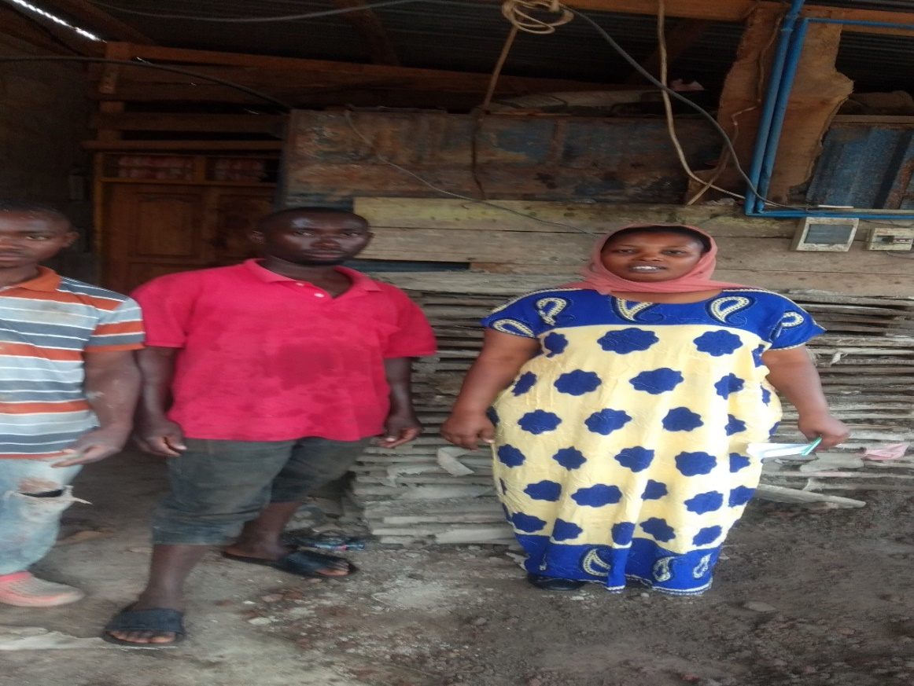

Figure 5.1: A researcher with some members of Ufyatuaji wa Matofali Kelamfua Mokala group in monitoring of the project activity

Table 5.6: Participatory Monitoring Plan
Objective/Activities | Monitoring Method | Performance Indicator | Means of Verification
Activities:

Discussing the idea of registering the group | Document Review | Three meetings were conducted | Minutes
- Obtain the registration  forms from Rombo District | Observation | The researcher assigned to get the application forms | The registration form
- Filling and signing  the registration form | Observation | Youth group members signatures | A copy of filled and signed application form
- Submission of the  application form | Document review | Evidence of members contribution towards the fees | Receipt of application fees
- Collection of  registration certificate | Observation | The researcher assigned to collect the certificate | Registration Certificate (Kikundi cha Ufyatuaji wa matofali Kelamfua Mokala)

Some of the pictures taken during the blocks production activity showing youth group at work.
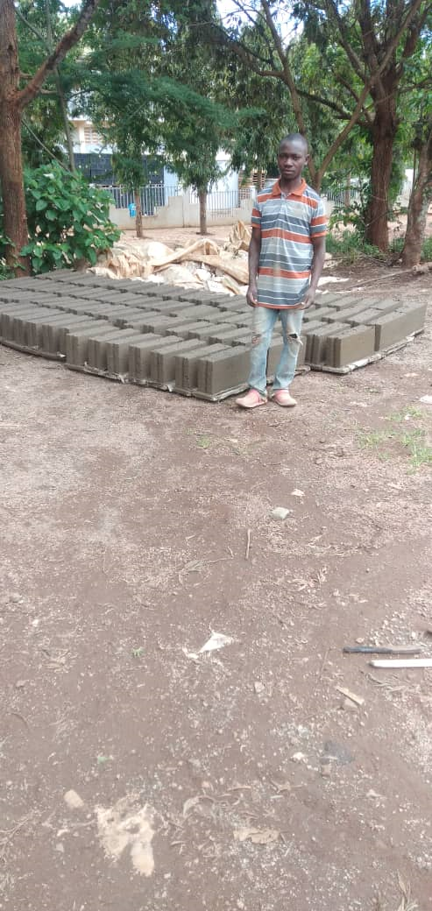
Figure 5.2: showing one of the members of the group standing in front of blocks

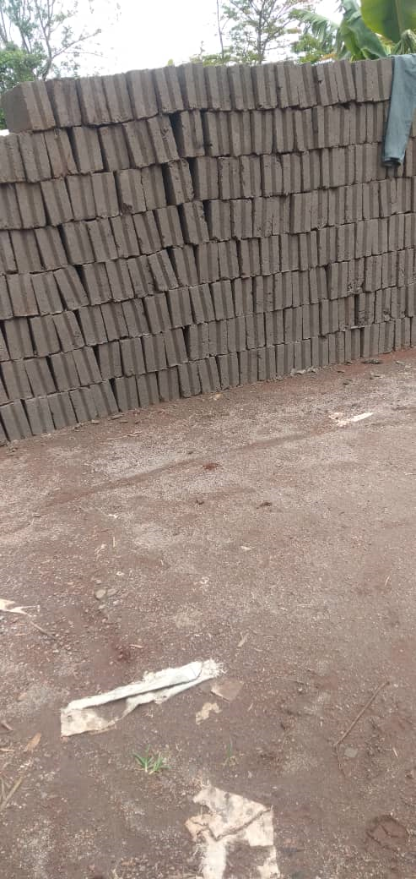

Figure 5.3: Blocks Produced by Kikundi cha Ufyatuaji wa matofali Kelamfua Mokala

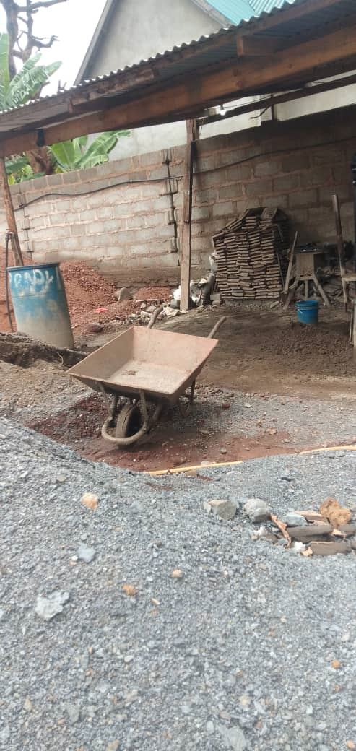

igure 5.4: Showin Blocks Production Site for Kikundi cha ufyatuaji wa matofali Kelamfua Mokala

5.4.2 Objective 2: To train the youth on the improved production and management techniques of blocks in Kelamfua Mokala ward
The second objective of the current study was to train the youth on the improved production and management techniques of the blocks at Kelamfua Mokala ward. The training was conducted by a person who is experienced in blocks production from Rombo District Prison. The training involved all 20 people who form Kikundi cha Ufyatuaji wa matofali Kelamfua Mokala. The training was conducted for two weeks before starting the production of blocks. Table 5.3 shows the objectives, monitoring method, performance indicators and mean of verification.

Table 5.7: Participatory Plan for Objective Two
Objectives/Activities | Monitoring Method | Performance Indicator | Means of Verification
1. Attendance of group members in the training | Document review | List of names of training participants | Weekly attendance register
2.Members are trained choose leaders who was organizing activities | Observation | Schedule of activity in training program or handout | Members can organize themselves their leadership
3.Members understand the how to produce quality blocks | Observation | Members are able to produce strong blocks for sustainable profit in their group | Members can produce blocks with high quality
4.Members understand the use of modern technologies used for blocks production | Observation | Ability in operating modern machines used for blocks production | Members are able to operate successfully the modern machine for block
Source: Field Data (2023)
Some photos were taken during the trainings:

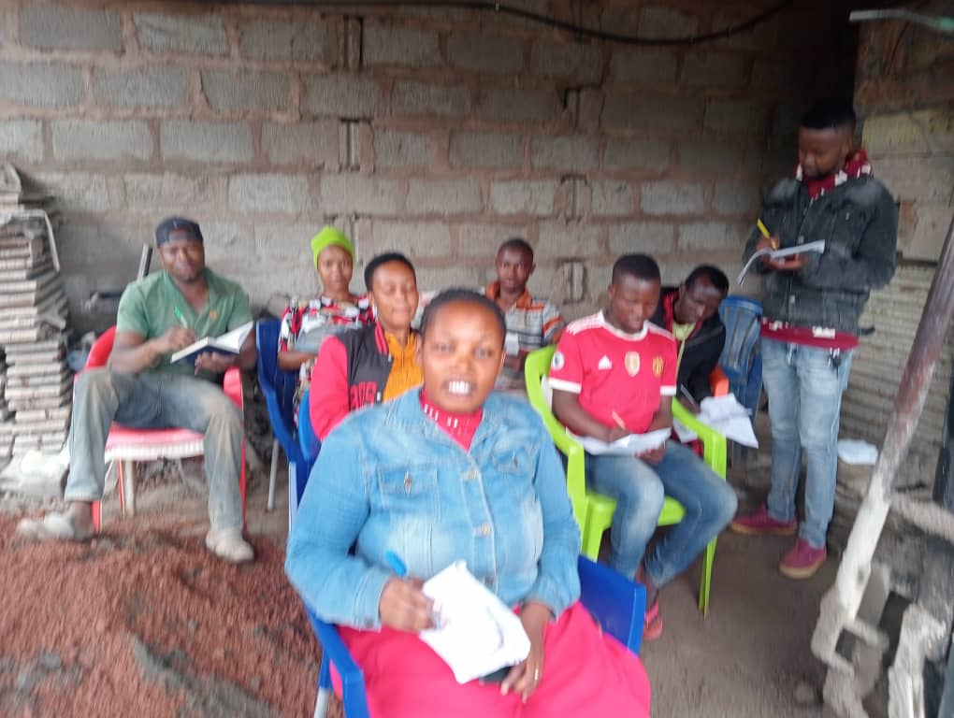

Figure 5.5: Somemembers of Youth Group in the Training on how to produceblocks with high quality

After the training the members went back to continue with some activities
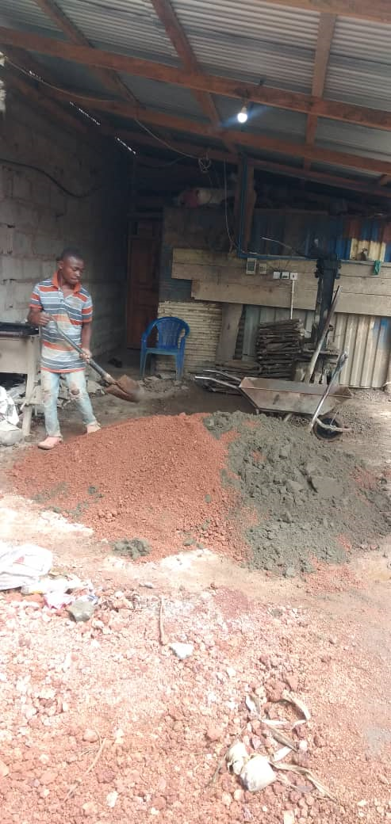

5.4.3 Objective Three: To assist the youth on the accessibility of financial services for block production in Kelamfua Mokala ward
The third objective of the current study was to assist Kikundi cha Ufyatuaji wa matofali Kelanfua Mokala. To make sure that this objective is achieved, the researcher made a consultation with people in banking sector especially those with experience in financial industry. Therefore, one experienced person came to meet with the group. The trainer focused on how groups like Kikundi cha ufyatuaji wa matofali Kelamfua Mokala can get loans from financial institutions. The trainer said that since the group is already registered, the youth group can use their certificates and some group official meetings to make decision for finding loans that can help them to expand their capital.

Table 5.8: Participatory Plan for Objective Two
Objectives/Activities | Monitoring Method | Performance Indicator | Means of Verification
1. Attendance of group members in the training | Document review | List of names of training participants | Weekly attendance register
2.Members were trained to manage writing loans application letters | Observation | Written loan application letters as a result of class works | Members of the group are able to write loans application letters
3.Members were trained to distinguish legal and illegal financial institutions | Observation | Members are able to know good financial institutions for loans | Members may decide to take loans for their blocks project
4.Members understand the strength of financial institution on how to raise capital | Observation | Ability in identifying importance of financial institutions to youth groups | Members are able to identify the role of financial institutions to the youth groups
Source: Field Data (2023)

Figure 5.6: A Researcher providing seminar to the members of the blocks production at Kelamfua Mokala ward

5.5 The project Evaluation
The participatory evaluation methods used includes observation, questionnaire and informative techniques whereby group members had to make sure they speak something about the blocks production project implementation and its activities in the Kelamfua Mokala ward. A self-assessment method through an evaluation questionnaire was used to engage the youth to evaluate the project outcomes.

Table 5.9: The Evaluation Plan 1
OUTCOME | Rate the Project Outcome in your own perspective
 | V.Good |  | Good | Average | Poor
Objective 1: To register the youth group dealing with blocks production
Output 1:  Group Registration Certificate | 100% |  | 0% | 0% | 0%
Objective 2: To train the youth on the improved production and management techniques of blocks in Kelamfua Mokala ward
Output 2: Understanding the production of quality blocks through modern machines | 100% | 0% |  | 0% | 0%
Objective 3: To assist the youth on the accessibility of financial services for block production in Kelamfua Mokala ward
Output 3: | 60% | 20% |  | 10% | 10%
Source: Field data (2023)

The project activities have shown to be implemented for the 100% therefore it has been implemented very successfully. The evaluation of the third output indicates that the group is still not comfortable as far as managing their activities are concerned. This is because they are still worrying about the access to finance. Furthermore, the findings show that about 60% of the group members thinks that the accessibility of finance for the group is still a challenge. Furthermore, these findings show that it is only 60% who think that the group can get financial access. There still needed a continued training on accessibility of finance to the blocks production group at Kelamfua Mokala ward.

5.6 Sustainability
The group has enough members and is expecting to have sensitization meeting to ensure the group members get new members subscribe to the Kikundi cha Ufyatuaji wa matofali Kelamfua Mokala and participate in blocks production and management. The project has to ensure it survives by using the resources it has such as human resource and the financial resources available. The main target was to encourage more youth to be busy with economic activities rather than depending on illegal activities that can lead them to jail.

5.6.1 Financial Sustainability
This group was sustainable financially because as time goes by, the group is building a financial base to help it gets established financially. However, it is also important to note that at start-up very little funds they have stated to contribute and continually was sustainable to the group. The group also has the assurance of financial sustainability in the long run as it continues to produce blocks, they sell blocks for Tshs 1,100/- per block. Their future is expected to be bright as they will continue selling blocks.

5.6.2 Technical Sustainability
This group will have a solid technical foundation thanks to the instruction they received. By doing this, you can make sure that the group is technically sustainable and that there won't be a significant negative impact if technical help is withdrawn.

5.6.3 Organizational Sustainability
This group, yet in its early stages of development, is up against a serious threat because it began as a group in terms of organization. The management of activities has not received a great grade up to this point. Nonetheless, there is hope for the group’s survival because it has been acknowledged by the ward-level, a local government body and because the group members are dedicated to carrying on the excellent work they have begun. Also, the first phase of the project helped the youths to get a profit of six (6) million, this shows a good sign that if they continue implementing this project their living standard will be improved.
It should be noted that, before this project, the youth involved in this project were not earning anything because they were idle. Therefore, the blocks production will be beneficial to them so they will be getting income for their families and personal life in general.

CHAPTER SIX

PROJECT CONCLUSION AND RECOMMANDTIONS

6.1 Introduction
This project was implemented in Rombo district in Kelamfua Mokala Ward. The project focused on establishment of blocks production group with the aim of encouraging youth at Kelamfua Mokala ward to engage themselves in economic activities rather than remaining idle. The conclusion can be made in regard to the highlights of the project design, literature review, project implementation, monitoring, evaluation and sustainability.

6.2 Conclusion
As youth have been facing a lot of challenges in Rombo district in Kilimanjaro because of unconducive conditions for agricultural activities, some have been involving themselves in illegal activities that lead them into the jail. Since Rombo district cannot accommodate all youth with capital formation, it is a responsibility of every individual to help the youth by establishing some projects that can help youth to generate income rather than engaging in illegal activities. As the youth group is developing every year at Kelamfua Mokala ward, the current study concludes that it is only formulation of youth group that can help in income generation among youth. Therefore, it can be concluded that many people are encourage to join these efforts by helping youth to have source of income and help them to avoid engaging in illegal activities.

6.3 The Project Recommendation
6.3.1 Establishment of group of youth for formal production of the blocks production in Kelamfua Mokala ward
The project was initiated this year, the study recommends that, since the group is still on early stages of operation, there is need for the members to be active and make sure that the group is sustainable as this group was beneficial to many youths in few years to come. One of the pre-conditions of any group to survive is activeness of the members. The study also recommends that there is need for local government authority in ward level to support this group through loans as the group started by using loans from private people of which the cost or the interest cost is very high.

6.3.2 To train the youth on the improved production and management techniques of blocks in Kelamfua Mokala ward
During the project, the researcher managed to conduct training in collaboration with experienced blocks producers who have experience in producing blocks. The trainings were successfully conducted, the group was trained on good management techniques and how to produce blocks with high quality. The current study recommends that trainings to the youth groups should be conducted so that encourage them in participating in economic activities. Trainings are only possible if the youth organize themselves in groups to make it easily to reach many youths in short period of time.

6.3.3 To assist the youth on the accessibility of financial services for block production in Kelamfua Mokala ward
The current project also involved in provision of financial education to the group members. The group members were given financial education that can help them in accessing loans from financial institutions. The current study recommends that Rombo district must have plans of providing trainings to youth groups found at Kelamfua Mokala ward and other wards. The trainings should focus on how youth can access financial services from financial institutions for their developments.

REFERENCES
Adaptation Fund Board (2022). Restoration of Lake Babati for Enhanced Climate Change Adaptation in Babati District. National Environment Management Council (NEMC)
Addae-Korankye, A. (2019). Youth Empowerment through Block Production Cooperatives: Case Studies from Sub-Saharan Africa. Cooperative Studies Journal, 32(3), 120-135.
Aikaeli. (2021). Income and Employment Potential for Youth and Women in Block Production Enterprises: A Study from Tanzania's Coastal Region. Coastal Studies Quarterly, 9(1), 40-55.
Barr, N. (2004). Problems and definition of measurement. In Economics of the welfare state. New York: Oxford University Press. pp. 121–124
Beamish, W. & Donovan, A. (1990). Village-level making. ISBN 3-528-02051-2. OCLC 472930436.International Printing limited.
Collins Dictionary. (2005). Youth Economic Empowerment: Definitions and Perspectives. Economic Perspectives Quarterly, 7(4), 78-92.
Elesh, M. (1970). Youth Employment Programs and Income Generation: Lessons from Tanzania's Block Production Initiatives. African Economic Review, 2(1), 10-25.
Hugh, A., & Spalding, B. (2004). Empowering Youth Through Entrepreneurship: A Case Study of Block Production in Rural Tanzania. Journal of Development Economics, 28(2), 67-82.
Kabiru, O., & Nyambura, F. (2017). Ujasiriamali wa Vijana na Uzalishaji wa Matofali: Fursa na Changamoto katika Mazingira ya Mijini. Hakiki ya Maendeleo ya Mjini, 12(1), 40-55.
Kamau, M., & Githinji, R. (2016). Vikundi vya Vijana katika Uzalishaji wa Matofali na Uendelevu wa Mazingira: Uchambuzi wa Mbinu za Usimamizi wa Taka. Jarida la Usimamizi wa Mazingira, 32(4), 180-195.
Kamau, T., & Ngugi, M. (2014). Jukumu la Fedha Ndogo katika Ujasiriamali wa Vijana: Ushahidi kutoka Miradi ya Uzalishaji wa Matofali katika Nchi Zinazoendelea. Hakiki ya Fedha Ndogo, 9(4), 220-235.
Khan, F., & Gupta, A. (2018). Athari ya Programu za Uwezeshaji wa Vijana kwa Maendeleo ya Kijamii na Kiuchumi: Mafunzo kutoka Vikundi vya Uzalishaji wa Matofali nchini India. Jarida la Masomo ya Maendeleo, 14(1), 60-75.
Kimani, S., & Mutua, P. (2019). Mazoea Endelevu katika Utengenezaji wa Matofali: Mifano kutoka Vikundi vya Vijana katika Asia Kusini-Mashariki. Jarida la Uendelevu, 8(2), 75-90.
Kimaro, A., & Towo, B. (2015). Factors Influencing Rural Youth Participation in Block Manufacturing: A Case Study from Tanzania's Southern Highlands. Journal of Rural Development, 14(3), 70-85.
Kimaro, P. J., and Towo, N. N. (2015). Determinants of rural youth’s participation in agricultural activities: the case of Kahe East ward in Moshi Rural District Council, Tanzania. International Journal of Economics, Commerce and Management, 3(2): 33.
Kothari R.C (2004). Research Methodology, Methods and Techniques (2nd Ed). New Delhi:
Kumar, R. (2018). Research methodology: A step-by-step guide for beginners. Research methodology, 1-528.
McArthur, Hugh, and Duncan Spalding. Engineering materials science: properties, uses, degradation and remediation. Chichester, U.K.: Horwood Pub., 2004. 194. Print.
Mwana, A., & Kamau, W. (2018). Uchumi na Ajira kwa Vijana: Ushahidi kutoka Miradi ya Uzalishaji wa Matofali katika Afrika Mashariki. Jarida la Maendeleo ya Kiuchumi, 22(3), 130-145.
Mwangi, J., & Nyambura, L. (2019). Uwezeshaji wa Vijana na Maendeleo ya Jamii: Uchambuzi Tofauti wa Miradi ya Uzalishaji wa Matofali katika Maeneo ya Vijijini na Mijini. Jarida la Maendeleo ya Jamii, 20(3), 120-135.
National Economic Empowerment Policy. (2004). Economic Empowerment Policies and Youth Entrepreneurship: Case Studies from Tanzania. Economic Empowerment Review, 12(2), 90-105.
National Youth Development Policy. (2007). Government Policies and Youth Development: A Case Study of Tanzania's National Youth Development Policy. Government Policy Review, 5(3), 160-175.
Njeri, M., & Ochieng', L. (2016). Mbinu za Kijamii katika Kuwawezesha Vijana: Mafundisho kutoka Vikundi vya Uzalishaji wa Matofali Amerika Kusini. Jarida la Maendeleo ya Jamii, 15(4), 180-195.
Otieno, K., & Wambui, A. (2021). Mabadiliko ya Teknolojia katika Utengenezaji wa Matofali: Athari kwa Ajira na Maendeleo ya Kiuchumi. Jarida la Ubunifu wa Teknolojia, 30(3), 160-175.
Patel, S., & Kimani, H. (2015). Vikundi vya Vijana katika Uzalishaji wa Matofali: Mifano ya Jinsia katika Uongozi na Maamuzi. Jarida la Masomo ya Jinsia, 18(2), 90-105.
Q Green Techno & Manage. (2020). Innovative Techniques in Block Production: A Case Study of Youth-Led Enterprises. Green Technology and Management Journal, 5(1), 45-58.
Regina, J. R.; Mattee, A. Z. and Nyamba, S. Y. (2020). Contribution of Youth Development Fund Supported Income Generating Activities to Youth Livelihood in Morogoro Municipality and Mvomero District, Tengeru Community Development Journal, Vol. 7 (2), 15-27
Rombo District Council (2013). Rombo District Socio-economic Profile
Ron. (2022). Sustainable Practices in Block Manufacturing for Youth Empowerment: Insights from a Pilot Project in East Africa. International Journal of Sustainable Development, 10(2), 88-101.
Small and Medium Enterprise Development Policy. (2003). Policy Interventions for Small and Medium Enterprises: Lessons from Tanzania's SME Development Policy. Development Policy Perspectives, 8(4), 220-235.
United Nations. (2008). Youth Empowerment and Economic Development: Policy Implications from a Global Perspective. UN Research Review, 40(4), 205-220.
United Nations. (2018). Youth Employment and Economic Prospects in Sub-Saharan Africa: Insights from a UN Study. UN Economic Bulletin, 48(2), 80-95.
Wafula, E., & Maina, K. (2017). Ushiriki wa Vijana katika Vikundi vya Uzalishaji wa Matofali: Mafunzo kutoka Uchunguzi Mbadala katika Afrika Kusini mwa Jangwa la Sahara. Jarida la Masomo ya Ushirikiano, 25(2), 100-115.
Webster's New World Dictionary. (2023). Youth Empowerment and Socioeconomic Growth: A Lexical Analysis. Lexicography Studies, 12(1), 30-42.
Werner, R. (2002). Youth Entrepreneurship and Block Production: A Pathway to Economic Independence. Journal of Youth Entrepreneurship, 6(2), 55-70.
Wikipedia. (2023). Youth Development Initiatives: A Comprehensive Overview. Wikipedia Journal of Social Sciences, 15(3), 102-115.

APPENDICES
Appendix I: Questionnaire
Habari,
Naitwa …………………………. ni mwanafunzi wa shahada ya pili katika Chuo Kikuu Huria Tanzania. Ninafanya utafiti katika shughli za kiuchumi za kuwawezesha vijana katika kata ya Kelamfua Mokala ward. Utafiti huu ni sehemu ya vigezo vya kitaaluma vitakavyoniruhusu kumaliza chuo. Naomba uwe sehemu ya utafiti huu kwa kushiriki katika kujibu maswali yaliyopo katika dodoso hili. Faragha ni muhimu katika utafiti huu hivyo ondoa shaka yoyote kwani taarifa utakazotoa ni kwa ajili ya suala la kitaaluma tu. Ninashukuru sana kwa ushirikiano wako.
Ni mimi

      - Taarifa Binafsi
Tafadhari weka alama ya vema kwenye kiboksi ulichopewa upande wa kulia wa swali
Jinsia | Me
 | Ke
Umri | Miaka 20 – 25
 | Miaka 26 – 30
 | Miaka 31 – 35
 | Miaka 35 – 40
Hali ya Ndoa | Nimeoa/ nimeolewa
 | Sijaoa/Sijaolewa

      - Ni shughuli gani unadhani zinaweza kusaidia kuzalisha kipato kwa vijana katika kata ya Kelamfua Mokala inayopatikana wilaya ya Rombo?
Aina ya Shughuli inayoingiza kipato | Weka alama ya vema
Kilimo
Ufugaji wa wanyama
Ufyatuaji Tofali za Kuuza
Biashara ndogo ndogo
Biashara ya kuongoza watalii
Kazi za nymbanina kulea watoto
Kuajiriwa katika sekta mbalimbali

3. Ni changamoto zipi kati ya hizi kwenye jedwali zinawakumba vijana katika uzalishaji wa kipato katika kata ya Kelamfua Mokala wilayani Rombo?
Changamoto | Weka alama ya vema kwenye changamoto uliyoichagua
Uzalishaji mdogo kwenye kilimo
Uhaba wa chakula
Changamoto ya upatikanaji fedha
Mabadiliko ya tabianchi
Ukosefu wa elimu ya ujasiliamali
Kukosekana kwa ajira
Uhalifu na tabia mbaya
      - Je, mradi wa ufyatuaji tofali unaweza kuwa na faida zipi kwa vijana katika kata ya Kelamfua Mokala?
Faida | Weka alama ya vema kwenye kisanduku husika
Ufyatuaji tofali unaleta matazamio ya kuleta kipato Zaidi ya shughuli zingine katani
Ufyatuaji tofali unaweza kuboresha Maisha ya vijana
Ufyatuaji tofali unaweza kusaidia vijana kujua jinsi ya kuomba mikopo kwa ajili ya mitaji
Ufyatuaji tofali una uwezekano mzuri wa soko kupatikana kwani watu wengi sasa hivi wanajenga
Angalu kwenye uzalishaji wa tofali vijana wana uelewa mzuri hivyo ni njia nzuri ya waokutengeneza kipato
Malighafi za kutengeneza tofali zinapatikana kwa wingi hivyo ni biashara nzuri kwa vijana

Kiambata II: Maswali ya Mahojiano
- Ni shughuli gani unadhani zinaweza kusaidia kuzalisha kipato kwa vijana katika kata ya Kelamfua Mokala inayopatikana wilaya ya Rombo?
- Ni changamoto zipi zinawakumba vijana katika uzalishaji wa kipato katika kata ya Kelamfua Mokala wilayani Rombo?
- Ni shughuli gani unadhani zinaweza kusaidia kuzalisha kipato kwa vijana katika kata ya Kelamfua Mokala inayopatikana wilaya ya Rombo?

APPENDIX 3: REGISTRATION CERTIFICATE
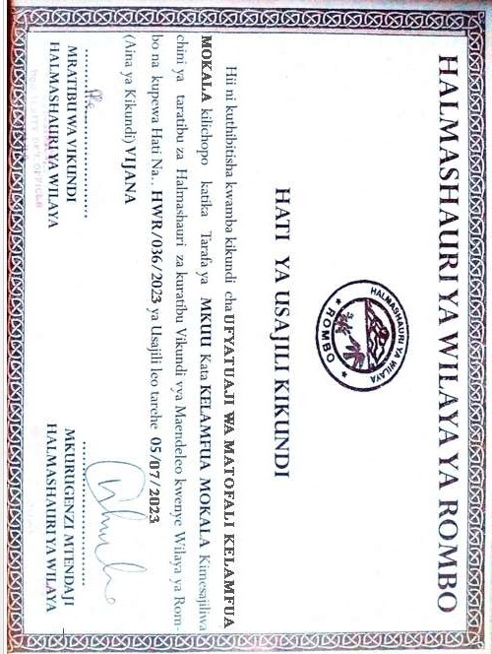

APPENDIX 4: INTRODUCTION LETTER




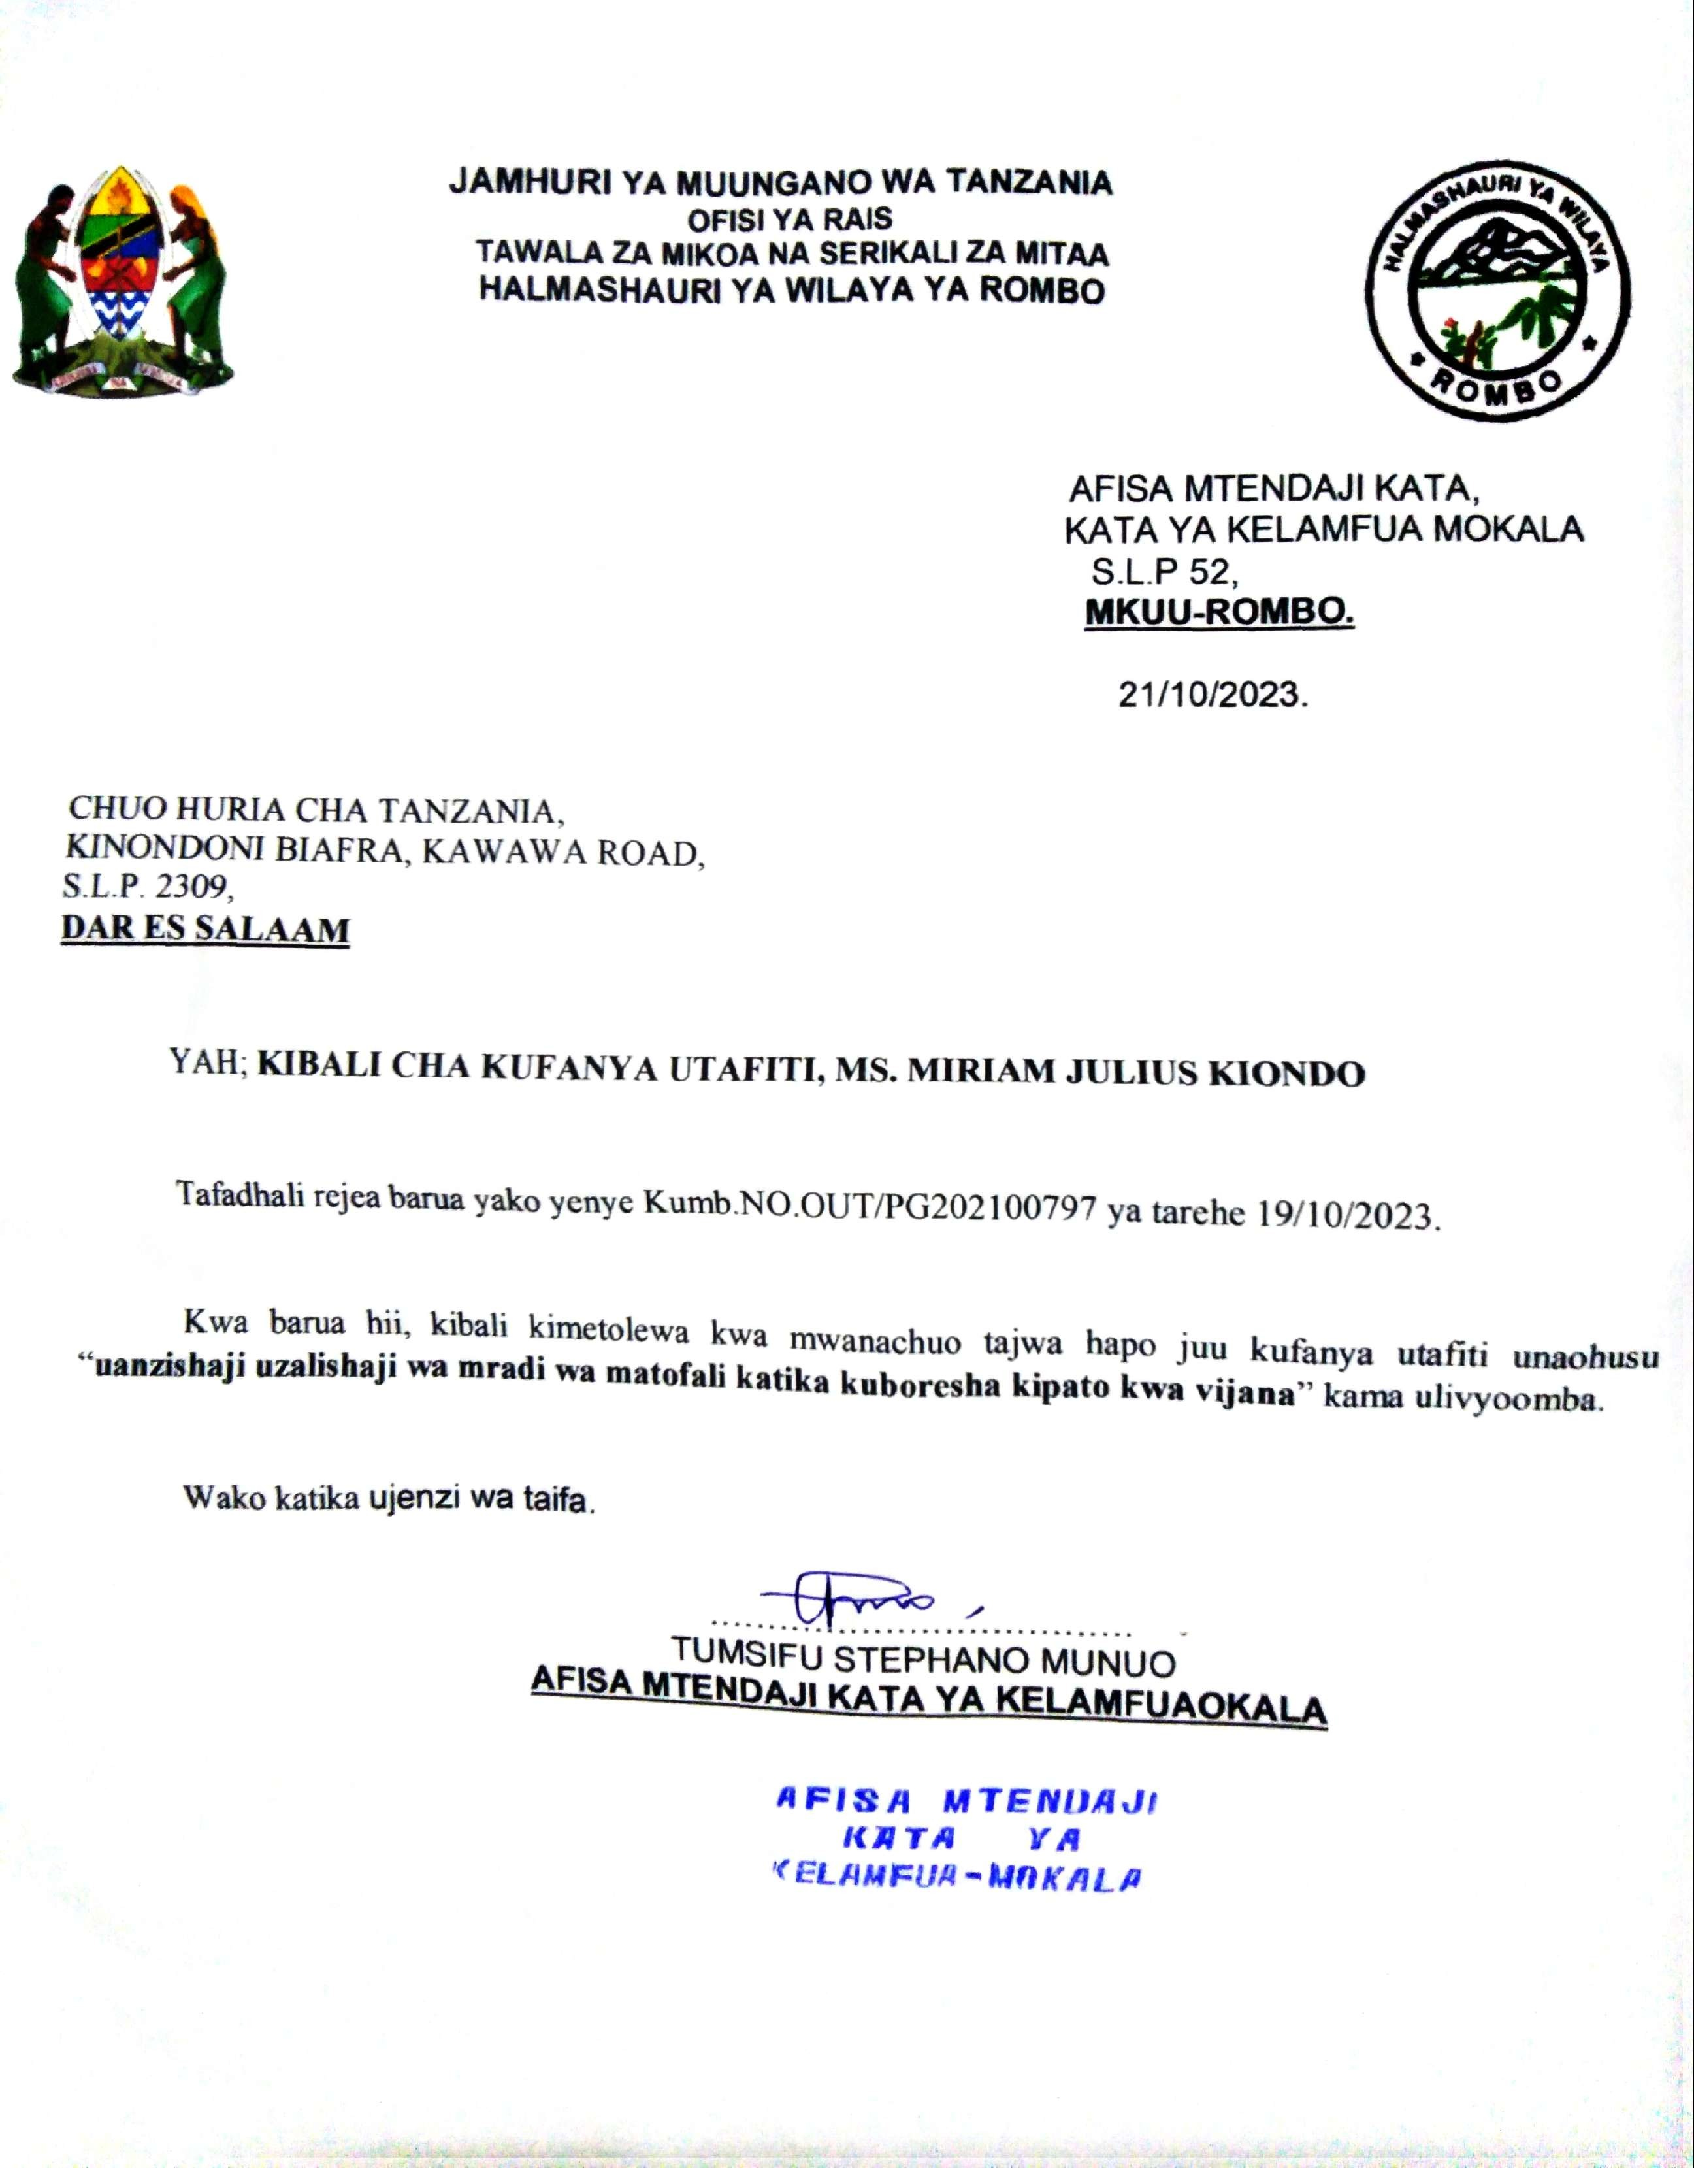

APPENDIX 5: RESEARCH PERMIT

APPENDIX 6: BUDGET BREAKDOWNS FOR DIRECT COST AND OTHER PROJECT REQUIREMENTS
No | Budget Line Items | Quantity | Price | Total
1 | Murram | 4 | 4lorry @Tshs 150,000/= | 600,000
2 | Pozzo | 3 | 3trip@Tshs. 200,000/= | 600,000
3 | Dusts | 2 | 2trips @Tshs. 100,000/= | 200,000
4 | Cement | 35 | 35bags @ 18,000 | 630,000
5 | s Production Machine @Tshs 3,000,000/= | 1 | 1@Tshs 3,000,000 | 3,000,000
6 | Emergency for Machine Repair @Tshs.20,000/= | 1 | 1@20,000 | 20,000
7 | Wiring installation |  | 100,000 | 100,000
8 | Slabs | 225 | 225@ Tshs 2,500/= | 562,000
9 | Steel @ Tshs 24,000/=360,000 | 15 | 15@ Tshs 24,000 | 360,000
10 | 3′′ X 2′′ Wood | 12 | 12@ Tshs. 7,000/= | 84,000
11 | Nails Tshs 20,000/= | 2 | 2@20,000 | 40,000
12 | Barrel Tshs 20,000/= | 1 | 1@20,000 | 20,000
13 | Water installation system | 1 | 300,000 | 300,000
14 | Buckets | 2 | 2@4,000 | 8,000
15 | 1 water Ball Tshs 120,000/= | 1 | 1@120,000 | 120,000
16 | Storage Container Tshs 600,000/= | 1 | 1@600,000 | 600,000
17 | Electric Emergency Machine at Tshs 500,000/= | 1 | 1@500,000 | 500,000
18 | Area Tshs. 60,000/= Per Month | 8 | 8@60,000 | 480,000
19 | Storage Water Tank with its materials and technical | 1 | 600,000 | 600,000
20 | Water bills per month | 1month | 100,000 | 100,000
21 | Electricity bill per month | 1 month | 100,000 | 100,000
22 | 2 spade | 2 | 2@10,000 | 20,000
23 | Training | 2 | 150,000/= | 300,000/=
 | Registration costs | 1 | 300,000/= | 300,000/=
Total Budget |  |  |  | 9,644,000.00
 | Total Revenue  Total Blocks Produced within 8 months | 13,000 | 13,000@1200 | 15,600,000.00
 | Profit |  | 15,600,000.00-9,644,000.00 | 5,956,000.00

APPENDIX 7: DAILY RECORD SHEET OF BLOCKS PRODUCTION
Date | Total blocks produced | Total blocks sold | Amount generated in TZS | Expenses | Cash Balance | Signature of the members of blocks production group | Signature of student researcher

