THE RELATIONSHIP BETWEEN AIRPORT SERVICE PERFORMANCE AND INTERNATIONAL TOURISTS' SATISFACTION:
A CASE OF SELECTED AIRPORTS IN TANZANIA

DENIS MWAGENI

A THESIS SUBMITTED IN FULFILMENT OF THE REQUIREMENT FOR THE DEGREE OF DOCTOR OF PHILOSOPHY
DEPARTMENT OF GEOGRAPHY, TOURISM AND HOSPITALITY SERVICES
THE OPEN UNIVERSITY OF TANZANIA
2024

CERTIFICATION
The undersigned certify that they have read and hereby recommend for acceptance by the Open University of Tanzania a thesis titled: "The Relationship Between Airport Service Performance and International Tourists' Satisfaction: A Case of Selected Airports in Tanzania". In fulfilment of the requirements for the award of Degree of Doctor of Philosophy of the Open University of Tanzania.

………………………………………
Dr. Shogo R. Mlozi
(1st Supervisor)

Date………………………

………………………………………
Dr Hawa Uiso
(2nd Supervisor)

Date………………………

COPYRIGHT
No part of this thesis may be reproduced, stored in any retrieval system, or transmitted in any form by any means, electronic, mechanical, photocopying, recording or otherwise without prior written permission of the author or the Open University of Tanzania.

DECLARATION
I, Denis Mwageni, declare that, the work presented in this thesis is original. It has never been presented to any other University or Institution. Where other people’s works have been used, references have been provided. It is in this regard that I declare this work as originally mine. It is hereby presented in fulfillment of the requirement for the degree of Doctor of Philosophy of the Open University of Tanzania.

……………………………….....
Signature

………………………………….
Date

DEDICATION
This thesis is dedicated to my Almighty God and family, who empowered me with this life today and helped me successfully achieve my PhD program. Without His will, the PhD program and this thesis could not have been pursued and conducted successfully.

ACKNOWLEDGEMENT
I wish to express my profound appreciation to the Almighty God who gave me the strength to overcome different challenges encountered during this study. Moreover, my deepest gratitude goes to my supervisors: Dr. Shogo R. Mlozi a former Senior Lecturer at the Open University of Tanzania, and Dr. Hawa Uiso of Tumaini University Dar es Salaam College. Their assistance comprising valuable guidance from PhD proposal development to the final stage of writing my PhD report is unforgettable. Equally, their valuable time spent reviewing the document, giving comments, and responding to different questions during my research cannot go without appreciation. Without their guidance, time, and commitment throughout my study, I would never have been able to accomplish this study timely.

My appreciation also goes to Dr. Deus Shata for advice and guidance in structural equation modeling using Smart PLS 3 Software. His persistence and intuitive remarks contributed massively to the achievement of my PhD. Likewise, my acknowledgment goes to Dr. France Shayo and Dr. Robert Msigwa for their advice, comments, and Smart PLS 3 Software guidance during my study. I also wish to acknowledge the Department of Geography, Tourism and Hospitality Services of the Faculty of Arts and Social Sciences at the Open University of Tanzania for everything they did towards the accomplishment of my PhD. I cannot forget to thank Fr. Eberhard Mwageni for his moral and tuition fee support. Similarly, my gratitude goes to the National Institute of Transport for their research fund support which enabled me to cover research costs without hectic conditions.
Furthermore, I would like to thank and appreciate my wife Felic L. Ngowo, and my mother Abia N. Luvanda for their love, understanding, encouragement, and support during my study time. Finally, I wish to acknowledge my lovely children, Heimrad D. Mwageni, Egilhard D. Mwageni, Boanerge D. Mwageni, and Penuella D. Mwageni because they missed my presence while writing this work. Regardless, they still showed me love, understanding, and a good smile when we met. To those not mentioned, my friends and relatives who contributed to my PhD journey, this work is the result of your decent support, and my thanks go to you all.

ABSTRACT
This study assessed the relationship between airport service performance and international tourists' satisfaction in selected airports in Tanzania. Reports of substandard service performance at international airports in the country triggered this study. The expectancy disconfirmation theory missed airport service performance indicators; hence, borrowing indicators from the airport model was inevitable. The four main airport domains-imposed fragmentation of perceived service performance in theory into four sole constructs of which the existing literature is missing. A stratified sampling technique was employed with a sample size of 420. A closed-ended questionnaire was adopted for data collection. Data were analyzed using PLS-SEM with the help of SmartPLS 3 software and SPSS IBM Statistics (Version 21). The study showed that arrival processing, departure processing, and departure non-processing domains have positive path coefficients with direct and significant relationships toward international tourists' satisfaction. The arrival non-processing domains revealed a negative path coefficient and insignificant direct relationship with international tourists' satisfaction. The study proposes a model that fits the context of Tanzania's international airports in assessing international tourists' satisfaction. The study recommends that indicators from the construct with direct and positive relationship toward international tourists’ satisfaction be treated as a primary factor while indicators for the domain with indirect relationship be treated as secondary factors without undermining its quality.
Keywords: Check-in; Disembarkation; Arrival immigration; Baggage claim; Arrival security screening; Arrival airport facilities; Arrival retail area.
TABLE OF CONTENTS
CERTIFICATION ii
COPYRIGHT iii
DECLARATION iv
DEDICATION v
ACKNOWLEDGEMENT vi
ABSTRACT viii
LIST OF TABLES xvii
LIST OF FIGURES xviii
CHAPTER ONE 1
INTRODUCTION 1
1.1 Chapter Overview 1
1.2 Background of the Study 1
1.3 Statement of the Problem 10
1.4 Objectives 12
1.4.1 General Objective 12
1.4.2 Specific Objectives 13
1.5 Significance of the Study 13
1.6 Organization of the Thesis 16
CHAPTER TWO 17
LITERATURE REVIEW 17
2.1 Chapter Overview 17
2.2 Conceptual Definitions 17
2.2.1 Tourists 17
2.2.2 Tourism 18
2.2.3 Tourists’ Satisfaction 19
2.2.4 Airport Service Performance 20
2.3 Theoretical Literature Review 28
2.3.1 Expectation Disconfirmation Theory 28
2.3.2 Passenger-Centered Airport Model 32
2.4 The Link between EDT and PCAM 36
2.5 Empirical Literature Review 36
2.5.1 The direct relationship between Arrival Processing Domain and Tourists’ Satisfaction 37
2.5.2 The Relationship Between Departure Processing Domain and Tourists Satisfaction 44
2.5.3 The Relationship Between Arrival Non-Processing Domain and Tourists Satisfaction 54
2.5.4 The Relationship Between Departure Non-Processing Domain and Tourists Satisfaction 60
2.6 Research Gap 70
2.7 Conceptual Model and Hypotheses 72
CHAPTER THREE 74
RESEARCH METHODOLOGY 74
3.1 Overview 74
3.2 Research Philosophy 74
3.3 Research Approaches 74
3.4 Research Strategies 75
3.5 Research Area 75
3.6 Target Population 77
3.7 Sampling Design and Procedure 77
3.8 Sample Size 78
3.9 Variables and Measurement Procedures 79
3.10 Data Collection Methods and Tools 80
3.10.1 Questionnaire 80
3.10.2 Documentary Review 81
3.11 Model Proposed 81
3.12 Measurement of Respondents’ General Information and Variables 82
3.12.1 Measurement of Respondents’ General Information 82
3.12.2 Measurement of Dependent and Independent Variables 82
3.13 Data Processing and Analysis 83
3.14 Assumptions Underlying PLS-SEM 84
3.14.1 The Good Neighbour Assumption 84
3.14.2 The Distribution of Variable Assumption 84
3.14.3 Relationships with Good Theoretical Support Assumption 84
3.14.4 Missing Values and Outliers’ Assumption 85
3.15 PLS-SEM Data Analysis 85
3.15.1 PLS-SEM Algorithms 85
3.15.2 PLS-SEM Path Mode 85
3.15.3 Procedures Used in SmartPLS Software 86
3.15.4 File Format and Importing Data Files in SmartPLS 3 Software 87
3.15.5 Creating a New Project and Inserting Data in Smartpls 3 Software 87
3.15.6 Sketching the Conceptual Path Model in Smartpls 3 Software 88
3.15.7 Naming and Connecting the Latent Variables in Smartpls 3 Software 88
3.15.8 Executing the PLS Algorithm in SmartPLS 3 Software 89
3.15.9 Bootstrapping Process in SmartPLS 3 Software 89
3.15.10Global Goodness-of-Fit Criterion and Prediction for PLS-SEM 90
3.15.11PLS-SEM Evaluation Procedures for Reflective Models 92
3.16 Evaluation of Reflective Measurement Model 92
3.16.1 Examining the Indicator Loadings (Reliabilities) 92
3.16.2 Examining Internal Consistency Reliability 93
3.16.3 Examining the Convergent Validity 93
3.16.4 Evaluating the Discriminant Validity 93
3.17 Evaluation of the Structural Model Procedures 94
3.17.1 Evaluating Collinearity 95
3.17.2 Examining the R2 Value of the Endogenous Constructs 95
3.17.3 Evaluating the f2 Effect Size 95
3.17.4 Evaluating the Q2 Values of the Endogenous Constructs 96
3.17.5 Evaluating the Statistical Significance and Relevance of the Path Coefficients 96
3.17.6 Importance-Performance Matrix Analysis 96
3.18 Reliability and Validity 98
3.18.1 Reliability 98
3.18.2 Validity 98
3.19 Techniques of Handling Missing Values 98
3.20 Techniques for Identifying and Handling Outliers 99
3.21 Ethical Considerations 99
CHAPTER FOUR 100
FINDINGS AND DATA ANALYSIS 100
4.1 Chapter Overview 100
4.2 Findings from the Pilot Study 100
4.2.1 Pilot Study Findings for Assessing Reflective Measurement Model 111
4.2.2 Pilot Study Findings for Assessing Reflective Structural Model 113
4.3 Findings of the Study 116
4.3.1 Respondents Profile 116
4.3.2 Rate of Respondents 117
4.3.3 Demographic Profile for the Respondents 117
4.3.4 Data Analysis for Specific Objectives 120
4.3.4.1 Assessing Reflective Measurement Models 120
4.3.4.2 Structural Model 124
CHAPTER FIVE 135
DISCUSSION OF THE FINDINGS 135
5.1 Chapter Overview 135
5.2 Respondents' Rates and Demographics 136
5.2.1 Respondents Rates 136
5.2.2 Gender of the Respondents 137
5.2.3 Age of the Respondents 137
5.2.4 Education Level of the Findings 137
5.2.5 Purpose of Travel 138
5.2.6 Travel Experience in Tanzania 139
5.2.7 The Airport used for Arrivals in Tanzania 139
5.2.8 Respondents Nationalities 140
5.3 The Relationship between ASP and International Tourists’ Satisfaction 140
5.3.1 The Direct Relationship Between Airport APD and International Tourists’ Satisfaction 140
5.3.2 The Direct Relationship Between Airport DPD and Tourists Satisfaction 143
5.3.3 The Indirect Relationship Between Airport ANPD and International Tourists’ Satisfaction 145
5.3.4 The Direct Relationship Between Airport DNPD and Tourists’ Satisfaction 147
5.4 Perception of Airport Management on International Tourists’ Satisfaction 149
5.5 Overall Explanatory Power 151
5.6 Powerfulness of Direct Path Coefﬁcients and P-values 152
CHAPTER SIX 155
SUMMARY OF FINDINGS, CONCLUSION, AND RECOMMENDATIONS 155
6.1 Chapter Overview 155
6.2 Summary of the Findings 155
6.2.1 The Direct Relationship Between Airport APD and International Tourists’ Satisfaction 155
6.2.2 The Direct Relationship Between Airport DPD and International Tourists’ Satisfaction 155
6.2.3 The Indirect Relationship Between Airport ANPD and International Tourists’ Satisfaction 156
6.2.4 The Direct Relationship Between Airport DNPD and International Tourists’ Satisfaction 156
6.3 Implications of the Study Findings 157
6.3.1 The Direct Relationship Between Airport APD and International Tourists’ Satisfaction 157
6.3.2 The Direct Relationship Between Airport DPD and International Tourists’ Satisfaction 158
6.3.3 The Indirect Relationship Between Airport ANPD and International Tourists’ Satisfaction 159
6.3.4 The Direct Relationship Between Airport DNPD and Tourists’ Satisfaction 159
6.3.5 Theoretical Knowledge Implication of the Study Findings 160
6.3.6 Justification of Theoretical Implication of the Study Findings 165
6.3.7 Variations of Overall Explanatory Power 168
6.3.8 P-Value and Path Coefficient Variation for the Construct Relationship 169
6.3.9 The Comparison of the Proposed Model and the Modified Models 169
6.3.10 The Repercussion of PCAM and EDT on the Study Findings 170
6.3.11 Empirical Implications of the Study Findings 171
6.3.12 Practical Implications of the Study Findings 172
6.3.13 Policy Implications of the Study Findings 173
6.4 Conclusions 173
6.4.1 The Direct Relationship Between Airport APD and International Tourists’ Satisfaction 173
6.4.2 The Direct Relationship Between Airport DPD and International Tourists’ Satisfaction 174
6.4.3 The Indirect Relationship Between Airport ANPD and International Tourists’ Satisfaction 174
6.4.4 The Direct Relationship Between Airport DNPD and International Tourists’ Satisfaction 175
6.4.5 Perception of the Airport Authority, Airport Management, and Other Stakeholders 176
6.1.1 Limitations and Delimitations of the Study 176
6.5 Recommendations of the Study 177
6.5.1 Recommendations to the Government 177
6.5.2 Recommendations to the Airport Authority and Airport Management 179
6.5.3 Recommendations to Policymakers 180
6.5.4 Areas for Further Research 180
REFERENCES 183
APPENDICES 203

LIST OF TABLES
Table 2.1: Indicators in each domain as indicated in PCAM 35
Table 2.2: The link between EDT and PCAM 36
Table 2.3: Summary of Empirical Studies 69
Table 3.1: Sample size distribution 79
Table 3.2: Evaluation of the measurement model 94
Table 3.3: Evaluation of the structural model 97
Table 4.1: List of dropped indicators 104
Table 4.2: List of remaining indicators 109
Table 4.3: Hypothesis tested 116
Table 4.4: Demographic profile of the respondents 118
Table 4.5: Nationalities of the respondents 120
Table 4.6: Construct’s indicator reliability 122
Table 4.7: Internal consistent reliability (composite reliability) and AVE results 123
Table 4.8: Discriminant validity results using Heterotrait-Monotrait Ratio 124
Table 4.9: Collinearity statistics 125
Table 4.10: f Squared value 126
Table 4.11: Q2 Values 128
Table 4.12: The tested hypothesis 130
Table 6.1: List of added indicators in the domains 162

LIST OF FIGURES
Figure 2.1: Expectation Disconfirmation Model 30
Figure 2.2: Passenger-Centred Airport Model 34
Figure 2.3: Conceptual framework of the study 73
Figure 3.1: PLS Mode A, Algorithm 86
Figure 3.2: PLS-SEM Evaluation Procedures for Reflective and Formative Models 91
Figure 4.1: Constructs’ convergent validity 101
Figure 4.2: Modes showing indicators and their reliability values 102
Figure 4.3: Model showing indicators and their P-value values 107
Figure 4.4: Model with IR, Path Coefficient, and ICR after dropping indicators 111
Figure 4.5: Constructs’ reliability values 112
Figure 4.6: Constructs convergent validity 112
Figure 4.7: Endogenous Constructs Coefficient Determination (R²) 113
Figure 4.8: The size of the path coefficient of the research model 114
Figure 4.9: Significance path coefficient - Bootstrapping analysis 115
Figure 4.10: Indicator’s reliability 121
Figure 4.11: R² Value of the endogenous construct 125
Figure 4.12: Q² for endogenous construct. 127
Figure 4.13: Path Coefficients 129
Figure 4.14: Statistical significance of path coefficient 130
Figure 4.15: Performance of constructs and their indicators 132
Figure 4.16: Performance map (indicators unstandardized effect) 133
Figure 4.17: Performance map (construct unstandardized effects) 134
Figure 5.1: Construct explanatory power 152
Figure 6.1: Final model 165
Figure 6.2A: Actual passenger centred airport model 167
Figure 6.2B: Validated passenger centred airport model 167
Figure 6.3: The change of the overall explanatory power – construct dropout 168
Figure 6.4: Recommended conceptual model with transit domains 181

LIST OF ABBREVIATIONS AND ACRONYMS
AAA Arrival Airport Accessibility
AAA1 Arrival Airport Accessibility Indicator number one
AAA2 Arrival Airport Accessibility Indicator number two
AAA3 Arrival Airport Accessibility Indicator number three
AAKIA Abeid Aman Karume International Airport
AAF Arrival Airport Facilities
AAF1 Arrival Airport Facilities Indicator number one
AAF2 Arrival Airport Facilities Indicator number two
AAF3 Arrival Airport Facilities Indicator number three
AAF4 Arrival Airport Facilities Indicator number four
AAF5 Arrival Airport Facilities Indicator number five
AAF6 Arrival Airport Facilities Indicator number six
AAF7 Arrival Airport Facilities Indicator number seven
AAF8 Arrival Airport Facilities Indicator number eight
AAF9 Arrival Airport Facilities Indicator number nine
AAF10 Arrival Airport Facilities Indicator number ten
AHP Analytical Hierarchy Process
AI Arrival Immigration
AI1 Arrival Immigration Indicator number one
AI2 Arrival Immigration Indicator number two
AI3 Arrival Immigration Indicator number three
ACSI American Customer Satisfaction Index
ANPD Arrival Non-Processing Domain
APD Arrival Processing Domain
ARA Arrival Retail Area
ARA1 Arrival Retail Area Indicator number one
ARA2 Arrival Retail Area Indicator number two
ARA3 Arrival Retail Area Indicator number three
ARA4 Arrival Retail Area indicator number four
ARA5 Arrival Retail Area indicator number five
ASS Arrival Security Screening
ASS1 Arrival Security Screening Indicator number one
ASS2 Arrival Security Screening Indicator number two
ASS3 Arrival Security Screening Indicator number three
ATM Automated Teller Machine
AVE Average Variance Extracted
BC Baggage Claim
BC1 Baggage Claim Indicator number one
BC2 Baggage Claim Indicator number two
BC3 Baggage Claim Indicator number three
BC4 Baggage Claim Indicator number four
BIA Bandaranaike International Airport
PCAM Passenger Centred Airport Model
CDT Cognitive Dissonance Theory
CI Check-In
CI1 Check – In Indicator number one
CI2 Check – In Indicator number two
CI3 Check – In Indicator number three
CI4 Check – In Indicator number four
CI5 Check – In Indicator number five
CQ Customs and Quarantine
CQ1 Customs and Quarantine Indicator number one
CQ2 Customs and Quarantine Indicator number two
CQ3 Customs and Quarantine Indicator number three
DAF Departure Airport Facilities
DAF1 Departure Airport Facilities Indicator number one
DAF2 Departure Airport Facilities Indicator number two
DAF3 Departure Airport Facilities Indicator number three
DAF4 Departure Airport Facilities Indicator number four
DAF5 Departure Airport Facilities Indicator number five
DAF6 Departure Airport Facilities Indicator number six
DAF7 Departure Airport Facilities Indicator number seven
DAF8 Departure Airport Facilities Indicator number eight
DAF9 Departure Airport Facilities Indicator number nine
DAF10 Departure Airport Facilities Indicator number ten
DAF11 Departure Airport Facilities Indicator number eleven
DAF12 Departure Airport Facilities Indicator number twelve
DAF13 Departure Airport Facilities Indicator number thirteen
DAF14 Departure Airport Facilities Indicator number fourteen
DAF15 Departure Airport Facilities Indicator number fifteen
DSS Departure Security Screening
DSS1 Departure security Screening Indicator number one
DSS2 Departure security Screening Indicator number two
DSS3 Departure security Screening Indicator number three
DNPD Departure Non-Processing Domain
DPD Departure Processing Domain
DRA Departure Retail Area
DRA1 Departure retail Area Indicator number one
DRA2 Departure Retail Area Indicator number two
DRA3 Departure Retail Area Indicator number three
DRA4 Departure Retail Area Indicator number four
DRA5 Departure Retail Area Indicator number five
DRA6 Departure Retail Area Indicator number six
ETD Expectation Disconfirmation Theory
GNIA Good Neighbour Assumption
HTMT Heterotrait-Monotrait Ratio
IATA International Air Transport Association
ICR Internal Consistency Reliability
IPA Important Performance Analysis
IPMA Importance Performance Matrix Analysis
ITS International Tourists Satisfaction
ITS1 International Tourists Satisfaction Indicator number one
ITS2 International Tourists Satisfaction Indicator number two
ITS3 International Tourists Satisfaction Indicator number three
ITS4 International Tourists Satisfaction Indicator number four
ITS5 International Tourists Satisfaction Indicator number five
JKIA Jomo Kenyatta International Airport
JNIA Julius Nyerere International Airport
KIA Kilimanjaro International Airport
KLIA Kuala Lumpur International Airport
MMIA Murtala Muhamed International Airport
MNRT Ministry of Natural Resource and Tourism
NBS National Bureau of Statistics
PCAM Passenger-Centred Airport Model
PLS Partial Least Squares
PLS-SEM Partial Least Squares-Structural Equation Modelling
R² Coefficient of Determination
SEVQUAL Service Quality
SEM Structural Equation Modelling
TCAA Tanzania Civil Aviation Authority
TMA Tanzania Meteorological Agency
UNWTO United Nations World Tourism Organization
VIF Collinearity Statistics
WTTC World Travel and Tourism Council
ZNZ Zanzibar

CHAPTER ONE

INTRODUCTION

Chapter Overview
This chapter covers the background information and explains the research problem for the study. It further describes the general and specific objectives, and the significance of the study and ultimately presents the overall organization of the thesis.

Background of the Study
Globally, airports are crucial in developing the tourism industry by providing accessibility to potential markets (Soshkin et al., 2019). According to Jasrotia et al. (2020) and Gupta (2018), airports are a major component of the tourism industry since they manage hundreds of flights daily. In today’s competing aviation industry, airports have transformed from mere points of entry and exit for tourists to dynamic areas where tourists can relax, shop, stay over, and enjoy leisure and recreational activities (Gupta and Venkaiah, 2018). Airports are now complex tourist entrance areas with various interacting services where tourists get the overall first impression of the country.

According to Wiredja (2017) and Latiffa and Imm (2015), airports play a significant role in international tourists’ satisfaction with the destination. Tourists’ expectations have tremendously influenced airport service performance due to increasing competition (Baranskaite, 2019). The airport is now a forefront and sensitive tourism competitive area that requires efficient service performance to exceed tourists’ expectations (Khoshnood et al., 2016; Nadimi et al., 2023). Zhao et al. (2017) contend that enhancing airport service performance can directly affect overall tourist satisfaction, hence increasing tourist arrivals and earnings. Cognizant of this, most countries regard airports as brand ambassadors for their country’s tourism and make efforts to create a positive image for tourists through airport performance (Nugraha, 2017). The tourism industry and airport authorities work together worldwide to enhance the quality of airport service performance (Lee and Yu, 2018).

Wattanacharoensil et al. (2017) advance that airports create the first and lasting impressions for a country, thus, service quality management at airports is essential to maintain repeat visits and the affirmative image of the country. According to Lohmann et al. (2018), high-quality airport service performance offers a critical competitive advantage in achieving targeted tourism performance. Airport service performance is increasingly becoming a matter of interest in tourism as it facilitates international tourist flow and is essential in vacation experience satisfaction (Rijal, 2018). Moreover, airports have been transformed into attractions that offer many services and facilities to satisfy tourists (Graham et al., 2015). Laniado et al. (2019) and Chatterjee et al., (2023) report that understanding airport service facilities is crucial to survival in the global airport competing environment by providing superior airport service performance in line with tourists' expectations. Fadare and Adeniran (2018) and Lohmann and Trischler (2018) also propound that offering excellent customer satisfaction at the airport terminal has become a competitive strategic priority in the tourism sector. Regardless, most tourism studies have overlooked airports as key areas for creating a positive impression on tourists and increasing visit confidence in the destination (Marchalina and Dewantara, 2018). Assessing international tourists' satisfaction at the airport terminal significantly improves airport service performance (Wiredja et al., 2017).

According to Popovic et al. (2015), airport service performance contains two main components: airport processing domains which include airport arrival processing domain and departure processing domains, and airport non-processing domains which encompass airport arrival non-processing domain and airport departure non-processing domain. Wiredja et al. (2017), Wiredja et al. (2019), and Mayhew (2016) reiterate that the airport processing domains being mandatory areas for tourists comprise departure processing domains and arrival processing domains. While the departure processing domain involves check-in, departure immigration, and departure security screening, the arrival processing domain comprises arrival immigration, baggage claim, arrival security screening, baggage transfers, transit screening, customs, and quarantine. On the other hand, the non-processing domain being tourists unrestricted consists of airport facilities, airport retail areas, and airport access (Bogicevic et al., 2013; Gomes and Bezerra, 2016; Gomez and Bezerra, 2015).

Wiredja et al. (2019) and Kick et al. (2012) advance that airport domains are the sections at the airport terminal where tourists’ activities and interactions occur. Thus, the processing and non-processing domains represent the domains where passenger-centered indicators for assessing airport service performance are addressed (Zhang and Jiang, 2016). Therefore, international tourists obtain service performance experience during departure, arrival, and transit when interacting with staff and facilities at the airport (Wiredja, 2017). Hence, tourists have to rate their level of satisfaction toward those indicators. Cross-referencing perceived performance and expectations form tourist satisfaction (Mock, 2019). Halpern and Mwesiumo (2021) report the challenge of avoiding imperfections during airport service delivery despite numerous efforts to upgrade several airport key processes during check-in, security screening, passport control, bag drop, and departure gates. Similarly, Trischler and Lohmann (2018) report that airport service failure is inevitable and can impact the overall international tourists’ satisfaction and affect tourists' behavioural intention to reuse and recommend the destination to others. Therefore, Wiredja (2019) cemented that for effective measurement of airport service performance experience, the processing and non-processing domains must both be assessed concurrently for tourist satisfaction and its statistically significant relationship.

Graham et al. (2015) and Popovic et al. (2010) remark that international tourists' satisfaction at each airport domain influences repeat tourists. Gilaninia et al. (2013), Jamkatel (2018), and the reference propound that tourists' satisfaction at the airport plays a significant role in tourism performance. According to Cristina (2017), airport service performance is a hot topic in the tourism and air transport industry. This is because international tourists can not escape getting in touch with airport services when returning from their destinations (Bellizzi et al., 2018; Seyanont, 2011). According to Saadat et al. (2018), tourists' impressions of the destination are frequently affected by their first and last service encounters at the gateway airport. Hence, tourists’ airport experience is a significant focus for many airports worldwide as it is their first primary business strategy (Wattanacharoensil et al., 2017). Weak airport service performance slows tourism sector performance (Daracha, 2013; Wirtz, 2011).

Nearly 3,759 airports serve over 1,303 airlines operating over 31,717 aircraft globally (Liu et al., 2019). International tourist arrivals grew from 1.322 billion tourists in 2017 to 1.4 billion in 2018 due to advancements in airport service performance (Soshkin et al., 2019). The number of flights carrying tourists indicates that international tourist flow has increased, and airports have improved their services to accommodate tourists' demands (Wiredja, 2017; Ilmu et al., 2018). Several studies worldwide have focused on airport departing passengers, while other researchers simplified their analysis by focusing only on arrival and transit (Bogicevic et al., 2013; Gomes et al., 2016). Equally, inadequate surveys in the world evaluated the combination of airport processing and non-processing domain and their relationship with tourists’ satisfaction (Cristina, 2017).

Hajez et al. (2021) project that by 2035, there will be a total of over 7.2 billion air travellers all over the world. Chuchu (2020) also projected that 16 billion travelers are expected to be transported by air in 2050. Thus airports must be well-equipped with better service performance to meet forecasted demand. Farooq et al. (2018) explain that airports require strategic quality measures for survival in the current and projected competitive aviation and tourism industry. Understanding the performance of airport service is the key to the achievement and existence of the tourism business (Wiranatha et al., 2017). Lee and Yu (2018) adds that providing superior airport service performance is unavoidable. As the traffic volume grows, most airports worldwide struggle to improve airport efficiency by focusing on customer demand (Fadare et al., 2018). Antwi et al. (2020) divulged that high customer satisfaction at the airport terminal is believed to contribute to better overall international tourists’ satisfaction and provide a long-term market advantage.

The number of tourists visiting African countries increased from 88.54 million passengers in 2017 to 91.99 million in 2018 (Berthe, 2019). It was anticipated that in the next 20 years, the tourism industry will be among the seven fastest-growing sectors in the World (Ricardianto et al., 2017; Eleboda, 2017). Accordingly, it is essential to understand that airport satisfaction is an ongoing core issue in the tourism and aviation industry (Suarez and Jimenez, 2016). However, the global COVID-19 pandemic disease restricted travel and put almost the whole world on lockdown. Although the situation is recovering right now, the forecasted tourism growth was affected by this pandemic disease (Ruwan et al., 2020), and the number of international tourist arrivals in Africa went down to 5.1 million in 2022 (Sasu, 2022).

Nationally, tourists visiting Tanzania have grown from 1,327,000 million in 2017 to 1,465,000 in 2019 (WBG, 2022). This number was expected to increase through the renovation of air transport services, facilities, and infrastructures (Harrison et al., 2015, Smith, 2018). The focus on airport service performance as amongst key areas for tourist satisfaction has been overlooked by many researchers around the world (Tudin et al., 2017), and (Farooq et al., 2018). The ongoing airport renovation and construction, and the plan to increase the number of international arrivals in the country calls for researchers to address this relationship clearly (Fadare et al., 2018). According to Seetanah et al. (2018), tourists' analysis of tourism service typically starts with quality service available at the airport terminal and other obtained services recognized as integral parts of destination satisfaction.

Studies by Spasojevic et al. (2018) and Silva et al. (2018) revealed that tourism and airport service performance complement each other and impressively support economic growth in Tanzania. Mudana (2017) and Marchalina and Dewantara (2018) dispose that a positive impression in the tourism industry starts from the airport as the first touch point in the destination. The role of airport service performance in Tanzania's tourism sector should not be treated as piecemeal (Abdullahi et al., 2018). Wiranatha et al. (2017) reported that the quality of airport service performance is crucial for tourists to applaud the destination to others and increase the country's economic growth. Jawabreh et al. (2015) and Hammoud et al. (2017) comment on the preliminary studies combining airport processing and non-processing domains and their apparent relationship with tourist satisfaction. Kate (2020) and Ansari and Agarwah (2015) also suggest that the relationship between airport service performance and tourist satisfaction has an impact on repeat tourists. Chi et al. (2018) recommend more researchers to develop an interest in the link due to global competition in the tourism sector.

On the contrary, no clear theory exists with identified airport constructs and indicators for traveling passengers to assess the relationship. The existing overall satisfaction theories, including the expectancy disconfirmation theory (EDT) used in this study, miss airport service indicators for assessing international tourists’ satisfaction at the airport terminal. Thus, adopting airport service indicators from the current passenger-centered airport model (PCAM) by Wiredja et al. (2019) was inevitable.

The EDT by Oliver (1980, 1997) shows that satisfaction is attained when expected and perceived services are disconfirmed by tourists. According to the theory, the cross-reference of airport perceived performance and expectations forms international tourists' satisfaction (Mock, 2019). Safiek (2009) and Dean and Yu (2001) add that the core of the airport satisfaction process is comparing the expectations before service consumption with the service performance after consumption. Expectations become more realistic after perceived service performance (Hartman et al., 1994; Cheng, 2019; Suy et al., 2019). Eleboda (2017) likely supported the theory that when expectations and actual service performance do not match, the tourist feels tension or discomfort. Thus, a tourist adjusts expectations or perceptions of the actual performance to release tension. According to Cheng (2019), several studies confirmed that EDT has interpretative power for the satisfaction dimensions. Regardless of its popularity, the theory misses airport service indicators for performance assessment. Therefore, a need to integrate a theory with an airport-related model containing indicators to assess the relationship between airport service performance and tourist satisfaction is very significant.

Correspondingly, tourists' satisfaction at the airport terminal is influenced by the quality of the airport and its offered services (Weredja et al., 2019). Most countries whose economies depend on tourism have competitively and strategically invested in the quality of airport service performance to increase tourists' level of satisfaction (Chi and Wonmi, 2022). The reported challenge is that most airports can not deliver a superior customer experience leading to tourist dissatisfaction (Chi et al., 2018; López et al., 2023). For instance, unconvincing services, serviceability of airport facilities, staff courtesy, and readiness to help, queuing time, retail areas, and other airport services have been reported to affect tourists’ satisfaction (Adetayo et al., 2020; Anton et al., 2021). Philemon (2015) claims that plans to increase international tourist flow should align with improving service performance and infrastructure at the airport terminals to meet tourists’ expectations. Tourists being airport key stakeholders, deserve close attention, and their needs must be studied to detect which aspects are significant and how airports should react.

Many studies have focused on quantifying the overall feelings and tourists' travel experience in tourism places. In contrast, other studies have focused on the link between passenger satisfaction and service quality in specific airport domains (Baker, 2013). Studies combining processing and non-processing domains and their value in the tourism sector have been overlooked in Tanzania's tourism sector (Slevitch et al., 2017). Moreover, studies that explicitly discuss airport service performance and tourist satisfaction are silent and hardly developed, but many studies addressed the quality of air transport service (Zhang and Jiang, 2016). Tourism performance in Tanzania is not convincing compared to the nearby countries, probably due to airport service performance which has not been worked upon (Mhlanga, 2017). The need to understand the link between international tourists' satisfaction and airport service performance calls for researchers to address the precise relationship. Therefore, the present study assessed the relationship between airport service performance and international tourists’ satisfaction in selected airports in Tanzania.

Statement of the Problem
Globally, airports play a significant role as they actively promote international tourism. Thus, satisfaction with the airport service performance significantly attracts airport passengers to visit the airport’s origin country as tourists. Tanzania is a global country with rich natural resources and tourist sites (Soshkin, et al., 2019). It has invested a lot in promoting the tourism industry to increase international tourist arrivals (Kazuzuru, 2014). Despite the promotional efforts, the sector has not attracted enough international tourists (Kinyondo et al., 2020). The greatest concern of international tourists is airport service which requires a lot of concentrated efforts and investments to meet tourist expectations. According to Philemon (2015), further service improvement at the airport terminal in Tanzania needs to be done. If thoughtfully executed to the required level, the improvements will increase international tourists’ satisfaction and more repeat visitors. Suarez and Jimenez (2016) cement that airport services are the central topic for international tourists’ satisfaction at any tourist destination. Tourism studies in Tanzania have drawn little attention to airport service performance as the most significant factor affecting international tourists’ satisfaction.

Conversely, international arrival raised concerns about services offered at the airport terminals in Tanzania. Makoye (2014) reported poor airport service performance with horrific, inadequate facilities and mistreatment of arriving passengers at Julius Nyerere International Airport (JNIA). In 2017, JNIA and Abeid Aman Karume International Airport (AAKIA) were reported to be among the ten worst airports in service provision in Africa. Some reasons for this were rude, unknowledgeable staff, and staff unconcerned with tourists’ affairs (McSherry, 2017; Maestro, 2017). Equally, in 2019, 2020, and 2021, none of the international airports in Tanzania appeared in the top ten best airports for tourist service provision in Africa (McSherry, 2019; Amara, 2020; Benson, 2022). Tourists mentioned problems concerning sleeping areas, rest zones, luggage storage, and lockers at Kilimanjaro International Airport (McSherry, 2020). Newton (2021) grumbled about unsatisfactory airport service and overall condition, disappointing COVID-19 precautions and protocol at AAKIA. The concerns touched on processing (arrival, transit, and departure domains) and non-processing (airport facilities, airport retail shops, and airport access) domains. However, only a few studies assessed ways of helping the aviation industry, specifically the airport authority, to improve airport service performance to enhance tourism sector performance in Tanzania.

Much research has been documented in the world to address airport service performance. However, studies combining processing and non-processing domains and their link with international tourists' satisfaction have been recommended (Dimitriou et al., 2018 and Wiredja et al., 2019). Adeniran et al. (2018) and Fadare et al. (2018) in Lagos, Nigeria, showed the relationship in a nutshell using SERVQUAL mode. However, the model did not precisely spotlight the service gap in a specific domain where airport authorities could quickly solve the identified service gap. Equally, empirical literature addressing airport processing and non-processing domains and the link with tourist satisfaction is missing in Tanzania's tourism sector. Wattanacharoensil (2019) emphasized that studies on airport service performance are minimal. Hence academicians are invited to explore how airport service performance affects tourist satisfaction.

Similarly, the EDT used in this study is silent on the expected and perceived service performance indicators precisely at the airport terminal. The need to adopt airport service performance construct indicators from the PCAM developed by Wiredja et al. (2019) and use them as perceived service performance was paramount to meet the study objectives. Therefore, the study assessed the relationship between airport service performance (airport arrival processing domains, airport departure processing domains, airport arrival non-processing domains, and airport departure non-processing domain) and international tourists’ satisfaction in selected airports in Tanzania.

Objectives
This section covers the general and specific objectives of the study to show the explicit goals.

General Objective
The general objective of this study was to examine the relationship between airport
service performance and international tourists’ satisfaction in selected airports in Tanzania.

Specific Objectives
- To assess the relationship between airport arrival processing domains and international tourists’ satisfaction.
- To assess the relationship between airport departure processing domains and international tourists’ satisfaction.
- To assess the relationship between airport arrival non-processing domains and international tourists’ satisfaction.
- To assess the relationship between airport departure non-processing domains and international tourists’ satisfaction.

Significance of the Study
The study is a prerequisite for the accomplishment of the doctorate in tourism. The findings have the potential to significantly contribute to knowledge generation in the respective field and pave the avenue for future researchers, development planners, donors, and tourism and aviation practitioners. The study suggestions and recommendations herein can be the guidelines and valuable sources of information for airport authorities to improve service performance in a specific airport domain. The tourism sector can benefit by enhancing tourism performance through strong joint efforts with airport authorities to ensure that the services offered at the international airport terminals meet tourists’ expectations. Policymakers can use the findings as a reference in amending policies to fortify service performance at the airport terminal. Stakeholders will benefit economically by conducting tourism activities within and outside the country. The findings will also add knowledge to researchers who want to extend this study.

The study complied with global policies to promote international economic development through successful continental connectivity. The Sustainable Development Goals (2030) depict transport as the leading global networking tool that facilitates tourism business, sustainable economic growth, and employment. International Civil Aviation Association’s strategic objectives for 2020/2021 consider global networking between continents, regions, and countries and inaccessible remote areas to outshine international tourism business and social connectivity. Africa Development Agenda (2063) signifies obligatory transport sector transformation for adequate global airport infrastructure facilities and the proper flow of goods, services, people, data, and knowledge. The policies provide guidelines to address critical areas to align with technological change and support the people’s livelihood through tourism as the primary contributor to sustainable economic growth. The study will contribute to the implementation of the Tanzania Development Vision 2025 and Tanzania National Transport Policy (2003) which focus on improving airport services. These documents link airport service performance and international tourists’ satisfaction to satisfy the global business and tourism market and attain sustainable economic competition and an industrialized economy.

The study can enhance the efforts of the government and airport authorities in reviewing airports' training, design, and audit approaches regarding arrival processing domains, arrival non-processing domains, departure processing domains, and departure non-processing domains to improve airport service performance. In addition, the study can enable government leaders, stakeholders, and policymakers to have a background of analysis for healthier decision-making concerning airport service performance to meet and even exceed international tourists’ expectations. Besides, the findings can add to the scanty literature about assessing both processing and non-processing domains and their relationship with international tourists’ satisfaction.

Regarding theoretical knowledge, the study findings contribute by adopting indicators from the PCAM by Wiredja et al. (2019) and all other added indicators used as perceived service performance indicators for assessing international tourists’ satisfaction at the airport terminal which the theory is missing. The study fragmented the perceived service performance construct into four constructs (airport arrival processing domains, airport departure processing domains, airport arrival non-processing domains, and airport departure non-processing domains) to meet study objectives. Empirically, the study adds to other airport service indicators in the PCAM for assessing airport service performance by international tourists as airport service consumers. The deductive study showing the precise relationship between airport service performance and international tourists’ satisfaction adds more knowledge to the existing literature. Furthermore, the study findings and recommendations are expected to improve global airport service performance by understanding the primary and secondary factors without service quality compromise.

Organization of the Thesis
This thesis report comprises six chapters. Chapter One presents the background information, statement of the problem, research objectives, significance of the study, and the overall organization of the thesis. The Chapter encompasses more details giving a clear picture of the thesis. Chapter two is about the literature review covering conceptual definitions, a literature review presenting both theoretical and empirical, the link between EDT and PCAM, a conceptual model and hypothesis, and the research gap for the study. Chapter three is research methodology composed of research approaches, research philosophy, research strategy, research area, target population, sampling design and procedures, sample size, variables, and measurement procedures, methods and types of data collection, measurement of respondent’s general information and variables, data processing and analysis, reliability, and validity of data, expected results of the study, ethical considerations, limitations and delimitations of the study. Chapter Four presents data analysis and findings of the study, while Chapter Five discusses the results based on the study’s research objectives. Chapter Six is for the summary, conclusions, and recommendations based on the specific research objectives. The final model showing the relationships between airport service performance and international tourists’ satisfaction was tested and validated to address the study objectives.

CHAPTER TWO

LITERATURE REVIEW

Chapter Overview
The literature review covers the conceptual definition, presentation of the underpinning theoretical framework of the study, review of relevant previous studies, conceptual framework, and research gap.

Conceptual Definitions
This section presents the definitions of the following basic concepts of the study: tourism, customer satisfaction, airport service performance, departure processing domains, arrival processing domains, departure non-processing domains, and arrival non-processing domains.

Tourists
Schwartz (2015) describes a tourist as a traveller or a visitor who takes a trip to a decided destination outside their typical environment for more than 24 hours and less than a year for business, leisure, and other personal purposes other than being employed by any resident company in the visited area. A visitor, either inbound, outbound, or domestic, is classified as a tourist only if the trip involves an overnight stay at the visited destination. Tourists are divided into international and domestic; international tourists travel and spend nights outside their country. In contrast, domestic tourists typically travel and spend a night outside their ordinary residence within a country (Clarke and Bowen, 2009). According to Ghanem (2017), there are three forms of tourism: domestic, inbound and outbound, whereby inbound tourists are travellers visiting a country where they do not reside. A traveller living in the country of reference and leaving it to visit another is called an outbound tourist.

In contrast, a domestic tourist takes on tourism activities within the country of reference. Similarly, Jenkins and Linckorish (1999) defined three forms of tourists: internal, national, and international. Internal tourists involve inbound and domestic tourists because both travel within the destination and contribute to the destination economy. In contrast, national tourists cover domestic and outbound tourists. After all, both reflect traveling within a destination and give authorities an activity to control movement. International tourists combine both inbound and outbound tourists. Therefore, focusing on the classification of tourist perspectives clearly shows that a tourist can be an inbound tourist for such a destination country while being considered an outbound tourist in their country of residence. In the present study, a tourist was considered as a person traveling to a destination distinctively from their ordinary location for well-defined purposes, which involves various spending to a visited destination but not being engaged and which comprehends staying for more than 24 hrs and below one year doing the envisioned activities. The visitor’s activities are what makeup tourism.

Tourism
Tourism refers to a temporary short-term movement of people to a destination outside their usual environment for not more than one consecutive year for leisure, business, and other purposes (Camilleri, 2017). The term “usual environment” excludes usual residence trips, regular and frequent trips between the domicile and the workplace, and other routine trips in the community (Camilleri, 2018). Schwartz et al. (2015) define the usual environment as the geographical site where an individual conducts a regular life routine. The United Nations World Tourism Organization (UNWTO) in Thakur (2021) explains that tourism encompasses a person's activities of traveling to a destination and staying there for not more than one consecutive year for business, leisure, and other purposes. Schwartz et al. (2015) defined tourism as visiting specific destinations for vacation, business, having a good time, sightseeing, sports, visiting friends, professional activities, research or study, and other study tours accompanied by an experienced tour guide. In the present research, tourism refers to the movement of people different from their familiar environment for well-defined purposes. The most notable involves spending to a visited area in various forms but not employment and comprises staying at the destination for more than 24 hrs doing the intended activities. According to Chilembwe (2014) and Odungo et al. (2014), tourists visit various destinations to perform different activities of their interests, including but not limited to cycling, mountain climbing, canoeing, camping, walking safaris, bird watching, and game viewing.

Tourists’ Satisfaction
Understanding tourists' satisfaction exists in people’s ability to learn from their previous or past experiences (Zeng et al., 2010). Parker et al. (2001) define satisfaction as the process of evaluating the expected and perceived service, while the American Customer Satisfaction Index by Clinton et al. (2013) defines satisfaction as a “weighted average of three survey ratings: perceived quality, perceived value, and customer expectations.” Mhlanga (2017) and Solomon (2002) define customer satisfaction as a feeling or attitude toward a particular service that is determined by the feelings a person has about a service after it has been performed. Wang et al. (2004) describe tourist satisfaction as a post-consumption evaluation that disappoints, meets, or exceeds expectations. Based on the theory of study, the definition by Wang et al. (2004) is adopted by this study because the study will evaluate airport services performance after international tourists have consumed the services. Tourists’ satisfaction is a strategy of winning, making tourists loyal to a destination, and recommending it to others (Gorji et al., 2012).

Airport Service Performance
According to Wiredja et al. (2019), airport service performance is the outcome and impact measure of key airport indicators in assessing tourists' satisfaction at the airport terminal. It evaluates tourists' experience at the airport, expressed in two significant groups of airport domains: airport processing and non-processing domain (Kick, 2013). In this study, airport service performance refers to the outcome of international tourists’ assessment of the consumed processing and non-processing services at the airport terminal. The domains provide a detailed understanding of the service experienced by the tourists at the airport terminal (Wiredja et al., 2015). Bogievic et al. (2013) propound that the airport processing domain involves sections within the terminal where tourists undergo compulsory airport activities. It is categorized into arrival, transit, and departure processing domains where a tourist performs restricted activities. Airport non-processing domains involve sections within the terminal where passengers undergo non-compulsory airport activities.
On the other hand, Wiredja et al. (2019) grouped airport service performance into processing and non-processing domains. The processing domains include the departure processing domain (check-in, security screening, and immigration) and the arrival processing domain (disembarkation, immigration, baggage claim, customs and quarantine, and security screening). Similarly, non-processing domains involve departure non-processing domains (airport facilities, airport access, and retail areas) and arrival non-processing domains (airport facilities, airport access, and retail areas).

Departure Processing Domains
These refer to the sections in the departure chain where a tourist has to undergo restricted activities before departure time (Wiredja, 2017). In the present study, the departure processing domain combines sections with restricted activities. International tourists must comply during departure and transit time at the airport terminal. The domain involves; check-in, security screening, immigration, customs, and boarding.

Check-in: This refers to a section where departing tourists submit their tickets and passports for processing by the airline staff and consent registration of their baggage ready for flight (Kick, 2013). Fast and efficient check-in increases tourists' satisfaction in this domain. In this domain, the tourist satisfaction indicators include the waiting time and queue length, check-in efficiency, staff enthusiasm, problem-solving, staff grooming, and appearance.

Departure Immigration: This refers to the domain where airport management and the appropriate government authorities check on regulatory information for traveling and upcoming tourists (Tsai et al., 2011). Tourists must fully comply with the procedure and government regulations as it is regarded as a non-negotiating domain (Wen et al., 2008). Many airports aim to deliver the best service by conducting an efficient immigration process for customer satisfaction (Chen et al., 2012). However, this has not been the case in some airports where tourists have many complaints about this section. According to Bogicevic et al. (2013) and Ayodeji et al. (2023). waiting time and staff courtesy are two significant indicators of customer satisfaction in this domain.

Departure Security Screening: The airport owner handles the domain and is the mark that separates the landside and airside, where after the screening, a passenger is regarded as being in the airside part of the airport (Chen, 2012). A tourist is checked for illegal items to comply with safety and security procedures (Atalick, 2009). However, most passengers are not sure of the requirements which causes apprehensive regarding what they can or cannot carry with them during traveling time (Humphreys et al., 2002). Staff courtesy, secure feeling, and waiting time or queue length are vital indicators for measuring customer satisfaction in this domain.

Arrival Processing Domains
These refer to the domains in which arriving tourists undergo restricted activities during arrival at the airport terminal (Darko et al., 2010). In the present study, the arrival processing domain is the combination of sections having restricted activities a tourist has to accomplish during arrival and transit time at the airport terminal. The arrival processing domain encompasses; disembarkation, arrival immigration, baggage claim, customs, and quarantine (Wiredja, 2015).

Disembarkation: Disembarkation is the first tourist activity at the arrival terminal after the plane has stopped and the cabin crew has completed all the required procedures before allowing tourists to get off the plane (Seyanont, 2011). This is among the most important domains because of the connecting facilities between the plane and airport terminals where a tourist starts interacting with various services (Chuo, 2009). Today, aerobridge is not only for disabled tourists or tourists traveling with babies, but it is very significant for the safety and comfort of all tourists (Zidarova et al., 2016). The indicators used to measure customer satisfaction in this domain include; waiting time, the interaction between staff and tourists, complaint handling, availability of aerobridge, and the ease of finding the way out (Correia et al., 2008).

Arrival Immigration: This is a domain in which airport management and the appropriate government authorities check on regulatory information for arriving tourists (Kramer et al., 2013). According to Correia et al. (2008), researchers are invited to study this domain to avoid work activity simplification and smarten airport service performance. Kramer et al. (2013) propound that passport inspection for arriving passengers was rated in one attribute (overall satisfaction), while in departure inspection, two attributes were rated (waiting time and courtesy of inspection staff). Therefore, to balance service performance, the equality of the number of indicators was recommended in this section. The present research used three attributes to measure customer satisfaction in this domain; waiting time, queue on Visa on arrival, and courtesy of inspection staff.

Baggage Claim: Tourists arriving at airports typically collect their baggage at the baggage claim domain terminal. Seyanont (2011), Tsai et al. (2011), Chang et al. (2008), Atalick (2009), Tang et al. (2011), Bogicevic et al. (2013) used various models to measure service satisfaction in this domain. However, tourists' satisfaction with baggage handling and delivery time was the only indicator. This is a limitation since passengers failed to show their perceptions of each particular service attained (Aigbavboa et al., 2013). In the present research, two attributes; baggage delivery time and secure baggage delivery (baggage missing, baggage damaged, or baggage items lost and delayed baggage), were used to measure passenger satisfaction in this domain

Arrival Security Screening: Chen (2013) described arrival security screening as the mark that separates the landside and airside of which, after the screening, a passenger is regarded to be in the landside part of the airport. A study by Atalick (2009) disposed that arrival security screening is the point of checking for any illegal item to comply with the safety and security procedures of the country. According to Humphreys et al. (2002), some passengers might have carried items harmful to living or non-living organisms in the country. However, the domain was not Included in the PCAM for unknown reasons. Therefore, assessing its relationship with tourist satisfaction is vital for service improvement. Staff courtesy, secure feeling, and waiting time or queue length are critical indicators for measuring customer satisfaction in this domain.

Customs and Quarantine: This is the last and non-compromised domain; all arriving passengers must completely comply with government and airport procedures (Wiredja, 2015). Tourists must complete incoming tourist cards and make accurate customs declarations (Zambellis et al., 2011). A few studies included customs and quarantine as evaluation domains to measure customer satisfaction at airport terminals using one indicator (Kramer, 2013). The present study used three attributes; waiting time and queue length, staff courtesy, and transparent information for customs and quarantine declaration to measure customer satisfaction in this domain.

Non-Processing Domain
According to Popovic et al. (2013), the airport non-processing domain refers to sections within the terminal where passengers are engaged in unrestricted activities. In the context of the present study, the non-processing domain refers to areas out of processing domains where a tourist can participate in unrestricted services during departure, arrival, and transit time at the airport terminal. The activities include browsing, shopping, money transactions, attending the washroom, buying meals and drinks, hiring transport, interactions, and involving in personal tasks. Furthermore, the domain is classified into airport access, airport facilities, and retail areas (Kick, 2013). All these domains have been explained in the airport departure and arrival non-processing domain to measure tourists' satisfaction with improving airport terminal service (op-cit).

Departure Airport Retail Area: This is the point after the security screening domain, where a tourist performs various discretionary activities before boarding time. Wiredja (2017) and Kick (2013) reported that departing passengers spend 36% of their time on processing activities while 64% is spent on unrestricted activities comprising purchasing, browsing, and watching television. The indicators employed to measure customer satisfaction in this domain include the availability of shopping facilities, variety of shops available, value for money in shops and cafes, and variety of foods and beverages. On the other hand, some frequent flyers like to spend their time at premium airline lounges while waiting to board their planes, and they usually engage in similar activities.

Arrival Airport Retail Area: The arrival retail area is among the most critical domains where tourists can overdo their discretionary time. It is the only area that can adequately be designed with specific attractions unique for arriving tourists to create a positive impression of the destination (Atalick, 2009). Similarly, departing tourists can be motivated to spend their discretionary time at this landside area before check-in time (Dimitrious, 2018). Equally, arriving tourists can spend at this domain waiting for pick-up at their respective areas. Several researchers overlooked this area during their studies (Kramer et al., 2013). This study used the listed indicators to measure tourists' satisfaction in this domain; a variety of shops, value for money of shops and cafes, variety of foods and beverages, and availability of shopping facilities.

Arrival Airport Facilities: The airport arrival facilities have not been given much attention by most researchers who have largely concentrated on airport facilities at the departure terminal as a critical domain in assessing customer satisfaction based on passenger experience (Kirk, 2013). Thus, most researchers have not included this domain when assessing airport customer satisfaction in the arrival terminal (op-cit). Nevertheless, airport arrival facilities provide the country’s first impression regardless of whether tourists may spend less time at the domain than at departure terminals (Tang et al., 2011, Madhushanka, et al., 2023). Weredja et al., (2019) and Weredja. (2017), the indicators used to measure tourists’ satisfaction in this domain include; the availability of baggage trolleys, internet or Wi-Fi, money changing or Automated Teller Machine (ATM) facilities, the helpfulness of information desks and information displays, the availability of children changing rooms, the ease of connections among terminals and sanitary condition of restrooms, availability, the adequacy of seat facilities, the comfort of seat facilities, the availability of shower/hotels at the airside area, the efficiency of boarding call and other information, the cleanliness of terminal, floor, facilities, public areas, children’s play area, and other provided facilities, the presence of television and entertainment facilities and terminal comfort and ambiance.

Arrival Airport Access: After arrival, tourists are picked to their booked hotel. Thus, measuring arrival airport access performance is vital (Chen and Chang, 2012). Researchers have considered evaluating this section in airport departure access while ignoring airport arrival access (Fukaya, 2012). The domain is highly expected by airport-arriving tourists due to ground transportation (Mattila and Paul, 2013). Therefore, the following indicators were used to assess customer satisfaction in this domain in the present study: the availability of public transport, options of ground transportation, tax availability, and prices, the availability of parking facilities or queue length for regular taxis, and ease of access to public transport.

Theoretical Literature Review
This study was guided by EDT by Oliver (1977, 1980) and the PCAM by Wiredja et al. (2019).

Expectation Disconfirmation Theory
The EDT was developed based on Cognitive Dissonance Theory, which was introduced by Festinger (1957). Cognitive dissonance is generated by simultaneously holding two contradictory thoughts; attitudes, beliefs, or behaviors condition (Festinger, 1957). Inconsistency among thoughts caused uncomfortable psychological tension (Festinger, 1957; Harmon, 2007). Festinger (1957) called this a discomfort feeling of dissonance. The drive to reduce dissonance is changing attitudes and beliefs/behavior, modifying or streamlining them (Koller et al., 2010). Comparing initial cognition and reality was used to balance moderate dissonance feel (Bhattacherjee et al., 2004). Reducing dissonance feeling is substantial in promoting satisfaction (Hausknecht et al., 1998). Koller et al. (2010) criticized cognitive dissonance as a temporary phenomenon with a measurement problem.
Oliver (1977, 1980) extended the work of Festinger (1957) by including comfort or discomfort; the feeling of dissonance, which resulted in the EDT, which is the most promising theory for assessing customer satisfaction. Oliver (1980, 1997) disposed that EDT consists of four determinants; expectation, perceived performance, disconfirmation, and satisfaction as the critical drivers of satisfaction. Expectation refers to a tourist’s anticipation regarding service performance at the airport (Surprenant and Churchil, 1982). Tourists' experience obtained after using a particular service at the airport terminal, which can be better or worse, is called perceived performance (MacKenzie et al., 1996). However, this study has just modified perceived performance to perceived service performance to precisely suit the study objectives.

Disconfirmation is the variation between customer expectation and actual consumed services (Premkumar and Bhattacherjee, 2004). Three categories of disconfirmation have been explained by Bakri and Elkhani (2011) as positive disconfirmation occurs when perceived service performance exceeds expected service. Negative disconfirmation occurs when perceived service performance does not meet expected customer service. In contrast, simple disconfirmation occurs when there is no variation between standard customer service and offered service. Thus, perceived service performance becomes equal to the expected service.

The theory posits that a customer obtains pre-service expectations before perceived service performance. The level of expectation becomes the standard against which service is judged (McKnight et al., 2012). The theory explains satisfaction formation by comparing initial expectations and actual performance through disconfirmation (Patterson et al., 1997). From the theory, when the outcome matches expectations, confirmation occurs. At the same time, when expectations and outcomes do not match, results in disconfirmation, which can be positive or negative (Weber, 1997). The EDT states that dissatisfaction occurs when prior expectations are disconfirmed by perceived service performance, while satisfaction occurs when the perceived service performance confirms prior expectations or exceeds them (Oliver, 1980; Tse et al., 1988). Perceived service performance can have a direct impact on satisfaction.
According to Oliver (1980), the theory contains three operational assumptions. The first assumption is when the expectation is high and performance is low, resulting in moderately low confirmation. In contrast, when expectations are moderately high, and performance is high, it results in confirmation. The second assumption is when the expectation is low, resulting in low performance, while high expectation results in high performance due to surprise effects. The third assumption is that confirmation will result when expectations match performance at any level, while expectations met will represent the value of expectations or performance level.
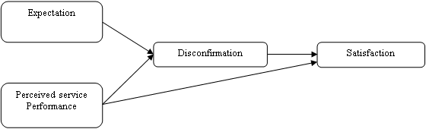
Figure 2.1: Expectation Disconfirmation Model
Source: Oliver (1980)

The model in Figure 2.1 shows the indirect relationship between perceived service performance and satisfaction through disconfirmation and the indirect relationship between expectation and satisfaction through disconfirmation. Furthermore, the model shows a direct relationship between perceived service performance and satisfaction and the statistical significance that has to be tested. Schiebbler (2018) criticized the EDT because empirical evidence about EDT is missing. According to Schiebbler (2018), the core question of EDT is how expectation and disconfirmation affect consumer satisfaction. There is an unavailability of a comprehensive theory of expectation effects on satisfaction, and multiple sub-theories make competing predictions (op-cit). Likewise, Werker (2010) criticized that customers may be dissatisfied with unexpected extraordinary services due to indebtedness, contrary to EDT.

Apart from werkers (2010) and Schiebbler‘s (2018) criticism, the theory was still relevant to this study because it contains determinants used in this study. Regardless of its relevance to this study, the theory was not popular for the airport service performance (airport departure domains, airport arrival domains, airport departure non-processing domains, and airport arrival non-processing domains) studies and its link with international tourists satisfaction. However, Cheng (2019) integrated Herzberg’s two-factor theory and EDT, assuming that the factors must first be processed through customer disconfirmation before they can fully interpret satisfaction. Anton et al. (2021) recommended integrating EDT and passenger satisfaction because airport service performance currently focuses on passenger satisfaction to compete effectively in the tourism and aviation industry.
The present study used only two constructs (perceived service performance and satisfaction) from the theory based on the study objective to assess the relationship between airport service performance and international tourists' satisfaction. However, the theory only describes the constructs while missing the indicators to assess visitor satisfaction. Therefore, this study adopted indicators from PCAM developed by Wiredja et al. (2019) in the perceived service performance construct in theory to assess tourist satisfaction for the attained airport service performance. Likewise, perceived service performance was fragmented into four constructs (arrival processing domain, arrival non-processing domain, departure processing domain, and departure non-processing domain) to have a clear picture of airport service performance based on processing domains (the restricted areas) and non-processing domains (the unrestricted areas).

Passenger-Centered Airport Model
Wiredje et al. (2019) developed the PCAM after a prosperous comparative analysis of more than 40 existing passenger-driven airport models, which vary in service performance measurement based on passenger airport perception. The models brought confusion. Thus, Wiredja et al. (2019) resolved it by identifying passenger-centered indicators in measuring overall airport service performance. The newly developed model categorizes airport passenger activities into two major domains: airport processing domains and airport non-processing domains, both involving arrival, transit, and departure.

The processing domains (departure, transit, and arrival) contain check-in, security screening, immigration airport facilities, airport access, retail areas and customs, Boarding, transit security screening, baggage transfer, arrival immigration, baggage claim, customs, and quarantine. Likewise, the non-processing domain (departure, transit, and arrival) includes; airport access, airport facilities, and retail area. Each airport domain has several indicators used to measure customer experience, as shown in Wiredja et al. (2019) and the reference therein. Before Wiredja et al. (2019), passenger experience at the airport domains was studied extensively by different authors, including Popovic et al. (2009), Park et al. (2011), Popovic et al. (2010), and Wiredja (2015, 2017). Fukaya (2012) and Tse et al. (2011) studied passengers' time and facilities inside the airport terminal. More materials about customer satisfaction at the airport, like time spent by tourists, have been thoroughly studied by Bogicevic et al. (2013) and Correia et al. (2008).

The PCAM by Wiredje et al. (2019) assessed airport service performance based on a set of listed indicators in each domain. Implementing this model can help airport management identify service gaps in a specific domain. The model provides a broader view of assessing airport customer experience to improve passenger satisfaction at the airport terminal (Popovic et al., 2012). Airport customer satisfaction leads to tourists' loyalty, profits increment, travel frequency, and comfort in staying at the desired destination (Alotaibi, 2015; Baranskaite, 2019).

The PCAM was relevant in this study because it contains major determinants in processing and non-processing domains (Figure 2.2) linked with objectives one, two, three, and four. Regardless of the relevant model in this study, it missed arrival security screening and other important indicators, which this study added and assessed its relationship with international tourists’ satisfaction. Furthermore, the model is airport centred and measures the experience for all passengers passing through the terminal, not tourists only. Therefore, this study assessed the relationship between airport service performance and international tourists’ satisfaction in Tanzania's tourism sector. The study dealt with arrival and departure domains only while excluding transit tourists. The indicators were treated as perceived service performance for measuring tourists' satisfaction at the airport terminal. Table 2.1 shows the list of indicators in each domain as per the PCAM.
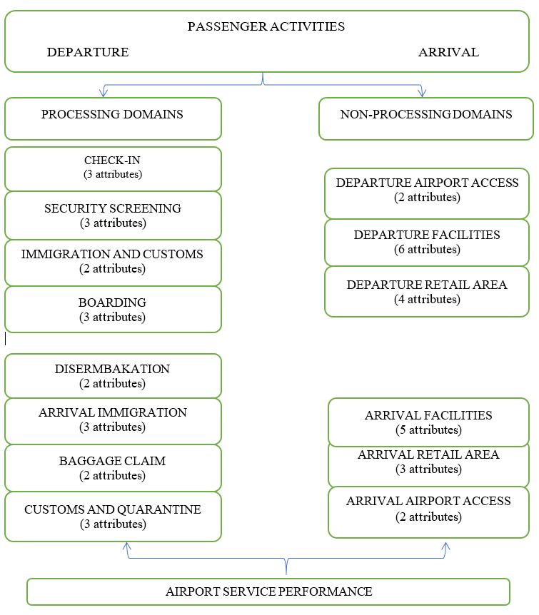
Figure 2.2: Passenger-Centred Airport Model
Source: Wiredje et al. (2019)
Table 2.1: Indicators in each domain as indicated in PCAM
Arrival Processing Domain | Check-in | - Perception of waiting time or queue length  - Staff courtesy or helpfulness  - Check-in efficiency
Arrival Processing Domain | Security screening | - Staff courtesy  - Secure feeling/thoroughness  - Perception of waiting time or queue length
Arrival Processing Domain | Arrival Immigration and customs | - Perception of waiting time  - Staff courtesy
Arrival Processing Domain | Boarding | - The efficiency of the boarding procedure  - Staff courtesy  - Availability of aerobridge
Departure Processing domains | Disembarkation | - Availability of aerobridge  - The ease of way out of finding
Departure Processing domains | Arrival immigration | - Perception of waiting time on immigration  - Staff courtesy  - Perception of waiting time on visa on arrival
Departure Processing domains | Baggage claim | - Perception of baggage delivery time  - Secured baggage delivery
Departure Processing domains | Customs and quarantine | - Perception of waiting time or queue length  - Staff courtesy  - Clear information on the customs declaration
Arrival Non-Processing domains and  Departure Non-Processing Domains | Airport Access (Arrival and Departure) | - Options for ground transportation  - Perception of parking facilities or queue length for regular taxi
 | Airport Facilities (Arrival and Departure) | - Availability of ATM or money changer  - The sanitary condition of restrooms  - The comfort of the waiting area/lounge  - Availability of information desks  - Availability of baggage trolleys  - Availability of Internet or Wi-Fi  - Ease of connection among airport terminals  - Availability of shower/hotel at airside area
 | Retail Area (Arrival and Departure) | - Variety of shops  - Value for money of shops and cafe  - Variety of foods and beverages
Source: Wiredje et al. (2019)

The Link between EDT and PCAM
This study used EDT by Oliver (1980) with the determinants explained in Section 2.3.1 and the PCAM with the number of indicators as described in the respective domain in Section 2.3.2 The link between the two is shown in Table 2.2. Airport service performance indicators for measuring tourist satisfaction have been treated as tourists’ perceived services after arrival in Tanzania as a final destination. Additionally, the indicators from each domain are shown as perceived airport service indicators based on the EDT.

Table 2.2: The link between EDT and PCAM
Independent variable |  | Dependent Variable
EDT | Passenger Centred Airport Model | EDT
Perceived Services Performance | - Service indicators at the airport arrival processing domains | International Tourists Satisfaction
Perceived Services Performance | - Service indicators at the airport departure processing domains | International Tourists Satisfaction
Perceived Services Performance | - Service indicators at the airport arrival non-processing domains | International Tourists Satisfaction
Perceived Services Performance | - Service indicators at the airport departure non-processing domains | International Tourists Satisfaction
Source: Researchers (2022)

Empirical Literature Review
Studies regarding airport service performance and international tourists’ satisfaction have been a critical point of discussion in both tourism and aviation industries due to the ongoing global tourism competition. However, the link between the two variables is recommended for further discussion by researchers. Therefore, this section presents research related to the objectives of this study which tried to address the relationship in a nutshell.

The direct relationship between Arrival Processing Domain and Tourists’ Satisfaction
Yavuz et al. (2021) researched tourist satisfaction with 100 American continent airports. The study was based on determining the main factors affecting the general satisfaction of passengers at the airport terminal in America. The study used the following factors affecting satisfaction; queuing times, terminal cleanliness, terminal seating, and overall satisfaction. The findings revealed that waiting time, airport cleanliness, and seating capacity are the factors affecting general satisfaction at the airport terminal. Yavuz et al. (2021) reported queuing times in all chains are the major factor affecting passengers' satisfaction at airport terminals on all three continents. However, the study did not assess the sole domain in processing and non-processing domains at the airport terminal. Thus further reaction was increasing airport passengers' satisfaction by having a strategic plan to improve airport services by assessing service performance for both processing and non-processing domains (Yavuz et al., 2021). The current study explained all the factors by showing processing and non-processing domains and their relationship with international tourists' satisfaction for effectively improving airport service performance.

Another study that identifies factors affecting tourist satisfaction at the airport terminal includes Moon et al. (2017), who concluded that the airport's physical environment, facilities, cleanliness, and seating comfort are among the key determinants of customer satisfaction at the airport processing terminal. Munoz et al. (2019) studied modeling air travelers’ experience based on service quality stages related to airlines and airports in Colombia using SEM. The study measured travelers' perceptions of airport service quality performance by considering that passengers' airport experience is attained after getting a chain of airport and airline services. The study further proposed a new scale named air travel service quality for assessing travel experience in air travel considering three service quality stages called arrival airport services (cleanliness of the toilet, number of shops, availability of different transportation modes at the airport exit, size of the arrival airport, effective air-conditioned areas for smokers, good signage, availability of trolley, reliability of the security control system, appealing of employees uniform, the comfort of the baggage claim area, availability of a wide newspaper selection, cleanliness of the arrival airport, modern looking of the arrival airport, quality of air conditioning).

Munoz et al. (2019) measured both airport and airline satisfaction which could not give genuine satisfaction results for the airport terminal. The findings showed that traveler experience toward airport arrival service indicators plays a crucial role in determining travelers' satisfaction; thus, the relationship between airport service performance, customer satisfaction, and behavioral intention is very significant. The findings revealed that all three stages of air travel service performance (departure airport, airline, and arrival airport service) have significant and positive effects on passenger satisfaction. The study suggested that the arrival airport performance has been ignored regardless of relevant aspects of tourists' satisfaction. Thus, it should be highly considered in satisfaction assessment. The study by Munoz et al. (2019) looked at a general airport arrival and departure services performance without separating the processing (arrival and departure restricted domains) and non-processing (arrival and departure un-restricted domains) to confirm if they separately have a significant and positive effect on passenger satisfaction. Therefore, the result provided chances for further analysis regarding the relationship.

Mwesiumo and Halpern (2021) researched airport service quality and passenger satisfaction: the impact of service failure on the likelihood of promoting an airport online in Norway. The study aimed to establish the structural relationship between variables of interest named overall satisfaction, airport recommendation for reuse, and eight airport service factors (terminal cleanliness, queueing times, terminal seating, terminal signs and directions, food and beverages, airport shopping, airport Wi-Fi services, and airport staff). The study showed that failure caused by airport staff and queuing times being among the factors in the arrival processing domain are among the key factors in reducing passengers' satisfaction and becoming promoters of an airport due to dissatisfaction. Likewise, a researcher reported that failure of any service attributes in any domain significantly reduces the probability of a passenger being an ambassador of a destination. Therefore, all sections of the airport arrival processing domain which a tourist interacts with are likely to suffer when services at one domain fail to meet tourists' expectations. The study advocated that service attributes at the airport terminal might have different satisfaction impacts on passengers to make them repeat visitors. Thus, Mwesiumo and Halpern (2021) recommended performing airport terminal bundle service investigation on a certain airport point/domains such as bag drop, dwell time, security screening, passport control, baggage reclaim, immigration, and customs that are more valued/significant and influence tourist satisfaction. This was an open gate to research to assess the causal effect power of airport domains toward satisfaction resulting in the most and least valued points at the airport terminals.

Kumar and Meen (2022) on air travellers' satisfaction and airport service quality in India analyzed the attributes of airport service quality (security inspection, check-in, airport environment, airport facility, and airport services) influencing travellers' satisfaction at the airport terminal. The study further categorized service quality indicators influencing tourist satisfaction at the airport terminal. Structural Equation Modelling (SEM) was used for data analysis. The study discovered a significant positive relationship between the quality of airport service indicators and passenger satisfaction. However, Kumar and Meen (2022) just examined the four factors (check-in service, security inspection, airport facility, and finding the way out) and their relation to tourists' satisfaction without looking at the link. Thus the researcher emphasized more research effort on the relationship between service quality and tourist satisfaction. The study invited satisfaction studies on other airport service attributes not included in this study and assessed their influence on satisfaction. Kumar and Meen (2022) recommended more empirical investigation and precision on airport service performance and tourist satisfaction as a hot topic of discussion today is required for the decision-making process because of tourists' sensitivity toward airport service performance to overpass their expectations.

Kratudnak et al. (2018) analyzed key factors of airport service quality using exploratory factor analysis and the Analytic Hierarchy Process in Thailand. The authors analyzed factors using security and mobility at the airport to raise tourist satisfaction indicators. The analyzed factors and variables by Kratudnak et al. (2018) that influence tourists' satisfaction includes; the check-in process efficiency, courtesy, and helpfulness of check-in, wait time at check-in), security screening (thoroughness of security screening, the feeling of beginning safe and secure, wait time and at the security checkpoint, courtesy and helpfulness of security staff), convenience (courtesy and helpfulness of airport staff, availability and quality of stores, availability of bank/ATM/Exchange, availability of quality of food facilities), facilities of the airport (cleanliness of washroom/toilets, enough available seats in waiting area), mobility (walking distance in airport, clarity of airport and flight information display). The study showed that the factors influence tourists' satisfaction, with convenience being the most important. The study recommended further research should involve SEM and Smart Partial Least Square (PLS) in detecting the significance of each factor for tourist satisfaction.

Riyas and Anand (2020) investigated airport service quality and passenger-perceived service quality and assessed the structural relationship between service attributes and satisfaction on the performance of airports in India. The study focused on understanding airport service performance based on the tourists' perceived performance indicators for both processing (restricted) and non-processing (unrestricted) functioning areas. About the arrival processing domain, Riyas and Anand (2020) suggested the following airport service domains be focused on during satisfaction measurement at the airport terminal: arrival immigration (waiting time Visa and staff courtesy), baggage claim (time for baggage delivery and secured baggage), customs and quarantine (waiting time, staff courtesy and proper custom declaration information). The researchers recommended the addition of new aspects of airport service performance in the arrival processing domain based on the fact that airport commercial activities are taking a fast move in the tourism industry. Multilevel regression analysis was suggested for future studies justifying the general satisfaction level of the airport arrival processing domain. However, the study did not assess the relationship between airport arrival service attributes and customer satisfaction. The present study performed further analysis using Smart-PLS to assess the relationship between airport-arrival processing domains and tourist satisfaction. Furthermore, the present study added other airport service attributes from their literature which will statistically and significantly be tested.

Yilmaz et al. (2017) determined the satisfaction levels of tourists with security services at airports in Turkey. The main purpose was to investigate the airport terminal security practices' effect on passenger satisfaction. The findings showed the availability of a meaningful relationship between airport security services and the level of satisfaction at the airport terminal. The study recommended that the influence of security service on tourists' satisfaction is attributed to security personnel characteristics like acting clearly and professionally, having good communication skills, speaking multiple foreign languages, and using sign language. Likewise, the recommended immigration personnel be sensitive during passport checks and quickly finish all the passport procedures to increase tourists' satisfaction. However, the study touched only one domain named security services at the airport arrival processing domain, which is seen to be very significant for increasing tourist satisfaction. Yilmaz et al. (2017) further suggested other studies in the future to determine factors affecting tourists' satisfaction at the airport terminal for both processing and non-processing (arrival, transit, and departure), aiming at improving service performance to cope with tourists changing behaviour for their satisfaction.

Bakir et al. (2022) researched how to achieve passenger satisfaction in the airport using regression analysis and a necessary condition analysis approach through online airport reviews in Switzerland. The major purpose was to examine the relationship between airport service factors and passenger satisfaction. About eight factors (queuing times, terminal cleanliness, terminal seating, terminal signs, food and beverages, airport shopping, Wi-Fi connectivity, and airport staff) were employed to examine the net effect on passenger satisfaction. The study discovered airport staff as the most influencing factor toward passenger satisfaction. Generally, it was noticed that six factors (queuing times, terminal cleanliness, terminal seating, terminal signs, food and beverages, and airport staff) out of eight are necessary to achieve passenger satisfaction at the airport. Other factors like airport shopping, Wi-Fi-connectivity were observed to have no significant effect on passenger satisfaction. Bakir et al. (2022) recommended that future studies assess airport service quality and passenger satisfaction using multi-criteria decision-making and machine learning tools. Moreover, the study recommended future studies to clarify in detail regarding cleaning components for passenger satisfaction using primary data like cleaning cover seats, washroom cleanliness, and public area cleanliness.

Studies by Yavuz et al. (2021), Moon et al. (2017), Munoz et al. (2019), Mwesiumo and Halpern (2021), Kumar and Meen (2022), Kratudnak et al. (2018), Bakir et al., (2022), and Yilmaz et al. (2017), correlate to this study because they dealt with airport service attributes from different domains including airport arrival processing domain attributes like security screening, immigration, baggage claim/drop and customs and their impact toward tourists satisfaction and the airport reuse. However, limited studies separated airport arrival service performance into disembarkation, immigration, baggage drop, security screening, customs, and quarantine during their study. The current study assessed the relationship based on those domains for effective airport service performance to each specific domain independently. Since the literature shows a direct relationship between airport service performance attributes specifically the arrival processing domain with tourist satisfaction, the hypothesis was formulated accordingly.
H₁ Services at the airport arrival processing domains directly correlate with international tourists’ satisfaction.

The Relationship Between Departure Processing Domain and Tourists Satisfaction
Chi et al. (2022) conducted a qualitative study on passengers' perceptions of airport service quality at Honolulu International Airport in Switzerland. The main purpose was to identify the key drivers of satisfaction and dissatisfaction with the provided airport services performance indicators. The study was based on several domain indicators: queuing time, terminal cleanliness, terminal seating, terminal signs, food and beverages, airport shopping, Wi-Fi, and airport staff in measuring the passengers' level of satisfaction. The findings show that terminal cleanliness and terminal seating have the highest rate of impact on passengers' satisfaction. Likewise, the study reported that further improvements should be made to airport signs, staff, queuing times, and wifi due to the low satisfaction rate. Chi et al. (2022) further confirmed that airport terminal environment and cleanliness significantly affect passenger satisfaction. Some words dissatisfied passengers use include; security, check, flight, line, and staff, while the most common words satisfied passengers use are staff, terminal, cleanliness, time, immigration, and free. The words implied customers' perspectives on airport managers to improve airport service performance and renovate airport facilities to meet customer expectations. The study recommended other studies to identify more aspects of customer preferences and expectations at the airport terminal. They almost change daily and then test their link/influence toward tourist satisfaction. This study's airport service performance indicators involve factors for the departure processing domain, such as queuing time, terminal cleanliness, terminal seating, terminal signs, Wi-Fi, and airport staff.

Aydoğan (2021) researched the non-nigeric measurement structure of airport service quality using a systematic literature review in Thailand. The attributes used by the study to define service quality encompassed servicescape, services, facilities, information, security, check-in access, comfort, convenience, ticketing, and functionality. The study exposed that services, facilities, information, servicescape, security, and check-in access are the most significant. They explored dimensions of passenger satisfaction while convenience, ticketing, functionality, comfort, and access were less significant and less explored. The study observed the significance of measuring airport service performance with multi-dimensional structures and not using one-dimensional structures. This is because of the diverse airport services provided at the airport terminal, as the indicators contributing to passenger satisfaction involve the difference in time, space, technological development, and culture. Aydoğan (2021) explained that the airport appears noticeable due to the passenger process, thus making it a critical business area, especially during departure and arrival. This study's exported dimensions were very important in assessing airport departure processing and tourist satisfaction. The sections mentioned impact tourists' satisfaction due to the services offered. However, the study ignored some domains and attributes and did not focus on the construct relationships. This study will cover the relationship and finally assess its significance.

Adetayo et al. (2020) studied factors analysis on passenger satisfaction at Murtala Muhammed Airport (MMA2) in Nigeria using non-probability sampling and factor analysis. Skytrax indicators were adopted by this study aiming at listing out airport service performance indicators integrated into the questionnaire for required data collection from the stated sample at the airport terminal. The involved departure processing airport terminal factors included: staff attitude and courteous at immigration and security staff, airport staff friendliness, language skills for the airport staff, baggage efficiency, loss luggage service prevention, baggage delivery time, efficiency for baggage delivery priority, ease of transit, waiting time at immigration and security screening, security and safety standard, queuing facilities and check-in. The findings disposed of the most influential factors in passengers' satisfaction being baggage delivery time, the efficiency of baggage delivery priority, the attitude of immigration staff, and waiting time at security screening of with attitude of immigration staff and waiting time at security screening are also quality indicators in the departure processing domain. The study recommended that airport managers put more effort toward those factors as the most crucial factor affecting passengers' satisfaction. However, the study did not group factors into processing (arrival, departure, and transit) and non-processing domains (arrival, departure, and transit) and independently assessed its relationship with international tourists' satisfaction.

Antwi et al. (2020) enquired whether the nature of airport terminal service activities matters using processing and non-processing service quality, passenger effective image, and satisfaction in China. The used processing service performance indicators include check-in waiting time, helpfulness and courteous of check-in staff, efficiency and ease of the check-in process, helpful and courteous security staff, security after a thorough screening, courteous and helpfulness of immigration and customs staff, easy and efficiency of boarding procedures, helpfulness and courteous of boarding staff, queuing or waiting time for security and immigration. The airport indicator passenger experience model used in the study revealed the presence of a direct relationship between processing/non-processing domains with passenger satisfaction, as well as processing domain and passenger effective image. The main focus of the study was based on the departure processing stages of passenger travel without including transit and arrival stages. Likewise, the focused stages missed other important indicators influencing tourists' satisfaction. Therefore, Antwi et al. (2020) recommended future studies to assess the transit and arrival stages services and their impact on passenger attitudinal and behaviour intention.
Nwaogbe et al. (2021) investigated service quality and passenger satisfaction in air transportation for developing economies with a focus on Nigeria. The study used the service quality model to measure five dimensions of service quality. The main aim was to check and assess the service level by comparing the travelling passengers’ perceived and expected service. The results concealed the score for the perceived service quality being less than tourists' expectations in Nigerian airport service operations. The implication is that passengers expected more service quality from the airport terminal because their satisfaction level was below the cutoff point. Thus, service improvement at the airport and reducing many queues at the baggage collection area were recommended to enhance passengers' frequent use of the airport. The study suggested that for the airport to attain the best standard to attract more passengers, the service quality factors impacting tourists' satisfaction should be addressed very well to satisfy passengers. Airport management was advised to manage customer relations and satisfaction to yield good market competition in the tourism and aviation industry.

Pivac et al. (2022) studied the overview of the influence of the level of service on the airport passenger terminal capacity in Croatia. The study used a mixed method in which the review of relevant literature about the passenger terminal capacity study was done. Regarding infrastructure and operational capacity, the passenger terminal design needs upgrading to improve airport terminal services for passengers' satisfaction. Pivac et al. (2022) recommended improving airport terminal infrastructure and facilities by conducting further studies regarding passenger satisfaction and airport service performance.
Riyas and Anand (2020) studied airport service quality and passenger-perceived service quality and assessed the structural relationship between service attributes and satisfaction on the performance of airports. The study focused on better understanding airport service performance based on the tourists' perceived performance indicators for both restricted (processing) and unrestricted (non-processing) functioning areas. The study was based on various airport service domains, one of them being departure processing terminals with the following domains check-in (Staff courtesy, waiting and queuing time, check-in speed), security screening (staff courtesy, waiting for and queuing time, secure feeling) immigration and customs (perception of waiting time and staff courtesy) and boarding (availability of aerobridge, staff helpfulness, and efficiency). The researchers recommended finding more new aspects of airport departure service performance as the airport is a key tourist satisfying point in today’s tourism business and is taking a fast move in the tourism and aviation industry. To obtain good results, multilevel regression analysis was recommended for future studies to define the inclusive satisfaction level of airport departure processing domains on the set of airport service attributes. Further relationship between airport service attributes and customer satisfaction was disregarded. This study performed further analysis using Smart-PLS looking at the relationship between airport departure processing domains and international tourists' satisfaction. Furthermore, the study added other airport service attributes from the literature, which will statistically be tested.

Jasrotia, Kour, and Gupta (2020) researched understanding the impact of airport service quality on passengers’ revisit intention amidst the COVID-19 pandemic in India and further its association with destination selection or choice using SEM. The used airport service indicators included layout accessibility (location and cleanliness of baggage trolley, airport signs, airport layout to cater for passengers with special needs, avoiding overcrowding and physical contacts for easy movement, mostly in waiting areas), check-in (waiting time, efficiency of check-in procedures, helpfulness of check-in procedures, appropriateness of self-check-in kiosk), security (waiting time, safe and secure during security screening, security screening was as per given guidelines for COVID-19, courteous and helpful of security staff), ambiance (facilities were well maintained and cleaned appropriately, the authority assured safe distance, guidelines for COVID-19) and facilities (seating and waiting arrangement, cleanliness of washrooms/toilets, seating and waiting arrangement and lear information provided by electronic flight display). The study showed that the quality of airport service performance attributes is significant in describing tourists' satisfaction. Jasrotia, Kour, and Gupta (2020) further reported that if the quality of airport services meets tourists' expectations, it ultimately generates satisfaction, thus affecting tourists' revisit and service reuse at the airport terminal. The examined airport service quality dimensions realized that check-in procedures, one of the departure processing domains, positively affect tourists' satisfaction. Likewise, a significant relationship has been observed between airport service performance and willingness to spend at the airport terminal and revisit the airport and the destination. A researcher recommended the consideration of other numerous airport factors that are well considered by passengers at the airport terminal to meet or exceed their expectations.
Munoz et al. (2019) research on modelling air travellers’ experience based on service quality stages related to airlines and airports in Colombia using SEM revealed that airport departure service, specifically check-in, security, and other services, positively affected tourists' satisfaction. The study proposed three airport services stages involving departure airport services, including cleanliness of the airport toilets, number of shops, parking space availability in the departure airport, size of the departure airport, effective air-conditioned areas for smokers, excellent signage, availability of trolley, employees uniform are visually appealing, the comfort of waiting hall, availability of wide newspaper selection, departure airport cleanliness, modern looking, quality of air conditioning. Other airport domains and service attributes were ignored, and this study needs to cover their link with tourist satisfaction. Additionally, Ma and Ma (2022) studied the impact of airport facility service quality on brand experience and passenger satisfaction: considering the mediating role of brand engagement using SEM. The study used empirical research to explore the impact of facility service quality for processing and non-processing facilities on passenger satisfaction. The findings discovered that airport service quality significantly affects passengers' satisfaction, specifically processing facilities.

Fakfare and Graham (2021) explored the multi-quality attributes of airports and the asymmetric effect on air traveller satisfaction at Thai International Airports using a cross-sectional survey in Thailand. The study used several airport service performance indicators encompassing of airport signage and layout (airport signage, suitability of signage size, finding way out, adequacy of signage quantity, airport physical layout enables easy movement of passengers, design of airport layout to cater for special needs passengers), terminal environment (airport lighting, suitability of airport temperature, adequacy of announcement level, pleasant and desirable of airport aroma, maintaining clean facilities at the airport), flight information screen (wide availability of information screen, clear visibility of flight information screens, frequent updation of information on the screen, appropriateness of information screen location), check-in (courteous and helpfulness of check-in staff, clear comunication and message appropriateness by check-in staff, efficiency of check-in staff, availability of passengers luggage carts, waiting time and well design of check-in kiosk and easy to use), security (filling safe and secure, friendliness, courteous and helpfuness of staff, clear staff communication and appropriate message delivery, thorough screening for passengers and personal belongings, waiting time is appropriate), passenger facilities (cleanliness of washrooms/toilets, widely availability of washrooms/toilets, availability of Wi-Fi, variety of products offered by restaurants, availability of bank/ATM/exchange and availability of retail store), immigration (waiting time in the outbound immigration area, waiting time in the inbound immigration area, waiting time in the inbound baggage belt area), departure hall (uncrowded of departure hall, aerobridge is available and in good condition, comfortable and space seating at waiting gate, provision on enough seating in the gate area, enough bed seating for transfer passengers), baggage service (the quality of baggage processing facilities, the circulation space for inbound baggage reclaim is spacious and easy to find the baggage trolley), leisure and entertainment (the appealing of the airport interior decoration, updation of interior and exterior decorations, pleasurable of airport operations use and fascination of the event and exhibitions provided by the airport). The findings showed that all the multiple indicators have a dynamic impact on tourist satisfaction, of which three domains, namely flight information screens, passenger facilities, and immigration, indicate asymmetric effects. In contrast, airport signage and layout, terminal environment, check-in, security, departure hall, baggage service, leisure, and entertainment show asymmetric and symmetric behaviour toward passengers satisfaction. Fakfare and Graham (2021) recommended appropriate observations and improvement of all the indicators which affect tourist satisfaction to meet tourists' expectations to uplift tourism performance. All attributes, especially those linked to restricted (processing domains) sections that tourists must pass through during departure time, must be managed properly to avoid dissatisfaction. Equally, the study recommended that unrestricted attributes be equally treated regardless of being significant or non-significant to capture the psychological minds of tourists to increase satisfaction.

Hajez and Fawzy (2021) analyzed passenger satisfaction at Saudi International Airports in Saudi Arabia to examine the relationship between passenger satisfaction and service quality. Convenience sampling and an electronic questionnaire were used to examine the topest service quality factors at the airport terminal. The service indicators used by the study based on the departure processing domain include check-in staff efficiency, queueing time at check-in, baggage integrity, staff friendliness at check-in, immigration, queuing time, and feeling protected and secure. The findings showed that the friendliness of the airport staff and waiting time in a queue positively affect tourists' satisfaction. The study suggested future research to include more other remaining attributes and assess their relationship with passengers' satisfaction through evaluating both expectation and perception of service performance at the airport terminal.

The studies by Chi et al. (2022), Aydoğan (2021), Adetayo, et al. (2020), Antwi et al. (2020), Nwaogbe et al. (2021), Pivac et al. (2022), Riyas and Anand (2020). Fakfare and Graham (2021), Munoz et al. (2019), Jasrotia, Kour, and Gupta (2020), and Fakfare and Graham (2021) relating to this study because it dealt with services attributes at the airport departure processing domains and its effect toward satisfaction, promotion and the destination in general. Regardless of its relevance, the study did not clearly show the airport departure processing domain, sub-domains, and its relationships with international tourists' satisfaction. Focusing on the literature, the following hypothesis was formulated.
H₂: Services at the airport departure processing domains directly correlate with international tourists’ satisfaction.

The Relationship Between Arrival Non-Processing Domain and Tourists Satisfaction
Sumanasiri and Dambagola (2020) used five-points Likert scale questionnaire based on the SERVIQUAL model to assess passenger satisfaction with the quality of service offered at Bandaranaike International Airport (BIA) in Sri Lanka. The study used five dimensions of the SERVQUAL model encompassing; reliability (workers' commitments and trustworthiness, correct and continuous service deliverance) which are the most significant factors to affect tourists' satisfaction, responsiveness (desire to assist passengers, timely and good customer service provision, problem-solving to confront customers and problem handling), assurance (staff understanding, trust and loyalty toward customers, safe and reliable service, staff competence, courtesy, legitimacy, and safety), empath (staff approach, staff interaction and staff ability to understand), normally, faithful tourists value empathy and honest because they base on establishing a feeling of interactive fairness, tangible (airport physical installation, machinery, staff ability, airport physical environment dimension) has an essential effect on the client attitude and overall satisfaction. All five SERVQUAL dimensions were hypothesized to affect customer satisfaction positively. Most of the listed items in the dimensions are indicators used to assess tourist satisfaction with airport service performance in this study. The study findings showed that tangibility, assurance, and empathy factors showed a positive and significant relationship with passenger satisfaction. The remaining two dimensions, reliability and responsiveness, showed a positive and insignificant relationship with passenger satisfaction. The study recommends improving tangible services to ensure a better competitive advantage at the airport terminal. Likewise, Sumanasiri and Dambagola (2020) recommended that the next study use other best models to measure service performance and its link with passenger satisfaction. With that fact, the current study opted to use passenger centred airport model with its domains and indicators to assess airport service performance and its relationship with international tourists' satisfaction.

Hajez and Fawzy (2021) in Saudi Arabia used descriptive analysis to analyze passenger satisfaction at Saudi International airports to examine the relationship between passenger satisfaction and airport service quality. Convenience sampling and a questionnaire examined the topest airport service quality factors. The study used airport service indicators basing on the arrival non-processing domain as follows; ease of finding the way out, flight information panel, walking distance to the passenger terminal, snack bars/restaurant quantity and quality, baggage intergrity, speed of baggage claim, quality and quantity of commercial establishment, overall airport cleanliness, availability of luggage trolleys, queue and staff friendliness, toilet availability and cleanliness, information on baggage claim conveyors, easy connections, value for money for the restaurant and commercial product, immigration and customs, queuing time, quality of internet/Wi-Fi, presence of ATM/banks/exchange offices, parking facilities, feeling protected and secured, public transport, airport termal and acoustic comfort, shopping availability, overall passenger satisfaction, tax availability and parking cost, standard of smoking lounge, services for disability passengers, childrens play areas and availability of prayer rooms. The findings showed that the friendliness of the airport staff, ease of finding the way out, walking distance to the airport terminal, and quality of snack bars and restaurants positively affect passengers’ satisfaction.

Furthermore, the findings showed no relationship between the speed of baggage claim factor and customer satisfaction. The study recommended future research to assess other remaining airport attributes to check their relationship with passengers' satisfaction by evaluating expectations and perceptions of airport service performance. Regardless of its relevance, the study did not solely assess processing and non-processing domains and their link with international tourists' satisfaction.
Chinonso and Ejem (2020) assessed airport service quality in Nigeria using a survey design questionnaire approach and SERVQUAL model. The survey aimed to obtain ratings of the airport service performance from the passengers who are the main consumers of the airport services. The study findings showed that the airport service performance is below standard and can not meet the service expectation of the travelling passengers. This indicated that the airports' and customers' service quality expectations were not adequately met. The study suggested a holistic approach to studying airport service performance toward passenger satisfaction since passengers are the main consumers of airport services. However, the study used the SERVQUAL model, contrary to this study, and did not focus on assessing processing and non-processing domains exclusively and their liaison with tourists’ satisfaction.
Mwesiumo and Halpern (2021) studied the airport service quality and passenger satisfaction in promoting an airport online in Norway and exposed that failure associated with arrival non-processing domain, including airport shopping and physical ambiance are least likely to reduce the probability of passengers’ satisfaction and becoming promoter of an airport. Moreover, all parts of the airport arrival non-processing chain will likely suffer when service attributes fail to meet tourists' satisfaction. Adeniran et al. (2018), on the relationship between passengers’ satisfaction and service quality in Murtala Muhamed International Airport (MMIA) in Lagos-Nigeria, showed a strong relationship between passengers’ satisfaction and airport service quality. The study integrated dimensions of the SERVQUAL model with airport service indicators to measure passenger satisfaction. The findings showed that public transport had a very weak correlation with passengers’ satisfaction implying low efficiency in satisfying passengers. Furthermore, the study revealed the availability of the relationship between passenger satisfaction and service quality, signifying that service performance influences passenger satisfaction.
Tinashe (2020) studied the impact of airport experience on international tourists' revisit intention in South Africa. The study was quantitative with a survey research design, and SEM was adopted for data analysis. The study exposed that conative destination image showing what potential tourists know about the destination was the most influential factor in causing travellers’ satisfaction and intention to revisit the destination. It was further recommended that good treatment at the airport terminal is more important as it helps add value to the tourists, hence creating a positive mind regarding the destination.

Riyas and Anand (2020) investigated airport service quality and passenger-perceived service quality and assessed the structural relationship between service attributes and satisfaction on the performance of airports in India. The study focused on better understanding airport service performance based on the tourists' perceived performance indicators for both restricted (processing) and unrestricted (non-processing) functioning areas. The study indicated various airport service domains required for effective customer service measurement at the airport. The domains include arrival non-processing functions with the following domains; airport facilities (facilities for exchange money, sanitary conditions, help desk, and waiting area, trolley availability, Wi-Fi and internet facilities), airport access (ground transport, taxi queuing time and parking facilities), retail areas (sufficient shops, value for money product, food, and beverage diversity, shopping facility). The researchers recommended the addition of other new aspects at the airport arrival non-processing domain service, referring that the airport is a core point and is taking a fast move in the tourism and aviation industry. A further suggestion for the next research was to focus on multilevel regression analysis to explain the overall satisfaction level of airport arrival non-processing domains on the customary service attributes. However, the study ignored the link between airport service attributes and customer satisfaction. The present study performed further analysis using Smart-PLS to assess the relationship between airport departure processing domains and international tourists' satisfaction.

Nadim et al. (2024) studied how to outperform airport quality of service in Iran using qualitative and quantitative data extracted from airport passengers using the grounded theory (GT) and SEM. The study inteviewed several unsatisfied passengers to understand what was missing and needed to be improved. The findings revealed that services in different airport elements affected the level of travelers’ satisfaction. The study further pointed out that providing more airport facilities for passengers with disabilities or diseases, facilities for parking and wrapping passengers’ freight, and information services were the highest promoters of the quality of service at airports. However, the study did not focus on the relationship and considered only a few domains and airport service indicators. The study commended that airports are important for aviation development, without improving other airport sections, it is difficult to promote tourists’ satisfaction and influence their loyalty. The study by Nadim et al. (2024) links with this study as the domains used are similar. Thus, this study assessed the relationship between service performance at the airport airport and international tourists' satisfaction.

Madhushanka et al. (2023) the effect of airport efficiency dimensions on international tourists’ satisfaction in Sri Lanka with reference to Bandaranaike International Airport. The study used a quantitative research approach and SPSS with Smart PLS for data analysis. The findings showed that there is a positive relationship between airport basic facilities and international tourists’ satisfaction. The study dwelled on only five constructs: ambiance, basic facilities, baggage handling, check-out, and security while ignoring other available airport domains. The study links with this study because it dealt with the domains used in this study. However, this study will use all processing and non-processing domains and assess its relationship with international tourists’ satisfaction. The studies by Hajez and Fawzy (2021), Chinonso and Ejem (2020), Mwesiumo and Halpern (2021), Sumanasiri and Dambagola (2020), Adeniran et al. (2018) Nadim et al. (2024), Madhushanka et al. (2023) and Tinashe, (2020) related to the current study because it dealt with factors at the airport arrival non-processing domain. Regardless of its relevance, these researchers did not clarify the domains of the airport arrival non-processing domain and their link with tourists' satisfaction in assessing airport service performance. Likely, based on the literature review, the following hypothesis was formulated for the present study.
H₃: Services at the airport arrival non-processing domains directly correlate with international tourists’ satisfaction.

The Relationship Between Departure Non-Processing Domain and Tourists Satisfaction
Putra et al. (2021), in Indonesia, used the importance-performance analysis to analyze Matahora Airport service performance. The factors and variables of service performance used involved arrival and departure processing facitlities (waiting time at check-in, waiting time at security inspection and baggage area, seating capacity in the departure waiting rooms, baggage drop-on or collection time), comfort provision facilities (availability of air circulation, cleanliness of terminal waiting area, seeming informationa and audio facilities, no smell and puddles from the toilets, availability of ample parking space for two wheeled and four wheeled, availability of facilities to help passengers with special needs for both toilest and waiting rooms), facilities providing value added tambah (availability of worship areas with good cleanliness and comfortability, presence of rooms or space for breast feeding, changing clothes and making milk, availability of shopping area, availability of place to eat or drink, availability of smoking area, availability of Wi-Fi, presence of clean dinking water and venting machines for drinks, availability of lounge area).

The findings revealed different service level importance based on the section a tourist is passing through, like arrival and departure process facilities (92.524%), showing that this was the most important section for tourists; thus, it has to be considered seriously for tourists satisfaction, followed by comfort provision facilities (83.266%) and finally value-added facilities (76.012%) with airport departure non-processing domain indicators. For the level of performance indicators, the availability of ample parking space for two and four-wheelers had the highest performance, while Wi-Fi showed the lowest performance. For the level of importance, the cleanliness and comfortable worship facilities had the highest importance, while waiting time had the lowest importance. The study indicated the presence of a relationship between non-processing domain attributes and customer satisfaction because most of the attributes were observed to be very important with the highest performance.

Sidiq (2019) studied factor analysis of passenger satisfaction in Nigerian Airports. The study used random and systematic sampling techniques, a questionnaire for data collection, and a factor analysis statistical method to reduce the data cloud to a little vital amount. The results showed that courteous staff, availability of staff, effective way of finding signs, availability of telecommunications, and restroom cleanliness are the most significant attributes affecting passenger satisfaction. Therefore, the study recommended airport managers to better serve their passengers by improving the attitudes of airport staff and improving technologies to increase their level of satisfaction.

Prentice and Kadan (2019) used SEM to determine the role of airport service quality and destination choice in Australia. The main aim was to examine the relationship between airport service quality, passenger satisfaction, and behavioural intentions, which involves airport reuse and destination revisitation. Airport service variables and the items used are facilities (comfortable and spacious seating around the terminal, availability and serviceability of the aero-bridges, availability of cafes and restaurants with a wide range of products), servicescape (airport signs, well design of the airport layout to cater for pax with special needs, airport crowd-free, and easy movement), security (safe and secure during security screening, thorough security screening, helpful, friendly and courteous of security staff), ambiance (airport maintain clean facilities, comfortability of the airport temperature, acceptable noise level, the airport aroma was fitting, the airport ambiance was satisfying) and check-in (efficiency of the check-in process, courteous, friendliness, and helpfulness of check-in staff, appropriate design of check-in kiosk). The study sample focused on departure passengers with both arrival and departure experiences. The study confirmed that airport facilities, servicescape, security, and ambiance are related to airport reuse and destination revisit. The findings were helpful to the airport management to take initiatives in encouraging passengers to re-use the airport by improving the identified weakness to a respective area at the airport. Additionally, airports can improve by implementing training programs to help personnel attune to passenger needs. Regardless of whether airport service performance is significantly related to passenger satisfaction, results showed only airport facilities and servicescape uniquely affect and contribute to passenger satisfaction. Check-in and security as conventional processing activities were not significant because of being perceived as mandatory fragments in any airport. The study links with this study because it dealt with airport facilities domains.

Seetanah et al. (2018) researched destination satisfaction and re-visit intention of tourists and the quality of airports using the probit model in Mauritius. The study used a survey research design and exploratory factor analysis to extract meaningful dimensions of airport service. The main focus was the relationship between the quality of the airport service performance, tourists' satisfaction at the destinations, and their intention to revisit. The quality attributes used to measure tourists’ satisfaction comprised airport waiting room, baggage claim facilities and delivery, availability and adequacy of baggage trollies, availability and adequacy of check-in facility, customs, and immigration, facilities availability for disabled people, availability of duty-free shops, availability of cafes and restaurants, presence of telephone and internet facilities, adequacy of toilets/restrooms, availability of medical facilities, airport security, enough signage and information center and accessibility of value-added tax reclaim. The findings revealed that quality airport service is vital in promoting tourist satisfaction. Fascinatingly, the findings showed all the listed airport service performance attributes are significant and influence tourist satisfaction and enhance repeat tourism. The study suggested using a mult-time scale using the Likert-scale type with SEM, which is more sophisticated for analyzing multi-items.

Phuyal et al. (2018) applied descriptive and inferential statistics to examine the travellers' satisfaction with the service quality of Tribhuvan International Airport in Nepal. The study used a mixed method for analyzing the collected data. The main focus was to address the importance of service quality performance on the satisfaction of travellers visiting Nepal for different purposes. Five main airport factors were considered to reduce the gap between the airport and passengers by giving clear ground regarding travellers’ expectations and satisfaction levels. The main factors considered in the study were airport service and facilities, airport access, airport dining/restaurant, and airport environment. Furthermore, the other top basic factors passengers expect from the airport include luggage safety, less waiting time, the hospitality of the airport staff, clear visa information, and timely response to luggage misplacement. From the results, most of the travellers were not satisfied with the airport service provided. Hence, the researcher recommended that airport management take serious measures to improve the provided services to influence customer satisfaction.

Adetayo et al. (2020) studied passenger satisfaction at Murtala Muhammed Airport using non-probability sampling and factor analysis in Nigeria. The study involved the following airport departure non-processing factors; availability of luggage trolleys, efficiency and availability of public transport options, availability of taxi and their prices, airline lounge location, location of telephone and fax, screen clarity, flight information and quality of the information provided, airport public announcement and boarding call clarity, airport policy and pricing, cafes, bars, and restaurant choices together with international choices, smoking area standards, free tax, shopping choices, and more other outlets, prices in retail areas, quality of physical impaired facilities, the comfort of the facilities, availability of seating throughout the terminal, terminal signage facilities and boarding gates entertainment facilities, quiet rest areas, play area for the children, Wi-Fi availability, business centre, money changer, cleanliness, washroom, and shower facilities. The findings showed that the availability of public transport options, ease of transit, availability of luggage trolleys, shopping choices, physically impaired standard facilities, seating facilities, entertainment facilities, quiet rest areas, Wi-Fi, business centre, money changer, washroom, and shower facilities was considered to be most significant factors affecting passengers satisfaction at the airport terminal. The study recommended airport management focus on quality service provision to the respective area to increase customer satisfaction levels at the airport terminal.
Hajez and Fawzy (2021) in Saudi Arabia used descriptive analysis to analyze passenger satisfaction at Saudi International airports to examine the relationship between passenger satisfaction and airport service performance. Convenience sampling and an electronic questionnaire examined the top service quality factors. The service indicators used by the study were based on the departure non-processing domain comprising comfortability at the departure lounge, flight information panel, the walking distance at the passenger terminal, quantity and quality of snack bars/restaurants, quality, and quantity of commercial establishments, seat availability at the departure lounge, overall airport cleanliness, staff friendliness, toilet availability and cleanliness, value for money for the restaurant and commercial product, immigration, quality of internet/Wi-Fi, presence of ATM/banks/exchange offices, parking facilities and quality of very important people lounge, feeling protected and secured, public transport, airport terminal and acoustic comfort, shopping availability, tax availability and parking cost, smoking lounge standard, children play areas and availability of prayer rooms. The findings showed that eight airport performance factors; the airport staff's friendliness, the airport terminal's walking distance, and the quality of snack bars and restaurants positively affect tourist satisfaction. The study recommended future research to include other uninvolved airport attributes to check their relationship with tourist satisfaction by evaluating both expectations and perception of service performance at the airport terminal.

Yavuz et al. (2021) investigated tourists' satisfaction with American continent airports in America and revealed that airport cleanliness, seating capacity, and queuing times affected tourists’ satisfaction. Furthermore, airport cleanliness affected overall satisfaction in all three study continents, showing its significance toward international tourists' satisfaction. Bellizzi et al. (2020) researched latent factors in assessing service quality in an Italian peripheral airport. The study adopted a survey research design in which the SEM approach was used for data analysis to define the relationship between the latent variables and between the observed and latent ones. Several service quality factors were employed, including signposting, flight information, accessibility of information, information point and security staff, terminal cleanliness, toilet cleanliness, passenger and baggage control, terminal air conditioning, terminal comfortability, efficiency and availability of airport services, and waiting time at check-in. Results from the analysis showed that clear information, flight information, and sign-posts at the airport terminal increase satisfaction due to easy airport service accessibility and a sense of well-being at the airport terminal. On the other hand, the appropriate check-in and baggage handling process helps to improve passengers' satisfaction with the overall service provided at the airport terminal.

Antwi et al. (2020) researched whether the nature of airport terminal service activities matters using processing and non-processing service quality, passenger effective image, and satisfaction in China. The researchers used non-processing service performance attributes including the availability of ATM or money changer, availability of restrooms, sanitary conditions of restrooms, user-friendliness of restrooms, comfortability of waiting for area/lounge, availability of information desk, availability of baggage trolley, internet or Wi-Fi, thermally comfortability of airport terminal, acoustic comfortability of the airport terminal, easy way finding out, easy accessibility of flight information, shortness of walking distance inside the terminal aerobridge connection between the airport terminal and aircraft, many options of ground transportation, easy accessing the preferred mode of transport, availability parking facilities, variety of shops, variety of consumer products in shops, restaurants and cafes and value for money products. The association between the non-processing domain and passenger effective image was not significant. The main focus of the study is based on departure non-processing stages of passenger travel without including transit and arrival stages. Similarly, the focused stages missed other important indicators influencing tourists' satisfaction. Therefore, the study recommended that future studies add transit and arrival stages services and assess their impact on passenger attitudinal and behavioural intention.

The studies by Adetayo et al. (2020), Yavuz et al. (2021), Hajez and Fawzy (2021), Putra et al. (2021), Yavuz et al. (2021), Antwi et al.(2020), Sidiq, (2019), Prentice and Kadan (2019), Seetanah et al., (2018), Phuyal et al. (2018) and Antwi et al. (2020) correlate with this study as the services quality attributes used by the study are also required to meet specific objectives in the current study. Irrespective of its relevance, the studies did not assess the relationship between airport departure non-processing domain and international tourists' satisfaction. Thus, based on the literature, the following hypothesis was formulated.
H₄: Services at the airport departure non-processing domains directly correlate with international tourists’ satisfaction.
Table 2.3: Summary of Empirical Studies
Author | Title | Country | Findings | Missing Literature (Gap)
Nadim et al. (2024) | how to outperform airport quality of service: qualitative and quantitative data analysis extracted from airport passengers using grounded theory (GT) and structural equation modelling (SEM) | Iran | The findings revealed that providing more airport facilities had the highest prioritiy to promote the quality of service at the airport. | The study did not focus on the relationship and considered only a few domains and airport service indicators
Madhushanka et al. (2023) | the effect of airport efficiency dimensions on international tourists’ satisfaction in Sri Lanka: with reference to the Bandaranaike International Airport. | Sri-Lanka | The findings showed that there is a positive relationship between airport basic facilities and international tourists’ satisfaction | The study dwelled on only five constructs: ambiance, basic facilities, baggage handling, check-out, and security while ignoring other available airport domains
Chi et al. (2022) | On content analysis of passengers' perceptions of airport service quality: the case of Honolulu international airport | Switzerland | Improvement required in the cleanliness of facilities, signage, and staff courtesy at security screening and check-in | Other airport domains and their relationship with tourist satisfaction were overlooked.
Yavuz et al. (2021) | Tourists' satisfaction with American continent airports in America | America | Airport cleanliness, seating capacity, and queuing times were explained to affect satisfaction. | Ignored other attributes in airport processing domains and their link with tourists’ satisfaction
Aydoğan* (2021) | The Non-Nigeric Measurement Structure of Airport Service Quality: A Literature Review using systematic literature review | Thailand | Servicescape, facilities information, security, and check-in with less consideration on access, comfort, and convenience affect satisfaction. | The study overlooked other domains and attributes significant for assessing airport service performance.
Kumar and Meen (2022) | A study on air travelers' satisfaction and Airport service quality | India | The study revealed a significant positive relationship between the quality of airport services and passenger satisfaction. | The study overlooked other key domains required to assess airport service performance.
Source: Literature Review, 2022
Note: More other empirical studies have been attached in Appendix 5

Research Gap
The EDT was developed to examine the performance in marketing and management. Since marketing and management are part of transport, it is possible to use the theory to understand the relationship between airport service performance and international tourists’ satisfaction. Despite the popularity of the EDT, there is little information about its applicability on the airport service performance involving the processing domain (arrival processing domain and departure processing domain) and non-processing domains (arrival non-processing domain and departure non-processing domain) and its relationship with tourists’ satisfaction. Anton et al. (2021) recommended the integration of EDT and passenger satisfaction as airport service performance currently focuses on satisfaction to compete effectively in the tourism and aviation industry.

Besides, the theory misses constructing service indicators for satisfaction assessment at the airport terminal. Therefore, to meet the objectives, the study had to borrow service indicators from PCAM by Wiredja et al. (2019). Furthermore, two constructs from the theory, namely perceived service performance, and satisfaction, were adopted in this study. The perceived service performance construct, in theory, was not fragmented based on the four main airport domains (arrival processing domain, departure processing domain, arrival non-processing domain, and departure non-processing domain) for better and specific service performance assessment at the airport terminal as suggested by Wiredja et al., (2019). Therefore, the domain indicators have been included in this study as tourists’ perceived service performance to effectively assess tourists’ satisfaction at the airport terminal.
Contextually, the PCAM missed other important indicators to measure service performance at the airport terminal in Tanzania. Equally, the model missed one domain (arrival security screening) in the arrival processing domain which is important to cover all the arrival domains available at the international airports in Tanzania. However, Wiredja et al. (2019) suggested the addition of other indicators from the literature and the domain to improve airport service performance depending on the area of study. Likewise, most previous literature on airport service performance overlooked non-processing domains. Similarly, studies that solely assess processing (arrival processing domain and departure processing domain) and non-processing domains (arrival non-processing domain and departure non-processing domain) toward international tourists’ satisfaction for effective satisfaction assessment at the airport terminal were inadequate, hence posing a need for further research. To cover the identified gap, this study solely involved processing and non-processing domains in assessing the relationship between airport service performance and international tourists’ satisfaction, which the existing empirical literature does not clarify inadequately.

Methodologically, preliminary studies have used Partial Least Square-SEM (PLS-SEM) with the help of Smart-PLS 3 software as a data analysis tool by focusing on a few domains in one construct but not for all four airport service performance domains as used in this study. Likewise, Riyas and Anand (2020) on airport service quality: passenger perceived service quality measurement-questionnaire framing components using simple regression analysis and aiming at checking the structural relationship between every service attribute and satisfaction recommended further research to focus on multilevel regression analysis for defining the overall satisfaction level for the airport processing and non-processing domains on the set of service attributes. Thus, this study uses this advanced analysis tool to assess the relationship between airport service performance and international tourists’ satisfaction.

Conceptual Model and Hypotheses
The integrative conceptual framework (Figure 2.3) was based on theoretical and empirical literature reviews. International tourists’ satisfaction is presented as a dependent variable, and airport service performance is the independent variable. The framework provides a better understanding of the impact of airport service performance on international tourists’ satisfaction through EDT through its two constructs (perceived service performance and satisfaction) used in this study. Airport service performance stands for perceived service performance, and it has been fragmented into four constructs named arrival processing domains, departure processing domains, arrival non-processing domains, and departure non-processing domains based on the main sections at the airport terminal. These domains are where tourists encounter airport services directly. Based on the specific objectives, this study specifically dealt with the relationship between two determinants in theory: perceived service performance and satisfaction.

During the literature review, none of the studies fragmented the perceived service performance into four constructs, and the theory is silent regarding the perceived service performance indicators. However, the theory is popular and has been used for assessing customer satisfaction in various instances (Weber, 1997). From the conceptual framework, airport service performance directly correlates with international tourists’ satisfaction. The following conceptual framework and hypotheses were formulated.

Independent Variables
(Perceived Services Performance)
Airport Service Performance
Services at the airport arrival processing domain
Services at the airport departure processing domain

Services at the airport arrival non-processing domain

International Tourist Satisfaction
Services at the airport departure non-processing domain

H₁
H₃
H₂
H₄

Dependent Variables
(Satisfaction)

Figure 2.3: Conceptual framework of the study
Source: Researcher, (2022)
Key: Theoretical and knowledge contribution

CHAPTER THREE

RESEARCH METHODOLOGY

Overview
This chapter describes how information and data were gathered, analyzed, and presented. It covers research approaches, research philosophy, research paradigm, research strategies and design, research area, target population, sampling design, and procedures. Moreover, it covers variables and measurement procedures, types and methods of data collection, data processing and analysis, reliability, and validity of data, the expected result of the study, and ethical considerations.

Research Philosophy
Due to the deductive nature of this study, the positivism philosophy was adopted to test and explain the relationship between causes and effects. Positivism creates and forms the ground for the predictions and generalization of findings. It further helps to test the study’s hypothesis and fulfil its objectives. In this context, closed-ended research questions were considered suitable for adopting the positivism philosophy in this study. Similarly, it contains the vital assumption underpinning the research strategy, research design, and the method chosen as part of the strategy (Aliyu et al., 2014). Thus, the researcher justified using positivism philosophy in this study by testing the relationships between constructs.

Research Approaches
This study adopted helpful quantitative research approaches, engaging a larger, randomly selected sample size. The collected data described the relationship between variables to answer research objectives. According to Bhattacharjee (2012), the quantitative research approach is a distinctive and relevant approach to the positivism philosophy that further employs empirical data. The approach involves random sampling techniques and controlled variables involving dependent, independent, moderators, and mediators (Scotland, 2012). This approach made the analysis less time-consuming as it used statistical software based on the positivism paradigm of measuring variables, offering reliable and repeatable information. It is anonymous as personal information does not make it formal (Alzheimer, 2009).

Research Strategies
Based on the philosophy that supported this study and the time given to conduct this research, a researcher adopted a survey research strategy because the data were collected once from a targeted population based on the population sample. The strategy was flexible regarding data collection methods and analysis, with questions structured to reflect the study’s objectives. The researcher collected quantitative data through survey strategy, which was quantitatively analyzed using descriptive and inferential statistics (Saunders et al., 2009). The strategy is usually associated with the deductive (positivism) approach. The survey strategy involved theoretical and empirical investigation of a particular contemporary experience within its real-life context and used multiple sources of evidence to prove the obtained information.

Research Area
The study was conducted in three international airports in Tanzania, namely, JNIA in Dar es Salaam, Kilimanjaro International Airport (KIA) in Moshi, and Abeid Aman Karume International Airport (AAKIA) in Zanzibar. The three airports were chosen because most international tourists arrive and depart through these airports, the only international airports in the country, thus were regarded as having the right respondents for this study. On the other hand, a pilot study was conducted in the Mwanza region at Mwanza Airport, where international tourists from different tourist destinations take their local flights to international airports for their departure. Besides, Mwanza Airport is one of the major domestic airports, third to JNIA and KIA. It is thus a hub of air transport in the great lake region, operational for passenger flights and cargo and specifically for freighting fish fillets to many destinations globally.

The airport is very near to famous tourist attractions, that is Serengeti National Park, Olduvai George where fossils of the first man were found, Bismarck rocks (the wonders of the rock), Burigi National Park, game hunting, topography, historical and archaeological ventures, Luchelele beaches, Malaika beach resort, Tilapia beach and boat ride, European cemetery, and Saanane Island National Park. Other attractions are Bujora Museum preserving Sukuma's cultural history, and Lake Victoria, with arranged natural rocks on top of each other, the largest lake in Africa and the second lake with the widest freshwater body in the world. Due to those unique attractions, many international tourists arrive and depart through Mwanza Airport. Therefore, the airport qualified to be used for pilot study without any doubt in getting international departing tourists heading to international airports for departure back to their mother countries,

Target Population
To meet the specific objectives of this study, international departing tourists at three different international airports in Tanzania were used to obtain the required information. International tourists are the most users of international airport services because they arrive and depart through these airports and mostly travelled by air. The targeted international departing tourists from three international airports represented the entire number of international tourists visiting the country. Defining the sampling frame for the tourists leaving the country was difficult. Hence, the researcher used statistics of the total number of departing tourists from the three airports for 2017-2018 which was 5,190,147. The departing international tourists assessed at the waiting lounge had airport arrival and departure service experience from processing and non-processing domains since they arrived and departed through international airports. The years 2017-2018 were before the COVID-19 pandemic in 2019 that affected the number of tourist arrivals in the country and the entire world. Thus, the number of tourist arrivals in the country was minimal for the sampling frame.

Sampling Design and Procedure
The study adopted the probability sampling design because of the study’s positivist nature which requires respondents to provide precise and reliable information to satisfy the research problem and objectives. Using probability sampling, every respondent had an equal chance of being included in the sample (Taherdooost, 2016). Stratified random sampling was involved in formulating strata focusing on international departing tourists. Therefore, tourists who fell in the regular and frequent flyers category were comprised in the formulated strata in this study. From each stratum, respondents were randomly selected. Saunders et al. (2009) defined stratified random sampling as a modification of probability sampling in which the sampling frame is divided into many subsets called strata. The researcher used this sampling technique because of its greatest freedom from bias and reduced chances of systematic error.

Sample Size
According to the nature of this study, the sample size was obtained by adopting the “ten times rule of thumb,” which recommends that a researcher have at least 10-15 participants per variable (Hair et al., 2012). Thus, the maximum number of indicators aiming at independent variables in the outer model was multiplied fifteen times to obtain the maximum sample size for this study (Hair et al., 2012). Both arrival and departure non-processing domains, being the independent variables, had 28 indicators, the maximum number of paths in the outer model from the conceptual framework. Therefore, the maximum sample size was obtained by multiplying 28 indicators times fifteen (15), equal to 420 maximum sample size to be used by this study. Using the same criteria, the minimum sample size was 280 (28 variables times 10). The sample size surpassed the recommended minimum sample size of 200, the usual average used by many studies (Hair et al., 2012). Sample size distribution was calculated based on international tourists’ two-year arrivals (2017-2018). The ratios were calculated to obtain the required sample for each international airport, as shown in Table 3.1.

Table 3.1: Sample size distribution
Airport | Total International Departing passengers (2017-2018) | Proportions/ratio | Calculation | Estimated sample size
Julius Nyerere International Airport | 2,394,226 | 0.46 | 0.46 x 420 | 193
Kilimanjaro International Airport | 1,599,572 | 0.31 | 0.31 x 420 | 130
Abed Aman Karume International Airport | 1,196,349 | 0.23 | 0.23 x 420 | 97
Total | 5,190,147 |  |  | 420

Variables and Measurement Procedures
The questionnaire being the survey instrument was designed to measure research variables using a measurement scale that involves nominal, interval, ordinal, and ratio measurement scales (Kothari, 2004). The researcher had to balance the length of the questionnaire, the relevance of the relevant questions, and the comprehensibility during the questionnaire design. An ordinal scale was employed to measure indicators generated from research variables. Five (5) point Likert scale was used by placing events in an orderly form where 1 = Strongly Disagree, 2 = Disagree, 3 = Neutral, 4 = Agree, and 5 = Strongly Agree. International tourists had to rate their level of satisfaction by indicating the extent to which they agreed or disagreed with the statement in the questionnaire. Appendix 6 shows variables, indicators, and levels of measurement for this study. The measurement indicators in Table 3.2 were adopted from Wiredja et al. (2019) and also retrieved from other literature, including Bellizzi et al. (2018), Smith (2018), Kratudnak et al. (2018), Yilmaz et al. (2017), and Prentice and Kadan (2019). Appendix 6 is the table showing variables, indicators, and the level of measurement.

Data Collection Methods and Tools
This section describes the primary and secondary types of data collected and the methods used for collection. Primary data was collected using a questionnaire, while secondary data was obtained by reviewing different documents.

Questionnaire
A set of closed-ended questions describing a problem under study was formulated by customizing questions from Wiredje et al. (2015; 2019). Other questions were formulated using attributes/determinants obtained from reviewed literature including Prentice and Kadan (2019), Munoz et al. (2019), Bellizzi et al. (2018), Smith (2018), Seetanah (2018), Kratudnak et al., (2018), Sumanasiri and Dambagola (2020), Yavuz et al. (2021), Moon et al., (2017), Kumar and Meen (2022), Chi et al. (2022), Adetayo, et al., (2020), and Pivac et al., (2022). The questionnaire was administered to respective respondents with a request to answer the questions to elicit primary data.

Based on the philosophy used, the questions provided answers to reflect the study's specific objectives. The questionnaires were handed to respondents and picked back after being filled up. According to Saunders et al. (2012), this technique allows researchers to gather primary data from a large representative sample of respondents at a relatively lower cost. The respondents had enough time to give well-thought and unbiased answers, and the response rate was more than 90%. A pilot study was conducted from July to the mid of August 2021, while data collection for the main study was done from September to December 2021. The pilot study helped in refining the research instruments. The main aim of using a questionnaire in data collection was to obtain pure primary data appropriate to the study objectives. The primary data were essential because of inadequate secondary data to carry out this study adequately.

Documentary Review
The study used available documents which were appropriate and revealed the study objectives. Relevant articles and research/studies to this study were significant for writing the literature review, research gap establishment, questionnaire constructions, and supporting the findings.

Model Proposed
Y α ( Airport arrival processing domain, airport departure processing domain, airport arrival non-processing domain and airport departure non-processing domain)
Where by
$Y = \text{Customer} \text{Satisfaction}$
$α = \text{Pr}\text{oportionality} \text{Function} = β_{i} \text{where} i = 0,\text{.}\text{.}\text{.},n$

The model assumption was that as the service at the airport terminal domains gets improved results in an increase in tourist satisfaction. Likewise, the service at the airport terminal domains is not well-performed, resulting in decreased satisfaction among tourists.

Measurement of Respondents’ General Information and Variables
This section significantly shows the measurement variables and the general respondents' information.

Measurement of Respondents’ General Information
The general information of the respondents was operationally measured using non-parametric measurements for gender, age, educational level, the purpose of travel, travel experience, and airport used during arrival. The response was based on the nominal scale attitude questions. On the other hand, the general response information was operationally measured using parametric measurement for nationality, where responses for nationalities of respondents were filled in the questionnaire.

Measurement of Dependent and Independent Variables
The dependent variable was international tourists’ satisfaction. The independent variables included arrival processing domains (disembarkation, arrival immigration, baggage claim, arrival security, customs, and quarantine), arrival non-processing domains, which entail arrival airport facilities, arrival retail area, and arrival airport accessibility, departure processing domains which comprise check-in, departure immigration, departure security screening and departure non-processing domains (departure airport accessibility, departure airport facilities, and departure airport retail area). All were operationally measured using non-parametric measurements. The responses from respondents based on five Likert Scale (ordinal) questions as follows; 1 = Strongly Disagree, 2 = Disagree, 3 = Neutral, 4 = Agree, and 5 = Strongly Agree

Data Processing and Analysis
The study’s closed-ended questionnaires were assigned numbers purposely to simplify and make the quantitative data analysis process more precise. Descriptive analysis was initially run through IBM SPSS Statistics Software (Version 2), where frequencies and cross-tabulation for several survey questions provided insights to specific questions, which helped omission of outliers, data cleaning, and checking the missing values. Based on the complexity of the research model, the nature of the quantitative data of the study, and the research relationship, PLS-SEM with the help of SmartPLS 3 software adoption was the best non-parametric multivariate method for data analysis in this study. The PLS-SEM is more flexible in terms of its ability to accommodate both direct and indirect relationships and identify the level of statistical significance of the constructs than other data analysis methods and can compare the respondents’ perceptions (Hair et al.,2018).

PLS-SEM permits the simultaneous use of several indicators per construct, resulting in valid conclusions. It can take into account the measurement error by incorporating measurement error variables that correspond to the measurement error portions of observed variables, permits modelling and testing patterns of relationships, incorporates simultaneously a multitude of hypotheses as a whole, and permits testing specific assumptions about parameters to check compatibility with the data. Finally, the variances and covariances of all observed variables are factored in systematic order.

Assumptions Underlying PLS-SEM
There are several assumptions to be considered during the application of PLS-SEM. These assumptions include the following.

The Good Neighbour Assumption
Under this assumption, the weight and loading linking the latent variable scores and their indicators were estimated using the PLS Model A. The estimation was done to purposely maximize the association strength amongst latent variables that were informally linked in a structural model of this study (Sarstedt, 2018). Its antecedents in the path diagram foreseen the latent variable estimation.

The Distribution of Variable Assumption
The assumption shows that each variable in the study is normally distributed (Byrne, 2010). Through this assumption, the study assumes that the data collected to answer the specific objectives were non-normally distributed as recommended for data analysis using PLS-SEM and SmartPLS3 (Hair et al., 2018).

Relationships with Good Theoretical Support Assumption
The research model constructs in this study originated from the original PCAM and empirical studies since PLS-SEM assumes that the relationship, which starts with the theoretical support, is good in the hypothesized model (Hair et al.,2018). Additionally, the model indicates latent variables to be considered during analysis and their relationship. However, the measurement theory specifies how to measure latent variables (Sartedt et al., 2017). Furthermore, this assumption indicates a linear relationship between the indicator variables and their underlying constructs and between one construct and another (Kline, 2011). This study explored linear relationships by creating bivariate scatter plots for all variables.

Missing Values and Outliers’ Assumption
The PLS-SEM operates in data analysis, assuming there are neither missing data nor outliers (Hair et al., 2018). Conversely, all missing values were allocated number 99 to alert SmartPLS software 3 to analyze the required data only during the data entry process. After completing the data entry process, outliers were checked through frequencies of determination of the data set in each variable with the help of IBM SPSS statistics version 21 software to ensure the highest quality of the findings.

PLS-SEM Data Analysis

PLS-SEM Algorithms
The PLS regression algorithm concept was used in this study because it is most regularly used in non-linear SEM to minimize collinearity (Kumar and Purani, 2018; Wong, 2013). One of the key defining characteristics in the context of PLS-based SEM is that the PLS algorithm no longer requires the existence of an internal model. According to Hair et al. (2018), the PLS algorithm minimizes collinearity between latent variables in a model with more than one latent variable, which applies to both formative and reflective latent variables.

PLS-SEM Path Mode
This study espoused the PLS Mode A algorithm, whose justification for use is based on the relationships of the research model constructs and their indicators. This began with subjective values being assigned to loadings (L) and weights (W) and the initialization of the construct (F). The vector W stores standardized weights, and the vector L stores loadings (Kock and Mayfield, 2015). These link the visible variable matrix X and the column vector F. The matrix Y integrates the rankings of the latent variables pointing at the latent variable F, containing the score for the latent variable. Likewise, the matrix Y contains the scores of the latent variables pointing at the latent variables F while the column vector B stores the standardized regression coefficient b₁, b₂ liking between Y and F (Pratyush et al., 2019). In Mode A, the matrix X “reflects” F, as illustrated in Figure 3.1. Likewise, PLS Mode A depends on the coefficients associated with the links going from the latent variables to other latent variables in the model
Y₁
Y₂
F
X₁
X₂
b₁ W₁L₁

b₂ W₂ L₂

Figure 3.1: PLS Mode A, Algorithm
Source: Mayfield and Kock (2015)

Procedures Used in SmartPLS Software
This study used SmartPLS 3 software due to its benefits and precise data analysis guidelines in applying PLS-SEM. SmartPLS 3 software has few limitations with sample size requirements compared to other SEM software. Furthermore, it does not necessitate linearity and normality conditions (Hair et al., 2018). This study's implemented procedures for using SmartPLS 3 software were as follows.

File Format and Importing Data Files in SmartPLS 3 Software
Study data were saved in .csv or .txt format, the required data file format, before drawing the research model in SmartPLS 3 software (Hair et al., 2018). After saving data in the required file format, the active SmartPLS 3 software was opened by clicking on the file that runs SmartPLS 3 and then running tabs to start the software. The software was made ready for creating a new SmartPLS 3 SEM project, as recommended by Hair et al. (2018).

Creating a New Project and Inserting Data in Smartpls 3 Software
The new project was created by clicking on the new project icon at the top left corner after the save icon where the project’s name was written (Hair et al., 2018). After clicking OK, the project’s name ‘airport service performance’ in the window was displayed. The project data was imported by clicking double click to import. After that “please choose a file” dialogue box appeared; then, the data file ‘airport service performance’ was clicked from the respective file in the computer where it was located. Then the data file ‘airport service performance’ was attached to the project name Airport Service Performance. The icon on this file changed to green, implying that data were correctly imported. After clicking the data file, the SmartPLS 3 software indicated missing data values, where 99 was coded and assigned to each missing value to tell the SmartPLS 3 software to take care of during analysis. It is recommended to code all missing data numerically so that the computer can show the total missing values (Hair et al., 2018). The missing data were 674 (2.24% of 30,075) total Likert scale questions responded to by 401 respondents out of the expected 420 sample size. The total Likert scale questions responded to per respondent was 75. The remaining seven were just respondents’ profiles which made 82 questions.

Sketching the Conceptual Path Model in Smartpls 3 Software
After clicking the ‘airport service performance’ data file, all the data moved to the lower left of the screen. The name of the data file becomes green, implying readiness for drawing the conceptual path model in the modelling window. At the top of SmartPLS 3 software were three icons named select, latent variable, and connect for use in the drawing. The model’s name was clicked on in drawing the conceptual model to get a blank modelling window. The latent variables were inserted in the modelling window by left-clicking the specific data and then moving the cursor to the modelling window until all the data were finished. As recommended by Hair et al. (2018), latent variables for the structural model were then inserted in the modelling window. The left click was done on the selected icon encase of moving the latent variables around the window.

Naming and Connecting the Latent Variables in Smartpls 3 Software
The latent variables were named by right-clicking the selected icon for the latent variable, of which the dialogue box with the rename option appeared as it was clicked ready for naming the latent variable (Diogenes and Dirceu, 2019). After writing the name for the latent variable, the OK was clicked, and the name appeared. The same procedure was performed for all latent variables (Hair et al., 2018). Indicators were attached to their constructs by left clicking, holding, dragging, and dropping the indicator to the respective latent variable until all the indicators were over (Hair et al., 2018). The indicators or measure variables were placed on a decided side by right-clicking on the latent variable and then clicking the selected desired position.

Executing the PLS Algorithm in SmartPLS 3 Software
After making sure that all the constructs and their indicators are respectively located to their position as presented in the conceptual model of this study, the PLS algorithm was performed by clicking the calculate icon and then the PLS algorithm. After commanding the PLS algorithm, the explanation of the relevance of path coefficients, endogenous latent variables (R²), and indicator reliability (outer loadings) appeared in the conceptual model. To obtain other values like convergent validity, discriminant validity and internal consistency reliability of the constructs, collinearity, and effect size of path coefficients (f²) and collinearity statistics (VIF), the report icon on the left side of the software was clicked (Hair et al., 2018).

Bootstrapping Process in SmartPLS 3 Software
The PLS-SEM, which relies on the bootstrapping process to test for the significance of the estimated path coefficient, was employed in this study with the help of SmartPLS 3 to create a subsample by randomly sampling drawn observations with replacement from the original sample. According to Hair et al. (2018), the subsample estimates the PLS path model. Standard error calculation for study hypotheses testing was performed assuming that subsample distribution was sensible for the proposed population distribution. The PLS-SEM bootstrapping process was used because it does not assume that the data are normally distributed, which inferred that parametric significance tests could not be applied to test whether coefficients such as outer weights, loadings, and path coefficients were significant. Instead, PLS-SEM relies on a non-parametric bootstrap procedure to test the significance of estimated path coefficients (Antony Hair et al., 2018; Hinkley, 1997).

Global Goodness-of-Fit Criterion and Prediction for PLS-SEM
This study employed a two-step process to assess PLS-SEM path models purposely to compensate for the PLS-SEM limitation of lacking global goodness-of-fit criterion, which limits its applicability in theory testing (Henseler and Sarstedt, 2013). The first step was the evaluation of measurement models with the use of reliability and validity with acceptable criteria. The second step was the evaluation of the inner structural model using the assessment of path coefficients, coefficients of determination (R²), effect size (f²), and Stone-Geisser's (Q²). These were calculated using the sample reuse technique as the predictive relevance criterion (Hair et al., 2018).
Does the model include reflectively measured constructs?
Stage 1.1 evaluation criteria (reflective model)
Indicator reliability
Internal Consistency reliability
Convergent Validity
Discriminant Validity
Does the model include formatively measured constructs?
Stage 1.2 evaluation criteria (formative models)
Convergent Validity
Collinearity
Significance and relevance of indicator weight
Stage 2 evaluation criteria
(Structural model)
Collinearity
R² explanation of endogenous latent variables
Predictive relevance Q²
Significance and relevance of path coefficients
f² and q² effects size of path coefficients
Holdout sample validation

Yes No

Figure 3.2: PLS-SEM Evaluation Procedures for Reflective and Formative Models
Source: Sartedt et al. (2017).

The SEM is a multivariate data analysis method for analyzing the complex relationship among constructs and indicators. Therefore, PLS represents a causal predictive approach to SEM that emphasizes prediction in estimating statistical models, whose structure is designed to provide causal explanations. Moreover, the PLS-SEM is very useful for confirmatory research and appropriate for exploratory research (Sarstedt et al., 2019). Figure 3.2 shows the PLS-SEM evaluation procedures for both reflective and formative models.

PLS-SEM Evaluation Procedures for Reflective Models
Based on Figure 3.5 and the indicators influenced by the construct, the reflective measurement model is the recommended and appropriate evaluation procedure for this study due to the nature of the constructs and their indicators in the study conceptual model (Sartedt et al., 2017). The reflective measurement model was appropriate due to the construct’s influence on their indicators. Therefore, data were analyzed based on reflective and structural measurement models.

Evaluation of Reflective Measurement Model
Four stages were involved when assessing the reflective measurement model. The stages included examining the indicator loading (reliabilities), assessing the convergent validity, internal consistent reliability, and discriminant validity.

Examining the Indicator Loadings (Reliabilities)
Indicator reliability was obtained by running the PLS algorithm in the SmartPLS 3 Software. According to Hair et al. (2018), the indicator reliability value has to be greater than 0.708. However, Hair et al. (2018) recommended that the value between 0.4 and 0.7 should be removed when, if deleted, it increases the composite reliability and average variance extracted (AVE).

Examining Internal Consistency Reliability
The PLS algorithm was run to check for composite reliability values of all constructs. Hair et al. (2018) recommended that the composite reliability value be greater than 0.708. A further recommendation was that the value between 0.6 and 0.7 is acceptable, and the value between 0.7 and 0.9 should range from satisfactory to good while the value of 0.95 is an objectionable response.

Examining the Convergent Validity
The AVE in SmartPLS 3 software after the PLS algorithm was used to evaluate a construct's convergent validity. Hair et al. (2018) recommend that the value for AVE should be above 0.5.

Evaluating the Discriminant Validity
Discriminant validity was assessed as the next step in the reflective measurement model, showing how a construct is empirically different from other constructs in the structural model. Ringle et al. (2016) proposed the Heterotrait-Monotrait ratio (HTMT) having a threshold value of 0.90 for structural models with conceptually very similar constructs. Table 3.2 shows the evaluation of the measurement model.

Table 3.2: Evaluation of the measurement model
Criteria | Values
Indicators Reliability | Indicators’ reliability should be >0.708.  Note: Indicators’ reliability with a value between 0.4 and 0.7 should be removed only if deletion of these indicators leads to an increase of composite reliability and AVE suggested threshold value.
Internal Consistency Reliability | Internal Consistency reliability should be >0.708  Note: In exploratory research, the internal consistency reliability value of 0.6 to 0.7 is considered acceptable—values of 0.70 and 0.90 range from satisfactory to good (Hair et al.,2018). Conversely, a reliability value of 0.95 and above suggests the possibility of undesirable response patterns.
Convergent Validity | For Convergent Validity: Average Variance Extracted (AVE) should be higher than 0.5
Discriminant Validity | For discriminant validity: The Heterotrait-Monotrait Ratio of Correlation (HTMT) threshold value should be less than 0.90 for structural models with conceptually similar constructs like cognitive satisfaction, effective satisfaction, and loyalty. The threshold value of 0.85 or less is for structural models with constructs that are conceptually distinct such as work environment perception, organization commitment, or brand equity and performance
Source: Hair et al., 2018

Evaluation of the Structural Model Procedures
The assessment of collinearity for the structural model construct was done accordingly. After that, the critical criteria for assessing the structural model in PLS-SEM went through looking for the significance of path coefficients, the level of the R² values, the f² effect size, and the predictive relevance (Hair et al., 2018). Table 3.5 Indicates the summary of the evaluation of the structural models using the established criteria.

Evaluating Collinearity
Collinearity was scrutinized to make sure regression results were not biased (Hair et al., 2018. Values of VIF were calculated using latent variable scores of the exogenous constructs, of which the values above 5 indicate probable collinearity of the predictor construct. VIF value less than 5 in all items implies that predictor constructs had no collinearity.

Examining the R² Value of the Endogenous Constructs
The next step in the structural modelling was to examine the Coefficient of Determination (R²⁾ value for the endogenous construct(s). The R² measures the variance explained in the endogenous construct (Hair et al., 2018). On the other hand, R² is known as predictive power, which ranges from 0 to 1. The R² values of 0.75 are substantial, 0.50 is moderate, and 0.25 is weak, respectively (Kuppelweieser et al., 2014). Also, an R² value of 0.10 is considered satisfactory. The R² value of 0.9 may not be shocking, especially during measuring inherently predictable concepts like physical processes. However, similar R² values that predict human perception, attitudes, and intentions could signpost overfit.

Evaluating the f² Effect Size
The evaluation of f² was to check if removing a certain predictor construct affects an endogenous construct’s R² value. When describing a dependent construct in the structural model, the rank order of the predictor constructs' relevance is frequently the same as when comparing the size of the path coefficients and the f² effect sizes. Thus, it was recommended that the report for the f² effect size should only be done once, as demanded by the editors or reviewers (Hair et al., 2018). Or else, the f² effect size can only be reported to describe the existence of full or partial mediation (Nitzl, Carrion, and Roldan, 2016). Grounding from the rule of thumb, the values higher than 0.02 depict small f² effect sizes, 0.15 depicts medium f² effect sizes, and 0.35 depicts a large f² effect size (Hair et al., 2018).

Evaluating the Q² Values of the Endogenous Constructs
The evaluation of Q² values of the endogenous constructs was also conducted as the next step in the structural modelling. The Q² value was obtained by running blindfolding in the SmartPLS 3 Software (Hair et al., 2018). However, if the Q² value is less than zero, the implication is that the predictor construct had the power to predict the outcome.

Evaluating the Statistical Significance and Relevance of the Path Coefficients
Another step in structural modelling was to evaluate the statistical significance and relevance of the path coefficients. This is to evaluate at which magnitude the collected data reflects the hypothesized relationships. Focusing on this study, a t-statistic higher than 1.96 at the significance level of 0.05 for all paths was considered acceptable. Likewise, the p-values of 0.05 or less were said to be significant.

Importance-Performance Matrix Analysis
This study also examined the importance and performance of the constructs and indicators of the research model. The importance-performance matrix was examined to evaluate the holdout sample validation. The constructs and indicators in a helpful research model used for decision-making should not follow under the quadrant with less important and low performance. Based on this study, no indicator or construct was under the quadrant with less essential and low performance. This indicates that all the constructs and indicators of the research model were essential, and their performance was higher in the study research model of this study. The Importance-Performance Map Analysis (IPMA) in SmartPLS was run to evaluate the holdout sample validation (Hair et al., 2018). The summary of the structural model evaluation using the established criteria is shown in Table 3.3.

Table 3.3: Evaluation of the structural model
Criteria | Values
Collinearity | Collinearity Statistics (VIF) value less than 5
Coefficient of Determination (R²) | R² substantial > 0.75, moderate > 0.5, and weak > 0.25.  Note: Acceptable R² values are based on the context, and in some disciplines, R² values as low as 0.10 are considered satisfactory. When measuring inherently predictable concepts like physical processes, the R² value of 0.9 might not be surprising but the same R² values in a model that predicts human attitudes, perceptions, and intentions could likely indicate overfit.
Predictive Relevance (Q²) | Q² > 0
Size and Significance of Path Coefficient | T-statistic higher than 1.96 at a significance level of 0.05 for all paths.
Examining the f² effect size | As a rule of thumb, values higher than 0.02, 0.15, and 0,35 depict small, medium, and large f² effect sizes,
Examining holdout sample validation | Determining the importance and performance of the constructs and indicators of the research model using the importance-performance matrix. The indicator or matrix should not follow under the less important low-performance quadrant.
Source: Hair et al., 2018

Reliability and Validity

Reliability
a pilot study was conducted before the data collection and analysis to ensure the reliability of the research instrument. Questionnaires were distributed to departing tourists to check the consistency of data collection methods. Moreover, the study used SmartPLS software 3 to check for internal consistency and composite reliability, of which a higher percentage of indicator reliability values were above 0.70 and less than 0.95. The results imply that the developed questionnaire was suitable for data collection, accepted, and could show reliable data (Hair et al., 2018). After being confident with the data collection, a researcher went for data collection.

Validity
The validity of the questionnaire was checked through SmartPLS Software 3. According to Hair., (2018), the AVE is supposed to be higher than 0.5 -for convergent validity, while the discriminant validity measured by the HTMT criterion has to be less than 0.9 to imply that the questionnaire measured what is agreed by all the constructs to measure.

Techniques of Handling Missing Values
All the missing values were handled through the extra answer method using SmartPLS Software 3. According to Hair et al. (2018), all the data not ranked in the scale adopted can be replaced by any number. Therefore, this study used 99 numbers to replace all missing values in the questionnaires. The method allowed for systematic difference resolution between observed and unobserved data.

Techniques for Identifying and Handling Outliers
IBM SPSS Statistics (Version 21) was used for outlier identification through the determination of frequencies of all variables together with their level of agreement. Therefore, in this way, outliers were identified and handled accordingly. Furthermore, the study used bootstrapping method to handle outliers. The method estimates the parameters of a model and their standard error from the sample without reference to a conceptual sampling distribution (Hair et al., 2018).

Ethical Considerations
During the conduct of this study, a researcher observed all major ethical standards as suggested by Akaranga and Makau (2016) and Mantzorou et al. (2011). The ethical issues involved include avoiding plagiarism by acknowledging every academic work used in this study, respecting for anonymity and confidentiality of the data collected from the respondents, avoiding falsification and fabrication, allowing voluntary participation, and keeping the secrecy of the respondents. Respondents were informed entirely of the study's objectives and reassured that their answers would be treated confidentially for academic use only. The attached research clearance provided by the Open University of Tanzania was sent to all three international airports (JNIA, AAKIA, and KIA) for data collection, and an acceptance letter attached was also used to inform the respondents about the objective of the study.

CHAPTER FOUR

FINDINGS AND DATA ANALYSIS

Chapter Overview
This chapter presents the findings and analysis of the data collected from the respondents. Descriptive analysis with the help of IBM SPSS Statistics (Version 21) software was used to analyze the respondents' demographic data. The results were presented as frequency distribution tables and mean and standard deviation scores. The gathered data based on the specific objectives of this study were analyzed using PLS-SEM with the assistance of SmartPLS 3 Software.

Findings from the Pilot Study
A pilot data analysis was done by assessing reflective and structural measurement models. The reflective measurement model involves; constructs’ internal consistency reliability, convergent validity, indicator reliability, and discriminant validity. Likewise, the structural measurement model involves; the R², size, and significance of path coefficient, collinearity, and predictive and explanatory power. The main purpose of conducting pilot study data analysis was to obtain a general view of respondents' responses to the survey questions and the results before actual data collection and analysis.

The pilot study used 301 respondents from Mwanza Airport, where the pilot study was conducted. The used sample size was acceptable since it exceeded the minimum sample size recommended by Hair et al. (2018) for PLS-SEM and SmartPLS software 3 data analysis application. The recommended rules require an exogenous construct with various indicators times ten, equivalent to the minimum sample size for the research model to be tested in assumptions (Hair et al., 2018). Thus, 280 respondents were required to meet the basic condition of the study research model using PLS-SEM and Smart PLS 3 software as departure non-processing constructs had 28 indicators. Thus, 28 indicators times ten is equal to 280, being the minimum number of respondents required per the rule of thumb suggested by Hair et al. (2018).

Based on the indicator's reliability and AVE, which were examined through SmartPLS 3 Software, the pilot study results showed that; three AVE were below 0.5 value, implying that the indicators explain more errors than the variance in the study constructs while two AVE values were higher than 0.5, implying that each construct’s validity was able to converge to explain the item’s variance (Figure 4.1).
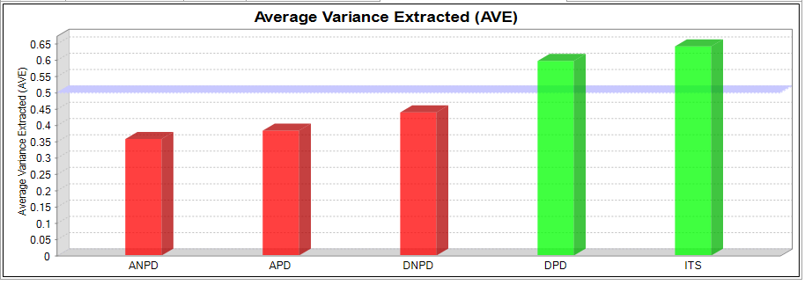
Figure 4.1: Constructs’ convergent validity
Source: Survey results, 2022
Some of the indicator’s reliability was below Hair et al.'s recommended value of 0.708 (2018). According to Hair et al., (2018), indicators reliability greater than 0.708 is recommended. Still, indicator reliability with values between 0.4 to 0.7 should be considered for removal only if the deletion of these indicators leads to an increase in composite reliability and AVE. Figure 4.2 shows the indicators and their reliability values. Therefore, to attain a threshold AVE value of 0.5 and above, the researcher considered dropping indicators below the recommended value starting from the lowest-valued indicators.
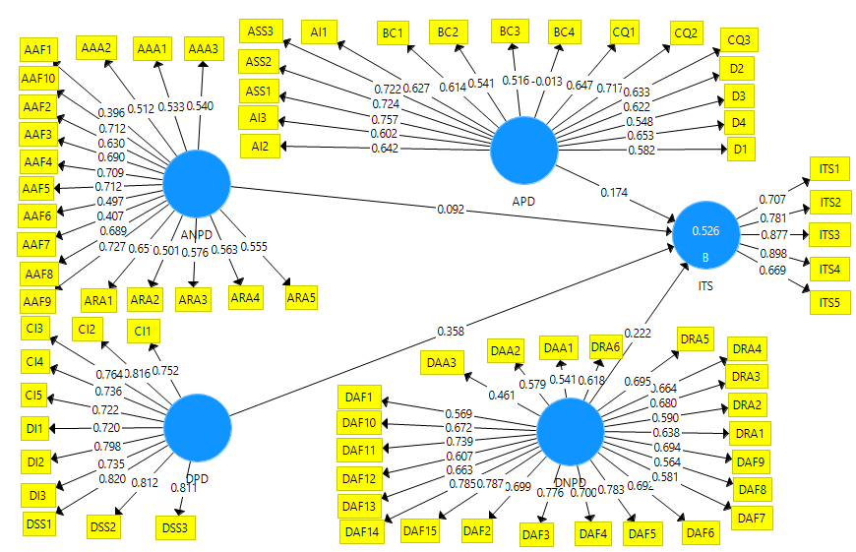
Figure 4.2: Modes showing indicators and their reliability values
Source: Survey results, 2022
Key: ANPD: Arrival Non-Processing Domain
APD Arrival Processing Domain
DNPD: Departure Non-Processing Domain
DPD: Departure Processing Domain
ITS: International Tourists Satisfaction
The total indicators used in the study were 75 questions answered by respondents in the survey questionnaire out of demographic questions. Table 4.1 shows the list of used indicators and those that have been dropped as Hair et al. (2018) recommended to meet the indicator’s reliability and AVE. None of the indicators were dropped from the departure processing domain construct because all its indicators' reliability was above the recommended value.
Table 4.1: List of dropped indicators
S/N | Arrival Processing Domains | Code | IR | P-Value | Remark
 | Disembarkation (D)
 | The condition of the aerobridge is good and satisfactory | D1 | 0.582 | 0.000 | Dropped
 | The aerobridge is user-friendly | D2 | 0.622 | 0.000 | Dropped
 | It is easy to find my way out at the airport | D3 | 0.548 | 0.000 | Dropped
 | There is good interaction between staff and passengers at the airport | D4 | 0.653 | 0.000
 | Arrival Immigration (AI)
 | Waiting time and queue at immigration is satisfactory | AI1 | 0.627 | 0.000 | Dropped
 | Immigration staff are helpful and courtesy | AI2 | 0.642 | 0.000
 | Waiting time and queue at visa on arrival are satisfactory | AI3 | 0.602 | 0.000 | Dropped
 | Baggage Claim (BC)
 | Baggage delivery is timely done | BC1 | 0.614 | 0.000 | Dropped
 | I received baggage (s) without any damage | BC2 | 0.541 | 0.000 | Dropped
 | I received baggage (s) without any missing item | BC3 | 0.516 | 0.000 | Dropped
 | There is a long queue at the baggage collection area | BC4 | -0.013 | 0.864 | Dropped
 | Arrival Security Screening (ASS)
 | Security staff are helpful and courtesy | ASS1 | 0.757 | 0.000
 | The screening exercise on arrival was properly conducted | ASS2 | 0.724 | 0.000
 | The average waiting time in the queue for security screening is short | ASS3 | 0.722 | 0.000 | Dropped
 | Customs and Quarantine (CQ)
 | Custom and quarantine staff are helpful and courtesy | CQ1 | 0.647 | 0.000
 | Waiting time and queue at customs clearance are satisfactory | CQ2 | 0.717 | 0.000
 | The arrival tourist card for customs declaration information is understood | CQ3 | 0.633 | 0.000 | Dropped
 | Arrival non-processing domains
 | Arrival Airport Facilities (AAF)
 | There is a serviceable ATM and money changer at the airports. | AAF1 | 0.396 | 0.000 | Dropped
 | The airports maintain good sanitary condition of restrooms | AAF2 | 0.630 | 0.000
 | The airport has a clear information desk, display, and signs | AAF3 | 0.690 | 0.000
 | Baggage trolleys are in good condition | AAF4 | 0.709 | 0.000
 | Baggage trolleys are conveniently located | AAF5 | 0.712 | 0.000
 | The Internet or Wi-Fi is available | AAF6 | 0.497 | 0.000 | Dropped
 | The internet or wi-fi is provided for free | AAF7 | 0.407 | 0.000 | Dropped
 | The terminal floor, facilities, and public areas are well-cleaned | AAF8 | 0.689 | 0.000
 | The terminal physical environment is good | AAF9 | 0.727 | 0.000
 | The airport terminal, in general, is comfortable | AAF10 | 0.712 | 0.000
 | Arrival Retail Area (ARA)
 | There is a variety of retail shops in the arrivals | ARA1 | 0.650 | 0.000 | Dropped
 | Prices at shops and café are valued for money on arrival | ARA2 | 0.501 | 0.000 | Dropped
 | A variety of foods and beverages are available on arrival | ARA3 | 0.576 | 0.000 | Dropped
 | I can get clear tourism information at the airport on arrival | ARA4 | 0.563 | 0.000 | Dropped
 | There is good COVID-19 precaution and safety protocol on arrival | ARA5 | 0.555 | 0.000 | Dropped
 | Arriva Airport Accessibility (AAA)
 | There is an availability of transport options from the airport to the city | AAA1 | 0.533 | 0.000 | Dropped
 | The tax fare is satisfactory | AAA2 | 0.512 | 0.000 | Dropped
 | There is easy access to public transport from the airport | AAA3 | 0.540 | 0.000 | Dropped
 | Departure Processing Domains
 | Check-In (CI)
 | Average waiting time and queue during check-in were satisfactory | CI1 | 0.752 | 0.000
 | There is an efficient and easy check-in process at the airport | CI2 | 0.816 | 0.000
 | Check-in staff are helpful and courtesy | CI3 | 0.764 | 0.000
 | Staff problem or complaint-solving at check-in is good | CI4 | 0.736 | 0.000
 | Staff grooming and appearance are good | CI5 | 0.722 | 0.000
 | Departure Immigration (DI)
 | Waiting time and queue at immigration is satisfactory | DI1 | 0.720 | 0.000
 | Immigration staff are helpful and courtesy | DI2 | 0.798 | 0.000
 | Waiting time and queue on the visa are satisfactory | DI3 | 0.735 | 0.000
 | Departure Security Screening (DSS)
 | Security staff are helpful and courtesy | DSS1 | 0.820 | 0.000
 | I felt secure after a thorough screening at the security point | DSS2 | 0.812 | 0.000
 | Waiting time and queue at security screening are satisfactory | DSS3 | 0.811 | 0.000
 | Departure Airport Accessibility (DAA)
 | A variety of transport options from the city to the airport are available | DAA1 | 0.541 | 0.000 | Dropped
 | Parking facilities are available, and it is easy to find a car park | DAA2 | 0.579 | 0.000 | Dropped
 | The taxi fare is satisfactory | DAA3 | 0.461 | 0.000 | Dropped
 | Departure Airport Facilities (DAF)
 | The airport has serviceable ATM and money changer facilities | DAF1 | 0.569 | 0.000 | Dropped
 | The airport maintains good sanitary condition of restrooms | DAF2 | 0.699 | 0.000
 | The airport waiting lounge is attractive and comfortable | DAF3 | 0.776 | 0.000
 | The seats at the airport are adequate and comfortable | DAF4 | 0.700 | 0.000
 | The airport has a clear information desk, display, and signs | DAF5 | 0.783 | 0.000
 | Baggage trolleys are in good condition and conveniently located | DAF6 | 0.692 | 0.000
 | The Internet or Wi-Fi is available | DAF7 | 0.581 | 0.000 | Dropped
 | The internet or wi-fi is provided for free | DAF8 | 0.564 | 0.000 | Dropped
 | The boarding call is satisfactory | DAF9 | 0.694 | 0.000 | Dropped
 | Children’s changing rooms are available and in good condition | DAF10 | 0.672 | 0.000 | Dropped
 | The terminal floor, facilities, and public areas are well-cleaned | DAF11 | 0.739 | 0.000
 | The airport has good children’s play area and facilities | DAF12 | 0.607 | 0.000 | Dropped
 | The airport has good televisions and entertainment facilities | DAF13 | 0.663 | 0.000
 | The overall terminal comfort is satisfactory | DAF14 | 0.785 | 0.000
 | The terminal physical environment is good | DAF15 | 0.787 | 0.000
 | Departure Retail Area (DRA)
 | A variety of retail shops and café are available at the airport | DRA1 | 0.638 | 0.000 | Dropped
 | Prices at shops and café are valued for money at the airport | DRA2 | 0.590 | 0.000 | Dropped
 | The café/restaurant service and environment are good at the airport | DRA3 | 0.680 | 0.000 | Dropped
 | The airport has a variety of foods and beverages | DRA4 | 0.664 | 0.000 | Dropped
 | I got clear tourism information at the airport | DRA5 | 0.695 | 0.000 | Dropped
 | There are good COVID-19 precautions and safety protocols during departure | DRA6 | 0.618 | 0.000 | Dropped
 | International Tourists Satisfaction (ITS)
 | I will communicate positive word of mouth about Tanzania to fellow people in my country | ITS1 | 0.707 | 0.000 | Dropped
 | The good services at the airport made me plan another trip to Tanzania | ITS2 | 0.781 | 0.000
 | Employees at the airport terminal are customer-focused | ITS3 | 0.877 | 0.000
 | The overall service performance at the airport was satisfactory | ITS4 | 0.898 | 0.000
 | I will recommend others in my country to visit Tanzania | ITS5 | 0.669 | 0.000
Source: Survey Results, 2022
ITS1 was dropped after analysis as per Figure 4.4. Based on the reliability values as per Figure 4.2, most of the indicators for the arrival retail area, disembarkation, baggage claim, and arrival and departure airport accessibility have been dropped because the indicators were below the recommended value of 0.708 by Hair et al. (2018).
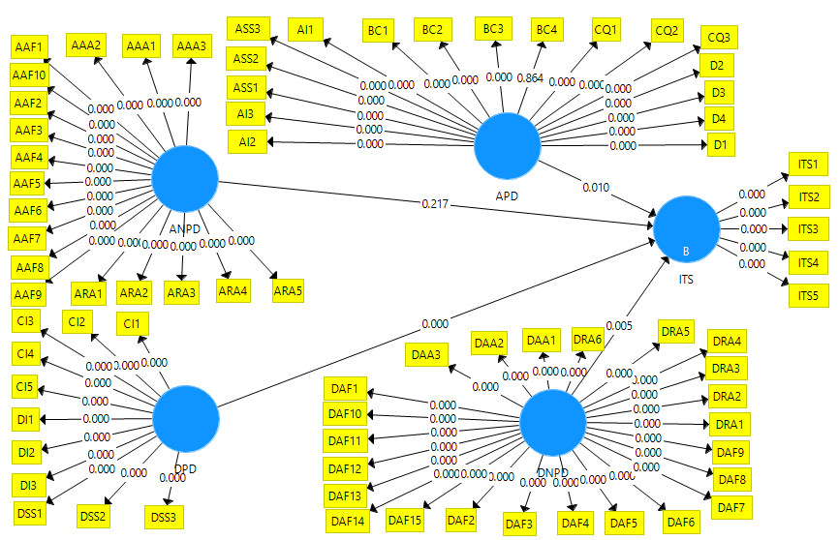
Figure 4.3: Model showing indicators and their P-value values
Source: Survey Results, 2022
Key: APD: Arrival Processing Domain
ANPD: Arrival Non-Processing Domain
DPD: Departure Processing Domain
DNPD: Departure Non-Processing Domain
ITS: International Tourists Satisfaction

The implication is that the service indicators are significant for airport quality performance but not critical factors for international tourists’ satisfaction. This is because tourists do not concentrate much on disembarkation or retail matters after arrival, and most transport arrangements will have been done before visitation by travel agents. This has been confirmed by checking the p-value between indicators and constructors and between constructs and constructs, as shown in Figure 4.3.

Based on Hair et al. (2018), indicators reliability recommendation, several indicators were dropped purposely to qualify for AVE value. Therefore, the indicators used in the analysis using Smart PLS software three have been reduced, as shown in Table 4.2. Another similar study can test the dropped indicators to assess their impact on international tourists’ satisfaction. The remaining indicators (Table 4.2) were used for actual data analysis. In that regard, the sample size used remained the same as Hair et al. (2018) recommended since the higher the sample size, the more the quality of the data analysis. The researcher decided to remain with D4 and AI2 for further testing during actual data analysis due to their significant impact on tourists during arrival time, as recommended by previous researchers.

Table 4.2: List of remaining indicators
S/N | Arrival Processing Domains | Code | IR | Remarks
 | Disembarkation (D)
 | There is good interaction between staff and passengers at the airport | D4 | 0.696 | Added
 | Arrival Immigration (AI)
 | Immigration staff are helpful and courtesy | AI2 | 0.658 | PCAM
 | Arrival security screening (ASS)
 | Security staff are helpful and courtesy | ASS1 | 0.823 | PCAM
 | The screening exercise on arrival was properly conducted | ASS2 | 0.753 | Added
 | Customs and Quarantine (CQ)
 | Custom and quarantine staff are helpful and courtesy | CQ1 | 0.720 | PCAM
 | Waiting time and queue at customs clearance are satisfactory | CQ2 | 0.735 | PCAM
 | Arrival non-processing domain
 | Arrival Airport Facilities (AAF)
 | The airports maintain good sanitary condition of restrooms | AAF2 | 0.710 | PCAM
 | The airport has a clear information desk, display, and signs | AAF3 | 0.726 | PCAM
 | Baggage trolleys are in good condition | AAF4 | 0.771 | Added
 | Baggage trolleys are conveniently located | AAF5 | 0.784 | Added
 | The terminal floor, facilities, and public areas are well-leaned | AAF8 | 0.816 | Added
 | The terminal physical environment is good | AAF9 | 0.841 | Added
 | The airport terminal, in general, is comfortable | AAF10 | 0.785 | Added
 | Departure Processing Domains
 | Check-in (CI)
 | Average waiting time and queue during check-in were satisfactory | CI1 | 0.748 | PCAM
 | There is an efficient and easy check-in process at the airport | CI2 | 0.814 | PCAM
 | Check-in staff are helpful and courtesy | CI3 | 0.764 | PCAM
 | Staff problem or complaint-solving at check-in is good | CI4 | 0.740 | Added
 | Staff grooming and appearance are good | CI5 | 0.725 | Added
 | Departure Immigration (DI)
 | Waiting time and queue at immigration is satisfactory | DI1 | 0.719 | PCAM
 | Immigration staff are helpful and courtesy | DI2 | 0.799 | PCAM
 | Waiting time and queue on the visa are satisfactory | DI3 | 0.735 | PCAM
 | Departure Security Screening (DSS)
 | Security staff are helpful and courtesy | DSS1 | 0.821 | PCAM
 | I felt secure after a thorough screening at the security point | DSS2 | 0.813 | PCAM
 | Waiting time and queue at security screening are satisfactory | DSS3 | 0.810 | PCAM
 | Departure non-processing domain
 | Departure Airport Facilities (DAF)
 | The airport maintains good sanitary condition of restrooms | DAF2 | 0.746 | PCAM
 | The airport waiting lounge is attractive and comfortable | DAF3 | 0.845 | PCAM
 | The seats at the airport are adequate and comfortable | DAF4 | 0.771 | PCAM
 | The airport has a clear information desk, display, and signs | DAF5 | 0.804 | PCAM
 | Baggage trolleys are in good condition and conveniently located | DAF6 | 0.724 | Added
 | The terminal floor, facilities, and public areas are well-leaned | DAF11 | 0.756 | Added
 | The airport has good televisions and entertainment facilities | DAF13 | 0.682 | Added
 | The overall terminal comfort is satisfactory | DAF14 | 0.845 | Added
 | The terminal physical environment is good | DAF15 | 0.849 | Added
 | International Tourists Satisfaction (ITS)
 | The good services at the airport made me plan another trip to Tanzania | ITS2 | 0.819 | Added
 | Employees at the airport terminal are customer-focused | ITS3 | 0.909 | Added
 | The overall service performance at the airport was satisfactory | ITS4 | 0.919 | Added
 | I will recommend others in my country to visit Tanzania | ITS5 | 0.746 | Added
Key: IR: Indicator reliability
Source: Survey results, 2022
Conversely, according to Hair et al. (2018), the Internal Consistency Reliability (ICR) should be higher than 0.708, but for exploratory research, a value of 0.6 to 0.7 is considered acceptable. Based on this study, the value of the ICR for the constructs was above 0.708, as recommended. Figure 4.4 shows the model with IR, path coefficient, and ICR after dropping other indicators.
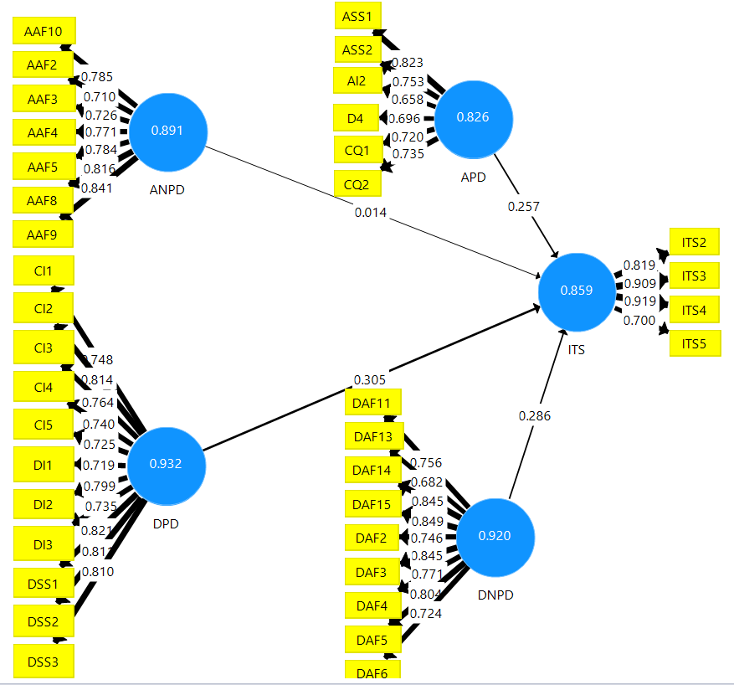
Figure 4.4: Model with IR, Path Coefficient, and ICR after dropping indicators
Source: Survey results, 2022
Key: APD: Arrival Processing Domain
ANPD: Arrival Non-Processing Domain
DPD: Departure Processing Domain
DNPD: Departure Non-Processing Domain
ITS: International Tourists Satisfaction

Pilot Study Findings for Assessing Reflective Measurement Model

Internal Consistency Reliability
The study used SmartPLS 3 Software to check for ICR. The obtained composite reliability values for all the constructs were above 0.708. The implication is that the indicators that measure the same construct are associated. Figure 4.5 shows the results of internal consistency reliability for the constructs by composite reliability.
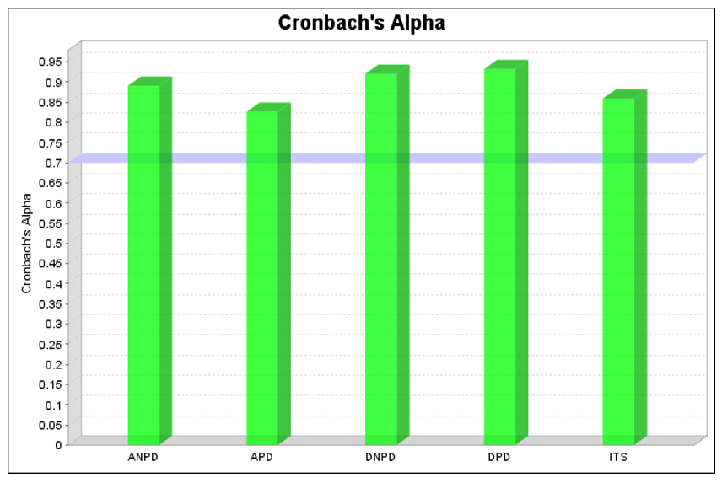
Figure 4.5: Constructs’ reliability values
Source: Survey results, 2022

Constructs’ Convergent Validity
The study used Smart PLS 3 Software, of which, after dropping indicators, the AVE from the evaluator of convergent validity raised from 0.5 value and above. The implication is that each construct’s validity was able to explain the variance of its items. Figure 4.6 Shows Constructs’ Convergent Validity results after running the PLS algorithm.
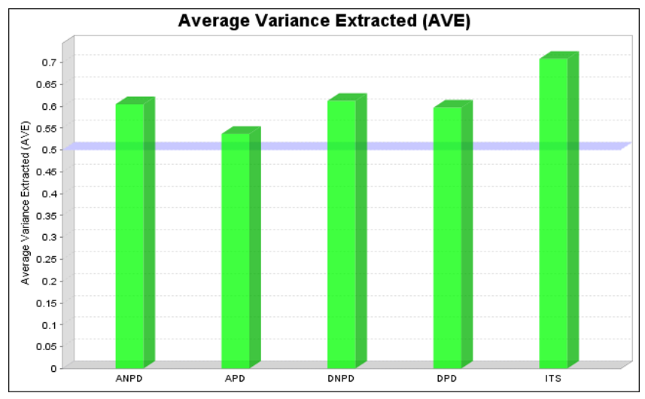
Figure 4.6: Constructs convergent validity
Source: Survey results, 2022

Pilot Study Findings for Assessing Reflective Structural Model

Coefficient of Determination
The R² was checked through the use of SmartPLS 3 Software. The PLS algorithm was run, and the R² result for the construct was 0.5. According to Hair et al. (2018), R²>0.75 is substantial, R² > 0.5 is moderate, and R² > 0.25 is weak. Therefore, the results imply that over 50 percent of international tourists’ satisfaction was influenced by the variation of the exogenous constructs. Figure 4.7 shows the results of endogenous constructs’ R².
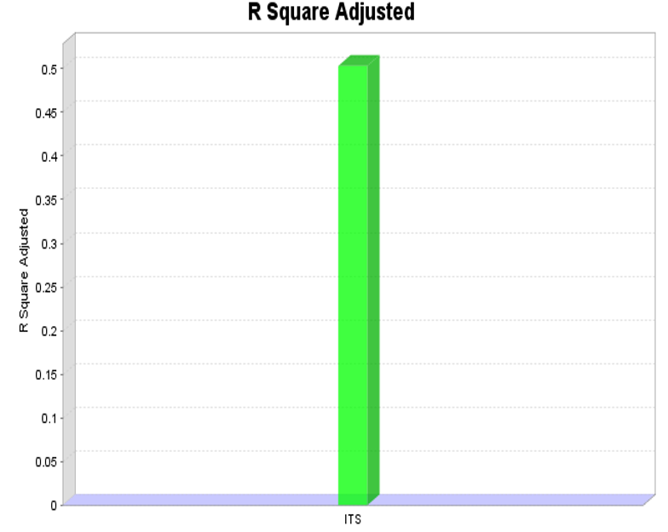
Figure 4.7: Endogenous Constructs Coefficient Determination (R²)
Source: Survey results, 2022

Examining the Size of the Path Coefficient
Through the use of SmartPLS 3 software, the size of path coefficients was appropriately checked. After running the PLS algorithm, the result for the size of path coefficients revealed that all hypothesized relationships had a positive correlation. Moreover, the results revealed that three hypothesized relationships had a positive correlation of 0.2 value and above, while one hypothesized relationship had a positive correlation of below 0.2 value (0.01). The observed relationship with values below 0.2 indicates a positive but very weak relationship. Figure 4.8 shows the results of the research model's path coefficient size.

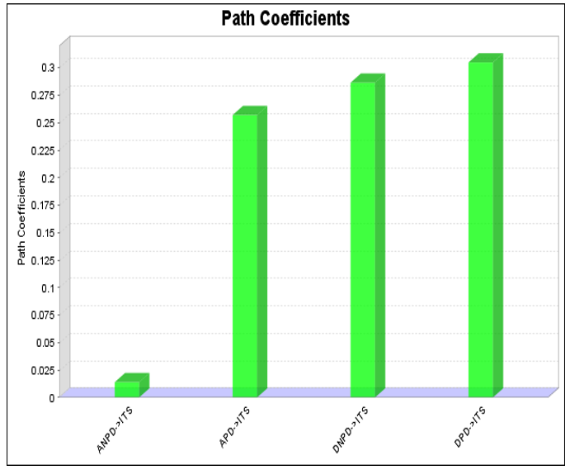
Figure 4.8: The size of the path coefficient of the research model
Source: Survey result, 2022

Examining the Significance of Path Coefficient
After running bootstrapping in SmartPLS 3 Software, a significance path coefficient was checked to measure direct effects for the set of independent variables on the dependent variables, that is, the cause-and-effect relationship. Hair et al. (2018) recommend a significance level of 0.05 for all paths. However, the results show one insignificant relationship between ANDP and ITS with a P-value of 0.849 which is above the recommended value. Figure 4.9 shows the results of significance path coefficients.

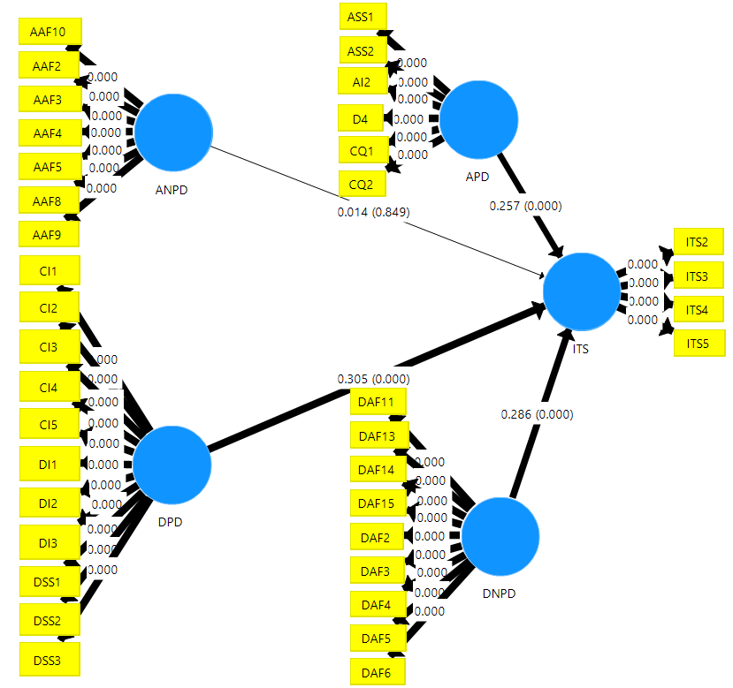
Figure 4.9: Significance path coefficient - Bootstrapping analysis
Source: Pilot survey results, 2022
Key: APD: Arrival Processing Domain
ANPD: Arrival Non-Processing Domain
DPD: Departure Processing Domain
DNPD: Departure Non-Processing Domain
ITS: International Tourists Satisfaction

Focusing on the study objectives and the results in Table 4.3, 75% of the hypothesized relationships are supported and exist in actual life situations while 25% of the hypothesized relationships were not supported and did not exist in actual life situations.
Table 4.3: Hypothesis tested
Hypothesis | Paths | Effect | Path coefficient | P Values | Remark
H₁ | APD -> ITS | Direct | 0.257 | 0.00 | Supported
H₂ | DPD -> ITS | Direct | 0.305 | 0.00 | Supported
H₃ | ANPD -> ITS | Direct | 0.014 | 0.849 | Rejected
H₄ | DNPD -> ITS | Direct | 0.286 | 0.00 | Supported
Source: Pilot survey results, 2022
Key
H₁: The arrival Processing Domain has a direct and positive relationship with International Tourists' Satisfaction
H₂: The departure Processing Domain has a direct and positive relationship with International Tourists' Satisfaction
H₃: Arrival Non-Processing Domain has an indirect and positive relationship with International Tourists' Satisfaction
H₄: Departure Non-Processing Domain has a direct and positive relationship with International Tourists' Satisfaction

Focusing on the pilot data analysis in Table 4.3 showing the hypothesis tested, the study had an overall view of the responses to the survey questions and their results. However, the data obtained for the pilot study were not included in the actual data analysis of the study findings.

Findings of the Study

Respondents Profile
The respondents’ profile aimed to understand the nature and characteristics of the respondents used in this study. Therefore, the questionnaire had 7 profile questions to be filled by the respondents. The gathered profile information involved the respondent’s gender, age group, nationality, travel experience, travel purposes, education level, and airport used during arrival. Table 4.4 illustrates the respondent profile by gender, educational level, and age group. In contrast, Table 4.2 illustrates the respondents’ profiles by travel experience, the purpose of travel, and the airport used during arrival, and Table 4.3 illustrates the respondents’ nationality.

Rate of Respondents
The respondents were the international departing tourists at the departure waiting lounge who had finished their check-in process. Therefore, the actual sample size of 401 as a response rate being 95 percent of the expected sample size (420) was accurately obtained in the actual data collection. That means 59 percent were international tourists who visited Tanzania for the first time, and 36 were international tourists who visited Tanzania more than once.

Demographic Profile for the Respondents

Gender of the Respondents
From the findings, the gender response rate was also assessed. Thus, Table 4.4 shows the gender of the respondents, whereby 60.1% of the respondents were male, and 39.9% were female.
Table 4.4: Demographic profile of the respondents
Characteristics |  | Frequency | Percent
Gender | Male | 241 | 60.1
Gender | Female | 160 | 39.9
Age group | 18-35 | 228 | 56.9
Age group | 36-50 | 103 | 25.7
Age group | Above 50 | 70 | 17.5
Level of education | Secondary level | 47 | 11.7
Level of education | First degree | 178 | 44.4
Level of education | Master and PhD | 171 | 42.6
Purpose of Travel to Tanzania | Tourism | 280 | 69.8
Purpose of Travel to Tanzania | Business | 54 | 13.5
Purpose of Travel to Tanzania | Meeting/conference | 64 | 16.0
Purpose of Travel to Tanzania | Others | 2 | .4
Travel Experience in Tanzania | First time | 236 | 58.9
Travel Experience in Tanzania | Second time | 37 | 9.2
Travel Experience in Tanzania | Third time | 17 | 4.2
Travel Experience in Tanzania | More than three times | 109 | 27.2
The airport used during arrival in Tanzania | JNIA | 165 | 41.1
The airport used during arrival in Tanzania | AAKIA | 73 | 18.2
The airport used during arrival in Tanzania | KIA | 157 | 39.2
Source: Survey results, 2022

Age of the Respondents
Table 4.4 presents the group age of the respondents based on the study findings. Therefore, the findings disclosed that 56.9% of the respondents were between 18-35, 25.7% were between 36-50, and 17.5% were above 50.

Education Level of the Respondents
Table 4.4 presents the findings of the respondents’ education level. The majority of the respondents, 44.4% were of the first degree, 42.6% were masters and Ph.D., and 11.7% were of secondary level.

Purpose of Travel
The findings in Table 4.5 shows the respondents’ purpose for travelling in Tanzania. According to the findings, 69.8% of the respondents visited Tanzania for tourism purposes, 16% visited for meetings and conferences, 13.5% for business, and only 0.5% for other purposes.

Travel Experience in Tanzania
Table 4.5 gives an analysis of the respondent’s experience in their fields. The findings show that 58.9% of the respondents visited Tanzania for the first time, 13.4% visited Tanzania twice and thrice, and 27.2% visited Tanzania more than three times.

The Airport Used for Arrivals in Tanzania
Table 4.5 presents the analysis of the airports used by respondents during their arrival in Tanzania. The findings showed that 41.1% of the respondents arrived in Tanzania through JNIA, 39.2% arrived in Tanzania through KIA, and 18.2% arrived in Tanzania through AAKIA.

Respondents’ Nationality
Table 4.6 presents the analysis of the respondent’s nationality. According to the findings, tourists from the United States of America accounted for 14.2%, followed by the French at 12.5%. Tourists from the rest of the mentioned countries were below 10%, while those not mentioned in the list were 31.7%. This signifies that Tanzania receives different global tourists which is significant for the airport service providers to note.
Table 4.5: Nationalities of the respondents
Characteristics |  | Frequency | Percent
Nationalities | USA | 57 | 14.2
Nationalities | French | 50 | 12.5
Nationalities | Ugandan | 36 | 9.0
Nationalities | Germany | 21 | 5.2
Nationalities | Chinese | 17 | 4.2
Nationalities | South Africa | 16 | 4.0
Nationalities | Rwandan | 14 | 3.5
Nationalities | Kenyan | 9 | 2.2
Nationalities | Indian | 8 | 2.0
Nationalities | Oman | 8 | 2.0
Nationalities | Italy | 7 | 1.7
Nationalities | Dutch | 7 | 1.7
Nationalities | Spain | 5 | 1.2
Nationalities | Comoro | 4 | 1.0
Nationalities | South Korea | 4 | 1.0
Nationalities | U. K | 3 | 0.7
Nationalities | British | 3 | 0.7
Nationalities | Others | 127 | 31.7
Source: Survey results, 2022

Data Analysis for Specific Objectives
The collected data was intended to respond to the four specific objectives of this study. As recommended by Hair et al. (2018), evaluation procedures from the PLS-SEM reflective model were used to analyze the collected data. Based on this study’s reflective model, the analysis through reflective and structural measurement models was performed as described in this section.

Assessing Reflective Measurement Models
After the successful assessment of the pilot study, the evaluation of the reflective measurement model, being the first step in the PLS-SEM model, started. The reflective measurement model involves; indicators reliability, internal consistency reliability, convergent validity, and discriminant validity. The findings for each of the mentioned components has been explained.

Indicators (Loading) Reliability: According to Hair et al. (2018), the indicators (loading) values have to be higher than 0.708, while those with a value between 0.4 and 0.7 (Figure 4.10) should be considered for removal only if deletion of these indicators leads to an increase of composite reliability and AVE threshold value. Therefore, all the used indicators’ reliability for the study research model construct was above 0.708. This implies that each construct described more than 50% of the indicator’s variance. Figure 4.10 and Table 4.7 show constructs and indicator reliability.
Independent Variable | Dependent Variable
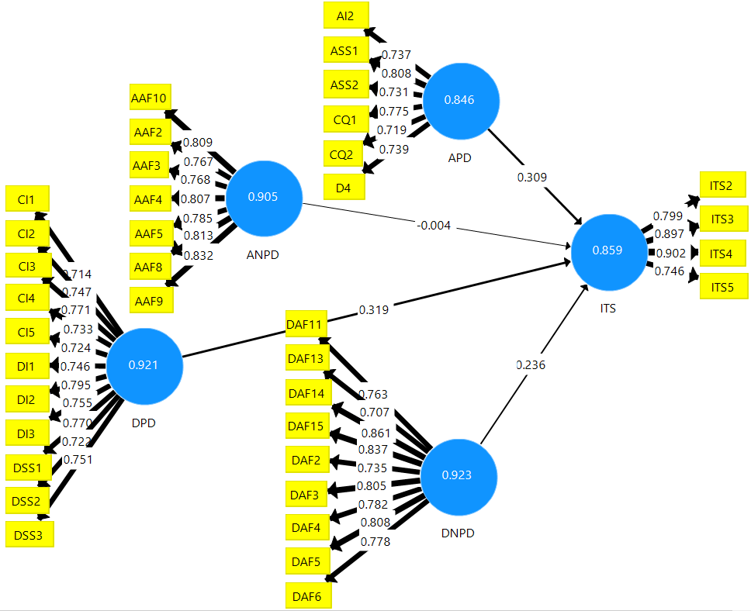
Figure 4.10: Indicator’s reliability
Source: Survey results, 2022
Key: APD: Arrival Processing Domain
ANPD: Arrival Non-Processing Domain
DPD: Departure Processing Domain
DNPD: Departure Non-Processing Domain
ITS: International Tourists Satisfaction

Table 4.6: Construct’s indicator reliability
 | ANPD | APD | DNPD | DPD | ITS
AAF10 | 0.809
AAF2 | 0.767
AAF3 | 0.768
AAF4 | 0.807
AAF5 | 0.785
AAF8 | 0.813
AAF9 | 0.832
AI2 |  | 0.737
ASS1 |  | 0.808
ASS2 |  | 0.731
CI1 |  |  |  | 0.714
CI2 |  |  |  | 0.747
CI3 |  |  |  | 0.771
CI4 |  |  |  | 0.733
CI5 |  |  |  | 0.724
CQ1 |  | 0.775
CQ2 |  | 0.719
D4 |  | 0.739
DAF11 |  |  | 0.763
DAF13 |  |  | 0.707
DAF14 |  |  | 0.861
DAF15 |  |  | 0.837
DAF2 |  |  | 0.735
DAF3 |  |  | 0.805
DAF4 |  |  | 0.782
DAF5 |  |  | 0.808
DAF6 |  |  | 0.778
DI1 |  |  |  | 0.746
DI2 |  |  |  | 0.795
DI3 |  |  |  | 0.755
DSS1 |  |  |  | 0.770
DSS2 |  |  |  | 0.722
DSS3 |  |  |  | 0.751
ITS2 |  |  |  |  | 0.799
ITS3 |  |  |  |  | 0.897
ITS4 |  |  |  |  | 0.902
ITS5 |  |  |  |  | 0.746
Source: Survey result, 2022
Internal Consistent Reliability: According to Hair et al. (2018), the internal consistency reliability was recommended to be higher than 0.708. For exploratory research, a value from 0.6 to 0.7 is considered acceptable, while a value from 0.70 to 0.95 is considered satisfactory to good. Therefore, all the constructs of the research model had values above 0.708 and below 0.95. The implication is that the data collected for answering the specific objectives of this study were reliable and had a close association with each other. Table 4.7 shows the reliability of the composite and internal consistency for all the research model constructs.

Table 4.7: Internal consistent reliability (composite reliability) and AVE results
 | Cronbach's Alpha | rho_A | Composite Reliability | Average Variance Extracted (AVE)
Arrival Non-Processing Domain (ANPD) | 0.905 | 0.908 | 0.924 | 0.636
Arrival Processing Domain (APD) | 0.846 | 0.850 | 0.886 | 0.566
Departure Non-Processing Domain (DNPD) | 0.923 | 0.928 | 0.936 | 0.620
Departure Processing Domain (DPD) | 0.921 | 0.923 | 0.933 | 0.560
International Tourists Satisfaction (ITS) | 0.859 | 0.883 | 0.904 | 0.704
Source: Survey result, 2022

Convergent Validity Result: Convergent validity is measured by AVE. Thus, Table 4.7 presents the AVE results from 0.5 and above in all research model constructs. This indicates that each construct of the study research model explained 50% or more of the variance of the items that comprise the construct.

Discriminant Validity Results by Heterotrait-Monotrait Ratio (HTMT): The discriminant validity for this study is shown in Table 4.8. According to Hair et al. (2018), the discriminant validity is measured by the HTMT ratio of correlation with a threshold value of less than 0.9. Therefore, after running the PLS algorithm, the result for the discriminant validity as per the HTMT report showed discriminant validity being less than 0.9 value in all the constructs as recommended for structural models whose constructs are conceptually similar. This is like destination satisfaction, product satisfaction, service performance, and revisit influencing factors. The results imply that discriminant validity for all the constructs was available, and the constructs are not highly correlated.

Table 4.8: Discriminant validity results using Heterotrait-Monotrait Ratio
 | ANPD | APD | DNPD | DPD | ITS
Arrival Non-Processing Domains (ANPD) | 0.798
Arrival Processing Domains (APD) | 0.517 | 0.752
Departure Non-Processing Domains (DNPD) | 0.806 | 0.457 | 0.787
Departure Processing Domains (DPD) | 0.577 | 0.687 | 0.590 | 0.748
International Tourists Satisfaction (ITS) | 0.530 | 0.634 | 0.562 | 0.668 | 0.839
Source: Survey results, 2022

Structural Model
After successfully assessing the measurement model, the researcher moved to structural model assessment comprising collinearity, R², Predictive relevance (Q²), size and significance of path coefficient, Examining the f² effects, and Examining hold-out sample validation. Focusing on the PLS-SEM evaluation model, the structural model assessment is similar to assessing formative measurement models.

Collinearity Statistics: The first step in assessing the structural model was to examine the collinearity to avoid any regression results biases. The latent variable scores of the constructs were used to calculate the VIF values. The higher the VIF, the greater the collinearity. The recommended collinearity value is less than 5 (Hair et al., 2018). However, the collinearity values higher than 5 indicate the possibility of collinearity amongst predictor constructs. Therefore, after running the PLS algorithm, the result for collinearity statistics values for the inner model was less than 3.2. The implication is that there are no multicollinearity problems among the predictor constructs. Table 4.9 shows VIF values for the inner model.

Table 4.9: Collinearity statistics
 | ITS (VIF)
Arrival Non-Processing Domain (ANPD) | 3.113
Arrival Processing Domain (APD) | 1.991
Departure Non-Processing Domains (DNPD) | 3.079
Departure Processing Domains (DPD) | 2.328
Source: Survey results, 2022

Assessing the R² value of the endogenous constructs: Figure 4.11 presents the results for the R² value for the endogenous constructs after running the PLS algorithm. Thus, the R² for the endogenous constructs was more than 0.5, which is moderate as recommended by Hair et al. (2018). The results indicate that 53.9% of R² values measured the variance explained by the exogenous constructs in the endogenous constructs. Furthermore, it implies that the exogenous constructs influenced over 53.9% of the variation of endogenous constructs.
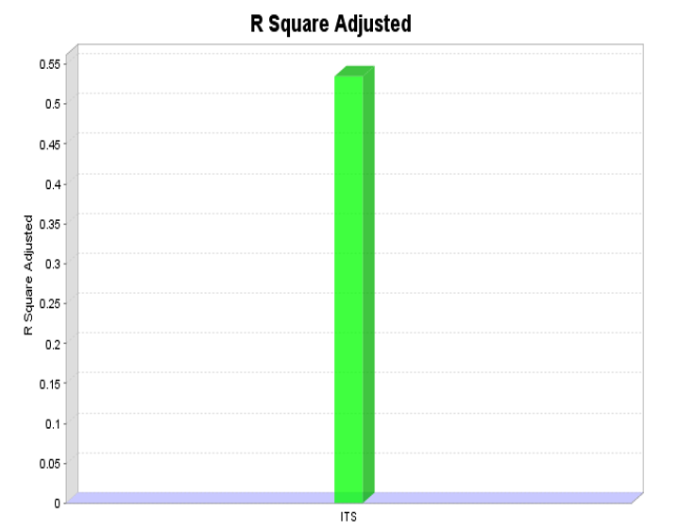
Figure 4.11: R² Value of the endogenous construct
Source: Survey results, 2022
F square effect size (f²): After running the PLS algorithm, Table 4.11 reveals the f² effect size of the constructs in the study research model. Hair et al. (2018) recommend that values higher than 0.02 depict small, 0.15 depict medium, and 0.35 depict large f² effect sizes. Therefore, three f² effect sizes (0.104, 0.039, and 0.095) indicate a small effect size of exogenous constructs to endogenous constructs. However, one variable with a 0.000 value indicates the presence of full mediation.
According to Cohen (1988), if an f² value of 0.02 is small, we consider indirect interpretation and understanding of any f² value less than 0.02 not affecting that relationship. Therefore, in this study, the f² value of 0.000 for the relationships between the arrival non-processing domain and international tourists’ satisfaction implies no relationship effect. Thus the relationship can be dropped or mediated. Furthermore, other values with f² higher than 0.02 imply the existence of partial, medium, or large effect sizes.

Table 4.10: f Squared value
 | ITS
Arrival Non-Processing Domain (ANPD) | 0.000
Arrival Processing Domain (APD) | 0.104
Departure Non-Processing Domain (DNPD) | 0.034
Departure Processing Domain (DPD) | 0.095
Source: Survey results, 2022

Q² Values for endogenous constructs: Based on the recommendations by Hair et al. (2018) after running blindfolding from SmartPLS 3, the findings in Figure 4.12 indicate endogenous constructs value of Q² being more significant than zero. This result implies that; the exogenous constructs have the power to predict the endogenous constructs. It further indicates that the model has predictive relevance and the values are well reconstructed.
Independent Variable | Dependent Variable
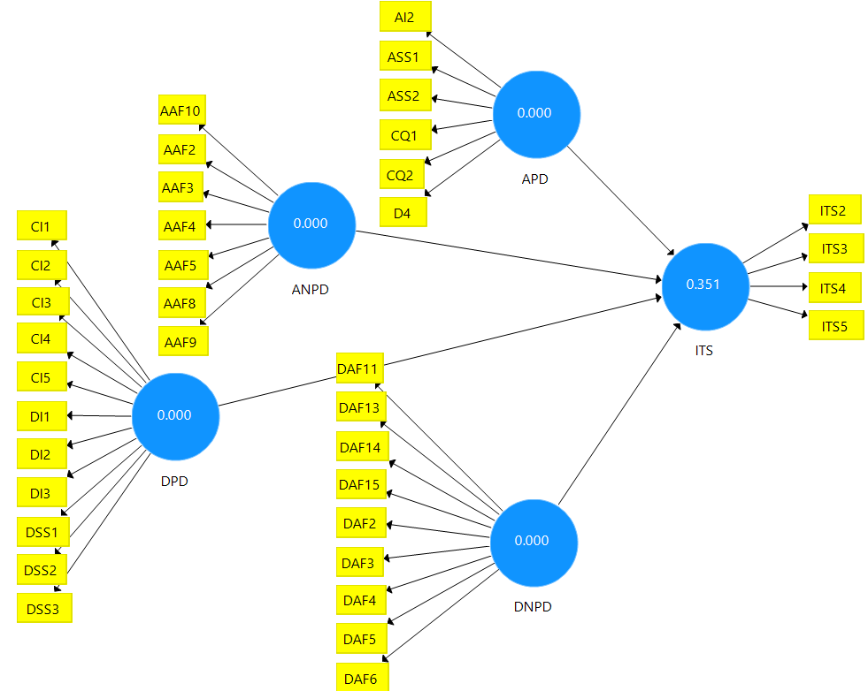
Figure 4.12: Q² for endogenous construct.
Source: Survey results, 2022

Key APD: Arrival Processing Domain
ANPD: Arrival Non-Processing Domain
DPD: Departure Processing Domain
DNPD: Departure Non-Processing Domain
ITS: International Tourists Satisfaction

Based on the recommendations by Hair et al. (2018), Table 4.11 shows the value of Q² being higher than zero (Q²>0) for the endogenous construct in this study. The results indicate that the exogenous construct has a higher power of predicting the endogenous constructs by 35.2%.
Table 4.11: Q2 Values
 | SSO | SSE | Q² =1-(SSE/SSO)
Arrival Non-Processing Domain (ANPD) | 2,807.000 | 2,807.000
Arrival Processing Domain (APD) | 3,406.000 | 2,406.000
Departure Non-Processing Domain (DNPD) | 3,609.000 | 3,609.000
Departure Processing Domain (DPD) | 4,411.000 | 4,411.000
International Tourists Satisfaction (ITS) | 1,604.000 | 1,041.043 | 0.351
Source: Survey results, 2022

Relevance of Path Coefficient: After performing the PLS algorithm in the SmartPLS 3 software, the results for the relevance path coefficient were as follows: three path coefficients for the hypothesized relationship had positive values. In contrast, only one path coefficient of the hypothesized relationship was negative. The results implied that an increase in one standard deviation for the three positive hypothesized determinants (departure non–processing domain, arrival processing domain, and departure processing domain) increased international tourists' satisfaction. Likewise, the negative path coefficient (arrival non-processing domain and international tourists’ satisfaction) implies that an increase in one standard deviation of the arrival non-processing domain resulted in a decrease in the rate of international tourists’ satisfaction (Hair et al., 2018). However, Cohen (1988) confirmed that an f² value less than 0.02 does not affect that relationship. Then, the one relationship with a negative path coefficient and f² value of 0.000 implies no existence of the direct relationship. Figure 4.13 shows the path coefficients
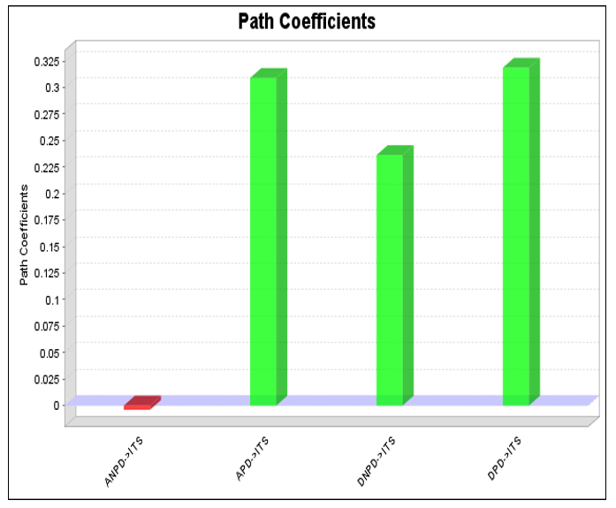
Figure 4.13: Path Coefficients
Source: Survey results, 2022

Statistical significance of the hypothesized relationship: After running the SmartPLS 3 software, the statistical significance for the three hypothesized relationships was supported (p-value <0.05). In contrast, one hypothesized relationship had a P-value of 0.957, indicating that the direct relationship is unsupported. The results imply that the formulated conceptual model for this study can be used for decision-making as all the hypothesized relationships appear to exist in real life with exceptional of one relationship, which has to be supported by the full mediator variables. The statistical significance of the hypothesized association for this study is seen in Figure 4.14.
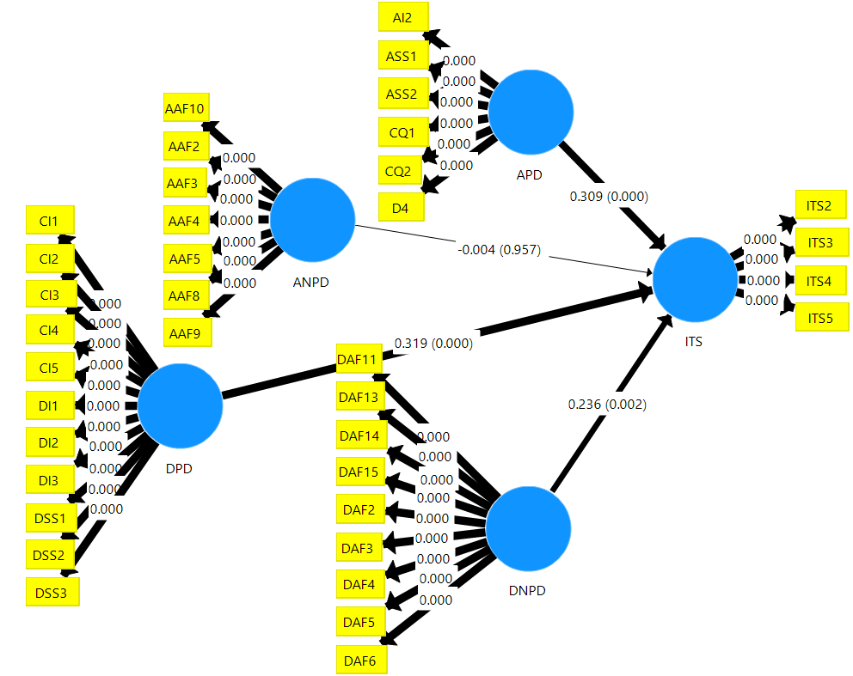
Figure 4.14: Statistical significance of path coefficient
Source: Survey results, 2022
Key APD: Arrival Processing Domain
ANPD: Arrival Non-Processing Domain
DPD: Departure Processing Domain
DNPD: Departure Non-Processing Domain
ITS: International Tourists Satisfaction

The study’s specific objectives were achieved Based on the results of the hypothesized relationships in Figure 4.14. Likewise, Table 4.12 shows the findings for the tested hypothesis in conformity with the specific objectives of the study.

Table 4. 12: The tested hypothesis
Hypothesis | Paths | Effect | P Values | Specific objectives
H1_{a} | APD -> ITS | Direct | 0.00 | One
H1_{b} | DPD -> ITS | Direct | 0.00 | Two
H1_{c} | ANPD -> ITS | Direct | 0.957 | Three
H1_{d} | DNPD -> ITS | Direct | 0.00 | Four
Source: Survey results, 2022
H₁: The arrival processing domain has a direct and positive relationship with international tourists’ satisfaction
H₂: The departure processing domain has a direct and positive relationship with international tourists’ satisfaction
H₃: The arrival non-processing domain has an indirect and negative relationship with international tourists’ satisfaction
H₃: The departure non-processing domain has a direct and positive relationship with international tourists’ satisfaction

Assessing the importance-performance of the constructs: Figure 4.15 shows the IPMA results of both exogenous and endogenous constructs and their indicators. The results were obtained after running smart PLS 3 software. The total effect of exogenous constructs on endogenous constructs is 0.316 for the arrival processing domain (APD), -0.004 for the arrival non-processing domain (ANPD), 0.336 for the departure processing domain (DPD), and 0.233 for the departure non-processing domain (DNPD). This implies predecessor constructs are important in shaping endogenous constructs. Thus, findings show that APD, DPD, and DNPD have a high total effect on endogenous construct than ANPD. Likewise, the performance averages for the latent variables scores are; 72.408 for APD, 74.661 for the ANPD, 74.588 for the DPD, and 68.629 for DNPD. This shows that the three constructs (APD, DPD, and DNPD) have good performance and high significance, while one construct (ANPD) shows high performance (74.661) but low significance (-0.004). The combination between predecessor construct importance and performance creates the importance–of performance map analysis. Generally, the results imply that all the exogenous constructs are fundamental in explaining the endogenous construct in the research model except ANPD.

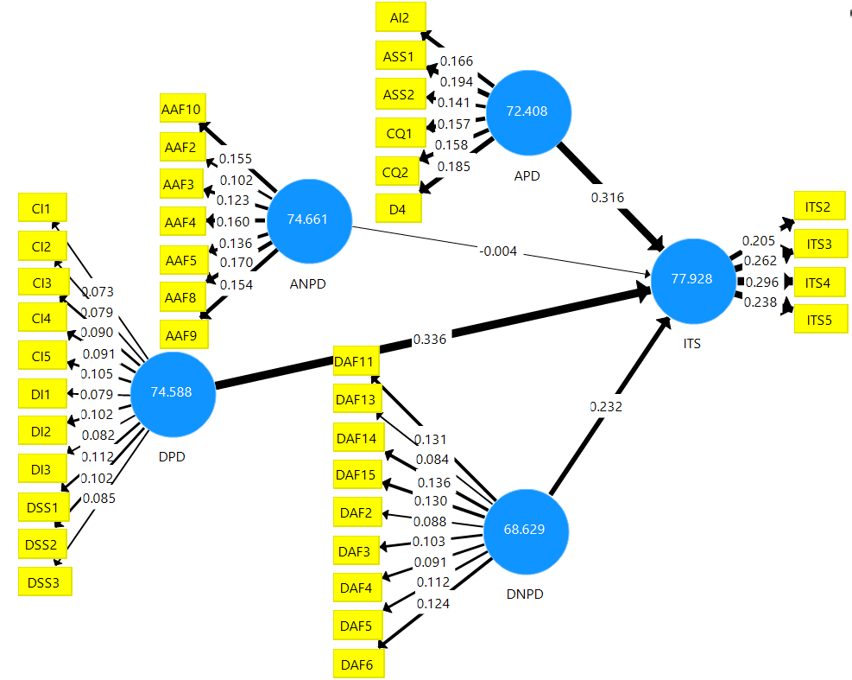
Figure 4.15: Performance of constructs and their indicators
Source: Survey results, 2022

Key APD: Arrival Processing Domain
ANPD: Arrival Non-Processing Domain
DPD: Departure Processing Domain
DNPD: Departure Non-Processing Domain
ITS: International Tourists Satisfaction

Assessing the importance-performance of the indicators: The indicators’ importance-performance results were opened after going through the report when the importance-performance matrix analysis was run in the SmartPLS 3 software. The findings imply that the indicators positioned from 0.030 to 0.060 in Figure 4.16 indicate that they were more significant. Also, their performance is highly required for the actuality of the research model in this study. On the other hand, the implication for the indicators from 0.00 to 0.030 indicates that they are less significant. Still, their performances are highly required in the actuality of the research model for this study. Additionally, indicators at exactly 0.000 value imply less significance regardless of being highly important to the study model.
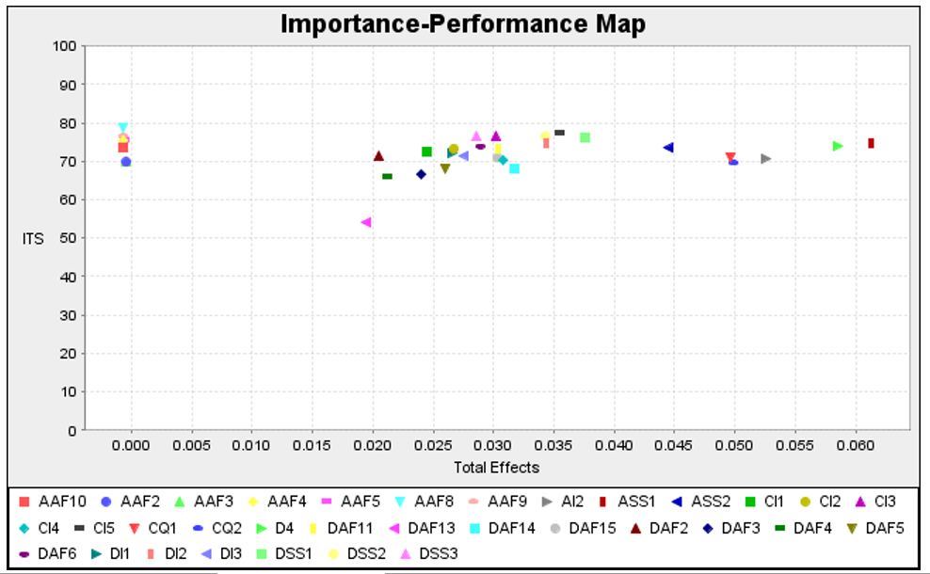
Figure 4.16: Performance map (indicators unstandardized effect)
Source: Survey results, 2022

Assessing importance - performance of the constructs: Focusing on the location of the constructs, the ANPD positioned between 0.00 and 0.175 in Figure 4.17 implies that the construct was not important but had a higher performance for the actuality of this research model. Similarly, the location of the DNPD, APD, and DPD positioned between 0.175 and 0.350 implies that they are more important and their performance is higher for this research model. This further indicates that high consideration is needed for the services provided in these constructs. Similarly, consideration is needed for ANPD as it influences international tourists' satisfaction through mediating variables. Investing in improving services offered at the airport domains, including capacity building, would significantly impact sustainable quality service performance.

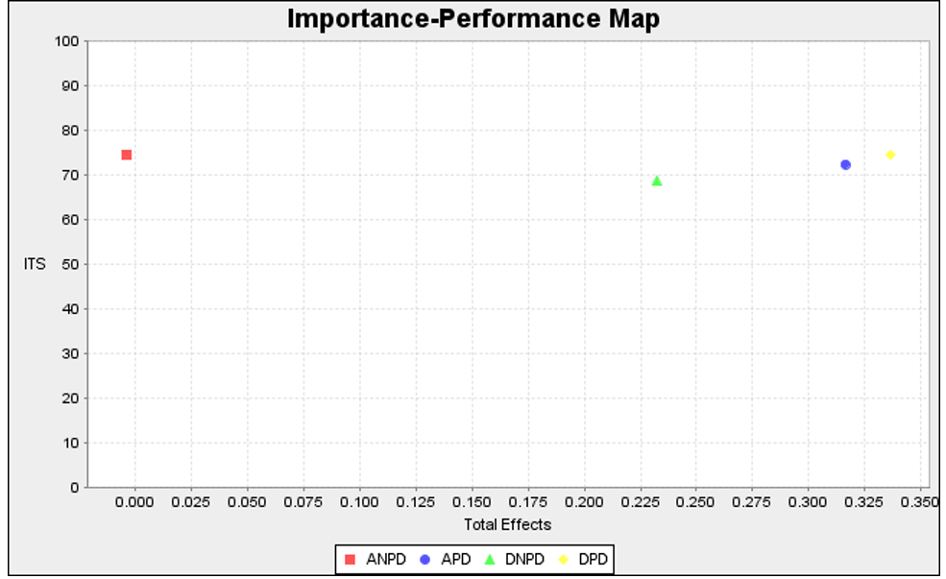
Figure 4.17: Performance map (construct unstandardized effects)
Source: Survey results, 2022

CHAPTER FIVE

DISCUSSION OF THE FINDINGS

Chapter Overview
The main purpose of this study was to assess the relationship between Airport Service Performance and international tourists’ satisfaction. The study was done at three international airports in Tanzania. In achieving the specific objectives of this study, both existing empirical literature, relevant theories, and models were used and finally reached the conceptual framework, which seriously showed the relationship between independent variables (airport service performance) and the dependent variables (international tourists’ satisfaction). This chapter discusses the findings based on the respondent demographics and the research’s specific objectives from which the conceptual framework for this study was developed. The following were the specific objectives of this study; the first was to evaluate the relationship between airport arrival processing domains and international tourists’ satisfaction. The study evaluated the relationship between airport departure processing domains and international tourists’ satisfaction. Third, the study assessed the relationship between arrival non-processing domains and international tourists’ satisfaction. The fourth objective was to assess the relationship between departure non-processing domains and international tourists’ satisfaction. Airport service performance which was used as perceived service performance based on the theory was fragmented into four constructs for effective service performance assessment based on passengers' restricted and un-restricted activities at the airport terminal. The four constructs are airport arrival processing domains (APD), airport departure processing domains (DPD), airport arrival non-processing domains (ANPD), and airport departure non-processing domains (DNPD). Studies that have fragmented airport service performance (ASP) into four constructs are inadequate.

Respondents' Rates and Demographics

Respondents Rates
Focusing on the nature of this study the respondents were the international departing tourists at the departure waiting lounge who had finished their check-in process and waiting for boarding call. The respondents’ willingness to complete the questionnaire was key to achieving a high response rate (Augustini, 2018). Therefore, the study managed to obtain a sample size of 401 which is 95% of the actual data collected from the anticipated sample size (420). Therefore, 59 percent were international tourists who visited Tanzania for the first time, and 36 were international tourists who visited Tanzania more than once. The collected sample size (401) was higher than the minimum sample size of 280 respondents for testing the hypothesis of the research model for this study under the guidelines proposed by Hair et al. (2018).

Morton et al. (2012) concluded that studies with much lower response rates were marginally less accurate than those with much higher described rates. Likewise, Mugenda (2003) categorized the response rate for analysis that 50% as adequate, 60% as good, and 70% and above as excellent. Therefore, based on this fact, the response rate for this study was excellent, similar to other previous findings. A study by Kurniawan et al. (2017) had a response rate of 80.6% which was excellent.

Gender of the Respondents
From the findings 60.1% of the respondent were male, and 39.9% were female. The findings are in contrast with the findings from other studies. For example, a study by Seetanah et al. (2018) revealed that 50.8% of the tourists surveyed were female and 49.2% were male, almost half by half. Likewise, a study by Graham et al. (2021) revealed that 60% of the respondents were female and 40% were male. Therefore, the study results imply male respondents dominated the study, whereas female respondents dominated other previous studies.

Age of the Respondents
The study findings reveal that 56.9% of the respondents were between 18-35, 25.7% were between 36-50, and 17.5% were above 50. These findings are different from the findings in other prior studies. For instance, a study by Kour et al. (2020) had 42.5% of respondents being of age between 18-25 years, 26.3% were of the 26-35 age group, 15.1% were of the 36-45 age group, and only 11.2% belonged to 46-55 years’ age group. Also, a study by Gupta et al. (2018) revealed from the surveyed respondents that 46.2% were younger, between 18 - 25 years and 25-34 years, 23.1% were of age between 35-44 years, and 25.2% were of the age between 45-64 while 4.8% were from of the age 65 and above. The findings imply that data for this study were provided by more mature respondents, similar to the data of other prior studies.

Education Level of the Findings
Results from the findings regarding the respondents’ education level showed that
44.4% were of the first degree, 42.6% were masters and Ph.D., and 11.7% were of secondary level. The findings are different from some of the prior studies. For example, a study by Gupta et al. (2018) revealed the education level of the respondents being 58% Post Graduate and above, 35.6% Graduates, 2.2% Diplomas, 3.4% Intermediate, and 0.8% Secondary School. Likewise, a study by Graham et al. (2021) divulged the education level of the respondents as follows; 73.5% were respondents with undergraduate degrees, 11.4% were respondents with Postgraduate degrees, 7.2% were respondents with associate degrees, and 7.8% were high school respondents. This implies that the data provided by the prior respondents and the current study were comprehensive and genuine. Furthermore, people with higher educational levels have good knowledge, experience, and access to helpful information important for improving airport service performance.

Purpose of Travel
Based on the purpose of travel the findings disposed that 69.8% of the respondents visited Tanzania for tourism purposes, 16% visited for meetings and conferences, 13.5% for business, and only 0.5% for other purposes. These findings are comparable with the previous findings. For example, a study by Halpern et al. (2021) revealed the purposes of travel from the findings as follows; 77.5% of the respondents travelled for leisure, and 22.8% of the respondents travelled for business purposes. Similarly, another study by Gupta et al. (2018) revealed the purpose of travel as follows; 29.9% of the respondents travelled for work, 27.5% for leisure, 42.4% to visit relatives and friends, and 11.2% for a personal emergency. Also, about 7% travelled for religious, 3.6% travelled for employment, 9% travelled to attend conferences, 1.6% travelled for medical reasons, 5.4% travelled to pursue studies, and 0.2% of the respondents travelled for Sports. This implies that Tanzania is doing better in natural and cultural tourism activities. However, more effort is required for Business tourism which involves; Meetings, Incentives, Conferences and Exhibitions, and other tourism activities that may attract more tourists to the country.

Travel Experience in Tanzania
Results from the findings show that 58.9% of the respondents visited Tanzania for the first time, 13.4% visited Tanzania twice and thrice, and 27.2% visited Tanzania more than three times. The findings imply that Tanzania is getting a large number of newly attracted tourists than regular visiting tourists. Therefore, the ongoing effort is required by the government for the airport authority to offer standard and quality service to meet tourist expectations sustainably. Similarly, strategies and measures are required to make several visiting tourists become repeat tourists.

The Airport used for Arrivals in Tanzania
Results from the findings showed that 41.1% of the respondents arrived in Tanzania through Julius Nyerere International Airport, 39.2% arrived in Tanzania through Kilimanjaro International Airport, and 18.2% arrived in Tanzania through Abeid Aman Karume International Airport. The implication is that Julius Nyerere International Airport and Kilimanjaro International Airport were the leading focal points for international tourist arrivals because the percentage difference between the two airports is 1.9% which is very minimal. Likewise, more investigations are required to assess why Abeid Aman Karume International Airport receives fewer international arrivals compared to the two international airports in the country.

Respondents Nationalities
The findings disclosed that tourists from the United States of America accounted for 14.2%, followed by France at 12.5%. Tourists from the rest of the mentioned countries were below 10%, while those not mentioned in the list were 31.7%. The findings are contrary to those of previous studies. For example, a study by Seetanah et al. (2018) revealed the respondents' most popular countries of origin being France, with 33.4% of tourists, followed by Britain, with 20.5%. This implies that Tanzania receives international tourists from many different countries which need to be identified. Equally, the most popular tourists visiting Tanzania are from the USA and France.

The Relationship between ASP and International Tourists’ Satisfaction
Focusing on the developed model after analysis of the collected data from three international airports in Tanzania, several hypotheses were developed between airport service performance and international tourists’ satisfaction purposely to achieve the specific objectives of this study. The hypotheses are portrayed in subsections 5.3.1 to 5.3.4.

The Direct Relationship Between Airport APD and International Tourists’ Satisfaction
According to the conceptual framework, the airport Arrival Processing Domain (APD) was hypothesized to have a positive and direct relationship with international tourists’ satisfaction. Similarly, results from this study revealed the direct and positive relationship between airport APD and international tourists’ satisfaction. The findings displayed positive path coefficients implying that an increase in one standard deviation of APD increased the rate of international tourist satisfaction (ITS). Moreover, the relationships were statistically significant with a P-value of less than 0.05 (P-values were < 0.05), which signifies that the relationships exist in real life. Furthermore, the findings in Appendix 4A expose that the arrival processing domain as a sole exogenous construct directly influences international tourists’ satisfaction by 41.9%.

The results are similar to the previous studies by Yavuz et al. (2021), Moon et al. (2017), Munoz et al. (2019), Mwesiumo and Halpern (2021), Kumar and Meen (2022), Kratudnak et al. (2018), Bakir et al., (2022), and Yilmaz et al. (2017). For example, Munoz et al. (2019)’s study showed that airport arrival services have a positive effect and significantly influence tourists’ satisfaction. Yavuz et al. (2021) divulged statistically that airport APD significantly affects tourist satisfaction. Based on its indicators, the study further proposed that queuing is one of the major factors affecting tourists’ satisfaction. The study recommended that queuing time attributes probably affect satisfaction less than other factors like cleanliness and airport comfort if similar research is carried out. Furthermore, it was confirmed that queuing time during arrival processing domains (Security screening, immigration, and baggage claim) could have a weak impact on international tourists’ satisfaction, similar to this study, especially in the immigration and baggage claim domains.
On the other hand, studies by Moon et al. (2017) and Munoz et al. (2019) and the references therein showed a positive relationship between airport arrival processing domains and passenger satisfaction, which results in tourists' willingness to spend and revisit the airport and tourists' destination. Likewise, a study by Mwesiumo and Halpern (2021) disclosed that airport staff and queuing times in the arrival processing domain significantly affect tourist satisfaction. A study by Wiredja et al. (2019) statistically revealed the direct impact of airport APD and its relevant attributes on the overall tourists’ experience at the airport terminal. Yilmaz et al. (2017) signify the direct relationship between airport arrival security services and international tourists' satisfaction. Furthermore, the study by Kumar and Meen (2022) shows a significant relationship between the quality of airport service indicators and tourists’ satisfaction. Kratudnak et al. (2018), Riyas and Anand (2020), Bakir et al. (2022), and Mwesiumo and Halpern (2021) showed that failure connected with airport service performance indicators, including services by airport staff, secure feelings, and queueing times are most likely to reduce the probability of passengers being a promoter of an airport and respective country as a tourists destination. The study explains that improvement in service performance at the airport will support the government in promoting tourism due to tourists' satisfaction with the airport service performance. Generally, the results for this study were similar to previous studies, and the relationship was statistically significant (Table 4.12) with a P value less than 0.05 (P value < 0.05) having a positive path coefficient.

The Direct Relationship Between Airport DPD and Tourists Satisfaction
Based on the study's conceptual framework, the airport Departure Processing Domain (DPD) was hypothesized to have a positive and direct relationship with international tourists’ satisfaction. Correspondingly, results from the findings indicated similarly the positive and direct relationship between DPD and International Tourists Satisfaction. The positive path coefficients were observed, denoting that an increase in one standard deviation of DPD caused an increase in the international tourists' satisfaction rate. The relationships were found statistically significant with P-value less than 0.05 (P-values were < 0.05), which signifies the existence of the relationships in real life. On the other hand, the findings in Appendix 4B indicate that the DPD individual exogenous construct directly influences international tourists’ satisfaction by 44.6%.

The results from the findings are comparable to the previous studies by Chi et al. (2022), Aydoğan (2021), Adetayo et al. (2020), Antwi et al. (2020), Nwaogbe et al. (2021), Pivac et al., (2022), Riyas and Anand (2020). Fakfare and Graham (2021), Munoz et al. (2019), Jasrotia, Kour, and Gupta (2020), Fakfare and Graham (2021). For instance, a study by Munoz et al. (2019), Ma and Ma (2022), and Riyas and Anand (2020) revealed that departure processing domains, including services at check-in, security, and other mandatory departure airport services, have a significant relationship with international tourists’ satisfaction. Furthermore, a study by Wattanacharoensil, Fakfare, and Graham (2021) showed that multiple indicators at the ADP, such as security and immigration domains, impact the satisfaction of air travelers. Munoz et al. (2021) and Hajez and Fawzy (2021) divulged statistically that Airport DPD, including check-in and security screening services like waiting time and staff friendliness, significantly affects overall tourist satisfaction. The study further pointed out that queuing is one factor that mainly affects tourists’ satisfaction; thus, the government should take measures to reduce queuing time for passenger satisfaction. Likely, for this study, the queuing time during Departure Processing Domains (check-in, immigration, and security screening) significantly showed a strong impact on international tourist satisfaction. Moreover, Jasrotia et al. (2020); presented significantly that there is a positive relationship between services at the airport DPD and international tourists' satisfaction. The relationship was observed to be stronger than non-processing domains (ANPD and DNPD).

Other studies by Chi et al. (2022) showed a direct relationship between DPD and international tourists' satisfaction. The study noted that airport terminal environment and cleanliness are among the significant factors for passenger satisfaction. Equally, Aydoğan* (2021) exposed that security and check-in access in the departure processing domain are the most significant and explored dimensions in passenger satisfaction. Alike, a study by Adetayo et al. (2020) disposed of the most influential factors in passengers' satisfaction during departure time being the attitude of immigration staff and waiting time at security screening. Antwi et al. (2020) revealed the presence of a direct relationship between processing with passenger satisfaction. The study used similar service indicators, including waiting for the time at check-in, helpfulness and courteousness of check-in staff, efficiency and ease of the check-in process, helpfulness and courteous of security staff, security after a thorough screening, courteous and helpfulness of immigration and customs staff. Nwaogbe et al. (2021) and Pivac et al. (2022) showed the presence of a positive impact on airport service quality, including the infrastructure of which the recommendation was for the airport to improve its infrastructure and overall service provision at the airport terminal. Likewise, other studies that support this study include Fakfare and Graham (2021), Riyas and Anand (2020), Jasrotia, Kour, and Gupta (2020), and the reference therein.

The Indirect Relationship Between Airport ANPD and International Tourists’ Satisfaction
Based on this study’s conceptual framework, the Arrival Non-Processing Domain (ANPD) was hypothesized to have a positive and direct relationship with International Tourists Satisfaction (ITS). However, results from the findings disclosed a negative path coefficient which logically means that the increase of one standard deviation for the ANPD causes a reduction in the rate of International Tourists Satisfaction. In addition, statistical facts disclose an insignificant relationship which was verified by its p-value of 0.957 being above 0.05 (>0.05) as recommended by Hair et al. (2018). This implies that the direct relationship between ANPD and ITS does not exist in real life.

The findings are dissimilar to the previous studies by Nadim et al. (2024), Hajez and Fawzy (2021), Madhushanka et al. (2023), Sumanasiri and Dambagola (2020), Chinonso and Ejem (2020), Mwesiumo and Halpern (2021), Adeniran et al. (2018), Tinashe, (2020), Riyas and Anand (2020) for example. A study by Tinashe (2020) disclosed that good treatment at the airport terminal is more important as it directly impacts the overall tourists' satisfaction, contrary to this study. Likewise, a study by Hajez and Fawzy (2021) revealed that arrival non-processing activities, including ease of finding the way out, airport comfort, washrooms sanitary conditions, restaurant services, cleanliness, and staff readiness, help positively influence passengers' satisfaction. Chinonso and Ejem (2020) revealed a direct relationship between dependent and independent contracts. The study exposed airport service performance below standard to meet tourists' expectations.

A study by Riyas and Anand (2020) recommended concerning airport service performance based on the tourists' perceived airport service performance indicators for both restricted and unrestricted that directly affect tourists' satisfaction. The factors for the arrival non-processing domains comprising airport facilities, layout accessibility, Airport ambiance, and shopping positively impact tourists' satisfaction and finally influence travellers' revisit intentions. Likewise, studies by Sumanasiri and Dambagola (2020) and Mwesiumo and Halpern (2021) shows a positive relationship between airport arrival non-processing domain and customer satisfaction. The study showed that parking facilities, washrooms and sanitary facilities, safety and cleanliness of the physical premises, employee attire, and restaurant facilities directly impact tourists' satisfaction. Additionally, a study by Adeniran et al. (2018) exposed a weak relationship between public transport options and passenger satisfaction.

A study by Hajez and Fawzy (2021) reveals a positive relationship between non-processing domains (Easy to find way out at the airport, Walking distance at the passenger terminal, quantity and quality of snack bars/restaurants) and tourists’ satisfaction. However, all the studies did not specify whether arrival non–processing domains or departure non-processing domains, which this study specified and showed its relationship with tourists’ satisfaction separately. Although the study’s findings are dissimilar from previous studies, it has added new knowledge about the relationship between ANPD and international tourists’ satisfaction through the arrival processing domain, departure processing domain, and departure non-processing domain, of which the existing theories and empirical studies are missing. However, most studies did not separately discuss the arrival non-processing domain and departure non-processing domain. Instead, all were discussed jointly as non-processing domains. This study has researched each construct to assess its impact on international tourist satisfaction. Statistically, the insignificant relationship of ANPD to international tourists’ satisfaction is missing in the current literature.

The Direct Relationship Between Airport DNPD and Tourists’ Satisfaction
Based on this study’s formulated conceptual framework, the departure non-processing domain (DNPD) was hypothesized to positively and directly influence international tourist satisfaction (ITS). Similarly, the study findings disclosed a positive path coefficient, which logically implies that the increase of one standard deviation for the departure non-processing domain causes an increase in the rate of international tourists’ satisfaction. The statistical facts reveal a significant relationship and influence being verified by its p-value of 0.00 (refer to Table 4.12), which is less than 0.05 (<0.05), as recommended by Hair et al. (2018). This implies that the relationship between DNPD and ITS exists in real life. On the other hand, the findings in Appendix 4D indicate that the departure non-processing domain as a separate exogenous construct directly influences international tourists’ satisfaction by 35.2%.

Equally, the findings are similar to previous studies by Adetayo et al. (2020), Yavuz et al. (2021), Hajez and Fawzy (2021), Putra et al. (2021), Yavuz et al. (2021), Antwi et al.(2020), Sidiq, (2019), Prentice and Kadan (2019), Seetanah et al., (2018), Phuyal et al. (2018) and Antwi et al. (2020). For example, studies by Bellizi et al. (2018) and Yavuz et al. (2021) reported that comfort, information and cleanliness, seating capacity, and queuing at the airport terminal are indicators for the departure non-processing domains significantly affect tourists' satisfaction and revisit intention. Phuyal et al. (2018) disclosed a significant relationship between overall airport satisfaction and the departure non-processing domains, to be precise, the sufficiency of airport facilities, access services, and their charges at the airport, similar to this study. On the other hand, a study by Putra et al. (2021), Hajez and Fawzy (2021), Antwi et al. (2020) and the reference therein showed that departure non-processing domain encompassing comfort and value-adding facilities like internet or wifi, comfortable worship facilities, parking space, air circulation, flight information panels, seating capacity, waiting lounge services, washroom facilities, walking distance, shops, restaurants, and breastfeeding room have a relationship with tourists satisfaction.
Jasrotia et al. (2020) and Bellizzi et al. (2020) revealed that Airport departure non-processing domains, including layout accessibility, Ambience, Facilities, and money spent at the airport, positively impact tourist satisfaction and influence tourists' revisit intentions. Adetayo et al. (2020), Yavuz et al. (2021), Seetanah et al. (2018), and Prentice and Kadan (2019) further confirmed the presence of a positive relationship between departure non-processing domains and overall tourists’ satisfaction. Regardless of the similarities of the findings, this study has added new knowledge by adding other indicators to the departure non-processing domain apart from the dropped indicators. The added indicators are available children’s changing rooms, cleanliness of the terminal floor, facilities, and public areas, airport entertainment facilities, overall terminal comfort, terminal physical environment, variety of retail shops and café, café/restaurant service, and environment. The existing and new passenger centre airport model by Wiredja (2019) is substantially missing these indicators.

Perception of Airport Management on International Tourists’ Satisfaction
The hypothesized perception of airport management regarding the indicators for both processing and non-processing domains and their relationship with constructs was expected to be significant. Likewise, the exposed results from the findings revealed similarly that the expectations of airport management were realistic because there was no indicator significance difference (Figure 5.1). This is because all used indicators for all constructs per the current research model had positive path coefficients. The findings imply that 100% of the construct indicators for the conceptual study model were perceived the same by the airport management. The study findings are comparable to other former studies such as Yavuz et al. (2021), Moon et al. (2017), Munoz et al. (2019), Mwesiumo and Halpern (2021), Kumar and Meen (2022), Kratudnak et al. (2018), Bakir et al., (2022), and Yilmaz et al. (2017) whose finding divulged that perception of international tourists on services offered in both processing and non-processing domains had no significant differences on managerial perception.

Furthermore, the airport management did not perceive an insignificant relationship between the arrival non-processing domain and international tourists' satisfaction. Based on the findings, the indirect relationship of the conceptual study model was positively observed by this study, of which the existing empirical and theoretical literature is quiet. For example, studies by Venkaiah and Gupta (2015); Hajez and Fawzy (2021); Wiredja et al. (2019); Yavuz et al. (2021); Antwi et al. (2020); Sumanasiri and Dambagola (2020); Mwesiumo and Halpern (2021); Riyas and Anand (2020); Gupta and Venkaiah (2018); Jasrotia et al. (2020); Mwesiumo and Halpern (2021) and Seetanah et al. (2018) and the reference therein was quiet concerning the indirect relationships of the arrival non-processing domain constructs toward international tourists’ satisfaction. Equally, PCAM and the theory have not cleared the existence of this observation with indirect relationships among its constructs. The new model of this study has cleared by showing the significance and insignificance relationship. These findings implied that the current study's constructs and conceptual model are valid for airport management, airport users, air transport professionals, and interested researchers in improving service performance at the airport terminal based on the relationship. Usman, Harsanto, and Aziz (2021) recommended that there is still a theoretical and empirical gap in airport service performance. Thus, integrating EDT and the service-centered airport modes significantly improves service quality and increases passenger satisfaction and profitability. Construct indicators for this study were taken as perceived service performance by the international tourists at the airport terminal, of which tourists had to rate their level of satisfaction.

Overall Explanatory Power
The proposed model for this study, as per Figure 4.10, indicates an overall explanatory power of 53.9 percent. This suggests that 53.9% of the variation in International Tourists Satisfaction is because of the direct effect of the airport Arrival Processing Domain (APD), airport Departure Processing Domain (DPD), and airport Departure Non-Processing Domain (DNPD). The negative effect of the Arrival Non-Processing Domain (ANPD) implies an absence of explanatory power effect toward international tourist satisfaction. Following that reason, this study suggests the research model for this study be taken into deliberation as a final model explaining clearly, the airport service performance factors to be considered for international tourists satisfaction, theoretical and knowledge contribution in Tanzania for better improvement of service performance at the airport terminal to meet and even exceed tourists satisfaction.
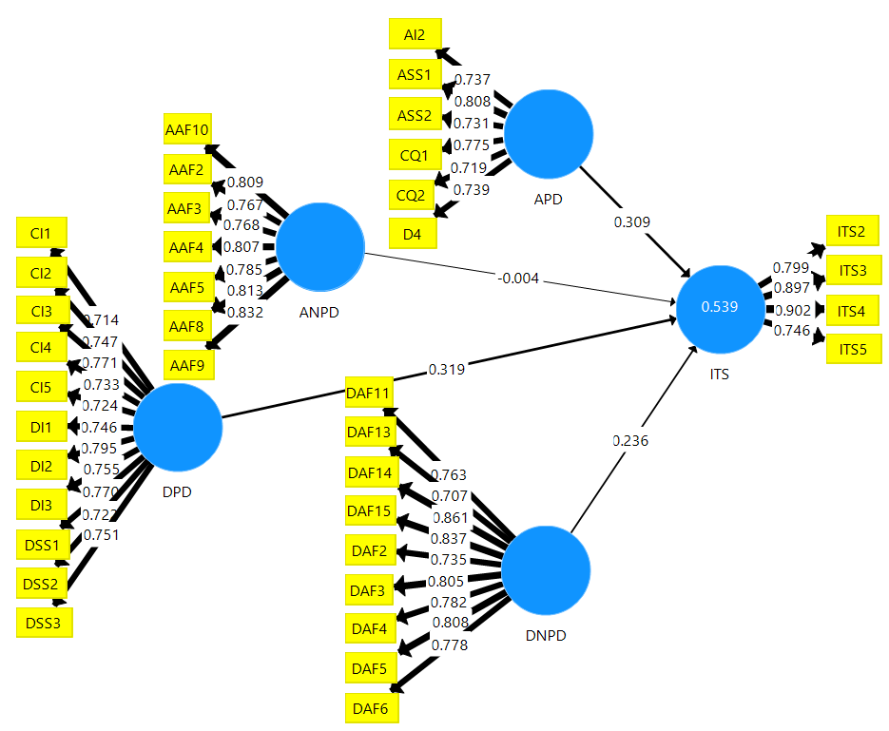
Figure 5.1: Construct explanatory power
Source: Researcher, 2022

Powerfulness of Direct Path Coefﬁcients and P-values
Figure 4.10 compares the direct path coefficient for the hypothesized relationships toward international tourists’ satisfaction. The departure processing domain is the first construct in comparing the direct path coefficient of the hypothesized relationships with international tourist satisfaction. From the analysis, DPD had β – value = 0.319 and P-Value = 0.000 in the relationship with international tourists’ satisfaction. The indication is that the services offered in the airport departure processing domain are significant as they directly affect tourists’ satisfaction. However, during departure, a tourist already has service experience attained in the arrival processing domain. Therefore, a tourist will compare the services and conclude overall airport service performance at the airport terminal for their overall satisfaction. This is the point to correct service mistakes during arrival processing service performance. Tourists’ re-visitation and airport reuse are positive results that the service offered met tourist expectations.
The second powerful predictor was the Arrival Processing Domain with β – Value = 0.309 and P-Value = 0.000 of the relationship with international tourists’ satisfaction compared to other constructs. The findings signify the essentiality of services at the airport Arrival Processing Domains (APD) being the first touch point a traveller interacts with within the country. Furthermore, it is the point where customer service judgment begins. Therefore, the implication is that tourists can create a positive or negative country image just from the first domain in the APD when a tourist touches the country for the first time. Thus, service providers must understand this as they are the country's mirror to tourists.

The third construct to compare the direct path coefficient of the hypothesized relationships with international tourists’ satisfaction was the airport Departure No-Processing Domain (DNPD) with β–Value of 0.236 and P-Value = 0.000. The implication is that DNPD also affects tourists’ satisfaction directly compared to the other two constructs. The Impact of DNPD on international tourists’ satisfaction is direct and significant, as observed. However, services offered in this domain are value additional since it is unrestricted. After completing the mandatory activities at the departure processing domain, a tourist requires a conducive environment to engage in other discretionary activities. Therefore, it is significant for a tourist to have a positive image regarding the services offered at DNPD to create repeat visitors.

The arrival non-processing domain (ANPD) is the fourth construct in comparing the direct path coefficients of the hypothesized relationship with international tourists’ satisfaction. Focusing on the analysis, the ANPD had β – Value = -0.004 and P-Value = 0.882 directly related to international tourist satisfaction. The implication is that no direct relationship exists between ANPD and international tourists’ satisfaction. Rather it indicates the presence of full mediation. After arrival, most tourists are tired and busy looking for transport or being picked up by already booked transport to the hotel for resting and relaxing. With that fact, most tourists do not concentrate on the service offered in this domain, though service quality should be managed appropriately to avoid unnecessary negative satisfaction ratings.

CHAPTER SIX

SUMMARY OF FINDINGS, CONCLUSION, AND RECOMMENDATIONS

Chapter Overview
This chapter summarises findings, conclusions, and recommendations based on the study’s objectives. To address these objectives, the final model shows direct relationships between the arrival processing domain (APD), arrival Non-processing domains (ANPD), departure processing domain (DPD), departure Non-processing domains (DNPD), and international tourists satisfaction (ITS).

Summary of the Findings

The Direct Relationship Between Airport APD and International Tourists’ Satisfaction
The intention of the first specific objective of this study was to evaluate the relationship between arrival processing domains and international tourists’ satisfaction. Findings revealed a positive path coefficient and the relationship was statistically significant (P-Value<0.05). The results imply that an increase in one standard deviation in the arrival processing domain translated into an increase in international tourists’ satisfaction, and it indicates that the relationship exists in real life. Similarly, the arrival processing domain as a sole construct influences international tourists’ satisfaction by 40.2% (refer Appendix 4A).

The Direct Relationship Between Airport DPD and International Tourists’ Satisfaction
The second specific objective intended to evaluate the relationship between the
departure processing domain and international tourists’ satisfaction. The findings exposed a positive relationship because of the positive path coefficient, which was found to be statistically significant (P-Value<0.05). The implication is that an increase in one standard deviation of the departure processing domain translates into an increase in international tourists’ satisfaction rate. Therefore, it confirms that the relationship exists in real life. In line with that, the influential power of the departure processing domain toward international tourists’ satisfaction is 44.6%, as observed in Appendix 4B.

The Indirect Relationship Between Airport ANPD and International Tourists’ Satisfaction
The third specific objective of the study evaluated the relationship between the arrival non-processing domain and international tourists’ satisfaction. The findings discovered a negative path coefficient, which was statistically insignificant (P-Value of 0.957). The finding implies that an increase in one standard deviation translates into a decrease in international tourists’ satisfaction rate. Furthermore, the findings indicated that a direct relationship does not exist in real life. However, the indirect relationship can further be tested by another study with more than 401 respondents because the results indicate the presence of full mediation.

The Direct Relationship Between Airport DNPD and International Tourists’ Satisfaction
The fourth specific research objective of the study evaluated the direct relationship between departure non-processing domain and international tourists’ satisfaction. The findings revealed that the departure non-processing domain has a positive relationship because the path coefficient was positive and statistically significant (P-Value<0.05). This means that an increase in one standard deviation of departure non-processing domain translates into an increase in international tourists’ satisfaction rate. This confirms that the relationship exists in real life. The influence of the departure non-processing domain on international tourists’ satisfaction is 32.5%, as shown in appendix 4D.

Implications of the Study Findings

The Direct Relationship Between Airport APD and International Tourists’ Satisfaction
The first specific objective of this study was to evaluate the direct relationship between airport arrival processing domain and international tourists’ satisfaction. The results from this study indicated that the arrival processing domain has a positive and significant relationship with international tourists’ satisfaction. The findings imply that tourists are sensitive to the critical factors/indicators in all the arrival processing domains. The arrival processing domain is one of the first core parts of tourists’ perception of the airport terminal as, for the first time, they get in touch with the restricted service before reaching the destination. On the other hand, this is the chain where tourist interaction with services available and staff is more significant than unrestricted areas to keep their stay happier. Equally, Antwi et al. (2020) further explained that interaction is more important at the airport terminal and in other service industries. Therefore, airport management and service providers need to understand the impact of interaction to meet tourists’ expectations. This is also supported by the expectancy disconfirmation theory that customers usually have pre-service expectations before perceived service performance. Hence, satisfaction occurs by comparing their initial expectation and real performance through disconfirmation (Patterson et al., 1997). Therefore, indicators in the arrival processing domain should be treated as the main factors for assessing international tourists’ satisfaction at the airport terminal due to its positive direct relationship with international tourists’ satisfaction.

The Direct Relationship Between Airport DPD and International Tourists’ Satisfaction
The second specific objective of the study was to evaluate the relationship between the departure processing domain and international tourists’ satisfaction. The relationship was found to be direct and significant, implying that tourists are directly affected by the indicators in the departure processing domains to meet their satisfaction and make them repeat visitors. The indicators are, therefore, the major factors that directly influence international tourists’ satisfaction at the airport terminal. The airport departure processing domain service provider must constantly and sustainably provide standard services that meet or exceed tourists’ expectations. Similarly, this is where tourists’ interaction appears to be essential for tourists’ satisfaction as they are engaging in restricted activities for the last time after arriving in the country. Good interaction and quality service provision will create a positive image leading to tourists recommending to others to visit Tanzania as the best tourism destination.

The Indirect Relationship Between Airport ANPD and International Tourists’ Satisfaction
The third specific objective of the study was to evaluate the relationship between the arrival non-processing domain and international tourists’ satisfaction. The relationship was statistically insignificant (P-Value=0.957), implying the existence of a negative influence of the arrival non-processing domain toward international tourists’ satisfaction. The results indicate the existence of full mediation. Therefore, indicators in the ANPD should be treated as a secondary factor without being underserviced or quality, as their presence indirectly supports other constructs to influence international tourists’ satisfaction. Proper service monitoring in this domain creates a positive airport image due to the psychological satisfaction effect. This finding is missing in the empirical and theoretical literature; hence great empirical and knowledge contribution to this study.

The Direct Relationship Between Airport DNPD and Tourists’ Satisfaction
The fourth specific objective of the study was to evaluate the relationship between departure non-processing domain toward international tourists’ satisfaction. The relationship was statistically significant, implying that indicators in the constructs directly influence international tourists’ satisfaction. These should also be treated as major factors due to their direct influence on international tourists’ satisfaction. However, the domain comprises additional value indicators of which tourists are engaged in unrestricted activities. Regardless, service providers in these domains must constantly and sustainably provide quality services to meet tourists’ expectations by ensuring that each indicator is properly serviced when a tourist demands. This is because the expectation disconfirmation theory used in this study clarifies that customers normally keep the anticipation of service performance being created from prior experience with the service, word of mouth, communication in the media, and so forth. Thus, when perceived service performance confirms what was anticipated in the customer’s mind or exceeded, it results in satisfaction. Vice versa, that will result in dissatisfaction (Oliver, 1980).

Theoretical Knowledge Implication of the Study Findings
Apart from the PCAM indicators, this study added other indicators on Check-in, arrival security screening, Disembarkation, arrival airport facilities, and departure airport facilities domains for measuring passengers’ airport experience (Table 6.1). This study used only two constructs from the theory: perceived service performance and satisfaction. The perceived service performance was fragmented into four constructs named arrival processing domain (APD), departure processing domain (DPD), arrival non-processing domain (ANPD), and departure non-processing domain (DNPD) to assess international tourists’ satisfaction with a specific domain based on restricted and unrestricted activities during arrival and departure time. Findings revealed that APD, DPD, and DNPD had a direct and significant relationship with international tourists’ satisfaction. In contrast, the arrival non-processing domain (ANPD) had a negative path coefficient and insignificant relationship toward international tourists' Satisfaction. The indirect relationship between ANPD and international tourist satisfaction (ITS) was overlooked in the literature. The theory has been recommended as the most used theory for customer satisfaction. However, it misses one domain and service performance indicators for assessing customer experience at the airport terminal. Hence, the study borrowed indicators from the PCAM to be used in theory as perceived service performance indicators in each fragmented service performance construct. Most of the borrowed service performance indicators were statistically significant with recommended P-Values and indicator loading, while some were dropped because they did not meet the recommended indicator loading. For effective use of EDT, a researcher borrowed indicators from PCAM.

Furthermore, other indicators were added to the literature and were statistically significant. Likewise, one domain (arrival security screening) in the arrival processing domain was added to cover all the domains available at international airports in Tanzania. The implication after statistical/scientific examination is that the indicators can be added or omitted depending on the area where the study is conducted. Table 6.1 shows the added indicators in each domain.
Table 6.1: List of added indicators in the domains
S/N | Arrival Processing Domains | Code | IR | Remarks
 | Disembarkation (D)
 | There is good interaction between staff and passengers at the airport | D4 | 0.739 | Added
 | Arrival Immigration (AI)
 | Immigration staff are helpful and courtesy | AI2 | 0.737 | PCAM
 | Arrival security screening (ASS)
 | Security staff are helpful and courtesy | ASS1 | 0.808 | added
 | The screening exercise on arrival was properly conducted | ASS2 | 0.731 | Added
 | Customs and Quarantine (CQ)
 | Custom and quarantine staff are helpful and courtesy | CQ1 | 0.775 | PCAM
 | Waiting time and queue at custom clearance is satisfactory | CQ2 | 0.719 | PCAM
 | Arrival non-processing domain
 | Arrival Airport Facilities (AAF)
 | The airports maintain good sanitary condition of restrooms | AAF2 | 0.767 | PCAM
 | The airport has a clear information desk, display, and signs | AAF3 | 0.768 | PCAM
 | Baggage trolleys are in good condition | AAF4 | 0.807 | Added
 | Baggage trolleys are conveniently located | AAF5 | 0.785 | Added
 | The terminal floor, facilities, and public areas are well cleaned | AAF8 | 0.813 | Added
 | The terminal physical environment is good | AAF9 | 0.832 | Added
 | The airport terminal, in general, is comfortable | AAF10 | 0.809 | Added
 | Departure Processing Domains
 | Check-in (CI)
 | Average waiting time and queue during check-in were satisfactory | CI1 | 0.714 | PCAM
 | There is an efficient and easy check-in process at the airport | CI2 | 0.747 | PCAM
 | Check-in staffs are helpful and courtesy | CI3 | 0.771 | PCAM
 | Staff problem or complaint-solving at check-in is good | CI4 | 0.733 | Added
 | Staff grooming and appearance are good | CI5 | 0.724 | Added
 | Departure Immigration (DI)
 | Waiting time and queue at immigration is satisfactory | DI1 | 0.746 | PCAM
 | Immigration staff are helpful and courtesy | DI2 | 0.795 | PCAM
 | Waiting time and queue on the visa are satisfactory | DI3 | 0.755 | PCAM
 | Departure Security Screening (DSS)
 | Security staff are helpful and courtesy | DSS1 | 0.770 | PCAM
 | I felt secure after a thorough screening at the security point | DSS2 | 0.722 | PCAM
 | Waiting time and queue at security screening are satisfactory | DSS3 | 0.751 | PCAM
 | Departure non-processing domain
 | Departure Airport Facilities (DAF)
 | The airport maintains good sanitary condition of restrooms | DAF2 | 0.735 | PCAM
 | The airport waiting lounge is attractive and comfortable | DAF3 | 0.805 | PCAM
 | The seats at the airport are adequate and comfortable | DAF4 | 0.782 | PCAM
 | The airport has a clear information desk, display, and signs | DAF5 | 0.808 | PCAM
 | Baggage trolleys are in good condition and conveniently located | DAF6 | 0.778 | Added
 | The terminal floor, facilities, and public areas are well cleaned | DAF11 | 0.763 | Added
 | The airport has good televisions and entertainments facilities | DAF13 | 0.707 | Added
 | The overall terminal comfort is satisfactory | DAF14 | 0.861 | Added
 | The terminal physical environment is good | DAF15 | 0.837 | Added
 | International Tourists Satisfaction (ITS)
 | The good services at the airport make me plan another trip to Tanzania | ITS2 | 0.799 | Added
 | Employees at the airport terminal are customer focused | ITS3 | 0.897 | Added
 | The overall service performance at the airport was satisfactory | ITS4 | 0.902 | Added
 | I will recommend others in my country to visit Tanzania | ITS5 | 0.746 | Added

Since no developed model shows the relationships between airport service performance (processing and non-processing domain) with international tourists’ satisfaction under the use of EDT, then this study suggests that the developed model in the context of Tanzania be used as a reference in the relationship between airport service performance and international tourists’ satisfaction. Based on this theory, where expectation, perceived performance, and disconfirmation are key drivers of satisfaction, then APD, ANPD, DPD, and DNPD cover tourists' perceived service performance (McKnight et al., 2012). Satisfaction in the theory is covered by international tourists’ satisfaction in the final model, as shown in Figure 6.1.

In their study, Usman et al. (2021) recommended that there is still a theoretical and empirical gap in airport service performance. The study invited researchers to integrate EDT and the SCAM for better service quality, passenger satisfaction, and profitability at the airport terminal. Therefore, constructs indicators for this study were taken as perceived service performance by the international tourists at the airport terminal. Their satisfaction was measured through a five-Likert scale.

EDT: Perceived Service Performance (PP)/(E≤PP) = Satisfaction
Arrival Non-Processing Domains (ANPD)
Arrival Processing Domains (APD)
Departure Processing Domains (DPD)

Departure
Non-Processing Domains (DNPD)
International Tourists Satisfaction (ITS)
Perceived Service Performance
Independent construct Dependent Construct
H₁ (+)
H₂ (+)
H₃ (+)
H₄ (+)

Figure 6.1: Final Model
Source: Tested and Validated Model, 2022.
Key: Supported Hypothesis existing in literature and PCAM
Theoretical and knowledge contribution (Do not exist in the literature)

Justification of Theoretical Implication of the Study Findings
The final conceptual model for this study used four constructs adopted from PCAM as a perceived service performance in theory. Each construct had a list of indicators used to measure tourists’ satisfaction at the airport terminal. Tourists typically build expectations by getting information from different sources about the standard service offered at the airport processing (APD, DPD) and non-processing domains (ANPD, DNPD) domains. The expectations become the standard against which the service performance is judged. Likewise, a tourist perceives the service offered during service consumption, resulting in positive or negative tourist satisfaction. Therefore, satisfaction comes when a tourist has judged the perceived services offered at the airport terminal. This study has increased other airport service performance indicators from the literature, which have significantly been confirmed to have a positive and significant relationship with the constructs in this study. Likewise, arrival security screening in the arrival processing domain, which was missing in the PCAM, has also been added in this study. The relationship confirmation was done through the execution of the SmartPLS algorithm and bootstrapping, revealing both significant and insignificant relationships. Table 6.1 shows the number of added indicators. The indicators are what tourists perceived after visitation resulting in satisfaction or dissatisfaction. Figure 6.2A shows the actual passenger-cantered airport model with the number of indicators as per Wiredja et al. (2019), while Figure 6.2B shows the validated PCAM with an increased number of indicators as indicated in red and an increase of arrival security screening which was missing in the PCAM.
Figure 6.2A: Actual passenger centred airport model | 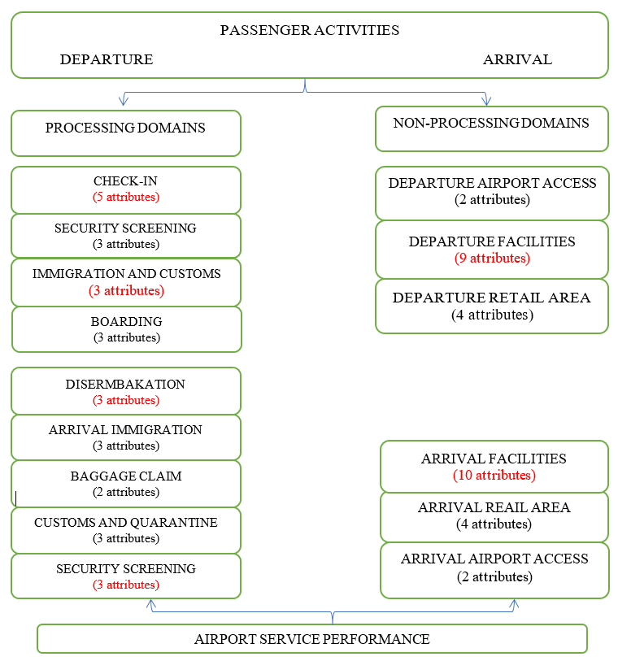  Figure 6.3B: Validated passenger centred airport model

Variations of Overall Explanatory Power
The SmartPLS algorithm was executed to confirm the insignificance of the ANPD constructs in the modified model. The findings revealed that the overall explanatory power for the final conceptual model with all four constructs (Figure 5.1) and the model with the omission of insignificance relationship (Figure 6.2) remained the same at 53.9% without being affected. The implication is that insignificant relationships do not have an explanatory power effect on international tourists’ satisfaction.
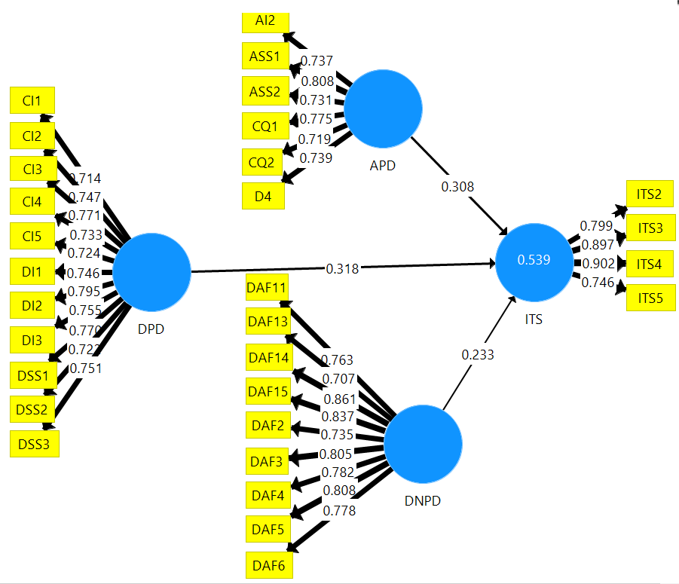
Figure 6.4: The change of the overall explanatory power – construct dropout
Source: Survey Results, 2022

Similarly, when more other construct was dropped for further justification, results exposed changes in the overall explanatory power. Appendix 4E and Appendix 4F show a decrease in the overall explanatory power of the conceptual model after dropping the constructs. The implication is that explanatory power decreases by removing indicators and constructs.

P-Value and Path Coefficient Variation for the Construct Relationship
After dropping ANPD and DNPD (Appendix 4E), APD and ANPD (Appendix 4F), the effect after running the SmartPLS algorithm in the Smart PLS was not only the variation of the P-Value slowing down but also the percentage of path coefficient getting increased. However, after dropping the insignificant relationship, the path coefficient was not affected, implying zero effect of ANPD on international tourists’ satisfaction. The implication is the path coefficient increases with the removal of constructs and indicators.

The Comparison of the Proposed Model and the Modified Models
Other experts can use the proposed conceptual model of this study in similar or related fields to solve problems and assess challenges/gaps in airport service performance. The proposed conceptual model will be used by airport authorities, operators, and other air transport stakeholders to evaluate their performance semi-annually or annually. All the used indicators are meant to improve service performance at the airport terminal. The model provides a ground solution for other experts interested in tourist or passenger satisfaction research at the airport terminal. The proposed conceptual model can also suggest solutions to all other customer satisfaction problems at each airport domain.

On the other hand, the modified model answers that not all airport domains directly correlate with international tourists’ satisfaction. Instead, some domains (ANPD) have insignificant relationships; hence, they indirectly support other domains (APD, DPD, DNPD) to influence international tourists’ satisfaction strongly. Furthermore, the modified model, which assesses all the domains, has indicated the full mediation for hypothesized direct relationships that were not statistically significant. Regardless of the identified insignificant relationship, once the processing and non-processing domain or each sub-domain is solely assessed for its relationship with tourists’ satisfaction, the direct relationship can be seen as positive and significant.

The Repercussion of PCAM and EDT on the Study Findings
The objectives were driven by the relationship between the main factors influencing international tourists’ satisfaction from airport processing and non-processing domains. Referring to the construct in the conceptual model with the main indicators from PCAM and Literature review, it is concluded that the negative path coefficient and insignificant relationship between arrival non-processing domain (ANPD) and international tourists’ satisfaction (ITS) were contributed by PCAM and EDT. This is because the study dealt with perceived service performance and satisfaction from the EDT and constructs with indicators from PCAM to meet the study objectives. Thus, perceived service performance in the EDT was covered by four constructs (independent variables): arrival processing domain, Arrival non-processing domain, departure processing domain, and departure non-processing domain, and overall airport service performance at the airport terminal. For the construct with the direct and significant relationship, the theory insists the airport management provide endless quality service to meet and even exceed customer expectations without compromising services for the construct with the indirect relationship as it supports other domains to meet international tourists’ expectations.

Empirical Implications of the Study Findings
Focusing on the previous empirical studies mostly conducted in developed countries, also based on this study, it is concluded that part of the existing empirical gap has been filled. This study assessed airport service performance with international tourists’ satisfaction for both processing domains (arrival processing and departure processing domains) and non-processing domains (arrival non-processing domain and departure non-processing domains). The domains assessment is based on the main factors/indicators influencing international tourists’ satisfaction as per PCAM proposed by Wiredja et al. (2019) and other indicators added from existing empirical literature which were missing from the model; hence the indicators are proposed to be used for assessing tourists experience at the airport terminal.

Furthermore, this study has successfully realized the final conceptual model showing significant and insignificant relationships. The insignificant relationships between the arrival non-processing domain with international Tourists' satisfaction have appropriately been grasped where the existing empirical and theoretical literature was missing. Wiredja et al. (2019) added more indicators to improve the PCAM. This study used PLS-SEM with the help of SmartPLS 3 software for data analysis. The existing empirical literature used SmartPLS 3 software insufficiently, like most studies overlooked running the importance-performance analysis for both indicators and constructs.

Practical Implications of the Study Findings
The final model practically has repercussions in terms of service performance at the airport terminal. Regarding relationships between processing and non-processing domains and international tourists’ satisfaction, the study’s final model suggests that all constructs with direct and significant relationships be used as major factors for assessing international tourists’ satisfaction at the airport terminal. Conversely, the indicators for the construct with insignificant relationship should be taken as secondary factors which support other constructs to influence international tourists’ satisfaction without undermining its quality. In case of poor airport service performance, the domains to immediately start assessment are those with direct and significant relationships followed by insignificant relationships. The airport authority, management, and operators should know the significance and position of insignificant relationships in assessing international tourists’ satisfaction at the airport terminal. The insignificant relationship of the arrival non-processing domain with international tourists’ satisfaction can be one of the predicted reasons most researchers ignored its involvement in their study. Likewise, the proposed model will assist auditors in addressing critical service performance attributes having a statistically significant and direct relationship with international tourists’ satisfaction without compromising service quality at the airport arrival non-processing domain, which supports other domains to meet tourists’ expectations.

Policy Implications of the Study Findings
The study’s final model has implications for tourism and transport policy regarding the main factors influencing international tourists’ satisfaction at the airport terminal. Likewise, the study is vital for policy sustainability and improving airport service performance to retain repeat visitors for the country’s economic growth. Jointly, with the airport authority, the tourism sector will benefit by improving tourism performance since policymakers will use the findings to amend policies and regulations to fortify service performance at the airport terminal. Through police amendment, air transport stakeholders, including airlines, might benefit by getting more travellers to their business and seeing the significance of employing customer-oriented staff. The airport shops and other businesses are expected to increase sales by improving their airport service performance through selling value-for-money products.

Conclusions

The Direct Relationship Between Airport APD and International Tourists’ Satisfaction
The direct relationship between the arrival processing domain and international tourists’ satisfaction was confirmed to be statistically significant with a positive path coefficient. It is concluded that service indicators at the airport arrival processing domains (arrival immigration, baggage claim, arrival security screening, custom, and quarantine) directly influence international tourist satisfaction. Service providers are earnestly invited to continue offering extraordinary service and good tourist interaction to meet and surpass international tourists’ expectations. However, the impact of baggage claims on international tourists’ satisfaction was very weak. This was confirmed by its service indicators being dropped because the indicators loading was below the recommended value by Hair et al. (2018).

The Direct Relationship Between Airport DPD and International Tourists’ Satisfaction
The direct relationship between the departure processing domain and international tourist satisfaction had a positive path coefficient and was statistically significant. Therefore, it is concluded that service indicators in the departure processing domain (check-in, departure immigration, and departure security screening) directly influence international tourists’ satisfaction. Similarly, airport service providers in this domain should sincerely be dedicated to offering quality service as the tourist gets the last impression of the country. Thus, excellent service performance implants a good image to the tourists departing to their mother country and makes them promoters of our country as a tourist destination.

The Indirect Relationship Between Airport ANPD and International Tourists’ Satisfaction
The direct relationship between arrival non-processing domain (ANPD) and international tourists’ satisfaction had a negative path coefficient and was statistically insignificant. It is concluded that service indicators in each arrival non-processing domain (arrival airport facilities, arrival retain areas, and arrival airport accessibility) indirectly influence international tourists’ satisfaction. That means ANPD can affect international tourists’ satisfaction through full mediation, which needs to be tested. Regardless of whether ANPD indirectly influences international tourists’ satisfaction, the two domains, airport arrival accessibility, and arrival retail, were dropped because their indicator reliability was below the recommended value by Hair et al. (2018). The implication is that the indicators are important but less significant for influencing international tourists’ satisfaction. During arrival, most tourists do not concentrate on the retail or transport services because the transport is mostly arranged before arrival.

The Direct Relationship Between Airport DNPD and International Tourists’ Satisfaction
The direct relationship between the departure non-processing domain (DNPD) and international tourists’ satisfaction had a positive path coefficient and was confirmed to be statistically significant. This study concludes that airport service indicators in the departure non-processing domain (departure airport facilities, departure retail area, and departure airport accessibility) directly influence international tourists’ satisfaction. Tourists consume more time in this domain than time spent in the departure processing domain. That means, after check-in, tourists engage in different unrestricted activities like browsing, taking food and beverages, and buying different items before boarding. However, the findings showed that the value for money, variety of food and beverages, and retail shops had low satisfaction rates. Likewise, departure airport accessibility and departure airport retail areas had a weak impact on international tourists’ satisfaction because the indicator reliability was below the recommended value by Hair et al. (2019). Thus, all offered services in this domain have to be monitored to keep tourists satisfied and indirectly convince them to recommend visits to the country.

Perception of the Airport Authority, Airport Management, and Other Stakeholders
The general objective of this study was to examine the relationship between airport service performance and international tourists’ satisfaction. However, referring to some of the previous studies in the literature indicates the perception of researchers and other aviation stakeholders that airport service performance (APD, DPD, ANPD, and DNPD) have direct and significant relations with passenger or traveller satisfaction. This study revealed differently, that the relationship between airport service performance and international tourists’ satisfaction was 75% significant because the relationship for the three constructs was positively and directly significant. Likewise, 25% was insignificant because the relationship for one construct was not directly significant. Since there were four constructs, the ratio of significant and insignificant was 3:1. Therefore, the perception was correct by 75% and incorrect by 25%. The 25% is another contribution of this study after confirming statistically through Smart PLS 3 software.

Limitations and Delimitations of the Study
One of the problems faced during the research undertaking was the respondents’ readiness during both piloting and actual data collection at all three airport terminals. This is because, among other things, tourists are busy waiting and listening for boarding calls and performing other non-discretionary activities. Some tourists were unwilling to fill in the questionnaire for no reason. These problems were mitigated by pleasing and requesting their attention to fill out the provided questionnaire keenly. In addition, getting all filled questionnaires from the expected respondents was challenging because of the reasons explained. The problem was solved by rechecking the questionnaire after collecting from the respondent and requesting them to accomplish the missing items though not all were filled. Likewise, few respondents thought the answers provided could be used against them regardless of the short introduction at the top of the questionnaire, in which a researcher assured them that their answers would be treated as confidential and for academic purposes. The problem was mitigated by showing them the research clearance letter from the Open University of Tanzania.

Furthermore, another problem faced during this study was getting the expected sample size of 420. The researcher collected only 401 total sample sizes, about 95.5% of the total sample for departing international tourists. To ensure that data analysis provides high-quality findings, the researcher used the planned PLS-SEM with the help of SmartPLS 3 software, which helped to avoid poor quality problems for the findings during data analysis. This is because SmartPLS 3 software uses the recommended sample as per the rule of thumb compared with other SEM methods that are co-variance based.

Recommendations of the Study

Recommendations to the Government
The findings show the direct impact of airport service performance on international
tourists' satisfaction, except for the arrival non-processing domain. Regardless, the average for overall international tourists’ satisfaction reached 79.4%. The government must emphasize the sustainable provision of quality service performance at the airport terminal to attract new tourists, create repeat visitors and make tourist promoters of Tanzania the best tourist destination country. Furthermore, the government should recommend the cooperation of the “golden triangle,” that is, airlines, airport authorities, and the tourism industry for them to share tourist satisfaction strategies to meet government forecasted objectives of attracting more international tourists and enhancing the promotion of domestic tourism. The triangle should work together as an atom with extreme commitment to meet international tourists’ expectations. Through created strategies and commitment, the airport serviced international tourists will be our country’s ambassadors and become repeat visitors.

In addition, the airport contains workers from different fields like personnel working at immigration, custom, quarantine, check-in, security, and other service providers in the non-processing domains like shops and restaurants. All these personnel provide service to similar tourists, thus requiring unvarying standard customer service. Therefore, training these personnel on handling customers accordingly is inevitable and should be a must for whoever is working at the airport terminal. If the government does not recognize and emphasize this, then one domain may distort the excellent service offered by another. The impressions of international tourists to the respective country are frequently affected by their first and last service encounters at the gateway airport. Thus, it should be noted that quality service performance at the airport is not an excuse for tourists but rather a strategic priority and sensitive issue to deal with and implement accordingly.

Today, most airports in the world have been designed to accommodate tourist attractions as an additional value to satisfy tourists and make them spend more time at the airport for economic purposes. Therefore, it is also recommended that, during the construction of new airports, expansion, and renovation of the existing ones, it's significant to consider the addition of those factors.

Recommendations to the Airport Authority and Airport Management
From the findings and the final model of this study, it is suggested that the airport authority and airport operators/management should make sure that regardless of the arrival non-processing domain being insignificant toward international tourists’ satisfaction, its service should still not be compromised as it may affect the overall international tourists’ satisfaction. Consequently, service quality should sustainably be retained and improved to exceed international tourists’ expectations. This can be done by seriously assessing and auditing each indicator separately and frequently.

Additionally, improved quality service performance at the arrival non-processing domain, being an unrestricted area, may let the tourists ignore other inconveniences in the processing domains. In line with that, frequent customer service training should be emphasized to prevent employees from performing routine tasks rather than providing customer-focused service.

Recommendations to Policymakers
Tourism and transport policymakers should strongly see the significance of re-uniting the “golden triangle” because airlines bring international tourists to the country. Airport operators undergo all the procedures to ensure that international tourists pass through the airport satisfactorily by meeting their expectations. The tourism industry ensures that international tourists reach the specific tourists’ destinations of their desire and are highly satisfied. All these sections need to have quality service homogeneity to satisfy tourists. Focusing on this study, policymakers should consider the airport design and ongoing airport technological improvement to increase international tourists' satisfaction in the country.

Generally, policymakers should consider airport processing and non-processing domains because results revealed that arrival processing domains, departure processing domains, and departure non-processing domains have higher importance and higher performance in influencing international tourists’ satisfaction. Arrival non-processing domains have low importance but higher performance per the study’s final model. However, services at the ANPD should not be disregarded.

Areas for Further Research
Focusing on this study's objectives and findings, which did not include the transit domain, this study recommends future research to involve transit domains (transit screening, transit facilities, and retail transit area) in the analysis of international tourists’ satisfaction. This will help to improve the overall explanatory power of the proposed conceptual model. Figure 6. 7 is the recommended conceptual model with transit domains.
Arrival Non-Processing Domains (ANPD)
Services at the Arrival Processing Domains *(APD)
Services at the Departure Processing Domains (DPD)
Departure Non-Processing Domains (DNPD)
Services at the Transit Processing Domains (TPD)
Services at the Transit Non-Processing Domains (TNPD)
International Tourists Satisfaction (ITS)

Figure 6.5: Recommended conceptual model with transit domains
Source: Recommended Conceptual Model, 2021
Key:
Existing Literature
Call for Further Research
Theoretical and knowledge Contribution

More than that, the future study can directly assess the relationship of each domain solely, that is, arrival processing domain, departure processing domain, arrival non-processing domain, and departure non-processing domain with international tourists’ satisfaction. Likewise, this study was also conducted at three international airports in Tanzania (Julius Nyerere International Airport, Kilimanjaro International Airport, and Abeid Aman Karume International Airport) and Mwanza Airport for the pilot study. Therefore, further studies should be conducted to more other local airports to improve local airport service performance. The study used only 401 respondents from the three mentioned international airports, all of which were departing international tourists. Therefore, further research can increase the sample size for more international departing tourists.

Equally, the study was based on applying the reflective model with constructs persuading the indicators. Further study can apply a formative model in which the indicator induces the specified constructs. Lastly, the data of this study were limited to departing tourists at international airports in Tanzania. Therefore, the model in this study is recommended to be tested in international airports in different countries to see the relevance of its applicability and if it can be generalized for international tourists’ satisfaction at the airport terminal.

REFERENCES
Abdullahi, M., Adesogan A., and Alhaji, A. (2018). The economic and social benefits of air transportation to tourism in Nigeria. International Journal of Social Sciences, 4 (1), 77-86.
Adeniran, A., and Fadare, S. (2018). Relationship between passenger satisfaction and service quality in Murtala Muhammed International Airport, Lagos, Nigeria. International Journal of Research in Industrial Engineering, 7 (3), 349-369.
Adeola, M. M., Adebiyi, S. O. (2014). Service quality perceived value and customer satisfaction as determinants of Airline choice in Nigeria. International Journal of Social and Humanistic Science, 20, 66-80.
Adetayo,A.O., Mobolaji,S., and Feyisola,A.O. (2020). Factor analysis of passenger satisfaction at Murtala Muhammed Airport (MMA2). Aeronautics and Aerospace Open Access Journal, 4(1), 13-24.
Aigbavboa, C., and Thwaha, W. (2013). A theoretical framework of users satisfaction/dissatisfaction theories and models. 2nd International Conference on Arts, Behavioral Sciences and Economics Issue, Pattaya (Thailand). University of Johannesburg, 48-53pp.
Akaranga, S. I., and Makau, B.K. (2016). Ethical consideration and their research application: a case of the University of Nairobi. Journal of Educational Policy and Entrepreneurial Research, 3 (12), 1-9.
Aliyu, A. A. (2015). Ontology, epistemology and axiology in quantitative and qualitative research: elucidation of the research philosophical misconception. Research Gate Journal, 2 (1), 1–26.
Aliyu, A.A., Bello, M.U., Kasim, R., and Martin, D. (2014). Positivist and non-positivist paradigm in social science research: conflicting paradigms or perfect partner. Journal of Management and Sustainability, 4 (3), 79-95.
Alotaibi M.M, (2015). Evaluation of "AIRQUAL" scale for measuring airline service quality and its effect on customer satisfaction and loyalty (PhD Thesis, Cranfield University, United Kingdom). Retrieved from chrome-extension://efaidnbmnnnibpcajpcglclefindmkaj/https://dspace.lib.cranfield.ac.uk/bitstream/handle/1826/9651/Alotaibi_M_M_2015.pdf?sequence=1&isAllowed=y.
Amara, O. (2020). Top Ten Best International Airports in Africa. Retrieved from Answers Africa: https://answersafrica.com/top-10-best-african-international-airports.html
Anderson, R. (1973). Consumer perception of service quality. Journal of Marketing, 10, 66-86.
Anderson, R. (2003). Consumers Dissatisfaction: The effect of disconfirmation expectancy on perceived product performance. Journal of Marketing Research. 10, 38-44. http://dx.doi.org/10.2307/3149407
Anderson, W. E., and Sullivan, W.M. (1993). The Antecedents and Consequences of Customer Satisfaction for Firms. Marketing Science, 12(2), 125-143.
Ansari Z, A., and Agarwah, J. (2020). A critical analysis of the passenger's satisfaction from the service quality of the King Abdulaziz International Airport Jeddah, Saudi Arabia. International Journal of Economics, Commerce and Management, 3(8), 213-228.
Anton, M.A., Usman, A., Azis, Y., and Harsanto,B. (2021). Airport service quality dimension and measurement: a systematic literature review and future research agenda. International Journal of Quality and Reliability Management, 1-21. 10.1108/IJQRM-07-2021-0198
Antony, D., and Hinkley, D. (1997). Bootstrap Method and Their Application. Mathematics and statistics Journal 42(2), 212-217
Antwi, C. O., Fan, C. J., Ihnatushchenko, N., Aboagye, M. O., and Hangyu, X. (2020). Does the nature of airport terminal service activities matter? processing and non-processing service quality, passenger affective image and satisfaction. Journal of Air Transport Management, 89 (C), 1-15.
Atalick, O. (2009). Voice of Turkish Customer: Importance of expectations and level of satisfaction at Airport Facilities. Review European Studies, 1 (1), 61-67.
Augustini, M. Y. D. H. (2018). Survey by knocking the door and response rate enhancement technique in international business research. Problems and Perspectives in Management, 16 (2), 155-163. 10.21511/ppm.16(2).2018.14
Aydoğan, S. (2021). Non-Generic Measurement Structure Of Airport Service. Süleyman Demirel Üniversitesi İktisadi ve İdari Bilimler Fakültesi Dergisi, 26 (2), 97-117.
Ayodeji, Y,. Husam, R and Özgit, H,. (2023). Achieving sustainable customer loyalty in airports: The role of waiting time satisfaction and self-service technologies. Technology in Society, Elsevier, 72(5). doi:10.1016/j.techsoc.2022.102106.
Baker, D. M. A. (2013). Service Quality and Customer Satisfaction in the Airline Industry: A Comparison between Legacy Airlines and Low-Cost Airlines. American Journal of Tourism Research, 2(1), 67–77.
Bakri, A. B. T., and Elkhani, N. (2011). Review on "expectance disconfirmation theory" (EDT) model in B2C E-commerce. Journal of Information Systems Research and Innovation in, 95-102.
Baranskaite E. (2019). Transformation of tourism: Innovation in the world's busiest airport. ISMC and ICLTIBM (pp. 1-12). Istanbul, Turkey: Future Academy.
Baron, R. M., and Kenny, D. A. (1986). The moderator-mediator variable distinction in social psychological Research: Conceptual, Strategic, and Statistical Considerations. Annals of Mathematics Statistics, 51, 1173-1182.
http://dx.doi.org/10.1037/0022-3514.51.6.1173.
Wen, Y. S., Liu, H. T., Chang, W. L., and Lin, T.A. (2008). Building an integrated model of future complaints intentions: The case of Taoyuan International Airport. Journal of Air Transport Management. 14 (2): 70-74.
Werker, S. (2010). Marketing Theory and Application (Vol. 21). Chicago: American Marketing Association.
Wiranatha, A. S., Antara, M., and Suryawardani, G, A, O. (2017). Impact of Tourism Leakage on the growth of economic sectors, employment, and income distribution in Bali, Indonesia. International Journal of Economic Research, 14 (8), 11-27.
Wiredja, D. (2017). Assessment of Airport Service Performance: A Passenger-Centred Model (Doctor thesis, Queensland University of Technology, Australia: QUT). Retrieved from https://eprints.qut.edu.au/112171/1/ Dedy_Wiredja_Thesis.pdf.
Wirtz, J., and Lovelock, C. (2011). Service Marketing, People, Technology and Strategy. New Delhi: Pearson Education Private Limited. HD Confirmation Report. Brisbane, Australia: Queensland University of Technology.
Wirtz, J., and Lovelock, C. (2011). Service Marketing, People, Technology and Strategy. New Delhi: Pearson Education Private Limited.
Wong, K. (2013). Partial Least Squares Structural Equation Modeling (PLS_SEM) Technique Using Smart PLS. Marketing Bulletin Journal, 24, 1-332.
Yam, C. Y. E. (2012). Customer Satisfaction Towards Service Quality in AirAsia. Malaysia: University Tunku Abdul Rahman.
Yavuz, N., Ay, E., Olgac, S., and Semra, G. A. (2021). Tourists satisfaction with American continent airports. Journal of multidisciplinary academic tourism, 6 (2), 89-98.
Yilmaz, H., Arslan, S., Durmuscelebi, C., Yuksel, C., Unsal, H. H., and Gurez, N. (2017). Researching the satisfaction level of passengers for security services at airports. International journal of marketing studies, 9 (5), 125-134.
Zhang, Y., and Jiang, H. (2016). An assessment of passenger experience at Melbourne airport. Journal of air transport management, 54, 88-92. http://dx.doi.org/10.1016/j.jairtraman.2016.04.002.
Zhao, C., Tian, B., Li, W., Yu, S., and Pei, H. (2017). A hybrid approach based on fuzzy AHP and 2-tuple fuzzy linguistic method for evaluation in-flight service quality. Journal of air transport management, 60, 49-64. doi:10.1016/j.jairtraman.2017.01.006.

APPENDICES
Appendix 1: Questionnaire for Tourists
Dear respondents:
I am Denis Mwageni, a Ph.D. candidate at the Open University of Tanzania, researching tourists’ satisfaction and airport service performance in selected airports in Tanzania. The questionnaire aims to seek your views on several issues indicated. Please feel free to fill out this questionnaire mainly intended for academic purposes. I declare that your information will be treated confidentially.

PART A: Basic Profile of Respondents (Please tick the appropriate box)
- Gender: Male Female
- Age group
18-35 | 36-50 | Above 50

- Highest level of education
Secondary level | First Degree | Master and PhD

- Nationality.................................................................................................................

- Purpose for Travel: Tourism Business Meeting/conference other Please specify....................................

- Travel experience to Tanzania
Fist time Second time Third time More than three times

- Please indicate the airport used during your arrival in Tanzania
Julius Nyerere International airport (JNIA) | Abeid Aman Karume International Airport (AAKIA) | Kilimanjaro International Airport (KIA)

SECTION B
Please rate your level of satisfaction by indicating the extent to which you agree or disagree with the following statement.

Use the scale 1 = Strongly Disagree (SD), 2 = Disagree (D), 3 = Neutral (N), 4 = Agree(S) and 5 = Strongly Agree(SA)
S/N | Arrival Processing Domains | Rank
 | Disembarkation | SD | D | N | A | SA
 | The condition of the aerobridge is good and satisfactory | 1 | 2 | 3 | 4 | 5
 | The aerobridge is user friendly | 1 | 2 | 3 | 4 | 5
 | It is easy to find my way out at the airport | 1 | 2 | 3 | 4 | 5
 | There is good interaction between staff and passengers at the airport | 1 | 2 | 3 | 4 | 5
 | Arrival Immigration
 | Waiting time and queue at immigration is satisfactory | 1 | 2 | 3 | 4 | 5
 | Immigration staff are helpful and courtesy | 1 | 2 | 3 | 4 | 5
 | Waiting time and queue at visa on arrival is satisfactory | 1 | 2 | 3 | 4 | 5
 | Baggage Claim
 | Baggage delivery is timely done | 1 | 2 | 3 | 4 | 5
 | I received baggage (s) without any damage | 1 | 2 | 3 | 4 | 5
 | I received baggage (s) without any missing item | 1 | 2 | 3 | 4 | 5
 | There is a long queue at the baggage collection area | 1 | 2 | 3 | 4 | 5
 | Arrival security screening
 | Security staff are helpful and courtesy | 1 | 2 | 3 | 4 | 5
 | The screening exercise on arrival was properly conducted | 1 | 2 | 3 | 4 | 5
 | The average waiting time on the queue for security screening is short | 1 | 2 | 3 | 4 | 5
 | Customs and quarantine
 | Custom and quarantine staff are helpful and courtesy | 1 | 2 | 3 | 4 | 5
 | Waiting time and queue at custom clearance is satisfactory | 1 | 2 | 3 | 4 | 5
 | The arrival tourist card for customs declaration information is understood | 1 | 2 | 3 | 4 | 5
 | Arrival Airport facilities
 | There is a serviceable ATM and money changer at the airports. | 1 | 2 | 3 | 4 | 5
 | The airports maintain good sanitary condition of restrooms | 1 | 2 | 3 | 4 | 5
 | The airport has a clear information desk, display and signs | 1 | 2 | 3 | 4 | 5
 | Baggage trolleys are in good condition | 1 | 2 | 3 | 4 | 5
 | Baggage trolleys are conveniently located | 1 | 2 | 3 | 4 | 5
 | The Internet or Wi-Fi is available | 1 | 2 | 3 | 4 | 5
 | The internet or wi-fi is provided for free | 1 | 2 | 3 | 4 | 5
 | The terminal floor, facilities and public areas are well cleaned | 1 | 2 | 3 | 4 | 5
 | The terminal physical environment is good | 1 | 2 | 3 | 4 | 5
 | The airport terminal in general is comfortable | 1 | 2 | 3 | 4 | 5
 | Arrival Retail Area
 | There is a variety of retail shops in the arrivals | 1 | 2 | 3 | 4 | 5
 | Prices at shops and café are value for money in arrival | 1 | 2 | 3 | 4 | 5
 | A variety of foods and beverages are available in arrival | 1 | 2 | 3 | 4 | 5
 | I can get clear tourism information at the airport in arrival | 1 | 2 | 3 | 4 | 5
 | There is good Covid 19 precaution and safety protocol in arrival | 1 | 2 | 3 | 4 | 5
 | Arriva Airport accessibility
 | There is an availability of transport options from the airport to the city | 1 | 2 | 3 | 4 | 5
 | The tax fare is satisfactory | 1 | 2 | 3 | 4 | 5
 | There is easy access of public transport from the airport | 1 | 2 | 3 | 4 | 5
 | Departure Processing Domains
 | Check-in
 | Average waiting time and queue during check-in were satisfactory | 1 | 2 | 3 | 4 | 5
 | There is an efficient and easy check-in process at the airport | 1 | 2 | 3 | 4 | 5
 | Check-in staffs are helpful and courtesy | 1 | 2 | 3 | 4 | 5
 | Staff problem or complaint-solving at check-in is good | 1 | 2 | 3 | 4 | 5
 | Staff grooming and appearance is good | 1 | 2 | 3 | 4 | 5
 | Departure Immigration
 | Waiting time and queue at immigration is satisfactory | 1 | 2 | 3 | 4 | 5
 | Immigration staff are helpful and courtesy | 1 | 2 | 3 | 4 | 5
 | Waiting for time and queue on the visa is satisfactory | 1 | 2 | 3 | 4 | 5
 | Departure security screening
 | Security staff are helpful and courtesy | 1 | 2 | 3 | 4 | 5
 | I felt secure after a thorough screening at the security point | 1 | 2 | 3 | 4 | 5
 | Waiting time and queue at security screening is satisfactory | 1 | 2 | 3 | 4 | 5
 | Departure Airport accessibility
 | A variety of transport options from the city to the airport are available | 1 | 2 | 3 | 4 | 5
 | Parking facilities are available and it is easy to find a car park | 1 | 2 | 3 | 4 | 5
 | The taxi fare is satisfactory | 1 | 2 | 3 | 4 | 5
 | Departure Airport facilities
 | The airport has serviceable ATM and money changer facilities | 1 | 2 | 3 | 4 | 5
 | The airport maintains good sanitary condition of restrooms | 1 | 2 | 3 | 4 | 5
 | The airport waiting lounge is attractive and comfortable | 1 | 2 | 3 | 4 | 5
 | The seats at the airport are adequate and comfortable | 1 | 2 | 3 | 4 | 5
 | The airport has a clear information desk, display and signs | 1 | 2 | 3 | 4 | 5
 | Baggage trolleys are in good condition and conveniently located | 1 | 2 | 3 | 4 | 5
 | The Internet or Wi-Fi is available | 1 | 2 | 3 | 4 | 5
 | The internet or wi-fi is provided for free | 1 | 2 | 3 | 4 | 5
 | The boarding call is satisfactory | 1 | 2 | 3 | 4 | 5
 | Children changing rooms are available and in good condition | 1 | 2 | 3 | 4 | 5
 | The terminal floor, facilities and public areas are well cleaned | 1 | 2 | 3 | 4 | 5
 | The airport has good children’s play area and facilities | 1 | 2 | 3 | 4 | 5
 | The airport has good televisions and entertainments facilities | 1 | 2 | 3 | 4 | 5
 | The overall terminal comfort is satisfactory | 1 | 2 | 3 | 4 | 5
 | The terminal physical environment is good | 1 | 2 | 3 | 4 | 5
 | Departure Retail Area
 | A variety of retail shops and café are available at the airport | 1 | 2 | 3 | 4 | 5
 | Prices at shops and café are valued for money at the airport | 1 | 2 | 3 | 4 | 5
 | The café/restaurant service and environment are good at the airport | 1 | 2 | 3 | 4 | 5
 | A variety of foods and beverages are available at the airport | 1 | 2 | 3 | 4 | 5
 | I got clear tourism information at the airport | 1 | 2 | 3 | 4 | 5
 | There are good Covid 19 precautions and safety protocols during departure | 1 | 2 | 3 | 4 | 5
 | Tourists Satisfaction
 | I will communicate positive word of mouth about Tanzania to fellow people in my country | 1 | 2 | 3 | 4 | 5
 | The good services at the airport make me plan another trip to Tanzania | 1 | 2 | 3 | 4 | 5
 | Employees at the airport terminal are customer focused | 1 | 2 | 3 | 4 | 5
 | The overall service performance at the airport was satisfactory | 1 | 2 | 3 | 4 | 5
 | I will recommend others in my country to visit Tanzania | 1 | 2 | 3 | 4 | 5

***THANK YOU FOR SPENDING YOUR TIME TO FILL MY RESEARCH QUESTIONNAIRE**

Appendix 2: Research Clearance Letters
A: Research Clearance - JNIA


B: Research Clearance Letter - KADCO


C: Research Clearance Letter - AAKIA



Appendix 3: Research Acceptance Letters

A: Acceptance Letter From - JNIA


B: Acceptance Letter From - KIA


Appendix 4: Research Findings
A: The Influence of Arrival Processing Domain on International Tourists' Satisfaction
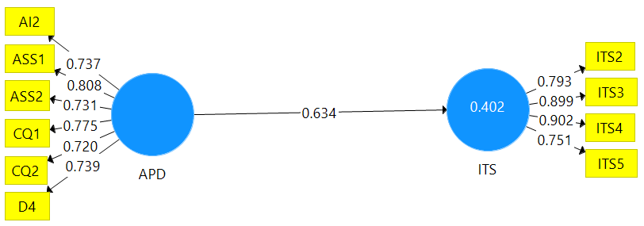

B: The Influence of Departure Processing Domain on International Tourists’ Satisfaction
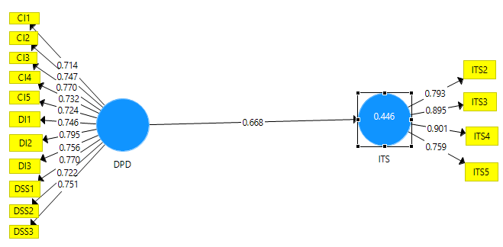

C: The Influence of Departure Processing Domain on International Tourists' Satisfaction
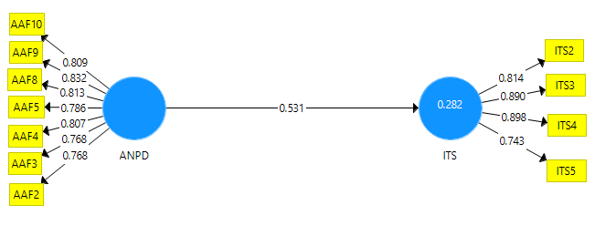
D: The Influence of Departure Non-Processing Domain on International Tourists' satisfaction
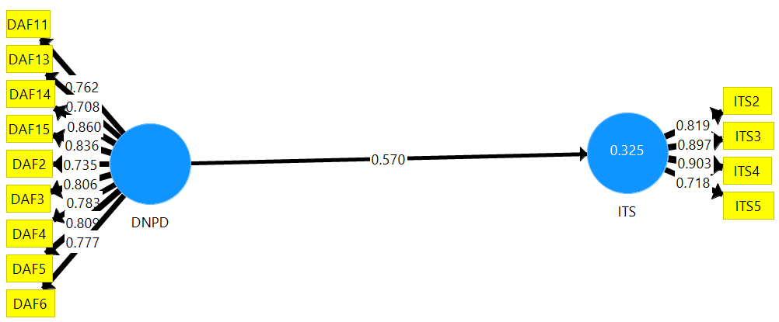

E: The change of the overall explanatory power
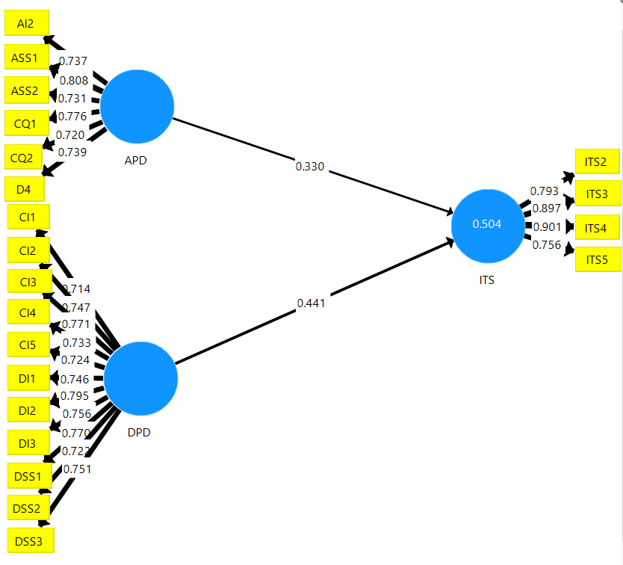

F: The changes of the overall explanatory power for Direct Relationships
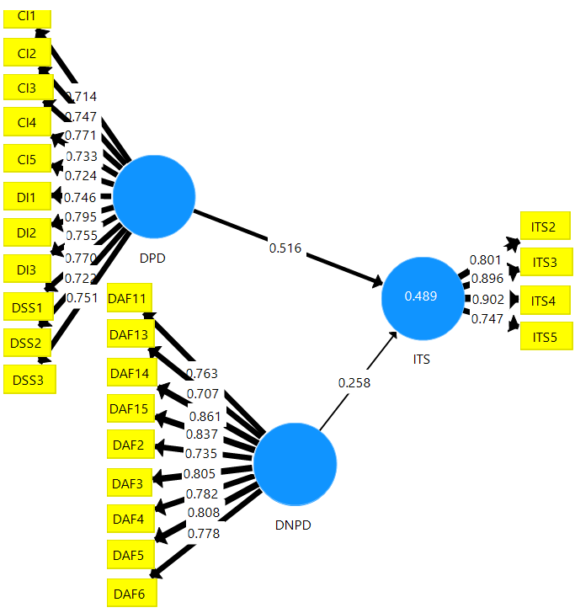

Appendix 5: Summary of Empirical Studies
Author | Title | Country | Findings | Missing Literature (Gap)
Pivac et al., (2022), | an overview of the influence of level of service on the airport passenger terminal capacity. | Croatia | The passenger airport terminal needs upgrading to improve its services for passengers satisfaction. | The discussion for each domain with the attributes and the link with tourists satisfaction was ignored
Bakir et al., (2022), | How to Achieve Passenger Satisfaction in the Airport? Findings from Regression Analysis and Necessary Condition Analysis Approaches through Online Airport Reviews | Switzerland | It was noticed that Queuing times, terminal cleanliness, terminal seating, terminal signs, food and beverages, and airport staff are necessary to achieve passenger satisfaction at the airport terminal. | The study dealt with only eight factors ignoring the inclusion of the factors based on the airport domains
Nwaogbe et al., (2021), | Service quality and passenger satisfaction in air transportation for developing economy | Nigeria | Findings showed that the score for the perceived service quality was less than tourists' expectations | The study missed other important domains necessary for this study.
Mwesiumo and Halpern (2021) | The airport service quality and passenger satisfaction: the impact of service failure on the likelihood of promoting an airport online | Norway | Failure associated with airport staff, queuing times, and other service attributes are most likely to reduce the probability of passengers becoming promoters of the airport. | Other airport arrival processing domains attributes and their relationship with tourist satisfaction were ignored.
Wattanacharoensil, Fakfare and Graham (2021) | Exploring mult-quality attributes of airports and the asymmetric effect on air traveler satisfaction: The case of Thai International airports | Thailand | Multiple attributes in different airport domains, like departure hall, security, immigration, entertainment, passenger facilities, flight information, terminal environment, airport signage, and layout, affect air travelers' satisfaction. | The study was general to all air travelers and overlooked the clear statistical liaison between the airport domains and the tourists' satisfaction.
Jasrotia, Kour and Gupta, (2020) | Understanding the impact of airport service quality on passengers’ revisit intention amidst the covid-19 pandemic | India | Airport service quality dimensions realized that check-in procedures have a positive impact on tourists' satisfaction and spending at the airport retail as well as plan to reuse the airport and its environment | Not all airport domains are touched and did not assess their relationship with tourist satisfaction.
Tinashe, (2020) | The impact of airport experience on international tourists' revisit intention | South Africa | Conative destination image which shows what exactly potential tourists know about the destination was seen to be the most influential factor in causing travellers satisfaction and intention to revisit the destination. | The study overlooked the discussion of the sole domain and its attributes and its relationship with tourists satisfaction
Munoz et al. (2019) | On modeling air travellers’ experience based on service quality stages related to airline and airports | Colombia | Airport departure and arrival service positively affect tourist satisfaction. | The study ignored discussion of each domain and the attributes and the link with tourists satisfaction
Sumanasiri and Dambagola, (2020) | Passenger satisfaction with the quality of service offered at the Bandaranaike International Airport (BIA) | Sri Lanka | Parking facilities, washrooms and sanitary facilities, safety and cleanliness of the physical premises, the employee attire, and restaurant facilities were found to be very important to create tourist satisfaction | Specific domains for the attributes were missing together with an assessment of its relationship with tourists satisfaction.
Hajez and Fawzy (2021), | passenger satisfaction of the service quality at Saudi International airports | Saudi Arabia | Check-in staff efficiency, comfort in the departure lounge, friendliness of airport staff, ease of finding the way out at the airport, flight information panels, queue time at check-in, the walking distance at the passenger terminal, and quality of snack bar restaurant positively affect tourist satisfaction. The speed of baggage claim factor showed no relationship with tourist satisfaction. | The combination of airport processing and non-processing domain and its relationship with tourist satisfaction was missing.
Halpern, (2021) | On the airport service quality and passenger satisfaction: the impact of service failure on the likelihood of promoting an airport online | Norway | Failure caused by airport staff and queuing times in departure processing domains are among the key factors in reducing the possibility of passengers becoming a promoter of the airport. | Ignored other airport service attributes and their relationships with tourist satisfaction.
Antwi et al.,(2020), | does the nature of airport terminal service activities matter? Processing and non-processing service quality passenger affective image and satisfaction | China | There is a direct relationship between the processing and non-processing domain and passengers satisfaction, as well as the processing domain and passenger effective image, except the non-processing domain and passenger affective image relation | The study focused on departure and retail areas only neglecting the arrival domains
Riyas and Anand (2020) | Airport Service quality: Passenger Perceived Service Quality Measurement Questionnaire Framing components | India | Understanding new aspects of airport service performance is significant through analyzing customers’ voices on service quality complaints. Further multilevel regression analysis for defining the overall satisfaction level of airport processing and non-processing domains on the set of service attributes was recommended. | Overlooked the relationship between airport service attributes and customer satisfaction
Chinonso and Ejem, (2020) | assessment of airport service quality | Nigeria | airport service quality in all the airports is low and can not meet the service quality expectation of passengers. Airport authorities should focus on improving the quality of airport service offered to passengers. | Did not focus on both processing and non-processing domain and their relation with tourists' satisfaction
Ansari and Agarwah, (2020) | Critical analysis of the passenger’s satisfaction with the service quality of the King Abdulaziz International Airport Jeddah | Jeddah | Airport services including shopping facilities, transfer services from the airport to the airplane, staff attitude, and staff efficiency influence in tourists satisfaction. | The number of service attributes was ignored and the relationship with tourists satisfaction
Prentice and Kadan (2019) | Role of airport service quality in airport and destination choice | Australia | Airport facilities and servicescape exert a unique and significant effect on destination choice and contribute to passenger satisfaction resulting in customer re-visitation | Airport processing domains perspective was ignored and airport facilities missed attributes
Chi et al. (2018) | Tourism service design: promoting Malaysia's culture through the national brand in KLIA | Malaysia | Many airports are unable to deliver a superior customer experience and customer focus has to be segmented in a meaningful way to make tourism investments in the future. | The airport processing domains (ATD) perspective was ignored and other attributes in the non-processing domain are missing
Hong et al, 2019 | Exploring different airport users’ service quality satisfaction between service providers and air travellers | South Korea | The airport service quality is significantly related to airport reuse and destination revisits. An appropriate service training program is needed to reduce the gap in satisfaction. | Airport arrival processing domain details were overlooked.
Munoz et al. (2019) | MATE based on service quality stages related to airlines and airports | Colombia | Departure airport service, airline service, and arrival airport service significantly and positively affect passenger satisfaction. | Details for specific airport processing and non-processing domains were ignored.
Bellizzi et al. (2018) | Air transport passengers’ satisfaction: OL model | Italy | Comfort, information and cleanliness at the airport terminal satisfy leisure tourists, work visitors and arriving more than two hours | Other domain attributes were ignored
Adeniran et al. (2018) | Relationship between passengers’ satisfaction and service quality in MMIA | Lagos, Nigeria | Public transport options for passengers have a very weak correlation and there is a revealed relationship between passengers satisfaction and service quality. | Details for specific airport domains were ignored.
Seetanah (2018) | Destination satisfaction and revisit intention of tourists: Does the quality of airport service matter? | Mauritius | Airport service does matter in fostering positive tourist behavior because the more satisfied the tourists are with airport service the more likely they are to come back. | Attributes for measuring customer experience to some of the domains are missing
Smith (2018) | The Impact of Airport Services cape on passenger satisfaction | Atlanta | Improving passenger satisfaction within services Cape has a positive influence on passengers' overall satisfaction with the airport and trip | The airport non - processing domains (ATD) perspective was ignored
Kratudnak et al. (2018) | Analysis of key factors for airport service quality: a case of three regional airport | Thailand | Check-in, security, airport convenience, airport facilities, and mobility are potential for airport service quality. convenience was found to be the most significant factor for airport service quality to influence customer satisfaction | Other domains like immigration, access, retail, baggage claim, and customs were ignored

Appendix 6: Table showing variables, indicators, and the level of measurement
Dependent variable |  | Indicators/attributes | Level of measurement | Author
Customer satisfaction |  | Positive word of mouth, Emotional state, attitude, behaviour, comfort, re-visitation. | Ordinal | Mhlanga (2017), Schiebler (2018)
Independent variable |  | Indicators
Airport departure processing domain | Check-in | Waiting time and queue length, check-in efficiency, Staff enthusiasm, Problem-solving, Staff grooming, and appearance. | Ordinal | Wiredja (2019), Bellizzi et al., (2020), Aydoğan* (2021)
Airport departure processing domain | Immigration | Waiting time and queue on immigration, waiting time and queue on visa on arrival, staff courtesy. | Ordinal | Wiredja (2019), Park et al. (2011)
Airport departure processing domain | Security screening | Staff courtesy, secure feeling/thoroughness, Waiting time or queue length. | Ordinal | Wiredja (2019), Kumar and Meen (2022) just
Airport arrival processing domain | Disembarkation | Interaction between staff and passengers, complaint handling, availability of aerobridge, easy way out finding, staff courtesy. | Ordinal | Wiredja (2019), Kumar and Meen (2022) just
Airport arrival processing domain | Immigration | Waiting time and queue on immigration, waiting time and queue on visa on arrival, Staff courtesy. | Ordinal | Wiredja (2019), Riyas and Anand (2020)
Airport arrival processing domain | Baggage claim | Baggage delivery time and secured baggage delivery. | Ordinal | Wiredja (2019), Chi et al. (2022), Mwesiumo and Halpern (2021)
Airport arrival processing domain | Customs | Waiting time, queue length, Staff courtesy, and Clear customs declaration information. | Ordinal | Wiredja (2019), Bogicevic (2013)
Airport  arrival non-processing domain and | Airport accessibility | Availability of public transport, ground transportation options, parking facilities or queue length for regular tax, Easy access to public transport, Tax availability, and prices. | Ordinal | Wiredja (2019), Adeniran et al. (2018), Chi et al. (2022)
Airport  arrival non-processing domain and | Airport facilities | Availability of ATM or money changer, sanitary conditions of restrooms, availability of seat facilities, comfort of seat facilities, availability of information desks and information display, availability of baggage trolley, availability of internet or wi-fi, ease of connections among terminals, efficiency of boarding call and availability of children changing room, availability of shower services, Terminal comfort and ambiance, Television and entertainments facilities, children’s play area and facilities provided, cleanliness of terminal floor, facilities and public areas, the efficiency of boarding call and other information. | Ordinal | Wiredja (2019); Bellizzi et al. (2018); Popovic et al. (2009, 2010, 2015), Antwi et al. (2020), Putra et al. (2021), Chi et al. (2022)
Airport  arrival non-processing domain and | Retail area | Variety of shops, value for money of shops and café, variety of foods and beverages, availability of shopping facilities, value for money in restaurants. | Ordinal | Wiredja (2019), Popovic et al. (2009, 2015), Antwi et al. (2020)
Airport departure non-processing domain | Airport accessibility | Availability of public transport, ground transportation options, parking facilities or queue length for regular tax, Easy access to public transport, Tax availability, and prices. | Ordinal | Wiredja (2019); Adeniran et al. (2018) Hajez and Fawzy (2021), Hajez and Fawzy (2021),
Airport departure non-processing domain | Airport facilities | Availability of ATM or money changer, sanitary conditions of restrooms, availability of seat facilities, comfort of seat facilities, availability of information desks and display, availability of baggage trolley, availability of internet or wi-fi, ease of connections among terminals, efficiency of boarding call and availability of children changing room, availability of shower services, terminal comfort and ambiance, television and entertainments facilities, children’s play area and facilities provided, cleanliness of terminal floor, facilities and public areas, the efficiency of boarding call and other information. | Ordinal | Wiredja (2019); Bellizzi et al. (2018); Popovic et al. (2009, 2010, 2015); Sumanasiri and Dambagola (2020), Hajez and Fawzy (2021), Adetayo, et al., (2020), Riyas and Anand (2020), Yavuz et al. (2021), Kumar and Meen (2022), Bakir et al., (2022),
Airport departure non-processing domain | Retail area | Variety of shops, value for money of shops and café, variety of foods and beverages, availability of shopping facilities, value for money in restaurants. | Ordinal | Wiredja (2019), Hajez and Fawzy (2021),
Source: Researchers Construct (2022)

Appendix 7: Acceptance Latter for Publication

