ROLE OF COMMUNICATION STRATEGIES IN MONITORING AND EVALUATION SYSTEMS EFFECTIVENESS IN FAITH-BASED ORGANIZATIONS PROJECTS: CASE OF EVANGELICAL LUTHERAN CHURCH OF TANZANIA-EAST OF LAKE VICTORIA DIOCESE

MPOKI JAFARI

A DISSERTATION SUBMITTED IN PARTIAL FULFILMENT OF THE REQUIREMENTS FOR THE DEGREE OF MASTER OF ARTS IN MONITORING AND EVALUATION
DEPARTMENT OF ECONOMICS AND COMMUNITY ECONOMIC DEVELOPMENT
THE OPEN UNIVERISTY OF TANZANIA
2023

CERTIFICATION
The undersigned certify that I have read and hereby recommend for acceptance by the Open University of Tanzania, a proposal titled: Role of communication strategies in monitoring and evaluation systems effectiveness in Faith-Based Organizations: Case Study of Evangelical Lutheran Church in Tanzania -East of Lake Victoria Diocese in partial fulfillment of the requirements for the award of the degree of Masters of Arts in Monitoring and Evaluation.

…………....…………………
Prof. Deus Ngaruko
(Supervisor)

………………..……………….
Date

COPYRIGHT
"No part of this thesis or dissertation may be reproduced, stored in any retrieval system, or transmitted in any form by any means, electronic, mechanical, photocopying, recording, or otherwise, without the prior written permission of the author or the Open University of Tanzania in that behalf".

DECLARATION
I, Mpoki Jafari, do hereby declare that, the work presented in this dissertation is original. It has never been presented to any other University or institution. Where other people’s works have been used, references have been provided. It is in this regard that I declare this work as originally mine. It is hereby in partial fulfillment of the requirements for the Degree of Masters of Arts in Monitoring and Evaluation of the Open University of Tanzania.



………………………………..
Signature

………………………………….
Date

DEDICATION

This work is dedicated to my parents and relatives and supervisor for their dedication and their unlimited support throughout my schooling

ACKNOWLEDGEMENT
I am glad to thank so much my supervisor Prof. Deus Ngaruko for his commitment, materials and guidance throughout the development of this research proposal.

ABSTRACT
This study focused on examining the role of communication strategies in monitoring and evaluation systems effectiveness in projects implemented by Faith-Based Organizations, using projects implemented by the Evangelical Lutheran Church of Tanzania -East of Lake Victoria Diocese as a case study; The objective of this study was, to examine the role of communication strategies in M&E systems effectiveness in FBOs projects; The study employed the descriptive quantitative approach and survey design whereby structured questionnaire was used to collect primary data electronically, in google forms, analyzed using Microsoft Excel and secondary data collected through literature review. Research findings presented using frequency, in tables and charts; Results revealed that, the ELVD M&E system shares weekly information from top to her members without conducting a survey to analyze and identify what types of information her members need, all members are not engaged in monitoring and evaluating the implemented project activities with an exceptional on implementation; Also the M&E system reports of ELCT-ELVD are not using charts and tables for the visual expressions of progress and variation, and there is a high need of suggestion box for opinions with scheduled day for leaders clarification and answers to what found in the box. The study recommends the availability of a forum and channel for continuous feedback dialogue between FBOs leaders and their congregations will increase collaboration and build trust, the ELCT-ELVD has to conduct a survey to analyze and identify the type of information her members need to be communicated to them concerning projects.
Key words: FBOs, Projects, M&E systems-Effectiveness, Communication-Strategies, Members, Information.

TABLE OF CONTENTS
CERTIFICATION ii
COPYRIGHT iii
DECLARATION iv
DEDICATION v
DEDICATION v
ACKNOWLEDGEMENT vi
ABSTRACT vii
LIST OF TABLES xii
LIST OF FIGURES xiii
ABBREVIATION & ACRONYMS xiv
CHAPTER ONE 1
INTRODUCTION 1
1.1 Background Information 1
1.2. Research problem Statement 2
1.3. Research Objective 4
1.3.1 The general Objective 4
1.3.2 Specific objectives are 4
1.4. Research Questions 5
1.5. Significance 5
1.6. Scope of the study 6
1.7. Limitation of the study 6
CHAPTER TWO 7
LITERATURE REVIEW 7
2.1. Conceptual definitions 7
2.1.1 Monitoring and Evaluation system Effectiveness 7
2.1.2 Communication strategies 7
2.2. Theoretical literature review 7
2.2.1 Extended Parallel Process Model 7
2.2.2 Communication theory 8
2.3 Empirical literature review 9
2.3.1 Type of information received by members on M&E system of FBOs 9
2.3.2 Examine the perceptions of members on knowledge and accessibility of information on M&E system of ELVD 10
2.3.3 Best channel and forum for feedback mechanism of FBOs M&E system 11
2.4. Research gap 12
2.6. Conceptual framework 13
2.6.1 Conceptual framework explanation. 15
CHAPTER THREE 16
RESEARCH METHODOLOGY 16
3.1 Research Design 16
3.2 Research approach 16
3.3 Survey population 17
3.4 Sampling design and procedures 17
3.5 Variables and measurement procedures 19
3.6 Methods of data collection 19
3.7 Data processing and analysis 20
CHAPTER FOUR 22
RESEARCH FINDINGS AND DISCUSSIONS 22
4.1 Chapter overview 22
4.2 Respondent’s Profile 22
4.2.1 Designation of the Respondents 22
4.2.2 Gender of the Respondents 23
4.2.3 Age of the Respondents 23
4.3 Type of information received by members on M&E system of ELVD 24
4.3.1 Type of information received by members on M&E system of ELVD 24
4.3.2 Cconducts of survey to assess kinds of information church members need 25
4.3.3 Members participation in designing and planning the activities to be implemented 26
4.3.4 Engagement of stakeholders in implementing planned activities 27
4.3.5 Engagement of Sstakeholders in Monitoring and Evaluation of the Implemented Activities 28
4.4 Perceptions on knowledge and accessibility of information 29
4.4.1 Understanding of M&E system reports by stakeholders 30
4.4.2 Use of visual expressions in the the M&E system reports 31
4.4.3 The M&E system reports distribution to members of the church for comments and decision making 31
4.4.4 Access to M&E system information by church members. 32
4.4.5 M & E reports are crucial for the development of an organization. 33
4.5 Identify the Best channel and forum for feedback mechanism 34
4.5.1 The organization to place suggestions box in a confidential place 35
4.5.2 The organization to have a day in a month for leaders to explain and provide answers 35
4.5.3 Website is the best source of information used by the majority of organization members 36
4.5.4 Printed Document such as reports, flayers, brochures, posters are the best source of information 37
4.5.5 Documentation Centre is the best source of information by ELCT-ELVD M&E 38
4.5.6 Social media (WhatsApp, Facebook, Instagram) are the best source of information 39
4.5.7 Mobile phones are the best source of information used by the majority of church/organization members 40
CHAPTER FIVE 42
SUMMARY, CONCLUSION AND RECOMMENDATIONS 42
5.1 Chapter overview 42
5.2 Summary of the findings 42
5.3 Conclusion 47
5.4 Recommendations 49
5.5 Recommendation for Further Research 52
REFERENCES 53
APPENDICES 59

LIST OF TABLES
Table 3.1: Sample size 18
Table 4.1 Designation of the Respondents 23
Table 4.2: Gender of the Respondents 23
Table 4.3: Age of the Respondents 24

LIST OF FIGURES

Figure 2.1: Conceptual Framework 15
Figure 4.1 Disaggregation of FBOs M&E information 25
Figure 4.2 Conducting Survey to analyze what information do stakeholders need 26
Figure 4.3 Church members designing and planning activities 27
Figure 4.4 Engagement of Stakeholders Implementing Planned Activities, 28
Figure 4.5 Engage Stakeholders in Monitoring and Evaluating Implemented Activities 29
Figure 4.6 M&E system report language simplest 30
Figure 4.7 visual expression 31
Figure 4.8 Distribution of M&E reports 32
Figure 4.9. Timely, freely and timely information access 33
Figure 4.10 Essential of M&E report 34
Figure 4.11 Suggestion box placements 35
Figure 4.12 Dialogue meeting 36
Figure 4.13 Website for feedback mechanism 37
Figure 4.14 Printed documents 38
Figure 4.15 Documentation Centre 39
Figure 4.16 social media 40
Figure 4.17 Mobile phones 41

ABBREVIATION & ACRONYMS
CBOs Community-Based Organizations
EBP Evidence-Based Practices
ELCT-ELVD Evangelical Lutheran Church of Tanzania-East of Lake Victoria Diocese
EPPM Extended Parallel Process Model
FBO Faith-Based Organization
ICT Information and Communication Technology
M&E Monitoring and Evaluation
NGOs Non-government Organizations

CHAPTER ONE

INTRODUCTION

Background Information
For the Faith Based Organizations M&E system to be effective need to have communication strategies; As other organizations, FBOs implementing various projects and providing services to the communities but facing a great challenge; Especially in Africa the FBOs are slow on practicing evidence based on the services they provide, which hinder the stakeholders to make desired decision and make it difficult to know if the services provided succeeded or failed (Terry et al., 2015; Uzochukwu et al., 2016) and CBOs, also challenged on implementing their various strategies and it became difficult to succeed because of dim communication channel in their M&E systems (Musambayi, 2012); Not only that, but also because of ineffective communication strategies in M&E system of the poverty reduction strategies of Tanzania government harden to succeed, because the information about poverty trend and strategies with all programs implemented to reduce poverty were not known with all stakeholders especially to those who are beneficiaries; The reasons were; No plain language easily understood by all level of stakeholders, no forum created to get feedback and this cause ineffective M&E system (URT, 2011; Uzochukwu et al., 2016) even if there are the lot of government effort but are not recognized by beneficiaries. Furthermore, the number of studies highlight that, the absence of effective communication strategies in M&E system in FBOs projects, lack the ability to use the opportunity appeared and no sustainability of effort overtime, no right decision will be made, no coordination of activities, relationship cannot be maintained, goals and objectives cannot be achieved because data are highly used by only data collectors and top leaders without the rest members, the members have decreased trust in their leaders and protest raising, commitment decreased, income decreased, investments take a long time to complete, church attendance decreases routinely which are capital of FBOs and organization members complaining concerning their leaders in the street and all complaints are not reaching their leaders thus no any positive changes occurred and the members are limited on the numbers of questions wanted to ask and when are unsatisfied no more clarifications to that question and there are highly increasing of diversion among members because they perceived that their opinions are not accepted by their leaders (Burgess-Wilkerson, 2011; Gamba, 2016; Reading, 2015 and Kiboi et al., 2018).
Therefore, this dissertation intends to examine the role of communication strategies in M&E system effectiveness in FBOs, using the case study of Evangelical Lutheran Church of Tanzania-East of Lake Victoria Diocese. The study will identify the best channel and forum for feedback mechanism, will determine the type of M&E information received by members whether is according to their need and the perceptions of members on knowledge and accessibility of information on M&E system of ELVD will be examined; All these will facilitate investment projects to be completed on time, income increasing, stakeholders from all level commitment on donating will increase, reducing conflicts, will raise stakeholders trust to their leaders in FBOs and all the set objectives will be achieved with sustainable development.

1.2. Research problem Statement
Data produced always and collected under the M&E system of the organization but
are not used by all levels of stakeholders such as high-level and low-level/grass root level; In this case, M&E system become ineffective because data are used by collectors only without the general population (Nicol et al., 2017). According to SALAAM and MERO (2019), despite financial and technical support to local NGOs from donors, M&E system remain poor because NGOs are no not willingly but forced to demonstrate the impact of their works; Uzochukwu et al. (2016), in their study, show that, in Africa communicating the research evidence is a big challenge and FBOs are slow in accepting and implementing evidence-based practices for the service they offer (Terry et al., 2015), All these situations will cause lack of the ability to use the opportunity appeared and unable to maintain the sustainability of effort overtime, no right decision will be made, no coordination of activities, relationship cannot be maintained, goals and objectives cannot be achieved because of ineffective communication strategies in M&E system in FBOs to make it effective in its projects and successful by communicating its reports (Burgess-Wilkerson, 2011),
More than that; There is failure of M&E system to reach all audiences at all levels (top to grass-root level) among FBOs, which caused by not engage multiple channels and creating forums for freely participation on dialogue concerning M&E reports (URT, 2011). Not only that; Also, low capital for investing in M&E system hindering the best practice among NGOs M&E system (Mero, 2019) of communicating its findings and all these creating large gap between leaders and members of the organization having no same insight concerning the activities of their organization and members have lost trust to their leaders; Though the members of the organization are complaining about leadership and occurring situation in the organization still no changes, because there are no platforms or channels for responsible persons to be informed, members to explain their issue concerning their organization and to be given clarification from their leaders.
Furthermore; according to TACAIDS (2010), in order to influence the community to adopt a certain behaviour, increasing commitment and creating ownership of organization; Communication strategies is a good innovative mechanism. As all these are known, but still FBOs M&E system is ineffective. Therefore; this study aims to examine the role of communication strategies in M&E system effectiveness in FBO to facilitate the use of M&E system output/report not only of research and evaluation but also concerning implementation reports in a two-way communication.

1.3. Research Objective

1.3.1 The general Objective
To examine the role of communication strategies in M&E systems effectiveness in FBOs projects.

1.3.2 Specific objectives are
- To determine the type of information received by members for M&E system effectiveness in ELVD projects.
- To examine the perceptions of members on knowledge and accessibility of information on M&E system of ELVD projects.
- To identify best channel and forum for feedback mechanism of FBOs M&E system.

1.4. Research Questions
- What are the types of information received by members on M&E system of ELVD projects?
- What are the perceptions of members on knowledge and accessibility of information on M&E system of ELVD projects?
- What are the best channels and forum for feedback mechanisms to be used by the FBOs M&E system?

1.5. Significance
This study will help the FBOs to inspect and know the role of communication strategies incorporated in and facilitating M&E system effectively to attaining its desired objectives. Also to avoid conflict among organization (FBOs) members for not getting M&E reports of organizations projects, will raise the trust of church members to their leaders, creating ownership of organization among stakeholders, commitment in implementing various projects and activities, will ensure sustainability development of the organization, promoting evidence-based practice to services and project implemented by involving stakeholders in planning M&E system of FBOs participatory to monitor and evaluate different projects and activities implemented through incorporating communication strategies in M&E system to ensure the progress of activities are tracked and achieving goal; Also the study will suggest the best channel and forum for feedback mechanism in FBOs. Generally, the study may provide inputs that will inform the policy makers in formulating the policies related to communication strategies for M&E system effectiveness in FBOs and other organization projects.

1.6. Scope of the study
The study was covered ELCT-ELVD to examine the role of communication strategies in monitoring and evaluation systems effectiveness in Faith-Based Organizations projects.

1.7. Limitation of the study
There were some limitations in attaining good results; including that Faith-Based Organizations for some staff were not ready to respond the questionnaires by fearing of being the cause of conflict by disclosing the organization ; But the researcher clarifying that all the answers will be generalized and the respondents will not be known by their names which gave them freedom to respond positively; Another limitations was time was a big challenge since the researcher had to work and at the same time accomplish the study; according to the situation the researcher has worked some extra hours and using electronic questionnaires to collect data form afar respondents.

CHAPTER TWO

LITERATURE REVIEW

2.1. Conceptual definitions
2.1.1 Monitoring and Evaluation system Effectiveness
According to Lesaux et al. (2010), Stewart and Pavlou (2002), Vincent et al. (2018) and Hapunda (2018) The study defines M&E system effectiveness as the series of policies, practices, indicators, tools and processes that enable the systematic and effective collection, analysis and communicating monitoring and evaluation information by getting out to the audiences and receiving feedback using different channels and forum, with availability of access to project M&E information.

2.1.2 Communication strategies
The study defines Communication strategies as a component of and for M&E system effectiveness and it is a two-way process of transferring information to the targeted audience and then receiving feedback using a certain channel or forum with accessibility of projects M&E information (Kasper and Kellerman, 2014; Hyland-Wood et al., 2021).

2.2. Theoretical literature review

2.2.1 Extended Parallel Process Model
Theory of communication strategy according to Maloney et al. (2011), put Extended Parallel Process Model (EPPM) as the message design theory of effective communication which assume that when the persuasive message which carry inspirational features increases will motivate people to take action toward or against good or bad outcome; In which for people to adopt the promoted behavior they must be motivated by message that will persuade them by increasing their ability to produce the intended results or to give responses to questions or request (Maloney et al, 2011).Also, the quality of human communication theory has the following components heuristic value, openness, theoretical scope, appropriateness, validity and parsimony (Maloney et al., 2011). This theory guides the researcher to examine the perceptions of members on knowledge and accessibility of information on M&E system of ELVD in which can lead to M&E system effectiveness in FBOs since the information communicated has human communication theory components such as openness, investigative value also will guide to the study to determine the type of information received by members on M&E system of ELVD if it is according to their information needs or purpose which lies on appropriateness in the theory.

2.2.2 Communication theory
According to Hargie (2021), communication theory conceptualizes the process of sending and receiving message. And communication require more than two contributors who send and receive message from each other by responding; in which in the process of communicating several components required such as sender and receiver, messages, channel and media, feedback, Noise and context, all these components in communication strategies which is the component important in M&E system effectiveness in FBOs since the researcher need to identify the best channel and forum for communicating information to various stakeholders according to their needs which creating forum for receiving feedback which leads to M&E system effectiveness.
The study used the two theories for a wider perspective on role of communication strategies in M&E system effectiveness in FBOs projects by guiding the researcher on developing the conceptual framework providing the components for communication strategies for M&E system effectiveness in FBOs projects.

2.3 Empirical literature review

2.3.1 Type of information received by members on M&E system of FBOs
To describe the type of information received by members on M&E system of FBOs according to their different information needs. The communication strategies is very important for successful of monitoring and evaluation system to be effective for members to use the system information (Rasila, 2021). and need to be included in the M&E system especially for increasing national/organization ownership of a program, participatory in decision making of a certain issue and increasing awareness (URT ,2011); According to Kanyamuna et al. (2019) in their study concludes that functional M&E systems are a missing vital in Africa, since there is no use of M&E information which caused by lack of incentives to promote the needs and supply of M&E information, there are need of participatory planning of M&E system by involving and utilizing effectively stakeholders for the sustainability of the organization projects, because will create ownership if all stakeholders plan what they need to monitor and evaluate (Ondeko, 2020). And they can decide whether to continue or not with the project and failure can be caused by lack of needful information by the members (Donus et al., 2013).

2.3.2 Examine the perceptions of members on knowledge and accessibility of information on M&E system of ELVD
To examine the perceptions of members on knowledge and accessibility of information on M&E system of FBOs, communication strategy is a good innovative mechanism to influence the community to adopt a certain behaviour (TACAIDS, 2010); Also, in Africa communicating the research evidence is a big challenge (Uzochukwu et al., 2016), which make difficult for policy maker and stakeholders to make decision based on evidence.
As it is known FBOs, are like other organization , they provide service to the communities but they are slow in accepting and implementing evidence-based practices for the service they offer; Therefore practicing evidence-based can enhance effectiveness of FBOs in providing services, and without evidence-based you cannot measure success or failure; To solve this, FBOs need routine evaluation to be conducted to measure the effectiveness of services provided; Also for FBO to succeed in evidence-based practice need communication strategies in which for all stakeholders to use research findings which translated in plain language and availability of Monitoring and Evaluation plan to track the progress and evaluate the implementation of the strategies for smooth success of an organization (Terry et al., 2015; URT, 2011;Uzochukwu et al., 2016). According to PERDOMO (2013), M&E is as an excellent tool to improve organization performance and to build good governance because of their decision-making guidance function based on continuing learning processes

2.3.3 Best channel and forum for feedback mechanism of FBOs M&E system
To identify best channel and forum for feedback mechanism of FBOs M&E system effectiveness is very importance; In order to reach more audiences, communication strategies imply different channels such as social medias, public announcement, interpersonal communication, brochures, posters which are effective for various kind of audiences according to their information needs and conducting survey for getting feedback (C-change, 2011; URT, 2005).
According to SALAAM and MERO (2019), NGOs are facing many challenges on her M&E system effectiveness; In order to influence M&E system effectiveness need the inclusion of ICT for facilitating data collection, analysis and dissemination of information. of sharing information using these several sources (channel) and forum as feedback mechanism, such channel can either be mass media or other, which will help getting information and helping decision making for development, which is the component of M&E system to be effective and successful.
Though M&E system data channel has been defined and information sharing among stakeholders accepted still M&E system is weak because the system has disjointed activities, is not of organization but of specific program-structure and fulfilling donors report needs (Kiboi et al, 2018).
According to Kanyamuna et al. (2019) in their study concludes that functional M&E systems are a missing vital in Africa, since there is no use of M&E information which caused by lack of incentives (forum and channels) to promote the needs and supply of M&E information, no forum, no result-based media for showing organization achievement and this lack the opportunity for various stakeholders to participate filling available gap. To solve this, it requires the organization to establish an incentive structure for the utilization of M&E information and through the incentives such as forum and media the organization motivate the use of information by stakeholders from all levels. More than that; According to PERDOMO (2013), M&E is as an excellent tool to improve organization performance and to build good governance because of their decision-making guidance function based on feedback and continuing conversation learning processes through using channel for feedback mechanism.

2.4. Research gap
Gamba (2016) conducted a study on factors affecting the utilization of M&E findings in the process of implementing Malaria control programs in Mukono District. The study found that it is important for various teams to identify some of the challenge hindering dissemination of M&E findings in their respective projects in order to allow a smooth process of sharing of information. The gap in the study only focusses on the challenges facing the M&E dissemination of information.
Kiboi et al. (2018) conducted research on Determinants of Effective Monitoring and Evaluation in Health Service Delivery, show there are weak culture of information use and demand; And this challenge caused by weak M&E system which has disjointed activities, specific program-structured M&E and satisfy the reports needs of the donor. In Kenya research have done on factor affecting the effectiveness of monitoring and evaluation system among FBOs by (Oketch, 2016) in which found that strong influence of donors and M&E system used only during project planning and need assessments only, these are factors affecting the M&E system then the study recommend the use of M&E system in the whole project life cycle.
Jothi et al. (2011) conducted research on effective of communication strategies in social media in promotion and advertising the brand in which focus in the analysis on social networking sites, which show in order for brand to be attractive it needs communication strategies Other research done on challenge of bridging the gap between researcher and policy makers including the utilization of research findings done in health research one of the challenges was communication gap between the two-group researcher and policy makers which need information to be available when needed, there were lack capacity to demand findings, were not ready to utilize the information in Nigeria (Uzochukwu et al., 2016). Also (Hyland-Wood et al., 2021) provide the recommendations for effective communication to influence people to reduce the infection of pandemic diseases especially in COVID-19 and other on HIV/AIDS prevention and treatment interventions done by government other on the influence of M&E practices on performance of project funded by FBO which show one practice is utilization of results (Rasila, 2021). and other on communication strategies for sustainability in the non-profit organization such as FBO and CBOs (Burgess-Wilkerson, 2011). According to literature review there are no more studies done on role of communication strategies in M&E system effectiveness in FBOs; Therefore, this study will examine the role of communication strategies in M&E system effectiveness in FBOs projects for achieving her objectives.

2.6. Conceptual framework
The conceptual framework has been presented to describe the relationship among the studied variables. In this study dependent variable is M&E system effectiveness and independent variable is communication strategies. For M&E system to be effective such as utilization of collected data and findings by reaching out its output to the audiences and receiving feedback which depend on the communication strategies which meet three dimensions such as:
- Type of information getting out to members of ELVD "targeted-audience" here means audiences which are disaggregated according to their different information needs or goals and purpose of the communication strategy not only high-level stakeholders but also the ordinary from the grass roots to create ownership.
- Improving information accessibility through creating user-friendly databases, plain language versions of reports including using cartoons and creative designs and info-graphics in order for ordinary stakeholders to understand.
- Creating multiple channel and forums where discussions can be held participatory and freely, this will influence participatory decision making, ownership of the organization, promoting accountability (URT, 2005; URT, 2011; C-Change, 2011).
The figure 2.1 helps to illustrate the relationships between the Dependent and Independent variables.
2.6.1 Conceptual framework explanation.
Figure 2.1: Conceptual Framework

Independent Variables

Dependent Variable

Type of information on Targeted audience

Information Knowledge and accessibility

M&E System Effectiveness

Multiple Channels and forum

CHAPTER THREE

RESEARCH METHODOLOGY

3.1 Research Design
Research design is a sketch used by researcher in the process of collecting, analyzing and interpreting data. It indicates the kind of the research and strategies to be used in conducting research. The function of a research design is to make sure that researcher enabled to effectively address the research problem logically and precisely (Magigi, 2015). The advantage of using research design is to facilitate the process of conducting research for making research efficiency with an adequate information which saves time and money (Kothari, 2004).
This study used survey research design; because it is a specific type of field study that involves the collection of data from a sample of elements drawn from a well-defined population through the use of a questionnaire (Visser, Krosnick & Lavrakas, 2000) for this study, the population is the believers of ELCT-ELVD. Also, the survey design entails a critical observation of events, objects, subjects and ideas without attempt to control the condition of such phenomenal (Jongbo, 2014). The reason of using survey research design is: not expensive, easily accessible information, very valuable tool for assessing opinions, allow the collection of a large amount of data from a larger population, and data are standardized that allowing easy comparison (Magigi, 2015).

3.2 Research approach
Research approaches refer to as the collection of procedures and plans that decide the overall process of research. The Research approach decides the methods for data collection, analysis, and interpretation. The concept of research approach is followed in the entire research processes. There are many factors for the selection of research approach, such as, research objective, experience of researcher, and the audience of research study (Creswell, 2012).
This study used descriptive quantitative approach to collect quantifiable information to be used for statistical analysis of the population sample for this reason; Descriptive research approach allows the detailed analysis and the general understanding of a particular phenomenon as it exists in the present condition.

3.3 Survey population
In this study, the survey population were the believers, members of the church of ELCT-East of Lake Victoria Diocese having the same characteristics, which include top leaders of the organization, head office lay staff, diocese districts lay and clergy staff, parishes lay and clergy staff and parishes believers both men and women in rural and urban areas; As according to Taherdoost (2016), survey population refers to a total number of people living or working in a particular area which can either be a country, region, district or members of a certain organization, in which, in this study, the survey population were the church members who are believers of ELCT-ELVD.

3.4 Sampling design and procedures
This study used purposive sampling to get representative from all respondents for the following reasons; the researcher decides what needs to be known and sets out to find people who can and are willing to provide the information by virtue of knowledge or experience, respondents have the same characteristics, there is no formula and not using statistical approach for setting the sample size as according to Denscombe (2017) and Suen et al. (2014), the other reasons of using this technique are; The organization population is very large, and a researcher has limited time, workforce and cost; The technique also called judgmental depend researcher decision, applying careful selection of the respondents due to the qualities the respondent possesses. Also, this technique does not need underlying theories or a set number of respondents (Suen et al., 2014). Table 3.1 presents a sample size across subpopulations to be engaged in the study:

Table 3.1: Sample size
S/N | Population Elements | Sample Size
1 | Top leaders | 2
2 | Head quarter lay staff | 8
3 | District clergy staff | 4
4 | District lay staff | 4
5 | Parishes clergy staff | 20
6 | Parish lay staff | 20
7 | Believers | 40
 | Total Sample size | 98

sample size which is the representatives of the ELVD believers having the same characters from rural and urban areas considering the position in the church and gender.

3.5 Variables and measurement procedures
The study has two variables independent (communication strategies) affect the dependent (M&E system effectiveness) affected, will use variable such as each question number will have variable name and content, each attribute/response coded using Likert-scale, and data frequency for getting responses for each statement and total frequency to statement according to the number of people responded. (Kaur, 2013)

3.6 Methods of data collection
Burns and Grove (2003) define data collection as the precise, systematic gathering of information relevant to the research sub-problems, using methods such as questionnaire, interviews, participant observations, focus group discussion, narratives and case histories. This study used structured questionnaire to collect primary data from ELVD believers in the field and secondary data were collected through literature review from books, articles and journals and all primary and secondary data used in this study; According to Sileyew (2019), primary data refers to information that a researcher gathers directly from the field. And Secondary data are all data that have already collected by other researchers such as all collected from books, journals and articles.
The study used Questionnaires to collect data primarily from the field source because it is the main suitable instruments for data collection because they allow researchers to reach many respondents within limited time (Sileyew, 2019). Philip Cleave (2021) says that questionnaires can reach people quickly, they are scalable and there is respondent anonymity. Despite the flexibility for respondents over where and when to complete their questionnaire, he further suggests that research must be prepared to mitigate challenges such as those of unanswered questions, some questions can be difficult to analyze, and there may be difficulty in conveying feelings and emotions for the respondents and for online platforms there may be a challenge of accessibility.

The researcher designed questionnaires in an online platform which can be accessed by multiple respondents at the same time; The questionnaires in this study were self-administered and the researcher informed respondents that the instruments being administered are for research purpose only and the response from the respondents will be kept confidential; Also respondents will have full access to the final report because they are also expected beneficiaries of this study. The researcher’s had obtained an introductory letter from the University in order to collect data from the field and deliver the questionnaires to the respondents in a timely manner.

3.7 Data processing and analysis
According to Hyndman (2008) and Sileyew (2019), data processing involves translating the answers on a questionnaire into a form that can be manipulated to produce statistics. This involves coding, editing, data entry, and monitoring the whole data processing procedure which was done in google forms, google sheet and Microsoft excel as the data obtained from questionnaires; This study used Microsoft excel to analyze data in order to reveal the findings in the data collected regarding the selected variables, because according to Niglas (2007) and Neyeloff et al. (2012), it is a powerful and provide tools for systematize, summarizes, visualize, manage and share the information to make the informed decisions or conclusion that are better grounded by data and it is flexible with features that can be used for analysis of quantitative and also for mixed research approach and it is readily available and familiar from school.

CHAPTER FOUR

RESEARCH FINDINGS AND DISCUSSIONS

4.1 Chapter overview
This chapter presents findings of the study. It is divided in four sections; Background information of the respondents which include their designation, gender, age, and location; How information getting out from FBOs M&E system reaching targeted audience disaggregated according to their information need or purpose or goal; What are the perceptions on knowledge and accessibility to various M&E information by stakeholders in FBOs and What are the best channels and forum for feedback mechanisms to be used by the ELCT-ELVD M&E system for its projects.

4.2 Respondent’s Profile

4.2.1 Designation of the Respondents
Respondents in this study were required to state their designation from the given options which included: Top leader, Head quarter lay staff, District clergy staff, District lay staff, Parish clergy staff, Parish lay staff and Believer. Findings in table 4.1 reveal respondents who were involved in the study.

Table 4.1 Designation of the Respondents
Variables | Frequency | Percentage
Top Leaders | 2 | 2.0
Head Quarter Lay staff | 8 | 8.2
District Clergy Staff | 4 | 4.1
District Lay Staff | 4 | 4.1
Parish Clergy Staff | 20 | 20.4
Parish Lay Staff | 20 | 20.4
Believers | 40 | 40.8
TOTAL | 98 | 100.0
Source: Field Data (2022)

4.2.2 Gender of the Respondents
Respondents were required to state their gender, given the options which included male and female. Table 4.2 reveals that, 45.9 percent of respondents were male and 54.1 percent were female in this study.

Table 4.2: Gender of the Respondents
Variable | Frequency | Percentage
Males | 45 | 45.9
Females | 53 | 54.1
Total | 98 | 100.0
Source: Field Data (2022)

4.2.3 Age of the Respondents
Respondents in this study were required to state their age from the given options which included: below 25, 25-35, 36-45, 46-55 and above 56. Findings in table 4.3 reveal respondents who were involved in the study.
Table 4.3: Age of the Respondents
Age group (years) | Frequency | Percentage
Below 25 | 8 | 8.2
25-35 | 40 | 40.8
36-45 | 32 | 32.7
46-55 | 11 | 11.2
56 and above | 7 | 7.1
Total | 98 | 100.0

Source: Field Data (2022)

4.3 Type of information received by members on M&E system of ELVD
The first objective was to determine the type of information getting out from FBOs M&E system reaching targeted audience, disaggregated according to their information need or purpose or goal. This objective was achieved by asking the respondents to respond to several statements to give their level of agreement on each statement, the levels of agreement were Strongly agreed, Agree, not sure, Disagree and Strongly disagree. Determining the type of information M&E system of ELVD disaggregated to targeted audience according to their needs or purpose as the role of communication strategies to make the system effective.

4.3.1 Type of information received by members on M&E system of ELVD
The study has found that, only 34.4 percent agreed that there is disaggregation of M&E system information to stakeholders according to their needs and purpose because every Sunday the information shared concerning the progress. While 24.0 percent of respondents strongly disagree two respondents have told the researcher that, it is culture for information to be shared each Sunday whether the members need or not, 17.7 percent strongly agree, 16.7 percent disagree and 7.3 percent of respondents were not sure because they see information shared but are not sure if it is according to audience purpose. This indicates that organization disaggregate its M&E information to stakeholders, shown in the Figure 4.1

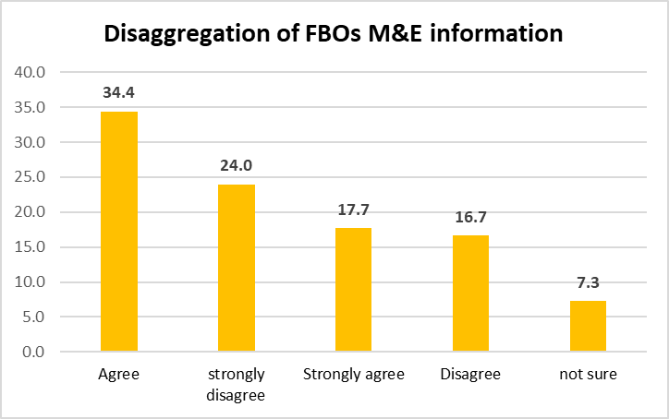
Figure 4.1 Disaggregation of FBOs M&E information
Source: Field Data (2022)

4.3.2 Cconducts of survey to assess kinds of information church members need
The study reveals that, 61.2 percent of respondents had strongly disagreed, 16.3 percent agree, 8.2 percent were not sure, 8.2 percent disagree and 6.1 of respondents were strongly agree that organization conducting survey to analyze the stakeholders (church/organization members) about what information they need to be given. when a researcher asked three respondents who disagree, they said no any survey conducted in the organization that is why there are a lot of M&E information that are not provided and the other who agreed when the researcher asked have said there are cells in organization where the church members can discuss and mention what information they need. This indicates that organization does not conduct any survey to analyze what information they need to be given as indicated in the Figure 4.2

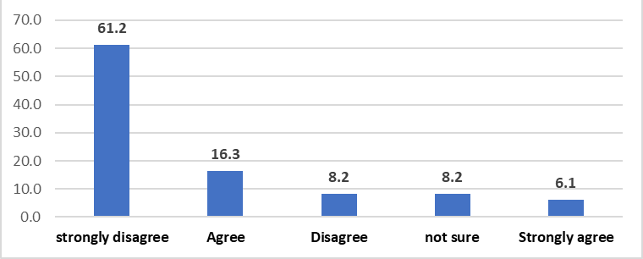
Figure 4.2 Conducting Survey to analyze what information do stakeholders need
Source: Field Data (2022)

4.3.3 Members participation in designing and planning the activities to be implemented
The study reveal that 36.7 percent of respondents agreed, 26.5 percent strongly disagree, 17.4 percent disagree, 15.3 percent strongly agree, and 4.1 percent of respondents not sure. On statement, M&E system of ELCT-ELVD allows stakeholders (church/organization) members to participate in designing, planning the activities to be implemented by their organization. When a researcher asked some respondents concerning agreed they said there are annual work plans which are prepared from each parish and some who disagree have said the work plans prepared in parishes do not have opinions of church members but done by leaders and chairperson of committee and not all activities especially diocesan projects church members are not engaged. The responses indicate that the system of ELCT-ELVD engaging church members to participate in designing and planning the activities of their organization as shown in the Figure 4.3.

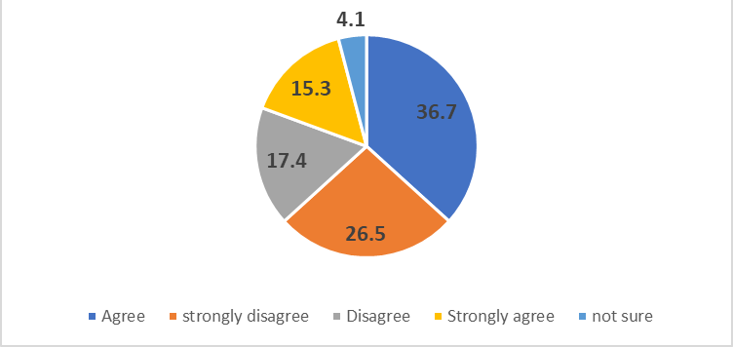
Figure 4.3 Church members designing and planning activities
Source: Field Data (2022)

4.3.4 Engagement of stakeholders in implementing planned activities
On the statement M&E system engaging all stakeholders (church/organization members) in activities implementation, the study found that, 43.3 percent of respondents agreed, 43.3 percent strongly agreed, 7.2 percent disagreed, 5.2 percent of respondents were not sure and 1.0 percent of respondents were strongly disagreed. A researcher asked some respondents who agreed said because you must implement the activities by contribution whether you like or not since order comes from top to the grass-root leaders to obey it otherwise they are in trouble. And some who disagree they have said not all planned activities they are engaged to implement. This indicates that, Organization M&E system engage all stakeholders in implementing the planned activities as indicated in the figure 4.4.

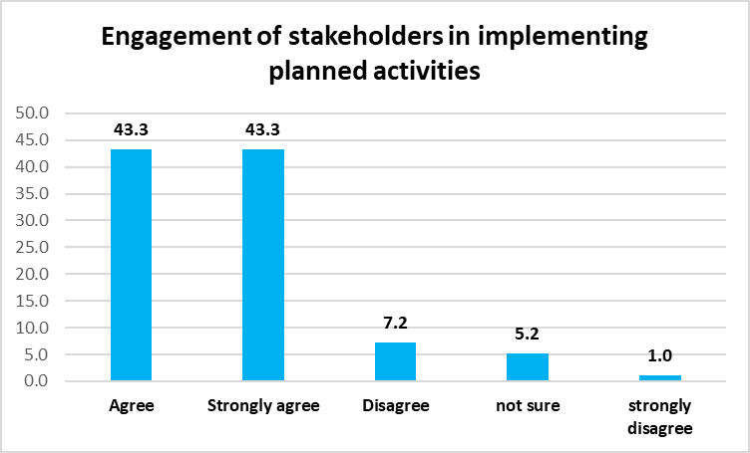
Figure 4.4 Engagement of Stakeholders Implementing Planned Activities, Source: Field Data (2022).

4.3.5 Engagement of Sstakeholders in Monitoring and Evaluation of the Implemented Activities
On responding this statement, M&E system engage all stakeholders (church/organization members) in monitoring and evaluating the organization implemented activities. Responses 29.6 percent of respondents strongly disagree, 27.6 percent agree, 19.4 percent disagree, 12.2 percent strongly agree, 11.2 percent of respondents were not sure of the statement. When a researcher asked some who agree have said there are representative of the church in the general assembly where the implementation report is shared and asked questions and received answers; But the other who disagree, have said that representation is not reality because they are guided who they want to send and not all questions answered and no face to face questions, also respondents have said they need to evaluate their contribution to invested project but no permission when they ask they do not get any complete information and are able to hire even a car for the purpose of tracking the progress and assessing the project implemented ; Thus, as per these responses organization M&E system does not engage all stakeholders in monitoring and evaluating the implemented activities by their organization as indicated in the Figure 4.5.

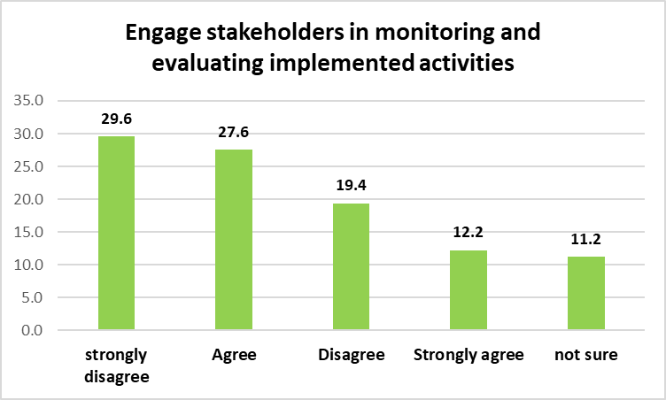
Figure 4.5 Engage Stakeholders in Monitoring and Evaluating Implemented Activities
Source: Field Data (2022)

4.4 Perceptions on knowledge and accessibility of information
The second objective of this study was, to examine the perceptions of members on knowledge and accessibility of information on M&E system of ELVD. This objective was achieved by asking the respondents to show their level of agreement to the given statements describing their perceptions on knowledge and accessibility to various M&E system information in FBOs.

4.4.1 Understanding of M&E system reports by stakeholders
The responses indicate, the ELCT-ELVD M&E system reports language is simple well understood by all levels of stakeholders from top level to grass root level educated and uneducated, revealed that, 34.7 percent of respondents agreed, 21.4 percent disagreed, 19.4 percent strongly agreed, 18.4 percent strongly disagreed, and 6.1 percent of respondents were not sure, The researcher asked the respondents who agreed and have said the language is Swahili and well understood by all members of the organization but the other who disagree have said there are some terms in an accounting language difficult to understood during reporting. This indicated that, the M&E system report of the organization is simple and understood by all level of stakeholders as illustrated in Figure 4.6.

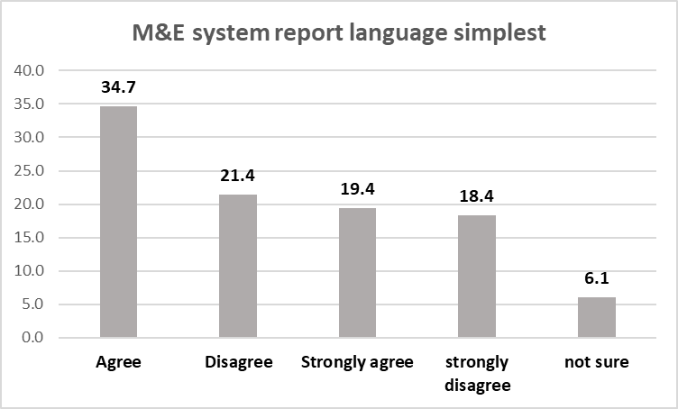
Figure 4.6 M&E system report language simplest
Source: Field Data (2022)

4.4.2 Use of visual expressions in the the M&E system reports
The responses to this statement, indicate that, the M&E system reports of ELCT-ELVD uses graphs, tables, charts, lines for visual expression (to show increase and decrease, rise-up, follow-down) the variation of the phenomenon, were as follows, 43.9 percent of respondents, were strongly disagree, 20.4 percent agree, 17.4 percent disagree, 10.2 percent were not sure, and 8.2 percent of respondents were strongly agreed. Thus, as per these responses most of the reports do not used graphs, tables, charts and lines to show visually the variation the agreed responses have said only the finance reports have tables. As indicated by the Figure 4.7.

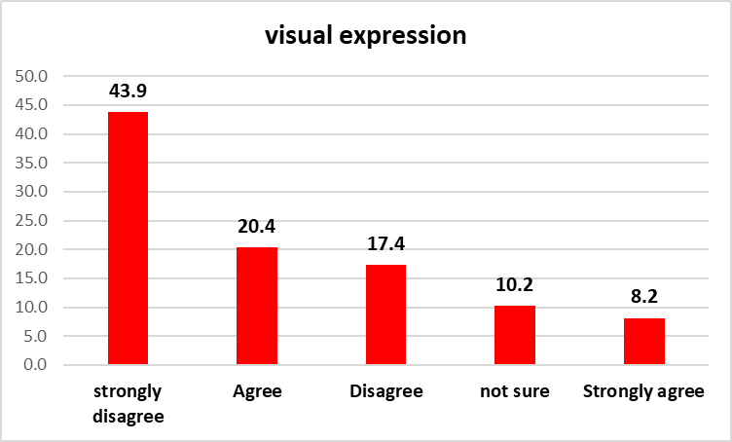
Figure 4.7 visual expression
Source: Field Data (2022)

4.4.3 The M&E system reports distribution to members of the church for comments and decision making
The respondents were asked to state their level of agreement on the statement, The M&E system reports of ELCT-ELVD distributed to all members of the church to read, provide comment and ask questions; 40.8 percent of the respondents strongly disagree and when a researcher asked two of them, they have said the time given to discuss on any given report is very short to process and making decision on information, 26.5 percent of respondents agree, 14.3 percent disagree, 12.2 percent strongly agree, and 6.1 percent of respondents were not sure of the statement. These responses imply that, the most of M&E reports are not communicated to all members of the church as illustrated in Figure 4.8.

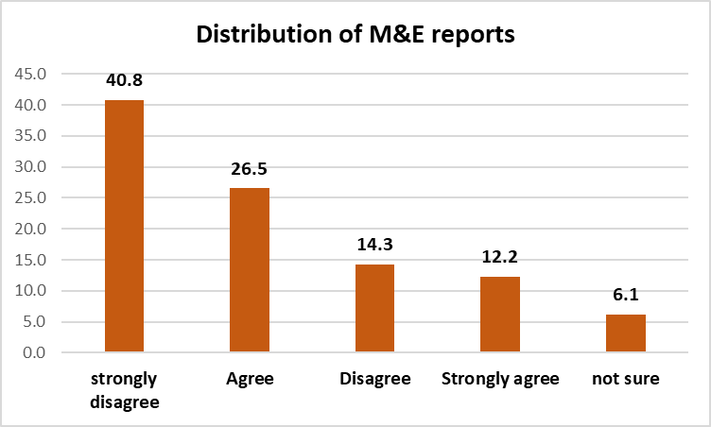
Figure 4.8 Distribution of M&E reports
Source: Field Data (2022)

4.4.4 Access to M&E system information by church members.
The respondents were asked to state their level of agreement on the statement, M&E system of ELCT-ELVD provide freely, easily and timely access of its information to each member of the church/organization. 31.6 percent of respondent were agree, 30.6 percent were strongly disagree, 17.4 percent were disagree, 11.2 percent were not sure and 9.2 percent of respondents were strongly agree; For the agreed respondents when one asked by a researcher concerning his response answered that, information are easily and freely and timely accessed because of WhatsApp mostly to pastors with smart phone through their groups, Also one disagreed respondent when asked by the researcher answered that information are free but are not easily and timely accessible by church members. The responses imply that there freely, easily accessibility of M&E information but not timely. Indicated in figure 4.9

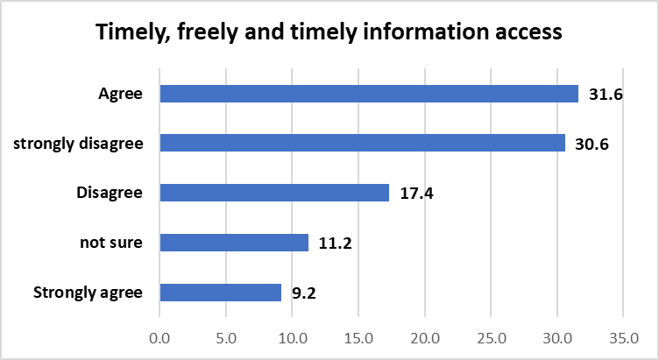
Figure 4.9. Timely, freely and timely information access
Source: Field Data (2022)

4.4.5 M & E reports are crucial for the development of an organization.
The respondents were asked to state their level of agreement on the statement, M & E reports are crucial for the development of an organization; The 86.6 percent of respondents were strongly agreed, 9.3 percent were agreed, 2.1 percent strongly disagree, 2.1 percent were not sure and with no disagree percent. The responses imply that; the M&E reports are crucial for the development of an organization as illustrated in figure 4.10.

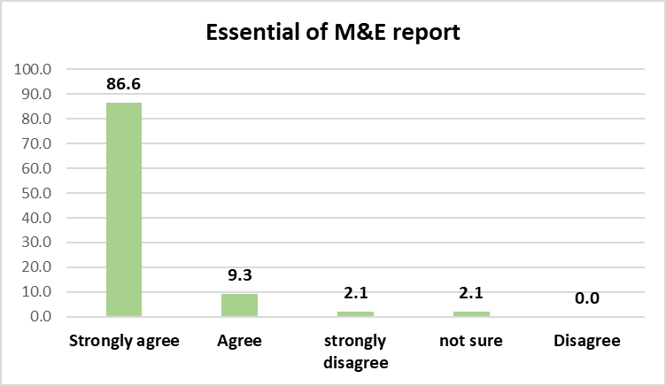
Figure 4.10 Essential of M&E report
Source: Field Data (2022)

4.5 Identify the Best channel and forum for feedback mechanism
The third objective of this study was, to identify the best channel and forum for feedback mechanism of FBOs M&E system. which will allow the FBOs to communicate its M&E reports and getting feedback easily and freely from the church members. This objective was achieved by asking the respondents to show their level of agreement to the given statements proposing the best channel and forum for receiving M&E report and providing feedback.

4.5.1 The organization to place suggestions box in a confidential place
The respondents were asked to state their level of agreement on the statement; The organization to place suggestions box in a confidential place for church members to write down their opinions, suggestions and questions in Parishes, Church Districts and Diocesan head office and responses were as follows 80.4 percent of respondents were strongly agree, 11.3 percent agreed ,4.1 percent were disagree, 4.1 percent were strongly disagree, and there were no percent of respondents who state not sure; This means most of the respondents were strongly agree as illustrated in the figure 4.11

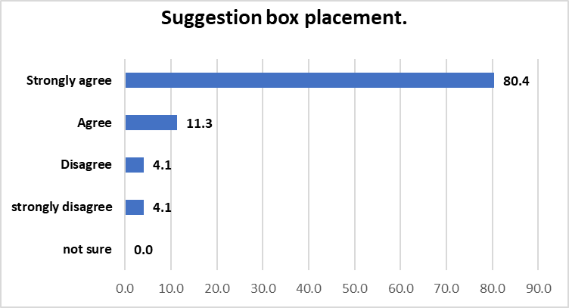
Figure 4.11 Suggestion box placements
Source: Field Data (2022)

4.5.2 The organization to have a day in a month for leaders to explain and provide answers
The respondents, responded to the statement stated the organization to have a day in a month for leaders to explain and provide answers and clarification on questions and suggestions kept on suggestion box to all members of the church/organization by having an Evaluation dialogue meeting. The responses were, 81.4 percent of respondents were strongly agreed, 10.3 percent agree, 5.2 percent were strongly disagreed, 2.1 percent disagree, 1.0 percent of respondents were not sure. Such responses imply that majority of the respondents need dialogue meeting for feedback from their leaders to be assure that their question received. As illustrated in the figure 4.12.

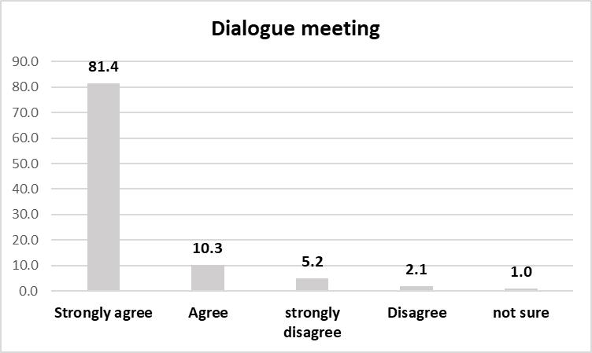
Figure 4.12 Dialogue meeting
Source: Field Data (2022)

4.5.3 Website is the best source of information used by the majority of organization members
The responses to the statement, Website is the best source of information used by the majority of church/organization members’, should be used by ELCT-ELVD for sharing progress reports and getting feedback. Were as follows 41.2 percent of respondents agree, 36.1 percent of respondents Disagree, 15.5 percent were strongly agreed, 5.2 percent of respondents were not sure and 2.1 percent of respondents were strongly disagreed on the statement; when a researcher asked one respondent who disagreed, have answered that most of the church members do not know their website and unable to visit. As illustrated in figure 4.13.

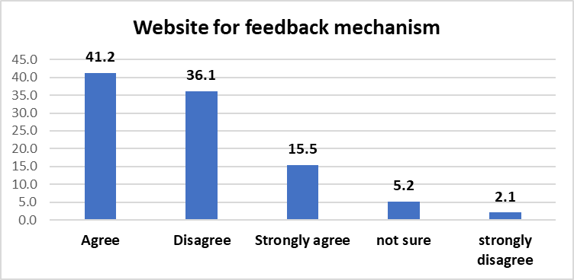
Figure 4.13 Website for feedback mechanism
Source: Field Data (2022)

4.5.4 Printed Document such as reports, flayers, brochures, posters are the best source of information
The respondents, were asked to state their level of agreement on the statement in which 66.3 percent of respondents were strongly agree, 19.4 percent were agree, 8.2 percent were disagree, 5.1 percent were not sure, and 1.0 percent of respondents were strongly disagree that Printed Document such as reports, flayers, brochures, posters are the best source of information used by the majority of church/organization members’, should be used by ELCT-ELVD for sharing progress reports and getting feedback. The responses declare that it is strongly agreed as illustrated in figure 4.14

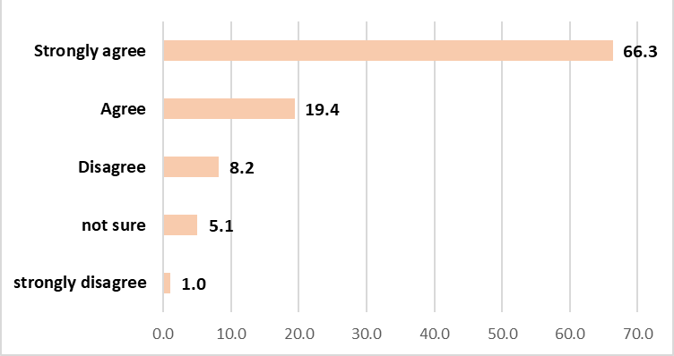
Figure 4.14 Printed documents
Source: Field Data (2022)

4.5.5 Documentation Centre is the best source of information by ELCT-ELVD M&E
On the statement; Documentation Centre is the best source of information used by the majority of church/organization members’, should be used by ELCT-ELVD for sharing progress reports and getting feedback. The respondents have stated their level of agreement to the statement, in which 75.5 percent of respondents were strongly agree, 21.4 percent were agreed, 2.0 percent were disagreed, 1.0 percent were not sure, with no any percent of strongly disagree. Thus, implies that documentation Centre is strongly agreed by majority of ELCT-ELVD, as indicated in figure 4.15.

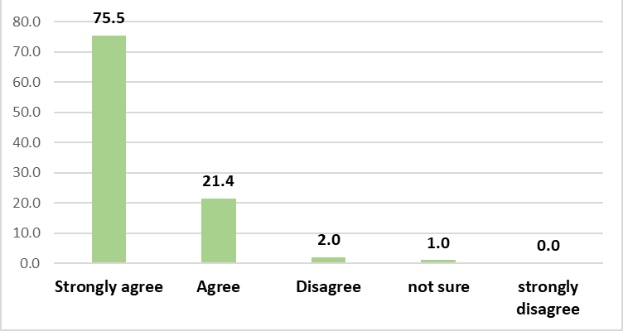
Figure 4.15 Documentation Centre
Source: Field Data (2022)

4.5.6 Social media (WhatsApp, Facebook, Instagram) are the best source of information
The level of agreement on the statement, social media (WhatsApp, Facebook, Instagram) are the best source of information used by the majority of church/organization members’, should be used by ELCT-ELVD for sharing progress reports and getting feedback, the findings were as follows, 50.0 percent of the respondents agree, 41.8 percent were strongly agreed, 5.1 percent were disagreed, 2.0 percent were strongly disagreed and 1.0 percent of the respondents were not sure. According to responses indicate that majority much agree on the social media to be the best channel for feedback as illustrated in Figure 4.16.

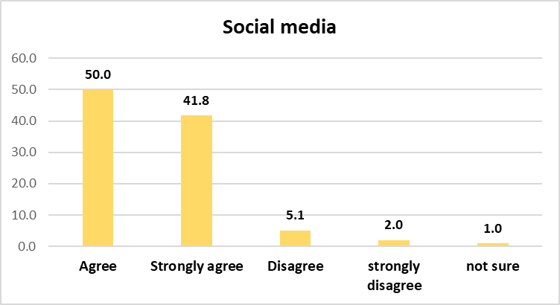
Figure 4.16 social media
Source: Field Data (2022)

4.5.7 Mobile phones are the best source of information used by the majority of church/organization members
The respondents were asked to state their level of agreement to the statement; Mobile phones are the best source of information system used by the majority of church/organization members’, should be used by ELCT-ELVD for sharing progress reports and getting feedback. In which 73.2 percent of the respondents were strongly agree, 18.6 percent were agreed, 4.1 percent were not sure, 3.1 percent were strongly disagreed and 1.0 percent of the respondents were disagreed with the statement, this implied that most of the respondents strongly agree with using mobile phone as channel for feedback because used by majority of church members. As illustrated in figure 4.17
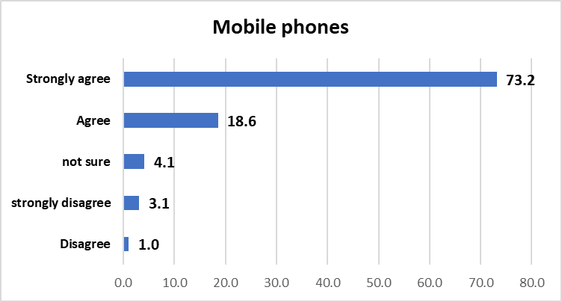
Figure 4.17 Mobile phones
Source: Field Data (2022)

CHAPTER FIVE

SUMMARY, CONCLUSION AND RECOMMENDATIONS

5.1 Chapter overview
This chapter contains summary of research findings, conclusions and recommendations and suggestions for further research. The study intended to examine the role of communication strategies in M&E system effectiveness in FBOs projects a case study of ELCT-ELVD. The researcher believes that recommendations put across will be likely and applicable by different FBOs and stakeholders in making effective M&E system in their organizations Projects.

Summary of the findings
The study intended to examine the role of communication strategies in M&E system effectiveness in FBOs projects a case study of ELCT-ELVD. More specifically the study, aimed at addressing the following objectives; To determine the type of information received by members on M&E system of ELVD, to examine the perceptions of members on knowledge and accessibility of information on M&E system of ELVD, and to identify best channel and forum for feedback mechanism of FBOs M&E system.
This study employed descriptive quantitative research approach, allow describing how is the role of communication strategies in M&E system effectiveness in FBOs projects. And structured questionnaires using google form were used to draw information from the respondents that focus on research objectives and questions.
Data was analyzed using Microsoft excel, in which the questionnaire has statements per each objective with Likert scale per each variable(statement) showing the level of agreement with assigned number of each level and descriptive statistics such as frequencies, and percentiles were used to interpret the data. Tables, graphs and chart were used for analysis and interpretation of data. The study has 98 respondents in which the distribution was in gender in which 45.9 percent of respondents were male and 54.1 percent were female , in terms of their age profile, the study reveal that, 8.2 percent of respondents had age below 25 years old, 40.8 Percent of respondents have age between 25-35 years old, 32.7 percent of respondents had age between 36-45 years old, 11.2 percent of respondents had age between 46-55 years old and 7.1 percent of the respondents had age above 56 years old. Moreover, the study reveals that, 2.0 percent of the respondents were top leaders, 8.2 percent were ELCT-ELVD head office lay staff, 4.1 percent were district clergy staff, 4.1 percent were district lay staff, 20.4 percent were parish clergy staff, 20.4 percent were parish lay staff, and 40.8 percent of the respondents were believers.
The findings reveal that, 34.4 percent of respondents agreed that, M&E system of ELCT-ELVD disaggregate information to the targeted audiences according to the needs and purpose and goal of the stakeholders but 24.0 percent were strongly disagreed by saying it is a routinely practice for information to come from top and read to all regardless the stakeholders need or have a purpose of it which make M&E system ineffectiveness as according to URT (2011) and Ondeko (2020). M&E system is effective when using communication strategies which is two way communication applied from top-bottom and bottom-up by members to place need and the organization to supply what members need and this create the ownership of projects; also 61.2 percent of respondents strongly disagreed by responding that, there is no any survey conducted by the organization to analyze what information church members need to be given by their leaders, in which M&E system became ineffective as according Kanyamuna et al. (2019) in their study concludes that, in, functional M&E systems there are need of participatory planning of M&E system by involving and utilizing effectively stakeholders for the sustainability of the organization projects in which survey is important for collecting opinions, 36.7 percent of respondents agreed that the organization engage her members in designing and planning the activities to be implemented by their organization but 26.5 percent of respondent strongly disagreed the statement because not all activities church members engaged to design and plan especially diocesan projects; more than that, 43.2 percent of respondents agreed and strongly agreed that the organization M&E system engage all stakeholders in implementing the planned activities by their organization because they have no option, it is a faith based organization otherwise the leaders in parish and district will be in trouble; While, 29.6 percent of the respondents strongly disagree by stating M&E system of their organization do not engage all church members in monitoring and evaluating the implemented activities, because when they ask report they do not get any complete information and even they able to hire even a car for the purpose of tracking the progress and assessing the project implemented; 27.6 percent of respondents agreed some of them saying there are representative of the church members who monitor and evaluate the activities implemented but for communication strategies in M&E system effectiveness Kanyamuna et al. (2019), Oketch (2016) recommend the use of M&E system in the whole project life cycle not only in some phases.
The study revealed that the majority which are 34.7 percent of respondents agreed that the language used in M&E system of the organization is simple, easily understood by all members of the organization from top to low grass-root level because is in their language which is Swahili which is in line with URT (2011 and Uzochukwu et al. (2016) in their study show that, effective communication strategies in M&E system effectiveness is one with plain language which is easily understood by stakeholders but other 21.4 percent of respondents have disagree because there are some financial accountants terms are not well understood by other members in rural areas which cause the failure of various strategies; Also 43.9 percent of respondents indicated that, the M&E reports of ELCT-ELVD do not using chart, table to show the variation, increasing or decreasing, rise and fall, while 40.8 percent of respondents disagreed by saying that, M&E system reports of ELCT-ELVD do not distributed to all members of the church to read, provide comment and ask questions and making decision and the time for discussion is limited because it is not for discussing the progress report but it is chipped in without having its specific time; Furthermore, the 31.6 percent of the respondents agreed and 30.6 percent of respondents were strongly disagree that M&E system of ELCT-ELVD provide freely, easily and timely access of its information to each member of church/organization for this reason, it is freely to get information but not easily and are not given on time the easiest it comes to pastors and evangelism who have smart phone and are in their WhatsApp group but not to other members of the organization which complement with the studies according to Musambayi (2012), caused by dim communication channel in the organization M&E systems and slow in accepting and implementing evidence-based practice on project activities implemented (Terry et al., 2015). And 84.6 percent of the responses have strongly agreed that, M & E reports are crucial for the development of an organization. That you cannot know whether you grow or not without M&E reports as revealed also with Terry et al. (2015) and Uzochukwu et al. (2016)
The study revealed that the majority 80.4 percent of respondents have strongly agreed that, they need their organization to place suggestions box in a confidential place for church members to write down and put into it their opinions, suggestions and questions in Parishes, Church Districts and Diocesan, to make some changes for the development of the organization; Also 81.4 percent of the respondents strongly agreed the organization to have a day in a month for leaders to explain and provide answers and clarification on questions, opinions and suggestions kept on suggestion box to all members of the church/organization and by having Evaluation dialogue meeting which is relating with the URT (2005), SALAAM and MERO (2019) in their studies shows that, communication strategies in M&E system using different channels and forum for feedback mechanism and sharing project/program progress reports including dialogue meetings, radio program and others. More than that, 41.2 percent of respondents were strongly agreed while 36.1 percent of respondents were disagreed on ELCT-ELVD to use website for communicating the progress report and receiving feedback because it is used by majority members of the organization and not all with skills and website is not known by many members of the church. 69.3 percent of respondents strongly agreed with Printed Document such as reports, flayers, brochures, posters that are the best source of information used by the majority of church/organization members’, should be used by ELCT-ELVD for sharing progress reports and getting feedback. Likewise, 75.5 percent of respondents had strongly agreed that Documentation Centre is the best source of information used by the majority of church/organization members’, should be used by ELCT-ELVD for sharing progress reports and getting feedback. Furthermore, 50.0 percent of respondents agreed while 41.8 percent of the respondents strongly agreed that Social media (WhatsApp, Facebook, Instagram) are the best source of information used by the majority of church/organization members’, should be used by ELCT-ELVD for sharing progress reports and getting feedback; Lastly the 73.2 percent of the respondents had strongly agreed that mobile phones are the best source of information system used by the majority of church/organization members’, should be used by ELCT-ELVD for sharing progress reports and getting feedback which agree with C-change (2011) which recommend the use of different channels for communicating M&E reports including brochures, flyers, posters, interpersonal communication, public announcement and other media to reach majority of stakeholders.

5.3 Conclusion
ELCT-ELVD as one of the FBOs, have M&E system in place to make sure the organization is growing and achieving its goal; But her M&E system is ineffective because does not imply effectively communication strategies to perform its role in its various projects implemented, that is why the conflict within the organization erupt frequently, commitment decrease and the trust of stakeholders to their leaders’ decreases, church members decrease at each Sunday services and projects fails. The study reveals that, its M&E system disaggregate the type of information which the audiences need and have a purpose of that information, in the same situation many information comes from top to down even for the needs of audience or not. Because no any survey conducted to assess what type of information do audience need, which is very crucial component in communication strategies for M&E system effectiveness for the success of various projects in the FBOs and other organization; There are minimum engagement of all members in designing and planning the activities of their organization , especially, in the organization projects, the opinions sent by members but not applied; But the members of organization are forced to implement the planned activities by their organization head office without option whether they like or not by the lowliness of their leaders in the low level governance such as parishes; Also there are low engagement of church members to the monitoring and evaluating the implemented activities of their organization projects with no strong feedback concerning the project progress.
This study discovers that; Though organization projects M&E reports use simple language which is easily understood by the majority members of the organization, because it uses Swahili language, but still there are some accountant language difficult to be understood by illiterate members, the projects and other organization M&E report are free but are not easily and timely accessed; Also they are not distributed to all members to ask, to provide opinions and making decision according to it and the time for discussing the reports is limited not enough because it is not only discussing the reports and they are not using charts, tables, and lines for visual expression to make it easily understood by all members by showing variation visually with images; Moreover, the majority of the organization members believed with confident that the project M&E reports are very crucial for the development of the organization because they can know where they are and what to do to go higher and reallocation of organization resources.
Lastly; the study reveals that, majority of FBOs members use channels such as printed documents, flyers, brochure, posters, Documentation Centre, mobile phones and social medias like Facebook, WhatsApp and declare them as better source of information and for getting feedback and suggest their organization to use them for communicating their projects activities progress reports and receiving feedback from members without leaving website which does not recognized by majority of the members, many amazed if there is organization website even to whom that are in urban areas; Much more the study reveals that there are high need of suggestion box at the diocesan head office, districts and parishes in a confidential area where the members of organization can put in, their opinions, questions, suggestions freely because they have something to say Concerning projects and other activities but they afraid, this is required with having the day in a month for a dialogue meeting with an evaluation meeting platform or forum where leaders can clarifies and giving answers and explanation to the members on what had kept in the suggestion box.

5.4 Recommendations
The FBO, ELCT-ELVD need to incorporate communication strategies in her M&E system to be effective in all of its projects implemented, the effectiveness will be by, conducting survey to all their members in all levels to analyze and identifying what information these members need to be given and providing them the same-same information, and this will stir up the commitment on contributing their effort for church growth, developments and economic sustainability of the organization because no project will fail; The M&E system has to engage all FBOs members in designing and planning the activities of their organization projects by creating even a short questionnaire with list of activities to be implemented in the following year or in four years’ strategic plan so as to own the plan as it is for all members of ELCT-ELVD and remove the gap between diocese and parish like parishes are different from diocese while it is within the diocese, thus there will be no separation between the diocese and parishes.
This study also, recommend the ELCT-ELVD, to engage all of her members in monitoring and evaluating the implemented projects, where they contribute their efforts in implementing, by taking a certain number of members from different groups within parishes to oversee their investment projects, even by donating transport cost themselves and this will increase trust to their leaders and ownership of the organization and reducing conflicts within a diocese and will highly preserve its believers.
More than that, this study recommends, the ELCT-ELVD to use charts, tables and lines for visual expression of its various projects M&E reports to make sure it makes sense and easily understood by all members of the organization, this will lead to having construction opinions and participatory decision from the majority. Also, the ELCT-ELVD should make sure its projects M&E reports and other reports are distributed to all members of the church/organization and preparing the specific day and time which will be purposively for reviewing progress and evaluation reports only with enough time to ponder and discuss and coming with constructive decision without having the short time for reading report in a Sunday service where people are not able to remain in church after service and have tired in which you cannot get their opinions because they are not ready and felt late for their economic and social activities; This will enlarge the number of church members by having trust on their organization transparency and cooperative system
Moreover, this study recommends, the ELCT-ELVD to place the suggestion boxes in a confidential place at diocesan head office, districts and parishes where the organization members can freely and confidentially put their opinions, questions and suggestions which was very difficult to face a person or leaders for even a constructive issue, also to set apart a specific day in a month purposively as forum for leaders and church/organization members to have a dialogue meeting for feedback and responses to questions from leaders and for evaluation and corrections also the forum for clarifying, answering questions found in a suggestion box for the well-being of FBO. Lastly; the ELCT-ELVD recommended by this study, to use the following channels for communicating findings and receiving feedback, more printed documents, brochures, posters, flyers, with having the documentation Centre’s at each level of administrations including head office of the organization, districts, parishes and in their Centers for any person to get any information of the organization by knowing where he/she can get, also using mobile phones to provide the progress reports to all members, social medias but website needs more advertisement to the majority of the organization members because they are not aware of it; For the FBOs to use all these channels and forum for communicating M&E reports to their members there will be no more conflict and commitment among members will increase with created ownership of the organization.

5.5 Recommendation for Further Research
The empirical study has indicated a number of relevant issues that the research project did not investigate, but which might be important for further research on examine the role of communication strategies in M&E system effectiveness in FBOs in Evangelical Lutheran Church in Tanzania – East of Lake Victoria Diocese.
This study was conducted at ELCT-East of Lake Victoria Diocese; other studies can involve other areas and other FBOs in order to obtain more holistic and wide information of the same. Also, this study used one research method descriptive quantitative research design with structured questionnaire for data collection and Microsoft excel for data analysis but other can use another method to complement these results and a researcher is sure that will be the same.

REFERENCES
Baškarada, S., & Koronios, A. (2018). A philosophical discussion of qualitative, quantitative, and mixed methods research in social science. Qualitative Research Journal.
Blog, F. (2021). Descriptive research designs: Types, examples & methods.
Buadi, D. K., Anaman, K. A., & Kwarteng, J. A. (2013). Farmers’ perceptions of the quality of extension services provided by non-governmental organisations in two municipalities in the Central Region of Ghana. Agricultural Systems, 120, 20-26.
Burgess-Wilkerson, B. (2011) Sustainability in the Nonprofit Sector: Communication Strategies to Increase the Bottom Line. Advances in Business Research, 2(1), 247-255.
C-Change. 2011. Social and Behavior Change Communication Capacity Assessment Tool (SBCC-CAT) for Use with Donors and Networks. Facilitator’s Guide. Washington, DC: C-Change/AED.
Denscombe, M. (2017). EBOOK: The good research guide: For small-scale social research projects. McGraw-Hill Education (UK).
Gamba, P. (2016). factors affecting utilization of monitoring and evaluation findings in implementation of malaria control programmes in mukono district, uganda.
Hargie, O. (2021). Skilled interpersonal communication: Research, theory and practice. Routledge.
Hyland-Wood, B., Gardner, J., Leask, J., & Ecker, U. K. (2021). Toward effective government communication strategies in the era of COVID-19. Humanities and Social Sciences Communications, 8(1), 1-11.
Hapunda, G. (2018). Developing a Participatory Monitoring and Evaluation System. Participatory Monitoring and Evaluation for Projects, Programmes or Policies, 275.
Jothi, P. S., Neelamalar, M., & Prasad, R. S. (2011). Analysis of social networking sites: A study on effective communication strategy in developing brand communication. Journal of media and communication studies, 3(7), 234-242.
Kanyamuna, V., Kotzé, D. A., & Phiri, M. (2019). Monitoring and Evaluation Systems: The Missing Strand in the African Transformational Development Agenda. World Journal of Social Sciences and Humanities, 5(3), 160-175.
Kaur, S. P. (2013). Variables in research. Indian Journal of Research and Reports in Medical Sciences, 3(4), 36-38.
Kasper, G., & Kellerman, E. (2014). Communication strategies: Psycholinguistic and sociolinguistic perspectives. Routledge.
Kiboi, G. K., Kilonzo, D. J., & Iravo, P. M. (2018). Determinants of effective monitoring and evaluation in health service delivery: A case of Nairobi city county health facilities. Int J Manag Commer Innov ISSN, 6(1), 231-45.
Kothari, C.R. (2012). Research methodology: Methods and techniques, 2nd edition, New International (P) Ltd, New Delhi, India.
Lesaux, N. K., Kieffer, M. J., Faller, S. E., & Kelley, J. G. (2010). The effectiveness and ease of implementation of an academic vocabulary intervention for linguistically diverse students in urban middle schools. Reading Research Quarterly, 45(2), 196-228.
Maloney, E. K., Lapinski, M. K., & Witte, K. (2011). Fear appeals and persuasion: A review and update of the extended parallel process model. Social and Personality Psychology Compass, 5(4), 206-219.
McIntosh, M. J., & Morse, J. M. (2015). Situating and constructing diversity in semi-structured interviews. Global qualitative nursing research, 2, 2333393615597674.
McKim, C. A. (2017). The value of mixed methods research: A mixed methods study. Journal of mixed methods research, 11(2), 202-222.
Mero, F. (2019). Assessment of Factors Influencing the Success of Monitoring and Evaluation Systems for Local NGO’s in Mwananyamala Ward: The Case of PACT Tanzania (Doctoral dissertation, The Open University of Tanzania).
Musambayi, E. L. (2012). Challenges of strategy implementation in community-based organizations in Nairobi, Kenya (Doctoral dissertation, University of Nairobi, Kenya).
Neyeloff, J. L., Fuchs, S. C., & Moreira, L. B. (2012). Meta-analyses and Forest plots using a microsoft excel spreadsheet: step-by-step guide focusing on descriptive data analysis. BMC research notes, 5, 1-6.
Nicol, E., Bradshaw, D., Uwimana-Nicol, J., & Dudley, L. (2017). Perceptions about data-informed decisions: an assessment of information-use in high HIV-prevalence settings in South Africa. BMC health services research, 17(2), 25-38.
Niglas, K. (2007). Media Review: Microsoft Office Excel Spreadsheet Software. Journal of Mixed Methods Research, 1(3), 297-299.
Oketch, C. M. (2016). Factors Affecting the Effectiveness of Monitoring and Evaluation Systems among Faith Based Organizations in Kenya: A Case Study of the Kenya Young Men’s Christian Association in Nairobi County (Doctoral dissertation, Daystar University, School of Human and Social Sciences).
Ondeko, R. N. (2020). Unpacking Partnerships for Planning Monitoring and Evaluation-Sustainability of Agricultural Projects Funded by Non-Governmental Organizations Nexus. An Empirical Study in Bungoma County, Kenya. International Journal of Business and Social Science, 11(9).
Philip Cleave. (2021). Advantages of Questionnaires in Online Research Smart Survey. https://www.smartsurvey.co.uk/blog/advantages-of-questionnaires-in-online-research
Rasila, B. N. (2021). improving government communication services through effective monitoring and evaluation.
Reading, E. (2015). Ways to build trust among stakeholders in conflict settings.
Ruark, A., Kishoyian, J., Bormet, M., & Huber, D. (2019). Increasing family planning access in Kenya through engagement of faith-based health facilities, religious leaders, and community health volunteers. Global Health: Science and Practice, 7(3), 478-490
Salaam, m., & mero, f. (2019). Factors influencing the success of monitoring and evaluation systems for local ngo’s: a case of pact in.
Sileyew, K. J. (2019). Research design and methodology (pp. 1-12). Rijeka: IntechOpen.
Stewart, D. W., & Pavlou, P. A. (2002). From consumer response to active consumer: Measuring the effectiveness of interactive media. Journal of the academy of marketing science, 30(4), 376-396.
Suen, L. J. W., Huang, H. M., & Lee, H. H. (2014). A comparison of convenience sampling and purposive sampling. Hu Li Za Zhi, 61(3), 105.
TACAIDS (2010). TACAIDS annual report for financial year 2009/2010
Taherdoost, H. (2016). Sampling methods in research methodology; how to choose a sampling technique for research. How to Choose a Sampling Technique for Research (April 10, 2016).
Tanzania, T. A. C. A. I. D. S. (2010). Tanzania Commission for AIDS annual report for financial year 2009/2010.
Terry, J. D., Smith, A. R., Warren, P. R., Miller, M. E., McQuillin, S. D., Wolfer, T. A., & Weist, M. D. (2015). Incorporating evidence-based practices into faith-based organization service programs. Journal of Psychology and Theology, 43(3), 212-223.
Urt (2011). Mkukuta Ii M&E Communication Strategies
Uzochukwu, B., Onwujekwe, O., Mbachu, C., Okwuosa, C., Etiaba, E., Nyström, M. E., & Gilson, L. (2016). The challenge of bridging the gap between researchers and policy makers: experiences of a Health Policy Research Group in engaging policy makers to support evidence informed policy making in Nigeria. Globalization and health, 12(1), 1-15.
Vincent, K., Aurick, M., Ng’andu Emily, M. C., & Ackson, M. (2018). An Assessment of the Demand-Side of the Monitoring and Evaluation System of the Health Sector in Zambia. World, 4(2), 75-86.

APPENDICES

Appendix I: Questionnaire and Interview Guide
Dear Leaders /staff/believers
My name is Mpoki Jafari, a student from The Open University of Tanzania pursuing Master’s degree of Arts in Monitoring and Evaluation and as part of academic requirement, I am conducting the research titled role of communication strategies in monitoring and evaluation systems effectiveness in faith-based organizations, please fill out the questions below according to your experience to help me in this study.
Your answers will remain anonymous and will be treated in confidential, so please endeavor to answer honestly. I will be glad that you sign below to consent for participation in this study. Note that you are free to skip or stop answering any question that you don’t feel okay to answer.
If you have questions about the questionnaire or the research in general, feel free to contact the researcher via the following email addresses: jafampoki@gmail.com or mobile phone +255-752011567
SECTION A: BACKGROUND INFORMATION
Please ticks (√) to the correct answer or give details as appropriate in the following questions.
- What is your designation/position at ELCT-ELVD?
□Top Leader □ Clergy Staff □ Lay Staff □ Believer

- What is your gender?
□ Male □ Female
- Age
□ Below 25 □ 25 – 35 □ 36 – 45 □46 – 55 □ 56+ □
- Location?
□ Head quarter □ District □ Parish □ Other Specify …………….

SECTION B: DISAGGREGATION OF THE TYPE OF INFORMATION
For the following statements on the disaggregation of information, please indicate your level of agreement or disagreement on the following statements indicated below base on the following scale; Tick the number that best represents your level of agreement with the statement. Where, 5= Strongly agree, 4=Agree, 3= Not sure, 2= Disagree and 1= Strongly disagree
No. | Statement | Responses
No. | Statement | 1 | 2 | 3 | 4 | 5
1 | ELCT-ELVD M&E system disaggregate information to stakeholders according to their different information needs or purpose
2 | The organization conducting survey to analyze the stakeholders (church/organization members) about what information they need to be given.
3 | M&E system of ELCT-ELVD allow stakeholders (church/organization) members to participate in designing, planning the activities to be implemented.
4 | M&E system engage all stakeholders (church/organization members) in activities implementation.
5 | M&E system engage all stakeholders (church/organization members) in monitoring and evaluating the organization implemented activities.

SECTION C: PERCEPTIONS OF KNOWLEDGE AND ACCESSIBILITY
For the following statements on the perceptions of knowledge and accessibility, please indicate your level of agreement or disagreement on the following statements indicated below base on the following scale; Tick the number that best represents your level of agreement with the statement. Where, 5= Strongly agree, 4=Agree, 3= Not sure, 2= Disagree and 1= Strongly disagree
No. | Statements | Responses
No. | Statements | 1 | 2 | 3 | 4 | 5
1 | The ELCT-ELVD M&E system reports language is simple well understood by all levels of stakeholders (top level to grass root level educated and uneducated)
2 | The M&E system reports of ELCT-ELVD uses graphs, tables, charts, lines for visual expression (to show increase and decrease, rise-up, follow-down)
3 | The M&E system reports of ELCT-ELVD distributed to all members of the church to read, provide comment and ask questions
4 | M&E system of ELCT-ELVD provide freely, easily and timely access of its information to each member of church/organization.
5 | M & E reports are crucial for the development of an organization

SECTION D: BEST CHANNEL AND FORUM FOR FEEDBACK MECHANISM
For the following statements on the best channel and forum for feedback mechanism, please indicate your level of agreement or disagreement on the following statements indicated below base on the following scale; Tick the number that best represents your level of agreement with the statement. Where, 5= Strongly agree, 4=Agree, 3= Not sure, 2= Disagree and 1= Strongly disagree
No. | Statements | Responses
No. | Statements | 1 | 2 | 3 | 4 | 5
1 | The organization to place suggestions box in a confidential place for church members to write down their opinions, suggestions and questions in Parishes, Church Districts and Diocesan head office
2 | The organization to have a day in a month for leaders to explain and provide answers and clarification on questions and suggestions to all members of the church/organization (Evaluation meetings)
3 | Website is the best source of information used by the majority of church/organization members’, should be used by ELCT-ELVD for sharing progress reports and getting feedback.
4 | Printed Document such as reports, flayers, brochures, posters are the best source of information used by the majority of church/organization members’, should be used by ELCT-ELVD for sharing progress reports and getting feedback.
5 | Documentation Centre is the best source of information by ELCT-ELVD M&E system used by the majority of church/organization members’, should be used by ELCT-ELVD for sharing progress reports and getting feedback.
6 | Social media (WhatsApp, Facebook, Instagram) are the best source of information used by the majority of church/organization members’, should be used by ELCT-ELVD for sharing progress reports and getting feedback.
7 | mobile phones are the best source of information by ELCT-ELVD M&E system used by the majority of church/organization members’, should be used by ELCT-ELVD for sharing progress reports and getting feedback.

Appendix 2: Research Clearance Letter

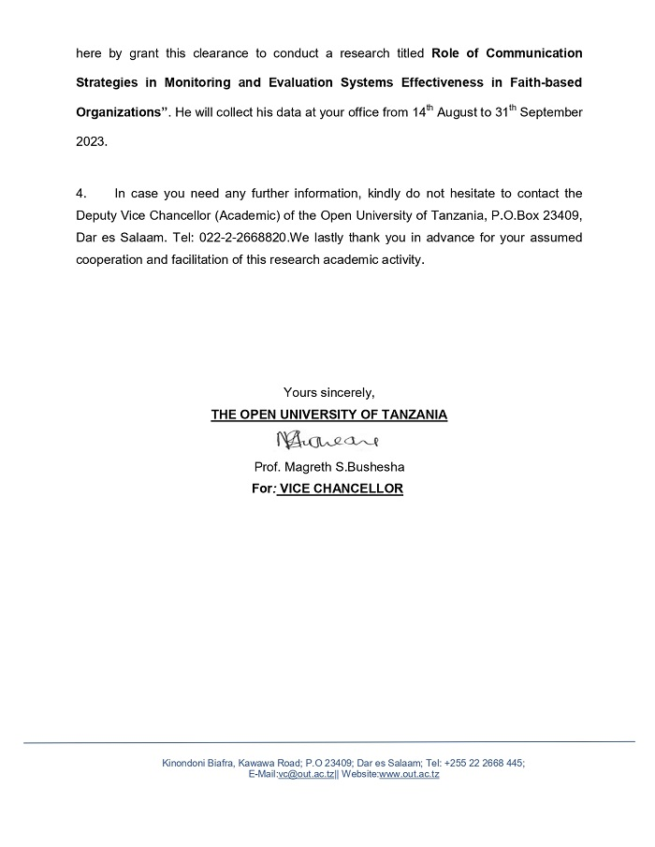

Thank you for your participation

