IMPROVING INCOMES OF YOUNG SINGLE MOTHERS THROUGH PRODUCTION OF AMARANTH, PUMPKIN AND SWEET POTATO LEAVES AT TANDALE WARD IN KINONDONI MUNICIPAL

CLARA GHATI KISUNTE

A DISSERTATION SUBMITTED IN PARTIAL FULFILMENT OF THE REQUIREMENTS FOR THE DEGREE OF MASTER OF COMMUNITY ECONOMIC DEVELOPMENT (MCED)
DEPARTMENT OF ECONOMICS AND COMMUNITY ECONOMIC DEVELOPMENT
OF THE OPEN UNIVERSITY OF TANZANIA
2022

CERTIFICATION
The undersigned certifies that he has read and hereby recommends for the acceptance by the Open University of Tanzania (OUT) a dissertation entitled; “Improving Incomes Of Young Single Mothers Through Production Of Amaranth, Pumpkin and Sweet Potato Leaves at Tandale Ward, Kinondoni Municipality” in partial fulfilment of the requirements for the degree of Master of Community Economic Development (MCED).

.........................................................
Dr. Noel Matemba
(Supervisor)

.............................................
Date

COPYRIGHT
No part of this dissertation may be reproduced and stored in any retrieval system or transmitted in any form or by any means of electronic, mechanical, photocopying or otherwise, without prior written permission of the author or from The Open University of Tanzania in that behalf.

DECLARATION
I, Clara Ghati Kisunte, declare that, the work presented in this dissertation is original. It has never been presented to any other University or Institution. References have been supplied where other people's work has been used. In this regard, I declare that this is my unique work. It is hereby submitted in partial fulfilment for the Degree of Master of Project Management (MPM).


...............................................
Signature

07th Nov. 2022
..............................................
Date

DEDICATION
This work is dedicated to my husband, Bernard James Mapalala, who encouraged and supported me to undergo the programme, also to my lovely children; James, Marygoreth and Hannah for their patience, integrity and obedience during my study period. Others include my fellow work mates at Tanzania Social Action Fund for their support through my entire master’s programme journey.
.

ACKNOWLEDGEMENT
I wish to express my sincere thanks to the Community of Tandale Ward and officers from Kinondoni Municipal Council who cooperated with me tirelessly from the beginning of this Project. I would like to thank my Supervisor Dr. Noel Matemba whose supervision, guidance, and facilitation made this project report to come the way it looks. Special thanks should also go to fellow classmate Ally Msumi, for his moral and material support. He was so helpful to my studies.

I would like to express my thanks to the Research respondents, Ward Executive Officer (WEO) Mr. Boniphace Masagida and other stakeholders for assisting in the accomplishment of this project. However this type of research and project undertaking has involved the efforts of many people who are to be on an infinite list thus it behoves me to mention just few as above and I sincerely thank them for their cooperation and assistance in various aspects pertaining to the successful completion of this project report and the course in general.

ABSTRACT
This project report emanates from a project on improving incomes of young single mother through the production of vegetable namely…. at Tandale Ward, in Kinondoni Municipal. Before the intervention, Community Needs Assessment (CNA) was carefully carried-out which established the community needs and problems. Through CNA it was established that, the main problem which face majority of young single mothers of Tandale Ward was sustainability of income. The study set out specific objectives towards solving the problem. The objectives were, 10 young single mothers to be trained on production of amaranth, sweet potato leaves and pumpkin leaves by June,2022; facilitation of acquisition of 2450 sqm of land to 10 young mothers for production of amaranth, pumpkin leaves and sweet potato leaves by June 2022; facilitation of capital formation for 10 young single mothers on production of amaranth, pumpkin leaves and sweet potato leaves by July 2022 and to increase incomes of 10 young single mothers through vegetable production from 100,000-700,000 tshs per month by August 2022. The young single mothers agreed to establish green vegetables (amaranth, sweet potato leaves and pumpkin leaves) production project. The young mothers showed commitment to the project by working alongside stakeholders in execution of the project. Agricultural extension Officer was also involved in the project for follow-up sustainability of the project. It is recommended that other women groups should adopt similar income generating projects for poverty alleviation.
Keywords: Incomes, Young, Single Mothers, Production.

TABLE OF CONTENTS
CERTIFICATION ii
COPYRIGHT iii
DECLARATION iv
DEDICATION v
ACKNOWLEDGEMENT vi
ABSTRACT vii
TABLE OF CONTENTS viii
LIST OF TABLES xii
LIST OF FIGURES xiii
LIST OF ABBREVIATIONS xv
CHAPTER ONE 1
PARTICIPATORY NEED ASSESSMENT 1
1.1 Background Information 1
1.2 Community Profile 2
1.3 Community Need Assessment 2
1.3.1 Community Needs Assessment Objectives 3
1.3.3 Research Methodology 4
1.3.3.1 Research design 4
1.3.3.4 Data collection methods 6
1.3.3.5 Data Analysis 7
1.4 Community Needs Assessment Findings 7
1.4 Community Needs Prioritization/Levelling of needs 11
CHAPTER TWO 13
PROBLEM IDENTIFICATION 13
2.1 Background of Research Problem 13
2.2 Problem Statement 14
2.3 Project Description 15
2.3.1 Target Community 16
2.3.2 Stakeholders 17
2.3.3 Project Goals in CED Terms 17
2.3.4 Project Objectives 17
2.3.4.1 General Objective 17
2.3.4.2 Specific Objectives 18
2.4 Host Organization/ CBO profile 18
2.4.1 Vision of the Host Organization 18
2.4.2 Mission 19
2.4.3 Activities 19
2.4.4 Organizational Structure for Host Organization 19
2.4.5 SWOC Analysis 20
2.4.6 Role of CED Student in the Project 21
2.4.7 Host Organization Roles in the Project 21
CHAPTER THREE 22
LITERATURE REVIEW 22
3.1 Introduction 22
3.2 Review of Theoretical Literature 22
3.2.1 Definition of Key Terms 22
3.2.1.1 Income 22
3.2.1.2 Micro-economic Theory 22
3.2.1.3 Maslow’s Theory 23
3.3 Review of Empirical Literature 24
3.4 Policy Reviews (Tanzania Agriculture Policy of 2013) 26
3.4.1 Policy Overview 26
3.4.2 Irrigation Development 27
3.4.4 Farmer Organizations 28
3.4.5 Urban Agriculture 29
3.4.6 Gender 29
3.4.7 Business for Development Supports New Policy on Agriculture 30
3.5 Literature Review Summary 30
CHAPTER FOUR 32
PROJECT IMPLEMENTATION 32
4.1 Introduction 32
4.2 Project Output 32
4.2.2 Project Outputs 32
4.3 Project Planning 33
4.3.1 Implementation Plan 34
4.3.3 Budget Assessment 36
4.3 Project Implementation 38
4.4.1 Project implementation Report 39
4.3.2 Project implementation Gantt Chart 40
CHAPTER FIVE 44
PARTICIPATORY MONITORING EVALUATION 44
AND SUSTAINABILITY 44
5.1 Introduction 44
5.2 Participatory Monitoring 45
5.2.1 Monitoring Information System 46
5.2.2 Participatory Monitoring Plan 47
5.3 Participatory Evaluation 49
5.3.1 Performance Indicators 50
5.3.2 Project Evaluation Summary 51
5.3.3 Participatory Evaluation Methods 54
5.4 Project Sustainability 54
5.4.1 Financial Sustainability 54
5.4.2 Management Sustainability 54
5.4.3 Political Sustainability 55
CHAPTER SIX 56
CONCLUSION AND RECOMMENDATIONS 56
6.1 Introduction 56
6.2 Conclusion 56
6.3 Recommendations 57
REFERENCES 61
APPENDICES 64

LIST OF TABLES
Table 1.1: Sample Distribution (N=20) 5
Table 1.2: Age of Respondents 8
Table 1.3: Education of the Respondents 8
Table 1.4: The Level of Income Monthly of Respondents 9
Table 1.5: Major needs of young Single Mothers in Tandale Ward 9
Table 1.6: Other Sources of Community Income 10
Table 1.7: Preference Ranking 12
Table 1.8: Preference Ranking and Scoring 15
Table 1.9: Stakeholders’ Analysis 17
Table 2.1: SWOT Analysis 20
Table 4.1: Project Output 34
Table 4.2: Project Implementation Plan 35
Table 4.3: Budget Assessment 38
Table 4.4: Project implementation Report 40
Table 4.5: Project Gantt Chart 42
Table 5.1: Monitoring Information System 47
Table 5.2: Participatory Monitoring Plan 49
Table 5.3: Performance Indicators 51
Table 5.4: Project Evaluation Summary 53

LIST OF FIGURES
Figure 2.1: Organizational Structure for Host Organization 20
Figure 3.1: Mastow’s Motivational Model 25
Figure 4.1: MCED Student with Tandale Young Single Mothers during a Mobilization meeting 44

LIST OF ABBREVIATIONS
CNA Community Needs Assessment
FGD Focus Group Discussion
SPSS Statistical Package for Social Science
MCED Masters in Community Development
PRA Participatory Rural Appraisal
PIP Project Implementation Plan
PIR Project Implementation Report
CED Community Economic Development
CDO Community Development Officer
LGA Local Government Authority
WEO Ward Executive Officer
GDP Gross Domestic Product
CBO Community Based Organization
WADC Ward Development Committee
TASAF Tanzania Social Action Fund

CHAPTER ONE

PARTICIPATORY NEED ASSESSMENT

1.1 Background Information
In Tanzania, women fall among the population segments vulnerable to poverty mainly due to lack of capital. A lot of challenges face by young single mothers in strengthening their income through different economic activities. The Nzasa community members, specifically the young mothers, being beneficiaries of TASAF are vulnerable to income poverty hence unable to afford basic needs (Kivuyo, 2019).
On the other side, increasingly single mothers are choosing to co-reside with other relatives or adults in times of economic stress (Lokshin & Harris, 2020).

Therefore, the following project conducted by referring improving the young single mothers’ income through vegetables production such are amaranth, sweet potato leaves and pumpkin leaves in Tandale ward. Participatory Needs Assessment findings are presented in this chapter. It was conducted in March 2022 in Tandale Ward, KwaMtogole Street, Kinondoni Municipal. Participatory Assessment was adopted to ensure participation of community and other stakeholders in identification of resources and community real needs.

Further, it was aimed to ensure that the community owns the process. The way community needed and accepted the project was further explained. The assessment engaged Focus Group Discussions, Interviews and Observations. Collected data were analysed by qualitative and quantitative methods and lastly the findings were presented in tabular form and elaborations.

1.2 Community Profile
This project was implemented at Tandale ward in Kinondoni Municipal. Under the CED Projects, researcher is responsible for selection of a community based organization, local government authorities, villages or districts. The area of the study was selected based on researcher’s residential area, financial and time constraints; the study was conducted in Tandale Ward, specifically Kwa Mtogole Street. According to Ward Report of 2022, Tandale kwa Mtogole has 3618 Households with the population of 1389 and among 57 are young single mothers.

The community under study was Young Single Mothers, who are smallest homogeneous group, living/found in the smallest possible geographical location, sharing same needs for them to survive and same approach/interventions in meeting, project in attaining their needs. These young single mothers, majority of them have reached secondary education. We could say that90% of the families survive on less than 120 US dollars per month and Young Single Mothers alike. This is an undeniable truth: the people survive, 95% of the population is self-employed. Very few have a stable job, most of the population and young single mothers are engaging in informal sector activities, such as small business like food vending, selling of vegetables and casual labours (World Bank, 2022).

1.3 Community Need Assessment
Community Needs Assessments seek to gather accurate information representative of the needs of a community. Assessments are performed prior to taking action and are used to determine current situations and identify issues for action. Needs assessments establish the essential foundation for vital planning (Taylor & Brunso, 2019). In order to effectively serve a community, it is important to understand the community. The assessment plays a critical role in guiding decision-making and priority-setting for the program while involving community members in the process.
Community Needs Assessment was conducted by the researcher in collaboration with Local Government Officials, Community members (Young single mothers), and influential people from the community and officers from Kinondoni Municipal Council.

1.3.1 Community Needs Assessment Objectives

1.3.1.1 Main Objective
The broad objective of Community Needs Assessment was to identify opportunities, needs and obstacles for improving incomes of young single mothers in Tandale Ward.

1.3.1.2 Specific Objectives
- To determine the major needs of young single mothers of Tandale Ward.
- To identify possible alternative sources of incomes for Tandale young single mothers.
- To come up with possible interventions for the identified needs of young single mothers of Tandale Ward.

1.3.2 Community Needs Assessment Questions
- What are the major needs of young single mothers of Tandale Ward?
- What are the possible alternative sources of incomes for the young single mothers of Tandale Ward?
- What are possible interventions for the identified needs of young single mothers of Tandale Ward?

1.3.3 Research Methodology
Research methodology simply refers to the practical “how” of any given piece of research. More specifically, it’s about how a researcher systematically designs a study to ensure valid and reliable results that address the research aims and objectives (Kothari, 2004)

1.3.3.1 Research design
Creswell, (2014) asserts research design as the framework that guides the research process and strategy on how the study was collected and analysed. The aim of the research design is to make sure about accuracy, validity and reliability of the study. This study employed for explanatory sequential mixed method and mixed approach was adopted. Creswell (2002) noted that quantitative research is the process of collecting, analysing, interpreting and writing the results of study while Qualitative research is the approach to data collection, analysis and report writing differing from the traditional, quantitative approaches.

During qualitative data, the researcher studied on individual’s understanding of their social feelings and reality on income sustainability, through observation, interviews, by orally asking people, questionnaires, focus groups and recoding by researcher mobile phone. The data obtained were generally numerical. The reason behind for selecting this method is often tries to preserve the voices and perspectives of participants and can be adjusted as a new research question arise, it had good flexibility on data collection and analysis process can be adopted as new idea or patterns emerged. Contrasted to this, a quantitative methodology was applied in order to measure the relationship between two variables (vegetable production and likelihood to improve income of people with disability). Meanwhile Quantitative findings were obtained through questionnaire to 20 young single mothers, Local Government Authority, influential people and Kinondoni Municipal officials. Respondents which included young hand qualitative findings were collected through Focus Group Discussions and interviews.

1.3.3.2 Sampling techniques
Tandale Kwa Mtogole has 3618 households and population of 1389 people. Researcher had a meeting with 30 young mothers (Target population) out of 57 and sample was drawn from the population and 10 young single mothers, 2 Local government officials, 5 influential people, and 3 officers from Kinondoni Municipal were sampled and interviewed. (See Table 1.1). Random sampling/Probability and Non probability sampling were applied. In non-probability sampling Purposive sampling was applied to get Local government Officials, Community Development Officer, Agriculture Extension Officer, Trade Officer and influential people

Table 1.1: Sample Distribution (N=20)
Number of Respondents | Sample size | Percent
Young Single Mother | 10 | 50
Local Government Official | 2 | 10
Influential People | 5 | 25
Officer from Kinondoni Municipal Council | 3 | 15
Total | 20 | 100%
Source: Field Data, 2021

1.3.3.4 Data collection methods

1.3.3.4.1 Interviews
Structured interviews were used to obtain quantitative based data such as level of income, challenges associated to the economic wellbeing of young single mothers and income generating activities, whereby the researcher allowed the modification of some questions so that to reduce awkwardness from participants. In this research project, structured interviews were conducted to key informants such as Ward Executive Officer, Mtaa Executive Officer, Agriculture Extension Officer, Trade Officer, Community Development Officer and 5 Influential people such as ten cell leaders of Mtogole Street.

1.3.3.4.2 Focus Group Discussions (FGDs)
The study used FGDs to capture insights from young single mothers regarding their priorities and possible interventions to respond to their needs using needs prioritization tool. The discussions surrounded on identification of the challenges facing young single mothers, assesment of livelihood opportunities for young single mothers and possible intervention in development activities.

1.3.3.4.3 Questionnaire
The questionnaire is a well-established tool within social science research for acquiring information on participant social characteristics, present and past behaviour, standards of behaviour or attitudes and their beliefs and reasons for action with respect to the topic under investigation (Bulmer, 2004). A questionnaire with both open and closed ended was used in gathering respondents’ demographic information, income sources, and pressing community needs. This information was crucial to this study as it addresses the means of improving young single mothers’ incomes.

1.3.3.4.4 Observation
Observation was made regarding generation and organization of other sources of income in the study area and also the participation of young single mothers in income generating activities.

1.3.3.5 Data Analysis
Qualitative data were coded, transcribed and analyzed using content analysis technique. Quantitative data were analyzed descriptively using Statistical Package for Social Science (SPSS 16.0). Descriptive statistics used comprise of percentages and frequencies.

1.4 Community Needs Assessment Findings
1.4.1 Findings on Personal Particulars
1.4.1.1 Age of Respondents
The findings indicate that majority of young single mothers were aged 22 years in average. The youngest mother was 17 years and eldest mother was 25 years. Also, the standard deviation of 2.685 implies that the sample data of young single mothers is closest to the mean. Therefore, the implication of 22 years of average age to all single mothers involved in this project shows the relevance of their participation in the project thus the project is implemented to the effective beneficiaries.

Table 1.2: Age of Respondents
 | N | Range | Minimum | Maximum | Mean | Std. Deviation
Age of respondent | 10 | 8 | 17 | 25 | 22.10 | 2.685
Valid N (listwise) | 10
Source: Field Data (2022)

1.4.1.2 Education
The findings indicate that majority of single mothers (60.0%) involved in this study had secondary education. The researcher is interested to understand the level of education of people in the study area so that to have a hypothetical understanding of how better they can keep financial records and manage accounts of the project and run the major project activities beyond the objective of the project. This project has to go further in helping single mothers through training about marketing, production, and preparation of books of accounts for instance cash books and petty cash books.

Table 1.3: Education of the Respondents
 |  | Frequency | Percent | Cumulative Percent
Valid | Primary education | 3 | 30.0 | 30.0
Valid | Secondary education | 6 | 60.0 | 90.0
Valid | University education | 1 | 10.0 | 100.0
Valid | Total | 10 | 100.0
Source: Field Data (2022)

1.4.1.3 Income
Income is the money received, especially on a regular basis, for work or through investments. This project assessed the level of income of single mothers in the Tandale ward as the result of analysing their well-being and how to deal with them in the process of improving their income. Majority of the young single mothers (60%) are below 100,000 Tshs per month, which means improving their income is very crucial hence the level of income they generate is very low.

Table 1.4: The Level of Income Monthly of Respondents
 |  | Frequency | Percent | Cumulative Percent
Valid | Below 100,000 | 6 | 60.0 | 60.0
Valid | Between 100,000-200,000 | 3 | 30.0 | 90.0
Valid | Above 200,0000 | 1 | 10.0 | 100.0
Valid | Total | 10 | 100.0
Source: Field Data (2022)

1.4.2 Findings on Major Community Needs
1.4.2 Major Needs of Young Single Mothers of Tandale Ward
As presented in table 1.5, majorities of single mothers about 40% involved in this project, need sustainable income through green vegetable production such are amaranth, sweet potato leaves and pumpkin leaves. The study will facilitate the project of these single mothers through business skills and capacity building; hence the project initiated for the purpose of improving the income of young single mothers.

Table 1.5: Major needs of young Single Mothers in Tandale Ward
Needs | Frequency | Percent
Favourable market | 2 | 20
Entrepreneurship skills | 1 | 10
Proper methods of production | 2 | 20
Sustainable income | 4 | 40
Support from the community | 1 | 10
Total | 10 | 100
Source: Field Data (2022)
Other needs found in this project are; market expansion and proper methods of production (20.0%), and support from the community and entrepreneurship skills (10.0%). This indicates that, if these needs are met the requirements will help in the implementation of the project for improving their income.

    - Other Sources of Community Income
As presented in Table 1.6, majorities of young single mothers about 40% involved in this project are casual labourers. These results imply that dealing with green vegetable production as the key project in the Tandale ward is a sense of sustainability. Therefore, the project was conducted to the majority which means there is high conceiving power to all mothers under different income generating activities to facilitate the green vegetable production such are amaranth, sweet potato leaves and pumpkin leaves. In the ranking, the following are income generating activities performed by other young single mothers in this project; food vending (30.0%), shop sellers (20.0%), and selling of vegetables (10.0%).

Table 1.6: Other Sources of Community Income
Activities | Frequency | Percent
Casual labour | 4 | 40
Food vending | 3 | 30
Shop sellers | 2 | 20
Selling of vegetables | 1 | 10
Total | 10 | 100
Source: Field Data (2022)

    - The Possible Interventions for the identified young single mother’s need
The project study revealed that conducting a project like production of vegetables such are amaranth, sweet potato leaves and pumpkin leaves whereby LGA and the facilitator of this project in their intervention will enhance and improve young single mothers’ income in Tandale ward. From an interview conducted with WEO of Tandale ward had these to say:
“....Yes we know the importance of helping young single mothers especially when you consider this in economic point of view. Obviously there is no any project implemented to help young single mothers in our ward. We thank you for what you have thought to help these mothers because you will reduce poverty, dependence ratio and you will create employment opportunities to other groups.... ”. (interview conducted with….. on 29th April 2022).

1.4 Community Needs Prioritization/Levelling of needs
A number of communities needs were mentioned and were prioritized in order to come up with one most need which is to be addressed through a project which were designed by majority of respondents. Preferences were placed on a piece of paper and the selected respondents ranked the items. Pair wise ranking technique was used to prioritize the identifying problems so as to get a project area. Thus as presented below sustainable income seen as the need of Tandale young single mothers and through the production of Amaranth, Pumpkin leaves and Sweet potato leaves.

This chapter dealt with Community Needs Assessment conducted in Tandale Ward, specifically at Kwa Mtogole street, with the intention of defining the economic activities of the ward and describe their influence to the community; examining the major needs and opportunities and the challenges facing them in the process of improving their income as well as the intervention to respond to prioritized needs. Community Needs Assessment was carried-out in March to April, 2022 by engaging participatory methods. Findings showed that the major community need was of lack sustainable incomes that were addressed through production of vegetables such as amaranth, sweet potato leaves and pumpkin leaves.
 | Sustainable income(A) | Entrepreneurship skills (B) | Proper methods of production(C) | Favourable market(D) | Support from the community (E) | Priority Frequency | Rank
Sustainable income (A) |  | A | A | A | A | 4 | 1st
Entrepreneurship skills (B) |  |  | B | D | B | 2 | 3rd
Proper methods of production (C) |  |  |  | D | C | 1 | 4th
Favourable market (D) |  |  |  |  | D | 3 | 2nd
Support from the community (E) |  |  |  |  |  | 0 | 5th

Table 1.7: Preference Ranking
Source: Field Data (2022)

CHAPTER TWO

PROBLEM IDENTIFICATION

2.1 Background of Research Problem
The CNA results showed that the young single mothers in Tandale Ward faced problem of sustainable income to engage in socio-economic activities which in turn lead to low their income. The majority of Tandale young single mothers engage in the following income generating activities; casual labour, food vending, shop sellers, and selling of vegetables. Majorities of single mothers in Tandale ward need green vegetable production such are amaranth, sweet potato leaves and pumpkin leaves in improving their income.

On the other hand, most of young single mothers in Tandale ward are earning below 100,000 Tanzanian shillings per month, which means improving their income through green vegetable production is very crucial since through this project their community wellbeing will change. A single parent family is becoming a societal challenge as its number increasing rapidly for instance in Tanzanian context it was reported that divorce, early marriage and pregnancy to students and pupils cases have increased and in somewhat it continues to affect a big number of children, as result increase high number of street children, law breaking teenage, pregnancies in girls as well as high rate of school dropout (Raphael, 2017).

It’s reported that many children are being reared by single mothers, who seem to struggle making ends meet living below the poverty line; though some few women are rich the majority are poor (Ikonen, 2019). It’s expected that conducting this project will empower women so as to reduce the dependence ratio and thereby promoting to others in order to reduce dropout rate, early marriage, street children and pregnancies to girls.

2.2 Problem Statement
Young women who live in poverty continue to find them unable to make the economy or society work for them. Struggling to stay in school, working for low wages, and lacking childcare, young women face many challenges. At risk of a future living in poverty, and possibly raising another generation to do the same, young women want to work to build a better future and community (McCracken, Dykman, Parent, & Lopez, 2012). This participatory research project in Tandale ward sought to describe the barriers and opportunities for young women in the "new" economy, and outlines Community Economic Development approaches to preventing poverty among young women ages 17 to 25. The authors found that young women in Tandale ward are ready and willing to participate in holistic programs that respect their cultural backgrounds, and build strong futures for themselves, their families and their communities (Gottschalk & Ortayli, 2014).

Therefore, women are struggling to stay in school, working for low wages, and lacking childcare. Young women face many challenges in their development. They are at risk of a future living in poverty, and possibly raising another generation to do the same, young women want to work to build a better future and community. And Tandale ward, many young women suffer from poverty and they try to engage themselves in different economic activities without success.

After the preference of the target community on the problems that are highly considered to hinder their development, the following as presented in Table 7 are scoring and ranking of the problems initiated by the target community with the help of the facilitator of this project. For that reason, the target community need is sustainable income, thus young single mother’s lack sustainable income in their community development in order to economical move from one point to another. Therefore the following research project focused on “improving income of young single mothers through green vegetable production such are amaranth, sweet potato leaves and pumpkin leaves in Tandale ward at Kinondoni Municipal”. Then, based on the targeted goal, objectives and activities this project was conducted with specific tentative plan for action.

Table 1.8: Preference Ranking and Scoring
SN | Problem | Score | Rank
1 | Shortage of market | 3 | 2
2 | Poor entrepreneurship skills | 1 | 4
3 | Poor methods of production | 2 | 3
4 | Sustainable Income | 4 | 1
5 | Weak support from the community | 0 | 5
Source: Field Data (2022)

2.3 Project Description
The project was carried out near Tandale primary school and ward office, Tandale Ward at Kinondoni Municipal Council. Apart from that through CNA been conducted by researcher with collaboration of Tandale young single mothers, LGA through the provision of special groups loan to facilitate this project on the purpose of solving the problem of lack of capital for community, the project help the community to access soft loans as a capital for develop their business and increase income by producing vegetables.

The project commenced on June 2022. Awareness creation was done through meetings. Young single mothers were mobilized to form groups of ten members each. Under the guidance of Tandale ward office, groups of women were formed. The task was further administered with collaboration of ward community development officer and MCED student

2.3.1 Target Community
This project intended to serve young single mothers in Tandale ward at Kinondoni Municipal. These young single mothers participate in this project in all phases of project life cycle starting from project identification, preparation, financial appraisal, implementation, monitoring and evaluation. These women participate by giving their ideas and contribution to the project through groups in which it’s an effective way to deal with them more than individually. This project empowers young single mothers by strengthening their income through enabling them in capital formation. Therefore, this project intends to boost the income of these women as the result of reducing poverty to the community.

This project involves different stakeholders who assisted the completion and successful of the project. As presented in Table 9 below, such stakeholders include; government leaders, Local Government Authority, the community (people living in Tandale ward), young single mothers and MCED student.

2.3.2 Stakeholders

Table 1.9: Stakeholders’ Analysis
Stakeholders(Players, groups or institutions) | Role in the program | Stakeholder expectation
Kinondoni Municipal Council | Provide permission, piece of land and all necessary technical, financial and managerial support | Group will benefit from the support provided
Ten cell Leaders | Assuming general leadership, group coordination and forming linkage with other stakeholders
  Coordination of group activities as well as linking the group with other stakeholders
Agriculture Extension Officer | Offering technical training to the group | Capacity of the group to implement the project will be strengthened
Community Development Officer | Offering support towards registration of the group and as well as offering of both technical and managerial support | The group will be registered and supported accordingly
Ward Executive Officer | Provision of technical support and ensure project sustainability | Ensure the effective and efficient project goal achievement.
Mtaa Executive Officer | Work together with WEO to ensure successful of intended project. | Ensure the effective and efficient project goal achievement.
Trade Officer | Providing technical training to the group | The group will get reliable market for its product
Beneficiaries(Young Single Mothers)
  Resource mobilization, participation in activities of group and comply to norms of the group
  Mobilization of resources will take place as well as the actual implementation
Researcher | Carrying-out research through CNA | Communication of CNA findings with stakeholders
Source: Field Data (2022)

2.3.3 Project Goals in CED Terms
To improve income of young single mothers through vegetable production such as amaranth, sweet potato leaves and pumpkin leaves.

2.3.4 Project Objectives

2.3.4.1General Objective
To improve income of young single mothers through vegetable production at Tandale ward in Kinondoni Minicipal.

2.3.4.2 Specific Objectives
- 10 young single mothers trained on production of amaranth, sweet potato and pumpkin leaves by June, 2022.
- To facilitate acquisition of 2450 sqm of land to 10 young single mothers for production of pumpkin, amaranth and sweet potato leaves by June,2022.
- 10 young single mothers were facilitated on capital formation on production of amaranth, sweet potato leaves and pumpkin leaves by July,2022.
- To increase incomes of10 young single mothers from 100,000-700,000 tshs earned per month by August,2022.

2.4 Host Organization/ CBO profile
Tandale Ward Office at Kinondoni Municipal Council was the host organization in charge of daily administration and overall management of all matters related to social and economic development in the ward. The Ward Executive Officer further offered supervision role for the same. The ward leadership was responsible for communication and coordination of all activities of various stakeholders. The ward communicated with agricultural extension officer, community development officer and other stakeholders to ensure successful and sustainable implementation of the project.

2.4.1 Vision of the Host Organization
To become a leading organization to support the community in effective use of existing resources to improve their social economic development.

2.4.2 Mission
To provide socioeconomic support to the community members to allow social and economic enhancement of the people for their prosperity and wellbeing.

2.4.3 Activities
Tandale ward as the host organization has the following activities which for one way or another are for the socio-economic development;
- Assisting on training to modern vegetable production with the assistance from the agricultural extension officer from the municipal council.
- To conduct development meetings with other stake holder for helping young single mother to access land for cultivation.
- To facilitate young single mothers on capital formation through mobilizing on access to collateral by forming the groups.
- To make follow up and evaluation towards the whole process of before and after the project implementation

    - Organizational Structure for Host Organization
Organizational structure is an important aspect in this project because it orders the value of each department to the performance of the project. In this project the Ward Development Committee, Street chairpersons and Ward Executive Officer are at the top level to all functions of the LGA. There exists four committees which are responsible for finance, social welfare, environment and security. Organization structure of the Ward was as follows:

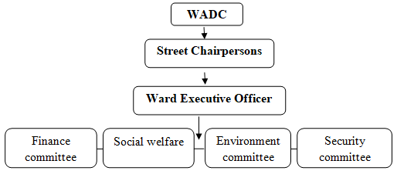

Figure 2.1: Organizational Structure for Host Organization

2.4.5 SWOC Analysis
SWOT analysis is a framework used to evaluate an organization’s competitive position and to develop strategic planning. SWOC analysis assesses internal and external factors, as well as current and future potential. The internal factors are strengths and weaknesses, and the external factors are opportunities and challenges. The following table show the description of the factors behind LGA as a host organization:

Table 2.1: SWOT Analysis
 | INTERNAL FACTORS | EXTERNAL FACTORS
POSITIVE | Strengths | Opportunities
POSITIVE | High level of commitment from the local leaders | Availability of urban arable land for vegetable cultivation
POSITIVE | Availability of human resources from the authority | Easiest of forming groups to young single mothers
POSITIVE | Availability of hard working single mothers in the ward | Availability of special group loans from the government
NEGATIVE | Weaknesses | Challenges
NEGATIVE | Some of the beneficiaries might be affected of profit oriented mechanism | Bureaucratic procedures from the government level
NEGATIVE | Follow up of the government officials it’s questionable to all areas. | Sometimes accessing special group loans takes much time
NEGATIVE |  | Possibility of lack of support from the higher level of the government
Source: research data, (2022)

2.4.6 Role of CED Student in the Project
- To be the main character in facilitating day to day activities of implementation of the project
- To assist Tandale young single mothers to access loans, training and entrepreneur education.
- To ensure young single mothers in Tandale ward fully participate in execution of the project.
- Ensure that government and other stakeholders participate in the implementation of the project
- Foster linkage of participation between LGA and Tandale young single mothers.
- To enhance sustainability of the project by using monitoring and evaluation methods

2.4.7 Host Organization Roles in the Project
- To ensure execution of the project is in accordance with the implementation plan.
- To ensure sustainability of the project
- To support with provision of some of equipment required for project.
- To offer continuous support to the project even after the completion of MCED student’s studies

CHAPTER THREE

LITERATURE REVIEW

3.1 Introduction
Theoretical and empirical literature reviewed for the study is presented in this chapter. Potential sources include published and unpublished sources, books, reports, dissertations/theses, government publications, and online databases.

Review of Theoretical Literature

3.2.1 Definition of Key Terms

3.2.1.1 Income
Defining income in a comprehensive, rigorous, and coherent way is very difficult, if not impossible. Economists, tax scholars, policymakers, and others have struggled with the income concept for well over a hundred years, with no solution in sight. Instead, there are many different definitions of income for different purposes-income definitions for taxes, transfers, measurement of national production, measurement of household resources, measurement of individual wellbeing, health care subsidies, student financial aid grants and loans, and more. Even within the Code, there are several different measures of income for different purposes. Each concept serves a specific goal, but none is truly comprehensive, nor can any be(John, 2018).

3.2.1.2 Micro-economic Theory
This theory was originated early in 1770s by Adam Smith. The micro economic theory states that the higher the income of the individuals, the higher the economic wellbeing of such an individual. Therefore as the individuals access the higher income as the results of a number of needs are attained and it’s thereby the higher standard of well-being is attained. The micro economic theory based on the implication of perfect market which relatively it means that there are a large number of single mothers in the market, and none of them can influence their production activities, especially in green vegetable production (Airley, 2008).

Nonetheless, in normal circumstances, the principle fails when any retire behaviour controls economic wellbeing (Fuentes and Rojas, 2001).The theory failed to show the application of variable in unpredictable. It is impossible to precisely recreate market conditions or predict an outcome based on how single mothers have behaved in the past or in different location under similar circumstances. The world is too influenced by human behaviour to act in any way that is 100% predictable.

3.2.1.3 Maslow’s Theory
Maslow theory was developed by Abraham Maslow in 1943. The theory explains the human developmental psychology which describes the stages of human growth. These stages are physiological, safety, love and belonging, esteem, and self-actualization. These stages mean that in order for motivation to occur at the next level, each level must be satisfied among individuals themselves. For instance a person who is dying for hunger he will search for food before worrying to secure the job. That means no need to demand for the higher needs before fulfilling the lower needs (Kossek and Lautsch, 2018). Maslow’s theory will be used to explain the economic satisfactory of single mothers starting from physiological needs such as food and the safety needs which include job security.
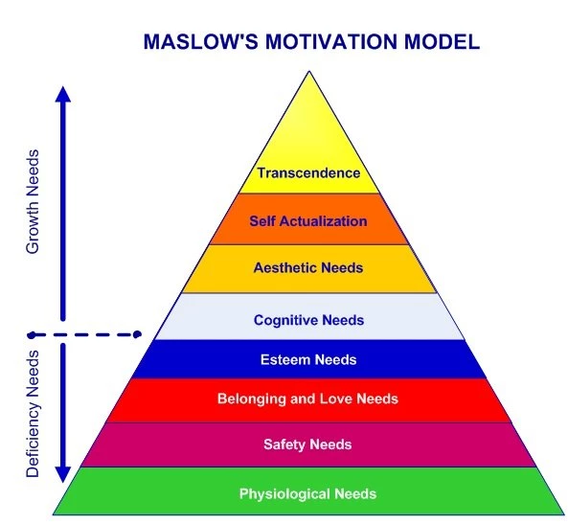

Figure 3.1: Mastow’s Motivational Model
Source: Maslow (1943)

The theory was criticized by other scholars that the need may not follow the hierarchy proposed by Maslow (Louise, 2003). For example the safety need may be attained before the physiological need been attained. Thus a person can secure his job with unsafe living place. Also this Maslow’s was been criticized of been appropriate to all areas at all time (Twum-darko, 2013). The relevant of this theory in this study is its ability to explain how single mothers will be influenced by the Maslow model in their production of green vegetables.

3.3 Review of Empirical Literature
The study conducted in United State about the work effects of tax cuts on low-income single mothers (Francis, 2005). Reducing taxes on low-income single mothers can have an especially favourable effect: some of these women will leave welfare and get paid employment. The authors note that the tax reforms had much less of an impact on the number of hours worked by single mothers, even though the financial incentives were sizable, than on their decisions to work. The authors argue that these work patterns may be explained by fixed costs of work, such as childcare, transportation, and time lost in commuting to, preparing for, or recovering from work.

Many studies of single motherhood and related problems of welfare use and poverty have used data from the Panel Study of Income Dynamics (PSID). Rendall (1993) indicated that resulting biases in terms of the age, race, welfare use, and poverty status are estimated in the present study by using the PSID Relationship File. Substantial undercounts of single mothers in the younger ages and some over counts at older ages are found, especially for black mothers. However, Han et al. (2021) revealed that material circumstances of single mothers improved in the decades following welfare reform.

The consumption of the most disadvantaged single mother headed families those with low consumption or low education rose noticeably over time and at a faster rate than for those in comparison groups. Esther (2019) carried-out a study on improving income of young single mothers through green vegetable production in Nzasa hamlet, Tanzania and found out that the young mothers, who are TASAF beneficiaries are affected by income poverty hence unable to afford basic needs. This study differs with Esther’s study in terms of location as well as the community involved in this study.

3.4 Policy Reviews (Tanzania Agriculture Policy of 2013)

3.4.1 Policy Overview
The significance of agricultural sector in the national economy cannot be overemphasized owing to its relationship between its performance and that of key economic indicators like GDP and employment. Since this relationship is there to stay for some time to come, it justifies the argument that any attempts to improve living standards of the people must give particular attention to increased production and productivity in the agricultural sector (URT, 2013). The National Agriculture Policy 2013 revolves around the goals of developing an efficient, competitive and profitable agricultural industry that contributes to the improvement of the livelihoods of Tanzanians and attainment of broad based economic growth and poverty alleviation.

The Government is committed to bring about a green revolution that entails transformation of agriculture from subsistence farming towards commercialization and modernization. The significance of agricultural sector in the national economy cannot be overemphasized owing to its relationship between its performance and that of key economic indicators like GDP and employment. Since this relationship is there to stay for some time to come, it justifies the argument that any attempts to improve living standards of the people must give particular attention to increased production and productivity in the agricultural sector (URT, 2013).

The National Agriculture Policy 2013 revolves around the goals of developing an efficient, competitive and profitable agricultural industry that contributes to the improvement of the livelihoods of Tanzanians and attainment of broad based economic growth and poverty alleviation. The Government is committed to bring about a green revolution that entails transformation of agriculture from subsistence farming towards commercialization and modernization through crop intensification, diversification, technological advancement and infrastructural development (URT, 2013).

3.4.2 Irrigation Development
Tanzania targeted on crop productivity and profitability enhanced in irrigated agriculture in a sustainable manner in order to ensure food security and poverty reduction. The policy states on the promotion of public and private sector participation in irrigation development in the country (Bont & Chris, 2018). The irrigation development shall be regulated to ensure high productivity and sustainability of the crops and the development of water harvesting techniques in an economically efficient, socially acceptable and environmentally responsive manner shall be enhanced.

Irrigation schemes with special focus on high value crops (vegetables, fruits and flowers) along with such traditional crops as paddy shall be promoted. Irrigator’s organization shall be strengthened to ensure effective management of irrigation schemes and full participation in Integrated Water Resources Management and Water use efficiency and drainage shall be promoted to enhance water productivity and minimize salinity in irrigation schemes (URT, 2013).

Agricultural Marketing: Agricultural product markets are crucial for the development of agricultural commodities and stimulating agricultural production. Furthermore, the whole set of supportive infrastructure from production, transportation, storage and processing is vital in enhancing agricultural marketing (Cooksey, 2011). Tanzania has a target to improve agricultural product market, infrastructure, information and quality standards.

The policy states that; capacities of agricultural marketing actors shall be enhanced in meeting quality, grades and standards for the domestic, regional and international markets. Also the policy emphasizes to the Government in collaboration with other stakeholder’s shall promote the establishment of Price Stabilization Funds. Furthermore; the Government, in collaboration with farmers, farmer groups, associations and cooperative societies, shall enforce regulations governing utilization of designated buying posts and centres for agro-products (URT, 2013).

3.4.4 Farmer Organizations
Farmers’ organizations in the form of associations, cooperatives and groups are important vehicles for farmers to lobby for policy changes that may help to improve their bargaining power in the input and output markets. Farmer groups also provide an avenue for cost reduction of various services such as cost effective delivery of loans, inputs, extension services and market information. However, these institutions are weak in managerial skills and are not member based (Wennink & Heemskerk, 2006). The policy indicates that formation of viable and sustainable farmer organizations to strengthen their bargaining power and competitiveness shall be facilitated. Also the Government in collaboration with other stakeholders shall ensure farmer organizations are equipped with organizational, leadership, entrepreneurship knowledge and skills (URT, 2013).

3.4.5 Urban Agriculture
Urban and peri-urban agriculture is a vital aspect of food security and employment creation, broadening tax base, beautification of cities and serves as supplementary source of income of the urban dwellers. Urban agriculture can be practiced in areas inside the cities (intra-urban) or in areas outside the city (the peri-urban) areas (Lohrberg, 2016). This type of agriculture can be practiced in different forms such as home gardening, open space production or container gardening depending on available land and purpose. Due to limited and unsecured land for urban agriculture, most of the urban dwellers tend to carry out short-term crop production dominated by vegetable crops whereby over 90per cent of the leafy vegetables are produced within and around cities in the country (Orsini, 2013).

Tanzania has a target to increase the production, productivity and profitability of urban agriculture in accordance with acceptable standards for both environmental protection and public health assurance. The policy indicates on the development of supportive mechanisms for undertaking urban and peri-urban agriculture, regulatory framework for urban and peri-urban agriculture and the promotion of good Agricultural Practices for urban and peri-urban agriculture (URT, 2013).

3.4.6 Gender
The majority of Tanzanian farmers are women who constitute the majority of agricultural labour force. Over 90.4 per cent of active women in Tanzania are engaged in agricultural activities, producing about 70 per cent of the country’s food requirements (Leavens, Gugerty & Anderson, 2019). They are also actively involved in the production of cash crops and in household activities. Most of these jobs involve tenuous, manual and highly time consuming undertakings. However, there are inadequate skills and knowledge among women; inequitable access to productive resources; inappropriate technologies; and inappropriate social-cultural practices and beliefs(Doss, Meinzen-Dick, Quisumbing, & Theis, 2018).Tanzania has a target to promote equitable participation of men and women in the production of goods and services in agriculture while ensuring that benefits are equitably shared(URT, 2013).

3.4.7 Business for Development Supports New Policy on Agriculture
The Tanzanian government and donors have put directed of their support for agriculture production and food security, focusing mostly the supply-side (production and related food security interventions). Agriculture is a key sector in the economy of Tanzania, providing employment to more than 70 per cent of the population and contributing 26.5 percent on the GDP (OECD, 2008). The government and development partners must reverse years of policy neglect and remedy massive underinvestment and disinvestment in agriculture. Smallholder farmers must be empowered to access productivity enhancing inputs, irrigation and market. Thereafter, best practice in irrigation must be established for public funded irrigation scheme. Also, the government of Tanzania should take advantage of rising local and regional demand to develop agro-food processing industry (OECD, 2008).

3.5 Literature Review Summary
Studies have addressed the issues behind young single mothers and their income. It addressed on the way forward towards enabling the growth of young single mothers’ income. A part from basing on specific vegetable crops, the different behind against this study is; the project conducted inside one of the ward in Dar es Salaam city and taking Local Government Authority (LGA) to be the host organization. Therefore, the sustainability factor in this project was attained as compared to other projects whereby other projects were not hosted by LGA.

CHAPTER FOUR

PROJECT IMPLEMENTATION

4.1 Introduction
This chapter presents the process on how project inputs and outputs were achieved. Time and schedule of activities, stakeholder involvement is also presented.

4.2 Project Output
The chief venture yield is to chip away at the compensation of energetic single mothers in Tandale ward. This would be achieved after affirmation of pay from the arrangements of vegetables. By communicating the overall objectives and the objectives of the endeavour as portrayed in the ensuing segment, we can describe the consequences of the execution of this errand as follows:
- 1 day of mobilizing 10 young single mothers to form group and 2 days training on the production of amaranth, sweet potato leaves and pumpkin leaves by June, 2022.
- 1 day meeting with Ward Executive Officer and 2450 sqm of land were provided to young single mothers for vegetable production by June, 2022.
- 10 young single mothers were facilitated on capital formation and special group loan were initially applied to young single mothers by July, 2022.
- Incomes of 10 young single mothers improved from 100,000-700,000 tshs per month, as young single mothers know how to sell their products and the new markets for the products were obtained by August 2022.

4.2.2 Project Outputs
Table 4.1 indicates the project output.

Table 4.1: Project Output
OBJECTIVES | OUTPUT | ACTIVITIES
Objective 1: 10 young single mothers trained on production of amaranth, sweet potato leaves and pumpkin leaves by June, 2022. | Output 1: 1 day of mobilizing 10 young single mothers to form group | Activity 1: Studying different young single mothers living in Tandale ward
 |  | Activity 2: Selecting young single mothers to be involved in the project
 | Output 2: 2 days 10 single mothers accessed training on the production ofamaranth, sweet potato leaves and pumpkin leaves | Activity 1: Teaching on methods of production
 |  | Activity 2: Teaching on marketing their products
Objective 2: To facilitate acquisition of 2450 sqm of land to 10 young single mothers for production of pumpkin leaves, amaranth and sweet potato leaves by June, 2022. | Output 1: 1 day meeting with Ward Executive Officer was successful | Activity 1: Learning on how the LGA helps special groups especially single mothers
 |  | Activity 2: Negotiation on helping the sustainability of the project
 | Output 2: 2450 sqm of land were provided to young single mothers | Activity 1: Reaching the area for cultivation
 |  | Activity 2: Making agreement on the usefulness of the area
Objective 3: 10 young single mothers were facilitated on capital formation on production of amaranth, sweet potato leaves and pumpkin leaves by July, 2022. | Output 1: 10 young single mothers forming a group | Activity 1: Elaborating on the importance of forming groups to young single mothers
 | Output 1: 10 young single mothers forming a group | Activity 2: Analysing the effects of group towards increasing their income.
 | Output 2: Special group loan were initially applied | Activity 1: Facilitating on the use of the loans
 | Output 2: Special group loan were initially applied | Activity 2: Linking of vegetable production and the loan provided
Objective 4:Increased income of 10 young single mothers from 100,000-700,000 Tshs per month for selling of amaranth, sweet potato leaves and pumpkin leaves by Aug, 2022. | Output 1: Young single mothers knows how to extend their market | Activity 1: facilitating them on producing quality products
 |  | Activity 2: incentive and frequent training on effective production
 | Output 2: New markets for the products were obtained | Activity 1: Facilitation on acquiring new customers
 | Output 2: New markets for the products were obtained | Activity 2: Making them understand the new markets

Source: Research Data, 2022

4.3 Project Planning
Victorious accomplishment of this undertaking's objectives requires legitimate intending to empower execution of exercises to carry the venture into the truth. This part includes execution plan, members organizing and financial plan evaluation. Project execution incorporates management and assessment of exercises and the commitment of every partner. Project partners who are dependable are Tandale young single parents, Tandale WEO and MCED understudy.

4.3.1 Implementation Plan
Project Execution plan is about various arrangement exercises and assets required to accomplish the referenced task targets in a particular timeframe which various assets.

Table 4.2: Project Implementation Plan
OBJECTIVES | OUTPUT | ACTIVITIES | PROJECT MONTH |  |  |  |  |  |  |  |  |  |  |  | RESOURCES NEEDED | RESPONSIBLE PERSON
OBJECTIVES | OUTPUT | ACTIVITIES | J | F | M | A | M | J | J | A | S | O | N | D
Objective 1: 10 young single mothers trained on production of amaranth, sweet potato leaves and pumpkin leaves by June, 2022. | Output 1: 1 day of mobilizing 10 young single mothers to form group | Activity 1: Studying different young single mothers living in Tandale ward |  |  |  |  |  |  |  |  |  |  |  |  | Human resource  Financial resource | MCED student  CDO  WEO
 |  | Activity 2: Selecting young single mothers to be involved in the project |  |  |  |  |  |  |  |  |  |  |  |  | Human resource  Financial resource | MCED student  Tandale young single mothers  WEO  CDO
 | Output 2: 2 days 10 single mothers accessed training of spinach, tours and pumpkin leaves | Activity 1: Teaching on methods of production |  |  |  |  |  |  |  |  |  |  |  |  | Human resource  Financial resource | MCED student  Tandale young single mothers  WEO  CDO
 |  | Activity 2: Teaching on marketing their products |  |  |  |  |  |  |  |  |  |  |  |  | Human resource  Financial resource | MCED student  Tandale young single mothers  WEO  CDO
Objective 2: To facilitate acquisition of 2450 sqm of land to 10 young single mothers for production of pumpkin leaves, amaranth and sweet potato leaves by June, 2022. | Output 1: 1 day meeting with Ward Executive Officer was successful | Activity 1: Learning on how the LGA helps special groups especially single mothers |  |  |  |  |  |  |  |  |  |  |  |  | Human resource  Financial resource | MCED student  Tandale young single mothers  WEO  CDO
 |  | Activity 2: Negotiation on helping the sustainability of the project |  |  |  |  |  |  |  |  |  |  |  |  | Human resource  Financial resource  Physical resource | MCED student  Tandale young single mothers  WEO  CDO
 | Output 2: 2450 sqm were provided to young single mothers | Activity 1: Reaching the area for cultivation
 | Output 2: 2450 sqm were provided to young single mothers | Activity 2: Making agreement on the usefulness of the area
Objective 3: 10 young single mothers were facilitated on capital formation on production of amaranth, sweet potato leaves and pumpkin leaves by July, 2022. | Output 1: 10 young single mothers forming a group | Activity 1: Elaborating on the importance of forming groups to young single mothers |  |  |  |  |  |  |  |  |  |  |  |  | Human resource  Financial resource | MCED student  Tandale young single mothers  WEO  CDO
 | Output 1: 10 young single mothers forming a group | Activity 2: Analyzing the effects of group towards increasing their income. |  |  |  |  |  |  |  |  |  |  |  |  | Human resource  Financial resource | MCED student  Tandale young single mothers  WEO  CDO
 | Output 2: Special group loan were initially applied | Activity 1: Facilitating on the use of the loans |  |  |  |  |  |  |  |  |  |  |  |  | Human resource  Financial resource | MCED student  Tandale young single mothers  WEO  CDO
 | Output 2: Special group loan were initially applied | Activity 2: Linking young single mothers to loan provider. |  |  |  |  |  |  |  |  |  |  |  |  | Human resource  Financial resource | MCED student  Tandale young single mothers  WEO  CDO
Objective 4: Increased income of 10 young single mothers from 100,000 to 700,000 tshs per month for selling of amaranth, sweet potato leaves and pumpkin leaves by August, 2022. | Output 1: Young single mothers knows how to extend their market | Activity 1: facilitating them on producing quality products |  |  |  |  |  |  |  |  |  |  |  |  | Human resource  Financial resource | MCED student  Tandale young single mothers  WEO  CDO
 |  | Activity 2: incentive and frequent training on effective production |  |  |  |  |  |  |  |  |  |  |  |  | Human resource  Financial resource  Physical resource | MCED student  Tandale young single mothers  WEO  CDO
 | Output 2: New markets for the products were obtained | Activity 1: Facilitation on acquiring new customers
 | Output 2: New markets for the products were obtained | Activity 2: Making them understand the new markets

Source: Research Data, (2022)

4.3.3 Budget Assessment
Assessed budgeting plan of the undertaking was TZS 2,715,000/=. Out of this spending plan TZS 2,500,000/= was subsidized by the host association as a delicate unique gathering credit and the excess expense summing TZS 215,000/= which was for writing supplies and preparing materials was taking by CED student.

Table 4.3: Budget Assessment
OBJECTIVES | OUTPUT | ACTIVITIES | RESOURCES NEEDED | QUANTITY | UNITY PRICE | TOTAL
Objective 1: 10 young single mothers trained on production of amaranth, sweet potato leaves and pumpkin leaves by June, 2022. | Output 1: 1 day of mobilizing 10 young single mothers to form group | Activity 1: Studying different young single mothers living in Tandale ward | Note book  Marker pen  Human  Lunch | 1  1 box  10 | 5000  10,000  30,000  5000 | 5000  10,000  30,000  50,000
 |  | Activity 2: Selecting young single mothers to be involved in the project | Note book  Marker pen  Human  Lunch | 1  1 box  1  10 | 5000  10,000  30,000  5000 | 5000  10,000  30,000  50,000
 | Output 2: 2 days 10 single mothers accessed training of amaranth, sweet potato leaves and pumpkin leaves | Activity 1: Teaching on methods of production | Expert  Facilitator  Marker pen  Flip chart | 1  1  10  1 | 100,000  50,000  10,000  15,000 | 100,000  50,000  100,000  15,000
 |  | Activity 2: Teaching on marketing their products | Expert  Facilitator  Marker pen  Flip chart | 1  1  10  1 | 100,000  50,000  10,000  15,000 | 100,000  50,000  100,000  15,000
Objective 2: To facilitate acquisition of 2450 sqm of land to 10 young single mothers for production of pumpkin leaves, amaranth and sweet potato leaves by June, 2022. | Output 1: 1 day meeting with Ward Executive Officer was successful | Activity 1: Learning on how the LGA helps special groups especially single mothers | Lunch | 2 | 10000 | 20,000
 |  | Activity 2: Negotiation on helping the sustainability of the project | Lunch | 2 | 10000 | 20000
 | Output 2: 2450 sqm were provided to young single mothers | Activity 1: Preparing the area for cultivation | Transport  Lunch | 10  10 | 5000  5000 | 50,000  50,000
 | Output 2: 2450 sqm were provided to young single mothers | Activity 2: Making agreement on the usefulness of the area | Lunch | 2 | 10000 | 20000
Objective 3: 10 young single mothers were facilitated on capital formation on production of amaranth, sweet potato leaves and pumpkin leaves by July, 2022. | Output 1: 10 young single mothers forming a group | Activity 1: Elaborating on the importance of forming groups to young single mothers | Expert  Facilitator  Flip chart | 1  1  1 | 100,000  50,000  15,000 | 100,000  50,000  15,000
 | Output 1: 10 young single mothers forming a group | Activity 2: Analyzing the effects of group towards increasing their income. | Expert  Facilitator  Flip chart | 1  1  1 | 100,000  50,000  15,000 | 100,000  50,000  15,000
 | Output 2: Special group loan were initially applied | Activity 1: Facilitating on the use of the loans | Expert  Facilitator  Flip chart | 1  1  1 | 100,000  50,000  15,000 | 100,000  50,000  15,000
 | Output 2: Special group loan were initially applied | Activity 2: Tools of production purchased | Hand hoe  Slashes  Seeds  Organic fertilizer  Generator  Irrigation pipes | 5  5  5 kg  1 tone  1  100m | 5,000  5,000  5,000  100,000  300,000  50,000 | 25,000  25,000  25,000  100,000  300,000  500,000
Objective 4: Increased income of 10 young single mothers from 100,000-700,000 tshs per month for selling of amaranth, sweet potato leaves and pumpkin leaves by Aug,2022. | Output 1: Young single mothers knows how to extend their market | Activity 1: facilitating them on producing quality products | Expert  Transport | 1  1 | 100,000  50,000 | 100,000  50,000
 |  | Activity 2: vegetables harvested and sold | Flip chart | 1 | 15,000 | 15,000
 | Output 2: New markets for the products were obtained | Activity 1: Facilitation on acquiring new customers | Expert | 1 | 100,000 | 100,000
 | Output 2: New markets for the products were obtained | Activity 2: Making them understand the new markets | Expert | 1 | 100,000 | 100,000
TOTAL |  |  |  |  |  | 2,715,000

Source: Research Data, 2022

4.3 Project Implementation
This part depicting the real carried out project exercises began the finish of June, 2022. The carried out exercises were among those which were arranged during project configuration stage. A significant number of the arranged exercises were really carried out as reflected in the execution plan. The task execution is into two significant subsections which are project execution report and project execution Gantt chart as displayed beneath.

4.4.1 Project implementation Report

Table 4.4: Project implementation Report
PLANS |  |  | ACCOMPLISHMENTS
OBJECTIVES | OUTPUT | ACTIVITIES | Means of Verification | Comments
Objective 1: 10 young single mothers trained on production of amaranth, sweet potato leaves and pumpkin leaves by June, 2022. | Output 1: 1 day of mobilizing 10 young single mothers to form group | Activity 1: Studying different young single mothers living in Tandale ward | Session attendance list | Coordinated by MCED student, young single mothers together with facilitator
 |  | Activity 2: Selecting young single mothers to be involved in the project | Session attendance list  Project report | Coordinated by MCED student, young single mothers together with facilitator
 | Output 2: 2 days 10 single mothers accessed training of amaranth, sweet potato leaves and pumpkin leaves | Activity 1: Teaching on methods of production | Practical Training report | Coordinated by MCED student, young single mothers together with facilitator
 |  | Activity 2: Teaching on marketing their products | Practical Training report | Coordinated by MCED student, young single mothers together with facilitator
Objective 2: To facilitate acquisition of 2450 sqm of land to 10 young single mothers for production of pumpkin leaves, amaranth and sweet potato leaves by June, 2022. | Output 1: 1 day meeting with Ward Executive Officer was successful | Activity 1: Learning on how the LGA helps special groups especially single mothers | Session attendance list  Project report | Coordinated by MCED student, young single mothers together with facilitator
 |  | Activity 2: Negotiation on helping the sustainability of the project | Project report | Coordinated by MCED student, young single mothers together with facilitator
 | Output 2: 2450 sqm of land were provided to young single mothers | Activity 1: Preparing the area for cultivation | Project report | Coordinated by MCED student, young single mothers together with facilitator
 |  | Activity 2: Making agreement on the usefulness of the area | Project report | Coordinated by MCED student, young single mothers together with facilitator
Objective 3: 10 young single mothers were facilitated on capital formation on production of amaranth,sweet potato leaves and pumpkin leaves by July, 2022. | Output 1: 10 young single mothers forming a group | Activity 1: Elaborating on the importance of forming groups to young single mothers | Project report | Coordinated by MCED student, young single mothers together with facilitator
 | Output 1: 10 young single mothers forming a group | Activity 2: Analysing the effects of group towards increasing their income. | Project report | Coordinated by MCED student, young single mothers together with facilitator
 | Output 2: Special group loan were initially applied | Activity 1: Facilitating on the use of the loans | Session attendance list  Project report | Coordinated by MCED student, young single mothers together with facilitator
 | Output 2: Special group loan were initially applied | Activity 2: Tools for production purchased | Session attendance list  Project report | Coordinated by MCED student, young single mothers together with facilitator
Objective 4: Increased income of 10 young single mothers from 100,000-700,000 tshs per month for selling of amaranth, sweet potato leaves and pumpkin leaves by Aug,2022. | Output 1: Young single mothers knows how to extend their market | Activity 1: facilitating them on producing quality products | Session attendance list  Project report | Coordinated by MCED student, young single mothers together with facilitator
 |  | Activity 2: incentive and frequent training on effective production | Session attendance list  Project report  Practical Training report | Coordinated by MCED student, young single mothers together with facilitator
 | Output 2: New markets for the products were obtained | Activity 1: Facilitation on acquiring new customers | Project report | Coordinated by MCED student, young single mothers together with facilitator
 | Output 2: New markets for the products were obtained | Activity 2: Making them understand the new markets | Project report | Coordinated by MCED student, young single mothers together with facilitator

4.3.2 Project implementation Gantt Chart
The accompanying table underneath had shown the objectives, output and activities and explicit timeframe during the execution of the undertaking.

Table 4.5: Project Gantt Chart
OBJECTIVES | OUTPUT | ACTIVITIES | PROJECT MONTH
OBJECTIVES | OUTPUT | ACTIVITIES | J | F | M |  | A | M |  |  | J |  |  | J |  | A | S | O |  |  | N |  |  | D
Objective 1: 10 young single mothers trained on production of amaranth, sweet potato leaves and pumpkin leaves by June, 2022. | Output 1: 1 day of mobilizing 10 young single mothers to form group | Activity 1: Studying different young single mothers living in Tandale ward
 |  | Activity 2: Selecting young single mothers to be involved in the project
 | Output 2: 2 days 10 single mothers accessed training of amaranth, sweet potato leaves and pumpkin leaves | Activity 1: Teaching on methods of production
 |  | Activity 2: Teaching on marketing their products
Objective 2: To facilitate acquisition of 2450 sqm of land to 10 young single mothers for production of pumpkin leaves, amaranth and sweet potato leaves by June, 2022. | Output 1: 1 day meeting with Ward Executive Officer was successful | Activity 1: Learning on how the LGA helps special groups especially single mothers
 |  | Activity 2: Negotiation on helping the sustainability of the project
 | Output 2: 2450 sqm of land were provided to young single mothers | Activity 1: Preparing the area for cultivation
 |  | Activity 2: Making agreement on the usefulness of the area
Objective 3: 10 young single mothers were facilitated on capital formation on production of amaranth, sweet potato leaves and pumpkin leaves by July, 2022. | Output 1: 10 young single mothers forming a group | Activity 1: Elaborating on the importance of forming groups to young single mothers
 | Output 1: 10 young single mothers forming a group | Activity 2: Analysing the effects of group towards increasing their income.
 | Output 2: Special group loan were initially applied | Activity 1: Facilitating on the use of the loans
 | Output 2: Special group loan were initially applied | Activity 2: Tools for production purchased
Objective 4: Increased income of 10 young single mothers from 100,000-700,000 tshs per month for selling of amaranth, sweet potato leaves and pumpkin leaves by Aug,2022. | Output 1: Young single mothers knows how to extend their market | Activity 1: facilitating them on producing quality products
 |  | Activity 2: incentive and frequent training on effective production
 | Output 2: New markets for the products were obtained | Activity 1: Facilitation on acquiring new customers
 | Output 2: New markets for the products were obtained | Activity 2: Making them understand the new markets
Source: Field Data, 2021
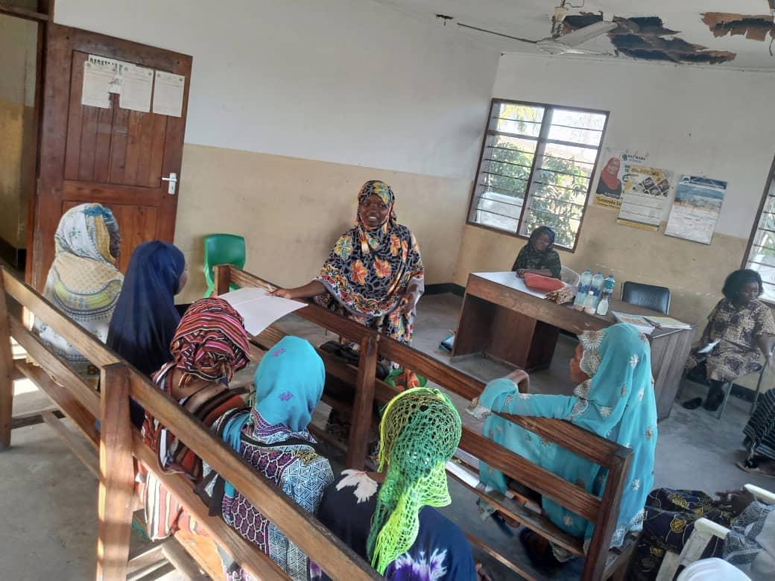

Figure 4.1: MCED Student with Tandale Young Single Mothers during a Mobilization meeting

CHAPTER FIVE

PARTICIPATORY MONITORING EVALUATION

AND SUSTAINABILITY

5.1 Introduction
This section presents aspects of participatory monitoring, evaluation and sustainability of a project designed by the MCED student, which are vegetable production at Tandale ward in Kinondoni Municipal. All strategies utilized in observing and assessment will be made sense of exhaustively, including, participatory checking and participatory assessment, in which execution pointers, assessment participatory technique and undertaking assessment rundown are covered. Project maintainability will be covered too by which institutional, monetary and political supportability will be examined.

Monitoring is the persistent or intermittent review of program or venture execution to survey conveyance, recognize hardships, learn trouble spots and suggest medicinal activities. It is a precise and ceaseless gathering and examining of data about the advancement of a piece of work after some time. Checking is a fundamental and general administration device for recognizing qualities and shortcomings in any venture or program.

Evaluation is an occasional assessment of importance, execution, effectiveness and effect of a piece of work with regards to its expressed targets. The point is to decide the importance and satisfaction of goals, formative proficiency, adequacy, effect and supportability. An assessment should be possible during execution at its end "last assessment" or subsequently, either to help coordinating the venture or to draw illustrations for what's in store undertakings and programming. An evaluation ought to prompt a choice to proceed, redress or stop a task and the ends and suggestions, ought to likewise be considered while arranging and executing other comparative future undertaking. The job of assessment is to decide program viability, to shows effect, qualities and shortcomings of a task, and to advance replication of fruitful intercessions.

5.2 Participatory Monitoring
Participatory monitoring is the course of regularly assembling data on all parts of the venture exercises that includes bunch individuals in project execution. The job of participatory checking is to comprehend targets of neighbourhood advancement project, to distinguish exercises to accomplish goals, estimations to survey results or show degree of progress accomplished. It additionally assists with creating estimation pointers, strategies and procedures of gathering data.

In this undertaking, participatory monitoring exercise from began since leading CNA to creation process. Participatory monitoring activity includes all partners of the undertaking from the very outset to the furthest limit of the venture. This assists members with becoming mindful of the venture advancement and development. It additionally assists with understanding the soundness of the venture whether it will kick the bucket or be supported paying little heed to changes in outer help or inside assets. During the execution of this task the participatory checking was directed after at regular intervals month to see whether exercises are carried out according to plan. The participatory observing intends to monitory all arranged exercises incorporate all gatherings, choice of ranchers for preparing and limit building, visiting day and the entire execution plan

5.2.1 Monitoring Information System
Monitoring information system is the intended to gather and report data on various venture exercises that empower a task boss to design, screen, assess and investigate activities and execution of the undertaking. Monitoring information system was expected to keep the venture centred and measure the undertaking progress. The monitoring information system was ready by including various partners, for example, MCED understudy and Agriculture official. The data accumulated were investigated, went along and announced back to the gathering and partners for different use.

Table 5.10: Monitoring Information System
information and activities categories | Elements for monitoring | Records types kept | Person Responsible | Users of collected information | Usage of collected information | Decision to be arrived at and achieved outputs
Project implementation work plan | Available resources , Project life time | Monthly reports | CED student  WEO  Young single mother’s leader | Key project stakeholders  Young single mothers | To identify the coverage of implemented project | Filling the gap of activities to accomplish the project
Project Cost and expenditure | Amount of fund investment  Budgeting | Financial reports | WEO | Key project stakeholders  Young single mothers | To assess the performance of financial resources in the project | To control financial resources for the better way
Staffing and supervision | Staff’s skills and knowledge  Staff’s qualification  Attitude towards the project | Roles and responsibilities of staffs as per national policies,  rules and regulations | CED student  WEO | Key project stakeholders  Young single mothers | To assess the performance of human resources in the project | To evaluate the ability of human resources in accomplishing the project sustainably
Other inputs | Other necessary reports | The required additional inputs | CED student  WEO  Young single mother’s leader | Key project stakeholders  Young single mothers | Assess the planned resources for implementation and other additional resources required | To identify additional inputs in helping the project to accomplish
Source: Field Data, 2021
The data found in checking data framework incorporates classifications of data and exercises to zero in on, sorts of records to keep capable staff, result and accomplishments. Different strategies and procedures used to include partners in observing of venture exercises. Prior to social event data including organized conversational meetings which used to assemble data on best seeds, seed organization, pesticides, strategies of sunflower creation and other data with respect to vegetable treatments.

5.2.2 Participatory Monitoring Plan
This sort of checking was intended to follow the venture execution progress through the arranged exercises. Thusly, the MCED understudy as a team with partners observed the execution of the directed gatherings and stages of preparation to meet momentary outcomes as displayed beneath in the table synopsis.

Table 5.2: Participatory Monitoring Plan
OBJECTIVES | OUTPUT | ACTIVITIES | OUTPUT INDICATORS | DATA SOURCE | METHODS | PERSON RESPONSIBLE | TIME FRAME
Objective 1: 10 young single mothers trained on production of amaranth, sweet potato leaves and pumpkin leaves by June, 2022. | Output 1: 1 day of mobilizing 10 young single mothers to form group | Activity 1: Studying different young single mothers living in Tandale ward | Visiting  Seminar | session attendance list Practical Training report | Documentation  Observation | CED student  Tandale young single mothers | Within[June,2022}
 |  | Activity 2: Selecting young single mothers to be involved in the project | Seminar | Attendance list | Documentation | CED student  Tandale young single mothers | Within(June, 2022)
 | Output 2: 2 days 10 single mothers accessed training of amaranth, sweet potato leaves and pumpkin leaves | Activity 1: Teaching on methods of production | Seminar  Training | pictures Training attendance list | Documentation  Presentation | CED student  Tandale young single mothers | Within(June 2022)
 |  | Activity 2: Teaching on marketing their products | Seminar  Training | pictures Training attendance list | Documentation  Presentation | CED student  Tandale young single mothers | Within (June 2022)
Objective 2: To facilitate acquisition of 2450 sqm of land to 10 young single mothers for production of pumpkin leaves, amaranth and sweet potato leaves by June, 2022. | Output 1: 1 day meeting with Ward Executive Officer was successful | Activity 1: Learning on how the LGA helps special groups especially single mothers | Seminar  Training | Pictures Training Attendance list | Documentation  Presentation | CED student  Tandale young single mothers | 1 month (July 2022)
 |  | Activity 2: Negotiation on helping the sustainability of the project | Meeting | Attendance list | Presentation | CED student  Tandale young single mothers | 1 month (July 2022)
 | Output 2: 2450 sqm were provided to young single mothers | Activity 1: Reaching the area for cultivation | Visiting | Pictures | Observation | CED student  Tandale young single mothers | 1 month (July 2022)
 | Output 2: 2450 sqm were provided to young single mothers | Activity 2: Making agreement on the usefulness of the area | Visiting | Pictures | Observation | CED student  Tandale young single mothers | 1 month (August 2022)
Objective 3: 10 young single mothers were facilitated on capital formation on production of amaranth, tours and pumpkin leaves by July, 2022. | Output 1: 10 young single mothers forming a group | Activity 1: Elaborating on the importance of forming groups to young single mothers | Seminar  Training | Attendance list | Presentation  Documentation | CED student  Tandale young single mothers | 1 month (August 2022)
 | Output 1: 10 young single mothers forming a group | Activity 2: analysing the effects of group towards increasing their income. | Seminar  Training | Attendance list  Project report | Presentation  documentation | CED student  Tandale young single mothers | 1 month (August 2022)
 | Output 2: Special group loan were initially applied | Activity 1: Facilitating on the use of the loans | Seminar  Training | Attendance list  project report | Presentation  documentation | CED student  Tandale young single mothers | 1 month (August 2022)
 | Output 2: Special group loan were initially applied | Activity 2: Production tools were purchased | Seminar  Training | project report | Presentation  documentation | CED student  Tandale young single mothers | Within 1 month (August 2022)
Objective 4: Increased income of 10 young single mothers from 100,000-700,000 tshs per month for selling of amaranth, sweet potato leaves and pumpkin leaves by Aug,2022. | Output 1: Young single mothers knows how to extend their market | Activity 1: facilitating them on producing quality products | Seminar  Training | Attendance list  project report | Presentation  documentation | CED student  Tandale young single mothers | Within 1 month (August 2022)
 |  | Activity 2: incentive and frequent training on effective production | Seminar  Training | Attendance list  project report | Presentation  documentation | CED student  Tandale young single mothers | Within 1 month (August 2022)
 | Output 2: New markets for the products were obtained | Activity 1: Facilitation on acquiring new customers | Seminar  Training | Attendance list  project report | Presentation  documentation | CED student  Tandale young single mothers | 1 month (August 2022)
 | Output 2: New markets for the products were obtained | Activity 2: Making them understand the new markets | Seminar  Training | Attendance list  project report | Presentation  documentation | CED student  Tandale young single mothers | 1 month (September 2022)
Source: Field Data, (2021).

5.3 Participatory Evaluation
Participatory evaluation is the aggregation of assessment and appraisal of accomplishments of undertaking goals by project partners. Its job is to decide program viability, showing effect, Qualities and shortcomings of a task and advancing replication of fruitful mediations. This task will be assessed two times, the mid-term toward the finish of October 2022 and summative assessment on February 2023.

5.3.1 Performance Indicators
The performance indicators shows what was finished and what the results of the executed exercises, all in all, execution markers measure the outcome of the carried out goals.

Table 5.3: Performance Indicators
OBJECTIVES | OUTPUT | ACTIVITIES | RESOURCES NEEDED | PERFORMANCE INDICATORS
Objective 1: 10 young single mothers trained on production of amaranth, sweet potato leaves and pumpkin leaves by June, 2022. | Output 1: 1 day of mobilizing 10 young single mothers to form group | Activity 1: Studying different young single mothers living in Tandale ward | Human resources  Financial resources | Training
 |  | Activity 2: Selecting young single mothers to be involved in the project | Human resources  Financial resources | Participation
 | Output 2: 2 days 10 single mothers accessed training of spinach, sweet potato leaves and pumpkin leaves | Activity 1: Teaching on methods of production | Human resources  Financial resources  Facilities | Training  Seminar
 |  | Activity 2: Teaching on marketing their products | Human resources  Financial resources  Facilities | Training  Seminar  Participation
Objective 2: To facilitate acquisition of 2450 sqm of land to 10 young single mothers for production of pumpkin leaves, amaranth and sweet potato leaves by June, 2022. | Output 1: 1 day meeting with Ward Executive Officer was successful | Activity 1: Learning on how the LGA helps special groups especially single mothers | Human resources  Financial resources | Training  Seminar  Participation
 |  | Activity 2: Negotiation on helping the sustainability of the project | Human resources  Financial resources | Seminar  Meeting
 | Output 2: 2450 sqm of land were provided to young single mothers | Activity 1: Preparing the area for cultivation | Human resources  Financial resources | Visiting
 |  | Activity 2: Making agreement on the usefulness of the area | Human resources  Financial resources | Meeting
Objective 3: 10 young single mothers were facilitated on capital formation on production of amaranth, sweet potato leaves and pumpkin leaves by July, 2022. | Output 1: 10 young single mothers forming a group | Activity 1: Elaborating on the importance of forming groups to young single mothers | Human resources  Financial resources | Seminars  Participation
 | Output 1: 10 young single mothers forming a group | Activity 2: Analysing the effects of group towards increasing their income. | Human resources  Financial resources | Seminars  Participation
 | Output 2: Special group loan were initially applied | Activity 1: Facilitating on the use of the loans | Human resources  Financial resources | Seminars
 | Output 2: Special group loan were initially applied | Activity 2: Tools for production purchased | Human resources | Training
Objective 4: Increased income of 10 young single mothers from 100,000-700,000 tshs per month for selling of amaranth, sweet potato leaves and pumpkin leaves by Aug, 2022. | Output 1: Young single mothers knows how to extend their market | Activity 1: facilitating them on producing quality products | Human resources | Training
 |  | Activity 2: incentive and frequent training on effective production | Human resources | Training
 | Output 2: New markets for the products were obtained | Activity 1: Facilitation on acquiring new customers | Human resources | Seminars  Training  Participation
 | Output 2: New markets for the products were obtained | Activity 2: Making them understand the new markets | Human resources | Seminars  Training  Participation
Source: Field Data, 2021

5.3.2 Project Evaluation Summary
The table underneath shows the project evaluation synopsis in view of the undertaking objectives, targets, execution markers, anticipated results and genuine result. Zeroing in project objectives, targets and exercises arranged and those have been met with assumptions for mid and yearly assessment that will be finished following multi month of the project execution.

Table 5.4: Project Evaluation Summary
OBJECTIVES | OUTPUT | ACTIVITIES | PERFORMANCE INDICATORS | EXPECTED OUTPUT | ACTUAL OUTCOMES
Objective 1: 10 young single mothers trained on production of amaranth, sweet potato leaves and pumpkin leaves by June, 2022. | Output 1: 1 day of mobilizing 10 young single mothers to form group | Activity 1: Studying different young single mothers living in Tandale ward | Observing | Knowing the area for the project effectively | Non participant observation was successful conducted
 |  | Activity 2: Selecting young single mothers to be involved in the project | Participation | To form 2 groups for mobilizing finance | Two (2) groups of 5 people each were formulated
 | Output 2: 2 days 10 single mothers accessed training on the production of amaranth, sweet potato leaves and pumpkin leaves | Activity 1: Teaching on methods of production | Training  Seminar | Members of Tandale young single mothers to have their own capacity in modern green vegetable production | The training was successful provided to Tandale young single mothers
 |  | Activity 2: Teaching on marketing their products | Training  Seminar  Participation | Members of Tandale young single mothers to have their own capacity in modern green vegetable production | The training was successful provided to Tandale young single mothers
Objective 2: To facilitate acquisition of 2450 sqm of land to 10 young single mothers for production of pumpkin leaves, amaranth and sweet potato leaves by June, 2022. | Output 1: 1 day meeting with Ward Executive Officer was successful | Activity 1: Learning on how the LGA helps special groups especially single mothers | Training  Seminar  Participation | Members of Tandale young single mothers to have their own capacity in modern green vegetable production | The training was successful provided to Tandale young single mothers
 |  | Activity 2: Negotiation on helping the sustainability of the project | Seminar  Meeting | Continuous monitoring and evaluation for sustainability of the project | The meeting and seminars were successful conducted
 | Output 2: 2450 sqm of were provided to young single mothers | Activity 1: Preparing the area for cultivation | Visiting | Attaining the area for selecting the arable land | The area was reached
 | Output 2: 2450 sqm of were provided to young single mothers | Activity 2: Making agreement on the usefulness of the area | Meeting | To reach the agreement | The meeting was successful conducted
Objective 3: 10 young single mothers were facilitated on capital formation on production of amaranth, sweet potato leaves and pumpkin leaves by July, 2022. | Output 1: 10 young single mothers forming a group | Activity 1: Elaborating on the importance of forming groups to young single mothers | Seminars  Participation | Increasing loan accessibility factors | The meeting and seminars were successful conducted
 | Output 1: 10 young single mothers forming a group | Activity 2: Analysing the effects of group towards increasing their income. | Seminars  Participation | Use of young single mothers group for economic wellbeing | The meeting and seminars were successful conducted
 | Output 2: Special group loan were initially applied | Activity 1: Facilitating on the use of the loans | Seminar | Tangale young single mothers to access special group loan | Awareness in accessing special group loans
 | Output 2: Special group loan were initially applied | Activity 2: Tools for production purchased | Training | Effective use of the loan to vegetable production | The training was successful provided to Tandale young single mothers
Objective 4: Increased income of 10 young single mothers from 100,000-700,000 tshs per month for selling of amaranth, sweet potato leaves and pumpkin leaves by Aug,2022. | Output 1: Young single mothers knows how to extend their market | Activity 1: facilitating them on producing quality products | Training | Production of more quality | The training was successful provided to Tandale young single mothers
 |  | Activity 2: incentive and frequent training on effective production | Training | Awareness on vegetable marketing | The training was successful provided to Tandale young single mothers
 | Output 2: New markets for the products were obtained | Activity 1: Facilitation on acquiring new customers | Seminars  Training  Participation | Acquiring more green vegetable production | The seminars and training were successful conducted
 | Output 2: New markets for the products were obtained | Activity 2: Making them understand the new markets | Seminars  Training  Participation | Spreading vegetable market in Dar es Salaam | The seminars and training were successful conducted
Source: Field Data, (2021).

5.3.3 Participatory Evaluation Methods
Various techniques were utilized to assess the task really, including partners gatherings, preparing and centre gathering conversation which was finished toward the finish of the preparation. The gathering were evaluated the goals, exercises and the conversation zeroed in on how far the venture has gone and what works and what doesn't work. In centre gathering conversation various experiences technique were utilized to assess the adequacy of the preparation by requesting that the members share new learning and bits of knowledge during and after the preparation. Likewise audit of various undertaking reports, project execution plan and meeting minutes will be utilized as the devices for the project evaluation.

5.4 Project Sustainability
Project sustainability will require following elements financing sustainability, management sustainability and political sustainability.

5.4.1 Financial Sustainability
Financial sustainability is the monetary status of the gathering on capacity to produce assets and assets that will assist project with running itself, without outside reserves. The venture financier will be answerable for keeping reserves got from selling the delivered sunflower. The undertaking council gatherings will choose the utilization of assets on various cultivating matters.

5.4.2 Management Sustainability
Management sustainability is capacity of the venture to design, make due, adjust and screen the advancement of the task. Administration issues, genuineness, responsibility and straightforwardness are vital in administration. MCED understudy associate the gathering with local area advancement office who vow to connect the gathering on various limit working inside and outside the Ward, Different partners which will keep offering help to the undertaking execution incorporate task advisory group individuals and Ward Executive Officer.

5.4.3 Political Sustainability
Sustainability of the projects relies upon the quietness of the town and the country by any means. The objective of the venture is to further develop pay of young single parents through vegetable creation. This objective will assume a major part in political manageable on the grounds that even the legislators and government pioneers continuously looking through changed approaches to further developing pay of the local area individuals to decrease destitution.

CHAPTER SIX

CONCLUSION AND RECOMMENDATIONS

6.1 Introduction
This chapter provides an over view of the vegetable production as an end to increased income to young single mothers in Tandale Ward, Kinondoni Municipal. It gives the summary of the whole process and steps undertaken since the identification of the project, problem identification up to the project implementation outputs. The areas which have been summarized in this chapter include; Community Needs Assessments (CNA), Problem identification, Literature review, Project implementation, Participatory Monitoring, Evaluation, and ultimately the sustainability of the project. In general, the chapter shows in nutshell what have been discussed in all chapters.

6.2 Conclusion
The struggle to pull out of poverty is the task of every individual. It is a considerable long time since Tanzania started straggling to combat poverty among her people. While other groups within the community are doing better in improving their welfare, women and especially young single mothers are doing poorly with little support from government and other development partners. Young single mothers Tandale Ward are among of them affected by income poverty in Kinondoni Municipal.

The CNA conducted in Tandale Ward to young single mothers in collaboration with the CED student revealed the prevalence of training , favourable market, and support from the community seen an opportunity for income earning to the young single mothers hence economic development. In order to ensure that the project implementation ultimately bring about sustainable economic development, the CED student planned and managed to involved the young single mothers, LGAs and community members (local people) and different stakeholders in the whole process of the project from the preliminary stage of project identification, project planning, project implementation and project monitoring and evaluation of planned activities.

A project cycle technique which shows all procedure in project planning and implementation was abided in participatory monitoring and evaluation. The participatory monitoring and evaluation have been helpful to both vegetable grower’s project group members and the CED student. The CED student learned the importance of participation of local people because they showed great ability in monitoring and evaluation throughout the implementation of the project. On the other hand participatory monitoring and evaluation is very useful for successful project implementation and for its sustainability because it allows local people to participate in all process of the project intervention. It also creates a sense of ownership for the project group members hence, project sustainability.

6.3 Recommendations
Project design and implementation is a crucial and very sensitive activity which need self-commitment of the particular person. In order for successful achievement of the project implementation it needs one to abide in all principles of project design and Management. At the project level it is where resources are committed, therefore, it need effective and efficiency utilization of resource. Participatory approach at each level should be well applied from the identification to evaluation stage.
According to the experiences drawn from the implementation of young single mothers vegetable growing project, it came to be understood that local people (community members) are eagerly engaging in the implementation any project once things are run in transparency manner. When they are fully participated in the project from the preliminary stage, they are ready to contribute their material, human resource, and time to the project. Therefore, effective participation is of profound importance because it creates a sense of ownership of the project to all stakeholders.

Effective Participatory assessment is very important in order to come up with a real problem which affect majority of the concerned community. In conducting the assessment exercise; accurate, valid, and genuine data are very important and results to sound CNA exercise which lead to unveil a real core problem of the community in question. Participatory assessment gives chance to the community members to know various problems pertaining in their community and find possible solutions together. Participatory assessment should be representative of the community under study in order to capture all important areas.

Under project design and implementation, it is very important to think of time according to the nature of the project so as to schedule adequate time for the completion of the project. Some projects need many players and need more timeto commence. For example vegetable production needed more time to realize the harvest. According to available literature review, good policies on how to promote urban agriculture in Tanzania have been well analysed but there is little implementation and close follow up on the laid down strategies. However, problems and challenges faces vegetable producers in Tanzania including unreliable market have been identified and well analysed. The government in collaboration with other stakeholders should act on the analysed problems to promote vegetable production as one of the urban agriculture products. Among others the following are to be adhered;- to sensitize the establishment of vegetable processing industries to rescue over increasing damaged vegetables. The government should ensure reliable market for vegetables and to ensure the sustainability of the vegetable production.

Monitoring, evaluation and sustainability are very important aspects in the project intervention. Different stakeholders should abide in participatory monitoring and evaluation which create a clear opportunity to various participants to air out their views and contribution on the issue in hand. When a person is well participated in the whole process of project design and implementation he/she become familiar of all activities in the project and devote his/her efforts to ensure the project implementation. This then will simply bring about project sustainability because they become part and parcel of the project. Therefore participatory monitoring and evaluation should be encouraged.

Under this study the useful strategy which has been helpful in the study is the CNA process strategy and the participatory approach in the project intervention. The CNA allow the useful information to be drawn from the community at the grassroots level where also in most cases become the project area. This creates the sense of ownership of the project from the very preliminary stage. The data collection method which I have found to be useful according to the data collected is interview method in which questionnaire tool was used to depict in-depth information from the community and came up with useful information. The information obtained through questionnaire was simply entered into SPSS and analysed accordingly. In general, the method simplified the task of collecting and analysing data. On my opinion interview method, according to the nature of the project I undergone was the best method, though other method are also useful such as focus discussion and observation but cannot be applied solely and explore enough information to fulfil the need of the study.

REFERENCES
Agronomos, (2019). Urban Farming in Tanzania. Urban farming is consider as the way to guarantee favorable living conditions in developing countries such as Tanzania. Agronomos Sin Fronteras. Retrieved on 12th June, 2022 from; https://agronomossinfronteras.org/en/urban-farming-in-tanzania-2/.
Braun, V. & Clarke, V. (2006). Using thematic analysis in psychology. Qualitative Research in Psychology , 3 (2), 77-101.
Bruce, F., & Crush, J. (2010). The Invisible Crisis: Urban Food Security in Southern Africa. Cape Town: Queen's University and AFSUN.
Bulmer, M. (2004). Questionnaires. New York : Sage Publications Inc.
Burroughs, E. (n.d.). Promoting a bicycle-friendly environment: community assessment and action. Progress in community health partnerships .
Burroughs, E. (2011). Promoting a bicycle-friendly environment: community assessment and action. Progress in community health partnerships: research, educatuion and action , 5 (2), 151-159.
Creswell, J. W. (2012). Educational research: Planning, conducting and evaluating quantitative and qualitative research. New York: Pearson.
Creswell, J. W. (2014). Research design:Qualitative quantitative and mixed methods approaches . New Delhi: SAGE Publications Ltd.
Eigenbrod, C. & Gruda, N. (2015). Urban vegetable for food security in cities. A review. Agronomy for Sustainanble Development , 35 (2), 483-498.
FAO, (2022). FAO in Tanzania. Dar es Salaam: House H. SIDA.
FAO, (2016). Urban Agriculture. Country profile- United Republic of Tanzania .
Globalgiving, (2022). Explore sustainanable agriculture products. Afghanistan: Globalgiving.
Ismail, S. (2021, March 3). Current Progress and Future Prospects of Agriculture Technology: Gateway to Sustainable Agriculture. Sustainability, 13, 48-83.
Kacholi, D. & Sahu, M. (2018). Levels and Health Risk Assessment of Heavy Metals in Soil, Water and Vegetables of Dar es Salaam, Tanzania. Journal Chemistry, 1, 1-9.
Kamilaris, A., & Kartakoullis, A. (2017). A review on the practice of big data analysis in agriculture. Computers and Electronics in Agriculture , 143, 23-27.
Kini, A. & Patil, S. (2022). Assessing the determinants of microfinance in India: a case study of the joint liability groups of the Nothern Karnataka region. International Journal of Electronic Finance , 11 (2), 143-158.
Kothari, C. (2004). Research methodology. New Delhi: New Age International Ltd.
Macatta, M. (2016). Importance of agricultural sector in country's economic development. The Guardian, IPPMEDIA.
Makoye, K. (2018). Unlocking Potential of Tanzania's Smallholder Farmers. Iringa: Anadolu Agency.
Morgan, D. (2012). Focus Group Discussion. New York: SAGE Publications Inc.
Stenhauer, J. (2020). Victory Gardens Were More About Solidarity Than Survival. New York: The New York Times.
Taylor, T. & Brunso, M. (2019). Community Needs Assessments. Community needs and identifying needs, retrieved on June, 2022 from; https://www.learning togive.org/resources/community-needs-assessments.
URT, (2022). Ward Development Report. Kinondoni: Unpublished document.
World Bank, (2022). Economic Overview. Dar es Salaam: IBRD-IDA.

APPENDICES
APPENDIX 1: QUESTIONNAIRE
SECTION A: DEMOGRAPHIC INFORMATION
- Age of respondent ___________________
- Level of education
- Primary
- Secondary
- University
- Income level
- Below 100,000 TZS
- 100,000 – 200,000 TZS
- Above 200,000 TZS

SECTION B: BASED ON CNA OBJECTIVES
- What are the major needs of young single mothers?
Needs | Tick the appropriate need
Favourable market
Entrepreneurship skills
Proper methods of production
Sustainable income
Support from the community

- What are other possible sources of income of Tandale young single mothers?
Activities | Tick the appropriate source of income
Casual labour
Food vending
Shop sellers
Selling of vegetables

- What are possible interventions for the identified young single mother’s needs?
- ___________________________________________________________
- ___________________________________________________________
- ___________________________________________________________
- ___________________________________________________________

2: FOCUS GROUP DISCUSSION GUIDE
1. What are the needs of the Young single mothers of Tandale Ward?
2. How can the needs you have mentioned be addressed?
3. Which project do you think is good for you to implement and improve your income?
4. Why do you think the project you have mentioned is suitable for you?


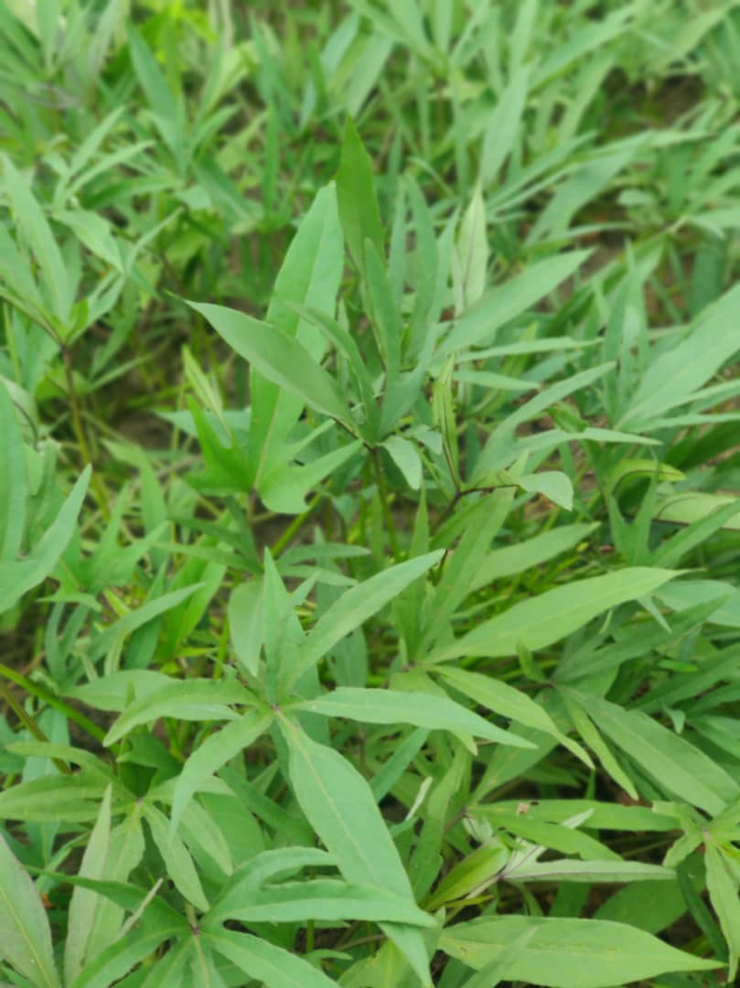
Photo 1:Reflect types of vegetables planted by Young Single mothers at Tandale Ward.
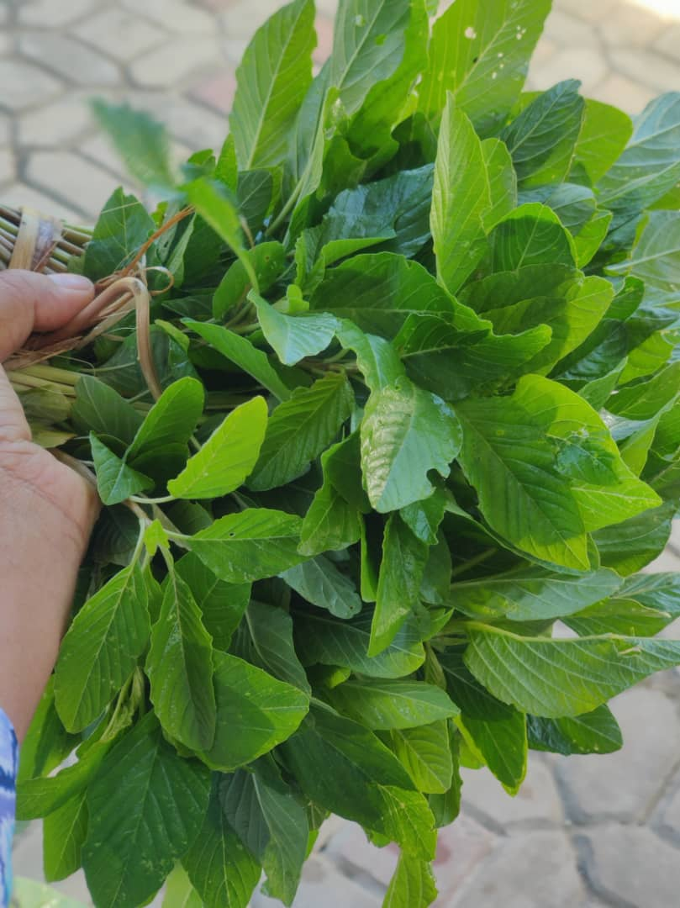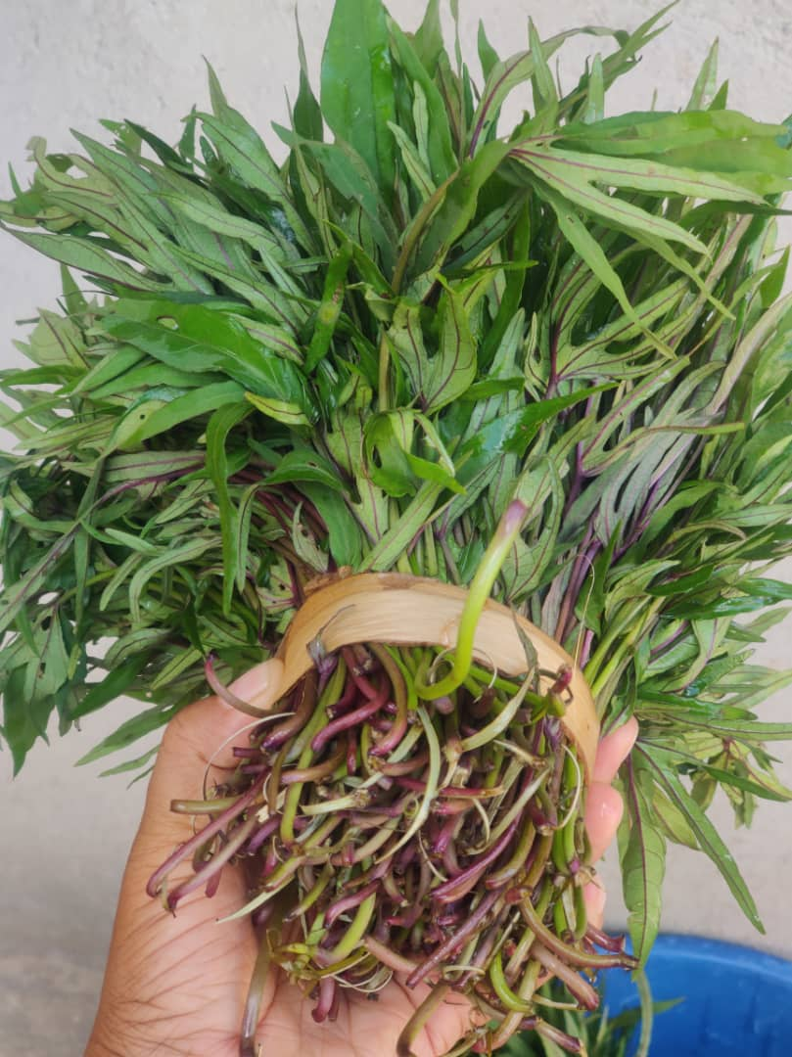
Photo 2: Bunches of Amaranth and Sweet potato leave read to be delivered to the customers.
APPENDIX 2: RESEARCH CLEARANCE LETTERS


