EFFECTS OF KNOWLEDGE TRANSFER PRACTICES ON EMPLOYEE’S PERFORMANCE OF LOCAL GOVERNMENT AUTHORITIES IN TANZANIA

HAJI MUSA MNASI

A THESIS SUBMITTED IN FULFILMENT OF THE REQUIREMENTS
FOR THE DEGREE OF DOCTOR OF PHILOSOPHY IN HUMAN RESOURCE MANAGEMENT (PhD)
DEPARTMENT OF MARKETING, ENTREPRENEUSHIP AND MANAGEMENT
OF THE OPEN UNIVERSITY OF TANZANIA
2022

CERTIFICATION
The undersigned certify that they have read and hereby recommend the thesis for examination, entitled; “Effects of Knowledge Transfer Practices on Employee’s Performance of Local Government Authorities in Tanzania”, in fulfillment for the requirement of Award for the Doctor of Philosophy in Human Resource Management (PhD).

...................................................
Dr. Chacha Matoka
(Supervisor)

..........................................................
Date


...........................................................
Dr. George Mrope
(Supervisor)

11/11/2022
............................................................
Date

COPYRIGHT
No part of this dissertation may be reproduced, stored in any retrieval system, or transmitted in any form by means, electronic, mechanical, photocopying, recording or otherwise without prior written permission of the author or the Open University of Tanzania in that behalf.

DECLARATION
I, Haji Musa Mnasi, do declare that the work presented in this thesis is original. It has never been presented to any other university or institution. Acknowledgements have been made, where other people's work has been used, and references have been provided. It is in this regard that I declare this work as originally mine. It is hereby presented in fulfillment of the requirement for the degree of Doctor of Philosophy in Human Resource Management (PhD).

.....................................................
Signature

.......................................................
Date

DEDICATION
To my late parents’ father; Musa Mnasi Makong’o and mother; Mwambie Masudi Mnipela for opening the world of education to me whose guidance, love and word of wisdom taught me to value education.

ACKNOWLEDGEMENT
Firstly, I thank the Almighty Allah for the gift of life, good health, wisdom, knowledge, and for enabling me reach this far.

My profound gratitude goes to all who in one way or other assisted me in successful accomplishing of these research. I reckon the commitment of my university supervisors Dr. Chacha Matoka and Dr. George Mrope for their invaluable and constructive support throughout the stages of this study. Their patience, sympathy, motivation, suggestion, constructive criticism and the reference materials they provided were most resources to this accomplishment, I truly appreciate. I also thank Mnasi family for their encouragement and support, both materially and morally towards the completion of this great endeavor.

Others on the list are; Dr. Gwahula Raphael, Dr. Adolf Rutayuga, Dr. Emmanuel Tonya, Dr. Salvio Macha, Dr. Pamela Semiono, Dr. Nasra Kaaya, Dr. Jeofrey Oleke, Dr. Hamis Amani, Dr. Bahati Goliama, Dr. Sabato Nyakujanga, Dr. Alex Nkondola, Dr Amani Makota, and Dajudy Stationery just to mention a few for their encouragement and support. I register my appreciation to Open University of Tanzania staff, colleagues in Ileje DC, Songwe RS, NACTVET family and everyone contributed in one way or another to the study success.

Moreover, I wish to thank my research assistants Bargavin Arthur, Neema Mwavala, Emmanuel Nyaki, Rashid Kibana and Bilhuda Meena for their hard work that contributed to successful completion of this PhD thesis. Least, may I granted a leave to extend my heartfelt appreciation to all those who direct or indirect, morally or materially, supporting me in whatever means toward successfully finalization and submission of this thesis. Together we stand apart we fall.

ABSTRACT
This study examined the effects of knowledge transfer practices on employee performance of Local Government Authorities in Tanzania. Specifically, to determine the effect of mentoring practice, to assess the effect of peer training practices, to investigate the effect of information and communication technology practices and to examine the effect of team work practices on employee performance in LGAs. The study was guided by knowledge-based theory and dynamic theory of organizational knowledge creation, the positivism philosophy with a quantitative approach was adopted. A close-ended questionnaire was used to survey a total of 368 employees drawn from Mbeya City Council, Iringa Municipal Council, Tunduma Town Council and Makete District Council. The multiple linear regression model was used to test the hypotheses. The study findings showed that mentoring practice, information and communication technology practice and team work practice, had statistically positive and significant effect on employee performance in Local Government Authorities. However, peer training practice was statistically insignificant influence on employee’s performance. The study concludes that, team work practice had a strong significant association to affect employee performance. The study therefore, recommends that Local Government Authorities to increase review on training policies in addressing need for knowledge transfer practice on employee performance. Other recommendation of the study was; promotion of the application of information communication technology resources and skills to encourage employee interaction in all levels of local government authorities.
Keywords: Knowledge Transfer Practices, Employee Performance, Local Government Authorities, Employees.

TABLE OF CONTENTS
CERTIFICATION ii
COPYRIGHT iii
DECLARATION iv
DEDICATION v
ACKNOWLEDGEMENT vi
ABSTRACT viii
TABLE OF CONTENTS ix
LIST OF TABLES xiv
LIST OF FIGURES xvi
LIST OF ABBREVIATIONS xvii
CHAPTER ONE 1
INTRODUCTION 1
1.1 Overview 1
1.2 Background to the Study 1
1.3 Statement of the Problem 4
1.4 Objectives of the Study 5
1.4.1 General Objective 5
1.4.2 Specific Objectives 6
1.5 Significance of the Study 6
1.5.1 Theoretical Contribution 6
1.5.2 Policy complication 6
1.6 Scope of the Study 7
1.7 Organization of the Thesis 7
CHAPTER TWO 9
LITERATURE REVIEW 9
2.1 Overview 9
2.2 Definition of Key Terms 9
2.3 Theoretical Literature Review 13
2.3.1 Knowledge Based Theory 14
2.3.2 The Dynamic Theory of Organizational Knowledge Creation 17
2.3.3 Synthesis of Theoretical Perspectives and Summary of the Theories 19
2.4 Empirical Literature Review 19
2.4.1 Effects of Mentoring and Employee Performance 19
2.4.2 Effects of Peer Training Practice on Employee Performance in LGAs 23
2.4.3 Effects of Information and Communication Technology Practices on Employee Performance in EPLGAs 27
2.4.4 Effects of Team Work Practices on Employee Performance in EPLGAs 30
2.5 Research Gap 32
2.5.1 Theoretical Gap 33
2.5.2 Empirical Gap 33
2.5.3 Methodological Gap 34
2.6 Conceptual Framework 34
CHAPTER THREE 36
RESEARCH METHODOLOGY 36
3.1 Overview 36
3.2 Research Philosophy 36
3.3 Research Approach 37
3.4 Research Design and Strategy 37
3.5 Area of Study 39
3.6 Study Population 39
3.7 Sampling and Sample Size 40
3.7.1 Sampling Frame 40
3.7.2 Sample Size 40
3.7.3 Sampling Design and Technique 42
3.8 Variable and Measurement Procedure 42
3.9 Sources and Methods of Data Collection 44
3.10 Data Processing Analysis 45
3.10.1 Descriptive Statistical Analysis 45
3.10.2 Inferential Statistical Analysis 46
3.10.3 Multiple Linear Regression Analysis 47
3.10.4 Assumptions of Multiple Linear Regressions 48
3.11 Data Validity and Reliability 52
3.11.1 The Validity of the Research Instruments 52
3.11.2 Reliability of the Research Instruments 54
3.12 Ethical Consideration 55
CHAPTER FOUR 57
DATA ANALYSIS AND PRESENTATION 57
4.1 Overview 57
4.2 Response Rate 57
4.3 Testing Reliability and Validity of Data 58
4.3.1 Reliability of the Research Instruments 58
4.3.2 Testing for Validity of the Measuring Instruments 59
4.4 Demographic Distribution of Respondents 60
4.4.1 Respondents Distribution by Age 60
4.4.2 Respondents Distribution by Departments 61
4.4.3 Respondents’ Distribution by Education Level 62
4.4.4 LGAs’ Employee Experience 62
4.4.5 Cross Tabulation between Demographic Data and EP 63
4.5 Variable Descriptive Statistics Results 64
4.5.1 Descriptive Statistics on Mentoring Practice 64
4.5.2 Descriptive Statistics on Peer Training Practice 65
4.5.3 Descriptive Statistics on Information and Communication Technology Practice 66
4.5.4 Descriptive Statistics on Team Work Practice 67
4.5.5 Employees Performance in LGAs 68
4.6 Inferential Analysis 68
4.6.1 Testing Assumptions for Multiple Linear Regression 69
4.6.2 Multiple Linear Regression Analysis by Objectives 76
CHAPTER FIVE 80
DISCUSSION OF THE FINDINGS 80
5.1 Overview 80
5.2 MP and Employee Performance in LGAs 81
5.3 PTP and Employee Performance in LGAs 83
5.4 ICTP and Employee Performance in LGAs 83
5.5 TWP and Employee Performance in LGAs 85
5.6 Model Improvement 86
CHAPTER SIX 89
CONCLUSIONS AND RECOMMENDATIONS 89
6.1 Overview 89
6.2 Conclusions Regarding Essential Aspects of the Study 89
6.2.1 Effects of MP on Employee Performance 89
6.2.2 Effects of ICTP on Employee Performance 89
6.2.3 Effects of TWP on Employee Performance 90
6.3 Contribution of the Study 90
6.3.1 Theoretical Implication 91
6.3.2 Implication to Policy Maker 92
6.3.3 Practical Implication 93
6.4 Recommendations from the Study 94
6.4.1 Limitations of the Study 95
6.4.2 Area for Future Studies 95
REFERENCES 97
APPENDICES 115

LIST OF TABLES
Table 2.1: Summary of Previous Studies on the Effects of MP on EPLGAs 23
Table 2.2: Summary of Previous Studies on the Effects of PTP on EPLGAs 26
Table 2.3: Summary of Previous Studies on the Effects ICTP on EPLGAs 29
Table 2.4: Summary of Previous Studies on the Effects of TWP on EPLGAs 32
Table 3.1: Study Population and Sample Size 40
Table 3.2: Summary of Measures of Variables 43
Table 4.1: Response Rate of the Respondents 58
Table 4.2: Reliability Statistics 58
Table 4.3: ANOVA with Tukey's Test for Non-additivity 58
Table 4.4:Intra Class Correlation Coefficient 59
Table 4.5: KMO and Bartlett’s Test 60
Table 4.6: Demographic Characteristics of the Respondents 63
Table 4.7: Cross tabulation Between Demographic Data and EP 64
Table 4.8: Descriptive Statistics on MP Measurements 65
Table 4.9: Descriptive Statistics PTP Measurements 66
Table 4.10: Descriptive Statistics of ICTP Measurements 66
Table 4.11: Descriptive Statistics of TWP Measurements 67
Table 4.12: Descriptive Statistics for Employees Performance (EP) 68
Table 4.13: Tests of Normality V 71
Table 4.14: Kurtosis and Skewness of the Variables 72
Table 4.15: VIF and Tolerance (1/VIF) 76
Table 4.16: Model Summary^{c} 77
Table 4.17: ANOVA Table 77
Table 4.18: Coefficients for MP, PTP, ICTP, and TWP against EPLGAs 78

LIST OF FIGURES
Figure 4.1: Linearity for General Model 70
Figure 4.2: Normality Test for General Model 72
Figure 4.3: Homoscedasticity for General Model 74
Figure 5.1: Modified Conceptual Model 87

LIST OF ABBREVIATIONS
ANOVA Analysis of Variance
CA Cronbach Alpha
CAG Controller and Auditor General
CMT Council Management Team
DC District Council
DTOKC The Dynamic Theory of Organization Knowledge Creation
DV Dependent Variable
EFA Explanatory Factor Analysis
EP Employee Performance
EPLGAs Employment Performance of Local Government Authorities
ERD Explanatory Research Design
FFP Fabrication, Falsification and Plagiarism
HoD Head of Department
IBM International Business Machine
ICC Intra class correlation coefficient
ICT Information and Communication Technology
ICTP Information Communication Technology Practices
IT Information Technology
IV Independent Variable
KBT Knowledge Based Theory
KMO Kaiser Meyer Olkin
K-S Kolmogogorov-Smirnov Test
KTP Knowledge Transfer Practice
LGAs Local Government Authorities
LGRP Local Government Reform Programme
MLR Multiple Linear Regression
MP Mentoring Practice
NACTVET National council for technical and vocation education and
OUT Open University of Tanzania
PhD Doctor of Philosophy
PMU Procurement Management Unit
PO-PSM President’s Office-Public Service Management
PO-RALG President’s Office-Regional Administration and Local Government
P-P Probability – probability Plot
PSRP Public Service Reform Programme
PTP Peer Training Practice
RS Regional Secretariat
SPSS Statistical Package for Social Science
TWP Team Work Practice
URT United Republic of Tanzania

CHAPTER ONE

INTRODUCTION

1.1 Overview
This chapter presents the background information, statement of the problem, research objectives, hypothesis, significance, scope and organization of the study.

1.2 Background to the Study
In global context, employee performance is considered an important assert in an organization’s achievements (Alshammari, 2020). Individuals are the best hope of managerial skills, abilities, productivity, competence, service delivery, job satisfaction, social cohesion, accountability, engagement and confidence (Bert et al., 2019; Alshammari, 2020; Maley & Kiessling, 2021; Itoe & Karadas, 2022). On the view of public organization, employee’s performance and competitiveness improves services provision to the people (O’riordan, 2017; Nenungwi & Garaba, 2022). Likewise, in local government authorities, employees’ performances are concerned with providing standards services (Njunwa, 2017; Performance et al, 2020).

In the knowledge management world, two terms flying around whereby the transfer and sharing of it are sometimes used synonymously with an overlapping content. (Silva & Borsato, 2017; Adıgüzel, 2019; Singh et al, 2021). Hence, in order to provide better services to the people knowledge transfer practices (KTP) is known as an important approach to influence employees’ performance (Ibidunni, 2020; Elgin, 2021). Human Resources Development as the organization activities is directed towards improving the skills and capacity of employees and hence increasing emphasis on training (Maley & Kiessling, 2021). It also foster development for interpersonal skill, career advice, mentoring, shared vision and decision. Others are to enhance experience, coaching, feedback, orientation, IT, social media, skills, trust, confidence, engagement, accountability and team work. (Qiao Ting Low et al., 2018, Jamsheed et al., 2018).

Empirically, the need for knowledge transfer practice in the organization intends to increase performance. It is one of the tools used to preparing tomorrow’s skilled employees. According to Ofabruku (2016), transfer affects positively employees’ performance. It is also used to strengthen organizational capabilities, intelligences, build organization knowledge and sustain the organization competitive advantages. Realizing the importance of knowledge transfer practice for improving employees’ performance, the governments in various contexts adopted various techniques (Nonaka, et al., 2018). For instance, China developed a knowledge transfer strategy and introduced ideal laboratory for the study of global knowledge for the practices of employees (Reeves et al., 2018; Zhang, 2021).

Through that strategy, China exploits new tactics, practices, procedures and hence better employees’ performance. Because of the sensitivity and importance of the knowledge transfer especially the relationship between local government and employee performance, the research efforts had been directed towards the subject (Shao, & Ariss, (2020). A few examples of such researches include but is not limited to few empirical revisions (Septian & Gilang, 2017; Ahmed & Mansoor, 2017; Kalemba, 2017).

In order to improve the employee performance, like in other countries, Tanzania has established a number of initiatives to ensure proper knowledge transfer practices. Such initiatives include; Public Service Management and Employment Policy of 1999, and Public Service Reform Program (PSRP) phase one, two and three of 2000, 2008 and 2020, Local Government Reform Programme which began in 1998 with the aim of transferring resources from central to local government, and devolving and decentralizing power to create more autonomous LGAs.

The programme has two broad objectives: to improve local governance and to improve service delivery. Another one is the Public Service Act No. 8 of 2002, and District Authorities Act number 7 of 1982. In addition, LGAs knowledge transfers practices is governed by LGAs strategy (2010) and Public Service Policy. Furthermore, the government strategies embarked on facilitation of knowledge transfer practices aimed at improving the quality of service delivery, also the strategies extend to productivity, ethics, use of IT skills, acceptance, shared vision, coaching and training (PO PSM, 2014; Msambichaka et el., 2015; PO RALG, 2020).

However, the Knowledge Based Theory (KBT) as used by Penrose (1959) employees can achieve performance for growth by the accumulation of knowledge. This can be done through use of the existing knowledge within the organization more efficiently and alternatively and the use of new knowledge from external sources with the condition of internal absorbing capabilities. Apart from that, organization will be limited in terms of the possibility of expansion in employee’s performance, service delivery, productivity, shared vision, decision making and formalization opportunities because of inherent rigidities and internal performance. Dynamic Theory of Organizational Knowledge Creation focuses on Knowledge Transfer Practice to provide the basis for strategies to employee performances to ensure competitiveness in LGAs. The theory advocates transfer of knowledge within organizations to improve employee performance through Team work (Ofobruku and Nwakoby, 2016). Other limitations to growth may come from the lack of relevant information on how to use an existing knowledge resources base to maintain coherence of activities. (Nonaka, et al., 2018), points out that the growth of a firm is limited by the speed with which new knowledge and resources are accumulated and by its manager’s ability to quickly learn and respond by expanding the scope of the firms and organizations performance.

As regarding to employee performance endless debate remains (Pallangyo, 2020) that, of what are the reasons behind for poor performing, poor delivery, unproductivity, corruption, qualified opinion, lack of trust and unaccountability (CAG, 2020). The notion builds a necessity to expand nature of the relationship of constructs by adopting the four constructs to test each relationship on employee performance. However, empirical that could reduce the risk of making misleading inferences and conclusions did not focus on the effects of better understanding of current contingent relationships of mentoring practices. Others include; ICTP or use of IT resources, acquisition of useful IT skills (zoom); readiness of government and TWP work ethics, trust, cohesiveness, shared vision and shared decision making and employee performance in LGAs. Therefore, this study examined the effects of KTP on EPLGAs in Tanzania.

1.3 Statement of the Problem
Local Government Authorities have been taking a lead on the implementations of knowledge transfer practices by using guidelines and policies aimed at improving employee’s performance. Despite the implementation of such guidelines and policies in Tanzania, LGAs have continued to perform below its expectations (PO-RALG, 2020; CAG, 2020; Shitindi, 2020). Several studies have (Olanrewaju, 2016; Fountain, 2018; Uchenna & Nkechi, 2019) been striving to find out the specific reasons for poor knowledge transfer practices, including employee performance in local government authorities in Tanzania.

Based on the findings, the government has been taking initiatives to curb the low performance (PO RALG 2021, CAG 2020). The initiatives taken include; mentoring in career development, employee training, application of human resources planning, team work skills. Public Service Management and Employment Policy of 1999, Public Service Reform Programme (PSRP) of 2020, Local Government Reform Programme (LGRP) of 1998, LGA strategy of 2010 aimed at improving in EPLGAs the quality-of-service delivery, productivity, accountability, work place ethics, shared common vision and mission, the employee performance in LGAs is still in doubt (CAG 2021).The study combined the four mentioned knowledge transfer practices from both KBT and DTOKC and examined their interdependence effects on EPLGAs.). However, to the best of the authors knowledge, it is unknown how DTOKC relates to the KTP on EPLGAs. Therefore, it was expected that this study could contribute to knowledge transfer practices on EPLGAs.

1.4 Objectives of the Study
This research was guided by the general and specific objectives.

1.4.1 General Objective
Generally, the study examined the effects of knowledge transfer practices on employee performance in Local Government Authorities in Tanzania.

1.4.2 Specific Objectives
The study was guided by the following specific objectives:
- To determine the effect of mentoring practice on employee performance in LGAs;
- To assess the effect of peer training practices on employee performance in LGAs;
- To investigate the effect of information and communication technology practices on employee performance in LGAs; and
- To examine the effect of team work practices on employee performance in LGAs.

1.5 Significance of the Study

1.5.1 Theoretical Contribution
The study offers theoretical evidence that link knowledge transfer practice to employee performance in LGAs. The finding contributes to the theories of Knowledge-based and The Dynamic Theory of Organization Knowledge Creation by analyzing MP, PTP, ICTP and TWP effects to promote KTP in LGAs. The study adds to board of knowledge by explaining how KTP may be improved in LGAs if the four variables are given output consideration in complementing current understanding by employing more insights regarding KTP.

1.5.2 Policy complication
Obtained findings guide interest to stakeholders like; regulators, policy makers, planners, administrators and public at large to establish the knowledge transfer practice policy for integration in all LGAs. To public and private organizations, the knowledge obtained from this study would assist in designing knowledge transfer practices and training programs for employee performance. The study applied KBT and DTOKC in the Tanzanian context and in EPLGAs and therefore, contributed to knowledge contribution.

The findings are expected to bring both theoretical and practical significance and of interest to stakeholders like regulators, policy makers, planners, administrators and public at large. They acquire more knowledge on how KTP might lead to productivity, service delivery, accountability, shared vision, acceptance and increase performance proxy for LGA’s development, instead of its limitation to profit making. Lastly, the study expected to validate the Knowledge Based Theory (KBT) and Dynamic Theory of Organizational Knowledge Creation (DTOKC) act as the basis for expecting the action and validate them in the Tanzania context and also contribute knowledge to its development.

1.6 Scope of the Study
The goal of the study was to examine the determinants of knowledge transfer practice on EPLGAs. The study sample was LGAs employees in various department and section in selected district council in the southern highlands.

1.7 Organization of the Thesis
The remainder of the thesis is organized as follows: Chapter two presents a review of national and international literature on the study. Specifically, it consists of conceptual definitions, theoretical reviews, empirical studies, research gaps and conceptual framework. Chapter three covers research methodology used in the study. Specifically, chapter three covers research philosophy, research strategies, study area, population of the study, sampling techniques, source of data, data collection tools, data analysis and ethical issues. Moreover, chapter four presents the findings of the study in the form of descriptive and inferential statistics. Specifically, it consists of analyzed data from the model and in the form of frequency distribution, percentages, scatter plots, histogram and curves of the key variables in the questionnaire and the tested hypothesis.

Furthermore, chapter five discusses the research findings obtained from data analysis in chapter four. This chapter includes the interpretation of the research findings and also the hypothesis testing using Chi-Square (χ), Pearsons Square, Bartlett’s test of Sphericity and Multiple linear regression model. Lastly chapter six provides a review of the study to address the research objectives and hypothesis. Specifically, this chapter provides conclusions, implications and recommendations of the KTP on EPLGAs and areas for future research.

CHAPTER TWO

LITERATURE REVIEW

2.1 Overview
Chapter two provides in-depth information on the literature related to the effects of knowledge transfer practices (KTP) on employee performance in local government authorities (EPLGAs). Therefore, the chapter comprises of sefinition of key terms, theoretical literature review, empirical literature review, research gap. And conceptual framework.

2.2 Definition of Key Terms

2.2.1 Knowledge Transfer Practices
Knowledge transfer practices are those that lead to improvement in performance by helping a low performing company become high performer are hence stay successful (Maley & Keissling, 2021). The transfer or exchange involves organizational learning transits between a source to a beneficiary for achieving predetermined outcomes (Ibidunni et al., 2018). In a broader sense, it incorporates employee willingness to interact with others i.e. donate knowledge and to also learn from the collected knowledge (Ibidunni et al., 2018).

For this study, knowledge transfer practice means the process by employees at working place exchange knowledge, skills and behaviors within their organization, which was adopted from Elgin, (2021) because it is in line with this study context in terms of different ways adopted by LGAs in transfer of knowledge including trainings, mentorship and team work as well as through application of Information and Communication Technology (ICT).

2.2.2 Employee Performance
Maley and Kiessling, (2021) defined employee performance as commitment and satisfaction of employees in the jobs they are doing. It involves a continuous process for improving the performance of individuals by aligning actual performance with the desired organizational goal (Kaehler & Grundei, 2019; Panait, 2020). Put simply, employee performance is how a member of staff fulfils the duties of their role, completes required tasks and behaves in the workplace. Measurements of performance include; quality, quantity and efficiency (Silva & Borsato, 2017; Takahashi, 2018; Hamdoun, & Othman, 2018; Shao & Aris, 2020). For this study employee performance means the extent of commitment and fulfilment of the duties of their role, behavior in work place and effective and efficiency on service delivery to others. The definition was used as it highlights the achievements of the employees’ roles in LGAs of which was the major theme of this study.

2.2.3 Local Government Authority
According to Bangase, (2018) local governments is a system of administration under local communities that are organized to maintain law and order that provide some limited range of social amenities and hence encourage cooperation and participation of inhabitants towards the improvement of their living conditions. It is a generic term used to refer to the lowest tiers of public administration within a particular sovereign state (Kajimbwa, 2018). This particular usage of the word government refers specifically to a level of administration that is both geographically localized and has limited powers (Commonwealth Local Governance Forum, 2022). In this study local government is that part of the government of the country operating at a local level and functioning through a representative organ or council; because the study surveyed the employees of LGAs.

2.2.5 Mentoring Practices
According to Stanulis, et al., (2019) mentoring is a process of using selected experienced and trained individuals to provide guidance and continuing support in learning career development process. Similar to teaching, mentoring involves communication of information between people. Specifically, mentors are “guides on the side,” facilitating the mentee’s construction of their own personal and professional development. “It is important to help [mentees] develop their own interests. Mentorship is not about replicating one’s work, but about guiding [mentees] in becoming one who they want to be (Ndung’u 2016; Willemse, 2018; Uchenna & Nkechi, 2019). In the context of this study mentoring practices are methods of helping employees to acquire skills and knowledge from experienced supervisors or leaders within the Council Management Team (CMT).

2.2.6 Peer Training Practices
Willis et al., (2022) described peer training practice as the organized procedure by which employees learn knowledge and skill for a definite purpose. Peer to peer learning is a type of mutual learning and training strategy. Byrne, et al., (2021) notes that PTP involves participants of the same level that are engaging in collaborative education. Peer to peer learning is invaluable in many situations. Grant (1996) revealed that while it's usually associated with classrooms, peer learning is also important at work. It creates an engaged workforce that is constantly developing their skills. In the context of this study, peer training practice refers to the teaching activities carried on for the primary purpose of helping fellow employees to acquire and to apply knowledge and skills to perform better within an organization.

2.2.7 Information and Communication Technology Practices
Venkatesh et al., (2018) defined Information and Communication Technology (ICT) as degree to which the employees use IT services to gain job performance. Breznik et al., (2019) defined ICTP to one’s ability to converse with people through various technologies. Similar to information technology (IT), ICT refers to technology use for regular, everyday tasks: sending an email, making a video call, searching the internet, using a tablet or mobile phone, and more. For this study, information and communication technology refers to applicability of Information and Communication Technology (ICT) by LGAs employees when providing services to the people.

2.2.8 Team Work Practice
Walker, et al., (2021) defined Team work practices as the act of owning your responsibilities, staying accountable and doing what you say you are going to do. Team members rely on one another, so if one person drops the ball, an entire project can fail. Reeves & Zwarenstein, (2018) have noted that members of the team must trust one another and have a strong rapport. On the other hand, Phina, et al., (2018) described team work as the collaborative effort of a group to achieve a common goal within the organization. Employee Team work is a collection of an individuals who are interdependent in the tasks and who share responsibilities for the outcomes. Team enables people to cooperate, enhance individual skills and provide constructive feedback without any conflict among individuals. According to McEwan and Crawford, (2022) has noted that most of the organization activities become complex due to advancement in technology.

McEwan and Crawford, (2022) views team members as the ability to enhance the skills, knowledge and abilities of the working teams. This means that while working employees who work in teams are able to employ their skills, knowledge and abilities of the working teams. It means that while working they are able to employ their skills, knowledge and ability by learning from each other. Due to that it enables to produce effectively and efficiently. Luthra et el., (2018); Ratheeswari, (2018); Mughal and Iraqi, (2020) have noted that in today’s business competition, customer expectations of new technology and many other developments, it is more critical than ever to build team work in organization for employee’s performances. In this study team work is conceptualized as a process whereby employees in LGAs works together to complete their task in the most effective and efficient way.

2.3 Theoretical Literature Review
Empirical and theoretical studies report that there is no single general theory which relates to KTP on EPLGAs and instead, different existing theories are applied depending on the particular study (Joseph & Wilson, 2018; Nason & Wiklund, 2018). The KBT and DTOKC were applied in guiding this study because of their solid foundation. This was due to their valuable insight in the management fields on knowledge transfer practices toward employee performances. KBT is one of the best theories utilized in explaining how to use the firm’s internal resources as a strategy for gaining KTP and improving employee performance. (Alberti et al., 2019). Nonetheless, Elgin (2021) argues that KBT is not solely satisfactory in explaining how the organization can suffice and make it productive and better service delivery and therefore the need to interlink it with other perspectives aiming at productivity. Elgin (2021) suggestion implicitly calls to interlinkage KBT with other theories and in particular DTOKC which guides knowledge transfer practices through socialization in internalization effect on EPLGAs. Moreover, Kleiner (2021) and John et al., (2016) opine that several theories can serve as the foundation for merging one research study on employee performance. KBT and DTOKC were therefore used to guide this study. The theory provides valuable experience for LGAs to think about MP, PTP, ICTP and TWP inherent in relation to employee performance.

2.3.1 Knowledge Based Theory
The perspective can be traced back in 1952 in paper published in the American Economic Review 1959. The theory originated from the strategic management and extended as resource-based view of the firm. The theory was initially promoted by Penrose (1959) and later expanded by (Wernerfelt, 1984; Barney, 1991). Kengatharan, (2019), asserts that knowledge is easier and less costly to pass on and the transfer of which can only take place in interaction in master/apprentice like relationships. Penrose considered firm to be administrative entities, with control over potentially valuable resources.

The perspective argued,” that it is the managers of the firm who make decisions about how firm activities and resources are deployed” (Penrose, 1959). Penrose (1959) emphasis was on the importance of managerial capabilities based on her views that the firm is not just a collection of individuals but a collection of individuals who have experience of working together” (Tinofirei, 2011; Nikolaou, 2019). It suggests how to use existing knowledge and skills more efficiently and alternatively, use of new knowledge from external sources but with condition of internal absorbing capabilities (Penrose, 1959; Bert & Monster, 2019; Alshammari, 2020; Kleiner, 2021). However, Bauer et al., (2021), opine that knowledge transfer such as; mentoring, peer training, IT skills are critical to the growth and employee performance.

Penrose (1959) proposed the size of a firm’s performance opportunity set to be positively related to the ability of the organizations to perform. The employee performance set is determined on how employees are trained to combine knowledge transfer at their disposal to service delivery (Tegan & Mercus, 2022). Knowledge transfer were considered, valuable because they facilitated the conception of strategies, knowledge and experience. It also facilitates skills, competencies, coaching, service delivery, acceptance, shared vision acquired through MP, PTP, ICTP and TWP on employee performance (Olanrewaju, 2016; Willemse, 2018; Ratheeswari, 2018; Nenungwi, 2022).

Grant (1996), extended the knowledge-based theory by establishing three variables for knowledge transfer. These indicators are; mentoring, peer training and information and communication technology as are anchored in the theory. KBT therefore helps the study to elevate mentoring, training and ICTP factors on employee performances. Employees are often judged on how well they perform based on individual transferring of knowledge (Willimse, 2018). In this case, the study is important since it reflects on the actual environment of Tanzania’s LGAs. These are indicators of Knowledge-Based Theory with significant effects on employee performance. This indicator was found to be important for knowledge transfer within the organization. Because of emphasis on contribution of employee’s knowledge, skills expectance towards bringing LGAs performances, knowledge transfers practices such as; role modeling companionship acceptances peer to peer, coaching, formal training, ICT skills, social media, zoom application, e- government and shared vision.

Theoretically, KBT is seen to be suitable to explain the framework in the knowledge transfer practices and the employee performances of LGAs in Tanzania. The next paragraph discusses the strength and weakness of KBT. A major strength of KBT is that it helps the study to set the relationship between employee performance that include all related knowledge, skills, experiences that make productive service delivery commitment, accountability, job satisfaction, engagement and lead into LGAs performance (Silva & Borsato, 2017; Nikolaw, 2019). Moreover, KBT helps administrators to identify the value of having unique and distinctive resources and its practicability to assist KTP promote employee performance.

However, the theory has several weaknesses as it did not consider the contribution of technological innovation systems on employees’ performance (Nickerson & Zenger, 2004). Another weakness of KBT was criticized being levelled against theoretical focus prevents the development of a richer, more complex, knowledge-based theory of a firm. Furthermore, the theory does not consider the professionalization of management, evolution of technology and institutions that influence firm’s expansion (Schwab et al., 2017; Nyakujanga, 2021).
Moreover, another critique is the testability of the theory that Penrose developed unlike theoretical work today which emphasize constructs and relationships, Penrose mostly used case histories to develop some theoretical principles and logic and she acknowledged that testing them remained problematic (Schwab et al., 2017; Singh et al., 2021). The assumption of unlimited growth opportunities does not hold today given the fact that a firm’s acquisition experience may be limited to knowledge transfer, particularly to the employee ability and competence within the given context of the Local Government Authority (Silva, 2017).

On the other hand, the possibilities of a firm reports on poor performance and failure in future growth become questionable as some firms may have reported previously (Singh et al., 2021). Schwab et al., (2017) suggestion, therefore, logically calls to interlinkage KBT with DTOKC which guides in KTP on EPLGAs. Schwab et al., (2017) argument, therefore stimulated this study to interlink KBT and DTOKC variables with intention of building a single conceptual framework and find their interdependence effect on EPLGAs. DTOKC is therefore, discussed in the next section.

2.3.2 The Dynamic Theory of Organizational Knowledge Creation
Dynamic Theory of Organizational Knowledge Creation (DTOKC) was developed by Nonaka, (1994) who asserts that the ideal knowledge is transferred through socialization, internalization and externalization through combination of socialization and team work practices. Its central theme is that organizational knowledge is created through a continuous dialog between tacit and explicit knowledge. It argued that while new knowledge is developed by individuals, the organization plays a critical role at articulating and amplifying that knowledge (Nonaka, 1994; Abdul et al., 2011). It is widely observed that the society we live in has been gradually turning into a “Knowledge Society” (Saiz-Pardo et al., 2021).

The increasing importance of knowledge in contemporary society calls for a shift of thinking concerning innovation in large organization, be it technical or productivity, strategic or organizational innovation, (Nonaka & Rechsteiner, 2012; Ofobruku & Nwakby, 2016). The theory further claims that it has been long dominated by a paradigm that conceptualize the organizations as a system that processes information or solves problems. However, to the best of the author’s knowledge, it is unknown on how DTOKC relates to the EPLGAs. Thus, the next paragraph discusses how DTOKC is likely to relate to the employee performance in LGAs.

The theory suggest that the solution lies in the input process output sequence of hierarchical information processing which have found out that individual employees and their team mate performance mostly rely on the level of their shared vision ethical, collective decision, level of trust, conference, and interpersonal skills. Their commitment to LGAs employees tend to increase the level of their working personalities experience and ability to perform their duties. Dynamic Theory of Organizational Knowledge Creation helps the study to understand a team work practices effects on employee performance towards their LGAs performance.

As the weakness of DTOKC, Von Krogh, Nonaka and Rechsteiner, (2012) revealed that it was focused on the role of central, upper-echelon, leadership in knowledge creation processes, without devoting much attention to context and knowledge assets. Based on this theory, in this study Team work was taken as determinants to study the effects of knowledge transfer on employee’s performance in LGAs.

2.3.3 Synthesis of Theoretical Perspectives and Summary of the Theories
In this study, KBT was combined with DTOKC to strengthen the study model that better explained the effects of knowledge transfer practices on employee’s performance in Tanzania as presented in Table 2.1. The use of the combined theories has been recommended by a number of scholars. For instance, Ndekwa (2015) combined TOE framework and diffusion of innovation theory in examining the determinants of adopter and non-adopter of computerizing accounting system among small and medium enterprises in Tanzania.

However, in this study, MP, PTP and ICTP are the dimension from KBT of the firm as the main theory and team work (TWP) variable from DTOKC as supporting theory were combined to study the effects of KTP on employee performance. The study thus filled the gap by examining how knowledge transfer practice variables generated from KBT and DTOKC are related and useful to the EPLGAs in Tanzania.

2.4 Empirical Literature Review
This part presents several studies which have been performed in different area of the world. To have a critical review on the content, they are divided into four sections based on specific objectives.

2.4.1 Effects of Mentoring and Employee Performance
Fountain (2018), examined the relationship between mentoring and employee performance through engagement in the United States of America. The study used perceived organizational support as a moderating role. The theoretical foundation for this study was social exchange theory. The study was quantitative and the surveyed questionnaire of a total of 307 employees representing different industries. Data was analyzed using descriptive and inferential analysis, including Pearson’s correlations, linear and stepwise regression analysis. The result of the inferential analysis analyses indicated that each part of mentoring variable i.e. career support, psychosocial support and role modelling had an independent impact on work engagement.

The interaction between psychosocial support and organizational support was also significant after accounting for the effects of mentoring and organizational support. The findings indicate that managers can achieve positive social change and improve employee well-bring within their organization by being dutifully involved in their employee work lives. As a recommendation, managers should also be available to apply resources such as mentoring for technicians and technologists when needed.

This study differs from the current study in the fact that it was done in the United States of America, while the current study was done in Tanzania southern highland zone. Also this study used perceived organizational support as a moderating role while the current study didn’t have moderating role, and lastly this study employed social exchange theory while the current study employed two theories such as KBT and DTOKC to explain the relationship exists between the dependent and independent variables with regards to their proxy measures.

Uchenna and Nkechi (2019), examined the effects of mentoring practice on employee’s performance in Nigeria. The objective of the study was to identify the nature of relationship between knowledge transfer, mentoring and career growth of junior lecturers and establish the nature of relationship between psychosocial function of mentoring and career adjustment of junior lecturers. The theoretical foundation for this study was social cognitive theory. To achieve the objective, a survey research design was adopted. The technique employed in analyzing the data was descriptive statistics and the spearman rank correlation coefficient. Through quantitative approach from 396 lecturers, the study found that there is positive and significant relationship between knowledge transfer mentoring and career growth of lecturers. It was found also, that there is a positive and significant relationship between psychosocial function of a mentor and career adjustment of junior lecturer.

Based on the findings, the researcher concluded that mentoring practice has an effect on employee performance. It was recommended among others that; management of Abia State University should make mentoring an academic responsibility of certain categories of lecturers. Mentoring was an effective strategy for not only developing the worker but also actualizing organizational socialization and employee performance. It insisted that there is no doubt that mentoring is an effective strategy for employee performance. It recommended that management should adopt a full-fledged formal mentoring program with the necessary structures, guidelines, and incentives have to be given for employee performance.

The study relates to the current study although there is different in terms of area of the study where this study was conducted in Nigeria while the current study was conducted in Tanzania. Not only that, but also differ in terms of the focus where this study focused on junior lectures of the university while this current study focused on local government employees.

Manzi (2017), examined mentorship and coaching to support strengthening healthcare systems lessons learned across the five-population health implementation and training partnership projects in Sub-Saharan countries including Tanzania. The study applied research design case study and approach simple random sampling. Data was collected using questionnaire and analyzed using descriptive statistical analysis, size involved was 396 health facilities employees and was done quantitatively. The study found out that when adapted to local challenges and capacity, mentorship can catalyze improvement process to strengthen employee performance. It was concluded that incorporating mentorship and coaching activities into HSS strategies was associated with improvements in quality of care and health systems.

Recommendation was mentoring and coaching to be crucial for employee performance. Despite the work of scholars showing positive and significant effects, most of the study have been done in private sector. Therefore, researcher suggested conducting further studies on knowledge transfer in public sector organization particularly the LGAs in Tanzania context. This study differs with the current study because it examined mentorship and coaching to support strengthening healthcare systems, while the current study focused on knowledge transfer practice on employees’ performance in local government authorities. Basing on a theoretical and empirical literature review (Cameron & Ebrahimi, 2014; Hagin, 2012; Kengatharan, 2019; Bert & Monster, 2019; Kleiner, 2021) this study hypothesis that;
1H_{1:} Mentoring practices has positive effects on employee performance in LGAs.
Table 2.1: Summary of Previous Studies on the Effects of MP on EPLGAs
Author (Year) | Study Objective | Variables | Analytical Method | Main findings Relationship
Fountain (2018)  USA | Mentoring Elements that Influence Employee Engagement. | Exposure Assignment Role model | Descriptive and inferential methods | Positive and significant
Uchena (2019)  Nigeria | Effects of Mentoring Practice on employee’s Performance: | Counselling Engagement Acceptance | Questionnaire survey was used by Multiple regression | Positive and significant
Manzi (2017),  Tanzania | Mentorship and coaching to support strengthening healthcare systems: lessons learned across the five Population Health  Implementation and Training partnership  projects in sub-Saharan Africa | Close relationship  Innovative  Friendship  Job acceptance | Questionnaire survey was used by Descriptive statistical analysis | Positive and significant
Source: Field Data, 2021

2.4.2 Effects of Peer Training Practice on Employee Performance in LGAs
Mwangi (2018), sought to examine the effects of peer-to-peer training on employee performance in State Corporations in Kenya. A sample of 126 State Corporations were randomly picked from the target population of 187. The study applied mixed methods research with cross-sectional survey design. To obtain opinions from the respondents, a five-point Likert scale and open-ended questions was used.

Multiple regression analysis was adopted being a technique of multivariate analysis. The data was analyzed using SPSS (version 23) and presented by way of means, percentages, standard deviation, tables and figures. Peer to peer training explained 31.4% of the variance in employee performance with 68.6% being explained by other factors not related to peer-to-peer training. The general conclusion drawn from the findings was that peer-to-peer training significantly improves employee performance in State Corporations in Kenya and therefore should be enhanced. The study recommended that State Corporations should allocate resources to promote peer to peer training activities in order to improve individual employee performance. This study differs with the current study in the sense of methodological perspective because it applied mixed methods research with cross-sectional survey design, while the current study applied quantitative methodology with explanatory research design.

Sendawula, et al., (2018), the purpose of this study was to investigate the contribution of training and employee performance using evidence from Uganda’s health sector. The study was cross sectional and correlational. A total of 150 questionnaires were received from respondents. Data were analyzed using SPSS. Regression analysis results indicated that training and employee engagement significantly predict employee performance by 44.7% and employee engagement was found to be a major predictor of employee performance as compared to training. Correlation analysis results indicated that there is a significant positive relationship between training and employee performance.

Correlation analysis results further indicate that there is a significant positive relationship between employee engagement and employee performance. Therefore, this research recommended that it is important to managers, policy makers and government in improving employee performance in the health sector. This current study relates to research approach, sampling, methods of data collection using questionnaire contrary to the study in Uganda with sample from health sector where they used SPSS and 150 questionnaires to review employee performance. Conclusively, the current study improved the sample size by 368 and multiple linear regression for data analysis with help of IBM SPSS software V26. This study differs in terms of area and context of the study because it was based in Uganda’s health sector while this current study was based in Tanzania local government authority.

Palango (2020), this study intended to examine the power of coaching and counseling on employee performance of local government authorities in Tanzania using the Nanyumbu District Council as a case study. The study used exploratory design using qualitative method. A semi-structured interview was used for data collection in which sixty-three (63) respondents were interviewed. The findings indicated that the majority of respondents revealed that through coaching and counseling, they have received help to improve the quality of services, increase confidence and effectiveness in performing their works.

The study thus recommended that Local Government Authorities to have plans and strategies for coaching and counseling employees, which they will be able to implement even in a time when funds are inadequate. It was however recommended to test the effects of training on employees’ performance in LGAs in Tanzanian context. This study differs from the current study because it was focused on coaching and counseling on employees’ performance in Nanyumbu District Council while the current study focused on knowledge transfer on employees’ performance in southern highlands of Tanzania.

Based on these empirical findings it was difficult to adopt and to make conclusion on the effects of peer training on employee performance without proper testing of the effects of knowledge transfer on employee performance in LGAs in Tanzania context, with these results of the relationship between peer training practice and employee performance basing on a theoretical and empirical literature review (Willis et al., 2019; Bull et al., 2021; Grant, 1996; Pallangyo, 2020; Sendawula et al., 2018).

In comparison both studies aimed the local government authority in Tanzania. The current study examined effects of knowledge transfer practices while Pallangyo examined the power of coaching and counseling on employee performance of local government authorities in Tanzania using a semi-structured interview for data collection in which sixty-three (63) respondents were interviewed. Conclusively, the current study improved the sample size by 368 quantitatively and multiple linear regression for data analysis model. This study hypothesized that;
2H_{1:} Peer training practices has positive effects on employee performance in LGAs.

Table 2.2: Summary of Previous Studies on the Effects of PTP on EPLGAs
Author (Year) | Study objective | Variables | Analytical Method | Main findings
Mwangi (2018)  Kenya | Effects of peer-to-peer training on employee performance in State Corporations. Performance | Job rotation  Transfer  Orientation | Mixed methods research with cross-sectional survey design. questionnaire by Multiple regression | Positive and significant
Sendawula (2018)  Uganda | Contribution of training and employee performance using evidence from health sector. | Conferences  Coaching | Cross sectional correlational. Questionnaire and Regression analysis | Positive and significant
Palango (2020)  Tanzania | The Power of Coaching and Counseling for Employees Performance in Local Government Authorities | Role playing  Formal training  Peer training | Descriptive and inferential methods | Positive and significant
Source: Field Data, 2021

2.4.3 Effects of Information and Communication Technology Practices on Employee Performance in EPLGAs
Kalashi et al., (2020), examined the effects of the application of ICT skills on the process of knowledge management components and the effectiveness of creativity indicators for the improvement of employees' performance system in the Ministry of Sports and Youth of Guilan province, Iran. The collected data were analyzed by K-S tests, the Kruskal-allis test, the Mann-Whitney U test, Spearman correlation coefficient and regression analysis. The results also showed that the correlation coefficient of the relationship between ICT with knowledge management components was 0.369 and ICT with creativity indicators was 0.291.

Since there is a significant relationship between the research variables, so it was recommended to use online methods, multimedia methods, virtual trainings and virtual libraries to increase employees’ knowledge management components and creativity indicators in the Ministry of sports. This study differs with current study because it focused on employees' performance system in the Ministry of Sports and Youth of Guilan province, Iran while the current study focused in employees’ performance in LGAs in Tanzania.

Olanrewaju (2016), examined customer’s and employee’s responses to technology innovation, and their effects on the performance of the Nigerian banks. Fifteen (20) major banks were selected for the research. Four hundred and fifty (450) questionnaires were distributed to customers to test the first hypothesis out of which 400 were collected which is 88.88% of the distributed questionnaires, Chi square was used to test the hypothesis. Findings revealed that technological innovation influenced banks employee’s performance, customer’s satisfaction and improvement in banks profitability. The study recommends effective management of technological innovation for improved employees’ performance, customer’s satisfaction, sustainable profit, increased return on investment, returns on equity and to promote competitiveness in the Nigerian banking industry. The current study was on knowledge transfer practices in Tanzania, Olanrewaju examined customer’s and employee’s responses to technology innovation, and their effects on the performance of the Nigerian banks.

Siwale (2015), examined Information and Communication Technology (ICT) and employees’ performance with a case of fingerprint UNITAT Tanzania police force in Tanzania. The study was quantitative using content analysis; interview and questionnaire to 23 respondents who were employees from forensic unit and 20 employees from Information technology both from Tanzania police force, making a total of 43 respondents. It was found out that the use of ICT assures the efficiency and employee performance. The study concluded that facilities were moderate as they were neither good nor poor as compared to good IT knowledge. It recommended that ICT facilities should be made adequately available by administration such that employees can utilize them for performance.

Despite the importance of these findings most of the studies have been conducted in another context apart from LGAs in Tanzania. Therefore, there is a need of testing the effects of ICT on employee’s performance of LGAs in Tanzanian context. With these results of the relationship between information and communication technology practice and employee performance, basing on theoretical and empirical literature review (Kalashi et al., 2020; Venkatesh et al., 2018; Siwale, 2015; Olanrewaju, 2016)

In addition to that, the current study is different from this study because the authors of this study used cross-sectional data with 120 individuals while the current study improved the methodology by employing panel data with 321 sample observations.
this study seconded the hypothesis which states that;
3H_{1:} Information and communication technology practices have positive effects on employee performance in LGAs.

Table 2.3: Summary of Previous Studies on the Effects ICTP on EPLGAs
Author (Year) | Study Objective | Variables | Analytical Method | Main findings
Kalashi et al., (2020) Iran | Application of ICT Skills on the Process of Knowledge Management Components and Effectiveness of Creativity Indicators | IT resources  ICT skills  e-government | K-S tests, the Kruskal-allis test, the Mann-Whitney U test, Spearman correlation coefficient and regression analysis | Positive and significant
Olanrewaju (2016) Nigeria | Information and communication technology in organizational performance of local government. | Social media  Processing | A quantitative approach was adopted, data collected by means of interview and questionnaire. | Positive and significant
Siwale(2015) Tanzania | Information Communication Technology (ICT) and employee performance. | Electronic linking  Online action taking | A quantitative approach was adopted, data collected by means of interview and questionnaire. | Positive and significant
Source: Field Data, 2021

2.4.4 Effects of Team Work Practices on Employee Performance in EPLGAs
Septian and Gilang (2017), The study is to examine the influence of team work on employee performance in state-owned enterprise in Bandung, Indonesia. The kind of this research used descriptive method and causal. Data used was primary data obtained from interviews and questionnaires and secondary data such as literature books and documents. Techniques for sample data collection was simple random sampling while data processing analysis methods used were descriptive analysis, simple linear regression, hypothesis test (test t) and coefficient of determination using SPSS (Statistical Product and Service Sciences). Results indicate that team work had influence of 23.5% on the performance of employees, while rest of 76.5% were other factors that affects the employee performance and was not examined in this research.

While the current study was on the effect of knowledge transfer practices in local government authorities in Tanzania, Septian and Gilang focused to examine the influence of team work on employee performance in state-owned enterprise in Bandung, Indonesia. Conclusively this study improved data analysis methods and presentation of results. This study differ from the current study in terms of its context and are of the study because it focused on state-owned enterprise in Bandung, Indonesia while the current study focused on employees performance in LGAs in Tanzania

Kalemba et al., (2017), examined influence of team work practices on employee performance in public service in Kenya. Quantitatively the sample was 225 employees and used descriptive statistics. The findings became the base in policy formulation and further studies in the field of business management and human resource. It was revealed that team work ensures democracy at the workplace, enhances change, encourage innovation and creativity and allow for effective decision-making and networking.

It was recommended that organizations should enhance capacity building of employees and appraisal; prompt promotion of employees, provide higher remuneration and good rewards higher achievers to enhance commitment and improvement in work environment; effective communication and involvement of employees in decision making. While Kalemba examined the influence of team work practices on employee performance in public service in Kenya, the current study focused on the effect of knowledge transfer practices in local government authority in Tanzania.

Kilindo (2015), examined factors that affected the establishment and practice of Team work of 50 teachers selected from secondary school in Kilwa District Tanzania. Questionnaires were used and analyzed. It was found out that structure, team, trust and performance had a significant and positive impact on the employee performance. The study concluded that practice of Team work of teachers in secondary schools have revealed that there are several factors that can be positive or negative towards the establishment and practice of team work. Study recommended team work for good results and performance.

These findings need to be analyzed in LGAs for final decision based on the effects of Team work practice on employee performance. Lastly, with these results of the relationship between team work practice and employee performance, basing on a theoretical and empirical literature review (Walker et al., 2021; McEwan & Crawford, 2022; Phina, 2018; Kalemba et al., 2017). While the current study focused on the effects of knowledge transfer practices in local government authority in Tanzania, Kilindo only focused to examine factors affecting the establishment and practice of team work teachers selected from secondary school in Kilwa District Tanzania. Based on the empirical and theoretical review of the literature, this study therefore hypothesized the hypothesis which states that;
4H_{1:} Team Work Practice practices has positive effects on employee performance in LGAs.

Table 2.4: Summary of Previous Studies on the Effects of TWP on EPLGAs
Author (Year) | Study Objective | Variables | Analytical Method | Main findings
Septiani and Gilang (2017) Indonesia | The Influence of Team work On Employees Performance | Recognition  Shared experience and practices  Group reward  Solving challenges | Data collected by using interviews and questionnaires and analyzed by using linear regression. | Positive and significant
Kalemba et al (2017) Kenya | Influence of Team work Practices on Employee Performance. | Intrapersonal skills  Collective decision  Shared vision  Ethics | Questionnaire and Cross sectional survey | Positive and Significant
Kilindo (2015) Tanzania | Factors Affecting Establishment and Practice Of Team work Of Teachers | Effective team work  Confidence  Skills | Questionnaire was used | Insignificant relationship
Source: Field Data, 2021

2.5 Research Gap
The utmost importance of research is to generate more knowledge from existing researches realized from available literature so as to contribute to the particular body of knowledge. Following a critical review of empirical and theoretical literature, the current researcher came up with theoretical, empirical and methodological gap associated with knowledge transfer practices and employee performance of Local government authorities.

2.5.1 Theoretical Gap
The indication of mixed results on the amount and direction of influence among scholars on effects of knowledge transfer practice fails to provide consistence findings, calling for additional insight in the field (Nason, & Wiklund, 2018). In a nutshell, Knowledge Based Theory (KBT) postulates that knowledge transfer practice involves mentoring, peer training and information and communication technology on improving individual performance. However, to the best of author’s knowledge, there was lack of substantial information on KBT in regards of MP, PTP and ICTP as KBT did not explain another important variable. The study goes beyond the current understanding by borrowing insights from DTOKC to expand the construct of KBT. Hence, the current study aims at bridging this theoretical gap that exist on the applicability of the KBT and DTOKC to come up with a model that best address the effect of KTP on EPLGs.

2.5.2 Empirical Gap
Empirically, there has been little literature explaining KTP on employees’ performance in LGAs. The conducted studies have not been done in the Tanzanian context, (Nassazi, 2013; Qiao, et al., 2018; Jamsheed, et al., 2018; Mwangi, 2019; Performance, et al., 2020). The study adds up a body of knowledge to scholars by developing an understanding of the influence of KTP variables on employees’ performance in the Tanzanian context.

2.5.3 Methodological Gap
There is a little evidence that comprehensive study has been conducted on the KTP on EPLGs. This study, therefore, filled the gap by covering the specific industry of the EPLGAs and involving a large sample size of 368 respondents. Each of the previous dealt studies on the KTP used only one theory. This study filled the knowledge and methodological gap by using the two theories, namely KBT and DTOKC in building a single conceptual framework.

2.6 Conceptual Framework
A conceptual framework usually contains key factors, variables and presumed relationships among them and can either be presented graphically or in a narrative form Thomas and Tee (2022). The base for developing the conceptual framework in figure 2.1 was intensive theoretical and empirical review. The motivation for developing the conceptual framework is helping in focusing to specific research objectives and avoiding overloading of information. The conceptual model of this study is the product of this research and has been drawn from Knowledge Based Theory and Dynamic Theory of Organizational Knowledge Creation is presented in figure 2.1.

The framework comprises of five variables namely; employee performance as dependent variable (DV) and MP, PTP, ICTP and TWP being independent variable (IV). The diagram stipulates that KTP are the independent variables while EPLGAs is the dependent variable. Based on theoretical and empirical literature review, there is a relationship between knowledge transfer and employee performance. It is therefore hypothesised that the knowledge transfer practices affects employee’s performance. The relationship between independent variables (mentoring practice, peer training practice, Information and Communication Technology practice and team work practice) and dependent variable i.e. employee performance in government authorities is as Figure 2.1 indicates.
Independent Variables Dependent Variable
Mentoring Practice
Information and Communication Practice
Peer Training Practice
Team Work Practice
Employees Performance in LGAs of Tanzania

Figure 2.1: Conceptual Framework of the Study

Source: Researcher’s Construct Based on the Literature Review (2021)

CHAPTER THREE

RESEARCH METHODOLOGY

3.1 Overview
The chapter contains the research methodology that was employed to obtain information concerning knowledge transfer practices and its effects on employee performance. The chapter consists of a research philosophy, approach, design, strategies, study area, population, sampling techniques and sample size, source of data, data collection tool, data analysis and ethical issues.

3.2 Research Philosophy
In this study, the positivism philosophy was applied as originates from natural sciences where observations of phenomenon are made and their results are transformed into a standard generation that corresponds to social reality (Yarahmadi, 2020; Kumar, 2019). The philosophy was adopted because it allows collection of information that is created through a positivist focal point based on careful observation and estimation of the fact that exists in study area.

Furthermore, it allows the generalization of the collected data from large populations and sub-populations with different social contexts as well as bearing clarification of the meaning of basic concepts and scientific assertion of the phenomenon (Yang, 2017; Junjie & Yingxin, 2022). In this study, objectives were justified by formal propositions, quantifiable measures of indicators and drawing inferences about employees’ performance in LGAs from representative samples of a defined population. Thus, the positivist philosophy was appropriate for this study as it assumes higher levels of objectivity from data collection to data analysis stages.

3.3 Research Approach
In this research, a deductive approach was employed. It has been suggested that a deductive approach is suitable for positivism philosophy and utilizes empirical data (Saunders & Lewis, 2017; Kothari, 2017; Kumar, 2019). The approach is concerned with formulation of research hypotheses based on the theory under study and the research strategy is designed to test the formulated hypotheses (Tsagris & Pandis; Creswell & Hirose, 2019).

The deductive research approach examines and tests a known theory or phenomenon if that theory is relevant under certain circumstances (Shim et al., 2019; Nardi,2018bry). According to Baran, (2022), empirical testing, random sampling method and controlled variables, such as dependent and independent, are also part of a deducted approach. So, due to the nature of the data for this study, the quantitative research strategies were adopted to test the developed hypothesis with primary data from all 4 selected city council, municipal, town and district council in Tanzania.

3.4 Research Design and Strategy
A research design refers to a detailed plan for data collection and analysis depending upon the research hypotheses of a particular study (Creswell & Hirose, 2019; Saunders, et al., 2019; Kumar, 2019; Baran, 2022). Research design is a framework that provides guidelines and procedures to be used to ensure that data and evidence collected will help to test the research hypotheses. Indeed, is like an architects’ blue prints for the house through which all major parts of the research will be guided (Creswell, 2019). Explanatory research emphasizes to study the relationship between variables. In explanatory studies, the researcher is faced with “cause-and-effects” problems with the major task for the researcher being the separation of such causes (Saunders & Lewis, 2017).

The explanatory research design was chosen because the current study attempted to test and analyze the relationship among the hypothesized variables in the construct. Moreover, the explanatory design through the surveyed was deemed most suitable for the topic under investigation because the ultimate aim of the study was to test the empirical association between knowledge transfer and employee performance. Kumar, (2019), asserts that if the research primarily uses closed-ended questions and employs statistical data analysis to get the relevant information, it is quantitative in nature. In view of the stated arguments, this research was typically quantitative in nature since it used closed-end questions and employed statistical data analysis to get the relevant information.

Furthermore, quantitative research approach was chosen because this study investigated the effects of knowledge transfer practice on employee performance and therefore fits the quantitative research design features. Besides, quantitative research approach was also suitable for measuring the variables to determine the cause and effects relationships. The study used the survey research strategy because it provides a quantitative description of trends, attitudes or opinions of a population by studying a sample of that population (Creswell, 2019). The survey method was also chosen because it saves time and cost by systematically selecting a relatively small sample, collecting and analyzing its data to represent the entire population of the study. A cross-sectional survey was employed because it allows data to be collected at one point of time of the specific study (Kothari, 2017).

3.5 Area of Study
A study area refers to the geographical site where data is gathered in research. This is important as it determines the kind of information that the study would get including the possible conclusion based on the information collected (Kothari 2017). survey area for this study was Southern Highland zone in Tanzania namely; Njombe, Songwe, Mbeya and Iringa Regions where four (4) districts councils namely Mbeya City Council, Iringa Municipal, Tunduma Town Council and Makete District Council were surveyed on effects of KTP on EPLGAs in each district equally as shown in Table 3.1. The areas were chosen because of their poor performance in service delivery, productivity, accountability and confidence (Controller and Auditor General Reports of 2020).

It was considered a view of a researcher that the data collected from could save as model for similar studies in other LGA. Therefore, southern highland zone provided sampled LGAs to the researcher data collection tools in this regard, the choice hinged on the fact that government made some initiatives to implement employee performance in LGAs which oversees and plays a great role in the formal supervision of its services delivery, accountability, productivity, and self -motivation. Basing on this argument it was important to know how the knowledge transfer practices based in respect of the LGAs Management as triggered high to employee performance in services delivery.

3.6 Study Population
The population for this study was composed of a list of LGA employees in Southern Highland Regions whom sample was drawn (Zhang et al., 2021). It was this entire group of individuals which the researcher was interested in generalizing the conclusions regarding knowledge transfer and employee performance in LGAs (Moultry, 2021; Williams, et al., 2022). The population was from four Councils as show in Table 3.1. Since this study was a survey of the entire knowledge transfer, the study population was the 8550 employees from LGAs in Tanzania.

Table 3.1: Study Population and Sample Size
District Council | Population | Sample Size
Mbeya City Council | 4029 | 173
Iringa Municipal Council | 1316 | 57
Tunduma Town Council | 1032 | 44
Makete District Council | 2173 | 94
Total | 8550 | 368
Source: Research Data (2021)

3.7 Sampling and Sample Size

3.7.1 Sampling Frame
A sampling frame was a list of selected employees in LGAs. A set of information was used to identify a sample population for statistical treatment. A sampling frame includes all information about characteristics of the employee and responses to survey questionnaires to aid in the analysis and allow for division into further frames for more in-depth analysis (Baran, 2022). The study population was selected from the total of 20 departments and units from all studied areas comprising a total population of 8550 employees from selected LGAs in Tanzania.

3.7.2 Sample Size
A sample size is statistically selected from the targeted population for purpose of making observations and inferences of the individual population (Nardi, 2018). The sample size was an important feature in which the goal was to make inferences about 8,550 employees from a sample of 368 employees. The sample study for selection of the respondent was based on Krejcie & Morgan, (1970). This formula has been adopted by (Nyakujanga, 2021) the formula is given as follows: -
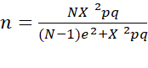 equation, 3.1
Where: N = required sample size (Population size)
ρ= Population Proportion (Assumed to be 0.5)
e²= Degree of accuracy expressed as a proportion
X²= Table of value of K-square for the desired level of confidence of 0.05
X = 1.96 for a confident level of 95%
q= (1-p)
e = margin of error
X = 1.96, p = 0.5, N = 8550, e = 0.05

According to Krejcie and Morgan (1970) the actual sample size was
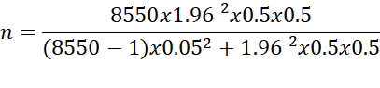
n = 367.67 as approximately 368

However, according to Kingu, et al., (2018), existing literature brings conflicting arguments on the criteria for appropriate sample size. Scholars argue that sample size depends on the discipline (Creswell, & Hirose, 2019; Bauer et al., 2021; Baran, 2022) while others argue that sample size depends on the method employed to analyse the data (Baran, 2022). This study applied multiple regression, therefore, the sample used must conform to this method. First of all, the size of the sample must be appropriate enough for it to produce strong statistical power for the generalization of the results (Creswell & Hirose, 2019; Hair, et al., 2021; Bergien, 2022). Obtaining an appropriate sample size was critical for many reasons. Most importantly, a large sample size was more representative of the population.

3.7.3 Sampling Design and Technique
Basing on the theoretical and practical issues in this study, both purposively and simple random sampling technique was adapted to select the sample size of 368 respondents from EPLGAs. Simple random sampling was chosen in this study because the method ensured a high degree of representatives and provided the sampling units with the same chance of being included and it avoids biases (Kumar, 2019).

The researcher therefore, collected an available list of employees included in the sample. Each employee was then assigned a unique random number from 8,550 to 0048 on slips of paper where they were then selected. Purposive sampling technique was used to select the directors, head of departments and sections while simple randomly selected supporting staffs were asked to fill the questionnaire until actual sample size of 368 respondents was reached from the four selected councils. The sampling unit of this study was the employees in the selected councils from Southern highland regions in Tanzania.

3.8 Variable and Measurement Procedure
This study involves two categories of variables to be measured, namely independent variable and dependent variables. Independent variable includeds variables such as MP, PTP, ICTP & TWP while the dependent variable was employee performance in LGA’s. The source was as shown in the Table 3.2 whereby the variables were reasoned by using the existing scales from other studies, a five point Likert scale was taken into account in the measuments of the items.
Table 3.2: Summary of Measures of Variables
Code | Proxy Measures | No. of Items & Scale | Source
MP | Mentoring Practices Variables | 6 items, 5 points Likert scale | Qiao Ting Low, et al., (2018), Fountain (2018), Uchenna & Nkechi (2019), Manzi (2017)
MP 1 | Role model
MP 2 | Acceptance
MP 3 | Companionship
MP 4 | Sponsorship
MP 5 | Assignment exposure
MP 6 | Close relationship
 | Peer Training Practice
PTP 1 | Peer to peer training | 6 items, 5 points Likert scale | Bull et al., ()  Mwangi, (2018)  Pallango (2020)  Willis et al., (2022)  Sendawula et al., (2018)
PTP 2 | Formal training
PTP 3 | Conferences
PTP 4 | Rotation
PTP 5 | Orientation
PTP 6 | Coaching
 | Information & Communication Technology Practice Variable
ICTP 1 | IT Resources | 12 items, 5 points scale, | Venkatesh et al., (2018),  Breznik et al., (2019)  Olanrewaju (2016)  Siwale (2015)
ICTP 2 | Readiness
ICTP 3 | Relevance
ICTP 4 | Action taking
ICTP 5 | IT skills
ICTP 6 | E-government
ICTP 7 | Linking and Coordination
ICTP 8 | E-promotion
ICTP 9 | It training
ICTP 10 | Directive
ICTP 11 | Social media
ICTP 12 | Communication
 | Team Work Practice Variable
TWP 1 | Shared vision | 7 items, 5 points Likert scale | Walker, et al., (2021)  McEwan & Crawford (2022) Phina, et al., (2018) Reeves & Zwarestein, (2018) Kilindo, (2015)  Kalemba, et al., (2017)  Septian & Gilang (2017)
TWP 2 | Shared decision
TWP 3 | Respect
TWP 4 | Work ethics
TWP 5 | Interpersonal Skill
TWP 6 | Trust
TWP 7 | Cohesiveness
 | Employee Performance
EP 1 | Service delivery | 10 items,5 points Likert scale | Kaehler & rundei,2019;  Tomkin, 2014;Maley & Keissling, (2021);  Shao & Aris, (2020);  Hamdoun & Othman, (2018); Panait, (2020).
EP 2 | Job Satisfaction
EP 3 | Motivation
EP 4 | Accountability
EP 5 | Unit-corruption
EP 6 | Engagement
EP 7 | Confidence
EP 8 | Directives
EP 9 | Altitudes
EP 10 | Responsiveness
Source: Researcher Data, (2021).
Furthermore, both independent and dependent variables comprised with a list of proxy measures which were computed to form each single specific variable which then was used in multiple linear regression. Moreover, the choosen scale for this study was applied by previous researchers who conducted studies on knowlwdge transfer practices towards employee performance (Ndung’u, 2016; Jamsheed, et al., 2018; Uchenna & Nkechi, 2019), the five-point Likert scale responses were rated as strong disagree, disagree, neutral, agree and strongly agree.

3.9 Sources and Methods of Data Collection
This study used primary data and were directly collected using a closed ended questionnaire (appendix 1) from the directors, head of departments, head of sections and other supporting staff at the department level represented by male and female with different duties and roles of LGAs from Mbeya city council, Iringa municipal council, Tunduma Town Council and Makete District Council. Saunders and Lewis (2017), assert that the questionnaire is the most preferred data collection instrument in survey strategy because each respondent is asked exactly respond to the same set of questions. Data collection using a 368 questionnaire is an efficient method of collecting responses from a large sample to fit quantitative data analysis (Creswell, & Hirose, 2019).

The questionnaire had been adopted from previous studies (Carroll et al., 2020) and modified basing on the study’s objective and hypotheses. The questionnaires were highly structured and standardized for all KTP and with all close-ended questions with a 5-point Likert scale. Furthermore, the questionnaires were transcribed from Swahili into English language. The researchers and assistants distributed self-completed questionnaires by hand delivery and collection method to quicken the response rate from the respondents. The questionnaire consisted of three sections A, B and C, where section ‘A’ contained personal particulars namely age, gender, department and units, education level and experience in LGAs. Section B contained questions related to independent variable. Section C comprised questions related to dependent variable.

3.10 Data Processing Analysis
To clearly capture the required information from the study in the simplest form, the collected data was systematically processed, analyzed and interpreted. Kothari (2017) asserts that processing and analysis of data include organization and coding the replies from the survey, storing the data in the computer, selecting appropriate statistical technique, selected suitable software package and performing statistical computations. Therefore, the quantitative data for all four research objectives were tabulated and analyzed by IBM Software SPSS version 26.

3.10.1 Descriptive Statistical Analysis
Descriptive statistical analysis was carried out to estimate the variables’ proxy measures for measurement purposes comparison purposes and strength checks for the given data characteristics. The respondents age, gender, department and units, education level and experience in LGAs and reasons of joining support programmes were used to describe the existing general characteristics of employee performance (Kothari, 2017; Hadi et al., 2016). Descriptive statistical analysis was also done to generate the mean, median, maximum, minimum and standard deviation for the relevant data. Descriptive information was presented in the form of frequency distribution, cross-tabulation, percentages and graphs, depending on the required information.

3.10.2 Inferential Statistical Analysis
Inferential statistical analysis was done to assist in concluding the relationship between independent and dependent variables by using econometric models. This data employed multivariate techniques for data analysis because it had four independent variables, which are successor involvement in mentoring practice, peer training practice, information and communication technology practice and team work practice. Hair et al., (2021) define multivariate analysis as all statistical techniques which simultaneously analyze the multiple measurements on individual objects under the study. Kumar (2019) posits that there are two types of multivariate techniques for data analysis: data that contain both dependent and independent variables and data which contain several variables but do not depend on each other. The correct data analysis techniques for a study with both independent and dependent data include multiple regression analysis, (Saunders et al, 2017).

Then the level of significance for interaction effects between the knowledge transfer variables and employee performance variable to explain the effects responses of EPLGAs was carefully determined. Significance levels for each hypothesis were tested using scientific procedures in ANOVA dialogue using F-test to see if MP, PTP, ICTP, and TWP affect the changes of EPLGAs building on the results, a statistical model was produced to explain relationships and hence the discussion of those effects relationships.
This statistical measurement technique was adopted to clarify the hypothesis by evaluation the contributions for four hypothesized indicators, their relevance and outer weight on EPLGAs. Each indicator’s relative contribution and importance to the construct was estimated concerning the correlation coefficient. The examination used Durbin Watson because of several variable (Saunders & Lewis, 2017; Zhang et al, 2021). On the other hand, economic significant coefficients including intercepts, strength, and direction of the relationship (t- values) and MP, PTP, ICTP, and TWP importance of relativity (Betas) in the model were obtained.

3.10.3 Multiple Linear Regression Analysis
The generalized linear model was a flexible generalization of a multiple linear regression that allows for response variables that have error distribution models other than a normal distribution. The multiple regression equation was used to examine the effects of knowledge transfer practice on employee performance in LGAs in Tanzania. Thus, corresponding regression models were estimated to examine the effects MP, PTP, ICTP and TWP. The research model was formulated based on the empirical literature, theories, and significantly observed variables selected from highly empirical studies. This study based on the conceptual model adopted with modifications from (Olanrewaju, 2016; Kalemba, 2017; Mwangi, 2017; Uchenna & Nkechi, et al., 2019).

Multiple linear regression analysis was therefore, suitable for analyzing, testing hypotheses and making the conclusion.
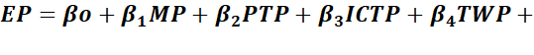_{Ɛ} Equation 3.2
where;
The EP is the predicted value of dependent variable (Employee performance) and is the Y-intercept (constant) in regression. Thus is the estimated regression coefficient of MP denoting the net change in EP for each unit change in the predictors KTP by holding other predictors fixed. is the estimated regression coefficient of PTP denoting the net change in Y for each unit in change in predictors PTP by holding other predictors fixed? Likewise, is the estimated regression coefficient of ICTP denoting the net change in EP for each unit change in predictors coefficient of ICTP by holding other predictors fixed. Likewise, is the estimated regression coefficient of TWP denoting the net change in EP for each unit change in the predictor TWP by holding other predictors fixed. Finally, _{Ɛ} is a random variable introduced to accommodate the effects of other factor that affect knowledge transfer variable that are not included in the model.

3.10.4 Assumptions of Multiple Linear Regressions
Statistical tests mostly rely on assumptions about the variables utilized in data analysis. If these assumptions are smartly met, the findings are trustworthy since Type I error, Type II error and over-or under-estimation are significantly avoided. Simonsohn et al., (2019); Shrestha, (2020), emphasize that the fundamental crucial assumptions of multiple linear regressions analysis are the presence of normality, linearity, homoscedasticity, reliability of measurement and absence of outliers. However, the other commonly tested assumption of multiple linear regressions analysis is the multicollinearity concept (Gwahula, 2013; Hair, et al., 2021; Shao, 2014). These assumptions are addressed in the following sub-sections.

3.10.4.1 Normality Assumption
The first assumption of multiple linear regression is that variables are normally distributed. Regression assumes that variables have normal distributions. Non normally distributed variables such as highly skewed, kurtotic variables or variables with substantial outliers, can distort the relationships and significance tests (Saunders & Lewis 2017). Kolmogorov-Smirnov test is appropriate if the sample size is at least 200 observations and works best if the sample size exceeds 1000 observations (Hair et al., 2016; Nardi, 2018). If Kolmogorov-Smirnov test is insignificant (p>.05), the distribution of data meets the assumption for conduction any parametric test since data are normally distributed (Saunders et al., 2012). The null hypothesis is stated that data are not normally distributed. Conversely, If Kolmogorov-Smirnov test is significant (p< 0.05, **p< 0.01 or ***p< 0.001). To test whether the data for each variable were normally distributed, the Shapiro-Francia Wilk test for normal data was carried out.

3.10.4.2 Homoscedasticity Assumption
The second assumption of multiple linear regressions is the presence of homoscedasticity which means that the variance of errors is the same across all levels of the independent variables, otherwise, it is heteroscedasticity. The implication is that residuals have approximately the constant variance regardless of the dependent variable value. For every value of X, the distribution of Y scores should essentially have approximately equal variability (homoscedasticity). To test for the presence of heteroscedasticity, Szroeter’s Test was conducted in this current study. This test involved testing the null hypothesis that the variance of the error terms was normally distributed or whether the variance of error terms from regression was dependent on the values of the independent variables (homoscedasticity) or no heteroscedasticity. It was of utmost importance to test for heteroscedasticity problems existing within the variables. (Kumar, 2019).

3.10.3.3 Multicollinearity Assumption
The third assumption of multiple linear regressions is that there is little or no multicollinearity in the data. Since linear regression was used as part of econometric tests to establish the relationship between knowledge transfer and employee performance variables, it was vital to test multicollinearity of the independent variables. This was done using the Variance Inflation Factor (VIF) and the results are presented. The problem of multicollinearity usually arises when certain explanatory variables are highly correlated, meaning that one can be linearly predicted from the others with a non-trivial degree of accuracy (Schreiber-Gregory, 2018; Shrestha, 2020).

To ensure that the models were correct test was made for the existence of a multicollinearity problem in the data set. Variance Inflation Factor (VIF) was conducted to test for multicollinearity. According to Simonsohn et al., (2019), VIF<= 5 is acceptable. However, on one hand, Kothari (2017), articulated that correlation above 0.8 between independent variables indicated the existence of the problem of multicollinearity and on the other hand, Hair et al., (2021) propounded that the VIF <= 10 is acceptable as a minimum level.

3.10.4.4 Extreme Values Assumption
The fourth assumption of multiple linear regression is the absence of substantial extreme values in data which means no outliers. Multiple regression analysis is sensitive to outliers which are extreme values characterized by unusual or unrepresentative cases. The presence of outlier’s bias regression coefficients and are likely to lead in getting invalid results. Outliers are removed before data analysis (Zhang et al., 2021). Statistical analysis is also carried out to test the status of outliers. Williams et al., (2022) suggests that the data which are free from outliers have standardized residuals within the limits of ± 3 which are expected for normal distribution of data. Residuals can also be assessed on whether 82 are normally distributed by simply producing a normal probability plot called normal P-P plot and box plots.

3.10.4.5 Linearity Assumption
The fifth assumption of multiple linear regression is that the relationship between the independent and dependent variable(s) can be accurately estimated if the relationships are linear in nature. Linearity shows the degree to which the change in a dependent variable is related to a change in the independent variables (Moosavi & Ghassabian, 2018). If the relationship between independent variables and the dependent variable is not linear, the results of regression analysis will under-estimate the true relationship.

Linearity assumption is tested using correlation coefficients and scatter plots (Hair et al., 2021). Linearity assumes that the correlation between the variables is linear and this is true if the bivariate correlations for each pair of independent variables is significant showed by an asterisk mark (*p<0.05, **p<0.01 or ***p<0.001). Since the data in the current study had shown that there were normally distributed and homoscedastic, then we did not have to worry about the linearity of data. So, the model contains useful variables.

3.11 Data Validity and Reliability

3.11.1 The Validity of the Research Instruments
According to Clark and Watson (2019), Rahardja, et al., (2019), validity was the accuracy of measurement of which the effects of knowledge transfer to employee on performance was to be of truthful for the results. If research was high in validity that means it was to produce results that correspond to real properties, characteristics, and variations in the physical or social world. This study tested validity using content validity and criterion validity. The instrument was adjusted to measures what was intended to evaluate (Patterson, et al., 2018).

In the context of this study, to ensure validity, sample adequacy was tested in explanatory factor analysis whereby the Kaiser-Meyer-Olkin (KMO) was used to examine sample adequacy. Kaiser-Meyer-Olkin is used to measure the sampling adequacy prior to regression analysis. For the KMO statistics Kaiser (1974) recommends a bare minimum of 0.5 and that values between 0.5 and 0.7 are mediocre, values between 0.7and 0.8 are good, values between 0.8 and 0.9 are great and values above 0.9 are superb.

3.11.1.1 Content Validity
Content validity was the extent that measurement instrument items were relevant and representative of the target construct and the extent to which a measure “covers” the effects of knowledge transfer and employee performance (Almanasreh et al., 2019). To ensure content validity, the effects of MP, PTP, ICTP and TWP variables, and employee performance dimensions were identified from theoretical and literature reviewed, and were done to validate whether the measurement variables were accurate to reflect the theoretical domain of the construct they claim to measure. Content validity of the instrument used was guaranteed by discussions on the knowledge transfer practice on LGAs. This assisted the researcher to construct variables that would provide accurate reflections for theoretical arguments.

3.11.1.2 Criterion Validity
Criterion validity was the extent to which a measure was related to an outcome. It measured how well one measure or predicts an outcome for another measure. Criterion validity was concerned with the ability of the variables to predict an outcome for another measure, as per theoretical arguments (Saunders et al., 2017). A test had this type of validity if it is useful for predicting performance or behaviour in another situation i.e. past, present, or future. Criterion validity was often divided into concurrent and predictive validity based on the timing of measurement for the "predictor" and outcome.

Concurrent validity refers to a comparison between the measure in question and an outcome assessed at the same time (Otero, et al., 2021). Concurrent validity reflected only the status quo at a particular time and predictive validity, on the other hand, compares the measure in question with an outcome assessed at a later time. In this study, the data collection and variable construction were developed by considering strong validated current empirical literature.

3.11.2 Reliability of the Research Instruments
Reliability refers to the consistency and accuracy of the research results (Chan, & Lay, 2018; Arslan, 2020). The reliability of a research instrument concerns the extent to which the instrument yields the same or consistent results on repeated trials. It measures the consistency, precision, repeatability, and trustworthiness of research (Chakrabartty, et al., 2017). An instrument is considered reliable when there is a degree of similarity with results obtained every time the procedure is replicated (Goos & Meintrup, 2016).

In quantitative research, reliability can be illustrated as the stability of the measurement over time, the similarity of the measurements during the given period, and also the degree to the same results of the measurement given repeatedly. If the same result can be consistently achieved by using the same methods under the same circumstances, the measurement is considered reliable. Revelle and Condon (2019), defines reliability as the extent to which results are consistent over time and an accurate representation of the total population under study is referred to as reliability and if the results of a study can be reproduced under a similar methodology, then the research instrument is considered to be reliable.

Consequently, to ensure reliability, the researcher developed variables based on empirical research and tested the regression model for normality, linearity, multicollinearity, and heteroscedasticity. All these econometric tests/results showed no violation. Therefore, the model was robust and the results were representative of the sample. The most popular internal consistency reliability estimate was given by Cronbach’s alpha in 1951. It is expressed as alpha = Np/ [1+p (N-1)] Where N equals the number of items and p equals the mean inter item correlation. It is typically varying between 0 and 1, where 0 indicates no relationship among the items on a given scale, and 1 indicates absolute internal consistence. Alpha values above 0.7 are generally considered acceptable and satisfactory, above 0.8 and are usually considered very-good, and above 0.9 are considered to reflect exceptional internal consistency (Cronbach, 1951). In the social sciences, the acceptable range of alpha value is from 0.7 to 0.8 (Vakili, 2018).

Further, to ensure reliability the Cronbach’s alpha (α) analysis was employed to test the reliability of the predictor variables. The study found out very reliable variables since the Cronbach's coefficient was of 0.841 to 0.949. Surucu & Maslacki, (2020) pointed out that the strong and reliable range between 0.70 < α ≤ 0.90 was acceptable. On the other hand, the Cronbach's Alpha coefficient based on standardized Item for overall data was 0.92 suggesting that the data collected have good internal consistence above 0.5 that was highly acceptable.

3.12 Ethical Consideration
In carrying out research, ethical consideration is a significant concern. This includes maintaining high standards to ensure accuracy of data and not misrepresenting the collected data such that no one suffers adverse or hammed (Saunders et al., 2019; Turocy et al., 2021). The study maintained the organizational hierarchy when accessing official documents. The permission to access official documents was obtained from the President’s Office-Regional Administration and Local Government (PO-RALG), Regional Secretariat and the respective Councils’ Directors, Appendix IV(A) and IV(B).
This letter provided a researcher for the informed consent of the respondents the purpose and nature of the research so that they freely choose whether or not be involved in the research and provide room to refuse to participate or to terminate participation at any time. In addition to that, the researcher ensured protection of participants during data collection by avoiding sensitive or difficult questions and being careful in assisting respondents using trained research assistants when filling the questionnaire. This protected participants from physical discomfort, emotional stress, humiliation, embarrassment or any other situation that divulge the respondent.

Moreover, the researcher avoided any kind of plagiarism, biasness; inaccurate reporting and the inappropriate use of information hence appropriate citation and referencing were adhered. Also, all resources of information and knowledge for this study including published and unpublished literature were highly acknowledged, respected and fairly used. According to the data collected, it was observed, the ethics, rules and regulations of Tanzanian Government and the Open University of Tanzania, Finally, the study also honestly appreciated any help and all the words borrowed or cited from others.

CHAPTER FOUR

DATA ANALYSIS AND PRESENTATION

4.1 Overview
The chapter presents data analysis and presentation of findings; it comprises response rate of the respondents, testing of reliability and validity of data, demographic distribution of the respondents, variable descriptive statistics results and inferential analysis.

4.2 Response Rate
The population of the study was LGAs employees, directors, head of departments, units and other supporting staff from four district councils notably; Mbeya City, Iringa Municipal, Tunduma Town, and Makete District. The researcher and assistants distributed 368 questionnaires. Out of 368 of the distributed questionnaires, 306 (83.2%) were successfully completed and returned. During data analysis, the total of 62 outliers’ cases that were in either the extreme low or extreme high were eliminated.

However; the remaining 62 respondents were not part of the research analysis because of several reasons such as; refusal to participate in the study, and others failed to complete major questions; factors which excluded them from fitting for this research analysis. Therefore, this study respondent’s response rate of 62% for Mbeya City Council, 100% for Iringa Municipal Council, 100% for Tunduma Town Council and 100% for Makete District Council; which made an average of 82% of the desired sample size was good enough to generalize the characteristics of the study population as indicated in Table 4.1. Therefore, the analysis was strictly based on 306 observations.

Table 4.1: Response Rate of the Respondents
District Council | Designed Sample | Actual Sample Size
Mbeya City Council | 173 | 111
Iringa Municipal Council | 57 | 57
Tunduma Town Council | 44 | 44
Makete District Council | 94 | 94
Total | 368 | 306
Source: Research Data, (2021)

4.3 Testing Reliability and Validity of Data

4.3.1 Reliability of the Research Instruments
The study found reliable variables since the Cronbach's coefficient for standardized item for overall study tool was of 96.7% as shown on Table 4.2. However, Appendix II show’s reliability statistics for specific items.

Table 4.2: Reliability Statistics
Cronbach's Alpha | Cronbach's Alpha Based on Standardized Items | N of Items
.922 | .967 | 51
Source: Research Data, (2021)

Table 4.3: ANOVA with Tukey's Test for Non-additivity
 |  |  | Sum of Squares | df | Mean Square | F | Sig
Between People |  |  | 5206.014 | 302 | 17.238
Within People | Between Items |  | 25019.088 | 50 | 500.382 | 374.521 | .000
Within People | Residual | Non-additivity | 56.094 | 1 | 56.094 | 42.099 | .000
Within People | Residual | Balance | 20118.407 | 15099 | 1.332
Within People | Residual | Total | 20174.501 | 15100 | 1.336
Within People | Total |  | 45193.589 | 15150 | 2.983
Total |  |  | 50399.603 | 15452 | 3.262
Source: Research Data, (2021)
This indicates that, the study tool was good to proceed for further procedures. Table 4.3 summarized (ANOVA) with Tukey’s Test for non-additivity as in Table 4.3 results reveal that the relationship of factors within people and between item had P-value of 0.000 and 0.000 respectively implying that the outcomes were significantly consistent internally at 0.05 level.

Another reliability measurement employed by the study was Intra class Correlation Coefficient (ICC) that describes the reliability of information organized in group within the study. The Table 4.4 shows result of ICC in two-way effects. The Intra classes Correlation Coefficient (ICC) as indicated in Table 4.4 has significant level that less than P-values of 0.05 which is 0.000. This indicated that the ICC has statistically significant with 95% confident intervals.

Table 4.4:Intra Class Correlation Coefficient
 | Intra class Correlation | 95% Confidence Interval |  | F Test with True Value 0
 | Intra class Correlation | Lower Bound | Upper Bound | Value | df1 | df2 | Sig
Single Measures | .189ª | .165 | .218 | 12.902 | 302 | 15100 | 0.000
Average Measures | .922^{c} | .909 | .934 | 12.902 | 302 | 15100 | 0.000
Source: Research Data, (2021)

4.3.2 Testing for Validity of the Measuring Instruments
After constructing explanatory factor analysis, the overall value for KMO was 0.953 which falls into the range of being good as shown on Table 4.5. With this KMO the researcher was confident that the issue of validity and reliability was taken into consideration. Therefore, based on KMO output, the next stage was to conduct regression.

Table 4.5: KMO and Bartlett’s Test
Kaiser-Meyer-Olkin Measure of Sampling Adequacy. |  | 0.953
Bartlett's Test of Sphericity | Approx. Chi-Square | 8.561E3
Bartlett's Test of Sphericity | Df | 820
Bartlett's Test of Sphericity | Sig. | .000
Source: Research Data, (2021)

4.4 Demographic Distribution of Respondents
The demographic characteristics presented provided a major picture of respondents involved during data collection. The findinacteristics helped to judge the proportional and representation of each unique characteristic of respondents which could affect the outcome of the research. By considering such needs, respondent’s gender, age, education level and experience were presented. Even though demographic characteristics were found to be important for collecting meaningful information, asking many questions on demographic characteristics sometimes was not good since it could result into having improper information for targeted results. Respondents felt that investigation could harm their work and survival in future. They became worried and hide some important information. Based on those situations, this study documented few demographic characteristics namely gender, age, education level and experience to assist the discussion of the findings.

4.4.1 Respondents Distribution by Age
The variation in age validates the study as it was getting information from different groups of age (Temu, 2019). Workers age groups represent the strategy of government to employ great number with energy and who will serve for long time. In this case most were young, majority of respondents in LGAs had the age between 31-40 years old. Results in Table 4.6 indicated that a great number of 137 respondents (45.77%) were between 31-40 years old, followed by 79 respondents (25.82%) who were between 41-50 years old.

Following closely behind were 66 respondents (21.57%) aged between18-20 years, a fewer of 20 respondents (6.54%) were 51 and above years old while 4 respondents (1.13%) were aged between18-20 respectively. Four (1.31%) of the respondents had the age of between 18-20 years old, 66(21.57%) had the age of between 21-30 years, 137(45.77%) were between 31-40 years old, 79(25.82%) had the age of between 41-50 years old and 20(6.54%) of the respondents had the age of 51 and above years old. Therefore, valuable inputs were obtained from all senior employees aging between 31 to above 50 years who by virtue were experiencing knowledge transfer on employee performance in LGAs.

4.4.2 Respondents Distribution by Departments
Table 4.6 shows the departments which respondents of the study belonged. Results indicated that majority of the respondents 42.81% came from the Education Department. However, picking them from different departments displayed inclusiveness of respondents with different experience. Table 4.6 shows that all Finance, Agriculture Irrigation & Cooperative and Cooperative unit had a tie of 6.21% respondents. It is noted that, 5.56% came from administration, 5.23% Land, 4.58% Planning, 3.59% CMHT, 3.27% Accounts, 3.27% Environmental department, 2.61% Information and technology, 2.29% Community Development, 1.96% PMU unit, 1.96% Human Resource and Administration, 1.31 Transportation, 0.98% work, 0.65% Livestock Department, 0.65% Statistics, and 0.33% respondents on Law and Election unit.

4.4.3 Respondents’ Distribution by Education Level
The results in Table 4.6 indicated that, 47(15.36%) of the surveyed respondents in LGAs had certificate education level, 93(30.39%) of them had diploma education level, 151(49.58%) had bachelor degree, while 14(4.58%) had master’s degree and none had PhD level of education. The majority of the respondents had bachelor degree in LGAs. However, their performance was not impressive because of inadequate knowledge transfer practice. In general, most of the respondents were well knowledgeable and hence contributing to valuable input and information for this study.

4.4.4 LGAs’ Employee Experience
In looking for the experience of the LGAs employees, the results in Table 4.6 showed that 70(23%) LGAs had 1-5 years, 98(32%) had 6-10 years, 90(29%) had 11-15 years, 27(9%) had 16-20 years and 21(7%) of the LGAs had 21 and above. The majority of the LGAs in Tanzania had an experience of 6 -10 years. Therefore, having majority working experience in LGAs would enable employees to have plenty of knowledge on performance. Thus, employee contributed to knowledge transfer practice for this study. Moreover, the findings emphasized that experience was an important factor to consider in knowledge transfer practice in LGAs.

Table 4.6: Demographic Characteristics of the Respondents
Variables | Categories | Frequency | Percent
Age | 18-20 | 4 | 1.3
Age | 21-30 | 66 | 21.6
Age | 31-40 | 137 | 44.8
Age | 41-50 | 79 | 25.8
Age | 51 and above | 20 | 6.5
Department | Administration | 17 | 5.6
Department | Agriculture irrigation and cooperative | 19 | 6.2
Department | PMU | 6 | 2.0
Department | Livestock | 2 | .7
Department | Ujenzi/works | 3 | 1.0
Department | Land | 16 | 5.2
Department | Finance | 19 | 6.2
Department | Information and technology | 8 | 2.6
Department | Accounts | 10 | 3.3
Department | CMHT | 11 | 3.6
Department | Education | 131 | 42.8
Department | Community development | 7 | 2.3
Department | Planning | 14 | 4.6
Department | Statistics | 2 | .7
Department | Human resource and administration | 6 | 2.0
Department | Election unit | 1 | .3
Department | Transportation | 4 | 1.3
Department | Environmental department | 10 | 3.3
Department | Law | 1 | .3
Department | Cooperative | 19 | 6.2
Education level | Certificate | 47 | 15.4
Education level | Diploma | 93 | 30.4
Education level | Degree | 151 | 49.3
Education level | Master | 14 | 4.6
Education level | PhD | 1 | .3
Employee Experience in LGAs | 1-5yrs | 70 | 22.9
Employee Experience in LGAs | 6-10yrs | 98 | 32.0
Employee Experience in LGAs | 11-15yrs | 90 | 29.4
Employee Experience in LGAs | 16-20yrs | 27 | 8.8
Employee Experience in LGAs | above 20yrs | 21 | 6.9
Source: Research Data, (2021)

4.4.5 Cross Tabulation between Demographic Data and EP
The cross tabulation was conducted to provide a detailed picture on the distribution of work experience of respondents with respect to gender. The results as show in Table 4.7 showed that out of 70 respondents who had experience between 1-5 years working in LGAs 32(45.7%) were male and 38(54.3%) was female. On the other hand, respondents who had worked between 6-10 years were 98 and the gender compositions were 45(45.9%) male and 53(54.1%) female. In addition, between 6-10 years the female were more than male by 54.1%.

Employees who had experience between 11-15 years in total they were 90 and out of these 31(34.4%) were male and 59(65.6%) were female. Likewise, for employee who had between 16-20 years of experience, 16 (59.3%) were male and 11(40.7%) were female. Generally, number of females who were educated was found to be higher in comparison to their female counterparts. This means that in local government authorities’ demographic factors such as age, gender, departments, and education level does not influence employee’s performance; instead working experience in LGAs does, as shown in Table 4.7.

Table 4.7: Cross tabulation Between Demographic Data and EP
 | N | Pearson Chi-Square | df | Asymptotic Significance (2-sided)
EP * Age | 306 | 134.529 | 112 | 0.072
EP * Gender | 306 | 21.957 | 28 | 0.783
EP * Department | 306 | 464.022 | 532 | 0.985
EP * Education level | 306 | 126.507 | 112 | 0.165
EP * Experience in LGAs | 306 | 145.073 | 112 | 0.019
Source: Research Data, (2021)

4.5 Variable Descriptive Statistics Results

4.5.1 Descriptive Statistics on Mentoring Practice
Table 4.8 shows the results of the analysis acceptance yields with a high mean value M = 4.19, SD = .926 followed by close relationship which scored mean value M = 4.17, SD = .926. In addition, role model scored M = 4.15, SD = .937. The least item was sponsorship which scored M = 3.92, SD = 1.065 from these findings. This meant that the higher the mean value, the more impressions on mentoring practices towards contributing on employee’s performance in Tanzania LGAs. From descriptive statistics, findings indicated mentoring practices are crucial on influencing employee’s performance in LGAs. Table 4.8 describes the perceptions of employees in LGAs concerning the effects of mentoring practices on employee’s performance in local government’s authorities.

Table 4.8: Descriptive Statistics on MP Measurements
 | N | Minimum | Maximum | Mean | Std. Deviation
Role Model | 306 | 1 | 5 | 4.15 | .937
Acceptance | 306 | 1 | 5 | 4.19 | .926
Companionship | 306 | 1 | 5 | 4.13 | .847
Sponsorship | 306 | 1 | 5 | 3.92 | 1.065
Delegation | 306 | 1 | 5 | 4.12 | .867
Relationship | 306 | 1 | 5 | 4.17 | .858
Valid N (listwise) | 305
Source: Research Data (2021)

4.5.2 Descriptive Statistics on Peer Training Practice
Peer training practice through attending conference or meeting had high contribution on employee’s performance compared to other measurements as indicated in Table 4.9. This is because conference yields mean value of M = 3.95, SD = .972 which was higher compared to other measurement items. In addition, coaching scored mean value of M = 3.94, SD = .975 formal training scored M = 3.925, SD = .9705 and orientation had M = 3.91, SD = .989 the least item was rotation which scored M = 3.85, SD = 1.065. From these findings, it meant that the higher the mean value the more impressions on training practices towards employee’s performance.
Table 4.9: Descriptive Statistics PTP Measurements
 | N | Minimum | Maximum | Mean | Std. Deviation
Peer to Peer Training | 306 | 1 | 5 | 3.88 | 1.042
Formal Training | 306 | 1.0 | 5.0 | 3.925 | .9705
Conferences | 306 | 1 | 5 | 3.95 | .972
Rotation | 306 | 1 | 5 | 3.85 | 1.065
Orientation | 306 | 1 | 5 | 3.91 | .989
Coaching | 306 | 1 | 5 | 3.94 | .975
Valid N (listwise) | 306
Source: Research Data, (2021)

4.5.3 Descriptive Statistics on Information and Communication Technology Practice
Table 4.10 indicated; IT skill maintained higher effects on employee’s performance compared to other measurements. It yields mean value M = 3.98, SD = 1.051 which was higher compared to other measurement items. Specifically, IT training items was found to have relatively minimal effects on employee’s performance.

Table 4.10: Descriptive Statistics of ICTP Measurements
 | N | Minimum | Maximum | Mean | Std. Deviation
Resources | 305 | 1 | 5 | 3.76 | 1.170
Readiness | 306 | 1 | 5 | 3.81 | 1.211
Relevance | 306 | 1 | 5 | 3.75 | 1.163
Action taking | 306 | 1 | 5 | 3.76 | 1.098
IT skills | 306 | 1 | 5 | 3.98 | 1.051
e-government | 306 | 1 | 5 | 3.89 | 1.000
Linking | 305 | 1 | 5 | 3.83 | 1.091
e-promotion | 306 | 1 | 5 | 3.83 | 1.082
IT-Trainings | 306 | 1 | 5 | 3.62 | 1.263
Directives | 306 | 1 | 5 | 3.77 | 1.198
Social media | 306 | 1 | 5 | 3.74 | 1.143
Communication | 306 | 1 | 5 | 3.81 | 1.161
Valid N (listwise) | 304
Source: Research Data, (2021)
The mean value of M = 3.62, SD = 1.263, was because of minimum level of IT literacy with lack of IT infrastructure at work place that causes the diminishing in working motivation due to IT technical aspect. From descriptive statistics, results for all twelve items as presented in Table 4.10 showed the perceptions of employees in LGAs in concerning the effects of information and communication technology practices.

4.5.4 Descriptive Statistics on Team Work Practice
Table 4.11 shows that work ethics had higher effects on employee’s performance compared to other measurements because its mean value was M = 4.19, SD = .930 followed by respect which got M = 4.17, SD = .909 Also, shared decision scored mean value of M = 4.08, SD = .909 while common vision scored M = 4.06, SD = .946. The least item was cohesiveness which obtained M = 3.98, SD = .907 mean values. The higher the mean value the more impressions on team work practices towards contributing on performance.

Table 4.11: Descriptive Statistics of TWP Measurements
 | N | Minimum | Maximum | Mean | Std. Deviation
Shared Vision | 306 | 1 | 5 | 4.06 | .946
Shared Decision | 306 | 1 | 5 | 4.08 | .909
Respect | 306 | 1 | 5 | 4.17 | .909
Work Ethics | 306 | 1 | 5 | 4.19 | .930
Interpersonal Skills | 306 | 1 | 5 | 4.01 | .880
Trust | 306 | 1 | 5 | 4.10 | .925
Cohesiveness | 306 | 1 | 5 | 3.98 | .907
Valid N (listwise) | 306
Source: Research Data, (2021)
From descriptive statistics, as shown in Table 4.11 team work practices were found to enhance employee’s performance. Despite, these results could not be applicable to justify the cause to effects relationship between team work practices and employee’s performance. Thus, regression analysis was employed to determine the significant relationship of team work practices and employee performance in LGAs for inferential conclusion.

4.5.5 Employees Performance in LGAs
From descriptive statistics relating to employee performance in LGAs findings in Table 4.12 indicated that knowledge transfer was important on enhancing employee’s performance. Further, analysis was done to examine the significant relationship of all variables using regression analysis Examination of the normal relationship of variables correlation analysis was also done in the following subsection.

Table 4.12: Descriptive Statistics for Employees Performance (EP)
 | N | Minimum | Maximum | Mean | Std. Deviation
Service delivery | 306 | 2 | 5 | 4.05 | 0.852
Satisfaction | 306 | 2 | 5 | 4.06 | 0.905
Motivation | 306 | 2 | 5 | 4.22 | 0.809
Accountability | 306 | 1 | 5 | 4.14 | 0.833
Anti-corruption | 306 | 1 | 5 | 4.23 | 0.950
Engagement | 306 | 2 | 5 | 4.19 | 0.783
Confidence | 306 | 1 | 5 | 4.24 | 0.800
Directives | 306 | 2.0 | 5.0 | 4.206 | 0.8058
Altitudes | 306 | 1 | 5 | 4.11 | 0.843
Responsiveness | 306 | 1 | 5 | 4.20 | 0.820
Valid N (listwise) | 306
Source: Research Data, (2021)

4.6 Inferential Analysis
Before the presentation of the findings, the data from filled questionnaire were coded and analyzed by using the relevant statistical tool with the support of IBM software SPSS version 26. This study adopted and modified correlational analysis to test the variables association at individual level and regression data analyses methods to test the variables associations at grouped level.

4.6.1 Testing Assumptions for Multiple Linear Regression
The assumptions were assessed to satisfy data used robustness as to avoid error and bias that could lead to inappropriate conclusion. The linearity, normality, outlier, homoscedasticity, multicollinearity, independence of residuals and sample adequacy of the data were carried out before running the analysis.

4.6.1.1 Linearity and Functional Form Testing
Linearity is the property of function or a mathematical relationship which means that it can be graphically represented as a straight line. It is also a situation in which the mean values of the dependent variable for each increment of the independent variable lie along a straight line, Shrestha (2020). Hair et al., (2021), argued that the linearity of data is often assumed for variables in multivariate analysis and if left unattended, a non-linear data can seriously undermine any statistical inference.

Additionally, linearity assumes that the correlation between the variables is linear and this is true if the bivariate correlations for each pair of independent variables are significant. The relationship between each independent variable, namely MP, PTP, ICTP and TWP were all significant an indication that all independent variable residuals met the linearity assumption; figure 4.1 for general model and Appendix V for specific variables. Accordingly, as suggested by Amrhein et al,.(2019);Welsh. (2021), this study tested linearity assumption of data collected through the inspection of bivariate scatter plots, Appendix V showed no serious violation of linearity and the scatter plots for the argued component plus residuals was linear in nature. The five scatter plots indicated that all point variables linearly follow the regress line to meet linearity role. Testing the hypothesis of no linear relationship between the predictors and dependent variable was likewise done. Thus, the hypothesis that there was no linear relationship between the predictors and outcome variables was rejected. The residuals likewise were examined to find out its straight-line relationship with predicted outcome variable scores when referring to the former scatter plots.
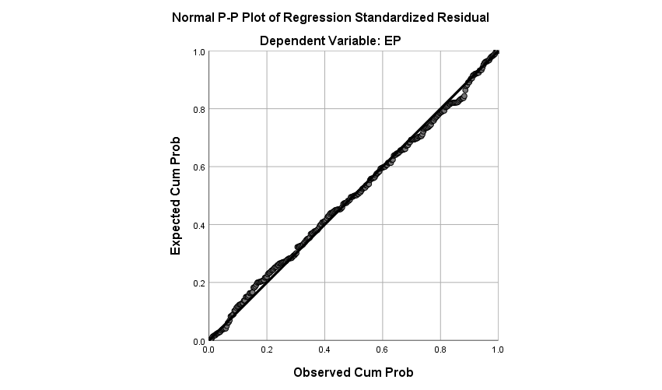
Figure 4.1: Linearity for General Model

4.6.1.2 Results from Normality Testing
Table 4.13, Kolmogorov-Smirnov had a value of 0.114 and Shapiro-Wilk value of 0.914 with their P-value of 0.000 less than 0.05 level of significance indicating that the study residual significantly behaved normal.
Table 4.13: Tests of Normality V
 | Kolmogorov-Smirnovª |  |  | Shapiro-Wilk
 | Statistic | Df | Sig. | Statistic | df | Sig.
EP | .114 | 306 | .000 | .914 | 306 | .000
a. Lilliefors Significance Correction
Source: Research Data, (2021)

Furthermore, its skewness and kurtoisis of dependent and independent variables as presented in Table 4.14, were -1.248; -.794; -.930; -1.520; and -1.221 for MP; PTP; ICTP; TWP; and EP respectively which are in range of -2 and +2. Therefore, regarded as acceptable and prove normal univariate distribution. Bun and Harrison (2019), cited that a variable with absolute skew-index value greater than 3.0 is extremely skewed while kurtosis index greater than 8.0 is extreme kurtosis. Ho (2017), showed that values for skewness and kurtosis between -2 and +2 are regarded as acceptable in order to prove normal univariate distribution.

Baran (2022), averred that in the Q-Q plot, or the normal probability plot, the observed value for each score is plotted against the expected value from the normal distribution, where a reasonable straight line indicates normal distribution. The skewness and kurtosis results are collaborated by the graphical analysis results of normal Q-Q plot. The line representing the actual data distribution closely follow the diagonal in the normal Q-Q plot as indicated in figure 4.2 for general model and Appendix VI for specific variables, which suggests normal distribution (Bayer and Cribari, 2017).
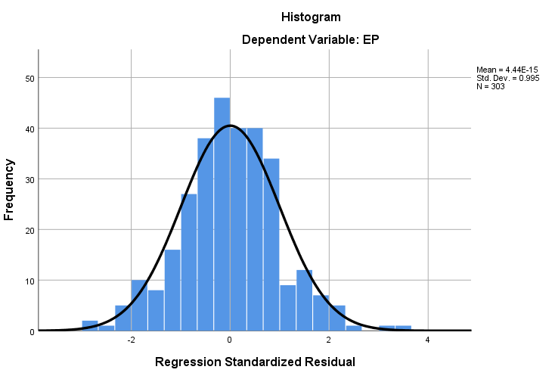
Figure 4.2: Normality Test for General Model

Table 4.14: Kurtosis and Skewness of the Variables
 | N | Mean | Std. Deviation | Skewness |  | Kurtosis
 | Statistic | Statistic | Statistic | Statistic | Std. Error | Statistic | Std. Error
MP | 305 | 4.1137 | .68746 | -1.248 | .140 | 2.078 | .278
PTP | 306 | 3.9069 | .74849 | -.794 | .139 | .400 | .278
ICTP | 304 | 3.7947 | .91126 | -.930 | .140 | .180 | .279
TWP | 306 | 4.0854 | .70782 | -1.520 | .139 | 3.597 | .278
EP | 306 | 4.1631 | .61386 | -1.221 | .139 | 2.066 | .278
Source: Research Data, (2021)

4.6.1.3 Results from Extreme Values Testing
Outliers are data points with extreme value that could have a negative effect on estimators. According to Hair et al., (2021), outliers are data points which are extreme and have a unique combination of characteristics exclusively distinctly from other observations. Therefore, ignoring them in this research on KTP effects on employee performance could result in a loss of precision and render the results biased. Moosavi and Ghassabian (2018), argued that a value is completely at random if the probability point is missing depends on neither observed nor unobserved variables. In this study, outlier’s variables were tested/checked using regression models with the help IBM SPSS V26.

Bun and Harrison (2019), argue that when data is missing completely at random, it is safe to remove it from the dataset. Therefore, list-wise deletion method was used in this study by removing all cases that had one or more missing values. For instance, 62 (16.8%) questionnaires were dropped from the study hence remaining with 306 individual cases (i.e. 368 sample observations) throughout the study. To check for outlier, the avplots command (added-variable plots) was used. Residuals were also assessed on whether they were normally distributed by basically producing a normal probability plot (p-p) known as p-plot. These are shown in Appendix VIII. All these four plots indicated that almost all data point was in range and were sufficiently used to assess the possibility of extreme outliers.

4.6.1.4 Results from Homoscedasticity Testing
This assumption states that the variances of error terms are similar across the values of the independent variables. A plot of standardized residuals (Scatter Plots) versus the predicted values has to show whether points are equally distributed rectangularly across all values of knowledge transfer variables. An important assumption in testing homoscedasticity is that the variance in the residuals has to be homoscedastic or constant. Additionally, residual cannot be varied for lower of higher values of independent variable. However, the scatter plots figure 4.3 for general model and Appendix VII for specific variables are distributed across the rectangle. Therefore, the overall, results suggested that homoscedasticity was not violated for both criterion variables, as the variability of the residuals must be fairly robust to violate this assumption (Bun & Harrison, 2019).
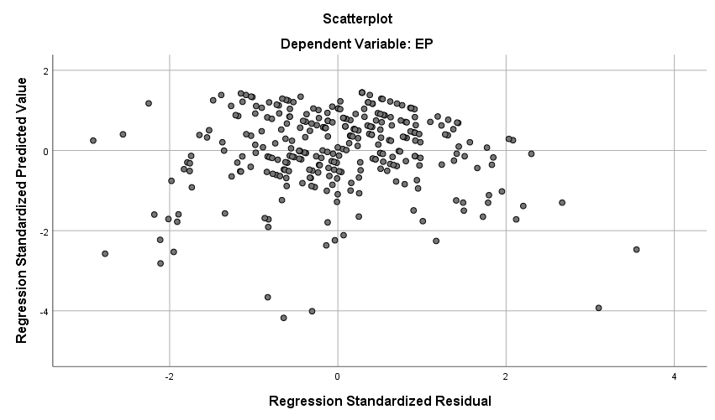
Figure 4.3: Homoscedasticity for General Model

4.6.1.5 Results from Multicollinearity Testing
Multicollinearity results from the circumstances where two or several variables are so highly correlated in such a way, they both essentially represent the same underlying construct, that is; what appear to be separate variables actually measure similar constructs, (Hair et al., 2021). When such situation appears, only one of them should be incorporated in the same analysis, but not both. Moreover, extreme multi-collinearity is among the major causes of non-positive definiteness and solutions in multivariate analysis and creates instability in study results; hence it is of the essence that researchers control for its influence (Turocy, et al., 2021). Shesthra, et al., (2020), argued that multicollinearity do limits the size of the regression coefficients and obscures the importance of individual predictor variables. Therefore, two or more independent variables have a high correlation between them hence leads to a complication in separating the effects of each independent variable on the dependent variables, Appendix III.

In dealing with extreme multicollinearity the two mechanisms available are elimination of the concerned variables or combination of them into a composite, (Chan & Lay, 2018). Furthermore, Hair et al., (2021), argued that correlation analysis and variance inflation factor (VIF) can be used to check for multicollinearity. However, Chan and Lay (2018), posits that correlation analysis do not exactly measure the degree to which each of the dependent variable is explained by the set of other independent variables and therefore opting variance inflation factor (VIF).

In this study the variance inflation factor was used to test multicollinearity. The linear regression model was run and IBM SPSS V26 tool used to check for multicollinearity was VIF and the results as presented in Table 4.15. indicated showed that the VIF for the score of independent variables ranged from 2.488 (minimum) to 2.708 (maximum) all variables had VIF less than 5 and Tolerant values (1/VIF) are more than 0.2. Specifically, it was found out that, MP, PTP, ICTP, and TWP had Variance Inflation Factor (VIF) of 2.488; 2.708; 2.299; and 2.527 respectively. All the values were below 4.0 indicating that there was no problem of multicollinearity among the independent variables. The authors posit that the VIF values greater than 5 and Tolerant values less than 0.2 indicated that there was no multicollinearity among the independent variable included in the model.
Table 4.15: VIF and Tolerance (1/VIF)
Model | Variables | Collinearity Statistics
 | Variables | Tolerance=1/VIF | VIF
 | MP | 0.402 | 2.488
 | PTP | 0.369 | 2.708
 | ICTP | 0.435 | 2.299
 | TWP | 0.396 | 2.527
a. Dependent Variable: EP
Source: Research Data (2021)

4.6.2 Multiple Linear Regression Analysis by Objectives
The study had four objectives, which were separately analyzed by multiple linear regressions. Multiple linear regression analysis results had to conclude the extent to which each independent variable influenced the dependent variable (employee performance). The study analyzed MP, PTP, ICTP, and TWP being the independent variables while the dependent variable was the EP. The study developed a regression equation to explain a significant proportion of variance in the EP.

4.6.2.1 Model Summary
The effectiveness of employee performance were mentoring practices, peer training practices, information and communication technology practices and team work practices employee’s performance in LGAs was analysed using multiple regression analysis. The regression model summary in Table 4.16 was developed to explain the proportion of variance on employee’s performance in local governments yielding R square =0.698. This implied that 69.8% of the proportion on employee’s performance in local government’s authorities could be explained by knowledge transfer under mentoring practices, peer training practices, information and technology practices and team work practices. In addition, the findings express that R value = 0.835 indicated the predictor variable which is knowledge transfer practices (mentoring practices, peer training practices, information and communication technology practices and team work practices) were effective by 83.5% on providing change to employee performance in local government authorities. This means that from these results knowledge transfer maintained the effects towards employee’s performance in LGAs.

Table 4.16: Model Summary^{c}
 | R | R Square | AdjustedR Square | Std. Error of the Estimate | Change Statistics |  |  |  |  | Durbin-  Watson
 |  |  |  |  | R Square Change | F Change | df1 | df2 | Sig. F Change | Durbin-  Watson
1 | .835a | .698 | .694 | .33996 | .698 | 172.5 | 4 | 298 | .000 | 1.966
a. Predictors: (Constant), MP, PTP, ICTP, TWP
b. Dependent Variable: EP
Source: Research Data, (2021)

4.6.2.2 Statistical Test F Test
Result indicated that the knowledge transfer practices maintain significant effects on employee’s performance in LGAs. This is because the significance level obtained after statistical F test of 172.135 was 0.000. Thus, the study model revealed the statistical significance at 95% confidence interval as indicated in Table 4.17.

Table 4.17: ANOVA Table
General Model |  | Sum of Squares | Df | Mean Square | F | Sig.
1 | Regression | 79.577 | 4 | 19.894 | 172.135 | .000^{b}
1 | Residual | 34.441 | 298 | .116
1 | Total | 114.018 | 302
a. Dependent Variable: EP
b. Predictors: (Constant), MP, PTP, ICTP, TWP
Source: Research Data, (2021)

4.6.2.3 Coefficients Relationship of Knowledge Transfer Practices and EP
Relationship of knowledge transfer based on mentoring, peer training, information and communication technology and team work practices with effects on employee’s performance was measured by multiple regression analysis. The model contribution on employee performance had significant contribution. The result indicated that mentoring practices had positive and economic contribution in the model on employee performance in local government authorities at β = 0.146, p value of 0.001.

Also, findings revealed that the information and communication technology practices enhanced employee performance with (β =0.111 with p value of 0.001) indicating positive and significant effects on employee performance. In addition, team work practices enhanced employee performance at (β =0.487, with p value of = 0.000). This was due to the facts that p value was found being less than 0.05 which indicated significant. Contrary to these significant results peer trainings practices was insignificant on employee’s performance at (β = 0.134, p = 0.423) as indicated in Table 4.18.

Table 4.18: Coefficients for MP, PTP, ICTP, and TWP against EPLGAs
General Model |  | Unstandardized Coefficients |  | Standardized Coefficients
 |  | B | Std. Error | Beta | t | Sig.
1 | (Constant) | 1.017 | 0.127 |  | 8.010 | 0.000
1 | MP | 0.146 | 0.045 | 0.164 | 3.262 | 0.001
1 | PTP | 0.134 | 0.043 | 0.142 | .802 | 0.423
1 | ICTP | 0.111 | 0.033 | 0.164 | 3.399 | 0.001
1 | TMP | 0.487 | 0.044 | 0.562 | 11.106 | 0.000
Source: Research Data (2021)
The mathematical model that showed model contribution for mentoring practices, peer training practices, information and communication technology practices and team work practices to employee performance was derived as follows: -

Thus, the relationship between independent variable namely MP, PTP, ICTP and TWP with employee’s performance can be expressed as follows:
Therefore; if other things remain constant, according to the Multiple Linear Regression Model in Table 4.18 unit increased in independent variables as attributed by the functions of knowledge transfer practice (KTP), including Mentorship Practice (MP), Information and Communication Technology Practice (ICTP) and Team Work Practices (TWP) would significantly leads to 0.146; 0.111; and 0.487 increase in Employees perfomance (EP), vice versa is applicable. However, Peer Training Practice had no significant infliuence on EP because its P-Value was 0.423 which is above the acceptable significance level.

CHAPTER FIVE

DISCUSSION OF THE FINDINGS

5.1 Overview
This chapter discusses the research findings. It explains the insights that emerged as a result of the study of the problem and summaries, compares and contrasts with what has been established in the literature review with regards to the knowledge transfer practices in LGAs. This reflects the status of employee performance in LGAs in Tanzania by examining the points of departure from literature, the study objectives, research hypothesis, conceptual and theoretical framework of the study. It also confirms the hypotheses used and suggests improvements for the model to reflect the current findings.

The overall objective of the study was to examine the effects of KTP on employee performance in LGAs. The foundation of the study was based on theoretical and empirical studies on KTP. A conceptual model of the relationship between the predictors (explanatory variables) and the dependent variables was developed. Hypothesis were developed and tested. Three hypotheses namely MP, ICTP and TWP were accepted as they were statistically significant and one hypothesis (PTP) was rejected. Test for linearity, normality, homoscedasticity, outlier, multicollinearity was carried out and the assumptions.

According to the results, 69.8% (R-Square = 0.689) of the proportion on employee’s performance in local government’s authorities could significantly (P-Value = 0.000) be explained by knowledge transfer practices under mentoring practices, peer training practices, information and communication technology practices and team work practices. The following discussion was made based on the specific objectives.

5.2 MP and Employee Performance in LGAs
The first objective of the study was to determine the effects of mentoring practices on employee performance in LGAs. Thus, from that background, in the current study it was hypothesized that mentoring practices had a positive and significant effects on employee’s performance in LGAs in Tanzania. After multiple regressions analysis, findings revealed that mentoring practices to maintain positive had significant effects on employees’ performance of local government authorities with (β = 0.146, p = 0.001) and p value less than 0.05. This means that the practices of mentoring practices in LGAS are important to be done since it has significant effects on employee’s performance. Triangularly, correlation analysis supported these findings as it revealed that, there was high positive significant correlation between mentoring practice and employee’s performance (Pearson Correlation Coefficient = 0.698; P-Value =0.000).

These results are supported by the previous studies in the developing and developed countries. For instance, Fountain (2018) found out the positive and significant effects of mentoring practices on employee performance in the United States of America. This was further evidenced by Uchenna & Nkechi (2019), who noted on the positive and significant effects of mentoring practices on employee’s performance in Nigeria. The study insisted that, mentoring practices were the effective strategy for not only developing the worker but also actualizing organizational socialization and employee performance. The same positive and significant effects of mentoring practices on employee performance were previously noted by Manzi (2017) in Sub-Saharan countries including Tanzania. On contrary (Gkorezis et al.,2016) noted that not mentorship but rather a level of fairness transparent with regards to appraisal process and other remuneration related matter that would affect performance.

Nevertheless, these findings justify that mentoring practices in LGAs enhances employee’s performance. This is because most mentoring practices provides experienced knowledge, and the acceptance of knowledge and skills became better on employees with effects on building close relationship. Mentoring practices through delegation of power assist to enhance proper decision making and which results into high performance (John et al, 2016). In the same line, finding by Jyoti and Rani, (2017) indicated the mentorship of employee to enhance capabilities by providing career related information, would result into better understanding of their job and reducing job ambiguity.

According to Temu, (2019) assert that the mentorship addresses workforce abilities morale and level of motivation. However, the regression line indicates the relationship between the dependent variable (EP) and the independent variables, hence there is a converse relationship between performance and employee mentorship. This does not necessarily involve mentorship rather it is the ability of organization to adapt to the changing environment as the managerial practice may be setting divergence and interconnectivity between their roles and how the environment requires to behave. Therefore, the findings do support the theory of knowledge base (KBT) that the habit of mentoring practices should be encouraged to enhance better employee’s performance in LGAS. Therefore; the findings confirm to the hypothesis stated that mentoring practices (MP) had positive and significant effects on employee performance in LGAs; was accepted in the context of this study.

5.3 PTP and Employee Performance in LGAs
The second objective of this study was to determine the effects of peer training practices on employee performance in LGAs. According to the multiple linear regression analysis results, peer training practices was statistically insignificant relating to employee’s performance (β = 0.134, p = 0.423). This was due to the facts that p value was found to be above 0.05 which indicated insignificant. Triangularly, correlation analysis was antagonistic with this finding as it revealed that, there was high positive significant correlation between peer training practice and employee’s performance (Pearson Correlation Coefficient = 0.635; P-Value =0.000).

5.4 ICTP and Employee Performance in LGAs
The third study objective was to determine the effects of information and communication technology practice on employee’s performance in LGAs. It was hypothesized that information and communication technology practice to have positive and significant effects on employee’s performance in LGAs in Tanzania. Findings indicated that information and communication technology practices enhanced employee’s performance with (β = 0.111, p = 0.001).

This result implied that information and communication technology practices have a contribution on employee’s performance since p values was found out to be less than 0.05. Triangularly, correlation analysis was supporting this finding as it revealed that, there was high positive significant correlation between ICTP and employee’s performance (Pearson Correlation Coefficient = 0.625; P-Value =0.000).

Generally, findings revealed that information and communication technology practices had positive and significant effects on employee’s performance. These findings justify that information and communication technology practices in LGAs contribute on employee’s performance. The findings were in line with theory of knowledge base due to the fact that the inputs lead to a positive outcome. Similarly, to what was previously found in Indonesia, Nigeria and Tanzania, by Nadeem et al., (2018), who realized positive and significant effects of ICT on employee performance in Indonesia.

Moreover, examining the effects of ICT on employee’s performance in Nigeria, Olanrewaju (2016), established a positive and significant effects of ICT on employee performance on the other hand in line with the findings. Siwale (2015), found out the positive and significant effects on employee performance Tanzania police force in Tanzania. Farmansyah (2020), indicate that knowledge sharing technologies and ICT have a positive relationship on the organizational performance of the LGAs, in comparison communication technology does not have a relationship towards the performance of the East Java Provincial Government and the result was expected to make practical contributions to apply knowledge and sharing technologies, ICT infrastructure and software as well as effective communication technologies as a management tool in motivating and evaluating performance.

Therefore, from the discussion and findings the hypothesis that; information and communication technology practices (ICTP) had positive and significant effects on employee performance in LGAs; was accepted in the context of this study.

5.5 TWP and Employee Performance in LGAs
The last objective of this study was to determine the effects of team work practice on employee’s performance in LGAs. According to the Multiple Linear Regression analysis results, TWP had statistical significance influence on employee performance positively (β =0.487, p = 0.000), which indicated that, team work practices enhanced employee’s performance by 0.000. This was because after analysis p values were found to be less than 0.05 which justify team work practices in LGAs positively and significantly affects employee’s performance. Triangularly, correlation analysis was supporting this finding as it revealed that, there was high positive significant correlation between team work practice and employee’s performance (Pearson Correlation Coefficient = 0.809; P-Value =0.000).

The effects of team work practices on employee performance has been well studied previously in consistent to the study at hand. Similar results were noted in Malaysia, Kenya and Tanzania. For instance, Jamsheed et al., (2018) examined the effects of team work on employee performance in Malaysia, and they noted that team work had positive and significant effects on employee performance. Performance is realized when the employees work as a team.

In addition, Kalemba et al., (2017) used quantitative approach to examine influence of team work practices on employee performance in public service in Kenya. Their results indicated that, team work practices had positive and significant effects on employee performance in public service. In other words, team work practices ensured democracy at the workplace, enhances change, encourage innovation and creativity, and allow for effective decision-making and networking. In Tanzania, Kilindo (2015) examined factors affecting the establishment and practice of team work of teachers in Tanzania.

The study results indicated that, team work practices had significant effects on employee performance in secondary schools in Tanzania. It also contributes towards the establishment and practice of team work. The findings of Ahmad & Manzoor, (2017) showed team work had significant positive effects on employee performance. It also discloses that employee empowerment has significant positive effects on performance. Lastly, the study concluded that training had significant positive effects on employee performance.

The results of Adi (2018) on team work showed that competence has a significant influence on work discipline but no influence on job stress and performance. Leader-member exchange has a significant influence on work discipline, job stress and employee performance. Team work has a significant influence on work discipline but has no influence on job stress and employee performance. Work discipline and job stress have a significant influence on employee performance of Construction Company in East Java. Therefore, the hypothesis which states that, team work practices (TWP) had positive and significant effects on employee performance in LGAs; was accepted in the context of this study.

5.6 Model Improvement
From the four stated hypothesis which showed the effects of knowledge transfer practice on employee performance in LGAs in Tanzania. Three constructs of knowledge transfer practice had positive and significant effects on employee’s performance. These constructs were mentoring practices, information and communication practices and team work practices. In addition, one construct namely peer training practices had positive but insignificant effects on employees Performance as shown on Figure 5.1.
Independent Variables
Mentoring practice (MP)

1 H₁ Dependent Variable
Employees Performance of LGAs in Tanzania

Information & communication technology practice (ICTP)

3 H₃
H₄
Team work practice (TWP)

Figure 5.1: Modified Conceptual Model
Source: Researcher Data, (2021)

Based on the findings the data analysis output on Table 4.18, the hypothesis was stated and a new model’s variables depicted in Figure 5.1. In this model, the phenomenon of the findings was introduced and knowledge transfer practice (MP, ICTP and TWP) effects on employee performance were taken into account to reflect the knowledge transfer of the model as proposed in knowledge-based theory (KBT) and Dynamic theory of organizational knowledge creation (DTOKC) and findings. The findings stipulated that EPLGAs was influenced by functions of KTP, such as; MP, ICTP and TWP as shown in the model Figure 5.1. After insignificant variable was removed from the study model, employee performance explained by three (3) variables with indicator variables were done and reflected in the new improved model (Figure 5.1).

CHAPTER SIX

CONCLUSIONS AND RECOMMENDATIONS

6.1 Overview

This final chapter presents key conclusion, implications on the main issue, intention

of the study and recommendations for future study. The implication of the study address the theoretical and practical implications of the results. It also highlights the
contribution of the current study and areas for future research.

6.2 Conclusions Regarding Essential Aspects of the Study

6.2.1 Effects of MP on Employee Performance
Based on the study findings it is concluded that, mentoring practice has strong statistical significance influence on employee performance in LGAs positively. Furthermore, mentoring practices were crucial on influencing employee’s performance in LGAs. The highest impression on mentoring practices toward contributing on employee performance was acceptance followed by close relationship, role modelling, companionship and the least were sponsorship, assignments and exposure. Another area of interest to this study was the perceptions of employees in LGAs concerning the effects of mentoring practices on employee’s performance in local government’s authorities. Literally, mentoring practice varied in terms of specific requirements making in effective to the achievement of employee goals.

6.2.2 Effects of ICTP on Employee Performance
ICTP had a strong statistically significant association with the LGAs employee performance. IT skill was related to ability to maintain higher effects on employee’s performance compared to other measurements, followed by IT training with relatively minimal effects on employee’s performance. Generally, perceptions of employees in LGAs concerned the effects of information and communication technology practices was highly related to the existence of IT resources, readiness on e-government, relevance software, online action taking, ICT skills, e-government achievement, electronic linking and coordination, e-governments promotion, training on e-government, electronic directives and use of social media.

6.2.3 Effects of TWP on Employee Performance
In study the team work practices on employee’s performance were tested in terms of shared vision, employees respect, employee ethics, collective decision, team level of trust, intrapersonal skills, team cohesiveness towards their performance and increased employee responsiveness. Thus, it was concluded that, Team work is statistically significant influence of employee performance in local government authorities; where, work ethics was found with higher effects on employee’s performance followed by respect as comparing to other matrixes including shared vision, shared decision, interpersonal skills, trust and cohesiveness.

6.3 Contribution of the Study
From the conclusion above, the following contribution are suggested, in order to examine employee performance in LGAs. The study makes several contributions concerning matters of theoretical, policy and practical concern. The contribution about the theoretical are presented first, followed by the policy contribution and lastly the practical implications.

6.3.1 Theoretical Implication
This study was conducted to widen the framework of theories on the effects of KTP on EPLGAs in Tanzania. This is one of the most important areas of contribution required by academic researches particularly doctoral researches. One of the ways to contribute to a theory is to identify how addition or deletion of a factor to the model affects the acceptance association between the variables, Nason and Wiklund (2018). This is one of the most cited articles when it comes to what it constitutes a theoretical contribution in research. In addition to that, articles make theoretical contribution if they create systematic understanding of some phenomenon at an abstract level and application of existing theories to the business and society literature is probably still the most substantive contribution to the field to date, (Nardi, 2018; Mathotaarachchi & Thilakarathna, 2021).

Despite the fact that, a good theoretical work is the one with an issue of original contribution i.e a research work which offer new insights that has not been seriously debated, the other way on which empirical work can make theoretical contribution is testing the theory by using a hypothetical-deductive model that use theory which involves formulating hypothesis before testing those hypotheses with observations, (King et al., 2021).

In the current study, the new integrated theoretical framework on Knowledge Based Theory and Dynamic Theory of Organizational Knowledge Creation act as bases for employee performance, hence good indicators for expected outcome (service delivery, accountability, productivity, confidence, self-motivation and job satisfaction). It is the first study to integrate the variables from the KBT alone that could not explain the important role thus, the study elevates DTOKC insights regarding teamwork practice compliment for KBT. Therefore, the combination of the two phenomena has contributed to the new knowledge and make this study unique.

The theory emphasizes that team work practice while working they are able to employ their skills, knowledge and abilities by learning from each other. The combination of the two phenomena has contributed to new knowledge. The theory provides the basis for developing knowledge transfer practices that attend the employees’ performance, namely their skills requirements, service delivery, accountability, engagement, confidence, job satisfaction and self-motivation and the quality of their job. Knowledge transfer practices therefore might affect organizational performance if they encourage discretionary efforts, commitment, competencies, develop skills and supported with employee performance in LGAs. The constructs of MP, ICTP and TWP have strengths in LGAs performance due to the fact that, they combine DTOKC perspective. Finally, theoretical position helps to show a good knowledge transfer practices that enhance the performance and commitment as such, they impact positively on productivity and performance.

6.3.2 Implication to Policy Maker
Considering the observation of the researcher, available data and information to influences or the effects of knowledge transfer practice on the employee performance of LGAs in Tanzania and empirical results revealed in this study, the policy implications that had been suggested to encourage policy makers to set policies that aim at enhancing knowledge transfer practice that would strengthen employee performance in LGAs in Tanzania. This might be done through initiative such as; Public Service Management and Empowerment Policy of 1999, and Public Service Reform Program (PSRP) (2000-2020), Local Government Reform Programme (LGRP), Public Service Act No. 8 of 2002, and District Authorities Act. No 7 of 1982. Furthermore, the Government strategies have to embark on the facilitation of knowledge transfer practices aimed at improving the quality-of-service delivery, productivity, ethics, use of IT skills, acceptance, shared vision, coaching and training (URT, 2018).

The study would contribute to the development of policies relevant to enhancing mentoring practice, peer training practice, information and technology practice, Team work practice, in LGAs that in the country and globally the need to improve productivity and service delivery, accountability, self-motivation is been encouraged even though the policies vary from country to country. Therefore, the Government through LGAs management of Tanzania would use the findings of the current study in determining policy decisions in promoting employee performance.

6.3.3 Practical Implication
The study contributes to the practice of knowledge transfer practice in many ways. Firstly; it fosters management of KTP and provides an understanding of the performance of LGAs in Tanzania. The research findings would help administrators, regulators, academicians to have a broader comprehension and better understanding of knowledge transfer practices. Secondly, the findings are useful reference of value to the Government in adapting proper management strategy model for more effective transfer of knowledge. The study would contribute to practical and scientific approach that is advanced in mentoring practice, peer training, ICT skills and Team work in the future.

Lastly, the study would contribute to validate theoretical models and assumptions used in knowledge transfer practice in LGAs. The models used in the study yielded a number of empirically acceptable results and hence, can be used in future studies. And those that had inconclusive results can be further tested and modified in future studies. It is recommended that LGA managers to find ways and means of communicating their goals and strategies to their employees in order to achieve what the council is expecting as permission and vision.

6.4 Recommendations from the Study
Considering the findings of the study and its subsequent conclusions, the study makes several recommendations as follows; LGAs management calls for policy that it would help to facilitate the application of resources to encourage employee perform according to planned objectives through employee sponsorship and exposure. To promote and enhance the LGAs management and employees to increase efforts, resources needed for peer training practice in EPLGAs.

To provide increase of the application of ICT resources and skills to contribute to service delivery, job satisfaction to employees, self-motivation of employees, increased employees’ accountability, corruption prohibition, employee’s engagements. Other contributions are employee confidence on handling their duties, accomplishing directives, positive change on employee’s attitudes towards their performance and increased responsiveness. Moreover, efforts to push that LGAs managers, leaders, stakeholders and public organization, prioritize the needs of promoting human working environment by encouraging employee interaction in all levels of LGA through sharing of common vision, mission, goals, workplace ethics and trust ahead of LGAs goal.

6.4.1 Limitations of the Study
While the researcher reckons that, the study was fairly robust, detailed, and empirical, however, there were some limitations that are worth acknowledged. The limitation is categorized into two broad concepts: Topic coverage, and methodological limitations Creswell (2022). This study suffered from a number of limitations, in the case of topic coverage, the study was limited to assessing the effects of MP, PTP, ICTP and TWP on EPLGAs in Tanzania. However; these findings remained to be remarkable evidence of how knowledge transfer practice affects employee performance in Tanzania and provide an overview picture of LGAs.

Nevertheless, the study was conducted specifically on knowledge transfer practices and employee performance of Local Government Authority in Tanzania. In that regard, another avenue may be pursued to undertake similar study on Human Resource Management process and EPLGAs in line with marital status, leadership behaviour, employee attitudes and work environment.

6.4.2 Area for Future Studies
The current study identified several research gaps that can enable other researchers in the future to research the following into two areas: in one hand, the current research used only four variables of knowledge transfer practice to study their effects on employee performance which was measured using four dimensions namely; MP, PTP, ICTP and TWP. Future studies can be carried out using more dimensions to cover large area with huge sample size and more comprehensive on moderating and intervening factors on EPLGAs. On the other hand, a comparative study can be done to find out which is best suited to drive the local government and organization as well. The conceptual model of this study was tested with a sample of LGAs employees in Tanzania. Future research could be tested in other settings to different situation and approach to address the problem of employee performance such as private sector, NGOs, CBOs and other multi-sectoral organizations.

REFERENCES
Abdulla, I., Rashid, Y. & Umair, T. (2013). Effects of Organizational Learning and Knowledge Management Practices on Organizational Performance. Journal of Basic and Applied Scientific Research, 3(5), 34-39.
Adbulle, A. & Aydıntan, B. (2019). The effect of Team work on employee performance in some selected private banks in mogadishu-somalia. Dergisi, 11(3), 1589-1598.
Adi, S. T. (2018). Effects of competence, leader-member exchange and team work on work discipline, job stress and their impact on employee performance of construction company in East Java, Indonesia. Russia Journal of Agricultural and Socio-Economic Sciences, 74(2), 67-78.
Adıgüzel, Z. (2019). Relationships among leader effectsiveness, learning orientation, effectsive communication, team creativity and service innovation in the service sector. Business and Economics Research Journal, 10(1), 131-148.
Ahmad, I. & Manzoor, S. R. (2017). Effects of teamwork, employee empowerment and training on employee performance. International Journal of Academic Research in Business and Social Sciences, 7(11), 380-394.
Almanasreh, E., Moles, R. & Chen, T. F. (2019). Evaluation of methods used for estimating content validity. Research in social and administrative pharmacy, 15(2), 214-221.
Alshammari, A. A. (2020). The impact of human resource management practices, organizational learning, organizational culture and knowledge management capabilities on organizational performance in Saudi organizations: a conceptual framework. Revista Argentina de Clínica Psicológica, 29(4), 714.
Amrhein, V., Trafimow, D. & Greenland, S. (2019). Inferential statistics as descriptive statistics: There is no replication crisis if we don’t expect replication. The American Statistician, 73(1), 262-270.
Arslan, A. (2020). Reliability and Validity of Instruments Measuring English Teachers’ TPACK. International Journal of Assessment Tools in Education, 7(3), 343-360.
Bangase, E. A. (2018). Local Government Authority Performance Management Practices, Analysis of the Functional Organizational Assessment Tool (Foat) (Doctoral dissertation, University of Ghana).
Baran, M. L. (2022). Mixed methods research design. In Research Anthology on Innovative Research Methodologies and Utilization Across Multiple Disciplines (pp. 312-333). IGI Global.
Barney, J. (1991). Firm Resources and Sustained Competitive Advantage. Journal of Management, Texas A&M University, 17(1), 99-120.
Bauer, G. R., Churchill, S. M., Mahendran, M., Walwyn, C., Lizotte, D. & Villa-Rueda, A. A. (2021). Intersectionality in quantitative research: A systematic review of its emergence and applications of theory and methods. SSM-Population Health, 14, 100798.
Bayer, F. M. & Cribari-Neto, F. (2017). Model selection criteria in beta regression with varying dispersion. Communications in Statistics-Simulation and Computation, 46(1), 729-746.
Bergien, R. (2022) Taylorfrancis. Retrieved from www.taylorfrancis.com: https://www.taylorfrancis.com/chapters/edit/10.4324/9781003147329-6/ knowledge-transfer-technopolitics-r%C3%BCdiger-bergien
Bert, G., Walker, R. & Monster, J. (2019). Does Strategic Planning Improve Organizational Performance? A Meta‐Analysis. Public Administration Review, 79(6), 810-819.
Breznik, K., Špur, N., Creelman, A. & Frumen, S. (2019). Didactical Use of Information Communication Technology (ICT) and Modern Teaching Practices (MTPs) in Higher Education. 2nd International Scientific Conference »Teaching Methods for Economics and Business Sciences« 7 May, 2018, Maribor, Slovenia.
Bull, C., Byrnes, J., Hettiarachchi, R., & Downes, M. (2019). A systematic review of the validity and reliability of patient‐reported experience measures. Health Services Research, 54(5), 1023-1035.
Bun, M. J. & Harrison, T. D. (2019). OLS and IV estimation of regression models including business sector in Vietnam. VNU Journal of Science, Economics and Business, 38(7), 814-827.
CAG, (2020). CAG Report on Governments Performance, Focus of Local Government Authorities. Dar es Salaam: Government Printer.
Cameron, R. & Ebrahimi, M. (2014). Coaching in the workplace. In Workforce development (pp. 253-268). Springer, Singapore.
Carroll, A. B., Adler, N. J., Mintzberg, H., Cooren, F., Suddaby, R., Freeman, R. E., & Laasch, O. (2020). What are responsible management? A conceptual potluck. In Research Handbook of Responsible Management (pp. 56-71). Edward Elgar Publishing.
Chan, S. H. & Lay, Y. F. (2018). Examining the reliability and validity of research instruments using partial least squares structural equation modeling (PLS-SEM). Journal of Baltic Science Education, 17(2), 239.
Cherono, V., Towett, D. K. & Njeje, D. (2016). Influence of mentorship practices on employee performance in small manufacturing firms in Garissa County, Kenya. European Journal of Business and Management, 8(8), 151-160.
Clark, L. A. & Watson, D. (2019). Constructing validity: new developments in creating objective measuring instruments. Psychological Assessment, 31(12), 1412.
Cohen, L., Manion, L., & Morrison, K. (2017). Observation. In Research methods in education (pp. 542-562). London: Routledge and Keegan.
Creswell, J. W. & Hirose, M. (2019). Mixed methods and survey research in family medicine and community health. Family Medicine and Community Health, 7(2).
Cronbach, L. J. (1951). Coefficient Alpha and the Internal Structure of Tests. Psychometrika, 16(2), 297-334.
Dhakal, C. P. (2017). Dealing with outliers and influential points while fitting regression. Journal of Institute of Science and Technology, 22(1), 61-65.
Elgin, S. Z. (2021). Merely partial definition and the analysis of knowledge. Synthese, 198(7), 1481-1505.
Farmansyah, M. (2020). Information and communication technology in organizational performance of local government. Polish Journal of Management Studies, 22.
Fountain, L. T. (2018). Mentoring Elements that Influence Employee Engagement. (Doctoral dissertation, Walden University. College of Management and Technology).
Gkorezis, P., Georgiou, L. & Theodorou, M. (2018). High-performance work practices and nurses’ intention to leave: The mediating role of organizational cynicism and the moderating role of human resource management-related educational background. The International Journal of Human Resource Management, 29(3), 465-484.
Goos, P. & Meintrup, D. (2016). Statistics with JMP: hypothesis tests, ANOVA and regression. London: John Wiley & Sons.
Grant, R. M. (1996). Toward a knowledge‐based theory of the firm. Strategic Management Journal, 17(S2), 109-122.
Gwahula, R. (2013). Measuring Banks Efficiency and Performance in Tanzania, Doctoral dissertation, PhD Thesis, Dongbei University of Finance and Economis, Shahekou, China.
Hadi, N. U., Abdullah, N. & Sentosa, I. (2016). An easy approach to exploratory factor analysis: Marketing perspective. Journal of Educational and Social Research, 6(1), 215.
Hair Jr, J. F. & Sarstedt, M. (2021). Data, measurement and causal inferences in machine learning: opportunities and challenges for marketing. Journal of Marketing Theory and Practice, 29(1), 65-77.
Hamdoun, M., Jabbour, C. J. C. & Othman, H. B. (2018). Knowledge transfer and organizational innovation: Impacts of quality and environmental management. Journal of Cleaner Production, 193(2), 759-770.
Ho, R. (2017). Understanding statistics for the social sciences with IBM SPSS. London: Chapman and Hall/CRC.
Ibidunni, A. S., Kolawole, A. I., Olokundun, M. A. & Ogbari, M. E. (2018). Knowledge transfer and innovation performance of small and medium enterprises (SMEs): An informal economy analysis. Heliyon, 6(8), e04740. in Public Service in Kenya.
Itoe Mote, N. J. & Karadas, G. (2022). The Impact of Automation and Knowledge Workers on Employees’ Outcomes: Mediating Role of Knowledge Transfer. Sustainability, 14(3), 1377.
Jamsheed, S. (2018). The Effects of Knowledge Sharing on Team Performance through Lens of Team Culture. Research Article, University of Malaya, Kuala Lumpur jobs, ILO, Geneva John Wiley and Sons, Inc.
John, B., Thavavel, V., Jayaraj, J., Muthukumar, A. & Jeevanandam, P. K. (2016). Design of Open Content Social Learning That Increases Learning Efficiency and Engagement Based on Open Pedagogy. Turkish Online Journal of Educational Technology-TOJET, 15(1), 20-32.
Joseph, J. & Wilson, A. J. (2018). The growth of the firm: An attention-based view. Journal of Basic and Applied Scientific Research, 3(5), 34-39.
Junjie, M. & Yingxin, M. (2022). The Discussions of Positivism and Interpretivism. Glob Acad J Humanit Soc Sci, 4.
Jyoti, J., & Rani, A. (2019). Role of burnout and mentoring between high performance work system and intention to leave: Moderated mediation model. Journal of Business Research, 98, 166-176.
Kaehler, B. & Grundei, J. (2019). The concept of management: In search of a new definition. In HR Governance (pp. 3-26). Springer, Cham.
Kajimbwa, M. G. A. (2018). Benchmarking accountability of local government authorities in public procurement in Tanzania: a methodological approach. Italienisch, 12(1), 908-917.
Kalashi, M., Bakhshalipour, V., Azizi, B. & Siavash, K. S. (2020). The Effect of the Application of ICT Skills on the Process of Knowledge Management Components and the Effectiveness of Creativity Indicators for the Improvement of Employees’ Performance System in the Ministry of Sports and Youth. World Journal on Educational Technology: Current Issues, 12(1), 48-61.
Kalemba, J., Chepkilot, R. & Zakayo, C. (2017). Influence of Team work practices on employee performance in public service in Kenya. African Research Journal of Education and Social Sciences, 4(3), 1-9.
Kilindo, E. J. (2017). Factors Affecting the Establishment and Practice of Team work of Teachers: The Case Study of Selected Secondary Schools in Kilwa District, Tanzania, Doctoral dissertation, The Open University, Dar es Salaam, Tanzania.
Kilmer, J. T. & Rodríguez, R. L. (2017). Ordinary least squares regression is indicated for studies of allometry. Journal of Evolutionary Biology, 30(1) 4-12.
King, A., Goldfarb, B. & Simcoe, T. (2021). Learning from testimony on quantitative research in management. Academy of Management Review, 46(3), 465-488.
Kingu, P. S., Macha, S., & Gwahula, R. (2018). Impact of non-performing loans on bank’s profitability: Empirical evidence from commercial banks in Tanzania. International Journal of Scientific Research and Management, 6(1), 71-79.
Kleiner, G. B. (2021). Intelligence-based theory of the firm. Voprosy ekonomiki, (1), 73-97.
Kothari, C. (2017). Research methodology methods and techniques: (3rd Ed). Delhi New Age International (P) Ltd., Publishers, 91.
Kothari, R. C. & Garg, G. (2014). Research methodology: Methods and Technique (3rd Ed). Delhi: New Age International Publishers.
Krejcie, R. V. & Morgan, D. W. (1970). Determining sample size for research activities: New York: Education and Physiological Measurements.
Kumar, R. (2019). Research methodology: A step by step guide for beginner (4nd Ed.). London: SAGE Publication.
Luthra, S., Mangla, S. K., Chan, F. T., & Venkatesh, V. G. (2018). Evaluating the drivers to information and communication technology for effectsive sustainability initiatives in supply chains. International Journal of Information Technology & Decision Making, 17(01), 311-338.
Maley, J. & Kiessling, T. (2021). Global knowledge transfers through in patriates: performance management, LMX and embeddedness. Journal of Global Mobility: The Home of Expatriate Management Research. Management Studies, 41, 205-217.
Manzi, A., Hirschhorn, L. R., Sherr, K., Chirwa, C., Baynes, C., & Awoonor-Williams, J. K. (2017). Mentorship and coaching to support strengthening healthcare systems: lessons learned across the five population health implementation and training partnership projects in sub-Saharan Africa. BMC health services research, 17(3), 5-16.
Mathotaarachchi, K. P. & Thilakarathna, K. A. A. N. (2021). Philosophy of Approaches in Social Sciences: A Review of Positivism, Phenomenology and Critical Social Sciences in Qualitative Research. Technium Social. Science Journal, 20, 944.
Matoka, C. & Rwegoshora, H. (2019). Perceived Psychological Contract Breach on Organizational Continuance Commitment in the Tanzanian Public Universities: The Case of Selected Universities. Huria: Journal of the Open University of Tanzania, 26(2).
McEwan, D., & Crawford, K. L. (2022). Why does team work execution breakdown? Experiences of university team sport athletes. Sport, Exercise, and Performance Psychology.
Moosavi, S. M. & Ghassabian, S. (2018). Linearity of calibration curves for analytical methods: A review of criteria for assessment of method reliability. Calibration and validation of analytical methods: A sampling of current approaches, 109-127.
Moultry, J. (2021). Assessing Alignment Factors and It Strategy in Retail Industry: an Explanatory Study. Doctoral dissertation, Capella University.
Msambichaka, A. L., Mduma, K. J., Selejo, O. & Mashindano, J. O. (2015). How Can Tanzania Move from Poverty to Prosperity? Dar es Salaam: Dar es Salaam University Press.
Mughal, M. U. & Iraqi, K. M. (2020). The Impact of Leadership, Team work and Employee Engagement on Employee Performances. Saudi Journal of Business and Management Studies, 5(3), 233-244.
Mwangi, Z. K. (2019). Effects of Knowledge Transfer Processes on Employee Performance in State Corporations in Kenya, Doctoral dissertation, College of Human Resource Development JKUAT-COHRED, Kenya.
Nadeem, S., Alvi, A. K. & Iqbal, J. (2018). Performance indicators of e-logistic system with mediating role of Information and Communication Technology (ICT). Journal of Applied Economics & Business Research, 8(4), 217-228.
Nardi, P. M. (2018). Doing survey research: A guide to quantitative methods. London: Routledge and Keegan.
Nason, R. S. & Wiklund, J. (2018). An assessment of resource-based theorizing on firm growth and suggestions for the future. Journal of Management, 44(1), 32-60.
Nassazi, A. (2013). Effects of Training on Employee Performance. Evidence from Uganda. Unpublished master thesis, University of Applied Science, Suorituskyky, Uganda.
Ndekwa, A.N. (2015). Determinants of Adopter and Non-Adopter of Computerizing Accounting System (CAS) Among Small and Medium Enterprises (SMEs) in Tanzania. International Journal of Innovative Science, Engineering & Technology, 2(1), 438-449.
Ndung'u, M. W. & Gikandi, J. W. (2018). Knowledge ambassadors in academic libraries in Kenya: Development, benefits, and challenges. College & Undergraduate Libraries, 25(1), 17-38.
Nenungwi, F. & Garaba, F. (2022). Knowledge management awareness in South African provincial government departments: The case of KwaZulu-Natal Department of Public Works, Pietermaritzburg. South African Journal of Information Management, 24(1), 1456.
Nickerson, J. A., & Zenger, T. R. (2004). A knowledge-based theory of the firm-The problem-solving perspective. Organization Science, 15(6), 617-632.
Nikolaou, I. E. (2019). A framework to explicate the relationship between CSER and financial performance: An intellectual capital-based approach and knowledge-based view of firm. Journal of the Knowledge Economy, 10(4), 1427-1446.
Njunwa, K. (2017). Employee’s motivation in rural local governments in Tanzania: Empirical evidence from Morogoro District Council. Journal of Public Administration and Governance, 7(4), 224-237.
Nonaka, I. (1994). A dynamic theory of organizational knowledge creation. Organization Science, 5(1), 14-37.
Nonaka, I., Nishihara, A. H. & Kawada, H. (2018). Knowledge-based management theory. In Knowledge Creation in Public Administrations (pp. 1-21). Palgrave Macmillan, Cham. Normality tests to non-normal data. Sains Malaysiana, 40(6), 737-641. NY: McGraw- Hill.
Nyakujanga, S. (2021). Business support services and its moderating effects micro and small enterprises growth in Tanzania. Doctoral dissertation, The Open University of Tanzania, Dar es Salaam, Tanzania.
Ofobruku, S. A. & Nwakoby, N. P. (2015). Effects of mentoring on employees’ performance in selected family business in Abuja, Nigeria. Singaporean Journal of Business, Economics and Management Studies, 51(2681), 1-22.
Ogendo, J. L. (2014). Knowledge transfer, strategy content, external environment and performance of companies listed on the Nairobi securities exchange, Doctoral dissertation, University of Nairobi, Kenya.
Olanrewaju, P. (2016). Effects of Information and communication technology in performance in Nigerian banking industries. Research Journal of Finance and Accounting, 7(3), 52-64.
O'riordan, J. (2017). The Practice of Human Resource Management. Retrieved 07th 30, 2018, from https://www.ipa.ie.
Otero, I., Salgado, J. F. & Moscoso, S. (2021). Criterion validity of cognitive reflection for predicting job performance and training proficiency: A meta-analysis. Frontiers in Psychology, 12, 668592.
Pallangyo, L. R. (2020). Investigation of employee turnover among public organizations in Tanzania: the case of Tanzania Posts Corporation (Doctoral dissertation, Mzumbe University, Morogoro, Tanzania.
Panait, C. A. (2020). Study of employee motivation in organizations. Global Economic Observer, 8(1), 114-119.
Patterson, P. D., Weaver, M. D., Fabio, A., Teasley, E. M., Renn, M. L., Curtis, B. R. & Higgins, J. S. (2018). Reliability and validity of survey instruments to measure work-related fatigue in the emergency medical services setting: a systematic review. Prehospital Emergency Care, 22(1), 17-27.
Penrose, E. T. (1959). The Theory of the Growth of the Firm. Oxford: Oxford University Press.
Performance, S. P., Review, M. & Mar, N. (2020). Predicting Perceived Effectiveness of Training in Local Government. Journal of Information Communication Technology (ICT), 27(3), 51-59.
Phina, O. N., Arinze, A. S., Chidi, O. F. & Chukwuma, E. D. (2018). The effects of Team work on employee performance: A study of medium scale industries in Anambra State. International Journal of Contemporary Applied Researches, 5(2), 174-194.
PO-RALG, (2020). Labour Government Reforms: Dodoma: Government Printer.
Qiao, T., Low, C., Toh, Y. L., Teo, S. W. A., Toh, Y. P. & Krishna, L. (2018). A narrative review of mentoring programmes in general practice. Education for Primary Care, 29(5), 259-267.
Rahardja, U., Aini, Q., Graha, Y. I. & Lutfiani, N. (2019). Validity of test instruments. In Journal of Physics: Conference Series, 1364(1), 012050. IOP Publishing.
Ratheeswari, K. (2018). Information communication technology in education. Journal of Applied and Advanced Research, 3(1), 45-47.
Reeves, S., Xyrichis, A. & Zwarenstein, M. (2018). Team work, collaboration, coordination, and networking: Why we need to distinguish between different types of inter-professional practice. Journal of Inter-professional Care, 32(1), 1-3.
Revelle, W., & Condon, D. M. (2019). Reliability from α to ω: A tutorial. Psychological Assessment, 31(12), 1395.
Rvspk, R., Priyanath, H. H. S. & Megama, R. G. N. (2020). Digital literacy, business uncertainty & economic performance: An empirical study of small business in Sri Lanka. Journal of Academic Research in Business and Social Sciences, 10(5), 50-76.
Sáiz-Pardo, M., Domínguez, M. C. H. & Molina, L. M. (2021). Transactive memory systems mediation role in the relationship between motivation and internal knowledge transfers in a military environment. Journal of Knowledge Management, 25(10), 2396-2419.
Saunders, M., & Lewis, P. (2017). Doing research in business and management. London: Pearson.
Schreiber-Gregory, D. N. (2018). Ridge Regression and multicollinearity: An in-depth review. Model Assisted Statistics and Applications, 13(4), 359-365.
Sendawula, K., Nakyejwe Kimuli, S., Bananuka, J. & Najjemba Muganga, G. (2018). Training, employee engagement and employee performance: Evidence from Uganda’s health sector. Cogent Business & Management 5(1), 1470891.
Septiani, D. & Gilang, A. (2017). The Influence of Team work on Employee Performance. In State-Owned Enterprise in Bandung, Indonesia. International Journal of Scientific & Technology Research, 6(4), 81-84.
Shao, J. J. & Ariss, A. A. (2020). Knowledge transfer between self-initiated expatriates and their organizations: Research propositions for managing SIEs. International Business Review, 29(1), 101634.
Shim, S. R., Kim, S. J. & Lee, J. (2019). Diagnostic test accuracy: application and practice using R software. Epidemiology and health, 41.
Shitindi, N. (2020). Enhancing Accountability through Enforceability of Controller and Auditor General Reports in Tanzania: A case of President Office Regional Administration and Local Government (Doctoral dissertation, Mzumbe University).
Shrestha, N. (2020). Detecting multicollinearity in regression analysis. American Journal of Applied Mathematics and Statistics, 8(2), 39-42.
Silva, F. A. & Borsato, M. (2017). Organizational Performance and Indicator: Trands and Opportunities. 27th International Conference on Flexible Automation and Intelligent manufacturing (pp. 11925-1932). Modena, Italy: Procedia manufacturing.
Simonsohn, U., Simmons, J. P. & Nelson, L. D. (2019). Specification curve: Descriptive and inferential statistics on all reasonable specifications. Paper ID 2694998, Special Science Research Network.
Singh, S. K., Mazzucchelli, A., Vessal, S. R. & Solidoro, A. (2021). Knowledge-based HRM practices and innovation performance: Role of social capital and knowledge sharing. Journal of International Management, 27(1), 100830.
Siwale, (2015). Information Communication Technology (ICT) and Employees Performance: A Research Paper Sixth Edition: New York: Peerson.
Stanulis, R. N., Wexler, L. J., Pylman, S., Guenther, A., Farver, S., Ward, A., ... & White, K. (2019). Mentoring as more than “cheerleading”: Looking at educative mentoring practices through mentors’ eyes. Journal of teacher education, 70(5), 567-580.
Stokes, P. (2017). Key Concept in Business and Management Research Methods: Strategic Management Journal, 39(6), 1779-1800.
Sürücü, L. & Maslakçi, A. (2020). Validity and reliability in quantitative research. Business & Management Studies: An International Journal, 8(3), 2694-2726.
Tabachnick, B. G., & Fidel, L. S. (1996). Using multivariate statistics (Vol. 5, pp. 481-498). Boston, MA: Pearson.
Takahashi, T. (2018). Motivation of students for learning English in Rwandan schools. Issues in Educational Research, 28(1), 168-186.
Tegan, G., & Merkus, J. (2022). Scribbr. Retrieved from www.scribbr.com:https://www.scribbr.com/methodology/explanatory-research/
Temu, J. (2019). Management Practices Influencing Employees Engagement in Local Government Authorities: A Case of Kinondoni Municipality in Tanzania, Doctoral dissertation, Mzumbe University, Morogoro, Tanzania.
Thomas, L. D. & Tee, R. (2022). Generativity: A systematic review and conceptual framework. International Journal of Management Reviews, 24(2), 255-278.
Tinofirei, C. (2011). The Unique Factors Affecting Employees Performance in non-Profit Organization. Master’s Thesis, University of South Africa. Training on Employee Performance in Pakistan: Journal of Applied Psychology, 89(1), 127-136.
Tsagris, M., & Pandis, N. (2021). Normality test: Is it really necessary? American Journal of Orthodontics and Dentofacial Orthopedics, 159, (4), 548-549.
Turocy, J., Adashi, E. Y. & Egli, D. (2021). Heritable human genome editing: Research progress, ethical considerations, and hurdles to clinical practice. Cell, 184(6), 1561-1574.
Uchena, M. Nkechi E. (2019). Effects of Mentoring Practice on employee’s Performance: A Case Study of Abia State University Uturu, Nigeria University Paper Series on Quantitative Applications in the Social Sciences, Series: Management Science, 61(4), 707-722.
URT, (2018). Tanzania Human Development Report 2017. Social policy in the Context of Economic Transformation. Economic and Social Research Foundation. Dar es Salaam: National Bureau of Statistics.
Vakili, M. M. (2018). Assessment of construct validity questionnaires in psychological, educational and Health research: Applications, Methods, and Interpretation of Exploratory factor analysis: Journal of Medical Education Development, 11(30), 4-19.
Venkatesh, V., Thong, J. Y., & Xu, X. (2012). Consumer acceptance and use of Information Communication Technology (ICT): Extending the unified theory of acceptance and use of technology. MIS quarterly, 157-178.
Von Krogh, G., Nonaka, I. & Rechsteiner, L. (2012). Leadership in organizational knowledge creation: A review and framework. Journal of Management Studies, 49(1), 240-277.
Vu, T. T. N. (2021). Understanding validity and reliability from qualitative and quantitative research traditions. VNU Journal of Foreign Studies, 37(3) pp1-8
Walker, F. A., Ball, M., Cleary, S. & Pisani, H. (2021). Transparent Team work: The practice of supervision and delegation within the multi‐tiered nursing team. Nursing Inquiry, 28(4), e12413.
Welsh, J. (2021). A power-critique of academic rankings: Beyond managers, institutions, and positivism. Power and Education, 13(1), 28-42.
Wernerfelt, B. (1984). A Resource-Based View of the Firm. Strategic Management Journal, 5, 171-180. Graduate School of Business Administration, Michigan: Wiley and Sons.
Willemse, A. K. (2018). The moderating effects of mentorship on enterprise development in South Africa (Doctoral dissertation, University of the Witwatersrand, Faculty of Commerce, Law and Management, Graduate School of Business Administration).
Williams, M., Wiggins, R., Vogt, W. P. & Vogt, P. R. (2022). Beginning Quantitative Research. London: Sage Publishers.
Willis, J. V., Ramos, J., Cobey, K. D., Ng, J. Y., Khan, H., Albert, M. A., … & Moher, D. (2022). Knowledge and motivations of training in peer review: an international cross-sectional survey. medRxiv

APPENDICES

APPENDIX I: Respondents Survey Questionnaire
Dear respondent, the purpose of this survey is to determine the effects of knowledge transfer practices on employees’ performance in LGAs in Tanzania. You are requested to describe your perception using knowledge transfer practices indicators/ factors which affects employee’s performance in LGAs in Tanzania. Data given will be secret and usefully for academic purpose in Open University of Tanzania. Kindly, you are requested to respond these questions below to facilitate valuable information which will be usefully on this the study.

SECTION A: GENERAL INFORMATION (PUT AN APPROPRIATE ANSWER)
Please put a tick ☑ to the right response in the space provided below each item
a) | Age | 15 – 20 | 21 - 30 | 31 – 40 | 41 – 50 | 51 and above
b) | Gender | Male | Female
c) | Indicate your Departments/Unit
d) | Education level | Certificate | Diploma | Degree | Masters | PhD
e) | Experience in LGAs | 1 – 5 years | 6 –10 years | 11-15 years | 16-20 years | Above 20 years

SECTION B: EFFECTS OF KNOWLEDGE TRANSFER PRACTICES ON EMPLOYEES’ PERFORMANCE IN LGAs IN TANZANIA.
On the following statements of knowledge transfer practices, please indicate your level of disagree or agreed based on the scale of 1-5 where 1 strongly disagree (SD), 2 disagree (DA), 3 neutral (N), 4 agree and 5 strongly agree (SA).
- Mentoring Practices
Code | Items. | SD | D | N | A | SA
MP | Mentoring Practices
MP1 | My supervisors/leaders are role model to achieve my goal at work place | 1 | 2 | 3 | 4 | 5
MP2 | I accept advice provided by supervisor to achieve my goal at work place | 1 | 2 | 3 | 4 | 5
MP3 | The spirit of companionship is encouraged in my departments | 1 | 2 | 3 | 4 | 5
MP4 | My employers sponsor me to attain new knowledge/skills | 1 | 2 | 3 | 4 | 5
MP5 | I am delegated with exposure assignments to represent my supervisor | 1 | 2 | 3 | 4 | 5
MP6 | Close relationship are encouraged to all staff in my departments | 1 | 2 | 3 | 4 | 5

- Peer Training Practices
Code | Items. | SD | D | N | A | SA
PTP | Peer Training Practices
PTP1 | Peer to Peer training is conducted at my work place | 1 | 2 | 3 | 4 | 5
PTP2 | Staff are given formal training at my work place | 1 | 2 | 3 | 4 | 5
PTP3 | Staff are given support to attend conferences, workshop and meetings | 1 | 2 | 3 | 4 | 5
PTP4 | At my work place staff are transferred/rotated from one place to another | 1 | 2 | 3 | 4 | 5
PTP5 | Supervisors/Leaders spend time on orienting staff at my work place | 1 | 2 | 3 | 4 | 5
PTP6 | There is continuous coaching from supervisors coach their subordinates | 1 | 2 | 3 | 4 | 5

Information and Communication Technology Practices
Code | Items. | SD | D | N | A | SA
ICTP | Information and Technology Practice
ICTP1 | There is existence of IT resources in my work place | 1 | 2 | 3 | 4 | 5
ICTP2 | I use IT resources to speed up my work | 1 | 2 | 3 | 4 | 5
ICTP3 | Relevance software are installed to enhance my work performance | 1 | 2 | 3 | 4 | 5
ICTP4 | On line action taking is encouraged in my work place | 1 | 2 | 3 | 4 | 5
ICTP5 | I have IT skills which facilitates friendly use of IT resources | 1 | 2 | 3 | 4 | 5
ICTP6 | Introduction of electronic governments facilitates my work achievements | 1 | 2 | 3 | 4 | 5
ICTP7 | I am linked and coordinated using IT which increase my performance | 1 | 2 | 3 | 4 | 5
ICTP8 | In my work place the use of IT is promoted/encouraged | 1 | 2 | 3 | 4 | 3
ICTP9 | Several trainings are conducted in my work place IT | 1 | 2 | 3 | 4 | 5
ICTP10 | In my work place directives are provided by means of IT | 1 | 2 | 3 | 4 | 5
ICTP11 | In my work place social media are used to enhance performance | 1 | 2 | 3 | 4 | 3
ICTP12 | Frequently zoom and related link are used for communication | 1 | 2 | 3 | 4 | 5

- Team Work Practices
Code | Items. | SD | D | N | A | SA
TWP | Team Work Practices
TWP1 | Staff work with common vision on implementing organizational duties | 1 | 2 | 3 | 4 | 5
TWP2 | In my work place there is shared decision making | 1 | 2 | 3 | 4 | 3
TWP3 | In my work place staff are encouraged to respect each other | 1 | 2 | 3 | 4 | 5
TWP4 | Work ethics is encouraged in my work place | 1 | 2 | 3 | 4 | 5
TWP5 | In my work place intrapersonal skills are developed | 1 | 2 | 3 | 4 | 3
TWP6 | In my work place trust is promoted | 1 | 2 | 3 | 4 | 5
TWP7 | In my work place cohesiveness of employees is encouraged | 1 | 2 | 3 | 4 | 3

SECTION C: EMPLOYEES PERFORMANCE IN LGAs
Code | Items. | SD | D | N | A | SA
EP | Employees performance
EP1 | In my work place services deliverance to the people is improved | 1 | 2 | 3 | 4 | 5
EP2 | I am satisfied with my work | 1 | 2 | 3 | 4 | 5
EP3 | To achieve my work I am self-motivated | 1 | 2 | 3 | 4 | 5
EP4 | In my work place I am accountable based on my responsibility and duties | 1 | 2 | 3 | 4 | 5
EP5 | In my work place corruption is strictly prohibited | 1 | 2 | 3 | 4 | 5
EP6 | Level of work engagements is high to accomplish my duties | 1 | 2 | 3 | 4 | 5
EP7 | I am confidence enough to accomplish my responsibility | 1 | 2 | 3 | 4 | 5
EP8 | I accomplish all directives from my supervisor/leaders in my work place | 1 | 2 | 3 | 4 | 5
EP9 | Employees respond quickly on assignments | 1 | 2 | 3 | 4 | 5
EP10 | Employees have positive attitudes on work | 1 | 2 | 3 | 4 | 5
Thanks for your time and response
Name……………………………………………………..
Email: ………………………………..
Mob …………………..

APPENDIX II: Reliability Statistics for Specific Item
 | Scale Mean if Item Deleted | Scale Variance if Item Deleted | Corrected Item-Total Correlation | Cronbach's Alpha if Item Deleted
Age | 202.6472 | 880.239 | -.035 | .924
Gender | 204.2347 | 879.690 | -.026 | .923
Department | 193.4393 | 874.000 | -.091 | .967
Education level | 203.3601 | 870.170 | .172 | .923
Experience in LGAs | 203.3403 | 878.714 | -.013 | .924
My supervisors/leaders are role model to achieve my goal at work place | 201.6505 | 847.560 | .562 | .920
I accept advice provided by supervisor to achieve my goal at work place | 201.6076 | 848.384 | .552 | .920
The spirit of companionship is encouraged in my departments | 201.6703 | 848.665 | .602 | .920
My employers sponsor me to attain new knowledge/skills | 201.8881 | 840.867 | .602 | .920
I am delegated with exposure assignments to represent my supervisor | 201.6769 | 845.685 | .647 | .920
Close relationship are encouraged to all staff in my departments | 201.6307 | 856.051 | .446 | .921
Peer to Peer training is conducted at my work place | 201.9277 | 842.447 | .587 | .920
Staff are given formal training at my work place | 201.8782 | 845.794 | .573 | .920
Staff are given support to attend conferences, workshop and meetings | 201.8551 | 845.219 | .583 | .920
At my work place staff are transferred/rotated from one place to another | 201.9574 | 843.204 | .563 | .920
Supervisors/Leaders spend time on orienting staff at my work place | 201.8947 | 841.707 | .639 | .920
There is continuous coaching from supervisors coach their subordinates | 201.8683 | 841.126 | .655 | .920
There is existence of IT resources in my work place | 202.0399 | 834.628 | .640 | .919
I use IT resources to speed up my work | 202.0003 | 828.391 | .706 | .919
Relevance software are installed to enhance my work performance | 202.0498 | 832.022 | .680 | .919
On line action taking is encouraged in my work place | 202.0399 | 837.292 | .637 | .919
I have IT skills which facilitates friendly use of IT resources | 201.8287 | 841.954 | .591 | .920
Introduction of electronic governments facilitates my work achievements | 201.9112 | 839.093 | .674 | .919
I am linked and coordinated using IT which increase my performance | 201.9772 | 834.743 | .685 | .919
In my work place the use of IT is promoted/encouraged | 201.9772 | 836.036 | .670 | .919
Several training are conducted in my work place IT | 202.1852 | 827.843 | .683 | .919
In my work place directives are provided by means of IT | 202.0366 | 828.403 | .714 | .919
In my work place social media are used to enhance performance | 202.0630 | 834.126 | .660 | .919
Frequently zoom and related link are used for communication | 201.9838 | 833.239 | .670 | .919
Staff work with common vision on implementing organizational duties | 201.7429 | 840.331 | .692 | .919
In my work place there is shared decision making | 201.7165 | 843.951 | .663 | .920
In my work place staff are encouraged to respect each other | 201.6274 | 846.456 | .601 | .920
Work ethics is encouraged in my work place | 201.6076 | 846.002 | .595 | .920
In my work place intrapersonal skills are developed | 201.7891 | 847.381 | .604 | .920
In my work place trust is promoted | 201.7033 | 845.220 | .613 | .920
In my work place cohesiveness of employees is encouraged | 201.8221 | 845.651 | .619 | .920
In my work place services deliverance to the people is improved | 201.7495 | 845.706 | .665 | .920
I am satisfied with my work | 201.7462 | 845.877 | .614 | .920
To achieve my work I am self-motivated | 201.5812 | 852.923 | .541 | .921
In my work place I am accountable based on my responsibility and duties | 201.6604 | 849.557 | .594 | .920
In my work place corruption is strictly prohibited | 201.5812 | 847.051 | .563 | .920
Level of work engagements is high to accomplish my duties | 201.6043 | 849.173 | .650 | .920
I am confidence enough to accomplish my responsibility | 201.5614 | 851.691 | .582 | .920
I accomplish all directives from my supervisor/leaders in my work place | 201.6010 | 851.594 | .572 | .920
Employees respond quickly on assignments | 201.6868 | 847.331 | .635 | .920
Employees have positive attitudes on work | 201.6043 | 852.292 | .547 | .921
MP | 201.6874 | 847.495 | .777 | .920
PTP | 201.8969 | 842.803 | .824 | .919
ICTP | 202.0078 | 833.513 | .852 | .919
TWP | 201.7156 | 844.664 | .825 | .919
EP | 201.6376 | 848.991 | .832 | .920

APPENDIX III

Multicollinearity test for all Measurements
Variablesª | VIF | 1/VIF
Role Model | 2.872 | 0.348
Formal Training | 2.417 | 0.414
Conferences | 2.307 | 0.433
Rotation | 2.361 | 0.424
Orientation | 2.317 | 0.432
Coaching | 1.694 | 0.590
Peer Training | 2.215 | 0.451
Formal Training | 2.083 | 0.480
Conferences | 2.158 | 0.463
Rotation | 1.965 | 0.509
Orientation | 2.455 | 0.407
Coaching | 2.518 | 0.397
IT Resources | 3.483 | 0.287
Readiness | 3.833 | 0.261
Relevance | 3.516 | 0.284
Action taking | 2.919 | 0.343
IT skills | 2.408 | 0.415
E-government | 3.412 | 0.293
Linking and Coordination | 3.626 | 0.276
E-promotion | 3.693 | 0.271
It training | 4.049 | 0.247
Directive | 4.311 | 0.232
Social media | 3.062 | 0.327
Communication | 3.263 | 0.306
Shared vision | 2.824 | 0.354
Shared decision | 2.900 | 0.345
Respect | 3.162 | 0.316
Work ethics | 3.168 | 0.316
Interpersonal Skill | 2.303 | 0.434
Trust | 2.403 | 0.416
Cohesiveness | 2.344 | 0.427
Service delivery | 2.362 | 0.423
Job Satisfaction | 2.343 | 0.427
Motivation | 2.067 | 0.484
Accountability | 2.398 | 0.417
Unit-corruption | 2.302 | 0.434
Engagement | 2.400 | 0.417
Confidence | 2.723 | 0.367
Directives | 2.863 | 0.349
Altitudes | 2.835 | 0.353
Responsiveness | 2.134 | 0.469
Mean VIF | 2.743 | .
ª Dependent Variable; EP

APENDIX IV
Appendix IV (A): Research Clearance

Appendix IV (B): Research Clearance


Appendix V

Linearity Tests
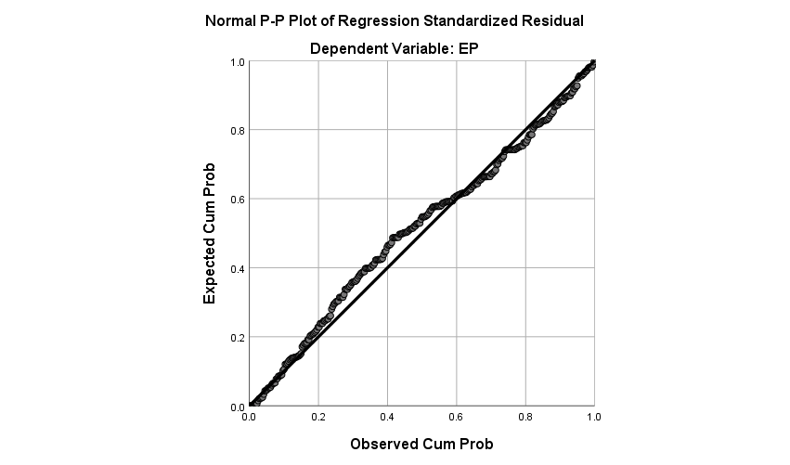
Linearity for MP
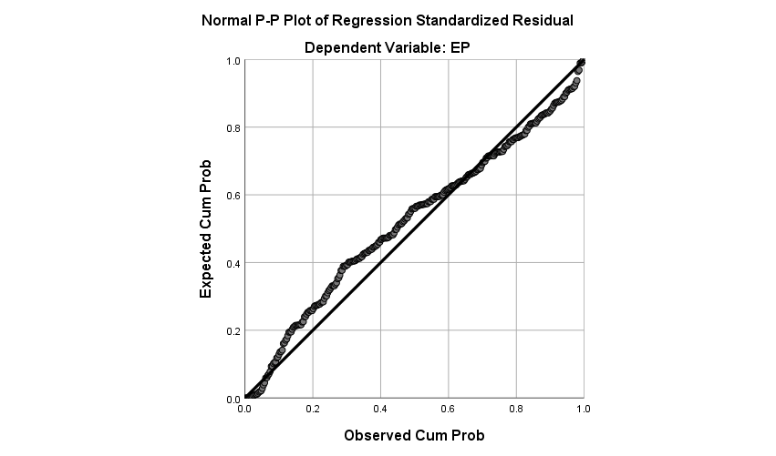Linearity for PTP
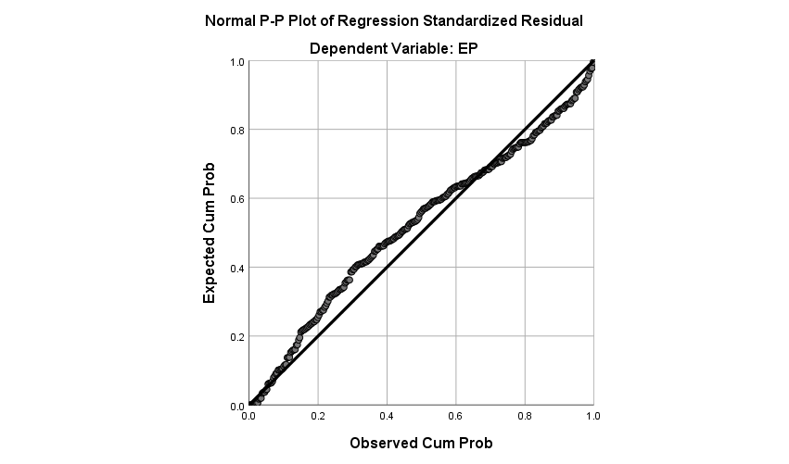

Linearity for ICTP
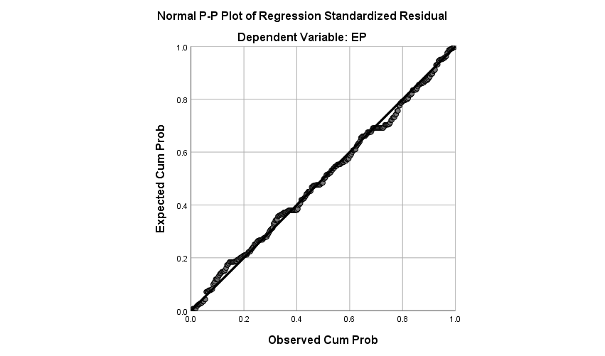
Linearity for TWP

Appendix VI: Normality Tests
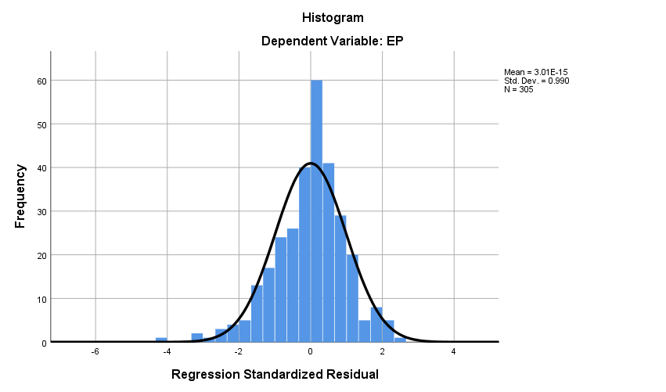
Normality for MP
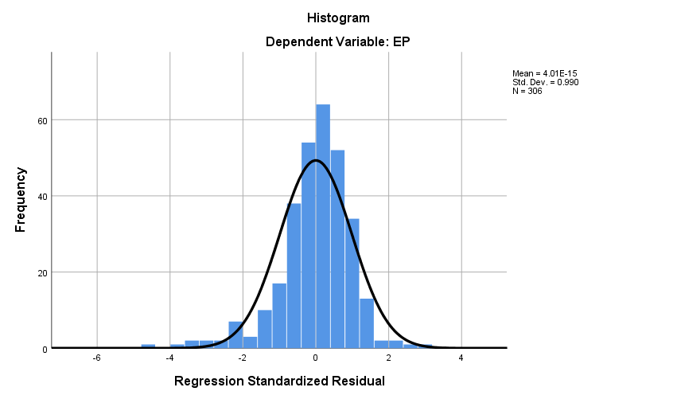
Normality for PTP
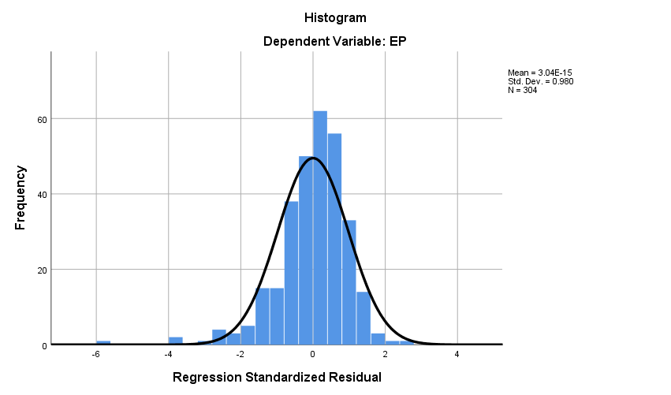
Normality for ICTP
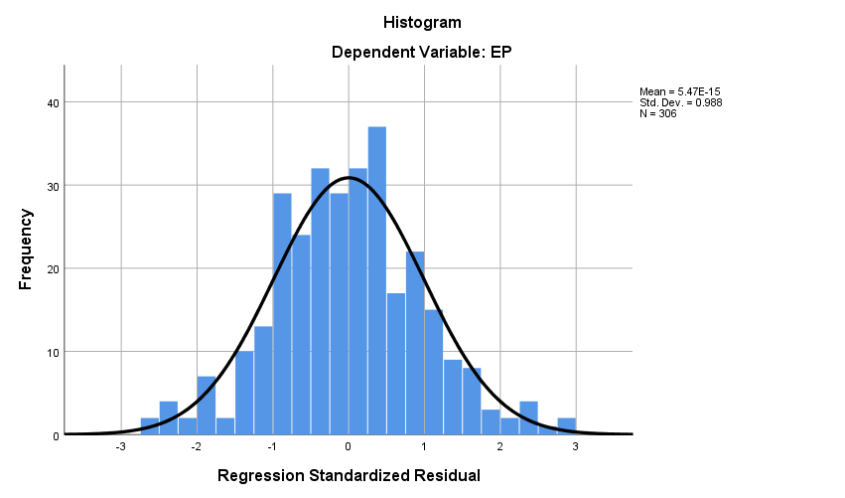
Normality for TWP

Appendix VII: Homoscedasticity Tests
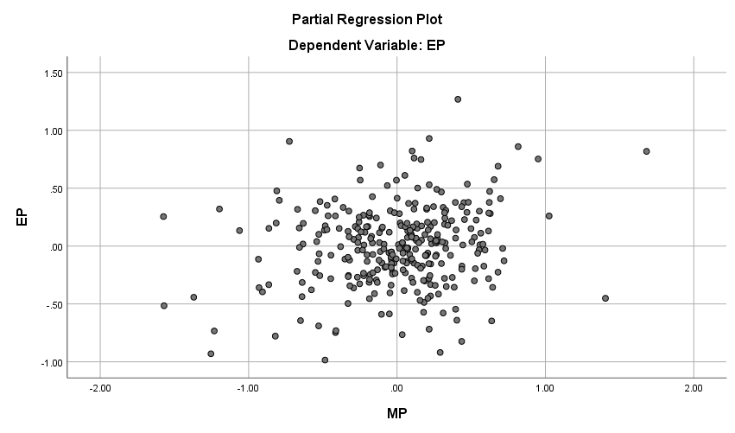
Homoscedasticity for MP
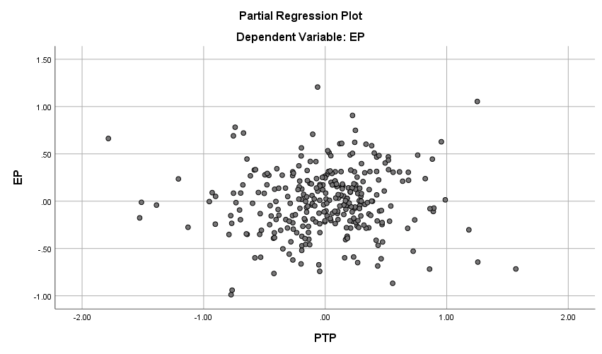
Homoscedasticity for PTP
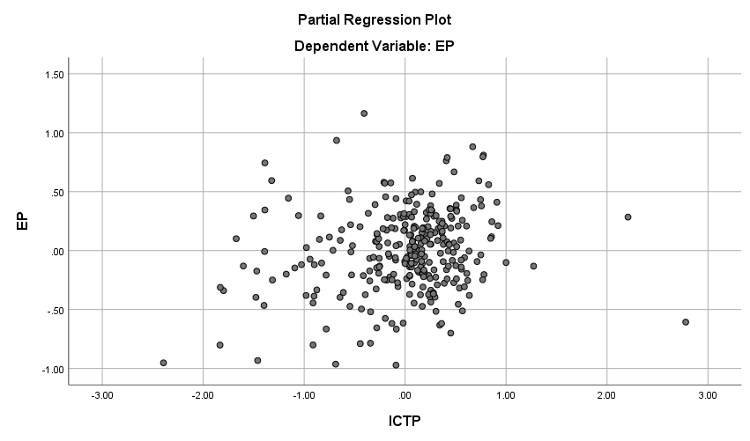
Homoscedasticity for ICTP

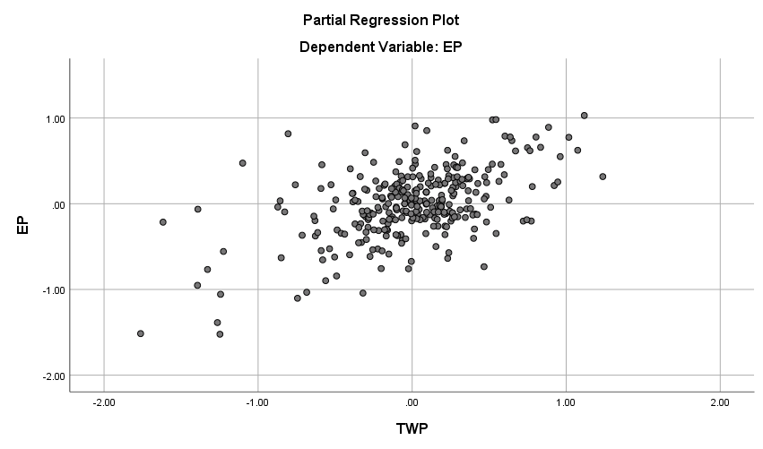
Homoscedasticity for TWP
Appendix VIII: Outlier Tests

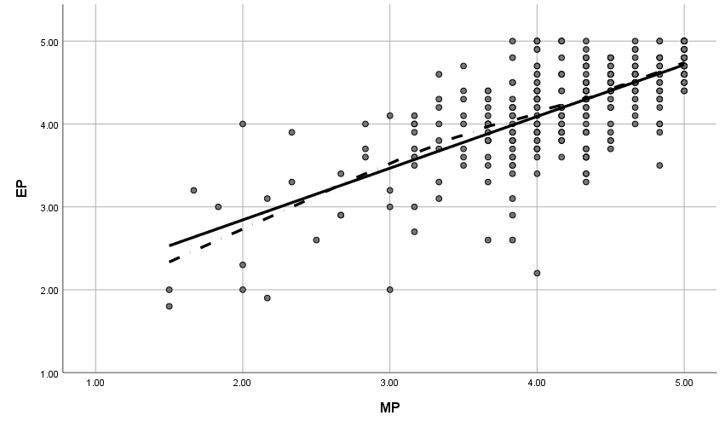
Outlier for MP
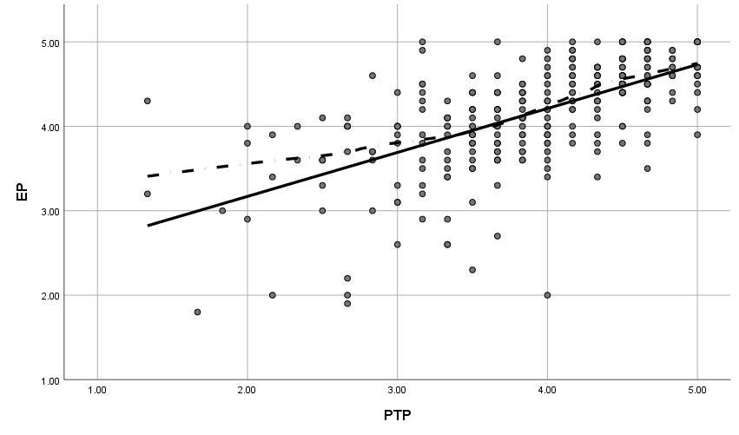
Outlier for PTP

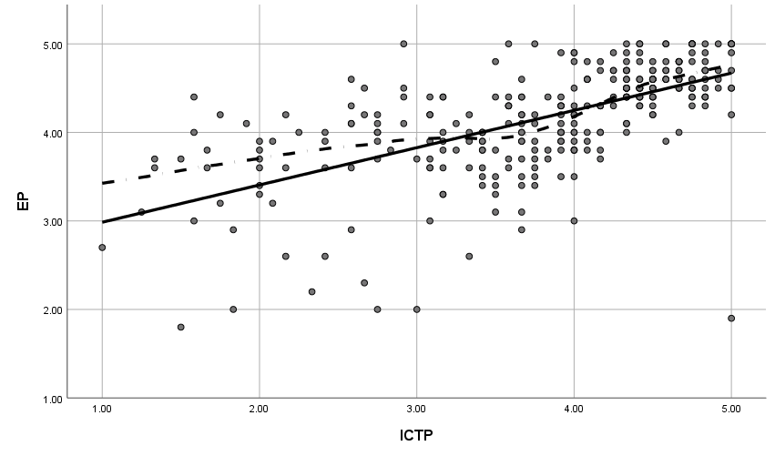
Outlier for ICTP

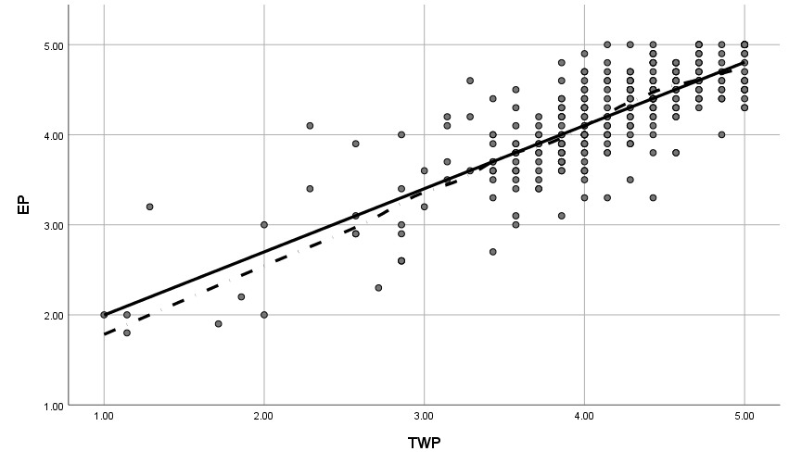
Outlier for TWP
Appendix xiv: Journals


