FACTORS AFFECTING PERFORMANCE OF DAR ES SALAAM BUS RAPID TRANSIT PROJECT IN TANZANIA

JUMA SAID

A DISSERTATION SUBMITTED IN PARTIAL FULFILLMENT OF THE
REQUIREMENTS FOR THE DEGREE OF MASTER OF ARTS IN MONITORING AND EVALUATION
DEPARTMENT OF ECONOMICS
OF THE OPEN UNIVERSITY OF TANZANIA
2022

CERTIFICATION

The undersigned certifies that he has read and hereby recommends for acceptance by the Open University of Tanzania a dissertation titled“Factors Affecting Performance of Dar Es Salaam Bus Rapid Transit Project in Tanzania” in partial fulfillment of the requirements for the degree of Master of Arts in Monitoring and Evaluation of the Open University of Tanzania.

……………………………………….
Dr. Felician Mutasa
(Supervisor)

……………………………….
Date

COPYRIGHT
This dissertation is copyright material protected under the Berne Convention, the Copyright Act of 1996, and other international and national enactments, on that behalf, on intellectual property. It may not be reproduced by any means in full or part, except for short extracts in fair dealings of scholarly review with an acknowledgment, without the written permission of the Directorate of the Research Postgraduate Studies, on behalf of both the author and the Open University of Tanzania.

DECLARATION
I, Juma Said, declare that, the work presented in this dissertation is original. It has never been presented to any other university or institution. Where other people’s works have been used, references have been provided. It is in this regard that I declare this work as originally mine. It is hereby presented in partial fulfillment of the requirement for the Degree of Master of Arts in Monitoring and Evaluation of the Open University of Tanzania.

………………………………..
Signature

……………………………..
Date

DEDICATION

To my late lovely father Juma Said Mndeme, my mother Jane Balomi, my Sister Mwanahamisi Juma, my young brother Ramadhani Juma and my young Sister Latifa Juma.

ACKNOWLEDGEMENT
I would like to acknowledge those people who contributed in one way or another towards accomplishment of this dissertation. It is not possible to mention the names of all who has participated to this dissertationin one way or another, but there are those whom I cannot omit.
First, I would like to thank my almighty God who kept me safe during this time of my course. Kindly, I would like to thank Dr. Felician Mutasa who was my supervisor. He played a great role in supervision of this research study before and after data collection as well as tireless guidance, encouragement and making this study successful.
Secondly, I give thanks to all DBRT passengers and DART operational staff where data were collected and research assistants for enabling me to conduct this study.
Lastly, my thanks should go to my lovely family for their encouragement in the whole process of studying.

ABSTRACT
The study aimed to assess factors affecting performance of Dar Es Salaam Bus Rapid Transit Project in Tanzania. The study was conducted in DSM city along its DBRT corridor in five (5) terminals which include Kimara, Gerezani, Morocco, Muhimbili, and Kivukoni terminal. The research applied a descriptive design. The study used simple and purposive sampling technique to select respondents from the population and a sample size of 96 participants from passengers of the DBRT. The researcheranalysed quantitative data using descriptive and thematic methods. Findings reveal that the DBRT system offers faster travelling speed compared to daladala, and waiting time at the stop is short. Also, findings imply that there is some delay in getting DBRT services as there is no a sufficient number of buses and routes in the daily operation. Moreover, findings reveal that the rate of accidents and fatalities has reduced and most respondents are comfortable with safety in the bus. Although DBRT buses have enough space, findings also show that the DBRT buses are overcrowded. Furthermore, findings reveal that the transport fare is not affordable as most respondents indicated that the DBRT did not help to reduce travelling costs compared to other means of transport. Therefore, the study concludes that reliability, travel time savings, capacity, safety and security, and cost-effectiveness of the transport services are very significant factors for the performance of the DBRT system. The research suggests that Land Transport Regulatory Authority (LATRA)and other government institutions should be fully involved in identifying and selecting new bus operators, increase the number of buses, and standardize transport fares.
Keywords: Performance, system terminals and transport.

TABLE OF CONTENTS
CERTIFICATION i
COPYRIGHT ii
DECLARATION iii
DEDICATION iv
ACKNOWLEDGEMENT v
ABSTRACT vi
LIST OF TABLES xi
LIST OF FIGURES xii
LIST OF ABBREVIATIONS xiii
CHAPTER ONE 1
BACKGROUND TO THE STUDY 1
1.1 Introduction 1
1.2 Background to the problem 1
1.2.1 Travel Time Savings 4
1.2.2 Reliability of the service 5
1.2.3 Safety and security of travel 6
1.2.4 Capacity of buses 7
1.2.5 Cost-effectiveness 8
1.3 Problem Statement 9
1.4 Objectives of the Study 10
1.4.1 General Objective 10
1.4.2 Specific Objective 10
1.5 Research Questions 11
1.6 Research Significance 11
1.7 Scope of the study 12
1.8 Limitations of the study 12
1.9 Organization of the Study 13
CHAPTER TWO 14
LITERATURE REVIEW 14
2.1 Introduction 14
2.2 Definition of key concepts 14
2.2.1 Public Transport 14
2.2.2 Bus Rapid Transport (DBRT) 15
2.2.3 Performance 15
2.3 Theoretical Literature Review 16
2.3.1 Theories of the study 16
2.3.1.1 The Public-Private Partnership (PPP) Theory 17
2.3.1.2 The Balance Scorecard Theory 18
2.4 Empirical Reviews 22
2.5 Research Gap 26
2.6 Conceptual Framework 27
CHAPTER THREE 30
RESEARCH METHODOLOGY 30
3.1 Introduction 30
3.2 Research Design 30
3.3 Area of Study 30
3.4 Study Population 31
3.5 Sample Size 32
3.6 Sampling Techniques 33
3.7 Types and Sources of Data 33
3.7.1 Primary Data 33
3.7.2 Secondary Data 34
3.8 Data Collection Methods 34
3.8.1 Questionnaires 34
3.8.2 Interviews 35
3.9 Measurement of Variables 35
3.10 Data Processing and Analysis 36
3.11 Reliability and Validity Issues 37
3.11.1 Reliability 37
3.11.2 Validity 38
3.12 Ethical consideration 38
CHAPTER FOUR 39
DATA ANALYSIS AND FINDINGS 39
4.1 Introduction 39
4.2 Demographic Information of the Respondents 39
4.3 Travel Time Saving 41
4.3.1 DBRT system offers faster travelling speed compared to daladala 42
4.3.2 The waiting time at the stop is short 43
4.3.3 DBRT gives convenient operating hours 45
4.4 Reliability of the Service 46
4.4.1 The frequency of the bus travel service (Available in 24 hours) 47
4.4.2 Number of buses in the daily operation 49
4.4.3 Number of routes in the DBRT operations 51
4.5 Security and Service 53
4.5.1 The comfortability of commuters in the bus 54
4.5.2 The rate of accidents and fatalities 55
4.5.3 Camera in buses has reduced theft and pickpocketing 56
4.5.4 Commuters enter into DBRT buses at a bus stop in a proper way 57
4.6 The Capacity of Buses 58
4.6.1 The Capacity of Buses 59
4.6.2 The DBRT buses are overcrowded 60
4.6.3 The DBRTBuses and Accommodation of Passengers all the Time 60
4.7 The Cost-Effectiveness 61
4.5.1 The transport fare is affordable 62
4.5.2 Smartcards as a ticketing system 63
4.5.3 Passengers are getting tickets conveniently within a short time period 64
4.5.4 DBRT and travelling costs 65
CHAPTER FIVE 67
CONCLUSION AND RECOMMENDATIONS 67
5.1 Introduction 67
5.2 Conclusion 67
5.3 Recommendation 68
5.4 Area for further research 69
REFERENCE 70
APPENDICES 80
LIST OF TABLES
Table 3.1: Distribution of the Sample size 33
Table 3.2: Measurement of variables from the conceptual framework 36
Table 4.1: Demographic information of the respondents 39

LIST OF FIGURES
Figure 2.1: Balance Score Card Model 20
Figure 2.2: Conceptual Framework 27
Figure 3.1: DBRT system Phase- I corridor 31
Figure 4.1: Travel Time Saving 41
Figure 4.2: Reliability of the Service 47
Figure 4.3: Security and Service 53
Figure 4.4: The Capacity of Buses 58
Figure 4.5: Cost-Effectiveness 62

LIST OF ABBREVIATIONS
ADB Asian Development Bank
BRT Bus Rapid Transit
BSC Balance Scorecard Theory
BSC Balanced Scorecard
DART Dar es Salaam Rapid Transit
DBRT Dar es Salaam Bus Rapid Transit
ICT Information and Communication Technology
IT Information and Technology
NMB Nelson Mandela Bay
PPP Public-Private Partnership
SPSS Statistical Package for Social Science
UDART Usafiri Dar es Salaam Rapid Transit
URT United Republic of Tanzania

CHAPTER ONE

BACKGROUND TO THE STUDY

1.1 Introduction
This chapter sets the foundation for the study. It presents the background to the study, statement of the problem, objectives of the study, and research questions that guide the study. Also, it shows the theoretical and practical significance of the study as well as the scope of the study.

1.2 Background to the problem
Urban public transport is becoming a major issue and an increasingly important part of the socio-economic development of many cities in the world (Agarbattiwala & Bhatt, 2016). Public transport allows people to connect and contributes to the growth of urban areas, and increases the mobility of labor and capital. As indicated by Kundi (2013), many people in urban areas depend on public transport as their core transport mode in traveling to their daily activities. The supply and demand of transportation are heavily influenced by urban population expansion. As cities expand geographically, transportation demand rises in lockstep, as service and workplace distances become more scattered (Ahferom & Svensson, 2009). Today, the routine use of public transport in the cities for many people includes traveling to school, work, shopping, leisure, or visiting friends and family ( Eriksson, 2011; Deng & Nelson, 2011).
In Dar es Salaam, lack of sufficient infrastructure resulted in unreliable service with astonishingly low levels of quality of transport in the city. Meanwhile, the minimal investment engaged by operators explains the proliferation of daladala which has attempted to address the transport challenges in the city such as vehicles operating without control, no transport schedules at all, long waiting times in the middle of the route, absence of services during some hours in some areas, especially at late hours in the evening overcrowding in vehicles, bottlenecks generated in some stops due to the concentration of vehicles competing for passengers to fill the vehicles before they move, congestion of roadways and lack of safe road infrastructures that endanger both motorized and non-motorized transport users including pedestrians(African Development Bank (ABD), 2015). As indicated by ABD (2015),in places like Kariakoo, Buguruni, and TAZARA, it was common to see huge congestion, before the daladala stops and clear streets or free-flowing traffic after the bus stops(African Development Bank (ABD), 2015).
For more than 50 years, Dar es Salaam residents have faced problems with public transportation, mainly due to traffic jams and frequent traffic accidents that lead to death, injury, permanent disability, property damage, and delays in work. Since the 1980s, the Tanzanian government has worked hard to eliminate traffic problems in the city, but with little success(Chengula & Kombe, 2017).
Thus, to address these problems, the Government of Tanzania established Dar Rapid Transit Agency (DART) under the Prime Minister’s Office, Regional Administration, and Local Government through the Ministerial Advisory Board. The aim was to create an agency that would establish and operate a Bus Rapid Transit (DBRT) system in Dar es Salaam City to add to the City's efforts to enhance mobility, safety, comfort, and a clean environment (Bagoka, 2015). DBRT system is a relatively new mode of transportation; it is found almost in 195 cities around the world, and itis considered to be an effective and feasible solution to urban traffic challenges. Unlike traditional public transportation systems, DBRT runs on dedicated lanes, usually with larger capacity and unique ticketing systems, and provides real-time information.In Tanzania, the construction of the DBRT System in Dar es Salaam city started in 2012 to reduce traffic delays, congestion, and frequency of traffic accidents (Chengula & Kombe, 2017).
Reports show that as of 2014 commuter buses operated in Dar es Salaam city were 5,200. Despite the big number of buses, motorcycles and tricycles in the city but transport problems remain high. The routes had tremendous traffic accidents, waiting time for daladala at stops were more than 1hour, delays on the journey due to traffic congestion were also high (Elisonguo, 2013;Kiunsi, 2013; Filipe & Macário, 2012). Thereby the introduction of the DBRT System by the government of the United Republic of Tanzania (URT) was hypothesized to be a practical solution to solve transport problems in Dar es Salaam city (Rwenyagira et al., 2015).
The main objective of the DBRT project was to ensure an orderly flow of traffic on the city streets and roads by increasing the level of mobility, improving public urban transport, promoting the use of non-motorized transport, and meeting the ever-increasing travel demand of the city residents with the ultimate aim of increasing comfort and quality of life and urban development (ABD, 2015).
Since late 2016, the DBRT system was doing well as it was awarded the 2018 sustainable transit award and this has made Dar Es Salaam the first African city to win the award (Chengula & Kombe, 2017). Despite the success of DBRT, currently, the performance of the DBRT system is still questionabledue to several operational challenges such as overcrowding at the bus stations and long queues during ticket booking, and poor service quality. Currently, the DBRT system does not allow passengers to check and top-up their smart card balance and most of the smart card machines are not working, and hence fare payment through smart card machines is current a rare case (Alfred & Kaijage, 2019; Loyde, 2020).
Other challenges that emerged in this project include tight financial planning, where some DBRT does not receive operational subsidies, thus result in operational costs rising, a problem with poor fare collection systems which causes longer queues at the stations, overcrowding at stations, and raises the risks of loss of fare revenue to DBRT operators(Nikitas & Karlsson, 2015).

1.2.1 Travel Time Savings
The travel time savings is the aspect that customers care about the most when boarding a public transport service, especially when they commuter from their home to their work, or vice versa (Jara-Díaz & Tirachini, 2013). As indicated by Jara-Díaz and Tirachini (2013), this travel time on a service can be dissected into four aspects: The first aspect includes the running time, time spent in bus services travelling from station to station; the second aspect includes the dwell time, time spent in the vehicles at bus stops, waiting for passengers to board or alight; the Third aspect includes the wait time, time spent at the beginning of the trip by customers at a bus stop waiting to board on service; and the fourth aspect includes the transfer time, time spent by passengers transferring between DBRT services and other types of public transport mode. DBRT operators try to reduce the travel time for passengers, in order to increase the attractiveness of the service.
For low-income people, saving travel time is a huge advantage, because they usually face very long travel times due to poor location and restrictions on access to high-speed modes. There is evidence that by combining exclusive infrastructure and speed-up technology, the DBRT system has the potential to significantly reduce average passenger travel time (Venter et al., 2013). But due to its connection with arteries and good pathways and systems, its accessibility greatly saves passengers' time. However, it is very important for the user to evaluate the travel time because the related expenses due to travel delays are very high (Chengula & Kombe, 2017).
Hidalgo and Yepes (2005) studied the travel time savings in the first phase of Bogotá Trans Millennia and found that for the poor, the travel time savings on each trip was 18 minutes longer than that of middle-income users who traveled 10 minutes per trip. On the other hand, Tiwari and Jain (2012) compared the travel time savings by Delhi DBRT mode and found that cyclists save more time than bus users, which is around 33%. Though they did not pay particular attention to income levels, they indicated that low-income families in Delhi are the main users of non-motorized transportation.

1.2.2 Reliability of the service
Service reliability is the ability of transit operators to maintain operations schedules at a constant level that customers can feel satisfied. However, customers can feel unreliable service when bus arrival times are not as scheduled or when travel times are highly variable and unpredictable. Customers' satisfaction increases when the service is reliable, hence the ridership increases and serves more commuters (Cham et al., 2006).
Authors such as Jara-Díaz and Tirachini (2013), and Bates et al. (2001) argued about the schedule delays and adherence to timetables while speaking about reliability. Therefore, reliability hangs on the ability to maintain consistent travel times and the availability of consistent service (Bayle, 2012). In this case, customers are more likely to use a service if they consider it to be reliable, thus, DBRT has to provide a service that displays great quality and consistency for better performance of the DBRT system (Bates et.al, 2001).
DBRT systems are exclusive lanes, off-board ticketing, iconic stations, scheduled arrival and departure time and proper information using mobile apps and displays help improving schedule adherence by reducing variability in waiting and in-vehicle travel time. However, if there is well schedule adherence then can be used to measure deviations of arrival time at the station from the scheduled time. Therefore, some of the failures in the transportation system like late arrival at the station due to traffic accidents and service distractions are not regarded as unreliability (Chengula & Kombe, 2017).

1.2.3 Safety and security of travel
Safety reflects freedom from hazards such as road accidents, injuries, etc. On the other hand, security reflects the freedom from criminal activities against customers and their property, e.g. thefts, violent acts, threats (Jara-Díaz & Tirachini, 2013).
Road accidents result in injuries, disabilities, loss of properties, death of life as well as an increase of dependants particularly in developing nations. The demand for various cities in the world needs an efficient transport system, which can help to reduce road traffic accidents and environmental pollution. The traffic accidents in the world related to urban transport are the fourth leading sector with a large number of deaths particularly in Asia and Sub-Saharan Africa (ADB, 2012; Ruikar, 2013). The number of deaths from traffic accidents in Dar es Salaam increased to 325 in 2016, an increase of 2.8% compared to 2015 (Lwangili, 2017).
Reports showed that the establishment of the DBRT system has reduced environmental pollution and traffic congestion, and road traffic accidents for more than 50 percent in various cities in the world (Solanki et al., 2016; Yazici et al., 2013). Rodriquez (2009) establishment of DBRT in Bogota city during the year 2004 reduced accident crashes by 92 percent, travel time reduced by 32percent, reduced vehicle emission by 40percent, and fuel savings by 47 percent. The average monthly crashes in Guadalajara, decreased by 46percent during the first year of DBRT operation (Duduta et.al, 2012).
Reports showed that the establishment of a DBRT system has reduced environmental pollution and traffic congestion, and road traffic accidents in cities around the world have decreased by more than 50% (Solanki et al., 2016; Yazici et al., 2013). Rodriquez (2009) studied a DBRT in Bogotá in 2004, resulting in reduced accidents by 92%, vehicle emissions by 40%, travel time by 32%, and fuel savings by 47%. In the first year of bus rapid transfers, the average monthly traffic accidents in Guadalajara decreased by 46% (Vecino-Ortiz & Hyder, 2015).

1.2.4 Capacity of buses
This is defined as the maximum number of passengers that can be carried by a DBRT for a given time and a given direction, depending on specific conditions (a type of vehicle) (Chengula &Kombe, 2017). DBRT vehicles designed with large sizes to carry a large number of passengers at once to reduce the average costs of trips that would be allocated with smaller local buses. Despite the size factor, also the system should be served with a sufficient number of vehicles across the corridor to avoid chaos and overcrowding of passengers at the stations and in the buses (Hidalgo & Carrigan, 2010). There must also be proper scheduling of the buses to ensure the constant availability of buses depending on travel demand needs. Bus maintenance must be reliably done to avoid unexpected bus shortages (Loyde, 2020).

1.2.5 Cost-effectiveness
The main benefit of the DBRT scheme looks a bit cost-effective compared to other urban public transportation. The DBRT system infrastructure costs and its operating cost is less than Metro transit and light rail systems (Pojani & Stead, 2015). Nevertheless, rail and metro transit systems need electricity as the finest alternative energy to operate the engines compared to diesel engines. However, for developing nations, electric energy is still a challenge as it is not sustainable and expensive to obtain from sources (Loyde, 2020).
The investment and operation of metros costs are very high which makes them less financially viable in medium-sized developing cities than in mega-cities which prompt them a smaller amount of affordable public transportation (Pojani & Stead, 2015). Studies show in the USA alone the operating costs per hour for light rails is twice more than rapid transit buses and the investment cost to build a mile length of bus way was around 60% less than a typical light rail system provided a similar average operating speed of the two systems (Cervero, 2013). Although, there is an argument that the operating cost of a DBRT system is higher than the light rail system which encourages investors to invest in a light rail system for public urban transport (MacKechnie, 2017). The high cost of operating the DBRT system is measured by the need for a number of buses and workers to accommodate the same amount of commuters per trip on which there will be a future offset of high investment cost for light rail transit, especially in Megacities. Therefore, the public DBRT system is a proper choice for urban transportation mainly for developing nations, as the cost of its project is the effective life cycle.

1.3 Problem Statement
For many years, public transport has been viewed as an inevitable need in many parts of the world. A good transport system cannot be attained if there are no effective and efficient services that enhance people’s living standards and gives them satisfaction through the features such as affordability, reliability, and comfortability (Phoebe, 2017).The government of Tanzania established DBRT for the people of Dar Es Salaam city as the response to public transport problems in the city. The government envisaged the DBRT system to reduce road traffic congestion and provide comfortable, safe, and quick travel to city commuters. The system was also expected to reduce the number of private cars entering the city center thus improve air quality which is important for the life of people and sustainable development of the city.
However, currently, the commuters of the DART system are facing complaints about breakdown of a large number of vehicles, long delays and overcrowding in vehicles particularly during the morning and evening hours (peak hours). There is increasing trespassing of other vehicles both private and government vehicles other than DBRT buses, passing in the DART corridor unlawfully, and floods in some routes such as Jangwani area. There is also an increase in accident incidences along the corridor thus affecting the safety of passengers and staff. The increase in these challenges affects the overall performance of DBRT in the city (Kalokola, 2019). There are insufficient studies about the factors affecting performance of Dar Es Salaam Bus Rapid Transit Project in Tanzania as most of the studiessuch as Chengula and Kombe(2017),Kalokola (2019), and Loyde (2020) focused on DBRTs’ service quality, effectiveness, and challenges associated with DBRT.Therefore, to address the performance of this project, this study is aimed to assess the factors affecting performance of Dar Es Salaam Bus Rapid Transit Project in Tanzania.

1.4 Objectives of the Study
The objectives of the study are divided into two parts including general objectives, and specific objectives.

1.4.1 General Objective
The general objective of this study is to assess factors affecting performance of Dar Es Salaam Bus Rapid Transit Project in Tanzania.

1.4.2 Specific Objective
- To determine the influence of travel time saving on the performance of Dar Es Salaam Bus Rapid Transit project
- To examine the influence of the reliability of the service on the performance of Dar Es Salaam Bus Rapid Transit project
- To identify the influence of security and safety on the performance of Dar Es Salaam Bus Rapid Transit project
- To determine the influence of the capacity of the buses on the performance of Dar Es Salaam Bus Rapid Transit project
- To examine the influence of the cost-effectiveness on the performance of Dar Es Salaam Bus Rapid Transit project.

1.5 Research Questions
- What is the influence of travel time saving on the performance of Dar Es Salaam Bus Rapid Transit project?
- What is the influence of the reliability of the service on the performance of Dar Es Salaam Bus Rapid Transit project?
- What is the influence of security and safety on the performance of Dar Es Salaam Bus Rapid Transit project?
- What is the influence of the capacity of the buses on the performance of Dar Es Salaam Bus Rapid Transit project?
- What is the influence of cost-effectiveness on the performance of Dar Es Salaam Bus Rapid Transit project?

1.6 Research Significance
The results of this study are important for the DART Agency and UDART in their mission to improve DBRT performance on bus service operations as it can show the current status of the system, the problems perceived by passengers, and the areas that need to be improved to revamp the system’s attractiveness to passengers.
The findings of the study can reveal the performance areas and challenges of the current system and hence sets the base for performance in future phases. Also, the knowledge to be obtained from this study shall be useful to other nations with DBRT systems of similar settings.
To other researchers, the study can form a basis upon which future studies can be done by establishing a knowledge gap on the concept. In addition, current and future students can use the research findings and conclusions to enrich their knowledge on the topic, create their literature review, and establish new research areas.

1.7 Scope of the study
The research was narrowed in Dar Es Salaam City, involving passengers of DBRT available at the corridor bus stations and terminal, and excludes the passengers of other transport modes like city buses (daladala), taxis, tricycle (Bajaj), or motorcycles (bodaboda). The study also was limited toidentify the factors affecting performance of the DBRT system.

1.8 Limitations of the study
First, many passengers approached were not ready to fill the questionnaires and some were not completing the questionnaires because of their hurry. However, the researcher was able to get the targeted number of passengers who were ready to fill and complete the questionnaires.

Second, getting the DART operational officers for the interview required patience because of their busy schedules. Some interviewees were unwilling to provide some information because of confidentiality. The researcher explained to them that the study is purely for academic reasons and not for any other purpose. Luckily, the researcher managed to get the desired response on time and able to meet the intended research objectives.

1.9 Organization of the Study
This study is organized into six chapters where chapter one illustrates the background of the study, statement of the problem, research objectives, research questions, significance of the study, the scope of the study, and organization of the study. Chapter two covers a literature review which comprises theoretical and empirical reviews, while chapter three covers research methodology. Moreover, chapter four includes data analysis, presentation of findings,andchapter six comprises of discussion of findings, and chapter six includes conclusions, recommendations, and areas for further research.

CHAPTER TWO

LITERATURE REVIEW

2.1 Introduction
This chapter gives reviews of the literature. It further defines key concepts, theoretical review, empirical review, and study conceptual framework.

2.2 Definition of key concepts
This part defines key terms that were used in the study including Public Transport, Bus Rapid Transport, and Performance.

2.2.1 Public Transport
Public transport (also called public transit, urban transit, or mass transit) is defined as a form of travel that allows more people to travel together along designed routes at the preset fare(Litman, 2015). The public transport system provides travel services for all groups of people in society, including children, the elderly, and the disabled(Kanyama et al., 2004). Public transport includes all modes available to the general public such as scheduled bus services, coach and rail operators, taxis, private hire buses, and coaches, and those buses which are providing school services, irrespective of ownership (White, 2016).
In many countries, public transport is controlled by the government and some in collaboration with the private sector. The poor performance of public transportation affects passenger satisfaction and declines the quality of travel service causing stress to passengers (Beirão & Cabral, 2007). DBRT is termed as a public transport because it carries many passengers from one point to another across its dedicated bus lanes serving the general public in urban and city areas.

2.2.2 Bus Rapid Transport (DBRT)
Differentauthors defined DBRTfrom various perspectives, however, they all centered on defining DBRT as a transport-based system that emulates the high capacity, performance features of urban transport system at a much lower cost (Deng and Nelson (2011).Bayle et al. (2012) defined DBRT as a mass transit system that has a corridor of exclusive and segregated bus lanes, high capacity articulated buses and largely closed stations that allow fare payment outside the trunk buses. Also, DBRT as indicated by Levinson et al., (2003), consists ofa flexible form of rapid transit that contains stations, separated roads, information technology, an integrated structure with modern transportation services.The essential characteristics of DBRT include the existence of segregated running ways, pre fare and ticketing system, special vehicles, bus operation, and integration of ICT in bus services (Nikitas& Karlsson, 2015).
Therefore, in this study, DBRT is defined as the mass transit system that mimics the railway system in character but offers services at a fraction of cost with more flexibility. It is becoming an attractive transport mode due to its cost-benefit advantages and flexibility comparing to Metros and LRT which are more expensive and non-feasible for many low-income developing countries (Wright & Fjellstrom, 2003).

2.2.3 Performance
There is no single definition of the term performance. The term performance is defined differently depending on the area or field it has been applied to. As indicated by Samsonowa (2012) all definitions of performance from different disciplines defined performance based on two terms, which are effectiveness and efficiency. The term performancebased on effectiveness indicates the level of goal achievement, whilst the term performance based on performanceindicates the degree that resources have been consumed to reach such achievement. Thus, Samsonowa concluded by defining performance as the level or degree of goal achievement of an organization or department rather than just of individuals.
Rolstadås (1998) describedthe term performance as a complex interrelationship between seven performance measures that are effective, efficiency, quality, productivity, quality of life, innovation, and profitability. Also, Krause (2005) defined the term performance as the degree of the achievement of objectives or potentially possible accomplishment about the important characteristics of a company for the relevant stakeholders.
Therefore, based on theSamsonowa (2012) this study is defined as the term performance as the degree of achievement of goals by the urban public transport system in providing travel services to commuters. This includes achieving goals like reducing traffic congestion, delays, and the provision of excellent customer service to passengers. This can be achieved by adopting efficient transport modes.

2.3 Theoretical Literature Review

2.3.1 Theories of the study
This study is governed by two theories which include the Public-Private Partnership (PPP) theory, and the Balance Scorecard Theory.

2.3.1.1 The Public-Private Partnership (PPP) Theory
In numerous countries in the world, PPPs are becoming more common and can provide multiple types of public infrastructure, including hospitals, transportation projects, schools, waste and water treatment facilities, and prisons. In theory, PPPs aim to overcome the persistent challenges faced by traditionally executed public works projects by leveraging the network and social inclusion of governments and companies involved in large-scale projects (Siemiatycki, 2012).
This theory requires to be contractual planning between a private party and a government body, for the provision of a public asset or service, whereas the private party bears a significant amount of risk and management responsibility, and therefore, remuneration is linked to performance (Ngowi, 2006). As indicated by Ngowi (2006),
PPP theory aims to diminish too much responsibility from the government in fulfilling its projects, thus the government may choose to invite the private sector to perform tasks along with it. The contractual agreement between both sides (government and private sector) will narrate each part’s responsibilities. In this manner, the government is relieved from the burden but also it gives a chance to the private sector to participate in the operation. However, the PPP partnership must be in a win-win situation to ensure the benefits of both parties.
Not surprisingly, the contract management costs associated with remediating conflicts have been high for one or both of the partners. However, one surprising aspect of early transportation PPPs has been the number of projects that have been canceled or gone bankrupt before the scheduled conclusion of the concession period (Siemiatycki, 2012). As a result of the poor track record of transportation PPPs that transfer traffic volume and operations risk to the private sector, governments and investors have become increasingly reticent to participate in PPPs that involves the transferring of all traffic volume risk to the private sector. In response, one adjustment that has been made in recent years is the move towards PPP models that pay the concessionaire a guaranteed annual payment provided the facility is available and meeting performance criteria. Under such models, the public sector partner can maintain control over the setting of user fee rates and regional planning objectives(Siemiatycki, 2012).
This theory is relevant in this study as the operations under the DART system are a good example of PPP partnerships as suggested in the PPP theory. This is because while the system is under government ownership the bus operation and fare collections have been contracted to the private sector. The current bus operation is under UDART Group Limited, while fare collection was under Maxcom Africa Limited, although presently is being done by UDART on an interim basis. However, the government through DART is making efforts to procure the new bus service provider and fare collector (Mwaluwinga, 2020). Moreover, this theory implies how PPP partnership can predict the performance of the DBRT project.

2.3.1.2 The Balance Scorecard Theory
This theory is grounded on the management approach and the performance of the company and it was first developed by Norton and Kaplan in 1996. The theory indicates the transformation of the company's strategic plan into the company's "action order" as well as it provides a structure not only for evaluating performance, but also to help planners decide what needs to be implemented and measured (Kaplan & Norton, 1996).
The BSC theory gives straight guidance as to what companies should measure to 'balance' the financial perspective for the performance of the company. The BSC theoryindicates that for the companies to succeed in their operation, they should illuminate their strategy and vision and interpret them into action. Companies should alsogive feedback to both the internal business processes and external results to constantly influence strategic performance and outcomes (Kaplan & Norton, 1996).
As indicated by Kaplan and Norton (2007), the active implementation of BSC needs company management to provide much weight into four BSC perspectives. These perspectives comprise; thelearning and growth perspective, internal business processes, customer perspective,and financial perspective. The BSC provides a model for strategic and management performance measurement for high-performance companies. According to Kaplan and Norton (2007), the BSC interprets a company’s mission and strategy into a comprehensive set of performance measures that delivers the structure for a strategic measurement and management system (Kaplan & Norton, 1996).This strategic management system measures company performance in a four-balanced perspective as expressed in Figure 2.1.

Figure 2.1: Balance Score Card Model
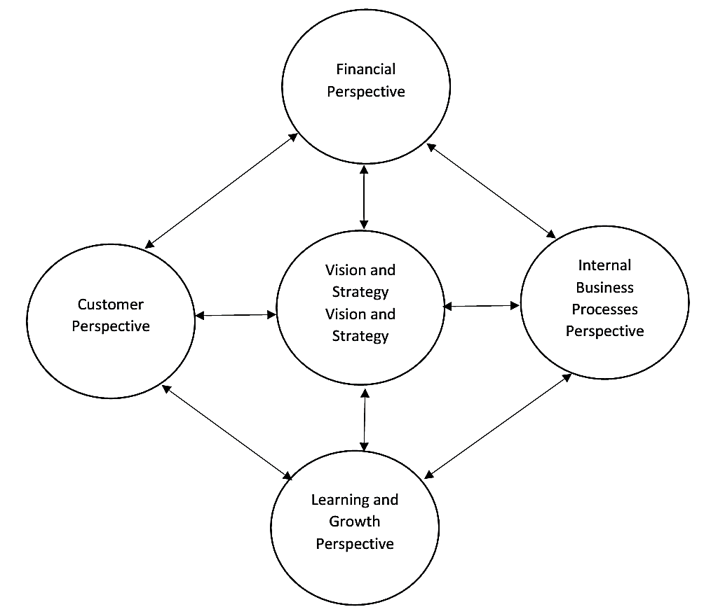
Source: (Kaplan & Norton, 2001)
The financial perspective is referred to as ameasure of financial performance that shows whether the company’s strategy, operation, and performance are contributing to bottom-line development(Kaplan & Norton, 1996). It shows the outcomes of the strategic choices made in the other three perspectives. According to Kaplan and Norton (2001), companies should createfundamental improvements in their operations and the financial issues take care of themselves. A company's financial performance should be measured by how efficiently and effectively they meet the needs of their customers. Thus, for the company, the financial perspective emphasizes cost-efficiency, i.e. capacity to provide maximum value to the customer (Kaplan & Norton, 2006). This theory enlightens that the management of the DBRT system should regulate the financial flow to guarantee the operations of the project in effective and efficient means. This shows that the good financial regulations of the project can be a way forward of repairing theinfrastructures of the projects.
Customer perspective captures the capacity of the company to deliver quality goods and services to satisfy the customers. Numerous companiespresently have a mission based on the customer, and measuring how a company is performing from its customers’ perspective has become the main concern for the top management. The theory of BSC explains that managers interpret their mission statement on customer service into specific measures that mirror the issues that surely matter to customers. This shows that the good performance of the DBRT project is also viewed in the customer satisfaction perspective, the higher the satisfaction of the service from the DBRT project the higher the performance of the project is considered (Kaplan & Norton, 2006).
The internal business processes perspective is mainly focused on the analysis of the company’s internal processes. Internal business processes are the tools through which the performances of the company expectations are attained. Thecustomer perspective focused on the internal business lead to financial victory and satisfaction to customers. Thus, managers have to prioritize the serious internal operations that assist them to satisfy the needs of customers (Kaplan & Norton, 2006).Under normal circumstances, the DART system is expected to be a sustainable, efficient, and self-reliant project. If the system operates with high efficiency, there shall be a significant reduction in the monies required to subsidize its operations. However, this can only be achieved by making the system competitive and profitable through enhancing its performance.
The learning and growth perspective emphasizes constant progress for the product of the company and processes through staff training and development. In this situation, the learning and growth perspective focuseson such issues, which comprise the capacity of staff, the quality of information systems, and the results of company position in enhancing the achievement of goals of the company. Hence, to achieve the expectation of customers, employees may be asked to take on dramatically new capabilities, responsibilities, and may require skills (Kaplan & Norton, 2006).
Therefore, based on a four-balanced perspective as expressed in Figure 2.1, The BSC theory proves that employees job description, better employees’ supervision, and increased level of top management support, supports the implementation of the four balanced scorecard perspective and hence lead to effective implementation of balanced scorecard in a company.

2.4 Empirical Reviews
Siyongwana and Binza (2012) studied the challenges facing the transformation of the public transport system in Nelson Mandela Bay, South Africa. The interview and focus group discussions were used to draw information from the fieldwork andmeetings fromaffected senior managers and stakeholdersof NMB who were in the implementation of the DBRT system. The findings of the study revealed that the DBRTimplementation was not simply achieved, as various challenges were raised in the DBRT implementation phase. The chief challenges include limited effective stakeholder,absence of intensive planning, and affected community engagement. The study concluded that the implementation of DBRTin NMB was not easy as much as the DBRT has accredited the public road transportation system innovation in South Africa, and will be an important history for the city.
Chengula and Kombe (2017) studied the assessment of the effectiveness of the DBRT System in Dar es Salaam, Tanzania. Questionnaires and interviews were used to get data from the respondents, and the analysis of responses was based on households and commuters. This study used probability sampling known as random sampling to recognize potential passengers who are now gaining with the existence of the DBRT system in Dar-es-salaam city. A sample of 200 respondents was used in the study and a total of 200questionnaires were distributed to the households living nearby DBRT terminals and commuters. For the case of commuters, the respondents were taken from every terminal. This research revealed that passengers’waiting time at terminals/stations is reduced to more than 50 percent, delays in the journey are reduced to 60percent and savings of fare cost to passengers is 28 percent compared to the former daladala type. For the DBRT system, there should be a connection between DBRTroads and truck roads to achieve sustainable business life cycle costs and projects. In order to serve a large group of people, the fare price per trip should be adjusted to 77percent of the present fare price.
Ahferom and Svensson (2009) studied the assessment of the sustainability of a DBRTsystem: The case of Dar es Salaam, Tanzania. This article compares the sustainability before and after the introduction of the proposed DBRT system and examines the public transport conditions in Dar es Salaam. A case study design with both quantitative and qualitative aspects was used.The conclusion from the study showed that the establishment of a DBRT system in Dar es Salaam has many marked achievements in terms of improving the current public transport services. However, some weaknesses have been recognized which include; the unfair delivery of services through population groups; growth in the number of cars; the absence of participation of the recent public transport operators in the planning process, and the careless handling of their fates.
Alphonse (2008) analyzed the commuter’s attitude towards the proposed DBRT system in DSM. In his study, he intended to examine the perception of commuters towards the proposed DART system during that period and their socio-economic and spatial difference characteristics. The study mainly aimed at getting the perceived value of the proposed DART system together with its proposed attributes. The study suggested that the DART system, once established would stimulate urban public transportation in the city through the provision of quality, affordable and accessible transport services. The findings of the study showed that generally the travel time, travel fare, and comfort had a significant effect on DBRT choice. Furthermore, the people in high traffic zones and those living in peripheral zones of the city had a considerably higher preference forthe DART system than the existing public transport system (daladalabuses). This study was carried before the actual implementation of the DART system thus gave the conclusions based on the predictions of the system.
However, the system has been currently in operation for more than three years now. It is high time to test the current image and position of the DART system reflecting the earlier projected perceptions versus vies current perception on performance attributes of the system. The city has rapidly changed with various new challenges and opportunities. This study sought to investigate the present perception of passengers on the DART system contribution to the improvement of public transport in the city, understand the dominant factors of DBRT performance, and the gaps in DART system implementation.
Oluwaseyi and Olawunmi (2016) assessed the efficiency of DBRT for the commuter’s movement in Lagos. In his study, he analyzed the impacts of high motorization in the cities. He went further saying that the high motorization in the cities leads to increased road traffic congestions, increased pollutions, increased consumption of non-renewable energy, declining quality of life, and increased accidents. However, these problems are common to many African cities including DSM city. Oluwaseyi indicated that the efficient DBRT system is a solution to urban public transport problems and thus suggests the understanding of factors for the high performance of DBRT to achieve customer satisfaction. Oluwaseyi mentioned the bus frequency, commuting price, punctuality, andtraveling time as very crucial factors in attaining DBRT efficiency and customer satisfaction. The study emphasized that responsible authorities in urban public transportation systems should pay attention to the voice of commuters and take corrective actions on improving DBRT system efficiency.
Afolabi, Oluwaseyi, and Adegbayi (2017)This study investigated the commuter public transport travel behavior of passengers in Lagos State, Nigeria. Descriptive research surveys were applied to evaluate respondents’ opinions through questionnaire surveys. The research involved 84 respondents as sample size and tested two hypotheses by using the Pearson product-moment correlation coefficient at a significance level of 0.05. The results obtained showed that in the Lagos metropolitan area, there is a positive correlation between travel frequency and passenger income, and in the Lagos metropolitan area, there is a positive correlation between travel frequency and the distance covered by passengers. Also, the results showed that about 57% of the population in the sample were men, and 62% were civil servants, and 48% of participants traveled for business purposes. The majority of respondents (50%) said that commercial public transportation is extremely prone to accidents, while about 64% of respondents travel every day. Facts have proved that the lack of transportation infrastructure and poor road maintenance are the main reasons for the inconvenience of the area.

2.5 Research Gap
The study assessed the factors affecting performance of Dar Es Salaam Bus Rapid Transit Project in Tanzania.Different researches have been reviewed, and particularly empirical reviewsthat are written by different scholars,researcher find out that numerous authors emphasized on challenges facing the DBRT system, the effectiveness of DBRT system, customer’s satisfaction, customer perception of service quality. Based on the literature reviews, it is clearly seen that there are insufficient reviews about the factors affecting performance of Dar Es Salaam Bus Rapid Transit Project.Hence, a researcher has found out that there isa need to study more about the factors affecting performanceof DBRT in Tanzania since its implementation.

2.6 Conceptual Framework
The conceptual framework shows how independent variables and dependent variables are connected. Independent variables in this study include travel time savings, reliability of the service, safety and security, capacity of buses, and cost-effectiveness whilst dependent variable include DBRT system performance in terms a of service quality.The relationship between these variables (independent and dependent variables) is indicated in Figure 2.2 as guided by (Siemiatycki, 2012) in PPP theory.
Figure 2.2: Conceptual Framework
Independent Variables Dependent Variables
Travel Time Savings

Reliability of the Service

Safety and Security
BRT system performance

Capacity of Buses

Cost-Effectiveness

Source: Researcher's construction (2021)

Independent Variables
Reliability of the service: customers can feel unreliable service when bus arrival times are not as scheduled or when travel times are highly variable and unpredictable. Customers' satisfaction increases when the service is reliable, hence the ridership increases and serves more commuters (Cham et al., 2006).
Travel time savings: Travel time savings includes the running time, time spent in bus services travelling from station to station; the dwell time, time spent in the vehicles at bus stops, waiting for passengers to board or alight; the time spent at the beginning of the trip by customers at a bus stop waiting to board on service; time spent by passengers transferring between DBRT services and other types of public transport mode (Jara-Díaz & Tirachini, 2013).
Safety and security of travel: Safety reflects freedom from hazards such as road accidents, injuries, etc. On the other hand, security reflects the freedom from criminal activities against customers and their property, e.g. thefts, violent acts, threats (Jara-Díaz & Tirachini, 2013).
Capacity of buses: DBRT vehicles designed with large sizes to carry a large number of passengers at once to reduce the average costs of trips that would be allocated with smaller local buses. Despite the size factor, also the system should be served with a sufficient number of vehicles across the corridor to avoid chaos and overcrowding of passengers at the stations and in the buses (Chengula & Kombe, 2017).
.
Cost-effectiveness:The main benefit of the DBRT is in the aspect of cost compared to other urban public transportation. The DBRT system infrastructure costs and its operating cost should be less than other means of transport to enhance performance (Pojani & Stead, 2015).
Dependent variable
DBRT system performanceis viewed in terms a of service quality.

CHAPTER THREE

RESEARCH METHODOLOGY

3.1 Introduction
This chapter consists of research design, research area, study population, sample size, sampling techniques, sources of data, data collection methods, measurements of variables, data analysis plan, reliability, and validity of data, and ethical consideration.

3.2 Research Design
Research design gives the structure of research work and can be considered as the glue that holds together all other elements of the research work (Barbour & Barbour, 2018).The research applied a descriptive design whereby both the quantitative and qualitative approacheswere used to achieve the objectives of the study. As indicated by Bell et al. (2018) the descriptive design includes the gathering of information applied to define phenomena. Hence, this design was the best design that meets the purpose of the research because it can describe phenomena without variables manipulation.

3.3 Area of Study
The study was conducted in DSM city along its DBRT corridor in five (5) terminals which include Kimara, Gerezani, Morocco, Muhimbili, and Kivukoni terminal. The researcher selected the DBRT system and not any other DBRT in Africa or other parts of the world because of the convenience to fill the gap in the local environment because the DBRT system is a new project in Tanzania and Eastern Africa at large.DBRT system has a total of 28 bus stations and 5 terminals which include Kimara, Gerezani, Morocco, Muhimbili, and Kivukoni terminal(Chengula & Kombe, 2017); however,this study gathered information in these five terminals. Figure 3.1 indicates the map of the study area, DBRT system-phase I corridor.

Figure 3.1: DBRT system Phase- I corridor
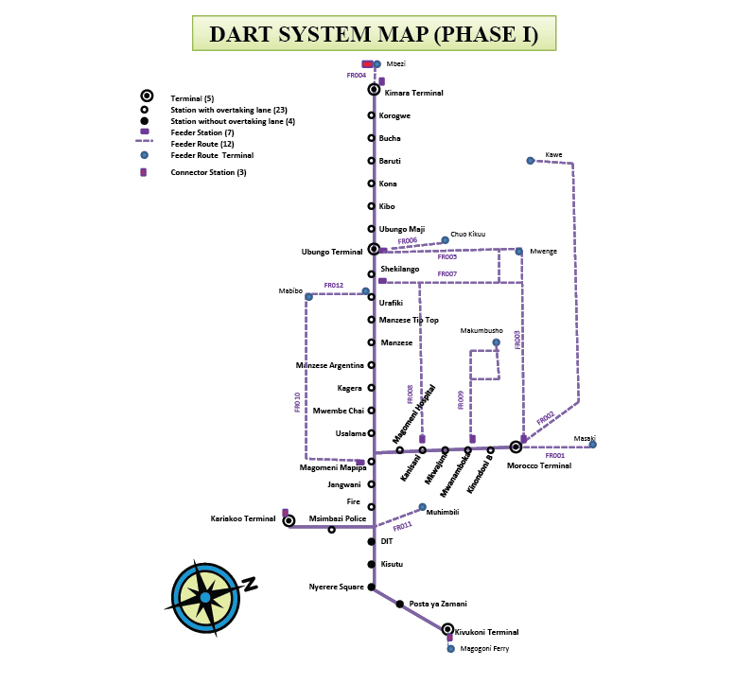
Study Area
Source: Chengula and Kombe (2017)

3.4 Study Population
The population is the items’ total number that requires information. It also indicates the set of elements or objects of interest to the researcher in the study(Murphy, 2016). The target population in this study comprised passengers of the DBRT system available at the selected 5 terminals which include Kimara, Gerezani, Morocco, Muhimbili, and Kivukoni terminal, and employees responsible for the daily operations of DBRT from DART Agency. However, the study excludedthe passengers who are not regular users of the system and visitors of the city to avoid inappropriate responses that may be obtained from their unfamiliarity with the DBRTsystem operations.

3.5 Sample Size
A sample is defined as a set of respondents selected from a larger population for a survey. It is simply a portion of the population and not all elements of the population(Kombo & Tromp, 2006). A sample size of 96 participants was used to achieve the study objectives. The sample selection was due to financial and time factors. The formula of Cochran (1977)is useful to calculate the sample sizeand was used to get a sample size of 96 respondents. The formula is given by;
n = $\frac{z^{2}pq}{e^{2}}$, n = $\frac{{\left(1.96\right)}^{2}(0.5)(0.5)}{{(0.1)}^{2}}$= 96.04 ~ 96,
Where: n = Sample size,
z = confidence level, q = 1-p, and
e = precision level = 0.1
P = population estimated attribute, p = 0.5
Z = 1.96 (95% C. level)

Table 3.1: Distribution of the Sample size
Population | Selected Sample Size | Data Collection Method
DART operational staff | 6 | Interviews
DBRT passengers (regular users) | 90 | Questionnaires
Total | 96
Source: Researcher (2021)

3.6 Sampling Techniques
This is an approach of getting individuals from the population for the study (Kothari & Garg, 2014). The study applied the simple randomsampling technique in selecting respondents (DBRT passengers) from the population. The simple random sampling technique was used as it gives the respondents equal chances to be selected or included in a sample(Kothari, 2004).
Also, the study applied the purposive sampling technique to select DART operational staff to be included in the sample for the study.The purposive sampling technique (also called judgmental sampling technique) entrusts the researcher with the decision on what item should be included or not based on the researcher’s decision or judgment (Kothari, 2004). The purposive sampling technique was used to select DART operational staff who had relevant information for the study.

3.7 Types and Sources of Data

3.7.1 Primary Data
Primary data are those data that are being collected by the researcher for the first time directly from the respondents (Kothari, 2004). Primary data have the character of being original as they come directly from the source. In obtaining the primary data, the researcher administered questionnaires to a selected sample of passengers of the DBRT system and also led interviews with the selected officers from the DART agency.

3.7.2 Secondary Data
Secondary data entails the kind of data which is collected from literature sources in relation to the research problem being studied or investigated(Kothari, 2006). The key sources for secondary data in this study were literature sources including published and unpublished materials such as research reports/dissertations, journals, and books.Secondary datawere useful since are easily obtained and they give the research a general overview of the topic studied.

3.8 Data Collection Methods
The researcher collected the primary data through questionnaires and interviews.

3.8.1 Questionnaires
A questionnaire is a research tool designed for statistical analysis of the responses consisting of a series of questions and other prompts to collect data from the respondents. They involve printed questions in a definite order, designed to answer research questions to meet research objectives (Gillham, 2008). In this study, the researcher prepared the questionnaires in English and Swahili language for commuters of the DBRT system, and 90 questionnaires of Likert scale questions, and multiple-choice questionswere administered to DBRT commuters.To get relevant DBRT commuters, the researcherfirst asked the commuters about their experience with the systembefore administering the questionnaires. Only those who commute regularly were permitted to fill the questionnaires and those who commute occasionally wereexcluded from the study.Questionnaireswere useful to this study since questionnaires acquire more information from numerous participants compared to other methods of data collection.

3.8.2 Interviews
An interview involves a set of questions that the interviewer asks when interviewing (Mugenda & Mugenda, 2003). Patton (2007) advocated that it enable participants to discuss their interpretations of the world in which they live and express how they regard the situation from their point of view and it is associated with a very high response rate.This technique involves the researcher’s attempt to get reliable and valid measures in the form of verbal responses from one or more respondents. In this study, an in-depth interview was used where the questions were asked in a consistent order. The researcher administered the interview in-person to six (6) DART operational staffto identify the challenges facing DBRT management in its day-to-day operations.

3.9 Measurement of Variables
The dependent and independent variables in this study will be measured as indicated in Table 3.2.

Table 3.2: Measurement of variables from the conceptual framework
Variable | Sub variable | Measurement
DBRT performance | - Savings in traveling time  - Reduced congestions  - Passengers Satisfaction | Likert scale of five-level scales (1=Strongly Agree, 2=Agree, 3=Not sure, 4=Disagree, 5=Strongly Disagree)
Time travel savings | - Fastness  - Total traveling times  - Speed of buses | Likert scale of five-level scales (1=Strongly Agree, 2=Agree, 3=Not sure, 4=Disagree, 5=Strongly Disagree)
Reliability of the service | - Travel time variability  - Service schedule changes  - Availability of buses | Likert scale of five-level scales (1=Strongly Agree, 2=Agree, 3=Not sure, 4=Disagree, 5=Strongly Disagree)
Cost-Effectiveness | - Fare affordability  - Ticketing system | Likert scale of five-level scales (1=Strongly Agree, 2=Agree, 3=Not sure, 4=Disagree, 5=Strongly Disagree)
Safety and Security | - Rate of accidents  - Theft cases  - DBRT cleanliness  - DBRT rules enforcement | Likert scale of five-level scales (1=Strongly Agree, 2=Agree, 3=Not sure, 4=Disagree, 5=Strongly Disagree)
The capacity of the buses | - Size of buses  - Number of buses  - Passenger crowding | Likert scale of five-level scales (1=Strongly Agree, 2=Agree, 3=Not sure, 4=Disagree, 5=Strongly Disagree)
Source: Researcher's construction (2021)

3.10 Data Processing and Analysis
Before data analysis, data wereentered, edited, and cleaned, and thereafter, data analysis was conducted. Data analysis is defined as the process of computing certain measures and searching the areas of the relationship that exists among several data groups. In this research data entry, coding, and data cleaning was done in the first place before performing the actual analysis. During the data analysis process, the nature of the study and types of data are major aspects of consideration (Kothari, 2004). The study applied both qualitative and quantitative methods in analysing the data. The researcher analysed quantitative data using descriptive methods. Descriptive statistical analysis (frequencies and percentages in tables and graphs) was used toanalyse the extent to which DBRT implementation has improved public transport in DSM city, and the factors affecting performance of the DBRT system. Moreover, qualitative analysis was used to analyse the challenges facing DBRT management in its day-to-day operations.
The analysis of data was performed by using the Statistical Package for the Social Sciences (SPSS) Statistics as well as Microsoft Excel to give frequencies and percentages through tables in the study.

3.11 Reliability and Validity Issues

3.11.1 Reliability
Reliability is a measure of how consistent the results from a test are. For the study to be reliable it must demonstrate similar results even when carried out on a similar group of respondents in a similar context (Kothari, 2004). To ensure the reliability of the data, the researcher assured the confidentiality of data which helped to get consistent results. Moreover, to ensure the reliability of the data, the researcher usedthe same sampling technique which assisted the researcher to collect data from reliable sources only. This was done by using purposive sampling to ensure that research instruments can only be administered to respondents who possessed the trait of the researcher’s interest.

3.11.2 Validity
Validity is evidence of the quality of a tool used in research to be correct, accurate, meaningful, and right (Kothari, 2004). The instrument used in this study was presented to experts and peers for discussions and comments.Moreover, the researcher conducted a pre-testing of 10 questionnaires to passengers to test whether they generate dresponses according to the intent of the question. Moreover, after the pilot test, questionnaires were improved ready for data collection.

3.12 Ethical consideration
Ethics in research is defined as the practice of doing what is morally and legally right in research (Cozby, 2007). The respondents were verbally informed on the significance of the study and for whom the findings were expected. Moreover, the researcher informed the respondents that they were free to withdraw their participation at any stage during the data collection process. Furthermore, the study assured that the given data cannot beused for some other purpose(s) and none of the participants can be identified by names in the report.

CHAPTER FOUR

DATA ANALYSIS AND FINDINGS

4.1 Introduction
This chapter analyses, interprets, presents, and discusses the gathered information. The research consisted of a sample size of 96 respondents whereby 90 respondents were DBRT passengers (regular users) who responded to the questionnaire administered, and 6 respondents were DART operational staffwho were interviewed. The first part presents the respondents’ background information and the second part presents the findings based on the study-specific objectives.

4.2 Demographic Information of the Respondents
The first part presents the background information of the respondents (DBRT passengers = 90 respondents). The researcher asked the respondents to respond on their personal information including gender, age, and employment status. Table 4.1 indicates the demographic information of the respondents.

Table 4.1: Demographic information of the respondents
Demographic | Category | Frequency | Percentages (%)
Gender | Male | 61 | 67.8
 | Female | 29 | 32.2
 | Total | 90 | 100
Age | 18-25 years | 25 | 27.8
 | 26-35 years | 44 | 48.9
 | 36-45years  46 years and above | 12  9 | 13.3  10
 | Total | 90 | 100
Employment status | Employed | 34 | 37.8
 | Self-employed | 31 | 34.4
 | Unemployed | 8 | 8.9
 | Student | 16 | 17.8
 | Retired | 1 | 1.1
 | Total | 90 | 100
Source: Field Data, 2021
Table 4.1 indicates the gender of the respondents. The gender attribute assisted the researcher to understand the gender distribution in the selected sample. Results show that most of the respondents 61 (67.8%) were males and 29 (32.2%) of the respondents were females. Findings show that from the selected respondents in the study, males were more than females. Moreover, results reveal that there was the participation of both males and females, this also depicts that there is an interaction of both male and female passengers in DBRT. The inclusion of both gender (male and female) is important as the study need to have a clear understanding of assessingthe factors affecting performance of Dar Es Salaam Bus Rapid Transit Project.
Also, the respondents’ age was studied. Results depicted that most respondents had the age between 26-35 years with 44 (48.9%) respondents followed by 18-25 years with 25 (27.8%) respondents,36-45 years with 12 (13.3%) respondents, and 46 years and abovewith 9 (10%). Results display that most44 (48.9%) respondents were in the working-age categories. These findings imply that BRT interacts mostly with passengers who are in the working-age group as this age group is active in the search for economic opportunities to ensure life goes, so they often use this transport regularly to get to their destinations.
Moreover, the studied employment status of the passengers, Results showed that 34 (37.8%) respondents were employed, 31 (34.4%) respondents were self-employed, 16 (17.8%) respondents were students, 8 (8.9%) respondents were unemployed, and 1 (1.1%) were retired. This gives the confidence that the responses of the sampled passengers are valid as the study includeddifferent categories of passengers with various occupations.

4.3 Travel Time Saving
The travel time saving is a significant benefit to the low-income passengers given that first,they weretypically facing very long travel times due to a combination of poor location and limited access to high-speed modes.Therefore, the study aimed to determine the influence of travel time saving on the performance of Dar Es Salaam Bus Rapid Transit project, thus, the selected passengers were asked to indicate whether the DBRT system offers faster-traveling speed (23 km/hr) compared to daladala, thewaiting time at the stop is short (schedule interval of 15 minutes), and DBRT gives convenient operating hours(from 5:00 am to 11:00 pm in seven days of the week).The findings of the study are indicated in Figure 4.1.

Figure 4.1: Travel Time Saving
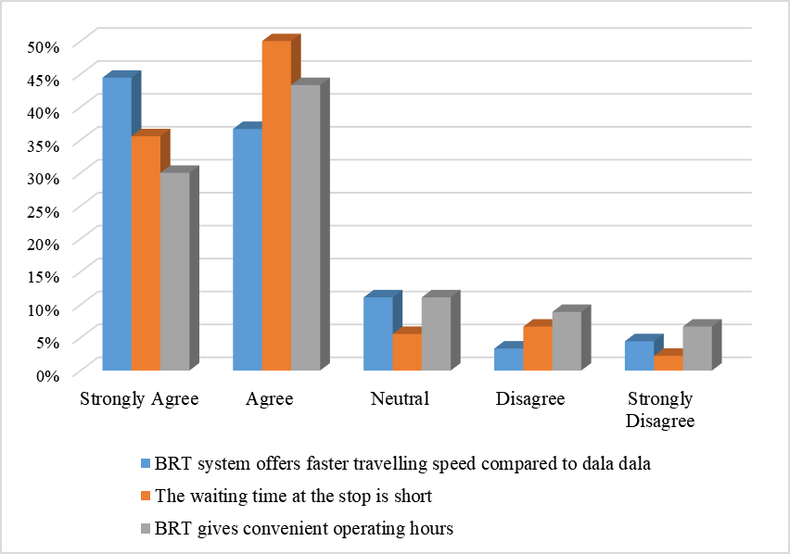
Source: Field Data, 2021

4.3.1 DBRT system offers faster travelling speed compared to daladala
As indicated by Morten et al. (2020), the faster travelling speed of BRT is around 23km/hr whereby the BRT buses spend around 39 minutes to reach the destination. Therefore, the study sought to determine whether the DBRT system offers a faster travelling speed (23km/hr)compared to daladala. Findings in Figure 4.1 show that 40 (44.4%) respondents strongly agreed, 33 (36.7%) respondents agreed, 10 (11.1%) respondents were neutral, 4 (4.4%) respondents strongly disagreed, and 3 (3.3%) respondents disagreed that DBRT system offers faster travelling speed (23km/hr) compared to daladala.
Findings reveal that most respondents 40 (44.4%) strongly agreed and agreed (33 (36.7%) that the DBRT system offers faster travelling speed compared to daladala.This is due to the fact that since the DBRT system uses its road system, thus, it is difficult for the buses to face jam challenges on the road, which ultimately remain the best options transport system for the passengers to reach their destinations.
These findings are supported by 65 (83.3%) respondents who indicated that DBRT buses travel at a speed that significantly reduces travelling time. Tiwari and Jain (2012) linked the travel time saved by Delhi DBRT mode and found that 33% of the time is saved by cyclists than bus users. Also, these results differ from those of Chengula and Kombe (2017) where the introduced DBRT in Bogota in 2004 reduced travel time by 32%.
The main thing that sets the speed difference between the BRT buses and the daladala is that the BRT buses pass on their own route which does not interfere with other vehicles thus avoiding the queue that the daladala encounters on the normal route. Dalada also has a system for calling passengers to each station so they sometimes have to stay in one station for a long time to get more passengers and make the trip take longer than required. Moreover, one of the operational officersfrom DART claimed that;
"DBRT system has played a vital role in helping DSM employees enjoy travel time at the right time. For example, before the introduction of the DBRT system, on average, from Mbezi to Kivukoni with Daladala, travelers used to spend 3 to 4 hours on the road. But today, with the DBRT system on the same track, passengers only need to spend 30 to 45 minutes on average."
These findings are in line with Chengula and Kombe (2017) whereby BRT buses travel at a speed that significantly reduces travelling time.This implies that for low-income travelers, saving travel time is a great advantage because they usually face a long travel time due to poor geographic location and restrictions on high-speed modes.

4.3.2 The waiting time at the stop is short
As indicated by Chengula and Komba (2017) the study waiting time at the terminals is on the schedule interval of 15 minutes. Therefore, the study aimed to know if this interval of 15 minutes is attained.Findings in Figure 4.1 show that 45 (50%) respondents agreed, 32 (35.6%) respondents strongly agreed, 6 (6.7%) respondents disagreed, 5 (5.6%) respondents were neutral, and 2 (2.2%) respondents strongly disagreed that waiting time at the stop is short. Findings reveal that most45 (50%) respondents agreed that waiting time at the stop is short.Therefore, these results imply that this interval of 15 minutes is attained. The purpose of the DBRT service is to lessen the passengers’ travel time to increase the service attractiveness. However, one of the DART operational staff in the interview argued that;
“Sometimes passengers stay too long at the stations and terminals waiting for the buses. The buses are not always available at the time required by passengers especially at midday, and Sunday’s whereby few numbers of buses operates compared to other days in a week and compared to the morning and evening time.”

The system's unreliability was also indicated, particularly during peak hours, when bus drivers are more likely to skip bus stops. This is due to a lack of transparency as well as a general decrease in customer service.
Also, another, staff argued that;

“Despite the reduced travel time on the DBRT route, there are some delays at the stops due to off-peak hours (1200 to 1500 hours) and long wait times on weekends.”

In the interview with one of the staff, the researcher asked about sticking to the schedule during peak hours, the officer admitted that;

“With few passengers and empty bus, the three-hour bus running from 1,200 to 1,500 hours is not cost-effective. Recently, the schedule for bus arrivals to the terminals /stations during peak hours has been extended to 25 minutes, but it has not been officially specified in the schedule. To reduce passenger confusion, it is important to accurately view schedules during peak hours and weekends.”

These findings imply that DBRT services satisfy most passengers as the DBRT timetable gives passengers accessibility to services during friendly hours. In the research by Loyde (2020), the researcher observed that DBRT buses do not spend more than thirty seconds in the terminals. The travel time saving is a significant benefit to the low-income passengers given that they typically face very long travel times due to a combination of poor location and limited access to high-speed modes.
These findings were also in line with Chengula and Kombe (2017) where the majority of the respondents agreed that the existence of the system of DBRT has decreased the time travel from 1 hour and a half to 39 minutes compared to the earlier system of daladala. Also, some of the respondents (31%), argued that to reduce waiting time more and more, the planned waiting time at the terminals should be reduced from 15 minutes to 10 minutes. This can only be possible if the number of buses in the operation is sufficient and the timetable is followed by the drivers.

4.3.3 DBRT gives convenient operating hours
The DBRT operates from 5:00 am to 11:00 pm on seven days of the week. The study sought to determine whether DBRT gives convenient operating hours. Findings in Figure 4.1 show that 39 (43.3%) respondents agreed, 27 (30%) respondents strongly agreed, 10(11.1%) respondents were neutral, 8 (8.9%) respondents disagreed, and 6 (6.7%) respondents strongly disagreed that DBRT gives convenient operating hours. Findings reveal that most respondents agreed that DBRT gives convenient operating hours. These findings imply that DBRT services satisfy most passengers as the DBRT timetable gives passengers accessibility to services during friendly hours. Therefore, the operating hours from 5:00 am to 11:00 pm on seven days of the week seemed to be friendly to passengers. These hours might be convenient due to the fact many Dar Es Salaam residents start trips to their work/business areas and return to their homes within this time interval.
These findings are different from the findings of Mwatawala, (2019) who indicated that travelers spending too much time at bus terminals. As a result, passengers do not board on time due to overcrowding or a lack of buses on the road, lengthening the waiting time.
Since the DBRT system operates almost at a convenient time (from 5:00 am to 11:00 pm in seven days of the week), then, this system gives passengers the opportunity to feel free to carry on their activities without fear of the unavailability of guaranteed transportation to their terminals. Therefore, this might imply that DBRT services satisfy most passengers as the DBRT timetable gives passengers accessibility to services during friendly hours.

4.4 Reliability of the Service
Service reliability is the ability of transit operators to maintain operations schedules at a constant level that customers can feel satisfied. However, customers can feel unreliable service when bus arrival times are not as scheduled or when travel times are highly variable and unpredictable (Chengula&Komba, 2017). The study aimed to examine the influence of the reliability of the service on the performance of Dar Es Salaam Bus Rapid Transit project. Therefore, respondents were asked to state whether the bus travel service is frequent (available in 24 hours), there is a satisfying number of buses in the daily operation, and the number of routes that DBRT operates is satisfied.The findings of the study are indicated in Figure 4.2.

Figure 4.2: Reliability of the Service
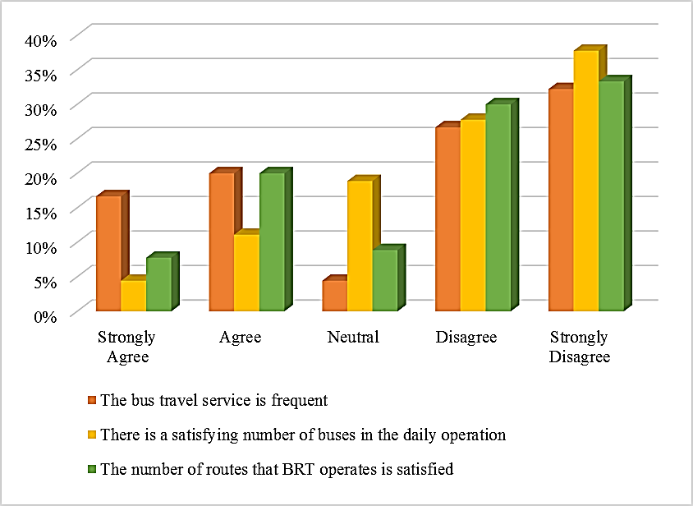
Source: Field Data, 2021

4.4.1 The frequency of the bus travel service (Available in 24 hours)
The study intended to examine whether the bus travel service is frequent. Findings in Figure 4.2 show that 29 (32.2%) respondents strongly disagreed, 24 (26.7%) respondents disagreed, 18 (20%) respondents agreed, 15 (16.7%) respondents strongly agreed, and 4 (4.4%) respondents were neutral that the bus travel service is frequent (available in 24 hours). Findings reveal that most respondentsstrongly disagreed that the bus travel service is frequent (available in 24 hours), thus, these results reveal that the bus travel service is not frequent.This is an indisputable fact as BRT buses start providing services from 4:30 am to 11:00 pm, thus posing a challenge to some residents whose activities last until midnight. Also, for any emergency that may arise for the passenger from the moment the services are stopped, he or she will have to use another form of transport such as bodaboda or bajaji or tax to reach the point of destination which may increase transport cost compared to BRT. This gives them a challenge as when they have to return home after completing their activities, they have to spend a lot of money on the fare to reach the point of their destination. One of the staff from DART during the interview claimed that;
“Sometimes DBRT service is not frequently due to the small number of buses in the operation. Also, some of the buses are not in operation because of breakdown while others are not repaired in time.”
Also, another staff argued that “We have a hard time waiting at the station because the busestake so long to get to the stations”

These findings imply that there is some delay in getting DBRT services as most of the respondents were not much satisfied with the services offered. Also, these findings can be linked with most respondents who strongly disagreed that there is a satisfying number of buses in the daily operation.Also, as indicated by the Tanzanian citizen newspaper on Wednesday, July 14, 2021, DBRT operators were planning to buy 95 buses in the first phase to attain the expected number of buses, however, there were still 70 buses in the Tanzania Port Authority (TPA). When the 70 DBRT buses start running after they were released from TPA, the UDARTplanned to establish new feeder routes, putting an end to commuters' nightmare. According to the managing director of UDART John Nguya, phase one of the BRT was planned to include 11 routes, but due to a scarcity of buses, not all of them were used. Phase oneof BRT was scheduled to feature 305 buses, but only 140 were really operational. As a result, the addition of 70 new buses will bring the total number of buses to 210, allowing for more routes such as routes of Mwenge-Morocco, Mbezi-Kibaha through Maili-Moja, Magomeni-Kigogo through Ubungo, Morocco-Kawe, Morocco-Masaki and the route from Morocco-Mwenge were not executed since the buses were not enough.
Likewise, these findings are also in line with Dewi (2010)who found out that travel reliability is among one of the very vital factors that travelers consider in selecting means of transport.
Due to the city's road traffic congestion, Daladala's travel time and waiting time are longer. DBRT waiting time is short because they use dedicated runways, system delays only occur at intersections, and boarding time at stations/Terminals.
According to Satiennam et al. (2006) in their study, a high service level is due to shorter headways, or high service frequency, which allows customers to make judgments about whether or not to use the system. In fact, the length of time consumers must wait for service at the terminals has an impact on their route planning.
Therefore, these findings imply that the service of DBRT is not as frequent to the passengers as most of them indicated, thus, this infrequency of the service may somehow compel passengers to opt for another mode of transport such as bodaboda and bajaji to save time.

4.4.2 Number of buses in the daily operation
The study intended to examine whether there is a satisfying number of buses in the daily operation. Findings in Figure 4.2 show that 34 (37.8%) respondents strongly disagreed, 25 (27.8%) respondents disagreed, 17 (18.9%) respondents were neutral, 10 (11.1%) respondents agreed, and 4 (4.4%) respondents strongly agreedthat there is a satisfying number of buses in the daily operation. Findings reveal that most respondents strongly disagreed that there is a satisfying number of buses in the daily operation.These findings imply that most of the respondents were not satisfied with the number of buses in operations. Also, most of the available buses are not in operation becausethey are damaged and hence result ina shortage of buses in operations. These findings were also justified by one of the staff from DART during the interview who claimed that;

“As for the DBRT, in order to ensure bus repeatability, buses leave the terminal and terminal every 15 minutes. Since the project intends to have 305 buses, but there are only 140 buses in operation, the small number of buses in operation also speeds up the reduction in the frequency of buses at the terminal.”

Also, another staff from DART argued that;
“It is hoped that before the end of 2021, there will be another bus operator with more buses than presently, and hence passengers may travel with more comfortable than it is in this transition period, passengers should expect the tremendous service changes just in few days to come”

Resultsshow that there are not enough buses that operate under the DBRT system that do not meet the travel needs of running a DBRT. As a result, passengers complained about unreliable service due to delays and buses failing to meet the expected level of service. This would affect the reputation of the system for passengers, as some passengers decided to use traditional means of transportation, such as city buses (Daladala), or motorcycles (Bodaboda), and tricycles (Bajaj).
More buses should be available to lower total commuting time, as demonstrated by Okagbue et al. (2015) study on "Motivation and obstacles faced by commuters using BRT in Lagos, Nigeria." Amiegbebhor et al. (2014) investigated the effect of bus rapid transit on commuter satisfaction in Lagos, Nigeria, and discovered that a lack of buses was a major issue. The findings of their studies show how the shortage of buses in operations devalues the BRT system because of system failures to meet the objectives and goals of improving transportation services in contrast to other forms of land transport. The system might be good but when the buses in operations are not enough, most of the passengers are congested in the main terminals or stations waiting for the buses to reach their destinations and this may prove the failure of the project.

4.4.3 Number of routes in the DBRT operations
The study intended to examine whether the number of routes that DBRT operates is satisfied. Findings in Figure 4.2 show that 30 (33.3%) respondents strongly disagreed, 27 (30%) respondents disagreed, 18 (20%) respondents agreed, 8 (8.9%) respondents were neutral, and 7 (7.8%) respondents stronglyagreed that the number of routes that DBRT operates is satisfied. Findings reveal that most respondentsstrongly disagreed that the number of routes that DBRT operates is satisfied.For example, the route from Airport to Uhuru Street along Nyerere, the route along Bagamoyo Road, and Sam Nujoma were not established.The absence of these routes leads to a lack of connection with other established routes. These findings were also justified by one of the staff from DART during the interview who claimed that;
“As part of the remote path is not linked with the main DBRT path, the DBRT system has not yet been completed. The first stage of the DBRT network has apparently been completed on the truck street and has been connected to some nearby roads.”
Also, another staff argued that;

“Certain areas of Dar es Salaam (such as Buguruni, Mwenge, and Bagamoyo highways) do not have DBRT roads, so if someone wants to go to these areas, they have to use other means of transportation other than DBRT bus services. The DBRT system is not yet complete. In this system, some remote paths are not associated with the main DBRT path. The expected phase of the DBRT network has been completed on truck aisles and connected to some adjacent bypass roads.”

These results reveal that number of routes in the DBRT project is not sufficient as some areas are not covered yet. An insufficient number of routes results in this project impacting passengers in the established routes. However, since, there are other phases in this project, thus, it is expected that the coming phases of the project can cover a large part of society.
Although respondents showed that the number of routes that DBRT operates is satisfied, still part of the remote path is not linked with the main DBRT path, the DBRT system has not yet been completed. The first stage of the DBRT network has been completed on the truck street and has been connected to some nearby roads.
The results of this study are also supported by Ahferom and Svensson (2009) as they believed that for a DBRT system to have a viable life cycle cost and sustainable projects, a connection must be established between the DBRT truck road and the main road as well as remote areas. In their study when asked whether a DBRTstation is easily accessible for transportation, only 48% of the respondents agreed, stating that it is necessary to establish an immediate connection between the DBRT truck road and the minor road and establish routes to remote areas. However, it takes most of the passengers 20 minutes to reach the DBRT station or terminals, because most DBRT stations or terminals are not aligned with the stands, stops, or other platforms.

4.5 Security and Service
The transport system with lower rates of accidents and fatalities to passengers, staff, and other users is perceived as it operates in a good performance, while the one with increasing incidents of accidents and fatalities is perceived as it operates under a low performance. This study aimed to identify the influence of security and safety on the performance of Dar Es Salaam Bus Rapid Transit project. Therefore, respondents were asked to state whether commuters are comfortable with safety in the bus, the rate of accidents and fatalities have reduced, camera in buses has reduced theft and pickpocketing, and commuters enter into DBRT buses at a bus stop in a proper way.The findings of the study are indicated in Figure 4.3.

Figure 4.3: Security and Service
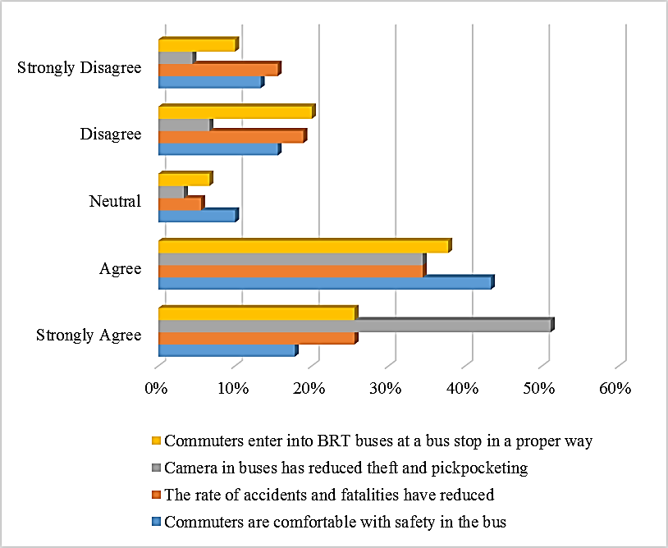
Source: Field Data, 2021

4.5.1 The comfortability of commuters in the bus
The study aimed to identify whether commuters are comfortable with safety in the bus. Findings in Figure 4.3 show that 39 (43.3%) respondents agreed, 16 (17.8%) respondents strongly agreed, 14 (15.6%) respondentsdisagreed, 12 (13.3%) respondents strongly disagreed, and 9 (10%) respondents were neutralthat the commuters are comfortable with safety in the bus. Findings reveal that most respondents agreed that commuters are comfortable with safety in the bus.This shows that commuters using DBRT feel safe compared to daladala and bodaboda due to the high number and frequency of traffic accidents caused by careless bodaboda and daladala drivers.
Based on the results, most respondents believed that DBRT was safe for them, while a few respondents claimed that it was not. The aim of implementing the DBRTproject was to minimize traffic congestion, vehicle-related fatalities, accidents, and disabilities, as well as pollution in the environment. DBRT system implies safety since, theDBRT uses separate lanes, which means there are fewercollisions with other cars, but the speed is still low enough to cause accidents. The response from one of the selected DART officers also supported the results from the passengers by claiming that;
“Special groups such as the disabled, pregnant women, and the elderly have a special seat. Officer also stated that these vehicles have been adapted for use by the elderly, children, and the disabled, and provide space for wheelchairs. By ensuring that private groups sit in private seats and have special people to help the handicapped, special groups are given special priority.”
Also, another staff stated that;
“The DBRT system has notemporary toilets at the stops, this may hinder the DBRT effectiveness in terms of customer comfortability.”
In their research "Passengers' Satisfaction, Driver, and Bus Scheduling," Kayode et al. (2008) found similar results. Based on the study's findings, 63% of commuters were pleased with the comfort level offered by the DBRT system, owing to the existence of new buses that were giving services. These results differed from those ofIles (2005), who reported a high level of public discomfort with the quality of public transportation systems in many developed nations.
Overcrowding was also mentioned as a discomfort source in a study done by Batarce et al. (2015) in Santiago, Chile on public transportation. Overcrowding may make it difficult for non-captive passengers to switch to BRT, thwarting efforts to reduce traffic congestion and emissions. If DBRT intends to attract more diverse passengers and help reduce traffic congestion in a city that is now plagued by it, this problem must be addressed.
Therefore, commuters' comfortability is a critical feature of every public transit system, since it is what attracts people to use it. As a result, there is a need to align public vehicles with environmental standards.

4.5.2 The rate of accidents and fatalities
The study aimed to identify whether the rate of accidents and fatalities has reduced. Findings in Figure 4.3 show that 31 (34.4%) respondents agreed, 23 (25.6%) respondents strongly agreed, 17 (18.9%) respondents disagreed, 14 (15.6%) respondents strongly disagreed, and 5 (5.6%) respondents were neutral that the rate of accidents and fatalities have reduced. Findings reveal that most respondents agreed that the rate of accidents and fatalities has reduced.The findings are also supported by one of the DART officers argued that;
“The buses are driven by well-trained and qualified drives and their recruitment process is very competitive. This is made so to further improve the safety of travel for our esteemed passengers”

Also, another DART officer argued that;

“The number of accidents has reduced significantly compared to when DART started. Many accidents occur at the intersections, mostly because of drivers' reckless and others unlawful driving along the DART corridor and other road users passing on restricted areas of the road. Since it started in May 2016, a total of 837 accidents have been recorded, where it involves 20 fatal, 122 major accidents and other 695 minor accidents”.

Also, some of the DART officers indicated that the number of accidents has reduced significantly compared to when DART started. Many accidents occur at the intersections, mostly because of drivers' reckless and others unlawful driving along the DART corridor and other road users passing on restricted areas of the road. Since it started in May 2016, a total of 837 accidents have been recorded, where it involves 20 fatal, 122 major accidents, and 695 minor accidents.
However, as per Matata et al. (2017), in the first months of DBRT operations, a significant number of accidents involving DBRT buses and private vehicles, daladala, cruisers, and tricycles were reported. When respondents were asked to list the factors that contribute to traffic accidents, the most prominent factor was identified as Jay-people on foot (30 percent), followed by Jaydrivers, especially those who ride bikes (25 percent). Generally, this is because the DBRT system was new, and pedestrians and drivers were unfamiliar with the system's regulations and rules. On the other hand, the lack of formal driving training for drivers was also a source for such accidents.

4.5.3 Camera in buses has reduced theft and pickpocketing
The study aimed to identify whether the camera in buses has reduced theft and
pickpocketing. Findings in Figure 4.3 show that 46 (51.1%) respondents strongly agreed, 31 (34.4%) respondents agreed, 6 (6.7%) respondents disagreed, 4 (4.4%) respondents strongly disagreed, and 3 (3.3%) respondents were neutral that camera in buses has reduced theft and pickpocketing. Findings reveal that most respondents strongly agreed that camera in buses has reduced theft and pickpocketing. One DART officer during the interview responded that;

“Safety of our passengers is paramount in our travel service delivery. The designing of passenger footbridges, high ventilation stations, and special areas for those with disabilities, is one of the safety measures taken by the DART Agency. Again, to protect passengers from pickpockets and robbery at the stations, DART Agency has procured a China Security Company, which provides security service at around all stations. Also, the Police Officers assist with checking the safety of passengers at all 5 terminals.”

Findings reveal that the DBRT system has reduced theft and pickpocketing as there is a security system in the buses which can somehow track the activities of passengers. This may give passengers the confidence to have faith inthe DBRT system.

4.5.4 Commuters enter into DBRT buses at a bus stop in a proper way
The study aimed to identify whether commuters enter into DBRT buses at a bus stop in a proper way. Findings in Figure 4.3 show that 34 (37.8%) respondents agreed, 23 (25.6%) respondents strongly agreed, 18 (20%) respondents disagreed, 9 (10%) respondents strongly disagreed, and 6 (6.7%) respondents were neutral that commuters enter into DBRT buses at a bus stop in a proper way. Findings reveal that most respondents agreed that commuters enter into DBRT buses at a bus stop in a proper way.These results differed with Kalokola (2019)who reported that commuters enter buses at bus stops in an improper or arranged manner, particularly during peak hours when the terminals are crowded. Some passengers were seriously injured as a result of attempting to board buses at bus terminals or stations.

4.6 The Capacity of Buses
The transport system that matches the passengers traveling demands signifies good performance, but the transport system is incapable of meeting the travel demand, creating passenger overcrowding at stations and in buses. The capacity of any public transportation system is a critical factor in determining DBRT efficiency. Based on this research, capacity was described as the amount of space available within buses, stations, or terminals during the day, particularly during peak hours (morning and evening). This study aimed to determine the influence of the capacity of the buses on the performance of Dar Es Salaam Bus Rapid Transit project. Therefore, respondents were asked to state whether DBRT buses have enough space, DBRT buses are overcrowded, and DBRT buses can accommodate passengers all the time.The findings of the study are indicated in Figure 4.4.
Figure 4.4: The Capacity of Buses
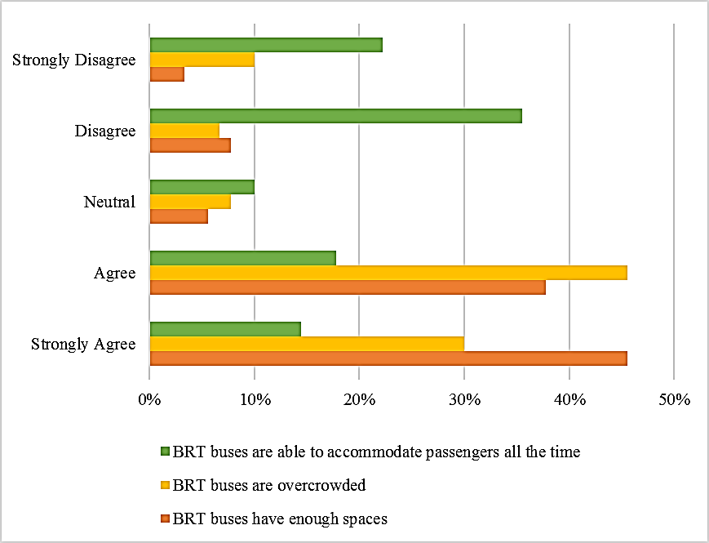
Source: Field Data, 2021

4.6.1 The Capacity of Buses
The study aimed to know whether the DBRT buses have enough space. Findings in Figure 4.4 show that 41 (45.6%) respondents strongly agreed, 34 (37.8%) respondentsagreed, 7 (7.8%) respondents disagreed, 5(5.6%) respondents were neutral, and 3 (3.3%) respondents strongly disagreed that the DBRT buses have enough spaces. Findings reveal that most respondents strongly agreed that the DBRT buses have enough space.
Although DBRT buses have enough space, findings also show that the DBRT buses are overcrowded. Some DART officers also, claimed that the shortage of buses for the project may exacerbate the problem because the first phase of the project should have contained 305 buses in operation, but unfortunately there were only 140 buses, which caused public dissatisfaction. However, some of the 140 buses were unable to operate after a crash or damage. Due to the shortage of buses in this project, overcrowding of buses is inevitable.
These results differ from the results by Kalokola (2019) who indicated that there is insufficient space inside the buses. Mass transit buses have to be distinctly designed and delineated and bring sufficient passenger capacity, lowfloors for easy traveler access, multiple doors, and sufficient interior air circulation. Also, the researcher during the study particularly in peak hours (morning and evening)noticed that DBRT buses were more overcrowded with passengers, resulting in minimal air circulation within the buses.

4.6.2 The DBRT buses are overcrowded
The study aimed to know whether the DBRT buses are overcrowded. Findings in Figure 4.4 show that 38 (42.2%) respondents agreed, 27 (30%) respondents strongly agreed, 12 (13.3%) respondents strongly disagreed, 7(7.8%) respondents were neutral, and 6 (6.7%) respondents disagreed that the DBRT buses are overcrowded. Findings reveal that most respondents agreed that the DBRT buses are overcrowded. These findings are supported by one of the DART officers who claimed that;

“The shortage of buses for the project may exacerbate the problem because the first phase of the project should have contained 305 buses in operation, but unfortunately there were only 140 buses, which caused public dissatisfaction. However, some of the 140 buses were unable to operate after a crash or damage. Due to the shortage of buses in this project, overcrowding of buses is inevitable.”

Therefore, these results show that the shortage of buses in the operation is the critical factor for overcrowding of passengers in the stations or terminals. Therefore, these results imply that there is a possibility of reducing overcrowding in the stations/ terminals if and only if the number of buses in the operations increases to fit the population of passengers in the terminals/stations.

4.6.3 The DBRTBuses and Accommodation of Passengers all the Time
The study aimed to know whether the DBRT buses can accommodate passengers all the time. Findings in Figure 4.4 show that 32 (35.6%) respondents disagreed, 20 (22.2%) respondents strongly disagreed, 16 (17.8%) respondents agreed, 13 (14.4%) respondents strongly agreed, and 9 (10%) respondents were neutral that the DBRT buses can accommodate passengers all the time. Findings reveal that most respondents disagreed that the DBRT buses can accommodate passengers all the time. Since the number of buses in the operation is not sufficient, then, the possibility to accommodate all passengers especially during the morning and evening time is a nightmare.
Also, Kalokola (2019) noticed a shortage of passenger benches in the mid-terminals when researching the field. The shortage of essential facilities such as benches when waiting for the bus affects the passengers' comfort and convenience. This shows that even the sitting facilities in the stations/terminals are not sufficient to serve all passengers.

4.7 The Cost-Effectiveness
The affordability of transport cost is a very important aspect in every means of transport. Among the target of introducing the DBRT system is to reduce transportation costs and increase the efficiency of transportation services. The target of this study is to examine the influence of cost-effectiveness on the performance of Dar Es Salaam Bus Rapid Transit project. Therefore, respondents were asked to state whether the transport fare is affordable, the smartcards are still used as a ticketing system, passengers are getting tickets conveniently within a short time period, and DBRT has helped to reduce travelling costs compared to other means of transport.The findings of the study are indicated in Figure 4.5.

Figure 4.5: Cost-Effectiveness
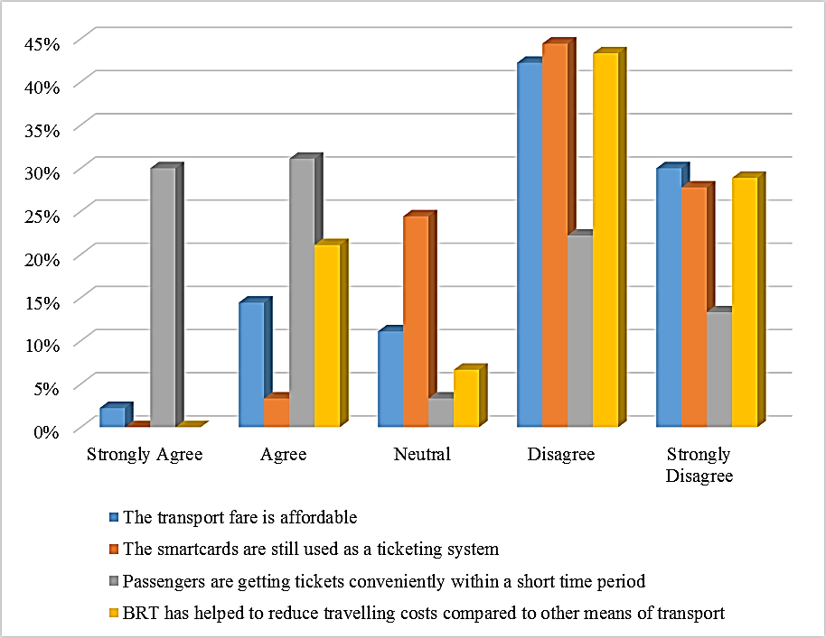
Source: Field Data, 2021

4.5.1 The transport fare is affordable
The study aimed to know whether the transport fare is affordable. Findings in Figure 4.5 show that 38 (42.2%) respondents disagreed, 27 (30%) respondents strongly disagreed, 13 (14.4%) respondents agreed, 10(11.1%) respondents were neutral, and 2 (2.2%) respondents strongly agreed that the transport fare is affordable. Findings reveal that most respondents disagreed that the transport fare is affordable. These findings imply that the given fare is not affordable to most passengers, since, this DBRT project is expected to improve the public transport services including travelling expenses, then, unfriendly fare amount can reflect the low performance of the project.
According to The Citizen newspaper, which published an article titled “Why DBRT System Excludes the Poor” on Saturday, January 26, 2019, the poor were already stuck in traffic on cheaper buses every day. The alternative to cutting traveling time by two hours a day is for passengers who have a sufficient income to pay a higher fare. Because the DBRT rate is then considerably higher than that used by minibusses or daladala, some passengers are benefiting from the DBRT scheme. Some of the passengers choose to stay at the local commute (daladala), to save fuel, for they are unable to afford the Tsh 650.

4.5.2 Smartcards as a ticketing system
The study aimed to know whether the smartcards are still used as a ticketing system. Findings in Figure 4.5 show that 40 (44.4%) respondents disagreed, 25 (27.8%) respondents strongly disagreed, 22 (24.4%) respondents were neutral, and 3(3.3%) respondents agreed that smartcards are still used as a ticketing system. Findings reveal that most respondents disagreed that the smartcards are still used as a ticketing system. These results show that most of the smartcards are currently not used as a result of the broke-down of smartcard machines.
Currently, smartcard machines are not used as most of them are technically damaged. According to The Citizen, newspaper of Monday, June 20, 2019, titled “UDART introduces smart card system today” state the smart card system was introduced to relieved passengers of DBRT from scrambling for a ticket from a single window at the bus stop. The introduction of these smart cards was anticipated to reduce queues and improve the payment system.
Under smart card, system passengers were activating their cards with a minimum amount of Tsh 5,000 and a maximum amount of Tsh 30,000. However, the numbers of smart cards were not enough to satisfy the number of all passengers, only a few passengers obtained these cards. The smart-card machine (Swapping machines) was not last long as many of these machines broke down, brought back all passengers to a very local system of ticketing which also led to delays especially during peak hours.

4.5.3 Passengers are getting tickets conveniently within a short time period
The study aimed to know whether the passengers are getting tickets conveniently within a short time period. Findings in Figure 4.5 show that 28 (31.1%) respondents agreed, 27 (30%) respondents strongly agreed, 20 (22.2%) respondents disagreed, and 12 (13.3%) respondents strongly disagreed, and 3 (3.3%) respondents were neutral that the passengers are getting tickets conveniently within a short time period. Findings reveal that most respondents agreed that the passengers are getting tickets conveniently within a short time period.
These findings are different fromthe findings byMwatawala (2019) who indicated that there is the ticketing system was well organized to enhance the passengers to enjoy the transport services. Also, When Ugo (2014) examined the service quality dimension of commuter uptake in Cape Town, South Africa, he discovered that information about where to get cards is a source of unhappiness among commuters. Passengers may be lost due to difficulties in obtaining or reloading cards. As a result, a convenient BRT system would be one in which purchasing tickets/cards is simple.

4.5.4 DBRT and travelling costs
The study aimed to know whether the DBRT has helped to reduce travelling costs compared to other means of transport. Findings in Figure 4.5 show that 39 (43.3%) respondents disagreed, 26 (28.9%) respondents strongly disagreed, 19 (21.1%) respondents agreed, and 6 (6.7%) respondents were neutral that the DBRT has helped to reduce travelling costs compared to other means of transport. Findings reveal that most respondents disagreed that the DBRT has helped to reduce travelling costs compared to other means of transport.The reason behind is that daladala buses on average charges a bus fare of TZS 400/- for shorter distance and up to TZS 500/- for longer distance whilst DART system charging the flat fare of TZS 650/- along the same routes respectively. This rate is higher than that charged with daladala buses.
In the interview, one of the DART officers stated that;
"The bus fare structure in the DART system is not grounded on kilometers or distance but is based on a fixed fare system. Also, the fare is set by LATRA (formerly known as LATRA). The bus fare is fixed at 650 TZS /-It is equivalent to 0.28 USD (2300 TZS/USD) of the main trunk of the car, no matter how far the travel distance. Daladala fare ranges from 400 TZS to 500 TZS, which is equivalent to 0.17 USD to 0.21 USD, which is the same as provided by DART,it’s cheaper compared to the price of the country. However, with DBRT, passengers can travel quickly, comfortably, and reliably."
These results are in line with Hidalgo and Yepes (2005), who indicated that gross daily savings for passengers who would have paid two fares on the traditional system were in the range of 8% to 12% of low-income households’ average daily income in Bogotá. However, this does not apply to all potential low-income travelers. As opposed to a single fare ride, the traditional bus system is less expensive than the DBRT system since the DBRT system uses a formalized trip fare, which is more expensive.
In a simulation of commuter preference for DBRT, Nkurunziza et al. (2012) found that lower charges attract customers, resulting in the sustainability of public transportation services. According to Nhundu (2013), who evaluated Zeithaml et al. (2006)'s study, affordability is related to a customer's perception of the service's affordability. Customers' decision-making and affordability are linked. In this context, Okagbue et al. (2015)have advocated for a fares review as one of the ways to alleviate commuting problems.
Therefore, these findings expose that the travelling costs in the DBRTsystem are not cheap compared to other means of transport as most of the respondents argued during the study. The BRT fares must be low compared to other means of transport to accelerate the demand of DBRT over other means of transport.

CHAPTER FIVE

CONCLUSION AND RECOMMENDATIONS

5.1 Introduction
This chapter presentsthe conclusion of the study based on the findings as well as recommendations of the study.

5.2 Conclusion
The general objective of this study is to assess the factors affecting performance of Dar Es Salaam Bus Rapid Transit Project in Tanzania. The study concludes that the introduction of a DBRT system in Dar es Salaam is a viable project, particularly when properly managed. It is best to manage DBRT system performance based on performance-related factors, such as reliability, travel time savings, capacity, safety and security, and cost-effectiveness. The study concludes that reliability, travel time savings, capacity, safety and security, and cost-effectiveness of the transport services are very significant factors for the performance of the DBRT system. The passengers are pleased with the high quality of transport services including the time taken in one route, comforts, security, and safety, thus, missing these important factors, the transportation system is considered to operate underperformance. The results of data analysis show that, according to the opinions of the interviewees, the DBRT system performs poorly in certain areas. Although boarding delays in buses have been reduced to a certain extent, sometimes the waiting time at the bus station is not short, so due to the small number of buses in operation, they sometimes wait for a long time in the terminal/ station. Also, the small number of buses in operation is the keyaspect affecting the performance of the DBRT.
Moreover, the study concludes that the introduction of the DBRT system has noticeable benefits in terms of improving the current public transport supply. However, some shortcomings have been discovered that limit the role of the system in promoting the development of a sustainable urban transportation system in cities. These shortcomings are reflected in the unfair distribution of services among population groups where some areas have no access to this DBRT project until the expected next phases are complete.

5.3 Recommendation
First, the research suggests that LATRA and other government institutions should be fully involved in identifying and selecting new bus operators so that their next phase can be easily managed through reliable services.
Second, the research suggests that the DBRT management should increase the number of buses to reduce the congestion at the bus terminals, particularly in peak hours.
Third, the fare of 650 Tanzanian shillings should be revised to make it affordable for all passengers of all income levels; this will allow them to choose only one DBRT service. When the government plans to invest in the second phase of the DBRT, it must take into account people's multiple price structures on this DBRT system.
Fourth; for the sustainability of the DBRT service, the DBRT project should be extended to other areas (such as Kibaha to Chalinze, and Bagamoyo road). Also, the study suggests that the DBRT management should repaired damaged DBRT infrastructure such as ticketing system by using smart-card, and other infrastructures in the bus.

5.4 Area for further research
Further research should be conducted to see how technology, political factors, and financial capacity enhances the performance of the DBRT services since most of the infrastructures such as smart-card machines and terminals were left unrepaired.

REFERENCE
African Development Bank (ADB. (2012). “Transport Sector Assessment, Strategy, and Road Map in Philippines.” Publication Stock No. RPS124914. https://doi.org/978-92-9092-855-3
African Development Bank (ABD). (2015). DAR ES SALAAM BUS RAPID TRANSIT PROJECT:ENVIRONMENTAL AND SOCIAL IMPACT ASSESSMENT SUMMARY.
Agarbattiwala, T. V, & Bhatt, B. V. (2016). Performance Analysis of BRT System Surat. International Journal of Engineering Research, 5(6), 519–523.
Ahferom, M. T., & Svensson, M. G. E. (2009). Closing the Commute Gap: Evaluationof Bus Rapid Transit in Tanzania. Lund University, Sweden.
Alfred, R., & Kaijage, S. F. (2019). Design of an Integrated Android Mobile Application and Web-Based System (IAMA-WBS) as a Solution to Concerns of Passengers Using Bus Rapid Transit System for Public Transportation in Dar Es Salaam. Int. J. Inf. Technol. Comput. Sci, 11(2), 30–37.
Alphonse, N. (2008). Analysing Commuters’ Attitudes towards the Proposed Bus Rapid Transit System in Dar es Salaam, Tanzania: Using Stated Choice and Spatial Analysis.
Amiegbebhor, D., Dickson, O., & Authority, L. M. A. T. (2014). Impact assessment of bus rapid transit on commuters satisfaction in Lagos State Nigeria. Journal of Research in Nation Development, 12(2), 198–208.
Bagoka, R. (2015). Project implementation departing from socio-economic implications. A case study of Bus Rapid Transit Project in Dar es Salaam Tanzania [University of Botswana]. www.slideshare.net/RobiusBagoka1/implementation-of-rapidtransit-project-departing-in-tanzania
Barbour, R. S., & Barbour, R. (2018). Doing focus groups (Vol. 4). Sage.
Batarce, M., Muñoz, J. C., Ortúzar, J. D. D., Raveau, S., Mojica, C., & Ríos Flores, R. A. (2015). Evaluation of Passenger Comfort in Bus Rapid Transit Systems. Inter-American Development Bank.
Bates, J., Polak, J., Jones, P., & Cook, A. (2001). The valuation of reliability for personal travel. Transportation Research Part E: Logistics and Transportation Review, 37(2–3), 191–229.
Bayle. (2012). Identifying the performance parameters of importance in the design of Bus Rapid Transit: an experimental framework using microscopic simulation.
Bayle, R., Mulley, C., & Tirachini, A. (2012). Identifying the performance parameters of importance in the design of Bus Rapid Transit: an experimental framework using microscopic simulation. Institute of Transport and Logistic Studies (ITLS), University of Sydney, Sydney.
Beirão, G., & Cabral, J. A. S. (2007). Understanding attitudes towards public transport and private car: A qualitative study. Transport Policy, 14(6), 478–489.
Bell, E., Bryman, A., & Harley, B. (2018). Business research methods (5th ed.). Oxford university press.
Bryan, G., Siddiqi, B., Morten, M., & Balboni, C. (2016). Closing the Commute Gap: Evaluation of Bus Rapid Transit in Tanzania.
Cervero, R. (2013). Bus Rapid Transit ( BRT ) An Efficient and Competitive Mode of Public Transport. December, 1–36.
Cham, L., Chang, M., Chung, J., Darido, G., Geilfuss, C., & Henry, D. (2006). Honolulu BRT Project Evaluation. Project No: FTA -26- 7226. Federal Transit Administration United States Department of Transportation.
Chengula, D. H., & Kombe, K. (2017). Assessment of the Effectiveness of Dar Es Salaam Bus Rapid Transit (DBRT) System in Tanzania. International Journal of Sciences: Basic and Applied Research (IJSBAR) ISSN, 2307–4531.
Cochran, W. G. (1977). Sampling techniques (J. Wiley, N. Doubleday, & D. Rivard (eds.); 3rd ed.).
Cozby, P. (2007). Methods in behavioral research (9th ed.). NY.
Deng, T., & Nelson, J. D. (2011). Recent developments in bus rapid transit: a review of the literature. Transport Reviews, 31(1), 69–96.
Dewi, A. U. (2010). Research on factors affecting travel behavior on choice of transportation means for working activity:: Case study Yogyakarta city, Indonesia. Universitas Gadjah Mada.
Duduta, N., Adriazola, C., Hidalgo, D., Lindau, L. A., & Jaffe, R. (2012). Understanding road safety impact of high-performance bus rapid transit and busway design features. Transportation Research Record, 2317(1), 8–14.
Elisonguo, A. D. (2013). The social-economic impact of road traffic congestion in Dar es Salaam region. Mzumbe University.
Eriksson, L. (2011). Car Users’ Switching to Public Transport for the Work Commute. Karlstad University.
Gillham, B. (2008). Developing a questionnaire. A&C Black.
Hidalgo, D., & Carrigan, A. (2010). BRT in Latin America High Capacity and Performance, Rapid Implementation and Low Cost. Built Environment, 36(3), 283–297.
Hidalgo, D., & Yepes, T. (2005). Are Bus Rapid Transit Systems Effective in Poverty Reduction?-Experience of Bogotá’s TransMilenio and Lessons for Other Cities. 84th TRB Annual Meeting (in CD-ROM).
Iles, R. (2005). Public transport in developing countries (Vol. 478). Elsevier Amsterdam.
Jara-Díaz, S., & Tirachini, A. (2013). Urban bus transport: open all doors for boarding. Journal of Transport Economics and Policy (JTEP), 47(1), 91–106.
Kalokola, C. B. (2019). Assessment of Performance of BRT Project in Tanzania: A Case of Dar Es Salaam. Mzumbe University.
Kanyama, A., Carlsson-Kanyama, A., & Lindén, A.-L. (2004). Public Transport in Dar-es-Salaam, Tanzania. FOI MEMO.
Kaplan, R. S., & Norton, D. P. (1996). Using the balanced scorecard as a strategic management system.
Kaplan, R. S., & Norton, D. P. (2001). Transforming the balanced scorecard from performance measurement to strategic management: Part II. Accounting Horizons, 15(2), 147–160.
Kaplan, R. S., & Norton, D. P. (2006). Alignment: Using the balanced scorecard to create corporate synergies. Harvard Business Press.
Kayode, O., Bambo, O., & Femi, S. (2008). “Passengers’ Satisfaction, Driver and Bus Scheduling: The Case of Lagos Metropolis Bus Rapid Transit (BRT) Scheme”. http://www.wctrs.leeds.ac.uk/wp/wpcontent/uploads/abstracts/lisbon/general/01518.pdf
Kiunsi, R. B. (2013). A review of traffic congestion in Dar es Salaam city from the physical planning perspective. Journal of Sustainable Development, 6(2), 94.
Kombo, D. K., & Tromp, D. L. A. (2006). Proposal and thesis writing: An introduction. Nairobi: Paulines Publications Africa, 5, 814–830.
Kothari, C. (2006). Research Methodology: methods and techniques. reprint. Dehli: New Age International, 14–16.
Kothari, C., & Garg, G. (2014). Research Methodology: Methods and Strategy. New Age International.
Krause, O. (2005). Performance Management.
Kundi, A. M. (2013). Factors Influencing Customer’s Satisfaction in Urban Public Transport in Tanzania,“A Case Study of Public Transport in Kigoma-Ujiji Urban. The Open University of Tanzania.
Levinson, H. S., Zimmerman, S., Clinger, J., & Gast, J. (2003). Bus rapid transit: Synthesis of case studies. Transportation Research Record, 1841(1), 1–11.
Litman, T. (2015). Evaluating public transit benefits and costs. Victoria Transport Policy Institute Victoria, BC, Canada.
Loyde, M. (2020). FactorsInfluencing Urban Public Transport Performance, A Case Study of the Dar Rapid Transit System in Dar EsSalaam, Tanzania. Mzumbe University.
Lwangili, J. (2017, January). Year 2016 Saw Much More Road Accidents Than 2015. Daily News.
MacKechnie. (2017). The True Operating Costs between Bus and Light Rail. Which is Cheaper to Operate?
Matata, F., Kitali, A. E., Sando, T., & Bwire, H. (2017). Operational Characteristics of the Newly Introduced Bus Rapid Transit in Dar Es Salaam, Tanzania.
Morten, M, Bryan, G, Siddiqi, B, Balboni, C. (2020). Evaluating the impacts of the Dar es Salaam Bus Rapid Transit System. https://doi.org/10.23846/DPW1IE110
Mugenda, O. M., & Mugenda, A. G. (2003). Research methods. Quantitative and Qualitative Approaches.
Murphy, M. (2016). Population definitions for comparative surveys in education.
Mwatawala, S. W. (2019). Assessment of passengers satisfaction with bus rapid transit: the case of Dar Es Salaam Rapid Transit (DART). Faculty of Engineering and the Built Environment.
Ngowi, H. P. (2006). Public-private partnerships (PPPs) in the management of municipalities in Tanzania–issues and lessons of experience. African Journal of Public Administration and Management, 17(2), 29–31.
Nhundu, E. (2013). Challenges Facing Transport Sector in Providing Quality Service to the Society, A Case of Public Transport Sector in Dar es Salaam. The Open University Of Tanzania.
Nikitas, A., & Karlsson, M. (2015). A worldwide state-of-the-art analysis for bus rapid transit: Looking for the success formula. Journal of Public Transportation, 18(1), 3.
Nkurunziza, A., Zuidgeest, M., Brussel, M., & Van Maarseveen, M. (2012). Examining the potential for modal change: Motivators and barriers for bicycle commuting in Dar-es-Salaam. Transport Policy, 24, 249–259.
Okagbue, H. I., Adamu, M. O., & Owoloko, E. A. (2015). On the Motivations and Challenges Faced by Commuters Using Bus Rapid Transit in Lagos, Nigeria. The Social Sciences, 10(6), 696–701.
Oluwaseyi, A, & Olawunmi, F. K. (2016). Assessment of Bus Rapid Transit in Efficient of Movement of Commuters in Lagos State. Eur. J. Humanit. Soc. Sci, 35, 15.
Oluwaseyi, Afolabi, & Adegbayi, H. (2017). Behavioral pattern of commercial public transport passengers in Lagos metropolis. Journal of Sustainable Development of Transport and Logistics, 2(1 (2)).
Patton, M. Q. (2007). Sampling, qualitative (purposive). The Blackwell Encyclopedia of Sociology.
Phoebe, O. (2017). Factors Influencing Customer Satisfaction In Public Transport Sector: A Case Of Matatus In Central Business District Nairobi-Kenya. United States: University 0f Nairobi Research Archive.
Pojani, D., & Stead, D. (2015). Sustainable urban transport in the developing world: beyond megacities. Sustainability, 7(6), 7784–7805.
Rodriquez., D. (2009). Good Practices in City Energy Efficiency. Bus Rapid Transit for Urban Transport.
Rolstadås, A. (1998). Enterprise performance measurement. International Journal of Operations & Production Management, 18(9–10), 989–999.
Ruikar, M. (2013). National statistics of road traffic accidents in India. Journal of Orthopedics, Traumatology and Rehabilitation, 6(1), 1.
Rwenyagira, V., Huruma, K., Ketalile, G., & Lyakurwa, S. (2015). Environmental and Social Impact Assessment for Design of 42.9 kms of Bus Rapid Transit System Phase 2 and 3 in Dar es Salaam City. Second Central Transport Corridor Project (CTCP2). The United Republic of Tanzania, Prime Minister’s Office, Regional Administration and Local Government. Dar Rapid Transit Agency. IDA CR, 4455-TA.
Samsonowa, T. (2012). Performance Management. In Industrial Research Performance Management (pp. 9–52). Springer.
Satiennam, T., Fukuda, A., & Oshima, R. (2006). A study on the introduction of bus rapid transit system in Asian developing cities: A case study on Bangkok Metropolitan Administration Project. IATSS Research, 30(2), 59–69.
Siemiatycki, M. (2012). The theory and practice of infrastructure public-private partnerships revisited: the case of the transportation sector. Pobrano z: Http://Www. Ub. Edu/Graap/Final% 20Papers% 20PDF/Siemiatycki% 20Matti. Pdf [Dostęp: 22.12. 2016].
Siyongwana, P. Q., & Binza, M. S. (2012). Challenges facing the transformation of the public transport system in Nelson Mandela Bay, South Africa: history in the making. Journal for Contemporary History, 37(1), 191–202.
Solanki, H. K., Ahamed, F., Gupta, S. K., & Nongkynrih, B. (2016). Road transport in Urban India: Its implications on health. Indian Journal of Community Medicine: Official Publication of Indian Association of Preventive & Social Medicine, 41(1), 16.
Tiwari, G., & Jain, D. (2012). Accessibility and safety indicators for all road users: case study Delhi BRT. Journal of Transport Geography, 22, 87–95.
Ugo, P. D. (2014). The bus rapid transit system: A service quality dimension of commuter uptake in Cape Town, South Africa. Journal of Transport and Supply Chain Management, 8(1), 1–10.
Vecino-Ortiz, A. I., & Hyder, A. A. (2015). Road safety effects of bus rapid transit (BRT) systems: a call for evidence. Journal of Urban Health, 92(5), 940–946.
Venter, C., Hidalgo, D., & Valderrama, A. (2013). Assessing the equity impacts of bus rapid transit: emerging frameworks and evidence. 13th WCTR.
White, P. R. (2016). Public transport: its planning, management and operation (J. Glasson (ed.); 5th ed.). Taylor & Francis.
Wright, L., & Fjellstrom, K. (2003). Sustainable Transport: A Sourcebook for Policy-makers in Developing Cities. Module 3a: Mass Transit Options.
Yazici, M. A., Levinson, H. S., Ilicali, M., Camkesen, N., & Kamga, C. (2013). A bus rapid transit line case study: Istanbul’s metrobüs system. Journal of Public Transportation, 16(1), 8.
Zeithaml, V. A., Bitner, M. J., & Gremler, D. D. (2006). Integrating customer focus across the firm. Services Marketing.

APPENDICES

APPENDIX 1: QUESTIONNAIRE TO PASSENGERS
Dear respondent,
I am SaidJuma, a student at the Open University, Tanzania, pursuing a Master of Arts in Monitoring and Evaluation. I am researching “Performance of Dar Es Salaam Bus Rapid Transit Project in Tanzania”
Questionnaire No. [ ]
SECTION A: Demographic Details
Please put a tick () to the fitting answer
- Gender
Male
Female

- Age
Age group (Years) | 18-25 | 26-35 | 36-45 | 46+

3) What is your Employment Status?
(a) Employed [ ](b) Self-employed [ ](c) Unemployed [ ]
(d) Student[ ] (e) Retired [ ]

SECTION B: TRAVEL TIME SAVING
For the questions below put a tick (√) to a correct answer.
 | Statement | Strongly  Agree | Agree | Neutral | Disagree | Strongly Disagree
A | DBRT system offers faster travelling speed compared to daladala
B | DBRT buses travel at a speed that significantly reduces travelling time
C | The waiting time at the stop is short
D | DBRT gives convenient operating hours
SECTION C: RELIABILITY OF THE SERVICE
For the questions below put a tick (√) to a correct answer.
 | Statement | Strongly  Agree | Agree | Neutral | Disagree | Strongly Disagree
A | The bus travel service is frequent
B | There is a satisfying number of buses in the daily operation
C | The number of routes that DBRT operates is satisfied

SECTION D: SECURITY AND SAFETY
For the questions below put a tick (√) to a correct answer.
 | Statement | Strongly  Agree | Agree | Neutral | Disagree | Strongly Disagree
A | Commuters are comfortable with safety in the bus
B | The rate of accidents and fatalities have reduced
C | Camera in buses has reduced theft and pickpocketing
D | Commuters enter into DBRT buses at a bus stop in a proper way

SECTION E: CAPACITY OF THE BUSES
For the questions below put a tick (√) to a correct answer.
 | Statement | Strongly  Agree | Agree | Neutral | Disagree | Strongly Disagree
A | DBRT buses have enough spaces
B | DBRT buses are overcrowded
C | DBRT buses are able to accommodate passengers all the time

SECTION F: COST EFFECTIVENESS
For the questions below put a tick (√) to a correct answer.
 | Statement | Strongly  Agree | Agree | Neutral | Disagree | Strongly Disagree
A | The transport fare is affordable
B | The smartcards are still using as a ticketing system
C | Passengers are getting tickets conveniently within a short time period
D | DBRT has helped to reduce travelling costs compared to other means of transport

THANK YOU FOR YOUR COOPERATION

APPENDIX

APPENDIX I1: INTERVIEW GUIDES
1. What challenges do you face in your day-to-day operations?
……………………………………………………………………………………………………………………………………………………………………………………………………………………………………………………………………………………………………………………………………………………………………………………………….......................................................................................................
2. How do you guarantee quality services to the passengers?………………………………………………………………………………………………………………………………………………………………………………………........................................................................................................................................................................................................................................
3. What are the Technological challenges facing the DBRT system?
…………………………………………………………………………………………………………………………………………………………………………………………………………………………………………………………………………………………………………………………………………………………………………4. How do you handle the safety and security of the BRT system?
……………………………………………………………………………………………………………………………………………………………………………………………………………………………………………………………………………………………………………………………………………………………………………………………………………………………………………………………………
5. Can you explain the merits of the BRT system to the passengers in Dar Es Salaam?
………………………………………………………………………………………………………………………………………………………………………………………………………………………………………………………………………………

