The United Republic of Tanzania


Population Distribution by Administrative Units
2013

2012 Population and
Housing Census

Volume I

NBS Vision
To be a preferable source of official statistics in Tanzania

NBS Mission
To facilitate informed decision-making process, through provision of relevant, timely and reliable user-driven statistical information, coordinating statistical activities and promoting the adherence to statistical methodologies and standards

For comments and suggestions, please contact:

Director General,
National Bureau of Statistics,
P.O. Box 796,
Dar es Salaam.
Tel: +255 22 2122722/3
Fax: +255 22 2130852
Email: dg@nbs.go.tz
Website: www.nbs.go.tz
Chief Government Statistician,
Office of Chief Government Statistician,
P.O. Box 2321,
Zanzibar.
Tel: +255 24 2231869
Fax: +255 24 2231742
Email: zanstat@zanlink.go.tz
Website: www.ocgs.go.tz

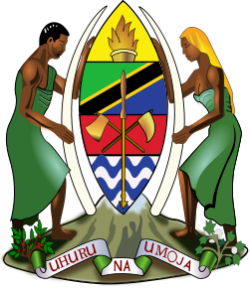

The United Republic of Tanzania

2012 POPULATION AND HOUSING CENSUS

Population Distribution by
Administrative Areas

National Bureau of Statistics
Ministry of Finance
Dar es Salaam

and

Office of Chief Government Statistician
President’s Office, Finance, Economy and Development Planning
Zanzibar

March, 2013

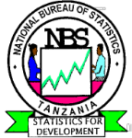



Foreword

The 2012 Population and Housing Census (PHC) for United Republic of Tanzania was carried out on the 26th August, 2012. This was the fifth Census after the Union of Tanganyika and Zanzibar in 1964. Other Censuses were carried out in 1967, 1978, 1988 and 2002. The 2012 PHC, like others, will contribute to the improvement of quality of life of Tanzanians through the provision of current and reliable data for development planning, policy formulation and services delivery as well as for monitoring and evaluating national and international development frameworks.

The 2012 PHC is unique in the sense that, the information collected will be used in monitoring and evaluating the Development Vision 2025 for Tanzania Mainland and Zanzibar Development Vision 2020, Five Year Development Plan 2011/12 – 2015/16, National Strategy for Growth and Reduction of Poverty (NSGRP) commonly known as MKUKUTA and Zanzibar Strategy for Growth and Reduction of Poverty (ZSGRP) commonly known as MKUZA. The census will also provide information for the evaluation of the Millennium Development Goals (MDGs) in 2015. The Poverty Monitoring Master Plan, which is the monitoring tool for NSGRP and ZSGRP, mapped out core indicators for poverty monitoring against the sequence of surveys, with the 2012 Census being one of them. Several of these core indicators for poverty monitoring will be measured directly from the 2012 Census. The census will also provide a denominator for the determination of other indicators such as enrolment and literacy rates, infant and maternal mortality rates, unemployment rate and others.

The General Report on Population Distribution by Administrative Units is the first of a series of publications planned for the 2012 PHC. The main purpose of the report is to give aggregated totals of population by sex. The report will also provide number of households, average household size, population densities, average annual inter-censal growth rates and sex ratios. Levels of aggregation are national, regional, district council and ward/shehia.

The success of the census depended upon the cooperation and contributions from the government, development partners, various institutions and the public at large. A special word of thanks should go to the government leaders at all levels particularly, Minister for Finance; Minister of State, President’s Office, Finance, Economy and Development Planning, Zanzibar; Members of Parliament; Members of House of Representatives; Councilors; Regional and District Census Committees chaired by Regional and District Commissioners; Field Assistants; Enumerators; Supervisors; local leaders and heads of households.

Our special gratitude should go to the following; DfID, Government of Japan, JICA, UNDP, UNFPA, UNICEF, USAID, World Bank and other development partners for providing assistance in terms of equipment, long and short term consultancies, training and funding. We would like to thank religious and political party leaders, as well as Non-Governmental Organisations (NGOs), mass media and the general public for their contribution towards successful implementation of the census.

Last but not least, we would wish to acknowledge the vital contributions to the project by Hajjat Amina Mrisho Said, the 2012 Commissioner for Population and Housing Census and Mr. Mwalim Haji Ameir, the Census Commissar for Zanzibar. Special thanks should also go to the Management and staff of the National Bureau of Statistics and Office of Chief Government Statistician, Zanzibar. Their commitment and dedication made significant contributions to the overall efficiency of the census operations. We would also like to convey our appreciation to all other Government Officials who worked tirelessly to ensure successful implementation of the 2012 Population and Housing Census.

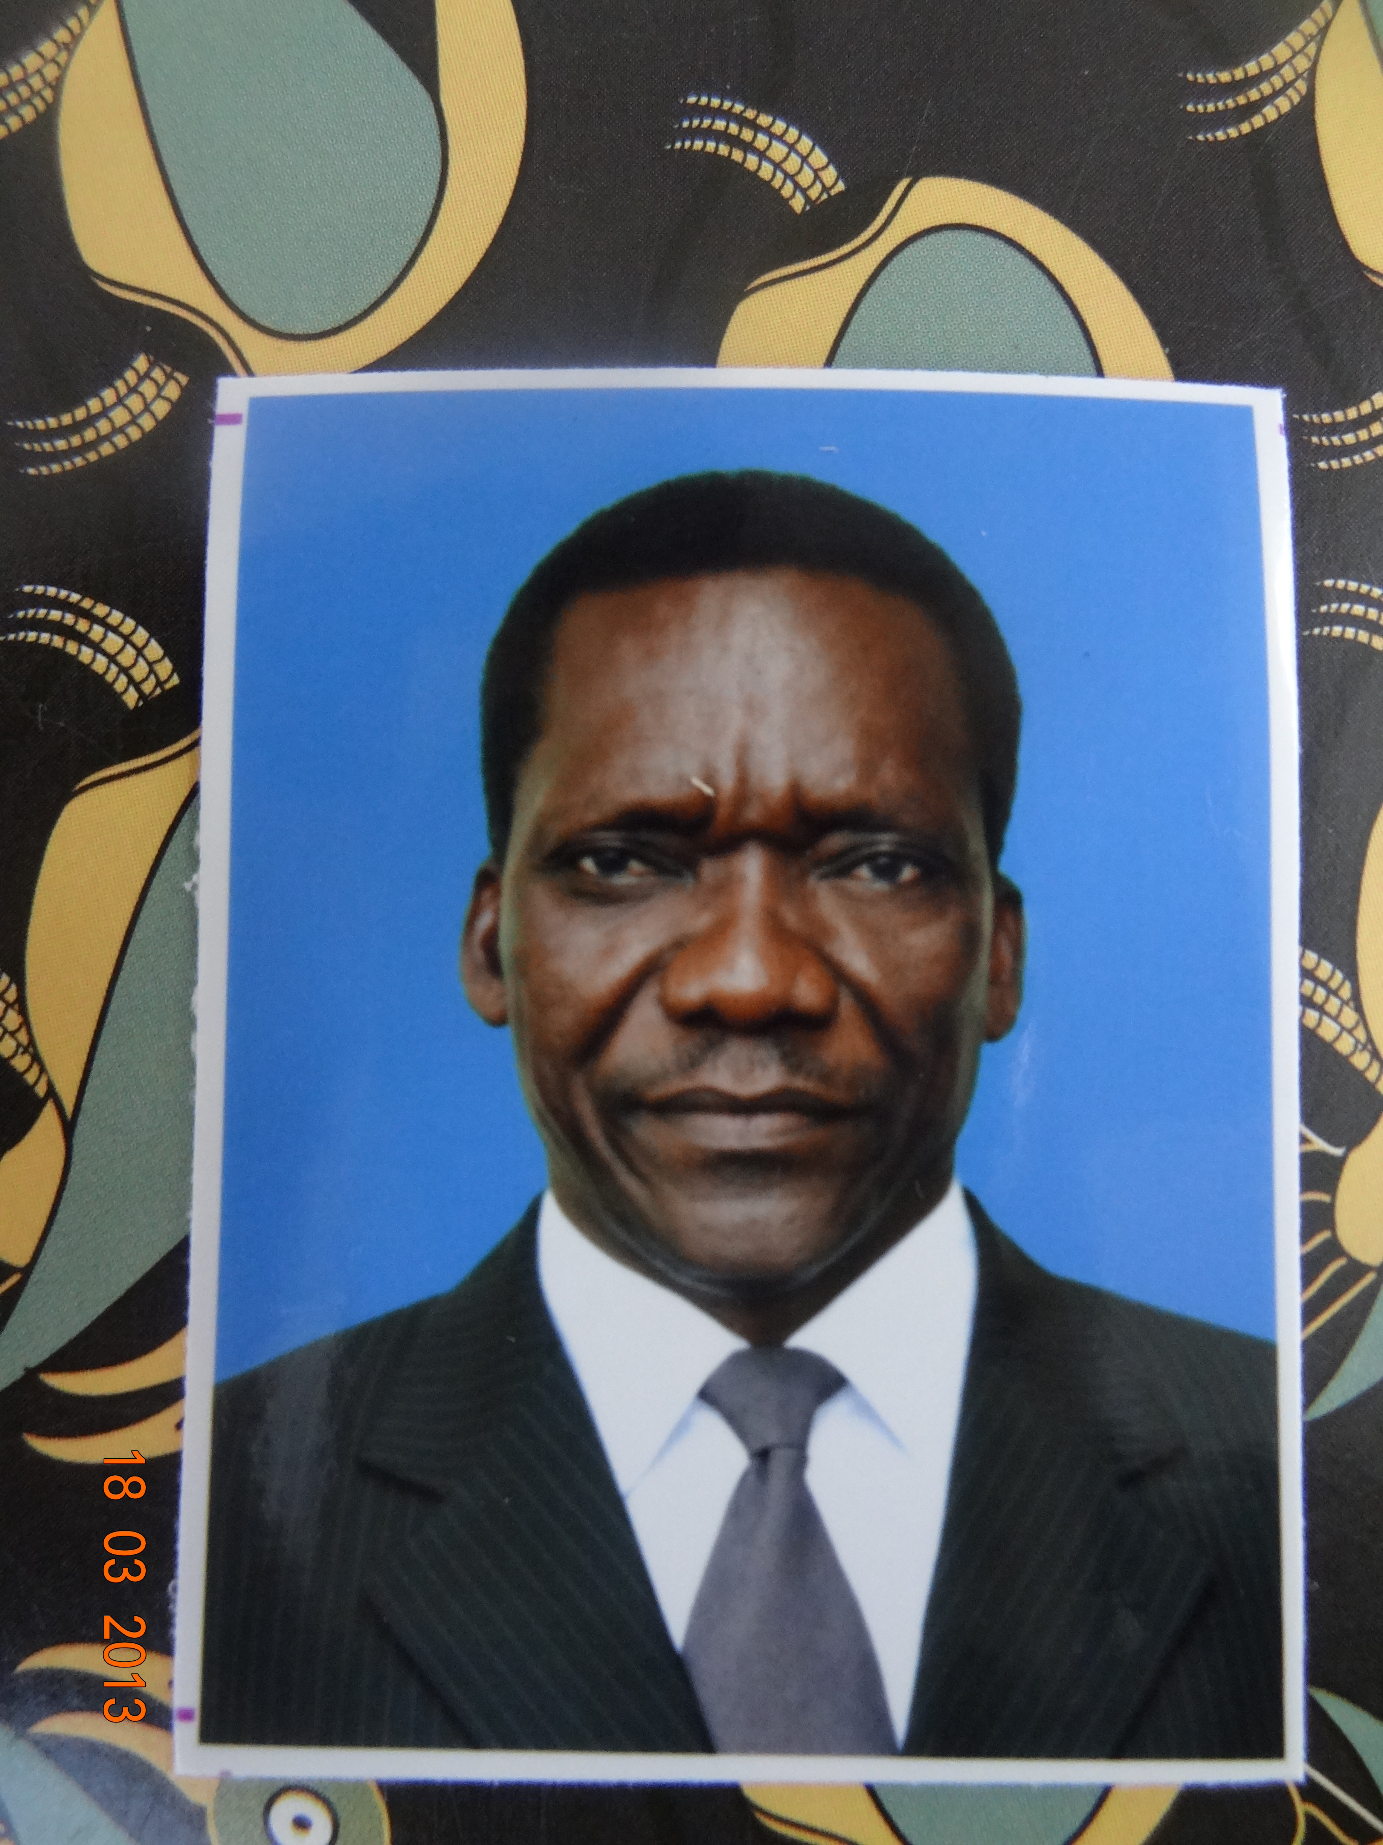
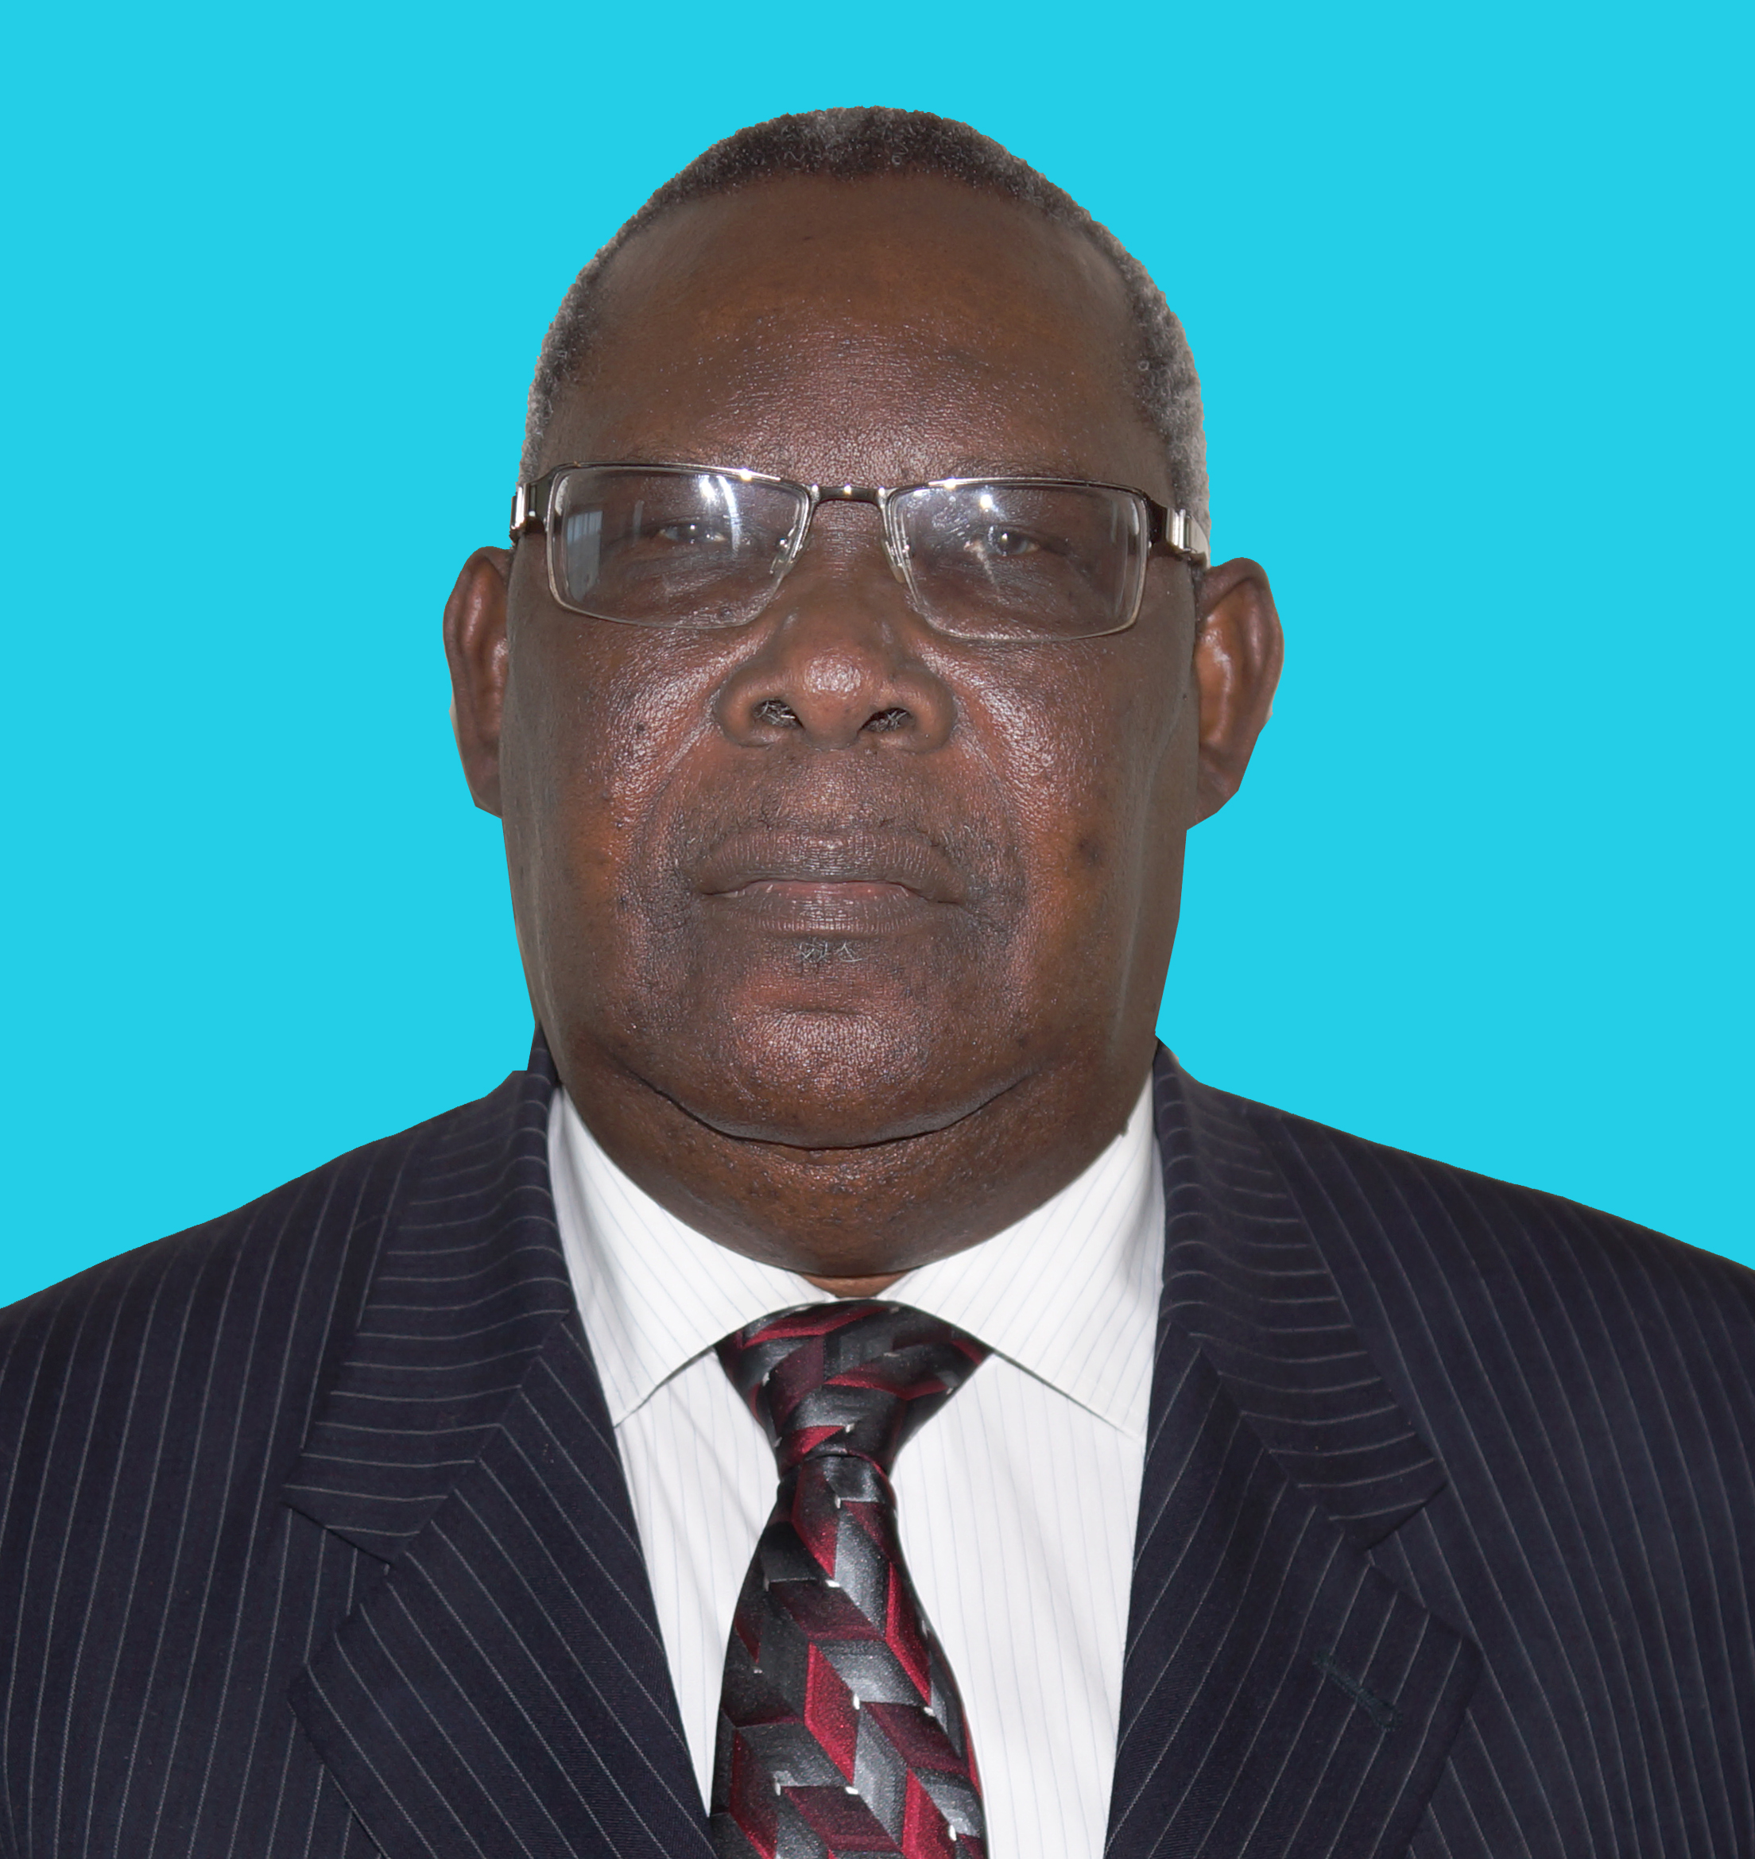

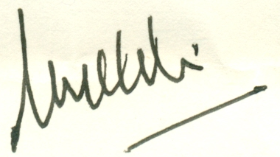
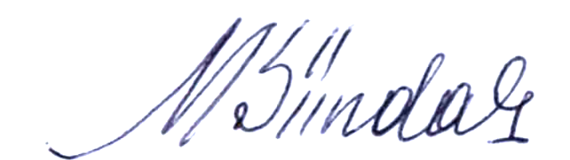

Hon. Mizengo Peter Pinda (MP),
Prime Minister, United Republic of Tanzania
Hon. Ambassador Seif Ali Iddi (MP/MHR),
Second Vice President, Zanzibar

March, 2013

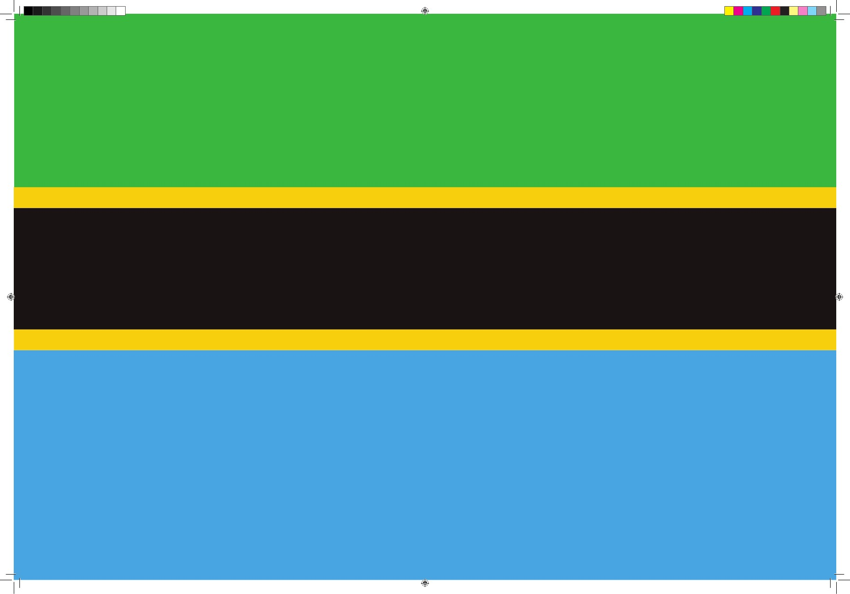
Census Results in Brief

Total Population, Tanzania | 44,928,923
Male Population | 21,869,990
Female Population | 23,058,933
Total Population, Mainland | 43,625,354
Male Population | 21,239,313
Female Population | 22,386,041
Total Population, Zanzibar | 1,303,569
Male Population | 630,677
Female Population | 672,892
Average Annual Intercensal Growth Rate, Tanzania, 2002 - 2012 | 2.7
Average Annual Intercensal Growth Rate, Mainland | 2.7
Average Annual Intercensal Growth Rate, Zanzibar | 2.8
Number of Households, Tanzania | 9,362,758
Number of Households, Mainland | 9,109,150
Number of Households, Zanzibar | 253,608
Average Household Size, Tanzania | 4.8
Average Household Size, Mainland | 4.8
Average Household Size, Zanzibar | 5.1
Population Density, Tanzania | 51
Population Density, Mainland | 49
Population Density, Zanzibar | 530
Sex Ratio, Tanzania | 95
Sex Ratio, Mainland | 95
Sex Ratio, Zanzibar | 94
CONTENTS

Page

Foreword i
Census Results in Brief iii
Concepts and Definitions xix

Section A: Summary of Findings 1

1.1 Number of Persons 1
1.2 Population by Region 1
1.3 Average Annual Growth Rates 3
1.4 Population Density 6
1.5 Household Size 8
1.6 Sex Ratio 10
1.7 Regional Population Distribution 11

List of Text Tables
Table 1: Population by Region and Average Annual Growth Rate, 2002 and 2012 Censuses 2
Table 2: Average Household Size by Region, 2002 and 2012 Censuses 9
Table 3: Regional Population by Sex, Average Household Size and Sex Ratio 14

List of Figures
Figure 1: Population Trends in Tanzania, 1967 – 2012 Censuses 1
Figure 2: Average Annual Intercensal Population Growth Rates, 1967 – 2012 Censuses 3
Figure 3: Average Annual Intercensal Population Growth Rate by Region, 2002 – 2012 Censuses 4
Figure 4: Population Density by Region, 2012 Census 6
Figure 5: Average Household Size by Region, 2012 Census 8
Figure 6: Sex Ratio by Region, 2012 Census 10
Figure 7: Trends in Sex Ratio, 1988 – 2012 Censuses 11
List of Maps
Map 1: Average Annual Population Growth Rate by Region, 2002 – 2012 Censuses 5
Map 2: Population Density by Region, 2012 Census 7
Map 3: Percentage Population Distribution by Region, Tanzania Mainland, 2012 Census 12
Map 4: Percentage Population Distribution by Region, Tanzania Zanzibar, 2012 Census 13

Section B: Population in the Regions, District Councils, Wards/Shehia by Sex, Average Household Size and Sex Ratio 15

Table 1. 0: Population of Dodoma Region by Sex, Average Household Size and Sex Ratio 17
Table 1. 1: Population of Kondoa District Council by Sex, Average Household Size and Sex Ratio 18
Table 1. 2: Population of Mpwapwa District Council by Sex, Average Household Size and Sex Ratio 19
Table 1. 3: Population of Kongwa District Council by Sex, Average Household Size and Sex Ratio 20
Table 1. 4: Population of Chamwino District Council by Sex, Average Household Size and Sex Ratio 21
Table 1. 5: Population of Dodoma Municipal Council by Sex, Average Household Size and Sex Ratio 22
Table 1. 6: Population of Bahi District Council by Sex, Average Household Size and Sex Ratio 23
Table 1. 7: Population of Chemba District Council by Sex, Average Household Size and Sex Ratio 24
Table 2. 0: Population of Arusha Region by Sex, Average Household Size and Sex Ratio 26
Table 2. 1: Population of Monduli District Council by Sex, Average Household Size and Sex Ratio 27
Table 2. 2: Population of Meru District Council by Sex, Average Household Size and Sex Ratio 28
Table 2. 3: Population of Arusha City Council by Sex, Average Household Size and Sex Ratio 29
Table 2. 4: Population of Karatu District Council by Sex, Average Household Size and Sex Ratio 30
Table 2. 5: Population of Ngorongoro District Council by Sex, Average Household Size and Sex Ratio 31
Table 2. 6: Population of Arusha District Council by Sex, Average Household Size and Sex Ratio 32
Table 2. 7: Population of Longido District Council by Sex, Average Household Size and Sex Ratio 33
Table 3. 0: Population of Kilimanjaro Region by Sex, Average Household Size and Sex Ratio……………………… 35
Table 3. 1: Population of Rombo District Council by Sex, Average Household Size and Sex Ratio 36
Table 3. 2: Population of Mwanga District Council by Sex, Average Household Size and Sex Ratio 37
Table 3. 3: Population of Same District Council by Sex, Average Household Size and Sex Ratio 38
Table 3. 4: Population of Moshi District Council by Sex, Average Household Size and Sex Ratio 39
Table 3. 5: Population of Hai District Council by Sex, Average Household Size and Sex Ratio 40
Table 3. 6: Population of Moshi Municipal Council by Sex, Average Household Size and Sex Ratio 41
Table 3. 7: Population of Siha District Council by Sex, Average Household Size and Sex Ratio 42
Table 4. 0: Population of Tanga Region by Sex, Average Household Size and Sex Ratio 44
Table 4. 1: Population of Lushoto District Council by Sex, Average Household Size and Sex Ratio 45
Table 4. 2: Population of Korogwe District Council by Sex, Average Household Size and Sex Ratio 46
Table 4. 3: Population of Muheza District Council by Sex, Average Household Size and Sex Ratio 47
Table 4. 4: Population of Tanga City Council by Sex, Average Household Size and Sex Ratio 48
Table 4. 5: Population of Pangani District Council by Sex, Average Household Size and Sex Ratio 49
Table 4. 6: Population of Handeni District Council by Sex, Average Household Size and Sex Ratio 50
Table 4. 7: Population of Kilindi District Council by Sex, Average Household Size and Sex Ratio 51
Table 4. 8: Population of Mkinga District Council by Sex, Average Household Size and Sex Ratio 52
Table 4. 9: Population of Korogwe Town Council by Sex, Average Household Size and Sex Ratio 53
Table 4. 10: Population of Handeni Town Council by Sex, Average Household Size and Sex Ratio 54
Table 5. 0: Population of Morogoro Region by Sex, Average Household Size and Sex Ratio 56
Table 5. 1: Population of Kilosa District Council by Sex, Average Household Size and Sex Ratio 57
Table 5. 2: Population of Morogoro District Council by Sex, Average Household Size and Sex Ratio 58
Table 5. 3: Population of Kilombero Council District by Sex, Average Household Size and Sex Ratio 59
Table 5. 4: Population of Ulanga District Council by Sex, Average Household Size and Sex Ratio 60
Table 5. 5: Population of Morogoro Municipal Council by Sex, Average Household Size and Sex Ratio 61
Table 5. 6: Population of Mvomero District Council by Sex, Average Household Size and Sex Ratio 62
Table 5. 7: Population of Gairo District Council by Sex, Average Household Size and Sex Ratio 63
Table 6. 0: Population of Pwani Region by Sex, Average Household Size and Sex Ratio 65
Table 6. 1: Population of Bagamoyo District Council by Sex, Average Household Size and Sex Ratio 66
Table 6. 2: Population of Kibaha District Council by Sex, Average Household Size and Sex Ratio 67
Table 6. 3: Population of Kisarawe District Council by Sex, Average Household Size and Sex Ratio 68
Table 6. 4: Population of Mkuranga District Council by Sex, Average Household Size and Sex Ratio 69
Table 6. 5: Population of Rufiji District Council by Sex, Average Household Size and Sex Ratio 70
Table 6. 6: Population of Mafia District Council by Sex, Average Household Size and Sex Ratio 71
Table 6. 7: Population of Kibaha Town Council by Sex, Average Household Size and Sex Ratio 72
Table 7. 0: Population of Dar es Salaam Region by Sex, Average Household Size and Sex Ratio 74
Table 7. 1: Population of Kinondoni Municipal Council by Sex, Average Household Size and Sex Ratio 75
Table 7. 2: Population of Ilala Municipal Council by Sex, Average Household Size and Sex Ratio 76
Table 7. 3: Population of Temeke Municipal Council by Sex, Average Household Size and Sex Ratio 77
Table 8. 0: Population of Lindi Region by Sex, Average Household Size and Sex Ratio….. 79
Table 8. 1: Population of Kilwa District Council by Sex, Average Household Size and Sex Ratio 80
Table 8. 2: Population of Lindi District Council by Sex, Average Household Size and Sex Ratio 81
Table 8. 3: Population of Nachingwea District Council by Sex, Average Household Size and Sex Ratio 82
Table 8. 4: Population of Liwale District Council by Sex, Average Household Size and Sex Ratio 83
Table 8. 5: Population of Ruangwa District Council by Sex, Average Household Size and Sex Ratio 84
Table 8. 6: Population of Lindi Municipal Council by Sex, Average Household Size and Sex Ratio 85
Table 9. 0: Population of Mtwara Region by Sex, Average Household Size and Sex Ratio 87
Table 9. 1: Population of Mtwara District Council by Sex, Average Household Size and Sex Ratio 88
Table 9. 2: Population of Newala District Council by Sex, Average Household Size and Sex Ratio 89
Table 9. 3: Population of Masasi District Council by Sex, Average Household Size and Sex Ratio 90
Table 9. 4: Population of Tandahimba District Council by Sex, Average Household Size and Sex Ratio 91
Table 9. 5: Population of Mtwara Mikindani Municipal Council by Sex, Average Household Size and Sex Ratio 92
Table 9. 6: Population of Nanyumbu District Council by Sex, Average Household Size and Sex Ratio 93
Table 9. 7: Population of Masasi Town Council by Sex, Average Household Size and Sex Ratio 94
Table 10. 0: Population of Ruvuma Region by Sex, Average Household Size and Sex Ratio. 96
Table 10. 1: Population of Tunduru District Council by Sex, Average Household Size and Sex Ratio 97
Table 10. 2: Population of Songea District Council by Sex, Average Household Size and Sex Ratio 98
Table 10. 3: Population of Mbinga District Council by Sex, Average Household Size and Sex Ratio 99
Table 10. 4: Population of Songea Municipal Council by Sex, Average Household Size and Sex Ratio 100
Table 10. 5: Population of Namtumbo District Council by Sex, Average Household Size and Sex Ratio 101
Table 10. 6: Population of Nyasa District Council by Sex, Average Household Size and Sex Ratio 102
Table 11. 0: Population of Iringa Region by Sex, Average Household Size and Sex Ratio 104
Table 11. 1: Population of Iringa District Council by Sex, Average Household Size and Sex Ratio 105
Table 11. 2: Population of Mufindi District Council by Sex, Average Household Size and Sex Ratio 106
Table 11. 3: Population of Iringa Municipal Council by Sex, Average Household Size and Sex Ratio 107
Table 11. 4: Population of Kilolo District Council by Sex, Average Household Size and Sex Ratio 108
Table 11. 5: Population of Mafinga Town Council by Sex, Average Household Size and Sex Ratio 109
Table 12. 0: Population of Mbeya Region by Sex, Average Household Size and Sex Ratio 111
Table 12. 1: Population of Chunya District Council by Sex, Average Household Size and Sex Ratio 112
Table 12. 2: Population of Mbeya District Council by Sex, Average Household Size and Sex Ratio 113
Table 12. 3: Population of Kyela District Council by Sex, Average Household Size and Sex Ratio 114
Table 12. 4: Population of Rungwe District Council by Sex, Average Household Size and Sex Ratio 115
Table 12. 5: Population of Ileje District Council by Sex, Average Household Size and Sex Ratio 116
Table 12. 6: Population of Mbozi District Council by Sex, Average Household Size and Sex Ratio 117
Table 12. 7: Population of Mbarali District Council by Sex, Average Household Size and Sex Ratio 118
Table 12. 8: Population of Mbeya City Council by Sex, Average Household Size and Sex Ratio 119
Table 12. 9: Population of Momba District Council by Sex, Average Household Size and Sex Ratio 120
Table 12. 10: Population of Tunduma Town Council by Sex, Average Household Size and Sex Ratio 121
Table 13. 0: Population of Singida Region by Sex, Average Household Size and Sex Ratio 123
Table 13. 1: Population of Iramba District Council by Sex, Average Household Size and Sex Ratio 124
Table 13. 2: Population of Singida District Council by Sex, Average Household Size and Sex Ratio 125
Table 13. 3: Population of Manyoni District Council by Sex, Average Household Size and Sex Ratio 126
Table 13. 4: Population of Singida Municipal Council by Sex, Average Household Size and Sex Ratio 127
Table 13. 5: Population of Ikungi District Council by Sex, Average Household Size and Sex Ratio 128
Table 13. 6: Population of Mkalama District Council by Sex, Average Household Size and Sex Ratio 129
Table 14. 0: Population of Tabora Region by Sex, Average Household Size and Sex Ratio 131
Table 14. 1: Population of Nzega District Council by Sex, Average Household Size and Sex Ratio 132
Table 14. 2: Population of Igunga District Council by Sex, Average Household Size and Sex Ratio 133
Table 14. 3: Population of Uyui District Council by Sex, Average Household Size and Sex Ratio 134
Table 14. 4: Population of Urambo District Council by Sex, Average Household Size and Sex Ratio 135
Table 14. 5: Population of Sikonge District Council by Sex, Average Household Size and Sex Ratio 136
Table 14. 6: Population of Tabora Municipal Council by Sex, Average Household Size and Sex Ratio 137
Table 14. 7: Population of Kaliua District Council by Sex, Average Household Size and Sex Ratio 138
Table 15. 0: Population of Rukwa Region by Sex, Average Household Size and Sex Ratio 140
Table 15. 1: Population of Kalambo District Council by Sex, Average Household Size and Sex Ratio 141
Table 15. 2: Population of Sumbawanga District Council by Sex, Average Household Size and Sex Ratio 142
Table 15. 3: Population of Nkasi District Council by Sex, Average Household Size and Sex Ratio 143
Table 15. 4: Population of Sumbawanga Municipal Council by Sex, Average Household Size and Sex Ratio 144
Table 16. 0: Population of Kigoma Region by Sex, Average Household Size and Sex
Ratio 146
Table 16. 1: Population of Kibondo District Council by Sex, Average Household Size and Sex Ratio 147
Table 16. 2: Population of Kasulu District Council by Sex, Average Household Size and Sex Ratio 148
Table 16. 3: Population of Kigoma District Council by Sex, Average Household Size and Sex Ratio 149
Table 16. 4: Population of Kigoma Ujiji Municipal Council by Sex, Average Household Size and Sex Ratio 150
Table 16. 5: Population of Uvinza District Council by Sex, Average Household Size and Sex Ratio 151
Table 16. 6: Population of Buhigwe District Council by Sex, Average Household Size and Sex Ratio 152
Table 16. 7: Population of Kakonko District Council by Sex, Average Household Size and Sex Ratio 153
Table 16. 8: Population of Kasulu Town Council by Sex, Average Household Size and Sex Ratio 154
Table 17. 0: Population of Shinyanga Region by Sex, Average Household Size and Sex Ratio 156
Table 17. 1: Population of Shinyanga Municipal Council by Sex, Average Household Size and Sex Ratio 157
Table 17. 2: Population of Kishapu District Council by Sex, Average Household Size and Sex Ratio 158
Table 17. 3: Population of Shinyanga District Council by Sex, Average Household Size and Sex Ratio 159
Table 17. 4: Population of Kahama District Council by Sex, Average Household Size and Sex Ratio 160
Table 17. 5: Population of Kahama Town Council by Sex, Average Household Size and Sex Ratio 161
Table 18. 0: Population of Kagera Region by Sex, Average Household Size and Sex Ratio 163
Table 18. 1: Population of Karagwe District Council by Sex, Average Household Size and Sex Ratio 164
Table 18. 2: Population of Bukoba District Council by Sex, Average Household Size and Sex Ratio 165
Table 18. 3: Population of Muleba District Council by Sex, Average Household Size and Sex Ratio 166
Table 18. 4: Population of Biharamulo District Council by Sex, Average Household Size and Sex Ratio 167
Table 18. 5: Population of Ngara District Council by Sex, Average Household Size and Sex Ratio 168
Table 18. 6: Population of Bukoba Municipal Council by Sex, Average Household Size and Sex Ratio 169
Table 18. 7: Population of Missenyi District Council by Sex, Average Household Size and Sex Ratio 170
Table 18. 8: Population of Kyerwa District Council by Sex, Average Household Size and Sex Ratio 171
Table 19. 0: Population of Mwanza Region by Sex, Average Household Size and Sex Ratio 173
Table 19. 1: Population of Ukerewe District Council by Sex, Average Household Size and Sex Ratio 174
Table 19. 2: Population of Magu District Council by Sex, Average Household Size and Sex Ratio 175
Table 19. 3: Population of Nyamagana Municipal Council by Sex, Average Household Size and Sex Ratio 176
Table 19. 4: Population of Kwimba District Council by Sex, Average Household Size and Sex Ratio 177
Table 19. 5: Population of Sengerema District Council by Sex, Average Household Size and Sex Ratio 178
Table 19. 6: Population of Ilemela Municipal Council by Sex, Average Household Size and Sex Ratio 179
Table 19. 7: Population of Misungwi District Council by Sex, Average Household Size and Sex Ratio 180
Table 20. 0: Population of Mara Region by Sex, Average Household Size and Sex Ratio 182
Table 20. 1: Population of Tarime District Council by Sex, Average Household Size and Sex Ratio 183
Table 20. 2: Population of Serengeti District Council by Sex, Average Household Size and Sex Ratio 184
Table 20. 3: Population of Musoma District Council by Sex, Average Household Size and Sex Ratio 185
Table 20. 4: Population of Bunda District Council by Sex, Average Household Size and Sex Ratio 186
Table 20. 5: Population of Musoma Municipal Council by Sex, Average Household Size and Sex Ratio 187
Table 20. 6: Population of Rorya District Council by Sex, Average Household Size and Sex Ratio 188
Table 20. 7: Population of Butiama District Council by Sex, Average Household Size and Sex Ratio 189
Table 21. 0: Population of Manyara Region by Sex, Average Household Size and Sex Ratio 191
Table 21. 1: Population of Babati District Council by Sex, Average Household Size and Sex Ratio 192
Table 21. 2: Population of Hanang District Council by Sex, Average Household Size and Sex Ratio 193
Table 21. 3: Population of Mbulu District Council by Sex, Average Household Size and Sex Ratio 194
Table 21. 4: Population of Simanjiro District Council by Sex, Average Household Size and Sex Ratio 195
Table 21. 5: Population of Kiteto District Council by Sex, Average Household Size and Sex Ratio 196
Table 21. 6: Population of Babati Town Council by Sex, Average Household Size and Sex Ratio 197
Table 22. 0: Population of Njombe Region by Sex, Average Household Size and Sex
Ratio 199
Table 22. 1: Population of Njombe Town Council by Sex, Average Household Size and Sex Ratio 200
Table 22. 2: Population of Wanging'ombe District Council by Sex, Average Household Size and Sex Ratio 201
Table 22. 3: Population of Makete District Council by Sex, Average Household Size and Sex Ratio 202
Table 22. 4: Population of Njombe District Council by Sex, Average Household Size and Sex Ratio 203
Table 22. 5: Population of Ludewa District Council by Sex, Average Household Size and Sex Ratio 204
Table 22. 6: Population of Makambako Town Council by Sex, Average Household Size and Sex Ratio 205
Table 23. 0: Population of Katavi Region by Sex, Average Household Size and Sex Ratio 207
Table 23. 1: Population of Mpanda Town Council by Sex, Average Household Size and Sex Ratio 208
Table 23. 2: Population of Mpanda District Council by Sex, Average Household Size and Sex Ratio 209
Table 23. 3: Population of Mlele District Council by Sex, Average Household Size and Sex Ratio 210
Table 24. 0: Population of Simiyu Region by Sex, Average Household Size and Sex Ratio 212
Table 24. 1: Population of Bariadi District Council by Sex, Average Household Size and Sex Ratio 213
Table 24. 2: Population of Itilima District Council by Sex, Average Household Size and Sex Ratio 214
Table 24. 3: Population of Meatu District Council by Sex, Average Household Size and Sex Ratio 215
Table 24. 4: Population of Maswa District Council by Sex, Average Household Size and Sex Ratio 216
Table 24. 5: Population of Busega District Council by Sex, Average Household Size and Sex Ratio 217
Table 25. 0: Population of Geita Region by Sex, Average Household Size and Sex Ratio 219
Table 25. 1: Population of Geita District Council by Sex, Average Household Size and Sex Ratio 220
Table 25. 2: Population of Nyang'hwale District Council by Sex, Average Household Size and Sex Ratio 221
Table 25. 3: Population of Mbongwe District Council by Sex, Average Household Size and Sex Ratio 222
Table 25. 4: Population of Bukombe District Council by Sex, Average Household Size and Sex Ratio 223
Table 25. 5: Population of Chato District Council by Sex, Average Household Size and Sex Ratio 224
Table 51. 0: Population of Kaskazini Unguja Region by Sex, Average Household Size and Sex Ratio 226
Table 51. 1: Population of Kaskazini ‘A’ District by Sex, Average Household Size and Sex Ratio 227
Table 51. 2: Population of Kaskazini ‘B’ District by Sex, Average Household Size and Sex Ratio 228
Table 52. 0: Population of Kusini Unguja Region by Sex, Average Household Size and Sex Ratio 230
Table 52. 1: Population of Kati District by Sex, Average Household Size and Sex Ratio 231
Table 52. 2: Population of Kusini District by Sex, Average Household Size and Sex Ratio 232
Table 53. 0: Population of Mjini Magharibi Region by Sex, Average Household Size and Sex Ratio 234
Table 53. 1: Population of Magharibi District by Sex, Average Household Size and Sex Ratio 235
Table 53. 2: Population of Mjini District by Sex, Average Household Size and Sex Ratio 236
Table 54. 0: Population of Kaskazini Pemba Region by Sex, Average Household Size and Sex Ratio 238
Table 54. 1: Population of Wete District by Sex, Average Household Size and Sex Ratio 239
Table 54. 2: Population of Micheweni District by Sex, Average Household Size and Sex Ratio 240
Table 55. 0: Population of Kusini Pemba Region by Sex, Average Household Size and Sex Ratio 242
Table 55. 1: Population of Chake Chake District by Sex, Average Household Size and Sex Ratio 243
Table 55. 2: Population of Mkoani District by Sex, Average Household Size and Sex Ratio 244

List of Abbreviations

DCC - District Census Coordinator
DfID - Department for International Development
JICA - Japanese International Co-operation Agency
MDG - Millennium Development Goals
MHR - Member of House of Representatives
MP - Member of Parliament
NBS - National Bureau of Statistics
NGO - Non-Governmental Organization
NSGRP - National Strategy for Growth and Reduction of Poverty
OCGS - Office of Chief Government Statistician
PHC - Population and Housing Census
RCC - Regional Census Coordinator
UNDP - United Nations Development Programme
UNFPA - United Nations Population Fund
UNICEF - United Nations Children’s Fund
USAID - United States Agency for International Development
ZSGRP - Zanzibar Strategy for Growth and Reduction of Poverty

Concepts and Definitions

Household refers to a person or group of persons who reside in the same homestead/compound but not necessarily in the same dwelling unit, have same cooking arrangements, and are answerable to the same household head.

Average household size is calculated by dividing the total number of persons by the total number of households in a given population.

Sex ratio is the ratio of males to females in a given population usually expressed as the number of males for every 100 females. For example, sex ratio of 98 for Katavi region means, for every 100 females, there are 98 males.

Population density refers to the number of people living in a given area usually expressed as people per square kilometre.

Population growth refers to the change in population over time, and can be quantified as the change in the number of individuals in a population using "per unit time" for measurement.

Population growth rate is the fractional rate at which the number of individuals in a population increases. Specifically, population growth rate ordinarily, refers to the change in population over a unit time period, often expressed as a percentage of the number of individuals in the population at the beginning of that period. Growth rate in this book is expressed as an exponential rate of growth of population from year 2002 to 2012.

Section A: Summary of Findings

1.0 Introduction
This section presents summary of findings of the 2012 PHC. These include number of persons by region, average annual population growth rates, average household size, population densities and sex ratios.

1.1 Number of Persons
The 2012 PHC revealed that, the population of Tanzania has grown from 12,313,469 persons in the 1967 Census to 44,928,923 persons counted in 2012 as shown in Figure 1.

Figure 1: Population Trends in Tanzania, 1967 – 2012 Censuses
The population of Tanzania has more than tripled from 12.3 million in 1967 to 44.9 million in 2012
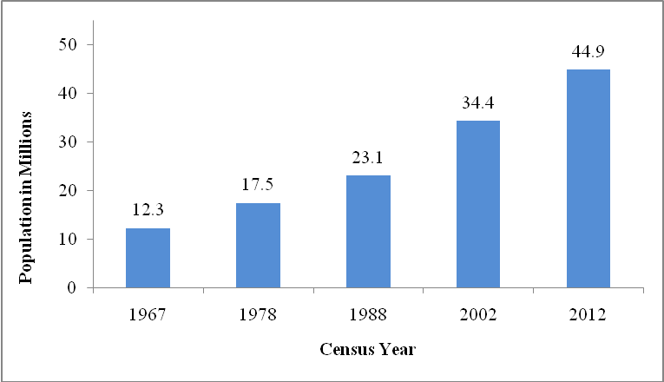

1.2 Population by Region
The United Republic of Tanzania is a union of Tanganyika (Tanzania Mainland) and Zanzibar (Tanzania Zanzibar). Administratively, Tanzania has 30 regions (25 in Tanzania Mainland and 5 in Tanzania Zanzibar). Table 1 shows regional populations during the 2002 and 2012 censuses and their inter-censal growth rates. In the 2012 Census, Dar es Salaam was found to have a population of 4.36 million accounting for 10 percent of the total Tanzania Mainland population. Regions with a population of over 2 million were Mwanza (2.77 million), Mbeya (2.71 million), Kagera (2.46 million), Tabora (2.29 million), Morogoro (2.22 million), Kigoma (2.13 million), Dodoma (2.08 million) and Tanga (2.05 million). In Tanzania Mainland, there were four regions with a population of less than one million. These were Katavi (564,604), Njombe (702,097), Lindi (864,652) and Iringa (941,238).
Dar es Salaam accounts for 10 percent of the total Tanzania Mainland population

In Tanzania Zanzibar, the region with the largest population was Mjini Magharibi (593,678) which accounts for 46 percent of the total population of Tanzania Zanzibar. The region with the smallest population was Kusini Unguja with a population of 115,588.
In ten years (2002 to 2012), the population of Tanzania increased by 30 percent from 34.4 million to 44.9 million

Table 1: Population by Region and Average Annual Growth Rate, 2002 and 2012 Censuses

Region | Population (Number) |  |  | Population Increase | Average Annual Rate (Percent)
Region | 2002 Census Counts | 2012 Projected Population | 2012 Census Counts | 2002 - 2012  (Number) | 1988-2002 | 2002-2012
Tanzania | 34,443,603 | 45,798,475 | 44,928,923 | 10,485,320 | 2.9 | 2.7
Tanzania Mainland | 33,461,849 | 44,439,683 | 43,625,354 | 10,163,505 | 2.8 | 2.7
Dodoma | 1,692,025 | 2,214,657 | 2,083,588 | 391,563 | 2.2 | 2.1
Arusha | 1,288,088 | 1,758,196 | 1,694,310 | 406,222 | 3.9 | 2.7
Kilimanjaro | 1,376,702 | 1,702,207 | 1,640,087 | 263,385 | 1.6 | 1.8
Tanga | 1,636,280 | 2,054,042 | 2,045,205 | 408,925 | 1.8 | 2.2
Morogoro | 1,753,362 | 2,209,072 | 2,218,492 | 465,130 | 2.6 | 2.4
Pwani | 885,017 | 1,110,917 | 1,098,668 | 213,651 | 2.4 | 2.2
Dar es Salaam | 2,487,288 | 3,270,255 | 4,364,541 | 1,877,253 | 4.3 | 5.6
Lindi | 787,624 | 960,236 | 864,652 | 77,028 | 1.4 | 0.9
Mtwara | 1,124,481 | 1,374,767 | 1,270,854 | 146,373 | 1.7 | 1.2
Ruvuma | 1,113,715 | 1,449,830 | 1,376,891 | 263,176 | 2.5 | 2.1
Iringa | 840,404 | 1,789,779 | 941,238 | 100,834 | 1.6 | 1.1
Mbeya | 2,063,328 | 2,822,396 | 2,707,410 | 644,082 | 2.4 | 2.7
Singida | 1,086,748 | 1,440,682 | 1,370,637 | 283,889 | 2.3 | 2.3
Tabora | 1,710,465 | 2,539,715 | 2,291,623 | 581,158 | 3.6 | 2.9
Rukwa | 729,060 | 1,615,098 | 1,004,539 | 275,479 | 3.5 | 3.2
Kigoma | 1,674,047 | 1,971,332 | 2,127,930 | 453,883 | 4.8 | 2.4
Shinyanga | 1,249,226 | 4,161,091 | 1,534,808 | 285,582 | 3.3 | 2.1
Kagera | 1,791,451 | 2,763,329 | 2,458,023 | 666,572 | 3.1 | 3.2
Mwanza | 2,058,866 | 3,771,067 | 2,772,509 | 713,643 | 3.2 | 3.0
Mara | 1,363,397 | 1,963,460 | 1,743,830 | 380,433 | 2.6 | 2.5
Manyara | 1,037,605 | 1,497,555 | 1,425,131 | 387,526 | 3.9 | 3.2
Njombe | 648,464 | N/A | 702,097 | 53,633 | N/A | 0.8
Katavi | 408,609 | N/A | 564,604 | 155,995 | N/A | 3.2
Simiyu | 1,317,879 | N/A | 1,584,157 | 266,278 | N/A | 1.8
Geita | 1,337,718 | N/A | 1,739,530 | 401,812 | N/A | 2.6
Tanzania Zanzibar | 981,754 | 1,358,792 | 1,303,569 | 321,815 | 3.1 | 2.8
Kaskazini Unguja | 136,639 | 189,574 | 187,455 | 50,816 | 2.5 | 3.2
Kusini Unguja | 94,244 | 117,475 | 115,588 | 21,344 | 2.1 | 2.0
Mjini Magharibi | 390,074 | 506,907 | 593,678 | 203,604 | 4.5 | 4.2
Kaskazini Pemba | 185,326 | 275,806 | 211,732 | 26,406 | 2.1 | 1.3
Kusini Pemba | 175,471 | 269,030 | 195,116 | 19,645 | 2.3 | 1.1

Note: N/A stands for Not Applicable

1.3 Average Annual Growth Rates
In Tanzania, the population growth rate has declined from 3.3 percent in 1967 to 2.7 percent in 2012. Tanzania Mainland shows a decline from 3.2 percent in 1967 to 2.7 percent in 2012. Tanzania Zanzibar shows a different pattern of growth. The growth rate increased from 2.7 percent in 1967 to 3.1 in 2002 and then declined to 2.8 percent in 2012 (Figure 2).
At the current growth rate of 2.7 percent, the population of Tanzania will double in the next 26 years

Figure 2: Average Annual Intercensal Population Growth Rates, 1967 – 2012 Censuses

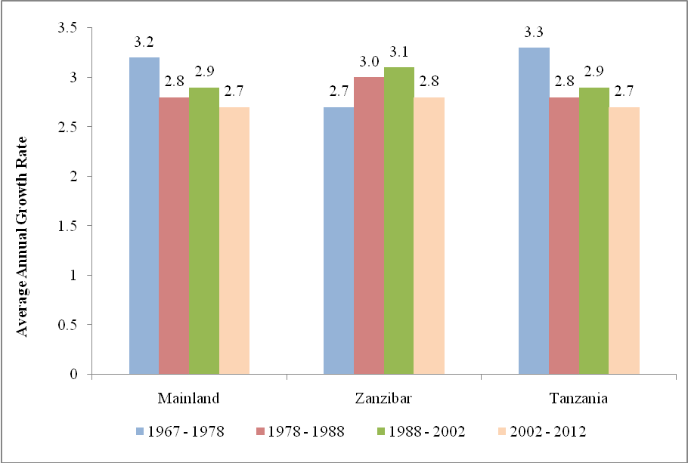

The average annual growth rates vary from region to region (Figure 3 and Map 1). The average rates of growth for the period of 2002 to 2012 range from 5.6 percent recorded in Dar es Salaam region to 0.8 percent recorded in Njombe. Regions dominated by large urban populations recorded the highest growth rates. These are Dar es Salaam (5.6 percent) and Mjini Magharibi (4.2 percent).

Figure 3: Average Annual Intercensal Population Growth Rate by Region, 2002 – 2012 Censuses

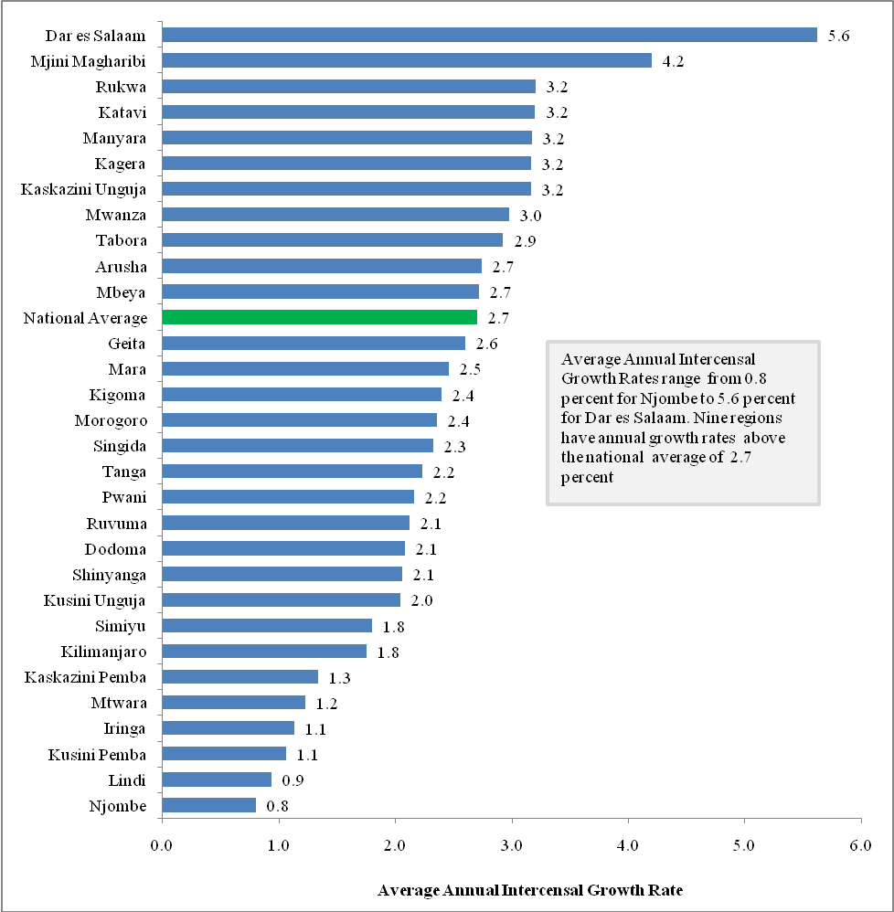

Map 1: Average Annual Population Growth Rate by Region, 2002 – 2012 Censuses

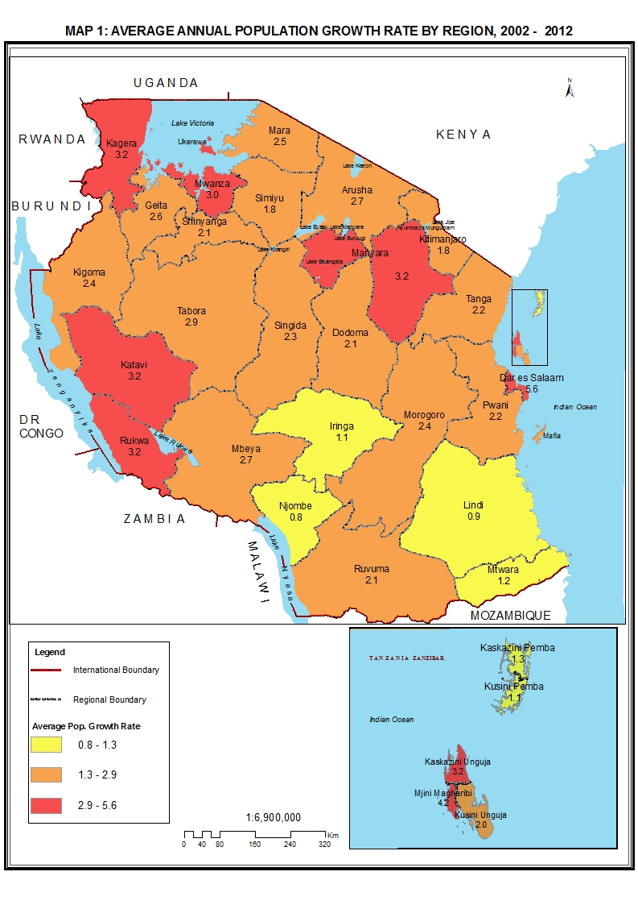

1.4 Population Density

Tanzania is sparsely populated with population density of 51 persons per square kilometre with variation across regions (Figure 4 and Map 2). Persons are concentrated in Dar es Salaam and Mjini Magharibi regions with population densities of 3,133 and 2,581 persons per square kilometre respectively. Regions with lowest population densities are Lindi (13 persons per square kilometre) and Katavi (15 persons per square kilometre).

Figure 4: Population Density by Region, 2012 Census

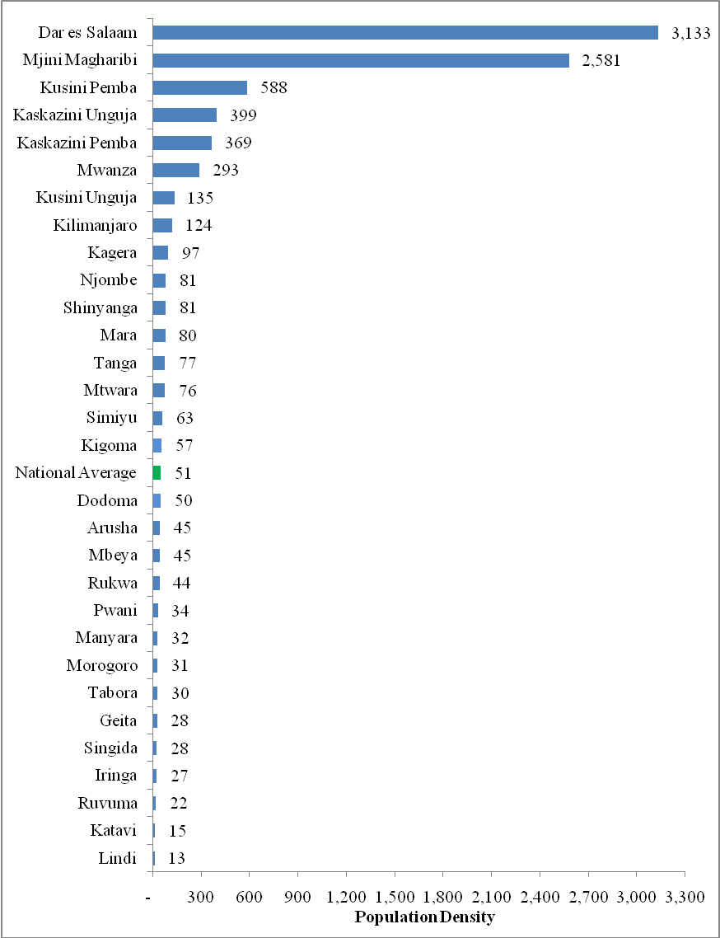
Map 2: Population Density by Region, 2012 Census

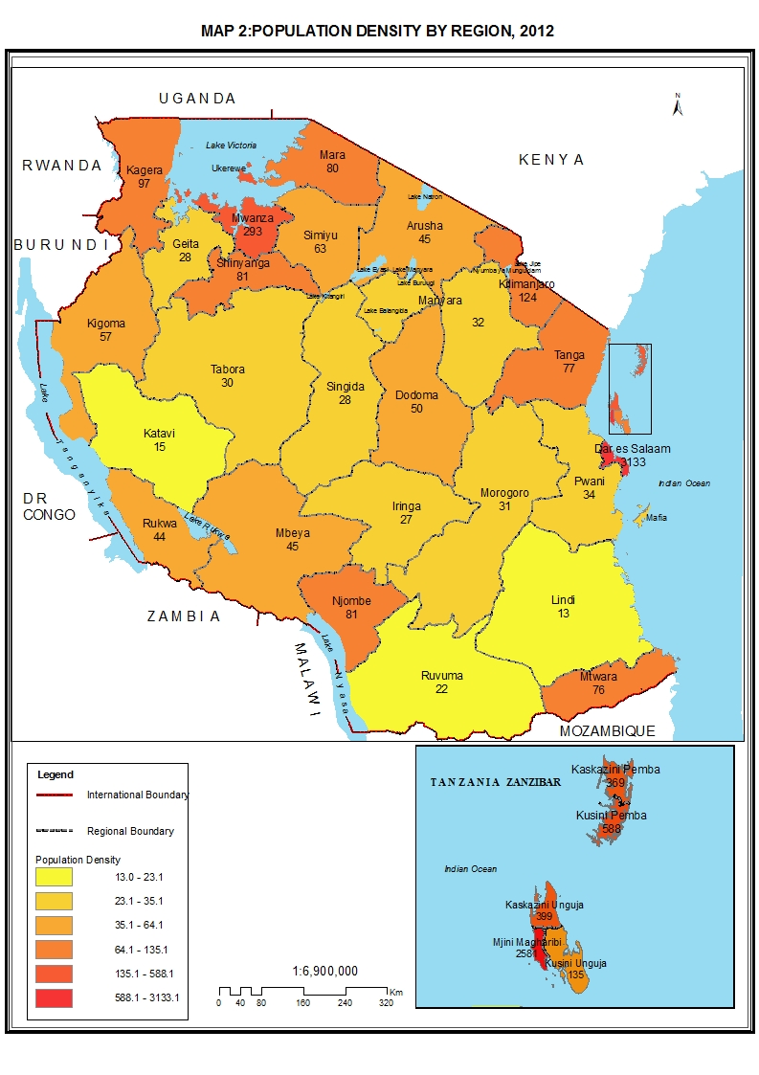

1.5 Household Size

The average household size in Tanzania remained almost constant between 2002 and 2012 Censuses. Average household size was found to be 4.9 persons per household in 2002 and 4.8 in 2012.

The average household size varies among regions. Fourteen regions recorded an average household size that was above the national average of 4.8 persons per household. Mtwara region recorded the lowest average household size of 3.7 (Figure 5).

Figure 5: Average Household Size by Region, 2012 Census

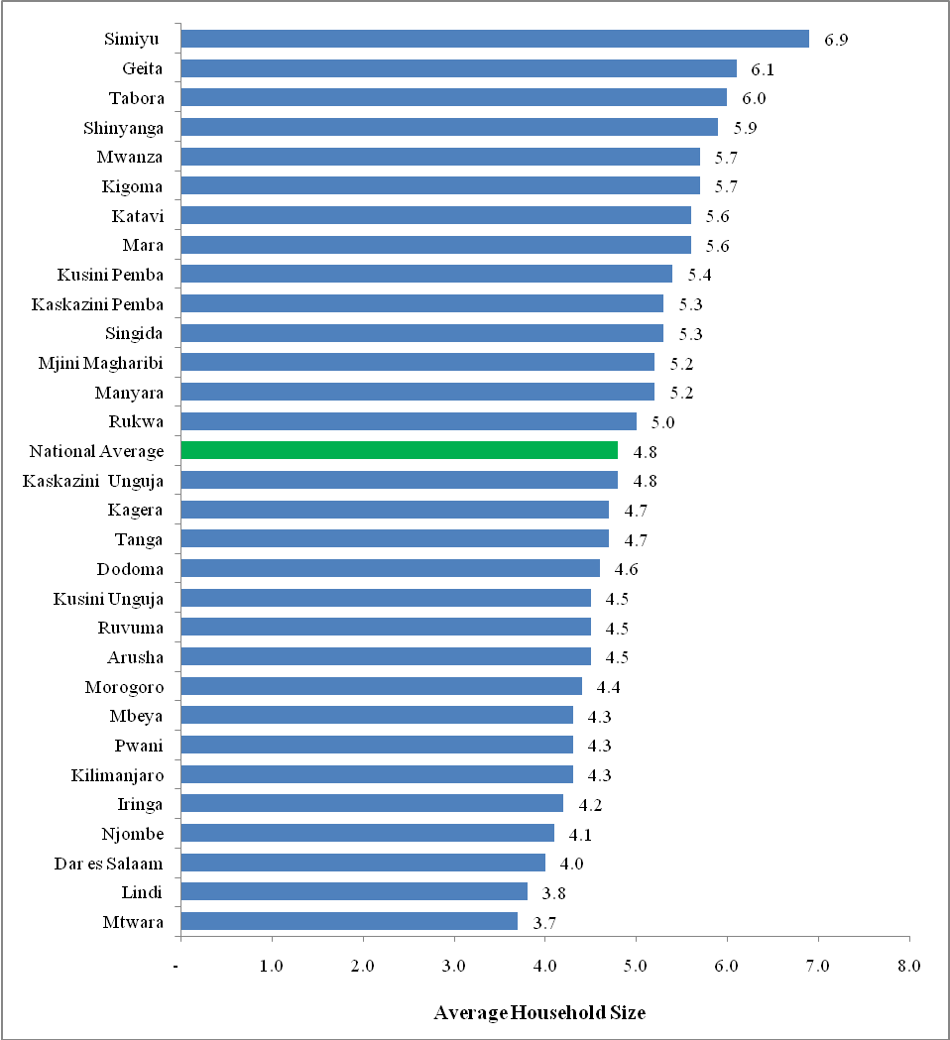

Table 2: Average Household Size by Region, 2002 and 2012 Censuses
Region | 2002 Census |  |  | 2012 Census
Region | Population  (Number) | Households  (Number) | Average Household Size | Population  (Number) | Households  (Number) | Average Household Size
Dodoma | 1,692,025 | 376,530 | 4.5 | 2,083,588 | 453,844 | 4.6
Arusha | 1,288,088 | 286,579 | 4.5 | 1,694,310 | 378,825 | 4.5
Kilimanjaro | 1,376,702 | 297,439 | 4.6 | 1,640,087 | 384,867 | 4.3
Tanga | 1,636,280 | 356,993 | 4.6 | 2,045,205 | 438,277 | 4.7
Morogoro | 1,753,362 | 385,260 | 4.6 | 2,218,492 | 506,289 | 4.4
Pwani | 885,017 | 200,919 | 4.4 | 1,098,668 | 257,511 | 4.3
Dar es Salaam | 2,487,288 | 596,264 | 4.2 | 4,364,541 | 1,095,095 | 4.0
Lindi | 787,624 | 190,761 | 4.1 | 864,652 | 225,972 | 3.8
Mtwara | 1,124,481 | 293,908 | 3.8 | 1,270,854 | 344,834 | 3.7
Ruvuma | 1,113,715 | 232,340 | 4.8 | 1,376,891 | 303,071 | 4.5
Iringa | 840,404 | 195,497 | 4.3 | 941,238 | 223,028 | 4.2
Mbeya | 2,063,328 | 491,929 | 4.2 | 2,707,410 | 635,047 | 4.3
Singida | 1,086,748 | 217,572 | 5.0 | 1,370,637 | 258,280 | 5.3
Tabora | 1,710,465 | 291,369 | 5.9 | 2,291,623 | 383,432 | 6.0
Rukwa | 729,060 | 142,987 | 5.1 | 1,004,539 | 199,766 | 5.0
Kigoma | 1,674,047 | 242,533 | 6.9 | 2,127,930 | 374,488 | 5.7
Shinyanga | 1,249,226 | 198,786 | 6.3 | 1,534,808 | 261,732 | 5.9
Kagera | 1,791,451 | 348,129 | 5.1 | 2,458,023 | 524,793 | 4.7
Mwanza | 2,058,866 | 348,152 | 5.9 | 2,772,509 | 486,184 | 5.7
Mara | 1,363,397 | 246,600 | 5.5 | 1,743,830 | 312,444 | 5.6
Manyara | 1,037,605 | 199,860 | 5.2 | 1,425,131 | 273,284 | 5.2
Njombe | 648,464 | N/A | N/A | 702,097 | 170,160 | 4.1
Katavi | 408,609 | N/A | N/A | 564,604 | 101,224 | 5.6
Simiyu | 1,317,879 | N/A | N/A | 1,584,157 | 229,946 | 6.9
Geita | 1,337,718 | N/A | N/A | 1,739,530 | 286,757 | 6.1
Total Mainland | 33,461,849 | 6,811,087 | 4.9 | 43,625,354 | 9,109,150 | 4.8
Kaskazini Unguja | 136,639 | 27,854 | 4.9 | 187,455 | 38,651 | 4.8
Kusini Unguja | 94,244 | 19,937 | 4.7 | 115,,588 | 25,947 | 4.5
Mjini Magharibi | 390,074 | 74,363 | 5.3 | 593,678 | 113,420 | 5.2
Kaskazini Pemba | 185,326 | 33,019 | 5.6 | 211,732 | 39,706 | 5.3
Kusini Pemba | 175,471 | 29,776 | 5.9 | 195,116 | 35,884 | 5.4
Total Zanzibar | 981,754 | 184,949 | 5.3 | 1,303,569 | 253,608 | 5.1
Total Tanzania | 34,443,603 | 6,996,036 | 4.9 | 44,928,923 | 9,362,758 | 4.8

Note: N/A stands for Not Applicable

1.6 Sex Ratio

The sex ratio of Tanzania and Tanzania Mainland were both 95 males per 100 females while that of Tanzania Zanzibar was 94. Sex ratios varied among regions from 88 males per 100 females in Njombe region to 101 in Manyara, with the majority of regions having sex ratios from 92 to 95 males per 100 females (Figure 6).
The 2012 Census results revealed that, 51 percent of Tanzanians were females and 49 percent were males. This is a common pattern in most African Countries

Figure 6: Sex Ratio by Region, 2012 Census

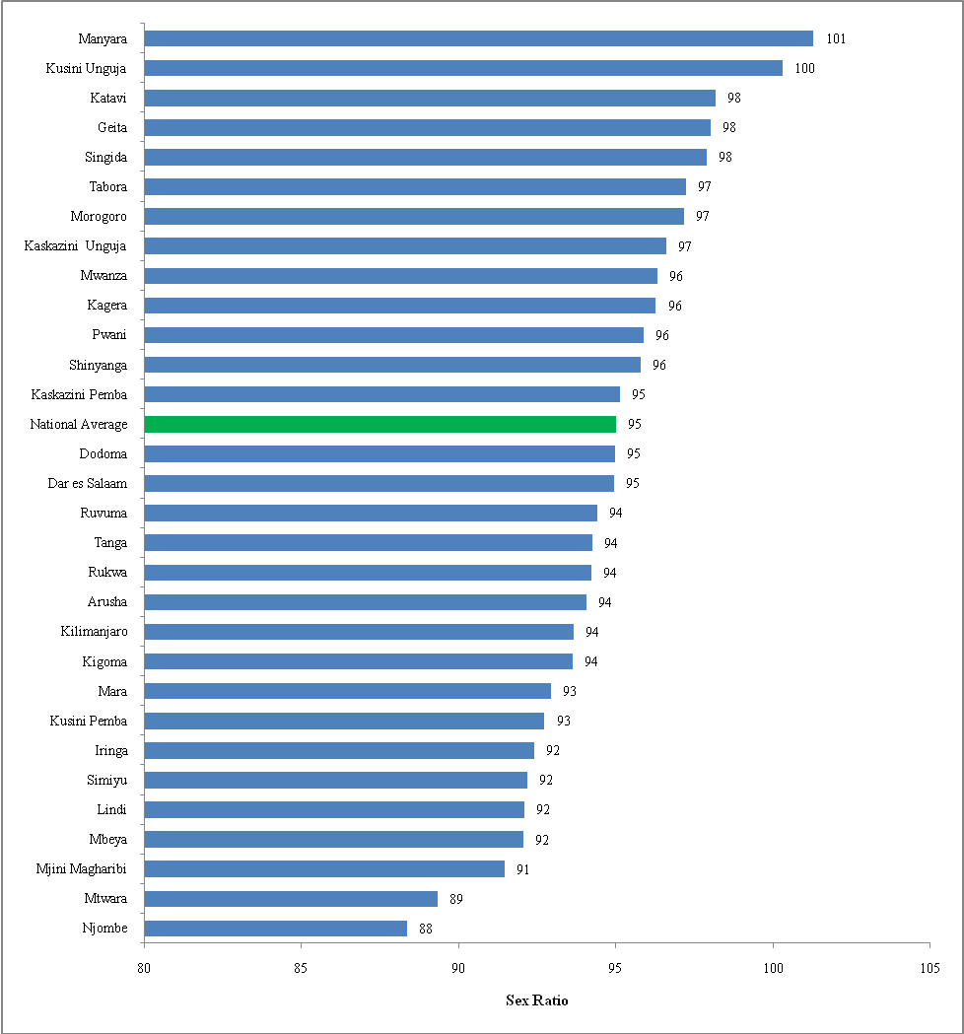

Trends in sex ratio between 1988 and 2012 Censuses show that, there were more females than males in the population, both in Tanzania Mainland and Tanzania Zanzibar (Figure 7).
Figure 7: Trends in Sex Ratio, 1988 – 2012 Censuses

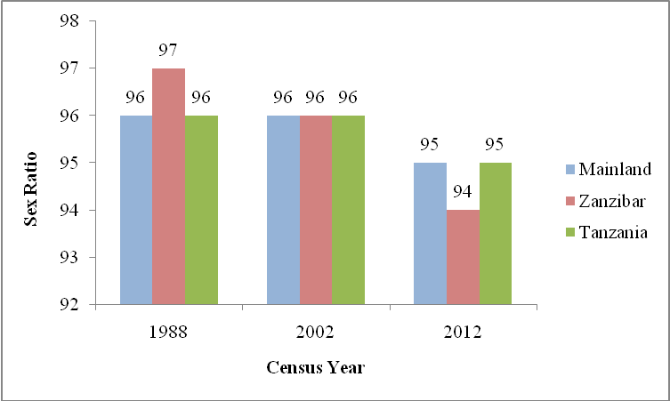

1.7 Regional Population Distribution

Population size varies across regions both in Tanzania Mainland and Tanzania Zanzibar. In Tanzania Mainland, Dar es Salaam shows high proportion with 10 percent of overall Mainland population followed by Mwanza region with 6.4 percent. Nine regions have proportions ranging from 4.0 to 6.2 percent. The regions with the least population share of less than 2 percent are Katavi (1.3 percent) and Njombe (1.6 percent) (Map 3).

In Tanzania Zanzibar, about half of the population resides in Mjini Magharibi which accounts for 46 percent while the region with the least share of population is Kusini Unguja (8.9 percent) (Map 4).
Map 3: Percentage Population Distribution by Region, Tanzania Mainland, 2012 Census

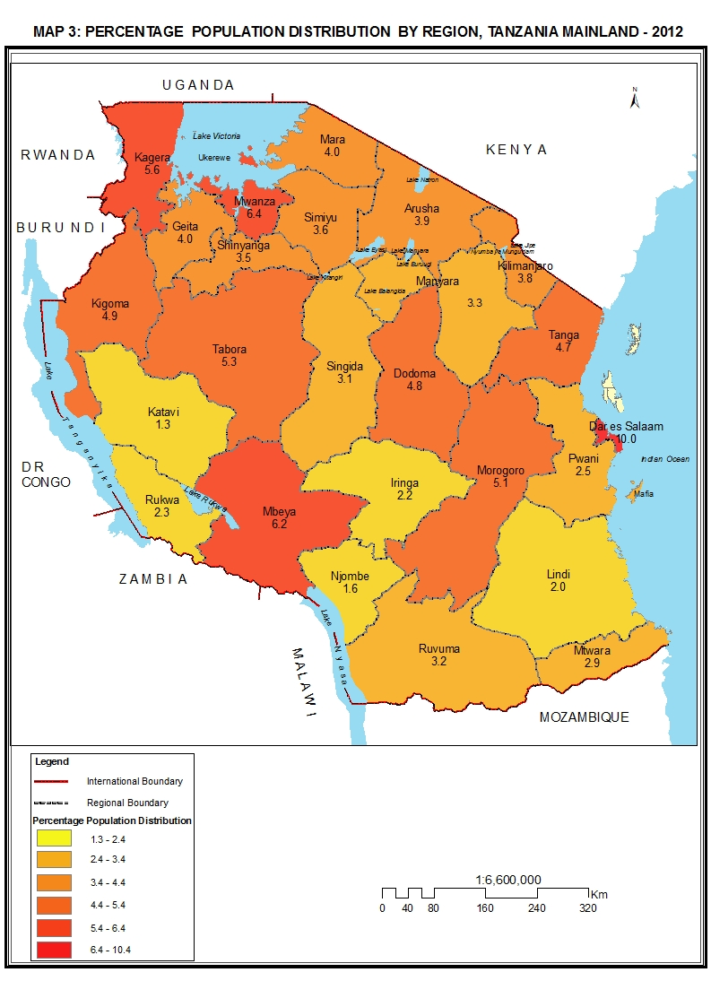

Map 4: Percentage Population Distribution by Region, Tanzania Zanzibar, 2012 Census

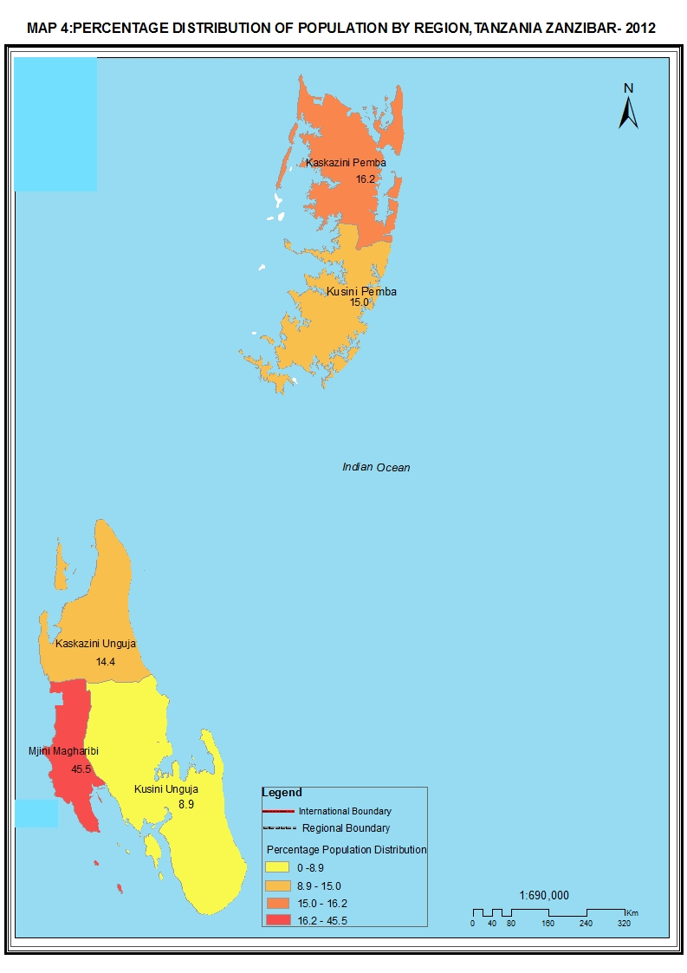

Table 3: Regional Population by Sex, Average Household Size and Sex Ratio
Region | Population (Number) |  |  | Average Household Size | Sex Ratio
Region | Total | Male | Female | Average Household Size | Sex Ratio
Tanzania | 44,928,923 | 21,869,990 | 23,058,933 | 4.8 | 95
Tanzania Mainland | 43,625,354 | 21,239,313 | 22,386,041 | 4.8 | 95
Dodoma | 2,083,588 | 1,014,974 | 1,068,614 | 4.6 | 95
Arusha | 1,694,310 | 821,282 | 873,028 | 4.5 | 94
Kilimanjaro | 1,640,087 | 793,140 | 846,947 | 4.3 | 94
Tanga | 2,045,205 | 992,347 | 1,052,858 | 4.7 | 94
Morogoro | 2,218,492 | 1,093,302 | 1,125,190 | 4.4 | 97
Pwani | 1,098,668 | 537,826 | 560,842 | 4.3 | 96
Dar es Salaam | 4,364,541 | 2,125,786 | 2,238,755 | 4.0 | 95
Lindi | 864,652 | 414,507 | 450,145 | 3.8 | 92
Mtwara | 1,270,854 | 599,648 | 671,206 | 3.7 | 89
Ruvuma | 1,376,891 | 668,684 | 708,207 | 4.5 | 94
Iringa | 941,238 | 452,052 | 489,186 | 4.2 | 92
Mbeya | 2,707,410 | 1,297,738 | 1,409,672 | 4.3 | 92
Singida | 1,370,637 | 677,995 | 692,642 | 5.3 | 98
Tabora | 2,291,623 | 1,129,730 | 1,161,893 | 6.0 | 97
Rukwa | 1,004,539 | 487,311 | 517,228 | 5.0 | 94
Kigoma | 2,127,930 | 1,028,994 | 1,098,936 | 5.7 | 94
Shinyanga | 1,534,808 | 750,841 | 783,967 | 5.9 | 96
Kagera | 2,458,023 | 1,205,683 | 1,252,340 | 4.7 | 96
Mwanza | 2,772,509 | 1,360,381 | 1,412,128 | 5.7 | 96
Mara | 1,743,830 | 840,020 | 903,810 | 5.6 | 93
Manyara | 1,425,131 | 717,085 | 708,046 | 5.2 | 101
Njombe | 702,097 | 329,359 | 372,738 | 4.1 | 88
Katavi | 564,604 | 279,682 | 284,922 | 5.5 | 98
Simiyu | 1,584,157 | 759,891 | 824,266 | 6.9 | 92
Geita | 1,739,530 | 861,055 | 878,475 | 6.1 | 98
Tanzania Zanzibar | 1,303,569 | 630,677 | 672,892 | 5.1 | 94
Kaskazini Unguja | 187,455 | 92,114 | 95,341 | 4.8 | 97
Kusini Unguja | 115,588 | 57,880 | 57,708 | 4.4 | 100
Mjini Magharibi | 593,678 | 283,590 | 310,088 | 5.2 | 91
Kaskazini Pemba | 211,732 | 103,222 | 108,510 | 5.3 | 95
Kusini Pemba | 195,116 | 93,871 | 101,245 | 5.4 | 93

Section B

Population in the Regions, District Councils, Wards/Shehia by Sex, Average Household Size and Sex Ratio

This Section presents population by Sex, Average Household Size and Sex Ratios for each region by means of maps and tables. Each regional map shows population distribution by district. During the cartographic preparations for the 2012 PHC, all villages/mitaa, wards/shehia and districts councils were mapped to facilitate census operations and data dissemination.

It will be observed that, a few district councils are formed by two polygons which are separated by urban authorities or neighbouring district councils. These district councils include Gairo in Morogoro Region, Masasi in Mtwara Region, Mbeya in Mbeya Region, Uyui in Tabora Region and Kahama in Shinyanga Region. However, it should be noted that, the maps presented in this Section are for statistical purposes only.
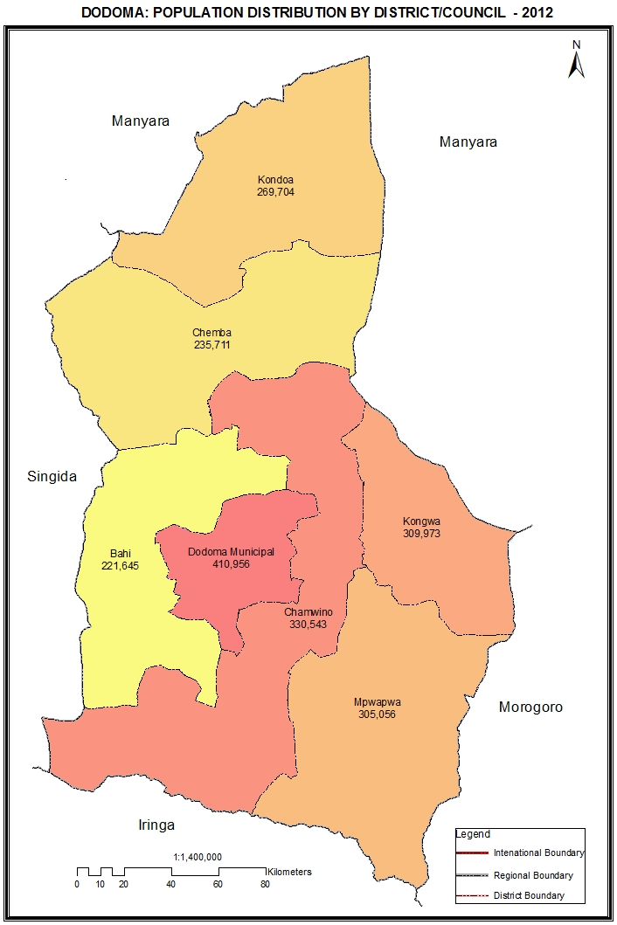

Table 1.0: Population of Dodoma Region by Sex, Average Household Size and Sex Ratio
Serial No. | District/Council | Population (Number) |  |  | Average Household Size | Sex Ratio
Serial No. | District/Council | Total | Male | Female | Average Household Size | Sex Ratio
 | Total | 2,083,588 | 1,014,974 | 1,068,614 | 4.6 | 95
1 | Kondoa District Council | 269,704 | 136,518 | 133,186 | 4.8 | 103
2 | Mpwapwa District Council | 305,056 | 147,306 | 157,750 | 4.6 | 93
3 | Kongwa District Council | 309,973 | 149,221 | 160,752 | 5.0 | 93
4 | Chamwino District Council | 330,543 | 158,882 | 171,661 | 4.5 | 93
5 | Dodoma Municipal Council | 410,956 | 199,487 | 211,469 | 4.4 | 94
6 | Bahi District Council | 221,645 | 105,975 | 115,670 | 4.5 | 92
7 | Chemba District Council | 235,711 | 117,585 | 118,126 | 4.7 | 100

Table 1. 1: Population of Kondoa District Council by Sex, Average Household Size and Sex Ratio
Serial No. | Ward/Shehia | Population (Number) |  |  | Average Household Size | Sex Ratio
Serial No. | Ward/Shehia | Total | Male | Female | Average Household Size | Sex Ratio
 | Total | 269,704 | 136,518 | 133,186 | 4.8 | 103
1 | Bumbuta | 8,602 | 4,433 | 4,169 | 5.0 | 106
2 | Pahi | 13,944 | 7,082 | 6,862 | 4.8 | 103
3 | Busi | 18,724 | 9,416 | 9,308 | 5.0 | 101
4 | Haubi | 13,757 | 7,027 | 6,730 | 5.1 | 104
5 | Kalamba | 13,988 | 7,023 | 6,965 | 4.9 | 101
6 | Kwadelo | 11,593 | 5,801 | 5,792 | 4.9 | 100
7 | Masange | 5,388 | 2,665 | 2,723 | 4.6 | 98
8 | Kikilo | 9,318 | 4,667 | 4,651 | 5.0 | 100
9 | Bereko | 7,226 | 3,655 | 3,571 | 4.7 | 102
10 | Kisese | 12,989 | 6,631 | 6,358 | 4.8 | 104
11 | Kikore | 13,044 | 6,724 | 6,320 | 5.0 | 106
12 | Serya | 6,054 | 3,188 | 2,866 | 4.6 | 111
13 | Kilimani | 7,237 | 3,503 | 3,734 | 4.7 | 94
14 | Chemchem | 7,914 | 3,797 | 4,117 | 4.1 | 92
15 | Hondomairo | 8,114 | 4,221 | 3,893 | 5.0 | 108
16 | Bolisa | 3,644 | 1,812 | 1,832 | 4.6 | 99
17 | Kinyasi | 8,816 | 4,508 | 4,308 | 5.0 | 105
18 | Salanka | 8,632 | 4,335 | 4,297 | 5.1 | 101
19 | Itololo | 7,196 | 3,717 | 3,479 | 4.9 | 107
20 | Itaswi | 9,774 | 5,159 | 4,615 | 4.8 | 112
21 | Suruke | 3,545 | 1,841 | 1,704 | 4.5 | 108
22 | Kingale | 11,003 | 5,602 | 5,401 | 4.3 | 104
23 | Kondoa Mjini | 14,382 | 6,744 | 7,638 | 4.2 | 88
24 | Kolo | 5,243 | 2,690 | 2,553 | 4.4 | 105
25 | Changaa | 9,634 | 5,095 | 4,539 | 4.8 | 112
26 | Thawi | 10,799 | 5,449 | 5,350 | 4.8 | 102
27 | Mnenia | 11,528 | 5,905 | 5,623 | 4.9 | 105
28 | Soera | 7,616 | 3,828 | 3,788 | 4.8 | 101

Table 1. 2: Population of Mpwapwa District Council by Sex, Average Household Size and Sex Ratio
Serial No. | Ward/Shehia | Population (Number) |  |  | Average Household Size | Sex Ratio
Serial No. | Ward/Shehia | Total | Male | Female | Average Household Size | Sex Ratio
 | Total | 305,056 | 147,306 | 157,750 | 4.6 | 93
1 | Mazae | 8,021 | 3,908 | 4,113 | 4.4 | 95
2 | Ving'hawe | 12,277 | 5,812 | 6,465 | 4.5 | 90
3 | Matomondo | 17,131 | 8,355 | 8,776 | 4.6 | 95
4 | Kimagai | 7,340 | 3,570 | 3,770 | 4.6 | 95
5 | Kibakwe | 16,705 | 8,115 | 8,590 | 4.5 | 94
6 | Lumuma | 3,783 | 1,874 | 1,909 | 4.3 | 98
7 | Luhundwa | 12,161 | 5,904 | 6,257 | 4.7 | 94
8 | Massa | 12,561 | 6,083 | 6,478 | 4.5 | 94
9 | Ipera | 12,870 | 6,304 | 6,566 | 4.8 | 96
10 | Rudi | 10,029 | 4,739 | 5,290 | 4.1 | 90
11 | Mlunduzi | 9,668 | 4,602 | 5,066 | 4.4 | 91
12 | Wotta | 13,340 | 6,359 | 6,981 | 4.8 | 91
13 | Mima | 14,435 | 6,926 | 7,509 | 4.6 | 92
14 | Berege | 10,931 | 5,373 | 5,558 | 5.2 | 97
15 | Chunyu | 11,593 | 5,458 | 6,135 | 4.3 | 89
16 | Mbuga | 5,813 | 2,924 | 2,889 | 5.3 | 101
17 | Godegode | 7,884 | 3,899 | 3,985 | 4.3 | 98
18 | Mpwapwa Mjini | 21,337 | 10,147 | 11,190 | 4.5 | 91
19 | Lupeta | 8,477 | 4,081 | 4,396 | 4.7 | 93
20 | Gulwe | 10,385 | 5,059 | 5,326 | 4.5 | 95
21 | Nghambi | 8,377 | 3,987 | 4,390 | 4.5 | 91
22 | Chitemo | 7,782 | 3,765 | 4,017 | 4.6 | 94
23 | Iwondo | 7,700 | 3,651 | 4,049 | 4.7 | 90
24 | Kingiti | 7,024 | 3,410 | 3,614 | 4.5 | 94
25 | Lufu | 4,937 | 2,401 | 2,536 | 4.8 | 95
26 | Pwaga | 11,217 | 5,353 | 5,864 | 4.4 | 91
27 | Galigali | 4,356 | 2,145 | 2,211 | 4.8 | 97
28 | Mtera | 10,934 | 5,434 | 5,500 | 4.4 | 99
29 | Chipogoro | 10,682 | 5,076 | 5,606 | 4.5 | 91
30 | Malolo | 5,306 | 2,592 | 2,714 | 4.7 | 96

Table 1. 3: Population of Kongwa District Council by Sex, Average Household Size and Sex Ratio
Serial No. | Ward/Shehia | Population (Number) |  |  | Average Household Size | Sex Ratio
Serial No. | Ward/Shehia | Total | Male | Female | Average Household Size | Sex Ratio
 | Total | 309,973 | 149,221 | 160,752 | 5.0 | 93
1 | Kongwa | 13,531 | 6,513 | 7,018 | 4.6 | 93
2 | Sejeli | 19,097 | 9,315 | 9,782 | 4.7 | 95
3 | Hogoro | 17,129 | 8,374 | 8,755 | 4.4 | 96
4 | Zoissa | 6,105 | 2,981 | 3,124 | 4.3 | 95
5 | Mkoka | 11,925 | 5,766 | 6,159 | 4.5 | 94
6 | Njoge | 10,063 | 4,874 | 5,189 | 4.9 | 94
7 | Mtanana | 12,559 | 6,113 | 6,446 | 4.9 | 95
8 | Pandambili | 8,004 | 3,848 | 4,156 | 5.6 | 93
9 | Mlali | 19,623 | 9,305 | 10,318 | 5.5 | 90
10 | Iduo | 11,197 | 5,424 | 5,773 | 5.5 | 94
11 | Sagara | 22,066 | 10,505 | 11,561 | 5.4 | 91
12 | Kibaigwa | 24,761 | 11,808 | 12,953 | 4.6 | 91
13 | Ugogoni | 17,048 | 8,059 | 8,989 | 5.0 | 90
14 | Chamkoroma | 14,675 | 7,286 | 7,389 | 5.3 | 99
15 | Makawa | 8,622 | 4,198 | 4,424 | 4.9 | 95
16 | Chitego | 9,799 | 4,698 | 5,101 | 4.6 | 92
17 | Matongoro | 10,095 | 4,900 | 5,195 | 4.5 | 94
18 | Ngomai | 10,534 | 5,105 | 5,429 | 4.9 | 94
19 | Songambele | 17,712 | 8,405 | 9,307 | 4.5 | 90
20 | Chiwe | 19,479 | 9,287 | 10,192 | 5.6 | 91
21 | Lenjulu | 14,440 | 6,938 | 7,502 | 5.5 | 92
22 | Nghumbi | 11,509 | 5,519 | 5,990 | 5.9 | 92

Table 1. 4: Population of Chamwino District Council by Sex, Average Household Size and Sex Ratio
Serial No. | Ward/Shehia | Population (Number) |  |  |  | Average Household Size | Sex Ratio
Serial No. | Ward/Shehia | Total |  | Male | Female | Average Household Size | Sex Ratio
 | Total | 330,543 |  | 158,882 | 171,661 | 4.5 | 93
1 | Haneti | 13,128 |  | 6,454 | 6,674 | 4.5 | 97
2 | Segala | 12,791 |  | 6,544 | 6,247 | 4.6 | 105
3 | Itiso | 12,636 |  | 6,293 | 6,343 | 4.4 | 99
4 | Dabalo | 16,115 |  | 8,003 | 8,112 | 4.5 | 99
5 | Membe | 8,726 |  | 4,300 | 4,426 | 4.5 | 97
6 | Msanga | 9,663 |  | 4,642 | 5,021 | 4.1 | 92
7 | Chilonwa | 7,907 |  | 3,852 | 4,055 | 4.3 | 95
8 | Buigiri | 16,821 |  | 7,934 | 8,887 | 4.2 | 89
9 | Majeleko | 6,886 |  | 3,284 | 3,602 | 4.5 | 91
10 | Manchali | 10,485 |  | 4,993 | 5,492 | 4.0 | 91
11 | Ikowa | 6,325 |  | 3,000 | 3,325 | 4.5 | 90
12 | Msamalo | 14,142 |  | 6,683 | 7,459 | 4.4 | 90
13 | Igandu | 14,880 |  | 6,939 | 7,941 | 4.4 | 87
14 | Muungano | 10,745 |  | 5,084 | 5,661 | 4.3 | 90
15 | Mvumi Makulu | 7,460 |  | 3,410 | 4,050 | 4.0 | 84
16 | Handali | 9,854 |  | 4,679 | 5,175 | 4.1 | 90
17 | Mvumi Mission | 16,514 |  | 7,748 | 8,766 | 4.5 | 88
18 | Idifu | 9,609 |  | 4,584 | 5,025 | 4.6 | 91
19 | Makang'wa | 20,337 |  | 9,494 | 10,843 | 4.5 | 88
20 | Iringa Mvumi Zamani | 11,313 |  | 5,415 | 5,898 | 4.4 | 92
21 | Manzase | 11,485 |  | 5,478 | 6,007 | 4.9 | 91
22 | Fufu | 3,469 |  | 1,668 | 1,801 | 4.9 | 93
23 | Mlowa Bwawani | 9,031 |  | 4,291 | 4,740 | 4.5 | 91
24 | Mpwayungu | 12,634 |  | 6,091 | 6,543 | 4.7 | 93
25 | Nghambaku | 7,339 |  | 3,657 | 3,682 | 4.5 | 99
26 | Chinugulu | 5,216 |  | 2,553 | 2,663 | 4.7 | 96
27 | Manda | 9,874 |  | 4,762 | 5,112 | 4.8 | 93
28 | Huzi | 7,589 |  | 3,653 | 3,936 | 4.9 | 93
29 | Loje | 5,134 |  | 2,493 | 2,641 | 4.5 | 94
30 | Chiboli | 4,679 |  | 2,306 | 2,373 | 4.5 | 97
31 | Nhinhi | 7,203 |  | 3,371 | 3,832 | 4.5 | 88
32 | Zajilwa | 10,553 |  | 5,224 | 5,329 | 4.3 | 98

Table 1. 5: Population of Dodoma Municipal Council by Sex, Average Household Size and Sex Ratio
Serial No. | Ward/Shehia | Population (Number) |  |  | Average Household Size | Sex Ratio
Serial No. | Ward/Shehia | Total | Male | Female | Average Household Size | Sex Ratio
 | Total | 410,956 | 199,487 | 211,469 | 4.4 | 94
1 | Viwandani | 4,883 | 2,437 | 2,446 | 3.5 | 100
2 | Uhuru | 2,419 | 1,229 | 1,190 | 4.1 | 103
3 | Chamwino | 19,175 | 9,063 | 10,112 | 4.2 | 90
4 | Kiwanja cha Ndege | 10,129 | 4,629 | 5,500 | 4.7 | 84
5 | Makole | 10,504 | 4,953 | 5,551 | 4.1 | 89
6 | Miyuji | 14,965 | 7,187 | 7,778 | 4.5 | 92
7 | Msalato | 6,718 | 3,356 | 3,362 | 4.5 | 100
8 | Makutupora | 14,430 | 7,762 | 6,668 | 5.1 | 116
9 | Chihanga | 11,004 | 5,366 | 5,638 | 4.5 | 95
10 | Hombolo | 22,457 | 10,845 | 11,612 | 4.5 | 93
11 | Ipala | 6,026 | 2,903 | 3,123 | 4.4 | 93
12 | Nzuguni | 15,466 | 7,412 | 8,054 | 4.3 | 92
13 | Dodoma Makulu | 17,097 | 8,219 | 8,878 | 4.4 | 93
14 | Mtumba | 17,268 | 8,440 | 8,828 | 4.5 | 96
15 | Kikombo | 8,343 | 4,025 | 4,318 | 4.3 | 93
16 | Ng'hong'honha | 9,536 | 4,513 | 5,023 | 4.1 | 90
17 | Mpunguzi | 17,891 | 8,650 | 9,241 | 4.4 | 94
18 | Tambukareli | 6,584 | 3,222 | 3,362 | 4.0 | 96
19 | Kilimani | 6,471 | 3,137 | 3,334 | 4.2 | 94
20 | Kikuyu Kusini | 5,974 | 2,724 | 3,250 | 4.3 | 84
21 | Kikuyu Kaskazini | 9,852 | 4,814 | 5,038 | 4.1 | 96
22 | Mkonze | 12,515 | 6,134 | 6,381 | 4.5 | 96
23 | Mbabala | 11,901 | 5,683 | 6,218 | 4.3 | 91
24 | Zuzu | 6,485 | 3,103 | 3,382 | 4.4 | 92
25 | Hazina | 9,540 | 5,182 | 4,358 | 4.5 | 119
26 | Madukani | 2,421 | 1,101 | 1,320 | 4.3 | 83
27 | Majengo | 5,214 | 2,531 | 2,683 | 3.8 | 94
28 | Kizota | 34,453 | 16,506 | 17,947 | 4.3 | 92
29 | Nala | 5,567 | 2,735 | 2,832 | 4.3 | 97
30 | Mbalawala | 8,830 | 4,204 | 4,626 | 4.5 | 91
31 | Ntyuka | 4,558 | 2,165 | 2,393 | 4.4 | 90
32 | Chigongwe | 7,281 | 3,447 | 3,834 | 4.5 | 90
33 | Chang'ombe | 25,415 | 12,583 | 12,832 | 4.3 | 98
34 | Iyumbu | 2,700 | 1,332 | 1,368 | 4.1 | 97
35 | Chahwa | 4,365 | 2,092 | 2,273 | 4.5 | 92
36 | Mnadani | 14,373 | 7,087 | 7,286 | 4.4 | 97
37 | Ipagala | 18,146 | 8,716 | 9,430 | 4.4 | 92

Table 1. 6: Population of Bahi District Council by Sex, Average Household Size and Sex Ratio
Serial No. | Ward/Shehia | Population (Number) |  |  | Average Household Size | Sex Ratio
Serial No. | Ward/Shehia | Total | Male | Female | Average Household Size | Sex Ratio
 | Total | 221,645 | 105,975 | 115,670 | 4.5 | 92
1 | Makanda | 7,896 | 3,808 | 4,088 | 4.4 | 93
2 | Lamaiti | 12,268 | 5,971 | 6,297 | 4.3 | 95
3 | Babayu | 10,126 | 4,942 | 5,184 | 4.6 | 95
4 | Zanka | 9,886 | 4,866 | 5,020 | 4.5 | 97
5 | Msisi | 11,847 | 5,736 | 6,111 | 4.5 | 94
6 | Mundemu | 8,149 | 3,917 | 4,232 | 4.2 | 93
7 | Bahi | 18,293 | 8,876 | 9,417 | 4.5 | 94
8 | Mpamantwa | 12,984 | 6,249 | 6,735 | 4.8 | 93
9 | Ibihwa | 11,060 | 5,223 | 5,837 | 4.3 | 89
10 | Ilindi | 9,440 | 4,515 | 4,925 | 4.5 | 92
11 | Kigwe | 15,559 | 7,315 | 8,244 | 4.3 | 89
12 | Chikola | 13,668 | 6,479 | 7,189 | 4.4 | 90
13 | Chipanga | 9,654 | 4,594 | 5,060 | 4.5 | 91
14 | Chali | 11,300 | 5,282 | 6,018 | 4.3 | 88
15 | Nondwa | 15,369 | 7,344 | 8,025 | 4.8 | 92
16 | Mpalanga | 10,228 | 4,831 | 5,397 | 4.5 | 90
17 | Ibugule | 8,046 | 3,770 | 4,276 | 4.6 | 88
18 | Chibelela | 10,033 | 4,739 | 5,294 | 4.4 | 90
19 | Mwitikira | 7,235 | 3,424 | 3,811 | 4.4 | 90
20 | Mtitaa | 8,604 | 4,094 | 4,510 | 4.5 | 91

Table 1. 7: Population of Chemba District Council by Sex, Average Household Size and Sex Ratio
Serial No. | Ward/Shehia | Population (Number) |  |  | Average Household Size | Sex Ratio
Serial No. | Ward/Shehia | Total | Male | Female | Average Household Size | Sex Ratio
 | Total | 235,711 | 117,585 | 118,126 | 4.7 | 100
1 | Makorongo | 15,162 | 7,343 | 7,819 | 4.6 | 94
2 | Ovada | 11,648 | 5,897 | 5,751 | 4.6 | 103
3 | Msaada | 6,349 | 3,163 | 3,186 | 4.9 | 99
4 | Kimaha | 10,602 | 5,302 | 5,300 | 4.8 | 100
5 | Churuku | 9,260 | 4,556 | 4,704 | 4.8 | 97
6 | Songoro | 10,751 | 5,472 | 5,279 | 4.9 | 104
7 | Mondo | 9,494 | 4,675 | 4,819 | 4.3 | 97
8 | Dalai | 15,078 | 7,365 | 7,713 | 4.8 | 95
9 | Jangalo | 17,764 | 8,939 | 8,825 | 4.8 | 101
10 | Mrijo | 13,104 | 6,405 | 6,699 | 4.7 | 96
11 | Chandama | 18,705 | 9,253 | 9,452 | 4.9 | 98
12 | Goima | 12,261 | 6,061 | 6,200 | 4.7 | 98
13 | Chemba | 16,047 | 8,119 | 7,928 | 4.7 | 102
14 | Paranga | 12,297 | 6,141 | 6,156 | 4.3 | 100
15 | Gwandi | 7,971 | 3,967 | 4,004 | 4.7 | 99
16 | Farkwa | 9,991 | 5,091 | 4,900 | 4.7 | 104
17 | Mpendo | 6,997 | 3,349 | 3,648 | 4.6 | 92
18 | Sanzawa | 10,613 | 5,434 | 5,179 | 4.6 | 105
19 | Kwamtoro | 9,785 | 4,995 | 4,790 | 4.5 | 104
20 | Lalta | 11,832 | 6,058 | 5,774 | 5.0 | 105
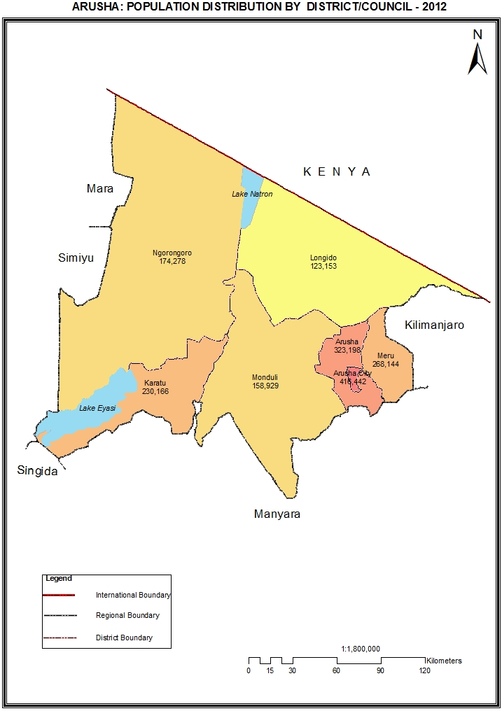

Table 2.0: Population of Arusha Region by Sex, Average Household Size and Sex Ratio
Serial No. | District/Council | Population (Number) |  |  | Average Household Size | Sex Ratio
Serial No. | District/Council | Total | Male | Female | Average Household Size | Sex Ratio
 | Total | 1,694,310 | 821,282 | 873,028 | 4.5 | 94
1 | Monduli District Council | 158,929 | 75,615 | 83,314 | 4.7 | 91
2 | Meru District Council | 268,144 | 131,264 | 136,880 | 4.3 | 96
3 | Arusha City Council | 416,442 | 199,524 | 216,918 | 4.0 | 92
4 | Karatu District Council | 230,166 | 117,769 | 112,397 | 5.1 | 105
5 | Ngorongoro District Council | 174,278 | 82,610 | 91,668 | 4.8 | 90
6 | Arusha District Council | 323,198 | 154,301 | 168,897 | 4.5 | 91
7 | Longido District Council | 123,153 | 60,199 | 62,954 | 5.0 | 96

Table 2. 1: Population of Monduli District Council by Sex, Average Household Size and Sex Ratio
Serial No. | Ward/Shehia | Population (Number) |  |  | Average Household Size | Sex Ratio
Serial No. | Ward/Shehia | Total | Male | Female | Average Household Size | Sex Ratio
 | Total | 158,929 | 75,615 | 83,314 | 4.7 | 91
1 | Engaruka | 11,121 | 5,314 | 5,807 | 5.1 | 92
2 | Selela | 8,703 | 4,244 | 4,459 | 4.6 | 95
3 | Monduli Juu | 15,914 | 7,321 | 8,593 | 4.8 | 85
4 | Engutoto | 6,970 | 3,304 | 3,666 | 4.7 | 90
5 | Monduli Mjini | 7,796 | 3,793 | 4,003 | 3.9 | 95
6 | Moita | 11,340 | 5,136 | 6,204 | 4.8 | 83
7 | Sepeko | 16,720 | 7,902 | 8,818 | 5.4 | 90
8 | Lolkisale | 10,056 | 4,892 | 5,164 | 4.9 | 95
9 | Makuyuni | 11,228 | 5,434 | 5,794 | 4.8 | 94
10 | Esilalei | 14,595 | 6,950 | 7,645 | 4.8 | 91
11 | Mto wa Mbu | 11,405 | 5,470 | 5,935 | 3.7 | 92
12 | Lepurko | 8,151 | 3,665 | 4,486 | 4.7 | 82
13 | Meserani | 11,301 | 5,400 | 5,901 | 5.1 | 92
14 | Mswakini | 5,776 | 2,861 | 2,915 | 4.9 | 98
15 | Majengo | 7,853 | 3,929 | 3,924 | 4.0 | 100

Table 2. 2: Population of Meru District Council by Sex, Average Household Size and Sex Ratio
Serial No. | Ward/Shehia | Population (Number) |  |  | Average Household Size | Sex Ratio
Serial No. | Ward/Shehia | Total | Male | Female | Average Household Size | Sex Ratio
 | Total | 268,144 | 131,264 | 136,880 | 4.3 | 96
1 | Ngarenanyuki | 20,379 | 10,169 | 10,210 | 4.4 | 100
2 | Leguruki | 17,636 | 8,584 | 9,052 | 4.6 | 95
3 | King'ori | 23,280 | 11,465 | 11,815 | 4.6 | 97
4 | Maji ya Chai | 29,313 | 14,143 | 15,170 | 4.0 | 93
5 | Kikatiti | 16,755 | 8,220 | 8,535 | 4.4 | 96
6 | Maroroni | 14,103 | 7,021 | 7,082 | 4.6 | 99
7 | Makiba | 11,874 | 5,819 | 6,055 | 4.6 | 96
8 | Mbuguni | 16,130 | 8,193 | 7,937 | 4.3 | 103
9 | Kikwe | 10,795 | 5,431 | 5,364 | 4.2 | 101
10 | Usa River | 23,437 | 11,174 | 12,263 | 3.8 | 91
11 | Nkoaranga | 13,929 | 6,789 | 7,140 | 4.3 | 95
12 | Poli | 9,507 | 4,542 | 4,965 | 4.4 | 91
13 | Seela Sing'isi | 10,109 | 4,911 | 5,198 | 4.2 | 94
14 | Akheri | 13,699 | 6,610 | 7,089 | 3.9 | 93
15 | Nkoanrua | 18,520 | 8,961 | 9,559 | 4.3 | 94
16 | Songoro | 11,319 | 5,698 | 5,621 | 4.4 | 101
17 | Nkoarisambu | 7,359 | 3,534 | 3,825 | 4.3 | 92

Table 2. 3: Population of Arusha City Council by Sex, Average Household Size and Sex Ratio
Serial No. | Ward/Shehia | Population (Number) |  |  | Average Household Size | Sex Ratio
Serial No. | Ward/Shehia | Total | Male | Female | Average Household Size | Sex Ratio
 | Total | 416,442 | 199,524 | 216,918 | 4.0 | 92
1 | Kati | 3,114 | 1,564 | 1,550 | 4.4 | 101
2 | Kaloleni | 9,591 | 4,490 | 5,101 | 3.8 | 88
3 | Sekei | 9,213 | 4,272 | 4,941 | 3.7 | 86
4 | Kimandolu | 27,649 | 12,911 | 14,738 | 3.7 | 88
5 | Baraa | 12,498 | 5,896 | 6,602 | 4.3 | 89
6 | Oloirien | 18,679 | 8,743 | 9,936 | 3.7 | 88
7 | Themi | 9,458 | 4,579 | 4,879 | 4.1 | 94
8 | Lemara | 19,564 | 9,573 | 9,991 | 4.2 | 96
9 | Terrat | 21,790 | 10,346 | 11,444 | 4.5 | 90
10 | Sokon I | 73,331 | 35,534 | 37,797 | 4.0 | 94
11 | Daraja Mbili | 19,491 | 9,375 | 10,116 | 3.7 | 93
12 | Unga Limited | 17,342 | 8,497 | 8,845 | 3.6 | 96
13 | Sombetini | 48,268 | 22,769 | 25,499 | 3.9 | 89
14 | Ngarenaro | 12,382 | 5,955 | 6,427 | 4.0 | 93
15 | Levolosi | 8,838 | 4,279 | 4,559 | 4.0 | 94
16 | Engutoto | 7,426 | 3,619 | 3,807 | 4.4 | 95
17 | Elerai | 40,749 | 19,244 | 21,505 | 3.6 | 89
18 | Olasiti | 36,361 | 17,883 | 18,478 | 4.5 | 97
19 | Moshono | 20,698 | 9,995 | 10,703 | 4.4 | 93

Table 2. 4: Population of Karatu District Council by Sex, Average Household Size and Sex Ratio
Serial No. | Ward/Shehia | Population (Number) |  |  | Average Household Size | Sex Ratio
Serial No. | Ward/Shehia | Total | Male | Female | Average Household Size | Sex Ratio
 | Total | 230,166 | 117,769 | 112,397 | 5.1 | 105
1 | Karatu | 26,617 | 12,990 | 13,627 | 4.1 | 95
2 | Endamarariek | 24,996 | 12,686 | 12,310 | 5.5 | 103
3 | Buger | 9,919 | 5,051 | 4,868 | 5.9 | 104
4 | Endabash | 14,358 | 7,564 | 6,794 | 5.8 | 111
5 | Kansay | 14,198 | 7,254 | 6,944 | 5.7 | 104
6 | Baray | 23,554 | 12,398 | 11,156 | 5.2 | 111
7 | Mang'ola | 6,087 | 3,235 | 2,852 | 5.1 | 113
8 | Daa | 9,868 | 5,243 | 4,625 | 5.0 | 113
9 | Oldean | 6,870 | 3,525 | 3,345 | 4.3 | 105
10 | Qurus | 15,919 | 8,027 | 7,892 | 4.9 | 102
11 | Ganako | 15,481 | 7,822 | 7,659 | 5.0 | 102
12 | Rhotia | 24,268 | 12,490 | 11,778 | 5.0 | 106
13 | Mbulumbulu | 21,764 | 11,219 | 10,545 | 5.5 | 106
14 | Endamaghang | 16,267 | 8,265 | 8,002 | 5.2 | 103

Table 2. 5: Population of Ngorongoro District Council by Sex, Average Household Size and Sex Ratio
Serial No. | Ward/Shehia | Population (Number) |  |  | Average Household Size | Sex Ratio
Serial No. | Ward/Shehia | Total | Male | Female | Average Household Size | Sex Ratio
 | Total | 174,278 | 82,610 | 91,668 | 4.8 | 90
1 | Orgosorok | 12,268 | 6,112 | 6,156 | 4.8 | 99
2 | Digodigo | 8,195 | 3,942 | 4,253 | 5.0 | 93
3 | Oldonyosambu | 5,233 | 2,525 | 2,708 | 5.3 | 93
4 | Pinyinyi | 8,482 | 4,083 | 4,399 | 5.0 | 93
5 | Sale | 4,384 | 2,069 | 2,315 | 4.5 | 89
6 | Malambo | 14,226 | 6,608 | 7,618 | 4.9 | 87
7 | Naiyobi | 9,133 | 4,277 | 4,856 | 4.8 | 88
8 | Nainokanoka | 12,971 | 6,032 | 6,939 | 4.5 | 87
9 | Olbalbal | 8,969 | 4,119 | 4,850 | 4.6 | 85
10 | Ngorongoro | 12,586 | 5,871 | 6,715 | 4.5 | 87
11 | Enduleni | 13,537 | 6,000 | 7,537 | 4.7 | 80
12 | Kakesio | 5,537 | 2,578 | 2,959 | 4.5 | 87
13 | Arash | 7,841 | 3,711 | 4,130 | 5.0 | 90
14 | Soit-Sambu | 10,956 | 5,407 | 5,549 | 5.1 | 97
15 | Enguserosambu | 1,521 | 752 | 769 | 5.8 | 98
16 | Oloirien | 9,485 | 4,685 | 4,800 | 4.6 | 98
17 | Samunge | 6,579 | 3,156 | 3,423 | 5.2 | 92
18 | Alailelai | 7,351 | 3,405 | 3,946 | 4.8 | 86
19 | Maalon | 4,353 | 2,004 | 2,349 | 4.9 | 85
20 | Ololosokwan | 6,557 | 3,263 | 3,294 | 5.0 | 99
21 | Oloipiri | 4,114 | 2,011 | 2,103 | 5.1 | 96

Table 2. 6: Population of Arusha District Council by Sex, Average Household Size and Sex Ratio
Serial No. | Ward/Shehia | Population (Number) |  |  | Average Household Size | Sex Ratio
Serial No. | Ward/Shehia | Total | Male | Female | Average Household Size | Sex Ratio
 | Total | 323,198 | 154,301 | 168,897 | 4.5 | 91
1 | Oldonyosambu | 16,484 | 7,943 | 8,541 | 4.9 | 93
2 | Olkokola | 24,728 | 11,511 | 13,217 | 4.9 | 87
3 | Ilkiding'a | 10,850 | 5,218 | 5,632 | 4.9 | 93
4 | Bangata | 9,136 | 4,495 | 4,641 | 4.4 | 97
5 | Sokon II | 32,073 | 15,261 | 16,812 | 4.1 | 91
6 | Oltoroto | 15,451 | 7,536 | 7,915 | 4.8 | 95
7 | Moivo | 27,151 | 13,311 | 13,840 | 3.7 | 96
8 | Kiranyi | 25,469 | 12,084 | 13,385 | 3.9 | 90
9 | Kimnyaki | 3,487 | 1,652 | 1,835 | 5.0 | 90
10 | Oltrumet | 10,226 | 4,806 | 5,420 | 4.8 | 89
11 | Mwandeti | 17,390 | 7,927 | 9,463 | 5.0 | 84
12 | Mussa | 11,836 | 5,598 | 6,238 | 4.7 | 90
13 | Kisongo | 8,769 | 4,166 | 4,603 | 4.9 | 91
14 | Mateves | 15,632 | 7,373 | 8,259 | 4.3 | 89
15 | Oljoro | 7,896 | 3,905 | 3,991 | 5.1 | 98
16 | Bwawani | 11,117 | 5,483 | 5,634 | 4.7 | 97
17 | Nduruma | 12,042 | 5,960 | 6,082 | 4.5 | 98
18 | Mlangarini | 12,983 | 6,343 | 6,640 | 4.6 | 96
19 | Sambasha | 9,484 | 4,157 | 5,327 | 5.0 | 78
20 | Olorieni | 22,434 | 10,705 | 11,729 | 4.5 | 91
21 | Olmotonyi | 18,560 | 8,867 | 9,693 | 4.6 | 91

Table 2. 7: Population of Longido District Council by Sex, Average Household Size and Sex Ratio
Serial No. | Ward/Shehia | Population (Number) |  |  | Average Household Size | Sex Ratio
Serial No. | Ward/Shehia | Total | Male | Female | Average Household Size | Sex Ratio
 | Total | 123,153 | 60,199 | 62,954 | 5.0 | 96
1 | Ketumbeine | 7,233 | 3,613 | 3,620 | 5.7 | 100
2 | Engikaret | 6,527 | 3,192 | 3,335 | 5.0 | 96
3 | Eleng'ata Dapash | 10,221 | 4,856 | 5,365 | 5.5 | 91
4 | Ilorienito | 5,571 | 2,565 | 3,006 | 4.8 | 85
5 | Gelai Meirugoi | 9,173 | 4,454 | 4,719 | 5.6 | 94
6 | Gelai Lumbwa | 6,198 | 3,108 | 3,090 | 5.0 | 101
7 | Matale | 4,411 | 2,194 | 2,217 | 4.8 | 99
8 | Engarenaibor | 11,607 | 5,789 | 5,818 | 5.3 | 100
9 | Mundarara | 7,301 | 3,711 | 3,590 | 5.7 | 103
10 | Kimokouwa | 7,806 | 3,763 | 4,043 | 5.2 | 93
11 | Namanga | 9,189 | 4,464 | 4,725 | 3.6 | 94
12 | Orbomba | 7,900 | 3,901 | 3,999 | 4.7 | 98
13 | Longido | 2,285 | 1,155 | 1,130 | 3.9 | 102
14 | Tingatinga | 8,821 | 4,286 | 4,535 | 4.9 | 95
15 | Olmolog | 8,764 | 4,210 | 4,554 | 4.9 | 92
16 | Kamwanga | 10,146 | 4,938 | 5,208 | 4.9 | 95

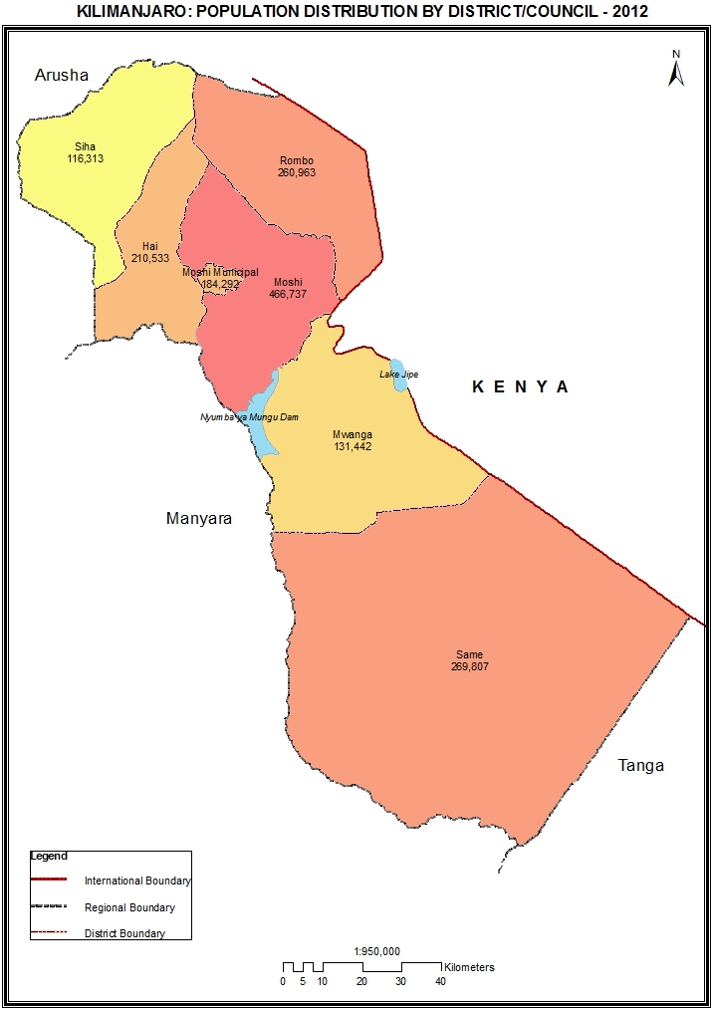

Table 3.0: Population of Kilimanjaro Region by Sex, Average Household Size and Sex Ratio
Serial No. | District/Council | Population (Number) |  |  | Average Household Size | Sex Ratio
Serial No. | District/Council | Total | Male | Female | Average Household Size | Sex Ratio
 | Total | 1,640,087 | 793,140 | 846,947 | 4.3 | 94
1 | Rombo District Council | 260,963 | 124,528 | 136,435 | 4.4 | 91
2 | Mwanga District Council | 131,442 | 63,199 | 68,243 | 4.4 | 93
3 | Same District Council | 269,807 | 131,515 | 138,292 | 4.5 | 95
4 | Moshi District Council | 466,737 | 225,767 | 240,970 | 4.2 | 94
5 | Hai District Council | 210,533 | 102,457 | 108,076 | 4.2 | 95
6 | Moshi Municipal Council | 184,292 | 89,174 | 95,118 | 4.0 | 94
7 | Siha District Council | 116,313 | 56,500 | 59,813 | 4.3 | 94

Table 3. 1: Population of Rombo District Council by Sex, Average Household Size and Sex Ratio
Serial No. | Ward/Shehia | Population (Number) |  |  | Average Household Size | Sex Ratio
Serial No. | Ward/Shehia | Total | Male | Female | Average Household Size | Sex Ratio
 | Total | 260,963 | 124,528 | 136,435 | 4.4 | 91
1 | Mamsera | 9,935 | 4,859 | 5,076 | 4.0 | 96
2 | Mahida | 7,980 | 3,918 | 4,062 | 4.2 | 96
3 | Mengwe | 5,277 | 2,437 | 2,840 | 4.0 | 86
4 | Keni Mengeni | 8,719 | 4,253 | 4,466 | 4.8 | 95
5 | Aleni | 9,801 | 4,787 | 5,014 | 4.3 | 95
6 | Shimbi | 14,591 | 7,086 | 7,505 | 4.4 | 94
7 | Makiidi | 8,720 | 4,063 | 4,657 | 4.3 | 87
8 | Kelamfua Mokala | 13,302 | 6,097 | 7,205 | 4.1 | 85
9 | Ushiri Ikuini | 8,879 | 4,103 | 4,776 | 4.4 | 86
10 | Mrao Keryo | 8,199 | 3,766 | 4,433 | 4.3 | 85
11 | Kirwa Keni | 8,362 | 3,659 | 4,703 | 4.4 | 78
12 | Katangara Mrere | 11,642 | 5,451 | 6,191 | 4.5 | 88
13 | Kisale Msaranga | 10,048 | 4,640 | 5,408 | 4.3 | 86
14 | Olele | 6,723 | 3,134 | 3,589 | 4.3 | 87
15 | Kirongo Samanga | 14,895 | 7,106 | 7,789 | 4.5 | 91
16 | Kitirima Kingachi | 18,420 | 8,677 | 9,743 | 4.6 | 89
17 | Ubetu Kahe | 19,295 | 9,248 | 10,047 | 4.6 | 92
18 | Nanjara Reha | 26,715 | 12,989 | 13,726 | 4.7 | 95
19 | Tarakea Motamburu | 20,746 | 10,253 | 10,493 | 4.4 | 98
20 | Motamburu Kitendeni | 5,603 | 2,875 | 2,728 | 4.5 | 105
21 | Marangu Kitowo | 7,734 | 3,609 | 4,125 | 4.3 | 87
22 | Ngoyoni | 4,038 | 1,939 | 2,099 | 3.9 | 92
23 | Manda | 4,040 | 1,906 | 2,134 | 4.0 | 89
24 | Holili | 7,299 | 3,673 | 3,626 | 3.8 | 101

Table 3. 2: Population of Mwanga District Council by Sex, Average Household Size and Sex Ratio
Serial No. | Ward/Shehia | Population (Number) |  |  | Average Household Size | Sex Ratio
Serial No. | Ward/Shehia | Total | Male | Female | Average Household Size | Sex Ratio
 | Total | 131,442 | 63,199 | 68,243 | 4.4 | 93
1 | Kileo | 13,645 | 6,702 | 6,943 | 4.1 | 97
2 | Mwanga | 15,783 | 7,414 | 8,369 | 4.1 | 89
3 | Msangeni | 6,925 | 3,256 | 3,669 | 4.5 | 89
4 | Kifula | 8,020 | 3,826 | 4,194 | 4.5 | 91
5 | Kighare | 6,254 | 2,915 | 3,339 | 4.6 | 87
6 | Kirongwe | 4,771 | 2,228 | 2,543 | 4.2 | 88
7 | Kwakoa | 3,717 | 1,869 | 1,848 | 4.5 | 101
8 | Lembeni | 11,780 | 5,666 | 6,114 | 4.4 | 93
9 | Jipe | 2,564 | 1,294 | 1,270 | 4.3 | 102
10 | Mwaniko | 7,741 | 3,693 | 4,048 | 4.4 | 91
11 | Chomvu | 7,444 | 3,401 | 4,043 | 4.5 | 84
12 | Ngujini | 3,314 | 1,483 | 1,831 | 4.6 | 81
13 | Kirya | 4,917 | 2,531 | 2,386 | 4.2 | 106
14 | Kilomeni | 4,467 | 2,139 | 2,328 | 4.5 | 92
15 | Shighatini | 7,765 | 3,740 | 4,025 | 4.6 | 93
16 | Lang'ata | 8,965 | 4,435 | 4,530 | 4.2 | 98
17 | Mgagao | 6,011 | 2,879 | 3,132 | 4.7 | 92
18 | Toloha | 3,055 | 1,484 | 1,571 | 4.5 | 94
19 | Kigonigoni | 2,610 | 1,364 | 1,246 | 4.5 | 109
20 | Kivisini | 1,694 | 880 | 814 | 5.0 | 108

Table 3. 3: Population of Same District Council by Sex, Average Household Size and Sex Ratio
Serial No. | Ward/Shehia | Population (Number) |  |  | Average Household Size | Sex Ratio
Serial No. | Ward/Shehia | Total | Male | Female | Average Household Size | Sex Ratio
 | Total | 269,807 | 131,515 | 138,292 | 4.5 | 95
1 | Same | 9,049 | 4,194 | 4,855 | 3.8 | 86
2 | Ruvu | 14,261 | 7,439 | 6,822 | 4.6 | 109
3 | Njoro | 5,368 | 2,599 | 2,769 | 4.3 | 94
4 | Kisiwani | 9,309 | 4,314 | 4,995 | 4.4 | 86
5 | Msindo | 6,495 | 3,179 | 3,316 | 4.6 | 96
6 | Mshewa | 6,154 | 3,077 | 3,077 | 4.5 | 100
7 | Mhezi | 4,790 | 2,348 | 2,442 | 4.8 | 96
8 | Mwembe | 11,913 | 5,935 | 5,978 | 5.5 | 99
9 | Vudee | 7,120 | 3,529 | 3,591 | 4.9 | 98
10 | Vuje | 10,726 | 5,288 | 5,438 | 4.8 | 97
11 | Bombo | 5,530 | 2,711 | 2,819 | 4.4 | 96
12 | Mtii | 5,488 | 2,706 | 2,782 | 4.5 | 97
13 | Maore | 15,722 | 7,682 | 8,040 | 4.1 | 96
14 | Ndungu | 13,636 | 6,557 | 7,079 | 4.2 | 93
15 | Kihurio | 10,341 | 5,032 | 5,309 | 4.1 | 95
16 | Bendera | 4,913 | 2,358 | 2,555 | 4.3 | 92
17 | Myamba | 13,168 | 6,521 | 6,647 | 4.6 | 98
18 | Mpinji | 8,453 | 4,177 | 4,276 | 4.7 | 98
19 | Bwambo | 9,479 | 4,705 | 4,774 | 4.7 | 99
20 | Vunta | 8,659 | 4,126 | 4,533 | 4.7 | 91
21 | Chome | 5,893 | 2,924 | 2,969 | 4.5 | 98
22 | Suji | 8,776 | 4,377 | 4,399 | 4.7 | 99
23 | Makanya | 10,629 | 5,321 | 5,308 | 4.2 | 100
24 | Hedaru | 18,476 | 8,749 | 9,727 | 4.3 | 90
25 | Kirangare | 5,528 | 2,667 | 2,861 | 4.8 | 93
26 | Kisima | 9,885 | 4,119 | 5,766 | 4.7 | 71
27 | Stesheni | 6,860 | 3,289 | 3,571 | 4.7 | 92
28 | Vumari | 5,908 | 2,971 | 2,937 | 4.8 | 101
29 | Mabilioni | 6,570 | 3,256 | 3,314 | 4.6 | 98
30 | Kalemawe | 4,248 | 2,134 | 2,114 | 4.4 | 101
31 | Lugulu | 6,460 | 3,231 | 3,229 | 4.8 | 100

Table 3. 4: Population of Moshi District Council by Sex, Average Household Size and Sex Ratio
Serial No. | Ward/Shehia | Population (Number) |  |  | Average Household Size | Sex Ratio
Serial No. | Ward/Shehia | Total | Male | Female | Average Household Size | Sex Ratio
 | Total | 466,737 | 225,767 | 240,970 | 4.2 | 94
1 | Mwika Kusini | 19,645 | 9,591 | 10,054 | 4.0 | 95
2 | Mwika Kaskazini | 21,177 | 10,387 | 10,790 | 4.2 | 96
3 | Mamba Kaskazini | 9,065 | 4,366 | 4,699 | 4.0 | 93
4 | Mamba Kusini | 10,060 | 4,888 | 5,172 | 3.9 | 95
5 | Marangu Mashariki | 23,734 | 11,455 | 12,279 | 4.3 | 93
6 | Marangu Magharibi | 18,976 | 9,132 | 9,844 | 4.2 | 93
7 | Makuyuni | 22,442 | 10,781 | 11,661 | 3.7 | 92
8 | Kilema Kaskazini | 9,669 | 4,592 | 5,077 | 4.5 | 90
9 | Kilema Kusini | 22,711 | 11,114 | 11,597 | 4.4 | 96
10 | Kirua Vunjo Mashariki | 8,657 | 4,306 | 4,351 | 4.2 | 99
11 | Kirua Vunjo Magharibi | 12,840 | 6,266 | 6,574 | 4.1 | 95
12 | Kahe | 19,142 | 9,581 | 9,561 | 4.4 | 100
13 | Kahe Mashariki | 11,384 | 5,789 | 5,595 | 4.4 | 103
14 | Old Moshi Mashariki | 9,528 | 4,575 | 4,953 | 4.2 | 92
15 | Old Moshi Magharibi | 8,100 | 4,036 | 4,064 | 4.3 | 99
16 | Mbokomu | 14,606 | 7,036 | 7,570 | 4.1 | 93
17 | Uru Mashariki | 14,781 | 7,248 | 7,533 | 4.3 | 96
18 | Uru Shimbwe | 6,107 | 2,844 | 3,263 | 4.2 | 87
19 | Uru Kusini | 22,904 | 11,065 | 11,839 | 4.3 | 93
20 | Uru Kaskazini | 11,081 | 5,331 | 5,750 | 4.4 | 93
21 | Mabogini | 28,992 | 14,320 | 14,672 | 4.2 | 98
22 | Arusha Chini | 13,960 | 7,227 | 6,733 | 4.4 | 107
23 | Kibosho Mashariki | 14,148 | 6,374 | 7,774 | 5.1 | 82
24 | Kibosho Kati | 10,258 | 4,613 | 5,645 | 4.0 | 82
25 | Kibosho Magharibi | 20,291 | 9,737 | 10,554 | 4.2 | 92
26 | Kindi | 21,391 | 10,222 | 11,169 | 4.4 | 92
27 | Kirua Vunjo Kusini | 19,378 | 9,455 | 9,923 | 4.2 | 95
28 | Kirima | 10,709 | 4,890 | 5,819 | 4.6 | 84
29 | Okaoni | 10,446 | 4,709 | 5,737 | 4.0 | 82
30 | Kimochi | 13,562 | 6,476 | 7,086 | 4.1 | 91
31 | Kilema Kati | 6,993 | 3,361 | 3,632 | 4.1 | 93

Table 3. 5: Population of Hai District Council by Sex, Average Household Size and Sex Ratio
Serial No. | Ward/Shehia | Population (Number) |  |  | Average Household Size | Sex Ratio
Serial No. | Ward/Shehia | Total | Male | Female | Average Household Size | Sex Ratio
 | Total | 210,533 | 102,457 | 108,076 | 4.2 | 95
1 | Machame Mashariki | 13,084 | 6,353 | 6,731 | 3.8 | 94
2 | Machame Kusini | 13,572 | 6,828 | 6,744 | 4.6 | 101
3 | Machame Kaskazini | 23,334 | 11,317 | 12,017 | 4.1 | 94
4 | Machame Magharibi | 6,503 | 3,156 | 3,347 | 3.8 | 94
5 | Machame Uroki | 10,762 | 5,293 | 5,469 | 3.9 | 97
6 | Masama Mashariki | 25,723 | 12,481 | 13,242 | 4.0 | 94
7 | Masama Magharibi | 10,851 | 5,357 | 5,494 | 4.0 | 98
8 | Masama Kusini | 12,060 | 5,824 | 6,236 | 4.2 | 93
9 | Masama Rundugai | 14,033 | 7,036 | 6,997 | 4.6 | 101
10 | Hai Mjini | 34,098 | 16,157 | 17,941 | 4.1 | 90
11 | Masama Kati | 11,562 | 5,601 | 5,961 | 3.9 | 94
12 | Machame Weruweru | 12,402 | 6,141 | 6,261 | 4.1 | 98
13 | KIA | 10,472 | 5,225 | 5,247 | 4.7 | 100
14 | Machame Narumu | 12,077 | 5,688 | 6,389 | 4.5 | 89

Table 3. 6: Population of Moshi Municipal Council by Sex, Average Household Size and Sex Ratio
Serial No. | Ward/Shehia | Population (Number) |  |  | Average Household Size | Sex Ratio
Serial No. | Ward/Shehia | Total | Male | Female | Average Household Size | Sex Ratio
 | Total | 184,292 | 89,174 | 95,118 | 4.0 | 94
1 | Kilimanjaro | 5,233 | 2,539 | 2,694 | 4.6 | 94
2 | Njoro | 14,296 | 6,992 | 7,304 | 3.8 | 96
3 | Mji Mpya | 15,293 | 7,349 | 7,944 | 3.9 | 93
4 | Majengo | 9,006 | 4,375 | 4,631 | 3.7 | 94
5 | Mawenzi | 1,770 | 773 | 997 | 4.3 | 78
6 | Rau | 9,137 | 4,294 | 4,843 | 3.9 | 89
7 | Korongoni | 5,815 | 2,757 | 3,058 | 3.7 | 90
8 | Kiusa | 5,950 | 2,911 | 3,039 | 3.6 | 96
9 | Bondeni | 4,050 | 2,045 | 2,005 | 3.7 | 102
10 | Pasua | 13,460 | 6,572 | 6,888 | 4.0 | 95
11 | Kaloleni | 6,554 | 3,208 | 3,346 | 3.8 | 96
12 | Kiboriloni | 9,206 | 4,290 | 4,916 | 3.6 | 87
13 | Msaranga | 7,699 | 3,760 | 3,939 | 4.4 | 95
14 | Karanga | 7,124 | 4,115 | 3,009 | 5.0 | 137
15 | Longuo B | 6,632 | 3,044 | 3,588 | 4.0 | 85
16 | Miembeni | 15,220 | 7,438 | 7,782 | 4.0 | 96
17 | Mfumuni | 4,750 | 2,205 | 2,545 | 4.3 | 87
18 | Soweto | 14,946 | 7,219 | 7,727 | 4.4 | 93
19 | Boma Mbuzi | 15,776 | 7,518 | 8,258 | 3.8 | 91
20 | Ng'ambo | 7,890 | 3,635 | 4,255 | 4.0 | 85
21 | Shirimatunda | 4,485 | 2,135 | 2,350 | 4.6 | 91

Table 3. 7: Population of Siha District Council by Sex, Average Household Size and Sex Ratio
Serial No. | Ward/Shehia | Population (Number) |  |  | Average Household Size | Sex Ratio
Serial No. | Ward/Shehia | Total | Male | Female | Average Household Size | Sex Ratio
 | Total | 116,313 | 56,500 | 59,813 | 4.3 | 94
1 | Ndumeti | 11,344 | 5,729 | 5,615 | 4.0 | 102
2 | Ngarenairobi | 9,431 | 4,679 | 4,752 | 3.9 | 98
3 | Gararagua | 9,884 | 4,693 | 5,191 | 4.7 | 90
4 | Sanya Juu | 11,283 | 5,422 | 5,861 | 4.1 | 93
5 | Biriri | 7,768 | 3,690 | 4,078 | 4.6 | 90
6 | Makiwaru | 10,699 | 5,213 | 5,486 | 4.8 | 95
7 | Nasai | 8,032 | 3,881 | 4,151 | 3.7 | 93
8 | Livishi | 6,140 | 3,059 | 3,081 | 3.9 | 99
9 | Naeny | 10,748 | 5,205 | 5,543 | 4.0 | 94
10 | Kashashi | 6,694 | 3,248 | 3,446 | 4.0 | 94
11 | Karansi | 11,394 | 5,447 | 5,947 | 4.7 | 92
12 | Olkolili | 12,896 | 6,234 | 6,662 | 4.9 | 94

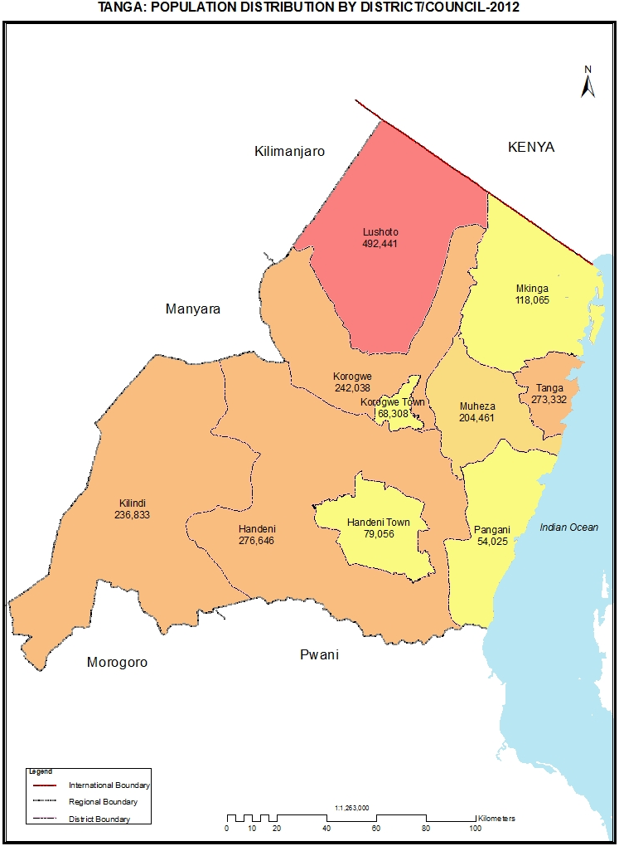

Table 4.0: Population of Tanga Region by Sex, Average Household Size and Sex Ratio
Serial No. | District/Council | Population (Number) |  |  |  | Average Household Size | Sex Ratio
Serial No. | District/Council | Total | Male | Female |  | Average Household Size | Sex Ratio
 | Total | 2,045,205 | 992,347 | 1,052,858 |  | 4.7 | 94
1 | Lushoto District Council | 492,441 | 230,236 | 262,205 |  | 4.7 | 88
2 | Korogwe District Council | 242,038 | 118,544 | 123,494 |  | 4.6 | 96
3 | Muheza District Council | 204,461 | 100,843 | 103,618 |  | 4.3 | 97
4 | Tanga City Council | 273,332 | 130,920 | 142,412 |  | 4.4 | 92
5 | Pangani District Council | 54,025 | 26,870 | 27,155 |  | 4.1 | 99
6 | Handeni District Council | 276,646 | 137,218 | 139,428 |  | 5.0 | 98
7 | Kilindi District Council | 236,833 | 118,167 | 118,666 |  | 5.1 | 100
8 | Mkinga District Council | 118,065 | 57,760 | 60,305 |  | 4.6 | 96
9 | Korogwe Town Council | 68,308 | 33,121 | 35,187 |  | 4.4 | 94
10 | Handeni Town Council | 79,056 | 38,668 | 40,388 |  | 5.0 | 96

Table 4. 1: Population of Lushoto District Council by Sex, Average Household Size and Sex Ratio
Serial No. | Ward/Shehia | Population (Number) |  |  | Average Household Size | Sex Ratio
Serial No. | Ward/Shehia | Total | Male | Female | Average Household Size | Sex Ratio
 | Total | 492,441 | 230,236 | 262,205 | 4.7 | 88
1 | Lushoto | 28,190 | 13,258 | 14,932 | 4.5 | 89
2 | Gare | 12,477 | 5,830 | 6,647 | 4.7 | 88
3 | Kwai | 12,829 | 6,108 | 6,721 | 4.8 | 91
4 | Ubiri | 6,325 | 2,943 | 3,382 | 4.6 | 87
5 | Soni | 12,839 | 5,968 | 6,871 | 4.6 | 87
6 | Vuga | 11,128 | 5,320 | 5,808 | 4.7 | 92
7 | Mponde | 11,232 | 5,562 | 5,670 | 4.8 | 98
8 | Mamba | 11,359 | 5,315 | 6,044 | 4.6 | 88
9 | Mbuzii | 6,882 | 3,261 | 3,621 | 4.5 | 90
10 | Tamota | 8,300 | 3,949 | 4,351 | 4.5 | 91
11 | Bumbuli | 10,159 | 4,849 | 5,310 | 4.5 | 91
12 | Funta | 10,592 | 4,959 | 5,633 | 4.3 | 88
13 | Mayo | 12,218 | 5,862 | 6,356 | 4.5 | 92
14 | Baga | 8,521 | 4,053 | 4,468 | 5.0 | 91
15 | Mlingano | 12,467 | 6,035 | 6,432 | 5.0 | 94
16 | Mgwashi | 12,772 | 6,104 | 6,668 | 5.0 | 92
17 | Mtae | 12,851 | 5,614 | 7,237 | 4.6 | 78
18 | Sunga | 20,452 | 9,057 | 11,395 | 4.8 | 79
19 | Rangwi | 14,936 | 6,873 | 8,063 | 4.7 | 85
20 | Mnazi | 11,221 | 5,322 | 5,899 | 4.6 | 90
21 | Lunguza | 8,278 | 3,952 | 4,326 | 4.4 | 91
22 | Mbaramo | 12,465 | 5,962 | 6,503 | 5.1 | 92
23 | Mng'aro | 7,148 | 3,475 | 3,673 | 4.3 | 95
24 | Mlalo | 8,143 | 3,727 | 4,416 | 4.4 | 84
25 | Mwangoi | 9,649 | 4,432 | 5,217 | 4.6 | 85
26 | Shume | 12,251 | 5,757 | 6,494 | 4.8 | 89
27 | Malindi | 17,979 | 8,321 | 9,658 | 4.7 | 86
28 | Hemtoye | 9,125 | 4,125 | 5,000 | 4.7 | 83
29 | Malibwi | 17,680 | 8,101 | 9,579 | 4.5 | 85
30 | Mlola | 9,724 | 4,394 | 5,330 | 4.4 | 82
31 | Makanya | 13,888 | 6,478 | 7,410 | 4.6 | 87
32 | Ngwelo | 4,647 | 2,093 | 2,554 | 4.6 | 82
33 | Kilole | 6,460 | 2,943 | 3,517 | 4.6 | 84
34 | Kwekanga | 11,858 | 5,457 | 6,401 | 4.8 | 85
35 | Lukozi | 11,998 | 5,660 | 6,338 | 4.7 | 89
36 | Manolo | 23,134 | 10,826 | 12,308 | 5.1 | 88
37 | Dule "M" | 8,834 | 4,064 | 4,770 | 4.7 | 85
38 | Kwemshasha | 8,093 | 3,537 | 4,556 | 4.6 | 78
39 | Nkongoi | 9,208 | 4,443 | 4,765 | 4.9 | 93
40 | Dule "B" | 7,971 | 3,794 | 4,177 | 4.9 | 91
41 | Maheza Ngulu | 9,006 | 4,305 | 4,701 | 5.0 | 92
42 | Usambara | 5,351 | 2,610 | 2,741 | 5.0 | 95
43 | Ngulwi | 6,152 | 2,851 | 3,301 | 5.0 | 86
44 | Kwemashai | 5,649 | 2,687 | 2,962 | 5.0 | 91

Table 4. 2: Population of Korogwe District Council by Sex, Average Household Size and Sex Ratio
Serial No. | Ward/Shehia | Population (Number) |  |  | Average Household Size | Sex Ratio
Serial No. | Ward/Shehia | Total | Male | Female | Average Household Size | Sex Ratio
 | Total | 242,038 | 118,544 | 123,494 | 4.6 | 96
1 | Mashewa | 11,938 | 6,045 | 5,893 | 4.8 | 103
2 | Kizara | 14,622 | 7,251 | 7,371 | 5.1 | 98
3 | Magoma | 11,395 | 5,575 | 5,820 | 4.4 | 96
4 | Kerenge | 14,737 | 7,353 | 7,384 | 4.6 | 100
5 | Kwagunda | 8,924 | 4,426 | 4,498 | 4.3 | 98
6 | Mnyuzi | 19,174 | 9,461 | 9,713 | 4.2 | 97
7 | Vugiri | 9,772 | 4,864 | 4,908 | 5.0 | 99
8 | Dindira | 12,086 | 5,800 | 6,286 | 4.7 | 92
9 | Bungu | 14,232 | 6,876 | 7,356 | 4.9 | 93
10 | Lutindi | 7,840 | 3,924 | 3,916 | 4.4 | 100
11 | Makuyuni | 13,180 | 6,312 | 6,868 | 4.7 | 92
12 | Chekelei | 8,228 | 3,963 | 4,265 | 4.6 | 93
13 | Mombo | 17,093 | 8,054 | 9,039 | 4.6 | 89
14 | Mkalamo | 8,836 | 4,283 | 4,553 | 5.0 | 94
15 | Mazinde | 22,832 | 10,981 | 11,851 | 4.6 | 93
16 | Mkomazi | 8,069 | 4,073 | 3,996 | 4.4 | 102
17 | Kwashemshi | 10,166 | 5,005 | 5,161 | 4.8 | 97
18 | Mpale | 9,006 | 4,530 | 4,476 | 5.0 | 101
19 | Mswaha | 13,594 | 6,718 | 6,876 | 4.5 | 98
20 | Magamba Kwalukonge | 6,314 | 3,050 | 3,264 | 4.6 | 93

Table 4. 3: Population of Muheza District Council by Sex, Average Household Size and Sex Ratio
Serial No. | Ward/Shehia | Population (Number) |  |  | Average Household Size | Sex Ratio
Serial No. | Ward/Shehia | Total | Male | Female | Average Household Size | Sex Ratio
 | Total | 204,461 | 100,843 | 103,618 | 4.3 | 97
1 | Misozwe | 6,606 | 3,397 | 3,209 | 4.3 | 106
2 | Pande Darajani | 3,681 | 1,899 | 1,782 | 3.4 | 107
3 | Ngomeni | 9,190 | 4,546 | 4,644 | 4.2 | 98
4 | Kigombe | 5,678 | 2,851 | 2,827 | 3.9 | 101
5 | Lusanga | 7,739 | 3,614 | 4,125 | 4.3 | 88
6 | Kicheba | 6,328 | 3,147 | 3,181 | 4.1 | 99
7 | Magoroto | 5,769 | 2,943 | 2,826 | 4.8 | 104
8 | Magila | 6,758 | 3,285 | 3,473 | 4.4 | 95
9 | Mbaramo | 2,795 | 1,285 | 1,510 | 4.6 | 85
10 | Majengo | 6,992 | 3,210 | 3,782 | 4.2 | 85
11 | Masuguru | 3,824 | 1,772 | 2,052 | 4.3 | 86
12 | Tingeni | 2,709 | 1,338 | 1,371 | 4.5 | 98
13 | Kilulu | 8,212 | 4,001 | 4,211 | 4.4 | 95
14 | Mkuzi | 7,948 | 3,866 | 4,082 | 4.3 | 95
15 | Mtindiro | 10,831 | 5,485 | 5,346 | 4.3 | 103
16 | Kwafungo | 11,943 | 5,959 | 5,984 | 4.1 | 100
17 | Songa | 5,769 | 2,940 | 2,829 | 4.4 | 104
18 | Bwembwera | 5,557 | 2,763 | 2,794 | 4.0 | 99
19 | Potwe | 5,812 | 2,921 | 2,891 | 4.1 | 101
20 | Nkumba | 6,473 | 3,158 | 3,315 | 4.1 | 95
21 | Kisiwani | 7,123 | 3,541 | 3,582 | 4.6 | 99
22 | Misalai | 6,942 | 3,401 | 3,541 | 4.3 | 96
23 | Zirai | 9,289 | 4,758 | 4,531 | 4.7 | 105
24 | Mbomole | 5,663 | 2,813 | 2,850 | 4.2 | 99
25 | Amani | 5,553 | 2,818 | 2,735 | 4.2 | 103
26 | Tongwe | 7,478 | 3,722 | 3,756 | 4.3 | 99
27 | Mhamba | 3,391 | 1,726 | 1,665 | 4.2 | 104
28 | Kwakifua | 3,084 | 1,511 | 1,573 | 4.2 | 96
29 | Kwemkabala | 6,672 | 3,127 | 3,545 | 4.4 | 88
30 | Genge | 6,521 | 3,019 | 3,502 | 4.5 | 86
31 | Tanganyika | 3,580 | 1,671 | 1,909 | 4.0 | 88
32 | Mpapayu | 3,225 | 1,618 | 1,607 | 4.3 | 101
33 | Mlingoni | 5,326 | 2,738 | 2,588 | 4.2 | 106

Table 4. 4: Population of Tanga City Council by Sex, Average Household Size and Sex Ratio
Serial No. | Ward/Shehia | Population (Number) |  |  | Average Household Size | Sex Ratio
Serial No. | Ward/Shehia | Total | Male | Female | Average Household Size | Sex Ratio
 | Total | 273,332 | 130,920 | 142,412 | 4.4 | 92
1 | Central | 5,739 | 2,830 | 2,909 | 4.7 | 97
2 | Majengo | 7,482 | 3,610 | 3,872 | 4.3 | 93
3 | Nguvumali | 15,133 | 7,123 | 8,010 | 4.2 | 89
4 | Chumbageni | 14,225 | 6,652 | 7,573 | 4.3 | 88
5 | Ngamiani Kaskazini | 3,910 | 1,906 | 2,004 | 4.6 | 95
6 | Ngamiani Kati | 4,755 | 2,211 | 2,544 | 4.8 | 87
7 | Ngamiani Kusini | 7,638 | 3,558 | 4,080 | 4.3 | 87
8 | Usagara | 10,330 | 4,831 | 5,499 | 4.5 | 88
9 | Makorora | 16,664 | 7,731 | 8,933 | 4.2 | 87
10 | Mzingani | 29,041 | 13,772 | 15,269 | 4.6 | 90
11 | Msambweni | 9,610 | 4,388 | 5,222 | 3.9 | 84
12 | Mwanzange | 7,521 | 3,563 | 3,958 | 4.2 | 90
13 | Tangasisi | 19,149 | 9,201 | 9,948 | 4.7 | 92
14 | Mabawa | 35,125 | 16,194 | 18,931 | 4.7 | 86
15 | Tongoni | 4,594 | 2,203 | 2,391 | 4.0 | 92
16 | Marungu | 3,025 | 1,521 | 1,504 | 4.0 | 101
17 | Pongwe | 13,513 | 6,613 | 6,900 | 4.3 | 96
18 | Maweni | 14,091 | 7,546 | 6,545 | 4.7 | 115
19 | Duga | 18,704 | 8,895 | 9,809 | 4.4 | 91
20 | Mzizima | 11,570 | 5,830 | 5,740 | 4.1 | 102
21 | Mabokweni | 5,433 | 2,667 | 2,766 | 4.5 | 96
22 | Kirare | 4,756 | 2,458 | 2,298 | 4.0 | 107
23 | Kiomoni | 6,587 | 3,302 | 3,285 | 4.2 | 101
24 | Chongoleani | 4,737 | 2,315 | 2,422 | 4.7 | 96

Table 4. 5: Population of Pangani District Council by Sex, Average Household Size and Sex Ratio
Serial No. | Ward/Shehia | Population (Number) |  |  | Average Household Size | Sex Ratio
Serial No. | Ward/Shehia | Total | Male | Female | Average Household Size | Sex Ratio
 | Total | 54,025 | 26,870 | 27,155 | 4.1 | 99
1 | Pangani Mashariki | 2,975 | 1,392 | 1,583 | 4.2 | 88
2 | Pangani Magharibi | 6,262 | 2,919 | 3,343 | 4.2 | 87
3 | Bweni | 1,263 | 620 | 643 | 4.2 | 96
4 | Madanga | 3,298 | 1,596 | 1,702 | 3.7 | 94
5 | Kimang'a | 3,876 | 1,921 | 1,955 | 3.8 | 98
6 | Bushiri | 7,294 | 3,836 | 3,458 | 3.9 | 111
7 | Mwera | 4,601 | 2,234 | 2,367 | 4.1 | 94
8 | Tungamaa | 2,583 | 1,350 | 1,233 | 3.9 | 109
9 | Kipumbwi | 5,333 | 2,680 | 2,653 | 4.4 | 101
10 | Mikunguni | 4,646 | 2,327 | 2,319 | 4.6 | 100
11 | Ubangaa | 2,112 | 1,067 | 1,045 | 3.6 | 102
12 | Mkwaja | 4,217 | 2,171 | 2,046 | 4.2 | 106
13 | Mkalamo | 5,565 | 2,757 | 2,808 | 4.7 | 98

Table 4. 6: Population of Handeni District Council by Sex, Average Household Size and Sex Ratio
Serial No. | Ward/Shehia | Population (Number) |  |  | Average Household Size | Sex Ratio
Serial No. | Ward/Shehia | Total | Male | Female | Average Household Size | Sex Ratio
 | Total | 276,646 | 137,218 | 139,428 | 5.0 | 98
1 | Segera | 23,445 | 11,505 | 11,940 | 4.7 | 96
2 | Ndolwa | 23,317 | 11,553 | 11,764 | 5.3 | 98
3 | Mazingara | 15,854 | 7,783 | 8,071 | 5.0 | 96
4 | Kwamsisi | 11,351 | 5,654 | 5,697 | 4.6 | 99
5 | Kwasunga | 8,257 | 4,107 | 4,150 | 5.0 | 99
6 | Kwaluguru | 11,347 | 5,593 | 5,754 | 5.0 | 97
7 | Kang'ata | 9,099 | 4,843 | 4,256 | 5.1 | 114
8 | Kwankonje | 10,671 | 5,313 | 5,358 | 5.3 | 99
9 | Kwachaga | 10,438 | 5,126 | 5,312 | 5.2 | 96
10 | Sindeni | 16,790 | 8,135 | 8,655 | 5.3 | 94
11 | Misima | 13,366 | 6,393 | 6,973 | 5.4 | 92
12 | Kiva | 9,972 | 4,895 | 5,077 | 5.2 | 96
13 | Kabuku | 12,222 | 5,939 | 6,283 | 4.9 | 95
14 | Kwamatuku | 11,219 | 5,794 | 5,425 | 4.9 | 107
15 | Kwedizinga | 6,319 | 3,180 | 3,139 | 4.5 | 101
16 | Mgambo | 11,317 | 6,121 | 5,196 | 5.6 | 118
17 | Komkonga | 16,262 | 7,850 | 8,412 | 5.4 | 93
18 | Mkata | 31,879 | 15,522 | 16,357 | 5.0 | 95
19 | Kabuku Ndani | 15,551 | 7,787 | 7,764 | 4.5 | 100
20 | Kwamgwe | 7,970 | 4,125 | 3,845 | 4.6 | 107

Table 4. 7: Population of Kilindi District Council by Sex, Average Household Size and Sex Ratio
Serial No. | Ward/Shehia | Population (Number) |  |  | Average Household Size | Sex Ratio
Serial No. | Ward/Shehia | Total | Male | Female | Average Household Size | Sex Ratio
 | Total | 236,833 | 118,167 | 118,666 | 5.1 | 100
1 | Lwande | 8,793 | 4,423 | 4,370 | 5.3 | 101
2 | Kikunde | 10,468 | 5,237 | 5,231 | 5.2 | 100
3 | Songe | 14,801 | 7,119 | 7,682 | 4.8 | 93
4 | Pagwi | 11,518 | 5,720 | 5,798 | 5.4 | 99
5 | Masagulu | 13,464 | 6,686 | 6,778 | 5.3 | 99
6 | Kimbe | 14,249 | 7,296 | 6,953 | 5.1 | 105
7 | Kilindi | 11,093 | 5,810 | 5,283 | 5.0 | 110
8 | Negero | 10,000 | 4,989 | 5,011 | 4.8 | 100
9 | Mkindi | 10,774 | 5,299 | 5,475 | 5.2 | 97
10 | Mvungwe | 20,100 | 9,834 | 10,266 | 5.3 | 96
11 | Kwediboma | 17,748 | 8,780 | 8,968 | 4.9 | 98
12 | Saunyi | 3,231 | 1,564 | 1,667 | 5.1 | 94
13 | Jaila | 12,319 | 6,017 | 6,302 | 5.1 | 95
14 | Msanja | 17,233 | 8,938 | 8,295 | 5.0 | 108
15 | Kisangasa | 9,591 | 4,780 | 4,811 | 5.0 | 99
16 | Mabalanga | 6,916 | 3,437 | 3,479 | 5.2 | 99
17 | Kibirashi | 20,796 | 10,229 | 10,567 | 5.0 | 97
18 | Kilwa | 6,835 | 3,509 | 3,326 | 5.4 | 106
19 | Tunguli | 7,774 | 3,818 | 3,956 | 4.8 | 97
20 | Kwekivu | 9,130 | 4,682 | 4,448 | 5.2 | 105

Table 4. 8: Population of Mkinga District Council by Sex, Average Household Size and Sex Ratio
Serial No. | Ward/Shehia | Population (Number) |  |  | Average Household Size | Sex Ratio
Serial No. | Ward/Shehia | Total | Male | Female | Average Household Size | Sex Ratio
 | Total | 118,065 | 57,760 | 60,305 | 4.6 | 96
1 | Mwakijembe | 6,515 | 3,251 | 3,264 | 5.3 | 100
2 | Mkinga | 4,839 | 2,325 | 2,514 | 4.9 | 92
3 | Duga | 9,444 | 4,587 | 4,857 | 5.1 | 94
4 | Moa | 4,339 | 2,009 | 2,330 | 4.4 | 86
5 | Manza | 3,613 | 1,723 | 1,890 | 4.7 | 91
6 | Kwale | 2,430 | 1,137 | 1,293 | 4.6 | 88
7 | Mtimbwani | 3,103 | 1,439 | 1,664 | 4.4 | 86
8 | Gombero | 6,302 | 3,065 | 3,237 | 4.4 | 95
9 | Mhinduro | 6,989 | 3,487 | 3,502 | 4.2 | 100
10 | Maramba | 10,961 | 5,274 | 5,687 | 4.4 | 93
11 | Kigongoi | 7,318 | 3,711 | 3,607 | 5.0 | 103
12 | Daluni | 6,905 | 3,438 | 3,467 | 4.8 | 99
13 | Bosha | 7,585 | 3,767 | 3,818 | 4.8 | 99
14 | Mapatano | 6,677 | 3,374 | 3,303 | 4.3 | 102
15 | Bwiti | 9,711 | 4,730 | 4,981 | 4.7 | 95
16 | Mnyenzani | 3,604 | 1,833 | 1,771 | 4.0 | 104
17 | Doda | 2,670 | 1,357 | 1,313 | 4.4 | 103
18 | Boma | 2,587 | 1,192 | 1,395 | 4.5 | 85
19 | Parungu Kasera | 4,560 | 2,250 | 2,310 | 5.0 | 97
20 | Mayomboni | 4,001 | 1,952 | 2,049 | 4.8 | 95
21 | Sigaya | 3,912 | 1,859 | 2,053 | 5.0 | 91

Table 4. 9: Population of Korogwe Town Council by Sex, Average Household Size and Sex Ratio
Serial No. | Ward/Shehia | Population (Number) |  |  | Average Household Size | Sex Ratio
Serial No. | Ward/Shehia | Total | Male | Female | Average Household Size | Sex Ratio
 | Total | 68,308 | 33,121 | 35,187 | 4.4 | 94
1 | Ngombezi | 5,346 | 2,633 | 2,713 | 4.1 | 97
2 | Mtonga | 10,369 | 4,957 | 5,412 | 4.6 | 92
3 | Magunga | 9,519 | 4,631 | 4,888 | 4.6 | 95
4 | Kwamndolwa | 5,160 | 2,447 | 2,713 | 4.3 | 90
5 | Old Korogwe | 6,394 | 3,085 | 3,309 | 4.2 | 93
6 | Manundu | 17,499 | 8,440 | 9,059 | 4.5 | 93
7 | Kilole | 8,208 | 4,046 | 4,162 | 4.2 | 97
8 | Kwamsisi | 5,813 | 2,882 | 2,931 | 4.1 | 98

Table 4. 10: Population of Handeni Town Council by Sex, Average Household Size and Sex Ratio
Serial No. | Ward/Shehia | Population (Number) |  |  | Average Household Size | Sex Ratio
Serial No. | Ward/Shehia | Total | Male | Female | Average Household Size | Sex Ratio
 | Total | 79,056 | 38,668 | 40,388 | 5.0 | 96
1 | Malezi | 8,077 | 4,031 | 4,046 | 5.3 | 100
2 | Kwenjugo | 7,115 | 3,382 | 3,733 | 4.9 | 91
3 | Mabanda | 5,860 | 2,804 | 3,056 | 5.5 | 92
4 | Konje | 3,057 | 1,645 | 1,412 | 6.1 | 117
5 | Mlimani | 5,252 | 2,558 | 2,694 | 5.4 | 95
6 | Msasa | 4,328 | 2,121 | 2,207 | 5.2 | 96
7 | Kideleko | 5,414 | 2,605 | 2,809 | 5.0 | 93
8 | Kwamagome | 9,188 | 4,503 | 4,685 | 5.2 | 96
9 | Vibaoni | 6,078 | 3,074 | 3,004 | 4.6 | 102
10 | Chanika | 10,994 | 5,297 | 5,697 | 4.7 | 93
11 | Mdoe | 9,541 | 4,588 | 4,953 | 4.5 | 93
12 | Kwediyamba | 4,152 | 2,060 | 2,092 | 5.0 | 98

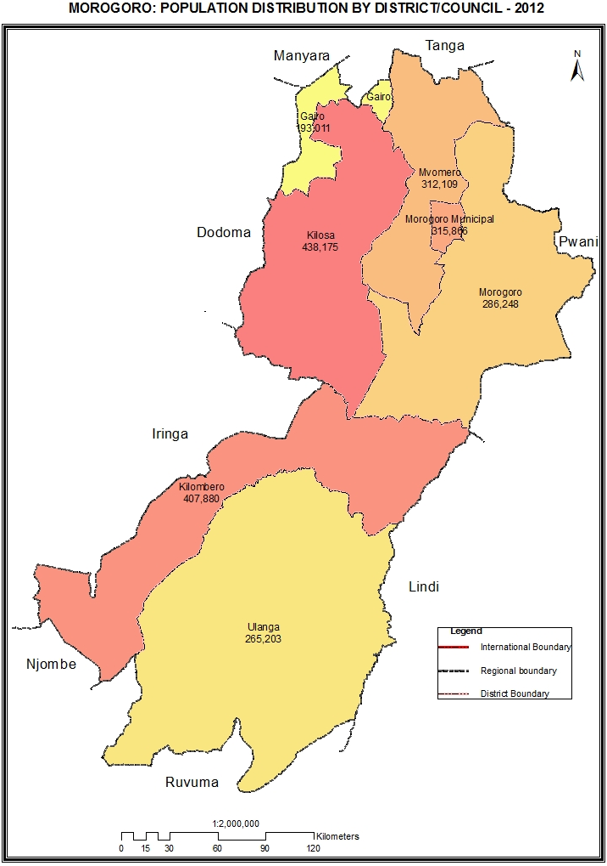

Table 5.0: Population of Morogoro Region by Sex,Average Household Size and Sex Ratio
Serial No. | District/Council | Population (Number) |  |  |  |  | Average Household Size | Sex Ratio
Serial No. | District/Council | Total | Male |  | Female |  | Average Household Size | Sex Ratio
 | Total | 2,218,492 | 1,093,302 |  | 1,125,190 |  | 4.4 | 97
1 | Kilosa District Council | 438,175 | 218,378 |  | 219,797 |  | 4.2 | 99
2 | Morogoro District Council | 286,248 | 140,824 |  | 145,424 |  | 4.2 | 97
3 | Kilombero District Council | 407,880 | 202,789 |  | 205,091 |  | 4.3 | 99
4 | Ulanga District Council | 265,203 | 131,562 |  | 133,641 |  | 4.9 | 98
5 | Morogoro Municipal Council | 315,866 | 151,700 |  | 164,166 |  | 4.1 | 92
6 | Mvomero District Council | 312,109 | 154,843 |  | 157,266 |  | 4.3 | 98
7 | Gairo District Council | 193,011 | 93,206 |  | 99,805 |  | 5.2 | 93

Table 5. 1: Population of Kilosa District Council by Sex, Average Household Size and Sex Ratio
Serial No. | Ward/Shehia | Population (Number) |  |  | Average Household Size | Sex Ratio
Serial No. | Ward/Shehia | Total | Male | Female | Average Household Size | Sex Ratio
 | Total | 438,175 | 218,378 | 219,797 | 4.2 | 99
1 | Mabula | 7,168 | 3,511 | 3,657 | 5.1 | 96
2 | Maguha | 7,848 | 4,018 | 3,830 | 4.8 | 105
3 | Berega | 11,199 | 5,486 | 5,713 | 5.0 | 96
4 | Magubike | 10,274 | 5,125 | 5,149 | 4.9 | 100
5 | Mamboya | 28,710 | 14,312 | 14,398 | 5.2 | 99
6 | Dumila | 21,288 | 10,373 | 10,915 | 4.9 | 95
7 | Magole | 20,954 | 10,657 | 10,297 | 4.2 | 103
8 | Msowero | 29,361 | 14,899 | 14,462 | 4.4 | 103
9 | Rudewa | 18,352 | 9,078 | 9,274 | 4.3 | 98
10 | Chanzulu | 12,229 | 5,973 | 6,256 | 4.2 | 95
11 | Kimamba A | 6,079 | 2,986 | 3,093 | 3.5 | 97
12 | Kimamba B | 5,967 | 2,849 | 3,118 | 3.7 | 91
13 | Mbumi | 4,540 | 2,159 | 2,381 | 3.6 | 91
14 | Mkwatani | 12,428 | 5,866 | 6,562 | 4.1 | 89
15 | Magomeni | 11,998 | 5,834 | 6,164 | 3.9 | 95
16 | Kasiki | 5,459 | 2,762 | 2,697 | 3.9 | 102
17 | Mabwerebwere | 7,155 | 3,494 | 3,661 | 3.8 | 95
18 | Kilangali | 10,679 | 5,331 | 5,348 | 4.5 | 100
19 | Mikumi | 19,977 | 9,973 | 10,004 | 3.9 | 100
20 | Ruhembe | 15,198 | 7,578 | 7,620 | 3.7 | 99
21 | Kidodi | 9,106 | 4,429 | 4,677 | 3.6 | 95
22 | Vidunda | 11,698 | 5,973 | 5,725 | 4.3 | 104
23 | Malolo | 10,750 | 5,504 | 5,246 | 3.8 | 105
24 | Kisanga | 14,311 | 7,386 | 6,925 | 4.2 | 107
25 | Uleling`ombe | 4,095 | 2,067 | 2,028 | 5.0 | 102
26 | Ulaya | 17,354 | 8,833 | 8,521 | 4.0 | 104
27 | Zombo | 9,982 | 4,976 | 5,006 | 4.0 | 99
28 | Lumuma | 13,221 | 6,475 | 6,746 | 4.2 | 96
29 | Masanze | 7,890 | 4,059 | 3,831 | 4.0 | 106
30 | Kidete | 11,329 | 5,708 | 5,621 | 4.0 | 102
31 | Lumbiji | 6,891 | 3,504 | 3,387 | 5.3 | 103
32 | Kitete | 10,247 | 5,092 | 5,155 | 4.5 | 99
33 | Madoto | 3,570 | 1,757 | 1,813 | 4.0 | 97
34 | Tindiga | 13,291 | 6,513 | 6,778 | 3.8 | 96
35 | Ruaha | 27,577 | 13,838 | 13,739 | 3.9 | 101

Table 5. 2: Population of Morogoro District Council by Sex, Average Household Size and Sex Ratio
Serial No. | Ward/Shehia | Population (Number) |  |  | Average Household Size | Sex Ratio
Serial No. | Ward/Shehia | Total | Male | Female | Average Household Size | Sex Ratio
 | Total | 286,248 | 140,824 | 145,424 | 4.2 | 97
1 | Kasanga | 6,558 | 3,107 | 3,451 | 4.5 | 90
2 | Kolero | 9,301 | 4,521 | 4,780 | 4.1 | 95
3 | Mvuha | 14,250 | 6,955 | 7,295 | 4.6 | 95
4 | Selembala | 6,861 | 3,406 | 3,455 | 4.2 | 99
5 | Bwakila Chini | 13,718 | 6,684 | 7,034 | 4.4 | 95
6 | Bwakila Juu | 5,976 | 2,862 | 3,114 | 4.6 | 92
7 | Kisaki | 13,510 | 6,543 | 6,967 | 3.9 | 94
8 | Mngazi | 9,528 | 4,553 | 4,975 | 3.8 | 92
9 | Singisa | 11,493 | 5,599 | 5,894 | 4.4 | 95
10 | Mkambarani | 11,552 | 5,883 | 5,669 | 4.2 | 104
11 | Mikese | 15,569 | 7,951 | 7,618 | 4.3 | 104
12 | Kidugalo | 9,273 | 5,014 | 4,259 | 4.5 | 118
13 | Mkulazi | 5,065 | 2,559 | 2,506 | 4.6 | 102
14 | Ngerengere | 11,780 | 5,705 | 6,075 | 4.1 | 94
15 | Tununguo | 7,462 | 3,847 | 3,615 | 4.2 | 106
16 | Kinole | 11,944 | 5,802 | 6,142 | 4.3 | 94
17 | Kiroka | 21,853 | 10,601 | 11,252 | 4 | 94
18 | Mkuyuni | 17,935 | 8,560 | 9,375 | 4.2 | 91
19 | Tegetero | 6,644 | 3,315 | 3,329 | 4.7 | 100
20 | Kibogwa | 7,986 | 3,823 | 4,163 | 4.1 | 92
21 | Kibungo Juu | 6,304 | 3,060 | 3,244 | 3.9 | 94
22 | Kisemu | 9,137 | 4,365 | 4,772 | 3.8 | 91
23 | Lundi | 9,685 | 4,860 | 4,825 | 4.2 | 101
24 | Mtombozi | 9,215 | 4,536 | 4,679 | 4.3 | 97
25 | Tawa | 11,019 | 5,358 | 5,661 | 4.1 | 95
26 | Matuli | 6,103 | 3,028 | 3,075 | 4.1 | 98
27 | Gwata | 6,575 | 3,396 | 3,179 | 4.5 | 107
28 | Konde | 5,546 | 2,738 | 2,808 | 4.1 | 98
29 | Bungu | 4,406 | 2,193 | 2,213 | 4.1 | 99

Table 5. 3: Population of Kilombero Council District by Sex, Average Household Size and Sex Ratio
Serial No. | Ward/Shehia | Population (Number) |  |  | Average Household Size | Sex Ratio
Serial No. | Ward/Shehia | Total | Male | Female | Average Household Size | Sex Ratio
 | Total | 407,880 | 202,789 | 205,091 | 4.3 | 99
1 | Kidatu | 32,589 | 16,359 | 16,230 | 4.1 | 101
2 | Sanje | 11,041 | 5,485 | 5,556 | 4.3 | 99
3 | Mkula | 9,090 | 4,443 | 4,647 | 3.9 | 96
4 | Mang'ula | 36,176 | 17,736 | 18,440 | 4.0 | 96
5 | Kisawasawa | 9,048 | 4,642 | 4,406 | 3.6 | 105
6 | Kiberege | 22,312 | 11,075 | 11,237 | 4.3 | 99
7 | Kibaoni | 28,869 | 13,924 | 14,945 | 4.6 | 93
8 | Ifakara | 55,956 | 26,620 | 29,336 | 4.3 | 91
9 | Lumemo | 21,599 | 10,591 | 11,008 | 4.2 | 96
10 | Idete | 21,648 | 11,064 | 10,584 | 4.6 | 105
11 | Mbingu | 22,717 | 11,502 | 11,215 | 4.2 | 103
12 | Mofu | 11,722 | 6,025 | 5,697 | 4.9 | 106
13 | Mchombe | 38,651 | 19,660 | 18,991 | 4.5 | 104
14 | Chita | 22,663 | 11,597 | 11,066 | 4.6 | 105
15 | Chisano | 5,737 | 2,948 | 2,789 | 4.6 | 106
16 | Mlimba | 38,108 | 18,752 | 19,356 | 4.2 | 97
17 | Utengule | 10,562 | 5,470 | 5,092 | 5.1 | 107
18 | Masagati | 7,121 | 3,718 | 3,403 | 4.5 | 109
19 | Uchindile | 2,271 | 1,178 | 1,093 | 3.9 | 108

Table 5. 4: Population of Ulanga District Council by Sex, Average Household Size and Sex Ratio
Serial No. | Ward/Shehia | Population (Number) |  |  | Average Household Size | Sex Ratio
Serial No. | Ward/Shehia | Total | Male | Female | Average Household Size | Sex Ratio
 | Total | 265,203 | 131,562 | 133,641 | 4.9 | 98
1 | Minepa | 16,267 | 8,081 | 8,186 | 4.6 | 99
2 | Lupiro | 16,329 | 8,037 | 8,292 | 4.7 | 97
3 | Kichangani | 6,195 | 3,052 | 3,143 | 4.5 | 97
4 | Msogezi | 6,288 | 3,261 | 3,027 | 4.6 | 108
5 | Vigoi | 14,452 | 6,958 | 7,494 | 4.6 | 93
6 | Mahenge | 9,523 | 4,670 | 4,853 | 4.0 | 96
7 | Isongo | 7,981 | 3,771 | 4,210 | 4.6 | 90
8 | Ruaha | 8,745 | 4,299 | 4,446 | 4.6 | 97
9 | Chirombola | 5,870 | 2,997 | 2,873 | 4.4 | 104
10 | Sali | 4,932 | 2,928 | 2,004 | 5.2 | 146
11 | Euga | 4,598 | 2,307 | 2,291 | 4.5 | 101
12 | Mwaya | 8,763 | 4,256 | 4,507 | 4.2 | 94
13 | Lukande | 2,897 | 1,513 | 1,384 | 4.5 | 109
14 | Mbuga | 8,212 | 4,125 | 4,087 | 4.9 | 101
15 | Ilonga | 12,143 | 6,001 | 6,142 | 4.8 | 98
16 | Kilosa kwa Mpepo | 3,253 | 1,645 | 1,608 | 4.9 | 102
17 | Ngoheranga | 7,335 | 3,648 | 3,687 | 5.0 | 99
18 | Biro | 7,124 | 3,481 | 3,643 | 5.4 | 96
19 | Malinyi | 31,249 | 15,210 | 16,039 | 4.8 | 95
20 | Sofi | 14,084 | 6,902 | 7,182 | 5.7 | 96
21 | Usangule | 14,402 | 7,096 | 7,306 | 5.7 | 97
22 | Mtimbira | 16,000 | 7,936 | 8,064 | 4.6 | 98
23 | Itete | 20,755 | 10,296 | 10,459 | 5.7 | 98
24 | Iragua | 17,806 | 9,092 | 8,714 | 5.7 | 104

Table 5. 5: Population of Morogoro Municipal Council by Sex, Average Household Size and Sex Ratio
Serial No. | Ward/Shehia | Population (Number) |  |  | Average Household Size | Sex Ratio
Serial No. | Ward/Shehia | Total | Male | Female | Average Household Size | Sex Ratio
 | Total | 315,866 | 151,700 | 164,166 | 4.1 | 92
1 | Sabasaba | 2,339 | 1,164 | 1,175 | 4.2 | 99
2 | Uwanja wa Taifa | 7,247 | 3,420 | 3,827 | 3.5 | 89
3 | K iwanja cha Ndege | 12,203 | 5,825 | 6,378 | 3.5 | 91
4 | Mji Mpya | 7,359 | 3,500 | 3,859 | 3.6 | 91
5 | Kingo | 2,944 | 1,436 | 1,508 | 4.0 | 95
6 | Mji Mkuu | 4,612 | 2,173 | 2,439 | 4.0 | 89
7 | Sultan Area | 2,604 | 1,217 | 1,387 | 3.8 | 88
8 | Mafiga | 13,586 | 6,344 | 7,242 | 3.7 | 88
9 | Mazimbu | 72,527 | 34,312 | 38,215 | 4.2 | 90
10 | Mwembesongo | 43,571 | 21,266 | 22,305 | 3.9 | 95
11 | Kichangani | 19,166 | 9,146 | 10,020 | 4.3 | 91
12 | Kilakala | 18,345 | 8,759 | 9,586 | 4.3 | 91
13 | Boma | 8,706 | 4,378 | 4,328 | 4.3 | 101
14 | Mlimani | 4,893 | 2,315 | 2,578 | 4.3 | 90
15 | Mbuyuni | 11,786 | 5,611 | 6,175 | 4.0 | 91
16 | Kingolwira | 21,953 | 10,631 | 11,322 | 4.3 | 94
17 | Bigwa | 10,149 | 4,873 | 5,276 | 4.3 | 92
18 | Mzinga | 7,452 | 3,711 | 3,741 | 3.6 | 99
19 | Kihonda | 44,424 | 21,619 | 22,805 | 4.4 | 95

Table 5. 6: Population of Mvomero District Council by Sex, Average Household Size and Sex Ratio
Serial No. | Ward/Shehia | Population (Number) |  |  | Average Household Size | Sex Ratio
Serial No. | Ward/Shehia | Total | Male | Female | Average Household Size | Sex Ratio
 | Total | 312,109 | 154,843 | 157,266 | 4.3 | 98
1 | Mvomero | 37,321 | 18,689 | 18,632 | 4.3 | 100
2 | Hembeti | 21,057 | 10,311 | 10,746 | 4.3 | 96
3 | Maskati | 14,396 | 7,165 | 7,231 | 4.9 | 99
4 | Kibati | 22,628 | 11,289 | 11,339 | 4.7 | 100
5 | Sungaji | 14,508 | 7,131 | 7,377 | 4.1 | 97
6 | Mhonda | 20,354 | 10,073 | 10,281 | 4.4 | 98
7 | Diongoya | 21,017 | 10,309 | 10,708 | 4.4 | 96
8 | Mtibwa | 31,382 | 16,025 | 15,357 | 4.2 | 104
9 | Kanga | 21,018 | 10,782 | 10,236 | 4.7 | 105
10 | Bunduki | 7,136 | 3,467 | 3,669 | 4.3 | 94
11 | Kikeo | 14,518 | 6,987 | 7,531 | 4.4 | 93
12 | Langali | 8,610 | 4,169 | 4,441 | 4.2 | 94
13 | Tchenzema | 11,229 | 5,356 | 5,873 | 4.5 | 91
14 | Mzumbe | 19,056 | 9,264 | 9,792 | 4.0 | 95
15 | Mlali | 23,320 | 11,470 | 11,850 | 4.0 | 97
16 | Doma | 13,041 | 6,580 | 6,461 | 3.8 | 102
17 | Melela | 11,518 | 5,776 | 5,742 | 4.2 | 101

Table 5. 7: Population of Gairo District Council by Sex, Average Household Size and Sex Ratio
Serial No. | Ward/Shehia | Population (Number) |  |  | Average Household Size | Sex Ratio
Serial No. | Ward/Shehia | Total | Male | Female | Average Household Size | Sex Ratio
 | Total | 193,011 | 93,206 | 99,805 | 5.2 | 93
1 | Chakwale | 22,603 | 10,897 | 11,706 | 5.1 | 93
2 | Iyogwe | 23,286 | 11,489 | 11,797 | 5.0 | 97
3 | Idibo | 17,837 | 8,788 | 9,049 | 5.1 | 97
4 | Kibedya | 19,369 | 9,282 | 10,087 | 5.4 | 92
5 | Msingisi | 15,489 | 7,365 | 8,124 | 5.4 | 91
6 | Gairo | 33,209 | 16,112 | 17,097 | 4.8 | 94
7 | Rubeho | 22,263 | 10,471 | 11,792 | 5.6 | 89
8 | Mandege | 8,382 | 4,096 | 4,286 | 5.5 | 96
9 | Chagongwe | 11,302 | 5,279 | 6,023 | 5.4 | 88
10 | Chanjale | 10,108 | 5,005 | 5,103 | 5.1 | 98
11 | Nongwe | 9,163 | 4,422 | 4,741 | 5.5 | 93
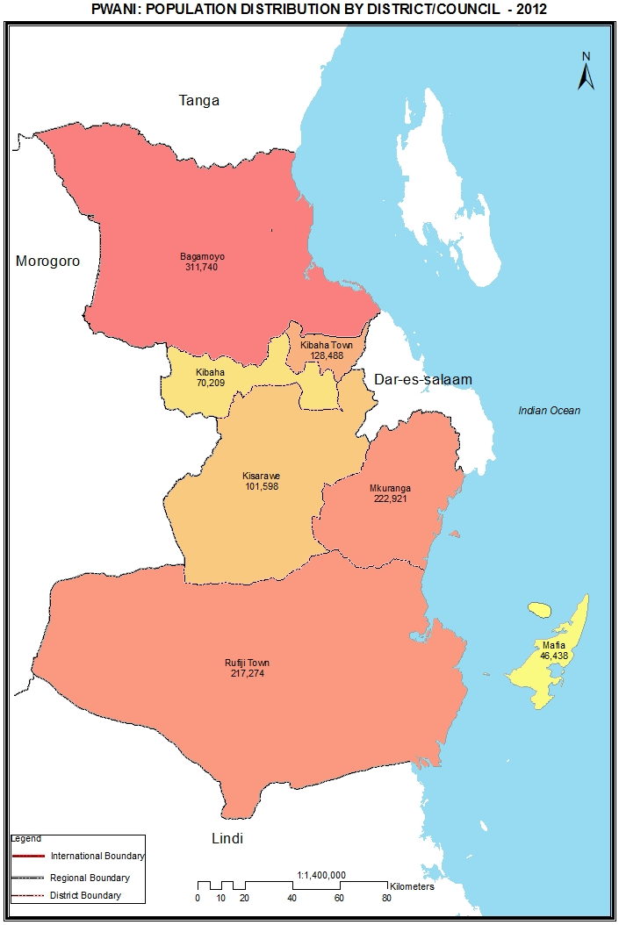

Table 6.0: Population of Pwani Region by Sex, Average Household Size and Sex Ratio
Serial No. | District/Council | Population (Number) |  |  | Average Household Size | Sex Ratio
Serial No. | District/Council | Total | Male | Female | Average Household Size | Sex Ratio
 | Total | 1,098,668 | 537,826 | 560,842 | 4.3 | 96
1 | Bagamoyo District Council | 311,740 | 154,198 | 157,542 | 4.4 | 98
2 | Kibaha District Council | 70,209 | 34,515 | 35,694 | 4.1 | 97
3 | Kisarawe District Council | 101,598 | 50,631 | 50,967 | 3.9 | 99
4 | Mkuranga District Council | 222,921 | 108,024 | 114,897 | 4.3 | 94
5 | Rufiji District Council | 217,274 | 104,851 | 112,423 | 4.4 | 93
6 | Mafia District Council | 46,438 | 22,954 | 23,484 | 3.9 | 98
7 | Kibaha Town Council | 128,488 | 62,653 | 65,835 | 4.1 | 95

Table 6. 1: Population of Bagamoyo District Council by Sex, Average Household Size and Sex Ratio
Serial No. | Ward/Shehia | Population (Number) |  |  | Average Household Size | Sex Ratio
Serial No. | Ward/Shehia | Total | Male | Female | Average Household Size | Sex Ratio
 | Total | 311,740 | 154,198 | 157,542 | 4.4 | 98
1 | Kiwangwa | 14,586 | 7,403 | 7,183 | 4.4 | 103
2 | Msata | 13,740 | 6,844 | 6,896 | 4.5 | 99
3 | Miono | 17,009 | 8,301 | 8,708 | 4.8 | 95
4 | Mkange | 12,026 | 5,981 | 6,045 | 4.5 | 99
5 | Magomeni | 29,234 | 14,665 | 14,569 | 4.3 | 101
6 | Dunda | 14,559 | 7,091 | 7,468 | 4.2 | 95
7 | Kiromo | 7,279 | 3,677 | 3,602 | 3.7 | 102
8 | Zinga | 11,189 | 5,600 | 5,589 | 4.0 | 100
9 | Yombo | 8,262 | 4,138 | 4,124 | 4.0 | 100
10 | Vigwaza | 16,650 | 8,176 | 8,474 | 4.2 | 96
11 | Talawanda | 9,229 | 4,710 | 4,519 | 4.7 | 104
12 | Bwilingu | 35,149 | 16,810 | 18,339 | 4.2 | 92
13 | Lugoba | 11,423 | 5,624 | 5,799 | 4.1 | 97
14 | Ubenazomozi | 15,343 | 7,644 | 7,699 | 4.3 | 99
15 | Mbwewe | 14,509 | 7,029 | 7,480 | 4.4 | 94
16 | Kibindu | 13,673 | 7,098 | 6,575 | 4.9 | 108
17 | Fukayosi | 9,129 | 4,823 | 4,306 | 4.5 | 112
18 | Kerege | 18,008 | 8,609 | 9,399 | 4.3 | 92
19 | Pera | 12,701 | 6,164 | 6,537 | 4.8 | 94
20 | Msoga | 10,144 | 4,961 | 5,183 | 4.4 | 96
21 | Kimange | 8,533 | 4,174 | 4,359 | 4.7 | 96
22 | Mandera | 9,365 | 4,676 | 4,689 | 4.3 | 100

Table 6. 2: Population of Kibaha District Council by Sex, Average Household Size and Sex Ratio
Serial No. | Ward/Shehia | Population (Number) |  |  | Average Household Size | Sex Ratio
Serial No. | Ward/Shehia | Total | Male | Female | Average Household Size | Sex Ratio
 | Total | 70,209 | 34,515 | 35,694 | 4.1 | 97
1 | Gwata | 5,280 | 2,585 | 2,695 | 4.7 | 96
2 | Dutumi | 1,812 | 939 | 873 | 4.2 | 108
3 | Magindu | 4,991 | 2,453 | 2,538 | 4.5 | 97
4 | Soga | 4,713 | 2,428 | 2,285 | 3.7 | 106
5 | Kikongo | 4,238 | 2,112 | 2,126 | 3.7 | 99
6 | Ruvu | 3,466 | 1,719 | 1,747 | 3.8 | 98
7 | Mlandizi | 17,318 | 8,546 | 8,772 | 4.2 | 97
8 | Kwala | 3,472 | 1,749 | 1,723 | 3.8 | 102
9 | Kilangalanga | 10,588 | 4,997 | 5,591 | 4.3 | 89
10 | Janga | 10,926 | 5,242 | 5,684 | 4.0 | 92
11 | Bokomnemela | 3,405 | 1,745 | 1,660 | 3.8 | 105

Table 6. 3: Population of Kisarawe District Council by Sex, Average Household Size and Sex Ratio
Serial No. | Ward/Shehia | Population (Number) |  |  | Average Household Size | Sex Ratio
Serial No. | Ward/Shehia | Total | Male | Female | Average Household Size | Sex Ratio
 | Total | 101,598 | 50,631 | 50,967 | 3.9 | 99
1 | Kisarawe | 11,838 | 5,835 | 6,003 | 3.8 | 97
2 | Msimbu | 11,147 | 5,569 | 5,578 | 4.0 | 100
3 | Masaki | 7,202 | 3,649 | 3,553 | 3.8 | 103
4 | Kibuta | 10,146 | 5,113 | 5,033 | 3.8 | 102
5 | Marumbo | 5,682 | 2,754 | 2,928 | 3.6 | 94
6 | Maneromango | 7,896 | 3,792 | 4,104 | 3.7 | 92
7 | Msanga | 5,422 | 2,652 | 2,770 | 4.2 | 96
8 | Marui | 3,793 | 1,901 | 1,892 | 4.2 | 100
9 | Cholesamvula | 6,061 | 3,009 | 3,052 | 3.8 | 99
10 | Vikumbulu | 3,248 | 1,663 | 1,585 | 3.8 | 105
11 | Mafizi | 6,546 | 3,428 | 3,118 | 4.5 | 110
12 | Kurui | 2,995 | 1,527 | 1,468 | 3.7 | 104
13 | Mzenga | 5,458 | 2,664 | 2,794 | 4.0 | 95
14 | Vihingo | 3,300 | 1,707 | 1,593 | 3.9 | 107
15 | Kiluvya | 10,864 | 5,368 | 5,496 | 4.2 | 98

Table 6. 4: Population of Mkuranga District Council by Sex, Average Household Size and Sex Ratio
Serial No. | Ward/Shehia | Population (Number) |  |  | Average Household Size | Sex Ratio
Serial No. | Ward/Shehia | Total | Male | Female | Average Household Size | Sex Ratio
 | Total | 222,921 | 108,024 | 114,897 | 4.3 | 94
1 | Mkuranga | 25,847 | 12,256 | 13,591 | 4.4 | 90
2 | Tambani | 20,204 | 10,024 | 10,180 | 4.2 | 98
3 | Vikindu | 34,762 | 16,967 | 17,795 | 4.5 | 95
4 | Mbezi | 7,759 | 3,765 | 3,994 | 4.1 | 94
5 | Shungubweni | 2,985 | 1,541 | 1,444 | 4.2 | 107
6 | Kisiju | 12,113 | 5,902 | 6,211 | 4.3 | 95
7 | Magawa | 5,852 | 2,874 | 2,978 | 4.0 | 97
8 | Kitomondo | 4,880 | 2,311 | 2,569 | 4.5 | 90
9 | Lukanga | 10,355 | 4,914 | 5,441 | 4.5 | 90
10 | Nyamato | 11,834 | 5,736 | 6,098 | 4.6 | 94
11 | Kimanzichana | 17,846 | 8,301 | 9,545 | 4.5 | 87
12 | Mkamba | 14,492 | 7,190 | 7,302 | 4.8 | 98
13 | Panzuo | 7,559 | 3,829 | 3,730 | 4.1 | 103
14 | Bupu | 7,241 | 3,615 | 3,626 | 4.1 | 100
15 | Mwalusembe | 11,706 | 5,560 | 6,146 | 4.2 | 90
16 | Vianzi | 10,264 | 5,070 | 5,194 | 3.8 | 98
17 | Njia nne | 6,627 | 3,195 | 3,432 | 4.1 | 93
18 | Kiparang'anda | 10,595 | 4,974 | 5,621 | 4.1 | 88

Table 6. 5: Population of Rufiji District Council by Sex, Average Household Size and Sex Ratio
Serial No. | Ward/Shehia | Population (Number) |  |  | Average Household Size | Sex Ratio
Serial No. | Ward/Shehia | Total | Male | Female | Average Household Size | Sex Ratio
 | Total | 217,274 | 104,851 | 112,423 | 4.4 | 93
1 | Ikwiriri | 12,200 | 5,808 | 6,392 | 4.2 | 91
2 | Mgomba | 9,027 | 4,298 | 4,729 | 4.6 | 91
3 | Umwe | 10,936 | 5,182 | 5,754 | 4.4 | 90
4 | Utete | 5,878 | 2,794 | 3,084 | 4.3 | 91
5 | Mkongo | 4,619 | 2,199 | 2,420 | 4.2 | 91
6 | Ngorongo | 11,946 | 5,902 | 6,044 | 4.2 | 98
7 | Mwaseni | 6,391 | 3,270 | 3,121 | 4.1 | 105
8 | Kibiti | 15,156 | 7,150 | 8,006 | 4.2 | 89
9 | Bungu | 18,719 | 8,884 | 9,835 | 4.6 | 90
10 | Mahege | 5,968 | 2,831 | 3,137 | 4.4 | 90
11 | Mchukwi | 7,001 | 3,411 | 3,590 | 4.4 | 95
12 | Chumbi | 16,334 | 7,933 | 8,401 | 4.8 | 94
13 | Mbwara | 9,709 | 4,598 | 5,111 | 4.7 | 90
14 | Mtunda | 8,135 | 3,998 | 4,137 | 4.8 | 97
15 | Ruaruke | 7,229 | 3,450 | 3,779 | 4.4 | 91
16 | Salale | 9,076 | 4,462 | 4,614 | 4.8 | 97
17 | Mbuchi | 6,025 | 2,992 | 3,033 | 4.4 | 99
18 | Kiongoroni | 4,896 | 2,433 | 2,463 | 4.5 | 99
19 | Maparoni | 5,783 | 2,788 | 2,995 | 4.5 | 93
20 | Chemchem | 5,133 | 2,446 | 2,687 | 4.2 | 91
21 | Ngarambe | 2,453 | 1,253 | 1,200 | 4.3 | 104
22 | Dimani | 5,445 | 2,701 | 2,744 | 4.4 | 98
23 | Mtawanya | 6,772 | 3,251 | 3,521 | 4.6 | 92
24 | Mjawa | 12,045 | 5,606 | 6,439 | 4.4 | 87
25 | Mlanzi | 5,216 | 2,549 | 2,667 | 4.7 | 96
26 | Mwambao | 5,182 | 2,662 | 2,520 | 4.2 | 106

Table 6. 6: Population of Mafia District Council by Sex, Average Household Size and Sex Ratio
Serial No. | Ward/Shehia | Population (Number) |  |  | Average Household Size | Sex Ratio
Serial No. | Ward/Shehia | Total | Male | Female | Average Household Size | Sex Ratio
 | Total | 46,438 | 22,954 | 23,484 | 3.9 | 98
1 | Kanga | 3,758 | 1,859 | 1,899 | 3.8 | 98
2 | Kirongwe | 5,701 | 2,951 | 2,750 | 4.0 | 107
3 | Baleni | 5,870 | 2,994 | 2,876 | 4.1 | 104
4 | Kilindoni | 14,221 | 6,767 | 7,454 | 3.8 | 91
5 | Miburani | 4,106 | 1,966 | 2,140 | 3.7 | 92
6 | Kiegeani | 4,094 | 2,022 | 2,072 | 3.8 | 98
7 | Jibondo | 3,729 | 1,873 | 1,856 | 4.6 | 101
8 | Ndagoni | 4,959 | 2,522 | 2,437 | 3.6 | 103

Table 6. 7: Population of Kibaha Town Council by Sex, Average Household Size and Sex Ratio
Serial No. | Ward/Shehia | Population (Number) |  |  | Average Household Size | Sex Ratio
Serial No. | Ward/Shehia | Total | Male | Female | Average Household Size | Sex Ratio
 | Total | 128,488 | 62,653 | 65,835 | 4.1 | 95
1 | Pangani | 6,828 | 3,500 | 3,328 | 3.8 | 105
2 | Maili Moja | 21,606 | 10,419 | 11,187 | 4.0 | 93
3 | Tumbi | 11,650 | 5,503 | 6,147 | 4.4 | 90
4 | Picha ya Ndege | 17,994 | 8,680 | 9,314 | 4.2 | 93
5 | Mkuza | 15,132 | 7,368 | 7,764 | 4.2 | 95
6 | Kibaha | 11,828 | 5,668 | 6,160 | 4.0 | 92
7 | Msangani | 5,903 | 2,954 | 2,949 | 4.2 | 100
8 | Kongowe | 18,500 | 8,944 | 9,556 | 4.0 | 94
9 | Misugusugu | 6,137 | 3,137 | 3,000 | 3.9 | 105
10 | Visiga | 8,902 | 4,491 | 4,411 | 4.0 | 102
11 | Mbwawa | 4,008 | 1,989 | 2,019 | 3.9 | 99
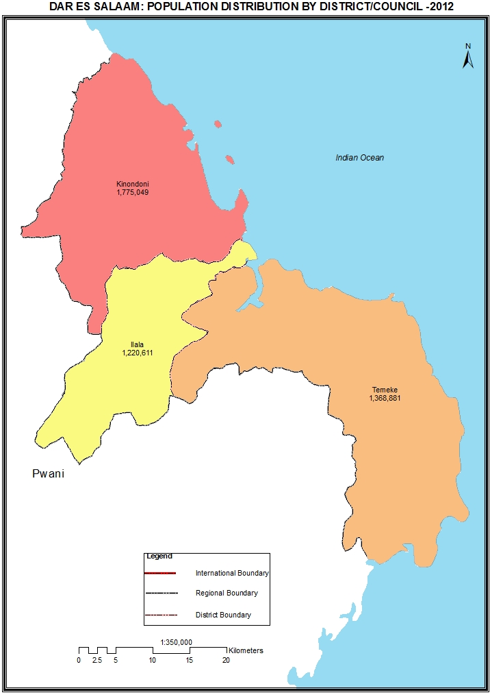

Table 7.0: Population of Dar es Salaam Region by Sex, Average Household Size and Sex Ratio
Serial No. | District/Council | Population (Number) |  |  | Average Household Size | Sex Ratio
Serial No. | District/Council | Total | Male | Female | Average Household Size | Sex Ratio
 | Total | 4,364,541 | 2,125,786 | 2,238,755 | 4.0 | 95
1 | Kinondoni Municipal Council | 1,775,049 | 860,802 | 914,247 | 4.0 | 94
2 | Ilala Municipal Council | 1,220,611 | 595,928 | 624,683 | 4.0 | 95
3 | Temeke Municipal Council | 1,368,881 | 669,056 | 699,825 | 3.9 | 96

Table 7. 1: Population of Kinondoni Municipal Council by Sex, Average Household Size and Sex Ratio
Serial No. | Ward/Shehia | Population (Number) |  |  | Average Household Size | Sex Ratio
Serial No. | Ward/Shehia | Total | Male | Female | Average Household Size | Sex Ratio
 | Total | 1,775,049 | 860,802 | 914,247 | 4.0 | 94
1 | Magomeni | 24,400 | 11,906 | 12,494 | 3.8 | 95
2 | Makurumla | 63,352 | 30,933 | 32,419 | 3.8 | 95
3 | Ndugumbi | 36,841 | 17,894 | 18,947 | 3.7 | 94
4 | Tandale | 54,781 | 27,205 | 27,576 | 3.6 | 99
5 | Mwananyamala | 50,560 | 24,322 | 26,238 | 3.7 | 93
6 | Msasani | 48,920 | 24,123 | 24,797 | 3.9 | 97
7 | Kinondoni | 21,239 | 10,301 | 10,938 | 3.8 | 94
8 | Mzimuni | 21,486 | 10,326 | 11,160 | 4.1 | 93
9 | Kigogo | 57,613 | 28,229 | 29,384 | 3.9 | 96
10 | Mabibo | 85,735 | 41,824 | 43,911 | 3.9 | 95
11 | Manzese | 70,507 | 34,495 | 36,012 | 3.7 | 96
12 | Ubungo | 56,015 | 27,221 | 28,794 | 3.8 | 95
13 | Kibamba | 28,885 | 13,840 | 15,045 | 4.2 | 92
14 | Goba | 42,669 | 21,066 | 21,603 | 4.2 | 98
15 | Kawe | 67,115 | 32,426 | 34,689 | 4.0 | 93
16 | Kunduchi | 75,016 | 36,610 | 38,406 | 4.2 | 95
17 | Mbweni | 13,766 | 6,672 | 7,094 | 4.2 | 94
18 | Bunju | 60,236 | 29,157 | 31,079 | 4.1 | 94
19 | Makuburi | 57,408 | 28,021 | 29,387 | 3.8 | 95
20 | Mburahati | 34,123 | 16,784 | 17,339 | 3.9 | 97
21 | Makumbusho | 68,093 | 33,251 | 34,842 | 3.7 | 95
22 | Sinza | 40,546 | 18,892 | 21,654 | 4.1 | 87
23 | Kijitonyama | 58,132 | 27,509 | 30,623 | 3.9 | 90
24 | Kimara | 76,577 | 36,654 | 39,923 | 4.1 | 92
25 | Mikocheni | 32,947 | 16,108 | 16,839 | 4.0 | 96
26 | Mbezi | 73,414 | 35,637 | 37,777 | 4.2 | 94
27 | Hananasif | 37,115 | 17,978 | 19,137 | 3.7 | 94
28 | Saranga | 104,127 | 49,263 | 54,864 | 4.2 | 90
29 | Kwembe | 56,899 | 28,040 | 28,859 | 4.1 | 97
30 | Msigani | 55,111 | 26,479 | 28,632 | 4.3 | 92
31 | Mbezi juu | 41,340 | 19,844 | 21,496 | 4.2 | 92
32 | Makongo | 43,796 | 21,289 | 22,507 | 4.3 | 95
33 | Mabwepande | 25,460 | 12,500 | 12,960 | 3.8 | 96
34 | Wazo | 90,825 | 44,003 | 46,822 | 4.0 | 94

Table 7. 2: Population of Ilala Municipal Council by Sex, Average Household Size and Sex Ratio
Serial No. | Ward/Shehia | Population (Number) |  |  | Average Household Size | Sex Ratio
Serial No. | Ward/Shehia | Total | Male | Female | Average Household Size | Sex Ratio
 | Total | 1,220,611 | 595,928 | 624,683 | 4.0 | 95
1 | Ukonga | 80,034 | 39,413 | 40,621 | 4.1 | 97
2 | Pugu | 49,422 | 24,159 | 25,263 | 4.2 | 96
3 | Msongola | 24,461 | 12,147 | 12,314 | 4.3 | 99
4 | Tabata | 74,742 | 35,909 | 38,833 | 3.8 | 92
5 | Kinyerezi | 38,366 | 18,593 | 19,773 | 4.4 | 94
6 | Ilala | 31,083 | 15,242 | 15,841 | 4.3 | 96
7 | Mchikichini | 25,510 | 12,977 | 12,533 | 3.9 | 104
8 | Vingunguti | 106,946 | 53,248 | 53,698 | 3.7 | 99
9 | Kipawa | 74,180 | 35,866 | 38,314 | 4.0 | 94
10 | Buguruni | 70,585 | 34,547 | 36,038 | 3.8 | 96
11 | Kariakoo | 13,780 | 7,306 | 6,474 | 4.3 | 113
12 | Jangwani | 17,647 | 9,174 | 8,473 | 4.2 | 108
13 | Gerezani | 7,276 | 3,767 | 3,509 | 4.4 | 107
14 | Kisutu | 8,308 | 4,069 | 4,239 | 3.7 | 96
15 | Mchafukoge | 10,688 | 5,422 | 5,266 | 3.9 | 103
16 | Upanga Mashariki | 11,167 | 5,461 | 5,706 | 4.0 | 96
17 | Upanga Magharibi | 13,476 | 6,786 | 6,690 | 4.0 | 101
18 | Kivukoni | 6,742 | 3,531 | 3,211 | 4.0 | 110
19 | Kiwalani | 82,292 | 40,247 | 42,045 | 3.7 | 96
20 | Segerea | 83,315 | 40,065 | 43,250 | 4.3 | 93
21 | Kitunda | 57,132 | 27,340 | 29,792 | 4.4 | 92
22 | Chanika | 43,912 | 21,164 | 22,748 | 4.0 | 93
23 | Kivule | 72,032 | 34,707 | 37,325 | 4.4 | 93
24 | Gongo la Mboto | 57,312 | 27,927 | 29,385 | 4.0 | 95
25 | Majohe | 81,646 | 39,550 | 42,096 | 4.2 | 94
26 | Kimanga | 78,557 | 37,311 | 41,246 | 4.1 | 90

Table 7. 3: Population of Temeke Municipal Council by Sex, Average Household Size and Sex Ratio
Serial No. | Ward/Shehia | Population (Number) |  |  | Average Household Size | Sex Ratio
Serial No. | Ward/Shehia | Total | Male | Female | Average Household Size | Sex Ratio
 | Total | 1,368,881 | 669,056 | 699,825 | 3.9 | 96
1 | Kigamboni | 30,496 | 15,262 | 15,234 | 4.0 | 100
2 | Vijibweni | 29,010 | 14,221 | 14,789 | 4.1 | 96
3 | Kibada | 8,585 | 4,241 | 4,344 | 4.1 | 98
4 | Kisarawe II | 8,306 | 4,233 | 4,073 | 3.9 | 104
5 | Somangila | 19,283 | 9,734 | 9,549 | 4.1 | 102
6 | Kimbiji | 6,411 | 3,425 | 2,986 | 4.1 | 115
7 | Mbagala | 52,582 | 25,836 | 26,746 | 3.8 | 97
8 | Chamazi | 63,650 | 30,258 | 33,392 | 4.2 | 91
9 | Yombo Vituka | 76,999 | 37,638 | 39,361 | 4.0 | 96
10 | Charambe | 101,933 | 48,961 | 52,972 | 4.0 | 92
11 | Toangoma | 44,578 | 21,292 | 23,286 | 4.3 | 91
12 | Miburani | 44,290 | 21,667 | 22,623 | 4.0 | 96
13 | Temeke | 26,047 | 12,692 | 13,355 | 3.9 | 95
14 | Mtoni | 59,378 | 29,184 | 30,194 | 3.7 | 97
15 | Keko | 35,163 | 17,937 | 17,226 | 3.8 | 104
16 | Kurasini | 26,193 | 12,831 | 13,362 | 3.8 | 96
17 | Azimio | 76,832 | 37,462 | 39,370 | 3.7 | 95
18 | Tandika | 49,491 | 23,832 | 25,659 | 3.7 | 93
19 | Sandali | 52,660 | 26,050 | 26,610 | 3.8 | 98
20 | Chang'ombe | 19,302 | 9,401 | 9,901 | 4.0 | 95
21 | Mbagala Kuu | 74,774 | 36,146 | 38,628 | 3.9 | 94
22 | Makangarawe | 53,291 | 26,007 | 27,284 | 3.9 | 95
23 | Pembamnazi | 9,672 | 4,904 | 4,768 | 4.1 | 103
24 | Mjimwema | 27,789 | 13,740 | 14,049 | 4.0 | 98
25 | Tungi | 23,380 | 11,439 | 11,941 | 4.2 | 96
26 | Kijichi | 69,195 | 33,764 | 35,431 | 4.1 | 95
27 | Mianzini | 100,649 | 48,737 | 51,912 | 4.0 | 94
28 | Kiburugwa | 78,911 | 38,833 | 40,078 | 3.8 | 97
29 | Buza | 55,082 | 26,761 | 28,321 | 4.1 | 94
30 | Kilakala | 44,949 | 22,568 | 22,381 | 3.7 | 101

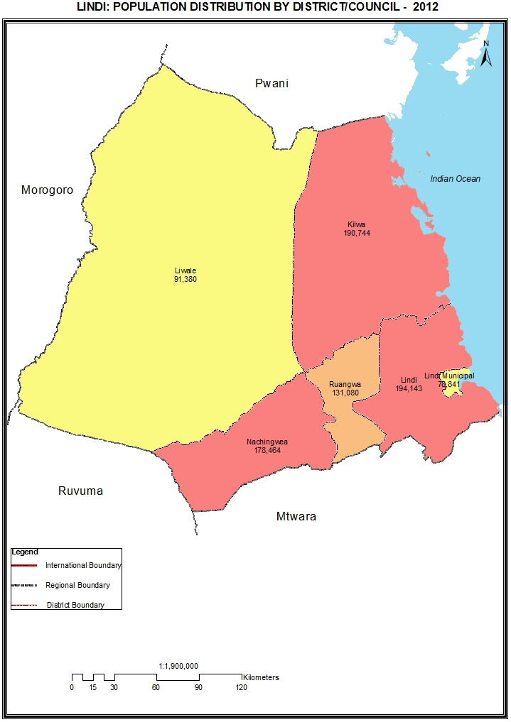

Table 8.0: Population of Lindi Region by Sex, Average Household Size and Sex Ratio
Serial No. | District/Council | Population (Number) |  |  | Average Household Size | Sex Ratio
Serial No. | District/Council | Total | Male | Female | Average Household Size | Sex Ratio
 | Total | 864,652 | 414,507 | 450,145 | 3.8 | 92
1 | Kilwa District Council | 190,744 | 91,661 | 99,083 | 4.4 | 93
2 | Lindi District Council | 194,143 | 91,647 | 102,496 | 3.7 | 89
3 | Nachingwea District Council | 178,464 | 86,382 | 92,082 | 3.7 | 94
4 | Liwale District Council | 91,380 | 44,027 | 47,353 | 4.3 | 93
5 | Ruangwa District Council | 131,080 | 63,265 | 67,815 | 3.5 | 93
6 | Lindi Municipal Council | 78,841 | 37,525 | 41,316 | 3.5 | 91

Table 8. 1: Population of Kilwa District Council by Sex, Average Household Size and Sex Ratio
Serial No. | Ward/Shehia | Population (Number) |  |  | Average Household Size | Sex Ratio
Serial No. | Ward/Shehia | Total | Male | Female | Average Household Size | Sex Ratio
 | Total | 190,744 | 91,661 | 99,083 | 4.4 | 93
1 | Tingi | 6,782 | 3,235 | 3,547 | 4.4 | 91
2 | Miteja | 6,157 | 3,042 | 3,115 | 4.2 | 98
3 | Mingumbi | 9,948 | 4,754 | 5,194 | 4.5 | 92
4 | Kinjumbi | 14,426 | 6,886 | 7,540 | 4.6 | 91
5 | Chumo | 13,897 | 6,550 | 7,347 | 5.0 | 89
6 | Kipatimu | 14,606 | 7,053 | 7,553 | 5.0 | 93
7 | Kandawale | 5,040 | 2,452 | 2,588 | 4.9 | 95
8 | Njinjo | 8,094 | 3,813 | 4,281 | 4.6 | 89
9 | Mitole | 3,352 | 1,651 | 1,701 | 4.4 | 97
10 | Miguruwe | 3,381 | 1,667 | 1,714 | 4.4 | 97
11 | Likawage | 3,569 | 1,745 | 1,824 | 4.2 | 96
12 | Nanjirinji | 7,491 | 3,691 | 3,800 | 3.9 | 97
13 | Kiranjeranje | 9,752 | 4,698 | 5,054 | 4.6 | 93
14 | Mandawa | 13,192 | 6,404 | 6,788 | 4.2 | 94
15 | Lihimalyao | 10,434 | 5,056 | 5,378 | 4.6 | 94
16 | Pande Mikoma | 11,596 | 5,642 | 5,954 | 4.3 | 95
17 | Kikole | 4,294 | 2,082 | 2,212 | 4.3 | 94
18 | Kivinjesingino | 19,376 | 9,035 | 10,341 | 4.0 | 87
19 | Songosongo | 3,026 | 1,634 | 1,392 | 4.0 | 117
20 | Masoko | 13,601 | 6,462 | 7,139 | 3.9 | 91
21 | Kibata | 8,730 | 4,109 | 4,621 | 5.2 | 89

Table 8. 2: Population of Lindi District Council by Sex, Average Household Size and Sex Ratio
Serial No. | Ward/Shehia | Population (Number) |  |  | Average Household Size | Sex Ratio
Serial No. | Ward/Shehia | Total | Male | Female | Average Household Size | Sex Ratio
 | Total | 194,143 | 91,647 | 102,496 | 3.7 | 89
1 | Mipingo | 5,926 | 2,941 | 2,985 | 3.8 | 99
2 | Kitomanga | 4,720 | 2,306 | 2,414 | 4.1 | 96
3 | Mchinga | 6,063 | 2,814 | 3,249 | 3.6 | 87
4 | Kilolambwani | 6,286 | 3,041 | 3,245 | 3.7 | 94
5 | Kilangala | 6,498 | 3,103 | 3,395 | 3.7 | 91
6 | Kiwalala | 13,304 | 6,334 | 6,970 | 3.8 | 91
7 | Navanga | 3,839 | 1,808 | 2,031 | 4.0 | 89
8 | Mnolela | 11,846 | 5,508 | 6,338 | 3.7 | 87
9 | Sudi | 5,544 | 2,572 | 2,972 | 3.9 | 87
10 | Nachunyu | 6,713 | 3,180 | 3,533 | 4.2 | 90
11 | Mtama | 4,398 | 2,029 | 2,369 | 3.4 | 86
12 | Nyangao | 9,835 | 4,575 | 5,260 | 3.3 | 87
13 | Namupa | 5,769 | 2,730 | 3,039 | 3.6 | 90
14 | Nyengedi | 5,390 | 2,527 | 2,863 | 3.3 | 88
15 | Mtua | 3,561 | 1,627 | 1,934 | 3.6 | 84
16 | Nahukahuka | 5,026 | 2,434 | 2,592 | 3.6 | 94
17 | Nyangamara | 7,545 | 3,511 | 4,034 | 3.7 | 87
18 | Mandwanga | 9,227 | 4,306 | 4,921 | 3.8 | 88
19 | Mnara | 10,128 | 4,817 | 5,311 | 3.8 | 91
20 | Chiponda | 6,162 | 2,915 | 3,247 | 3.8 | 90
21 | Pangatena | 4,900 | 2,259 | 2,641 | 4.0 | 86
22 | Longa | 3,185 | 1,453 | 1,732 | 3.7 | 84
23 | Rutamba | 11,210 | 5,335 | 5,875 | 3.5 | 91
24 | Milola | 9,616 | 4,486 | 5,130 | 3.4 | 87
25 | Kiwawa | 2,668 | 1,296 | 1,372 | 3.8 | 94
26 | Mtumbya | 1,859 | 924 | 935 | 3.5 | 99
27 | Matimba | 4,934 | 2,305 | 2,629 | 3.7 | 88
28 | Nangaru | 5,280 | 2,533 | 2,747 | 3.8 | 92
29 | Majengo | 6,891 | 3,153 | 3,738 | 3.5 | 84
30 | Namangwale | 5,820 | 2,825 | 2,995 | 3.4 | 94

Table 8. 3: Population of Nachingwea District Council by Sex, Average Household Size and Sex Ratio
Serial No. | Ward/Shehia | Population (Number) |  |  | Average Household Size | Sex Ratio
Serial No. | Ward/Shehia | Total | Male | Female | Average Household Size | Sex Ratio
 | Total | 178,464 | 86,382 | 92,082 | 3.7 | 94
1 | Nambambo | 16,592 | 8,003 | 8,589 | 3.6 | 93
2 | Kilimahewa | 6,835 | 3,427 | 3,408 | 4.2 | 101
3 | Ruponda | 6,338 | 2,962 | 3,376 | 3.7 | 88
4 | Mneromiembeni | 8,512 | 4,022 | 4,490 | 3.8 | 90
5 | Namapwia | 4,323 | 2,073 | 2,250 | 3.8 | 92
6 | Kiparamnero | 4,918 | 2,383 | 2,535 | 3.7 | 94
7 | Lionja | 8,522 | 4,055 | 4,467 | 3.7 | 91
8 | Namikango | 3,772 | 1,877 | 1,895 | 3.8 | 99
9 | Nditi | 4,721 | 2,201 | 2,520 | 3.8 | 87
10 | Kilimarondo | 4,344 | 2,053 | 2,291 | 3.7 | 90
11 | Mbondo | 7,485 | 3,692 | 3,793 | 3.9 | 97
12 | Kiegei | 5,047 | 2,728 | 2,319 | 4.6 | 118
13 | Mkoka | 5,768 | 2,713 | 3,055 | 3.6 | 89
14 | Chiola | 5,385 | 2,514 | 2,871 | 3.4 | 88
15 | Mpiruka | 5,766 | 2,836 | 2,930 | 3.5 | 97
16 | Nangowe | 8,935 | 4,218 | 4,717 | 3.5 | 89
17 | Mkotokuyana | 2,900 | 1,371 | 1,529 | 3.4 | 90
18 | Naipanga | 10,665 | 5,117 | 5,548 | 3.7 | 92
19 | Stesheni | 8,071 | 4,006 | 4,065 | 3.4 | 99
20 | Naipingo | 16,226 | 8,004 | 8,222 | 3.7 | 97
21 | Mtua | 7,759 | 3,838 | 3,921 | 3.5 | 98
22 | Mnerongongo | 5,101 | 2,434 | 2,667 | 3.5 | 91
23 | Matekwe | 3,096 | 1,555 | 1,541 | 3.8 | 101
24 | Marambo | 8,764 | 4,198 | 4,566 | 3.6 | 92
25 | Namatula | 3,604 | 1,691 | 1,913 | 3.5 | 88
26 | Ndomoni | 5,015 | 2,411 | 2,604 | 3.5 | 93

Table 8. 4: Population of Liwale District Council by Sex, Average Household Size and Sex Ratio
Serial No. | Ward/Shehia | Population (Number) |  |  | Average Household Size | Sex Ratio
Serial No. | Ward/Shehia | Total | Male | Female | Average Household Size | Sex Ratio
 | Total | 91,380 | 44,027 | 47,353 | 4.3 | 93
1 | Liwale Mjini | 8,651 | 4,064 | 4,587 | 4.2 | 89
2 | Mihumo | 5,348 | 2,557 | 2,791 | 4.2 | 92
3 | Ngongowele | 3,644 | 1,794 | 1,850 | 4.5 | 97
4 | Mlembwe | 2,971 | 1,450 | 1,521 | 4.5 | 95
5 | Makata | 6,244 | 2,954 | 3,290 | 4.5 | 90
6 | Barikiwa | 4,817 | 2,378 | 2,439 | 4.4 | 97
7 | Mkutano | 1,614 | 754 | 860 | 4.6 | 88
8 | Mbaya | 6,042 | 2,904 | 3,138 | 4.6 | 93
9 | Kimambi | 754 | 368 | 386 | 4.6 | 95
10 | Kiangara | 4,309 | 2,110 | 2,199 | 4.4 | 96
11 | Kibutuka | 3,920 | 1,982 | 1,938 | 4.0 | 102
12 | Nangano | 2,849 | 1,424 | 1,425 | 4.0 | 100
13 | Mpigamiti | 2,096 | 999 | 1,097 | 4.6 | 91
14 | Mirui | 4,521 | 2,260 | 2,261 | 4.3 | 100
15 | Liwale "B" | 8,151 | 3,963 | 4,188 | 4.2 | 95
16 | Mangirirkiti | 5,362 | 2,548 | 2,814 | 4.4 | 91
17 | Nangando | 6,591 | 3,107 | 3,484 | 3.9 | 89
18 | Likongowele | 6,482 | 2,930 | 3,552 | 3.9 | 82
19 | Kichonda | 3,286 | 1,581 | 1,705 | 4.5 | 93
20 | Lilombe | 3,728 | 1,900 | 1,828 | 4.5 | 104

Table 8. 5: Population of Ruangwa District Council by Sex, Average Household Size and Sex Ratio
Serial No. | Ward/Shehia | Population (Number) |  |  | Average Household Size | Sex Ratio
Serial No. | Ward/Shehia | Total | Male | Female | Average Household Size | Sex Ratio
 | Total | 131,080 | 63,265 | 67,815 | 3.5 | 93
1 | Ruangwa | 5,435 | 2,546 | 2,889 | 3.7 | 88
2 | Mbekenyera | 11,257 | 5,398 | 5,859 | 3.6 | 92
3 | Nkowe | 5,264 | 2,610 | 2,654 | 3.3 | 98
4 | Malolo | 7,405 | 3,572 | 3,833 | 3.3 | 93
5 | Luchelegwa | 4,528 | 2,210 | 2,318 | 3.4 | 95
6 | Chienjele | 8,691 | 4,216 | 4,475 | 3.3 | 94
7 | Namichiga | 5,165 | 2,542 | 2,623 | 3.6 | 97
8 | Narungombe | 8,407 | 4,086 | 4,321 | 3.4 | 95
9 | Makanjiro | 3,323 | 1,632 | 1,691 | 3.3 | 97
10 | Likunja | 8,425 | 4,123 | 4,302 | 3.4 | 96
11 | Mnacho | 6,607 | 3,195 | 3,412 | 3.4 | 94
12 | Mandawa | 6,662 | 3,140 | 3,522 | 3.6 | 89
13 | Nambilaje | 6,182 | 3,044 | 3,138 | 3.7 | 97
14 | Chunyu | 5,810 | 2,801 | 3,009 | 3.5 | 93
15 | Mandarawe | 3,796 | 1,807 | 1,989 | 3.4 | 91
16 | Nachingwea | 8,142 | 3,769 | 4,373 | 3.4 | 86
17 | Matambarale | 5,071 | 2,492 | 2,579 | 3.6 | 97
18 | Chibula | 2,937 | 1,476 | 1,461 | 3.4 | 101
19 | Nandagala | 5,314 | 2,529 | 2,785 | 3.7 | 91
20 | Nanganga | 4,959 | 2,425 | 2,534 | 3.5 | 96
21 | Chinongwe | 7,700 | 3,652 | 4,048 | 3.5 | 90

Table 8. 6: Population of Lindi Municipal Council by Sex, Average Household Size and Sex Ratio
Serial No. | Ward/Shehia | Population (Number) |  |  | Average Household Size | Sex Ratio
Serial No. | Ward/Shehia | Total | Male | Female | Average Household Size | Sex Ratio
 | Total | 78,841 | 37,525 | 41,316 | 3.5 | 91
1 | Ndoro | 1,836 | 848 | 988 | 3.3 | 86
2 | Makonde | 1,091 | 530 | 561 | 3.5 | 94
3 | Mikumbi | 2,006 | 956 | 1,050 | 3.2 | 91
4 | Mitandi | 2,515 | 1,169 | 1,346 | 3.1 | 87
5 | Rahaleo | 2,111 | 960 | 1,151 | 3.4 | 83
6 | Mwenge | 2,808 | 1,230 | 1,578 | 3.5 | 78
7 | Matopeni | 3,578 | 1,633 | 1,945 | 3.4 | 84
8 | Wailes | 2,812 | 1,357 | 1,455 | 3.7 | 93
9 | Nachingwea | 3,176 | 1,491 | 1,685 | 3.4 | 88
10 | Rasbura | 6,599 | 3,197 | 3,402 | 3.7 | 94
11 | Mtanda | 5,683 | 2,743 | 2,940 | 3.7 | 93
12 | Jamhuri | 6,571 | 3,344 | 3,227 | 3.6 | 104
13 | Msanjihili | 6,391 | 3,045 | 3,346 | 3.6 | 91
14 | Mingoyo | 11,812 | 5,538 | 6,274 | 3.6 | 88
15 | Ng´apa | 7,760 | 3,701 | 4,059 | 3.3 | 91
16 | Tandangongoro | 3,550 | 1,646 | 1,904 | 3.3 | 86
17 | Chikonji | 5,354 | 2,557 | 2,797 | 3.5 | 91
18 | Mbanja | 3,188 | 1,580 | 1,608 | 3.4 | 98

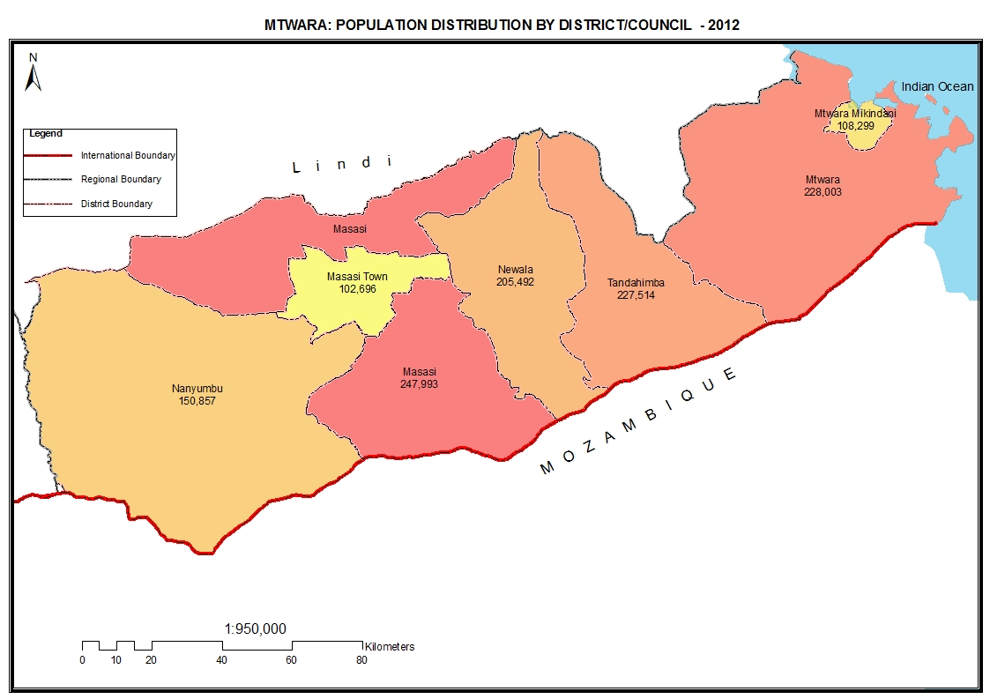

Table 9.0: Population of Mtwara Region by Sex, Average Household Size and Sex Ratio
Serial No. | District/Council | Population (Number) |  |  | Average Household Size | Sex Ratio
Serial No. | District/Council | Total | Male | Female | Average Household Size | Sex Ratio
 | Total | 1,270,854 | 599,648 | 671,206 | 3.7 | 89
1 | Mtwara District Council | 228,003 | 107,922 | 120,081 | 3.9 | 90
2 | Newala District Council | 205,492 | 95,018 | 110,474 | 3.5 | 86
3 | Masasi District Council | 247,993 | 118,976 | 129,017 | 3.6 | 92
4 | Tandahimba District Council | 227,514 | 105,322 | 122,192 | 3.7 | 86
5 | Mtwara Municipal Council | 108,299 | 51,062 | 57,237 | 3.8 | 89
6 | Nanyumbu District Council | 150,857 | 72,237 | 78,620 | 3.7 | 92
7 | Masasi Town Council | 102,696 | 49,111 | 53,585 | 3.6 | 92

Table 9. 1: Population of Mtwara District Council by Sex, Average Household Size and Sex Ratio
Serial No. | Ward/Shehia | Population (Number) |  |  | Average Household Size | Sex Ratio
Serial No. | Ward/Shehia | Total | Male | Female | Average Household Size | Sex Ratio
 | Total | 228,003 | 107,922 | 120,081 | 3.9 | 90
1 | Madimba | 13,139 | 6,223 | 6,916 | 3.8 | 90
2 | Ziwani | 8,919 | 4,342 | 4,577 | 3.7 | 95
3 | Nanguruwe | 6,213 | 2,954 | 3,259 | 3.8 | 91
4 | Mahurunga | 8,214 | 3,905 | 4,309 | 3.9 | 91
5 | Kitaya | 8,542 | 4,074 | 4,468 | 4.0 | 91
6 | Kiromba | 4,766 | 2,264 | 2,502 | 3.7 | 90
7 | Njengwa | 10,066 | 4,695 | 5,371 | 4.0 | 87
8 | Nitekela | 9,664 | 4,538 | 5,126 | 3.8 | 89
9 | Nanyamba | 13,320 | 6,139 | 7,181 | 4.0 | 85
10 | Mtiniko | 7,423 | 3,443 | 3,980 | 3.9 | 87
11 | Dihimba | 6,911 | 3,265 | 3,646 | 3.9 | 90
12 | Mnima | 12,365 | 5,777 | 6,588 | 3.9 | 88
13 | Kitere | 10,270 | 4,823 | 5,447 | 3.8 | 89
14 | Ndumbwe | 6,232 | 2,883 | 3,349 | 3.8 | 86
15 | Mayanga | 9,528 | 4,571 | 4,957 | 4.0 | 92
16 | Naumbu | 9,745 | 4,662 | 5,083 | 3.9 | 92
17 | Chawi | 6,644 | 3,192 | 3,452 | 3.8 | 92
18 | Namtumbuka | 8,163 | 3,927 | 4,236 | 4.0 | 93
19 | Libobe | 5,641 | 2,658 | 2,983 | 3.8 | 89
20 | Mpapura | 4,933 | 2,284 | 2,649 | 3.7 | 86
21 | Muungano | 3,551 | 1,698 | 1,853 | 4.1 | 92
22 | Mbawala | 8,052 | 3,917 | 4,135 | 3.9 | 95
23 | Msanga Mkuu | 10,844 | 5,194 | 5,650 | 3.9 | 92
24 | Tangazo | 8,751 | 4,134 | 4,617 | 3.9 | 90
25 | Kiyanga | 5,065 | 2,435 | 2,630 | 3.9 | 93
26 | Milangominne | 6,685 | 3,133 | 3,552 | 3.9 | 88
27 | Mbembaleo | 6,125 | 2,898 | 3,227 | 3.8 | 90
28 | Mtimbwilimbwi | 8,232 | 3,894 | 4,338 | 3.9 | 90

Table 9. 2: Population of Newala District Council by Sex, Average Household Size and Sex Ratio
Serial No. | Ward/Shehia | Population (Number) |  |  | Average Household Size | Sex Ratio
Serial No. | Ward/Shehia | Total | Male | Female | Average Household Size | Sex Ratio
 | Total | 205,492 | 95,018 | 110,474 | 3.5 | 86
1 | Luchingu | 20,740 | 9,519 | 11,221 | 3.5 | 85
2 | Makote | 9,055 | 4,126 | 4,929 | 3.6 | 84
3 | Nanguruwe | 7,413 | 3,483 | 3,930 | 3.5 | 89
4 | Mkunya | 6,363 | 2,970 | 3,393 | 3.7 | 88
5 | Mcholi I | 11,652 | 5,348 | 6,304 | 3.7 | 85
6 | Namiyonga | 6,365 | 2,884 | 3,481 | 3.4 | 83
7 | Mnekachi | 6,130 | 2,810 | 3,320 | 3.3 | 85
8 | Chitekete | 3,920 | 1,839 | 2,081 | 3.7 | 88
9 | Mnyambe | 7,578 | 3,592 | 3,986 | 3.4 | 90
10 | Chilangalanga | 9,675 | 4,507 | 5,168 | 3.7 | 87
11 | Mkoma II | 2,834 | 1,367 | 1,467 | 3.3 | 93
12 | Kitangari | 11,391 | 5,251 | 6,140 | 3.5 | 86
13 | Malatu | 6,266 | 2,945 | 3,321 | 3.3 | 89
14 | Mchemo | 8,885 | 4,097 | 4,788 | 3.4 | 86
15 | Mtopwa | 8,477 | 3,820 | 4,657 | 3.6 | 82
16 | Chiwonga | 5,298 | 2,445 | 2,853 | 3.5 | 86
17 | Maputi | 6,421 | 3,070 | 3,351 | 3.6 | 92
18 | Makukwe | 6,320 | 2,888 | 3,432 | 3.6 | 84
19 | Mkwedu | 6,436 | 2,981 | 3,455 | 3.5 | 86
20 | Mcholi II | 6,002 | 2,737 | 3,265 | 3.5 | 84
21 | Mtonya | 7,639 | 3,565 | 4,074 | 3.6 | 88
22 | Makonga | 7,892 | 3,575 | 4,317 | 3.4 | 83
23 | Nakahako | 4,507 | 2,171 | 2,336 | 3.4 | 93
24 | Chihangu | 5,774 | 2,698 | 3,076 | 3.4 | 88
25 | Nambali | 6,295 | 2,880 | 3,415 | 3.5 | 84
26 | Nandwahi | 6,261 | 2,925 | 3,336 | 3.6 | 88
27 | Mtunguru | 6,047 | 2,723 | 3,324 | 3.5 | 82
28 | Mdimbampelempele | 3,856 | 1,802 | 2,054 | 3.6 | 88

Table 9. 3: Population of Masasi District Council by Sex, Average Household Size and Sex Ratio
Serial No. | Ward/Shehia | Population (Number) |  |  | Average Household Size | Sex Ratio
Serial No. | Ward/Shehia | Total | Male | Female | Average Household Size | Sex Ratio
 | Total | 247,993 | 118,976 | 129,017 | 3.6 | 92
1 | Namatutwe | 14,122 | 6,943 | 7,179 | 3.7 | 97
2 | Namajani | 13,739 | 6,571 | 7,168 | 3.6 | 92
3 | Mlingula | 9,095 | 4,410 | 4,685 | 3.6 | 94
4 | Chiwale | 11,311 | 5,505 | 5,806 | 3.7 | 95
5 | Lukuledi | 17,060 | 8,194 | 8,866 | 3.6 | 92
6 | Mpanyani | 7,559 | 3,654 | 3,905 | 3.6 | 94
7 | Chigugu | 17,495 | 8,289 | 9,206 | 3.7 | 90
8 | Mwena | 27,908 | 13,331 | 14,577 | 3.7 | 91
9 | Nanganga | 16,655 | 7,968 | 8,687 | 3.6 | 92
10 | Chiwata | 5,654 | 2,789 | 2,865 | 3.7 | 97
11 | Mkundi | 5,510 | 2,698 | 2,812 | 3.5 | 96
12 | Mkululu | 8,105 | 3,867 | 4,238 | 3.6 | 91
13 | Nanjota | 9,094 | 4,290 | 4,804 | 3.6 | 89
14 | Chiungutwa | 13,676 | 6,521 | 7,155 | 3.6 | 91
15 | Mbuyuni | 8,394 | 4,002 | 4,392 | 3.5 | 91
16 | Lipumburu | 7,266 | 3,546 | 3,720 | 3.6 | 95
17 | Sindano | 5,485 | 2,640 | 2,845 | 3.6 | 93
18 | Namalenga | 11,507 | 5,447 | 6,060 | 3.4 | 90
19 | Mchauru | 10,887 | 5,249 | 5,638 | 3.5 | 93
20 | Mnavira | 11,674 | 5,625 | 6,049 | 3.7 | 93
21 | Chikolopola | 7,219 | 3,455 | 3,764 | 4.0 | 92
22 | Lulindi | 8,578 | 3,982 | 4,596 | 3.6 | 87

Table 9. 4: Population of Tandahimba District Council by Sex, Average Household Size and Sex Ratio
Serial No. | Ward/Shehia | Population (Number) |  |  | Average Household Size | Sex Ratio
Serial No. | Ward/Shehia | Total | Male | Female | Average Household Size | Sex Ratio
 | Total | 227,514 | 105,322 | 122,192 | 3.7 | 86
1 | Tandahimba | 20,569 | 9,658 | 10,911 | 3.7 | 89
2 | Kitama | 12,859 | 6,031 | 6,828 | 3.9 | 88
3 | Michenjele | 6,333 | 2,995 | 3,338 | 4.1 | 90
4 | Mihambwe | 10,239 | 4,760 | 5,479 | 4.0 | 87
5 | Mkoreha | 10,244 | 4,865 | 5,379 | 4.0 | 90
6 | Maundo | 10,232 | 4,750 | 5,482 | 3.7 | 87
7 | Naputa | 7,671 | 3,564 | 4,107 | 3.9 | 87
8 | Namikupa | 8,100 | 3,695 | 4,405 | 3.5 | 84
9 | Mnyawa | 8,152 | 3,664 | 4,488 | 3.7 | 82
10 | Mkundi | 8,203 | 3,786 | 4,417 | 3.7 | 86
11 | Lukokoda | 5,329 | 2,439 | 2,890 | 3.7 | 84
12 | Mahuta | 5,722 | 2,514 | 3,208 | 3.3 | 78
13 | Nanhyanga | 8,531 | 3,979 | 4,552 | 3.6 | 87
14 | Chingungwe | 7,082 | 3,197 | 3,885 | 3.4 | 82
15 | Mdimbamnyoma | 8,270 | 3,794 | 4,476 | 3.7 | 85
16 | Milingodi | 4,785 | 2,253 | 2,532 | 3.8 | 89
17 | Lyenje | 3,794 | 1,778 | 2,016 | 3.7 | 88
18 | Chaume | 10,085 | 4,655 | 5,430 | 3.9 | 86
19 | Mkonjowano | 5,226 | 2,401 | 2,825 | 3.9 | 85
20 | Luagala | 6,653 | 3,159 | 3,494 | 3.7 | 90
21 | Ngunja | 9,697 | 4,417 | 5,280 | 3.7 | 84
22 | Mkwiti | 4,819 | 2,285 | 2,534 | 3.6 | 90
23 | Litehu | 5,528 | 2,517 | 3,011 | 3.7 | 84
24 | Nambahu | 6,960 | 3,300 | 3,660 | 3.8 | 90
25 | Mihuta | 4,137 | 1,936 | 2,201 | 3.7 | 88
26 | Kwanyama | 4,077 | 1,887 | 2,190 | 3.6 | 86
27 | Mchichira | 5,636 | 2,619 | 3,017 | 3.7 | 87
28 | Chikongola | 6,947 | 3,074 | 3,873 | 3.4 | 79
29 | Dinduma | 4,406 | 1,974 | 2,432 | 3.4 | 81
30 | Mdumbwe | 7,228 | 3,376 | 3,852 | 3.6 | 88

Table 9. 5: Population of Mtwara Mikindani Municipal Council by Sex, Average Household Size and Sex Ratio
Serial No. | Ward/Shehia | Population (Number) |  |  | Average Household Size | Sex Ratio
Serial No. | Ward/Shehia | Total | Male | Female | Average Household Size | Sex Ratio
 | Total | 108,299 | 51,062 | 57,237 | 3.8 | 89
1 | Majengo | 3,859 | 1,767 | 2,092 | 3.2 | 84
2 | Chikongola | 14,787 | 6,956 | 7,831 | 3.6 | 89
3 | Likombe | 13,302 | 6,589 | 6,713 | 3.9 | 98
4 | Railway | 2,789 | 1,289 | 1,500 | 3.5 | 86
5 | Shangani | 12,896 | 5,911 | 6,985 | 4.2 | 85
6 | Vigaeni | 3,673 | 1,756 | 1,917 | 3.5 | 92
7 | Chuno | 8,884 | 4,098 | 4,786 | 3.9 | 86
8 | Jangwani | 4,215 | 1,983 | 2,232 | 4.1 | 89
9 | Kisungule | 1,123 | 530 | 593 | 3.3 | 89
10 | Mitengo | 1,600 | 792 | 808 | 3.9 | 98
11 | Mtonya | 1,912 | 848 | 1,064 | 3.5 | 80
12 | Ufukoni | 25,011 | 11,729 | 13,282 | 3.8 | 88
13 | Magengeni | 1,800 | 835 | 965 | 3.6 | 87
14 | Rahaleo | 5,208 | 2,360 | 2,848 | 3.6 | 83
15 | Naliendele | 7,240 | 3,619 | 3,621 | 4.2 | 100

Table 9. 6: Population of Nanyumbu District Council by Sex, Average Household Size and Sex Ratio
Serial No. | Ward/Shehia | Population (Number) |  |  | Average Household Size | Sex Ratio
Serial No. | Ward/Shehia | Total | Male | Female | Average Household Size | Sex Ratio
 | Total | 150,857 | 72,237 | 78,620 | 3.7 | 92
1 | Mangaka | 16,494 | 7,817 | 8,677 | 3.6 | 90
2 | Nangomba | 8,178 | 3,955 | 4,223 | 3.7 | 94
3 | Lumesule | 7,656 | 3,684 | 3,972 | 3.8 | 93
4 | Likokona | 18,629 | 8,846 | 9,783 | 3.7 | 90
5 | Sengenya | 13,479 | 6,491 | 6,988 | 3.7 | 93
6 | Mnanje | 7,912 | 3,738 | 4,174 | 3.5 | 90
7 | Mikangaula | 16,848 | 7,997 | 8,851 | 3.8 | 90
8 | Maratani | 6,668 | 3,109 | 3,559 | 3.5 | 87
9 | Nandete | 10,067 | 4,818 | 5,249 | 3.6 | 92
10 | Mkonona | 8,137 | 4,034 | 4,103 | 3.8 | 98
11 | Nanyumbu | 10,826 | 5,127 | 5,699 | 3.7 | 90
12 | Masuguru | 5,945 | 3,011 | 2,934 | 3.7 | 103
13 | Chipuputa | 9,926 | 4,748 | 5,178 | 3.8 | 92
14 | Napacho | 10,092 | 4,862 | 5,230 | 3.7 | 93

Table 9. 7: Population of Masasi Town Council by Sex, Average Household Size and Sex Ratio
Serial No. | Ward/Shehia | Population (Number) |  |  | Average Household Size | Sex Ratio
Serial No. | Ward/Shehia | Total | Male | Female | Average Household Size | Sex Ratio
 | Total | 102,696 | 49,111 | 53,585 | 3.6 | 92
1 | Mwenge Mtapika | 6,355 | 3,019 | 3,336 | 3.5 | 90
2 | Temeke | 11,547 | 5,555 | 5,992 | 3.6 | 93
3 | Mkuti | 7,807 | 3,767 | 4,040 | 3.6 | 93
4 | Mpindimbi | 12,861 | 6,175 | 6,686 | 3.6 | 92
5 | Nyasa | 14,368 | 6,803 | 7,565 | 3.8 | 90
6 | Marika | 11,175 | 5,339 | 5,836 | 3.5 | 91
7 | Mkomaindo | 4,030 | 2,009 | 2,021 | 3.8 | 99
8 | Mtandi | 4,771 | 2,294 | 2,477 | 3.4 | 93
9 | Jida | 8,237 | 3,962 | 4,275 | 3.7 | 93
10 | Migongo | 4,447 | 2,106 | 2,341 | 3.6 | 90
11 | Mwenge | 7,222 | 3,430 | 3,792 | 3.5 | 90
12 | Sululu | 9,876 | 4,652 | 5,224 | 3.6 | 89

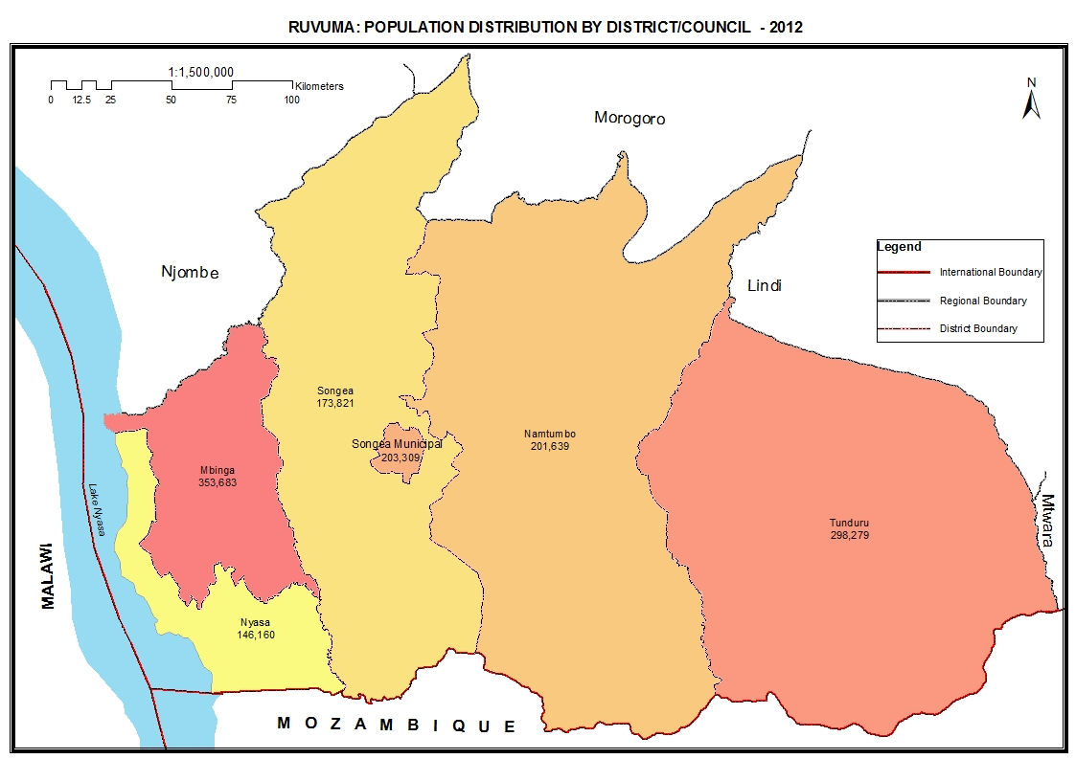

Table 10.0: Population of Ruvuma Region by Sex, Average Household Size and Sex Ratio
Serial No. | District/Council | Population (Number) |  |  | Average Household Size | Sex Ratio
Serial No. | District/Council | Total | Male | Female | Average Household Size | Sex Ratio
 | Total | 1,376,891 | 668,684 | 708,207 | 4.5 | 94
1 | Tunduru District Council | 298,279 | 143,660 | 154,619 | 4.2 | 93
2 | Songea District Council | 173,821 | 86,548 | 87,273 | 4.5 | 99
3 | Mbinga District Council | 353,683 | 172,402 | 181,281 | 4.7 | 95
4 | Songea Municipal Council | 203,309 | 96,347 | 106,962 | 4.2 | 90
5 | Namtumbo District Council | 201,639 | 98,335 | 103,304 | 5.1 | 95
6 | Nyasa District Council | 146,160 | 71,392 | 74,768 | 4.7 | 95

Table 10. 1: Population of Tunduru District Council by Sex, Average Household Size and Sex Ratio
Serial No. | Ward/Shehia | Population (Number) |  |  | Average Household Size | Sex Ratio
Serial No. | Ward/Shehia | Total | Male | Female | Average Household Size | Sex Ratio
 | Total | 298,279 | 143,660 | 154,619 | 4.2 | 93
1 | Kalulu | 4,271 | 2,103 | 2,168 | 4.7 | 97
2 | Ligunga | 8,452 | 4,057 | 4,395 | 4.5 | 92
3 | Mlingoti Mashariki | 6,135 | 2,874 | 3,261 | 3.8 | 88
4 | Mindu | 4,444 | 2,177 | 2,267 | 3.9 | 96
5 | Ngapa | 6,068 | 3,061 | 3,007 | 4.2 | 102
6 | Nakapanya | 14,402 | 7,043 | 7,359 | 3.9 | 96
7 | Muhuwesi | 17,540 | 8,514 | 9,026 | 4.3 | 94
8 | Tuwemacho | 8,841 | 4,292 | 4,549 | 4.1 | 94
9 | Ligoma | 7,989 | 3,914 | 4,075 | 4.0 | 96
10 | Misechela | 8,169 | 3,945 | 4,224 | 4.1 | 93
11 | Namasakata | 9,938 | 4,764 | 5,174 | 4.1 | 92
12 | Mtina | 17,617 | 8,442 | 9,175 | 4.3 | 92
13 | Mchesi | 8,781 | 4,202 | 4,579 | 4.2 | 92
14 | Lukumbule | 8,755 | 4,235 | 4,520 | 4.1 | 94
15 | Nalasi Magharibi | 8,282 | 3,905 | 4,377 | 4.4 | 89
16 | Mchoteka | 12,288 | 5,827 | 6,461 | 4.6 | 90
17 | Marumba | 11,445 | 5,505 | 5,940 | 4.9 | 93
18 | Mbesa | 15,592 | 7,422 | 8,170 | 4.5 | 91
19 | Mlingoti Magharibi | 4,345 | 2,110 | 2,235 | 4.0 | 94
20 | Kidodoma | 9,264 | 4,485 | 4,779 | 4.3 | 94
21 | Nandembo | 7,663 | 3,764 | 3,899 | 4.3 | 97
22 | Nampungu | 4,692 | 2,270 | 2,422 | 4.2 | 94
23 | Matemanga | 9,398 | 4,619 | 4,779 | 4.6 | 97
24 | Namwinyu | 10,476 | 4,979 | 5,497 | 4.8 | 91
25 | Mbati | 5,548 | 2,680 | 2,868 | 4.8 | 93
26 | Nalasi Mashariki | 8,003 | 3,856 | 4,147 | 4.6 | 93
27 | Mchuluka | 3,584 | 1,756 | 1,828 | 4.3 | 96
28 | Namiungo | 9,530 | 4,630 | 4,900 | 4.1 | 94
29 | Jakika | 3,768 | 1,792 | 1,976 | 4.4 | 91
30 | Masonya | 5,933 | 2,833 | 3,100 | 3.9 | 91
31 | Sisikwasisi | 5,776 | 2,785 | 2,991 | 3.9 | 93
32 | Mchangani | 6,031 | 2,868 | 3,163 | 4.1 | 91
33 | Majengo | 7,660 | 3,693 | 3,967 | 3.9 | 93
34 | Nanjoka | 9,486 | 4,384 | 5,102 | 3.9 | 86
35 | Nakayaya | 8,113 | 3,874 | 4,239 | 4.1 | 91

Table 10. 2: Population of Songea District Council by Sex, Average Household Size and Sex Ratio
Serial No. | Ward/Shehia | Population (Number) |  |  | Average Household Size | Sex Ratio
Serial No. | Ward/Shehia | Total | Male | Female | Average Household Size | Sex Ratio
 | Total | 173,821 | 86,548 | 87,273 | 4.5 | 99
1 | Wino | 12,298 | 6,061 | 6,237 | 4.5 | 97
2 | Ndongosi | 6,446 | 3,305 | 3,141 | 4.6 | 105
3 | Matumbi | 1,878 | 1,030 | 848 | 4.9 | 121
4 | Mpandangindo | 4,733 | 2,430 | 2,303 | 4.3 | 106
5 | Gumbiro | 5,716 | 2,941 | 2,775 | 4.8 | 106
6 | Mpitimbi | 14,554 | 7,125 | 7,429 | 4.2 | 96
7 | Muhukuru | 16,579 | 8,288 | 8,291 | 4.7 | 100
8 | Magagura | 16,018 | 8,081 | 7,937 | 4.5 | 102
9 | Litisha | 14,362 | 7,121 | 7,241 | 4.6 | 98
10 | Kilagano | 12,479 | 6,365 | 6,114 | 4.5 | 104
11 | Maposeni | 5,795 | 2,844 | 2,951 | 4.2 | 96
12 | Peramiho | 15,031 | 7,076 | 7,955 | 4.4 | 89
13 | Mahanje | 11,997 | 5,955 | 6,042 | 4.1 | 99
14 | Matimira | 11,397 | 5,668 | 5,729 | 4.5 | 99
15 | Mtyangimbole | 9,337 | 4,557 | 4,780 | 4.6 | 95
16 | Mkongotema | 6,548 | 3,359 | 3,189 | 4.9 | 105
17 | Mbinga Mhalule | 8,653 | 4,342 | 4,311 | 4.2 | 101

Table 10. 3: Population of Mbinga District Council by Sex, Average Household Size and Sex Ratio
Serial No. | Ward/Shehia | Population (Number) |  |  | Average Household Size | Sex Ratio
Serial No. | Ward/Shehia | Total | Male | Female | Average Household Size | Sex Ratio
 | Total | 353,683 | 172,402 | 181,281 | 4.7 | 95
1 | Ruanda | 7,374 | 3,711 | 3,663 | 4.7 | 101
2 | Litumbandyosi | 8,743 | 4,423 | 4,320 | 4.6 | 102
3 | Kigonsera | 10,275 | 5,053 | 5,222 | 4.4 | 97
4 | Kihangi Mahuka | 12,832 | 6,364 | 6,468 | 4.8 | 98
5 | Utiri | 7,974 | 3,882 | 4,092 | 4.5 | 95
6 | Mbinga Mjini | 37,893 | 17,752 | 20,141 | 4.6 | 88
7 | Kilimani | 11,529 | 5,665 | 5,864 | 4.9 | 97
8 | Mbangamao | 12,105 | 5,947 | 6,158 | 4.7 | 97
9 | Kihungu | 3,904 | 1,912 | 1,992 | 4.5 | 96
10 | Kikolo | 4,949 | 2,488 | 2,461 | 4.5 | 101
11 | Kambarage | 9,712 | 4,696 | 5,016 | 5.0 | 94
12 | Mapera | 10,513 | 4,980 | 5,533 | 4.9 | 90
13 | Kipapa | 7,012 | 3,342 | 3,670 | 4.7 | 91
14 | Kipololo | 4,381 | 2,178 | 2,203 | 4.6 | 99
15 | Nyoni | 10,918 | 5,238 | 5,680 | 4.9 | 92
16 | Luwaita | 8,030 | 3,883 | 4,147 | 4.8 | 94
17 | Maguu | 13,396 | 6,299 | 7,097 | 4.7 | 89
18 | Kitumbalomo | 9,106 | 4,527 | 4,579 | 4.8 | 99
19 | Mkako | 12,736 | 6,818 | 5,918 | 4.6 | 115
20 | Mkalanga | 8,425 | 3,983 | 4,442 | 4.9 | 90
21 | Langiro | 11,239 | 5,481 | 5,758 | 4.5 | 95
22 | Mbuji | 11,245 | 5,466 | 5,779 | 4.6 | 95
23 | Litembo | 12,443 | 5,868 | 6,575 | 4.5 | 89
24 | Ngima | 10,061 | 4,933 | 5,128 | 4.6 | 96
25 | Myangayanga | 10,805 | 5,155 | 5,650 | 4.7 | 91
26 | Mkumbi | 11,583 | 5,575 | 6,008 | 4.8 | 93
27 | Linda | 11,111 | 5,393 | 5,718 | 4.6 | 94
28 | Matiri | 11,860 | 5,967 | 5,893 | 4.8 | 101
29 | Ukata | 5,159 | 2,559 | 2,600 | 4.2 | 98
30 | Kitanda | 7,832 | 3,858 | 3,974 | 4.9 | 97
31 | Kitura | 7,341 | 3,679 | 3,662 | 4.5 | 100
32 | Namswea | 8,079 | 4,050 | 4,029 | 4.7 | 101
33 | Mpepai | 12,693 | 6,271 | 6,422 | 4.8 | 98
34 | Mpapa | 10,425 | 5,006 | 5,419 | 4.5 | 92

Table 10. 4: Population of Songea Municipal Council by Sex, Average Household Size and Sex Ratio
Serial No. | Ward/Shehia | Population (Number) |  |  | Average Household Size | Sex Ratio
Serial No. | Ward/Shehia | Total | Male | Female | Average Household Size | Sex Ratio
 | Total | 203,309 | 96,347 | 106,962 | 4.2 | 90
1 | Mjini | 9,443 | 4,441 | 5,002 | 4.1 | 89
2 | Majengo | 7,400 | 3,366 | 4,034 | 3.7 | 83
3 | Misufini | 4,599 | 2,076 | 2,523 | 3.6 | 82
4 | Mfaranyaki | 9,115 | 4,184 | 4,931 | 3.7 | 85
5 | Lizaboni | 14,815 | 6,780 | 8,035 | 4.3 | 84
6 | Matarawe | 6,949 | 3,197 | 3,752 | 3.8 | 85
7 | Bombambili | 28,058 | 12,989 | 15,069 | 4.0 | 86
8 | Matogoro | 5,127 | 2,405 | 2,722 | 4.5 | 88
9 | Ruvuma | 13,543 | 6,481 | 7,062 | 4.3 | 92
10 | Subira | 7,662 | 3,752 | 3,910 | 4.4 | 96
11 | Ruhuwiko | 7,377 | 3,565 | 3,812 | 4.6 | 94
12 | Mshangano | 8,205 | 4,077 | 4,128 | 4.4 | 99
13 | Mletele | 5,331 | 2,634 | 2,697 | 4.5 | 98
14 | SeedFarm | 6,228 | 3,029 | 3,199 | 4.5 | 95
15 | Tanga | 8,754 | 4,312 | 4,442 | 4.4 | 97
16 | Msamala | 18,920 | 8,943 | 9,977 | 4.6 | 90
17 | Lilambo | 11,981 | 5,837 | 6,144 | 4.3 | 95
18 | Mwengemshindo | 2,601 | 1,356 | 1,245 | 4.3 | 109
19 | Mjimwema | 12,055 | 5,653 | 6,402 | 4.3 | 88
20 | Mateka | 13,537 | 6,479 | 7,058 | 4.6 | 92
21 | Ndilimalitembo | 1,609 | 791 | 818 | 4.6 | 97

Table 10. 5: Population of Namtumbo District Council by Sex, Average Household Size and Sex Ratio
Serial No. | Ward/Shehia | Population (Number) |  |  | Average Household Size | Sex Ratio
Serial No. | Ward/Shehia | Total | Male | Female | Average Household Size | Sex Ratio
 | Total | 201,639 | 98,335 | 103,304 | 5.1 | 95
1 | Rwinga | 13,668 | 6,491 | 7,177 | 4.8 | 90
2 | Mkongo | 7,012 | 3,420 | 3,592 | 5.1 | 95
3 | Ligera | 11,796 | 5,855 | 5,941 | 5.0 | 99
4 | Lusewa | 18,883 | 9,137 | 9,746 | 4.9 | 94
5 | Magazini | 8,639 | 4,136 | 4,503 | 5.1 | 92
6 | Msindo | 6,882 | 3,369 | 3,513 | 4.5 | 96
7 | Luchili | 13,824 | 6,654 | 7,170 | 5.3 | 93
8 | Namabengo | 10,055 | 4,883 | 5,172 | 4.6 | 94
9 | Kitanda | 10,498 | 5,221 | 5,277 | 5.6 | 99
10 | Luegu | 7,754 | 3,732 | 4,022 | 5.3 | 93
11 | Namtumbo | 19,275 | 9,462 | 9,813 | 4.9 | 96
12 | Mgombasi | 9,996 | 4,830 | 5,166 | 5.7 | 93
13 | Iitola | 10,752 | 5,207 | 5,545 | 4.7 | 94
14 | Likuyuseka | 10,811 | 5,452 | 5,359 | 5.6 | 102
15 | Mputa | 11,117 | 5,427 | 5,690 | 5.9 | 95
16 | Hanga | 14,218 | 6,998 | 7,220 | 4.9 | 97
17 | Limamu | 6,288 | 3,106 | 3,182 | 5.2 | 98
18 | Mchomoro | 10,171 | 4,955 | 5,216 | 5.4 | 95

Table 10. 6: Population of Nyasa District Council by Sex, Average Household Size and Sex Ratio
Serial No. | Ward/Shehia | Population (Number) |  |  | Average Household Size | Sex Ratio
Serial No. | Ward/Shehia | Total | Male | Female | Average Household Size | Sex Ratio
 | Total | 146,160 | 71,392 | 74,768 | 4.7 | 95
1 | Liparamba | 9,673 | 4,868 | 4,805 | 4.5 | 101
2 | Tingi | 23,028 | 11,711 | 11,317 | 4.9 | 103
3 | Chiwanda | 7,084 | 3,421 | 3,663 | 4.8 | 93
4 | Mtipwili | 7,102 | 3,361 | 3,741 | 4.5 | 90
5 | Kingerikiti | 15,875 | 7,680 | 8,195 | 5.0 | 94
6 | Luhangarasi | 7,970 | 3,811 | 4,159 | 4.8 | 92
7 | Kilosa | 7,816 | 3,764 | 4,052 | 4.5 | 93
8 | Mbambabay | 10,066 | 4,811 | 5,255 | 4.3 | 92
9 | Lipingo | 8,945 | 4,379 | 4,566 | 4.5 | 96
10 | Liuli | 12,611 | 6,058 | 6,553 | 4.4 | 92
11 | Kihagara | 10,321 | 4,998 | 5,323 | 4.9 | 94
12 | Ngumbo | 3,933 | 1,921 | 2,012 | 4.6 | 95
13 | Liwundi | 4,906 | 2,453 | 2,453 | 4.4 | 100
14 | Mbaha | 6,972 | 3,406 | 3,566 | 5.0 | 96
15 | Lituhi | 9,858 | 4,750 | 5,108 | 4.5 | 93
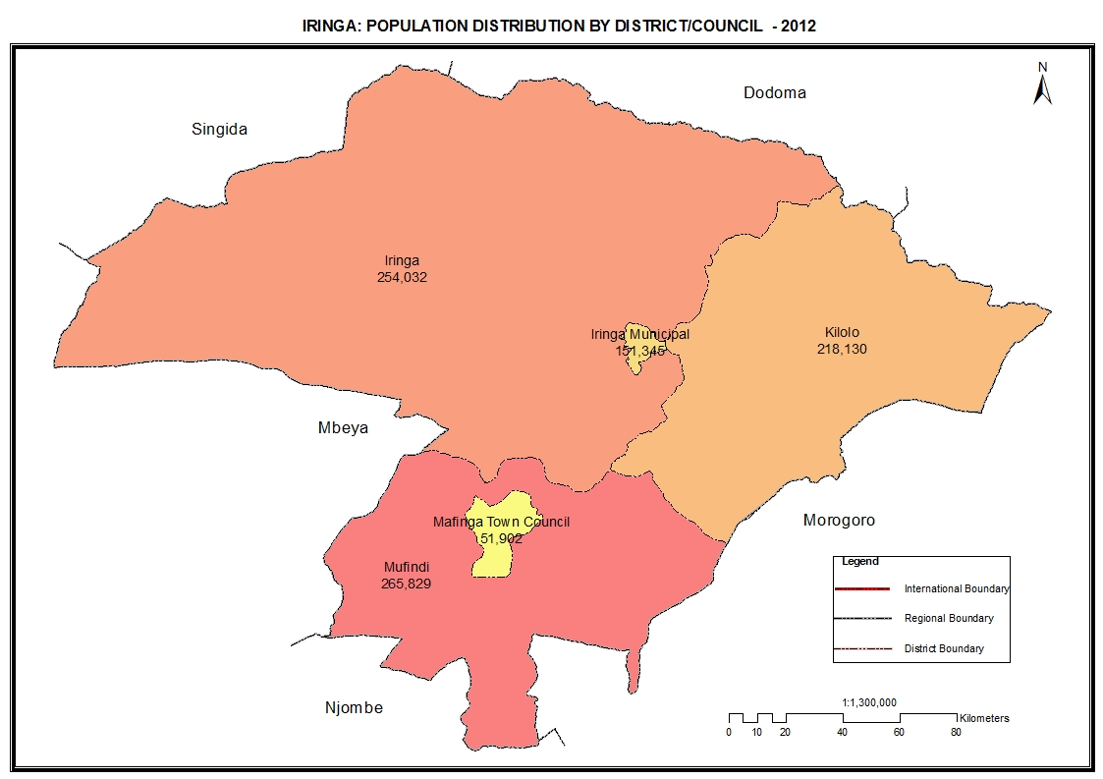

Table 11.0: Population of Iringa Region by Sex, Average Household Size and Sex Ratio
Serial No. | District/Council | Population (Number) |  |  | Average Household Size | Sex Ratio
Serial No. | District/Council | Total | Male | Female | Average Household Size | Sex Ratio
 | Total | 941,238 | 452,052 | 489,186 | 4.2 | 92
1 | Iringa District Council | 254,032 | 123,243 | 130,789 | 4.2 | 94
2 | Mufindi District Council | 265,829 | 125,896 | 139,933 | 4.2 | 90
3 | Iringa Municipal Council | 151,345 | 71,932 | 79,413 | 4.2 | 91
4 | Kilolo District Council | 218,130 | 105,856 | 112,274 | 4.3 | 94
5 | Mafinga Town Council | 51,902 | 25,125 | 26,777 | 4.0 | 94

Table 11. 1: Population of Iringa District Council by Sex, Average Household Size and Sex Ratio
Serial No. | Ward/Shehia | Population (Number) |  |  | Average Household Size | Sex Ratio
Serial No. | Ward/Shehia | Total | Male | Female | Average Household Size | Sex Ratio
 | Total | 254,032 | 123,243 | 130,789 | 4.2 | 94
1 | Kalenga | 6,963 | 3,175 | 3,788 | 4.2 | 84
2 | Kiwere | 9,776 | 4,747 | 5,029 | 3.9 | 94
3 | Nzihi | 14,872 | 7,025 | 7,847 | 4.0 | 90
4 | Ulanda | 9,257 | 4,384 | 4,873 | 4.0 | 90
5 | Mseke | 15,868 | 7,565 | 8,303 | 4.2 | 91
6 | Maguliwa | 13,639 | 6,663 | 6,976 | 4.3 | 96
7 | Mgama | 12,561 | 5,943 | 6,618 | 4.3 | 90
8 | Ifunda | 12,199 | 5,795 | 6,404 | 4.1 | 90
9 | Lumuli | 7,852 | 3,808 | 4,044 | 4.2 | 94
10 | Maboga | 12,642 | 6,161 | 6,481 | 4.2 | 95
11 | Wasa | 10,595 | 5,095 | 5,500 | 4.4 | 93
12 | Mahuninga | 4,331 | 2,128 | 2,203 | 3.9 | 97
13 | Idodi | 10,202 | 5,128 | 5,074 | 3.9 | 101
14 | Mlowa | 9,483 | 4,690 | 4,793 | 4.5 | 98
15 | Itunundu | 14,420 | 7,187 | 7,233 | 4.1 | 99
16 | Ilolo Mpya | 6,376 | 3,099 | 3,277 | 4.2 | 95
17 | Nduli | 8,045 | 3,881 | 4,164 | 4.0 | 93
18 | Kihorogota | 7,688 | 3,800 | 3,888 | 4.1 | 98
19 | Izazi | 5,281 | 2,608 | 2,673 | 4.5 | 98
20 | Malenga Makali | 7,917 | 3,925 | 3,992 | 4.5 | 98
21 | Nyang'oro | 9,810 | 4,866 | 4,944 | 4.5 | 98
22 | Luhota | 14,019 | 6,640 | 7,379 | 4.4 | 90
23 | Lyamgungwe | 9,836 | 4,688 | 5,148 | 4.3 | 91
24 | Mlenge | 9,463 | 4,686 | 4,777 | 4.7 | 98
25 | Migoli | 10,937 | 5,556 | 5,381 | 4.2 | 103

Table 11. 2: Population of Mufindi District Council by Sex, Average Household Size and Sex Ratio
Serial No. | Ward/Shehia | Population (Number) |  |  | Average Household Size | Sex Ratio
Serial No. | Ward/Shehia | Total | Male | Female | Average Household Size | Sex Ratio
 | Total | 265,829 | 125,896 | 139,933 | 4.2 | 90
1 | Kiyowela | 7,540 | 3,696 | 3,844 | 4.4 | 96
2 | Makungu | 12,751 | 6,360 | 6,391 | 4.0 | 100
3 | Mninga | 14,799 | 7,017 | 7,782 | 3.9 | 90
4 | Kasanga | 7,908 | 3,648 | 4,260 | 3.9 | 86
5 | Igowole | 13,459 | 6,399 | 7,060 | 4.0 | 91
6 | Mtambula | 10,477 | 4,869 | 5,608 | 4.4 | 87
7 | Itandula | 11,866 | 5,427 | 6,439 | 4.4 | 84
8 | Mbalamaziwa | 8,021 | 3,736 | 4,285 | 4.2 | 87
9 | Idunda | 6,110 | 2,924 | 3,186 | 4.1 | 92
10 | Malangali | 5,849 | 2,765 | 3,084 | 4.1 | 90
11 | Nyololo | 11,979 | 5,643 | 6,336 | 4.2 | 89
12 | Ihowanza | 10,756 | 5,070 | 5,686 | 4.3 | 89
13 | Ikweha | 8,213 | 3,982 | 4,231 | 4.3 | 94
14 | Sadani | 8,585 | 4,111 | 4,474 | 4.2 | 92
15 | Igombavu | 7,101 | 3,395 | 3,706 | 4.2 | 92
16 | Bumilayinga | 6,136 | 3,008 | 3,128 | 4.6 | 96
17 | Mtwango | 17,073 | 8,008 | 9,065 | 3.6 | 88
18 | Isalavanu | 7,483 | 3,570 | 3,913 | 4.3 | 91
19 | Rungemba | 6,120 | 2,819 | 3,301 | 4.5 | 85
20 | Ifwagi | 16,722 | 8,088 | 8,634 | 4.1 | 94
21 | Mdabulo | 9,342 | 4,410 | 4,932 | 4.5 | 89
22 | Ihalimba | 11,205 | 5,277 | 5,928 | 4.4 | 89
23 | Kibengu | 15,806 | 7,284 | 8,522 | 4.5 | 85
24 | Mapanda | 11,693 | 5,504 | 6,189 | 4.4 | 89
25 | Mpanga | 727 | 406 | 321 | 4.0 | 126
26 | Ihanu | 8,540 | 3,970 | 4,570 | 4.1 | 87
27 | Luhunga | 9,568 | 4,510 | 5,058 | 4.3 | 89

Table 11. 3: Population of Iringa Municipal Council by Sex, Average Household Size and Sex Ratio
Serial No. | Ward/Shehia | Population (Number) |  |  | Average Household Size | Sex Ratio
Serial No. | Ward/Shehia | Total | Male | Female | Average Household Size | Sex Ratio
 | Total | 151,345 | 71,932 | 79,413 | 4.2 | 91
1 | Kihesa | 18,196 | 8,528 | 9,668 | 4.3 | 88
2 | Mtwivila | 21,017 | 9,768 | 11,249 | 4.5 | 87
3 | Gangilonga | 9,599 | 4,730 | 4,869 | 5.0 | 97
4 | Kitanzini | 3,617 | 1,790 | 1,827 | 4.2 | 98
5 | Ruaha | 16,984 | 7,918 | 9,066 | 4.1 | 87
6 | Mshindo | 1,892 | 852 | 1,040 | 3.8 | 82
7 | Mivinjeni | 4,780 | 2,265 | 2,515 | 3.7 | 90
8 | Mlandege | 4,640 | 2,200 | 2,440 | 4.0 | 90
9 | Mwangata | 13,486 | 6,421 | 7,065 | 4.4 | 91
10 | Kwakilosa | 7,948 | 3,785 | 4,163 | 3.9 | 91
11 | Makorongoni | 7,790 | 3,634 | 4,156 | 4.0 | 87
12 | Ilala | 4,448 | 2,110 | 2,338 | 3.6 | 90
13 | Mkwawa | 9,673 | 4,623 | 5,050 | 4.2 | 92
14 | Kitwiru | 11,461 | 5,512 | 5,949 | 4.3 | 93
15 | Isakalilo | 9,188 | 4,549 | 4,639 | 4.3 | 98
16 | Nduli | 6,626 | 3,247 | 3,379 | 3.9 | 96

Table 11. 4: Population of Kilolo District Council by Sex, Average Household Size and Sex Ratio
Serial No. | Ward/Shehia | Population (Number) |  |  | Average Household Size | Sex Ratio
Serial No. | Ward/Shehia | Total | Male | Female | Average Household Size | Sex Ratio
 | Total | 218,130 | 105,856 | 112,274 | 4.3 | 94
1 | Image | 9,180 | 4,404 | 4,776 | 4.2 | 92
2 | Irole | 12,146 | 5,734 | 6,412 | 4.1 | 89
3 | Ilula | 11,109 | 5,264 | 5,845 | 4.1 | 90
4 | Uhambingeto | 10,327 | 5,100 | 5,227 | 4.2 | 98
5 | Udekwa | 5,803 | 2,949 | 2,854 | 4.2 | 103
6 | Mahenge | 10,039 | 5,074 | 4,965 | 3.8 | 102
7 | Mtitu | 11,328 | 5,558 | 5,770 | 4.4 | 96
8 | Dabaga | 7,787 | 3,700 | 4,087 | 4.6 | 91
9 | Ukumbi | 12,912 | 6,352 | 6,560 | 4.3 | 97
10 | Ukwega | 12,195 | 5,913 | 6,282 | 4.9 | 94
11 | Boma la Ng'ombe | 11,313 | 5,358 | 5,955 | 4.4 | 90
12 | Idete | 8,059 | 3,791 | 4,268 | 4.8 | 89
13 | Masisiwe | 10,053 | 4,729 | 5,324 | 4.5 | 89
14 | Ng'uruhe | 11,012 | 5,339 | 5,673 | 4.4 | 94
15 | Ng'ang'ange | 4,123 | 1,942 | 2,181 | 4.3 | 89
16 | Ihimbo | 10,212 | 4,978 | 5,234 | 4.4 | 95
17 | Lugalo | 12,359 | 6,004 | 6,355 | 4.0 | 94
18 | Nyalumbu | 15,306 | 7,406 | 7,900 | 4.0 | 94
19 | Mlafu | 6,386 | 3,190 | 3,196 | 4.2 | 100
20 | Ibumu | 6,681 | 3,252 | 3,429 | 4.3 | 95
21 | Ruaha Mbuyuni | 12,151 | 6,144 | 6,007 | 4.1 | 102
22 | Kimala | 7,649 | 3,675 | 3,974 | 4.7 | 92

Table 11. 5: Population of Mafinga Town Council by Sex, Average Household Size and Sex Ratio
Serial No. | Ward/Shehia | Population (Number) |  |  | Average Household Size | Sex Ratio
Serial No. | Ward/Shehia | Total | Male | Female | Average Household Size | Sex Ratio
 | Total | 51,902 | 25,125 | 26,777 | 4.0 | 94
1 | Sao Hill | 12,765 | 6,668 | 6,097 | 4.8 | 109
2 | Boma | 21,723 | 10,241 | 11,482 | 3.8 | 89
3 | Kinyanambo | 17,414 | 8,216 | 9,198 | 3.9 | 89

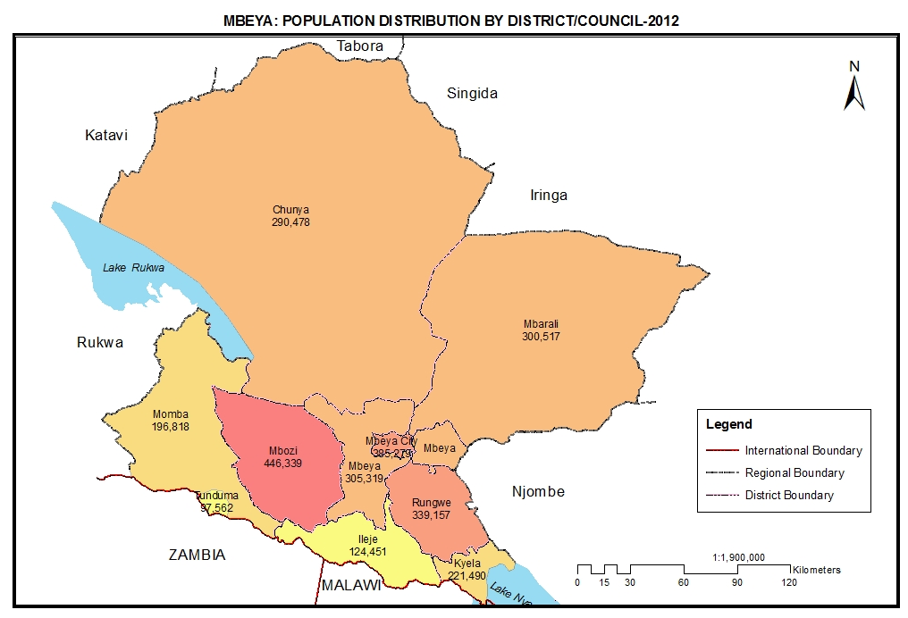

Table 12.0: Population of Mbeya Region by Sex, Average Household Size and Sex Ratio
Serial No. | District/Council | Population (Number) |  |  | Average Household Size | Sex Ratio
Serial No. | District/Council | Total | Male | Female | Average Household Size | Sex Ratio
 | Total | 2,707,410 | 1,297,738 | 1,409,672 | 4.3 | 92
1 | Chunya District Council | 290,478 | 145,420 | 145,058 | 4.9 | 100
2 | Mbeya District Council | 305,319 | 143,779 | 161,540 | 4.1 | 89
3 | Kyela District Council | 221,490 | 106,012 | 115,478 | 4.1 | 92
4 | Rungwe District Council | 339,157 | 161,249 | 177,908 | 4.1 | 91
5 | Ileje District Council | 124,451 | 58,463 | 65,988 | 4.0 | 89
6 | Mbozi District Council | 446,339 | 213,217 | 233,122 | 4.3 | 91
7 | Mbarali District Council | 300,517 | 145,867 | 154,650 | 4.3 | 94
8 | Mbeya City Council | 385,279 | 182,620 | 202,659 | 4.2 | 90
9 | Momba District Council | 196,818 | 94,257 | 102,561 | 4.6 | 92
10 | Tunduma Town Council | 97,562 | 46,854 | 50,708 | 4.0 | 92

Table 12. 1: Population of Chunya District Council by Sex, Average Household Size and Sex Ratio
Serial No. | Ward/Shehia | Population (Number) |  |  | Average Household Size | Sex Ratio
Serial No. | Ward/Shehia | Total | Male | Female | Average Household Size | Sex Ratio
 | Total | 290,478 | 145,420 | 145,058 | 4.9 | 100
1 | Kambikatoto | 7,091 | 3,585 | 3,506 | 6.2 | 102
2 | Mafyeko | 9,409 | 4,916 | 4,493 | 5.5 | 109
3 | Matwiga | 8,939 | 4,688 | 4,251 | 5.1 | 110
4 | Mtanila | 8,711 | 4,437 | 4,274 | 5.1 | 104
5 | Lupatingatinga | 12,835 | 6,626 | 6,209 | 4.8 | 107
6 | Luwalaje | 4,305 | 2,260 | 2,045 | 4.7 | 111
7 | Sangambi | 9,772 | 5,082 | 4,690 | 4.4 | 108
8 | Itewe | 8,341 | 4,136 | 4,205 | 3.9 | 98
9 | Chokaa | 15,227 | 7,538 | 7,689 | 4.4 | 98
10 | Mbugani | 8,734 | 4,270 | 4,464 | 4.0 | 96
11 | Chalangwa | 8,013 | 3,982 | 4,031 | 4.0 | 99
12 | Ifumbo | 6,541 | 3,206 | 3,335 | 4.3 | 96
13 | Kanga | 9,430 | 4,549 | 4,881 | 4.7 | 93
14 | Galula | 8,440 | 4,135 | 4,305 | 4.6 | 96
15 | Mbuyuni | 17,318 | 8,334 | 8,984 | 5.0 | 93
16 | Totowe | 11,643 | 5,544 | 6,099 | 5.9 | 91
17 | Namkukwe | 14,323 | 6,907 | 7,416 | 6.2 | 93
18 | Mkwajuni | 15,292 | 7,329 | 7,963 | 4.4 | 92
19 | Mbangala | 5,622 | 3,023 | 2,599 | 5.4 | 116
20 | Kapalala | 8,089 | 4,177 | 3,912 | 5.4 | 107
21 | Gua | 6,533 | 3,414 | 3,119 | 4.9 | 109
22 | Ngwala | 3,017 | 1,653 | 1,364 | 4.9 | 121
23 | Mamba | 15,462 | 7,764 | 7,698 | 5.5 | 101
24 | Ifwenkenya | 7,876 | 3,835 | 4,041 | 6.0 | 95
25 | Magamba | 10,489 | 5,055 | 5,434 | 6.3 | 93
26 | Saza | 6,708 | 3,671 | 3,037 | 4.4 | 121
27 | Mwambani | 8,912 | 4,463 | 4,449 | 5.0 | 100
28 | Mkola | 5,813 | 2,978 | 2,835 | 5.2 | 105
29 | Makongolosi | 18,116 | 8,975 | 9,141 | 4.3 | 98
30 | Matundasi | 9,477 | 4,888 | 4,589 | 4.6 | 107

Table 12. 2: Population of Mbeya District Council by Sex, Average Household Size and Sex Ratio
Serial No. | Ward/Shehia | Population (Number) |  |  | Average Household Size | Sex Ratio
Serial No. | Ward/Shehia | Total | Male | Female | Average Household Size | Sex Ratio
 | Total | 305,319 | 143,779 | 161,540 | 4.1 | 89
1 | Ihango | 8,342 | 3,903 | 4,439 | 3.8 | 88
2 | Ulenje | 6,946 | 3,273 | 3,673 | 4.0 | 89
3 | Tembela | 10,710 | 4,982 | 5,728 | 4.0 | 87
4 | Ijombe | 10,185 | 4,756 | 5,429 | 3.8 | 88
5 | Santilya | 17,578 | 8,099 | 9,479 | 3.9 | 85
6 | Ilembo | 17,391 | 8,113 | 9,278 | 4.1 | 87
7 | Iwiji | 15,056 | 7,167 | 7,889 | 4.6 | 91
8 | Isuto | 13,958 | 6,648 | 7,310 | 4.1 | 91
9 | Igale | 10,864 | 5,183 | 5,681 | 4.0 | 91
10 | Iwindi | 18,397 | 8,740 | 9,657 | 4.1 | 91
11 | Utengule Usongwe | 41,952 | 19,706 | 22,246 | 4.1 | 89
12 | Mshewe | 11,241 | 5,506 | 5,735 | 4.5 | 96
13 | Ikukwa | 6,024 | 2,858 | 3,166 | 4.2 | 90
14 | Iyunga Mapinduzi | 7,377 | 3,466 | 3,911 | 4.1 | 89
15 | Bonde la Songwe | 18,487 | 8,733 | 9,754 | 4.0 | 90
16 | Inyala | 10,544 | 5,041 | 5,503 | 3.9 | 92
17 | Ilungu | 12,095 | 5,791 | 6,304 | 3.7 | 92
18 | Maendeleo | 5,223 | 2,421 | 2,802 | 4.0 | 86
19 | Swaya | 9,477 | 4,434 | 5,043 | 3.9 | 88
20 | Masoko | 7,682 | 3,563 | 4,119 | 4.1 | 87
21 | Itawa | 11,156 | 5,002 | 6,154 | 3.9 | 81
22 | Nsalala | 19,346 | 9,143 | 10,203 | 4.4 | 90
23 | Lwanjiro | 4,323 | 2,141 | 2,182 | 3.6 | 98
24 | Itewe | 4,655 | 2,183 | 2,472 | 3.9 | 88
25 | Igoma | 6,310 | 2,927 | 3,383 | 3.8 | 87

Table 12. 3: Population of Kyela District Council by Sex, Average Household Size and Sex Ratio
Serial No. | Ward/Shehia | Population (Number) |  |  | Average Household Size | Sex Ratio
Serial No. | Ward/Shehia | Total | Male | Female | Average Household Size | Sex Ratio
 | Total | 221,490 | 106,012 | 115,478 | 4.1 | 92
1 | Lusungo | 6,354 | 3,054 | 3,300 | 4.2 | 93
2 | Makwale | 12,654 | 6,000 | 6,654 | 4.4 | 90
3 | Matema | 17,103 | 8,145 | 8,958 | 4.3 | 91
4 | Mwaya | 11,651 | 5,608 | 6,043 | 4.2 | 93
5 | Ndobo | 6,684 | 3,137 | 3,547 | 4.5 | 88
6 | Kajunjumele | 8,240 | 4,042 | 4,198 | 4.0 | 96
7 | Bujonde | 7,528 | 3,614 | 3,914 | 4.2 | 92
8 | Ikolo | 5,140 | 2,448 | 2,692 | 4.1 | 91
9 | Katumba Songwe | 13,895 | 6,743 | 7,152 | 4.2 | 94
10 | Ngana | 7,944 | 3,808 | 4,136 | 3.9 | 92
11 | Busale | 9,246 | 4,381 | 4,865 | 3.7 | 90
12 | Ipande | 8,081 | 3,945 | 4,136 | 4.1 | 95
13 | Ikama | 4,724 | 2,259 | 2,465 | 4.2 | 92
14 | Ipinda | 20,847 | 9,934 | 10,913 | 4.2 | 91
15 | Ngonga | 8,310 | 4,045 | 4,265 | 4.2 | 95
16 | Ikimba | 10,583 | 5,010 | 5,573 | 4.1 | 90
17 | Itope | 6,717 | 3,224 | 3,493 | 4.1 | 92
18 | Muungano | 3,278 | 1,513 | 1,765 | 3.9 | 86
19 | Talatala | 5,122 | 2,459 | 2,663 | 4.2 | 92
20 | Kyela | 47,389 | 22,643 | 24,746 | 3.9 | 92

Table 12. 4: Population of Rungwe District Council by Sex, Average Household Size and Sex Ratio
Serial No. | Ward/Shehia | Population (Number) |  |  | Average Household Size | Sex Ratio
Serial No. | Ward/Shehia | Total | Male | Female | Average Household Size | Sex Ratio
 | Total | 339,157 | 161,249 | 177,908 | 4.1 | 91
1 | Swaya | 7,555 | 3,482 | 4,073 | 4.2 | 85
2 | Masebe | 4,967 | 2,339 | 2,628 | 3.7 | 89
3 | Suma | 6,256 | 3,027 | 3,229 | 3.7 | 94
4 | Kandete | 10,284 | 4,811 | 5,473 | 3.7 | 88
5 | Luteba | 7,111 | 3,270 | 3,841 | 3.7 | 85
6 | Mpombo | 8,787 | 4,136 | 4,651 | 3.8 | 89
7 | Isange | 5,790 | 2,768 | 3,022 | 3.8 | 92
8 | Kabula | 10,271 | 5,036 | 5,235 | 4.3 | 96
9 | Lwangwa | 10,668 | 5,073 | 5,595 | 4.2 | 91
10 | Lufilyo | 6,370 | 3,015 | 3,355 | 3.9 | 90
11 | Itete | 9,869 | 4,670 | 5,199 | 4.2 | 90
12 | Kisegese | 5,511 | 2,670 | 2,841 | 4.2 | 94
13 | Lupata | 9,090 | 4,383 | 4,707 | 4.1 | 93
14 | Kambasegela | 12,597 | 5,907 | 6,690 | 4.0 | 88
15 | Masukulu | 5,795 | 2,722 | 3,073 | 3.9 | 89
16 | Kisiba | 6,629 | 3,198 | 3,431 | 3.9 | 93
17 | Masoko | 6,136 | 2,948 | 3,188 | 4.1 | 92
18 | Bujela | 5,579 | 2,606 | 2,973 | 4.0 | 88
19 | Ilima | 6,737 | 3,074 | 3,663 | 3.7 | 84
20 | Kisondela | 11,070 | 5,308 | 5,762 | 3.9 | 92
21 | Ikuti | 13,035 | 6,351 | 6,684 | 4.3 | 95
22 | Malindo | 5,960 | 2,927 | 3,033 | 4.1 | 97
23 | Mpuguso | 13,969 | 6,616 | 7,353 | 4.1 | 90
24 | Kikole | 3,303 | 1,591 | 1,712 | 4.1 | 93
25 | Lufingo | 17,166 | 8,145 | 9,021 | 4.3 | 90
26 | Nkunga | 16,139 | 7,987 | 8,152 | 4.5 | 98
27 | Kyimo | 14,033 | 6,712 | 7,321 | 4.2 | 92
28 | Kinyala | 12,871 | 6,186 | 6,685 | 4.5 | 93
29 | Kiwira | 25,244 | 11,936 | 13,308 | 4.1 | 90
30 | Isongole | 18,689 | 8,642 | 10,047 | 3.8 | 86
31 | Ikama | 3,766 | 1,804 | 1,962 | 4.0 | 92
32 | Ibighi | 8,899 | 4,207 | 4,692 | 4.1 | 90
33 | Bagamoyo | 3,207 | 1,501 | 1,706 | 4.0 | 88
34 | Kawetele | 5,506 | 2,614 | 2,892 | 4.0 | 90
35 | Bulyaga | 6,393 | 2,996 | 3,397 | 4.1 | 88
36 | Msasani | 6,292 | 3,054 | 3,238 | 4.4 | 94
37 | Makandana | 7,613 | 3,537 | 4,076 | 4.1 | 87

Table 12. 5: Population of Ileje District Council by Sex, Average Household Size and Sex Ratio
Serial No. | Ward/Shehia | Population (Number) |  |  | Average Household Size | Sex Ratio
Serial No. | Ward/Shehia | Total | Male | Female | Average Household Size | Sex Ratio
 | Total | 124,451 | 58,463 | 65,988 | 4.0 | 89
1 | Itumba | 10,186 | 4,688 | 5,498 | 4.0 | 85
2 | Itale | 7,609 | 3,542 | 4,067 | 4.2 | 87
3 | Ibaba | 8,058 | 3,686 | 4,372 | 4.0 | 84
4 | Ndola | 6,820 | 3,175 | 3,645 | 4.1 | 87
5 | Luswisi | 4,632 | 2,175 | 2,457 | 4.4 | 89
6 | Ngulilo | 4,659 | 2,232 | 2,427 | 4.4 | 92
7 | Lubanda | 8,582 | 4,071 | 4,511 | 4.3 | 90
8 | Ngulugulu | 4,927 | 2,434 | 2,493 | 3.9 | 98
9 | Sange | 4,757 | 2,296 | 2,461 | 4.4 | 93
10 | Ikinga | 7,824 | 3,694 | 4,130 | 3.7 | 89
11 | Kafule | 7,450 | 3,432 | 4,018 | 3.8 | 85
12 | Malangali | 6,485 | 3,037 | 3,448 | 3.7 | 88
13 | Bupigu | 6,145 | 2,935 | 3,210 | 4.0 | 91
14 | Isongole | 9,893 | 4,650 | 5,243 | 3.8 | 89
15 | Chitete | 8,673 | 4,052 | 4,621 | 3.9 | 88
16 | Mbebe | 9,282 | 4,426 | 4,856 | 4.2 | 91
17 | Mlale | 4,896 | 2,256 | 2,640 | 4.2 | 85
18 | Kalembo | 3,573 | 1,682 | 1,891 | 4.0 | 89

Table 12. 6: Population of Mbozi District Council by Sex, Average Household Size and Sex Ratio
Serial No. | Ward/Shehia | Population (Number) |  |  | Average Household Size | Sex Ratio
Serial No. | Ward/Shehia | Total | Male | Female | Average Household Size | Sex Ratio
 | Total | 446,339 | 213,217 | 233,122 | 4.3 | 91
1 | Ihanda | 21,355 | 10,088 | 11,267 | 4.1 | 90
2 | Bara | 20,106 | 9,591 | 10,515 | 4.5 | 91
3 | Nanyala | 8,914 | 4,149 | 4,765 | 3.9 | 87
4 | Nambinzo | 25,951 | 12,610 | 13,341 | 4.7 | 95
5 | Itaka | 21,032 | 10,264 | 10,768 | 4.5 | 95
6 | Isansa | 42,891 | 20,464 | 22,427 | 4.4 | 91
7 | Ruanda | 8,604 | 4,136 | 4,468 | 4.1 | 93
8 | Iyula | 30,784 | 14,766 | 16,018 | 4.2 | 92
9 | Nyimbili | 23,903 | 11,485 | 12,418 | 4.3 | 92
10 | Mlangali | 19,539 | 9,459 | 10,080 | 4.5 | 94
11 | Myovizi | 15,738 | 7,591 | 8,147 | 4.3 | 93
12 | Igamba | 34,822 | 16,569 | 18,253 | 4.3 | 91
13 | Halungu | 27,151 | 13,023 | 14,128 | 4.3 | 92
14 | Msia | 27,361 | 13,319 | 14,042 | 4.3 | 95
15 | Mlowo | 38,016 | 17,978 | 20,038 | 4.0 | 90
16 | Ipunga | 9,367 | 4,401 | 4,966 | 4.0 | 89
17 | Isandula | 14,549 | 6,952 | 7,597 | 4.2 | 92
18 | Vwawa | 56,256 | 26,372 | 29,884 | 4.2 | 88

Table 12. 7: Population of Mbarali District Council by Sex, Average Household Size and Sex Ratio
Serial No. | Ward/Shehia | Population (Number) |  |  | Average Household Size | Sex Ratio
Serial No. | Ward/Shehia | Total | Male | Female | Average Household Size | Sex Ratio
 | Total | 300,517 | 145,867 | 154,650 | 4.3 | 94
1 | Luhanga | 11,466 | 5,612 | 5,854 | 5.9 | 96
2 | Madibira | 24,742 | 12,103 | 12,639 | 4.5 | 96
3 | Mawindi | 9,917 | 4,825 | 5,092 | 4.2 | 95
4 | Ihahi | 8,474 | 4,124 | 4,350 | 3.8 | 95
5 | Mapogoro | 24,754 | 12,059 | 12,695 | 4.4 | 95
6 | Chimala | 16,633 | 7,734 | 8,899 | 3.9 | 87
7 | Utengule Usangu | 15,407 | 7,239 | 8,168 | 4.9 | 89
8 | Ruiwa | 15,867 | 7,765 | 8,102 | 4.3 | 96
9 | Mahongole | 11,744 | 5,676 | 6,068 | 3.6 | 94
10 | Ubaruku | 29,197 | 14,257 | 14,940 | 4.1 | 95
11 | Igurusi | 22,296 | 10,734 | 11,562 | 3.9 | 93
12 | Kongolo | 10,309 | 5,058 | 5,251 | 3.9 | 96
13 | Mwatenga | 8,416 | 4,109 | 4,307 | 4.9 | 95
14 | Imalilosongwe | 11,268 | 5,545 | 5,723 | 4.6 | 97
15 | Igava | 14,292 | 6,879 | 7,413 | 4.9 | 93
16 | Ipwani | 8,503 | 4,143 | 4,360 | 4.3 | 95
17 | Itamboleo | 9,313 | 4,641 | 4,672 | 4.8 | 99
18 | Miyombweni | 9,773 | 4,861 | 4,912 | 4.9 | 99
19 | Rujewa | 29,473 | 14,241 | 15,232 | 4.2 | 93
20 | Lugelele | 8,673 | 4,262 | 4,411 | 4.0 | 97

Table 12. 8: Population of Mbeya City Council by Sex, Average Household Size and Sex Ratio
Serial No. | Ward/Shehia | Population (Number) |  |  | Average Household Size | Sex Ratio
Serial No. | Ward/Shehia | Total | Male | Female | Average Household Size | Sex Ratio
 | Total | 385,279 | 182,620 | 202,659 | 4.2 | 90
1 | Sisimba | 4,112 | 2,043 | 2,069 | 4.2 | 99
2 | Isanga | 11,307 | 5,434 | 5,873 | 4.1 | 93
3 | Iganzo | 14,414 | 6,896 | 7,518 | 4.3 | 92
4 | Mwansekwa | 1,803 | 878 | 925 | 4.0 | 95
5 | Itagano | 1,751 | 790 | 961 | 4.0 | 82
6 | Itezi | 18,445 | 8,634 | 9,811 | 4.3 | 88
7 | Nsalaga | 18,993 | 8,975 | 10,018 | 4.3 | 90
8 | Igawilo | 17,300 | 7,931 | 9,369 | 3.9 | 85
9 | Iganjo | 8,697 | 4,134 | 4,563 | 4.1 | 91
10 | Uyole | 11,543 | 5,344 | 6,199 | 4.1 | 86
11 | Iduda | 4,157 | 1,961 | 2,196 | 4.0 | 89
12 | Mwasanga | 945 | 440 | 505 | 3.6 | 87
13 | Tembela | 2,334 | 1,135 | 1,199 | 4.2 | 95
14 | Ilomba | 34,021 | 16,001 | 18,020 | 4.4 | 89
15 | Mwakibete | 23,319 | 11,094 | 12,225 | 4.2 | 91
16 | Ilemi | 26,841 | 12,845 | 13,996 | 4.3 | 92
17 | Isyesye | 7,970 | 3,662 | 4,308 | 4.7 | 85
18 | Ruanda | 21,927 | 10,198 | 11,729 | 3.8 | 87
19 | Iyela | 31,634 | 15,174 | 16,460 | 4.4 | 92
20 | Sinde | 7,014 | 3,355 | 3,659 | 3.9 | 92
21 | Maanga | 6,881 | 3,185 | 3,696 | 3.9 | 86
22 | Mbalizi Road | 6,045 | 3,318 | 2,727 | 4.7 | 122
23 | Forest | 6,649 | 3,036 | 3,613 | 4.0 | 84
24 | Mabatini | 7,415 | 3,511 | 3,904 | 4.0 | 90
25 | Nzovwe | 22,898 | 10,823 | 12,075 | 4.5 | 90
26 | Kalobe | 13,180 | 6,185 | 6,995 | 4.3 | 88
27 | Iyunga | 15,026 | 7,188 | 7,838 | 4.3 | 92
28 | Iwambi | 12,387 | 6,005 | 6,382 | 4.8 | 94
29 | Itende | 3,490 | 1,788 | 1,702 | 4.6 | 105
30 | Iziwa | 3,176 | 1,442 | 1,734 | 4.0 | 83
31 | Nsoho | 1,819 | 876 | 943 | 4.0 | 93
32 | Majengo | 3,314 | 1,563 | 1,751 | 3.4 | 89
33 | Ghana | 4,885 | 2,267 | 2,618 | 4.1 | 87
34 | Nonde | 2,488 | 1,188 | 1,300 | 3.8 | 91
35 | Itiji | 4,231 | 1,976 | 2,255 | 4.3 | 88
36 | Maendeleo | 2,868 | 1,345 | 1,523 | 3.7 | 88

Table 12. 9: Population of Momba District Council by Sex, Average Household Size and Sex Ratio
Serial No. | Ward/Shehia | Population (Number) |  |  | Average Household Size | Sex Ratio
Serial No. | Ward/Shehia | Total | Male | Female | Average Household Size | Sex Ratio
 | Total | 196,818 | 94,257 | 102,561 | 4.6 | 92
1 | Chilulumo | 11,177 | 5,281 | 5,896 | 4.8 | 90
2 | Kamsamba | 17,055 | 8,297 | 8,758 | 4.8 | 95
3 | Ivuna | 31,254 | 14,883 | 16,371 | 5.0 | 91
4 | Mpapa | 6,512 | 3,024 | 3,488 | 4.8 | 87
5 | Mkulwe | 9,337 | 4,517 | 4,820 | 5.2 | 94
6 | Chitete | 19,431 | 9,292 | 10,139 | 4.4 | 92
7 | Msangano | 15,770 | 7,689 | 8,081 | 4.4 | 95
8 | Chiwezi | 25,060 | 12,006 | 13,054 | 4.2 | 92
9 | Nkangamo | 12,996 | 6,235 | 6,761 | 4.6 | 92
10 | Ndalambo | 11,693 | 5,532 | 6,161 | 4.2 | 90
11 | Kapele | 11,690 | 5,594 | 6,096 | 4.5 | 92
12 | Nzoka | 13,252 | 6,276 | 6,976 | 4.5 | 90
13 | Myunga | 11,591 | 5,631 | 5,960 | 4.3 | 94

Table 12. 10: Population of Tunduma Town Council by Sex, Average Household Size and Sex Ratio
Serial No. | Ward/Shehia | Population (Number) |  |  | Average Household Size | Sex Ratio
Serial No. | Ward/Shehia | Total | Male | Female | Average Household Size | Sex Ratio
 | Total | 97,562 | 46,854 | 50,708 | 4.0 | 92
1 | Tunduma | 97,562 | 46,854 | 50,708 | 4.0 | 92
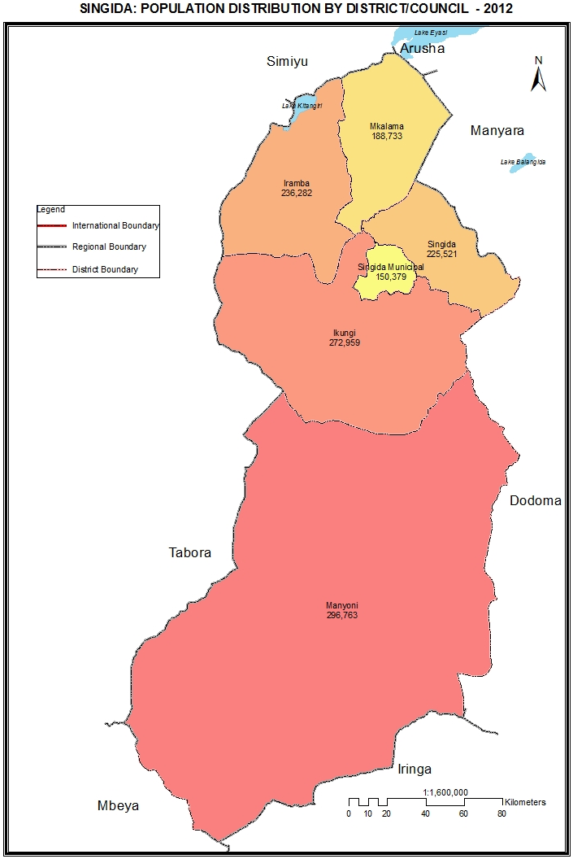

Table 13.0: Population of Singida Region by Sex, Average Household Size and Sex Ratio
Serial No. | District/Council | Population (Number) |  |  | Average Household Size | Sex Ratio
Serial No. | District/Council | Total | Male | Female | Average Household Size | Sex Ratio
 | Total | 1,370,637 | 677,995 | 692,642 | 5.3 | 98
1 | Iramba District Council | 236,282 | 116,997 | 119,285 | 5.4 | 98
2 | Singida District Council | 225,521 | 111,772 | 113,749 | 5.4 | 98
3 | Manyoni District Council | 296,763 | 146,030 | 150,733 | 5.0 | 97
4 | Singida Municipal Council | 150,379 | 73,484 | 76,895 | 4.9 | 96
5 | Ikungi District Council | 272,959 | 136,178 | 136,781 | 5.6 | 100
6 | Mkalama District Council | 188,733 | 93,534 | 95,199 | 5.4 | 98

Table 13. 1: Population of Iramba District Council by Sex, Average Household Size and Sex Ratio
Serial No. | Ward/Shehia | Population (Number) |  |  | Average Household Size | Sex Ratio
Serial No. | Ward/Shehia | Total | Male | Female | Average Household Size | Sex Ratio
 | Total | 236,282 | 116,997 | 119,285 | 5.4 | 98
1 | Urughu | 13,380 | 6,566 | 6,814 | 7.3 | 96
2 | Mtekente | 16,973 | 8,396 | 8,577 | 6.5 | 98
3 | Mtoa | 19,724 | 9,738 | 9,986 | 6.1 | 98
4 | Mgongo | 13,041 | 6,377 | 6,664 | 6.5 | 96
5 | Shelui | 14,933 | 7,417 | 7,516 | 5.1 | 99
6 | Ntwike | 16,977 | 8,461 | 8,516 | 5.4 | 99
7 | Tulya | 8,265 | 4,370 | 3,895 | 5.1 | 112
8 | Kidaru | 9,727 | 4,849 | 4,878 | 6.2 | 99
9 | Kisiriri | 10,686 | 5,294 | 5,392 | 4.6 | 98
10 | Kiomboi | 25,375 | 12,270 | 13,105 | 4.5 | 94
11 | Kinampanda | 14,870 | 7,308 | 7,562 | 5.0 | 97
12 | Ulemo | 17,174 | 8,407 | 8,767 | 4.8 | 96
13 | Kyengege | 7,845 | 3,902 | 3,943 | 5.1 | 99
14 | Ndago | 14,453 | 7,195 | 7,258 | 4.9 | 99
15 | Mbelekese | 12,678 | 6,364 | 6,314 | 5.6 | 101
16 | Kaselya | 9,801 | 4,849 | 4,952 | 5.6 | 98
17 | Ndulungu | 10,380 | 5,234 | 5,146 | 5.7 | 102

Table 13. 2: Population of Singida District Council by Sex, Average Household Size and Sex Ratio
Serial No. | Ward/Shehia | Population (Number) |  |  | Average Household Size | Sex Ratio
Serial No. | Ward/Shehia | Total | Male | Female | Average Household Size | Sex Ratio
 | Total | 225,521 | 111,772 | 113,749 | 5.4 | 98
1 | Mudida | 14,629 | 7,194 | 7,435 | 5.8 | 97
2 | Makuro | 17,717 | 8,845 | 8,872 | 5.9 | 100
3 | Ikhanoda | 10,907 | 5,468 | 5,439 | 5.5 | 101
4 | Mwasauya | 11,032 | 5,471 | 5,561 | 5.3 | 98
5 | Msange | 11,981 | 5,880 | 6,101 | 5.7 | 96
6 | Maghojoa | 8,983 | 4,475 | 4,508 | 5.5 | 99
7 | Itaja | 7,116 | 3,610 | 3,506 | 5.5 | 103
8 | Ngimu | 11,296 | 5,729 | 5,567 | 5.7 | 103
9 | Mughunga | 7,469 | 3,802 | 3,667 | 5.5 | 104
10 | Mgori | 8,419 | 4,218 | 4,201 | 4.8 | 100
11 | Mughamo | 7,189 | 3,501 | 3,688 | 5.6 | 95
12 | Kinyagigi | 9,409 | 4,717 | 4,692 | 5.6 | 101
13 | Merya | 8,051 | 3,921 | 4,130 | 5.5 | 95
14 | Kinyeto | 9,055 | 4,437 | 4,618 | 5.3 | 96
15 | Ntonge | 7,907 | 3,901 | 4,006 | 5.3 | 97
16 | Ilongero | 10,635 | 5,177 | 5,458 | 5.1 | 95
17 | Mrama | 9,347 | 4,631 | 4,716 | 5.4 | 98
18 | Kijota | 9,666 | 4,793 | 4,873 | 5.3 | 98
19 | Mtinko | 19,414 | 9,596 | 9,818 | 5.2 | 98
20 | Ughandi | 15,985 | 7,820 | 8,165 | 5.1 | 96
21 | Msisi | 9,314 | 4,586 | 4,728 | 5.4 | 97

Table 13. 3: Population of Manyoni District Council by Sex, Average Household Size and Sex Ratio
Serial No. | Ward/Shehia | Population (Number) |  |  | Average Household Size | Sex Ratio
Serial No. | Ward/Shehia | Total | Male | Female | Average Household Size | Sex Ratio
 | Total | 296,763 | 146,030 | 150,733 | 5.0 | 97
1 | Manyoni | 25,505 | 12,328 | 13,177 | 4.3 | 94
2 | Solya | 4,372 | 2,109 | 2,263 | 4.4 | 93
3 | Makuru | 11,874 | 6,080 | 5,794 | 5.1 | 105
4 | Chikuyu | 6,487 | 3,183 | 3,304 | 4.2 | 96
5 | Makanda | 9,768 | 4,634 | 5,134 | 4.9 | 90
6 | Kintinku | 8,877 | 4,269 | 4,608 | 4.3 | 93
7 | Mvumi | 7,873 | 3,701 | 4,172 | 4.8 | 89
8 | Majiri | 11,721 | 5,589 | 6,132 | 4.7 | 91
9 | Sasajila | 7,141 | 3,470 | 3,671 | 4.7 | 95
10 | Idodyandole | 11,201 | 5,633 | 5,568 | 6.1 | 101
11 | Chikola | 12,334 | 5,933 | 6,401 | 6.2 | 93
12 | Heka | 7,921 | 3,820 | 4,101 | 5.7 | 93
13 | Nkonko | 11,281 | 5,414 | 5,867 | 5.4 | 92
14 | Sanza | 10,387 | 4,928 | 5,459 | 4.3 | 90
15 | Isseke | 12,214 | 6,023 | 6,191 | 4.9 | 97
16 | Rungwa | 2,209 | 1,109 | 1,100 | 4.5 | 101
17 | Mgandu | 13,788 | 6,963 | 6,825 | 5.5 | 102
18 | Itigi | 5,590 | 2,719 | 2,871 | 4.9 | 95
19 | Ipande | 10,040 | 5,018 | 5,022 | 5.7 | 100
20 | Sanjaranda | 8,828 | 4,463 | 4,365 | 5.2 | 102
21 | Aghondi | 5,468 | 2,881 | 2,587 | 5.1 | 111
22 | Mkwese | 4,726 | 2,462 | 2,264 | 5.2 | 109
23 | Muhalala | 3,980 | 1,958 | 2,022 | 5.0 | 97
24 | Saranda | 9,115 | 4,546 | 4,569 | 4.5 | 99
25 | Makutopora | 6,635 | 3,282 | 3,353 | 4.6 | 98
26 | Sasilo | 11,987 | 5,867 | 6,120 | 5.7 | 96
27 | Mwamagembe | 6,462 | 3,226 | 3,236 | 5.5 | 100
28 | Mitundu | 23,081 | 11,555 | 11,526 | 5.8 | 100
29 | Kitaraka | 9,711 | 5,070 | 4,641 | 5.8 | 109
30 | Itigi Majengo | 16,187 | 7,797 | 8,390 | 4.5 | 93

Table 13. 4: Population of Singida Municipal Council by Sex, Average Household Size and Sex Ratio
Serial No. | Ward/Shehia | Population (Number) |  |  | Average Household Size | Sex Ratio
Serial No. | Ward/Shehia | Total | Male | Female | Average Household Size | Sex Ratio
 | Total | 150,379 | 73,484 | 76,895 | 4.9 | 96
1 | Mtipa | 8,351 | 4,136 | 4,215 | 5.2 | 98
2 | Mughanga | 2,046 | 975 | 1,071 | 4.9 | 91
3 | Mitunduruni | 10,503 | 4,976 | 5,527 | 4.5 | 90
4 | Majengo | 9,370 | 4,469 | 4,901 | 3.9 | 91
5 | Unyambwa | 9,301 | 4,703 | 4,598 | 5.4 | 102
6 | Mungumaji | 4,320 | 2,276 | 2,044 | 5.7 | 111
7 | Unyamikumbi | 12,616 | 6,201 | 6,415 | 5.4 | 97
8 | Mtamaa | 6,981 | 3,417 | 3,564 | 5.2 | 96
9 | Kindai | 12,658 | 6,050 | 6,608 | 4.3 | 92
10 | Ipembe | 1,858 | 914 | 944 | 4.2 | 97
11 | Utemini | 11,269 | 5,556 | 5,713 | 4.7 | 97
12 | Mwankoko | 10,548 | 5,293 | 5,255 | 5.2 | 101
13 | Mandewa | 17,932 | 8,833 | 9,099 | 5.8 | 97
14 | Minga | 13,336 | 6,351 | 6,985 | 4.4 | 91
15 | Misuna | 13,061 | 6,186 | 6,875 | 4.5 | 90
16 | Uhamaka | 6,229 | 3,148 | 3,081 | 5.1 | 102

Table 13. 5: Population of Ikungi District Council by Sex, Average Household Size and Sex Ratio
Serial No. | Ward/Shehia | Population (Number) |  |  | Average Household Size | Sex Ratio
Serial No. | Ward/Shehia | Total | Male | Female | Average Household Size | Sex Ratio
 | Total | 272,959 | 136,178 | 136,781 | 5.6 | 100
1 | Puma | 9,945 | 4,795 | 5,150 | 4.9 | 93
2 | Kituntu | 8,444 | 4,219 | 4,225 | 5.6 | 100
3 | Mungaa | 18,276 | 8,903 | 9,373 | 5.1 | 95
4 | Siuyu | 7,952 | 3,987 | 3,965 | 5.4 | 101
5 | Kikio | 7,887 | 3,937 | 3,950 | 5.2 | 100
6 | Lighwa | 7,245 | 3,575 | 3,670 | 5.4 | 97
7 | Misughaa | 6,679 | 3,376 | 3,303 | 5.1 | 102
8 | Ntuntu | 11,360 | 5,738 | 5,622 | 5.4 | 102
9 | Dung'unyi | 10,158 | 5,111 | 5,047 | 5.1 | 101
10 | Mang'onyi | 14,962 | 7,903 | 7,059 | 4.9 | 112
11 | Mkiwa | 5,152 | 2,625 | 2,527 | 5.5 | 104
12 | Issuna | 12,158 | 6,212 | 5,946 | 5.5 | 104
13 | Unyahati | 9,710 | 4,870 | 4,840 | 5.0 | 101
14 | Ikungi | 12,661 | 6,331 | 6,330 | 5.0 | 100
15 | Iglansoni | 11,256 | 5,432 | 5,824 | 7.1 | 93
16 | Iseke | 6,933 | 3,444 | 3,489 | 5.2 | 99
17 | Ihanja | 8,269 | 4,169 | 4,100 | 5.1 | 102
18 | Minyughe | 18,440 | 9,239 | 9,201 | 6.6 | 100
19 | Muhintiri | 8,896 | 4,420 | 4,476 | 6.0 | 99
20 | Iyumbu | 9,377 | 4,590 | 4,787 | 8.3 | 96
21 | Mgungira | 6,548 | 3,198 | 3,350 | 7.2 | 95
22 | Mwaru | 11,784 | 5,752 | 6,032 | 6.1 | 95
23 | Ighombwe | 13,344 | 6,692 | 6,652 | 7.3 | 101
24 | Mtunduru | 17,056 | 8,589 | 8,467 | 5.8 | 101
25 | Sepuka | 12,446 | 6,092 | 6,354 | 5.3 | 96
26 | Irisya | 6,021 | 2,979 | 3,042 | 5.5 | 98

Table 13. 6: Population of Mkalama District Council by Sex, Average Household Size and Sex Ratio
Serial No. | Ward/Shehia | Population (Number) |  |  | Average Household Size | Sex Ratio
Serial No. | Ward/Shehia | Total | Male | Female | Average Household Size | Sex Ratio
 | Total | 188,733 | 93,534 | 95,199 | 4.8 | 98
1 | Mpambala | 11,192 | 5,512 | 5,680 | 7.2 | 97
2 | Mwangeza | 19,258 | 9,677 | 9,581 | 6.4 | 101
3 | Mwanga | 26,024 | 13,009 | 13,015 | 5.9 | 100
4 | Nkinto | 10,372 | 5,182 | 5,190 | 5.6 | 100
5 | Ibaga | 11,712 | 5,760 | 5,952 | 5.0 | 97
6 | Gumanga | 10,948 | 5,365 | 5,583 | 5.0 | 96
7 | Msingi | 7,289 | 3,625 | 3,664 | 4.8 | 99
8 | Nduguti | 8,638 | 4,193 | 4,445 | 4.9 | 94
9 | Ilunda | 21,622 | 10,815 | 10,807 | 5.3 | 100
10 | Kinyangiri | 13,475 | 6,685 | 6,790 | 5.2 | 98
11 | Iguguno | 25,860 | 12,643 | 13,217 | 5.0 | 96
12 | Miganga | 8,486 | 4,155 | 4,331 | 5.3 | 96
13 | Matongo | 6,338 | 3,166 | 3,172 | 5.4 | 100
14 | Kikhonda | 7,519 | 3,747 | 3,772 | 5.5 | 99

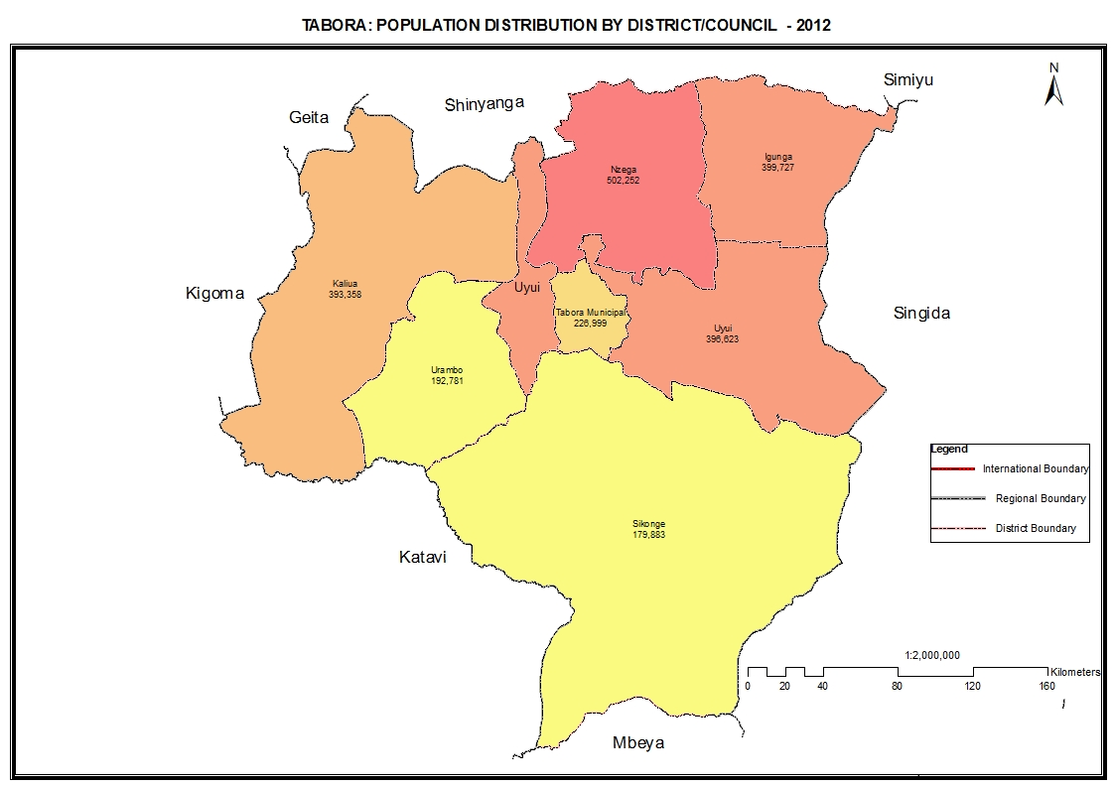

Table 14.0: Population of Tabora Region by Sex, Average Household Size and Sex Ratio
Serial No. | District/Council | Population (Number) |  |  | Average Household Size | Sex Ratio
Serial No. | District/Council | Total | Male | Female | Average Household Size | Sex Ratio
 | Total | 2,291,623 | 1,129,730 | 1,161,893 | 6.0 | 97
1 | Nzega District Council | 502,252 | 245,003 | 257,249 | 5.8 | 95
2 | Igunga District Council | 399,727 | 195,607 | 204,120 | 6.4 | 96
3 | Uyui District Council | 396,623 | 196,446 | 200,177 | 6.6 | 98
4 | Urambo District Council | 192,781 | 95,997 | 96,784 | 5.9 | 99
5 | Sikonge District Council | 179,883 | 88,947 | 90,936 | 5.9 | 98
6 | Tabora Municipal Council | 226,999 | 111,361 | 115,638 | 4.7 | 96
7 | Kaliua District Council | 393,358 | 196,369 | 196,989 | 6.2 | 100

Table 14. 1: Population of Nzega District Council by Sex, Average Household Size and Sex Ratio
Serial No. | Ward/Shehia | Population (Number) |  |  | Average Household Size | Sex Ratio
Serial No. | Ward/Shehia | Total | Male | Female | Average Household Size | Sex Ratio
 | Total | 502,252 | 245,003 | 257,249 | 5.8 | 95
1 | Puge | 12,985 | 6,370 | 6,615 | 5.3 | 96
2 | Nkiniziwa | 19,898 | 9,704 | 10,194 | 6.6 | 95
3 | Budushi | 6,940 | 3,375 | 3,565 | 7.1 | 95
4 | Mwakashanhala | 19,857 | 9,818 | 10,039 | 7.0 | 98
5 | Tongi | 17,151 | 8,354 | 8,797 | 6.1 | 95
6 | Mizibaziba | 11,606 | 5,668 | 5,938 | 6.8 | 95
7 | Milambo Itobo | 12,566 | 6,301 | 6,265 | 7.4 | 101
8 | Magengati | 12,430 | 6,145 | 6,285 | 6.6 | 98
9 | Ndala | 17,567 | 8,550 | 9,017 | 5.6 | 95
10 | Nzega Mjini | 34,744 | 16,466 | 18,278 | 4.2 | 90
11 | Wela | 7,031 | 3,396 | 3,635 | 6.2 | 93
12 | Mbogwe | 6,535 | 3,210 | 3,325 | 5.9 | 97
13 | Miguwa | 13,314 | 6,447 | 6,867 | 5.4 | 94
14 | Itilo | 14,668 | 7,171 | 7,497 | 5.3 | 96
15 | Muhugi | 12,336 | 6,134 | 6,202 | 6.7 | 99
16 | Utwigu | 22,743 | 11,135 | 11,608 | 6.3 | 96
17 | Ijanija | 9,873 | 4,852 | 5,021 | 5.2 | 97
18 | Nzega Ndogo | 8,726 | 4,294 | 4,432 | 5.5 | 97
19 | Lusu | 18,957 | 9,249 | 9,708 | 6.9 | 95
20 | Nata | 14,428 | 7,130 | 7,298 | 5.1 | 98
21 | Isanzu | 12,508 | 6,052 | 6,456 | 5.6 | 94
22 | Itobo | 9,411 | 4,517 | 4,894 | 4.9 | 92
23 | Mwangoye | 13,149 | 6,366 | 6,783 | 5.2 | 94
24 | Sigili | 9,754 | 4,804 | 4,950 | 6.1 | 97
25 | Mwamala | 15,620 | 7,536 | 8,084 | 5.4 | 93
26 | Igusule | 16,690 | 8,162 | 8,528 | 6.0 | 96
27 | Shigamba | 4,600 | 2,206 | 2,394 | 4.9 | 92
28 | Kasela | 9,259 | 4,440 | 4,819 | 5.1 | 92
29 | Karitu | 8,344 | 4,035 | 4,309 | 5.3 | 94
30 | Bukene | 7,641 | 3,623 | 4,018 | 4.4 | 90
31 | Mogwa | 12,140 | 5,931 | 6,209 | 6.0 | 96
32 | Mambali | 33,377 | 16,466 | 16,911 | 6.4 | 97
33 | Kahama Nhalanga | 13,701 | 6,654 | 7,047 | 6.3 | 94
34 | Uduka | 4,832 | 2,463 | 2,369 | 5.4 | 104
35 | Semembela | 17,114 | 8,302 | 8,812 | 7.0 | 94
36 | Isagenhe | 10,059 | 4,893 | 5,166 | 6.3 | 95
37 | Ikindwa | 9,698 | 4,784 | 4,914 | 5.3 | 97

Table 14. 2: Population of Igunga District Council by Sex, Average Household Size and Sex Ratio
Serial No. | Ward/Shehia | Population (Number) |  |  | Average Household Size | Sex Ratio
Serial No. | Ward/Shehia | Total | Male | Female | Average Household Size | Sex Ratio
 | Total | 399,727 | 195,607 | 204,120 | 6.4 | 96
1 | Igunga | 51,172 | 24,874 | 26,298 | 5.2 | 95
2 | Itumba | 20,464 | 10,112 | 10,352 | 7.7 | 98
3 | Bukoko | 15,985 | 7,752 | 8,233 | 7.9 | 94
4 | Isakamaliwa | 8,861 | 4,412 | 4,449 | 8.9 | 99
5 | Nyandekwa | 9,553 | 4,668 | 4,885 | 5.5 | 96
6 | Nanga | 14,835 | 7,252 | 7,583 | 6.3 | 96
7 | Nguvumoja | 11,588 | 5,778 | 5,810 | 7.8 | 99
8 | Mbutu | 17,468 | 8,721 | 8,747 | 7.5 | 100
9 | Kining'ila | 10,881 | 5,289 | 5,592 | 8.1 | 95
10 | Igurubi | 11,664 | 5,779 | 5,885 | 6.4 | 98
11 | Mwamashimba | 14,730 | 7,241 | 7,489 | 7.3 | 97
12 | Kinungu | 11,565 | 5,670 | 5,895 | 7.0 | 96
13 | Ntobo | 9,715 | 4,626 | 5,089 | 7.4 | 91
14 | Itunduru | 11,632 | 5,667 | 5,965 | 7.7 | 95
15 | Mwamashiga | 10,041 | 4,961 | 5,080 | 8.0 | 98
16 | Choma | 17,323 | 8,614 | 8,709 | 6.0 | 99
17 | Mwashiku | 16,234 | 8,105 | 8,129 | 6.4 | 100
18 | Ziba | 18,893 | 9,141 | 9,752 | 5.2 | 94
19 | Ndembezi | 12,724 | 6,252 | 6,472 | 5.4 | 97
20 | Nkinga | 21,608 | 10,358 | 11,250 | 5.5 | 92
21 | Ngulu | 8,470 | 4,125 | 4,345 | 6.8 | 95
22 | Simbo | 14,803 | 7,276 | 7,527 | 5.9 | 97
23 | Igoweko | 27,317 | 13,328 | 13,989 | 7.5 | 95
24 | Mwisi | 10,872 | 5,303 | 5,569 | 5.3 | 95
25 | Chabutwa | 6,264 | 3,034 | 3,230 | 5.6 | 94
26 | Sungwizi | 15,065 | 7,269 | 7,796 | 6.7 | 93

Table 14. 3: Population of Uyui District Council by Sex, Average Household Size and Sex Ratio
Serial No. | Ward/Shehia | Population (Number) |  |  | Average Household Size | Sex Ratio
Serial No. | Ward/Shehia | Total | Male | Female | Average Household Size | Sex Ratio
 | Total | 396,623 | 196,446 | 200,177 | 6.6 | 98
1 | Lutende | 25,103 | 12,275 | 12,828 | 7.2 | 96
2 | Kizengi | 21,356 | 10,498 | 10,858 | 7.0 | 97
3 | Goweko | 13,808 | 6,791 | 7,017 | 6.0 | 97
4 | Igalula | 14,571 | 7,150 | 7,421 | 7.0 | 96
5 | Ilolanguru | 16,110 | 8,052 | 8,058 | 5.5 | 100
6 | Mabama | 20,384 | 10,358 | 10,026 | 6.3 | 103
7 | Ndono | 9,382 | 4,688 | 4,694 | 6.6 | 100
8 | Ufulumwa | 26,969 | 13,556 | 13,413 | 6.6 | 101
9 | Usagari | 11,703 | 5,716 | 5,987 | 6.7 | 95
10 | Ibiri | 17,323 | 8,659 | 8,664 | 7.2 | 100
11 | Bukumbi | 26,368 | 12,798 | 13,570 | 6.3 | 94
12 | Ikongolo | 13,644 | 6,682 | 6,962 | 6.0 | 96
13 | Upuge | 6,463 | 3,182 | 3,281 | 6.4 | 97
14 | Magiri | 13,705 | 6,971 | 6,734 | 6.3 | 104
15 | Isikizya | 11,129 | 5,637 | 5,492 | 6.5 | 103
16 | Shitage | 10,221 | 5,084 | 5,137 | 6.5 | 99
17 | Loya | 24,925 | 12,301 | 12,624 | 6.7 | 97
18 | Miswaki | 11,883 | 5,746 | 6,137 | 7.1 | 94
19 | Tura | 19,433 | 9,791 | 9,642 | 6.6 | 102
20 | Nsololo | 15,784 | 7,773 | 8,011 | 6.3 | 97
21 | Kigwa | 22,931 | 11,211 | 11,720 | 6.2 | 96
22 | Miyenze | 19,327 | 9,457 | 9,870 | 7.1 | 96
23 | Nsimbo | 9,009 | 4,502 | 4,507 | 7.6 | 100
24 | Ibelamilundi | 15,092 | 7,568 | 7,524 | 6.9 | 101

Table 14. 4: Population of Urambo District Council by Sex, Average Household Size and Sex Ratio
Serial No. | Ward/Shehia | Population (Number) |  |  | Average Household Size | Sex Ratio
Serial No. | Ward/Shehia | Total | Male | Female | Average Household Size | Sex Ratio
 | Total | 192,781 | 95,997 | 96,784 | 5.9 | 99
1 | Kapilula | 4,385 | 2,106 | 2,279 | 5.5 | 92
2 | Urambo | 34,176 | 16,727 | 17,449 | 4.6 | 96
3 | Vumilia | 10,258 | 5,158 | 5,100 | 6.0 | 101
4 | Muungano | 13,025 | 6,606 | 6,419 | 5.7 | 103
5 | Songambele | 12,909 | 6,474 | 6,435 | 6.8 | 101
6 | Uyogo | 18,897 | 9,485 | 9,412 | 7.0 | 101
7 | Kiloleni | 8,372 | 4,167 | 4,205 | 6.8 | 99
8 | Ussoke | 8,797 | 4,252 | 4,545 | 5.3 | 94
9 | Uyumbu | 12,217 | 6,136 | 6,081 | 6.4 | 101
10 | Ugalla | 8,732 | 4,331 | 4,401 | 7.4 | 98
11 | Usisya | 13,901 | 6,794 | 7,107 | 6.2 | 96
12 | Itundu | 6,891 | 3,347 | 3,544 | 5.6 | 94
13 | Kasisi | 9,393 | 4,662 | 4,731 | 6.3 | 99
14 | Imalamakoye | 2,984 | 1,502 | 1,482 | 5.4 | 101
15 | Nsenda | 14,382 | 7,321 | 7,061 | 6.2 | 104
16 | Ukondamoyo | 13,462 | 6,929 | 6,533 | 6.2 | 106

Table 14. 5: Population of Sikonge District Council by Sex, Average Household Size and Sex Ratio
Serial No. | Ward/Shehia | Population (Number) |  |  | Average Household Size | Sex Ratio
Serial No. | Ward/Shehia | Total | Male | Female | Average Household Size | Sex Ratio
 | Total | 179,883 | 88,947 | 90,936 | 5.9 | 98
1 | Tutuo | 14,641 | 7,135 | 7,506 | 5.5 | 95
2 | Chabutwa | 7,837 | 3,852 | 3,985 | 6.0 | 97
3 | Kiloleli | 7,525 | 3,747 | 3,778 | 5.9 | 99
4 | Kipanga | 9,067 | 4,642 | 4,425 | 5.9 | 105
5 | Sikonge | 17,140 | 8,187 | 8,953 | 5.1 | 91
6 | Igigwa | 28,881 | 14,184 | 14,697 | 7.4 | 97
7 | Kitunda | 9,710 | 5,062 | 4,648 | 5.5 | 109
8 | Kiloli | 4,689 | 2,396 | 2,293 | 5.4 | 104
9 | Kipili | 20,197 | 10,022 | 10,175 | 5.6 | 98
10 | Pangale | 6,983 | 3,564 | 3,419 | 6.2 | 104
11 | Ipole | 5,838 | 2,884 | 2,954 | 5.3 | 98
12 | Ngoywa | 5,984 | 2,930 | 3,054 | 6.4 | 96
13 | Kisanga | 10,373 | 5,184 | 5,189 | 7.0 | 100
14 | Misheni | 5,594 | 2,580 | 3,014 | 4.7 | 86
15 | Mole | 12,169 | 6,108 | 6,061 | 6.0 | 101
16 | Mpombwe | 6,115 | 2,950 | 3,165 | 7.0 | 93
17 | Usunga | 7,140 | 3,520 | 3,620 | 6.0 | 97

Table 14. 6: Population of Tabora Municipal Council by Sex, Average Household Size and Sex Ratio
Serial No. | Ward/Shehia | Population (Number) |  |  | Average Household Size | Sex Ratio
Serial No. | Ward/Shehia | Total | Male | Female | Average Household Size | Sex Ratio
 | Total | 226,999 | 111,361 | 115,638 | 4.7 | 96
1 | Kanyenye | 10,063 | 4,614 | 5,449 | 4.5 | 85
2 | Gongoni | 8,064 | 3,918 | 4,146 | 4.0 | 95
3 | Mbugani | 15,301 | 7,221 | 8,080 | 4.1 | 89
4 | Chemchem | 19,980 | 9,630 | 10,350 | 4.4 | 93
5 | Tambukareli | 6,783 | 3,345 | 3,438 | 4.4 | 97
6 | Kiloleni | 14,213 | 6,943 | 7,270 | 3.9 | 96
7 | Mtendeni | 5,536 | 3,390 | 2,146 | 5.8 | 158
8 | Isevya | 13,507 | 6,360 | 7,147 | 4.0 | 89
9 | Ipuli | 23,444 | 11,258 | 12,186 | 4.7 | 92
10 | Cheyo | 11,399 | 5,648 | 5,751 | 4.8 | 98
11 | Kitete | 9,192 | 4,233 | 4,959 | 4.4 | 85
12 | Ng`ambo | 19,702 | 9,429 | 10,273 | 4.0 | 92
13 | Malolo | 3,424 | 1,669 | 1,755 | 5.1 | 95
14 | Kakola | 3,470 | 1,764 | 1,706 | 5.7 | 103
15 | Uyui | 6,262 | 3,162 | 3,100 | 6.3 | 102
16 | Itonjanda | 2,714 | 1,326 | 1,388 | 5.9 | 96
17 | Ndevelwa | 8,112 | 4,111 | 4,001 | 6.7 | 103
18 | Itetemia | 4,549 | 2,247 | 2,302 | 4.8 | 98
19 | Tumbi | 6,205 | 3,087 | 3,118 | 5.2 | 99
20 | Kalunde | 8,113 | 4,307 | 3,806 | 6.2 | 113
21 | Misha | 6,234 | 3,202 | 3,032 | 5.3 | 106
22 | Kabila | 5,778 | 2,939 | 2,839 | 6.0 | 104
23 | Ikomwa | 7,152 | 3,581 | 3,571 | 6.8 | 100
24 | Ifucha | 3,219 | 1,650 | 1,569 | 5.8 | 105
25 | Ntalikwa | 4,583 | 2,327 | 2,256 | 6.5 | 103

Table 14. 7: Population of Kaliua District Council by Sex, Average Household Size and Sex Ratio
Serial No. | Ward/Shehia | Population (Number) |  |  | Average Household Size | Sex Ratio
Serial No. | Ward/Shehia | Total | Male | Female | Average Household Size | Sex Ratio
 | Total | 393,358 | 196,369 | 196,989 | 6.2 | 100
1 | Ukumbisiganga | 8,837 | 4,552 | 4,285 | 5.0 | 106
2 | Zugimlole | 23,241 | 11,610 | 11,631 | 6.6 | 100
3 | Ushokola | 14,950 | 7,247 | 7,703 | 5.8 | 94
4 | Ugunga | 13,551 | 6,575 | 6,976 | 7.3 | 94
5 | Kaliua | 17,073 | 8,393 | 8,680 | 5.2 | 97
6 | Usinge | 42,323 | 21,275 | 21,048 | 6.0 | 101
7 | Igagala | 23,841 | 12,182 | 11,659 | 6.4 | 104
8 | Kamsekwa | 11,246 | 5,709 | 5,537 | 6.3 | 103
9 | Kazaroho | 14,499 | 7,415 | 7,084 | 6.1 | 105
10 | Igwisi | 30,047 | 15,216 | 14,831 | 6.2 | 103
11 | Uyowa | 16,475 | 8,163 | 8,312 | 6.4 | 98
12 | Silambo | 17,305 | 8,781 | 8,524 | 6.3 | 103
13 | Kashishi | 16,805 | 8,225 | 8,580 | 6.4 | 96
14 | Sasu | 32,031 | 15,783 | 16,248 | 6.1 | 97
15 | Seleli | 13,647 | 6,765 | 6,882 | 6.7 | 98
16 | Ichemba | 17,750 | 8,851 | 8,899 | 6.5 | 99
17 | Mwongozo | 9,431 | 4,715 | 4,716 | 5.7 | 100
18 | Kanoge | 4,504 | 2,338 | 2,166 | 6.4 | 108
19 | Kanindo | 22,561 | 11,155 | 11,406 | 6.0 | 98
20 | Milambo | 25,933 | 12,908 | 13,025 | 5.8 | 99
21 | Igombe Mkulu | 17,308 | 8,511 | 8,797 | 6.8 | 97

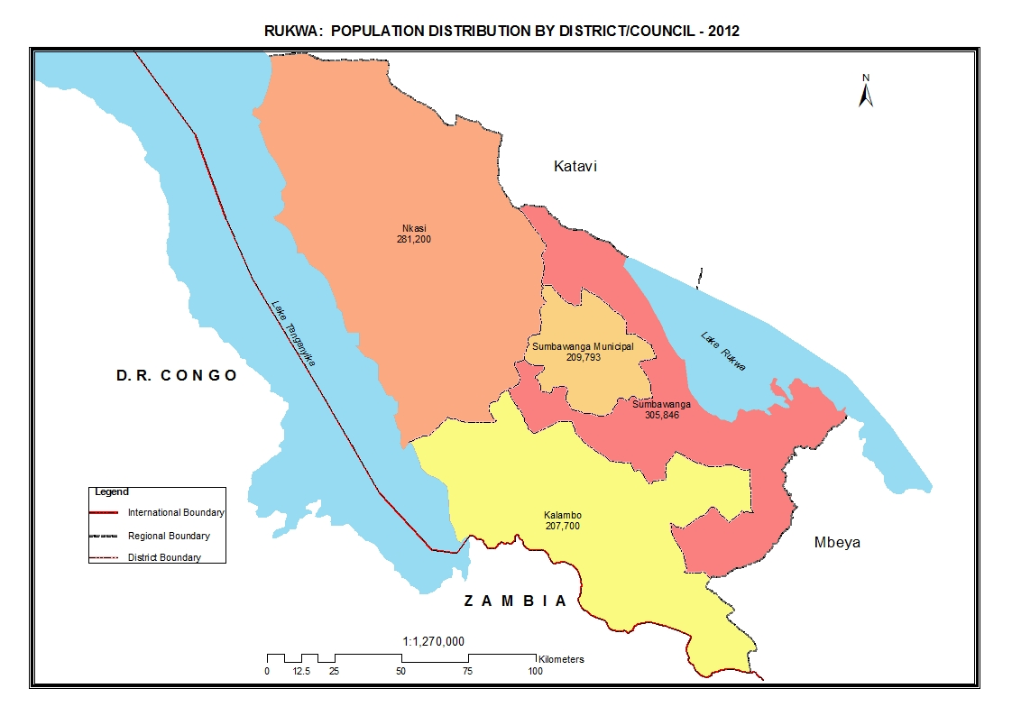

Table 15.0: Population of Rukwa Region by Sex, Average Household Size and Sex Ratio
Serial No. | District/Council | Population (Number) |  |  | Average Household Size | Sex Ratio
Serial No. | District/Council | Total | Male | Female | Average Household Size | Sex Ratio
 | Total | 1,004,539 | 487,311 | 517,228 | 5.0 | 94
1 | Kalambo District Council | 207,700 | 100,474 | 107,226 | 4.9 | 94
2 | Sumbawanga District Council | 305,846 | 149,062 | 156,784 | 5.0 | 95
3 | Nkasi District Council | 281,200 | 137,041 | 144,159 | 5.3 | 95
4 | Sumbawanga Municipal Council | 209,793 | 100,734 | 109,059 | 4.8 | 92

Table 15. 1: Population of Kalambo District Council by Sex, Average Household Size and Sex Ratio
Serial No. | Ward/Shehia | Population (Number) |  |  | Average Household Size | Sex Ratio
Serial No. | Ward/Shehia | Total | Male | Female | Average Household Size | Sex Ratio
 | Total | 207,700 | 100,474 | 107,226 | 4.9 | 94
1 | Kasanga | 18,527 | 9,115 | 9,412 | 4.9 | 97
2 | Mkowe | 12,454 | 6,091 | 6,363 | 5.2 | 96
3 | Msanzi | 16,507 | 8,023 | 8,484 | 5.1 | 95
4 | Matai | 16,335 | 7,811 | 8,524 | 4.9 | 92
5 | Sopa | 13,230 | 6,463 | 6,767 | 5.1 | 96
6 | Mwazye | 8,883 | 4,384 | 4,499 | 4.8 | 97
7 | Katazi | 16,088 | 7,738 | 8,350 | 4.9 | 93
8 | Mwimbi | 10,230 | 4,952 | 5,278 | 5.0 | 94
9 | Mambwekenya | 10,487 | 5,005 | 5,482 | 4.8 | 91
10 | Mwembenkoswe | 8,494 | 3,991 | 4,503 | 4.8 | 89
11 | Legeza Mwendo | 9,039 | 4,260 | 4,779 | 4.7 | 89
12 | Ulumi | 11,780 | 5,790 | 5,990 | 4.8 | 97
13 | Mnamba | 9,945 | 4,789 | 5,156 | 5.0 | 93
14 | Katete | 8,669 | 4,238 | 4,431 | 5.0 | 96
15 | Kisumba | 17,292 | 8,314 | 8,978 | 4.9 | 93
16 | Mkali | 11,845 | 5,696 | 6,149 | 5.1 | 93
17 | Kilesha | 7,895 | 3,814 | 4,081 | 5.0 | 93

Table 15. 2: Population of Sumbawanga District Council by Sex, Average Household Size and Sex Ratio
Serial No. | Ward/Shehia | Population (Number) |  |  | Average Household Size | Sex Ratio
Serial No. | Ward/Shehia | Total | Male | Female | Average Household Size | Sex Ratio
 | Total | 305,846 | 149,062 | 156,784 | 5.0 | 95
1 | Mfinga | 15,072 | 7,494 | 7,578 | 5.4 | 99
2 | Muze | 27,441 | 13,505 | 13,936 | 5.1 | 97
3 | Mtowisa | 26,143 | 12,949 | 13,194 | 5.0 | 98
4 | Milepa | 15,762 | 7,792 | 7,970 | 5.2 | 98
5 | Sandulula | 18,755 | 9,133 | 9,622 | 5.2 | 95
6 | Kaengesa | 28,917 | 14,117 | 14,800 | 5.0 | 95
7 | Mpui | 14,831 | 7,216 | 7,615 | 4.6 | 95
8 | Msanda Muungano | 7,986 | 3,881 | 4,105 | 5.2 | 95
9 | Ilemba | 26,078 | 12,877 | 13,201 | 5.1 | 98
10 | Kipeta | 25,755 | 12,639 | 13,116 | 5.4 | 96
11 | Kaoze | 26,306 | 12,723 | 13,583 | 5.4 | 94
12 | Miangalua | 14,419 | 6,923 | 7,496 | 4.7 | 92
13 | Kalambanzite | 20,786 | 9,949 | 10,837 | 4.8 | 92
14 | Lusaka | 13,866 | 6,620 | 7,246 | 4.6 | 91
15 | Laela | 23,729 | 11,244 | 12,485 | 4.6 | 90

Table 15. 3: Population of Nkasi District Council by Sex, Average Household Size and Sex Ratio
Serial No. | Ward/Shehia | Population (Number) |  |  | Average Household Size | Sex Ratio
Serial No. | Ward/Shehia | Total | Male | Female | Average Household Size | Sex Ratio
 | Total | 281,200 | 137,041 | 144,159 | 5.3 | 95
1 | Korongwe | 17,617 | 8,478 | 9,139 | 4.7 | 93
2 | Mtenga | 29,860 | 14,557 | 15,303 | 6.2 | 95
3 | Mkwamba | 11,324 | 5,579 | 5,745 | 5.3 | 97
4 | Chala | 13,499 | 6,484 | 7,015 | 5.3 | 92
5 | Kipande | 16,915 | 8,302 | 8,613 | 5.4 | 96
6 | Isale | 14,502 | 7,138 | 7,364 | 6.0 | 97
7 | Kate | 23,678 | 11,537 | 12,141 | 5.6 | 95
8 | Sintali | 8,923 | 4,354 | 4,569 | 5.2 | 95
9 | Kala | 13,344 | 6,422 | 6,922 | 5.0 | 93
10 | Wampembe | 14,611 | 7,212 | 7,399 | 4.8 | 97
11 | Ninde | 12,291 | 6,152 | 6,139 | 5.0 | 100
12 | Kirando | 21,169 | 10,177 | 10,992 | 4.9 | 93
13 | Kabwe | 13,087 | 6,454 | 6,633 | 5.1 | 97
14 | Kipili | 16,525 | 8,297 | 8,228 | 4.8 | 101
15 | Nkandasi | 15,493 | 7,554 | 7,939 | 5.5 | 95
16 | Namanyere | 18,877 | 9,001 | 9,876 | 5.4 | 91
17 | Nkomolo | 19,485 | 9,343 | 10,142 | 5.4 | 92

Table 15. 4: Population of Sumbawanga Municipal Council by Sex, Average Household Size and Sex Ratio
Serial No. | Ward/Shehia | Population (Number) |  |  | Average Household Size | Sex Ratio
Serial No. | Ward/Shehia | Total | Male | Female | Average Household Size | Sex Ratio
 | Total | 209,793 | 100,734 | 109,059 | 4.8 | 92
1 | Malangali | 6,743 | 3,270 | 3,473 | 4.6 | 94
2 | Mazwi | 6,197 | 2,907 | 3,290 | 4.1 | 88
3 | Izia | 19,463 | 9,064 | 10,399 | 4.5 | 87
4 | Katandala | 12,685 | 5,937 | 6,748 | 4.2 | 88
5 | Old Sumbawanga | 23,298 | 11,128 | 12,170 | 4.7 | 91
6 | Kizwite | 16,187 | 7,662 | 8,525 | 4.7 | 90
7 | Ntendo | 13,324 | 6,525 | 6,799 | 5.3 | 96
8 | Senga | 6,793 | 3,430 | 3,363 | 5.4 | 102
9 | Mollo | 15,707 | 7,640 | 8,067 | 5.2 | 95
10 | Pito | 15,561 | 7,495 | 8,066 | 5.2 | 93
11 | Milanzi | 13,482 | 6,588 | 6,894 | 5.2 | 96
12 | Matanga | 9,521 | 4,701 | 4,820 | 5.3 | 98
13 | Kasense | 11,201 | 5,411 | 5,790 | 5.1 | 93
14 | Majengo | 15,447 | 7,394 | 8,053 | 4.7 | 92
15 | Chanji | 24,184 | 11,582 | 12,602 | 4.7 | 92

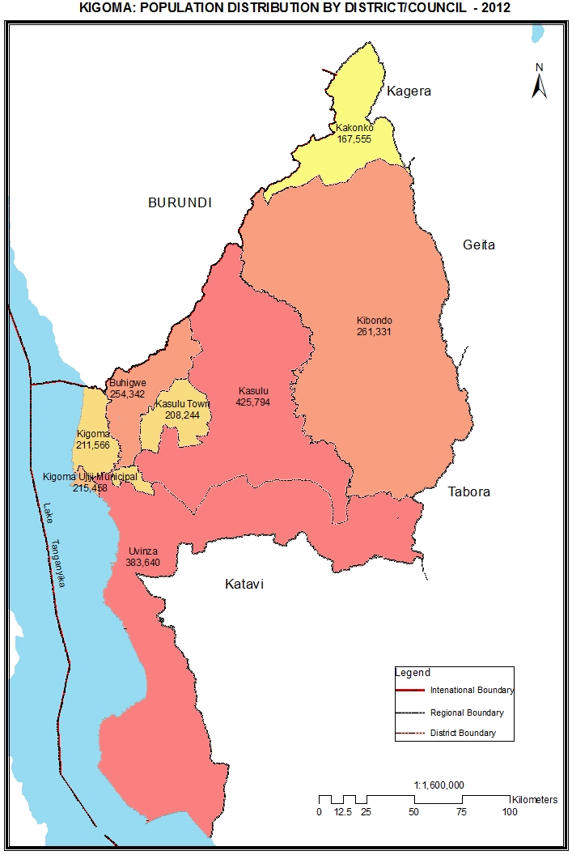

Table 16.0: Population of Kigoma Region by Sex, Average Household Size and Sex Ratio
Serial No. | District/Council | Population (Number) |  |  | Average Household Size | Sex Ratio
Serial No. | District/Council | Total | Male | Female | Average Household Size | Sex Ratio
 | Total | 2,127,930 | 1,028,994 | 1,098,936 | 5.7 | 94
1 | Kibondo District Council | 261,331 | 125,284 | 136,047 | 4.9 | 92
2 | Kasulu District Council | 425,794 | 207,421 | 218,373 | 7.6 | 95
3 | Kigoma District Council | 211,566 | 101,499 | 110,067 | 5.8 | 92
4 | Kigoma-Ujiji Municipal Council | 215,458 | 104,185 | 111,273 | 5.0 | 94
5 | Uvinza District Council | 383,640 | 189,130 | 194,510 | 5.4 | 97
6 | Buhigwe District Council | 254,342 | 120,690 | 133,652 | 5.7 | 90
7 | Kakonko District Council | 167,555 | 81,417 | 86,138 | 5.0 | 95
8 | Kasulu Town Council | 208,244 | 99,368 | 108,876 | 5.6 | 91

Table 16. 1: Population of Kibondo District Council by Sex, Average Household Size and Sex Ratio
Serial No. | Ward/Shehia | Population (Number) |  |  | Average Household Size | Sex Ratio
Serial No. | Ward/Shehia | Total | Male | Female | Average Household Size | Sex Ratio
 | Total | 261,331 | 125,284 | 136,047 | 5.0 | 92
1 | Misezero | 8,221 | 3,912 | 4,309 | 4.9 | 91
2 | Bitare | 10,496 | 5,032 | 5,464 | 4.8 | 92
3 | Kibondo | 39,300 | 19,215 | 20,085 | 4.7 | 96
4 | Murungu | 7,338 | 3,552 | 3,786 | 4.9 | 94
5 | Busagara | 30,722 | 14,515 | 16,207 | 5.0 | 90
6 | Rugongwe | 27,246 | 13,017 | 14,229 | 4.9 | 91
7 | Busunzu | 23,932 | 11,519 | 12,413 | 5.0 | 93
8 | Kumsenga | 22,641 | 10,894 | 11,747 | 4.9 | 93
9 | Kizazi | 17,734 | 8,528 | 9,206 | 5.0 | 93
10 | Mabamba | 17,580 | 8,356 | 9,224 | 4.7 | 91
11 | Bunyanbo | 13,563 | 6,450 | 7,113 | 4.7 | 91
12 | Itaba | 18,127 | 8,701 | 9,426 | 4.8 | 92
13 | Kitahana | 24,431 | 11,593 | 12,838 | 4.9 | 90

Table 16. 2: Population of Kasulu District Council by Sex, Average Household Size and Sex Ratio
Serial No. | Ward/Shehia | Population (Number) |  |  | Average Household Size | Sex Ratio
Serial No. | Ward/Shehia | Total | Male | Female | Average Household Size | Sex Ratio
 | Total | 425,794 | 207,421 | 218,373 | 7.6 | 95
1 | Kitanga | 20,932 | 10,266 | 10,666 | 5.2 | 96
2 | Herushingo | 18,215 | 8,809 | 9,406 | 5.3 | 94
3 | Nyamidaho | 18,201 | 8,929 | 9,272 | 5.7 | 96
4 | Kitagata | 105,204 | 51,264 | 53,940 | 23.4 | 95
5 | Nyachenda | 14,304 | 6,975 | 7,329 | 5.8 | 95
6 | Buhoro | 60,120 | 29,991 | 30,129 | 10.8 | 100
7 | Nyamnyusi | 16,516 | 7,835 | 8,681 | 5.7 | 90
8 | Nyakitonto | 19,486 | 9,551 | 9,935 | 5.7 | 96
9 | Kagerankanda | 13,864 | 6,919 | 6,945 | 5.8 | 100
10 | Kurugongo | 21,817 | 10,632 | 11,185 | 5.6 | 95
11 | Rungwe Mpya | 15,206 | 7,431 | 7,775 | 5.7 | 96
12 | Asante Nyerere | 7,223 | 3,658 | 3,565 | 5.5 | 103
13 | Titye | 11,436 | 5,440 | 5,996 | 5.8 | 91
14 | Shunguliba | 4,462 | 2,183 | 2,279 | 5.8 | 96
15 | Muzye | 12,563 | 5,928 | 6,635 | 6.0 | 89
16 | Bugaga | 14,402 | 6,757 | 7,645 | 5.8 | 88
17 | Kigembe | 13,264 | 6,408 | 6,856 | 5.7 | 93
18 | Rusesa | 19,398 | 9,281 | 10,117 | 5.7 | 92
19 | Kwaga | 19,181 | 9,164 | 10,017 | 5.6 | 91

Table 16. 3: Population of Kigoma District Council by Sex, Average Household Size and Sex Ratio
Serial No. | Ward/Shehia | Population (Number) |  |  | Average Household Size | Sex Ratio
Serial No. | Ward/Shehia | Total | Male | Female | Average Household Size | Sex Ratio
 | Total | 211,566 | 101,499 | 110,067 | 5.8 | 92
1 | Kagunga | 16,972 | 8,311 | 8,661 | 6.3 | 96
2 | Mkigo | 16,252 | 7,830 | 8,422 | 6.1 | 93
3 | Mwamgongo | 15,657 | 7,633 | 8,024 | 6.0 | 95
4 | Kalinzi | 27,426 | 13,134 | 14,292 | 6.0 | 92
5 | Bitale | 20,425 | 9,629 | 10,796 | 5.9 | 89
6 | Mkongoro | 18,656 | 8,859 | 9,797 | 6.0 | 90
7 | Mahembe | 22,763 | 10,952 | 11,811 | 5.5 | 93
8 | Matendo | 22,458 | 10,749 | 11,709 | 5.7 | 92
9 | Mungonya | 12,644 | 6,087 | 6,557 | 5.6 | 93
10 | Kagongo | 19,407 | 9,398 | 10,009 | 5.7 | 94
11 | Mwandiga | 18,906 | 8,917 | 9,989 | 5.5 | 89

Table 16. 4: Population of Kigoma Ujiji Municipal Council by Sex, Average Household Size and Sex Ratio
Serial No. | Ward/Shehia | Population (Number) |  |  | Average Household Size | Sex Ratio
Serial No. | Ward/Shehia | Total | Male | Female | Average Household Size | Sex Ratio
 | Total | 215,458 | 104,185 | 111,273 | 5.0 | 94
1 | Gungu | 25,224 | 12,194 | 13,030 | 5.2 | 94
2 | Kibirizi | 25,143 | 12,292 | 12,851 | 5.4 | 96
3 | Buhanda | 7,629 | 3,658 | 3,971 | 5.2 | 92
4 | Businde | 2,436 | 1,217 | 1,219 | 5.1 | 100
5 | Machinjioni | 3,465 | 1,675 | 1,790 | 5.3 | 94
6 | Kagera | 9,040 | 4,521 | 4,519 | 4.9 | 100
7 | Kasimbu | 4,910 | 2,360 | 2,550 | 5.2 | 93
8 | Rubuga | 2,634 | 1,290 | 1,344 | 5.2 | 96
9 | Kasingirima | 2,867 | 1,391 | 1,476 | 5.1 | 94
10 | Majengo | 4,329 | 2,049 | 2,280 | 5.2 | 90
11 | Kitongoni | 6,973 | 3,413 | 3,560 | 5.2 | 96
12 | Kipampa | 7,917 | 3,734 | 4,183 | 5.6 | 89
13 | Rusimbi | 6,779 | 3,220 | 3,559 | 5.1 | 90
14 | Buzebazeba | 18,446 | 8,743 | 9,703 | 5.1 | 90
15 | Mwanga Kusini | 16,331 | 7,774 | 8,557 | 4.6 | 91
16 | Kigoma | 6,908 | 3,419 | 3,489 | 4.8 | 98
17 | Bangwe | 15,453 | 7,782 | 7,671 | 5.1 | 101
18 | Mwanga Kaskazini | 24,184 | 11,555 | 12,629 | 4.6 | 91
19 | Katubuka | 24,790 | 11,898 | 12,892 | 4.7 | 92

Table 16. 5: Population of Uvinza District Council by Sex, Average Household Size and Sex Ratio
Serial No. | Ward/Shehia | Population (Number) |  |  | Average Household Size | Sex Ratio
Serial No. | Ward/Shehia | Total | Male | Female | Average Household Size | Sex Ratio
 | Total | 383,640 | 189,130 | 194,510 | 5.4 | 97
1 | Kalya | 22,486 | 11,238 | 11,248 | 5.3 | 100
2 | Buhingu | 16,973 | 8,456 | 8,517 | 5.3 | 99
3 | Igalula | 23,868 | 11,839 | 12,029 | 5.6 | 98
4 | Sigunga | 20,455 | 10,154 | 10,301 | 5.6 | 99
5 | Sunuka | 36,023 | 17,572 | 18,451 | 5.5 | 95
6 | Ilagala | 47,026 | 23,360 | 23,666 | 5.3 | 99
7 | Simbo | 31,650 | 15,495 | 16,155 | 5.6 | 96
8 | Kandaga | 23,696 | 11,223 | 12,473 | 5.4 | 90
9 | Kazuramimba | 34,115 | 16,656 | 17,459 | 5.4 | 95
10 | Uvinza | 35,231 | 17,637 | 17,594 | 5.4 | 100
11 | Mganza | 24,823 | 12,403 | 12,420 | 5.9 | 100
12 | Mtego wa Noti | 15,308 | 7,685 | 7,623 | 5.4 | 101
13 | Nguruka | 27,179 | 13,128 | 14,051 | 5.3 | 93
14 | Itebula | 24,807 | 12,284 | 12,523 | 5.5 | 98

Table 16. 6: Population of Buhigwe District Council by Sex, Average Household Size and Sex Ratio
Serial No. | Ward/Shehia | Population (Number) |  |  | Average Household Size | Sex Ratio
Serial No. | Ward/Shehia | Total | Male | Female | Average Household Size | Sex Ratio
 | Total | 254,342 | 120,690 | 133,652 | 5.7 | 90
1 | Nyamugali | 10,705 | 4,970 | 5,735 | 5.6 | 87
2 | Biharu | 8,880 | 4,099 | 4,781 | 5.8 | 86
3 | Muyama | 10,436 | 5,011 | 5,425 | 5.7 | 92
4 | Kajana | 13,383 | 6,427 | 6,956 | 5.5 | 92
5 | Mugera | 15,698 | 7,579 | 8,119 | 5.7 | 93
6 | Kilelema | 15,523 | 7,435 | 8,088 | 5.7 | 92
7 | Munyegera | 13,447 | 6,272 | 7,175 | 5.7 | 87
8 | Buhigwe | 15,224 | 7,230 | 7,994 | 5.7 | 90
9 | Kibande | 9,852 | 4,523 | 5,329 | 5.7 | 85
10 | Janda | 28,854 | 13,694 | 15,160 | 5.7 | 90
11 | Munzeze | 18,934 | 9,077 | 9,857 | 5.6 | 92
12 | Rusaba | 20,997 | 9,817 | 11,180 | 5.6 | 88
13 | Muhinda | 18,211 | 8,623 | 9,588 | 5.9 | 90
14 | Munanila | 33,782 | 16,308 | 17,474 | 5.7 | 93
15 | Mwayaya | 20,416 | 9,625 | 10,791 | 5.7 | 89

Table 16. 7: Population of Kakonko District Council by Sex, Average Household Size and Sex Ratio
Serial No. | Ward/Shehia | Population (Number) |  |  | Average Household Size | Sex Ratio
Serial No. | Ward/Shehia | Total | Male | Female | Average Household Size | Sex Ratio
 | Total | 167,555 | 81,417 | 86,138 | 5.0 | 95
1 | Nyabibuye | 10,046 | 4,840 | 5,206 | 5.1 | 93
2 | Nyamtukuza | 15,102 | 7,677 | 7,425 | 5.1 | 103
3 | Muhange | 24,195 | 11,867 | 12,328 | 4.9 | 96
4 | Kasuga | 16,553 | 8,036 | 8,517 | 5.1 | 94
5 | Kakonko | 21,827 | 10,657 | 11,170 | 5.1 | 95
6 | Kiziguzigu | 12,900 | 6,381 | 6,519 | 5.1 | 98
7 | Rugenge | 10,871 | 5,139 | 5,732 | 4.9 | 90
8 | Kasanda | 18,717 | 9,275 | 9,442 | 5.0 | 98
9 | Gwanumpu | 14,756 | 6,856 | 7,900 | 4.8 | 87
10 | Katanga | 10,668 | 5,055 | 5,613 | 4.7 | 90
11 | Mugunzu | 11,920 | 5,634 | 6,286 | 4.6 | 90

Table 16. 8: Population of Kasulu Town Council by Sex, Average Household Size and Sex Ratio
Serial No. | Ward/Shehia | Population (Number) |  |  | Average Household Size | Sex Ratio
Serial No. | Ward/Shehia | Total | Male | Female | Average Household Size | Sex Ratio
 | Total | 208,244 | 99,368 | 108,876 | 5.6 | 91
1 | Muganza | 17,940 | 8,451 | 9,489 | 5.9 | 89
2 | Kigondo | 16,489 | 8,031 | 8,458 | 5.6 | 95
3 | Msambara | 22,391 | 10,621 | 11,770 | 5.7 | 90
4 | Ruhita | 16,345 | 7,802 | 8,543 | 5.7 | 91
5 | Nyumbigwa | 11,639 | 5,505 | 6,134 | 5.6 | 90
6 | Murufiti | 9,495 | 4,615 | 4,880 | 5.9 | 95
7 | Nyansha | 13,406 | 6,379 | 7,027 | 5.8 | 91
8 | Kasulu Mjini | 67,704 | 32,464 | 35,240 | 5.3 | 92
9 | Muhunga | 32,835 | 15,500 | 17,335 | 5.7 | 89

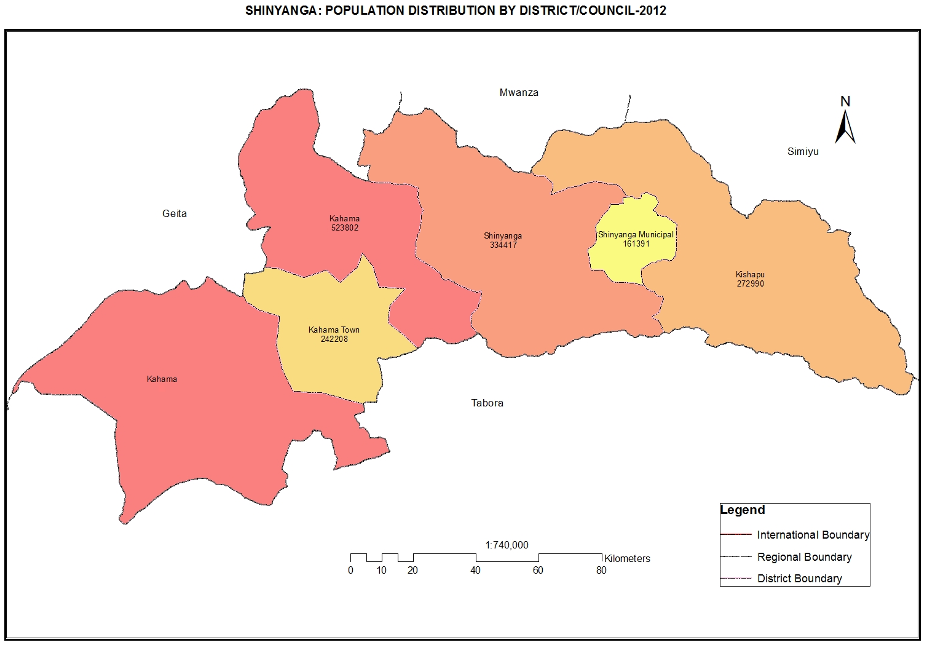

Table 17.0: Population of Shinyanga Region by Sex, Average Household Size and Sex Ratio
Serial No. | District/Council | Population (Number) |  |  | Average Household Size | Sex Ratio
Serial No. | District/Council | Total | Male | Female | Average Household Size | Sex Ratio
 | Total | 1,534,808 | 750,841 | 783,967 | 5.9 | 96
1 | Shinyanga Municipal Council | 161,391 | 78,655 | 82,736 | 4.8 | 95
2 | Kishapu District Council | 272,990 | 135,269 | 137,721 | 6.3 | 98
3 | Shinyanga District Council | 334,417 | 162,956 | 171,461 | 6.3 | 95
4 | Kahama District Council | 523,802 | 256,463 | 267,339 | 6.3 | 96
5 | Kahama Town Council | 242,208 | 117,498 | 124,710 | 4.9 | 94

Table 17. 1: Population of Shinyanga Municipal Council by Sex, Average Household Size and Sex Ratio
Serial No. | Ward/Shehia | Population (Number) |  |  | Average Household Size | Sex Ratio
Serial No. | Ward/Shehia | Total | Male | Female | Average Household Size | Sex Ratio
 | Total | 161,391 | 78,655 | 82,736 | 4.8 | 95
1 | Mwamalili | 7,100 | 3,583 | 3,517 | 6.1 | 102
2 | Kolandoto | 11,301 | 5,462 | 5,839 | 5.7 | 94
3 | Ngokolo | 19,658 | 9,314 | 10,344 | 4.3 | 90
4 | Ibadakuli | 12,537 | 6,290 | 6,247 | 5.2 | 101
5 | Shinyanga Mjini | 5,402 | 2,632 | 2,770 | 4.1 | 95
6 | Chamaguha | 5,218 | 2,669 | 2,549 | 4.6 | 105
7 | Ibinzamata | 5,061 | 2,462 | 2,599 | 4.1 | 95
8 | Kitangili | 8,338 | 4,063 | 4,275 | 4.2 | 95
9 | Kizumbi | 11,264 | 5,619 | 5,645 | 5.3 | 100
10 | Mwawaza | 5,665 | 2,766 | 2,899 | 5.8 | 95
11 | Ndala | 9,432 | 4,555 | 4,877 | 4.5 | 93
12 | Kambarage | 13,796 | 6,649 | 7,147 | 4.1 | 93
13 | Chibe | 5,840 | 2,917 | 2,923 | 5.6 | 100
14 | Lubaga | 7,042 | 3,402 | 3,640 | 4.9 | 93
15 | Ndembezi | 14,837 | 7,111 | 7,726 | 5.2 | 92
16 | Masekelo | 8,787 | 4,252 | 4,535 | 4.4 | 94
17 | Old Shinyanga | 10,113 | 4,909 | 5,204 | 5.1 | 94

Table 17. 2: Population of Kishapu District Council by Sex, Average Household Size and Sex Ratio
Serial No. | Ward/Shehia | Population (Number) |  |  | Average Household Size | Sex Ratio
Serial No. | Ward/Shehia | Total | Male | Female | Average Household Size | Sex Ratio
 | Total | 272,990 | 135,269 | 137,721 | 6.3 | 98
1 | Bunambiyu | 12,226 | 5,920 | 6,306 | 7.1 | 94
2 | Bubiki | 20,038 | 9,922 | 10,116 | 6.5 | 98
3 | Songwa | 19,257 | 9,788 | 9,469 | 5.0 | 103
4 | Seke-Bugoro | 16,616 | 8,011 | 8,605 | 5.9 | 93
5 | Mondo | 15,302 | 7,547 | 7,755 | 6.2 | 97
6 | Mwadui Luhumbo | 22,785 | 11,470 | 11,315 | 5.5 | 101
7 | Uchunga | 16,406 | 8,123 | 8,283 | 6.8 | 98
8 | Kishapu | 19,347 | 9,472 | 9,875 | 5.4 | 96
9 | Mwakipoya | 10,040 | 4,971 | 5,069 | 7.4 | 98
10 | Shagihilu | 13,126 | 6,522 | 6,604 | 6.5 | 99
11 | Somagedi | 7,428 | 3,697 | 3,731 | 7.4 | 99
12 | Mwamalasa | 13,195 | 6,518 | 6,677 | 6.9 | 98
13 | Masanga | 14,444 | 7,163 | 7,281 | 7.3 | 98
14 | Lagana | 10,020 | 5,037 | 4,983 | 6.9 | 101
15 | Mwamashele | 8,812 | 4,317 | 4,495 | 6.2 | 96
16 | Ngofila | 10,598 | 5,239 | 5,359 | 7.3 | 98
17 | Kiloleli | 6,059 | 2,981 | 3,078 | 7.1 | 97
18 | Ukenyenge | 15,304 | 7,723 | 7,581 | 5.7 | 102
19 | Talaga | 9,773 | 4,815 | 4,958 | 6.2 | 97
20 | Itilima | 12,214 | 6,033 | 6,181 | 6.2 | 98

Table 17. 3: Population of Shinyanga District Council by Sex, Average Household Size and Sex Ratio

Serial No. | Ward/Shehia | Population (Number) |  |  | Average Household Size | Sex Ratio
Serial No. | Ward/Shehia | Total | Male | Female | Average Household Size | Sex Ratio
 | Total | 334,417 | 162,956 | 171,461 | 6.3 | 95
1 | Imesela | 9,052 | 4,489 | 4,563 | 6.1 | 98
2 | Usule | 5,945 | 2,929 | 3,016 | 5.3 | 97
3 | Ilola | 10,068 | 4,864 | 5,204 | 6.4 | 93
4 | Didia | 10,666 | 5,169 | 5,497 | 5.1 | 94
5 | Itwangi | 10,037 | 4,963 | 5,074 | 5.4 | 98
6 | Tinde | 14,978 | 7,377 | 7,601 | 5.0 | 97
7 | Mwakitolyo | 20,191 | 10,217 | 9,974 | 7.2 | 102
8 | Salawe | 17,247 | 8,370 | 8,877 | 6.3 | 94
9 | Solwa | 22,218 | 10,855 | 11,363 | 7.2 | 96
10 | Iselamagazi | 18,465 | 8,748 | 9,717 | 6.5 | 90
11 | Lyabukande | 19,492 | 9,368 | 10,124 | 7.7 | 93
12 | Mwantini | 6,693 | 3,227 | 3,466 | 6.1 | 93
13 | Pandagichiza | 11,082 | 5,321 | 5,761 | 6.8 | 92
14 | Mwamala | 10,021 | 4,879 | 5,142 | 5.8 | 95
15 | Samuye | 11,080 | 5,409 | 5,671 | 6.0 | 95
16 | Usanda | 13,715 | 6,765 | 6,950 | 5.7 | 97
17 | Puni | 4,492 | 2,212 | 2,280 | 5.4 | 97
18 | Nyida | 6,221 | 3,053 | 3,168 | 5.1 | 96
19 | Nsalala | 8,313 | 4,069 | 4,244 | 5.2 | 96
20 | Bukene | 7,723 | 3,872 | 3,851 | 5.6 | 101
21 | Masengwa | 10,539 | 5,190 | 5,349 | 6.4 | 97
22 | Mwenge | 16,530 | 8,163 | 8,367 | 7.0 | 98
23 | Lyabusalu | 24,785 | 11,815 | 12,970 | 7.5 | 91
24 | Mwalukwa | 8,008 | 3,878 | 4,130 | 6.4 | 94
25 | Nyamalogo | 15,361 | 7,355 | 8,006 | 6.8 | 92
26 | Lyamidati | 21,495 | 10,399 | 11,096 | 7.1 | 94

Table 17. 4: Population of Kahama District Council by Sex, Average Household Size and Sex Ratio
Serial No. | Ward/Shehia | Population (Number) |  |  | Average Household Size | Sex Ratio
Serial No. | Ward/Shehia | Total | Male | Female | Average Household Size | Sex Ratio
 | Total | 523,802 | 256,463 | 267,339 | 6.3 | 96
1 | Bulyanhulu | 25,330 | 12,761 | 12,569 | 4.6 | 102
2 | Bugarama | 18,271 | 8,968 | 9,303 | 5.9 | 96
3 | Lunguya | 19,307 | 9,488 | 9,819 | 7.0 | 97
4 | Shilela | 9,795 | 4,788 | 5,007 | 7.4 | 96
5 | Segese | 18,364 | 8,930 | 9,434 | 5.6 | 95
6 | Mega | 9,967 | 4,739 | 5,228 | 7.2 | 91
7 | Chela | 20,760 | 10,121 | 10,639 | 7.2 | 95
8 | Busangi | 11,507 | 5,712 | 5,795 | 6.2 | 99
9 | Ntobo | 10,089 | 4,889 | 5,200 | 6.4 | 94
10 | Ngaya | 12,681 | 6,283 | 6,398 | 6.6 | 98
11 | Bulige | 10,505 | 4,992 | 5,513 | 6.8 | 91
12 | Kashishi | 13,410 | 6,392 | 7,018 | 7.9 | 91
13 | Mwanase | 14,898 | 7,024 | 7,874 | 7.7 | 89
14 | Mwalugulu | 18,054 | 8,745 | 9,309 | 7.2 | 94
15 | Jana | 16,099 | 7,823 | 8,276 | 7.0 | 95
16 | Isaka | 21,690 | 10,579 | 11,111 | 5.2 | 95
17 | Chona | 18,481 | 8,882 | 9,599 | 6.2 | 93
18 | Chambo | 14,516 | 7,084 | 7,432 | 6.2 | 95
19 | Kisuke | 10,467 | 5,157 | 5,310 | 5.6 | 97
20 | Mapamba | 6,273 | 3,072 | 3,201 | 6.6 | 96
21 | Bukomela | 6,492 | 3,220 | 3,272 | 6.7 | 98
22 | Ukune | 11,717 | 5,693 | 6,024 | 5.1 | 95
23 | Igunda | 6,597 | 3,182 | 3,415 | 5.4 | 93
24 | Kinamapula | 12,695 | 6,149 | 6,546 | 6.1 | 94
25 | Igwamanoni | 14,901 | 7,245 | 7,656 | 7.2 | 95
26 | Mpunze | 9,338 | 4,576 | 4,762 | 5.9 | 96
27 | Sabasabini | 11,563 | 5,702 | 5,861 | 6.5 | 97
28 | Idahina | 23,937 | 11,912 | 12,025 | 6.8 | 99
29 | Bulungwa | 24,642 | 12,090 | 12,552 | 6.3 | 96
30 | Nyankende | 14,515 | 7,113 | 7,402 | 6.6 | 96
31 | Ulewe | 18,308 | 8,875 | 9,433 | 6.5 | 94
32 | Ushetu | 17,538 | 8,728 | 8,810 | 6.5 | 99
33 | Uyogo | 15,291 | 7,407 | 7,884 | 6.7 | 94
34 | Ulowa | 19,230 | 9,780 | 9,450 | 6.0 | 103
35 | Ubagwe | 16,574 | 8,362 | 8,212 | 6.7 | 102

Table 17. 5: Population of Kahama Town Council by Sex, Average Household Size and Sex Ratio
Serial No. | Ward/Shehia | Population (Number) |  |  | Average Household Size | Sex Ratio
Serial No. | Ward/Shehia | Total | Male | Female | Average Household Size | Sex Ratio
 | Total | 242,208 | 117,498 | 124,710 | 4.9 | 94
1 | Ngogwa | 8,202 | 4,071 | 4,131 | 5.8 | 99
2 | Wendele | 7,536 | 3,746 | 3,790 | 5.8 | 99
3 | Kinaga | 14,841 | 7,176 | 7,665 | 6.1 | 94
4 | Isagehe | 10,828 | 5,222 | 5,606 | 5.7 | 93
5 | Mondo | 11,481 | 5,563 | 5,918 | 6.2 | 94
6 | Kagongwa | 21,446 | 10,253 | 11,193 | 4.5 | 92
7 | Nyahanga | 15,794 | 7,512 | 8,282 | 4.5 | 91
8 | Malunga | 10,225 | 4,854 | 5,371 | 4.2 | 90
9 | Mhongolo | 15,427 | 7,473 | 7,954 | 4.7 | 94
10 | Mwendakulima | 13,711 | 6,697 | 7,014 | 5.3 | 95
11 | Zongomera | 10,438 | 5,261 | 5,177 | 5.6 | 102
12 | Mhungula | 10,486 | 5,055 | 5,431 | 4.4 | 93
13 | Nyihogo | 13,622 | 6,575 | 7,047 | 3.9 | 93
14 | Nyasubi | 20,181 | 9,712 | 10,469 | 4.5 | 93
15 | Kahama Mjini | 6,621 | 3,479 | 3,142 | 4.6 | 111
16 | Majengo | 15,917 | 7,583 | 8,334 | 4.2 | 91
17 | Busoka | 5,323 | 2,618 | 2,705 | 5.4 | 97
18 | Kilago | 11,118 | 5,390 | 5,728 | 5.4 | 94
19 | Iyenze | 7,620 | 3,649 | 3,971 | 6.5 | 92
20 | Nyandekwa | 11,391 | 5,609 | 5,782 | 5.5 | 97

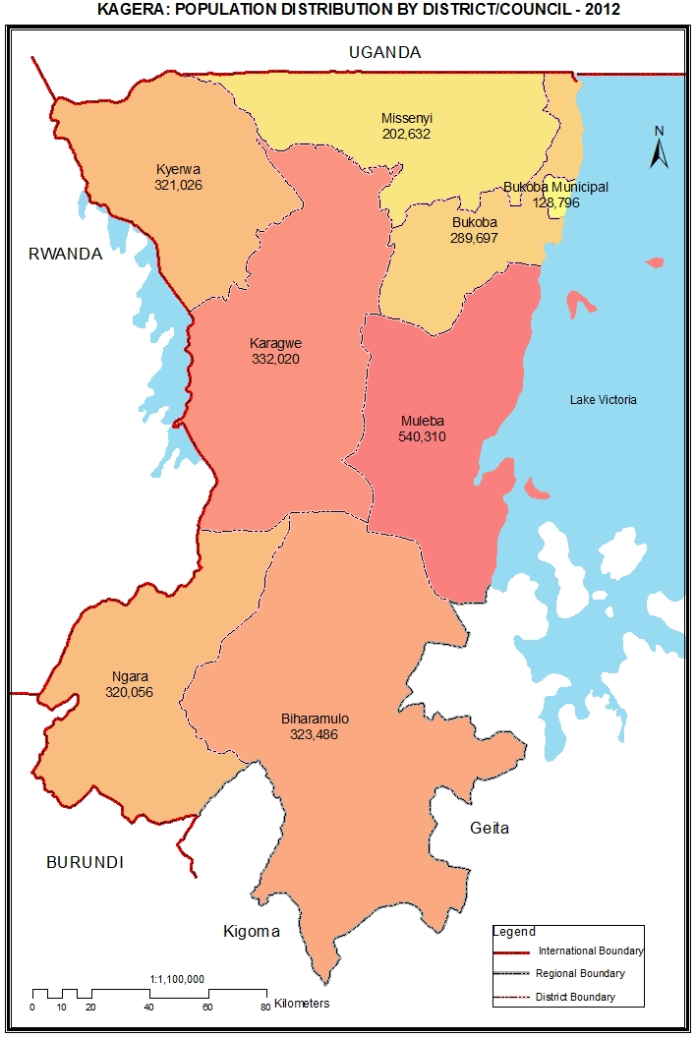

Table 18.0: Population of Kagera Region by Sex, Average Household Size and Sex Ratio
Serial No. | District/Council | Population (Number) |  |  | Average Household Size | Sex Ratio
Serial No. | District/Council | Total | Male | Female | Average Household Size | Sex Ratio
 | Total | 2,458,023 | 1,205,683 | 1,252,340 | 4.7 | 96
1 | Karagwe District Council | 332,020 | 163,864 | 168,156 | 4.6 | 97
2 | Bukoba District Council | 289,697 | 141,142 | 148,555 | 4.4 | 95
3 | Muleba District Council | 540,310 | 267,858 | 272,452 | 4.7 | 98
4 | Biharamulo District Council | 323,486 | 160,572 | 162,914 | 5.7 | 99
5 | Ngara District Council | 320,056 | 152,443 | 167,613 | 4.7 | 91
6 | Bukoba Municipal Council | 128,796 | 62,521 | 66,275 | 3.9 | 94
7 | Missenyi District Council | 202,632 | 100,085 | 102,547 | 4.2 | 98
8 | Kyerwa District Council | 321,026 | 157,198 | 163,828 | 4.8 | 96

Table 18. 1: Population of Karagwe District Council by Sex, Average Household Size and Sex Ratio
Serial No. | Ward/Shehia | Population (Number) |  |  | Average Household Size | Sex Ratio
Serial No. | Ward/Shehia | Total | Male | Female | Average Household Size | Sex Ratio
 | Total | 332,020 | 163,864 | 168,156 | 4.6 | 97
1 | Igurwa | 10,525 | 5,203 | 5,322 | 4.9 | 98
2 | Kanoni | 17,126 | 8,584 | 8,542 | 4.7 | 100
3 | Kihanga | 18,202 | 9,400 | 8,802 | 4.6 | 107
4 | Kituntu | 12,970 | 6,201 | 6,769 | 4.7 | 92
5 | Chanika | 17,632 | 8,793 | 8,839 | 4.5 | 99
6 | Kayanga | 18,968 | 9,341 | 9,627 | 4.2 | 97
7 | Bugene | 15,867 | 7,805 | 8,062 | 4.1 | 97
8 | Ndama | 11,887 | 5,805 | 6,082 | 4.5 | 95
9 | Rugera | 7,388 | 3,672 | 3,716 | 4.5 | 99
10 | Ihembe | 8,846 | 4,377 | 4,469 | 4.7 | 98
11 | Nyaishozi | 12,782 | 6,209 | 6,573 | 4.5 | 94
12 | Rugu | 14,160 | 7,091 | 7,069 | 4.6 | 100
13 | Nyakasimbi | 12,803 | 6,269 | 6,534 | 4.7 | 96
14 | Nyakakika | 16,605 | 8,157 | 8,448 | 4.6 | 97
15 | Nyakabanga | 16,531 | 8,149 | 8,382 | 4.8 | 97
16 | Bweranyange | 18,629 | 9,112 | 9,517 | 4.6 | 96
17 | Kibondo | 12,621 | 6,051 | 6,570 | 4.6 | 92
18 | Nyabiyonza | 10,748 | 5,301 | 5,447 | 4.5 | 97
19 | Kiruruma | 34,945 | 17,046 | 17,899 | 4.6 | 95
20 | Nyakahanga | 20,284 | 10,059 | 10,225 | 4.4 | 98
21 | Ihanda | 14,583 | 7,216 | 7,367 | 4.6 | 98
22 | Chonyonyo | 7,918 | 4,023 | 3,895 | 4.7 | 103

Table 18. 2: Population of Bukoba District Council by Sex, Average Household Size and Sex Ratio
Serial No. | Ward/Shehia | Population (Number) |  |  | Average Household Size | Sex Ratio
Serial No. | Ward/Shehia | Total | Male | Female | Average Household Size | Sex Ratio
 | Total | 289,697 | 141,142 | 148,555 | 4.4 | 95
1 | Rubafu | 8,442 | 4,197 | 4,245 | 4.2 | 99
2 | Kishanje | 8,381 | 4,105 | 4,276 | 4.4 | 96
3 | Kaagya | 11,413 | 5,651 | 5,762 | 4.3 | 98
4 | Buhendangabo | 7,724 | 3,696 | 4,028 | 4.5 | 92
5 | Nyakato | 14,414 | 6,839 | 7,575 | 4.8 | 90
6 | Katoma | 6,762 | 3,224 | 3,538 | 4.3 | 91
7 | Karabagaine | 15,302 | 7,504 | 7,798 | 4.5 | 96
8 | Bujugo | 7,140 | 3,430 | 3,710 | 4.3 | 92
9 | Maruku | 9,202 | 4,443 | 4,759 | 4.4 | 93
10 | Kanyangereko | 10,166 | 5,093 | 5,073 | 4.4 | 100
11 | Katerero | 5,884 | 2,806 | 3,078 | 4.6 | 91
12 | Kemondo | 15,900 | 7,724 | 8,176 | 4.3 | 94
13 | Nyakibimbili | 8,341 | 4,100 | 4,241 | 4.3 | 97
14 | Ibwera | 9,456 | 4,610 | 4,846 | 4.6 | 95
15 | Mikoni | 8,004 | 3,971 | 4,033 | 4.5 | 98
16 | Butelankuzi | 9,864 | 4,779 | 5,085 | 4.4 | 94
17 | Rubale | 8,901 | 4,371 | 4,530 | 4.2 | 96
18 | Rukoma | 11,747 | 5,816 | 5,931 | 4.6 | 98
19 | Kikomero | 6,165 | 3,031 | 3,134 | 4.4 | 97
20 | Kibirizi | 7,807 | 3,930 | 3,877 | 4.4 | 101
21 | Izimbya | 10,054 | 4,839 | 5,215 | 4.3 | 93
22 | Butulage | 10,049 | 4,893 | 5,156 | 4.2 | 95
23 | Ruhunga | 10,155 | 5,025 | 5,130 | 4.4 | 98
24 | Mugajwale | 10,381 | 5,079 | 5,302 | 4.4 | 96
25 | Kyamulaile | 13,478 | 6,698 | 6,780 | 4.4 | 99
26 | Katoro | 13,648 | 6,440 | 7,208 | 4.5 | 89
27 | Kaibanja | 13,905 | 6,705 | 7,200 | 4.5 | 93
28 | Kasharu | 7,764 | 3,706 | 4,058 | 4.3 | 91
29 | Kishogo | 9,248 | 4,437 | 4,811 | 4.4 | 92

Table 18. 3: Population of Muleba District Council by Sex, Average Household Size and Sex Ratio
Serial No. | Ward/Shehia | Population (Number) |  |  | Average Household Size | Sex Ratio
Serial No. | Ward/Shehia | Total | Male | Female | Average Household Size | Sex Ratio
 | Total | 540,310 | 267,858 | 272,452 | 4.7 | 98
1 | Muhutwe | 11,491 | 5,588 | 5,903 | 4.7 | 95
2 | Mayondwe | 7,216 | 3,659 | 3,557 | 5.1 | 103
3 | Goziba | 3,578 | 2,222 | 1,356 | 3.7 | 164
4 | Kerebe | 3,101 | 1,879 | 1,222 | 2.5 | 154
5 | Bumbire | 13,024 | 7,502 | 5,522 | 4.1 | 136
6 | Ikuza | 11,978 | 6,513 | 5,465 | 4.1 | 119
7 | Izigo | 10,843 | 5,183 | 5,660 | 4.6 | 92
8 | Katoke | 12,176 | 6,019 | 6,157 | 5.0 | 98
9 | Kagoma | 7,011 | 3,546 | 3,465 | 4.6 | 102
10 | Kikuku | 9,556 | 4,720 | 4,836 | 4.8 | 98
11 | Bureza | 7,472 | 3,564 | 3,908 | 4.7 | 91
12 | Muleba | 18,464 | 9,064 | 9,400 | 4.3 | 96
13 | Ikondo | 6,312 | 3,060 | 3,252 | 4.9 | 94
14 | Buhangaza | 6,603 | 3,271 | 3,332 | 5.0 | 98
15 | Mazinga Kisiwa | 6,730 | 3,791 | 2,939 | 3.8 | 129
16 | Magata Karutanga | 7,670 | 3,758 | 3,912 | 4.8 | 96
17 | Gwanseli | 14,456 | 7,031 | 7,425 | 4.9 | 95
18 | Kibanga | 10,432 | 5,008 | 5,424 | 4.7 | 92
19 | Kasharunga | 24,272 | 12,088 | 12,184 | 4.7 | 99
20 | Rulanda | 10,166 | 5,057 | 5,109 | 4.9 | 99
21 | Kimwani | 20,161 | 10,487 | 9,674 | 5.1 | 108
22 | Nyakabango | 15,424 | 7,660 | 7,764 | 5.7 | 99
23 | Kyebitembe | 25,460 | 12,596 | 12,864 | 5.0 | 98
24 | Karambi | 19,059 | 9,509 | 9,550 | 5.0 | 100
25 | Mubunda | 16,724 | 8,202 | 8,522 | 4.9 | 96
26 | Bisheke | 17,665 | 8,448 | 9,217 | 4.9 | 92
27 | Burungura | 13,354 | 6,625 | 6,729 | 4.8 | 98
28 | Biirabo | 18,900 | 9,185 | 9,715 | 4.7 | 95
29 | Mushabago | 8,792 | 4,217 | 4,575 | 4.7 | 92
30 | Nyakatanga | 9,079 | 4,368 | 4,711 | 4.8 | 93
31 | Ngenge | 20,339 | 10,076 | 10,263 | 4.8 | 98
32 | Rutoro | 9,979 | 5,220 | 4,759 | 4.9 | 110
33 | Kabirizi | 12,666 | 6,160 | 6,506 | 4.7 | 95
34 | Nshamba | 24,432 | 11,476 | 12,956 | 4.7 | 89
35 | Kashasha | 11,021 | 5,364 | 5,657 | 5.0 | 95
36 | Ijumbi | 13,178 | 6,174 | 7,004 | 5.0 | 88
37 | Kishanda | 17,753 | 8,480 | 9,273 | 4.7 | 91
38 | Buganguzi | 10,562 | 5,011 | 5,551 | 4.8 | 90
39 | Ibuga | 12,730 | 6,198 | 6,532 | 4.7 | 95
40 | Bulyakashaju | 9,951 | 4,948 | 5,003 | 4.6 | 99
41 | Kamachumu | 17,567 | 8,502 | 9,065 | 4.6 | 94
42 | Ruhanga | 7,518 | 3,751 | 3,767 | 4.4 | 100
43 | Mafumbo | 5,445 | 2,678 | 2,767 | 4.5 | 97

Table 18. 4: Population of Biharamulo District Council by Sex, Average Household Size and Sex Ratio
Serial No. | Ward/Shehia | Population (Number) |  |  | Average Household Size | Sex Ratio
Serial No. | Ward/Shehia | Total | Male | Female | Average Household Size | Sex Ratio
 | Total | 323,486 | 160,572 | 162,914 | 5.7 | 99
1 | Nyakahura | 26,123 | 13,362 | 12,761 | 5.4 | 105
2 | Ruziba | 12,090 | 6,046 | 6,044 | 5.3 | 100
3 | Biharamulo Mjini | 24,573 | 11,751 | 12,822 | 4.7 | 92
4 | Bisibo | 14,694 | 7,363 | 7,331 | 5.4 | 100
5 | Nyarubungo | 28,426 | 14,093 | 14,333 | 5.5 | 98
6 | Nyamahanga | 10,760 | 5,347 | 5,413 | 5.5 | 99
7 | Runazi | 14,472 | 7,210 | 7,262 | 5.9 | 99
8 | Kabindi | 25,312 | 12,335 | 12,977 | 5.9 | 95
9 | Nyamigogo | 15,583 | 7,682 | 7,901 | 7.1 | 97
10 | Nyabusozi | 23,988 | 11,661 | 12,327 | 6.4 | 95
11 | Nemba | 20,189 | 10,131 | 10,058 | 7.0 | 101
12 | Lusahunga | 37,234 | 18,285 | 18,949 | 5.5 | 96
13 | Kaniha | 19,525 | 10,102 | 9,423 | 6.2 | 107
14 | Nyantakara | 16,370 | 8,331 | 8,039 | 6.3 | 104
15 | Kalenge | 34,147 | 16,873 | 17,274 | 5.6 | 98

Table 18. 5: Population of Ngara District Council by Sex, Average Household Size and Sex Ratio
Serial No. | Ward/Shehia | Population (Number) |  |  | Average Household Size | Sex Ratio
Serial No. | Ward/Shehia | Total | Male | Female | Average Household Size | Sex Ratio
 | Total | 320,056 | 152,443 | 167,613 | 4.7 | 91
1 | Rusumo | 12,925 | 6,428 | 6,497 | 4.7 | 99
2 | Nyakisasa | 19,211 | 9,270 | 9,941 | 4.8 | 93
3 | Rulenge | 17,313 | 8,252 | 9,061 | 4.9 | 91
4 | Keza | 9,525 | 4,586 | 4,939 | 4.9 | 93
5 | Murusagamba | 18,093 | 8,613 | 9,480 | 5.0 | 91
6 | Muganza | 15,000 | 7,035 | 7,965 | 5.1 | 88
7 | Bugarama | 28,718 | 13,398 | 15,320 | 4.4 | 87
8 | Bukiriro | 19,875 | 9,440 | 10,435 | 4.7 | 90
9 | Kabanga | 22,010 | 10,441 | 11,569 | 4.6 | 90
10 | Mabawe | 12,823 | 6,049 | 6,774 | 4.7 | 89
11 | Kanazi | 17,937 | 8,513 | 9,424 | 4.7 | 90
12 | Mugoma | 13,493 | 6,342 | 7,151 | 4.5 | 89
13 | Kirushya | 10,628 | 4,874 | 5,754 | 4.7 | 85
14 | Ntobeye | 15,758 | 7,548 | 8,210 | 4.7 | 92
15 | Nyamiyaga | 8,381 | 4,042 | 4,339 | 4.8 | 93
16 | Ngara Mjini | 20,968 | 9,804 | 11,164 | 4.4 | 88
17 | Kibimba | 12,778 | 6,094 | 6,684 | 4.8 | 91
18 | Mbuba | 11,046 | 5,240 | 5,806 | 4.8 | 90
19 | Murukulazo | 15,142 | 7,410 | 7,732 | 4.8 | 96
20 | Kasulo | 18,432 | 9,064 | 9,368 | 4.7 | 97

Table 18. 6: Population of Bukoba Municipal Council by Sex, Average Household Size and Sex Ratio
Serial No. | Ward/Shehia | Population (Number) |  |  | Average Household Size | Sex Ratio
Serial No. | Ward/Shehia | Total | Male | Female | Average Household Size | Sex Ratio
 | Total | 128,796 | 62,521 | 66,275 | 3.9 | 94
1 | Hamugembe | 12,906 | 6,116 | 6,790 | 3.5 | 90
2 | Nshambya | 9,020 | 4,378 | 4,642 | 4.1 | 94
3 | Buhembe | 4,042 | 1,938 | 2,104 | 4.4 | 92
4 | Kahororo | 6,618 | 3,387 | 3,231 | 4.4 | 105
5 | Kashai | 30,791 | 14,689 | 16,102 | 3.9 | 91
6 | Miembeni | 6,543 | 3,464 | 3,079 | 4.2 | 113
7 | Bilele | 5,405 | 2,577 | 2,828 | 3.8 | 91
8 | Bakoba | 17,474 | 8,481 | 8,993 | 3.9 | 94
9 | Ijuganyondo | 2,591 | 1,285 | 1,306 | 4.4 | 98
10 | Kitendaguro | 5,672 | 2,766 | 2,906 | 4.3 | 95
11 | Kibeta | 8,088 | 3,969 | 4,119 | 4.1 | 96
12 | Kagondo | 4,170 | 2,035 | 2,135 | 4.2 | 95
13 | Nyanga | 3,129 | 1,571 | 1,558 | 4.3 | 101
14 | Rwamishenye | 12,347 | 5,865 | 6,482 | 3.6 | 90

Table 18. 7: Population of Missenyi District Council by Sex, Average Household Size and Sex Ratio
Serial No. | Ward/Shehia | Population (Number) |  |  | Average Household Size | Sex Ratio
Serial No. | Ward/Shehia | Total | Male | Female | Average Household Size | Sex Ratio
 | Total | 202,632 | 100,085 | 102,547 | 4.2 | 98
1 | Kakunyu | 20,133 | 10,267 | 9,866 | 4.7 | 104
2 | Nsunga | 19,001 | 10,159 | 8,842 | 3.7 | 115
3 | Mutukula | 15,499 | 7,735 | 7,764 | 4.0 | 100
4 | Kassambya | 26,633 | 13,055 | 13,578 | 4.0 | 96
5 | Minziro | 9,951 | 4,828 | 5,123 | 4.4 | 94
6 | Ruzinga | 3,293 | 1,549 | 1,744 | 4.2 | 89
7 | Kashenye | 5,657 | 2,740 | 2,917 | 4.3 | 94
8 | Kanyigo | 10,168 | 4,954 | 5,214 | 4.3 | 95
9 | Ishunju | 3,479 | 1,635 | 1,844 | 4.5 | 89
10 | Buyango | 8,878 | 4,273 | 4,605 | 4.2 | 93
11 | Bwanjai | 8,298 | 3,990 | 4,308 | 4.2 | 93
12 | Ishozi | 7,194 | 3,517 | 3,677 | 4.3 | 96
13 | Gera | 4,831 | 2,341 | 2,490 | 4.4 | 94
14 | Bugandika | 9,444 | 4,478 | 4,966 | 4.3 | 90
15 | Kitobo | 7,327 | 3,531 | 3,796 | 4.0 | 93
16 | Bugorora | 6,905 | 3,366 | 3,539 | 4.3 | 95
17 | Kyaka | 13,190 | 6,437 | 6,753 | 4.1 | 95
18 | Mushasha | 5,083 | 2,496 | 2,587 | 4.4 | 96
19 | Kilimilile | 11,456 | 5,652 | 5,804 | 4.4 | 97
20 | Mabale | 6,212 | 3,082 | 3,130 | 4.3 | 98

Table 18. 8: Population of Kyerwa District Council by Sex, Average Household Size and Sex Ratio
Serial No. | Ward/Shehia | Population (Number) |  |  | Average Household Size | Sex Ratio
Serial No. | Ward/Shehia | Total | Male | Female | Average Household Size | Sex Ratio
 | Total | 321,026 | 157,198 | 163,828 | 4.8 | 96
1 | Isingiro | 16,705 | 8,040 | 8,665 | 4.7 | 93
2 | Kaisho | 12,878 | 6,212 | 6,666 | 4.8 | 93
3 | Rutunguru | 9,797 | 4,864 | 4,933 | 4.9 | 99
4 | Kibingo | 20,572 | 10,037 | 10,535 | 4.8 | 95
5 | Murongo | 15,044 | 7,380 | 7,664 | 4.6 | 96
6 | Bugomora | 11,144 | 5,572 | 5,572 | 5.0 | 100
7 | Kibale | 15,254 | 7,532 | 7,722 | 5.0 | 98
8 | Mabira | 21,529 | 10,339 | 11,190 | 4.9 | 92
9 | Businde | 19,230 | 9,392 | 9,838 | 5.2 | 95
10 | Kamuli | 20,074 | 9,768 | 10,306 | 5.1 | 95
11 | Nyakatuntu | 15,168 | 7,461 | 7,707 | 4.8 | 97
12 | Kimuli | 17,926 | 8,853 | 9,073 | 4.7 | 98
13 | Kikukuru | 17,337 | 8,471 | 8,866 | 4.8 | 96
14 | Rwabwere | 20,669 | 10,086 | 10,583 | 4.7 | 95
15 | Nkwenda | 22,421 | 10,914 | 11,507 | 4.4 | 95
16 | Rukuraijo | 24,214 | 11,909 | 12,305 | 4.8 | 97
17 | Songambele | 19,459 | 9,571 | 9,888 | 4.8 | 97
18 | Kyerwa | 21,605 | 10,797 | 10,808 | 4.7 | 100
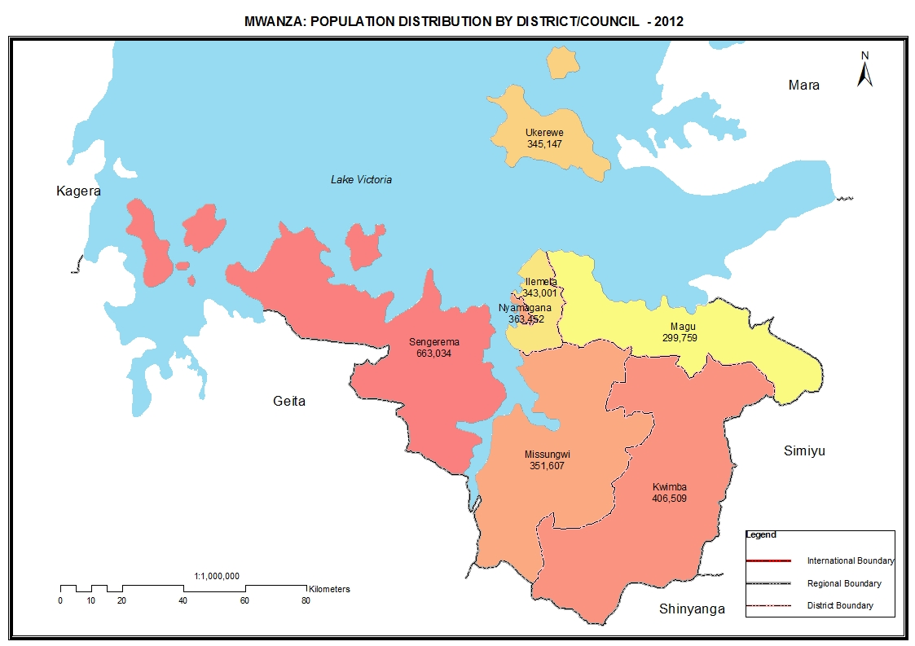

Table 19.0: Population of Mwanza Region by Sex, Average Household Size and Sex Ratio
Serial No. | District/Council | Population (Number) |  |  | Average Household Size | Sex Ratio
Serial No. | District/Council | Total | Male | Female | Average Household Size | Sex Ratio
 | Total | 2,772,509 | 1,360,381 | 1,412,128 | 5.7 | 96
1 | Ukerewe District Council | 345,147 | 169,279 | 175,868 | 5.8 | 96
2 | Magu District Council | 299,759 | 146,461 | 153,298 | 5.8 | 96
3 | Nyamagana Municipal Council | 363,452 | 177,812 | 185,640 | 4.7 | 96
4 | Kwimba District Council | 406,509 | 198,096 | 208,413 | 6.5 | 95
5 | Sengerema District Council | 663,034 | 330,018 | 333,016 | 6.0 | 99
6 | Ilemela Municipal Council | 343,001 | 164,718 | 178,283 | 4.8 | 92
7 | Misungwi District Council | 351,607 | 173,997 | 177,610 | 6.5 | 98

Table 19. 1: Population of Ukerewe District Council by Sex, Average Household Size and Sex Ratio
Serial No. | Ward/Shehia | Population (Number) |  |  | Average Household Size | Sex Ratio
Serial No. | Ward/Shehia | Total | Male | Female | Average Household Size | Sex Ratio
 | Total | 345,147 | 169,279 | 175,868 | 5.8 | 96
1 | Nansio | 7,674 | 3,441 | 4,233 | 4.7 | 81
2 | Kagera | 9,427 | 4,266 | 5,161 | 4.8 | 83
3 | Nakatunguru | 8,937 | 4,095 | 4,842 | 4.7 | 85
4 | Kakerege | 4,223 | 1,984 | 2,239 | 5.4 | 89
5 | Bukongo | 6,195 | 2,895 | 3,300 | 5.3 | 88
6 | Nkilizya | 7,854 | 3,795 | 4,059 | 5.1 | 93
7 | Bukanda | 13,344 | 6,509 | 6,835 | 5.6 | 95
8 | Mukituntu | 18,960 | 9,175 | 9,785 | 5.8 | 94
9 | Igalla | 17,368 | 8,411 | 8,957 | 6.1 | 94
10 | Bwiro | 18,908 | 9,526 | 9,382 | 5.9 | 102
11 | Muriti | 23,014 | 11,151 | 11,863 | 5.8 | 94
12 | Ilangala | 38,008 | 19,041 | 18,967 | 5.8 | 100
13 | Namilembe | 16,544 | 8,065 | 8,479 | 6.2 | 95
14 | Nduruma | 16,397 | 7,996 | 8,401 | 6.1 | 95
15 | Murutunguru | 18,156 | 9,038 | 9,118 | 5.8 | 99
16 | Kagunguli | 25,130 | 12,294 | 12,836 | 5.8 | 96
17 | Bukindo | 15,911 | 7,719 | 8,192 | 5.8 | 94
18 | Namagondo | 12,034 | 5,938 | 6,096 | 5.7 | 97
19 | Ngoma | 18,008 | 9,095 | 8,913 | 5.7 | 102
20 | Bwisya | 13,141 | 6,533 | 6,608 | 6.2 | 99
21 | Bukungu | 8,548 | 4,287 | 4,261 | 5.8 | 101
22 | Nyamanga | 7,422 | 3,618 | 3,804 | 6.7 | 95
23 | Bukiko | 8,071 | 4,012 | 4,059 | 6.7 | 99
24 | Irugwa | 11,873 | 6,395 | 5,478 | 5.7 | 117

Table 19. 2: Population of Magu District Council by Sex, Average Household Size and Sex Ratio
Serial No. | Ward/Shehia | Population (Number) |  |  | Average Household Size | Sex Ratio
Serial No. | Ward/Shehia | Total | Male | Female | Average Household Size | Sex Ratio
 | Total | 299,759 | 146,461 | 153,298 | 5.8 | 96
1 | Kisesa | 30,486 | 14,639 | 15,847 | 5.3 | 92
2 | Bujashi | 12,881 | 6,335 | 6,546 | 5.9 | 97
3 | Lutale | 12,307 | 6,026 | 6,281 | 5.6 | 96
4 | Kongolo | 14,264 | 7,075 | 7,189 | 5.5 | 98
5 | Nyanguge | 14,449 | 6,879 | 7,570 | 5.4 | 91
6 | Kitongo Sima | 13,540 | 6,682 | 6,858 | 5.5 | 97
7 | Mwamanga | 12,847 | 6,471 | 6,376 | 6.7 | 101
8 | Kahangara | 19,378 | 9,576 | 9,802 | 5.7 | 98
9 | Nyigogo | 25,202 | 12,214 | 12,988 | 5.8 | 94
10 | Mwamabanza | 7,380 | 3,603 | 3,777 | 6.5 | 95
11 | Sukuma | 18,599 | 9,189 | 9,410 | 6.2 | 98
12 | Lubugu | 14,858 | 7,257 | 7,601 | 5.8 | 95
13 | Ng'haya | 20,024 | 9,900 | 10,124 | 6.6 | 98
14 | Nkungulu | 23,539 | 11,517 | 12,022 | 6.3 | 96
15 | Jinjimili | 10,167 | 5,049 | 5,118 | 6.8 | 99
16 | Shishani | 15,302 | 7,582 | 7,720 | 6.5 | 98
17 | Magu Mjini | 23,822 | 11,237 | 12,585 | 4.6 | 89
18 | Bukandwe | 10,714 | 5,230 | 5,484 | 5.9 | 95

Table 19. 3: Population of Nyamagana Municipal Council by Sex, Average Household Size and Sex Ratio
Serial No. | Ward/Shehia | Population (Number) |  |  | Average Household Size | Sex Ratio
Serial No. | Ward/Shehia | Total | Male | Female | Average Household Size | Sex Ratio
 | Total | 363,452 | 177,812 | 185,640 | 4.7 | 96
1 | Mikuyuni | 18,780 | 9,163 | 9,617 | 4.1 | 95
2 | Igogo | 27,303 | 13,374 | 13,929 | 4.2 | 96
3 | Pamba | 23,519 | 11,411 | 12,108 | 4.5 | 94
4 | Nyamagana | 5,807 | 2,961 | 2,846 | 4.4 | 104
5 | Mirongo | 2,925 | 1,478 | 1,447 | 4.5 | 102
6 | Isamilo | 24,220 | 11,752 | 12,468 | 4.6 | 94
7 | Mbugani | 39,041 | 19,010 | 20,031 | 4.3 | 95
8 | Mahina | 59,437 | 28,550 | 30,887 | 5.1 | 92
9 | Igoma | 56,596 | 27,321 | 29,275 | 4.9 | 93
10 | Buhongwa | 26,681 | 12,789 | 13,892 | 5.1 | 92
11 | Mkolani | 32,199 | 15,716 | 16,483 | 5.0 | 95
12 | Butimba | 46,944 | 24,287 | 22,657 | 5.0 | 107

Table 19. 4: Population of Kwimba District Council by Sex, Average Household Size and Sex Ratio
Serial No. | Ward/Shehia | Population (Number) |  |  | Average Household Size | Sex Ratio
Serial No. | Ward/Shehia | Total | Male | Female | Average Household Size | Sex Ratio
 | Total | 406,509 | 198,096 | 208,413 | 6.5 | 95
1 | Walla | 17,190 | 8,424 | 8,766 | 7.0 | 96
2 | Bungulwa | 10,361 | 5,071 | 5,290 | 6.8 | 96
3 | Sumve | 16,436 | 7,984 | 8,452 | 6.4 | 94
4 | Mantare | 11,599 | 5,797 | 5,802 | 6.3 | 100
5 | Ngulla | 12,692 | 6,137 | 6,555 | 6.0 | 94
6 | Mwabomba | 10,096 | 5,030 | 5,066 | 6.5 | 99
7 | Mwagi | 11,325 | 5,485 | 5,840 | 6.4 | 94
8 | Iseni | 10,349 | 5,170 | 5,179 | 6.8 | 100
9 | Nyambiti | 13,731 | 6,711 | 7,020 | 6.0 | 96
10 | Maligisu | 20,788 | 10,007 | 10,781 | 6.6 | 93
11 | Mwandu | 11,132 | 5,479 | 5,653 | 7.1 | 97
12 | Malya | 15,437 | 7,490 | 7,947 | 5.7 | 94
13 | Lyoma | 12,561 | 6,104 | 6,457 | 6.2 | 95
14 | Mwang'halanga | 11,099 | 5,390 | 5,709 | 6.5 | 94
15 | Nyamilama | 7,611 | 3,724 | 3,887 | 6.5 | 96
16 | Mwakilyambiti | 16,079 | 7,754 | 8,325 | 6.6 | 93
17 | Hungumalwa | 16,508 | 7,931 | 8,577 | 5.7 | 92
18 | Mwamala | 10,582 | 5,129 | 5,453 | 6.4 | 94
19 | Kikubiji | 22,032 | 10,578 | 11,454 | 7.0 | 92
20 | Mhande | 19,629 | 9,583 | 10,046 | 6.9 | 95
21 | Bupamwa | 17,366 | 8,437 | 8,929 | 7.0 | 94
22 | Fukalo | 17,534 | 8,556 | 8,978 | 7.1 | 95
23 | Ng'hundi | 9,255 | 4,520 | 4,735 | 6.7 | 95
24 | Igongwa | 11,705 | 5,707 | 5,998 | 6.9 | 95
25 | Ngudu | 27,630 | 13,471 | 14,159 | 5.4 | 95
26 | Bugando | 7,173 | 3,468 | 3,705 | 6.6 | 94
27 | Nkalalo | 7,266 | 3,597 | 3,669 | 5.9 | 98
28 | Mwankulwe | 9,495 | 4,705 | 4,790 | 6.5 | 98
29 | Ilula | 11,966 | 5,782 | 6,184 | 6.4 | 93
30 | Shilembo | 9,882 | 4,875 | 5,007 | 7.6 | 97

Table 19. 5: Population of Sengerema District Council by Sex, Average Household Size and Sex Ratio
Serial No. | Ward/Shehia | Population (Number) |  |  | Average Household Size | Sex Ratio
Serial No. | Ward/Shehia | Total | Male | Female | Average Household Size | Sex Ratio
 | Total | 663,034 | 330,018 | 333,016 | 6.0 | 99
1 | Ibisabageni | 13,256 | 6,251 | 7,005 | 5.1 | 89
2 | Nyamazugo | 16,353 | 8,100 | 8,253 | 6.1 | 98
3 | Chifunfu | 23,381 | 11,983 | 11,398 | 5.6 | 105
4 | Katunguru | 20,284 | 10,131 | 10,153 | 5.3 | 100
5 | Kasungamile | 15,599 | 7,829 | 7,770 | 6.7 | 101
6 | Nyamatongo | 26,707 | 13,441 | 13,266 | 5.7 | 101
7 | Tabaruka | 9,747 | 4,892 | 4,855 | 6.8 | 101
8 | Busisi | 16,839 | 8,447 | 8,392 | 6.2 | 101
9 | Buyagu | 15,483 | 7,767 | 7,716 | 6.8 | 101
10 | Igalula | 18,851 | 9,480 | 9,371 | 6.7 | 101
11 | Kagunga | 19,817 | 9,849 | 9,968 | 7.4 | 99
12 | Sima | 15,477 | 7,746 | 7,731 | 6.9 | 100
13 | Nyakasungwa | 20,817 | 10,411 | 10,406 | 6.4 | 100
14 | Kalebezo | 18,960 | 9,284 | 9,676 | 6.1 | 96
15 | Nyehunge | 35,726 | 17,445 | 18,281 | 5.9 | 95
16 | Kafunzo | 10,743 | 5,287 | 5,456 | 6.6 | 97
17 | Bupandwa | 30,194 | 14,873 | 15,321 | 5.8 | 97
18 | Katwe | 24,167 | 12,111 | 12,056 | 6.0 | 100
19 | Maisome | 16,489 | 8,699 | 7,790 | 4.9 | 112
20 | Kazunzu | 14,063 | 6,995 | 7,068 | 5.9 | 99
21 | Lugata | 25,593 | 12,980 | 12,613 | 5.6 | 103
22 | Nyakaliro | 33,830 | 16,740 | 17,090 | 5.9 | 98
23 | Nyakasasa | 21,941 | 11,500 | 10,441 | 6.0 | 110
24 | Buzilasoga | 13,348 | 6,661 | 6,687 | 6.9 | 100
25 | Nyanzenda | 20,654 | 10,020 | 10,634 | 6.4 | 94
26 | Bulyaheke | 35,378 | 18,024 | 17,354 | 5.9 | 104
27 | Irenza | 19,212 | 9,602 | 9,610 | 6.2 | 100
28 | Kasenyi | 15,591 | 7,835 | 7,756 | 6.0 | 101
29 | Mwabaluhi | 10,844 | 5,237 | 5,607 | 6.0 | 93
30 | Nyatukala | 20,166 | 9,748 | 10,418 | 5.3 | 94
31 | Nyampulukano | 32,648 | 15,289 | 17,359 | 5.5 | 88
32 | Nyampande | 9,571 | 4,701 | 4,870 | 6.7 | 97
33 | Kishinda | 12,342 | 6,115 | 6,227 | 6.7 | 98
34 | Igulumuki | 8,963 | 4,545 | 4,418 | 7.0 | 103

Table 19. 6: Population of Ilemela Municipal Council by Sex, Average Household Size and Sex Ratio
Serial No. | Ward/Shehia | Population (Number) |  |  | Average Household Size | Sex Ratio
Serial No. | Ward/Shehia | Total | Male | Female | Average Household Size | Sex Ratio
 | Total | 343,001 | 164,718 | 178,283 | 4.8 | 92
1 | Buswelu | 22,897 | 11,047 | 11,850 | 5.2 | 93
2 | Nyakato | 82,348 | 39,264 | 43,084 | 5.0 | 91
3 | Nyamanoro | 51,456 | 23,945 | 27,511 | 4.5 | 87
4 | Kirumba | 28,103 | 13,621 | 14,482 | 4.4 | 94
5 | Kitangiri | 20,802 | 9,877 | 10,925 | 4.4 | 90
6 | Pasiansi | 35,723 | 17,360 | 18,363 | 4.8 | 95
7 | Ilemela | 43,244 | 20,694 | 22,550 | 5.0 | 92
8 | Bugogwa | 37,312 | 18,311 | 19,001 | 5.0 | 96
9 | Sangabuye | 21,116 | 10,599 | 10,517 | 5.1 | 101

Table 19. 7: Population of Misungwi District Council by Sex, Average Household Size and Sex Ratio
Serial No. | Ward/Shehia | Population (Number) |  |  | Average Household Size | Sex Ratio
Serial No. | Ward/Shehia | Total | Male | Female | Average Household Size | Sex Ratio
 | Total | 351,607 | 173,997 | 177,610 | 6.5 | 98
1 | Bulemeji | 9,387 | 4,677 | 4,710 | 6.1 | 99
2 | Idetemya | 15,387 | 7,592 | 7,795 | 5.6 | 97
3 | Usagara | 15,037 | 7,364 | 7,673 | 5.4 | 96
4 | Ukiriguru | 10,271 | 5,044 | 5,227 | 5.8 | 96
5 | Kanyelele | 14,371 | 7,158 | 7,213 | 6.9 | 99
6 | Koromije | 13,686 | 6,788 | 6,898 | 6.4 | 98
7 | Igokelo | 18,305 | 9,087 | 9,218 | 6.5 | 99
8 | Mwaniko | 8,144 | 4,005 | 4,139 | 7.7 | 97
9 | Misungwi | 30,728 | 14,864 | 15,864 | 5.7 | 94
10 | Misasi | 16,574 | 7,941 | 8,633 | 5.8 | 92
11 | Kijima | 12,034 | 5,888 | 6,146 | 6.7 | 96
12 | Shilalo | 13,205 | 6,483 | 6,722 | 7.7 | 96
13 | Buhingo | 13,871 | 6,772 | 7,099 | 6.6 | 95
14 | Busongo | 9,022 | 4,504 | 4,518 | 7.1 | 100
15 | Nhundulu | 20,236 | 9,920 | 10,316 | 6.7 | 96
16 | Lubili | 5,572 | 2,796 | 2,776 | 6.7 | 101
17 | Ilujamate | 15,195 | 8,148 | 7,047 | 6.8 | 116
18 | Mbarika | 15,216 | 7,454 | 7,762 | 6.5 | 96
19 | Sumbugu | 14,100 | 6,973 | 7,127 | 6.7 | 98
20 | Kasololo | 15,896 | 7,860 | 8,036 | 7.0 | 98
21 | Ilalambogo | 5,691 | 2,834 | 2,857 | 6.6 | 99
22 | Isesa | 7,579 | 3,724 | 3,855 | 6.7 | 97
23 | Gulumungu | 11,638 | 5,833 | 5,805 | 7.0 | 100
24 | Mabuki | 16,314 | 8,322 | 7,992 | 6.5 | 104
25 | Mondo | 9,451 | 4,671 | 4,780 | 7.4 | 98
26 | Mamaye | 8,789 | 4,340 | 4,449 | 7.0 | 98
27 | Fella | 5,908 | 2,955 | 2,953 | 6.3 | 100

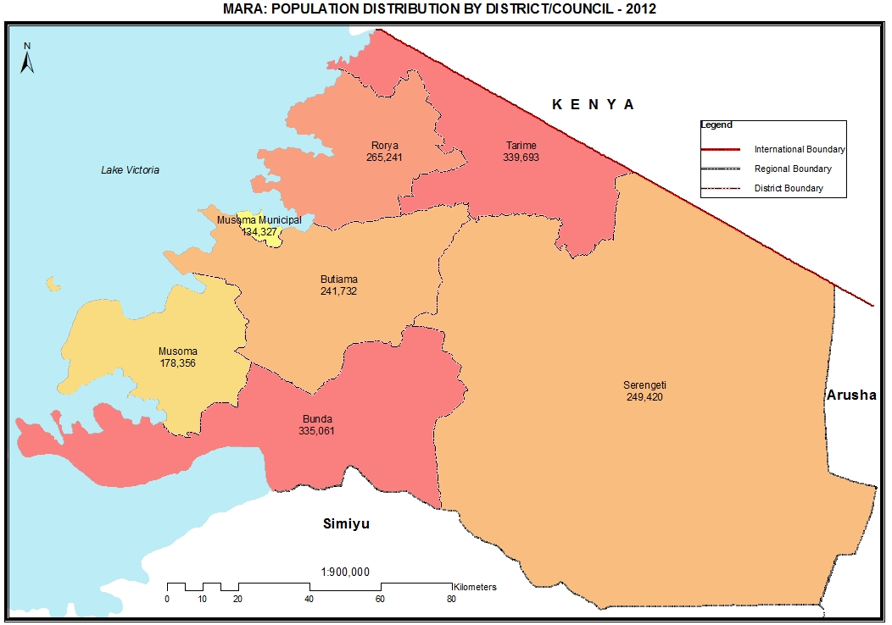

Table 20.0: Population of Mara Region by Sex, Average Household Size and Sex Ratio
Serial No. | District/Council | Population (Number) |  |  | Average Household Size | Sex Ratio
Serial No. | District/Council | Total | Male | Female | Average Household Size | Sex Ratio
 | Total | 1,743,830 | 840,020 | 903,810 | 5.6 | 93
1 | Tarime District Council | 339,693 | 162,986 | 176,707 | 5.2 | 92
2 | Serengeti District Council | 249,420 | 121,399 | 128,021 | 6.0 | 95
3 | Musoma District Council | 178,356 | 87,324 | 91,032 | 6.3 | 96
4 | Bunda District Council | 335,061 | 162,241 | 172,820 | 5.9 | 94
5 | Musoma Municipal Council | 134,327 | 62,694 | 71,633 | 4.9 | 88
6 | Rorya District Council | 265,241 | 126,247 | 138,994 | 5.0 | 91
7 | Butiama District Council | 241,732 | 117,129 | 124,603 | 6.0 | 94

Table 20. 1: Population of Tarime District Council by Sex, Average Household Size and Sex Ratio
Serial No. | Ward/Shehia | Population (Number) |  |  | Average Household Size | Sex Ratio
Serial No. | Ward/Shehia | Total | Male | Female | Average Household Size | Sex Ratio
 | Total | 339,693 | 162,986 | 176,707 | 5.2 | 92
1 | Susuni | 10,381 | 4,885 | 5,496 | 4.9 | 89
2 | Mwema | 10,204 | 4,981 | 5,223 | 5.3 | 95
3 | Sirari | 15,917 | 7,574 | 8,343 | 4.7 | 91
4 | Pemba | 10,844 | 5,174 | 5,670 | 5.3 | 91
5 | Nyakonga | 6,797 | 3,288 | 3,509 | 5.4 | 94
6 | Nyarero | 12,331 | 5,952 | 6,379 | 5.8 | 93
7 | Nyamwaga | 13,917 | 6,677 | 7,240 | 5.1 | 92
8 | Muriba | 10,861 | 5,283 | 5,578 | 5.4 | 95
9 | Nyanungu | 11,272 | 5,352 | 5,920 | 4.8 | 90
10 | Gorong'a | 11,062 | 5,321 | 5,741 | 5.0 | 93
11 | Nyarokoba | 15,670 | 7,466 | 8,204 | 5.1 | 91
12 | Kemambo | 13,338 | 6,591 | 6,747 | 5.1 | 98
13 | Kibasuka | 15,137 | 7,167 | 7,970 | 5.5 | 90
14 | Binagi | 9,443 | 4,555 | 4,888 | 5.8 | 93
15 | Turwa | 27,238 | 13,010 | 14,228 | 5.4 | 91
16 | Bomani | 9,165 | 4,621 | 4,544 | 5.5 | 102
17 | Nyandoto | 7,893 | 3,721 | 4,172 | 5.3 | 89
18 | Matongo | 19,176 | 9,490 | 9,686 | 4.7 | 98
19 | Manga | 7,249 | 3,493 | 3,756 | 5.9 | 93
20 | Bumera | 9,601 | 4,490 | 5,111 | 5.3 | 88
21 | Komaswa | 6,860 | 3,238 | 3,622 | 5.3 | 89
22 | Kiore | 8,020 | 3,790 | 4,230 | 5.5 | 90
23 | Sabasaba | 11,524 | 5,368 | 6,156 | 4.6 | 87
24 | Nyamisangura | 12,742 | 5,874 | 6,868 | 4.7 | 86
25 | Kentare | 9,475 | 4,542 | 4,933 | 5.7 | 92
26 | Nyamaranga | 10,966 | 5,348 | 5,618 | 5.2 | 95
27 | Mbogi | 8,124 | 3,966 | 4,158 | 5.3 | 95
28 | Genyange | 7,453 | 3,560 | 3,893 | 5.6 | 91
29 | Nyansincha | 7,061 | 3,426 | 3,635 | 5.2 | 94
30 | Itiryo | 9,972 | 4,783 | 5,189 | 5.1 | 92

Table 20. 2: Population of Serengeti District Council by Sex, Average Household Size and Sex Ratio
Serial No. | Ward/Shehia | Population (Number) |  |  | Average Household Size | Sex Ratio
Serial No. | Ward/Shehia | Total | Male | Female | Average Household Size | Sex Ratio
 | Total | 249,420 | 121,399 | 128,021 | 6.0 | 95
1 | Kenyamonta | 11,336 | 5,363 | 5,973 | 5.5 | 90
2 | Busawe | 5,532 | 2,707 | 2,825 | 5.1 | 96
3 | Kisaka | 12,534 | 6,046 | 6,488 | 5.7 | 93
4 | Kebanchabancha | 8,241 | 4,015 | 4,226 | 7.0 | 95
5 | Ring'wani | 8,785 | 4,191 | 4,594 | 6.9 | 91
6 | Rung'abure | 9,698 | 4,662 | 5,036 | 6.3 | 93
7 | Machochwe | 9,871 | 4,639 | 5,232 | 6.8 | 89
8 | Kisangura | 8,506 | 4,227 | 4,279 | 7.2 | 99
9 | Mugumu | 10,226 | 4,958 | 5,268 | 5.0 | 94
10 | Ikoma | 6,502 | 4,015 | 2,487 | 4.0 | 161
11 | Natta | 12,849 | 6,504 | 6,345 | 5.9 | 103
12 | Issenye | 10,161 | 4,946 | 5,215 | 5.8 | 95
13 | Rigicha | 9,465 | 4,637 | 4,828 | 6.3 | 96
14 | Nyambureti | 14,158 | 6,832 | 7,326 | 5.8 | 93
15 | Nyamoko | 8,237 | 3,923 | 4,314 | 6.9 | 91
16 | Manchira | 7,888 | 3,938 | 3,950 | 5.6 | 100
17 | Kyambahi | 7,022 | 3,510 | 3,512 | 6.2 | 100
18 | Nyamatare | 5,476 | 2,607 | 2,869 | 6.0 | 91
19 | Majimoto | 8,536 | 4,170 | 4,366 | 5.4 | 96
20 | Magange | 7,262 | 3,474 | 3,788 | 5.4 | 92
21 | Nyansurura | 10,129 | 4,898 | 5,231 | 6.5 | 94
22 | Mosongo | 11,618 | 5,638 | 5,980 | 6.6 | 94
23 | Sedeco | 11,436 | 5,388 | 6,048 | 7.1 | 89
24 | Mbalibali | 11,390 | 5,419 | 5,971 | 6.9 | 91
25 | Stendi Kuu | 6,625 | 3,117 | 3,508 | 5.2 | 89
26 | Geitasamo | 5,520 | 2,607 | 2,913 | 6.4 | 89
27 | Morotonga | 4,108 | 1,936 | 2,172 | 5.0 | 89
28 | Uwanja wa Ndege | 6,309 | 3,032 | 3,277 | 6.2 | 93

Table 20. 3: Population of Musoma District Council by Sex, Average Household Size and Sex Ratio
Serial No. | Ward/Shehia | Population (Number) |  |  | Average Household Size | Sex Ratio
Serial No. | Ward/Shehia | Total | Male | Female | Average Household Size | Sex Ratio
 | Total | 178,356 | 87,324 | 91,032 | 6.3 | 96
1 | Bukumi | 12,097 | 5,865 | 6,232 | 6.0 | 94
2 | Makojo | 9,648 | 4,720 | 4,928 | 6.6 | 96
3 | Bwasi | 11,717 | 5,624 | 6,093 | 6.4 | 92
4 | Bulinga | 6,368 | 3,077 | 3,291 | 6.5 | 93
5 | Bukima | 18,537 | 8,996 | 9,541 | 6.1 | 94
6 | Murangi | 16,933 | 8,411 | 8,522 | 6.4 | 99
7 | Bugwema | 11,251 | 5,635 | 5,616 | 6.7 | 100
8 | Nyamrandirira | 13,705 | 6,856 | 6,849 | 6.7 | 100
9 | Nyambono | 18,106 | 8,888 | 9,218 | 6.8 | 96
10 | Suguti | 13,729 | 6,704 | 7,025 | 6.4 | 95
11 | Tegeruka | 10,701 | 5,240 | 5,461 | 6.5 | 96
12 | Kiriba | 16,737 | 8,301 | 8,436 | 5.7 | 98
13 | Busambara | 8,706 | 4,141 | 4,565 | 6.3 | 91
14 | Mugango | 10,121 | 4,866 | 5,255 | 5.7 | 93

Table 20. 4: Population of Bunda District Council by Sex, Average Household Size and Sex Ratio
Serial No. | Ward/Shehia | Population (Number) |  |  | Average Household Size | Sex Ratio
Serial No. | Ward/Shehia | Total | Male | Female | Average Household Size | Sex Ratio
 | Total | 335,061 | 162,241 | 172,820 | 5.9 | 94
1 | Nyamuswa | 9,323 | 4,370 | 4,953 | 5.4 | 88
2 | Salama | 9,073 | 4,341 | 4,732 | 6.3 | 92
3 | Mihingo | 13,161 | 6,129 | 7,032 | 5.9 | 87
4 | Mugeta | 14,363 | 7,019 | 7,344 | 6.0 | 96
5 | Hunyari | 14,569 | 7,264 | 7,305 | 6.6 | 99
6 | Mcharo | 10,115 | 4,949 | 5,166 | 6.7 | 96
7 | Sazira | 10,803 | 5,285 | 5,518 | 5.9 | 96
8 | Kunzugu | 11,249 | 5,627 | 5,622 | 6.0 | 100
9 | Bunda Mjini | 17,280 | 7,923 | 9,357 | 4.6 | 85
10 | Guta | 15,676 | 7,575 | 8,101 | 6.2 | 94
11 | Butimba | 8,505 | 4,138 | 4,367 | 5.9 | 95
12 | Neruma | 15,784 | 7,549 | 8,235 | 6.1 | 92
13 | Kibara | 8,412 | 3,968 | 4,444 | 4.9 | 89
14 | Nansimo | 12,714 | 6,252 | 6,462 | 5.9 | 97
15 | Kisorya | 10,179 | 5,000 | 5,179 | 5.5 | 97
16 | Igundu | 12,507 | 6,314 | 6,193 | 6.9 | 102
17 | Iramba | 10,715 | 5,360 | 5,355 | 6.1 | 100
18 | Namhula | 13,151 | 6,459 | 6,692 | 6.8 | 97
19 | Wariku | 9,900 | 4,943 | 4,957 | 6.9 | 100
20 | Kabasa | 13,233 | 6,442 | 6,791 | 6.8 | 95
21 | Nampindi | 9,639 | 4,733 | 4,906 | 6.5 | 96
22 | Chitengule | 12,912 | 6,236 | 6,676 | 6.1 | 93
23 | Kasuguti | 7,085 | 3,425 | 3,660 | 6.6 | 94
24 | Balili | 15,524 | 7,282 | 8,242 | 4.9 | 88
25 | Bunda Stoo | 12,632 | 5,893 | 6,739 | 5.3 | 87
26 | Nyasura | 17,565 | 8,540 | 9,025 | 5.3 | 95
27 | Nyamang'uta | 10,150 | 4,884 | 5,266 | 6.2 | 93
28 | Ketare | 8,842 | 4,341 | 4,501 | 6.4 | 96

Table 20. 5: Population of Musoma Municipal Council by Sex, Average Household Size and Sex Ratio
Serial No. | Ward/Shehia | Population (Number) |  |  | Average Household Size | Sex Ratio
Serial No. | Ward/Shehia | Total | Male | Female | Average Household Size | Sex Ratio
 | Total | 134,327 | 62,694 | 71,633 | 4.9 | 88
1 | Mukendo | 2,426 | 1,360 | 1,066 | 5.8 | 128
2 | Mwigobero | 2,179 | 974 | 1,205 | 4.3 | 81
3 | Iringo | 5,321 | 2,448 | 2,873 | 4.6 | 85
4 | Kitaji | 5,464 | 2,560 | 2,904 | 4.3 | 88
5 | Nyasho | 6,344 | 2,856 | 3,488 | 4.5 | 82
6 | Bweri | 25,943 | 12,247 | 13,696 | 5.2 | 89
7 | Nyakato | 20,419 | 9,637 | 10,782 | 4.8 | 89
8 | Kigera | 21,080 | 9,750 | 11,330 | 5.2 | 86
9 | Kamunyonge | 5,004 | 2,303 | 2,701 | 4.2 | 85
10 | Nyamatare | 6,527 | 3,011 | 3,516 | 4.8 | 86
11 | Mwisenge | 13,603 | 6,243 | 7,360 | 4.9 | 85
12 | Buhare | 10,129 | 4,684 | 5,445 | 5.3 | 86
13 | Makoko | 9,888 | 4,621 | 5,267 | 5.2 | 88

Table 20. 6: Population of Rorya District Council by Sex, Average Household Size and Sex Ratio
Serial No. | Ward/Shehia | Population (Number) |  |  | Average Household Size | Sex Ratio
Serial No. | Ward/Shehia | Total | Male | Female | Average Household Size | Sex Ratio
 | Total | 265,241 | 126,247 | 138,994 | 5.0 | 91
1 | Kigunga | 13,824 | 6,591 | 7,233 | 5.0 | 91
2 | Kirogo | 7,250 | 3,520 | 3,730 | 4.6 | 94
3 | Nyamtinga | 11,203 | 5,251 | 5,952 | 4.7 | 88
4 | Nyamagaro | 17,006 | 8,186 | 8,820 | 5.0 | 93
5 | Nyahongo | 18,454 | 8,637 | 9,817 | 4.8 | 88
6 | Mkoma | 17,132 | 7,890 | 9,242 | 4.9 | 85
7 | Tai | 12,506 | 5,949 | 6,557 | 4.9 | 91
8 | Bukura | 15,228 | 7,329 | 7,899 | 4.7 | 93
9 | Roche | 8,728 | 4,164 | 4,564 | 4.6 | 91
10 | Kitembe | 9,845 | 4,741 | 5,104 | 4.6 | 93
11 | Mirare | 12,416 | 5,918 | 6,498 | 4.8 | 91
12 | Goribe | 9,915 | 4,611 | 5,304 | 4.7 | 87
13 | Ikoma | 10,397 | 5,001 | 5,396 | 4.8 | 93
14 | Koryo | 7,652 | 3,484 | 4,168 | 4.8 | 84
15 | Bukwe | 9,920 | 4,677 | 5,243 | 5.0 | 89
16 | Nyathorogo | 14,809 | 7,056 | 7,753 | 4.9 | 91
17 | Rabour | 11,259 | 5,463 | 5,796 | 5.0 | 94
18 | Kisumwa | 12,447 | 5,991 | 6,456 | 5.1 | 93
19 | Komuge | 13,651 | 6,510 | 7,141 | 5.9 | 91
20 | Nyamunga | 13,161 | 6,378 | 6,783 | 5.3 | 94
21 | Kyang'ombe | 18,438 | 8,900 | 9,538 | 6.0 | 93

Table 20. 7: Population of Butiama District Council by Sex, Average Household Size and Sex Ratio
Serial No. | Ward/Shehia | Population (Number) |  |  | Average Household Size | Sex Ratio
Serial No. | Ward/Shehia | Total | Male | Female | Average Household Size | Sex Ratio
 | Total | 241,732 | 117,129 | 124,603 | 6.0 | 94
1 | Bwiregi | 10,275 | 4,923 | 5,352 | 5.7 | 92
2 | Buswahili | 11,576 | 5,498 | 6,078 | 5.9 | 90
3 | Nyamimange | 5,203 | 2,459 | 2,744 | 5.4 | 90
4 | Sirorisimba | 8,220 | 3,905 | 4,315 | 6.2 | 90
5 | Buhemba | 9,326 | 4,515 | 4,811 | 5.7 | 94
6 | Mirwa | 13,722 | 6,836 | 6,886 | 6.0 | 99
7 | Muriaza | 10,203 | 4,855 | 5,348 | 5.9 | 91
8 | Butiama | 19,217 | 9,225 | 9,992 | 6.1 | 92
9 | Masaba | 13,147 | 6,473 | 6,674 | 6.4 | 97
10 | Kyanyari | 16,676 | 8,173 | 8,503 | 6.4 | 96
11 | Kukirango | 24,501 | 11,753 | 12,748 | 6.0 | 92
12 | Buruma | 16,480 | 8,032 | 8,448 | 6.2 | 95
13 | Nyakatende | 19,341 | 9,557 | 9,784 | 5.9 | 98
14 | Etaro | 10,492 | 5,339 | 5,153 | 5.6 | 104
15 | Nyegina | 8,220 | 3,943 | 4,277 | 5.6 | 92
16 | Nyankanga | 9,734 | 4,690 | 5,044 | 5.5 | 93
17 | Bisumwa | 10,072 | 4,785 | 5,287 | 6.0 | 91
18 | Bukabwa | 11,002 | 5,312 | 5,690 | 5.8 | 93
19 | Butuguri | 9,006 | 4,302 | 4,704 | 6.3 | 91
20 | Busegwe | 5,319 | 2,554 | 2,765 | 5.6 | 92

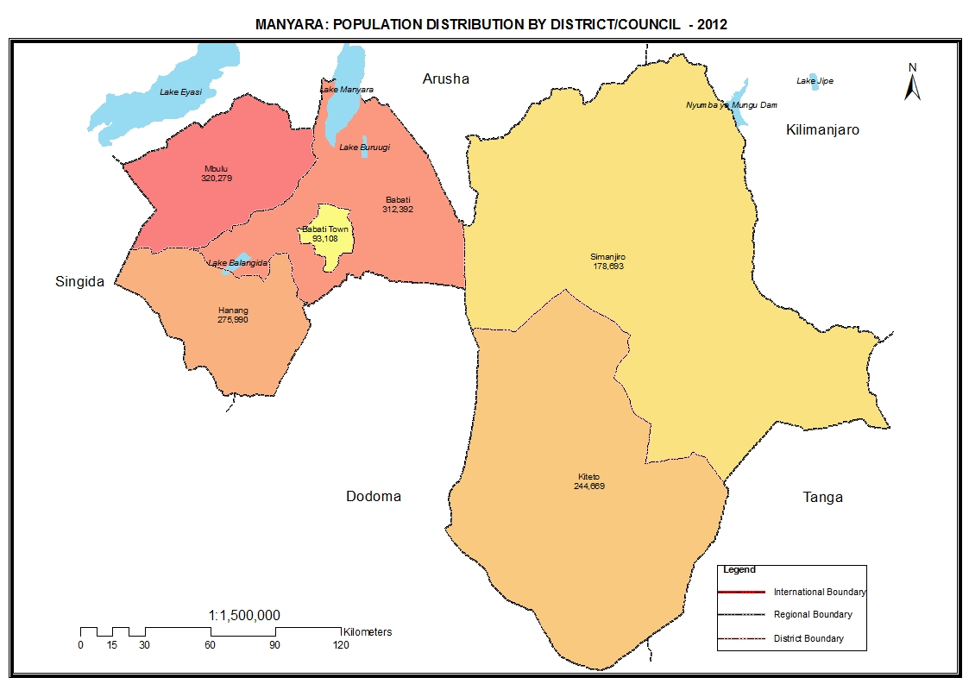

Table 21.0: Population of Manyara Region by Sex, Average Household Size and Sex Ratio
Serial No. | District/Council | Population (Number) |  |  | Average Household Size | Sex Ratio
Serial No. | District/Council | Total | Male | Female | Average Household Size | Sex Ratio
 | Total | 1,425,131 | 717,085 | 708,046 | 5.2 | 101
1 | Babati District Council | 312,392 | 158,804 | 153,588 | 5.2 | 103
2 | Hanang District Council | 275,990 | 140,212 | 135,778 | 5.7 | 103
3 | Mbulu District Council | 320,279 | 161,548 | 158,731 | 6.0 | 102
4 | Simanjiro District Council | 178,693 | 88,975 | 89,718 | 4.6 | 99
5 | Kiteto District Council | 244,669 | 120,233 | 124,436 | 4.8 | 97
6 | Babati Town Council | 93,108 | 47,313 | 45,795 | 4.4 | 103

Table 21. 1: Population of Babati District Council by Sex, Average Household Size and Sex Ratio
Serial No. | Ward/Shehia | Population (Number) |  |  | Average Household Size | Sex Ratio
Serial No. | Ward/Shehia | Total | Male | Female | Average Household Size | Sex Ratio
 | Total | 312,392 | 158,804 | 153,588 | 5.2 | 103
1 | Magara | 15,336 | 8,051 | 7,285 | 4.7 | 111
2 | Nkaiti | 14,150 | 7,030 | 7,120 | 5.0 | 99
3 | Mwada | 16,139 | 8,533 | 7,606 | 4.6 | 112
4 | Mamire | 9,014 | 4,638 | 4,376 | 5.1 | 106
5 | Gallapo | 19,578 | 9,879 | 9,699 | 4.8 | 102
6 | Qash | 19,549 | 9,962 | 9,587 | 5.1 | 104
7 | Ayasanda | 6,182 | 3,180 | 3,002 | 5.4 | 106
8 | Gidas | 7,392 | 3,764 | 3,628 | 5.5 | 104
9 | Duru | 11,526 | 5,914 | 5,612 | 5.2 | 105
10 | Riroda | 12,179 | 6,210 | 5,969 | 5.2 | 104
11 | Arri | 14,146 | 7,099 | 7,047 | 5.2 | 101
12 | Dareda | 22,880 | 11,452 | 11,428 | 5.4 | 100
13 | Dabil | 16,781 | 8,656 | 8,125 | 5.7 | 107
14 | Ufana | 20,189 | 10,208 | 9,981 | 6.0 | 102
15 | Bashnet | 13,367 | 6,578 | 6,789 | 6.1 | 97
16 | Madunga | 21,094 | 10,522 | 10,572 | 6.1 | 100
17 | Kiru | 13,119 | 6,832 | 6,287 | 5.0 | 109
18 | Magugu | 32,774 | 16,672 | 16,102 | 4.2 | 104
19 | Baoy | 6,565 | 3,385 | 3,180 | 5.0 | 106
20 | Nar | 11,186 | 5,518 | 5,668 | 6.3 | 97
21 | Endakiso | 9,246 | 4,721 | 4,525 | 5.5 | 104

Table 21. 2: Population of Hanang District Council by Sex, Average Household Size and Sex Ratio
Serial No. | Ward/Shehia | Population (Number) |  |  | Average Household Size | Sex Ratio
Serial No. | Ward/Shehia | Total | Male | Female | Average Household Size | Sex Ratio
 | Total | 275,990 | 140,212 | 135,778 | 5.7 | 103
1 | Balangidalalu | 14,478 | 7,339 | 7,139 | 5.8 | 103
2 | Gehandu | 15,222 | 7,646 | 7,576 | 6.0 | 101
3 | Laghanga | 11,872 | 6,071 | 5,801 | 5.9 | 105
4 | Getanuwas | 12,152 | 6,190 | 5,962 | 6.2 | 104
5 | Hirbadaw | 7,903 | 4,037 | 3,866 | 5.8 | 104
6 | Bassodesh | 16,762 | 8,535 | 8,227 | 6.2 | 104
7 | Bassotu | 24,527 | 12,498 | 12,029 | 5.6 | 104
8 | Gendabi | 10,968 | 5,579 | 5,389 | 6.0 | 104
9 | Mogitu | 21,547 | 11,015 | 10,532 | 5.8 | 105
10 | Gitting | 13,370 | 6,726 | 6,644 | 6.1 | 101
11 | Masakta | 7,321 | 3,679 | 3,642 | 5.7 | 101
12 | Masqaroda | 7,254 | 3,625 | 3,629 | 5.7 | 100
13 | Endasak | 10,054 | 4,961 | 5,093 | 4.8 | 97
14 | Gidahababieg | 5,366 | 2,743 | 2,623 | 5.7 | 105
15 | Measkron | 13,149 | 6,588 | 6,561 | 6.0 | 100
16 | Hidet | 6,528 | 3,423 | 3,105 | 5.9 | 110
17 | Simbay | 6,737 | 3,523 | 3,214 | 5.7 | 110
18 | Sirop | 5,563 | 2,816 | 2,747 | 5.4 | 103
19 | Gisambalang | 10,937 | 5,811 | 5,126 | 5.2 | 113
20 | Nangwa | 13,165 | 6,675 | 6,490 | 6.2 | 103
21 | Katesh | 8,774 | 4,223 | 4,551 | 4.7 | 93
22 | Ganana | 7,543 | 3,610 | 3,933 | 4.4 | 92
23 | Dirma | 8,538 | 4,483 | 4,055 | 6.2 | 111
24 | Lalaji | 9,698 | 5,111 | 4,587 | 5.6 | 111
25 | Endasiwold | 6,562 | 3,305 | 3,257 | 5.9 | 101

Table 21. 3: Population of Mbulu District Council by Sex, Average Household Size and Sex Ratio
Serial No. | Ward/Shehia | Population (Number) |  |  | Average Household Size | Sex Ratio
Serial No. | Ward/Shehia | Total | Male | Female | Average Household Size | Sex Ratio
 | Total | 320,279 | 161,548 | 158,731 | 6.0 | 102
1 | Daudi | 7,642 | 3,864 | 3,778 | 6.0 | 102
2 | Bargish | 8,804 | 4,469 | 4,335 | 6.0 | 103
3 | Gehandu | 12,092 | 6,243 | 5,849 | 6.0 | 107
4 | Kainam | 7,679 | 3,866 | 3,813 | 5.8 | 101
5 | Murray | 9,965 | 5,082 | 4,883 | 6.0 | 104
6 | Ayamaami | 4,848 | 2,452 | 2,396 | 5.8 | 102
7 | Uhuru | 7,141 | 3,458 | 3,683 | 4.7 | 94
8 | Tlawi | 8,547 | 4,358 | 4,189 | 6.0 | 104
9 | Bashay | 10,194 | 5,263 | 4,931 | 5.9 | 107
10 | Dongobesh | 11,770 | 5,941 | 5,829 | 5.7 | 102
11 | Tumati | 12,798 | 6,470 | 6,328 | 6.3 | 102
12 | Maretadu | 14,343 | 7,259 | 7,084 | 6.2 | 102
13 | Maghang | 13,624 | 6,790 | 6,834 | 6.1 | 99
14 | Haydom | 23,013 | 11,225 | 11,788 | 5.7 | 95
15 | Yaeda Chini | 5,420 | 2,791 | 2,629 | 5.7 | 106
16 | Masieda | 9,929 | 5,087 | 4,842 | 6.5 | 105
17 | Marang | 7,377 | 3,793 | 3,584 | 5.8 | 106
18 | Gunyoda | 11,477 | 5,793 | 5,684 | 6.2 | 102
19 | Nahasey | 9,844 | 5,053 | 4,791 | 6.0 | 105
20 | Endamilay | 13,967 | 6,984 | 6,983 | 6.6 | 100
21 | Yaeda Ampa | 13,138 | 6,638 | 6,500 | 6.5 | 102
22 | Masqaroda | 10,262 | 5,176 | 5,086 | 6.2 | 102
23 | Nambisi | 8,874 | 4,557 | 4,317 | 6.1 | 106
24 | Dinamu | 11,606 | 5,918 | 5,688 | 6.1 | 104
25 | Ayamohe | 5,785 | 2,739 | 3,046 | 4.7 | 90
26 | Sanu Baray | 6,233 | 3,031 | 3,202 | 4.7 | 95
27 | Imboru | 7,938 | 4,063 | 3,875 | 5.3 | 105
28 | Endagikot | 4,463 | 2,246 | 2,217 | 5.4 | 101
29 | Geterer | 11,445 | 5,816 | 5,629 | 6.3 | 103
30 | Hayderer | 13,004 | 6,458 | 6,546 | 6.3 | 99
31 | Eshkesh | 5,859 | 2,961 | 2,898 | 6.2 | 102
32 | Gidihim | 11,198 | 5,704 | 5,494 | 6.5 | 104

Table 21. 4: Population of Simanjiro District Council by Sex, Average Household Size and Sex Ratio
Serial No. | Ward/Shehia | Population (Number) |  |  | Average Household Size | Sex Ratio
Serial No. | Ward/Shehia | Total | Male | Female | Average Household Size | Sex Ratio
 | Total | 178,693 | 88,975 | 89,718 | 4.6 | 99
1 | Orkesumet | 5,325 | 2,601 | 2,724 | 4.1 | 95
2 | Naberera | 19,814 | 10,060 | 9,754 | 5.0 | 103
3 | Loiborsiret | 13,569 | 6,542 | 7,027 | 4.8 | 93
4 | Emboreet | 8,860 | 4,268 | 4,592 | 5.3 | 93
5 | Terrat | 8,586 | 4,081 | 4,505 | 5.1 | 91
6 | Oljoro No. 5 | 15,527 | 7,296 | 8,231 | 4.9 | 89
7 | Shambarai | 9,420 | 4,876 | 4,544 | 4.7 | 107
8 | Mrerani | 13,450 | 6,838 | 6,612 | 3.6 | 103
9 | Msitu wa Tembo | 12,054 | 5,990 | 6,064 | 4.2 | 99
10 | Ngorika | 7,417 | 3,682 | 3,735 | 4.2 | 99
11 | Liborsoit | 7,207 | 3,928 | 3,279 | 4.5 | 120
12 | Ruvu Remiti | 5,077 | 2,471 | 2,606 | 5.0 | 95
13 | Kitwai | 5,914 | 2,778 | 3,136 | 5.0 | 89
14 | Komolo | 11,555 | 5,604 | 5,951 | 4.8 | 94
15 | Naisinyai | 11,144 | 5,893 | 5,251 | 5.5 | 112
16 | Endiamtu | 13,621 | 7,006 | 6,615 | 3.6 | 106
17 | Endonyongijape | 10,153 | 5,061 | 5,092 | 5.5 | 99

Table 21. 5: Population of Kiteto District Council by Sex, Average Household Size and Sex Ratio
Serial No. | Ward/Shehia | Population (Number) |  |  | Average Household Size | Sex Ratio
Serial No. | Ward/Shehia | Total | Male | Female | Average Household Size | Sex Ratio
 | Total | 244,669 | 120,233 | 124,436 | 4.8 | 97
1 | Kibaya | 8,759 | 4,230 | 4,529 | 4.2 | 93
2 | Partimbo | 20,669 | 10,397 | 10,272 | 4.8 | 101
3 | Njoro | 15,410 | 7,639 | 7,771 | 4.7 | 98
4 | Olboloti | 16,497 | 8,157 | 8,340 | 4.6 | 98
5 | Makame | 9,751 | 4,724 | 5,027 | 5.2 | 94
6 | Ndedo | 5,103 | 2,393 | 2,710 | 4.8 | 88
7 | Kijungu | 6,165 | 3,141 | 3,024 | 4.9 | 104
8 | Lengatei | 12,776 | 6,256 | 6,520 | 4.9 | 96
9 | Sunya | 23,558 | 11,694 | 11,864 | 4.9 | 99
10 | Dongo | 17,980 | 8,680 | 9,300 | 5.0 | 93
11 | Songambele | 7,532 | 3,685 | 3,847 | 4.9 | 96
12 | Dosidosi | 7,785 | 3,779 | 4,006 | 4.9 | 94
13 | Engusero | 24,707 | 12,123 | 12,584 | 4.8 | 96
14 | Matui | 19,883 | 9,641 | 10,242 | 4.7 | 94
15 | Bwagamoyo | 10,748 | 5,291 | 5,457 | 4.8 | 97
16 | Loolera | 6,098 | 3,052 | 3,046 | 5.1 | 100
17 | Magungu | 8,732 | 4,262 | 4,470 | 4.5 | 95
18 | Chapakazi | 7,773 | 3,787 | 3,986 | 4.7 | 95
19 | Namelock | 14,743 | 7,302 | 7,441 | 5.0 | 98

Table 21. 6: Population of Babati Town Council by Sex, Average Household Size and Sex Ratio
Serial No. | Ward/Shehia | Population (Number) |  |  | Average Household Size | Sex Ratio
Serial No. | Ward/Shehia | Total | Male | Female | Average Household Size | Sex Ratio
 | Total | 93,108 | 47,313 | 45,795 | 4.4 | 103
1 | Babati | 16,718 | 8,559 | 8,159 | 4.5 | 105
2 | Mutuka | 4,910 | 2,521 | 2,389 | 5.0 | 106
3 | Nangara | 7,468 | 3,905 | 3,563 | 4.8 | 110
4 | Singe | 6,620 | 3,380 | 3,240 | 4.8 | 104
5 | Bonga | 9,603 | 4,935 | 4,668 | 4.6 | 106
6 | Bagara | 28,920 | 14,280 | 14,640 | 3.9 | 98
7 | Sigino | 10,038 | 5,158 | 4,880 | 4.9 | 106
8 | Maisaka | 8,831 | 4,575 | 4,256 | 4.6 | 107

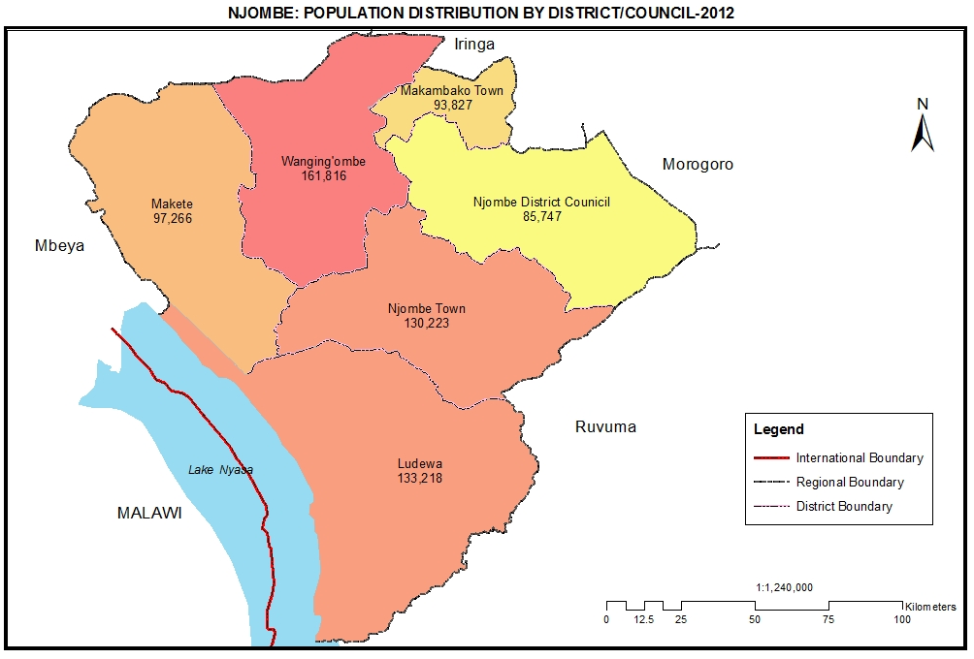

Table 22.0: Population of Njombe Region by Sex, Average Household Size and Sex Ratio
Serial No. | District/Council | Population (Number) |  |  | Average Household Size | Sex Ratio
Serial No. | District/Council | Total | Male | Female | Average Household Size | Sex Ratio
 | Total | 702,097 | 329,359 | 372,738 | 4.1 | 88
1 | Njombe Town Council | 130,223 | 61,112 | 69,111 | 4.1 | 88
2 | Wanging'ombe District Council | 161,816 | 75,427 | 86,389 | 4.0 | 87
3 | Makete District Council | 97,266 | 45,300 | 51,966 | 3.7 | 87
4 | Njombe District Council | 85,747 | 40,047 | 45,700 | 4.2 | 88
5 | Ludewa District Council | 133,218 | 63,442 | 69,776 | 4.4 | 91
6 | Makambako Town Council | 93,827 | 44,031 | 49,796 | 4.2 | 88

Table 22. 1: Population of Njombe Town Council by Sex, Average Household Size and Sex Ratio
Serial No. | Ward/Shehia | Population (Number) |  |  | Average Household Size | Sex Ratio
Serial No. | Ward/Shehia | Total | Male | Female | Average Household Size | Sex Ratio
 | Total | 130,223 | 61,112 | 69,111 | 4.1 | 88
1 | Njombe Mjini | 26,678 | 12,464 | 14,214 | 3.7 | 88
2 | Mjimwema | 13,929 | 6,505 | 7,424 | 4.1 | 88
3 | Ramadhani | 16,305 | 7,695 | 8,610 | 4.0 | 89
4 | Yakobi | 5,660 | 2,730 | 2,930 | 3.9 | 93
5 | Kifanya | 9,011 | 4,171 | 4,840 | 4.2 | 86
6 | Ihanga | 5,095 | 2,338 | 2,757 | 4.1 | 85
7 | Iwungilo | 8,419 | 3,912 | 4,507 | 4.3 | 87
8 | Luponde | 9,372 | 4,471 | 4,901 | 4.4 | 91
9 | Matola | 12,262 | 5,649 | 6,613 | 4.8 | 85
10 | Makowo | 4,213 | 2,079 | 2,134 | 4.7 | 97
11 | Lugenge | 5,843 | 2,737 | 3,106 | 4.4 | 88
12 | Uwemba | 8,900 | 4,236 | 4,664 | 4.0 | 91
13 | Utalingolo | 4,536 | 2,125 | 2,411 | 4.2 | 88

Table 22. 2: Population of Wanging'ombe District Council by Sex, Average Household Size and Sex Ratio
Serial No. | Ward/Shehia | Population (Number) |  |  | Average Household Size | Sex Ratio
Serial No. | Ward/Shehia | Total | Male | Female | Average Household Size | Sex Ratio
 | Total | 161,816 | 75,427 | 86,389 | 4.0 | 87
1 | Saja | 11,469 | 5,391 | 6,078 | 4.1 | 89
2 | Kijombe | 8,025 | 3,918 | 4,107 | 4.2 | 95
3 | Wanging`ombe | 12,115 | 5,753 | 6,362 | 4.0 | 90
4 | Ilembula | 15,642 | 7,150 | 8,492 | 4.1 | 84
5 | Uhambule | 6,028 | 2,858 | 3,170 | 3.8 | 90
6 | Usuka | 6,146 | 2,961 | 3,185 | 4.0 | 93
7 | Igwachanya | 12,067 | 5,703 | 6,364 | 4.1 | 90
8 | Mdandu | 12,886 | 6,124 | 6,762 | 4.1 | 91
9 | Igima | 14,363 | 6,583 | 7,780 | 4.0 | 85
10 | Imalinyi | 8,529 | 3,993 | 4,536 | 4.0 | 88
11 | Ulembwe | 10,883 | 4,892 | 5,991 | 4.1 | 82
12 | Makoga | 8,303 | 3,741 | 4,562 | 3.9 | 82
13 | Kipengere | 7,273 | 3,243 | 4,030 | 4.0 | 80
14 | Igosi | 7,204 | 3,304 | 3,900 | 4.2 | 85
15 | Wangama | 4,098 | 1,879 | 2,219 | 4.1 | 85
16 | Kidugala | 4,838 | 2,262 | 2,576 | 4.1 | 88
17 | Luduga | 11,947 | 5,672 | 6,275 | 3.9 | 90

Table 22. 3: Population of Makete District Council by Sex, Average Household Size and Sex Ratio
Serial No. | Ward/Shehia | Population (Number) |  |  | Average Household Size | Sex Ratio
Serial No. | Ward/Shehia | Total | Male | Female | Average Household Size | Sex Ratio
 | Total | 97,266 | 45,300 | 51,966 | 3.7 | 87
1 | Lupalilo | 4,527 | 1,993 | 2,534 | 3.5 | 79
2 | Iwawa | 10,176 | 4,697 | 5,479 | 3.6 | 86
3 | Mang`oto | 3,781 | 1,706 | 2,075 | 3.6 | 82
4 | Lupila | 5,004 | 2,255 | 2,749 | 3.7 | 82
5 | Ukwama | 3,529 | 1,616 | 1,913 | 3.6 | 84
6 | Bulongwa | 3,824 | 1,708 | 2,116 | 3.7 | 81
7 | Kipagilo | 3,913 | 1,801 | 2,112 | 3.5 | 85
8 | Iniho | 3,720 | 1,781 | 1,939 | 3.8 | 92
9 | Ipelele | 4,890 | 2,348 | 2,542 | 3.7 | 92
10 | Kigulu | 918 | 432 | 486 | 4.6 | 89
11 | Matamba | 10,441 | 4,952 | 5,489 | 3.6 | 90
12 | Mlondwe | 3,937 | 1,893 | 2,044 | 3.6 | 93
13 | Kitulo | 3,469 | 1,679 | 1,790 | 3.9 | 94
14 | Ikuwo | 3,648 | 1,755 | 1,893 | 4.0 | 93
15 | Mfumbi | 4,718 | 2,242 | 2,476 | 3.8 | 91
16 | Ipepo | 5,020 | 2,328 | 2,692 | 3.8 | 86
17 | Mbalatse | 2,952 | 1,319 | 1,633 | 3.8 | 81
18 | Tandala | 5,933 | 2,794 | 3,139 | 4.6 | 89
19 | Luwumbu | 2,240 | 1,044 | 1,196 | 3.4 | 87
20 | Isapulano | 3,191 | 1,534 | 1,657 | 3.8 | 93
21 | Kigala | 3,022 | 1,391 | 1,631 | 4.2 | 85
22 | Itundu | 4,413 | 2,032 | 2,381 | 3.7 | 85

Table 22. 4: Population of Njombe District Council by Sex, Average Household Size and Sex Ratio
Serial No. | Ward/Shehia | Population (Number) |  |  | Average Household Size | Sex Ratio
Serial No. | Ward/Shehia | Total | Male | Female | Average Household Size | Sex Ratio
 | Total | 85,747 | 40,047 | 45,700 | 4.2 | 88
1 | Mtwango | 12,948 | 5,999 | 6,949 | 4.0 | 86
2 | Igongolo | 8,447 | 3,944 | 4,503 | 4.5 | 88
3 | Kichiwa | 9,961 | 4,543 | 5,418 | 4.1 | 84
4 | Ninga | 5,751 | 2,751 | 3,000 | 4.4 | 92
5 | Ikuna | 9,178 | 4,189 | 4,989 | 4.0 | 84
6 | Kidegembye | 8,068 | 3,756 | 4,312 | 4.0 | 87
7 | Matembwe | 8,653 | 4,083 | 4,570 | 4.3 | 89
8 | Lupembe | 7,709 | 3,584 | 4,125 | 4.1 | 87
9 | Ikondo | 7,635 | 3,637 | 3,998 | 4.6 | 91
10 | Mfriga | 4,249 | 2,122 | 2,127 | 4.4 | 100
11 | Idamba | 3,148 | 1,439 | 1,709 | 4.1 | 84

Table 22. 5: Population of Ludewa District Council by Sex, Average Household Size and Sex Ratio
Serial No. | Ward/Shehia | Population (Number) |  |  | Average Household Size | Sex Ratio
Serial No. | Ward/Shehia | Total | Male | Female | Average Household Size | Sex Ratio
 | Total | 133,218 | 63,442 | 69,776 | 4.4 | 91
1 | Lumbila | 1,880 | 881 | 999 | 4.8 | 88
2 | Kilondo | 2,053 | 959 | 1,094 | 4.4 | 88
3 | Mawengi | 9,083 | 4,298 | 4,785 | 4.4 | 90
4 | Lupanga | 6,439 | 2,969 | 3,470 | 4.5 | 86
5 | Mlangali | 12,977 | 6,089 | 6,888 | 4.0 | 88
6 | Milo | 6,861 | 3,120 | 3,741 | 3.9 | 83
7 | Lugarawa | 8,535 | 3,993 | 4,542 | 4.5 | 88
8 | Madope | 5,442 | 2,549 | 2,893 | 4.5 | 88
9 | Madilu | 9,172 | 4,336 | 4,836 | 4.6 | 90
10 | Mundindi | 7,346 | 3,706 | 3,640 | 5.0 | 102
11 | Mavanga | 7,651 | 3,853 | 3,798 | 5.0 | 101
12 | Ibumi | 1,812 | 940 | 872 | 4.7 | 108
13 | Nkomang'ombe | 3,649 | 1,818 | 1,831 | 4.5 | 99
14 | Luilo | 3,976 | 1,861 | 2,115 | 4.5 | 88
15 | Masasi | 2,293 | 1,082 | 1,211 | 4.8 | 89
16 | Manda | 4,304 | 1,993 | 2,311 | 4.4 | 86
17 | Iwela | 1,193 | 579 | 614 | 4.2 | 94
18 | Lupingu | 4,842 | 2,236 | 2,606 | 4.7 | 86
19 | Ludewa | 10,115 | 4,853 | 5,262 | 4.1 | 92
20 | Ludende | 5,498 | 2,619 | 2,879 | 4.0 | 91
21 | Luana | 4,570 | 2,246 | 2,324 | 4.1 | 97
22 | Makonde | 3,952 | 1,891 | 2,061 | 4.6 | 92
23 | Mkongobaki | 3,530 | 1,694 | 1,836 | 4.5 | 92
24 | Lifuma | 2,224 | 1,042 | 1,182 | 4.3 | 88
25 | Ruhuhu | 3,821 | 1,835 | 1,986 | 4.6 | 92

Table 22. 6: Population of Makambako Town Council by Sex, Average Household Size and Sex Ratio
Serial No. | Ward/Shehia | Population (Number) |  |  | Average Household Size | Sex Ratio
Serial No. | Ward/Shehia | Total | Male | Female | Average Household Size | Sex Ratio
 | Total | 93,827 | 44,031 | 49,796 | 4.2 | 88
1 | Ubena | 17,691 | 8,430 | 9,261 | 4.2 | 91
2 | Mjimwema | 28,998 | 13,262 | 15,736 | 4.1 | 84
3 | Mlowa | 5,712 | 2,723 | 2,989 | 4.3 | 91
4 | Lyamkena | 9,383 | 4,392 | 4,991 | 4.3 | 88
5 | Mwembetogwa | 7,382 | 3,500 | 3,882 | 4.3 | 90
6 | Mahongole | 9,222 | 4,401 | 4,821 | 4.5 | 91
7 | Kitandililo | 6,842 | 3,229 | 3,613 | 4.1 | 89
8 | Utengule | 8,597 | 4,094 | 4,503 | 4.1 | 91

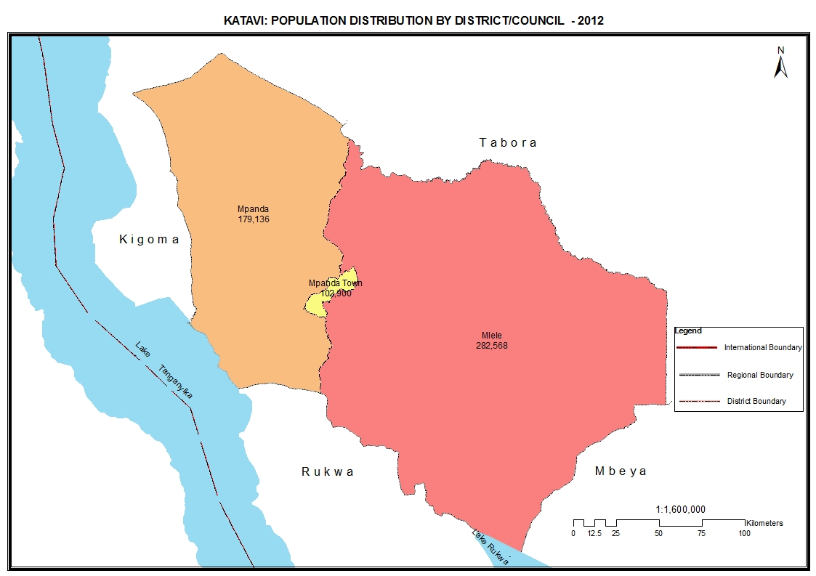

Table 23.0: Population of Katavi Region by Sex, Average Household Size and Sex Ratio
Serial No. | District/Council | Population (Number) |  |  | Average Household Size | Sex Ratio
Serial No. | District/Council | Total | Male | Female | Average Household Size | Sex Ratio
 | Total | 564,604 | 279,682 | 284,922 | 5.5 | 98
1 | Mpanda Town Council | 102,900 | 50,437 | 52,463 | 4.8 | 96
2 | Mpanda District Council | 179,136 | 89,265 | 89,871 | 5.7 | 99
3 | Mlele District Council | 282,568 | 139,980 | 142,588 | 5.8 | 98

Table 23. 1: Population of Mpanda Town Council by Sex, Average Household Size and Sex Ratio
Serial No. | Ward/Shehia | Population (Number) |  |  | Average Household Size | Sex Ratio
Serial No. | Ward/Shehia | Total | Male | Female | Average Household Size | Sex Ratio
 | Total | 102,900 | 50,437 | 52,463 | 4.8 | 96
1 | Kakese | 21,360 | 10,745 | 10,615 | 5.7 | 101
2 | Misunkumilo | 3,396 | 1,689 | 1,707 | 4.7 | 99
3 | Shanwe | 7,361 | 3,583 | 3,778 | 5.0 | 95
4 | Makanyagio | 10,375 | 5,032 | 5,343 | 4.3 | 94
5 | Kashaulili | 13,009 | 6,330 | 6,679 | 4.2 | 95
6 | Mpanda Hotel | 11,527 | 5,751 | 5,776 | 4.6 | 100
7 | Kawajense | 15,373 | 7,416 | 7,957 | 4.7 | 93
8 | Nsemulwa | 17,166 | 8,318 | 8,848 | 4.9 | 94
9 | Ilembo | 3,333 | 1,573 | 1,760 | 4.6 | 89

Table 23. 2: Population of Mpanda District Council by Sex, Average Household Size and Sex Ratio
Serial No. | Ward/Shehia | Population (Number) |  |  | Average Household Size | Sex Ratio
Serial No. | Ward/Shehia | Total | Male | Female | Average Household Size | Sex Ratio
 | Total | 179,136 | 89,265 | 89,871 | 5.7 | 99
1 | Mishamo | 61,017 | 29,541 | 31,476 | 5.7 | 94
2 | Mpandandogo | 25,293 | 12,745 | 12,548 | 5.7 | 102
3 | Mwese | 7,520 | 3,847 | 3,673 | 5.4 | 105
4 | Katuma | 9,470 | 4,921 | 4,549 | 6.1 | 108
5 | Kabungu | 22,676 | 11,401 | 11,275 | 5.8 | 101
6 | Sibwesa | 19,183 | 9,709 | 9,474 | 6.7 | 102
7 | Ikola | 17,659 | 8,798 | 8,861 | 4.8 | 99
8 | Karema | 7,465 | 3,830 | 3,635 | 5.4 | 105
9 | Kapalamsenga | 8,853 | 4,473 | 4,380 | 5.7 | 102

Table 23. 3: Population of Mlele District Council by Sex, Average Household Size and Sex Ratio
Serial No. | Ward/Shehia | Population (Number) |  |  | Average Household Size | Sex Ratio
Serial No. | Ward/Shehia | Total | Male | Female | Average Household Size | Sex Ratio
 | Total | 282,568 | 139,980 | 142,588 | 5.8 | 98
1 | Kasokola | 3,967 | 1,917 | 2,050 | 5.1 | 94
2 | Ugala | 8,559 | 4,360 | 4,199 | 5.5 | 104
3 | Litapunga | 70,854 | 34,124 | 36,730 | 6.1 | 93
4 | Mtapenda | 4,811 | 2,399 | 2,412 | 5.3 | 99
5 | Inyonga | 11,127 | 5,540 | 5,587 | 5.0 | 99
6 | Ilunde | 3,719 | 1,989 | 1,730 | 5.3 | 115
7 | Ilela | 6,229 | 3,174 | 3,055 | 5.6 | 104
8 | Utende | 7,615 | 3,864 | 3,751 | 5.2 | 103
9 | Mamba | 21,545 | 10,488 | 11,057 | 6.2 | 95
10 | Mbede | 10,538 | 5,145 | 5,393 | 7.3 | 95
11 | Urwila | 6,124 | 3,071 | 3,053 | 5.3 | 101
12 | Nsimbo | 7,104 | 3,544 | 3,560 | 4.9 | 100
13 | Magamba | 3,186 | 1,586 | 1,600 | 4.6 | 99
14 | Sitalike | 9,638 | 5,071 | 4,567 | 4.7 | 111
15 | Usevya | 8,824 | 4,296 | 4,528 | 5.7 | 95
16 | Kibaoni | 12,391 | 6,049 | 6,342 | 5.7 | 95
17 | Machimboni | 9,372 | 5,037 | 4,335 | 5.0 | 116
18 | Kapalala | 4,508 | 2,213 | 2,295 | 6.1 | 96
19 | Itenka | 16,122 | 8,106 | 8,016 | 6.2 | 101
20 | Ikuba | 7,982 | 3,904 | 4,078 | 6.1 | 96
21 | Mwamapuli | 16,249 | 8,113 | 8,136 | 7.2 | 100
22 | Majimoto | 18,166 | 9,008 | 9,158 | 5.9 | 98
23 | Kasansa | 7,930 | 3,981 | 3,949 | 6.3 | 101
24 | Nsenkwa | 6,008 | 3,001 | 3,007 | 4.9 | 100

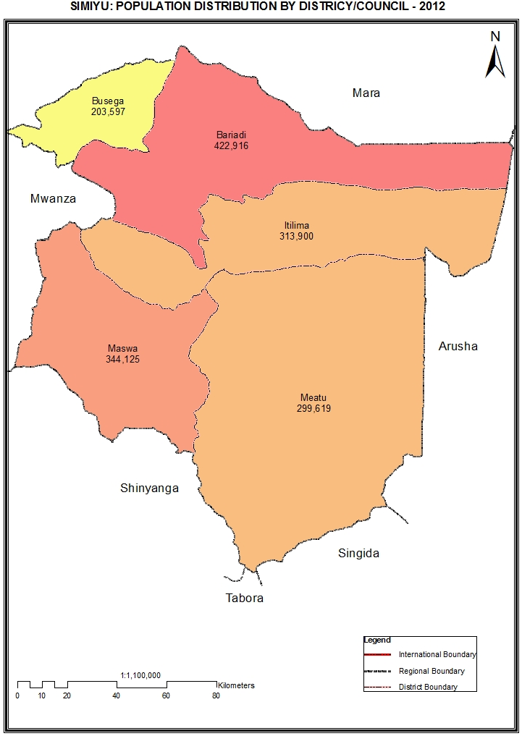

Table 24.0: Population of Simiyu Region by Sex, Average Household Size and Sex Ratio
Serial No. | District/Council | Population (Number) |  |  | Average Household Size | Sex Ratio
Serial No. | District/Council | Total | Male | Female | Average Household Size | Sex Ratio
 | Total | 1,584,157 | 759,891 | 824,266 | 6.9 | 92
1 | Bariadi District Council | 422,916 | 201,718 | 221,198 | 7.1 | 91
2 | Itilima District Council | 313,900 | 148,502 | 165,398 | 7.2 | 90
3 | Meatu District Council | 299,619 | 143,569 | 156,050 | 7.4 | 92
4 | Maswa District Council | 344,125 | 167,402 | 176,723 | 6.5 | 95
5 | Busega District Council | 203,597 | 98,700 | 104,897 | 6.1 | 94

Table 24. 1: Population of Bariadi District Council by Sex, Average Household Size and Sex Ratio
Serial No. | Ward/Shehia | Population (Number) |  |  | Average Household Size | Sex Ratio
Serial No. | Ward/Shehia | Total | Male | Female | Average Household Size | Sex Ratio
 | Total | 422,916 | 201,718 | 221,198 | 7.1 | 91
1 | Nkindwabiye | 13,948 | 6,683 | 7,265 | 7.4 | 92
2 | Mwaubingi | 15,780 | 7,488 | 8,292 | 7.7 | 90
3 | Nkololo | 21,776 | 10,241 | 11,535 | 6.9 | 89
4 | Mwaumatondo | 25,748 | 12,136 | 13,612 | 7.6 | 89
5 | Mwadobana | 25,778 | 12,083 | 13,695 | 8.7 | 88
6 | Nyangokolwa | 22,557 | 10,755 | 11,802 | 7.4 | 91
7 | Somanda | 16,592 | 8,005 | 8,587 | 6.8 | 93
8 | Bunamhala | 28,301 | 13,470 | 14,831 | 6.9 | 91
9 | Sakwe | 25,676 | 12,092 | 13,584 | 7.4 | 89
10 | Ngulyati | 11,462 | 5,530 | 5,932 | 7.2 | 93
11 | Mhango | 11,253 | 5,307 | 5,946 | 6.9 | 89
12 | Kilalo | 9,953 | 4,924 | 5,029 | 7.0 | 98
13 | Kasoli | 14,442 | 7,026 | 7,416 | 7.2 | 95
14 | Gambosi | 15,047 | 7,332 | 7,715 | 7.2 | 95
15 | Guduwi | 10,550 | 5,069 | 5,481 | 7.4 | 92
16 | Ikungulyabashashi | 10,153 | 4,929 | 5,224 | 7.1 | 94
17 | Nyakabindi | 19,723 | 9,465 | 10,258 | 6.8 | 92
18 | Dutwa | 15,792 | 7,696 | 8,096 | 6.7 | 95
19 | Sapiwi | 19,356 | 9,292 | 10,064 | 7.4 | 92
20 | Matongo | 26,267 | 12,760 | 13,507 | 7.8 | 94
21 | Gilya | 16,118 | 7,658 | 8,460 | 8.4 | 91
22 | Isanga | 11,354 | 5,263 | 6,091 | 7.5 | 86
23 | Bariadi | 11,248 | 5,226 | 6,022 | 5.1 | 87
24 | Malambo | 10,489 | 4,925 | 5,564 | 4.7 | 89
25 | Sima | 13,553 | 6,363 | 7,190 | 4.9 | 88

Table 24. 2: Population of Itilima District Council by Sex, Average Household Size and Sex Ratio
Serial No. | Ward/Shehia | Population (Number) |  |  |  |  | Average Household Size | Sex Ratio
Serial No. | Ward/Shehia | Total |  | Male |  | Female | Average Household Size | Sex Ratio
 | Total | 313,900 |  | 148,502 |  | 165,398 | 7.2 | 90
1 | Bumera | 13,861 |  | 6,552 |  | 7,309 | 7.4 | 90
2 | Ikindilo | 13,037 |  | 6,150 |  | 6,887 | 7.1 | 89
3 | Mwamtani | 10,648 |  | 5,001 |  | 5,647 | 7.7 | 89
4 | Sagata | 18,650 |  | 8,667 |  | 9,983 | 7.7 | 87
5 | Mwaswale | 14,411 |  | 6,717 |  | 7,694 | 7.7 | 87
6 | Nkuyu | 11,337 |  | 5,397 |  | 5,940 | 7.5 | 91
7 | Mhunze | 11,835 |  | 5,544 |  | 6,291 | 8.0 | 88
8 | Migato | 20,655 |  | 9,532 |  | 11,123 | 7.7 | 86
9 | Chinamili | 15,393 |  | 7,244 |  | 8,149 | 7.9 | 89
10 | Ndolelezi | 13,645 |  | 6,380 |  | 7,265 | 7.9 | 88
11 | Lagangabilili | 12,909 |  | 6,078 |  | 6,831 | 7.0 | 89
12 | Budalabujiga | 11,250 |  | 5,191 |  | 6,059 | 7.7 | 86
13 | Nkoma | 21,450 |  | 10,015 |  | 11,435 | 7.5 | 88
14 | Mwalushu | 13,758 |  | 6,648 |  | 7,110 | 6.6 | 94
15 | Mwamapalala | 16,091 |  | 7,791 |  | 8,300 | 6.1 | 94
16 | Nyamalapa | 13,603 |  | 6,393 |  | 7,210 | 6.7 | 89
17 | Lugulu | 18,328 |  | 8,769 |  | 9,559 | 6.9 | 92
18 | Nhobora | 13,101 |  | 6,202 |  | 6,899 | 7.2 | 90
19 | Zagayu | 14,737 |  | 7,145 |  | 7,592 | 6.6 | 94
20 | Kinang'weli | 12,315 |  | 6,085 |  | 6,230 | 7.0 | 98
21 | Mbita | 12,623 |  | 6,013 |  | 6,610 | 7.3 | 91
22 | Sawida | 10,263 |  | 4,988 |  | 5,275 | 6.5 | 95

Table 24. 3: Population of Meatu District Council by Sex, Average Household Size and Sex Ratio
Serial No. | Ward/Shehia | Population (Number) |  |  | Average Household Size | Sex Ratio
Serial No. | Ward/Shehia | Total | Male | Female | Average Household Size | Sex Ratio
 | Total | 299,619 | 143,569 | 156,050 | 7.4 | 92
1 | Mwanhuzi | 20,175 | 9,747 | 10,428 | 5.3 | 93
2 | Nkoma | 8,526 | 4,046 | 4,480 | 7.9 | 90
3 | Kimali | 9,394 | 4,498 | 4,896 | 7.1 | 92
4 | Mwamishali | 12,909 | 6,317 | 6,592 | 7.6 | 96
5 | Itinje | 14,836 | 7,228 | 7,608 | 7.0 | 95
6 | Kisesa | 19,509 | 9,119 | 10,390 | 7.8 | 88
7 | Mwandoya | 17,720 | 8,373 | 9,347 | 6.9 | 90
8 | Lingeka | 6,803 | 3,225 | 3,578 | 8.3 | 90
9 | Sakasaka | 11,756 | 5,619 | 6,137 | 7.3 | 92
10 | Imalaseko | 6,587 | 3,215 | 3,372 | 7.7 | 95
11 | Mwabuzo | 12,272 | 5,910 | 6,362 | 8.0 | 93
12 | Mwamalole | 9,546 | 4,757 | 4,789 | 8.8 | 99
13 | Mwanjolo | 11,955 | 5,628 | 6,327 | 9.5 | 89
14 | Mwabuma | 15,577 | 7,338 | 8,239 | 8.1 | 89
15 | Mwabusalu | 11,894 | 5,723 | 6,171 | 7.6 | 93
16 | Lubiga | 16,351 | 7,839 | 8,512 | 7.2 | 92
17 | Mwamanongu | 7,961 | 3,873 | 4,088 | 8.1 | 95
18 | Ng'hoboko | 12,087 | 5,913 | 6,174 | 7.7 | 96
19 | Bukundi | 10,759 | 5,242 | 5,517 | 8.3 | 95
20 | Mwasengela | 13,002 | 5,915 | 7,087 | 8.1 | 83
21 | Mwamanimba | 4,781 | 2,276 | 2,505 | 9.2 | 91
22 | Tindabuligi | 12,034 | 5,647 | 6,387 | 7.5 | 88
23 | Mwakisandu | 8,941 | 4,131 | 4,810 | 7.2 | 86
24 | Mwangundo | 12,270 | 6,088 | 6,182 | 6.9 | 98
25 | Mwanyahina | 11,974 | 5,902 | 6,072 | 6.9 | 97

Table 24. 4: Population of Maswa District Council by Sex, Average Household Size and Sex Ratio
Serial No. | Ward/Shehia | Population (Number) |  |  | Average Household Size | Sex Ratio
Serial No. | Ward/Shehia | Total | Male | Female | Average Household Size | Sex Ratio
 | Total | 344,125 | 167,402 | 176,723 | 6.5 | 95
1 | Ng'wigwa | 10,005 | 4,923 | 5,082 | 6.9 | 97
2 | Nguliguli | 6,914 | 3,355 | 3,559 | 6.2 | 94
3 | Ipililo | 18,894 | 9,083 | 9,811 | 7.0 | 93
4 | Senani | 11,873 | 5,641 | 6,232 | 7.0 | 91
5 | Mwamanenge | 8,686 | 4,110 | 4,576 | 7.5 | 90
6 | Sukuma | 9,912 | 4,880 | 5,032 | 6.4 | 97
7 | Mpindo | 12,111 | 5,914 | 6,197 | 7.3 | 95
8 | Dakama | 14,596 | 7,040 | 7,556 | 6.5 | 93
9 | Lalago | 23,391 | 11,459 | 11,932 | 6.5 | 96
10 | Budekwa | 13,630 | 6,631 | 6,999 | 6.9 | 95
11 | Busilili | 15,797 | 7,729 | 8,068 | 7.0 | 96
12 | Seng'wa | 10,544 | 5,137 | 5,407 | 6.5 | 95
13 | Masela | 12,380 | 6,056 | 6,324 | 6.4 | 96
14 | Isanga | 17,036 | 8,284 | 8,752 | 6.3 | 95
15 | Zanzui | 5,458 | 2,663 | 2,795 | 6.5 | 95
16 | Mwamashimba | 9,421 | 4,601 | 4,820 | 7.3 | 95
17 | Buchambi | 13,520 | 6,635 | 6,885 | 7.1 | 96
18 | Kadoto | 11,916 | 5,771 | 6,145 | 6.9 | 94
19 | Shishiyu | 24,695 | 11,913 | 12,782 | 7.1 | 93
20 | Nyabubinza | 9,913 | 5,093 | 4,820 | 6.7 | 106
21 | Mwang'honoli | 9,877 | 4,841 | 5,036 | 7.0 | 96
22 | Kulimi | 14,383 | 6,851 | 7,532 | 6.9 | 91
23 | Malampaka | 16,445 | 7,948 | 8,497 | 5.5 | 94
24 | Badi | 16,131 | 7,890 | 8,241 | 6.5 | 96
25 | Nyalikungu | 14,354 | 6,855 | 7,499 | 4.7 | 91
26 | Binza | 12,243 | 6,099 | 6,144 | 5.2 | 99

Table 24. 5: Population of Busega District Council by Sex, Average Household Size and Sex Ratio
Serial No. | Ward/Shehia | Population (Number) |  |  | Average Household Size | Sex Ratio
Serial No. | Ward/Shehia | Total | Male | Female | Average Household Size | Sex Ratio
 | Total | 203,597 | 98,700 | 104,897 | 6.1 | 94
1 | Shigala | 12,974 | 6,361 | 6,613 | 6.4 | 96
2 | Badugu | 13,571 | 6,587 | 6,984 | 6.6 | 94
3 | Nyaluhande | 9,688 | 4,797 | 4,891 | 6.7 | 98
4 | Kiloleli | 19,396 | 9,360 | 10,036 | 5.6 | 93
5 | Mwamanyili | 15,224 | 7,270 | 7,954 | 5.3 | 91
6 | Kabita | 22,772 | 10,754 | 12,018 | 5.2 | 89
7 | Kalemela | 10,928 | 5,297 | 5,631 | 6.0 | 94
8 | Lamadi | 22,062 | 10,625 | 11,437 | 5.1 | 93
9 | Lutubiga | 11,721 | 5,826 | 5,895 | 7.4 | 99
10 | Mkula | 16,821 | 8,114 | 8,707 | 6.9 | 93
11 | Ngasamo | 18,935 | 9,353 | 9,582 | 7.2 | 98
12 | Malili | 17,084 | 8,326 | 8,758 | 6.5 | 95
13 | Igalukilo | 12,421 | 6,030 | 6,391 | 6.4 | 94
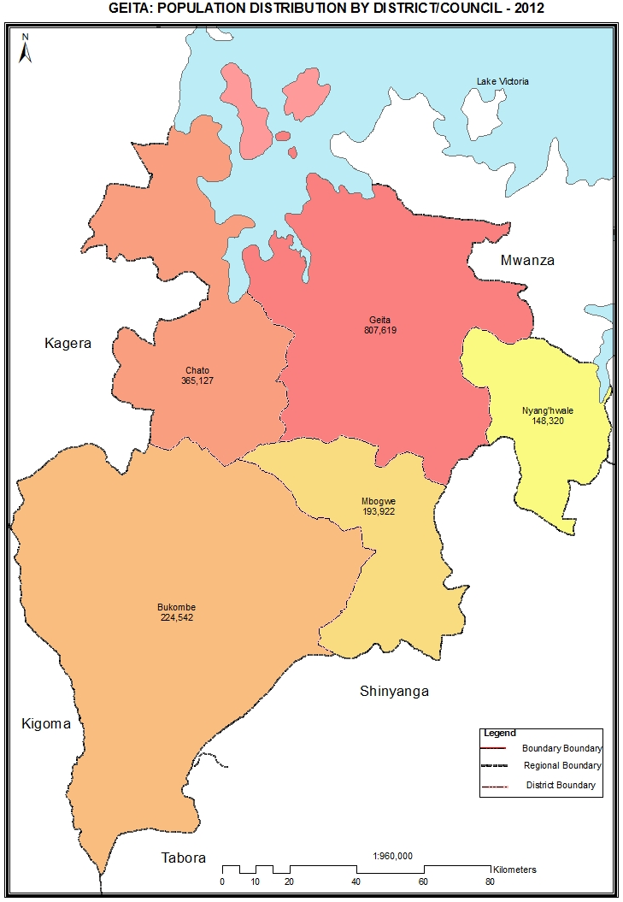

Table 25.0: Population of Geita Region by Sex, Average Household Size and Sex Ratio
Serial No. | District/Council | Population (Number) |  |  | Average Household Size | Sex Ratio
Serial No. | District/Council | Total | Male | Female | Average Household Size | Sex Ratio
 | Total | 1,739,530 | 861,055 | 878,475 | 6.1 | 98
1 | Geita District Council | 807,619 | 400,475 | 407,144 | 5.9 | 98
2 | Nyang'hwale District Council | 148,320 | 73,272 | 75,048 | 6.8 | 98
3 | Mbogwe District Council | 193,922 | 95,083 | 98,839 | 6.4 | 96
4 | Bukombe District Council | 224,542 | 110,857 | 113,685 | 5.9 | 98
5 | Chato District Council | 365,127 | 181,368 | 183,759 | 6.0 | 99

Table 25. 1: Population of Geita District Council by Sex, Average Household Size and Sex Ratio

Serial No. | Ward/Shehia | Population (Number) |  |  | Average Household Size | Sex Ratio
Serial No. | Ward/Shehia | Total | Male | Female | Average Household Size | Sex Ratio
 | Total | 807,619 | 400,475 | 407,144 | 5.9 | 98
1 | Kagu | 24,920 | 12,379 | 12,541 | 6.0 | 99
2 | Bugulula | 21,578 | 10,734 | 10,844 | 6.4 | 99
3 | Senga | 22,402 | 11,138 | 11,264 | 6.3 | 99
4 | Kakubilo | 23,248 | 11,407 | 11,841 | 5.9 | 96
5 | Nkome | 32,726 | 16,419 | 16,307 | 5.4 | 101
6 | Katoma | 19,635 | 9,904 | 9,731 | 6.2 | 102
7 | Nzera | 20,321 | 10,135 | 10,186 | 5.8 | 99
8 | Lwezera | 24,137 | 11,988 | 12,149 | 6.1 | 99
9 | Kamhanga | 16,727 | 8,414 | 8,313 | 6.8 | 101
10 | Bugalama | 14,213 | 6,983 | 7,230 | 6.3 | 97
11 | Lubanga | 11,980 | 5,995 | 5,985 | 6.9 | 100
12 | Isulwabutundwe | 11,623 | 5,676 | 5,947 | 6.7 | 95
13 | Kasamwa | 24,461 | 11,996 | 12,465 | 6.2 | 96
14 | Bung'wangoko | 8,587 | 4,295 | 4,292 | 7.4 | 100
15 | Bulela | 15,269 | 7,527 | 7,742 | 7.7 | 97
16 | Ihanamilo | 9,710 | 4,843 | 4,867 | 6.9 | 100
17 | Nyanguku | 9,658 | 4,652 | 5,006 | 7.2 | 93
18 | Kamena | 21,700 | 10,702 | 10,998 | 6.8 | 97
19 | Nyamalimbe | 15,761 | 7,895 | 7,866 | 7.1 | 100
20 | Bujula | 9,223 | 4,647 | 4,576 | 7.2 | 102
21 | Bukoli | 16,345 | 8,071 | 8,274 | 6.1 | 98
22 | Butobela | 11,809 | 6,036 | 5,773 | 6.0 | 105
23 | Nyarugusu | 40,588 | 20,567 | 20,021 | 5.6 | 103
24 | Nyakamwaga | 19,618 | 9,897 | 9,721 | 6.7 | 102
25 | Lwamgasa | 29,148 | 14,479 | 14,669 | 6.3 | 99
26 | Kaseme | 24,957 | 12,404 | 12,553 | 6.7 | 99
27 | Busanda | 15,490 | 7,541 | 7,949 | 6.5 | 95
28 | Katoro | 70,317 | 33,553 | 36,764 | 5.5 | 91
29 | Nyamigota | 16,515 | 8,076 | 8,439 | 6.5 | 96
30 | Nyakagomba | 19,206 | 9,689 | 9,517 | 6.4 | 102
31 | Nyachiluluma | 19,898 | 10,128 | 9,770 | 6.0 | 104
32 | Bukondo | 13,371 | 6,871 | 6,500 | 5.9 | 106
33 | Chigunga | 27,456 | 13,640 | 13,816 | 6.1 | 99
34 | Mtakuja | 25,227 | 12,963 | 12,264 | 5.1 | 106
35 | Kalangalala | 99,795 | 48,831 | 50,964 | 4.8 | 96

Table 25. 2: Population of Nyang'hwale District Council by Sex, Average Household Size and Sex Ratio
Serial No. | Ward/Shehia | Population (Number) |  |  | Average Household Size | Sex Ratio
Serial No. | Ward/Shehia | Total | Male | Female | Average Household Size | Sex Ratio
 | Total | 148,320 | 73,272 | 75,048 | 6.8 | 98
1 | Shabaka | 14,341 | 7,256 | 7,085 | 7.8 | 102
2 | Busolwa | 16,894 | 8,307 | 8,587 | 6.8 | 97
3 | Kakora | 16,133 | 7,942 | 8,191 | 6.7 | 97
4 | Nyugwa | 12,742 | 6,299 | 6,443 | 6.9 | 98
5 | Bukwimba | 17,335 | 8,542 | 8,793 | 6.5 | 97
6 | Kafita | 11,846 | 5,913 | 5,933 | 6.7 | 100
7 | Kharumwa | 13,480 | 6,546 | 6,934 | 6.0 | 94
8 | Izunya | 6,521 | 3,207 | 3,314 | 7.0 | 97
9 | Mwingiro | 8,382 | 4,219 | 4,163 | 6.3 | 101
10 | Nyabulanda | 9,285 | 4,626 | 4,659 | 7.3 | 99
11 | Nyang'hwale | 9,355 | 4,600 | 4,755 | 6.9 | 97
12 | Nyijundu | 12,006 | 5,815 | 6,191 | 6.7 | 94

Table 25. 3: Population of Mbongwe District Council by Sex, Average Household Size and Sex Ratio
Serial No. | Ward/Shehia | Population (Number) |  |  | Average Household Size | Sex  Ratio
Serial No. | Ward/Shehia | Total | Male | Female | Average Household Size | Sex  Ratio
 | Total | 193,922 | 95,083 | 98,839 | 6.4 | 96
1 | Nanda | 7,788 | 3,852 | 3,936 | 7.1 | 98
2 | Ikobe | 10,350 | 4,999 | 5,351 | 7.1 | 93
3 | Lulembela | 18,191 | 8,727 | 9,464 | 6.0 | 92
4 | Ikunguigazi | 8,053 | 3,948 | 4,105 | 6.9 | 96
5 | Isebya | 9,064 | 4,581 | 4,483 | 7.2 | 102
6 | Ilolangulu | 11,703 | 5,705 | 5,998 | 6.8 | 95
7 | Mbogwe | 9,935 | 4,904 | 5,031 | 6.1 | 97
8 | Ngemo | 9,193 | 4,428 | 4,765 | 6.6 | 93
9 | Ushirika | 11,622 | 5,692 | 5,930 | 6.5 | 96
10 | Nyasato | 11,039 | 5,437 | 5,602 | 7.0 | 97
11 | Lugunga | 14,982 | 7,459 | 7,523 | 6.9 | 99
12 | Nyakafulu | 21,900 | 10,514 | 11,386 | 5.2 | 92
13 | Bukandwe | 11,338 | 5,576 | 5,762 | 7.1 | 97
14 | Ng'homolwa | 6,631 | 3,281 | 3,350 | 6.8 | 98
15 | Masumbwe | 18,716 | 9,315 | 9,401 | 5.9 | 99
16 | Iponya | 13,417 | 6,665 | 6,752 | 6.9 | 99

Table 25. 4: Population of Bukombe District Council by Sex, Average Household Size and Sex Ratio
Serial No. | Ward/Shehia | Population (Number) |  |  | Average Household Size | Sex  Ratio
Serial No. | Ward/Shehia | Total | Male | Female | Average Household Size | Sex  Ratio
 | Total | 224,542 | 110,857 | 113,685 | 5.9 | 98
1 | Runzewe Mashariki | 16,095 | 7,949 | 8,146 | 5.7 | 98
2 | Runzewe Magharibi | 11,990 | 5,923 | 6,067 | 5.7 | 98
3 | Namonge | 30,654 | 15,303 | 15,351 | 6.2 | 100
4 | Uyovu | 29,909 | 14,763 | 15,146 | 5.1 | 97
5 | Busonzo | 10,296 | 5,246 | 5,050 | 6.6 | 104
6 | Ng'anzo | 22,442 | 11,105 | 11,337 | 6.5 | 98
7 | Butinzya | 18,107 | 9,007 | 9,100 | 6.8 | 99
8 | Ushirombo | 6,040 | 3,024 | 3,016 | 5.9 | 100
9 | Lyambamgongo | 6,314 | 3,181 | 3,133 | 7.2 | 102
10 | Bukombe | 11,706 | 5,700 | 6,006 | 6.8 | 95
11 | Bugelenga | 8,463 | 4,216 | 4,247 | 7.3 | 99
12 | Iyogelo | 7,910 | 3,923 | 3,987 | 7.4 | 98
13 | Igulwa | 44,616 | 21,517 | 23,099 | 5.0 | 93

Table 25. 5: Population of Chato District Council by Sex, Average Household Size and Sex Ratio
Serial No. | Ward/Shehia | Population (Number) |  |  | Average Household Size | Sex Ratio
Serial No. | Ward/Shehia | Total | Male | Female | Average Household Size | Sex Ratio
 | Total | 365,127 | 181,368 | 183,759 | 6.0 | 99
1 | Muganza | 27,245 | 13,099 | 14,146 | 5.2 | 93
2 | Bwongera | 11,395 | 5,807 | 5,588 | 6.4 | 104
3 | Kigongo | 23,718 | 11,873 | 11,845 | 6.1 | 100
4 | Nyamirembe | 15,643 | 7,874 | 7,769 | 6.3 | 101
5 | Ichwankima | 7,307 | 3,672 | 3,635 | 6.5 | 101
6 | Kachwamba | 6,996 | 3,532 | 3,464 | 7.2 | 102
7 | Kasenga | 16,863 | 8,470 | 8,393 | 6.0 | 101
8 | Ilemela | 9,099 | 4,615 | 4,484 | 7.6 | 103
9 | Chato | 17,508 | 8,343 | 9,165 | 4.9 | 91
10 | Muungano | 12,816 | 6,278 | 6,538 | 5.9 | 96
11 | Bwina | 8,422 | 4,209 | 4,213 | 5.4 | 100
12 | Katende | 4,139 | 2,029 | 2,110 | 7.6 | 96
13 | Ilyamchele | 5,966 | 2,912 | 3,054 | 6.9 | 95
14 | Bukome | 16,933 | 8,574 | 8,359 | 6.4 | 103
15 | Buziku | 15,757 | 7,786 | 7,971 | 6.3 | 98
16 | Nyarutembo | 16,619 | 8,227 | 8,392 | 6.4 | 98
17 | Makurugusi | 28,772 | 14,411 | 14,361 | 6.2 | 100
18 | Buseresere | 29,055 | 14,249 | 14,806 | 5.5 | 96
19 | Butengorumasa | 14,036 | 7,002 | 7,034 | 6.7 | 100
20 | Iparamasa | 30,378 | 15,146 | 15,232 | 6.4 | 99
21 | Bwanga | 36,763 | 18,449 | 18,314 | 5.8 | 101
22 | Bwera | 9,697 | 4,811 | 4,886 | 6.0 | 98
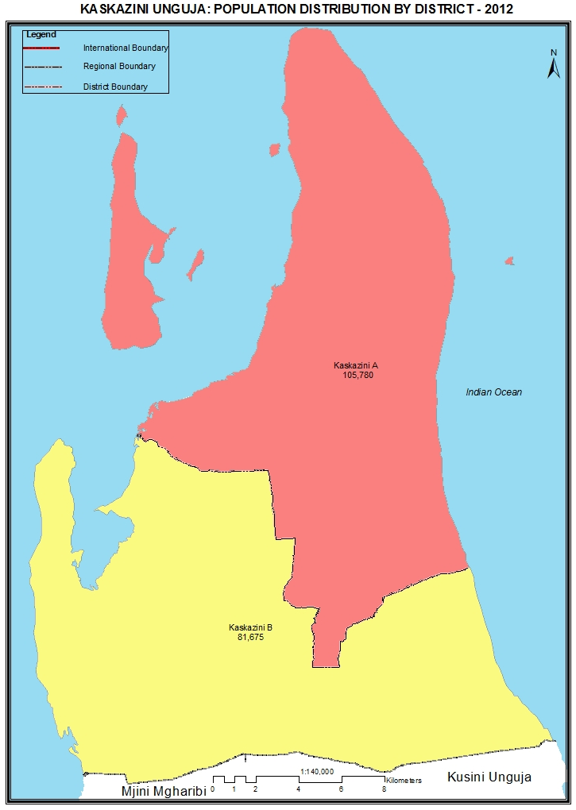

Table 51: Population of Kaskazini Unguja Region by Sex and Average Household Size and Sex Ratio
Serial No. | District/Council | Population (Number) |  |  | Average Household Size | Sex Ratio
Serial No. | District/Council | Total | Male | Female | Average Household Size | Sex Ratio
 | Total | 187,455 | 92,114 | 95,341 | 4.8 | 97
1 | Kaskazini A District | 105,780 | 51,566 | 54,214 | 4.8 | 95
2 | Kaskazini B District | 81,675 | 40,548 | 41,127 | 4.7 | 99

Table 51. 1: Population of Kaskazini ‘A’ District by Sex, Average Household Size and Sex Ratio
Serial No. | Ward/Shehia | Population (Number) |  |  | Average Household Size | Sex Ratio
Serial No. | Ward/Shehia | Total | Male | Female | Average Household Size | Sex Ratio
 | Total | 105,780 | 51,566 | 54,214 | 4.8 | 95
1 | Mkokotoni | 2,803 | 1,400 | 1,403 | 4.9 | 100
2 | Mto wa Pwani | 1,074 | 516 | 558 | 4.6 | 92
3 | Pale | 1,216 | 616 | 600 | 5.3 | 103
4 | Kivunge | 4,199 | 2,012 | 2,187 | 4.8 | 92
5 | Tumbatu Gomani | 4,990 | 2,412 | 2,578 | 4.6 | 94
6 | Tumbatu Jongowe | 3,262 | 1,482 | 1,780 | 4.6 | 83
7 | Mkwajuni | 3,509 | 1,651 | 1,858 | 5.1 | 89
8 | Kibeni | 2,799 | 1,345 | 1,454 | 4.8 | 93
9 | Muwange | 2,022 | 998 | 1,024 | 4.5 | 97
10 | Pitanazako | 4,027 | 1,945 | 2,082 | 5.3 | 93
11 | Potoa | 2,326 | 1,112 | 1,214 | 5.1 | 92
12 | Fukuchani | 2,208 | 1,062 | 1,146 | 4.8 | 93
13 | Kidoti | 2,973 | 1,436 | 1,537 | 5.0 | 93
14 | Tazari | 3,084 | 1,530 | 1,554 | 4.7 | 98
15 | Kigunda | 1,813 | 872 | 941 | 4.9 | 93
16 | Nungwi | 10,392 | 5,113 | 5,279 | 4.4 | 97
17 | Matemwe | 5,014 | 2,502 | 2,512 | 5.0 | 100
18 | Kijini | 3,369 | 1,670 | 1,699 | 5.1 | 98
19 | Pwani Mchangani | 3,441 | 1,740 | 1,701 | 4.7 | 102
20 | Gamba | 3,401 | 1,594 | 1,807 | 4.8 | 88
21 | Moga | 2,089 | 995 | 1,094 | 5.1 | 91
22 | Chaani Masingini | 4,562 | 2,247 | 2,315 | 5.0 | 97
23 | Mchenza Shauri | 917 | 443 | 474 | 5.1 | 93
24 | Chaani Kubwa | 3,030 | 1,477 | 1,553 | 5.2 | 95
25 | Kikobweni | 2,757 | 1,356 | 1,401 | 5.1 | 97
26 | Bandamaji | 1,616 | 783 | 833 | 5.3 | 94
27 | Kinyasini | 3,311 | 1,589 | 1,722 | 5.0 | 92
28 | Kandwi | 1,741 | 882 | 859 | 4.9 | 103
29 | Chutama | 1,638 | 823 | 815 | 4.5 | 101
30 | Kisongoni | 1,539 | 747 | 792 | 5.2 | 94
31 | Kilindi | 1,186 | 580 | 606 | 4.4 | 96
32 | Kilimani | 2,590 | 1,266 | 1,324 | 5.2 | 96
33 | Uvivini | 4,136 | 2,015 | 2,121 | 4.6 | 95
34 | Kidombo | 3,147 | 1,589 | 1,558 | 4.7 | 102
35 | Bwereu | 1,616 | 778 | 838 | 5.1 | 93
36 | Kigomani | 1,983 | 988 | 995 | 5.1 | 99

Table 51. 2: Population of Kaskazini ‘B’ District by Sex, Average Household Size and Sex Ratio
Serial No. | Ward/Shehia | Population (Number) |  |  | Average Household Size | Sex Ratio
Serial No. | Ward/Shehia | Total | Male | Female | Average Household Size | Sex Ratio
 | Total | 81,675 | 40,548 | 41,127 | 4.7 | 99
1 | Misufini | 7,986 | 3,920 | 4,066 | 4.6 | 96
2 | Makoba | 3,477 | 1,725 | 1,752 | 4.5 | 98
3 | Mangapwani | 2,246 | 1,145 | 1,101 | 4.9 | 104
4 | Fujoni | 3,147 | 1,531 | 1,616 | 5.0 | 95
5 | Kiombamvua | 1,938 | 963 | 975 | 4.4 | 99
6 | Donge Mchangani | 2,917 | 1,503 | 1,414 | 5.0 | 106
7 | Mkadini | 2,449 | 1,219 | 1,230 | 4.5 | 99
8 | Zingwezingwe | 745 | 388 | 357 | 4.6 | 109
9 | Kitope | 5,582 | 2,759 | 2,823 | 4.8 | 98
10 | Mahonda | 4,322 | 2,129 | 2,193 | 4.8 | 97
11 | Mnyimbi | 1,266 | 620 | 646 | 4.9 | 96
12 | Donge Mtambile | 2,739 | 1,321 | 1,418 | 5.0 | 93
13 | Kinduni | 2,616 | 1,222 | 1,394 | 4.7 | 88
14 | Donge Karange | 1,826 | 928 | 898 | 5.0 | 103
15 | Donge Mbiji | 2,447 | 1,245 | 1,202 | 4.9 | 104
16 | Donge Kipange | 1,070 | 545 | 525 | 5.0 | 104
17 | Donge Vijibweni | 3,760 | 1,860 | 1,900 | 5.0 | 98
18 | Upenja | 1,978 | 1,009 | 969 | 4.6 | 104
19 | Kiwengwa | 3,575 | 1,836 | 1,739 | 4.3 | 106
20 | Pangeni | 1,604 | 815 | 789 | 4.4 | 103
21 | Kilombero | 1,934 | 934 | 1,000 | 4.5 | 93
22 | Mgambo | 2,799 | 1,375 | 1,424 | 4.7 | 97
23 | Muwanda | 950 | 485 | 465 | 4.7 | 104
24 | Matetema | 2,600 | 1,272 | 1,328 | 4.8 | 96
25 | Kidanzini | 2,642 | 1,299 | 1,343 | 4.6 | 97
26 | Mbaleni | 2,811 | 1,415 | 1,396 | 4.7 | 101
27 | Mafufuni | 3,832 | 1,951 | 1,881 | 4.7 | 104
28 | Mkataleni | 4,869 | 2,370 | 2,499 | 4.8 | 95
29 | Njia ya Mtoni | 1,548 | 764 | 784 | 5.0 | 97
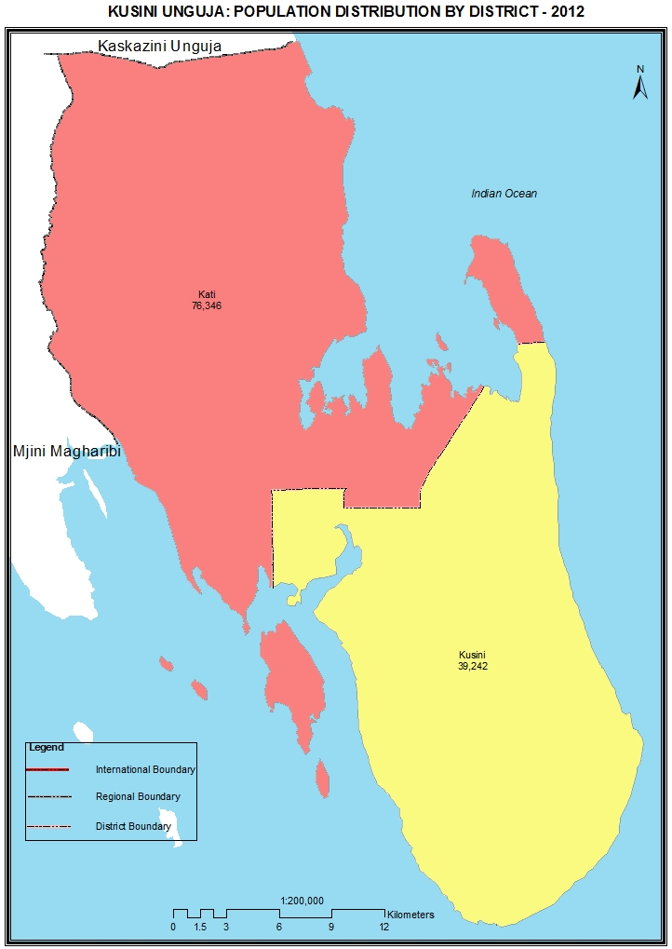

Table 52: Population of Kusini Unguja Region by Sex and Average Household Size and Sex Ratio
Serial No. | District/Council | Population (Number) |  |  | Average Household Size | Sex Ratio
Serial No. | District/Council | Total | Male | Female | Average Household Size | Sex Ratio
 | Total | 115,588 | 57,880 | 57,708 | 4.4 | 100
1 | Kati District | 76,346 | 38,538 | 37,808 | 4.5 | 102
2 | Kusini District | 39,242 | 19,342 | 19,900 | 4.2 | 97

Table 52. 1: Population of Kati District by Sex, Average Household Size and Sex Ratio
Serial No. | Ward/Shehia | Population (Number) |  |  | Average Household Size | Sex Ratio
Serial No. | Ward/Shehia | Total | Male | Female | Average Household Size | Sex Ratio
 | Total | 76,346 | 38,538 | 37,808 | 4.5 | 102
1 | Dunga Bweni | 2,808 | 1,369 | 1,439 | 4.5 | 95
2 | Ubago | 3,936 | 2,033 | 1,903 | 5.2 | 107
3 | Kidimni | 4,185 | 2,030 | 2,155 | 4.4 | 94
4 | Machui | 1,462 | 806 | 656 | 4.6 | 123
5 | Kiboje Mwembeshauri | 1,467 | 731 | 736 | 4.4 | 99
6 | Miwani | 2,310 | 1,116 | 1,194 | 4.7 | 93
7 | Kiboje Mkwajuni | 1,268 | 650 | 618 | 4.3 | 105
8 | Ghana | 1,869 | 974 | 895 | 4.0 | 109
9 | Koani | 3,091 | 1,507 | 1,584 | 4.8 | 95
10 | Mgeni Haji | 1,204 | 610 | 594 | 4.7 | 103
11 | Uzini | 944 | 447 | 497 | 4.3 | 90
12 | Mitakawani | 1,113 | 562 | 551 | 4.7 | 102
13 | Tunduni | 1,054 | 552 | 502 | 4.2 | 110
14 | Bambi | 3,028 | 1,575 | 1,453 | 4.6 | 108
15 | Pagali | 720 | 393 | 327 | 4.2 | 120
16 | Umbuji | 1,402 | 726 | 676 | 4.5 | 107
17 | Mchangani | 2,066 | 1,056 | 1,010 | 4.7 | 105
18 | Dunga Kiembeni | 1,938 | 998 | 940 | 4.6 | 106
19 | Ndijani Mseweni | 2,951 | 1,491 | 1,460 | 4.6 | 102
20 | Jendele | 1,939 | 936 | 1,003 | 4.5 | 93
21 | Chwaka | 3,196 | 1,569 | 1,627 | 4.4 | 96
22 | Marumbi | 1,167 | 590 | 577 | 4.2 | 102
23 | Uroa | 2,613 | 1,323 | 1,290 | 4.5 | 103
24 | Pongwe | 800 | 457 | 343 | 4.3 | 133
25 | Jumbi | 3,905 | 1,902 | 2,003 | 4.1 | 95
26 | Tunguu | 3,563 | 1,788 | 1,775 | 4.4 | 101
27 | Binguni | 1,378 | 729 | 649 | 4.6 | 112
28 | Cheju | 2,038 | 1,040 | 998 | 4.2 | 104
29 | Bungi | 2,518 | 1,241 | 1,277 | 4.7 | 97
30 | Unguja Ukuu Kaepwani | 1,563 | 796 | 767 | 4.6 | 104
31 | Kikungwi | 972 | 505 | 467 | 4.6 | 108
32 | Uzi | 1,801 | 919 | 882 | 4.0 | 104
33 | Ng'ambwa | 901 | 454 | 447 | 4.4 | 102
34 | Charawe | 954 | 485 | 469 | 4.4 | 103
35 | Ukongoroni | 896 | 447 | 449 | 4.8 | 100
36 | Michamvi | 1,572 | 895 | 677 | 4.1 | 132
37 | Mpapa | 1,746 | 819 | 927 | 4.8 | 88
38 | Unguja Ukuu Kaebona | 1,362 | 664 | 698 | 4.6 | 95
39 | Ndijani Mwembepunda | 1,486 | 761 | 725 | 4.7 | 105
40 | Tindini | 1,160 | 592 | 568 | 4.5 | 104

Table 52. 2: Population of Kusini District by Sex, Average Household Size and Sex Ratio
Serial No. | Ward/Shehia | Population (Number) |  |  | Average Household Size | Sex Ratio
Serial No. | Ward/Shehia | Total | Male | Female | Average Household Size | Sex Ratio
 | Total | 39,242 | 19,342 | 19,900 | 4.2 | 97
1 | Nganani | 2,050 | 949 | 1,101 | 4.3 | 86
2 | Kijini | 2,634 | 1,252 | 1,382 | 3.9 | 91
3 | Mzuri | 2,120 | 1,045 | 1,075 | 4.2 | 97
4 | Kajengwa | 2,313 | 1,112 | 1,201 | 3.9 | 93
5 | Jambiani Kikadini | 2,691 | 1,273 | 1,418 | 4.3 | 90
6 | Mtende | 1,330 | 656 | 674 | 3.4 | 97
7 | Kibuteni | 482 | 260 | 222 | 3.9 | 117
8 | Kizimkazi Dimbani | 1,760 | 898 | 862 | 3.7 | 104
9 | Kizimkazi Mkunguni | 2,617 | 1,243 | 1,374 | 4.4 | 90
10 | Muyuni 'A' | 1,028 | 524 | 504 | 4.3 | 104
11 | Muyuni ' B ' | 934 | 467 | 467 | 4.0 | 100
12 | Muyuni ' C ' | 811 | 407 | 404 | 4.4 | 101
13 | Pete | 1,420 | 708 | 712 | 4.4 | 99
14 | Muungoni | 1,629 | 858 | 771 | 4.6 | 111
15 | Paje | 3,245 | 1,643 | 1,602 | 4.3 | 103
16 | Jambiani Kibigija | 3,369 | 1,621 | 1,748 | 4.3 | 93
17 | Bwejuu | 2,050 | 977 | 1,073 | 4.3 | 91
18 | Kitogani | 1,128 | 597 | 531 | 4.6 | 112
19 | Kiongoni | 1,106 | 526 | 580 | 3.9 | 91
20 | Tasani | 1,519 | 768 | 751 | 4.3 | 102
21 | Dongwe | 3,006 | 1,558 | 1,448 | 4.4 | 108
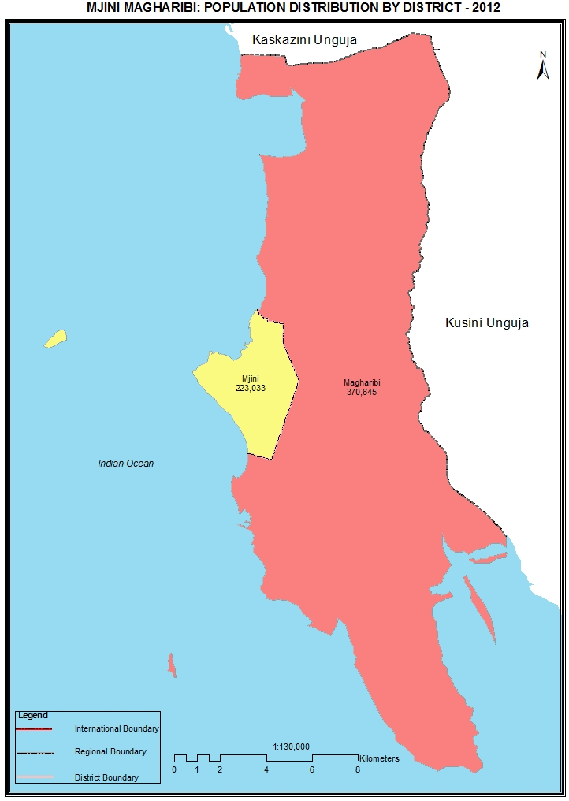

Table 53: Population of Mjini Magharibi Region by Sex and Average Household Size and Sex Ratio
Serial No. | District/Council | Population (Number) |  |  | Average Household Size | Sex Ratio
Serial No. | District/Council | Total | Male | Female | Average Household Size | Sex Ratio
 | Total | 593,678 | 283,590 | 310,088 | 5.2 | 91
1 | Magharibi District | 370,645 | 176,979 | 193,666 | 5.2 | 91
2 | Mjini District | 223,033 | 106,611 | 116,422 | 5.3 | 92

Table 53. 1: Population of Magharibi District by Sex, Average Household Size and Sex Ratio
Serial No. | Ward/Shehia | Population (Number) |  |  | Average Household Size | Sex Ratio
Serial No. | Ward/Shehia | Total | Male | Female | Average Household Size | Sex Ratio
 | Total | 370,645 | 176,979 | 193,666 | 5.2 | 91
1 | Mwera | 10,238 | 4,914 | 5,324 | 5.1 | 92
2 | Mtoni | 6,571 | 3,160 | 3,411 | 5.4 | 93
3 | Bububu | 15,666 | 7,273 | 8,393 | 5.4 | 87
4 | Chuini | 6,158 | 2,868 | 3,290 | 4.8 | 87
5 | Kama | 2,921 | 1,450 | 1,471 | 5.3 | 99
6 | Mfenesini | 2,803 | 1,316 | 1,487 | 5.0 | 89
7 | Mwakaje | 2,907 | 1,490 | 1,417 | 4.6 | 105
8 | Fuoni Kibondeni | 15,400 | 7,468 | 7,932 | 5.0 | 94
9 | Kianga | 9,908 | 4,759 | 5,149 | 5.0 | 92
10 | Dole | 3,933 | 2,079 | 1,854 | 4.8 | 112
11 | Kizimbani | 3,304 | 1,683 | 1,621 | 4.8 | 104
12 | Mbuzini | 5,856 | 2,810 | 3,046 | 4.7 | 92
13 | Bumbwisudi | 2,269 | 1,124 | 1,145 | 4.6 | 98
14 | Maungani | 4,048 | 1,984 | 2,064 | 4.8 | 96
15 | Shakani | 2,760 | 1,351 | 1,409 | 4.4 | 96
16 | Kiembesamaki | 11,760 | 5,548 | 6,212 | 4.8 | 89
17 | Chukwani | 8,298 | 4,042 | 4,256 | 4.9 | 95
18 | Fumba | 981 | 492 | 489 | 4.2 | 101
19 | Bweleo | 971 | 488 | 483 | 4.3 | 101
20 | Dimani | 2,052 | 1,019 | 1,033 | 4.3 | 99
21 | Kombeni | 3,162 | 1,580 | 1,582 | 4.6 | 100
22 | Mwanakwerekwe | 20,215 | 9,530 | 10,685 | 5.4 | 89
23 | Mto Pepo | 16,440 | 7,968 | 8,472 | 5.7 | 94
24 | Magogoni | 14,928 | 7,215 | 7,713 | 5.7 | 94
25 | Mtoni Kidatu | 16,612 | 8,029 | 8,583 | 5.5 | 94
26 | Mwanyanya | 9,683 | 4,548 | 5,135 | 5.5 | 89
27 | Fuoni Kijitoupele | 19,374 | 8,944 | 10,430 | 4.9 | 86
28 | Tomondo | 23,254 | 11,019 | 12,235 | 5.5 | 90
29 | Welezo | 13,119 | 6,360 | 6,759 | 5.7 | 94
30 | Mtufaani | 9,123 | 4,424 | 4,699 | 4.8 | 94
31 | Sharifu Msa | 4,975 | 2,395 | 2,580 | 5.5 | 93
32 | Kibweni | 7,115 | 3,321 | 3,794 | 5.4 | 88
33 | Kihinani | 14,139 | 6,688 | 7,451 | 5.1 | 90
34 | Mombasa | 14,492 | 6,806 | 7,686 | 5.5 | 89
35 | Kisauni | 9,331 | 4,441 | 4,890 | 4.9 | 91
36 | Meli nne | 16,984 | 8,032 | 8,952 | 5.3 | 90
37 | Pangawe | 26,275 | 12,164 | 14,111 | 5.0 | 86
38 | Kinuni | 11,333 | 5,527 | 5,806 | 5.4 | 95
39 | Nyamanzi | 1,287 | 670 | 617 | 4.7 | 109

Table 53. 2: Population of Mjini District by Sex, Average Household Size and Sex Ratio
Serial No. | Ward/Shehia | Population (Number) |  |  | Average Household Size | Sex Ratio
Serial No. | Ward/Shehia | Total | Male | Female | Average Household Size | Sex Ratio
 | Total | 223,033 | 106,611 | 116,422 | 5.3 | 92
1 | Shangani | 3,886 | 1,910 | 1,976 | 5.1 | 97
2 | Mkunazini | 3,308 | 1,573 | 1,735 | 5.1 | 91
3 | Kiponda | 1,654 | 819 | 835 | 5.0 | 98
4 | Malindi | 3,204 | 1,719 | 1,485 | 4.9 | 116
5 | Mchangani | 2,211 | 1,016 | 1,195 | 5.0 | 85
6 | Mlandege | 2,070 | 946 | 1,124 | 4.9 | 84
7 | Mwembeladu | 2,954 | 1,376 | 1,578 | 5.6 | 87
8 | Gulioni | 2,488 | 1,186 | 1,302 | 5.4 | 91
9 | Makadara | 5,048 | 2,342 | 2,706 | 5.3 | 87
10 | Shaurimoyo | 8,335 | 3,927 | 4,408 | 5.5 | 89
11 | Mwembemakumbi | 8,354 | 3,945 | 4,409 | 5.7 | 89
12 | Chumbuni | 10,925 | 5,198 | 5,727 | 5.9 | 91
13 | Kwamtipura | 11,572 | 5,575 | 5,997 | 5.8 | 93
14 | Kilimahewa Juu | 4,714 | 2,341 | 2,373 | 5.4 | 99
15 | Amani | 6,156 | 2,880 | 3,276 | 5.1 | 88
16 | Nyerere | 9,657 | 4,618 | 5,039 | 5.4 | 92
17 | Sebleni | 5,102 | 2,450 | 2,652 | 5.7 | 92
18 | Magomeni | 6,165 | 2,906 | 3,259 | 5.4 | 89
19 | Mpendae | 13,252 | 6,362 | 6,890 | 5.5 | 92
20 | Urusi | 7,532 | 3,656 | 3,876 | 5.0 | 94
21 | Kilimani | 2,911 | 1,420 | 1,491 | 4.6 | 95
22 | Miembeni | 6,095 | 3,023 | 3,072 | 5.1 | 98
23 | Kikwajuni Juu | 2,408 | 1,062 | 1,346 | 5.0 | 79
24 | Kikwajuni Bondeni | 2,257 | 1,061 | 1,196 | 4.7 | 89
25 | Kisimamajongoo | 2,615 | 1,251 | 1,364 | 5.1 | 92
26 | Vikokotoni | 1,872 | 918 | 954 | 5.1 | 96
27 | Mwembetanga | 2,610 | 1,167 | 1,443 | 4.9 | 81
28 | Mwembeshauri | 1,933 | 894 | 1,039 | 5.1 | 86
29 | Rahaleo | 1,950 | 926 | 1,024 | 4.9 | 90
30 | Kwaalimsha | 3,479 | 1,630 | 1,849 | 5.1 | 88
31 | Mikunguni | 2,984 | 1,361 | 1,623 | 5.1 | 84
32 | Mkele | 7,140 | 3,394 | 3,746 | 5.2 | 91
33 | Muungano | 5,304 | 2,492 | 2,812 | 5.1 | 89
34 | Sogea | 4,801 | 2,295 | 2,506 | 4.9 | 92
35 | Jang'ombe | 6,122 | 2,945 | 3,177 | 5.0 | 93
36 | Kidongo Chekundu | 2,290 | 1,073 | 1,217 | 5.2 | 88
37 | Matarumbeta | 2,711 | 1,260 | 1,451 | 4.7 | 87
38 | Kwahani | 4,815 | 2,337 | 2,478 | 4.7 | 94
39 | Kwaalinatu | 5,438 | 2,680 | 2,758 | 4.9 | 97
40 | Karakana | 8,610 | 4,076 | 4,534 | 5.9 | 90
41 | Kilimahewa Bondeni | 5,116 | 2,390 | 2,726 | 5.2 | 88
42 | Kwa Wazee | 6,454 | 3,063 | 3,391 | 5.3 | 90
43 | Migombani | 7,164 | 3,674 | 3,490 | 5.7 | 105
44 | Meya | 5,777 | 2,755 | 3,022 | 5.3 | 91
45 | Kisiwandui | 1,590 | 719 | 871 | 4.9 | 83

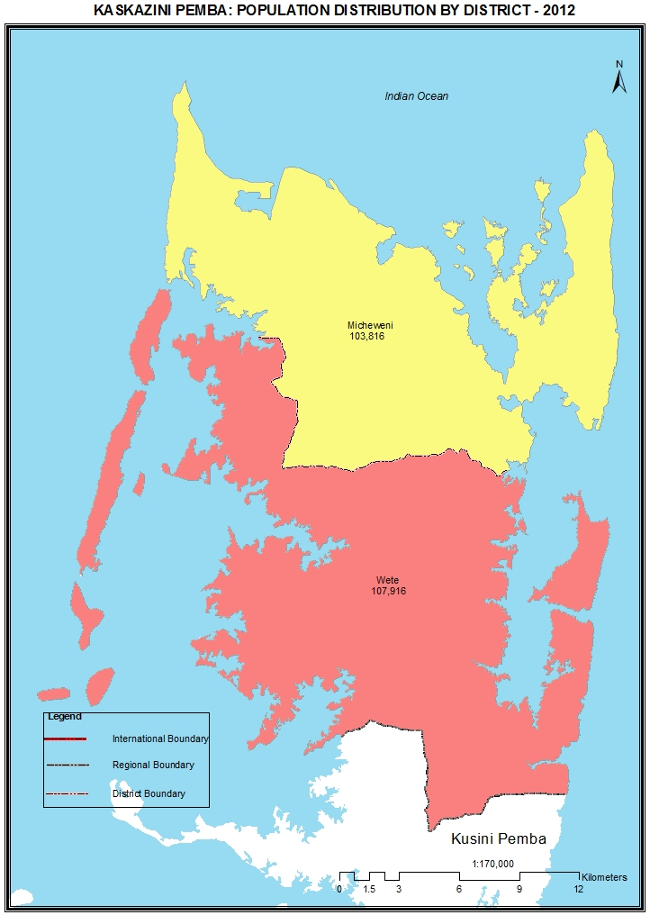

Table 54: Population of Kaskazini Pemba Region by Sex and Average Household Size and Sex Ratio
Serial No. | District/Council | Population (Number) |  |  | Average Household Size | Sex Ratio
Serial No. | District/Council | Total | Male | Female | Average Household Size | Sex Ratio
 | Total | 211,732 | 103,222 | 108,510 | 5.3 | 95
1 | Wete District | 107,916 | 52,348 | 55,568 | 5.3 | 94
2 | Micheweni District | 103,816 | 50,874 | 52,942 | 5.3 | 96

Table 54. 1: Population of Wete District by Sex, Average Household Size and Sex Ratio
Serial No. | Ward/Shehia | Population (Number) |  |  | Average Household Size | Sex Ratio
Serial No. | Ward/Shehia | Total | Male | Female | Average Household Size | Sex Ratio
 | Total | 107,916 | 52,348 | 55,568 | 5.3 | 94
1 | Kipangani | 4,241 | 2,053 | 2,188 | 5.3 | 94
2 | Mtambwe Kaskazini | 5,417 | 2,638 | 2,779 | 5.3 | 95
3 | Fundo | 1,625 | 816 | 809 | 5.1 | 101
4 | Mchanga Mdogo | 3,280 | 1,569 | 1,711 | 5.6 | 92
5 | Kambini | 3,344 | 1,609 | 1,735 | 5.4 | 93
6 | Kojani | 2,358 | 1,165 | 1,193 | 5.0 | 98
7 | Ole | 7,018 | 3,384 | 3,634 | 5.4 | 93
8 | Kangagani | 3,135 | 1,503 | 1,632 | 5.3 | 92
9 | Kiuyu Minungwini | 3,133 | 1,579 | 1,554 | 5.5 | 102
10 | Piki | 3,274 | 1,582 | 1,692 | 5.1 | 93
11 | Kisiwani | 3,236 | 1,611 | 1,625 | 5.3 | 99
12 | Gando | 2,210 | 1,111 | 1,099 | 5.1 | 101
13 | Ukunjwi | 2,769 | 1,379 | 1,390 | 5.2 | 99
14 | Pandani | 5,895 | 2,835 | 3,060 | 5.2 | 93
15 | Shengejuu | 1,753 | 863 | 890 | 5.3 | 97
16 | Bopwe | 5,212 | 2,450 | 2,762 | 5.5 | 89
17 | Utaani | 3,829 | 1,762 | 2,067 | 5.3 | 85
18 | Mtambwe Kusini | 3,791 | 1,901 | 1,890 | 5.1 | 101
19 | Selem | 2,603 | 1,196 | 1,407 | 5.4 | 85
20 | Kinyikani | 2,296 | 1,106 | 1,190 | 5.6 | 93
21 | Chwale | 1,698 | 838 | 860 | 5.3 | 97
22 | Maziwani | 2,051 | 976 | 1,075 | 5.4 | 91
23 | Mpambani | 2,178 | 1,104 | 1,074 | 5.0 | 103
24 | Mjini Ole | 3,531 | 1,744 | 1,787 | 5.5 | 98
25 | Kiuyu Kigongoni | 2,703 | 1,332 | 1,371 | 5.5 | 97
26 | Mzambarauni Takao | 2,001 | 983 | 1,018 | 5.1 | 97
27 | Junguni | 2,547 | 1,257 | 1,290 | 5.0 | 97
28 | Kiungoni | 3,112 | 1,513 | 1,599 | 5.2 | 95
29 | Pembeni | 1,689 | 844 | 845 | 5.6 | 100
30 | Kizimbani | 5,875 | 2,826 | 3,049 | 5.5 | 93
31 | Limbani | 3,919 | 1,897 | 2,022 | 5.5 | 94
32 | Jadida | 6,193 | 2,922 | 3,271 | 5.4 | 89

Table 54. 2: Population of Micheweni District by Sex, Average Household Size and Sex Ratio
Serial No. | Ward/Shehia | Population (Number) |  |  | Average Household Size | Sex Ratio
Serial No. | Ward/Shehia | Total | Male | Female | Average Household Size | Sex Ratio
 | Total | 103,816 | 50,874 | 52,942 | 5.3 | 96
1 | Micheweni | 6,197 | 3,134 | 3,063 | 5.5 | 102
2 | Msuka Mashariki | 4,260 | 2,018 | 2,242 | 5.1 | 90
3 | Kinowe | 4,380 | 2,096 | 2,284 | 5.3 | 92
4 | Tumbe Mashariki | 4,679 | 2,292 | 2,387 | 5.4 | 96
5 | Mgogoni | 2,482 | 1,235 | 1,247 | 5.3 | 99
6 | Shumba Viamboni | 2,580 | 1,238 | 1,342 | 5.3 | 92
7 | Finya | 2,608 | 1,251 | 1,357 | 5.5 | 92
8 | Konde | 8,573 | 4,106 | 4,467 | 5.4 | 92
9 | Wingwi Mapofu | 4,504 | 2,194 | 2,310 | 5.4 | 95
10 | Kiuyu Mbuyuni | 6,416 | 3,089 | 3,327 | 5.3 | 93
11 | Makangale | 2,645 | 1,348 | 1,297 | 5.9 | 104
12 | Wingwi Njuguni | 2,052 | 984 | 1,068 | 5.5 | 92
13 | Shumba Mjini | 4,763 | 2,412 | 2,351 | 5.3 | 103
14 | Majenzi | 2,370 | 1,166 | 1,204 | 5.6 | 97
15 | Mjini Wingwi | 4,521 | 2,305 | 2,216 | 5.3 | 104
16 | Msuka Magharibi | 4,274 | 2,094 | 2,180 | 5.5 | 96
17 | Chimba | 3,080 | 1,567 | 1,513 | 5.1 | 104
18 | Tumbe Magharibi | 4,228 | 2,077 | 2,151 | 5.3 | 97
19 | Sizini | 5,284 | 2,586 | 2,698 | 5.6 | 96
20 | Kinyasini | 3,188 | 1,541 | 1,647 | 5.4 | 94
21 | Mihogoni | 2,596 | 1,259 | 1,337 | 5.4 | 94
22 | Kifundi | 2,796 | 1,363 | 1,433 | 5.3 | 95
23 | Maziwa Ng'ombe | 5,820 | 2,859 | 2,961 | 5.0 | 97
24 | Tondooni | 2,705 | 1,335 | 1,370 | 5.6 | 97
25 | Mtemani | 3,017 | 1,461 | 1,556 | 5.0 | 94
26 | Wingwi Mjananza | 1,702 | 856 | 846 | 5.1 | 101
27 | Mlindo | 2,096 | 1,008 | 1,088 | 5.4 | 93

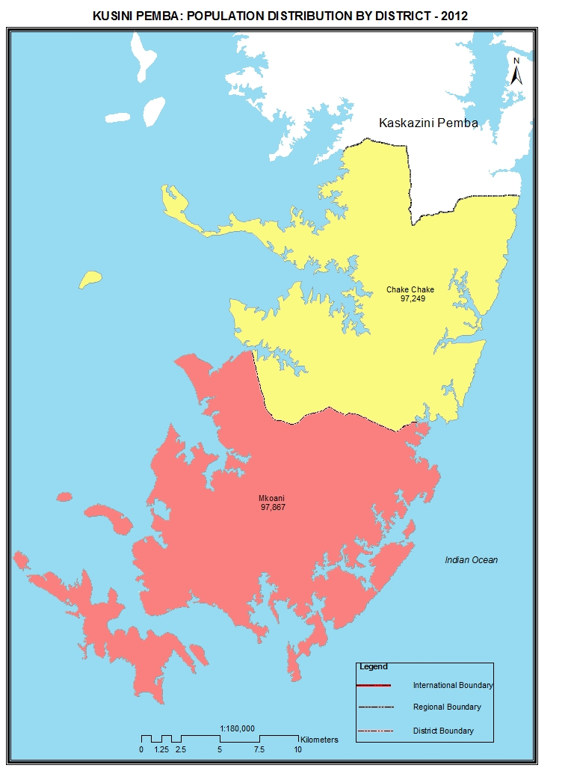

Table 55: Population of Kusini Pemba Region by Sex and Average Household Size and Sex Ratio
Serial No. | District/Council | Population (Number) |  |  | Average Household Size | Sex Ratio
Serial No. | District/Council | Total | Male | Female | Average Household Size | Sex Ratio
 | Total | 195,116 | 93,871 | 101,245 | 5.4 | 93
1 | Chake Chake District | 97,249 | 46,411 | 50,838 | 5.5 | 91
2 | Mkoani District | 97,867 | 47,460 | 50,407 | 5.4 | 94

Table 55. 1: Population of Chake Chake District by Sex, Average Household Size and Sex Ratio
Serial No. | Ward/Shehia | Population (Number) |  |  | Average Household Size | Sex Ratio
Serial No. | Ward/Shehia | Total | Male | Female | Average Household Size | Sex Ratio
 | Total | 97,249 | 46,411 | 50,838 | 5.5 | 91
1 | Chanjaani | 3,311 | 1,560 | 1,751 | 5.7 | 89
2 | Wawi | 5,615 | 2,690 | 2,925 | 5.5 | 92
3 | Pujini | 4,066 | 1,980 | 2,086 | 5.6 | 95
4 | Ziwani | 4,023 | 1,892 | 2,131 | 5.2 | 89
5 | Ndagoni | 3,905 | 1,875 | 2,030 | 5.4 | 92
6 | Kwale | 3,780 | 1,835 | 1,945 | 5.5 | 94
7 | Vitongoji | 4,517 | 2,175 | 2,342 | 5.2 | 93
8 | Ng'ambwa | 6,133 | 2,901 | 3,232 | 5.6 | 90
9 | Shungi | 2,488 | 1,235 | 1,253 | 5.9 | 99
10 | Chonga | 3,319 | 1,560 | 1,759 | 5.3 | 89
11 | Mgelema | 1,250 | 640 | 610 | 5.5 | 105
12 | Kilindi | 3,947 | 1,923 | 2,024 | 5.5 | 95
13 | Tibirinzi | 4,041 | 1,923 | 2,118 | 5.9 | 91
14 | Chachani | 974 | 467 | 507 | 5.0 | 92
15 | Wara | 3,930 | 1,765 | 2,165 | 5.3 | 82
16 | Mvumoni | 2,463 | 1,141 | 1,322 | 5.4 | 86
17 | Matale | 3,912 | 1,970 | 1,942 | 5.8 | 101
18 | Wesha | 3,893 | 1,874 | 2,019 | 5.7 | 93
19 | Uwandani | 2,632 | 1,282 | 1,350 | 5.5 | 95
20 | Madungu | 4,252 | 1,943 | 2,309 | 5.6 | 84
21 | Mgogoni | 2,598 | 1,209 | 1,389 | 5.4 | 87
22 | Dodo | 4,268 | 2,110 | 2,158 | 5.5 | 98
23 | Mbuzini | 2,919 | 1,428 | 1,491 | 5.5 | 96
24 | Michungwani | 2,457 | 1,208 | 1,249 | 5.7 | 97
25 | Kibokoni | 2,584 | 1,263 | 1,321 | 5.4 | 96
26 | Kichungwani | 2,158 | 959 | 1,199 | 5.7 | 80
27 | Msingini | 2,305 | 1,025 | 1,280 | 5.2 | 80
28 | Mkoroshoni | 3,473 | 1,596 | 1,877 | 5.8 | 85
29 | Mfikiwa | 2,036 | 982 | 1,054 | 5.1 | 93

Table 55. 2: Population of Mkoani District by Sex, Average Household Size and Sex Ratio
Serial No. | Ward/Shehia | Population (Number) |  |  | Average Household Size | Sex Ratio
Serial No. | Ward/Shehia | Total | Male | Female | Average Household Size | Sex Ratio
 | Total | 97,867 | 47,460 | 50,407 | 5.4 | 94
1 | Ng'ombeni | 3,159 | 1,507 | 1,652 | 4.9 | 91
2 | Makombeni | 1,846 | 858 | 988 | 5.5 | 87
3 | Makoongwe | 1,453 | 705 | 748 | 5.2 | 94
4 | Shidi | 982 | 481 | 501 | 5.1 | 96
5 | Mkanyageni | 3,168 | 1,465 | 1,703 | 5.1 | 86
6 | Michenzani | 2,932 | 1,393 | 1,539 | 4.9 | 91
7 | Chokocho | 4,539 | 2,221 | 2,318 | 5.1 | 96
8 | Kisiwa Panza | 3,087 | 1,534 | 1,553 | 4.9 | 99
9 | Kangani | 3,995 | 1,911 | 2,084 | 5.4 | 92
10 | Kengeja | 6,967 | 3,253 | 3,714 | 5.3 | 88
11 | Muambe | 6,662 | 3,260 | 3,402 | 5.6 | 96
12 | Kiwani | 3,026 | 1,491 | 1,535 | 5.4 | 97
13 | Mtambile | 4,890 | 2,299 | 2,591 | 5.3 | 89
14 | Mizingani | 1,628 | 825 | 803 | 5.8 | 103
15 | Ngwachani | 3,110 | 1,501 | 1,609 | 5.7 | 93
16 | Chambani | 6,096 | 2,984 | 3,112 | 5.3 | 96
17 | Wambaa | 3,271 | 1,608 | 1,663 | 5.6 | 97
18 | Mbuguani | 1,725 | 832 | 893 | 5.7 | 93
19 | Uweleni | 2,539 | 1,192 | 1,347 | 5.3 | 88
20 | Mtangani | 3,198 | 1,621 | 1,577 | 5.9 | 103
21 | Ukutini | 2,747 | 1,299 | 1,448 | 5.3 | 90
22 | Chumbageni | 2,579 | 1,328 | 1,251 | 5.7 | 106
23 | Mbuyuni | 1,883 | 932 | 951 | 5.1 | 98
24 | Stahabu | 2,369 | 1,132 | 1,237 | 5.3 | 92
25 | Kuukuu | 2,126 | 1,029 | 1,097 | 5.3 | 94
26 | Mjimbini | 2,406 | 1,172 | 1,234 | 5.6 | 95
27 | Shamiani | 951 | 469 | 482 | 5.7 | 97
28 | Jombwe | 3,013 | 1,534 | 1,479 | 5.6 | 104
29 | Kendwa | 4,495 | 2,161 | 2,334 | 5.4 | 93
30 | Minazini | 1,463 | 722 | 741 | 5.3 | 97
31 | Mgagadu | 2,328 | 1,182 | 1,146 | 5.2 | 103
32 | Mkungu | 1,372 | 664 | 708 | 5.6 | 94
33 | Changaweni | 1,862 | 895 | 967 | 5.4 | 93

Collective households included
Njombe was part of Iringa and the 2012 projected population of Iringa region includes that of Njombe region
Katavi was part of Rukwa and the 2012 projected population of Rukwa region includes that of Katavi region
Simiyu was part of Shinyanga and Mwanza and the 2012 projected population of Shinyanga and Mwanza include that of Simiyu
Geita was part of Shinyanga, Mwanza and Kagera and the 2012 projected population of Kagera, Mwanza and Shinyanga includes that of Geita

