IMPROVING INCOME OF PEOPLE WITH DISABILITIES THROUGH SHOE-MAKING AND SEWING: THE CASE OF RANGENI GROUP IN SAME DISTRICT, KILIMANJARO REGION

ALLY S. MSUMI

A DISSERTATION SUBMITTED IN PARTIAL FULFILMENTOF THE REQUIREMENTS FOR THE DEGREE OF MASTER OF COMMUNITY ECONOMIC DEVELOPMENT (MCED)
DEPARTMENT OF ECONOMICS AND COMMUNITY ECONOMIC DEVELOPMENT
THE OPEN UNIVERSITY OF TANZANIA
2022
CERTIFICATION
The undersigned certifies that he has read and hereby recommends for the acceptance by the Open University of Tanzania a dissertation entitled; “Improving incomes of people with disabilities through shoe-making and sewing: the case of Rangeni group in Same District, Kilimanjaro Region” in partial fulfillment for the requirements of the award of Master of Community Economic Development (MCED).

…………………………..……
Dr. Noel Matemba
(Supervisor)

………………………………
Date

COPYRIGHT
No part of this dissertation may be reproduced and stored in any retrieval system or transmitted in any form or by any means of electronic, mechanical, photocopying or otherwise, without prior written permission of the author or from The Open University of Tanzania in that behalf

DECLARATION
I, Ally Shabani Msumi, declare that, the work presented in this dissertation is original. It has never been presented to any other University or Institution. Where other people’s works have been used, references have been provided. It is in this regard that I declare this work as originally mine. It is hereby presented in partial fulfillment for the requirements of the Masters in Community Economic Development (MCED).

………………………………….
Signature

………………… …………….
Date

DEDICATION
This work is dedicated to my lovely Children, My fellow colleagues from Same and Rangeni group members for the encouragement, emphasizes and their supports I received from them during my studies in Master in Community Economic Development. My special thanks to my brother Emmanuel Gabriel Jacob, Economist from Planning Department in Same District Council, for his tolerance and support. I received from him during my studies in order to pursue Master in Community Economic Development.

ACKNOWLEDGEMENTS
First of all I would like thank the almighty God for giving me strength and able mind that facilitate me to complete this study successfully. Through his presence and power I am able to reach this stage. Secondly, my heartfelt thanks go to Dr. Noel Matemba for his immense support, guidance, assistance, encouragement and critics that helped me to focus and execute this task. I am sincerely grateful to my beloved wife Mwantumu Bwenzi for her patience and tolerance during my studies. Her advice has always come in handy when needed, the love, care, moral and material support received from her made the entire journey of this study a pleasant and memorable one.

To my Head of Department, Community Development Department, Same District Council, Mr. Benedict Missani, for his patience he put during my study, I believe all of this hasn’t been in vain. I owe my gratitude to host organization Ishinde Youth Initiatives allowing me to work with them. In particular, I would like to thank Mr. Noel Kikwesha the Coordinator for, her heartily support and guidance all along the project period. Also my heart fully thanks to all staff of Ishinde Youth Initiatives for their endless support.

Lastly, my appreciation goes to Hedaru Ward Executive Officer, Community Development Officer, and Village Executive Officers for unconditional support and collaboration received from them throughout the project period. Also to the people of Same Community, for their willingness to work with me and readiness to see the changes in their community, from data collection phase to the identification and implementation of this project. Through their assistance my work was a bit easier.
ABSTRACT
This dissertation is an outcome of the research study conducted in Same District and the project being implemented in the Hedaru ward. The project intended at improving incomes of people with disabilities through shoe-making and sewing activities. The community under study was a group of people with disability of deaf and physical. It is a smallest homogeneous group of 10 members living/found in the smallest possible geographical location, sharing same needs (source of income) for them to survive and same approach/interventions in attaining their needs. It is poor and low income community ranged from Tsh.20, 000 to 60,000 per month. They are unemployed with education level ranges from standard seven to Certificate of Secondary Education. Their marital status varies from single to married. The project covers a period between October2021 to August2022. The participatory community assessment was conducted in the village using participatory methods and tools like Focus Group Discussions (FGD), semi-structured Interviews and Field visit surveys. About six major community needs emerged, which needed to be urgently addressed. The identified Community needs were need sustainable incomes, access to market, food vending, poultry keeping, tailoring and tri cycle (Bajaj riding business). Among the needs identified, sustainable sources of income ranked first, after further assessment of the causes of the need, shoe-making and sewing was identified as projects that will enable them increase their incomes through sale of shoes within and outside the District. The study concludes and recommends that extra strategic efforts is still required to capacitate the disabled communities on income generating activities such as the shoe making and sewing projects.
Keywords: Sustainable income, People with disability,community needs assessment.

TABLE OF CONTENTS
CERTIFICATION ii
COPYRIGHT iii
DECLARATION iv
DEDICATION v
ACKNOWLEDGEMENTS vi
ABSTRACT vii
TABLE OF CONTENTS viii
LIST OF TABLES xiii
LIST OF FIGURES xv
LIST OF ABBREVIATIONS xvi
CHAPTER ONE 1
PARTICIPATORY NEEDS ASSESSMENT 1
1.1 Background Information 1
1.2 Community Profile 3
1.3 Community Needs Assessment 3
1.3.1 Community needs Assessment Objectives 5
1.3.2 Overall objectives 5
1.3.3 Specific objectives 5
1.3.4 Community Needs Assessment Questions 5
1.3.5 Research design 6
1.3.6 Sample Size 6
1.3.7 Sampling Technique 7
1.4 Data Collection Methods 7
1.4.1 Key informant Interviews 7
1.4.2 Focus Group Discussions 7
1.5 Community Needs Assessment Findings 8
1.5.1 Demographic Characteristics of Respondents 8
1.5.2 Economic Activities Undertaken by the Community 10
1.5.3 Findings on the needs of the Community 12
1.5.4 Findings on Identification of Possible Interventions 12
1.5.5 Community Needs Prioritization 12
1.5.6 Community Project Intervention Prioritization 13
1.6 Conclusion 15
CHAPTER TWO 16
PROBLEM IDENTIFICATION 16
2.1 Research Problem Background 16
2.1.1 Situational Analysis of PWDs in Tanzania 17
2.2 Problem Statement 17
2.3 Project Description 18
2.3.1 Target Community 18
2.3.2 Stakeholders 19
2.3.3.1 Project Goals in CED Terms 19
2.3.3.2 Project Objectives 20
2.3.3.3 Specific Objectives 20
2.4 Profile of Host Organization 20
2.5 SWOT Analysis 20
CHAPTER THREE 22
LITERATURE REVIEW 22
3.1 Overview 22
3.2 Theories related to the Study 22
3.2.1 Classical Theories of Management Bureaucracy 22
3.2.2 Innovative Growth Theory of Joseph Schumpeter 23
3.2.3 Empirical Literature Review on PWDs 24
3.2.2 Innovative growth theory of Joseph Schumpeter 24
CHAPTER FOUR 26
PROJECT IMPLEMENTATION 26
4.1 Overview 26
4.2 Products and Outputs 26
4.3 Project Planning 26
4.3.1 Implementation Plan 27
4.3.2 Project Implementation Plan 27
4.3.3 Inputs 27
4.3.4 Project Staffing 30
4.4 Logical Framework 32
4.5 Implementation Report of the Project 34
4.5.1 Design of the Project and Formulation 35
4.5.2 Community training and Sensitization 36
4.5.3 Community Land Acquisition for Production Activities 36
4.5.4 Community Members Produce Pairs of Shoes Made 37
4.5.5 Community Member’s Product Sales And Banking 37
CHAPTER FIVE 40
PROJECT PARTICIPATORY MONITORING, EVALUATION AND SUSTAINABILITY 40
5.1 Introduction 40
5.2 Participatory Monitoring 40
5.2.1 Monitoring Information System 40
5.2.2 Participatory Monitoring Methods 43
5.2.3 Participatory Monitoring Plan 44
5.3 Participatory Evaluation 46
5.3.1 Performance Indicators 46
5.3.2 Participatory Evaluation Methods 46
5.3.3 The PRA Techniques 48
5.3.4 Project Evaluation summary 48
5.3.5 Actual Evaluation Conducted 51
5.3.5.1 Activities Evaluated Include 51
5.3.5.2 Direct Indicators 51
5.3.5.3 Indirect Indicators 51
5.3.5.4 The research methodology used to conduct evaluation 52
5.3.5.5 Presentation of results 53
5.4 Project Sustainability 54
5.4.1 Environmental Sustainability 54
5.4.2 Institutional Sustainability 54
5.4.3 Project Sustainability Elements 55
5.4.4 The Sustainability Plan 55
5.4.5 Political sustainability 55
5.4.6 Financial sustainability 55
CHAPTER SIX 56
PROJECT CONCLUSION AND RECOMMENDATION 56
6.1 Introduction 56
6.2 Conclusions and Recommendations 56
6.3 Recommendations 56
6.3.1 Recommendation for further studies 57
REFERENCES 58
APPENDICES 64

LIST OF TABLES
Table 1.1: Gender of Respondents 8
Table 1.2: Age of Respondents 9
Table 1.3: Marital status of respondents 9
Table 1.4: Education level of respondents 9
Table 1.5: Economic activities 10
Table 1.6: Most dependable activities 10
Table 1.7: Most Grown Food 11
Table 1.8: Dependable Livelihood keeping 11
Table 1.9: Average monthly Income 11
Table 1.10 Community needs 12
Table 1.11: Identification of possible interventions 12
Table 1.12: Pair-Wise Ranking Method for Needs Prioritization 13
Table 1.13: Pair-Wise Ranking Method for Needs Prioritization 14
Table 2.1: Stakeholder Analysis 19
Table 2.2: SWOT Analysis 21
Table 4.1: Project Implementation Plan 28
Table 4.2: Project Input 29
Table 4.3: Project Staffing Pattern 30
Table 4.4. Budget of the Project 31
Table 4.5: The Logical Framework of the Project 32
Table 4.6: Project Implementation Report 34
Table 5.1: Project Monitoring Information System 45
Table 5.2: Project Evaluation plan(Information System) 47
Table 5.3: Monitoring and Evaluation Plan (Information System) 49
Table 5.4: Evaluation summary report 52
Table 5.5: the presentation of the results 53

LIST OF FIGURES
Figure 4.1: Rangeni Group Members in Production Activities 35
Figure 4.2: Rangeni Group Members during Shoe making and sewing Activities 35
Figure 4.3: Photo with Rangeni Group Members 36
Figure 4.4: Various Design of Shoes Made by Rangeni disabled Group 37
Figure 4.5: Production Activities in Progress 38

LIST OF ABBREVIATIONS
CAN Community Needs Assessment
FGD Focus Group Discussion
KII Key Informant Interview
SPSS Statistical Package for Social Science
MCED Masters in Community Development
TDHS Tanzania Data for Health Survey
PRA Participatory Rural Appraisal
PWDs People With Disabilities
PIP Project Implementation Plan
NGO Non-Governmental Organization
PIR Project Implementation Report
UN United Nation
IGAS Income Generating Activities
ILO International Labor Organization
LGAS Local Government Authorities
WEO Ward Executive Officer
WHO World Health Organization
VEO Village Executive Office
SAIPRO Same Agricultural Irrigation Project
CHAWASA Chama Watu wenye Ulemavu Same

CHAPTER ONE

PARTICIPATORY NEEDS ASSESSMENT

Background Information
This study focused on improving income of community of PWD through shoe-making and sewing project. The target group namely Rangeni and is located at Hedaru Ward in Same District. Compared to other groups, peoples with disabilities are faring relatively poor, lacking support from potential stakeholders including government, as well as other development partners. The disabled people in Same District are among of the affected minority community in this context. They have low living standards as well as low income due to lack of sustainable income generating activities.

Success of the project would ensure not only an increase in their income but also a reduction of dependency ratio among PWDs. Therefore this project sought to address on improvement of income generating activities through technical skills imparted through the project establishment. According to 2012 census of people and residence Kilimanjaro region had 5,552 people with disability, 3,103 male and 2,448 female. Their disabilities vary from physical, deaf, and albinos. Same District constitute 37% of that Population.In many societies, including Tanzania, persons with disabilities are extremely poor and disadvantaged. According to World Health Organization (2011), disability is universal.

Everybody is likely to experience disability directly or to have a family member who experiences difficulties in functioning at some point in his or her life, particularly when they grow older. World Health Organization (2011) further recognizes disability as a global public health issue, a human rights issue and a development priority. Disability is a growth priority since of its greater prevalence in lower-income countries and as disability and poverty build up and preserve one another. Poverty rises the likelihood of impairments through malnutrition, poor health care, dangerous living conditions, working and travelling conditions. Disability may cause to a poorer standard of living and poverty over lack of access to education and employment, and through increased expenditure related to disability.

According to United Nations statistics of the year 2018, there are formerlyabove 600 million PWDs all over the world of whom 400 million live in developing countries and 80 million in Africa. A World Health Organization source upholds that around forty percent of Africa’s population consists of PWDs, including 10-15 percent of school-age children. This percentage would interpret into about 300 million people with disabilities in Africa. Disability is triggered by numerous factors, including malnutrition and disease, environmental hazards, traffic and industrial accidents, and civil conflict and war, and the number of people with disabilities continues to upturn.

Whilst largely agreed in the literature that disability and poverty are closely interweaved; PWDs are between the most marginalized in every society. They have basically been ignored and have not gained the benefits of the international human rights framework. They tend to be the last to be careful considered in human rights contexts regardless of a country’s economic situation. Hence PWDs have largely relied on the charity of others rather than trying to be contributing members of society. The study was conducted through Participatory Needs Assessment by requesting group or community members what they see as the most pressing needs.The mostly ranked needs were the ones that got addressed first. The exercise was preceded with situational analysis. Data were collected using unstructured interviews, focus group discussion and questionnaire.

1.2 Community Profile
The selected area of the study was Same District based on researcher’s residential area, financial status and time constraints. The community under study was a group of both deaf and physical disability. It is smallest homogeneous group of 10 members living/found in the smallest possible geographical location, sharing same needs (source of income) for them to survive and same approach/interventions in attaining their needs. It is poor and low income community ranged from Tsh.20, 000 to 60,000 per month. The main economic activities for their livelihood system depend on agriculture, livestock keeping and trading. They are unemployed with education level ranges from standard seven to Certificate of Secondary Education. Their marital status varies from single to married.

1.3 Community Needs Assessment (CNA)
There are several variables reasons for encouraging Community members to participate and determining their needs, challenges and prioritizing their needs and choosing the solutions of the use to address their needs. There are several reasons for the community to be inclusive, first Community members may have depth of knowledge about the challenges they face than we do and so will be better in identifying the underlying the causes of the challenges they face. Secondly, if they are engaged in the process of need identification and feel their voices have been heard, enable them develop sense of ownership of the process and outcome, this is where long term project sustainability come from.

Kiwanis International annual report (2022) suggests that the purpose of CNA is to identify a need or problem in a community review the resources available, assets identification and gather relevant data. Communities are diverse and we need to make sure that we are working with representative examples of their members, need assessment need to include people with disabilities as one of the common marginalized members in society.

CNA was carried out to obtain general demographic description of the Community such as bio-information (features that are given by nature and cannot change against demographic information (man-made eg. number of children) and socioeconomic information’s which include anything that is causing relationships that influence on income. Secondly was to obtain livelihood information system of the community such as source of income, kinds of employment, how people survive. Thirdly was the identification and prioritization of important Community needs and fourthly is was an identification and prioritization of important projects to meet.

CNA was executed at Hedaru ward under justifications that it is among the leading wards with large number of PWDs especially physical disability. According to Same District profile (2020), there were 1004 people with disability, 331 female and 673 male, in all 34 Wards of the District. Hedaru is leading with greatest number of PWDs of about 89 which is equivalent to 8.86% compared to the rest of 33 Wards, that on average had 20 to 29 number of PWDs. Basing on those figure, the researcher opted to conduct CNA at this ward. The CNA conducted in collaboration with the Ward Development Committee (WDC) Village Chairman, Ward Executive Officer, Ward and Village Extensions officers, stakeholders, host organization representatives, group of people with disabilities, Community members and Village Executive Officer.

1.3.1 Community needs Assessment Objectives

1.3.2 Broad Objective
The broad objective of this study was to improve income of a group of people with disabilities in Hedaru ward through shoe-making and sewing.

1.3.3 Specific Objectives
- To identify the major needs of people with disabilities in Hedaru ward
- To assess the income level of people with disabilities in Hedaru ward
- To identify income generating activities practiced by people with disabilities in Hedaru ward
- To explore possible interventions to improve income of people with disabilities in Hedaru ward.

1.3.4 Community Needs Assessment Questions
- What are the key needs of people with disabilities in Hedaru ward?
- What are the income levels of people with disabilities in Hedaru ward?
- What are the IGAs practiced by people with disabilities in Hedaru ward
- Which interventions can improve income of people with disabilities in Hedaru ward?

1.3.5 Research Design
The study adopted descriptive research design that incorporates quantitative and qualitative data. The population of people with disabilities who organized into group of 10 members known as Rangeni saved as the case study. It collected data that used to answer a wide range of what, how, when and where of the research questions. The researcher only observed and collects valid and reliable response and analyzed them without manipulation of the variables present. It enabled researcher to accurately define the population. Qualitative data used to gain an understanding of underlying reasons for low income facing people with disability through focus group discussion method meanwhile quantitative data emphasized objective measurement and numerical analysis of data collected through questionnaire.

1.3.6 Sample Size
Using total number of population of PWDs from Chomesuji division which comprised 7 Wards of Hedaru, Mabilioni, Gavao Saweni, Makanya, Chome, Suji and Tae. These wards had 131 disabled people in total, of which 78 male and 53 female. 10% of them was selected to participate in study which is equal to 13 respondents from the community of people with disability. On summing up with 11 key informants, the sample size was 24 respondents who participated in the study. This included village’s officials, extension officers, livelihood expert and experts from trade and finance departments. The roles of extension officers were to facilitate group members on information’s and advice in making better decisions to ensure availability of market and raw material from within and outside the study area.

1.3.7 Sampling Technique
Sampling design is about deciding who you are going to collect your data from (your sample). Non probability sampling was employed to recruit the respondents. The researcher used this method because of its less stringent, less expensive in terms of time and cost. In this study judgmental or purposive method applied. To determine key informants, purposive sampling was used.

1.4 Data Collection Methods
The Quantitative data were gathered through questionnaires, while Qualitative data was gathered through interviews and focus group discussions.

Key informant Interviews
KIIs were conducted to potential key informants familiar with the needs of disabled community. They included Ward Executive Officer, Village Executive Officer, Ward Councilor, District trade officer and host organization coordinator.

Focus Group Discussions
FGDs were conducted with Rangeni Disabled group. FGDs comprises of 8 to 12 participants and discussed themes feel under improvement of income particularly on shoe making and sewing. FGDs with 4 host organization representatives, 6 disabled group members and 2 women. The discussions were flexible, allowed participant to freely express their views and ideas. The FGDs session were carefully audio recorded and notes taking was also carefully done to ensure all the responses were captured.
      - Questionnaire
Questionnaires had a list of questions used to gather data from the respondents about their attitude, experience or opinions relating to sustainable income generation to people with disability.

1.4.4.2 Data Analysis Methods
Using SPSS, descriptive statistics were done and presentation made using frequency tables per specific objective. For the qualitative data, content analysis method was used. In analyzing qualitative data procedures included coding of the data, generating themes reviewing themes, categories and interpretations of findings.

1.5 Findings of Community Needs Assessment

1.5.1 Demographic Characteristics of Respondents

1.5.1.1 Gender
Table 1.1 presents results showing that males were majority (70.8 %) whereas minorities were females (29.2%)

Table 1.1: Gender of Respondents(N=24)
Respondents | Frequency | Percent | Valid Percent
Male | 17 | 70.8 | 70.8
Female | 7 | 29.2 | 29.2
Total | 24 | 100.00 | 100.00
Source: Researcher, (2022)

1.5.1.2 Age
The results show that majorityof PWDs were of age of 26 – 40 years old hence 54.1%, while those of age 15-25 were 20.8%
Table 1.2: Age of Respondents (N=24)
Respondents | Frequency | Percent | Valid Percent
15-25 | 5 | 20.8 | 20.8
26-40 | 13 | 54.1 | 54.1
41-56 | 3 | 12.5 | 12.5
Above 60 | 3 | 12.5 | 12.5
Total | 24 | 100.0 | 100.0
Source: Researcher, (2022)

1.5.1.3Marital Status of Respondents (N=24)
Results show that majority of respondents have married by 50% while those not yet married were 33.3% as shown in the table 1.3

Table 1.3: Marital Status of Respondents (N=24)
Respondents | Frequency | Percent | Valid Percent
Married | 12 | 50.0 | 50.0
Not married | 8 | 33.3 | 33.3
Widow | 3 | 12.5 | 12.5
Widower | 1 | 4.1 | 4.1
Total | 24.0 | 100.0 | 100.0
Source: Researcher, (2022)

1.5.1.4 Education Level
Table 1.4: Education Level of Respondents (N=24)
Respondents | Frequency | Percent | Valid Percent
Primary School Education | 14 | 58.3 | 58.3
Secondary School Education | 3 | 12.5 | 12.5
College | 3 | 12.5 | 12.5
Technical Education | 4 | 16.6 | 16.6
Uneducated | 0 | 0 | 0
Total | 24 | 100.0 | 100.0
Source: Researcher, (2022)

Results show that majority of respondents have attained primary level education which (58.3%) next to that category, followed those with technical education level (16.6%) and secondary and college (12.5% each) this results implies that majority of respondents have Primary level of education, hence the need for capacity building.

1.5.2 Community’s Economic Activities
The survey findings indicate that, the dominant economic activity was shoe making and sewing that reported by 66.7% of the respondents followed by tailoring 25% and then food vendor that reported 8.3%.

Table 1.5: Economic activities (N=24)
Respondents | Frequency | Percent | Valid Percent
Food vendor | 2 | 8.3 | 8.3
Tailoring | 6 | 25 | 25
Shoe making and sewing | 16 | 66.7 | 66.7
Total | 24 | 100.0 | 100.0
Source: Researcher, (2022)

Findings show that shoe making ranked first 75.0% while petty business were 25.0%. The implication is that shoe making dominates in dependency hence an obligation to the researcher in empowering the PWDs Community to execute shoe making and sewing project. Findings are presented in table 1.6

Table 1.6: Most Dependable Activities (N=24)
Respondents | Frequency | Percentage | Valid Percent
Shoe making | 18 | 75 | 75
Business | 6 | 25 | 25
Total | 24 | 100.0 | 100.00
Source: Researcher, (2022)

Findings as presented from table 1.7 below showed maize ranked first, being grown by 79.2% followed by beans 12.5% while banana was 8.3%. The implications of these findings is that, people with disability being part of the community that grows maize at large, they should be involved in agricultural production as well as food security aspect, though they will not participate directly in field but they can hire cheap labor to work on behalf. Employing cheap labor requires has financial cost implication. Therefore successful shoe making project managed to generate cash that covered the required cost.

Table 1.7: Most Grown Food (N=24)
Respondents | Frequency | Percentage | Valid Percent
Beans | 3 | 12.5 | 12.5
Maize | 19 | 79.2 | 79.2
Banana | 2 | 8.3 | 8.3
Total | 24 | 100.0 | 100.0
Source: Researcher, (2022)

Results in table 1.8 show that breeding ranks as a second livelihood constituting 12.5 percent. The leading livelihood is shoe making constituting 70.8%.

Table 1.8 Popular Livelihood (N=24)
Respondents (Tsh.) | Frequency | Percentage | Valid Percent
Food vendors | 2 | 8.3 | 8.3
Fishing | 2 | 8.3 | 8.3
Breeding | 3 | 12.5 | 12.5
Shoe making | 17 | 70.8 | 70.8
Total | 24 | 100.0 | 100.0
Source: Researcher, (2022)

Findings show that 83.3% of respondents fall under Tsh. 21,000 – 40,000 and then 12.5% fall under 0– 20,000 Tshs. while Tsh. 41,000 – 60,000 constitutes 4.2%.

Table 1.9: Average Monthly Income (N=24)
Respondents(Tsh) | Frequency | Percentage | Valid Percent
0-20,000 | 3 | 12.5 | 12.5
21,000-40,000 | 20 | 83.3 | 83.3
41,000-60,000 | 1 | 4.2 | 4.2
Total | 24 | 100.0 | 100.0
Source: Researcher, (2022)

1.5.3 Findings on the needs of the Community
Results show that majority of the respondent’s lack of sustainable income by 87.5% hence it was the main problem of the community.

Table 1.10 Community Needs (N=24)
Respondents(Tsh) | Frequency | Percentage | Valid Percent
Lack of Sustainable Incomes | 21 | 87.5 | 87.5
Lack of Clean Water | 2 | 8.3 | 8.3
Poor Health Services | 1 | 4.1 | 4.1
Total | 24 | 100.0 | 100.0
Source: Researcher, (2022)

1.5.4 Findings on Identification of Possible Interventions
Findings indicate that 50% anticipate on training on shoe making 16.7% expect on shoe making based on improved produce market accessibility and 12.2% expect on shoe making based on improved technique.

Table 1.11: Identification of Possible Interventions (N=24)
Respondents | frequency | Percentage | Valid Percent
Availability of credit to shoe makers | 3 | 12.5 | 12.5
Availability of improved leather equipment’s | 2 | 8.3 | 8.3
Shoe making based on improved techniques | 3 | 12.5 | 12.5
Frequent provision of shoe making training | 12 | 50 | 50
Improved produce market accessibility | 4 | 16.7 | 16.7
Total | 24 | 100.0 | 100.0
Source: Researcher, (2022)

1.5.5 Community Needs Prioritization
The most pressing needs of community were identified through focus group discussion, where by host organization was also invited. In this exercise six possible needs were listed, ranked and prioritized. The listed needs were the availability of
sustainable source of income, access to market, food vending business, poultry keeping, tailoring, and tricycle riding. By using pairwise matrix ranking as indicated in table number 12 below, sustainable source of income ranked number one whereas the second was access to market, followed by food vending business, which ranked number three, then poultry keeping, tailoring and finally tricycle riding (bajaji).

Table 1.12: Pair-Wise Ranking Method for Needs Prioritization
 | Sustainable Income | Access to market | Access to market | Poultry keeping | Poultry keeping | Bajaji | Score | Ranks
Sustainable Income |  | Sustainable Income | Sustainable Income | Sustainable Income | Sustainable Income | Sustainable Income | 5 | 1
Access to market |  |  | Access to market | Access to market | Access to market | Access to market | 4 | 2
Food vending |  |  |  | Food vending | Food vending | Food vending | 3 | 3
Poultry keeping |  |  |  |  | Poultry keeping | Poultry keeping | 3 | 4
Tailoring |  |  |  |  |  | Tailoring | 1 | 5
Bajaji |  |  |  |  |  |  | 0 | 6
Source: Research Findings (2022)

1.5.6 Community Project Intervention Prioritization
The most pressing need identified above was addressed through list of proposed interventions through Focus group discussion and interview. The interventions were stated, prioritized and ranked so as to explore the deserved project to be implemented. The listed interventions were utensils selling and repair, tricycle riding, belts and wallets making, shoe making and sewing and paper making. Projects prioritization was accompanied through Pair-Wise Ranking Method as shown in table 13 below:

Table 1.13: Pair-Wise Ranking Method for Project Prioritization
 | Shoe making and sewing | Belts and wallets making | Tricycle riding | Utensils selling and repair | Paper making | Score | Ranks
Shoe making and sewing |  | Shoe making and sewing | Shoe making and sewing | Shoe making and sewing | Shoe making and sewing | 4 | 1
Belts and wallets making |  |  | Belts and wallets making | Belts and wallets making | Belts and wallets making | 3 | 2
Tricycle riding(bajaji) |  |  |  | Tricycle riding(bajaji | Tricycle riding(bajaji | 2 | 3
Utensils selling and repair |  |  |  |  | Paper making | 1 | 4
Paper-making |  |  |  |  |  | 0 | 5
Source: Research Findings (2022)

By using pairwise matrix ranking as indicated in table number 13 above, shoe making and sewing scored highest (4 marks) hence ranked as number one project, belts and wallets making scored (3 marks) and ranked as the second proposed project, triccle riding scored (2 marks) and ranked as third proposed project whereas utensils selling and repair scored (1 mark) and ranked as number four proposed project, meanwhile paper did not scored and termed as last proposed project.

1.6 Conclusion
The chapter presented findings of Community Needs Assessment carried-out in Hedaru Ward, CNA conducted in Same District, specifically at Hedaru Ward, with the intention of defining the economic activities of the District and describe their influence to the community; assessing peoples with disability participation and examine the challenges facing them in livelihood system and income generation activities, determine assets/opportunities that can respond to prioritized needs to community-based intervention project. The Community Needs Assessment was conducted in October, 2021 and Concluded in August 2022 by using participatory methods for the sake of carrying out field surveys. The findings were compiled and analyzed using the SPSS computer software and findings presented as outlined in the report. The findings revealed that the major need of the community is availability of sustainable income that can be achieved through establishment of shoe making and sewing project that in turn enabled increased income and livelihood system to disabled community.

CHAPTER TWO

PROBLEM IDENTIFICATION

Research Problem Background
The Community Needs Assessment (CNA) sought to facilitate participation of community and stakeholders towards identification of community challenges, income sources availability, economic activities, resources availability and other related needs. The project to address the identified needs was the purpose of the exercise, challenges identified included, sustainable incomes, access to market, food vending, poultry keeping, tailoring and tricycle riding (bajaji). Family background and ignorance appears as the key source of economic challenges to the unemployed PWDs. Inadequate income ranked top among the existing needs tackling that could solve the rest of the challenges.

Notably PWDs are disadvantaged compared to people without disabilities. PWDs suffer from low rates of employment, low wages as well as earnings. Most PWDsin developing countries face livelihood challenges as a result of general economic disadvantages and disability in particular. Inadequate income among PWDs were attributed to factors like lack of training and education in general. PWDs originates from families with low income background and largely the poor ones. Shoe making and sewing were mentioned by PWDs as ideal lively hood options for income generation and also potential employment opportunities.

Study titled “Social protection for people with disabilities in Tanzania” revealed that while the need of social protection programs was higher among PWDs related to the universal population, this was not matched by higher enrolment. PWDs were specifically and benefit platform obtainable by the programs were not implemented to their needs. Modifying majority social protection schemes to be inclusive of PWDs may therefore be an important phase in addressing poverty alleviation goals, including those set out in the recently implemented sustainable development goals.

2.1.1 Situational Analysis of PWDs in Tanzania

According to 2012 census of people and residence, Kilimanjaro region had 5,552 people with disability, 3,103 male and 2446 female. Their disabilities varies from physical, deaf and albinos. On that number Same has 37% of that population. Same district profile 2016 reported to have 2004 people with disability, 831 female and 1173 male. Yet out 2002 District Primary schools 187 government owned and 15 privately owned. Only 5 schools have special needs education for pupils with disabilities, with only 31 specialist teachers in Same, Kisiwani, Maore, Kisima, Makanya and Hedaru Wards. Meanwhile District has 66 Secondary schools, 43 governments and 23 private owned, only 6 secondary schools offers special education needs to students with disabilities. The total number of pupils and students with disabilities are 239.

2.2 Problem Statement
PWDs of Same district face serious challenge of inadequate incomes at both household and individual levels. In appropriate income generating activities among PWDs, school drop outs, cultural dynamics not in favor to PWDs, absence of community support, and absence of official PWDs centers pose among the factors to inadequate incomes among them. Subsequently, PWDs face livelihood insecurity, hence unable to meet basic needs. The circumstances results to dependence among PWDs. Insufficient income among PWDs in the study area ranked as the current major problem that they face, that being the case shoe making and sewing project could promise to serve as the intervention to solve the income problem among the PWDs and also improving their living standards.

2.3 Project Description
The project goal was to improve groups incomes through shoe-making and sewing by disabled group in Hedaru ward, Same District. The project sought to organize a homogenous group of people living in Hedaru ward, who share same needs and the same approach in attaining needs.

2.3.1 Target Community
A group of people with disability, registered as Rangeni disabled group is the target group. It was a smallest homogeneous group consisting of 10 members, 3 female and 7 male. They are not of the same disability, 4 deaf (“kiziwi”) with inability to hear sound adequately and 6 have physical disability of feet deformity. They share the same needs (sustainable Income generation activities) and same approach/interventions in meeting/in attaining need (shoe making and sewing).

Rangeni is both a poor and low income community living below US$1.90 per day. Currently its members are engaged in shoe shine and sewing however at small scale with low quality outputs hence facing market challenge. Their education ranges from primary to Secondary school levels of education, and uneducated. It is the researcher’s expectation that the project is going to become sustainable in an efficient and sufficient manner because group members trained by professional experts invited from SIDO in Moshi. There is no similar shoe making project by disability group or by people without disability in Same District.

2.3.2 Stakeholders

Table 2.1: Stakeholder Analysis
S/N | Name | Role of the stakeholders | Expectations
1 | Ishinde Youth Initiatives | 1.1Offering technical support to the Rangeni group | Achievement of the project goal
1 | Ishinde Youth Initiatives | 1.2 Funding the project | Shoe products inputs
1 | Ishinde Youth Initiatives | 1.3 Empowerment | Mindset Change of and skills increase and knowledge.
1 | Ishinde Youth Initiatives | 1.4 Enhancing sustainability of the project | Society change.
2 | District Council | Community mobilization and awareness creation | PWDs job creation.
3 | Group of People with disabilities | Making of Shoes, promotingmarket and sells | Capital and income generation
4 | SAIPRO | Managing PWD in production process. | Financial breakthrough PWD
5 | CHAWASA | Sharing skills and experience. | Production. Level increase
Source: Researcher, (2022)

Key stakeholders were community members together and the researcher. Group members, Ishinde Youth Initiatives as CBO and Community development Officers, extension officers are also stakeholders playing great role in their various areas of responsibilities.

2.3.3.1 Goals of Project per CED Terms
Improving income levels of Rangeni Group members through shoe making was the main project goal.

2.3.3.2 Project Objectives
Improve group income through shoe-making by Rangeni group in Hedaru ward, was the main project goal.

2.3.3.3 Specific Objectives
- 10 persons with disabilities trained on shoe making and sewing by 30th June 2022.
- 400sq. Meters plot coverage area acquired by 30th June 2022.
- 150 pairs of shoes produced by the end of 30th July 2022.
- 150 pairs of shoes sold and Tsh.1, 345,000.00and funds saved in bank account by 30thAugust 2022.

2.4 Profile of Host Organization
Ishinde Youth Initiatives is Community Based Organization (CBO) for the proposed project. The CBO was responsible to offer conducive environment to the researcher, but also to identify activities of the project to be executed by the researcher. The CBO mission is the transmission of the target group (elderly, youth and vulnerable children) from poor economic condition to better life standards by providing integrated family care and community based services. An institutional assessment of host organization was conducted.

2.5 SWOT Analysis
SWOT for Ishinde Youth Initiatives are as presented in table 2.2.

Table 2.2: SWOT Analysis
Strength | Weaknesses | Opportunities | Challenges
leadership that is committed and strong | Inadequate funds | PWD being anxious to learn, to be trained to work and to be empowered | Readiness of beneficiaries. Absence of self-motivation and seriousness
Access to funding among PWDs | Delay release of funds | Readiness of community to receive assistance | Youth with low understanding
Decent relationship with stakeholders | Delays in project approval for funding | Access to both markets and leather | Laziness attitude.
Ideal collaboration with stakeholders | Inadequate staff to serve community projects | Cooperation and support from community leaders | Low levels of income
Working with communities readily and willingly | Insufficient visits by staff to field | Sustainability of CED projects among other PWDs | Landlessness
Source: Researcher, 2022

CHAPTER THREE

LITERATURE REVIEW
  - Overview
This section investigates literatures connected to local community economic development. It mentions the researcher to applicable information by reading varied books, journals, reports and policy review of economic development. (Marra, Ho, & Edwards, 2012), suggested that literature review is significant as it offers knowledge of the problematic area, evidently identifies the need for the proposed study and it identifies the gaps and strengths in earlier scholarly studies.

On this section material on literature review under three structures of theoretical, empirical and policy reviews associated to previous initiatives that has been made in numerous areas concerning community empowerment through income generation activities with respect to shoe making and sewing are provided (Maynard, Gilson, & Mathieu, 2012). In the context of theoretical literature reviews, the prominence is to associate with theories in arrears of income generating activities and entrepreneurship while empirical literature, reviews on efforts established by others linked to the topic is narrated; and finally the policy review related to the topic under study.

3.2 Theories related to the Study

Classical Theories of Management Bureaucracy
Max Weber (1864-1920) He was a German sociologist presented the theory of Bureaucracy. His major impact to the theory is the concept of authority, structure and its inter-se relationship. Weber in his model of bureaucracy indicated that there are three types of authority in any organization. First, legal authority indicating that a person holds authority based on legal position or a rank within the hierarchy, for example production manager in the industry or a battalion commander in the military organization. Secondly, Traditional authority, employees obey a person because he comes from a traditionally recognized power holding family or a person belonging to a royal family. Lastly, charismatic authority, which indicates special power or an appeal that a leader possesses.

This theory has an implication to the project under study in the sense that, in order for the disabled group to perform, should abide with the context of bureaucracy, a successful group should have Chairman, Vice Chairman, Secretary, treasurer and members. Max-Weber presented features of bureaucracy such as hierarchy of authority which involves superior-subordinate relationship, division of work based on competence, system of policy, rules and regulation. This theory has great contribution as far as Community under study is concerned, for example in system of policy, rules and regulation requires disabled group to have constitutions for their income generation activities guidance.

Innovative Growth Theory of Joseph Schumpeter
A noteworthy contribution to growth theory was introduced by Joseph Alois Schumpeter (1883-1950), primarily due to his work "Theory of Economic Development», first published in 1911. Schumpeter introduced into the economics the term "innovation" and in a new way considered the significance of the entrepreneur in terms of economic growth (Lavrov and Kapoguzov, 2006).
Investigation of the theory of economic growth starts with the name Joseph Schumpeter. Contrary to the classics, Schumpeter did not consider the accumulation of capital as the main driving force of economic growth. He assigned great importance to the concept of the entrepreneur-innovator, calling him a "hero of development". In his judgment, the innovation and creativity of entrepreneurs determined economic development. Schumpeter was influenced of the unbalanced nature of economic growth and he attributed that process to the nature of the ‘jump’. (Schumpeter 1934, p. 65) Following the introduction of an innovation an entrepreneur receives great profits, but over time the competition copies the invention and the profits begin to decline.

The theory of economic growth proposed by Schumpeter is based on the assumptions of private property, a competitive market and the efficiency of financial markets that could support the production of new inventions. However, in countries lacking a democratic system, these conditions frequently are not fulfilled. Thus, Schumpeter's theory is addressed to the democratic and economically developed countries. This theory is applicable to this project under study because people with disability are creative and innovators, found in a country which is democratically stable as stated by Schumpeter, hence their innovation and creativity is potential towards economic growth and economic development.

Empirical Literature Review on PWDs
The review on the related literature was on the study conducted in Ondo and Osun states, Nigeria to scrutinize the motivational factors for entrepreneurial empowerment of PWDs, and determined the level of knowledge, skills, attitudes and competences that are necessary to become self-employed and add to individual income growth and community development rather than living in poverty, burdens as beggars along the roads in Ondo and Osun states, Nigeria. Exploratory survey was adopted, using interviews and focus group discussion.

The study discovered that most deaf and dumb in the communities who are involved in entrepreneurial skills development are cobblers, dry cleaners, tailors, bricklayers, carpenters, and hair dressers; while some disabled are into music, typing, teaching and trading. Meanwhile many are still depending on members of the society for survival. Many disabled are not motivated into engaging in entrepreneurial activities as the attitude of the society towards them does not indicate these people could be useful in different entrepreneurial activities of their abilities, while some families use their disabilities as sources of income.

The study therefore recommended that parents should understand that no matter the nature of their children’s disability, individual is useful in one area or the other; PWDs should be encouraged to engage themselves in entrepreneurial skills development and establish them after graduation. Members of the community and the government in particular should create opportunities to identify areas where each disabled is gifted, develop them to be useful for themselves and the development of the community. In spite of the global efforts invested to address on inclusion of PWDs, the significant gap is still observed between people with disabilities and those without disabilities in the community. This study conducted to improve income of PWDs through shoe making and sewing as income generating activities to alleviate poverty.

CHAPTER FOUR

PROJECT IMPLEMENTATION

4.1 Overview
This chapter focuses on production and output, project planning, implementation plan, inputs, staffing plan, budget and logical framework.

4.2 Products and Outputs
It commenced in October 2021 and was planned to be completed on August 2022 whereby the targeted group of people with disability have established shoe making and sewing project. The products were Pairs of shoes produced, in which by the end of 30th August 2022, already 150 pairs produced, the output were
- Presence of 10 members sensitized and trained on shoe making and sewing for 5 Day’s intensive training sessions facilitated by SIDO expert from Moshi and host organizations being official financial sponsor.
- 400sq meters plot legally acquired from ward plots reserve as official site for production activities.
- Presence of local leaders oriented through sensitization meetings conducted to (WEO, VEO, WC, influential leaders and VC) who aided in supportive monitoring and supervision conducted to group beneficiary’s project.
- Establishment of group bank account where by 150 pairs of shoes sold and Tsh.1,345,000.00 saved into bank account National Microfinance Bank (NMB) Hedaru branch

4.3 Project Planning
Steps below were involved
- Meeting beneficiaries and stakeholders
- Goals fixing and prioritizing
- Deliverables description
- Implementation plan development
- Issues classification and finalizing risk management
- Disclosed plan of the stakeholders
- Preparing project take off meetings

4.3.1 Implementation Plan
Plan was created which point out activities, the assets, time frame and responsible individual per project objectives. Project sensitization to stakeholders, PWDs groups’ formation was done. Involved individuals were Village Executive Officers, disabled groups, Ward Executive Officers, Ward Extension Officers and Community development Officers.

4.3.2 Project Implementation Plan
Implementation plan of the project presented in Tables 4.1,

4.3.3 Inputs
Project inputs are presented in Table 4.2.
Table 4.1: Project Implementation Plan
Objectives | Output | Activities | 2022 Months |  |  |  |  |  | Needed Resources | Person Responsible
Objectives | Output | Activities | 1 | 2 | 3 | 4 | 5 | 6 | Needed Resources | Person Responsible
1.0. 10 persons with disabilities trained on shoe making and sewing by 30th June 2022 | - Number of people trained | 1.1.1. Participants invitations |  |  |  |  |  |  | Financial and human, stationaries | MCED student, Host Organization staff (Project Manager and project officers)
 | - Number of people trained | 1.1.2. Venue organization |  |  |  |  |  |  | Financial and human, stationaries | MCED student, Host Organization staff (Project Manager and project officers)
 | 1.2 Skills acquired | 1.2.1 training material preparation |  |  |  |  |  |  | Financial and human, stationaries | MCED student, Host Organization staff (Project Manager and project officers)
 | 1.2 Skills acquired | 1.2.2 Logistics and procurements |  |  |  |  |  |  | Financial and human, stationaries | MCED student, Host Organization staff (Project Manager and project officers)
2.0. 400sq Meters plot coverage area acquired by 30th June 2022. | 2.1. Physical plot acquired | 2.1.1. Signing of contracts documents |  |  |  |  |  |  | Financial, human resource and stationaries | MCED student, Host organization (Project Officers)
 | 2.1. Physical plot acquired | 2.1.2. Photocopying and filing |  |  |  |  |  |  | Stationaries, Financial, Human resources, training materials (teaching aids) | Host organization and MCED student
 | 2.2 Ownership document | 2.2.1 Photocopying |  |  |  |  |  |  | Financial, human resource and stationaries | MCED student, Host Organization staff (Project Manager and project officers)
 | 2.2 Ownership document | 2.2.2 Signing and filing |  |  |  |  |  |  | Financial, human resource and stationaries | MCED student, Host Organization staff (Project Manager and project officers)
3.0. 150 pairs of shoes produced by the end of 30th July 2022. | - Pairs of shoes produced | 3.1.1. Leather measuring and cutting |  |  |  |  |  |  | Human resource, Physical harvesting equipment’s | MCED student, Project officers, together with people with disability
 | - Pairs of shoes produced | 3.1.2. Shoe designing and decoration
 | - Shoe making and sewing skills achieved | 3.2.1 Learning
 | - Shoe making and sewing skills achieved | 3.2.1 Testing |  |  |  |  |  |  | Human resources and financial | MCED student, host organization, VEO, WEO, Community Development Officer
4.0 150 pairs of shoes sold and 1,345,000.00 banked by 30thAugust 2022. | 4.1 Availability of group Bank Account number | 4.1.1Signatories selection |  |  |  |  |  |  | Human resources | MCED student and people with disability
 | 4.1 Availability of group Bank Account number | 4.1.2Cash deposition |  |  |  |  |  |  | Financial resources | Leaders of people with disability group
 | 4.2 Bank statement | 4.2.1 Photocopying |  |  |  |  |  |  | Human resources and financial | Leaders of people with disability group
 | 4.2 Bank statement | 4.2.2 Filing |  |  |  |  |  |  | Human resources | Leaders of people with disability group
Source: Field Data, 2022
Table 4.2 Project Input
Objectives | Output | Activities | Inputs/Resources
- 1.0. 10 persons with disabilities trained on shoe making and sewing by 30th June 2022 | - Number of people trained | 1.1.1. Participants invitations | Ream paper
 | - Number of people trained | 1.1.1. Participants invitations | Airtime bundle
 | - Number of people trained | 1.1.1. Participants invitations | Ground transport
 | - Number of people trained | 1.1.2. Venue organization | Airtime bundle
 | - Number of people trained | 1.1.2. Venue organization | Ground transport
 | 1.2 Skills acquired | 1.2.1 training material preparation | Ream papers
 | 1.2 Skills acquired | 1.2.1 training material preparation | Flip charts
 | 1.2 Skills acquired | 1.2.1 training material preparation | Note books
 | 1.2 Skills acquired | 1.2.1 training material preparation | Maskin tapes
 | 1.2 Skills acquired | 1.2.1 training material preparation | Pens
 | 1.2 Skills acquired | 1.2.1 training material preparation | Pencils
 | 1.2 Skills acquired | 1.2.2 Logistics and procurements | Airtime bundle
 | 1.2 Skills acquired | 1.2.2 Logistics and procurements | Ground transport
2.0. 400sq meters plot area acquired by 30th June 2022. | 2.1. Physical plot acquired | 2.1.1. Signing of contracts documents | Files
2.0. 400sq meters plot area acquired by 30th June 2022. | 2.1. Physical plot acquired | 2.1.1. Signing of contracts documents | Stepper
2.0. 400sq meters plot area acquired by 30th June 2022. | 2.1. Physical plot acquired | 2.1.2. Photocopying and filing | Box file
2.0. 400sq meters plot area acquired by 30th June 2022. | 2.1. Physical plot acquired | 2.1.2. Photocopying and filing | Spiral binding
2.0. 400sq meters plot area acquired by 30th June 2022. | 2.2 Ownership document | 2.2.1 Photocopying | Financial resources
2.0. 400sq meters plot area acquired by 30th June 2022. | 2.2 Ownership document | 2.2.1 Photocopying | Files
2.0. 400sq meters plot area acquired by 30th June 2022. | 2.2 Ownership document | 2.2.1 Photocopying | Financial resources
3.0. 150 pairs of shoes produced by the end of 30th July 2022. | - Pairs of shoes produced | 3.1.1. Leather | Pair of scissors and
 | - Pairs of shoes produced |  | Pure leather(Pc)
 | - Pairs of shoes produced |  | Glue (ml)
 | - Pairs of shoes produced |  | Shoe carpet(pc)
 | - Pairs of shoes produced |  | Shoe sole (pc)
 | - Pairs of shoes produced |  | Shoe shiner(pc)
 | - Pairs of shoes produced |  | Sponge
 | - Pairs of shoes produced |  | measuring tapes
 | - Pairs of shoes produced | measuring and cutting | Brush(pc)
 | - Pairs of shoes produced | measuring and cutting | Top-up(pc)
 | - Pairs of shoes produced | 3.1.2. Shoe designing and decoration | Shoe shiner(pc)
 | - Pairs of shoes produced | 3.1.2. Shoe designing and decoration | Brush(pc)
 | - Pairs of shoes produced | 3.1.2. Shoe designing and decoration | Sponge
 | - Pairs of shoes produced | 3.1.2. Shoe designing and decoration | Nails(Kg)
 | - Pairs of shoes produced | 3.1.2. Shoe designing and decoration | Wood(pc)
 | - Shoe making and sewing skills achieved | 3.2.1 Learning | fibers
 | - Shoe making and sewing skills achieved | 3.2.1 Testing | needle
4.0 150 pairs of shoes sold and 1,345,000.00 funds saved in bank account by 30thAugust 2022. | 4.1 Availability of group Bank Account number | 4.1.1Signatories selection | Ground transport
 | 4.1 Availability of group Bank Account number | 4.1.1Signatories selection | Financial resources
 | 4.1 Availability of group Bank Account number | 4.1.2 Cash deposition | Ground transport
 | 4.1 Availability of group Bank Account number | 4.1.2 Cash deposition | Financial resources
 | 4.2 Bank statement | 4.2.1 Photocopying | Ground transport
 | 4.2 Bank statement |  | Financial resources
 | 4.2 Bank statement | 4.2.2 Filing | Ground transport
 | 4.2 Bank statement | 4.2.2 Filing | Financial resources
Source: Field Data, 2022

4.3.4 Project Staffing

Staffing Pattern for the project are presented in Table 4.3.

Table 4.3: Project Staffing Pattern
S/N | Activities | Responsible Individuals
1 | Project design and formulation. | MCED student and Host organization representatives.
2 | To conduct monthly and quarterly meeting, Organization, Monitoring and supervision of ongoing project activities | Group Chairman
3 | Record keepings, morning and evaluation | Group secretary
4 | Financial management and financial record keeping, local promotion and advertisement | Group Accountant
5 | Responsible with all project, operation, production monitoring and evaluation activities. | Group members
Source: Researcher, (2022)

Table 4.4: Budget of the Project
Objectives | Output | Activity | Resources | Quantity | Unit Price | Total
Objective 1;10 persons with disabilities trained on shoe making and sewing by July 2021 | People with disability equipped with knowledge and skills on shoe making and sewing skills | To conduct 2 days training on shoe making and sewing | Printing | 20 | 1,000.00 | 20,000.00
 |  | To conduct 2 days training on shoe making and sewing | Flip chart | 4 | 8,000.00 | 32,000.00
 |  | To conduct 2 days training on shoe making and sewing | Marker pen | 3 | 8,000.00 | 24,000.00
 |  | To conduct 2 days training on shoe making and sewing | Note book | 20 | 20,000.00 | 400,000.00
 |  | To conduct 2 days training on shoe making and sewing | Pen(box) | 2 | 20,000.00 | 40,000.00
 |  | Logistics and training materials preparation | Facilitators allowance | 4 | 150,000.00 | 600,000.00
 |  | Logistics and training materials preparation | Refreshments | 20 | 6,000.00 | 120,000.00
 |  | Logistics and training materials preparation | Maskin tape | 3 | 7,000.00 | 21,000.00
 | Training report documented | Downloading and Typing training material | Ream paper | 2 | 25,000.00 | 50,000.00
 | Training report documented | Downloading and Typing training material | Internet bundle | 2 | 20,000.00 | 40,000.00
 | Training report documented | Photocopying and filling | Ream paper | 5 | 25,000.00 | 125,000.00
400sq Meters plot coverage area acquired by 30th June 2022. | Availability of contract documents for acquired land | Local Government Officer consultation | Person Per diem | 4 | 150,000.00 | 600,000.00
400sq Meters plot coverage area acquired by 30th June 2022. | Availability of contract documents for acquired land | Local Government Officer consultation | Ground transport | 20 | 5,000.00 | 100,000.00
400sq Meters plot coverage area acquired by 30th June 2022. | Availability of contract documents for acquired land | Offer preparation | Signing fee | 2 | 50,000.00 | 100,000.00
400sq Meters plot coverage area acquired by 30th June 2022. | Availability of contract documents for acquired land | Offer preparation | Ground transport | 20 | 5,000.00 | 100,000.00
400sq Meters plot coverage area acquired by 30th June 2022. | Physical plot asset acquired | Handing over process | Photographing | 2 | 100,000.00 | 200,000.00
400sq Meters plot coverage area acquired by 30th June 2022. | Physical plot asset acquired | Handing over process | Official broadcasting | 2 | 100,000.00 | 200,000.00
400sq Meters plot coverage area acquired by 30th June 2022. | Physical plot asset acquired | Plot declaration to be owned by the group | Ward general meeting | 20 | 500 | 10,000.00
400sq Meters plot coverage area acquired by 30th June 2022. | Physical plot asset acquired | Plot declaration to be owned by the group | Documentation | 20 | 100 | 2,000.00
150 pairs of shoes produced by the end of 30th July 2022. | Pairs of shoes produced | Leather measuring and cutting | Cutting machine | 4 | 300,000.00 | 1,200,000.00
150 pairs of shoes produced by the end of 30th July 2022. | Pairs of shoes produced | Leather measuring and cutting | Pair of scissors | 5 | 30,000.00 | 150,000.00
150 pairs of shoes produced by the end of 30th July 2022. | Pairs of shoes produced | Shoe designing and decoration | Designing machine | 2 | 500,000.00 | 1,000,000.00
150 pairs of shoes produced by the end of 30th July 2022. | Pairs of shoes produced | Shoe designing and decoration | Folding machine | 2 | 500,000.00 | 1,000,000.00
150 pairs of shoes produced by the end of 30th July 2022. | Shoe making and sewing experience observed | Learning | Sole | 10 | 10,000.00 | 100,000.00
150 pairs of shoes produced by the end of 30th July 2022. | Shoe making and sewing experience observed | Learning | leather | 10 | 50,000 | 500,000.00
150 pairs of shoes produced by the end of 30th July 2022. | Shoe making and sewing experience observed | Testing | Transport | 20 | 5,000.00 | 100,000.00
150 pairs of shoes produced by the end of 30th July 2022. | Shoe making and sewing experience observed | Testing | Photocopying | 20 | 100 | 2,000.00
30 pairs of shoes sold and 2 Million banked by 30thAugust 2022. | Availability of group Bank Account number | Selection of signatories | Transport | 20 | 5,000.00 | 100,000.00
 | Availability of group Bank Account number | Selection of signatories | Photocopying | 20 | 100 | 2,000.00
 | Availability of group Bank Account number | Cash deposition | ground transport | 2 | 10,000.00 | 20,000.00
 | Availability of group Bank Account number | Cash deposition | Photocopying | 20 | 100 | 2,000.00
 | Bank statement | Requesting bank statements | Ground transport | 20 | 5,000.00 | 100,000.00
 | Bank statement | Requesting bank statements | Filling | 20 | 100 | 2,000.00
Grand total |  |  |  |  |  | 7,062,000.00

4.4 Logical Framework
Logical Framework is tabulated in Table 4.5.

Table 4.5: The Logical Framework of the Project
Hierarchy of objectives | Intervention logic | Objectively verifiable Indicators (OVIs) | Means of verification | Assumptions
Goal | To improve income among people with disability through shoe making and sewing in Hedaru Ward, Same DC, Kilimanjaro Region” | Improved welfare of the people with disability | Monitoring and evaluation reports | The government/local government Authorities (LGAs) is fully supporting the project.
Objectives | - 1.04 days training conducted to 10 persons with disabilities on shoe making and sewing by 30th June 2022 | % of people with disabilities with knowledge and skills on shoe making and sewing | Project reports | People with disability are willing to participate in the trainings
Objectives | 2.0 400sq Meters plot coverage area acquired by 30th June 2022. | % of Land secured for shoe making and sewing | Project reports | Local Government Authorities are willing to provide land for people with disability to engage on shoe making and sewing
Objectives | 3.0. 30 pairs of shoes produced by the end of 30th July 2022. | % of number of shoes produced for sell | Project reports | The community will be willing to support people with disability and buy shoes from them.
Objectives | 4.0 30 pairs of shoes sold and 1,345,000 shillings banked by 30thAugust 2022. | % of people with disability with established shoe making are generating income to support their families. | Project reports | The community will be willing to support people with disability and buy shoes from them.
Output | - 1.1. Number of people trained | Number of people with disability equipped | Training evaluation and report | Trainers in various topics are available
Output | 2.1. 10 people with disability equipped with knowledge and skills on shoe making and sewing | Number of people with disability equipped | Attendance list and training report | Trainers in various topics are available
Output | 3.1. 10 people with disability have accessed shoe making and sewing | Numbers of people with disability accessed shoe making and sewing | Project report | People with disability are willing to access shoe making and sewing
Output | 3.2. 10 people with disability have Increased their income | Number of people with disability with increased their income | Project report | People with disability are willing to use their income in supporting their families
Activities | 1.1.1. Participants invitations | Number of invited participants | Activity report | Time and conditions are available for conducting invitations
Activities | 1.1.2. Plot acquisition | Number of hectares provided to group of people with disability | Activity reports,  Authorization letter from the LGAs | LGAs willing to provide part of the village land to be used by group of people with disability
Activities | 2.1.1. Sensitization to group of people with disability | Number of people with disability sensitized | Activity report | LGAs willing to provide venue to be used by group of people with disability
Activities | 2.1.2. Formation of the people with disability groups | Number of groups formed | Activity report | People with disability are active to join and form groups
Activities | 2.1.3. Developing group action plan and their constitution for smooth running of the groups | Number of action plan and group constitutions developed | Activity report | people with disability are willing to accept and use the developed documents
Activities | 2.1.4. Conducting the Training on entrepreneurship and shoe making skills. | Number of topics/themes selected and venue available on time. Number of people with disability trained. | Training report | All parties are ready to support the implementation of the training
Activities | 3.1.1. Accessing of the agricultural inputs such as seeds, fertilizers and herbicides | Number of inputs provided | Activity report | Fully availability of agricultural inputs to be used by the adolescent mothers.
Activities | 3.1.2. Establishment of shoe making and sewing | Number of shoes produced | Activity reports | LGAs provided expert for shoe making and production
Activities | 3.2.1. Market research | Number of prospects (potential clients) | Activity reports | Good marketing plan is prepared
Activities | 3.2.2. Selling | Number of sales | Activity reports | Market for their products is available
Activities | 3.2.3. Training to raise awareness on economic sustainability | Number of potential themes/topics selected | Activity report | Trainers are willing to invest their time and resources to train trainees

Source: Research Data 2022

4.5 Implementation Report of the Project
Table 4.6 present conducted activities both accomplished as well as on going.

Table 4.6 Project Implementation Report
Objectives | Output | Activities | Implementation status | Reasons for deviation
- 1.0. 10 persons with disabilities trained on shoe making and sewing by 30th June 2022 | - Number of people trained | 1.1.1. Participants invitations | Completed | No deviation observed
 | - Number of people trained | 1.1.2. Venue organization | Completed | No deviation observed
 | 1.2 Skills acquired | 1.2.1 training material preparation | Completed | No deviation observed
 |  | 1.2.2 Logistics and procurements | Completed | No deviation observed
2.0. 400sq meters plot acquired by 30th June 2022. | 2.1. Physical plot acquired | 2.1.1. Signing of contracts documents | Completed | No deviation observed
2.0. 400sq meters plot acquired by 30th June 2022. | 2.1. Physical plot acquired | 2.1.2. Photocopying and filing | Completed | No deviation observed
2.0. 400sq meters plot acquired by 30th June 2022. | 2.2 Ownership document | 2.2.1 Photocopying | Completed | No deviation observed
2.0. 400sq meters plot acquired by 30th June 2022. |  | 2.2.2 Signing and filing | Completed | No deviation observed
3.0. 150 pairs of shoes produced by the end of 30th July 2022. | - Pairs of shoes produced | 3.1.1. Leather measuring and cutting | In progress | No deviation observed
 | - Pairs of shoes produced | 3.1.2. Shoe designing and decoration | In progress | No deviation observed
 | - Shoe making and sewing skills achieved | 3.2.1 Learning | In progress
 | - Shoe making and sewing skills achieved | 3.2.1 Testing | In progress | No deviation observed
4.0 150 pairs of shoes sold and 1,345,000.00 shillings banked by 30thAugust 2022. | 4.1 Availability of group Bank Account number | 4.1.1Signatories selection | Completed | No deviation observed
 | 4.1 Availability of group Bank Account number | 4.1.2 Cash deposition | Not yet started | N No deviation observed o deviation observed
 | 4.2 Bank statement | 4.2.1 Photocopying | Not Yet started | No deviation observed
 | 4.2 Bank statement | 4.2.2 Filing | Not Yet started | No deviation observed

Source: Research Data 2022

4.5.1 Design of the Project and Formulation
Design of the project and its formulation were done in December 2021 and project subsequent to CNA.
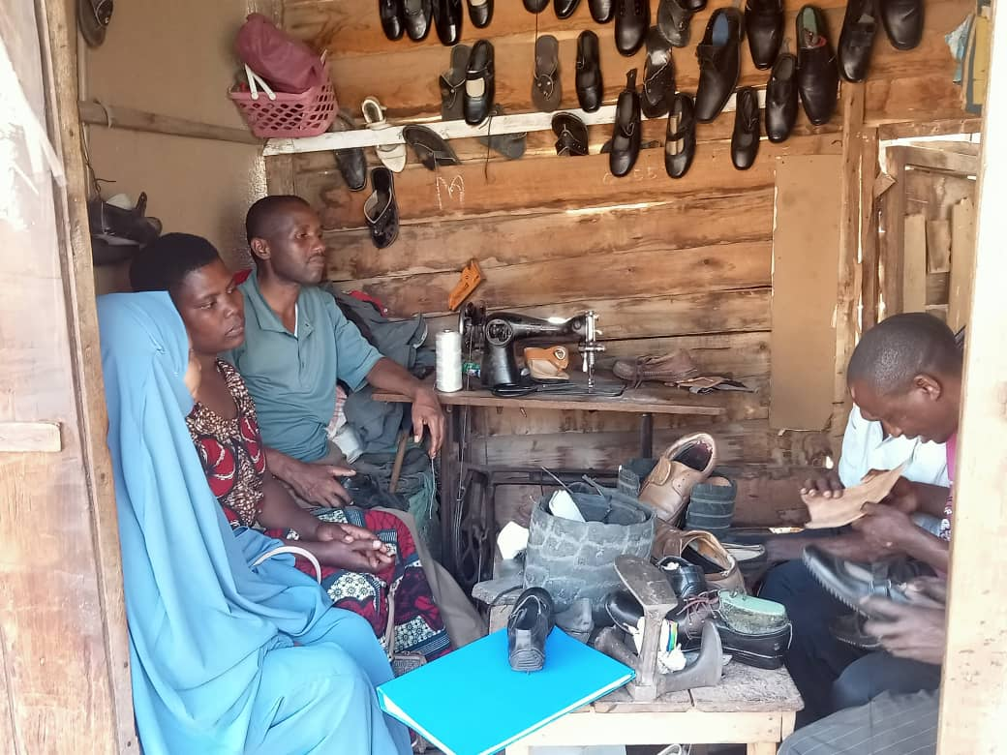

Figure 4.1: Rangeni Group Members in Production Activities
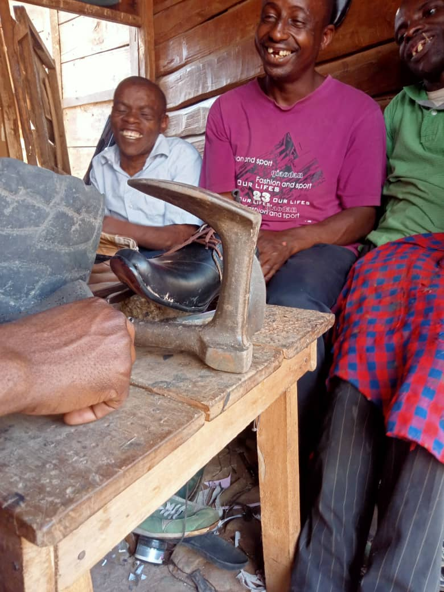

Figure 4.2: Rangeni Group Members during Shoe making and sewing Activities

Source: Research Data 2022

4.5.2 Community training and Sensitization
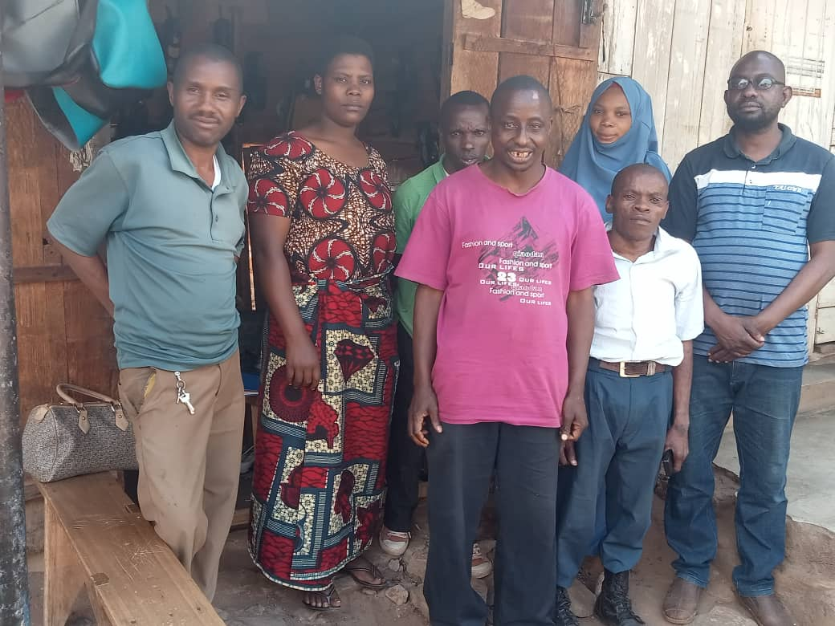
Training session of four days conducted to 10 members of Rangeni disabled group as awareness raising and orientation on shoe making and sewing skills. The training was held for introduction of the identified project PWDs Group perceived it as both potential and sustainable income generating activity. Identification of potential market was also done. The invited guest on this training was host organization representatives, stakeholders, Ward Executive Officer and facilitator from SIDO Moshi.

Figure 4.3: Photo with Rangeni Group Members

Source: Research Data 2022

4.5.3 Community Land Acquisition for Production Activities
A plot coverage of 400sq Meters acquired from Village land reserve and owned to leadership of Rangeni disabled group at Eastern part of the village. The MCED student together with host organization helped the disabled group in handing over process.

4.5.4 Community Members Produce Pairs of Shoes Made
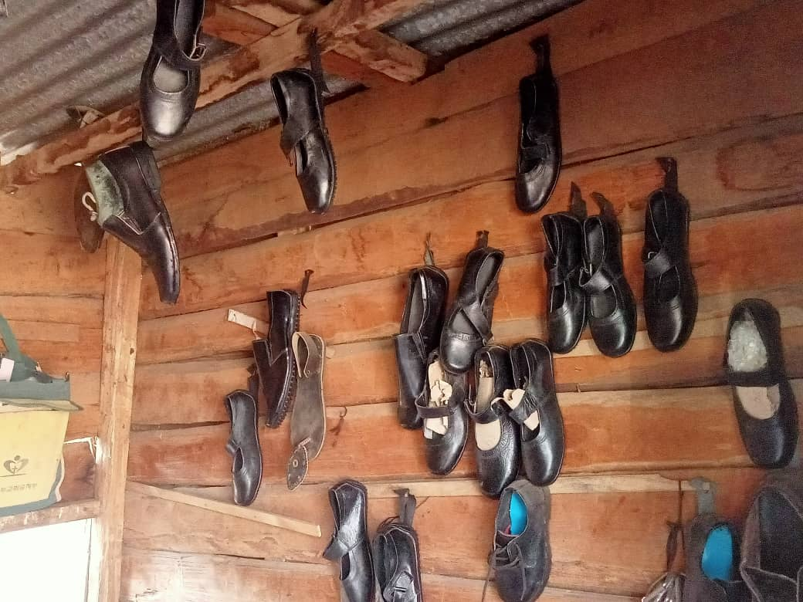
The group members have the capacity to produce 5 pairs of boots and 10 pairs of open shoes per day which is equivalent to 150 pairs of boots 300 of open shoes per month. This production requires inputs material such as pure leather in square foot, glues in bottles volume, 4.5 inches nails, dozens of shoe laces, pieces of shoe soles, shoe polishes(kiwi) shoe carpets. All these materials are purchased in Moshi in whole sale shops.

Figure 4.4: Various Design of Shoes Made by Rangeni disabled Group

Source: Research Data 2022

4.5.5 Community Member’s Product Sales and banking
As per implementation plan by the end of August 2022, 150 pairs of boot and 300 pairs of open shoes were produced and sold, the main market are pupils and students in Schools and Colleges as well as ordinary people. A total sum of Tsh. 1,345, 000 was saved in bank account.
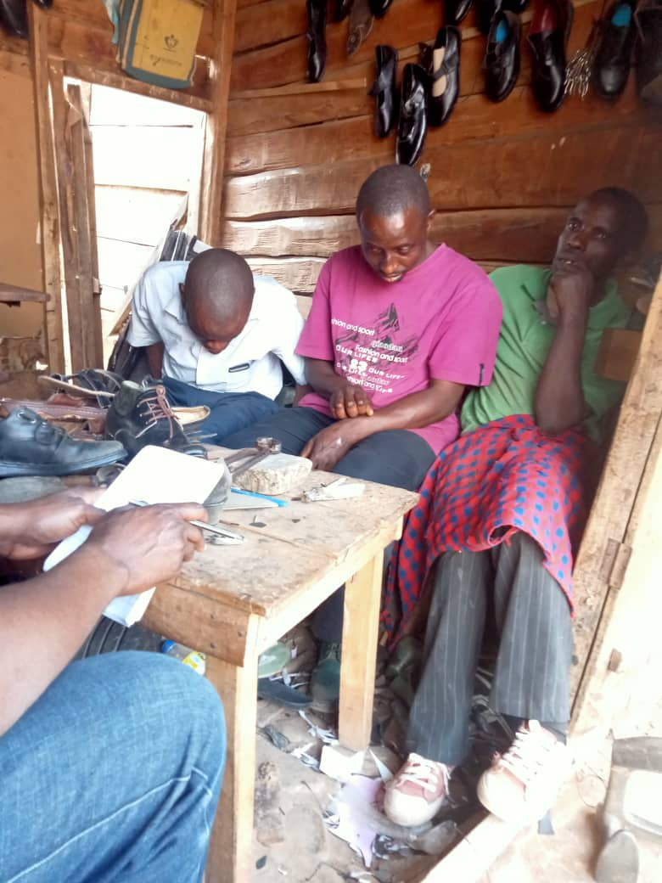

Figure 4.5: Production Activities in Progress

Source: Research Data 2022

Table 4.7 Project Time Management Plan (Gant chart)
 |  |  | 2021 |  |  | 2022
Objectives | Output | Activities | O | N | D | J | F | M | A | J | J | A | S
- 1.0. 10 persons with disabilities trained on shoe making and sewing by 30th June 2022 | - Number of people trained | 1.1.1. Participants invitations
 | - Number of people trained | 1.1.2. Venue organization
 | 1.2 Skills acquired | 1.2.1 training material preparation
 |  | 1.2.2 Logistics and procurements
2.0. 400sq Meters plot coverage area acquired by 30th June 2022. | 2.1. Physical plot acquired | 2.1.1. Signing of contracts documents
 | 2.1. Physical plot acquired | 2.1.2. Photocopying and filing
 | 2.2 Ownership document | 2.2.1 Photocopying
 |  | 2.2.2 Signing and filing
3.0. 150 pairs of shoes produced by the end of 30th July 2022. | - Pairs of shoes produced | 3.1.1. Leather measuring and cutting
 | - Pairs of shoes produced | 3.1.2. Shoe designing and decoration
 | - Shoe making and sewing skills achieved | 3.2.1 Learning
 | - Shoe making and sewing skills achieved | 3.2.1 Testing
4.0 150 pairs of shoes sold and 1,345,000.00 banked by 30thAugust 2022. | 4.1 Availability of group Bank Account number | 4.1.1Signatories selection
 | 4.1 Availability of group Bank Account number | 4.1.2 Cash deposition
 | 4.2 Bank statement | 4.2.1 Photocopying
 | 4.2 Bank statement | 4.2.2 Filing
:

CHAPTER FIVE

PROJECT PARTICIPATORY MONITORING, EVALUATION AND SUSTAINABILITY

5.1Introduction
The monitoring and evaluation plan connects the project activities to the sustainability when the researcher think of monitoring and evaluation, he/she reflects the data collected and the activities done by the project and this stage, the measurement is made to see to what extent they have been performed. The implementation monitoring and evaluation were part of the actual plan to keep the project successfully in the process, the below chart summarizes the project monitoring and evaluation plan.

5.2 Participatory Monitoring
The Rangeni group, CED student and the host organization were involved in Participatory Monitoring and Evaluation (M&E)others were Village Executive Officer as well as youth development officer.

5.2.1 Monitoring Information System
Monitoring is the systematic and continuous gathering and analysis of information about the progress of a development intervention. Monitoring is done to guarantee that all the people who need to know about an intervention are correctly informed, and so that decisions can be taken in a timely manner. There are numerous different types of monitoring, including financial monitoring, process monitoring and impact monitoring. With social development monitoring can defined as the systematic and continuous collecting and analyzing of information about the process of a piece of work over time(Gosling and Edwards 2003, p12). Monitoring is done to guarantee that all the people who need to know about a development intervention are properly informed about it. It is also completed so that management decision can be taken in timely manner.

Traditionally monitoring differs from evaluation because it is passed out by internal rather than external staff, it is on ongoing rather than periodic, and it focuses further on activities and output than outcomes and impacts. In addition monitoring usually depend on a system rather than being one of the exercise passed out a specific point in time. There are numerous different kinds of monitoring. Some of the types are defined below. However this is known by different terms and different organization. Process or performance monitoring focuses on the activities passed out as part of development intervention. It is designed to assess whether and/how well those activities are being implemented. It also shields the use of resources. Process monitoring is designed to provide the information needed to continually plan and review work, assess the success or otherwise of the implementation of the project and programs, recognize and deal with problems and challenges and take advantage of opportunities as they rise.

Situation monitoring sometimes is known as scanning, is concerned with monitoring the external environment. Sometimes completed through defining and collecting indicators relating to subjects such as the local, political, situation, changes in the economy, and the activities of other development performers. At other times situation monitoring simply means keeping eyes and ears open in order to measure what is happening outside of the project or programs that might influence it. Financial monitoring is concerned with the monitoring of budget and finance and is linked to auditing. It is usually concerned with tracing costs against categories of expenditure.

Administrative or logistics monitoring covers issues such as the repair of premises, transport, personnel, stock keeping and other forms of administrations. Compliance monitoring is designed to ensure compliance with concerns such as donor regulations, grants or contracts requirements, government regulation and ethical standards (ibid). Management Information Systems (MIS) are frequently associated with computer-based systems, though some CSOs operate paper-based Management Information Systems. An MIS can cover any feature of monitoring, but is more often associated with process, financial, administrative and compliance monitoring. The remainder of this paper is largely concerned with process and impact monitoring. This is sometimes known collectively as programs monitoring.

Results or impact monitoring aims to measure the changes brought about by a project or programs on a continuous basis. Often this means weighing changes in a target population (example individuals, communities, supported organizations, targeted decision-makers). Impact monitoring can be used to weigh progress towards goals and objectives, as well as unintended change. Despite the name, impact monitoring is frequently associated with changes at outcome, rather than impact, level.

Beneficiary monitoring, or beneficiary contact monitoring, is a specific kind of impact monitoring that aims to track the perceptions of project or programs beneficiaries (IFRC 2011). It can include beneficiary followed, and changing them when necessary. In this regard, good monitoring is often indistinguishable from good management. In different circumstances, monitoring can also serve several other purposes. Some of the more common are:
- Providing managers, staff and other stakeholders with information on the progress being made towards stated goals and objectives in order to demonstrate accountability to different stakeholders;
- Providing information that enables approaches and strategies to be changed in response to evolving situations;
- Identifying whether there is a need to change goals, objectives, plans or budgets over time;
- Testing project or programs assumptions on a regular basis;
- identifying the need for further information or research;
- Providing information that enhances ongoing learning, both within and outside a project or programs; and
- Demonstrating or communicating activities and changes to other audiences for marketing or fundraising purposes.

5.2.2 Participatory Monitoring Methods
Participatory monitoring & evaluation (PM&E) is a process through which stakeholders at various levels engage in monitoring or evaluating a particular project, program or policy, share control over the content, the process and the results of the monitoring and evaluation (M&E) activity and engage in taking or identifying corrective actions. PM&E focuses on the active engagement of primary stakeholders (WORLD BANK 2010a).Participatory Monitoring and Evaluation is one of many approaches to ensure that the implementation of the different projects within the action plan or smaller individual projects leads to the expected outcomes. As with all other monitoring and evaluation elements, the process for PM&E has to be prepared prior to project implementation (Phillip et al. 2008).

The stakeholder groups typically involved in a participatory M&E activity include: the end users of project goods and services, including both men and women at the community level; intermediary organizations, including NGOs; private sector businesses involved in the project; and government staff at all levels (Rietbergen, et al., 1998). Several methods were used to involve all the stakeholders of the project. Information was collected then analyzed to ensure that the project was going as planned and that all the activities have been implemented according to plan and the resources are employed in an appropriate way at a specific period. The methods used include interview, observation and documentation.

5.2.3 Participatory Monitoring Plan

The plan is presented in Table 5.1 it summarizes the source of data, indicators, collection means and frequency. Their timed against the output objectives and activities.

Table 5.1: Project Monitoring Information System
Categories of information | What to monitor | What records to keep | Who collects data | Who uses data | How to use information | What decision can be made
1.Work plan activities | Timing of activities.  Availability of resources. | Monthly and Quarterly work plans.  Work schedules. | Executive  Committees.  Supervisors. | Executive committees. | Ensure staff and resources are available. | Reschedule activities when needed.
2.Cost and expenditure | Available budget.  Amount utilized.  Remaining amount. | Financial receipts.  Financial control books.  Bank transactions. | Treasurer. | Executive committees. | Ensure funds availability for activities implementation. Ensure compliance with financial regulations. | Authorize expenditures. Make budget reviews. Explore other funding sources when needed
3.Staff and Supervision | Staff Knowledge, attitudes and skills.  Educational levels. | Performance reviews.  Roles and responsibilities description | Executive chairperson.  Trainers. | Executive committee. | Resolve responsibilities problems. | Training needs. Disciplinary actions. Roles placement.
4.Other inputs | Materials inventories.  People with disability group inventories. | People with disability registers Secretary reports  Extension worker reports | Executive committee. | Executive committee | Ensure timely availability of raw material and distribution to members. Ensure timely supply of material inputs. | Quantity of supply. When to supply.
5.Results | No. and type of training provided.  No. and varieties of leather products acquired and distributed. Pairs of shoes and leather products sold. | Training attendance forms.  Pairs of shoes distribution for selling and distribution forms | Executive committee.  Livelihood.  Extension officer. | Executive committee. | Ensure objectives are met. Assess quality of products distributed. Assess quality of training provided. | Revise objectives. Retrain staff. Revise project strategy and approach.
Source; Field Data (2022)

5.3 Participatory Evaluation
Group members and local community leaders were involved in project implementation. With support from the MCED student alongside the community based organization members, creation of a baseline was done to allow smooth evaluation of the project a year later.

5.3.1 Performance Indicators
Indicators were approved budget documented identified participant list of the project, designed letter and confirmed letter for the registration, meeting minutes with local government officer, signed contracts for loan access purchase receipt and taxed invoice and receipt.

5.3.2 Participatory Evaluation Methods
Evaluation methods of participatory nature are presented in Table 5.2.

Table 5.2: Project Evaluation plan(Information System)
Objectives | Output | Activities | Indicators | Data source | Methods | Responsible person | Time frame
10 persons with disabilities trained on shoe making and sewing by 30th June 2022 | Number of people trained | Participants invitations | Number of participants | Meetings reports | Interviews, Observations | MCED student, Host Organization staff (Project Manager and project officers)
 | Number of people trained | Venue organization | Payment receipt | Meetings reports | Interviews, Observations | MCED student, Host Organization staff (Project Manager and project officers)
 | Skills acquired | training material preparation | Attendance list | Meetings reports | Interviews, Observations | MCED student, Host Organization staff (Project Manager and project officers)
 | Skills acquired | Logistics and procurements | Items procured | Meetings reports | Interviews, Observations | MCED student, Host Organization staff (Project Manager and project officers)
400sq meters plot acquired by 30th June 2022. | Physical plot acquired | Signing of contracts documents | Copy of contracts | Meetings reports | Interviews, Observations | MCED student, Host organization (Project Officers)
400sq meters plot acquired by 30th June 2022. | Physical plot acquired | Photocopying and filing | Number of copies | Meetings reports | Interviews, Observations | Host organization and MCED student
400sq meters plot acquired by 30th June 2022. | Ownership document | Photocopying | Number of copies | Meetings reports | Interviews, Observations | MCED student, Host Organization staff (Project Manager and project officers)
400sq meters plot acquired by 30th June 2022. | Ownership document | Signing and filing | List of documents | Meetings reports | Interviews, Observations | MCED student, Host Organization staff (Project Manager and project officers)
150 pairs of shoes produced by the end of 30th July 2022. | Pairs of shoes produced | Leather measuring and cutting | Number of pair of shoes made | Meetings reports | Interviews, Observations | MCED student, Project officers, together with people with disability
150 pairs of shoes produced by the end of 30th July 2022. | Pairs of shoes produced | Shoe designing and decoration | Pair of shoes decorated | Meetings reports | Interviews, Observations | MCED student, Host Organization staff (Project Manager and project officers)
 | Shoe making and sewing skills achieved | Learning |  | Meetings reports | Interviews, Observations
 | Shoe making and sewing skills achieved | Testing |  | Meetings reports | Interviews, Observations | MCED student, host organization, VEO, WEO, Community Development Officer
150 pairs of shoes sold and 1,345,000 banked by 30thAugust 2022. | Availability of group Bank Account number | Signatories selection |  | Meetings reports | Interviews, Observations | MCED student and people with disability
 | Availability of group Bank Account number | Cash deposition | Bank statements document | Meetings reports | Interviews, Observations | MCED student, Host Organization staff (Project Manager and project officers)
 | Bank statement | Photocopying | Produced copies | Meetings reports | Interviews, Observations | MCED student, Host Organization staff (Project Manager and project officers)
 | Bank statement | Filing | Produced files | Meetings reports | Interviews, Observations | MCED student, Host Organization staff (Project Manager and project officers)

5.3.3 The PRA Techniques

5.3.4 Project Evaluation Summary
Evaluation is done in three ways listed and explained below
- Before the implementation- this was done to ensure the time and activities are observed with time and the projects itself.
- There was also formative evaluation which was conducted while activities were in progress this meant to measure the deviations if any during the process of implementations of the project activities identified.

Table 5.3: Monitoring and Evaluation Plan (Information System)
Objectives | Outputs | Activity | Performance indicator | Data Source | Methods Tools | Person Responsible | Time Frame (2021) | Expected Output | Actual Output
10 person with disabilities trained on shoe making and sewing by June 2021 | Output 1.1 Giving an invitation to come to the business meeting | Activity1.Budget preparation for training | Approved budget documented | Approved letter/email | Documentation | Treasure &Chair leader | April-2022 | Prepared Budget document | A budget allocated to support training logistic
 | Output 1.2 A total of 10 members trained
 | Output 1.3 A total of 10 members received and able to form a group of shoe making | Activity 2. Planning and coordination of the meeting | Approved budget documented | Approved letter/email | Documentation | Treasure &Chair leader | April-22 | Training conducted | 10 members and received training
 | Output 1.4 Formed a group by the name Rangeni | Activity 3: Allocation of the place to conduct the meeting
 |  | Activity 1; Send the invitation to 10 members of RANGENI | Identified participant list | Participant list | Documentation | Treasure &Chair leader | April-22 | Received 10 names of participants from the group | 10 participants attended
 |  | Activity 2: Sending invitation to the Village executive officer | Signed letter and Confirmed letter | Dispatch/signed letter | Observation and Documentation | Chair leader and CED student | April-22 | Received name of Community development officer | Training conducted
 |  | Activity 3: Loan application to facilitate the group practice
400sq M plot coverage area acquired by 30th August 2022 | availability of contract documents for hired land | Consulting local government officer | Signed letter and Confirmed letter | Dispatch/signed letter | Observation and Documentation | Chair leader and CED student | April-22 | Hiring process completed the supply of produced product | Places for distribution
 | Available center for product distribution | Preparing Contract document/processing land lease Contract | Meeting minutes with Local Government officer | Minutes report | Documentation | Chair leader and CED student | May-22 | Contact available | Signed contract by both parties
 | Available center for product distribution | Preparing Contract document/processing land lease Contract | Meeting minutes with Local Government officer | Minutes report | Documentation | Chair leader and CED student | May-22 | Contact available | Signed contract by both parties
 | Availability of materials for shoe making production and distribution | Procurement of production materials | Signed Contract | Contact available | Documentation and /observation | Chair leader and CED student | July-22 | Building material purchased | Poultry shed constructed
 | Pairs of shoes produced | Measuring, cutting of leather
 | Numbers of community members equipped | Assembling of leather on shoe shape
 |  | Budget allocation for procurement
Objective 4: | Introducing the group to the local leaders | Sending an appointment with the local officer | Bank statement collected and documentation in the file | Procurement meeting minutes | Documentation and /observation | Treasure and procurement committee | Aug-22 | Purchase Receipts and delivery note from selected company | Cash amount deposited
 | 150 pairs of shoes sold and 1,345,000 shillings banked by 30th August 2022 | Pairs of shoes sold | Identification of potential market
 |  | Pay slip available | Total sale collection and recording
Source: CEDEPA page 64

5.3.5 Actual Evaluation Conducted
When we want to keep the project in progress the actual evaluation must be taken into consideration.

5.3.5.1 Activities Evaluated Include
- Inputs- Always The Input Results Into Output And The Output Depends On The Input Processed.
- Process –This Elaborate The Collecting Of Information And The Evidence Reliability And The Content Coverage Of All The Activities Of The Project
- Outputs-Looked The Relationship Of The Process And The First Step To Evaluation Such As Constraints To The Implementation Of The Project.
- Impact-This Is To See Whether The Objectives Have Been Achieved In The Required Quality In The Community And The Organization During The Brief Meeting After The Project Implementation.

5.3.5.2 Direct Indicators
- Input- this is the quantitative measure of all activities of the project
- Process –the number of sessions attended during training of different discipline within the organization.
- Output-number of qualified trainees who will be able to be part of the project.

5.3.5.3 Indirect Indicators
- The increase of the level of saving within the community spheres
- The increased number of the village community bank
- The organization members who were trained got the required level of satisfaction
- The change of service delivery in terms of efficiency

5.3.5.4 The Research Methodology used to Conduct Evaluation
The methods used were participatory, observation, review of relevant documents and the beneficiary assessment and the stakeholders of the project.

Table 5.4: Evaluation Summary Report
Objectives | Performance indicators | Actual outcome/output | Expected outcome/output | Reason for deviation | Recommendation
10 persons with disabilities trained on shoe making and sewing by 30th June 2022 | Number of members trained,  Technical skills gained | Technical skills capacitated | Technical skills capacitated | No deviation observed as project performed per objective per time frame | Trained members should train other colleagues
20M by 40M plot coverage area acquired by 30th June 2022. | Ownership documents filed | Physical Ownership certificates | Physical Ownership certificates | No deviation observed as project performed per objective per time frame | The acquired land should fenced
150 pairs of shoes produced by the end of 30th July 2022. | Pairs of shoes produced and supplied in the market | Output products at hand | Output products at hand | No deviation observed as project performed per objective per time frame | Products quality and standards should be observed to maintain market share
150 pairs of shoes sold and 2 Million banked by 30thAugust 2022. | Cash deposited to group bank account | Financial reports through bank statements | Financial reports through bank statements | No deviation observed as project performed per objective per time frame | Cash flow and financial reports should open to all members to avoid conflicts

5.3.5.5 Presentation of Results
The analysis was done at Hedaru ward, by host organization and the researcher/CED student and presented to stakeholders through presentations and reports, the table below explains in details how the presentation was made and the copy of the report were given to all the stakeholders

Table 5.5: Presentation of the Results
Goal | Question | Purpose of the question | Actual outcome
Having the group and community that can be able to save and raise the income of the people with disability | Is there any service delivery improvement?  What about the members who are coming for saving?  Where do you access loan? | Assessment of the project intention  Which include establishment of a group  Have skilled people in the community with the technical skills of shoe making and sewing | They are able to meet the community challenges due to the training they have received  And able to practice what they have taught.
Objective  The training of 10 member of RANGENI disabled group who will be the center for shoe making and sewing at Hedaru Ward in Same District. | The level of objective achievement /were the objective attained? | To measure the objectives of the project. | The number of sensitization meeting conducted in the community
Effectiveness | To what extent the project result reflects the et objectives? | If there is any positive change within the organization members | Quality and Standards of the products provided.
Impact | What were the effects of training to the organization and the community? | The extent of the project contribution to the development of the community and the group | Let them say what they are feeling on the provided services.
Source: Designed by the Researcher 2022

5.4 Project Sustainability
Any organization must take the component of continuity without termination even if the owner dies, the organization will continue to the level going concern. The project has to ensure it continues by using the assets it has such as human resource which include skills and knowledge of the organization members as well as the external funding that depend on the level of the organization to elevate its own resource. The organization should have the sustainability essentials such as good financial position, good leadership, and good political impacts. The project was participatory type and that has been a major component that had made people happy to contribute. The awareness and training meetings done in Hedaru Ward has enlarged the knowledge to the organization and make them start the internal resource mobilization.

5.4.1 Environmental Sustainability

Environmental impacts were not ignored during project implementation. Shoe making and sewing waste products poses many threats to the wellbeing if not well managed. Waste product was treated into garbage pits and dust binpresent in production plot. Left over from leather pieces, shoe carpets, threads, needles, glues, were burnt in the present garbage pits.

5.4.2 Institutional Sustainability
The sustainability of shoe making and sewing was achievable because of the presence of committed target group, who are project owner, being empowered by the project, have a stake in the project offered physical, and time commitment. Presence of potential stakeholders as other players on the successful project implementation and host organization, who has capacity to integrate with project implementation activities, resources inputs, time frame and responsible persons against expected outputs. Capacity building skills conducted by SIDO Moshi facilitators on shoe making and sewing aid in production of quality shoe products which attracted market share. In addition, training on planning, monitoring and evaluation skills gave theme sense of ownership spirit that leads to sustainability of the project.

5.4.3 Project Sustainability Elements

5.4.4 The Sustainability Plan
The training provided has made the organization to have a sustainable growth of members who are joining to be the group members which will result into the improved donation to the organization.

5.4.5 Political Sustainability
The community desire to cooperate with the inhabitants and the law makers and other leaders ensures the political sustainability of the organization. The government wish to continue fight the poverty has ensured the political resolve to support the determinations of the project.

5.4.6Financial Sustainability
The registered RANGED PWDs group has privilege for acquiring funds from multiple sources. In Tanzania’s context, a registered group of people at Wards level is eligible for loan from financial institutions as well as government once. In District level 10% is located by local government authority from its own sources for women, youth Disabled groups with the ratio of 4:4:2. It is the expectation of the researcher that, RANGENI group being officially registered and trained will access those opportunities for the financial sustainability of the project.

CHAPTER SIX

PROJECT CONCLUSION AND RECOMMENDATION

6.1 Introduction
This chapter presents conclusion and recommendation of the executed project.

6.2 Conclusions and Recommendations
Study findings review that sustainable income was the major community need of people with disabilities, shoe making and sewing was project that addressed the identified need. Shoe making and sewing aid to improve PWDs income level, rights promotion, and wellbeing expansion and poverty alleviation. There was an increase of economic activities in the community. Community members live changed to some extent as a result of shoe making and sewing activities. Improved income levels resulted to improved living standards of the community. Effectively implementation of activities was done as result of gained skills in training.

6.3 Recommendations
PWDs face berries in economic activities due to lack of funding from various potential sources. People should be provided with activities to engage with so as to enhance standard of living. Shoe making and sewing offer opportunities to PWDs, to community and other individuals. Support from the government and other development partners are essentials for such activities. Host organization should proceed with sensitization programs to group implanters (PWDs group) on the sense of ownership of project for sustainability purpose and keep on searching further potential market within and outside the study area.

6.3.1 Recommendation for Further Studies

Similar CED project can be replicated in other parts of the country to target PWDs living in poor environment and with limited income and capital start up. Literature offers an array of similar success projects in developing countries.

REFERENCES
Barrett, C. & Swallow, B. (2005). Dynamic poverty traps and rural livelihoods: Rural Livelihoods and Poverty Reduction Policies. Edited by Ellis, and Freeman, H. A. (2005), Routledge 270 Madison Ave, New York: Nova Science Publishers.
Bulmer, M. (2004). Questionnaires, V.1. Thousand Oaks, CA: Sage Publications.
Cagatay, N. (2001). Trade, Gender and Poverty,” Background paper for UNDP project on Trade and Sustainable Human Development. October 2001. retrieved on 23/11/2017 from: [http://www.undp.org/mainundp/propoor/ docs/pov_tradegenderpoverty_doc.pdf].
Chachage, S. (2003). Gender impoverishment and class reproduction”: In Chachage, S. and Chamber, R. (1993). Rural Development: Putting the Last First. Essex. England, 1, 114-131.
Evance, J. & Slowley, M. (2010). Not the end of the story. Supporting teenage mothers back into school. Believe in Children Barnardo’s report. Ilford, Barnardos.
Eyben, E. (2008). Conceptualizing empowerment and the implications for pro-poor growth, Institute of Development Studies at the University of Sussex, Brighton, UK.
Fontana, A & Frey, J. (2005). The interview: From neutral stance to political involvement. In Denzin, N. K. & Lincoln, Y.S. (eds.). The Sage Handbook of Qualitative Research. 3rd Ed., Thousand Oaks, CA: Sage.
Gutman, M. & Akerman, R. (2008). Determinant of aspirations. Centre for research on the wider benefits of learning. Institute of education, 20 Bedford way, London, UK.
Hallam, S. (2007). Evaluation of Behavioural Management in Schools: A Review of the Behaviour Improvement Programme and the Role of Behaviour and Education Support Teams. Child and Adolescent Mental Health, 12(3), 106–12.
Hayes, C. (Ed.). (1987). Risking the future, adolescent sexuality, pregnancy and childbearing.
ILO, (2000), State of the art review of the Tanzanian Informal Sector.An Unpublished Research Report. Dar es Salaam, Tanzania.
ILO, (2001). The influence of national policies, laws and regulations on employment in MSEs in Tanzania”. Unpublished research report. Dar es Salaam, Tanzania.
Koponen, J. (1988). People and Production in late Pre–colonial Tanzania: History and structures, Scandinavian Institute of African studies, in Africa Affairs. Journal of African History, 103(410), 23-49.
Luvanga, N. E. (1997). The Potential of Informal Sector in Poverty Alleviation through Employment and Income Generation in Tanzania: A Case Study of Kilimanjaro Region, Repoa. Dar es Salaam, Tanzania.
Madeni F, Horiuchi S. & Iida M. (2011). Evaluation of a reproductive health awareness program for adolescence in urban Tanzania--a quasi-experimental pre-test post-test research. Reproductive Health, 2(4), 8 - 21.
Maghimbi, S. (1994). The Problem of low Motivation of Entrepreneurship among Tanzanian women. Tanzanian Journal of population studies and Studies and Development, 1, 21-30.
Maynard, R. (1996). The Cost of Early Childbearing. In R. Maynard (ed.), Kids Having Kids. Washington, DC: Urban Institute.
Mbizvo, M. T., Kasule, J., Gupta, V., Rusakaniko, S. & Gumbo, J. (1995). November 4).Reproductive biology knowledge, and behavior of teenagers in East, Central and Southern Africa: the Zimbabwe case study. Cent Afr J Med. 41(11), 346-54.
Minde, I. (1998). Economic Analysis of Farm and Non- farm rural employment in Morogoro District, Tanzania. Unpublished Ph.D. Thesis, Michigan State University, Michigan, US.
Mkandawile, T, & Soludo, C. (2003). African Voices on Structural Adjustment: A Companion to ‘Our Continent, Our Future’ Eritrea: African World Press.
Mtatifikolo, F. (1999). Development Strategies and Poverty Reduction Initiatives. Analytical Discussion with Applications to Tanzania. East Africa Social Science Research Review, 1(1), 33-52.
Mwazmadzingo, M. (2002) Poverty Alleviation and the Role of Workers’ Organizations in Africa retrieved on 12th March, 2017 from: http://www.dpmf.org/poverty-alleviationmohammed.html.
Ngalinda, I. (2000). Socio-economic factors associated with premarital childbearing and adolescent Age at first motherhood. Dar es Salaam, Tanzania.
OECD, (2010). Accelerating progress towards the MDGs through pro-poor growth: policy messages from the DAC Network on Poverty Reduction, OECD, Paris. Extracted from World Bank President Zoellick’s speech at the MDG3 conference, Copenhagen, 25 March, 2010.
Panda S. A. & Lund, R. (1998). Gender–sensitive planning in Asia; Its status and some directions, Regional Development Dialogue, 19(I), 71–83.
Ranjit, K. (2005). Research Methodology, a step by step guide for beginners, (3rd edition), New Delhi: Sage Publication.
Restless Development, (2011). Annual Report 2011 can be also accessed in http://www.restlessdevelopment.org/file/annual-report-2011-pdf.
Rothenberg, A. & Weissman, A. (2002). The development of programs for pregnant and parenting teens.Social Work in Health Care, 35(1), 65-83.
Sen, G. & Batliwala, S. (2000). Women’s Empowerment and Demographic Processes. New York: Oxford University press.
Stone, U. R., Chauhan, S. S. & Lissi, S. (1994). Project design for Programme Managers. The centre for Development and Population Activities, 1400 Sixteenth Street N.W. Suite 100 Washington, D.C.
Tibaijuka, A. & Kaijage, F. (1996). International Institute of labour Studies United Nations Development Programme, Poverty and social exclusion in Tanzania. University of Dar es Salaam. pp. 136-155.
UNDP, ILO & UNIDO, (2002). Roadmap informal sector study for Tanzania Mainland: Assessment on why MSEs find formalization daunting, Dar es Salaam, Tanzania.
United Nations Development Programme, (1994). Human Development Report 1994. Washington, D.C., United Nations.
United Nations Development Programme, (2004). Human Development Report. United Nations. Washington, D.C.
United Republic of Tanzania, (2005a). National Strategic for Growth and Reduction of Poverty (NSGRP).Vice President’s Office. Final Draft 15th June 2005. Dar es salaam, Tanzania.
United Republic of Tanzania, (1998). The National Poverty Eradication Strategy, the Government of Tanzania, Dares Salaam, Tanzania.
United Republic of Tanzania, (2000). Poverty Reduction Strategy Paper (PRSP), Tanzania Government, Dar es salaam, Tanzania.
United Republic of Tanzania, (2000). Tanzania Development Vision, Planning Commision, Dar es Salaam: Government Printers.
United Republic of Tanzania, (2001). Rural Development Strategy, the Government of Tanzania. Dar es Salaam, Tanzania.
United Republic of Tanzania, (2002). Tanzania Assistance Strategy, The Government of Tanzania, Dar es Salaam Tanzania.
United Republic of Tanzania, (2002). The Tanzania Development Vision 2025, Government of Tanzania, Dares Salaam, Tanzania.
United Republic of Tanzania, (2003). Integration of Population Variables in Development Planning, Part II Trainees Manual, Demographic Training Unit, Dares Salaam: University of Dar es Salaam.
United Republic of Tanzania, (2004). Tanzania Demographic and Health Survey (TDHS). Dar es Salaam, Tanzania.
United Republic of Tanzania, (2005). Poverty and Human Development Report, Research and analysis working group, Dar es Salaam, Tanzania.
United Republic of Tanzania, (2005). Summary of the National Strategy for Growth and Reduction of Poverty, Vice Presidents office. Dar es Salaam, Tanzania.
United Republic of Tanzania, (2006). Millenium Development Goals Progress Report, Ministry of Planning Economy and Empowerment, Tanzania.
United Republic of Tanzania, (2010). National Strategy for Growth and the Reduction of Poverty (MKUKUTA) 2010-2015 Basic Education Statistics in Tanzania. Dodoma, Tanzania.
United Republic of Tanzania, (2010). Tanzania Demographic and Health Survey (TDHS). Dar es Salaam, Tanzania.
Washa, F. L. (2002). Assessment of on farm and Off-farm Income Generating Activities in Kisarawe District. Dissertation for Award of Msc Degree at Sokoine University of Agriculture, Morogoro, Tanzania.
World Bank, (2001). World Development Report 2000/2001. Attacking poverty: Opportunity, Empowerment and Security, Washington D.C.
APPENDICES

QUESTIONNAIRES
The purpose of this questionnaire isto generate information that will be used to improve income to group of people with disability. Issues relating to people with disability on their income status will be discussed. The time for this interview will not be more than 40 minutes.

QUESTIONNAIRE:
Region: ---------------------------------- District: -------------------------------------
Ward: -------------------------------------------- Village: -------------------------------------
Consent
Will you please tell me if you accept to participate on this survey questions? If you respond yes, that means you will be part of this study.
Yes No
- Demographic features (Please tick √ where appropriate)
- Sex
    - Male
    - Female
- Oldness
- 10-15
- 16-19
- 20 and above
- Schooling
- id not complete Primary Education
- Completed primary education
- Did not complete ordinary level
- Completed Ordinary level
- Marital status
- Lone
- Wedded
- Widow
- Separated
2. What is your major requirement as a disabled person? (Please tick √ one only)
- Credit
- Income generating activity
- Set-up
- Plot
- clean and harmless water
3. What is your revenue per month? (Please Tick √ one only)
- Above 150,000
- 100,000 to 150,000
- 50,000 to 100,000
- 50,000 to 10,000
- Below 10,000
4. Please hand-picked the type of income generating activity you are undertaking.
- Chicken Fowl
- Sesame farm
- Food vendor
- Tailoring
- shoe making and sewing
5. What is the likely intermediation person with disabilities income? Please Tick one only
- Chicken Fowl
- Sesame farm
- Food vendor
- Watermelon plantation
- shoe making and sewing

Key Informant Interview (KII)
This interview is intended to produce material that can be used to persons with income. The Study will converse issues regarding people with disabilities ‘especially their income position, support and important mediations to enable them to generate their own income. The interview will not take more than 40 minutes.
Agreement
Will you tell me if you settle to join in this survey/interview? If you around yes, it means that you have agreed to be part of the study.
Yes No

1. From your understanding and practice in the community, what are the major requirements of people with disabilities’?
2. From your involvement, how can your level the income level of people with disabilities?
3. Do you have any thoughts on the source of support of people with disabilities’ in your community? If yes, Can you please segment your thoughts?
4. Do you know the income generating activities that are being accepted out by people with disabilities’ in your community? If yes, please clarify.
5. What do you think are the best intermediations to improve people with disabilities’ income in your community?

FOCUS GROUP DISCUSSION
FGD Tool for the Community Assessment Good day and recognize you for taking the time to line our discussion about the community. My name is Ally S. Msumi, Master’s student in Community Economic Development at The Open University of Tanzania. Currently, I am doing Community Need Assessment (CNA) at your community as a part of partial Completion of the Obligation for masters’ degree. The information provided in this conversation is private. Your input is very important for this study, however, if you feel uncomfortable responding some of the questions, please feel free to reject answering at any point. This argument will last for about 1 hour.

Enquiries for Focus Group Discussion
1. To originate, how would you define people with disability in this community?
2. If you could label people with disability development in your community in just a few arguments, what would those arguments be?
b. Can you think of any achievements or positive growths that help and support label people with disability in Hedaru community?
c. What do you see as the judgments for developing label people with disability during out-of-school time in Hedaru community?
3. Think back when you were fresher: “What opinions did you have regarding how to help to develop life abilities in people with disability in your community?” "What ideas do you have that would help peoples with disability development programs, attract peoples with disability and keep their interest in urban settings?"
4. What type of topics and topics should peoples with disability development programs address (risk factors, help with homework, life skill development, S.E.T. programming, leadership skills, social skills, etc.)?
5. What do you reproduce is needed to enlarge life skills programming among peoples with disability in your community?

REQUEST LETTER TO RANGENI GROUP

C/O Chuo kikuu huria cha Tanzania,
P.O. Box 138,
SAME
18/03/2022,
Katibu wa kikundi cha RANGENI
S. L p 149,
Hedaru.

YAH: OMBI NA LA MKUTANO NA WANACHAMA WA RANGENI.
Kichwa Tafadhali husika na kichwa cha habari hapo juu.
Nawasilisha kwenu ombi maalumu la mkutana timu ya kikundi cha RANGENI kinachojishughulisha na shughuli za ujasiriamali ndani ya kata ya Hedaru.
Lengo la kukutana nanyi ni kufanya majadiliano kuhusu mada ya kukuza kipato na uandishi wa mpango wa biashara.
Ni matarajio yangu ombi langu litapewa kipaumbele

Ally S. Msumi
MCED STUDENT KILIMANJARO.
FACULTY OF ARTS AND SOCIAL SCIENCE

LETTER OF REPLYING FROM RANGENI
Kikundi cha RANGENI,
S.L.P 149,
Hedaru
26/03/2022.
Ally S. Msumi
K.K Open University
S. L P 138
Kilimanjaro.
Ndugu,
YAH: KUKUBALI MKUNO NA WANACHAMA WA RANGENI
Tafadhali husika na mada tajwa hapo juu.
Nachukua fursa hii kukujulisha kwamba ombi lako la kutaka mkutano na wanakikundi limekubaliwa.
Hivyo wanakikundi wanakukaribisha Hedaru kwa ajili ya uwasilishaji wa mada ulizoziandaa kwetu.

Niwaeli Mchome Mmbaga
Katibu wa kikundi cha RANGENI

MKATABA WA KUMIKILISHWA ARDHI
- Mimi…………………………………….Kwa niaba ya kijiji cha………………..
Tumemmilikisha ardhi kwa kikundi cha………………………………………….
- Mipaka ya kiwanja hicho ni
Upande wa Mashariki………………………………
Upande wa Magharibi………………………………
Upande Kaskazini…………………………………..
Upande wa Kusini…………………………………..
- Kiwanja hicho kimemilikishwa mbele ya mashahidi
- Jina ……………………………………………………………………. Saini………………………
- Jina…………………………………………….Saini…………………
- Jina…………………………………………….Saini…………………
- Jina…………………………………………….Saini…………………Mwenye kiwanja
Jina kamili………………………..……Cheo………………..Saini……………

- Anaemilikishwa kiwanja
Jina kamili……………..……………..Cheo……………..………..Saini……………
- Viongozi wa serikali ya kijiji
Jina kamili……………..……………..Cheo……………………..Saini……………
Jina kamili……………..……………..Cheo…………..………..Saini……………
Tarehe……………………………………



