ACCESS TO MARKET FOR BAR SOAP PRODUCED BY MUUNGANO WOMEN GROUP IN KALELA VILLAGE, KASULU DISTRICT

JOSEPH KARLO MIGUNDA

A DISSERTATION SUBMITTED IN PARTIAL FULFILMENT OF THE
REQUIREMENTS FOR THE DEGREE OF MASTER OF
COMMUNITY ECONOMIC DEVELOPMENT (MCED)
DEPARTMENT OF ECONOMIC, COMMUNITY DEVELOPMENT
OF THE OPEN UNIVERSITY OF TANZANIA
2022

CERTIFICATION
The undersigned certifies that he has read and hereby recommends for acceptance by the senate of the Open University of Tanzania a dissertation titled; “Access to “Market for Bar Soap Produced by Muungano Women Group in Kalela Village, Kasulu District, Tanzania” in partial fulfillment of the requirements for the degree of Master in Community Economic Development (MCED).

…………………………………….
Prof. Deus Ngaruko
(Supervisor)

………………………………..
Date

COPYRIGHT
No part of this dissertation may be reproduced, stored in any retrieval system, or transmitted in any form by means, electronic, mechanical, photocopying, recording or otherwise without prior written permission of the author or the Open University of Tanzania in that behalf.

DECLARATION
I, Joseph Karlo Migunda, declare that, the work presented in this dissertation is original. It has never been presented to any other University or Institution. Where other people’s works have been used, references have been provided. It is in this regard that I declare this work as originally mine. It is hereby presented in partial fulfilment of the requirement for the Degree of Master of Community Economic Development (MCED).

……………………………….
Signature

………………………………
Date

DEDICATION
I dedicate this work to my wife and children for their love, patience and support throughout the development of this research work, without which this study might not have been completed. It is also a special honor to my father who invested a lot in my childhood education leading to where I am today. Despite your absence in this world, here is another kind return of your investment in me.

ACKNOWLDGEMENT
I am very grateful to my GOD for the opportunity, love, care and protection he had provided to me throughout my study period. Special thanks to leaders and residents of Kalela Village in Kasulu District, Kigoma Region, for accepting me and for being ready to work together, to share ideas and experiences during the process of data collection and during implementation of this Project.

Special appreciations to MWG for accepting to host me and avail their support and resources to perfect activities in this project. The leaders were very active and instrumental in responding to all the requests I presented and in mobilizing the members to participate in meetings and activities. Similarly, much appreciation to the ILO - YWEE Management Team for sponsoring this project. The CDOs and BDSPs from Kasulu DC as well as the Regional Trade Officer from the regional secretariat played an enormous role in mapping the groups and recommending this group to the ILO. Thank you all for your valuable support.

I express my special thanks to my supervisor Prof. Deus Ngaruko for helping me to organize my ideas for this project work and how to write a reader-friendly and precise project report to its completion. Finally, I would like to thank my family who were always with me, giving me moral and material support that was needed for this research, especially my wife Emmy, for close support and encouragement throughout. I want to say thank you for your prayers; the patience and the sacrifices you made throughout my studies. God bless you so much.

ABSTRACT
The study Accessed Market for Bar Soap produced by Muungano Women Group in Kalela Village, Kasulu District Council in Kigoma region Tanzania. CNA results on women participation in economic activities indicated that 95% of women actively engage in productive work. According to NBS (2012), 85% of the household income is generated from agriculture. Out of 31 respondents, 61% indicated that access to market was the leading challenge impeding economic progress. Other factors include lack of relevant skills (35%), limited use of modern technology (39%) and unwillingness to abandon traditional production practices (48%). As a response to these challenges, the main solution proposed was creating the market for their products. Less than 10% of the people in Kalela village engage in the processing of byproducts of palm oil known as mise to make bar soap. 18 members of MWG decided to set up a soap making social enterprise. Therefore stakeholders in the area decided to support MWG to scale up their enterprise with focus on business skills, improving production efficiency and facilitate access to reliable market. Members of MWG were trained on Social Enterprise Management and Business Planning. A production house was built and installed with bar soap making machines. A participatory Monitoring Plan was created with members from MWG, VEO, WEO, CDO, RAS Office and ILO considered. Evaluation plan was activity based and also planned to occur annually. The socio-economic, financial, environmental and political sustainability aspects were observed involving all the parties concerned.
Keywords: Social Enterprise, Market Access, Muungano Women Group, Reliable Market.

TABLE OF CONTENTS
CERTIFICATION ii
COPYRIGHT iii
DECLARATION iv
DEDICATION v
ACKNOWLDGEMENT vi
ABSTRACT vii
TABLE OF CONTENTS viii
LIST OF TABLES xiii
LIST OF FIGURES xiv
LIST OF ABBREVIATIONS xv
CHAPTER ONE 1
PARTICIPATORY NEEDS ASSESSMENT 1
1.1 Background Information 1
1.2 Kalela Community Profile 2
1.2.1 General Information 2
1.2.2 Population and Ethnic Groups 2
1.2.3 Area and Physical Characteristics 3
1.2.4 Availability of Social Services 3
1.3 Community Needs Assessment (CNA) 4
1.3.1 Objectives of CNA 4
1.3.2 Research Questions 5
1.3.3 Research Methodology 5
1.3.3.1 Research Design 6
1.3.3.2 Sampling Techniques 6
1.3.3.3 Data Collection Methods 7
1.3.3.4 Data Analysis Methods 8
1.4 Community Needs Assessment Findings 9
1.4.1 Focus Group Discussion Results 9
1.4.2 Semi Structured Questionnaire Results 11
1.4.2.1 Respondents Demographic Findings 11
1.4.2.2 Main Findings 14
1.5 Community Needs Prioritization of Needs 17
1.6 Conclusion & Recommendation 18
1.6.1 Conclusion 18
1.6.2 Recommendations 19
CHAPTER TWO 19
PROBLEM IDENTIFICATION 20
2.1 Background to the Research Problem 20
2.2 Problem Statement 21
2.3 Project Description 22
2.3.1 Target Community 22
2.3.2 Stakeholders 23
2.3.3 Project Goal 23
2.3.4 Project Objectives 24
2.4 Host Organization/CBO Profile 24
2.4.1 Introduction 24
2.4.2 Vision 25
2.4.3 Organization Structure 26
2.4.4 Mission 26
2.4.5 Organizational Goal 26
2.4.6 Core Values 27
2.5 Target Groups & Beneficiaries 27
2.6 Programme and Projects 27
2.7 Core Activities 28
2.8 Strength and Weaknesses 28
CHAPTER THREE 30
LITERATURE REVIEW 30
3.1 Chapter Overview 30
3.2 Theoretical Literature Review 30
3.2.1 Market Access Defined 30
3.2.2 Designing Support Based on the Types of Market Linkages 31
3.2.3 Building Capacity to efficiently take on Economic Functions 34
3.3 Empirical Literature Review 35
3.3.1 Efforts to Create Markets For Small Scale Producers in Africa 35
3.3.2 The Need to Create Markets for Small Scale Producers in Tanzania 38
3.4 Economic Theories of Entrepreneurship 38
3.4.1 Resource Based Theory 38
3.4.2 Opportunity Based Theory 39
3.4.3 Asset-Based Community Development Theory 40
3.5 The Policy Reviews 41
CHAPTER FOUR 45
PROJECT IMPLEMENTATION 45
4.1 Chapter Overview 45
4.2 Products and Outputs 46
4.3 Project Planning 48
4.3.1 Project Implementation Plan (PIP). 49
4.3.2 Logical Framework 50
4.3.3 Major Project Inputs 51
4.3.4 Staffing Pattern 52
4.3.5 Project Budget 53
4.4 Project Implementation 54
4.4.1 Project Implementation Report 54
4.4.2 Project Implementation Ghantt Chart 57
CHAPTER FIVE 58
PARTICIPATORY MONITORING, EVALUATION AND SUSTAINABILITY 58
5.1 Introduction 58
5.2 Participatory Monitoring 58
5.3 Participatory Evaluation 62
5.4.1 Financial Sustainability 65
5.4.2 Technical Sustainability 65
5.4.3 Community Sustainability 66
5.4.4 Political Sustainability 66
5.4.5 Environmental Sustainability 66
5.4.6 Economic Sustainability 67
CHAPTER SIX 68
CONCLUSION AND RECOMMENDATION 68
6.1 Introduction 68
6.2 Conclusions 68
6.3 Recommendations 69
REFERENCES 73
APPENDICES 77

LIST OF TABLES
Table 1.1: Sample Distribution 6
Table 1.2: Focus Group Discussion Results 9
Table 1.3: Economic Opportunities Available in Kalela Village 16
Table 1.4: Prioritization through Pairwise Ranking Method 18
Table 1.5: Problem Ranking 20
Table 1.6: Project Stakeholders 23
Table 1.7: Core Values of MWG Kalela 27
Table 5.1: Indicators used in Monitoring the Project 59
Table 5.2: Monitoring & Evaluation Plan 64

LIST OF FIGURES
Figure 1.1: FGD with members of MWG 7
Figure 1.2: Age of Respondents 11
Figure 1.3: Sex of Respondents 12
Figure 1.4: Respondents' Education Level 13
Figure 1.5: Respondents' Marital Status 13
Figure 1.6: Post-School Training Opportunities in Kalela Village 14
Figure 1.7: Proposed Solutions to Reduce Post-School Training Inadequacy in Kalela Village 15
Figure 1.8: Factors Affecting Productivity in Kalela Village 16
Figure 1.9: Women Involvement in Productive Works 17
Figure 2.1: Organization Structure for Muungano Women Group (2020) 26
Figure 4.1: Field Photos 55
Figure 4.2: Field Photo 56

LIST OF ABBREVIATIONS
CNA Community Needs Assessment
CED Community Economic Development
DC District Council
CDO Community Development Officers
BDSP Business Development Services Providers
REA Rural Electrification Authority
ILO International Labour Organization
YWEE Youth and Women Economic Empowerment
DED District Executive Director
VEO Village Executive Officer
WEO Ward Executive Officer
NBS National Bureau of Statistics
VICOBA Village Community Banks
RAS Regional Administrative Secretary
FGD Focus Group Discussion
UNDP United Nations Development Program
SIDO Small Industries Development Organization
TGNP Tanzania Gender Networking Program
MIS Management Information System
VETA Vocational Education Training Authority
SIYB Start and Improve Your Business
NGOs Non-Governmental Organization
MWG Muungano Women Group
CBO Community Based Organization

CHAPTER ONE

PARTICIPATORY NEEDS ASSESSMENT
  - Background Information
In order to understand the challenges facing women in informal sector in Kasulu District, needs assessment exercise was conducted with the objective of unpacking the challenges and their possible solutions. The exercise embraced a participatory approach to ensure that adequate information is gathered in relation to the project. The needs assessment exercise was undertaken in collaboration with other partners including International Labour Organization, Office of RAS Kigoma, Office of DED Kasulu DC, members of Muungano Women group and Business Development Services Providers (BDSPs) working under the support from UNDP. The CNA also involved local leaders (VEO and WEO) in Kalela to bring in their experience and views with regards to challenges facing surrounding women and propose workable solutions which could easily be adopted and scaled up.

Data was obtained from both primary and secondary sources. Primary data was gathered through the use of Interviews, Focus Group Discussions and Direct Observation. To obtain secondary data, review of relevant policies, reports produced by development agencies with a component of community economic empowerment as well as minutes and other publications at Village, Ward, District and Regional level.

The CNA was administered in two rounds, the first round aimed at gathering information for the project design. This was undertaken while implementing the ILO – Funded project of supporting Youth and Women groups in designing income generating activities. It involved use of meetings with leaders of the women and youth groups, few members, VEO and WEO. The second round involved all members of the community and detailed survey was used. The completion of the CNA activities in both stages was the basis of crafting a problem statement.

  - Kalela Community Profile
    - General Information
Kalela is one of the three villages located in Kalela ward of Kasulu District Council. The indigenous people here are mostly Waha and few Manyema, Sukuma, Jita and refugees on the Western side where they boarder with Burundi. The village is located about 25KM South of Kasulu Town center and only 1.5KM from Kigoma Kasulu main road.

    - Population and Ethnic Groups
The current population of Kalela village according to the NBS Census (2012) is 10511 which is 1.7% of the total population of Kasulu District Council which is 634,038 people. The village has an almost equal distribution of population in terms of gender whereby 5066 (48.2%) of the people are male while 5445 (52%) are female. About 85% of the village income is generated from agriculture (crop and animal husbandry) and the remaining 15% from other sectors. The inhabitants of Kalela engage themselves in subsistence farming, beekeeping and petty business.

The main food crops are Maize, beans cassava sweet potatoes and banana. People also sell about 30% of their food crops for cash. The main cash crops includes ginger and semi processed palm oil famously known as ‘mise'. The contribution of these productive activities from this village to the district economy is low due to very little investment in using modern technologies.

    - Area and Physical Characteristics
Kalela village covers an area of 1,024 km² of which 1003.52 km² is land area and 20.48km² is water area. Kalela is semi-arid, characterised by seasonal rainfall distribution with a short wet season starting in late October to the end of May and a long dry season starting from late May to late September each year. The average rainfall ranges from 800MM to 1500MM per annum. Temperature ranges between 15℃ and 22℃ with the highest temperature attained in month of September.

    - Availability of Social Services
The people of Kalela Division have three Primary schools which include Kalela, Kunde and Nyakayaga. There is one Ordinary Level Secondary school named Kabagwe Secondary school P.O.Box 338 Kasulu with registration number S2156. According to the reports from Department of Community Development, despite presence of these education services, about 11% of the people do not know how to read, write and do simple calculations. There is one dispensary located at Kalela center to serve people of Kalela village and surrounding villages who receive treatment at Kalela dispensary. This center has one ambulance which helps to transfer patients with serious cases to Kasulu or Kigoma regional hospital.

People fetch water for domestic use from boreholes built by the government, from wells and from nearby a small river. The supply of water is good during wet season and very challenging during dry season because both sources are subjected to availability of rainfall. Houses in Kalela are connected with electricity through REA and that has led to emergence of other economic activities such as grain milling activities and semi processing of agricultural products such as palm and ginger.

  - Community Needs Assessment (CNA)
The needs assessment activity was conducted for Muungano Women group based in Kalela village in December 2020. This is a VICOBA group also engaged in making bar soap using mise which is a local name for semi-processed palm oil residues. It is an income generating activity designed by the group members as a way of supplementing household incomes. This was an essential step in identifying challenges impeding the scaling up of this venture as well as learning from the group and surrounding community members on practical solutions to address them. A set of participatory approaches were applied to acquire the data that led to the design of this project. Partners in this project included the MCED Student (Consultant), The International Labour Organization, Office of RAS Kigoma, Office of DED Kasulu DC, members of Muungano Women group and Business Development Services Providers (BDSPs) who are supported by UNDP

    - Objectives of CNA
Community Needs Assessments seek to gather accurate information representative of the needs of a community. Assessments are performed prior to taking action and are used to determine current situations and identify issues for action (Sleezer 2014). The overall objective of the CNA was to identify challenges which affect the scaling up of the bar soap produced by the members of Muungano Group. This was an important step in the design of a project that would help to institutionalize and commercialize soap making activities in their group as a main revenue stream. Specifically the Community Needs Assessment was carried out to;
- To identify skills gaps among members of Kalela community that impede their active engagement in the bar soap making business.
- To assess production and market opportunities for women in Kalela village.
- To gather the options for women in Kalela village that can boost their economic contribution in their households.

    - Research Questions
Community Needs Assessment was guided by the following main questions;
- Do members of Kalela village community poses relevant skills to be able to engage actively in the bar soap making business?
- What are the existing production and market opportunities for the women in Kalela village?
- What are the options for women in Kalela village that can boost their economic contribution in their households?

    - Research Methodology
Community Needs Assessment (CNA) was done specifically aiming at identifying the potentials possessed by women in Kalela village and to determine concerns around utilization of such potentials as far as women economic empowerment is concerned. Different participatory methods ranging from Focus Group Discussion and Interview were done purposefully to the important stakeholders. These interviews were further substantiated by secondary data. Random questions were used to solicit more information and consensus was reached on key issues like what they real think to be situation.
      - Research Design
A qualitative evaluation research design was used during this survey. The method allowed for sequential flow of answers to the research questions, enabled the researcher to review the data generated and analyze the data collected in order to draw conclusion. It involved asking questions to representative sample of the population using Interviews, FGD and direct observation. SPSS frequency tabulations were used in analyzing data. The survey was carried out in Kalela village, Kalela ward in Kasulu District Council. The decision to choose the project area was guided by the reasons that the researcher is familiar with the area because he has been working as a consultant for ILO under the UN -Kigoma Joint Program under a component of Youth and Women Economic Empowerment and had regular activities with the people in this community.

      - Sampling Techniques
The sample size was 31 respondents to whom the interview was administered. The sample was chosen through both purposive sampling and simple random techniques. Purposive sampling was employed to get community leaders from the office of VEO and WEO, Kasulu District Community Development Officer, Representative from RAS Office and BDSPs. Other representatives such as community members and members of Muungano Women Group were selected using simple random method.
Table 1.1: Sample Distribution
Category of Respondents | Number
Community Members | 11
Community Leaders | 6
Representatives from Muungano Women Group | 10
Community Development Officer | 1
Representative from RAS Office | 1
Business Development Services Providers (BDSPs) | 2
Total | 31

Source: researcher (2022)
      - Data Collection Methods
(a) Focus Group Discussion
This method was used to get opinions of the community members. Unlike interview that focused mainly to know the status of the community in the area, FGD was done to assess the community members and members of Muungano women group on perceptions and pressing issues impeding their economic development and and the suggested ways to solve them using resources that are locally available. The FGD was also used to get information on factors affecting the livelihoods of members of Muungano Women group. Besides the study identified strengths, weakness and opportunities that can be used for better improvement of the project implementation.
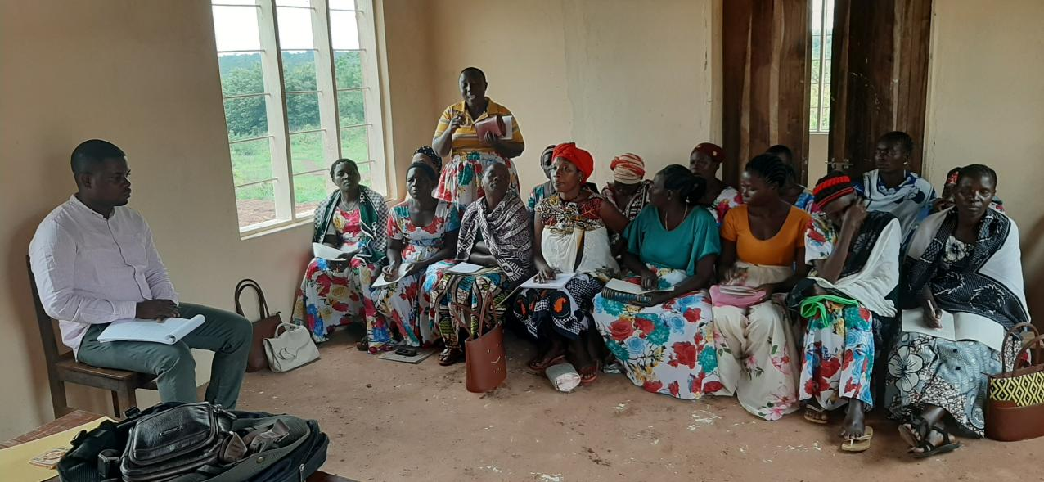
Figure 1.1: FGD with members of MWG

(b) Interviews
This method was used to collect primary data from all groups of respondents. In order to maintain focus and remain carefully controlled, Interviews were facilitated by the use of semi-structured questionnaires.

(c) Participant Observation
The use of this method enabled the researcher to assess real situation around Kalela village as well as assessing the tools currently used by the members of Muungano Women Group to produce bar soap, tools used for keeping records and their newly built facility which was part of the support received from ILO and UNDP. This method was used hand in hand with discussion with key informants and hence enabled the researcher to supplement what was stated in the interview by respondents and on the other hand, community members to see and make their own value decision on issues relating their environment and their livelihoods.

(d) Secondary Data Collection
The main source for the secondary data were from Kasulu District Council Strategic Plan, UN-Kigoma Joint Program reports, Village and Ward documents and reports, research reports, and other information available on Kasulu District Council online domains.

      - Data Analysis Methods
In general terms, data analysis entails a number of closely related operations which are performed with purpose of summarizing and organizing data in such manner that they answer research questions or hypotheses, Kothari (1990). Statistical Package for Social Sciences (SPSS) software was used to analyze data obtained from the use of semi-structured questionnaire. Furthermore content analysis technique was used to analyze qualitative data and information obtained from other methods of data collection. The component of the verbal discussion was analyzed in detail with the help of the content analysis method. Recorded conversation was broken down into smallest meaningful units of information. These were later being useful in ascertaining values and respondents’ attitude.
  - Community Needs Assessment Findings
The findings presented in this section have been obtained based on three themes derived from the specific research objectives which included skills gap, production and market opportunities and other income generating options for people in Kalela village. Findings from the focus group are presented in the following Table 1.2 which includes what each group said in each sub-theme.

    - Focus Group Discussion Results
Table 1.2: Focus Group Discussion Results
Sub - theme | Opinions of the Selected Groups
Sub - theme | Community Members | Members of Muungano Women Group
Skills Gap | There is absence of post school training tailored to enhance the skills of the villagers. It decreases active participation of villagers in income generation activities and rely overly on traditional practices in common activities such as agriculture. | Majority of them are STD VII leavers and few cannot even read and write. Opportunities to tailored acquire skills are by means of projects or Community Development Officers. It is only few people who get the chance to attend them. Those with Vocational skills from SIDO are the one with enterprising spirit and engage in producing and selling products such as soap.  They are also used as resource persons in training others especially those who belong in either youth or women groups.
Production & Market Opportunities | The main means of production for the people of Kalela is land and hence everybody in the community survives on agriculture. The crops grown are majorly cassava, maize, palm and ginger. Cassava and maize are food crops while palm and ginger are considered cash crops.  They process palm traditionally to get a semi-processed palm oil and residues called mise. Same is for ginger, they make ginger powder and pack in poor packages for sale.  Buyers for these products are from Kasulu Town or Kigoma Town. Adequate supply has been a major concern for buyers because the farmers rely on seasonality alone. | They need to increase investment in cash crops. That will help them to have money and buy food when they face shortage of food at household level.  Poor production is also contributed by lack of business skills like the gross margin analysis which could help them analyze the cost and benefits of each crop value chain and hence make informed choice of crops to grow.  There is a need to promote aggregation of produce so as to satisfy market demands. Current supply levels are very low due to poor investment and other factors like skills on production and marketing.
Other Income generating options | The youth have turned into Boda boda business using the lease to own modality.  There is an open market and boarder market days where farmers and other businessmen and women get the opportunity to sell their items. | Women seem to be the bread earners in the households. They engage in other income generating activities such as keeping domestic animals such as pigs and chicken as well as the traditional processing of cassava and making bar soap.  All these are done at a very small scale and hence the impact is not visible.
Findings from Focus Group Discussions can be summarized as follows;
- Despite presence of Primary and Secondary schools in this community, essential life skills including vocational skills is still a challenge. Villagers including women and youth rely on traditionally common skills in their production activities. This has continued to reduce the contribution of productive workforce into the household income. Vocational skills such as those offered by SIDO are found to be the ideal design of skills required to enhance productivity of the people in this community. Such skills will help them in adding value to the farm products as well as engaging in alternative income generating activities apart from agriculture.

- The largest population in this community rely on agriculture. However, due to poor use of improved farming technologies, farmers earn very low yield. This has limited their supply capacity despite existing demand of their products especially ginger powder and palm oil or mise. There is also low uptake of good agricultural practices and as a result farmers fail to make informed decisions on which crops to invest their resources on and determine the return on such investment (profitability). To make the market for their farm produce more attractive to buyers, aggregating the grains to meet required market volume can be one of the key solutions.

- To supplement the traditionally known sources of income, members of this community especially the youth have turned into Boda boda business using a lease to own model. One reason for this shift is because this pays much better and faster compared to agriculture. With the income from boda boda, the youth are able to meet their basic needs including buying food and build decent houses. Women on the other side involve in animal keeping to supplement their household incomes. Others engage in craft activities as well as in production activities such as soap making due to locally availability of raw materials (palm residues - mise).

    - Semi Structured Questionnaire Results
      - Respondents Demographic Findings
The study involved members of the community in Kalela village. In this part, respondents’ profiles including age, sex, education, marital status and occupation were examined to portray their characteristics and its implications on results obtained from the study.

        - Age of Respondents
In examining the age of the respondents, the study noted that age distribution of the respondents do range from 19 - 57 years. Respondents with age group 31-36 were many (14) compared to all other age groups. Respondents were age group 37+ were also considerably many while there was absence of respondents below age 18 years. The finding here suggest that age group of 31-36 years is the active group in this village, See Figure 1.2.
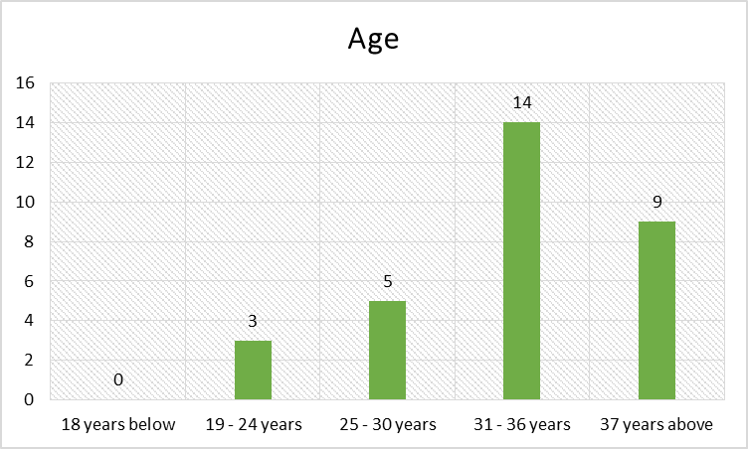
Figure 2.2: Age of Respondents
Source: Field Survey (2020)
        - Sex of Respondents
With regard to sex of the respondents the needs assessment survey noted 58 percent females and 42 percent males, See Figure 1.3. It implies that any development or economic agenda in this community must ensure that it caters for the needs of women and allow the maximum involvement of women in implementation.

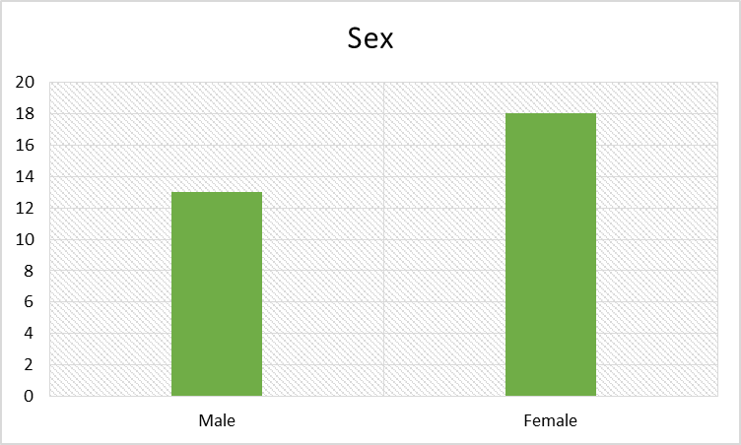
Figure 3.3: Sex of Respondents
Source: Field Survey (2020)

        - Education Level of Respondents
In assessing the level of education of the respondents, the survey find out that majority have acquired primary education (55 percent). 29 percent of all respondents attended up to secondary level, while almost 13 percent had not attended any school and only 3 percent of the respondents had college/university education. These results imply that the people in this community have the basic education enabling them to read, write and do simple calculations. The results also reveal that there is high rate of illiteracy rate in the area. See Figure 1.3.
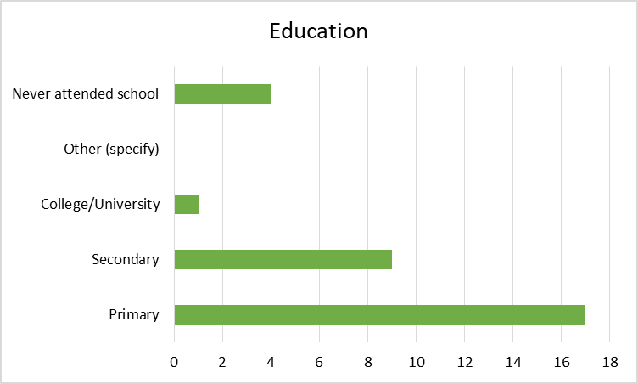
Figure 4.4: Respondents' Education Level
Source: Field Survey (2020)

        - Respondents Marital Status
The study assessed marriage status of respondents by grouping them into four categories of married, not married, widow and divorced. The results indicated that majority of respondents (21) were married, 5 (16%) were not married, 10% (3) were widows and 7% (2) were divorced. See Figure 5 below. Impliedly, it shows that the village has the largest population of married households while also having those with different marriage related challenges.

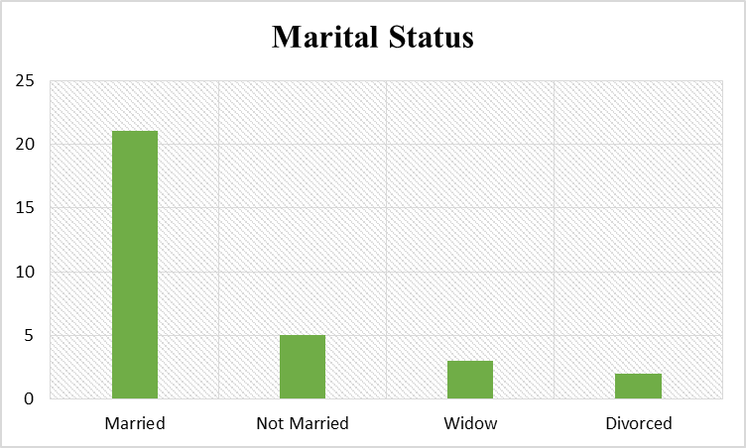
Figure 5.5: Respondents' Marital Status
Source: Field Survey (2020)
      - Main Findings
This section presents findings in response to the questions designed to gather information on three main areas; skills gap, production and market opportunities as well as options for women economic empowerment.

        - Availability of Post School Training Opportunities
The questions in this section were designed to enable respondents to list available post school training opportunities available in their village and whether such training are adequate. The results as depicted in Figure 1.6 revealed that people of Kalela are being reached by different trainings through the office of Community Development at District level an through other development organizations. The training offered focus on health awareness, agriculture and entrepreneurship. The findings indicate that each of the listed training is rated highly as inadequate. However, for entrepreneurship trainings, responses implied that it is among the fairly available in the village. When asked to state about the reasons for inadequacy, respondents indicated cost of training, lack of awareness and not seeing the need as top factors.
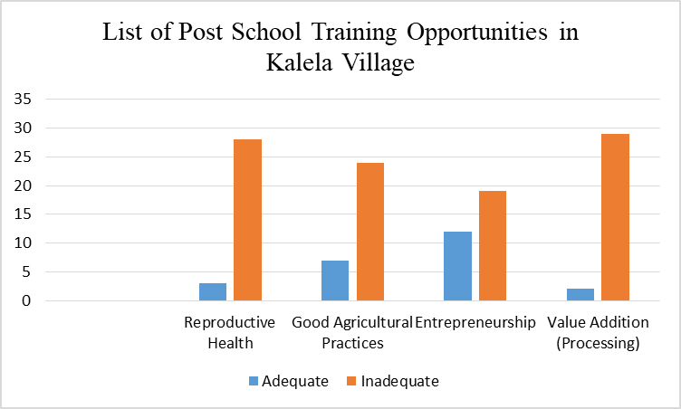
Figure 6.6: Post-School Training Opportunities in Kalela Village
The study further assessed respondents’ views and advice on solutions which can be taken to address the challenges related to inadequacy of the post-school training opportunities in their area. The findings revealed that 16 out of a total of 31 respondents preferred that training to be channeled through existing groups such as SACCOs, Farmer Organizations, youth and women organizations as well as other producer groups. A considerable number of respondents (7) were in favor having a training center built in Kalela village while awareness and use of VEO and WEO did not seem to attract the respondents as good options, see Figure 1.7.
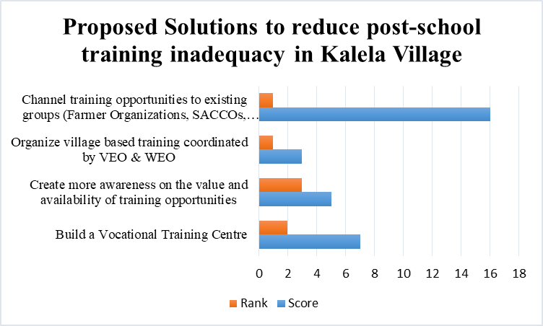
Figure 7.7: Proposed Solutions to Reduce Post-School Training Inadequacy in Kalela Village

        - Production and Market Opportunities in Kalela
In this section the study assessed whether respondents had knowledge of the economic opportunities available in Kalela village. Also the study further assessed the factors affecting productivity in Kalela village. The findings are presented in Table 1.3 and Figure 1.8.

          - Economic Opportunities Available in Kalela
The study revealed that 74 percent of the respondents had a good knowledge of the opportunities in their village while 26 percent were not able to attest the knowledge. This implies that not all the people in this village are able to recognize the economic potentials around them. It is therefore important to create awareness from the village level on the opportunities including availability of locally available resources.

Table 1.3: Economic Opportunities Available in Kalela Village
Do you know economic opportunities in Kalela? | Frequency | Percentage
YES | 23 | 74
NO | 8 | 26
Total | 31 | 100
Source: Field Survey (2020)

          - Factors Affecting Productivity in Kalela Village
In an endeavor to identify challenges that affect productivity among the people in Kalela, it was revealed that infrastructures such as road and electricity were not mentioned as a hindrance at all. Respondents indicated that they face difficulty in accessing market (61%) and that limits their productivity. Also lack of relevant skills have emerged to be among the hindrances by (35%), limited use of modern technology (39%) followed by unwillingness to abandon traditional production practices (48%).
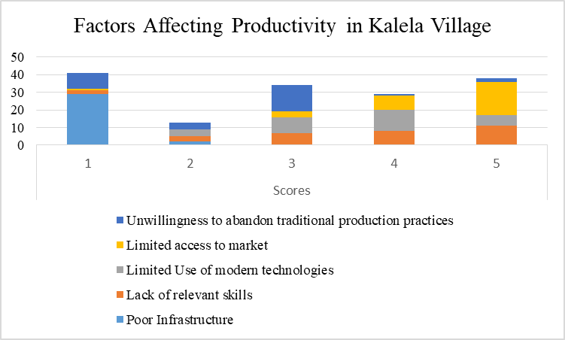
Figure 8.8: Factors Affecting Productivity in Kalela Village
        - Women Participation in Economic Activities
This part assessed the involvement of women in economic activities. Results have shown that 95% of the respondents agreed that women are actively involved in productive works. Some of the respondents added that in some families and according to their culture, in most houses with husband and wife, women are bread earners and men spend all they earn for personal refreshment including taking alcohol. The 5 percent of respondents denied that women are not actively involved in productive works. These findings prove that effort to lift the community in Kalela would not be impactful if it leaves aside the women who are the main producers and are many in terms of population size.
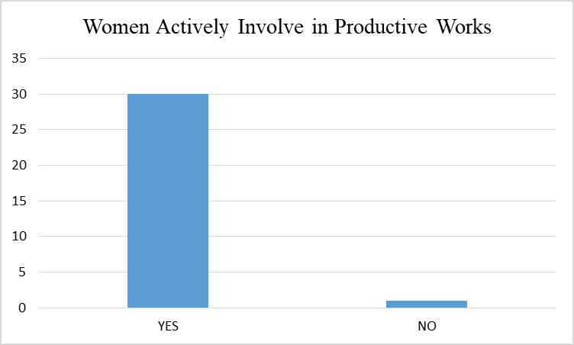
Figure 9.9: Women Involvement in Productive Works

  - Community Needs Prioritization of Needs
Community needs prioritization was done through pair wise ranking method whereby respondents were fully involved. Members participated by arguing and making decision according to their wishes. Members of the community were asked to mention as many as possible problems which hinder their development. Problems were judged against each other to get the most pressing need which got high score. The rank in which the problems were prioritized can be seen in Table 1.4;

Table 1.4: Prioritization through Pairwise Ranking Method
Problem |  | C1 | C2 | C3 | C4 |  | C5 | Score | Rank
C1 |  |  | 0 | 0 | 1 |  | 1 | 2 | 3
C2 |  | 1 |  | 1 | 1 |  | 1 | 4 | 1
C3 |  | 1 | 0 |  | 1 |  | 1 | 3 | 2
C4 |  | 0 | 0 | 0 |  |  | 1 | 1 | 4
C5 |  | 0 | 0 | 0 | 0 |  |  | 0 | 5
Where
C1 = | Supply of Modern Technologies
C2 = | Vocational & Life skills Training
C3 = | Market for Agricultural Products
C4 = | Infrastructure (Electricity)
C5 = | Leadership at Village & Ward Level

From the Pair wise ranking method, respondents had shown more interest on Vocational & Life skills training as their first priority. This was followed by the need for market for their agricultural products. They also ranked supply of modern technologies as their third preference followed by infrastructure and good leadership. Making vocational and life skills training as a priority indicate that the people are ready to begin with mental transformation before embarking into other development interventions. It also allow them to acquire basic skills that shall help in enhancing productivity in their respective economic endeavors.

  - Conclusion & Recommendation
    - Conclusion
From the CNA Findings, it has been revealed that the people of Kalela need vocational and life skills training first before any other development support. This is contributed by the fact that possession of relevant skills will enable the members to increase productivity in their daily activities across different sectors. Therefore, appropriate training procedures including undertaking a thorough training needs assessment, design of training curriculum, trainer and trainee guide manuals as well as training calendar are among the key tasks in perfecting this priority. It would be important to train trainers from within the village or involving staff from surrounding organizations so as to have an assured availability of trainers at an affordable cost.

    - Recommendations
- In order to ensure a constant availability of vocational and life skills training, the village and ward government can seek the support from development partners who are able to finance the training activities. Also, the ward government should encourage training of its community members and certification as trainers so as to reduce the cost burden. The government can also enter into specific arrangement with SIDO to facilitate vocational training for the people of Kalela at least twice a year.
- The government and other development partners should find ways of building a good market system to help the producers of Kalela find buyers of their agricultural produce. Such intervention shall help to rescue the producers from middlemen who steal from them through under pricing of goods as well as use of unapproved measurement/weighing tools.
- Invest in mobilizing people in groups. These can be groups of smallholder farmers through Farmer Organization, Youth and Women Groups, SACCO and VICOBA. These groups are good in simplifying communication, channel education and build work and entrepreneurial mindset.

CHAPTER TWO

PROBLEM IDENTIFICATION
  - Background to the Research Problem
The results from pair ranking method were able to highlight three major problems out of the five problems highlighted. Then, a meeting was arranged between the, host organization, some community leaders and CED candidate to share the identified problems and propose an intervention for the most felt one. A total of 11 people participated in the meeting that involved 1 VEO and 1 WEO as community leaders, 1 BDSP, 6 members of Muungano Women Group, 1 Community Development Officer and a CED Candidate. The three prioritized problems were shared and an open voting system was applied to get one problem that will be the basis for the new intervention.

Table 1.5: Problem Ranking
Identified Problem | Number of votes | Position
Vocational & Life skills Training | 3 | 2
Market for Agricultural Products | 5 | 1
Supply of Modern Technologies | 2 | 3
Infrastructure (Electricity) | 1 | 4
Leadership at Village & Ward Level | 0 | 5
Source: Study Findings (2020).

The above voting results suggested that participants felt the need for market of their agriculture products more than acquisition of the skills. To justify their decision, the voters looked at quick impact because majority of their economic activities is around agriculture and therefore considering any support on that area will easily translate into change in income at individual and household level. Another factor was on an area of sustainability because support from external sources including government support has been very volatile and therefore investing on assured market was considered to be a sustainable solution because once the linkages are created between them as producers and the buyers then other transaction requirements shall depend on satisfaction and negotiation.

  - Problem Statement
WB (2022) reveals that female labor-force participation rate rose from 67% in 2000 to 80% in 2019 well above the average 63% for Sub-Saharan Africa. In rural and urban areas of Tanzania, there is an increase in number of women who engage in micro self-reliance activities around agriculture, semi-processing, services and petty trade (UNWOMEN, 2020). Empirical evidence obtained by Doepke and Tertilt (2011) shows that money in the hands of mothers as opposed to husbands’ brings more benefits to the family. It is therefore very important to ensure women are given an opportunity for economic participation. Productivity in women operated ventures is low due to factors linked to cultural patterns, limited access to credit facilities, limited access to market, lack of relevant vocational and entrepreneurship skills and their minimal involvement in the decision making process at household level (Koda and Makaranga, 1997; UDEC, 2002; TGNP, 2004).

More than 61% of members of Kalela community revealed access to market as the most pressing challenge affecting women who are organized in groups and operating a group business. Muungano Women Group was formed as Credit & Savings group by women who engage in petty trade so as to address the challenge of access to credit for boosting the working capital of its members. Later in 2018, the group agreed to establish and venture into a bar soap making business. The motive came about due to availability of raw materials in Kalela which are the by-products of palm oil processing locally known as mise. At the time of setting up this assignment the group had two production cycles in a month producing an aggregate of 7 cartons of bar soap. They were capable of selling around 90% of their stock in each production cycle to the people around Kalela.

The major concern shared by these women in common is availability and of markets for their bar soap. They estimate that the current demand of their bar soap can go up to 120 cartons of bars of soap per month outside Kalela. It is because the current target residents in Kalela also have the ability to make same bar soap traditionally on their own and hence limiting business for their products. This feedback in connection with the results obtained from CAN is what has led to the proposition of this intervention. Therefore, this project intends to address the market challenge affecting MWG that limits sales of its bar soap to markets beyond Kalela residents. The project will thus focus on improving production capacity and facilitate the establishment of sustainable trade linkages between MWG (suppliers) and identified buyers in Kigoma and neighboring regions.

  - Project Description
The proposed project was “Access to Market for Bar Soap Produced by Muungano Women Group in Kalela Village, Kasulu DC, Tanzania”. The location of the project was Kasulu District Council at Kalela Village.

    - Target Community
The direct beneficiaries of this project were 18 women who were current members of Muungano Women Group in Kalela. The indirect beneficiaries included potential new members of the group, other women groups in the area and in neighboring villages, village and ward government and ultimately the household members.

    - Stakeholders
Stakeholders are those entities within or outside a project and may have a positive or negative influence in the project. According to the stakeholders analysis the followings were the key stakeholders of this project

Table 1.6: Project Stakeholders
Name of the Stakeholder | Affiliation | Role in the project
Residents of Kalela Village | Community members | Respondents during CNA exercise
VEO & WEO of Kalela | Government representatives | Assuring safety of the MCED student and the project team. Mobilize residents for the CNA. Participating in FGDs and interviews as key informants
Members of MWG | Host Organization | Availing maximum cooperation, participating in CAN and training, hosting the support from donors, engage in the production and marketing of bar soap.
Community Development Officers (CDOs). | Government Representatives | Mentor the group and support them with any government linked opportunities. Assist in finalizing formal registration of the group including opening of bank account
Buyers of Bar Soap | Market Actors | Signing of forward contracts for purchasing bar soap produced by MWG.
International Labour Organization | Development Partner | Provision of Business Skills and funding for acquisition of machines as well as construction of production facility
Business Development Services Providers | Private Sector Actors | Coach and follow-up on the group after the support and ensure there is uptake of the business skills by the members of MWG.
    - Project Goal
The main goal of this project was to support MWG to enhance production and markets for bar soap produced by Muungano Women Group in Kalela Village – Kasulu DC, Kigoma.

    - Project Objectives
- To increase production of bar soap up to 60% in order to meet existing market demand by June 2021.
- To secure an assured market for bar soap from MWG by August 2021

  - Host Organization/CBO Profile
    - Introduction
Muungano Women Group (MWG) is a social enterprise founded by a group of women residing in Kalela ward with the goal of joining their hands by engaging in productive social and economic activities so as to lift the social and economic welfare of its members. The group was founded and officially registered in 2018 in Kasulu District Council under the District Development Office. MWG aims to improve the livelihood of local communities in and around Kalela specifically the women who according to the norms have become bread earners in their families.

The livelihoods of these communities are threatened by extreme income poverty, lack of markets for farm products, limited use of technologies as well as poor infrastructures. The MWG’s ultimate goal is to improve local community and household welfare through diversification of income sources, exposure to life skills trainings, access to market for farm products as well as land and natural resource management.

Ongoing local government reforms in the country have created opportunities for women and youth. According to the Local Government Finance Act, 2019 Cap.290 Section 37, the government has set aside guidelines demanding each district to spend 10% of its domestic revenue to issue simple and small loans to the groups of youth, women and people with disability. However, not many groups have benefited from this opportunity and this is because of low ability to organize and meet the minimum set requirements.

Upon this realization, MWG was also founded to be able to mobilize and bring together women who can submit their social enterprise challenges to the government and benefit from the allocated resources. To be able to execute other objectives of their enterprise, these women need to engage meaningfully with policy making and policy implementation institutions and processes. This requires that they have a broad understanding of the regulatory and policy environment that exist. That way they will use the opportunities within existing policies, laws and institutions, and advocate for changes where these are necessary.

    - Vision
Realize the empowerment and connection of women by building women’s capacity, acting as a catalyst for change and leading the way to income independence and active involvement in household and community decision making processes.

    - Organization Structure

Figure 10.1: Organization Structure for Muungano Women Group (2020)
General Meeting
Executive Committee
Chairperson
Vice Chairperson
Development & Planning Committee
Income Generation Committee
Finance Committee
Resource Persons/Volunteers
Members
Audit & Procurement Team

    - Mission
To do everything in our power to help women in our community unlock the potential within themselves and in the environment surrounding them.

    - Organizational Goal
To promote social and economic welfare of women through capacity building, networking and investment in order to improve their livelihood and sustainably manage their resources.
    - Core Values
Table 1.7: Core Values of MWG Kalela
Value | Value Statement
Empowerment | We believe every woman is unique and powerful. Our members are our greatest strength and we will support them to achieve our aims by providing them with the information, rewards and capacity they need to take the initiative and make decisions to solve problems and improve their livelihood. As an organization, we encourage our people to try and make mistakes, we learn and grow and get better, stronger and smarter.
Respect | We believe every woman has the right to be treated with fairness and dignity. We trust each other implicitly, confident in the knowledge that we are all working towards the same goals. Equally, we hold each other responsible and accountable at all levels of the organization for the outcomes of our actions. We will be bold, clear and kind in our communication with our colleagues across the organization and not allow disrespectful behavior to go unchallenged.
Integrity | We will never communicate in any way that exploits or demeans the women we exist to serve, we will deliver a program of training that maximizes the impact for the women we serve to bring them the biggest benefits and facilitate the greatest long term positive change in their lives.
Resilience | We see every day the strength of women survivors of various social attacks and their ability to never lose hope despite having faced all those challenges. They inspire us to stay strong, hopeful, focused and committed to our purpose. We support each other to do the same.

  - Target Groups & Beneficiaries
The main focus of MWG is generally on women with priority to disadvantaged women who are self-reliant and not under any form of contracted activities. These are women involved in agriculture, handcrafts and small processing activities as a means of making ends meet. However, upon rising in demand the group will be open to accommodate any woman who is forward thinking and believes in the power of togetherness in achieving biggest women aspirations. Such women can include those in formal employment or with specific roles in the community.

  - Programme and Projects
MWG has been actively involved in programme and projects that aim to upscale the welfare of women. Such programme include the UN-Joint Program under the component of Youth and Women Economic Empowerment. They also engaged in UN-WOMEN programme which aimed at imparting vocational skills to the women groups with social enterprise offered in partnership with SIDO. The Women through the office of District Development Officers have been involved in numerous Entrepreneurship, Health, and Agriculture, Gender, Legal and Environment projects.

  - Core Activities
- Design and initiate projects or income generating activities that engages the members as their extracurricular activities.
- Training women to identify locally available resources and enabling them to utilize in a sustainable manner.
- Participate in formation of village by-laws and make sure that women interests are protected.
- Support and advice women to ensure fair contracts and agreements with investors.
- Sensitize and raise awareness of the women to understand government policies.
- Gender mainstreaming and women empowerment through equal representation.
- Engage in any other productive activities in social or economic space for purposes of ensuring that women affairs are well addressed and benefits are well defined.

  - Strength and Weaknesses
MWG draws its strength from its good relations with the government from the village to the district level. Through this relationship the group has managed to secure government loans and have received numerous offers to attend trainings within and outside Kasulu District Council. Also the group has dedicated members who share the great vision of the group and are determined to take responsibilities of their actions. MWG is a beneficiary of UN-Joint Program and hence have very good image to the United Nations agencies operating in Kigoma such as ILO, UNDP, UNCDF, UN-WOMEN and UNICEF. MWG owns a building in which they do have an office and where they have installed machines used for bar soap making.

Majority of MWG members are STD VII leavers with some limitation to read and write accurately. This weakness has resulted into poor documentation of their operations and inability to account for any earnings and expenditures. The group is lacking some key skills that will enhance their productivity - which include vocational skills on soap making and packing, marketing skills as well as matters related to health and safety during and after production. There are currently only 18 active members and there is need to intensify enrollment of new members.

CHAPTER THREE

LITERATURE REVIEW
  - Chapter Overview
This chapter covers different literatures on the subject matter from different sources and areas within and outside Tanzania. Koech, B.K (2014) argues that review of literature involves a comprehensive check on past and current publications on the subject under study. It aims to discuss key issues, identify gaps and generate new ideas for the purposes of enhancing the sustainability of operations for women in the community where the project is undertaken (Kothari, 1990). The chapter is divided into three (3) main sections where the first section describes various theories relevant to the project, the second section is on the empirical literature review and the third section is on policy reviews where different relevant policies related to the project are covered.

  - Theoretical Literature Review
    - Market Access Defined
Msamula, J. et al (2017) states that today’s biggest challenge facing businesses is not a shortage of goods but a shortage of customers. This means industries can produce far more goods than the consumers can buy. This forms a basis on how Kotler, (2003), conceptualizes marketing as more to do with how to compete on bases other than price. It is the art of creating genuine customer value. Kotler, (2003) laments that marketing practice today must go beyond a fixation on transaction that often leads to a sale today and a lost customer tomorrow. Marketer’s goal therefore, is to build mutually profitable long-term relationship with its customers, not just sell a product. This suggests that in order to create meaningful impact to the community especially for those organized in groups and running a social enterprise, an area of having assured market is key in determining the production in terms of quantity and quality. Social enterprises like MWG have always subjected themselves into big losses after putting so much investment in producing products without having a clear understanding of the customers’ needs.

Another scholar Jarvis, J (2010) continue to emphasize that marketing is everything that you do to communicate your business to both your existing and potential customers. It means after being clear with your customers (niche), the next task is to clarify exactly what is it that you are going to be selling to this market. It is important to be clear about what it is that you are selling and the value you are offering. The level of communication with your customers will be influenced by your own level of clarity. It means buying from someone who is totally clear about what they have, how it can be of benefit and is able to put that information across a straightforward manner can lead to a great sales achievement. These scholarly views shade light on the definition of market access as defined by Bhasin, (2019) who believes that market access denotes the ability of someone in terms of the extent to which they can reach out so as to sell their products or services to the consumers.

    - Designing Support Based on the Types of Market Linkages
Clancy, K (2014) argue that markets linkages connect the organisations involved in producing the products and delivering the services for any and every market. As such when linkages are absent or weak, markets become inefficient. Similarly, in the propositions of Ruffing, (2006) and Stringfellow, et al., (1997), there are two types of linkages; the first one being linkage-dependent and the other is linkage-independent groups. He suggests that linkage-dependent and linkage-independent groups can be distinguished according to their relationships to the private sector.

This distinction is meaningful both for conceiving support to improve farmers’ access to new market opportunities and for devising capacity building to strengthen existing linkages to market. Linkage - dependent groups are characterized by a strong arrangement between the group and an outside agent which has a central role in market access and can take on supervision activities regarding the group commitment to deliver its products under predetermined terms and conditions. This type of group has a lower bargaining power but it benefits from much lower needs of managerial and entrepreneurial skills.

On the other hand, linkage-independent groups have much more freedom of action to define their conditions of access to markets. But support to these groups is usually more demanding in terms of training and capacity building. Indeed, linkage - independent groups face a managerial challenge since they have to make quicker and more frequent decisions in relation to investments (who to do business with, under what terms and conditions) while achieving participation and be accountable to their members.

Finally, reasoning the most appropriate arrangement for partner organization clearly depends on the conditions under which they operate. When they have relatively little experience with formal cooperation and where markets are thin, linkage-dependent approaches seem to offer considerable advantages (Ruffing, 2006).
A good example was cited by Ruffing, L (2006) about Unilever when it first started operations in Vietnam in 1985, they had to overcome negative social and political attitudes towards the private sector as well as poor government policies and regulations. In order to create better relations and realize intended sales targets, Unilever began working with local SMEs. They invested in plants, upgraded manufacturers and suppliers and created distribution networks.

Another good case is presented by Mckone (1997) who suggests that BIODESA Project in Bolivia. According to him, it is a good case to reflect on the functioning of linkage-dependent model. This project was funded by French Ministry of Foreign Affairs. In the project, farmer cooperatives in rural areas extract oil from aromatic plants like eucalyptus and rosemary and sell their production to the University of Cochabamba which refines it and exports the final products to international buyers. Small processing units based on technology innovation from the University are operated by farmer cooperatives.

The identification of the marketable products and potential buyers required a partnership between an international NGO who provided its commercial network and the University. A long term commitment of donors has been necessary for the appropriate technology and commercialization to be developed simultaneously. A frequent difficulty lies in developing the right technologies without a commitment of a buyer to buy regular volumes. The establishment of partnerships between farmers’ cooperatives, University and NGO presently offers new opportunities to enter niche markets (organic and fair trade).
    - Building Capacity to efficiently take on Economic Functions
In order to ensure there is efficiency in an economic or income generating activity that is owned collectively by a group of people, relevancy of skills and capacity of members are key determinants. Collective actions such as efficient access to markets for the members may be highly demanding in terms of skills and capacity. Support is therefore supposed to be carefully designed as demonstrated in a case of a project named Project de Centers de Prestation de Services (PCPS) for business development services developed in Mali. This project assisted the federation of service centers, which accounts a total of 157 partner organization members, to call for tenders with the main input traders and obtain cheaper inputs for its members (Espady, 2012).

Farmers groups received support on access to market information and to understand the characteristics of markets (price fluctuations, control exerted by larger operators etc). Supporting collective organizational capacities is key factor for partner organizations to effectively and efficiently take on economic functions. When members join an organization, they usually expect to benefit quickly from their participation into the collective action.

Members’ immediate payment when deliver their production can help producers’ organization tackle the potential free-riding problem and that downstream contractual arrangements are developed. This points out the need of training for developing and piloting new institutional arrangements between companies, banks and smallholders which are mutually acceptable in terms of risk sharing and distribution of benefits.
Planning and risk assessment must then precede the choice and implementation of economic functions by producers’ organizations. As pointed out by String fellow et al., (1997), ‘donors wishing to promote farmer cooperation should refrain from rushing the process of group formation or from overburdening groups with too many or too complex functions’. Hence Jenkins et al (2011) urge to the construction of new relations arising from step by step approaches and the use by government and NGOs of clear fixed term contracts drawn up in conjunction with the groups.

  - Empirical Literature Review
    - Efforts to Create Markets For Small Scale Producers in Africa
History suggests that small scale producers in Africa have struggled to be incorporated into formal markets. Studies indicate numerous efforts directed towards addressing such a challenge (see, for example, Bernstein, 1979; Boesen 1979; Cliff 1977; Nyoni & Bonga (2018) of African agricultural development. Nyoni & Bonga, (2018) asserts that typically peasants in Africa would be subjected to a ‘reproduction squeeze’, in which the real prices of their output would be forced down in the market by competing goods produced under more favorable conditions.

Meanwhile attempts to intensify and improve productivity would lead to rising costs of production, decreasing returns to Labour, or both, especially if peasants brought more marginal land into cultivation, or were unable to conserve their soils. This could become a downward spiral as shortfalls in production and income would lead to indebtedness, starvation rents, crop mortgaging, forced sale of assets, and so on, ultimately to destitution.
Another study by Olwande and Mathenge, (2012) on the impact of collective action on enabling market access to small producers in Africa denotes that institutional factors like membership in the group, extension service, and infrastructure have an influence on market participation. Poor infrastructure has a negative effect on market participation because the majority of smallholder farmers in developing countries is located in remote areas with poor infrastructure and often fail to participate in the market due to the high transaction cost involved (Goetz, 1992; Makhura, et al., 2001; Key, et al., 2002).

Membership to the group has both positive and negative impact on market participants. It positively impacts on market participation because it increases household’s access to information vital to production and marketing decisions (Olwande and Mathenge, 2012). On the other hand, it can negatively impact market participation in case disagreement emerges among group members, distorting marketing decision. Extension service is expected to impact positively on market participation because it is through extension services that farmers are able to acquire better skill and knowledge on marketing.

Physical resource endowments like ownership of transport and communication equipment have an impact on market participants. Ownership of communication equipment such as mobiles, radios and televisions have a positive impact on the market participation by facilitating marketing information to the farmers. Ownership of transport equipment such as bicycles, motorcycles and truck have a positive impact on market participation by reducing the cost of transporting output from the farm to the market (Key, et al., 2000).
Market factors have been found to positively and negatively influence market participation. Jari (2009) stated that availability of market information boosts confidence of household who are willing to participate in the market. Poor access to market information result in information-related problem, namely moral hazard and adverse selection which in turn increase transaction costs and hence discourages participation in the market by some farmers (Fatchamp and Hill, 2005; Shiferaw et al., 2009). Distance from the farm to point of sale, and market information were found in a couple of studies to be a major constraint to intensity of market participation (Montshwe, 2006; Bahta and Bauer, 2007; Omiti et al., 2009). Price factor positively influences market participation. Alene et al. (2008) argue that output price is an incentive for sellers to supply more in the market.

Signe, (2018) states that Africa is one of the fastest-growing consumer markets in the world. Consumer expenditure has grown at a compound annual rate of 3.9% since 2010 and reached $1.4 trillion in 2015. Studies have shown that African consumers are savvy and brand loyal. Local vendors are entrepreneurial and present key assets for distribution chains. At the same time, the vast majority of consumer spending on the continent currently takes place in informal, roadside markets, even in those countries with the well-developed retail and distribution markets.

This disconnect signals enormous potential for growth as African consumers shift from the informal toward more formal forms of consumption including shopping malls, supermarkets, and eventually even e-commerce a process that is already underway in all but the most fragile and underdeveloped countries. By 2030, the largest consumer markets will include Nigeria, Egypt, and South Africa. There will also be lucrative opportunities in Algeria, Angola, Ethiopia, Ghana, Kenya, Morocco, Sudan, Tunisia, and Tanzania, among other African countries (Signe, 2018).

    - The Need to Create Markets for Small Scale Producers in Tanzania
Aku, A. et al (2018) study on the effect of market accessed through farmer organizations on household income in Babati district discovered that limited market information is the major obstacle to increased smallholders income in Tanzania. The formation of a farmer organization is one way to overcome these challenges by improving access to market while reducing transaction cost.

The results indicated that smallholder vegetable farmer market access is strongly associated with socioeconomic characteristics. Gender significantly affects the likelihood of market access. Male-headed households had a higher probability of market access than female and this is mainly because for most cases it is the man in a family who make the decisions on whether to sell or not (Parvin & Akteruzzaman, 2012). Vegetable farmers who have access to better market information are likely to access the market. Perhaps this might be because access to market information helps in planning the marketing process of any farm business (Magesa, Michael & KO, 2014).

  - Economic Theories of Entrepreneurship

3.4.1 Resource Based Theory
In this theory Barney (1991) suggests that resources that are valuable, rare, difficult to imitate and non-substitutable best position an organization for long-term success. These strategic resources provide the foundation to develop organizational capabilities that can lead to superior performance over time. Capabilities are needed to bundle in a manner that provides value added to customers and creates advantages over competitors. Barney explains that organization’s resources consists of all assets and capabilities, skills, processes and organizational attributes, information and knowledge that are available and controlled by the organization, as well as allowing them to be used in order to trace strategy more adherent to the business creating value above the market average over a period of time.

3.4.1.1 Four Characteristics of Resource Based Theory
As put forth by Barney, the four main characteristics of this theory include Valuable, Rare, and Inimitable and Non-substitutable summarized as VRIN.
- Valuable: Resources are considered valuable when they enable a company to adopt strategy to improve their efficiency and effectiveness.
- Rare: It means valuable resources are controlled by an organization that is not owned by a large number of competitors.
- Inimitable: A valuable and rare resource can often be a sustainable competitive advantage generator only if the companies that do not have it, cannot obtain it.
- Non-substitutable: It is about resources that can be considered equivalent. Although different from each other, it enables the deployment of the same capacity or strategy.

3.4.2 Opportunity Based Theory
This theory is anchored by names such as Peter Drucker and Howard Stevenson. An opportunity based approach provides a wide range of conceptual framework for entrepreneurship research (Fiet, 2002, Shane, 2000). According to this theory, entrepreneurs do not cause change (as claimed by the Schumpeterian or Austrian School) but exploit the opportunities that change (in technology, consumer preferences etc) creates (Ngcobo & Sukdeo(2015). He further says ‘this defines entrepreneur and entrepreneurship, the entrepreneur always searches for change, responds to it, and exploits it as opportunity’. What is apparent in Drucker’s opportunity construct is that entrepreneurs have an eye more for possibilities created by change than problems.

3.4.3 Asset-Based Community Development Theory
Asset-based community development theory for community building, assumes that social and economic revitalization starts with what is already present in the community – not only the capacities of residents as individuals, but also the existing commercial, associational and institutional foundation (Turner & Pinkett, 2000). The theory seeks to leverage the resources within a community by mapping these assets and then mobilizing them to facilitate productive and meaningful connections.

Nyoni and Bonga (2018) have identified three characteristics of asset-based community development namely; Asset-based community development begins with what is present in the community (assets), as opposed to what is absent or problematic in the community (needs). It is focused on indigenous assets as opposed to perceived needs. An asset-based approach involves community residents, organizations, institutions and businesses.
- Internally focused. Asset-based community development calls upon community members to identify their interests and build upon their capacity to solve problems. One of the distinguishing characteristics of the approach is its heavy emphasis on leveraging that which is in the community first, before looking to (but not excluding) outside entities and/or resources.
- Relationship driven. Community building has also been defined as "any identifiable set of activities pursued by a community in order to increase the social capacity of its members" (Kazimoto, P. 201497). Consequently, asset-based community development encourages the ongoing establishment of productive relationships among community members, as well as the associated trust and norms necessary to maintain and strengthen these relationships.

A blend of concepts from the three theories is foundational in designing community projects. Organizations as put forth by Sukdeo & Ngcobo (2015) need to know their resources and be able to use them strategically to build their competitive advantage. To be able to excel in the market, a clear knowledge of determining changes which occur in the community is very important. As Drucker suggests, lack of knowledge on the advantages which come with certain changes in the community results into failure to distinguish opportunities from other social occurrences. Finally, to be able to have sustainability in any community project, it is necessary that organizations are able to realize their internal and external potentials. This means, forward looking communities should always focus on utilizing what they have in solving their problems as opposed to focusing on what they need or what they do not have.

  - The Policy Reviews
The government of Tanzania has developed different policies and guidelines to govern the welfare of its people and development of social entrepreneurs through access to market, finance and access to business development services. The implemented project complies with number of policies of the United Republic of Tanzania governing sectors to which it falls. The project is in line with Small and Medium Enterprise Development Policy of 2003, Employment policy of 1997, National Education and Training Policy of 1995 and Community Development Policy of 1996.

The project positively complies with Education and Training Policy of 1995 which in detail explains the rationale of education in bringing about the development of the community more specifically rural communities. The policy defines education as a process by which the individual acquires knowledge and skills necessary for appreciating and adapting to environment and the aver-changing social, political and economic conditions of society and as a means by which one can realize one’s full potential. This clearly shows that the policy is in line with the project of facilitating access to market for small producers because series of trainings shall be involved while building the internal capacity to sustain the enterprise at the organization level.

Moreover, the policy clearly shows the close relationship between education and development. In this case the policy is trying to emphasize that education on self-reliance will enhance community development. On the other hand, education and training policy in its context advocate for access and equity in education and this is well in line with this project. Other policy that complies with this project is that of Community Development Policy of 1996. Community Development Policy of 1996 which puts emphasis on effective utilization of abundant resources available in Tanzania. The policy recognizes the fact that Tanzania communities have been largely unable to utilize these resources effectively in bringing about meaningful development. The policy promote for community awareness so that they have ability to identify resources and use them in their own development. It also has the objective of helping community to participate more effectively in economic activities.

Small and Medium Enterprise Development Policy (2003) recognize that private sector plays a crucial role in employment creation and income generation in Tanzania. For the sector to tap its full potential the policy was formulated so as to address the constraints it is facing. Employment policy 1997, direct the government to promote employment through expansion of education, initiation of vocational education and training, initiation of education for self-reliance and development of the self-employment sector in rural areas so as to reduce the rate of migration to urban areas.

  - Literature Review Summary
Theorists and national policies highlighted in this study have presented diverse knowledge and approaches used to empower women in rural areas. However, there is a gap in integrating community members from design to the closing stage. Another area which CNA revealed was on institutionalization of the community economic empowerment interventions. It was revealed that, groups such as Muungano Women Group had been a beneficiary of many projects in the past but none of them had managed to centralize the support at an institution level in which management and control becomes easy. The result of this malpractice has been many project fail immediately after closure and after withdrawal of donor support.
The biggest gap from the CNA was lack of commercial attributes into the support as an important factor for sustainability. Even in areas where support aimed at strengthening business or building commercial mindsets of the beneficiaries, it was evident that very little or no investment was directed towards ensuring that community members acquire the right enterprising skills to sustain the income generating projects in their communities. Form all these gaps and with a focus to Muungano Women Group, this project was designed to support MWG on Access to Market for bar soap produced by the members of MWG in Kalela Village, Kasulu DC Kigoma in Tanzania.

CHAPTER FOUR

PROJECT IMPLEMENTATION
  - Chapter Overview
This chapter presents the planned project implementation and what has actually been implemented by focusing on inputs, outputs and impacts of the project. The chapter also include research budget by highlighting main items and their costs. Implementation of the project activities was focused on realization of the project main goal. Project implementation involved formulation of project activities such as sensitization and mobilization, training, in-store coaching and field trips all designed to ensure creation of an assured market for the goods produced.

The process of developing this project started with organizing and conducting community needs assessment for the purpose of exploring from the community some of the problems hindering their development especially on scaling up of the bar soap produced by the members of Muungano Women Group in Kalela, Kasulu District Council. To achieve this, three thematic areas of skills, production and market opportunities as well as other options for women economic empowerment were taken into consideration.

After conducting the need assessment the findings indicated that access to market was the critical challenge which limits their livelihood improvement. Based on this, this project was designed in order to support the community members particularly the women attached to Muungano Women Group to access market for bar soap which is a social enterprise designed to lift the income status of its group members.
  - Products and Outputs
The major project product is realization of improved livelihood for the women community in Kalela through building good market systems to off-take the locally made products and goods including bar soap and other agricultural products. This will be realized after a number of interventions including capacity building to ensure that Muungano Women Group is well aligned in terms of capacity to engage in business dealings. This means assessing and building their capacity from production, finance and marketing skills.

Production will specifically focus on bar soap which is the social enterprise chosen by the group and that has been in operation for almost six months. All capacity issues to do with planning for production, procurement, packaging and finally taking the products to market will be addressed. This will include writing a business plan to raise funding to address some of the capacity gaps like building the standard production unit, purchase of production machines.

The end result expected is for the group to enter into forward contracts with buyers of their bar soap. These contracts are seemingly important in informing investment plans in terms of production and finance. Not all the activities were designed to bring results in the course of the project duration, some of the systemic results may be realized after the project duration is over.

Table 4.1: Main Project Outputs
Objectives | Outputs | Activities
Objective 1  To increase production of bar soap up to 60% in order to meet existing market demand by June 2021. | Output 1  One training for MWG on Social Enterprise Management conducted. | Conduct TNA and prepare training content.
 |  | Training 18 members of MWG on Social Enterprise Management.
 | Output 2  0.5 Acre of land from the village government acquired | Filing an application and responding to land acquisition procedures from VEO Office.
 | Output 3  One building for production, storage and office operations constructed. | Inviting tenders from village and ward level contractors
 |  | Approving the Bill of Quantities (BOQ).
 |  | Supervising the construction process.
 | Output 4  One bar soap making machine procured, installed and operationalized. | Screening and deciding the best bar soap making machine supplier.
 |  | Supervising installation and training of operators
Objective 2  To secure an assured market for bar soap from MWG by August 2021 | Output 1  One purchase contract between MWG and soap buyers signed. | Mapping of retail and wholesale buyers of bar soap.
 |  | Preparing the contract.
 |  | Seeking legal advice from legal office at LGA level.
 |  | Conducting Business to Business Meetings and signing the contract.

Project Planning
Implementation of the project activities involved key stakeholders namely MCED student, VEO and WEO of Kalela, Office of Community Development Kasulu DC, International Labour Organization - YWEE Project Manager, BDSPs and Muungano Women Group as a host organization. Resources used in implementation of the project activities were jointly contributed by the government through LGA Kasulu DC and the ILO through its YWEE Project under the Kigoma UN-Joint Program.

The MCED student was a Consultant hired by the ILO under YWEE Project to build the capacity of Youth and Women Owned Group Enterprises in Kasulu DC, Kasulu TC, Kibondo and Kakonko. This enabled to directly involve in conducting assessment, participate in sensitization, facilitate trainings and strike a room for discussions with other project partners on matters related to support to Muungano Women Group quite easily. The village government contributed land and members of MWG contributed their labor force by collecting stones to the construction site.

The Community Development Officers from Kasulu DC provided a list of existing and potential group which could be a target of any support from project and government initiatives. BDSPs were instrumental in sustaining the Business Support services to the group after phasing out of the project on basis of shared benefits to both sides.

Project Implementation Plan (PIP).
Table 4.2: Project Implementation Plan
Objectives | Outputs | Activities | Months (2020 – 2021) |  |  |  |  |  |  |  |  |  | Resources Needed | Responsible Person
Objectives | Outputs | Activities | N | D | J | F | M | A | M | J | J | A | Resources Needed | Responsible Person
Objective 1  To increase production of bar soap up to 60% in order to meet existing market demand by June 2021. | Output 1  One training for MWG on Social Enterprise Management conducted. | - Conduct TNA and prepare training content. |  |  |  |  |  |  |  |  |  |  | Transport, Stationeries | MCED Student, ILO
 |  | - Training 18 members of MWG on Social Enterprise Management. |  |  |  |  |  |  |  |  |  |  | Transport, Funds | MCED Student, ILO
 | Output 2  0.5 Acre of land from the village government acquired | - Filing an application and responding to land acquisition procedures from VEO Office. |  |  |  |  |  |  |  |  |  |  | Funds, Transport | MWG Leaders, ILO & VEO
 | Output 3  One building for production, storage and office operations constructed. | - Inviting tenders from village and ward level contractors |  |  |  |  |  |  |  |  |  |  | Stationeries, Funds | MWG Building Committee
 |  | - Approving the Bill of Quantities (BOQ). |  |  |  |  |  |  |  |  |  |  | Funds | MWG Building Committee, ILO
 |  | - Supervising the construction process. |  |  |  |  |  |  |  |  |  |  | Transport, Meals | MWG Leaders, & MCED Student
 | Output 4  One bar soap making machine procured, installed and operationalized. | - Screening and deciding the best bar soap making machine supplier. |  |  |  |  |  |  |  |  |  |  | Transport, Stationeries | MWG Procurement Committee
 |  | - Supervising installation and training of operators |  |  |  |  |  |  |  |  |  |  | Transport, Meals | MWG Leaders
Objective 2  To identify an assured market for bar soap from MWG by August 2021 | Output 1  One purchase contract between MWG and soap buyers signed. | - Mapping of retail and wholesale buyers of bar soap. |  |  |  |  |  |  |  |  |  |  | Transport, Funds | MCED Student & BDSPs
 |  | - Preparing the contract. |  |  |  |  |  |  |  |  |  |  | Funds | MWG Leaders, VEO, LGAS
 |  | - Seeking legal advice from legal office at LGA level. |  |  |  |  |  |  |  |  |  |  | Transport, Funds | MWG Leaders, LGAs
 |  | - Conducting Business to Business Meetings and signing the contract. |  |  |  |  |  |  |  |  |  |  | Transport, Funds | MWG Leaders, MCED Student & BDSPs

Logical Framework
Table 4.3: Logical Framework
 | Intervention Logic | Indicators | Means of Verification | Risk/Assumptions
Goal: | To enhance production and markets for bar soap produced by Muungano Women Group in Kalela Village – Kasulu DC, Kigoma.
Objective 1 | To increase production of bar soap up to 60% in order to meet existing market demand by June 2021. | - Change in quantities of bar soap produced.  - Quantities of bar soap sold (Cartons) | - Enterprise Survey  - Warehouse & Sales Reports  - Production report | Approved budgets are disbursed timely.  Members of MWG agree to engage in rotational production cycle on non-payment basis.
Outputs | One training for MWG on Social Enterprise Management conducted. | - Number of members trained. | - Training Needs Assessment Report  - Training Timetable  - Training Attendance Register  - Training Report | MWG members are able to read, write and do simple calculations.  MWG are willing to cover their costs of attending the sessions.
Outputs | 0.5 Acre of land from the village government acquired | - Size of land acquired. | - Offer letter | The Land Committee is satisfied on uses of the land and issues offer letter.
Outputs | One building for production, storage and office operations constructed. | - Number of buildings constructed. | - Permits  - Signed agreement with building contractors. | VEO and the land committee at the office of WEO are able to grant 0.5 acre to MWG.  ILO is able to approve financial request of TZS 17Million.
Outputs | One bar soap making machine procured, installed and operationalized. | - Number of machines purchased | - Supplier Quotations  - Purchase receipt | Timely disbursement of money by the ILO.
Activities | - Sensitization and introduction meetings to stakeholders about the project.  - Conduct TNA.  - Training of MWG members on Social Enterprise Development.  - Filing an application and responding to land acquisition procedures from VEO Office.  - Inviting tenders from village and ward level contractors  - Approving the Bill of Quantities (BOQ).  - Supervising the construction process.  - Screening and deciding the best bar soap making machine supplier.  - Supervising installation and training of operators.
Objective 2 | To identify an assured market for bar soap from MWG by August 2021 | - Number of existing and potential buyers | - Customer Portfolio | Both parties on the purchase contract are able to honor its implementation.
Outputs | One purchase contract between MWG and soap buyers signed. | - Number of B2B meetings.  - Number of buyers identified.  - Number of Purchase Contracts signed | - Meeting attendance & Minutes  - List of buyers  - Signed contracts | Identified buyers express their willingness to sign the contract as a binding document.
Activities | - Mapping of retail and wholesale buyers of bar soap.  - Preparing the contract.  - Seeking legal advice from legal office at LGA level.  - Conducting Business to Business Meetings and contract signing.

Major Project Inputs
Table 4.4: Major Project Inputs
Objectives | Outputs | Activities | Inputs | Quantity | Unit Cost(TZS)
Objective 1  To increase production of bar soap up to 60% in order to meet existing market demand by June 2021. | Output 1  One training for MWG on Social Enterprise Management conducted. | Conduct TNA and prepare training content. | Resource Persons (MCED Student & BDSPs) | 4 (2days) | 2,000,000/=
 |  | Training 18 members of MWG on Social Enterprise Management. | Facilitator  Training Materials  Venue | 2 (12 days)  90Kits  1 | 6,000,000/=  2,250,000/=  N/A
 | Output 2  0.5 Acre of land from the village government acquired | Filing an application and responding to land acquisition procedures from VEO Office. | Land Fee | 1 | 25,000/=
 | Output 3  One building for production, storage and office operations constructed. | Inviting tenders from village and ward level contractors | Stationeries  Airtime | 1 | 300,000/=
 |  | Approving the Bill of Quantities (BOQ). | Stationeries | 1 | 100,000/=
 |  | Supervising the construction process. | Resource Persons | 2 | N/A
 | Output 4  One bar soap making machine procured, installed and operationalized. | Screening and deciding the best bar soap making machine supplier. | Money  Procurement Committee | 1  N/A | 4,500,000/=  N/A
 |  | Supervising installation and training of operators | Resource Persons | 2 | N/A
Objective 2  To identify an assured market for bar soap from MWG by August 2021 | Output 1  One purchase contract between MWG and soap buyers signed. | Mapping of retail and wholesale buyers of bar soap. | Resource Persons  Transport | 2 | 2,000,000/=
 |  | Preparing the contract. | Resource Persons | 1 | 500,000/=
 |  | Seeking legal advice from legal office at LGA level. | Resource Persons | 1 | N/A
 |  | Conducting Business to Business Meetings and signing the contract. | Resource Persons | 2 | 1,850,000/=
Total |  |  |  |  | 19,525,000/=

    - Staffing Pattern
Implementation of the project solely relied on using members, committees and leaders of MWG, BDSPs and LGAs from Kasulu DC in Kigoma.

Table 4.5: Project Staffing Pattern
Activities |  | Personnel (Person Hours)
Work breakdown Structure Code | Description | MCED Student | MWG Leaders | MWG Committee | BDSPs | LGAs
1.1.1 | Conduct TNA and prepare training content. | 16 | 2 | 0 | 16 | 0
1.1.2 | Training 18 members of MWG on Social Enterprise Management. | 96 | 2 | 0 | 96 | 0
1.2.1 | Filing an application and responding to land acquisition procedures from VEO Office | 8 | 24 | 0 | 0 | 8
1.3.1 | Inviting tenders from village and ward level contractors | 8 | 16 | 48 | 0 | 0
1.3.2 | Approving the Bill of Quantities (BOQ). | 2 | 6 | 6 | 0 | 2
1.3.3 | Supervising the construction process. | 66 | 112 | 112 | 0 | 0
1.4.1 | Screening and deciding the best bar soap making machine supplier. | 4 | 8 | 8 | 2 | 0
1.4.2 | Supervising installation and training of operators | 2 | 24 | 24 | 2 | 1
2.1.1 | Mapping of retail and wholesale buyers of bar soap. | 32 | 8 | 0 | 16 | 8
2.1.2 | Preparing the contract. | 3 | 1 | 1 | 0 | 0
2.1.3 | Seeking legal advice from legal office at LGA level. | 2 | 8 | 0 | 0 | 8
2.1.4 | Conducting Business to Business Meetings and signing the contract. | 48 | 32 | 0 | 16 | 8

Project Budget
A total budget of TZS 33,915,000/= was set aside for the implementation of this project. The budget was divided into direct activity costs, reimbursable expenses and field operations expenses as presented in Table 4.6.

Table 4.6: Project Budget
 | Items | Units | No.of Units | Unit Cost | Total (TZS)
1.1.1 | Conduct TNA and prepare training content. | Assessors | 4 | 500,000/= | 2,000,000/=
1.1.2 | Training 18 members of MWG on Social Enterprise Management. | Facilitators | 2 | 4,125,000/= | 8,250,000/=
1.2.1 | Filing an application and responding to land acquisition procedures from VEO Office. | Leaders | 1 | 25000/= | 25,000/=
1.3.1 | Inviting tenders from village and ward level contractors | Committee | 1 | 300,000/= | 300,000/=
1.3.2 | Approving the Bill of Quantities (BOQ). | committee | 1 | 100,000/= | 100,000/=
1.3.3 | Supervising the construction process. | Members | 18 | 00 | 00
1.4.1 | Screening and deciding the best bar soap making machine supplier. | committee | 1 | 4,500,000 | 4,500,000/=
1.4.2 | Supervising installation and training of operators | Members | 1 | 00 | 00
2.1.1 | Mapping of retail and wholesale buyers of bar soap. | BDSPs | 2 | 1,000,000/= | 2,000,000/=
2.1.2 | Preparing the contract. | Consultant | 1 | 500,000/= | 500,000/=
2.1.3 | Seeking legal advice from legal office at LGA level. |  |  |  | 00
2.1.4 | Conducting Business to Business Meetings and signing the contract. |  |  |  | 1,850,000/=
 | Direct Activity Cost |  |  |  | 19,525,000/=
 | Reimbursable Expenses | Units | No.of Units | Unit Cost | Total (TZS)
 | MCED Student Allowance | Months | 6 | 350,000 | 2,100,000/=
 | Government Officers allowances | Man-day | 23 | 120,000/= | 2,760,000/=
 | Business Development Services Providers | Man-day | 2 | 80,000/= | 160,000/=
 | Communication | Months | 5 | 30,000/= | 150,000/=
 | Office, equipment and utilities | Months | 6 | 50,000/= | 300,000/=
 | Total Reimbursable expenses |  |  |  | 5,470,000/=
 | Field Operational Expenses
 | Vehicles(Field Transport) - Car hire &/Fuel Costs | Man day | 23 | 150,000/= | 3,500,000/=
 | Total Operational Expenses |  |  |  | 8,920,000/=
 | TOTAL DIRECT PROJECT COST |  |  |  | 33,915,000/=

Project Implementation
The execution of this project started around October 2020 with the preliminary activities which included proposing to ILO for financial support, aligning with the RAS Office Kigoma and the LGA office in Kasulu. This time was also used for sensitization and conducting CAN. The outcomes of this stage included getting approvals of the budget for the project from the ILO, securing lists of potential organizations/groups from Kasulu DC and producing the CNA Report.

Actual implementation of the project activities started on 19th November 2020 when I started conducting the Training Needs Assessment (TNA). This activity was followed by actual training activity conducted from 30th November 2020 to 11th December 2020. The training was on Social Enterprise Management with three major blocks; Business Planning, Social Enterprise Governance and Business Model Development. At the end of this training, members of MWG were able to produce a work plan with all the activities/tasks and timeliness as indicated in the Ghantt Chart. It was designed that the project ends by 30th August 2021.

Project Implementation Report
This part presents proof of implemented activities, a brief detail on how the implementation was coordinated and its alignment to the main project objectives.

Training of MWG on Social Enterprise Management
As earlier stated, this activity started on 30th November 2020 and ended in 11th December 2020. A total of 18 members of Muungano Women Group were trained at Kalela Center. MCED Student was the lead facilitator assisted by one BDSP based in Kasulu DC named Chrisantus Philbeth Kitumbu.
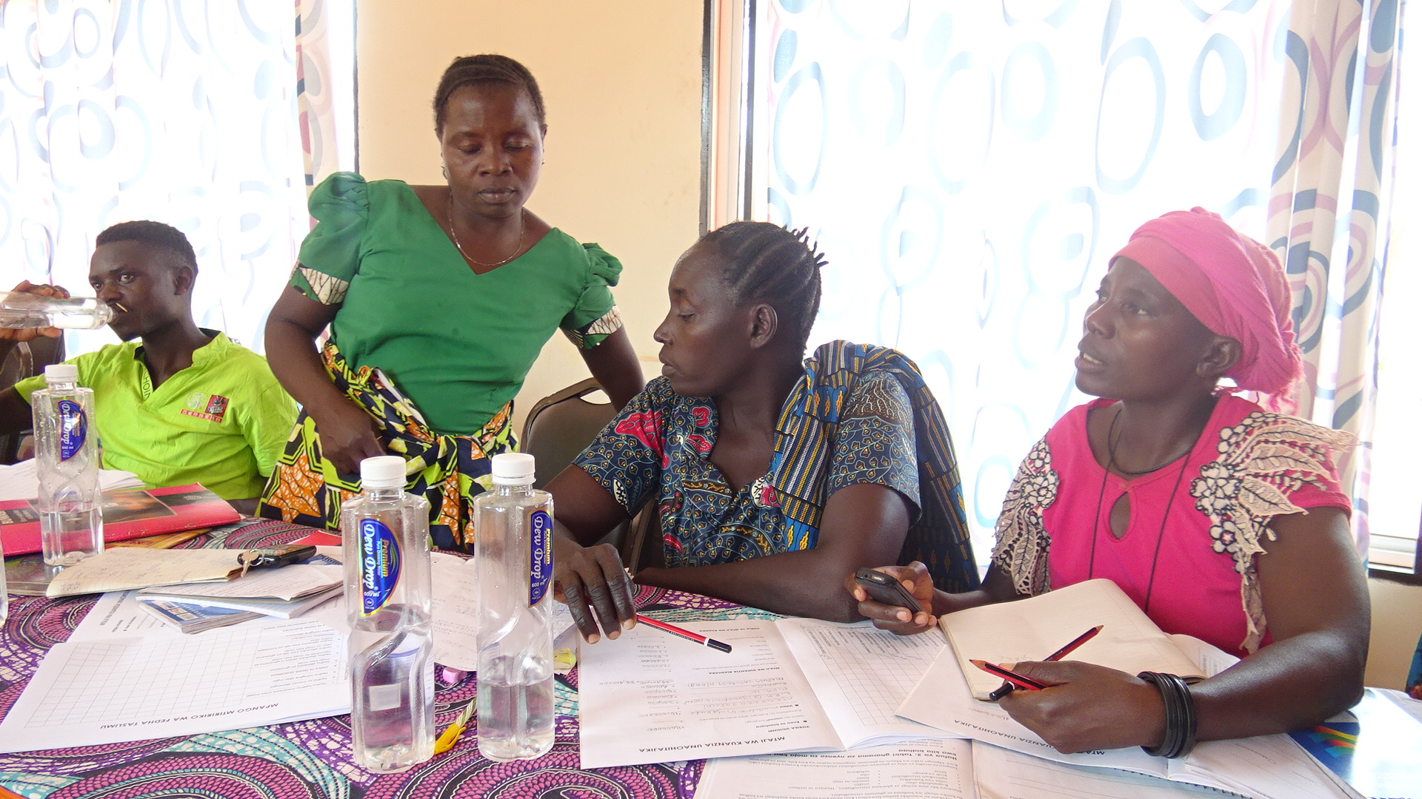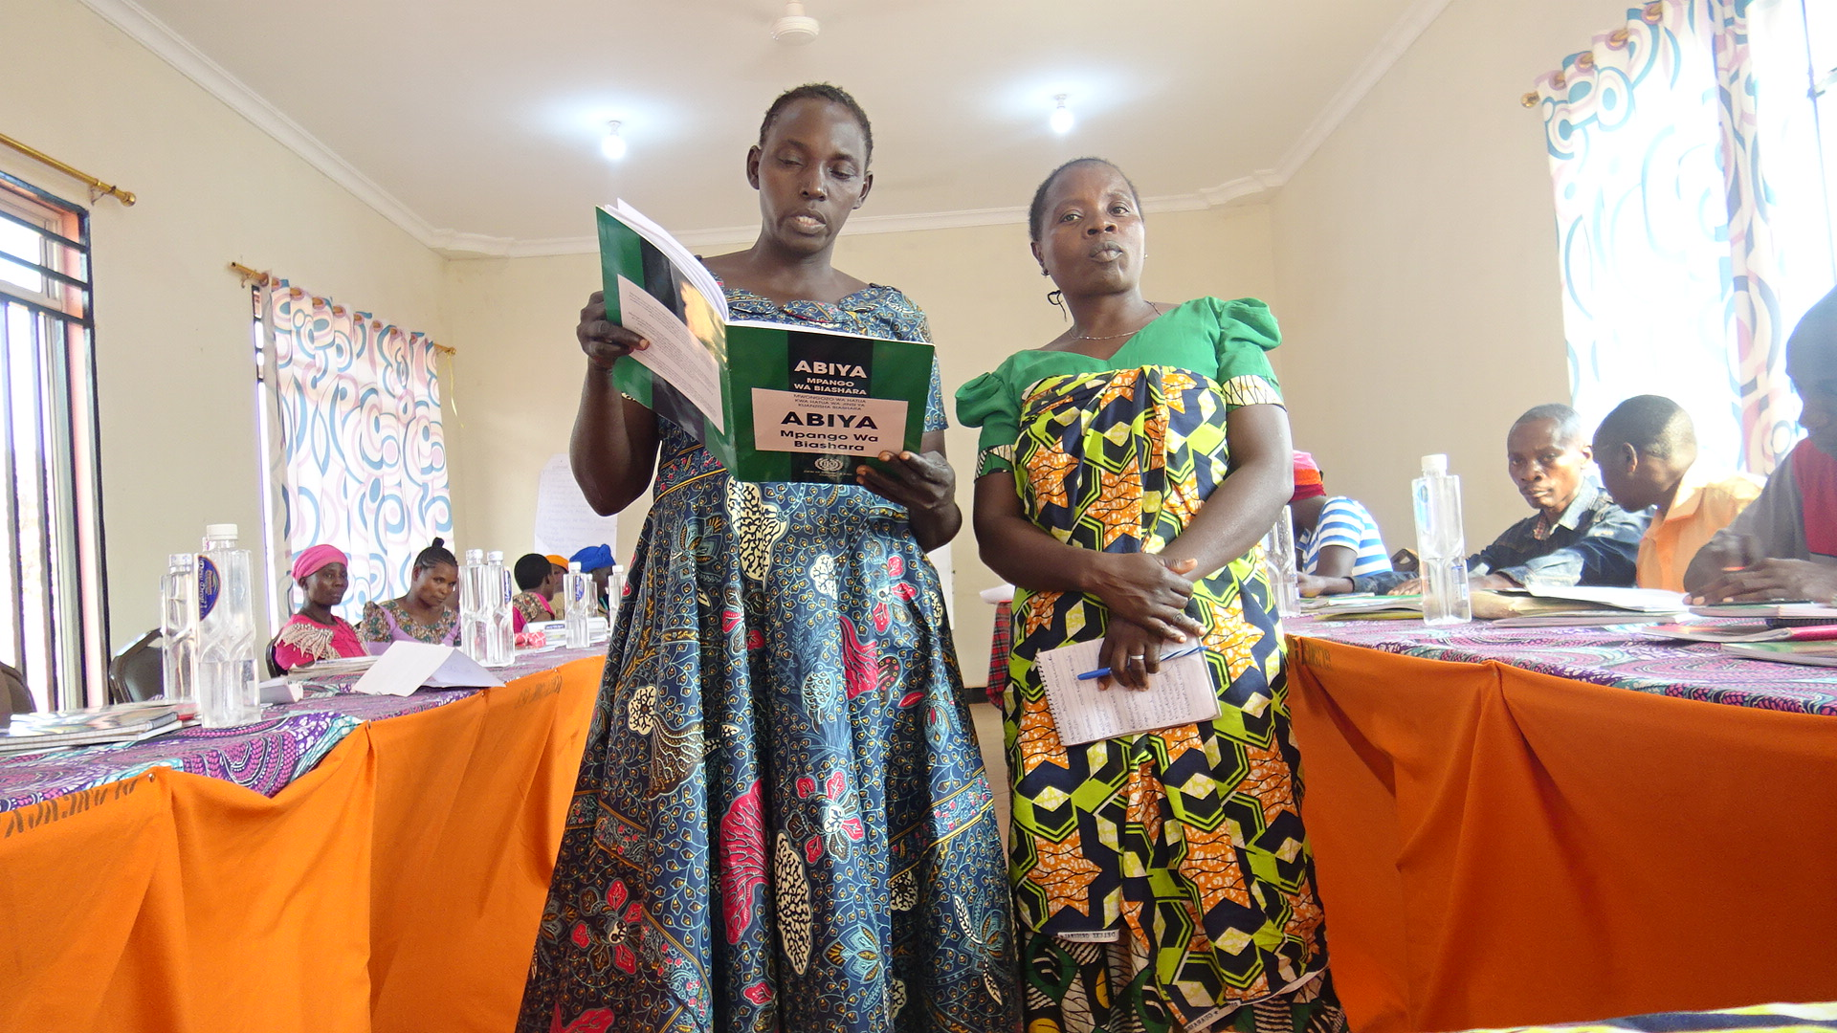
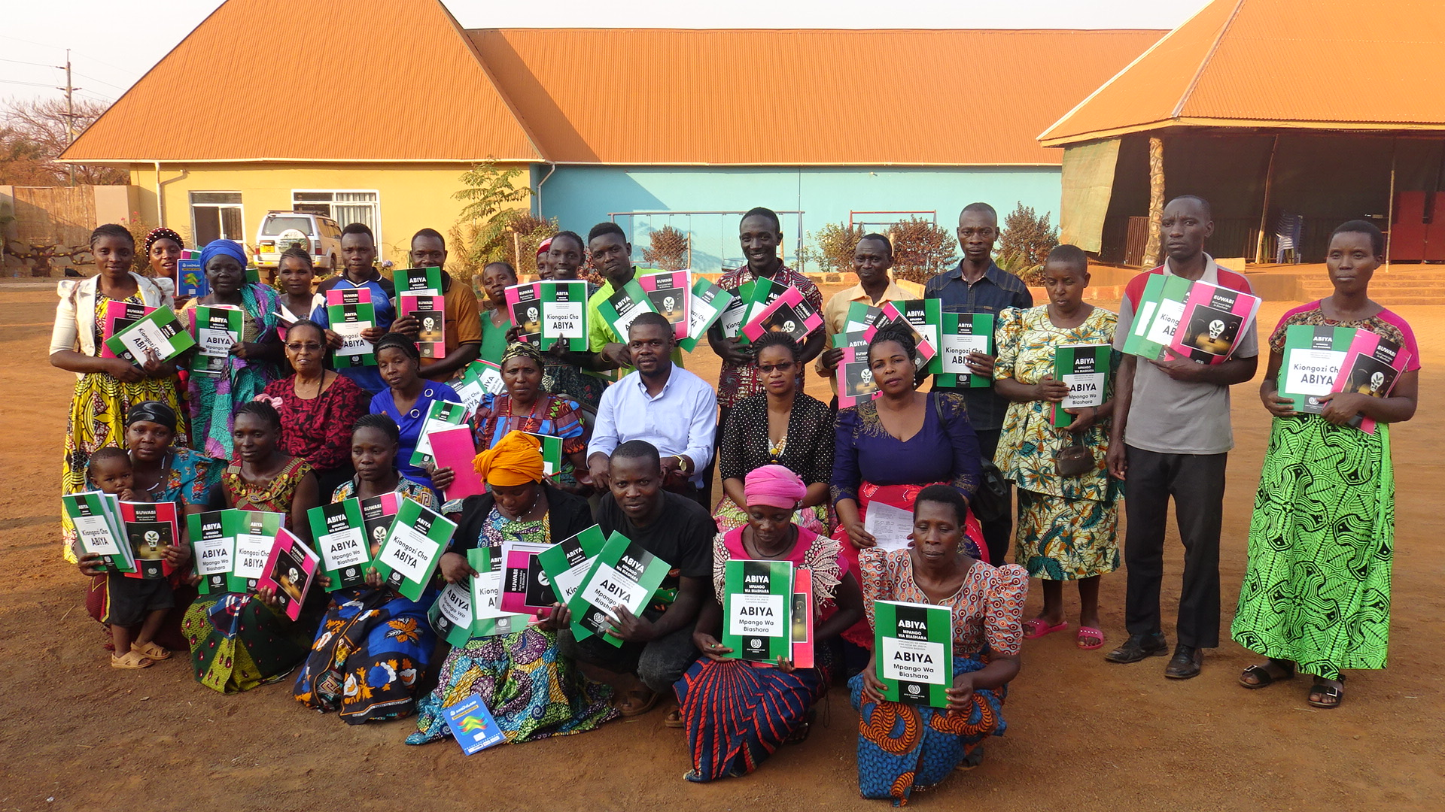
Figure 4.11: Field Photos

First picture on the left shows members of MWG and few representative of youth group working on their business plan and on the right side shows when they were presenting their final plan. The last picture is a joint picture of all the participants holding their training materials (ILO –SIYB Manuals for business plan development designed for small enterprises).

Construction of a Production and Operations Facility
This activity started in 6th January 2021 and went on until 21st May 2021. There were a number of activities which preceded the construction process. These included applying for land from the office of VEO at Kalela and later on secure approval from the office of WEO at Kalela. This was important because MWG did not own land and it needed it for their activities. After acquiring land from VEO office, the Construction committee announced tender and awarded it finally to a local Masonry based in Kalela village. The committee in collaboration with the leaders of the group approved the BOQ submitted by the masonry and approved the commencement of the construction activity.
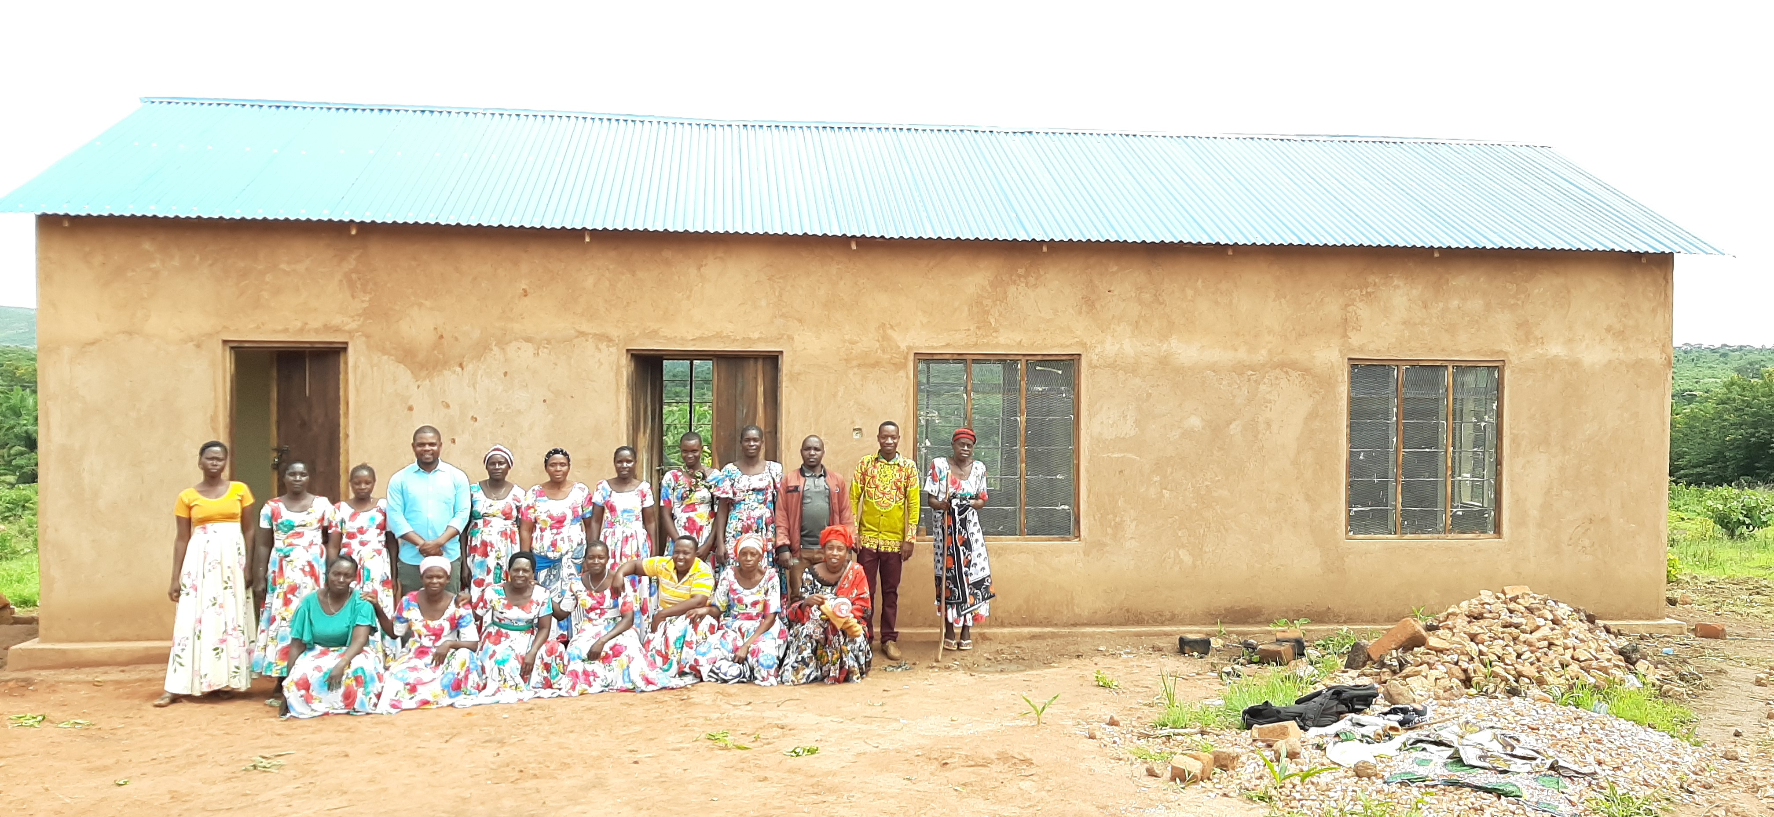
Figure 4.12: Field Photo

MWG Members with MCED Student (in light blue shirt) and BDSP in a picture in front of a newly constructed building at Kalela center to be used for production and office operations.

Purchase and Installation of Soap Making Machine
After completing the construction of the production and operations building, the procurement committee issued a call for quotations from potential suppliers of the bar soap making machine on 23rd May 2021. This tender was won by SIDO Kigoma who had agreed to supply the machine for a cost of TZS 4,500,000/= and offer free training to the operators and regular advice whenever necessary for one year. By 16th June 2021, SIDO was able to install the machine after ensuring that the building is connected to electricity through REA Project.

Conducting Business to Business Meeting and Signing of the Contract
By design, this activity was planned to take place from 21st June 2021 to 30th August 2021. It involved mapping out all potential buyers of bar soap around Kasulu and Kigoma town, preparing the contract that is to be entered between MWG and the
identified buyers. Then numerous meetings were planned to occur between MWG Leaders and the potential buyers and signing of the contract where they reach an agreement. This activity has not been fully completed because MWG had challenges on working capital and hence failed to produce enough stock that will attract the buyers from outside Kalela. It was therefore agreed that the women will organize themselves and raise funds by filling application for a loan from Kasulu DC that is meant for Women and Youth. Their loan of TZS 2,500,000/= was approved late August 2021 while the ILO had promised to resume with facilitating the B2B meetings by November 2021.

Project Implementation Ghantt Chart
Table 4.7: Project Implementation Ghantt Chart
 |  |  |  |  |  | Months(2020 – 2021)
Activities |  | % Done | Task Owner | Start Date | End Date | N | D | J | F | M | A | M | J | J | A
Act. Codes | Description
1.1.1 | Conduct TNA and prepare training content. | 100% | MCED Student, ILO | 19/11/’20 | 20/11/’20
1.1.2 | Training 18 members of MWG on Social Enterprise Management. | 100% | MCED Student, ILO | 30/11/’20 | 11/12/’21
1.2.1 | Filing an application and responding to land acquisition procedures from VEO Office | 100% | MWG Leaders, ILO & VEO | 06/01/’21 | 15/01/’21
1.3.1 | Inviting tenders from village and ward level contractors | 100% | MWG Building Committee | 14/02/’21 | 26/02/’21
1.3.2 | Approving the Bill of Quantities (BOQ). | 100% | MWG Building Committee, ILO | 01/05/’21 | 05/03/’21
1.3.3 | Supervising the construction process. | 100% | MWG Leaders, & MCED Student | 08/03/’21 | 21/05/’21
1.4.1 | Screening and deciding the best bar soap making machine supplier. | 100% | MWG Procurement Committee | 23/05/’21 | 28/05/’21
1.4.2 | Supervising installation and training of operators | 100% | MWG Leaders | 14/06/’21 | 16/06/’21
2.1.1 | Mapping of retail and wholesale buyers of bar soap. | 45% | MCED Student & BDSPs | 21/06/’21 | 09/07/’21
2.1.2 | Preparing the contract. | 100% | MWG Leaders, VEO, LGAS | 12/07/’21 | 13/07/’21
2.1.3 | Seeking legal advice from legal office at LGA level. | 100% | MWG Leaders, LGAs | 14/07/’21 | 16/07/’21
2.1.4 | Conducting Business to Business Meetings and signing the contract. | 30% | MWG Leaders, MCED Student & BDSPs | 19/07/’21 | On-going

CHAPTER FIVE

PARTICIPATORY MONITORING, EVALUATION AND SUSTAINABILITY
  - Introduction
This chapter explains monitoring, evaluation and sustainability of the project. Monitoring and evaluation of this project was participatory whereby stakeholders who included MWG, LGA officers, BDSPs, ILO and the MCED Student had key roles in managing and evaluating project activities. It also presents sustainability plan that elaborate measures that guarantees continuity of the activities created by the project after withdrawal of other stakeholders’ assistance.

  - Participatory Monitoring
Monitoring is regarded as the routine process of collecting and managing project data that provides feedback as pertains to the progress of a project (Mulwa, 2008). The process involves measuring, assessing, recording and analyzing the project information on continuous basis and communicating the same to those concerned. The process becomes participatory when each of the interested parties or stakeholders is actively involved at their own level of operation in collecting and interpreting such information to assist them in ongoing decision-making.

Monitoring of the projec t wa s based o n the action plan and monitoring plan developed. This was done by ensuring that all members of MWG are involved in the project implementation whether through their committee or through routine exchange plan where every individual had specific day and task to monitor or engage. Monitoring was based on the prior set indicators for each project objectives as highlighted in Table 5.1.
Table 8.1: Indicators used in Monitoring the Project
Objectives | Indicators
Objective 1:  To increase production of bar soap up to 60% in order to meet existing market demand by June 2021. | - Quantities of bar soap sold (Cartons)  - Number of members trained.  - Size of land acquired.  - Number of buildings constructed.  - Number of machines purchased
Objective 2:  To secure an assured market for bar soap from MWG by August 2021 | - Number of B2B meetings.  - Number of buyers identified.  - Number of Purchase Contracts signed

    - Monitoring Information System
In order to ensure smooth implementation of the project implementation plan, MWG members, MCED Student, LGAs, BDSPs, ILO and the RAS office agreed on using simplified ways to verify their engagement in monitoring the activities. A WhatsApp group with all the stakeholders was created and named ‘Uwezeshaji Vijana na Wanawake’ in which field visits photos were exchanged. Physical challenges such as roads during rainy season as well as suggestion for fixing existing problems were being shared transparently. For purposes of ensuring rapport among the stakeholders, a specific information flow system was designed as below;
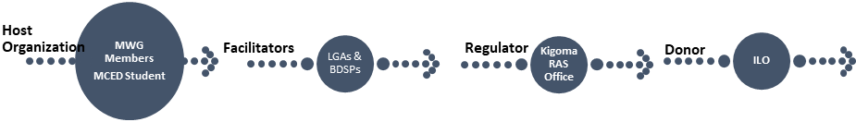
Figure 5.1: Communication Flow among Project Partners
Source: ILO-YWEE (2020).
This meant that any concerns related to information by Muungano Women Group raised either by the members or MCED student had to be channeled to LGAs officers at Kasulu DC who were also working together with BDSPs in same offices. At this level the concerns may be addressed or channeled further to Kigoma RAS Office who was the regional host of the project. Upon realization that the information concern is critical and needs donors’ attention then such concern was communicated from the RAS Office to the donor. Similar process of information sharing was used when sharing activity reports. Besides, there were joint Result Review Meetings at the level of all project stakeholders and similar meetings at the level of committees where major information was being discussed before dissemination.

    - Participatory Monitoring Methods
The monitoring methods used in this project were drawn from the Participatory Rural Appraisal (PRA) and Beneficiary Assessment. This approach emphasizes empowerment of and equity among local people. PRA involves field workers in facilitating local capacity to analyze, plan and take action. The methods used under PRA include semi-structured interviews to key informants and direct observation.
- Participatory Rural Appraisal
This is an open approach which helps to analyze the situation before and after through the use of different community based approaches:-

- Semi-Structured Interviews
The MCED Student identified ILO YWEE Program Manager, DECO Kasulu DC, Regional Trade Officer Kigoma, VEO & WEO of Kalela and Leaders of MWG as key informants. The interview was designed to gather feedback from these prominent individuals on the implementation progress and whether they find everything in line with the initial plans and objectives. This method was selected because it provides flexibility to both the interviewer and interviewee in responding to the questions based on the monitoring checklist prepared.

- Direct Observation
MCED Student together with BDSPs conducted a number of field visits to Kalela to check on the progress of the activities, to verify whether action plans and business plans initially prepared during training are being implemented accordingly. There were also field visits conducted by the ILO and representative from the Kigoma RAS Office where they had a chance to talk to talk directly to the members of MWG as well as other community members and to collect feedback on the progress of the implementation. This method helped the RAS office and ILO to enrich their information about the project on top of the reports which were being channeled to them after end of every activity.

- Beneficiary Assessment
This method of monitoring was used during and after training activities. While conducting the Social Enterprise Management training, participants were distributed with Daily Evaluation forms in which they rated each day from the facilitator, logistics and the entire learning environment. This helped to improve the learning environment on daily basis. At the end of each training participants were supplied with end of Seminar assessment forms to fill and rate the entire training intervention on whether it was a useful intervention or not.
  - Participatory Evaluation
Evaluation is the periodic assessment and review of the extent to which medium and long-term objectives of an activity or programme have been reached (Conick, 1995). A project that has evolved through participatory processes of identification, planning and management should of necessity be appraised in the same spirit (Mulwa, 2008). Local stakeholders should therefore maintain a key role throughout a project cycle.

Evaluation is the process that generates the information that helps the entity to analyze the consequences, outcomes and results of its actions. Evaluation also provides regular feedback that helps organizations assess their relevance, scope and sustainability. In essence, evaluation entails the collection and analysis of information to assess the impact of a service delivery by addressing the question of whether or not the services made a difference to the beneficiaries’ quality of life. It is usually aimed at establishing the worth or merit of a service, program, or an intervention such as a policy.

In this project evaluation was based on the indicators established at the beginning of the project. The task of evaluating the activities was handled by all stakeholders at different stages. Some of the indicators were being evaluated monthly and other after specific period of time as will later be indicated in the Monitoring and Evaluation plan. The baseline data established at the start of the project were used as a benchmark to measure the achievement of the project. Evaluation process also stated the source of data, frequency of the evaluation and the final point of the evaluation report.
    - Participatory Evaluation Methods
In order to ensure that everybody is involved in evaluating the project activities two major approaches were used; Joint Result Review Meetings and Steering Committee Meetings.
- Joint Result Review Committee
This approach was designed to bring together all project stakeholders together and reflect on their contribution to the achievement of project objective. During the session every partner had the opportunity to present from their side activities they have implemented and show success and failures, status and proposed way forward. Around each presentation followed a stiff discussion on areas of improvement on the partners’ specific roles. After every partner has presented, then a joint discussion was held and resolution was made on all areas which needed improvement categorized based on each partner’s role.

- Steering Committee Meetings
This was an evaluation meeting which included ILO YWEE Project Manager, MCED Student, Leaders of MWG, DECO Kasulu and one representative from the office of RAS Kigoma. Members of this meeting had a role of discussing activity reports from MWG and service providers on the implementation of the project. After the discussion, members of this group came up with the resolutions which were then dropped to the members of Joint Result Review Committee as agenda. This separation aided to make discussions during the meeting to be more objective driven and specifically highlight areas for improvement with ease.

Table 9.2: Monitoring & Evaluation Plan
 | INDICATOR |  | DEFINITION |  | BASELINE |  | TARGET |  | DATA SOURCE |  | FREQUENCY |  | RESPONSIBLE | REPORTING
Goal: To enhance production and markets for bar soap produced by Muungano Women Group in Kalela Village – Kasulu DC, Kigoma.
Objective 1  To increase production of bar soap up to 60% in order to meet existing market demand by June 2021. |  | Change in quantities of bar soap produced. |  | Quantities of bar soap sold (Cartons) |  | Average cartons: 12 per month |  | Average score: 100 per months |  | Reading production and sales report. |  | Every 3 months | MWG Leaders |  | MWG Members, LGAs and ILO.
Output 1  One training for MWG on Social Enterprise Management conducted. |  | Number of members trained. |  | Total number of MWG who were present from the first to last day of the training |  | 0 |  | 18 |  | Workshop attendance records. |  | End of first quarter | MCED Student |  | ILO, MWG & LGAs.
Output 2  0.5 Acre of land from the village government acquired |  | Size of land acquired. |  | Total size of land acquired by MWG. |  | 0 |  | 0.5 acres |  | Review of land ownership application documents |  | End of first quarter | MCED Student |  | MWG Members
Output 3  One building for production, storage and office operations constructed. |  | Number of buildings constructed. |  | Total number of buildings constructed |  | 0 |  | 1 |  | Review of Tendering and BoQ documents |  | End of 2nd quarter | MCED Student |  | ILO, LGAs and Members of MWG.
Output 4  One bar soap making machine procured, installed and operationalized. |  | Number of machines purchased |  | Total number and type of machine bought. |  | 0 |  | 1 |  | Audit of purchase process and review of purchase receipt. |  | End of 3rd Quarter | MCED Student |  | ILO, MWG Members & LGAs.
Objective 2  To identify an assured market for bar soap from MWG by August 2021 |  | Number of existing and potential buyers |  | Total number of potential and existing buyers |  | 0 |  | 3 wholesale buyers |  | Review of Sales Receipts. Conduct stock audit. |  | Quarterly | MWG Leaders, BDSPs & MCED Students |  | MWG Members & LGAs.
Output 1  One purchase contract between MWG and soap buyers signed. |  | Number of B2B meetings.  Number of buyers identified.  Number of Purchase Contracts signed |  | Total number of meetings conducted  Total number of buyers identified  Number of signed contracts |  | 0  5%  0 |  | 18  60%  1 |  | Reviewing Meeting Minutes.  Reviewing marketing plan report  Reviewing the signed contract. |  | Monthly  Quarterly  End of the project | MCED Student  MWG Leaders |  | ILO & LGAs.

  - Project Sustainability
Mulwa (2008) defines project sustainability as the continuity of a project until it attains its set objectives. In this project, all sustainability aspects were considered from the design stage.

    - Financial Sustainability
Financial sustainability was embedded into ensuring that there is continuity of business between MWG and buyers of bar soap tied by contracts to ensure presence of regular cash-flows. The group was also linked to Kasulu DC officials for purposes of attracting government support in terms of loan or any form of support that is managed by the council or even give good recommendation to donors and other well-wishers.

    - Technical Sustainability
Technical sustainability involved linking MWG with SIDO as suppliers of the machines whose purchase contract had an item of continuing to provide coaching on the use of the machine depending on the need of the group at an affordable fee. Similarly, this project brought in CDOs and BDSPs who are locally based to carry out the role of supporting the group to be able to master the production and market environment. The community in addition has a defined leadership system and constitution to give guidance of the management of their social enterprise. Even when the supporting organization, The MCED student and others leave, the group will continue with their activities. This is institutional strengthening and sustainability.
    - Community Sustainability
This project is a result of community needs assessment. Community members are aware that the project has to be self-sustained to ensure them with attainment of the project main goal of improving the livelihood by providing alternative and best option livelihood. On recognizing this, members were effectively participating on day to day planning process, implementation of the planned activities and finally monitoring and follow up on the total outcome of the project performance and results. Effective participation assures beneficiaries’ sense of ownership and thus their commitment which gives project sustainability.

    - Political Sustainability
The current government policies emphasize on support to smallholders in terms of access to capital and markets. Politicians will thus tend to advocate for that. Community development policy 1996, Agricultural and Livestock policy 1997 and Small and Medium Enterprises of 2003 are in place that assures protection and legal and institutional arrangement for the social enterprise. The political leaders from the Councilor of Kalela, the Member of the Parliament, and all other district and regional political leaders have been fully informed about this intervention from its start and were regularly briefed on its progress. This was intentionally done considering that all the activities of MWG will be in their areas and hence have a direct role of nurturing and continuing to guide them.

    - Environmental Sustainability
The production of bar soap is a green activity because it utilizes remains from processing of palm which otherwise would have been left out in the environment. The process of adding value by converting it into bar soap with very minimal use of chemicals is a clear commitment of the group in protecting the environment. The group is also planning to install solar panel as an alternative source of energy replacing petroleum which is the current replacement in the absence of electricity (REA). The group has good control of water and wastes and have formed a policy on environment cleanliness and waste disposal. During production, the team on duty is mandated to wear masks and gloves to protect their health.

    - Economic Sustainability
The establishment of the office and soap making facility will be a direct source of employment for few people. These will include daily operators and transporters who will be handling delivery sales delivery. Also the enterprise will boost income levels of MWG members through annual dividends. Besides, involvement of women in the production, leadership and marketing activities will enhance their skills and hence increase their economic ability to engage actively in other income generating activities apart from the traditional peasantry farming.

CHAPTER SIX

CONCLUSION AND RECOMMENDATION
  - Introduction
This chapter presents the summary of the whole study highlighting major issues observed in each part of this project report. In this, concerns are clearly stated and way forward suggested for maintaining or improving the situation.

  - Conclusions
The results from the CNA indicated clearly that the people of Kalela including the women members of MWG lack skills that would help to boost their productivity and actively engage in economic activities. The need to impart skills both business and vocational skills was an obvious way of ensuring that community members are able to utilize locally available resources for sustainable livelihood. It was then decided that a facility for making bar soap and building an office is built. Construction of the facility was meant to improve the production capacity so that prior to finding buyers, MWG already have an assured supply capacity to be able to meet the buyers’ demands.

Sensitization and mobilization meetings have shown to be of the great importance. Attitude of the community members towards such meetings has positively changed. This has been observed through commitment to participate in project activities. In this regard, members in this community were used to getting paid when are invited to attend any development meetings without which there was very poor attendance. Development partners in the area had been complaining that such behaviour contradicts their support objectives and sometimes decides to withdraw their support. Through this project, the members had reached to a point of attending in full without any excuse and were ready to be there for the whole day discussing about their fate without any pay. This was a very good indicator of ownership and commitment to the project. All trainings have been conducted. Majority of those who attended the training have indicated to enjoy the style of delivery and action-oriented learning style. Sometimes they assimilated real situations and were requested to decide or comment on such environment.

All key stakeholders were involved in monitoring and evaluation of the project. The Monitoring and Evaluation tools were designed and put to use by MWG for records keeping. They use data collected from monitoring and evaluation to draw meaning, trends, make decision and adjust project activities accordingly. With all these inclusive interventions, it is expected that this project will be able to sustain itself. MWG and the government of Kasulu DC through CDOs have committed to continue providing support to the group and ensure that operations of the Soap Making enterprise remain to be the prime source of individual income for members of the group. Specifically, the government has committed to inviting MWG to trade shows and exhibitions as well as sharing their profile with potential buyers in other districts of Kakonko, Kibondo and Kasulu TC. Key to the sustainability aspect is the fact that main raw materials for production and other resources are all locally available and in huge quantities.

  - Recommendations
Based on experience and observation in course of participating in implementation of this project, a general recommendation is that, involvement of the primary beneficiaries should always be considered as prime for the success of any project. Members and community buy- in and willingness to learn and change current attitude is critical to attainment of project objectives. However the following are recommended based on findings and conclusions made above;

- Training and Sensitization
Continue to diversify skills training, and organize many more sensitization and resource mobilization meetings. Trainings helps to reduce the knowledge gap required for them to engage in productive works. Also new skills help them to adopt improved practices in their income generation activities be it soap making or farming. The ILO and other development agencies should continue to design relevant packages around generation of business ideas, business planning and business improvement packages.

- Observance to Constitution and Governance Structure
Emphasize observance of the constitution and governance structure. Initially MWG like many women groups did not pay much attention to the governance structure stated in the constitution. As a result role conflict was rampant and as an outcome there was low motivation for new members. This was evident because the number of members of MWG until December 2020 was only 18 which is very small compared to the number of women living in Kalela village. It means through sensitization and education to the members, the group will realize the importance of broadening its membership base and the benefits which come with it. The CDOs in Kalela ward and those from Kasulu DC should conduct regular assessment to find out how governance structures are being observed it being a proactive way of avoiding potential conflicts.

- Follow- Up
CDOs in collaboration with VEO and WEO should increase follow-ups to ensure that the group abide by the constitution and observe all the production, marketing and financial plans. Where necessary, be part of the Annual General Meetings and advice based on their financial and operational reports.

- Sustain Market Support
The CDOs and BDSPs should continue to identify market opportunities for MWG and facilitate the linkage. This will enhance communication with the buyers of bar soap and assure the group about availability of the market. The government should however continue to moderate the relationship in order to ensure that both sides engage in fair business dealings.

- Protect the Project Assets and Objectives
While it is very evident that the project is one of the key achievement for MWG, it also brought in some misunderstanding driven by self-interests of few members. The support which MWG has received, production unit and bar soap making machines need to be protected. The office of VEO and WEO must always follow-up on MWG to check whether these two assets are being used as intended and communicate with LGAs and RAS Office in case they find any misuse or underutilization that is caused by lack of interest.

- Working Capital Boost
MWG had initially highlighted the need to have a slot in the budget from the donor to cover operational expenses. Unfortunately, all the funds availed were used for construction and purchase of the bar soap production machine. This led to failure in commencing the production activities. The LGAs from Kasulu DC in collaboration with BDSPs should support the group to finance its working capital requirements by linking them to the Kasulu DC government loan program which is for youth, women and people with disabilities. This is important as a means to actualize the shift from donor led income to generating income through sales of bar soap.

REFERENCES
Asfaw, S et al (2012). Poverty reduction effects of agricultural technology adoption: A micro-evidence from rural Tanzania. Journal of Development Studies, 48, 1288–1305. Chicago, IL: ACTA Publications.
Bernstein, H.(1979). ‘African Peasantries: A Theoretical Framework’, Journal of Peasant Studies, 6 (4), 421 Dar es Salaam.
Kasulu District Council, (2020). Report on First & Second Councilors Meetings. http://kasuludc.go.tz/news/2. Accessed on 14th December 2020.
Kasulu District Council (2020).Strategic Plan 2012 – 2017. http://kasuludc.go.tz/news/2. Accessed on 14th December 2020
Office of VEO Kalela. (2020). Village Development Report. Office Board of adverts. Accessed in 11th January 2021.
Kothari, R.C. (1990). Research Methodology: Methods and Techniques. 2nd Edition. New Delhi: Wishwa Prakashan.
Kretzmann, J. P. & McKnight, J. L. (1993). Building Communities from the Inside
Magesa, M. M., Michael, K., & Ko, J. (2014). Access to Agricultural Market Information by Rural Farmers in Tanzania. International Journal of Information and Communication Technology Research, 4(7), 264–273.New Delhi: Wishwa Prakashan.
Mulwa F. W (2008a), Participatory Monitoring and Evaluation of Community Projects, Pauline Publications Africa, Nairobi Out: A Path Toward Finding and Mobilizing a Community's
Parvin, M. T., & Akteruzzaman, M. (2012). Factors affecting farm and non-farm income of haor inhabitants of Bangladesh. Progressive Agriculture, 23(1–2), 143–150.
Skjöldevald, Maja (2012) Small scale farmers’ access to and participation in markets – The case of P4P program in western Kenya
Sleezer, Catherine, Darlene F Russ-Eft, and Kavita Gupta. (2014). A Practical Guide to Needs Assessment, Third Edition. 3rd ed. San Francisco, CA: Wiley.)
The World Bank (Editor) (2010): Participatory Monitoring and Evaluation, in Topics: Participation and Civic Engagement. Washington D.C.: The World Bank. URL.
United Republic of Tanzania (1996), Community Development Policy, Government Printers, Dar es Salaam
United Republic of Tanzania (1997), Agriculture and Livestock policy, Government Printers, Dar es Salaam
United Republic of Tanzania (1997), Employment policy of 1997, Government Printers, Dar es Salaam.
United Republic of Tanzania (2003), Small and Medium Enterprises Development Policy, Business Printers Dar es Salaam
Zica, R. M. F., Gonçalves, C. A., Cordeiro Martins, H., & Gonçalves, M. A. (2016). The resource-based theory and its adherence to a superior performance strategy: An analysis in small companies in Brazil. Corporate Ownership & Control, 13(3-3), 434
Banjade, A. (2006). Voice to the Voiceless in Western Nepal: An Audience Survey of Community Radio Madanpokhara. The Journal of Development Communication, 17(1): 72-91.
Chambers, Robert. (1992). Rural Appraisal: Rapid, Relaxed and Participatory. Institute of Development Studies (University of Brighton), IDS Discussion Paper No. 311, Sussex.
Aubel, Judi. (1993). Participatory Program Evaluation: A Manual for Involving Program Stakeholders in the Evaluation Process. Catholic Relief Services, Senegal. Available through PACT Publications, 777 United Nations Plaza, New York, New York 10017.
Msamula, J et al (2016). Rural entrepreneurship in Tanzania: why are micro and small enterprises not creating value in furniture manufacturing industry?, Transnational Corporations Review, 8(4), 250-264.
Doepke and Tertilt (2011). “Does Female Empowerment Promote Economic Development?” CEPR Discussion Paper 8441.
Ruffing, L. (2006). “Deepening development through business linkages. United Nations, New York.
Jenkins et al (2011).Business Linkages: Lessons, Opportunities and Challenges. IFC, International Business.
Koech, B.K (2014). Contribution of Women Groups in Economic Empowerment of Rural Women: A Case of Women Groups in Bureti Constituency, Kericho County, Kenya.
Nyoni. T, & Bonga, W.G (2018). Anatomy of the small & medium enterprises (SMEs) critical success factors (CSFs) in Zimbabwe: Introducing the 3E model. Journal of Business and Management (DRJ-JBM).
Ngcobo. S, & Sukdeo. R (2015). Challenges facing SMMEs during their first two years of operation in South Africa. Corporate Ownership and Control.
Kazimoto, P. (2014). Assessment of challenges facing small and medium enterprises towards international marketing standards: A case study of Arusha Region Tanzania. International Journal of Academic Research in Accounting, Finance and Management Sciences, 4(2), 303-311.

APPENDICES
Appendix I: Interview Guide: Semi-Structured Questionnaire
This questionnaire aims to collect information that will help the establishment of the project purposely for addressing challenges facing women in Kalela Village Kasulu District Council in Kigoma region. The project report will be produced to satisfy academic requirements for the award of Masters of Community Economic Development (MCED) of Open University of Tanzania (OUT). The information provided will be used solely for that purpose. Kindly answer each question according to the guidance provided for each question

PART A: Respondents Details
- Age ( Put √ in the correct answer)
- 18 years below
- 19 - 24 years
- 25 - 30 years
- 31 - 36 years
- 37 years above
- Education (Put √ in the correct answer)
- Primary
- Secondary
- College/University
- Others………………(specify)
- Never attended school
- Marital Status (Put √ in the correct answer)
- Married
- Not Married
- Widow
- Divorced
- Sex (Put √ in the correct answer)
- Male
- Female
- Occupation (Put √ in the correct answer)
- Farming
- Pastoralism
- Entrepreneur/Business
- Others……… (Specify).

PART B: Skills Gaps, Production and Market Opportunities, Favorable options for women economic empowerment.
- What type of post school training services are available in your area? ________________________________________________________________________________________________________________________________________________
- In connection to your response above, is the supply of these education services adequate compared to the needs of the people in your community? YES / NO.
- Explain the reasons for your response in question 7 above._______________________________________________________________________________________________________________________________________________
- What among the following would be your advice to improve the life and vocational skills of people in your community? (Put √ in the correct answer)
[ ] Build a Vocational Training Centre
[ ] Create more awareness on the value and availability of training opportunities
[ ] Organize village based training coordinated by VEO & WEO
[ ] Channel training opportunities to existing groups (Farmer Organizations, SACCOs, Women and Youth groups)
- Do you know economic opportunities available in your community?(Put √ in the correct answer)
- YES [ ] NO [ ]
- The following factors affect productivity across various economic sectors in Kalela. In a scale of 1 - 5 rate the responses against the factor where 1= Strongly Disagree, 2 = Disagree, 3 = Fairly, 4 = Agree, 5 = Strongly Agree
Factors | Scores
 | 1 | 2 | 3 | 4 | 5
Poor Infrastructure
Lack of relevant skills
Limited Use of modern technologies
Limited access to market
Unwillingness to abandon traditional production practices

- Do you agree that women in Kalela are actively involved in economic activities? (Put √ in the correct answer) YES [ ] NO [ ]
Appendix II: MWG PROJECT - OBSERVATION CHECK LIST
SN | Item | Scores
SN | Item | 1 | 2 | 3 | 4 | 5
1 | Change in Mindset.
 | Frequency of attendance to the meetings
 | Contributing on agenda
 | Meeting own cost for attendance
 | Readiness to be included in the tasks
2 | Learning and adoption of knowledge and skills.
 | Happy with class interactions
 | Punctuality
 | Notes taking
 | Asking questions
 | Ability to relate with local examples/situations.
 | Type of action plan developed
 | Team work during learning process
3 | Involvement in construction activities.
 | Performing committee roles as expected
 | Attending all the roles while on duty
 | Complains/compliments on progress
 | Expression of ownership
 | Targets on future benefits
 | Display of team spirit
4 | Production of bar soap
 | Plans for production.
 | Staff Routines.
 | Stock Size

Appendix III: Contract from the ILO, UNDP and Kigoma RAS Office to conduct the project under ILO-YWEE Component in 2019


