THE IMPACT OF REFUGEE CAMPS ON HOST COMMUNITIES
A CASE OF NYARUGUSU VILLAGE

ENOCK MTIBA CHACHA

A DISSERTATION SUBMITTED IN PARTIAL FULFILLMENT
OF THE REQUIREMENTS FOR THE DEGREE OF MASTER OF INTERNATIONAL COOPERATION AND DEVELOPMENT (MAICD)
DEPARTMENT OF POLITICAL SCIENCE AND PUBLIC ADMINISTRATION
THE OPEN UNIVERSITY OF TANZANIA
2020

CERTIFICATION
The undersigned certifies that he has read and hereby recommends for acceptance by the Open University of Tanzania a dissertation entitled, The Impact of Refugee camps on Host communities, a case of Nyarugusu village. In partial fulfilment of the requirements for the Degree of Masters of international cooperation and development of the Open University of Tanzania.

………………………………………………
Dr. Miraji Kitigwa

(Supervisor)

………………………………………….
Date

COPYRIGHT
No part of this dissertation may be reproduced, stored in any retrieval system, or transmitted in any form or by any means; electronic, mechanical, photocopying, recording or otherwise without prior written permission of the author or The Open University of Tanzania in that behalf.

DECLARATION
I Enock Mtiba Chacha declare that, the work presented in this dissertation is original. It has never been presented to any other University or Institution. Where other people’s works have been used, references have been provided. It is in this regard that I declare this work as originally mine. It is hereby presented in partial fulfillment of the requirement for the Degree of Master of International Cooperation And Development (MAICD)

…………………………………….
Signature

……………………………………….
Date

DEDICATION
This work is dedicated to the Government of the United Republic of Tanzania.

ACKNOWLEDGEMENTS
My profound gratitude is due to my supervisor, Dr. Miraji Kitigwa for his tireless constructive advice, criticism and understanding from the initial stage of developing the proposal to the production of this dissertation.

Despite having tight schedules, he always had time for comments on my work. I greatly acknowledge my employer the office of the Regional Administrative Secretary Tabora for granting me study leave. Their contribution is regarded as a corner stone in my studies which without it my studies would have not taken place.

I am grateful to the cooperation I got from the staff of Kasulu District Council for their useful information and granting me permission to carry out the study in their district. I appreciate and particularly feel indebted to the Village officers at Nyarugusu village and respondents themselves for providing a lot of useful information which formed the basis of this work. Their knowledge and experience had been of a great help in making my study a success.

Above all, I thank God for bestowing upon me good health and patience for the completion of this work.

ABSTRACT
The presence of refugees tends to change the lives of the local population in hosting communities. This study was carried out to determine the impacts of refugee camps on host community. It was geared specifically to determine both positive and negative impacts of refugee camps to local people in Nyarugusu Village after refugees’ influx. The study was conducted in Nyarugusu Village where Nyarugusu refugee camp is located. Data was collected from individuals in the host area. Other respondents included village executive officers and ten cell leaders. Secondary data that was used were materials from government reports, research reports, books and journals from University of Dar es Salaam library. The study revealed that opportunities available in the host communities changed in both positive and negative ways in agriculture, environment, market economy, and infrastructure and in the context of social services. On the positive side, refugees were sources of cheap agricultural labour for villagers in the study area; refugee labour was attractive to local farmers because it was cheap and readily available hence increased production of food crops, better health services due to establishment of better equipped refugee hospitals that offer a free service to Tanzanians. Despite the benefits of refugee labour, many villagers blamed refugees as source of theft, particularly of food crops, internal peace and security has been affected by increase in serious criminal activities, and conflicts. On environmental perspective, refugees affected environment due to firewood and charcoal uses. The study findings can be used by a wide range of stakeholders and the government of Tanzania to create refugees’ policies.
Keywords: Refugee, Refugee Camps, Host community, Nyarugusu village.
TABLE OF CONTENTS
CERTIFICATION ii
COPYRIGHT iii
DECLARATION iv
DEDICATION v
ACKNOWLEDGEMENTS vi
ABSTRACT vii
TABLE OF CONTENTS viii
LIST OF TABLES xi
LIST OF FIGURES xii
LIST OF ABBREVIATION xiii
CHAPTER ONE 1
INTRODUCTION 1
1.1 Overview 1
1.2 Background of the problem 1
1.3 Statement of the Problem 5
1.4 Objectives of the Study 6
1.6 Significance of the Study 7
1.7 Limitations and Delimitations of the Study 8
1.8 Scope of the study 9
1.9 Organization of the Research 10
CHAPTER TWO 11
LITERATURE REVIEW 11
2.1 Introduction 11
2.2 Definition of key Concepts 11
2.3 Theoretical review 13
2.4 Factors Behind the Rise of Refugees in the World 14
2.5 Empirical Literature Review 21
2.6 Conceptual Framework 24
CHAPTER THREE 26
THE STUDY AREA AND RESEARCH METHODOLOGY 26
3.1 Introduction 26
3.2 Research Design 26
3.3 The Study Area 27
3.4 Target Population 28
3.5 sampling design 28
3.6 Sampling Technique 29
3.7 Sources of Data Collection 30
3.8 Data Collection Methods 31
3.9 Data Processing and Analysis 33
3.10 Data Reliability and Validity 34
3.11 Ethical considerations 35
CHAPTER FOUR 36
DATA PRESENTATION, ANALYSIS AND DISCUSSION 36
4.1Introduction 36
4.2 Data validity and reliability 36
4.3 Demographic attributes of the Respondents 36
4.4 Findings analysis and discussion as per study objectives 41
CHAPTER FIVE 57
CONCLUSION AND RECOMMENDATIONS 57
5.1 Introduction 57
5.2 Summary of major Findings 57
6.3 Conclusion of the study 59
5.4 Recommendations of the study 60
5.5 Area for further research 62
REFERENCE 63

LIST OF TABLES
Table 3. 1 Sample size 29
Table 4. 2 Distribution of the respondents by their age 37
Table 4. 3 Distribution of the respondents on refuges 42
Table 4. 4 Distribution of the respondents on relation with refugees 45
Table 4. 5 Distribution of the respondents on health service provided 50
Table 4. 6 Distribution of the respondents on Cheap Labour 53
Table 4. 8 Distribution of the respondents on disadvantages 54

LIST OF FIGURES
Figure 2. 6 Conceptual framework 25
Figure 4. 1 Distribution of the respondents by gender 38
Figure 4. 2 Distribution of the respondents by Education level 39
Figure 4. 3 Distribution of the respondents by Occupation 40
Figure 4. 4 Distribution of the respondents on Perception on refugees 43
Figure 4. 5 Distribution of the respondents on staying Nyarugusi 46
Figure 4. 6 Distribution of the respondents on connection with refugees 47
Figure 4. 7 Distribution of the respondents on areas of connections 48
Figure 4. 8 Distribution of the respondents on Employment opportunity 51
Figure 4.9 Distribution of the respondents by usiness opportunities………..…...…52

LIST OF ABBREVIATION

IRIN Integrated Regional information Networks

UNHCR United Nations High Commissioner for Refugees

OAU Organization of African Union

UN United Nations

EU European Union

TANCOSS Tanzania Comprehensive Solution Strategy

UAM Unaccompanied Minors

IRIN Integrated regional information Networks

UNEP United Nations Environment programme

UNICEF United Nations International Children Emergence Fund

TWESA Tanzania Water and Environmental Sanitation

REDESO Relief to Development Society

CHAPTER ONE

INTRODUCTION

Overview

This is an introduction chapter; lays a foundation for the later chapters. As such the chapter presents the background of the study, the problem under the study; the objectives, research questions, significance of the study, limitations of the study, scope of the study, and at the end it had presented the organization of the study.

1.2 Background of the problem
Global displacement is at a high record and conflicts, persecution, discrimination, natural hazards, poverty, and underdevelopment are the root causes. According to the UNHCR report (2019), violence, threats, human rights violations as well as lack of food, medicine, and basic services seem to be major causes that lead to the largest displacement crisis worldwide recently. It has stipulated that at the end of 2018, 70.8 million were forcibly displaced as a result of persecution, conflict, violence, and human rights violations. According to the report the number of displaced people doubled since 1998. Eighty percent (80%) of refugees are hosted by their neighboring countries, including some of the world’s poorest countries which host one-third of all refugees. Only 16% of the world’s refugees are hosted in the rich and developed parts of the world (UNHCR, 2019).

In the event an emergency refugee camp needs to be constructed, it is not in all likelihood that it happens in an entirely “deserted” area. In other words, local communities are already present and living in or around that specific area where the camp establishment takes place. In such a scenario the establishment of refugee camps and influx of refugees will in some way be affecting the lives of peoples living in that area. This often results in host communities adapting to the changes and challenges brought on by the establishment of the camp that might have different impacts on their livelihoods (Chambers 1986:245). In such scenarios, the attention is often focused on the refugee population as they are obviously in a crisis. Nonetheless, people of host communities have similar difficult living conditions where the presence of refugee camps often makes their lives even more challenging (UNHCR 2011:2). It is equally important that this group does not get neglected in such situations of crisis.

Several studies have pointed out impacts resulting from the presence of refugee camps on host communities. According to Maystadt (2019), hosting refugees have both negative and positive impacts. Grindheim (2013) had the same view that impacts by refugee camps on host communities are complex and maybe both positive and negative. While there are several pieces of literature available on the impact of voluntary migration on the host country’s economy, these studies emphasize a lack of evidence on the economic consequences of forced displacement (Ruiz and Vegas-Silva, 2013).

According to Grindheim (2013), new market opportunities, improved jobs, and business opportunities are the most reported positive impacts. Alix-Garcia, and Saah, (2009), on the other side, reported that the unexpected nature and size of these population movements generate a natural experiment that allows their effects on prices and household wealth in the western Tanzanian regions. A study conducted in Rwanda by Craig Loschmann1, Özge Bilgili, and Melissa Siegell (2016) found evidence that residing close to a refugee camp makes it more likely that an individual is engaged in wage employment in comparison to farming or livestock production, representing a shift away from subsistence farming activities. Also, there is evidence that females living nearby a camp have a higher occurrence of self-employment in business both as a primary and secondary activity, highlighting a notable gender-specific dynamic. Likewise, living near a camp is associated with greater household asset ownership, benefiting both male- and female-headed households.

Tanzania is one of the African countries hosting refugees from neighboring countries. It has been hosting refugees from its neighboring countries since the early 1960s (Chaulia, 2003). In 1994, over one million refugees resided in the country. because of Burundi’s civil war in the 1990s, caused by the conflict between the Hutu and Tutsi ethnic groups, hundreds of thousands of people fled to Tanzania (Romtveit, 2019).

The Open-door Policy promoted by the first President of Tanzania Mwalimu Julius Nyerere and his Vice President Rashid Kawawa made Tanzania a very welcoming country to Refugees. The policy was premised on the belief that Tanzania had enough resources to share and that the presence of refugees would not be a prolonged issue (Kamanga, 2005). It based on the perception of refugees as victims and freedom fighters of political change and the refusal to treat such refugees as foreigners when such a label was based on arbitrary borders in Africa.
Nyarugusu refugee camp is one of the largest and best-known refugee camps of the 21st century, with around 150,000 refugees. It is located in the western province of Kigoma, Tanzania, about 150 km east of Lake Tanganyika “Nyarugusu camp voices”, 2016)
.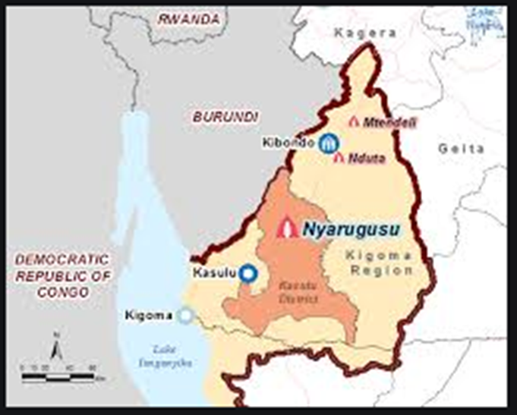
Figure 1: Map showing the location of Nyarugusu Camp

Nyarugusu refugee camp was made by the UNHCR and the Tanzanian government in 1996 after an estimated 150,000 Congolese refugees from the eastern Sud-Kivu region of the DRC crossed the border into Tanzania escaping civil wars. Many Congolese refugees remained in the camp for decades, although the population of the camp was reduced after 2015. However, from 2015 over 110,000 Burundian refugees arrived in Tanzania to escape riots and civil unrest in their home country. These refugees went to Nyarugusu until the Tanzanian government allowed Burundian refugees to go to other camps. Approximately 65,000 Burundian refugees remained at Nyarugusu (UNHCR, 2016)

The field study conducted on socio-economic assessment in the refugee camps and hosting districts of the Kigoma region reported that despite a challenging legal environment, the contribution of refugees to the economy of the region is positive (UNHCR,2020). Generally, there are limited empirical studies that clearly explains the impact of refugee camps on hosting communities in Tanzania. The researcher in this study therefore seeks to establish a thorough understanding of the impact of refugees’ camps on host communities with specific reference to Nyarugusu village in Kigoma, Tanzania.

  - Statement of the Problem
Tanzania has a long history of hosting refugees from Burundi and Congo. Burundians have been displaced from turmoil in three waves: the 1972 Hutu genocide, the civil war through the mid-1990s and 2000s, and the most recent political crisis in 2015. According to UNHCR (2005), there were 232,221 Burundian refugees in Tanzania residing in Nyarugusu, Nduta, and Mtendeli (ibid). despite the government stopped prima facie refugee designation in January 2017, but there were several new arrivals in the last two years. In these emergency refugees, camp needs to be constructed, and in most cases, these camps are established adjacent/ close to another host community.

According to Millita (2015) the establishment of refugee camps and influx of refugees had been resulting into effects on the lives of peoples living in that area. According to Chamber (2005) This often results in host communities to adapt to the changes and challenges brought on by the camps establishment that might have different impacts on their livelihoods. According to NBS, (2017), the largest proportion of the host community is made of subsistence farmers with farms inherited from parents or bought from fellow villagers. The presence of refugee camps and the potential consumer base and labor force they possess affect economic activities in the surrounding host communities.

Despite the large and growing number of humanitarian emergencies, there is little empirical evidence of the impacts of refugee camps and internally displaced people on the communities that receive them. This analysis of the impact of the refugee camp on host populations in Nyarugusu Village in Tanzania

1.4 Objectives of the Study

1.4.1. General Objective
The general objective of this study was to explore the impacts of the presence of refugees’ camps on host communities in Nyarugusu village.

Specific objectives
- To analyse the perceptions of both host communities and refugees.
- To examine the extent of social and economic integrations between refugees and the host community.
- To identify the positive and negative impact of a refugee camp on the host community in Nyarugusu.

Research Questions

This study was guided by the following research questions;
- What are the perceptions of both host communities and refugees on the presence of refugees?
- How do refugees in Nyarugusu camp integrate with their neighboring Nyarugusu villagers?
- What are the positive and negative impacts of the Nyarugusu refugee camp on the Nyarugusu village community?

1.6 Significance of the Study
The refugee problem is one of issues facing developing countries in Africa. It is a burden to the host community. While primary prevention would be the ultimate objective in the control of problems experienced by the host community, this is not possible without sufficient intervention through education, information, and communication to the refugees, the host community, and the refugee agencies that this study has provided. This survey will give insights to intervention programs involved in the efforts of reducing conflicts between host and the hosted communities. The study will also be significant to donors and facilitators of the Nyarugusu refugees’ camp since they will become aware of the impacts made by the refugees’ camp on the host community.
The findings of this study will help those studying refugee issues to be aware of both positive and negative impacts of the presence of refugee camps on host communities. Also the results of the study can help Nyarugusu camp administration office to provide better humanitarian assistance to refugee communities and possibly establishing a provision for the host communities.

The study will also contribute knowledge to society and academicians. It will serve as secondary data for anyone who will be interested to research the impacts of a refugee camp on host communities.

1.7 Limitations and Delimitations of the Study

The study faced several limitations as follows: -

The language was the main barrier during the collection of data. The researcher's main languages were English and Swahili while Nyarugusu village residents spoke either their respective mother tongues (Kiha) or a bit of Swahili. As a result, the researcher sometimes depended on translators to get the information desired.

Another limitation was based on the information provided. Some respondents were reluctant to share information with the researcher. Some of the refugees were not willing to provide information to the research despite explaining to them the aim of this study. There were poor perceptions among refugees and some of the host communities regarding providing some of the information to what they considered unfamiliar people.

The other limitation was respondents were usually engaged in different activities such as farming, field works. Under those circumstances, some respondents already selected couldn’t come to our discussion meeting. I order to overcome this limitation we tried to rescheduled meetings and, in some cases, I find other respondents.

The other problem for the researcher and the assistants was that there were no living areas around and near the refugee camp, where I was collecting data, so I with my assistant were living about 60km from Nyarugusu Camp, and during data collection, I had to travel early in the morning, 7:00, and returning late from a refugee camp in the afternoon, 7:00 for twenty days. In this case, I sometimes arrived late at the Nyarugusu office, and sometimes I find Nyarugusu office staff already on camps. As a result, I spent without work for some hours until I got a car, which traveled to camp because the camp is a bit far from the refugee administration office

1.8 Scope of the study

The scope of the study was based on Nyarugusu village, Kasulu district in the Kigoma region. The study covered the whole village, but 30 households were obtained through simple random selection as a sample. The participants were Village executive officers, ten cell leaders, and other residents in Nyarugusu village. The study was based on descriptive study design because the case it describes the detailed information about a particular subject that it would not be possible to acquire through another type of experimentation. Kigoma had also been chosen because most of the refugee camps had been established in this region as a result of refugees from Burundi and Congo. Furthermore, the selection was based on the researcher’s easy accessibility to the data required, the limited time required to complete the research study as indicated in the third chapter of this study, and also to minimize the research covering the cost in general.

1.9 Organization of the Research

The first chapter gives a general introduction by introducing the topic at hand. It states the significance of the study and the objectives of the study. It also presents the research questions guiding the proposal. The second chapter presents definitions of key terms, theoretical literature review, empirical literature, and conceptual framework. Finally the research gap is identified. Chapter three discusses the methodology of the research, which includes the research design, area of study and sampling techniques. It also describes the sources of data, data collection technique, and how these data is going to be analyzed and interpreted.

CHAPTER TWO

2.0 LITERATURE REVIEW

2.1 Introduction
In this chapter literature on the socio-economic effects of refugees on the local community is reviewed. First, the concept of refugees is discussed, followed by a review of the causes of refugee’s presence in the world, the situation of refugees at the global level, negative and positive impacts caused by the presence of refugee camps on the host community, and finally theories of international migration.

2.2 Definition of Key Concepts

2.2.1 Refugee

According to the united nation's status of refugees, a refugee is a person owing to well-founded fear from persecution for reasons of race, religion, nationality, membership of a particular social group or political opinion, is outside his/her county of origin or habitual residence and is unable or unwilling to avail himself to the protection of that country (UNHCR 1979).

The OAU definition of refugees relating to status also includes those people compelled to leave their countries for reasons of external aggression, occupation, foreign domination, or events seriously disturbing public order either in part or in the whole of the country of origin (Chasiani, 1990; Baconnier, 1994). Refugees are classified into the convention and non-convention refugees. Convention refugees are those who fall under the 1951 UN Convection or the 1969 OAU Convention. The Conventions enumerate social and economic rights designed to assist integration, and in its article 34 calls on states to facilitate the assimilation and naturalization of refugees. So, convention of refugees applies to all persons who have entered EU Member States through UNHCR resettlement programmes and to those who have been granted subsidiary protection (Kelly, 1989). Non- convection refugees are the displaced persons who have fled their homes due to well-founded fear of being persecuted on various grounds but do not qualify to be refugees because they have not crossed an international boundary (Chasians, 1990). These are known as internally displaced people.

2.2.2 Indigenous people/community

The concept of indigenous people in Africa is explained in different ways. Many national politicians claim strongly that all Africans are indigenous, but less so when seen by those who claim to be indigenous (Saugestad 2001). At the international level, indigenous people are defined as communities, people, and nations that have a historical continuity with pre-invasion and pre-colonial societies that developed on their territories, consider themselves distinct from other sectors of the societies now prevailing in those territories or parts of them. They form at present non-dominant sectors of society and are determined to preserve, develop and transmit to future generations their ancestral territories, and their ethnic identity, as the basis of their continued existence as people, following their cultural patterns, social institutions, and legal systems (1989 UN special report )

2.2.3 Host community

A host community is a group of people willing to take others into their homes and help support them. United Nations high commission for refugees (UNHCR) has expanded a definition of a host community and refers to the country of asylum and the local regional and national government, social and economic structure within refugees surrounding.

2.2.4 Refugee Camp

According to UNHCR, refugee camps are temporary facilities built to provide immediate protection and assistance to people who have been forced to flee due to conflict, violence, or persecution. While camps are not intended to provide permanent sustainable solutions, they offer a haven for refugees where they receive medical treatment, food, shelter, and other basic services during emergencies (UNHCR 2019).

2.3 Theoretical review

2.3.1 Theories of International Migration

Theories of international migration have dealt with the question of why people migrate from one country to another and to a lesser extent, the dynamic of migration, such as chain migration in migrant networks. (Omari 1993) noted two important theories of international migration which are micro and macro level theories.

Micro level theory states that the number of persons going distance is directly proportional to the number of opportunities at the distance and inversely proportional to the number of intervening opportunities. This means if opportunities are distributed relatively homogeneously over geographical space, then the number of intervening opportunities obstacles such as a nation-state frontiers-is a simple inverse function of distance. Macro level theory is the gravity approach which concern with the level relation between distance and the tendency to move.(Omari 1993).

Micro theory concerns with individual decision to migrate for securing survival, comfort, autonomy and morality. Macro level theory goes further to economic, social and political factors such as income and unemployment differentials, political repression, ethnic, national and religious conflicts, population growth and availability of arable land between the countries. International migration is the most important product of today’s refugee’s presence in the world due to social economic and political differentials among countries in the World (Omari, 1993).

2.4 Factors Behind the Rise of Refugees in the World
The rise of refugees in the world has been caused by various factors such as frequent civil wars, ethnic/religious conflicts, and conflict over economic resources, and political clashes (UNEP, 2005). These conflicts and abuses of human rights force many people to flee their countries in search for safe places.

2.4.1 Conflict Over Resources
A study by Kunt and Cook (1999) found that nature and causes of conflicts over scarce land and water resources for livelihood differ from one place to another; from ownership disputes between or among the livelihood’s groups or classes to competition for access to use of resources for livelihood activities. When there are uneven distributions of national economic resources by those in power or when one group wants to advance at the expense of others conflict may break out (World Watch, 1994). This dissatisfaction among the people makes the oppressed ones to flee from their origin country searching for protection.

2.4.2 Political instability
Political instability occurs when one political group is fighting against another group in order to gain political control. Political fights and battles make various political followers especially those less powerful groups left unprotected, destabilized and even killed. This forces the less powerful groups to cross boundaries in search for peaceful places to settle (Wordegabriel, 1996). States which suffer from diminished capacity to exercise legitimate authority over governance including the capacity to administer government, maintain law and order, provide social services and defend state sovereignty bear a good number of refugees (Jacobsen, 2002). The incapacity to exercise effective control over their resources is in part, the source of their crises of legitimacy (Green, 1994). These crises force weak people to abandon their homes to about 125 million people lived outside their country of birth or citizenship (Oucho, 2002). Every nation hosts some political refugees, but Africa and Western Asia contain over half of the world total of 27 million refugees and displaced persons (Flinton, 2001). According to King (2006), Tanzanian has been hosting refugees on a cyclic basis since the late 1950s. In the 1970s Tanzania offered naturalization to more than 30,000 Rwandan refugees (Kamanga, 2005). On 22 October 1993, thousands of refugees arrived in western Tanzania (Borgadi,2007). Between October and December 1993, approximately 300,000 refugees fled to Kigoma and Kagera regions (Whitaker, 1996). Other refugees came from Uganda, especially during Amini’s rule in 1970s in which political stability in Uganda was fragile (Jacobsen, 1997).

2.4.3 Recurring civil wars
This occurs when there is a fundamental civil dispute over who should control the government, how the society should organize itself, who commands the power and enjoy their privileges. This happens when there are no free and fair elections in a country giving chance to emergence of tribal rulers and religious groups. These situations have been observed in Africa, Afghanistan in central Asia, El Salvador, Nicaragua and Guatemala (UNHCR, 1996). In the 1960s and in the 1970s, the focus of refugee’s assistance was set in less developed countries, notably in Africa where large numbers of refugees were fleeing wars (Fox, 2007). Despite the commonly expressed idea that the world has enjoyed an era of peace since the Second World War, conflicts have proliferated in different places where people such as Koreans, Vietnamese, Cambodians, Salvadorians, Ethiopians, Mozambicans or Somalis as examples have experienced civil wars which caused a lot of refugees from these countries. Kenya and Uganda have been hosting a lot of refugees from Somalia and Ethiopia. Following the fall of Siyaad Barre in 1991 and the subsequent power struggle in Central and Southern Somalia, an estimated 300,000 Somali refugees fled to Kenya (Omar and De Waal, 1993).

Tanzania has been hosting refugees from Rwanda, Burundi, the DRC, Somalia, Uganda, Mozambique, Namibia, Angola, Zimbabwe and South Africa due to civil wars and violation of human rights. For example, in Kigoma and Kagera regions, after the assassination of Burundian Presidents Ndadaye, 1993 and Ntaryamira, 1994, an influx of refugees of unprecedent magnitude was experienced (Liganga,2006).

2.5 The impacts of refugee camps on host communities
The presence of refugee camp in a certain locality has an impact in terms of security, social, political environment and economic aspect of life. Refugees need water, healthcare, sanitary services, food, education and other social services. Apart from these, they also need firewood, trees for building their shelter and offices. Some of these resources are obtained from the host communities which is a heavy burden to most developing countries with fragile economies (WFP, 1990). When local communities lack basic services, it may lead to complaints which in turn may erode national interconnection.

2.5.1 Environmental degradation
According to Daley (1989) the carrying capacity at Katumba old settlement exceeded by over 400% which as accommodation for refugees from Burundi. This resulted into environmental degradation and water pollution due to the rise in demand for timber, poles, fuel wood and charcoal which stimulates deforestations and degradations of farm land. The effects include: deforestation, de-vegetation, erosion destruction, degradation and pollution of water resources and catchments areas, illegal poaching and fishing (Liganga, 2006). Many refugee camps were located relatively close to protected forest reserves, where refugee cutting and charcoal-burning practices threatened vital natural resources. As a general category, refugees are predisposed to become resource degraders (Jacobsen, 1997).

2.5.2 Insecurity
Insecurity is due to the fact that some of the refugees participate in military activities with the aim of returning back to destabilize the regimes in their countries of origin. Armed robbery and other illegal activities make the asylum countries to initiate destabilization Programmes (Whitaker, 2002). The administration of refugee related issues, especially those related to security and the increase in population and increased crime has resulted to too much pressure on the police and Judiciary. Western Tanzania experienced high levels of crime and insecurity after the refugees came. Although statistical records wasn’t found in kasulu police station but they said crime rates rose sharply in Kasulu districts after the refugee influx, especially crimes such as armed robbery, and illegal possession of firearms (Johnson, 1994).

2.5.3 Business opportunities
Refugees partly stimulate some economic activities like business and agricultural marketing, this is due to the fact that refugees work hard to improve their situation. In some cases, they enter into economic relation with businessmen in their new homes. Allen (2001) conducted a study to examine the economic impacts of Utica’s refugee’s population on a local economy of Northern America. He found out that although refugees become a challenge to the area, they sometimes changed into an economic plus to the region. For instance, they were given houses and employment basing on their education, and later on they were needed by local business people who needed workers from these refugee’s population thus they contributed to the economy of the country.

2.5.4 Agricultural opportunities
The influx of refugees significantly altered agriculture opportunities for host communities. Farmers take advantage of refugees labour because of the wage paid to a causal labour. Refugees are able to accept lower wages because they are receiving food ratio and non-food items from UNHCR (Kibreab, 1985). Furthermore Whitaker (1996) conducted a study on refugees and host communities in Karagwe district Tanzania and found out that, the arrival of the refugees partly increased agricultural production as Tanzanians use refugees labour hence expanded cultivation. Production of bananas went up from 396 metric tones in 1993 to 651 metric tones in 1996, beans production rose from 19 metric tons to 38 metric tones in the same period.

2.5.5 Increased market
Survey in western Tanzania found out that the labour shortages and lack of markets were significant constraints to agricultural production (Ndege et al., 1995). The massive influxes of refugees from the neighboring countries increased the size of the local market as well as the pool of labour.

2.5.6 Infrastructure and development resources
In the process of hosting refugees, the International Non-Governmental Organizations (INGOs) and the UNHCR construct some infrastructure to facilitate service provision to the refugees; for example, houses, roads, bridges, etc which help to create development in the host area (UNHCR, 2009). Furthermore, projects which are established to assist refugees may lead to improvement of infrastructure such as all-weather roads, bridges, Telecommunication, schools, health facilitates, food distribution and water supply which will also be enjoyed by the local population.

2.6 Refugee Camps and Security: A Well-founded Relationship?

Whether one finds himself/herself in Sub-Sahara Africa or Europe, the dominant school of thought seems to be that refugees cause trouble inter-state relations and are a burden to national security: “Support to migrants and refugees incurs military retaliation and draws asylum countries into the chaos” (Loescher, 1992, p. 50). In Tanzania, this way of thinking was and is equally present. Refugees are considered “threats to national security” “who have caused incalculable damage to this country (UNHCR, 2009). To know if this assumption is correct and security reasons actually contributed to the adoption of the new refugee policy it is of utmost importance to distinguish the national security situation from the regional one. National security is all about maintaining the survival of the state through the use of economic power, diplomacy, power projection and political power. National security is important because the most important role of the federal government is protecting its citizens fron national security threats while regional security is a security that is provided by cooperation of the states belonging to the certain region.

2.7 Refugees: A Burden to National Security?

In the wake of the large refugee influxes, criminality rates in and around the ‘designated areas’ increase rapidly, for refugees armed with knives or small arms committed killings, robberies and other crimes to obtain basic commodities and shelter. Some even settled outside the refugee camps and took part in illegal or rebel activities, causing instability and social disruption within the host communities (Government of Tanzania) “Refugees contravene laws” (The African, 2000, p. 3) or “Police uncover hit list in refugee camp” (The Guardian, 2000, pp. 1-5). In this respect, refugees also put additional pressure on the already weak and shorthanded Tanzanian judicial and correctional system. A detailed study of the center for the study of forced migration funded by the european union is explicit in this respect (Peter, 2000, pp. 12-23), as are numerous press articles: “Refugees convicted of crimes, fill prisons in Kigoma” (The Guardian, 2000, p. 1), “Burundi refugees detained in Ngara” (The African, 2000, p. 1), “Kigoma court jails 165 Burundi Combatants” (The Guardian, 2000, p. 1). Therefore, as a matter of the above evidences there is no doubt that refugees are burden to national security.

2.5 Empirical Literature Review
Different literatures have addressed the effects of refugee’s camp on host countries. The following part elaborates different literatures by different scholars on refugee’s camp on host countries.

The study by Crisp (2003) on “Refugees in Africa” found that situations in Africa as featured by limited physical security, violence and frequent conflicts between refugees and local populations. The study found the main root causes for such uprising conflicts between refugees and local population are complex and many. Crisp (2003) identifies two typical areas that are creating tensions in the initial influx stage. The first one depends on the degree that locals recognize their benefits from projects and services provided to refugees. Increased pressure on vital natural resources which the host community is depending upon is another possible source of conflict between them. Causes of conflicts between refugees and hosts are not a straight forward process to identify, as many variables and impacts are affecting the relationship.

Jacobsen (2012) did a study on the “Migration and security in Africa” and the finding reveal that when refugees arrive in new communities there are likely risks of security problems of different nature both between refugees and with the host community. Such conflicts may vary over a broad spectrum including local crime and violence, clashes between refugees and the local community, organized crime, drug smuggling, human trafficking amongst others (ibid).

According to Loescher and Milner (2006), Refugees living in camps have at least to some extent access to services such as health care and education due to international aid and donor programmes, while such accesses may be limited or non-existing to the host community. Further refugees are provided with food and shelter by UNHCR (UNHCR b. 2012) while host communities who are often located in remote areas struggle to meet their daily needs. Such factors can contribute to increasing tensions and instability of the relationship which further potentially can escalate into conflicts

Bolesta (2005:) identifies the amount of violence that takes place in refugee camps in Kenya (Dadaab and Kakuma) which she further describes as impossible to quantify. Deaths and serious injuries occur on a daily basis where safety and security fears are high within the refugee camps. These incidents include both inter-communal conflicts between refugees and also between refugees and host communities. The spillover and access to small arms in areas where refugee camps are present also play a huge part in these situations of violent encounters (Bolesta 2005:27-28). It is especially common that the local people of the area have access to small arms for different reasons such as protecting cattle or history of tribal disputes.

Parker (2012) emphasizes the importance of supporting livelihoods in conflict area with humanitarian aid including both emergency relief inputs as well as long-term livelihood support. Specifically, long-term support should reach both refugees and the host community for enhancing and promoting coexistence. Proactive measures in the implementing phase are equally important in the sense of analyzing before implementing. In such situations donors and humanitarian agencies should identify and consult local actors familiar with the political and security context of the area in how to best implement and distribute programs

Green (2016) emphasizes the importance of supporting livelihoods in conflict area with humanitarian aid including both emergency relief inputs as well as long-term livelihood support. Specifically, long-term support should reach both refugees and the host community for enhancing and promoting coexistence. Proactive measures in the implementing phase are equally important in the sense of analyzing before implementing. In such situations donors and humanitarian agencies should identify and consult local actors familiar with the political and security context of the area in how to best implement and distribute programs

2.6 Conceptual Framework
Since the coming of refugees is a multidisciplinary and interdisciplinary phenomenon to lives of the host Nation, it implies that refugee’s inflow impacts every aspect of human life. This study employed quantitative and qualitative analysis where different variables like employment, business opportunities, productions, household income, illegal business on one hand and intermarriage, education, health facilities, crime rates and foreign culture assimilation since the coming of refugees is a multidisciplinary and interdisciplinary phenomenon to lives of the host nation, it implies that refugees inflow impacts every aspect of human life on the other hand, will be investigated to study the economic and social effects respectively.
INDEPENDENT VARIABLES (INPUT) DEPENDENT VARIABLES(OUTPUT)
Socio-Economic Impacts of refugees’ camps on host communities.
• Employment
• Business opportunities
. Increased market
• Agriculture Opportunities
• Intermarriages
• Crime

Refugee Camps associated features
● Population pressure
● Insufficient resources
● Deforestation
● Diseases
●Land degradation

Attitude of local people toward the impacts of refugee camps

Figure 2.1: Figure 1: Conceptual Framework 2019

CHAPTER THREE

THE STUDY AREA AND RESEARCH METHODOLOGY

3.1 Introduction
This chapter deals with the research methodology and the study areas. The chapter elaborates how the research was carried out. It particularly concerns with the research settings, research design, the sample and sampling procedure, study population, the techniques employed in this study during collection of data, and data processing and analysis.

3.2 Research Design
The research design helped the researcher to obtain relevant data to fulfill the objectives of this study because it provides the needed conceptual structure within which to conduct the research (Kothari, 2009). This study used a case study research design. The researcher employed this design because it is a useful design when not much is known about a phenomenon. This research design combines both qualitative and quantitative approach (Kothari, 2001). A case study research design intensively investigates a particular contemporary phenomenon or what is going on in a single unit within its real-life context, by using multiple sources of evidence (Cooper and Schindler, 2009). Kothari (2009) amplifies this idea by saying that a case study design allows for the use of several research instruments such as interviews, questionnaires, documents, et cetera (Kothari, 2009). Also, according to Cooper and Schindler (2009), a case study (in contrast to a statistical study) places more emphasis on a full contextual analysis of fewer events or conditions and their interrelations in order to understand them better. This is opposed to statistical studies which are designed for breath in their attempt to capture populations’ characteristics so as to generalize findings based on samples.

This study used a predominantly qualitative approach though it also has incorporated some elements of quantitative approaches for tabulating some simple statistical data. According to Kothari (2009) qualitative research has the ability to assess attitudes, opinions and behaviours of research informants in a more realistic way. This approach helped the researcher to understand, record, and describe the nature and quality of views of the informants in their own terms

3.3 The Study Area
The study was conducted in Nyarugusu village located in Kasulu district Kigoma region. The researcher chose this village because there is already well-established camp known as Nyarugusu Camp in Kigoma region. Kigoma region has been receiving many refugees from both Burundi and the Democratic Republic of Congo compared to other regions in the country. Nyarugusu village was selected for this study mainly because of the presence of Nyarugusu refugee camp. It is located in the western province of Kigoma in Tanzania and lies about 150 km from Lake Tanganyika. Nyarugusu camp comprises of refugees from DRC and Burundi. Nyarugusu refugee camp had a total of 234,393 refugees up to October 2019 (Massabo, 2019)

3.4 Target Population
The entire group of people or objects to which the researcher wishes to generalize the study findings, (Churchil, 2006). The target population for this study was head of household. Others were village executive officers and ten cell leaders. Total number of targeted populations was 100.

3.5 sampling design
Sample design is the way the way in which the research plan to conduct the study. (Kothari;2010). Normally the sampling design includes Sampling unit, Sampling frame, Sample size and Sampling technique:

3.5.1 Sampling unit
According to Churchill and Brown (2007) sampling units are sets of elements which are always used in selections of the sample under the study. Under the present study the sampling units included the head of households, Village executives’ officers and Ten Cell leaders who are living in Nyarugusu communities.

3.5.2 Sampling frame
A sampling frame is a frame which guide the sampling selections. It involved the collection of data from a sample, a technique used in statistics when a population or data sample is too large to be studied. The method however does not take all accounts of the population into study either because of faulty frames or lack of an apparent frame to study (Nachimias; 2002). The head of households, Village executive officers and Ten Cell leaders who are living in Nyarugusu communities constituted the target population of the study.

3.5.3 Sample size
This refers to the number of selected elements from the total population to construct required sample (Kothari, 2008). Because the research populations are very high that it’s difficult to collects data from all respondents in study population the researcher selected the sample to represent the entire populations. Under this study, the total sample size of 100 respondents including 85 Households, 5 village executive officers, and 10 Ten cell leaders had been selected. The following table 3.1 below summarizes the sample of the study considering the number of respondents from each organization.

Table 3.1. Summary of the Sample Size
No | Source of Data | Total respondents
1 | Households | 85
2 | Village executives’ officer | 5
3 | Ten cell leaders | 10
 | TOTAL | 100
Source: Field research (2020).

3.6 Sampling Technique
According to Millita (2012), sampling technical is the process that involves a selection of a relatively small number of elements from a larger defined group of elements with expectation of obtaining information from the selected small group to enhance judgments on the larger group. Furthermore, sampling frame is a list of elements from which the sample is actually drawn and is closely related to the population (Cooper & Schindler, 2001). This study applied non-probability sampling technique in order to draw required sample population. In this study all the households had been selected using stratified simple randomly sampling while Village Executives officers and Ten Cell leaders were purposively selected due to their work and their experiences in relations to refugees and host countries.

3.7 Sources of Data Collection
Considering the nature of the present study the study collected the data from both primary source of data and secondary source of data collections.

3.7.1 Primary Data
According to Saunders (2007) the primary data are those data which are initially collected for the present study and has been used for the first time under the study. Primary data are collected directly from the respondent’s and can be through interviews or questionnaires. The questionnaire or interview normally can be structured or unstructured in nature. The researcher used questionnaires to get the views of the respondents on the impacts of refugees’ camp on host countries together with the how the host country integrates with the refugees

3.7.2 Secondary Data
According to Churchill and Brown (2007) secondary data is information collected from other materials. These data had not been collected for the present study but as a result of reading different other material on the subject matter. Secondary data can be either published data or unpublished data. Under this study the secondary data involved that data collected from different UNHR Nyarugusu refugees’ reports, published materials concerning the impacts of refugees’ camp on host communities and other online materials concerning the impacts of refugees’ camp on host countries

3.8 Data Collection Methods
The methods for data collection in this study involved information from both questionnaires and in-depth interviews.

3.7.1Questionnaires
Self-administered questionnaires refer to a set of questions printed in a definite order on a form or set of forms which are given to respondents who fill them in the absence of the researcher (Kothari, 2009). Questionnaire is a good tool for obtaining opinions that contain sensitive information such as refugee since they allow the respondents to respond without fear or pressure from the researcher. This researcher used questionnaires to gather data from village residents.

3.7.2 In-Depth Interviews
According to Kothari (2009), an interview is a set of questions administered through oral communication or is a face-to-face discussion between the researcher and the respondent. In-depth interviews are regarded as most suitable for exploring individual experiences of handling and reporting abuse incidents (Kisanga, 2012). Through in-depth interviews, the researcher deeply explored and collected information on the impacts of the presence of refugee camps on host communities.

3.7.3 Focus Group Discussions
Another method that was used to collect data was focus group discussions. The focus group discussion used for a group of village executive officers. In the focus group discussion, respondents were able to exchange experiences by discussing issues and impacts with each other and therefore, in turn, give each other new ideas and perspectives. Focused discussions preferably used for eliciting sensitive information on a group level without necessarily touching on individual experiences (Barbour and Kitzinger, 1998).

A focus group discussion functioned as a good complement to the interviews for two reasons. They enabled the researcher to attain more in-depth knowledge on refugees and refugee camp issues. Secondly, by having discussions by a group of people with similar experiences, the participants felt more comfortable when discussing issues.

3.7.4 Documentary Literature Review
Documentary literature review refers to the analysis subjected to the documents that contain information about an issue the researcher is interested to investigate (Bailey, 1994). Mogalakwe (2006) stated that documentary literature review is good and sometimes cost effective than social surveys, in-depth interviews or participant observation. In order to capture information related to impacts of refugee camps, the researcher read different Nyarugusu refugees camp reports and also minutes of village meetings and administrative reports, to see if they contain information related to the research questions and through those materials, he managed to find out some information related to the research questions.

3.9 Data Processing and Analysis
Under the present study the data analysis had been done using statistical package called Statistic Package for Social Science (SPSS). The data analysis involved the tall of the frequencies and the percentages from all respondents. general trends and in order to ensure logical completeness and consistency of responses. Also, in ensuring the data collected are more valuable the data editing was carried out each day by the researcher. All mistakes obtained were corrected as soonest before data coding. There after the data collection the data were coded on SPSS and were analyzed qualitatively and quantitatively.

The researcher used qualitative data analysis by use of using contents analysis and logical analysis. Thematic analysis of qualitative data collections and in some-cases Nvivo were used to analyze qualitative data for the study.
3.10 Data Reliability and Validity
This part is going to explain how the data reliability and validity were ensured by the research in this study.

3.10.1 Data reliability
Data reliability present how similar data resulted or provide consistent results if used by different researcher (Joppe, 2000). The reliability test is the best option that the research did in order to ensure the data collected are more reliable. The pilot study which involves conducting simple data collections to some selected groups or respondents to measure their understanding on the questionnaire had been done whereby the respondents were given preliminary questionnaire containing all objectives and asked to fill in. Respondents were asked to be free and anonymity was observed.

3.10.2 Data Validity
Data validity entails how the data were collected and how they provided accurate results. The questionnaires were checked and reviewed carefully before being given to the respondents to ensure they are correct. Since the pilot study were conducted then those questions which were found to be not correct were removed and replaced by the new questionnaires. The researcher ensured all the questions were corrected and understandable to the respondents. There after the verified questions which were filled correctly were coded to the data analysis program for the data analysis. This statistical/software package had some validation rules for some fields

3.11 Ethical considerations
The researcher considered issues on ethical considerations in conducting the research concerning impact of refugee’s camp on host communities. The researcher had consulted the Nyarugusu camp administrative office in collecting relevant information regarding the research study. Respondents were requested to give accurate information on the subject and no bias were done in selecting respondents. The research objectives of the study were clearly explained to the respondents and respondents agreed to participate in the research by providing some crucial information on the academic paper.

Also, to guarantee data confidentiality the researcher requested for the data collection approval from the university and the approval was granted by the Open university of Tanzania Dar es salaam campus college, the approval was also given to the respondents for their approval.

CHAPTER FOUR

DATA PRESENTATION, ANALYSIS AND DISCUSSION

4.1Introduction

This Chapter presents data as obtained through both qualitative and quantitative methods in relation to the two objectives. Also the chapter integrates the research objectives and the findings in order to arrive at sound conclusions and recommendations for the study.

The chapter is organized into three sections. The first section presents reliability and validity of the data, the second section present the findings on characteristics of the respondents involved in the study while the last section presents the specific findings

4.2 Data validity and reliability
Data collected were edited, evaluated and measured against the research objectives to ensure their completeness, consistency, accuracy and relevance. This enabled gathered data to be presented into tables, figures and charts for qualitative explanations and analysis on the impacts of refugees’ camp on the host communities using the case of Nyarugusu camp.

4.3 Demographic attributes of the Respondents
The study involved a total number of 100 participants from Nyarugusu Village. The respondents included the heads of household, Village executive officers and ten cell leaders who had experience in refugee matters; all of whom were drawn from within Nyarugusu in Kigoma. The profile of the respondents was analyzed so as to have the general picture of the respondents to the study. The characteristics of these respondents are presented in the context of age, gender, education level, marital status and even other professional qualifications.

4.3.1 Age of the respondents (household)
The age of respondents was analyzed so as to check the constitution of the respondents based on their age. Table 4.3 summarizes results on ages of respondents.
Table 4.2 Distribution of the respondents by their age
 | Frequency | Percent | Cumulative Percent
21 to 30 years | 50 | 50.0 | 50.0
31 to 40 years | 46 | 46.0 | 96.0
Above 40 years | 4 | 4.0 | 100.0
Total | 100 | 100.0
Source: Field Data Analysis (2020)

The Table 4.3 above shows the distribution of the respondent (household) based on their age. It shows that 50 respondents (equivalents to 50.0%) were from 21 to 30 years old, 46% of the respondents on the same group were those aged between 31 to 40 year while the rest of the respondents under the same group 4 (4.0%) were aged above 40 years old. These respondents were distributed in this range as it separates youths from adults. So, in general the analysis shows that most of the respondents attain the age of maturity/ majority which gives much confidence on the data obtained.

4.3.2 Gender of respondents
The gender of the respondents was analyzed so as to check the composition of the respondents based on their age. This was necessary in order to check if both types of the respondents were given equal chance.

Figure 4.1 Distribution of the respondents by gender
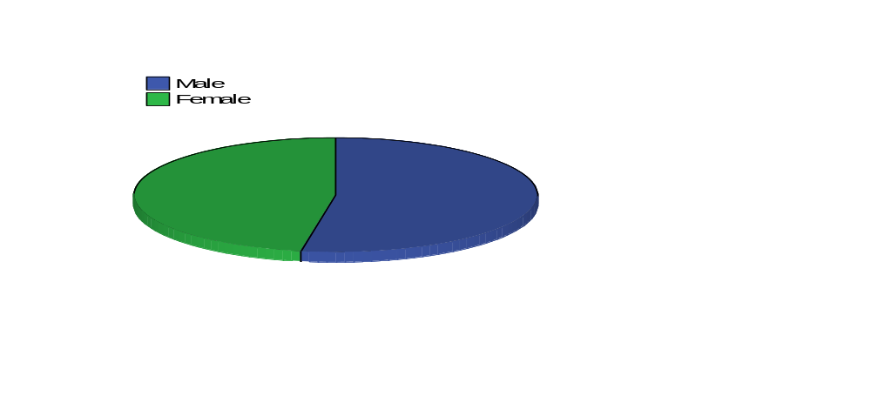 Source: Field Data Analysis (2020)

After the analysis the findings indicated that 60 respondent’s equivalents to (60.0%) of the respondent were males outweighing 40 females (40.0%). Although data analysis shows that males outweighs females but this does not mean that males were more cooperative than females since the distribution pattern of the questionnaire is not given. These results of the findings show that both genders were given equal chance to express their view as the finding shows above to both groups of respondents.

4.3.3 Education level of the households
It was also necessary for the study to determine the level of educations of the households in Kigoma. The analysis showed that majority of the household communities had only Standard seven education level. Figure 4.2 presents the data of the education level of respondents
Figure 4.2 Distribution of respondents on education level
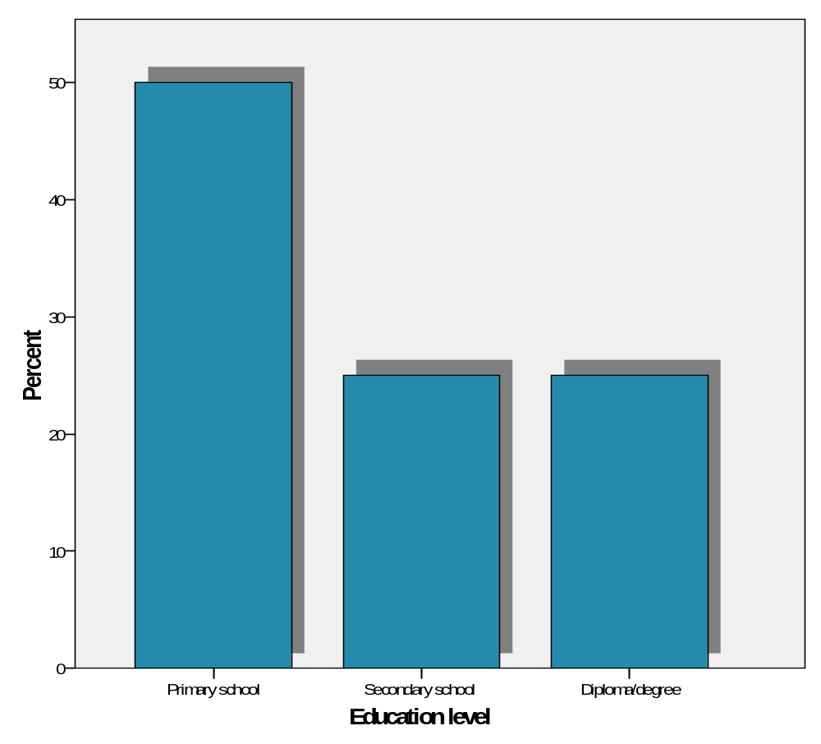
Source: Field Data Analysis (2020)
From Figure 4.3, it can be seen that at least 50% of the respondents had primary education certificates, 25% of the respondents had secondary school certificate and only 25% of the respondents had above diploma or bachelor degree. This somehow shows that most of them can afford some of the projects by themselves.

4.3.4 Occupation of the local communities
The occupations of the local communities were evaluated to check the main economic activities of the local communities. The analysis reveals most of the local communities are either farmers or pastoralist. The figure below summarizes the results of the findings.
Figure 4.3 Distribution of respondents on their occupation
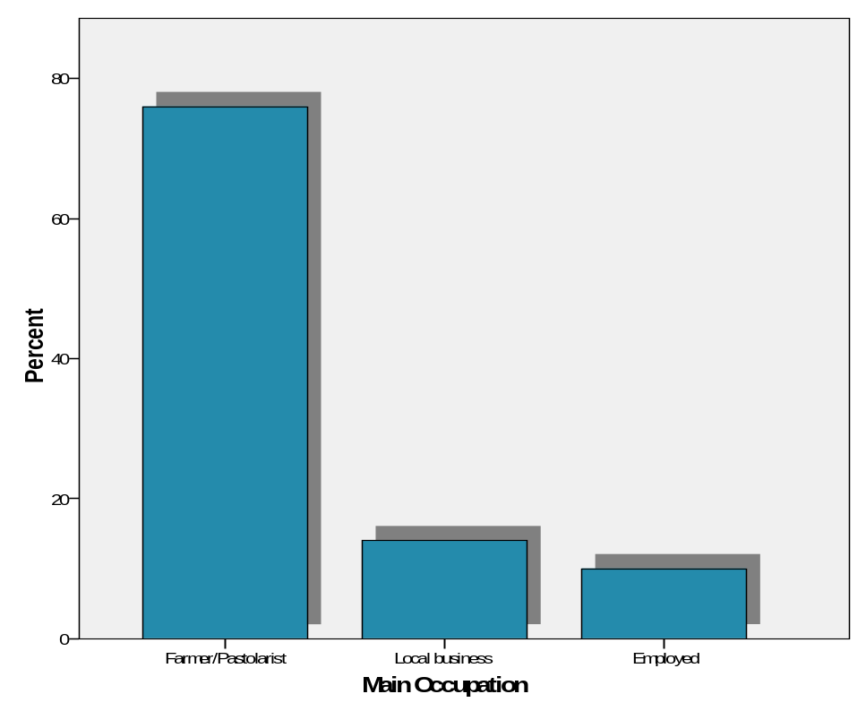
Source: Field Data Analysis (2020)

Generally, the Nyarugusu Village community was observed to be less educated community and their main economic activities was farming followed by business and formal employment. The researcher in this study expected to find out the impact of the presence of refugee camps on host communities with reference to Nyarugusu camp.

4.4 Findings analysis and discussion as per study objectives
This section analyzes the findings of the study in relation to the research objectives and questions presented in the study. More specifically the study aimed at establishing the perceptions of local communities over refugees, examine how the host communities and refugees integrate to each other and also evaluating the impacts (positively and negatively) of refugee’s camp on the host community.

4.4.1 Objective One
The first objective which was to analyse the perceptions of both host communities and refugees. The findings, analysis and discussion are presented in the contents of the following.

4.4.1.1 Responses of Local People towards Refugees
Respondents were asked how they feel about the presence of refugees in their Village and majority (66%) of respondents said they are not comfortable with the presences of refugees whereas only few (34%) of respondents said that they are comfortable with the presence of refugees in their village. Those claimed not to be comfortable with the presence of refugees said refugees have increased scarcity of food and theft while those comfortable with the presence of refugees said refugees have opened market for their commodities and availability of cheap labour in their farms.

Table 4.3: distribution of respondents on local people towards refugees
 | Frequency | Percent | Cumulative Percent
Comfortable | 34 | 34.0 | 34.0
Not comfortable | 66 | 66.0 | 100.0
Total | 100 | 100.0
Source: Field Data Analysis (2020)

4.4.1.2 Perceptions with host community/refugees
The local community were asked to give their view on how they perceive the refugees, the analysis reveal that most of the respondents said most of them are friendly. The Figure 4.4 below summarizes the results of the findings

Figure 4.4 Distribution of the respondents on Perception on refugees
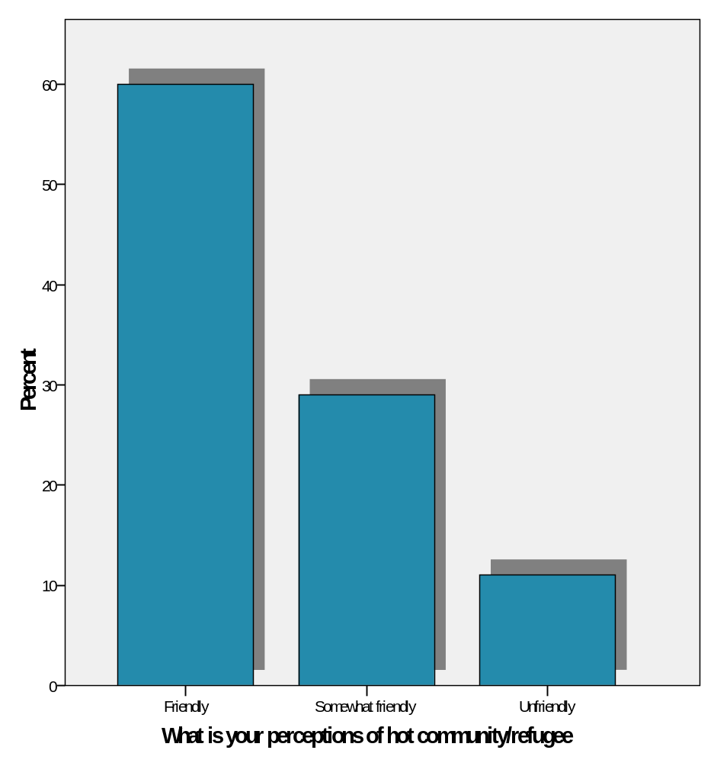
Source: Field Data Analysis (2020)

From the Figure 4.4 above the analysis reveal that more than half (60.0%) of the host community interviewed perceived the refugees as friendly to one another, 29% said refugees were somewhat friendly. Acknowledging the predicament of a refugee, as a person in need of assistance, the host community thought that since they share the same culture and portray the same religious beliefs, the refugees were friendly people. In spite of this observation, 11.0% of the host community is cautious of the aggressive behavior of some refugees.

Also, during the interview with one of the village executive officer mention that
“Refugees need a lot of assistant from us, we always take them as our friends and our families, despites some challenges we are facing while leaving near their camps but they need our assistants, we are brothers and sisters we need help each other” ( Nyabenda, 2019).

4.4.2. Objective two
The second objective which was to examine the extent of social and economic integrations between refugees and the host community. Findings, analysis and discussion are presented in the contents of the following;

4.4.2.1 Relationships between hosts and refugees.
The researcher also sought information on relationships between hosts and refugees in the study area. Majority (52%) of respondents ranked the relations as low whereas only few (16%) of respondents ranked it as moderate, while (32) % ranked the relations as good. The table below summarizes the results of the findings.

Table 4.5: distribution of respondents by relationships between hosts and refugees
 | Frequency | Percent | Cumulative Percent
Moderate | 16 | 16.0 | 16.0
Low | 52 | 52.0 | 68.0
Good | 32 | 32 | 100.0
Total | 100 | 100.0

Source: Field Data (2020)

The study revealed that few people who claimed that relationship between hosts and refugees is good are people who carry out business they said that refugees increased market opportunities for their goods. All groups interacting with refugees at common market, also through marriage between the refugees and Tanzanians.

4.4.2.2 How long had they stayed at Nyarugusu
The Nyarugusu camp commandant asked to provide statistics on how long the refugees had stayed together with the local communities. The following were the figures provided by Nyarugusu camp commandant:

Figure 4.5 Distribution of the respondents on staying at Nyarugusu
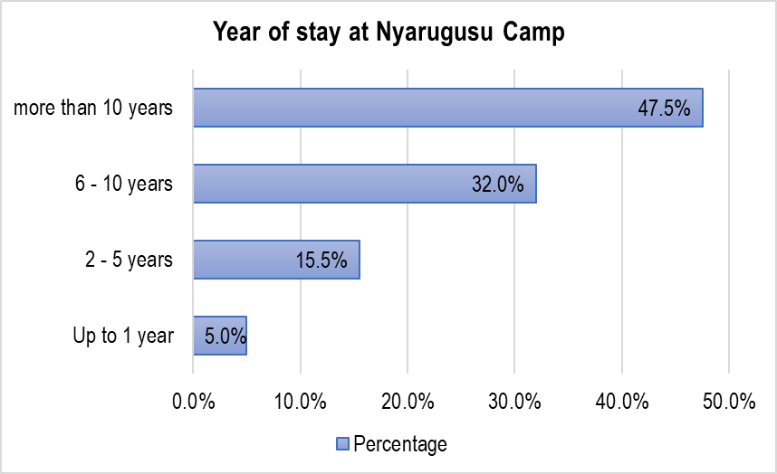Source: Field data analysis (2020)

From figure 4.6 above, the analysis revealed that majority of the refugees had stayed for more than 10 years, which constitute about 47.5% of all respondents; 32% of all respondents had been at the camp for more than 6 years; 15.5% had been at the camp for between 2 and 5 years and few respondents for less than 1 year. This finding implies that there are strong relationships and integrations between these refugees and host communities.

4.4.2.3 Connection with refugee
The respondents were asked to indicate if they were/had close connections with refugees in these areas. The analysis revealed that most of the respondents agree as chart 4.6 summarizes the results below.

Chart 4.6 Distributions of respondents on connections with refugees
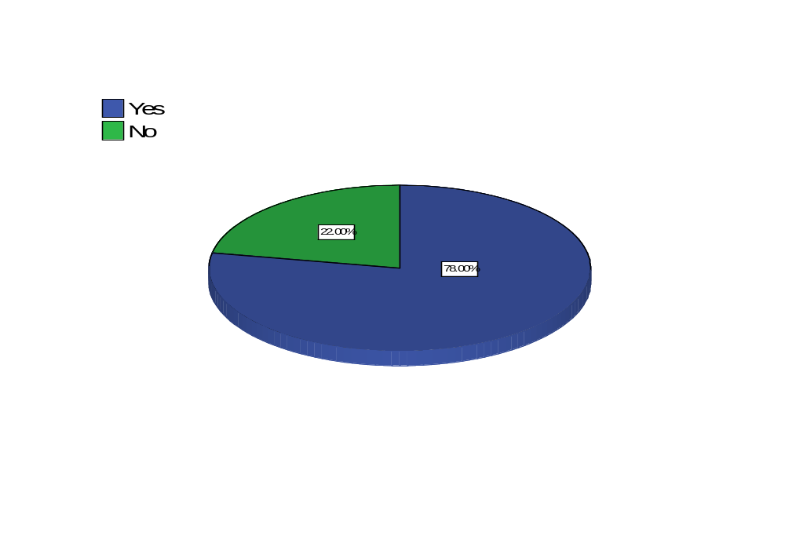
Source: Field Data Analysis (2020)

The analysis also reveals that most of the respondents said YES, they had connections with the refugees. The analysis reveals that 78 (78.0%) of respondents said YES, 22 (22.0%) said NO.

4.4.2.4 Which area did you obtain social connections
The respondents were asked to indicate in which area they had close connection with the refugees. The analysis revealed that majority of the respondents agreed on this. Figure 4.8 summarizes the results

Figure 4.7 Distributions of respondents on areas of connections
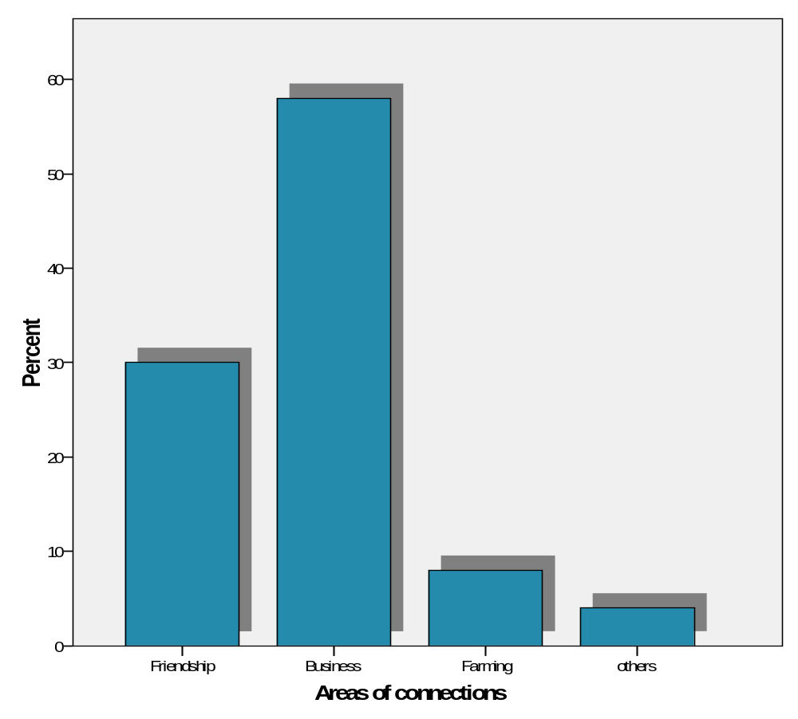
Source: Field Data Analysis (2020)

The findings in Figure 4.8 above shows that 58% of the respondents agreed that trade and market are the major activity integrating refugees and host community. This was because more people in the two communities were predominantly involved in trade. Friendship was the second integration activity with about 30% of the respondents agreed, while other integration such as marriage and employment scored 12%. This was due to the disproportionate absorption capacity of employment opportunities to the high population in the area among the refugees and host community.

While refugees were able to import and supply to the markets cheap untaxed goods from Burundi and Congo, their Tanzanians counterparts had to supply other essential commodities like fruits, vegetables, livestock, milk, construction materials and other foodstuffs. Similarly, livestock trade from Burundi played an important role in sustaining trade by providing cash incomes which were then used to purchase tradable food and non-food commodity.

4.4.3 Objective three
The third objective was to identify the positive and negative impacts of refugee camps on the host community in Nyarugusu. Findings, analysis and discussion are presented in the contents of the following;

4.4.3.1. Positive impacts on host community due to the presence of refugee camp

The presence of Nyarugusu refugees’ camp and relief resources in western Tanzania significantly altered the lives of people who lived in Nyarugusu village. The opportunities available to host communities changed in both positive and negative ways. The following sections will discuss the positive effects of refugees in local context.

4.4.3.1.1 Health Services

Study findings showed that refugees had a hospital in Nyarugusu camp that served both the local and refugees. Majority of respondents (98%) said that this hospital in the refugee camp provides adequate health services to both the local residents and refugees free of charges. Some of the respondents (2%) complain that the priorities are given to the refugees in that hospital than the residents.

Table 4.6: Ddistributions of respondents by health services provided to Nyarugusu
 | Frequency | Percent | Cumulative Percent
Fairly provided | 98 | 98.0 | 98.0
Priorities are given to the refugees | 02 | 2.0 | 10.0
Total | 100 | 100.0
Source: Field Data Analysis (2020)

4.4.3.1.2. Employment

When asked about employment opportunities, majority (53%) of the hosts respondents said employment in the study area increased as the result of the presence of refugees, while 47% of them said there was no increase in job opportunities. Majority of respondents who said employment opportunities increased associated it with the emergence of business opportunities and road and building construction jobs within the refugee camp.

Figure 4.8: Distribution of respondents by Employment Opportunities (N=100)

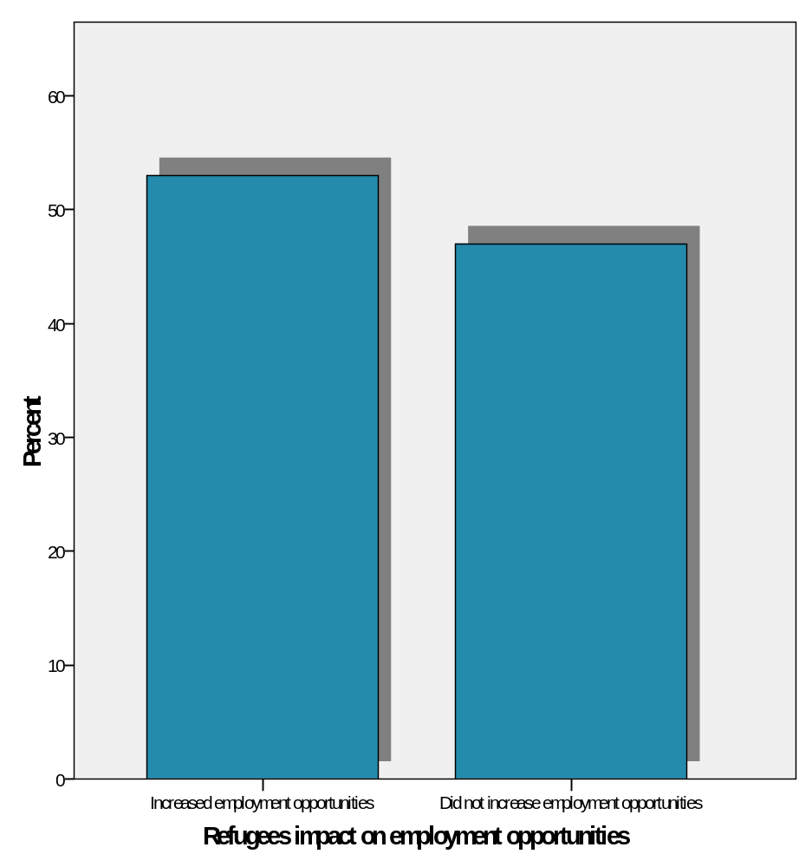
Source: Field Data Analysis (2020)

4.4.3.1.3 Business opportunities

Findings from the study show that majority (70%) of the respondents said refugees increase business in Nyarugusu village, while (30%) of respondents said there is no any business improvement. Those who said business improved said it is due to increase in market needs and customers as well.

Figure 4.9: Distribution of respondents by business Opportunities (N=100)

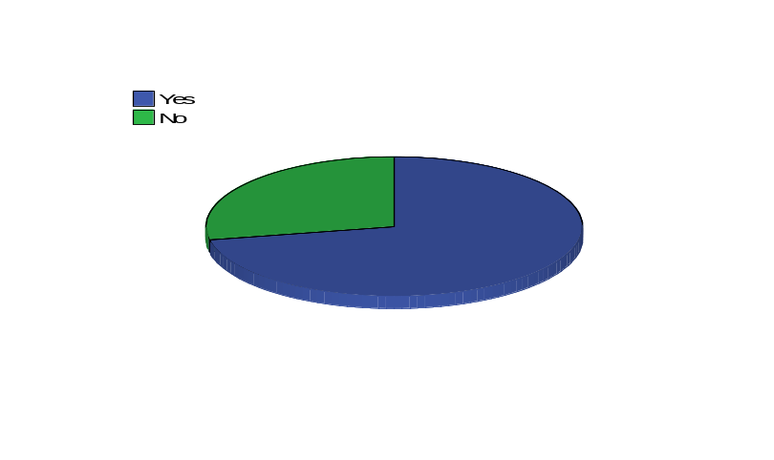
Source: Field Data Analysis (2020)

These findings imply that residents in the study area benefit much especially for those who are involved in business by better market for their goods and roads improvement although for those who are not involved in business were affected by rising prices due to high demand for goods.

4.4.3.1.4 Labour force from refugees

The study found out that, majority (84%) of respondents said that refugees provided labour force to local peoples’ farms, while only few (16%) of respondents said there is no refugees contribution to labor power. Furthermore, (84%) of respondents said refugees increase crops production where as 17% of respondents said refugees do not increase crops production. Majority (84%) of respondents of those who said refugees increase crop productions was because refugees supply labor to local people farms, where as 84% host respondents claimed that refugees cheap labor helped the local people to increase the size of their farms. The increase in the size of local people’s farms helped to produce more crops to meet demand for food crops which is high as a result of refugee’s influx.

Table 4.7: Distribution of respondents on cheap refugees’ labour in residents’ farms (N=100)
Characteristics |  | Frequency | Percent

Refugees provide Cheap labour
Yes |  | 84 | 84%
No |  | 16 | 16%

Refugee Increased crop production
Yes |  | 84 | 84%
No |  | 16 | 16%

If yes why
Refugees Supplies labour in local people farm | 84 |  |  | 84%
Other reasons | 16 |  |  | 16%
Source: Field Data Analysis (2020)

4.4.3.2 Negative impacts on host community due to the presence of refugee camp

Apart from the positive impacts the findings discovered some negative impacts as well. When the respondents asked if there are disadvantages in hosting refugees (55%) of respondents said yes while 45% of respondents said no. For those who said yes 42% of them claimed on affecting environment, 35% claimed on theft/robbery and 23% claimed on conflicts as shown in Table 7. Apart from other disadvantages theft and the environment issues are the one seems to irritate a lot of local residents.

Table 4.8: Distribution of respondents on disadvantages of hosting refugees (N=100)

Characteristics Respondents Percent

Disadvantages of hosting refugees

Yes 55 55%

No 45 45%

Reasons

Environmental degradation 42 42%

Conflict 23 23%

Theft/robbery 35 35%

Source: Field Data Analysis (2020)

4.4.3.2.1 Impact on Environment

During the focus group meetings, local participants were asked to describe any environmental problems affecting them or their village and participants referred to refugees as being the cause for degradation. Environmental problems noted by participants in Nyarugusu village included illegal harvesting of trees and forest resources. The scarcity of water resources and illegal tree harvesting is attributed to the growing population in the area of both the refugees and Tanzanians. However, in some instances the participants argued that even though the villagers are participating in the environmentally harmful activities, they only started doing so after the coming of the refugees. The refugees are seen as the primary cause.

Refugees have impacted negatively the environment as several studies have corroborated. The impacts include deforestation, devegetation, erosion destruction, degradation and pollution of water sources. According to detailed reports written on environmental degradation on the refugee affected areas in Tanzania, the close proximity of the camps to the forest reserves has been a key contributing factor to environmental degradation. These studies show that refugees continue to encroach upon the forest reserves, primarily to collect firewood or wood for construction (UNEP, 2005; Relief 2003; Western 1997)

Deforestation and depletion of forest resources is the most oft-cited environmental problem in western Tanzania. The rate of deforestation is reportedly higher than the national average (relief, 2003:11) Refugees travel much greater distances to find dead wood, some people have chosen to illegally cut down living trees ,thus further contributing to the degradation (UNEP, 2005:33)

Deforestation and depletion of forest resources is the most often –cited environmental problem in western Tanzania. The rate of deforestation is reportedly higher than the national average (relief, 2003:11). Refugees travel much greater distances to find dead wood, some have chosen to illegally cut down living trees, thus further contributing to the degradation (UNEP, 2005:33). The reason that made them travel greater distance to find firewood is because it is illegal to cut down a tree within the camp boundaries.

4.4.3.2.2 Conflicts

When asked about conflicts, the majority of respondents said that conflict arises due to stealing from the farms or when they go into the forest to cut firewood. Banditry and theft were mostly mentioned in focus groups meetings as the reasons for conflicts, in addition while some of the villagers acknowledged that the bandits were often non refugees the increase in crime occurred at the same time as the refugee influx.

CHAPTER FIVE

CONCLUSION AND RECOMMENDATIONS

5.1 Introduction
This chapter presents the summary of the study, the conclusions drawn from the findings and the recommendations for future research. The chapter begins with a summary of findings, followed by the conclusions made from the findings and, finally, it presents the recommendations for socio –economic effects due to the presence of refugee’s camps on host community.

5.2 Summary of major Findings
On the whole, the study examines the effects of a refugee’s camp on host communities in Nyarugusu Camp. More specifically the study establishes the perceptions of host communities and refugees about each other, examine the extent of integrations between refugees’ and host community in Nyarugusu Camp integrate with host community and also identify positive and negative impact of refugee’s camp on host community.

The findings reveal that there is a good perception of both the host communities and the refugees regarding their competence. The analysis reveals that most of the host communities see the refugees as they need assistance and treat them friendly. This had been concluded by 60% of the respondents. Furthermore, the analysis reveals the analysis reveals most of the host communities and also refugees they feel don’t feel comfortable with each other. This had been concluded by more than 66% of the respondents from the analysis. These findings are similar to the findings by the study by Milton (2012) also reveal similar results that most of the refugees and the host communities take to each other as friends, these findings are also similar to the findings from the study by Millen (2014), Sangido (2012) and also Ngole (2015).

Also, the findings reveal that there are integrations between the host community and refugees. The integrations are very high and exist in a different nature. The analysis reveals that most of the refugees had stayed in the camp for more than 10 years. This had been concluded by more than 47.5% of the respondents of the refugees on the camp, ignoring those who stayed more than 6 years. Now staying on the camp for more than 10 years means your part of the community around. The study by Green (2012) mentioned that as the refugees stay more with host countries, they become familiar and part of the host communities.

Furthermore about 78% of the respondent’s host communities said they had connections with the refugees in one way to another, this is a large proportion of the community. The analysis further concluded that the nature of the relationship mainly comes from the business they do. This had been concluded by 58% of all respondents. The business relationship between host communities and refugees camp had also explained by different kinds of literature such as Millita (2011), Green (2007), Mengoy, (2013), and also Zhankang (2018). Furthermore, the analysis reveals that the other kind of integrations was found in friendship where some of the marriage happened between the host communities and the refugees.
Furthermore, the analysis reveals that there is the positive and negative impact of the refugee camp and the host communities. The analysis reveals that the improvement of health services as a result of refugee camps is one of the impacts of the existence refugeed camps. The analysis reveals that 98% of the host countries had agreed on this. This had also been explained by the study by Millita (2011) and Green (2012). An increase in employment opportunities is another advantage that the host countries benefit from from refugee’s camps. Some of the host communities are employed on the camps or even become employees of the refugees. This increases the relationship between the two communities. The study also concluded that in most cases the employment opportunity is one of the advantages of a refugeed camp in host countries. Several studies had also mentioned similar results.

The study also finds other negative factors related to conflicts between the host communities and the refugees as a result of land and other activities, the security issues, and even the environmental degradation as another challenge of having refugees camp in other countries. Banditry and theft are the most reasons for conflicts between the host community and the refugees. These findings are similar to the finding by Andres’s (2010) while revising a study by Welmon, (2008), finds that conflicts and securities are among the challenge on the refugee’s camps to host communities

6.3 Conclusion of the study
From the findings, the researcher concludes that in most cases the existence of the refugee camp affected the host communities. It had also concluded that the relationship between the host communities and the refugees somehow is not bad as they take each other as friends. The study further reveals there are potential integrations between the two on business and even friendly. This created a lot of opportunities for the host community. Several impacts had been found to the impact of the refugeed camp on the host communities, these effects can either be positive or negative. The improvements of health facilities, infrastructure, securities, and even business opportunities are among the positive impacts of the refugeed camps to host communities. Similarly, the negative side includes the conflicts between the refugeed and host communities, the issue of security, and environmental degradations are among the negative impacts to host communities. These factors also had been mentioned by several studies such as Namisango (2010), Magiri (2015), Suma (2012), Panjay (2012), and (Millita, 2011).

5.4 Recommendations of the study
This section provides some recommendations with regard to research objectives, research hypothesis, and research findings after the analysis of the respondents’ views. The recommendations had been given as per research findings

Peace building and peace education such as by UNHCR should continue, expand, include more actors and try to become even more efficient. Continuing with mixed schools are creating good relationship and interactions between hosts and refugees. Marketplaces and hosts working for refugees are reported to be an area where both conflicts start and where mutual benefits are experienced. Improving this area could benefit both groups. Promoting more structure in the camp could be one approach as many disputes start from there. Although, this is obviously a challenge since many refugees use food aid as a currency for trading or employment.

Develop strategies for host community development. Promoting much needed development in the host community could improve livelihoods for hosts in addition to their relationship with the refugee population. This could also improve the well-being of refugees through tensions between host and refugees decreasing. In specific, the issue of food and water security is important for the host community.

Providing more access to water and promote sustainable livelihoods could be one approach. If hosts are better equipped to sustain themselves it is likely that they will be less dependent on searching for livelihoods in the camp. It is important to balance the bridge between humanitarian and development aid. Providing only “hand-outs” to hosts would not promote sustainability. Promoting sustainable ways of providing livelihood could be more efficient in the long-term. The balance between involving hosts in hosting refugees and limit the dependency on the camp could be a dilemma.

When or if the camp closes down it is important that the host community is not only dependent on the camp for surviving. Nevertheless, it is clearly that hosts are eager to benefit more from being a hosting community and be involved. Increase employment of hosts in NGOs, especially unskilled labor can be one approach. Providing practical education for hosts to be better equipped for jobs in NGOs could make hosts more attractive in the job market

5.5 Area for further research
As the results of different limitations such as financial and Time constraints the researcher was limited to some areas which can be further taken into considerations. The following areas are recommended to be taken into consideration since it needs further study. These are has become limited to my research as a result of time and financial constraints.
- Since this study was conducted in Nyarugusu camp only then the results of this research can’t be applied to other refugee camps in Tanzania. Therefore, it needs further studies in other camps
- During data collections some of the respondents complain over some political agenda among politician to affects relationship between host communities and refugees then further research needs to examine the roles of the Kigoma political leaders’ roles for refugee and host relationships.
- Further study should be done to assess the role and influence of social support networks on the relationship between host communities and refugees on refugees’ camps

REFERENCES

Adelman, H. (1992). “Ethnicity and refugees”, World Refugee Survey 1992, pp.6 -12.

Adepoju, A. (1995). “Emigration dynamics in Sub-Saharan Africa”. International migration. Volume 33 pp.315 -386.

Allen, P. (2001). Utica refugees in North America local economy. Http//www.Unhcr.visited on 13/11/2018approach(2nd ed.). Thousand Oaks, CA: Sage Publication.

Armstrong, A. (1987). Refugee’s settlement schemes in Tanzania, land reform, settlement and cooperatives. pp. 83 – 108.

Atim, G. (2013). “The impact of refugees on conflicts in Africa”. Journal of Humanities and Social Sciences. 14(2), 04-09.

Baconnier, J. (1994). “When peace breaks out- Mozambican refugees: A study in socio- Economic Reintegration”. International migration, volume 31.p. 601-623.

Black, R. (1991). “Refugees and displaced persons: Geographical perspectives and research directives”, Progress in Human Geography. 203pp.

Boswell C (2002). “Addressing the causes of migratory and refugee movements: the role of the European Union”. Institute for Peace Research and Security Policy, University of Hamburg, Germany. 29pp.

Chasian, S. (1990). “Refugees research in Africa. Problem and possibilities”, International Migration. Makerere University. pp103.

Collins, C. (1996). “The refugee’s crisis around Great Lakes, African recovery, and countries; A research model”. Journal of Refugee Studies, 4:1-20.

Coser, L. (1956). The Functions of Social Conflict. New York: Free Press.
Creswell, J. (2003). Research design: Qualitative, quantitative and mixed method approach (2nd ed) Thousands oaks.CA: Sage publication.

Crisp, J. (2002). “Africa’s refugees: patterns, problems and policy challenges”, New Issues in Refugee Research. Working paper No. 28. Geneva: UNHCR.
Crisp, J. (2002). “Human displacement: Africa’s refugees: patterns, problems and policy challenges”. Conflict Trends, 1(2), 16-19.
Daley, S. (1989). Refugees and underdevelopment in Africa, the case of Burundi refugees in Tanzania. Journal of Refugees Studies, 5: 248-266.

Flinton, F. (2001). “Environmental Refugees – A Misnomer or a Reality? A Contribution to the Wilson Park Conference,” Report on Environmental Security and Conflict Prevention, March 1-3. 17-33 pp.

Green, H. (1994). “Relief and repatriation; Views by Rwandan refugees. Lessons for Humanitarian Aid workers”. African Affairs. 95(8):403-429

Jackobsen, K. (2005). The Economic Life of Refugees. Bloomfield, NJ: Kumarian Press. 241 pp.

Jacobsen, J. (1988). “Environmental Refugees: A yardstick of Habitability”. World Watch Paper, No. 86. Washington, D.C. World Watch Institute. pp 301.

Jacobsen, K. (1997). “Refugee’s environmental impact: The effect of patterns of settlement”, Journal of Refugee Studies 10 (1):19-36

Jacobsen, K. (2002). “Can refugees benefit the state? Refugee resources and African state building”. Journal of Modern African Studies 40 (4): 577-596.
Jeffrey, H. (1989). The creation and maintenance of national boundaries in Africa.
International organization,43(4),673-692.

Johnson, A. (1994). “Environmental refugee in Ghana: The politics of assistance to Sahel refugee”. Legon Journal of the Humanities 7: 41 – 56.

Jones, W. (2002). “Farming system in Africa. The Great Lakes high lands of Zaire, Rwanda and Burundi”. World Bank Technical paper No. 27: 12-18.

Kalpers, J. (2001). “Armed Conflict and Biodiversity in Sub – Saharan Africa: Impacts, Mechanisms and Responses”, in Armed Conflict and Biodiversity in Sub-Saharan Africa. Washington, D.C.: Biodiversity Support Program.

Kalyango, B and Kirk, C (2002). Refugees and environment. An over view of human included disasters in great lakes region in Africa. University of Dar es Salaam. pp. 18-37.

Kamanga, K. (2005). “The (Tanzania) Refugees Act of 1988: Some legal and policy implications”. Journal of Refugee Studies, 18 (1): 100-116.

Kelly, N. (1989). “Working with refugee’s, women practical guide”. International NGO working group of refugee’s women, geneva, 1989. 213 pp.

Kibondo District Council (2006). Five year-Strategic Plan 2006/2007 to 2010/2011.Kibondo, Kigoma: Tanzania Kibondo District Council. 120 pp.

Kibreab, G. (1985). African refugees: Reflection on the African refugees’ problem. Trenton, NJ: African World press. 103 pp.

King, T. (2006). “Environmental displacement: Coordinating efforts to find solutions”. Science-Red orbit. 16 pp.

Kothari, C. (1990). Research, methodology, methods and techniques. Second edition Dharaushi printers, Delhi India. 67 pp.

Kunt, A. and Cook, J. (1999). “Land problems in refugees host zone and implication for refugee protection”: Social research in Africa. pp.62-71.

Kurimoto, E. (2005). “Multidimensional Impact of Refugees and Settlers in the Gambela Region, Western Ethiopia”. In I. Ohta and Y.D. Gebre (eds.), Displacement Risks in Africa. Kyoto: Kyoto University Press. 202 pp.

Liganga, L. (2006). Refugees and the environment: The other side of Tanzania’s generosity. This Day, 28 August, 2006.16pp.

Maystadt, J. et al (2019). Impacts of Hosting Forced Migrants in Poor Countries. Annual Review of Resource Economics. Vol. 11:439-459 (Volume publication date October 2019). First published as a Review in Advance on May 21, 2019.

Mugerwa, S. (1992). Refugees and environment: Some recent experiences from Kagera region in Eastern Central Africa. University of Dar es Salaam. 23pp.

Murray, C. (1981). What driving migration. Formulation mission report. Volume 8(1): 23-33.

Nowagaba, K. (2002). African refugees: Development, aids and repatriation. Boulder West Views Press. 142 pp.
"Nyarugusu camp voices". Retrieved May 14, 2016. Refugees.org.

Omar, R. and Del Waal, A. (1993). Land tenure, the creation of famine and prospects for peace in Somalia, Africa rights, 17 October, 1993. 68pp.

Oucho, J. (2002). Refugees and Internally Displaced Persons: Africa’s Liability for the Next Millennium. In Daniele Joly (ed.) Global changes in Asylum Regimes. London: Palgrave Macmillan.154pp.

Romtveit, G. (2019). 6 things to know about refugees in Tanzania. Published 06. Mar 2019.Available at https://www.nrc.no/perspectives/2019

Ruiz, I & Vargas-Silva, C. (2017) The Consequences of Forced Migration for Host Communities in Africa. Revue d'économie du développement 25:3, pages 135. Crossref

Ruiz, I & Vargas-Silva, C. (2013) The Economics of Forced Migration, The Journal of Development Studies, 49:6, 772-784pp.

Rutinwa, B. and Kamanga, K. (2003). The impact of the presence of refugees in north western Tanzania. The Center for the Study of Forced Migration at the University of Dar es salaam. Final report. Available at http/www.refugees.org/article.aspx? [accessed 24 November 2018].

UNEP (2005). Impacts of refugees and internally displaced persons on the environment in Tanzania. Available at www. unep. org/ depi/ programmes/ emergences.html [accessed 24 November 2018].

UNHCR (1996a). Refugees and the environment in Africa; Proceedings of a workshop at Bahari Beach, Dar es Salaam, Tanzania 2-5 July, 1996. 53pp.

UNHCR (1996). The state of the world refugees in search of solutions. United Nation High Commission for Refugees. Oxford University Press. 95pp.

UNHCR (2009). 2008 Global Trends. Geneva: UNHCR. 69pp.

URT (2002). The National Refugees Policy. Government printer, Dar es Salaam.

18 pp.

WFP (1990). Food and Agriculture Organization of the United Nations, 10 August 1990.Tanzania: Refugee Affected Areas Development project: Identification/formulation mission report. 47pp.

Whitaker, B. (1996). Changing opportunities, refugees and host communities in Western Tanzania. New issues in Refugees Research, Working paper II. University of North Carolina and UNHCR.

Whitaker, B. (2002). Refugees in Western Tanzania: The Distribution of Burdens and Benefits Among Local Hosts. Journal of Refugee Studies. 15 (4):20-32.

Wordegabriel, A. (1996). The social cultural and economic impact of refugees on host Indigenous committees in West Africa. A case study of Liberian refugee at Buduburam community in Ghana. Masters in Indigenous Studies, University of Tromso. 1996.

World Watch (1994). Refugees and the environment. Some recent experience in the world. Boulder Most View Press. 142pp.

