THE INFLUENCE OF FREE-RANGE GRAZING ON SOIL DEGRADATION: A CASE OF THE LIVINGSTONE MOUNTAIN RANGES IN LUDEWA DISTRICT, TANZANIA

RAINERY AUDALION MWINUKA

A DISSERTATION SUBMITTED IN PARTIAL FULFILLMENT OF THE REQUIREMENTS FOR THE DEGREE OF MASTER OF ARTS IN NATURAL RESOURCES ASSESSMENT AND MANAGEMENT
DEPARTMENT OF GEOGRAPHY
THE OPEN UNIVERSITY OF TANZANIA
2021

CERTIFICATION
The undersigned certifies that, she has read and hereby recommends for acceptance by the Open University of Tanzania a Dissertation entitled: “The Influence of Free-Range Grazing on Soil Degradation: A Case of the Livingstone Mountain Ranges in Ludewa District, Tanzania, in partial fulfillment of the requirement for the award of Degree of Master of Arts in Natural Resources Assessment and Management.

……………………………..…………
Dr. Susan Rugano Gwalema

……………………………..………
Date

COPYRIGHT
No part of this dissertation may be reproduced, stored in a retrieval system or transmitted in any form or by any means, electronic, mechanical, photocopying, recording or otherwise without the prior permission of the author or the Open University of Tanzania in that behalf.

DECLARATION

I, Rainery Audalion Mwinuka, do hereby declare that this dissertation is my own original work and that it has not been presented and will not be presented to any other University for a similar or any other degree award. It is hereby presented in partial fulfillment of the requirement for the award of Degree of Master of Arts in Natural Resources Assessment and Management.

……………………..……………
Signature

…………………………….………
Date

DEDICATION
I dedicate this study to my mom and daddy who made sure I get education against all odds.

ACKNOWLEDGEMENT
Foremost, I would like to express my gratitude to my family members specifically my wife Grace, my daughters Raelyn and Gracie for the committed support, encouragement and time dedicated during my studies.

My sincere gratitude goes to key informants for their consent to participate in the study and provided crucial information for successful production and accomplishment of this research work.

My research Supervisor Dr. Susan R. Gwalema deserves more gratefulness for her patience, motivation, great care, advice, support and heartfelt supervision and guidance from the preliminary preparation until production of this presentable dissertation.

My sincere acknowledgement also goes to the Ludewa District Executive Director (DED), the Head of Natural Resource and Environment Department, the Head of the department of Agriculture, Irrigation and Cooperative and all the District administers for their great support and provision of the permit to access data in the study area.

I express my sincere gratitude to the National Council for Technical Education (NACTE), OUT Community; Academics, Administrative Staff and my fellow MANRAM Candidates for their support and teamwork that led to the production of this work.

ABSTRACT
Human life and developmental activities are interconnected with the availability and quality of natural resources attached to soil. This study assessed the ‘Influence of Free-Range Grazing on Soil Degradation in Ludewa District in Tanzania. The research is qualitative in nature and applied interview, observation technique and literature review to acquire data. The researcher collected data from thirty-two (32) respondents who were purposefully sampled to participate. This study collected different information about causes, forms and impacts of soil degradation, knowledge, attitudes and responsibilities of local people towards soil conservation. The study found that, free grazing has diverse implications towards soil conservation in Tanzania. The activity affects ecological balance that is necessary for survival of living things. Shortage of water and food cause death to living organisms; thus, disturbing an interdependence among living things and food chain. It was also noted that, soil erosion, loss of soil fertility, soil pollution, loss of biodiversity, air and water pollution are the impacts resulted from free grazing. Free grazing is responsible for land deformation in forms of furrows, gullies, water channels and trenches. Sustainability of soil quality depends on community involvement in conservation and behavioural change towards soil conservation. Thus, the researcher adopted three theories to guide this study; Theory of Reasoned Action (TRA), the Property Rights Theory (PRT) and the Responsible Environmental Behaviour (ERB). Adopted theories focus on community empowerment towards conservation of natural resources. Therefore, different projects to support local community with alternative economic activities like beekeeping and agroforestry should be introduced to reduce human intervention within Livingstone Mountain Ranges in Ludewa District.
Keywords: Soil Degradation, Free - Range Grazing, Soil Quality and Conservation, Biodiversity and Environmental Education
TABLE OF CONTENTS
CERTIFICATION ii
COPYRIGHT iii
DECLARATION iv
DEDICATION v
ACKNOWLEDGEMENT vi
ABSTRACT vii
LIST OF FIGURES xiii
LIST ABBREVIATIONS AND ACRONYMS xiv
CHAPTER ONE 1
INTRODUCTION 1
1.1 Overview 1
1.2 Background to the Research Problem 1
1.3 Statement of the Research Problem 4
1.4 Objectives of the Study 6
1.4.1 General Objective 6
1.4.2 Specific Objectives 6
1.5 Research Questions 6
1.6 Justification of the Research 7
1.7 Scope of the Study 8
1.8 Organization of the Research 9
CHAPTER TWO 10
LITERATURE REVIEW 10
2.1 Overview 10
2.2 Conceptual Definitions 10
2.2.1 Soil 10
2.2.2 Soil Degradation 11
2.2.3 Free Range Grazing 12
2.2.4 Small Scale Livestock Keeping 13
2.2.5 Ecosystem 14
2.2.6 Deforestation 14
2.3 Theoretical Analysis of the Study 15
2.3.1 Environmentally Responsible Behavior (ERB) Theory 15
2.3.2 The Theory of Reasoned Action (TRA) 17
2.3.3 Property Rights Theory 18
2.4 Empirical Analysis of Relevant Studies 19
2.4.1 Communities’ Dependency on Livestock 19
2.4.2 Types of Soil Degradation 19
2.4.3 Impacts of Soil Degradation 22
2.4.4 Soil Degradation by Anthropogenic Practices 23
2.4.5 Soil Management Strategies 25
2.5 Conceptual Framework 26
2.6 Research Gap 28
CHAPTER THREE 30
RESEARCH METHODOLOGY 30
3.1 Overview 30
3.2 Research Design 30
3.3 Survey Population 32
3.4 The Study Area 33
3.4.1 Geographical Location 33
3.4.2 Topography and Climate 33
3.4.3 Soil Type 33
3.4.4 Ethnic Groups and Culture 34
3.4.5 Economic Activities 34
3.5 Sampling Design and Procedures 34
3.6 Type and Sources of Data 36
3.7 Research Methods 37
3.8 Research Tools 38
3.8.1 Personal Interview Method 38
3.8.2 Observation Method 39
3.8.3 Documentary Method 40
3.9 Data Processing and Analysis 40
3.10 Validity and Reliability 42
3.11 Ethical Considerations 43
CHAPTER FOUR 45
FINDINGS AND DISCUSSIONS 45
4.1 Overview 45
4.2 Presentation of the Findings 45
4.2.1 Demographic Data 46
4.2.2 Forms of Soil Degradation 48
4.2.3 Causes of Soil Degradation 50
4.2.4 Impacts of Free-Range Grazing on Soil Quality 51
4.2.5 Factors Influencing Free Grazing 53
4.2.6 Knowledge, Attitudes and Responsibilities of Local People 55
4.2.7 Intervention Strategies for Improving Soil Quality 56
4.3 Discussion of the Findings 57
4.3.1 Different Forms of Soil Degradation Resulting from Free-Range Livestock Grazing 57
4.3.2 Knowledge, Attitudes and Responsibilities of Local People towards Environmental Conservation 58
4.3.3 Impacts of Free-Range Grazing on Soil Quality 63
4.3.4 Intervention Strategies for Improving Soil Quality 64
CHAPTER FIVE 67
SUMMARY, CONCLUSIONS AND RECOMMENDATIONS 67
5.1 Introduction 67
5.2 Summary of the Findings 67
5.3 Conclusions 67
5.4 Recommendations 69
5.4.1 Recommendations of the Study 69
5.2.5 Recommendations for Further Research 70
REFERENCES 71
APPENDICES 81

LIST OF TABLES
Table 4.1: Demographic Summary for Public Officers 46
Table 4.2: Sex of respondents through Interview Method 47
Table 4.3: Respondents’ Locality 47
Table 4.4: Respondents’ Level of Education 48
Table 4.5: Respondents’ Employment Status 48
Table 4.6: Forms of Soil Degradation Resulted from Free Grazing System 49
Table 4.7(a): Causes of Soil Degradation 50
Table 4.7(b): Causes for Soil Degradation………………………………………...51
Table 4.8: Impacts of Soil Degradation 52

LIST OF FIGURES
Figure 2.1: Theory of Environmentally Responsible Behavior (ERB) 16
Figure 2.2: Theory of Reasoned Action (TRA) 18
Figure 2.3: Conceptual Framework Underpinning Management of Soil Health 28
Figure 3.1: Map of Ludewa District Showing Ludewa Ward 35
Figure 4.1: Degraded Landscape caused by Free Range Grazing. 49
Figure 4.2: Eroded Soil and Uncovered Plant Roots 52
Figure 4.3: Poor Vegetation Cover 53
Figure 4.4: Goats Grazing freely within Mountain Ranges 54

LIST ABBREVIATIONS AND ACRONYMS

CEMS Comprehensive Environmental Management Strategy
DED District Executive Director
ERB Environmental Responsible Behaviour
FAO Food and Agriculture Organization
HIMA Hifadhi ya Mazingira
IBAs Important Bird and Biodiversity Areas
LDCSEP Ludewa District Council Socio –Economic Profile
MANRAM Master of Arts in Natural Resources Assessment and Management
NBS National Bureau of Statistics
NEMC National Environmental Management Council
NEP National Environmental Policy
OUT Open University of Tanzania
PHC Population and Housing Census
PRT Property Rights Theory
SDGs Sustainable Development Goals
SPSS Statistical Package for the Social Scientists
SSA Sub-Saharan Africa
TMA Tanzania Meteorological Authority
TRA Theory of Reasoned Action
URT United Republic of Tanzania
WWF World Wildlife Fund

CHAPTER ONE

INTRODUCTION

1.1 Overview
Environmental degradation is a world problem, which negatively affects natural resources and anthropological life. Tanzania like other parts of the world; especially in Sub-Saharan Africa (SSA), is challenged with environmental degradation in different forms which include soil degradation resulting from free range grazing and cutting down trees by small scale livestock keepers.

Prolonged heavy grazing contributes to the disappearance of palatable plant species and the subsequent dominance by other, less palatable, herbaceous plants or bushes (Zegeye, 2017). Such loss of plant cover in consequence, requires a long regenerative cycle. Excessive livestock grazing also causes soil compaction and erosion, decreased soil fertility and water infiltration, loss in organic matter content and water storage capacity. On the other hand, total absence of grazing also reduces biodiversity because a thick canopy of shrubs and trees develops which intercepts light and moisture and results in overprotected plant communities, which are susceptible to natural disasters (Nandya et al. 2015).

1.2 Background to the Research Problem
Human survival on this earth depends much on the availability of arable land resources to which other resources like soil, wild fauna and flora are attached. According to the World Agroforestry Centre (2014) different human activities such as overgrazing, unsuitable cultivation practices, clearing land for construction of buildings, dams and roads dramatically accelerate the rate at which erosion takes place. Accelerated erosion may affect both agricultural areas and the natural environment. Soil erosion is one of the most widespread of today’s environmental problems. It is a cultural practice to African societies to keep livestock in a free-range system; and the bigger the number of livestock the more prestigious and famous the family becomes. Free range grazing system and the tendency of keeping large numbers of animals have great influence on soil degradation because livestock keepers depend much on the natural environment for pasture and water to feed their animals.
Different studies have been conducted on soil degradation as Longshan & Rui (2019), explicate. They clarify that soil loss is more serious in karst rural environments than in other environments, but little information is available on its relationship with human activities; consequently, rural residents generally lack awareness of the effect of their actions on soil loss. Another study by White et al (2012) indicates that soil management is important for environmental sustainability and human health; and good grazing management can transform poor grazing land into healthy, productive pasture. Also, Xu et al. (2018) observe that grazing land management sometimes simultaneously influence the soil properties. Grazing management plays an important role in determining ecosystem productivity and sustainability.
Furthermore, natural resources provide different materials for shelter, food, medicine, timber, firewood, charcoal and habitat for varied living organisms. In forests, human beings can harvest different natural resources like honey and other wild produce that can be converted into economic valuables for business and earning their living. Roe et al. (2009), clarify this phenomenon as commercial use of natural resources that often remain centralized by being conditioned and regulated by authorities. Balasubramanian (2017) insists that soil is the most fundamental and basic natural resource for all life to survive. Despite the benefits from natural resources, Li et al. (2011) provides that anthropogenic activities, particularly altering land use practices, are acknowledged as the principal force driving rangeland degradation. According to Asmare (2018), livestock is effectively used to control exotic invasive perennial grasses. It is also important for natural fertilization and transport of nutrients in animals. Manure is a rich source of nutritive substances essential for green biomass growth.
Maiangwa et al. (2007), noted that almost all farmers in African communities lack lands designated for grazing. Thus, uncontrolled (free-range) grazing by cattle, sheep, goats, donkeys and camels is a common practice. Sustainability of natural resources in Mount Livingstone ranges is at risk since several human activities take place unsustainably. Free range grazing, leads to bare land as livestock browse on the available vegetation. Consequently, soil degradation results through wind and water erosion, trampling by livestock and degradation of arable lands. This same situation prevails in the Mount Livingstone ranges.
Livingstone Mountain Ranges have been covered with natural vegetation that has ecological value for balancing nature. Despite its ecological importance, this resourceful forest and the associated ecosystem are threatened by anthropogenic activities that include free grazing system and the habit of cutting trees for creating pasture land demonstrated by livestock keepers.

1.3 Statement of the Research Problem
Human life and its survival on this earth depend on the available natural resources. Also, human development cannot be separated from natural resources. Anthropogenic activities have increased challenges in the management of natural resources, as they are negatively affecting their sustainability. Livestock production continues to play a major economic and cultural role in numerous rural communities (Mwalyosi, 1992). However, different kinds of human activities are the main reasons for environmental degradation.
The mountainous topography of Ludewa District Council is favorable for livestock keeping. The great challenge is free range grazing and uncontrolled animal keeping because livestock owners tend to leave livestock on their own in the forest. Asmare (2018) conducted a study on Ecological and Socio-Economic Implications of Free Grazing in Ethiopia and noted that, improper use of pasture such as both overgrazing and under grazing creates a threat for its biodiversity. Free range grazing system is the main problem that affects soil quality because of poor control and management of pastures. Kikoti et al. (2015), conducted research on the Impact of Grazing on Plant Natural Regeneration in Northern Slopes of Mount Kilimanjaro and concluded that, grazing has been affecting plant composition and interfering with natural regeneration. Free-range grazing system and the habit of cutting down trees contribute to soil degradation in the Livingstone Mountain Ranges. Grazing activities in the research area cause soil degradation in different forms.
The most pronounced forms include: water erosion, wind erosion and gravitational erosion due to loss of organic matter, fertility decline and mass movement. Kirui (2016) & Mongi (2019) provide that, land degradation has been top ranked and soil erosion account for 61% environmental problems in Tanzania. Thus, soil degradation in Livingstone Mountain Ranges is vivid.

Soil Degradation in the Livingstone Mountains has been pronounced for a long period of time due to lack of proper strategies for environmental management. In 1998, Natural Resources Conservation and Management Programme in Tanzania (HIMA) was introduced in Ludewa District to ensure sustainable utilization of natural resources. HIMA programme ended in 2002 and evaluation indicated that an emphasis on crop and livestock productivity, and sustainable forest management were still a significant problem in most parts.

Local communities in the study area experience water shortage and changes in the quality of vegetation as well as disappearance of wild animals. Since the problem has been in existence for some decades, observation shows changes in vegetation cover, precipitation, and land deformation due to soil erosion. According to Gwangndi et al. (2016) soil degradation is threat to environmental conservation, the availability of food, and sustainability of socio-economic activities.

In struggling to ensure sustainability of forest resources, Ludewa district has notable 13 Forest Reserves lying in the Livingstone Mountains including Madenge (1,146 ha), Mdando (5,140 ha), Msiora (315 ha) and Sakaranyumo (840 ha) (IBA, 2020 & LDCSEP, 2010). Other efforts currently used to curb the problem include the enforcement of bylaws under the administration of local leaders. The ongoing soil degradation in the Livingstone Mountain Ranges was considered a problem that required a solution through detailed research. This prompted the researcher to undertake this study.

1.4 Objectives of the Study

1.4.1 General Objective
The general objective of this study was to provide an understanding on free-range grazing influences on soil degradation in Njombe Region.

1.4.2 Specific Objectives
- To assess different forms of soil degradation resulting from free-range grazing in the Mount Livingstone Ranges.
- To evaluate the knowledge, attitudes and responsibilities of local people towards environmental conservation.
- To examine impacts of free-range grazing on the sustainability of soil quality in the study area.

1.5 Research Questions
- What are the forms of soil degradation caused by free-range grazing in the Mount Livingstone Ranges?
- What knowledge, attitudes and responsibilities do local people have towards environmental conservation?
- What are the impacts of free-range grazing on the sustainability of soil quality in the study area?

1.6 Justification of the Research
Soil is an important resource that holds other resources that balance the ecology. This study informs different environmentalists, conservers, government and other stakeholders on the influence of free-range grazing system on soil degradation. Different forms of soil degradation in Livingstone Mount Ranges are the result of free-range grazing. Tanzania National Environmental Policy (NEP) of 1997, has analyzed strategic areas that need great attention. In validating the magnitude of soil degradation, Zuazo & Pleguezuelo (2008) point out inadequate safe water, pollution in towns and the countryside, the loss of habitats for wildlife, the productivity of lakes, rivers, coastal and marine waters and deforestation.

With regard to Sustainable Development Goals (SDGs), Goal 13 and Goal 15 are the environmental concerns for all nations to act upon. Goal 13 insists on taking urgent action to combat climate change and its impacts by improving education, awareness-raising and human and institutional capacity on climate change mitigation, adaptation, impact reduction and early warning. Developing capacity of communities on environmental issues is an element cementing behavioral change towards soil conservation as per the Theory of Reasoned Action (TRA), the Property Rights Theory (PRT) and the Responsible Environmental Behavior (ERB) Theory that guide this study. Goal 15 calls nations to protect, restore and promote sustainable use of terrestrial ecosystems, sustainably manage forests, combat desertification, and halt and reverse land degradation and halt biodiversity loss.

This study is relevant to SDG 15 that targets to restore degraded land and soil. It strives to ensure the conservation of mountain ecosystems, including their biodiversity, in order to enhance their capacity to provide benefits that are essential for sustainable development. Therefore, this study provides reliable information to regulatory authorities like the National Environmental Management Council (NEMC), law makers and implementers, policy makers, government and conservation societies, to facilitate making more informed decisions on how to sustainably conserve valuable resources and control soil degradation in the study area. Also, the study enlightens the communities on the importance of conserving natural resources and dangers of destroying natural resources and the associated impacts for the present and future generations. Based on the above, this study is relevant and valid nationally and globally.

1.7 Scope of the Study
This study focused on assessing influences of free-range grazing on soil degradation and provides recommendations on the best grazing practices. Qualitative approaches were applied by using interview methods, observation technique and literature review to acquire data. The study collected data from thirty-two (32) respondents sampled purposefully. The research was conducted to assess whether free grazing influence soil degradation by collection information from individuals within the study area. In enhancing community knowledge and involvement in environmental conservation, ‘Responsible Behavior Theory (ERB)’ and Theory of Reasoned Action (TRA), were applied. Proper management of resources need sense of ownership and shared responsibility. Thus, the researcher adopted the Property Rights Theory (PRT) to encourage local community conserve and protect natural resources in the land owned individually. The study was conducted at Ludewa Ward in Ludewa District, which is located in Njombe Region, Tanzania.

1.8 Organization of the Research
The research is organized in six chapters. Chapter One; covers an introductory part of the study, background of the research problem, statement of the research problem, research objectives and questions and relevance of the study. Chapter Two; covers literature review in which conceptual definitions, theoretical analysis, empirical analysis of relevant studies and research gap. Conceptual framework guiding the study has been presented. In Chapter Three, research methodology, research strategies, design and research area have been presented. Furthermore, chapter three presented population sample, sampling design and procedures, methods for data collection. Chapter Four presents and interprets data obtained from the field. In Chapter Five, summary of the research findings has been provided and discussed. Conclusions and recommendations to overcome challenges caused by free grazing, and areas for future studies have been presented in Chapter Six. Conclusions and recommendations have been organized in accordance to each specific objective addressing the same issue.

Therefore, Chapter One has presented the Background to the Research Problem, Statement of the Research Problem, Objectives of the Study and Research Questions, Justification and Scope of the Study and Organization of the Research.

CHAPTER TWO

LITERATURE REVIEW

2.1 Overview
This chapter analyzes and synthesizes different writings related to soil degradation resulting from free range grazing. Literatures from different authors provide the researcher with views, opinions, experiences and beliefs in soil degradation as a result of free-range grazing and related to cutting down trees and other activities. Literature review helps to identify relevant information and outlying existing knowledge; identify the gap that a study wants to address; produce a rationale of study justification (Creswell, 2012). Basically, this chapter is organized in eight parts; namely the conceptual definitions, the theoretical analysis, the empirical analysis of relevant studies, the research gap, the conceptual framework, the theoretical framework and the summary.

2.2 Conceptual Definitions

2.2.1 Soil
Soil is a complex mixture of minerals obtained from the breakdown of underlying rocks or sub-soils, organic matter obtained from the decay of plants and animal materials, water, air and other gases, plus biological life in the form of worms, insects and microbes. Soil is also defined as complex mixture of minerals, water, air, organic matter, and countless organisms that are the decaying remains of once-living things (Lal, 2015). Soil forms the surface of land known as the “skin of the earth”. Soil is capable of supporting plant life and is vital to life on earth (Li et al. 2016). The definition also covers the unconsolidated mineral or organic material on the immediate surface of the earth that serves as a natural medium for the growth of land plants; and the unconsolidated mineral or organic matter on the surface of the earth that has been subjected to and shows effects of genetic and environmental factors of climate (including water and temperature effects), and macro and micro-organisms, conditioned by relief, acting on parent material over a period of time (Giday et al. 2018).

2.2.2 Soil Degradation
Soil degradation is a narrower term, and one form of land degradation, referring to declining soil quality, encompassing the deterioration in physical, chemical and biological attributes of the soil (Zuazo & Pleguezuelo, 2008). Soil compaction, low organic matter content, loss of soil structure, poor internal drainage, salinization and soil acidity are the key factors considered in defining soil degradation (Gomiero, 2016). Soil degradation is the decline in soil characteristic originated by its unsuitable use, typically for agrarian, pastoral, manufacturing or city causes (Johnson & Lewis, 1995). Soil degradation; specifically, soil erosion is a result of poor grazing system which cause removal of vegetation cover from soils. It also refers to lowering of soil quality including the ability to hold nutrients and other materials for a balanced ecology. Destruction of habitat for living organisms is the result of soil degradation.

Also, soil degradation involves soil erosion which implies physical removal of the soil by tillage, wind, gravity, raindrop splash, surface run-off, stream flow, coastal processes, and chemical dissolution (Lal, 2012). Pastures and rangelands are vulnerable to extreme soil erosion since they are located in areas of sloping land that is not suitable for crop production (Zegeye, 2017). The degree of grazing and intensity of use can create a soil compaction problem and contribute to serious surface runoff. It is relatively unnoticed or can occur at an alarming rate, causing serious loss of topsoil. Soil compaction, low organic matter, loss of soil structure, poor internal drainage, salinization and soil acidity problems are other serious soil degradation conditions that can accelerate the soil erosion process (Roe et al, 2009).

Therefore, soil degradation is a human-induced or natural process, which impairs the capacity of soil to function as indicated. This is reflected in the study by Zuazo and Pleguezuelo (2008) in the Mediterranean area who accept that soil degradation is accelerated by overgrazing. According to Lal (2012), “soil degradation implies the decline in its capacity to provide ecosystem services (ESs) of interest to humans and useful to nature’s functions. The principal processes of soil degradation are erosion, salinization, nutrient and carbon (C) depletion, drought, decline in soil structure and tilth”.

2.2.3 Free Range Grazing
Free range denotes a method of farming husbandry where the animals, for at least part of the day, can roam freely outdoors, rather than being confined in an enclosure for 24 hours each day. Halasz et al. (2016) explained the concept of free-range grazing as “herds roaming on big pastures without restrictions” In this form, livestock are allowed to run free, and the owner is not liable for any damage caused to natural resources (Bokdam, 2003). Free range grazing also refers to the free movement of cattle in search for flourished pasture and drinking water. In this study ‘free range grazing’ terminology refers to the circumstances where grazing cattle are given unlimited and continuous access to an area of land. Grazing can involve browsing which describes feeding on the tender shoots of trees and shrubs rather than foraging on grass and other groundcovers. Grazing damages trees and trampling, compacts the soil, thereby reducing water infiltration and percolation rates. Traditional pastoral system is the major threats to landscapes and their wildlife (Bokdam & Gleichman, 2000).

2.2.4 Small Scale Livestock Keeping
Small scale livestock keepers include mixed crop, livestock farmers, pastoralists and landless livestock keepers from both indigenous and non-indigenous societies (FAO, 2009). In defining ‘small-scale livestock keepers, it is important to consider their tendency to operate on communal rather than private land or may be landless.

According to ILRI (2008), which focused on a generic definition, small scale livestock farmers are dairy farmers with fewer than six milking animals within an area of less than 3 hectors of land; pastoralists with fewer than ten mature cattle; farmers keeping fewer than 30 small ruminants or fewer than 200 poultry are also encompassed with this definition. In this research, Small Scale Livestock Keeping refers to the system of animal keeping where by local people keep cattle in a free-range mode.

This involves young boys who frequently take care for cattle (called mchungaji) sending cattle to the rangeland in the morning and turning them in the evening or leaving them to stay for some days in the forest. In this system, local people perform different activities that include cultivation of crops on small scale, animal keeping and harvesting of other natural resources.

2.2.5 Ecosystem
An ecosystem is all the plants and animals that live in a particular area together with the complex relationship that exists between them and their environment. The system involves the interactions between a community of living organisms in a particular area and its nonliving environment. Ecosystem is a system made up of a community of animals, plants, and bacteria interrelated together with its physical and chemical environment. According to Niesenbaum (2019), an ecosystem covers complex relationship between living organisms and their interrelationships with the physical environment. He redefined the term ecosystem as a unit comprising a community or communities of organisms and their physical and chemical environment, at any scale, desirably specified in which there are continues fluxes of matter and energy in an interactive open system. Therefore, in this study an ecosystem refers to mutual interaction amongst community of living organisms in combination with the inorganic components of their environment.

2.2.6 Deforestation
The term ‘deforestation’ is applied in this study to the act of intentional destruction, clearing of virgin forests or removal of trees and other vegetation done by livestock keepers without allowing time for the forest to regenerate itself. According to World Wide Fund for Nature (WWF) Report (2018), trees are illegally removed from forests as sources of fuel, need for more land available for housing and urbanization, harvest timber to create commercial items such as paper, furniture and homes, to create ingredients that are highly prized consumer items, such as the oil from palm trees and to create room for cattle ranching. Thus, cutting down trees leads to clearance of forests and hence soil erosion.

2.3 Theoretical Analysis of the Study
The theoretical analysis is a synthesized structure that summarizes concepts and theories from previously tested and published knowledge (Kivunja, 2018). Thus, theoretical analysis covers theory of a research study that form basis for data analysis and interpretation as explained by Swanson, (2013). In assessing the Influence of Free-Range Grazing on Soil Degradation; three theories have been adopted. First, the Environmentally Responsible Behaviour (ERB) Theory proposed by Hines, Hungerford, & Tomera, (1986); Second, the Theory of Reasoned Action (TRA) developed by Martin Fishbein and Icek Ajzen in the late 1960s; Third, the Property Rights Theory (PRT) propounded by Coase (1960). The researcher has adopted three theories to guide the research in terms of data collection, analysis, interpretation and make proper recommendations and conclusions (Swanson, 2013). Principally, theories adopted form their basis on changing attitudes, behaviour and practices towards soil conservation.

2.3.1 Environmentally Responsible Behavior (ERB) Theory
In assessing the influence of free-range grazing on soil degradation, the Environmentally Responsible Behavior (ERB) is one of the Theory adopted to guide the study. The Environmentally Responsible Behavior (ERB) Theory was proposed by Hines, Hungerford, & Tomera, (1986). The Model of Responsible Environmental Behavior indicates that the following variables; intention to act, locus of control (an internalized sense of personal control over the events in one’s own life), attitudes, sense of personal responsibility, and knowledge, suggest whether a person would adopt a behavior or not.
According to Sivek & Hungerford, (1992), Environmentally Responsible Behavior (ERB) is a specific term describing any action, individual or group, directed toward remediation of environmental issues or problems. This theory is stipulating a combination of environmental issues and encouraging family and friends to behave in environmentally responsible ways. It provides specific actions for protection of the environment that include recycling of different goods, purchasing environmentally friendly and sustainable goods.

The concept suggests for use of alternative sources of energy like solar power, hydro-power, wind energy and reduce dependence on fossil fuels. This model also highlights the existence of a relationship between the control center, attitudes of individuals and their intention to act. The authors assert that the control center directly affects an individual’s attitudes which can lead to an improved intention of acting and improved behavior.
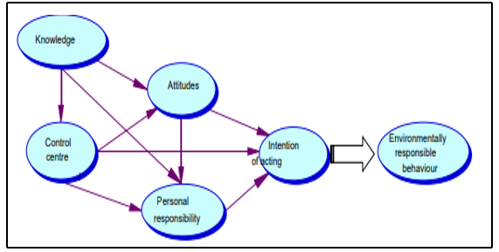
Figure 2.1: Theory of Environmentally Responsible Behavior (ERB)

Source: Hines, Hungerford & Tomera (1986)
Thus, the theory concentrates more on existing interactions between parameters that influence a person’s behavior than on the singular impact of a single variable. Participation of communities in environmental protection and conservation is crucially important for addressing environmental problems for a sustainable future. Thus, ERB theory is relevant to this study. It shall assess community’s knowledge, attitudes and responsibilities towards conservation. It will generate knew knowledge and attitudes towards management of grazing activities within the research area.

2.3.2 The Theory of Reasoned Action (TRA)
The researcher adopted another Theory known as Theory of Reasoned Action (TRA) which was developed by Martin Fishbein and Icek Ajzen in 1960s. The Theory explains and predicts behaviour based on attitudes, norms and intentions. Thus, behaviour is determined by the intention and moderated by actual control. Intention is determined by attitude, perceived norm, and perceived behavioural control (Chuanmin, 2018; Hagger, 2019). Perceived behavioural control influences behaviour directly or indirectly through intention. Actual control provides feedback to the perceived control. Performing the behaviour responds to the beliefs underlying the three elements of intention (Fishbein & Ajzen, 2010).

This research has applied TRA approach to enlighten the community and influence behavioural change and intention to conserve soil. Environmental conservation is affected by human behaviour, norms and attitudes. Therefore, TRA enabled the researcher to assess how controlled behaviour, attitudes and norms provide relief to soil conservation.
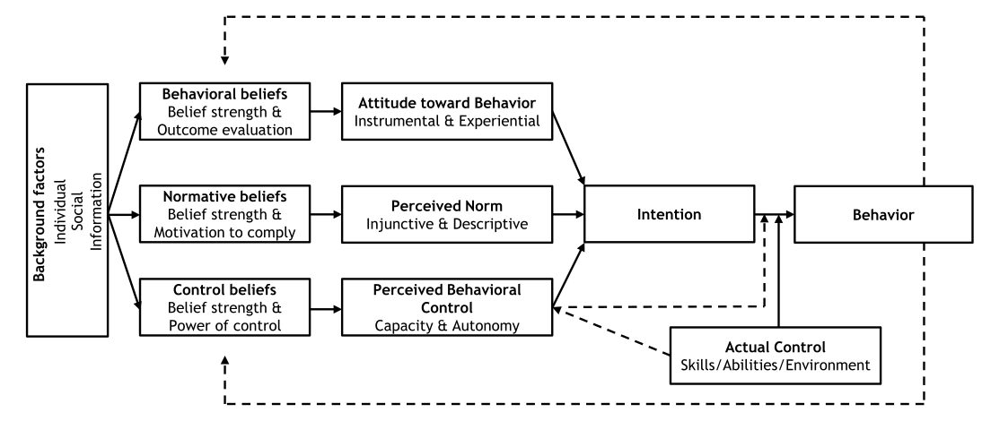
Figure 2.2: Theory of Reasoned Action (TRA)

Source: Fishbein & Ajzen (2010)

2.3.3 Property Rights Theory
Property Rights Theory (PRT) was propounded by Coase in 1960s denoting that, land degradation is due to absence or poorly defined property rights to environmental goods (Maiangwa et al. 2007). Thus, where land rights are unclear, unspecified, disputed or non-existent, then land users are less likely to be interested in conserving resources. The land resource users would have no incentive to take care of their land resources and use them in a socially optimal way. For the sake of this research, Property Rights Theory is adopted to guide assessment of Soil Management Efforts by providing land use and right of ownership to individuals for shifting conservation responsibility to individuals. Thus, ensuring coordination and regulating grazing activities in Livingstone Mountain Ranges.

2.4 Empirical Analysis of Relevant Studies

2.4.1 Communities’ Dependency on Livestock
The world has 1.468 billion herds of cattle and the largest share of livestock population is found in the developing countries. In developing countries, livestock keeping plays an essential role in development. Brazil has the largest cattle inventory in the world followed by India and China (FAO, 2014). Tanzania accounts for about 1.4% of the global cattle population and 11% of African cattle population (FAO, 2014). According to the Tanzania Livestock Sector Analysis report of 2018, Tanzania has about 30.5 million cattle, 18.8 million goats and 5.3 million sheep.

Due to dependency on livestock, people tend to keep many cattle compared to the land carrying capacity leading to land degradation specifically soil degradation as asserted by Giday et al. 2018. Maiangwa et al. (2007) noted that almost all farmers in the African communities lack lands designated for grazing. The study shows that, societies depend much on natural vegetation to feed livestock; thus, soil degradation is a common phenomenon in pastoral communities. As a result of the neglect of land management aspects, farmers tend to abandon degraded land and move to new land (Haule et al. 2013). Similar practice is conducted in the study area where livestock keepers tend to shift from place to place for search of green and palatable pasture to feed their animals; thus, intensifying soil degradation in those places.

2.4.2 Types of Soil Degradation
Lal (2015), in the study on restoring soil quality to mitigate soil degradation has expounded that, there are four types of soil degradation, namely physical, chemical, biological and ecological. A type of soil degradation depends on soil inherent properties, climate, topography and vegetation. (Gomiero, 2016).

- Physical Soil Degradation
Soil degradation can occur through physical processes in terms of soil erosion and soil loss of compaction (Gomiero, 2016). Physical soil degradation generally results in a reduction in structural attributes leading to compaction, reduced water infiltration, increased surface runoff, wind and water erosion, greater soil temperature fluctuations, and an increased propensity for desertification (Lal, 2015). This type of soil degradation occurs as a result of land use and land management including grazing activities. Soil quality is affected by cattle’s free movement of which soil is exposed to water and wind erosion. Thus, continuous overgrazing and overstocking affect soil physically in terms of compaction and breakdown of aggregates (WWF, 2015).

- Chemical Soil Degradation
This type of soil degradation involves chemical reactions like acidification, salinization, nutrient depletion, reduced cation exchange capacity, increased or deficiencies in soil chemicals, leaching or contamination of soil by wastes or by-products (Xu, 2018; Gomiero, 2016). The Quality of the soil has a great role in the ecological system; where chemical balancing, filtering of chemicals, water purification and infiltration to the ground is done. Salination and acidification occur when the soil quality is poor thus unable to filter unrequired chemicals hence water percolation into the ground is poor. Chemically, soil is degraded by increasing or decreasing its Soil pH and salinization when evaporation exceeds precipitation, nutrient leaching and diminishing organic matter content (WWF, 2015).
- Biological Soil Degradation
It involves depletion of the soil organic carbon pool, loss in soil biodiversity, soil nutrient depletion, reduction in soil carbon sink capacity and increased greenhouse gas emissions from soil into the atmosphere (Giday, 2018). Loss of soil organic matter occurs in places where nutrients are dissolved through leaching and get away through evaporation. Also, due to poor quality soil, the organic materials cannot be properly decomposed and attached to it for quality vegetation to grow. In addition, soil is important for micro and macro-organisms to survive. Soil supports ecological life among living things by providing habitats and other living materials to provide food, habitat and other life supporting materials (White, 2012).

- Ecological Soil Degradation
Lal (2015) illustrates that ecological degradation reflects on disruption in ecosystem functions such as elemental cycling, water infiltration and purification, perturbations of the hydrological cycle, and a decline in net biome productivity. Thus, soil cannot ecologically function in absorbing environmental socks caused by issues related to water and environmental pollution and support production of biomass. Karlen (2015), provides that ecological degradation reflects a combination of other three (physical, chemical and biological), and leads to disruption in ecosystem functions such as elemental cycling, water infiltration and purification, perturbations of the hydrological cycle, and a decline in net biome productivity.

Uncontrolled grazing of cattle, sheep, goats, donkeys and camels is very common in Africa specifically Tanzania. As livestock browses available vegetation in search of fodder, leads to soil surfaces being left bare without vegetation. The same applies to Livingstone Mountain Ranges, where the area is used as a free resource to the surrounding community as the result there is no proper control of the resources. Livingstone Mountain Ranges extend to and are linked to Lake Nyasa and Kitulo National Park. In Njombe District, these ranges are also known as Kipengele Mountains while in Mbeya they are known as Uporoto Mountains.

2.4.3 Impacts of Soil Degradation
Soil degradation is a common phenomenon in grazing societies and more than half of the world’s land surface is grazed (FAO, 2015). Unsustainable grazing activities, inﬂuence the botanical composition of soil structure since it results in lower productivity and higher land degradation. Thus, adopting appropriate grazing methods can be an effective way to improve soil water inﬁltration while maintaining livestock productivity (Xu, 2018). A major concern of good soil management is keeping soil in place and maintaining its fertility (Alam, 2014). A study conducted by Giday et al. (2018), on the effects of livestock grazing in Desa Forest in Ethiopia indicates that soil degradation is highly pronounced. 5.6% out of 90% of the respondents have made efforts for alternative forage to overcome shortage of pasture. Mtanzania News Paper release dated 16th July, 2019 with the heading “NEMC Yaonya Ukataji Miti Milima ya Livingstone”, indicated the prevailing environmental concerns within the study area.

The Authority highlighted the impact of environmental degradation where cutting down trees causes soil erosion by water during the rainy season, thereby, changing Lake Nyasa ecological system by siltation. Consequently, soil degradation results through wind and water erosion, trampling by livestock and degradation of arable lands.
Due to free access and availability of pastures, herders developed a tendency of moving with animals from one place to another in search of green pasture and water in form of nomadic, semi nomadic and transhumance grazing system. Herding is increasingly replaced by more profitable free-ranging systems, whereby livestock are left on their own to graze over extensive areas. Soil can lose its quality physically, chemically and biologically through loss of organic matter, decline in soil fertility, and structural condition, erosion, adverse changes in salinity, acidity or alkalinity, and the effects of toxic chemicals, pollutants or excessive flooding (Douglas & Charles, 2015). It is estimated that about 44 % of India’s land soil erosion and degradation had been substantial due to grazing pressure (Mythili & Goedecke, 2016).

According to Nkonya et al. (2016), Sub-Saharan Africa (SSA) has experienced the most severe land degradation in the world. In Tanzania, land degradation is ranked as the top environmental problem of which soil erosion is reportedly affecting about 61% of the entire land area in this country (Kirui, 2016). Since, little is known by locals about the long-term effects of this change in grazing patterns on the landscape structure and its conservation values, this study is important.

2.4.4 Soil Degradation by Anthropogenic Practices
People depend much on the natural environment searching for pasture and water to feed their animals. The study by Douglas & Charles (2015) highlights different causes of soil degradation that are both natural and human induced in Sub-Saharan Africa (SSA). According to Lal (2012), desertification is also referring to land degradation which covers approximately 41 % of the continental area. Apart from land clearing and deforestation, inappropriate agricultural practices, improper management of industrial effluents and wastes, careless management of forests, surface mining, urban sprawl, and commercial/industrial development and over-grazing are also indicated as other causes of soil degradation. Animal keepers have the tendency of carrying bush knives and always set fire for different purposes. Approximately, each keeper cuts up to five trees every day in the forest knowingly for a specific purpose. If considering it at the wider perspective, the area is highly prone to soil degradation that negatively affects ecosystems and habitats for wild fauna and flora. Eriksson (2011) enlightens that, in Africa farming systems were traditionally based on animal husbandry and depended on utilizing outfields as summertime grazing for cattle, sheep and goats, as arable land was scarce. African communities like the Maasai in both Kenya and Tanzania keep their status on increased number of animals.

Good soil produces good vegetation which provides food and habitat for animals. Human activities lead to environment changes that have become harmful to all living beings (Tyagi et al. 2014). Human interventions that involve deforestation and removal of natural vegetation, overgrazing, agricultural activities and over exploitation of the vegetation for domestic purpose are the main causes of soil degradation. Sakinatu & Muhammad (2017), elucidate that soil degradation is one of the most important threats facing mankind, which not only weakens the productive capability of an ecosystem but also affects the overall climate. Free range grazing activity is associated with cutting down trees, clearing vegetation, setting of bushfires, firewood collection, timber making from wild forest and charcoal making. Grazing activities in Livingstone Mountain Ranges have been conducted for a notable period of time.
Due to its ecological importance in connection with biodiversity within the ranges and its ecological connectivity to Kitulo National Park, Lake Nyasa and other protected areas including Forest Reserves; this study is deemed important in order to rescue the situation.

2.4.5 Soil Management Strategies
Soil Management Strategies refer to adoption of land systems that, through appropriate management practices, enable land users to maximize the economic and social benefits from the land, while maintaining or enhancing the ecological support functions of the land resources (Nkonya, et al. 2016). Grazing management are the best practices for soil quality management. Controlled grazing management practice is considered beneficial in conditions of poor vegetation cover, overgrazing and degraded soils.

According to Bolo et al. (2019) to ensure sustainable soil conservation, grazing management practices of livestock keeping are the best practices. Grazing management practices include reducing number of livestock on rangelands in accordance with the carrying capacity. Controlled grazing favors regrowth of vegetation in overgrazed rangelands and stimulates re growth of grass vegetation, reduces soil compaction, and promotes rangeland productivity. FAO (2015), provides that rotational grazing is a management system based on the subdivision of the grazing area into a number of enclosures and the successive grazing, control the intensity at which the pasture plants are grazed by controlling the number of animals and reducing the extent of selective grazing by confining a relatively large number of animals to a small portion of the rangeland. Rotational grazing as a proper grazing strategy involves dividing pasture into a certain number of small areas called paddocks and the livestock can use only one of them. In this case, the grazing animals are moved from one paddock to another and are thus forced to graze much of the grass, (Sevov et al. 2018).

Mitigating land degradation and fostering sustainable land management practices needs a suitable policy framework that sufficiently accounts for the interest of present and future generations in a dynamic and evolving environment (Gebreselassie et al, 2016; URT, 1997a). There are conflicting perceptions on overgrazing as environmentalists view large herd size and overgrazing as major causes of land degradation. On the other hand, animal keepers view livestock as a sign of wealth, and would like to maximize their herd size for their own social, cultural, and economic reasons. Thus, different policies that include environmental, livestock and natural resources policies and enforcement of laws are some of the soil management strategies. Globally, United Nations (UN) General Assembly created Sustainable Development Goals (SDGs) as Agenda for Sustainable Development. In combating land degradation, the UN highlighted the importance of soil conservation by uniting landholders globally to achieve Zero Net Land Degradation. Governments and scientists need to nurture collaboration with farmers, create a policy that supports and strengthens sustainable land management.

2.5 Conceptual Framework
A conceptual framework is a system or model for the relationships between variables that may or may not imply a particular theoretical perspective, with the purpose of describing the phenomenon, concepts, assumptions, expectations, beliefs, and theories that supports and informs research (Gray, 2014). Since human activities have direct linkage to soil degradation, this framework is in line with the theories guiding this study. The Framework provides linkages on how human beings accelerate the process of soil degradation through various activities. The main causes of soil degradation due to human intervention are deforestation and removal of natural vegetation, overgrazing, converting forests to farms, cultivating on steep slopes, degrading marginal lands and over exploitation of the vegetation for domestic purpose (Milkha & Sidhu, 2004). Conceptual Framework Underpinning Management of Soil Health model shows the interaction of fixed site and disturbance factors in their effect on vegetation, soil biota and soil processes which are considered to result from the interactions between soil habitats and populations of soil organisms.
The composition and structure of habitat factors describe the soil profile, structure; chemical pools and the composition and structure of the soil populations describe the soil biological community (Stockdale, 2018). From the model, fixed site factors that include climate, topography, geology and hydrology directly influence growth and quality of vegetation and improved habitat for various species. Vegetation, habitat and population depend on one another and influence each other through various processes. Direct or indirect disturbances like fire outbreak, floods and agricultural practices affect the quality of habitat and population attached to soil. Since, free grazing is taking place in the environment with quality site factors, disturbance set to site factors might cause adverse impacts vegetational quality due to poor soil and poor habitat to living organisms as stated by Stronge, (2020). Fire, Floods, and other human activities including shifting cultivation and free grazing put more stress on habitat; thus, affecting populations too. Generally, free grazing has impacts on site factors, vegetation, habitats, species population and accelerates disturbances on soil by other human activities.
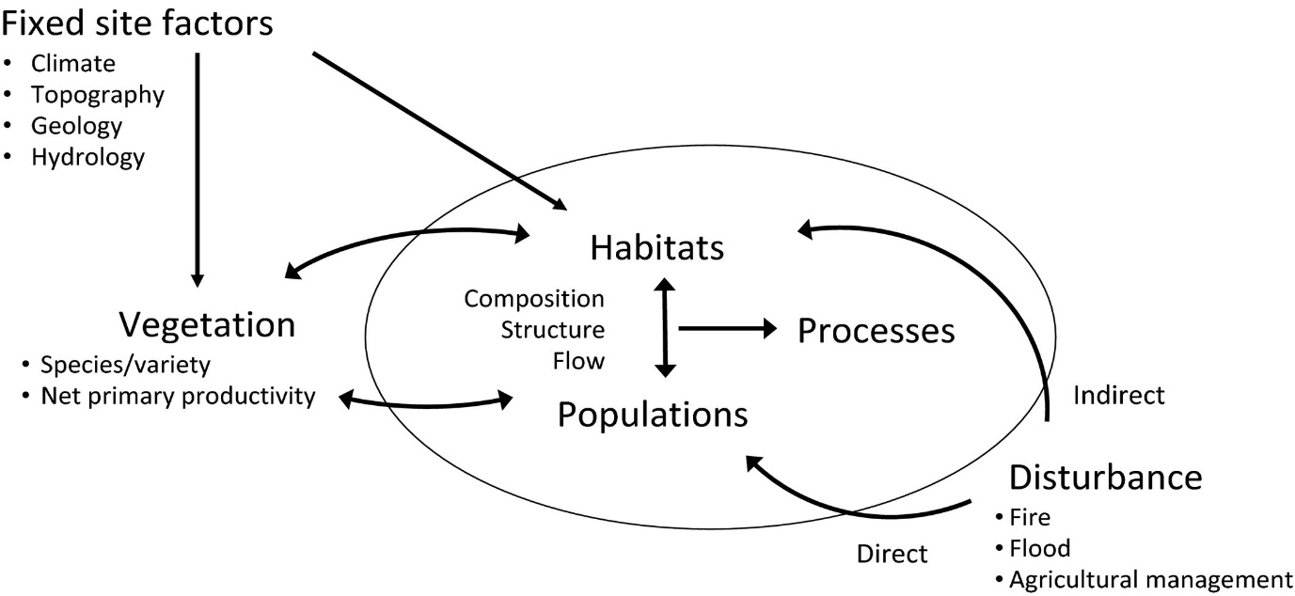
Figure 2.3: Conceptual Framework Underpinning Management of Soil Health

Source: Stockdale, 2018

2.6 Research Gap
The theories guiding this study describe a combination of environmental issues and encourage communities to behave in environmentally responsible ways. It has been noted that, communities that practice free range grazing and those that slash down trees in favor of pasture, lack environmental responsible behavior and sense of land ownership. A study conducted in the Sahelian region of Africa by Kimaro & Hieronimo (2014), indicates that shallowness of the soils and very steep slope topography is the major cause of severe water erosion mainly during periods of heavy rainfall, coupled with severe burning and bushfires during severe droughts. According to Longshan & Rui (2019), soil loss is more serious in karst rural environments than in other environments, but little information is available on its relationship with human activities. Consequently, rural residents generally lack awareness of the effect of their actions on soil loss. It is noted also that, there is lack of control over grazing pressure on rangelands, integration with the land-use systems and of slowing or even reversing desertification in the Sahelian region of Africa (Kimaro & Hieronimo, 2014). Free grazing is a common practice within the Livingstone Mountain Ranges for decades but documentation of the attitudes and behavior of livestock keepers towards the environment and future sustainability of the natural resources attached to soil in Livingstone Mountain Ranges is lacking. Therefore, this study is crucial for bridging the gap which several studies have not taken into consideration.

Consequently, this chapter has provided ideas, views, opinions, experiences and beliefs from different authors. Synthesis of different writing enabled identification of relevant information, gaps in literature and rationale for the study. In chapter three, the methodology has been provided.

CHAPTER THREE

RESEARCH METHODOLOGY

3.1 Overview
This chapter presents the research approach, design, sampling techniques, methods for data collection, data recording and analysis and ethical issues related to conduct of research. Research methods include all the techniques and methods used in conducting research. Research methodology denotes different approaches in which research problems are solved systematically. In research methodology, the researcher explains the different steps taken to study a research problem (Mishra & Alok, 2019). According to Bist (2014), a research methodology is a tool utilized by a researcher to measure the activities of the study that provides systematic, work plan and describes the essential methods for the completion of research project.

3.2 Research Design
Since this study aimed at identifying impacts of free-range grazing on soil degradation, the researcher has applied the qualitative research approach. In this approach, qualitative methods were employed to guide the selection of the research methods and tools for data collection, data analysis and presentation.

The research design is the arrangement of conditions for collection and analysis of data in a manner that aims to combine relevance to the research purpose with economy in procedure (Kothari, 2004). Basically, there are two methods of conducting research; qualitative and quantitative. The combination of qualitative and quantitative methods, form the mixed research approach, which is the third one.
According to Kothari (2004), qualitative research design is preferred to obtain data and reliable information regarding people’s attitudes, feelings, beliefs, and gives pace to the respondent to communicate much data. Qualitative research develops descriptions of social phenomena and seek answers to questions about why people behave the way they do, how opinions and attitudes are formed, how people are affected by the events that go on around them, how and why cultures and practices have developed in the way they have (Hancock et al. 2007).

This study applied the qualitative research approach so as to gain more information on the habitual practices of grazing and cutting down trees that has existed for a long time. Qualitative research is linked to research designs where experiences are studied and use information that includes people’s interpretations, perceptions, viewpoints, values and conditions. Creswell (2003), supports the statement by indicating that in qualitative research different knowledge is gained through enquiry tactics and data collection methods and analysis employed. Therefore, research design involves determining method(s) applied in data collection and analysis. Creswell (2012) gives general elements of research designs, which are the specific procedures, involved in the research process of data collection, data analysis, and report writing. Hence, it is a logical sequence and outline that guide the whole process in conducting research. The methodology, participants and sample collection and assignment, data collection procedures and methods are key aspects of the research design.

A research design appropriate for a particular research problem, involves consideration for methods of obtaining information; availability and skills of the researcher; objectives of the study; the nature of the problem; time and monetary aspects (Bryman, 2012). The research applied qualitative research approach specifically, narrative research design to grasp attitudes, feelings, beliefs, perceptions and views about the topic. Creswell (2012) explains that, narrative research designs are qualitative procedures in which researchers describe the lives of individuals, collect and tell stories about these individuals’ lives, and write narratives about their experiences. Narrative research design has advantages of flexibility, which can make it more appropriate for inductive research and qualitative research designs (Alam, 2014). This research design allows the researchers to write narratives about experiences of individuals- describe a life experience and discuss the meaning of the experience with the individual (Hancock, 2007). Therefore, primary data was collected through interview method from public officers, livestock-keepers, villagers and local leaders from the research area. The research also used observation strategy to collect different facts regarding soil degradation. Finally, secondary sources were used to strengthen primary information collected for the first time in the field.

3.3 Survey Population
In qualitative research, a population refers to the representative sample selected to provide their attitudes, feelings, beliefs, perceptions and views about the topic on behalf of the whole population. It can also be explained as the total of all the individuals who have certain characteristics and are of interest to a researcher. The researcher involved participants from Ludewa ward who were animal keepers performing free range grazing in Mount Livingstone Ranges and cutting down trees, village leaders around the research area, Natural Resources and Environment Officers from Ludewa District.

3.4 The Study Area

3.4.1 Geographical Location
Livingstone Mount Ranges are located in the Southern Highlands of Tanzania in Ludewa District, Njombe Region. Ludewa is located approximately 34⁰10^{l}E - 35⁰21¹E and 09⁰30¹S – 10⁰36¹S in Njombe Region, South West Tanzania along Lake Nyasa in East Africa Rift Valley System with a total population of 133,218 (LDCSEP, 2013; PHC, 2012 pg. 199).

3.4.2 Topography and Climate
Ludewa district is categorized into three climatic zones: lowlands, midlands, and highlands. The highlands zone is found at an altitude of 2,400 meters above sea level with an average temperature of 16⁰C, the Midland zone with an average temperature of 25⁰C and the lowlands zone which lies at an altitude of 900 meters above sea level with an average temperature of 27⁰C (LDCSEP, 2013). The district receives rainfall of between 900mm and 1,600mm annually, falling between the months of October or November and April or sometimes May and a dry season from May to September or October (Baxter, 2010)

3.4.3 Soil Type
The soil is divided into three types depending on the attitude and temperature. Thus, clay loam soil type is located on high attitudes of about 1,800 - 2,800 meters from the sea level, which receives rainfall of about 1,500 millimeters with an average temperature of 16⁰C per year. Clay soil type is located in midland attitudes about 900 meters - 1,700 meters from the sea level which receives rainfall of about 1,200 millimeters with an average temperature of 23⁰C per year. Sandy soil type is found in lowland attitudes of about 500 meters - 900 meters from the sea level, which receives rainfall of about 900 millimeters with an average temperature of 27⁰C per year (TMA, 2021).

3.4.4 Ethnic Groups and Culture
The habitants of Ludewa belong to three main ethnic groups namely: Pangwa, Manda, and Kisi but also there is Ngoni minority in the area. These ethnic groups have different traditional dances; where ‘Mganda’, ‘Kihoda’, ‘Ngwaya’, ‘Matuli’ and ‘Ling’oma’ are common dances in Ludewa. Pottery, carving and basketry are handcrafts taking place among local people around the place (LDCSEP, 2010).

3.4.5 Economic Activities
The geographical location and climatic conditions influence inhabitants to carryout different socio – economic activities that include subsistent agriculture, livestock keeping, tourism, small scale mining, small scale trading and fishing (LDCSEP, 2013; NBS 2003). This study was conducted in Ludewa Ward within the Livingstone Mountain Ranges that are located in the highland zone close to Ludewa District Council Headquarters.

3.5 Sampling Design and Procedures
The study was qualitative in nature and respondents were sampled purposefully to participate. This has been attributed by chances provided by the purposeful sampling technique in enhancing the gaining of in-depth picture of the study from individuals or site(s) covered. The sample was chosen by the researcher on the basis of representation of the whole population.
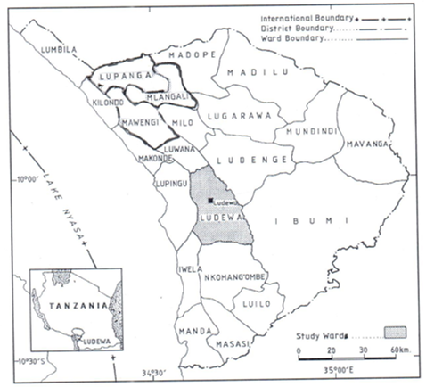
Figure 3.1: Map of Ludewa District Showing Ludewa Ward

Source: LDCSEP, 2016

The sample’s main characteristics are similar or identical to those of the population (Gray, 2014). Creswell (2012) gives importance of using purposeful sampling in qualitative studies as researchers intentionally select individuals and sites to learn or understand the central phenomenon. Data from the study area indicated that there were about 120 livestock keepers that practice free grazing within Ludewa Ward. Thus, the researcher collected data from thirty-two (32) respondents; including sixteen (16) animal-keepers, eight (8) villagers, four (4) village leaders around the research area and four (4) Natural Resources or Environment Officers from Ludewa District. The sampled population represented 38% of the animal keepers in Ludewa Ward.
Selection of this representative sample was based on the local knowledge and experiences of local communities in their natural environment as informed by Ayaa & Waswa (2016). Also, environmental officers have formal knowledge and expertise on issues related to environmental conservation; thus, their involvement yields accurate and up-to-date information. The selected study sample provided important information on grazing activities and people’s awareness on soil conservation.

On the other hand, environmental officers were in the position to provide legal and administrative information regarding the study area. Respondents were interviewed at different times, where some were interviewed during grazing time while others were interviewed after grazing time. Typical purposeful sampling procedures enable appropriate selection of participants to answer research questions and get realism about the problem. The desirability of sampling procedure depended on the knowledge of the informants, purpose of the study, susceptibility to errors and timely corrections, time and costs involved. Purposeful sampling provided the researcher with chances to use knowledge and make judgments on choosing a proper sample of individuals for inclusion in a research sample. This sampling strategy allows the researcher to address the research problem in accordance with the research objectives and areas of specialization or occupation of informants.

3.6 Type and Sources of Data
The nature of this study required the researcher to use both primary and secondary sources of data. Primary and Secondary sources of data are relative terms judged according to specific historical contexts and what is being studied (Creswell, 2012). According to Kothari (2004), primary data are those, which are collected afresh and for the first time, and thus happen to be original in character. Secondary sources of data use information already collected, processed, and reported by another researcher or entity (Vanderstoep & Johnston, 2009). They have already passed through the statistical process.

The methods of collecting primary and secondary data differ since primary data are originally collected, while secondary data are merely compiled. Primary sources of data involve observation, survey and interview methods to collect various information. Both, primary and secondary sources of data were used to obtain different information for the researcher to identify different forms of soil degradation, establish views, attitudes and knowledge of local livestock keepers towards soil conservation. Data collected enabled determination of impacts of free-range grazing on the sustainability of soil quality in the study area. It also simplified collection of views and opinions on intervention strategies or measures to improve soil quality.

3.7 Research Methods
Research methodology is a systematic way of solving a research problem in a certain area (Kothari, 2012) while research methods refer to various ways research data can be collected and analyzed; they include interview guides and data analysis using software like IBM Statistical Package for the Social Sciences (SPSS). Mishra & Alok (2019) define research methods as techniques and methods, which have been taken for conducting research whereas research methodology is the approach in which research troubles are solved thoroughly. Therefore, it is a science of studying how research is conducted systematically and the scientific approach, which is adopted for conducting research, is called methodology.
The researcher used personal interview and observation as methods for data collection of primary data from the research participants. In the field, the researcher conducted interview, took notes and recorded different features observed. Recording of observed features were through taking moving and still pictures which have been included in this report.

3.8 Research Tools

3.8.1 Personal Interview Method
Interview method is known as a verbal interaction between an interviewer and an interviewee designed to give the information, news, opinions and feelings they have, on their own which can be face to face or telephone interview. Korath (2019) argues that, interview is a stage upon which knowledge is constructed through the interaction of the interviewer and interviewee roles. An ‘interview’ is typically a face-to-face conversation between a researcher and a participant involving a transfer of information to the interviewer (Creswell, 2012; Kothari, 2004). Creswell (2012) asserts that it is important to have some means for structuring the interview and taking careful notes; audiotaping for interviews provides a detailed record of the interview, but as a backup strategy, the researcher is required to take notes during the interview and have the questions ready to be asked.

The researcher applied an interview method to collect data from animal keepers and local leaders. Most of the animal keepers and local leaders were not good at reading and writing. In some cases, questions were asked to respondents and the researcher took notes. Thus, interview method was proper, important and useful in getting quick and immediate data. Interview method is the most reliable approach due to its flexibility where the researcher can restructure questions to suit the specific objectives. The researcher used an interview guide comprising a list of open-ended questions to collect data on the influence of free-range grazing on soil degradation. The researcher conducted interview to four (4) Natural Resources or Environment Officers from Ludewa District to collect primary data regarding. In facilitating recording and analysis of data, responses from the field were classified and presented in accordance with research objectives and research question(s) they address.

3.8.2 Observation Method
Observation method entails the systematic noting and recording of events, artifacts and behaviors of informants as they occur in specific situations rather than as they are later remembered, recounted and generalized by participants themselves (Daymon & Holloway, 2005). Observation is the process of gathering open-ended, firsthand information by observing people and places at a research site (Creswell, 2012). The use of different methods and tools for data collection provided more details and validate information from one method to another. Since it is rare for a study to be conducted by observation methods alone (Daymon & Holloway, 2005), the researcher used this method to observe different forms of soil degradation in the ward resulting from free range grazing and cutting trees for establishing pastureland. These activities involved transect walks and recording of landscapes and activities during observation process using a video camera and still pictures. An observation checklist was prepared to cover soil degradation features developed in the grazing lands. Soil degradation features included eroded soil, bare surfaces with poor vegetation on grazing land, erosion on the sides of river banks due to grazing, polluted water, deposition of sand and dried water sources.

3.8.3 Documentary Method
Scott & Marshall, (2015) as cited by Korath (2019), explains that documentary review uses personal and official documents as a source material; including newspapers, diaries, stamps, directories, handbills, maps, government statistical publications, photographs, paintings, tapes and computer files.

The researcher collected data from secondary sources such as books, search engines through internet, journals and past researches to strengthen and support primary data collected from the site. These secondary sources enabled collection of different information on forms of soil degradation, impacts of free-range grazing and the associated activities, sustainability and grazeland management and soil conservation strategies. Information collected from other sources with cases related to this study, has been summarized and synthesized by addressing specific objectives stated.

3.9 Data Processing and Analysis
The data analysis is fundamentally about data reduction and it is concerned with reducing the large corpus of information that the researcher has gathered so that he or she can make sense of it (Bryman, 2012). In qualitative research, data analysis involves description of individuals and identifies themes and interpretation of the meaning of the data. Thus, words or pictures are analyzed to establish themes they carry in accordance to the study objectives (Creswell, 2012). It involves discussing personal experiences, identifying cultural backgrounds of participants during phases of the project (Creswell, 2012). In this study, groundwork for data analysis involved organization of varied information and transferring it from interviews recorded to a presentable analysis using computer applications. Data analysis reﬂects description of interrelations between themes, where the researcher assigned codes and analyzed data using the Statistical Package for Social Scientists (SPSS) Computer Programme (Field, 2000). Analysis of both primary and secondary data involved grouping of responses and findings. Data have been grouped in accordance to their similarities and meaning they possess and assigning codes to participants’ responses. Each Interview guide and themes developed from observation checklist were assigned different letters for which each answer was assigned a different code. Therefore, similar codes were grouped together for analysis and identification of central theme that responds to study objectives as asserted by Bryman (2012).

Coding is a process whereby the data are broken down into their component parts and those parts are then given labels. The researcher is seeking to link the process of making sense of the data with the research questions that provided the starting point, as well as with the literature relating to theoretical ideas used to illuminate the issue. Also, different themes form literatures is analyzed and synthesized in accordance with study objectives, the theory governing this study and making linkage with data collected through interviews and observation methods. Grbich (2007) as cited by Owen, (2014), elaborates that thematic analysis is a common qualitative research technique and it is usually employed at the end of the data collection process. It is a process that involves “segmentation, categorization, and re-linking of aspects of the database prior to the final write up”.

In data analysis, the researcher prepared and organized data collected by both primary and secondary sources. The review of data and selection of required information was conducted prior to formulation of codes for specific data categorization. Data review and categorization enabled the researcher to formulate different themes and assign proper codes according to specific objectives. Finally, the researcher used IBM SPSS Version 20 to analyze and present the data (Alam, 2014).

3.10 Validity and Reliability
Different studies provide that, validity and reliability in research refers to research that is trustworthy. Golafshani (2003) states that, reliability and validity are conceptualized as trustworthiness, rigor and quality in qualitative paradigm. Cypress (2017) provides that, validity refers to the state of being well-grounded or justifiable, relevant, meaningful, logical and confirming to accepted principles of research qualities. Reliability assesses consistency and care in the application of research practices; reflecting on visibility of research practices, analysis and conclusions.

Thus, elimination of bias in research increases the researcher’s truthfulness about some social phenomenon under study. To ensure reliability of data, the researcher developed interview guide that collect information to the sampled population according to study objectives.

Credibility and validity of research findings involved critical analysis of primary and secondary sources of information for the purpose of thematic assessment. This research has associated guiding theories in research design, methodologies and data collected from the field. According to Creswell & Miller (2000), triangulation is a validity procedure where researchers search for convergence among multiple and different sources of information to form themes or categories in a study. In triangulation process, the researcher designed a matrix for recording data from the field against research method, theory and confirming secondary data cited from different authors.

3.11 Ethical Considerations
In any research work, protection of participants and respondents using appropriate ethical principles is important as determined by. Mohd Arifin (2018). The most important issue in research is to gain respondents consent and willingness to participate in the study.

This study has considered and adopted six ethical issues in research process from Howard et al (2011). First, the researcher considered voluntary participation of respondents in the research and rights to withdraw from the study. Participants were informed on the study purpose and the information to quested from them and then filling-in a designed consent form. Second, the researcher considered confidentiality of data and anonymity of the participant.

According to Ketefian (2015), the researcher is required to ensure that data cannot be linked to or identify the participant. Third, ensured communication in relation to the research done with honesty and transparency. The study avoided presentation of misleading information that lead to biasness. Fourth, participants were equally treated in fair grounds without any discrimination. Fifth, participants are not subjected to any harm caused by this research; the researcher considered protection of the privacy of research participants during data collection and presentation of findings. According to Bryman & Bell (2007), the researcher is responsible for any harm caused to research participants. should not in any ways whatsoever. Sixth, another issue in research ethics is acknowledgement of works of other authors used. The researcher made clear citation for all works from different authors used in different parts of this dissertation. Any type of misleading information, as well as representation of primary data findings in a biased way must be avoided.

CHAPTER FOUR

FINDINGS AND DISCUSSIONS

4.1 Overview
Chapter Four presents, interprets, analyzes and discuses data obtained from respondents about the influences of free-range grazing on soil degradation in the Livingstone Mountain Ranges in Ludewa District. The Findings have been presented in accordance with study objectives and the respective research questions. Collected information using Interview method were given codes to differentiate responses from one participant to another (Smith, 2015). Data collected were evaluated for comparison and differences in order to establish meaning and themes as asserted by Bryman (2012).

4.2 Presentation of the Findings
The researcher developed Codes LMR which stands for (Livingstone Mountain Ranges) and I represent Interview Questions. Thus, the researcher used LMR I1 to 28 representing twenty-eight (28) interviewees. These codes were given to represent 16 interviewed animal keepers 8 villagers and 4 local leaders. Code LMRQ1 to Q4 represented interview conducted to four (4) public officers. Coding is important for guaranteeing anonymity and confidentiality of participants and information. Therefore, this chapter presents findings in form of themes developed from each objective using answers from interviews and observation methods. Qualitative research approach; specifically, narrative research design was applied in this study for the researcher to grasp participants attitudes, feelings, beliefs, perceptions and views about the topic (Creswell, 2014). Narrative research design is used in data analysis and presentation according to research objectives and research questions they address (Smith, 2015).

4.2.1 Demographic Data
Research study sample has been classified into different demographic characteristics. These demographics include sex, age, locality, grazing duration, employment status, level of education and working experience. In Table 4.1 the sampled population covered 4 public officers responsible for natural resources and environmental management - 1 Female and 3 Males.

Table 4.1: Demographic Summary for Public Officers

Respondent | Sex | Age | Education | Employment Status | Working Experience | Locality | Grazing Duration
1 | F | 35 | Master’s Degree | Government Employment | 10 Years | Ludewa Town | Not Applicable
2 | M | 32 | Master’s Degree | Government Employment | 20 Years | Ludewa Town | Not Applicable
3 | M | 42 | Bachelor’s Degree | Government Employment | 30 Years | Ludewa Town | Not Applicable
4 | M | 45 | Master’s Degree | Government Employment | 5 Years | Ludewa Town | Not Applicable
Source: Field Data

Through interviews, age group between 12-20 years covered 35.6%; 21-30 and between 31-40 covered 21.5% each and the age group between 41-50 occupied 21.4% of the proposed sample. The stipulated population involved 20 Males (M) and 8 Females (F) making 71.4% and 28.6% respectively and have performed free grazing for an average of not less than 9 years. This indicates that, in the study area, females are less involved in grazing (Table 4.2).
Table 4.2: Sex of respondents through Interview Method
Respondents’ Sex | Respondents | Percentage
Female | 8 | 28.6%
Male | 20 | 71%
Total | 28 | 100
Source: Field Data

In identifying respondents’ locality, data collected indicate that Nyamapinda covered 39.3%; Mapetu 25%; Mvava 21.4% and Ludewa (M) 14.3%. Thus, Nyamapinda was mentioned by many villagers with livestock and graze freely in the Livingstone Mountain Ranges as indicated in Table 4.3.

Table 4.3: Respondents’ Locality

Locality | Respondents | Percentage
Ludewa (M) | 4 | 14.3%
Mapetu | 7 | 25%
Mvava | 6 | 21.4%
Nyamapinda | 11 | 39.3%
Total | 28 | 100%
Source: Field Data

Respondents’ details covered education status; and it was found that among the sampled population 64.3% possessed Standard Seven (Primary School) level of education. Only 35.7% of the remaining population possessed Diploma Qualification, Certificate Qualification and Secondary education. Thus, Table 4.4 indicate that, free grazing is mainly practiced by people with low level of education. This could impact negatively on their knowledge and awareness on environmental conservation.

Table 4.4: Respondents’ Level of Education
Level of Education | Respondents | Percentage
Certificate | 3 | 10.7%
Diploma | 2 | 7.1%
Secondary Education | 5 | 17.9%
Primary Education | 18 | 64.3%
Total | 28 | 100%
Source: Field Data

Most of the local people were engaged in their own undertakings including grazing and farming. Table 4.5 shows that the majority (89.3%) of participants were self-employed and involved themselves in grazing, framing and harvesting of other natural resources.

Table 4.5: Respondents’ Employment Status
Working Experience | Respondents | Percentage
2 Years | 1 | 3.6%
4 Years | 1 | 3.6%
5 Years | 1 | 3.6%
Not Employed | 25 | 89.3%
Total | 28 | 100%
Source: Field Data

4.2.2 Forms of Soil Degradation
Data collected from public officers, identified soil erosion, loss of soil texture, soil pollution and loss of soil quality as different forms of soil degradation. Respondents provided loss of soil fertility, disappearance of living organisms, desertification (bare land with poor vegetation), loss of biodiversity, air and water pollution. The study, identified lack of vegetation cover in most of the grazing lands to have caused loss of biodiversity.
The researcher through observation and recorded some features which resulted from free-range grazing system. It was observed that, soil degradation resulting from free-range grazing system was very high. Soil had been moved from one place to another leaving the surface bare. Some plant’s roots were not covered with soil due to frequent and repeated use of grazing land. At the top of the mountain, the researcher noted that the places were bare surfaces with poor vegetation cover. The researcher observed different agricultural activities taking place within the mountain; thus, different indicators of soil degradation are presented in table 4.6.

Table 4.6: Forms of Soil Degradation Resulted from Free Grazing System

Respondents | Issues Extracted | Percentage
LMRQ1 | Loss of Biodiversity, Desertification, Formation of Rills and Valleys, Air and Water Pollution | 25%
LMRQ2 | Soil Erosion, Gullies and Valleys | 25%
LMRQ3 | Soil Erosion, Land Degradation, Loss of Soil | 25%
LMRQ4 | Fertility, Loss of Wild Animals and Plants  Soil Erosion, Loss of Soil Fertility, Shortage of Water | 25%
Total |  | 100%
Source: Field Data

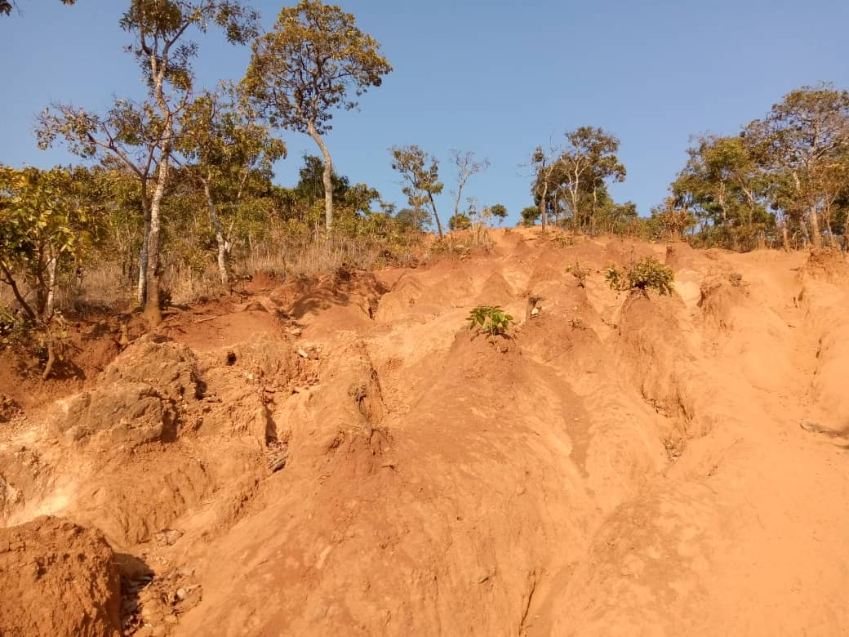
Figure 4.1: Degraded Landscape caused by Free Range Grazing.

Source: Field Data

4.2.3 Causes of Soil Degradation
Field Data informed that, improper farming practices (shifting cultivation), use of agricultural chemicals, cutting down trees and burning vegetation leads to drought and drying of sources of water. Participants identified different causes of soil degradation which included: soil erosion caused by wind and water run-off. Another issue that caused soil degradation was the tradition of local people possessing a large number of livestock (Table 4.7a). Keeping large herds influenced repetitive grazing on the same area and cause soil erosion. People in Ludewa Ward have a tendence of keeping many livestock that exceeds the carrying capacity of the land they legally possess. Observation showed that human activities including shifting cultivation, movement of livestock from one place to another, cutting down trees by livestock keepers and burning of the natural vegetation caused soil degradation. Table 4.7 (a) summaries data collected from the field about causes of soil degradation.

Table 4.7(a): Causes of Soil Degradation
Respondents | Causes of Soil Degradation | Percentage
LMRQ1 | Large Number of Livestock, Repetitive Grazing on Land, Soil Erosion | 25%
LMRQ2 | Overgrazing, Poor Farming Practices, Shortage of Water | 25%
LMRQ3 | Repetitive Grazing, Cutting Trees, Burning of Vegetation | 25%
LMRQ4 | Soil Erosion, Wind and Water run off | 25%
Total |  | 100%
Source: Field Data

Interview information collected from village leaders provided that human activities such as overgrazing, poor farming practices (shifting and slope cultivation) that involve cutting down trees, subject soil to factors of its degradation. The researcher observed that, local people practiced shifting cultivation (locally known as ‘matema’ or ‘migunda’) that involve slashing and burning trees, grasses and other vegetation. Table 4.7 (b) provides interview responses collected from the field.

Table 4.7 (b): Causes for Soil Degradation
Data Collected by Interviews from Local Community and Leaders | Respondents | Percent
Charcoal Making | 3 | 10.7
Cutting down Trees | 4 | 14.3
Destruction of Water Sources | 1 | 3.6
Drought | 3 | 10.7
Loss of Vegetation | 3 | 10.7
Overgrazing | 4 | 14.3
Poor Grazing Practices | 1 | 3.6
Repeating Grazing on the Same Area | 4 | 14.3
Shortage of Grazing Land | 1 | 3.6
Soil Erosion | 3 | 10.7
Water Shortage | 1 | 3.6
Total | 28 | 100.0
Source: Field Data

4.2.4 Impacts of Free-Range Grazing on Soil Quality
Free-Range Grazing System has great impact on ecosystems. Responses specified that, soil erosion and water pollution caused loss of life in fauna and flora. Through observation, it was depicted that, local people performed shifting cultivation on the top of mountains. Preparation of farms involved cutting down trees leading to destruction of water sources, loss of habitat and breeding places. It was also observed that, free range grazing caused uprooting of some trees especially when the soil that covers roots has been removed by run off (Plate 4.2). Thus, both animals and plants were disappearing due to ecological imbalances caused by free range grazing system within Mount Livingstone Ranges.
Data collected through interviewees pointed out impacts of soil degradation as loss of soil fertility due to soil erosion caused by uncontrolled grazing, shifting cultivation and other human activities. Destruction of natural habitats, water shortage and loss of natural vegetation were other issues associated with soil degradation as indicated in Table 4.8.

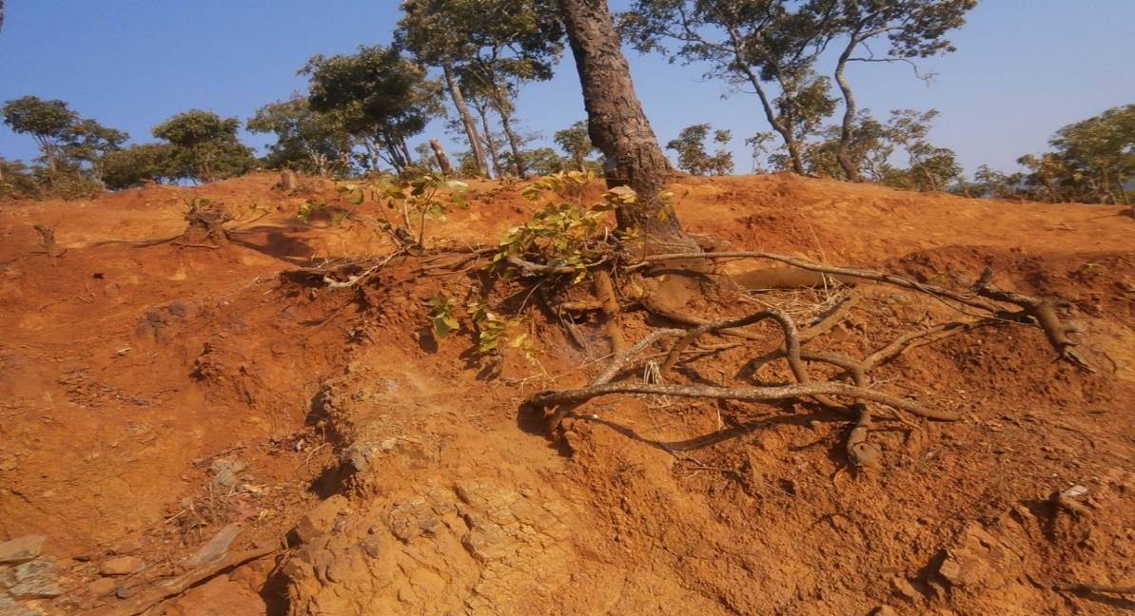
Figure 4.2: Eroded Soil and Uncovered Plant Roots
Source: Fieldwork

Table 4.8: Impacts of Soil Degradation

Data Collected by Interviews | Respondents | Percent
Destruction of Natural Habitats | 1 | 3.6
Loss of Natural Vegetation | 1 | 3.6
Loss of Natural Vegetation, Destruction of Natural Habitat | 1 | 3.6
Loss of Natural Vegetation, Water Shortage | 1 | 3.6
Loss of Soil Fertility | 8 | 28.6
Loss of Soil Fertility, Soil Erosion | 1 | 3.6
Loss of Soil Quality | 4 | 14.3
Shortage of Water | 5 | 17.9
Soil Erosion | 5 | 17.9
Water Shortage, Destruction of Natural Habitat | 1 | 3.6
Total | 28 | 100.0
Source: Field Data
The researcher observed that the top of the mountain was dominated with loose soil and poor vegetation cover as shown in Plate 4.3.
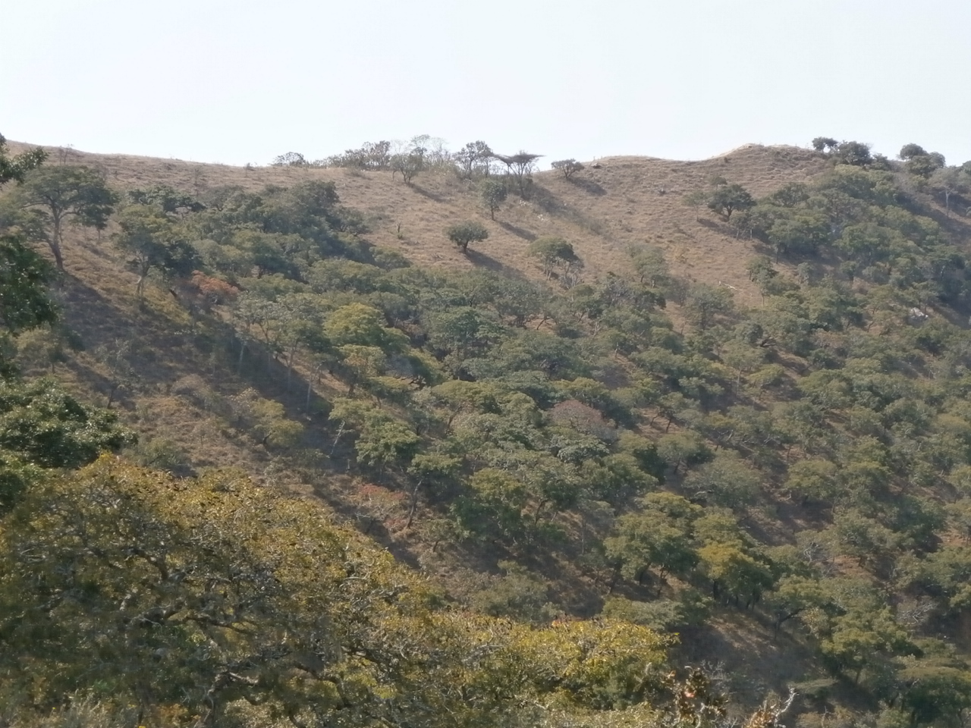
Figure 4.3: Poor Vegetation Cover
Source: Fieldwork

Interview conducted to four (4) Natural Resources or Environment Officers showed that, disappearance of plants and animals occur due to drying off water sources. Loss of biodiversity and destruction of natural habitat and breeding places were explained as impacts that resulted from soil degradation. It was expanded that; soil erosion causes loss of soil fertility and land degradation. Loss of soil fertility and water pollution affects ecological balance where shortage of clean water, food and habitat (loss of land naturality) is dangerous for the survival of living things.

4.2.5 Factors Influencing Free Grazing
In obtaining information on the influences for practicing free grazing, the study established five factors. Data collected using interviews, elucidated that Livingstone Mountain Ranges were free from dangerous wild animals that threaten both human beings and livestock. Thus, security and availability of free grazing land were factors for soil degradation caused by free grazing. It was stated that, ‘free range grazing system was practiced in the place because livestock keepers have not been assigned specific areas for grazing’. Hence, grazing was taking place on privately owned and common land like the Living Stone Mountain Ranges.

According to field data, lack of education regarding proper grazing approach influenced the practice of free-range grazing system. The practice of free grazing is prevailing in the place due to shortage of land owned individually. Thus, The Property Rights Theory need to be adopted and use to assign land and shift conservation role to individuals.

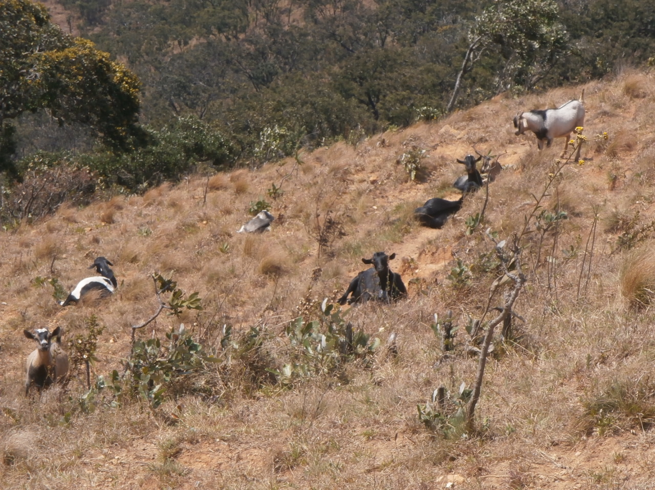
Figure 4.4: Goats Grazing freely within Mountain Ranges

Source: Fieldwork
Also, the researcher used interview to different views and opinions from thirty-two (32) participants. Participants explained that, “access to free pasture, local grazing practice, availability of free land for grazing, grazing land is not specified and individuals own small pieces of land, lack of education on environmental conservation”. Participants confirmed that, free grazing system is a less costly practice and provide time to perform other undertakings. Through observation method, the researcher observed goats staying on of mountain sides due to security and availability of pasture land.

4.2.6 Knowledge, Attitudes and Responsibilities of Local People
Data collected from Environmental and Natural Resource Officers revealed that, “availability of large areas for grazing in mountain ranges encouraged local people to practice free-grazing system in Ludewa Ward”. Data from the field suggest that, people had knowledge on soil degradation. Research participants pointed out loss of soil fertility and soil erosion as indicators denoting soil degradation.

Responses from Natural Resources and Environment Officers specify that, modern animal keeping practices were not commonly practiced in Ludewa Ward. Respondents emphasized that, local people are responsible for soil degradation by performing various human activities. When respondents were asked about awareness and attitude, they made it clear that lack of environmental education to the community contributed to soil degradation. It was made clear that, local people still perform their daily activities that deteriorate the environment. Data collected on knowledge and attitude about soil degradation, confirmed that there is loss of soil quality indicated by less support to growth of plants. Similarly, interviewees were of the view that, there is loss of soil fertility. Soil erosion caused by uncontrolled grazing, shifting cultivation and other human activities. Therefore, human activities have great influence on soil degradation; and to curb the situation adoption to Environmental Responsible Behaviour Theory (ERB) is inevitable.

4.2.7 Intervention Strategies for Improving Soil Quality
Respondents suggested different efforts required to ensure environmental sustainability with Livingstone Mountain Ranges. In response to efforts required, enacting bylaws, regulations and guidelines on environmental conservation were suggested. The need for local people to be informed and updated on responsible and modern animal keeping practices was proposed. It was detailed that, raising awareness of local people was important for transferring environmental conservation responsibilities to local community is important. Authorities are required to provide environmental conservation education to the community and develop environmental responsible behaviour. Responses provided were in line with the guiding theory of this study. Environmental Responsible Behaviour

Theory (ERB) assesses community’s self-driven and motivation towards environmental conservation. Facts highlighted on establishing specific areas for grazing; thus, land use plan was required to demarcate premeditated areas for grazing and for other human activities. Information extracted from interviews, detailed the need to encourage local people to reduce the number of livestock to match the carrying capacity of the grazing land. Natural Resources Officers explained the need for more efforts to enlighten local people to practice proper farming methods and adopt proper grazing system that include rotational, tethering and zero grazing.
Villagers through interviews suggested the need for provision of environmental education and creating awareness to the community on the best grazing systems and practices. Village leaders recommended reduction of the number of livestock to match the carrying capacity of the grazing land. Also, Interviewees recommended to the community to practice and adopt better grazing systems by adopting rotational grazing instead of free grazing system to avoid exhausting the grazing land.

4.3 Discussion of the Findings

4.3.1 Different Forms of Soil Degradation Resulting from Free-Range Livestock Grazing
In searching for responses on features that resulted from soil degradation, the Researcher collected data using interviews and observation. In all methods used, research participants and respondents provided different elements and associated physical features, which resulted from soil degradation. Information collected from Public Officers identified soil erosion as a form of soil degradation. Loss of soil fertility, loss of biodiversity and shortage of water were other forms of degradation mentioned. One of the contributing factors to poor soil fertility, land degradation and soil erosion was the free grazing of animals. Optimum grazing could be a tool to maintain or enhance biodiversity of grazed areas (Asmare, 2018). Data collected from villagers using interviews highlighted formation of desertification, loss of soil fertility and soil erosion. Land deformation in form of furrows, gullies, water channels, soil relies and valleys, and trenches were also stated as forms of soil degradation. Soil erosion and desertification are mainly aggravated by uncontrolled fire and overgrazing as asserted by Lal (2012).
Environmental degradation covers the deterioration of the environment through depletion of natural resources such as air, water and soil; the destruction of ecosystems and the extinction of wildlife (Tyagi et al. 2014). Information collected from interviews informed that, improper farming practices (shifting cultivation), use of agricultural chemicals, cutting down trees and burning vegetation propagates climatic changes and leads to drought and drying of sources of water. Smith at el. (2015) enlightens that some human activities have direct and clear impacts on soil degradation. To combat the problem, Bhattacharyya (2015) suggests application of agronomical practices like use of cover crops, including mixed cropping, inter cropping and strip cropping, crop rotation, green manuring and mulch farming are vital practices associated with integrated nutrient management.

The researcher observed and recorded some features, which had resulted from free-range grazing system. It was observed that, soil degradation resulting from free-range grazing system was very high. Soil had been eroded leaving the surface without vegetation cover thus exposing plant roots. At the top of the mountain, poorly vegetated land surfaces were noticeable.

4.3.2 Knowledge, Attitudes and Responsibilities of Local People towards Environmental Conservation
Data collected from Environmental Officers and Natural Resources Officers revealed that, availability of large areas for grazing in mountain ranges encouraged local people practice free-grazing system in Ludewa Ward. It was also established that, mountain ranges were free from dangerous wild animals that threatens both human beings and livestock. Thus, security and availability of free grazing land were factors for soil degradation. It was also established that, free range grazing system was practiced in the locality because livestock keepers had not been assigned specific areas for grazing. Hence, grazing was taking place on privately owned land and common land like the Livingstone Mountain. The study found that, lack of education regarding proper grazing approach was another factor that influenced the practice of free-range grazing system. Data collected from public officers indicated that, loss of soil fertility and soil erosion were notable indicators of soil degradation.

The research also aimed at identifying roles and responsibilities of different stakeholders on ensuring environmental conservation. Participants highlighted adoption of proper grazing practices that include reducing the number of livestock according to land carrying capacity, manageable size and change in grazing system from free range to rotational and zero grazing. Adoption of proper grazing methods such as the appropriate grazing intensity and frequency is the key to enhance soil quality (Xu et al. 2018). This practice was qualified with ideas of planting pastures, provision of environmental education to sensitize local people on planting trees, and protection of natural vegetation.

Also, participants provided that, “conservation of water sources and adoption of proper farming methods would help to combat soil degradation”. Mongi (2019) notes that, land degradation involves collection of many human activities and natural related phenomena that decrease the productivity of land leading to soil degradation. Responses provided that, application of a legal framework would be a better measure to control soil degradation. Giday (2018) stipulates that, local people have to govern their grazing area through their local bylaws. Thus, bylaws and regulations are to be enacted to ensure environmental sustainability. Management of land requires cooperation and involvement of different institutions so as to form a comprehensive strategy on soil conservation; including the local authorities, land property tribunals, district land tribunals and Land Courts (Nkonya, 2016). Therefore, different stakeholders in Ludewa district should be involved in land administration and management. Involvement of different stakeholders would join efforts in setting land plan, bylaws and regulations to manage grazing. Henceforth, formation of a wide-ranging conservational management approach in Ludewa.

In assessing community knowledge on proper grazing system for soil quality; it was informed that, ‘for years local people were used to send their livestock to the mountain and let them stay there for some days. Local people send livestock in the mountain in the morning and let them wonder all the day and take them back home in the evening. Responses showed that, modern animal keeping practices were not common practices in Ludewa Ward. Interviewees explained that, local people had no proper knowledge on conservation. Some interviewees highlighted that; local people were not friendly to the environment as people performed various activities for survival, which in turn destroyed natural environment. Activities highlighted include: cutting trees and burning bushes for pasture growth, firewood, charcoal making and cultivation. Three quarters of the respondents stipulated that free grazing was practiced due to lack of awareness and environmental education.

Some farmers were forced to abandon their farms and migrate to other areas to open up new farms due to perceived loss of soil fertility. Hence, assessment and building of farmers’ awareness on the decline of soil fertility and associated changes is essential for improvement of their livelihoods (Haule et al, 2013). The same applies to shifting cultivation and free grazing system. Livestock keepers tend to move with cattle to new pastures further causing soil degradation. This calls for provision of education and awareness on environmental conservation.

The study found out that, bush fires, cutting down trees and cultivation activities without consideration of environmental conservation practices was wide spread. Most of the local people had negative attitudes towards environmental conservation as they did not like to have large bushes in fear of dangerous animals and diseases. Responses indicated that, significant degradation resulted from anthropogenic activities.

Generally, prevalence of poor agricultural practices indicated that local people had low awareness about conservation of the environment. Bhattacharyya et al. (2015), highlight that human activity especially cultivation through poor farming practices without conservation measures, land clearing through clear cutting, overgrazing and other developmental activities with poor control of pollution and poor waste management leads to land degradation.

Some participants were aware of soil degradation as they were able to mention signs of the same. It was explained that, there is loss of soil quality as indicated by less support to growth of plants. Similarly, there was loss of soil fertility due to soil erosion caused by uncontrolled grazing, shifting cultivation and other human activities. Respondents specified that, community participation in environmental conservation was low. According to Nkonya et al. (2016), when community awareness is minimal, no improved grazing practices are adopted.
Participants identified different causes for soil degradation. It was revealed that, soil degradation resulted from soil erosion caused by wind and water run-off. This happened when the soil quality is affected by being tamped by livestock during search for pasture. It was informed that, people in Ludewa Ward have a tendence of keeping many livestock that exceeded the carrying capacity of the land they legally possessed. To grip the situation, Livingstone Mountain Ranges are affected by free grazing leading to environmental degradation. Since the mountain ranges are free and common resources, uncontrolled grazing within mountain ranges for a long period led to soil degradation. This practice of using common resources for grazing, calls for the Ludewa District Council to plan for grazing land and make by laws to manage to control movement of animals. Management of livestock need to take into consideration numbers of livestock and land carrying capacity. The Theory of Reasoned Action (TRA) need to be emphasized and empower local community by taking appropriate actions towards soil conservation.

In Ludewa Ward, local people are practicing shifting cultivation (‘matema’ or ‘migunda’) that involve slashing and burning trees, grasses and other vegetation. This activity involves burning of trees, grasses and other vegetation, thus, causing loss of biodiversity by destroying animals’ habitats, killing of living things and soil degradation. Nkonya et al. (2016) observe that in many sub classes of scattered land cover or use such as slash and burning field, mountain paddy rice terraces and fruit plantations cause soil degradation. In this study, the researcher observed that local people were practicing shifting cultivation, which intensified soil degradation. Consequently, a combination of anthropogenic influences with natural effects was responsible for soil degradation as asserted by Tyagi et al. (2014).

4.3.3 Impacts of Free-Range Grazing on Soil Quality
Free-Range Grazing System has adverse impact on ecosystems. Data collected from animal keepers indicated that, soil erosion and water pollution cause loss of life in fauna and flora. Information obtained from Public Officers indicated that, climatic change, land degradation and ecological imbalances caused destruction of natural habitats. Responses signified that, impacts, which resulted from soil degradation, are vivid and negatively affected the survival of living things. The study conducted in Greece on Impact of Grazing Management on Land Degradation by Kosmas et al. (2015), provide that grazing intensity was usually beyond the carrying capacity of land leading to accelerated soil erosion and land desertification. Grazing animals also have an effect on the botanical composition by trampling and selective grazing.

However, intensive grazing can also cause over fertilization of pastures; thus, disturbing organic matter and the nutrient circulation balance. Animal faces and urine change the element content of soil and plants. Species composition is also influenced by the time of the year that a pasture is grazed; thus, negatively influencing the biodiversity of a whole ecosystem (Asmare, 2018).

The free grazing system has been the cause for soil and environmental degradation by destroying some plants when the soil that covers roots has been removed. The unfavorable influence of treading strongly occurs at unsystematic grazing when the animals move freely and stay for a long time in the rangeland. Under the influence of grazing, some plants fall off the grassland, animals eat almost entirely the leaves of tall trees, which make their recovery difficult as observed by Sevov et al. (2018). Thus, soil erosion causes loss of soil fertility and land degradation.
The study identified soil erosion, land degradation, loss of soil fertility, environmental degradation, water pollution, disappearance of living organisms and spread of animal diseases as results of soil degradation as asserted by Kikoti et al. (2015). Soil erosion rates have significantly increased due to the increased livestock pressure resulting in overgrazing and reduction of vegetation cover (Kosmas et al. 2015). These factors may lead to food shortage and cause migration of people. This movement of people may further cause accelerated soil degradation through the establishment of new settlements and clearing new land for cultivation and grazing.
Cutting down trees for the purpose of creating pastureland pose disturbances on the availability of food and water within an ecosystem. Shortage of water and food causes death of living organisms; thus, disturbing an interdependence among living things and food chain. Due to shortage of key elements for wildlife survival, plants and animals’ disappearance is pronounced.
Loss of habitat and breeding places for living things was another impact caused by drought and cutting down trees. Changes in climatic patterns were other impacts, which resulted from free grazing system. It was noted that, there was shortage of rains unlike in the past.
Therefore, land degradation, drying of water sources, loss of biodiversity, shortage of food, destruction of natural habitat, soil erosion and loss of natural vegetation were the impacts resulting from free grazing.

4.3.4 Intervention Strategies for Improving Soil Quality
Interview conducted to villagers and leaders suggested that, different efforts are required to ensure environmental sustainability with Livingstone Mountain Ranges. Field data collected using interview indicated that, environmental and conservation education to the community is required. Developing awareness to local people is important for transferring environmental conservation responsibilities to local community. Asmare (2018), suggests ‘zero grazing system’ as a strategy to address issues of degradation of grazing land. Theory of Reasoned Action (TRA), the Property Rights Theory (PRT) and the Responsible Environmental Behaviour (ERB) Theory assess community’s self-driven and motivation towards environmental conservation. In capacity building local people are empowered with these theories and become responsible soil conservers.

Respondents expounded that; local people need to reduce the number of livestock to match the carrying capacity of the grazing land. Hence, half of the respondents showed concern over the optimal number of livestock to be kept and planting pasture. Establishing man-made pasture to feed livestock by zero grazing as new grazing approach was proposed. Strategies in achieving compliance with environmental protection and sustainable agricultural practice in developing countries are required (Asmare, 2018). They further suggested proper farming methods and grazing practices as a viable strategy for environmental sustainability. To achieve this strategy, the community is encouraged to practice rotational, tethering or zero grazing. Consequently, more efforts are required to enlighten local people to practice proper farming methods and adopt proper grazing systems as asserted by Smith, (2015).

In places affected by deforestation and poor vegetation, afforestation and reforestation strategies should be applicable. According to Mongi (2012) some intervention measures for soil degradation are evacuation of people from water sources, banning of unauthorized movement of livestock, and pastoralism on the fragile slopes of mountains, afforestation and reforestation, control of forest fires, promoting alternative energy use and alternative building materials. Thus, provision of environmental education to local people and conservation of water sources is inevitable for ensuring environmental sustainability. This is supported by Nkonya (2016), who observes that improved pasture management such as rotational grazing and restricted movement of livestock are viable strategies for soil conservation. Maiangwa et al. (2007) conducted similar study in Nigeria and recommended for developing public awareness, assignment of secure, inheritable and transferable land rights to individuals and groups, adoption of concrete mechanisms to foster participation and action towards sustainable use and management of land.

To conclude this chapter, the study found that free range grazing system was practiced in the locality because livestock keepers had not been assigned specific areas for grazing. Consequently, grazing was taking place on small pieces of privately owned land and common land like the Livingstone Mountain Ranges. The practice led to soil erosion, loss of soil fertility, loss of biodiversity, shortage of water and destruction of natural habitats. Undeniably, participation of local people and other stakeholders is required to enhance sustainable management of resources. Involvement of different stakeholders in land management provides for developing sense of ownership and shared decision-making towards formation of a wide-ranging conservational management approach in Ludewa District. This approach motivates local people and set a shared responsibility as required by theories adopted in this research.

CHAPTER FIVE

SUMMARY, CONCLUSIONS AND RECOMMENDATIONS

5.1 Introduction
In the previous chapter, data presentation, interpretation, analysis and discussion of the research findings has been provided. In this part, summary of the findings, conclusions and recommendations to overcome challenges caused by free range grazing have been presented. Conclusions and recommendations have been organized in accordance with specific objective addressing the same issue.

5.2 Summary of the Findings
Free grazing in the Livingstone Mountain Ranges has great influence on soil degradation in Ludewa Ward. This study collected information about different forms of soil degradation, knowledge, attitudes and responsibilities of local people towards environmental conservation. Also, information on impacts of free-range grazing and intervention strategies for improving soil quality in the study area were collected.

5.3 Conclusions
In identifying different features of soil degradation, identified soil erosion, loss of soil fertility, loss of biodiversity and shortage of water. Land deformation in form of furrows, gullies, water channels, soil relies and valleys and trenches were also stated as forms of soil degradation. Generally, features resulting from free-range grazing system were severe. Desertification at the top of the mountain has been aggravated by grazing, features with poorly distributed vegetation leaving plant roots bare.

Assessment of issues related to knowledge, attitudes and contribution to soil degradation, it was established that, agricultural practices and soil degradation were inseparable. Uncontrolled activities and availability of large open land for grazing in Mountain Ranges encouraged local people to practice free-grazing system in Ludewa District thereby causing land deformation and soil degradation.

Improper farming practices (shifting cultivation), use of agricultural chemicals, cutting down trees and burning vegetation lead to climatic changes and cause drought and drying of sources of water. It was also established that, free range grazing system was practiced in the study area because livestock keepers had not been assigned specific areas for grazing. It was noted that, lack of education regarding proper grazing approaches influenced the practice of free-range grazing system. Local people performed different activities, which caused environmental degradation. Activities listed included: cutting trees and burn bushes for pasture growth, firewood, charcoal making and cultivation. Soil degradation forces some farmers to abandon their farms and migrate to other areas to open up new farms. Similarly, livestock keepers move with cattle to new pastures thereby further causing soil degradation. The same impact was caused by shifting cultivation and free grazing system.

In the scrutiny of free-range grazing impacts, the study found that, free grazing has diverse implications towards soil conservation in Tanzania. This affected ecological balance that is necessary for survival of living things. Shortage of water and food causes death of living organisms; thus, disturbing an interdependence among living things and food chain. Data collected provided that, impacts of soil degradation included soil erosion, loss of soil fertility, texture, quality and minerals, soil pollution, and vanishing of living organisms, loss of biodiversity, air and water pollution. Thus, there is a need to modernise livestock keeping in Tanzania for sustainable ecosystem maintenance.

5.4 Recommendations

5.4.1 Recommendations of the Study
Quality environment depends on the sustainability of different resources attached to it; including soil. Therefore, soil quality is crucial for ecological steadiness and thus, the study provides recommended strategies and better practices to ensure sustainability of soil quality. Consequently, the study recommends the following:
- Develop awareness among local people about environmental conservation and their responsibilities to local community based on the principles of the Environmental Responsible Behaviour Theory (ERB).
- Regulate the use of the Livingstone Mountain ranges by developing a plan that is governed by laws with regard to activities permissible in the mountains by adopting the Property Rights Theory (PRT).
- Empower local people to adopt responsible and proper farming and grazing methods. Enhancing community knowledge and involvement in environmental conservation and gradually adopting the Environmental Responsible Behaviour (ERB) is a necessity.
- The community, Non-Governmental Organizations (NGOs) and Government Organs to join efforts to form a Comprehensive Environmental Management Strategy (CEMS).
- Establish different projects to support local community with alternative economic activities like beekeeping and agroforestry that might reduce human intervention with Livingstone Mountain Ranges in Ludewa District according to the Theory of Reasoned Action (TRA)
- Provide environmental education towards a quality environment. Education provided need to inform the community on the proper grazing, farming and other human practices compromising environmental quality.
- Authorities responsible need to coordinate and regulate grazing activities in Livingstone Mountain Ranges.

5.2.5 Recommendations for Further Research
Livingstone Mountain Ranges have abundant valuable ecological resources to support wildlife and human survival. Thus, more studies on tourism attractions and possibility of making Livingstone Mountain Ranges as reserved or Protected Forest is needed since they are linked to Lake Nyasa, Kitulo National Park and other reserved forests.

REFERENCES
Alam, A. (2014). Soil Degradation: A Challenge to Sustainable Agriculture. International Journal of Scientific Research in Agricultural Sciences, 1(4). ISSN: 2345-6795. DOI:10.12983/IJSRAS-2014, pp.0050-0055.
Ayaa, D. & Waswa, F. (2016). The Role of indigenous knowledge systems in the conservation of the bio-physical environment among the Teso community in Busia County-Kenya. African Journal of Environmental Science and Technology. Vol. 10(12), pp. 467-475.
Bahrami A., Emadodin, I., Atashi, M. & Bork, H. (2010). Land-use change and soil degradation: A case study, North of Iran. Agriculture and Biology Journal of North America. ISSN Print: 2151-7517, ISSN Online: 2151-7525-2014, pp. 600-605.
Balasubramanian, A. (2017). Soil Erosion. Causes and Effects. Centre for Advanced Studies in Earth Science, University of Mysore, Mysore.
Bhattacharyya, R., Ghosh, B., Mishra, P., Mandal, B., Rao, C., Sarkar, D., Das, K., Anil, K., Lalitha, M., Hati, K. & Franzluebbers, A. (2015). Soil Degradation in India: Challenges and Potential Solutions. Sustainability. ISSN 7, 2071-1050 DOI:10.3390/su7043528.
Bell, J., Waters, S., & Ebooks Corporation. (2014). Doing your research project: A guide for first-time researchers (Sixth ed.). Maidenhead, Berkshire: Open University Press.
Bist, R. B. (2014). Writing a Research Proposal: A General Guideline. Journal of NELTA. Vol.1:1-6.
Bolo, P., Sommer, R., Kihara, J., Kinyua, M., Nyawira, S & Notenbaert, A. (2019). Rangeland Degradation: Causes, Consequences, Monitoring Techniques and Remedies. Working Paper. CIAT Publication No. 478. International Center for Tropical Agriculture (CIAT). Nairobi, Kenya.
Bokdam, J. (2003). Nature conservation and grazing management. Free-ranging cattle as a driving force for cyclic succession. PhD thesis. Wageningen University, Wageningen, The Netherlands.
Bryman, A. & Bell, E. (2007). “Business Research Methods”, 2nd edition. Oxford University Press.
Cohen, L., Manion, L & Morrison, K. (2013). Research methods in education (7th ed.). Abingdon, Oxon; New York: Routledge. doi:10.4324/9780203720967.
Chuanmin, M., FangKai C., ChingTorng L., & YuHsuan, C. (2018). The Theory of Reasoned Action to CSR Behavioral Intentions: The Role of CSR Expected Benefit, CSR Expected Effort and Stakeholders. Sustainability 2018, 7, 6523-6552
Creswell, J. (1994). Research Design: Qualitative and Quantitative Approaches. Thousand Oaks; London: SAGE.
Creswell, J. (2014). Research Design. Qualitative, Quantitative, and Mixed Methods Approaches. Los Angeles: SAGE Publications, Inc.
Creswell, J., & Maietta, C. (2002). Qualitative Research. In D. C. Miller & N. J. Salkind (Eds.), Handbook of Social Research (pp. 143–184). Thousand Oaks, CA: Sage.
Creswell, J. (2012). Educational Research: Planning, Conducting and Evaluating Quantitative and Qualitative Research (4th ed.). MA: Pearson Education, Inc.
Cypress, B. (2017). Rigor or Reliability and Validity in Qualitative Research: Perspectives, Strategies, Reconceptualization, and Recommendations. Dimensions of Critical Care Nursing Vol. 36 / No. 4:253/263] DOI: 10.1097/DCC.0000000000000253
Daymon, C. & Holloway, I. (2005). Qualitative Research Methods in Public Relations and Marketing Communications. New York: Routledge 29 West 35th Street.
Field, A. (2000). Discovering statistics using SPSS for Windows. London: Sage Publications Inc.
Fishbein, M., & Ajzen, I. (2010). Predicting and changing behaviour: The Reasoned Action Approach. New York: Taylor & Francis.
Food and Agriculture Organization of the United Nations, (2014). Livestock Sector Brief – United Republic of Tanzania. Livestock Information Sector Analysis.
Gebreselassie S., Kirui, K., Mirzabaev A. (2016). Economics of Land Degradation and Improvement in Ethiopia. Economics of Land Degradation and Improvement – A Global Assessment for Sustainable Development. Springer, Cham
Giday, K., Humnessa, B., Muys, B., Taheri, F., & Azadi, H. (2018). Effects of Livestock Grazing on Key Vegetation Attributes of a Remnant Forest Reserve: The Case of Desa’a Forest in Northern Ethiopia. Global Ecology and Conservation. Elsevier
Golafshani, N. (2003). Understanding reliability and validity in qualitative research. The Qualitative Report, 8(4), 597-606. Retrieved [Insert date], from http://www.nova.edu/ssss/QR/QR8-4/golafshani.pdf
Gomiero, T. (2016). Soil Degradation, Land Scarcity and Food Security: Reviewing a Complex Challenge. Sustainability 8, 281.
Gwangndi, M., Muhammad, Y & Tagi, S, (2016). The Impact of Environmental Degradation on Human Health and Its Relevance to The Right to Health Under International Law. European Scientific Journal. ISSN 1857- 7431
Hagger, S. (2019). The reasoned action approach and the theories of reasoned action and planned behavior. In D. S. Dunn (Ed.), Oxford Bibliographies in Psychology. New York, NY: Oxford University Press. doi: 10.1093/OBO/9780 199828340- 0240
Halasz, A., Nagy, G., Tassi, J. & Bajnok, M. (2016). Detailed Analysis of Cattle Behavior on a Rangeland under Free Range Grazing System. www.resea rchgate.net/publication/308034012
Howard, H., Joly, Y., Avard, D., Laplante, N., Phillips, M. & Tardif, J. (2011). Informed consent in the context of pharmacogenomic research: ethical considerations. Pharmacogenomics J 11, 155–161 https://doi.org/10.1038/tpj
Haule, C., Mlozi, M. & and Mulengera, M. (2013). Land Degradation and Smallholder Farmers’ Response: A Case of Villages in the Southern Parts of Ludewa District, Iringa Region. Tanzania Journal of Agric Scien. 12(1), 11-21
Hancock B., Windridge K., & Ockleford E. (2007). An Introduction to Qualitative Research. The NIHR RDS for the East Midlands / The NIHR RDS for Yorkshire and the Humber.
Hines, J., Hungerford, H., & Tomera, A. (1986). Analysis and Synthesis of Research on Responsible Environmental Behavior: A Meta-analysis. The Journal of Environmental Education, 18(2), 1-8.
International Livestock Research Institute, (2008). Mapping Poverty and Livestock in the Developing World. Nairobi
Karlen, D & Rice, C. (2015) Soil Degradation: Will Humankind Ever Learn? Sustainability 2015, 7, 12490-12501; doi:10.3390/su70912490
Ketefian S. (2015). Ethical considerations in research. Focus on vulnerable groups. Invest Educ Enferm. 33(1): 164-172.
Kimaro, D., & Hieronimo, P, (2014). Land for Agriculture in Tanzania: Challenges and Opportunities. Journal of Land and Society, Vol. 1 No. 1, 91-102
Kirui O.K. (2016). Economics of Land Degradation and Improvement in Tanzania and Malawi. Economics of Land Degradation and Improvement – A Global Assessment for Sustainable Development. Springer, Cham
Kikoti, I., Mligo, C. & Kilemo, D. (2015). The Impact of Grazing on Plant Natural Regeneration in Northern Slopes of Mount Kilimanjaro, Tanzania. Open Journal of Ecology, 5, 266-273. http://dx.doi.org/10.4236/oje.2015.56021
Kivunja, C. (2018). Distinguishing between Theory, Theoretical Framework, and Conceptual Framework: A Systematic Review of Lessons from the Field. International Journal of Higher Education. 7(6), 2018. DOI: https://doi.org/ 10.5430/ijhe.v7n6p44
Kosmas, C., Detsis, V., Karamesouti, M., Kounalaki K., Vassiliou, P. & Salvati, L. (2015). Exploring Long-Term Impact of Grazing Management on Land Degradation in the Socio-Ecological System of Asteroussia Mountains, Greece. Land. 2015, 4, 541-559; doi:10.3390/land4030541
Kothari, C. (2004). Research Methods, Methods and Techniques. New Delhi: New AGE International Publisher (P) Limited Publishers.
Kothari, C., & Garg, G. (2014). Research Methodology Methods and Techniques (3rd ed.). New Dellhi: New Age International (P) Ltd.
Lal, R. (2015). Restoring Soil Quality to Mitigate Soil Degradation. Sustainability 2015, 7, 5875-5895; doi:10.3390/su7055875
Lal, R. (2012). Climate Change and Soil Degradation Mitigation by Sustainable Management of Soils and Other Natural Resources. Agricultural Research Journal. 199–212 DOI 10.1007/s40003-012-0031-9
Longshan, Z & Rui, H (2019). Human Causes of Soil Loss in Rural Karst Environments: Case Study of Guizhou, China. Published online 2019 Mar 1. doi: 10.1038/s41598-018-35808-3
Gray, D. (2014). Doing Research in the Real World. Thousand Oaks, California: SAGE Publications Inc.
Maiangwa, A, Ogungbile, J, Olukosi & Atala, (2007). Land Degradation: Theory and Evidence from the North-West Zone of Nigeria. Journal of Applied Sciences, 7: 785-795. DOI: 10.3923/jas.2007.785.795
Milkha, A. & Sidhu, G. (2004). Soil Degradation in India: Causes, Major Threats, and Management Options. National Bureau of Soil Survey and Land Use Planning, New Delhi India.
Mishra, B. & Alok, S (2019). Handbook of Research Methodology A Compendium for Scholars & Researchers. Education Publishing Rz 94, Sector - 6, Dwarka, New Delhi
Mohd, R. (2018). Ethical Considerations in Qualitative Study. International Journal of Care Scholars, 1(2), 30–33. Retrieved from https://journals.iium.edu.my/ijcs/ index.php/ijcs/article/view/82
Mongi, J (2019) Addressing Land Degradation in Tanzania: Contemporary Issues Related to Policies and Strategies. SSRN Electronic Journal · September 2012 DOI: 10.2139/ssrn.2150752.
Mythili G., Goedecke J. (2016) Economics of Land Degradation in India. Economics of Land Degradation and Improvement – A Global Assessment for Sustainable Development. Springer, Cham.
Nandya, S., Singha, C., Dasa, K, Kingmab, N. & Kushwahaa, S. (2015). Environmental Vulnerability Assessment of Eco-Development Zone of Great Himalayan National Park, Himachal Pradesh, India. Ecological Indicators. Volume 57, October 2015, Pages 182-195. https://doi.org/10.1016/j.ecolind.2015.04.024
Niesenbaum, R. (2019). The Integration of Conservation, Biodiversity, and Sustainability. Sustainability.
Nkonya E., Johnson T., Kwon H.Y., Kato E. (2016) Economics of Land Degradation in Sub-Saharan Africa. Economics of Land Degradation and Improvement – A Global Assessment for Sustainable Development. Springer, Cham
Nkonya E., von Braun J., Mirzabaev A., Le Q.B., Kwon HY., Kirui O. (2016) Concepts and Methods of Global Assessment of the Economics of Land Degradation and Improvement. Economics of Land Degradation and Improvement – A Global Assessment for Sustainable Development. Springer, Cham
Owen, T. (2014). Qualitative Methods in Higher Education Policy Analysis: Using Interviews and Document Analysis. The Qualitative Report, 19(26), 1-19. Retrieved from http://nsuworks.nova.edu/tqr/vol19/iss26/2
Roe D., Nelson, F., Sandbrook, C. (2009). Community Management of Natural Resources in Africa (Eds.): Impacts, Experiences and Future Directions, Natural Resource Issues no. 18, International Institute for Environment and Development, London, UK.
Sakinatu, I., & Muhammad, A. (2017). Impact of Soil Erosion and Degradation on Water quality: A Review, Geology, Ecology, and Landscapes, 1:1, 1-11, DOI: 10.1080/24749508.2017.1301053
Saunders, M., Lewis, P. & Thornhill, A. (2012). “Research Methods for Business Students” (6th Edition), Pearson Education Limited.
Sevov, A., Yancheva, C., & Kazakova, Y. (2018). New Perspectives in Forage Crops. Sustainable Pasture Management. doi.org/10.5772/intechopen.72310
Sivek, J., & Hungerford, H. (1992). Predictors of Responsible Behavior in Members of Three Wisconsin Conservation Organizations, Journal of Environmental Education, 21(2), pp. 35-40.
Smith, M., Thorpe, R., & Jackson, P. (2015). Management and Business Research (5th Ed.). London: SAGE Publications Inc.
Smith, M., Thorpe, R & Jackson, P. (2015). Global Change Pressures on Soils from Land Use and Management. Geology, Ecology, and Landscapes. doi.org/10.1111/gcb.13068
Stockdale, E., Griffiths, B., Hargreaves, P., Bhogal, A., Crotty, F., & Watson, C. (2018). Conceptual framework underpinning management of soil health—supporting site-specific delivery of sustainable agro-ecosystems. Food and Energy Security published by John Wiley & Sons Ltd. and the Association of Applied Biologists. https://doi.org/10.1002/fes3.158
Stronge, D., Stevenson, B., Harmsworth, G., & Kannemeyer, R. (2020). A Well-Being Approach to Soil Health—Insights from Aotearoa New Zealand. Sustainability 2020, 12, 7719; doi:10.3390/su12187719.
Swanson, A. (2013). Theory Building in Applied Disciplines. A Definition of Theory: Research Guidelines for Different Theory-Building Research Methods in Operations Management. Journal of Operations Management, 16. 361 – 385. https://doi.org/10.1016/S0272-6963(98)00019-9.
Tyagi, S., Garg, N., & Paudel, R. (2014). Environmental Degradation: Causes and Consequences. European Researcher. ISSN 2219-8229 E-ISSN 2224-0136 Vol. 81, No. 8-2, pp. 1491-1498, 2014 DOI: 10.13187/er.2014.81.1491
Vanderstoep, S., & Johnston, D. (2009). Research Methods for Everyday life. Blending Qualitative and Quantitative Approaches. Jossey-Bass A Wiley Imprint 989 Market Street, San Francisco, CA 94103
World Agroforestry Centre, (2014). Conservation Agriculture with Trees: Principles and Practice. A simplified guide for Extension Staff and Farmers. Technical Manual No. 21. Nairobi, Kenya.
White, J. & Broadley, R., (2012). Some Elements are More Equal Than Others: Soil-To-Plant Transfer of Radiocaesium and Radiostrontium, Revisited. Plant Soil 355, 23–27 (2012). https://doi.org/10.1007/s11104-012-1163-1
WWF Living Planet Report (2018): Aiming Higher. Grooten, M. and Almond, R.E.A.(Eds). WWF, Gland, Switzerland.
Xu, S.; Jagadamma, S.; Rowntree, J. (2018). Response of Grazing Land Soil Health to Management Strategies: A Summary Review. Sustainability 2018, 10, 4769.
Zegeye, H. (2017). In situ and ex situ conservation: Complementary approaches for maintaining biodiversity. IJRES 4 (2017) 1-12. ISSN 2059-1977
Zuazo, V. & Pleguezuelo, C. (2008). Soil Erosion and Runoff Prevention by Plant Covers. A Review. Agronomy for Sustainable Development, Springer Verlag/EDP Sciences/INRA, 2008, 28 (1), pp.65-86. ffhal-00886458f
United Nations, (2015). Sustainable Development Goals (SDGs) and Disability
United Republic of Tanzania, (2006). Tanzania Livestock Policy. Dar es Salaam: Government Printer.
United Republic of Tanzania, (2003). National Bureau of Statistics. Dar es Salaam: Government Printer.
United Republic of Tanzania, (1997). Tanzania National Environmental Policy (NEP). Dar es Salaam: Government Printer,

APPENDICES

Appendix I: Interview Guide for Natural Resources and Environment Officers

Dear participant,
Rainery A. Mwinuka is studying for Master of Natural Resource Assessment and Management at The Open University of Tanzania. One of the academic requirements for the specified award is to conduct research. The study on the “Influence of Free-Range Grazing on Soil Degradation: A Case of The Livingstone Mountain Ranges, Ludewa Ward, Tanzania” is conducted for such purpose. Please be informed that, this study abides to research ethics and your responses and personal information shall remain confidential and shall only be used for the purpose of this study; not otherwise! Thus, you are requested to participate in this study by providing views, opinions and experiences on the topic.

Background Information
- Name: _______________________________ (option)
- Sex: Male Female
- Age Range: [12 – 20]; [21 – 30]; [31 – 40]; [41 – 50]; [51- 60]
- Village/Suburb: ____________________________
- Employment Status: Employed Not Employed
- Working Experience: _______________Years/Months

Research Title
The Influence of Free-Range Grazing on Soil Degradation: A Case of the Livingstone Mountain Ranges in Ludewa District Tanzania

Questions under Study
- Free-range grazing system involves free movement of cattle in the grazing land and has impacts to the soil quality. Why do local people practice this grazing system? (mfumo wa ufugaji huru unahusisha kuchunga mifugo kwa uhuru katika eneo la machungio na mfumo huu unaathiri ubora wa udongo. Kwa nini mfumo huu unatumika katika eneo lako la machungio?)
_____________________________________________________________________________________________________________________________________________________________________________________________________________________________________________________________________________________________________________

- What do you see as the result of free-range grazing system on the environment (eleza ni matokeo unayoyaona kutokana na mfumo wa ufugaji huru kwa mazingira)?
___________________________________________________________________________________________________________________________________________________________________________________________________________________________________________________________________________________________________________
- What do you understand about soil degradation (unaelewa nini kuhusu uharibifu wa udongo)?
__________________________________________________________________________________________________________________________________________________________________________________________________________________________________________________________________________________________________

- Mention causes of soil degradation in your pasture land (taja visababishi vya uharibifu wa udongo katika eneo lako la kulisha mifugo)
_______________________________________________________________________________________________________________________________________________________________________________________________________________________________________________________________________________________________________

- Mention forms of soil degradation that you are aware of (taja aina za uharibifu wa udongo unazozijua)
_____________________________________________________________________________________________________________________________________________________________________________________________________________________________________________________________________________________________________________________________________

- List down features that have occurred due to free-range grazing system in your pasture land (orodhesha sura za uharibifu uliojitokeza kutokana na mfumo huru wa ufugaji katika maeneoyenu ya kuchungia).
_____________________________________________________________________________________________________________________________________________________________________________________________________________________________________________________________________________________________________________________________________

- Explain the impacts of free-range grazing and cutting down trees for creating pastureland (eleza athari za mfumo huru wa ufugaji na ukataji miti katika kuandaa eneo la malisho ya mifugo)
____________________________________________________________________________________________________________________________________________________________________________________________________________________________________________________________________

- What are your responsibilities towards environmental conservation at your place (wajibu wako katika kutunza mazingira hayo ni upi?)
_____________________________________________________________________________________________________________________________________________________________________________________________________________________________________________________________________________________________________________________________________
- Do the local people have knowledge on soil conservation and proper grazing system instead of the current practice? Explain briefly. (Je wenyeji wana elimu na uelewa juu ya utunzaji wa udongo na mfumo unaokubalika wa ufugaji? Elezea kwa kifupi)
_____________________________________________________________________________________________________________________________________________________________________________________________________________________________________________________________________________________________________________________________________

- What are the attitudes and behaviors of local people towards environmental conservation around Ludewa Ward? (Wenyeji wa Kata ya Ludewa wana mtazamo upi na tabia gani katika utunzaji wa mazingira?)
____________________________________________________________________________________________________________________________________________________________________________________________________________________________________________________________________

- Suggest best practices for sustainability of soil quality (pendekeza njia endelevu na sahihi za kudumisha ubora wa udongo).
____________________________________________________________________________________________________________________________________________________________________________________________________________________________________________________________________
Appendix II: Interview Guide for Animal-keepers, Villagers and Local Leaders

The study on the Influence of Free-Range Grazing on Soil Degradation shall interview participants using the following guide (questions);

- Free-range grazing system involves free movement of cattle in the grazing land and has impacts to the soil quality. Why this grazing system is widely practiced in Ludewa Ward? (mfumo wa ufugaji huru unahusisha kuchunga mifugo kwa uhuru katika eneo la machungio na mfumo huu unaathiri ubora wa udongo. Kwa nini mfumo huu wa ufugaji unatumika zaidi katika kata ya Ludewa?)

- What are your opinions with regard to usefulness and problems of free-range grazing system on the environment? (mfumo huru wa ufugaji una umuhimu na matatizo gani katika mazingira?)

- What do you understand about soil degradation (unaelewa nini kuhusu uharibifu wa udongo)?

- What are the causes of soil degradation in your pasture land (taja visababishi vya uharibifu wa udongo katika eneo lako la kulisha mifugo)?

- Can you mention forms of soil degradation that have occurred in your grazing land? (taja aina za uharibifu wa udongo ambazo zimejitokeza katika sehemu mnazolishia mifugo).

- What features have occurred due to free-range grazing system in your pasture land (orodhesha sura za uharibifu uliojitokeza kutokana na kukithiri kwa mfumo huru wa ufugaji).

- What are the impacts of free-range grazing and cutting down trees for creating pastureland (eleza athari za mfumo huru wa ufugaji na ukataji miti katika kuandaa eneo la malisho ya mifugo)?

- What are the best practices for sustainability of soil quality (pendekeza njia endelevu na sahihi za kudumisha ubora wa udongo)?

Appendix III: Observation Check List (Researcher)

In observing soil degradation features influenced by free range grazing, the researcher shall use the following checklist:
SN | Observable Soil Degradation Feature | Location (specific area) | Degradation Status (Yes/No) | More Information  (how grazing has resulted to degradation)
1. | Furrows
2. | Poor vegetation due to loss of soil fertility
3. | Bare surface due to grazing
4. | Poor vegetation resulting from grazing
5. | Erosion on the sides of river banks due to grazing
6. | Deposition features in rivers
7. | Dry of water sources due to deposition
8. | Water pollution
9. | Anthropogenic activities leading to degradation

Appendix IV: Research Clearance Letter

