TEACHERS EXPERIENCES IN OVERCROWDED CLASSROOM MANAGEMENT IN TANZANIA: A CASE OF PRIMARY SCHOOLS IN UBUNGO MUNICIPALITY

FIDES GASPER

A DISSERTATION SUBMITTED IN PARTIAL FULFILLMENT OF THE REQUIREMENTS FOR THE MASTER DEGREE OF EDUCATION IN ADMINISTRATION, PLANNING AND POLICY STUDIES (MED-APPS)
DEPARTIMENT OF POLICY, EDUCATION PLANNING AND ADMINISTRATION
THE OPEN UNIVERSITY OF TANZANIA
2021
CERTIFICATION
The undersigned certify that she has read and hereby recommends for acceptance by The Open University of Tanzania, a dissertation titled; “Teachers Experiences in Overcrowded Classroom Management in Tanzania: A Case of Primary Schools in Ubungo Municipality” in partial fulfilment of the requirements for the Degree of Master of Education in Administration, Planning and Policy Studies of The Open University of Tanzania.

........................................................
Dr. Zamzam I. Nyandara
(Supervisor)

....................................................
Date

COPYRIGHT
No part of this Dissertation may be reproduced, stored in any retrieval system, or transmitted in any form by any means, electronic, mechanical, photocopying, recording or otherwise without prior written permission of the author or The Open University of Tanzania in that behalf.

DECLARATION
I, Fides Gasper declare that, the work presented in this dissertation is original. It has never been presented to any other University or Institution. Where other people’s works have been used, references have been provided. It is in this regard that I declare this work as originally mine. It is hereby presented in partial fulfillment of the requirement for the Degree of Master of Education in Administration, Planning and Policy Studies (MED-APPS)

……………………………………
Signature

…………………………………..
Date

DEDICATION
This work is dedicated to my beloved family

ACKNOWLEDGMENT
I thank the almighty God, the Creator of heavens and earth. Frankly speaking, He is the one who has been with me from the very beginning of this work, enlivening me and carrying me through all challenges and obstacles. Indeed, He is worthy of all praise and glory!
My sincere thanks and gratitude are all extended to my supervisor Dr. Zamzam I. Nyandara, who tirelessly have been there for me, supporting me to ensure the survival of my academic dream.
My indebtedness also goes to my husband Deogratius George Algawesa, my family, relatives and comrades who determinedly boosted up my academic aspiration. I hope that your benevolent support and silent prayers be awarded abundantly.
I thank all teachers from all 5 primary schools in Ubungo Municipality for their cooperation. Thank you for your support through different process of data collection. Your persistent endeavor benefited me tremendously. To all those who have joined their hands in pushing forward this work, I absolutely thank you very much indeed.

ABSTRACT
This dissertation is deals with the teacher's experience in overcrowded classroom management in the Public Primary Schools in Ubungo Municipal. The study had three research objectives which were;(i) To establish the teacher-student ratio in public primary schools in Ubungo municipal;(ii)To find out the practice of managing overcrowded classrooms in public primary schools in Ubungo Municipal;(iii) To determine teacher's views on the impact of students' numbers on classroom management in the Ubungo Municipal
The data collected methods were structured questionnaire, semi structured interview, and documentary review. The data collected were analyzed descriptively through SPSS and Content Analysis. Data were analyzed descriptively by using bar charts.
In qualitative data, the researchers transcribed the data from the interview transcript, and field documents in words and store them in Microsoft words.
The study finding shows that more than 90% of the schools in Ubungo Municipal are overcrowded, with pupil’s more than 40:1 teacher-student ratio, whereby one teacher teach a classroom of more than 40 students. However poor teaching and learning environment is influenced much with failure to manage shouting students, is very challenging
The study recommended the following; the Government should build adequate classrooms in compliance with government standards. Building more classrooms in schools with high teacher student ratio will reduce over-crowdedness, teachers will be able to manage the classroom; monitor student’s behavior and academic performance.
Keywords: Teachers Experiences, Overcrowded, Classroom Management, Tanzania

TABLE OF CONTENTS
CERTIFICATION ii
COPYRIGHT iii
DECLARATION iv
DEDICATION v
ACKNOWLEDGMENT vi
ABSTRACT vii
LIST OF TABLES xiii
LIST OF FIGURES xiv
LIST OF ABBREVIATIONS xvi
CHAPTER ONE 1
INTRODUCTION 1
1.1 Overview 1
1.2 Background of the Problem 1
1.2 Statement of the Problem 4
1.3 Overall Objective 5
1.3.1 Specific Objectives 6
1.4 Research Questions 6
1.5 Significance of the Study 7
1.6 Limitation of the Study 7
CHAPTER TWO 9
LITERATURE REVIEW 9
2.1 Introduction 9
2.2 Definition of Key Terms 9
2.2.1 Overcrowded Classrooms 9
2.2.2 Classroom Management 10
2.2.3 Teacher 10
2.3 Theoretical Literature Review 11
2.3.1 The Concept of Overcrowded Classrooms 11
2.3.2 Teachers Experience in Managing Overcrowded Classroom 13
2.3.3 Teacher Experience in Time Management on Overcrowded Classroom 14
2.3.4 Teachers Experience in Managing Student Performance in Overcrowded Classroom 15
2.3.5 Teachers Experience on Management of Classroom Arrangement in Overcrowded Classroom 17
2.3.6 Teachers Experience in Behaviour Management in Overcrowded Classroom 19
2.3.7 Teacher's Perception on Influence of Number of Students in Classroom Management 20
2.4 Theoretical Framework 21
2.4.1 Teacher-Directed Management Theory 21
2.5 Research Gap 22
CHAPTER THREE 23
RESEARCH METHODOLOGY 23
3.1 Introduction 23
3.2 Research Design 23
3.3 Area of the Study 24
3.4 Target Population 24
3.5 Sample Size 25
3.6 Sampling Procedure 26
3.6.1 Purposive Sampling 26
3.7 Data Collection Methods 26
3.7.1 Primary Data Collection Method 26
3.7.1.1 Structured Questionnaire 26
3.7.1.2 Semi structured Interview 27
3.7.2 Secondary Data Collection Methods 28
3.7.2.1 Documentary Review 28
3.8 Validity of the Study 29
3.9 Data Analysis Plan and Procedures 29
3.10 Ethical Consideration 30
3.11 Summary of Chapter 30
CHAPTER FOUR 31
DATA PRESENTATION, ANALYSIS AND DISCUSSION 31
4.1 Introduction 31
4.2 The Teacher-Student Ratio in Public Primary Schools in Ubungo Municipal 31
4.2.1 Teacher-student ratio 31
4.2.2 The teacher teaches more than 40 students and above 32
4.2.3 Teaching in a classroom less than 40 students. 33
4.2.4 Teacher Students Ratio of Public Primary School in Ubungo Municipal 34
4.3. To Find Out The Experiences of Teachers on Classroom Management in Public Primary 35
4.3.1 Management of a classroom of more than 40 students 35
4.3.2 Managing shouting students in overcrowded classrooms 37
4.3.3 Monitoring Students’ Behaviour in the Class when Teaching 39
4.3.4 Assessment of students learning when teaching in a classroom 39
4.3.5 The use a variety of teaching and learning activities when teaching 40
4.3.6 Time management when teaching. 41
4.3.7 Setting of sitting arrangement in a classroom of more than 40 students 42
4.4 Teacher's Views On The Influence Of Students' Numbers On Classroom Management 44
4.4.1 The use of classroom rules to manage overcrowded classroom 44
4.4.2 Teacher- student relationship 45
4.4.3 Teacher’s focus during teaching 46
4.4.4 Students Behavior in the Classroom 47
4.5.5 Implementation of the Planned Learning Activities 48
4.6.6 Students’ Performance 49
4.4.7 Monitoring of Student attendance in the classroom 50
4.5 Discussion of the Findings 51
CHAPTER FIVE 57
SUMMARY, CONCLUSION AND RECOMMENDATIONS 57
5.1 Introduction 57
5.2 Summary of findings 57
5.2.1 High teacher student’s ratio in public primary schools in Ubungo Municipal 57
5.2.2 Teachers Face Challenges in Managing Overcrowded Classrooms 58
5.2.3 Teachers’ view on the Impact of High Number of Students in Classroom Management. 59
5.3 Conclusion 60
5.4 Recommendations 61
5.4.1 Recommendation for Action 61
5.4.2 Recommendation for Further Research 62
REFERENCES 64

LIST OF TABLES
Table 1: Sample Frame for Questionnaire 27
Tables 2. Sample Frame for Interview 28
Table 4.1: All classrooms at our school have more than 40 students 31
Table 4.2. Approximately, one teacher deals with more than 40 students 32
Table 4.3. Approximately, one teacher deal with less than 40 students when teaching 33
Table 4.4: Teacher students ratio of public primary school in Ubungo municipal 34

LIST OF FIGURES
Figure 4.1: I found difficult to manage a classroom of more than 40 students 35
Figure 4.2: I found difficult to manage shouting students in the classroom when teaching 36
Figure 4.3: I make my students attentive when teaching 37
Figure 4.4 : I found difficult to monitor students behavior in a classroom with more than 40 Students 38
Figure 4.5: Assessment of Students Tearning when Teaching in a Classroom 39
Figure 4.6: The use a variety of teaching and learning activities when teaching 41
Figure 4.7: Time management when teaching 42
Figure 4.8: Setting of Sitting Arrangement in a Classroom of More than 40 Students 43
Figure 4.9: The use of classroom rules to manage overcrowded classroom 44
Figure 4.10: Teacher- student relationship 45
Figure 4.11: Teacher’s Focus During Teaching 46
Figure 4.12: Students Behavior in the Classroom 47
Figure 4.13: Implementation of the planned learning activities 48
Figure 4.14: Students’ Performance 49
Figure 4.15: Monitoring of Student Attendance in the Classroom 50

LIST OF ABBREVIATIONS
MOEVT The Ministry of Education and Vocational Training
PEDP Primary Education Development Plan
URT United Republic of Tanzania
PEDP Primary Education Development Programs
SEDP Secondary Education Plan
PSLE Primary School Leaving Examination
CSEE Certificate of Secondary Education Examinations
STD STANDARD
TUKI Taasisi ya Uchunguzi wa Kiswahili
PMO-RALG Prime Minister's Office for Regional Administration and Local Government
SPSS Statistical Package for Social Sciences

CHAPTER ONE
INTRODUCTION
1.1 Overview
This chapter includes the background of the problem, statement of the problem, research objectives, research questions, significance of the study, and limitation of the study on teachers experience in managing overcrowded classrooms in public primary school in Ubun1go Municipality.

1.2 Background of the Problem
Overcrowded Classroom is a problem that many education institutions in all over the world have experience. This problem lead to poor and infective teaching and learning process. Several studies made in the world supports this fact, Corcoran et al (1988) in his study describe overcrowded classroom as “a classroom of more than normal teacher student ratio. In New York elementary schools has standard teacher students ratio of 30;1 , but the study found that some of schools has more than 30:1 ratio. The high teacher student ratio led to teaching task seems heavy with much work- loads and stressful. Batiz, R. et al. (1995) in their study conducted in US in New York City found that” students in a overcrowded classroom a likely to have poor academic performance due to poor classroom management. Khan and Iqbal (2012) in their study “over crowded classroom” argued that, effective teaching cannot be possible in over- crowded classes because majority of teachers are facing instructional, discipline, physical and evaluation problems.
In Africa, the problem of over-crowded classrooms has being a common problem, thus influence many studied exploring the core of the problem. According to Ijaiya in his study “Effects of Over- Crowded Classrooms On Teacher-students Interactions” found that, increase of student enrollment in schools with few classrooms led to overcrowded classrooms. He concluded that overcrowded classroom diminishes the quality and quantity of teaching and learning with serious implication for attainment of education goals. In Tanzania the problem of overcrowded classroom also exist, according to previous studies done by TWAWEZA MONITORING (May 2011) in Dar-es-Salaam and they found that, most of primary schools Classrooms are overcrowded and not conducive to learning. They observed that the average number of pupils per classroom is 81 much higher than the National target of 40 pupils per classroom, and half of the schools, pupils sit on the floor, on average five pupils share one desk.
The problem of overcrowded classrooms in Tanzania has its historical background, despite of good effort done by the government to implement the right of education to every citizen. The Tanzanian Government through the Ministry of Education and Vocational Training (MOEVT) has successfully made a lot of efforts to make sure that all children acquire at least Primary education and by doing so new community schools were constructed hurriedly to cater for the expanded intake at secondary schools as per Primary Education Development Plan (PEDP) I & II. Consequently, no teachers or other related inputs were put in place to make sure the established program goes well as planned (URT: 2008a). Since 2000, the number of children enrolled in primary and secondary school has increased by 3 million due to the implementation of Primary Education Development Programs (PEDP) and Secondary Education Plan (SEDP). Due to this increase, it has resulted in a shortage of teachers, teaching and learning facilities in secondary schools (Wedgwood, 2005).
The Government of Tanzania implemented the Secondary Education Development Program I (SEDP I), to promote economic and social development and reduce poverty through human resource development at the secondary level. Large class size and overpopulated schools have a direct impact on the quality of teaching and instruction delivery. Overcrowded classrooms have increased the possibilities of mass failure and make the pupil lose interest in school (Cohen & Manion, 1983).
This is because large class size does not allow an individual pupil to get attention from teachers which always leads to low reading scores, frustration, and poor academic performance. The idea that the school population and class size might affect pupil performance is consistent with the growing literature on the relationship between public sector institutional arrangements and outcomes (MOE, 1984).
The seating arrangement is therefore too important to help pupil understanding in many secondary schools in the country. As rightly observed by Cohen and Manion (1983) careful attention to seating arrangement contributes as effectively as any other aspect of classroom management and control to overall success with a class subsequently. Seats should be arranged in rows with a reasonable amount of space between them to allow for proper teacher to pupil and pupil to pupil interactions, as well as allow for individual and group work (Cohen & Manion, 1983). To this end, the ratio of teacher to a pupil should not exceed 1:40 or at most 1:45 based on the size of classrooms. But what one finds in many of these classes is beyond the ratio stated above.
Overcrowding occurs when a school facility enrolls more pupil than it was designed to accommodate (Hornick-Lockard, 2015). Most schools identified as overcrowded are in areas where the school-age populations are growing fast and most of them in Tanzania are found in urban areas. It had been agreed that overcrowding involves a class of 46 pupils or more, the more classrooms are overcrowded the harder it becomes to manage them. Most of teacher experience difficulties to manage student’s behavior, using quality and effective teaching methods or even monitoring their academic performance hence to poor academic performance in most of public primary schools. The issue of poor academic performance of pupils in Tanzania has been of much concern to stakeholders. The problem is so much that it has led to a decline in the standard of education. In 2012, only 30.7 percent of the 865,534 pupils who sat for the PSLE passed the examination (BEST, 2009-2014). A similar situation existed in public secondary school in 2012, less than half of students, equal to 43.1% percent of all the students who sat for the Certificate of Secondary Education Examinations (CSEE) passed the examinations. Both the National Examinations and independent assessments of stakeholders show there is poor learning outcomes in overcrowded classrooms (BEST 2009-2014).

1.2 Statement of the Problem
A lot of efforts have been done by the Government of Tanzania to ensure that there is free education in both primary and secondary education in public schools. Perhaps, such efforts have attracted more enrollments of students in public schools (Orestes, 2017). Besides, the good intention of the government to ensure the students of Tanzania get free education, there is another manifestation of over increase of students in classrooms contrary to standards of teacher student ratio and class size. For instance. Ubungo Municipal Council has 180 Primary schools, whereby 64 are owned by Government. All 64 Primary Schools has a total number of 101,262 pupils from STD I to STD VII and 2,108 teachers. The present school infrastructures include 833 classrooms.
In respect to the above data found in Ubungo Municipal Council profile 2020, evidence existence of the problem of overcrowded classrooms in public schools, whereby student’s number is not direct proportional to the number of the classrooms as well as number of teachers. Existence of overcrowded classroom hinders teachers to manage and control the classrooms effectively. In the same token, overcrowded classrooms caused lack of student's attention in listening and participating in the learning process, resulted to most of the students in public schools failed to understand lessons and knowing how to read and write (Orestes, 2017).
Therefore, as the serious problem continues to persist in managing overcrowded classrooms, this study explored on teacher's experiences in managing overcrowded classrooms, also the study investigated the challenges facing experienced teachers in managing overcrowded classrooms. The study established the teacher student ratio in public primary school. Finally, the study explored the views of teachers on the impact of student number on class management in Ubungo municipality.
1.3 Overall Objective
The focus of this study is to explore teachers' experiences in overcrowded classroom management in the Public Primary Schools in Ubungo Municipal.
1.3.1 Specific Objectives
- To establish the teacher-student ratio in public primary schools in Ubungo municipal.
- To find out teachers practices in managing overcrowded classrooms in public primary schools in Ubungo Municipal.
- To determine teacher's views on the impact of students' numbers on classroom management in the Ubungo Municipal.

1.4 Research Questions
- What is the teacher-student ratio in the selected public primary schools in Ubungo Municipal?
- How do teachers manage overcrowded classrooms in public primary schools in Ubungo Municipal.
- How do teachers view the impact of students' numbers on classroom management?

1.5 Significance of the Study
The study is useful to school administrators to formulate a policy on identifying schools with large numbers of students in a single classroom and construct enough classrooms which will accommodate a big number of students.
Hence, the study may motivate and influence the government to continue taking further informed decision so as to ensure the availability of enough teachers and class buildings in public primary schools in Ubungo District and other public primary schools in Tanzania. Also, the research is expected to pave the way for other researchers in the field of education to use this research as a resource to fill the research gap in this area.

1.6 Limitation of the Study
The study was conducted in Ubungo Municipality in Dar es Salaam region as case study area. Five public primary schools were involved in the research. Whereby head of schools and classroom teachers involved in responding to questionnaires and interview. In this study the researcher failed to collect data on time, this was influenced by busy working schedule of most public primary teachers. It was difficult to reach them at once, therefore the researcher has to reschedule several appointments for data collections.
During sampling selection, the researcher spend much time in select research respondent, this is due to some of teachers were not willingly to participate in the study just because they were scared to give their views concern government primary schools.
Language barrier was another limitation that the researcher experience, some of public primary school teachers were not able to understand and respond some of statements in the questionnaire, and therefore the researcher took time to translate some statements in Kiswahili language. Due to language barrier some of respondents responded opposite to the statement intends.

CHAPTER TWO
LITERATURE REVIEW
2.1 Introduction
This chapter reviewed literature related to overcrowded classrooms. This chapter commenced with the definition of key terms, discussion on scholars' conceptualizations of overcrowded classroom and empirical observation. This study comprised issues concern the impact of overcrowded classrooms and the challenges face teachers in managing overcrowded classrooms. Also, this chapter discussed the theoretical framework as exterior plan of this study.
2.2 Definition of Key Terms
2.2.1 Overcrowded Classrooms
Buchunan and Rogers (1990) define a overcrowded classroom as a class of 80 students or more students. Meanwhile, Enerson (1997) regards that, more than 100 is an overcrowded classroom. According to Matus (1999), overcrowded classrooms are often made up of large numbers of socially and economically diverse students. International development in the United States of America (Year) defines an overcrowded class as one with 40 or more learners in a class. According to the New York Independent Budget Office (2010), overcrowded classrooms are ones that exceed their enrolment capacity by 2.5%. Drawing from the above definitions, it is evident that an overcrowded classroom presents challenges for teachers. This is a problem that leads to limited opportunities for teaching and learning within the classroom.
2.2.2 Classroom Management
Evertson and Weinstein (2006) defined classroom management as the actions teachers take to create a supportive environment for the teaching and learning process. To manage the classroom, teachers must use five types of actions for good classroom management, firstly, the teachers must develop gentle and supportive relationships with students. Secondly, teachers should give instruction or teach in ways that optimize students' access to learning. Thirdly, teachers should encourage direct interaction with students in academic tasks, by using management methods. Fourthly, teacher needs to establish rules and classroom procedures for students to follow, and lastly, the teacher needs to use Award as a means of motivation and classroom management (Chandra, 2015).
Egeberg and Price (2016) Argued that, Teachers must promote the development of students' social skills and self-regulation hence makes students responsible for their behavior. Teachers must use proper intervention methods to assist in the improvement of student's behavior. Saurabh Kumar (2017) added that, effective classroom management improves student behavior, create a conducive learning environment, student are able to follow and maintains established rules and procedures. Good classroom management allows direct teacher-students engagement in classroom activities.
2.2.3 Teacher
A teacher has been defined by many scholars. Although all scholars refer to the teaching profession, the TUKI dictionary defines a teacher as a person who facilitates the learning process (TUKI, 1981:201). The Tanzania Education Act (No.353 R.E 2002) section 2(1) defines a teacher as "Any registered person by the law. On top of that, section 46 of the Act stipulates that a person who has been registered by the commissioner for education and being awarded a teaching license will be regarded as a teacher. Mwalimu Julius Nyerere (1966) defined a teacher as follows; "A teacher is the only person who is capable of imparting knowledge and shaping the youths to the wider scope of knowledge. Teachers are capable of living and shape the youths in a way that their power is paramount as they determine the fate of society. Both teachers and parents live with the children for a long time and hence they are capable of imparting knowledge, skills, and values that cannot be easily challenged by society."
2.3 Theoretical Literature Review
2.3.1 The Concept of Overcrowded Classrooms
According to (Khan& Iqbal, 2012) overcrowded classrooms in Pakistan led to poor classroom management and poor teaching. Due to overcrowded classroom Pakistan’s teachers experience challenges in instructing, discipline, and evaluating the progress of students.
Dr. Eric and Dr.Tamanja (2017) explained that in Ghana the standard teacher-student ratio is 1:35, therefore, a classroom of more than 50 students is considered as overcrowded. He observed that overcrowded classrooms hinder pupil-teacher interaction and Class management. Also, it hinders time management to a teacher. A teacher may have a single period of 30 minutes but spent 15 minutes in managing disciplinary issues of the classroom contrary to the lesson plan. He further added up that, overcrowded classroom reduces the ability of a teacher to identify appropriate teaching strategies in teaching different concepts and the type of learning tasks targeted constitute a very important component in the delivery of quality instruction. He concludes that overcrowded classroom is not friendly management of pupil-teacher interaction.
According to Petro Marais (2016) South Africa the maximum recommended teacher-student ratio is 40:1 for primary schools and secondary schools are 35:1. However, there are schools in South Africa that have far more teacher-student ratio lead to overcrowded classrooms. Overcrowded classrooms have been a challenge in managing them. Also as John (2013) reports, in some schools in the Eastern Cape, students are overcrowded in a classroom hence leads to poor seating management. In his report he observed that careful attention and seating arrangement contribute as effectively as any other aspect of classroom management and control of the classroom. Sitting plan of a classroom should be arranged in rows with a reasonable amount of space between them to allow for proper teacher and pupil interactions, this enhances good and effective classroom management.
In Tanzania standard ratio is 40:1 ratio, whereby a classroom is designed to accommodate only 40 students and not more than 45, if exceed that number we term that class as an overcrowded classroom (Buchunan,1990). According to education for all report (2015) provide that, ministry of education and vocation training in collaboration with the Prime Minister's Office for Regional Administration and Local Government (PMO-RALG) set a required ratio of 40;1 in each classroom, above that, is an overcrowded classroom.
The issue of the overcrowded classroom in Tanzania has been into existence for long, since in the early 1990's in the introduction of PEDP I & II which influence student's enrollment. In 2000 the number of children enrolled in primary school due to the implementation of Primary Education Development Programs (PEDP) which resulted to increase of students in a single classroom and classroom become overcrowded. It is obvious that overcrowded classroom has a direct negative impact on the quality of teaching, teachers experience hardship in managing the overcrowded classroom hence teacher experience difficulties to manage students misbehaving conduct in the classroom (Source).
2.3.2 Teachers Experience in Managing Overcrowded Classroom
Most of the public school classrooms in developing countries like Tanzania are going through the problem of overcrowded classrooms. Sometimes it reaches a time the classroom is not enough to accommodate a large number of student and some decide to study outside the classrooms, this is because the teacher cannot manage 200 students crowded in a single classroom. Unfortunately, according to research done by haki elimu, (2017), revealed that, most overcrowding classrooms leads to poor academic performance, hence many primary public schools in Tanzania have bad academic student's performance due to overcrowded classrooms. Harrison (2014) reported that dropping of academic performance of a student may be influenced by an overcrowded classroom that has no good classroom management, as teachers face challenges in managing the classroom, they cannot do one-on-one classroom supervision in a classroom of 200 students. On the other hand, Munar (2005) states that the single teacher would not be able to manage his or her time either in teaching or assisting each student in an overcrowded classroom. The students who need help from the teacher will probably not receive it due to the number of students in the classroom and poor time management.
2.3.3Teacher Experience in Time Management on Overcrowded Classroom
Teaching in overcrowded classrooms reduces teacher's ability to manage time. According to Imtiaz and Mustafa (2014), teachers who teach in overcrowded classrooms spend less time teaching, reading and writing tasks most of the time is often wasted by administrative tasks, such as checking attendance lists, and managing behaviour. Timaam (2014) says that, a teacher loose valuable time that could be spent in teaching, but due to overcrowded classroom time spent on managing the disciplinary issue of the student in the class, it is obvious student tend to be very chatty when grouped. Therefore the teacher will still have extra work to keep them quiet as a result the teacher's time of teaching spent on management issues than teaching, and this is a great challenge for many teachers since they cannot finish their lesson plan on time at the end student do not get what was supposed to gain, hence academic drop out to many students.
Modisaotsile (2012) in his study stated that overcrowded classrooms had a negative influence on managing discipline, however, is not surprising to find student sleeping in an overcrowded and very noisy classroom some started to play or fight and some student laugh at the teacher, as the teacher has a burden to manage the classroom in such way they become attentive, but challenge emerges in the issue of time management due to many interruptions from students and sometimes overcrowded classrooms tended to be chaotic and unmanageable. In addition to that, Mapfumo (2014) further explain that Overcrowded classroom with poor classroom management led to work overloading, lower teacher's time management ability not only that, even teaching ability. However, managing an overcrowded classroom is stressful as the teacher spends much time shouting at the students to keep quiet, hence use much energy with higher voice pitch just to let more than 200 students to pay attention during teaching or to understand what the lesson is all about.
2.3.4 Teachers Experience in Managing Student Performance in Overcrowded Classroom
Sephania (2017) states that it is very easy for a teacher to teach, evaluate and get feedback from each student if the classroom is not overcrowded. Class with 40:1 attracts good classroom management and highly supervision by the teacher hence academic achievement increases. Similarly to that, some education works of literature such as korpershoek (2014) explain that, teaching a classroom with standard teacher-student ratio, promote effective classroom management. A class of 40:1 ratio helps a teacher to create his or her authority in the classroom and establish defined policies that help in classroom management.
In addition to that, Kern (2015), stated that overcrowded classroom is very hard for a teacher to establish a strong authority as method of managing and control the classroom, failure to do that, student take control of the class, effect of this can be seen when a teacher is teaching and some student make noise or playing in the class and badly of it student ignore instruction given by their teachers or abstain from doing either classroom exercise as result poor academic performance.
Shark (2014), states that a classroom with a few numbers of students as required by national standards allows full control of the class by the teacher. The classroom becomes student-centered and easy to make follow up to individual students. The ministry of education and vocation training proposed that the teacher-student ratio should be 40:1 The aim of this is to allow good classroom management. Elias and Schwab (2006) state that, Teachers play a fundamental role in the cognitive and social development of children by allowing them to learn. But this does not happen in overcrowded classroom teachers forced to use many strategies to manage the classroom that has more than 40:1 ratio. The teacher establishes authorities, rules, principles, and punishments to manage the overcrowded classroom sometime this read to bad teacher-student relation.
On the other hand, Smart and Brent (2010), warned that when establishing authority to enhance classroom management he should be careful not to a lost good relationship with students. To have effective classroom management and control of the classroom by the teacher there must be mutual respect and trust. To achieve this, teachers need to be in close partnership with the students when making decisions that affect the class. But in a classroom of more than 40:1 ratio, a teacher forced to breach this good relationship.
According to Samer and Betty (2017), stated that Teachers experience challenges especially teaching a class with more than 40:1 ratio much effort and energy used to manage the classroom as result led to inability to handle the class and even enable to deliver quality teaching method so as the student many understand well but at the end, few students unable to understand the lesson and have great quality academic performance.
However, John (2012), argued that many teachers have negative views on the issue of the classroom with more than 40:1 ratio has management challenges, hence hinder teaching quality. Furthermore, Mansell (2009) states that It is so difficult for teachers to prepare directed activities in a class of more than 40:1 ratio. Sosibo (2014) also argued that overcrowded classroom is a great challenge to the teachers cannot conduct an easy assessment. Teachers cannot have one on one supervision instead of the teacher check if the student has completed the task or not.
2.3.5 Teachers Experience on Management of Classroom Arrangement in Overcrowded Classroom
The physical atmosphere of the classroom can help in classroom management issues as well as promote and improve learning (Shamim, 1998). Shamim further explains that the structuring of the learning environment is essential for teachers and students. The physical arrangement of the classroom can affect both student and teacher behavior, but the situation is different in many public primary schools which accommodate more than 40 students in a classroom, teachers face a challenge in managing student's behaviors or planning and design teaching strategies.
Janelle (2019) emphasizes that, well classroom arrangement can boost student performance since the teacher can manage the classroom. The overcrowded classroom is difficult to manage since some of the students will be struggling to have a comfortable place to sit and others making noise, which means a teacher has to stop teaching and start managing the situation arise. Suad (2014) further stated that, good classroom sitting arrangement facilitates good classroom management by the teacher hence promote good student behavior and learning outcomes, but it is very difficult for a teacher to manage student's behaviors and learning processes if the classroom is overcrowded with no good classroom seating arrangements.
According to Mariola (2016) state that, among effective mode of classroom management is a class sitting arrangement and teacher experience challenges especially during a teaching in the overcrowded classroom with complex sitting arrangement, this becomes near-impossible for the teacher to go round the class either to mark pupils' work or assist the individual student. Due to overcrowding, the teacher forced to apply the lecture method all the time because of the rigidity in the seating arrangement.
Janelle (2019) argues that, teachers experience a great challenge in classroom management if the classroom setup is not properly especially in an overcrowded classroom. Emmer (2014) argued that, Increase of student ratio in many public primary schools led to a large number of students in the classroom hence to classroom management problem especially classroom sitting arrangement. According to the standard ratio required by the government, the class should have 40 students per teacher. Good sitting arrangement is one of the classroom management technique allows the teacher to go round the class either to mark pupils' work or assist the individual student.
Several studies made to support this fact. According to woods (2004) argued that class with acceptable teacher-student ratio influence excellent classroom management and better teacher-student interaction, hence maximizing student's involvement and cooperation in learning. Kyle, (2008) supplement that, a class with few students in required rate influence good discipline management, this help student to be attentive during class lessons. In 2012, Khan reported that the overcrowded classroom increases teachers' challenges in instruction, discipline, physical and evaluation management. Ijaiya (2011) added that, a large number of students in a single classroom led to poor classroom management hence diminishes the quantity and quality of teaching and learning.
2.3.6 Teachers Experience in Behaviour Management in Overcrowded Classroom
Petro (2016), state that, a large number of students in a class become a barrier to effective communication and effective teaching. The class with many students contrary to standard level is likely to have classroom management problems, hence led to serious questions about the quality and quantity of teaching/learning in such classes. Abdolreza (2016) adds up that, to have a quality of teaching and learning, the teacher needs to manage classroom behaviour in the overcrowded classroom. Overcrowded classroom attracts noisemakers also the back stubborn benches. Lillian (2015) argues that a class with effective classroom management; students are likely to have good behaviours that influence higher academic performance.
Patricia and David (2005) In their study, they tried to provide a solution to issues of behaviour management in a classroom. They focus on increasing the frequency of contingent praise for appropriate student behaviour. Teacher praise is one of the most powerful methods that will reinforce the students after seen another student is praised, this will help other students to understand their misbehavior and correct themselves without any punishment, but this method cannot be easily applied in an overcrowded classroom.
2.3.7 Teacher's Perception on Influence of Number of Students in Classroom Management
The overcrowded classroom has to be a challenge in teaching, managing and learning processes. Effectiveness of the teacher and contribution in producing quality education depend much with a number of students in the classroom ( Graue, Rauscher & sherfiniski, 2009). This challenge has been stimulated due to increase in student enrolment. Teachers argue that the number of students influences the teacher to plan well lesson plans and manage well student's behavior in the classroom. In a class with a large number of students most of the teachers face a challenge in managing classroom activities, the teacher spends much time managing student's behaviour than going through the lesson plan. Johnson (2011) viewed t hat, a classroom with a smaller student-teacher ratio most of the teachers spend much time teaching, due to good time management.
Nizamettin and Celik (2014) argue that, number of students in a classroom influence the teacher to decide a propriety classroom management theory. A classroom with few numbers of students allow the teacher to have full control of the classroom and behaviour, the teacher is also free to hear student's thoughts, feelings, ideas, and preferences are taken into account easily.
Maussa and Weinstein (2012) highlighted that, number of students affects students' performance if no good classroom management, the more students misbehaving the more academic scores drops. Overcrowded classroom hinders the teacher to apply, a student-centered approach, or jointly contribute in any classroom activities. The student-centered approach favors a classroom with a few numbers of the student as required by government standards also allows the teacher to manage the classroom easily. Teachers believe that to have a good learning environment and classroom management the classroom should have a 1:40 student ratio.
Mustafa (2014) in light that, most of the teachers experience a challenge of time management in overcrowded classrooms, time might be spending much either in managing students misbehaving or the teacher spend much time assessing student's activities, homework assignments or examination scripts. Due to overloading of works the teacher is forced to minimize teaching minutes. According to Toedora (2014), argued that time management in overcrowded classrooms has brought has great challenges in the academic performance of a student, if the teacher failed to balance the right time for, practicing, rehearsing, reviewing or any academic activities students a likely to have lower scores.
2.4 Theoretical Framework
2.4.1 Teacher-Directed Management Theory
Kind of classroom management the teacher is responsible for behaviour management and providing guidelines and rules also employs rewards and punishments as a way to control the behaviour of the students. Teacher-directed management as developed by Lee and Marlene Canter can be known as Assertive discipline or the take-control approach. Canter focuses on corrective discipline and being insistent as well as establishing a set list of rules and directions that clearly define the limits of acceptable and unacceptable student behaviour. Canter argues that the teacher has the right to establish an optimal learning environment; to Jones he argues that Children need to be controlled to behave properly.
According to Ronald and others (2011), they suggest that for the Teachers to achieve control of student’s behaviours through doing follow up closer to the student's behaviour change. Monitoring student behavior change is not only for the teachers but also parents and school administrators can be used to gain control over student behaviors. They go further saying that, during the learning, process teachers should demonstrate skills that will aid in managing student's behaviour by using Grandma’s rule that focus one reward system, whereby a Teacher can use graphic reminders that provide examples and instructions, quickly praise students for doing something correctly by doing this student behaviour is likely to improve the behaviour of students. Another skill that the teacher should use is to set good the student seating arrangement for managing student behaviour, the teacher is obligated to organize student's seating arrangement that allows easy movement in the classroom.
2.5 Research Gap
Many studies have discussed issues concerning overcrowded classrooms since the establishment of Primary Education Development Programs (PEDP). Most of the studies have been discussing teaching and learning challenges due to overcrowded classrooms than discussing the challenge in overcrowded classroom management. Few researchers tried to highlight the outbreak challenge on overcrowded classroom management and impact on student's academic performance but they failed to go deeper and explain the challenges that teachers experience during managing the overcrowded classroom. Therefore, this study will focus on teachers experience in overcrowded classroom management.

CHAPTER THREE
RESEARCH METHODOLOGY
3.1 Introduction
This chapter discusses the methodology adopted and explains the area of the study, research design, targeted population, study sample size and sampling procedure, methods and instrument for data collection and analysis.
3.2 Research Design
A research design is a basic plan of the research that guides the researcher on data collection and analysis phases of the research project. Furthermore, it provides the framework that specifies the type of information to be collected (Mahajan sangeeta, 2017). Research design provides the blueprint that the researcher should follow in order to ensure that the study is relevant to the problem.
This study employed a case study design. Use of case study design allowed the researcher to gain in-depth information from teachers on challenges they experience in managing overcrowded classrooms. The use of a case study design was important in this study because it helped the researcher to describe the real life challenges teachers experience in managing the overcrowded classrooms.
The researcher intended to determine the current detailed description of teacher’s challenges in managing overcrowded classrooms. The researcher collected data from a group of teachers within five public primary schools in Ubungo Municipal, explore their experiences in managing overcrowded classrooms. The motive of using case study design was to allow the researcher to collect and use qualitative, quantitative data and other observable facts that is to say this study used mixed method of data analysis
3.3 Area of the Study
This study was conducted in Ubungo Municipal Council one of the five Municipalities that constitute the City of Dar-Es-Salaam-Tanzania. The Municipality is bordered by the Kibaha District to the North, Kinondoni District to the South-East, and Kisarawe District to the West. The Municipality has a total area of 260.40 square kilometers.
Ubungo Municipal has 65 primary schools owned by the Government with the total number of 76,346 pupils from standard I to standard VII and 2,434 Teachers in which their schools are overcrowded (Ubungo Profile, 2016). The researcher selected five public primary schools as an area of study. Selected schools five schools represented other 65 overcrowded primary schools. The researcher visited Kibamba primary school, Hondogo primary school, Mbezi primary school, Mbezi ufundi primary school and Kibwegere primary school.
3.4 Target Population
The term population refers to the entire group, individuals, events or objects having common observable characteristics (Mugenda, 1999). Also, Fraenkel and Wallen (2000) assert that the term population refers to the group to which results of the study intends to apply. Also, Cohen (2000) shows that a population is a group from which the researcher expects to get useful information and draw conclusions for the study.
The target population in this study was heads of schools and classroom teachers, selection of this population based on the belief that they are useful with relevant information related to this study. The target population was categorized in respect to their years of working experience for the purpose of determining their experience in managing overcrowded classroom. The researcher believes the difference in working experience helps in determining to what extent the challenge of managing overcrowded classrooms exist. This study involved demography of 60% female and 40% male participants, this is due to the fact that in Ubungo municipal primary school female teacher are highly employed than male teachers.
3.5 Sample Size
The term sample means a portion of people drawn from a larger population. According to Manheim (1977), a sample is a part of the population, which is studied to make inference about the whole population. As pointed out by Kothari (2004) the sample must be of optimum size, should neither be excessively large nor too small.
This study used a sample size of 70 participants, who are the teachers and head of schools from five public primary schools in Ubungo Municipal. The selection of sample size involved identification of overcrowded public primary schools in Ubungo Municipal. 60 respondents of the sample size were equally divided in all five schools were involved in filling the questionnaire. The lest 10 respondents were involved in interviewing. The interview session involved 5 head of schools and 5 classroom teachers selected from each school. Among five public primary school selected for this study each school provided one head of school and one classroom teacher for interview. The data obtained from the selected sample were taken for statistical analysis to make scientific inferences and conclusions.

3.6 Sampling Procedure

During sampling, purposive sampling procedure was used to get the required sample as discussed below.

3.6.1 Purposive Sampling
Purposive sampling known as judgmental, selective, or subjective sampling that allows the researcher to select eligible participants in respect to their profile. In this study, the researcher selected 5 heads of schools and 5 classroom teachers, the purpose of this selection was to obtain respondents who are knowledgeable to the area of the study.

3.7 Data Collection Methods

3.7.1 Primary Data Collection Method
Primary data are those collected afresh and for the first time and thus happen to be original in character (Kothari, 2004). In collecting primary data, this study used structured questionnaires, interviews and observation.

3.7.1.1 Structured Questionnaire
Is a document that consists of a set of standardized questions and well designed closed end questions with pre-coded answers, Cheung (2014). In this study the researcher used likert scale with closed ended questions, whereby the respondent answers were limited to a fixed set of responses such as (1) strongly disagree (2) disagree, (3) not sure, (4) agree, (5) strongly agree (roopa,s. Rani, 2017). The use of likert scale helped the researcher to measure the social attitude of the participants. Based on the nature of the respondents the researcher administered the questionnaires papers to 60 school teachers within five public primary schools in Ubungo municipal. Each school had 12 copies of questionnaire distributed to teachers. The questionnaires set was structured questions that were filled in by the classroom teachers only.

Table 1: Sample Frame for Questionnaire
Names of schools | Respondents
Kibamba primary school | 12
Hondogo primary school | 12
Kibwegere primary school | 12
Mbezi ufundi primary school | 12
Mbezi primary school | 12
Source: Researcher, 2020
3.7.1.2 Semi structured Interview
Semi structures interview is one of data collection methods that interviewer does not follow strictly formalized list of questions instead allows more open ended questions and allows new ideas to be brought up during interview (William Adams, 2015). The interview questions were administered through face to face conversation (Kothari, 2002). This technique is considered suitable for an intensive investigation whereby the respondent is free to express his or her feelings beyond the question scope. Unstructured questions and structured questions were also administered to provide the opportunity to ask enough questions to gather quality information. However, the use of interviews preferred in this study allowed flexibility in collecting data and accommodated new ideas which the researcher believes other tools will not provide.
Therefore, semi structured interview was conducted in five primary schools and each school provided two respondents, one head of schools and one classroom teacher. This approach of data collection was used to capture in-depth qualitative information from well-placed and informed respondents in the study area about the teacher's experience in managing overcrowded classrooms.
Tables 2. Sample Frame for Interview
Name of school | Respondents
Kibamba primary school | 2
Hondogo primary school | 2
Kibwegere primary school | 2
Mbezi ufundi primary school | 2
Mbezi primay school | 2
Source: Researcher, 2020

3.7.2 Secondary Data Collection Methods
3.7.2.1 Documentary Review
Secondary data consists of information that has undergone the formal statistical process and is nationally and internationally recognized (Kothari, 2003). The researcher reviewed secondary data obtained from the schools about overcrowded classroom issues. This includes both published and unpublished materials from various sources related to managing overcrowded classrooms such as journals, reports and articles, books, and other research papers linked to overcrowded classroom management. The review created solid information on the study.

3.8 Validity of the Study
Maykut and Morehouse (1994) define validity as correctness or credibility of the description, conclusion, explanation, interpretation, or other sort of account. The important issue is how the researcher ruled out specific threats to his interpretation that could lead into invalid conclusions. Creswell (2007) has outlined various strategies which are normally used by quantitative and qualitative researchers for validation of raw data or information. In this study, the researcher used two strategies which are relevant for validation. The researcher prolonged engagement with participants in the field and persistently keep close to participants. This built trust with participants and hence, the researcher was able to explore and gather enough credible information. The researcher used multiple sources and methods to gather and triangulate data which provided authentic information.

3.9 Data Analysis Plan and Procedures
Qualitative and quantitative data were collected and analyzed. Quantitative data were analyzed by using the Statistical Package for Social Sciences (SPSS). Data were analyzed descriptively by using bar charts.
In qualitative data, the researchers transcribed the data from the interview transcript, and field documents in words and store them in Microsoft words. Then, the researchers created the anchor code from research questions and label them. After that, the researcher prepared a matrix from contain master list of codes and categorize the codes from the segments of participants comments based on their frequencies. After creating the categories based on the anchor code the researcher created the themes of most repeated codes, then after coding and categorizing the raw data from data sets the researcher prepares bar chart to present data.

3.10 Ethical Consideration
In this study the researcher adhered to all ethical principles including asking permission from the authority, informed consent, maintaining confidentiality and acknowledging sources of information and data.

3.11 Summary of Chapter
Chapter three presented different tool that used in carrying out the study. However, all tools were useful in obtaining relevant information. Data analysed through a computations system of analysis were presented, interpreted and discussed.

CHAPTER FOUR

DATA PRESENTATION, ANALYSIS AND DISCUSSION

4.1 Introduction
The study was purposely to determine teachers experience on managing overcrowded classrooms in Primary schools in Ubungo Municipal. This chapter gives results of research findings conducted in five Primary schools within Ubungo Municipal, the schools are Mbezi Primary school, Mbezi ufundi Primary school, Kibwegere Primary school, Hondogo primary school and Kibamba Primary school.

4.2 The Teacher-Student Ratio in Public Primary Schools in Ubungo Municipal
4.2.1 Teacher-student ratio
Table 4.1: All classrooms at our school have more than 40 students
 |  | Frequency | Percent | Valid Percent | Cumulative Percent
Valid | Strongly Disagree | 2 | 3.3 | 3.3 | 3.3
 | Not Sure | 3 | 5.0 | 5.0 | 8.3
 | Agreed | 23 | 38.3 | 38.3 | 46.7
 | Strongly Agree | 32 | 53.3 | 53.3 | 100.0
 | Total | 60 | 100.0 | 100.0
Most of primary schools in Ubungo municipal are overcrowded. According to the data collected by the researcher through questionnaire, majority of teachers agreed with the statement that all classroom in their schools have more than 40:1 ratio contrary to the government teacher-student ratio of 40:1.
From frequency table above shows that the majority of teachers (53%) strongly agreed and 38% agreed with the statement while 3.3% strongly disagrees and 5% not sure. This study has observed some of classroom in kibamba primary school, especially since standard one, two and three are overcrowded classroom, students were seen crowded nearly to the blackboard.
4.2.2 The teacher teaches more than 40 students and above
Teaching in overcrowded classroom of more than 40 students has been a great challenge to majority of teachers in Ubungo municipal public primary schools. Majority of teachers responded agreed with the statement in the question (C) part B of questionnaire that required respondent to show their experience whether they teach more than 40 student and above or not.

Table 4.2. Approximately, one teacher deals with more than 40 students
 |  | Frequency | Percent | Valid Percent | Cumulative Percent
Valid | Strongly agreed | 39 | 65.0 | 65.0 | 65.0
 | Agreed | 15 | 25.0 | 25.0 | 90.0
 | Not Sure | 3 | 5.0 | 5.0 | 95.0
 | Disagreed | 1 | 1.7 | 1.7 | 96.7
 | Strongly disagree | 2 | 3.3 | 3.3 | 100.0
 | Total | 60 | 100.0 | 100.0
Source: Field Data, 2020
From frequency table 4 shows that 65% of respondents strongly agreed with the statement and 25% agree while 3.3% strongly disagree and 1.7 disagreed too, apart from that 5% are not sure. In respect to the findings, this study found that majority of teachers are teaching in overcrowded classroom, this statement is justified further by head teachers of Kibwegere primary school in interviewer , argued that “ many teachers brought complains in the office about difficulties in teaching, managing and doing academic assessment in an overcrowded classroom.”
4.2.3 Teaching in a classroom less than 40 students.
The researcher posed this question with intent to justify and validate the information given in statement (C) part B of questionnaire. It has proved that majority of teachers in public primary schools in Ubungo municipal are teaching in classrooms of more than 40 students. This is further justified by responds given in statement (D) in part B of questionnaire whereby majority of respondents disagreed with the statement.

Table 4.3. Approximately, one teacher deal with less than 40 students when teaching
 |  | Frequency | Percent | Valid Percent | Cumulative Percent
Valid | Strongly Disagree | 29 | 48.3 | 48.3 | 48.3
 | Disagree | 16 | 26.7 | 26.7 | 75.0
 | Agree | 6 | 10.0 | 10.0 | 85.0
 | Strongly Agree | 9 | 15.0 | 15.0 | 100.0
 | Total | 60 | 100.0 | 100.0

Source: Field Data, 2020
From frequency table 5 the results show that 48% of respondents strongly disagree and 26% disagree with the statement. While 15% strongly agree and 10 % agree with the statement. In respect to the response difference justified that majority of teachers in public primary schools in Ubungo Municipal do not teach in a classroom with less than 40 students. According to this statement is justified further by interviewee (class teacher) who said that “ Our school does not have a classroom with less than 40 students, my class has 100 students”

4.2.4 Teacher Students Ratio of Public Primary School in Ubungo Municipal
The table figure 6 present teacher student ratio in five public primary schools in Ubungo municipal. According to the data provided by the head of schools of kibamba primary school, Hondogo primary school, Kibwegere primary school, Mbezi primary school and Mbezi ufundi primary school, justify existence overcrowded classroom in public Primary schools at Ubungo Municipal.

Table 4.4: Teacher students ratio of public primary school in Ubungo municipal
Name of the school | Students enrolled | Number of full time teachers | Classroom teacher-student ratio
Kibamba primary school | 2200 students enrolled | 69 full-time teachers | 100:1 teacher-student ratio in the class
Hondogo primary school | 400 students enrolled | 16 full-time teachers | 65:1 teacher-student ratio in the class
Kibwegere primary school | 1300 students enrolled | 40 full-time teachers | 150:1 teacher-student ratio in the class
Mbezi primary school | 500 students enrolled | 30 full-time teachers | 130:1 teacher-student ratio in the class
Mbezi ufundi primary school | 355 students enrolled | 25 full-time teachers | 41.1 teacher-student ratio in the class
Source: Documentary Review, 2020

4.3. To Find Out The Experiences of Teachers on Classroom Management in Public Primary
4.3.1 Management of a classroom of more than 40 students
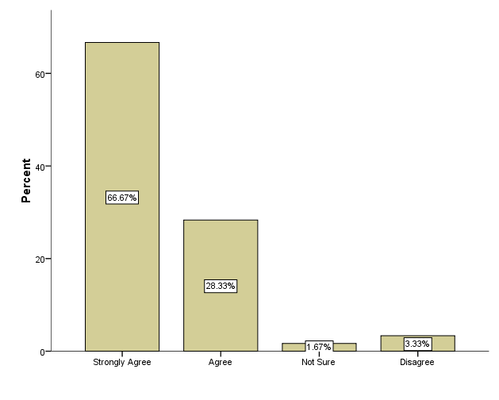
Figure 4.1: I found difficult to manage a classroom of more than 40 students
Source: Field Data, 2020

Management of classroom has been a great challenge in most public primary schools in Ubungo municipal due to the high number of students of more than 40 in a classroom. Majority of teachers agreed with the statement (A) part C of questionnaire that they found difficult to manage classroom of more than 40 students.
From figure 4.1 above shows that 66% of the respondents strongly agreed that they face challenges in managing a classroom of more than 40 students and about 28.33% agree with the statement while 3.33% disagreed and 1% not sure. According to the findings, found that the majority of teachers face a great challenge in managing a classroom which is overcrowded. It is very challenging. This statement is justified by classroom teacher of Kibamba Primary school as he said,“ Managing a classroom with more than 40 students is very difficult and more challenging, sometime lead to stress and working load”

Figure 4.2: I found difficult to manage shouting students in the classroom when teaching
Source: Field Data, 2020
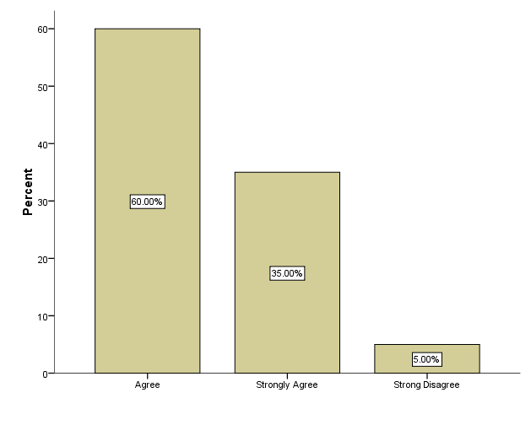
4.3.2 Managing shouting students in overcrowded classrooms
Majority of teachers in public primary schools in Ubungo municipal agreed with the statement (C) from part C of questionnaire that managing shouting students has been a difficult thing. they further argued that shouting student hinders teaching and learning process.
From figure 4.2 shows that a majority of 60% respondents agreed that managing shouting students when teaching is a great challenge. While 35% strongly agreed
and only 5% strongly disagreed with the statement. The difference of finding percentage implies that teachers in public Primary schools in Ubungo Municipal face a challenge of managing shouting students while teaching in the overcrowded classroom.
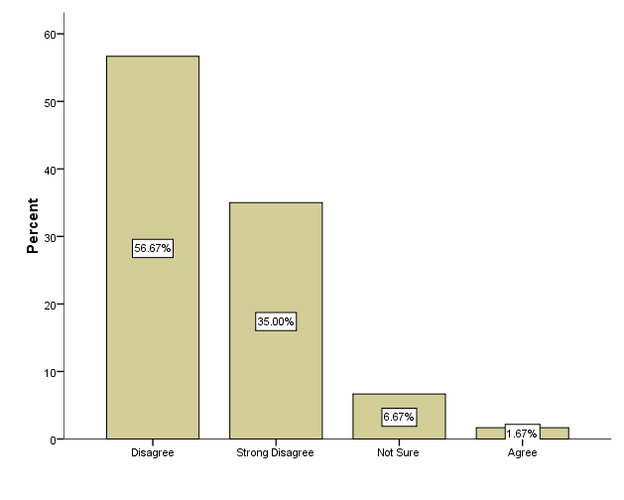
Figure 4.3: I make my students attentive when teaching
Source: Field Data, 2020

4.3.3 Monitoring Students’ Behaviour in the Class when Teaching
Furthermore, this study observed that some students do not pay attention to the teacher and they keep talking and get into little discussions, and the teacher ignore them and continue teaching. This act justifies that the teacher failed to manage the shouting student and seem that she do not care whether the students do listening or not. However, this challenge has negative impact on academic performance of a student. This statement is justified by the finding in the figure 4.3 below shows that 56% of respondents disagree that they a capable of making students attentive and 35% strongly disagree with the statement while 6.67% not sure and lastly 1.67% agreed.

Figure 4.4 : I found difficult to monitor students behavior in a classroom with more than 40 Students
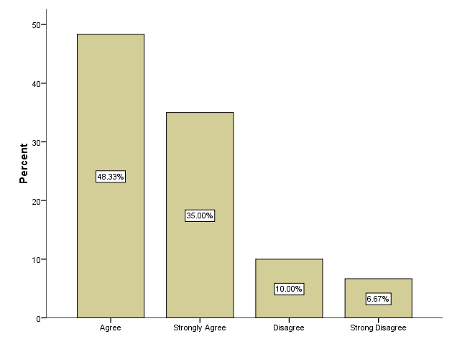

Source: Field Data, 2020
4.3.4 Assessment of students learning when teaching in a classroom
Monitoring student’s behaviors in a classroom of more than 40 students has been a difficult thing. Majority of teachers participated in this research agreed with the statement (E) part C of questionnaire that, they found difficult to manage students behaviors in a classroom of more than 40 students, failure to manage students behaviors led to poor academic performance.
From the field data shown in the figure 4 the majority of respondents, 48.3% agree with the statement and 35% strongly agree while 10% disagree and 6.67% strongly disagree. Due to finding result this study revealed that teachers face a great challenge in monitoring student behaviors. This statement is justified by the class teacher of Kibamba Primary school, Our classrooms are crowded, therefore we are not able to walk around and monitor students behaviour and activities such as bullying, stealing and quarrels in the class”

Figure 4.5: Assessment of Students Tearning when Teaching in a Classroom
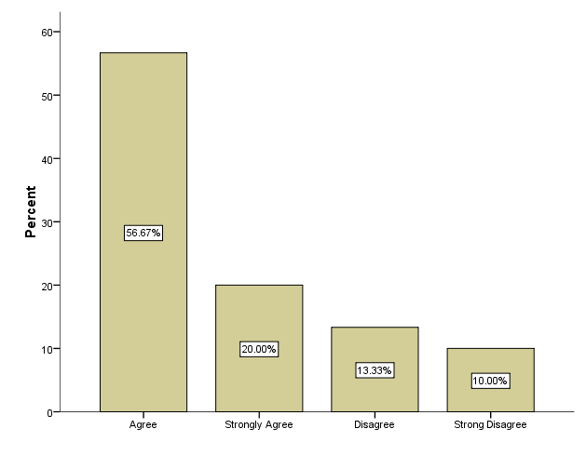

Source: Field Data, 2020
Majority of teachers responded in a statement (F) part C of questionnaire agreed with the statement that, they found difficult to do academic assessment of every individual student in a classroom of more than 40 students. Therefore the teachers failed to determine high performing student and slow learner students.
According to figure 4.5 the results shows significant number of 56% respondents agree with the statement that they face difficult to do assessment when teaching in a class of more than 40 students and 20% strongly agreed with the statement while 13.33% disagree and 10% strongly disagree. In respect to the majority respondent agreed with the statement it proves that teachers in public Primary school in Ubungo Municipal face a great challenge doing assessment in a classroom of more than 40 students. This statement is justified by class teacher in Hondogo Primary school;
“In a classroom of more than 100 students is very difficult to mark assignments of every student during teaching due to large number of students in the classroom. Also, due to overcrowedness is very difficult to identify slow learners students.”
4.3.5 The use a variety of teaching and learning activities when teaching
Use of teaching and learning activities in a overcrowded classroom has been a great challenge that make it difficult for a teacher to employ his or her teaching technique or distribute learning materials. However, majority of teachers participated in this research agreed with statement (G) part C of questionnaire that they found difficult to use a lot of teaching and learning activities when teaching in a overcrowded classroom.
According to figure 4.6 below, A significant proportion 40% respondents strongly agreed with the statement and 28.33% agree, while 13.33% are not sure and 13.33% disagreed and lastly only
5% strongly disagreed. With finding result justifies that teachers face a challenge in teaching and the use of learning activities in overcrowded classroom.

Figure 4.6: The use a variety of teaching and learning activities when teaching
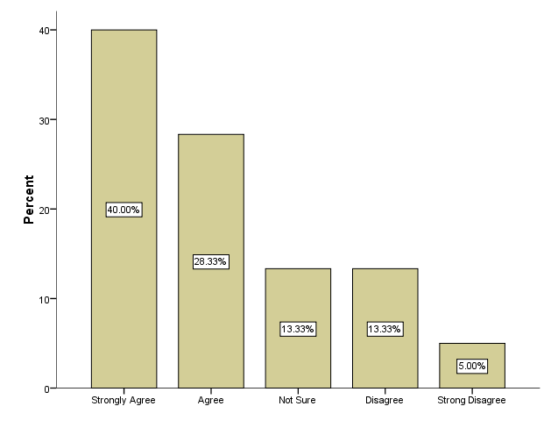
Source: Field Data, 2020
4.3.6 Time management when teaching.
Managing time in a overcrowded classroom is an existing challenge in most public primary schools in Ubungo municipal. Majority of teachers participated in this research agreed with the statement (H) part C of questionnaire, that they found difficult to manage time when teaching overcrowded classroom. Poor time management led to working load, stress that is brought by failure to keep up with teaching lesson plan and syllabus.

Figure 4.7: Time management when teaching
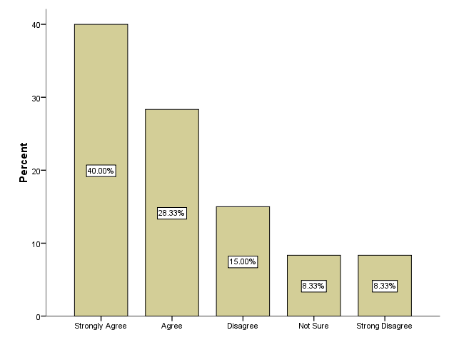
Source: Field Data
According to the finding shown on the figure 4.7 chart above This study revealed that, majority of 40% respondents strongly agreed with the statement and 28.33% agreed while 15% disagree 3.33% not sure and 3.33% strongly disagree . Difference in percentage justifies the existence of challenge of time management in public primary schools in Ubungo Municipal.
4.3.7 Setting of sitting arrangement in a classroom of more than 40 students
Primary schools in Ubungo municipal experience a challenge of poor setting arrangement due to one classroom accommodate more than 40 students. Teachers who participate in this study they agree with the statement (J) part C of questionnaire. majority of them agreed that they found difficult to set sitting arrangement in the classroom of more than 40 students. This challenge hinder good teaching and learning environment.

Figure 4.8: Setting of Sitting Arrangement in a Classroom of More than 40 Students
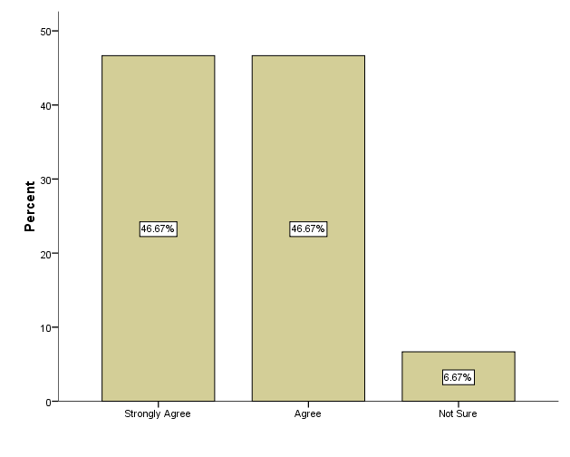

Source: Field Data, 2020
According to the finding results shown above in the figure 4.8, majority of 46.67% strongly agree with the statement and 46.67% agree while 5.67% are not sure with the statement. In respect to the statement shows that majority of teachers agree that they face a challenge in setting sitting arrangement. This statement is justified by interview section with head teacher of Mbezi Primary school, he said that;
“Teachers find difficult in sitting arrangement in an overcrowded classroom because even movements within the classroom are not easy and in some classroom students are sitting on the floor closer to the blackboard”
4.4 Teacher's Views On The Influence Of Students' Numbers On Classroom Management
4.4.1 The use of classroom rules to manage overcrowded classroom
Use of classroom rules to manage overcrowded classrooms has been a challenging issue. Majority of teachers agreed with the statement from statement (a) part D of questionnaire that they found difficult to use classroom rules to manage students in a overcrowded classroom.
Figure 4.9: The use of classroom rules to manage overcrowded classroom
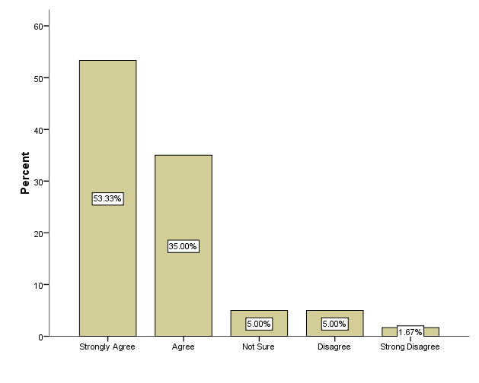

Source: Field Data, 2020
In respect to the field findings shown on figure 4.9 above, majority of respondent strongly agree with the statement about 53.33% and 35% agree while 5% disagree with the statement and 1.67% strongly disagree with the statement and only 5.% are not sure. Dissimilarity of percentage justifies that teachers in public Primary schools experience a challenge of using classroom rules as means of managing the overcrowded classroom. According to the interview done by class teacher of Mbezi Primary school said that;
“It is difficult for a classroom of more than 40 students to follow classroom rules”
4.4.2 Teacher- student relationship
Overcrowded classrooms have brought a challenge in respect to teacher student’s relationship in most of primary schools in Ubungo municipal. According to the finding majority of teacher responded to the statement (b) part D of questionnaire they agreed to the statement that, overcrowded classrooms led to poor teacher students relation, as result to poor academic performance.

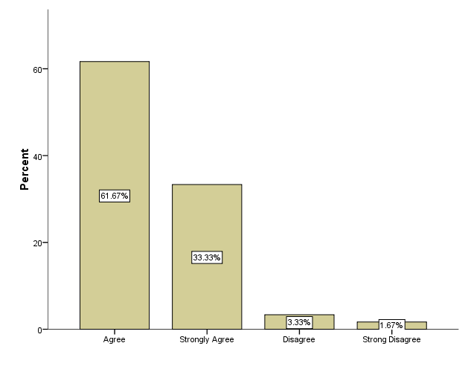
Figure 4.10: Teacher- student relationship

Source: Field Data, 2020
From the figure 4.10 above the field finding results revealed that, overcrowded classroom result to poor teacher-students relationship and this is proved by significant number of 75% agree with the statement, 10% agree too with the statement while 5% strongly disagree and 10% disagree. The dissimilarity of the finding percentage implies that it is true that overcrowded classroom lead to poor teacher- student relationship.

4.4.3 Teacher’s focus during teaching
Teacher in overcrowded classroom experience lack of focus during teaching, as to justify this statement majority of teachers who were involved in this study agreed with the statement (c) part D of questionnaire that, overcrowded classrooms hinder their focus during teaching and this is due to either shouting students or concentrating on disciplinary issues than teaching.

Figure 4.11: Teacher’s Focus During Teaching
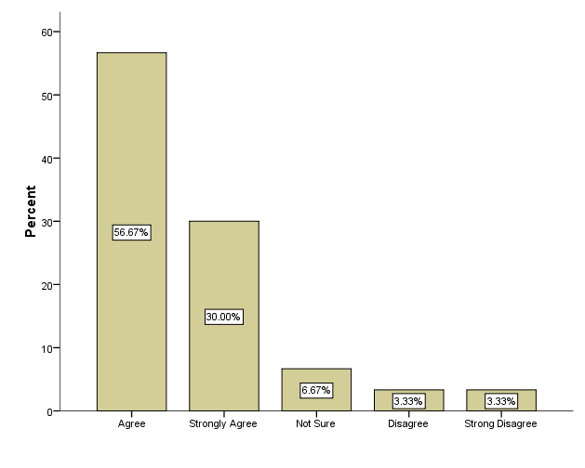

Source: Field Data, 2020
From the field data finding result shown on the figure 4.11, majority of teachers about 80% agree with the statement and 10% disagree and another 10 % strongly disagree. In respect to the findings this study found that, due to overcrowedness in the classroom teachers in public Primary schools in Ubungo Municipal they lack focus during teaching. This statement is justified by interview done by Kibamba class room teacher
“It is difficult for a teacher to focus on lesson plan just because much time is spend in disciplinary issues with stubborn student”

4.4.4 Students Behavior in the Classroom
Majority of teachers participated in this study as respondents they agreed with the statement (d) part D of questionnaire that, overcrowded classrooms influence student misbehaving. The teacher in a overcrowded classroom cannot identify students behaviour change and manage them toward positive direction.

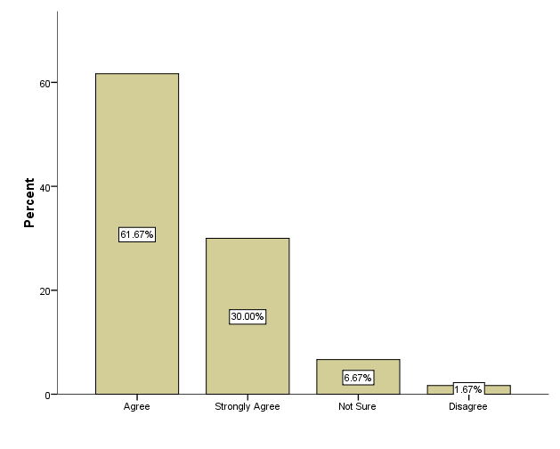
Figure 4.12: Students Behavior in the Classroom

Source: Field Data, 2020
In respect to the figure 4.12 shows finding result that majority of 61.67% respondents agree with the statement that overcrowded classroom influence students to misbehave and 30% strongly agree while 1.67 disagrees and 6.67% are not sure. Therefore justification of this statement is proven by highly of majority percentage who agreed with the statement that overcrowded classroom influence students misbehaving.

4.5.5 Implementation of the Planned Learning Activities
Most teacher in Ubungo municipal schools experience difficultness in implementation of the planned learning activities in overcrowded classrooms. According to teachers participated in this study as respondents they agreed with the statement (e) part D of questionnaire. That it is difficult for them to implement planned learning activities in overcrowded classroom.

Figure 4.13: Implementation of the planned learning activities
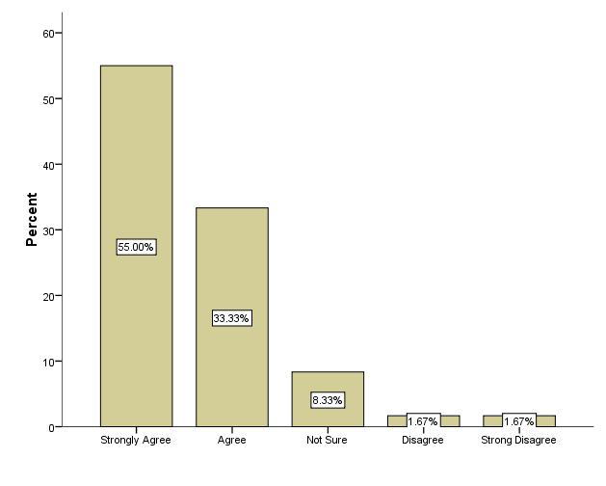

Source: Field Data, 2020
From field data in figure 13 revealed that majority of 55% strongly agree with the statement 33.33%% agree while 1.65% disagree and 1.67% strongly disagree lastly only 3.33% are not sure with the statement. Due to dissimilarity of respondent percentage proves that teachers fail to follow the lesson plans as planned. This statement is justified further by classroom teacher views in an interview;
“Large number of students in a classroom makes difficult to conduct planned practical activities much time is spent in managing students than teaching”

4.6.6 Students’ Performance
Public primary schools in Ubungo municipal seem to have poor academic performance due to Overcrowded classroom. In respect to the teachers who were respondents in this study. They agreed with statement (f) part D of questionnaire, they think overcrowded classroom attract poor students performance.

Figure 4.14: Students’ Performance
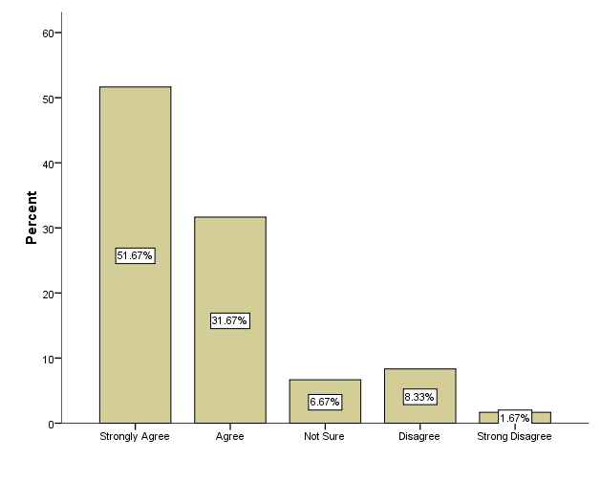

Source: Field Data, 2020
According to the field data shown on the figure 4.14 majority of 51.67% respondents strongly agree with the statement that overcrowded classroom attracts poor students' performance, 31.67% also agree with the statement but 8.33% disagree with the statement followed by 1.67% who strongly disagree and lastly only 6.67% not sure. In respect to the finding results variation of percentage shows majority of teachers agrees that overcrowded classroom attracts poor students’ performance.

4.4.7 Monitoring of Student attendance in the classroom
Most teachers in public primary schools in Ubungo municipal experience difficultness in monitoring student’s attendance in overcrowded classroom. majority of them agreed with the statement (f) part D of questionnaire, that it is very difficult to monitor students attendance in a overcrowded classroom.

Figure 4.15: Monitoring of Student Attendance in the Classroom
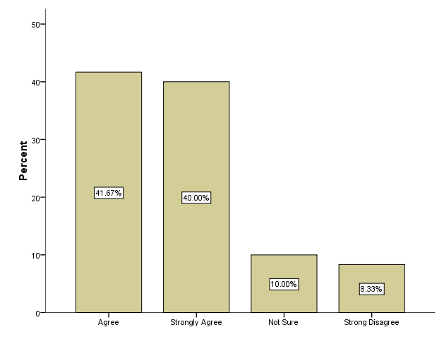

Source: Field Data, 2020
According to the field finding result shows in the figure 4.15 majority of 41.67% agree with the statement that it is difficult to manage students’ attendance in an overcrowded classroom. 40% strongly agree with the statement, while 3.33% disagree and 10% not sure. Dissimilarity of percentage justifies that overcrowded classroom brought a great challenge for a teacher to manage students’ attendance as result to students absenteeism behaviour. In a overcrowded classroom the teacher cannot recognize easily number of absent students in the classroom. This statement is justified further by interview with head teacher of Mbezi ufundi Primary school in overcrowded classroom;
“It is difficult for a teacher to manage students attendance in a classroom of more than 100 students and this provide a chance for students absenteeism. If a classroom is of 40 students a classroom is able to spot absent students because the teacher knows all students by their face, names and sitting position in the classroom.”

4.5 Discussion of the Findings
Discussion of the finding of the study based on research questions that were formulated for this study. In respect to the research question number one, which intend to explore the teacher student ratio in public primary schools in Ubungo municipal.From data analysis done, the results disclosed that majority of respondents agreed that public primary schools in Ubungo municipal has high teacher student ratio.
According to the interview done by head of 5 primary schools in Ubungo municipal, they agree existence of high teacher student ratio in their schools and they went further by justifying the existence by presenting secondary data that shows high number of students enrolled and fewest number of teachers full employed in their schools. Therefore, secondary data presented in table 6, justify the existence of high teacher student ratio in Ubungo municipal public primary schools. In the same vein, the finding of this study is in relation to the study conducted by Haki elimu (2017) they disclosed existence of high teacher student ratio most public primary schools.
However, upon the existence of high teacher student ratio, this study revealed the existence of overcrowded classrooms. The finding results show that most of public primary schools in Ubungo municipal are overcrowded. According to the finding done on if one teacher deals with more than 40 students and above when teaching, the results revealed that the majority of teachers agreed that, they teach in a classroom of more than 40 in a classroom, due to the finding results significantly proves existence of overcrowded classrooms in public primary schools in Ubungo municipal
However, managing students in an overcrowded classroom seem to be a very challenging issue for most primary teachers. According to the finding done exploring the difficulties in managing a classroom of more than 40 students. The findings revealed that the majority of teachers agreed that, managing a classroom of more than 40 students is a difficult task. According to the interview done with heads of school in Kibwegere primary school and justified the existence of teachers teaching in a classroom of more than 40:1 ratio, he further added that, the majority of teacher file complains on difficult to teach and manage an overcrowded classroom. This finding has been supported by Petro Marais (2016) in his study on overcrowded classroom through the eyes of student teacher, commented that, even in Kenya teachers complain about raise of students number per classroom up to 200, increase of the students number undermine the teaching and learning process
However, the researcher used teacher direct management theory, as to govern the whole process of findings. The theory chosen focus on obedience-based discipline approach. This approach seems to be a fundamental key way to manage overcrowded classrooms this is due to the majority of teachers agreed to use punishment as a tool to manage the classrooms and students behaviors’. Mustafa (2014), in his study supported this argument and he commented that, teacher in overcrowded classrooms tend to use much disciplinary approach as an approach to manage the classroom and students’ behaviours.
In this study, the researcher used teacher direct theory management as the theory that guides the researcher toward research findings. The researcher used the theory assumption as a guideline toward research findings. Whereby the theory assumption expected the researcher to find out that, students are misbehaving in the classroom, teacher use disciplinary action as to manage and lastly are violation of teacher’s right to teach without interruptions by students misbehaving. Therefore the study finding results seems to support the theory assumption
Therefore, this study revealed that, students in overcrowded classroom seem to be misbehaving, to the extent that brought a lot of challenges. Majority of teachers agreed with the findings that, it is difficult to monitor student’s behaviour. According to the interview session done by the researcher with class teacher in Kibamba Primary school, he said that, overcrowded classroom limits the teacher to monitor individual students behaviour, such as bullying, stealing and quarrels in the class. Timaam (2014) in his study said that, it is obvious in overcrowded classrooms to have misbehaving students.
Furthermore, this study finding found that, students misbehaving brought many challenges such as time management in classrooms. According to the findings, majorities of teachers agreed to experience a challenge in managing time when teaching in overcrowded classrooms, due to students misbehaving. Shouting students interrupt the teacher when teaching and also distracts other student’s attention, due such misbehaving situation, most of teacher applies teacher direct management theory by taking disciplinary actions as a tool to make students attentive.
However, in application of teacher direct management theory in overcrowded classrooms, teachers found spent much time in disciplinary issue and waste the teaching time. In respect to a previous study of Timaam, (2014) he commented that, a teacher loose valuable time that could be spent in teaching, and spent on managing the disciplinary issues in a classroom. This study, found that, teachers who teach in overcrowded classroom use force or disciplinary actions to make students obey classroom rules. Majority of teachers agreed that it is difficult for students in overcrowded classroom to follow rules made by teacher.
This statement is justified by class teacher in Mbezi primary school, he commented that, it is difficult for students in a classroom of more than 40 to follow rules. In the light, of the theory, for the teacher to create obedience classroom, he must use disciplinary measures, but the use of disciplinary measure seems to have a negative impact.
According to the findings, shows Majority of teachers agreed that, overcrowded classroom leads to poor teacher-students relationship Poor teacher-students relationship are facilitated by misbehaving students. This study revealed that, the use of too much punishment creates a bad relationship whereby the students view the teacher as the enemy. Hondogo primary school classroom teacher justifies, that, due to poor teacher relationship, some students decide to revenge by arranging attacks against teachers.
In respect to the theory assumption, the study finding results support the assumption that, teacher in overcrowded classrooms uses much disciplinary action in managing the classroom as result to failure to focus on teaching. This study finding revealed that, students misbehaving distract the teacher’s focus. According to okebukoka (2012), in his study argued that, in overcrowded classroom the teacher cannot have effective teaching focus, due to students noise interruptions, As to maintain focus the teacher shift from teaching and focus on disciplinary action toward noise makers.
This study notes that, the use of too much disciplinary action resulted in a time management challenge, whereby the teacher spend much time in physical punishments, as a result failed to implement planned classroom activities, hence poor students’ performance. The finding conquers with Mustafa (2014) who observed that, disruptive behaviour reduced the efficiency of lesson delivery since the teachers spent much lesson time creating conducive learning environment than implementing the lesson plan. Harrison (2014) in his study supported the Mustafa view of point by commenting that, dropping of academic performance in overcrowded classroom is influenced by failure of teacher to deliver quality and effective lesion due to shortage of time.
As to conclude, this study found that, application of teacher direct management theory in an overcrowded classroom seems has been proven to fail, this is because finding of this study has shown challenges brought by application of this theory. Majority of teachers in the study agreed that, the use of too much disciplinary action lead to time wasting, create bad teacher students relationships and even lead to failure of teacher to implement planned lesson activities and lastly too much disciplinary actions may also lead to increase of students absenteeism, students feel scared to attend classroom lessons, as result to poor academic performance.
Therefore, the government should take into account, the reduction of the teacher student ratio and increase number of classrooms to overcome overcrowded classroom. However, reduction of the teacher student ratio will create a favorable environment of application of teacher direct management theory. As to finalize, this revealed, the necessity of teachers to be more trained on another method of classroom management, and not to focus on one model of classroom management, as according to the finding majority of teachers in public primary school keeps on using teacher direct management theory.

CHAPTER FIVE

SUMMARY, CONCLUSION AND RECOMMENDATIONS

5.1 Introduction
This study was focused on exploring teachers ‘experiences in managing overcrowded classrooms. Case study of this study was Primary schools located in Ubungo Municipal. This study involved five Primary school, which are Kibamba primary school, Mbezi primary school, Kibwegere primary school, Hondogo primary school, and Mbezi ufundi primary school. Participant to the findings were head of schools and classroom teachers. Selection of head of schools and classroom teachers as participants was purposely to understand on the difficulties and challenges that teachers experience in managing overcrowded classrooms. This chapter focused on Discussion, implication of the study, and recommendation for future research.

5.2 Summary of findings
5.2.1 High teacher student’s ratio in public primary schools in Ubungo Municipal
This study finding shows that more than 90% of the schools in Ubungo Municipal are overcrowded, with pupil’s more than 40:1 teacher-student ratio. According to the field data given by the head of schools show that in Kibamba primary school teacher student ratio is 100:1, Hondogo Primary school 65:1, Kibwegere 150:1, Mbezi Primary school 130:1 and Mbezi ufundi is 41:1. In respect to the data above, proves existence of overcrowedness in most of Primary school in Ubungo Municipal. The data reviled further that imbalanced teacher’s deployment in Ubungo Municipal Primary schools. Furthermore, the result and observation done shows that, most of the Primary schools in Ubungo Municipal have few classroom streams as result to one classroom accommodate students more than the standard ratio of 40:1 per classroom. Due to this factor teachers are forced to teach in an overcrowded classroom.
Teaching in overcrowded classroom forced teachers to practice various methods so as to manage overcrowded classroom. Managing a large class sizes make teaching much harder, it’s a challenge, but teachers have being trying a lot to manage the classrooms. This study found that most of teachers use various methods to minimize these challenges and teach effectively in a overcrowded classroom. First method most of teacher use is to keep the classroom busy by giving students more assignments to do, as well as a mini lesson with associated independent task. Another method teacher’s use is by giving group work or exercise. Grouping keeps students working on tasks given and some help one another. And lastly, some teachers tend to keep lesson short. It is obvious that to keeping a larger number of students engage in an extended lesson are very difficult, so the only way is to keep student attentive and engage is to keep the lesson short and more engaging. Despite of practicing various methods but no positive results outcome. Teachers failed to complete syllabus on time, students a limited to engage with the teachers directly hence to academic dropout.
5.2.2 Teachers Face Challenges in Managing Overcrowded Classrooms
Based on field data results found that teachers are facing a lot of challenges in managing the overcrowded classroom. The majority of teachers responded that managing overcrowded classroom is very stressful and difficult. Teachers use much time and energy trying to control students rather than spending time in teaching, hence lead to failure to follow the class lesson plan and finishing syllabus on time. Failure to finish syllabus lead to poor student’s performance in most public Primary schools in Ubungo Municipal.
The finding revealed farther that, teachers face a great challenge in managing shouting students in the classroom while teaching. Despite of setting classroom rules and punishment, but still some students keep on shouting and disturb other students attentiveness during teaching as result some of students fails to listen and understand what the teacher is teaching. Teachers spend much time disciplining notorious students who shouts, bullying and even physical disturb others than time of teaching.
According to the results findings doing classroom assessment either academically or behavior change to each student is very challenging and difficult in a classroom of more than 40:1 ratio. Teachers are unable to give the students required number of exercises and assignments as an assessment tool. Teacher’s sometime face a challenge of marking more than 100 exercise books this large number of exercise books affects the quality of the assessment of students performance.

5.2.3 Teachers’ view on the Impact of High Number of Students in Classroom Management.
This study has found that teachers are unable to use teaching and learning facilities during teaching due to poor students setting arrangement. Majority of Teachers argued that, they find difficult to move around the classroom and deal with individual student or distributing learning facilities such as books or learning exhibits. This study observed in some schools students’ seat on the floor; hence hinder the teacher move around to each student in a classroom to oversee their progress.
As to conclude, due to a large number of students in a classroom, most of the teachers failed to keep and follow up student’s attendance. Large number of students in classroom hinders the teacher to determine whether a certain student is present in the class or not.
5.3 Conclusion
This research was undertaken to explore teachers’ experience in managing overcrowded classrooms in Ubungo municipal public primary schools. Through data analysis in this study identified various challenges teachers in public primary school experience. According to the study objective, the researcher succeeds to to evidence in respect to finding results existence of high teacher-student ratio in most public primary school. Also, through data analysis the researcher finds out most of public primary schools in Ubungo municipal are overcrowded and teacher experience challenge in managing them. Majority of teachers agreed that they experience challenges in managing time, students behaviours and even managing students’ attendance in overcrowded classrooms. Teachers added up that, overcrowded classroom limit the teacher to use teaching and learning activities and also due to students misbehaving and shouting automatically distract the teacher focus during teaching.
Due to the challenges teachers experience they suggested that, the government should anticipate these challenges immediately failure to that, they will lead to more problems such as increase of poor academic performance, increase of absenteeism behaviours, and lastly increase of working load to the teachers as result undermine teaching ability.
Therefore, this study recommend that, the government should improve and build more classroom in overcrowded schools, employing more teacher as to balance teacher-student ratio. The government should provide more workshops and training to the teachers on how to manage overcrowded classrooms.

5.4 Recommendations
5.4.1 Recommendation for Action
The Government should build adequate classrooms in compliance with government standards. Building more classrooms in schools with high teacher student ratio will reduce overcrowedness, teachers will be able to manage the classroom; monitor student’s behavior and academic performance. The classroom with standard ratio of 40:1 allows the teacher to monitor student’s attendance in the class.
The government should employ more public primary teachers in schools with high number of students. Employing more teachers will reduce working load to the teacher who teaches three classrooms with more than 100 students per day. The government can allow use of volunteers and teaching assistants to overcome the challenge of inadequate teachers in public primary school.
The government should provide adequate teaching and learning materials in schools with overcrowded classrooms, this will create conducive teaching and learning environment. Availability of teaching materials will help teacher to monitor and improve students’ performance.
The government should provide frequently workshops and special training to head teachers and classroom teachers in practice to make them competent on how to manage overcrowded classroom. The government can add up special course on overcrowded classroom management to teachers in training. Impacting this knowledge will help many teachers to understand how they can manage classrooms with more than 40:1 ratio. Once the teachers employed with enough skills and knowledge on overcrowded classroom management will reduce stress and working load during teaching.
The Ministry of education should create a free space for the teachers and their representatives to speak and give solutions on challenges they face during teaching in overcrowded classrooms. Actively engagement of teacher’s representative and the government will help very much in identification of common challenges foresee coming challenges and find out ways to overcome them in the future.

5.4.2 Recommendation for Further Research
The Government should build adequate classrooms in compliance with government standards. Building more classrooms in schools with high teacher student ratio will reduce overcrowedness, teachers will be able to manage the classroom; monitor students behavior and academic performance. The classroom with standard ratio of 40:1 allows the teacher to monitor student’s attendance in the class.
The government should employ more public primary teachers in schools with high number of students. Employing more teachers will reduce working load to the teacher who teaches three classrooms with more than 100 students per day. The government can allow use of volunteers and teaching assistants to overcome the challenge of inadequate teachers in public primary school.
The government should provide adequate teaching and learning materials in schools with overcrowded classrooms, this will create conducive teaching and learning environment. Availability of teaching materials will help teacher to monitor and improve students’ performance.
The government should provide frequently workshops and special training to head teachers and classroom teachers in practice to make them competent on how to manage overcrowded classroom. The government can add up special course on overcrowded classroom management to teachers in training. Impacting this knowledge will help many teachers to understand how they can manage classrooms with more than 40:1 ratio. Once the teachers employed with enough skills and knowledge on overcrowded classroom management will reduce stress and working load during teaching.
The Ministry of education should create a free space for the teachers and their representatives to speak and give solutions on challenges they face during teaching in overcrowded classrooms. Actively engagement of teacher’s representative and the government will help very much in identification of common challenges foresee coming challenges and find out ways to overcome them in the future.

REFERENCES
Amarat,M. (2011). The Classroom Problems Faced Teachers at the Public Schools in Tafila Province, and Proposed Solutions, International Journal of Educational Sciences. 3:1, 37-48, DOI: 10.1080/09751122.2011.11890007
Ayoub, G. (2019).Teachers' experiences in overcrowded classrooms in Egyptian public schools [Master’s thesis, the American University in Cairo]. AUC Knowledge Fountain.https://fount.aucegypt.edu/etds/786
Benbow J, Mizrachi A, Oliver D & Said-Moshiro L 2007. Large class sizes in the developing world: What do we know and what can we do? Available at http://www.equip123.net/docs/E1LargeClassrooms.pdf. Accessed 5 December 2014.
Blatchford, P. (2010). Lai, K.C (pp. 200–206). Class Size – Arguments and Evidence. International Encyclopedia of Education; https://doi.org/10.1016/B978-0-08-044894-7.01081-2
Brophy, J. (2006). History of Research on Classroom Management. In C. M. Evertson & C. S. Weinstein (Eds.), Handbook of classroom management: Research, practice, and contemporary issues (pp. 17–43). Lawrence Erlbaum, Associates Publishers.
Cheung, A. K. L. (2014). Structured Questionnaires. In A. C. Michalos (Ed.), Encyclopedia of Quality of Life and Well-Being Research. Dordrecht: Springer; https://doi.org/10.1007/978-94-007-0753-5_2888
Cohen, L., & Manion, L. (1983). A Guide to Teaching Practice. London: Methuen..
Denscombe, M. (1998). The good research guide for small-scale social research projects. Buckingham: Open University Press.
Enerson, L. (1997). Large class literature. The Journal of Educational Research, 98
Evertson, C. M., & Weinstein, C. S. (2006). Classroom management as a field of inquiry. In C. M. Evertson & C. S. Weinstein (Eds.), Handbook of classroom management: Research, practice, and contemporary issues (pp. 3–16). Mahwah, NJ: Lawrence Erlbaum Associates.
Graue, B., Rauscher, E., & Sherfinski, M. (2009). The Synergy of Class Size Reduction and Classroom Quality. The Elementary School Journal, 110. https://doi.org/10.1086/605772
Hornick-Lockard. (2015). Barbara January. Overcrowding in Schools - Research Starters Education; Accessed January 1, 2015.
Hosain, Md. (2016). Teaching Workload and Performance: An Empirical Analysis on Some Selected Private Universities of Bangladesh. International Journal of English and Education. https://doi.org/10.2139/ssrn.2810640.
Jimaa, S. (2011). The impact of assessment on students learning. Procedia: Social and Behavioral Sciences, 28, 718–721. https://doi.org/10.1016/j.sbspro.2011.11.133
Johnson, D. (2013). Johnson, D. W., & Johnson, R. T. (2013). The impact of cooperative, competitive, and individualistic learning environments on achievement. In J. Hattie & E. Anderman (Eds.), International handbook of student achievement (pp. 372–374). New York: Routledge.
Khan, P. Iqbal, M. (2012). "Over crowded classroom: a serious problem for teachers".
Koc, N., & Çelik, B. (2015). The Impact of Number of Students per Teacher on Student Achievement. Procedia: Social and Behavioral Sciences, 177, 65–70. https://doi.org/10.1016/j.sbspro.2015.02.335
Kombo, D. K., & Tromp, D. L. (2006). Proposal and thesis writing: An introduction. Nairobi: Paulines Publications Africa
Kothari, C. R. (1990). Research Methodology: Methods and Techniques Wishwa. New Delhi: Prakashan.
Marzano, R. J. (with Marzano, J. S., & Pickering, D. J.). (2003b). Classroom management that works. Alexandria, VA: ASCD.
Mertens, M. D. (2012). Ethics in Qualitative research: An introduction to methods and design. San Francisco: Jossey Bass.
Monks, J., & Schmidt, R. (2011). The Impact of Class Size on Outcomes in Higher Education. The B.E. Journal of Economic Analysis & Policy, 11(1), 62–62. https://doi.org/10.2202/1935-1682.2803
.Mtika, P. (2011). Trainee teachers’ experiences of teaching practicum: Issues, challenges, and new possibilities. Africa Education Review., 8(3), 551–567. https://doi.org/10.1080/18146627.2011.618715
Myers, A. (2013). Roles in changing education. Africa Education Review.
Nesane, M. A. (2008). Selected school-related reasons why teachers abandon the teaching profession: An educational management perspective . The University of South Africa.
Norris, A. J. (2003). Looking at classroom management through a social and emotional lens. Theory into Practice.
OECD (2009), Creative and effective teaching and learning environments: First results from TALIS, OECD, Paris
Onwu, G., & Stoffels, N. (2005). Challenges of large class teaching. Journal of South African Education.
Philip E.Akech (2017), The impact of over-crowded classrooms to teachers and students : Interaction in the process of teaching and learning in selected primary schools in Arusha City Council, Tanzania. ISBN 9783668540453
Richard W. Martha R. (1990). Innovative Assessment in Large Classes. Taylor & Francis, Ltd.]
Rimm K, Sandilos L. (2012). Improving students' relationships with teachers to provide essential supports for learning. Retrieved from http://www.apa.org/education/k12/relationships.aspx?item=1#
Roja, M. Fathima M. Parimala K. (2013). A Study on Emotional Maturity and Self Concept at Higher Secondary Level. Journal of the History of the Behavioral Sciences, 81-83. 10.12691/rpbs-1-5-4
Saxon, D. Morante, E. (2014). Effective Student Assessment and Placement: Challenges and Recommendations. Journal of Developmental Education, 37(3), 24–31. Retrieved from http://www.jstor.org/stable/24614032 Accessed September 16, 2020
Shah, J. (2012). THE IMPACT OF OVERCROWDED CLASSROOM ON THE ACADEMI.. international journal of commerce, Economics and Management. VOLUME NO. 2.
Singh, Y. K., & Bajpai, R. B. (2008). Research Methodology Techniques and Trends. New Delhi: APH Publishing Corporation.
Spilt, J. L., Koomen, H. M., Y.,Thijs, J. T. (2011). Teacher well being: The importance of teacher-student relationships. Educational Psychology Review, 23(4), 457-477.
doi:http://dx.doi.org.goucher.idm.oclc.org/10.1007/s10648-011-9170-y
Where are the instruments used for data collection???

