EMPOWERING TUKE HOUSEHOLD WOMEN GROUP IN ENTREPRENEURSHIP AND FOOD PROCESSING SKILLS

EVA A. MGONGOLWA

A DISSERTATION SUBMITTE D IN PARTIAL FULFILLMENT OF THE REQUIREMENTS FOR THE DEGREE OF MASTER OF COMMUNITY ECONOMIC DEVELOPMENT (MCED)
DEPARTMENT OF COMMUNITY ECONOMIC DEVELOPMENT
OF THE OPEN UNIVERSITY OF TANZANIA
2021

CERTIFICATION
The undersigned certify that he has read and hereby recommends for acceptance by The Open University Tanzania, a project titled “Empowering Tuke Household Women Group of Tandale Ward, Kinondoni Municipal Council In Enterprenurship And Food Processing Skills” in partial fulfillment of the requirements for the Degree of Masters in Community Economic Development (MCED) of the Open University of Tanzania.

…………………..…………….
Dr. Felician Mutasa
(Supervisor)

……………………………...
Date

COPYRIGHT
No part of this dissertation may be reproduced, stored in any retrieval system, or transmitted in any form by any means, electronic, mechanical, photocopying, recording or otherwise without a prior written permission of the author or the Open University of Tanzania in that behalf.

DECLARATION
I, Eva A. Mgongolwa, declare that, the work presented in this dissertation is original. It has never been presented to any other University or Institution for the same purpose. Where other people’s works have been used, references have been provided. It is in this regard that I declare this work as originally done by the researcher. It is hereby presented in partial fulfillment of the requirements for the award of Masters Degree in Community Economic Development (MCED).

…………………………………
Signature

………………………………
Date

DEDICATION
This work is dedicated to my beloved husband YUSUF MWAUGALI who had kept encouraging me to continue with my studies despite the many challenges.

ACKNOWLEDGEMENT
First and foremost I thank GOD for the mercy and protection given to me that I could complete this work. Indeed, I would like to thank all the people who have contributed to the accomplishment of this report. My Deep thanks should go to my supervisor Dr Felician Muttasa who had spent a lot of time to guide me.

My gratitude are also due to all other instructors in the Community Economic Development Section for their tireless and excellent instructions and advices that had greatly contributed to the end results of my study. This work would have not be completed without the kindness and support of Tandale Ward administration and Tuke Women Group members. The acceptance and support they gave me throughout the research work is highly appreciated. I am also indebted to GLAAMS Investments, just to mention the Director Dr Lyimo, H L N as they had used considerable time to make sure that my objectives are met.

My sincere appreciation also goes to my employer, The Municipal Director, Kinondoni Municipal Council for granting me some time to attend the course. Others are office colleagues and fellow students especially CED – Dar es Salaam Centre (2020)for their moral and material support during the study period. Finally I am highly indebted to my family member; my husband YUSUF MWAUGALI my daughters ZAHARA and SASHA and my son FEISAL for accepting part of our family income be used to support my studies and the endless encouragement they had given me during the study period.

ABSTRACT
A participatory Community Need Assessment (CNA) was done to Tandale ward Household Women Groups and revealed two major needs of business undertaking knowledge and technical aspect of whatever enterprises they undertake. A strategy of the social economic groups under one umbrella coupled with strategic training was planned and done. Tandale Women Social Economic Groups Platform was established to be a resource center to link the groups with necessary institutions. This was followed by selecting and trains one group that will act as a role model for other groups. Tuke Women Group which was dealing with food vendors was selected. This group was trained on entrepreneurship, group dynamics and management and food processing and marketing. In a period of three months, the group businesses had expanded allowing them to make 85% profit margin and members enthusiasm for income generating activities increased. It was hitherto concluded that the CNA to the household women groups had enabled to reveal the real need of the groups. Furthermore, having groups linked by the Tandale WOSEG Platform had made women groups in Tandale well connected to each other and to various micro-financial institutions. The project had attracted Micro financial institutions to fund platform members. Indeed, trainings in entrepreneurship, group management and technical skills had raised confidence and increased income. During M&E, elements of laxity were recorded. It was recommended that stronger involvement of different stakeholders from municipal council and local communities will be needed to sustain project activities. Women groups need to be encouraged to form their own savings and credit societies that will enable getting smooth loan from own sources.
Keywords: Empowering, Tuke Household Women Group, Entrepreneurship, Food Processing.
TABLE OF CONTENTS
CERTIFICATION ii
COPYRIGHT iii
DECLARATION iv
DEDICATION v
ACKNOWLEDGEMENT vi
ABSTRACT vii
TABLE OF CONTENTS viii
LIST OF TABLES xvi
LIST OF FIGURES xviii
LIST OF ABBREVIATIONS xix
CHAPTER ONE 1
PARTICIPATORY NEEDS ASSESSMENT 1
1.1 Introduction 1
1.2 Community Profile 1
1.2.1 Geographical Location 1
1.2.2 Community Demographic Features 2
1.2.3 Ward Climatic Conditions 3
1.2.4 Topography 3
1.2.5 Water supply, Sanitation and Hygiene 3
1.2.6 Social Services in Tandale 4
1.2.7 Infrastructures 4
1.2.8 Economic Activities 4
1.2.9 Community Supporting Organizations NGO/CBOs 5
1.2.10 Organizational Structure of Tandale Ward 5
1.3 Tandale Household Women Community Needs Assessment 6
1.3.1 Objectives of the Community Needs Assessment 6
1.3.1.1 Specific Objectives 7
1.3.2 Community Needs Assessment Questions 7
1.3.3 Community Needs Assessment Methodology 7
1.3.3.1 Community Needs Assessment Design 8
1.3.3.2 Study Sample and Sapling Procedure 8
1.3.3.3 Data Collection Methods 9
1.3.3.4 Data Collection Tools 10
1.3.3.5 Data Analysis 10
1.4 Household Women Community Needs Assessment Findings 10
1.4.1 Social Characteristics of the HW in Tandale Ward Community at Large 11
1.4.1.1 HW Age Group 11
1.4.1.2 Marital Status of HW Group Members 11
1.4.1.3 Household Status of the HW in Tandale Ward 12
1.4.1.4 Education of the HW Members 12
1.4.2 Social Services Assessment 13
1.4.3 Health Assessment 15
1.4.4 Environmental Assessment 16
1.4.5 Economic Analysis 17
1.4.5.1 Employment to Community 17
1.4.5.2 Economic Activities undertaken by People in the Ward 17
1.3.5.3 Income of Household Women in Tandale Ward 21
1.4.5.4 Women Groups Formation and Objectives for Economic Business Ventures 21
1.4.5 Capital for Business 23
1.4.6 Women Groups Revenues and Expenditure 26
1.4.7 Knowledge and Skills for IGA to Tandale Household Women 27
1.4.7.1 Training in Business Skills 27
1.4.8 Resources and Opportunities Available for HW to Develop IGA 27
1.4.9 The Role of Government and Ways in which HW in Tandale Ward are Empowered 28
1.4.10 Business Challenges/stress that are Faced by Household Women in Tandale Ward 29
1.5 Resources available, Stress and Needs for the Household Women 32
1.5.1 Available Resources that could be used to fulfil the Needs 32
1.5.2 Needs and Stresses 32
1.5.3 Community Needs Prioritization (Leveling of Needs) 32
1.6 Conclusion 34
CHAPTER TWO 36
PROBLEM IDENTIFICATION 36
2.1 Introduction 36
2.2 Problem Statement 36
2.3 Project Description 37
2.4 Targeted Community 38
2.4.1 Stake holder Analysis 38
2.4.3 Project Goal 39
2.4.4 General and Specific Project Objectives 39
2.4.5 Activities 40
2.4.6 Indicators 40
2.5 Host Organization 40
2.5.1 TUKE Women Groups Vision 41
2.5.2 TUKE Women Groups Mission 41
2.5.3 TUKE Women Group Objectives 41
2.5.4 The Management Organization of TUKE Women Groups 41
2.5.5 SWOC analysis of TUKE Household Women Group 42
2.6 Conclusion 43
CHAPTER THREE 44
LITERATURE REVIEW 44
3.1 Introduction 44
3.2 Theoretical Review 44
3.2.1 The Concept of Empowerment 44
3.2.2 Women Groups Economic Empowerment 46
3.2.3 Women Groups Empowerment Interventions 47
3.2.4 Income Generating Activities (IGA) for Women 48
3.2.4.1 Success in Women Income Generating Activities 49
3.3 Empirical Review 50
3.3.1 Women Groups IGA Development, Existence and Performance 50
3.3.2 Challenges Faced in Empowering Women 51
3.3.3 Women Empowerment in Tanzania 53
3.3.4 Women IGA in Tanzania 54
3.4 Policy Review 55
3.4.1 International Policy on Women Empowerment and IGA 55
3.4.2 National Policy on Women Empowerment and IGA 56
3.4 Literature Gap 57
CHAPTER FOUR 58
PROJECT IMPLEMENTATION 58
4.1 Introduction 58
4.2 Project Products and Outputs 58
4.2 Project Planning 59
4.2 Project Implementation Plan 59
4.3 Project Inputs and Budget 63
4.4 Staffing Pattern 63
4.4 Project Implementation and Report 64
CHAPTER FIVE 68
PROJECT PARTICIPATORY MONITORING, EVALUATION AND SUSTAINABILITY 68
5.1 Introduction 68
5.2 Participatory Monitoring and Evaluation 68
5.2.1 Monitoring and Evaluation Objective 68
5.2.2 Research Question 69
5.2.3 Monitoring and Evaluation Design 69
5.2.4 Participatory Monitoring and Evaluation Methods 69
5.3 Monitoring and Evaluation Results 72
5.3 Project Sustainability 77
5.3.1 Financial Sustainability 78
5.3.2 Technical Sustainability 78
5.3.3 Institution Sustainability 79
CHAPTER SIX 80
CONCLUSIONS AND RECOMMENDATION 80
6.1 Introduction 80
6.2 Conclusions 82
6.4 Recommendations 85
REFERENCES 87
APPENDICES 97

LIST OF TABLES
Table 1.1: Tandale Population and Household Distribution 2
Table 1.2: List of Respondents 9
Table 1.3: Age of HW Respondents 11
Table 1.4: Marital status of HW Group Members 11
Table 1.5: Age and Household Status of the HW in Tandale Ward 12
Table 1.6: Education Level of HW Members in the Groups 13
Table 1.7: Available Social Services in Tandale as Indicated by the Key Informant and Household Women Respondents 14
Table 1.8: Health Challenges and Possible Solutions/Strategies in Tandale Ward Community 15
Table 1.9: Environmental Challenges of the Tandale Community 16
Table 1.10: Major Economic Activities of People in Tandale Ward as Mentioned by Key Informants 18
Table 1.11: Economic Activities done by Household Women Groups in Tandale Ward 19
Table 1.12: Income for Women Household Tandale Ward 22
Table 1.13: Source of Motivation for Forming/Joining the Group 22
Table 1.14 Reasons for Making/Joining in Groups 23
Table 1.15: Source Capital as Mentioned by the Interviewed Women and Group Discussions 24
Table 1.16: Capital for Group IGA (businesses) 24
Table 1.17: Reasons for low Investment in the IGA 25
Table 1.18: Monthly Group Net Revenue per Person 27
Table 1.19: Resources and Business Opportunities Response from Household women Group Members and FGD 28
Table 1.20: Ways in which Household Women are Empowered in Tandale Ward as Discussed and Ranked in the FGD 30
Table 1.21: Constrains/ Mentioned by the HWs 30
Table 1.22: Business Challenges Mentioned by HWs 31
Table 1.23: Challenges and Mitigations Derived from the Focus Group Discussion 32
Table 1.24: Tandale Ward WH Economic Needs 33
Table 1.25: Pair-Wise Ranking of Household Economic Needs 34
Table 2.1: Stakeholders Analysis 39
Table 2.2: Household Women Groups SWOC Analysis 43
Table 4.1: Logical Frame Work by Matrix 61
Table 4.2: Project Implementation Plan 62
Table 4.4: Project Staffing and Responsibility 65
Table 4.5: Project implementation Schedule (Ghantt Chart) 67
Table 5.1: Participatory Monitoring and Evaluation Plan 71
Table 5.2: Project Proposals Submitted to Various Financial Sources 74
Table 5.3: TUKE-HWG Sales and Earnings before and after the Trainings 76
Table 5.4: Monitoring and Evaluation Report Summary 77

LIST OF FIGURES
Figure 2.1: Problem Tree Analysis 38
Figure 2.2: Organizational Structure Tandale Household Women Groups 43
Figure 5.1: Some of TUKE Group Members with well arranged and neat Business Environment during Nane Nane DAY 2021 75
Figure 5.2 Well Packed and Orderly Arranged Food Items in the TUKE Sales Apartment 76

LIST OF ABBREVIATIONS
BRAC Bangladesh Rural Advancement Committee
BRELA Business Registration and Licensing Agency
C.R.D.B Community Rural Development Bank
CBOs Community Based Organizations
CDOs Community Development Officer(s)
CED Community Economic Development
CIDA Canadian International Development Agency
CNA Community Need Assessment
CSO Civil Society Organization
D.C.B Dar es Salaam Community Bank
DAWASCO Dar es Salaam Water Supply Company
EFG Equality for Growth
FBO Faith Based Organizations
FGD Focus group discussion
FINCA Foundation for International Community Assistance
HHH Household Head
HIV Human Immune Virus
HO Health Officer
HW House Hold Women
ICW International Community Of Women
IFRC International Federation Of Red Cross And Red Crescent
IGA Income Generating Activities
ILO International Labor Organization
LGA Local Government Authority
M&E Monitoring and Evaluation
MC Municipal Council
MCDO Municipal Community Development Officer
NBC National Bank of Commerce
NGOs Non Government organization
NMB National Microfinance Bank
NSGRP National Strategy for Growth and Reduction of Poverty
NWEF National Women Empowerment Fund
OUT Open University of Tanzania
PRA Participatory Rapid Appraisal
PRIDE Promotion of Rural Initiative Development Enterprises
PRSP Poverty Reduction Strategy Paper
RCS Rich Communication Services
REPOA Research of Poverty Alleviation
SACCOS Saving and Credit Cooperative Society
SIDO Small-scale Industrial Development Organization
SWO Social Work Officer
SWOC Analysis Strength, Weakness, Opportunities and Challenges
TACAIDS Tanzania Commission for AIDS
Tandale WOSEG Tandale Women Social Economic Groups Platform
TASAF Tanzania Social Action Fund
TOT Training of Trainers
TUKE-HWG TUKE Household Women Group
UNAIDS United Nation Programme on HIV/AIDS
UNCDF United Nations Capital Development Fund
UNDESA United Nations Department of Economic And Social Affairs
UNDP United Nation Development Programme
UNFPA United Nation Population Fund
UNIFEM United Nations Development Fund For Women
URT United Republic of Tanzania
USA United States of America
USAID United States of America International Aid
VEO Village Executive Officer
VICCOBA Village Community Cooperation Bank
WB World Bank
WCDO Ward Community Development Officer
WEO Ward Executive Officer
WHO Ward Health Officer
WPTF Women Presidential Trust Fund

CHAPTER ONE

PARTICIPATORY NEEDS ASSESSMENT

1.1 Introduction
This section presents the findings of Community Needs Assessment (CNA) conducted in Tandale ward, Kinondoni Municipal in Dares Salaam Region with basing more to household women groups. CNA is a method of determining what activities are required by a given community and that can be supported by themselves or by outsiders to bring a change that will alleviate their needs. Community members, facilitated by outsiders (Change Agent) go through a process in which they identify the conditions that are necessary for successful completion of activities, and gather information to determine whether or not their community has these conditions or can create them (Bartle, 2007)

The process involves a participatory approach of discussing with a particular community on their needs s and analyzing jointly with them the problems that they face and resource available. It helps to mobilize communities to take collective action towards planning for solutions, implementing, monitoring and ownership of their activities/projects. This chapter reports on the results of a Household Women (HW) community need assessment conducted in September, 2020 in Tandale Ward in Kinondoni Municipality, Dar es Salaam, Tanzania. The needs were sought so that it will be possible to understand which project will meet the real needs of the household women community in the Ward.

1.2 Community Profile

1.2.1 Geographical Location
Tandale ward is one of the 20 wards in Kinondoni Municipal. It has six sub wards (mtaa) including Kwa Tumbo, Mtogole, Muhalitani, Mkunduge, Pakacha and Sokoni. .The ward is bounded by Ndugumbi in the south and Kijitonyamato ward in the north. To the west and east the ward is bounded by Manzese and Makumbusho respectively (Appendix VIII (a). The ward is well linked by roads which connects it to Dar es Saalaam city center and outside the district.

1.2.2 Community Demographic Features
Tandale ward was previously occupied by mainly three native tribes (ethnic groups ) that are Zaramos, Kwere, and Ndengereko. However, over several years now, other tribes have migrated to the ward making it to have no specific tribes of the area. The ward has a population estimate of 77,062 of which 38,280 are male and 38,802 are females (KMC, 2019) It has 22,158 household of approximately four (4) people per household to which 14,772 and 7,386 are male and female headed respectively (Table 1.1).

Table 1.1: Tandale Population and Household Distribution
Mtaa | People |  |  | Household Head
Mtaa | Female | Male | Total | Male | Female | Total
Kwa Tumbo | 9,145 | 7,136 | 16,290 | 4836 | 1,518 | 6354
Mtogole | 1,728 | 1,890 | 9,737 | 1936 | 409 | 2345
Muhalitani | 1248 | 2,516 | 10076 | 2415 | 732 | 3246
Mkunduge | 751 | 1,204 | 8979 | 3162 | 321 | 3483
Pakacha | 1967 | 2146 | 11,413 | 1009 | 1002 | 2011
Sokoni | 9.348 | 11,119 | 20,467 | 2987 | 1,729 | 4716
TOTAL | 38,802 | 38,280 | 77,062 | 14,772 | 7,386 | 22,158
Source: Tandale Ward, (2007- 2010) estimates

The religions groups found in Tandale are mainly Christians and Islam’s. Within the Christian category there are various denominations such as the Catholics, Lutherans, Anglicans and Pentecostal Church believers (KMC, 2019; and WEO, 2020 personal communication).

1.2.3 Ward Climatic Conditions
Tandale Ward has a modified type of equatorial climate. It is generally hot and humid throughout the year with an average temperature of 25-29⁰C. The average annual rainfall is 1300mm and humidity is around 96% in the mornings and 67% in the afternoons (KMC, 2019).

1.2.4 Topography
The whole land of Tandale has more or less similar characteristics mainly sandy soils with few areas of unconsolidated clay for agricultural activities. There are rather few trees planted surrounding some residential and business centers. There is also the Ngombe water stream which floods during the rain season causing environmental hazard to the surrounding households (Appendix VIII (b))

1.2.5 Water supply, Sanitation and Hygiene
The ward is markably put into unplanned settlements (KMC, 2019) with no sustainable basic infrastructure, and with poor sewerage and water drainage system. Such features may cause environment degradation due flood, unhygienic water supply and poor waste management. This required proper urban planning and policies, so as to have efficient institutional functions and co-ordination among the key actors in urban development. Main source of water supply is the 21 bore holes located in different mitaas articulated to 55 water points which works under the Ward Water Committee. Limited and unreliable supply is also from DAWASCO. The community members therefore depend on this deep and shallow well water. Waste management in the sub-ward is still a problem and people depend on burying the wastes in the ground or on the rather poor services provided by the municipal council.

1.2.6 Social Services in Tandale
Social services predominantly in the sub-ward include 4 primary school 1 health facilities, 13 worship centres, and 21 water bore holes and a centre for street kids. The ward has one Police Post with an average of four police staff that takes care of peace and security in the ward.

1.2.7 Infrastructures
The road network is currently good and passable throughout the year and allows accessibility to almost all important points. However, access to most house/plot is rather difficult because of the poor town planning. There are 9 good road network which serves the purpose of transport system to and from the city Centre or to all important within and outside the ward. These are Sokoni, Mkukumkuku, Bi Mtumwa, Argentina, Kiboko, Mbuyuni, Malenda, Mtogole, Pakacha and Mlandizi roads. Mlandizi road connects the ward to the outside ward (Ndugumbi -Magomeni and Kijiweni - Sinza. Other infrastructures available within the ward are Hotels, Restaurants/cafes, Guest house/lodgings, Workshops, Bars, markets. Office buildings, Health centres, petrol station and the water stations

1.2.8 Economic Activities
The ward residents are engaged in different economic activities be it self-employed, government and private employment. The informal sector interventions mainly involves, food vendors, hair saloon, batiki making, soft and hard drinks (retail and whole sales), bodaboda, tailoring, and beauty shops. According to WEO, about 3% of the working force is engaged in subsistence agriculture in the ward (urban farming) done in the few open spaces and alongside residential plots. Majority of the residents (85. %.of the population) is in the informal sector with petty business most of the time or with no specific jobs (Ward Office -Personal communication).

1.2.9 Community Supporting Organizations NGO/CBOs
Tandale has three Non-Governmental Organizations’ operating namely; CARE International (Tanzania), Pakacha Group and The World Vision Tanzania which work very closely with the local government in addressing health and poverty issues in areas particularly women and girls empowerment initiatives.

1.2.10 Organizational Structure of Tandale Ward
The ward organization comprises of the Ward Development Committee with Ward Executive Officer as a secretary and Extension Officers as a technical staffs, At Mtaa level, is the Mtaa chairperson and Mtaa Executive Officers (Figure 1.1). as office bearers. The Ward Executive Officer (WEO) as administrator of the ward and leads in managing all the departments at the ward. She/He is an in-charge and core supervisor of all governance issues including security, land ownership, water , sanitation and hygiene, environment, infrastructure maintenance, education facilities and all other social economic development activities. She/he is guided by the Ward Development Committee.
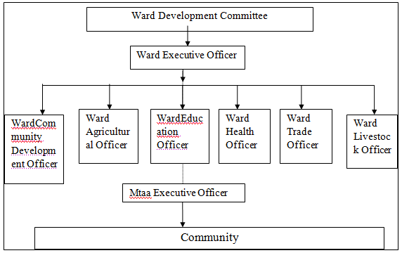
Figure 1.1 Ward Organizational Structure
Source: Tandale Ward Office (2020)

1.3 Tandale Household Women Community Needs Assessment
According to Sharma et al (2000) Community Need Assessment (CNA) a process of a community to determine their potential concerns it faces and identifying the assets they have or need to solve their existing needs. This CNA was conducted in Tandale from 1st to 7th^{rd} September 2020. The process involved interviewing household women community members of Tandale together the some local government leaders and technicians as key informants to identify needs of the local women community. Together with the interviews, the assessment also used focus group discussion; Observation and Transect walk to gather the required information.

1.3.1 Objectives of the Community Needs Assessment
The main objective of the CNA was to acquire detailed information and opinions related to TUKE household women community needs and resources available for them in Tandale Ward and suggest empowering interventions in response to the needs.

1.3.1.1 Specific Objectives
- Identify economic activities undertaken by household women in Tandale ward
- Identify the potential obstacles that hinders women in the study area to undertake economically viable activities to improve their income
- Assess the needs and opportunities available to develop social economic status of household women in Tandale ward.

1.3.2 Community Needs Assessment Questions
The CNA used six basic research questions as a guide to assessments. These were:-
- What are the economic activities under taken by women in Tandale Ward?
- Is the Tandale household women community accessing necessary services adequately?
- What are the existing gaps related to services rendered to household women community members in Tandale ward?
- What are important needs of the Tandale household women community?
- Which among the needs is given the most priority by the Tandale household women community?
- What are the obstacles that hinders women to earn adequate income from their income generating activities

1.3.3 Community Needs Assessment Methodology
This study used participatory data collection methods including individual interviews and focus group discussion to generate knowledge and reveal issues related to the needs of the household women community in Tandale. To complement the two approaches, personal observations and secondary data from Ward Executive Officer were also used.

1.3.3.1 Community Needs Assessment Design
A research design is the overall conceptual structure through and within which research is conducted (Kothari, 1990). Both descriptive and explorative designs were used to assess the community. The two were preferred because it uses the respondents or group members to describe the situation as requested by researchers or by the group members. The explorative approach was also employed while transacting the ward to collect information about the immediate community needs that could not be mentioned by the respondents or in the FGD. Through this triangulation both qualitative and quantitative data was collected as far as community resources and stresses were concern.

Study Sample and Sapling Procedure
According to Casley and Kumar (1988), a sample is a representative as close as possible of the full population in which conclusions about characteristics of the whole population can be made. In this assessment, two categories of respondents are considered (Table 1.2). The first categories comprised of the key informants including WEO, 6 Mitaa chairperson (MEOs); CDO; HO; SWO and 4 NGO/CBO purposefully picked due to the nature of their responsibilities in the Ward that makes then to have knowledge on the social economic status of the Ward population. The second category comprised of 40 women selected randomly from the list of 145 registered household women groups in Tandale. A Focus Group Discussions of 15 participants randomly selected from the list of household women groups provided by the WEO.was also used as a source of information.

Table 1.2: List of Respondents
Category | Title/Designation | Number of respondent
I | WEO, CDO, HO, SWO/MEO | 10
 | NGO/CBO/business member | 4
 | Mitaa Chairperson | 6
 | Sub total | 20
II | Household women groups members | 40
 | Total | 60
Focus Group | Household women groups members | 15

1.3.3.3 Data Collection Methods
Participatory approach was used in all processes of collecting primary data through focus group discussions and face to face interviews. Secondary data was collected through review of various reports at Tandale Ward and Kinondoni Municipal Council offices and personal observations. This data was needed to complement the primary data from FGD and interviews. This triangulation approach helps to validate data obtained from each source as it was compared with one another.

Observation involved making some transverse across the Tandale ward while recording any fact that had some effect on women economic activities while Interview was done to 20 key informants and 40 household women randomly selected from the women group lists in the ward semi structured questionnaires. Focus group discussion was conducted with 15 women formed from women group members to discuss the various issues related to their strengths, needs, opportunities and challenges.

1.3.3.4 Data Collection Tools
Data collection tools used depended on the methodology. Semi structured questionnaires were used in the direct interviews (Appendix 1). It helped in understanding of broader perspectives of the distinguished needs of the Tandale household women and the whole community members at large. In the Focus group discussions, a check list questions were used to provoke participants and data obtained were recorded and evaluated. As a tool, focus group discussion was used to cross check on the information gathered with other methods and also obtaining group views and eventually used to rank the needs from the assessments.

1.3.3.5 Data Analysis
Information obtained from the four methods were compiled, summarized and used to describe the community and their needs. Qualitative descriptions mainly percentages and frequencies were calculated by the use of excel software and the results used to describe the community. Where necessary few results were coded and subjected to SPSS (2010) software and analyzed in a cross tabulation approach. Facts obtained from the focus group including the challenges and needs that were mentioned and agreed by the household women community members were summarized and ranked to have prioritized needs. A pair wise ranking tool was used in the ranking.

1.4 Household Women Community Needs Assessment Findings
The findings from the CNA to Household Women (HW) community in Tandale Ward (Kinondoni Municipal) are presented in this section based on the method and type of data collection used as well as the type of respondents.

1.4.1 Social Characteristics of the HW in Tandale Ward Community at Large

1.4.1.1 HW Age Group
Table 1.3 shows the age of the HW who are making the various women groups in the ward as obtained from the interviewed household women. The results shows that majority of household women in the groups are adults of age 35 to 45 who under normal circumstances have families.

Table 1.3: Age of HW Respondents
Age group | Frequency | Percent
18 -25 | 2 | 5.0
25 – 35 | 8 | 20.0
35 – 45 | 13 | 32.5
45 - 55 | 13 | 32.5
Above | 4 | 10.0
Total | 40 | 100.0
Source: Research Findings 2020

These families depend partially or wholly on them, depending on the economic status of a particular family. People aged between 35 - 45 years in Tanzania is regarded as productive people and a targeted group to participate in social economic development activities that need to be assisted for developmental career where ever possible.

1.4.1.2 Marital Status of HW Group Members

Table 1.4: Marital status of HW Group Members
 | Status | Frequency | Percent
 | Married | 12 | 30.0
 | Not married/widow | 15 | 37.5
 | Divorced/separated | 13 | 32.5
 | Total | 40 | 100.0
Source: researcher, (2021)
Table 1.4 shows the marital status of the HW group members in the ward whereby married and single headed Households are more than married couples. The findings indicates among 40 people interviewed only 12 (30%) were married. The rest 70.0% were not married/widows. However the single family proportion could be an alarming indication that separation had forced them to come into the group as a rescue.

1.4.1.3 Household Status of the HW in Tandale Ward
From Table 1.5 about a half of the HW respondents were also the household head due to death of their husband, by divorce or not married at all majority at the age of 36-55years.

Table 1.5: Age and Household Status of the HW in Tandale Ward
Age group | Number of respondents | Percentage (%) | Respondents that are also HHH | Percentage (%)
< 20* | 3 | 7.5 | 0 | 0
20-35 | 9 | 22.5 | 4 | 10.0
36-55 | 26 | 65.0 | 9 | 22.5
>55 | 4 | 10.0 | 3 | 7.5
Total | 40 | 100 | 17 | 42.5
Source: Research findings, 2020
*<20 Years of age were still staying with their Parents

In such case she is responsible for all the needs of the family including food, shelter, health, education and other needs.

1.4.1.4 Education of the HW Members
Education is a very important factor in the development of projects and the community in general. The levels of education for household wives in Tandale varies from those with informal education to tertiary level but majority (95.0%) have primary and secondary education (Table1.1.6)

Table 1.6: Education Level of HW Members in the Groups
Education level | Frequency | Percent
Informal education | 5 | 12.5
Primary education | 26 | 62.5
Secondary education | 13 | 22.5
College | 5 | 2.5
Total | 40 | 100.0
Source: Survey Finding (2020)

Basing on the findings from the study (Table 1.6) majority had attained a primary level of education that would be a good stand for understanding of trainings in various aspects such as life skills and entrepreneurship. With additional awareness and trainings in various aspects their undertakings would be improved.

1.4.2 Social Services Assessment
Respondents had shown that transport electricity network, education and water supply was the best services that are available within the ward (Table 1.7). The results that are substantiated by the observations during transecting that the ward electricity and roads network are at the art of state. Government administration and support to investments was not readily accepted by the household women (Table 1.7). This implies that the community expects more from the government than it does now. Possibly more information on the role of government and awareness of the government administration machinery is needed to by the community.

Table 1.7: Available Social Services in Tandale as Indicated by the Key Informant and Household Women Respondents
S/No | Service | Responses *
 |  | Good | Fair | Poor
1 | Water Availability | 8 (13.3%) | 39 (65%) | 13 (21.7%)
2 | Electricity Availability | 49 (81.7%) | 9 (15.0%) | 2 (3.3%)
3 | Government administration and Support to investments | 20 (33.3%) | 33 (55%) | 7 (11.7%)
4 | Health Services | 1 (1.7%) | 22 (36.7%) | 37 (61.7)
5 | Access to Education | 41 (68.3%) | 11 (18.3%) | 8 (13.3%)
6 | Access to Transport system | 51 (85%) | 10 (16.7%) | 1 (1.7%)
7 | Social institutions | 0 (0.0%) | 11 (18.3%) | 49 (81.7%)
8 | Trading centres/retail and whole sale shops | 24 (40%) | ( 48) 80% | 7 (11.66%)
9 | Information systems | 12 (20%) | 33 (55%) | (39) 65%
*Respondent included both household women and key informants (N=60)
Source: Study Findings 2020

The efforts of government to create conducive environment for individuals to invest, provision of cost sharing should be put across the community for them to understand the role of the government roll and their role in service provision. Existence of the Social promotion institutions were not reported to provide good services to any of the respondents which calls for more awareness from the institutions including the NGOs, communication systems and sundries provider centers. The focus group had mentioned three major services that they consider to be adequately rendered in their community including access to primary school for their children, public transport and communication network and electricity supply.

1.4.3 Health Assessment
The ward has only one health centre which provide services to majority of the people in the ward and which its services are regarded as unsatisfactory by all respondents because of what they regard as substandard facilities and services. . Health challenges mentioned by the key informants are listed in (Table 1.8) whereby inadequate health facilities and diseases epidemics were considered as the major health challenges in the ward priority. Favorable environment for investors, proper town plan and maintaining neat and tidy environment are considered the best mitigation attempts by 95 and 80% of the respondents respectively. The results connote that health services were denied to be adequate because of both quality and cost involved. This needs critical consideration by the ward and Municipal administration given the fact that there is cost sharing in health services.

Table 1.8: Health Challenges and Possible Solutions/Strategies in Tandale Ward Community
Stress mentioned | Percent respondents | Mitigation | Percent respondents
Few health facilities | 95 | Crate favourable environment for investors / Proper town Plan | 95
High health services costs | 40 | Cost sharing policy review and adherence to health principles | 40
Disease epidemics (cholera, diarrhorea, Corona, Malaria etc) | 80 | Maintain neat and tidy environment and adherence to health principles | 80
 |  | Community awareness on disease etiology and cost sharing | 80
 |  | Cost sharing in waste management | 60
Existence of brothel (Uwanja wa Fisi) | 25 | Abolish the brothel place | 25
Outdated health equipments, staff with poor morale and insufficient drugs and medicines supply | 20 | Supply art of state equipments, instruments and provide incentives/motivation to health staff | 20
 |  | Cost sharing and financial planning by the municipal governance
Overpopulation | 5 | Family planning | 5

Source: researcher, (2021)

1.4.4 Environmental Assessment
Environment situation in the ward was assessed by revealing the challenges mentioned by the key informants and through observations (Table 1.9).

Table 1.9: Environmental Challenges of the Tandale Community
Stress mentioned | %* | Source | Mitigation | %*
Poor waste management | 75 | Limited resources, community negligence, | Provision of waste damp points/dust bins | 75
 |  |  | Cost sharing in waste management system | 35
 |  | Decrepit sewage system | Revamp sewage system
Overpopulation | 20 | Migration influx | No response | 100
Noisiness | 5 | High population | Human right Awareness and adherence | 25
Floods | 85 | Poor Drainage system, | Construction of appropriate drainage system | 45
 |  | Poor town planning | Ward collaboration with other Partners (NGO, Red Cross, DPs) | 55
Poor Housing | 20 | Poor Urban planning, | Re-planning of the township | 20
 |  | Poverty, | Economic enhancement | 5
Unplanned buildings | 55 | Poor Urban planning, | Re-planning of the township | 45
Brigand (robbery, stealing, bandit, thug) | 65 | Overpopulation, Jobless, poor town planning | Community Security System (CSS) (Sungusungu) | 45
 |  |  | Police Security system intervention | 35
Source: Field Data

Key informants had revealed seven challenges in which floods, poor sewage waste management and brigand (robbery, stealing, bandit, thug) was mentioned by majority of the respondents (85%. 75% and 65% respectively The irregular and non assured waste haulage at the street points leave a lot of garbage in the surroundings for long time un collected. Public sewer in Dar es Salaam is more than 48 years old and currently could provide services to only 7% of the Dar es Salaam residents (KMC, 2019) and this has necessitated the use of site disposal services such as septic tank system and pit latrines to 93% of Dar es Salaam residences.

The situation had imposes necessities for increasing the capacity of cesspit emptying services, which is being provided by both Municipal council and private sector at cost. Enhancement of the Community Security System (Sungusungu) were mentioned as possible strategies to encounter the challenges which seems to be more entrusted than the formal police system (45% as compared by 35%).

1.4.5 Economic Analysis

1.4.5.1 Employment to Community
Employment to the people of the ward was regarded as difficult by majority (95%) of the key informants due to few government employment vacancies and no private enterprises within the ward. Informal sector was regarded as the major employment opportunity available in the ward.

1.4.5.2 Economic Activities undertaken by People in the Ward
In the interviews, the 20 key informants were requested to list the activities done by majority of people in the ward while the 40 women group members were requested to list major activities done by women in the ward and again mention their group activities (Table 1.10).

Table 1.10: Major Economic Activities of People in Tandale Ward as Mentioned by Key Informants
Type of activity | Percent (%)
Type of activity | Activities in the community | Activities typical for women
Employed (government, private sector) | 15.0 | 15.0
Formal business (traders, shops, bar, etc) | 15.0 | 15.0
Tailoring (tailor marts) | 25.0 | 10.0
Handcrafts (batik, baskets, hand bags, etc), | 30.0 | 70.0
Petty street business (food items kitchen materials (sundries) along the street) Machinga | 100.0 | 55
Food venders (Mama Lishe, bakery, chips etc) | 85.0 | 100
Beauty saloon/hair cuts | 25.0 | 35.0
House girls/boys | 45.0 | 75.0
Maids and waiters in hotels, bars, | 55.0 | 55.0
Transport (Bodaboda) | 50.0 | 0
Small workshops (carpentry, mechanics, masonry) | 45 | 0
Agriculture (crop/livestock) | 0 | 65.0
* One activity could be mentioned by more than one person (Percentages Not mutually exclusive)
Source: Field Data

Key informants regarded employment in the formal sector and agriculture at least. Food venders (Mama Lishe, bakery), Tailoring, Handcrafts (batik, baskets, hand bags, etc) Petty street business (food items kitchen materials along the street, door to door delivery alias Machinga and House girls/boys are regarded as economic activities opportunities for most women in the ward society. Further to this, majority of the key informants (75%) consider the women IGA as not very successful while 25% do not even know how women are fairing with these activities. This situation is similar to what exists in many other cities of African countries (Bayeh, E. 2016, Montanari and Bergh, 2019).

Interviewed HW group members indicated that their groups are engaged in four major activities whereby food venders and petty business are mostly done (Table 1.11). Activities listed by the HWs are not much different from those mentioned by the key informants (Table 1.10) that indicate majority being engaged in informal sector. Some group members have their individual activities in addition to that done as a group whereas some are employed in the private sector. Others have beauty/hair dressing saloon and some have small shops. Those doing 'Mama Ntilie' had no spare time for doing any other activities outside the group. Tailor mat, saloon and maid groups are also having other activities outside the group. To learn from these results is that household women community is a low income community activities.

Table 1.11: Economic Activities done by Household Women Groups in Tandale Ward
Activity | Group business |  | Business outside the group
 | Frequency | Percent | Frequency | *Percent
Employed in registered private enterprises | 0 | 0.0 | 3 | 7.5
Small shops/stationeries, | 2 | 5.0 | 0 | 0
Tailoring | 9 | 12.5 | 0 | 0
Petty business along the streets and at market points (food items, kitchen materials, sundries ) | 0 | 0.0 | 2 | 5.0
Food venders (Mama Ntilie) | 13 | 32.5 | 0 | 0
Food venders (bakery, bites, vegetables etc) | 6 | 15.0 | 2 | 5.0
Beauty/Hair dressing Saloons/decorations | 2 | 5.0 | 0
Manufacturing of local good (soaps, mats, disinfectants, batik, tie and dye etc) | 5 | 12.5 | 0 | 0
Agriculture: Food processing | 3 | 7.5 | 0 | 0
Total | 40 | 100.0 | 10 | 17.5
Source: Surveys, (2020)

The findings reveal that only small percent (17.5%) of the household women are involved in other economic activities on individual basis. It means that majority depend on the income from the group or other relatives (husband/son/daughter etc) for income to sustain their families. The ward is not industrial area rather residential with limited employment chances leaving majority of the women engaging themselves in food vendors selling food items as it is regarded to be more rewarding and require little cash capital. One of interviewed women during transecting (face to face) on why so many women are engaged in food kiosk/vendors (Mama Ntilie) has responded;
" hauhitaji kutumia nguvu nyingi wala kutafuta mtaji mkubwa na watoto wanakula na wanaenda shule kwa shughuli hii hii")

Meaning that one does not need use a lot of efforts or invest heavily and yet children get their daily food and school requirements (fees, uniform and other amenities).

Urban agriculture (horticulture) was meagerly considered as economic activity in the Ward by the key informants (Table 1.10) but revealed by observations (Appendix VIII (c)) in few places. The findings from both key informant and the household women, are in line of the national population census (2002) which indicated that 52% of population in Kinondoni was engaged in informal sector especially groceries and small shops (KMC, 2019).

Through the interviews and observation it was observed that employment opportunities available in the ward for the community at large irrespective of gender include trading in small shops, kiosks, food vending (Stockiest and Mama Ntilie) and tailor mats (Appendix (d, e and f)), Others are hair beauty/barber saloon, handcrafts, workshops Charcoal vending, liquor stores/bars and second hand cloth vendors. The observation concurs with the documentary review findings that revealed the main activity in the area to be petty trade (Tandale Ward Annual Report, 2019; KMC, 2019) and also with the observations made during transecting. The results indicate that HW community is within poor economic environment.

1.3.5.3 Income of Household Women in Tandale Ward
The WH in the ward have income range from less than 10,000/- to above 100,000/=. Majority being at 10,000 – 50,000.00 (Table 1.12). Since majority of the women (82.5%) are only doing group activities for income (Table1.11), such income may not satisfy the family needs especially where such woman is also the household head.

Table 1.12: Income for Women Household Tandale Ward
Income range per month | Number | Percentage (%)
Less than 10,000/- | 2 | 5.0
10, 000 - 30,000/- | 15 | 37.5
31,000 - 50,000/- | 16 | 40.0
51,000 - 100,000/- | 5 | 12.5
Above 100,000/- | 2 | 5.0
Total | 40 | 100
Source: Surveys, (2019)

The results are in line with the Tandale community income at large which is estimated to have per capita income of less than1$ (2,200 Tshs) per day (KMC, 2019). Interesting is that, despite of the low income the HW members had all agreed that their projects are economically viable. This may be due to the fact that women do not consider income per-ce as only major benefit of being in groups. It could be done to the limited exposure to more rewarding activities.

1.4.5.4 Women Groups Formation and Objectives for Economic Business Ventures
When asked as to how they were motivated to join the group, majority were motivated by LGA staff. Table 1.13 shows the various ways in which women were motivated to join their respective groups.

Table 1.13: Source of Motivation for Forming/Joining the Group
Source/motivator | Frequency | Percent
Other women | 21 | 52.5
LGA staff | 35 | 87.5
Other sources (NGOs and CBOs /FBOs Mass media) | 4 | 10.0
Others Relatives | 5 | 12.5
Percentages not mutually exclusive
Source: Field Data (2020)

Majority of the groups were formed as LGA initiatives to empower women. They need to see that the groups are sustainable and their activities are both economically, socially and environmentally feasible. One major way of doing this is through trainings and supervision. Moreover they are all registered at the LGA office except two groups. that are not registered at all and six which are registered by BRELA. Registration under BRELA and Home Affairs gives more chance of getting credit from multisource financial institutions including Banks and International NGOs.
When asked as to why they had joined/formed groups the household women had four reasons of which income gain was given priority (100%) followed by social relations (40%) and status (50%) (Table 1.14). The responses justify the persistency of the group activities despite the low income as they are also going in groups for other purposes including social reason and status.

Table 1.14 Reasons for Making/Joining in Groups
Response | Percentage
Income | 100
Social Relations | 40
Status | 40
Percentages not mutually exclusive
Source: Field Data (2020)

1.4.5 Capital for Business
Major source of the groups for capital is the Government sources. It seems that they have little access to other sources. In the group discussion, this source was also preferred even more than own source and NGO/CBOs (Table 1.15) possibly due to its smooth loan conditions. The findings indicate that 12.5% of respondents used their own saving as capital for their business. Since they have low income the investment is also low. Where they will have no access to financial services this would be the case of poverty cycle.

Table 1.15: Source Capital as Mentioned by the Interviewed Women and group Discussions
 | Interview response |  | FGD results
 | Frequency | Percent | Scores | Rank
Personal capital (own source) | 5 | 12.5 | 77 | 3
Family and other Relatives | 3 | 7.5 | 28 | 5
NGO/CBO/FBO loans/grants | 3 | 7.5 | 99 | 2
SACCOS Loans | 4 | 10.0 | 69 | 4
Government loans/grants (LGA) | 25 | 62.5 | 127 | 1
Total | 40 | 100.0
Source: Field Data (2020)

During group discussions it was revealed that, majority of the groups were formed following some pressure/back up from the Community Development Officers. This means that, close follow ups and trainings are necessary for the groups. Work done elsewhere (Dodoma Municipal, (Sanga, 2019 Unpublished) has shown that there is a lot of delay and mishaps in the return of the soft loans from LGA Youth, Women and Disabled Funds as well as National Youth Empowerment Funds.

Table 1.16 shows the capital structure of businesses carried out by the women groups as obtained from the interviews. This low capital investments (50,000/= to 200,000/=) would be one of the reason for little revenue from their IGA but with low risks. Sampton, (2019) had shown that the low the capital invested in a business, the higher is the profit but the risk is low

Table 1.16: Capital for Group IGA (businesses)
 | Frequency | Percent
50,000/= - 100,000/= | 17 | 42.5
100,000/= - 200,000/= | 10 | 25.0
200,000/= - 300,000/= | 7 | 17.5
300,000/= - 400,000/= | 2 | 5.0
400,000/= and above | 4 | 10.0
Total | 40 | 100.0
Source: Field Data (2020)

As an economic principle, the low the capital, the low the income The amount of capital invested was regarded as insufficient to 87.5% of the HW members and only 12.5% were satisfied with the capital they had invested. Despite the insufficient capital, more than half (55%) accepted to undertake viable projects.

The findings indicates that majority (42.5%) had capital ranging from 50,000 - 100,000/= and only one (5%) had capital investment above 300,000/= They all agreed that this capital was not sufficient. When asked as to why such small capital they had mixed answers, While some claimed to have no means of more capital (72.2%) and no collaterals which was possibly due to difficulties of access to financial institution, this reasons were ranked 1st and 2nd in the group discussions. Other reasons for low investment were inability to manage large capital investments (11.7%) and risk a verse (Table 1.17).

Table 1.17: Reasons for low Investment in the IGA
Response | Interviews |  | FGD
 | Frequency | Percent | Scores | Rank
No collateral for loans acquisition | 30 | 27.0 | 116 | 2
No need (risk averse) | 13 | 11.7 | 0 | 4
Available low income | 17 | 15.3 | 157 | 1
Available opportunities not known | 31 | 29.9 | 157 | 1
Risk of large capital | 0 | 0.0 | 54 | 3
Source: Surveys, (2020)

The perception of having no need of large capital and viewing large capital as risk (risk averse) arises from lack of entrepreneurship knowledge and skills (simpson, 2019). The reasons given calls for a need to train them of entrepreneurship, importance of optimal capital, ways to search for loans/credits and look for an alternative sources that would provide soft loan such as Presidential Women Empowerment Fund (URT, 2014) and NGOs (CARE, 2018) Although, majority had obtained their capital from government initiatives (62.5%) there are also some NGO/CBO and National Government Funds where women could obtain loans or grants eg FINCA, CARE and National Women Empowerment Fund (URT, 2014). Further to this if they can fulfill banks conditions they can also get funds from these institutions which were not preferred at all by the FGD members. Currently none of the groups had attempted to accessed fund from these sources. All this calls for the need to have the community members more informed on possible sources of loans for projects.

A study done by Gichuki et al., (2014) in Kenya. revealed that , small investments are rather risky enterprises resulting into little revenues and curtail access to capital from recognized sources such as banks and some NGO . On the other hand, some investors would like to invest at small scale to see whether the experience is growing for better or worse (ILO, 2003) Indeed there is a need to create more awareness to the groups on the possible sources of credit and grants such as NGOs and the Government Empowerment Funds,

1.4.6 Women Groups Revenues and Expenditure

Table 1.18: Monthly Group Net Revenue per Person
 | Frequency | Percent
< 50,000/= | 0 | 0
50,000/= - 100,000/= | 15 | 37.5
100,000/= - 200,000/= | 18 | 45.0
200,000/= - 300,000/= | 4 | 10.0
>300,000/= - | 3 | 7.5
Total | 40 | 100.0
Source: Field Data (2020)

Table 1.18 shows the response of the interviewed women group members on their revenues. Monthly revenue of the group members is low for the majority whereby 72.5% receives an income of 50,000 to 200,000 TShs per month. This could be regarded as a result and cause of low investments in their respective enterprises. With this turn over, little is left for reinvestment. By nature, with low risk investment, there is less at stake either in terms of amount invested or the significance of the investment to profit. That is there is less to gain in terms of potential return or benefit terms.

Response on the kind of savings they undertake shows that none saves with Banks. Majority (90%) saves in a colloquial way (Upatu and Kibubu) while only 5% saves with Local SACCOS. One of the women in responding to the question of how they save their revenue reacted as follows: "What do I have to save in a Bank". The implication of such statement is that their income from the IGA is still low to allow substantial savings. The reasons given were uncertainty with SACCOs, collateral and bureaucracy with the banks and financial institutions. While the Upatu and Kibubu were mostly accepted because it is easy to get the money back and there is no cost of saving. The comments given in the group discussion is 'A bank is where you borrow an umbrella before it starts raining and they require you to return it once it starts raining'.

1.4.7 Knowledge and Skills for IGA to Tandale Household Women

1.4.7.1 Training in Business Skills
All respondents indicated to have received skills and knowledge from trainings done by LGA staff, or from experience/learning from others in various fields including entrepreneurship/business management, technical skills and women emancipation and development. Irrespective of the source, they had all considered the trainings to be insufficient in terms of skills and knowledge which may cause their business not to prosper. This does not underscore what has being reported elsewhere that since women owns small enterprises, they tend to be smaller and with poor growth compared to men owned enterprises, they therefore appear to be unsuccessful as measured by economic and financial criteria. (Tripp, 1989). The findings could be interpreted that the respondents need to be equipped with more entrepreneurship and business management skills, access micro financial institution and business management skills for them to operate their business more successfully.

1.4.8 Resources and Opportunities Available for HW to Develop IGA
Interview respondents were asked to indicate the opportunities available if utilized properly can help to develop their business. In the group discussions these available opportunities were listed and scored (Table 1.19).

Table 1.19: Resources and Business Opportunities Response from Household women Group Members and FGD
Opportunities | Response from HW |  |  | FGD |  | Results
 | Frequency | Percent |  | Scores |  | Rank
Existence of others already in business | 5 | 12.5 |  | 40 |  | 3
Conducive policy (LGA Empowerment Fund) | 40 | 100.0 |  | 212 |  | 1
Financial institution, | 4 | 10.0 |  | 90 |  | 2
Market Infrastructure/business points/open spaces | 13 | 32.50 |  | 31 |  | 3
Training opportunities entrepreneurship knowledge and skills | 6 | 15.0 |  | 27 |  | 4
NGO/CBO/FBOs | 11 | 27.5 | 90 |  | 2
High population as consumers | 11 | 27.5 | 0 |  | 5
Source: Field Data (2020)

The household women group members mentioned the conducive policy which is the existence of the LGA empowerment fund as the first opportunity followed by the existence of financial institutions (NGO/CBO/FBO) willing to support/empower women groups.

1.4.9 The Role of Government and Ways in which HW in Tandale Ward are Empowered
Under the current government policy (URT, 2000) HW are supposed to be empowered in various ways to enable them to sustain normal life. However, Ward administration provided a Ward Annual Report of 2018/2019 which showed that 43 out of the 143 groups had accessed the LGA Youth, Women and Disabled Funds.
Desk studies revealed that HWs in the ward are supported through capacity building (training on life skills and entrepreneurship), and information on available opportunities.

Table 1.20: Ways in which Household Women are Empowered in Tandale Ward as Discussed and Ranked in the FGD
Kind of Support | Score | Rank | Discussed remarks
Business Trainings | 27 | 2 | They are trained on entrepreneurship so that they can access and manage loans
Capital | 34 | 4 | Offered capital for IGA
Awareness and mobilization | 44 | 1 | Mobilized to form groups so that they can access loans or can be easily identified
Technical skills training | 48 | 3 | Trained on production technologies/skills such as manufacturing local soaps and batik
Source: Field Data (2020)

Other organizations, mainly NGO and FBOs also support women groups in policy awareness, entrepreneurship trainings, and few in financial assistance. Provision of tools and equipments is rarely done and to specified groups such as PLHA and when introducing new technologies. The above results were confirmed in the group discussions where capital awareness and groups formation and registration were given priority among the empowerment means from the Government and other stake holders (Table 1.20).

1.4.10 Business Challenges/stress that are Faced by Household Women in Tandale Ward
The household women responses on constrains and challenges faced in operating their business are shown in Table 1.21 and 1.22.

Table 1.21: Constrains/ Mentioned by the HWs
Response | Frequency |  | *Percent | Mitigation
Inadequate capital | 40 | 100.0 |  | Assistance by LGA to Solicit more capital
Insufficient entrepreneurship and business management skills | 34 | 85.0 |  | Trainings for knowledge and skills development
Group Members misunderstandings a | 7 | 17.5 |  | Training in group dynamics
Products market | 9 | 22.5 |  | Produce quality products
Source: Field Data (2020)
*Percentages not mutually exclusive

Majority of the respondents mentioned lack of adequate capital, lack of business management skills and difficult to obtain funds from the government and micro financial institution, to which LGA facilitation and training were considered as main mitigation strategies. Difficult condition to micro financial institutions was mention by very small percent simply because they don't even attempt to secure loans from the institutions. This is because of the already mentioned fact that the institutions need collaterals which the women groups do not have. Never the less this is a big challenge because, these institutions are paramount in supporting firms/groups that need capital for business.

Table 1.22: Business Challenges Mentioned by HWs
Challenge |  | Frequency | Percent |  | Mitigation
Bureaucracy in obtaining funds from Government source | 29 |  |  | 72.5 |  | Issue funds in time
Business premises not readily available and difficulties in marketing products | 12 |  |  | 30.0 |  | Ward Administration to assist in getting spaces
Difficult condition for getting funds from micro financial institutions | 4 |  |  | 10.0 |  | Policy reform  Timely loans
Rent, Tax and levies | 7 |  |  | 17.5 |  | Tax exemption  Review taxes and levies in favour of HW business
Customers loyalty | 3 |  |  | 7.5 |  | Strict terms cash business
Source: Field Data (2020)
*Percentages not mutually exclusive
Due to the mentioned constraints their business are operated with low knowledge and skills in addition to the already observed low capital. Different from what has been reported by Rwegasira (1998) none mentioned that they are constrained by the fact that entrepreneurship for women is not traditionally accepted activity. The author lamented that, "Women entrance into business is hindered by belief that engaging in business was incompatible with traditional women’s material and marital roles". Mitigation suggested are mainly availing sufficient capital to the groups, ensuring adequate knowledge and skills and creating awareness and enthusiasm of the group members. Others are facilitating formation of groups with similar interest (homogenous groups). Focus group discussions (Appendix VIII (g)) revealed challenges that they are facing in doing their IGA as shown in Table 1.23

Table 1.23: Challenges and Mitigations Derived from the Focus Group Discussion
Challenge derived | Score | Rank | Mitigations suggested
Lack of Capital | 199 | 1 | Increase loan/credit availability for capital
Security | 21 | 4 | Enhancement of LSS (Sungusungu)
Ill health and expensive health services | 11 | 5 | Environmental maintenance (cleanness), Awareness on environment and health norms
Limited Knowledge and skills for specified IGA | 98 | 2 | Provide trainings (skills, group dynamics, leadership, business )
Taxes and levies | 71 | 3 | Review taxes and levies , tax exemption to women groups
Source: Field Data, (2020)

These challenges had focused mainly on their IGA and pointed out lack of capital and limited knowledge and skills for specified IGA as major challenges. The results which are similar to what has being reported by the interviewed respondents (Tables 1.22.

1.5 Resources available, Stress and Needs for the Household Women

1.5.1 Available Resources that could be used to fulfil the Needs
Available resources that were indicated by both key people and the HW include the NGOs that are willing and able support women groups, good policy, existence of financial institutions such as Village Community Bank (VICOBA), PRIDE, Pakacha and Small Industry Development Organization (SIDO)that could offer credits to the HW groups. Existence of Community Development and Officer, Social Welfare desks (qualified staff that are capable to advice and offer appropriate services to Tandale community) also a resource to them.

1.5.2 Needs and Stresses
From the challenges given by the HW members and key informants as well as from the observations, major stresses and needs of house hold women in the community were deduced and listed (Table 1.24).

Table 1.24: Tandale Ward WH Economic Needs
SN | Economic stress | Need
1 | Small capital and Accessibility to Loan | Access to credit/financial institution , Avail Capital for IGA, and Facilitation to access Credit/loans from various Institutions
2 | Unemployment | Employment
3 | Insufficient business/trading centers and market | Access to affordable business premises  Reliable market for their products
4 | Inadequate entrepreneur and respective technical skills | Entrepreneurship and business management skills  Technical skills to a particular IGA
5 | Insufficiency in business, capital and market information | Updates in proper information channels
6 | Insecurity to their properties and themselves | Enhanced social security system
7 | Unstable economic groups | Strong and stable formal group
Source: Surveys, (2020)

1.5.3 Community Needs Prioritization (Leveling of Needs)
Revealed needs were discussed a group of 20 household women that were randomly selected from the groups and the CED student as a facilitator of the process. The
needs were discussed and eventually ranked by the group using pair-wise ranking techniques. The results are shown in Table 1.25

Table 1.25: Pair-Wise Ranking of Household Economic Needs
 | Access credit /financial institution / Capital for IGA | Employment | Access to affordable business premises | Reliable market for their products | Entrepreneurship and technical skills | Updates in proper information channels | Enhance social security system | Strong and stable formal group | Scores | Rank
Access credit/financial institution/ Capital for IGA |  | √ | √ | √ | √ | √ | √ | √ | 7 | 1
Employment | 0 |  | 0 | 0 | 0 | √ | 0 | 0 | 1 | 6
Access to affordable business premises | 0 | √ |  | √ | 0 | √ | 0 | √ | 4 | 3
Reliable market for their products | 0 | √ | 0 |  | 0 | √ | 0 | √ | 3 | 4
Entrepreneurship and technical skills | 0 | √ | √ | √ |  | √ | √ | √ | 6 | 2
Updates in proper information channels | 0 | √ | 0 | 0 | 0 |  | √ | 0 | 2 | 5
Enhance social security system | 0 | √ | 0 |  | 0 |  |  |  | 1 | 6
Strong and stable formal group | 0 | √ | 0 | 0 | 0 | √ | √ |  | 3 | 4
Source: Research Findings 2020
The results from Table 1.25 indicates that the major needs to the household community is the access to financial institutions or any other institution that could offer credit or grants them as capital. Previously it was observed that their IGA are of rather low credit and that might not allow them to realize some profit. The second need was the needs to have entrepreneurship knowledge and the technical skills to whatever project they were to do. For instance in the FGD it was realized that they were preparing food and sell ready packed. However they didn't have the knowledge of packing food for take away. Premises and reliable market was the third and fourth needs respectively. In this case there arised the need to establish the major cause of such challenge and their possible solutions.

1.6 Conclusion
The study has shown that, Tandale Ward is low earning community, majority of the household women are engaged in small business (tailor marts, small shops, food vendors, and petty street business. Participatory assessment conducted with Household Women group members showed that women were constrained by access to financial institution for credits, maintaining stable economic group and inadequate entrepreneurship knowledge and skills. The members were however willing to develop their group to be economically more strong in order to utilize opportunities available and to obtain more income so as to break the vicious circle.

The various established needs that were given priority include availing capital to women groups. The second and third needs were entrepreneurship, management and technical skills for their IGA and access to affordable /demarcated business/trading premises respectively. This was followed by awareness of available sources for capital and group formalization to have economical and social stable groups.

CHAPTER TWO

PROBLEM IDENTIFICATION

2.1 Introduction
This chapter explains the problem identified during participatory community needs assessment. It specifies the target community and stakeholders, the magnitude and impact of the problem. The goal and objectives that are set for informed interventions are discussed. The surveys showed that majority of Tandale Ward household women are engaged in small business mainly food vendors and some other petty businesses of low capital investments.

The CNA identified different problems and needs of household women groups at Tandale. These groups doing some business, lack basic skills to operate their businesses. Consequently, they end up doing unprofitable or rather low profit economic activities. Their economic activities are very informal, and of very low scale and of very poor standards because of the low investment.

2.2 Problem Statement
Majority of Household Women Group members are low income earners. Their groups operates small scale economic businesses of low investment that are unviable. They lack strategic plans to guide them in different matters concerning their activities, and have inadequate entrepreneurship skills and knowledge. Furthermore, they have no link with financial institution for credit or grants as capital. Consequently they have been continuously doing unviable IGA This underscores the fact that training them in group dynamics, management, entrepreneurship and have them bounded by a strategic plan will facilitate the group access to credit, and improve their performance of their IGA

2.3 Project Description
In order to establish the underlying causes of the stated problem in Sec. 2.2, a focus group composed of 20 members was used. These members were picked from 20 randomly selected groups out of the 140 listed Household Women Groups in Tandale. The task of this focus group was to establish the cause, propose possible intervention and eventually undertake the stake holders analysis for proposed project. The group first established a problem tree (Figure 2.1).
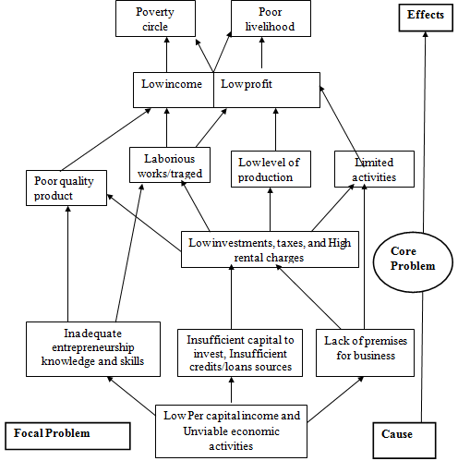

Figure 2.1: Problem Tree Analysis

From the analysis, the plan was to concentrate on empowering the women groups by acquainting then with sufficient group dynamics business knowledge; and information on capital acquisition. By empowering one Household Women Group, it is expected to have a spillover effect even to other women group. A project to empower one Household Women Groups at Tandale Ward in Kinondoni Municipal Council by formalizing it, assisting them to develop simple strategic plans; training their members in entrepreneurship and group management and connecting them to financial institutions was proposed and developed.

2.4 Targeted Community
The project targeted one group named TUKE Group but with expectations that its impact will spill to all members of the Household Women Groups and eventually to all entrepreneurs community residing in Tandale ward where the project is implemented. TUKE group was simply picked up randomly from the 20 groups whose members formed the discussion group.

2.4.1 Stake holder Analysis

Table 2.1: Stakeholders Analysis
Name of Stakeholder | Stakeholder Roles | Expectations
Household Women Groups | Project owners and are expected to fully involved in managing and administering project | Registration, access credits, fund raising activities, become knowledgeable in IGA
Community Members | Customers of the products and Support women group members during implementation of the project | Get art of state services from the HW, Provide conducive relationship during project implementation
Ward Local Government | Availing conducive environment for trainings and women IGA undertakings | Full Participation in project implementation, Support trainings, Avail training Venue.
Municipal Council | Support to women empowerment, adequate trainings and technical support in implementing the project and provide capital through Women, Youth and Disabled Empowerment Fund | Support cooperation among stakeholders towards project success, Trainings and M&E of the project, Support HWGs getting credits and business information
Central Government | Technical support , policy issues, legal and regulatory frame work for project sustainability | Collaboration efforts among stakeholder towards project sustainability
Financial institution for loan/credit | Collaborate in providing financial services to the community especially loan through sharing experience | Provision of capital, soft loans, monitoring and evaluation of projects
Source: Research Findings 2020
Stake holders are major key players in the process of identifying, implementation monitoring and evaluation of a project towards its success or failure. The focus group established in Sec. 2.3 was used to enlist all the possible stakeholders within the area and their expected roles, and their institutional relationship (Table 2.1).

2.4.3 Project Goal
The goal of the project is: To have household women groups in Tandale undertaking profitable income generating activities.

2.4.4 General and Specific Project Objectives
The general objective of the project is to support women groups in Tandale Ward to form a platform (Tandale WOSEG Platform) that can link the women groups to financial institutions and act as a hub for appropriate business and technical information source and empower one group (TUKE) as a role model by January 2021.

The project aims to achieve the following specific objectives:
- To guide the 145 women groups in Tandale ward to form a social economic platform (Tandale - Social Economic Groups Platform (Tandale-WOSEG Platform) and linked with micro financial institutions by December, 2020;
- To train TUKE Household Women Group members in group dynamics and strategic plan formulation by January 2021; and
- To empower TUKE Household Women Group through training its members on entrepreneurship, business management skills and basic food technologies to increase their earnings from their IGA. Have it as a role model group to train other groups by January 2021

2.4.5 Activities
- Call and hold meeting with 145 group chairperson and persuade them to form a platform (awareness and persuasion) and connect them with financial institutions
- To train at least 20 members of the formed platform on strategic plan development and wining proposal write up for fund requests (loan, credit, grants, contributions, donations, charity and others);
- Conduct training on group organization, dynamics, leadership, and entrepreneurship skills to TUKE Household Women Group members

2.4.6 Indicators
- Meeting session, Meeting Agendas, Household Women Groups platform formed and Groups have a link addresses;
- Training manuals, Household Women Groups well organized with simple strategic plans and achievable Vision and Mission.
- At least 20 Household Women Groups regarded as a reputable group that could be accredited
- At least 20 Household Women Groups accessing funds from various financial institutions.
- At least 20 Household Women Groups and members conducting viable IGA

2.5 Host Organization
The project was hosted by TUKE Women Group located in Tandale ward at Kinondoni Municipal Council.

2.5.1 TUKE Women Groups Vision
The host organization vision is to be a reputable women economic group able to undertake socially and economically viable activities

2.5.2 TUKE Women Groups Mission
The organization mission is to strengthening and improves their income generating activities that will increase their individual income and make them highly respected and recognized creditable economic women group in Tandale Ward

2.5.3 TUKE Women Group Objectives
TUKE Women Group objectives are:-
- To be household women group with members that can come together, discuss and agree on their various needs, challenges and available options
- To cooperate with other organizations within, and outside Tandale Ward to implement socio economic activities and programs beneficial to HW
- To operate diversified IGAs and produce various food materials, ingredients and packed food to sell for income
- Improve the standard of living of their family members by increasing production efficiency, income and savings from their IGA
- To be a creditable entity by financial institutions so as to be able to increase the capital for their income generating activities

2.5.4 The Management Organization of TUKE Women Groups
Administratively, TUKE Women Groups is headed by a chair person who is the overall in charge of administrative matters and she is assisted by a vice chairperson. Other office bearers are the treasurer, and the secretary. All officer bearer are on two years terms. The five makes the administration team of the TUKE Women Groups which has 15 members (Figure 2.2).
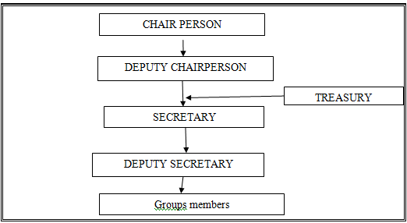

Figure 2.2: Organizational Structure Tandale Household Women Groups

2.5.5 SWOC analysis of TUKE Household Women Group
SWOC analysis of TUKE was done by the focus group to identify its strengths, weaknesses, opportunities and existing challenges in order to enable developing a strategic teaching materials as well as other activity schedules. Table 2.2 shows the SWOC analysis of the Platform.

Table 2.2: Household Women Groups SWOC Analysis
INTERNAL ANALYSIS |  | EXTERNAL ANALYSIS
Strength | Weakness | Opportunities |  | Challenges
Considerable large number of household women eager to undertake income generating activities | -Weak management organization |  | Trainers willing to train them |  | Limited capital
 | -Low income  -Inadequate knowledge and skills for economically viable activities |  | Accepted by the community members leaders/Municipal |  | Limited funds sources  Hard to reach funding sources
 | -Low level of production |  | Large population (produce consumers) |  | -Unacceptable quality of products
 | -Lack of substantive capital |  | Possibility of credit from various organizations (LGA, NWEF, Banks, NGOs) |  | -Lack of collateral  - Low level of investment
 |  |  | Some NGOs willing to assist |  | -Limited knowledge to loan logistics
 |  | Acceptance of the group as a role model |  | -Low capital to invest
Source: researcher, (2021)

2.6 Conclusion
The underlying causes of identified problems of woman social economic groups associated with unviable IGA undertakings are insufficient knowledge in entrepreneurship and technical skills. Others being low capital investment that was rooted to having insufficient information on available sources of funds and the requirements/prerequisites for soliciting funds from the sources.. A project was designed to tackle the challenges and piloted to one women social economic group in Tandale (TUKE). This group was selected among other groups to be a pioneer and to become a Training of Trainers (ToT) for other groups in the ward.

CHAPTER THREE

LITERATURE REVIEW

3.1 Introduction
This chapter presents a review of what has being documented by other researchers as far as women groups’ empowerment and income generation activities are concern. It is subdivided into theoretical, empirical and policy review sections. The theoretical parts covers general information related to theories that speculates women empowerment and development while the empirical literature summarizes practical information cited from different authors on similar topic. The policy review section summarizes the existing international and national policies that support or discourage women empowerment.

3.2 Theoretical Review

3.2.1 The Concept of Empowerment
Empowerment is defined by Wilkinson, (1998) as a process that creates power to individuals over their own lives, and in their communities at large, meaning to increase the spiritual, political, social, racial, educational, gender or economic strength of the individuals and communities totality. Mosedale, (2005) view people being empowered when they are able to access the opportunities available to them without limitations and restrictions. Similar to this,

The World Bank (2006) had defined empowerment as in three perspectives that are “the process of increasing capacity of individuals or groups to make choices and to transform those choices into desired actions and outcomes; to ‘build individual and collective assets, and to improve the efficiency and fairness of the organizational and institutional context which govern the use of those assets” and the “expansion of assets and capabilities of poor people to participate in, negotiate with, influence, control, and hold accountable institutions that affect their lives’’. According to UNIFEM, (2000) gaining the ability to generate choices and exercise bargaining power developing a sense of self-worth, and the right to control one’s life is what should be regarded to as empowering individuals.

All definition, suggest that the empowered individual/group (in this case women) will develop confidence and bestowed with capacities to make decisions and undertake some pro social economic activities to improve their living standards. Women access to resources alone does not automatically empower them, because for it to be effective, they must also have the ability to use the resources to meet their goals they choose. In case therefore, their status in women in the society must be heaved through education, raising awareness, reducing their illiteracy, and training them in various technical and life skills all geared to equip and allowing women to make life-determining decisions (Bayeh, 2016)

Empowerment when done in a participatory approach that involves discussing with women, and even men of the community in concern and analyzing jointly with them issues that are within their environment had shown better results (Summy, 2015).; It helps to identify and assert available resources that could be used to solve their own problem and forms the basis for the implementation of a rights and community-based solution. As observed by IFRC and RCS, (2011) the result of needs assessment guides community towards problem roots identification, planning for solutions, implementing, monitoring and ownership of their activities/projects.

3.2.2 Women Groups Economic Empowerment
Women's economic groups empowerment refers to the process by which women group members enjoy their right to control and benefit from the economic resources, assets, income and their own time, as well as the ability to manage risk and improve their economic status and well being. (Care International, 2018; Nabil Abdo, 2019) . Women play a great role in the national economy and at household wellbeing responsibilities and production processes at all social levels it being household national or global (Everleigh et al. 2015; Philipo, 2008).

At family level, incomes of women are used for the increase of the well being of the family To enable them to thrive in such situation, women especially the low income earners have become largely interested in running small scale projects in older to improve their standard of living. However, faced with various challenges including insufficient funds, poor technology, low education and inadequate business skills (ILO. 2003; 2017) which makes most of women’s projects being established to fail. This is why they need to be empowered.

Majority of worldwide women groups are planned and formed for a purpose, and are often large and usually formally organized. They are composed of women members with common property of interdependence among with common purpose. Such groups are regarded as secondary groups, (Brown, 1999; Forsyth, 2016 and Benson 2009). Group members share beliefs, values, and norms of their common interest; they come together to work on common tasks and for agreed purposes (Benson 2000). Being in a group, women have the opportunity to work together on joint projects and tasks, and with time, they can develop more complex and larger-scale activities and become a significant sites of socialization and education whereby enabling them to develop a sense of identity and belonging, to deepen their knowledge, skills, values and attitudes. As income generating groups, they gave a chance of enhanced economic activities. Benson, (2009) and Das and Chandra (1973) had reported that in a group, women has a chance of being considered for support in their activities, in other words 'empowered' while outside the groups, women may exercise less social responsibility which in turn will often lead to less task involvement.

3.2.3 Women Groups Empowerment Interventions
The literature shows that empowering women groups in the informal economy is key to expanding their choices, improving their livelihoods and advancing gender equality (Charmes and Saskia, 2003; Elis, 2007;. UN, 2009; ILO,. 2015; UNWomen, 2018) Empowerment interventions within and between the groups are clustered into four typologies that include training and skills development; entrepreneurship promotion; employment services; and access to resource and subsidized employment (Kluve at al., 2017).

In line with the theory of change Stein and Valters (2012), these aspects do improve the thinking capacity, issues perspectives and enhancement in employment and earnings outcomes for women. Women can be imparted with business skills i.e. entrepreneurship which has been recognized worldwide as an integral component of women employment creation through trainings (FAO, 2016; Gaur, 2017). Joseph Schumpeter’s (1949) innovation theory of entrepreneurship quoted by Nayab and Rebeca, (2011) describe an entrepreneur as one having innovation, foresight, and creativity. These are achieved through trainings and experience. Other interventions for women empowerment include micro-credit, or any other financial assistance for small scale businesses that will act as Startup Capital and women rights emancipation (UNWomen, 2018).

3.2.4 Income Generating Activities (IGA) for Women
Studies generally indicate that female groups formed and group promotion activities have being reported as major way to feasible IGAs that gives women a higher status within the family. This also place greater amount of income under women's control devoted to their children's education, health and nutrition (FAO, 2016). It is so when guaranteed that women will have the control of the funds (saving, loans etc) and the free disposal of them to implement IGAs (ILO, 2003). Considering their family responsibility, the main push of the women's development activities would therefore be to assist them in the establishment of sustainable income generating activities to be undertaken in or near the home.

Various studies (Montanari and Bergh, 2019; Philipo, 2008; Everleigh et al., 2015) had reported small-scale agricultural (to include and animal production) and their products processing and preservation as activities for women in rural areas. On the other hand, food processing, sewing, knitting embroidering, carpet making , vendors, handcrafts, sundries and trading as for urban women. Empowerment efforts should thus focus more on location and how to market such products since physical environment and lack of marketing expertise is regarded as the major constrain of several women production(Montanari and Bergh (2019).
With the ever increasing urbanization in the developing countries the small-scale enterprise sector becomes more and more important and a substantial number of women are now involved in these small scale enterprises. There is an increase in number and volume of women businesses in terms of formalization, employment growth, equipment used, and size of businesses established been facilitated by access to finance; advice given by friends and relatives; moral support and encouragement from, friends and family members; competencies acquired prior to starting the business, and various strategies adopted by the women entrepreneurs themselves during the course of running business.

However, these activities have never sustain their income generation and /or their incomes are still low with little or no savings (Makombe, 2004). This indicates that there are some underlying issues that hinder sustainability of their projects. Such factors need to be studied so that remedies could be developed to make their income objectives attainable. Either they are reported to undertake short termed/not sustainable projects (Elgar, 1997) or unviable (little or no profit).

3.2.4.1 Success in Women Income Generating Activities
The identification of income generating activities should come from a bottom up approach so that it correspond to the needs of women in concern, PRA with women to identify problems, elaboration causes, group promotion and programme development (planning, organizing and supporting) has shown to have good results toward type and sustainability of the IGA (Sara et al., 2015). It should be noted here that financial institution and empowerment programmes has to support, IGAs that are traditionally undertaken by women, and located in or near their home place. In that way the women can use skills and experience they already possess and supervise/involves themselves more cordially. Women needs to be motivated to start and run a business. They enter in IGA as a as a hobby, a way of creating employment for themselves and, to create income. With this, they enjoy and feel secured. As a group then, they must have common interest and exposed to some role models. Skills and competence acquired prior to starting the business of from trainings are also important for successful women IGAs (UNWomen, 2012).

3.3 Empirical Review

3.3.1 Women Groups IGA Development, Existence and Performance
International aid donors, governments, scholars, and other development experts have paid much attention to microfinance as a strategy capable of reaching women and involving them in the development process. A 2001 survey by the Special Unit on Microfinance of the United Nations Capital Development Fund (SUM/UNCDF) revealed that approximately 60 percent of their clients were women. Six of the 29 focused entirely on women and the remaining 23 in mixed-sex programs with 52 percent of clients being women (USAID, 2010). According to USAID’s annual Microenterprise Results Report for 2000, approximately 70 percent of USAID supported MFIs’ clients were women (USAID, 2001). Considerable variation existed among the regions with percentages of women clients ranging from 27 percent in the Near East to 87 percent in Asia.

Research done by UNDP, UNIFEM, and the World Bank, among others, indicates that gender inequalities in developing societies inhibit economic growth and development. For example, a recent World Bank (WB, 2001) report confirms that societies that discriminate on the basis of gender pay the cost of greater poverty, slower economic growth, weaker governance, and a lower living standard of their people. The UNDP found a very strong correlation between its gender empowerment measure and gender-related development indices. Overall, evidence is mounting that improved gender

Development results cannot be maximized and sustained without explicit attention to the different needs and interests of women and men. equality is a critical component of any development strategy. CIDA for instance, recognizes in its gender policy (CIDA, 1999), “Attention to gender equality is essential to sound development practice and at the heart of economic and social progress. As part of its poverty reduction priority, CIDA supports programs that provide increased access to productive assets (especially land, capital, and credit), processing, and marketing for women. by giving women access to working capital and training, microfinance helps mobilize women’s productive capacity to alleviate poverty and maximize economic output. In this case, women’s entitlement to financial services, development aid, and equal rights rests primarily on their potential contribution to society rather than on their intrinsic rights as human beings and members of that society.

3.3.2 Challenges Faced in Empowering Women
In the processes of empowering women, a myriad of challenges are reported. Such challenges include inadequate customers, non-payment of debts, high taxes and license fees, unavailability of finance, lack of space, lack of capital equipment and difficulties with existing regulations (Peprah et al., 2019; Mwau, 2009. Work done by ILO (1984) noted that the failure of women economic activities in groups is due to lack of education and skills particularly in technical, managerial and commercial field (Gichuki, Njeru, and Tirimba, 2014).

In his study on challenges facing informal sector activities in Kangemi, Nairobi, Mwau (2009) cited inadequate trading spaces as challenges facing women in the informal sector that was attributed to poor urban planning in the study area. In another study by Jaka and Shava (2018) in Zimbabwe, it showed that limited number of small and medium scale entrepreneurs succeed in accessing funds from financial institutions, the main reason being failure to meet lending requirements, among them being provision of collateral security. Thus, the inability of the informal sector workers to provide these collateral securities hinders their ability to secure loans from banks

Beside this, other workers in SSA had reported high loan processing fees, high rates of legal fees, and of interest, high cost of credit insurance and high expenses incurred in travelling in the process looking for credit which further exacerbate their problems (Shangadi. 2017; Ackah and Vuvor, 2011; Gichuki et al., 2014) Mwangi and Bwisa, 2015). Peprah et al., (2019) work in Ghana reported 3.9% of women in informal sector facing a constraint such as difficulties with existing regulations (such as payment of property license, container license and yearly medical screening for food vendor) while 32.9% were faced by the challenge of having inadequate customers.

The later underscore the need of having background information of the potential of business location. Poor and uneducated women are likely to be found in informal sector, operating small food kiosks while some richer women with more capital operate relatively large enterprises, employing more labour and use appropriate technology. Minde, (1998) in Tanzania and Mutangadura,(2005) in South Africa reported constraint in women IGA to include socio-economic factors namely illiteracy, lack of capital and implements for economic business, collateral, entrepreneurship skills and experience, training and advice which hinder them from access and control of financial resources. Other studies (ILO,1984; TACAIDS, 2018, REPOA, 2007; USAID, 2019) in addition to these had identifies reported lack of assets and access to wealth, markets, and to community rights, premises for business and credibility to loans.

3.3.3 Women Empowerment in Tanzania
Empowerment effort did especially to those poor include the establishment of enabling policies and Funds specifically for women. The government of Tanzania has introduced Youth, Women and people with Disabilities LGA Funds (URT, 2014)to finance self help community to address social and economic needs of this group. The government of Tanzania has also introduced Women Empowerment Presidential Trust Fund (WPTF) (URT, 2000) specifically for women to finance self help community to address social and economic needs. In addition, there are also NGO/CBOs as well as trust funds geared towards women empowerment (Care International 2018; UNDESA, 2013;.UASID, 2019)..

The Tanzania Social Action Fund (TASAF) through a credit from the World Bank (WB) is another source that women can approach for social economic support, (TASAF, 2011). Through these empowerment funds, awareness, training on entrepreneurship and skills, soft loans, and conducive environment (social political change to involve women in decision making) are the top most strategies used (URT, 2010).

3.3.4 Women IGA in Tanzania
It is estimate that by year 2025, over 55% of the Tanzania population will be urbanized (Sheuya, 2002, UNIDO/ILO/UNDP, 2002; and UNIDESA, 2013). In this case urban areas such as Tandale in Kinondoni will have more people and off-course more women that needs to have stable families (primary group). This connote the importance of this group having stable income to support their families. In 2004, it was been estimated that women constitute 43% of all entrepreneurs in Tanzania (ADB/ILO, 2004) despite of the constraints which prevent them from participating on a gender equity environment.

In most parts of Tanzania, women operate through the use of small loans from Financial Institutions such as Care International, FINCA Tanzania, BRAC, SACCOS and VICOBA. and Government programs to mention few (URT, 1988, 2017). These small loans has resulted in a tremendous positive upward mobility in the poor families livelihood through house women mainly the single mothers who, otherwise, have no income of their own e.g. funds from Pride Tanzania (Tembo, 2011). They use these income to raise their children, to contribute to the education of their children and effect all other family needs.

The enterprises tend to be in informal, low capital, low profit areas, with intense competition e.g. food vending, tailoring, batik making etc (ILO, 2003). The International Labour Organization (ILO, 2001) research reported several challenges to good performance of women entrepreneurs in Tanzania to mention some are limited skills and knowledge; limited support services; including finance, technical skills, management and advocacy services; and social-cultural obstacles as well as legal, regulatory and administrative barriers which do not support women to start and run enterprises (ILO, 2001). UDEC, 2002 isolated the major ones to be impaired project management, funding, expertise and marketing. This has not hindered women to prosper although few to develop formal small and medium enterprises, demonstrating “upward mobility”. In their report, EFG (2009)suggest for a great need for more information and understanding on the situation female entrepreneurs face in establishing and practicing IGA for further advancement.

3.4 Policy Review

3.4.1 International Policy on Women Empowerment and IGA
Empowerment of women, also called gender empowerment, has become a significant topic of discussion in regards to world development and economics agenda. Entire nations, businesses, communities, and groups can benefits from the implementation of programs and policies that adopt the notion of women empowerment. It is one of the main procedural concerns when addressing human rights and development.

United Nations human development and capabilities approach, the Millennium Development Goals, and other credible approaches/goals for development point out empowerment and participation as a necessary step if a country is to overcome the obstacles associated with poverty and development (UN, 2016; WB, 2006; FAO, 2016). It has established various policies that advance gender equality and youth inclusion in a supportive enabling environment under the United Nations poverty-related Sustainable Development targets for women empowerment (UN, 2016; USAID, 2019). WB recognized the importance of taking women development agenda on board by establishing the post of advisor on women in development (Mascarenhas and Mbilinyi 1983)

3.4.2 National Policy on Women Empowerment and IGA
Like many other developing countries, Tanzania has adopted policies that advance gender equality and youth inclusion in a supportive enabling environment (Neema, 2014, ILO, 2001). The main thrust being to assist women in the sustainable establishment of income generating activities with a strategic concern to eradicate poverty This is done through empowerment of people including women for self –development taking the informal sector as an important part of the equation (URT, 1992), That is to say, establishing system to reduce women’s heavy workload and to expand on ways which will be used in coordinating women development programs.

Women empowerment in Tanzania is cordially supported by several national policies including Women Development Policy (URT, 1999); Private Sector Development Policy (URT, 1999); Poverty Reduction Strategy (URT 2010) and Community Development Policy (URT, 2007). Nevertheless, because of the various constrains facing women groups social and economic development in the country including lack of assets and access to wealth, access to markets, lack access to the community rights capital for economic business, premises for business, entrepreneurship skills, credibility to loans (ILO, 1984; and REPOA, 2007, USAID, 2019), there is still a need of vigorous and dynamic attempts of empowering women.

3.4 Literature Gap
Through the literature reviewed, it is obvious that enormous efforts have been done to empower women through soft loans and grants. The results of such efforts have not being realized to is optimal level for various mentioned obstacles that which are location oriented. CNA enabled the identification of such obstacles and possible remedies. Knowledge and skills on entrepreneurship has been mostly considered the outermost impediment. This implies that training component must be done tactically from the pedagogical and didactic (moralistic, informative and instructive education) point of view such that the mindset of those concerned (women) could be reoriented to entrepreneurship and technical skills with respect to the activity to be taken up it being service or production project is sufficiently acquired. Women groups needs to be made more homogenous in terms of interest and goals through awareness and convincing programs.

CHAPTER FOUR

PROJECT IMPLEMENTATION

4.1 Introduction
Project implementation is the stage where planned activities are put into action. Before the implementation of a project, the implementers do identify their strength and weaknesses (internal forces), opportunities and threats/challenges (external forces). These are positive forces that should be exploited to implement planned activities of a group.

On the other hand weaknesses and challenges are hindrances that can hamper project from been implemented and should be well addressed for a positive results. All these have been outlined in Chapter 2 section 2.3 to 2.5. This section covers planned project activities and how it was implemented. It presents the original project implementation plan and the actual implementation as well as reporting the achievement and failures. The section gives the outline of the project goal, to support women to develop and undertake financially viable business of their own.

4.2 Project Products and Outputs
The outputs anticipated from the project include established Tandale Household Women Economic Group Platform (Tandale WOSEG), trained candidates from TUKE - HWG as experts in groups IGA and TOT to other women groups, TUKE - HWG strategic plans and prepared, and they can access loans from various financial institutes, Training manual developed that will be used even by the trained women for reference and for training others, and Women groups that are linked with financial Institutions. Other is readily marketable products from TUKE. For that matter the immediate product of the project is the TUKE HWG empowered to becoming a creditable registered group with members who are able to practice economically viable IGA other products are the Tandale WOSEG platform and readily marketable food products from TUKE. .

4.2 Project Planning

4.2 Project Implementation Plan
Planning is a process which describes series of activities that are planed and implemented to achieve the set goal(s). Planning was done in participatory way that involved all group members. In order to achieve the mentioned output and product in Sec. 4.1, a project was planned with various activities and a set targets in a logical framework (Table 4.1) followed by an action plan (Table 4.2) that showed the responsibilities of each stakeholder, time frame and required resources for each activity in the project.

Table 4.1: Logical Frame Work by Matrix
Objectives |  | Activity |  | Performance indicators |  | Means of verification |  | Assumption
Goal: Tandale Women groups become economic groups, with member well informed of the available knowledge and skills for their respective enterprises through a registered Economic Women Groups Platform
- Tandale Women Social Economic Groups Platform (Tandale WOSEG) formed by January, 2020. | Hold meeting with members from the 145 groups for the purpose of forming Tandale WOSEG |  | Meeting session  Platform existence |  | Attendance register  Platform registration certificate/Number |  | Women groups Members will attend the meetings  Group members accept the idea of Platform
- 20 members of TUKE Household Women Group trained in group dynamics leadership, strategic and business plan development plan formulation and wining proposal write up for fund requests by January 2021 | Prepare training material &schedules  Search for experts/trainers and reviewing the training materials.  Conduct trainings  Develop TUKE - HWG strategic plan write project proposals |  | Meeting session  TUKE HWG developed proposals and submitted for funding  TUKE - HWG strategic plan in place |  | Training manuals, schedules, strategic plan and proposals documents in place |  | Acceptable training documents will be availed  TUKE - HWG are trainable  Financial Institutions and programs are reachable
 |  |  | TUKE - HWG being a reputable group that could be accredited |  | TUKE- HWG reports |  | TUKE - HWG Members are trainable (attend and understand) and comprehend
- Empower TUKE - HWG through training the members on entrepreneurship and business management skills, and basic food technologies by January 2021 | Search for experts/trainers and reviewing the training materials.  Conduct trainings |  | Experts procured  TUKE - HWG members conducting viable IGA |  | Signed Contract  Training manual  Report from facilitator  TUKE - HWG monthly report |  | All material needed related to trainings will be available  Trainers are able to train effectively and TUKE - HWG Members are trainable (attend and understand)
- Link Tandale-WOSEG Platform) including TUKE - HWG with micro financial institution by February 2021 | Find and List Financial institution with their physical addresses  TUKE - HWG to identify and connect women economic groups in the ward with the various financial institutions |  | Letters of introduction and requests written and sent to the institutions |  | TUKE - HWG reports and copies of the letters  TUKE - HWG accessing funds from various financial institutions |  | Financial Institutions and Programs acceptance
- TUKE Women Groups undertaking economically viable income generating activities | Purchase food raw materials, Preparation and packaging food and recipes in a tidy and neet environment |  | Prepared items,  Customers flow, observed neat environment, changed business behaviour |  | Increased flow of customers, Group physical and financial record |  | The current trading area is maintained
- TUKE - HWG activities Monitored and evaluated | Project monitoring and evaluation Visit project sites and inspect activities |  | M&E team visiting the group members and offices |  | M&E Report |  | M&E team do its duty

Table 4.2: Project Implementation Plan
Objectives | Output | Activities | Resource needed | Responsible person | Time frame
- Tandale Women Social Economic Groups Platform formed by January, 2020. | - Tandale Women Social Economic Groups Platform officially registered by the Municipal Council  - 145 groups members sensitized on the benefit Platform and registered | To hold meeting with members from the 145 groups of Tandale and persuade them to form Platform (Awareness creation on Platform, linkages) | Experts, time transport, stationeries refreshment | CED student and MCDO, NGO,CDO | Nov – Dec  2020
 |  |  | Expert, Stationary, time and refreshment | CED student, MCDO and CDO | Nov- Dec 2020
- Twenty members of TUKE -HWG trained in group dynamics leadership, strategic and business plan development plan formulation and wining proposal write up for fund requests | - Strong, reputable TUKE - HWG  - TUKE - HWG Strategic Plan  - Funding proposals submitted | 2.1: Prepare training material &schedules  2.2:Search for experts /trainers  2.3 review training materials  2.4 Conduct trainings | Experts, transport, stationeries and time | CED student, CDO, Experts | Jan 2021
- Empower TUKE-HWG through training their members on entrepreneurship and business management skills, and basic food technologies by December, 2020 | - Developed Training manual  - TUKE-HWG performing viable IGA  - TUKE-HWG as Women TOT for IGA  - Improvement in skills and knowledge on businesses undertaken by women | 3.1 Procure trainers  3.2 Review training materials  3.3 Conduct trainings | Human resource, stationary, time and refreshment | CED student, CDO: Experts | Jan. 2021
- To link Tandale WOSEG Platform members with financial institution by February 2021 | - The group linked with financial institutions  - Submitted funding proposals | 3.1 Find and List Financial institution with their physical addresses | Human time resource, stationary, and refreshment | CED student, CDO and MSW | Jan. - Feb, 2021
- TUKE Women Groups undertaking economically viable income generating activities starting from January, 2021 | - Prepared and packed food and recipes ready for sale  - Income from sold products | Prepare food materials and recipes, packing food and selling | Human resource, capital for investment, time, Utensils and food raw materials, source of power | TUKE administration | February on ward
- TUKE-HWG activities Monitored and evaluated | - TUKE-HWG activities well done, and documented | Project monitoring and evaluation | Stationary, refreshment, and transport | CED student WCDO and TUKE HWG members | Nov. 2020 - Jan 2021

4.3 Project Inputs and Budget
Project inputs are the resources that are put into the project for the production of the intended products. In this project various inputs were required including human resources, financial resources and material input (Table 4.3). Human resources were the various experts in the training fields (entrepreneurship, project planning, proposal writing, cooperative societies, and food technologists). The experts were either obtained from the Municipal Council or procured from reliable sources (ministries departments and NGOs), Loan officer from DCB was invited during the trainings to educate members on loan acquisition. Financial resource used in conducting the training for payment of the experts, refreshments, communication, training materials and stationeries, facilitation fee, and transport were solely from CED student (Table 4.3).

Table 4.3: Project input
S/N | DESCRIPTION | QUANTITIES | UNIT COST | INPUT COST
1. | Facilitation Fee for experts | 4 x 4dys | 50,000.00 | 800,000.00
 | Facilitation Fee for experts | 4x 4 days | 50,000.00 | 800,000.00
2. | Refreshments (awareness meeting) | 100 x 1day | 1,500.00 | 150,000.00
 | Refreshments (THWG trainings) | 28x 8 days | 1,500.00 | 336,000.00
3. | Stationary | 1 lot | 15,000 | 15,000.00
4. | Communication | Various | 10,000.00 | 10,000.00
 | TOTAL INPUT COST |  |  | 2,111,000.00

4.4 Staffing Pattern
This project was implemented by TUKE Household Women Group (TUKE-HWG) and facilitated by CED student. Trainers were obtained /procured from the Municipal Office or NGOs within the Municipality. Their and responsibilities are shown in Table 4.4.

Table 4.4: Project Staffing and Responsibility
Staff source | Position | Role | Responsibilities
University (OUT) | CED Student - Change Agent | Supervisor (project manager/ Mobilizer) | Monitor daily activities of the project; M&E
Municipal office | Trade Officer | Trainer - Entrepreneurship, business management | Training: Entrepreneurship
Ward office | Community Development Officer | Trainer - Group dynamics / trainer | Training: Group dynamics, Leadership and administration
Dar es salaam Community Bank | Loan officers | Trainer - Credits/ loan requests procedures and management | Awareness on loan request procedures and management
NGO | Extension Services | Platform formation and benefits | Awareness, mobilization for Platform Formation ; Training: strategic plan development, proposal development
TUKEHousehold Women Group | Group leaders and members | Trainees and IGA implementers | Manage the group collective activities and start TOT

4.4 Project Implementation and Report
The project started in October 2020 after identifying the target community and established their needs, strengths and weaknesses. This was followed by project development with the objective of uniting all the women groups in the ward and links them with micro financial institution and empowering identified group (TUKE Household Woman Group) to be able to conduct viable IGAs by training them on entrepreneurship and business management. The research had first to introduce the project by letter to the Ward Executive Officer and obtain the permission to hold meetings with Women groups and the TUKE HWG members in the ward (Appendix 2 and 3). Likewise she had to request the TUKE-HWG acceptance to work with (Appendix 4). Following the acceptance by WEO and TUKE-HWG (Appendix 5, 6 and 7), the research organized the meetings with women groups and experts for the Platform formation and registration. Meeting venue was provided by the WEO. The pre- prepared constitution was adopted and deliberations for registration and involvement were set from the meeting. CDO was assigned the responsibility of ensuring that the platform is registered by the Municipal Council. (Appendix.8)

Concurrently, the researcher had to organize the meeting with TUKE HWG members and discussed on how undertake the trainings. A time table was developed. The first meeting was to develop a strategic plan whereby the researcher in collaboration with the experts from LGA and TUKE-HWG members outlined their activities, goals and available resources and have the expert leading them in the plan write up. After the strategic plan development (Appendix 9), training of the group members on group dynamics, leadership, entrepreneurship and business management was done. This was followed by training the group members on loan acquisition procedures, loan management and proposal writing training session.

Third session was on food preparations and packaging. This technology was chosen by the group members as it is the top most business done by the group. Attendance was 94 - 100% in all training sessions. Members were assisted to develop letters of interest in loan request to various sources. Four requests were submitted to the DCB (1), Women and Youth Empowerment Fund (2) and the Presidential Women Empowerment Fund (1). Table 4.5 is the project implementation schedule and outputs (Ghantt Chart)

Table 4.5: Project implementation Schedule (Ghantt Chart)
S/N | Project objective and Activity | 2020 | 2021 |  |  |  |  |  |  | Resource/ input |  | Responsible person
 |  | Nov. | Dec | Jan |  |  | Feb |  | Mar
1 | Tandale Women Social Economic Groups Platform formed by January, 2020
1.1 | To hold meeting with members from the 140 groups of Tandale and persuade them to form Platform (Awareness creation on Platform, linkages) |  |  |  |  |  |  |  |  | Experts, time transport, stationeries refreshment | CED Student  CDO, NGO, Women Groups members
2 | Twenty members of UHWG trained in group dynamics leadership, strategic and business plan development plan formulation and wining proposal write up for fund requests
2.1 | Search for experts /trainers |  |  |  |  |  |  |  |  | Experts, transport, stationeries and time |  | CED student, MCDO, Experts
2.2 | Prepare training material &schedules
2.3 | Review training materials
 | Conduct training
 | Develop Strategic Plan for UHWG
3 | Empower TUKE HWG through training on entrepreneurship and business management skills, and basic food technologies
 | Procure trainers |  |  |  |  |  |  |  |  | Human[po0i9uHuman resource, stationary, time and refreshment |  | CED student, MCDO and MSW
 | Review training materials
 | Conduct trainings
 | Develop 4 fund request proposal
 | To link Tandale WOSEG Platform members with financial institution
 | Find and list financial institution with their physical addresses |  |  |  |  |  |  |  |  | Human resource, stationary, and transport |  | CED student, MCDO and MSW
 | TUKE Women group TUKE Women Groups undertaking economically viable income generating activities starting from January 2021
 | Purchase and prepare various food types, food materials, and recipes, packing food for sale and selling |  |  |  |  |  |  |  |  | Capita, huan resources, customers |  | BOKE group adninistaration and all members, customers
3 | Monitoring and evaluation
3.1. | Visit project sites and supervise activities |  |  |  |  |  |  |  |  | Human resource, transport |  |  | CED student WCDO and TUKE HWG members

CHAPTER FIVE

PROJECT PARTICIPATORY MONITORING, EVALUATION AND SUSTAINABILITY

5.1 Introduction
This chapter narrates how evaluation was planned and done. It reports on the details of each activity giving results and advises given to TUKE-HWG members. It starts by reporting the process on how each activity was achieved and later the output in comparison with what was expected. Sustainability strategies are also described in this chapter.

5.2 Participatory Monitoring and Evaluation (M&E)
Monitoring is a systematic process of collecting and analyzing information to keep informed on what is taking place towards achievement of planned activities. Monitoring and evaluation as the routine assessment of ongoing activities and progress; looks on what is being done, how, when and by whom allowing the users to capture data and process to measure the activity (s) trends using a set of indicator(s) that were planned (CEDPA 1994). In this case, project sites where activity(s) was taking place were visited and progress recorded and compare with what is indicated on the implementation schedule. By doing this the project leader (student) was able to compare what was planned with actual events (evaluation).

5.2.1 Monitoring and Evaluation Objective
Objective of conducting participatory monitoring and evaluation was to gather information on how TUKE-HWG project(s) progresses and assess whether progress achieved as per plans and enable adjustment made where necessary to keep project on track

5.2.2 Research Question
The research question answered by the monitoring and evaluation was: to what extent the planned resource and implementation plan was adhered and targets reached and what amendments are needed if any.

5.2.3 Monitoring and Evaluation Design
Explorative design was used in monitoring the project whereby project sites were visited, information collected by team through observation and/or interviewing the implementers. The design was ideal to be used because it explored what was in place for reporting according to the implementation plan and on site evaluation. It observed outputs and outcomes to compare with expected ones.

5.2.4 Participatory Monitoring and Evaluation Methods
In this project monitoring and evaluation was done from the starting of the study during CNA, planning and implementation of the project. M&E team included CED student, Ward CDO, and group leaders (Chairperson). Others who come in during project implementation included NGO staff, and Municipal CDOs. Monitoring information was collected by holding two valuation discussions meetings, one at the mid way and the other towards the end whereby observations and information from the monitoring team was presented and evaluated by the team members before debriefing to group members (project beneficiaries) individually or in a group as feedback. The team monitored the inputs, outputs and the outcomes of the project. Data collected from monitoring formed the basis for evaluation the progress of the
project against the planned activities in the respective month by considering the comments. Information from both groups and community members was deployed and used in evaluations.

Table 5.1: Participatory Monitoring and Evaluation Plan
Objective/Activities to be monitored and evaluated | Responsible person |  |  |  | Planned time frame | Actual time frame
Objective 1: Tandale Women Social Economic Groups Platform formed by January, 2020
1.1: Hold meeting with members from the 140 groups | CEOs, CED student, CDO, Pakacha NGO Staff |  |  |  | Nov. 2020 | Dec. 2020
1.2 Registration process | CED student, Municipal CDO |  |  |  | Nov. 2020 | Dec. 2020
Objective 2: Twenty (20) members of TUKE Household Women Group (TUKE-HWG) members trained in group dynamics leadership, strategic and business plan development plan formulation and wining proposal write up for fund requests
2.1. Prepare training material &schedules | CED student, MCDO, Experts |  |  |  | Dec, 2020 | Jan. 2021
2.2. Search for experts/trainers and reviewing the training materials | CED student, WCDO, Experts |  |  |  | Dec, 2020 | Jan. 2021
2.3 Conduct trainings to TUKE-HWG members in group dynamics leadership, strategic and business plan development plan formulation and wining proposal write up | CED student, MCDO, Experts |  |  |  | Jan. 2021 | Jan. 2021
2.4 Develop TUKE-HWG strategic plan | CED student, WCDO, Experts |  |  |  | Jan. 2021 | Jan. 2021
2.5: Write project proposals | CED student, CDO |  |  |  | Jan. 2021 | Feb. 2021
Objective 3: Empower TUKE-HWG through training the members on entrepreneurship and business management skills, and basic food technologies
3.1 Search for experts/trainers and reviewing the training materials |  | -CED student, -CDO |  |  | Jan., 2021 | Feb. 2021
3.2 Conduct trainings entrepreneurship and business management skills, and basic food technologies to TUKE-HWG members |  | -CED student, -MCDO, Experts |  |  | Jan., 2021 | Feb. 2021
Objective 4: Link Tandale-WoSEG Platform) including THWG with micro financial institution
4.1 Find and List Financial institution with their physical addresses |  |  | -CED student, -MCDO |  | Feb 2021 | Feb 2021
4.2 Tandale WoSEG Platform to identify and connect women economic groups in the ward with financial institutions |  |  | Tandale WoSEG, CED Student, |  | Feb 2021 | Feb 2021
Objective 5:TUKE Women Groups undertaking economically viable income generating activities starting from January, 2021
5.1 Prepare food materials and recipes, packing food  5.2 Selling packed food, recipes and other food related materials |  |  |  | TUKE administration and all group members | February 2021 | March 2021
Objective 6: TUKE-HWG activities Monitored and evaluated
6.1 Monitoring and evaluation of group activities  6.2 Report writings |  |  |  | CED student WCDO MCDO, TUKE-HWG members, Pakacha NGO | -March 2020 | March 2021

5.3 Monitoring and Evaluation Results
Planned meetings and trainings were conducted as planned and at the right time and resource (staff, project beneficiaries, resource person, funds and materials) .All activities were conducted in time according to the action plan and indicated budgets. At each time, evaluation was done accordingly. Indeed, there were no amendments done up to the time of writing the report.

The Planned platform was inaugurated and 110 Women Economic Groups were enlisted. The platform was registered with the Municipal Director Office as Tandale Household Social Economic Platform (Tandale-WoSEG Platform) with Reg. No.KMC/WGR/1219 (Appendix 8). With the assistance from CED student and MCDO, Tandale WoSEG Platform had identified 6 institutions within the reach of the women household groups in the Ward and that could extend credits to the groups. These included Municipal Director (Kinondoni), DCB, NMB, CRDB and NWEF. The groups were connected to these institutions either by giving them their physical addresses or direct contact with responsible officers in the institutions.

With the assistance of CED students and some experts, a strategic plan for TUKE-HWG was developed to guide them in their plans for period of five years starting from 2022 - 2026 (Appendix IX). The selected TUKE-HWG group members (22) were trained on entrepreneurship and business management skills, and basic food technologies. They were also trained on group dynamics leadership, strategic and business plan development and writing wining proposal at different session (Appendix VIII (h)).
At the point of writing the report a total of 4 projects were prepared and submitted to DCB, CRDB bank, for loan request (Table 5.2). Other requests were forwarded to NWEF, LGA and to Women and Youth Empowerment Fund. In March, 2020 the group had received an acknowledgement in favour of their request from DCB and LGA where the request were pending bank appraisal and LGA Fund committee approval respectively. This being an indication that the proposal write up trainings was fruitful. It was also observed that it may take quite long before loan request are accepted especially for LGA where a committee had to seat for approval in a planned period of time irrespective of the requests.

Table 5.2: Project Proposals Submitted to Various Financial Sources
No | Title of submitted proposal | Amount requested ('000') | Institution to which it was submitted | Response to March 30th
1 | Purchase of Saloon facility | 4,185,000 | C.R.D.B BANK | No response
2 | Food preparation and packaging for take away customers in Tandale | 2,780,000 | NWEF | Approval Follow ups in progress
3 | Preparation and marketing of Nutrition flower | 993,000 | LGA -WYEF | Pending Committee approval
4 | Cake and Ice Cream Making and and distribution | 3,984,000 | D.C.B | No response
Source: researcher, (2021)

No response was received from National Women Empowerment fund and CRDB. However, close follow ups were done. In this case it is justifiable for the Government to review its empowerment loan release system to allow women to access the official financial aids in time. This is important as some projects are rather seasonal and may not match with scheduled meeting in the LGA/NWEF. TUKE women group was engaged in food materials dealer and sales of ready food and take away food. With the trainings group members were empowered to prepare various food recopies in a more economical and clean environment. With respect to on going IGA the group had improved their business environment, packaging and customer care (Figure.......).
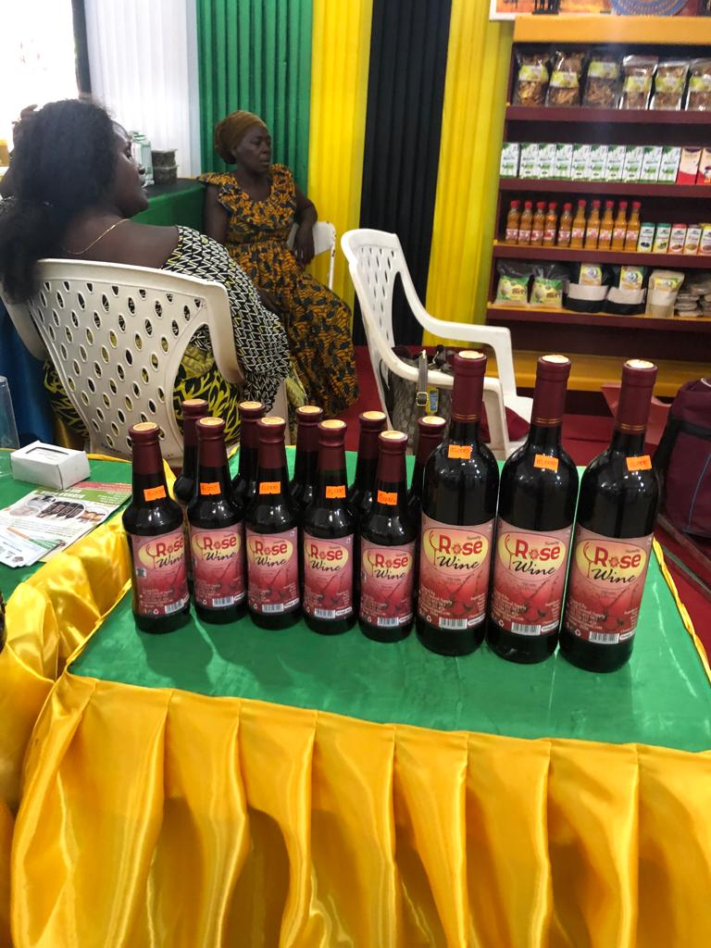

Figure 5.1: Some of TUKE Group Members with well arranged and neat Business Environment during Nane Nane DAY 2021

One customer mate on the site during the M&E had this to say;
"Nimegundua sasa kuwa TUKE wamepata mfadhili anayewafanya mazingira yapendeze namna hii. Chakula kinatengenezwa vizuri, wanafungasha safi. Si unaona hata wateja wanafurika" meaning: I know now that this group has a sponsor who had made them to have such a good environment. Even their food preparation and packaging has improved so much. You can see now the flow of customers."
Improvement that had created such a positive changes was made on neatness/smartness of the environment, packaging and advertisement (Figure 5.2)
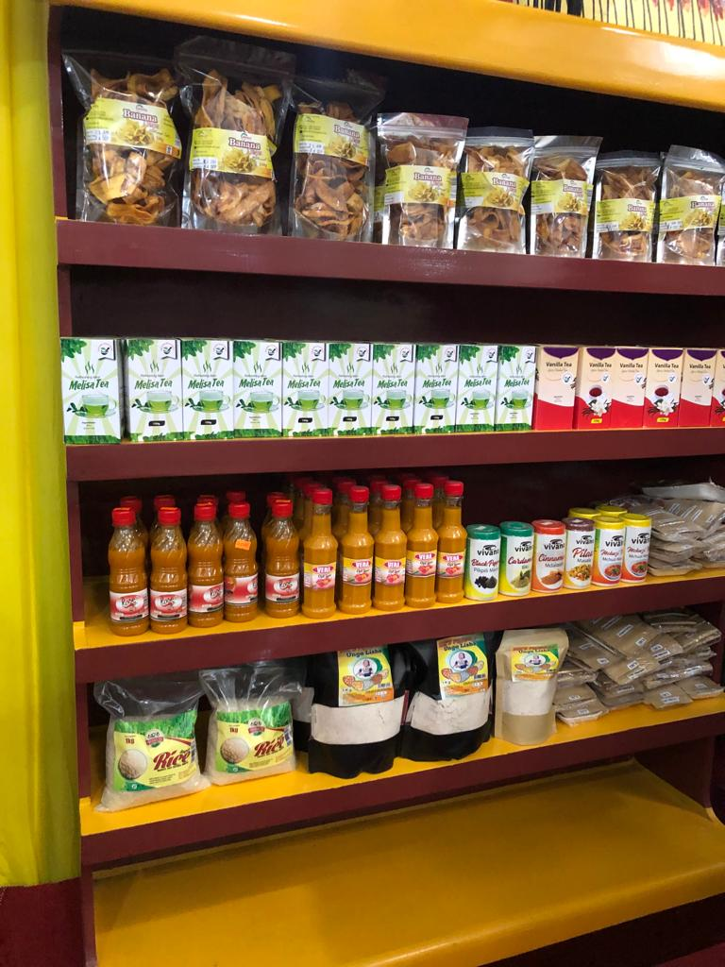

Figure 5.2 Well Packed and Orderly Arranged Food Items in the TUKE Sales Apartment

Evaluation of data presented before and a month of follow up after the trainings it was realized that there were an increase of customers/sales by 35% that had also resulted in almost 50% of gross earnings (Table 5.3).

Table 5.3: TUKE-HWG Sales and Earnings before and after the trainings
 | Before | After Sale | increase (%)
Sales (units) | 220 | 506 | 290 (52.5%)
Gross income (Tsh) | 440,000 | 1,012,000 | 480,000 (52.9%)
NB: Sales and income were deduced in a period on one month after trainings and compared with one months before trainings
With the time and group administration being improved more could be achieved. During debriefing, it was revealed that about 50% of the women groups do not know where and how to get such loans. In this case, the inaugurated platform had a role to play as information centre. Equally the same, the local and central government, as well as institutions supporting women development should devise a means of making business women aware of kinds of facilities they offer so they can fully utilize and exploit such opportunities. During the monitoring and evaluation, it was observed and reported that there were some elements of laxity in the responsibility.

One of the members said;
"Tunategeana wakati mwingine halafu tunagawana sawa"
Meaning that some members are less committed but receive equal dividends. For this matter t is recommended that stronger commitment of TUKE-HWG members and involvement of different stakeholders from municipal council and local communities for the purpose of projects sustainability, is needed to sustain project activities.

Table 5.4: Monitoring and Evaluation Report Summary
Objective / Activities |  |  | Performance Indicators achieved
Objective No 1: Tandale Women Social Economic Groups Platform formed by January, 2020
Activity: 1.1.To conduct meeting with 140 group members one from each of the existing groups in Tandale ward |  |  | 110 out of 140 women groups in Tandale attended the meeting and agreed on platform formation
Activity:1.2. Register the envisaged Platform |  |  | Tandale WOSEG was formed and registered (Reg. No. KMC/WGR/1219).
Objective No 2: Twenty (20) members of TUKE Household Women Group (TUKE-HWG) members trained in group dynamics leadership, strategic and business plan development plan formulation and wining proposal write up for fund requests
Activity:2.1 Search for experts and prepare training material &schedules |  | Training Materials developed by experts
Activity:2.2 Search for experts/trainers and reviewing the training materials |  | reviewed Training materials by CED student, WCDO and Experts
Activity:2.3 Conduct trainings to TUKE-HWG members in group dynamics leadership, strategic and business plan development plan formulation and wining proposal write up |  | Attendance register, 22 TUKE-HWG members trained and Achievements in group projects performance
Activity:2.4 Develop TUKE-HWG strategic plan |  | TUKE-HWG 2020 - 2025 Strategic Plan in place
Activity:2.5 Write project proposals |  | Four (4) proposals developed and submitted
Objective 3 Empower TUKE-HWG through training the members on entrepreneurship and business management skills, and basic food technologies
Activity:3.1 Search for experts/trainers and reviewing the training materials | Expert availed and training materials were reviewed
Activity:3.2 Conduct trainings entrepreneurship/business/management skills/basic food technologies to TUKE-HWG members | Attendance register (22) members attended the trainings and improvement in sales and earnings
Objective 4 Link Tandale-WoSEG Platform) including TUKE-HWG with micro financial institution
Activity 4.1 Find and List Financial institution with their physical addresses | Tandale WoSEG had earmarked 06 institutions
Activity 4.2 Tandale WoSEG Platform to identify and connect women economic groups in the ward with financial institutions | Physical addresses given to 110 women groups and Institutions contacted by 40 groups within a month
Objective 5:TUKE Women Groups undertaking economically viable income generating activities starting from Jan 2021
5.1 Prepare food materials and recipes and packing |  |  | Packed food items, neat environment
5.2 Selling packed food, recipes and other food related materials |  |  | Customer on site, packed food, recipes and other food related materials in place for sale
Objective 6 Monitoring and evaluation of project activities
Activity 6.1 Monitoring and evaluation | Continuous monitoring and evaluation and Final report

5.3. Project Sustainability
Sustainability of a project refers to the capacity of its continuity functioning in efficiently delivering the intended deliverables. This means that resources, (human resources, material and funds) are available and utilized even where there is no external support. According to Mosedale, (2005); FAO, (2016) and Gaur, (2017)) the trainings to TUKE-HWG group members had empowered them and made them able to access the opportunities available to them without limitations and restrictions for their income generating activities sustainably. Reinvestment of part of the income generated in the TUKE-HWG income generating activities observed during the M&E is an indicator of sustainability. Equally the same, involvement of the women groups and in particular TUKE-HWG members in a strategic plan is a strategy to ensure sustainability. The training and the platform had solved challenges mentioned by ILO, 1990 and 2017 that curtail sustainability of women income generating activities that include poor technology and inadequate business skills.

5.3.1 Financial Sustainability
Through the trainings on winning proposal writing, and Platform strategic activities, the possibility of TUKE-HWG and other women groups to access credit has increased. This will increase capital acquisition to invest in IGA and hence expanding services as well as income. During M&E, the group had already some activities going on and that was found to expand creating more income. With the increased income there is reinvestment, saving and cost for daily living.

5.3.2 Technical Sustainability
The technical trainings on food technology was meant for technical sustainability that had made the group to produce quality food and well packed which has actually resulted in increase in total sales. Staff with techniques for various fields of production (livestock, batik, hair saloon, decorations and the like) from NGOs and at the Municipal office is meant for training and assisting the community in various technical aspects. NGOs and other financial institutions are as well available in the ward for technical assistance

5.3.3 Institution Sustainability
The TUKE-HWG has a well structured constitution which acts as a regulatory mechanism to the group. The group was also taught in group dynamics and management for the purpose of making a stable group. The Municipal Council staff and expertise especially Ward Community Development Officers are always available to assist in following up and building capacity of group members to make the project sustainable,

CHAPTER SIX

CONCLUSIONS AND RECOMMENDATION

6.1 Introduction
The study involved a series of activities that had different approaches to enable first, realization of the Tandale Ward community needs and available resources that could be used to solve the established needs. This was followed by planning and execution of a project that has solved the uppermost needs for household women social economic activities. The planning was followed by selecting one Women economical group - TUKE Household Women Group as a role model to implement the planned project. Review of some literature was done to establish the gaps that existed from what others had done elsewhere in solving such needs.

The project was community based as it started by the participatory community need assessment whereby the first priority needs were articulated and taken on board. After assessment it was revealed that TUKE members like any other groups members, had inadequate skills on entrepreneurship and business management as well as technical skills to improve the market of their products. Lack of strategic plan had denied them power of recognition and other unexpected group malfunctions. The group had some difficulties in operating their business because of inadequate knowledge that had resulted to poor net return to capital or no profit as a result their income remained low.

The planned project involved empowerment TUKE members through business and technical skills trainings. Members were also empowered on how to develop a strategic plan as well as writing wining proposals. Before this, a motherboard platform was formed as information seeker and distributor among the household women groups in the ward. After execution of the project, the Tandale HWOSEG platform had 141 members on board and had connected them to 4 main financial/supporting institutions around the ward.

Furthermore, empowerment done through trainings and the various mobilization activities (platform and networking) TUKE-HWG members capacity to become TOT and to conduct their economic activities were developed and enhanced. After empowerment the group had managed to write 4 proposals submitted to Banks and Municipal and National Empowerment Funds. Indeed they had increased their gross sales by 52%. This results confirm the importance of finding the community needs in a participatory approach, planning together for the ways to solve them and the force of empowerment to economic groups. This chapter presents the summary of the whole study starting by the needs assessment, planning and execution of interventions activities to solve the needs and the outcome of these activities in increasing income. Recommendation and suggestion for further studies are also presented.

It is concluded that empowering TUKE-HWG by developing of their constitution, trainings of their members in entrepreneurship, group dynamics, management and administration, technical skills for food production and marketing had raised their confidence, net return to capital. Furthermore, TUKE-HWG had become a center for empowering other women and their members had become trainer for other groups. The project had enabled members of the HWOSEG platform, TUKE in particular to start being considered for credit from Micro financial institutions/empowerment Funds

6.2 Conclusions
The study started by undertaking the CNS. This deployed a cross-sectional and explorative designs but to some areas an descriptive design had to be used. This multiple approach was done to make it possible to collect all the necessary data that will enable the needs and resources available put on situ. Data collection tools used were questionnaire, observations and FGD for the primary data and desk study for secondary data. . The triangulation allowed the establishment of the data validity and reliability as well as trustworthiness. The CNA has being a useful approach to reveal the needs of the household women groups in the ward concerned (Tandale Ward). As a result of this approach the established needs had the followed activities were community bases letting then have the ownership.

Following the needs assessment, it was Tandale ward is markbly a petty business centre (low income investors). Household women groups being not exceptional, majority of them are engaged in small business (tailor marts, small shops, food vendors, and petty street business. The major problem being, that the groups were constrained by limited access to financial institution for credits, maintaining stable economic group and inadequate entrepreneurship knowledge and technical skills. The groups in the Ward were not well linked together or even to the supporting institutions. There economic activities are of low investments in nature and their activities are rather not business oriented. Equally the same, they were unable to produce quality products for the market because they were limited in their technical skills.
In deed they were limited with resources especially capital and unfavorable business environment (premises, taxes, loyalties, safeguarding policy). After establishing the needs and their prioritization, it was realized that the best way to assist the economic household groups in Tandale ward was to unite the groups in one umbrella - "form of platform" so that they will have a centre to get the right information at the right time and to connect them to various available opportunities for capital, markets as well as resources.

Indeed it was also necessary to train them in business undertakings (entrepreneurship) and equip them with specific technologies of the activities they undertake. This will enable then to produce quality products, sale at profit and eventually increasing their income and social economic situation in general. In this case TUKE Household Women Group was randomly picked up as a role model. A project was planned to establish Tandale Household Women Economic Group and train the TUKE Household Women Group members in entrepreneurship and food processing and packaging. Food processing and packaging was taken on board because this was their major activity so far.

The planned project was to support women in Tandale ward to form a platform (Tandale HWOSEG Platform) that can link the women groups to financial institutions and act as a hub for appropriate business and technical information source and empower one group (TUKE) as a role model by training their members on business undertaking and technical aspects of their major activity. A literature on such project was reviewed to allow establishment of gaps that exist on the available knowledge and gained experience in such project. It was realized from this that knowledge and skills on entrepreneurship is considered the outermost impediment while. Participatory planning and execution is necessary and that the group trainings must be done tactically from the pedagogical and didactic point of view such that the mindset of the group members is reoriented to have homogenous group member (in terms of interest and goals) with similar entrepreneurship and technical skills.

The planned projects had 6 objectives been implemented including Establishment and registration of the Tandale - Household Women Social Economic Groups (HOWSEG) Platform and linking the Tandale Women Groups under one umbrella of the platform into various credit and supporters Others were empowering TUKE Household Women Group members (training in business skills and food processing and writing its organization strategic plan) and putting in practice the trainings by mobilizing TUKE group to purchase, prepare and sell various food recipes and readymade, well packed food stuffs and selling at profit in neat environment. Monitoring and evaluation was an activity done throughout the project to ensure meeting the target.

The M& E findings show that all the activities were done according to the plan. One Platform for 110 Tandale household social economic groups was established and registered. A strategic plan for TUKE was developed and in place and TUKE members were cordially trained in development of strategic plan, entrepreneurship, group dynamics and food materials soliciting, purchase and preparation of various recipes and packed foods for sale. During M&E it was vividly observed that the group was able to submit 4 proposals for fund requests and in their activity they had realise a greater profit margin when compared to previous practices. The gross income had increased by 52%.

6.3 Challenges
The major challenge in the study was the limited time of execution. The CNA had to be done in the shortest possible time despite of the various components involved. As such extra care and cost were used. At some points technical personnel from some institutions that were requested to offer services were to be limited as they were requesting some payments in response tuitions they had to offer. Another challenge especially during project implementation was convincing time for training due to the fact that TUKE income generating activities were to be done concurrently with those of the project. Another challenge is associated with policy issues of business/trading area whereby they have to pay some taxes and royalties despite of their limited income. To some extent the training materials were to be developed at cost which the MCED student had to incur.

6.4 Recommendations
From the study the following recommendations are made:
- A community need assessment strategy is a good one in establishing the needs of a given community and in particular women groups
- Women groups can perform better when empowered. Thus a strategy for rigorous women groups empowerment is important to improve their social economic power in the communities.
- Women groups in the Platform encouraged to form their own savings and credit cooperative societies (SACCOS). This will enable even individual member to get a smooth loan from its SACCOS and in turn, helps to expand capital as well as volume of their businesses. Ultimately it would raise the standard of living of the group members and households at large.
- Training as an empowerment tool should consider both entrepreneurship and technical skills for the groups IGA point of view.
- There are also some policy issues emanating from the CNA that should be resolved. These include the issue of taxes to these small scale/petty business, the convenient centre and environment and security that were all considered to stress the community.
- Evaluation of the project has observed some elements of irresponsibility within members and hence recommended that for the purpose of projects sustainability, stronger commitment of TUKE-HWG members and involvement of different enforcers/stakeholders from municipal council and local communities will be needed to sustain project activities.
- The Government and other Development stake holders enhance their support processes in terms of funding conditions and bureaucracy. .Important for them to encourage and organize more training course on business management and vocational trainings for groups to acquire technical skills of various types (livestock, tailoring, batik, tie and dye, handcrafts etc) depending on individual interests.
- Further studies are also recommended including hoe to manage and sustain Platforms at Ward level namely Tandale HWOSEG and others, to establish policy that will create preferable working environment for women economic activities and most rewarding IGA to Tandale Household Women Social economic groups

REFERENCES
Ackah J, Vuvor S. (2011) The Challenges faced by Small & Medium Enterprises (SMEs) in Obtaining Credit in Ghana. Business
Bartle, P (2007) Participatory Assessment and Research.. Washngton DC. USA.
Bayeh, E. (2016). The role of empowering women and achieving gender equality to the sustainable development of Ethiopia. Pacific Science Review B: Humanities and Social Sciences. 2 (1): 38.
Benson, J. (2000). Working More Creatively with Groups. 2 edn. London: Routledge.
Benson, J. (2009). Working More Creatively with Groups. 3 Edn. London: Routledge
Brown, Rupert (1999) Group processes: Dynamics within and between groups 2edn. Oxford: Wiley Blackwell.
CARE International (2018). Women’s Economic Empowerment Impact Report 2018., CARE International UK89 Albert Embankment London SE1 7TPinsights. careinternational.org.uk retrieved on 15th May 2020
Casley and Kumar (1988). The collection analysis and use of monitoring and evaluation data
CEDPA (1994). Project Design for Project Managers: Training Manual series volume II; Washington. DC USA
Charmes, J. and Saskia W. (2003). Measuring women's empowerment: an assessment of the gender-related development index and the gender empowerment measure. Journal of Human Development 4.3: 419-435.
CIDA (1999) CIDA’s Policy on Gender Equality. Canadian International Development Agency (CIDA), Hull, Canada: CIDA, 1999: 5.
Das, R Chandra R. (edit) (1973). Handbook of Research on Micro financial Impacts on Women Empowerment, Poverty and InequalityIGA Global
Elgar, E. (1997). Towards Sustainable Project Development (edt. Frank Arnal Wilson) Business & Economics - 257 pages
Ellis, A. (2007). Gender and Economic Growth in Kenya: Unleashing the power of women. World Bank Publications, 2007.
Everleigh, S.,. Carlye, L., Evan, E, and Kathryn J. O (2015).. Income Generating Activities of Rural Kenyan Women. Journal of Sustainable Development 8(8): p42 DOI: 10.5539/jsd.v8n8p42
FAO (2016) Rural Women's Empowerment and Collective Action. FAO, Rome Italy.
Forsyth, D, and Donelson R. (2016). Group Dynamics 6edt. Boston MA.: Centage. International Student Edition]. Belmont CA.: Thomson Wadsworth Publishing
Gaur, A (2017). How Women Empowerment Promotes Economic Stability in India. https///medium.com/@abihilashagaur?source=post-page-20dcdeeb696d. Cite visited on 14/07/2020
Gichuki J. W., Njeru, W, Tirimba, O I. (2014). Challenges Facing Micro and Small Enterprises in Accessing Credit Facilities in Kangemi Harambee Market in Nairobi City County, Kenya. Economics International journal of scientific and research publications
Gikonyo, C; Bejon P; Marsh, V, And Molyneux S. (2008)Taking Social Relationship Seriously :Lessons Learned From The Informed Consent Practices of a Vaccine Trial on the Kenya Coast. Social Science and Medicine 67:708-720.
IFRC & RCS (2011) Project /Programme monitoring and Evaluation guide, Geneva 2011
ILO (2013) Global Employment Trends - Recovering from a second jobs dip. International Labour Organization, Geneva:
ILO (2017) Towards a better future for women and work: Voices of women and men Gallup, Inc. and the International Labour Organization. Geneva.
ILO (1984) Identification on successful project for providing the employment conditions of rural women. International Labour Organization Arusha- Tanzania
ILO (2001). The influence of National policies, law and regulations on employment in Small and Medium Enterprises in Tanzania. Unpublished research report, pp 35. International Labour Organization, Geneva. Italy
ILO (2003). Tanzania women entrepreneurship: Going for growth. Geneva. International Labour Office. Pp. 19–20. International Labour Organization, Italy
Jaka, H. and Shava, E (2018). Resilient rural women’s livelihoods for poverty alleviation and economic empowerment in semi-arid regions of Zimbabwe. Jamba. 2018; 10 (1): 524. . doi:10.4102/jamba.v10i1.524
Kluve J, Puerto S, Robalino D, Romero J M, Rother F, Stöterau J, Weidenkaff F, Witte M. (2017). Interventions to improve the labour market outcomes of youth: a systematic review of training, entrepreneurship promotion, employment services, and subsidized employment interventions Campbell Systematic Reviews 2017:12DOI: 10.4073/csr.2017.12
KMC (2019). Kinondoni Municipal Profile 2019. Kinondoni, Dar es Salaa. Tanzania
Kothari, 1990). Research methodology methods and techniques 1st Edtn. Dharaush Printers Delhi, India
Kothari, C.R (2006). Research Methodology. Methods and Technique. 2nd edition. Dharaush Printers Delhi India.. pp 50-67.
Kumar, R. (2014). Research Methodology: A step-byStep Guide for Beginners (2nded). SAGE. London
Makombe, I. A. M. (2004). Women's Business Performance and Empowerment: The Case of Women Micro and Small Entrepreneurs in Arusha, Tanzania Research and Publications Department Mzumbe University Business women - 57 p
Mascaenhas, A. and Mbilinyi M. (1983). Women in Tanzania. Scandinavia Institute for African studies. Stockholm, The Netherlands
Minde, I. J. (1998). Economic Analysis of Farm and Non- farm rural employment inMorogoro District, Tanzania. Ph.D. Thesis, Michigan State University.pp.250
Montanari, B., Bergh, S.I.(2019) A Gendered Analysis of the Income Generating Activities under the Green Morocco Plan: Who Profits?. Hum Ecol, 47, 409–417.
Mosedale, Sarah (2005). Assessing women's empowerment: towards a conceptual framework". Journal of International Development. 17 (2): 243–257.
Mutangadura, G. B. (2005). Gender, HIV/AIDS and Rural Livelihoods in Southern Africa: Addressing the Challenges, JENDA: A Journal of Culture and African Women Studies: Issue 7, 2005. Africa Resource Center, Inc.
Mwangi, R M and Bwisa H (2015) Determinants Influencing Growth Performance In Women Owned Small And Microenterprises in Kenya. Women Boutiques in Murang’a Town, Murang’a County Strategic Journal of Business & Change Management Vol 2, No 2 (2015)
Nabil A. (2019). Women's economic empowerment The gendered impact of IMF policies in Middle East and North Africa (MENA) region The case of Egypt, Jordan and Tunisia OXFARM International. London
Nayab, N and Rebecca Scudder. 2011. “What is Entrepreneurship? A Look at Theory.”. http://www.brighthub.com/office/ entrepreneurs/articles /78364.aspx Accessed April 12, 2016
Neema, M. I (2014) Women’s Entrepreneurship Development In Tanzania: Insights and recommendations. Institute of Management and Entrepreneurship Development International Labour Organization 2014
Phillipo, F (2008) Contribution of women’s income generating activities to household income in Kigoma urban district, Kigoma region, Tanzania. Sokoine University of Agriculture URI: http://hdl.handle.net/123456789/304
REPOA (2007). Poverty and Human Development Report...Reseach and Analysis Working Group. 2007. URT, Dar es Salaam. Tanzania.
Rwegoshora, H. M. M (2006). A Guide to Social Science Research. Mkuki and Nyota Publishers, Dar es Salaam, Tanzania.
Sara P., Pamela P., Ana P. and Campos, O. (2015). Qualitative research on women’s economic empowerment and social protection Aresearch guide Food and Agriculture Organization of the United Nations (FAO) Rome, Italy
Shangadi E. O. 2017 An inverstigation into challenges in accessing finances by SMEs from financial service providers in Khomas, region, Namibia , Business
Sheuya, S (2002) Urban Development in Tanzania: An Updated Review (May 2002). United Republic of Tanzania
SPSS, (2010) Statistical Package for Social Science Version 6, CSx HA 32 F154. London Sage Publishers.UK.
Sriani A. K. (2017). Gender in employment policies and programmes: What works for women? Working Paper No.235 Employment Policy Department Policy International Labour Office – GENEVA
Stein D. and C. Valters (2012). Understanding Theory of Change in International Development. London: The Justice and Security Research Programme, London School of Economics.
Simpson, S. D.( 2019). Trading skills and essential risk management. In: Investopedia (2012). The ten Low Risk Investiments. Bankrate LLL NMLS ID M 27381. Dutdesh Publishing Family. USA
Summy G. (2015). Community Participation and Women’s Empowerment: The Kerala Experience of Participatory Planning and Budgeting. Springer Briefs in Environment, Security, Development and Peace book series (BRIEFSSECUR, volume 22)
TACAIDS (2018) Challenges Facing Women Groups Worldwide. TACAIDS Annual Report 2017/2018. Tanzania Commission For Aids Prime Minister’s Office. Dodoma
TASAF (2011) Assessment of the Viability of The Income-Generating Activities Interventions Implemented In Tanzania. Tanzania Social Action Fund (TASAF). Dar es Salaam Tanzania
Tripp, (1989). Women and the changing urban house hold economy in Tanzania. Dar es Salaam Printers. Tanzania
UN (2009). World Survey on the Role of Women In Development. Women's Control over Economic Resources and Access to Financial Resources, including Microfinance Report). United Nations. 2009. New York:
UN (2013). Online survey on Promoting Empowerment of People in achieving poverty eradication, social integration and full employment integration and full employment and decent work for all. Department of Economic and Social Affairs. Division for Social Policy and Development. 2013
UNDESA (2013a) Promoting Empowerment of People in achieving poverty eradication, social integration and full employment integration and full employment and decent work for all. United Nations Department of Economic and Social Affairs (DESA) Division for Social Policy and Development
UNDESA (2013b). World Urbanisation Prospects, 2011 Revisions. Correspondence on urban population. http://esa.un.org/unpd/wup/index.htm
UNIDO (2010) Independent UNIDO Country Evaluation United Republic Of Tanzania. United Nations Industrial Development Organization Vienna, 2010.
UNIDO/ILO/UNDP (2002) Roadmap Study of the Informal Sector in Mainland Tanzania, Dar es Salaam, Tanzania
UNIFEM (2000) Reaching Down and Scaling Up: Focus on USAID’s Development Partners: Progress of the World's Women Progress 2000: Volume 2
UNWomen, 2018; National and international policies and conventions, provide basic support services to women. New York
URT (2007). National Employment Creation Programme, 2007. United Republic of Tanzania
URT (1996).Community Development Policy. Ministry of Community Development, Women Affairs and Children. Government Printers, Dar es Salaam. Tanzania
URT (1999). Private Sector Development Policy Government Printers, Dar es Salaam Tanzania.
URT (2000). Poverty Reduction Strategy paper Government printers, Dar es Salaam Tanzania.
URT (2001). TASAF CNA Guide (2001). Tanzania Publishing Unit, Dar es Salaam.
URT (2003). National Policy for the Development of Small and Medium Enterprises, United Republic of Tanzania, Ministry of Industry and Trade. Government Printers Dar es Salaam Tanzania.
URT (2004). National Economic Empowerment Policy (2004) Dar es Salaam, Tanzania
URT (2004). The Public Finance Act, 2001 Act No. 6 of 2001, Principal Legislation Revised Edition, 2004. United Republic of Tanzania.
URT (2005) National Empowerment Policy -2005. Dar-es salaam, Tanzania
URT (2007). Community Development Policy. Ministry of Community Development Gender and Children. Tanzania. United Republic of Tanzania
URT (2010) National Strategy for Growth and Reduction of Poverty II NSGRP II. Ministry of Finance and Economic Affairs. Tanzania. Government Printers, Dar es Salaam.
URT (2014). Integrated Labour Force Survey . United Republic of Tanzania, Dar es Salaam
URT (2014): National Economic Empowerment Report: Youth Economic Challenges; Dar es salaam
URT (2017) Controller and Auditor General Report(2017). United Republic of Tanzania, Dar es Salaam.
URT (2018) Finance Act 2018 No 4 amendment of the local government Finances act, (Cap. 290). Dar es Salaam.
URT (2002). Small and Medium Enterprises Development Policy. Dar-es salaam, Tanzania
URT (1988). Situations of women in Tanzania. Ministry of Community Development, Children, Youth and Sports. Government Press, Dar es Salaam.
URT, (2007). Tanzania Integrated Household Budget Survey-2005/2006. United Republic of Tanzania.
URT, 1992) How Tanzania tax system has been reformed
USAID (2019).Gender Equality and Women’s Empowerment Tanzania, Dar es Salaam
USAID (2001). Microenterprise Development in a Changing World: U.S. Agency for International Development Micro enterprise Results Reporting for 2000 (Arlington, Va.: Weidemann Associates, 2001): 31.
USAID. (2010) Microenterprise Results Reporting for 1999 (Arlington, Va.: Weidemann Associates, 2000), 22.
Wilkinson, A. (1998) Empowerment: Theory and Practice. Personnel Review, 27, 40-56. http://dx.doi.org/10.1108/00483489810368549. Downloaded on 15 May 2020.
World Bank (2006) Empowerment: What does it mean to you. definition of empowerment. UN Social Network The Department of Economic and Social Affairs (DESA), Social Policy and Development.

APPENDICES
APPENDIX I: QUESTIONAIRES
A: CATEGORY ONE: KEY INFORMANTS IN THE WARD
Questionnaires No..................................
THE OPEN UNIVERSITY OF TANZANIA

RESEARCH TITLE: EMPOWERING HOUSEHOLD WOMEN GROUPS IN TANDALE WARD”

- Name of sub ward..........................................
- Job Title................................................................................................
- Department..............................................................................................
- Education/qualification...........................................................
Social economic issues
- How is Employment opportunities of the people in the community?
- Readily available.
- Difficult for formal employment
- Difficult to both formal and informal
- Any other comment………………..?
- What are available social services/facilities in the sub ward/ward
................................................................................................
...............................................................................................
- Are you certified with the services Yes/Not
If not why...................................................................................
................................................................................................
................................................................................................
...............................................................................................
- What are the major activities are carried out by the people in this community?
- ……………………………………………………………………
- ………………………………………………………………………
- Add as necessary.....................................................................................
- Which among these activities are mainly carried by women groups in Tandale ward?
................................................................................................................................................................................................................................................................................ How do women IGA perform in terms of achievements of their respective objective?
................................................................................................................................................................................................................................................................................ What is the role of your department/NGO/CBO towards women empowerment on income generating activities?
................................................................................................................................................................................................................................................................................ What are the available opportunities/resources for income to women groups in your area?
................................................................................................................................................................................................................................................................................................
- Is their income generation activities successful (any benefit they get)
  - If No: Why
  - If yes : what are the drivers

- Do you think the women community members have adequate business management skills in implementing economic activities in a cooperative way??
.............................................................................................................................
.....................................................................................................................................
- Are there any training provided for women empowerment on income generating activities? (Yes/no)
- If yes what are they? and who provides such training
........................................................................................................................................
........................................................................................................................................ And if not how do you help them to secure trainings or acquire knowledge needed for IGA?
........................................................................................................................................
........................................................................................................................................

- What are challenges contributing to poor performance of women income generating activities in your area? list them
........................................................................................................................................

- Is there any mitigation to address such challenges (What should be done to solve such problems)?
........................................................................................................................................
........................................................................................................................................ What do you consider to be the most needs by the women community?/ needs given the most priority? (list)
Environmental issues
- What are the environmental pollution/problems/challenges facing the community in Tandale wards? ............................................................. ........................................................ ...............................................................................................................................
- Do they have any impact to women economic activities in the ward?
- What are the sources of environmental degradation /pollution in the ward?
................................................................................................................................................................................................................................................................................ How community involve in solving environmental problems (mitigation)
Health issues
- Are the health facilities adequately addressing the needs of the community...........................................................................................................................................................................................................................................
- What are other health challenges do the community faces (list)
....................................................................................................................................
- What could be done in order to ameliorate the situation (mitigation).................
............................................................................................................................

THANK YOU FOR YOUR COOPERATION
CATEGORY II: QUESTIONNAIRE TO THE WOMEN GROUPS MEMBERS
Questionnaires No.................................. Date.................................
THE OPEN UNIVERSITY OF TANZANIA

RESEARCH TITLE: EMPOWERING HOUSEHOLD WOMEN GROUPS IN TANDALE WARD”

Please answer all the following questions according to the instructions given; your answer will be strictly confidential. You are therefore kindly asked to complete this within a week from the date of submission.

Put a tick (√) to the correct answer/answers in the bracket
- Group Name..............................................................................
- Is your group registered ...................................................................
- If yes under what LGA/Home Affairs/BRELA/etc
- Please tick your age group.
- 15 – 25 years ( )
- 26 – 30 years ( )
- 36 – 45 years ( )
- 46 – 55 years ( )
- 55> ( )

- Please tick you education level.
- Primary level ( )
- Secondary level ( )
- High education level ( )
- Other specify………………………………………………………….
- Marital status..................................................................................................
- Married ( )
- Single ( )
- Separated l ( )
- Widow (....)
- Divorced (...).
- Household structure.(Put Yes at your age if you are the household head)
- 15 – 25 years ( )
- 26 – 30 years ( )
- 36 – 45 years ( )
- 46 – 55 years ( )
- 55> ( )
- Please state your occupation beside group activities
- Employed as civil servant ( )
- Employed in private sector ( )
- Self employed ( )
- Business man/women ( )
- Farmer ( )
- Others ( )
- How were you motivated to join the group?
- Other women ( )
- LGA staff ( )
- Councilors ( )
- NGOs and CBOs ( )
- Religious organizations ( )
- Mass media(Radio/newspaper) ( )
- Others (---)
- Does the ward leadership assist you in your plans for empowerment/economic activities. If yes how and if not why
- What are women activities undertakings in Tandale ward for income acquisition (IGA)?
- Batik and tie &dye activities ( )
- Gardens preparing activities ( )
- Small scale retail trade ( )
- Decoration and cooking activities ( )
- Stationary ( )
- Soap making activities ( )
- Tailoring activities ( )
- Livestock keeping ( )
- Other ( )
- . What are the main activities done by your group (Both economic and social)
................................................................................................................................................................................................................................................................................
- What is the major objective of your groups.................................................
...................................................................................., ........................................................................................................................................ Through which aspect do you benefit from group
- Income ( )
- Health ( )
- Social relationship ( )
- Others mention ( )

- What do you consider as benefits you do get from the projects?
..............................................,......................................., ............................................
........................................................................................................................................ Are the projects financially feasible
IF not what are the problems/constrains........................................................................................................................................................................................................................................................................................................................................................................................ How much money (approximately) do you get from the project (Tsh/month)
- 10,000-20,000Tsh ( )
- 21,000-30,000Tsh ( )
- 31,000-40,000Tsh ( )
- 41,000-50,000Tsh ( )
- 51,000-100,000 Tsh (...)
- More than 100,000Tsh (...)

- What is the source of incme for investiment (capita)
Bank, SACCOS, Government, own source, family, relatives etc)
- How much money do you access from the different sources
- 10,000-100,000Tsh ( )
- 100,000-500,000Tsh ( )
- 500,000-1,000,000Tsh ( )
- 1,000,000-2,000,000Tsh ( )
- More than 2,000,000Tsh
- Was it enough to meet the need/requirement? (Yes/no)
..............................................................................................................................................................................................................................................................................................................................................................................................................................................
- Do you have savings of your income?
- Yes ( )
- No ( )

- Do you keep financial records? (Yes/no) If no why?
............................................................................................................................
............................................................................................................................ Where do you save your income? Please tick
- SACCOS ( )
- Bank ( )
- Kibubu ( )
- Upatu ( )
- Others specify ( )
- For how long does your project existed?
- 1-2 wks ( )
- 2-4 wks ( )
- 4-6 wks ( )
- 6> wks ( )
- Do you have any knowledge and skills on the IGA you are doing
- Yes ( )
- No
- If yes which ones
- Have you ever attended training on entrepreneurship or managerial skills? (Yes/no)
If yes mention..............................................................................................
....................................................................................................................
- Was the training sufficient for your activities (if no say why)............................
........................................................................................................................................
........................................................................................................................................
- Are there any challenges which hinder your group to implement your projects ....................................................................................................................................................................................................................................................................
- What do you think should be done to solve the challenges? (suggestions)
........................................................................................................................................ Please explain briefly how did you get your basic needs before and after starting the IGA?
- Before............................................................................................
- After..............................................................................................

- Do you think the IGA play an effective role in promoting economic empowerment to women?
- Yes ( )
- No ( )
- I don’t know ( )

- Any other comment on women empowerment in your ward.....................................

THANK YOU FOR YOUR COOPERATION

Appendix II Introductory letter and Request to WEO for Conference Facility
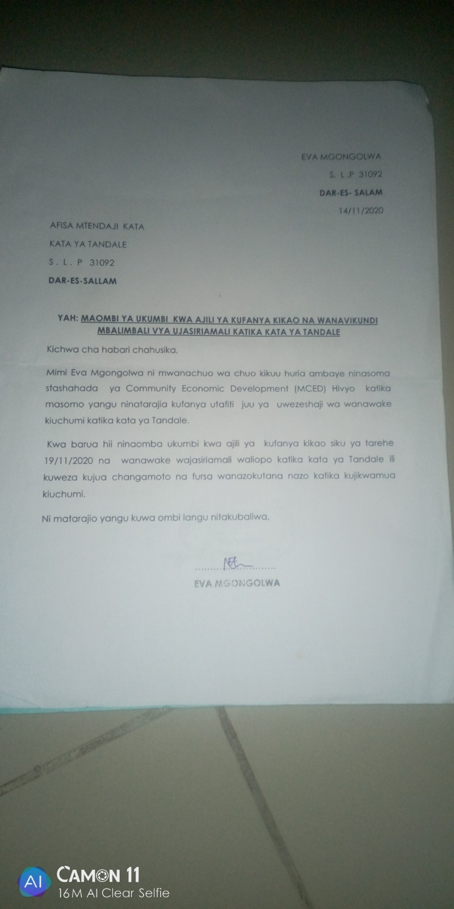
Appendix III Acceptance from WEO for Conference facility
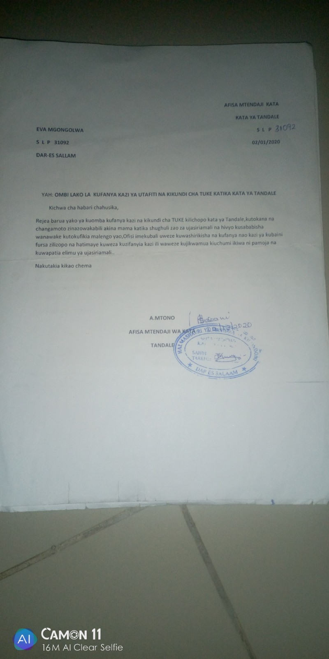
Appendix IV Introduction to TUKE and request for collaboration in Research
EVA ANDREW MGONGOLWA,
S .L P 30902
DAR-ES-SALAAM
14/12/2020
UMOJA WA KIKUNDI CHA TUKE
KATA YA TANDALE
S. L. P …….
DAR-ES SALAAM
YAH: MAOMBI YA KUSHIRIKI KATIKA KUFANYA UTAFITI WA NAMNA YA KUWAWEZESHA KIUCHUMI WANAWAKE WA TANDALE
Tafadhali husika na kichwa cha habari hapo juu.
Mimi Eva Andrew Mgongolwa ni Mwanachuo ambaye nasoma katika chuo kikuu huria Dar-es salaam, Ninaomba kuwahusisha katika kufanya utafiti wangu wa kimasoma juu ya namna ambavyo kaya za wanawake wa Tandale ambavyo zinavyoweza kuinuliwa au kuwezeshwa kiuchumi.
Aidha katika Kuwashirikisha tutaweza kubaini ni fursa gani zilizopo katika eneo na namna ya kuweza kuzitumia ili kujiletea maendeleo ya kiuchumi kwa wanawake wa
Ni matumaini yangu kuwa ombi langu litakubaliwa.

EVA MGONGOLWA
MWANACHUO CHUO KIKUU HURIA
DAR-ES SALAAM
Appendix V Acceptance latter from TUKE - HWG
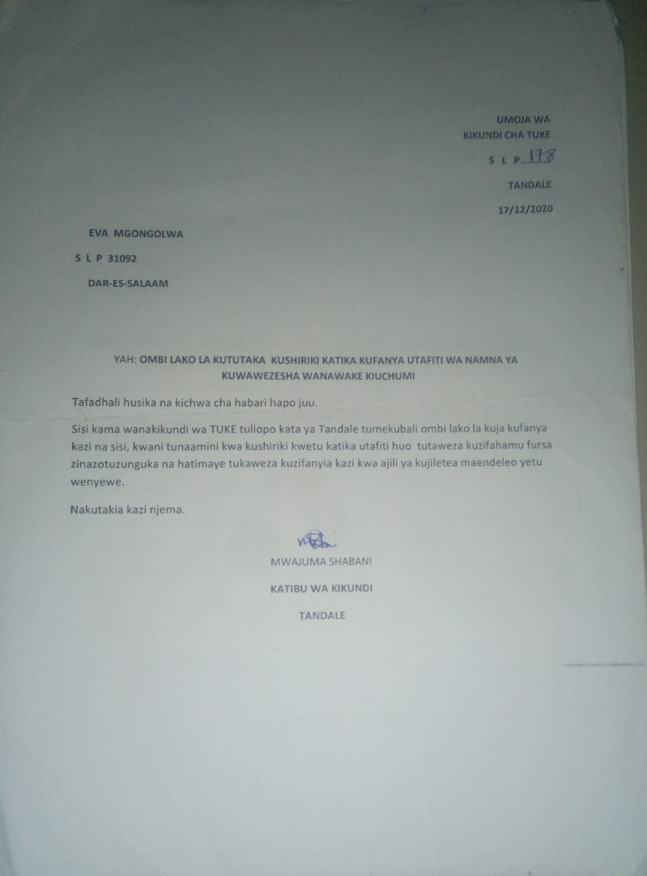

Appendix VI Tandala WOSEG Registration
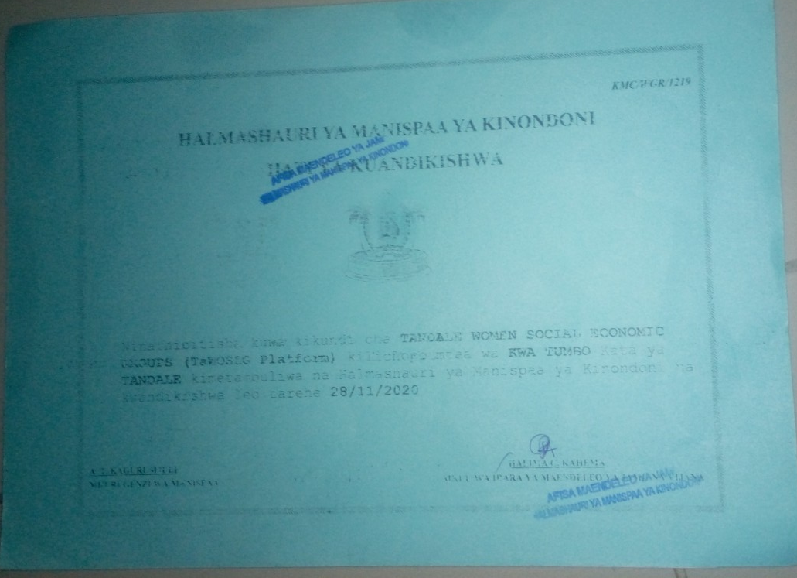

Appendix VII Tandale Strategic Plan (cover)
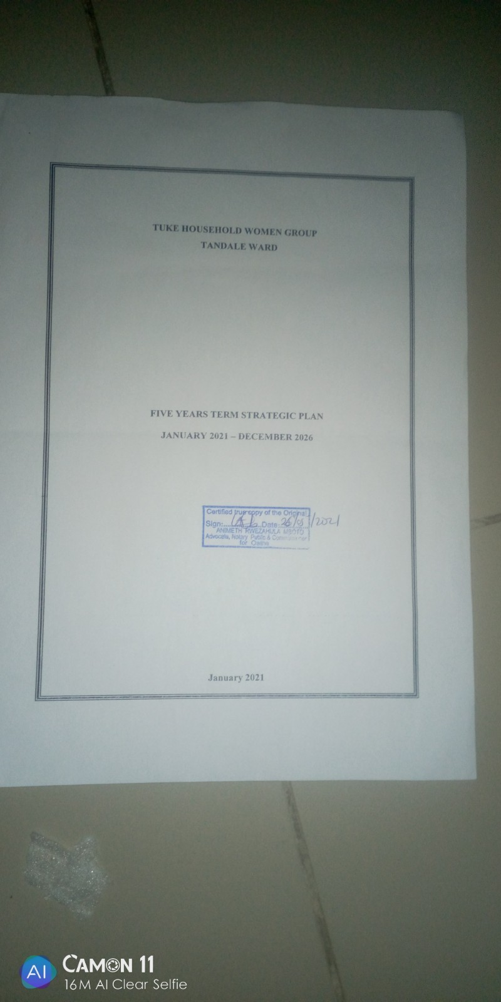

Appendix VII (a) Map of Tandale Ward
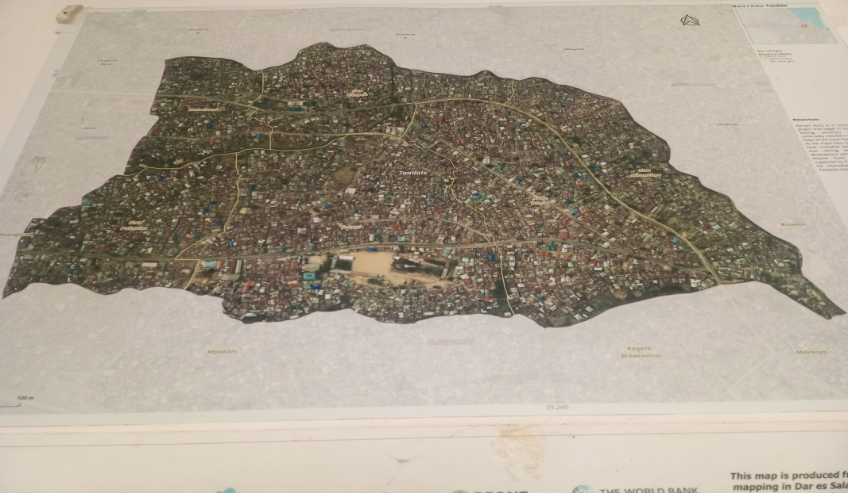

Appendix VIII (b) Ng'ombe water stream
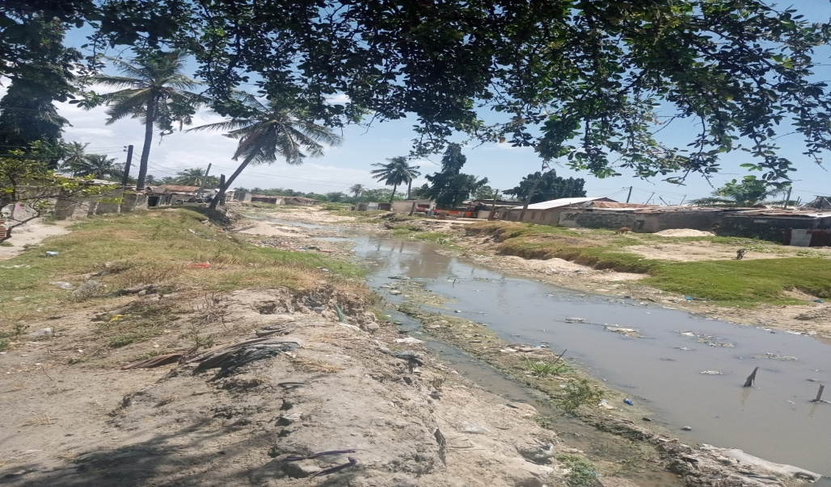
Appendix VIII (c) Urban Farming in Tandale ward
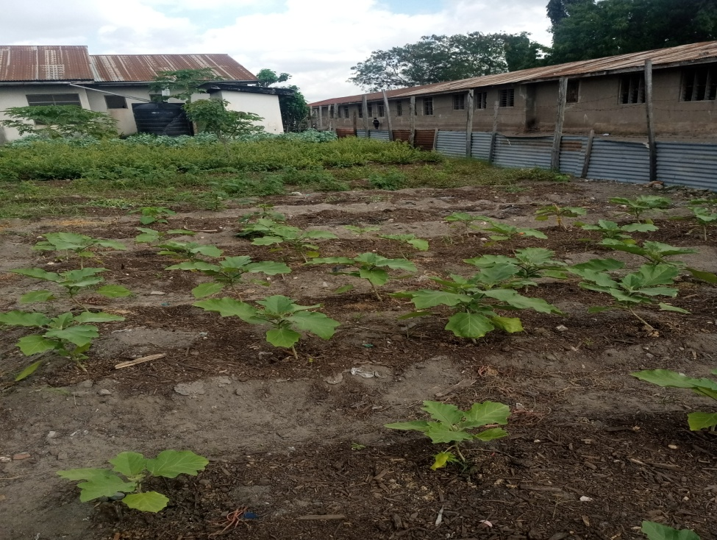

Appendix VIII (d) Tailor Mat Women Group
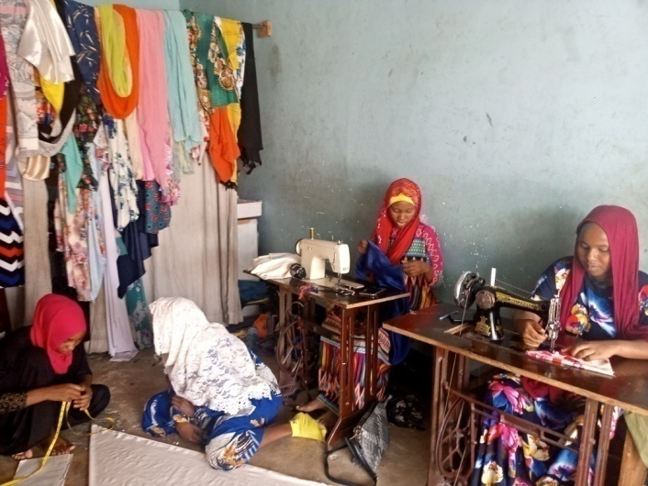

Appendix VIII (e) Tandale food suppliers
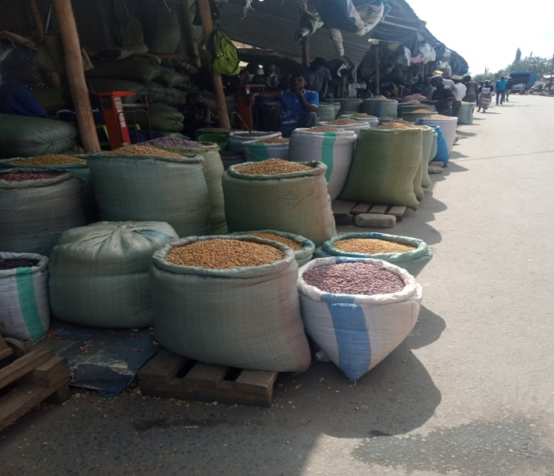

Appendix VIII (f) Mama Ntilie business at Tandale
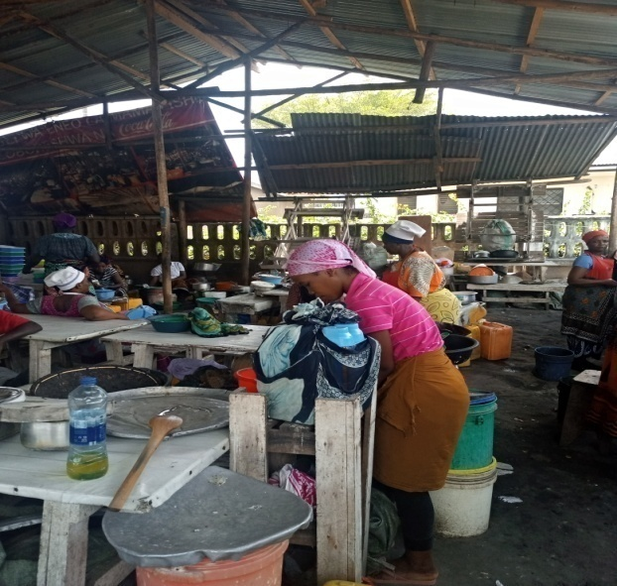
Appendix VIII (g) Focus group discussions at Tandale
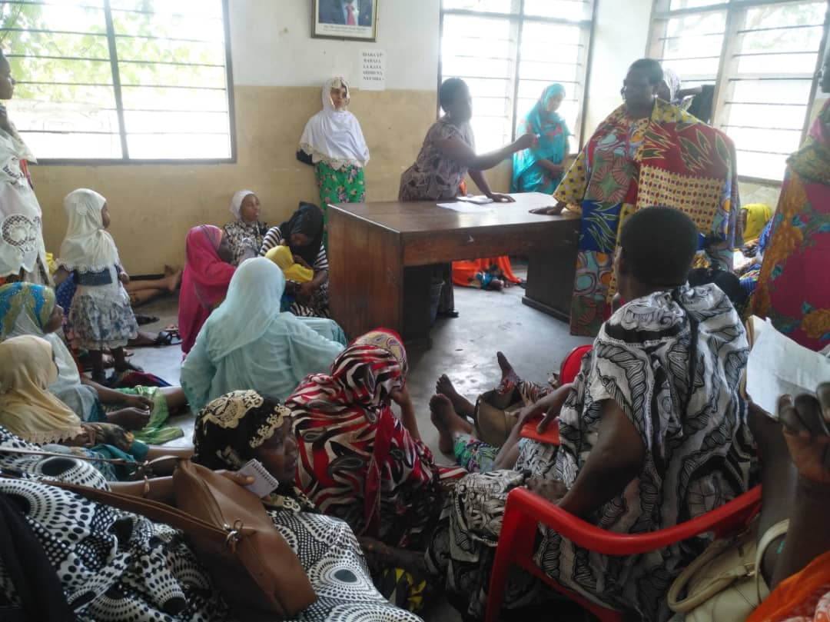

Appendix VIII (h) TUKE HWG Training Session at Tandale


