HEALTH CARE WORKERS’ KNOWLEDGE ATTITUDES AND PRACTICES FOR EFFECTIVE MANAGEMENT OF BIOMEDICAL WASTE IN DODOMA CITY TANZANIA

AUGUSTINE EDWARD

A DISSERTATION SUBMITTED IN PARTIAL FULFILMENT OF THE REQUIREMENTS FOR THE DEGREE OF MASTERS OF ENVIRONMENTAL STUDIES (MES)
DEPARTMENT OF ENVIRONMENTAL STUDIES
OF THE OPEN UNIVERSITY OF TANZANIA
2021

CERTIFICATION
The undersigned do certifies that he has read and hereby recommends for acceptance by the Open University of Tanzania a dissertation entitled; “Assessment of Health Care Workers’ Knowledge Attitudes and Practices for Effective Management of Biomedical Waste in Dodoma City Tanzania” in partial fulfilment of the requirements for the award of the Degree of Master of Environmental Studies (MES).

.…………………………………………
Prof. Emmanuel S. P. Kigadye
(Supervisor)

……………………………
Date

COPYRIGHT
No part of this Dissertation may be reproduced, stored in any retrieval system, or transmitted in any form by any means, electronic, mechanical, photocopying, recording or otherwise without prior written permission of the author or The Open University of Tanzania in that behalf.

DECLARATION
I, Augustine Edward, do hereby declare that, the work presented in this dissertation is original. It has never been presented to any other University or Institution. Where other people’s works have been used, references have been provided. It is in this regard that I declare this work as originally mine. It is hereby presented in partial fulfillment of the requirement for the Degree of Master of Science in Environmental Health.

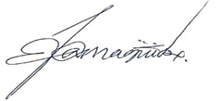
……………………………..………
Signature

16/03/2021
…………………………………
Date

DEDICATION
This work is dedicated to my mother, Ms. Secilia Thobias Mahune for her loving care, advice and moral support and encouragement for my whole life and during the period of my studies; to my wife Amina Issa Mtika who cared for our family and encouraged me consistently throughout the period of my studies, field research and the writing of this dissertation.

ACKNOWLEDGEMENTS
My special thanks go to my supervisor Prof. Emmanuel S. P. Kigadye, Director of Research Publications and Innovation of the Open University of Tanzania (OUT), for his commitment, support, advice and overall supervision of my research. I thank my mother Ms. Secilia Thobias Mahune for her unwavering love and encouragement and my wife for caring for the family as I struggled with the research and the writing, and my young brother Joseph Augustine who assisted me in non-technical matters relating to the study, including photographing important support events.

I acknowledge the support of my boss Mr. Samora Sanga, Director of the Institute of Allied Health Sciences (IAHS) of Ruaha Catholic University (RUCU) when I sought permission to pursue further and higher studies. I thank my workmate at RUCU, Mr. Gasper Baltazary for sharing with me his exposure on the use of the computer software SPSS which enabled me to analyse my field data. I thank the staff, pharmacists, doctors, nurses, laboratory personnel and support staff of the different health facilities in the city of Dodoma for their support, co-operation and voluntarily participation that enabled me to accomplish this work. I also thank the Director of Dodoma City for his permission to conduct my study in different health facilities in his city.

Finally, I thank Mwalimu William Sabaya, retired former Director of Tanzania Institute of Education, founder and first Chief Executive of Tanzania Commission for Universities and first Administrator of Tanzania Academy of Sciences, for editing this work.

ABSTRACT
Biomedical waste mismanagement has been and continues to be a hazardous health risk to health personnel and the general public. This study endeavoured to identify and assess the gaps in knowledge, attitudes and practices or actions by the full range of health care workers involved in waste management with particular focus on those handling biomedical wastes. A total of 142 health care workers participated in the study. Quantitative and qualitative data were collected and analysed using descriptive statistical techniques guided by the Statistical Package for Social Sciences version 20. The findings indicated that 96.5% of health care workers were aware that improper management of biomedical wastes is likely to cause various health hazards. Indeed 97.9% of study participants indicated that mismanagement of biomedical wastes resulted in environmental problems. Dump the waste directly into garbage bins for removal and direct incineration were mostly used as methods of wastes disposal by 73.2%. A significant proportion of staff (80.3%) had not received adequate training related to biomedical waste management. On average it was interesting that most of health workers in Dodoma city had positive attitude and mindsets for safe management of health waste, example 79.6% were believed that waste management is a team work practice and 85.2% were believed that waste management is not an extra burden on work. It was, therefore, recommended that training and public awareness promotion should be put in place for the proper handling and management of biomedical wastes and that this is a necessary requirement for all workers in health care systems in Dodoma as well as other cities and towns in the country.
Keywords: Biomedical Waste, Health Care, Knowledge, Management.

TABLE OF CONTENTS
CERTIFICATION ii
COPYRIGHT iii
DECLARATION iv
DEDICATION v
ACKNOWLEDGEMENTS vi
ABSTRACT vii
TABLE OF CONTENTS viii
LIST OF TABLES xii
LIST OF FIGURES xiii
ABBREVIATIONS AND ACRONYMS xiv
CHAPTER ONE 1
INTRODUCTION 1
1.1 Background to the Study 1
1.2 Statement of the Research Problem 3
1.3 Research Objectives 5
1.3.1 General Research Objective 5
1.3.2 Specific Research Objectives 5
1.4 Research Questions 5
1.4.1 General Research Question 5
1.4.2 Specific Research Questions 6
1.5 Significance of the Research 6
CHAPTER TWO 7
LITERATURE REVIEW 7
2.1 Introduction 7
2.2 Conceptual Definitions 7
2.3 Risk of Biomedical Waste Management to Environment and Health 8
2.3.1 Health Hazards 8
2.3.2 Occupational Health Hazards 9
2.3.3 Hazards to the General Public 10
2.4 Biomedical Waste Management Process 11
2.5 Health Personnel Knowledge about Biomedical Waste Management 11
2.6 Health Personnel Attitude to Biomedical Waste Management 14
2.7 Health Personnel Mode of Practice in Handling Biomedical Waste 16
2.8 Training Needs of Health Care Workers to Biomedical Waste Management 21
2.9 Research Gap 22
2.10 Conceptual Framework 23
CHAPTER THREE 25
RESEARCH METHODOLOGY 25
3.1 Study Area 25
3.2 Study Design 26
3.3 Study Population 27
3.4 Sampling Procedure and Sample Size 27
3.4.1 Sampling Procedure 27
3.4.2 Sample Size 28
3.5 Type of Data 28
3.6 Data Collection Methods 29
3.6.1 Quantitative Methods 29
3.6.2 Qualitative Methods 29
3.7 Pre-Testing of the Questionnaire 30
3.8 Data Analysis 30
3.9 Ethical Clearance 31
CHAPTER FOUR 32
RESULTS 32
4.1 Introduction 32
4.2 Demographic Characteristics of the Respondents 32
4.3 Assessment of Knowledge Level of the Respondents 33
4.4 Health Care Workers’ Attitude Assessment 34
4.5 Assessment of the General Conduct or Practice of Health Care Workers 35
4.6 Training Needs of Health Care Workers 36
4.7 Assessment of Knowledge base and Working Experience of Health Care Workers 37
4.8 Attitude Assessment of Health Care Workers with Training 38
4.9 Attitude Assessment of Health Care Workers based on their Level of Education 39
CHAPTER FIVE 41
DISCUSSION OF RESULTS 41
5.1 Introduction 41
5.2 Assessment of Knowledge base of Health Care Workers 41
5.3 Assessment of Health Care Workers’ Attitudes towards Biomedical Waste Management 43
5.4 Assessment of Health Care Workers’ Practical Roles in Biomedical Waste Management 44
5.5 Training needs of Health Care Workers 46
CHAPTER SIX 49
CONCLUSIONS AND RECOMMENDATIONS 49
6.1 Conclusion 49
6.2 Recommendations 50
REFERENCES 53
APPENDICES 60

LIST OF TABLES
Table 4.1: Demographic Characteristics of the Health Care workers (N=142) 33
Table 4.2: Summary of the Knowledge Base of Health Care Workers (N=142) 35
Table 4.3: Summary of Health Care Workers’ Attitude Assessment (N=142) 36
Table 4.4: Assessment of Practical Roles of Health Care Workers (N=142) 37
Table 4.5: Training Needs of Health Care Workers (N=142) 38
Table 4.6: Knowledge Assessment of Health Care Workers Based on Their Working 39
Table 4.7: Attitude Assessment of Health Care Workers with Training 40
Table 4.8: Attitude Assessment of Health Care Workers Against Level of Education 41

LIST OF FIGURES
Figure 2.1: Conceptual Framework Illustrating the Relationship between the Knowledge, Attitude and Practice of Biomedical Waste Management in Health Facilities 24
Figure 2.2: A map showing Dodoma Urban 26

ABBREVIATIONS AND ACRONYMS
AIDS Acquired Immune Deficiency Syndrome
AMO Assistant Medical Officer
BM Bio-medical
BMW Bio-medical Waste
BMWM Bio-medical Waste Management
BOD Biochemical Oxygen Demand
CHC Clinical Health Care
CO Clinical Officer
HCW Health Care Waste
HIV Human Immunodeficiency Virus
Kg Kilogram
LLHFs Lower Level Health Facilities
MD Medical Doctor
MOH Ministry of Health
MWM Medical Waste Management
NGO Non Governmental Organization
OT Occupational Therapy
OUT Open University of Tanzania
PPE Personal Protective Equipment
TB Tuberculosis
WHO World Health Organization

CHAPTER ONE

INTRODUCTION

1.1 Background to the Study
Medical waste management has become one of the major problems facing health care facilities worldwide. The problem is aggravated by the lack of or inadequate knowledge, befitting staff attitudes practices and regulated waste management services. Health care workers, particularly the waste handlers are mostly involved in waste management services and mitigation of potential risks (Deress et al., 2019).

Manzoor and Sharma (2019) report that inadequate and unscientific and unregulated management of biomedical waste is linked to risks impacting people who are directly and indirectly associated with biomedical and other wastes. Biomedical wastes cause challenges such as threatening the quality of water, air, and the soil. Several studies have reported that the proportions of different constituents of wastes, their handling, treatment, and disposal methods in different healthcare settings vary and their treatment and disposal methods have been found to be inadequate in most of the studies (Mwakalukwa., 2017; Gupta et al., 2017; Mugabi et al., 2018; Manzoor and Sharma, 2019). Also Manzoor and Sharma (2019) added that the hazards associated with poor biomedical waste management and pertinent shortfalls in the existing systems have been identified by various researchers as the main concerns for the people’s health and living conditions.

Gaps in knowledge and practice in medical waste management are high among health care workers; also negative attitude of the health care providers about the need to adhere to set regulations in waste management has been reported to be responsible for health conditions caused by mismanagement of biomedical wastes (Mugabi et al., 2018). These outcomes do affect the smooth provision of essential hospital services. The study of Oyefabi and Yahuza (2016) also reported increasing home deliveries in African countries due to poor attitudes of health care providers on the need for expedient removal and management of wastes especially the biomedical wastes

The key factors contributing to the poor management of biomedical wastes include the knowledge base, attitudes and behaviours of health care workers in different health care settings (Mohamed et al., 2019). Needless to say but the team of health care staff must have an appropriate level of befitting knowledge, positive attitudes towards the need for clean environments and practices or timely actions appropriate for handling medical wastes in manners that positively impact the people’s lives, the general community and the general environment (Mohamed et al., 2019).

Health workers in Uganda who had training in HCW management were more likely to demonstrate good practices in ensuring the people’s health (Wafula et al., 2019). They put into effective application what they were trained in. Similar findings from a study in Ethiopia revealed that health workers trained in waste management were more likely to exhibit satisfactory practices and behaviours relating to HCW management (Wafula et al., 2019). Wafula et al. (2019) recommended that trainings should therefore be recognized and intensified if the practices and attitudes of health care workers are to effectively support and ensure the people’s healthy living. Most results from literature reported inadequate health workers’ knowledge, inappropriate attitude and inadequately responsible practices in involvement with biomedical wastes, despite the many recommendations for corrective actions by different researchers, a high gap still exists in the implementation of the recommendations. It was established that there was not much improvement in practice following recommendations by different researchers (Haifete et al.,2016; Erigene et al., 2019; Gaitu et al., 2019); Wafula et al., 2019). Thus why this current research provided a number of other recommendations that can particularly work in Tanzania.

The aim of this study was to assess the gaps in current knowledge, attitude and practices relating to biomedical waste management among the health care workers in Dodoma city in comparison with international best practices and in consonance with approved standards at national and regional levels. Appropriate management of health care through efficient and effective waste management is therefore a crucial component of environmental health protection and should be recognized as an integral feature of health care services worldwide.

1.2 Statement of the Research Problem
In the city of Dodoma clinical waste has been observed in dumpsites alongside other domestic, business, industrial and environmental waste without any control measures as special waste that is bound to threaten and put at risk human health and contaminate the environment. The use of incineration to dispose medical waste is the common practice in the city health facilities. However, the release of matching air pollutants still constitutes an environmental health threat to humans and domesticated animals. According to Zilihona et al. (2013), the major effects of uncollected or poorly managed wastes in Dodoma city include of epidemics (87.0%), air pollution (34.5%) and environmental dirt (27.5%). These problems necessitated the researcher of this study to investigate improper management of biomedical waste in the aspect of knowledge, attitude and practice. These problems are due to poor waste collection and disposal technologies and infrastructures such as the use of sanitary land filling, compositing, incineration and disposal as part of the sewage system.

In addition, inadequate research, the lack of appropriate and modern technologies, limited capacity among health stakeholders, the lack of appropriate partnerships and poor information flow among concerned stakeholders of the health sector stand as bottlenecks to intended strategies to curb the waste management problem. Tanzania does not have standard procedures for the segregation of waste produced in medical establishments. As a result, mistakes are bound to be committed in classifying wastes leading to the risk of a person accidentally coming into contact with hazardous waste. Improper management of wastes can result in the spread of infections and diseases such as HIV/AIDS, Hepatitis A, B and C, Tuberculosis, pneumonia, diarrhoeal diseases, tetanus, and whooping cough.

Currently there are no specific studies that have been done on the impact of knowledge bases, attitudinal expositions and working styles of health care workers involved in or in matters relating to Biomedical Wastes specifically in the city of Dodoma. Given this gap, this study aimed to assess the impact of knowledge bases, attitudes and behaviours as well as work modalities of health are staff in respect of biomedical waste management in Dodoma health facilities. The researcher hopes that this study will add new and relevant knowledge to the available collection of literature on safe management of biomedical waste. It will also improve the behavioural and attitudinal outlooks and modes of actions of relevant staff amidst the current and emerging global trends in the management of environmental problems.

1.3 Research Objectives

1.3.1 General Research Objective
The main objective of the study was to identify and assess the impact of existing bases of knowledge, attitudes and practices of health care workers in biomedical waste management with particular focus on the city of Dodoma.

1.3.2 Specific Research Objectives
The specific objectives of the study were
- To assess the level of health workers’ knowledge about waste management practices in medical facilities.
- To determine the attitudinal outlooks of health care workers in matters relating to biomedical waste management.
- To evaluate the extent to which current practices on BMW management enhance public health in the study area.
- To identify training needs for quality BMW management among health care workers in the study area.

1.4 Research Questions

1.4.1 General Research Question
What are the impacts of existing bases of knowledge, attitudes and practices of health care workers in biomedical waste management with particular focus on the city of Dodoma?

1.4.2 Specific Research Questions
The study endeavoured to answer the following questions:
- What basic knowledge characterizes waste management among health care workers in the study area?
- What attitudes do health care workers demonstrate in biomedical waste management?
- To what extent current practices on BMW management enhance public health in the study area?
- What are the training needs of health care workers for effective BMW management in the study area?

1.5 Significance of the Research
The study adds new and relevant knowledge to the available collection of literature on safe handling and general management of biomedical waste. It will contribute towards improved attitudes and behaviours and practices of health care workers in the management of biomedical waste in consonance with the current and emerging global trends in improvement of living and working environments. The study will provide valuable information for health policy makers, waste management regulatory authorities, health service providers, development support groups and all other health stakeholders through publication of findings and recommendations of this study.

CHAPTER TWO

LITERATURE REVIEW

2.1 Introduction
This chapter provides the review of literature related to the study on biomedical waste management among the health care workers. It provides conceptual definitions, review of the state of biomedical waste management processes, risks connected with biomedical waste on the environment and human and animal health, the knowledge levels, altitudes and practices of biomedical waste management personnel across the world, in Africa, in East Africa and in Tanzania all in the hope to identify the research gap and befitting conceptual framework for the study.

2.2 Conceptual Definitions
Biomedical waste refers to any waste, which is generated during patient diagnostic examination, treatment or immunization as well as from research activities or in the production or testing of biological materials (WHO, 2017).
Safe health-care waste management is involving the provision of quality, people-centered care, protection of patients and staff safety and safeguarding the environment (WHO, 2017). WHO (2017) categorizes and defines health-care waste as follows;
- Infectious waste which refers to all waste suspected to contain pathogens; e.g. laboratory cultures; waste from isolation wards; excreta, tissues (swabs), materials, or equipment that have been in contact with infected patients;
- Pathological waste including foetuses, body parts, human tissues or fluids, namely blood and other body fluids.
- Pharmaceutical waste: Waste containing pharmaceuticals; e.g. medicines that have expired or are no longer needed; contaminated pharmaceuticals, including related bottles and boxes.
- Genotoxic waste: Waste containing cytostatic drugs (often used in cancer therapy)/ genotoxic chemicals.
- Chemical waste: Waste containing chemical substances e.g. laboratory reagents; film developers; disinfectants and solvents that are expired or are no longer needed.
- Wastes with high content of heavy metals: Batteries, broken thermometers, blood pressure gauges, Pressurized containers, gas cylinders, gas cartridges, aerosol cans.
- Radioactive waste from radiotherapy: Waste containing radioactive substances e.g. unused liquids from laboratory research; contaminated glassware, packages or absorbent paper; urine and excreta from patients treated or tested with unsealed radionuclides.

2.3 Risk of Biomedical Waste Management to Environment and Health

2.3.1 Health Hazards
The study conducted in Brazil by Da Silva et al. (2020) revealed that risks to health and the environment caused by improper management and disposal of waste, can lead to international mobilization for the implementation of waste management systems. According to the WHO, the global human life expectancy is increasing year after year. However, deaths due to infectious disease are also increasing. A study conducted in India by Patil (2015) reveals that more than 50,000 people die every day from infectious diseases. Tuberculosis, pneumonia, diarrhoeal diseases, tetanus, whooping cough etc., are common diseases spread due to improper waste management (Patil, 2015; Barar and Kulkhestha, 2015). Similar findings have been reported in other studies where most health workers were aware of the risk of hazards leading to such conditions as injuries, infections (HIV/AIDS, Hepatitis B and C), and environmental pollution all caused by improper HCW management (Wafula et al., 2019).

2.3.2 Occupational Health Hazards
Characteristically, hospitals create occupational health and safety guidelines for hazards in response to hospital premises, the services offered, the activities undertaken, the equipment and facilities used, and operational procedures and practices. The most dangerous activities that expose health care workers to occupational hazards are injection and intravenous transfusion and relevant surgical procedures (Shonje, 2017). Also Shonje (2017) added that health care work is associated with many occupational health and safety hazards which can result in infections. Therefore, there is a great need for improved occupational health and safety management guidelines in the hospitals (Shonje, 2017).

According to Cordeiro et al. (2016) in Brazil medical accidents happened mainly during medicine administration based on the recapping of hollow needles. One accident was caused by the lack of PPE use. The authors highlight that the risks in home care are similar to those at hospitals, as the procedures for waste management are the same. According to Barar and Kulkhestha (2015) risks that can lead to infections outside hospitals for waste handlers, scavengers and the general public include injuries from sharps objects and exposure to harmful chemical wastes and radioactive waste all of which cause health hazards to employees. Proper management of waste can solve the problem of occupational hazards to a large extent.

A study conducted in Ethiopia by Deress et al. (2019) indicated that Medical waste management has become a major issue for HCFs worldwide. It showed further that, the problem could be aggravated by the lack of adequate knowledge, befitting attitude, and practices for the proper management of waste utilities. Health care workers, particularly the waste handlers, were mostly involved in management and were potentially at risk. In that study, the level of knowledge, attitude, and practice scores were unsatisfactory and the use of appropriate personal protective devices and waste management utilities were limited.

2.3.3 Hazards to the General Public
The health status of the general public can also be adversely affected by, improper practices in handling bio-medical waste such as dumping waste in public dustbins, open spaces, water bodies etc., leading to the spread of diverse diseases (Barar and Kulkhestha, 2015). Similarly, emissions from incinerators and open burning of waste also lead to exposure to harmful gases which can cause cancer and respiratory diseases. Exposure to radioactive waste can also cause serious health hazards. An often-ignored area is the increase of in-home healthcare activities. Barar and Kulkhestha (2015) adds that an increase in the number of diabetics who inject themselves with insulin, and home nurses that take care of terminally ill patients etc., all generate biomedical waste, which can cause health hazards.

2.4 Biomedical Waste Management Process
In Malaysia, according to Ghasemi and Yusuff (2016), health care waste is generally treated by incineration technology and the incinerated ash is then disposed of in Malaysian as landfills. There are several constraints impacting incineration and landfilling for health care wastes as such waste can be a major source of dioxin and furan pollution that may pose such health problems as liver failure and cancer. Therefore, other methods should be considered and used as alternatives to incineration and landfilling in order to better manage health care waste.

Another study conducted in Ethiopia by Yazie et al. (2019) revealed that incineration is the most widely used waste treatment method to destroy hazardous HCW before the final disposal of the same. Incineration and open burning are common treatment methods for treat hazardous and general waste types, respectively. However, incinerators are often operated under sub-optimal conditions mostly with untrained personnel. Thus, due to inadequate incineration harmful substances can be released into the environment and may cause disease conditions.

2.5 Health Personnel Knowledge about Biomedical Waste Management
In India there is inadequate and sub-optimal knowledge and awareness about biomedical waste generation, legislation and management among health care personnel working in primary health centre (Gupta et al., 2017). A study conducted in India by Ananthachari et al. (2016) showed that health care workers who handle waste are at high risk of getting fatal diseases like hepatitis B and C and HIV through contaminated needles and other sharp waste items. There is the lack of knowledge about transmission of infections and immunisation against hepatitis B among health care workers, the majority (89.0%) of whom opined correctly that diseases like HIV, hepatitis B and hepatitis C can be transmitted during the collection, segregation and disposal of biomedical waste.

In Brazil Sanches et al. (2018) revealed that nurses’ knowledge about techniques of managing HCW is low or unsatisfactory and this applies to all stages of HCW management production. In Peru, the study conducted by Diaz-Soriano et al. (2020) showed that Peruvian public university students demonstrated the expected knowledge and were aware of the need for adequate management and/or recycling of biomedical waste relating to dental care and its products. None of the associated variables including age, sex, year of study and marital status significantly affecting this relationship. In another study in Sri Lanka conducted by Gunawardana (2018) following the empirical analysis it was realized that, large amounts of health care wastes are generated every day in the health care facilities. It conclusively showed that medical waste posed a significant impact on health and the environment.

According to Al-balushi and Muqeet (2018) in Oman, the staff knew about documentation related to rules and regulation of biomedical waste management which needed strict implementation. A high percentage of health care workers knew about the diseases that are transmitted through mishandling of biomedical waste. In Libya a study conducted by Mohammed and Meidan (2018) concluded that, a significant number of health workers in medical laboratories in Benghazi medical center had knowledge about biological hazards. A study conducted in North Western Nigeria by Oyefabi and Yahuza (2016) reported that, the prevalence of hospital hazard among the respondent was high in the study at the rate of 33.3%. This was due to poor or low knowledge and wrong perception of potential hospital hazards of medical wastes by the respondents. Further, the use of foul language and abusive insults uttered by health workers, sexual harassment, and undue handling of patients’ specimens constituted major ethical challenges.

Another study conducted in Nigeria by Anozie et al. (2017) revealed that there was poor knowledge and general unawareness as well as high level of non-compliance with standard medical waste management guidelines and procedures, in addition to the lack of regular training and information updating on occupational safety measures. In Ethiopia, according to Deress et al. (2018), the health care workers’ level of knowledge was not satisfactory, as the majority of the health care professionals did not undergo any biomedical waste management training prior to being appointed for medical related jobs. Against this observation, educational level, use of visual aids, and availability of color-coded bins in the departments were identified as factors to be considered seriously against biomedical waste management.

In Botswana, a study conducted by Mugabi et al. (2018) among doctors, nurses, laboratory technicians, and housekeeping personnel showed that there were gaps in knowledge concerning medical waste management across all categories of health care workers. A study conducted in South Africa at a district hospital in KwaZulu-Natal reported that the knowledge level of health care waste management staff was generally inadequate, with 42.7% of the participants scoring ‘poor’ in the overall (Olaifa et al., 2018). A study conducted in Rwanda by Erigene et al. (2019) revealed that, the level of both knowledge and inclination to act for bio-medical waste management among health care personnel was low.

Another study conducted in Uganda by Wafula et al. (2019) reported that most health workers had adequate knowledge and understanding especially in waste segregation and levels of risk to health as posed by health care wastes. Another study conducted in Makambako, Tanzania reported that staffs generally lack basic knowledge and understanding of the proper usage of equipment and benefits of using protective equipment and effects. However, infectious wastes of the highest health risk are generated in high quantity compared to other wastes so they need to be carefully and properly handled in order to avoid infections on those handling them (Mwakanyamale, 2017).

2.6 Health Personnel Attitude to Biomedical Waste Management
In Oman positive attitudes were reported by Al-balushi and Muqeet (2018) that biomedical waste management is a team work endeavour and the majority of staff followed universal precautions in handling biomedical waste. In Libya a study conducted by Mohammed and Meidan (2018) concluded that, most laboratory workers had a positive attitude towards the biological hazards. A study in Nigeria by Anozie et al. (2017) showed that, all health care managers admitted that their activities with respect to health care waste management and occupational safety procedures had never been subjected to scrutiny by relevant government agencies. Even so, all the respondents showed willingness to improve their practice in the interest of their occupations, fellow staff, patients and the general community.

A study conducted by Olaifa et al. (2018) in South Africa at a district hospital in KwaZulu-Natal reported that, over half of the participants reported a good attitude towards the appropriate disposal of health care wastes. In Botswana, a study conducted by Mugabi et al. (2018) among doctors, nurses, laboratory technicians, and housekeeping personnel showed positive attitude as most respondents agreed that medical waste should be segregated at the point where it is generated. A study conducted in Ethiopia by Abdela et al. (2016) on Hepatitis B Virus (HBV), virus infection prevention which are closely connected with biomedical waste management and related staff attitudes revealed that, in the overall medical staff were conscious about the threats caused by poor management of biomedical waste.

A study in Uganda conducted by Sani (2016) revealed that multipurpose workers demonstrated the least level of attitude towards BMW segregation, the majority of the multipurpose staff (85%) felt that the segregation of BMW is not an issue at all and is purely the responsibility of the institution, but not individuals. A good number (76%) felt that the safe segregation of BMW is an extra burden at work, though all doctors felt that safe segregation of health care waste is an extra burden on their work.

Maina (2018) of Kenya revealed that, medical staff generally had a positive attitude towards waste segregation. There were myths and misconceptions amongst some of the staff in regard to the daily practice. Such misconceptions were that; all hospital waste is clinical waste thus there is no need for segregation. As a result, some staff felt that it was an unnecessary waste of resources and time to segregate waste while others thought that it was not their responsibility to segregate waste. Another study conducted in Tanzania in Amana hospital, Dar es Salaam and Ligula hospital in Mtwara by Kagonji and Manyele (2016) reported different views and perceptions between administrators and implementers of set procedures making MWM, administrators (supervisors and doctors) do not feel the exact burden of work, which makes them give less priority while the whole burden is being left to the lower level implementers with limited resources.

2.7 Health Personnel Mode of Practice in Handling Biomedical Waste
A study in Brazil conducted by Cordeiro et al. (2016) concluded that 42.8% of nursing professionals who worked in a home care facility in the state of São Paulo had suffered accidents with biological material when undertaking their duties in the homes. The accidents happened mainly during administration of medicine as a result of the recapping of hollow needles, and one accident caused by the lack of PPE use. The authors highlight that the risks in home care are similar to those at hospitals, as long as the procedures are the same.

Another study conducted in Brazil by Sanches et al. (2018) to the Brazilian nursing experience in the management of surgery and injections related waste, all the participants in a related study reported that the referred waste were sorted and adequately conditioned, contributing to the minimization of disease risks. Health care waste management is a challenge in the nursing agenda because, faced with so many duties and responsibilities, the management of the waste they often get involved in does not always receive the necessary attention such as to keep the nurses safe.

In Papua New Guinea, Gaitu et al. (2019) indicated that, the majority of health care workers did not apply the recommended health care waste management practices asset by the WHO. Improperly managed healthcare practices are likely to pose human and environmental risk. Similarly, inadequate supply of colour coded containers, the lack of guidelines for health care waste management and low commitment of health care workers were seen to increase the risks caused by poor or improperly regulated biomedical waste handling.

In Nigeria a study by Anozie et al. (2017) found that unsafe and inappropriate means of handling biomedical waste characterized the various facilities investigated. The results showed that hazardous waste were not properly collected, segregated and disposed in appropriate manner. There was a lot of open dumping of potentially infectious materials and a general lack of incinerators to treat waste materials. In addition, there was a rampant non-compliance with standard procedures for medical waste management, and a lack of training in occupational safety measures. Also poor monitoring and no regulation of health care activities, and no safe handling and disposal of hospital waste were observed. The respondents reported other several challenges facing the proper practices in MWM such as half of the participants reported inadequacy or inappropriateness of waste receptacles, the next most reported challenge was the lack of protective gear, such as heavy-duty gloves for the cleaners, and doctors’ failure to dispose of waste after medical procedures.

From the study findings, it became evident that relevant regulating agencies should step up their efforts in monitoring and regulating health care activities and ensure regular staff training and induction into safe handling and disposal of hospital waste.
Another study conducted in Ethiopia by Deress et al. (2019) reported that scores of general conductor practices at work were unsatisfactory as there was very low use of appropriate personal protective devices and waste management utilities were in limited supply and use.

In Botswana a study conducted by Mugabi et al. (2018) pertaining to the daily practices in waste management, established presence of a high level of agreement that there was a colour-coding system in the hospital under study. Nonetheless, segregation of medical waste was problematic with incidences of mixing the different types of waste in one container. In addition, adherence to MWM policies was poor, and HCWs were rarely included in the development of waste handling policies. There was evidence that the different departments involved in medical practice do not synergize with each other for proper MWM. For example, waste was often found mixed up, although the institution has a colour coding system, and placement of waste is not in proper receptacles.

A study conducted by Olaifa et al. (2018) in South Africa at a district hospital in KwaZulu-Natal reported that, 53.9% demonstrated good health care waste management practices. There was a significant relationship between knowledge and practice (p< 0.05) and between attitudes and practices (p< 0.05). Another study conducted in Kampala Uganda by Sani (2016) reported that all doctors felt that Safe segregation of health care waste is an extra burden on their work. Generally, all categories of health workers including technicians and multipurpose workers demonstrated poor practices in handling BMW waste especially the segregation of the different categories of wastes.

Another study conducted in Uganda by Wafula et al. (2019) reported that, the practices of health workers involved in HCW management were satisfactory in relation to their appreciation as there was significant association between practice and knowledge scores (p < 0001). The satisfactory practices suggest that health workers might be less likely to experience adverse effects associated with poor handling of medical waste.

A study conducted in Kenya observed that medical staff had a generally correct understanding of the concept of waste segregation in hospitals and health centres (Maina, 2018). The study informed that quality health care and practices are reflected in all the areas of health care including waste segregation and management. Generally, the staff with adequate knowledge practiced better than those who do not have high educational endowment. Most of the staff are familiar with the colour codes used for waste segregation in hospitals and those without adequate knowledge do not adequately ensure waste segregation as expected. A study conducted in Tanzania in Amana hospital, Dar es Salaam and Ligula hospital in Mtwara by Kagonji and Manyele (2016) revealed that, waste container coding and labelling is very important in MWM, the collection centres included sluice rooms stored pathological and infectious waste while other wastes are stored at the waste collection zone in Amana and refuse bay at Ligula hospital.

The study from the Amana hospital Tanzania studied by Shonje (2017) on the occupational health and safety hazards showed that health care workers at the hospital are actually exposed to risks and the commonest are blood splash, needle stick and cut injuries. The study showed that medical waste management at the hospital has two major deficiencies. First the waste collection frequency is too low, leading to overflowing of the waste. Second, infectious and non-infectious fractions of medical wastes are mixed instead of being handled separately, which amplifies health, safety and environmental risks.

Another study conducted in Makambako, Tanzania reported that staff involved in managing waste in health centres employ protective equipment such as overall gown, protective boots and gloves. However, these equipment neither efficient nor suitable. Staff generally lack basic knowledge and understanding of the proper usage of equipment and benefits of using protective equipment and effects. Infectious wastes are generated in high quantity compared to other wastes so they need to be carefully and properly handled in order to avoid infections on those handling them (Mwakanyamale, 2017).

The study conducted in Mwanza, Tanzania by Mwita et al. (2019) attempted to examine the waste handling procedures for unfit medicines prior to terminal disposal of the same. The study revealed poor storage management practices as some of the unfit medicines were left unpacked out of boxes or separated from the usable medicines and not properly labelled. Less than half of the facilities are segregated as unfit from usable medicines. Furthermore, it was reported that accumulation of unfit medicines poses three major concerns, first is the active pharmaceutical ingredients (APIs) disposed off into sewage or trash comprising a diverse source of potential chemical stressors in the environment. Second are the accumulated medicines representing an increased potential for medicines diversion, with its attendant risks of unintentional poisonings and abuse. Third are the leftover medicines representing wasted health care resources and lost opportunities for medical treatment.

2.8 Training Needs of Health Care Workers to Biomedical Waste Management
A study in Sri Lanka conducted by Gunawardana (2018) following the empirical analysis it was realized that, the study revealed an urgent need for awareness and education for all staff on medical waste issues, in particular, to create positive attitudes not only among members of the public but also top managers towards the benefits of effective waste management practices, and to promote the use of high-quality technologies to reduce the harmful effects of wastes.

In Libya a study conducted by Mohammed and Meidan (2018) concluded that, laboratory workers exhibited inadequate ability to practice what they were trained in.
A study conducted in Namibia by Haifete et al. (2016) reported that, a high percentage of HCWs strongly agreed that safe disposal of medical wastes was of utmost importance for the preventing and control of infections. The study recommended that training for all categories of health care workers in waste management was necessary and should be repeated on regular bases. In Botswana, a study conducted by Mugabi et al. (2018) among doctors, nurses, laboratory technicians, and housekeeping personnel showed that, the inadequacy of knowledge was reported as the most common obstacle to proper work performance in medical waste management, necessitating that training and retraining in proper medical waste management was seen as a key solution to the problem in Africa.

A study conducted in Ethiopia by Deress et al. (2019) indicated that periodic training and supplies for the waste handlers in health care facilities was seen as a key factor for effective medical waste management. However, in this study only 30.9% of the participants were trained which was not in compliance with the national and international requirements. A study conducted in Rwanda by Erigene et al. (2019) recommended that continuing education and training and short courses in bio-medical waste management should be carried out regularly to update staff towards improved knowledge and practices related to bio-medical waste management.

A study in Uganda conducted by Sani (2016) revealed that 50% of multipurpose workers demonstrated the need to undergo training in segregation of BMW. Another study conducted in Uganda by Wafula et al. (2019) reported that, training in HCW management is considered critical to the success of any waste management programme as health workers who had training in HCW management were more likely to practice well in waste management. It improves the knowledge base of health workers, increases their cooperation with HCW programmes and impacts practices on HCW management.

2.9 Research Gap
Most results from literature reported inadequate health workers’ knowledge, inappropriate attitude and inadequately responsible practices in involvement with biomedical wastes. Despite the many recommendations for corrective actions by different researchers, a high gap still exists in the implementation of the recommendations. It was established that there was not much improvement in practice following recommendations by different researchers. A number of studies have indicated that inappropriate handling and disposal of health care waste poses health risks to health workers who may be directly exposed to the waste and to the people near the relevant health facilities. Following the identified gap in relevant knowledge, attitude and mode of actions by health care workers relating to Biomedical waste management, this study was initiated, starting in Dodoma with the hope that the results of the study can be applicable to other parts of Tanzania and indeed the East Africa region and beyond.

2.10 Conceptual Framework
The City of Dodoma faces the problem of biomedical waste management (BMWM). This study considered three factors as key sources of improper biomedical waste management. The first factor is lack of knowledge among health care workers in aspect of health hazards related to biomedical waste management, disposal of biomedical waste management, effect of improper waste management to environment, knowledge on segregation of biomedical waste and colour coding of biomedical waste storage containers.

The second factor is attitude of health care workers in aspect of biomedical waste safe management, need to undertake training related to biomedical waste management, attitude related to biomedical waste segregation, colour coding and disposal. The third factor is practices concerning biomedical waste management in aspect of production of biomedical waste, segregation of biomedical waste, colour coding and disposal of biomedical waste. But this study considered that, if there is no a comprehensive system which is committed to handle knowledge, attitude and practices of biomedical waste management among health care workers’ potential health risks, environment and community are mostly expected.

Furthermore, legislation, policies, availability of equipment and guidelines for biomedical waste management practices were considered as factors that can affect proper biomedical waste management among health care workers in our health care facilities. Expansion of health care facilities as a result of the population growth in the city which is a consequence of elevating the municipal status of Dodoma to City status and the elevation of the town into the new national capital and seat of the national government must be integrated with biomedical waste management efforts in order to avoid potential health risks to health workers, environment and community.
Level of knowledge in
BMWM health hazards
Disposal of BMW
Effect of BMW on the environment
Segregation of BMW
Colour coding of BMW

Attitude of health care workers on
BMW safe management
Training needs concerning BMWM
BMW disposal
Segregation of BMW
Colour coding of BMW

BMWM Practices
Production of BMW
Segregation of BMW
Colour coding of BMW
Disposal of BMW

Legislation, policies and guidelines for BMWM practices

potential health risks to
health workers
environment
community

Figure 2.1: Conceptual Framework Illustrating the Relationship between the Knowledge, Attitude and Practice of Biomedical Waste Management in Health Facilities

Source: researcher, 2021

CHAPTER THREE

RESEARCH METHODOLOGY

3.1 Study Area
The study was conducted at Hospitals, health centers and dispensaries in Dodoma City which are located in Dodoma urban which is among the seven districts in Dodoma region, the other districts include Bahi District, Chamwino District, Chemba District, Kondoa, Kongwa and Mpwapwa.
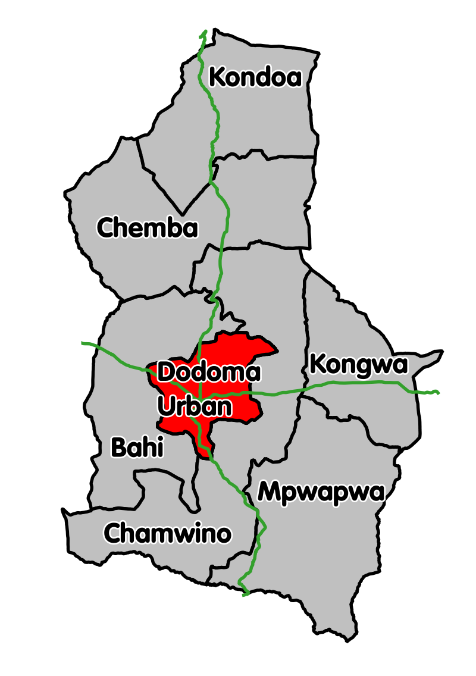

Figure 3.1: A Map showing Dodoma Urban
Source: (https://en.wikipedia.org/wiki/Dodoma_District#/media/File:Dodoma Dodoma_Urban.svg)
The necessity of choosing Dodoma city for this study is due to recently decisions of the government to shift its headquarter offices and ministries from Dar es Salaam to Dodoma and elevating the municipal status of Dodoma to City status caused increase in population, implication on healthcare delivery, expansion of health care facilities. All those must be integrated with biomedical waste management efforts in order to avoid potential health risks to health workers, environment and community.

Dodoma District is Located at 6°10′23″S 35°44′31″E, in the centre of Tanzania, the district has an area of 2,576 km² of the region which is about 41,310 km² and 410,956 of population out of 2,083,588 population of the whole region according to the 2012 national census and the Capital Development Authority (CDA) together with independent American consultants projected a population 1.3 million by 2020 in Dodoma Urban only (https://en.wikipedia.org/wiki/Dodoma)

Health services in Dodoma city are provided by the Government, NGO’s and a growing number of Health Centres, private dispensaries and pharmacies. The city has mobile clinics which normally operate during local and national vaccination campaigns to reduce maternal mortality and infant mortality rates and manage the spread of HIV-AIDS Infection. According to the 2012 national census the city has 4 hospitals, 6 health centers 51 dispensaries, 4 special clinics and 56 outreach and mobile clinics owned by the government, parastatal and private organizations (Nyampundu et al., 2020).

3.2 Study Design
The study used a cross-sectional design method that applied both qualitative and quantitative research strategy. The study was conducted from August 2019 to December 2019.Using a combination of qualitative and quantitative data can improve an evaluation by ensuring that the limitations of one type of data are balanced by the strengths of another. This will ensure that understanding is improved by integrating different ways of knowing.

3.3 Study Population
The targeted population for this study was staff of the health facilities in Dodoma city including doctors, nurses, pharmacists, laboratory personnel, and other health support staff.About 12 health facilities of different level including hospitals, health centers and dispensaries were involved in this study as follows, Dodoma regional referral hospital, Makole hospital, Mkonze health center, Police Dodoma health center, Michese dispensary, Kikuyu dispensary, Zuzu dispensary, Makole dispensary, Chamwino dispensary, Matumbulu dispensary, Mpunguzi dispensary, and Nkulabi dispensary. Dispensaries were involved in large number due to small number of staff available in dispensary level.

3.4 Sampling Procedure and Sample Size

3.4.1 Sampling Procedure
The study employed multi-stage sampling procedure.
Stage 1: Selection of 12 health facilities using simple random sampling technique without replacement
Stage 2: Selection of 146 health care workers using simple random sampling technique without replacement

3.4.2 Sample Size
A random sample was selected from a total of 12 registered hospitals, health centers and dispensaries for both qualitative and quantitative data. Formula for obtaining staff sample size per level of health facility:
n = z²p (100-p)
ε²
Where:
Z = Level of confidence of the study, which is 1.96 for 95% confidence level.
Ε=maximum likely error (taken as 9.6%)
n= (sample size), Proportion of health care providers in the selected hospitals, health centers and dispensaries.
P=86% (P) =Expected level of knowledge, attitude and practice of health care providers in selected hospitals, health centers and dispensaries.

From the formula above;
The number of staff that will be involved in each category is
n = 1.96²×86(100-86) = 50 staff
9.6²
Expected number of staff in hospitals, health centers and dispensaries = 50x3=150 staff. Good establishment of rapport was ensured in order to build good relationship with participants in avoiding large number of non-response rate, of which 142 (94.7%) of staff participated in this study.

3.5 Type of Data
In this study primary data was collected from the sample using structured questionnaires. The study applied primary data collection method, to obtain data directly from the selected institutions.

3.6 Data Collection Methods

3.6.1 Quantitative Methods
Structured questionnaires were used to gather primary data from the respondents. The aim was to assess the baseline knowledge of health care workers on waste management practices and attitudes in the study area as well as training needs of the workers for quality BMW management. Structured questionnaires were considered helpful as they are cost-efficient way to quickly collect massive amounts of information from a large number of people in a relatively short period of time.

3.6.2 Qualitative Methods
Although, structured questionnaires are mostly used in quantitative research design but this study was in need to obtain some of data by observingfor self-sufficiency which provided the nature of qualitative research. Such data are, availability of biomedical waste management guidelines in health facilities, ways of disposing biomedical waste in health facilities, whether segregation done before disposal or not, if coloured bags for storing biomedical waste before disposal are available. Such data were found among the questionnaires provided but were marked for observing technique.

The study sample included 12 health facilities which were selected randomly out of 47 public health facilities of which 3 are hospitals, 8 are health centres and 36 are dispensaries (Mwaseba et al., 2018) that provide health services in the city of Dodoma. Health care workers (including doctors, pharmacists, nurses, laboratory personnel and related support staff) were selected randomly from different departments in selected health facilities in the city, the randomly selected number of staff from each department was flexible depending on the available number of staff available per facility and staff, example large sample size was taken from hospital compared to health centres and dispensaries which have less number of staff but are many in number.

3.7 Pre-Testing of the Questionnaire
Prior to data collection, a pre-test of the data collection tool was done on Health care workers in the same study population in order to see how the target population understood the questions in the data collection tool. In addition, questionnaires are tested on members of target population/study population, to evaluate the reliability and validity of the survey instruments prior to their final distribution. The pre-testing enabled the refinement of the questionnaire such as question related to current training within five years concerning biomedical waste management was added. Also helped to change decision of involving some data to observation technique like availability of biomedical waste management guidelines in health facilities, ways of disposing biomedical waste in health facilities, whether segregation done before disposal or not, if coloured bags for storing biomedical waste before disposal are available.

3.8 Data Analysis
In this study, all collected data was coded, categorized and ordered according to the emergent categories of the responses. The collected data was processed with the help of the computer SPSS software statistical package version 20 (IBM Corp., Armonk, NY) and analyzed statistically using descriptive statistical techniques giving frequencies and percentages and compare significant relationship between different variables by using p-values of Chi-square inferential statistical test. The above methods of analysis were applied for all the objectives of the study with a focus on the knowledge base, attitudes, current practices, and training needs relating to BMW management among the health care workers in the study area. Percentage was used to score the level of knowledge, attitude, practice and need of training.

3.9 Ethical Clearance
An approval to conduct this study was sought from the Directorate of Research Publications and Innovations of the Open University of Tanzania (OUT) prior to going for field data collection. Due permission was also obtained from director’s office of the Dodoma city council directed to District Medical Officer (DMO) and at facilities level where the study was scheduled to be conducted. Request for consent to participate in the study was also sought from the potential participants. Confidentiality was assured to the respondents of the questionnaires that the data collected was for academic purposes only. The investigator was not directly involved nor in contact with the biomedical waste and hence safety in contact with the respondents was further enhanced.

CHAPTER FOUR

RESULTS

4.1 Introduction
This chapter presents and analyses the data collected from the field on the theme of the study, namely, assessment of health workers’ knowledge base, attitudinal exposition and practice orientation for effective management of biomedical waste in health facilities in the city of Dodoma.

4.2 Demographic Characteristics of the Respondents
See the results in Table 4.1.

Table 4.1: Demographic Characteristics of the Health Care workers (N=142)
Demographic characteristics | Valid | Frequency  (n) | Valid percent (%)
Category of health facility | Hospital | 40 | 28.2
Category of health facility | Health center | 62 | 43.7
Category of health facility | Dispensary | 40 | 28.2
Gender | Male | 54 | 38.0
Gender | Female | 88 | 62.0
Age group | 19 or below | 1 | 0.7
Age group | 20-29 | 77 | 54.2
Age group | 30-39 | 32 | 22.5
Age group | 40-49 | 17 | 12.0
Age group | 50 or above | 15 | 10.6
Field profession | Clinicians (MD, AMO, CO) | 32 | 22.5
Field profession | Nurses | 52 | 36.6
Field profession | Pharmaceutical personnel | 40 | 28.2
Field profession | Laboratory personnel | 16 | 11.3
Field profession | Cleaners | 2 | 1.4
Highest level of education | Primary school | 4 | 2.8
Highest level of education | Secondary school | 6 | 4.2
Highest level of education | Certificate | 28 | 19.7
Highest level of education | Diploma | 69 | 48.6
Highest level of education | Graduate | 34 | 23.9
Highest level of education | Postgraduate | 1 | 0.7
Working experience(years) | Less than 1 | 45 | 31.7
Working experience(years) | 1-5 | 43 | 30.3
Working experience(years) | 6-10 | 25 | 17.6
Working experience(years) | 11-20 | 12 | 8.5
Working experience(years) | Above 20 | 17 | 12.0
Key;
MD – Medical doctor, holder of degree of medicine
AMO – Assistant Medical Officer, holder of advanced diploma of medicine
CO – Clinical Officer, holder of diploma in clinical medicine
The Table 4.1 show that, data was collected from health centers which represented 62 (43.7%) of all the health facilities involved, hospitals 40 (28.2%) and dispensaries 40 (28.2%). The work experience of the majority of the respondents was less than 1 year that is 45 (31.7%), followed by 1-5 years were 43 (30.3%). The gender analysis of the respondents indicated that female employees were the majority that is 88 (62.0%). The most participated age group was the age between 20-29 years in which 77(54.2%) participants were involved. The distribution of the respondents by field profession nurses were much involved by 52 (36. 6%). By the level of education diploma holders were mostly involved in the study by 69 (48.6%).

4.3 Assessment of Knowledge Level of the Respondents
The results in table 4.2 show that, 137 (96.5%) of health care workers were aware that improper waste management causes various health hazards, which demonstrated good awareness of the impact caused by improper waste management. A total of 139 (97.9%) of the respondents said they were aware that improper waste management causes environmental problems, also good knowledge showed by the participant by better understanding of impacts of improper waste management to the environment.

In addition, a total of 101 (71.1%) respondents said that the government of Tanzania provided guidelines for biomedical waste management. A total of 55 (38.7%) observed that Biomedical wastes were disposed by dumping directly into garbage bins, followed by incineration by 49 (34.5%). Ninety-two (92) respondents (64.8%) observed that maintaining records of biomedical waste (BMW) was mandatory in their health facilities.

Table 4.2: Summary of the Knowledge Base of Health Care Workers (N=142)
Knowledge assessment | Valid |  | Frequency  (n) |  | Valid percent  (%)
Can improper waste management cause health hazards? |  | Yes |  | 137 |  | 96.5
 |  | No |  | 3 |  | 2.1
 |  | Don't know |  | 2 |  | 1.4
Are guidelines for BMWM provided by government of Tanzania? |  | Yes |  | 101 |  | 71.1
 |  | No |  | 11 |  | 7.7
 |  | Don't know |  | 30 |  | 21.1
How is BMW Disposed in your health facility? |  | Dump directly into garbage bins |  | 55 |  | 38.7
 |  | Handing it over to garbage collectors |  | 24 |  | 16.9
 |  | Handing it over to BMWM agency |  | 14 |  | 9.9
 |  | Incineration |  | 49 |  | 34.5
Is maintaining BMW records mandatory in your health facility? |  | Yes |  | 92 |  | 64.8
 |  | No |  | 22 |  | 15.5
 |  | Don't know |  | 28 |  | 19.7
Does improper waste management cause Environmental problems? |  | Yes |  | 139 |  | 97.9
 |  | No |  | 3 |  | 2.1
Key;
BMW – Biomedical Waste
BMWM – Biomedical Waste Management

4.4 Health Care Workers’ Attitude Assessment
The results in table 4.3 show that, most participants have good or positive attitude towards improving management of biomedical waste in their health care facilities as large percentage of good attitude reported in factors that were used to assess attitude as follows, 129 (90.8%) of the respondents agreed that safe management of biomedical waste is important. A total of 113 (79.6%) of the respondents were aware that waste management is a matter of team work/no single class of people is responsible for safe. A total of 121 (85.2%) respondents said safe management of health care waste is not an extra burden on their work. A total of 88 (62.0%) of the respondents said safe management efforts by hospitals does not increases financial burden on managements.

Table 4.3: Summary of Health Care Workers’ Attitude Assessment (N=142)
Attitude assessment | Valid | Frequency  (n) | Valid percent (%)
Safe management of health care waste is not an issue at all? | Yes | 13 | 9.2
Safe management of health care waste is not an issue at all? | No | 129 | 90.8
Safe management of health care waste is the responsibility of government? | Yes | 26 | 18.3
 | No | 116 | 81.7
Waste management is team work/no single class of people is responsible for safe management? | Yes | 113 | 79.6
 | No | 29 | 20.4
Safe management efforts by hospital increases financial burden on management? | Yes | 54 | 38.0
 | No | 88 | 62.0
Safe management of Health Care waste is an extra burden on work? | Yes | 21 | 14.8
 | No | 121 | 85.2
Source: Field Data, 2020

4.5 Assessment of the General Conduct or Practice of Health Care Workers
The results in table 4.4 show investigated poor practices towards management of biomedical waste. Most health care workers were not able to state correctly the colour of bags that were used to store biomedical waste before disposal. The results were surprising as follows, only 43 (30.3%) respondents said that used disposable plastic items were disposed of in Yellow bags which is correct,63 (44.4%) of the respondents said soiled dressings and impression materials were disposed of in red bags which is correct, 30 (21.1%) of the respondents said plaster of Paris (POP) was disposed of in black bags which is correct.

At least satisfactory practice investigated in two aspects that, 97 (68.3%) of the respondents said extracted teeth and human tissue were disposed of in red bags which is correct and 103 (72.5%) of the respondents said used sharps and needles were disposed of in Safety boxes which was correct despite of needles being used more frequently. Although, amount of health care waste generated per day in a pertinent health care facility above 4Kg by 51.4%, segregation of biomedical waste done by 87.3% and a total of 133 (93.7%) respondents said different coloured bags were used to collect different types of waste but the results in practices are not much interesting.

Table 4.4: Assessment of Practical Roles of Health Care Workers (N=142)
Practice assessment | Valid |  | Frequency(n) |  |  | Valid percent (%)
Amount of waste generated per day (in Kg) |  | 0-2 |  | 12 | 8.5
 |  | 2-4 |  | 57 | 40.1
 |  | Above 4 |  | 73 | 51.4
Whether there is waste segregation before disposal? |  | Yes |  | 124 | 87.3
 |  | No |  | 18 | 12.7
Whether different coloured bags are used to dispose different types of waste? |  | Yes |  | 133 | 93.7
 |  | No |  | 5 | 3.5
 |  | Don't know |  | 4 | 2.8
Colour of bags in which plastic items (e.g., catheter) are disposed of in? |  | Yellow bags |  | 43 | 30.3
 |  | Red bags |  | 50 | 35.2
 |  | Black bags |  | 15 | 10.6
 |  | Don't know |  | 34 | 23.9
Colour of bags in which Soiled dressings and used impression materials are disposed of in? |  | Blue/white bags |  | 15 | 10.6
 |  | Red bags |  | 63 | 44.4
 |  | Black bags |  | 30 | 21.1
 |  | Don't know |  | 34 | 23.9
Colour of bags in which sharps and needles are disposed of in? |  | Yellow bags |  | 9 | 6.3
 |  | Satety box |  | 103 | 72.5
 |  | Red bags |  | 19 | 13.4
 |  | Don't know |  | 11 | 7.7
Colour of bags in which Extracted teeth and human tissue are disposed of in? |  | Yellow bags |  | 9 | 6.3
 |  | Red bags |  | 97 | 68.3
 |  | Black bags |  | 5 | 3.5
 |  | Don't know |  | 31 | 21.8
Colour of bags in which Plaster of Paris is disposed of in? |  | Yellow bags |  | 55 | 38.7
 |  | Red bags |  | 20 | 14.1
 |  | Black bags |  | 30 | 21.1
 |  | Don't know |  | 37 | 26.1
Key;
Kg – Kilogram

4.6 Training Needs of Health Care Workers
The results in table 4.5 show that, 114 (80.3%) of the respondents did not receive any training related to biomedical waste management since they were employed. A total of 115 (81%) of the respondents confessed that they did not receive any training related to biomedical waste management in the last five years A total of 132 (93.0%) of the respondents agreed that for every health facility government should organize induction training or continuing education to upgrade existing knowledge bases of staff in matters of biomedical waste management. A total of 124 (87.3%) of the respondents said they were able to voluntarily attend programmes that enhance and upgrade their knowledge bases about biomedical waste management.

Table 4.5: Training Needs of Health Care Workers (N=142)
Training need | Valid | Frequency  (n) | Valid percent (%)
Have you received any training related to biomedical waste management since you were employed? | Yes | 28 | 19.7
 | No | 114 | 80.3
Have you ever received any training related to biomedical waste management in the last five years? | Yes | 27 | 19.0
 | No | 115 | 81.0
Do you think health facilities/government should organize training classes or continuing education programme to upgrade existing knowledge base about biomedical waste management? | Yes | 132 | 93.0
 | No | 4 | 2.8
 | Not sure | 6 | 4.2
Will you be ready to attend voluntarily programmes that enhance and upgrade your knowledge about biomedical waste management? | Yes | 124 | 87.3
 | No | 6 | 4.2
 | Not sure | 12 | 8.5
Source: Field Data, 2020

4.7 Assessment of Knowledge base and Working Experience of Health Care Workers
In table 4.6 Chi-square inferential statistical test was used to compare significant relationship of health care workers’ knowledge and working experience to health care workers by using p-values, the aim was to investigate if knowledge of health care workers can be enhanced by working experience. The results showed that, there is a significant relationship (p < 0.05) between improper waste management to various health hazards for staff with working experience. The remaining indicators of knowledge status are not significant to working experience (p>0.05).

Table 4.6: Knowledge Assessment of Health Care Workers Based on Their Working
Experience  Knowledge base  assessment | Working experience of HCWs  (in years) | Yes  n(%) | No  n(%) | Don't know  n(%) | Total  n(%) | Chi-square | Df | P  value
Can improper waste management cause health hazards? | Less than 1 | 44(31) | 0(0) | 1(0.7) | 45(31.7) | 2.015 | 8 | 0.010
Can improper waste management cause health hazards? | 1-5 | 42(29.6) | 1(0.7) | 0(0) | 43(30.3) | 2.015 | 8 | 0.010
Can improper waste management cause health hazards? | 6-10 | 25(17.6) | 0(0) | 0(0) | 25(17.6) | 2.015 | 8 | 0.010
Can improper waste management cause health hazards? | 11-20 | 9(6.3) | 2(1.4) | 1(0.7) | 12(8.4) | 2.015 | 8 | 0.010
Can improper waste management cause health hazards? | Above 20 | 17(12) | 0(0) | 0(0) | 17(12) | 2.015 | 8 | 0.010
Can improper waste management cause health hazards? | Total | 137(96.5) | 3(2.1) | 2(1.4) | 142(100) | 2.015 | 8 | 0.010
Are guidelines for BMWM provided by the government? | Less than 1 | 31(21.8) | 2(1.4) | 12(8.5) | 45(31.7) | 9.921 | 8 | 0.271
Are guidelines for BMWM provided by the government? | 1-5 | 27(19) | 5(3.5) | 11(7.7) | 43(30.3) | 9.921 | 8 | 0.271
Are guidelines for BMWM provided by the government? | 6-10 | 20(14.1) | 0(0) | 5(3.5) | 25(17.6) | 9.921 | 8 | 0.271
Are guidelines for BMWM provided by the government? | 11-20 | 9(6.3) | 2(1.4) | 1(0.7) | 12(8.4) | 9.921 | 8 | 0.271
Are guidelines for BMWM provided by the government? | Above 20 | 14(9.9) | 2(1.4) | 1(0.7) | 17(12) | 9.921 | 8 | 0.271
Are guidelines for BMWM provided by the government? | Total | 101(71.1) | 11(7.8) | 30(21.1) | 142(100) | 9.921 | 8 | 0.271
Is maintaining BMW records mandatory in your health facility? | Less than 1 | 27(19) | 5(3.5) | 13(9.2) | 45(31.7) | 14.639 | 8 | 0.067
 | 1-5 | 24(16.9) | 8(5.6) | 11(7.7) | 43(30.3) | 14.639 | 8 | 0.067
 | 6-10 | 17(12) | 7(4.9) | 1(0.7) | 25(17.6) | 14.639 | 8 | 0.067
 | 11-20 | 9(6.3) | 1(0.7) | 2(1.4) | 12(8.4) | 14.639 | 8 | 0.067
 | Above 20 | 15(10.6) | 1(0.7) | 1(0.7) | 17(12) | 14.639 | 8 | 0.067
 | Total | 92(64.8) | 22(15.5) | 28(19.7) | 142(100) | 14.639 | 8 | 0.067
Does improper waste management cause Environmental problems? | Less than 1 | 43(30.3) | 2(1.4) | 0(0) | 45(31.7) | 2.358 | 4 | 0.067
Does improper waste management cause Environmental problems? | 1-5 | 42(29.6) | 1(0.7) | 0(0) | 43(30.3) | 2.358 | 4 | 0.067
Does improper waste management cause Environmental problems? | 6-10 | 25(17.6) | 0(0) | 0(0) | 25(17.6) | 2.358 | 4 | 0.067
Does improper waste management cause Environmental problems? | 11-20 | 12(8.4) | 0(0) | 0(0) | 12(8.4) | 2.358 | 4 | 0.067
Does improper waste management cause Environmental problems? | Above 20 | 17(12) | 0(0) | 0(0) | 17(12) | 2.358 | 4 | 0.067
Does improper waste management cause Environmental problems? | Total | 139(97.9) | 3(2.1) | 0(0) | 142(100) | 2.358 | 4 | 0.067
Source: Field Data, 2020

4.8 Attitude Assessment of Health Care Workers with Training
Safe management efforts by hospital increase the financial burden on management. Chi-square inferential statistical test was used to compare significant relationship between health care workers’ attitude and health care workers who received training by using p-values, the aim was to investigate if training can change attitude. This showed a significant relationship with health care workers who received training related to biomedical waste management over five years (p <0.05). The remaining indicators of attitude assessment as shown in table 4.7 are not significantly related to training in biomedical waste management (p >0.05).

Table 4.7: Attitude Assessment of Health Care Workers with Training
Attitude assessment |  | Have you ever received any training related to biomedical waste management in the last five years? |  | Total  n(%) | Chi-square | Df | P value
 |  | Yes  n(%) | No  n(%)
Safe management of health care waste is not an issue at all? | Yes | 3(2.1) | 10(7.1) | 13(9.2) | 0.153 | 1 | 0.695
Safe management of health care waste is not an issue at all? | No | 24(16.9) | 105(73.9) | 129(90.8) | 0.153 | 1 | 0.695
Safe management of health care waste is not an issue at all? | Total | 27(19) | 115(81) | 142(100) | 0.153 | 1 | 0.695
Safe management of health care waste is the responsibility of government? | Yes | 4(2.8) | 22(15.5) | 26(18.3) | 0.272 | 1 | 0.602
 | No | 23(16.2) | 93(65.5) | 116(81.7) | 0.272 | 1 | 0.602
 | Total | 27(19) | 115(81) | 142(100) | 0.272 | 1 | 0.602
Waste management is team work/no single group of people is responsible for such safety | Yes | 20(14.1) | 93(65.5) | 113(79.6) | 0.621 | 1 | 0.431
 | No | 7(4.9) | 22(15.5) | 29(20.4) | 0.621 | 1 | 0.431
 | Total | 27(19) | 115(81) | 142(100) | 0.621 | 1 | 0.431
Safe management efforts by hospital increases financial burden on management? | Yes | 15 | 39 | 54 | 4.346 | 1 | 0.037
 | No | 12 | 76 | 88 | 4.346 | 1 | 0.037
 | Total | 27(19) | 115(81) | 142(100) | 4.346 | 1 | 0.037
Safe management of Health Care waste is an extra burden at work? | Yes | 3(2.1) | 18(12.7) | 21(14.8) | 0.358 | 1 | 0.550
 | No | 24(16.9) | 97(68.3) | 121(85.2) | 0.358 | 1 | 0.550
 | Total | 27(19) | 115(81) | 142(100) | 0.358 | 1 | 0.550
Source: Field Data, 2020

4.9 Attitude Assessment of Health Care Workers based on their Level of Education
Chi-square inferential statistical test was used to compare significant relationship between health care workers’ attitude and health care workers’ level of education by using p-values, the aim was to investigate if high level of education attained by health care workers can change attitude. Surprisingly, all indicators of attitude assessment shown in table 4.8 are not significant in relation to level of education in biomedical waste management (p > 0.05).

Table 4.8: Attitude Assessment of Health Care Workers against Level of Education
Attitude assessment |  |  | Highest level of education to health care workers |  |  |  |  |  |  |  |  |  |  |  | Total |  | Chi-square |  |  | Df |  |  |  | P  value
Attitude assessment |  |  | Pri  edu |  | Sec  edu |  | Cert |  | Dip |  | Gra |  | Posgra
Safe BMWM is not an issue at all |  | Yes n(%) |  | 1(0.7) |  | 2(1.4) |  | 3(2.1) |  | 6(4.2) |  | 1(0.7) |  | 0(0) |  | 13(9.1) |  | 7.204 |  |  | 5 |  | 0.206
 |  | No n(%) |  | 3(2.1) |  | 4(2.8) |  | 25(17.6) |  | 63(44.4) |  | 33(23.2) |  | 1(0.7) |  | 129(90.9)
 |  | Total n(%) |  | 4(2.8) |  | 6(4.2) |  | 28(19.7) |  | 69(48.6) |  | 34(23.9) |  | 1(0.7) |  | 142(100)
Safe BMWM is the responsibility of government |  | Yesn(%) |  | 1(0.7) |  | 2(1.4) |  | 8(5.6) |  | 10(7) |  | 5(3.5) |  | 0(0) |  | 26(18.3) |  |  | 4.188 |  |  | 5 |  |  | 0.523
 |  | Non(%) |  | 3(2.1) |  | 4(2.8) |  | 20(14.1) |  | 59(41.6) |  | 29(20.4) |  | 1(0.7) |  | 116(81.7)
 |  | Total (%) |  | 4(2.8) |  | 6(4.2) |  | 28(19.7) |  | 69(48.6) |  | 34(23.9) |  | 1(0.7) |  | 142(100)
Waste management is team work |  | Yesn(%) |  | 2(1.4) |  | 4(2.8) |  | 22(15.5) |  | 57(40.1) |  | 27(19) |  | 1(0.7) |  | 113(79.6) |  |  | 3.433 |  |  | 5 |  |  | 0.633
 |  | Non(%) |  | 2(1.4) |  | 2(1.4) |  | 6(4.2) |  | 12(8.5) |  | 7(4.9) |  | 0(0) |  | 29(20.4)
 |  | Totaln(%) |  | 4(2.8) |  | 6(4.2) |  | 28(19.7) |  | 69(48.6) |  | 34(23.9) |  | 1(0.7) |  | 142(100)
Safe BMWM efforts by hospital increases financial burden |  | Yesn(%) |  | 1(0.7) |  | 3(2.1) |  | 7(4.9) |  | 31(21.8) |  | 11(7.7) |  | 1(0.7) |  | 54(38) |  | 6.158 |  |  | 5 |  | 0.291
 |  | Non(%) |  | 3(2.1) |  | 3(2.1) |  | 21(14.8) |  | 38(26.8) |  | 23(16.2) |  | 0(0) |  | 88(62)
 |  | Totaln(%) |  | 4(2.8) |  | 6(4.2) |  | 28(19.7) |  | 69(48.6) |  | 34(23.9) |  | 1(0.7) |  | 142(100)
Safe BMWM is an extra burden at work |  | Yesn(%) |  | 1(0.7) |  | 0(0) |  | 5(3.5) |  | 10(7) |  | 4(2.8) |  | 1(0.7) |  | 21(14.8) |  | 7.595 |  |  | 5 |  | 0.180
 |  | Non(%) |  | 3(2.1) |  | 6(4.2) |  | 23(16.2) |  | 59(41.6) |  | 30(21.1) |  | 0(0) |  | 121(85.2)
 |  | Totaln(%) |  | 4(2.8) |  | 6(4.2) |  | 28(19.7) |  | 69(48.6) |  | 34(23.9) |  | 1(0.7) |  | 142(100)
Source: researcher, 2021.

CHAPTER FIVE

DISCUSSION OF RESULTS

5.1 Introduction
This chapter presents a detailed discussion of analysed data as represented in chapter four focusing on knowledge base, attitude status and staff practices related to biomedical waste management among health care workers in health facilities in the city of Dodoma in Tanzania.

5.2 Assessment of Knowledge base of Health Care Workers
The findings of the present study conducted in Dodoma, Tanzania indicated that most health care workers had adequate knowledge about the hazards of improper biomedical waste management to communities and the environment. They demonstrated adequate knowledge of management of biomedical waste which can reduce direct health impact on the community, the health care workers and the environment. Such findings are similar to the findings of a study conducted in Brazil by Da Silva et al. (2020) which revealed that risks to health and environment can be caused by improper management and disposal of waste.

In addition, Da Silva et al. (2020) observed that adequate knowledge of management of biomedical waste can reduce the direct health impacts to the community. This observation is supported by the findings of a study conducted in Uganda by Wafula et al. (2019) that reported that, the risk of hazards such as injuries, infections (HIV/AIDS, Hepatitis B and C), and environmental pollution were caused by improper health care waste management. Another study conducted in India by Patil (2015) reveals that more than 50,000 people die every day from infectious diseases, and one of major causes is the increase in infectious diseases due to improper waste management.

In this study, a big number of health facilities had guidelines related to biomedical waste management provided by the government or had different kinds of flyers developed from national guidelines. This surprising finding reduces efforts in providing guidance for the environmentally sound management of health care waste in the country. In the findings of the present study, it was more surprising that two disposal methods, namely dumping directly into garbage bins and incineration were associated with the greatest health risk and were used in many health facilities. This is in agreement with the observation from a study in Ethiopia by Yazie et al. (2019) that revealed that incineration is the most widely used waste treatment method to treat hazardous HCW before their final disposal. Incineration and open burning are common treatment methods used to treat hazardous and general waste types, respectively.

However, incinerators are often operated under sub-optimal conditions mostly by untrained personnel. According to Barar and Kulkhestha (2015), emissions from incinerators and open burning also lead to releases of harmful gases which can cause cancer and respiratory diseases. In Nigeria a study found a lot of open dumping of potentially infectious materials and general absence of incinerators to treat waste materials (Anozie et al., 2017). The present study also informs of similar findings with those of Hossain (2018) in Dhaka city Bangladesh who found that, open dumping is very basic in developing nations because of low financial bases. Nonetheless, in this study a good number of health care workers also agreed that maintaining records of biomedical waste (BMW) was mandatory in their health facilities.

5.3 Assessment of Health Care Workers’ Attitudes towards Biomedical Waste Management
The findings of this study indicated that most health workers in Dodoma demonstrated positive attitudes towards safe management of biomedical waste. This was similar to the findings in a study conducted in Ethiopia by Abdela et al. (2016) who revealed that, in the overall, attitudes towards Hepatitis B Virus (HBV) prevention among the participants was favourable when prevention was connected with biomedical waste management. However, a study in Nigeria by Anozie et al. (2017) showed that, all the healthcare managers admitted that their activities with respect to healthcare waste management and occupational safety procedures had never been subjected to scrutiny by relevant government agencies.

Another similar study in Oman by Al-balushi and Muqeet (2018) reported that biomedical waste management should be a team work responsibility which concurs to the findings of this study and the majority of them followed universal precautions while handling biomedical waste. But the findings of the present study disagree with those in a study conducted in Ethiopia by Deress et al. (2019) who reported that the level of attitude for health care staff towards BMWM was unsatisfactory and their use of appropriate personal protective devices and waste management utilities were limited. Furthermore, a study conducted in Botswana by Mugabi et al. (2018) showed that, in terms of attitude, most respondents agreed that medical waste should be segregated at the point where it is generated.
Public health care workers must be concerned about safe management of health care waste as they can direct interact with hospital waste which is dumped direct to open garbage bins causing infections. A study in Uganda conducted by Sani (2016) revealed that, in terms of attitudes towards BMW, the majority of multipurpose staff felt that the segregation of BMW is not an issue at all and it is purely the responsibility of the concerned institution and not individual responsibility, also they felt that the safe segregation of BMW is an extra burden at their work, and all doctors felt that Safe segregation of Health Care waste is an extra burden to their work, this can cause health risk to health care workers and the public in general.

Although government commitment and support is needed for universal, long-term improvement of BMWM and for more positive results in safe management of biomedical waste, any person who interacts with such waste must be enhanced with due knowledge in biomedical waste management. This strategy can provide positive public health results, minimal environmental pollutions and reduce incidences of infections (Sani, 2016). In the present study it was observed that, waste produced in the course of health care activities carries a higher potential for infection and injury than any other type of waste. Again, inadequate and inappropriate attitude in handling health care waste may have serious health consequences and a significant impact on the environment as well. Da Silva et al. (2020) reports similar findings in Brazil.

5.4 Assessment of Health Care Workers’ Practical Roles in Biomedical Waste Management
Research results show that health care wastes are produced frequently in different level health facilities. A study conducted by Kuchibanda et al. (2015) in Shinyanga municipality, Tanzania showed that, the increase of healthcare facilities has resulted in an increase in healthcare wastes, which poses serious threats to the environment, the health status of workers, and the general environment.

In the present study, segregation of biomedical waste was mostly conducted in many health facilities but proper segregation practice was not observed in most of health facilities. The results concur with Anozie et al. (2017) in Nigeria who reported that hazardous waste were not properly collected, segregated and disposed in an appropriate manner and that there was a lot of open dumping of potentially infectious materials and general absence of incinerators to treat waste materials. Again the finding is in agreement with Kuchibanda et al. (2015) in Shinyanga municipality who found that awareness about practical actions on waste colour coding is still poor leading to high health risks for the general public. Health care workers are always at the most risk from disposable plastic items (e.g catheter), soiled dressings and impression materials, used sharps and needles, extracted teeth and human tissue, plaster of Paris (P.O.P) most of which are not often stored in appropriate containers.

Another study conducted in Ethiopia by Deress et al. (2019) reported that health care practice scores were unsatisfactory despite their use of appropriate personal protective gear and waste management precautions. Also a study in Botswana conducted by Mugabi et al. (2018) pertaining to the practical handling of biomedical waste agreed with this study particularly in that there was a colour-coding system in the hospitals studied. The Botswana study finding was also similar to those of this study that, segregation of medical waste was problematic with mixing of the different types of waste. These findings are similar to those of another study from South-Eastern Nigeria, where Anozie et al. (2017) reported that 98.1% of hospitals in the region practiced indiscriminate disposal of biomedical waste. Generally, most health care workers in Dodoma city do not demonstrate safe management of health care waste for most of them do not observe the prescribed use of coloured bags.

5.5 Training needs of Health Care Workers
In the present study, it was found that the highest number of health care workers did not receive any training related to biomedical waste management since they were employed. Similar results were found by Anozie et al. (2017) in Nigeria who reported that, the lack of regular training and update on occupational safety measures caused poor knowledge of, and high level of non-compliance to standard medical waste management procedures. Again the findings are similar with those of Deress et al. (2018) in Ethiopia who reported that, the level of knowledge, attitude, and practice scores for health care staffs were not satisfactory because their majority never did access and attend biomedical waste management training. WHO (2017) reported that the highest number of medical staff were not exposed to training in medical waste management. The organization insisted that education and training are essential and should be provided to all staff that is responsible for both segregation and collection of biomedical waste.

Most of the related staff showed willingness to attend voluntary training programmes. What is needed; is an awareness of the need and action from the government and related organs. The results of the present study failed to show good correlation between health workers’ knowledge levels, attitudes and practices relating to biomedical waste management. The situation is closely similar to that observed in a study from South-Eastern Nigeria, where Anozie et al. (2017) reported that 98.1% of hospitals in the region practiced indiscriminate waste disposal, while 40% of healthcare managers reporting having received basic training in medical waste management. However, the above observations are in disagreement to the findings is a study conducted in Uganda by Wafula et al. (2019) who reported that the conduct and practices of health workers there on HCW management were satisfactory.

The finding from Uganda relates to appreciable knowledge as there was significant association between practice and knowledge scores (p < 0001) and health workers who had received training in health care waste management and were more likely to demonstrate satisfactory practices. No one can argue against the importance of training for safe management of biomedical waste. Training is everything and carries with it knowledge, attitudes and changes in mind-sets and improves modes of actions or practices in all matters relating to biomedical waste management. It is very clear from the various studies reviewed in the literature that there is a big lack of knowledge, befitting attitudes and practices for effective BMW management amongst medical and health care staff especially in developing countries including Tanzania.

According to Deress et al. (2018) findings in Ethiopia the level of knowledge, demonstrated attitudes and practice, scores were not satisfactory because the majority of the healthcare professionals did not access nor attend biomedical waste management training. On another hand a study conducted in Rwanda by Erigene et al. (2019) recommended that, continuing education and training programmes and short courses in bio-medical waste management should be carried out regularly to improve the knowledge bases and modes of practice for bio-medical waste management among healthcare staff.

Intensive Healthcare Waste Management (IHWM) training could be an effective intervention for improved knowledge bases, attitudes and mind-sets as well as modes of action or practices among health workers involved in handling or managing the disposal of infectious biomedical waste. Kumar et al. (2016) in Pakistan established that, the training of health workers has been proven to be one of the most effective strategies for improved practices and behaviours of staff in the health sector especially when combined with other innovative and more creative strategies. It has been shown that regular training and retraining and induction of health care workers is instrumental in improving staff conduct and practices in waste management for the improved living and working conditions of all mankind.

CHAPTER SIX

CONCLUSIONS AND RECOMMENDATIONS

6.1 Conclusion
Health care workers in Dodoma city demonstrated good awareness of the impact of improper management of health care waste. A total of 96.5% of health care workers were aware that improper waste management causes various health hazards and 97.9% were aware that improper waste management causes environmental problems.
It was also observed that two waste disposal methods (dumping directly into garbage bins and incineration) which were associated with the greatest health risk were mostly seen in many health facilities. About 38.7% of wastes were disposed by dumping directly into garbage bins, and by incineration (34.5%) making a total of 73.2% significant statistic for the two methods.

Guidelines related to biomedical waste management were not adequately implemented in some of the health facilities in Dodoma City. Different kinds of flyers were found for the purpose of creating public awareness about the risks of mismanaging biomedical wastes but most of the health workers were not aware of the existence of the fliers for the same were not placed in all units of health facilities.
On average it was interesting that most of health workers in Dodoma city had positive attitude and mind-sets for safe management of health waste.

Generally, as explained above, based on the research findings relating to different practices, most health care workers in Dodoma city Tanzania did not practice nor demonstrate safe management of health care waste. Most of them did not make correct use of the coloured bags. It was more surprising that 80.3% of health care staff did not receive any training or induction related to biomedical waste management since they were employed and only 19.7% of the respondents to the questionnaire of this study had ever received training since they were first employed. In terms of working experiences some health care workers were in practice for more knowledgeable even though for more than 20 years they did not undertake any training related to biomedical waste management.

It was even more interesting that most of the respondents in this study showed positive attitudes and support for training as 93.0% agreed that every health facility and indeed the government should organize classes or introduce continuing education programmes to upgrade existing knowledge bases about biomedical waste management, as 87.3% were interested even to attend voluntarily in any training related to management of health care waste. No one can argue that training is not needed for safe management of biomedical waste, as training is everything in both knowledge building, attitude modification and mind-set changing as well as improving modes of actions and practices for biomedical waste management.

6.2 Recommendations
In Tanzania there is a need to build a comprehensive system by health policy makers that addresses and defines clearly the responsibilities, and resource allocation criteria for handling and disposing Biomedical wastes. There is also the urgent need to improve awareness creation about the risks of poor handling and neglects in the management of biomedical wastes including the pertaining safe and sound practices in all the concerned areas. Government commitment and support is needed for universal, long-term improve handling and management of BMW alongside immediate action at every health facility. Tanzania Ministry of President’s Office – Regional Administration and Local Government (PO-RALG) responsible for local government has given local authorities, the mandate to handle health related matters in specific areas.

Furthermore, as presented in figure 1 of conceptual framework legislation, policies, availability of equipment and guidelines for biomedical waste management practices were considered as factors that can affect proper biomedical waste management among health care workers in our health care facilities, and the ministry of PO-RALG has authorities to handle those matters up to the lower level health facilities. The government is advised to establish an independent department to be responsible for biomedical waste. The unit should be headed by a professional person specialized in biomedical waste management Such an officer should ensure, among other responsibilities, that the injuries inflicting health care personnel are promptly reported for health care actions and prevention of infections.

The government, in collaboration with training institutes like universities and colleges, should establish training centers for biomedical waste management and require that such training and staff retraining should be compulsory for all healthcare facilities and relevant regulatory organs such as the National Council for Technical Education and the Tanzania Commission for Universities and related professional associations should ensure the appropriate assessment, recognition and accreditation of the relevant courses. The training sessions should not become merely a one-time activity but should be a continuous process and arrangement.
The relevant government Ministry or department should organize classes or plan for continuing education programme to upgrade existing knowledge bases in biomedical waste management for health care workers for attitude building and mind-set change. Dodoma City should scale up its effort to better manage wastes from all sources and so guarantee good human, animal and environmental health for the city dwellers. Proper segregation of healthcare waste must follow standardized procedures, according to national and international guidelines.

In addition, Section 92(a) of the Tanzania Public Health Act emphasizes that, the concerned authority shall, in collaboration with the Ministers responsible for health, environmental management agencies and local government, ensure that health care wastes are sorted and stored in prescribed coded containers and transported in waste trucks designed and registered for the purpose. Strong enforcement of this law is needed in order to maintain good practices of biomedical waste management and so avoid hazards associated with improper disposal of biomedical waste.

REFERENCES
Abdela, A., Woldu, B., Haile, K., Mathewos, B. & Deressa, T. (2016). Assessment of knowledge, attitudes and practices for the prevention of hepatitis B virus infection among students of medicine and health sciences in Northwest Ethiopia. BMC research notes, 9(1), 410.
Al-balushi, Y. A. & Muqeet, U. (2018). Knowledge, Attitude and Practice relating to Biomedical Waste Management among Health Care Personnel in a Secondary Care Hospital of Al Buraimi Governorate, Sultanate of Oman. Global Journal of Health Science, 10(3), 70-83.
Ananthachari, K. R. & Divya, C. V. (2016). A study on assessment of knowledge on biomedical waste management among health care workers of Malabar Medical College Teaching Hospital, Calicut, Kerala, India. International Journal of Community Medicine and Public Health, 3(9), 2409-2413.
Anozie, O. B., Lawani, L. O., Eze, J. N., Mamah, E. J., Onoh, R. C., Ogah, E. O. & Anozie, R. O. (2017). Knowledge, attitude and practice of health care managers on medical waste management and occupational safety practices: Findings from Southeast Nigeria. Journal of clinical and diagnostic research: JCDR, 11(3), IC01.
Barar, M. & Kulkhestha, A. (2015). Biomedical waste management–Need of today- A review. International Journal of Science Research, 4, 2417-21.
Cordeiro, J. F. C., Alves, A. P., Chayamiti, E. M. P. C., Miranda, D. O., Gir, E. & Canini, S. R. M. S. (2016). Occupational accidents among nursing professionals in a home care service in the state of São Paulo. Electronic Journal of Nursing, 18, e1175.
Da Silva, I. A. & Sant'ana, L. P. (2020). Management of health care waste. Santa Cecília University biological science, 9(2), 124-129.
Deress, T., Hassen, F., Adane, K. & Tsegaye, A. (2018). Assessment of knowledge, attitude, and practice about biomedical waste management and associated factors among the healthcare professionals at Debre Markos Town healthcare facilities, Northwest Ethiopia. Journal of environmental and public health, 1(1), 1-10.
Deress, T., Jemal, M., Girma, M. & Adane, K. (2019). Knowledge, attitude, and practice of waste handlers about medical waste management in Debre Markos town healthcare facilities, northwest Ethiopia. BMC research notes, 12(1), 146.
Diaz-Soriano, A., Gallo, W., Luza, S., Munive-Degregori, A., Bocanegra, R. & Mayta-Tovalino, F. (2020). Knowledge and awareness of effective recycling of dental materials and waste management among Peruvian undergraduate students of dentistry: A logistic regression analysis. Journal of International Society of Preventive and Community Dentistry, 10(3), 309.
Erigene, R., Jean, A. N., & Michael, H. (2019). Knowledge and Practice for Bio-Medical Waste Management among Healthcare Personnel at Kabgayi District Hospital, Rwanda. Journal of public health international, 1(4), 36.
Gaitu, K., Muduli, K., Apana, H., Aich, S. & Pumwa, J. (2019). The Issues Affecting the Correct Practice of Health Care Waste Management in Lae’sAngau Memorial General Hospital. Indian Journal of Public Health, 10(12), 551.
Ghasemi, M. K. & Yusuff, R. B. (2016). Advantages and Disadvantages of Healthcare Waste Treatment and Disposal Alternatives: Malaysian Scenario. Polish Journal of Environmental Studies, 25(1), 17-25.
Gunawardana, K. D. (2018). An analysis of medical waste management practices in the health care sector in Colombo. Management of Environmental Quality: An International Journal, 29(5), 813-825.
Gupta, N. K., Shukla, M. & Tyagi, S. (2017). Knowledge, attitude and practices of biomedical waste management among health care personnel in selected primary health care centres in Lucknow. International Journal of Community Medicine and Public Health, 3(1), 309-313.
Haifete, A. N., Justus, A. H. & Iita, H. (2016). Knowledge, attitude and practice of healthcare workers on waste segregation at two public training hospitals. European journal of pharmaceutical and medical research, 3(5), 674-689.
Hossain, F. (2018). A review on health care waste management system in Dhaka city. Unpublished Bachelor project report, Brac University, Dhaka, Bangladesh.
Kagonji, I. S. & Manyele, S. V. (2016). Analysis of health workers’ perceptions on medical waste management in Tanzanian Hospitals. Engineering, 8(07), 445.
Kuchibanda, K. & Mayo, A. W. (2015). Public health risks from mismanagement of health care wastes in Shinyanga municipality health facilities, Tanzania. The Scientific World Journal, PMID: 26779565.
Kumar, R., Somrongthong, R. & Ahmed, J. (2016). Impact of waste management training intervention on knowledge, attitude and practices of teaching hospital workers in Pakistan. Pakistan journal of medical sciences, 32(3), 705.
Maina, J. W. (2018). Knowledge, Attitude and Practice of Staff on Segregation of Hospital Waste: A Case Study of a Tertiary Private Hospital in Kenya. European Scientific Journal, 14, 401-417.
Manzoor, J., & Sharma, M. (2019). Impact of Biomedical Waste on Environment and Human Health. Environmental Claims Journal, 31(4), 311-334.
Mohamed, H. H., Abd El-Kader, R. G. & Ibrahim, A. A. W. (2019). Knowledge, Attitude and Practice of Health Care Personnel about Medical Waste Management in Selected Family Health Centers in Mansoura, Egypt. International Journal of Innovative Research in Medical Science, 4(6), 349-459.
Mohammed, M. W. & Meidan, T. M. (2018). Assessment of knowledge, Attitude and Practice of Biological Hazards Among Health Workers in Medical Laboratories in Benghazi Medical Center, unpublished Doctoral dissertation, University of Benghazi, from; file:///C:/Users/AUGUST~1/AppData/Local/ Temp/Assessment%20of%20knowledge,%20Attitude%20and%20Practice%20of%20Biological%20Hazards%20Among%20Health%20Workers%20in%20Medical%20Laboratories%20in%20Benghazi%20Medical%20Center-1. pdf.
Mugabi, B., Hattingh, S. & Chima, S. C. (2018). Assessing knowledge, attitudes, and practices of health care workers regarding medical waste management at a tertiary hospital in Botswana: A cross-sectional quantitative study. Nigerian Journal of Clinical Practice, 21(12), 1627-1638.
Mwakalukwa, S. I. (2017). Public Awareness on Clinical Waste Management in Mabibo, Buguruni and Mbagala Wards, Dar es Salaam, unpublished Doctoral dissertation, The Open University of Tanzania, Dar es Salaam, Tanzania.
Mwakanyamale, N., &Mwakanyamale, N. (2017). Assessment of Medical Waste Management in Health Facilities: The Case of Makambako Health Centre, unpublished Doctoral dissertation, Mzumbe University, Morogoro, Tanzania.
Mwita, S., Ngonela, G. & Katabalo, D. (2019). Disposal Practice of Unfit Medicines in Non-Governmental Hospitals and Private Medicine Outlets Located in Mwanza, Tanzania. Journal of Environmental and Public Health, 2019(3), 1-6.
Nyampundu, K., Mwegoha, W. J. & Millanzi, W. C. (2020). Sustainable solid waste management Measures in Tanzania: an exploratory descriptive case study among vendors at Majengo market in Dodoma City. BMC Public Health, 20(1), 1-16.
Olaifa, A., Govender, R. D. & Ross, A. J. (2018). Knowledge, attitudes and practices of health care workers about health care waste management at a district hospital in KwaZulu-Natal. South African Family Practice, 60(5), 137-145.
Oyefabi, A. O. M. & Yahuza, B. S. (2016). Ethical issues in knowledge, perceptions, and exposure to hospital hazards by patient relatives in a tertiary institution in North Western Nigeria. Nigerian journal of clinical practice, 19(5), 622-631.
Patil, Y. D. (2015). Disposal of Bio-medical Waste in India. Journal of Krishna Institute of Medical Sciences University, 4(1), 188-192.
Sanches, A. P. M., Mekaro, K. S., Figueiredo, R. M. D., & André, S. C. D. S. (2018). Health-Care Waste: Knowledge of Primary Care nurses. Revistabrasileira de enfermagem, 71(5), 2367-2375.
Sani, J. (2016). Knowledge, Attitudes and Practices Regarding Biomedical Waste Segregation by Health Care Workers at China-Uganda Friendship Hospital, Naguru-Kampala. Unpublished Doctoral dissertation, International Health Sciences University. Kampala, Uganda.
ShonjeYotham, S. (2017). Occupational Health and safety Hazards Encountered by Health Care Workers in Tanzania: The Case of Amana Regional Referral Hospital, Dar es Salaam. Unpublished Doctoral dissertation, Ardhi University, Dar es Salaam, Tanzania.
Mwaseba, S. L., Mwang’onda, E. S., &Juma, M. S. (2018). Patient’s Perception on Factors for Choice of Healthcare Delivery at Public Hospitals in Dodoma City. Hospitals, 3(2), 5.
Tanzania Environmental Management Act (2004), Retrieved on 20th June, 2020 from; http://extwprlegs1.fao.org/docs/pdf/tan71740a.pdf.
Tanzania Public Health Act, (2009). Retrieved on 02nd July, 2019 from; file:///C:/Users/AUGUST~1/AppData/Local/Temp/1452146412-ActNo-1-2009.pdf.
Wafula, S. T., Musiime, J. & Oporia, F. (2019). Health care waste management among health workers and associated factors in primary health care facilities in Kampala City, Uganda: a cross-sectional study. BMC public health, 19(1), 203.
World Health Organization, (2017). Safe management of wastes from health-care activities: a summary No. WHO/FWC/WSH/17.05. Retrieved on 30th June from; file:///C:/Users/AUGUST~1/AppData/Local/Temp/WHO-FWC-WSH-17.05-eng.pdf.
Yazie, T. D., Tebeje, M. G. & Chufa, K. A. (2019). Healthcare waste management current status and potential challenges in Ethiopia: a systematic review. BMC research notes, 12(1), 1-7.
Zilihona, I. J. E., Mayaya, H. K., Mnyone, G. & Nkonoki, J. (2013). Perceived environmental risks and challenges of urban waste management in planned and unplanned settlements of Dodoma municipality in Tanzania. The social sciences, 8(1), 55-63.

APPENDICES
APPENDIX 1: QUESTIONNAIRE FOR HEALTH CARE WORKERS
Knowledge, Attitude and Practices in Biomedical Waste Management among Health Care Workers in Dodoma city, Tanzania.

SECTION A: FOR THE RESEARCHER’S USE ONLY
Researcher’s name……………………………………………………………….
Researcher’s university registration number …………………………………….
Questionnaire number……………………………………………………………..
Date of data collection………………………………………………………………
Categories (show by tick).
Type of institute; Hospital……. Health center………. Dispensary……….
Name of institute………………………………………………………….….

SECTION B: SOCIAL AND DEMOGRAPHIC CHARACTERISTICS OF RESPONDENT
Instructions
Circle/tick the best choice in the multiple choice questions below. In some questions you are allowed to circle/tick more than one response when necessary. If you find difficulty in understanding the question, please ask for clarification before answering.
1. Sex
a) Male b) Female
2. Age
a) ≤19 b) 20 – 30 years c) 30 – 39 years d) 40 – 49 years e) ≥ 50 years
3. Field profession
a) Clinicians (Medical Doctor, AMO, Clinical Officer) b) Nurse & medical attendant
b) Pharmaceutical personnel d) Laboratory personnel e) Cleaners
4. Highest level of education
a) Primary school b) Secondary school c) Certificate d) Diploma
e) Graduate f) Postgraduate
5. How long have you been working as a health care worker (Service experience)?
a) Less than 1 year b) 1 – 5 years c) 6 – 10 years d) 11 – 20 years e) > 20 years

ECTION C: KNOWLEDGE BASE ASSESSMENT
1. Can improper waste management cause health hazards?
a) Yes b) No c) Don’t know
2. Do you know about any government guidelines for BMW management?
a) Yes b) No c) Don't know
3. Disposal of health care waste?
a) Dumped directly into garbage bins b) Handing it over to garbage collectors
c) Handing it over to the Bio-medical waste management agency d) Other methods
4. Is maintaining a BMW records mandatory in your hospital/clinic?
a) Yes b) No c) Don't know
5. Does improper waste management cause environmental problems?
a) Yes b) No c) Don't know

SECTION D: ATTITUDE ASSESSMENT
1. Safe management of health care waste is not an issue to me at all?
a) Yes b) No
2. Safe management of health care waste / BMW is the responsibility of government?
a) Yes b) No
3. Waste management is team work / no single class of people is responsible for safe management?
a) Yes b) No
4. Safe waste management efforts by hospitals increases financial burden on management?
a) Yes b) No
5. Safe management of Health Care waste / BMW is an extra burden on work?
a) Yes b) No

SECTION E: NEED OF TRAINING
1. Have you received any training in biomedical waste management since you were employed? If yes attempt next question.
a) Yes b) No
2. Have you received training related to biomedical waste management in the last five years?
a) Yes b) No
3. Do you think the health facility / government should organize periodic training to upgrade existing knowledge about biomedical waste management?
a) Yes b) No c) Not sure
4. Will you be ready to attend voluntarily programmes that enhance and upgrade your knowledge about biomedical waste management?
a) Yes b) No c) Not sure

SECTION F: PRACTICE ASSESSMENT
1. What amount of healthcare waste / BMW is generated per day in your work area?
a) 0-2 kgs b) >2 - <4 kgs c) > 4 kgs
2. Is there any segregation of the waste before its disposal?
a) Yes b) No
3. Are different coloured bags used to segregate and dispose different types of BM waste?
a) Yes b) No c) Don't know
4. Used disposable plastic items (e.g., catheters) are disposed in:
a) Yellow bags b) Red bags c) Black bags d) Don't know
5. Soiled dressings and used impression materials are disposed in:
a) Blue/ white bags b) Red bags c) Black bags d) Don't know
6. Used sharps items and needles are disposed in:
a) Yellow bags b) Rigid/puncture-proof container (safety box) c) Red bags d) Don't know
7. Extracted teeth and human tissue are disposed in:
a) Yellow bags b) Red bags c) Black bags d) Don't know
8. Plaster of Paris is disposed in:
a) Yellow bags b) Red bags c) Black bags d) Don't know

APPENDIX 2: RESEARCH CONSENT FORM
My name is Augustine Edward, a postgraduate student at the Open University of Tanzania currently pursuing the Msc programme in Environmental health. I am on a mission to collect data relating to the Assessment of health care workers’ knowledge attitudes and practices for effective management of biomedical waste in Dodoma City Tanzania: You are kindly requested to take part in this research by filling up the questionnaire provided. The data collected from this research will only be used for research purposes and not otherwise. Participation in this research is completely voluntary.

If you agree to take part in this study, please fill out your name, signature and contact here below and return the form to me with my advance thanks.
Name …………………………………………………
Signature …………………………………………….
Mobile phone number ………………………………

APPENDIX 3: THE OPEN UNIVERSITY OF TANZANIA INTRODUCTION LETTER
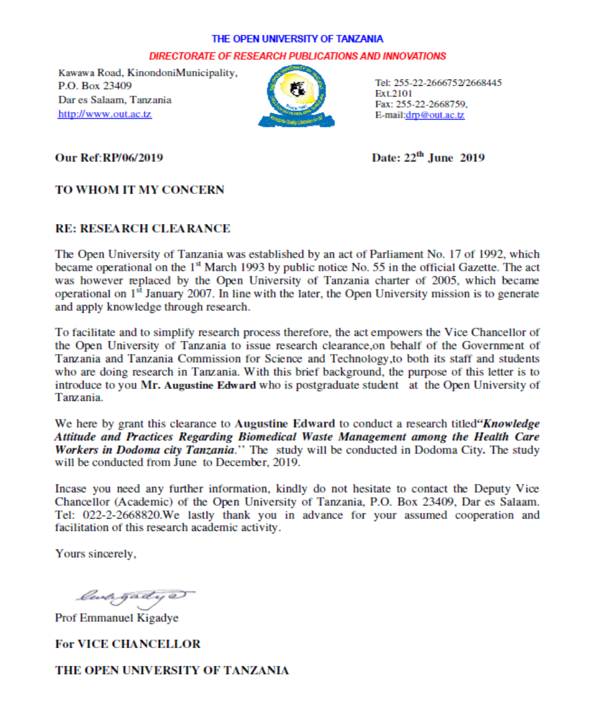
APPENDIX 4: LETTER OF PERMISSION FROM THE DIRECTOR OF DODOMA CITY
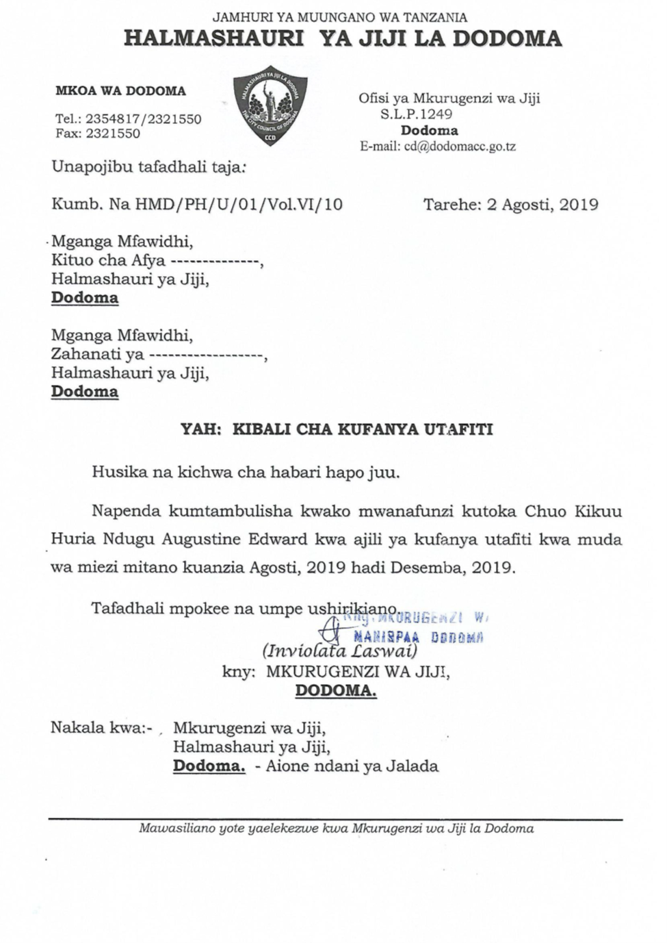
APPENDIX 5: CERTIFICATION OF EDITING
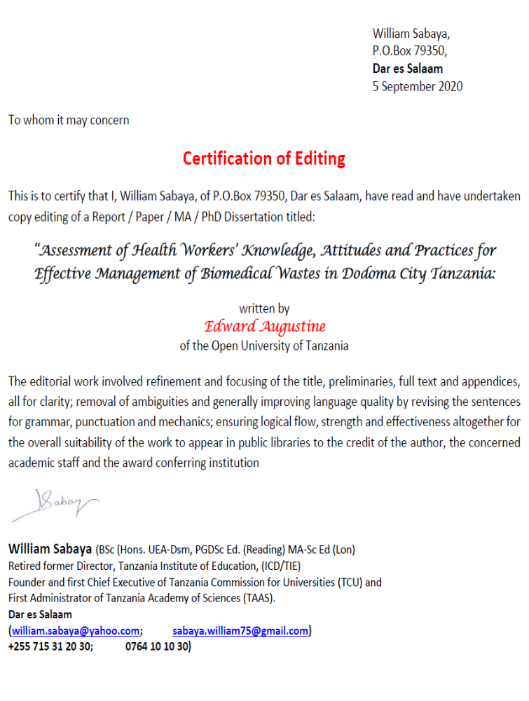

APPENDIX 6: INTERVIEW SESSIONS WITH HEALTH CARE WORKERS IN THE CITY OF DODOMA
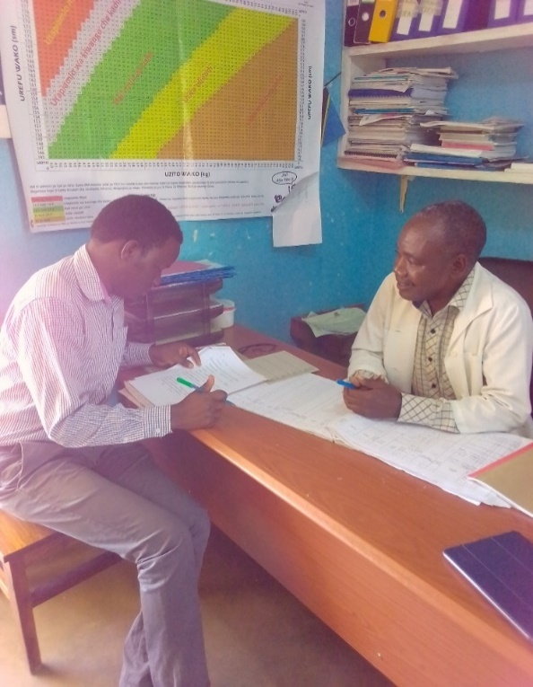 | 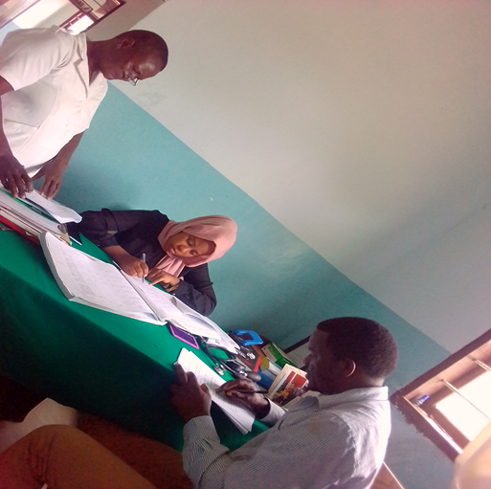
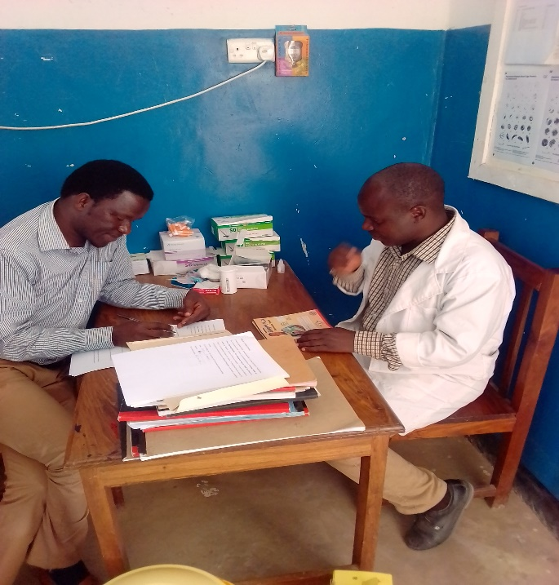 | 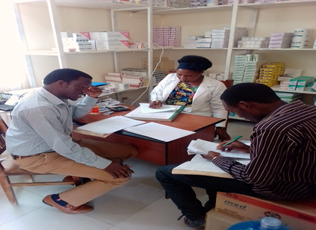

APPENDIX 7: WASTE MANAGEMENT PRACTICES IN PICTURES
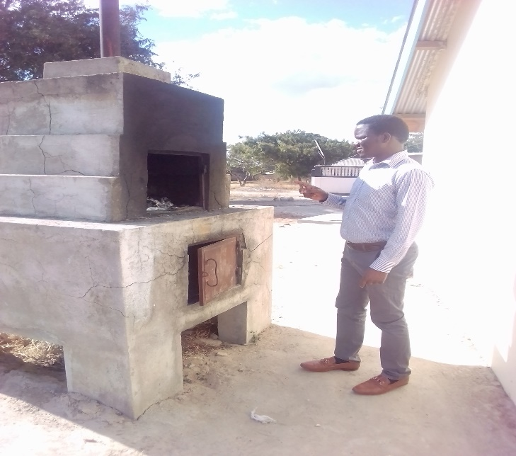 | 

