VALUATION OF ECOSYSTEM’S WATER SUPPLY SERVICES IN MARA WETLANDS

ENOCK E. KAWIRA

A DISSERTATION SUBMITTED IN PARTIAL FULFILMENT OF THE REQUIREMENTS FOR THE DEGREE OF MASTER OF ENVIRONMENTAL STUDIES (MED)
DEPARTMENT OF ENVIRONMENTAL STUDIES
OF THE OPEN UNIVERSITY OF TANZANIA
2021

CERTIFICATION
The undersigned certifies that she has read and hereby recommends for acceptance by The Open University of Tanzania a Thesis entitled; “Valuation of Ecosystem’s Water supply services in Mara Wetlands, Tanzania” In partial fulfilment of the requirements for the Degree of Master of Science in environmental studies of The Open University of Tanzania

……………………………………..
Dr. Irene Aurelia Tarimo
(Supervisor)

………………………….…
Date

COPYRIGHT
No part of this dissertation may be reproduced, stored in any retrieval system, or transmitted, in any form by any means, electronic, mechanical, photocopying, recording or otherwise without prior written permission of the author or the Open University of Tanzania in that behalf.

DECLARATION
I, Enock E. Kawira declare that, the work presented in this dissertation is original. It has not been presented to any other University or Institution. Where other people’s works have been used, references have been provided. It is in this regard that I declare this work as originally mine. It is hereby presented in partial fulfillment of the requirement for the Degree of Master of Science in environmental studies.


………………………………………………
Signature

14th September 2020
……………………………………………
Date

DEDICATION
I dedicate this work firstly to almighty God since with Him everything is possible. Also, I dedicate this work to my parents Mr. Ezra Kawira and Mrs. Dorothy Kawira for morally laying good foundation of education during my childhood with stronger support and to my Siblings (Esther, Eliver and Douglas) for prayers and being my drive of Success at large. Despite the limited resources you dedicated it all to make sure that I achieve my desires.

ACKNOWLEDGEMENTS
I am grateful forever to the mighty God for giving me this precious life providing me with guidance, strength, courage, and patience to carry out this study.

Also I would like to express my sincere thanks to Dr. Irene Aurelia Tarimo and Prof. Ken Irvine for commitments and encouragements during the supervision of my dissertation. Indeed, without your commitment, it would be difficult to accomplish this dissertation in time. Then, I also thank friends who assist me during data collection, all Birdlife International and all farmers who use their time to give me necessary information.

Similarly, I thank My Aunt Leah Makoyo, Paul and Anita lips through their financial Support, Dr Stephanie Ly for being an Inspiration, encouragement. I must thank again Dr. Josephat Saria and other Lecturers for offering their much time, material and technical support during master’s theory course. Thanks to Dr Irene Aurelia Tarimo, Dr Joel Matiku for encouragement and editing my work. You and all not mentioned your contributions and advices are highly valued.

ABSTRACT
The study aimed to establish the value of ecosystems water supply services in Mara wetlands. The sample consisted of total number of 120 households in which nine villages of Butiama, Tarime and Rorya Districts which were purposively selected to represent Mara wetlands areas. Data on water supply services from wetlands, beneficiaries of water supply services from wetlands, quantity of water accessed, quality of water and their price were collected using direct observations, interviews and questionnaires. Also, data on household’s perception on economic value of wetlands were collected. The descriptive and inferential statistics were both used for data analysis. Data were analysed by using SPSS version 20. The findings indicate that wetlands support people livelihoods through water services offered from wetlands that enable residents to engage in livelihood strategies including farming activities, livestock keeping, fishing and business that highly depend on wetlands water sources. Secondly rural residents depend on raw water from wetlands for drinking as compared to their counterpart urban residents who depended on tap water wells. Lastly Mara wetlands provide domestic water supply services of Tsh 5.2 million per day. The study recommends local government Authorities (LGAs) to collaborate with the communities in rural areas and join their efforts in protecting and the wise utilization wetlands found in Mara Region and elsewhere for poverty alleviation .There should be education campaigns in boiling water for drinking to avoid water related diseases to safeguard health for sustainable development.
Keywords: Ecosystems, Water Supply, Wetlands, Mara.

TABLE OF CONTENTS
CERTIFICATION ii
COPYRIGHT iii
DECLARATION iv
DEDICATION v
ACKNOWLEDGEMENTS vi
ABSTRACT vii
TABLE OF CONTENTS viii
LIST OF TABLES xii
LIST OF FIGURES xiii
LIST OF ABBREVIATIONS AND ACRONYMS xiv
CHAPTER ONE 1
INTRODUCTION 1
1.1 Background Information of the Study 1
1.2 Statement of the Problem 5
1.3 Research Objectives 6
1.3.1 General Objective: To Establish the Value of the Ecosystem’s Water Supply Services in Mara Wetlands 6
1.3.2 Specific Objectives 6
1.3.3 Research Questions 6
1.4 The Significance of the Study 7
1.5 Scope and Limitation of the Study 7
CHAPTER TWO 10
LITERATURE REVIEW 10
2.1 Sources of Drinking Water 10
2.1.1 Taps Sources Managed by Water Authorities 10
2.1.2 Wetlands, Springs and Wells 16
2.1.3 Rivers as Source of Drinking Water 17
2.2 Determinants of Amount of Water Consumption per Day 19
2.3 Identified Gap 20
2.4 Theoretical Framework 21
CHAPTER THREE 23
METHODOLOGY 23
3.1 Introduction 23
3.2 Research Area 23
3.3 Population and Economic Activities 24
3.4 Research Design 26
3.5 Sampling Process and Sample Size 27
3.6 Characteristics of the Respondents in the Study 27
3.7 Data Sources and Collection Instruments 28
3.7.1 Sources of Data 28
3.7.2 Data Collection Instruments 29
3.8 Main Source of Water 29
3.8.1 Treatment Strategy of Drinking Water 29
3.8.2 The Distance from Home to the Source of Water 29
3.8.3 Amount of Water Consumed per Day 29
3.9 Data Analysis Procedures 30
CHAPTER FOUR 31
RESULTS 31
4.1 Introduction 31
4.2 Socio-Demographic Characteristics of the Respondents 31
4.2.1 Sex of the Respondents 31
4.2.2 Occupation of the Respondents 32
4.3 Water Services Available and Benefit Offered By Wetlands 33
4.3.1 Water Services offered by Wetlands to Households in Mara Region 33
4.3.2 Beneficiaries of water Services from Wetland in Mara Region 34
Table 4.3: Beneficiaries of Water Services from Wetland 35
4.4 Quantity of Water demanded and their Price (Value) at House Hold Level 35
4.4.1 Performance in Main Depended Source of Water 35
4.4.3 Distance from Home to the Main Source of Water 36
4.4.4 The relationship between Main depended Source of Water and the Amount of Water consumed per Day 37
4.4.5 The Relationship between Treatment Nature of drinking Water and the amount of Water Consumed per Day 38
4.4.6 The Relationship between Distance from the Main Source of Water from Home and the amount of Water Consumed per Day 38
4.5 Amount of Drinking Water per Day per Person from Access to Water Sources 39
4.4.2 Water Quality Consumed at Household level from Wetland 41
4.6 Stakeholders Economic Perception on Cost of securing Wetland Water 43
CHAPTER FIVE 44
DISCUSSIONS OF THE RESULTS 44
5.1 Introduction 44
5.2 The Relationship between Access to Water Services and the Amount of Drinking Water consumed 44
5.2 Potential Application of Results 46
5.2.1 The Role of Treatment of Drinking Water 46
5.3 The Role of Amount of Drinking Water Daily 47
5.4 Water Quality Consumed at Household Level from Wetland 48
5.4 Theoretical Implications of the Findings 49
CHAPTER SIX 51
CONCLUSIONS AND RECOMMENDATIONS 51
6.1 Conclusion 51
6.3 Areas for Further Research 52
REFERENCES 53
APPENDIX 65

LIST OF TABLES
Table 4.1: Occupation of the Respondents 32
Table 4.2: Evidence on the Dependence on Wetland as Major Source of Water in all Seasons 33
Table 4.3: Beneficiaries of Water Services from Wetland 35
Table 4.4: Performance in Main Depended Source of Water by Districts 36
Table 4.5: Performance in Treatment Nature of the Drinking Water 36
Table 4.6: Distance from Home to the Main Source of Water by Districts 37
Table 4.7: The difference in the Daily Amount of Water Consumed with Depended Source of Water 37
Table 4.8: The difference in the Daily Amount of consumed Water with Treatment Nature 38
Table 4.9: The Difference in the Daily Amount of consumed Water with Distance 39
Table 4.10: Likelihood of Drinking Water per Day per Person 40
Table 4.11: Treatment Methods for drinking Water from Wetlands Used by Household 42
Table 4.12: Tests of Escherichia coli in Mara Basin Wetlands 42
Table 4.13: Gross Domestic Water Supply Value of Water 43

LIST OF FIGURES
Figure 1.1: Conceptual Framework for the Study 8
Figure 3.1: Mara wetland’s Overview and Catchment Area (bounded in Red) and Administrative Units 25
Figure 4.1: Occupation of the respondents 31
Figure 4.2: Education Level of Respondents 33

LIST OF ABBREVIATIONS AND ACRONYMS
DFDI Department for International Development
GWP Global Water Partnership
IUWM Integrated Urban Water Management
IWRM Integrated Water Resources Management
LVBC Lake Victoria Basin Commission
MUWASA Musoma Urban Water Supply and Sanitation Authority
NBS Nation Bureau of Standards
PREPARED Planning for Resilience in East Africa through Policy, Adaptation Research and Economic Development
SLF Suitable Livelihood Framework
SPSS Statistical Package for Social Sciences
TBS Tanzania Bureau of Standards
USA United States of America
WHO World Health Organization

CHAPTER ONE

INTRODUCTION

1.1 Background Information of the Study
Wetlands are vital for human endurance. They cover a complete area of 12.1 million km2 and record for 40.6% of the entire global ecosystem services (ES) value (Costanza et al., 2014; Ramsar Convention on Wetlands, 2018). Wetlands are recognized as both critical for Ecosystem services delivery (Mitsch and Gossilink, 2000; Rebelo et al., 2017; Zhang et al., 2017; Sieben et al., 2018) and highly threatened by a variety of human activities (Ramsar Convention Secretariat, 2006; Zhang et al., 2017; Tong et al., 2017; Best, 2019; Sieben et al., 2018).

Globally, numerous wetlands have been exploited or used unsustainably (Mitsch and Gossilink, 2000; Rebelo et al., 2017), which has brought about a 35% loss in the global wetland extent since 1970 (Ramsar Convention on Wetlands, 2018). Regardless of 169 countries having ratified the Ramsar Convention, wetland losses and degradation continue (Ramsar Convention on Wetlands, 2018). America the developed countries, has lost 87 million hectares of wetland, and similarly, European nations like Netherlands, Germany, Spain, Italy, Greece, and Portugal have lost 55, 67, 57, 60, 66, and 63% of their total wetlands, respectively (MEA, 2005a; MEA, 2005b; Tiner, 1984) within the last decades.

Additionally, to those, within the past 60 years, Philippines has lost 300,000 hectares (67%) of its wetland ecosystems While, for several folks, potable water is often obtained at any time of day or night just by turning a faucet, quite one in six people worldwide don't have access to their daily requirement of safe water. it's estimated that by 2025, 1.8 billion people are going to be living in countries or regions with absolute water scarcity which two-thirds of the planet population could experience water-stress conditions.

Water use has been growing at quite twice the speed of increase, with 70% used for irrigation, 22% for industry, and eight for domestic use. Despite the vital significance of this resource, we still mistreat this reservoir of life. We dump 2 million tonnes of body waste into watercourses every day, and 70% of commercial waste in developing countries is dumped untreated into waters, polluting the usable water system.The significance of water and thus this plight of this resource are highlighted within the United Nations’ Millennium Development Goals. One significant objective is to cut in half by 2015, the extent of the population without sustainable access to safe drinking water and essential sanitation. Another target aims to accomplish a critical improvement within the lives of a minimum of 100 million slum dwellers by 2020, by that consider improving sanitation and water facilities.

Water is additionally inextricably linked to the target to halve, between 1990 and 2015, the proportion of individuals that suffer from hunger, since water quality, availability and use are major factors in agriculture and food prices. The target to reduce biodiversity loss also directly incorporates the protection of water resources, both in and of themselves and as an area of ecosystems. While the protection of our water resources is featured in these targets directly, the importance of water makes its preservation an important component of all of the Millennium Development Goals.
Sub-Saharan Africa is characterized by one among the very best numbers of individuals that don't have access to clean water (319 million people in 2015) or sanitation (695 million people in 2015) (WHO/UNICEF, 2015). Additionally, numerous African cities experience rapid urbanization, industrialization, uncontrolled increase, and poor infrastructure, exacerbating these issues (Blumenfeld et al., 2009; Troyer et al., 2016)

Securing water resource and especially domestic and drinking water is of vital importance to individuals, local communities, states and the international community (Jones, 2010). Already, water crises have been threatening significant cities around the world such as Cape Town, Melbourne, Jakarta, Sao-Paulo; and Mexico City. In the latter about 21 million residents of can only access running water few hours of the day, while one in five get just a few hours from their taps a week (Welch, 2018). In South Africa, about 80% of rivers are have been overexploited in the Western Cape, 50 % of rivers have been overexploited in Kwazulu – Natal and dams’ levels are at about 52% capacity (Donnenfeld et al., 2018). South Africa is already recording around as low as 7 liters per capita per day (World Bank, 2012) as aresult of overexploitation of water sources in the country.

Scarcity of safe drinking water is already a problem in Tanzania. Only 60% of Tanzanians get their drinking water from an improved source. Some, 21 million people lack access to drinking water and quite double that figure, almost 43 million Individuals, lack access to improved sanitation. In 2016, 40% of water points were reportedly non-functional, with many failing within the first year after construction. About two-thirds of all piped water users in urban areas reported that they were unable to access for at least one day in the previous two weeks.

Rurality clarifies 45% of absence of access to improved water, while poorer wealth status explains 50% of lack of improved sanitation access. The nation recently fell an extended way in need of reaching its Millennium Development Goal (MDG) targets for water and sanitation, which was “to halve the proportion of people without improved drinking water and sanitation in 1990 by 2015.” Now, the new Sustainable Development Goals (SDG) intend to succeed in universal access to safe water and sanitation by 2030, an aspiration that appears even more daunting. (WORLD BANK GROUP 2018)

Mara River and the Wetlands is the main enduring source of water in the Serengeti-Mara ecosystem, and supplies water to 1.1 million people and animals including during the dry season. The human population in the Mara river basin is estimated to be growing at a yearly pace of over 3%, and around 62% of people directly rely upon the Mara for domestic water needs (Dutton et al. 2018). approximately 72 percent of the population in the four districts within the Mara River Basin draw water from unprotected sources, more than half of the basins. (CGIAR 2016).

The ramifications of such a scarcity include: increased risk of contracting waterborne diseases specifically, diarrheal disease; and under nutrition or stunting; increase in vector-borne diseases from mosquitoes, tsetse flies and ticks, particularly when the water is so polluted that it is not disturbed by humans and where the eggs of insects can survive for extended periods in a dormant state (Donnenfeld et al., 2018). Given such risks associated with scarce and contamination of safe drinking water, one of the most assessed indices to measure safe and drinking water access has been drinking water consumption rates and patterns. According to World Health Organization (WHO, 1997) water access can be categorized into: 1) basic access, which allows for consumption, hand washing and basic hygiene, but not necessarily bathing or laundry; 2) intermediate access, defined by one’s possibility to use 50 litres per day and near the source of water at about less than 100 meters, guaranteeing laundry and bathing; and 3) optimal access that allows continuous water supply meeting all needs of water consumption and hygiene (Moral, 2015). Since first and second categories limits someone to utilize much water and some needs are not met, there is a risk of some water related diseases. Thus, the closer water is to optimal access, the safer it is.

1.2 Statement of the Problem
Despite the documented improvement of conservation of wetlands including rivers, lakes, wells, and springs in Tanzania, a threat of contamination and pollution due to challenges such as human population growth, agricultural expansion, river flow alterations, industrialization, introduced species and climate change persists (Seeteram, et al., 2019). The challenges have exposed people to untreated drinking water from wetlands, wells, springs, rivers, and lakes. While strategies such as boiling water have been reported elsewhere to minimize the threats, some impurities require expensive efforts.

Past research has indicated that access to water sources with specific reference to type of water source, distance of home from water source and the strategies to treatment of water might be associated with water utilization at homes. However, it was not clear as to whether access to water sources in terms of type of water source, distance of home from water source and the strategies to treatment of water would influence the same way the amount of drinking water per day per person in Tanzania. It is against this background that the present study sought to investigate the value of ecosystem’s water supply services in Mara wetlands.

1.3 Research Objectives

1.3.1 General Objective: To Establish the Value of the Ecosystem’s Water Supply Services in Mara Wetlands

1.3.2 Specific Objectives
- To evaluate water provision supply services available to the beneficiaries in Mara wetlands.
- To assess quantity of water demanded in respect to their prices (value) at household from wetlands.
- To assess quality of water consumed by household from wetland.
- Determine stakeholder’s economic perception on cost of securing wetlands water.

1.3.3 Research Questions
- What are the water provision supply services available to the beneficiaries in Mara wetlands?
- What is the quantity of water demanded in respect to their prices at household from wetlands?
- What is the quality of water consumed by household from wetland?
- What is the stakeholder’s economic perception on cost of securing wetlands water?

1.4 The Significance of the Study
This study is significant now for its potential role to inform the local authorities on how access to water sources could improve the betterment of livelihoods, and specifically safe drinking water to the community, which could, in turn, boost the development of National Economy. The study is also expected to add on the body literature in the topic area. To the health advisors, the results of this study might act as a basis for counseling people on the importance of water treatment before the drink. This is because drinking raw water could expose them to more health problems.

To experts in the field of environmental sciences, these findings are of potential benefit for acquiring basic information on how people respond to risks of pollution and access to the water in wetlands, rivers, lakes springs, and wells. The study is useful to policy makers in water sector as it unveils the significance of wetlands in ensuring water quality and quantity to both urban and rural dwellers. To Local Government Authority the study findings put Local Government Authority in position of identifying potentials of wetlands in supporting people’s livelihood economically and socially.

1.5 Scope and Limitation of the Study
The study focused on Mara region, with sample representing both rural and urban districts. Thus, generalization of the findings of these findings needs to take into consideration of the same sources of information. In terms of limitations, the study used self-report questions. A study mixing more than one instrument might improve the results of the study.

1.6 Conceptual Framework of the Study
The study employed the production methods of valuing environmental goods (Boyer and Polasky, 2004). The underlying assumption is that the households are exposed to wetlands with water services that offer various services to the community. The type of services an individual accessed from wetland relied upon the sources of water they are using, the distance from home to the water sources and the treatment strategy of water accessed employed by household for drinking water services.
Intervening variables
Location of residence
Level of education
Economic activities
Outcome Variables
Improved amount of drinking water per person per day
Perceived economic benefits of wetland
Improved water quality
Enough quantity of water accessed
Vulnerability context
Exposure to untreated drinking water from wetlands, wells, springs, rivers, and lakes.

Independent Variables
Access to sources of water
Source type
Distance from home to source of water
Treatment strategy

Figure 1.1: Conceptual Framework for the Study

But this relationship was maintained by intervening variables including the location of the residents hereafter in this study there are those living in rural areas and those residing in urban areas. Also the level of education was assumed to influence the degree of exposure of household to wetlands and the way they utilized the wetlands for economic productivity hereafter economic productivity are livestock keeping, fishing, business and farming.

CHAPTER TWO

LITERATURE REVIEW

2.1 Sources of Drinking Water
Researchers are aware of sources of drinking water such as lakes, river, wells, springs, and harvesting directly from rainfall, just to mention a few. However, this work is limited to specific three sources that were studied among adults in Mara region. These are wetlands, springs or wells; taps and rivers. The discussion of each of these is presented in subsections 2.1.2.

2.1.1 Taps Sources Managed by Water Authorities
A water management regime is characterized by its societal function (Pahl-Wostl et al., 2007). The main objective is therefore to allocate water to different uses while at the same time considering different requirements such as quality and variability of demand in time and space. The most widely spread urban water management approaches currently in predominant around the world can be described as prediction and control (Pahl-Wostl et al., 2007; Mukheibir, 2010). These are often referred to as conventional/ traditional urban water management systems (Magnusson, 2005; Pahl-Wostl et al., 2007; Mukheibir, 2010). They consist of systems where behavior and response can be predicted, and responses designed in advance.

Decisions are made based on laws and regulations and technical principles resulting into highly specialized and fragmented divisions (water treatment, water supply, waste water treatment, etc.) that often work independently despite their natural interconnectedness. They are highly dependent on engineering solutions and water management is usually synonymous with project construction. Views of local actors are barely ever taken into consideration, because they are not easily quantifiable in clear design parameters.

There is high dependence on large-scale infrastructure such as dams, reservoirs and mechanized fresh and waste water treatment plants as well as a preference for large centralized systems that are costly to run and maintain (Magnusson, 2005; Mukheibir, 2010). While such systems are thought to be durable, reliable, stable, and efficient, it has met with criticism because of its lack of flexibility to changing social and environmental constraints as well as indiscriminate use of resources. Due to this, there is currently a shift towards more sustainable management approaches. Many of the new approaches advocate the need for strategies that are social and site specific and respond to local priorities and needs. They do not conflict with the old system, but rather complement the centralized infrastructure with more flexible schemes that are generated within communities, decentralized and flexible decision mechanisms, equitable pricing, effective use of appropriate technologies and protection of the environment (Pahl-Wostl et al., 2007).

One commonly cited approach in this category is integrated water resources management (IWRM). This process promotes coordinated development and management of water, land and related resources in order to maximize the resultant economic and social welfare in an equitable manner (GWP; in Magnusson, 2005). Water Availability, Affordability and Access Often referred to as the 3As, Water availability, access, and affordability are three very important aspects in water management. while the availability is often considered on a larger scale, i.e., national or regional level (for example, current practice measures availability in terms of population-water equation (Mukheibir, 2010) i.e. total amount of water available from all known sources divided by the total population).

Access on the other hand refers to the number of people with direct access to certain defined levels of water supply (Mukheibir, 2010). For example, the World Health Organization currently defines adequate access as receipt of 25-30 liters of safe water per person per day (WHO, 1995; in Mukheibir, 2010). Affordability on the other hand is about ability of households to be able to comfortably pay for water and water services without being too constrained. Often, availability and affordability affect the access of households to water. Water may be scarce that is low availability either due to physical scarcity or climate and resource constraints but also due to political or economic reasons (Mukheibir, 2010). Poor access to water is usually associated with low economic status, poor institutional representation, and social marginalization.

In developing countries, water is not homogeneous but rather a heterogeneous good with various sources providing water of different quality, reliability, and convenience (Magnusson, 2005). However, planning for water supply services has seldom considered this fact. Instead utilities are planned as a “one size fits all”. Because water utilities are often operated with cost recovery and profit as a main target, the type of management solutions chosen ultimately affect availability and affordability, and thus access to water. For example, large scale infrastructure investments may lead to high costs of water that some sections of society cannot afford; while locally generated solutions and technologies could have the opposite effect. In her discussion on the transitions that take place in the management of urban water systems, Brown et al. (2009) proposes the six stages. The stages span the range water supply city, concerned with basic provision of water (Access and security) up till the water sensitive city, where issues of intergenerational equity and resilience must be taken into consideration in planning and design of urban water systems.

Other authors including (Molle, Turton and Ohlsson (in Mukheibir, 2010) have also discussed staged progressions in water management starting with concerns about supply (infrastructure), then to conservation and management of demand and finally to higher values of reallocation of use from one user to another. These transition processes are shown to occur over long periods of up to centuries long and non-linearly (Brown et al. 2009; Mukheibir, 2010). While Brown et al. (2009) points out that no purely water sensitive city currently exists in the world, the desirability of such a city and the aspiration to achieve such high levels of management is present in cities all over the world. Moreover, challenges of resources scarcity and climate variability have made this quest almost imperative.

In accordance, with the characteristics of each stage under the framework in Brown et al. (2009), the city of Musoma does not fit any of the described stages (yes, not even the water supply city). Yet Musoma and many cities like Itare faced with ever increasing challenges from phenomena such as climate change, population explosions and general water scarcity. For these cities to meet such challenges, they must be able to leapfrog any intermediate stages and head straight for the water sensitive city. Moreover, unlike Cities in the developed world that have successively passed through these stages and had their systems successively adjusted with increase in population as well as technological developments, cities like Musoma must do it within a relatively short period if the above challenges are to be met; having to consider all these issues at once.

Studies on the application of IUWM indicate that several principles of IUWM have been applied in many of the World’s cities especially in Latin America countries including Argentina, Bolivia, Brazil, Chile, Mexico, and Peru but this involves picking only one or two principles and applying it to a particular situation, which does not really amount to applying IUWM as a whole. In Australia, IUWM principles were applied at subdivision or neighborhood level (Mitchell, 2006; GWP, 2011b); and were mainly based on technological solutions to water supply, sewerage, and storm water management.

In the US, competition for water and its subsequent scarcity was the main driver towards IUWM. It therefore appears that IUWM has only so far been applied in rich developed countries and on very small scale, where push factors are more aesthetic rather than fundamental. There have been concerns about the costs involved in implementing IUWM (Adank et al. 2011; Jacobsen et al. 2012) accruing from technology, infrastructure, and management. This leads to the question of the applicability of this method in less developed poor areas.

However, in terms of content of the principles, there is no single reason why this principle should not be applied in any setting. In South Africa some principles have been successfully applied showing that it can definitely be applied in tropical climates and presently, there are test pilot projects underway in areas in developing countries such as Accra - Ghana, Nairobi - Kenya, Mbale and Arua - Uganda but the extent of success has not yet been documented (Adank et al., 2011; Jacobsen et al., 2012). IUWM offers a number of important benefits to water utilities that practice it (Maheepala and Blackmore, 2008) such as: Providing water security – through diversification of sources i.e. to increase supply and efficient demand management (i.e. to use less).

A variety of supply sources such as surface water, groundwater, recycled water, storm water, roof water, grey water, and desalinated water can be used to meet urban demand in a fit-for-purpose manner. Reducing impacts on the environment – Since the IUWM approach considers urban areas as catchments, and manages it such as to improve habitat for native flora and fauna in urban waterways, it has the potential to reduce the impact of urbanization on the environment and enhance urban amenity. Enhancing governance – IUWM requires cooperation between key stakeholders to make multi-objective decisions that are aligned with the principles of sustainability.

This requires co-ordination, collaboration, and participation in the management of water supply, wastewater, storm water, and receiving waters in urban areas, potentially resulting in better long-term decisions that provide inter-generational equity. Improving system - management of the total water cycle involves accounting for interactions between subcomponents of the system and understanding system dynamics, rather than focusing on the behavior of individual components.

2.1.2 Wetlands, Springs and Wells
Among other sources of drinking water, wetlands are worth mentioning. However, wetlands are the most complex sources of safe water as it requires a very complex process for it to transform dirty and toxic water from environment to pure and quality water meeting drinking standards by human. As rainfall washes soil particles, fertilizers, pesticides, grease and oil from cars and trucks, and road salts from environment to water bodies; water becomes unsafe for human consumption. Wetlands improve water quality by removing such environmental pollutions from surface water through removal processes like sediment trapping, nutrient removal and chemical detoxification (Guerrero, 2020).

It is probably useful to argue that with increasing pollutants, some wetlands reach limit to purify surface water to fit human drinking. Only some and especially freshwater wetlands found at points where surface water enters an underground aquifer, usually successfully recharge groundwater supplies such as springs. These discharged springs provide a source for a local drinking water for both human and fish, animals, plants, and other organisms living on or near the stream during dry seasons. Such kinds of wetlands make a vital contribution to improving quality of surface or of ground water that they must be protected.

The protection needs to accommodate some procedures including identification of whether or not they recharge a drinking water source, such as a wellhead or source protection area; reduce levels of pollution in surface waters directly recharge underlying or adjacent ground water; contribute to the flow of class A surface water; help to improve water quality through chemical reaction; and if are adjacent to surface waters, especially impaired waters (Materu, Urban, & Heise, 2018). However, Materu et al. (2018) concludes sadly that Tanzania has not done much with regards to meeting her commitment under the Ramsar Convention to maintain ecological nature of wetlands despite the fact that the country has ratified the Convention. In other words there are no clear regulatory policies that might enhance the harnessing of the benefits the nation could achieve from the wetlands endowed to the country.

Another source of water mentioned to be safe for drinking by humans is wells. It has however, been argued that they are contaminated and thus, can be detrimental to human health if care is not taken. The most harmful elements mentioned being mercury and uranium which need to be filtered/removed so as to reduce on the carcinogenic risk of drinking water in the community. However, it should be clear that filtering is expensive and requires conscious decision making by authorities to invest in installation of heavy metal ﬁlters so as to avoid the whole community depending on wells from severe toxicological effects in humans (Kasozi et al., 2019).

2.1.3 Rivers as Source of Drinking Water
Water from rivers has been used for drinking from long time since the time of human history; and has today been depended by population of humans especially those living in rural areas (Gyau-Boakye et al., 2008). However, studies have indicated that pollution has worsened the safety of depending water from rivers for drinking due to contamination by and concentration of excess of arsenic, mercury, total dissolved solids, turbidity, water colour, nitrate-nitrogen and phosphate-phosphorus at higher than (WHO, 2004) limits for drinking water (Attua, Annan, & Nyame, 2014).According to Stauffer and Spuhler (2019) about 90 % of all waste water in less developed countries is discharged in the rivers without being treated. Given this astonishing fact, dependence on rivers in rural Tanzania might no longer be safe for human health if treatment intervention by the responsible authorities is not made a priority. Beshiru, et al. (2018) assessed physicochemical properties and water quality indices of five different rivers used for drinking water in Nigeria and found that water quality was very poor and unsuitable for drinking by human beings especially during dry season.

Kitalika, et al. (2018) analyzed 318 water samples for fluoride levels using Ion Selective Electrode (ISE) from five rivers around Mount Meru in Kilimanjaro region in Tanzania. Their results indicated that headwater of the rivers met the World Health Organization’s (WHO, 2004) maximum acceptable fluoride levels of 1.50 mg/l. they further found that the downstream environment qualified for Tanzania Bureau of Standards maximum permissible fluoride concentration in drinking water of 4.00 mg/l.

Although quality assessment studies have not been completed for all major rivers of Tanzania, the country has a strong legal framework for conservation of rivers and it is rich in fresh water resources and biodiversity (Seeteram et al., 2019). However, according to Teeteram et al. (2019), the rivers are not free from the threat of environmental degradation and water pollution given the challenges such as human population growth, agricultural expansion, river flow alterations, industrialization, introduced species and climate change.

2.2 Determinants of Amount of Water Consumption per Day
According to the Sustainable Development Goal (SDG) Target 6.1, there should be a universal and equitable access to safe and affordable drinking water from an improved water source. And that is located on the premises, available when needed, and free from faecal and priority chemical contamination. WHO (2019) reports that in 2017 cases of 5.3 billion persons used improved water sources located on premises and available when needed. This was free from contamination; 1.4 billion accessed improved water source located within a round trip of 30 minutes. Other 206 million used an improved water source requiring more than 30 minutes collecting water.

And others 435 million people used water from unprotected wells and springs while 144 million people collected untreated surface water from lakes, ponds, rivers and streams. Jones, et al. (2006) conducted a study in search of variables affecting the amount of water consumption pattern per person per day in Canada and found that a median amount of water consumed per day per person was 1.0 a litre. They also found that treatment nature of water determined the difference in water servings per day. Säve-Söderbergh et al. (2018) found average drinking water consumption ranged between 0.075 and 3 L/day for adults in Sweden.

The past researches in Sub-saharan Africa have put forward some factors affecting water supply in residential areas in general. These factors are such as lack of knowledge about the finite nature of water, its scarcity and cost. Others are the impact of deforestation and land degradation on the quantity and quality of water and inadequate capacity building (Beukman, 2002). Other factors are neglect of traditional knowledge bases; gender issues; and the fragmentation of water resources management. Also weak institutional frameworks; location of residence, main water source, income and cost (Beukman, 2002; Akoteyon, 2019) included other factors. Other factors revealed in Africa are settlement characteristics, poor financing and management, and the low capital allocation in the water sector (Egbinola, 2017), poor access to safe water supply (Akoteyon, 2016), the population growth pressure (Odjegba et al., 2015) and inconsistencies in the policy (Naiga et al., 2015). Neither could these studies inform on the amount of water consumption per person per day nor could they indicate associated factors of the same in Tanzania.

2.3 Identified Gap
From the previous research cited in this study, it has informed the researcher about the vulnerability people are who are exposed by drinking water from untreated water in the wetlands, wells, springs, rivers and lakes. The vulnerability is much more intensified by the challenges such as human population growth, agricultural expansion, river flow alterations, industrialization, introduced species and climate change. All these challenges might limit people from drinking sufficient improved drinking water.

However, so far it is unclear as to what amount of drinking water a person consumes per day and whether the amount is influenced by access to sources of water or not. It is unclear as to whether or not the distant of home from the source of water, treatment strategies people apply, or type of source of water people depend on might make difference with the amount of drinking water people consume per day.

Understanding of these variables is crucial as they might decrease people’s vulnerability to water related diseases resulting from drinking both unsafe and insufficient water from the available sources. Jones, et al. (2006) conducted a study in search of variables affecting the amount of water consumption pattern per person per day in Canada and found that a median amount of water consumed per day per person was 1.0 a litre. They also found that treatment nature of water determined the difference in water servings per day. Säve-Söderbergh et al. (2018) found average drinking water consumption ranged between 0.075 and 3 L/day for adults in Sweden. These studies inform on the amount of water consumption per person per day and they indicated the associated factors of the same but not in Mara, Tanzania where this study was done.

2.4 Theoretical Framework
The study employed production methods of valuing environmental goods without a real theory. Total Economic Value (TEV) framework, ecosystems can generate output values (the values generated in the current state of the ecosystem, e.g., food production, climate regulation and recreational value) as well as insurance values (Pascual et al., 2010). Valuation techniques in general and stated preference methods are affected by uncertainty, stemming from gaps in knowledge about ecosystem dynamics, human preferences and technical issues in the valuation process. Values vary with the characteristics of the ecosystem and the beneficiaries of the services it provides. Valuation practitioners present their results, and policy makers interpret and use valuation data accordingly (Ibid.).
Environmental goods and services are the biogeochemical processes, attributes or the products that relate to the self-maintenance of an ecosystem, provision of wildlife habitat, cycling of carbon, nitrogen, phosphorus, sulphur, water or the trapping of nutrients, etc. which make the basis of sustenance and prosperity to the human society. Some environmental goods and services have got markets, and therefore, prices of only a few of them are available as data. Production method is used to estimate the value of increased economic productivity caused by wetlands (Boyer and Polasky, 2004).

In this study Mara wetlands, the economic activities attributed by wetlands are fishing, livestock keeping, farming and business. This method enabled the study to address the study objectives including the examination of services available and benefit offered by wetlands. Also the production method enabled to assess the type of services offered from wetlands. Here the quality of water demanded and their prices was investigated. The method enabled to quantify the amount of raw water consumed by individual and to establish the stakeholders perceived economic value of Mara wetlands in terms of Gross Domestic Value of water services offered from wetlands.

CHAPTER THREE

METHODOLOGY

3.1 Introduction
This section describes how the proposed study was conducted to achieve its objectives. It is presented in subheadings of the research area, design, sampling procedure and sample size, as well as data sets and analysis process.

3.2 Research Area
The study was conducted in Mara region, and in the districts of Musoma urban, Butiama, Rorya and Tarime. The areas were selected as the appropriate sources of information regarding wetlands, rivers, wells, springs, lakes and taps as sources of drinking water. The Mara wetland comprises an extensive swamp dominated by papyrus (Cyperus papyrus). The extent of the wetland fluctuates within and among years (Irvine et al., 2017). The wetland (also known as Kirumi, Masirori, and Masurura wetlands) lies at the lower end of the Mara River Basin that rises at 2,932 m in the Mau escarpment in Kenya, and flows about 395 km, entering Lake Victoria near the town of Musoma, Tanzania, at an altitude of 1,134 m.

The Mara Wetlands are found in the Tanzanian part of the wider Mara Basin. The wetlands are currently estimated to covers 204 km² with an average width 13 km and length of 36.8 km and covers 51,700 Hectares. The Wetlands are in three administrative districts of the Mara Region, namely: Butiama, Rorya and Tarime (Irvine et al., 2017; PREPARED, 2016; Ng’umbi, 2009). Seasonal hydrological fluctuations in the Mara wetlands are driven by both rainfalls in the catchment and directly onto the wetlands, as well as by overall the levels of Lake Victoria.
Annual ‘long’ rains throughout the catchment are typically mid-March to June with a peak in April, while ‘short’ rains occur typically from September to December. Annual precipitation varies from a typical maximum of about 2000 mm in the Mau escarpment, to minima of about 500 mm in the lower catchment (LVBC, 2016). Recent estimates are that annual rainfall around the swamp range from 700 to 900 mm (Ng’umbi, 2009).

According to Jones (2010), WWF stated that” the heavy rains of the 1960s led to a significant expansion of the swamp. In the past 30 years, this wetlands area has grown 340 % (Jones, 2010). Also, from Statistics, the Masurura Swamps grew from 2 sq miles (20 sq km) to 24 Sq miles (63 sq km) from 1986 to 2006. This is likely because the change of land cover and use in the Upper Catchment has caused severe soil erosion that has been deposited downstream on these flat plains, (Bregoli, et al., 2019) Dramatic changes in rainfall patterns with increased droughts have been responsible for lowering water levels of the Masurura (Mara Swamps). Thus, this led to the decreasing space for fish and fish reproduction in its shallow waters, challenging farmers’ efforts and the other end users.

3.3 Population and Economic Activities
The large Mara river basin is home to over one million people (LVBC, 2016), with annual population increases estimates greater than 3% (Hoffman, 2007). In the national census of 2012, 83% of the population of the Mara region were living in rural areas, with one of the highest percentages of female headed households (37.9%) in Tanzania (NBS, 2014). The population census in three focus districts of study which borders the wetland are 8,577 in Rorya, 16,054 in Butiama and 23,893 in Tarime District.

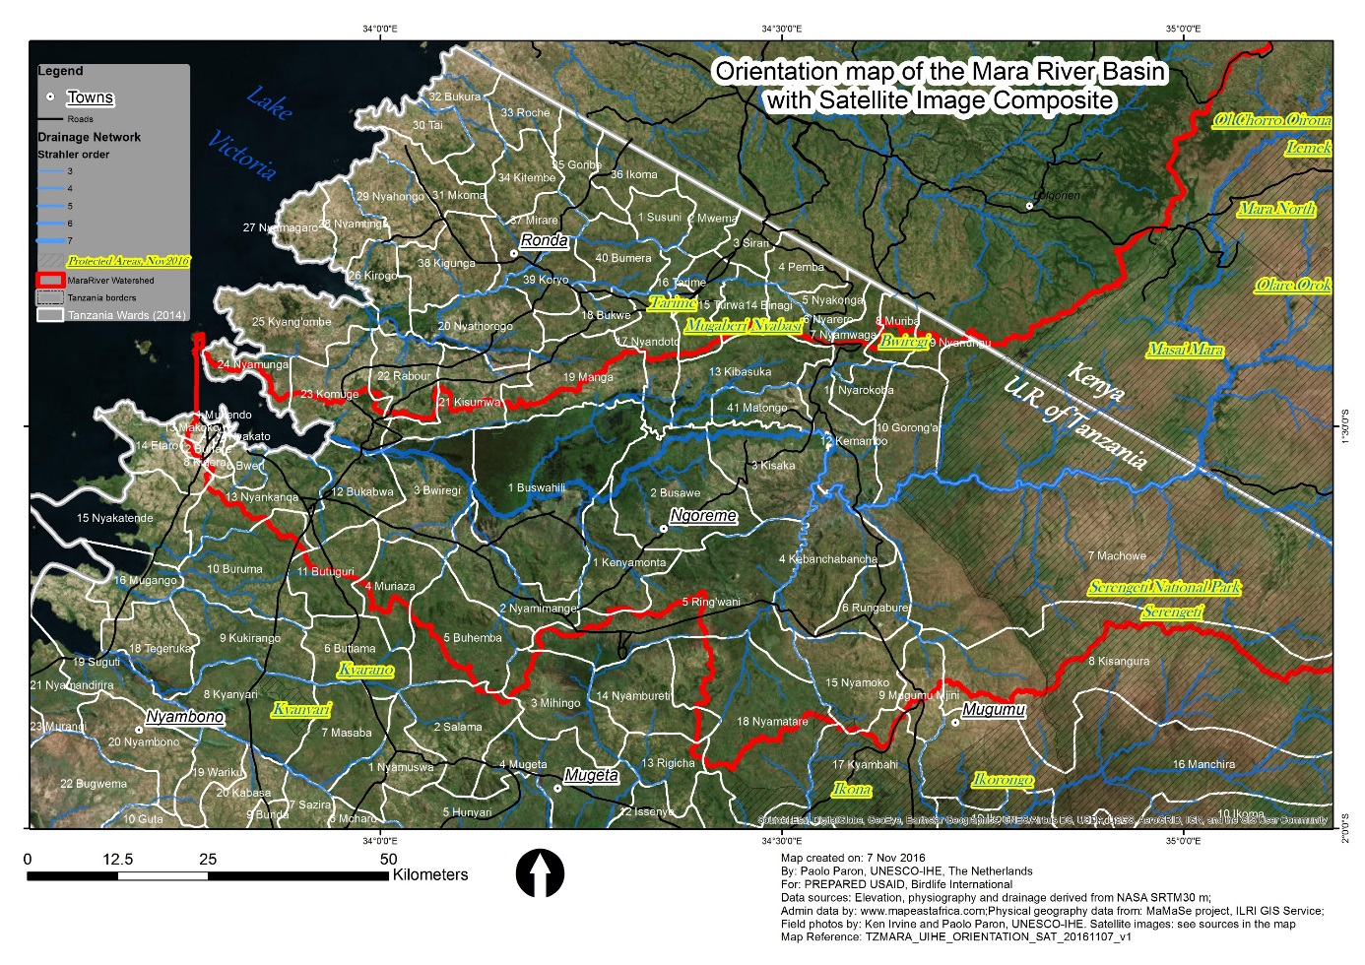
Figure 3.1: Mara wetland’s Overview and Catchment Area (bounded in Red) and Administrative Units

The total arable land of the Mara Wetlands is 51,700 hectares where only 10,340 hectares are under crop production (i.e. 20% of total arable land). The main food crops grown are cassava, sorghum, maize and finger millet. It is reported that Butiama and Rorya Districts are prone to food deficiency (URT, 2013). The study established that crop production yields low returns but takes a lot of household labor.
The main core of the wetland area is surrounded by a peripheral zone that is seasonally flooded and within a wider sub-catchment of original dryland mixed woodland. This dryland largely comprises agriculture, pasture and degraded land, with generally dispersed tree and shrub cover. Remaining woodland is more extensive on the northern than southern side of the wetland. Historical remote sensing images from 1973 to 2000 (Mutie et al., 2006; Mturi, 2007) shows the expansion of the wetland, and reductions of shrub and grassland. From 1973 to 2000 the wetland has had a conspicuous increase in size, with more than a doubling of extent between 1986 and 2015 (LVBC, 2016).

The changes in the overall size of the wetland and to the positioning of the river have been attributed to a number of factors, including increased soil erosion following the 1974 Ujamaa Villagization Programme, that increased the use of hill slopes for wood collection (Bogers, 2007), periods of drought followed by heavy flooding leading to increased siltation promoting wetland growth. Other factors that have been claimed for changes in wetland extent over the last 50 years are cattle poaching, and digging for lung fish and clay for bricks within the riparian wetland, which have promoted colonization of papyrus (Cyperus papyrus) and Typha spp. The construction of the Kirumi bridge in 1984 near the mouth of the river is reported to have led to constriction of the outlet channel and expansion of the wetland area from 1984 to 1988 (Mturi, 2007).

3.4 Research Design
The research approach was mainly quantitative, under which cross sectional survey design was employed in data collection. In addition, associations among variables characterized the analysis of data due to the nature of data required to achieve the information in the specific objectives. All respondents were exposed to one general questionnaire comprised of questions addressing all independent and dependent variables. In addition, respondents were asked to respond to the intervening variables such as sex, age, level of education and primary economic activities. Data from the questionnaire were coded and entered into the Statistical Package for Social Sciences (SPSS) version 21 for both descriptive and inferential analyses.

3.5 Sampling Process and Sample Size
Sample was systematically randomized for both representation and prototyping the population. A total of 120 sample sizes were included in the study as illustrated in Table 3.1.

Table 3.1: Sample Size
Districts | Frequency | Percent
Rorya  Tarime  Butiama  Musoma Urban | 35 | 28.9
Rorya  Tarime  Butiama  Musoma Urban | 35 | 28.9
Rorya  Tarime  Butiama  Musoma Urban | 21 | 17.4
Rorya  Tarime  Butiama  Musoma Urban | 30 | 24.8
Total | 120 | 100.0
Source: Field Data, 2021

3.6 Characteristics of the Respondents in the Study
According to Pallant (2011), in studies involving human participants, it is useful to collect and report information on the number of people in the sample, the number and percentage of males and females in the sample, the range and mean of ages, education level, and any other relevant background information. Though a lot of variables need to be studied, in this dissertation, only few prioritized were age, sex, location, and education level of participants. About 60 percent (72) were males and 40 percent (48) were females. Other variables are shown in Table 3.2.

Table 3.2: Characteristics of the Respondents in the Study
Variables (N=120) | Levels | Proportion
Variables (N=120) | Levels | F | %
Sex | Males | 72 | 60.0
Sex | Females | 48 | 40.0
The Highest Education level of the Respondent | No formal education | 14 | 11.7
The Highest Education level of the Respondent | Primary School | 98 | 81.7
The Highest Education level of the Respondent | Secondary School | 8 | 6.7
Religious belief | Christians | 65 | 54.2
Religious belief | Moslems | 18 | 15.0
Religious belief | Traditionalists | 37 | 30.8
Respondent's status in the household | Head of family | 105 | 87.5
Respondent's status in the household | Family member | 15 | 12.5
Primary economic activity | Farming | 92 | 76.6
Primary economic activity | Fishing | 15 | 12.5
Primary economic activity | Civil servants | 5 | 4.2
Primary economic activity | Business | 8 | 6.7
Age | Minimum | Maximum | Mean
 | 24 | 100 | 45.9
Source: Field Data, 2020

3.7 Data Sources and Collection Instruments

3.7.1 Sources of Data
Survey data regarding the access to sources of water involved three main specific variables. These were the main depended type of water source; treatment strategy of drinking water and the distance from home to the source of water. The main source of data was adults who were the owners of the households. However, about 12.5 percent of respondents were representatives of the heads of the households where the owners were not present at homes.

3.7.2 Data Collection Instruments

3.8 Main Source of Water
The main source of water was measured by asking respondents to check against the main source of water they depended for water. The options were: 1) for taps from water authority (MUWASA); 2) for rivers; and 3) wetlands/wells/springs.

3.8.1 Treatment Strategy of Drinking Water
This variable was measured by asking respondents check against the treatment method they used to access safe drinking water from any source they depended on. The options included three responses which were 1 for boiling, 2 for drinking raw water, and 3 for drinking bottled water.

3.8.2 The Distance from Home to the Source of Water
Respondents were given three options in the question demanding them to check against the distance closely describing the distance of their homes to the main source of water. Three categories of the responses were 1 for < = 0.5km; 2 was for ‘between 0.5 Km and 1.0 Km; and 3 for 1.0 Km +.

3.8.3 Amount of Water Consumed per Day
This variable was measured by asking respondents the number of times per day they drink a cupful of water equivalent to 250 mls. Bottled water with a volume 500 mls was also shown for comparison of amount of water for those buying bottled drinking water. The number of savings one reported per day was multiplied by 250 mls for those using a cup and 500 mls was multiplied the number of savings reported by those drinking bottled water.

3.9 Data Analysis Procedures
After data collection, the questionnaires were checked for their clarity, and those well filled were identified. Information were coded and entered in the statistical package for social sciences and then screened for clarity. A few incomplete (10) questionnaires were excluded from analysis following screening process. This accounted for about 7.7% out of the total administered questionnaires. Therefore, the questionnaires actually subjected to the analysis were 120, which is about 92.3% of the total administered questionnaires. Quantitative data were analyzed through the use of inferential statistics whereby chi-square tests and frequency counts were used.

CHAPTER FOUR

RESULTS

4.1 Introduction
This chapter contains a presentation of the research findings. The presentations are based on the research objectives and questions addressed in chapter one. Prior to the analyses of the findings the gender and age characteristics of the respondents is explained. Also an education characteristic of the respondents is explained in relation to solid waste management.

4.2 Socio-Demographic Characteristics of the Respondents

4.2.1 Sex of the Respondents
The study revealed 77.8% of the respondents were male while 22.3% were female (Figure 4.1). This finding was attributed by socio-cultural factors whereby majority of households are headed by male and not female.
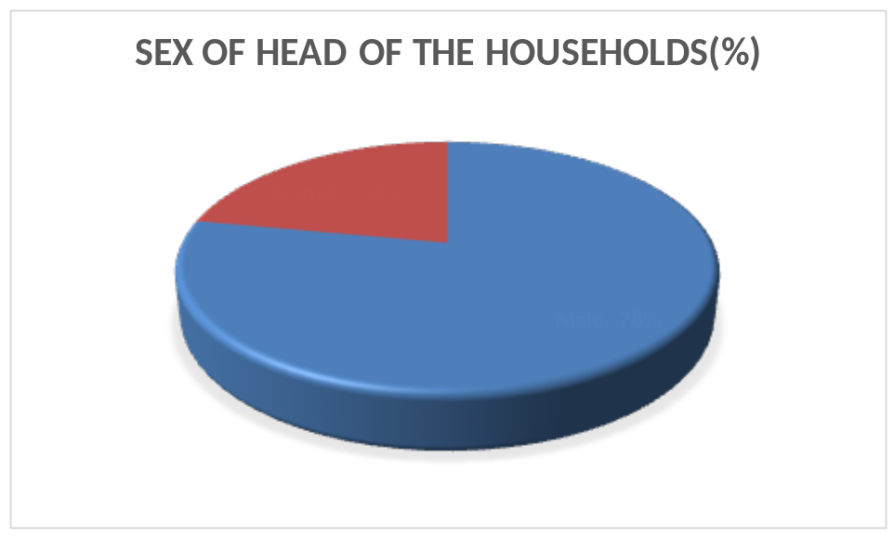
Figure 4.1: Occupation of the respondents
Source: Field Data, 2020

4.2.2 Occupation of the Respondents
The findings shows varied occupation of the respondents whereby the majority 48.9% were engaged in farming followed by livestock keeping 25.6% , 13.3% were engaged with fishing and least were engaged with formal employment in government and private sectors. This finding was attributed by rural households’ diversification of income whereby people prefer to engage in various income generating activities to cater their needs especially farming and livestock keeping. The findings unveil the dominants features of rural Africa whereby the main income generating activity is farming.

Table 4.1: Occupation of the Respondents
Occupation | Frequency | Percent
Farming | 44 | 48.9
Livestock | 23 | 25.6
Fishing | 12 | 13.3
Employment | 5 | 5.6
Business | 6 | 6.7
Total | 90 | 100
Source: Field Data, 2020

4.2.3 Education Level of the Respondents
The study revealed that the majority of the respondents had primary education 46% followed by secondary education 27% and the least had tertiary education 6%. This situation was attributed by majority of the respondents finished primary level of education did not get the opportunity to continue with secondary and tertiary education. This implies that the majority they were primary education graduate.
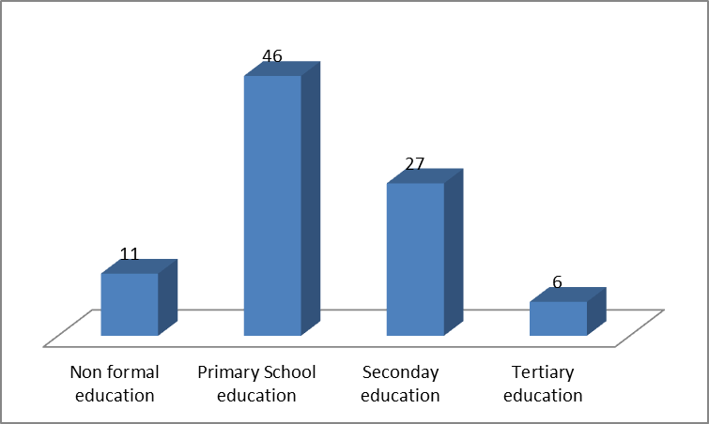
Figure 4.2: Education Level of Respondents
Source: Field Data, 2020

4.3 Water Services Available and Benefit Offered By Wetlands

4.3.1 Water Services offered by Wetlands to Households in Mara Region
Table 4.2: Evidence on the Dependence on Wetland as Major Source of Water in all Seasons
Sources of water available | Response (%)
Sources of water available | Yes |  | No
Wetland is the Source of water for house hold in Dry season | 51 | 56.7 | 39 | 42.2
Wetland is the Source of water for house hold in Rainy season | 39 | 43.3 | 51 | 55.6
River is the Source of water for house hold in Dry season | 32 | 35.6 | 58 | 64.4
River is the Source of water for house hold in Rainy season | 27 | 30.0 | 63 | 70.0
Well is the Source of water for house hold in Dry season | 29 | 32.2 | 61 | 67.8
Well is the Source of water for house hold in Rainy season | 42 | 46.7 | 48 | 53.3
Tap is the Source of water for house hold in Dry season | 8 | 8.9 | 82 | 91.1
Tap is the Source of water for house hold in Rainy season | 3 | 3.3 | 87 | 96.7
Shop Purchased Water Source of water for house hold in Dry | 3 | 3.3 | 87 | 96.7
Shop Purchased Water is the Source of water for house hold in Rainy season | - | - | 90 | 100.0
Rain is the Source of water for house hold in Dry season | 3 | 3.3 | 87 | 96.7
Rain is the Source of water for house hold in Rainy season | 21 | 23.3 | 69 | 76.7
Spring is the Source of water for house hold in Dry season | 3 | 3.3 | 87 | 96.7
Spring is the Source of water for house hold in Rainy season | 21 | 23.3 | 69 | 76.7
Other Sources are the Source of water for house hold in Dry season | 17 | 18.9 | 73 | 81.1
Source: Field Data, 2020
Results shows that 56.7 % of the interviewed agrees that Wetlands is their main source of water for house hold in dry season and 43.3% in wet season, also other 35.6% respondents said that river is their source of water in dry season and 30.0% river is their source of water in wet season, this proves that wetland is the major natural provider of water service to households in Mara wetlands. Similarly, respondents reported to confuse between wetlands and the river, hence mostly answered for river thinking its wetland. This implies Mara wetland is the main source of water by the community and its worth to the community. The wetlands determine the benefits obtained from it.

4.3.2 Beneficiaries of water Services from Wetland in Mara Region
The study revealed wetlands in the study area offered benefits through services it offer to the surrounding communities especially mainly water services which reported to support farming activities 48.9% followed by livestock keeping 25.6% , fishing 5.6 % and the least benefit acquired from wetlands was business of selling water flowing from spring. These benefit acquired by households in the study areas were attributed by services offered by wetland including protection and improvement of water quality, provision of fish and habitat quality and maintenance of flowing of water during dry period which at large these services the beneficiaries are the households residing Mara region wetlands.

One of the beneficiaries of wetlands in Rorya district during Focus Group Discussion reported that
“I was capable of building house, paying school fees for my kids and acquire other basic needs that support my households due to utilization of water from wetlands in farming and livestock keeping activities”. (Said a male student at the Rorya district Focus Group Discussion).

Table 4.3: Beneficiaries of Water Services from Wetland
Benefit offered from water services from wetlands | Frequency | Percent
Farming | 44 | 48.9
Livestock | 23 | 25.6
Fishing | 17 | 13.3
Business | 6 | 6.7
Source: Field Data, 2020

4.4 Quantity of Water demanded and their Price (Value) at House Hold Level

4.4.1 Performance in Main Depended Source of Water
Table 4.1 indicates that the main sources of water used at homes differed at a high magnitude of association (Cramer’s V = .62) with districts. Out of 40 respondents who reported depending on taps as their main source of water, 30 (75%) of them were from urban district. The opposite is evident whereby unlike their counterparts from rural districts, none of the respondent from urban district reported dependence on other sources of water such as wetlands, wells, spring, rivers and lake. Generally, for the main sources of water (wetlands, taps and river), most respondents about 42 (50%) in Rorya district reported dependence on wetlands, wells or springs as their main source of water. This was followed by 30 (75%) in Musoma Urban used taps as a source of water. The least proportion 2 (5%) in Butiama depended on tape water as their main source of water.

Table 4.4: Performance in Main Depended Source of Water by Districts
Source of water | Rorya | Tarime | Butiama | Musoma Urban | Chi-square test
Source of water | % | % | % | % | Ӽ2 | df | p | Cramer's V
Wetlands/Wells/Springs | 50 | 38.1 | 11.9 | 0 | 92 | 6 | 0.001 | 0.62
TAp (MUWASA) | 10 | 10 | 5 | 75
River/Lake | 23.7 | 39.5 | 36.8 | 0
Source: Field Data, 2020

Table 4.5: Performance in Treatment Nature of the Drinking Water
Nature | Rorya | Tarime | Butiama | Musoma Urban | Chi-square test
 | % | % | % | % | Ӽ2 | df | p | Cramer's V
Boiling | 29.3 | 19.5 | 7.3 | 43.9 | 14.8 | 6 | 0.02 | 0.25
Drinking raw | 26.7 | 33.3 | 24.4 | 15.6
Drink bottled water | 29.4 | 35.3 | 20.6 | 14.7
Source: Field Data, 2020

4.4.3 Distance from Home to the Main Source of Water
The study revealed that the distance from home to the main source of water largely differed significantly between urban district and rural districts. While respondents from urban district an estimate distance of < = to 0.5 kms from home to the main source of water, most respondents about 18 (46.2%) and 15 (38.5%) from Rorya and Tarime districts, respectively, reported a distance between 0.5 and 1km. Generally, 43 (35.5%) respondents reported that the main source of water they depended on was < = to 0.5 kms from home, 39 (32.2%) between 0.5 and 1 kms, and 38 (31.4%) reported a distance of more than 1 km (Table 6). This implies that distance from home to the main source of water was thought to possibly have an influence on the amount of drinking water people consume per day.
Table 4.6: Distance from Home to the Main Source of Water by Districts
Distance | Rorya | Tarime | Butiama | Musoma urban | Chi-square test
Distance | % | % | % | % | Ӽ² | df | p | Cramer's V
<= 0.5 Km | 11.6 | 11.6 | 7 | 69.8 | 76.53 | 6 | 0.001 | 0.57
Between 0.5Km and 1.0Km | 46.2 | 38.5 | 15.4 | 0
1.0Km+ | 28.9 | 39.5 | 31.6 | 0
Source: Field Data, 2020

4.4.4 The relationship between Main depended Source of Water and the Amount of Water consumed per Day
As indicated in Table 4.7, there was a significant difference [Ӽ ² (4, n = 120) = 23.95, p = .001, Cramer’s V = .32] in the amount of drinking water consumed per day with source of water. Out of 33.1 percent of the respondents who reported depending on taps as their main source of water 55.0% also reported drinking more than 1000 mls of water per day. This was a large magnitude of association (Cramer’s V = .32) relative to only 14.3 % and 13.2% out of 34.7 percent and 31.4 percent of dependents of wetlands and rivers respectively.

Table 4.7: The difference in the Daily Amount of Water Consumed with Depended Source of Water
 | Amount of water consumed per day
Units in mls | <= 500 ml |  | 501– 1000 ml. |  | 1001 ml+ |  | Chi-square test
Source of water | f | % | f | % | f | % | Ӽ² | df | p | Cramer's V
Wetland/Well/Spring | 25 | 59.5 | 11 | 26.2 | 6 | 14.3 | 23.95 | 4 | .001 | .32
TAP (MUWASA) | 12 | 30.0 | 6 | 15.0 | 22 | 55.0
River/Lake | 26 | 68.4 | 7 | 18.4 | 5 | 13.2
Source: Field Data, 2020

4.4.5 The Relationship between Treatment Nature of drinking Water and the amount of Water Consumed per Day
The findings show that there was a significant difference [χ 2 (4, n = 120) = 58.65, p = .001, Cramer’s V = .70] in the amount of drinking water consumed per day with water treatment (Table 8). The magnitude of association was significantly large (Cramer’s V = 0.70). This means that respondents who boiled drinking water were more likely to drink much water relative to their counterparts who drunk raw or bottled water. For example, out of out of 33.9 percent of the respondents who reported boiling water, 68.3% also reported drinking more than 1000 mls of water per day. On the other hand, only 11.1% out of 37.2% of respondents who reported drinking raw water from wetlands were drinking more than 1000 mls per day while all respondents who reported drinking bottled water also reported drinking less than 1000 mls per day (Table 4.8). This finding implies that the difference in treatment nature of water from various sources had significant difference to the amount of water consumed per day.

Table 4.8: The difference in the Daily Amount of consumed Water with Treatment Nature
 | Amount of consumed per day |  |  |  |  |  | Chi-square test
 | <= 500ml |  | 501 – 1000ml. |  | 1001ml+
Water treatment | f | % | f | % | f | % | Ӽ² | df | p | Cramer's V
Boiling | 7 | 17.1 | 6 | 14.6 | 28 | 68.3 | 58.6 | 4 | .001 | .70
Drinking Raw | 27 | 60.0 | 13 | 28.9 | 5 | 11.1
Drinking Bottled water | 29 | 85.3 | 5 | 14.7 | 0 | 0.0
Source: Field Data, 2020

4.4.6 The Relationship between Distance from the Main Source of Water from Home and the amount of Water Consumed per Day
The results indicates a significant difference where (Ӽ ² (4, n = 120) = 24.45, p = .001, Cramer’s V = 0.32) in the amount of drinking water consumed per day with distance of the main water source from home (Table 4.9). The magnitude of association was significantly large (Cramer’s V = .32). This means that respondents whose homes were at a distance less than 0.5 km from the main source of water reported drinking much water than their counterparts whose home locations were greater than 0.5 km away. For instance, of the 35.5 % of respondents who reported staying at a distance less than 0.5 km from the main source of water, about 53.5 % also reported drinking more than 1000 mls. On the other hand, out of 32.2 percent of those who reported a distance between 05 km and 1.0 km, 15.4% reported drinking more than 1000 mls per day, while only 10.5 % out of 31.4 % who reported a distance greater than 1.0Kms reported drinking more than 1000 mls per day. This shows that the greater the distance of the main source of water from home, the less the amount of drinking water consumed.

Table 4.9: The Difference in the Daily Amount of consumed Water with Distance
Distance | Amount of consumed per day |  |  |  |  |  | Chi-square test
Distance | <= 500mls. |  | 501 – 1000mls. |  | 1001mls+
Distance | f | % | f | % | f | % | Ӽ² | df | p | Cramer's V
<= 0.5 Km | 13 | 30.2 | 7 | 16.3 | 23 | 53.5 | 24.45 | 4 | .001 | .32
0.5Km -1.0Km | 23 | 59.0 | 10 | 25.6 | 6 | 15.4
1.0Km+ | 27 | 71.1 | 7 | 18.4 | 4 | 10.5
Source: Field Data, 2020

4.5 Amount of Drinking Water per Day per Person from Access to Water Sources
This section indicates how the logistic regression analysis was carried out to explain amount of drinking water per person per day from the key independent variables when all other variables in the conceptual framework were kept under control. Binary logistic regression analysis was performed to assess the influence of age, sex, education, and primary economic activity, main of type of water source, distance, and treatment strategy on the likelihood that respondents would report amount of drinking water per person per day. The model as a whole was statistically signiﬁcant, χ2 (7, N = 120) = 52.17, p < .001, indicating that the model was capable of distinguishing respondents who reported drinking low amount of water from those who reported drinking high amount of water. Specifically, the model as a whole explained between 35.3% (Cox and Snell R square) and 47.1% (Nagelkerke R squared) of the amount of water consumed per person per day, and was able to categorise78.3% of low water drinking group. Table 4.9 indicates the contribution of each variable in explaining roads’ maintenance status.

Table 4.10: Likelihood of Drinking Water per Day per Person
Variables in the Equation
Variables |  | β | S.E. | Wald | df | Sig. | Exp (B) | 95% C.I.for EXP(B)
 |  |  |  |  |  |  |  | Lower |  | Upper
S  T  E  p 1ª | Ditrict | .187 | .321 | .340 | 1 | .560 | 1.206 | .643 |  | 2.261
S  T  E  p 1ª | Sex(1) | -.288 | .551 | .272 | 1 | .602 | .750 | .255 |  | 2.209
S  T  E  p 1ª | HHAge | .001 | .018 | .002 | 1 | .965 | 1.001 | .965 |  | 1.038
S  T  E  p 1ª | HHActvt |  |  | 4.764 | 4 | .312
S  T  E  p 1ª | HHActvt(1) | -.565 | .608 | .863 | 1 | .353 | .569 | .173 |  | 1.872
S  T  E  p 1ª | HHActvt(2) | -1.156 | .824 | 1.970 | 1 | .160 | .315 | .063 |  | 1.581
S  T  E  p 1ª | HHActvt(3) | .882 | 1.462 | .364 | 1 | .546 | 2.417 | .138 |  | 42.461
S  T  E  p 1ª | HHActvt(4) | -1.985 | 1.292 | 2.361 | 1 | .124 | .137 | .011 |  | 1.728
S  T  E  p 1ª | HHEd |  |  | .759 | 2 | .684
S  T  E  p 1ª | HHEd(1) | -.628 | .955 | .433 | 1 | .511 | .534 | .082 |  | 3.466
S  T  E  p 1ª | HHEd(2) | .255 | 1.588 | .026 | 1 | .872 | 1.290 | .057 |  | 29.025
S  T  E  p 1ª | Source depend |  |  | .568 | 2 | .753
S  T  E  p 1ª | Source depend(1) | -.088 | 1.153 | .006 | 1 | .939 | .916 | .096 |  | 8.778
S  T  E  p 1ª | Source depend(2) | .384 | 1.148 | .112 | 1 | .738 | 1.469 | .155 |  | 13.931
S  T  E  p 1ª | Distance source |  |  | 3.150 | 2 | .207
S  T  E  p 1ª | Distance source(1) | -.440 | 1.039 | .179 | 1 | .672 | .644 | .084 |  | 4.936
S  T  E  p 1ª | Distance source(2) | -1.413 | 1.070 | 1.742 | 1 | .187 | .244 | .030 |  | 1.984
S  T  E  p 1ª | Treat drink water |  |  | 21.369 | 2 | .000
S  T  E  p 1ª | Treat drink water (1) | -2.034 | .628 | 10.477 | 1 | .001 | .131 | .038 |  | .448
S  T  E  p 1ª | Treat drink water (2) | -3.507 | .769 | 20.769 | 1 | .000 | .030 | .007 |  | .136
S  T  E  p 1ª | Constant | 2.686 | 1.898 | 2.002 | 1 | .157 | 14.666
Source: Field Data, 2020

4.4.2 Water Quality Consumed at Household level from Wetland
Methods of Treatment of Water used by Household from Wetlands: Water quality in the study areas was assessed through treatment method used by household and the level of Escherichia Coli presence in 100ml of water sample. By referring to treatment method the study indicates that performance in treatment nature of the drinking water differed significantly from one district to the other. While most respondents from urban district 18 (43.9%) reported boiling water, significant proportions 12 (26.7%) and 15 (33.3%) of their counterparts from rural districts (Rorya and Tarime, respectively) reported drinking raw water. Since these rural districts also reported dependence on wetlands, wells, spring, rivers and lake.

Generally, the main depended sources of water were three, namely; wetlands, taps and river, more needs to be explored on the explanations for these findings. Generally, of the three treatment natures, most respondents about 45 (37.2%) reported boiling, 41 (33.9%) reported drinking raw, while 34 (28.1%) reported using bottled water. It is astonishing that relatively most respondents from rural districts than their counterparts from urban district reported using bottled water. This might be explained by the fact that since they also reported depending on wetlands, wells springs, rivers and lakes; they might be mistrusting the water from these sources for drinking, and thus, resort to drinking bottled water. This finding was attributed by the nature of treatment of the drinking water that affects the amount of drinking water people consume per day.

Table 4.11: Treatment Methods for drinking Water from Wetlands used by household
Nature | Rorya | Tarime | Butiama | Musoma Urban | Chi-square test
 | % | % | % | % | Ӽ2 | df | p | Cramer's V
Boiling | 29.3 | 19.5 | 7.3 | 43.9 | 14.8 | 6 | 0.02 | 0.25
Drinking raw | 26.7 | 33.3 | 24.4 | 15.6
Drink bottled water | 29.4 | 35.3 | 20.6 | 14.7
Source: Field Data, 2020

Tests of Escherichia coli in Mara Basin Wetlands: Safe water must not be detectable in any 100-ml sample. The study revealed that all water points selected for test had escherichia coli that caused faecal contamination and polluted water and it was no longer safe for drinking unless treated by various methods (Table 4.11). This situation was caused by the penetration of domestic sanitary wastes, industrial wastes and livestock and other related wastes composed of bacteria that enter into river and along Mara River wetlands areas. This implies the contamination of water by the presence of Escherichia coli from various sources forced people to treat water through boiling and other opted for drinking bottled water. Also there were people who did not adhered to any treatment method they used raw water directly from the wetland water sources such as springs and wells.

Table 4.12: Tests of Escherichia coli in Mara Basin Wetlands
Location of wetland | Date of measurement | PH | Chloride  (mg/l) | Iron (mg/L) | CFU/100  m/E.Coli
Serengeti-Nyasusura | 20/05/2017 | 8.630 | 6.380 | 1.990 | 100
Mara Mine | 7/06/2018 | 8.110 | 4.338 | 2.019 | 100
Butiama -Kirumi | 20/05/2020 | 8.440 | 13.467 | 0.862 | 250
Butiama-Kirumi | 5/6/2020 | 7.550 | 5.110 | 1.223 | 100
Butiama-Kirumi | 14/03/2021 | 7.110 | 4.448 | 2.077 | 45
Butiama-Kirumi | 20/03/2021 | 7.350 | 32.279 | 2.561 | 40
Source: Mara Basin Authority Office, (2021)

4.6 Stakeholders Economic Perception on Cost of securing Wetland Water
Table 4.13: Gross Domestic water Supply Value of Water
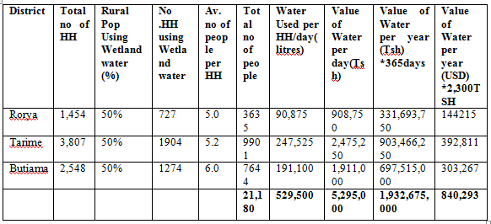

The study revealed that the number of water users in Mara wetlands were 21,180 individuals who valued the Mara wetland worth’s US $ 840,293 that was worth to 1.93 Billion per year Tanzania shillings. Thus implies that every day the Mara wetlands provide a domestic water supply services of Tsh 5.2 million per day (see Table 4:12).

CHAPTER FIVE

DISCUSSIONS OF THE RESULTS

5.1 Introduction
This chapter focuses on the discussion of the findings as analyzed and presented in chapter four. The discussion mainly relates the results obtained in this study to those of other past researchers, gravitating around the specific objectives of the present study. The chapter is organized in three sections, which are the relationship between access to sources of water and the amount of drinking water consumed per person per day, potential application of results in Tanzania and theoretical implications of the findings.

5.2 The Relationship between Access to Water Services and the Amount of Drinking Water consumed
In this study the relationship between access to water sources and the amount of drinking water consumed per day has been investigated. The main question addressed was whether or not access to sources of water would influence amount of drinking water consumed per day. Results have indicated the association between all three components of access to water sources and the amount of drinking water consumed per day.

Further, one component, treatment of drinking water managed to explain the amount of drinking water consumed per person per day. These results are similar to results from other past researchers, (Jones, et al., 2006; De Buck, et al., 2015; Säve-Söderbergh et al., 2018) all who reported the relationship between access to water sources and the amount of drinking water consumed per day. In a similar way, the results in the present study have indicated that water treatment strategy by boiling explained amount of drinking water consumed per day. It is then an additional knowledge that not only in the developed world, but also in Tanzania, access to non-restricted water explains the amount of drinking water, and thus, increasing the chances of health stability of the drinkers.

Though drinking bottled water might seem safer than other strategies it might be limited by the fact that access to the bottled water needs certain level of affluence to consistently maintain the purchasing power of the water. This might explain why respondents who reported drinking bottled water also reported the lowest amount of daily drinking water consumption. On the other hand, the amount of water consumed increased among those who reported boiling water. This might receive dual explanations. First, the level of consciousness on the risks taken by drinking raw water among these respondents on both boiling and the amount of water required for drinking. Second, since they boiled water specific for drinking, the very purpose of boiling might also work as a motivation to drinking large amount of water. These results face one comparison limitation.

Whereas most studies in the topic were conducted in the regions where acute demarcation between summer and winter periods is evident, this research was conducted concurrently regardless of the seasons of the year or difference in climatic conditions between the districts. This might have affected the results in terms of the amount of drinking water consumed per person per day, calling for more stringent study controlling for climatic conditions.

5.2 Potential Application of Results
There has been found the relationship between the main type of source of water and the amount of water one drinks per day. The most privileged source of water has been found to be taps. The more people accessed the taps, which is more improved type with assurance of water needs provision, the more they reported large amount of water consumption. Connecting this with what De Buck, Borra, De Weerdt, Veegaete, and Vandekerckhove (2015) reports with regard to association between the amount of water and decrease in diarrhea incidents and mortality rates in children younger than the age of five.

These results have potential in the fields of environmental and the public health. Since these sectors needs political intervention for their daily operations, information might be relevant in helping plans to help people in the rural districts to access taps instead of other sources which are likely to be detrimental to human health given the increasing challenges such as human population growth, agricultural expansion, river flow alterations, industrialization, introduced species and climate change. This is because with development driven human activities, waste is daily produced, and sad reports indicate that about 90% of all waste water in less developed countries is discharged in the rivers without being treated (Beshiru, Okareh, Chigor & Igbinosa, 2018; Stauffer & Spuhler, 2019).

5.2.1 The Role of Treatment of Drinking Water
Water treatment strategy explained the amount of water consumption. Practical implications for this finding is twofold discussed here. First, most people (43.9%) who reported boiling drinking water were the very people who reported access to water taps and from urban district. At the same time most people from rural districts (26.7% and 33.3% from and Tarime, respectively) reported drinking raw water. This indicates how these findings are of potential for community counseling by both community councilors and public health officials for improvement of citizen health.

WHO (2019) reports that in 2017 5.3 billion persons used improved water sources located on premises, other 435 million people used water from unprotected wells and springs while 144 million people collected untreated surface water from lakes, ponds, rivers and streams. These differences, being so vivid in one region, are also potential for use by researchers in all other regions and responsible leaders in relation to water treatment.

5.3 The Role of Amount of Drinking Water Daily
In their systematic literature review De Buck, Borra, De Weerdt, Veegaete, and Vandekerckhove (2015) searched the available evidence for the amount of water that is needed for drinking, cooking and hygienic purposes. They found that receiving a greater amount of water was related to a decrease in diarrheal incidents and mortality rates in children younger than five years of age. They also found that water treatment using containers reduced the risk of cholera.

By examining drinking occasions per day, amount consumed per drinking occasion, and intervals between drinking occasions, health officials are likely to conduct risk assessment by incorporating these data into available aggregate and cumulative models. This is one specific use for the data generated by this drinking water survey. However, this needs to be done in combination with other additional variables including source of drinking water, patterns of consumption for a day, week, monthly, seasons in question and so forth.

These results might also be used by other people benefiting from water industry, not only industries owners but also vendors. By understanding the drinking water patterns whether most people drink certain amount of water during weekdays versus weekends, whether water is typically consumed with or without food, where the water was consumed, and whether the water consumed on a given drinking occasion is bottled or tap water. All these variables of assessment may benefit so many stakeholders such as the bottled water industry or drinking water contaminant assessors.

5.4 Water Quality Consumed at Household Level from Wetland
In their studies Nowicki et al. (2021); Gwimbi et al. (2019); Reckien (2018) and Seib (2013) revealed rural people consumed water that had faecal contaminated thus proved to be of low quality. The found that water from the sources of water they were using for drinking had bacteria known as Escherichia coli. In other cases they used even more and less than 100ml of water sample in detecting bacteria and revealed the presence of bacteria. This finding relates with that of study whereby six different locations where tests was conducted it was revealed the presence of bacteria. This shows that wetland which produces various sources of water in rural areas especially in Africa water quality is a problem. This was attributed by multiple factors including establishment of settlements near wetlands, poor management of wastes disposal and institutional failures governing the protection of wetlands.

5.4 Theoretical Implications of the Findings
The conceptual framework employed the in this study has proved the ability to study water consumption patterns in Tanzanian context. It has been statistically signiﬁcant, χ2 (7, N = 120) = 52.17, p < .001, and capable of distinguishing respondents who reported drinking low amount of water from those who reported drinking high amount of water. It has also explained between 35.3% (Cox and Snell R square) and 47.1% (Nagelkerke R squared) of the amount of water consumption while categorizing 78.3% of low water drinking group. Such ability is a support to the Sustainable

Livelihood Framework (SLF) by the Department for International Development (DFID 2000) and Access Theory as proposed by Ribot and Peluso (2003). The two theoretical works, having provided a guide to the development of the conceptual framework for the present study, are hereby considered applicable and potential for further use by researchers in this line of environmental water management and public health. According to this approach, people in rural districts in Tanzania are vulnerable to the threats and weaknesses that must be taken into consideration for their healthy and successful development. The threats in our context are the inevitable challenges of water contamination.

Although studies indicate that some rivers especially around Mount Meru are safe according to standards set by Tanzania Bureau of Standards, it has however, been argued that some are contaminated and thus, can be detrimental to human health if care is not taken with the most harmful elements mentioned being mercury and uranium, which need to be filtered so as to reduce on causing cancer a risk to the community (Kasozi, et al., 2019). However, it should be clear that filtering is expensive and requires conscious decision making by authorities to invest in installation of heavy metal ﬁlters so as to avoid the whole community depending on wells from severe toxicological eﬀects in humans (Kasozi, et al., 2019).

The theory puts the role of authorities in rectifying the situation before it becomes worse. To do this, the theory argues that authorities should accept and share responsibility for the safety of the community, while community members need also to accept responsibility to abide by the rules of the game in the system (URT, 2017). One way in which authorities may accept responsibility is to diligently work in collective designing the stable means to consistently maintain the quality of wetlands, wells, springs, rivers and lakes so that they keep avoiding the possibility to further contaminations. This can be done successfully by the leaders who seek to utilize collectively the skills and diverse points of views from the public. The findings thus add to the theoretical understanding that government is the key to intervention of the vulnerability by the community by setting the directions in which the community will lie healthier and thus work for the sustainable development.

CHAPTER SIX

CONCLUSIONS AND RECOMMENDATIONS

6.1 Conclusion
The study concludes the following first; wetland is the main source of water in all seasons including wet and dry seasons for domestic purpose. Second, wetlands supports people livelihoods through water services offered from wetlands that enable farming activities, livestock keeping, fishing and business resulted from selling of water obtained from wetlands. Third rural residents depend on wetlands for domestic water uses as compared to urban areas. Fourth majority of rural residents trusted rural water quality from wetlands as compared to their counterparts urban areas who relied on tape water whereby rural residents the majority consumed drinking water on average 500ml from wetlands as compared to urban areas residents consumed more than 1000ml of drinking water from springs and lake. Lastly the Mara wetlands provides a domestic water supply services of worth of Tsh 5.2 million per day

6.2 Recommendations
The study recommends the following; first Local government in collaboration with the communities in rural areas should join their efforts in protecting wetlands found in Mara wetlands. This can be achieved through water committee and environmental committee established and managed by local people in their localities. Secondly, the ministry of health, community development, gender, elderly and children in collaboration with other stakeholders should conduct education campaign in rural areas on importance of treating drinking water to reduce water borne related diseases in rural areas that majority relied on raw water for domestic consumption.

6.3 Areas for Further Research
The study recommends areas for future research on the influence of agriculture activities on wetland protections. Despites of wetlands being important to the livelihoods of both urban and rural residents its sustainability especially wetland protection is depending on various human activities that are taking place on wetland.

REFERENCES
African Development Bank, (2006). African Development Fund Appraisal Report on Rural Water Supply and Sanitation Programme in Tanzania, 15-22, ADB.
African Development Bank, (2010). Tanzania-Rural Water Supply and Sanitation Program II, Appraisal report, ADB.
Akoteyon, I. S. (2019). Factors affecting household access to water supply in residential areas in parts of Lagos metropolis, Nigeria. Bulletin of Geography, Socio-economic Series, 43(43), 7-24.
Allison, J. (2010). No Water No Life, Mara River Expeditions report, Explorers club flag ninety three. Wings world queen flag number thirteen, retrieved on 12th March, 2020 from; www.nowater-nolife.org.
Angoua, E. L. E. Dongo, K. Templeton, M. R. Zinsstag, J. Bonfoh, B. (2018). Barriers to access improved water and sanitation in poor peri-urban settlements of Abidjan, CoÃte d’Ivoire. PLoS ONE 13(8), 1–13.
Attua, E. M., Annan, S. T. A. & Nyame, F. (2014). Water Quality Analysis Of Rivers Used As Drinking Sources In Artisanal Gold Mining Communities Of The Akyem-Abuakwa Area: A Multivariate Statistical Approach. Ghana Journal of Geography, (6), 24 – 41.
Balmford, A., Bruner, A., Cooper, P., Costanza, R., Farber, S., Green, R. E., Jenkins, M., Jefferiss, P., …. & Turner, R.K. (2002). Economic reasons for conserving wild nature. Science, 297, 950-53.
Bekele T. A. & Getahun S. M., (2020). Water quality assessment of streams and wetlands in a fast-growing East African city. Jimma University, Jimma, Ethiopia, 2(2), 05-15.
Beshiru, A., Okareh, O. T., Chigor, V. N. & Igbinosa, E. O. (2018). Assessment of water quality of rivers that serve as water sources for drinking and domestic functions in rural and pre-urban communities in Edo North, Nigeria.
Best, J. (2019). Anthropogenic stresses on the world’s big rivers. Nat. Geosci., 12, 681–686.
Beuel, S. Alvarezb, M., Amler, E., Behnb, K., Kotze, D., Kreye, C., Leemhuis, C.,Wagner, K., Willy, D. C., Ziegler, S. & Becker, M. (2016). A rapid assessment of anthropogenic disturbances in East African wetlands. Ecological Indicators 67, 684–692.
Beukman, R. (2002). Revisiting local water management in southern Africa’. Paper prepared for Policy workshop on local water management. Ottawa: Canada.
Bhandari, B. & Grant, M. (2007). User satisfaction and sustainability of drinking water schemes in rural communities of Nepal. Sustainability: Science, Practice, and Policy, 3(1), 12-20.
Biswas, A. K, Unver, O. & Tortajada, C. (2004). Water as a Focus for Regional Development. New Delhi: Oxford University Press.
Blumenfeld, S., Lu, C., Christophersen, T. & Coates, D. (2009). Water, Wetlands and Forests. A Review of Ecological, Economic and Policy Linkages. Secretariat of the Convention on Biological Diversity and Secretariat of the Ramsar Convention on Wetlands, Montreal and Gland. CBD Technical Series No. 47. retrieved on 10th May, 2021 from; https://www.cbd.int/doc/publications/cbd-ts-47-en.pdf.
Carney, D., Drinkwater, M., Rusinow, T., Neefjes, K., Wanmali, S. & Singh, N. (2000). Livelihoods approached compared. In: Forum on Operationalizing Sustainable Livelihoods Approaches. Proceedings. Annex 4. Pontignano (Siena). 7-11 March, 2000.
Carter, R. C. & Howsam, P. (1999). Impact and sustainability of community water supply and sanitation programmes in developing countries. J. Chartered Institution of Water and Environ. Manage, 13, 292-296.
CGIAR Research Program on Water, Land & Ecosystems. (2016). Withering boundaries: Nile basin wetlands shrink as communities quest for life. Colombo: Sri Lanka. CGIAR Research Program on Water, Land and Ecosystems (WLE).24p.
Costanza, R., de Groot, R., Sutton, P., Ploeg, S., Anderson, S. J., Kubiszewski, I., Farber, S., Turner, R.K. (2014). Changes in the global value of ecosystem services.Global Environ. Change, 26, 152-158.
Cubbin, J. & G. Tzanidakis, (1998). Regression versus Data Envelopment Analysis for Efficiency Measurement: An Application to the England and Wales Regulated Water Industry, Utilities Policy, 7, 75–85.
Davidson, N. C. (2014). How much wetland has the world lost? Long-term and recent trends in global wetland area. Marine and Freshwater Research, 65: 934–941.
De Buck, E., Borra V., De Weerdt E., Veegaete A.V., Vandekerckhove, P. (2015). A Systematic Review of the Amount of Water per Person per Day Needed to Prevent Morbidity and Mortality in (Post-) Disaster Settings. Plos One Journal, 10(5), 1-14.
de Jong, E., Sagardoy, J. A. & Sisto, I. (2012). Passport to Mainstreaming Gender in Water Programmes: Key Questions for Interventions in the Agricultural Sector. Food and Agriculture Organization, Rome: FAO.
Dijk, M. P. (2008). Public-private partnerships in basic service delivery: impact on the poor, examples from the water sector in India. International Journal of water, 4 (3), 216-234.
Doering, E. (2005). The reform of water sector in Tanzania, retrieved on 21st Feb., 2020 from; https://www.uni-siegen.de/zew/publikationen/fwuwaterre sources/volume0305/doering.pdf.
Dutton, C. L., Subalusky, A. L., Anisfeld, S. C., Njoroge, L., Rosi, E. J. & Post, D. M. (2018). The influence of a semiarid sub-catchment on suspended sediments in the Mara River, Kenya. PLoS ONE, 13(2).
Egbinola, C. N. (2017). Trend in Access to Safe Water Supply in Nigeria. Journal of Environment and Earth Science, 7(8), 89–96.
Food and Agriculture Organization, (2011). The State of Food and Agriculture: Women in Agriculture: Closing the Gender Gap for Development. Rome: FAO.
Gross, B., van-Wijk, C. & Mukherjee, N. (2000). Linking Sustainability with Demand, Gender and Poverty: A Study in Community-Managed Water Supply Projects in 15 Countries. Washington, D.C.: Water and Sanitation Program, WSP.
Gwimbi, P., George, M. & Ramphalile, M. (2019). Bacterial contamination of drinking water sources in rural villages of Mohale Basin, Lesotho: Exposures through neighbourhood sanitation and hygiene practices. Environmental Health and Preventive Medicine, 24(1), 1–7.
Gyau-Boakye P, Kankam-Yeboah K, Darko PK, Dapaah-Siakwan S. (2008). Groundwater as a Vital Resource for Rural Development: An Example from Ghana. In: Adelanaand MacDonald, (Eds.), Applied Ground Water Studies in Africa. pp: 149-190, New York: CRC Press.
Haddis, A., Getahun, T., Mengistie, E.; Jemal, A., Smets, I., Van der Bruggen, B. (2014). Challenges to Surface Water Quality in Mid-Sized African Cities: Conclusions from Awetu-Kito Rivers in Jimma, South-West Ethiopia. Water Environ. J., 28, 173–182.
Harvey, P. A. & Reed, R. A. (2007). Community-managed water supplies in Africa: sustainable or dispensable? Community Dev. J., 42(3), 365-378.
Hettiarachchi, M., Morrison, T. H., & McAlpine, C. (2015). Forty-three years of Ramsar and urban wetlands. Global Environmental Change, 32, 7-66.
Hoffman, C. M. (2007). Geospatial mapping and analysis of water availability-demand-use within the Mara River Basin. Thesis. Florida International University, Miami, FL, USA.
Hungerford, Harold R. & Trudi, L. (1990). Changing Learner Behavior Through Environmental Education. Journal of Environmental Education, 21(3), 8-21.
Irvine, K., Paron, P., Hes, E. & Mgimwa, E. (2017). Mara Wetland Mapping, Resource and Livelihood inventory. URT.
Jones, A. Q. Dewey, C. E. Dore, K. Majowicz, S. E. McEwen, S. A., and Waltner, D.(2006). Drinking water consumption patterns of residents in a Canadian community. Journal of Water and Health, 4 (1), 125–138.
Kasozi, K.I., Namubiru, S., Kamugisha, R., Eze, E.D.(2019). Safety of Drinking Water from Primary Water Sources and Implications for the General Public in Uganda. Journal of Environmental and Public Health, Management, 45(5), 1027-1039.
Kirkpatrick, C., Parker, D. & Zhang, Y. F. (2004). An empirical analysis of state and private-sector provision of water services in Africa. The World Bank Economic Review, 20(1), 143-163.
Kitalika, A. J., Machunda, R. L., Komakech, H. C. & Njau, K. N. (2018). Fluoride Variations in Rivers on the Slopes of Mount Meru in Tanzania. Hindawi Journal of Chemistry, 1, 3-18
Lake Victoria Basin Commission & World Wildlife Fund for Nature Eastern & Southern Africa Regional Programme Office. (2010). Assessing Reserve Flows for the Mara River. Nairobi and Kisumu, Kenya, USAID.
Lake Victoria Basin Commission, (2007). Report on Strategic Action Plan for the Lake Victoria Basin. Lake Victoria Environmental Management Project (LVEMP).
Lake Victoria Basin Commission, (2016). Mara River Basin. Transboundary Integrated Natural Resources Management Plan. Lake Victoria Basin Commission, Kisumu, Kenya.
Lockwood, H. & Smits, S. (2011). Supporting Rural Water Supply: Moving towards a Service Delivery Approach. Rugby: Practical Action Publishing.
Madulu, N . F. (2003). Linking poverty levels to water resource use and conflicts in rural Tanzania. J. Physics and chemistry of the earth, 28, 911-917.
Magnusson T. S. (2005). Urban Water Security – Local Conditions and Regional Context: A case Study of attitudes and water use behavior. Unpublished PhD thesis, Linköping University, Linkiping, Sweden.
Materu, S. F. Urban, B. & Heise, S. (2018). A critical review of policies and legislation protecting Tanzanian wetlands, Ecosystem Health and Sustainability, 4(12), 310-320.
Millennium Ecosystem Assessment (MEA), (2005). Ecosystems and Human Well-Being: Synthesis. Island Press, Washington DC. Mitsch, W. J., Gossilink, J. G. (2000). The value of wetland: importance of scale and landscape setting. Ecol. Econ., 35, 25-33.
Millennium Ecosystem Assessment, (2003). Ecosystems and human well-being: a framework for assessment, Millennium Ecosystem Assessment. Washington D.C.: Island Press.
Mitsch, W. J., Gossilink, J. G. (2000). The value of wetland: importance of scale and landscape setting. Ecol. Econ. 35, 25-33.
Mohan, R. V. R. (2003). Rural Water Supply in India: Trends in Institutionalizing People’s Participation, International Water Resources Association. Water International, 28(4), 442-453.
Moon, S. (2006). Private operation in the Rural Water Supply in Central Tanzania: Quick Fixes and Slow Transitions, Water Aid Tanzania.
Moral, C. (2015). How Many Litres of Water does a Person Need per Day? Retrieved on 20th March, 2021 from; https://blog.ferrovial.com/en/2015/03.
Mugisha, S. (2007). Effects of incentive applications on technical efficiencies: Elsevier, 15(4), 225-233.
Mukheibir, P. (2010). Water access, water scarcity, and climate change. Environmental Management, 45(5), 1027-39.
Munishi, P. K. T. (2007). The Biodiversity Values of the Mara River (Masurura) Swamp, Mara region, Northern Tanzania. Dar es Salaam: WWF Tanzania.
Mushi, C. A. (2013). Urban water management in Dar es Salaam: A case for an integrated approach. TRITA LWR Degree Project, Royal Institute of Technology (KTH), STOCKHOLM, Sweden.
NBS-National Bureau of Statistics, (2012). Population and Housing Census. National Bureau of Statistics Ministry of Finance and Office of Chief Government Statistician Ministry of State, President Office, State House and Good Governance, Dar es Salaam.
NBS-National Bureau of Statistics, (2014). Basic Demographic and Social Economic Profile Statistical Tables Tanzania Mainland. National Bureau of Statistics Ministry of Finance and Office of Chief Government Statistician Ministry of State, President Office, State House and Good Governance, Dar es Salaam.
Ndandiko, C. (2010). Private provision of Public services in developing countries? PhD thesis, University of Twente, Enschede, Netherlands.
Nowicki, S., DeLaurent, Z. R. De Villiers, E. P. Githinji, G. & Charles, K. J. (2021). The utility of Escherichia coli as a contamination indicator for rural drinking water: Evidence from whole genome sequencing. PLoS ONE, 16(1), 1–23.
Nyirishema R, Verweij M (2013). Improving Rwanda’s rural water supply through public-private partnerships. SNV Netherlands Development Organization, Rwanda. Retried on 21st June, 2020 from; http://m.snvworld.org/en/regions/africa/news/improving-rwandas-rural-water-supply-through-public-private-partnerships.
Odjegba, E. E. Idowu, O. A. Ikenweiwe, N. B. Martins, O. & Sadeeq, A. Y. (2015). Public Perception of Potable Water Supply in Abeokuta Southwest, Nigeria. J. Appl. Sci. Environ. Manage, 19(1), 5–9.
Omolo, D. (2017). The Impact of market and people’s perception on wetlands ecosystem services, Case study of Mara bay and Masirori wetlands, Delft, UNESCO-IHE.
Pascual, Unai; Luke Brander; Roldan Muradian and Erik Gomez-Baggethun (2010). The Economics of Valuing Ecosystem Services and Biodiversity. Retrieved on 26th August, 2020 from; https://www.researchgate.net/publication/ 303444184.
Peh, K., S. H., Balmford, A. P.1 , Bradbury, R. B., Brown, C., Butchart, S. H. M.5., Hughes, F. M. R., Stattersfield, A. J., Thomas, D. H. L., Walpole, M. & Birch, J. C. (2013). Toolkit for Ecosystem Service Site-based Assessment (TESSA). Cambridge, UK.
Planning for Resilience in East Africa through Policy Adaptation, Research and Economic Development. (2016). Economic valuation of biodiversity and ecosystem services in the Mara wetlands, United Republic of Tanzania. USAID, Kenya and East Africa.
Ramsar Convention on Wetlands, (2018). Global Wetland Outlook: State of the World’s Wetlands and Their Services to People. Ramsar Convention Secretariat, Gland, Switzerland.
Rebelo, A. J., Scheunders, P., Esler, K. J. & Meire, P. (2017). Detecting mapping and classifying wetland fragments at a landscape scale. Remote Sens. Appl. Soc. Environ, 8, 212-223.
Reckien, D. (2018). What is in an index? Construction method, data metric, and weighting scheme determine the outcome of composite social vulnerability indices in New York City. Regional Environmental Change, 18(5), 1439–1451.
Sanders, H. & Fitts, J. (2011). Assessing the Sustainability of Rural Water Supply Programs: A Case study of Pawaga, Tanzania. Masters Project, Nicholas School of the Environment, Duke University, Durham, North Carolina.
Säve-Söderbergh, M., Toljander, J., Mattisson, I., Åkesson, A. & Simonsson, M. (2018). Drinking water consumption patterns among adults—SMS as a novel tool for collection of repeated self-reported water consumption. Journal of Exposure Science and Environmental Epidemiology, 28,131–139

Seeteram, N. A. Hyera, P. T. Kaaya, L. T. Lalika, M. C. S. & Anderson, E. P. (2019). Conserving Rivers and Their Biodiversity in Tanzania, Water, 11(12), 2612.
Seib, M. D. (2013). Drinking water quality assessment at source and point-of-use in rural Mali: A case study. 86th Annual Water Environment Federation Technical Exhibition and Conference, WEFTEC, 3, 1848–1857.
Sharma, N. P. (2012). Community Managed Project (CMP) in Implementing Rural Water Supply in Amhara Region, Ethiopia. Unpublished Masters Thesis, Tampere University of Technology, Tampere, Finland.
Shi, A. (2000). How Access to Urban Potable Water and Sewerage Connections Affects Child Mortality. World Bank Policy Research Paper, Washington.
Sieben, E. J. J., Khubeka, S. P., Sithole, S., Job, N. M., Kotze, D. C. (2018). The classification of wetlands: integration of top-down and bottom-up approaches and their significance for ecosystem service determination. Wetl. Ecol. Manag. 26, 441-458.
Tong, Y., Zhang, W., Wang, X., Couture, R., Larssen, T., Zhao, Y., Li, J., Liang, H., Liu, X., Bu, X., He,W., Zhang, Q., Lin, Y. (2017). Decline in Chinese lake phosphorus concentration accompanied by shift in sources since, Nat. Geosci., 10, 507-511.
Turpie,J., K Lannas,K., Scovronick,N., Louw,A ., Malan,H. ( 2010). Wetland ecosystem services and their valuation: a review of current understanding and practice retrieved on 10th Nov., 2020 from; https://efdinitiative.org/sites/default/files/wetlands20vol20i.pdf.
United Republic of Tanzania, (2002). National Water Policy 2002. retrieved on June, 19th May, 2020 from; www.tzonline.org.
United Republic of Tanzania, (2005). National Strategy for Growth and Reduction of Poverty. Available on line at www.povertymonitoring.go.tz
United Republic of Tanzania, (2013). Prime Minister’s Office, Regional Administration and Local Government, Mara Investment Plan
URU, (2015). Ministry of Water and Environment, The economic value of biodiversity and ecosystem services in Lake Nabugabo Wetland Complex, Uganda.
World Bank Group, (2016). Reaching for the SDGs; The Untapped Potential of Tanzania’s Water Supply, Sanitation, and Hygiene Sector. Retrieved on 13th March, 2021 from; http://documents1.worldbank.org/curated/en/16779152 1012037920/df/124255-PUBLIC-P159820-the-untapped-potential-of-Tanzania-s-water-supply-sanitation-and-hygiene-sector.pdf.
World Health Organization (WHO), (2015). Progress on Sanitation and Drinking Water, 2015 Update and MDG Assessment. UNICEF: New York, NY, USA, 2015.
World Health Organization, (2019). Drinking – water, retrieved on 10th May, 2021 from; https://www.who.int/news-room/fact.
Xibao, X., Minkun, C., Guishan Y, Bo. J. & Ji, Z. (2020). Wetland ecosystem services research: A critical review. Global Ecology and Conservation, 22, 2351-9894.
Zhang, Y., Jeppesen, E., Liu, X., Qin, B., Shi, K., Zhou, Y., Thomaz, S. M. & Deng, J. (2017). Global loss of aquatic vegetation in lakes. Earth Sci. Rev. 173, 259-265.

APPENDIX
Mara Wetland Management Questionnaire Tool for Household and Key Informant Survey
This questionnaire assessment is part of the master’s dissertation study at Open University of Tanzania under the title: Valuation of Ecosystem’s Water Supply Services in Mara Wetlands
Dear respondent, the aim of this interview is for study purposes only and the information that you will provide is strictly confidential and will not be used for any other purposes therefore be free to share everything you know about what i will ask you for the successful completion of this study.
Date of Interview
Name of Enumerator
District
Village
Name of respondent
Gender of respondent

SECTION 1: Household Information
1. Provide details about the Household HEAD.
Gender(M/F) | Age | Primary Activity | Education Level

2. Is the household head the respondent Y/N………
3. Number of household member living permanently on the compound…….
Age Category | Male | Female | Total | Occupation
<15 years
15-25 years
25-35 year
36-45 years
>45 years
4. What is /are the main source of Income for your family? Which one is the most Important? (Number from I as most important) Agriculture (Farming and livestock)
Fishing
Livestock
Employment
Business
Others (Specify)

SECTION 2: Main depended source of water and the amount of water consumed per day

5. What are the sources of water for the household and how do you use the water?
Dry Season | Rainy Season | use
□ Wetland | □ Wetland
□ River | □ River
□ Well | □ Well
□ Tap water | □ Tap water
□ Purchased from shop | □ Purchased from shop
□ Rain water | □ Rain water
□ Spring | □ Spring
□ Other (specify) | □ Other (specify)
□ Other (specify) | □ Other (specify)
□ Other (specify) | □ Other (specify)

6. What is your most important supply of water and why?

.
SECTION 3: The distance from home to the source of water and the amount of water consumed
7. How many hours a day do you spend looking for water during the dry season and wet season?
Dry Season | Wet Season | Comments
□ Less than 0.5Km | □ Less than 0.5Km
□ 0.5Km – 1Km | □ 0.5 – 1Km
□ More than 1.0 Km | □ More than 1Kms

8. Who is/are Involved in the Collection of water for the household?
……………………………………………………………………………………………………………………………………………………………………………………
9. How much water do you consume daily for different activities in the household? The amount of water consumed per day categorized (<250mls, 500mls – 1000mls, 1000mls+)
Activity | Amount in Liters  (Dry Season) | Amount in Liters  (Wet Season)
□ Drinking
□ Cooking
□ Sanitation (domestic)
□ Other (specify)

- Do you pay to access water? □ YES □ NO
- If Yes, How much do you pay per unit? TSH ___________________
(A unit could be 20-liter container but please not the liters of the container)

SECTION 4: Water Treatment Methods
- Do you treat your water in any way to make it safer to drink?
Yes……. No…………
Don’t Know………….
- What do you usually do to the water to make it safer to drink? Anything else? Record all items mentioned
- Boiling ………
- Drinking Raw Water ……….
- Drinking Bottled water
iv.Add bleach/chlorine…………
v .Strain it through a cloth ………
vi. Use a water filter (ceramic, sand, composite, etc.)
vii. Other (specify)…………………
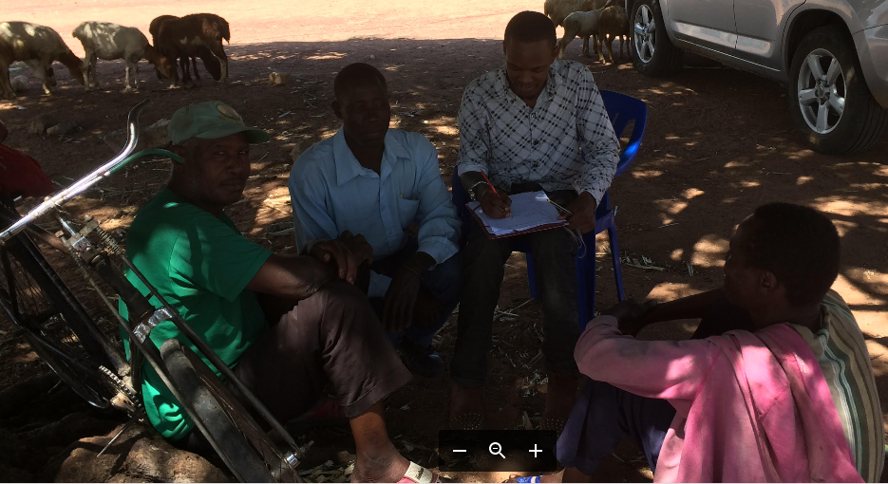
Plate 1: Interviewer administering a questionnaire to respondent
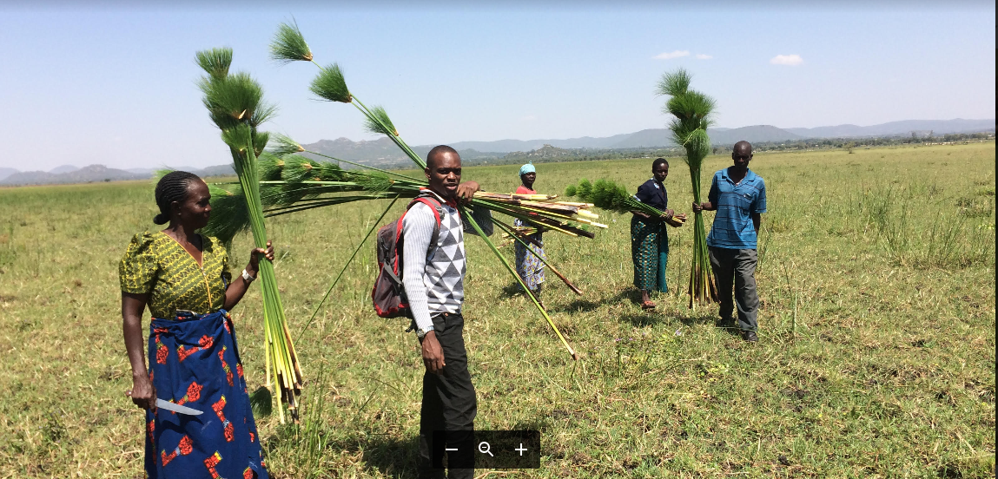
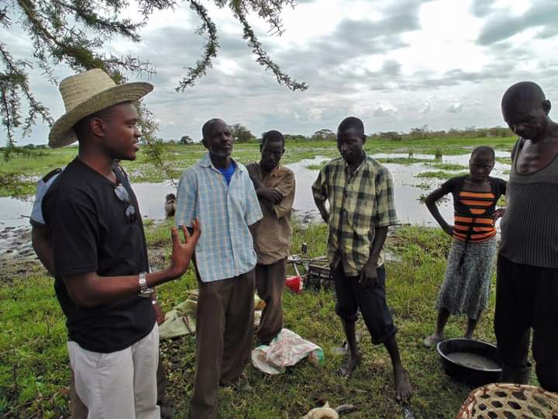
Plate 2: A group photo with beneficiaries of Wetland Water at Butiama
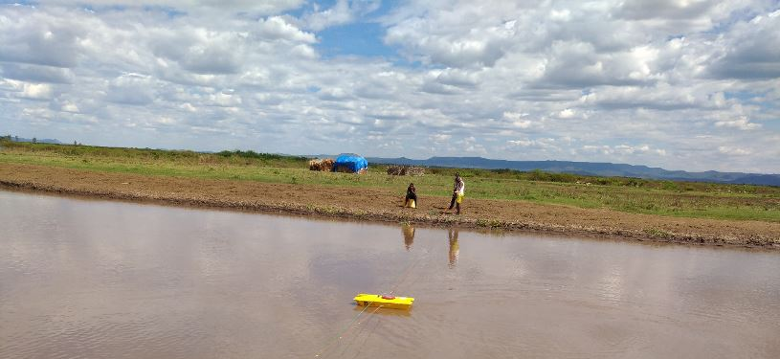
Plate 3 : Drinking water collection from the wetland with other ongoing human activities along the wetland (ie brickmaking, pastoralism)

