THE CHALLENGES OF PROMOTING AND ADOPTING BIOGAS TECHNOLOGY AS ALTERNATIVE ENERGY SOURCE IN SEMI-ARID AREAS OF TANZANIA: THE CASE OF KONGWA AND BAHI DISTRICTS OF DODOMA REGION

ANNA IBRAHIMU WAWA

A THESIS SUBMITTED IN FULFILLMENT OF THE REQUIREMENTS FOR THE DEGREE OF DOCTOR OF PHILOSOPHY (ENVIRONMENT) OF THE OPEN UNIVERSITY OF TANZANIA
2012

CERTIFICATION

The undersigned certify that they have read and hereby recommend for acceptance by The Open University of Tanzania a Thesis entitled “The Challenges of Promoting and Adopting Biogas Technology in Semi-arid areas of Tanzania: The Case of Kongwa and Bahi Districts in Dodoma Region”, in fulfilment of the requirements for the Degree of Doctor of Philosophy (Environment) of The Open University of Tanzania.

………………………..……………………….
Prof. Shadrack Mwakalila
(Supervisor)

Date…………………………………………….

……………………..…………………………….
Dr. Susan Gwalema
(Supervisor)

Date…………………………………………….

COPYRIGHT

This thesis is copyright material protected under the Berne Convention, the copyright and Neighbouring Rights Act 1999, and other international and national enactment in that behalf on intellectual property. No part of this Thesis may be reproduced, stored in any retrieval system, or transmitted in any form by any means, electronic, mechanical, photocopying, recording or otherwise, save for fair dealings, academic and research purposes, without prior written permission of the author or The Open University of Tanzania in that behalf.

DECLARATION

I, Anna Ibrahimu Wawa, do hereby declare to the Senate of the Open University of Tanzania that this thesis for the degree of Doctor of Philosophy (Environment) is my own original work and it has not been submitted and will not be presented to any other university or any other institution of higher learning for a similar award.

…………………………………………………
Anna Ibrahimu Wawa

Date ……………………………………………
DEDICATION

This thesis is dedicated to the Almighty God, to Him be all the Glory and Honour for by his Mercy and Grace, I have been able to accomplish this work. Also to my beloved father the late Ibrahimu Wawa and my mother Rebecca Kulunya, who saw the importance of educating their 8th born baby girl, despite objections from other family members. To my beloved husband Mallaki and my children Daniel, Glory, Gladness and David, who endured my absence and long working hours during the course of this study.

ACKNOWLEDGEMENT

The completion of this work has been possible through support and contributions of many individuals, organizations and institutions. It has been not easy to mention everybody here by name, but I sincerely wish to express my gratitude to them all.

I am particularly indebted to The Open University of Tanzania management for both financial and moral support during the course of my study. My Special thanks go to Prof. Tolly Mbwette the Current Vice Chancellor and Prof. Elifas Bisanda the Current Deputy Vice Chancellor (Academic) also to the previous Vice Chancellor Prof. Geofrey Mmari, for their constant encouragement, constructive challenges and inspiration which strengthened and motivated my thinking during the course of this study.

I am indebted to my supervisors, Prof. Shadrack Mwakalila of the University of Dar es Salaam and Dr. Susan Gwalema of the Open University of Tanzania. Their professional guidance, encouragement, constructive criticisms and comments have resulted to the success of this work. I am also thankful to Prof. Salome Misana of Dar es Salaam University, College of Education who partly supervised me during proposal development stage.

I am grateful to my colleagues (academic staff) of the Open University of Tanzania and friends from other academic institutions for their professional assistance and moral support. Space is not enough to mention all of them, but the following would represent the others; Dr. Cosmas Haule, Dr. Bibiana Komunte and Dr. Pembe Lipembe of the Open University of Tanzania, for their interest of reading early versions of my thesis and giving valuable suggestions and guidance which helped to improve this work. Dr. Frank Hawassi of the Institute of Rural Development Planning for his great help during data analysis process; he introduced and guided me on the use of computer software programmes of data analysis. Others are Dr. Massomo and Dr. Pallangyo, Mr Maulid Maulid, Mr. Hashil Abdallah and Mr. Shelad Mukama, Mr Matiku Joshua of the Open University of Tanzania for their assistance and guidance on various computer skills during the writing stage of this work.

My fieldwork would have not been successful without support and cooperation of officials from the Dodoma Regional Commissioner’s office and District Commissioner’s offices of Kongwa and Bahi districts. I am also obliged to extend my appreciation to the Managers of the following organizations: MIGESADO, CAMARTEC, TATEDO, REA and the Ministry of Energy and Minerals for their willingness to provide information and other valuable documents which formed part of secondary data for this study. I am indebted to research assistants: Mr. Mussa Mgulo, Mr. Japhet Mazengo, and Ms Matesha Sembuche of Mpwapwa Teachers Training College who tirelessly devoted their time to travel through rough and dusty roads to interior villages during field survey.

Last, but not least, I am indebted to the family of my brother in law Mr. Gideon Kiyenze and his wife Elizabeth Kiyenze. This family made my stay in Dar es Salaam easier and comfortable, their prayers and moral supports contributed to the psychological calmness during the course of my study. My Pastor, Jacob Konki and his wife Justina Konki will never be forgotten for their spiritual guidance and prayers which encouraged me and raised my faith during tough times of my study period. MAY THE ALMIGHTY GOD ABUNDANTLY BLESS YOU ALL.

ABSTRACT

Biogas technology was introduced in central Tanzania as an alternative renewable source of energy following domestic energy crisis. Despite the biogas project being operational in Dodoma region since 1994, the technology adoption level has remained low and on the decreasing rate. The aim of this study was to explore the root causes for low adoption level of biogas technology. The study was conducted in Kongwa and Bahi Districts in Dodoma Region. It employed a multi-stage sampling procedure involving purposive selection of the study villages which have been reached by the biogas project with the purpose of capturing the experiences of biogas users and other potential adopters. The study adopted both qualitative and quantitative approaches of data collection and analysis. A conceptual framework based on adoption theories guided the analysis of factors influencing biogas adoption.

The study findings have shown that, the adoption of biogas technology in Dodoma ranged from 0.06 to 0.5% across the region. Adoption increased gradually from year 1994 to 2005 after which it abruptly dropped. The decline is associated with reduction of subsidies for biogas plants constructions. Based on the marginal effect concept, the major factors influencing the adoption of biogas in the study area, arranged from the most influential factor were: Awareness (0.2342), Technical service availability (0.1482) and Age of respondents (0.1128). Other significant factors include; knowledge of the technology, water availability and access to credit, income and education level of household head. The study has further established that government institutions have not fully engaged themselves in promoting biogas technology instead responsibility for development of biogas projects has been left to non-governmental organizations without effectual intervention of government agents. This situation has had implication on other factors including; information dissemination, access to credits, motivation and coordination of sectors and stakeholders dealing with biogas dissemination.

Based on the findings, this study recommends the following; first, the ministry responsible for energy should improve policy environment by specifying appropriate implementation strategies, financial support and coordination of biogas programmes. Secondly, programme implementers should use effective promotional approaches. Lastly ongoing initiatives such as the Tanzania Domestic Biogas Programme should seriously consider the short-comings addressed by this study and experiences of the existing biogas projects to improve the technology and ensure its sustainability.

TABLE OF CONTENTS

CERTIFICATION i
COPYRIGHT ii
DECLARATION iii
DEDICATION iv
ACKNOWLEDGEMENT v
ABSTRACT viii
TABLE OF CONTENTS x
LIST OF TABLES xvi
LIST OF FIGURES xviii
LIST OF MAPS xix
LIST OF APPENDICES xx
LIST OF ABBREVIATIONS AND ACRONYMS xxi
CHAPTER ONE Error! Bookmark not defined.
INTRODUCTION 1
1.1 Background of the Study 1
1.2 Statement of the Problem 10
1.3 Objectives of the Study 11
1.3.1 Specific Objectives 11
1.3.2 Research Questions 12
1.4 Conceptual Framework of the Study 12
1.5 Significance of the Study 16
1.6 Scope of the Study 18
1.7 Organization of the Thesis 18
CHAPTER TWO 20
2.0 LITERATURE REVIEW 20
2.1 Chapter Overview 20
2.2 Global Energy Consumption 20
2.3 Energy Situation in Tanzania 22
2.4 Biogas Technology 25
2.4.1 Biogas Production 26
2.4.2 Biogas Plant 26
2.4.2.1 Fixed-dome (Chinese design) 27
2.4.2.2 Floating Cover (Indian design or KVIC model) 31
2.4.2.3 Tubular plastic design 32
2.4.4 Uses of Biogas and Effluent 34
2.4.5 The History of Biogas Technology 34
2.4.5.1 Biogas Technology worldwide 34
2.4.5.2 Biogas Technology in Tanzania 37
2.4.5.3 Biogas Project in Dodoma 40
2.5 Technology Adoption 44
2.5.1 Theoretical Frameworks for Technology Adoption 44
2.5.1.1 Theory of Planned Behavior 45
2.5.1.2 Diffusion of Innovation Theory 46
2.5.2 Adoption Process 51
2.5.3 Factors Affecting Adoption of Innovations 52
2.5.3.1 Socio- economic Characteristics 53
2.5.3.2 Institutional Characteristics 59
2.5.3.3 Technological Characteristics 61
2.5.3.4 Environmental Characteristics 62
2.5.4 Biogas Technology Dissemination 63
2.6 Government Institutions Involvement in Biogas Technology Promotion 65
2.7 Knowledge Gap 69
CHAPTER THREE 71
3.0 RESEARCH METHODOLOGY 71
3.1 Chapter Overview 71
3.2 Study Area Description 71
3.2.1 Kongwa District 71
3.2.1.1 Climate 72
3.2.1.2 Socio-economic Setting 73
3.2.1.3 Energy Sector 73
3.2.1.4 Livestock Keeping 76
3.2.1.6 Water Supply and Sanitation 78
3.2.2 Bahi District 79
3.2.2.1 Climate 80
3.2.2.2 Socio-economic Setting 81
3.2.2.3 Energy Sector 82
3.2.2.4 Livestock Keeping 82
3.2.2.6 Water Supply and Sanitation 84
3.4 Research Design 85
3.5 Sample Population 86
3.6 Sample Size and Sampling Procedures 87
3.7 Data Sources and Types 90
3.8 Data Collection Methods 91
3.8.1 Interviews 92
3.8.2 Focus Group Discussion 94
3.8.3 Field Observation 95
3.9 Field Survey 96
3.9.1 Pilot Survey 96
3.9.2 Detailed Field Survey 97
3.10 Data Processing and Analysis 98
3.10.1 Data processing 98
3.10.2 Data Analysis 98
3.10.3 Data presentation 104
CHAPTER FOUR 105
4.0 FINDINGS AND DISCUSSIONS 105
4.1 Chapter Overview 105
4.2 Overview of Respondents Characteristics 105
4.3 Factors Influencing Adoption of Biogas Technology 108
4.3.1 Socio economic Characteristics and Biogas Adoption 108
4.3.1.1 Age of Respondent and Biogas Adoption 109
4.3.1.2 Education Level and Biogas Adoption 111
4.3.1.3 Household Size and Biogas adoption 112
4.3.1.4 Main Economic Activity and Biogas Adoption 113
4.3.1.5 Household Income and Biogas Adoption 114
4.3.1.6 Gender and Biogas Adoption 115
4.3.2 Environmental Characteristics and Adoption of Biogas Technology 121
4.3.2.1 Fuel wood Scarcity 122
4.3.2.2 Availability of Feed-stocks for Biogas Plants 130
4.3.2.3 Availability of Water Supply 133
4.3.3 Technological Characteristics and Adoption of Biogas Technology 134
4.3.3.2 Perceived Benefits of Biogas technology 135
4.3.3.3 Performance of Biogas Plants 139
4.4 Peoples’ Awareness and Attitude towards Biogas Technology 145
4.4.1 Peoples’ Awareness on Biogas Technology 145
4.4.2 Peoples’ Attitudes towards Biogas Technology 149
4.5 Correlation of Factors Influencing Adoption of Biogas Technology 155
4.6 Extent and Rate of Adoption of Biogas Technology 163
4.6.1 Extent of Adoption of Biogas Technology 163
4.6.2 Rate of Biogas Technology Adoption 166
4.7 Stakeholders Involvement in Biogas Technology Promotion 170
4.7.1 Biogas Information Dissemination in the Study Area 170
4.7.2 Promotion of Biogas Technology 173
4.7.3 Government Institutions Involvement in Biogas Promotion 175
4.7.4 Biogas Promotion Strategies Used by Biogas Project 178
4.7.5 Promotion Strategies Suggested by Respondents 181
CHAPTER FIVE 183
5.0 SUMMARY, CONCLUSION AND RECOMMENDATIONS 183
5.1 Chapter Overview 183
5.2 Summary of the Findings 183
5.3 Conclusion 188
5.4 Recommendations 190
5.4.1 Promotion of Biogas Technology 191
5.4.2 Government Institutions Involvement in Biogas Promotion 192
5.4.3 Technological Improvement 193
5.4.4 Financial Support for Biogas Installation 195
5.5 Suggestions for Further Studies 197
REFERENCES 199
APPENDICES 211

LIST OF TABLES

Table 2.1: Worldwide fuel wood consumption (TJ) by 2005 22
Table 2. 2: Energy sources and their use in Tanzania 24
Table 2. 3: Number of biogas plants constructed in Dodoma from 1994 to 2009 42
Table 3. 1: Kongwa district livestock population by 2009 76
Table 3. 2: Villages selected for study in Kongwa and Bahi Districts 86
Table 3.3: Specification of variables included in logit model for adoption of biogas technology 102

Table 4. 1: Socio economic characteristics of the sample population 107
Table 4. 2: Socio - economic characteristics of the sample population 108
Table 4.3: Relationship between socio economic characteristics and biogas adoption 110
Table 4. 4: Relationship between socio - characteristics and biogas adoption 113
Table 4. 5: Relationship between cattle ownership, age and biogas adoption 114
Table 4.6: Responses on factors limiting adoption of biogas technology in the study area 115
Table 4. 7: Gender responsibilities in biogas issues at the household level 117
Table 4. 8: Gender responsibilities in biogas activities at household level 119
Table 4. 9: Environmental characteristics in relation to biogas technology adoption 123
Table 4.10: Population % vs. distances to firewood source among the study villages 126
Table 4. 11: Population % vs. Costs of firewood and charcoal in the study area 128
Table 4. 12: Responses on solutions to fuel wood problems 130
Table 4. 13: Cattle ownership by respondents in the study area 131
Table 4. 14: Focus group responses on unrealized benefits of biogas technology 136
Table 4. 15: Biogas adopters' reasons for continual use of other energy sources 139
Table 4. 16: Respondents who attend biogas awareness creation activities 147
Table 4. 17: Respondents' knowledge on biogas technology 148
Table 4. 18: Responses on issues which education is required by biogas adopters 149
Table 4. 19: Respondents attitudes towards biogas technology 150
Table 4. 20: Estimated Coefficients of factors influencing adoption of biogas technology 156
Table 4. 21: Extent of biogas adoption in Dodoma region 164
Table 4. 22: Number of biogas plants installed in 16 study villages from 1994 to 2009 166
Table 4.23: Reasons for decreased adoption of biogas technology as per focus group discussions 169
Table 4. 24: Sources of biogas technology information to respondents 171
Table 4. 25: Respondents access to factors assumed to promote adoption of biogas technology 174
Table 4. 26: Respondents opinions on government institutions involvement in biogas promotion 175
Table 4. 27: Focus groups opinions biogas stakeholders and their contribution towards biogas promotion 176
Table 4. 28: Weaknesses of promotion strategies as perceived by respondents 180
Table 4. 29: Promotion strategies as suggested by respondents 181

LIST OF FIGURES

Figure 1.1: A Conceptual framework for adoption of biogas technology 15
Figure 2. 1: Energy sources and their % use in industrialized countries 21
Figure 2. 2: Biogas plant types 27
Figure 2. 3: Fixed - dome biogas plant 28
Figure 2.4: Theory of Planned Behaviour 45
Figure 2. 5: Diffusion of innovation Model (Simplified) 48
Figure 2. 6: Conceptual framework for examining factors influencing adoption of rotational woodlot technology 50
Figure 3. 1: Researchers observing a biogas plant installed in Mlali village 75
Figure 4. 1: A man in his kitchen explaining how a biogas cooker works 121
Figure 4. 2: Distance to important resources pre-requisites for biogas technology 124
Figure 4. 3: Time spent for firewood collection in the study area 127
Figure 4. 4: Responses on frequency of technical staff visits to biogas users 135
Figure 4. 5: Other energy sources than biogas used by biogas users 138
Figure 4. 6: Status of constructed biogas plants in the study area 140
Figure 4. 7: Reasons for non-functioning biogas plants 141
Figure 4. 8: Awareness of biogas technology in the study area 146
Figure 4. 9: Respondents priorities in investing if enabled 152
Figure 4. 10: A man at Iduo village explaining how a biogas plant is operated 153
Figure 4. 11: Number of biogas plants installed in study villages as from 1994 to 2009 167
Figure 4. 12: Frequencies of biogas campaigns in the study area 172

LIST OF MAPS

Map 1: Location of Kongwa and Bahi Districts in Tanzania --------------------------72
Map 2: Location of Villages Covered by the Study in Kongwa District--------------89
Map 3: Location of Villages Covered by the Study in Bahi District-------------------90

LIST OF APPENDICES

Appendix 1: Households Questionnaire on Assessment of Promotion and Adoption of Biogas Technology; in Semi – arid Areas of Tanzania--------------211
Appendix 2: Interview Guide for Organizations Dealing with Biogas
Technology-------------------------------------------------------------------226
Appendix 3: Check list to the Ministry Offices/ Government Departments/ Institutions Dealing with Biogas Technology----------------------------231
Appendix 4: Check list for Focus Group Discussion-----------------------------------232

LIST OF ABBREVIATIONS

BES Biogas Extension Service
CBFM - Community Based Forest Management
CAMARTEC Centre for Agricultural Mechanization and Rural Technology
CBOs Community Based Organisations
CBPP Contagious Boville Pleurophenmonia
DIT Diffusion of Innovation Theory
DONET Dodoma Environmental Networks
ELCT Evangelical Lutheran Church in Tanzania
ERP Economic Recovery Programme
ESAMI Eastern and Southern African Management Institute
EWURA Energy and Water Utilities Regulatory Authority
FGD Focus Group Discussion
FIDE Friends in Development Trust Fund
ISAT Information and Advisory Service on Appropriate Technology
GTZ Deutsche Gesellschaft für Technische Zusammenarbeit
KIVC Khadi and Village Industries Commission
JFM Joint Forest Management
LAFR Local Authority Forest Reserves
MEM Ministry of Energy and Mineral
MIGESADO Miradi ya Gesi ya Samadi Dodoma (Dodoma Biogas Projects)
MKUKUTA Mpango wa Kuondoa Umaskini na Kukuza Uchumi Tanzania (Poverty Reduction and Economic Development Strategy in Tanzania)
MLE Maximum Likelihood Estimation
NGOs Non Governmental Organisations
NRF National Forest Reserves
PVC Polyvinyl Chloride
PFM Participatory Forest Management
SEP Special Energy Programme
SIDO Small Industries Development Organisations
SNV Netherlands Development Organisation
SURUDE Sustainable Rural Development
TaTEDO Tanzania Traditional Energy Development Organization
TDPP Tanzania Domestic Biogas Programme
TPB Theory of Planned Behaviour
TANESCO Tanzania Electric Supply Company
NFR National Forest Reserves
SPSS Statistical Package for Social Sciences
REA Rural Energy Agency
REF Rural Energy Fund
URT United Republic of Tanzania

CHAPTER ONE

INTRODUCTION

1.1 Background of the Study
Tanzania, as is typical of most third world countries, is facing an energy crisis. The crisis is not only limited to shortage of oil but also to scarcity of fuel wood, which has been described to be as serious as the oil crisis (Kambele, 2003). In this study the term fuel wood is used to mean wood products in form of firewood or charcoal used as fuel. In Less Developed Countries; wood has been the major source of fuel for centuries and is still the primary source for nearly half of the world population (Enger, 2006). Cunningham et al (2007) assert that people in the developing countries are in daily struggle to find enough fuel to warm their homes and cook their food. Shortage of fuel wood encompassing firewood and charcoal, imposes heavy costs on urban and rural consumers alike (Shechambo, 1984). Women in particular, due to their roles and their close interaction with the environment are the major victims of the domestic energy crisis. Cecelski (2000) further comments that rural women, who are traditionally firewood collectors, are facing crisis of wood energy, human energy and of time, to meet the domestic energy needs.

Tanzania’s 90% of its energy consumption is met by biomass, primarily wood; and over 80% of the energy consumption is used in rural areas. Biomass as defined by the Encarta Dictionary is a dry mass of living organisms within a particular environment or a plant and animal materials especially agricultural waste products used as a source of fuel. In the context of this study the term biomass is used to mean organic materials used as energy source such as wood, crops residues and any organic wastes. Biomass can either be used directly by combustion to produce heat or converted into other energy products such as biofuels or biogas.

In Tanzania the household sector constitutes the largest share of the total energy consumption mainly through its use of fuel wood (REA, 2007). The dominance of fuel wood use in Tanzania has led to its scarcity manifested by devastation of natural vegetation and the increasing distances between points where fuel wood is obtained and where it is required for basic survival activities such as cooking (Kambele, 2003). Nkonoki (1983) also found out that the energy crisis in Tanzania was worsening year after year especially with regard to the availability and cost of firewood, charcoal and kerosene. He further argues that there is a wide spread loss of trees in parts of Tanzania particularly in the regions of Mwanza, Shinyanga, Dodoma, Tabora, Singida, Mbeya and Arusha leading to scarcity of fuel wood. The scarcity of fuel wood therefore, suggests for an urgent need to look for alternative sources of energy which are sustainable and affordable to the majority who are mostly in rural areas. Women in particular need alternative sources of energy that is less laborious, more convenient and healthily safe to address their critical need of energy for cooking.

The shortage of fuel wood in many developing countries is compounded by rapid growth of population which creates increasing demands for firewood and charcoal hence excessive wood cutting for domestic energy from a diminishing supply. According to Reeds (1996) the net contribution to deforestation in Tanzania is by fuel extraction and charcoal making (55%), agricultural cultivation (39%), tobacco curing (4%) and by commercial logging (2%). In addition to the use of fuel wood in rural areas, a considerable amount of firewood and charcoal are collected and transported to urban centres, as a source of income for rural populations. The abject poverty and absence of substantial income generating activities in rural areas is what coerces villagers to engage into firewood collection, charcoal making and lumbering for sale in urban areas; activities which lead to increased deforestation rates.

Other causes of deforestation include frequent and uncontrolled bushfires and the use of forestlands for various developmental activities. Fforests and forested areas which are the major source of fuel wood have shrunk rapidly. Fin-Facts team (2010) reported that between 1990 and 2005 the global forest cover shrank by 3% that corresponds to an average annual loss of 0.2% (www.finfacts.ie). In Tanzania particularly, deforestation has spread rapidly affecting mainly semi-arid areas where forest and bush regeneration is slow. Between 2000 and 2005 deforestation was about 1.1% per annum and in central part of Tanzania like Dodoma region, the threat of desertification is real (Schimtz, 2007). Worse still the shrinking of forested areas is accompanied by inadequate afforestation measures and poor forest management resulting in widespread loss of trees.

On the other hand, the continuous rise of demand for wood based energy sources is caused to a large extent by the persistent price rise of oil based energy sources, high and rising electricity tariffs and lack of more efficient energy alternatives (Kulindwa and Shechambo, 1995). Due to continuous and increasing pressure on fuel wood for domestic energy supply and the conversion of woodlands and forests into crop lands, some analysts have predicted rather alarmingly that the country’s wood reserves could be wiped out entirely by the late 21st century (Kulindwa and Shechambo, opp.cit). As the world population is expected to reach 10 billion people towards the end of next century, the demands for future scenarios of resource utilization must be predicted on optimizing the capacity of the earth’s ecosystems to produce biomass as the only renewable source of energy; and minimizing waste through recycling, which reduces the need for raw materials and helps to protect the environment (Preston, 1995). This is very crucial since improvement in the quality of life of the population depends greatly on the availability of appropriate energy alternatives.

Following the fuel wood scarcity and energy crisis in general, Tanzania government aims to improve access to modern energy in rural areas through rural electrification. The challenge is how best to facilitate the availability of an affordable energy supply for domestic and commercial activities all over the country and to the sparsely populated areas. Kimambo (2002) observed that, programmes involving large commercial and centralized electricity generation, mainly from hydro and thermal resources have been executed to reasonable levels in Tanzania. Kimambo (2002) observed that, programmes involving large commercial and centralized electricity generation, mainly from hydro resources have been executed to reasonable levels in Tanzania as compared to other renewable sources of energy. However, the current energy supply in Tanzania is unreliable due to the country’s dependence on mono-source of hydro-power which has often been affected by unreliable rainfall patterns caused by global climatic changes. Furthermore, the growing demand of electricity for commercial and industrial activities accompanied by lack of petroleum products supply security poses a big challenge on the energy sector in the country.

Tanzania is a country with abundant, diverse and un-exploited renewable energy resources that are yet to be effectively utilised for improvement of the livelihood of the vast majority of the population. A renewable resource is one that can be renewed as it is used up or a natural resource that replaces itself unless overused. In this thesis, renewable energy is referred to as an alternative energy which is naturally generated from the sun, wind, waves and other natural renewable biomass sources in contrast to non-renewable energy generated from fossils fuels.

In Tanzania the renewable energy sector which includes biomass, wind, solar, geothermal and tidal waves power have not been explored sufficiently as sources of commercial electricity generation (Kimambo (2002). The reason, according to Kimambo (opp.cit) is that the renewable energy sector has not received considerable support from key development co-operating partners. Sawe (2009) in support of Kimambo’s view, gives an example of the National Strategy for Growth and Reduction of Poverty in Tanzania (MKUKUTA in Swahili), which specifically sets a goal for reducing the proportion of population depending on biomass for cooking from 90% in year 2005 to 80% in year 2010; yet, renewable technologies efforts have been left to the private sector without clear guidelines. As a result, the effect has been minimal and many projects are unsustainable.

It is believed for instance, that the production of biogas would benefit the societies by providing clean fuel in form of biogas from renewable feed-stocks such as large quantities of agricultural residues, municipal wastes and industrial wastes and help end energy poverty (Parawira, 2009). Biogas as defined by Balat and Balat, (2009) is gas that is generated from organic digestion under anaerobic conditions by a mixed population of organisms. Nes and Nhete (2007) advocate that biogas technology which converts biological wastes into energy is an excellent tool for improving life, livelihoods and health in the developing world and that biogas is a service that is broader than just energy supply. It uplifts the dignity of women and improves their health and hygienic conditions of families. Properly designed and used biogas digesters may mitigate a wide spectrum of environmental undesirables It is capable of improving sanitation, reducing greenhouse gas emissions, decreasing demand for wood and charcoal for cooking and hence help to preserve forested areas and natural vegetation. It also provides a high-quality organic fertilizer.

Biogas will be viable when the prospective acceptor is driven to the necessity of encountering physical limit to the amount of fuel available from the traditional sources. This could happen as a result of scarcity of wood/dung, as the case of the Chinese who suffered from a severe handicap with virtually no oil and coal resources, and very little wood, which took them to burning of rice straw to cook their meals (Rajeswaran, 1983). Another factor mentioned by Rajeswaran (opp.cit) as a physical limit was the increased transport cost and insufficient cash to purchase other fuels. This was the case of India, where transportation cost of coal and oil to the rural areas was high and an extra burden on an already poor farmer.

Rajeswaran (1983) also comments that there are factors which act as impetus to the biogas technology. This is when the essential inputs have a low opportunity cost, which is made possible by the continuous availability of feedlot materials (cattle dung) and the availability of water, which is very crucial, for without it, the running of biogas plant gets defeated. Other factors include adequate capital to cover installation costs and the willingness of laborers to undertake the work of operating the digester on continuous basis. When all these sets of factors are identified what remains to be considered is safeguarding the operational efficiency of the plant.

Rajeswaran (opp.cit) further reveals that biogas technology has attracted the interest of both developed and developing countries in recent years where several international organizations have shown interest in various aspects of biogas systems; as renewable alternative source of energy, fertilizer, environmental management, waste recycling, public health and hygiene, pollution control, ecological balance and appropriate technology. In his comparative analysis Rajeswaran showed that diffusion of biogas technology in India was within the range of 0.06 – 0.25 percent while in China, the spread was calculated at 5.26 per cent. In India, as part of extension work, farmers who owned digesters were asked to demonstrate them in the presence of prospective owners. In China on the other hand, the Government stressed the importance of training local people, and the influence of team and brigade leaders was considered extremely important for the popular acceptance of biogas technology. Rajeswaran (opp.cit) mentioned the planning and execution of an intensive media campaign at grass-root level as being a factor which contributed to success of biogas projects in China. Other factors that influenced the success of anaerobic digestion facilities, according to Biogas works (1999) was their design simplicity, local environmental regulations and other policies governing land use and waste disposal.
However the biggest constraint in the biogas programs had been the price of the digesters. The number of biogas plants built each year had fallen dramatically because of the reduction in subsidies with a consequent switching from biogas to coal as a fuel (Qiu et al., 1990). It was also learned that the popularization of biogas would only be successful when the direct benefits to the farmers were obvious (Kristoferson and Bokhalders, 1991). Furthermore, in many developing countries frequent changes in the government policies, interest rates and subsidies have also had negative impacts in biogas dissemination. These changes have disappointed the investors in long-term biogas development. The progressive farmers who would like to have biogas also become doubtful about their long-term biogas investments.

The poor performance of earlier biogas digesters can also be attributed to poor backup services. The poor performance of biogas plants is still largely prevalent and has led to a relatively high breakdown adoption rate (Kristoferson and Bokhalders 1991). According to Marchaim (1992) problems associated with biogas dissemination can be classified as (a) design faults; (b) construction faults (c) difficulty of financing; (d) operational problems due to incorrect feeding or poor maintenance and (e) organizational problems arising from the differences of approaches and lack of coordination.

Tanzania has been among forefront African countries promoting the use of biogas at the household level as an alternative renewable energy source intended to reduce excessive dependence on wood. According to Schmitz (2007), biogas technology in Tanzania can be seen as being relatively mature as compared to other African countries as its history dates back to 1975. In describing the rationale behind the promotion of biogas technology, particularly in the rural areas of Tanzania, Biogas Works (1999) observed that Tanzania with an agrarian tradition is ideally suited to use agricultural residues for the production of feed, fertilizer, and fuel as a result of biogas technology implementation. Semi-arid zones of Tanzania, Dodoma in particular, could be ideal locations for biogas units because the region is already experiencing scarcity of fuel wood which is a major source of energy for domestic use and forests are diminishing year after year.

Furthermore the region has factors that are favorable for the operation of the biogas plants. Such conditions include the relatively high ambient temperature conducive for microbial activities, a vast livestock population which facilitates availability of feed stocks and fuel wood scarcity experienced in the area to the extent that alternative energy sources are needed (Rajeswaran, 1983). Despite the biogas advantages highlighted above, the ideal conditions for adoption of biogas technology and the existence of biogas projects in the region, the response of people towards biogas technology is still low.

This is what triggered the need for this study; it is felt that there is a strong demand for alternative energy sources as a way out of domestic energy problems. This is also spelt out in the government energy policies, but despite the need and efforts directed to promote the available technologies such as biogas the adoption is still minimal. The present study therefore, seeks to examine the root causes for the low level of application of biogas technology in comparison to promotional efforts so far executed by stakeholders in Dodoma Region.

1.2 Statement of the Problem
Tanzania has been disseminating biogas technology as an alternative renewable energy source to reduce excessive dependence on fuel wood. Biogas technology use in Tanzania is relatively mature compared to other African countries. An analysis undertaken by Nhete and Kellner (2007) reveals that the exact number of biogas plants installed in Africa is not known but that most units were installed in Tanzania. Unfortunately an estimated 60% of the installed biogas plants failed to stay in operation. However other plants succeeded in providing the users with benefits over a number of years and gave evidence on the reliability of the technology if properly deployed. Nhete and Kellner (opp.cit) further reveal that in most cases, biogas was introduced free of cost through a pilot or demonstration project with the exception of Tanzania where most of the biogas plants have been built on a semi-commercial basis. The assumption was that the demonstrated benefits of the constructed biogas plants would motivate people to adopt the technology automatically. However this approach does not seem to have led to widespread development and use of the biogas technology.

Despite efforts made in introducing bio-energy programmes or interventions and their apparent advantages, such efforts have met with little success. Biogas technology in particular is yet to be taken as an alternative source of energy and as a way out of energy crisis in Tanzania, as revealed by several studies (Kauzeni et al 1998, Kambele 2003, Ngwandu et al 2009). These studies have also identified barriers which affect large scale biogas technology dissemination in Tanzania. Seemingly, the factors identified by these studies are a manifestation of promotional factors which have not been deeply studied. This study therefore, is intended to explore the root causes for the low adoption of biogas technology in relation to promotion efforts used by biogas stakeholders, which assumed to influence the level of awareness and people’s attitude towards biogas technology. The study focuses on the semi -arid, rural Tanzania, particularly, Bahi and Kongwa districts in Dodoma Region where biogas projects have been in existence since the establishment of Biogas Project in 1994, yet the adoption of the technology has been low.

1.3 Objectives of the Study
The main objective of this study was to explore the root causes for low adoption of biogas technology as an alternative source of energy for domestic use in Tanzania.

1.3.1 Specific Objectives
The specific objectives of this study were to:
- Examine factors affecting the adoption of biogas technology in semi-arid areas of Tanzania.
- Assess peoples’ awareness and attitude towards biogas technology.
- Determine the correlation of factors influencing biogas technology adoption.
- Determine the rate and extent of adoption of biogas technology in semi-arid areas of Tanzania.
- Assess involvement of government institutions and non-governmental organizations in promoting biogas technology.

1.3.2 Research Questions
The following research questions were formulated to guide the study:
- Does the study area have potential for biogas technology?
- What factors affect the adoption of biogas technology in semi arid areas?
- Are the people in the study area aware of biogas technology as an appropriate alternative energy source?
- What are people’s attitudes towards biogas technology?
- What is the correlation of factors influencing biogas adoption?
- What is the level of adoption of biogas technology?
- To what extent are government institutions and other stakeholders involved in promotion of biogas technology?

1.4 Conceptual Framework of the Study
Figure 1.1 shows the conceptual framework of the study adopted from Simon (2006) and from Technology Adoption Models (Ajzen, 1985 and Rogers, 1995). According to adoption theories awareness is the first stage in the adoption process which implies that before any adoption of the technology is made, people must be aware of the new innovation and its benefits. Awareness occurs when people get access to information on the technology. In this work the sources of information include government institutions such as the Ministry of Energy and Minerals, District Councils, village governments and financial institutions. Government institutions in particular can influence the adoption of biogas technology through policies, extension services, and awareness creation campaigns and through financial support. Other sources of information include biogas projects and non-governmental organizations dealing with energy issues, media channels and biogas beneficiaries. These are expected to promote the technology through implementation of policies, projects, advertisements, demonstrations, motivation, and provision of technical support services.

Once people are aware of the technology and accumulate knowledge on its benefits they develop a positive attitude towards the technology. In the case of biogas technology the benefits include clean energy and reduced workload of firewood collection for women and instead are involved in more productive work. In addition there is light for the house and refrigeration and others that improve life of rural people. Decreased deforestation is another expected benefit due to reduction of wood cutting for firewood consumption and charcoal making. Other benefits include decreased costs of energy requirements since there are monetary savings from purchasing kerosene and other costive energy, waste management and improved soil fertility by the use of bio slurry.

According to Simon (2006) after the initial stage of awareness and knowledge the potential adopters are still faced with the decision whether or not to adopt a technology. In the case of biogas technology the decision is influenced by various factors including socio-economic factors such as education level, age, household size, income level gender and the main economic activity of the household head. These characteristics are determinants of the individual’s ability to receive information, knowledge and perception towards the technology benefits which in turn influence one’s decision to adopt the technology or not. adopt. Furthermore, socio-economic factors determine the capability of individual households to afford installation costs and operation of biogas plants.

Environmental factors encouraging adoption of biogas technology include scarcity of fuel wood. Before a household adopts the technology, potential adopters should perceive the problem which a biogas technology intends to solve as a major constraint to their development efforts. Other environmental factors include the presence of biogas technology requirements such as availability of water, and feed-stocks. These requirements are vital for smooth and sustainable functioning of biogas plants and daily running of biogas activities. This study assumes that availability of these requirements, in addition to other factors, influence the willingness of individual households to adopt biogas technology.

Furthermore, the framework shows the influence of technological characteristics in adoption of the biogas technology. According to Simon (opp.cit), for a technology to be adopted it should be simple, reliable and compatible with the local environment and its potential benefits should be easily visible. In the final analysis, for a biogas plant to be installed the potential adopter should have the ability to afford the costs of construction which is determined by household income. Furthermore, good performance of the biogas plant would assure its sustainability and in turn attract other potential adopters to biogas technology. A combined effect of attitudes towards a technology, technological and environmental factors would influence the individual household’s willingness to invest in the technology resulting into adoption of biogas technology. It should also be noted that no factor works in its own; these factors influence one another and in turn influence the adoption process.
Institutional Factors
Policy and regulations
Extension services
Awareness creation campaigns
Credit provision
Effectiveness of Actors
(Biogas projects)
Training workshops/seminars
Demonstrations
Motivation
Advertisement, media

P R O M O T I O N
Adoption of Biogas Technology
Attitude towards Biogas technology

Socio-economic factors
Gender
Household size
Education
Income

Environmental factors
Recognition of fuel wood scarcity
Availability of feed-stocks
Availability of water
Technological factors
Technical service availability
Performance of biogas plants

Awareness
Knowledge of technology benefits
Figure 1.1: A Conceptual framework for adoption of biogas technology

Source: Adapted from Simon (2006) with modifications

The framework of the present study has made some modifications on Simon’s (2006) framework mainly on structural complexity and arrangement of factors. The present framework has considered simplicity of the model to show clearly the influencing factors to the adoption process and interaction of these factors. Furthermore the promotion element has been added which is the main focus of this study, to clearly and directly link the sources of information which are the government institutions and biogas projects to the adoption process. Furthermore, changes were made on Simon’ model particularly on content so as to fit the present study which is the adoption of biogas technology. These modifications have lead to the development of conceptual framework for the adoption of biogas technology.

1.5 Significance of the Study
The on-going efforts to promote renewable energy technologies in Tanzania need to be supported following the recognition of energy crisis particularly in semi arid areas. These are the areas threatened by desertification hence victims of domestic energy crisis. Biogas technology as an alternative renewable energy has been introduced in Tanzania for a reasonable period of time but so far the technology is not adopted to the expected levels, resulting into the continued exploitation of forests. The findings of this study will contribute to better understanding of the root causes of low adoption rate of biogas technology. If the responsible government institutions and other stakeholders will adequately promote biogas technology, many people will adopt it and have an alternative sustainable source of energy. As pointed out earlier, biogas dissemination and adoption will reduce deforestation, save time wasted in firewood collection and in turn increase women participation in other productive work. Organic fertilizer yielded as the end by-product of the technology will improve crop yields hence enriches the lives of users. The on-going efforts to promote renewable energy technologies in Tanzania need to be supported following the recognition of energy crisis particularly in semi arid areas. These are the areas threatened by desertification hence victims of domestic energy crisis. Biogas technology as an alternative renewable energy has been introduced in Tanzania for a reasonable period of time but so far the technology is not adopted to the expected levels, resulting into the continued exploitation of forests. The findings of this study will contribute to better understanding of the root causes of low adoption rate of biogas technology. If the responsible government institutions and other stakeholders will adequately promote biogas technology, many people will adopt it and have an alternative sustainable source of energy. As pointed out earlier, biogas dissemination and adoption will reduce deforestation, save time wasted in firewood collection and in turn increase women participation in other productive work. Organic fertilizer yielded as by-product of the technology will improve crop yields hence enriches the lives of users.

Furthermore, the findings of this study could be used as inputs for decision-making by the policy makers, planners, non-governmental organizations, and implementers of bio-energy technologies and other projects of similar nature. Following the establishment of the National Biogas Programme in 2008 the findings of this study could expose some areas which need improvement as far as development of biogas programmes is concerned. In addition the findings would provide additional knowledge on the present literature on bio-energy technologies about the potential of agro-forest residues to be used as raw materials for renewable energy source. It is anticipated further that the study would also stimulate interest on more researches in the field of renewable energy sources.

1.6 Scope of the Study
This study focuses on the micro-level relationships in the adoption of biogas technology and factors influencing it at the household level. It examines how adoption of biogas technology is in part influenced by policies and institutional support services, individual socio-economic characteristics, environmental characteristics and technological characteristics. Since only two districts, Bahi and Kongwa were involved in this study, findings may not be generalized to the whole country, instead, can be generalized to semi arid areas of Tanzania.

1.7 Organization of the Thesis
This thesis is organized into five chapters. Chapter one introduces the study by presenting the background information, statement of the problem, objectives of the study, research questions, and the conceptual framework of the study which forms a basis of analysis of issues related to adoption of biogas technology. The chapter also covers the significance of the study and scope of the study. Chapter two presents a review of the literature related to energy situation in Tanzania and history of biogas in Dodoma Region. The chapter further presents adoption theories and models related to technological innovations, factors influencing adoption and non-adoption of technologies. Chapter three presents a description of the methodology of the study; it covers the study area, sampling procedures, data collection methods and analysis procedures. Chapter four presents the findings and discussions of the study. The chapter specifically presents an overview of household characteristics and analyses their relationships with biogas technology adoption. It also analyses the relationships between technological and environmental characteristics with biogas technology adoption. The chapter further examines the factors influencing adoption of biogas technology, people’s awareness and attitude towards biogas technology, extent of biogas adoption in the study area and involvement of government in promoting biogas technology. Finally chapter five gives the summary, conclusions of the main findings and recommendations for promotion and adoption of biogas technology as alternative energy source in semi arid areas of Tanzania. It also provides recommendation for future research on bio-energy technologies to combat energy crisis for semi arid areas and Tanzania as a whole.

CHAPTER TWO

LITERATURE REVIEW

2.1 Chapter Overview
This chapter reviews the literature relating to energy situation at global and Tanzania perspectives which necessitate the need for alternative energy sources such as biogas. The history and experiences of biogas technology in other countries as well as in Tanzania are also reviewed for comparison purposes. The chapter also reviews adoption theory, adoption process and factors influencing adoption of biogas technology. The chapter further examines government involvement in promoting biogas technology with the specific attention to the related policies and institutional support services. People’s awareness and attitude towards biogas technology and women involvement in biogas activities are also reviewed. Finally the chapter explores the knowledge gap which this study intends to fill.

2.2 Global Energy Consumption
Energy security is dependent on two factors: the source of supply and the distribution systems. On the global perspective, energy security is dependent on the availability of primary energy. According to Enger and Smith (2006) over 90% of the energy consumed in the United States comes from three sources; oil, coal and natural gas (Figure 2.1). For many years there have been predictions that energy supplies particularly oil would run out and cause recessions from which the world will not recover. Production of oil, gas and coal would not be able to keep up indefinitely with growing global demand (Day, 2010). According to Day, at some stage there must be a supply gap. The recent reports as quoted by Day, estimate that there will be a gap of 5% in energy supply by 2010 rising to 23% in 2015 and 32% in 2020. Day (opp.cit) further comments that, as the world oil fields decline, the prices will rise, as evidenced from year 2008 where prices rose from $ 100 to over $ 139/barrel against a long term trend of under $ 50. What the above data tell is that there is an increasing energy supply gap caused by the diminishing supply of non- renewable energy sources.

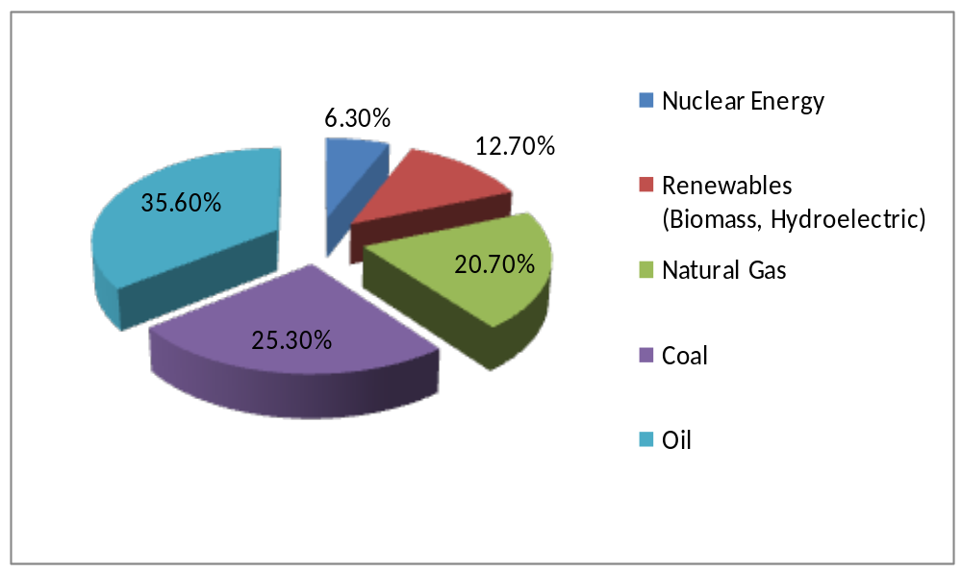
Figure 2. 1: Energy sources and their % use in industrialized countries
Source: Enger and Smith (2006)

In the rich nations of the world, energy for cooking, heating and lighting is readily available at a relatively low cost. This is due to the fact that rich nations have invested in both centralized sources and extensive distribution systems to make that energy available to citizens and business.
In the developing world on the other hand, processing and cooking of food is \accomplished mainly by biomass energy where women spend a significant part of time during the day gathering fuel wood and are exposed to harmful smoke and other by-products of burning organic materials (English Articles, 2010). Continental wise, recent data show that India is the highest consumer of fuel wood followed by Africa and the least consumer being Oceania (Table 2.1).

Table 2. 1: Worldwide fuel wood consumption (TJ) by 2005
Continent | Fuel wood | Charcoal | Black liquor | Total
Africa  North America  Latin America  Asia  Europe  Oceania | 5633  852  2378  7795  1173  90 | 688  40  485  135  14  1 | 33  1284  288  463  644  22 | 6354  2176  3150  8393  1831  113
Total | 17921 | 1361 | 2734 | 22017

Source: FAOSTAT (2005)

2.3 Energy Situation in Tanzania
The majority of rural Tanzania population has no access to modern energy services. Modern energy is defined by REA (2008) as the energy that is based on petroleum, electricity or any other energy forms that have commercialized market channels, the energy that has a higher heating or energy content value than traditional biomass fuel, and that which may be easily transported, stored and utilized (opp.cit). According to the Household Budget Survey done by REA in 2007, the proportion of households in Tanzania that are connected to the electricity grid increased slightly to 12% and coverage by the grid continues to be concentrated in urban areas, with rural coverage of only 2.5%.

As stated in section 1.1, 90% of Tanzanian energy consumption is met by biomass, primarily fuel wood (Table 2.2) and over 80% of this energy is used in rural areas (REA 2008). The excessive dependence on fuel wood for energy has lead to the continual depletion of forests which in turn results into shortage of fuel wood. Fontana and Natali (2008) in their study observed that nearly every household in Tanzania uses firewood for cooking; some households have in addition, kerosene or charcoal stoves. Fontana and Natali (opp.cit) further observed that an average Tanzanian household consumes about 7kgs of firewood per day and cooking is carried out mainly on traditional three stone fire places leading to severe health consequences mainly due to indoor air pollution.

Apart from cooking, fuel wood is also used for agro-industries such as tobacco curing, tea drying, fish smoking, local brewing, brick burning and ceramics. Due to scarcity of firewood in some places particularly in semi arid areas, people use maize stalks, maize cobs and sometimes dry cow dung for cooking, all of which are inadequate and unreliable sources of energy. Kerosene is mostly used for lighting for more than 80% of the rural population. However, kerosene use is faced with a challenge of continuous rise of price, hence becoming unaffordable to the majority of rural population.
Table 2. 2: Energy sources and their use in Tanzania
Energy Consumption by source | TJ | Percentage
Coal and coal products  Crude oil and natural gas liquids  Hydroelectric  Primary solid biomass (fuel wood, charcoal)  Biogas and liquid bio-fuels  Others | 126  26293  7829  589460  14  5485 | 0.00%  4.20%  1.20%  93.70%  0.002%  0.90%
Total | 629,207 | 100.0%

Source: Schmitz (2007)

According to URT (2003), one of the challenges facing the Tanzanian government is failure to reach rural households where only 2% of the population has access to modern energy services. Even for the population with access to electricity about 80% of the population has very low purchasing power hence opt to depend mainly on fuel wood as a cheaper and easily accessible source. Furthermore in areas with electricity, the energy supply is not reliable and unaffordable to the greater part of the population. In urban areas of Tanzania, according to Sawe (2009), only 37% of the population has access to electricity, and poor families spend up to 35% of their income on energy. A Minister of Energy and Minerals in an interview by Corporate Tanzania (2010) re-affirmed that the current energy supply in Tanzania is unreliable and is accompanied by frequent interruptions of power supply and is over dependent on a mono-source that is hydro-power.

However there are a number of existing and potential energy sources in Tanzania apart from fuel wood. These include solar, coal, natural gas, geothermal, hydro-power, wind, nuclear and biogas. These are potential energy sources which can be harnessed to meet the growing energy requirements and reduce the over dependence in biomass. Coal, for instance, is one of the major energy resources of Tanzania but so far its exploitation for energy purposes has been a bare minimal.

According to URT (2003) coal has to a large extent been used in industries for a thermal application but very little has been done to promote coal briquettes for use in household for cooking and heating. In addition coal exploitation is also associated with high cost of transportation, negative environmental impacts and high costs in the application of cleaner coal technologies. Energy availability to the respective population depends entirely on its source, types, and exploitation capacity and distribution systems. Economically, renewable energy sources stand a better chance to supply the scattered Tanzanian rural population, but so far they have not been fully tapped and are unaffordable to the most households (URT, 2003). In comparison to all renewable sources biogas has a big potential for domestic energy supply in Tanzania.

2.4 Biogas Technology
A technology is people using knowledge, tools, and systems to make their lives easier and better. Biogas technology is therefore, a complete system in itself; it includes cost effective production of energy and fertilizer for soil. Biogas technology has been recommended as one of the most appropriate renewable energy technologies for rural areas in developing countries because of the many advantages. Biogas dissemination in developing world has been promoted by many governments and non-governmental organizations, but its adoption has been slow. The following sections will explore some facts about biogas and background information as expounded in related literature.

2.4.1 Biogas Production
Biogas is produced by methanogenic bacteria acting on bio-digestible materials in absence of oxygen in the process known as anaerobic digestion. Anaerobic digestion is basically a simple process carried out in a number of steps that can use almost any organic material as a substrate. It occurs in digestive systems, in marshes, rubbish damps and septic tanks (Harris, 2005). Biogas is mainly composed of 50 to 70 percent methane, 30 to 40 percent carbon dioxide and low amount of other gases like Hydrogen (5-10), Nitrogen (1-2), water vapor (0.3) and traces of hydrogen sulphide (FAO/CMS, 1996).

It takes 1–2 cows, 5–8 pigs, or 4 adult humans to supply adequate daily feed-stocks for a single-household bio-digester (Brown, 2006). The daily input of dung and urine from a single cow produces 1–2 kilowatt- hours of electricity or 8–9 kilowatt hours of heat. In most African applications, a household biogas installation provides sufficient energy for cooking and some lighting. Production of energy is influenced by factors such as microbes, plant design, construction materials, climate, chemical and microbial characteristics of inputs, and the inter-relationships among these factors (FAO/CMS, 1996).

2.4.2 Biogas Plant
Gunnerson and Stuckey (1989) identify about 7 types of biogas plants or digesters. For the purpose of this study, three types which are commonly used in Tanzania will be reviewed. These include; the Fixed Dome (Chinese type), Floating Cover (Indian type) and Tubular Plastic or Bag Design (Taiwan, China) Figure 2.2.
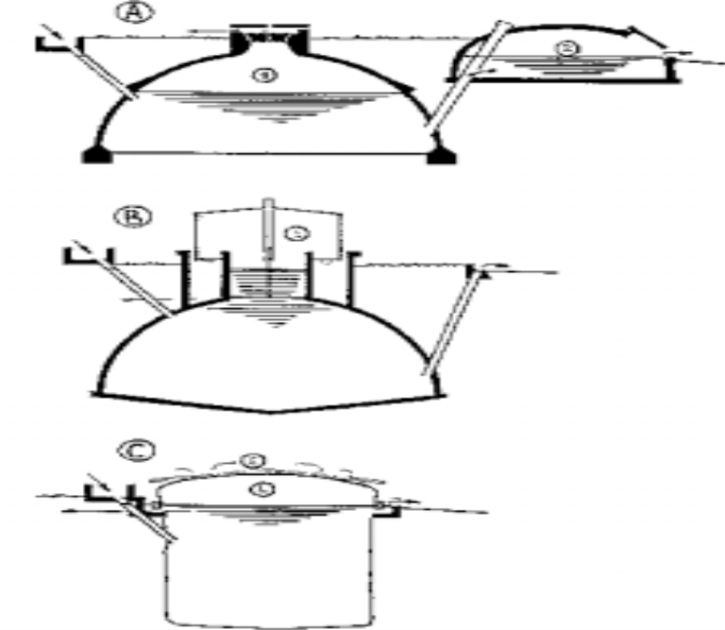
Figure 2. 2: Biogas plant types
A - Fixed dome (Chinese design), B- Floating Cover (Indian design) and C- Tubular Plastic or Bag Design (Taiwan).
Source: Sasse, Kellner and Kimaro (1991)

2.4.2.1 Fixed-dome (Chinese design)
Fixed dome design, according to Gunnerson and Stuckey (1989) is the most common digester type in developing countries. The digester type consists of a gas tight tank constructed of bricks, stone or poured concrete. Both the top and the bottom of the reactor are hemispherical and joined together by straight sides. The inner surface is sealed by thin layers of mortar to make it gas tight. At the top of the digester there is a manhole plug to facilitate entrance during cleaning, and the gas outlet pipe exits from the manhole cover (Figure 2.3).
Biogas plants can be of various sizes ranging from 2m³ for a single family of 5 people, to 140m³ for a community. The plant is normally divided into three parts: digester, inlet and outlet slurry pits, and gasholder (cit.opp).
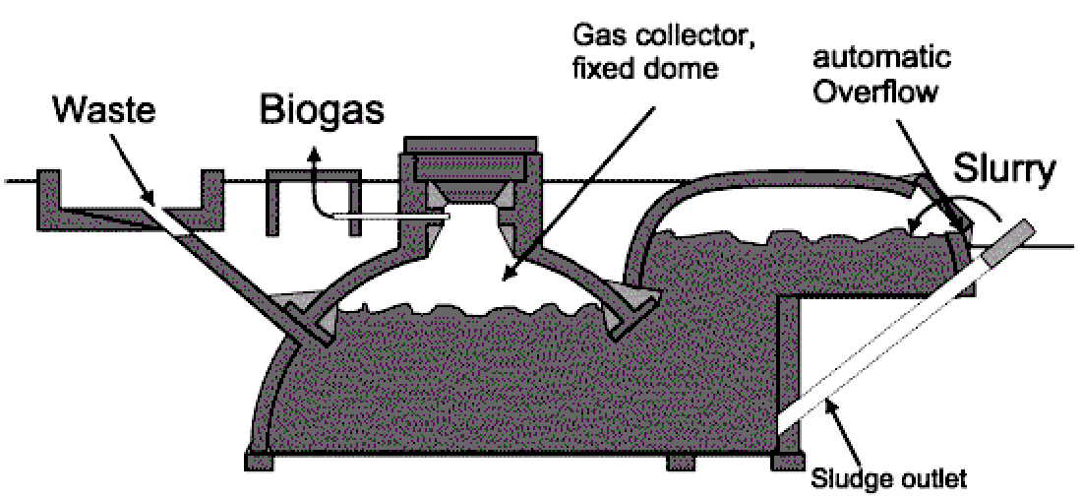
Figure 2. 3: Fixed - dome biogas plant
Source: Gunnerson and Stuckey (1998)

The main function of this structure is to provide anaerobic condition within it. Gunnerson and Stuckey (opp.cit) further describe the construction requirements to include digging and earth removal, masonry work, mechanical work, and supervision until self-reliance is achieved. Factors to consider when building a digester are cost, size, the local climate, and the availability and type of organic feedstock materials. A central consideration in plant design is to rely as much as possible on local materials and to use as little welding and as few advanced machine operations as possible. The typical feed to these digesters is usually a mixture of cow dung, water, night soil and agricultural residues depending on their availability (UNEP 1981). Feeds are mixed with water to form slurry and pumped into the digester where they are retained to allow anaerobic digestion to take place.
The digester must be kept at a consistent temperature to optimize digestion process, as rapid changes do upset bacterial activity. Other factors affecting the rate and amount of biogas output include pH, water/solids ratio, carbon/nitrogen ratio, mixing of the digesting material, the particle size of the material being digested, and retention time (Gunnerson and Stuckey 1998). According to Gunnerson and Stuckey (1998) pre-sizing and mixing of the feed material for a uniform consistency allows the bacteria to work more quickly. Antibiotics in livestock feed have, however, been known to kill the anaerobic bacteria in digesters. Complete digestion and retention times; therefore, depend on all of the above factors. As long as proper conditions are present, anaerobic bacteria will continuously produce biogas. Minor fluctuations may occur that reflect the loading routine.

The digester is fed once daily and the inlet pipe is straight and ends at mid-level in the digester. The typical feed to these digesters is usually a mixture of cattle manure dung, water, human excreta and agricultural residues depending on their availability (UNEP 1981). Feeds (animal manure and/or other wastes) are mixed with water to form slurry and pumped into the digester where they are retained to allow anaerobic digestion to take place. The gas produced during digestion is stored under the dome and displaces some of the digester contents into the effluent chamber, leading to increase of gas pressures in the dome. This creates quite high structural forces and is the reason that the reactor has a hemispherical top and bottom. Gas production rates according to Chan u sam, (1982), are in the order of 0.1 to 0.2 volumes of gas per volume of digester per day with retention times of 60 days at 25°C. The gas produced after a process of decomposition is typically composed of 65% methane, about 30% Carbon dioxide and traces of hydrogen, hydrogen sulfide and nitrogen. The Chinese digester is built of bricks or concrete with virtually no metal parts except for a short length of pipe for the gas outlet. Its construction demands a high level of technical skill and great care otherwise it will be less durable and/or subject to leakage of gas or fluids. Since most of the materials are locally available (except for the outlet pipe) and with the free labor contributed by the family, digester costs are relatively low. In China for instance the cost by 1980 ranged from $70 – 130 for a family size unit.

The advantages of a fixed dome plant design, according to Gunnerson and Stuckey (1989) include long useful life-span as no moving or rusting parts are involved; the basic design is compact, saves space and is well insulated; construction creates local employment. The main disadvantage of a fixed dome on the other hand is that the gas-holders require special sealants and high technical skills for gas-tight construction. Other disadvantages include gas leakages, which occur quite frequently, fluctuating gas pressure which complicates gas utilization, amount of gas produced is not immediately visible and plant operation is not readily understandable. Fixed dome plants need exact planning of levels and excavation which can be difficult and expensive in bedrock. Fixed dome plants can be recommended only where construction can be supervised by experienced biogas technicians. Fixed-dome design is commonly used in Tanzania and particularly in the study area. Installation costs for a normal household biogas plant according to MIGESADO annual report (2009), ranges from Tanzania Shillings 900,000 to 1.2 million (US $ 562 – 750), without subsidy. Since these costs are very high for an ordinary rural resident, subsidy is inevitable; subsidies are rated in four categories relating to the income level of the beneficiary household,

2.4.2.2 Floating Cover (Indian design or KVIC model)
Indian or KVIC model according to Gunnerson and Stuckey (1989) is extensively used throughout the world. A typical KVIC design consists of a reactor wall and bottom. Usually constructed of bricks reinforced with concrete, a concrete pit partly sunk into the ground, and an inverted dome, made mainly of steel floated in the liquid in the digester. This acts as a container within which the gas can collect. The gas produced in the digester is trapped under a floating metal dome. As the gas accumulates the dome rises.

The volume of the gas is approximately 50% of the total daily gas production. The pressure of the gas available depends on the weight of the gas-holder per unit area and usually varies between 4 – 8 centimeters of water pressure. The reactor is fed through an inlet pipe and displaces an equal amount of slurry through an outlet pipe. When the reactor has a high height to diameter ratio, a central baffle is included to prevent short-circuiting. Most KVIC type digesters are operated at ambient temperatures, thus detention times depend on the variation in ambient temperature. Typical detention times are 30 days in warm climates.

The typical feedstock is cattle dung. The cattle manure, generally about 20% solids is diluted to 10% total solids before feeding by adding an equal quantity of water. The daily average gas yield varies from 0.2 to 0.60 volume of gas per volume of digester ration in cold to warm climates.
A major advantage of the Indian designed digester is that it does not demand a high level constructional skill, for the dome, which is the critical component, is manufactured elsewhere in a workshop. Corrosion is a major problem of this type but other materials such as ferrocement, high-density polyethylene and fiberglass have been used to tackle the problem. Mainly because of the steel dome, a family size unit in India costs in the range of $370 – 470, which is more expensive in contrast to the Chinese design (Gunnerson and Stuckey, 1989).

2.4.2.3 Tubular plastic design
In the early 1980s tubular plastic design plant was developed in Columbia and later disseminated to Vietnam. In mid 1990s the design was introduced to Tanzania by a group of scientists from Sokoine University of Agriculture who visited Vietnam and
On their return they collaborated with farmers and improved the design to fit the Tanzanian condition (Gunnerson and Stuckey, 1989).

According to Gunnerson and Stuckey (opp.cit), tubular plastic digester consist of a long cylinder made of PVC, a Neoprene coated nylon fabric. The digester is placed in a trench and filled with water to expel air before dung is introduced. Depending on the temperature, it may take two weeks before gas is produced. Materials for a biogas plant are locally available and when all materials are delivered to the site it takes between 3 to 4 hours to set up the plant. In order to operate adequately, the bio-digester requires, on a daily basis, excreta from 1-2 diary cows or 5-8 pigs. The tubular plastic bio-digesters are cheaper and affordable to poor farmers. The material cost including installation is about US$ 100. The installation of the digester is simple where only two people can fixed it that means the tubular plastic design is easily localized and institutionalized at household level. The major drawback of the tubular plastic bio-digester is its limited durability due to its delicacy.

2.4.3 Biogas Plant Operation and Maintenance
The operation of a simple biogas plant is relatively uncomplicated. The user must be given all the information and practical assistance he/she needs before and during the early phases of plant operation (Werner et al (1989). According to Werner (opp.cit), daily activities for operating the biogas plant include; collecting the feed stocks, filling the plant, cleaning the mixing pit, agitating the digester contents, checking the gas pressure and the gas- holder contents and checking the appearance and odor of the digested slurry. Weekly/monthly activities include; removing the digested slurry, cleaning and inspecting gas appliances, checking the gas valves, fittings and appliances for leaks and inspecting the water traps.
The maintenance scope for a biogas plant includes all works and inspections needed to ensure smooth functioning and long service life. Werner et al (1989) further comment that to the extent possible, all maintenance work should be done by the biogas user, however biogas plant repair usually require external artisan since the user himself may not have the necessary tools or know-how. Biogas plants can develop a number of operational malfunctions. The most frequent problem is insufficient gas production, which has various causes, often enough, it takes the work of a "detective" to locate and remedy the trouble. It may be necessary to experiment with and monitor the plant for months on end in cooperation with the user.

2.4.4 Uses of Biogas and Effluent
Biogas has been acknowledged as being simple and cheap technology; it does not require imported knowledge or components and also is suitable for family and/or village scale use. Biogas is among the renewable non-conventional fuel technologies, which involves anaerobic digestion of biomass to yield biogas and organic slurry. In addition to gas production all disease causing organisms are eliminated making the effluent safe for disposal or reuse as manure for crop production. Biogas is one of the few technologies that utilize wastes as valuable resources and improves sanitation (Rajeswaran, 1983). Other benefits of biogas technology include reducing women’s workload, saving time consumed for firewood collection and increase of income by saving money spent for purchase of other energy sources (Rutamu, 1999). Furthermore according to Rajeswaran (1983), biogas can be used for heating, cooking, and to operate an internal combustion engine for mechanical and electric power. For engine applications it may be advisable to scrub out hydrogen sulfide (a highly corrosive and toxic gas). Very large-scale system/producers may be able to sell the gas to natural gas companies but this may require scrubbing out the carbon dioxide. Material drawn from the digester is called sludge, or effluent. It is rich in nutrients (ammonia, phosphorus, potassium, and more than a dozen trace elements) and thus is an excellent soil conditioner.

2.4.5 The History of Biogas Technology

2.4.5.1 Biogas Technology worldwide
The history of biogas utilization shows independent developments in various developing and industrialized countries. Anecdotal evidence indicates that biogas was used for heating bath water in Assyria during the 10th century BC and in Persia during the 16th century. In India the first digestion plant was built at a leper colony in Bombay in 1859, while in England, anaerobic digestion reached there in 1895 when biogas was recovered from a “carefully designed” sewage treatment facility and used to fuel street lamps in Exeter (Biogas works, 1999).

The country with the greatest experience in using large-scale digestion facilities has been Denmark, where 18 centralized plants were in operation by 1996 (Danish Ministry of Energy and Environment, 1996). Accordingly, Denmark’s commitment to anaerobic digestion increased energy initiatives that doubled biogas production by the year 2000 and was expected to triple by the year 2005. Among the key policy tools used to encourage technology deployment was “green pricing” that is, allowing manufacturers of biogas-generated electricity to sell their products at a premium. The sale of co-generated hot water to specially built district heating systems became an important source of revenue for project developers.

The historical experiences in Germany, China and India demonstrate clearly how biogas development responds to favorable frame conditions. In Germany for example, biogas dissemination gained momentum through the need for alternative energy sources in a war-torn economy (ISAT, undated). Following its launching in 1980, according to ISAT, the German Technical Cooperation (GTZ), chose biogas technology as a focal point of its activities. This resulted in a cross-sectoral scheme that has accompanied and supported the development and dissemination of biogas technology in Latin America, Asia and Africa. A number of biogas dissemination programs involving GTZ were launched in Bolivia, Colombia, Nicaragua, the Caribbean, Tanzania, Kenya, Burundi, Morocco and Thailand. Dissemination experience in Kenya shows that after a poor start working with educational institutions, biogas programmes turned to local artisans and commercial outlets working in the private sector. Hands-on training was given to masons and plumbers; and private traders were encouraged to manufacture and stock appliances such as cookers and light lamps. Kenyan Government also set up the Special Energy Programme (SEP).

According to Bui Xuan An (2002) India had a long and varied experience in the field of developing simple and easy-to-operate biogas technologies to suit different climatic conditions and socioeconomic groups of users. Bui Xuan An (opp.cit) also noted that, various management models of implementation of the size-able biogas extension program had been developed and tried successfully. A top-down centralized government initiative was recommended to promote the design and use of rural energy interventions because there were few options for rural India to alter deteriorating biomass resources. Bui Xuan An (opp.cit) further comments that biogas production has been stimulated by popular publicity campaigns and subsidized construction cost of biogas plants by central and local governments Everyone in India installing a biogas plant has the right to an allowance paid by the central government.

In China, a fixed dome biogas digester was built in Jiangsn as early as 1936 and over the intervening years considerable research had been carried out on various digester models (Meynell, 1976). China has learned many lessons during the recent past. After 1975, slogans such as “biogas for every household” led to the construction of 1.6 million digesters per year, mainly being concrete fixed-dome digesters, which were cheap but of low quality. The rapid development of biogas in China received strong government support and sometimes, subsidies from local government and village government were up to 75% (Gunnerson and Stuckey, 1989).

2.4.5.2 Biogas Technology in Tanzania
The history of biogas dissemination in Tanzania, according to Schmitz (opp.cit), dates back to 1975 when the Small Industries Development Organisation (SIDO) built 120 floating-drum biogas plants between 1975 and 1984 in the country. In Arusha region the Arusha Appropriate Technology Project constructed traditional Chinese fixed-dome plants and floating-drum plants. The objective of these projects was to build biogas plants at the lowest investment cost possible.

In 1982 the parastatal organisation; Centre for Agricultural Mechanization and Rural Technology (CAMARTEC) was founded and charged with the task of dissemination of biogas technology in Arusha Region. About a year after this initial initiative a Technical Cooperation between Tanzania and Federal Republic of Germany was signed which led to the introduction of the Biogas Extension Service (BES). In the initial years, the BES disseminated biogas technology mainly in the so-called "Coffee and Banana Belt", the region around Arusha town where particularly positive conditions promised a high dissemination density for biogas plants. CAMARTEC and the Deutsche Gesellschaft für Technische Zusammenarbeit (GTZ) were in charge of implementing this project. In 1990 the dissemination strategy and project structure underwent decisive changes which resulted from withdrawal of GTZ from the BES. The project was later seconded to an interdisciplinary team of scientists, mechanical engineers and agriculturists under the CARMATEC (Schmitz, 2007).

Kiwele (2008) reported that the Ministry of Energy and Minerals (MEM) in collaboration with CARMATEC under Special Energy Programme (SEP) provided coordination, support and training of local craftsmen, monitoring and evaluation of biogas technology in the country. But there were no arrangement for credit schemes to help the farmers to acquire biogas plant. High initial costs of biogas installation have been limited to few rich farmers and to capable institutions. These are probably the causes for limited acceptance of biogas technology.

Apart from CAMARTEC, which has done pioneering work in the design of appropriate digesters as well as promoting the use of biogas technology, several non-governmental organizations have implemented biogas projects. These projects, according to Schmitz (2007) include; Sustainable Rural Development (SURUDE), which was established in 1993 as cooperation between farmers and Sokoine University of Agriculture in Morogoro region. Other biogas projects are: MIGESADO, (a Swahili acronomy for “Miradi ya Gesi ya Samadi Dodoma”, meaning “gas projects from cow dung in Dodoma region). Other projects include Biogas and Solar Company project established in Arusha region dealing with fabrication and installation of solar PVCs and biogas plants; The Evangelical Lutheran Church in Tanzania (ELCT) located in Arusha, Friends in Development Trust Fund (FIDE) based in Babati, Manyara region, The Eastern and Southern African Management Institute (ESAMI) based in Arusha has focused on developing training courses aimed at capacity building for biogas market promotion.

Tanzania Traditional Energy Development Organization (TaTEDO) is another non-governmental organisation that advocates against over-dependence on fuel wood by
promoting efficient biomass technologies (improved cook stoves and baking ovens). TaTEDO also conducts capacity building training of artisans on construction and promotion of improved cook stoves and biogas plants. Improved cook stoves use less firewood and charcoal by 50% cost reduction, as compared to the traditional three stone fire place. They are also believed to reduce emission of greenhouse gases (TaTEDO, 2007). Improved stoves and biogas can play an important role in rural areas for energy, environment conservation, improved health of rural women and children and general enhancement of their livelihood status. The above mentioned stakeholders have been involved in biogas programmes, which by the year 2007 had resulted into the construction of nearly 4,000 biogas plants country wide and most of them were using subsidies (Schmitz, 2007).

In 2007 the Biogas for Better Life an African Initiative was launched. Following this launching, Tanzania biogas stakeholders aimed at establishment of a National Biogas Programme in Tanzania; Tanzania Domestic Biogas Programme (TDBP). Ngwandu et al., (2009) explain the aim of TDBP as to support the realization of government policies in the field of energy, poverty reduction, livestock development and rural development. Furthermore the programme is expected to follow commercial approach, that is, interaction between the prospective biogas customers and the Biogas construction enterprises in which both parties aim to maximize their returns. The main objective of the National Biogas Progaramme is to support the development of biogas sector and coordination of all relevant stakeholders. Ngwandu et al., (opp.cit) further reveal that the programme was funded by Netherlands Development Organization (SNV) up to June 2009 after which the programme had to seek funding from other donors.

The government was expected to contribute only 8% of the programme budget, the contribution which, by 2009 was yet to be committed. This funding environment of the National Biogas Programme is not promising as it is still dependent on donors. This might result into the previous experiences where withdraw of GTZ from SEP initiatives lead to financial impairment on dissemination of biogas technology. The little contribution from the government which was aimed at boosting the subsidy component of the programme may result into the previous experiences where high installation costs were the limiting factor to the spread of biogas technology.

2.4.5.3 Biogas Project in Dodoma
The dissemination of biogas technology in Dodoma started in 1994 after the establishment of the biogas project called MIGESADO in the region. This non-governmental organization started as a project in the year 1994 and was registered in 1996 with the head office in Dodoma municipality and is the only organization disseminating biogas technology in the region. The context; under which the organization was initiated relates to the serious deforestation in Dodoma region which was caused by demand on firewood, both in rural and urban areas: Other cause factors included need to alleviate heavy workload for rural women in fetching firewood and water and high prices for urban charcoal users.

The project was initiated by a joint effort of people from 8 various institutions namely: Dodoma Environmental Network (DONET), Catholic Diocese of Dodoma, INADES Formation Tanzania, Ministry of Community Development, together with the late Mr. Bahunde who was the project coordinator of phase 1. MIGESADO collaborates with some other non-governmental organizations (NGO’s) working in Dodoma on environmental and energy issues aiming at reducing deforestation and its effects by constructing biogas plants, water tanks and improved firewood stoves, planting trees, integrating livestock and agriculture; creating public awareness on the use of other alternative energy sources by providing technical support, advice and training in collaboration with other actors. According to Schmitz (2007), MIGESADO is the organization with the highest number of installed bio-digesters in Tanzania. Table 2.3 shows the total number of biogas plants constructed in Dodoma region from 1994 up to the study period 2009 (MIGESADO, 2009).

Through the MIGESADO project, technical skills are now available in Dodoma with qualified and confirmed masons who can work independently in biogas plant constructions. Technology adoption by the community is still on a very small scale despite the technology being known to the districts of Kongwa, Bahi, Chamwino and some parts of Mpwapwa. Governments of the districts have shown some interest in making people use biogas but so far there has been no any formal intervention from the government institutions to the project or to the targeted population.
Table 2. 3: Number of biogas plants constructed in Dodoma from 1994 to 2009
Region/District | Number of Households | Number of biogas plant constructed up to 2009
Kongwa | 50,877 | 127
Bahi | 51,068 | 50
Dodoma Urban | 74,914 | 398
Chamwino | 53,215 | 143
Mpwapwa | 56,563 | 32
Kondoa  Dodoma Region | 89,893  376,630 | 50  800
Source: Dodoma Regional Commissioner’s Office 2009

Biogas plants adopted in Dodoma are of the Chinese fixed dome design with sizes ranging from 5 to 25 cubic meters. Installation costs for a biogas plant ranged from Tshs 350,000/= in year 2000; Tshs 800,000/= in 2005 and Tshs 1.2 million in 2009 without subsidy. Since the costs are very high for an ordinary villager, subsidy was inevitable; subsidies were rated in four categories relating to the income level of the beneficiary household; 15%, 25%, 45% and 58% of total construction cost (MIGESADO reports, 2009). Subsidy was given by the biogas project and biogas beneficiaries contribute the remaining part of the construction costs. The contributions are made biogas beneficiaries are in two forms, in kind and in cash.

The subsidy approach has been used in introducing biogas technology in developing countries like China, India and in African countries such as Kenya and Tanzania. The subsidy approach has got some influences on adoption of a technology; Dupas (2012) asserts that subsidies may have both positive and negative effects in the adoption of a technology or any new product. On a positive side he sees that subsidies could in the long run boosts adoption through learning and income effect when the product or a technology had a good experience. Beneficiaries of the subsidized product or technology will be willing to pay for a replacement after experiencing the benefits and learning the true value of the new technology. This learning might trickle down to others in the community and increase the overall willingness to pay in the population as knowledge of the true value of the product diffuses. On the other hand Dupas (opp.cit) argues that subsidies may negatively affect long adoption through reference dependence. That is, once the subsidy has ended or being reduced people might take the previously subsidized prices as reference points and be unwilling to pay more for the technology later. But why subsidies, Warren (2010) argues that, the best situation would be no subsidies at all but even without subsidies, fossil fuels are known and familiar to people but renewable fuels represents a higher level of risks even if it is less expensive, so developers of the renewable energies still need to find ways to reduce the perceived risk of adopting them.

The subsidy approach biogas technology adoption will have positive effect if only the beneficiaries experienced the benefits of the technology as mentioned in the background section of this study. The surrounding community will be attracted by the changed quality of life of those who adopted the technology. However, previous studies show that a number of biogas plants so far installed have been found to have encounter drawbacks including inadequate capacity for cooking and low durability (Kimambo, 2002). Lotte et al., (2004) in their evaluation of small-scale biogas digesters in Morogoro region have revealed the reasons for the relatively high number of non-functioning bio-digesters. This is related to three aspects: technical that is the actual management and maintenance of the digesters, the organizational design of the biogas project and financial sustainability of the biogas project. These can have a negative effect on long run adoption of biogas technology.

2.5 Technology Adoption
Technology adoption is a process through which an individual or organization decides to full use of an innovation in their daily business (Rogers 1995). Adopting a technology according to Abukhzam and Lee (2010) depends on many factors which cause a prospective or targeted user to adopt or reject the technology. These factors as mentioned by Manros and Rice (1986) include absence of users’ involvement, lack of understanding, technical difficulties, lack of training and inefficient support from top management and perceived technology complexity. These factors can contribute to technology adoption success or failure. According to Senkondo et al., (1999) adoption encompasses incidence, intensity and rate of adoption. Incidence adoption is the percentage of people using a specific technology at a specific point of time, the intensity of adoption as the level of adoption of a given technology while the rate is the proportion of people who have adopted new technology overtime.

2.5.1 Theoretical Frameworks for Technology Adoption
Technology adoption frameworks are information systems that provide theoretical base for examining the factors influencing technology adoption (Davis et al., 1989). Abukhzam and Lee (2010) mention the several popular models used for investigating adoption behavior of an individual. Since it is not easy to discuss all adoption models, for the purpose of this study only two theories will be considered; the Theory of Planned Behavior and the Diffusion of Innovation as they seem to fit the study purpose.

2.5.1.1 Theory of Planned Behavior
The Theory of Planned Behavior was proposed by Ajzen (1985). The theory consists of three conceptual determinants of the adoption of a new technology, these include the attitude towards the technology, social factor termed as subjective norm which refers to the perceived social pressure on either to use or not to use the technology and facilitating conditions such as availability of government support and technology support (Figure 2.4). It is the assumption of this study that lack of institutional support on biogas technology has been a barrier to its widespread. Experience of China and India shows that government support has lead to widespread of biogas technology in these countries.

Attitude
Subjective Norm
Perceived Government and Technology Support
Adoption
Intention
Adoption of Innovation

Figure 2.4: Theory of Planned Behaviour

Source: Ajzen 1985

2.5.1.2 Diffusion of Innovation Theory
Another theory considered for this study is Diffusion of Innovation Theory. This theory developed by Rogers (1995) is the most widely recognized technology adoption framework. The Theory suggests three categories of determinants of technology adoption, these include characteristics of an innovation, individual categories and communication channels (Figure 2.5). The characteristics of an innovation which may influence its adoption include relative technology advantages such as ease to use, cost saving, efficiency and convenience. Compatibility, complexity and observability and triability of an innovation are other technology characteristics which, according to Rogers (1995), play a significant role in the adoption of an innovation. Rogers Theory further considers the categories of adopters as determinant of technology adoption. Rogers (1995) and Feder et al., (1985) classify members of a social system into five adopter categories. These are innovators, early adopters, early majority, late majority and laggards. These categories follow a standard deviation-curve, very few innovators adopt the innovation in the beginning (2.5%), early adopters making up for 13.5% a short time later, the early majority 34%, the late majority 34% and after some time finally the laggards make up for 16%.

Innovators are venturesome individuals in a social system, who is very eager to try new ideas, have substantial financial resources and the ability to understand and apply complex technical knowledge. They are also capable of coping with a high degree of uncertainty and play an important role in importing new ideas. They are regarded as the first to adopt a new idea (Rogers, 1995, Feder et al., 1985).
Early adopters are more integrated into the social system than innovators. Members of this category are said to speed up the diffusion process and are the ones from whom potential adopters seek advice and information about the innovation since they find it necessary to make judicious innovation decision (Lionbergen and Gwin, 1991). According to Rogers (1995) this category decreases the uncertainty about a new idea by adopting it and then conveying a subjective evaluation of the innovation to a near peer by means of interpersonal networks.

The early majority category of adopters comprises members who adopt the new idea just before the average member of the social system but after the early adopters. The members interact frequently with the peers but they seldom hold leadership positions unlike early adopters. This category links the very early adopters and the relatively late adopters in the diffusion process. The innovation decision period of early majority is relatively longer than that of the innovators and early adopters (Feder et al., 1985).

Late majority are the members of the social system who adopt innovations relatively late. The members of this category adopt the innovation after the majority of people in the society have adopted. The adoption by this category has been described to rely on economic necessity and peer group pressure (Rogers, 1995).

Laggards are the last group in a social system to adopt innovations, according to Rogers (1995) these people posses no opinion leadership and are the most localized in their outlook. The individuals often make decisions in terms of what has been done in previous generations and interact primarily with others who also have certain traditional values. It can therefore be argued that laggards tend to be suspicious of innovations and change agents (Msuya 1998).

The Diffusion of Innovation Theory further predicts that media as well as interpersonal contacts provide information and influence opinion and judgment. The information flows through networks. The nature of networks and the roles opinion leaders play in them determine the likelihood that the innovation will be adopted. Opinion leaders exert influence on audience behavior via their personal contact, but additional intermediaries called change agents and gate keepers are also included in the process of diffusion.
Innovation Characteristics
Relative advantages
Complexity
Compatibility
Triability
Categories of adopters
Innovators
Early adopters
Early majority
Late Majority
Laggards
Communication Channels
Media
Interpersonal contacts

Diffusion or Adoption of Innovation

Figure 2. 5: Diffusion of innovation Model (Simplified)
Source: Rogers 1995

The technology adoption theories though widely applied in the understanding of factors influencing technology adoption, they have got limitations. Abukhzam and Lee (2010) in their analysis of adoption frameworks came up with a conclusion that despite widespread interest in understanding factors affecting users attitude towards technology adoption, limited attention has been paid to describing factors that affect workforce attitude towards the adoption of a new technology. The Diffusion of Innovation Theory for instance, has been criticized in terms of its deficiencies in explaining the effect of adopters’ demography on innovation adoption (Abukhzam and Lee, 2010). Rogers (1995) ignores the impact of demographic differences among adopters such as age, income, gender and education which; according to Abukhzam and Lee (opp.cit) these factors have found to have a significant influence on users’ attitude towards the adoption of technological innovation. Abukhzam and Lee further argue that Rogers’ theory is a simplified representation of a complex reality.

Furthermore, technologies are not static; there is continual innovation to attract new adopters. By Diffusion of Innovation Theory, the communication process involved is one way flow of information. The sender of the message has a goal to persuade the receiver, that the person implementing the project controls the direction and outcome. Though in some cases this approach can be appropriate, in most cases a participatory approach has resulted into success of most projects. Simon (2006), with consideration of these limitations developed a conceptual framework (Figure 2.6) which incorporated demographic characteristics assumed to be important determinants of individuals’ attitude towards technology adoption. Simon (opp.cit) also incorporated the facilitating factors such as institutional support services and effectiveness of actors as factors influencing awareness and attitude towards technology adoption.

Farm Characteristics;
Farm size, labour, off farm equipments, machinery farm, incomes, farming experiences

Institutions/Actors;
RWL organization, extension, policy, awareness creation campaigns, resource support, marketability of RWL products
Production/
Environmental problems;
Bushfires, grazing livestock, wild animals, Dry spell and drought

Effective adoption and Diffusion
Household Characteristics;
Socio-economic factor; Age, status, education, land, ect.
Communication factors; Change agents and Media contacts.
Psychological factors; Values, beliefs and orientation.
Willingness to invest in RWL
Awareness and RWL training
Attitude towards RWL

Knowledge
RWL
Adoption
Recognition of problem
Technological Characteristics;
Technical complexity, compatibility with local cultures, trainability and observability, survival rates and tree performance, RWL technology benefits
Seeds/
Seedlings availability, inputs
Effective and timing of actor participation in developing and disseminating the RWL

Figure 2. 6: Conceptual framework for examining factors influencing adoption of rotational woodlot technology
Source: Simon, 2006

The conceptual framework of this study (Figure1.1) has been adapted from Simon (2006), based on the two theories; Theory of Planned Behavior and Diffusion of Innovation Model. Theory of Planned Behavior is incorporated as it considers the facilitating conditions such as government and technology support as factors influencing individuals’ attitude towards technology adoption. The Diffusion of Innovation theory on the other hand is incorporated due to its consideration of demographic characteristics and communication channels as significant determinants of technology adoption. The overall assumption of this study is that inadequate support from stakeholders particularly the government institutions has got an influence on adoption and non-adoption of biogas technology. Government institutions and other stakeholders’ support involves among others; effective information dissemination and promotion strategies through communication channels such as media which assumed to influence awareness and peoples’ attitude towards the technology adoption.

2.5.2 Adoption Process
Adoption of innovation entails the whole sequence of events occurring to an individual from the time one becomes aware of an innovation until the adoption stage. The whole process is referred to as the innovation-decision process, which may involve knowledge, persuasion, decision, implementation and confirmation stages (Rogers, 1995). In this process an adopter goes through different stages whereby awareness is the first stage and adoption the last stage.

At the awareness stage people get general information about a new idea, product or practice for the first time but not its details. Since people are not satisfied merely with knowledge or general information, they need and actively seek additional and detailed information about the innovation (interest stage). With the detailed information people decide whether the idea is good or not (evaluation stage) after which the potential adopter would try the new idea or practice a little and more late (trial stage). After successful trial, usually on observing and or consulting with others, people may take up the innovation for full use (adoption stage). Depending on the nature of innovation, some stages may be skipped and the most frequently skipped one is the trial stage due to difficulties in trying a little first and more, later on (Rogers, 1995).

Feder et al., (1985) pointed out that not all individuals in a society adopt an innovation at the same time. An individual adopts an innovation in a time sequence. Basing on the degree to which an individual or other unit of adoption is relatively earlier in adopting an innovation. They further argue that since people are rational in decision-making they do balance between a wish to innovate and the expected worth of the innovation. ISAT (Undated) argues that a complex process of decision-making is involved when people move from traditional practices to a modern or new innovation. Hopes, fears, expected reactions from the society, previous experiences with other technologies, and these entire features in the decision. According to ISAT rural households, as a rule, take rational decisions but they often have information deficits that lead to non-acceptance or reluctance towards new technologies. There are a number of factors associated with the decision for adoption or non-adoption of an innovation. These are explained in section 2.5.3 below.

2.5.3 Factors Affecting Adoption of Innovations
Adoption of innovation depends on various factors; these factors may differ across regions and sometimes are location specific. Several studies (Baidu-Forson, 1999; Bartz et al., 1999; Nhembo, 2003; Simon, 2006) have pointed out that adoption and dissemination of new technologies depend to a larger extent on demographic characteristics, environmental characteristics, institutional support services, nature of the technology and its benefits as perceived by the clientele. Such characteristics make adoption responses unique as they are related to the individual, some to the situation in which the individual is and some to the nature of the practice (Lionbergen and Gwin, 1991). In addition some innovations are also subject to the control and manipulation of change agents while some are not and specific to the study area and often incomparable.

2.5.3.1 Socio- economic Characteristics
These are specific factors and/or attributes of an individual and his /her families that make him/her adopt or reject a certain technology. These factors include age, educational level, family size, gender, ethnicity, religion and wealth (Nhembo, 2003)
Education level is associated with greater access to information and enhanced capacity for creativity, so educated individuals are expected to be more aware of and have more knowledge on a new technology. According to Akinola and Young, (1985) knowledge reduces uncertainty and thereby induces adoption. However some skills are not correlated with years of schooling. Senkondo et al., 1999 in their study found that adoption of rainwater harvesting technologies in western Pare was not significantly explained by education but rather by other factors like experience in farming and perceived technology benefits.

Age and experience have a range of influences on household decision making in adoption. Older ages, according to Nhembo (2003) may influence an individual in the direction of not adopting new ideas due to conservatism. However, with regard to experience, older people may have more experience and more resources that allow them to adopt capital-intensive technologies than younger people (Shiferaw and Holden, 1997). However, there are some innovations where the younger the age of the individual, the higher is the probability of adopting the technology. This, according to Shiferaw and Holden (opp.cit) is due to the fact that younger people are more likely to accept risks associated with the new technologies. Young people have longer planning horizons and therefore more innovative. Sebyiga (2007) observed that young people were more likely to adopt formalized land conservation approaches in Kilosa and Kiteto districts than were older people. Household size may have positive or negative influence on adoption of technologies. For labor intensive technologies, family size positively influences adoption (Simon, 2006).

Income is also an important factor in adoption of technologies. Availability of cash enables an individual to meet costs associated with a technology to be adopted. A research conducted by Alavalapati et al., (1995) in India revealed that rich farmers were the main beneficiaries of farm forestry programs since they could invest in such programs. Recognition of a problem to be solved by a new technology is another household factor influencing adoption of a technology. People being rational have their own priority of problems they want to solve for their development and they may not be ready to invest their time and resources to what they do not perceive to be a problem. Simon (2006) observed that adoption of rotational woodlot was associated with an acute shortage of fuel wood supplies due to natural forest depletion.

However beside recognition of a problem people usually compare benefits from the available technology and the newly introduced one and select the one with more preferred benefits. Kalineza et al., (1999) observed that tree planting in Gairo – Tanzania was the most preferred soil conservation practice not only because of relatively low labor demand but also because of trees having multipurpose uses that provide a number of benefits to farmers.

Gender can influence adoption of a technology positively or negatively depending on gender responsibilities and ownership of resources (Simon, 2006). The gender responsibilities can be in form of performing tasks among men and women in energy supply and management systems and differences in resource ownership such as livestock, houses and land. Kaliba et al., (1997) in their study found that gender had a significant influence in the adoption of stall-feeding technology in semi-arid areas of Tanzania. Similar results were reported by Kalineza (2000) who observed that gender played a significant role in influencing adoption of soil conservation measures in Kilosa District. In another research work Nhembo (2003) argues that if a technology to be adopted is expected to reduce women workload, then women may prefer to adopt it.

The burden of unpaid workload in developing countries is largely and mostly done by women. Gwalema (2002) argues that hierarchical relationship within family organization which takes the form of male dominance and female subordination, allocates women the more time-consuming labour, low status and poorly rewarded tasks in the home. Worse enough men do not regard labour performed by women as work. The unpaid tasks performed by women include firewood collection and water fetching, food preparation, home maintenance, domestic sanitation and waste disposal management, family care, especially care for children, old and sick people (Fontana and Natali, 2008: Wawa, 1999). In the rural areas in underdeveloped countries men and women play very distinct and definite roles in domestic energy management. Women in these countries have traditionally shouldered the responsibility of managing the domestic energy requirements for their families. The tasks of cooking are carried out by women. These have been perceived by many African societies as women's tasks. It is only when wood is collected for sale, or where social or religious constraints restrict women from leaving their homes, that men participate (Dutta, 1997). Analysis done by Budlender (2008) in Tanzania shows that women are more involved in firewood collection than men where participation rate for women is 38.9% while for men is 17.1%. Location wise women in rural areas are more involved in fuel wood collection by participation rate of 50.4% compared to 9.5% women in urban area.

Fontana and Natali (2008) further comment that public investment policy has an important role to play in redressing gender inequalities and reducing poverty by promoting initiatives that reduce time spent by women in the above mentioned tasks. In India for instance, over the last two decades or so, efforts have been made by the government to ameliorate the problems in the rural energy sector. These efforts have mainly been in the form of national programmes for promoting renewable energy technologies like biogas, improved energy serving cook stoves and solar cookers (Dutta 1997). Evaluation of these programmes, according to Dutta (opp.cit), has shown a wide variation in functionality rates and long-term acceptability of the technologies. Lack of involvement of women at all stages in the project cycles has been identified as one of the major causes of projects limited sustainability. Several studies (Dutta, 1997; Wawa, 1999; Gwalema, 2002) have identified a number of factors which form barriers to the effective participation of women in rural energy dissemination programmes. These factors include traditional decision-making roles in the society, women’s workload, level of economic independence, educational constraints leading to lack of access to information, skills and technical expertise, and ideological barriers among extension workers.

Women traditionally tend to have limited decision-making power about household purchases including technologies. Chungu et al., (2008) in their study on the processing plants and the individual sugarcane growers in Tanzania observed that the ownership patterns follow patriarchal lines. The head of the household (husband/father) owned the family property namely land, production tools and domestic animals. This, according to Chungu et al., (opp.cit), has been taken as an indication that ownership and management of the technology is male dominated. The above case study suggests that for a capital intensive technology like biogas, it is automatically a man who will decide on its adoption or non adoption. Since firewood is often and wrongly considered by the society as something free of charge and mainly collected by women and children; men who are decision makers of the household might not see the advantage of less time consumed by women for firewood collection and men might be reluctant in deciding for biogas installation.

Women particularly in rural areas are among the majority poor entirely depend on natural environment and are the most hit by environmental degradation (Wawa, 1999). Women have local knowledge of natural environment and are most familiar with household fuel supply problems as well as the need and preferences of the immediate environment and energy systems. But since extension officers interact primarily with men, this source of indigenous knowledge remains untapped hence technologies and innovations which were targeted for women are based on perceptions and preferences of men. It is therefore not surprising that women are reluctant to adopt the technologies.

Karlsson (2003) comments that because women are the primary users of energy, it is therefore important that they are involved in decision making on energy issues specifically, in designing and implementing projects to meet their needs. He identifies lack of education and technical training as an important constraint on women participation in energy decision-making processes and in activities involving energy systems. Women already have valuable knowledge about local conditions and resources, additional education about energy technologies and solutions would increase their ability to contribute to energy solutions and to adopt new cleaner fuels and equipments. Women, who have learned new skills and obtained improved access to energy for households and income generating activities, can create new resources for investing in better conditions for themselves, their families and their communities.

Karlsson (2003) describes a case study in India where rural women in Huluvangala village had rejected the stove technology disseminated under the government programme. However the two NGOs in the area, realized the need for new dissemination strategy and they engaged themselves in a dialogue with rural women on various aspects of stoves design, performance, durability and efficiency so as to select a stove that would cater for women’s needs and their expectations. A training programme was tailored to meet the site specific conditions and women were trained in stove construction. The results were that not only the women in the village used the stove, but also they were able to sell their services to other women and more women used the stoves.

Another case study is in Kenya, where the widespread of adoption of fuel-efficient “Upesi” stoves was achieved by training local women in stove production, distribution and installation. Besides learning how to produce the stoves they also received training in costing and pricing, record keeping, forging marketing links and responding to consumer demands. Furthermore, because of the women’s many domestic and community responsibilities, the training had to be fit into their other activities. As a result women producers went on to train others on a free basis and others applied the skills they acquired to other business ventures.

Case studies above express the importance of involving women on energy projects where women participation has contributed to adoption and sustainability of energy projects. In order to encourage women’s participation education is required to raise their awareness and confidence on alternative technologies.

2.5.3.2 Institutional Characteristics
Institutional support is another factor affecting adoption of a technology. According to Kalineza et al., (2000) rejection or acceptance of a new idea largely depends on how the information is relayed from the source, which is mainly the extension service. Extension is known to catalyze awareness, organization, and information exchange and technology promotion among individuals. The study by Baidu-Forson (1999) observed that adoption was higher for farmers having contacts with extension agents working on agro forestry technologies than farmers who had never experienced any extension contacts.

Information dissemination is a key process in bringing awareness about the presence of a new technology. After being aware of a new innovation, people would accumulate knowledge and then test the innovation and adoption is expected to happen after people become satisfied with the results of the test. Abadi-Ghadim and Pannell (1999) point out that adoption is a multistage decision process involving information acquisition and learning by doing. Consequently information as one of the crucial software aspects of innovation and information acquired during any given period is, in part, a decision variable (Burton et al., 1999). People with more access to information are expected to benefit much from the technology introduced in their areas. Accumulation of information over time is hypothesized as one of the main dynamic elements of innovation adoption process for it raises the level of knowledge. Provided that the innovation is profitable, the accumulation of favorable experiences will eventually induce the individual attitude towards adoption of a new innovation (Anin, 1999). Extension education provides access to information and makes a substantial contribution to motivating adoption or influencing an increase in the intensity of use of the technology (Baidu-Forson, 1999). It can therefore be concluded that before adopting any innovation a certain level of cumulative information must be attained while on the other hand, information problems may limit people’s ability to correctly anticipate the long-term profitability of a given technology.
Other factors like availability of credit facilities, market, policy and other institutions are also important in encouraging adoption. In Nigeria for instance, farmers’ ability to obtain credit from informal sources was a statistically significant explanatory variable of adoption of tractor hiring services (Akinola, 1987). Policies also play an important role in adoption of technologies. On their study on the effect of agricultural policies on adoption of soil and water conservation technologies in semi arid areas of Tanzania, Hatibu et al., (1999) revealed that sustainable adoption of soil and water conservation practices required policies and strategies which ensured strict but fair customs, rules and by-laws on soil and water conservation and direct tangible benefits of the individuals.

2.5.3.3 Technological Characteristics
Technological characteristics are also a factor influencing adoption of a technology. Rogers (1995) identified five major technological characteristics associated with high rate of adoption of technologies. They include the relative perceived advantage, compatibility with the local culture, low technical complexity, train-ability and afford-ability. Prior to adoption people do their analysis and finally adopt technologies with characteristics of their preference. Another technology specific characteristic is the performance of a technology under individuals’ conditions. Poor performance of a technology can discourage people from adopting it.

In Tabora rural, the low survival rates of trees discouraged farmers in afforestation program (SADC/ICRAF, 1996). Bartz et al., (1999) further observed that technologies with short-term benefits are more preferred than those perceived to have long term benefits since long periods required for realization of benefits of the technology make them more uncertain and less attractive. Governmental support to such technologies is more crucial, where the support can be in form of subsidies, loans and provision of technical services to encourage people to adopt the technologies.

2.5.3.4 Environmental Characteristics
Geographical characteristics such as location also play part in adoption of a technology. Simon (2006) in his study on adoption of rotational woodlot technology observed that a majority of adopters lived in either urban, division centres or sub urban areas. However, the low adoption rate in remote areas, according to Simon (opp.cit), could have been caused by the fact that people were closer to natural forests where the problem of fuel wood shortage was lower as compared to urban or sub urban areas.

Tendler (1993) mentioned a number of factors for success stories in agricultural research and extension in poverty stricken northeast Brazil. These include the strong demand from farmers for a solution to a particular problem and localized credit subsidies to bring about rapid and wide spread adoption. Other factors are municipal level actors, offer of financial incentives, provision of technical assistance and rewarding good performers while keeping funds away from bad performers. The role of local and extra-local actors, use of entrepreneurial farmers as model farmers, support from village leaders, and use of experienced and well-regarded extension workers and; decisive influence of other development actors formed another group of factors for successful adoption.

2.5.4 Biogas Technology Dissemination
Developing countries, according to Werner et al., (1989) are intensively promoting the dissemination of biogas technology. These countries have launched biogas dissemination programs with some or all of the following components: development of appropriate appliances and plants establishment of biogas technology, advisory-service centers, continuous support for the users and training of biogas practitioners. Other components include advertising and promotional activities, assistance for private craftsmen and provision of financing assistance. Werner et al., (opp.cit) further asserts that adoption of biogas in developing world is highly dependent on political, economic, logistical and social factors and a key to successful adoption appears to be direct observation and experience.

The development of biogas technology depends on the political will of donor and recipient governments and it is the task of the government and administrative authorities to provide access to the technology and to secure and organize the requisite material, financial and legal basis. Governments can play a more or less supportive role in biogas research, information dissemination and regulations for funding, subsidies or tax waiving. Ghimire (2008) further comments that government offices at the village, provinces and districts have a role to coordinate biogas activities and to integrate biogas related activities to their daily routine activities while local government bodies have to engage in information dissemination, motivating potential users and bridging the users and the biogas projects. Ghimire (opp.cit) further describes the role of biogas programme offices as; to implement the activities as stipulated in the guidelines, engage in capacity building, quality control of construction and after sale services, updating of database of completed biogas plants, and in promotion and extension services. Werner et al. (1989) further comment that political will and public opinion develop in interrelation successful practical examples, encouraging research funding, the use of media to spread information, all these are tools to influence the adoption of biogas technology.

Apart from government institutions Ghimire (2008) further identifies other stakeholders in dissemination of biogas technology. These include non-governmental organizations (NGOs), Community based Organizations (CBOs) and functional groups or clubs working at grassroots levels. Their roles are to promote the technology by motivating farmers through disseminating factual information on technology benefits, organize community level workshops and seminars and conduct users training capacity building, to facilitate operations and maintenance activities and be instrumental in penetrating rural needs communities. The existing and or potential users are also the key stakeholders of the technology. Satisfied users, according to Ghimire (2008) are very good motivators and disseminators of the technology through sharing of their views to potential users. Their decision to invest in the biogas installation and carrying out operations and maintenance activities provide opportunities of demonstrations to other potential users.

Furthermore since the impacts and aspects of biogas technology concern different governmental and non-governmental institutions, it is necessary to identify and include all responsible departments in the dissemination and awareness-raising process (Sasse, 1988). Without the public awareness of biogas technology, its benefits and pitfalls, there will be no sufficient basis to disseminate biogas technology at grassroots level.

2.6 Government Institutions Involvement in Biogas Technology Promotion
The Government involvement in biogas activities can be traced from its policies. According to URT (2003) the Tanzania Energy Policy objective for the development of the energy sector is to provide input in the development process by establishing a reliable and efficient energy production, procurement, transportation, distribution and end-use system in an environmentally sound manner and with due regard to gender issues. The main elements of the Energy Policy and Strategy are to develop domestic energy resources which are considered to be least cost options, to promote economic energy pricing, to improve energy reliability, security and efficiency, to encourage commercialization and private sector participation, to reduce forest depletion and to develop human resources. The policy recognizes the importance and contribution of indigenous energy resources, in particular in providing modern energy services in rural areas. With respect to rural energy, the policy stipulates the following development areas:
- To support research and development into rural energy;
- To promote the application of alternative energy sources, other than fuel wood, in order to reduce deforestation, indoor health hazards and time spent by rural women collecting firewood;
- To promote entrepreneurship and private initiatives in the production and marketing of products and services for rural and renewable energy;
- To ensure continued electrification of rural economic centers and make electricity accessible and affordable to low-income customers;
- To facilitate an increased availability of energy services including grid and non grid electricity in rural areas, and;
- To establish norms, codes of practice, standards and guidelines for cost effective rural energy supplies.

The Tanzanian government through the Ministry of Energy and Minerals (MEM) has recognized the need to establish an institutional framework that can mobilize, coordinate and facilitate both private and public initiatives in rural energy. This has led the ministry, to establish Rural Energy Agency (REA) and Rural Energy Fund (REF). REA According to REA (2008) annual report is envisioned to be the institution responsible for rural energy development and has a major function in promoting new investment in modern energy for rural areas throughout Tanzania. REA through its Rural Energy Fund is intended to provide capital subsidies to lower the cost of energy services and thereby reduce the risks to project developers envisioned to include communities, companies, local governments and others that are ready and capable of investing in the provision of modern energy services in rural areas. However, the REA Board chairperson (REA 2008) declared that it is a national challenge to increase access to modern energy services in the rural areas and facilitate a diversification of energy supply. Among the challenges experienced during the first year of REA operation, according to the report, include high expectations of rural communities and stakeholders while the undertaking is constrained with unavailability of adequate funds.
REA intends to enhance investment in energy supply through private sector participation; hence it encourages private sectors, such as NGOs, businesses, entrepreneurs, municipalities and Community Based Organisations (CBOs), to actively help rural communities through planning, financing and executing in renewable energy sector. However, the investment and overall interest of commercial actors over the years have been insignificant (URT 2003). According to URT there is lack of adequate capacity of these private sectors in design, manufacture, market, distribution and maintenance of renewable energy technologies; and these projects by their nature attract substantial capital investment. Another challenge facing private sectors is an unexpected increase in project costs as a result of delayed project execution due to procurement procedures. Arvidson and Nordström (2006) further observe that in Tanzania there is limited interface between energy policy and plans relating to national economic planning. Although the National Policy for Growth and Reduction of Poverty does make references to energy investments, the procedures and institutional capacity to handle that are not yet in place. Miller (2004) asserts that energy policies need to be developed with future in mind because experiences show that it usually takes at least 50 years and huge investment to phase in new energy alternative. This requires government commitment and strategic plans whenever an alternative energy is to be promoted

Rural Energy Agency also works with key service-sector institutions and ministries responsible for rural services (including water, agriculture, health, communications, education, and local government) to promote investment in modern energy that will increase the access of rural people to improved energy services. However Arvidson & Nordström (2006) comment that although energy is a critical element in the implementation of activities in the above named sectors, none of the policies in these sectors considers the energy requirement to achieve their objectives. Energy in their plans is simply placed within the recurrent budget, sometimes under miscellaneous, sometimes with other incidentals or incorporated in contingencies.

Furthermore the Tanzanian government in reaction towards economic crises of the late 1970s and 1980s formulated corrective policy measures including the Economic Recovery Programme (ERP) of 1983 to 1986. The ERP considered energy sector as one of its priority area (Kulindwa and Shechambo 1995). However, according to Kulindwa and Shechambo (opp.cit), the primary energy source, biomass, which touches the majority of the population, was not addressed explicitly in the ERP document. More resources were allocated mainly for rehabilitation of power generation, distribution and completion of Mtera Hydroelectric Power Scheme, extension of the national grid and importation of oil. As a result the access of households to modern energy sources has probably remained low or worsened and consumers of the energy continue to use the low or inefficient energy technologies.

The low use of commercial energy sources indicates that many economic activities are carried out using traditional low-energy technologies. The use of inefficient technologies results into environmental pollution in form of indoor air pollution, emission of greenhouse gases, destruction of land through deforestation and people spending a lot of money for purchasing fuel wood. In addition the inefficient energy practices particularly among poor households in rural and semi-urban areas and scarcity of fuel wood are mainly affecting women and children who do most of the domestic labor in many cultures of less developed countries. Wood collection and its use is associated with heavy and often low productive and time consuming work done mostly by women and children. In some places according to Cunningham et al., (2007) it takes eight hours or more just walking to the nearest fuel wood supply or even longer to walk back with a load of sticks or branches that will only last for a few days.

Promotion of any innovation has a direct link with the country’s policy environment. Tanzanian energy policy as also observed by other studies (Schmtiz 2007, Sawe, 2009) lacks policy statement which clearly addresses biogas. The policy does not promote biogas in particular as alternative energy source. The Ministry of Energy and Minerals considers biogas to be one option to address the current energy crisis in Tanzania (Schmitz 2007). Lack of policy statement by the responsible ministry has had negative implications as far as implementation efforts towards biogas sector development are concerned. Little involvement of respective policies in the dissemination of the technology has negatively affected the rate and intensity of its adoption.

2.7 Knowledge Gap
Literature has shown that biogas technology has been adopted but not at expected level in Tanzania despite its potential. Few studies have explored factors for the low adoption of biogas technology (Kambele 2004; Schmitz 2007, Ng'wandu et al., 2009). However the factors identified which include high costs of installation, training, marketing, coordination of stakeholders, public awareness seem to have direct link with institutional support services for promotion of biogas technology. The promotion factor has not fully been explored by such studies. The Tanzania energy policy does not specifically promote biogas as an appropriate renewable and alternative energy source for Tanzanian rural population. Existing studies have not explored the influence of institutional factors on promotion of biogas technology. Promotion embraces many other factors influencing adoption process, effective promotion contribute to peoples’ awareness and knowledge which are the foremost stages of technology adoption. Furthermore this study aims at establishing the extent and rate of biogas adoption and correlations of factors influencing biogas adoption, things which have not featured in previous studies. This study therefore seeks to fill these knowledge gaps and add onto the existing knowledge, particularly by developing conceptual framework for assessing factors influencing adoption of biogas technology based on adoption theories.

CHAPTER THREE

RESEARCH METHODOLOGY

3.1 Chapter Overview
This chapter presents information on the profile of the study area including its location and major characteristics of the study districts. The chapter further provides the explanation on how the study was conducted including sampling procedures, data types and their sources, data collection techniques and the methods used for processing and analyzing data.

3.2 Study Area Description
This study was carried out in two districts namely Kongwa and Bahi in Dodoma Region. Dodoma Region is divided into six administrative districts namely - Dodoma Urban, Kondoa, Mpwapwa, Kongwa, Chamwino and Bahi (Map. 3.1). The location of Kongwa and Bahi districts in Tanzania is as shown on Map 3.2 and their profiles as presented below.

3.2.1 Kongwa District
Kongwa district officially became a council in 1996, and started its operations in 2000. The district comprises a total of 14 wards, 67 villages and 288 sub villages. Kongwa District Council has an area of 4,041square kilometers; it lies between Latitude 5˚ 30 - 6˚ south and Longitude 36˚ 15’- 36˚ East. In the west, Kongwa District is bordered by Chamwino District, in the south it is bordered by Kilosa District (Morogoro Region), and in the east the district is bordered by Mpwapwa District and in the north by Kiteto District. More than 90% of its land is suitable for agriculture and livestock (Kongwa District Profile, 2007)
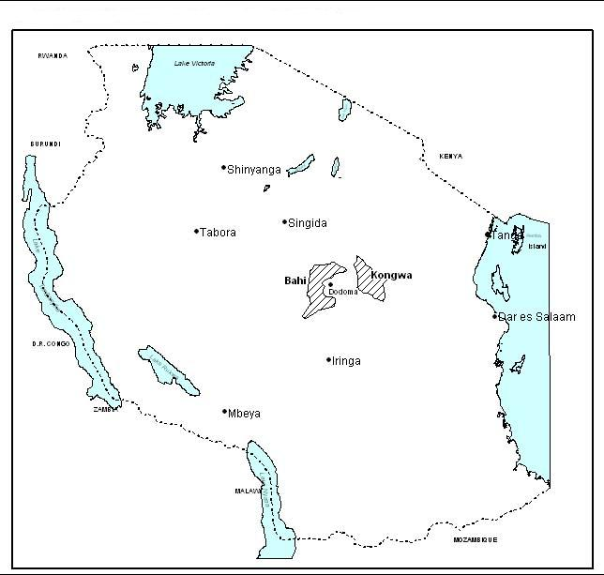
Map 3.1: Location of Kongwa and Bahi districts in Tanzania.
Source: Geological Institute of Statistics (Dodoma)

3.2.1.1 Climate
The microclimate of Kongwa district is greatly influenced by its altitude, the district is characterized by both high plateaus and hills. The mean temperature is about 26.5°C, but the coolest weather occurs in April to June where temperature can go down to as much as 11°C. The main rain season is between November-April with an annual average rainfall of 500- 800mm.

3.2.1.2 Socio-economic Setting
According to 2002 National Population Census, Kongwa district had a population of 249,760 with120, 089 males and 129,662 females and an annual population growth rate of 2.4 %. Council Population Projection by the year 2008 is estimated at 288,551, female147, 936 and males 140, 615. The main economic activities of the district are farming and livestock keeping. Overall the industrial sector has been in gradual development and scaling up its activities. This can be observed from small industries including the Cereal/Oil Milling Machines, Ceramic and Carpentry. These Industries started way back in 1990’s and is still going strong, producing different types of products including cooking oils, animal feeds and furniture.

Major crops produced in the areas include cereals like sorghum, millet, groundnuts and sunflower. Maize production within the district does not meet demand hence imported from other regions. Other food crops such as potatoes, rice, bananas and wheat have to be imported from outside the district and region respectively.

3.2.1.3 Energy Sector
Biomass fuel in the form of firewood and charcoal is the main source of energy used in households and commercial premises for cooking. Biomass wastes like crop residuals, rice husks, sawdust and wood shavers, and oil seed cake are also used in households. Additionally kerosene is used for cooking to a limited extent, but mainly for lighting in areas that are not electrified. Utilization of gas for household use is very limited; however the industrial use of oxyacetylene gas for welding and similar applications is widespread. Another form of energy available in the district is invariably electricity from the Tanzania Electric Supply Company (TANESCO). The supply of electricity to Kongwa district comes from hydropower sources of Mtera dam, Kidatu and Kihansi through the National Grid. The electricity is mainly used in urban settings and to a little extent to the rural population (Kongwa District Profile, 2007).
According to the district’s Environment Department Officer, the resources used by the energy sector have an environmental implication whereby biomass fuel use contributes to depletion of forest resources. On the other hand the use of biomass waste fuels like rice, groundnut and sunflower husks, maize cobs, oil seed cake and sawdust by some industries and institutions presents a resource recovery measure but this use does not directly contribute to resource depletion. Needless to add, resource recovery should be encouraged and promoted. Reuse and general recycling of waste should therefore be encouraged. Biogas technology has been introduced in a district by MIGESADO project and has been adopted though not to reasonable levels (Figure 3.1). Even where the use of charcoal or fuel wood cannot be abandoned, the promotion of the use of energy efficient stoves can go a long way towards protecting the environment. Additionally a reduction in electricity tariffs could encourage more people to use electricity instead of fuel wood with an equally similar positive impact on the environment.

The use of charcoal and firewood contributes to deforestation as well as soil erosion. According to Environment Department Office, the trend of tree felling for fuel wood has caused an enormous destruction of forests and soil on the hill tops surrounding the Kongwa district. The use of firewood as fuel in brick making contributes to deforestation, soil erosion and general land degradation. The problem is most serious when inadequately dried firewood is used. It is worse for the Kongwa district because during cold months people are forced to keep indoors with windows closed, which impedes ventilation, concentrating the hazardous combustion products indoors hence air pollution problems.

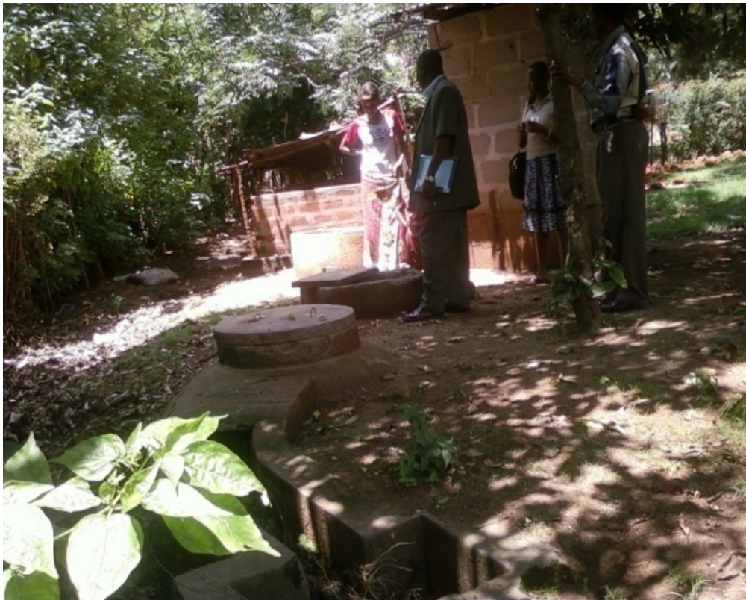
Figure 3. 1: Researchers observing a biogas plant installed in Mlali village
Source: Field survey, 2009

3.2.1.4 Livestock Keeping
Livestock keeping is carried out in many parts of Kongwa district mainly for the production of milk and beef. The current estimates of livestock population stand at 114,284 cattle, 70,381 goats, 32,592 sheep and 2,656 donkeys (Table 3.1). People also keep 9,675 pigs and other domestic animals like chicken are 376,877 and ducks are 5,627.

Table 3. 1: Kongwa district livestock population by 2009
Livestock Type | Population | Percentage
Cattle | 114,284 | 64%
Goats | 70,381 | 21%
Sheep | 32592 | 6%
Donkeys | 2656 | 2%
Pigs | 9675 | 7%
Total | 229,588 | 100%

Source: Kongwa District Planning Department reports

Zero grazing livestock keeping is undertaken in Kongwa, Mocha, Kibaigwa and Mlali wards. Within the district there is a ranch where exotic livestock are produced for diary and beef. This ranch has an area of approximately 34,000 ha. Free-range livestock keeping is mainly practiced in the periphery of the areas like Mtanana, Ugogoni, Zoissa, Njoge, Iduo, Pandambili, Hogoro, Chamkoroma, Sagara and Sejeli. Animals that are grazed on free-range basis can be found mainly in the “Mbuga” areas, in open spaces, on hills and even along roads. However, with expansion of farmland and settlements which have lead to a continuous decrease of grazing land, more livestock keepers have been forced to turn to either adopt zero grazing, moves out of the area or abandon livestock keeping altogether (Kongwa District Profile, 2007).

3.2.1.5 Forestry
The District has 1616.4 sq. km of natural forests owned by local authority (Local Authority Forest Reserves – LAFR) and central government (National Forest Reserves – NFR). The Kiborian Forest Reserve is the only forest reserve under the Council, whereas Mlali, Njoge and Ijogo forest reserves are under central government (Kongwa District Profile, 2007).

According to District Profile (2007) the forests comprise natural and man-made forest components. The natural forest part consists of patches of miombo and acacia covering about 13,308 ha; the forest reserve is under poor management due to sustained depletion brought about by unregulated forest harvesting and crop cultivation in the forest. Agricultural practices also strip land of its natural vegetation cover, leaving it bare and more prone to soil erosion caused by running water and wind. Moreover bad agricultural practices entail the burning of biomass that not only cause air pollution and destroy plant nutrients but also make the land more prone to soil erosion and leaching of nutrients.

On the other hand overgrazing has caused land degradation, including soil erosion. Effects of overgrazing are most significant on steep hill slopes (Kongwa District Profile, 2007). According to Kongwa District Profile (opp.cit) efforts to conserve the forest reserves were effected between 1992 and 2002 under Joint Forest Management (JFM) Participatory Forest Management (PFM) and Community Based Forest Management (CBFM). Trees were planted on both the forest reserves and water catchment areas of the district. Additionally forest fire control measures were instituted. The outcome is that most of the natural vegetation is decimated and tree density is rather sparse. The only products that can be obtained from the forests are poles and firewood. The forests and other allied sources no longer do supply enough forest products for the district. As a result the shortfall has to be obtained from outside the district and even outside the region. The District has taken stringent measures to address the issue of mismanagement of the forest by signing management contract with adjacent communities who will provide manpower for undertaking patrol in the forest to prohibit malpractice activities. Moreover forest vegetation frequently has been prone to bush fires that have razed it down (Kongwa District Profile, 2007).

3.2.1.6 Water Supply and Sanitation
Kongwa district depends on springs and boreholes to supply water to its people. Kongwa district council depends on springs and boreholes to supply water to its people. Currently the District has 47 deep boreholes, 8 Shallow wells, 9 dams, and 10 gravity schemes. The 67% of the community are receiving clean and safe water within 400 meter due to completion of 10 projects supported with Word bank under Rural Water Supply and Sanitation Programme (RWSSP Phase I). The problems that have been identified as hindering the operation of water supply service in the District are: high operation costs, especially due to high electricity bills incurred by water supply authorities in operating pumps, Inadequate and aged water supply infrastructures resulting into water leakages and reduced conveyance capacities of distribution pipes due to encrustation. Water supply is an essential component of biogas technology; its deficiency is an impediment to the technology (Kongwa District Profile, 2007).

The main sources of solid waste in the district are households, institutions, commercial premises like markets and shops, and industries. A large proportion of waste from households, markets and restaurants is organic in nature. According to District Profile (2007), Solid waste management makes use of environmental resources mainly through land-fill. Land is used for the disposal of solid waste and as a result it is alienated from other uses. Pollution as well as environmental degradation results from poor solid waste management. Uncollected and poorly disposed wastes cause scenic degradation and create breeding sites for disease vectors like flies, cockroaches and mosquitoes, apart from producing offensive odor when it decomposes. Burning of waste produces smoke, thus polluting the air and escalating fire outbreak risks in the neighborhood. Burying of waste may get in contact with ground water that leads to the formation of leach ate culminating in ground water pollution. Biogas technology would contribute in waste management since it utilizes organic wastes in a valuable manner (Kongwa District Profile, 2007).

3.2.2 Bahi District
Bahi is a newly established district in Dodoma region which became operational in 2007. It is part of the formerly Dodoma Rural district which has been divided into two; Bahi and Chamwino districts. The headquarters of the district is located in Bahi ward which is 50km away from Dodoma municipality. Bahi is located in the central plateau extending between latitude 4° and 8° South and between longitude 35° and 37° East. The district has a total area of 544,842 hectares, divided into 4 divisions, 20 wards and 56 villages. The population of Bahi District according to 2002 national census was 179,704; males 85,430 and females 94,294 with the population growth rate of 1.6%. Council Population Projection by the year 2008 is estimated at 238,951, female121, 865 and males 117,086 (Bahi District Profile, 2008).

3.2.2.1 Climate
Bahi district has a dry savannah type of climate which is characterized by a long dry season lasting between April to early December and a short single wet season occurring during the remaining months. The average rainfall is 500-800mm annually. Rainfall is not only relatively low but also unpredictable in frequency and amount. It is this unreliable rainfall which has imposed erosion risk in traditional agriculture and which represents a serious constraint on efforts to improve crop yields. However by-laws have been introduced which require farmers to cultivate among other crops, the drought resistant crops, namely millet, sorghum, cassava and sweet potatoes. The vegetation of the district is bushy wide spread throughout the area. Depressions and seasonally wet areas with impeded drainage support grasses and sometimes mixture of grasses with wood plants. However forest and woodland areas in the district have been greatly destroyed due to deforestation as a result of shifting cultivation, uncontrolled bush fires, overgrazing and tree felling for energy use (Bahi District Profile, 2008).
Bahi district is mostly a flatland with gentle slope hills and low lands in some places. In the eastern part of the district there is Bahi lowland area with swampy characteristics which makes it suitable for paddy farming. As a result, Bahi is among the famous districts for paddy production in Dodoma region. The Southern zone of the district with undulating hills is the most populated area of the district, used for cultivation of sorghum, millet, groundnuts and maize as food crops and tomatoes, onions and vines for cash. The main river in the district is Bubu river which flows from the north to south-east and drain its water into Bahi swamps. Like most natural rivers, dams, and swamps in the district, Bubu river is a seasonal one. (opp.cit).

3.2.2.2 Socio-economic Setting
Bahi district is predominantly rural with about 98.6% population residing in rural areas and the remaining 1.4% in the trading centres. The major economic activities in the district are subsistence farming contributing 41.0% and livestock keeping contributing 47.5% which altogether contribute to 88.5% to the district GDP. The district is among the least developed districts in Tanzania in terms of estimated income per capita. Based on the 2008 survey, majority of households in Bahi are still poor with average income being estimated at Tshs 427,489 per year. Its economy is entirely dependent on farming, managed by smallholder farmers. Farming is characterized by low productivity resulting from low rainfall, high evapo-transpiration and low moisture holding surface soil. Apart from farming, livestock also have great potential of contributing significantly to the district economy (Bahi District Profile, 2008).

3.2.2.3 Energy Sector
A survey conducted in June 2008 indicates that the main sources of energy in the district are; firewood (97.7%), with the remaining percentage being kerosene, gas and electricity from generators, solar and biogas. Other sources include animal dung, crop residuals and dry tree leaves for cooking. Solar power is used by few households located in town centers and in some institutions. Despite the fact that the national electricity grid passes through the district electricity has not been tapped for use in the district. Plans are underway for supplying electricity to the district (Bahi District Profile 2008). Excessive use of wood-fuel leads to the destruction of eco-system, forest depletion and serious environmental destruction. As an alternative to charcoal and firewood, environmental friendly sources like solar and biogas and the use of biomass waste fuels like rice husks, groundnut husks, and maize cobs, are advocated as measure to mitigate desertification.

3.2.2.4 Livestock Keeping
According to 2006 livestock census the district has 236,115 livestock, 189,841 cattle, 39,470 goats and 7,604 sheep. Constraints limiting livestock development include overgrazing and lack of pasture management, pasture and water are very scarce particularly during dry season resulting into poor conditions of animals. Facilities for disease prevention and control are extremely inadequate. An inadequate support service has lead to prevalence of diseases like Contagious Bovilie Pleurophenmonia (CBPP), East coast fever, foot and mouth diseases. More than 95% of cattle in the district are indigenous which have been developed over long period of time, and adopted a local condition (Bahi District Profile, 2008). Considerable amounts of manure cannot be tapped for biogas plants due to the fact that cattle are grazed freely over large expanses of land during the day.

3.2.2.5 Forestry
The characteristic vegetation of Bahi district is bush or thicket type which is wide spread throughout the area. The district is also endowed with forestry resources; it is estimated that the area of 2819 hectares is covered with natural forests and 175 hectares covered with exotic forests and 2644 hectares are forest reserves. Tree planting efforts in the district has been initiated by Non Governmental Organizations like World Vision Tanzania, Dodoma Environmental Network (DONET) and Dodoma Biogas Project (MIGESADO). (MIGESADO). Alongside tree planting campaigns there has also been advocacy on the use of improved cooking stoves and biogas technology as an alternative to excessive use of fuel wood which contributes to deforestation in the district. According to a survey carried out in 2008, a majority of households are aware of environmental protection by-laws and tree planting drive, but are reluctant to plant trees due to the fear that the trees would not survive as a result of inadequate water supply for watering and the problem of termites which destroy the newly established seedlings. As it is the case other parts of central Tanzania, environmental degradation due to deforestation and overgrazing is one of the major problems in Bahi district. This has resulted into declined soil fertility, reduced number of natural trees species and wild animals. Deforestation has been caused by clearing of land for farming and cutting of trees for firewood and charcoal.

A good number of people in the district depend on trading forest products for their livelihood. A significant proportion of charcoal and firewood supply to Dodoma municipality is from the district. The trend of forest products harvesting has been increasing and there is no sign of having the trend declining which implies that pressure on forests is increasing so the efforts need to be in place to counteract the prevailing situation. Biogas technology if widely spread in the district would be an effective e energy source for domestic use which would reduce fuel wood consumption and in turn reduce deforestation rates.

3.2.2.6 Water Supply and Sanitation
Due to poor climatic conditions and absence of reliable rainfall, permanent water sources like rivers and springs have been affected. Bahi district is characterized by seasonal rivers and swamps/wetlands. Furthermore, construction of boreholes, shallow wells, rain water harvesting structures and wind mills have minimized the perpetual chronic water shortage for both animals and domestic use. The district has 133 water supply schemes capable of providing clean and safe water to 66% of people in the district. District survey, done in June 2008 indicated that only 37% of the household in the district access water within 400m. With regard to sanitation, the survey conducted in June 2008 indicate that majority (86%) of households have pit latrines in their homes (Bahi District Profile, 2008). Both water supply and pit latrines are the important requirements as raw materials for biogas technology.

3.3 Selection of the Study Area
The description of the study area forms a basis of reasons for selecting the two districts for study. The reasons include:
- Kongwa and Bahi districts being semi arid areas have all the signs of scarcity of fuel wood hence a need for alternative energy sources.
- The potential of these area for biogas technology adoption due to the fact that the districts have principal factors for the operation of the biogas plants; these include livestock keeping agricultural residuals and water; hence availability of feed stocks and favorable temperatures for the operation of biogas plants.

- There have been biogas projects run by the non-governmental organization known as MIGESADO that has disseminated biogas technology within the two districts for more than fifteen years since 1994. Thus biogas awareness and adoption are expected to be high.

3.4 Research Design
The design used in this study is a cross-sectional survey. Cross sectional research design is a popular design that is widely used by researchers. Such a design allows collection of data on different groups of respondents at one point at a time. The design has greater degree of accuracy and precision in social science studies than other designs (Casley and Kumar, 1988). In this type of design, either the entire population or a subset thereof is selected, and from the sample population, data are collected to help answer research questions of interest. Cross-sectional survey was referred in this study because of its flexibility and its simplicity in collecting many types of information related to the use of various data collection methods. The design is also economical in terms of costs and time due to its ability to draw generalization about large population on the basis of representative sample (Krishnaswami and Ranganathan, 2005). Data can also be used for simple descriptive interpretations as well as determining the relationships between variables at a particular point at a time. In the case of this study data were collected from different groups including households, government officers and biogas project officers, in two districts at the same period of time.

3.5 Sample Population
The sample population for this study was the households selected from the two districts, Kongwa and Bahi. For each district, two divisions were selected from which two wards were selected, and from each ward two villages were selected. This makes a total of 16 villages (Table 3.2) from which 320 households were involved in the study.

Table 3. 2: Villages selected for study in Kongwa and Bahi Districts
District | Division | Ward | Villages
Bahi | Mndemu  Bahi | Zanka  Mndemu  Mwitikira  Kigwe | Mndemu  Mkondai  Kisima cha Ndege  Mayamaya  Mwitikira  Mtitaa  Chibelela  Kigwe
Kongwa | Mlali  Zoissa | Mlali  Iduo  Hogoro  Pandambili | Mlali  Chiwe  Ihanda  Iduo  Suguta  Hogoro  Songambele  Nduruguni
Total | 4 | 8 | 16

Source: Field survey 2009

3.6 Sample Size and Sampling Procedures
Sampling is the process by which inference is made to the whole population by examining a part of it (GMU, 2004). May (1993) mentions advantages of sampling to include: first, the data collection being cheaper; secondly, it requires fewer people to collect and analyze data; thirdly, it serves time; fourthly. it permits a higher level of accuracy as the sample size allows a check on the accuracy of the design and administration of the questionnaires; and finally fewer cases make it possible to collect and deal with more elaborate information.

A multi-stage sampling technique was used in this study. The multistage sampling is a complex form of cluster sampling in which the population is divided into groups then the required information is collected from sample elements within each group. The choice of this technique was guided by the following reasons; (i) the technique is convenient for studying large and geographically dispersed populations as well as populations whose list of the actual individuals to be studied is not available. (ii) It is easier to administer respondents as opposed to most single stage techniques mainly because the sampling frame under multi-stage is developed in partial units. (iii) A large number of units can be sampled for a given financial and time resources allocated, this is not possible in most of the single stage techniques and (iv) flexibility of utilizing several sampling methods at different stages (Kothari, 1990):

The first sampling stage used in this study was related to selection of divisions, wards and villages using purposive sampling technique based on availability of biogas plants. Purposive sampling was chosen as an important criterion for selecting wards and villages because it was considered a convenient method for the researcher to capture important aspects from respondents (Saunders et al., 2006). In addition to availability of biogas plants, selection of the villages also considered the location coverage of the districts so as to capture the spatial distribution of the technology within the districts (Map 3.2 and 3.3). Purposive sampling was employed for selecting villages which had adopted biogas technology hence enabling the researcher collect the data related to biogas users’ experiences. The list of villages covered by biogas project was obtained from MIGESADO offices in Dodoma town.

The second sampling stage was employed at the village level which involved classifying households into two groups, namely, adopters and non-adopters of biogas technology. The list of biogas adopters was provided by MIGEASDO biogas project offices and another of non-adopters provided by respective village executive officers, the lists were used as sampling frames. From the list of biogas adopters, 10 names were selected for interview. The number of households which had adopted the technology was not the same among selected villages due to variation in the extent to which the biogas technology had been adopted in each village. For villages having less than 10 biogas adopters all households were included in the sample, while for villages having more than 10 adopters only 10 adopters were selected for the interviews.

From the list of non-adopters of biogas technology given by village executive officer, 10 names of heads of household were drawn in order to obtain a fair representation of the population under the study. Simple random sampling was employed to select households which are non-adopters of biogas technology. This was done by listing all the names of head of households on pieces of paper and randomly selecting 10 names for interview in each selected village. Simple random sampling technique was chosen due to its simplicity and easiness to conduct and its ability to provide equal opportunity to all non-biogas adopters to be included in the sample, hence low degree of sampling error (Rwegoshora, 2006). The target population of the present study was the households for they are the potential adopters of biogas technology. It is from this target population a grand total of 320 households were sampled to represent the entire population in the study area.
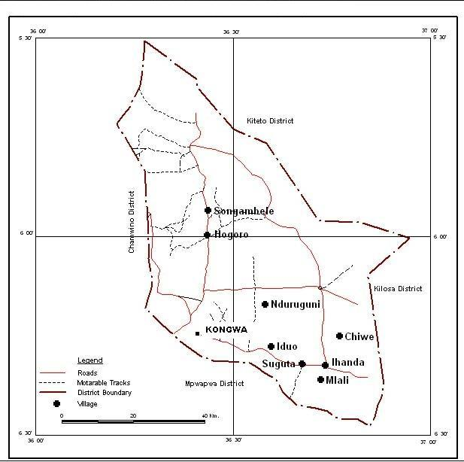
Map 3.2: Location of villages covered by the study in Kongwa District
Source: Geological Institute of Statistics (Dodoma)
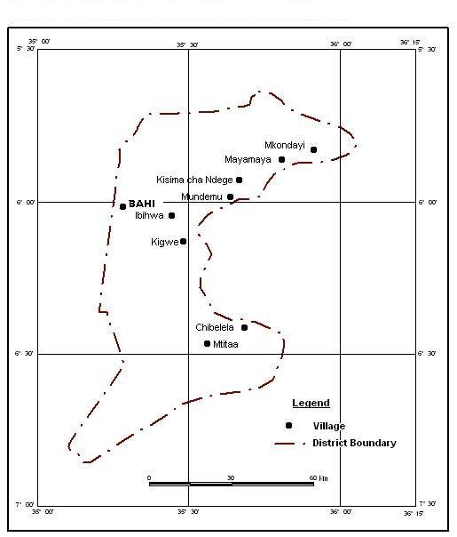
Map 3.3: Location of villages covered by the study in Bahi district
Source: Geological Institute of Statistics (Dodoma)

3.7 Data Sources and Types
Both primary and secondary data were collected and used to achieve the objectives of the study. Primary data were collected using interviews to a target population using different methods of data collection. Primary data were related to respondents’ and study area characteristics, analysis of biogas technology such as the rate and extent of adoption of biogas technology, factors influencing adoption and non adoption, and people’s awareness and attitude towards bio-gas technology. Also data relating to promotion of biogas technology in the study area by the government and other stakeholders were collected from the respondents during the household survey.

Secondary data were collected from various sources such as government officials at district and national levels and from NGOs reports, libraries, institutions and websites and then used to complement information obtained from respondents. Secondary data collected provided background information on energy situation in the country, on biogas technology, policy issues related to adoption of biogas technology, factors affecting adoption and non-adoption; and promotion of biogas technology.

3.8 Data Collection Methods
Both qualitative and quantitative approaches were employed due to the nature of the study. The study involved assessing attitudes and behaviors of individual households which assumed to have influenced adoption of biogas technology. The qualitative approach enabled the researcher to make an in-depth investigation of the variables related to adoption and non-adoption of biogas technology.

A combination of methods was used to collect both qualitative and quantitative data. These included structured and semi structured interviews, checklists for focus group discussion and field observations. The use of a combination of methods in data collection was due to diversity of information that was required to achieve the objective of the study.

3.8.1 Interviews
The interview was adopted as a method for data collection partly due to its cost effectiveness and its strength of capturing empirical data in both informal and formal settings (Kothari, 1990). The interview guide (Appendix 1) consisted of both open and closed ended questions. Open ended questions were designed to solicit information relating to actual and expected returns on respondents and study area characteristics and their relations to adoption of biogas technology. Closed ended questions on the other hand were intended to capture information relating to respondents’ attitude towards the adoption of biogas technology. The questions that were asked to all respondents were identical in order to solicit homogeneous information.

The interview was made up of four major parts: the first part was designed to collect information on household characteristics and availability of important energy resources in the study area; part two was aimed to collect information on biogas awareness in the study area and experiences from biogas adopters and gender involvement in biogas related activities; part three was designed to capture information relating to policy environment particularly government involvement in promotion of biogas technology; and part four was concerned with peoples’ attitude towards biogas technology.

Interviewing in research involves a meeting between a researcher and respondent and involves the interviewer asking a predetermined set of questions using basically the same wording and order of questions within the interview schedule. The interview method was very useful since it allowed face-to-face interaction with respondents and allowed the researcher to restructure the question or give clarification to questions when necessary. The choice of interview method for this study was dictated by the experience gained during a pilot survey whereby the majority of respondents preferred oral discussions with the researcher to filling in the questionnaires. This may be attributed to the nature of sample population (rural residence) where illiteracy is high. Rwegoshora (2006) mentions the advantages of the interview, among others as: (i) it makes possible to study events that are not open to observation, (ii) allows for the study of abstract factors like attitude, back emotions and reactions of the respondents, (iii) allows for the study of phenomenon in its historical background, (iii) allows for gathering information that is quite reliable, and (iv) enables to study past events.

Semi-structured interviews (appendices 2 to 3) were used during discussions with government officials, representative of NGOs, and other key informants. Unlike structured interview which involves tight control over the format of questions and answers, in semi-structured interview the questions are open ended and emphasis is on the respondent to elaborate points of interest (Denscombe, 1998). The interviewer had a list of issues which she wished to obtain answers from respondents but was flexible in terms of the order of the questions. Semi-structured interview, according to Kothari (1990) has advantages of allowing the researcher to restructure questions if need arises. Interviews were found useful as they allowed face-to-face discussion with respondents, restructuring of some questions to suite the situation and to capture some controversial issues between different groups of people in a community. Due to the nature of the study which required the investigation on people’s attitudes and awareness towards biogas technology, semi structured interviews were appropriate and offered more opportunity in gathering information.

Several non-governmental organizations dealing with biogas technology were visited; these included MIGESADO the main targeted organization for the study, CARMATEC in Arusha and TaTEDO in Dar es Salaam. The purpose of visiting these NGOs was to solicit background information and biogas technology experience across the country and other alternative energy sources in Tanzania. Information gathered from these organizations provided a background on biogas technology and the new developments on biogas sector in Tanzania particularly current initiatives on National Biogas Programme. Furthermore the Ministry of Energy and Minerals, Rural Energy Agency and EWURA were visited for information on energy situation in the country and policy aspects on energy and biogas technology in particular.

Information gathering from government offices at the districts level involved officials in the natural resource, agriculture, livestock; and environment departments. Whereas at the village level: executive officers, village chairpersons and ten cell leaders were involved. The information generated from discussions with these respondents helped to confirm some findings from household respondents and making relevant recommendations.

3.8.2 Focus Group Discussion
This method involved interviewing a small group of respondents drawn from similar background, who were believed to present general public opinion towards biogas technology. The advantage of this method according to May (1993) is that it allows the interaction with a range of key informants and allows the researcher to focus on group norms and dynamics around the issue being investigated. Moreover focus group discussions are useful in verifying and clarifying information and in filling in gaps of information caused by inadequate information gathered from the interviews and observations.

Focus group discussions were conducted in four selected villages each representing one division. The four villages were Chiwe and Mlali in Kongwa District, Kisima cha Ndege and Mtitaa in Bahi District. The focus groups comprised 10 – 15 participants who were selected with consideration of all social groups representations; men, women, youth, aged people, influential people in the village and village leaders. From focus group discussions, qualitative information such as general opinion, awareness and attitude towards biogas technology was collected. The checklist (appendix 4) was the basic tool for conducting focus group discussions. Participants’ responses were recorded in a notebook during the discussions or immediately thereafter.

3.8.3 Field Observation
Observation makes it possible to study behaviour as it occurs, the researcher simply watches people as they do and say things. This enables the generation of first hand data that are uncontaminated by factors standing between the investigator and the object of the research (Nachimias, 1976). According to Nachimias (opp.cit), the observation method might also be used when respondents are unwilling to express themselves verbally. Furthermore verbal reports can also be validated and compared with actual behaviour through observation.

In this study apart from interviews and discussions, direct observations were used to evaluate existence of biogas plants, designs and types of plant feeds also to confirm functioning of biogas plants. Furthermore observation helped to study some facial expressions, gestures and other behaviours during interviews which portrayed the hidden or doubtful responses during interactions between observer and respondent particularly on sensitive issue like income, beliefs and attitudes towards biogas acceptance. Moreover the camera was used to capture some events and structures of interest to this study. The information gathered using observation was used to counter-check information provided by household respondents and focus group participants.

3.9 Field Survey

3.9.1 Pilot Survey
Prior to detailed field survey, a pilot survey was conducted using a total of 15 respondents from 2 villages Iduo in Kongwa and Mndemu in Bahi districts. The pilot study was administered for the purpose of; (i) soliciting background information about the study areas (ii) familiarizing with the areas where the main survey was to be conducted (iii) establishing sampling frames and units (iv) pre-testing the questionnaires to validate the relevance of the questions to the intended respondents (v) determining the approximate time or duration taken to fill a questionnaire with one respondent and (vi) finding out the most efficient way of carrying out main survey. The pilot survey was carried out in February 2009 whereby a visit was made to selected villages and conducted discussions with household heads, village leaders and district authorities. Following the pilot survey some amendments were made to the questionnaires and interview guidelines, whereby questions were added, some were deleted while others were reframed to make them clearer and easier to understand.

During pilot survey research, assistants were recruited and trained to assist in data collection. Due to the nature of sample population (rural setting), selection of research assistants considered, in addition to fluency in English and Swahili, also proficiency in the local language of the study area. Research assistants were trained in order to orient them on interviewing techniques, recording of information collected and in dealing with difficulties encountered with respondents. Emphasis was put on ensuring harmonious interaction between interviewees and the interviewer for smooth running of the exercise,

3.9.2 Detailed Field Survey
The formal survey was conducted from June to December 2009; it involved household interviews, focus group discussions and discussions with government officials, representatives of NGOs and other key informants. The interviews were conducted by the researcher with the assistance of three well-trained enumerators. Prior to commencement of interviews, the researcher visited the districts, divisions, wards and villages to inform relevant authorities about the purpose of the study and to arrange the modality of conducting interviews.
Individual respondents were interviewed in their homes or offices after an initial appointment. The objectives of the study were explained precisely by the researchers to each respondent prior to interviews in order to win the willingness and cooperation of the respondents. The interviews were conducted in Swahili to overcome language barrier since most household respondents did not speak English language. Furthermore there were few respondents (especially old people) who did not speak even Swahili, for such cases the local language (Gogo) was used with the assistance of two research assistants who spoke the language.

3.10 Data Processing and Analysis

3.10.1 Data processing
Data collected through interviews were coded and entered into the Statistical Package for Social Sciences (SPSS) for windows versions 11.5. Data cleaning was done by running frequencies of individual variables and later analysed. Cleaned data were later exported to other software packages such as Microsoft Excel, and LIMDEP for windows (version 8) for further analysis.

3.10.2 Data Analysis
Both descriptive and quantitative techniques were used to analyse the data. A substantial part of the analysis was based on descriptive statistics such as frequencies, cross-tabulations, and correlation coefficients. These statistics were used to determine and to assess the following aspects: respondents’ characteristics, their awareness and attitude towards bio-gas technology, factors influencing adoption and non adoption of biogas technology; and assessment of the adequacy of strategies for promoting adoption of bio-gas technology in the study area. The statistics were also used to assess people's opinions, knowledge and insights regarding biogas technology.

The extent and rate of adoption of biogas technology were established by using the number of biogas plants constructed over a period since the introduction of biogas technology in the study area. Data on biogas plants and the number of households of the area were collected from regional offices and from biogas project offices and were used to calculate the extent of biogas adoption. Data relating to the number of biogas plants constructed in the study villages were used to create a histogram showing the growth rate of biogas adoption in the study area.

Furthermore an analysis of attitudes towards biogas technology was also undertaken. In order to estimate the level of attitude towards biogas technology, respondents were asked to indicate whether they found biogas technology beneficial or not. The statements were designed to capture respondents’ opinions on the advantages and disadvantages of biogas technology. The assumption was that if the respondent was knowledgeable and recognized the advantages of biogas technology; his or her attitude towards biogas would be positive and would adopt the technology.

Respondents were required to respond to the statements by indicating whether they strongly agree (SA), agree (A), were undecided (UD), disagree (D) or strongly disagree (SD). The responses were assigned numbers; 5 for strongly agree; 4 for agree; 3 for undecided; 2 for disagree and 1 for strongly disagree. In this case the individual positivism or negativism was indicated by one’s agreement or disagreement with the statements. For easier assessment, responses of “strongly agree” and “agree” were combined to show the agreement therefore positive towards the technology while responses “disagree” and strongly disagree” were combined to show disagreement therefore negative towards biogas technology. Responses of ‘undecided” were also included in the analysis and were considered to indicate the lack of knowledge or disability to weigh advantages and disadvantages of biogas advantages hence ignorance which was assumed to contribute to non adoption of biogas technology. The score weights of all statements for each respondent were added up to develop the Attitude Index.

The Attitude Index was given by the formula;
AI = ∑ (s₁+s₂+s₃+………..s_{n})
Where S = score weight for each statement

Apart from the afore-mentioned descriptive statistics, more focused empirical investigation was employed to confirm the existence of the relationships among variables. The logistic regression model was used to determine the factors affecting adoption and non-adoption of biogas technology. The main motivation of using logistic model is that the model is commonly used by researchers to analyse adoption problems due to rational behaviour of the households which leads to the discrete nature of management decisions (Aldrich and Nelson 1990; Senkondo et al., 1998; Powers and Xie, 2000). Based on rational behaviour, households are confronted with a decision whether to adopt a technology or not (Aldrich and Nelson 1990). In the present study households with positive reactions towards adoption of bio-gas technology were classified as “adopters” while those with negative reactions were classified as “non-adopters”. The observations were coded “1” for adopters and “0” for non-adopters and were used as a dependent variable. In view of above discussion, the general form of adoption of bio-gas technology is specified as follows:

Bi = βi β1 (AGE) + β2 (EDUC) + β3 (GENDER) + β4 (INCOME) + β5 (HHSIZE) + β6 (FWDIST) + β7 (BIOAWARE) + β8 (KNOWL) + β9 (ATTITUDE) + β10 (CATTLE) + β 11 (TECHAV) + β 12 (WATERAV) + β 13(CREDIT) +Є_{i}

Where,
Bi | Binary dependent variables denoted as “1” if the household adopt bio-gas technology and “0” otherwise
“ß_{i}” | Vector parameters to be estimated
“Ci” | is the constant term

Related to this model, the explanatory variables included in the empirical models are summarized in Table 3.3. The selection of explanatory variables to be included in the empirical model was based on the adoption theory and empirical findings from previous research elsewhere.

The specified empirical logit model was estimated using Maximum Likelihood Estimation (MLE) method in LIMDEP for Microsoft windows (version 8) software. In addition, the marginal probability concept was used to predict the effect of a change in an explanatory variable on the probability of a favourable attitude toward adopting bio-gas technology.
Table 3.3: Specification of variables included in logit model for adoption of biogas technology
Variable | Description of the variable | Measurability
BIOTECHi | Binary dependent variable that stands for “1” household adopted bio-gas technology and “0” otherwise | Binary
AGE | Age of the head of household | Years
EDUC | Years in school expended by the head of household | Years
HHSIZE | Number of household members | Number
GENDER | Whether the head of household is a male or female. | Proxy/categorical
INCOME | Household average income per annual | Tanzanian shillings
FWDIST | Distance to firewood sources | Kilometers
BIOAWARE | Awareness of households towards bio-gas technology specifies as proxy variable “1” stands for aware and “o” otherwise | Idea of bio-gas technology
KNOWL | Knowledge of households towards bio-gas technology specifies as proxy variable “1” stands for households knowledgeable and “o” otherwise | Ability to operate and apply bio-gas technology
ATTITUDE | Attitude of households towards bio-gas technology specifies as proxy variable “1” stands for households had positive attitude and “o” otherwise | Willingness and Habit of using bio-gas technology
CATTLE | Ownership of cattle | Number of cattle owned by HH
TECHAVA | Availability of technical support services specifies as proxy variable “1” stands for technical service available and “o” otherwise | Proxy/categorical
WATERAV | Availability of reliable water services specifies as proxy variable “1” stands for water available and “o” otherwise | Proxy/categorical
CREDIT | Availability of reliable credit services specifies as proxy variable “1” stands for credit available and “o” otherwise | Proxy/categorical

The goodness-of-fit of the logit model was measured by the McFadden with likelihood ratio statistics as the basis of inference with a chosen significance level of 5% probability level. Moreover, the following criteria were also employed to verify the goodness-of-fit of the model: (i) statistical tests of significance (t-tests for individual parameters), (ii) inspection of the signs of the estimated parameters to verify whether they agreed with expectations, (iii) values of the standard errors of the variables included in the model and (iv) whether the empirical model was correctly predicted. On the basis of these criteria, the empirical model was used in this study in determining the main factors which significantly influence adoption of biogas technology.

Related to logit model the following assumptions were made for explanatory variables included in investigations. From literature, older household heads (AGE) were expected to have more resources particularly cattle ownership (CATTLE) as compared to younger people, hence potentially capable of adopting biogas technology. This is due to the nature of the technology where cattle ownership is a prerequisite to ensure availability of feed-stocks for operation of biogas plants. Other requirements for biogas technology are; technical availability (TECHAVA) and water (WATERAV). Access to these requirements is an important factor for the adoption of the technology. Thus a positive relationship is hypothesized between age, cattle ownership, technical services, water availability and adoption of biogas technology

Education level (EDUC) of household head is an important factor assumed to influence adoption of biogas technology. Educated individuals are expected to be more aware of the technology (BIOAWARE) and more knowledgeable (KNOWLG) due to access to information. Hence the variables; Education, Awareness and Knowledge are hypothesized to have positive relationship with biogas adoption. Household income (INCOME) is another important factor influencing biogas technology. Higher income earners are expected to afford biogas installation costs. On the other hand, due to the capital intensive nature of biogas technology, the low income earners may require financial support through subsidies or loans hence availability of credit (CREDIT) facility is expected to be a motivation for household to adopt biogas technology. Thus income and credit availability are hypothesized to have positive relationships with adoption of biogas technology.

Other factors considered to influence biogas adoption include gender (GENDE); biogas technology is expected to lessen woman’s workload particularly firewood collection task. As the distances to firewood (FWDIST) sources increases women are expected to look for other alternative energy such as biogas technology. As far as family size (HHSIZE) is concern, larger families are expected to have enough labour to perform activities related to biogas plants operations. All these factors are hypothesized to have positive relationship with biogas adoption.

3.10.3 Data presentation
Cross-tables and figures such as histograms and pie-chart were used to present data for different studied variables. Concluding remarks, recommendations and discussions were essentially based on computed frequencies, percentages, rates and extents, logical framework and logistic regression analysis.

CHAPTER FOUR

FINDINGS AND DISCUSSIONS

4.1 Chapter Overview
This chapter presents the findings of the study and discussions of the results. The first section provides an overview of the chapter while section two presents the overview of the socio economic characteristics of the sampled population the findings are presented in relation study objectives, section three discusses factors which influence biogas technology adoption, and these include socio economic characteristics of the households, environmental characteristics and technological characteristics. The fourth section presents an analysis of people’s awareness and attitude towards biogas technology in the study area while section five presents the correlation of factors influencing biogas technology. An analysis of the rate and extent of biogas technology adoption forms the sixth section of this chapter while section seven explores the involvement of government institutions and other stakeholders in promoting biogas technology and the strategies used to promote biogas technology.

4.2 Overview of Respondents Characteristics
Table 4.1 and 4.2 summarize the socio economic characteristics of sampled population in the study area. Six important characteristics are considered due to their influence and relationship with biogas technology adoption. These characteristics include; sex, age, education level of household head, household size, household income and household main economic activity. These characteristics are further subjected to descriptive analysis in order to study their influence to the adoption of biogas technology (Table 4.3 and Table 4.4).

A total of 159 and 161 household heads were interviewed in Bahi and Kongwa districts respectively. The results in table 5 indicate that the majority (78.4%) of households in the study area are male headed as compared to (21.6%) female headed households. This has an implication on household decision making systems, the decision on whether the household adopts biogas technology or not, greatly rests on the head of household. The results further indicate that a majority of respondents were in the economically active age, that is, 20 – 60 which relates to labour provision for biogas activities, and resource ownership hence affordability of biogas installation costs.

The household size has an implication on household labour force for biogas related activities. The results in Table 4.1 indicate that a majority of households in the study area have an average of 5 – 8 family members, a sufficient number to provide adequate labour for running biogas plant operations. Table 4.1 further indicates that a majority of household heads, 70.4% (Bahi) and 75.1% (Kongwa) had attained primary education. This implies that a large part of the sample population can at least read and write, meaning that the individuals are trainable as far as biogas technology knowledge is concern.

The major economic activity in the study area is livestock farming as indicated by the results in Table 4.2 where 76.1% (Bahi) and 75.8% (Kongwa) earn their living through crop cultivation and livestock keeping. This is significant to the availability of biogas technology requirements such as feed-stocks from livestock and farm wastes for biogas plants feeding.

Table 4. 1: Socio economic characteristics of the sample population
Characteristics of  Respondents | Bahi  (N=159) | Kongwa (N=161) | Total  (N=320)
Sex  Male  Female  Total | 69.8 (111)  30.2 (48)  100.0 (159) | 87.0 (140)  13.0 (21)  100.0 (161) | 78.4 (251)  21.6 (69)  100.0 (320)
Age of respondent  Between 20 -40 years  Between 41– 60 years  Above 60 years  Total | 52.2 (83)  39.6 (63)  8.2 (13)  100.0 (159) | 39.1 (63)  51.6 (83)  9.3 (15)  100.0 (161) | 45.5 (146)  45.6 (146)  8.8 (28)  100.0 (320)
Education level  Never attended formal education  Primary education  Secondary education  College education  Total | 6.9 (11)  70.4 (112)  14.5 (23)  8.2 (13)  100.0 (159) | 7.5 (12)  75.1 (121)  13.7 (22)  3.7 (6)  100.0 (161) | 7.2 (23)  71.8 (213)  14.1 (45)  5.9 (19)  100.0 (320)
Household size  1-4 members  5-8 members  Above 8 members  Total | 30.2 (48)  56.6 (90)  13.2 (21)  100.0(159) | 20.5 (33)  53.4 (86)  26.1 (42)  100.0 (161) | 25.3 (81)  55.0 (176)  19.7 (63)  100.0 (320)
Bolded figures are the percentage and those in brackets are the number of respondents involved

Source: Field Survey (2009)

Household income in the two districts greatly depends on the main economic activities which are crop cultivation and livestock production. From Table 4.2 the average income tends to differ among households in the two districts; it is higher in Kongwa, where 65% of respondents earn Tshs ≥ 500,000/= per annum compared to 23.1% of respondents in Bahi who earn the same amount. In Bahi, a majority (46.2. %) earn below Tshs 500,000/= per annum. This has got an implication on affordability of biogas installation costs. For the farmers and livestock keepers the monetary figures presented here are the values of farm products (crops and livestock) as per sale price at the time of the study.

Table 4. 2: Socio - economic characteristics of the sample population
Characteristics of  respondents | Bahi  (N=159) | Kongwa (N=161) | Total  (N=320)
Main Economic activity  Livestock farming  Wage employment  Business  Total | 76.1 (121)  19.5 (31)  4.4 (7)  100.0 (159) | 75.8 (122)  19.9 (32)  4.3 (7)  100.0 (161) | 75.9 (243)  19.7 (63)  4.4 (14)  100.0 (320)
Household Average Income p.a  Between Tshs 100,000- 250,000  Between Tshs 251,000 – 500,000  Above 500,000  Total | 30.8 (16)  46.2 (24)  23.0 (12)  100.0 (52) | 10.0 (9)  24.4 (22)  65.6 (59)  100.0 (90) | 17.6 (25)  32.4 (46)  50.0 (71)  100.0 (132)

Bolded figures are the percentages and those in brackets are the number of respondents involved

Source: Field Survey (2009)

4.3 Factors Influencing Adoption of Biogas Technology

4.3.1 Socio economic Characteristics and Biogas Adoption
Table 4.3 summarizes the relationship between household characteristics and adoption of biogas technology. These characteristics include age of respondent, education level of household head, household size and sex which is further elaborated in Table 4.7 as gender in relation to biogas adoption.

4.3.1.1 Age of Respondent and Biogas Adoption
Findings in Table 4.3 indicate that older respondents aged between 40 to 60 years old were more likely to adopt biogas technology compared to younger respondents aged below 40 years. The plausible explanation of this can be the resource ownership especially cattle ownership as per Table 4.5. Cattle ownership is a prerequisite for biogas technology since it ensures availability of feed stocks for biogas plants. Furthermore older people are more established and own houses compared to younger people. A fixed dome biogas plant is an expensive and non-transferable investment; hence it requires a person who establishes it to have his or her permanent premise. For young people who do not have their own premises and in many cases have not settled, it becomes difficult for them to decide on adopting this permanent installation. In a focus group discussion one young man had this to say:
Ni vigumu Kwa vijana kujenga hii mitambo, kwanza hatumudu gharama, pili vijana bado tunahangaika na maisha wala hatujajijenga na pia mtu unaweza kwenda sehemu nyingine kutafuta unafuu wa maisha na mtambo hauhamishiki. Meaning, It is difficult for us young people to install biogas plants; first we can’t afford the costs, and secondly we are still struggling with life, moreover we are not yet established and are liable to shift to other places in search of better life while the biogas plant is not transferable.
On the other hand, the old people have more or less settled and are unlikely to move elsewhere.

Table 4.3: Relationship between socio economic characteristics and biogas adoption
`Household characteristics | Biogas Adopters (N=79) | Non Adopters  (N=241) | Total  (N=320)
Sex of respondent:  Male  Female  Total | 79.7 (63)  20.3 (16)  100.0 (79) | 78.0 (188)  22.0 (53)  100.0 (241) | 78.4 (251)  21.6 (69)  100.0 (320)
Age of respondent:  Between 20 – 40 years  Between 41 – 60 years  Above 60 years  Total | 22.3 (18)  64.5 (51)  12.7 (10)  100.0 (79) | 53.1 (128)  39.4 (95)  7.5 (18)  100.0 (241) | 45.6 (146)  45.6 (146)  8.8 (28)  100.0 (320)
Education level:  Never attended formal education  Primary education  Secondary education  College Education  Total | 10.1 (8)  57.0 (45)  24.1 (19)  8.9 (7)  100.0 (79) | 6.2 (15)  78.0 (188)  10.8 (26)  5.0 (12)  100.0 (241) | 7.2 (23)  72.8 (233)  14.1 (45)  5.9 (19)  100.0 (320)
Household size:  Between 1 – 4 Members  Between 5 – 8 Members  Above 8 members  Total | 13.9 (11)  51.9 (41)  34.2 (27)  100.0 (79) | 29.1 (70)  56.0 (135)  14.9 (36)  100.0 (241) | 25.3 (81)  55.0 (176)  19.7 (63)  100.0 (320)
Bolded figures are the percentages and those in brackets are the number of respondents involved

Source: Field Survey (2009)

Another explanation of the effect of age in biogas adoption can be preference and perception difference between the older and younger people. It was revealed during focus group discussions that younger people preferred technologies which were more advanced than biogas. The preferences mentioned by younger people include solar and hydro electricity; this was evidenced by less involvement of young people in biogas activities.

During the interviews household heads expressed that their children avoided to engage themselves in biogas plant operations by hesitating to hold cow-dung. Likewise during the field visit to a technical training institution called KISEDET in Kigwe village, one of the institutions which had adopted biogas technology, instructors of the institution explained that their students did not like the task of feeding the biogas plant. When asked about this, the students themselves expressed that they disliked holding cow-dung because they feel uncomfortable and fear that they might contract skin infection. Older people on the other hand recommended biogas technology for the reason that it was cheaper after the installation costs. Besides materials required were locally available as compared to solar and electricity equipment which according to them were not available and also unaffordable to the majority of the rural population.

However the adoption of biogas as shown in Table 4.3 tends to decrease with people aged 60 years and above. This can be explained by decreased labor force as most family members in these households; particularly the children had left their parents and established their own households. The old people left behind were unable to care of animals and carry out biogas plants operations.

4.3.1.2 Education Level and Biogas Adoption
The relationship between education and biogas adoption as indicated in Table 4.3 is that the majority of adopters (57%) were those with primary education compared to those with secondary or college education. This can be explained by the nature of technology itself and its raw materials requirements; cow-dung which requires cattle ownership. The findings in the same table show that a majority of the adopters were those engaged in farming and livestock keeping, activities which are of permanent nature hence provide opportunities for permanent investment like biogas technology. Comparatively, people who attained secondary and college education in a village level were more likely to be in wage employment like teaching, village administration and police officers. People belonging to this category, firstly, most of them live in public or hired houses hence have no permanent premises, secondly being public or civil servants they are liable to be transferred to other work places, hence they are unlikely to invest in biogas technology which is a permanent and non transferable structure as compared to farmers who are likely to be settled in their places permanently.

4.3.1.3 Household Size and Biogas adoption
The relationship between household size and biogas adoption is that households with many members had adopted biogas technology than households with few members Table 4.3. This can be explained by labor availability due to the fact that biogas technology requires labor force for biogas plant operations. Biogas plant operation involves activities like collecting cow dung, feeding the biogas plant, cleaning the cow shed and ferrying the slurry to the farm. All these activities require sufficient labor without which it becomes an impediment to the sustenance of the technology. During focus group discussions, inadequate feeding of biogas plants was among the problems mentioned by biogas adopters who do not have enough labor force. The households which experienced labor problem were those of aged biogas adopters as explained in section 4.3.1.1 above and those households in which most of the family members were of school going age. For these households hiring of labor would be a solution; however, this alternative was considered not affordable by a majority of the respondents.

4.3.1.4 Main Economic Activity and Biogas Adoption
Table 4.4 presents the relationship between socio economic characteristics such as the main economic activity of the area and household income and the implication of these to biogas adoption. The results further indicate that a majority of adopters of biogas technology were those engaged in livestock farming as compared to wage earning employees and business men. This can be explained by the nature of the biogas technology which requires livestock wastes as raw materials for biogas operations and permanency of the settlement. Comparatively wage earning employees and business men who are liable to move to other work places were unlikely to opt to invest in non-transferable technology like a biogas plant.

Table 4. 4: Relationship between socio - characteristics and biogas adoption
`Household characteristics | Biogas Adopters (N=79) | Non Adopters  (N=241) | Total  (N=320)
Main economic activity:  Livestock farming  Wage employment  Business  Total | 68.4 (54)  30.4 (24)  1.3 (1)  100.0 (79) | 78.4 (189)  16.2 (39)  5.4 (13)  100.0 (241) | 75.9 (243)  19.7 (63)  4.4 (14)  100.0 (320)
Average Income p.a (Tshs)  Between 100,000 – 250,000  Between 251,000 – 500,000  Above 500,000  Total | 16.1 (5)  22.6 (7)  61.3 (19)  100.0 (31) | 18.0 (20)  35.1 (39)  46.8 (52)  100.0 (111) | 17.6 (25)  32.4 (46)  50.0 (71)  100.0 (142)
Bolded figures are the percentages and those in brackets are the number of respondents involved

Source: Field Survey, 2009

4.3.1.5 Household Income and Biogas Adoption
Table 4.4 further indicates that a majority of the respondents who had adopted biogas technology were from higher income households. However there is also a good percentage (48%) of non adopters who have higher income but have not adopted the technology. This raises a question to whether Income is a major determinant of biogas adoption. Though it is a fact that biogas technology involves high initial installation costs hence higher income earners are more likely to afford the costs. Responses in Table 4.6 indicate a slight difference in responses given by adopters and non adopters concerning on the factors for non adoption of biogas technology where biogas adopters mentioned unreliable technical services as a major factor (26.4%) followed by high installation costs (20%). Comparatively non adopters mentioned unaffordable installation costs as a major factor for low level of adoption of biogas technology (39.5%) followed by the fact that the technology was not given a priority by the government (20.9%).

Table 4. 5: Relationship between cattle ownership, age and biogas adoption
Age group | Adopters own cattle  N=79 | Non Adopters own cattle  N=241 | Total  N=320
Between 20 – 40 years  Between 41 – 60 years  Above 60 years | 22.8 (18)  64.6 (51)  12.7 (10) | 53.1 (128)  39.4 (95)  7.5 (18) | 45.6 (146)  45.6 (146)  8.8 (28)
Total | 100.0 (79) | 100.0 (241) | 100.0 (320)
Bolded figures are the percentages and those in brackets are the number of respondents involved
Source: Field Survey (2009)
Table 4.6: Responses on factors limiting adoption of biogas technology in the study area
Factor | Adopters  N=121 | Non adopters  N=152
High installation costs  Unreliable technical services  Not given a priority by the Government  Inefficiency of existing biogas plants  Unavailable feed stocks  Water problems  Availability of firewood | 20.7 (25)  26.4 (32)  14.1 (17)  16.5 (20)  17.4 (21)  0.0 (0)  5.0 (6) | 39.5 (59)  11.6 (18)  20.9 (31)  9.0 (14)  9.0 (14)  5.0 (8)  5.0 (8)
Total | 100% (121) | 100 (152)
Bolded figures are the percentages and those in brackets are the number of respondents involved
Source: Field Survey (2009)

4.3.1.6 Gender and Biogas Adoption
The findings in Table 4.1 indicate that male headed households are the majority in the study area. This relates with the results in Table 4.3 which indicate that male headed households adopted biogas technology more than female headed households. This is due to the patriarchal system where males are the heads of households. The system is supported by the faith based books like Bible and Qur’an which state that man is the head of the household. In the Bible, for instance, The Book of Ephesians 5:23, the verse states that “For the husband is the head of the wife……” while in Qur’an An’nisa 4:.., A man is regarded as the leader of the family. Furthermore under the Islamic traditions; the holy Prophet of Islam (PBUH) comments that the male is a leader to the woman.….. This implies that in normal circumstances it is the male who is to head the household. The presence of female headed households might have been caused by either death of the husband or unmarried women who decided to establish their own homes or divorced women. However, for the purpose of this study the relationship between gender and biogas adoption is looked at the angle of responsibilities and involvement of male and female in biogas activities at the household level which is assumed to influence adoption or non adoption of biogas technology.

In Table 4.7, 75% of respondents indicated that women were the ones responsible to ensure availability of domestic energy in the household as compared to 15% men. However a majority (62%) of the respondents in the same table indicated that decision-making concerning biogas adoption was done by men, compared to 15% by women. The results tally with other studies like Dutta, 1997; Ngwandu et al., 2009 and Schmitz, 2007 who have indicated that traditionally the male dominates decision making in households as well as resources ownership. This implies that if a man who is a decision maker and controller of household resources is not convinced or not willing to adopt biogas technology he would decide not adopt it. The results further imply that women being responsible of ensuring availability of energy for domestic use would prefer biogas technology as an alternative energy but its adoption is determined by a man who is not directly affected by energy problems as woman.

It was further revealed by women during focus group discussions that men were mostly the ones who attended village meetings and seminars during the introduction of biogas technology in the area. This claim was evidenced during household interviews where women who were expected to be more conversant in explaining on biogas operations as they are the one who perform most of the activities, surprisingly they were not confident in giving explanations; instead the task was performed by men. In the absence of men; women could ask their school children to give explanation to the researcher about biogas. This indicated that women were inadequately trained on biogas issues, a fact which has contributed to them having little or no knowledge hence lack of confidence and interest on biogas technology.

Table 4. 7: Gender responsibilities in biogas issues at the household level
Activity/responsibility | Bahi  N=159 | Kongwa  N=161 | Total  N=320
Who ensures availability of energy;  Husband  Wife  Husband and Wife  Total  Who owns the biogas plant;  Husband  Wife  Husband and Wife  Total  Who decided on biogas adoption;  Husband  Wife  Husband and Wife  Total | 7.5 (12)  83.0 (132)  9.4 (15)  100.0 (159)  63.3 (19)  10.0 (3)  26.7 (8)  100.0 (30)  60.0 (18)  13.3 (4)  26.7 (8)  100.0 (30) | 23.0 (37)  66.5 (107)  10.6 (17)  100.0 (161)  61.2 (30)  16.3 (8)  22.4 (110)  100.0 (49)  63.3 (31)  16.3 (8)  20.4 (10)  100.0 (49) | 15.3 (49)  74.7 (239)  10.0 (32)  100.0 (320)  62.0 (49)  13.9 (11)  24.1 (19)  100.0 (79)  62.0 (49)  15.2 (12)  22.8 (18)  100.0 (79)
Bolded figures are the percentage and those in brackets are the number of respondents involved
Source: Field Survey 2009

Men who had adopted the technology further reported few cases where women and children were reluctant or showed no interest on biogas operations. One man in Mlali village, during household interview with a disappointed face, explained that he is the only person in the household who was obliged to facilitate operations of biogas plants. He gave an experience that he had once traveled for about three months, upon return home he found that the biogas plant was about to dry up because it had not been fed since he left. Lack of interest on attending biogas issues to women who are the main actors in biogas plants operation has a negative implication on sustainability of biogas technology resulting into continual use of wood based sources hence continued depletion of environmental resources.

Except for decision-making and ownership of biogas plants, all other activities related to biogas plant operations which require both energy and time, are carried out by women rather than by men (Table 4.8). These activities include collecting animal dung, fetching water for biogas plant, cleaning and feeding the biogas plant. This implies that women who are bound to ensure availability of energy for domestic use are also the ones responsible to operate biogas plants. Biogas technology also hoped to relieve them from firewood collection task, however during focus group discussion, it was revealed by women that, where distances to water sources are longer, biogas operation activities are as laborious and time consuming as that of firewood collection. In such situations where biogas which was meant to relieve woman from laborious firewood collection tasks, tends to be equally laborious as firewood collection to them (women) there would be no point in adopting it.

Table 4. 8: Gender responsibilities in biogas activities at household level
Activity/responsibility | Bahi  N=159 | Kongwa  N=161 | Total  N=320
Who collects stock feeds for biogas plant;  Husband  Wife  Husband and Wife  Total  Who fetches water for biogas plant;  Husband  Wife  Husband and Wife  Total  Who cleans and feed the biogas plant;  Husband  Wife  Husband and Wife  Total  Who carries bio-slurry to the farm;  Husband  Wife  Husband and Wife  Total | 20.0 (6)  53.3 (10)  26.7 (8)  100.0 (30)  16.7 (5)  60.0 (18)  23.3 (7)  100.0 (30)  13.3 (4)  53.3 (16)  33.3 (10)  100.0 (30)  50.0 (15)  20.0 (6)  30.0 (9)  100.0 (30) | 24.5 (12)  55.1 (27)  20.4 (10)  100.0 (49)  14.3 (7)  67.3 (33)  18.4 (9)  100.0 (49)  18.4 (9)  51.0 (25)  30.6 (15)  100.0 (49)  46.9 (23)  16.3 (8)  36.7 (18)  100.0 (49) | 22.8 (18)  54.4 (43)  22.8 (18)  100.0 (79)  15.2 (12)  64.6 (5)  20.3 (16)  100.0 (79)  16.5 (13)  51.9 (41)  31 (25)  100.0 (79)  48.1 (38)  17.7 (14)  34.2 (27)  100.0 (79)
Bolded figures are the percentages and figures in brackets are the number of respondents involved
Source: Field Survey (2009)

However, according to available literatures biogas technology does not only offer energy for cooking, it has got other advantages such as waste management, power for lighting and for refrigeration, the slurry serve as fertilizers and reduction of green house gases as mentioned in the background information of this study. This suggests for more education, especially to women who are the major actors; on multi-benefit nature of biogas technology which differentiates it from other alternative energy technologies.
The above observations, namely; the combined effect of decision-making system, ownership of household resources, knowledge of biogas technology and activities related to biogas operations have negatively influenced women’s attitude towards biogas technology and affected their participation in biogas plants operations. This had resulted in un-attended biogas plants and contributed to non-functioning of biogas plants which impede biogas technology sustainability. This finding tallies with that of Dutta (1997) who observed that little involvement of women in renewable energy programmes in India was the major barrier for technologies acceptability.

Another observation concerning gender and biogas adoption was that men who had adopted biogas technology were willing to involve themselves in cooking (Figure 4.1), the work which in many African cultures is normally perceived as women's work. This man (Figure 4.1) had this to say.
“Sasa naweza kuingia jikoni na kupika kwa vile hakuna moshi wala masi zi” Meaning, “Now I can get into the kitchen and cook because there is no more smoke or soot”

This implies that adoption of biogas technology creates a friendly kitchen environment which motivates men’s participation in house chores which in turn relieves women from domestic tasks and gives them time to involve themselves in more productive work. On the other hand this man’s expression can be interpreted to mean that the current cooking practices of using three stone fireplaces, accompanied by smoky environment, expose women’s health to risk than that of men.
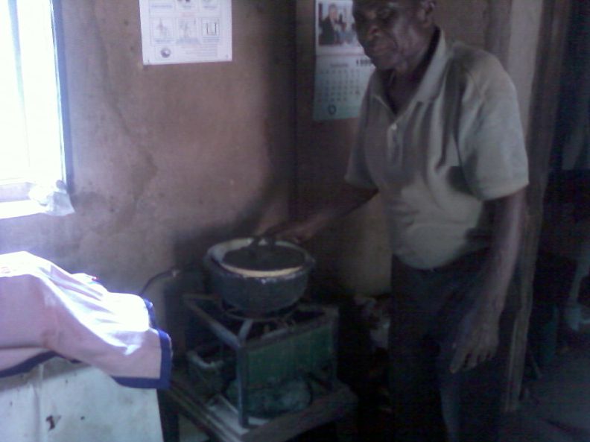
Figure 4. 1: A man in his kitchen explaining how a biogas cooker works
Source: Field Survey (2009)

Drawing from the above discussion on the relationship between household characteristics and tendency for biogas adoption it can be summarized that, except for education level of household head which shows a negative relationship, other factors show positive relationship with biogas adoption. These factors are further subjected to empirical analysis in section 4.5 to see their relationship to biogas adoption when examined against other factors.

4.3.2 Environmental Characteristics and Adoption of Biogas Technology
This section assesses the environmental potential of the study area for biogas technology adoption as summarized in Table 4.9. In the literature (Rajeswaran, 1983) it is provided that biogas technology is viable when the prospective acceptor is driven to the necessity of encountering physical limit to the amount of fuel available from the traditional sources. In the study area fuel wood is the primary energy source hence its scarcity is assumed to be a driving force for people to adopt biogas technology as an alternative energy source. Apart from finding a solution to firewood scarcity, biogas technology has got principal requirements without which it is impossible for a household to adopt the technology. These requirements include availability of feed-stocks and adequate supply of water for effective operation of biogas plants.

4.3.2.1 Fuel wood Scarcity
The primary energy source for domestic use in the study area is fuel wood in form of firewood or charcoal. Findings in Table 4.9 indicate that 69.7% of respondents experienced shortage of fuel wood while 22% of respondents indicated that the fuel wood was no longer available in their area. As indicated in study area description that due to fuel wood scarcity people have opted to use wastes like crop residuals, rice husks, sawdust and wood shavers, and oil seed cakes.

During field visit in Chiwe village the researcher could meet women and children carrying bundles of crop residuals from the farms for cooking. These wastes are seasonal and unreliable and cooking power from these residuals as per users explanation is very minimal. The shortage of fuel wood implies that people will have to look for alternative energy sources which are more efficient for domestic use.
Table 4. 9: Environmental characteristics in relation to biogas technology adoption
Characteristics of study district | Kongwa  N=161 | Bahi  159 | Total  N=320
Availability of wood-fuel  Easily available  Not easily available  Not available  Total  Availability of feed-stocks for  biogas plants  Respondents who own cattle  Respondents who do not own cattle  Total  Type of livestock management:  Zero grazing  Semi grazing  Outdoor grazing  Total  Availability of pastures  Easily available  Not easily available  Not available  Total  Availability of water  Easily available  Not easily available  Not available  Total | 1.2 ( 2)  62.7 ( 101)  36.0 ( 58)  100.0 ( 161)  69.6 (112)  30.4 (49)  100.0 (161)  19.5 (15)  3.9 (3)  76.6 (59)  100.0 (77)  0.9 (1)  71.3 (82)  27.8 (32)  100.0 (115)  47.2 (76)  50.3 (81)  2.5 (4)  100.0 (161) | 15.7 (25)  76.7 (122)  7.5 (12)  100.0 (159)  53.5 (85)  46.5 (74)  100.0 (159)  10.3 (6)  1.7 (1)  87.9 (51)  100.0 (58)  12.1 (14)  78.4 (91)  9.5 (11)  100.0 (116)  52.2 (83)  45.9 (73)  1.9 (3)  100.0 (159) | 8.4 (27)  69.7 (223)  21.9 (70)  100.0 (320)  61.6 (197)  38.4 (123)  100.0 (320)  15.6 (21 )  3.0 (4)  81.5 (110)  100.0 (135)  6.5 (15)  74.9 (173)  18.6 (43)  100.0 (231)  49.7 (159)  49.1 (154)  2.2 (7)  100.0 (320)
Bolded figures are the percentage and the figures in brackets are the number of respondents involved
Source: Field Survey (2009)

Study findings show that Kongwa District has longer distances to firewood sources than Bahi district (Figure 4.2 and Table 4.10). Figure 4.2 indicates that distances to resources, firewood in particular have increased with time, where 10 years ago the distances were about 2 km from homesteads but today they are above 10 km in some places. This implies that the demand for energy solution was also increasing with time; hence of the necessity to adopt alternative energy technologies such as biogas.
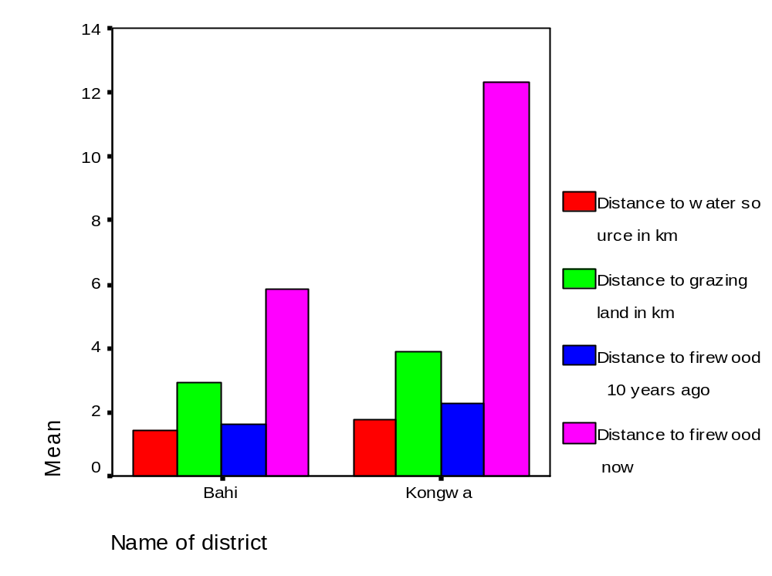
Figure 4. 2: Distance to important resources pre-requisites for biogas technology
Source: Field Survey (2009)

Table 4.10 provides detailed records of the distances to firewood sources from villages selected for study. The table indicates that Chiwe village in Kongwa District was the most affected by fuel wood scarcity, where 100% of its respondents collected firewood from distances 10 km and above as compared to Mayamaya village in Bahi District with 68% of respondents collecting firewood in less than 2kms from homesteads. The implication of distance to firewood sources on biogas adoption is shown by the number of biogas plants built per villages. Chiwe village had the highest number of Biogas plants (17 biogas plants) as compared to Mayamaya village which had only one biogas plant. Long distances to firewood sources in Chiwe have compelled people to adopt biogas technology while in Mayamaya village where firewood is easily available people do not see the necessity of adopting alternative energy. This was supported by explanation from the Village Executive Officer in Mayamaya village, who had this to say:
“Watu hawaoni sababu ya kujengewa mitambo ya biogas kwa gharama kubwa wakati mapori bado yapo karibu”. Meaning, “People do not see the reason of adopting such an expensive installation while the forests are still nearby”.

This view held by the village leader if generalized to other peoples’ perceptions in the area promises to be unhealthy to the environment and counteractive towards efforts for promotion of use of alternative energy sources.

The findings above imply that the demand for an alternative energy source was high in villages which were more affected by shortage of fuel wood. This result tallies with that of Adesina et al., (2000) who observed that the adoption of alley farming was higher in areas with problem of fuel wood than areas with plenty of fuel wood. However these findings reveal the ignorance of people on what is about to happen in near future and for the coming generations due to the fact that the demand for resources are on increase while the supply is diminishing as a result of population growth. Generally, despite the shortage of fuel wood, in the study area hence demand for a solution of energy problem, biogas technology has not yet been accepted as an alternative energy source. This implies that there were other factors which strongly influenced adoption of biogas technology against the need to find a solution to energy problem.
Table 4.10: Population % vs. distances to firewood source among the study villages
Name of  District | Name of  Village N=20 | 0 – 2kms | 2.1- 4  Km | 4.1-6  Km | 6.1-10  Km | Above 10  Km
Kongwa  Bahi | Chile  Hogoro  Iduo  Ihanda  Mlali  Ndurugumi  Suguta  Songambele  Average %  Of Pop.  Chibelela  Kigwe  K/Ndege  Mayamaya  Mkondai  Mndemu  Mtitaa  Ibihwa  Average% of  Popn | 0.0 (0)  0.0 (0)  0.0 (0)  0.0 (0)  0.0 (0)  0.0 (0)  0.0 (0)  0.0 (0)  0.0 (0)  0.0 (0)  0.0 (0)  66.0 (13)  68.0 (14)  61.0 (12)  10.0 (2)  20.0 (4)  5.0 (1)  29.0 (6) | 0.0 (0)  0.0 (0)  0.0 (0)  0.0 (0)  5.0 (1)  0.0 (0)  5.0 (1)  0.0 (0)  1.0 (1)  5.0 (1)  0.0 (0)  24.0 (5)  32.0 (6)  11.0 (2)  21.0 (4)  40.0 (8)  65.0 (13)  25.0 (4) | 0.0 (0)  5.0 (1)  0.0 (0)  0.0 (0)  15.0 (3)  15.0 (3)  30.0 (6)  30.0 (6)  12.0 (2)  35.0 (7)  35.0 (7)  10.0 (2)  0.0 (0)  28.0 (6)  68.0 (14)  30.0 (6)  30.0 (6)  29.0 (6) | 0.0 (0)  20.0 (4)  25.0 (5)  65.0 (13)  45.0 (9)  30.0 (6)  35.0 (7)  28.0 (6)  31.0 (6)  30.0 (6)  65.0 (13)  0.0 (0)  0.0 (0)  0.0 (0)  0.0 (0)  10.0 (2)  0.0 (0)  13.0 (3) | 100.0 (20)  75.0 (15)  75.0 (15)  35.0 (7)  35.0 (7)  55.0 (11)  30.0 (6)  42.0 (8)  56.0 (11)  30.0 (6)  0.0 (0)  0.0 (0)  0.0 (0)  0.0 (0)  0.0 (0)  0.0 (0)  0.0 (0)  4.0 (1)

Bolded figures are the percentages and the figures in brackets are the number of respondents involved
Source: Field Survey (2009)

Another indicator of fuel wood scarcity is time spent for firewood collection whereby 58% of the respondents reported to spend more than 5 hours for firewood collection (Figure 4.3). Firewood collection as per literature is a task mainly done by women and children. This implies that women spend most of their day time for firewood collection, a factor which affects their efficiency to perform other more productive work. On the other hand firewood collection is also laborious and consumes human energy, when accompanied by cooking exercise in a smoky environment they result to negative effect on women and children’s health. Among the aims of introducing biogas technology was the need to lessen women’s workload and improve their health; with the ultimate goal of influencing the decision of households to adopt biogas technology. But is the aim of the technology equally perceived by the beneficiary of the technology and the decision maker in the household? This is clarified in section 4.3.1.6 of this chapter.
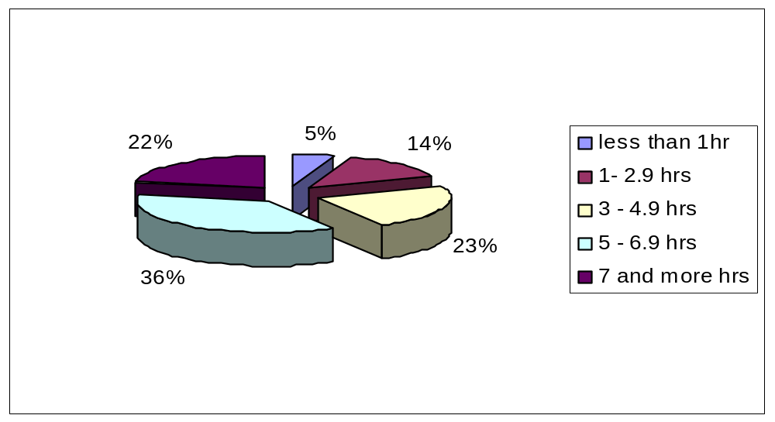
Figure 4. 3: Time spent for firewood collection in the study area
Source: Field Survey (2009)

Furthermore in cases where households could not engage directly in firewood collection, purchase of firewood and charcoal was their alternative. For this category of people, the increasing costs of available sources of energy pose a challenge to them and were likely to motivate them to adopt alternative technologies. Table 4.11 indicates the costs of firewood ranging from Tshs 500/= to 1500/= per firewood bundle and that of charcoal ranged from Tshs 3000/= to 9000/= per bag of charcoal, depending on location of the place from sources of the wood-fuel.

Table 4. 11: Population % vs. Costs of firewood and charcoal in the study area
Cost in Tshs | Kongwa District | Bahi District | Total
Cost of firewood per bundle;  Tshs ≤ 500  Between 501 – 1000  Above 1000  Total | 1.2 (1)  70.6 (60)  28.2 (24)  100.0 (85) | 49.2 (65)  50.8 (67)  0.0 (0)  100.0 (132) | 30.4 (66)  58.5 (127)  11.1 (24)  100.0 (217)
Cost of Charcoal per bag:  Between Tshs 3000 - 5000  Between Tshs 5001 – 7000  Above Tshs 7000 | 16.1 (9)  80.4 (45)  3.6 (2)  100.0 (56) | 93.0 (53)  7.0 (4)  0.0 (0)  100.0 (57) | 54.9 (62)  43.4 (49)  1.8 (2)  100.0 (113)
Bolded figures are the percentages and the figures in brackets are the numbers of respondents involved
Source: Field Survey (2009)

A firewood bundle for instance normally lasted for two to three days depending on the family size; hence per week a household spends about four firewood bundles that costs about Tsh 2000/= to 4000/= per week which is 8000/= to 16000/= per month. This cost, according to the respondents is significantly high for the majority low-income rural residents.

The above mentioned fuel wood scarcity indicators including increased distances to firewood sources, time spent for firewood collection and increased costs of firewood and charcoal, suggest that there is a need for alternative energy sources. The need for alternative energy sources was further expressed by the respondents during household interviews as well in focus group discussions. During focus group discussion one woman in Chiwe village had this to say:
“Mapori yanazidi kuisha, tunahitaji nishati mbadala kwa kupikia vinginevyo hali ni mbaya” that means “the forests are continually diminishing; we need alternative energy for cooking otherwise the situation is worsening”.

Men also expressed their concern on the need for alternative energy, even though their priority was different from that of women. During focus group discussion one man had this to say;
“Tunahitaji nishati mbadala kwa ajili ya umeme wa kuchajia simu, mwanga, kupigia pasi na friji tuweze kufanya biashara ndogondogo” that means, we need alternative energy source to provide electricity for charging our mobile phones, lighting, ironing and refrigerators so that we can ran small businesses”.

This difference of priority between men and women may have implication on adoption of biogas technology in relation to decision-making system. This as discussed under section 4.3.1.6 implies that men who are decision makers might not opt for biogas technology if there were other alternatives for their purpose.

All these expressions indicate that people in the study area have recognized that the fuel wood problem does exist and that there is a need for finding a solution. During household interviews respondents were asked to suggest ways they thought could alternatively solve the current fuel wood problem. Responses in Table 4.12 indicate that 30.7% of respondents mentioned alternative energy source as a solution to fuel wood problem. However a majority 31.7% of respondents mentioned migrating to unaffected areas or nearby forests as a solution to fuel wood problem. This response further reveals the ignorance of people on the future prospects, where people are forced to survive today on the expense of the environmental destruction while compromising with future requirements of the same.

Table 4. 12: Responses on solutions to fuel wood problems
Suggested solution | Respondents
Migrating to unaffected areas  Looking for alternative energy sources  Ownership of land to encourage tree planting  Banning charcoal business  Prevent wildfires | 31.7 (101)  30.7 (98)  10.5 (35)  12.7 (40)  14.5 (47)
Total | 100.0 (320)
Bolded figures are the percentages and figures in brackets are the number of respondents involved
Source: Field Survey (2009)

4.3.2.2 Availability of Feed-stocks for Biogas Plants
Another requirement for biogas technology is availability of feed-stocks for biogas plant. Cow dung is the common feed-stock for biogas plants in the study area. Findings in Table 4.13 indicated that 62 % of the respondents owned cattle hence availability of feed-stocks for a greater proportion of the population. Findings in Table 4.13 further indicate that 54.8% of the respondents who own cattle did not adopt biogas technology. This implies that cattle ownership does not necessitate the adoption of biogas technology. Though an interesting feature from the same table was that, 17% of respondents who did not own cattle had adopted biogas technology. This category of biogas adopters revealed that during biogas installation they had cattle but with time they either lost their cattle due to theft or sold them to cover other household running expenses including school fees for their children. These biogas adopters are able to operate their biogas plants by obtaining feed-stocks from their neighbors who happen to own a large number of cattle. Sharing of feed-stocks among society members has got a positive implication on sustainability of the biogas technology in terms of feed-stocks availability. However on the other side it is also true that where there are no such sharing opportunities, the uncertainty of cattle ownership where, the household having cattle today may not have them in future, this situation challenges the sustainability of biogas technology.

Table 4. 13: Cattle ownership by respondents in the study area
Cattle ownership | Biogas adopter  N=79 | Non adopter N=241 | Total  N=320
Respondents who Own cattle | 82.3 (65) | 54.8 (133) | 61.6 (197)
Respondents who Do not own cattle | 17.7 (14) | 45.2 (108) | 38.4 (123)
Total | 100.0 (79) | 100.0 (241) | 100.0 (320)
Bolded figures are the percentage and those in brackets are the number of respondents involved
Source: Field Survey (2009)

Shortage of feed-stocks for biogas plants was emphatically expressed by respondents in Chiwe village. Chiwe is a village with the highest number of biogas plants in the study area but it is greatly affected by the disappearance of forests and grazing land near the village as a result, livestock keepers particularly men, have to migrate with their cattle to distant places (about 25 km from their homesteads) especially during dry seasons searching for pastures. During such periods there are no feed-stocks for biogas plants as it was noted during the survey period that most of the biogas plants in this village were dry showing that they were not fed for some months.

Type of cattle management is another determinant of the availability of feed-stocks. Findings in Table 4.9 indicate that 81.5% of respondents managed their animals by outdoor grazing. The findings in the same table further indicated that pastures were not easily available (75% of respondents); this implies that cattle had to walk long distances in search for pastures. This affects the quantity and accessibility of the cow dung due to the fact that it is not easy to collect the scattered dung from walking animals; only a small amount of dung is collected from cattle sheds dropped during the night. This affects the availability of feed-stocks and impedes the operation of biogas plants. During focus group discussion in Chiwe village, one group participant, in a disappointed mood, asked the researcher:
“Hivi hakuna kitu kingine cha kulisha hii mitambo ya biogas badala ya kinyesi cha ng'ombe”? Meaning that “Isn’t there any other type of feed-stocks for biogas plants apart from cow-dung”?
This expression indicated that biogas adopters needed more information and training on alternative feed-stocks for sustainability of biogas technology instead of depending on mono source which showed to be unreliable.

4.3.2.3 Availability of Water Supply
Water is another critical requirement for biogas technology because it serves both livestock keeping and biogas plants operations. An equal amount of water and/or urine needs to be mixed with feed stocks like cow dung before it is fed into a biogas plant. Findings in Figure 4.2 above indicate that the sample population had access to water supply within a distance of 2km from homesteads. The finding corresponds to that of Schmitz (2007) who found that water is available to rural Tanzanian households to a share of 55% within one km even in dry season.

In addition to water accessibility it was also reported that in areas with shortage of water, the biogas project mitigated the problem by integrating water harvesting systems in its biogas schemes when deemed necessary. However from field observations it was noted that very few households (2 out of 10 households,) afforded the costs of water harvesting tanks, the costs which were separate from those of biogas plant installation and were not subsidized as biogas plants.

Furthermore, during focus group discussions, women in villages experiencing water shortages expressed their concern that, time which was expected to be saved from firewood collection as a result of adopting biogas technology, is almost the same as the time spent for water fetching required for biogas plants hence the new technology makes no difference. Sasse (1988) asserts that if a biogas plant is far from water source and from the cow sheds, a housewife must perform additional work. According to Sasse (opp.cit), the distance to water source should be less than a quarter of the distances to firewood collection sources. For villages which experience shortage of water this could pose a barrier for biogas adoption.

4.3.3 Technological Characteristics and Adoption of Biogas Technology
Technological characteristics of an innovation are very important determinants of its adoption. This study focused on the availability of maintenance services deemed necessary for good performance of biogas plants and technical support services which are assumed to be the determinants of the cost of construction and quality of biogas plants. The study also focused on the realization of perceived benefits of biogas technology which in turn facilitates dissemination of information to potential adopters of the technology and influences the adoption of biogas technology.

4.3.3.1 Availability of Technical Support Services
Unreliable technical services were a common problem reported by respondents during household interviews and in focus group discussions. There were respondents who had not yet adopted biogas technology and showed interest to adopt it but they couldn’t access technical staff for detailed information on procedures of construction. This was also confessed by a biogas project informant who revealed that the project did not have enough technical staff to carry out construction work. Maintenance services on the other hand were reported by biogas users to be unreliable as a result of unreliable visits of technical staff (Figure 4.4) this impeded the functioning of biogas plants. Many biogas plants were not functioning just because of minor repairs that need professional assistance.
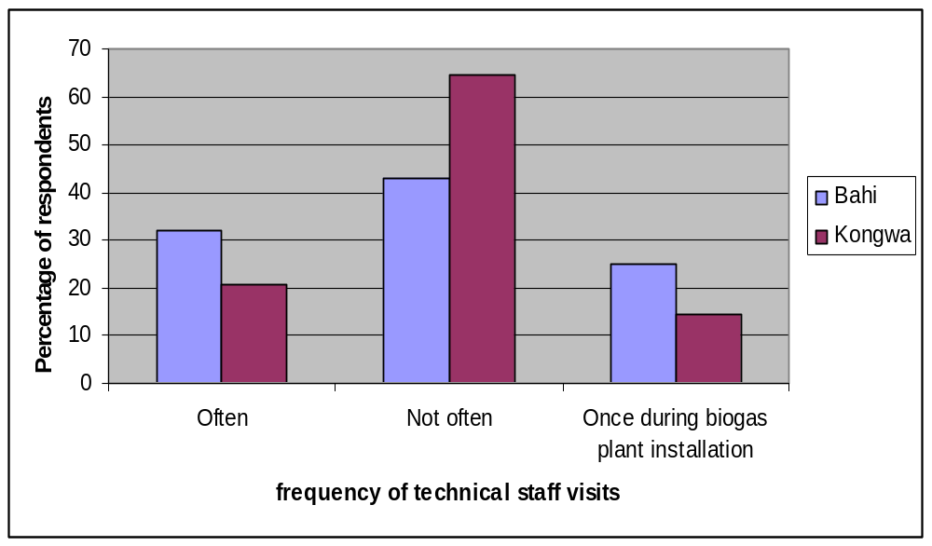
Figure 4. 4: Responses on frequency of technical staff visits to biogas users
Source: Field Survey (2009)

Elaborating on how they access maintenance service, biogas adopters explained that they were give telephone numbers of the project staff, but when they called for service it took a long time sometime up to a month or more for a project staff to turn up for maintenance of a biogas plant. These delayed services accompanied with unavailable spare parts for biogas plants, disappointed biogas users and resulted into abandonment of the technology as a result biogas users continue to use fuel wood as a main source. Unavailability of maintenance services, spare parts and appliances, according to the respondents contributed to poor performance and non- functioning of biogas plants installed in the area.

4.3.3.2 Perceived Benefits of Biogas technology
Another factor of technical nature was the benefits which the biogas technology can offer. It was revealed during focus group discussions that, when biogas technology was being advertised it said that it would to provide energy for cooking, for lighting and also for ironing and refrigeration. However this has not been the case. One Focus Group participant had this to say:
“Nilihamasika sana niliposikia kwamba kwa kupitia teknologia ya biogasi naweza kutumia pasi ya kisasa na friji huku kijijini! Meaning, “I was highly excited that with biogas technology I can use modern pressing iron and a refrigerator in a village!”

These promises had motivated rural residents to adopt biogas technology with the hope that they would access a kind of modern energy source that would release them from kerosene, firewood, and charcoal expenses. Unfortunately some of the advertised benefits of biogas technology were not realized by biogas users, as revealed in group discussions at four selected villages (Table 4.14).

Table 4. 14: Focus group responses on unrealized benefits of biogas technology
Villages | Mtitaa | Kisima cha ndege | Chiwe | Mlali
Responses on unmet expectations by biogas users | 1. Biogas benefits never experienced due to incomplete biogas plants constructions | 1. Fast cooking is not a reality.  2. Lighting for sitting rooms only, add itional lamps are too expensive (Tsh 60,000/= per lamp). | 1. Promises of diary cattle became reality only to few villagers  2. Uses of biogas for ironing and refrigeration were not a reality. | 1. Gas cookers are too small for big families hence use of firewood continues  2. Cooking for simple foods only  3. Lighting hindered by lack and expensive appliances
Source: Field Survey (2009)

According to focus group discussions, of all advertised benefits, only lighting was appreciated. Though this benefit again was reported to be faced with a challenge of high costs of additional lamps, where one lamp costs about Tshs 60,000 which was claimed to be unaffordable to majority of rural people. Other advertised benefits like refrigerators and modern pressing iron have never been realized and left the biogas users disappointed. Unrealized technology benefits negatively affect people’s attitudes towards the technology and impede its adoption.

Lighting as a biogas advantage was frequently discussed by men who showed interest in it with a reason that, it would relieve them from kerosene and charcoal expenses for cloth ironing. The men also expressed that the promise of refrigerators was thought to enable them carry out small businesses like selling of soft drinks and ice creams for supporting household economy. This indicates that shortage of fuel wood for cooking has not been perceived by men as a major problem to be solved by biogas technology as compared to the use of electrical appliances like pressing iron and refrigerators. Due to this priority differences between men and women, men who are decision makers in the household, may not decide to adopt biogas technology if there are other alternatives for their purposes. Despite difference on priority, had the expected benefits of biogas technology been realized, they would have positively influenced adoption of the technology.

The group discussion opinions in Table 4.14 support the household responses as indicated in Table 4.15 which expresses reasons on the continued use of fuel wood as the main source of energy for domestic use. The major reason is inadequate cooking power due to little gas production and inability to last long. The size of cookers was also reported by respondents to be too small to support large cooking utensils for large families. On the other hand, fast and clean cooking was one of the main benefits of biogas technology. According to the interviewed adopters fast cooking was reported to be possible only for simple foods like tea, porridge, vegetables, and milk; but not for other types of food which require long time to cook, for instance beans which in most households accompanies most dishes.

The result of this inadequacy of biogas technology is the continued use of fuel wood, such as firewood and charcoal as the main sources of energy (Figure 4.5) which has lead to the continued harvesting of forests for fuel wood despite the existence of biogas project in the study area.

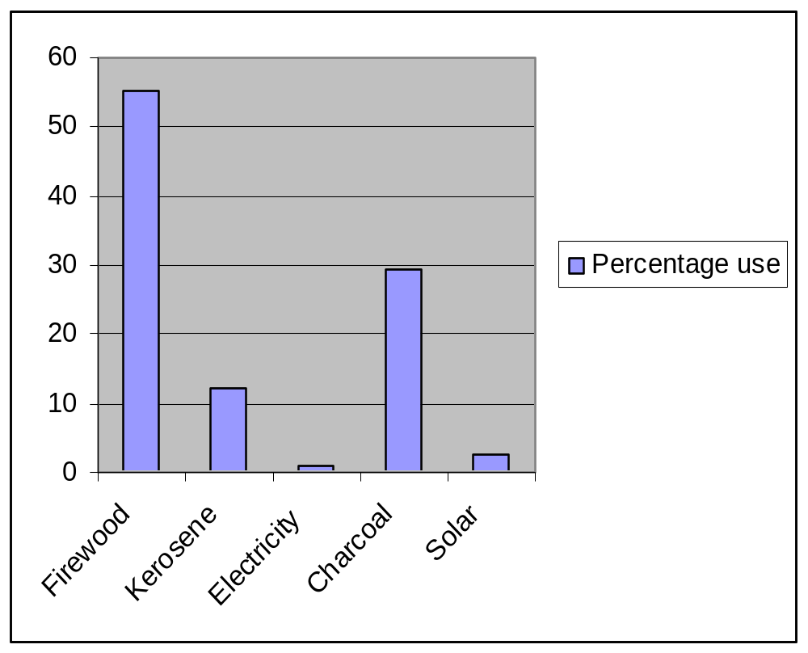
Figure 4. 5: Other energy sources than biogas used by biogas users
Source: Field Survey (2009)
Table 4. 15: Biogas adopters' reasons for continual use of other energy sources
Reasons | Respondents
Biogas plant is not functioning  Gas produced is not enough  Gas cookers are too small to hold big cooking utensils  More used to firewood and charcoal than other sources  Some foodstuff are not cooked properly | 27.5 (21)  30.2 (24)  15.9 (13)  10.7 (8)  16.7 (13)
Total | 100.0 (79)
Bolded figures are the percentages and those in brackets are the numbers of respondents involved
Source: Field Survey (2009)

In order to ensure sustainable and effective use of biogas technology as an alternative energy source, a number of initiatives need to be carried out towards improving the technology. The first is to conduct needs assessment to identify the actual needs of biogas users and incorporate them in manufacturing of appliances. Technical improvement needs to be effected in capacity of cookers, and its gas production which have something to do with size, types of the digesters and types of feed stocks for the digesters. Also other uses of biogas energy for ironing of clothes and refrigeration need to be included in needs assessment, things which this study has not attempted to investigate in details.

4.3.3.3 Performance of Biogas Plants
Result in Figure 4.6; indicate that about 47% of installed biogas plants in the study area were not functioning. 47% of constructed biogas plants not functioning is an alarming rate which means almost 50% of biogas adopters are not enjoying the benefits of their investments. It needs a close attention from biogas programmes and government intervention as people have invested their resources and also for the reputation of the technology. Figure 4.6 also shows that Kongwa district is doing better with biogas plants than Bahi district; this can be explained by income differences as indicated in Table 4.2 that, people in Kongwa can afford maintenance costs as compared to people in Bahi. Another explanation can be the accessibility to technical services as observed during field trips that villages in Kongwa district are more accessible by roads than Bahi villages, this make it easy for technicians to visits Kongwa than Bahi villages. Kongwa district is more affected by deforestation as indicated by longer distances to firewood sources than Bahi; hence people in Kongwa seemed more careful with their biogas plants as it is their alternative to domestic energy problems. The major reason for non-functioning plants as mentioned by respondents were technical problems indicated by 58% of respondents (Figure 4.7).
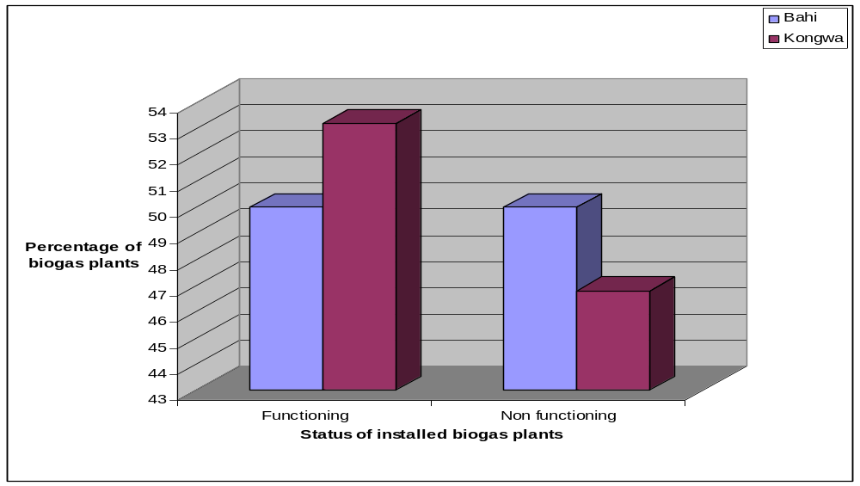
Figure 4. 6: Status of constructed biogas plants in the study area

Source: Field Survey (2009)
Other mentioned problems included incomplete construction of biogas plants, lack and/or expensive appliances like lamps, unavailable spare parts like cocks, pipes which were not locally accessible and unreliable maintenance services. Low gas production was explained by a biogas project informant to be caused by insufficient feeding of the biogas plants in relation to plant size. A majority of installed biogas plants were of large size 10 – 16 sq meters which required a large amount of feed stocks which were not affordable to most households. This as per project informant has necessitated the review and modification of biogas plants and that the project nowadays constructs smaller biogas plants of 6, 8, 10 sq feet (MIGESADO, 2009).

During field survey the researcher noticed some incidences which confirmed the technical problems mentioned by respondents. One incidence was a biogas plant (16m size) which was almost completely constructed with only pipes missing, was abandoned in a farm at Ihanda village.

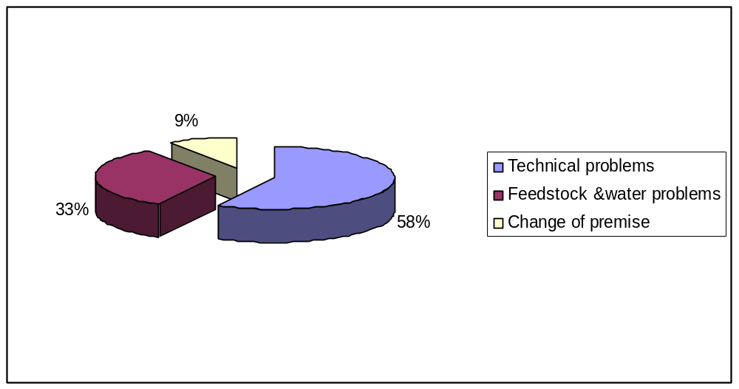
Figure 4. 7: Reasons for non-functioning biogas plants
Source: Field Survey (2009)
The reason for abandonment, explained a ten cell leader was that the head (a father) of the particular household had died before completion of the work and no other family member, wife or children were able to make follow ups to the project for completion of the work. Later on this affected household decided to shift to another place leaving behind the biogas plant abandoned in the farm under no one’s care. Anybody who knows the actual cost of biogas plant would be surprised to see such an expensive structure being abandoned in the farm with no one bothering about it.

Another incidence was that one household in Mtitaa village decided to turn its biogas plant into an underground crop storage tank due to incomplete construction of the plant. The reason for incomplete construction of the biogas plant, according to the owner is the failure to pay to the biogas project, the last instalment of the installation cost amounting to Tshs 27,000/=. When asked on the reason for not paying the money for his plant to be completed, the household head had this to say:
“Mitambo ya majirani zangu ambayo imeshakamilika kujengwa hata hivyo haifanyi kazi, sioni sababu ya kulipa hela hizo kwa technologia isiyoaminika”. Meaning, “My neighbours’ biogas plants whose construction is completed unfortunately are not functioning! I therefore don't see the importance of paying the money for unreliable technology”.

In Suguta village there were abandoned gas cookers which seemed not to be in use for some years just because the fittings were broken and the user could not easily purchase the fittings from local shops. During a focus group discussion one participant (biogas user) grievingly had this to say:
“Tunachekwa na majirani zetu ambao hawakuipokea teknologia hii, wanatuona kama tumepoteza fedha bure”. Meaning, “We are being mocked by our neighbours who didn’t adopt the technology and they labelled us as losers whose money was wasted”.

Non-adopters of biogas technology on the other hand were as well disappointed by non-functioning of biogas plants. During focus group discussion one man (biogas non adopter) in Chiwe village had this to say:
“Mtambo wa jirani yangu haujawahi kufanya kazi tangu umejengwa, kwanini na mimi nitupe hela yangu kwa kitu kisicho na faida? Interpreted as, “My neighbors' biogas plant has never functioned since it was constructed, why should I waste my money for something which is not advantageous?”

These were just few among several incidences the researcher came across in the field. From the above incidences, one easily captures the disappointment of both biogas adopters and non-adopters or potential adopters of biogas technology. These findings portray a different picture from the comment given by Tanzania Biogas Stakeholders Group Mission which, after their technical assessment conducted in Tanzania on July 2008, the Group commented that:
“Even with little training to masons and minimum supervision, the quality of construction and workmanship of biogas plants has been good, resulting in the majority of the users being satisfied with the performance of their biogas plants” (Ngwandu et al., 2009).
This difference in results could be due to locations where the study was conducted or sampled population but also due to the purpose of the study. For instance, the study done by the group was purposely for the formulation of Implementation Document for a Tanzania National Domestic Biogas Programme (TDBP) so the comment given above could be a justification for the programme implementation. The dissatisfaction of biogas adopters due to poor performance of biogas plants in the study area was clearly expressed as per findings under this section and has negative implications to the adoption of biogas technology. These findings concur with Ghimire (2008) who comments that none functioning or poorly functioning bio-digesters because not only capital waste but also do a lot of harm to the reputation of the technology itself and to the desired future of biogas programme. Schmitz (2007) with the same observation comments that good performance and reliability of biogas plants are good advertisements for biogas technology in Tanzania. The satisfied biogas users on one hand are the main and effective extension media for the promotion of the technology. On the other hand, dissatisfied biogas users spread negative information about biogas technology, hence reduce its adoption.

Probably one of the major causes of biogas failures is the lack of extension services, servicing facility for the plants and technical support services from the government and private sector. Furthermore the subsidy approach used by the biogas project in introducing the technology in the area, on one hand encouraged and enabled low income earners to adopt biogas technology. On the other hand, the subsidy approach had a negative implication on people not valuing their biogas plants. For the households who contributed very little, say 15% of total installation costs, they would not feel the responsibility of taking care of such an expensive installation. The current proposed commercial based approach by National Biogas Programme with financial support through easy loan is a recommendable approach. This enables rural people to afford the plant’s construction costs by paying in instalments while at the same time valuing their investments.

4.4 Peoples’ Awareness and Attitude towards Biogas Technology
Awareness and attitude are the first stages of adoption process as per conceptual framework and they are influenced by various factors leading to a decision to adopt or not adopt the technology. This section answers objective number two of this study which seeks to assess peoples’ awareness and attitude towards biogas technology.

4.4.1 Peoples’ Awareness on Biogas Technology
From the findings of the study (Figure.4.8), 82% of the respondents acknowledged that they had at least heard about biogas technology. This implies that people in the study area were aware of the existence of the biogas technology in their area; this might have been caused by the existence of biogas project in the area for about sixteen years up to this study period 2009.

However, awareness of the existence of biogas technology in the area does not necessarily mean awareness of the technology itself. Awareness of the technology involves people getting detailed information about the technology: what it is, how it functions, its advantages and its financial aspects, for it to be able to influence people’s decisions on its adoption.
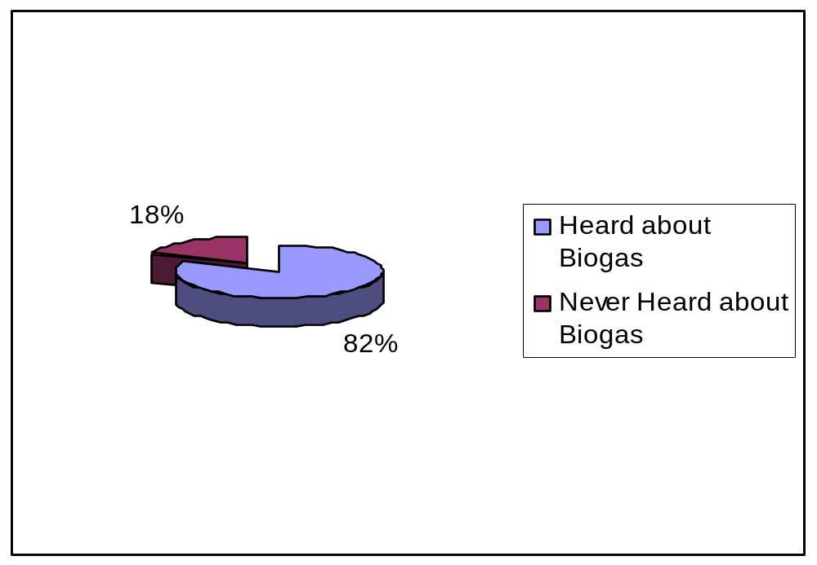
Figure 4. 8: Awareness of biogas technology in the study area
Source: Field Survey (2009)

Assessment of the information level on biogas technology in the study area, the respondents were required to indicate if they had attended awareness creation activities such as workshops, training, meetings, campaigns and demonstrations on biogas matters. Findings in Table 4.16 indicate that 72.4% of non-adopters of biogas technology had never attended any of the activities compared to 19.7% of adopters. In totality about 60% of all respondents had never attended any awareness creation activity. This implies that a majority of people in the study area have just heard about biogas technology but have no detailed information of the technology. These results tally with Kambele (2003) who observed that, in Arumeru district people did not have sufficient information on biogas technology, they had just heard about the technology. Lack of detailed information can have a negative effect on the way information is disseminated in relation to plants to the potential adopters and on the operations of biogas plants resulting into poor performance of biogas plants which in turn disappoints both adopters and potential adopters of the technology.

Table 4. 16: Respondents who attend biogas awareness creation activities
Activity | Non adopters | Adopters | Total
Seminars/workshops on biogas technology  Village meetings with biogas project officials  Visited by biogas project staff at home  Demonstration on biogas operations  Never attended any of the activities | 1.7 (4)  19.2 (46)  5.9 (14)  0.8 (2)  72.4 (173) | 34.2 (26)  32.9 (25)  7.9 (6)  5.3 (4)  19.7 (15) | 9.5 (30)  22.5 (71)  6.3 (20)  1.9 (6)  59.7 (188)
Total | 100.0 (239) | 100.0 (76) | 100.0 (315)
Bolded figures are the percentages and those in brackets are the number of respondents involved
Source: Field Survey 2009

Furthermore awareness alone is not enough to influence the adoption of an innovation. According to Rogers (1995), awareness is just the first stage of adoption process, and it has to be followed by accumulation of knowledge which in turn induces the perception of people on the technology. The accumulation of knowledge is a result of continuous efforts of acquiring information concerning the introduced innovation. Responding to household interviews on knowledge of biogas technology, 48.4% (Bahi District) and 44.7% (Kongwa District) respondents claimed to have little knowledge, while 45.3% Bahi and 41.6% Kongwa respondents claimed to have no knowledge at all (Table 4.17). This finding was supported by biogas project informant who admitted that the project focused more on construction of biogas plants, but little was done on educating people about the technology on continuous basis. After construction of biogas plants the adopters were left with a written brochure hoped to guide the user on biogas plants operations, but during household interviews very few respondents were able to show their brochures while a majority no longer owned theirs as they had either lost or destroyed them.

Table 4. 17: Respondents' knowledge on biogas technology
Knowledge level | Bahi | Kongwa | Total
No Knowledge at all  Little knowledge  Moderate knowledge  Much knowledge | 48.4 (77)  45.3 (72)  5.0 (8)  1.3 (2) | 44.7(72)  41.6 (67)  11.8 (19)  1.9 (3) | 46.6 (149)  43.4 (139)  8.4 (27)  1.6 (5)
Total | 100.0 (159) | 100.0 (161) | 100.0 (320)
Bolded figures are the percentages and those in brackets are the number of respondents involved
Source: Field Survey (2009)

During focus group discussion, biogas adopters also claimed to have little knowledge on operations of biogas plants as well as on emerging obstacles hence suggested for more education on such areas. Another area of concern was lack of education on other feed stock materials for biogas plants to compensate unavailable cow-dung (Table 4.18). Little knowledge can be among reasons which have lead to non-functioning of about 47% of all constructed biogas plants in the study area as discussed in section 4.3.3.3. Little knowledge on biogas technology among the people while the project has been with them for about 16 years can indicate the inadequate awareness creation by biogas actors or lack of interest towards the technology by targeted population.

Table 4. 18: Responses on issues which education is required by biogas adopters
Villages | Mtitaa (Bahi) | Kisima cha Ndege (Bahi) | Chiwe (Kongwa) | Mlali  (Kongwa)
Issues require education | 1. Plants operations  2. Emerging shortcomings and their remedies  3. Education to the whole community hence not discouraging adopters | 1. Plant operation, one day seminar is not enough.  2. Expected problems and how to solve them | 1. Feed-stocks other materials than cow dung which can be used for feeding the plant | 1. Feed-stocks other materials than cow dung which can be used for feeding the plant
Source: Field Survey 2009

4.4.2 Peoples’ Attitudes towards Biogas Technology
The awareness level as a result of continuous knowledge influences peoples’ attitude towards the new technology. Attitude is a crucial element in implementation of the technology and it can be a powerful activator or a barrier towards adoption of a technology (Abukhzam and Lee, 2010). This section assesses the respondents’ attitudes towards biogas technology using Attitude Index as explained in section 3.10.2.

In order to measure respondents’ attitude several statements related to positive attributes of biogas technology were developed and respondents were required to indicate whether they agreed or disagreed to the statements. Agreement was taken to infer positive attitude and disagreement inferred negative attitude towards biogas technology. Table 4.19 shows responses on the known advantages of biogas technology by respondents, it provides advantages that would have positive influence on the individual attitude and hence adoption of biogas technology.

Table 4. 19: Respondents attitudes towards biogas technology
Statement (Variable) | Agree |  | Undecided |  | Disagree
 | Adopters | Non Adopters | Adopters | Non  Adopters | Adopters | Non  Adopters
B 1- BT provides cheaper energy  B2 - BT solve firewood problem  B3 - BT improves soil fertility  B4 - BT reduces deforestation rate  B5 - BT Saves time for firewood collection  B6 - BT benefits overweighs its weaknesses  B7 - BT serves as waste treatment system  B8 - BT is recommended as alternative energy for domestic use | 89.9 (71)  89.9 (71)  77.2 (61)  88.6 (70)  93.7 (74)  60.8 (48)  89.9 (71)  65.8 (52) | 3.7 (9)  83.0 (200)  68.9 (106)  78.4 (189)  88.0 (212)  45.2 (109)  45.6 (110)  62.2 (150) | 3.8 (3)  10.1 (8)  22.8 (18)  11.4 (9)  6.3 (5)  35.4 (28)  10.1 (8)  25.3 (20) | 60.2 (145)  16.2 (39)  29.5 (71)  21.2 (51)  12.0 (29)  54.8 (132)  54.4 (131)  34.0 (82) | 6.3 ( 5)  0.0 (0)  0.0 (0)  0.0 (0)  0.0 (0)  3.8 (3)  0.0 (0)  8.9 (7) | 35.7( 87)  0.8 (2)  1.7 (4)  0.4 (1)  0.0 (0)  0.0 (0)  0.0 (0)  3.7 (9)
Bolded figures are the percentage and those in brackets are the number of respondents involved
Source: Field Survey (2009)

The results in Table 4.19 indicate that generally the scores for agreement with the statements were higher than disagreement with the statements for both adopters and non-adopters of biogas technology. This implies that a majority of respondents have positive attitude towards the technology. However the scores for biogas adopters were higher in all statements than for non-adopters indicating that the known advantages of biogas technology to the biogas adopters have positively influenced their attitudes towards the technology. Findings further shows that, non-adopters of biogas technology were neutral with the three statements; B1 (60.2%), B6 (54.8%) and B7 (54.4%). From the three statements, non-adopters of biogas technology could not tell if biogas could provide cheaper energy, if it could serve as waste management strategy or if biogas advantages overweigh its disadvantages. This can be attributed to the fact that non-use of the technology by non-adopters of the technology made them to have no experience of these advantages. Lack of information on advantages has negatively influenced their attitudes hence non-adoption of the technology. To adopters of biogas technology, their neutrality to statements above implies that biogas benefits were yet to be realized by users. Another explanation could be that biogas users’ expectations were higher than what the technology could offer.

Table 4.19 above shows that a majority of respondents have positive attitude towards biogas technology. However when further enquired about their willingness to invest in biogas technology if they were enabled to do so, only 25% of the respondents showed willingness to invest in biogas technology while the remaining 75% (Figure 4.9) showed interest of investing in other activities like small businesses, agriculture and education which were perceived to be more profitable than biogas technology. This implies that people in the study area were not yet convinced that biogas technology could be as profitable as other businesses. This could be attributed by unrealized advantages of the technology as discussed in Section 4.3.3.2 above. Nevertheless people may still see the available primary energy source mainly fuel wood as cheaper and easier to obtain as compared to biogas in terms of labor requirement and preferences of family members involved.
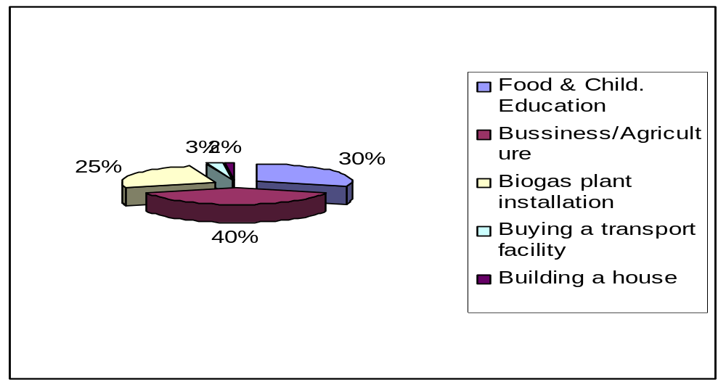
Figure 4. 9: Respondents priorities in investing if enabled
Source: Field Survey (2009

Attitude responses were further captured under the discussion on technological characteristics where both adopters and non-adopter expressed their disappointment towards poor performance of biogas plants. This had negatively affected their attitude on the technology resulting into abandoning using the technology and decrease in adoption rate of biogas technology.

Another attitude aspect that was revealed during focus group discussions concerned connection of latrines to the biogas plant (Figure 4.10). The biogas plant in figure 4.10 is connected to the latrine, a small uncovered bricks building. Connecting to latrine serves as an alternative or additional means of feed stocks to biogas plants. However only few households had connected their biogas plants to the latrines, in Chiwe village, for instance out of 17 constructed plants only 2 were connected to latrines.
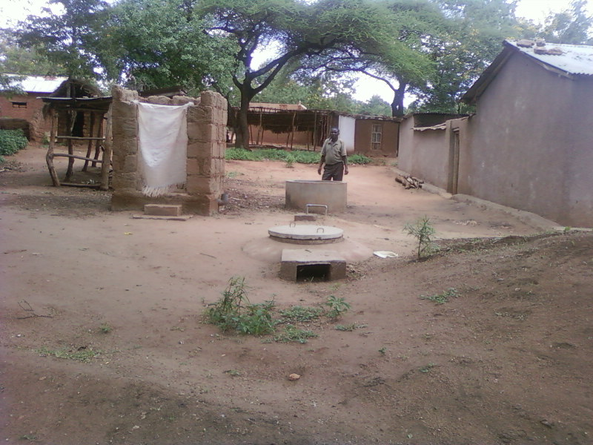

Figure 4. 10: A man at Iduo village explaining how a biogas plant is operated
Source: Field Survey 2009

Asked why they didn’t connect their biogas plants to latrines; household respondents responded that they could not afford cost for latrine construction. This reason was not convincing due to the fact that the construction of latrines using locally available materials were cheaper and affordable to the majority. The latrine in Figure 4.10 for instance, is not an expensive structure as it is constructed using mud bricks by household labor. This response raised a doubt that there could be unexpressed reasons for hesitation on connection of latrines to the biogas plants. The researcher could capture from respondents’ facial expressions that some people were not comfortable with using gas produced from human waste. Captured unaware one lady was heard saying:
“Tutapikiaje gesi iliyotokana na kinyesi cha binadamu, tunaona kinyaa na hiyo harufu je haitaingia kwenye chakula?” that means, “How could we cook using gas produced from human waste, we don’t feel comfortable with it and what about smell, wont it pollute the food?”

Schmitz (2007) in his study also observed the reluctance of biogas users to connect their biogas plants to the latrines. According to Schmitz (2007) the main reason was that users regard handling bio-slurry from toilet connected plants as hazardous or unclean. Connection of biogas plants to the latrine could be an alternative means of supply of feed-stocks in addition to cow-dung which seemed to be unreliable to some household. This was confirmed by one household in Mlali village whose biogas plant was functioning for some months without being fed with cow-dung, only through latrine. This household latrine was located along the way where other people apart from family members were allowed to use it intentionally for additional supply of feed-stocks for biogas plant. People’s perceptions on connection to the latrine suggest for more effort to educate people on scientific approval that the use of human waste as feed-stock for biogas plants is not harmful so as to raise people’s confidence on using it. Connecting to the latrine could prove to be a reliable source of feed stock supply for biogas plants as compared to cow dung which is conditioned by environmental and economical situations.

On the other hand biogas users in Suguta and Mlali villages expressed a positive side of connecting a biogas plant to the latrines. According to focus group discussions, some respondents gave experiences that one advantage is that the gas produced from biogas plants works as repellent to flies in the kitchen and there were cases of it being used as preservative of cereals when biogas released to cereal storage rooms. This as well needs scientific explanation which, if confirmed would add to experienced advantages of biogas technology. Another advantage expressed by the respondents was that biogas plant is a permanent toilet which relieves a household from digging new toilets now and then after the used ones were full.

Another attitude response from discussions above is perception differences in the uses of biogas technology between men and women as discussed under gender Section. Men perceived biogas technology as a modern energy source to supply electricity for electrical appliances like lamps for lighting, pressing iron, refrigerators for running small business while women perceived it as alternative energy for cooking to relieve them from firewood collection. This difference in perception has an implication on decision-making about adoption of biogas technology.

4.5 Correlation of Factors Influencing Adoption of Biogas Technology
This section answers objective number three of this study. The discussion under sections 4.2 and 4.4 analyzed descriptively the relationship between the individual factors and adoption of biogas technology. This section presents the empirical analysis which shows how these factors behave when they are put together. This is due to the fact that no individual factor acts in isolation; they influence one another and in turn influence adoption of biogas technology. Empirical results of econometric model used to determine factors influencing adoption of biogas technology are presented in Table 4.20. From Table 4.20, the fitness of Logit model is measured by Mc Fadden (R2), 53% Mc Fadden value provides a good predictive ability of the model implying that the variables included in the model explain about 53% of the variation in the dependent variable. The chi-square statistics show that the model is highly significant at 1% and 5% confidence levels with p≤0.01 and p≤ 0.05 respectively. Even after excluding ancillary variables, ten out of fifteen variables included in the empirical model were statistically significant.

Table 4. 20: Estimated Coefficients of factors influencing adoption of biogas technology
Variable | Coefficient | Std Error | |P[|Z|>z] | Marginal  Effect
SEX  AGE  HHSIZE  EDUC  INCOME  CATTLE  FWDISTA  AWARENES  ATTITUDE  KNOWLG  WATERAV  TECHAVAI  CREDITSC | 0.5333  1.3621  0.8246  -0.2012  -0.4694  -0.1595  -0.3167  -2.8276  0.6283  1.2020  -1.7899  -1.3325  0.8901 | 0.4616  0.3207  0.4735  0.3402  0.2073  0.3984  0.2870  0.5979  0.3626  0.3898  0.3376  0.5885  0.3887 | 0.9080  0.0000  0.0816  0.0541  0.0235  0.6888  0.2698  0.0000  0.0832  0.0020  0.0236  0.0000  0.0220 | 0.0044  0.1128  0.0683  0.0167  0.0389  0.0132  0.0262  0.2342  0.0520  0.0996  0.0865  0.1482  0.0780
Source: Field Survey 2009

Chi-squared 25.5602
P-value 0.00125
Pseudo R-squared 0 .5332
McFadden 0.5332
Percentage of right prediction 82.278
Percentage of prediction failure 17.722

The results in Table 4.20 show that age of the household heads (AGE) was found to have a positive coefficient value of 1.3021 indicating that, older household heads were likely to adopt biogas technology than the younger ones. This result tallies with that of Simon (2006) who reported that there was a positive relationship between household age and adoption of Rotational woodlot technology. However the present results differ from what Sebyiga (2007) reported; where younger people were more likely to adopt formalized land conservation approaches compared to older farmers. This difference is explained by Shiferaw and Holden, (1997) that if adoption has any relationship with age, it might be due to individuals experience or education, or a reflection of authority, labor availability or sources of income. Relating to the findings of this study, adoption of a capital-intensive technology like biogas can be explained by the fact that aged people have more resources including ownership of cattle, ownership of land and houses hence likely to adopt biogas technology than younger people are. From this study finding the age of household head is therefore statistically significant at 1% confidence level, in influencing adoption of biogas technology.

Results in Table 4.20 further show negative coefficient value (-0.2012) for education level (EDUC) of the household heads. This implies that people with lower education were likely to adopt biogas technology more than people who attained higher education. This observation differs with what was expected and also contradicts other studies (Simon, 2006; Hawassi, 2007; Sebyiga, 2008,) who reported that educated people were more likely to adopt innovations than those who spent few years in schooling. This difference might have been affected by the nature of the technology as explained in section 4.3.2. According to this study, the education level of household head appears to be statistically significant at 5% confidence level but negatively related to adoption of biogas technology.
Household income (INCOME) is statistically significant at 5% confidence level but shows a negative coefficient value of -0.4694. A negative sign implies that lower income earners were more likely to adopt biogas technology than higher income earners. This finding differs from other studies (Kambele, 2003 and Ng’wandu, 2009) which showed that higher income earners were likely to adopt biogas technology than lower income earners. The plausible explanation for this difference could be the subsidy approach used by the biogas project to introduce the technology in the study area, where those who decided to adopt the technology contributed part of installation costs and the remaining part was subsidized by the biogas project. Records provided by the biogas project indicate that the subsidies were rated in four categories relating to the income level of the beneficiary ranging from; 15%, 25%, 45% and 58% of total biogas plant construction costs. The low-income earners received higher percentage of subsidy than higher income earners. This arrangement encouraged lower income earners to adopt the technology. The subsidy effect is detailed under section 4.6.2 of this chapter.

Another explanation on why more low-income households adopted biogas than higher income households is that higher income earners in the villages could afford other energy sources. This was noted during the field survey where some of the wealthy households used charcoal for cooking and installed solar PVs for lighting and other electrical appliances. For villages which are connected to the national/mini grids wealthy households were connected to electricity supply. The respondent in such household perceived solar energy and electricity as more advanced alternatives sources compared to biogas technology. This finding supports what Schmitz (2007) observed in his feasibility study on biogas technology in Tanzania, that rich people who would more easily afford biogas plants costs have been reluctant to invest in biogas technology. For this category of people there were other factors which had influenced their decision to adopt biogas technology, beside high installation costs, which has been mentioned by several studies (Ng'wandu et al., 2009, Kambele 2003) as major limiting factor for adoption of biogas technology in Tanzania.

The results in Table 4.17 further indicate that awareness on biogas technology (BIOAWARE) and knowledge (KLOWLG) had an inverse relationship with adoption, implying that people with low awareness and knowledge adopted biogas technology. This can be explained by the effect of subsidy approach also by Theory of Planned Behaviour which explains that people’s attitude towards adoption of the technology is influenced not because they are aware or knowledgeable on it but because there is enabling environment. Awareness as per conceptual frameworks is the first stage of technology adoption and in actual fact people may not adopt the technology they don’t know but with external influence particularly financial support just superficial awareness can lead to adoption. Biogas awareness was significant at 1% confidence level.

Technical support services are another factor influencing biogas technology. Findings in Table 4.20 show that technical services availability (TECHAV) was statistically significant at 1% confidence level and had a negative coefficient of -1.3325 implying that despite little technical support services still people adopted biogas technology. This as explained by respondents was due to the initial advertisement made by the biogas project which were associated with subsidized construction of biogas plants but after the installation maintenance services became a problem which resulted into non functioning of many plants. According to focus group discussions, the unavailability of technical services contributed much on de-motivating biogas adopters both on continual use of the technology and its sustainability.

Water availability (WATERAV) was another factor found to have an inverse relationship with adoption of biogas technology (Table 4.20). This implies that despite shortage of water supply in the study are people were more likely to adopt biogas technology. The study area generally does not experience shortage of water as per section 4.3.2.3 except for few villages like Chiwe; again the biogas project was constructing rainwater harvesting tanks along with biogas plants for water storage to help adopters run their biogas activities during dry seasons. From the findings water availability is statistically significant at 5% confidence level.

Credit facility (CREDIT) was also statistically significant variable at 5% confidence level and had a positive correlation value. This implies that people with access to credit were more likely to adopt the technology. Interviewed respondents opined that credit facility was not available at all in the study area instead adopters were subsidized by the project developers. Moreover despite there being subsidy opportunity, not all individuals benefited from it due to the conditions set. During focus group discussion it was noted that lack of credit facility featured more prominently as a drawback to prospective biogas technology adopters who couldn’t afford to pay costs of biogas plant installation in lump sum. These people called for availability of easy loan to enable them pay the biogas plant construction costs through installments.

Findings in Table 4.20 also show other factors which were expected to have influenced biogas technology adoption but their coefficients were statistically insignificant. These include sex of household head (SEX), family size (HHSIZE), cattle ownership (CATTLE) Attitude (ATTITUDE) and distance to firewood source (FWDIST).

Sex for instance, appeared to be insignificant variable due to the fact that a majority (78%) of households in the study area was male headed (Table 4.1) hence overweighed female headed households. However, the significance of gender in relation to biogas adoption may not be quantified but was revealed under section 4.3.1.6 where decision-making systems, division of labor in the household and knowledge of biogas technology had a direct influenced on women who are main actors in biogas plants operations hence sustainability of biogas technology.

Family size was also expected to be significant variable due to the fact that biogas activities required labor availability. However, the findings in Table 4.20 showed that family size was an insignificant variable; this could be explained by the findings in Table 4.1 that a majority of households have 5-8 family members but had not adopted biogas technology. This implies that labor availability does not necessarily influence adoption of biogas technology when there are other stronger variables.
Cattle ownership was also expected to be a significant factor due to the nature of the biogas technology, but findings in Table 4.20 indicate that cattle ownership is an insignificant variable. This was further supported by descriptive statistics as per Table 4.13 which showed that 54.8% of respondents do own cattle but did not adopt biogas technology. This implies that cattle ownership does not necessarily motivate the household to adopt biogas technology; there should be other factors which have stronger influence on adoption of biogas technology than cattle ownership.

Furthermore, Table 4.20 indicates marginal probabilities of all variables included in a model which show the magnitude of effect among the factors influencing adoption of biogas technology in the study area. Arranged from the most influential factor are: AWARENESS (0.2342), TECHNICAL SERVICE AVAILABILITY (0.1482) and AGE (0.1128), were found to be the most influential factors on biogas adoption in the study area. These findings differ from other studies which identified high costs of biogas installations as being the major influencing factor towards adoption or non adoption of biogas technology (Kambele 2003, Ngwandu at al 2009). This might be due to the subsidy approach used to introduce biogas technology in the study area hence cost was not a major issue during subsidy existence but a negative effect of subsidy is revealed under section 4.6 below.

After noting that awareness was the major factor influencing biogas adoption, this study unfolds further to investigate awareness creation strategies used by stakeholders. Major stakeholders considered by this study were the government and MIGESADO biogas project as representatives of private sector agencies involved in biogas dissemination. Section 4.7 assesses the involvement of Tanzanian Government and strategies used by biogas project to promote biogas technology in the study area.

4.6 Extent and Rate of Adoption of Biogas Technology
This section examines the extent and the rate of biogas adoption in the study area. The available studies on biogas technology in Tanzania (Kimambo, 2002; Kambele, 2003; Schmitz, 2007; Ngwandu, 2009) have shown that biogas technology has not been adopted to the expected levels. This study has analyzed the extent of biogas adoption in semi-arid areas, Dodoma in particular.

4.6.1 Extent of Adoption of Biogas Technology
The calculated levels of biogas technology adoption are based on documented records by biogas projects regional wise. Data collected from the biogas project files shows that a total of 800 biogas plants had been constructed in Dodoma region from 1994 to 2009. Bahi district had a total of 50 biogas plants while Kongwa district had a total of 127 plants constructed by the year 2009. The extent of biogas adoption is presented in Table 4.21; this includes all the districts of Dodoma region and Chiwe village to represent villages selected for study. Chiwe village was found to have the highest number of biogas plants constructed as compared to other villages in the study area. The number of biogas plants in other study villages ranged from 1 to 12 per village. The adoption percentages were calculated by dividing the total number of biogas plants constructed by the number of households.

Table 4. 21: Extent of biogas adoption in Dodoma region
Region / District | Number of  households on 2009 | Number of biogas plants constructed up to 2009 | % adoption
Dodoma Region  Kongwa  Bahi  Dodoma Urban  Chamwino  Mpwapwa  Kondoa  Chiwe village | 376,630  50,877  51,068  74,914  53,215  56,563  89,893  6145 | 800  127  50  398  143  32  50  17 | 0.21  0.25  0.09  0.50  0.27  0.06  0.06  0.28
Bolded figures are the percentages of adoption
Source: Field Survey, 2009

According to Table 4.21 above, Bahi District has the lowest adoption percentage of 0.09 as compared to Kongwa district 0.25. This implies that the biogas technology has penetrated more in Kongwa district than in Bahi. This can be supported by several explanations, firstly, is the difference in socio-economic power of residents in the two districts as revealed in section 4.2. These factors include household incomes which seem to be higher in Kongwa than Bahi district as shown in section 4.2, implying that people in Kongwa district were in a better position to afford the costs of biogas plants installation as compared to the people in Bahi. The second influencing factor concerns scarcity of fuel wood as indicated by distances to firewood sources (Figure 4.2). Distances are longer in Kongwa than in Bahi district that means people in Kongwa are more in need of alternative energy source to help them solve the fuel wood problem as compared to their counter parts in Bahi who collect firewood from short distances.
Thirdly, is the proximity and accessibility of the district to the biogas project headquarters. Kongwa villages are more accessible through roads from Dodoma town where biogas Project headquarter is situated as compared to most of Bahi villages. This was evidenced during field trips where researchers faced difficulties in reaching villages in Bahi district than those in Kongwa district. Accessibility to the villages could have influenced the preference of biogas project developers to concentrate their biogas activities in places which are more easily accessible.

However, region-wise both Kongwa and Bahi districts have lower biogas adoption percentages as compared to Dodoma urban district which shows the highest extent of adoption (0.5) in the region. This finding raised another concern that the target groups for biogas extension works as per biogas project objectives were rural farmers, but the finding shows a reverse trend where more urban dwellers adopted the technology than rural dwellers. This finding concurs with Ng'wandu et al., (2009) who also observed that the target groups for domestic biogas have diverted to semi urban dwellers, rich farmers and institutions; the major factor influencing the trend is the high installation costs of biogas plants.

In addition to costs of installation, the method of cattle management also contributes to this difference; semi urban dwellers practice zero grazing as compared to rural dwellers that practice outdoor grazing as per Table 4.9 in section 4.3.1. This is due to the by-laws which prohibit outdoor grazing in urban areas. The indoor grazing positively encourages adoption of biogas technology as it provides easy access to feed stocks and in the required quantities from nearby cattle sheds. Furthermore semi urban dwellers’ biogas plants serve as waste management reservoirs while on the other hand the produced bio slurry serves as fertilizers for gardens. Field observation has revealed that the use of bio slurry in the villages was very minimal compared to semi-urban areas, it was noted that the free discharge of slurry from biogas plants were just left in ditches and never taken to the farms. Responding to why they do not use slurry as fertilizers, respondents in Mkondai village said that, their land is still fertile hence does not need additional fertilizers. This implies that not all benefits of biogas technology as perceived by biogas disseminators are equally appreciated by biogas adopters. The only perceived biogas benefits were lighting and cooking.

4.6.2 Rate of Biogas Technology Adoption
On the basis of study findings a histogram was constructed (Figure 4.11) using the number of biogas plants installed in the study villages from year 1994 to 2009 to show the growth rate of biogas plant construction over the period. Table 4.22 shows the number of biogas plants constructed in the study are as per data collected from study villages.

Table 4. 22: Number of biogas plants installed in 16 study villages from 1994 to 2009
Phases | Number of biogas plants | Percentage
1994 – 1997  1998 – 2001  2002 – 2005  2006 - 2009 | 5  23  37  10 | 6.5%  32.5%  48.1%  13.0%
Total | 77 | 100

Source: Field survey (2009)
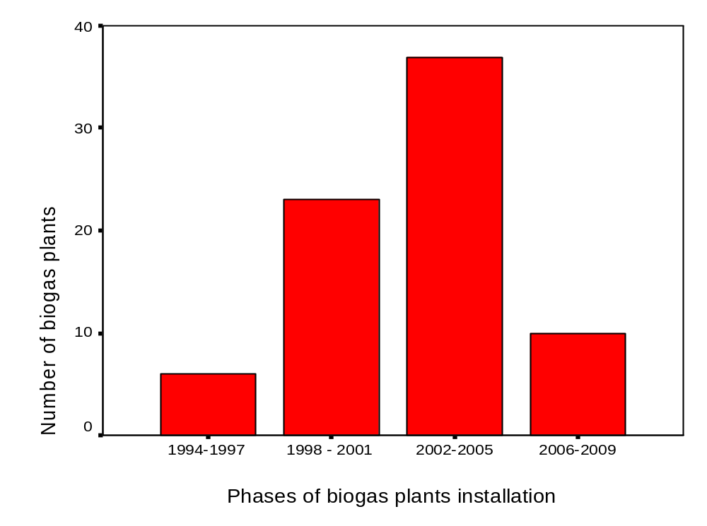
Figure 4. 11: Number of biogas plants installed in study villages as from 1994 to 2009

Source: Field survey (2009)

Table 4.22 and Figure 4.11 above indicates a positive growth rate of biogas plants construction up to 2005 after which there was a drastic drop on the number of plants constructed. The cause for this drop according to MIGESADO informants include; increased costs of biogas plants installation caused by the decrease in subsidy rates to biogas beneficiaries, inadequate and late remittance of subsidy from donors. Another cause factor was inadequate technical staff to carry out construction activities. This finding implies that subsidy was the main motivator for people to adopt the technology in the study areas since after its decrease the number of adopters declined. This can be explained by a reference dependence effect which according to Dupas (2012) can happen if people take the previously subsidized prices as reference points and be unwilling to pay higher later for the same product. The unwillingness to pay more after removal or reduced subsidy can also be caused by unrealized benefits of the new technology.

Section 4.3.3 discussed technological characteristics of biogas technology in the study area and showed dissatisfactions of biogas adopters which in turn disappointed potential adopters of the technology. This finding concurs with Schmitz (2007) who observed that rural people in Tanzania did not see the advantages of biogas technology to take up such a high risk of financing. He further observed that even richer people who could afford biogas installation were reluctant to invest in biogas technology. This suggests that people need to be educated more on the technology benefits and the necessity of adopting it as an alternative to the diminishing fuel wood resources and environmental benefits.

This shows the negative effect of subsidy approach to the technology adoption might not portray the real picture of biogas adoption trends which is a result of people’s demands towards the technology. The earlier rise of adoption shows the induced acceptance of the technology in the area while the later decrease after the reduced subsidy advocate the cost effect as also observed by other studies. This negative effect of subsidy approach is what made the INCOME variable to be insignificant factor on biogas technology adoption when in the actual fact it is not the case. The real adoption trend of biogas technology can be established when people adopt the technology on demand driven after realizing the benefits of the technology. Shortage of fuel wood is already experienced in the study area but as results indicate biogas benefits are yet to be realized.
Focus group discussions in four villages revealed the contributing factors for the decreased adoption rate of biogas technology (Table 4.23). Responses show that the major constraint for adoption is lack of technical support services, non-continual promotion of the technology and high installation costs. Inadequate technical services, as revealed by empirical analysis are a significant factor which discouraged both adopters and potential adopters of biogas technology and had a negative implication to the adoption process. According to the Diffusion of innovation theory, the perceived characteristics of the innovation can lead to decision to adopt the technology, after which the technological consequences can lead to continual adoption or discontinuance of the technology adoption. The consequences of the technology as revealed by this study were mostly negative; these include unavailability of technical support services, poor performance of biogas plants, increasing costs and insufficient sensitization of potential adopters which lead to the decreased adoption of biogas technology.

Table 4.23: Reasons for decreased adoption of biogas technology as per focus group discussions
Villages | Mtitaa (Bahi) | Kisima Cha Ndege (Bahi) | Chiwe (Kongwa) | Mlali  (Kongwa)
Reasons for decreased adoption | 1. Poor performance of biogas plants installed  1. Incomplete constructions of some plants  1. Water problem | 2. No more motivation  3. Unaffordable installation costs | 1.Unavailability of feedstock due to shift of live- stocks to distant grazing land  1. Lack of technical support and appliances  1. Unfaithful technicians. | 3. High installation costs.  2. Inadequate promotion  by the government  1. Unsustainable technical services
Note; For easy assessment the reasons of technical nature were assigned number 1, those of promotion nature assigned number 2, and those of cost nature assigned number 3.
Source: Field Survey (2009)

4.7 Stakeholders Involvement in Biogas Technology Promotion
Literature has shown that several studies have identified factors associated with low adoption of biogas technology in Tanzania (Kambele, 2003, Schmitz, 2007 and Ngwandu at al 2009). In addition to examining these factors this study has also linked these factors with policy environment particularly, government institutions and biogas projects involvement in biogas promotion. The study has focused more on information dissemination and accessibility to factors assumed to raise awareness and motivate people to adopt biogas technology. Further assessment is done on the involvement of local government officers and other stakeholders and lastly the strategies used by biogas project in promoting biogas technology.

4.7.1 Biogas Information Dissemination in the Study Area
Information dissemination is a key process in bringing awareness to people about a new technology in their environment. After becoming aware people accumulate more knowledge through training, then test the new technology and when satisfied with the result, people take up the innovation (Rogers, 1995). The findings in Table 4.24 indicate that a majority (43.4%) of the respondents in the study area were informed of biogas technology by their friends, relatives or neighbors who had adopted the biogas technology while 39.7% of respondents were informed by biogas project officers. From the same table, only 2.2% of respondents were informed through media advertisements while 1.3% of respondents were informed by extension officers and 0.6% by village leaders. In the context of this study, extension officers, media and village leaders represent government.
Table 4. 24: Sources of biogas technology information to respondents
Source of information | Bahi  N=159 | Kongwa  N=161 | Total  N=320
Biogas Project officer  Extension officer  Biogas Adopter (Neighbour, Relative)  Village Leader  Media advertisement  Not informed | 34.0 (54)  0.0 (0)  42.1 (67)  1.3 (2)  3.1 (5)  19.5 (31) | 45.3 (73)  2.5 (4)  44.5 (72)  0.0 (0)  1.2 (2)  6.2 (10) | 39.7 (127)  1.3 (4)  43.4 (139)  0.6 (2)  2.2 (7)  12.8 (41)
Total | 100.0 (159) | 100.0 (161) | 100.0 (320)
Bolded figures are the percentages and those in brackets are the number of respondents involved

Source: Field Survey (2009)

Extension services, for instance, are known to catalyze awareness, organization, and information exchange; hence they have profound influence in technology adoption (Feder 1999). On the other hand Baidu-Forson (1999) observes that adoption of agro forestry technologies was higher for farmers having contacts with extension agents than those who never experienced any extension contacts. The inadequate extension services and little involvement of other government agents as seen in Table 4.24 might have negatively affected peoples’ perception on the technology. As indicated in table the major medium of dissemination of biogas information was sharing of information between biogas adopters with their neighbors, relatives or friends. This provides a promising environment to sustainability of biogas technology only if those biogas adopters were well informed and knowledgeable on biogas issues. Otherwise disseminated information can be superficial, incomplete and in certain cases incorrect and not attractive to the potential adopters hence negatively affect biogas adoption. This further implies that a well informed and satisfied biogas adopter would be a major promoter of biogas technology; but the opposite is also true, that is, the dissatisfied biogas adopter will most probably discourage potential adopters from adopting the technology.

Furthermore assessment was done on the presence of awareness creation activities. According to Figure 4.12, 51% of respondents indicated that there were no awareness creation campaigns while 39% indicated that campaigns were held only once during the introduction of the biogas project in the study area, after which there were no more campaigns.
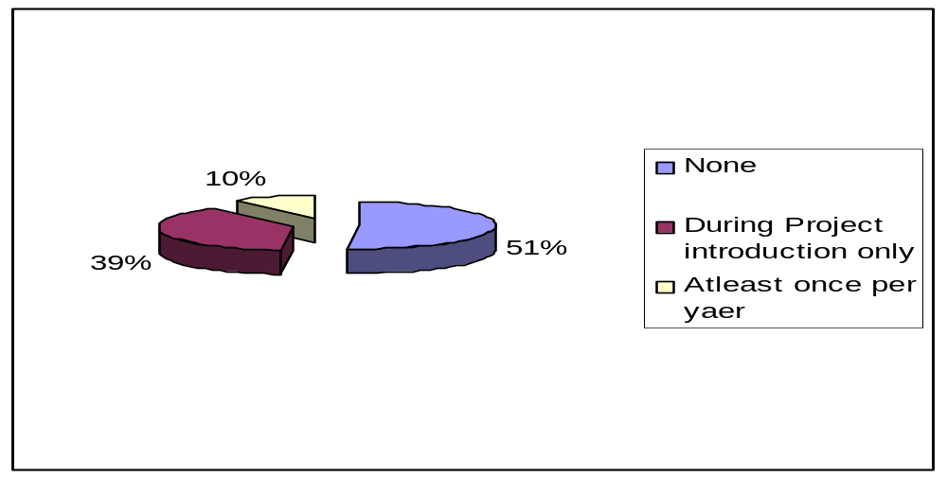
Figure 4. 12: Frequencies of biogas campaigns in the study area
Source: Field Survey 2009

From these findings, the lack or minimal awareness creation campaigns and unavailable extension services concerning biogas technology imply that there was inadequate promotion of the technology by the government institutions and other stakeholders

4.7.2 Promotion of Biogas Technology
Several studies have identified factors considered to promote effective adoption of any innovation (Tendler, 1993; Cramb, 2000; Simon, 2006). These factors include strong demand from people for a solution to a particular problem, access to knowledge, access to credit and subsidies, access to technical support, advertisements, encouragement and support from the government and rewarding of good performers. This study has adopted the above factors and investigated the extent of access to such factors which were assumed to influence adoption or non-adoption of biogas technology.

From Table 4.25, for all the factors assessed, a majority of respondents indicated that they had no access to the factors considered to promote adoption of biogas technology. However in some of factors (access to knowledge, access to financial supports, access to demonstrations and access to advertisements) a majority of biogas adopters had at least little access as compared to non-adopters. Accessibility to these factors means that there were some promotion efforts which contributed to motivate biogas adopters to adopt the technology. This implies that if more efforts were directed to the promotion of biogas technology there would be more intensification of people’s awareness and knowledge hence positively influenced adoption of biogas technology.

Accessibility to these factors has a direct link to government policies and their implementation strategies. Little or no access to these factors indicates the weakness in policies or little efforts in implementing the policy strategies. As revealed by Sawe (2009) that the Tanzanian Energy Policy is missing a statement which directly promotes biogas technology as an alternative energy source, hence no clear strategies are in place to develop the biogas sector. Nevertheless new hope can be sensed due to the recent efforts to establish the National Biogas Programme following Biogas for Better Life, Africa initiative, the programme which aims at coordinating and promoting biogas activities in the country. This could yield a positive outcome if only the policies are improved.

Table 4. 25: Respondents access to factors assumed to promote adoption of biogas technology
Factors | Non Adopter  N=241 | Adopters  N=79 | Total  N=320
Access to knowledge  No Access  Little access  Moderate access  Big access  Total  Access to credits and or subsidies  No Access  Little access  Moderate access  Big access  Total  Access to motivations  No Access  Little access  Moderate access  Big access  Total  Access to demonstrations  No Access  Little access  Moderate access  Big access  Total  Access to advertisements  No Access  Little access  Moderate access  Big access  Total | 61.0 (147)  37.8 (91)  0.8 (2)  0.4 (1)  100.0 (241)  67.6 (163)  29.5 (71)  2.5 (6)  0.4 (1)  100.0 (241)  75.9 (183)  24.1 (58)  0.0. (0)  0.0 (0)  100.0 (241)  87.1 (210)  11.2 (27)  1.2 (3)  0.4 (1)  100.0 (241)  60.6 (146)  37.3 (90)  2.1 (5)  0.0 (0)  100.0 (241) | 2.5 (2)  60.8 (48)  31.6 (25)  5.1 (4)  100.0 (79)  3.8 (51.9)  51.9 (41)  39.2 (31)  5.1 (4)  100.0 (79)  69.6 (55)  30.4 (24)  0.0 (0)  0.0 (0)  100.0 (79)  0.0 (0)  72.2 (57)  21.5 (17)  6.3 (5)  100.0 (79)  16.5 (13)  68.4 (54)  12.7 (10)  2.5 (2)  100.0 (79) | 45.6 (149)  43.4 (139)  8.4 (27)  2.6 (5)  51.9 (166)  35.0 (112)  11.6 (37)  1.6 (5)  100.0 (320)  74.4 (238)  25.6 (82)  0.0 (0)  0.0 (0)  100.0 (320)  65.6 (210)  26.3 (84)  6.3 (20)  1.9 (6)  100.0 (320)  49.7 (159)  45.0 (144)  4.7 (15)  0.6 (2)  100.0 (320)
Bolded figures are the percentages and those in brackets are the number of respondents
Source: Field Survey 2009

4.7.3 Government Institutions Involvement in Biogas Promotion
Further analysis was done to seek general opinion of the respondents on Government involvement in biogas activities. Table 4.26 shows that 60.3% of household respondents expressed their views that government institutions have not participated in biogas promotion.

Table 4. 26: Respondents opinions on government institutions involvement in biogas promotion
Level of involvement | Non adopters  N=241 | Adopters  N=79 | Total  N= 320
Fully involved  Partially involved  Not involved  Undecided | 8.3 (20)  27.4 (66)  63.1 (152)  1.2 (3) | 10.1 (8)  31.6 (25)  51.9 (41)  6.3 (5) | 8.8 (28)  28.4 (91)  60.3 (193)  2.5 (8)
Total | 100.0 (241) | 100.0 (79) | 100.0 (320)

Bolded figures are the percentage and those in brackets are the number of respondents involved
Source: Field Survey (2009)

The results in Table 4.26 were further supported by focus group participants where one of the FGD participants had this to say:
Shughuli za biogasi zimeachiwa taasisi zisizo za kiserekali tu, bila idara za serikali kujihusisha. Inaelekea hii technologia (biogesi) haijapewa kipaumbele na serikali Hatujawasikia viongozi wa wilaya, kwa mfano, wakizungumzia mambo ya biogesi”. Meaning, “The biogas activities have been left with Non-Governmental Organizations (NGOs) only, with no government department involved, seemed the technology (biogas) is not given the priority by the government; we don't hear from district council leaders for instance, speaking about biogas issues”.

The groups’ opinion were further processed using Participatory Ranking method, where participants were requested to identify biogas stakeholders and rank their involvement by assigning percentages, as they perceive participation of stakeholder in promotion of biogas technology (Table 4.27). The results in Table 4.27 show that all groups ranked NGOs higher, followed by biogas adopters as major promoters of biogas technology, while the lowest contribution was from government organs/individuals such as District Council, Politicians and the responsible Ministry.

Table 4. 27: Focus groups opinions biogas stakeholders and their contribution towards biogas promotion
 | Responses on perceived contribution levels (%) |  |  |  | Average contribution (%)
Stakeholder | MTITAA | KISIMA CHA NDEGE | CHIWE | MLALI | Average contribution (%)
MEM  District Council  Village government  Politicians  Researchers  NGOs  Biogas users | 0  5  8  0  2  40  45 | 15  0  15  2  4  40  20 | 3  2  5  0  25  35  35 | 10  5  5  0  10  50  20 | 7  3  8.0  0.5  10.2  41.3  30.0
 | 100% | 100% | 100% | 100% | 100%
Source: Field Survey (2009)

Little involvement of government departments was also noted by the researcher during fieldwork preparations. It was not possible to obtain biogas information/data from responsible district offices. Information like villages which were already reached by the biogas project and number of biogas plants constructed in the district was expected to be available in district offices. It was noted, however, that no such data existed in respective departments; instead they were only available at the biogas project offices.

Seemingly, the lack of policy statement and strategies by the responsible ministry could have contributed to this reluctance of the responsible departments at district levels. This reluctance of district authorities to what other biogas stakeholders are doing resulted into lack of coordination of such activities. This finding supports what Ngwandu et al., (2009) observed that, lack of coordination among biogas stakeholders and responsible government sectors is among barriers for biogas dissemination in Tanzania. Little involvement of government institutions in biogas promotion has negatively affected peoples’ perception and made them reluctant to adopt biogas technology as they feel that the technology might not be that much important.

The Tanzania energy policy encourages the private sector on investing in energy sector. At regional and district levels biogas is operated under the private sector and NGO’s. The ministry of energy and minerals should provide extension services and technical services facility to the villages involved in biogas programmes. Little involvement of the responsible ministry has implication on other factors that promote adoption of biogas technology, that is, access to credits and subsidies, advertisements, motivation, information dissemination and coordination of responsible sectors and other stakeholders. The combined effects of all these factors have lead to inefficiency and underdevelopment of biogas sector. Experiences from other countries such as China, India, and Germany show that, a strong policy and financial aid from the Government is an important factor for the successful implementation of national biogas programmes.

4.7.4 Biogas Promotion Strategies Used by Biogas Project
The approach used by biogas project to disseminate biogas technology in the study area was by the word of mouth advertisements through village meetings and households visit. From focus group discussions it was revealed that village leaders were requested by project officials to identify live-stock keepers who were economically capable of affording the costs of biogas installation. Village leaders then convened meetings between project officials and the identified livestock keepers. It was through such meetings that the biogas technology was introduced in the village and further seminars were given to the interested potential customers. After the seminars those who were convinced that the project was viable and were ready to adopt the technology were required to pay installation costs which were subsidized by the project.

It was further reported that, after the construction of biogas plants, communication remained between project staff and individual customers, as per contracts prepared by the project, there was no more involvement of village governments in biogas issues. This situation according to the respondents, led to lack of support from village government to biogas adopters in cases where problems related to biogas technology arose. The biogas adopters appeared to have no one backing them in their problems concerning biogas. In response to that complain, one of the village leaders (participant of FGD) in Mlali village had this to say.
“Hiyo ilikuwa ni biashara kati ya wale waliojengewa mitambo na mradi wa MIGESADO, serikali ya kijiji inahusikaje na mikataba yao?” Meaning, “That was their business, (“their” means, biogas adopter and Biogas Project), how can the village government be involved into their contract?”

Village leaders perceived the biogas programme as any other business involving contract between a seller and buyer. It is true that biogas plant is a private property and that government entities are not supposed to be intrusive, however biogas owners should have been facilitated to form their own clubs or society to deal with their problems and to solicit assistance from government institutions. Furthermore, expert advice should be sought on contract issues, to restructure the contracts between the project and biogas adopters. The contract should have clauses that ensure or guarantee services provision to the biogas plants for their sustainability. However, government institutions should not totally be excluded from biogas issues, due to the current energy situation of the country and the fact that biogas technology has environmental benefits which need to be a concern of the whole community. There should be a clear monitoring roots and coordination from the responsible ministry to ensure accountability of biogas projects and project owners to safeguard the welfare of people. It should also be noted that non-involvement of government entities on biogas issues has had a negative implication to the spread of biogas technology and its sustainability.

Furthermore the seminars between project developers and few identified villagers were perceived by household respondents to be selective and not open to every villager. A majority of non-adopters of biogas technology were of the opinion that through the strategy used by biogas disseminators only few people were accessible to biogas information (Table 4.28). Adopters on the other hand had the opinion that education given on the technology was not adequate, hence many people were not attracted to adopt the technology. From focus group discussion it was further revealed that people thought that biogas project was somebody’s business hence most villagers did not bother about it. From the above mentioned opinion it seems that the strategy used had a negative implication to the adoption process.

Table 4. 28: Weaknesses of promotion strategies as perceived by respondents
Weakness identified | Non Adopters  N=241 | Adopters  N=79 | Total  N=320
Few people were accessible to information  Method was selective, not open to all people  No enough education was  given on the Technology  No emphasis accompanied the biogas campaigns | 61.0 (147)  34.9 (84)  3.7 (9)  0.4 (1) | 21.5 (17)  6.3 (5)  53.2 (42)  19.0 (15) | 51.3 (164)  27.8 (89)  15.9 (51)  5.0 (16)
Total | 100.0 (241) | 100.0 (79) | 100.0 (320)
Bolded figures are the percentage and those in brackets are the number of respondents involved
Source: Field Survey 2009

4.7.5 Promotion Strategies Suggested by Respondents
In response to the weaknesses identified respondents proposed several strategies which they thought would be appropriate ways in promoting biogas technology (Table 4.29). According to the table, adopters of biogas technology proposed sensitization to be conducted through village meetings and be open to everybody. However, it was revealed through FGD that women, who were the targeted beneficiaries, did not attend village meetings or when they attended they were not confident enough to contribute their ideas. It was, therefore, suggested that women should be sensitized through their groups and in places where they can easily be accessed.

Table 4. 29: Promotion strategies as suggested by respondents
Promotion strategy | Non Adopters  N=241 | Adopters  N=79 | Total  N=320
Sensitization through village meetings  Mass Education to community  Through Media advertisement  Through community development groups  Financial support through soft loans | 11.6 (28)  29.8 (72)  1.2 (3)  25.2 (61)  32.2 (78) | 39.7 (310  2.6 (2)  29.2 (3)  9.0 (7)  19.2 (15) | 18.4 (59)  1.6 (5)  29.7 (95)  21.3 (68)  29.1 (93)
Total | 100.0 (241) | 100.0 (79) | 100.0 (320)
Bolded figures are the percentage and those in brackets are the number of respondents involved
Source: Field Survey 2009

Another proposed strategy was through mass education through which every community member would be aware of biogas technology and its benefits. Non-adopters proposed for financial support through soft loan as well as mass education as the way to promote biogas technology. Financial support through soft loans seemed to be a good promotion strategy due to the fact that people would be aware but if they couldn’t afford the technology costs it would be difficult for them to adopt it. The use of community development groups was also mentioned as a promotion strategy. As per focus group discussion, it is easier to spread the information to the community through groups provided that these groups are fully involved as compared to individual to individual communication.

Respondents through focus group discussion further identified key people who they thought would be effective promotion agents for biogas technology if sufficiently involved. These included streets or ten cell leaders, religion leaders, school teachers, women and youth groups. These categories of people, according to the respondents, were trustworthy and had convincing power and influence in the community. If these people were sufficiently aware and well trained on biogas technology and its benefits it would be easy for them to spread the news and influence the community. The household responses were supported by focus group discussants who further called for full participation of village government by the use of Village Environment Committee as a coordination unit between biogas customers and biogas projects. They also proposed for the government to set standards which would guide biogas projects and establish an evaluation mechanism of the biogas projects to ensure that project developers complied with the set standards and offer satisfactory services to their customers.

Respondents further suggested for the closer involvement of the government from district to village levels. They also called for full participation of the respective communities into biogas activities from planning to implementation stages for prosperous and sustainable adoption of biogas technology to take place.

CHAPTER FIVE

SUMMARY, CONCLUSION AND RECOMMENDATIONS

5.1 Chapter Overview
The chapter is subdivided into three sections, section one makes a summary of the study findings in relation to the objectives of the study. Section two presents conclusion on the study findings while section three recommends on some possible measures to increase the adoption level of biogas technology in semi-arid areas of Tanzania, where there is a need for alternative energy source due to the diminishing forest resources and the threat of desertification.

5.2 Summary of the Findings
The main objective of this study was to explore the root causes for low adoption of biogas technology as an alternative source of renewable energy in semi-arid areas of Tanzania. The study was conducted in Kongwa and Bahi Districts in Dodoma region where a biogas project has been in operation since 1994 but the adoption of biogas technology is still low and on decreasing trend. The study employed a multi-stage sampling procedure involving purposive selection of the study villages which are reached by biogas project aiming at capturing the experiences of biogas users, awareness and people’s attitudes towards biogas technology. The study adopted both qualitative and quantitative approaches for collection and analysis of data related to promotion and adoption of biogas technology.

The study findings reveal that there is scarcity of fuel wood in semi arid areas of Tanzania due to the diminishing forest resources. Fuel wood in the form of firewood and charcoal is the major source of energy for domestic use to a greater part of the sample population. The demand for fuel wood solution was highly expressed by respondents in villages which were most affected by deforestation indicated by long distances from homestead to firewood sources and increasing time consumed for firewood collection. The findings further indicate that distances from firewood sources were relatively longer in villages found in Kongwa district than Bahi; Chiwe village in Kongwa being the most affected area. In response to the demand for alternative energy, Chiwe village was found to have a higher number of biogas plants as compared to other study villages.

Assessment of the potential of the study area for biogas technology adoption indicates that about 60% of respondents do own cattle hence availability of animal dung which is the raw material for biogas plants in the study area. Water is another important requirement for operations of biogas plants, the findings show that 79% of the sample population had access to water within a distance of 0 - 2 kilometers from their homes, a fact which favors the adoption of the technology. Technical services availability is another prerequisite for biogas adoption. The existence of biogas projects in the area for a period of 15 years is another potential for access to information on biogas and technical services which had motivated people to adopt biogas technology. However, despite the presence of potential conditions favoring the area for adoption of biogas technology, the adoption levels are low and on decreasing trend.

The study was guided by five specific objectives; the first objective was examining factors affecting the adoption of biogas technology in semi-arid areas of Tanzania. Findings through descriptive analysis have shown that all factors as per conceptual framework have relationships with adoption of biogas technology and that the perceptions on the major factors influencing adoption of biogas technology differed among biogas adopters and non-adopters. Biogas adopters on one the hand perceived unavailability of technical support services as a major factor restraining adoption of biogas technology followed by high installation costs of biogas plants. Unavailability of technical services was accompanied by incomplete construction of biogas plants, unavailability of maintenance services and unmet expected benefits of biogas technology. All these factors had demoralized adopters of biogas technology from using the technology and also discouraged potential adopters from adopting it. Non-adopters on the other hand perceived high installation costs as a major factor deterring adoption followed by inadequate promotion of the technology by stakeholders. In addition to descriptive analysis all factors were also subjected to the empirical analysis through the logit model which examined their significance on adoption of biogas technology as dealt with in objective three of the study.

The second objective of the study was to assess peoples’ awareness and attitude towards biogas technology. From the findings of the study the majority of the respondents acknowledged that they had at least heard about biogas technology. However, from descriptive analysis on the respondents’ knowledge of biogas technology it was revealed that a majority of them had no or little knowledge of the technology. Even biogas users themselves claimed to have little knowledge on operations of biogas plants as well as on emerging obstacles. A majority of people in the study area were aware that there was something known as biogas technology but they did not have its details.
People’s attitude towards biogas technology was positive as the majority recommended for its promotion. However when further asked on their willingness to invest in biogas technology, only 25% of respondents showed willingness to invest in biogas while the remaining 75% of respondents showed interest of investing in other activities including small businesses, agriculture and in education which seemed to them as more profitable than biogas. Unwillingness to invest in biogas could be associated with low awareness, little knowledge, poor performance of the existing biogas plants and unrealized benefits of biogas technology as revealed by the study findings.

The third objective of the study was to determine the Correlation of factors influencing biogas technology adoption. The empirical results of econometric model showed that, eight out of thirteen variables included in the analysis were statistically significant in influencing biogas adoption. These variables include age of respondent, household income, education level, awareness and knowledge towards biogas technology. Other significant factors include water availability, technical availability and access to credit. The marginal probabilities were computed for the significant variables to show the magnitude of their effect on adoption of biogas technology. Based on the marginal probabilities, arranged from the most influencing factor the major factors were: Awareness (0.2342), Technical services availability (0.1482) and Age of household head (0.1128). From empirical analysis income showed a negative relationship with biogas adoption implying that low-income earners were more likely to adopt biogas technology. This was explained by the subsidy approach used by the biogas project to introduce and disseminate the technology in the area.
The fourth objective of the study sought to determine the rate and extent of adoption of biogas technology in the study areas. The study findings have shown that, despite the presence of basic requirements for biogas technology, the adoption rate of the technology in study area is still low still declining; the adoption in Kongwa district is 0.25% and Bahi district is 0.09%. Adoption rate on the other hand had increased gradually during the first phases of the biogas project from 1994 to 2005 after which there was an abrupt drop of biogas plants constructed between 2006 and 2009. The main reason for the drop was reported to be the increased costs of biogas plants installation hence unaffordable to the majority of rural residents. The increase of costs was related to the escalation of prices of building materials and decreased financial support from donors; hence the decrease of subsidy rates given to biogas adopters. This restrained the construction of biogas plants. The decrease of adoption following the decrease of subsidy reflected the negative effect of subsidy approach used by the biogas project and has defaulted the adoption rate as aimed by this study. It was not easy to identify the normal adoption through peoples’ demand for the biogas technology. However if the adoption trend after reduced subsidy, from 2006 were be considered as adoption on demand still the adoption rate is very low as compared to the increased deforestation rates.

Assessment of the involvement of government institutions and non-governmental organizations in promoting biogas technology was the fifth objective of this study. The study findings have confirmed that government institutions had not been fully involved in biogas promotion. Findings have shown that biogas activities have been left to non-governmental organizations, uncoordinated and without a clear policy backup and support from the responsible ministry. Little involvement of the government institutions has implication on all other factors like; access to credits and subsidies, motivation, information dissemination and coordination of responsible sectors and other stakeholders. Furthermore, the respondents doubted the viability of this technology from not seeing the seriousness of the government institutions in promoting this technology. The apprehension stemmed from the silence shown by local government leaders and politicians on the technology leading people to feel that the technology might not be that important.

The promotion strategy used by biogas project developers to disseminate biogas information was advertisement through the word of mouth. Findings revealed that the strategy was negatively perceived as being selective and inefficient because it resulted into only few people being informed of the technology while the greater part of the sample population was not informed. Another weakness noted was that information dissemination was not continuous, biogas campaigns were held during the establishment of the biogas project in the study area, after which there were no more campaigns conducted. In addition there was insufficient training and inadequate technical services resulted to abandonment of constructed biogas plants.

5.3 Conclusion
From the evidence gathered in the present study, it can be concluded that despite the potential and existence of favorable conditions for technology adoption and despite the existing a biogas project in the study area for a period of 15 years, the adoption rate of biogas technology has been at a low level and on the decrease. Adoption of biogas technology in semi arid areas of Tanzania has been influenced by many factors as expounded in the conceptual framework of this study. The major factors for low level adoption rates as revealed by the study can be categorized into; promotional factors, technological factors and socio economic factors. Promotional factors according to the conceptual framework are linked to institutional concerns including government institutions responsible for energy and to the actors or implementers of biogas programmes. Promotion embraces various factors including; policy, access to information, extension services, enabling environments and technical support services for technology sustainability. Findings have shown that lack of support, encouragement and coordination from both central and local governments have negatively affected people’s attitude towards biogas technology and little access to incentives hoped to positively influence continual use and sustainability of biogas technology. Inadequate involvement of government institutions in biogas promotion has left biogas activities with NGOs which are financially. This has been an impediment to the development of biogas technology in a country. On the other hand it has been established that overdependence of biogas programmes on donors support is another factor hampering the sustainability of biogas technology. This observation is substantiated by the drastic fall of adoption rates following the reduction of subsidy of biogas plants construction costs.

On technological related factors, it has been established that lack of technical services including maintenance services and lack of appliances at local vicinity has lead to non functioning of biogas plants and tarnished the reputation of biogas technology. Furthermore not all advertised benefits of biogas technology have been realized by the communities. All these inefficiencies when accompanied with high installation costs of the technology have negatively affected people’s attitudes and resulted into their becoming unwilling to invest in the technology they perceive to be unprofitable. In general it can be summed up that; inadequate awareness, insufficient technical support services, poor performance of the constructed biogas plants associated with unrealized benefits of the technology can be described as the key factors obstructing the adoption of biogas technology.

The socio economic factor which had a greater influence on biogas adoption as revealed by the study findings was age of the household head. Household head’s age has been associated with resource ownership particularly livestock, premises ownership and modernity of the technology. The biogas technological requirements as established in the present study seemed to favor older people than younger people. To the younger people it has been determined that biogas technology seems to be unaffordable and considered to be risky. They also tend to see it as being not modern when compared to other alternatives like electricity and solar PVs.

A conclusion which one might draw from this observation is that people, particularly the younger generation perceive biogas technology as not being a modern energy source. This calls for more technological improvement which would consider design simplicity, use of alternative feed stocks and transferability of biogas plants if biogas technology is to gain acceptance of all age groups in a society.

5.4 Recommendations
In view of the major findings and conclusions drawn from the findings, the following recommendations are made for actions to be taken in order to promote and raise levels of adoption rates of biogas technology as an alternative energy source for rural populations.

5.4.1 Promotion of Biogas Technology
The study has revealed that there has been low and declining adoption rate of biogas technology associated with inadequate promotion by the government institutions and the biogas project operating in the study area. This calls for biogas programmes to use effective promotion approaches and continuous education to the community about biogas technology. In addition, there is a need to implement awareness creation campaigns designed to encourage and attract the targeted population to adopt biogas technology. For effective awareness creation the researcher concurs with Ghimire (2008) who proposed the development of the materials written in understandable language; in the case of Tanzania, Kiswahili language is an appropriate one since it is widely used across the country including rural areas. Printed materials such as user manuals, posters, pamphlets and brochures should be made available and distributed to the community.

More information needs to be provided in the areas of benefits of biogas technology, operations of biogas plants, emerging obstacles and their solutions and knowledge of other feed-stocks alternative to cow dung. For extensive and sustainable information dissemination, it is suggested that biogas matters should be incorporated in formal education curriculum particularly through vocational training programmes. Other promotion activities may include broadcasting on local TVs and adios, exhibition and demonstrations, promotion campaigns, organizing regular training to potential users, project staff and school teachers. It is also recommended that project developers should emphasize on the training of women, because women are more involved in operating biogas plants. The use of women groups could be an easy and convenient way of disseminating biogas information.

5.4.2 Government Institutions Involvement in Biogas Promotion
While the Tanzania Energy policy encourages private sector to invest in renewable energy technologies, it is vital that the government should be closely involved in the promotion of the technology. This is necessary because of the current energy situation in the country and the importance of biogas technology to environmental management. This goal could be achieved by implementing the following strategies;

- The Ministry of Energy and Minerals should improve policy environment in favor of biogas technology through setting appropriate implementation strategies and coordination of biogas programmes.

- The Rural Energy Agency through Rural Energy Fund should provide financial support for both project developers and targeted populations for sustainability of biogas technology.
- Political leaders through policy reviews can promote the technology through media and through incorporating renewable energy technologies in their developmental plans.
- District councils should hire extension workers to monitor the activities of biogas projects and biogas customers to ensure their responsiveness and accountability. Besides y-laws should be established to guide and monitor biogas activities.
Furthermore, since biogas issues cut across different government sectors such as, energy, environment, agriculture, economics and health sectors, there should be a coordination unit. It is hoped that the newly established National Biogas Programme (TDBP) will play a coordination role for biogas activities national-wise. The programme should be well planned, strategic, fully supported by the responsible ministry to ensure sustainability of biogas projects and ensure the implementation of set strategies for the development of biogas sector in the country. Considering that the biogas technology in Tanzania has been in existence for a reasonable period of time, TDBP should look deeply on shortcomings addressed by this study. It should also take into consideration experiences of other biogas projects like CARMATEC, MIGESADO and ELCT and others to improve the biogas technology so as to add some values to it to be more attractive as compared to other energy alternatives but affordable to the rural populations.

5.4.3 Technological Improvement
Inadequate technical support services, poor performance of biogas plants and unrealized benefits of biogas technology are among the factors which have negatively affected adoption of biogas technology. To ensure availability of technical support services, it is recommended that:

- Biogas programmes should emphasize on training of local masons and technicians and sufficiently equip them. Training of local technicians is vital to ensure availability of maintenance and repair services within a reasonable radius and without excessive costs, time consuming and bureaucratic procedures.
- Biogas projects should ensure availability of appliances at local level; this could be done through collaboration with local business men who would make spare parts be available in local shops.

- A thorough technical examination should be implemented which would come up with strategies for improving biogas plants. Biogas technology professionals should look for more appropriate plant types, sizes and raw materials required. The common feed stock of cow dung seems to be inadequate and fluctuating due to climatic changes and un-certainty of cattle ownership. This calls for a more reliable source of feed-stocks for biogas plants. Besides, the use of human waste, agricultural residues and other organic wastes as feed stock needs a thorough scientific explanation and assurance to the users so that they eradicate doubts on their application as raw materials for biogas plants.

- Non-transferability of fixed designs of the biogas plants has been mentioned as an obstacle to technology adoption by the mobile groups of people for instance civil and public servants and young people. Moreover biogas technology professionals should also look into the possibilities of improving transferable designs like floating drum biogas plants.

The study also has revealed a reasonable number of non-functioning biogas plants installed in the study area. Training of biogas users on proper operation and maintenance of biogas plants on continuous bases is vital. Furthermore an extra effort is required in the study area to motivate disappointed biogas users and to rebuild the trust of potential adopters of biogas technology. It is recommended that the biogas project in the area should consider reviving the non-functioning biogas plants, if possible free of charge or at low charges. This is due to the fact that adopters were demoralized and had lost interest which might not be easy to persuade them to pay again for the installations. Similarly potential adopters may hesitate to invest in the technology which had already been perceived by their fellow villagers as non-profitable and capital wasting.

The study findings show that unrealized biogas technology benefits had disappointed biogas adopters and potential adopters. Experiences from other countries have shown that biogas can be used for various activities such as refrigerators, chicken heaters, coffee roasting, bread baking and sterilization of equipments. It is recommended that biogas developers should ensure that all these uses are realized by rural Tanzanian population. There should also be availability of the relevant appliances and maintenance services in their local environment. This would add value to the technology and make positive change to people’s attitudes towards biogas technology; and motivate potential customers to adopt the technology. Given the current speed and sparse population of Tanzania, rural electrification may remain a dream which might take many years to be realized to the rural population. Therefore improved biogas technology and realization of its benefits would fill up this gap.

5.4.4 Financial Support for Biogas Installation
High installation costs have been mentioned in this study and other studies as an obstacle for large scale dissemination of biogas technology especially to the poor rural population; as a result efforts have to be made to reduce construction costs. The subsidy approach which was used to introduce biogas technology in the study area was intended to reduce construction costs and enable rural population to afford biogas plants. However the approach appeared to have a negative effect on adoption. This calls for a more appropriate and sustainable approach of financial support to both biogas developers and potential adopters.

The government through its Rural Energy Agency should instead introduce credit schemes, in the form of easy loans in order for the rural people to adopt alternative energy technologies like biogas. The reason for this is that rural people have low incomes; which makes it difficult for them to make lump sum payment. The experience in one study village (Mlali) shows that there was a dairy cattle loaning scheme which was supported by the World Vision Organisation. This organisation supported farmers to acquire dairy cattle and encouraged them to adopt biogas technology as a result the majority of the biogas adopters in this village fall under this group of farmers. Government through the responsible ministries should implement similar schemes to enable more people to access such opportunities of multipurpose nature which would in turn encourage adoption of biogas technology.

Sustainable subsidies on construction materials as well as to institutions dealing with biogas dissemination could reduce the costs of biogas plants hence enable many people to afford the costs of construction. Donor dependence approach to supporting biogas programmes as featured in the initial years of National Biogas Programme (TDBP) needs to be reviewed, since the previous experiences have shown that external donations are unsustainable.
Lastly, people need to be informed on the on-going high rates of environmental destruction particularly forest disappearance which is likely to result into higher future costs compared to the cost of constructing a biogas plant. The perceived high costs of constructing biogas plants should be equated with the total advantages of biogas technology on energy provision, sanitation and health particularly to women, agricultural improvement and reduction of greenhouse gases emissions.

5.5 Suggestions for Further Studies
This study was limited to biogas situation in two districts of Dodoma region adding to earlier studies by Schimtz, (2007) and Sanne, (2008) done in northern regions of Arusha and Mwanza. Since energy crisis especially fuel wood shortage exists throughout the country, similar studies could be carried to other parts of the country to come up with comprehensive and professional recommendation and way forward for biogas sector development in Tanzania.

Furthermore this study just mentioned technological improvements but didn’t go into their details. More investigations of technical engineering nature need to be conducted so as to come up with more appropriate biogas plant designs which would be compatible, efficient and affordable to the rural settings. Moreover, technical problems associated with the technology which have contributed to overall restrained adoption of biogas technology also need more investigation for improvement.

Large scale biogas plants also need to be studied; experience elsewhere shows that biogas can be harnessed and used to generate electricity in towns and cities by trapping the organic garbage from households and from market places. In Tanzania such a plant has been erected in Tanga in a sisal plantation using pulps from sisal. Such projects if implemented would improve the hygienic conditions in towns and help to eradicate diseases like typhoid and diarrhoea and eliminate the pollution of underground water resources which are at present highly contaminated.

REFERENCES

Abadi-Ghadim, A. K. and Pannell, D. J. (1999). A Conceptual Framework of Adoption of an Agricultural Innovation. Journal of Agricultural Economics 21 (2): 145- 154.
Abukhzam, M. and Lee, A. (2010). Workforce Attitude on Technology Adoption and Diffusion. The Built and Human Environment Review. Vol. 3: 60 -71.
Adesina, A. A., Mbila, D., Nkamleu, G. B. and Endamana, D. (2000). Economic Analysis of Determinants of Adoption of Alley Farming by Farmers in the Forest Zone of South-West Cameroon. Agricultural Ecosystems and Environment 80:255-265.
Ajzen, I. (1985). From Intentions to Actions: A Theory of Planned Behavior, in Kuhl, J and Beckmann, J (eds.). Action - Control: From Cognition to Behavior (11-39). Heidelberg Springer.
Akinola, A. A. and Young, T. (1985). An Application of the Tobit Model in the Analysis of Agricultural Innovation Adoption Process: A study of Use of Cocoa Spraying Chemicals Among Nigeria Cocoa Farmers. Oxford Agrarian Studies 14: 26-57.
Akinola, A. A. (1987). An Application of Tobit Analysis to the Adoption of Tractor Hiring Services Scheme in Nigeria. Oxford Agrarian Studies 16: 70-82.
Alavalapati, J. R. R., Luckert, M. K. G. and Gill, D. S. (1995). Adoption of Agro forestry Practices: A case study from Andhra Pradesh, India. Agro forestry Systems 32 (1):1-14.
Aldrich, J. N. and Nelson, F. D.(1990). Linear Probability. Logit and Probit Models Series: Qualitative Applications in the Social Sciences. A SAGE University, Paper Series No. 45. The International Publishers, Newburry Park, London.
Anin, F. D. K. (1999). A Note on the Adoption of Soil Conservation Measures in North Province of South Africa. Journal of Agricultural Economics 50 (2) 336-345.
Arvidson, A. and Nordstrom, M. (2006). Enable Tanzania. Energy Sector Policy Overview paper. [http:// www.giz.de] site visited on 20/10/2009.
Baidu-Forson, J. (1999). Adoption of soil and Water Conservation Practices in the Sudan-Sahelian zone. Constrains and incentives. Journal of Agricultural Economics 21 (3): 231-239.
Bahi District Commissioner’s Office (2008). Bahi District Profile.
Balat, M. and Balat, H. (2009), Biogas as renewable Energy Source. A review www.ir.nust.ac.zw. Site visited on 25.07/2012

Bartz, F. J. Peter, K. J. and Janssen, W. (1999). Influence of Technology Characteristics on the Rate and Speed of Adoption. Agricultural Economics 21 (2): 121 -130.
Biogas Works (1999). Introduction to anaerobic Digestion. [http://www.biogasworks.com] site visited on 25/4/1007.
Budlender, D. (2008). The Political and Social Economy of Care: Contesting Gender and Class Inequalities Tanzania Report 2. Geneva: The United Nations Research Institute for Social Development [http://www.un.org/women] site visited on 6/10/2009.
Bui Xuan An (2002). Biogas technology in Developing Countries: Vietnam Case study. University of Agriculture and Forestry. Proceedings Biodigester Workshop. March 2002 [http://www.mekam.org/procbiod] site visited on 15/6/2007.
Burton, M., Rigby, D. and Young, T. (1999). Analysis of the Determinants of Adoption of Organic Horticultural Techniques in the UK. Journal of Agricultural Economics 50 (1):47-63.
Casley, D. and Kumar, K. (1988). The collection, Analysis and Use of Monitoring and Evaluation of Data. The International Bank for Reconstraction and Development, Washington D.C.
Cecelski, E. (2000). The Role of Women in Sustainable Energy Development: Energy, Environment and Development. National renewable Energy Laboratory, Colorado.
Chan U Sam (1982). State of the art review on the integrated use of Anaerobic process in China [http://www.fao.org/] site visited on 4/10/ 2010.
Chungu, A. S., Kimambo, C. Z. M. and Bali, T. A. L. (2001). Assessment of Village level sugar processing technology in Tanzania. Research Report No 014 for REPOA. Mkuki na Nyota Publishers, Dar es Salaam.
CONDRIT Ltda, (1995). Improvement and Promotion of Tubular Biogas Digester. Report to Coordination Farming Systems Program. Dar es Salaam.
Corporate Tanzania (2002). Energy and Solid Minerals: The Business Trade and Investment Guide 2010/2011. Corporate guides International Ltd. Dar es Salaam.

Cramb, R. A. (2000). Rethinking the Development, Dissemination and Adoption of Agricultural Technologies [http:// www.cip.upward.org.] site visited on 5/7/ 2009.
Cunningham, W. P, Cunningham, M. A, and Saigo, B. W (2007). Environmental Science. A Global Concern. 9th Edition Mc Graw Hill, Boston.
Danish Ministry of Energy and Environment (1996). Energy 21; The Danish Government s Action Plan for Energy 1996. Copenhagen.
Day, A. (2010). The Economic Consequences of a Global energy crisis [http://www.anthony-day.com.] site visited on 18/10/ 2010.
Davis, F., Bagozzi, R. and Warshaw, P. (1989). User Acceptance of Computer Technology: A Comparison of two Theoretical Models, Management Science, 35 (8), 982-1003.
Denscombe, M. (1998). The Good Research Guide, Open University Press, Buckingham: Philadelphia.
Dutta, S. (1997). International Network on Gender and Sustainable energy. Energia News issue 4. [http://www.google.co.tz] site visited on 11/4/ 2009.
Dupas, P (2012). Short-run Subsidies and Long-run Adoption of New Health Products; Evidence from a field Experience Stanford University. [http://www.stanford.edu.] site visited on 15/8/ 2012.
Enger, E. D. and Smith, B. F. (2006). Environmental Science: A study of Interrelationships. 12th Edition. McGraw – Hill Higher Education. Boston.
English Articles (2010). World Energy Crisis. [http://www.englisharticles.info] site visited 19/10/ 2010.
Fontana, M. and Natali, L. (2008). Gendered Patterns of time use in Tanzania. Public Investment in Infrastructure can help. Paper prepared for the IFPRI Project on ‘Evaluating the Long-Term Impact of Gender-focused Policy Interventions. [http://www.ids.ac.uk.] site visited on 15/6/ 2010.
FAO/CMC (1996). SD Environment: A system Approach to Biogas Technology. Training Manual for extension. [http://www.fao.org] site visited on 24/10/ 2007.
FAOSTAT (2005). Energy Statistics: Fuel Wood Consumption by Country. [http://www.worldenergy.org] site visited on 21/10/ 2010.
Feder, G, Just, R. and Ziberman, D, (1985). Adoption of Agricultural Innovations in Developing countries. A Survey. Economic Development and Cultural Change 33(2), 255-298.
Finfact Team (2010). Global Forest Cover Shrinking by 20,000 hectares a Day. Business Finance Portal. [http/:www.finfacts.ie] site visited on 4/10/ 2011.
Ghimire, P.C. (2008). Trainee’s Manual prepared for National Biogas Programme. [http://www.snvworld.org.] site visited on 25/6/ 2008.
GMU (2004). Basic Concepts of Sampling, George Mason University. [http:/ene.gmu.edu.] visited on 5/4/ 2004.
Gunnerson, C. G. and Stuckey, D. (1998). Bioenergy Options, Multidisplinary Participatory Method for Assessing Bionergy Options for Rural Villages in Tanzania.
Gwalema S. R. (2002). Levels and Sources of Poverty in Kibondo District Tanzania. A Case of Kibondo Division . A PhD Thesis Submitted at The University of Innsbruck.
Harris, P. (2005). Beginners Guide to Biogas. The University of Adelaide, Adelaide [http://www.ees.adelaide.edu.au] site visited on 14/10/ 2005.
Hatibu, N., Lazaro, E., Mahoo, H. F., Rwehumbiza, F. B. and Bakari, A. M. (1999). Soil and Water Conservation in Semi Arid Areas of Tanzania: National Policies and Local Practices. Tanzania Journal of Agricultural Sciences 2 (2):151-169.
Hawasi, F. G. H (2006). Analysis of Processing, Marketing and Demand for Processed Fruits and Vegetables in Tanzania. A PhD Thesis Submitted at Sokoine University of Agriculture, Morogoro Tanzania.
ISAT and GTZ (undated). Biogas Basics: Biogas Digest. Vol. 1. [ htpp://www.gtz.de] site visited on 4/10/ 2007.
Kaliba, A. R. M., Featherstone, A. M., Normare, D.W. (1997). A Stall Feeding Management for Improved Cattle in Semi Arid Central Tanzania. Journal of the International Association of Agricultural Economics, 17 (23), 133-146.
Kalineza, H. M. M. (1999). Factors influencing Adoption of Soil Conservation Technologies in Tanzania. A case Study in Gairo: Proceedings of FoA, Sokoine University of Agriculture 4: 76-84.
Kambele, Z. (2003). Factors affecting the adoption of Biogas technology as an alternative source of Energy in Rural Tanzania. A case study of Arumeru District, Arusha Region. A Dissertation for award of M.A Degree at University of Dar Es Salaam, Tanzania.
Karlsson, G. (2003). Technical Training for Women Regarding Energy Technologies. UNDP Briefing Paper. [http://www.sustainble-solutions.com/docs.] site visited on 15/10/ 2009.
Kauzeni, A. S., Masao, H. P., Sawe, E. N., Shechambo, F. C. (1998). Multi-disciplinary Participatory Method for Assessing Bio-energy Options for Rural Villages in Tanzania. Energy, Environment and Development Series – No 44. Stockholm Environment Institute.
Kimambo, C. Z. M. (2002). Appropriate Technologies for Renewable Energy Development in Tanzania. Rathaus Hamburg – Altoona.
Kiwele, P. M. (2008). Biogas Development Overview in Tanzania. A paper presented at National Biogas Steering Committee Meeting. [http://www.are.net.org] site visited on 5/11/ 2009.
Kongwa District Commissioner’s Office (2007) Kongwa District Profile 2007.
Kothari, C. R. (1990). Research Methodology. Methods and Techniques. New Age International. New Delhi.
Kristoferson, L. A. and Bokhalders, V. (1991). Renewable Energy Technologies: Their Applications in Developing Countries. Intermediate Technology Publications. London.
Krishnaswam, O, R. and Ranganathan, M. (2005). Methodology of Research in Social Sciences. Meena Pandey for Himalaya Publishing House, Mumbai.
Kulindwa, K. and Shechambo, F. (1995). The impact of Rural Energy use on the Environment during the Economic Reforms Period (1981-1992). Some evidence from Tanzania. UTAFITI Vol. 2 No 1&2 (110 - 131)
Lionbergen, H. F. and Gwin, P. H. (1991). Technology transfer. University of Missouri Press. Columbia.
Lotte, C., Malene, L. and Helle, K. N. (2004). Evaluation of Small Scale Biogas Digesters in Turiani, Nronga and Amani Tanzania. Integrated Farming in human development proceedings of a workshop. University of Aarhus, Denmark. [http://www.husdyr.kvl.dk] site visited on 5/3/ 2007.
Marchaim, U. (1992). Biogas Process for Sustainable Development. FAO Rome.
Manros, G. and Rice, R. (1986). Don’t Hang Up: Organizational Diffusion of the Intelligent Telephone. Information and Management (10): pp.161-175.
May, T. (1993). Social Research: Issues, Methods and Process. Buckingham, Open University Press.
Meynell, P. J. (1976). Methane Planning a Digester. Schoken Books. New York,
MIGESADO (2009). Dodoma Biogas and Alternative Energy Project. Annual Reports.
Miller, G. T (2004). Environmental Science. Working with the Earth. (10th Edition).
Thomson Brooks.
Msuya, C. P. (1998). A Study of Factors Affecting the Adoption of Hybrid Maize in Mwanga District. A Dissertation for the award of MSc. Degree at Sokoine University of Agriculture, Morogoro
Nachimias, D. and Nachimias, S. (1976). Research Methods in the Social Science. Edward Arnold Publisher’s Ltd. London.
Nes W. J. and Nhete T. D. (2007). Biogas for a Better Life: An African Initiative. Renewable Energy World Magazine, Vol. 10 Issue 4. [http://practicalaction.org/journal.] site visited on 10/7/ 2009.
Nhembo, M. J. (2003). Assessment of the Adoption Rate of Rainwater Harvesting Technologies for Crop Production in Dodoma, Tanzania. A Dissertation for the award of MA (Rural Dev.) Degree at Sokoine University of Agriculture Morogoro.
Nhete T. D. and Kellner, C. (2007). A Synopsis of Lessons from Past and Present Programmes to Disseminate Biogas Technology in Africa. Biogas for Better Life: An African Initiative. [http//:www.biogasafrica.org.] site visited on 4/9/1010.
Ng’wandu, E., Shila, L. C. and Heegde, F. E. W. (2009). Programme Implémentation Document. Tanzania Domestic Biogas Programme. Hivos SNV.
Nkonoki, S. R. (1983). “Rural Energy Use and Crisis in Tanzania” Proceedings of The Regional Workshop on Energy for Development in Eastern and Southern Africa Vol.1
Parawira, W. (2009). Biogas Technology in Sub-Saharan Africa: Status, prospects and Constraints. Reviews in Environmental Science and Biotechnology, 8 (2) 187 -200.
Powers, D. A. and Xie, Y. (2000). Statistical Methods for Categorical Data Analysis. Academic Press: San Diego.
Preston, T. R. (1995). Tropical Animal Feeding. A Manual for Research Workers, FAO, Rome.
Qiu, D. X., Gu, S. H., Liange, B. F. and Wang, C. H. (1990). Diffusion and Innovation in Chinese Biogas Program. World Development Oxford, 18: 555-563.
Rajeswaran, K. (1983). Simple Energy Technology Biogas Utilization in Tanzania. A Paper Presented at IRA Seminar held on 24 May 1983, UDSM. Service paper No. 83/4.
REA (2008). Rural Energy Agency. Annual Report for the financial year ended June 30th 2008.
Reeds, D. (1996). Structural Adjustment, The Environment and Sustainable Development. The Case study for Tanzania. Earthscan Publications LtD, London.
Rogers, E. M. (1995). Diffusion of Innovation. (4th Edition). The free Press, New York.
Rwegoshora, H. M. M. (2006). A Guide to Social Science Research. Mkuki and Nyota, Dar es Salaam.
Rutamu, I. (1999). Low Cost Bio-digesters for Zero Grazing Smallholder Dairy Farmers in Tanzania. Livestock Research for Rural Development (11) 2. [http://www.cipav.org.co.] site visited on 24/6/2009.
SADC/ICRAF (1996). Annual Agroforestry Project Report, Tumbi Tabora Tanzania. AFRENA Report No 105.
Sasse, L. (1988). Biogas Plants. Veiweg. [http://www.gate-international.org/energy] site visited on 3/4/ 2007.
Saunder, M., Lewis, P. and Thornhill, A (2006). Research Methods for Business
Students. Pearson Education Limited. New Delhi.
Sawe, E. N. (2009). Sustainable Charcoal Production for Poverty reduction in Tanzania. A Paper on Bioenergy for Sustainable Development in Africa. Brussels, Belgium [http://www.tatedo.org.] site visited on 19/10/ 2010.
Simon, M. M. S. (2006). Adoption of Rotational Woodlot Technology in Semi-arid areas of Tanzania: The case of Tabora Region. A Thesis for the award of Doctor of Philosophy Degree at Sokoine University of Agriculture. Morogoro, Tanzania.
Schmitz, T. (2007). Feasibility Study for a National Domestic Biogas Programme in Tanzania. GTZ, Eschborn.
Sebyiga, B. D. (2008). Farmers’ response to Institutionalized land conservation approaches for improved agricultural productivity in Tanzania: The case of Kilosa and Kiteto Districts. A Thesis for award of Doctor of Philosophy Degree at The Open University of Tanzania, Tanzania.
Senkondo, E. M. M., Lazaro, E. A., Kajiru G. J. (1998). Factors affecting the adoption of Rain water harvesting Technologies in Western Pare Lowlands of Tanzania. Tanzania Journal of Agricultural Sciences 1(1): 81-89.
Shechambo F. C. (1984). Urban Demand for Charcoal in Tanzania: Some Evidence from Dar es Salaam and Mwanza. IRA, University of Dar es Salaam
Shiferaw, B. and Holden, S. J. (1998). “Resource Degradation and Adoption of land Conservation Technologies in the Ethiopian Highlands” Journal of Agricultural Economics 18 (3). 233 -247.
TaTEDO (2007). TaTEDO Brochure. [ http://www.tatedo.org/.] site visited on 22/10/ 2009.
Tendler, J. (1993). Tales of Dissemination in Small-farm Agriculture: Lessons for Institutional Builders. World Development, 21: 1567 – 1582.
UNEP (1981). An Overview-Environmental Management: UNEP Report No. 3 Nairobi.
URT (2003). National Energy Policy. Ministry of Energy and Minerals. Dar es Salaam, Tanzania.
Wawa, A. I. (1999). The Need for Women Participation in Environmental Management Programmes. A case of Dodoma Region. A Dissertation for the award of M. A (Demography) Degree at University of Dar es Salaam, Tanzania.
Werner, U., Urlrich, S. S and Hees, N. (1987). Biogas Plants in Animal Husbandry. Viewg, GATE GTZ. [http://books.google.co.tz.] site visited on 10/4/ 2007.

APPENDICES

Appendix 1: Households Questionnaire on Assessment of Promotion and Adoption of Biogas Technology; in Semi – arid areas of Tanzania

PART 1
A: General Identification
  - Date of interview …………………………...……………………………
  - Name of the respondent …………………….……………………………
  - Village ……………………………………………………………………
  - Ward …………………………………………...…………………………
  - Division ……………………………………..……………………………
  - District …………………………………...………………………………

B: Household/Institution information
  - Sex of the head of household; 1 = male, 2 = female ( )
  - Age of the head of the household (Years) ( )
  - Provide number of people in each age groups in your household;

Age group | Number | Those who do provide labor
Infants 0 – 10 years
Children 11– 18 years
Youth 19 – 60 years
Adult, more than– 60

  - What is your highest level of education?
(i) Never attended formal education ( )
(ii) Below Standard Seven ( )
- Standard seven ( )
(iv) Secondary Education ( )
(v) College Education ( )

11. Main occupation of the head of household;
    - Farming ( )
    - Livestock keeping ( )
    - Petty Business ( )
    - Wage employment ( )
    - Others (specify) ……………………………………………

- Secondary occupation of the head of the household;
    - Farming ( )
    - Petty business ( )
    - Big Business ( )
    - Livestock keeping ( )
    - Others (specify) …………………………………………………………

C: Household Income
13. What are the sources of income for your household?
- Farm production ( )
- Livestock keeping ( )
- Business ( )
- Wage employment ( )
- Others (specify) …………………………………………………………

14. What is your average income per year Tshs …………….………………………

D: Livestock keeping
- Indicate number, and management system of the various livestock types in your farm.
Type | Number Kept | Management | Key to management  System
Cattle |  |  | Key to management  System
Goats |  |  | 1 = Zero grazing  2 = Semi grazing  3 = Open grazing
Sheep |  |  | 1 = Zero grazing  2 = Semi grazing  3 = Open grazing
Pigs |  |  | 1 = Zero grazing  2 = Semi grazing  3 = Open grazing
Donkeys |  |  | 1 = Zero grazing  2 = Semi grazing  3 = Open grazing
Chicken/ducks |  |  | 1 = Zero grazing  2 = Semi grazing  3 = Open grazing
Others (specify) |  |  | 1 = Zero grazing  2 = Semi grazing  3 = Open grazing
PART2: Availability of important resources
16. Are the following resources available in your area?
Resource | Availability  (use key) | Distance to the resource (Kms)
Water for domestic use
Fuel wood for cooking
Grazing land for livestock

Key on availability of resources
          - Readily available
          - Is in short supply
          - Not available

17. What is the major source of fuel for domestic uses?
  - Fuel wood and charcoal ( )
  - Electricity ( )
  - Solar energy, wind power ( )
  - Coal ( )
  - Biogas ( )
  - Others (Specify) …………………………………………………… ….

- If the source is fuel wood indicate where you obtain the fuel wood.
  - Public Forest reserve ( )
  - Planted trees ( )
  - Virgin land ( )
  - Trees left in the farmland ( )
  - Private forest reserve ( )
  - Fallow areas ( )
  - Neighbor’s village land ( )
  - Sellers/vendors ( )

- What was the distance to the source of fuel wood in 10 years ago? (Kms) …………………………………………………………………………………
- What is the distance now to the fuel-wood source? (kms) ……………………………………………………………………………………………………………………………………………………………………

- How long does it take to search fuel wood from the source to home place? (hrs) ………………………………………………………………………..….
…………………………………………………………………………………

- Average number of fuel wood bundles and or bags of charcoal used per month ………………………………………………………………………….
............................................................................................................................

- Who is responsible for energy availability in your household;
    - Wife ( )
    - Husband ( )
    - Children ( )
    - Wife and children ( )
    - Husband and children ( )

24. How do you rank the problem of fuel wood shortage in your area?
(i) Serious ( )
(ii) Moderate ( )
(iii) Small ( )

- What do you think is the best strategy toward solving the problem of fuel wood?
  - Migrate to an area closer to the source of fuel wood ( )
  - Plant trees ( )
  - Stop free range cattle, goats an ( )
  - Stop charcoal making ( )
  - Prevent bush fires ( )
  - Looking for alternative sources of energy ( )
  - Others (specify). ………………………………………………...……..

- Do you know any alternative energy other than fire wood and charcoal?
- Yes ( )
- No ( )

- If Yes, mention them;
(i) ……………………………………….….……………………………..
(ii) ………………………….………………..…………………………….

28. For the alternative energy sources you mentioned above, which ones do you use?
(i) …………………………………………………………………………….
(ii) .…………………………………………………………………………..

PART 3: Awareness, Attitude and promotion of adoption of biogas technology
A. Awareness
29. Have you ever heard about the biogas technology?
(i) Yes ( )
(ii) No ( )

30. Have you adopted biogas technology?
(i) Yes ( )
(ii) No ( )
31. Who gave you information about biogas technology for the 1st time?
  - Biogas researcher ( )
  - Extension officers ( )
  - Politician ( )
  - Neighbor, Relative, friend who adopted BT ( )
  - Biogas Project staff ( )
  - Others (Specify) …………………………………………………………

- If you have not adopted biogas technology give reasons;
  - Do not see the benefit of biogas technology ( )
  - Shortage of household labor ( )
  - Plenty of fuel wood in the area am living ( )
  - High Technology costs ( )
  - Not aware of the technology ( )
  - I find it not appropriate ( )
  - Others (specify)………………………………………………………

B: Attitude towards Biogas Technology
33 What is your comment concerning biogas technology as alternative energy source;
  - Is Appropriate technology ( )
  - Is Not appropriate technology ( )

34. What is your recommendation on biogas technology promotion?
- Strongly recommended 2. Moderately recommended
3. Not recommended …………………………….…………………. ( )
35. Circle one number based on whether you strongly agree (SA), Agree (A), undecided (UD), Disagree (DA) or strongly disagree (SD) statement.

STATEMENT | SA | A | UD | DA | SD
- Biogas will solve the problem of fuel wood for cooking.  - Biogas technology will help to improve soil fertility.  - Biogas technology help to improve hygiene due to the use of wastes  - Biogas technology will reduce the rate of deforestation.  - Biogas will relieve women workload and save time used for fuel wood collections.  - Generally benefits of Biogas technology over weighs limitation/weakness.  - Government and other stakeholders have not sufficiently promoted biogas technology | 5  5  5  5  5  5  5 | 4  4  4  4  4  4  4 | 3  3  3  3  3  3  3 | 2  2  2  2  2  2  2 | 1  1  1  1  1  1  1

36. If you are given a total of Tsh 2m/= what will be your priority of investing?
- i. Invest in biogas technology ( )
- ii. Invest in other more paying enterprises ( )
- iii. Meeting households needs ( )
- iv. Others (specify) ………………………….…………………………
37. If you will invest in other enterprises than biogas technology, rank such enterprises in order of importance
Enterprises | Rank 1 = most important
Farm production
Livestock production
Petty businesses
Others (Specify)

PART C: Experience on biogas technology. FOR BIOGAS USERS ONLY
38. When did you start using biogas technology as source of energy (year) ……….
- Who/ which company built you a biogas plant (Name) ……………...…………
40. Where did you get cash for biogas Installation and maintenance?
- Own savings ( )
- Credit /Loan ( )
- Fully Sponsored by Biogas project ( )
- Own contribution and subsidy from Biogas project ( )
- Own contribution and subsidy from the Government ( )
- Other sources (Specify) …………………………………………..

- What influenced you to adopt Biogas technology?
- Out of my own interest ( )
- Acute problem of fuel wood for domestic use ( )
- Encouraged by extension officer ( )
- Influenced by friends/neighbors who have already adopted
- Biogas technology ( )
- Given/promised some incentives (Specify) ( )
- Awareness of environmental problems ( )
- By- laws against tree cutting ( )
- High costs of other energy sources ( )
- Sensitized by the media ( )
- Others (specify) …………………………………………..…………..…

- Is your biogas plant functioning?
(i) Yes ( )
(ii) No ( )

43. If yes what are the benefits of using the technology:
(i) Easy and fast in use ( )
(ii) Clean, no soot as compared to fuel wood ( )
(iii) Low running cost after installation costs ( )
(iv) Saving time used for firewood collection ( )
(v) Others (specify) ………………………………………………………...

- If your biogas plant is not functioning, for how long? ……….……………. (months)

- What are the reasons for none functioning of your biogas plant?
- Technical problems ( )
- Feeding related problems ( )
- I don’t know ( )
- Others (specify)….....................................................................................

- How frequent are the Biogas project staff visit you to see the progress of the plant?
(i) Often ( )
(ii) Not often ( )
(iii) Never came back since installation of the plant ( )

- Are technical services available when needed?
(i) Easily available ( )
(ii) Available but not frequent ( )
(iii) Not available ( )

- Is your household labor able to accomplish the activities required to run a biogas Related activities
- Yes ( )
- No ( )

  - If no, what do you do to solve the problem of shortage of labor?
    - Use hired labor (Fulltime) ( )
    - Use hired labor (part time ( )
    - Use of own off-work hours ( )
    - Others (specify) ( )
50. What are weaknesses/ limitations of biogas technology?
- High costs of installation ( )
- Difficult to operate ( )
- Unavailability of feed stocks ( )
- High maintenance costs ( )
- Difficult in getting maintenance services ( )
- Not producing enough energy for cooking ( )
- Others (Specify) ……………………………………………....................

D: Gender in Biogas technology
51. Who is the owner of the biogas plant?
(i) Husband ( )
(ii) Wife, ( )
(iii) Both Husband and wife ( )
(iv) Other family member (Specify) …………………………………………

52. Who influenced the household decisions on establishing biogas plant?
(i) Husband ( )
(ii) Wife ( )
(iii) Both Husband and Wife ( )
(iv) Others Family member( Specify) …………………………………….

53. What is the gender division of labor for the following biogas related activities?
Gender | Type of activity
 | Fertching water | Cleaning the plant | Collection of feeds & ferrying slurry
Male
Female

- Apart from biogas do you use any other energy sources?
(i) Yes ( )
(ii) No ( )

55. Why continue using other energy sources while you have a biogas plants?
(i)……………………………………………………………………………….
(ii) ………………………………………………………………………………

PART E: Biogas technology Promotion
56. Are there any campaigns, seminars for promotion of biogas technology in your area?
(i) Yes ( )
(ii) No ( )

57. If Yes how many time were the campaigns/seminars in last year……………….

- Have you ever attended any of the following?
(i) Training workshop on biogas technology ( )
(ii) Biogas village campaign ( )
(iii) Public/Political biogas campaign ( )
(iv) Visited Biogas project for consultation ( )

- Which promotion ways/strategies are being used Biogas disseminators?
(i) …………………….………………………………………………………….
(ii)………………………….….…..……………….…………………………….
(iii) …………………….……….………………….…………………………….

- Which weaknesses do the strategies mentioned above has?
(i)…………………………….…………………………………………………..
(ii) …………………....………………………………………………………….
(iii) …………………...………………………………………………………….

- In your opinion, does the Tanzanian Government fully involved in promoting biogas technology?
(i) Yes ( )
- No ( )

62. The following are the factors assumed to promote adoption of biogas technology. Indicate the level of peoples’ access to the factors in your area.

Levels of access
- If No or negligible access
- If low level of access
- If access is satisfactory
- If access is relatively high
Factor assumed to influence adoption of biogas technology | Level of access
Strong demand from people for a solution to energy crisis problem
Awareness and knowledge of the technology
Access to credits and other sources of funds for affordability
Subsidies and other assistance to people
Support and encouragement from municipal council officials
Availability of technical assistance and experienced extension officers
Rewarding of good perfomers
Use of good perfomers as models and to train others
Use of village leaders in promotion of the technology
Advertisement and promotion activities

Appendix 2: Interview Guide for Organizations Dealing with Biogas Technology

- Name of Organisation …………………………………………..………………
- When the organisation did started disseminating biogas Technology in Dodoma? ………………. (year)
- Is there any other organisation in Dodoma Region dealing with Biogas technology?............................. If Yes mention them; …………………………..
- What motivated your organisation to engage into biogas technology?
5. What were the Project’s main objectives? At what level (%) are the objectives
met? …………………………………………..………………………………..
6. What was the targeted group of people to be reached by biogas technology as per your initial plans? ……………………………..……………………………
7. At what extent does the targeted group met?……………… If not met as Expected, what do you think are the reasons?
8. How many villages in this region have you reached for biogas technology …
9. Do you think many people are aware of biogas technology in Dodoma?

What percentage of population? ………………………………………………..……..
10. How many households in a region have adopted the technology?
(i) In Dodoma Urban District ………………………………………………..
(ii) Chamwino District …………………………………….………………….
(iii) Kongwa District …………………………………..………………………
(iv) Mpwapwa District ……………………………...…………………………
(v) Kondoa District ………………………………..………………………….
(vi) Bahi District …………………………………………...………………….

11. Table, on number of biogas plants installed per year Dodoma Region.
Year | Number of Plants installed | Targeted number | Reason for variance if any | Districts covered

12. What is the percentage of adopters as per population of the area? ……………

13. If the adopters’ percentage is small compared to the expected, what do you think are the factors for people not adopting biogas technology?

14. What percentage of biogas plants you installed is functioning?
……………………………………………….…………………………………………………………………………………………………………………….

15. How much does the biogas plant (family size) cost (a) in year 2000 ………….
(b) in year 2005…………… (c) in year 2009 …………………….

16. Apart from animal dung what other materials can be used as feed-stocks for
biogas plants? (i) …………… (ii) ……………….. (iii). ……….……………

17. What are the major complains received from biogas users on the technology?

18. What technical problems affecting functioning of biogas plants?
19. What have you done or you suggest as remedy to the problems you mentioned in your response to qn 17 and 18 above?

20. Did your organisation give any support/ contribution to people who adopted or who intend to adopt biogas technology? ………………………………..………

21. If yes what kind of support and at what level?
Kind of support Level of contribution (%)
(i) ……………………………………… ……..………………………
(ii)……………………………………… ……………….……………
(iii)……………………………………… ……………………………

22. Are the technical assistance/services available when needed by biogas adopters? How frequent do your technicians visit people who adopted the technology?……………………………………………..……………………….

23. What are the strategies your organisation use to disseminate biogas technology?

24. What are the problems facing your organisation in disseminating the technology?

25. What is your opinion on Governments’ involvement in biogas technology?
Dissemination?.....................................................................................................

26. What support does your organisation receive from the Government in technology dissemination efforts?
27. What have you leant as organisation about; and your suggestion to the Government on:
(i) Promotion of technology ………..………………………………………
(ii) Affordability of the technology, …..……………………………………
(iii) Sustainability of the technology, ……….………………………………
(iv) Plant types and sizes ……………………………………………………

28. Can you summarize the roles supposed to be played by the following Institutions/ organisations /individuals in Promotion of biogas technology, and indicate the level you think played by each?

Institution/organization/  Individuals | Role to be played in dissemination of biogas technology | Level participation (%)
Ministry responsible
Non Governmental Organisations
District’s Natural resources Department
Village Government
Citizen
Politicians
Researchers and Professionals

29. Any comment on sustainability of your project as far as Biogas dissemination is concerned? ……………………………………………………………………
30. From your experience in which setting does Biogas technology is more appropriate?
(i) Rural,
(ii) Sub-urban,
(iii) Urban
(iv) Both ………. ( )
Reasons for your response ………...………………………………………

Appendix 3: Check list to the Ministry Offices/Government Departments/Institutions Dealing with Biogas Technology

- Policy statements and strategies on alternative energy sources versus its Implementation status
- Data on energy situation and specifically Rural energy in Tanzania
- Renewable energy technologies so far implemented in Tanzania
- Please if you can provide data on the following;
- Government organizations dealing with biogas dissemination (Years established, location over the country
- Non Governmental organizations dealing with biogas technology, Biogas plants so far installed by regions and by years of installation

- Who monitors the operations of NGOs dealing with energy issues and what are the reporting mechanisms or channels used by both projects owners and the public (beneficiaries of the technology).

- What are the promotion strategies and support services offered by the ministry/government organizations to Biogas projects and the community to facilitate promotion of biogas technology?

8. What are the challenges facing the Ministry/department/organization on promotion of renewable energy technologies particularly Biogas technology.

Appendix 4; Check list for Focus Group Discussion

1. What do you comment on Deforestation status in your area and what are the major causes
.…………………………………………………………………………………..
…………………………………………………..………………………………

2. Is there energy problem in your area? If yes to what extent
.…………………………………………………………………………………..
…………………………………………………..………………………………

3. Do you see a need for alternative energy sources? If Yes which alternatives do you think are appropriate to your area. Think of environment, costs, availability of raw materials, technical services and technological know-how and cultural acceptance to the surrounding community.
…………………………………………………………..………………………
…………………………………………………………..………………………

4 What is acceptance status of biogas technology in your area, do you think the technology has been adopted to the expected level.
…………………………………….……………………………………………
………………………………………………………………………...…………

5. If you think adoption is low what are causes?
.…………………………………………………………………………………..
…………………………………………………..………………………………
6. For biogas users; what were you expectation from biogas technology. Are the expectations met?
.…………………………………………………………………………………..
…………………………………………………..………………………………

7. How Biogas technology did reached this area, what were the dissemination strategies used by disseminators.
.…………………………………………………………………………………..
…………………………………………………..………………………………

8. The following are biogas stakeholders; rank them according to how you perceive their participation level in promotion of biogas technology as alternative energy source.

Biogas stakeholders:
SN | Stakeholder | Perceive participation level
1 | Ministry of Energy and Minerals
2 | Extension officers at District level
3 | Village Government
4 | Political leaders eg. Members of Parliament
5 | Researchers and other professionals
6 | Non Governmental Organizations dealing with BT
7 | Respective community (Biogas adopters and Potential adopters)

9. For biogas adopters; Do you have enough knowledge about biogas to the extent of being able to share the information with others? If not what areas do you think need more education/training?
.…………………………………………………………………………………..
…………………………………………………..………………………………
10. The survey on biogas in this area has shown that most of installed biogas plants are not functioning, what are the major causes and suggest their remedies.
.…………………………………………………………………………………..
…………………………………………………..………………………………

